## AMERICAN UNIVERSITY OF NIGERIA DEPARTMENT OF NATURAL AND ENVIRONMENTAL SCIENCES

Senior Research Thesis

# CAMPUS CRITTERS: USING CAMERA TRAPS TO DETERMINE THE PRESENCE AND DISTRIBUTION OF WILDLIFE ON A NIGERIAN UNIVERSITY CAMPUS

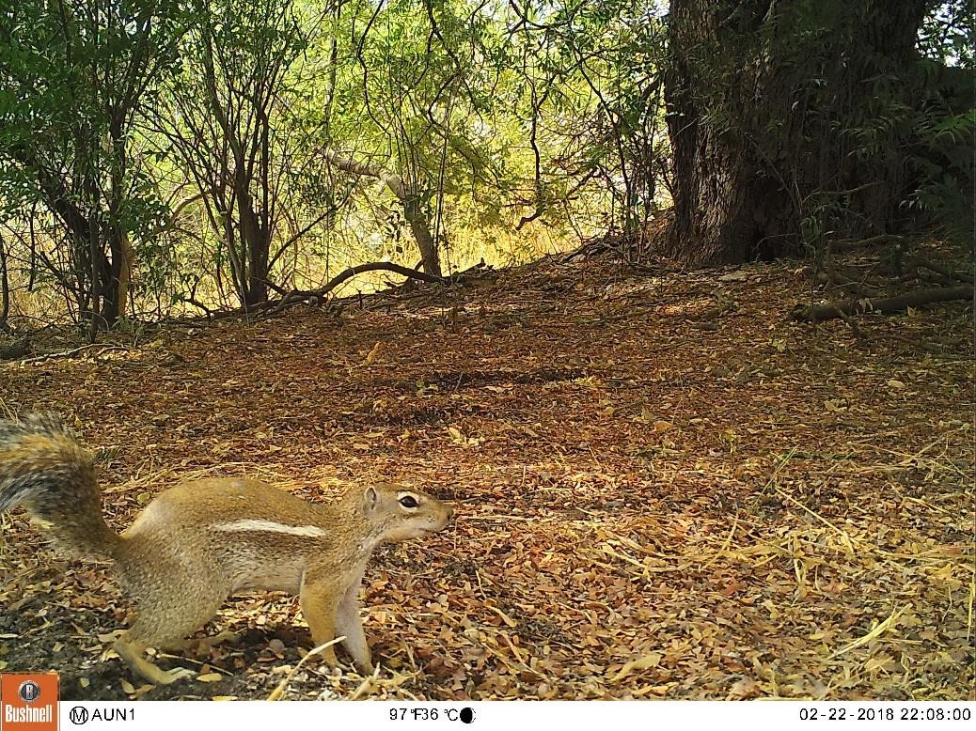

By

## ILIYASU SIMON A00016953

Submitted in partial fulfillment of the requirements for the degree of Bachelor of Science

2018

**AMERICAN UNIVERSITY OF NIGERIA DEPARTMENT OF NATURAL AND ENVIRONMENTAL SCIENCES**

# CAMPUS CRITTERS: USING CAMERA TRAPS TO DETERMINE THE PRESENCE AND DISTRIBUTION OF WILDLIFE ON A NIGERIAN UNIVERSITY CAMPUS

This thesis represents my original work in accordance with the American University of Nigeria regulations. I am solely responsible for its content.

## ILIYASU SIMON

**Signature Date**

I further authorize the American University of Nigeria to reproduce this thesis by photocopying or by any other means, in total or in part, at the request of other institutions or individuals for the purpose of scholarly research.

## ILIYASU SIMON

**Signature Date**

# CAMPUS CRITTERS: USING CAMERA TRAPS TO DETERMINE THE PRESENCE AND DISTRIBUTION OF WILDLIFE ON A NIGERIAN UNIVERSITY CAMPUS

## ILIYASU SIMON A00016953

**Approved by**

Research Co-supervisor**: Lynne R. Baker, Ph.D.**

Assistant Professor, Department of Natural and Environmental Sciences

## Signature Date

Research Co-supervisor**: Jennifer Che, MSc**

Instructor of Natural and Environmental Sciences

## Signature Date

## DEDICATION

This project is dedicated to Dr. Lynne R. Baker. Your effort and support made this project possible.

## ACKNOWLEDGEMENTS

All praise and thanks belongs to God Almighty for his protection and grace throughout this project. I am forever grateful to my family for their prayers and support. My family, I appreciate you.

I am out of words to show my appreciation to Dr. Lynne R. Baker. I could definitely not have done this project without your unending effort and support in this project. Thank you for helping bring out myself and always keeping me on track. I appreciate the many hours you spend on my data analysis. Thank you very much for being a friend and like a mother to me. It is an honor and pleasure working with you.

Another big appreciation goes to Mrs. Che. You have been an amazing supervisor and friend throughout this project. Thank you for going out to the field with me for my data collection for a while to ensure I was on track. You are truly a delight, and I am grateful to work with you.

I also appreciate Mr. Patrick Byrne and Luqman Jimoh for their assistance in providing me tools that I needed for my field work. Lastly, I want to thank AUN for providing me the opportunities and platform to achieve beyond my potential.

# CAMPUS CRITTERS: USING CAMERA TRAPS TO DETERMINE THE PRESENCE AND DISTRIBUTION OF WILDLIFE ON A NIGERIAN UNIVERSITY CAMPUS

## ILIYASU SIMON

American University of Nigeria, 2018

Research Co-supervisor**: Lynne R. Baker, Ph.D.**

Assistant Professor, Department of Natural and Environmental Sciences

Research Co-supervisor**: Jennifer Che, MSc.**

Instructor of Natural and Environmental Sciences

## ABSTRACT

Widely used to study wildlife, camera trapping involves automated devices that record pictures or videos using infrared sensors that detect motion. Camera trapping has greatly improved scientific investigation as it can gather data on rare, cryptic, or nocturnal species. On the American University of Nigeria campus in Adamawa State, northeastern Nigeria, I used camera trapping to determine the presence and distribution of wildlife species and the habitat use of two nocturnal mammals, white- tailed mongoose (*Ichneumia albicauda*) and giant-pouched rat (*Cricetomys gambianus*). I surveyed 29 sampling points for three trap nights, resulting in a total of 87 trap nights. Using occupancy modeling, I evaluated the influence of covariates on presence and habitat use of these two mammals. Results indicated that the presence of nature areas and domestic goats positively influenced the presence and habitat use of white-tailed mongoose. These factors were also important for the giant pouched rat, whose habitat use was positively associated with nature areas, but negatively associated with the presence of goats. These results indicate that white-tailed

mongoose and giant pouched rat prefer less disturbed habitats on campus. The adaptable mongoose, though, appears to also tolerate more disturbed areas and may even be excluded from areas where other mongoose species occur (in this study, banded mongoose). The pouched rat appears to avoid disturbed environments. My findings may be affected by the short survey period and limited number of cameras. I recommend the university enhance natural vegetation and increase awareness about the ecological importance of having such wildlife on campus.

## TABLE OF CONTENTS

CERTIFICATION… ii

READERS’ APPROVAL iii

DEDICATION… iv

ACKNOWLEDGEMENTS v

ABSTRACT… vi

LIST OF TABLES x

LIST OF FIGURES xi

CHAPTER 1… 1

INTRODUCTION 1

Presence 6

Distribution 8

Occupancy 9

Habitat use 10

Abundance/Density 11

Key advantages… 12

Non-lethal method 12

Data documentation 13

Disadvantages 13

Device malfunction 14

Cost 14

Other restrictions. 15

American University of Nigeria 15

AIMS & OBJECTIVES 17

CHAPTER 2 18

MATERIALS & METHODS 18

Study site 18

GPS units 19

Sampling 20

Modeling 22

CHAPTER 3 24

RESULTS 24

White-tailed mongoose 26

Giant pouched rat 27

CHAPTER 4 29

DISCUSSION 29

White-tailed mongoose 29

Giant pouched rat 31

Limitation 32

Recommendation 33

CHAPTER 5 35

CONCLUSION 35

APPENDIX I 36

History of photography in wildlife studies 36

REFERENCES 38

## LIST OF TABLES

**Table 1.** Impact of survey effort (number of camera days) on the number of animals detected in four studies *(sourced from Rovero et al., 2010*) 7

**Table 2.** Results of model selection for habitat use and detection probability of white-tailed mongoose using Akaike’s Information Criterion (AIC), corrected for

sample size and overdispersion (QAICc) 27

**Table 3.** Results of model selection for habitat use and detection probability of Giant-pouched rat proportional to sampling points using Akaike’s Information

Criterion (AIC) with a small sample size correction (AICc). 28

## LIST OF FIGURES

**Fig. 1.** A Camera trap attached to a tree for wildlife detection… 2

**Fig. 2.** Camera trap installed and checked by Indonesia's Tiger Research Team in Tesso Nilo National Park, Riau Province, Indonesia. The Indonesia’s researchers are seeking to record tigers in the Sumatran jungle 5

**Fig. 3.** The location of the American University of Nigeria (AUN) situated in a low dense populated area in Yola, Adamawa state 18

**Fig. 4.** Camera traps mounted on plane woods in a marsh-side animal trail 19

**Fig. 5.** Four sampling zones in this study were underdeveloped areas within the

AUN main campus 20

**Fig. 6.** The proportional sampling points of each of the four study zones 21

**Fig. 7.** Location of mammal species detected by camera traps in each of the four zones during this study 25

**CHAPTER 1 INTRODUCTION**

There have been challenges for wildlife ecologists and managers to develop reliable methods that can be used to assess and gain a better understanding of wildlife (Caughley, 1977). A wide variety of methods and analytical approaches have been developed. The advent of camera-trap technology has greatly improved ecologists’ and managers’ ability to study and monitor wildlife within natural habitats (O’Connell, Nichols, & Karanth, 2011)**.** A camera trap is an automated device that takes pictures or videos using infrared sensors that detect motion. As a result of technological advancements, camera-trap devices are now more cost effective. They provide a non-invasive way to study wildlife. Camera traps also can take High Definition (HD) photographs (Kucera & Barrett, 2011). In addition, camera trapping has improved wildlife studies mostly in terms of assessing and understanding elusive wildlife (Kucera & Barrett, 2011)**.**

In recent years, camera trapping has become a tool to study wildlife with little or no human disturbance (Rovero, Martin, Rosa, Ahumada, & Spitale, 2014). Camera trapping is used for different purposes, such as monitoring and documenting the occurrence of animal species. In addition, the results obtained from a camera-trap study can also be used for designing statistical models for assessing and investigating the animal population’s characteristics, such as abundance, presence, and distribution in a particular area (Karanth, Nichols, Kumar, & Hines, 2006; Karanth & Nichols, 1998). Camera trapping is often used to collect data on species that are difficult to study or detect. In recent years, camera trapping has provided profound results in understanding population characteristics and ecological relationships of animals,

ranging from common animal species (e.g. raccoons) to rare, elusive, and enigmatic animal species (e.g. African golden cats) (O’Connell et al., 2011).

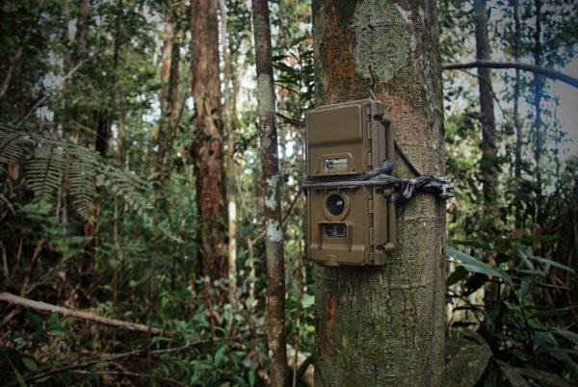

**Fig. 1.** A Camera trap attached to a tree for wildlife detection. *Credit: Wai-Ming Wong/Panthera.*

Camera trapping has become so well known that several ‘camera trap’ articles published in the *Web of Science* database boosted journal citation rates to more than 180 over the past five years (O’Connell et al., 2011). In addition, camera trapping has allowed scientists to more often use non-invasive sampling techniques, which do not disturb wildlife (Long, MacKay, Zielinski, & Ray, 2008). Technological engineering advancements, such as camera-system automation, system networking, device simplicity, and other modern camera system features, have also improved the technological aspect of camera-trapping (O’Connell et al., 2011)**.**

Conservation organizations have incorporated camera trapping in order to preserve and improve biodiversity around the world (Kucera & Barrett, 2011). As the endangerment and extinction of animal species became a major concern, scientists began asking questions and devising methods appropriate for studying rare animals (Ancrenaz, Hearn, Ross, Sollmann, & Wilting, 2012). As a result, camera trapping became widely held because it enabled undisturbed observation of wildlife (Kucera & Barrett, 2011).

Camera trapping is the most appropriate and ethical method in surveying species that are rare, shy, or have a low population density. Due to this camera technique, there have been an increase in the sum of knowledge of the lives of many wildlife species. For example, in one study, camera trapping was used to survey cryptic and elusive forest carnivores in the United States (Kucera & Barrett, 2011)**.** Camera trapping was also used to survey the frequency at which these elusive carnivores appeared along accessible areas in California (Kucera & Barrett, 1993; Kucera, 1993).

Over time camera trapping has detected presumed-extinct or previously unknown species. For example, cameras detected the striped rabbit (*Nesolagus timminsi*), previously unknown to science, in the Annamite mountain range of Laos and Vietnam. This detection occurred 1,500 km away from where another striped rabbit occurs: the Sumatran striped rabbit (*Nesolagus netscheri*), which is critically endangered, (Surridge, Timmins, Hewitt, & Bell, 1999). Using camera traps, Jeganathan et al. (2002) documented the critically endangered and poorly known Jerdon’s courser (*Rhinoptilus bitorquatus*) in India. In Sumatra, the presence and distribution of the endangered Asian tapir (*Tapirus indicus*) was confirmed via

camera traps even though park rangers claimed the species did not exist in the park (Holden, Yanuar, & Maryr, 2003). Camera traps also led to the first-ever photograph of a wolverine (*Gulo gulo*) in California since 1922, although the researchers were using cameras to study the distribution of another species, the American marten (*Martes americana*) (Moriarty et al., 2009). Camera trapping and using banana as bait helped researchers assess the distribution and abundance of the endangered buff- headed capuchin monkey (*Cebus xanthosternos*) (Kierulff, Santos, Canale, Guidoizzi, & Cassano, 2004).

Furthermore, camera trapping has provided opportunities for conservation organization to have more biodiversity awareness campaigns by promoting photographs of cryptic and elusive species (Kucera & Barrett, 2011). The Wildlife Conservation Society presented the first photograph of the very rare Lowe's servaline genet (*Genetta servalina lowei*) in Tanzania (Brink, Topp-Jorgensen, & Marshall, 2002). In Cambodia, Sanderson and Trolle (2005) provided evidence of continued existence of the Siamese crocodile (*Crocodylus siamensis*) using cameras. Similarly, the World Wildlife Fund presented the critically endangered Sumatran rhinoceros (*Dicerorhinus sumatrensis*) (Anonymous, 2006)**.**

In addition to being able to detect rare species, camera trapping may be more effective than other techniques under certain conditions. Roberts (2011), for example, compared camera trapping and transect sampling for mammals and found out that transect sampling depends heavily on the competence of the observers for accurate identification of species. On the other hand, camera traps do not need skilled

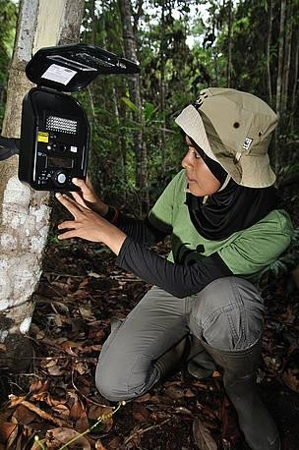

**Fig. 2.** Camera trap installed and checked by Indonesia's Tiger Research Team in Tesso Nilo National Park, Riau Province, Indonesia. The

Indonesia’s researchers are seeking to record tigers in the Sumatran

jungle. *Credit: © WWF-Indonesia / Des Syafrizal*

observers. Additionally, camera trapping is a labor-efficient, rigorous, and reliable method in large-scale and long-term monitoring of species and requires less human effort compare to other techniques (Roberts, 2011).

Finally, camera trapping has even been used to monitor wildlife vaccination programs. In Switzerland, cameras provided evidence of rabies vaccine uptake by red foxes (*Vulpes vulpes*) using bait stations (Hegglin et al., 2004). Cameras helped the researchers evaluate several methods to improve vaccination efficiency while reducing negative impacts from non-targeted species taking the baits (Hegglin et al., 2004).

Investigators are using camera traps for many purposes, some simple and some more complex. Some of these purposes include establishing a species’ presence,

determining distribution or occupancy of a species in a region, assessing how a species uses its habitat, or estimating abundance and density.

*Presence*

Camera trapping can confirm the presence of animal species in an environment with a single photograph. Such information can be used to create awareness on the value or importance of a habitat for a species. For example, using 15 camera traps, investigators logged 11,106 camera-trap days and identified 43 animal species, including mammals, birds, and a reptile, in a forest in Thailand (Kitamura, Thong- Aree, Madsri, & Poonswad, 2010). In addition, the study showed that these animals were less affected by human activity, except for direct poaching (Kitamura et al., 2010)**.** Likewise, Hibry and Jeffery (1987) confirmed the presence of the rare Mediterranean seal (*Monachus monachus*) in the caves of the Greek Island of Kefallinia using camera traps**.** Due to the seals’ sensitivity to human disturbance, camera trapping was considered the best method to determine presence of these species (Hibry & Jeffery, 1987). At least, four individual Mediterranean monk seals were photographed in their caves (Hibry & Jeffery 1987).

Confirming presence depends on the survey or trap effort. The greater the survey effort, the greater the likelihood of detecting species (Table 1). Survey or trap effort also can be mathematically calculated. The survey effort is calculated by multiplying the number of camera traps with the sampling days (Rovero et al., 2010).

For example, a 2,000 survey or trap effort might involve using 20 camera traps over 100 days, or 100 cameras over 20 days.

Nonetheless, certain elusive or very shy species may still be undetectable even with a 2,000 survey effort. This brings in the question the absence of a species (Rovero et al., 2010). In this case, without any insurance that a species was not detected, it is unlikely to state that a species is absent in an area because cameras only provide the presence of a species at a particular time and space. Therefore, inferences could still be made if a species is known to occur at a location.

Camera trapping can capture photos or videos of large-medium terrestrial species. Such species are often difficult to detect, given low population densities and shy behavior. A camera-trap inventory of species in northern Mexico were able to capture 80% of the large-medium species in the study area (Lorenzana-Pina, Castillo-Gomez, & Lopez-Gonzalez, 2004).

Camera-trapping data on detecting a species in a study area are also affected by the status of that species. For example, a study on endangered African wild dogs (*Lycaon pictus*) showed that presence and distribution were affected by human oppression and

**Table 1.** Impact of survey effort (number of camera days) on the number of animals detected in four studies *(sourced from Rovero et al., 2010*).

|  |  |  |  |
| --- | --- | --- | --- |
| **Site** | **Number of species (proportion of total of all mammals known to occur in**  **the study area)** | **Trap effort (camera days)** | **Source** |
| Emas National Park, Brazil | 16 (57%) | 1035 | (Silveira et al., 2003) |
| Atlantic forest, Brazil | 17 (81%) | 1849 | (Srbek-Araujo & Garcia, 2005) |
| Udzungwa Mountains, Tanzania | 44 (80%) | 3400 | (Rovero & De Luca, 2007) |
| Los Amigos, Peru | 21-24 (75-86%) | 1440-2340 | (Tobler et al., 2008) |

habitat reduction in Waterberg, South Africa (Ramnanan, Swanepoel, & Somers, 2013). Using camera traps, African wild dogs were mainly detected on private farmlands, indicating that private lands are important habitat for the conservation of African wild dogs (Ramnanan et al., 2013).

*Distribution*

Camera trapping can also be used to estimate the spatial distribution of a species over a large landscape or a small area (Ancrenaz et al., 2012)*.* Camera trapping is used to determine species distribution in conjunction with evaluating features of a study area, such as habitat type, anthropogenic threats, and presence of water, to determine how these features influence or affect, positively or negatively, distribution of a species (Ancrenaz et al., 2012)*.*

For example, in Gabon, west-central Africa, ecological features, roads, and other human-disturbance factors within a littoral mosaic landscape were measured and compared to distribution data of mammals collected via camera traps (Vanthomme, Kolowski, Korte, & Alonso, 2013). Investigators found out that even though positive results were associated with road presence, they suggested anthropogenic factors such as agriculture, hunting, and industrialization, which were also influenced by road presence, affected the community of mammals that were studied. Camera trapping has also been used to map the distribution of bird species in Bawangling Nature Reserve on Hainan Island, in the South China Sea. The study identified species that are endangered, vulnerable, or rare, and some species had not been photographed before (Lok, Shing, Jian-Feng, & Wen-Ba, 2005).

*Occupancy*

Camera traps can also be used to estimate occupancy, which is the area within a particular study site that is occupied by a species. Whereas distribution reveals where a species occurs in an area, occupancy reveals how much of a study site is occupied by the species (MacKenzie et al., 2006). Occupancy modeling accounts for imperfect detection and thus requires repeat observations. By calculating a detection probability for a species, investigators can determine the probability that the species occupies a sample locality even if the species was not observed there (Ancrenaz et al., 2012)*.* Investigators also measure covariates, such as vegetation features, habitat type, key resources, and anthropogenic threats, and relate these to occupancy patterns using statistical models (Rovero et al., 2010). Occupancy modeling can therefore show how covariates influence occupancy data gotten from camera traps (Bender, Weisenberger, & Rosas-Rosas 2014).

Camera traps have, for example, been used to estimate occupancy for many species, including Javelinas (*Pecari tajacu*) in the southern San Andres Mountains, New Mexico (Bender et al., 2014). Investigators found that occupancy was predicted by the presence of such covariates such as water, oak-mountain mahogany trees, riparian shrub canopies, as well as warmer temperatures (Bender et al., 2014).

Using camera trapping, studies of distribution and occupancy can be used over time to monitor changes in wildlife populations. In the case of occupancy, camera trapping is suggested to be a better monitoring method because the method involves no human interference. One approach in wildlife monitoring using camera traps is “participatory biodiversity monitoring” (Ancrenaz et al., 2012). This approach

involves engaging local people who are the primary users of wildlife resources to monitor those resources. It also involves training local communities to be volunteers and help gather a large amount of data on wildlife. Also, this approach provides an opportunity to increase awareness among local people about the status wildlife and environmental issues in natural habitats near them.

*Habitat use*

Wildlife monitoring may also involve investigating habitat use and changes in habitat use over time. Habitat use is how species use their physical and biological resources in an area. The use of camera traps to study habitat use help investigators understand the behavioral or activity patterns of species (Bridges & Noss, 2011). This is usually done by comparing the abundance of a species with the frequency with which camera traps capture them (Bridges & Noss, 2011). For example, camera traps showed that impalas (*Aepyceros melampus*) in the Kenyan rangeland preferred the nutrient-rich glades habitat than the acacia bushlands (Augustine, 2004). In another example, in Northern California, native mammalian predators preferred the vineyard near the core habitat, whereas non-native mammalian predators mostly avoided these core areas (Hilty & Merenlender, 2004). Camera traps may also be used to evaluate how artificial features, such as bridges, culverts, roads, and urban development, affect habitat use of species (Cain, Tuovila, Hewitt, & Tewes, 2003).

Another important aspect of evaluating habitat use of animals is wildlife management. Wildlife management involves balancing the requirements wildlife and people to maintain the well-being of both (Ancrenaz et al., 2012). For example, camera traps helped investigators determine the feeding patterns of red-legged

partridges (*Alectoris rufa*) in relation to climate change (Armenteros et al., 2015). The data showed that the patridges’ had a bimodal circadian feeding pattern that decreased in the middle of the day. The photographs also showed that the birds’ feeding pattern is not affected by vegetation growth or change of artificial feeders (Armenteros et al., 2015). Therefore, this information could be used to improve the survival rates of this species in sites where they are threatened by humans.

*Abundance & density*

Camera traps can even help investigators determine abundance, which is the number of individuals of a species in a particular area. Most published studies on abundance using camera trapping have been conducted in spatially and temporally closed systems to determine population size of single species (Karanth, 1995). Various quantitative measures are used to estimate abundance using camera trapping. Ideally, all the quantitative measures depend heavily on detection probability of a species and the positioning of camera traps to make viable inferences of abundance (O’Brien, 2011).

Because estimating abundance depends on detection probability, quantitative measures have been developed that include factors such as birth, death, and emigration of animals within a study area (O’Brien, 2011). In the Great Smoky Mountains National Park (Tennessee/North Carolina), USA, Bailey, Simons, and Pollock (2004) developed a model that considered that some plethodon salamander species emigrate temporarily from the study area or hide, or that cameras fail, in order to generate significant inferences of abundance of the species. The authors determined that the most appropriate way to improve estimates of species abundance

based on detection probability is to increase the number of camera traps and add survey days to the study design (Bailey et al., 2004).

To determine abundance, the position of cameras is also important. For example, placing camera traps far apart could create a gap in between the camera traps where the species would not be detected even though they are present in the sampling area (O’Brien, 2011). On the other hand, placing camera traps closer to each other would limit the sampling area and thus reduce the likelihood of detecting the species (O’Brien, 2011). This trade-off could be prevented by monitoring and ecological research in order to know the animal movement patterns and habitat use (O’Brien, 2011).

## Key advantages

*A non-lethal method*

In addition to being a useful tool to study and monitor wildlife, especially cryptic and rare species, camera trapping offers other advantages for wildlife researchers. For example, camera traps can be left for unattended for long periods of time in order to generate reliable data on species, (Rovero et al., 2010). In addition, researchers no longer needed to use physical traps, which may harm wildlife; traps could be replaced with bait (e.g. raw meat) stations, to help lure wildlife to area to determine presence. Physically capturing insectivorous bats, for example, was not needed to study their predatory behavior; instead, camera traps took the place of physical traps (Hirakawa, 2005). Because bats are attracted to any moving object of a certain size, the researcher used a pencil eraser as a bait; the bats mistaken it as insect prey and moved toward it and into the field of the camera trap (Hirakawa, 2005). Blood has

also been used as bait in camera-trap studies to assess the presence, distribution, and abundance of over 21 species, including grizzly bear (*Ursus arctos*) and black bears (*Ursus americanus*) (Mace, Minta, Manley, & Aune, 1994).

*Data documentation*

Order than providing photographs, camera trap devices provide other significant data on species’ behavioral activities and other activities for both scientific and popular uses (Swann et al., 2011). For example, camera-trap devices provide the date and time of photographs, and cameras can be set to take photos or video at predetermined time (Swann et al., 2011). In addition, cameras can record temperature, video, and audio data. Due to technological improvements, camera-trap devices can even record digital-over-film, which enables more images to be captured than regular digital cameras. The feature also allows continuous footage of animals to view animal behavior over a period of time. Recently, other innovations include connecting camera-trap devices to a researcher’s computer by satellite and get the feedbacks (such as photograph images) while the researcher is in an office or connected to a computer elsewhere (Swann et al., 2011).

## Disadvantages

*Device malfunction*

Like any survey method, camera traps have disadvantages, which can affect both data collection and analyses. One of the disadvantages is device malfunction, which may result from factors such as weather conditions, user experience, and animal interaction with a device. Because camera traps use multiple parts, if one part malfunctions, other parts may also breakdown. This is usually associated with wire-

cord failure caused by animals or battery failure (Swann et al., 2011). In another example, moisture can cause sensors to malfunction, metal parts to rust, and SD memory cards to warp (Swann et al., 2011). In addition, ants, termites, and bugs, can sometimes enter the interior of the camera and cause damages (Swann et al., 2011). In tropical environments, camera traps have been damaged due to extreme humidity (Kawanishi, 2002)**.**

Another problem that causes cameras to malfunction is related to battery life, such as loss of data due to having to replace of batteries and SD cards more often than expected (Swann et al., 2010). In addition, most of the non-infrared camera-trap devices require more power to work than cameras that use infrared sensors (Swann et al., 2011). Battery life also depends on the number of photographs taken (Rovero et al., 2010). Although some infrared cameras have been developed to use less battery power, and thus extend the life of the batteries, infrared images at night are only black and white (Rovero et al., 2010).

*Cost*

One constraint of using camera trapping is the initial and running costs (Ancrenaz et al., 2012). Other than the purchase of the device, which can range from $80 to $600 per unit, components including batteries, and memory cards, add to the overall costs (Ancrenaz et al., 2012). Transportation to remote areas to set up cameras may also add to the costs, but transportation can be an issue for most field studies (Ancrenaz et al., 2012).

*Other restrictions*

Depending where camera traps are deployed, they may capture behavioral or other activity of a species only at that location, including behavior that may be unique to that location (Bridges & Noss, 2011). Thus, this provides limited data on a species. For example, setting a camera trap to record behavior at nest sites may lead only to observations of predation, excluding potentially important foraging behavior at fruit trees or carcasses (Bridges & Noss, 2011).

Another possible restriction of camera traps is that studies of habitat use usually depend on the rate at which the camera traps photograph a species in the study area (Bridges & Noss, 2011). Thus, it may be difficult to distinguish whether a species is occupying the area or is passing through the area more frequently (Bridges & Noss, 2011).

*American University of Nigeria*

The American University of Nigeria (AUN) is a private university located on about 107 hectares in a woodland savanna region in Adamawa State in northeastern Nigeria. The campus has two nature areas, including nature trail passing through these areas, and other undeveloped areas. A comprehensive survey of woody plants on the AUN campus was conducted in late 2015 and early 2016, showing that plant diversity on the campus represents certain species beneficial to humans (Dariye, 2016). For example, *Tamarindus indica* can be used for food; *Prosopis africana* can be used for medicine; and *Balanites aegyptiacia* has economic value (Dariye, 2016).

However, the AUN campus provides a protected environment, meaning that hunting and unregulated harvesting of trees or non-timber forest products are not allowed. As such, the lack of human disturbance and the variety of tree species within the natural and underdeveloped areas of campus may attract wildlife species. For example, banded mongoose (*Mungos mungo*) were sighted repeatedly on campus in late 2016. Given regional road and building development and extensive agriculture in the surrounding region, the AUN campus, where no hunting occurs, might provide refuge for some species. However, wildlife is not easily sighted due to human activity, and some species may be active only at night.

Given these factors and because no wildlife survey has ever been conducted on the AUN campus, I investigated both the presence and distribution of wildlife using camera traps. My primary aim was to determine the factors that might influence which species use the campus and where they are found on campus. I also plan to share my findings with AUN administrators to promote wildlife-friendly management of facilities and grounds across campus.

## AIMS & OBJECTIVES

**Aim**

* To determine the factors that influence the presence and distribution of wildlife on the AUN campus.

## Objectives:

* To identify the species of wildlife on campus using camera traps.
* To determine the distribution of wildlife on the campus using camera traps.
* To compare the distribution of wildlife with vegetation features on campus.
* To identify anthropogenic factors on campus that might attract or deter wildlife.
* To evaluate associations between the distribution of wildlife and the presence of anthropogenic factors.
* Based on the findings, to recommend to campus authorities best practices for maintaining wildlife populations on the AUN campus.

## CHAPTER 2

## MATERIALS & METHODS

*Study Site*

I conducted the study in the main campus of American University of Nigeria (AUN) in Adamawa State, northeastern Nigeria. Adamawa state is situated in the Sudanian savanna region of Africa. It receives an annual rainfall of 1,500‒2,000 mm (Dariye, 2016). The rainy season starts from May and ends in October. The Harmattan period occurs from November to February, and the dry season usually lasts from late February to May. The region has a mean annual temperature of 28.30C

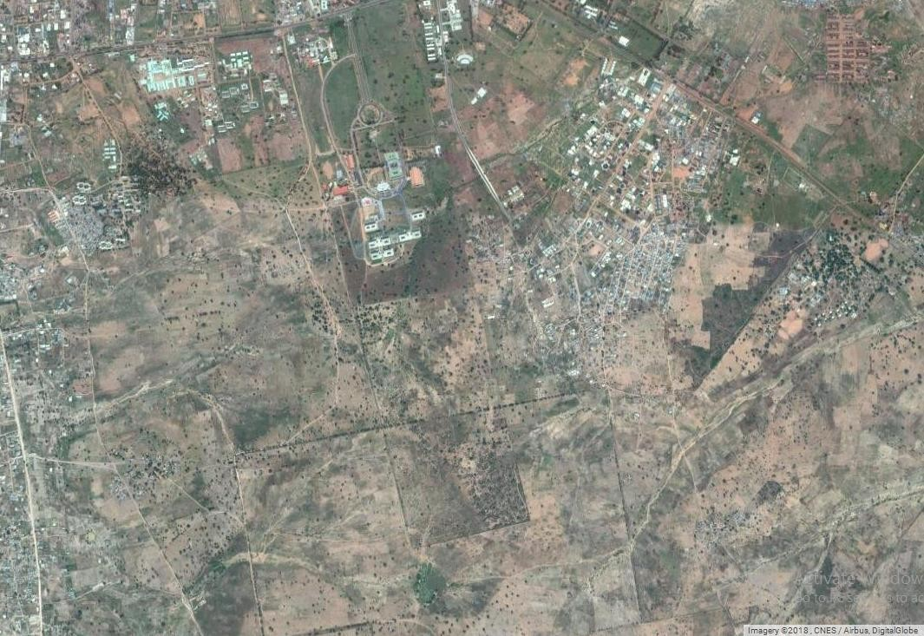

**Fig. 3**. The location of the American University of Nigeria (AUN) situated in a sparsely populated area in Yola, Adamawa State.

(Budnuka, 2015). The university is located in Yola, the capital city of Adamawa state. The immediate area is not densely populated area and is mostly surrounded by residences and farms (Fig. 3). AUN was built in 2003. The land on which it was built has been disturbed by cow grazing, farming, and building construction (Dariye, 2016). Over time, cow grazing and farming activities were restricted on campus. As

a result, two nature areas were developed and then protected. The regional habitat is woodland savanna, although the campus grounds are sparsely vegetated with native trees. Most of the area is covered by prairie tall grasses**,** which are regularly mowed to prevent fires.

*GPS units*

In this study, I used two camera traps (model: Bushnell Trophy HD Aggressor 119774C). These remote cameras are equipped with highly sensitive Passive Infra- red (PIR) motion sensors and a data pack that stamps each photograph with time, date, and temperature. Due to low tree density and limited suitable trees for mounting, I used portable camera mounts (Fig. 4) set at a height of 30 cm to detect smaller terrestrial species and maximize capture.

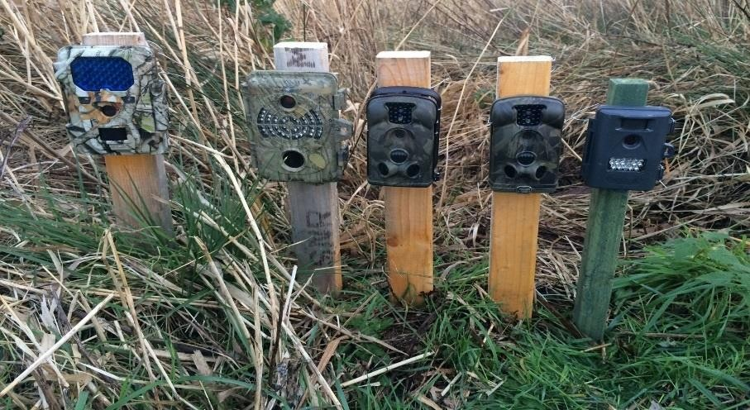

**Fig. 4.** Camera traps mounted on plane woods in a marsh-side animal trail. *Credit:* [*http://birdingfrontiers.com/2015/02/12/camera-trapping-a-review.com*](http://birdingfrontiers.com/2015/02/12/camera-trapping-a-review.com)

*Sampling*

Four study zones represented undeveloped sites on campus, including the North Nature Area (20 ha), South Nature Area (16.5 ha), Southwest Zone (4 ha), and Northwest Zone (14 ha) (Fig. 5). Each zone had varying degrees of tree and vegetation cover and distance from built structures. Sampling was conducted

between Jan. 29 and March

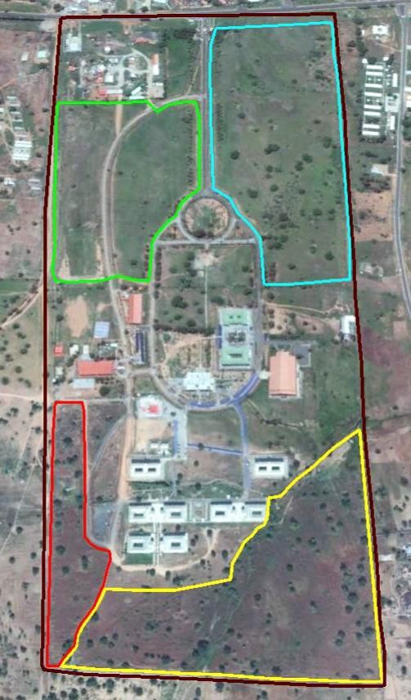

**North Nature Area**

**Northwest Zone**

**South Nature Area**

15, 2018.

Using a 150m-x- 150m-grid overlay of the main AUN campus, I systematically placed the two cameras at 150m intervals along

**Southwest Zone**

**Fig. 5.** Four sampling zones in this study were underdeveloped areas within the AUN main campus. *Credit: Imagery 2018 DigitalGlobe*

the grid within each study area.

In some cases, I moved the cameras a short distance away from previously defined sampling points to minimize the chance of theft or damage, or to avoid roadways or other unsuitable substrate for mounting a camera.

I used a proportional sampling effort based on size of the study zone: North Nature Area: 37% (10 sampling points), South Nature Area: 30% (8 sampling points),

Southwest Zone: 7% (3 sampling points), and Northwest Zone: 26% (8 sampling points) (Fig. 6). The total number of sampling points was 29. Each sampling point was surveyed for three trap nights, resulting in a total of 87 trap nights.

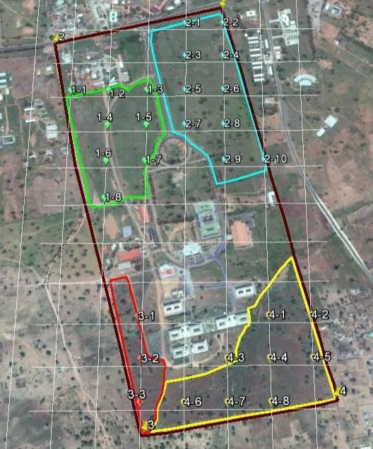

**Fig. 6.** Twenty-nine sampling points in four study zones were sampled with one camera trap for three nights each. Sampling effort was proportional to zone area.

*Modelling*

Using Program PRESENCE (version 2.12; Hines, 2006), I fitted a series of single- season occupancy models to the data separately for two mammal species: white- tailed mongoose (*Ichneumia albicauda*) and Gambian pouched rat (*Cricetomys gambianus*). Number of cameras deployed per site represented spatially replicated surveys. I modeled the presence of each species to evaluate possible influence of two site (habitat) covariates: presence of domestic goats and whether the site contained one of two campus nature areas. Three sampling covariates were included in the models: detection of domestic cats, whether the camera was positioned under tree cover, and distance (in meters) to the nearest food/waste bin. Values for the distance- to-food-bin covariate were standardized using a z-transformation.

The models estimated occupancy and detection probabilities for each species. Occupancy estimates rely on study designs that do not violate the four basic assumptions of occupancy modeling, of which one is “closure.” This assumption states that during the survey period, sites are “closed,” meaning occupancy status of the site for the species under study does not change (MacKenzie et al., 2006).

Because I could not ensure that closure was met during this study, I interpreted occupancy as the proportion of sites used by the species, instead of the proportion of sites occupied.

With detection probabilities held constant, I first modeled occupancy considering the site-specific covariates. Model weights were calculated using Akaike’s Information Criterion (AIC) adjusted for small sample size (AICc). For this study, effective sample size was equivalent to the number of surveys at occupied units (*n* = 18). The

models with the lowest AICc scores were considered to best fit the data. I compared model weights (*w*), which indicate relative support for a particular model. Starting with a null model [psi(.),p(i)], I used a forward-selection approach. If a covariate did not lead to a reduction in AICc compared to the null model, I removed that variable from the analysis. All combinations of retained covariates were then assessed. This procedure was followed until all potential covariates were either retained or discarded.

For each species, I initially conducted a goodness-of-fit test on the full model. Using 10,000 parametric bootstraps, I obtained a Pearson Chi-square statistic and estimated a variance inflation factor, ĉ. For white-tailed mongoose, ĉ = 1.1424, and for Gambian pouched rat, ĉ = 1.1565. Therefore, model ranks were adjusted for overdispersion (ĉ > 1) using QAICc.

## CHAPTER 3 RESULTS

*Species detected and distribution*

In this study, cameras photographed these mammal species: white-tailed mongoose (*Ichneumia albicauda*), banded mongoose (*Mungos mungo*), giant-pouched rat (*Cricetomys gambianus*), and striped ground squirrel (*Xerus erythropus*). Two domestic mammals were also detected: domestic cats and West African dwarf goats. A number of birds species were detected, including northern red-billed hornbill (*Tockus erythrorhynchus*), Abyssinian roller (*Coracias abyssinicus*), cattle egret (*Bubulcus ibis*), African wattled lapwing (*Vanellus senegallus*), black-headed heron (*Ardea melanocephala*), laughing dove (*Spilopelia senegalensis*), double-spurred francolin (*Pternistis bicalcaratus*), and Senegal coucal (*Centropus senegalensis*).

Domestic cats were detected once in zones 1, 2, and 3, and three times in Zone 4. West African dwarf goats were detected once in zone 1.White-tailed mongoose was detected thrice in zone 1 and twice in zone 2, while banded mongoose was detected once in zone 4. Cameras captured the giant-pouched rat twice in zone 2 and thrice in zone 4. The striped ground squirrel was detected once in zone 2.

The African wattled lapwing and cattle egret were detected in zones 1 and 2; Abyssinian roller, double-spurred francolin, and red-billed hornbill were detected in zone 1; laughing dove was detected in zones 1 and 4; Senegal coucal was detected in 1 and 2; and black-headed heron was detected in zone 2.

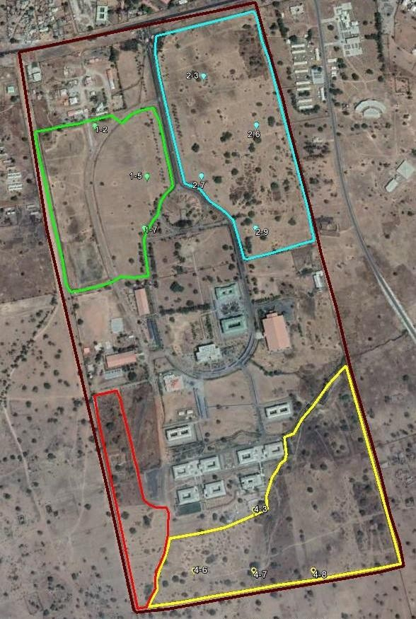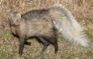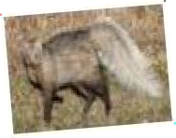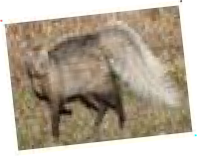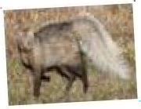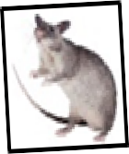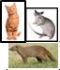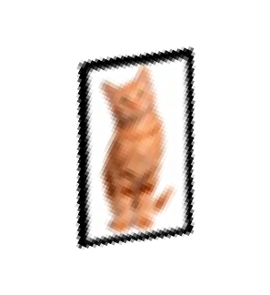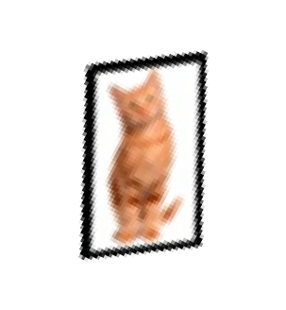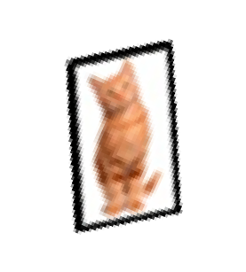

**Zone 1**

**Zone 4**

**Fig. 7.** Location of camera-trap detections of different mammal species in each of the four zones during this study.

*White-tailed mongoose*

White-tailed mongoose was detected in zones 1 and 2, or on the northern side of campus. Part of these zones were used for livestock grazing and farming in the past (Dariye, 2016). The species was not detected in the same zone as banded mongoose.

The best supported model of habitat use for the white-tailed mongoose included the two site covariates: presence of nature area and domestic goats (Table 2). These models were those that had lowered QAICc scores relative to the null model. No sampling covariates had an influence on the habitat use or detectability of the white- tailed mongoose; all models using sampling covariates had a ∆QAICc > 5, indicating little support for these models. I also noted that in four out of the five sampling sites where the white-tailed mongoose was detected, the area was an open area with few low grasses and was close to the campus roads.

The best-supported models with “nature area” and “goats” showed a slightly positive effect of each of these predictors on habitat use of mongoose, with “nature area” being the best model with a model weight of 50% (Table 2). Model ẞ estimates for each predictor were positive (nature area: ẞ = 0.215, SE = 1.607; goats: ẞ = 25.952, SE = not estimated). For the nature-area model using derived parameter estimates (conditional on detection history), the probability of habitat use by white-tailed mongoose in zones 1 and 2 was 100%, 29% in zone 3, and 11% in zone 4. Zones 2 and 4 contained nature areas.

**Table 2.** Results of model selection for habitat use and detection probability of white-tailed mongoose using Akaike’s Information Criterion (AIC), corrected for sample size and overdispersion (QAICc).

|  |  |  |  |  |  |  |
| --- | --- | --- | --- | --- | --- | --- |
| **Model** | **QAICc** | **∆QAICc** | **Model**  **weight** | **Likelihood** | **K**b | **-2\***  **LogLikehood** |
| psi (nature area),p(.) | 25.13 | 0.00 | 0.4997 | 1.0000 | 2 | 23.22 |
| psi (goats),p(.) | 26.49 | 1.36 | 0.2531 | 0.5066 | 2 | 24.78 |
| psi (.), p(.) | 27.35 | 2.22 | 0.1647 | 0.3296 | 2 | 25.76 |
| psi (.),p(distance-bins) | 30.64 | 5.51 | 0.0318 | 0.0636 | 2 | 29.52 |
| psi (.),p(cats) | 31.04 | 5.91 | 0.0260 | 0.0521 | 2 | 29.98 |
| psi (.),p(tree cover) | 31.26 | 6.13 | 0.0233 | 0.0467 | 2 | 30.23 |
| (Global)a model | 36.83 | 11.70 | 0.0014 | 0.0029 | 5 | 24.92 |

(.) Indicates that the parameter was held constant

a Global model used to estimate ĉ using 10,000 parametric bootstraps (ĉ = 1.1424)

b Number of model parameters

For the goats model using derived parameter estimates, the probability of habitat use in zones 1 and 2 was 100%, 29% for zone 3, and 9% for zone 4. The influence of goats may be less about the goats themselves, but more about the land-use and vegetation patterns and degree of disturbance found in zone 1.

*Giant pouched rat*

The giant pouched rat was detected in zones 2 and 4, on the eastern side of the campus. These zones represent the nature areas, thus have greater tree cover and taller (often mowed) grasses than elsewhere on campus. The species was detected in the same zones where domestic cats were detected.

**Table 3.** Results of model selection for habitat use and detection probability of giant pouched rat proportional to sampling points using Akaike’s Information Criterion (AIC) with a small sample size correction (AICc).

|  |  |  |  |  |  |  |
| --- | --- | --- | --- | --- | --- | --- |
| **Model** | **QAICc** | **∆QAICc** | **Model**  **weight** | **Likelihood** | **nKf** | **-2\***  **LogLikehood** |
| psi (nature area),p(.) | 24.88 | 0.00 | 0.4964 | 1.0000 | 2 | 23.22 |
| psi (goats),p(.) | 26.23 | 1.35 | 0.2528 | 0.5092 | 2 | 24.78 |
| psi (.), p(.) | 27.07 | 2.19 | 0.1661 | 0.3345 | 2 | 25.76 |
| psi (.),p(distance-bins) | 30.33 | 5.45 | 0.0325 | 0.0655 | 2 | 29.52 |
| psi (.),p(cats) | 30.72 | 5.84 | 0.0268 | 0.0539 | 2 | 29.98 |
| psi (.),p(tree cover) | 30.94 | 6.06 | 0.0240 | 0.0483 | 2 | 30.23 |
| (Global)e model | 36.57 | 11.69 | 0.0014 | 0.0029 | 5 | 24.94 |

(.) Indicates that the parameter was held constant

e Global used to estimate using 10,000 parametric bootstraps (*ĉ* =1.1565).

f Number of parameters modeled.

As with white-tailed mongoose, the best-supported models for giant pouched rat included “nature area” and “goats.” Presence of a nature area had a positive effect on habitat use of pouched rats (ẞ = 29.199, SE = not estimated), whereas presence of goats had a negative effect (ẞ = –27.327, SE = not estimated). The nature-area model was considered the best model, with a model weight of 50% (Table 3).

For the nature-area model using derived parameter estimates (conditional on detection history), probability of habitat use by pouched rats in zones 2 and 4 was 100%, 9% in zone 1, and 29% in zone 3. For the goats model using derived parameter estimates, probability of habitat use in zone 1 was 0%, 100% in zones 2 and 4, and 28% in zone 3. Giant pouched rats thus appear to prefer campus habitats with less disturbance and greater tree cover. The presence of potential predators, such as domestic cats, did not seem to affect this species’ habitat use or detectability.

## CHAPTER 4 DISCUSSION

*White-tailed mongoose*

A solitary species, the white-tailed mongoose was detected only on the northern side of campus, an area that historically was disturbed by farming and animal grazing (Dariye, 2016), although the exact history of agricultural practices in this area is not known. Other studies have shown that the intensification of agricultural or pastoral farming affects the quality or extent of natural habitats and prey availability (Remonti, Balestrieri, & Prigioni, 2011, as cited in Green, Cornell, Scharlemannn, & Balmford, 2005), which in turn may reduce food and shelter for carnivores (Ramesh & Downs, 2015). Given the dearth of woody tree species on the northern side of campus, this area was also likely disturbed by wood cutting (Dariye, 2016). White- tailed mongoose showed tolerance to this habitat type and other current disturbance related to livestock browsers (e.g. dwarf goats) and grazers detected in the same zone (Schuette, Wagner, Wagner, & Creel, 2013; Kinnaird & O’Brien, 2012). This study suggests that these disturbances may have affected the land in a way that is more suitable for this species.

It is thus not surprising that white-tailed mongoose is often found in proximity to farmlands and grasslands (Maddock & Perrin, 1993, as cited in Maddock, 1988). Such plantation sites may provide a refuge for this species in the absence of nature areas in the open mosaic of farmlands (Ramesh & Downs, 2014). This study’s findings support other research that found white-tailed mongoose to be ecologically flexible and adaptable to human land-use activities (Schuette et al., 2013)

In this study, the distribution of white-tailed mongoose was also not influenced by the variability of the nature areas and anthropogenic factors in the northern zones of campus. During the night, the species was detected in the grassland regions often close to roads. This may indicate there was sufficient prey within these sites (Admasu, Thirgood, Bekele, & Laurenson, 2004). White-tailed mongoose is insectivorous (Cavallini & Nel, 1995), consuming mainly surface invertebrates, such as dung beetles, termites, and ants (Hellyer & Aspinall, 2005). Its diet may be one factor influencing its sociality (Waser, 1981).

The species’ diet, morphology, and behavior are also considered to be adaptations to living on open grasslands (Cavallini & Nel, 1995). In this study, other measured factors, such as distance to food and waste bins, did not influence the habitat use and detectability of white-tailed mongoose. This is probably due to the solitary behavior of the species and the location of the bins, which are close to areas with high levels of human activity. It might also be that white-tailed mongoose in this region do not prefer human food waste and/or have enough natural foods on which to forage.

Given its adaptability, this species was surprisingly never detected in the South Nature Area (zone 4), the only zone where banded mongoose, a social species, was detected. The banded mongoose is also known to mainly eat insects and rodents (Stuart, & Stuart, 1988, as cited in Kenmuir & Williams 1975). The exclusion of white-tailed mongoose from zone 4 may indicate competition between the two mongoose species on campus. However, such potential competition may not pertain to food. For insectorivous mongoose species such as banded and white-tailed monogoose, in sites where their prey renews rapidly, one species excluding the other

within a foraging area only increases prey availability or density by 1% (Waser, 1981). However, no data are available on the diets of these two mongoose in my study site. Competition could still be related to food resources or to other factors.

*Giant pouched rat*

The giant pouched rat was detected only on the eastern side of campus, in less- disturbed nature areas. These areas also have more tree cover, burrows, and taller grasses than elsewhere on campus; such an environment may best suit this species. The giant pouched rat is known to avoid completely open areas and prefer areas made up of hollow tree covers, outcrops, and burrows made by the rodents or other animals (Ajayi, 1977). This may explain the lack of detection of this species close to food bins, which are usually found next to campus dorms. Studies have also found that this species has low tolerance to heat and, thus, prefers cooler environments, such as under tree cover (Ajayi 1977; Knight, 1988). Ajayi (1977) suggested that well-treed areas supply a source of food and shelter for the species. Open areas with little tree cover on the AUN campus may thus be unsuitable for giant pouched rats.

Interestingly, the giant rat appears to have a level of tolerance to human activity on the AUN campus, as others have reported (Ajayi, Tewe, & Faturoti, 1978). This rodent has even been recorded in urban areas (Ajayi, 1977). It may also be resilient against certain predators; for example, the presence of domestic cats did not affect the distribution of this species on campus.

The giant pouched rat is omnivorous and feeds on variety of fruits, vegetables, and insects such as termites, mollusks, and ants (Ajayi, 1977). The species is known to

successfully hoard food in any season (Kingdon, 1988). Such behavior may also favor the species, as it could travel shorter distances for foraging due to food availability in its burrows and avoid detection by domestic cats.

*Limitations*

My findings should be considered in context of the limitations of this research. First, only two camera traps were available for this study, which limited the number of trap nights and my ability to simultaneously survey several areas across the campus. In addition, this study was conducted over a 1.5‒month period. Detection of other species or more detections of mongoose or giant pouched rats may have led to different outcomes and thus conclusions, or provided more data to further support the findings in this study. For example, only once did I detect banded mongoose.

However, with a longer survey period and additional cameras, I may have been better able to ascertain the distribution and habitat use of this species and factors influencing its distribution.

Another limitation of this study was that it was conducted in the dry season. Cavallini and Nel (1995) pointed out that the daily activities of white-tailed mongoose depend on seasons. Therefore, the findings of this study may be different if the study was conducted in the wet season. If time permits, future studies should deploy more camera traps for a longer survey period covering both dry and wet seasons.

*Recommendations*

Given the detection of several wildlife species on campus, AUN should consider managing it grounds to improve habitat for wildlife. Both nature areas appear vital for the white-tailed mongoose and giant pouched rat on campus. Therefore, in these two areas, AUN should enhance the natural vegetation, avoid cutting certain tall grasses, and limit overall human disturbance. Such actions may improve the habitat for these species, as well as other wildlife. The prioritization of such measures is notably important for the giant pouched rat. Because this species is susceptible to heat, campus management should protect the nature areas and minimize or ban tree cutting as vegetative cover provides a cool environment for the species (Ajayi et al., 1978).

Although the white-tailed mongoose showed a level of tolerance to areas used by livestock on campus, Blaum, Tietjen, and Rossmanith (2009) found that heavy grazing and high stocking rates in the Kalahari rangelands in southern Africa led to the decline of the mongoose species population. Therefore, AUN should monitor livestock browsing and grazing activities across campus with an aim to assess their impact on biodiversity and to sustain biodiversity (Blaum et al., 2009). In addition, Dariye (2016) suggested that comparing the woody plants on campus with other land sites in the Yola-Jimeta metropolis will help to evaluate the intensity of disturbance in the nature areas.

The white-tailed mongoose species is known to have a strong negative response to pesticides (Rowe-Rowe, 1992). Therefore, management should consider minimizing

the use of pesticides across campus as they could cause secondary poisoning if poisoned prey is consumed (Ramesh & Downs, 2015; Kinnaird & O’Brien, 2012).

Finally, current boundary markers for the campus nature areas are not readily visible, which causes facility workers to mow into these areas while clearing surrounding grasses (Dariye, 2016). Therefore, more signboards for the nature areas should be erected and clearly displayed (Dariye, 2016). Furthermore, the perceptions of local people toward wildlife is also known to be an important factor to some species that can tolerate human activity (Ramesh & Downs, 2014). In this case, wildlife conservation education programs would help to highlight the ecological importance of the wildlife species on campus.

## CHAPTER 5 CONCLUSION

In this study, the detectability of the white-tailed mongoose and giant pouched rat indicated that both species prefer the nature areas on campus. However, the white- tailed mongoose also showed an adaptability to livestock activity, uneven distribution of the nature areas, and anthropogenic factors (e.g. campus roads). The species is known to be solitary. As a result, this may be reason for its lack of detection in the same zone with banded mongoose. Another reason considered for the absence of the white-tailed mongoose in the same site with banded mongoose was prey availability on campus (e.g. insects), which could result in food competition between the two species due to their diet similarities.

On the other hand, the detectability of the giant pouched rat only in the nature areas suggested that the species prefers less disturbed areas on campus. In all indications, the detection of the giant pouched rat on campus amid domestic cats suggests that the species can tolerate some level of predation. However, the giant pouched rat is likely to be affected negatively when the nature areas on campus are heavily disturbed, as this habitat provides food and shelter for the species.

In summary, enhancing the natural vegetation could have a positive support on the presence and distribution of the white-tailed mongoose and giant pouched rat on the AUN campus. Lastly, a scheme for wildlife habitat conservation should be established on campus.

## APPENDIX I

*History of photography in wildlife studies*

Like every invention, camera trapping went through various trends of development up till date. Professor G. Fritsch, a German explorer in South Africa in 1863, was one of the earliest wildlife photographer that made a photo collection of endangered species using a heavy photographic equipment (Guggisberg, 1977). The population of wildlife photographers increased in the 19th century. Some of wildlife photographers developed several ideas to enhance the camera components and ways to capture photos of targeted animal species. One of the development was improving the faster shutter speed by Eadweard James Muybridge in 1878 (Kucera et. al., 2011). This feature enabled wildlife cameras to take clear photos of animals at high speed. Eadweard also created an idea that made the animal took its own photo; the animal take its own photo by breaking the string that is attached to the camera trigger along a pathway (Kucera & Barrett, 2011). These two ideas provided the opportunity in understanding the locomotion of animals such as the horse four legs being above the ground at a point in time as it gallop (Guggisberg, 1977). Another feature was the camera flashlight system created by George Shiras in the 1890s (Kucera & Barrett, 2011). Shiras made a collection of many various wildlife species with this invention.

One of the most ideal idea added on the wildlife photography that improved wildlife study and also considered to have a scientific background was the ‘trip wire and bait’ (Kucera & Barrett, 2011). This idea was made by Frank M. Chapman (Kucera & Barrett, 2011).The idea was also considered to be the first attempt or method of remote photography in studying animal presence within their environment. Using camera trapping, he was one the first wildlife photographers that developed the

method of animal’s marking and behavior recognition, which have been developed over the recent years (Kucera & Barrett, 2011). Other wildlife photographers who used cameras for wildlife studies include Tappan Gregory, who improved the animal-triggered method and setting positions of the camera traps at trees, dark areas and the safety measures in using the magnesium flash powder Gregory (1939) to get a clear picture of the animal. Young (1946) stated the use of catnip oil in order to draw the attention of the animal and trigger the camera when the animal touches it.

From the mid-20th Century until the present, camera trapping has become portable, convenient, and reliable tool in studying wildlife. However, due to frequent technological upgrades of the camera-trap device and approaches used to analyze camera-trap data, many questions and doubts are being developed within the scientific community on the results or findings of camera trapping. Several studies have reviewed and recommended ways to improve the reliability of camera trapping. Burton et al. (2015) addressed the current application of camera trapping for unmarked species over a large scale study area. He recommended the used of sampling error due to imperfection detection and suggested that inferences on data should be based on occupancy estimation instead of detection indices (Burton et al., 2015).

## REFERENCES

Admasu, E., Thirgood, S.J., Bekele, A., & Laurenson, M.K. (2004). Spatial ecology of white-tailed mongoose in farmland in the Ethiopian Highlands. *African Journal of Ecology*, *42*, 153–159.

Ajayi, S.S. (1977). Field observations on the African giant rat (*Cricetomys gambianus*) waterhouse in southern Nigeria*. East African Wildlife Journal*, *15*, 191-198.

Ajayi, S.S., Tewe, O.O., & Faturoti, E.O. (1978). Behavioural changes in the African giant rat (*Cricetomys gambianus*) waterhouse under domestication. *East African Wildlife Journal*, *16*, 137-143.

Ancrenaz, M., Hearn A. J., Ross J., Sollmann R., & Wilting. (2012*). Handbook for wildlife monitoring using camera*‐*traps*. Bornean Biodiversity and Ecosystems Conservation II Secretariat (BBEC Publication no. 978-983-3108-21-3).

Sabah: Malaysia. JC Printer.

Anonymous. (2006). Endangered rhino stumbles into the limelight. *Nature, 441*, 920. Armenteros, J. A., Sánchez-García, C., Prieto, R., Lomillos, J. M., Pérez, J. A.,

Alonso, M. E., & Gaudioso, V. R. (2015). Do wild red-legged partridges (*Alectoris rufa*) use feeders? An investigation of their feeding patterns using camera trapping. *Avian Biology Research*, *8*(1), 14–24.

Augustine, D. J. (2004). Influence of cattle management on habitat selection by impala on central Kenyan rangeland. *Journal of Wildlife Management, 68*, 916–923.

Bailey, L. L., Simons, T. R., & Pollock, K. H. (2004). Estimating detection probability parameter fro plethodon salamanders using the robust capture- recapture design. *Journal of Wildlife Management, 68*, 1–13.

Bender, L. C., Weisenberger, M. E., & Rosas-Rosas, O. C. (2014). Occupancy and habitat correlates of javelinas in the southern San Andres Mountains, New Mexico. *Journal of Mammalogy*, *95*(1), 1–8.

Blaum, N., Tietjen. B., & Rossmanith, E. (2009). Impact of livestock husbandry on small-and medium-sized carnivores in Kalahari savannah rangelands. *Journal of Wildlife Management,* (*73*)1, 60-67.

Bridges, A. S., & Noss, A. J. (2011). Behavior and activity patterns. In A. F. O’Connell, J. D. Nichols & K. U. Karanth (Eds.), *Camera traps in animal ecology* (pp. 57-65). Tokyo: Springer Japan.

Brink, H., Topp-Jorgensen, J. E., & Marshall, A. R. (2002). First record in 68 years of Lowe’s servaline genet. *Oryx, 36*, 323–327.

Budnuka, A. C. (2015). Statistical analysis of seasonal temperature variation and thunderstorm activity over Yola North-East Nigeria. *American Journal of Educational Research*, *3*(7), 873-880.

Burton, A. C., Neilson, E., Moreira, D., Ladle, A., Steenweg, R., Fisher, J. T., & Boutin, S. (2015). Wildlife camera trapping: A review and recommendations for linking surveys to ecological processes. *Journal of Applied Ecology*, *52*(3), 675–685.

Cain, A. T., Tuovila, V. R., Hewitt, D. G., & Tewes, M. E. (2003). Effects of a highway and mitigation projects on bobcats in Southern Texas. *Biological Conservation, 114*, 189–197

Caughley, G. (1977). *Analysis of vertebrate populations*. New York, NY: John Wiley and Sons.

Cavallini, P. & Nel, J.A.J. (1995) Comparative behaviour and ecology of two sympatric mongoose species (*Cynictis penicillata* and *Galerella pulverulenta*). *South African Journal of Zoology*, *30*, 46–49.

Dariye, E. P. (2016).*Woody plant diversity and composition in two nature areas on the American University of Nigeria campus, Yola, Adamawa State* (Unpublished undergraduate senior thesis). American University of Nigeria, Yola, Adamawa state.

Green, R. E., Cornell, S. J., Scharlemann, J. P. W., & Balmford, A. (2005). Farming and the fate of wild nature. *Science*, *307*, 550.

Gregory, T. (1939). *Eyes in the night*. New York, NY: Thomas Y. Crowell Company.

Guggisberg, C. A. W. (1977). *Early wildlife photographers*. New York, NY: Taplinger Publishing Company.

Hegglin, D., Bontadina, F., Gloor, S., Romer, J., Mueller, U., Breitenmoser, U., Deplazes, P., Glor, S., & Müller, U. (2004). Baiting red foxes in an urban area: A camera trap study. *Journal of Wildlife Management*, *68*, 1010–1017.

Hellyer, P., & Aspinall, S. (2005). The emirates: A natural history. London, UK: Trident Press Limited.

Hibry, A. R., & Jeffery, J. S. (1987). Census techniques for small populations, with special reference to the mediterranean monk seal. *Symposia of the Zoological Society of London, 58*, 193–210.

Hilty, J. A., & Merenlender, A. M. (2004). Use of riparian corridors and vineyards by mammalian predators in northern California*. Conservation Biology, 18*, 126–135.

Hines, J. E. (2006). PRESENCE-Software to estimate patch occupancy and related parameters. USGS-PWRC. [http://www.mbrpwrc.usgs.gov/software/presence.html.](http://www.mbrpwrc.usgs.gov/software/presence.html)

Hirakawa, H. (2005). Luring bats to the camera – A new technique for bat surveys.

*Mammal Study*, *30*, 69–71.

Holden, J., Yanuar, A., & Maryr, D. J. (2003). The Asian tapir in Kerinci Seblat National Park, Sumatra: Evidence collected through photo-trapping. *Oryx, 37*, 34–40.

Jeganathan, P., Green, R. E., Bowden, C. G., Norris, K., Pain, D., & Rahmani A. (2002). Use of tracking strips and automatic cameras for detecting critically endangered Jerdon’s coursers (*Rhinoptilus bitorquatus)* in scrub jungle in Andhra Pradesh, India. *Oryx, 36*, 182–188.

Karanth, K. U. (1995). Estimating tiger *Panthera tigri*s populations from camera-trap data using capture-recapture models. *Biological Conservation, 71*, 333–338.

Karanth, K. U., & Nichols J. D. (1998). Estimation of tiger densities in India using photographic captures and recaptures. *Ecology, 79*, 2852–2862.

Karanth, K. U., Nichols, J. D., Kumar, N. S., & Hines, J. E. (2006). Assessing tiger population dynamics using photographic capture–recapture sampling. *Ecology*, *87*, 2925–2937.

Kawanishi, K. (2002). *Population status of tigers (Panthera tigris) in a primary rainforest of Peninsular Malaysia* (Unpublished doctorate degree thesis). University of Florida, Gainesville, Florida.

Kitamura, S., Thong-Aree, S., Madsri, S., & Poonswad, P. (2010). Mammal diversity and conservation in a small isolated forest of Southern Thailand. *Raffles Bulletin of Zoology*, *58*(1), 145–156.

Kucera, T. E., & Barrett, R. H. (2011). A history of camera trapping. In A. F. O’Connell, J. D. Nichols, & K. U. Karanth (Eds.), *Camera traps in animal ecology* (pp. 9-22). Tokyo: Springer Japan.

Kucera, T. E., & Barrett, R. H. (1993). The trailmaster camera system for detecting wildlife. *Wildlife Society Bulletin, 21*, 505–508.

Kucera, T. E. (1993). Seldom-seen carnivores of the Sierra Nevada. *Outdoor California*, *54*(6), 1–3.

Kierulff, M. C. M., Dos Santos, G. R., Canale, G., Guidoizzi, C. E., & Cassano, C. (2004). The use of camera-traps in a survey of the buff-headed capuchin monkey. *Neotropical Primates 12*, 56–59.

Kingdon, J. (1988). *East African mammals: An atlas of evolution in Africa* (Vols.3).

Chicago, USA: The University of Chicago Press.

Kinnaird, F. M., & O’brien, G. T. (2012). Effects of private-land use, livestock management, and human tolerance on diversity, distribution, and abundance of large African mammals. *Wiley for Society for Conservation Biology*, *26*(6), 1026-1039.

Knight, M.H. (1988). Thermoregulation in the largest African cricetid, the giant rat (*Cricetomys gambianus*). *Comparative Biochemistry and Physiology, 89*, 705- 708.

Lok, C. B. P., Shing, L. K., Jian-Feng, Z., & Wen-Ba, S. (2005). Notable bird records from Bawangling National Nature Reserve, Hainan Island, China. *Forktail*, *21*, 33–41.

Long, R. A., MacKay, P., Zielinski, W. J., & Ray, J. C. (Eds.). (2008). *Noninvasive survey methods for carnivores*. Washington, DC: Island Press.

Lorenzana-Pina, G. P., Castillo-Gomez, R. A., & Lopez-Gonzalez C. A. (2004). Distribution, habitat association, and activity patterns of medium and large- sized mammals of Sonora, Mexico. *Natural Areas Journal*, *24*, 354–357.

Maddock, A. H. (1988). *Resource partitioning in a viverrid assemblage*

(Unpublished doctorate degree thesis). University of Natal, Pietermaritzburg.

Maddock, A. H., & Perrin, M. R. (1993). Spatial and temporal ecology of an assemblage of viverrids in Natal, South Africa. *Journal of Zoology*, *229*, 277– 287.

Mace, R. D., Minta, S. C., Manley, T., & Aune, K. E. (1994). Estimating grizzly bear population size using camera sightings. *Wildlife Society Bulletin*, *22*, 74–83.

Mackenzie, D.I., Nichols, J.D., Rolye, J.A., Pollock, K.H., Bailey, L.L., & Hines,

J.E. (Eds). (2006). *Occupancy estimation and modeling: Inferring patterns and dynamics of species occurrence*. San Diego, CA: Elsevier.

Moriarty, K. M., Zielinski, W. L., Gonzales, A. G., Dawson, T. E., Boatner, K. M., Wilson C. A., Schlexer, F. V., Pilgrim, K. L., Copeland, J. P., & Schwartx, M.

K. (2009). Wolverine confirmation in California after nearly a century: Native or long-distance migrant? *Northwest Science*, *83*, 154–162.

Nichols, J. D., O’Connell, A. F., & Karanth, K. U. (2011). Camera traps in animal ecology and conservation: What’s next? In A. F. O’Connell, J. D. Nichols, &

K. U. Karanth (Eds.), *Camera traps in animal ecology* (pp. 253-261). Tokyo: Springer Japan.

O’Brien, T. G. (2011). Abundance, density and relative abundance: A conceptual framework. In A. F. O’Connell, J. D. Nichols, & K. U. Karanth (Eds.), *Camera traps in animal ecology* (pp. 71-93). Tokyo: Springer Japan.

O’Connell, A. F., Nichols, J. D., & Karanth, K. U. (2011). Evolution of camera trapping. In A. F. O’Connell, J. D. Nichols, & K. U. Karanth (Eds.), *Camera traps in animal ecology* (pp. 1-8). Tokyo: Springer Japan.

Ramesh, T., & Downs, T.C. (2015). Impact of land use on occupancy and abundance of terrestrial mammals in the Drakensberg Midlands, South Africa. *Journal for Nature Conservation*, *23*, 9-18.

Ramnanan, R., Swanepoel, L. H., & Somers, M. J. (2013). The diet and presence of African wild dogs (*Lycaon pictus*) on private land in the Waterburg region, South Africa. *South Africa Journal of Wildlife Research*, *43*(1), 68-73.

Remonti, L., Balestrieri, A., & Prigioni, C. (2011). Percentage of protein, lipids, and carbohydrates in the diet of badger Meles meles populations across Europe.

*Ecological Research*, *26*, 487–495.

Roberts, N. J. (2011). Investigation into survey techniques of large mammals: Surveyor competence and camera-trapping vs. transect-sampling. *Bioscience Horizons: The International Journal of Student Research*, *4*(1), 40–49.

Rovero, F., & De Luca, D.W. (2007). Checklist of mammals of the Udzungwa mountains of Tanzania. *Mammalia*, *71*, 47-55.

Rovero, F., Martin, E., Rosa, M., Ahumada, J. A., & Spitale, D. (2014). Estimating species richness and modelling habitat preferences of tropical forest mammals from camera trap data. *PLoS ONE*, *9*(7).

Rovero, F., Tobler, M., & Sanderson, J. (2010). Camera trapping for inventorying terrestrial vertebrates: Manual on field recording techniques and protocols for all taxa biodiversity inventories and monitoring. *The Belgian National Focal Point to the Global Taxonomy Initiative*, 100–128.

Rowe-Rowe, D. T. (1992). *The ungulates of Natal*. Pietermaritzburg: Natal Parks Board.

Sanderson, J. G., & Trolle, M. (2005). Monitoring elusive mammals. *American Scientist, 93*, 148–155.

Schuette, P., Wagner, A. P., Wagner, M. E., & Creel, S. (2013). Occupancy patterns and niche partitioning within a diverse carnivore community exposed to anthropogenic pressures. *Biological Conservation*, *158*, 301–312.

Silveira, L., Jacomo, A.T.A., & Diniz, J.A.F. (2003). Camera trap, line transect census and track surveys: A comparative evaluation. *Biological Conservation*, *114*, 351-355.

Surridge, A. K., Timmins, R. J., Hewitt, G. M., & Bell., D. J. (1999). Striped rabbits in Southeast Asia. *Nature*, *400*, 726.

Swann, D. E., Kawanishi, K., & Palmer, J. (2011). Evaluating types and features of camera traps in ecological studies: A guide for researcher. In A. F. O’Connell,

J. D. Nichols, & K. U. Karanth (Eds.), *Camera traps in animal ecology* (pp. 27-40). Tokyo: Springer Japan.

Tobler, M.W., Carrillo-Percastegui, S.E., Pitman, R.L., Mares, R., & Powell, G. (2008). An evaluation of camera traps for inventorying large-and-medium sized terrestrial rainforest mammals. *Animal Conservation, 11*, 169-178.

Vanthomme, H., Kolowski, J., Korte, L., & Alonso, A. (2013). Distribution of a community of mammals in relation to roads and other human disturbances in Gabon, Central Africa. *Conservation Biology*, *27*(2), 281–291.

Waser, P.M. (1981). Sociality or Territorial Defense? The influence of resource renewal. *Springer*, *8*(3), 231-237.

Young, S. P. (1946). *The Puma, mysterious American cat*. Washington, DC: The American Wildlife Institute.