# BIOMETRY OF THE CORPUS CALLOSUM IN AN ADULT NIGERIAN POPULATION USING MAGNETIC RESONANCE

**TABLE OF CONTENT**

Title page i

Certification ii

Dedication iii

Acknowledgement v

Table of content vi

List of tables viii

List of figures ix

Abstract x

CHAPTER ONE: INTRODUCTION

* 1. Background of the Study 1
  2. Statement of the Problems 2
  3. Research Questions 2
  4. Hypothesis 3
  5. Objectives of The Study 3
  6. Specific Objectives 3
  7. Significance of the Study 3
  8. Scope of the Study 4

CHAPTER TWO: REVIEW OF RELATED LITERATURE

* 1. Theoretical Review 5
     1. Anatomy of Corpus Callosum 5
     2. Basic Principle of MRI 7
     3. MR Brain Imaging 8
     4. Protocols adopted for Corpus Callosal Study 8
  2. Empirical Review 9
     1. Gender Related Studies 9
     2. Age Related Studies 11
     3. BMI Related Studies 11
     4. Brain Disorder Related Studies 12
     5. Mental Activities / Handedness Related Studies 13

CHAPTER THREE: METHODOLOGY

* 1. Research Design 14
  2. Duration of Study 14
  3. Sources of Data 14
  4. Study Population 14
  5. Sampling Technique 14
  6. Sample Size 14
  7. Subject Selection 15
  8. Inclusion Criteria 15
  9. Exclusion Criteria 15
  10. Equipment Used 15
  11. Scanning Technique 15
  12. Ethical Considerations 16
  13. Informed Consent 16
  14. Method of Data Collection 16
  15. Measurements of Corpus Callosum 17
  16. Method of Data Analysis 18

CHAPTER FOUR: DATA ANALYSIS

* 1. Normal Values of Corpus Callosal Biometry 19
  2. Descriptive Statistics of Age and BMI 20
  3. Comparing Males and Females Corpus Callosal Biometry 20
  4. Variations of Biometry with Age and BMI 21
  5. Correlation Analysis of Biometry with Age and BMI 33

CHAPTER FIVE: DISCUSSION / CONCLUSION

* 1. Discussion 34
  2. Limitations of Study 35
  3. Conclusion 37
  4. Areas of Further Studies 38

REFERENCES 39

APPENDIX

Data Sheet 42

Ethical Clearance 50

Informed Concent 51

Measurements of Corpus Callosum in National Hospital Abuja 52

# LIST OF TABLES

|  |  |
| --- | --- |
| Normal Values of Corpus Callosal Biometry in a Nigerian Population |  |
| Table 1  Descriptive Statistics of Age and Body Mass Index | 19 |
| (Table 2) | 20 |
| Comparing the Mean Values of Corpus Callosal Biometry of the Males  And Females Using Paired Sample T-Test (Table 3) | 20 |
| Variation of Corpus Callosal Biometry with Age for the Population Using  One-Way Anova (Table 4) | 21 |
| Variation of Corpus Callosal Biometry with Age for the Males Using |  |
| One-Way ANOVA (Table 5) | 24 |
| Variation of Corpus Callosal Biometry with Age for the Females Using |  |
| One-Way ANOVA (Table 6) | 23 |
| Variation of Corpus Callosal Biometry with BMI for the Population |  |
| (One-Way ANOVA (Table 7) | 27 |
| Variation of Corpus Callosal Biometry with BMI for the Males Using |  |
| One-Way ANOVA (Table 8) | 28 |
| Variation of Corpus Callosal Biometry with BMI for the Females |  |
| Using One-Way ANOVA (Table 9) | 29 |
| Correlation of Biometry with Age and BMI (Table 10) | 33 |

# LIST OF FIGURES

MRI image at Mid Sagittal Plane Showing the Corpus Callosum (Fig i) 5

Sagittal Section Showing the Corpus Callosum (Fig ii) 5

Diagramatic Illustration of the Measurements of CC (Fig iii) 16

A Bar Chart Representing the Corpus Callosal Biometry of the Different

Age Groups for the Males( Fig iv) 25

A Bar Chart Representing the Corpus Callosal Biometry of the Different

Age Groups for the Females( Fig v) 25

A 3-D Graphical Representation of the Variation of Corpus Callosal

Biometry with Age on the Males Fig (vi) 26

A 3-D Graphical Representation the Variation of Corpus Callosal Biometry with Age on the Females (Fig vii) 27

A Bar Chart Representing the Corpus Callosal Biometry of the Different

BMI Groups for the Males (Fig viii) 31

A Bar Chart Representing the Corpus Callosal Biometry of the Different

BMI Groups for the Females (Fig ix) 31

A 3-D Graphical Representing the Variation of Corpus Callosal Biometry

With BMI on the Males (Fig x) 32

A 3-D Graphical Representing the Variation of Corpus Callosal Biometry with BMI on the Females (Fig xi)

# ABSTRACT

This was a prospective cross-sectional survey study conducted in the Radio diagnostic Department of National Hospital Abuja from June 2013 to January 2014 on 210 cases (111 males and 99 females). The specific objectives were to determine the: (i) biometric values of corpus callosum in an adult Nigerian population, (ii) differences in corpus callosal biometry among different sexes and (iii) relationship between age, body mass index and corpus callosal biometry.The following findings were made from the study:

The mean corpus callosal biometry for the total population were: LC; 7.76±0.57cm, HC; 2.45±0.28cm, WG; 1.19±0.19cm, WS; 1.17±1.20cm, WC;

0.62±0.01cm, WCA; 0.58±0.01cm, WCP; 0.49±0.01cm, LR; 1.78±0.25cm. The

mean corpus callosal biometry for the males were: LC; 7.82±0.45cm, HC; 2.46±0.29cm, WG; 1.20±0.19cm, WS; 1.17±1.21cm, WC; 0.62±0.10cm, WCA;

0.49±0.09cm, WCP; 0.49±0.07cm, LR; 1.78±0.25cm. The mean corpus callosal biometry for the females were: LC; 7.69±0.91cm, HC; 2.43±0.28cm, WG; 1.17±0.18cm, WS; 1.18±1.20cm, WC; 0.64±0.01cm, WCA; 0.59±0.08cm, WCP; 0.49±0.08cm, LR; 1.77±0.22cm.

There was no significant difference (P >0.05) in the mean values of corpus callosal biometry in males when compared to the females. There was no significant relationship (P > 0.05) between corpus callosal biometry with age and BMI.

The normal values from this work can give a clue in making diagnosis of some brain disease processes. Hence, the effect of brain diseases on the corpus callosum can further be researched upon among the Nigerian population.

# CHAPTER ONE INTRODUCTION

# BACKGROUND OF THE STUDY

Corpus callosum (CC) is the main fiber tract connecting the cortical and subcortical regions of the right and left brain hemispheres and plays an essential role in the integration of information between the two hemispheres.

Corpus callosum is of interest to the Imaging Scientist, Neuroradiologist, Neurologist, Neuroscientist and Psychiatrists who are carrying out researches on the callosal biometry in connection to their various specialties. Guptal et al. (2008), in their study, noted that alteration in corpus callosal morphometry may give clue towards diagnosis of specific disease processes. Clark et al. (2007) noted that Neurosurgeons can reduce symptoms of refractory epilepsy by cutting the CC in an operation known as corpus callostomy.

Several other researches have been done on corpus callosum but no unanimity in literature yet on the subject of biometric variations. Many of the studies have found significant sex differences on the length, shape and area of the corpus callosum of males and females. On the other hand, there are many reports where no sex related differences in the size and various other measurements of corpus callosum have been reported. Conclusions regarding age related changes in the corpus callosum have also not been consistent in various studies available. Age changes in specific regions of corpus callosum have been documented and may indicate alteration of the interhemispheric fiber systems.

Most of the studies of CC measurements have been performed on Caucasian samples and a very few among the Indian and Japanese population, but hardly any yet among the Nigerian population. Bishop (1997) noted that callosal

biometry vary with different races. There is also scarcity of research on BMI related variations of callosal biometry.

Hence, there is a need to carry out a study to provide normal biometry to serve as a reference point to the various ongoing researches among the adult Nigerians. The present study was conducted using MRI scans and measurement done with MR measurement tools to get a comprehensive data regarding gender, age and BMI related differences of CC in a Nigerian adult population

# STATEMENT OF PROBLEMS

* + 1. Alterations in corpus callosum biometry have been noted to give clue to the diagnosis of specific disease processes (Guptal et al. 2008)
    2. Racial variations in callosal biometry has also been noted (Bishop 1997)
    3. There is yet scarcity of literature on the study of the corpus callosum among the black race and none, to the best of researchers’, knowledge has been done on the Nigerian population
    4. There is scarcity of studies that correlated corpus callosal biometry with body mass index.

# RESEARCH QUESTIONS

* + 1. What are the values of corpus callosal biometry among the Adult Nigerian population?
    2. Is the biometry of the male corpus callosum different from that of the females?
    3. Does the biometry of corpus callosum change with age?
    4. Does the biometry of the corpus callosum vary with body mass index?

# HYPOTHESIS

* + 1. **H0**: Corpus callosum biometry does not vary with age

**H1**: Corpus callosum biometry varies with age

* + 1. **H0**: Corpus callosum biometry does not vary with BMI

**H1**: Corpus callosum biometry varies with BMI

# OBJECTIVES OF THE STUDY

The aim of the study was to conduct a Magnetic Resonance Imaging biometry of corpus callosum in an adult Nigerian population

# SPECIFIC OBJECTIVES

The specific objectives were to determine:

* + 1. The biometric values of corpus callosum in an adult Nigerian population.
    2. The differences in corpus callosal biometry among different sexes.
    3. The relationship between corpus callosal biometry with age.
    4. The relationship between corpus callosal biometry with Body Mass Index.

# SIGNIFICANCE OF THE STUDY

* + 1. This study will provide biometric values for corpus callosum among the Nigerian population.
    2. It will state if there is any difference between the corpus callosal biometry of the males from the females.
    3. It will establish the relationship between corpus callosal biometry with age.
    4. It will establish the relationship between the corpus callosal biometry with Body Mass Index.
       - With all these findings are accurately made they will open doors for a more experimental research on the corpus callosum.
       - These would also be useful in the diagnosis of brain disorders.

# SCOPE OF THE STUDY

It was conducted in the Radio diagnostic Department of National Hospital Abuja from June 3013 to January 2014. The choice of National Hospital Abuja is informed by the fact that it is centrally located in Nigeria (Federal Capital Territory). This made it possible for the study to cut across the tribes of Nigeria since these tribes are most uniformly distributed in Abuja than any other part of the country.

**CHAPTER TWO**

**REVIEW OF RELATED LITERATURE**

* 1. **THEORITICAL REVIEW**

The corpus callosum, also known as the colossal commissure, is a curved, wide, flat bundle of light tissue neural fibers beneath the cortex and above the hypothalamus in the eutherian brain at the longitudinal fissure. It connects the left and right cerebral hemispheres and facilitates interhemispheric communication. It is the largest white matter structure in the brain, consisting of 200–250 million contra-lateral axonal projections. Its lighter texture is due to higher myelin content, resulting in faster neuronal impulse transmission. The

fibrous bundle that the corpus callosum appears as, can and does increase to such an extent in humans that it encroaches upon and wedges apart the hippocampal structures.

The posterior portion of the corpus callosum is called the splenium; the anterior is called the genu (or "knee"); between the two is the truncus, or "body", of the corpus callosum. The part between the body and the splenium is often markedly thinned and thus referred to as the "isthmus". The rostrum is the part of the corpus callosum that projects posteriorly and inferiorly from the anterior most genu.

The corpus callosum forms between the 11th and 20th weeks. The anterior genu is the first part to form. Development then proceeds posteriorly: anterior body, followed by the posterior body and splenium. After all of this is done, development pays attention to the front again, forming the rostrum. This is important in differentiating partial dysgenesis of the corpus callosum from a developmental injury when the splenium is not seen. Since the rostrum is the last to form, if you see a rostrum in the absence of a splenium, you know that the problem is injury to the splenium. If the rostrum is not seen, then the absent splenium is likely due to partial dysgenesis. (Loevner 2009).

Thinner axons in the genu connect the prefrontal cortex between the two halves of the brain. Thicker axons in the midbody of the corpus callosum and in the splenium interconnect areas of the premotor and supplementary motor regions and motor cortex, with proportionally more corpus dedicated to supplementary motor regions. The posterior body of the corpus communicates somatosensory information between the two halves of the parietal lobe and visual center at the occipital lobe (Caminital et al. 2006; Hofar et al. 2006).

# BASIC PRINCIPLES OF MRI

The acronym MRI stands for Magnetic Resonance Imaging. As the name implies it operates on the principle of applying a strong magnetic field and radiofrequency wave to the human body, in the process it absorbs energy and emits same which is converted to MR images.

The human body is a chemical composition of several elements, such as hydrogen, carbon, nitrogen, sodium, phosphorous potassium etc in various chemical combinations. It has been observed that the atoms of some of these elements have odd number of protons in their nuclei, they posses magnetic properties. The magnetic properties of the protons of these elements have been utilized to produce magnetic resonance signals and images. The most abundant of these present in the human body are the protons of hydrogen atoms in the form of water and various other organic compounds such as water, fats etc. The hydrogen proton is positively charged and has a spin (precess) and thus have high magnetic moment. These properties are exploited in the production of MR images.

When a patient is placed in the strong magnetic field in the MRI scanner, the hydrogen nucleus in the body, align with the applied external magnetic field (most parallel and others antiparallel).The hydrogen precess at a frequency which is dependent on the magnetic field strength. When a radio wave which has equal frequency with the precision frequency of hydrogen proton is applied, the protons are able to absorb its energy and are deflected to an angle of spin and also become coherent in precession. The process whereby frequency of radiowave equals the precision frequency of hydrogen proton is termed resonance. When this radiowave is pulsed, these precessing protons tends to return to the original alignment with the magnetic field and as well lose their

coherence. In this process a certain amount of energy is released in the form of heat and a part is converted to sectional MR images of human body accordingly as T1weighted, T2 weighted and proton density images, after being analyzed by computer and reconstructed mathematically by “Fourier’s Transformation”. (Jagan and Prasad 2005).

## MR Brain Imaging

**Indications**: evaluation of infections, tumours, metastasis, infarction and other idiopathic neurological disturbances.

**Patients’ positioning**: patients lies usually supine, head curl is set on patient and immobilized using sponges and straps.

**Sequences:** T1 and T2 spin echo sequences are used for axial, sagittal and coronal planes. Axial FLAIR or STIR is also added if need be to suppress fat or attenuate fluid as the case may be.

# PROTOCOL ADOPTED FOR CORPUS CALLOSUM STUDY

T1-Weighted Spin Echo Pulse Sequence on a sagittal cut localised on the mid sagittal region, were the corpus callosum is best demonstrated.

Slice thickness - 5mm. Slice gap - 3mm.

FOV - 16.

Number of excitation - 4. TR - 600ms.

TE - 20ms.

Slice thickness of 5mm and slice gap of 3mm with increased number of excitation will produced images of high anatomical contrast, especially since study was on a low magnetic field machine.

# EMPIRICAL REVIEW

## Gender Related Variations.

Bishop (1997), on his gender related study, suggested that "exceptional size of the corpus callosum may mean exceptional intellectual activity" and that there were measurable differences between men and women. Perhaps reflecting the political climate of the times, he went on to claim differences in the size of the callosum across different races. Witelson (1989) studied sex differences in the isthmus and genu and concluded that total corpus callosum, genu and anterior mid-body were greater in absolute area in males. On the other hand, isthmus was significantly larger in females. Gorman (1992) published an article that suggested that, because the corpus is "often wider in the brains of women than in those of men, it may allow for greater cross-talk between the hemispheres— possibly the basis for women’s intuition. A longer corpus callosum was also observed in males than in females in their studies as reported by (Elster et al. 1990; Suganthy et al. 2003).

Using diffusion tensorsequences on MRI machines, the rate that molecules diffuse in and out of a specific area of tissue, directionality or anisotropy, and rates of metabolism can be measured. These sequences have found consistent sex differences in human corpus callosal morphology and microstructure (Dubb et al. 2003; Westerhausen et al. 2004; Shin et al. 2005). Specific algorithms have found significant gender differences in over 70% of cases. In one of the reviews they argued that the shape of the corpus callosum defined the mental sex of individuals over their physical sex. This research suggests

variation with sexual orientation or behaviour (Yokota et al. 2005). Morphometric analysis has also been used to study specific 3-dimensional mathematical relationships with MRIs, and have found consistent and statistically significant differences across genders (Spasojevic et al. 2006; Kontos et al. 2009).

However, Takeda et al. (1994) reported no sexual difference in the measurements of corpus callosum in Japanese subjects. In this study most of the corpus callosal parameters were found to be similar in both sexes in both the autopsy and the MRI group. Most striking was the variations in callosal measurements in all these groups regardless of age or gender. Bishop and Wahlstein (1997), on the basis of 19 independent studies of human corpus callosum, concluded that there is insufficient evidence to support the presence of sex related differences in the size or shape of the splenium, irrespective of difference in the overall brain size in the two sexes. A meta-analysis of 49 studies since 1980 found that, contrary to De Lacoste-Utamsing and Holloway (1986) no sex difference could be found in the size of the corpus callosum, whether or not account was taken of larger male brain size (Bishop 1997). Luders et al. (2003) also suggested that effect of individual variations in callosal size was large enough to undermine any effect of splenial size differences between males and females. In a study by Guptal et al. (2008) slight variation is only noted in two of the parameter measured, the length and maximum width of splenium of the corpus callosum at p- values < 0.05.

All measurements are done with vernier calliper on the printed out films and multiplied by the magnification factor in centimetre. Sexual dimorphism was not observed in most of the other corpus callosal parameters studied. They therefore, assert that it might not be correct to attribute differences in hemispheric functions between sexes to callosal connections.

## Age Related Variations

Weis et al. (1993) reported significant decrease in genu and anterior part of the trunk with age, suggesting alteration in frontal and temporal inter-hemispheric fibre system. Salat et al.(1997) reported that among elderly subjects (age range 65-95yrs) age related atrophy of the anterior and middle sectors of the corpus callosum occurred in women but not in men. They concluded that men and women may show different time course of corpus callosum development and age related loss. Sullivan et al. (2002) reported statistically significant thinning of genu, body and splenium with age on MRI study of mid sagittal brain sections. Guptal et al. (2008), in their age related study using 30 adults (19 males and 11 females) on MRI scan and 44preserved brain specimen (22 males and 22 females cadavers), noted the following variations, at p- value < 0.05, increase in maximum width of rostrum and splenium, height and minimum width of corpus callosum. Garel etal. (2011), in their MR imaging biometry of the corpus callosum in children [a study done with six hundred and twenty-two children (320 boys, 302 girls)], ranging from 1 day to 15 years of age, showed rapid growth up to 3 years of age followed by slower until 7–8 years

## BMI Related Variations.

A study in 2006 using thin slice MRI showed no difference in thickness of the corpus when accounting for the size of the subject. (Luder et al. 2006)

Scarcity of research on the dimension of Body Mass Index informed this study.

## Brain Diseases Related Variations.

**Schizophrenia**

Abnormalities in the corpus callosum can lead to disorderd transfer of information between the two hemispheres and may explain some of the symptoms and cognitive abnormalities encountered in schizophrenia (Crow 1998; O’shea et al. 2003)

## Dyslexia

Research has shown that children with dyslexia tend to have smaller and less developed corpus callosums than their non-dyslexic counterparts (Hynd et al. 1995; Von.plessen et al. 2002).

## Alzheimer’s Disease

Also in a research done to dissociate beween corpus callosum atrophy and white matter pathology in Alzheimer’s disease (AD), it was noted that corpus callosum atrophy in AD can occur independent of white matter degeneration, likely reflecting specific AD pathology in projecting neurons (Teipel et al. 1998).

## Epilepsy

The symptoms of refractory epilepsy can be reduced by cutting the corpus callosum in an operation known as a corpus callosotomy. (Clark et al. 2007).

Walterfang et al. (2011) in their study observed that callosal structure and size reflect both state and trait markers in adult, and they may be useful biomarkers to index both white and gray matter changes that reflect illness severity and progression.

## Mental Activities/ Handedness Related Variations

The front portion of the corpus callosum has been reported to be significantly larger in musicians than non-musicians (Levitan et al. 1995), and to be 0.75 square centimeter or 11% larger in left-handed and ambidextrous people than right-handed people (Witelson 1985; Driesen et al. 1995). This difference is evident in the anterior and posterior regions of the corpus callosum but not in the splenium (Witelson 1985).

Researches correlating callosal morphology to individual mental activities and handedness are evolving frontiers of investigations which may find this study profitable.

# CHAPTER THREE RESEARCH METHODOLOGY

# RESEARCH DESIGN

It was a prospective cross-sectional survey study.

# DURATION OF STUDY

The study was carried out from June 2013 to January 2014.

# SOURCES OF DATA

Data was primary and was drawn from the adult Nigerian patients that present for MRI brain in the National Hospital Abuja within the stipulated time. A measurement of their height and weight was taken. Other information about the patient was obtained from the patients’ bio-data. The scan was subsequently done; measurements of patients’corpus callosum were made from their brain images. These information and measurements were used for research analysis, presentation /interpretation and discussion of result.

# STUDY POPULATION

All the adult Nigerian patients that presented for brain MRI in National Hospital Abuja.

# SAMPLING TECHNIQUE

Convenience sampling method was used for this study since use of volunteers was expensive considering the cost of MRI scan.

# SAMPLE SIZE

The patients that presented for brain MRI in the hospital from June 2013 to January 2014 were included in the study, only all the cases that met the inclusion criteria were used for this research. The total number of cases used was 210 (111 males and 99 females).

# SUBJECT SELECTION

Interviewing the patients, reviewing their request forms, images and radiologists’ report were helpful in subject selection. The subjects that met the inclusion criteria were included in this study.

# INCLUSION CRITERIA

* + - Patients that are from 18 years and above. Legally and according to Nigerian constitution an adult is regarded as one who is 18 years and above.
    - Patients who were not diagnosed of any corpus callosal or brain disorder.

# EXCLUSION CRITERIA

* + - Patients that are below 18years of age
    - Non Nigerians
    - All patients with noted brain or corpus callosal disorder.

# EQUIPMENT USED

A Magneton Concerto Siemens MRI machine, 2001 model, was used for this study. It has operating magnetic field strength of 0.2Tesla. Quality assurance is carried out on the machine on monthly interval.

A 2011 digital height and weight scale, TCS-JL18 from JIELI was used to measure the weight and height of patients. The measuring scale has load rate of 200kg with accuracy of 5.0g.

# SCANNING TECHNIQUE

The patients lies supine on the MRI couch. The head curl is set on the patient and immobilized using sponges and straps. T1-Weighted Spin Echo Pulse Sequence on a sagittal section was used to scan the patient. The following factors were used:

Slice thickness - 5mm. Slice gap - 3mm.

FOV - 16.

Number of excitation - 4. TR - 600ms.

TE - 20ms.

The cuts localised on the mid sagittal region, where the corpus callosum is best demonstrated, were used for this study.

Slice thickness of 5mm and slice gap of 3mm with increased number of excitation produced images of high anatomical contrast, especially since study was on a low magnetic field machine.

# ETHICAL CONSIDERATIONS

Ethical clearance was applied for and obtained from the National Hospital Abuja.

# INFORMED CONSENT

The procedure was explained to the patients and their consent sought for in writing before carrying out the research on each of them.

# METHOD OF DATA COLLECTION

**Stage 1** Measurement of height and weight of patients.

The height and weight of patients were measured and the record kept to be used for analysis.

**Stage2** Scanning of the patients: These patients were scanned with the stipulated techniques.

**Stage 3** Review of the images and reports:

Patients’ request form and images were reviewed with the radiologist report and record of the findings noted. This was used to exclude patients that do not meet the inclusion criteria.

# MEASUREMENTS OF CORPUS CALLOSUM (CC)

All measurements were in centimeter and were made using the MRI machine measuring tools. Measurements were made on T1 weighted images using the slice that best demonstrated the corpus callosum, at about the mid sagittal plane.

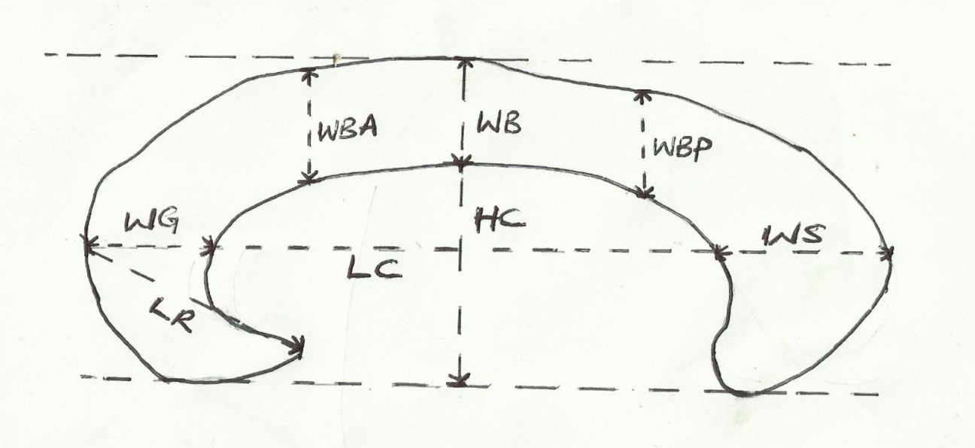

LR

WS

WCP

LC

HC

WG

WCA

WC

## Figure (iii) DIAGRAMATIC ILLUSTRATION OF MEASUREMENTS OF CORPUS CALLOSUM

Eight different sets of measurements were taken twice and the mean values used. The measurements are as follows:

1. Length of corpus callosum (LC): from the most anterior point of CC to its most posterior point.
2. Width of body of corpus callosum at mid point (WC). Width of CC was measured at the midpoint, which was taken at the center of the CC length.
3. Width of genu (WG): was from the most anterior most point of CC to the inner point of genu on the CC length line.
4. Width of splenium (WS): was taken starting at the most posterior point of CC to the inner point of splenium on the CC length line.
5. Height of corpus callosum (HC): A line taken through inferior border of rostrum and splenium. Another line parallel to this taken through the top most point of CC. Distance between these two lines is recorded as the height of CC.
6. Length of rostrum (LR): was taken from the most anterior point of genu to the tip of rostrum.
7. Width of anterior half of CC body (WCA): by the line at the midpoint of CC was divided into anterior and posterior halves. This measurement was taken at the middle point of the anterior half (WCA).
8. Width of posterior half of CC body (WCP). This measurement was taken at midpoint of the posterior half.

# METHOD OF DATA ANALYSIS

Descriptive statistics, Paired Samples T-Test, ANOVA and Pearson Product Moment Correlation Analysis were done using SPSS. Tables, Bar Charts and Graphs were used to present the data.

Descriptive statistics was used to determine the range of normal values for the corpus callosal biometry.

Paired Samples T-Test was used to compare and determine if there is significant difference between the male and the female corpus callosal biometries.

Analysis of Variance (ANOVA) was used to compare the biometries obtained for the different age and BMI groups to establish the relationship between the age, BMI and biometry.

Bivariate Pearson Product Moment Correlations Analysis was further used to establish the degree and direction of the relationship between age, BMI and biometry. Probability value less than 0.05 was considered statistically significant.

# CHAPTER FOUR

**DATA ANALYSIS/ INTERPRETATION**

* 1. **NORMAL VALUES OF CORPUS CALLOSAL BIOMETRY IN A NIGERIAN POPULATION**

TABLE 1. **NORMAL VALUES OF CORPUS CALLOSAL BIOMETRY**

|  |  |  |  |  |  |
| --- | --- | --- | --- | --- | --- |
| **BIOMETRY** | **MIN-MAX (CM)** | **MEAN±SD (CM)** | **RANGE (CM)** | **MEAN**  **STD ERROR** | **GENDER/**  **TOTAL POPULATION** |
| **LC** | 7.02-8.84 | 7.82±0.45 | 1.82 | 0.04 | **MALES** |
|  | 6.27-8.87 | 7.69±0.91 | 2.60 | 0.05 | **FEMALES** |
|  | 6.27-8.87 | 7.76±0.57 | 2.60 | 0.03 | **POPULATION** |
| **HC** | 1.53-3.23 | 2.46±0.29 | 1.70 | 0.03 | **MALES** |
|  | 1.79-3.06 | 2.43±0.28 | 1.27 | 0.03 | **FEMALES** |
|  | 1.53-3.23 | 2.45±0.28 | 1.70 | 0.02 | **POPULATION** |
| **WG** | 0.80-1.92 | 1.20±0.19 | 1.12 | 0.02 | **MALES** |
|  | 0.67-1.56 | 1.17±0.18 | 0.89 | 0.02 | **FEMALES** |
|  | 0.67-1.92 | 1.19±0.19 | 1.25 | 0.01 | **POPULATION** |
| **WS** | 0.44-2.14 | 1.17±0.21 | 1.70 | 0.02 | **MALES** |
|  | 0.78-1.81 | 1.18±0.20 | 1.03 | 0.02 | **FEMALES** |
|  | 0.44-1.98 | 1.17±0.20 | 1.54 | 0.01 | **POPULATION** |
| **WC** | 0.41-0.89 | 0.62±0.10 | 0.48 | 0.01 | **MALES** |
|  | 0.45-0.87 | 0.64±0.01 | 0.42 | 0.09 | **FEMALES** |
|  | 0.41-0.89 | 0.62±0.01 | 0.48 | 0.01 | **POPULATION** |
| **WCA** | 0.39-0.88 | 0.49±0.09 | 0.49 | 0.01 | **MALES** |
|  | 0.42-0.77 | 0.59±0.08 | 0.35 | 0.01 | **FEMALES** |
|  | 0.39-0.88 | 0.58±0.01 | 0.49 | 0.01 | **POPULATION** |
| **WCP** | 0.30-0.78 | 0.49±0.07 | 0.48 | 0.03 | **MALES** |
|  | 0.30-0.69 | 0.49±0.08 | 0.39 | 0.01 | **FEMALES** |
|  | 0.30-0.78 | 0.49±0.01 | 0.48 | 0.01 | **POPULATION** |
| **LR** | 1.23-2.85 | 1.78±0.25 | 1.62 | 0.02 | **MALES** |
|  | 1.24-2.81 | 1.77±0.22 | 1.57 | 0.03 | **FEMALES** |
|  | 1.23-2.85 | 1.78±0.25 | 1.62 | 0.02 | **POPULATION** |

* 1. **DESCRIPTIVE STATISTICS OF THE AGE AND BODY MASS INDEX**

TABLE 2. **DESCRIPTIVE STATISTICS OF THE AGE AND BODY MASS INDEX**

|  |  |  |  |  |  |
| --- | --- | --- | --- | --- | --- |
| **AGE (YRS)** | **MIN-MAX** | **MEAN±SD** | **RANGE** | **STD ERROR** |  |
| 18-79  18-64  18-79 | 44.30±1.41  42.31±1.37  43.36±1.27 | 61  46  61 | 1.41  1.37  0.98 | **MALES FEMALES POPULATION** |
| **BMI(KG/M2 )** | 19.49 - 33.06 | 26.67±0.26 | 13.57 | 0.262 | **MALES** |
|  | 21.93 - 37.91 | 27.27±0.29 | 15.98 | 0.287 | **FEMALES** |
|  | 19.49 - 37.91 | 26.96±0.82 | 18.42 | 0.12 | **POPULATION** |

* 1. **COMPARING THE CORPUS CALLOSAL BIOMETRY OF THE MALES AND FEMALES**

TABLE 3. C**OMPARING THE MEAN VALUES OF CORPUS CALLOSAL BIOMETRY OF THE MALES AND FEMALES USING PAIRED SAMPLE T-TEST.**

|  |  |  |  |
| --- | --- | --- | --- |
| **BIOMETRY OF CORPUS CALLOSUM (MEAN±SD)** | | | |
| BIOMETRY (CM) | MALES | FEMALES | P- Values |
| LC | 7.82±0.45 | 7.69±0.91 | 0.303 |
| HC | 2.46±0.28 | 2.43±0.28 | 0.661 |
| WG | 1.20±0.19 | 1.17±0.18 | 0.123 |
| WS | 1.17±0.21 | 1.18±0.20 | 0.644 |
| WC | 0.62±0.10 | 0.64±0.01 | 0.184 |
| WCA | 0.49±0.09 | 0.59±0.08 | 0.243 |
| WCP | 0.49±0.07 | 0.48±0.08 | 0.701 |
| LR | 1.78±0.25 | 1.77±0.22 | 0.356 |

From table 3 above there was no significant difference between the males and females corpus callosal biometry, since P >0.05, in all the compared parameters.

* 1. **VARIATION OF BIOMETRY WITH AGE AND BMI**

TABLE 4

|  |  |  |  |
| --- | --- | --- | --- |
| **VARIATION OF CORPUS CALLOSAL BIOMETRY WITH AGE FOR THE POPULATION USING ONE-WAY ANOVA** | | | |
| BIOMETRY | AGE (YRS) | MEAN±SD (CM) | P-values |
| LC | 18-40 | 7.79±0.91 | 0.087 |
|  | 41-60 | 7.81±0.53 |
|  | 61-80 | 7.90±0.40 |
| HC | 18-40 | 2.47±0.31 | 0.349 |
|  | 40-60 | 2.45±0.32 |
|  | 61-80 | 2.51±0.34 |
| WG | 18-40 | 1.23±0.12 | 0.067 |
|  | 40-60 | 1.21±0.25 |
|  | 61-80 | 1.17±0.16 |
| WS | 18-40 | 1.18±0.27 | 0.079 |
|  | 40-60 | 1.22±0.24 |
|  | 61-80 | 1.17±0.24 |
| WC | 18-40 | 0.63±0.08 | 0.093 |
|  | 40-60 | 0.62±0.08 |
|  | 61-80 | 0.64±0.10 |
| WCA | 18-40 | 0.61±0.08 | 0.330 |
|  | 40-60 | 0.63±0.09 |
|  | 61-80 | 0.59±0.10 |
| WCP | 18-40 | 0.52±0.07 | 0.974 |
|  | 40-60 | 0.54±0.08 |
|  | 61-80 | 0.51±0.10 |
| LR | 18-40 | 1.80±0.23 | 0.057 |
|  | 40-60 | 1.81±0.20 |
|  | 61-80 | 1.76±0.24 |

From table 4 above there was no significant variation of corpus callosal biometry with age on the total population, since P >0.05, in all the compared age groups.

TABLE 5

|  |  |  |  |
| --- | --- | --- | --- |
| **VARIATION OF CORPUS CALLOSAL BIOMETRY WITH AGE**  **FOR THE MALES USING ONE-WAY ANOVA** | | | |
| BIOMETRY | AGE (YRS) | MEAN±SD (CM) | P-values |
| LC | 18-40 | 7.76±0.81 | 0.106 |
|  | 41-60 | 7.82±0.52 |
|  | 61-80 | 7.90±0.50 |
| HC | 18-40 | 2.45±0.32 | 0.145 |
|  | 40-60 | 2.42±0.34 |
|  | 61-80 | 2.51±0.35 |
| WG | 18-40 | 1.24±0.13 | 0.061 |
|  | 40-60 | 1.25±0.22 |
|  | 61-80 | 1.18±0.10 |
| WS | 18-40 | 1.19±0.20 | 0.135 |
|  | 40-60 | 1.20±0.23 |
|  | 61-80 | 1.18±0.31 |
| WC | 18-40 | 0.63±0.08 | 0.075 |
|  | 40-60 | 0.60±0.09 |
|  | 61-80 | 0.62±0.12 |
| WCA | 18-40 | 0.61±0.08 | 0.072 |
|  | 40-60 | 0.64±0.09 |
|  | 61-80 | 0.50±0.10 |
| WCP | 18-40 | 0.53±0.05 | 0.710 |
|  | 40-60 | 0.52±0.09 |
|  | 61-80 | 0.54±0.09 |
| LR | 18-40 | 1.83±0.24 | 0.135 |
|  | 40-60 | 1.82±0.21 |
|  | 61-80 | 1.78±0.11 |

From table 5 above there was no significant variation of corpus callosal biometry with age on the males since P >0.05, in all the compared age groups.

TABLE 6

|  |  |  |  |
| --- | --- | --- | --- |
| **VARIATION OF CORPUS CALLOSAL BIOMETRY WITH AGE**  **FOR FEMALES USING ONE-WAY ANOVA** | | | |
| BIOMETRY | AGE (YRS) | MEAN±SD (CM) | P-values |
| LC | 18-40 | 7.41±1.21 | 0.073 |
|  | 41-60 | 7.80±0.54 |
|  | 61-80 | 7.92±0.32 |
| HC | 18-40 | 2.43±0.35 | 0.395 |
|  | 40-60 | 2.56±0.33 |
|  | 61-80 | 2.33±0.32 |
| WG | 18-40 | 1.26±0.21 | 0.987 |
|  | 40-60 | 1.25±0.20 |
|  | 61-80 | 1.27±0.26 |
| WS | 18-40 | 1.26±0.23 | 0.501 |
|  | 40-60 | 1.23±0.22 |
|  | 61-80 | 1.21±0.23 |
| WC | 18-40 | 0.62±0.09 | 0.192 |
|  | 40-60 | 0.61±0.06 |
|  | 61-80 | 0.63±0.08 |
| WCA | 18-40 | 0.62±0.08 | 0.678 |
|  | 40-60 | 0.64±0.09 |
|  | 61-80 | 0.60±0.08 |
| WCP | 18-40 | 0.52±0.09 | 0.636 |
|  | 40-60 | 0.53±0.06 |
|  | 61-80 | 0.51±0.14 |
| LR | 18-40 | 1.78±0.232 | 0.891 |
|  | 40-60 | 1.81±0.20 |
|  | 61-80 | 1.76±0.13 |

From table 6 above there was no significant variation of corpus callosal biometry with age on the females since P >0.05, in all the compared age groups.

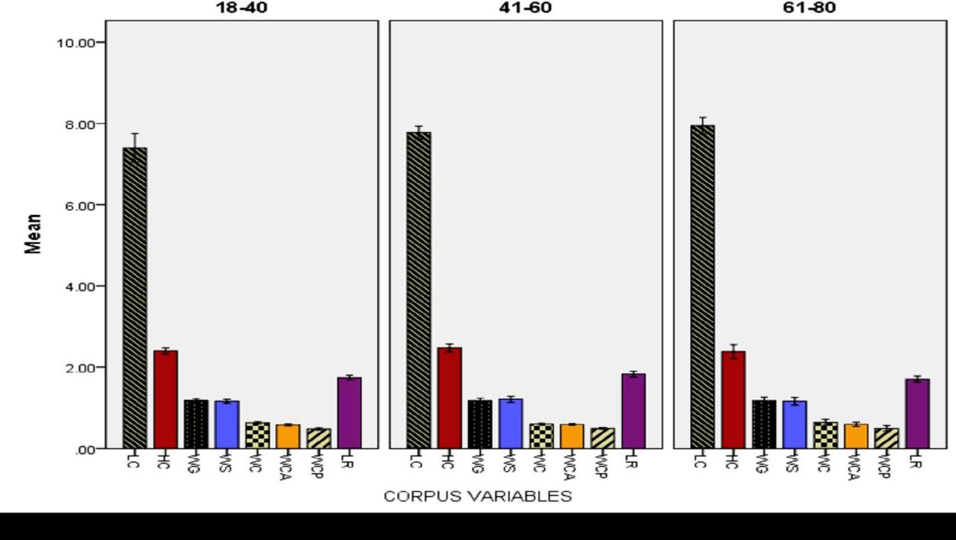

Fig iv. **A BAR CHART REPRESENTING THE CORPUS CALLOSAL BIOMETRY OF THE DIFFERENT AGE GROUPS FOR THE MALES**

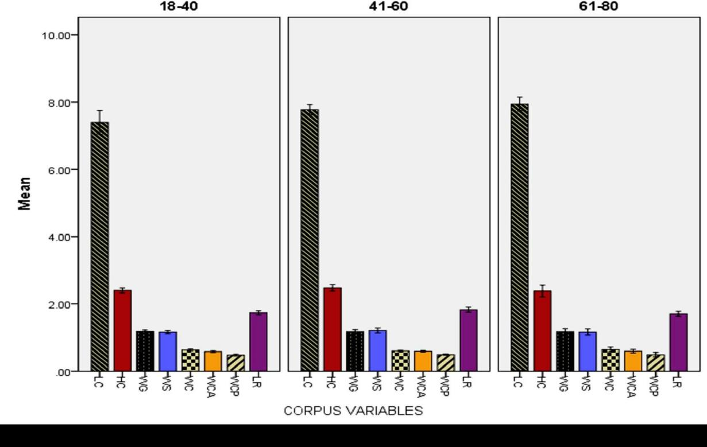

Fig v. **A BAR CHART REPRESENTING THE CORPUS CALLOSAL BIOMETRY OF THE DIFFERENT AGE GROUPS FOR THE FEMALES**

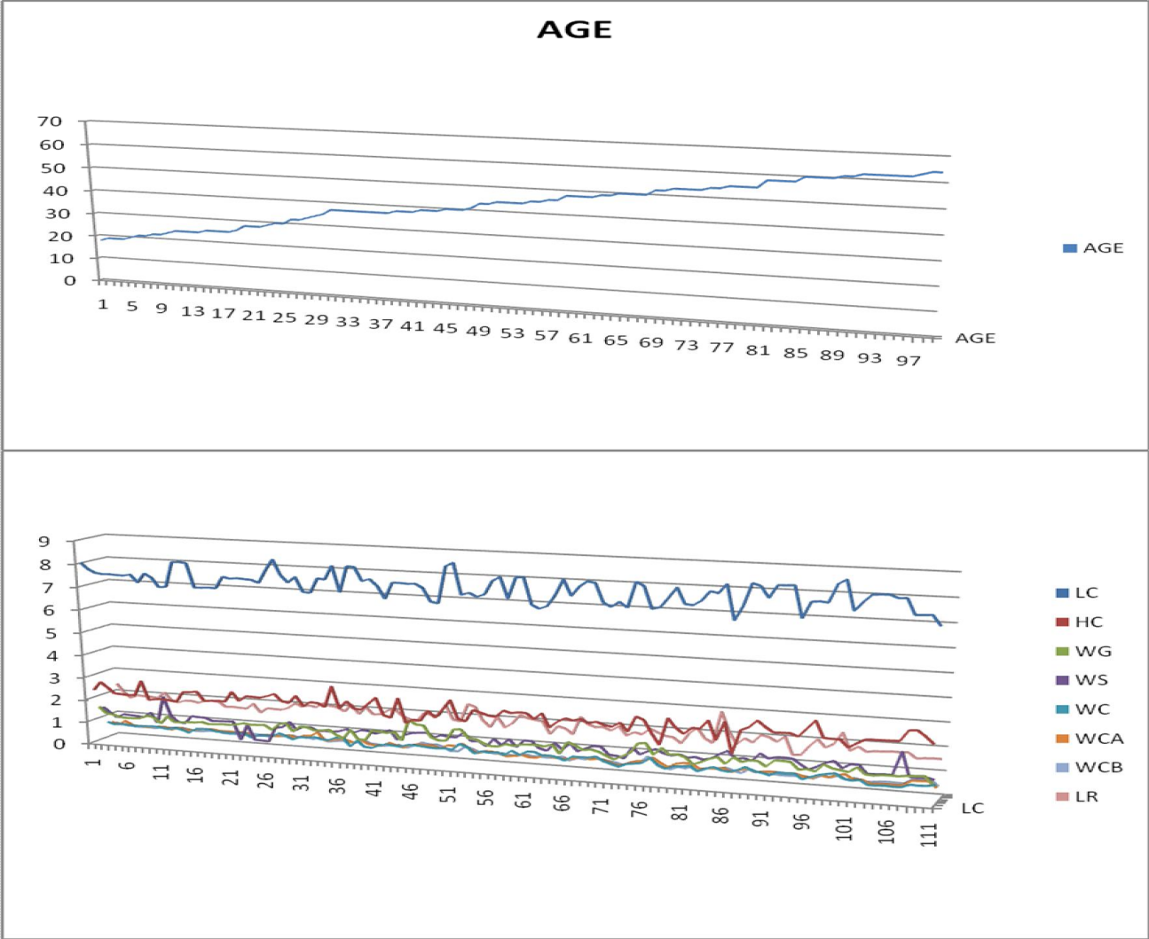

Fig vi. **A 3-D GRAPHICAL REPRESENTATION OF THE VARIATION OF CORPUS CALLOSAL BIOMETRY WITH AGE ON THE MALES**

The graphs above illustrate the pattern of variation of the different parameters of corpus callosal biometry with age on the males. The horizontal axis represents the number of individual cases measured on the increasing order of age while the vertical axis represents the pattern of variation of corpus callosal biometry on 1 cm scale (0 to 10cm). That of age is on 10cm scale(0 to 80 years of age). From the graphs it was observed that as age increased on a straight line the different parameters of the biometry were not correspondingly increasing in size, it was rather sigmoidal in shape. This suggests that the biometry did not vary with age.

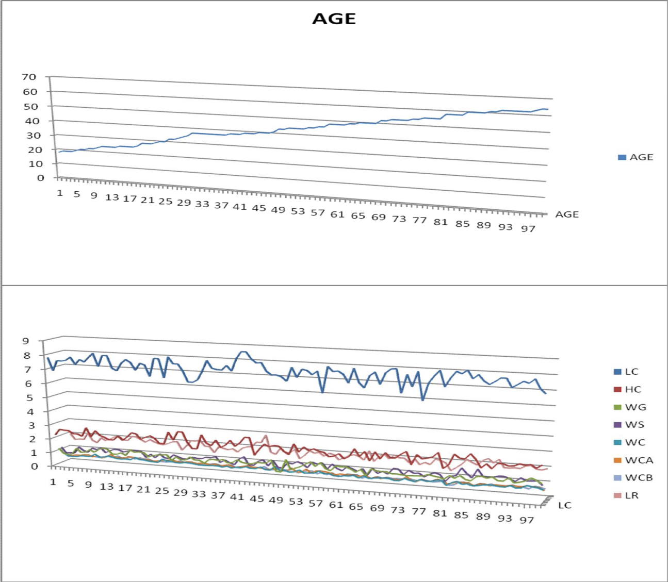

Fig vii. **A 3-D GRAPHICAL REPRESENTATION THE VARIATION OF CORPUS CALLOSAL BIOMETRY WITH AGE ON THE FEMALES**

The graphs above illustrate the pattern of variation of the different parameters of corpus callosal biometry with age on the females. The horizontal axis represents the number of individual cases measured on the increasing order of age while the vertical axis represents the pattern of variation of corpus callosal biometry on 1 cm scale (0 to 10cm). That of age is on 10cm scale(0 to 80 years of age). From the graphs it was observed that as age increased on a straight line the different parameters of the biometry were not correspondingly increasing in size, it was rather sigmoidal in shape. This suggests that the biometry did not vary with age.

TABLE 7

|  |  |  |  |
| --- | --- | --- | --- |
| **VARIATION OF CORPUS CALLOSAL BIOMETRY WITH BMI FOR THE POPULATION (ONE-WAY ANOVA)** | | | |
| BIOMETRY | AGE(YRS) | MEAN±SD (CM) | P-value |
| LC | 19-21.9 | 7.6±3.21 | 0.117 |
| 22-24.9 | 7.7±0.50 |
| 25-27.9 | 7.7±0.43 |
| 28-30.9 | 7.8±0.42 |
| 30-33.9 | 7.4±0.25 |
| HC | 19-21.9 | 2.4±0.20 | 0.115 |
| 22-24.9 | 2.5±0.31 |
| 25-27.9 | 2.4±0.23 |
| 28-30.9 | 2.5±0.24 |
| 30-33.9 | 2.4±2.31 |
| WG | 19-21.9 | 1.0±0.20 | 0.07 |
| 22-24.9 | 1.1±0.14 |
| 25-27.9 | 1.2±0.25 |
| 28-30.9 | 1.2±0.23 |
| 30-33.9 | 1.1±0.12 |
| WS | 19-21.9 | 1.1±0.24 | 0.06 |
| 22-24.9 | 1.1±0.23 |
| 25-27.9 | 1.1±0.21 |
| 28-30.9 | 1.2±0.23 |
| 30-33.9 | 1.2±0.10 |
| WC | 19-21.9 | 0.6±0.09 | 0.092 |
| 22-24.9 | 0.6±0.07 |
| 25-27.9 | 0.6±0.09 |
| 28-30.9 | 0.6±0.09 |
| 30-33.9 | 0.6±0.09 |
| WCA | 19-21.9 | 0.6±0.07 | 0.08 |
| 22-24.9 | 0.6±0.06 |
| 25-27.9 | 0.6±0.09 |
| 28-30.9 | 0.6±0.07 |
| 30-33.9 | 0.6±0.06 |
| WCP | 19-21.9 | 0.4±0.07 | 0.09 |
| 22-24.9 | 0.5±0.05 |
| 25-27.9 | 0.5±0.07 |
| 28-30.9 | 0.5±0.09 |
| 30-33.9 | 0.5±0.09 |
| LR | 19-21.9 | 1.7±0.21 | 0.371 |
| 22-24.9 | 1.8±0.32 |
| 25-27.9 | 1.8±0.20 |
| 28-30.9 | 1.8±0.30 |
| 30-33.9 | 1.8±0.31 |

From table 7 above there was no significant variation of corpus callosal biometry with BMI on the total population since, since P >0.05, in all the compared BMI groups.

TABLE 8

|  |  |  |  |
| --- | --- | --- | --- |
| **VARIATION OF CORPUS CALLOSAL BIOMETRY WITH BMI FOR THE MALES USING ONE-WAY ANOVA** | | | |
| BIOMETRY | AGE | MEAN±SD | P-value |
| LC | 19-21.9 | 7.75±0.38 | 0.10 |
| 22-24.9 | 7.72±0.42 |
| 25-27.9 | 7.81±0.40 |
| 28-30.9 | 7.94±0.45 |
| 30-33.9 | 7.89±0.63 |
| HC | 19-21.9 | 2.56±0.12 | 0.12 |
| 22-24.9 | 2.51±0.26 |
| 25-27.9 | 2.48±0.24 |
| 28-30.9 | 2.48±0.32 |
| 30-33.9 | 2.47±0.44 |
| WG | 19-21.9 | 1.22±0.21 | 0.09 |
| 22-24.9 | 1.14±0.16 |
| 25-27.9 | 1.17±0.15 |
| 28-30.9 | 1.28±0.29 |
| 30-33.9 | 1.24±0.13 |
| WS | 19-21.9 | 1.22±0.20 | 0.32 |
| 22-24.9 | 1.14±0.23 |
| 25-27.9 | 1.13±0.24 |
| 28-30.9 | 1.22±0.13 |
| 30-33.9 | 1.23±0.16 |
| WC | 19-21.9 | 0.60±0.08 | 0.89 |
| 22-24.9 | 0.63±0.09 |
| 25-27.9 | 0.62±0.10 |
| 28-30.9 | 0.63±0.12 |
| 30-33.9 | 0.63±0.09 |
| WCA | 19-21.9 | 0.56±0.07 | 0.20 |
| 22-24.9 | 0.56±0.08 |
| 25-27.9 | 0.57±0.10 |
| 28-30.9 | 0.61±0.10 |
| 30-33.9 | 0.61±0.07 |
| WCP | 19-21.9 | 0.52±0.05 | 0.06 |
| 22-24.9 | 0.48±0.05 |
| 25-27.9 | 0.47±0.06 |
| 28-30.9 | 0.53±0.11 |
| 30-33.9 | 0.47±0.12 |
| LR | 19-21.9 | 1.84±0.27 | 0.26 |
| 22-24.9 | 1.82±0.30 |
| 25-27.9 | 1.76±0.20 |
| 28-30.9 | 1.84±0.27 |
| 30-33.9 | 1.65±0.32 |

From table 8 above there was no significant variation of corpus callosal biometry with BMI on the males, since P >0.05, in all the compared BMI groups.

TABLE 9

|  |  |  |  |
| --- | --- | --- | --- |
| **VARIATION OF CORPUS CALLOSAL BIOMETRY WITH BMI FOR THE FEMALES USING ONE-WAY ANOVA** | | | |
| BIOMETRY | AGE | MEAN±SD | P-value |
| LC | 21-23.9 | 7.61±0.31 | 0.06 |
| 24-26.9 | 7.71±0.61 |
| 27-29.9 | 7.60±0.46 |
| 30-32.9 | 8.07±0.16 |
| 33-37.9 | 6.23±0.48 |
| HC | 21-23.9 | 2.47±0.22 | 0.08 |
| 24-26.9 | 2.46±0.33 |
| 27-29.9 | 2.36±0.25 |
| 30-32.9 | 2.65±0.17 |
| 33-37.9 | 2.27±0.21 |
| WG | 21-23.9 | 1.01±0.19 | 0.07 |
| 24-26.9 | 1.15±0.13 |
| 27-29.9 | 1.20±0.22 |
| 30-32.9 | 1.23±0.12 |
| 33-37.9 | 1.30±0.13 |
| WS | 21-23.9 | 1.04±0.20 | 0.10 |
| 24-26.9 | 1.13±0.17 |
| 27-29.9 | 1.21±0.18 |
| 30-32.9 | 1.34±0.10 |
| 33-37.9 | 1.30±0.10 |
| WC | 21-23.9 | 0.56±0.10 | 0.09 |
| 24-26.9 | 0.61±0.07 |
| 27-29.9 | 0.62±0.09 |
| 30-32.9 | 0.67±0.09 |
| 33-37.9 | 0.71±0.09 |
| WCA | 21-23.9 | 0.49±0.07 | 0.10 |
| 24-26.9 | 0.59±0.06 |
| 27-29.9 | 0.59±0.09 |
| 30-32.9 | 0.62±0.07 |
| 33-37.9 | 0.69±0.04 |
| WCP | 21-23.9 | 0.39±0.04 | 0.12 |
| 24-26.9 | 0.48±0.06 |
| 27-29.9 | 0.49±0.09 |
| 30-32.9 | 0.56±0.04 |
| 33-37.9 | 0.52±0.03 |
| LR | 21-23.9 | 1.66±0.27 | 0.07 |
| 24-26.9 | 1.78±0.22 |
| 27-29.9 | 1.74±0.21 |
| 30-32.9 | 1.85±0.15 |
| 33-37.9 | 2.03±0.22 |

From table 9 above there was no significant variation of corpus callosal biometry with BMI on the females, since P >0.05, in all the compared BMI groups.

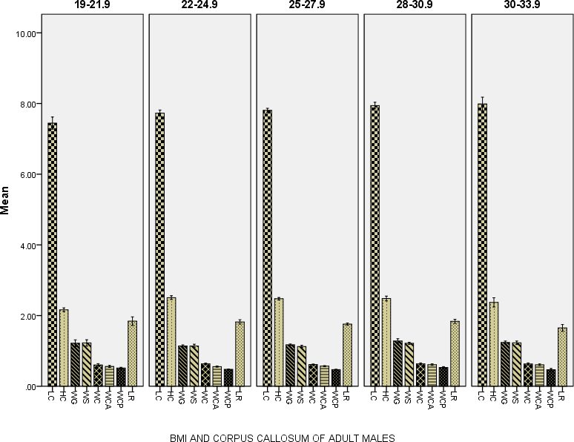

Fig viii. **A BAR CHART REPRESENTING THE CORPUS CALLOSAL BIOMETRY OF THE DIFFERENT BMI GROUPS FOR THE MALES**

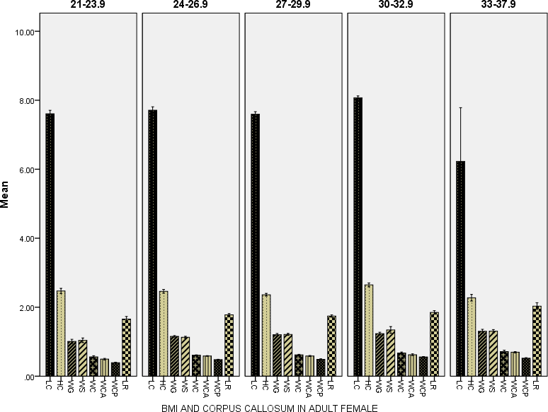

Fig ix. **A BAR CHART REPRESENTING THE CORPUS CALLOSAL BIOMETRY OF THE DIFFERENT BMI GROUPS FOR THE FEMALES**

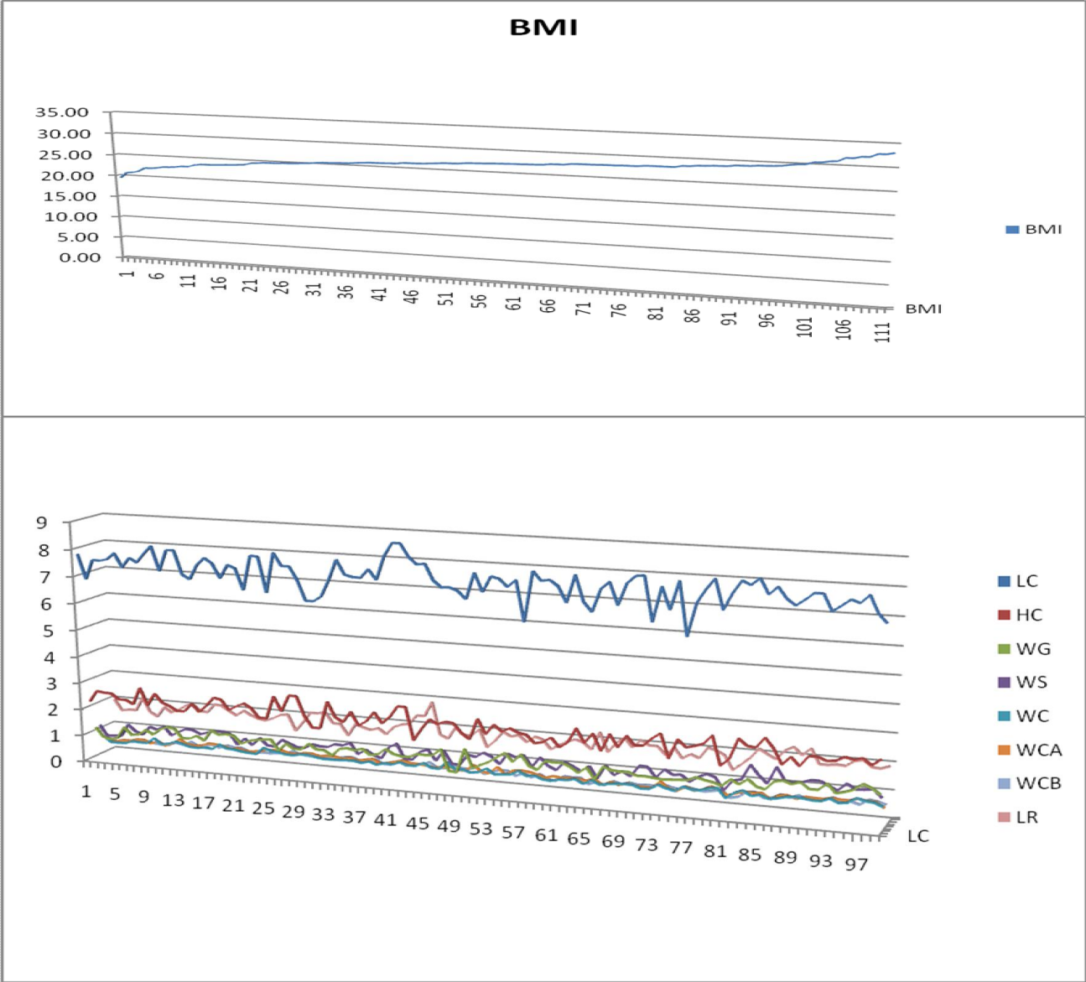

Fig x. **A 3-D GRAPHICAL REPRESENTING THE VARIATION OF CORPUS CALLOSAL BIOMETRY WITH BMI ON THE MALES**

The graphs above illustrate the pattern of variation of the different parameters of corpus callosal biometry with BMI on the males. The horizontal axis represents the number of individual cases measured on the increasing order of BMI while the vertical axis represents the pattern of variation of corpus callosal biometry on 1 cm scale (0 to 10cm). That of BMI is on 10cm scale(0 to 80 years of age). From the graphs it was observed that as age increased on a straight line the different parameters of the biometry were not correspondingly increasing in size, it was rather sigmoidal in shape. This suggests that the biometry did not vary with BMI.

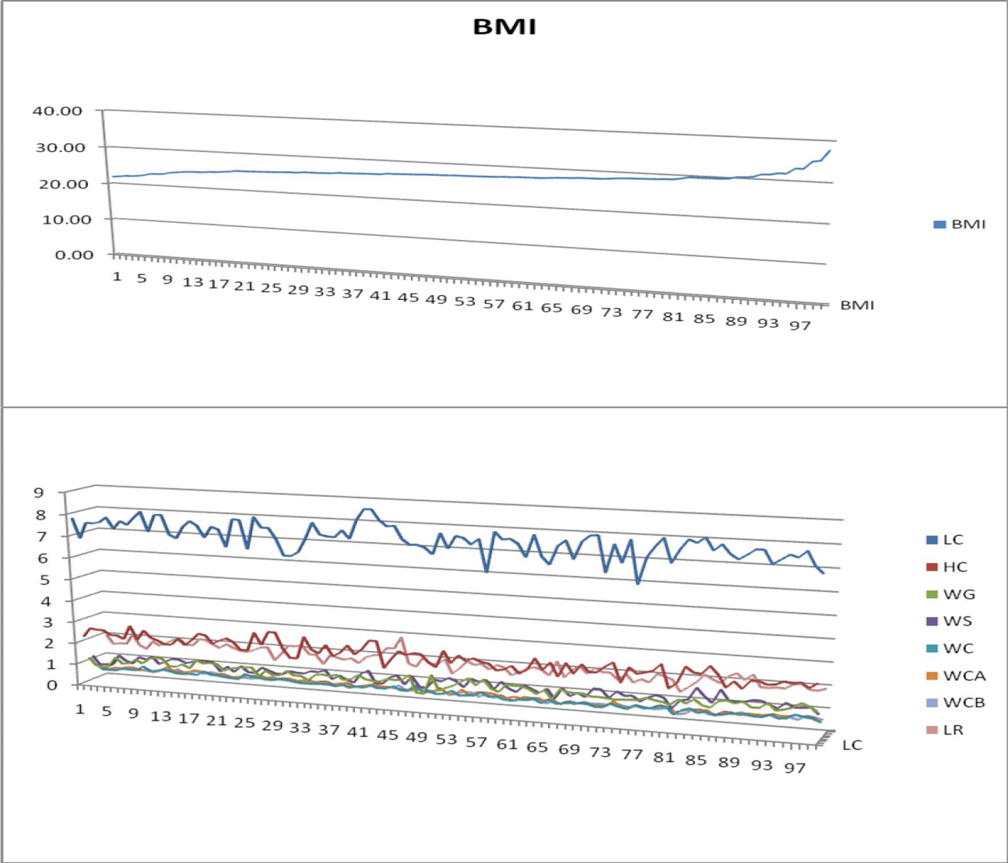

Fig xi. **A 3-D GRAPHICAL REPRESENTING THE VARIATION OF CORPUS CALLOSAL BIOMETRY WITH BMI ON THE FEMALES**

The graphs above illustrate the pattern of variation of corpus callosal biometry with BMI on the females. The horizontal axis represents the number of individual cases measured on the increasing order of BMI while the vertical axis represents the pattern of variation of corpus callosal biometry on 1 cm scale (0 to 10cm). That of BMI is on 10cm scale(0 to 80 years of age). From the graphs it was observed that as age increased on a straight line the different parameters of the biometry were not correspondingly increasing in size, it was rather sigmoidal in shape. This suggests that the biometry did not vary with BMI.

# CORRELATION ANALYSIS

TABLE 10 **CORRELATION OF BIOMETRY WITH AGE AND BMI**

|  |  |  |  |  |  |  |  |  |  |
| --- | --- | --- | --- | --- | --- | --- | --- | --- | --- |
| **BIVARARIATE CORRELATION (MALES)** | | | | | | | | | |
|  | | **LC** | **HC** | **WG** | **WS** | **WC** | **WCA** | **WCP** | **LR** |
| **AGE** | Pearson | 0.24 | 0.20 | -.20 | -01 | -.27 | -.22 | -.09 | -.20 |
| P- Value | 0.06 | 0.08 | 0.01 | 0.97 | 0.02 | 0.06 | 0.35 | 0.07 |
| **BMI** | Pearson | 0.29 | 0.04 | 0.14 | 0.01 | 0.01 | 0.20 | 0.04 | -.13 |
| P-Value | 0.07 | 0.68 | 0.13 | 0.95 | 0.95 | 0.35 | 0.67 | 0.06 |
| **BIVARIATE CORRELATION (FEMALES)** | | | | | | | | | |
| **AGE** | Pearson | 0.18 | 0.16 | -.06 | -.02 | -.08 | 0.01 | 0.11 | -0.19 |
| P-Value | 0.07 | 0.11 | 0.58 | 0.83 | 0.43 | 0.93 | 0.30 | 0.86 |
| **BMI** | Pearson | 0.11 | -.02 | 0.32 | 0.35 | 0.41 | 0.46 | 0.40 | 0.26 |
| P-Value | 0.30 | 0.84 | 0.08 | 0.06 | 0.07 | 0.09 | 0.07 | 0.08 |
| **BIVARIATE CORRELATION (TOTAL POPULATION)** | | | | | | | | | |
| **AGE** | Pearson | 0.22 | 0.19 | -.13 | -.02 | -.19 | -.13 | 0.00 | -0.12 |
| P-Value | 0.06 | 0.09 | 0.07 | 0.72 | 0.36 | 0.74 | 0.24 | 0.06 |
| **BMI** | Pearson | 0.18 | 0.01 | 0.22 | 0.20 | 0.19 | 0.32 | 0.21 | 0.04 |
| P-Value | 0.08 | 0.45 | 0.07 | 0.13 | 0.09 | 0.06 | 0.12 | 0.06 |

Correlation is significant at the 95% confidence level (0.05 level of significance).

From table 10 above, the following observations were made: All the obtained P-values > 0.05

Hence, none of the parameters of the corpus callosal biometry showed significant correlation with age for the males, females or total population.

None of the parameters of the corpus callosal biometry showed significant correlation with BMI for the males, females or total population.

# CHAPTER FIVE DISCUSSION/CONCLUSION

# DISCUSSION

The biometric values obtained from this study when compared to that of Guptal et al. (2008) among the Caucasians is significantly different. This may suggest racial variation in corpus callosal biometry. These were their values for the males and females respectively:

LC; 7.57±0.62cm and 7.10±0.41cm, WS; 1.18±0.cm and 1.43±0.13cm,

WCA; 0.91+/-0.12cm and 0.72+/-0.17cm, HC; 1.68±0.48cm and 2.18±0.43cm.

## Comparing the male and female biometry

When the mean values of the biometry were compared between the males and females no statistically significant difference was observed in any of the measured parameters. This is not in agreement with research findings of (Bishop. 1997; Suganthy et al. 2003; Dubb et al. 2003; Westerhausen et al. 2004; Shin et al. 2005; Spasojevic et al. 2006; Kontos et al. 2009; Guptal et al. 2008). There are significant difference in some of the parameters measured in their different studies.

This study suggests that there are often wider corpus callosum in the brains of women than in those of men, which allows for greater cross-talk between the hemispheres as reported by Gorman (1992) may not be the basis for women’s greater intuition than men. This is also not consistent with the findings of Yokota et al. (2005) who from their research findings supposed that the difference between the male and female callosal biometry defined the mental sex of individuals over their physical sex, the variation with sexual orientation or behaviour.

This study however agrees with Takeda et al. (1994) who reported no sexual difference in the measurements of corpus callosum in Japanese subjects. In their study most of the corpus callosal parameters were found to be similar in both sexes in both the autopsy and the MRI group. The research of Luders et al. (2003) also stated no sex difference.

## Varying biometry with age

No statistically significant variation in corpus callosal biometry with age was noted in this study in the total population, males or females. This is not consistent with the findings of Weis et al. 1993; Salat et al.1997; Sullivan et al. 2002; Guptal et al. 2008) who in their various age related studies of corpus callosum suggested various degree of variation with age of different biometric parameters.

## Varying biometry with BMI

No statistically significant variation in corpus callosal biometry with BMI was noted in this study in the total population, males or females. This is in agreement with the study of Luder et al. (2006) who using thin slice MRI showed no difference in thickness of the corpus when accounting for the size of the subject.

# LIMITATIONS OF STUDY

* + 1. High cost of MRI scan made it difficult for volunteers to be used for this study.
    2. The MRI equipment to be used is of low magnetic field strength and cannot be used for higher physiological imaging sequences.
    3. The partial effects of other factors like; level of intellectual activities, handedness and sexual orientation that could possibly affect the corpus callosal biometry were not controlled
    4. The oldest subjects that were used in this study were 79 years for the males and 64years for the females and thus the work may not have addressed the age related atrophy that sets in with the very elderly, in their nineties and above. (Salat et al.1997).

# CONCLUSION

It was a prospective cross-sectional survey study conducted in the Radiodiagnostic Department of National Hospital Abuja from June 2013 to January 2013. Data was primary and was drawn from all the adult Nigerian patients that presented for MRI brain in the National hospital Abuja within the stipulated time, who met the inclusion criteria. The total number of cases used was 210 (111 males and 99 females).

Descriptive statistics, Paired Sample T-Test, ANOVA and Correlation analysis were done using SPSS. Tables, bar charts and graphs were used to present the report. The following findings were made:

The mean corpus callosal biometry for the total population were: LC; 7.76±0.57cm, HC; 2.45±0.28cm, WG; 1.19±0.19cm, WS; 1.17±1.20cm, WC;

0.62±0.01cm, WCA; 0.58±0.01cm, WCP; 0.49±0.01cm, LR; 1.78±0.25cm.

The mean corpus callosal biometry for the males were: LC; 7.82±0.45cm, HC; 2.46±0.29cm, WG; 1.20±0.19cm, WS; 1.17±1.21cm, WC; 0.62±0.10cm, WCA;

0.49±0.09cm, WCP; 0.49±0.07cm, LR; 1.78±0.25cm.

The mean corpus callosal biometry for the females were: LC; 7.69±0.91cm, HC; 2.43±0.28cm, WG; 1.17±0.18cm, WS; 1.18±1.20cm, WC; 0.64±0.01cm, WCA; 0.59±0.08cm, WCP; 0.49±0.08cm, LR; 1.77±0.22cm.

There was no significant difference (P >0.05) in the mean values of corpus callosal biometry in males when compared to the females.

There was no significant relationship (P > 0.05) between corpus callosal biometry with age and BMI.

# SUGGESTED AREAS OF FURTHER STUDIES

* + 1. Using higher field MRI machines with capacity for functional investigations the effects of level of intellectual activities, handedness and sexual orientation on corpus callosal biometry can further be researched upon.
    2. Using the normal values from this work the effect of brain diseases on the corpus callosum can further be researched upon among the Nigerian population

# REFERENCES

Bishop KM, Wahlsten D. (1997) Sex differences in the human corpus callosum: myth or reality? Neurosci Biobehav Rev; 21: 581-601.

Caminiti R, Ghaziri H, Galuske R, Hof PR, Innocenti GM. (2006) Evolution amplified processing with temporally dispersed slow neuronal connectivity in primates. Proc Natl Acad Sci U S A. 106:19551–19556.

Clarke DF, Wheless JW, Chacon MM (2007). "Corpus callosotomy: a palliative therapeutic technique may help identify resectable epileptogenic foci". *Seizure* 16 (6): 545–53.

Crow TJ. (1998) Schizophrenia as a transcallosal misconnection syndrome. *Schizophr Res*; 30:111–14.

De Lacoste MC, Holloway R.L. (1986) Sexual dimorphism in the human corpus callosum: an extension and replication study. Human Neurobiol; 5: 87- 91.

Driesen NR, Raz N. (1995).The influence of sex, age and handedness on corpus callosum morphology: a meta analysis. Psychobio; 23: 240-7.

Dubb A, Gur R, Avants B, Gee J (2003). "Characterization of sexual dimorphism in the human corpus callosum". *Neuroimage* 20 (1): 512–9

Elster AD, Dipersio DA, Moody DM. (1990) Sexual dimorphism of the human corpus callosum studied by magnetic resonance imaging: fact, fallacy and statistical confidence. Brain Dev; 12: 321-5.

Garel, C. Cont,I., Alberti,C. Josserand,E., Moutard, M.L and H. Ducou le Pointe, H. (2011) Biometry of the Corpus Callosum in Children: MR Imaging Reference Data July 28, *AJNR 32: 1436-1443*

Gorman, C (20 January 1992). "Sizing up the sexes". *Time*: 36–43.

Gupta, T; Singh,B;Kapoor,K;Gupta,M and Kochhar, S; de Lacoste-Utam: (2008) Age and sex related variations in Corpus Callosal morphology Nepal Med Coll J; 10(4): 215-221

Holloway RL, Anderson PJ, Defendini R, Harper C. (1993) Sexual dimorphism of the human corpus callosum from three independent samples: Relative size of the corpus callosum. Amer J of Phys Anthropol; 92: 481-98.

Hynd, G.W., Hall, J., Novey, E.S., (1995). "Dyslexia and Corpus Callosum Morphology", *Archives of Neurobiology* 52(1): 32–38.

Jagan,J and Prasad. (2005) Step by step of MRI; India, Taylor and Francis Group PLC.

Kontos, Despina. Megalooikonomou, Vasileios. Gee, James C. (2009) Morphometric analysis of brain images with reduced number of statistical tests: a study on the gender-related differentiation of the corpus callosum. Artificial Intelligence in Medicine. 47(1):75-86.

Levitin, Daniel J. (1995)” This is your Brain on Music”, ‘ Wilkipeadia

Loevner, LA.(2009) Case Review Series: Brain Imaging, 2nd edition. Posted by Behrang Amini, MD/PhD Anatomy, Neuroradiology.

Luders E, Rex DE, Narr KL (2003). Relationships between sulcal asymmetries and corpus callosum size: Gender and handedness effects. Cereb Cortex; 13: 1084-93.

O’Shea RP, Corballis PM. (2003) Binocular rivalry in split-brain observers. *J Vis*;3:610–15.

Salat D, Ward A, Kaye IA, Janowsky JS. (1997) Sex differences in the corpus callosum with aging. Neurobiol Aging; 18: 191-7.

Shin YW, Kim DJ, Ha TH. (2005). "Sex differences in the human corpus callosum: diffusion tensor imaging study". *NeuroReport* 16 (8): 795–8.

Spasojević, G Stojanović, Z. Suscević , Dand Malobabić,S (2006) "Sexual dimorphism of the human corpus callosum—digital morphometric study",*Vojnosanitetski pregled* : 933–938.(official translation from Serbian).

Suganthy J, Raghuram L, Antonisamy B, Vettivel S, Madhavi C, Koshi R. (2003) Gender–and age–related differences in the morphology of the corpus callosum. Clin Anat; 16: 396-403.

Sullivan EV, Pfefferbaum A, Adalsteinsson E, Swan GE, Carmelli D.(2002) Differential rates of regional brain change in callosal and ventricular size: a 4 year longitudinal study of elderly men. Cereb Cortex; 12: 438-45.

Takeda S, Hirashima Y, Ikeda H, Yamamoto H, Sugino M Endo S.(2003) Determination of indices of the corpus callosum associated with normal aging in Japanese individuals. Neuroradiol; 45: 513-8.

Teipel, S.J.,Hampel,H.,Alexander, G.E., Schapiro, M.B.,Horwitz,B., Teichberg, D., Daley,E., Hippius H. Moller, H.J.,Rapport, S. J.,(1998). Dissociation between corpus callosum atrophy and white matter pathology in Alzheimer's disease.Neurology. Nov; 51(5):1381-5.

Walterfang, M, M. Faheyc, L. Abeld, M. Fietze, A. Woodf, E. Bowmana,d, D. Reutensg and D. Velakoulisa,(2011) Size and Shape of the Corpus Callosum in Adult Niemann-Pick Type C Reflects State and Trait Illness Variables ;*AJNR 32: 1340-1346*

Weis S, Kimbacher M, Wenger E, Neuhold A. (1993) Morphometric analysis of the corpus callosum using MR: Correlation of measurement with aging in healthy individuals. Amer J Neuroradiol; 14: 637-45.

Westerhausen R, Kreuder F, Dos Santos Sequeira S (2004). "Effects of handedness and gender on macro-and microstructure of the corpus callosum and its subregions: a combined high-resolution and diffusion- tensor MRI study". *Cognitive Brain Research* 21 (3): 418–26.

Witelson SF (1985). "The brain connection: the corpus callosum is larger in left-handers". *Science* 229 (4714): 665–68.

Westerhausen R, Walter C, Kreuder F, *(2003).* The influence of handedness and gender on the microstructure of the human corpus callosum: a diffusion- tensor magnetic resonance imaging study. *Neurosci Lett*;13:99–102.

Von Plessen, K., Lundervold, A., (2002). "Less developed corpus callosum in dyslexic subjects – a structural MRI study", *Neuropsychologia* 40(7): 1035–1044.

Yokota, Y. Kawamura, Y. Kameya, Y. (2005) Callosal Shapes at the Midsagittal Plane: MRI Differences of Normal Males, Normal Females, and GID. Annual International Conference of the IEEE Engineering in Medicine & Biology Society. 3:3055-8.

APPENDIX

|  |  |  |  |  |  |  |  |  |  |  |  |  |
| --- | --- | --- | --- | --- | --- | --- | --- | --- | --- | --- | --- | --- |
| **DATA FOR THE MALES** | | | | | | | | | | | | |
| S/N | AGE | LC | HC | WG | WS | WC | WCA | WCB | LR | WT | HT | BMI |
| 1. | 18 | 7.31 | 2.09 | 1.23 | 0.94 | 0.64 | 0.61 | 0.52 | 1.74 | 55 | 1.68 | 19.49 |
| 2. | 18 | 7.72 | 2.14 | 0.99 | 2.14 | 0.60 | 0.51 | 0.54 | 1.64 | 55 | 1.63 | 20.70 |
| 3. | 18 | 8.04 | 2.38 | 1.55 | 1.48 | 0.73 | 0.67 | 0.59 | 2.32 | 54 | 1.61 | 20.83 |
| 4. | 19 | 7.85 | 1.86 | 1.92 | 1.29 | 0.69 | 0.67 | 0.68 | 1.91 | 53 | 1.58 | 21.23 |
| 5. | 19 | 7.78 | 2.75 | 1.27 | 1.25 | 0.64 | 0.56 | 0.50 | 1.94 | 55 | 1.58 | 22.03 |
| 6. | 19 | 8.28 | 2.56 | 1.14 | 1.32 | 0.73 | 0.65 | 0.51 | 1.83 | 55 | 1.58 | 22.03 |
| 7. | 19 | 8.84 | 2.43 | 1.10 | 1.11 | 0.60 | 0.72 | 0.42 | 1.56 | 68 | 1.75 | 22.20 |
| 8. | 20 | 7.61 | 2.26 | 1.12 | 1.19 | 0.63 | 0.57 | 0.46 | 1.82 | 59 | 1.62 | 22.48 |
| 9. | 24 | 7.59 | 2.24 | 1.13 | 1.17 | 0.65 | 0.55 | 0.47 | 1.81 | 48 | 1.46 | 22.52 |
| 10. | 24 | 7.34 | 2.63 | 1.31 | 1.12 | 0.70 | 0.69 | 0.60 | 2.01 | 75 | 1.82 | 22.64 |
| 11. | 24 | 8.44 | 2.32 | 0.92 | 1.26 | 0.45 | 0.52 | 0.46 | 1.71 | 60 | 1.62 | 22.86 |
| 12. | 26 | 8.22 | 2.45 | 1.27 | 1.20 | 0.62 | 0.70 | 0.40 | 1.84 | 60 | 1.62 | 22.86 |
| 13. | 26 | 7.67 | 2.46 | 1.34 | 1.01 | 0.69 | 0.63 | 0.47 | 1.92 | 78 | 1.83 | 23.29 |
| 14. | 27 | 7.16 | 2.13 | 1.09 | 1.04 | 0.61 | 0.55 | 0.50 | 1.75 | 61 | 1.61 | 23.53 |
| 15. | 27 | 7.23 | 2.24 | 1.13 | 1.21 | 0.63 | 0.62 | 0.44 | 1.61 | 78 | 1.82 | 23.55 |
| 16. | 27 | 8.79 | 2.19 | 1.68 | 1.48 | 0.78 | 0.62 | 0.56 | 2.35 | 73 | 1.76 | 23.57 |
| 17. | 29 | 7.46 | 2.36 | 0.99 | 0.97 | 0.5 | 0.43 | 0.42 | 1.94 | 70 | 1.72 | 23.66 |
| 18. | 29 | 7.58 | 2.26 | 1.15 | 1.14 | 0.66 | 0.56 | 0.45 | 1.78 | 67 | 1.68 | 23.74 |
| 19. | 29 | 7.64 | 2.92 | 1.30 | 1.37 | 0.67 | 0.61 | 0.51 | 2.05 | 48 | 1.42 | 23.80 |
| 20. | 29 | 7.85 | 2.01 | 1.73 | 1.35 | 0.63 | 0.66 | 0.64 | 1.85 | 80 | 1.83 | 23.89 |
| 21. | 30 | 7.89 | 2.29 | 1.28 | 1.22 | 0.72 | 0.88 | 0.58 | 2.06 | 63 | 1.62 | 24.01 |
| 22. | 30 | 8.32 | 2.51 | 0.98 | 0.96 | 0.42 | 0.43 | 0.44 | 1.63 | 80 | 1.81 | 24.42 |
| 23. | 30 | 7.68 | 2.36 | 0.93 | 1.04 | 0.50 | 0.49 | 0.37 | 1.45 | 83 | 1.84 | 24.52 |

|  |  |  |  |  |  |  |  |  |  |  |  |  |
| --- | --- | --- | --- | --- | --- | --- | --- | --- | --- | --- | --- | --- |
| 24. | 30 | 7.48 | 2.11 | 1.32 | 1.12 | 0.52 | 0.46 | 0.42 | 1.79 | 57 | 1.52 | 24.67 |
| 25. | 30 | 7.55 | 2.17 | 1.33 | 1.29 | 0.67 | 0.62 | 0.55 | 1.74 | 73 | 1.72 | 24.68 |
| 26. | 31 | 8.13 | 2.85 | 1.17 | 1.13 | 0.69 | 0.56 | 0.47 | 2.85 | 80 | 1.8 | 24.69 |
| 27. | 31 | 7.19 | 2.09 | 1.10 | 1.00 | 0.51 | 0.55 | 0.46 | 1.69 | 70 | 1.68 | 24.80 |
| 28. | 31 | 7.74 | 2.70 | 1.19 | 0.44 | 0.67 | 0.60 | 0.51 | 1.82 | 70 | 1.68 | 24.80 |
| 29. | 32 | 7.31 | 2.15 | 1.18 | 1.35 | 0.59 | 0.63 | 0.46 | 1.65 | 59 | 1.54 | 24.88 |
| 30. | 32 | 8.26 | 2.54 | 1.13 | 1.34 | 0.70 | 0.63 | 0.46 | 1.79 | 64 | 1.6 | 25.00 |
| 31. | 32 | 7.91 | 2.79 | 1.05 | 0.95 | 0.57 | 0.46 | 0.37 | 1.96 | 61 | 1.56 | 25.07 |
| 32. | 33 | 7.71 | 2.55 | 1.22 | 0.48 | 0.61 | 0.55 | 0.51 | 1.66 | 63 | 1.58 | 25.24 |
| 33. | 33 | 7.60 | 2.28 | 1.14 | 1.21 | 0.64 | 0.58 | 0.45 | 1.84 | 69 | 1.65 | 25.34 |
| 34. | 36 | 8.58 | 2.44 | 1.41 | 1.40 | 0.55 | 0.55 | 0.50 | 1.84 | 75 | 1.72 | 25.35 |
| 35. | 36 | 8.31 | 2.65 | 1.21 | 1.32 | 0.77 | 0.45 | 0.43 | 1.96 | 88 | 1.86 | 25.44 |
| 36. | 37 | 8.33 | 2.51 | 1.02 | 0.98 | 0.44 | 0.43 | 0.45 | 1.66 | 78 | 1.75 | 25.47 |
| 37. | 37 | 8.42 | 2.31 | 0.91 | 1.25 | 0.43 | 0.48 | 0.45 | 1.74 | 72 | 1.68 | 25.51 |
| 38. | 37 | 8.43 | 2.30 | 0.92 | 1.26 | 0.43 | 0.53 | 0.47 | 1.69 | 85 | 1.82 | 25.66 |
| 39. | 37 | 8.25 | 2.61 | 1.18 | 1.31 | 0.71 | 0.66 | 0.52 | 1.79 | 78 | 1.74 | 25.76 |
| 40. | 39 | 7.09 | 2.55 | 1.14 | 1.25 | 0.61 | 0.71 | 0.41 | 1.67 | 73 | 1.68 | 25.86 |
| 41. | 39 | 7.59 | 2.62 | 1.29 | 1.14 | 0.64 | 0.58 | 0.50 | 1.51 | 73 | 1.68 | 25.86 |
| 42. | 39 | 7.91 | 2.45 | 1.29 | 1.29 | 0.75 | 0.54 | 0.46 | 1.81 | 63 | 1.56 | 25.89 |
| 43. | 40 | 7.67 | 2.53 | 1.25 | 0.45 | 0.61 | 0.56 | 0.49 | 1.63 | 85 | 1.81 | 25.95 |
| 44. | 40 | 7.68 | 2.32 | 1.26 | 1.13 | 0.50 | 0.49 | 0.50 | 1.44 | 75 | 1.7 | 25.95 |
| 45. | 41 | 7.16 | 2.04 | 1.36 | 0.95 | 0.58 | 0.47 | 0.40 | 1.61 | 73 | 1.67 | 26.18 |
| 46. | 41 | 8.33 | 2.64 | 1.23 | 1.31 | 0.78 | 0.46 | 0.44 | 1.92 | 73 | 1.67 | 26.18 |
| 47. | 41 | 7.69 | 2.45 | 1.24 | 1.17 | 0.62 | 0.55 | 0.56 | 2.35 | 83 | 1.78 | 26.20 |
| 48. | 42 | 7.59 | 2.99 | 1.07 | 0.96 | 0.56 | 0.66 | 0.68 | 1.44 | 68 | 1.61 | 26.23 |
| 49. | 42 | 7.95 | 2.87 | 1.32 | 1.24 | 0.64 | 0.64 | 0.47 | 2.02 | 70 | 1.63 | 26.35 |
| 50. | 42 | 8.49 | 2.53 | 1.31 | 1.37 | 0.67 | 0.59 | 0.41 | 1.98 | 72 | 1.65 | 26.45 |

|  |  |  |  |  |  |  |  |  |  |  |  |  |
| --- | --- | --- | --- | --- | --- | --- | --- | --- | --- | --- | --- | --- |
| 51. | 42 | 7.64 | 2.53 | 1.24 | 1.05 | 0.68 | 0.76 | 0.61 | 1.70 | 63 | 1.54 | 26.56 |
| 52. | 42 | 7.85 | 2.59 | 1.35 | 1.15 | 0.55 | 0.48 | 0.42 | 1.92 | 75 | 1.68 | 26.57 |
| 53. | 43 | 8.29 | 2.38 | 1.21 | 1.29 | 0.77 | 0.61 | 0.53 | 1.85 | 76 | 1.69 | 26.61 |
| 54. | 43 | 7.63 | 2.12 | 1.04 | 1.30 | 0.55 | 0.53 | 0.52 | 1.77 | 72 | 1.64 | 26.77 |
| 55. | 45 | 8.65 | 2.43 | 1.15 | 1.39 | 0.80 | 0.65 | 0.57 | 2.31 | 67 | 1.58 | 26.84 |
| 56. | 45 | 7.25 | 2.26 | 1.15 | 1.22 | 0.62 | 0.61 | 0.45 | 1.59 | 91 | 1.84 | 26.88 |
| 57. | 45 | 7.85 | 2.91 | 1.01 | 1.19 | 0.68 | 0.61 | 0.51 | 1.54 | 76 | 1.68 | 26.93 |
| 58. | 46 | 7.24 | 2.25 | 1.14 | 1.23 | 0.64 | 0.63 | 0.43 | 1.58 | 78 | 1.7 | 26.99 |
| 59. | 46 | 7.23 | 2.41 | 1.24 | 1.02 | 0.65 | 0.60 | 0.42 | 1.39 | 80 | 1.72 | 27.04 |
| 60. | 46 | 7.57 | 2.22 | 1.17 | 1.08 | 0.67 | 0.69 | 0.53 | 2.08 | 81 | 1.73 | 27.06 |
| 61. | 46 | 7.21 | 2.10 | 1.31 | 1.31 | 0.61 | 0.50 | 0.51 | 1.68 | 66 | 1.56 | 27.12 |
| 62. | 47 | 7.54 | 2.49 | 0.89 | 1.14 | 0.46 | 0.50 | 0.36 | 1.67 | 66 | 1.56 | 27.12 |
| 63. | 47 | 7.22 | 2.21 | 1.11 | 1.19 | 0.65 | 0.61 | 0.45 | 1.59 | 88 | 1.8 | 27.16 |
| 64. | 48 | 7.94 | 3.14 | 0.97 | 1.11 | 0.68 | 0.60 | 0.53 | 1.63 | 62 | 1.51 | 27.19 |
| 65. | 48 | 8.00 | 2.32 | 1.27 | 1.30 | 0.60 | 0.55 | 0.39 | 1.57 | 68 | 1.58 | 27.24 |
| 66. | 49 | 7.56 | 2.62 | 1.06 | 1.09 | 0.78 | 0.61 | 0.52 | 1.74 | 85 | 1.76 | 27.44 |
| 67. | 49 | 8.36 | 2.81 | 1.61 | 1.07 | 0.65 | 0.65 | 0.78 | 1.92 | 91 | 1.82 | 27.47 |
| 68. | 49 | 8.5 | 2.54 | 1.31 | 1.38 | 0.65 | 0.58 | 0.41 | 1.23 | 73 | 1.63 | 27.48 |
| 69. | 50 | 8.43 | 2.98 | 1.23 | 1.49 | 0.60 | 0.58 | 0.51 | 1.91 | 82 | 1.72 | 27.72 |
| 70. | 50 | 7.69 | 2.54 | 1.23 | 0.47 | 0.62 | 0.57 | 0.52 | 1.64 | 85 | 1.75 | 27.76 |
| 71. | 51 | 8.21 | 2.69 | 1.65 | 1.24 | 0.89 | 0.84 | 0.65 | 1.78 | 95 | 1.85 | 27.76 |
| 72. | 51 | 7.98 | 2.73 | 1.02 | 1.29 | 0.52 | 0.60 | 0.43 | 1.73 | 65 | 1.53 | 27.77 |
| 73. | 51 | 8.45 | 2.83 | 1.01 | 1.49 | 0.54 | 0.46 | 0.45 | 1.51 | 73 | 1.62 | 27.82 |
| 74. | 51 | 7.68 | 2.13 | 1.29 | 1.35 | 0.60 | 0.54 | 0.50 | 1.74 | 66 | 1.54 | 27.83 |
| 75. | 51 | 7.24 | 2.43 | 0.99 | 1.14 | 0.45 | 0.49 | 0.44 | 1.64 | 66 | 1.54 | 27.83 |
| 76. | 51 | 8.53 | 2.68 | 1.24 | 1.14 | 0.64 | 0.53 | 0.47 | 1.97 | 75 | 1.64 | 27.89 |
| 77. | 51 | 8.52 | 2.55 | 1.29 | 1.36 | 0.67 | 0.59 | 0.43 | 1.25 | 75 | 1.64 | 27.89 |

|  |  |  |  |  |  |  |  |  |  |  |  |  |
| --- | --- | --- | --- | --- | --- | --- | --- | --- | --- | --- | --- | --- |
| 78. | 51 | 7.63 | 2.78 | 1.11 | 0.98 | 0.56 | 0.68 | 0.67 | 1.49 | 67 | 1.55 | 27.89 |
| 79. | 52 | 7.31 | 2.31 | 0.86 | 0.94 | 0.41 | 0.39 | 0.35 | 1.55 | 95 | 1.84 | 28.06 |
| 80. | 52 | 7.27 | 2.48 | 1.17 | 1.08 | 0.65 | 0.53 | 0.41 | 1.96 | 85 | 1.74 | 28.08 |
| 81. | 52 | 7.83 | 2.02 | 1.75 | 1.33 | 0.66 | 0.65 | 0.62 | 1.87 | 85 | 1.74 | 28.08 |
| 82. | 52 | 8.11 | 2.74 | 1.33 | 1.14 | 0.67 | 0.65 | 0.57 | 1.97 | 93 | 1.82 | 28.08 |
| 83. | 53 | 7.64 | 2.72 | 1.30 | 1.21 | 0.67 | 0.69 | 0.48 | 1.86 | 93 | 1.82 | 28.08 |
| 84. | 54 | 7.44 | 2.53 | 1.14 | 0.95 | 0.60 | 0.58 | 0.42 | 1.98 | 90 | 1.78 | 28.41 |
| 85. | 54 | 8.63 | 2.98 | 1.65 | 1.24 | 0.89 | 0.84 | 0.65 | 2.45 | 88 | 1.76 | 28.41 |
| 86. | 57 | 7.21 | 2.49 | 0.80 | 0.90 | 0.62 | 0.43 | 0.43 | 1.49 | 76 | 1.63 | 28.60 |
| 87. | 57 | 8.30 | 2.50 | 1.00 | 0.95 | 0.41 | 0.40 | 0.40 | 1.62 | 67 | 1.53 | 28.62 |
| 88. | 58 | 8.24 | 2.48 | 1.14 | 1.29 | 0.60 | 0.55 | 0.47 | 1.72 | 88 | 1.75 | 28.73 |
| 89. | 58 | 7.14 | 2.18 | 1.12 | 1.29 | 0.65 | 0.72 | 0.40 | 1.72 | 106 | 1.92 | 28.75 |
| 90. | 59 | 7.84 | 3.23 | 1.04 | 1.14 | 0.80 | 0.63 | 0.47 | 2.09 | 105 | 1.91 | 28.78 |
| 91. | 59 | 7.25 | 2.46 | 1.19 | 1.11 | 0.63 | 0.55 | 0.46 | 1.92 | 93 | 1.79 | 29.03 |
| 92. | 60 | 7.87 | 2.32 | 1.25 | 1.10 | 0.76 | 0.65 | 0.50 | 1.76 | 80 | 1.66 | 29.03 |
| 93. | 60 | 7.08 | 2.68 | 1.19 | 0.95 | 0.67 | 0.53 | 0.45 | 1.75 | 82 | 1.68 | 29.05 |
| 94. | 60 | 8.07 | 2.05 | 1.28 | 1.34 | 0.58 | 0.61 | 0.56 | 2.05 | 72 | 1.57 | 29.21 |
| 95. | 61 | 7.55 | 2.43 | 1.04 | 1.29 | 0.65 | 0.51 | 0.47 | 1.53 | 100 | 1.85 | 29.22 |
| 96. | 61 | 7.74 | 2.48 | 1.02 | 1.05 | 0.60 | 0.54 | 0.51 | 1.49 | 97 | 1.82 | 29.28 |
| 97. | 62 | 7.94 | 2.38 | 1.05 | 1.07 | 0.68 | 0.67 | 0.57 | 1.91 | 80 | 1.65 | 29.38 |
| 98. | 64 | 7.61 | 3.01 | 1.08 | 0.94 | 0.54 | 0.67 | 0.65 | 1.47 | 75 | 1.59 | 29.67 |
| 99. | 64 | 8.12 | 2.39 | 1.05 | 1.04 | 0.55 | 0.42 | 0.41 | 1.75 | 101 | 1.84 | 29.83 |
| 100 | 64 | 8.33 | 2.53 | 1.46 | 1.34 | 0.70 | 0.56 | 0.5 | 2.23 | 98 | 1.81 | 29.91 |
| 101 | 65 | 8.3 | 2.68 | 1.18 | 1.33 | 0.76 | 0.47 | 0.40 | 2.13 | 90 | 1.72 | 30.42 |
| 102 | 66 | 7.53 | 2.51 | 1.01 | 0.86 | 0.55 | 0.54 | 0.50 | 1.72 | 117 | 1.96 | 30.46 |
| 103 | 67 | 8.21 | 2.52 | 1.03 | 0.98 | 0.42 | 0.43 | 0.44 | 1.65 | 72 | 1.53 | 30.76 |
| 104 | 67 | 8.06 | 2.54 | 1.16 | 1.16 | 0.70 | 0.56 | 0.55 | 1.82 | 115 | 1.93 | 30.87 |

|  |  |  |  |  |  |  |  |  |  |  |  |  |  |  |  |  |  |  |  |  |  |  |
| --- | --- | --- | --- | --- | --- | --- | --- | --- | --- | --- | --- | --- | --- | --- | --- | --- | --- | --- | --- | --- | --- | --- |
| 105 | 67 | | 7.02 | | 1.53 | | 1.33 | | 1.17 | | 0.64 | | 0.58 | | 0.37 | | 1.79 | | 75 | | 1.54 | 31.62 |
| 106 | 68 | | 7.61 | | 2.54 | | 1.14 | | 1.24 | | 0.79 | | 0.65 | | 0.57 | | 1.63 | | 76 | | 1.55 | 31.63 |
| 107 | 68 | | 7.31 | | 2.15 | | 1.18 | | 1.35 | | 0.59 | | 0.63 | | 0.46 | | 1.65 | | 118 | | 1.92 | 32.01 |
| 108 | 73 | | 8.23 | | 2.53 | | 1.02 | | 1.98 | | 0.43 | | 0.45 | | 0.44 | | 1.67 | | 74 | | 1.52 | 32.03 |
| 109 | 74 | | 7.39 | | 1.69 | | 1.49 | | 1.19 | | 0.47 | | 0.47 | | 0.30 | | 1.62 | | 127 | | 1.97 | 32.72 |
| 110 | 75 | | 7.43 | | 2.60 | | 1.12 | | 1.01 | | 0.60 | | 0.53 | | 0.50 | | 2.01 | | 112 | | 1.85 | 32.72 |
| 111 | 79 | | 7.79 | | 2.83 | | 1.23 | | 1.13 | | 0.60 | | 0.64 | | 0.44 | | 1.38 | | 127 | | 1.96 | 33.06 |
| **DATA FOR THE FEMALES** | | | | | | | | | | | | | | | | | | | | | | |
| S/N | | AGE | | LC | | HC | | WG | | WS | | WC | | WCA | | WCB | | LR | | WT | HT | BMI |
| 1. | | 18 | | 7.82 | | 2.23 | | 1.16 | | 1.18 | | 0.66 | | 0.42 | | 0.38 | | 1.93 | | 52 | 1.54 | 21.93 |
| 2. | | 19 | | 6.91 | | 2.64 | | 0.81 | | 0.78 | | 0.46 | | 0.42 | | 0.32 | | 1.51 | | 60 | 1.65 | 22.04 |
| 3. | | 19 | | 7.63 | | 2.6 | | 0.75 | | 0.81 | | 0.46 | | 0.50 | | 0.38 | | 1.56 | | 45 | 1.42 | 22.32 |
| 4. | | 19 | | 7.62 | | 2.59 | | 0.81 | | 0.83 | | 0.47 | | 0.50 | | 0.38 | | 1.56 | | 45 | 1.42 | 22.32 |
| 5. | | 20 | | 7.69 | | 2.39 | | 1.25 | | 1.29 | | 0.57 | | 0.57 | | 0.45 | | 2.06 | | 46 | 1.43 | 22.49 |
| 6. | | 21 | | 7.93 | | 2.39 | | 0.98 | | 1.05 | | 0.55 | | 0.58 | | 0.45 | | 1.54 | | 46 | 1.42 | 22.81 |
| 7. | | 21 | | 7.43 | | 2.25 | | 1.02 | | 0.95 | | 0.55 | | 0.46 | | 0.40 | | 1.39 | | 61 | 1.62 | 23.24 |
| 8. | | 22 | | 7.79 | | 2.89 | | 1.22 | | 1.27 | | 0.76 | | 0.57 | | 0.37 | | 1.77 | | 65 | 1.67 | 23.31 |
| 9. | | 22 | | 7.64 | | 2.26 | | 1.07 | | 1.19 | | 0.55 | | 0.43 | | 0.38 | | 1.59 | | 57 | 1.56 | 23.42 |
| 10. | | 23 | | 7.97 | | 2.72 | | 1.29 | | 1.35 | | 0.60 | | 0.54 | | 0.50 | | 1.72 | | 79 | 1.82 | 23.85 |
| 11. | | 24 | | 8.27 | | 2.4 | | 1.41 | | 1.01 | | 0.70 | | 0.73 | | 0.44 | | 1.9 | | 60 | 1.58 | 24.03 |
| 12. | | 24 | | 7.38 | | 2.29 | | 1.35 | | 1.18 | | 0.63 | | 0.57 | | 0.59 | | 1.99 | | 51 | 1.45 | 24.26 |
| 13. | | 24 | | 8.15 | | 2.13 | | 1.02 | | 1.31 | | 0.55 | | 0.53 | | 0.45 | | 1.74 | | 79 | 1.8 | 24.38 |
| 14. | | 24 | | 8.16 | | 2.15 | | 1.04 | | 1.29 | | 0.54 | | 0.56 | | 0.46 | | 1.72 | | 80 | 1.81 | 24.42 |
| 15. | | 25 | | 7.30 | | 2.45 | | 1.16 | | 1.16 | | 0.57 | | 0.67 | | 0.55 | | 2.04 | | 58 | 1.54 | 24.46 |
| 16. | | 25 | | 7.15 | | 2.17 | | 1.01 | | 1.25 | | 0.55 | | 0.65 | | 0.45 | | 2.02 | | 60 | 1.56 | 24.65 |
| 17. | | 25 | | 7.68 | | 2.43 | | 1.43 | | 1.33 | | 0.74 | | 0.62 | | 0.57 | | 1.84 | | 64 | 1.61 | 24.69 |
| 18. | | 25 | | 7.95 | | 2.75 | | 1.28 | | 1.32 | | 0.61 | | 0.52 | | 0.51 | | 1.69 | | 46 | 1.36 | 24.87 |

|  |  |  |  |  |  |  |  |  |  |  |  |  |
| --- | --- | --- | --- | --- | --- | --- | --- | --- | --- | --- | --- | --- |
| 19. | 26 | 7.77 | 2.70 | 1.33 | 1.28 | 0.60 | 0.58 | 0.53 | 1.90 | 74 | 1.72 | 25.01 |
| 20. | 28 | 7.25 | 2.33 | 1.30 | 0.89 | 0.55 | 0.50 | 0.41 | 1.74 | 60 | 1.54 | 25.30 |
| 21. | 28 | 7.75 | 2.50 | 1.02 | 1.14 | 0.52 | 0.50 | 0.4 | 1.64 | 82 | 1.8 | 25.31 |
| 22. | 28 | 7.64 | 2.63 | 1.14 | 0.92 | 0.51 | 0.56 | 0.42 | 1.59 | 83 | 1.81 | 25.34 |
| 23. | 29 | 6.88 | 2.47 | 1.21 | 1.22 | 0.77 | 0.62 | 0.41 | 1.70 | 65 | 1.6 | 25.39 |
| 24. | 30 | 8.13 | 2.13 | 1.25 | 0.96 | 0.67 | 0.63 | 0.45 | 1.85 | 77 | 1.74 | 25.43 |
| 25. | 30 | 8.11 | 2.15 | 1.27 | 0.94 | 0.65 | 0.65 | 0.46 | 1.89 | 79 | 1.76 | 25.50 |
| 26. | 32 | 6.84 | 2.98 | 0.89 | 1.22 | 0.59 | 0.57 | 0.58 | 1.30 | 73 | 1.69 | 25.56 |
| 27. | 32 | 8.29 | 2.45 | 1.17 | 1.10 | 0.58 | 0.56 | 0.48 | 1.64 | 60 | 1.53 | 25.63 |
| 28. | 33 | 7.85 | 3.04 | 1.01 | 0.94 | 0.62 | 0.67 | 0.42 | 2.07 | 72 | 1.68 | 25.70 |
| 29. | 34 | 7.83 | 3.06 | 1.00 | 0.99 | 0.65 | 0.63 | 0.45 | 2.03 | 70 | 1.65 | 25.71 |
| 30. | 35 | 7.35 | 2.34 | 1.24 | 1.15 | 0.59 | 0.56 | 0.40 | 2.11 | 56 | 1.47 | 25.92 |
| 31. | 37 | 6.64 | 1.94 | 1.05 | 1.10 | 0.55 | 0.60 | 0.47 | 1.70 | 84 | 1.8 | 25.93 |
| 32. | 37 | 6.64 | 1.94 | 1.05 | 1.10 | 0.55 | 0.60 | 0.47 | 1.70 | 84 | 1.8 | 25.93 |
| 33. | 37 | 6.83 | 2.95 | 0.87 | 1.23 | 0.56 | 0.54 | 0.53 | 1.29 | 76 | 1.71 | 25.99 |
| 34. | 37 | 7.43 | 2.40 | 1.15 | 1.21 | 0.58 | 0.61 | 0.55 | 1.75 | 70 | 1.64 | 26.03 |
| 35. | 37 | 8.17 | 2.24 | 1.20 | 1.33 | 0.58 | 0.52 | 0.42 | 1.64 | 68 | 1.61 | 26.23 |
| 36. | 37 | 7.66 | 2.65 | 1.15 | 0.93 | 0.53 | 0.58 | 0.43 | 1.57 | 85 | 1.8 | 26.23 |
| 37. | 37 | 7.59 | 2.16 | 1.23 | 1.13 | 0.61 | 0.64 | 0.55 | 1.66 | 64 | 1.56 | 26.30 |
| 38. | 37 | 7.58 | 2.35 | 1.02 | 0.95 | 0.51 | 0.49 | 0.40 | 1.46 | 70 | 1.63 | 26.35 |
| 39. | 38 | 7.90 | 2.70 | 1.08 | 0.86 | 0.60 | 0.54 | 0.40 | 1.75 | 71 | 1.64 | 26.40 |
| 40. | 38 | 7.54 | 2.32 | 1.30 | 1.29 | 0.58 | 0.61 | 0.55 | 1.87 | 66 | 1.58 | 26.44 |
| 41. | 38 | 8.4 | 2.58 | 1.13 | 1.46 | 0.69 | 0.69 | 0.42 | 1.92 | 72 | 1.65 | 26.45 |
| 42. | 39 | 8.87 | 2.99 | 1.08 | 0.91 | 0.60 | 0.60 | 0.51 | 2.26 | 71 | 1.63 | 26.72 |
| 43. | 39 | 8.87 | 2.99 | 1.08 | 0.91 | 0.60 | 0.60 | 0.51 | 2.26 | 71 | 1.63 | 26.72 |
| 44. | 39 | 8.42 | 1.79 | 1.22 | 1.23 | 0.74 | 0.57 | 0.62 | 2.81 | 54 | 1.42 | 26.78 |
| 45. | 40 | 8.17 | 2.24 | 1.20 | 1.33 | 0.58 | 0.51 | 0.43 | 1.62 | 67 | 1.58 | 26.84 |

|  |  |  |  |  |  |  |  |  |  |  |  |  |
| --- | --- | --- | --- | --- | --- | --- | --- | --- | --- | --- | --- | --- |
| 46. | 40 | 8.21 | 2.61 | 1.22 | 0.95 | 0.57 | 0.57 | 0.45 | 1.49 | 75 | 1.67 | 26.89 |
| 47. | 40 | 7.65 | 2.46 | 1.47 | 1.35 | 0.86 | 0.60 | 0.6 | 1.94 | 64 | 1.54 | 26.99 |
| 48. | 41 | 7.42 | 2.57 | 0.69 | 0.89 | 0.61 | 0.50 | 0.51 | 1.68 | 70 | 1.61 | 27.01 |
| 49. | 43 | 7.44 | 2.54 | 0.67 | 0.87 | 0.62 | 0.52 | 0.49 | 1.67 | 71 | 1.62 | 27.05 |
| 50. | 43 | 7.33 | 2.21 | 1.56 | 1.27 | 0.54 | 0.76 | 0.58 | 1.94 | 65 | 1.55 | 27.06 |
| 51. | 44 | 7.06 | 2.01 | 0.87 | 1.22 | 0.58 | 0.52 | 0.36 | 1.29 | 73 | 1.64 | 27.14 |
| 52. | 44 | 8.00 | 2.77 | 1.02 | 1.4 | 0.74 | 0.50 | 0.46 | 1.56 | 67 | 1.56 | 27.18 |
| 53. | 44 | 7.35 | 2.24 | 1.15 | 1.28 | 0.55 | 0.75 | 0.57 | 1.93 | 67 | 1.57 | 27.18 |
| 54. | 44 | 7.91 | 2.61 | 1.35 | 1.03 | 0.58 | 0.51 | 0.56 | 1.77 | 58 | 1.46 | 27.21 |
| 55. | 45 | 7.84 | 2.39 | 1.54 | 1.44 | 0.60 | 0.67 | 0.40 | 1.84 | 63 | 1.52 | 27.27 |
| 56. | 45 | 7.58 | 2.53 | 1.24 | 1.33 | 0.76 | 0.70 | 0.53 | 1.61 | 59 | 1.47 | 27.30 |
| 57. | 46 | 7.84 | 2.39 | 1.54 | 1.44 | 0.60 | 0.67 | 0.40 | 1.84 | 70 | 1.6 | 27.34 |
| 58. | 46 | 6.40 | 2.34 | 1.14 | 1.04 | 0.64 | 0.60 | 0.55 | 1.75 | 91 | 1.82 | 27.47 |
| 59. | 48 | 8.18 | 2.06 | 1.02 | 1.41 | 0.53 | 0.51 | 0.38 | 1.42 | 61 | 1.49 | 27.48 |
| 60. | 48 | 7.86 | 2.13 | 1.38 | 1.12 | 0.50 | 0.60 | 0.35 | 1.59 | 68 | 1.57 | 27.59 |
| 61. | 48 | 7.91 | 2.32 | 1.35 | 1.00 | 0.58 | 0.56 | 0.55 | 1.76 | 68 | 1.57 | 27.59 |
| 62. | 48 | 7.71 | 1.99 | 1.36 | 1.32 | 0.58 | 0.58 | 0.53 | 1.86 | 78 | 1.68 | 27.64 |
| 63. | 49 | 7.16 | 2.19 | 1.25 | 1.19 | 0.65 | 0.58 | 0.55 | 1.78 | 78 | 1.68 | 27.64 |
| 64. | 49 | 8.14 | 2.73 | 1.05 | 1.04 | 0.50 | 0.54 | 0.33 | 1.54 | 56 | 1.42 | 27.77 |
| 65. | 50 | 7.23 | 2.23 | 1.27 | 1.25 | 0.66 | 0.65 | 0.45 | 2.20 | 76 | 1.65 | 27.92 |
| 66. | 50 | 6.90 | 2.59 | 0.87 | 0.83 | 0.52 | 0.43 | 0.35 | 1.50 | 63 | 1.5 | 28.00 |
| 67. | 50 | 7.71 | 1.99 | 1.36 | 1.32 | 0.58 | 0.58 | 0.53 | 1.86 | 70 | 1.58 | 28.04 |
| 68. | 50 | 7.97 | 2.62 | 1.25 | 1.00 | 0.61 | 0.49 | 0.45 | 2.07 | 66 | 1.53 | 28.19 |
| 69. | 52 | 7.18 | 2.17 | 1.23 | 1.17 | 0.63 | 0.57 | 0.53 | 1.75 | 74 | 1.62 | 28.20 |
| 70. | 52 | 7.95 | 2.61 | 1.24 | 1.01 | 0.62 | 0.52 | 0.48 | 2.04 | 75 | 1.63 | 28.23 |
| 71. | 53 | 8.22 | 2.28 | 1.13 | 1.42 | 0.52 | 0.50 | 0.50 | 1.87 | 75 | 1.63 | 28.23 |
| 72. | 53 | 8.25 | 2.31 | 1.14 | 1.41 | 0.53 | 0.50 | 0.50 | 1.87 | 93 | 1.81 | 28.39 |

|  |  |  |  |  |  |  |  |  |  |  |  |  |
| --- | --- | --- | --- | --- | --- | --- | --- | --- | --- | --- | --- | --- |
| 73. | 53 | 6.69 | 2.59 | 1.11 | 1.04 | 0.71 | 0.76 | 0.58 | 1.57 | 75 | 1.62 | 28.58 |
| 74. | 53 | 7.92 | 2.79 | 1.08 | 1.37 | 0.61 | 0.53 | 0.5 | 1.87 | 95 | 1.82 | 28.68 |
| 75. | 54 | 7.14 | 1.93 | 1.10 | 1.20 | 0.54 | 0.46 | 0.45 | 1.50 | 88 | 1.75 | 28.73 |
| 76. | 54 | 8.15 | 2.63 | 1.12 | 1.23 | 0.73 | 0.67 | 0.56 | 1.68 | 70 | 1.56 | 28.76 |
| 77. | 55 | 6.27 | 2.37 | 1.14 | 1.00 | 0.64 | 0.53 | 0.50 | 1.56 | 71 | 1.57 | 28.80 |
| 78. | 55 | 7.44 | 2.45 | 1.27 | 1.20 | 0.65 | 0.59 | 0.45 | 1.97 | 73 | 1.59 | 28.88 |
| 79. | 55 | 7.91 | 2.55 | 1.19 | 1.34 | 0.75 | 0.74 | 0.50 | 1.89 | 96 | 1.82 | 28.98 |
| 80. | 55 | 8.29 | 2.87 | 1.14 | 1.24 | 0.79 | 0.65 | 0.57 | 1.75 | 78 | 1.64 | 29.00 |
| 81. | 58 | 7.25 | 1.83 | 1.04 | 0.80 | 0.45 | 0.47 | 0.30 | 1.24 | 75 | 1.6 | 29.30 |
| 82. | 58 | 7.84 | 2.09 | 1.30 | 1.18 | 0.67 | 0.58 | 0.37 | 1.47 | 90 | 1.74 | 29.73 |
| 83. | 58 | 8.27 | 2.84 | 1.15 | 1.25 | 0.78 | 0.66 | 0.58 | 1.73 | 90 | 1.74 | 29.73 |
| 84. | 58 | 8.14 | 2.60 | 1.36 | 1.80 | 0.61 | 0.64 | 0.60 | 2.09 | 90 | 1.74 | 29.73 |
| 85. | 60 | 8.39 | 2.57 | 1.12 | 1.45 | 0.68 | 0.67 | 0.41 | 1.91 | 83 | 1.67 | 29.76 |
| 86. | 60 | 7.86 | 2.94 | 1.05 | 1.18 | 0.56 | 0.46 | 0.45 | 1.76 | 85 | 1.69 | 29.76 |
| 87. | 60 | 8.14 | 2.6 | 1.36 | 1.80 | 0.61 | 0.64 | 0.60 | 2.09 | 99 | 1.82 | 29.89 |
| 88. | 60 | 7.76 | 2.05 | 1.42 | 1.34 | 0.69 | 0.67 | 0.51 | 2.25 | 84 | 1.65 | 30.36 |
| 89. | 61 | 7.55 | 2.35 | 1.32 | 1.29 | 0.71 | 0.57 | 0.62 | 1.98 | 74 | 1.56 | 30.41 |
| 90. | 61 | 7.76 | 2.05 | 1.42 | 1.34 | 0.69 | 0.67 | 0.51 | 2.25 | 106 | 1.86 | 30.64 |
| 91. | 62 | 8.00 | 2.43 | 1.20 | 1.44 | 0.65 | 0.65 | 0.55 | 1.71 | 97 | 1.76 | 31.31 |
| 92. | 62 | 8.00 | 2.43 | 1.20 | 1.44 | 0.65 | 0.65 | 0.55 | 1.71 | 95 | 1.74 | 31.38 |
| 93. | 62 | 7.43 | 2.31 | 1.45 | 1.29 | 0.77 | 0.71 | 0.66 | 1.75 | 65 | 1.43 | 31.79 |
| 94. | 62 | 7.64 | 2.34 | 1.14 | 1.16 | 0.64 | 0.68 | 0.54 | 1.73 | 65 | 1.43 | 31.79 |
| 95. | 62 | 7.86 | 2.50 | 1.21 | 1.43 | 0.68 | 0.68 | 0.57 | 1.93 | 98 | 1.72 | 33.13 |
| 96. | 62 | 7.76 | 2.43 | 1.32 | 1.25 | 0.87 | 0.77 | 0.48 | 1.99 | 98 | 1.72 | 33.13 |
| 97. | 63 | 8.05 | 2.51 | 1.55 | 1.27 | 0.79 | 0.72 | 0.69 | 1.76 | 101 | 1.70 | 34.95 |
| 98. | 64 | 7.45 | 2.29 | 1.42 | 1.31 | 0.76 | 0.70 | 0.65 | 1.74 | 102 | 1.70 | 35.29 |
| 99. | 64 | 7.15 | 2.52 | 1.22 | 1.03 | 0.64 | 0.52 | 0.56 | 1.85 | 134 | 1.88 | 37.91 |