# CHAPTER ONE

* 1. **INTRODUCTION**

# Background to the Study

In recent years, the demand for petroleum as a source of energy and raw material for chemical industries has resulted in a tremendous increase in world production. This increase in production, refining and distribution of crude oil has also brought with it an ever- increasing problem of environmental pollution (Gopinathan *et al.,* 2012; Abioye *et al*., 2013; Sojinu and Ejeromedoghene, 2019).

Petroleum hydrocarbons can seep into the soil and contaminate underlying ground water. Runoff from unregulated sites can carry petroleum contaminants off site into nearby waterways. Indiscriminate dumping of petroleum waste products can lead to an elevated level of petroleum hydrocarbons in the soil, which results in a significant decline in the quality of the soil, makes it unfit for use and becomes a threat to healthy soil microorganisms. Oil spills and waste discharges into the sea from refineries, factories or shipping contain poisonous compounds that are potentially dangerous to plants and animals. These poisons can pass through the food web which may eventually be eaten by humans (Abioye *et al.,* 2013; Ikuesan, 2017).

Several methods are used to remediate a contaminated site or oil polluted soil and these include the use of physical, chemical and biological methods. The biological method is the use of a biological agent such as microorganisms and green plants. Microorganisms are also equipped with a metabolic machinery to use petroleum as carbon and energy source. Crude oil by its nature is biodegradable, thus, biological methods (bioremediation technique) have

been developed and improved for cleaning up oil contaminated sites and have become alternatives to chemical and physical techniques (Abioye *et al*., 2013; Kure *et al*., 2018).

The degradation of hydrocarbon which is one of the trait possess by microbes is not limited to certain genera but widely distributed in nature. Some genera of bacteria with the capability to degrade hydrocarbon includes *Pseudomonas*, *Rhodococcus*, *Bacillus*, *Xanthomonas*, *Cornybacterium*, *Acinetobacter* (Morais and Tauk-Tornisielo, 2009 ;Ajao *et al*., 2014; Hamzah *et al*., 2017).

The genus *Pseudomonas* and *Bacillus* in particular have been the subject of numerous studies. The *Pseudomonas* sp is one of the best crude oil degraders. An interesting and useful characteristic of many *Pseudomonas* sp. is their ability to utilize a wide variety of organic substrates for growth. *Pseudomonas* sp. utilizes crude oil organic compounds as sole source of nutrients which includes saturated and aromatic compounds (Gopinathan *et al.,* 2012).

*Bacillus* on the other hand has the ability to grow on different substrates. They have the ability to degrade different hydrocarbons by the production of biosurfactants, which facilitates the hydrocarbon degradation. They also produce a variety of enzymes, which are involved in biodegradation (Gopinathan *et al.,* 2012).

Biodegradation efficiency is determined with the provision of favourable conditions to the microbes which will enhance their rapid growth, such condition include oxygen, nutrient, pH, temperature other conditions. Only then will these organisms able to degrade and breakdown pollutants (e.g hydrocarbon) at a correspondingly faster rate. The most important principle of biodegradation is that microorganisms can be used to destroy hazardous

contaminants or transform them to less harmful forms (Abioye *et al*., 2013; El-Borai *et al*., 2016).

Several catabolic pathways that controls biodegradation have been identified and are generally located on the large, transmissible plasmids usually found in *Pseudomonas* sp. Molecular information about an ecosystem contamination is useful in order to develop improve bioremediation strategies (Arvanitis, 2008).

# Statement of the Research Problem

Industrialization, discovery of crude oil as a source of fuel and most human activities have impacted the soil and water directly or indirectly. Human and other life forms depend on the soil directly or indirectly for their survival. The negative impact of crude oil pollution on the soil and other environment is overwhelming and this has led researchers in search of possible ways to ameliorate this problem using a quick, safe, beneficial, benign and cheap method with the understanding that the cost of managing impacted soil is very expensive. Crude oil contamination of the environment has become a global challenge. Whenever there is a crude oil contamination, there adverse effects are always enormous both on land and on the aquatic life. The soil structure, composition and nutrient are also affected by oil spillage or contamination, some of these oil spill get seeped into ground water which can adversely affect human health. More so, developing effective strategies for biodegradation has been a problem.

# Justification for the study

Biodegradation of crude oil by microorganisms has received enormous attention over the past decades using indigenous microbes (Abioye *et al*., 2012; Vinothini *et al*., 2015;

Benchouk and Chibani, 2017). However, few studies are available regarding the biodegradation of crude oil by bacteria isolated from pristine soil. Attention has been focused on isolating microbes from contaminated environment neglecting those from the pristine environment. Some of the microbes from the pristine environment could do well. It is also possible that there may not be contaminated environment to isolate these microbes from. Successful biodegradation techniques require the right combination of microbes and environmental conditions. Therefore, there is need to screen for oil degrading bacteria from pristine soil best suited to degrade petroleum based contaminants.

# Aim and Objectives of the Study

The aim of this study was to investigate the biodegradation of crude oil by bacteria isolated from pristine soil.

The objectives of the study were to:

* + 1. determine the physicochemical properties of the pristine soil
    2. isolate and identify the selected bacteria from the soil
    3. investigate the crude oil biodegradation potential of the isolated bacteria

# CHAPTER TWO

* 1. **LITERATURE REVIEW**

# Petroleum Contaminations

The introduction of petroleum hydrocarbons into a pristine environment immediately changes the nature of that environment. The introduced hydrocarbons kill or inhibit many microbial species, thereby altering the functionality of the microbial community and therefore the ecosystem (Truskewycz *et al.,* 2019).

Crude oil and its derivatives are among very significant and dangerous sources of ecosystem contaminants that reach the environment from refining-petrochemical plants, engineering industry, during the mining and transport of crude oil, during spills to the soil being the result of damage to pipelines. Crude oil derivatives that contaminate the soil are a threat to human health as well as a hazard to all living beings. Hydrocarbons from contaminated ecosystems may be removed as a result of photodegradation, oxidation, hydrolysis, volatilization and microbiological processes. The most important of the mentioned transformations are those that involve microbiological processes. The main organisms contributing to the degradation of hydrocarbons in the soil environment are bacteria and fungi. However, it is thought that the dominant role in this process is played by bacteria. Bacteria carrying out the degradation of hydrocarbons belong to the genera: *Achromobacter, Alcaligenes, Arthrobacter, Bacillus, Flavobacterium, Micrococcus, Mycobacterium, Nocardia* and *Pseudomonas* (Boszczyk-Maleszak *et al.*, 2004; Akpe *et al*., 2015; Xu *et al.,* 2018; Truskewycz *et al.,* 2019)

# Petroleum Formation

Petroleum or crude oil is a natural product, resulting from the anaerobic conversion of biological matter under high temperature and pressure. Petroleum hydrocarbons refer to a mixture of compounds in petroleum products that are all made entirely from hydrogen and carbon, hence the name "hydrocarbon" (Antwi-Akomeah, 2011; Revuelta, 2017).

According to generally accepted theory, petroleum is derived from ancient biomass. Formation of petroleum occurs from hydrocarbon pyrolysis, in a variety of mostly endothermic reactions at high temperature and/or pressure (Abdulkareem, 2005; Bauman *et al.,* 2010; Schmitz *et al.,* 2011). Present day crude oil is formed from the preserved remains of prehistoric zooplankton and algae, which has settled down in a sea or lake bottom in large quantities under anoxic conditions (Kvenvolden, 2006). Over geological time the organic matter mixes with mud and is buried under heavy layers of sediment resulting in high heat and pressure. This process causes the organic matter to change, first into a waxy material known as kerogen (found in various oil shales around the world), and then with more heat into liquid and gaseous hydrocarbons via a process known as catagenesis (Shekhawat *et al.,* 2011; Runge, 2014).

# Classification of crude oil

Crude oil according to the United States Environmental Protection Agency (USEPA) (1996) can be classified into the following as discussed:

# Class A: Light, volatile oils

These oils are often clear, spread rapidly on solid or water surfaces, have a strong odour, a high evaporation rate, and are usually flammable. They penetrate porous surfaces such as

dirt and sand, and may be persistent in such a matrix. They do not tend to adhere to surfaces; flushing with water generally removes them. Class A oils may be highly toxic to humans, fish, and other biota. Most refined products and many of the highest quality light crudes can be included in this class.

# Class B: Non-sticky oils

These oils have a waxy or oily feel. Class B oils are less toxic and adhere more firmly to surfaces than Class A oils, although they can be removed from surfaces by vigorous flushing. As temperature increases, their tendency to penetrate porous substrates increases and they can be persistent. Evaporation of volatiles may lead to a Class C or D residue. Medium to heavy paraffin-based oils fall into this class.

# Class C: Heavy, sticky oils

Class C oils are characteristically viscous, sticky or tarry, and brown or black in appearance. Flushing with water will not readily remove this material from surfaces, but the oil does not readily penetrate porous surfaces. The density of Class C oils may be near that of water. Weathering or evaporation of volatiles may produce solid or tarry Class D oil. Toxicity is low, but wildlife can be smothered or drowned when contaminated. This class includes residual fuel oils and medium to heavy crudes.

# Class D: Non-fluid oils

Class D oils are relatively non-toxic, do not penetrate porous substrates, and are usually black or dark brown in colour. When heated, Class D oils may melt and coat surfaces making cleanup very difficult. Residual oils, heavy crude oils, some high paraffin oils, and some weathered oils fall into this class.

These classifications are dynamic for spilled oils; weather conditions and water temperature greatly influence the behaviour of oil and refined petroleum products in the environment. For example, as volatiles evaporate from Class B oil, it may become Class C oil. If a significant temperature drop occurs for instance at night, a Class C oil may solidify and resemble a Class D oil. Upon warming, the Class D oil may revert back to Class C oil (United States Environmental Protection Agency USEPA, 1996).

# Crude Oil Composition and Fractions

Petroleum is a liquid mixture of hydrocarbons (oil) obtained from natural underground reservoirs (Kumar *et al*., 2011). The hydrocarbons in crude oil or petroleum are mostly alkanes, cycloalkanes and various aromatic hydrocarbons while the other organic compounds contain nitrogen, oxygen and sulfur, and trace amounts of metals such as iron, nickel, copper and vanadium. The exact molecular composition varies widely from formation to formation but the proportions of chemical elements vary over fairly narrow limits. Carbon constitutes about 83 to 87%, hydrogen, 10 to 14%, nitrogen, 0.1 to 2%,

oxygen, 0.1 to 1.5%, sulphur, 0.5 to 6% and metals < 0.1% (Jukić, 2013; Singh, 2017). The various compounds in crude oil can be broadly categorized into four simple fractions:

* saturates (or alkanes);
* aromatics, including such compounds as benzene, toluene, ethylbenzene and xylenes (BTEX) and polyaromatic hydrocarbons (PAHs);
* resins, consisting of compounds containing nitrogen, sulphur, and oxygen, that are dissolved in oil; and
* asphaltenes, which are large and complex molecules that are colloidally dispersed in oil such as phenols, fatty acids, ketones, esters, and porphyrins (Singh, 2017; Varjani, 2017).

The most common petroleum hydrocarbons contaminating environment are the gasoline, diesel and fuel oils (Hewelke *et al.,* 2018). Petroleum hydrocarbons are between C6 and C25. Gasoline is a light fraction in the range from C6 to C10 with a boiling temperature ranging from 23OC to 204OC. Diesel fuel is in the middle distillate group (C6 to C24) with boiling temperature between 202OC and 320OC (Adeniji *et al*., 2017). Most diesel hydrocarbons are between the C10 and C18. Molecules with the same number of carbon atoms can vary in their number of hydrogen atoms. Fuel oil (kerosene) and lubricants are heavier cuts in petroleum products and similar in composition and characteristics to middle distillates (Speight, 2014). These types of fuels are relatively viscous and insoluble in water and are relatively immobile in the subsurface. Below are some structural components of petroleum.

C—C—C—C—C 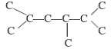

n-alkanes iso-alkanes

cycloalkanes

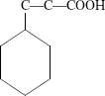

Aromatic hydrocarbon Condensed aromatic hydrocarbon Naphthenic acid

  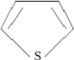

Phenol pyridine Thiophene

# Figure 2. 1 Structural categories of some crude petroleum components

Source**:** Hassanshahian and Cappello (2013).

Petroleum products have basically similar chemical and physical properties. For the purpose of remediation of contaminants the most important physical properties are volatility, solubility in water and viscosity. The viscosity of spilled oils determines the spreading and dispersion of the hydrocarbon mixture and also the surface area available for microbial attack. The most common distillates are gasoline (petrol), diesel, kerosene and liquefied petroleum gas (LPG) (Gehitha, 2015; Koshlaf and Ball, 2017).

# Biodegradation of Hydrocarbons

* + 1. **Aliphatic hydrocarbons**

Alkanes are saturate form of hydrocarbons and are available in different types like linear, cyclic, branched alkanes. They are up to 50% of crude oil and are known for their chemically inert nature. Enzymes like monooxygenases or hydroxylases are required to activate alkanes by incorporating oxygen either by terminal or subterminal oxidation (Pasumarthi, 2016; Brzeszcz and Kaszycki 2018). The inert nature of hydrocarbons has overcome by these enzymes by generating reactive oxygen species. As a result of oxidation

of terminal methyl group a primary alcohol is produced which is converted to aldehyde by aldehyde dehydrogenase (Ayala *et al*., 2014; Moreno and Rojo 2017). The so formed product is converted into fatty acid and further converted to acetyl-coA by β-oxidation of fatty acids. ω-oxidation is the process where both the terminal methyl groups are oxidized resulting in formation of ω-hydroxy fatty acid which is further converted into dicarboxylic acid by β-oxidation. The subterminal oxidation of n-alkanes generates a secondary alcohol which is later converted to corresponding ketone followed by oxidation to render an ester. An enzyme called easterase hydrolyses the product to alcohol and fatty acid (Rojo 2009; Minerdi *et al*., 2012; García 2014).

Unsaturated alkenes are oxidized at the saturated end of the hydrocarbon chain and then further turn into fatty acids. The complex branching like tertiary butyl groups in branched chains hinders the degradative enzyme action. In case of cyclic alkanes the absence of terminal methyl group for oxidative attack results in resistance for degradation but a few bacteria are known for their capabilities to degrade branched and cyclic alkanes (Rojo 2009; Pasumarthi, 2016) (Fig 2.1) and (Fig 2.2).

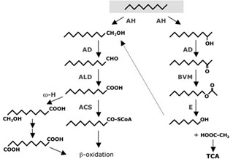

Figure 2.2: Aerobic alkane degradation pathway by terminal and subterminal oxidation. Source: Rojo (2009)

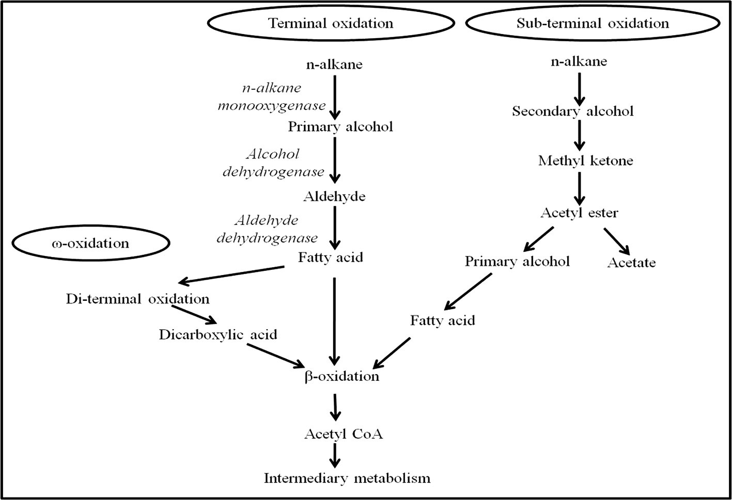

Figure. 2.3 Three possible peripheral pathways for n-alkane degradation (aerobic) in microorganisms Source: Varjani (2017).

# Aromatic hydrocarbons

Aromatic hydrocarbons are organic molecules having aromatic ring made of carbon and hydrogen. Polyaromatic hydrocarbons are type of aromatic hydrocarbons having more than one aromatic ring leading to formation of linear, angular cluster arrangements based on the fusion of aromatic rings (Jussila, 2006; Malik *et al*., 2014; Mahgoub, 2019; Sun *et al*., 2019). The biodegradation of polyaromatic hydrocarbon is of great interest due to their structural complexity. The first step of incorporating oxygen into the aromatic ring is common for all aromatic hydrocarbons (Ghosal *et al*., 2016). The degradation pattern of different hydrocarbons has been extensively reviewed and it has been stated that the cis-

dihydrodiols formed by the action of mono or dioxygenases are further oxidized to aromatic dihydroxy compounds (catechol) and then go through ortho or meta cleavage pathways (Das and Chandran, 2011; Farag and Soliman, 2011; Saleh and Partila, 2013). As a result, the precursors of tricarboxylic acid cycle are formed. For instance Naphthalene degradation is extensively studied for its simple structure and comparatively high solubility (Pasumarthi, 2016). Naphthalene is oxidized by naphthalene dioxygenase to cis-1,2-dihydroxy-1,2- dihydronaphthalene which is later converted to 1,2-dihyroxynaphthalene by naphthalene(+)- cis-dihydrodioldehydrogenase. 1,2-dihyroxynaphthalene is converted to cis-2- hydroxybenzal pyruvate and then to salicylate and pyruvate. Salicylate is oxidized to catechol by salicalate hydroxylase and further process is carried out by ortho or meta fission. All polyaromatic hydrocarbons follow a similar pattern of degradation involving oxygenase enzymes but the speed of reaction and intermediates or byproduct production depends on the number of aromatic rings and also the bacteria involved (Mrozik *et al*., 2003) (Fig 2.3).

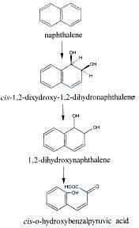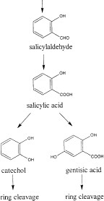

Figure 2.4: Aerobic Naphthalene degradation pathway Source: Rojo (2009).

# Effects of Oil Pollution

The effects of crude oil contamination in the environment cannot be over emphasized. The gross health effect of these pollutants however depends basically on the type of pollutant, duration of exposure, exposed dosage, general health condition of the person exposed to the pollutant. Incessant exposure to these pollutants directly or indirectly which can be by taking contaminated food, drinking contaminated water or breathing contaminated air can result in severe health conditions and in worse cases death. Exposure to these contaminants may results in the damage of vital organs in the human system such as the liver, spleen, kidney and lungs. Prolonged exposure causes severe health conditions such as peripheral neuropathy which affects the central nervous system and is characterized by numbness in the feet and in severe cases, paralysis or even death. In pregnant women, it can lead to abortion and teratogenic effects. Most of these pollutants can cause irritating sensation to the skin and eyes. The effects of these releases as highlighted in a number of literatures include nutrient status (nitrogen and phosphorus) depletion, inhibition of microbial activities and inhibition of seed germination (Atlas and Bartha, 1993; Kirk *et al*., 2005).

Anoliefo and Vwioko (1995) reported that oil contamination contributed to reduced oxygen content in soils. The formation of oily scum which impedes oxygen and availability of water to biota as well as the formations of hydrophobic micro aggregates with clay surfaces are associated with oil content in soils (Rasiah *et al*., 1990; Amadi *et al*., 1993). Decrease in soil water retention capacity and high potential caused by water being replaced by oil in the competition for pore spaces and also water film thickness reduction around macro aggregates are also effects of oil in soil (Rasiah *et al*., 1990).

# Effect of Crude Oil on Certain Soil Parameter

* + 1. **Effects of crude oil on soil physical properties**

The presence of oily waste makes soil constituent hydrophobic. Disposal of oily waste or oil spill may lead to formation of oily scum which impedes oxygen and water availability to biota. This creates anaerobic conditions in the subsoil which aids the persistence of oil (Amadi *et al*., 1993).Oil in soil creates unsatisfactory conditions for plant growth probably due to insufficient aeration in the soil (Anoliefo and Vwioko, 1995). This condition causes the displacement of air from pore-spaces by oil and an increase in the demand for oxygen brought about by the activities of oil-decomposing microorganisms. Oil occupies macrospores and coated aggregates reduce oil film thickness around macro aggregates and retard the movement of water in and out of micro aggregates (McGill, 1976). Rasiah *et al*. (1990) reported that oil interact with clay surfaces to form hydrophobic micro aggregates.

It has been observed from studies on the effect of oil-base waste on soil hydraulic properties that drainage is decreased and water retention increases (Stevenson, 1987). Low water retention (Rasiah *et al*., 1990) suggests that oil had replaced water in competition for pore space and according to the study, the decreased water retention occurred at high potential (- 10 to -200Kpa) suggesting that the competition occurred for the macro-pores. On the ability of soil microorganisms to remediate oil contaminated soils, Glick (2003) observed that the availability of soil microorganisms on decomposition processes was found to be high at high water potential than at low water potential. Oil contaminated soil appeared waxy and usually did not allow water to penetrate from above (Glick, 2003; Akpaetor ,2011).

# Effect of crude oil on soil productivity

According to Avidano *et al*. (2005), petroleum and human industrial activities strongly affect the soil status. Soil productivity is the continuous capacity of the soil to function as a vital system within the ecosystem and land use boundaries to sustain biological productivity, promote the quality of air and water environment and maintain plant, animal and human health. A good number of soil health bio indicators have been developed and reviewed (Nielson *et al*., 2002, Anderson, 2003; Griffiths, 2018). Variety in microbial population and activity has been reported to function as a predictor of changes in soil health (Ovreas, 2000; Akpaetor, 2011). Katsievela *et al*. (2005) reported that petroleum waste sludge adversely affected the microbial population by depleting essential inorganic nutrients and growth factors, lowering the pH immediately around negatively charged surfaces. Nitrogen-fixing and heterotrophic microbes relevant for the maintenance of soil health were gradually eliminated in oil-contaminated sites (Bossert and Compeau, 1995). The very low nitrate- nitrogen usually associated with oil-contaminated soils is the limiting factor to nitrogen- fixing and heterotrophic microbes.

# Effects of crude oil on soil chemical properties.

The depletion of soil nutrient status (nitrogen and phosphorus) has been reported by Atlas and Bartha(1993). Amadi *et al*. (1993) observed that contaminated soil pH status varied between 4.0 (acidic) and 6.0 (near neutral). From their studies, available carbon content of soil decreases from 3.6% to 2.8% at heavy contaminated areas and moderate contaminated areas respectively. The total nitrogen differed by a fraction of 0.01% in heavy and moderate impacted zones. Cation exchange capacity (CEC) decreased from a combined mean of 6.48 to 4.46 between heavy and moderate impacted zones. Microbial activity inhibition such as

nitrogen fixation, and bacterial chemotaxis was observed by Bossert and Compeau (1995). Under natural environment, crude oil pollution resulted in increased percentage organic carbon and decreased phosphorus (Ogboghodo *et al*., 2004). This manifested in the alteration of the ecological equilibrium such as change in biodiversity and soil biomass. Amadi *et al*. (1993) reported that organic carbon, total nitrogen, carbon-nitrogen ratio (C: N), available phosphorus, exchangeable potassium and cation exchange capacity were adversely affected in oil-contaminated soils.

# Factors Influencing Petroleum Hydrocarbon Degradation

A number of factors have been recognized to affect the biodegradation of petroleum hydrocarbons. The composition and inherent biodegradability of the petroleum hydrocarbon pollutant is the first and foremost important consideration when the suitability of a remediation approach is to be assessed.

Microorganisms for bioremediation of contaminated soil require a few criteria to be successful. The first is the ability for the microbes to reach the contaminant. As long as the microbes can reach the contaminants with other necessary condition being favourable, then remediation will be successful. Humic and fulvic acids are naturally occurring soil compounds which may dissolve in water and help to dissolve non-polar compounds (Glick, 2003). Covalent bonding of contaminants to the functional group of humic molecules serves to immobilize contaminants. At given environmental conditions, the degree of crude oil component degradation is influenced by the type of hydrocarbon present in contaminant matrix. It has been observed that preferred substrate by microorganisms were n-alkanes and branched alkanes of intermediate length (C10 – C20) and these were those most easily

degradable. It has also been observed that some oil contain toxic hydrocarbons which may prevent or delaymicrobial attack (Katsievela, 2005).

The second is the availability of oxygen. In the biodegradation of petroleum-based products, microbial activity is most frequently limited by insufficient oxygen due to slow rates of diffusion into the interior of the soil layers or piles and into the center of soil aggregates. Generally, the greater the mass of oxygen that can be distributed the more rapid and complete the cleanup. Although anaerobic degradation of poly aromatic hydrocarbons (PAHs) by microorganisms has been shown to occur, the rates are somewhat negligible and limited to halogenated aromatic compounds such as the halobenzoates, chlorophenols and alkyl-substituted aromatics (Hartmann *et al*., 2000).

The third is temperature. Among physical factors, temperature plays an important role in biodegradation of hydrocarbons by directly affecting the chemistry of the pollutants as well as affecting the physiology and diversity of the microbial flora. The working range is between 5-45ºC (with 28ºC being the optimum) (Onwurah, 2000; Chen, 2013). Atlas (1995) found that at low temperatures, the viscosity of the oil increased, while the volatility of the toxic low molecular weight hydrocarbons were reduced, delaying the onset of biodegradation. Temperature also affects the solubility of hydrocarbons. Although hydrocarbon biodegradation can occur over a wide range of temperatures, the rate of biodegradation generally decreases with the decreasing temperature. Foght *et al*. (1996) showed that highest degradation rates generally occur in the range 30–40oC in soil environments, 20–30oC in some freshwater environments and 15–20oC in marine environments (Cooney, 1984). Venosa and Zhu (2003) reported that ambient temperature of

the environment affected both the properties of spilled oil and the activity of the microorganisms.

The fourth is pH . The optimum pH for microbial activities is observed to be6.5 to 8.5. The fifth is nutrients and moisture (Breedveld and Sparrevik, 2000; van Hamme *et al*., 2003Vin˜as *et al*., 2005; Jurelevicius *et al*., 2013).

Nutrients (mostly nitrogen and phosphorus) are very important ingredients for successful biodegradation of hydrocarbon pollutants and in some cases iron (Cooney, 1984). Addition of nutrients is necessary to enhance the biodegradation of oil pollutants (Kim *et al*., 2005). On the other hand, excessive nutrient concentrations can also inhibit the biodegradation activity (Chaillan *et al*., 2006).

# Biodegradation Kinetics

First-order kinetics is commonly used to describe biodegradation in environmental fate models because mathematically the expression can be incorporated easily into the models (Greene *et al.,* 2000). Many investigators grasp at first-order kinetics because of the ease of presenting and analyzing the data, the simplicity of plotting the logarithm of the chemical remaining versus time as a straight line, and the ease of predicting future concentrations (Reardon *et al*., 2002). In different environments, first-order constants and the number of cells able to metabolize the substrate would differ (Greene *et al*., 2000).

Information on kinetics is extremely important because it characterizes the concentration of the chemical remaining at any time and permits prediction of the levels likely to be present at some future time.

Strategies that are employed in studying the kinetics of a process have been based on the theory that the reaction rate constant in the rate equation quantifies the rate of the reaction; the reaction rate constant (k) is an average of values calculated at various experimental kinetic data points, e.g. reactant concentrations at various reaction times. A smaller rate constant indicates a slower reaction, while a larger rate indicates a faster reaction. As the biodegradation of petroleum hydrocarbons is influenced by a complex array of different factors, it is important to note that a simple kinetic model cannot realistically provide precise and accurate descriptions of various concentrations at different time lines in different areas by a single oil spill (Zahed *et al.,* 2011).

Short-term biodegradation experiments may not be adequate in appropriately articulating the biodegradation kinetics of a chemical contaminant by various microorganisms used (Venosa *et al.,* 1996). However, firstorder kinetics (exponential decay) often describes biodegradation when the initial substrate concentration is low. Based on the nature of the substrate and experimental conditions, different values of rate constants have been obtained in various studies on hydrocarbon biodegradation.

# CHAPTER THREE

* 1. **MATERIALS AND METHODS**

# Study Area

The soil sample was collected from the biological garden of the Federal University of Technology Minna, Bosso Campus, and transported to the microbiology laboratory in a sterile polythene bag.

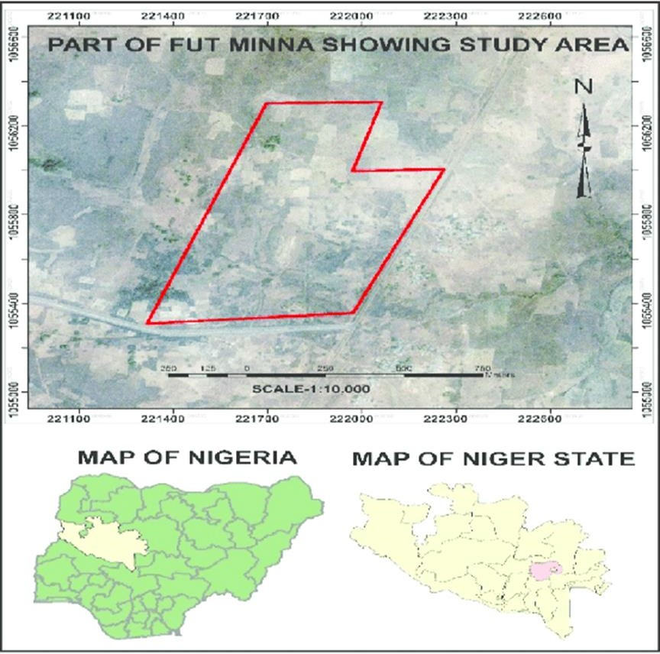

**Figure 3.1: Map of Federal University of Technology, Minna, Showing the Sample Collection Area (pristine soil)**

Source: Remote Sensing/Geographical information system (GIS) laboratory, Geography department, FUTMINNA (2021)

# Sample Collection

Soil sample was collected from the biological garden, Federal University of Technology, Minna, Nigeria. Surface soil at 10-20 cm depth was collected in sterile polyethene bags.

# Physicochemical Analysis

* + 1. **Determination of pH**

The pH of the soil was determined. Ten gram of soil sample was weighed into an extraction cup, 10ml distilled water was added to the soil sample and allowed to stand for 15 minutes, the mixture was shaken on an orbital shaker for 30 minutes at 150rpm after which it was allowed to stand for 10 minutes. The pH meter was standardized using buffer 7.0 and 4.0. Finally the pH value was read on the pH meter (Orion Versa Star Pro VSTAR-pH Japan).

# Determination of organic carbon

This method is adapted from Heanes (1984). It is a complete oxidation procedure. Ninety eight grams of reagent-grade Potassium dichromate (K2Cr2O7) was dissolved in distilled water and diluted to 2 liters.

One milliliter of the 5 standard solutions was added into 5 digestion tubes each. Five mL of K2Cr2O7 solution was added to samples and standards followed by 10 mL of concentrated H2SO4. It was then capped with a rubber stopper, and allowed to swirl on a vortex mixer until the soil sample was completely dispersed. It was then placed in a digestion block and preheated to 150 oC for exactly 30 minutes. The tubes where allowed to cool then it was diluted to 50 mL, mixed, and allowed to stand overnight.

The standards and samples were read on a spectrophotometer at a wavelength of 600 nm. The standards contain 0, 2.50, 5.00, 7.50, and 10.00 mg of C.

# Calculations:

To determine the amount of carbon (C) from a standard curve, zero % of OC was calculated as using Equation 3.1

%OC = mg C

mg of sample

X 100 (3.1)

Organic matter content may be estimated by multiplying organic C by a factor of 1.729

% Organic matter in soil= % organic carbon × 1.729

# Nitrogen analysis

Nitrogen contents of the soil was determined using Kjeldahl method which comprises of three stages as follows:

# Digestion

Two gram of the soil sample was weighed into a digestion flask and then digested by heating it in the presence of sulfuric acid (an oxidizing agent which digests the soil), anhydrous sodium sulfate (to speed up the reaction by raising the boiling point) and a catalyst copper (to speed up the reaction). Digestion converts any nitrogen in the soil (other than that which is in the form of nitrates or nitrites) into ammonia, and other organic matter to CO2 and H2O. Ammonia gas is not liberated in an acid solution because the ammonia is in the form of the ammonium ion (NH4+) which binds to the sulfate ion (SO42-) and thus remains in solution:

# Neutralization

After the digestion was completed the digestion flask was connected to a receiving flask by a tube. The solution in the digestion flask was then made alkaline by addition of sodium hydroxide, which converts the ammonium sulfate into ammonia gas. The ammonia gas that was formed was liberated from the solution and moves out of the digestion flask and into the receiving flask - which contains an excess of boric acid. The low pH of the solution in the receiving flask converts the ammonia gas into the ammonium ion, and simultaneously converts the boric acid to the borate ion:

# Titration

The nitrogen content was then estimated by titration of the ammonium borate formed with standard sulfuric or hydrochloric acid, using a methyl red indicator to determine the end- point of the reaction.

The concentration of hydrogen ions (in moles) required to reach the end-point was equivalent to the concentration of nitrogen that was in the original soil using Equation 3.2

% Nitrogen = (ml standard acid−ml blank)X N of acid X 1.4007

weight of sample in grams

(3.2)

# Available phosphorous (Olsen Phosphorus)

The available phosphorous was determined by weighing 1.0 g of 2 mm air-dried soil sample into a clean dry 50 mL centrifuge tube. The blank sample was also weighed using the same procedure. Twenty Millilitres of the extracting solution was dispensed into tubes which was placed in a reciprocating shaker and allowed to shake for 30 mins. It was further centrifuge at 3000 rpm for 5 minutes. For the colour development, 10 mL of the extract was pipetted into 50 mL flask, 2 drops of Nitrophenol was added and titrated with 1.8N sulphuric acid.

Ten ml of Ascorbic acid reagent was added, distilled water was added to make up to 50ml and then it was shaked gently. Each batch contains 5 check samples which was read at an absorbance of 880 nm on a spectrophotometer.

Soil P (ug/ g) was calculated using Equation 3.3

soil P (ug/ g) = ppmP*extraction volume (3.3)

# Isolation and Characterization of Crude oil Degrading Bacteria

One gram of pristine soil sample was serially diluted, 0.1mL was plated on oil agar. The oil agar consist of mineral salt medium (MSM) which contains 1.8 g K2HPO4, 4.0 g NH4Cl, 0.2 g MgSO4.7H2O, 1.2 g KH2PO4, 0.01 g FeSO4.7H2O, 0.1 g NaCl, 1 % crude oil (as the only carbon source) in one liter of distilled water and 20 g agar agar as the solidifying agent and incubated for 7 days at 37 oC. Nystatin was added at a concentration of 50mg/L to suppress the growth of fungi. The agar plates were incubated at 37oC for 24 hours. The isolates were purified to obtain a pure culture. All the isolates were subjected to biochemical test and characterized using the Bergey’s Manual of Determinative Bacteriology (Bergey, 1939).

# Gram Staining

A smear of bacterial isolates was passed through flame to fix it to the glass slide, flooded with crystal violet and allowed to stand for 60 seconds, the crystal violet was poured away and slide flooded with Grams iodine and allowed to stand for 60 seconds and rinsed with water after which decolorisation was done using 95 % ethyl alcohol and rinsed with water, counterstaining was done by flooding smear with safranin and allowed to stand for 30 seconds before rinsing with water. The slides was viewed using oil immersion objective lens of light microscope

# Identification of Bacterial Isolates

The biochemical tests for bacterial isolates were carried out following the under listed steps (Cheesbrough, 2002):

# Catalase test

The smear of the bacterial isolates was aseptically placed on a clean glass slide using a sterilized wire loop. A drop of hydrogen peroxide was added on each smear and observed for bubble formation which indicates positive reaction (Cheesbrough, 2002).

# Citrate utilization test

Simmon citrate medium was dispensed into a clean test tube and sterilized in an autoclave at 121oC for 15 minutes. Using a sterile straight wire, the slopes was streaked and stabbed to the bottom of the slope with the bacterial isolates and incubated for 48 hours at 37 ºC. Bright blue colour indicates a positive citrate reaction. No change in colour indicates a negative citrate reaction (Cheesbrough, 2002).

# Coagulase test

A drop of physiological saline was placed on a clean glass slide to make a smear of the bacterial isolate. A drop of human plasma was added to the suspension and mixed gently. The formation of a clump by the organism indicates positive result for coagulase (Cheesbrough, 2002).

# Starch hydrolysis

Twelve grams of nutrient agar was weighed into a 500 mL conical flask; 1.75 g of soluble starch was added into the conical flask. Five hundred milliliter (500 mL) of distilled water

was also added to the mixture, pre-heated and sterilized by autoclaving at 121 oC for 15 minutes. The medium was allowed to cool to 40 oC and aseptically poured into sterile Petri dishes and allowed to solidify. Each test bacterial isolate was inoculated by streaking, while the duplicate sets of nutrient agar plates were left uninnoculated (to serve as control) and incubated at 37 oC for 24 hours. After incubation, the plates were flooded with 10 mL of Gram’s iodine and observed for colour change. A clear zone shown around the colonies of the test organism confirmed a positive result, while blue-black colouration with Gram’s iodine indicated a negative result (Cheesbrough, 2002).

# Methyl red test

Glucose phosphate broth was prepared, dispensed into test tubes and sterilized by autoclaving at 121 oC for 15 minutes. The sterile medium was inoculated with bacterial culture and incubated at 37 oC for 48 hours. Four drops of methyl red indicator was added and gently mixed. Positive test was indicated by bright red color while negative test was indicated by yellow color (Cheesbrough, 2002).

# Vogesproskauer test

One milliliter (1 mL) of 40 % KOH and 3 mL of 5 % alpha–naphtol was added to the test organism in peptone water and incubated at 37 oC for 48 hours and shaken gently. Pinkish colorations indicates a positive Vogesproskauer test (Cheesbrough, 2002).

# Motility test

A drop of bacterial suspension was placed at the center of a cover slip, soft paraffin was applied over the corners of the cover slip. A glass slide was gently placed over the cover slip and held upside down, it was in such a manner that the bacteria was hanging between the

cover slip and glass slide. Examination under the light microscope was done under X10 and X 40 objective lens (Cheesbrough, 2002).

# Acid and gas production from sugar fermentation

Peptone water and sugars (glucose, lactose, maltose, arabinose, xylose and mannitol) was dispensed into a conical flask, to which 0.1 g of bromocresol purple was added. The solutions were dispensed into test tubes and Durham tube was introduced in an inverted position into each test tube and sterilized appropriately. After sterilization the medium was allowed to cool. Each sterile medium tube was inoculated with bacterial culture and afterwards incubated at 35 oC for 48 hours. After incubation the tubes were observed for acid production by change in color from purple to pink. The tubes were also observed for gas production in the inverted Durham tubes (Cheesbrough, 2002).

# Urease production test:

Urea agar slants was prepared and inoculated with the test organism and incubated at 37 0C for 24hours and examined every 12 h. Positive result shows a colour change from light red or pink while a negative result shows no colour change (Cheesbrough, 2002).

# Biodegradation of Crude Oil

Biodegradation studies was carried out by inoculating, 2 mL of 24 h broth culture of each species of the bacterial isolates into 100 mL of sterile MSM, containing 0.5g of crude oil in Erlemmeyer flask. The experiment was set up in triplicates with control flasks which contain 100ml of sterile mineral salt medium plus 0.5 g of crude oil but without adding any bacteria. The flasks was incubated in an incubator shaker and maintained at 30 °C at 150 rpm for 28 days. At seven days intervals, triplicates flasks per organism and the control flask were

removed from the incubator shaker and the residual crude oil extracted twice with 150 ml n- hexane and dried with anhydrous sodium sulphate. The solvent was removed by rotary evaporator, the weight of the residual oil was measured and recorded and the percentage biodegradation of the crude oil was calculated using the formula of Ijah and Ukpe (1992). The residual oil was diluted with n-hexane and cleaned up with silica gel, 1 microlitre of the extracted oil sample was analysed using gas chromatography and mass spectrometry (GC/MS). Total petroleum hydrocarbon data was fitted to first order kinetics model of Yeung *et al*. (1997).

Y= ae-kt

Where y is the residual hydrocarbon content, a is the initial hydrocarbon content, k is the biodegradation rate constant (day-1) and t is time (day). The model estimated the biodegradation rate and half-life of hydrocarbons used in the biodegradation of crude oil compared to the control. Half-life was then calculated from the model of Yeung *et al*. (1997)

Half-life= ln(2)/k

This model was based on the assumption that the degradation rate of hydrocarbons positively correlated with the hydrocarbon pool size (Yeung *et al.,*1997).

Biodegradation = weight of oil (control)−Weight of oil (degraded) × 100

3.4

weight of oil (control) 1

# Gas Chromatography Mass Spectrophotometry

The gas chromatographic (GC) analysis was performed on an Agilent GC Technology model interfaced with Mass Selective Detector model: 5975C (MSD), Japan. The column used was Agilent technologies HP5MS with length 30m, internal diameter 0.320mm,

thickness of 0.25micrometer. The carrier gas used was Helium. The oven temperature program was the initial temperature 80 degree Celsius held for 2 minutes and increased at 6 degree per minutes to the temperature of 280 degree Celsius and held for 6 minutes. The volume of sample injected was 1 microlitre (1µ/l).

# Data Analysis

Statistical analysis of data was carried out using Analysis of Variance (ANOVA) with SPSS version 17

# CHAPTER FOUR

**4.0 RESULTS AND DISCUSSION 4.1: Physicochemical Properties of the Pristine Soil**

The physicochemical properties of the pristine soil are presented in Table 4.1. The pH of the soil was slightly acidic (5.65). Other physicochemical parameters analyzed were nitrogen (0.34 %), phosphorous (37.31 ppm), organic carbon (5.27 %) and organic matter (5.22 %). The texture of the soil is sandy loam.

# Table 4.1: Physicochemical Properties of the pristine soil

|  |  |
| --- | --- |
| **Parameter** | **Value** |
| pH | 5.65 |
| Nitrogen (%) | 0.34 |
| Phosphorus (ppm) | 37.31 |
| Organic carbon (%) | 5.27 |
| Organic Matter (%) | 5.22 |

The pH of the soil was 5.65 which is slightly acidic. Soil pH is important because it influences several factors of plant growth such as soil bacteria, nutrient availability and soil structure. Bacteria operate best in the pH range of 5.5 to 7.0.

# 4.2 Morphological and Biochemical Identification of Hydrocarbon Utilizing Bacteria

Two bacterial isolates from the pristine soil sample were identified as species of *Bacillus* and *Staphylococcus*. Morphological and biochemical identification revealed the organisms to be *Bacillus subtilis and Staphylococcus aureus.* Species of *Bacillus* and *Staphylococcus* have been consistently isolated from oil polluted soil, pristine soil and implicated in crude oil biodegradation (Abioye *et al.,* 2012; Vinothini *et al.,* 2015; Kiamarsi *et al.,* 2019). The Morphological and Biochemical Identification of Hydrocarbon Utilizing Bacteria is represented in Table 4.2

# Table 4.2: Morphological and Biochemical Identification of Bacterial Isolates

|  |  |  |
| --- | --- | --- |
| **Test** | Results of Test | |
| Shape | Rod | Cocci |
| Gram Stain | + | + |
| Catalase | + | + |
| Citrate | + | - |
| Oxidase | _ | + |
| Urease | _ | + |
| Starch hydrolysis | + | - |
| Methyl red | _ | _ |
| Voges proskauer | - | - |
| Motility | + | - |
| Lactose | + | + |
| Indole | _ | _ |
| Glucose | + | + |
| Coagulase  Suspected organism | -  *B. subtilis* | +  *S. aureus* |

**4. 3 Percentage Biodegradation of Crude Oil**

Based on the ability to utilize crude oil and growth on oil agar, two bacteria isolates were selected for the biodegradation studies. The two isolates were identified as species of *Bacillus subtilis* and *Staphylococcus aureus*. These bacteria have been implicated in biodegradation of crude oil by previous studies of several authors (Das and Mukherjee, 2007; Ahamed *et al.,*2010; Ayangbenro and Babalola, 2017; Wang *et al.*, 2019). Biodegradation of crude oil increased steadily from day 0 to day 28 of biodegradation studies as shown in Table 4.3. At the end of 28 days, 28.57 % and 31.70 % oil biodegradation was recorded by the test organisms when compared with the control. There was a rapid biodegradation of oil within the first 7 days of incubation with flask inoculated with *Staphylococcus aureus* recording 18.75 % biodegradation in the seventh day. At the end of the 28 days, *Staphylococcus aureus* recorded the highest percentage of oil biodegradation (31.70 %) followed by *Bacillus subtilis*. The reason for this might be its ability to adapt to the environment and constant development of several surviving strategies by the bacterium. *S. aureus* has been considered to be a strong hydrocarbon utilized by Ahamed *et al.* (2010) who reported 78.26 % and 92 % biodegradation for kerosene and diesel respectively. When natural environments are contaminated with pollutants, the indigenous microbial communities are likely to contain microbial populations of different taxonomic characteristics, which are capable of degrading the contaminating chemicals.

# Table 4.3: Percentage Biodegradation of Crude Oil

|  |  |  |  |
| --- | --- | --- | --- |
| % Oil Biodegradation | | | |
| Time (days) | *Bacillus subtilis* | *Staphylococcus* | Control |
|  |  | *Aureus* |  |
| 7 | 14.28±4.08 | 18.75±0.00 | 1.0±0.8 |
| 14 | 23.40±6.38 | 26.08±7.53 | 1.8±1.1 |
| 21 | 26.66±6.67 | 29.54±4.55 | 2.4±1.8 |
| 28 | 28.57±4.76 | 31.70±4.88 | 2.6±0.9 |

* 1. **Biodegradation Rate Constant and Half Life**

First order kinetics model of Yeung *et al*. (1997) was used to determine the rate of biodegradation of crude oil. Table 4.4 shows the biodegradation rate constant (k) and half- life (t1/2) within 28days of the study. Crude oil degraded by *Staphylococcus aureus* showed the highest biodegradation rate of 0.019 day-1 and half-life 36.48days. The biodegradation rate and half-life of crude oil degraded by *Bacillus subtilis* was 0.018 day-1 and 38.50 days respectively. The kinetic parameters observed in this study show that the rate of degradation of crude oil by *Staphylococcus aureus* was higher than that of *Bacillus subtilis*. This might be its ability to adapt to the environment and constant development of several surviving strategies by the bacterium.

# Table 4.4 Biodegradation rate and half-life of hydrocarbon

|  |  |  |
| --- | --- | --- |
| Organism | Biodegradation constant (k)  day-1 | Half-life (t1/2) days |
| *Bacillus subtilis* | 0.018 | 38.50 |
| *Staphylococcus aureus* | 0.019 | 36.48 |

* 1. **Gas chromatography and Mass Spectroscopy (GS/MS) of undegraded crude oil**

Metabolism of hydrocarbon by microorganisms in biodegradation could be in form of complete degradation of the parent hydrocarbon or transformation of the parent hydrocarbon to a new form of organic compound of lower molecular weight which could become more volatile and naturally escape from the contaminated soil. Gas Chromatography and Mass Spectroscopy (GC/MS) analysis was used to determine the extent of biodegradation of hydrocarbon after 28days. The GC/MS chromatogram of the crude oil and the individual hydrocarbon present in the crude oil before it was subjected to biodegradation are shown in Table 4.4 and Figure 4.1 respectively, consisting of n-alkane of carbon chain (C10– C44), alkenes, carboxylic acid (C2H3O – C23H44O3), naphthalene, akyl group of naphthalene (C10H8 – C15H28), aromatic and polycyclic aromatic compounds.

Gas Chromatography and Mass Spectroscopy (GCMS) analysis revealed a total number of 48 individual hydrocarbon compounds in the original undegraded crude oil used for the study.

A b u n d a n c e

TIC: c rude oil new.D\ data.ms

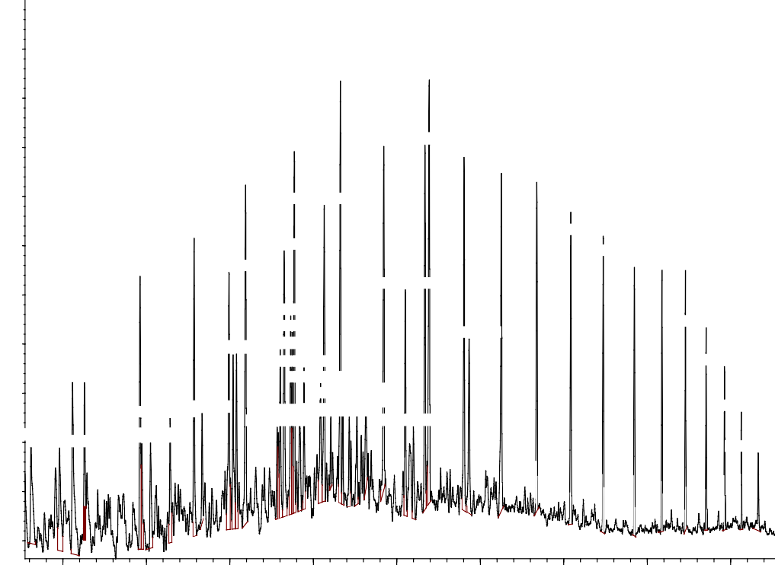5 5 0 0 0 0 0

5 0 0 0 0 0 0

1 0 . 6 5 0

1 2 . 7 7 7

4 5 0 0 0 0 0

9 . 5 4 7

8 . 3 7 9

1 1 . 6 1 2 . 6 7 6

1 3 . 6 1 4

8 9

1 4 . 5 0 6

1 5 . 3 5 6

4 0 0 0 0 0 0

3 5 0 0 0 0 0

3 0 0 0 0 0 0

5 . 8 4 9

7 . 1 4 5

7 . 9 8 1

1 0 . 2 6 3

9 . 3 0 3

9 . 4 6 0

9 . 4 9 6

1 2 . 2 0 5

1 3 . 7 3 4

1 6 . 1 7 0

1 6 . 9 4 8

1 7 . 6 9 4

1 8 1. 385. 94 1 8

1 9 . 4 1 2

2 5 0 0 0 0 0

2 0 0 0 0 0 0

4 4 . 5 1 9

8 . 1 6 19 . 2 0 9

9 . 7 7 9

8 . 0 7 9

1 0 . 1 7 4

1 01 .17.00 84 6

6 7 6

. 4 2 1

1 9 . 8 5 3

. 2 3 3

7 . 3 3 8

9 . 1 0

1 1 . 2 6 2

2 0 . 2 5 5

3 . 2 3 8

6 . 5 7 1

5 6. 8. 19 01 1

9 . 1 3 5

1 0 . 8 6 3

1 2 . 3 9 9

1 5 0 0 0 0 0 3 . 9 2 1

2 0 . 6 6 3

1 0 0 0 0 0 0

5 0 0 0 0 0

4 . 0 0 6 . 0 0 8 . 0 0 1 0 . 0 0 1 2 . 0 0 1 4 . 0 0 1 6 . 0 0 1 8 . 0 0 2 0 . 0 0

T i m e - - >

# Figure 4.1 Chromatogram of Un-degraded Crude Oil used for Biodegradation.

**Table 4.5: Individual Hydrocarbon Identified in Undegraded Crude Oil**

|  |  |  |  |  |
| --- | --- | --- | --- | --- |
| PK | Compound | Formula | RT | Area (%) |
| 1 | Nonane | C9H20 | 3.239 | 1.89 |
|  | Decane, 2,5,6- trimethyl- | C13H28 |  |  |
| 2 | Mesitylene | C9H12 | 3.920 | 1.89 |
|  | Benzene, 1,2,4-trimethyl- | C9H12 |  |  |
| 3 | Mesitylene | C9H12 | 4.235 | 3.26 |
|  | Benzene, 1,2,4-trimethyl- | C9H12 |  |  |
| 4 | Decane | C10H22 | 4.520 | 1.36 |
|  | Nonane | C9H20 |  |  |
| 5 | Undecane | C11H24 | 5.849 | 2.83 |
| 6 | Benzene, 1,2,4,5-tetramethyl- | C10H14 | 5.892 | 1.15 |
|  | Benzene, 1-ethyl-2,3-dimethyl- | C10H14 |  |  |
|  | Benzene, 1,2,3,5-tetramethyl- | C10H14 |  |  |
| 7 | 1-methydecahydronaphthalene | C11H20 | 6.101 | 1.36 |
|  | Naphthalene, decahydro-2-  methyl- | C10H8 |  |  |
| 8 | 1H-indene, 1-methylene- | C10H8 | 6.573 | 1.42 |
|  | Naphthalene | C10H8 |  |  |
| 9 | Dodecane | C12H26 | 7.144 | 3.00 |
|  | Tridecane | C13H28 |  |  |
|  | Tetradecane | C14H30 |  |  |

Key: PK= Peak number, RT= Retention time.

# Table 4.5: Individual Hydrocarbon Identified in Undegraded Crude Oil (Cont’d)

|  |  |  |  |  |
| --- | --- | --- | --- | --- |
| PK | Compound | Formula | RT | Area (%) |
| 10 | Undecane, 2,6-dimethyl- | C13H28 | 7.339 | 0.89 |
|  | Undecane, 3,6-dimethyl- | C13H28 |  |  |
|  | Dodecane, 6-methyl- | C13H28 |  |  |
| 11 | Naphthalene, 1-methyl | C11H10 | 7.982 | 3.01 |
|  | Naphthalene, 2-methy- | C11H10 |  |  |
| 12 | Nonane, 3-methyl- | C10H22 | 8.077 | 1.70 |
|  | Hexanedecane, 2,6,11,15-tetramethyl- | C20H42 |  |  |
|  | Sulfurous acid, dodecyl 2-ethylhexylester | C20H42O3S |  |  |
| 13 | Naphthalene, 2- methyl- | C11H10 | 8.1163 | 1.70 |
|  | Naphthalene, 1-methyl- | C11H10 |  |  |
| 14 | Tridecane | C13H28 | 8.377 | 3.71 |
| 15 | Tridecane, 2-methyl- | C14H30 | 9.135 | 0.81 |
|  | Dodecane, 2-methyl- | C13H28 |  |  |
|  | Heptacosane, 1-chloro- | C27H55Cl |  |  |
| 16 | Decahydro-1,1,4α,5,6-  pentamethylnaphthalene | C15H28 | 9.211 | 1.72 |
|  | Naphthalene, decahydro-1,8α-dimethyl-7- (1-methylethyl)-, [1R-(1-α,4αβ,7β,8α)] | C15H28 |  |  |
|  | 10α-Eremophilane | C15H28 |  |  |

**Table 4.5: Individual Hydrocarbon Identified in Undegraded Crude Oil (Cont’d)**

|  |  |  |  |  |
| --- | --- | --- | --- | --- |
| PK | Compound | Formula | RT | Area (%) |
| 17 | Naphthalene,2,7-dimethyl- | C12H12 | 9.301 | 3.37 |
|  | Naphthalene, 1,6-dimethyl- | C12H12 |  |  |
| 18 | Naphthalene, 2,3-dimethyl- | C12H12 | 9.458 | 1.98 |
|  | Naphthalene, 2,6-dimethyl- | C12H12 |  |  |
|  | Naphthalene, 1,6-dimethyl- | C12H12 |  |  |
| 19 | Naphthalene, 2,6-dimethyl- | C12H12 | 9.497 | 1.47 |
|  | Naphthalene, 2,7-dimethyl- | C12H12 |  |  |
|  | Naphthalene, 1,6-dimethyl- | C12H12 |  |  |
| 20 | Tetradecane | C14H30 | 9.549 | 3.50 |
| 21 | Naphthalene, 1,3-dimethyl- | C12H12 | 9.677 | 1.34 |
|  | Naphthalene, 2,3-dimethyl- | C12H12 |  |  |
| 22 | Decahydro-1,1,4α,5,6-pentamethylnaphthalene | C15H28 | 9.777 | 1.34 |
|  | Naphthalene, decahydro-1,4α-methyl-7-(1- methylethyl)-, [1s-(1-α, 4α,7α,8β)] | C15H28 |  |  |
|  | 1-(p-fluorophenyl)-4-piperidone | C11H12FNO |  |  |
| 23 | Decahydro-1,1,4α,5,6-pentamethylnaphthalene | C15H28 | 10.173 | 1.68 |
|  | 2- anthracenamine | C14H11N |  |  |
| 24 | 2,6,10—trimethyltridecane | C16H34 | 10.263 | 3.06 |
|  | Dodecane, 2,6,11-trimethyl | C15H32 |  |  |
|  | Tridecane | C13H28 |  |  |

# Table 4.5: Individual Hydrocarbon Identified in Undegraded Crude Oil (Cont’d)

|  |  |  |  |  |
| --- | --- | --- | --- | --- |
| PK | Compound | Formula | RT | Area (%) |
| 25 | Naphthalene,1,6,7-trimethyl- | C13H14 | 10.420 | 0.56 |
|  | Naphthalene, 2,3,6-trimethyl | C13H14 |  |  |
| 26 | Pentadecane | C15H32 | 10.649 | 4.08 |
| 27 | Naphthalene, 1,6,7-trimethyl- | C13H14 | 10.706 | 0.88 |
|  | Naphthalene, 1,4,6-trimethyl- | C13H14 |  |  |
| 28 | Naphthalene, 1,6,7-trimethyl- | C13H14 | 10.864 | 0.88 |
|  | Naphthalene, 1,4,6-trimethyl- | C13H14 |  |  |
| 29 | Naphthalene, 1,6,7-trimethyl- | C13H14 | 11.044 | 1.21 |
|  | Naphthalene, 2,3,6-trimethyl- | C13H14 |  |  |
| 30 | Naphthalene, 2,3,6-trimethyl- | C13H14 | 11.263 | 1.11 |
|  | 3-(2-methylpropenyl)-1H-indene | C13H14 |  |  |
| 31 | Hexadecane | C16H34 | 11.687 | 3.31 |
| 32 | Pentadecane, 2,6,10-trimethyl | C18H38 | 12.206 | 2.26 |
|  | Tetradecane | C14H30 |  |  |
|  | Dodecane, 2-methyl-8-propyl | C16H34 |  |  |
| 33 | 9H-fluorene, 2-methyl- | C14H12 | 12.401 | 1.01 |
|  | 9H-fluorene, 9-methyl- | C14H12 |  |  |
|  | 9H-fluorene, 1-methyl | C14H12 |  |  |
| 34 | Heptadecane | C17H36 | 12.678 | 3.40 |
|  | Tetradecane | C14H30 |  |  |

**Table 4.5: Individual Hydrocarbon Identified in Undegraded Crude Oil (Cont’d)**

|  |  |  |  |  |
| --- | --- | --- | --- | --- |
| PK | Compound | Formula | RT | Area (%) |
| 35 | Pentadecane, 2,6,10,14-  tetramethyl- | C19H40 | 12.778 | 4.57 |
| 36 | Octadecane | C18H38 | 13.616 | 3.44 |
|  | Hexadecane | C16H34 |  |  |
| 37 | Hexadecane, 2,6,10,14- tetramethyl- | C20H42 | 13.735 | 2.19 |
|  | Eicosane | C20H42 |  |  |
|  | Dodecane | C12H26 |  |  |
| 38 | Nonadecane | C19H40 | 14.506 | 3.55 |
|  | Hexadecane | C16H34 |  |  |
| 39 | Eicosane | C20H42 | 15.354 | 3.06 |
|  | Hexadecane | C16H34 |  |  |
|  | Nonadecane | C19H40 |  |  |
| 40 | Heptadecane, 2,6,10,15- tetramethyl | C21H44 | 16.168 | 2.62 |
|  | Hexadecane | C16H34 |  |  |
| 41 | Hexadecane | C16H34 | 16.949 | 2.55 |
|  | Pentadecane, 8-hexyl- | C21H44 |  |  |
|  | Nonadecane | C19H40 |  |  |
| 42 | Tricosane | C23H48 | 17.692 | 2.25 |
|  | Eicosane, 10-methyl- | C21H44 |  |  |
|  | Hexacosane | C26H54 |  |  |

# Table 4.5: Individual Hydrocarbon Identified in Undegraded Crude Oil (Cont’d)

|  |  |  |  |  |
| --- | --- | --- | --- | --- |
| PK | Compound | Formula | RT | Area (%) |
| 43 | Tetracosane | C24H50 | 18.354 | 1.89 |
|  | Pentadecane, 8-hexyl- | C21H44 |  |  |
| 44 | Tetracosane | C24H50 | 18.916 | 1.69 |
|  | Heneicosane | C21H44 |  |  |
|  | Pentadecane, 8-hexyl | C21H44 |  |  |
| 45 | Octadecane | C18H38 | 19.411 | 1.22 |
|  | Heptadecane,9-octyl | C25H52 |  |  |
|  | Hexacosane | C26H54 |  |  |
| 46 | Heptacosane | C27H56 | 19.854 | 1.05 |
|  | Heptadecane, 9-octyl- | C25H52 |  |  |
|  | Heptadecane, 9-hexyl | C23H48 |  |  |
| 47 | Heptacosane | C27H56 | 20.254 | 0.70 |
|  | Hexacosane | C26H54 |  |  |
|  | Heptadecane | C17H36 |  |  |
| 48 | Heptacosane | C27H56 | 20.663 | 0.77 |
|  | Eicosane | C20H42 |  |  |
|  | Tricosane | C23H48 |  |  |

Key: PK= Peak number, RT= Retention time.

# Gas Chromatography and Mass Spectroscopy (GS/MS) of residual crude oil degraded by *Bacillus subtilis*

Gas Chromatography and Mass Spectroscopy (GCMS) analysis revealed 27 individual hydrocarbon compounds for crude oil subjected to *Bacillus subtilis* biodegradation. The GCMS results after 28 days of biodegradation with *Bacillus* species including the individual hydrocarbon and the chromatogram are presented in Table 4.5and Figure 4.2 respectively. The result shows a decrease in the intensity of the hydrocarbon peaks when compared to Fig. 4.1 of the undegraded crude oil. There was a significant decrease in the alkane constituents of the crude oil used in biodegradation after 28 days especially those degraded by *Bacillus subtilis* . The long chain alkanes were almost completely degraded in all samples after 28 days of biodegradation. This could be because alkanes are simple hydrocarbon having carbon-carbon single bond which can be easily degraded by bacteria. Reports by Sharma *et al.* (2014) revealed that several bacterial strains containing alkane hydroxylase can assimilate alkanes larger than C20. An increase in the ester constituent was also observed as the alkane constituent decrease, this was detected by GC/MS and this could be because their carbon linkages are not broken easily. Esters are considered as being resistant to microbial attack. This could also be alluded to the nature of the compound (polycyclic aromatic hydrocarbon), they cannot be easily degraded because they are complex compounds.

Crucial ` information about biotransformation of hydrocarbon by microbes were revealed by the GC/MS results. Different components of the crude oil have different degradability; for example aliphatic and aromatic hydrocarbons may be readily degraded but the resins and asphaltenes are inherently recalcitrant (Sharma *et al.,* 2014) .

Abundance

TIC: B289.D\ data.ms

1.4e+07

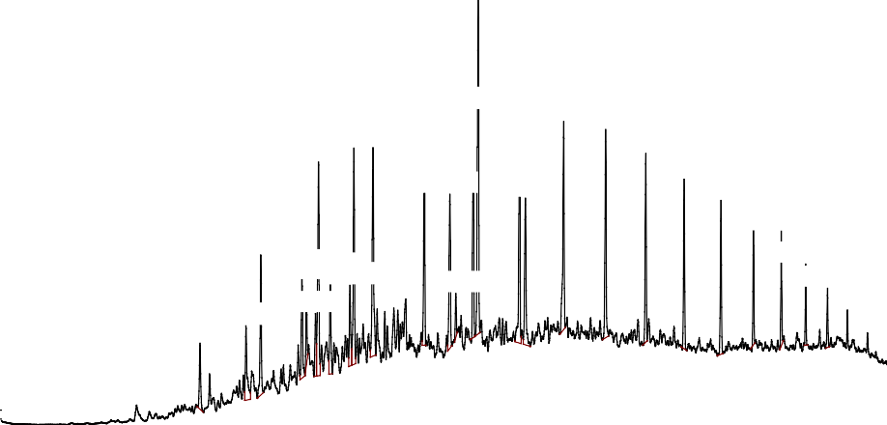

12.770

10.635

11.6 12.6 13.608

10.247

9.5

29

14.50135.355

16.169

12.193 13.726

8.358

9. 9.1706.8166

8.057 9.468

7.124

12.314

16.947

17.694

18.354

18.918

19.413

19.855

1.3e+07

1.2e+07

1.1e+07

1e+07

9000000

8000000

77

69

7000000

6000000

5000000

4000000

9.192

284

3000000

2000000

1000000

4.00 6.00 8.00 10.00 12.00 14.00 16.00 18.00 20.00

Time-->

**Figure 4.2 Chromatogram of degraded crude oil by *Bacillus subtilis* after 28days**

# Table 4.6: Individual Hydrocarbon Identified in degraded Crude Oil by *Bacillus subtilis*

|  |  |  |  |  |
| --- | --- | --- | --- | --- |
| PK | Compound | Formula | RT | Area |
|  |  |  |  | (%) |
| 1 | Tridecane | C13H28 | 7.125 | 1.78 |
|  | Dodecane | C12H26 |  |  |
| 2 | Octane, 3,6-dimethyl- | C10H22 | 8.658 | 2.49 |
|  | Hexadecane, 2, 6,11,15-tetramethyl- | C20H42 |  |  |
|  | Octane, 1,1,-oxybis- | C16H34O |  |  |
| 4 | Decahydro-1,1,4α,5,6-pentamethylnaphthalene | C15H28 | 9.192 | 2.77 |
|  | 2,5,5,6,1α-pentamethyl-cis-1α,4α,5,6,7,8- hexahydro-γ-chromene | C14H24O |  |  |
|  | Neopentylidenecyclohexane | C11H20 |  |  |
| 5 | Dodecane, 2,6,11-trimethyl- | C15H32 | 9.282 | 1.63 |
|  | Dodecane, 2,6,10-trimethyl- | C15H32 |  |  |
| 6 | Naphthalene, 1,8-dimethyl- | C12H12 | 9.468 | 1.50 |
|  | Naphthalene,2,6-dimethyl- | C12H12 |  |  |
|  | Naphthalene,1,6-dimethyl- | C12H12 |  |  |
| 7 | Tetradecane | C14H30 | 9.530 | 5.97 |
| 8 | Decahydro-1,1,4α,5,6-pentamethylnaphthalene | C15H28 | 9.768 | 2.57 |
|  | Cyclododecane, 2-methylene | C13H24 |  |  |
|  | (cyclopropyl)trivinylsilane | C9H14Si |  |  |

Key: PK= Peak number, RT= Retention time.

# Table 4.6: Individual Hydrocarbon Identified in degraded Crude Oil by *Bacillus subtilis*)(Cont’d)

|  |  |  |  |  |
| --- | --- | --- | --- | --- |
| 9 | Decahydro-1,1,4α,5,6-pentamethylnaphthalene | C15H28 | 10.168 | 2.05 |
|  | Silane, chlorodiethyl(2-methylpent-3-yloxyl)- | C11H26O2Si | |  |
|  | 2-Abthrancenamine | C14H11N |  |  |
| 10 | Dodecane, 2,6,11-trimethyl | C15H32 | 10.249 | 5.49 |
|  | Undecane | C11H24 |  |  |
|  | Tetratetracontane | C44H90 |  |  |
| 11 | Pentadecane | C15H32 | 10.635 | 6.69 |
|  | Tetradecane | C14H30 |  |  |
| 12 | Hexadacane | C16H34 | 11.678 | 5.19 |
| 13 | Pentadecane, 2,6,10-trimethyl | C18H38 | 12.192 | 4.19 |
|  | Heptacosane | C27H56 |  |  |
|  | Tetratetracontane | C44H90 |  |  |
| 14 | Naphthalene, 1-methyl-7-(1-methylethyl) | C14H16 | 12.316 | 0.83 |
|  | Chamazulene | C14H16 |  |  |
|  | Benzane, (4,5,5-trimethyl-1,3-cyclopentadien-1-yl) | C14H16 |  |  |
| 15 | Heptadecane | C17H36 | 12.668 | 5.10 |
| 16 | Pentadecane, 2,6,10,14-tetramethyl | C19H40 | 12.768 | 9.52 |
|  | Hexadecane, 2,6,11,15-tetramethyl | C20H42 |  |  |
|  | Decane, 2-methyl | C11H24 |  |  |
| 17 | Octadecane | C18H38 | 13.606 | 6.16 |
|  | Heptadecane | C17H36 |  |  |
| 18 | Hexadecane, 2,6,10,14-tetramethyl | C20H42 | 13.725 | 4.25 |
| 19 | Nonadecane | C19H40 | 14.501 | 5.51 |
|  | Heptadecane | C17H36 |  |  |
| 20 | Eicosane | C20H36 | 15.354 | 4.94 |
| 21 | Heneicosane | C21H44 | 16.168 | 4.09 |
|  | Heptadecane | C17H36 |  |  |

Key: PK= Peak number, RT= Retention time.

# Table 4.6: Individual Hydrocarbon Identified in degraded Crude Oil by *Bacillus subtilis* (Cont’d)

|  |  |  |  |  |
| --- | --- | --- | --- | --- |
| 22 | Docosane | C22H46 | 16.168 | 4.09 |
|  | Octadecane | C18H38 |  |  |
|  | Heneicosane | C21H44 |  |  |
| 23 | Tricosane | C23H48 | 17.692 | 3.28 |
|  | Heneicosane | C21H44 |  |  |
| 24 | Tetracosane | C24H50 | 18.354 | 2.30 |
| 25 | Pentacosane | C25H52 | 18.920 | 2.08 |
|  | Tricosane | C23H48 |  |  |
|  | Docosane | C22H46 |  |  |
| 26 | Hexacosane | C26H54 | 19.416 | 1.26 |
|  | Tricosane | C23H48 |  |  |
|  | Docosane | C22H46 |  |  |
| 27 | Tricosane | C23H48 | 19.854 | 1.10 |
|  | Hexacosane | C26H54 |  |  |

Key: PK= Peak number, RT= Retention time.

* 1. **Gas chromatography and Mass Spectroscopy (GS/MS) of residual crude oil degraded by *Staphylococcus aureus***

The highest hydrocarbon reduction was observed in samples degraded by *Staphylococcus aureus* in which the n-alkanes were almost completely degraded with the exception of eicosane (C20H42), naphthalene, alkyl groups of napthalenes, some aromatic and polycyclic hydrocarbon. The increase in percentage biodegradation of crude oil obtained in this study correlates with the trends in hydrocarbon utilizing bacterial. The high biodegradation rates could be attributed to an increase in the activity of hydrocarbon utilizing bacteria at this oil pollution level (Abioye *et al.,* 2012). Biodegradation of crude oil by microorganisms appears to be the natural process by which the bulk of the polluting oil is used as an organic carbon source, causing the breakdown of petroleum components to lower molecular compounds (Zhang *et al.,* 2011). The continuous increase in percentage of crude oil degradation is in line with the findings of other researchers (Wang *et al.*, 2010; Abioye *et al.,* 2012) who reported that total petroleum hydrocarbon levels could be signiﬁcantly reduced by increasing the incubation period during treatment of waste oil-contaminated soil.

Abundance

TIC: S289.D\ data.ms

900000

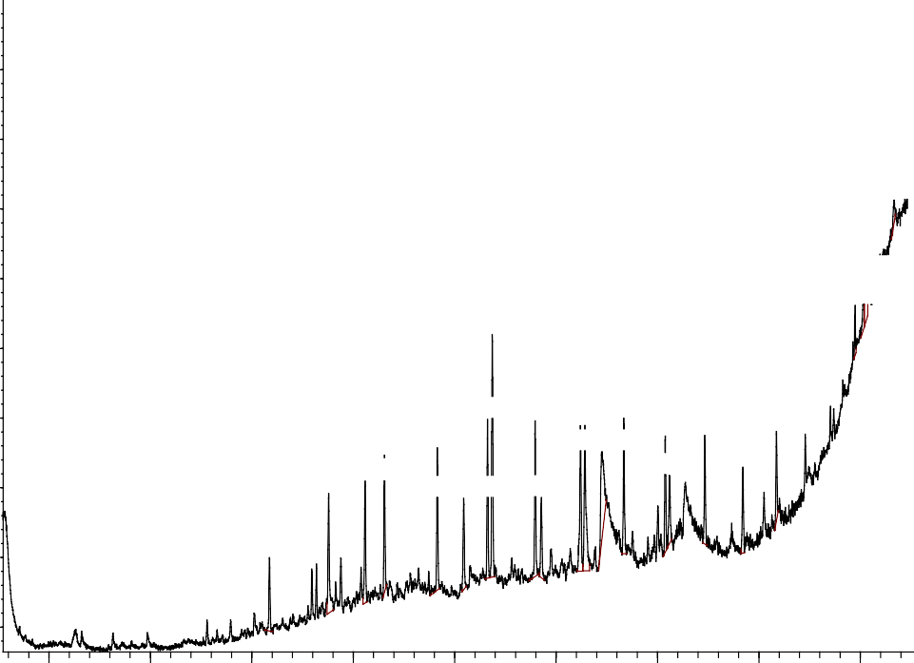

20.668

20.105

19.898

12.743

12.6 13.5 14. 15.338

10.6111.660

16.116.934 18.348

14.909

17.685

9.516

10.235

16.239

12.180 13.711

8.349

800000

700000

600000

20.062

500000

400000

6

50

89

14.482

569

54

300000

200000

100000

4.00 6.00 8.00 10.00 12.00 14.00 16.00 18.00 20.00

Time-->

**Figure 4.3 Chromatogram of degraded crude oil by *Staphylococcus aureus* after 28days**

# Table 4.7: Individual Hydrocarbon Identified in degraded Crude Oil by

***Staphylococcus aureus***

|  |  |  |  |  |
| --- | --- | --- | --- | --- |
| PK | Compound | Formula | RT | Area (%) |
| 1 | Tridecane | C13H28 | 8.349 | 2.46 |
|  | Amphetamine | C9H13N |  |  |
| 2 | Tetradecane | C14H30 | 9.516 | 5.31 |
|  | Undecane | C11H24 |  |  |
| 3 | Decane, 3,8-dimethyl- | C12H26 | 10.235 | 4.54 |
|  | 2,6,10-trimethyltridecane | C16H34 |  |  |
|  | Heptacosane | C27H56 |  |  |
| 4 | Pentadecane | C15H32 | 10.616 | 4.61 |
|  | Hexadecane | C16H34 |  |  |
| 5 | Hexadecane | C16H34 | 11.658 | 5.28 |
| 6 | Dodecane | C12H26 | 12.182 | 3.49 |
|  | Tridecane | C13H28 |  |  |
|  | Tetratracontane | C44H90 |  |  |
| 7 | Heptadecane | C17H36 | 12.649 | 4.99 |
| 8 | Pentadecane,2,6,10,14- tetramethyl- | C19H40 | 12.744 | 8.92 |
|  | Dodecane, 2,6,11-trimethyl- | C15H32 |  |  |
| 9 | Octadecane | C18H38 | 13.587 | 5.70 |

# Table 4.7: Individual Hydrocarbon Identified in degraded Crude Oil by

***Staphylococcus aureus* (Cont’d)**

|  |  |  |  |  |
| --- | --- | --- | --- | --- |
| PK | Compound | Formula | RT | Area (%) |
| 10 | Hexadecane, 2,6,10,14-tetramethyl- | C20H42 | 13.711 | 3.33 |
|  | Tetradecane | C14H33O |  |  |
| 11 | Nonadecane | C19H40 | 14.482 | 6.54 |
| 12 | Hexadecanoic acid, methylester | C17H32O2 | 14.568 | 8.33 |
| 13 | n-hexadecanoic acid | C16H32O2 | 14.911 | 7.93 |
|  | Phenylephrine | C9H13NO2 |  |  |
|  | Urea, butyl | C5H12N2O |  |  |
| 14 | Eicosane | C20H42 | 15.339 | 4.82 |
|  | Heptadecane | C17H36 |  |  |
|  | Octadecane | C18H38 |  |  |
| 15 | Heneicosane | C21H44 | 16.154 | 4.10 |
|  | Octadecane | C18H38 |  |  |
| 16 | Pyrido[2,3-d]pyrimidine- 2,4(1H,3H)dione, 1-ethyl-5-(2-  furanyl)- | C7H5N3O2 | 16.239 | 3.03 |
|  | Methyl stearate | C19H38O2 |  |  |
| 17 | Docosane | C22H46 | 16.935 | 3.83 |
|  | Pentadecane | C15H32 |  |  |
|  | Tridecane | C13H28 |  |  |

Key: PK= Peak number, RT= Retention time.

# Table 4.7: Individual Hydrocarbon Identified in degraded Crude Oil by

***Staphylococcus aureus* (Cont’d)**

|  |  |  |  |  |
| --- | --- | --- | --- | --- |
| PK | Compound | Formula | RT | Area (%) |
| 18 | Tricosane | C23H48 | 17.687 | 3.17 |
| 19 | Eicosane | C20H42 | 18.349 | 2.88 |
|  | Octadecane, 1-Chloro | C18H37Cl |  |  |
|  | 4-methyldocosane | C23H48 |  |  |
| 20 | (4,6-O-furfurylidene)methyl-α-D  glucopyranoside | C14H18O6 | 19.897 | 1.23 |
|  | Cis-1-ethyl-3-methyl-cyclohexane | C9H18 |  |  |
|  | 1,2-bis(trimethylsilyl)benzene | C12H22Si2 |  |  |
| 21 | Ethane,1-(4,4,4-trifluoro-1,3-dithiobutyl)-  2-(3,3,3-trifluoro-1,2-dithiopropyl) | C5H6F6S4 | 20.063 | 1.80 |
|  | Methoxamine | C11H17NO3 |  |  |
|  | Benzo[h]quinoline,2,4-dimethyl- | C15H13N |  |  |
| 22 | MDMA methylene homolog | C12H17NO2 | 20.106 | 2.71 |
|  | Cyclotrisiloxane, hexamethyl- | C6H18O3Si3 |  |  |
|  | Tetrasiloxane, decamethyl | C10H30O3Si4 |  |  |
| 23 | Benzo[h]quinoline,2,4-dimethyl- | C15H13N | 20.668 | 1.02 |
|  | Cyclotrisiloxane, hexamethyl- | C6H18O3Si3 |  |  |
|  | 1,1,1,3,5,5,5-heptamethyltrisiloxane | C7H21O2Si3 |  |  |

Key: PK= Peak number, RT= Retention time.

# CHAPTER FIVE

* 1. **CONCLUSION AND RECOMMENDATIONS**

# Conclusion

The physicochemical parameters (pH, nitrogen, phosphorus, organic carbon and organic matter) of the soil was suitable for the isolation of the bacteria.

The bacteria isolated from pristine soil were *Bacillus subtilis* and *Staphylococcus aureus.*

The bacteria were able to utilize crude oil as the sole source of carbon and energy.

Biodegradation of crude oil by the two isolates was moderate having 28.57% and 31.70% for *Bacillus subtilis* and *Staphylococcus aureus* respectively after 28days. The components degraded from the crude oil were majorly the n-alkane. Some of the aromatic hydrocarbons were converted into an intermediate product. *Bacillus* and *Staphylococcus* species could be good candidate microorganisms in the bioremediation of crude oil contaminated sites because of their environmental friendliness. The isolates demonstrated ability to degrade petroleum hydrocarbon.

# Recommendations

It is recommended that :

* + 1. The bacteria can be prepared into an inoculums in the form of a powder
    2. *Bacillus* and *Staphylococcus* can be employed for the biodegradation of diesel oil
    3. Further studies on the gene responsible for hydrocarbon degradation by these bacteria should be conducted

# REFERENCES

Abdulkareem, A. S. (2005). Refining biogas produced from biomass: An alternative to cooking gas. *Leonardo Journal of Sciences*, 7, 1-8.

Abioye, O. P., Agamuthu, P., & Abdul, A. (2012). Biodegradation of used lubricating oil by microbes isolated from pristine soil environment. *Malaysian Journal of Science*, 31(1), 1-7.

Abioye, O. P., Amaefule, P. O., Aransiola, S. A., & Stephen, E. (2013). Screening of Bacterial Consortium Isolated from Oil Contaminated Soil for Its Potential to Degrade Crude Oil. *Advanced Science Focus*, 1(3), 242-245.

Adeniji, A. O., Okoh, O. O., & Okoh, A. I. (2017). Analytical methods for the determination of the distribution of total petroleum hydrocarbons in the water and sediment of aquatic systems: A review. *Journal of Chemistry*, 2017:1-13

Ahamed, F., Hasibullah, M., Ferdouse, J., & Anwar, M. N. (2010). Microbial degradation of petroleum hydrocarbon. *Bangladesh Journal of Microbiology*, 27(1), 10-13.

Ajao, A. T., Yakubu, S. E., Umoh, V. J., & Ameh, J. B. (2014). Enzymatic studies and mineralization potential of Burkholderiacepacia and Corynebacteriumkutscheri isolated from refinery sludge. *Journal of Microbiological Research*, 4(2), 29-42.

Akpaetor, K. I. (2011). Optimizing crude oil biodegradation in soil microcosm using earthworms and poultry droppings (PhD dissertation, University of Nigeria).

Akpe, R., Ekundayo, A. O., Aigere, S. P., & Okwu, G. I. (2015). Bacterial degradation of petroleum hydrocarbons in crude oil polluted soil amended with cassava peels. *American Journal of Research Communication*, 3(7), 99-118.

Amadi, A., Dickson, A. & Maate, G. (1993). Remediation of oil polluted soil: Effects of organic and inorganic nutrient supplement in the performance of maize (Zea mays). *Water, Air and Soil Pollution*, 66, 54-76.

Anderson, T. H. (2003). Microbial eco-physiological indications to asses soil quality.

*Agricultural Ecosystems and Environment*, 98, 285-293.

Anoliefo, G. O. & Vwioko, D. E. (1995). Effect of spent lubricating oil on the growth of *Capsicum annum* L. and *Lycopercion esculentum. Environmental Pollution*, 99, 301-364.

Antwi-Akomeah, S. (2011). Biodegradation of Used Lubricating Engine Oil Contaminated Water Using Indigenous Hydrocarbon Degrading Microbes in a Fixed Bed Bioreactor System (PhD dissertation, Kwame NkurmaUniversity of Science and Technology).

Arvanitis, N., Katsifas, E. A., Chalkou, K. I., Meintanis, C., & Karagouni, A. D. (2008). A refinery sludge deposition site: presence of nah H and alk J genes and crude oil biodegradation ability of bacterial isolates. *Biotechnology letters*, 30(12), 2105-2110.

Atlas, R. & Bartha, R. (1993) Stimulated biodegradation of oil slicks using oleophilic fertilizer. *Environmental Science and Technology*, 7, 538-540.

Atlas, R. M. (1995). Bioremediation of petroleum pollutants. *International Biodeterioration & Biodegradation*, 35(1-3), 317-327.

Avidano, L., Gamalero, E., Cossa, G. & Carraro, E. (2005) Characterization of soil health in an Italian polluted site by using microorganism as bioindicators. *Applied Soil Ecology*, 30, 21-33.

Ayala, A., Muñoz, M. F., & Argüelles, S. (2014). Lipid peroxidation: production, metabolism, and signaling mechanisms of malondialdehyde and 4-hydroxy-2- nonenal. *Oxidative Medicine and Cellular Longevity*, 2014, 1-31.

Ayangbenro, A., & Babalola, O. (2017). A new strategy for heavy metal polluted environments: a review of microbial biosorbents*. International Journal of Environmental Research and Public Health*, 14(1), 94-110.

Bauman, J. H., Huang, C. K., Gani, M. R., & Deo, M. D. (2010). Modeling of the in-situ production of oil from oil shale. In Oil Shale: A Solution to the Liquid Fuel Dilemma . *American Chemical Society*,1032,135-146.

Benchouk, A., & Chibani, A. (2017). Petroleum-hydrocarbons biodegradation by Pseudomonas strains isolated from hydrocarbon-contaminated soil. *Journal of Fundamental and Applied Sciences*, 9(2), 713-726.

Bergey, A. D. & Zhu, X. (2003). Biodegradation of crude oil contaminating marine shorelines and freshwater wetlands. *Spill Science and Technology Bulletin*. 8 (2), 163–178.

Bergey, D. H. (1939). Determinative Bacteriology. Baltimore: Williams &Wilkins, 556.

Bossert, I. D., & Compeau, G. C. (1995). Cleanup of petroleum hydrocarbon contamination in soil. Microbial transformation and degradation of toxic organic chemicals, 79-89

,Wiley-Liss, Inc New York.

Boszczyk-Maleszak, H. A. N. K. A., Przestrzelska, A. N. N. A., Bieszkiewicz, E., & Horoch, M. A. C. I. E. J. (2004). Biodegradation of petroleum products by microorganisms adapted to high crude oil concentration in presence of easy assimilated carbon source. *Polish Journal of Microbiology*, 53(3), 183-187.

Breedveld, G.D., & Sparrevik, M. (2000) Nutrient-limited biodegradation of PAH in various soil strata at a creosote contaminated site. *Biodegradation*, 11, 391-399.

Brzeszcz, J., & Kaszycki, P. (2018). Aerobic bacteria degrading both n-alkanes and aromatic hydrocarbons: an undervalued strategy for metabolic diversity and flexibility. *Biodegradation,* 29(4), 359-407.

Chaillan, F. Chaˆıneau, C. H. Point, V. Saliot, A. & Oudot, J. (2006) Factors inhibiting bioremediation of soil contaminated with weathered oils and drill cuttings. *Environmental Pollution*, 144 (1), 255–265.

Cheesbrough M. (Eds) (2002). Biochemical tests to identify bacteria. In, *Laboratory practice in tropical countries*, Cambridge edn. pp. 36-70.

Chen, Y. (2013). Application of hydrocarbon degrading microorganism enumeration and catabolic genes detection for soil assessment.

Cooney, J. J. (1984). The fate of petroleum pollutants in fresh water ecosystems. In:

*Petroleum Microbiology*. R. M.Atlas (Ed). Macmillan, New York, Pp. 399.

Das, K., & Mukherjee, A. K. (2007). Crude petroleum-oil biodegradation efficiency of Bacillus subtilis and Pseudomonas aeruginosa strains isolated from a petroleum-oil contaminated soil from North-East India. *Bioresource Technology*, 98(7), 1339- 1345.

Das, N., & Chandran, P. (2011). Microbial degradation of petroleum hydrocarbon contaminants: an overview. *Biotechnology Research International*, 2011, 1-13

El-Borai, A. M., Eltayeb, K. M., Mostafa, A. R., & El-Assar, S. A. (2016). Biodegradation of Industrial Oil-Polluted Wastewater in Egypt by Bacterial Consortium Immobilized in Different Types of Carriers. *Polish Journal of Environmental Studies*, 25(5),1901- 1909.

Farag, S., & Soliman, N. A. (2011). Biodegradation of crude petroleum oil and environmental pollutants by Candida tropicalis strain. *Brazilian Archives of Biology and Technology*, 54(4), 821-830.

Foght, J. M., Westlake, D. W., Johnson, W. M., & Ridgway, H. F. (1996). Environmental gasoline-utilizing isolates and clinical isolates of *Pseudomonas aeruginosa* are taxonomically indistinguishable by chemotaxonomic and molecular techniques. *Microbiology*, 142(9), 2333-2340.

García Ojeda, J. L. (2014). Oxidation of long-chain n-alkanes by mutants of a thermophilic alkane-degrading bacterium: Thermus sp. ATN1 (Doctoral dissertation, Technische Universität Hamburg).

Gehitha, T. R. (2015). Characterization and genetic engineering of gene sequence of putrificating bacteria (PhD Dissertation ,University of Kartuske).

Ghosal, D., Ghosh, S., Dutta, T. K., & Ahn, Y. (2016). Current state of knowledge in microbial degradation of polycyclic aromatic hydrocarbons (PAHs): a review. *Frontiers in Microbiology*, 7, 1369-1376.

Glick, B. B. (2003). Phytoremediation:Synergistic use of plant and bacteria to clean up the environment. *Biotechnology Advances*, 21, 383-393.

Gopinathan, R., Prakash, M., & Bharathirajan, R. (2012). An experimental study for crude oil biodegradation in contaminated soil. *International Journal of Current Microbiology & Applied Sciences* (IJCMAS), 1, 12-16.

Greene, E. A., Kay, J. G., Jaber, K., Stehmeier, L. G., & Voordouw, G. (2000). Composition of soil microbial communities enriched on a mixture of aromatic hydrocarbons. *Applied and Environmental Microbiology*, 66(12), 5282-5289.

Griffiths, B., Faber, J., & Bloem, J. (2018). Applying soil health indicators to encourage sustainable soil use: The transition from scientific study to practical application. *Sustainability*, 10(9), 3021-3032.

Hamzah, A., Manikan, V., & Aziz, N. (2017). Biodegradation of Tapis Crude Oil Using Consortium of Bacteria and Fungi: Optimization of Crude Oil Concentration and Duration of Incubation by Response Surface Methodology. *SainsMalaysiana*, 46(1), 43-50.

Hartmann, H., Angelidaki, I., & Ahring, B. K. (2000). Increase of anaerobic degradation of particulate organic matter in full-scale biogas plants by mechanical maceration. *Water Science and Technology*, 41(3), 145-153.

Hassanshahian, M., & Cappello, S. (2013). Crude oil biodegradation in the marine environments. In *Biodegradation-Engineering and Technology*. IntechOpen. London

Heanes, D. L. (1984). Determination of total organic‐C in soils by an improved chromic acid digestion and spectrophotometric procedure. *Communications in soil science and plant analysis*, 15(10), 1191-1213.

Hewelke, E., Szatyłowicz, J., Hewelke, P., Gnatowski, T., & Aghalarov, R. (2018). The impact of diesel oil pollution on the hydrophobicity and CO2 efflux of forest soils. *Water, Air, & Soil Pollution*, 229(2), 51-60.

Ijah, U. J. J., & Ukpe, L. I. (1992). Biodegradation of crude oil by Bacillus strains 28A and 61B isolated from oil spilled soil. *Waste Management*, 12(1), 55-60.

Ikuesan, F. A. (2017). Microbial response to varying concentrations of crude oil pollution of agricultural soils in Ondo State, Nigeria. *Microbiology Research Journal International*, 22,(4),1-8.

Jukić, A. (2013). Petroleum refining and petrochemical processes. Natural Gas Composition, Classification, *Processing*, 16,1-47

Jurelevicius, D., Alvarez, V. M., Peixoto, R., Rosado, A. S., & Seldin, L. (2013). The use of a combination of alkB primers to better characterize the distribution of alkane- degrading bacteria. *PloS one*, 8(6), e66565-72

Jussila, M. M. (2006). Molecular Biomonitoring during Rhizoremediation of oil- contaminated soil (PhD *Dissertation from University of North Rekutet*).

Katsievela, E., Moore, E. R., Maroukli, D., Strompl, C., Pieper, D. & Kalogerakis, N. (2005). Bacterial community dynamics during in situ bioremediation of petroleum waste sludge in land farming sites. *Biodegradation*, 16, 160-180.

Kiamarsi, Z., Soleimani, M., Nezami, A., & Kafi, M. (2019). Biodegradation of n-alkanes and polycyclic aromatic hydrocarbons using novel indigenous bacteria isolated from contaminated soils. *International Journal of Environmental Science and Technology*, 16(11), 6805-6816

Kim, S. J. Choi, D. H. Sim, D. S. & Oh, Y. S. (2005). Evaluation of bioremediation effectiveness on crude oil-contaminated sand. *Chemosphere*. 59(6), 845–852.

Kirk, J. L., Moutoglia, P., Klironomos, J., Lee, H. & Trevor, J. T. (2005). Toxicity of diesel fuel to germination, growth and colonization of glomus intraradices in soil and in vitro transformed carrot root cultures. *Plant and Soil*, 270:23-30.

Koshlaf, E., & Ball, A. S. (2017). Soil bioremediation approaches for petroleum hydrocarbon polluted environments. *AIMS Microbiology*, 3(1), 25.

Kumar A., Munjal A., & Sawhney R. (2011). Crude oil PAH constitution, degradation pathway and associated bioremediation microflora: an overview. *International Journal of Environmental Sciences* 1, (7) 1420-35.

Kumar, A., Bisht, B. S., Joshi., V. D. & Dhewa, T. (2011). Review on bioremediation of polluted environment: A management tool. *International Journal of Environmental Sciences*, 1(6), 1079.

Kure, J.T., Gana, M., Emmanuel, A., Isah, R.M., & Ukubuiwe, C.C. (2018). Bacteria Associated With Heavy Metal Remediation: A Review. *International Journal of Applied Biological Research,* 9(1),134-148.

Kvenvolden, K. A. (2006). Organic geochemistry–A retrospective of its first 70 years. *Organic Geochemistry*, 37(1), 1-11.

Mahgoub, H. A. (2019). Nanoparticles Used for Extraction of Polycyclic Aromatic Hydrocarbons. *Journal of Chemistry*, 2019, 1-20.

Malik, A., Grohmann, E., & Akhtar, R. (2014). *Environmental Deterioration and Human Health*. Springer, Dordrecht.

McGill, W.R. (1976). An introduction to oil personnel on the effect of oil spill in soil and some general restoration and cleaning procedures. *Alberta Institute of Pedelogy*. Pp.19.

Minerdi, D., Zgrablic, I., Sadeghi, S. J., & Gilardi, G. (2012). Identification of a novel B aeyer‐V illiger monooxygenase from A cinetobacter radioresistens: close relationship to the *M ycobacterium tuberculosis* prodrug activator EtaA*. Microbial Biotechnology,* 5(6), 700-716.

Morais, E. B. D., & Tauk-Tornisielo, S. M. (2009). Biodegradation of oil refinery residues using mixed-culture of microorganisms isolated from a landfarming. *Brazilian Archives of Biology and Technology*, 52(6), 1571-1578.

Moreno, R., & Rojo, F. (2017). Enzymes for Aerobic Degradation of Alkanes in Bacteria. *Aerobic Utilization of Hydrocarbons, Oils and Lipids*, 1-25.

Mrozik, A., Piotrowska-Seget, Z., & Labuzek, S. (2003). Bacterial Degradation and Bioremediation of Polycyclic Aromatic Hydrocarbons. *Polish Journal of Environmental Studies* 12, 15-25.

Nielson, K. A., Langenecker, S. A., & Garavan, H. (2002). Differences in the functional neuroanatomy of inhibitory control across the adult life span. *Psychology and Aging*, 17(1), 56.

Ogboghodo, A., Iruaga, E. K., Osemwota, I.O. & Chokor, J. U. (2004). An assessment of the effects of crude oil pollution on soil properties, germination and growth of maize (Zea Mays) using two crude types- Forcados Light and Escravos Light. *Environmental Monitoring and Assessment.* 96, 143-152.

Onwurah, I. N. E. (2000). Bioremediation technologies for oily wastes. *A Perspective of Industrial and Environmental Biotechnology*, 53-71.

Ovreas, L. (2000). Population and community level approaches for analyzing microbial diversity in natural environments. *Ecology Letters*, 3, 236-251.

Pasumarthi, R. (2016). Hydrocarbonoclastic Bacteria and the Strategies for Improving Biodegradation (PhD dissertation, BITS Pilani).

Rasiah, V., Voroney, R., Groenevelt, P. & Kachanoski, R. (1990). Modification in soil water retention and hydraulic conductivity by an oily waste. *Soil Technology*. 3, 367-372.

Reardon, K. F., Mosteller, D. C., Rogers, J. B., DuTeau, N. M., & Kim, K. H. (2002). Biodegradation kinetics of aromatic hydrocarbon mixtures by pure and mixed bacterial cultures. *Environmental Health Perspectives*, 110( 6), 1005-1011.

Revuelta, M. B. (2017). *Mineral Resources: From Exploration to Sustainability Assessment.*

Springer.

Rojo, F., 2009. Degradation of alkanes by bacteria. *Environmental Microbiology*. 11, 2477- 2490.

Runge, W. (2014). *Technology Entrepreneurship: A Treatise on Entrepreneurs and Entrepreneurship for and in Technology Ventures*. Vol 2 (Vol. 2). KIT Scientific Publishing.

Saleh, Y., & A. M. Partila (2013). "Identification of polycyclic aromatic hydrocarbon degrading bacterial strain and its ability to degrade pyrene." *World Applied Sciences Journal* 23,(4) 515-525.

Schmitz, A., Wilson, N. L., Moss, C. B., & Zilberman, D. (2011). *The economics of alternative energy sources and globalization*. Bentham Science Publishers.

Sharma, A., Kumar, P., & Rehman, M. B. (2014). Biodegradation of diesel hydrocarbon in soil by bioaugmentation of Pseudomonas aeruginosa: a laboratory scale study. *International Journal of Environmental Bioremediation & Biodegradation*, 2(4), 202-212.

Shekhawat, D., Spivey, J. J., & Berry, D. A. (Eds.). (2011). *Fuel cells: technologies for fuel processing*. Elsevier.

Singh, D. P., Singh, H. B., & Prabha, R. (Eds.). (2017). *Plant-microbe interactions in agro- ecological perspectives.* New Delhi: Springer.

Sojinu, S. O., & Ejeromedoghene, O. (2019). Environmental challenges associated with processing of heavy crude oils. Processing of Heavy Crude Oils: Challenges and Opportunities, 241.

Speight, J. G. (2014). *The chemistry and technology of petroleum*. CRC press.

Stevenson, D. S. (1987). Effect of three soil conditioners on water content in two soils at three pressure plate matrix potentials. *Canadian Journal of Soil Science*. 67,395-397.

Sun, Y., Wu, S., & Gong, G. (2019). Trends of Research on Polycyclic Aromatic Hydrocarbons in Food: A 20-year perspective from 1997 to 2017. *Trends in Food Science & Technology*, 83, 86-98.

Truskewycz, A., Gundry, T. D., Khudur, L. S., Kolobaric, A., Taha, M., Aburto-Medina, A.,

... & Shahsavari, E. (2019). Petroleum Hydrocarbon Contamination in Terrestrial Ecosystems—Fate and Microbial Responses. *Molecules*, 24(18), 3400.

United States Environmental Protection Agency (USEPA), (1996). “Recycling Used Oil: What Can You Do?” Cooperation Extension Services ENRI-317, 1-2.

van Hamme, J.D., Singh, A. & Ward, O.P. (2003). Recent advances in petroleum microbiology. *Microbiology and Molecular Biology Reviews,*67, 503-549.

Varjani, S. J. (2017). Microbial degradation of petroleum hydrocarbons. *Bioresource Technology*, 223, 277-286.

Venosa, A. D., & Zhu, X. (2003). Biodegradation of crude oil contaminating marine shorelines and freshwater wetlands. *Spill Science & Technology Bulletin*, 8(2), 163- 178.

Venosa, A. D., Suidan, M. T., Wrenn, B. A., Strohmeier, K. L., Haines, J. R., Eberhart, B. L., & Holder, E. (1996). Bioremediation of an experimental oil spill on the shoreline of Delaware Bay. *Environmental Science & Technology*, 30(5), 1764-1775.

Vin˜as, M., Sabate´, J., Espuny, M. J. & Solanas, A. M. (2005). Bacterial community dynamics and polycyclic aromatic hydrocarbon degradation during bioremediation of heavily creosotecontaminated soil. *Applied and Environmental Microbiology*. 71, 7008-15.

Vinothini, C., Sudhakar, S., & Ravikumar, R. (2015). Biodegradation of petroleum and crude oil by Pseudomonas putida and Bacillus cereus. *International Journal of Current Microbiology and Applied Sciences,* 4(1), 318-329.

Wang, D., Lin, J., Lin, J., Wang, W., & Li, S. (2019). Biodegradation of petroleum hydrocarbons by Bacillus subtilis BL-27, a strain with weak hydrophobicity. *Molecules*, 24(17), 3021-30

Wang, X., Frenq, J. & Zhao, J. (2010).Effects of crude oil residuals on soil chemical properties in oil sites, Momonge Wetland, China. *Environmental Monitoring Assessment*, 161(1-4), 271-282.

Xu, X., Liu, W., Tian, S., Wang, W., Qi, Q., Jiang, P., & Yu, H. (2018). Petroleum Hydrocarbon-Degrading Bacteria for the Remediation of Oil Pollution Under Aerobic Conditions: A Perspective Analysis. *Frontiers in Microbiology*, 9, 2885-92.

Yeung, P. Y., Johnson, R. L., & Xu, J. G. (1997). Biodegradation of petroleum hydrocarbons in soil as affected by heating and forced aeration . *American Society of Agronomy, Crop Science Society of America, and Soil Science Society of America*, 26( 6), 1511-1516

Zahed, M. A., Aziz, H. A., Isa, M. H., Mohajeri, L., Mohajeri, S., & Kutty, S. R. M. (2011). Kinetic modeling and half life study on bioremediation of crude oil dispersed by Corexit 9500. *Journal of Hazardous Materials*, 185(2-3), 1027-1031.

Zhang, Y., Li, X., Guowen, L., Wang, Z., Kong, T., Tang, J., Zhag, P., Yang, W., Li, D. & Liu, L. (2011). Development of ELISA for detection of mercury based on specific monoclonal antibodies against mercury-chelate. *Biological Trace Element Research*, 144, 854–864.