Automated Canteen Ordering system.

Thesis Submitted in Partial Fulfilment of the Requirement for the degree Of

B.Sc.

In

Computer Science [Software Engineering] By

# Bisong-Abang Anthonia Obanghe

To

The Department of Computer science

Baze university, Abuja

[December 2020]

## DECLARATION

This is to certify that this thesis entitled **Automated Canteen ordering system**, which is submitted by **Bisong-Abang Anthonia O.** in partial fulfilment of the requirement for the award of degree for B.Sc. in information technology to the department of computer science, Baze university Abuja, Nigeria, comprises of only my original work and due acknowledgement has been made in the text to all other materials used.

Date: [12/12/2020]

Name of Student: Bisong-Abang Anthonia O.

**APPROVED BY**

**--------------------------------**

**HOD**

Dept. of Computer Science

## CERTIFICATION

This is to certify that this Thesis entitled **Automated canteen ordering system,** which is submitted by **Bisong-Abang Anthonia O.** in partial fulfilment of the requirement for the award of degree for B.Sc. in information technology to the Department of Computer Science, Baze University Abuja, Nigeria is a record of the candidate’s work carried out by the candidate under my/our supervision. The matter embodied in this Thesis is original and has not been submitted for the award of any other degree.

Date: supervisor:

Date: 2nd supervisor

## APPROVAL

This is to certify that the research work, **Automated canteen ordering system,** and the subsequent preparation by **Bisong-Abang Anthonia O.** with **BU/17C/IT/2655** has been approved by the Department of Computer Science, Faculty of Computing and Applied Science, Baze University, Abuja, Nigeria.

By

Dr. Chollete Olisah Date

1st Supervisor

Mrs Khadijah Mohammed Date

2nd Supervisor

Dr. C. V Uppin Date

Head of Department

Prof M. B. Hammawa Date

Dean, Faculty of Computing and Applied Science

Prof. A. B. Garko Date

External Examiner

## DEDICATION

This project is dedicated to God for keeping me alive up till the moment of writing this project, my mum for the continuous support throughout my years in school, my friends for reminding me to not procrastinate and also uncle ben for assisting with this project work. And my lecturers for instilling knowledge in me throughout my years in Baze University.

## ABSTRACT

Nowadays people do not have much time to spend in canteen by just waiting for the waiter to take their order. Many customers visit the canteen in their lunch break and recess, so they have limited time to eat and return to their respective offices and colleges. So, this software helps them to save time and order food whenever they want without calling the waiter again and again.

Manual system involves paperwork in the form of maintaining various files and manuals. Maintaining critical information in the files and manuals is full of risks and tedious process. Including a framework showing how to apply internet technology progressively as skills and confidence grow, the project demonstrates the routes from adapting materials to developing an online environment.

This canteen automation system enables the end users to register online, read and select the food from the e-menu card and order food online by just selecting the food that the user want to have. The results after selecting the food from the E-menu card will directly appear in the screen near the chef who is going to cook the food for you. The system is the combination of android, iOS, as well as web application.

The tools used in developing this system includes PHP, CSS, JavaScript. HTML, MySQL. HP laptop.

## TABLE OF CONTENTS

ABSTRACT VI

LIST OF TABLES IX

LIST OF FIGURES X

LIST OF ABBREVIATIONS XI

CHAPTER 1: INTRODUCTION 1

* 1. OVERVIEW 1
  2. BACKGROUND AND MOTIVATION 1
  3. STATEMENT OF THE PROBLEM 2
  4. AIM AND OBJECTIVES 2
  5. SIGNIFICANCE OF THE PROJECT 2
  6. PROJECT RISKS ASSESSMENT 3
  7. SCOPE/PROJECT ORGANIZATION 4

CHAPTER 2: LITERATURE REVIEW 5

* 1. INTRODUCTION 5
  2. HISTORICAL OVERVIEW 5
  3. RELATED WORK 6
  4. SUMMARY 6

CHAPTER 3: REQUIREMENTS, ANALYSIS, AND DESIGN 7

* 1. OVERVIEW 7
  2. PROPOSED MODEL 7
  3. METHODOLOGY 7
     1. METHOD 1 (E.G INTERVIEW) 7
     2. METHOD 2 (E.G OBSERVATION) 7
  4. TOOLS AND TECHNIQUES 7
  5. ETHICAL CONSIDERATION 7
  6. REQUIREMENT ANALYSIS 7
  7. REQUIREMENTS SPECIFICATIONS 7
     1. Functional Requirement Specifications 8
     2. Non-Functional Requirement Specifications 8
  8. SYSTEM DESIGN 9
     1. Application Architecture 9
     2. Use Case 9
     3. Data Design 10
     4. Activity Diagrams 10
     5. Dataflow Diagram 10
     6. Control Flow Diagram 10
     7. Entity-Relationship Diagram (ERD) 11
     8. User Interface Design 11
  9. Summary 11

CHAPTER 4: IMPLEMENTATION AND TESTING 12

* 1. OVERVIEW 12
  2. MAIN FEATURES 12
  3. IMPLEMENTATION PROBLEMS 12
  4. OVERCOMING IMPLEMENTATION PROBLEMS 12
  5. TESTING 12
     1. Tests Plans (for Unit Testing, Integration Testing, and System Testing) 12
     2. Test Suite (for Unit Testing, Integration Testing, and System Testing) 13
     3. Test Traceability Matrix (for Unit Testing, Integration Testing, and System Testing) 13
     4. Test Report Summary (for Unit Testing, Integration Testing, and System Testing) 13
     5. Error Reports and Corrections 13
  6. USE GUIDE 14
  7. SUMMARY 14

CHAPTER 5: DISCUSSION, CONCLUSION, AND RECOMMENDATIONS 15

* 1. OVERVIEW 15
  2. OBJECTIVE ASSESSMENT 15
  3. LIMITATIONS AND CHALLENGES 15
  4. FUTURE ENHANCEMENTS 15
  5. RECOMMENDATIONS 15
  6. SUMMARY 15

REFERENCES 16

APPENDICES 17

## LIST OF TABLES

|  |  |
| --- | --- |
| TABLE 1.1 | PROJECT RISK ASSESMENT |
| TABLE 3.1 | FUNCTIONAL REQUIRENMENT SPECFICATIONS |
| TABLE 3.2 | NON-FUNCTIONAL REQUIRENMENT SPECFICATIONS |
| TABLE 4.1 | TEST SUITE PERFORMED FOR SIGNUP |
| TABLE4.2 | TEST SUITE PERFORMED FOR LOGIN |
| TABLE 4.3 | TEST SUITE PERFORMED TO ADD/REMOVE ITEM FROM CART |
| TABLE 4.4 | TEST SUITE PERFORMED TO CHECKOUT |
| TEST 4.5 | TEST SUITE PERFORMED TO LOGIN ADMIN |
| TABLE 4.6 | TEST TRACEABILITY MATRIX |
| TABLE 4.7 | TEST REPORT SUMMARY |
| TABLE 4.8 | ERROR REPORTS AND CORRECTIONS |

## LIST OF FIGURES

FIGURE 3.1 AGILE METHODOLOGY FIGURE 3.2 APPLICATION ARCHITECTURE FIGURE 3.3 USE CASE DIAGRAM

FIGURE 3.4 ACTIVITY DIAGRAM FIGURE 3.5 DATA FLOW DIAGRAM FIGURE 3.6 CONTROL FLOW DIAGRAM

FIGURE 3.7 ENTITY RELATIONSHIP DIAGRAM

## LIST OF ABBREVIATIONS

|  |  |
| --- | --- |
| CPU | Central Processing Unit |
| ERD | Entity Relationship Diagram |
| IT | Information Technology |
| API | Application Programming Interface |
| CSS | Cascading Style Sheet |
| HTML | Hyper-Text Markup Language |
| PHP | Hyper-Text Pre-Processor |
| MYSQL | Structured Query Language |

## Overview

# CHAPTER 1: INTRODUCTION

Computers have become a part of the life for accessing almost any kind of information. Life in the 21st century is full of technological advancement and this technological age it is very difficult for any organization to survive without utilizing technology. The world wide web contributes greatly to the creation of an ever-increasing global information database. It could also be used as a mechanism to share information within an enterprise.

In today’s age of fast food and takeout, many canteens have chosen to focus on quick preparation and speedy delivery of orders rather than offering a rich dining experience. Until very recently, all these delivery orders were placed to the waiters over the phone, but there are many disadvantages to this system, including the inconvenience of the customer needing to have a physical copy of the menu, lack of a visual confirmation that the order was placed correctly, and the necessity of the canteen to have an employee answering the phone and taking orders. What, I propose is a canteen automation system, which is a technique of ordering foods online applicable in any food delivery industry. The main advantage of this system is that it greatly simplifies the ordering process for both the customer and the canteen.

## Background and Motivation

The automated canteen ordering system is one of the latest servicers most fast food restaurants and canteens in the western world are adopting. With this method, food is ordered online and delivered to the customer. This is made possible through the use of electronic payment system. Customers pay with their credit cards, although credit cards customers can be served even before they make payment either through cash or cheque. So, the system designed in this project will enable customers go online and place order for their food.

Due to the great increase in the awareness of internet and the technologies associated with it, several opportunities are coming up on the web. So many business and companies now venture into their business with ease because of the internet. One of such business that the internet is an automated canteen ordering system. In today’s age of fast food and take out, many restaurants and canteens have chosen to focus on quick preparation and speedy delivery of orders rather than

offering a rich dining experience. Until recently, most of the delivery orders were placed over the phone, but there are many disadvantages to this system.

It is possible for anybody to order any goods via the internet and have the goods delivered at his/her doorsteps. But while trying to discuss the transfer method of the good and services, attention is focused on the payment mode. In other words, how possible is it to pay for goods and services via the internet? This then leads to a discussion of the economic consequences of digital cash. What are the implementations from the viewpoint of economics? Since the world is fast and becoming a global village, it is necessary too; for this process is communication of which telecommunication is a key player. A major breakthrough is the wireless telephone system which comes in either fixed wireless headphone Lines or the global system of mobile communication (GSM).

The main advantage of this system is that it greatly simplifies the ordering process for both the customer and the canteen. The system also lightens the load on the canteens’ end, as the entire process of taking orders is automated. Once an order is placed on the webpage or the app that will be designed, it is placed into the database and then retrieved, in pretty much real time by a desktop application on the canteens’ end. In this application, all items in the order are displayed, along with their corresponding options and delivery details, in a concise and easy to read manner. This allows the canteen employees to quickly go through the orders as they are placed and produce the necessary items with minimal delay and confusion. The greatest advantage of this system is FLEXIBILITY.

## Statement of the Problem

The most common problem of the manual system of canteen is that the efficiency of the management along with customer satisfaction could not be fulfilled. Customers have to wait in long queues, for placing orders and they have to also wait for their order to be ready on the counters.

Another problem that is faced in canteen is the verbal communication on between the cashier and the customer. Many times, it happens, customer or cashier have problem in understanding what the other individual is saying, mostly during the busy hours of canteen. And during these busy

hours, the noise and crowd is too much, that miscommunication is common, which results in wrong orders or errors on bill.

One more problem faced by the customer is food customization. Many at times it happens that a customer wants to give some direction regarding their food, or they are allergic to some ingredients, which is often forgotten or is miscommunicated to the chef, resulting in unsatisfied customers.

One bigger problem for canteen is updating their menu. Most of the canteen wants to introduce new dishes and items on their menu. However, as most of the canteens have their menu either attached to the wall or on pamphlet which is very difficult to update frequently. Resulting, the customer is not able to know about the new items and sale of such dishes or items is low. The canteen manager also might change prices of the specific dishes, for what they either need to change the whole menu or overwrite on menu chart, after which the menu is not readable clearly to the customers.

However, as industries are fast expanding, people are seeking for more ways to purchase products with much ease and still maintain cost effectiveness. The proposed system will help to solve these problems.

## Aim and Objectives

The aim of this project is to develop an automated canteen ordering system. And it is achieved based on the following objectives:

* + - To design and develop a web application for rapid food ordering to be used by the canteen customers.
    - To implement and test the web application for food ordering in a canteen.

## Significance of the Project

The automated canteen ordering system management is an application that will allow the users to get an automated way of ordering food easily. But in today’s fast-moving world, people find it

difficult to go to the canteen to eat because of their busy work schedules. What if there is an automated way of ordering from canteen? Yes, it is possible through the use of automated canteen ordering system. This application will provide an easy way of ordering the food required through the online mode.

Following are the advantages of this application:

* + - The automated canteen ordering system can help in saving time of the customers since they do not have to wait in queues to get the food.
    - The interface will be user-friendly and easy to use by any user.
    - The user can order food from anywhere and at any time without any difficulty.
    - The details of the orders placed by a customer got easily through the use of this application.
    - Fault free management is achievable through the use of this application.

## Project Risks Assessment

These are some of the areas where the researcher cannot fully control and the steps to be taken to curb these risks.

**RISKS**

|  |  |
| --- | --- |
| Inability to cope with volume. | Risk of losing customer’s data. |
| Chances of technical problem in the system. | Data security. |
| Mismatch data of orders, customers, and drivers. | Bugs or errors from 3rd party API’s |
| Limited access to store hardware. | Inadequate hardware to test app. |

## Scope/Project Organization

This project is presented in five chapters:

* + - **Chapter 1**: This chapter provides the whole project with an introduction and history. An exploration of the current and prevailing situation, the issues and an outline of the proposed solution have been recorded in this section.
    - **Chapter 2**: A summary of the previous literary works, paper, and documentation on automated canteen ordering system.
    - **Chapter 3**: The third chapter records the study process of systems, specifications of requirements and the design phase of systems for this project.
    - **Chapter 4**: This chapter documents the final results of this project. These findings include: The full and implemented framework, screenshots of the interface, different test cases and test results, and other required system-related documents, such as hardware and software specifications.
    - **Chapter 5**: This chapter outlines the overview of this project, with relevant and critical recommendations.

References and appendices are included in the concluding part of this documentation.

# CHAPTER 2: LITERATURE REVIEW

## Introduction

A lot of research work has been done in relation to automated canteen ordering system. This section shows the self-service ordering in a canteen and previous research works and products in the field of automated canteen ordering system.

## Self-Service/Self-Ordering in Restaurant (Canteen)

Self-service or self-ordering in restaurant (canteen) industry refers to the restaurant taking orders from customers through applying various types of technologies such as internet and many others. Self-service or self-ordering is successful when it is applied at restaurants/canteens in many other countries. The usage of the self-service or self-ordering technology is proven to benefit most of the investors.

Odesser-Torpey (Odesser-Torpey, 2008) reports that most of the Americans hate waiting for an order. Therefore, they prefer self-service technology, which can be in form of text-messaging, the internet and kiosk. Usually, the customer prefers self-service because of speed and convenience in making order and transactions that self-activated terminals are more likely to serve as ordering innovation in the future. The implementation of alternative ordering can increase check size, free up counter, staff that need to serve customers and take money handling out of service equation.

Bhatnagar (Bhatnagar, 2006) mentioned that the innovation of kiosk and computerized table top ordering screen will force restaurant industry re-jigger an often-used acronym quick service restaurant. Customer can get information or search for recipes from the kiosk and internet. The kiosk and internet also take orders and receives credit cards and debit cards payment. As a result, wrong order and long queue can be avoided, order staff can be arranged to somewhere else and focus to speed up delivery orders. On the other hand, a table-top touch screen order system can take customer orders as well, handle other customer requests such as refill drinks, call a waiter and make payment by credit or debit card.

Bytes, a restaurant located at Canterbury has been successfully standing apart from the competitors because of applying online service ordering and the payment concepts. The system used in bytes allows the customers make an order through the touch screen, and the order will be directed to the bar or kitchen. The system also offers games after a customer has placed orders while internet access will be provided to customers in the future. Touch screen ordering reduces the need of the waiter. The system also provides database for customers’ habits and preferences, generate the management reports, perform analysis as well as allows the menu to be uploaded instantly. (Brickers, 2006).

Based on study, it is possible for applying the online food ordering system to the fast food restaurants and canteens in Nigeria. This is because the system can improve workplace efficiency, increase sales of the restaurant as well as reduce making incorrect orders. As a result, it is worth for investing on the system, whereby it can shorten the return on investment.

In addition, the system should be supported by the food origin taste and services to maintain the customers’ loyalty and satisfaction. However, the widely implementing of automated canteen ordering system may cause the influx of labor due to the elimination of waiters in restaurant industry. Even the system is important to be implemented, yet there is still some risk in other factors such as a direct interaction and restaurant design concept, which need to be considered for ensuring the success of the system.

Gan (Gan, 2002) proposed to develop an automated canteen ordering system that allows customers to place orders anytime at any place. The system helps to manage order from customer as well as advertise promotion. It allows kitchen staff to view ordering information, management to manage fast raw materials and staff to search customer delivery and profile information. This system helps to reduce queue issues during peak hours, speed up food preparation and increase customer volumes. As a result, market share of fast food restaurant/canteen can be boosted up and increases return of investment for the investor.

De Leon (De Leon, 2008) mentioned that there are several aspects that should be included in a good, automated ordering system. System should be simple to navigate, not clustered and easy to make an order. (Sharma, 2007) designed with professionals looking with search engines optimize capability and available 24hours. The system should also have a secure payment gateway to

protect their customers’ credit card information, fast and keep track on orders and sales history easily as well as generate a comprehensive sales report. (Sharma, 2007).

## E-Commerce

Electronic commerce or e-commerce according to garret, (1996) is the exchange of goods and services by means of the internet or other computer networks. In e-commerce, buyers and sellers transact business over networked computers.

Electronic commerce is also sharing business information, maintaining business relationships and conducting business transactions by means of communication networks. It includes the relationship between companies (business-to-business), between customers (customer-to- customer) as well as between companies and customers (business-customer). Business to business segment currently dominates e-commerce while customer-oriented segment is significantly lagging behind and current estimate places it at less than 10% of the total volume, even though they are all experiencing an exponential growth (Vladimir, 1998). E-commerce offers buyers convenience. They can visit the world wide web site multiple vendors 24 hours a day and even seven days a week to compare prices and make purchases, without having to leave their homes or offices.

For sellers, e-commerce offers a way to cut costs and expand their markets. They do not need to build staff or maintain a store or print and distribute mail order catalogs. Because they sell over the global internet, sellers have the potential to market their products or services globally and are not limited by the physical location of a store.

E-commerce also have some disadvantages, however. Customers are reluctant to buy some products online. Online furniture businesses for example, have failed for the most part because customers want to test the comfort of an expensive item such as a sofa before they purchase it. Many people also consider shopping a social experience, for instance, they may enjoy going to a store or a shopping mall with friends or family, an experience they cannot get online. Customers also need to be reassured that credit card transactions are secure, and their privacy is respected.

E-commerce is not only widening customer’s choice of product and services, but also creating new business and compelling established business to develop internet strategies.

## History of Automated Canteen ordering system

The first online food order was a pizza hut in 1994. The online food ordering market has increased in the U.S with 40 percent of U.S adult having ordered their food online once. The online food ordering market includes food prepared by restaurants, prepared by independent people. And groceries being ordered online and then picked up or delivered.

The first online food ordering service, worldwide waiter (now known as waiter.com) was founded in 1995. The site originally serviced only northern California, later expanding to several additional cities in the united states.

By the late 2000’s major pizza chains had created their own mobile applications and started doing 20-30 percent of their business online. With increased smartphone penetration, and the growth of both uber and the sharing economy, food delivery startups started to receive more attention. In 2010, snap finger, who is a multi-restaurant ordering website, had a growth in their mobile food orders by 17 percent in one year.

By 2015, online ordering began overtaking phone ordering.

In 2015, china’s online food ordering and delivery market grew from 0.15 billion yuan to

44.25 billion yuan.

As of September 2016, online delivery accounted for percent of the 61 billion U.S restaurant transactions.

## Purpose of Automated Canteen Ordering System

Automated canteen ordering system is the system where customers order their food and receive food in the canteen without any delay as the can directly go and collect what they ordered without waiting for a turn or waiting time. This system aims to accelerate customer orders and customer order system used by employees to accept customer order.

The purpose of the system is to develop a simple automated canteen ordering system and implement it.

The proposed “automated canteen ordering system” is economically feasible because:

* + - The system requires very fewer time factors as compared to manual system
    - The system will provide fast and efficient automated environment instead of slow and error prone manual system, thus reducing both the time and manpower spent in running the system.
    - The system will have GUI interface and very less user training is required to learn it.

## Related Works

Swiggy is application which can be used in smartphone to order food from restaurants near you. If the restaurant is far away, then the delivery charge increases. In Swiggy there is no QR code generation. However, when an order is placed, the ordered item is delivered at your doorstop. Payment can be done through online as well as offline mode. In Swiggy, the customer needs to first order the required food from the hotel, once the order is placed, the order notification is given to restaurant and they start preparing the food, meanwhile a Swiggy delivery partner is assigned to deliver the prepared food step. This application based on a chain of restaurants who are registered under Swiggy.

The next advancement was QORDER. It is a portable ordering system for devices. Here the waiter approaches the customers table with the QOrder, a handheld device, rather than the traditional notepad. He uses the touch screen to enter the order information and then sends it to the kitchen in real time for processing. Simultaneously, the POS system receives the sales information for the purpose of billing. QOrder uses WIFI to easily access every corner of the restaurant, encompassing all the tablets establishes within. Once the customer wishes to leave, the waiter uses his belt to print the receipt and processes payment with the handheld unit much like he would on the POS system. But there are still many areas which require serious attention. Changes in the menu card urge obviate the heap of paper-based records, to assure the customer that he will be served with what he has ordered, to record the customer feedback. To establish

this, the institution needs to create an external WIFI network which is not connected with institution assets, data, and all.

## Summary

This chapter discusses the related works, history of ordering system and the purpose of the canteen ordering system.

# CHAPTER 3: REQUIREMENTS, ANALYSIS, AND DESIGN

## Overview

This chapter discusses about the proposed model of the system, the methodology used in building the system, tools and techniques, ethical consideration, requirement analysis, requirement specification. It also talks about the functional and non-function requirements of the system, the system design. The application architecture of the system will also be shown in this chapter, the use case diagram, data design, activity diagrams, dataflow diagram, control flow diagram, entity-relationship diagram (ERD) and user interface design will all be shown in this chapter.

## Analysis of Existing System

Throughout the system analysis, an in-depth, study of the end-user information is conducted for producing functional requirement of the proposed system. Data about the existing ordering system is collected through several fact-finding techniques such as website visit and document review, at the beginning of this stage. The data collected facilities information required during detailed analysis. A study on the current system is performed based on the collected data. As a result, user requirement of the proposed system are determined. At the end of this stage, requirement specification is produced as deliverable.

## The Existing System

The existing system happens to be a non-computerized operating system were all operations are done manually by the waiter carrying paper and to take down the order of the customer or making an order over the counter. This leads to mistakes because the waiter might not understand what the customer had ordered therefore serving him/her a different menu. This could be so embarrassing because the customer might not take it lightly with the waiter which may lead to misunderstanding.

## Problems of Existing System

Due to manual menu means it is very difficult to satisfy the wants and needs of the customers. Most of the problems include:

* + - * Mistakes are made when taking the orders of the customers
      * The process of collecting customers’ purchases order id very tedious. This makes it impossible to deliver goods on time.
      * It leads to lack of understanding between the customers and the employees.
      * The record keeping the system its poor. Losses of vital records have been reported in the past consequently. Besides, protecting the system file system from unauthorized access is a problem that has defiled solution.
      * Unnecessary time is wasted conveying information through the ladder of authority. Management at times seeks to get a copy of the customer’s order form and this may take a lot of time to obtain it.
      * It causes reduction of production flow.

These are the major problems facing the existing system and would be corrected with the help of the proposed system.

## Proposed System.

The proposed system is developed to manage ordering activities in a canteen. It helps to record customer submitted orders. The system should cover the following functions to support the canteens’ business process for achieving the objective:

* To allow the customer to make order, view order and make changes before submitting their order and allow them make payment.
* To provide interface that allows promotion and menu.
* Tools that generate reports that can be used in decision making.
* A tool that allows the management to modify the food information such as price, add a new menu and many others as well as for managing user, system menu and promotion records.

## Justification for New System

It is the purpose of the new system to address all the problems plaguing the present system. This system will do the analyzing and storing of information either automatically or interactively. It will make use of PHP-MYSQL. This will be like this: a report generated confronting to particular information needed by the management via the monitor. This will require the input of necessary data and record of canteen food ordering and delivery and then a report is generated.

The proposed system will also have some other featured such as:

* + - * Accuracy in handling of data.
      * The volume of paperwork will be greatly reduced.
      * Fast rate of operation as in making the ordered food available and delivered on time.
      * Flexibility (i.e. it can be accessed at any time)
      * Easy way to back up or duplicating data in CD’S in case of data loss
      * Better storage and faster retrieval system
      * Errors in the reports will be greatly minimized.

## Methodology

I used the agile methodology for this system. Agile methodology is a combination of iterative and incremental process model with a focus on process adaptability and customer satisfaction by rapid delivery of working software product.

**Incremental software development:** this approach allows the team to deliver finished components of the whole in parts. It allows the team to stagger the release of features thus allowing for a better understanding of the market.

**Iterative software development:** this approach allows the team to build upon an idea or a solution which might not be clear at the beginning, but constant feedback at all levels from the customer encourages development in the form of iterations.

The agile method combines the iterative and incremental approaches and encourages a flexible environment. It is iterative as it plans for the work of one iteration to be improved upon in

subsequent iterations and incremental because completed work is delivered throughout the project.

Agile development, in its simplest form, offers a lightweight framework for helping teams, given a constantly evolving functional and technical landscape, maintain a focus on the rapid delivery of business value. As a result of this focus, one of the benefits of agile software development is that organizations are capable of significantly reducing the overall risk associated with software development.

Agile assumes that the end users’ need is ever changing in a dynamic business and IT world. Changes can be discussed, and features can be newly introduced or removed based on the feedback. This effectively gives the customer the finished product they want or need.

**Benefits of agile methodology:**

* Improved quality
* Focus on business value
* Focus on users
* Stakeholder engagement
* Transparency
* Early and predictable delivery
* Predictable cost and schedule
* Allows for change

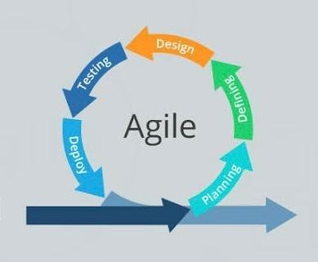

-FIGURE 3.1: AGILE METHODOLOGY DIAGRAM.

## Interview Method

I used the semi-structured interview. A semi-structured interview refers to an interview technique that does not follow a specific format. For example, an interviewer may come up with a general list of questions they want to ask in the interview, but they will not just simply go down the list. Instead, they will use their list as reference point to guide the conversation. This means that, rather than asking specifically worded questions that have handwritten down before them, they may bounce around and ask the questions they have in a more open-ended, conversational manner.

Therefore, there is some structure to the interview in that the interviewer know the end goal and has a general idea of how they plan to guide the interview, but there is also room to get creative. The person’s answers may spark other questions.

**The pros of semi-structured interviews:**

* + - * Semi-structured interviews feel more like conversations.
      * Semi-structured interviews leaves room for creativity.
      * Semi-structured interview can be tailored uniquely to you.

However, at the empathize phase of the project I conducted 8 semi-structured interviews at canteens and discovering what they did to pass time while waiting.

**Survey:** in addition to the semi-structured interview, I created a survey to reach the broader population through snowball sampling. The survey contained multiple choice questions about how often the respondent bought food at canteens and what the waiting time were like. It also had open-ended questions for the respondent to share their past experiences, activities, and feelings. I received 15 responses.

**Results:**

Three major patterns stood out:

* + - * Feelings while waiting joyful or negative
      * Activities to pass time: browse on the phone or look around/ talk to people
      * Willingness to wait moderate or low

## Observation Method

The observation method is described as a method to observe and describe the behavior of a subject. As the name suggests, it is a way of collecting relevant information and data by observing. It is also referred to as a participatory study because the researcher must establish a link with the respondent and for this must immerse himself in the same setting as theirs. Only then can he use the observation method to record and take notes.

Observation method is used in cases where you want to avoid error that can be a result of bias during evaluation and interpretation processes. It is a way to obtain objective data by watching a participant and recording it for analysis at a later stage.

They are different types of observation methods, the one used in this project is the *“naturalistic observation.”*

**Naturalistic observation**: this process involves and studying the spontaneous behavior of participants in open or natural surroundings. The role of the researcher is to find and record whatever he can and observe in natural habitat.

**Advantages of naturalistic observation:**

* + - * When a participant is in a natural habitat, his flow of behavior is natural and not forced.
      * The studies have gained better ecological validity than the controlled observation method.
      * The naturalistic observation is mostly used by researchers to create ideas. The researcher has the chance to observe the total situation and can find avenues that other people have not thought about.

## Tools and Techniques

* Php
* MySQL
* HTML, CSS, and Java script
* Hp laptop

**Third party API:** various API’s were used for the development of automated canteen ordering system.

* Google API
* Firebase
* One signal

## Ethical Consideration

* + - **Customer privacy and data:** back in the not-so-olden-days, customers simply called up the restaurant to order. Their order was then delivered by a driver employed by the restaurant. Maybe they provided a credit card over the phone. Maybe they paid in cash at the door. But times have changed. Now customer order on their cellphones and through food delivery apps like Door Dash and UberEATS. Sensitive data, including credit card numbers, is transmitted, and stored, often across multiple networks and systems.

Hardly, a day passes when we do not read about another data breach or other hacking incident. And in the restaurants and canteen industry, too often we see what we like to call “nephew-built websites” (i.e. *“my nephew can build your website over the weekend real cheap!”*) especially for smaller restaurants and canteens. Computer and internet security can be challenging even for experienced businesses. If your website got hacked and exposes customer data, customer could lose trust in your brand for a time.

* + - **Food safety:** food safety should be a concern for every restaurant and canteen, whether they deliver or not, but it becomes especially important for delivery because of the additional risks. First and foremost, canteens and restaurants should be concerned about maintaining the correct hot and cold temperatures of food they are delivering. How long has that potato salad out? How long will it sit in a hot car? Even if you are using a third- party delivery service, you need to be aware of how your delivery orders will be held in your store until they are picked up by a driver. Do you have the right equipment like a hot food holding cabinet?

And then the delivering process itself. How is the food been transported? Is it just sitting on the passenger seat of the delivery person’s car? Or are they appropriate delivery bags or boxes for the drivers? If you use a third-party delivery service, what type of delivery accessories do they require their drivers to have?

These are important questions and considerations. Just as we see on the news of data breaches, we seen a rise in foodborne illnesses that stem from restaurants. You definitely do not want to be source of one of these events. A little care ahead of time can save a lot of headaches and tummy aches later. However, this system will make sure that all food safety will be ensured, to avoid problems for the canteen.

* + - **Food quality:** your food product as restaurant or canteen. And your reputation is built on how good your product is. The question becomes how well does your product travel? Lots of food are meant to be served immediately upon being cooked. How does your food fare when it has been cooked, sits on the counter or in a holder awaiting the delivery driver and then sitting in the car in the delivery bag or box? Are they crispy things still crispy? Are the vegetables wilted? Do you have hot and cold ingredients side by side in the same container?

In recent study, off-prime insights looked at customer feelings about takeout, delivery, and catering, they found that food quality was the most important driver of satisfaction with food delivery.

Food quality may be one of the most challenging problems for the industry to solve, there are so many factors to consider, many of which are beyond the control of the restaurant operator. Even with that in mind, the same study tells us: “but who gets the blame if there is a problem with the food delivery? According to the study, 82% of consumer will blame the restaurant, not the delivery service.”

So, it is your restaurant’s reputation on the line, even if it is not strictly your fault. This can lead to bad reviews can lead to decreased new customer acquisition. It becomes a vicious cycle. This system will try to make sure the quality of the food is top notch.

## Requirements Specifications

The following section presents the complete set of functional and non-functional requirement identified for the subject automated canteen ordering system. The functional requirement is listed first. Then the non-functional requirement is listed after the functional requirement.

### Functional Requirement Specifications

**Table 3.1: Functional Requirement specifications**

|  |  |  |
| --- | --- | --- |
| **Req. No.** | **Description** | **Type** |
| R-101 | This web application shall run on windows, mac,  iPhone, and android | Configuration |
| R-102 | The web application shall  include user interface | Functional |
| R-103 | The web application shall require access to the internet  to function | configuration |
| R-104 | The web application shall  require users to signup to | Functional |

|  |  |  |
| --- | --- | --- |
|  | make use of functionalities |  |
| R-105 | The web application will  accept inputs from users | Functional |
| R-106 | The web application will allow the users navigate the  canteen’s menu | Functional |
| R-107 | The web application will allow the users to place an  order | Functional |
| R-108 | The web application will  allow users add/remove item from their order | Functional |
| R-109 | The web application will allow users review their  orders | Functional |

### Non-Functional Requirement Specifications

**Table 3.2: Non-Functional Requirement Specifications**

|  |  |  |
| --- | --- | --- |
| **Req. No.** | **Description** | **Type** |
| NR-101 | When the URL is searched, the web application will run unless the user is not connected to the internet | Performance |
| NR-102 | The web application shall ensure sensitive information is secure | Security |
| NR-103 | The web application shall be user-friendly | Usability |
| NR-104 | Non-registered members will not be able to access the functionalities | Security |
| NR-105 | The web application shall run well on desktop and mobile devices | Configuration |

## System Design

Designing is the most important and the most efficient function while software development. Without a proper design, it is very difficult to develop an appropriate software that fulfils nearly all user demands. Therefore, managing designing part in an organization is a critical activity. A designer needs to ensure that the design created by him can be easily understood by all the members of developing a team. A proper design will allow the coder to implement the system development planning properly. Similarly, the backend part that includes the database management plays a key role in any of the system. Thus, the team working on this field must know proper handling and management of database and its tools

### Overall Description of Automated Canteen Ordering System

**Time saving:** The automated canteen ordering system is developed with a primary aim of saving time. The customer can order food and it is also efficient for canteen workers because this system takes lesser time compared to phone based or manually based system.

**No complication:** major complication for automated canteen ordering system is adding a product or managing products section. In the automated canteen ordering system. No complicated part is involved in managing sections; I have taken immense care in this section and nullified all complications which makes this system accurate and unique.

**Cost effective:** it is cheaper. You do not have to purchase multiple copies of software to install on multiple computers. Multiple copies often require you to pay multiple licensing fees, but you are not actually purchasing any software with an online system that is not a concern.

**Security:** online system are just as secure. Most online automated canteen ordering system programs allow you to create multiple user accounts with various levels of access. Your data is stored on secure, protected servers that feature firewalls and other online security programs.

### product perspective

This system will be developed using PHP, HTML, CSS, MySQL, and other web tools.

**Product functions:**

The product developed will provide an easy access to the users to manage and alter the automated canteen ordering system to the need.

**General constraints:**

* + - * The cost constraint includes ordering additional hardware to run the new system
      * No current website.
      * Security must be upgraded for online searching.

**Assumptions:**

* + - * The system will support all browsers
      * The processor must be at least dual cored and can be any other latest one etc.

## Application Architecture

Application architecture is a diagrammatical representation of an applications’ structure to give the developers a visualization of what the application may look like and each page connects to one another.



Admin

start

Login

Me

Item

Image

Custom

Order

Special

Delivery

Me

Me

PayStack

Success

notification

DB

inventory

processor

failed

notification

DB clean up

Customer delivery info

DB update/

access

manager

Cart (update, delete)

Food details

DB access

control

Menu

register

Homepage (login, register, search)

About us

Contact us



HOME

Admin Menu

-FIGURE 3.2: APPLICATION ARCHITECTURE DIAGRAM.

## Use Case

A use case diagram is used to depict the interaction between the users and the system. It shows the functionalities of the system from a users’ point of view and the different activities a user can perform.



registration

login

navigate menu

customer

select item

add item

remove item

review order

replace order

admin

pay for order

update menu

receive for order

recieve confirmation

check out

-FIGURE 3.3: USE CASE DIAGRAM

## Data Design

Data design is the first design activity, which results in less complex, modular, and efficient program structure. The information domain model developed during analysis phase is transformed into data structures needed for implementing the software. The data objects, attributes, and relationships depicted into entity relationship diagrams and the information stored in data dictionary provide a base for data design activity. A data dictionary should be developed to depict hoe different data objects interact with each other and what constraints are to be imposed on the elements of data structure.

**Customer**

|  |  |  |  |  |
| --- | --- | --- | --- | --- |
| **Column** | **Type** | **Null** | **Default** | **Comments** |
| Id *(primary)* | Bigint (20) | No |  |  |
| Email | Varchar (255) | No |  |  |
| Name | Varchar (255) | No |  |  |
| phone | Varchar (255) | No |  |  |
| Created_at | Timestamp | Yes | *NULL* |  |
| Updated_at | timestamp | Yes | *NULL* |  |

**Failed_jobs**

|  |  |  |  |  |
| --- | --- | --- | --- | --- |
| **Column** | **Type** | **Null** | **Default** | **Comments** |
| Id *(primary)* | Bigint (20) | **No** |  |  |
| Uuid | Varchar (255) | **No** |  |  |
| Connection | Text | **No** |  |  |
| queue | Text | **No** |  |  |
| Payload | Longtext | **No** |  |  |
| Exception | Longtext | **No** |  |  |
| Failed_at | timestamp | **No** | **Current_timestamp()** |  |

**Food**

|  |  |  |  |  |
| --- | --- | --- | --- | --- |
| **Column** | **Type** | **Null** | **Default** | **Comments** |
| Id *(primary)* | Bigint (20 | No |  |  |
| Name | Varchar (255) | No |  |  |
| Price | Decimal (10,2) | No |  |  |
| Description | Text | No |  |  |
| Created_at | Timestamp | Yes | *NULL* |  |
| Updated_at | Timestamp | Yes | *NULL* |  |

**Migrations**

|  |  |  |  |  |
| --- | --- | --- | --- | --- |
| **Column** | **Type** | **Null** | **Default** | **Comments** |
| Id *(primary)* | Int (10) | No |  |  |
| Migration | Varchar (255) | No |  |  |
| batch | Int (11) | No |  |  |

**Orders**

|  |  |  |  |  |
| --- | --- | --- | --- | --- |
| **Column** | **Type** | **Null** | **Default** | **Comments** |
| Id *(primary)* | Bigint (20) | No |  |  |
| Number | Varchar (255) | No |  |  |
| Customer_id | Bigint (20) | No |  |  |
| Created_at | Timestamp | Yes | NULL |  |
| Updated_at | Timestamp | Yes | NULL |  |

**Order_details**

|  |  |  |  |  |
| --- | --- | --- | --- | --- |
| **Column** | **Type** | **Null** | **Default** | **Comments** |
| Id *(primary)* | Bigint (20) | No |  |  |
| Order_number | Varchar (255) | No |  |  |
| Food_id | Bigint (20) | No |  |  |
| Quantity | Bigint (20) | No |  |  |
| Amount | Decimal (10,2) | No |  |  |
| Created_at | Timestamp | Yes | *NULL* |  |
| Updated_at | Timestamp | Yes | *NULL* |  |

**Password_reset**

|  |  |  |  |  |
| --- | --- | --- | --- | --- |
| **Column** | **Type** | **Null** | **Default** | **Comments** |
| Email | Varchar (255) | No |  |  |
| Token | Varchar (255) | No |  |  |
| Created_at | Timestamp | Yes | *NULL* |  |

**Payments**

|  |  |  |  |  |
| --- | --- | --- | --- | --- |
| **Column** | **Type** | **Null** | **Default** | **Comments** |
| Id *(primary)* | Bigint (20) | No |  |  |
| Order_number | Varchar (255) | No |  |  |
| Amount | Decimal (10,2) | No |  |  |
| Payment_type | Varchar (255) | No |  |  |
| Created_at | Timestamp | Yes | *NULL* |  |
| Updated_at | Timestamp | Yes | *NULL* |  |

**Users**

|  |  |  |  |  |
| --- | --- | --- | --- | --- |
| **Column** | **Type** | **Null** | **Default** | **Comments** |
| Id (primary) | Bigint (20) | No |  |  |
| Name | Varchar (255) | No |  |  |
| Email | Varchar (255) | No |  |  |
| Email_verfied_at | Timestamp | Yes | *NULL* |  |
| Password | Varchar (255) | No |  |  |
| Remember_token | Varchar (100) | No |  |  |
| Created_at | Timestamp | Yes | *NULL* |  |
| Updated_at | Timestamp | Yes | *NULL* |  |

* + 1. **Activity Diagram**

An activity diagram is to elaborate and give more in-depth visualization to the use cases (Tanwir, adman, dragos &ivan 2019). This activity diagram shows the process of registration and logging in of others.

Create an

account

Check info

invalid

valid



Choose food

items

Save order

incomplete

Delete order

Send

confirmation

message

complete

Pay fees

-FIGURE 3.4: ACTIVITY DIAGRAM.

* + 1. **Dataflow Diagram**

Data flow diagram is used to show the flow of data in the system.

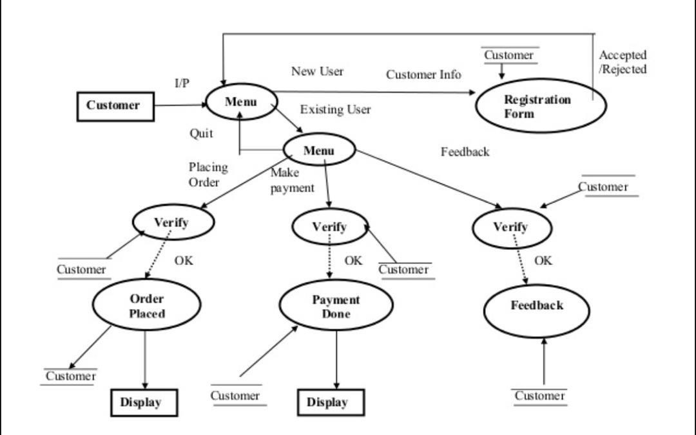

-FIGURE 3.5: DATA FLOW DIAGRAM

# Control Flow Diagram

A control flow diagram helps us understand the detail process. it shows us where control starts and ends and where it may branch off in another direction, given certain situations.



start

item

login

correct

Review order

View menu item

Sign in

Select menu

item

My cart

payment

Proceeds to

checkout

Menu item

Home

Add to cart

Continue to

make order

stop

Order receipts

Check out

-FIGURE 3.6: CONTROL FLOW DIAGRAM.

## ENTITY RELATIONSHIP DIAGRAM (ERD)

Entity relationship diagram is a type of UML diagram that is used to show the structural design of an application database. It gives account of all the entities and attributes present in the database.

-FIGURE 3.7 ENTITY RELATIONSHIP DIAGRAM.

## User Interface Design

This sections the user interface which is the front-end design which the user will use to interact with the web application.

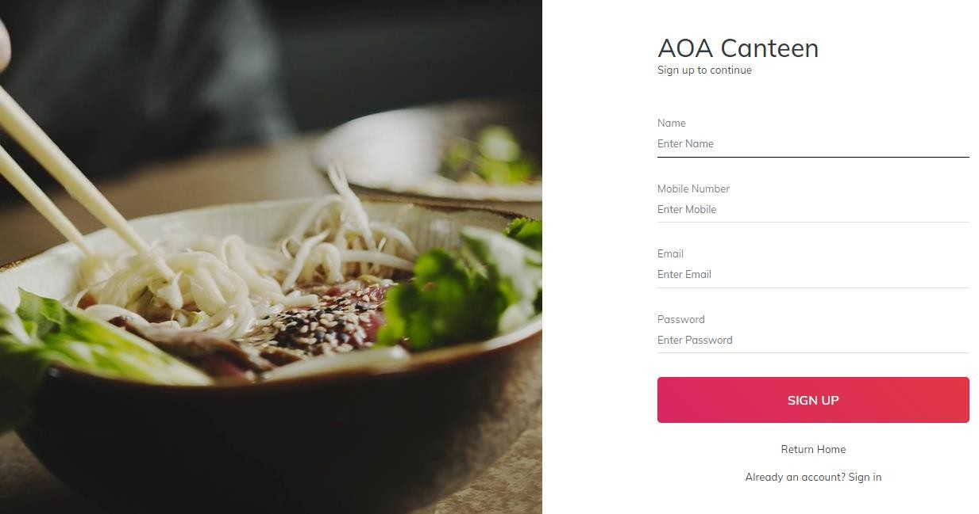

-FIGURE 8.1: SIGNUP PAGE

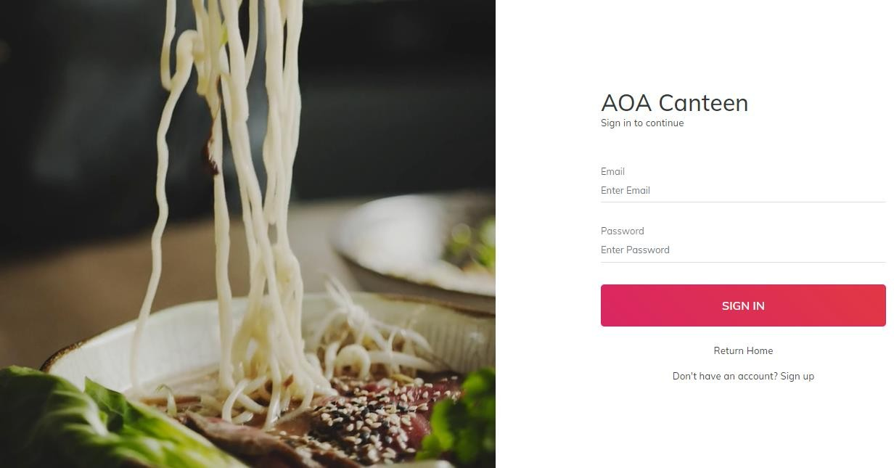

-FIGURE 8.1.1: LOGIN PAGE

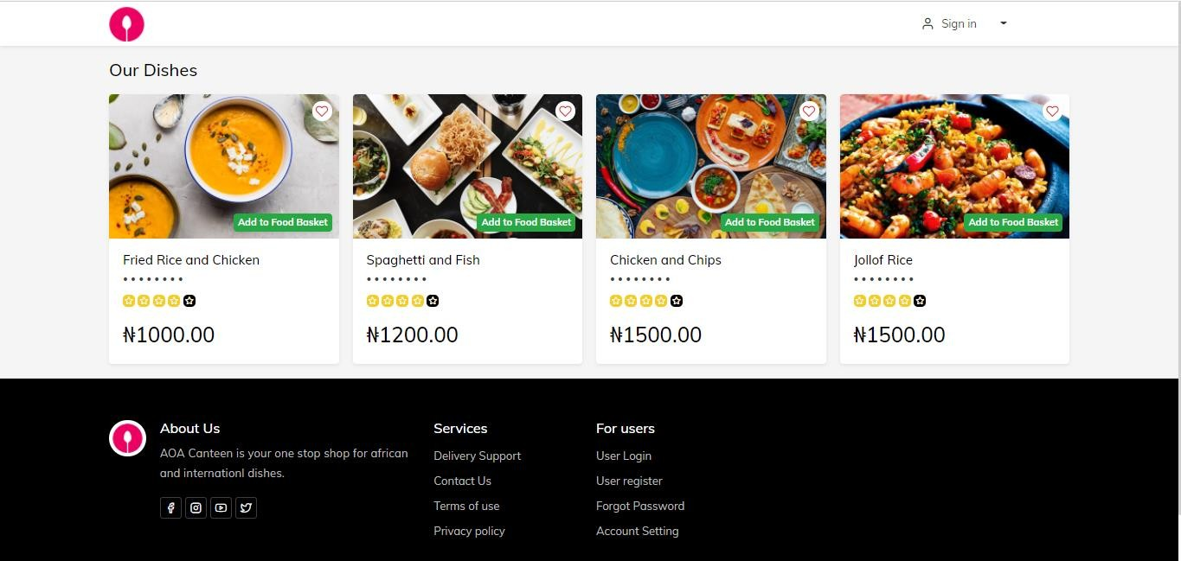

-FIGURE 8.1.2: HOME PAGE

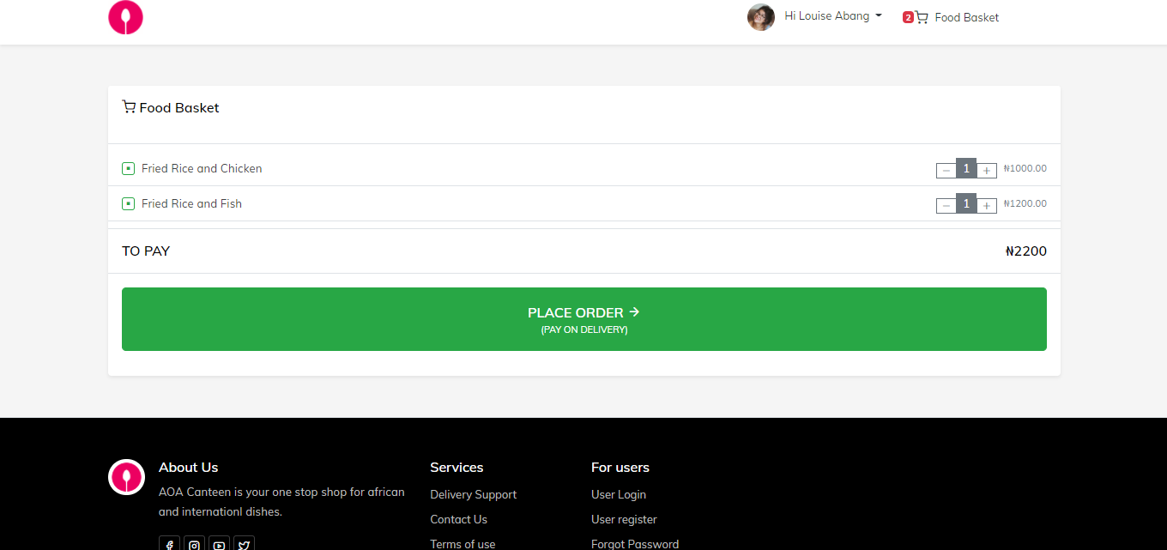

-FIGURE 8.1.3: FOOD BASKET

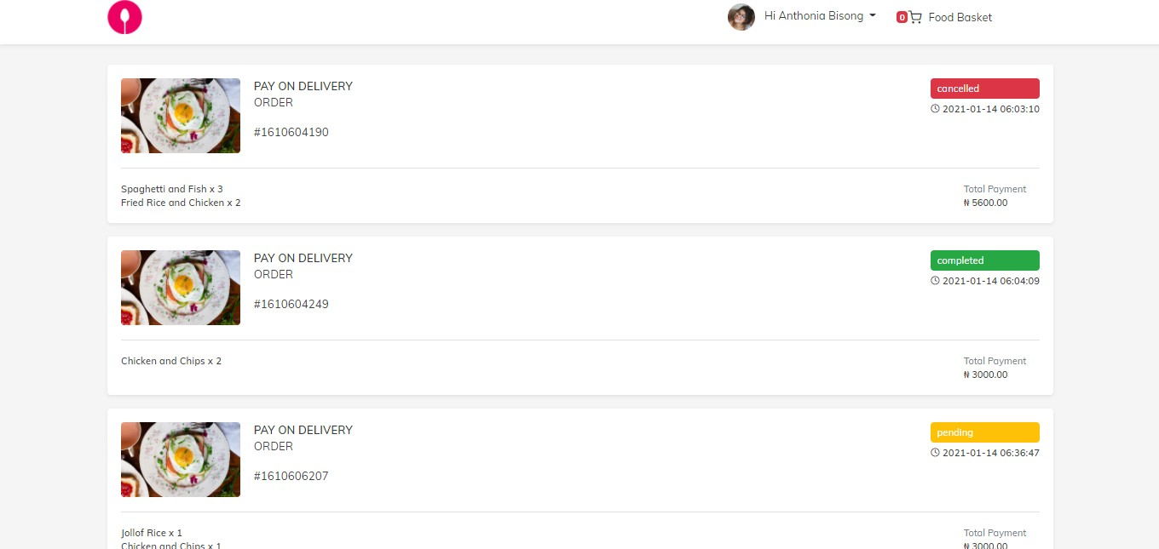

-FIGURE 8.1.4: ORDER PAGE

* **Signup page:** Figure 8.1 shows a picture if the signup page where prospective users can sign up and provide the necessary data needed to become registered users.
* **Login page:** Figure 8.1.1 shows a picture of the login page where registered users fill in their login information to gain access.
* **Home page:** Figure 8.1.2 shows a picture of the homepage, which shows the different dishes the user can select and order from and also the contact of the canteen.
* **Food basket:** Figure 8.1.3 shows a picture of the food basket, this shows the users which they have selected and want to order.
* Order page: Figure 8.1.4 shows a picture of the order page, this shows the users food which they have ordered and it shows the status of the food ordered, if it has been completed (delivered), cancelled, pending.

## Summary

In this chapter, the existing system of the canteen was disused, the problems of the existing system was discussed in other to work on the proposed system. However, the proposed system was discussed, the justification of the proposed system was also discussed. The methodology (agile methodology) used in the research was discussed. The tools and techniques were also

listed and discussed. The ethical consideration for the canteen was discussed. The requirement specifications was discussed, the nonfunctional and functional requirement was also discussed.

The system design was discussed. The application architecture diagram of the automated canteen ordering system was shown in this chapter. The use case diagram was shown in this chapter, the data design (database) was shown in this chapter. The activity diagram was shown in this chapter. The data flow and control flow diagram was also shown in this chapter. The user interface showing how the customers interact with the system was shown in this chapter.

# CHAPTER 4: IMPLEMENTATION AND TESTING

## Overview

The aim of this chapter is to document the process of development of the main features. It gives a detailed breakdown of the problems encountered and how they were resolved. It also goes through the test plan and test report of the project to ensure all the functionalities are functioning properly. This chapter is where the project is going to be implemented.

However, the software and hardware components used in the implementation of this project will be analyzed below.

## Software Components

* + 1. **The Front End:** front end development is the part of web development that codes and creates front end elements of a website, which are features that are directly viewable and accessible by the end-user client. The front-end codes used in this application include:
       - HTML: hypertext markup language, is the standard markup language for documents designed to be displayed in a web browser. It can be assisted by technologies such as cascading style sheets (CSS) and scripting languages such as java script, web browsers receive HTML documents from a web server or from local storage and render the documents into multimedia web pages. HTML describes the structure of a web page semantically and originally includes cues for the appearance of the document.

HTML elements are the building blocks of HTML pages. With HTML constructs, images, and other objects such as interactive forms may be embedded into the rendered page. HTML provides a means to create structured documents by denoting structural semantics for text such as headings, paragraphs, lists, links, quotes, and other items. HTML elements are delineated by tags, written using angle brackets. Tags such as

<img/> and <input/> directly introduce content into the page. Other tags such as <p> surround and provide information about document text and may include other tags as sub-elements. Browsers do not display the HTML tags but use them to interpret the content of the page.

HTML can be embedded programs written in a scripting language such as JavaScript, which affects the behavior and content of web pages. Inclusion of CSS defines the look and layout of content.

* + - * CSS: cascading style sheet is a style sheet language used for describing the presentation of a document written in a markup language like HTML.CSS is a cornerstone technology of the world wide web, alongside HTML and JavaScript.CSS is designed to enable the separation of presentation and content, including layout, colors, and fonts. This separation can improve content accessibility, provide more flexibility and control in the specification of presentation characters, enable multiple web pages to share formatting by specifying the relevant CSS in a separate .CSS file, and reduce complexity and repetition in the structural content.
      * JavaScript: JavaScript is a high-level, interpreted scripting language that conforms to the ECMAScript specification. Java script has curly-bracket syntax, dynamic typing, protype-based object-orientation and first-class functions. Alongside HTML and CSS, JavaScript is one of the core technologies of the world wide web. JavaScript enables interactive web pages and is an essential part of web applications. The vast majority of websites use it and major web browsers have a dedicated JavaScript engine to execute it. As a multi-paradigm language, JavaScript supports event-driven, functional, and imperative (including object-oriented and protype-based) programming styles. It has APIs for working with text, arrays, dates, regular expressions, and the DOM, but the language itself does not include any I/O, such as networking, storage, or graphic facilities. It relies upon the host environment in which it is embedded to provide these features.
    1. **The Back End:** The back end is the code thar runs on the server, that receives requests from the clients, and contains the logic to send the appropriate data back to the client. The back end also includes the database, which will persistently store all the data for the application.

The back-end codes used for this application includes:

* PHP: PHP is a server-side scripting language that is used to develop static websites or dynamic websites or web applications. PHP stands for hypertext pre-processor, that earlier stood for personal home pages. PHP scripts can only be interpreted on a server that has PHP installed. The client computer accessing the PHP scripts requires a web browser only. A PHP file contains PHP tags and ends with the extension “.php”.

The term PHP is an acronym for PHP: hypertext preprocessor. PHP is a server-side scripting language designed specifically for web development. PHP can be easily embedded in HTML files and HTML codes can also be written in a PHP file. The thing that differentiates PHP with client-side language like HTML is, PHP codes are executed on the server whereas HTML codes are directly rendered on the browser.

* MySQL: MySQL is an open source relational database management system (RDBMS) based on structured query language (SQL). It is one part of the very popular LAMP platform consisting of Linux, apache, My SQL, and PHP. Currently My SQL database is available on most important OS platforms. It runs on BSD Unix, Linux, Windows, or Mac OS. Wikipedia and YouTube use My SQL. These sites manage millions of queries each day. My SQL comes in two versions: My SQL server system and My SQL embedded system.
  + 1. **HARDWARE COMPONENTS:**
       - PC with 250 GB or more hard disk
       - PC with 2GB or more RAM.
       - PC with Pentium 1 and above.

## Main Features

The main features of the application are itemized as follows:

* Registration and profile creation: the registration process is probably one of the first steps of the customer interacting with the app. The registration feature is simple, allowing the

customers to complete their registrations. The registration is supported with a secure and robust backend to keep the user details safe.

* Searching for food: this feature is the core of the automated canteen ordering system. After completing the registration process. the customer will login and search for the food they want which results in quick order.
* Adding food to cart: when customer find the food they want to order, they will add items on the cart. The cart feature helps customers to order multiple food items at one go.
* Making payment easy: the payment option of the app, does give customer a hard time in making payment. And payment can be done on delivery.
* Logout user: a user can logout at point after logging in. a log out option is at the home page.

## Implementation Problems

A couple of bugs and errors were encountered during the implementation process.

## Overcoming Implementation Problems

The problems encountered during the implementation process were resolved with the help of stack overflow and cross checking the codes properly.

## Testing

In this section the functionalities will be verified and validated. This helps the developer identify and understand the limitation and possible vulnerabilities of the web application.

## Tests plans (for Unit Testing, Integration Testing and System Testing)

Below is the test plan for “automated canteen ordering system”

### Test Identifier:

**TEST LEVEL: Master test plan**

**AUTHOR’S NAME: BISONG-ABANG ANTHONIA.O.**

**AUTHOR’S CONTACT:** [**toniabisong15@gmail.com**](mailto:toniabisong15@gmail.com)

### Introduction

This section provides a breakdown of the tests carried out to verify and validate the functional requirement for automated canteen ordering system. White and black box testing were carried out.

### Features to be tested.

* + - * + Signup page
        + Register page
        + Add/ remove item from cart
        + Check out
        + Check previous order
        + Admin login
        + Admin accessing dashboard

## Test Suite (for Unit Testing, Integration Testing, and System Testing)

#### Test case TC-001 (signup user)

**Table 4.1: Test suite performed for signup**

|  |  |
| --- | --- |
| Test suit ID | R-121 |
| Test case ID | TC-001 |
| Test case summary | This is to ensure users can signup |
| Related requirement | R-121 |
| Prerequisite | * The web app must be opened in a Brower * Uninterrupted internet connection must   be available |
| Test procedure | 1. Navigate to the site using a URL 2. Click the signup |
| Test data | User’s information |
| Expected result | The user should be signed up |
| Actual result | The web application registered the user |
| Status | successful |

|  |  |
| --- | --- |
| Remarks | The test was successful |
| Created by | Bisong-Abang Anthonia |
| Date created | 8th October 2020 |
| Executed by | Bisong-Abang Anthonia |
| Date execution | 8th October 2020 |
| Test Environment | Hardware: Hp laptop  Software: Brower-google chrome |

#### Test case TC-002 (login user)

**Table 4.2: Test suite performed for login**

|  |  |
| --- | --- |
| **Test suit ID** | **R-122** |
| Test case ID | TC-002 |
| Test case summary | This test to ensure registered users can login |
| Related requirement | R-121 |
| Prerequisite | * User must be connected to the internet * User must be registered. |
| Test procedure | 1. Navigate to login page 2. login |
| Test data | 1. Registered email 2. password |
| Expected result | User should be logged in and redirected to the  home page |
| Actual result | User is logged in |
| Status | Successful |
| Remarks | The test was successful |
| Created by | Bisong-Abang Anthonia |
| Date created | 10th October 2020. |

|  |  |
| --- | --- |
| Executed by | Bisong-Abang Anthonia. |
| Date execution | 10th October 2020 |
| Test environment | Hardware: HP laptop  Software: browser- google chrome |

#### Test case TC-003 (Add/remove item from cart)

**Table 4.3: test suite performed to add/remove item from cart**

|  |  |
| --- | --- |
| Test suit ID | R-123 |
| Test case ID | TC-003 |
| Test case summary | This test case is to ensure user can remove and  add to their cart. |
| Related requirement | R-123 |
| Prerequisite | * user must be logged in * user must click “add to food basket” button * user must be on menu page * user must click “the x button” which is for remove * to remove user must be on the checkout   page |
| Test procedure | 1. login 2. click “add to food basket” button 3. click “x” button to remove item |
| Test data | Add/remove cart |
| Expected result | The web application should add food to  cart/the web application should remove food |

|  |  |
| --- | --- |
|  | from cart |
| Actual result | The web application should add food to cart/the web application should remove food  from cart |
| Status | successful |
| Remarks | The test was successful |
| Created by | Bisong-Abang Anthonia |
| Date created | 12th October 2020 |
| Executed by | Bisong-Abang Anthonia |
| Date execution | 12th October 2020 |
| Test environment | Hardware: hp laptop  Software: browser- google chrome |

#### Test case TC-004 (check out order)

**Table 4.4 test suite performed to check out.**

|  |  |
| --- | --- |
| Test suit ID | R-124 |
| Test case ID | TC-004 |
| Test case summary | The aim of this test case is to ensure the user  can check out |
| Related requirement | R-124 |
| Prerequisite | * user must be logged in * user must navigate to check out page |
| Test procedure | 1. login 2. click on “food basket” button |
| Test data | Check out |
| Expected result | The web application should take user to  checkout page |
| Actual result | The web application should take user to |

|  |  |
| --- | --- |
|  | checkout page |
| Status | successful |
| Remarks | The test case was successful |
| Created by | Bisong-Abang Anthonia |
| Date created | 20th October 2020 |
| Executed by | Bisong-Abang Anthonia |
| Date execution | 20th October 2020 |
| Test environment | Hardware: hp laptop  Software: browser- google chrome |

#### Test case TC-005 (login admin)

**Table 4.5: test suite performed to login admin**

|  |  |
| --- | --- |
| Test suit ID | R-125 |
| Test case ID | TC-005 |
| Test case summary | The aim of this test case to ensure the admin  can login |
| Related requirement | R-125 |
| Prerequisite | * admin must be connected to the internet |
| Test procedure | 1. navigate to the login page 2. login |
| Test data | 1. Registered username 2. password |
| Expected result | The admin should be logged in |
| Actual result | The admin is logged in and directed to the  admin dashboard |
| Status | successful |
| Remarks | This test case was successful |
| Created by | Bisong-Abang Anthonia |
| Date created | 22nd October 2020 |
| Executed by | Bisong-Abang Anthonia |

|  |  |
| --- | --- |
| Date execution | 22nd October 2020 |
| Test environment | Hardware: hp laptop  Software: browser- google chrome |

## Test Traceability Matrix (for Unit Testing, Integration Testing, and System Testing)

**Table 4.6: Test Traceability Matrix**

|  |  |  |  |  |  |
| --- | --- | --- | --- | --- | --- |
| Reqt. | Description | Priority | Test Case | Test Date | Test result |
| R-121 | The web application should allow users sign up. | 8 | 1 | 8th October 2020 | Successful |
| R-122 | The web application should allow users login | 7 | 2 | 10th October 2020. | Successful |
| R-123 | The web application should allow user  add/remove item from cart | 4 | 3 | 12th October 2020 | Successful |
| 1 |  |  |  |  |  |
| R-124 | The web application should allow user check out. | 4 | 4 | 20th October 2020 | Successful |
| R-125 | The web application should allow admin login | 8 | 5 | 22nd October 2020 | Successful |

## Test Report Summary (for Unit Testing, Integration Testing, and System Testing)

**Table 4.7: Test report summary**

|  |  |
| --- | --- |
| **SUMMARY OF TEST CARRIED OUT** | **RESULT** |

|  |  |
| --- | --- |
| Number of functions tested | 6 |
| Number of functions not tested | 2 |
| Number of tests passed | 15 |
| Number of tests failed | 0 |
| Percentage of tests passed | 100% |
| Percentage of test failed | 0% |

## Error Reports and Corrections

**Table 4.8: Error reports and corrections.**

|  |  |  |
| --- | --- | --- |
| **S/N** | **Error reports** | **Corrections** |
| 1 | Logical bugs and errors | These were corrected by going through documentations of libraries and scheming through codes to change the logic so to fit  the functionalities. |

## Use Guide

The user guide is used by prospective and already registered users to understand the functionalities provided by the web application and how to access them. Users make use of the use guide to understand what the web application has to offer.

## Summary

The chapter gives a clear breakdown of the main features and functionalities of the web application and the various methods and techniques used to implement the features. Each functionality was tested and documented. Error faced while carrying out implementation were stated as well as how the errors were resolved. This chapter played a critical role in the development of this web application.

# CHAPTER 5: DISCUSSION, CONCLUSION, AND RECOMMENDATIONS

## Overview

The aim of this chapter is to discuss the objective assessment of the project, the limitations and challenges encountered during the development of the project, possible future plans to enhance the project and also recommendations for future projects in automated canteen ordering system.

## Objective Assessment

Automated canteen ordering system is a web application that performs fast services to its users. Usually people have to go to canteen and order the foods and they have to wait in queue for a long time to get the orders. But with the help of this users just have to follow a very simple process to order their stuffs.

## Limitations and Challenges

This section discusses the problems and challenges faced during the development process. The challenges encountered will be analyzed below.

* + - The COVID pandemic restricted meetings with lectures to online only.
    - Lack of sufficient time.

## Future Enhancements

The overall objective of automated canteen ordering system is to provide fast service for users of the canteen.

Below are the possible enhancements for automated canteen ordering system.

* + - Drive sales with social media: the popularity of mobile phones and the usage of social media platforms using phones is known to the world. So, it is not to be surprise that food chains are now including provisions of using their devices application food plus for ordering to promote their sales.
    - Mobility and ease: with the online payment feature online payment feature ordering food using a canteen-based application has become a lot easier these days. There occurs no

requirement to make use of hard cash. Anyone can order food online using online payment modes right from the canteen ordering app.

Customers can also save up payment-related details in their profiles. Therefore, the food ordering script is hassle free, there is no need for adding their account details. With one click, anyone can order food online.

## Recommendations

It is known that for any meaningful computer-based information management to be integrated into any organization, proper training and orientation has to be given both to the staff and management. Proper training should be given to the data entry staff on how to handle computer hardware especially sensitive to change in temperature or pressure and as such data can be lost easily. the staff should also be highlighted on the need and advantage of the system and how it will equally assist them in their various field of work. They should also be informed of the cost of maintaining this new system so that they will handle it with all carefulness. Training materials should be circulated to the personnel. This will at the end generate appreciation and needed interest to operate the system.

## Conclusion

An automated canteen ordering system is developed where the customers can make an order for the food and avoid the hassles of waiting for the order to be taken by the waiter. Using the application, the end users register online, read the e-menu card, and select the food from the e- menu card to order food online. Once the customer selects the required food item the chef will be able to see the results on the screen and start processing the order. This application nullifies the need of a waiter or reduces the workload of the waiter. The advantage is that in a crowded canteen there will be chances that the waiters are overloaded with orders and they are unable to meet the requirement of the customer in a satisfactory manner. Therefore, by using this application, the users can directly place order for food and get it delivered.

## Summary

This chapter provides an objective assessment of the project which focuses on if all the requirements specified were met. The challenges faced during the implementation of this project were also documented in this chapter. Future enhancement, suggestions, and recommendations were also discussed. Overall, this chapter is the conclusion of the entire thesis.

# REFERENCES

-Bhatnagar, P. (2006). Dinning trends. 11-32

-Lynn beighley & micheal (2008), headfirst PHP & MySQL.

-Ian sommerville (2010). Software engineering

-Robin nixcon (2010). Learning PHP, MySQL, JavaScript & CSS

-Gan, C.C, (2002). Online canteen ordering system 22-34

-Purname j. & Wibowo, A.Y. (2007). Wireless application for canteen management system.55- 60

-Sharma, i. (2007). How online food ordering system helps you run more effectively.

-Sheweta S.T. Priyanka R.S madhura M.J (2013). Automated food ordering system. International journal of advanced research in computer science and software engineering. 3(2): 220-225

- QSR Web ( 2014). The top ordering trends restaurants cannot ignore. Retrieved from [https://www.qsrweb.com/articles/the-top-online- ordering-trends-restaurants-can’t-ignore/](https://www.qsrweb.com/articles/the-top-online-%20ordering-trends-restaurants-can’t-ignore/)

-Chavan V., Jadhav P., Korade S., Teli P. (2015). Implementing Custo- mizable Online Food Ordering System Using Web Based Application.

-International Journal of Innovative Science, Engineering & Technology,Vol. 2 Issue 4, pp. 722- 727.

-tutorials on point. (2020). SDLC-agile model-tutorialspoint. Retrieved from tutorials point.com:

-awojide, simon, I.M. Omogbheme, O.S. Awe, and T.S. Babatope (2008), “towards the digitization of restaurant business process for food ordering in Nigeria private university: the design perspective. A study of Samuel adegboyega university edo state Nigeria,” Int. J. sci. res. Publ., vol.8, no.5, pp. 46-54

-Tanwir, A., adan., Junaid, i., dragos, t., & ivan, p. (2019). Model-based testing using UML activity diagrams: a systematic mapping study. Computer science review, 98-112.

K,j. (2018, 01 29). 12 best software development methodologies with pros and cons, retrieved from acodez: https://acodez.in/12-best-software-development -methodologies-pros-cons/

-Yang, T., Lai, I. K. W., Fan, Z. B., & Mo, Q. M. (2020). Interactive service quality on the acceptance of self-service ordering systems for the restaurant industry. *Journal of Hospitality and Tourism Technology*.

-Young, J. A., Clark, P. W., & McIntyre, F. S. (2006). The web as an e-commerce medium: An exploratory study of consumer perceptions in a restaurant setting. *Journal of marketing Channels*, *14*(1-2), 5-22.

-Avhad, P., Bhanushali, H., Bhatt, K., & Rathod, M. (2020). Canteen Automation System with Payment Gateway. *Available at SSRN 3568597*.

-Vignesh, G., & Arun, B. (2019). A study on online food delivery service market (swiggy). *ZENITH International Journal of Multidisciplinary Research*, *9*(4), 370-376.

## APPENDICES

**Appendix A- Interview Report.**

Time efficiency: answers the question if it can be achieved within the time for the project, 1 being very bad and 5 being very good.

Feasibility: this answers the questions if the developer has the skill as well as the availability of tools/ funding to carry out that solution. 1 being very bad and 5 being very good.

Risk analysis: how risky would it be to embark on this solution. 1 being very risky and 5 being moderately okay.

|  |  |  |  |  |  |
| --- | --- | --- | --- | --- | --- |
| S/N | Ideas | Time  efficiency | Feasibility | Risk analysis | Total/15 |
| 1 | Going to the canteen to  find information about the existing system. | 2 | 5 | 3 | 10 |
| 2 | Getting information  from canteen users | 3 | 4 | 2 | 9 |

## Appendix B- Source codes.

<!DOCTYPE html>

<html>

<head>

<meta charset="utf-8">

<meta http-equiv="X-UA-Compatible" content="IE=edge">

<title>GETTING STARTED WITH BRACKETS</title>

<meta name="description" content="An interactive getting started guide for Brackets.">

<link rel="stylesheet" href="main.css">

</head>

<body>

<h1>GETTING STARTED WITH BRACKETS</h1>

<h2>This is your guide!</h2>

<!--

MADE WITH <3 AND JAVASCRIPT

-->

<p>

Welcome to Brackets, a modern open-source code editor that understands web design. It's a lightweight,

yet powerful, code editor that blends visual tools into the editor so you get the right amount of help

when you want it.

</p>

<!--

WHAT IS BRACKETS?

-->

<p>

<em>Brackets is a different type of editor.</em>

Brackets has some unique features like Quick Edit, Live Preview and others that you may not find in other

editors. Brackets is written in JavaScript, HTML and CSS. That means that most of you using Brackets

have the skills necessary to modify and extend the editor. In fact, we use Brackets every day to build

Brackets. To learn more about how to use the key features, read on.

</p>

<!--

GET STARTED WITH YOUR OWN FILES

-->

<h3>Projects in Brackets</h3>

<p>

In order to edit your own code using Brackets, you can just open the folder containing your files.

Brackets treats the currently open folder as a "project"; features like Code Hints, Live Preview and

Quick Edit only use files within the currently open folder.

</p>

<samp>

Once you're ready to get out of this sample project and edit your own code, you can use the dropdown

in the left sidebar to switch folders. Right now, the dropdown says "Getting Started" - that's the

folder containing the file you're looking at right now. Click on the dropdown and choose "Open Folder…"

to open your own folder.

You can also use the dropdown later to switch back to folders you've opened previously, including this

sample project.

</samp>

<!--

THE RELATIONSHIP BETWEEN HTML, CSS AND JAVASCRIPT

-->

<h3>Quick Edit for CSS and JavaScript</h3>

<p>

No more switching between documents and losing your context. When editing HTML,

use the

<kbd>Cmd/Ctrl + E</kbd> shortcut to open a quick inline editor that displays all the

related CSS.

Make a tweak to your CSS, hit <kbd>ESC</kbd> and you're back to editing HTML, or just leave the

CSS rules open and they'll become part of your HTML editor. If you hit

<kbd>ESC</kbd> outside of

a quick inline editor, they'll all collapse. Quick Edit will also find rules defined in LESS

and

SCSS files, including nested rules.

</p>

<samp>

Want to see it in action? Place your cursor on the <!-- <samp> --> tag above and press

<kbd>Cmd/Ctrl + E</kbd>. You should see a CSS quick editor appear above, showing the CSS rule that

applies to it. Quick Edit works in class and id attributes as well. You can use it with your

LESS and SCSS files also.

press

You can create new rules the same way. Click in one of the <!-- <p> --> tags above and

<kbd>Cmd/Ctrl + E</kbd>. There are no rules for it right now, but you can click the

New Rule

button to add a new rule for <!-- <p> -->.

</samp>

<a href="screenshots/quick-edit.png">

<img alt="A screenshot showing CSS Quick Edit" src="screenshots/quick-edit.png" />

</a>

<p>

You can use the same shortcut to edit other things as well - like functions in JavaScript, colors, and animation timing functions - and we're adding more and more all the time.

</p>

<p>

For now inline editors cannot be nested, so you can only use Quick Edit while the cursor is in a "full size" editor.

</p>

<!--

LIVE PREVIEW

-->

<h3>Preview HTML and CSS changes live in the browser</h3>

<p>

You know that "save/reload dance" we've been doing for years? The one where you make changes in

your editor, hit save, switch to the browser and then refresh to finally see the result?

With Brackets, you don't have to do that dance.

</p>

<p>

Brackets will open a <em>live connection</em> to your local browser and push HTML and CSS updates as you

type! You might already be doing something like this today with browser-based tools, but with Brackets

there is no need to copy and paste the final code back into the editor. Your code runs in

the

browser, but lives in your editor!

</p>

<h3>Live Highlight HTML elements and CSS rules</h3>

<p>

Brackets makes it easy to see how your changes in HTML and CSS will affect the page.

When your cursor

is on a CSS rule, Brackets will highlight all affected elements in the browser. Similarly, when editing

an HTML file, Brackets will highlight the corresponding HTML elements in the browser.

</p>

bolt

<samp>

If you have Google Chrome installed, you can try this out yourself. Click on the lightning

icon in the top right corner of your Brackets window or hit <kbd>Cmd/Ctrl + Alt +

P</kbd>. When

Live Preview is enabled on an HTML document, all linked CSS documents can be edited in real-time.

The icon will change from gray to gold when Brackets establishes a connection to your browser.

Now, place your cursor on the <!-- <img> --> tag above. Notice the blue highlight that appears

around the image in Chrome. Next, use <kbd>Cmd/Ctrl + E</kbd> to open up the defined CSS rules.

Try changing the size of the border from 10px to 20px or change the background

color from "transparent" to "hotpink". If you have Brackets and your browser running side-by-side, you

will see your changes instantly reflected in your browser. Cool, right?

</samp>

<p class="note">

Today, Brackets only supports Live Preview for HTML and CSS. However, in the current version, changes to

JavaScript files are automatically reloaded when you save. We are currently working on Live Preview

support for JavaScript. Live previews are also only possible with Google Chrome, but we

hope

to bring this functionality to all major browsers in the future.

</p>

<h3>Quick View</h3>

<p>

For those of us who haven't yet memorized the color equivalents for HEX or RGB values, Brackets makes

it quick and easy to see exactly what color is being used. In either CSS or HTML, simply hover over any

color value or gradient and Brackets will display a preview of that color/gradient automatically. The

same goes for images: simply hover over the image link in the Brackets editor and it will display a

thumbnail preview of that image.

</p>

<samp>

To try out Quick View for yourself, place your cursor on the <!-- <body> --> tag at the top of this

document and press <kbd>Cmd/Ctrl + E</kbd> to open a CSS quick editor. Now simply hover over any of the

color values within the CSS. You can also see it in action on gradients by opening a CSS quick editor

on the <!-- <html> --> tag and hovering over any of the background image values. To try out the image

preview, place your cursor over the screenshot image included earlier in this document.

</samp>

<h3>Need something else? Try an extension!</h3>

<p>

In addition to all the goodness that's built into Brackets, our large and growing community of

extension developers has built hundreds of extensions that add useful functionality. If

there's

something you need that Brackets doesn't offer, more than likely someone has built an

extension for

it. To browse or search the list of available extensions, choose <strong>File > Extension Manager…</strong> and click on the "Available" tab. When you find an extension you

want, just click

the "Install" button next to it.

</p>

<!--

LET US KNOW WHAT YOU THINK

-->

<h2>Get involved</h2>

<p>

Brackets is an open-source project. Web developers from around the world are contributing to build

a better code editor. Many more are building extensions that expand the capabilities of Brackets.

Let us know what you think, share your ideas or contribute directly to the project.

</p>

<ul>

<li><a href=["http://bra](http://brackets.io/)c[kets.io">Bra](http://brackets.io/)ckets.io</a></li>

<li><a href=["http://blog.bra](http://blog.brackets.io/)c[kets.io">Bra](http://blog.brackets.io/)ckets Team Blog</a></li>

<li><a href="https://github.com/adobe/brackets">Brackets on GitHub</a></li>

<li><a href="https://brackets-registry.aboutweb.com">Brackets Extension Registry</a></li>

<li><a href="https://github.com/adobe/brackets/wiki">Brackets Wiki</a></li>

<li><a href="https://groups.google.com/forum/#!forum/brackets-dev">Brackets Developer Mailing List</a></li>

<li><a href="https://twitter.com/brackets">@brackets on Twitter</a></li>

<li>Chat with Brackets developers on IRC in <a href=["http://webc](http://webchat.freenode.net/?channels=brackets&uio=d4)h[at.freenode.net/?channels=brackets&uio=d4">](http://webchat.freenode.net/?channels=brackets&uio=d4)#brackets on Freenode</a></li>

</ul>

</body>

</html>

<!--

[[[[[[[[[[[[[[[ ]]]]]]]]]]]]]]]

[:::::::::::::: ::::::::::::::]

[:::::::::::::: ::::::::::::::]

[::::::[[[[[[[: :]]]]]]]::::::]

[:::::[ ]:::::]

[:::::[ ]:::::]

[:::::[ ]:::::]

[:::::[ ]:::::]

[:::::[ CODE THE WEB ]:::::]

[:::::[ [http://brackets.io](http://brackets.io/) ]:::::]

[:::::[ ]:::::]

[:::::[ ]:::::]

[:::::[ ]:::::]

[:::::[ ]:::::]

[::::::[[[[[[[: :]]]]]]]::::::]

[:::::::::::::: ::::::::::::::]

[:::::::::::::: ::::::::::::::]

[[[[[[[[[[[[[[[ ]]]]]]]]]]]]]]]

-->

php:

preset: laravel disabled:

* no_unused_imports finder:

not-name:

* + index.php
  + server.php

js:

finder:

not-name:

* + webpack.mix.js

css: true

## Appendix C – Test Cases

#### Test case TC-001 (signup user)

|  |  |
| --- | --- |
| Test suit ID | R-121 |
| Test case ID | TC-001 |
| Test case summary | This is to ensure users can signup |
| Related requirement | R-121 |
| Prerequisite | * The web app must be opened in a Brower * Uninterrupted internet connection must   be available |
| Test procedure | 1. Navigate to the site using a URL 2. Click the signup |
| Test data | User’s information |
| Expected result | The user should be signed up |
| Actual result | The web application registered the user |
| Status | successful |
| Remarks | The test was successful |
| Created by | Bisong-Abang Anthonia |
| Date created | 8th October 2020 |
| Executed by | Bisong-Abang Anthonia |
| Date execution | 8th October 2020 |
| Test Environment | Hardware: Hp laptop  Software: Brower-google chrome |

*Test case TC-002 (login user)*

|  |  |
| --- | --- |
| **Test suit ID** | **R-122** |
| Test case ID | TC-002 |
| Test case summary | This test to ensure registered users can login |
| Related requirement | R-121 |

|  |  |
| --- | --- |
| Prerequisite | * User must be connected to the internet * User must be registered. |
| Test procedure | 1. Navigate to login page 2. login |
| Test data | 1. Registered email 2. password |
| Expected result | User should be logged in and redirected to the  home page |
| Actual result | User is logged in |
| Status | Successful |
| Remarks | The test was successful |
| Created by | Bisong-Abang Anthonia |
| Date created | 10th October 2020. |
| Executed by | Bisong-Abang Anthonia. |
| Date execution | 10th October 2020 |
| Test environment | Hardware: HP laptop  Software: browser- google chrome |

## Appendix D – User Guide/Manual



**Figure 1. User guide manual**



**Figure 2. User guide manual**

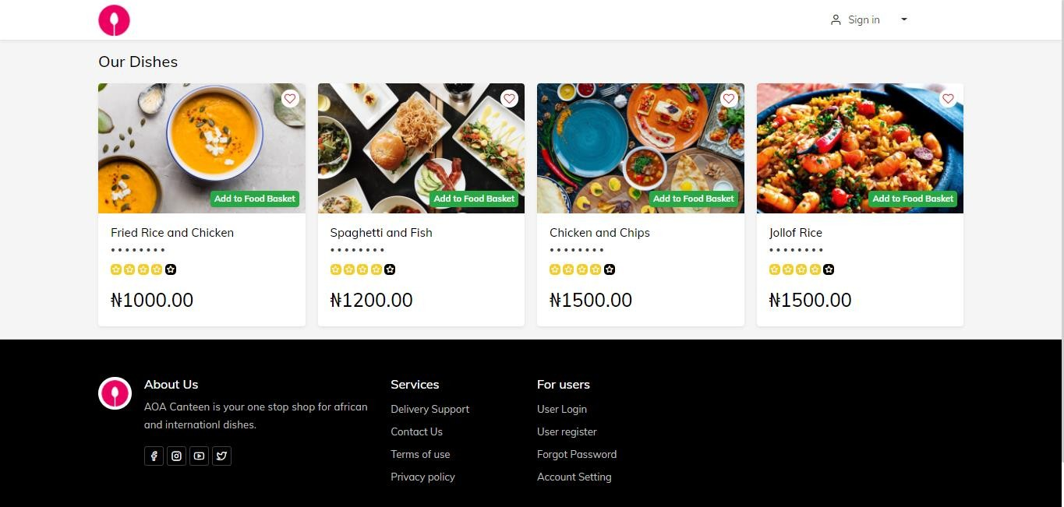

**Figure 3. User guide manual**



**Figure 4. User guide manual**



**Figure 5. User guide manual.**