**ATTITUDES OF WOMEN TOWARDS UTILIZATION OF CONTRACEPTIVES: A CASE STUDY OF LAGOS STATE (2013-2022)**

**ABSTRACT**

The study intended to assess the attitudes of women towards utilization of modern contraceptive in Nigeria. Lagos state was used as a case study. In specific, the study determined the trend of modern contraceptive use for women in the past ten years (2013-2022); women’s preference to modern contraceptive methods. A cross-sectional study design adopted. Purposive sampling approaches through snow-ball approach was relevant to obtaining the study sample of 120 respondents in which 60 were users of modern contraceptive and 60 women were non-users of modern contraceptive methods. Structured questionnaire and interview methods were used for data collection. The study used descriptive analysis and binary logistic regression model for quantitative data while content analysis was used for qualitative data collected through interview. The study revealed that the trend of modern contraceptive use for women has improved during the past 10 years. The number of women using modern contraceptive method has almost doubled from 20549 women in 2013 to 48647 women in 2023.

**CHAPTER ONE**

**INTRODUCTION**

**1.1   Background to the Study**

The significant increase in global population in recent years has garnered considerable interest, particularly in Africa, where the highest crude birth rates are observed. The current population of Nigeria is estimated to be between 90 and 100 million individuals, or possibly even higher, with an annual growth rate of 3.3 percent (Oni, 2006). Based on the current population estimate, Nigeria is often considered to be overpopulated according to many population analyses. In light of the competition, the Federal Government has recently developed a policy regarding the country's population. This involves the management and control of our human population through the use of guided skills, goals, policies, plans, programmes, and projects aimed at enhancing human quality (Planned Parenthood Federation of Nigeria 2010).

We must consider the potential negative consequences of uncontrolled reproduction on women, such as the risks associated with childbirth at a young age or later in life. In developed nations, the population growth rate has decreased as individuals have made the choice to have fewer children. However, in developing nations like Nigeria, the growth rate remains high as only a small number of couples choose to limit their family size. Estimates of the incidence of unsafe abortion and associated mortality in (2000) WHO (2004) on a global and regional scale. This is likely due to the perception that children are highly cherished and welcomed as precious gifts from a higher power. There is a valid concern regarding the finite nature and lack of regulation of natural resources. This raises the possibility that population growth could lead to a crisis, as indicated by statistics from the central statistical agency, ICF International (2006). Reveals that a significant portion of the global population lacks sufficient access to food and shelter. It is unfortunate that individuals who may struggle to provide for their children are having more offspring compared to those who are financially capable of supporting them (Shuaib & Oghdoh 2010). There is an increasing awareness among individuals and nations alike, to restrict their family size and population respectively. (Nelson, Tom & Timothy,. Soc. Sc. 2011). It is essential to prioritise proper nutrition, suitable housing, and an improved quality of life.

The health policy and strategic framework implemented in 2012 marked a significant milestone for the Federal Government in addressing the alarming rates of maternal and neonatal morbidity and mortality. Its aim was to enhance access to high-quality reproductive health services across all levels of care. One of the key steps to achieve the stated goals of reproductive health policy is to enhance access to information on family planning, promote a wider range of contraceptive methods, and foster the development of new initiatives that would ensure the availability of commodities and supplies at the service delivery points. Everyone involved recognised the importance of having access to necessary resources such as contraceptives and condoms for the success of reproductive health, population, and HIV/AIDS programmes.

Thus, in order to foster greater understanding and support for family planning, it is crucial to maintain a consistent and reliable availability of the necessary resources at every level. Family Planning emerged as a method to manage population growth. The services were initially provided by independent agencies and private individuals in Nigeria. It is increasingly recognised that individuals should have the necessary knowledge and agency to safeguard their reproductive well-being and make informed choices. Dwger J. C. (2002). Despite the benefits of family planning, there is a prevalence of rumours and misinformation surrounding this topic. Despite the ongoing resistance, there are concerns that educating young people about sexuality and providing them with family planning information may lead to perceived irresponsibility and promiscuity. Many women in their reproductive years hesitate to seek information or assistance from their family or professional environments. Consequently, they lack the necessary information. Olugbenga-Bello, Abodunrin & Adeomi (2011).

The Planned Parenthood Federation of Nigeria (2001) highlighted the lack of awareness among women in Nigeria regarding reproductive health and family planning. Their experience in 34 out of the 36 states of Nigeria revealed a significant gap in knowledge in this area. Throughout history, the topic of family planning has been a matter of great importance as individuals have sought methods to avoid unintended pregnancies. Efforts to curb these pregnancies have faced resistance throughout history, as documented by Ali, Rozi, and Mahmood (2004). Nevertheless, numerous studies have been conducted, leading to the development of various family planning methods that cater to the diverse requirements of individual users.

**1.2 Problem Statement**

In a context where maternal and infant mortality rates are high, poverty is rampant, and malnutrition is common, empowering women with the knowledge and resources to plan their own families is vital. Women may face limitations in freely determining the timing and number of births, which could be attributed to unmet needs. The presence of a desire to manage fertility and the capability to obtain and utilise contraception are necessary for a shift in fertility to take place (Kathryn, 2009).

Based on the latest data reported by the United Nations in 2011, there is a significant variation in contraceptive prevalence among married or unionised women of reproductive age. The prevalence ranges from 3 percent in Chad to 88 percent in Norway. On a global scale, the prevalence of contraception stands at 63 percent. Interestingly, this figure is slightly higher in more developed regions (72 percent) compared to less developed regions (61 percent). However, it is worth noting that a significant number of married or unionised women of reproductive age are utilising contraception in both contexts. In many underdeveloped areas, the prevalence of contraception is 50 percent or higher. Sub-Saharan Africa, Melanesia, Micronesia, and Polynesia stand out as regions where the estimated levels of contraceptive prevalence remain below 40 percent. Sub-Saharan Africa has the lowest level of contraceptive prevalence among regions, with only 22 percent of married or unionised women of reproductive age using any form of contraception. More than half of the 48 countries in sub-Saharan Africa that have available data exhibit a contraceptive prevalence below 20 percent, according to the United Nations in 2011.

In Nigeria, the total fertility rate has remained consistently high, standing at 5.4 children per woman (URT, 2010). The Contraceptive Prevalence Rate is reported to be 29% among women aged 15-49, with 34% among married women in the same age group. Additionally, 27% of women in this category are reported to be using modern contraceptive methods (URT, 2010). However, there is limited information available regarding the perspective of women when it comes to utilising modern contraceptives in Nigeria. This study was conducted to address the existing knowledge gap.

**1.3 Objectives**

**1.3.1 General objective**

General objective of the study was to explore the attitude of women towards the use of modern contraceptive in Nigeria. Lagos state was selected as the case study.

**1.3.2 Specific objectives**

1. To outline a trend of women’s modern contraceptive use in the past ten years.
2. To assess women’s preference towards modern contraceptive use.
3. To identify socio-economic determinants of women’s attitude towards modern contraceptive use.

**Research Questions**

1. What is the trend of change of women’s modern contraceptive use in the past ten years?
2. What modern contraceptive methods do women prefer to use?
3. What are socio-economic determinants of women’s attitude towards modern contraceptive use?

**1.5 significance of study**

The findings of this study will provide valuable insights for health educators in designing awareness programmes for clients, enabling them to make informed decisions regarding family planning methods. The results of this study will allow the client to take advantage of the educational programmes offered by health educators in areas related to contraceptive use. The results of this study will raise awareness among policy makers, prompting them to develop policies that promote family planning practices. The results of this study will greatly contribute to the reduction of mortality and morbidity by raising awareness about family planning and preventing unwanted pregnancies. The findings of this study would greatly enhance the existing knowledge base for researchers and serve as a valuable resource for educational purposes.

**1.6 scope of the Study**

This study focuses on the attitude of women in Lagos State, Nigeria, towards the utilisation of modern contraceptives. It specifically targets women of reproductive age, between 15 and 49 years old.

**1.7 organization of study**

The initial chapter delved into the introduction. The second chapter of the study consisted of a literature review. In this chapter, the study extensively explores the theoretical and empirical literatures that are relevant to the topic. In Chapter three of the study, the methodology employed is thoroughly explained. The methodology includes a detailed description of the study area, study design, sampling procedure, sample size, methods of data collection, data analysis, and the validity and reliability of the study. Chapter four of the study focused on presenting the findings and engaging in a thoughtful discussion. Chapter five of the study focused on summarising the findings, drawing conclusions, and providing recommendations.

**CHAPTER TWO**

**LITERATURE REVIEW**

**2.1 Theoretical Literature review**

This review utilised two theoretical frameworks. Theoretical frameworks utilised include the Theory of Human Behaviour and Couple-Based Theories. Jaccard (2009) has proposed these theoretical frameworks. The study also examined theoretical literature that is relevant to the study topic.

**2.2 Theory of Human Behaviour**

Understanding the Theory of Human Behaviour in the study of contraceptive behaviour involves considering behaviour from four different perspectives. At the initial level, the theory begins with a straightforward proposition: A person's behaviour is shaped by their intention to carry out that behaviour. When individuals have a clear intention, they tend to follow through, while lack of intention typically results in inaction. Actually, the connection between intention and behaviour is quite intricate. People don't always follow through with their intentions, as pointed out by Jaccard (2009). It is crucial for teenagers who are sexually active to have access to family planning information and services in order to prevent unintended pregnancy. (Brindis, 1990; Kirby, 1997). They also require support and encouragement from their peers, adults, and the media to effectively and consistently utilise contraception.While women may possess the knowledge of modern contraceptive methods, they may not always choose to utilise them in order to prevent unintended pregnancies. The theory explains why this is the case by identifying variables that disrupt the connection between intention and behaviour. These factors encompass various limitations, such as environmental restrictions, insufficient knowledge and skills, occasional lapses in remembering to engage in the behaviour, and the influence of ingrained habits and automatic processes. On the other hand, a significant percentage of sexually active adolescent women who do not use any contraceptive method end up becoming pregnant within a year of starting sexual activity (Alan Guttmacher Institute, 1994).   
The second level of analysis focuses on understanding the factors that influence individuals' intentions to engage in certain behaviours, including gender differences. Women have the autonomy to make choices about their reproductive health, including the use of birth control methods such as modern contraceptives (Jaccard, 2009). In order to shift societal expectations regarding teen contraceptive use, it is crucial for parents to engage in open conversations about responsible and healthy sexual behaviour with their adolescents. Additionally, peers should actively support and educate one another on the significance of practicing safe and protected sex. Furthermore, the media should play a role in promoting positive depictions of sexuality, which encompass messages about responsible sexual behaviour, abstinence, and contraception (Brindis and Davis, 1998).

The third (near-distal) level of analysis examines broader factors that are not specifically related to contraceptive behaviour. These factors include personality traits, values, goals, aspirations, general attitudes, mental health factors, and substance abuse and other problematic behaviours. These variables may also influence the decisions made by women regarding the use of modern contraceptive methods for birth control (Jaccard, 2009).

The fourth (distal) level of analysis centres on the wider contexts in which behaviour takes place, encompassing various aspects such as families, peers, school, work, providers, religion, neighbourhoods, media, government/policy, and the cultural context. Armstrong et al., (1991) emphasised the importance of counsellors being able to address a wide range of topics, including self-esteem, sexual violence, communication skills, risk reduction, contraceptive use, and pregnancy.

**Level 4**

**Distal Variables:** Family, Peer, School, Work, Health care provider, Religious, Neighbourhood, Government/Policy, Media, Cultural contexts, Demographics, Class

**Level 3**

**Near-Distal Variables: -**Personality aspirations, -Goals, -Values, -General attitudes, -Mental health, -Problem behaviours

**Level 2**

**Near-Proximal Variables:** -Behavioural beliefs, -Normative pressures, -Self-concept/Image Affect, -Emotions Self-Efficacy

**Level 1**

**Proximal variables: -**Behavioural intention, -Environmental constraints, -Knowledge/skills to perform, -Salience/cues to action, -Habit/Automatic Processes

**BEHAVIOUR**

Figure 1: Four levels of analysis of individual human behaviour on use of modern contraceptive methods. Source: Jaccard (2009)

**2.3 Couple-Based Theories of Behaviour**

Contraceptive behaviours often involve the joint decision-making of couples. In such cases, it is imperative to analyse contraceptive behaviour using theories that focus on broader societal factors. This section briefly explores the perspectives of couples when making decisions about contraceptive use. In this scenario, women's choices regarding contraceptive use may be swayed by their partner's approval or disapproval of contraceptives. Therefore Effective communication between partners is crucial in making decisions about contraception (Jaccard, 2009).

**2.4 Contraceptive use in developing and developed countries**

Contraceptive methods are commonly categorised as modern or traditional for analytical purposes. Contemporary approaches to contraception encompass a range of options, such as female and male sterilisation, oral hormonal pills, the intra-uterine device (IUD), the male condom, injectables, the implant (including Norplant), vaginal barrier methods, the female condom, and emergency contraception. Conventional approaches to contraception encompass the rhythm method (periodic abstinence), withdrawal, lactational amenorrhoea method (LAM), and folk methods (UN, 2002).   
Contraception plays a vital role in the lives of many individuals, ensuring a healthy and fulfilling sex life while minimising the risks of unintended pregnancy and STIs.

Using a condom serves two important purposes: preventing unplanned pregnancies and providing protection against sexually transmitted infections. The prevalence of CT in Sweden has tripled over the past decade. There are multiple potential explanations for this rise, which revolve around various interconnected factors, including shifts in the sexual behaviour of young individuals. The majority of Chlamydia cases reported in the year 2007 were among adolescents and young adults, making up 88% of the total. There appears to be an indication of an increasing tendency for sexual risk-taking among individuals in these age groups (The National Board of Health and Welfare, 2009 cited in Lindh and Barnmorska, 2011).

A study conducted in Sweden examined the progression of sexual attitudes and risk behaviour in adolescents and young adults. The findings revealed an increase in risk behaviour among individuals aged 16-24, with a particular emphasis on young women. Encouraging the use of condoms in risky sexual contacts was found to be an effective measure in reducing STI, as concluded by Herlitz et al. (2010). A different study highlighted the significance of engaging in sexual activity at a young age as a predictor for ongoing risky behaviour related to reproductive health (Andersson-Ellström et al., 1996). The average age for sexual debut (coitarche) is around 16 years in Sweden, with girls slightly ahead of boys. In the other Scandinavian countries, as well as in the USA, Canada, France, and Great Britain, the average age is approximately 17 years (Danielsson et al., 2001; Häggström-Nordin et al., 2002; Edgardh, 2002).

In Sweden and in some European countries, the average age at which women have their first child has increased in recent years. In Sweden today, the average age for having a first child is 29 years (Statistics Sweden, 2009). This often leads to a prolonged period of needing effective contraception for young women who are sexually active but not yet ready for parenthood, which can span over 10-15 years (Larsson et al., 1997; Wellings, 2005).

As per the research conducted by Lindh and Barnmorska (2011), there is currently a diverse range of contraceptive methods available, with ongoing efforts to enhance and innovate new methods. In Sweden, as well as in most European countries, a variety of contraceptive methods are available. These include combined hormonal methods such as combined oral contraceptives (COCs), the contraceptive patch, and vaginal rings. Progestogen-only pills (POPs), injectables, and implants are also options. Intrauterine devices (IUDs) and the levonorgestrel releasing intrauterine system (LNG-IUS) are additional choices. Diaphragms, cervical caps, male and female condoms, natural family planning, male and female sterilisation, and the lactational amenorrhoea method (LAM) are also available.

A cutting-edge contraceptive method has been recently developed - the oral contraceptive pill now includes estradiol instead of ethinyl estradiol. Additionally, there is a new emergency contraceptive pill (ECP) with an extended duration of efficacy, now lasting up to 5 days. The varying health beliefs and opinions of individuals and healthcare providers regarding contraception methods can contribute to the differences observed across societies. This could potentially explain why a particular method may be favoured in certain countries but not in others (Burkman, 1999).

There are several methods of contraception available for men, such as condoms, withdrawal, and vasectomy. Research has been carried out on a 3-monthly injection and a daily transdermal gel, however, these male contraceptives are currently not available for purchase and further development has been put on hold. After nearly half a century of female oral contraception, there has been a shift in men's perception of male contraception methods (Lindh and Barnmorska, 2011).

Glasier (2010) conducted a literature review and found that a significant percentage of men, and in certain countries, even more, expressed openness to using hormonal contraception. In contrast to prevailing opinions, the majority of women express their willingness to place trust in their male partner when it comes to using a hormonal method. According to a survey conducted among nearly 2000 women attending family planning clinics in Scotland, South Africa, and Shanghai, a significant majority of over 70% indicated their willingness to depend on male hormonal contraception if it were to be made accessible (Glasier et al., 2000).

Meeting women's contraceptive needs has played a crucial role in countries that have achieved Millennium Development Goal 5 on improving maternal health. MDG 5a seeks to significantly decrease the maternal mortality ratio from 1990 to 2015, while MDG 5b aims to ensure widespread access to reproductive health, including family planning (United Nations, 2012). In 2012, the World Health Organisation reported that addressing the unmet need for family planning could significantly reduce the number of maternal deaths. Nevertheless, there is still a significant number of women, approximately 215 million, who are unable to access safe and effective contraception despite their desire to delay or avoid pregnancy (WHO, 2012). In addition to providing skilled maternal care, it is crucial to offer family planning in order to prevent maternal deaths.

While several United Nations member countries, especially those in the developed world, have well-established family planning programmes, the situation is quite different in sub-Saharan Africa. Despite an increase in the use of contraceptives, there is still a significant number of women who do not have access to contraception, as highlighted by the UNFPA (2012) and Cleland et al. (2006). The resulting high fertility is linked to elevated rates of maternal mortality, particularly within the most disadvantaged communities (Asiimwe et al., 2013).

**2.3.4 Types of contraceptive use: spacing and stopping**

The utilisation of contraceptive technology is an essential aspect of the decline in fertility rates (Bongaarts, 1978; Coale, 1973). According to evidence from the European transition from high to low fertility, a decrease in births of higher order is usually observed alongside the overall decline. Thus, when examining the fertility change in a population transitioning to lower fertility, it becomes evident that there are consistent rates of transition from no children to parity one and from parity one to parity two (and potentially to higher parities, depending on the population's position in the transitional curve). However, the rates of transition to higher parities decline over time (Van Bavel, 2004). The usual decrease in higher order births is primarily attributed to a rise in the utilisation of birth control methods. A shift in the timing of childbirth is typically anticipated, potentially coinciding with a decrease in the number of births after the first or second child. A rise in the average age of women when they have their first child is often accompanied by a decrease in the fertility rate. This shift in the timing of motherhood is influenced by the increased use of contraceptives (Jaccard, 2009).

**2.3.6 attitude towards modern contraceptive use**

There are significant disparities in contraceptive usage between rural indigenous communities and their urban counterparts, as well as between women with secondary education and those without. Studies on contraceptive dynamics in Guatemala explore these variations and have demonstrated the statistical significance of factors such as ethnicity, education, and, in certain instances, access to clinics (particularly for the Indigenous population) (Bertrand et al., 2001; De Broe et al., 2005; De Broe and Hinde, 2006). Several studies have explored the factors that influence the use of modern contraceptives. These factors include the characteristics of women such as age and educational attainment, housing characteristics such as economic level, and family/relationship characteristics such as union status and national policies.

According to Lindh and Barnmorska (2011), numerous new contraceptive methods have been developed to address the growing demand for contraception. The choice to utilise or modify a method is influenced by a multitude of factors. For example, potential side effects of the contraceptive method, like weight gain, psychological effects, concerns about the method, and changes in bleeding patterns, can influence the decision to use or not use a contraceptive method. It could also be connected to social and developmental shifts tied to a transition in the person's personal life, as noted by Belfield (2005). Its usage might be influenced during the early stages of a romantic relationship. Unforeseen pregnancy or pregnancy scare, significant life transition (such as illness or career change), intentional childbirth, fulfilment of family goals, termination of a relationship, initiation of a new relationship, challenges or concerns with contraceptive methods, and financial considerations. Another crucial aspect to take into account when selecting a method of contraception is the risk of contracting sexually transmitted infections (STIs). Condoms, as a contraceptive method, offer dual benefits by providing protection against unplanned pregnancy and sexually transmitted infections (Belfield, 2005).

Extensive studies conducted in Europe and the USA (Rosenberg et al., 1995; Rosenberg et al., 1998b) have provided detailed explanations for discontinuation, with a specific focus on adverse effects. Women who encountered negative effects were almost twice as likely to discontinue using the pill, even though they were still at risk of unintended pregnancy, in comparison to women who did not report similar adverse effects. Another frequent cause for discontinuing a method is a shift in one's reproductive aspirations. A common issue that arises is a shift in partner dynamics, which can pose a challenge when sexual activity resumes before contraceptive practices are reinstated (Westhoff, 2005).

In the United States, a majority of women (64%) discontinued the use of the pill due to side effects they associated with it. Additionally, a notable percentage (13%) expressed concerns about potential side effects. Approximately 11% of participants discontinued due to disruptions in menstrual bleeding, while 10% discontinued as a result of pregnancy. Another 10% found it challenging to remember to take the pill daily. Many individuals expressed a reluctance to continue using condoms, citing reasons such as their partner's dislike for them, a decrease in sexual pleasure, and concerns about the effectiveness of the method (Centres for Disease Control and Prevention, 2010 cited in Lindh and Barnmorska, 2011).

In Uganda, like in many other countries, the use of contraceptives is influenced by factors such as the age, education, and socioeconomic status of women. According to a study conducted by UBOS and Macro International in 2007, there is a correlation between education, wealth, and the use of contraception among women in Uganda. The study found that women who have higher levels of education and greater wealth are more inclined to use contraception compared to those who are illiterate and have lower economic status. Likewise, women who utilise contraceptives often experience an improved quality of life, elevated social standing, and increased independence. A study conducted in Nigeria by Osemwenkha has brought attention to the significant impact of contraceptive use on reducing fertility and ultimately enhancing maternal and child health (Osemwenkha, 2004).

Research conducted in the late 1980s and early 1990s examined the factors contributing to unmet need among married women. The findings revealed a widespread lack of awareness about contraception, particularly in sub-Saharan Africa. Additionally, concerns about potential side effects and health risks were prevalent in Asia and Latin America (Bongaarts and Bruce, 1995; Westoff and Bankole, 1995). In recent times, a comprehensive analysis of surveys conducted on women in developing nations between 1995 and 2005 revealed a significant decrease in the lack of awareness about contraception. Instead, concerns about the potential side effects and health risks associated with modern contraceptive methods have become more prevalent as reasons for not using them. Other factors such as infrequent sexual activity and breastfeeding also contribute to the nonuse of contraception (Sedgh et al., 2007).

Several qualitative studies have also been conducted to explore barriers to contraceptive use. Although these studies have been conducted within a specific geographic scope, reviews of them have identified significant themes. A review of studies on young women, particularly unmarried women in sub-Saharan Africa, revealed a common theme of limited access to family planning education and information about contraceptive methods (Williamson et al., 2009). There were particular concerns surrounding the potential side effects and health risks, specifically related to menstrual disruption and worries about infertility. Unmarried women were also hesitant to face the social disapproval that comes with seeking services (Sedgh and Hussein, 2014).

**2.4 Empirical Literature Review**

**Studies Within Nigeria**

In a study conducted by Michael (2012), the focus was on the use of contraceptive methods among women in stable marital relations attending health facilities in Kano state, Nigeria. The study aimed to investigate the prevalence of contraceptive use among women in stable marital relations attending health facilities. Additionally, it sought to examine the types of contraceptive methods used, as well as the socio-cultural factors influencing their use, such as beliefs, religious views, husband's approval, and spouse communication. Furthermore, the study aimed to determine the association between socio-demographic factors (age, occupation, education level, access, number of children) and contraceptive use among these women. The study utilised cross tabulation and chi-square test to analyse the relationship between contraceptive use and socio-economic and cultural factors.

The study conducted by Lwelamira et al. (2012) examined the knowledge, attitude, and practice of married women of reproductive age (15-49 years) in Rivers state, Nigeria, regarding modern contraceptives. The study design utilised a cross-sectional survey, which included 160 women who were randomly selected from eight villages. The number of respondents per village was approximately equal. Data was collected from respondents using a pre-tested semi-structured questionnaire. In addition, qualitative information was collected through eight Focus Group Discussions (FGDs), with one FGD per village. The quantitative data was analysed using version 12 of the Statistical Package for Social Sciences (SPSS) programme. The analysis of qualitative data was conducted using Content Analysis (CA). The study findings indicated a high level of awareness regarding modern contraceptives among the study population. In addition, the study revealed that a significant number of respondents had a favourable outlook on modern contraceptives, suggesting that there is potential for increasing their usage within the study population. The survey results indicate that a significant portion of respondents who were aware of modern contraceptives believed that the benefits of these contraceptives outweigh any negative effects. Additionally, a considerable percentage agreed that they would be comfortable recommending the use of modern contraceptives to a friend.

Although many women in the study population have a positive attitude towards modern contraceptives, the negative attitude of husbands can hinder the success of campaigns to increase their use in the study area. A significant majority of study participants reported that their husband does not approve of modern contraceptives. The contraceptive prevalence rate in the target group, while showing some improvement compared to past national averages, still falls significantly short of the desired national target of 60%. The results of the Binary Multiple Logistic Regression Analysis showed that certain factors were significantly associated with an increased likelihood of women being current users of modern contraceptives. These factors included having a secondary education or higher, having four or more living children, engaging in spousal communication about modern contraceptives, participating in decision making regarding fertility within the family, receiving husband approval of modern contraceptives, and having positive attitudes towards modern contraceptives. These findings highlight the importance of education, communication, and supportive attitudes in promoting the use of modern contraceptives among women. The chances of a woman being a current user of modern contraceptive decrease if she lives more than 5 km from the nearest health facility (OR= 0.67, p<0.05) and if she has ever encountered side effects (OR = 0.44, p<0.05). Recommendations for improving modern contraceptive use in a study population have been indicated based on these findings.

The study conducted by Oyedonkun (2007) focused on examining the level of awareness and utilisation of modern contraceptive methods among 408 women aged 15-49 in a specific area of Osun state in Nigeria. The researcher employed the logistic regression method to analyse the data. The results indicated that although the women had a good understanding of the available methods, only 30.1% had actually used any of them, and less than a tenth were currently using any method at the time of the survey.

Magdalene & Chioma (2008) conducted a study using descriptive analysis to investigate the prevalence of contraceptive method use among youths in Nigeria. The study utilised participant observation from nine villages in Enugu state, group discussions and interviews, and 16 health facility simulated patient visits from 1999-2002. The study revealed that Fertility was greatly appreciated, while out-of-wedlock pregnancies were met with social disapproval. Girls commonly used traditional methods of contraception, such as wearing charms or consuming ash solutions. Young single mothers often opt for modern contraception methods like Depo Provera due to its accessibility, privacy, and infrequent nature. Nevertheless, the utilisation of these methods varied and lacked consistency due to concerns about potential side effects, such as hormonal contraceptives causing infertility and condoms reducing male pleasure. Women who had recently gotten married made it a priority to conceive as soon as possible. Conventional methods were employed to address issues related to infertility, miscarriage, or challenging deliveries. These were attributed to various factors, including physical causes such as sexually transmitted infections, contraception, and abortion, as well as supernatural causes like God's will, witchcraft, and ancestral punishment. There is a significant need for improved reproductive health education and services. It is important to highlight the potential of condoms in safeguarding future fertility.

**Literature review from Africa**

The study conducted in Baringo (2014) in North district in Kenya utilised the multiple logistic regression model to evaluate the factors that impact the utilisation of modern contraceptive methods. The study found that a lack of understanding about different contraceptive methods, concerns about potential side effects, and the need for partner approval were factors contributing to low usage of modern contraceptives. The study also emphasised the importance of reproductive health programmes in enhancing women's understanding of modern contraceptive options, including their potential side effects. It also highlighted the need to promote constructive partner involvement in these programmes.

Ochako et al. (2015) conducted a study to analyse the barriers that young women in Kenya face when it comes to adopting modern contraceptive methods. According to the study, it was found that young women in Kenya are more likely to face the challenge of mistimed and unwanted pregnancy compared to their older counterparts. Despite this, contraceptive use among youth continues to be low. Common obstacles to adoption include potential side effects, availability of resources, and the need for partner consent. The methods used included developing a qualitative study to better understand the barriers faced by young women in a youth-focused behaviour change communication campaign conducted by Population Services Kenya.

A study was conducted in the South Nyanza region (George et al., 2002). Through the descriptive study, it became evident that lack of education hinders a woman's ability to fully exercise her reproductive rights. Women who have received a higher education possess the ability to understand information regarding contraceptive methods and have a greater awareness of their human rights, including their reproductive rights. Women who have received education are able to take the initiative in using contraceptives, which falls under the concept of self-care. On the other hand, women who have not had access to education face a deficit in self-care when it comes to accessing contraceptives. The approach to helping both these groups of women differs.

In a study conducted in Uganda (Timothy et al, 2011), it was found that 51% of the participants utilised family planning services, while the remaining 49% did not. The individuals who use contraceptives have different motivations, such as family planning and protecting themselves from sexually transmitted diseases. While 20% of the respondents utilised family planning to manage their family, 30% employed it as a means of preventing pregnancy. The study highlights that women commonly use contraceptives to avoid pregnancy and reduce the risk of contracting STIs. However, the decision to not use contraceptives can be influenced by various factors such as the frequency of sexual activity, marital status, desire for children, cultural beliefs, pregnancy, religious beliefs, and lack of support from the partner. The study findings indicate that condoms were the most frequently utilised contraceptive method at 35%, followed by pills at 33%, injections at 19%, and IUDs at 4%. It has been observed that concerns about mortality, economic difficulties, and the risk of transmitting HIV to unborn children have influenced HIV patients' decisions to postpone or stop having children.

Frankline et al. (2014) assessed the utilization of modern contraceptive among women of child bearing age in Nigeria by using logistic regression method. The study found that the prevalence rates were extremely low among all segments of the population. Efforts should be made to promote the use of modern contraceptive methods, according to the study's recommendations.

**Literature beyond Africa**

In a study conducted by Shahidul (2013), the focus was on understanding the factors that influence current choices in family planning methods in Bangladesh. The researcher utilised the logistic regression method to analyse the relationship between male knowledge, attitude, and approval of family planning practices. The study indicates that there is a high level of contraceptive knowledge and positive attitude among men in this area, which strongly influences their decision to use contraceptives.

The 2009 Jordan Population and Family Health Survey (JPFHS) found that a significant number of married women in Jordan may benefit from family planning services. Around 73 percent of married women may have a need to either limit or space their births. Out of this group, 42 percent do not wish to have any more children in the future, while 31 percent prefer to delay having another child for at least two years. The data shows that a significant number of married women have a need for family planning. However, there is still a portion of women who have an unmet need for family planning. According to a study, a significant number of currently married women who are not using a contraceptive method have future plans to use one. More than half of these women (58%) have expressed their intention to use a method, while 37 percent have stated that they do not plan to use any method. A small percentage (5%) remain unsure about their future contraceptive choices (JPFHS, 2009).

The study conducted by Williamson et al. (2009) focused on the limitations of modern contraceptive use among young women in developing countries. The findings highlighted the importance of providing young women in these countries with access to safe and effective methods of fertility control. However, it was observed that many young women still rely on traditional contraceptives rather than modern options like condoms or oral/injectable hormonal methods.

Sedgh and Hussein (2014) conducted a literature survey to analyse the factors contributing to contraceptive non-use in various countries. This study utilises data from 51 surveys conducted between 2006 and 2013 in Africa, Asia, and Latin America and the Caribbean. It aims to provide an updated review of the factors contributing to the lack of contraceptive use among married women with unmet need. The study provides detailed insights into the main factors contributing to nonuse, such as low frequency of sexual activity and concerns about potential side effects or health risks. The research indicates that having access to a variety of contraceptive methods, along with proper information and counselling, can greatly assist women in overcoming barriers to contraceptive use and meeting their needs.

Grace (2010) explores the availability of contraceptive and family planning services within the Guatemalan population. The 2002 Reproductive Health Survey data set (RHS) is utilised to identify women who are in the greatest need of reproductive health services through the use of classification trees. The results shed light on the ongoing marginalisation experienced by the poor and indigenous communities. They also offer valuable insights into how factors such as education, place of residence, and couple characteristics influence contraceptive use and intent.

**CHAPTER THREE**

**RESEARCH METHODOLOGY**

**3.1 Research design**

The study was conducted using both approaches (qualitative and quantitative method). The study was carried out at one point in time i.e. cross sectional study.

**3.2 Study Area**

The study focused on Lagos state in Nigeria as the case study. The city serves as the business hub of Nigeria, boasting a population of over 21 million in 2006. Lagos is situated in the southwestern part of Nigeria and is widely recognised as one of the largest cities in Africa.

**3.3 Methods of Data collection**

Data collection involved the use of both qualitative and quantitative methods. An interview was conducted as a qualitative method to gather detailed information about women's preferences regarding modern contraceptive use. A structured questionnaire was utilised to collect quantitative data using a quantitative method. The Ministry of Health and Social Welfare provided us with secondary data on the attitudes of women towards contraceptive use.

**3.4 Sampling Procedure**

The study utilised purposive sampling through the Snow-ball technique to gather a sample of 60 women who use modern contraceptives for birth control, as well as another 60 women who do not use modern contraceptives.

**3.5 Sample Size**

The study utilised a sample of 120 women to accurately represent the women in the study area. The sample size was obtained by distributing questionnaires to respondents. A total of 160 respondents were included in the study. The forms were completed by 120 respondents, resulting in a response rate of 75%. The margin of error is 5% and the confidence level (CI) is 95%.

**3.6 Validity and Reliability**

The study maintained a high level of validity and reliability. The data collection tool was thoroughly pre-tested by experts in the field of study to ensure its reliability in providing accurate data before the data collection process commenced. The pre-test findings were instrumental in addressing the identified shortcomings in the data collection tool prior to the official data collection exercise. In addition, the researcher has extensively reviewed the literature to ensure the validity of the study. They have adapted methodologies used by other researchers and cross-checked the variables used in the study with those used in other research areas, resulting in successful findings. In addition, the study employed Cronbach's alpha test to assess the internal reliability of the data. The result indicates a Cronbach's alpha of 7.4. The findings indicate a strong internal consistency of data, which adds to the overall reliability of the study.

**3.7 Data analysis, Variables and Measurement**

The data collected were analysed using Statistical Package for the Social Sciences (SPSS) version 16 and presented in the form of tables and figures. The study utilised a binary logistic regression model to analyse the factors influencing women's choices regarding modern contraceptive use. The incidence of use of modern contraceptive methods among women was the dependent variable. There are several modern contraceptive methods available for women, including condoms, IUDs, sterilisation, contraceptive pills, and injectable contraceptive drugs.

**CHAPTER FOUR**

**RESULTS AND DISCUSSION**

**4.1 Background Information of Respondents**

The characteristics of respondents are outlined by examining the distribution of respondents across different age groups, marital statuses, and education levels. The characteristics have been thoroughly explained in sub-sections 4.2.1, 4.2.2, and 4.2.3.

**4.2.1 Age of respondents**

The survey revealed that the majority of women who participated fell within the age range of 30-44 years (47.5%). This was closely followed by those in the 15-24 age group (33.3%), as depicted in Figure 3. A small percentage of the respondents were women over the age of 44 (19.2%). The age range spanned from 17 to 46 years. The age distribution had an average of 34 years and a standard deviation of 9.59. The age group of women who took part in the survey aligns with the recommended active reproductive age range of 15-49 years set by the Ministry of Health and Social Welfare in Nigeria. The average age was 29.4 years, with a standard deviation of 7.5. The age range spanned from 14 to 51 years. In their study on the pattern and determinants of modern contraceptive use in Southern Africa, Nair and Navaneetham (n.d) observed that women in the surveyed countries were predominantly concentrated in the age groups of 20-39 and 30-39 years.

In addition, the study found a significant association (χ2 (2) =54.023, p<0.001) between the age of women and the use of modern contraceptives. A significant number of women under the age of 40 are opting for modern contraceptive methods. The study reveals that a significant number of women who took part in the survey are currently in their reproductive years. As a result, they are a crucial demographic that can greatly benefit from access to modern contraceptive methods. These methods enable them to have greater control over their family planning, which has both economic and health-related advantages. Parents should aim to have a limited number of children in order to ensure they can adequately provide for their basic needs, including food, clothes, and education. Proper child spacing is crucial for reducing the risks of maternal death, as complications during birth can arise from unplanned pregnancies.

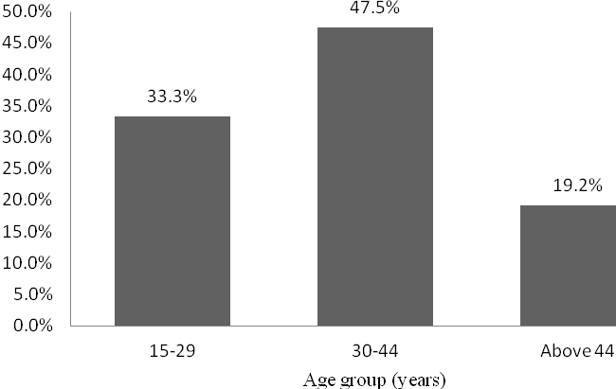

Figure 3: Age group distribution of respondents (n=120)

**4.2.2 Marital status**

A significant portion of the women who took part in the survey were married, as indicated in Table 2. Some individuals were single (29.2%), divorced (5.8%), or widowed (8.3%). There was no significant association found between the marital status of the woman and her decision to use or not use modern contraceptive methods (χ2 (3) =6. 882, p=0. 076). Married women play a crucial role in reproduction and the care of children, which justifies their dominance. It is important for couples to carefully plan their reproduction using modern contraceptives. This helps to control the number of children and reduce the risk of maternal and infant mortality caused by birth complications.

**Table 2: Distribution of respondents based on marital status (n=120)**

|  |  |  |
| --- | --- | --- |
| **Marital status** | **Frequency** | **Percent** |
| Married | 68 | 56.7 |
| Single | 35 | 29.2 |
| Divorce | 7 | 5.8 |
| Widow | 10 | 8.3 |
| Total | 120 | 100 |

**4.2.3 Education level of respondents**

According to the level of education, the majority of women (66.7%) who took part in the survey have completed primary education (Figure 4). A small percentage of individuals have completed secondary education (9.1%) and post-secondary education (5%). On the other hand, the study found that 19.2% of respondents lack formal education. However, the study found a significant association between a woman's level of education and her decision to use or not use modern contraceptive methods (χ2 (3) =32.746, p<0.001). The study found that women who attend school are the primary users of modern contraceptives, even though there were some women who didn't attend school but still used them. Women who have received a good education have convenient access to information regarding reproductive health and family planning matters.

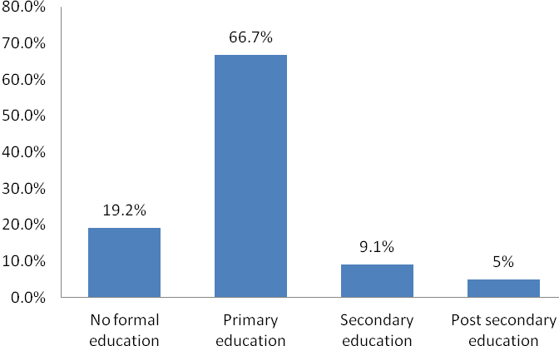

Figure 4: Distribution of respondents based on level of education (n=120)

**4.3 Trend of Modern Contraceptive Use for Women in the Past Ten Years**

The assessment of women’s attitude towards the use of modern contraceptive was done through secondary data collected from 2013-2022 annual reports of the Ministry of Health and Social Welfare in Lagos state. The findings in Figure 5 indicate that the trend of usage of modern contraceptives among women has proved to increase year after year for the whole period of ten years from 2013-2022. The number of women using modern contraceptive methods has increased by 28098 (137%) users, from 20549 users in 2013 to 48647 users in 2022.

This trend implies that there is an increase in awareness on the importance of using modern contraceptive methods and improvement in reproductive health services in Lagos state. Such trend can be related by the strategies jointly done by government and development partners such as donor communities and NGOs in improving access to health services including construction of health centres and dispensaries nearby community, improving availability of reproductive health facilities as well as increasing the number of health workers. Also, NGOs such as PSI, Family Health International and Engender Health Nigeria play an important role through their projects in creating awareness to the community members on the importance and methods modern contraception as well as assist in supplying facilities required for modern contraception especially to women. The report by URL (2023) showed as well a percentage (20%) increase in the use of modern contraceptive methods among women from 7% in 1991-1992 to 29% in 2010 (URT, 2010). Jones et al. (2012) reported the overall in 2006–2010, 62% of women aged 15–44 in the United States were using a method of contraception in the month of interview and 38% were not.

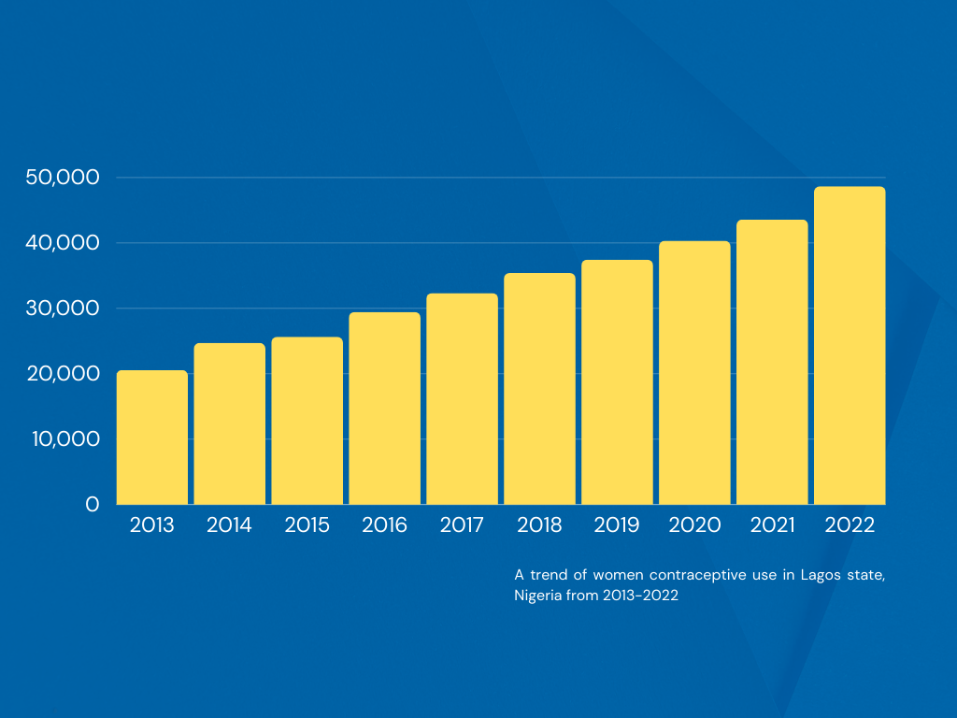

**Figure 5: A trend of women’s modern contraceptive use in Lagos state from 2013-2022**

**4.4 Women’s Preference Towards Modern Contraceptive Use**

The study aimed to evaluate women's preference for modern contraceptive methods by examining the specific methods they use for birth control. The data was collected from a sample of 60 women who are currently using modern contraceptives and living in the study area. According to the findings, a significant number of women (50%) have chosen contraceptive pills as their preferred modern contraception method (Figure 6). Contraceptive pills are a popular choice due to their widespread availability in dispensaries and health centres, as well as their effectiveness in preventing unwanted pregnancies. The findings presented here contradict the study conducted by Kai et al (2015), which examined the utilisation of modern contraceptives among women of childbearing age at Uasin Gishu sub-County Hospital in Kenya. The authors discovered that injectable contraceptives were the most commonly used method, while condoms were the least favoured choice.

Condoms were found to be used by 41.7% of surveyed women, as they are readily available in nearby health centres, dispensaries, pharmacies, and shops. Condoms can be easily accessed by a woman at a convenient time. Injectable contraceptive drugs have been widely used by women, with a usage rate of 23.3%. It is important for women to follow the prescribed schedule for clinic visits and injections, as advised by medical officers and clinical officers. The respondents stated that injectable contraceptive drugs are highly effective in preventing unwanted pregnancies, but users must consistently attend clinics.

However, it is worth noting that 15% of women surveyed have opted for intra-uterine contraceptive devices (IUDs) as a method of birth control. This device is inserted into the uterus to prevent embryo development from a fertilised egg, effectively stopping the process of implantation. Users have expressed that the method is highly effective in preventing pregnancies. Unfortunately, IUDs are not commonly found in health centres, dispensaries, and pharmacies. Additional support from a medical practitioner is necessary for women to utilise the method.

Sterilisation is a modern contraceptive method used by a small number (8.3%) of women. The procedure entails a minor surgical intervention that involves the cutting of the Fallopian tube in order to prevent fertilisation. Although there are other methods that offer the possibility of reversing reproduction, sterilisation is a permanent means of preventing pregnancies. The study revealed that there is no significant correlation between a woman's age and her decision to use or not use sterilisation method (χ2 (1) =1.083, p=0.298), as well as her birth frequency (χ2 (1) =0.909, p=0.340). This study emphasises the importance of considering individual and couple's ability to meet the basic needs of children when making the decision to undergo sterilisation for permanent pregnancy prevention. In some cases, health-related issues may also play a role in this decision.

In addition, during interviews, certain women expressed that they have experienced a range of health issues while using modern contraceptives, as well as facing resistance from their partners. There are several complications that can arise, such as feelings of nausea, vomiting, and irregular heartbeats. Some individuals mentioned that the financial aspect plays a role in choosing a specific modern contraceptive method or using it inconsistently. According to their findings, the lack of funding resulted in some women choosing not to use modern contraceptive methods, increasing their chances of experiencing unplanned pregnancies.

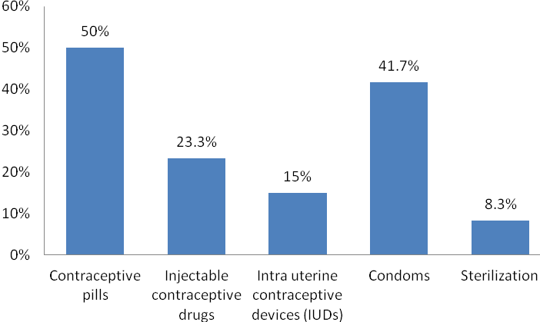

Figure 6: Women’s response towards use of modern contraceptive methods (n=60)

**4.5 Socio-economic and Institutional Determinants of Women’s Decision towards Modern Contraceptive Use**

The study examined various factors that influence women's choices regarding modern contraceptive use, including socio-economic and institutional factors. The assessment takes into account various socio-economic factors, such as family income, education level of women, marital status, frequency of births, partner's acceptance, and the woman's desire to have more children. However, the institutional factors encompass various aspects such as the proximity of the health centre, women's access to information, availability of service providers, and access to birth control programmes. The factors were initially evaluated using descriptive statistics. Subsequently, a binary logistic regression model was employed to analyse the impact of these factors on women's decision-making regarding modern contraceptive use. The sub-sections 4.5.1, 4.5.2, and 4.5.3 provide a detailed explanation of the factors influencing women's decision towards modern contraceptive use.

**4.5.1 Descriptive statistics of socio-economic determinants of women’s decision towards modern contraceptive use**

The study includes descriptive statistics on various socio-economic factors, such as family income, frequency of birth, partner's acceptance, and a woman's desire to have more children.

a) Family income

The assessment of family income revealed that a majority of the respondents (80.8%) earn income ranging from 30,000 to 100,000 N per month (Figure 7). According to other respondents, a significant portion (19.2%) have family earnings exceeding 100,000 N per month. The range of family income was from 30,000 N to 300,000 N per month. The average family income per month was 83,116.67 N, with a standard deviation of 49,590.62. Family income plays a crucial role in a woman's decision-making process when it comes to choosing a modern contraceptive method. It directly impacts her ability to afford the associated financial costs.   
The study findings align with the research conducted by Jones et al. (2012) in the United States. It suggests that when faced with the financial burden of travelling to a medical professional for a monthly injection, women may opt for contraceptive methods that require minimal or no medical appointments. Examples of such methods include long-lasting options like an IUD, which can be effective for up to 10 years, or easily accessible options like condoms, which can be obtained from local stores.

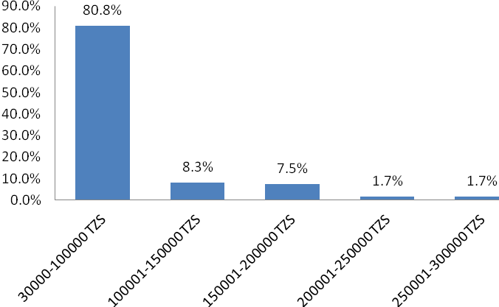

Figure 7: Distribution of respondents based on family income (N/month) (n=120)

b) Frequency of birth

The study provided an analysis of the birth rates among women who took part in the survey. According to the study, a significant number of women (56.7%) who took part in the survey had a birth frequency ranging from 4 to 7, as depicted in Figure 8. The birth frequency of others ranged from 0 to 3 (40.8%) and above 7 (2.5%). Furthermore, the birth frequency ranged from 0 to 8, with a standard deviation of 1.84. The findings indicate that a significant number of respondents are women in their reproductive age who already have children. In addition, the study discovered that there was no correlation (β1=0.055, p=0.924) between the number of births and the use of modern contraceptives among women. Thus, they play a crucial role in utilising modern contraceptives to manage the timing of childbirth and reduce the potential risks associated with reproductive complications. According to a study conducted by Jones et al. (2012), there is a consistent pattern of contraceptive use among women who have more than 5 children in the United States. In 1998, 2000, and 2003, the percentage of women with more than 5 children was 28%, 28%, and 29% respectively, according to their report.

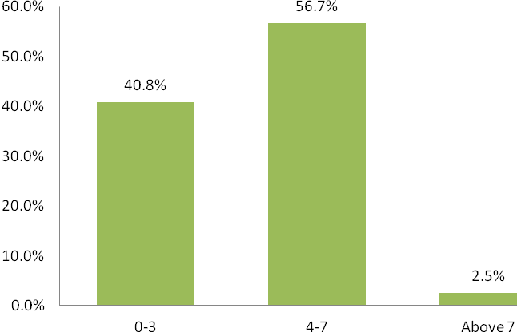

Figure 8: Distribution of respondents based on birth frequency (n=120)

c) Partner’s acceptance towards use of modern contraceptives

The study aimed to assess whether partners are open to using modern contraceptives for birth control. According to the survey results, a significant number of women (56.7%) reported that their partners are not supportive of using modern contraceptives for birth control (Figure 9). A mere 43.3% of respondents reported that their partners are supportive of their use of modern contraceptives. According to women, some of their partners are opposed to using modern contraceptive methods because of religious beliefs.   
According to their statement, many women choose to use contraceptives without informing their partners. Many women choose to use modern contraceptives, such as injectable drugs and pills, because they offer a higher level of confidentiality and privacy compared to other methods. However, some women may stop using modern contraceptives if their partner does not accept or support their use.

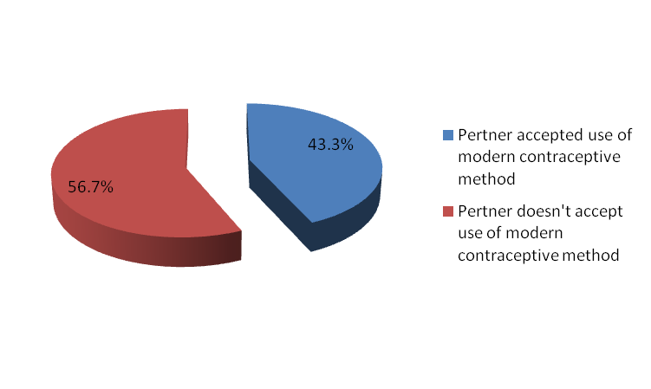

Response on partner’s acceptance towards use of modern contraceptive methods (n=120)

d) Woman’s desire to have more children

The study examined women's aspirations for expanding their families. The data from Figure 10 reveals that a significant majority of women (70.8%) who took part in the survey expressed that they do not wish to have more children than they can financially support for essential needs like food, healthcare, and education. A significant portion of the respondents (29.2%) expressed a wish to expand their families. Individuals expressing a desire for more children emphasised that their current number of children does not meet their expectations for family size, and they are not willing to delay or forego further reproduction. The study findings show that a significant percentage of women in the United States, who had more than 5 children, expressed a desire to have additional children. Specifically, the findings by Jonase et al. (2012) indicate that this need was reported by 33% of women in 1998, 33% in 2000, and 35% in 2003.

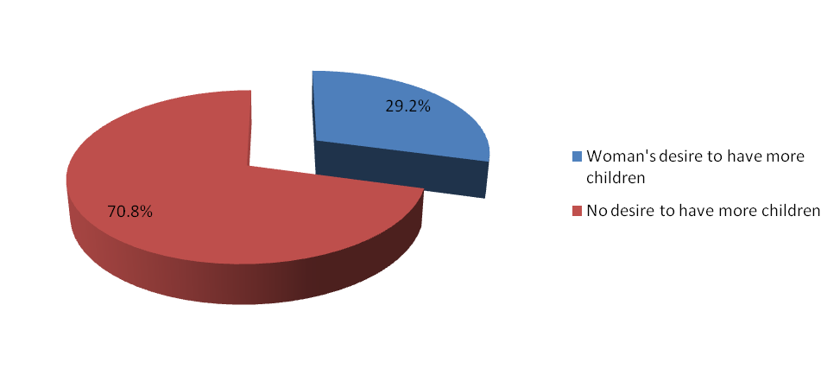

Figure 10: Distribution of respondents based on their desire to have other children (n=120)

**4.5.2 Descriptive statistics of institutional determinants of women’s decision towards modern contraceptive use**

The study presents a comprehensive explanation of the descriptive statistics of institutional factors. These factors include the distance to the health centre, women's access to information, availability of service providers, and women's access to birth control programmes.

a) Distance to the nearest dispensary or health centre

The study revealed that a significant number of women (45%) in the survey were able to reach the health centre or dispensary within a 30-minute walk. Another group (28.3%) reported walking for 61 to 90 minutes to reach their destination (Figure 11). Some other respondents have reported spending between 31 to 60 minutes (20.8%) and over 90 minutes (5.9%). Women need to spend anywhere from 10 to 140 minutes walking to reach the nearest health centre and dispensary. The walking distance had an average of 51.12 minutes, with a standard deviation of 32.3. According to respondents, the distance to health centres and dispensaries is a major barrier for women in accessing modern contraceptives. The long distance discourages women from regularly following up on their contraceptive use.

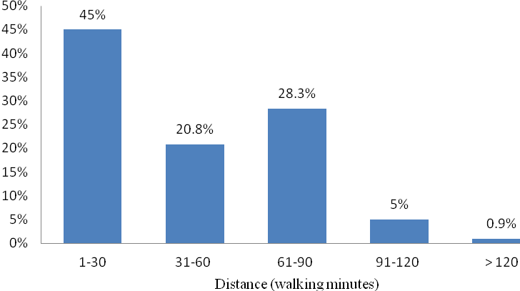

Figure 11: Distribution of respondents based on distance from home to the nearby dispensary or health centre (n=120)

b) Access to information, availability of birth control service providers and benefit from family planning program

According to Table 3, the data reveals that 44.2% of women have access to information regarding family planning. This information includes access to birth control service providers and the existence of family planning programmes. A significant majority of respondents (55.8%) do not have access to information on modern contraceptives. The respondents who provided information stated that they typically obtain knowledge about birth control from various media sources, including radio, newspapers, and magazines. According to Michel (2012), the majority of contraceptive method users in Kahama district, Nigeria obtained information from health facilities or reproductive and child health clinics (65.8%). It is crucial to provide information on the use of modern contraceptive methods for birth control. This helps to raise awareness about the effectiveness of these methods and dispel any misconceptions regarding their potential side effects.   
The study conducted by Kiday et al. (2015) examined the factors influencing the use of modern contraceptives among women in Nigeria. Their analysis of data from the Nigeria demographic and health survey revealed that women who received information on contraceptive use at health facilities were 40% more likely to use contraceptives compared to those who did not receive such information. In a study conducted by Michael (2012), a strong correlation was found between source information and the utilisation of contraceptive methods among married individuals in Lagos, Nigeria (P<0.001).   
  
However, it is worth noting that 41.7% of women have access to a birth control service provider near their home, as shown in Table 3. A significant number of women (58.3%) do not have convenient access to a nearby birth control service provider. Women who have access to birth control service provider have emphasised that they receive service from well-trained community health workers who are conveniently stationed in their localities. Condoms and other contraceptives can be easily found at retail shops and pharmacies nearby.   
The study also evaluated whether women benefited from the family planning programme implemented in the study area. According to the findings, a mere 26.1% of women who took part in the survey were recipients of project(s) related to family planning (Table 3). Women discussed various family planning projects being implemented by NGOs like PSI, Family Health International, and Engender Health Nigeria. Projects focused on birth control play a crucial role in educating couples and individuals about birth control and reproductive health.

**Table 3: Response of women’s on selected factors guiding women’s modern contraceptive use (n=120)**

|  |  |  |
| --- | --- | --- |
| **Factors for woman’s modern contraceptive use** | **Frequency** | **Percent of response** |
| Woman’s access to information pertaining to family planning. | 53 | 44.2 |
| Access to birth control service provider nearby home. | 50 | 41.7 |
| If a woman is beneficiary of family planning program/project implemented in the study area. | 31 | 26.1 |

**4.5.3 Logistic regression analysis for socio-economic and institutional determinants of women’s decision towards modern contraceptive use (n=120)**

The study utilised a binary regression model to analyse the factors influencing women's choices regarding modern contraceptive use. The model's dependent variable was the use of modern contraceptive methods for birth control. It was measured using binary indicators: 1 if a woman uses a modern contraceptive method, and 0 if she doesn't. The study evaluated various modern contraceptive methods, such as contraceptive pills, injectable contraceptive drugs, intra-uterine contraceptive devices, condoms, and sterilisation. The logistic model included various dependent variables such as family income, education of a woman, marital status, frequency of birth, partner acceptance, desire for more children, distance to the health centre, information, service provider, and family planning program/project.

**CHAPTER FIVE**

**CONCLUSION AND RECOMMENDATIONS**

**5.1 Summary of Findings**

The study examined factors influencing women's choices regarding modern contraceptive use in Lagos state. The study focused on analysing the usage of modern contraceptives among women over the past decade. It also examined women's preferences for modern contraceptive methods and investigated the various socio-economic and institutional factors that influence women's decisions regarding contraceptive use.

**5.2.1 Trends of women’s modern contraceptive use in the past ten years**

The usage of modern contraceptive methods among women has seen a significant improvement, with the number of users increasing by 137% from 20549 women in 2013 to 48647 women in 2022. Thus, the user base has nearly doubled over the course of a decade.

**5.2.2 Women’s preference towards modern contraceptive use**

The study analysed the usage of modern contraceptive methods among women by examining the number of users for each of the five methods surveyed. Contraceptive methods include contraceptive pills, injectable contraceptive drugs, intra-uterine contraceptive devices, condoms, and sterilisation. Women primarily rely on contraceptive pills (50%) and condoms (41.7%) as their preferred methods of contraception. The usage rates of contraceptive methods among women are as follows: 23.3% use injectable contraceptive drugs, 15% use intra-uterine contraceptive devices, and 8.3% opt for sterilisation.

**5.2.3 Socio-economic determinants of women’s decision on modern contraceptive use**

The logistic regression analysis showed that certain socio-economic factors were found to have a significant and positive impact on women's decision to use modern contraceptives. These factors include income, education, and partner's acceptance. However, it is worth noting that marital status (β1= -4.258, p=0.042) and women's desire to have more children (β1= -7.302, p=0.035) showed a significant and negative correlation with women's modern contraceptive use. However, logistic regression showed that the frequency of birth did not have a significant impact on women's decision to use modern contraceptives, in terms of socio-economic factors.

**5.2 Conclusion**

The trend of modern contraceptive use has shown consistent improvement over the years. As an example, the utilisation of contemporary contraceptive methods has nearly doubled between 2013 and 2022. The study area shows a strong preference among women for contraceptive pills and condoms as methods of birth control. Not many women have a preference for injectable contraceptive drugs, intra-uterine contraceptive devices, or sterilisation methods. There are several factors that can impact women's choices regarding modern contraceptive use. The factors that influence modern contraceptive use for women are the income of the family, education level of a woman, marital status, partner's acceptance, and women's desire to have more children. Income, education, and partner's acceptance play a crucial role in influencing and positively impacting women's decision to use modern contraceptives. However, there is a noteworthy correlation between women's desire to have more children and being married, and a decrease in the use of modern contraceptives. The distance to health centres and dispensaries is an important institutional factor that negatively affects women's decision to use modern contraception. In conclusion, various socio-economic and institutional factors play a significant role in shaping women's choices regarding modern contraceptive use in the study area.

**5.3 Recommendations**

Basing on the results and conclusion of the study, the following are the recommendations:

1. It is crucial for the government and other stakeholders, including NGOs, to consistently educate the community, particularly women, about the significance of utilising modern contraceptive methods for birth control. This will greatly contribute to improving family planning among community members.
2. It is crucial to ensure that married individuals are well-informed about the significance of using modern contraceptives for birth control and improving women's reproductive health. This includes raising awareness and providing education on the subject.
3. The government, in collaboration with the community and other development partners, should prioritise the construction of more dispensaries and health centres. This will ensure that health services are easily accessible to the community, which can encourage women to visit clinics for birth control.
4. It is important for the government to ensure that modern contraceptives are easily accessible and affordable for all individuals. It is likely that women will be more able to afford the cost of contraceptives, which will in turn increase their use of modern contraceptives for birth control.

**REFERENCES**

AlanGuttmacher Institute, (1994) Family planning among people living with HIV in post-conflict Northern Uganda: A mixed methods study. Conflict and Health ;5:18.

Ali, O. Rozi J. & Mahmood D. (2004) Contraceptive prevalenceamong women in Nigeria. J Obstet Gynecol ;25:182-185.

Andersson-Ellström R, Fitzgerald DW, Liautaud B, Deschamps MM,Verdier RI, Beaulieu ME, GrandPierre R, Joseph P; Severe P, Noel F, Wright P, Johnson Jr WD, Pape JW. (1996) The feasibility, demand, and effect of integrating primary care services with HIV voluntary counseling and testing: evaluation of a 15-year experience in Haiti; 1985- 2000. J Acquir Immune Defic Syndr 2003;33:470- 477.

Armstrong A, Delaunay V, Adjamagbo A. (1991) Knowledge and use of contraceptive methods in rural Sereer, Senegal. Sante ;13:31-7.

Asiimwe P. GJ, Legesse TW, Seid Y. (2013) Contraceptive utilization among couples and associated factors in Dodota District, Oromia Region, Ethiopia. Biomed J Sci Tech Res. 2018;4(1). doi:10.26717/BJSTR.2018.04.000986

Baringo J. (2014)Awareness, attitude and practice of family planning methods in a tertiary care hospital, Uttar Pradesh, India. Int J Reprod Contracept Obstet Gynecol. 2017;6:500‑6. doi:10.18203/2320-1770.ijrcog20170370

Belfield P. (2005) Assessment of modern contraceptive method utilization and associated factors among women of reproductive age group at Arba Minch Town, SNNPR, Ethiopia. EC Gynaecol. 2017;6(2):36–53.

Bertrand K. Gupta V, Mohapatra D, Kumar V. (2001) Family planning knowledge, attitude, and practices among the currently married women (aged 15–45 years) in an urban area of Rohtak district, Haryana. Int J Med Sci Public Health. 2016;5:627–632. doi:10.5455/ijmsph.2016.12082015100

Bongaarts, S. (1978) Socio-demographic determinants and knowledge, attitude, practice: survey of family planning. J Fam Med Prim Care. 2012;1(1):43–47. doi:10.4103/2249-4863.94451

Brindis A.I and Davis, P. (1998) attitude and practice of family planning amongst women in a High density low income urban of Enugu, Nigeria. Afri J Reprod Health ;5:83-89.

Brindis, AI , (1990) Contraceptive practices among women in rural communities in South-Western Nigeria. Global Journal of Medical research ;11:1.

Burkman, S.A (1999). Fertility Regulation Behaviors and Their Costs: Contraception and Unintended Pregnancies in Africa, Eastern Europe & Central Asia. Washington, DC: World Bank.

Cleland J. Tarekegn M, Embiale M. (2006) Knowledge, attitude and practice towards family planning among reproductive age women in a resource limited settings of Northwest Ethiopia. BMC Res Notes. 2018;11:577. doi:10.1186/s13104-018-3689-7

Coale, WT, (1973) Measuring fertility intention, family planning utilization and associated factors among married couples in Mekelle City, Tigray, Ethiopia; Cross-sectional Study. IJPBSF. 2013;6(1).

Danielsson R and Jolly C. (2001) The start of the Sub-Saharan fertility transitions: some answers and many questions. Annals of the New York Academy of Sciences, Human Reproductive Ecology: Interactions of Environment, Fertility, and Behavior 1994; 709:379–395.

De Broe A. and Hinde, J. (2006) Postpartum family planning utilization and associated factors among women who gave birth in the past 12 months, Kebribeyah Town, Somali Region, Eastern Ethiopia. J Women’s Health Care. 2016;5:340. doi:10.4172/2167-0420.1000340

Edgardh, B. (2002) Contraceptive practices in newly married women in sub-urban Bangalore. Health and PopulationPerspectives and Issues ;29:21-28.

Frankline O. Donovan P, Wulf D. (2014) Family planning can reduce high infant mortality levels. Alan Guttmacher Inst. ;(2):1–4.

Glasier K. Pokharel N, Shrestha M. (2000) Knowledge, attitude and practices of contraception among the married women of reproductive age group in selected wards of Dharan Sub-Metropolitan City. J Contracept Stud. 2018;(3):18. doi:10.21767/2471-9749.100051

Glasier SG, (2010). Knowledge, sources and use of family planning methods among women aged 15–49 years in Uganda: a cross-sectional study. Pan Afri Med J. 2016;24:39. doi:10.11604/pamj..24.39.5836

Häggström-Nordin A, Desgrées du Loû .A. (2002) Fertility regulation among women in Abidjan, Côte d’Ivoire: Contraception, abortion or Both? International Family Planning Perspectives ;28:159–166.

Herlitz F. ,Nakigozi G, Lutalo T, Kagayi J,Sekasanvu J,Settuba A,Serwada D,Wawer (2010). Use of HIV-related services and modern contraception among women of reproductive age, Rakai Uganda. Afr J Reprod Health 2010;14:91- 101.

ICF International (2006) Fact sheet on family planning/contraception; 2018. Available from: <http://www.who.int/mediacentre/factsheets/fs351/en/>.

Jaccard I, (2009) Use of modern birth control methods among rural communities in Imo state, Nigeria. African Journal of Reproductive Health ;12:101-108.

Kathryn, J, (2009) Constrained contraceptive choice: IUD prevalence in Uzbekistan. International Family Planning Perspectives;33:50–57.

Kirby, P. (1997) Prevalence and determinants of the use of modern contraceptive methods in Kinshasa, Democratic Republic of Congo; Contraception ;74:400-406.

Larsson F.A, El-Refaey A.M and ELGharib M.N. (1997) Attitude of primigravidas to pregnancy: a comparison between the younger and older age groups. Int J Med Biomed Res ;1:119-123.

Lindh D.R, Barnmorska, M.K, (2011) Contraceptive practices and related factors among females in predominantly rural Muslim area of North India. The Internet Journal of World Health and Societal Politics ;5.

Lwelamira T.  Qazi M, Saqib N, Gupta S. (2012) Knowledge, attitude and practice of family planning among women of reproductive age group attending outpatient department in a tertiary centre of Northern India. Int J Reprod Contracept Obstet Gynecol. 2019;8(5):1–9. doi:10.18203/2320-1770.ijrcog20191531

Michael AD. (2012) Factors influencing utilization of family planning services among females of reproductive age (15–45 years) in the Bauchi local government area, Bauchi state of Nigeria. Nurs Palliat Care. 2018;3(2):2–6. doi:10.15761/NPC.1000180

Nelson, V. Tom P. & Timothy Soc. (2011) Knowledge, attitude and practice of family planning amongst women with unplanned pregnancy in Calabar, Nigeria. Nigerian Journal of Physiological sciences ;18:65-71.

Ochako I. & Olugbenga-Bello AI, Abodunrin OL, Adeomi AA. (2015) Contraceptive practices among women in rural communities in South‑Western Nigeria. Glob J Med Res. ;11.

Olugbenga-Bello, P. Abodunrin H. & Adeomi D. (2011).. Profile of intrauterine contraceptive device acceptors at the Oyo State Teaching Hospital, Oyo, Nigeria. Annals of African Medicine ;7:1-5.

Oni, H, (2006) Contraceptive use and incidence of pregnancy among women after HIV testing in Abidjan, Ivory Coast. Rev Epidemiol Sante Publique;57:77- 86.

Osemwenkha, N. (2004) N. Family planning service utilization and its associated factors among married women in Benchi-Maji Zone, Southwest, : community-based cross-sectional study. Clin Mother Child Health. 2017;14:258. doi:10.4172/2090-7214.1000258

Oyedokun AO.(2007) Determinants of contraceptive Usage: lessons from women in Osun State, Nigeria. J Human Soc Sci. ;1:1–14.

Planned Parenthood Federation of Nigeria (2010) Children's and Women's Rights in Nigeria: A Wake-up Call. Situation Assessment and Analysis; Abuja, Nigeria: National PlanningCommission (NPC) and UNICEF, . 4

Plummer J. Ayaz S, Efe SY. (2008),Family planning attitudes of women and affecting factors. J Turk Ger Gynecol Assoc. 2009;10:137–141.

Sedgh A.and Hussein, G. (2014). Knowledge, attitude and practices of contraception among married women. Int J Reprod Contracept Obstet Gynecol. 2014;3:385–388. doi:10.5455/2320-1770.ijrcog20140620

Sedgh T Sindhu BM, Angadi MM. (2007) Knowledge, attitude and practice about family planning methods among reproductive age group women in a Tertiary Care Institute. Int J Sci Stud. ;4(2):133–136.

Shuaib J. &  Oghdoh K (2010) Contraception: an investment in lives, health and development. Guttmacher Institute and UNFPA ;5.

United Nations Department of Economic and Social Affairs Population

United Nations General Assembly.(2011) Transforming our world: the 2030 agenda for sustainable development. General assembly resolution 70/1; 2015. Available from: <http://www.un.org/ga/search/view_doc.asp?symbol=A/RES/70/1&Lang=E>.

Van Bavel, T, (2004) Family planning knowledge, attitude and practice among married couples in Jimma Zone, Ethiopia. PLoS One. 2013;8(4):e61335. doi:10.1371/journal.pone.0061335

Wellings, C. (2005) Incidence of induced abortion in southern Ghana, International Family Planning Perspectives ;27:96-101.

Westhoff, Z (2005) Extended postpartum modern contraceptive utilization and associated factors among women in Gozamen District, East Gojam Zone, Northwest Ethiopia. Insights Reprod Med. 2017;1(2).

Westoff H. and Bankole, K. (1995). Intentions on contraception use and its associated factors among postpartum women in Aksum town, Tigray region, northern Ethiopia: a community-based cross- sectional study. BMC Reprod Health. ;15:188. doi:10.1186/s12978-018-0632-2

WHO. Trends in Maternal Mortality 1990 to 2015 Estimates by WHO, UNICEF, UNFPA. Geneva: World Bank Group and the United Nations Population Division; 2015.

Williamson J. Sherpa SZ, Sheilini M, Nayak A. (2009) Knowledge, attitude, practice and preferences of contraceptive methods in Udupi district, Karnataka. J Family Reprod Health. 2013;7:115–120.

**QUESTIONNAIRE**

Please tick the option that best fits your opinion.

Age

15-29 { }

30-44 { }

Above 44 { }

Marital Status

Married { }

Single { }

Divorce { }

Widow { }

Educational level

No formal education { }

Primary education { }

Secondary education { }

Post-secondary education { }

Which of these contraceptive method do you prefer and adopt?

Contraceptive Pill { }

Injectable contraceptive { }

Intra uterine contraceptive devices { }

Condoms { }

Sterilization { }

Family Income

30,000-100,000 { }

100,001-150,000 { }

150,001-200,000 { }

200,001-250,000 { }

250,001-300,000 { }

Birth Frequency

0-3 years { }

4-7 years { }

Above 7 years { }

Does your partner accept your use of modern contraceptive method?

Yes, my Partner accepts. { }

No, my partners does not accept. { }

As a woman do you desire to have more children?

Yes, I do { }

No, I don’t. { }

What is your walking distance?

01-30 minutes { }

31-60 minutes { }

61-90 minutes { }

91-120 minutes { }

Above 120 minutes { }

Which of these determines your use of modern contraceptives?

Access to information pertaining to family planning. { }

Access to birth control service provider nearby home. { }

If a woman is beneficiary of family planning program/project implemented in the study area. { }