# ASSESSMENT OF WATER POVERTY IN MINNA, NIGERIA

Water is explicitly linked with economic progress and developmental trajectories of most countries and regions of the world. However, inspite of its significant contribution to quality of life, public health and socio-economic development, water scarcity has continuously remained one of the most excruciating problems around the globe. In view of the disproportionate nature of water scarcity, both in space and time, coupled with urban population growth dynamics this thesis assesses the level of water stress at household and neighbourhood level in Minna urban, Nigeria within the framework of water poverty methodology, with a view to identify the priority areas requiring policy interventions. By utilizing cluster sampling technique, data on household water sources, water stress features and adaptation measures were obtained through questionnaire administered on 378 households in 8 selected neighbourhoods in the study area. These were complemented with data from the Niger State Water and Sewerage Corporation (NSWSC) on public water supply network in the study area. The data were analysed using descriptive (frequency and percentage) and inferential statistics (ANOVA, cross-tabulation, linear scaling technique, correlation, principal component analysis and independent T-Test). Findings from the study revealed that households in the study area are characterized by low level of access to public water supply and rely on other informal non-network water sources to augment improved water source. The empirical findings also indicated that water poverty levels vary among the neighbourhoods in the study area and manifest in spatial terms with Tudun wada south neighbourhood exhibiting the best water situation while F-Layout has the worst water situation. The study further revealed that storage of water in drums (100 liters and above), rain water harvest and installation of storage tanks were the three (3) top ranked most effective household adaptive strategies in coping with water poverty in the study area. As a recommendation, policy makers as a matter of priority should give first level priority attention to improving water use across all the neighbourhoods in the study area. This is followed by accessibility to water, which requires second level priority in term of water improvement in F-Layout, Kpakungu, Maitumbi, Saukakahuta and Tudun-Fulani. Resource is the third priority area for attention and would be advantageous to F-Layout, Saukakahuta and Tudun-Fulani.

**CHAPTER ONE**

* 1. **INTRODUCTION**
  2. **Background to the Study**

It has been widely acknowledged that water is explicitly linked with economic progress and developmental trajectories of most countries and regions of the world. It has remained a top priority on international agenda and merits public policy consideration. Several policy initiatives have been developed over time to address water crisis at the global, regional and country level. Among these initiatives are: United Nations Water for Life Decade 1981-1990; The Dublin Principles of 1991; UNCED Rio Declaration 1992 on Agenda 21; International Hydrological Programme (2014-2021); Cooperation in International Waters in Africa (CIWA); African Water Facility (AWF); Sustainable Development Goal 6; the New Water Law of South Africa as well as the National Water Supply and Sanitation Policy (2000) in Nigeria). Despite these laudable initiatives, and the significant contribution of water to quality of life, public health and socio-economic development (Agnew and Woodhouse, 2011; Hanjra *et al.*, 2009; Ishaku *et al.*, 2011; Jimenez-Cisneros *et al.*, 2014; Rockstrum and Falkenmark, 2015), water scarcity has continuously remained one of the most excruciating problems around the globe.

The Global Risks Report of the World Economic Forum identified water crisis as one of the top five high impact risks bedeviling human society in current times (World Economic Forum, 2017). For example, between 1.5 and 2.5 billion people in world were estimated to have lived under some degree of water scarcity around the year 2000 (Alcamo *et al.*, 2007; Kummu *et al.*, 2010; Gosling and Arnell, 2016; Kummu *et al.*, 2016), and it is projected that

by year 2025, about 1.8 billion people will reside in countries with *absolute* water scarcity, with two-third of the world’s population likely to live under water-stressed conditions by the year 2040 (UN-Water and FAO, 2007; Reigh *et al.*, 2013; Liu *et al.*, 2015). The United Nations General Assembly acknowledged the human right to *safe* and *accessible* water on a *sustainable* basis. The absence of such right to water erodes human dignity and signifies water scarcity and water poverty (SADC, 2008; Sanusi, 2010; Naiga *et al.*, 2015). In recognition of water scarcity as a form of human deprivation, the United Nations Sustainable Development Goal (SDG) 6.4 aspires to significantly reduce the proportion of people suffering from water scarcity by 2030.

While water scarcity is a global concern, it remains pervasive in Africa – a continent with over 800 million people. It has been observed that 54% of the entire continent is arid, and over 300 million of its inhabitants are living in water scarce environments (Rached *et al.,* 1996; NEPAD, 2006; Akpor and Muchie, 2011). More than 2⁄3 of African households (especially women and children who are considered vulnerable) are also considered “water poor” as they trekked over 1 hour from their home per water collection trip to fetch water for consumption purposes (Montgomery and Elimelech, 2009; Sorenson *et al.*, 2011; Pickering and Davies, 2012). Evidence has further shown that only 58% of African dwellers have access to improved water sources, and these levels are declining in many cities (World Bank, 2014a; World Bank, 2014b). The unbalanced nature of water scarcity in African countries is also worrisome, as regional disparities exist in terms of water supply and distribution. The WHO-UNICEF (2010) for instance, identified water scarcity to be more pronounced in Sub- Saharan region relative to other regions in Africa, with piped water into dwellings, plots or yards declining between 1990 and 2008 from 43% to 35% in urban areas.

As a nation in Africa, Nigeria with over 180 million inhabitants, also suffers from acute water supply. This dimension of water scarcity is alarming and has been well documented. For example, Nigerians represent one in every ten persons in the world who suffers from unimproved water supply (WHO-UNICEF/JMP, 2017; MICS, 2017). The Wash-Norm survey (2018) conducted by the Federal Government of Nigeria in conjunction with the National Bureau of Statistics reported that between 2000 and 2017, only 21% of Nigerian population had access to drinking water from improved source, provided collection time is not more than 30 minutes for a round trip including queuing. Progress in access to improved water supply in Nigeria has been on the decline for nearly two decades, with access to reliable water sources in Nigeria’s urban centres dropping from 78% in 1990 to barely 64% in 2017 (WHO-UNICEF/JMP, 2017; MICS, 2017). Given the ever-increasing population growth of the country at 3.8% (NPC, 2006) the constant growing demand for water is bound to outstrip water availability in the near future. It has therefore been envisaged that if this current situation remains unabated, only 15-20% of urban residents in Nigeria will be able to enjoy direct water supply in their residence by the year 2025 (Macheve *et al.*, 2015).

Against the background of the disproportionate nature of water scarcity, both in space and time, coupled with urban population growth dynamics, it is important to assess the extent to which urban households are water stressed at both household and neighbourhood scale. Any effort geared towards alleviating water poverty largely depends on adequate evidence on the extent of water stress at such smallest scale of analysis, to provide the pathway for appropriate water policy interventions. This is the focal point of this thesis: to assess the level of water stress at household and neighbourhood level in Minna, Nigeria within the framework of water poverty methodology.

In linking water stress to the related poverty at household and neighbourhood level, the water poverty assessment framework beyond other assessment metrics has been progressively recognized as a robust quantitative and monitoring tool (Sullivan, 2002; Sullivan *et al.,* 2003; Sullivan, *et al.,* 2006; Damkjaer and Taylor, 2017) for providing new insight into the complexities of water issues, by integrating the concept of environmental sustainability and social adaptive capacity with different physical and economic drivers of water scarcity (Garriga and Foguet, 2010; Sullivan and Jemmali, 2014; Hung *et al.,* 2017).

# Statement of the Research Problem

The National Bureau of Statistics (NBS, 2006) survey has shown that improved water coverage in Nigeria range from 30.7% to 73.5%, and significantly varies between the northern and southern regions. However, these limits are way outside the target of Sustainable Development Goal (SDG) 6.1 which requires extending the improved water coverage by 100% to currently un-served population with a focus on equitable access, quality and sustainable water by the year 2030.

This limited water coverage is also characterized by low levels of access, intermittent and poor quality of water supply services especially in urban centres (Akpor and Muchie, 2011). While urban residents who are outside the reach of public water coverage are “de-watered”, their water needs are exclusively in form of informal non-network delivery service. The low coverage of public water supply also shifts the burden of safe and reliable water supply to virtually all urban households, who consequently engage in a variety of strategies to cope with the lack of access to water supply. As rightly noted by Macheve *et al.* (2015) the cost of coping with lack and unreliable water supplies to Nigerian households is estimated at US700

million dollars on yearly basis. It is therefore not surprising that only a dismal 3.7% of 185

million Nigerians had improved water sources in their premises which are free from fecal and chemical contamination (WASH Poverty Diagnostics, 2016; MICS, 2017; WASH- NORM, 2018).

Households’ lack of access to water supply has also been aggravated by non-functionality and sustainability issues. In this regard, the National Water Supply and Sanitation Survey in 2015 noted that approximately 38% of improved water facilities and 46% of all water schemes are non- functional in Nigeria. The magnitude and complexity of the low water coverage, poor access and non-functionality of water points is far more biting among urban households in Nigeria’s urban centres, with State Water Agencies (SWAs) lacking the capacity to cater for their growing water needs, including those of the more than 2 million new residents urbanization brings to the cities on yearly basis (Macheve *et al.*, 2015).

In view of the fore goings, prior research has empirically linked the extent to which households are water stressed to the related level of poverty at local and community level by utilizing the water poverty framework. Useful evidence of these international studies conducted at local and commune level include: Cullis and O’Regan, (2004) in South Africa, Sullivan *et al.,* (2003) and Sullivan *et al.,* (2006) both in South Africa, Sri Lanka and Tanzania as well as Zahra *et al.* (2012) in India. In the Nigerian context, notable contributions to this strand of research are scarce and location-specific. The empirical study by Ifabiyi *et al.* (2020), Ifabiyi and Ogunbode (2014) in Oyo state, Ahuchaogu *et al.* (2015) in Akwa- Ibom state, and Yahaya *et al.* (2009) in Ondo state are representative articles that have applied the water poverty index to investigate water stress at Local Government Areas (LGAs) as case studies. While the overall water poverty index derived from such empirical investigation

significantly hides the actual poverty levels experienced in from such studies due to spatial

temporal variations of water scarcity drivers (Cullis and O’Regan, 2004; Gine and Perez- Foguet, 2009), the present thesis departs from these prior studies by its application of the water poverty index in providing useful insights into the level of water stress at both household and neighbourhood scale in a different geographical area. This is the research gap which this current thesis attempts to address.

# Research Questions

The main research questions which are specifically dealt with in this thesis are:

1. What is the extent of public water supply coverage in Minna?
2. What is the pattern of water delivery sources available to households across different neighborhoods in the study area?
3. To what extent can neighborhoods in the study area be considered to be water stressed/ poor?
4. In terms of water poverty, how do neighborhoods around the public mains compare with those outside?
5. How do households cope with the problem of water poverty?

# Aim and Objectives of the Study

The aim of this study is to assess the level of water poverty at a neighbourhood scale in Minna with a view to identify priority areas requiring policy interventions.

The objectives of the study were to:

1. Examine the area coverage of public water supply in Minna.
2. Assess household’s sources of water supply across different neighbourhoods in the study area.
3. Determine the level of water poverty in the study area.
4. Compare water poverty in neighbourhoods within the public mains with those neighborhoods outside the public mains.
5. Assess households’ adaptation to water poverty in the study area.

# Research Hypothesis

The research hypotheses considered relevant to the purpose of achieving the objectives of this thesis are:

1. **Null Hypothesis (Ho1)**: There is no statistically significant variation between households’ source of water supply for drinking purpose and domestic use in the study area.
2. **Null Hypothesis (Ho2)**: There is no statistically significant difference in water poverty level of neighbourhoods within the public water mains and those neighborhoods partly outside the public water mains.

# Scope of the Study

Geographically, this study is limited to urban households residing in four (4) neighbourhoods located within the public water supply mains and four (4) neighbourhoods partly outside the public water supply mains in the four regions (north, south, east and west) of the city. In total, eight (8) neighbourhoods were sampled with two (2) neighbourhoods (comprising 1 neighbourhood within and 1 neighbourhood partly outside the public water mains) each selected from the north, south, east and western part of Minna city. The study applied water poverty index to measure the multidimensional nature of water poverty situations in the selected eight (8) neighbourhoods and also addressed the following critical issues in the study area:

1. Extent of public water main coverage in terms of improved water supply provided by the State Water Agency (Niger State Water Board) to households in these neighbourhoods.
2. Households’ water sources (both improved and unimproved sources) for drinking purpose and domestic use (such as pipe water to dwelling/compound, shared pipe water connection with neighbour, public covered borehole, private covered dug well, unprotected dug well, rain water harvest, water truck, private water vendor, pond and lake, dam, digging of deep well, ground water extraction, bottled and sachet water).
3. Water stress features at the household level (such as water sufficiency/availability status, number of trips to water point, water collection time, waiting time for water fetching, water fetching responsibility, perceived rainfall pattern, seasonal variation in public water supply, water treatment method and coping costs).
4. Households’ adaptation measures to water stress/poverty focusing on measures such as water storage in drum and container, installation of water tank, rain water harvest, use of booster pump, use of water sparingly, water collection from different locations, water collection from shared connection/from neighbor, protest to water authorities, relocation to areas with water supply, rescheduling activities till when water is available.

# Justification for the Study

The significant contribution of water resources to socio-economic development, public health and quality of life implies that issues pertaining to its volumetric availability, accessibility and withdrawal merit public policy consideration. Various water scarcity metrics such as water stress index (Falkenmark, 1989), criticality ratio (Raskin *et al.*, 1997; Vorosmarty *et*

*al.,* 2000; Alcamo *et al.*, 2003), IWMI indicator (Seckler *et al.*, 1998a; Molden *et al.*, 2007) and the water poverty index (Sullivan, 2002, Sullivan *et al.*, 2003) have established that global water resources are extremely stressed, and that given the rapid growth in human population, water resources will need to be effectively managed on a sustainable basis. In view of this, an in-depth study of this magnitude can provide a quantitative assessment evidence of water scarcity challenge necessary for water policy planning, benchmarking and performance monitoring.

Such evidence can aid policy makers in effectively identifying specific areas of activities which could reduce existing water stress, and target households and neighbourhoods with the highest levels of poverty in terms of prioritization of interventions to address specific water deprivations. Aside its contribution to the existing vast body of literature on the linkage between water and poverty, the empirical findings from the current study can stimulate households’ understanding of the complexity of the water problems and beyond the conventional approach, the pragmatic ways to address water scarcity in a sustainable manner.

# Profile of the Study Area

The study area can be described in terms of its geographical description, water bodies, climate and ecology, population and economic base as follows.

# Geographical description and location

The city of Minna acts as both the state and administrative capital of Niger state in Nigeria, and covers an approximate land mass of 88 km2. It lies on latitude 90 25’ N and 90 40’ N of the equator and longitude 60 24’ E and 60 36’ E of the meridian (Figure 1.1). In terms of regional location, the city is located in the North-Central geopolitical zone of Nigeria and provides the gateway to the northern and southern part of Nigeria. Geographically, it is

located apart from other bordering cities. By roads, Minna is approximately 112km apart from FCT, 300km from Kaduna, 90km from Bida and 100km to Suleja (Sanusi, 2006).

The geomorphology of the city is characterized by undifferentiated basement of many complex of gneiss and magnetite. The city lies on a highland with major elevations within the city ranging from 240m – 270m, though the highest level of elevation in the city is 443m which corresponds to Paida hill (Sanusi, 2006). The city is topographically diverse, with a range of steep hills stretching from north eastern part of Minna westwardly towards Bosso and Tudu-Fulani neighbourhoods and some pockets of rock outcrops within the flat and developable area of the city. This freezes land supply, hence limiting residential developments to the southeast and southwest part of Chanchaga and Kpakungu corridors respectively. The city is segmented into 29 neighbourhoods, which serve as the basis of the unit of analysis in this study (Figure 1.2).

# Water resources/bodies and drainage channels

Freshwater availability and run-off in the city take the form of river Chanchaga, Tagwai, Suka and their tributaries. In the south east part of the city is river Chanchaga which takes its source from the north central highlands and thereafter flowing to meet river Kaduna at a point south west of Minna. The major tributaries of river Chanchaga are: rivers Wana, Shaho, Godina and Dunalape, which flow from their respective highlands and isolated areas such as Gwam, Kpewi, Zuru and Tsauran Nabi hills (Dalil *et al.*, 2015). The lower part of the city is slice up by river Suka and its tributaries providing flood plains for rice cultivation (Sanusi, 2006).

The city is however drained by many drainage channels with a major drainage outlet fed by other secondary drainages, flowing from the centre of the city towards the southwest part and outskirt of the city.

# Figure 1.1: Minna in Niger State

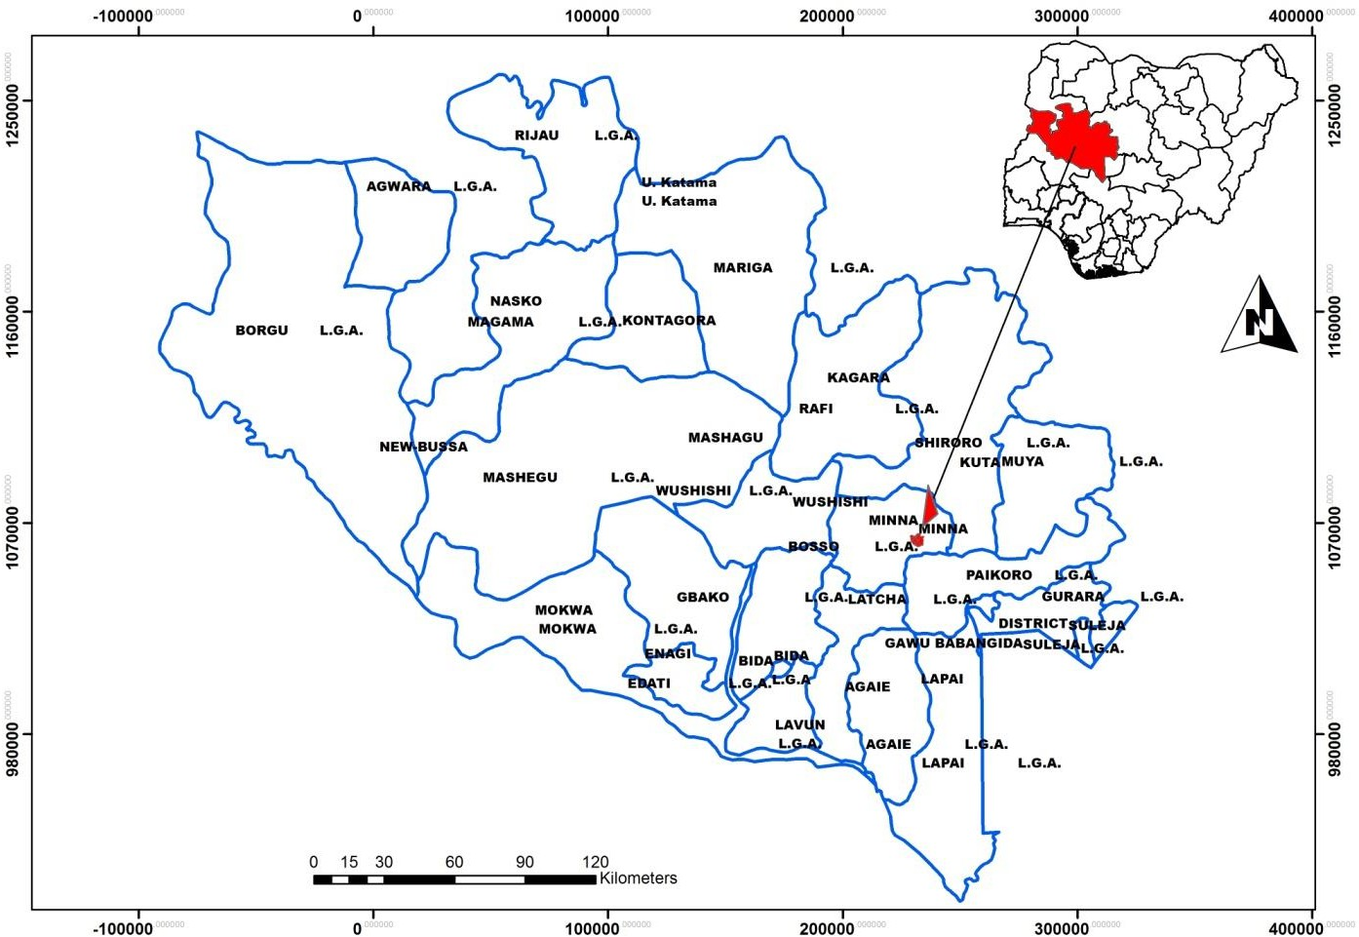

Source: Source: Digitized by the Author

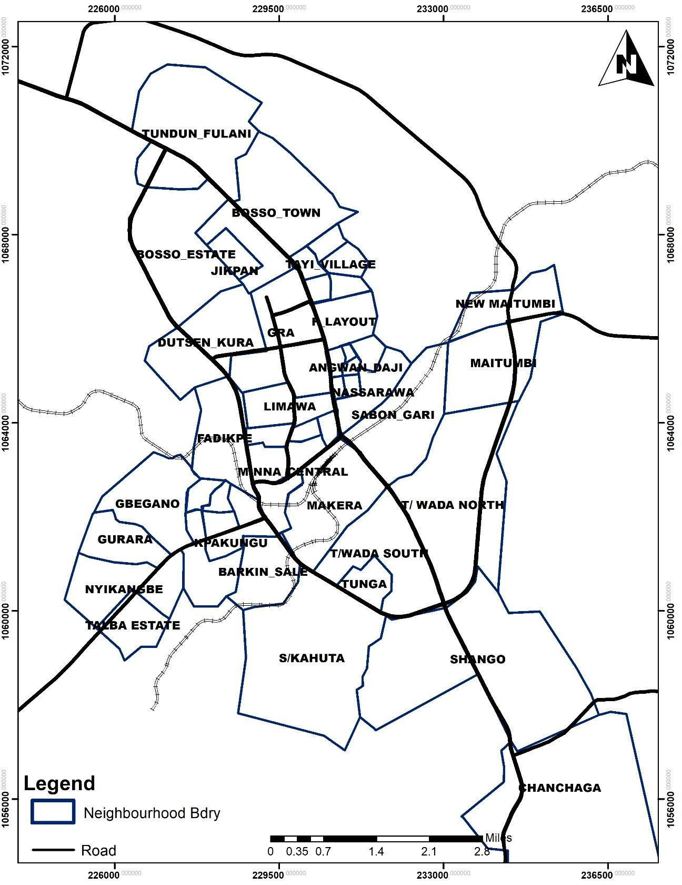

# Figure 1.2: Minna Neighbourhoods

Source: Digitized by the Author

The hydro-geological structure of the city depicts that the depth of water table in the underlying crystalline basement complex of gneiss and magnetite, lies on the average between 3m -15m (Offodile, 2002). The mean yield of borehole in this aquifer is estimated between 0.75 litres - 1.80 litres per second, at an average depth of 37.30m (Davis and de- Weist, 1970).

# Climate and ecology

Minna city falls within the temperate humid and is located within the hinterland and the Guinea savannah zone of Nigeria (north and the sub-equatorial south climate regions) based on koppen classification scheme (Simon *et al.*, 2018). Consequently, it has an average monthly temperature that varies significantly, with peak temperature between 400C - 420C around the months of February and March, and the lowest in August at 330C. Minimum temperature levels below 300C occur during harmattan periods, usually in December and January of the next year (Dalil *et al.*, 2015). Minna city received an annual mean precipitation level of 1300 mm and is characterized by a bimodal rainfall distribution which peaks at 300mm in September. With an annual rainfall of 1334mm (Abubakar, 2017), the rainy season commences in the month of May and ends around October, while the dry season lasts from October to March. The variability and decline in rainfall during the dry season will however form an integral part of water assessment framework employed in this study.

# Population and demographics

Minna city is home to approximately 541,672 inhabitants of heterogeneous ethnic and religion background. This figure is based on the projection of the 2006 population and housing census at 2.6% annual population growth rate (National Population Commission, 2020). Between 50% - 57% of the population are male with 17.1% - 54.1% of the total population being unable to read and write in English language (Niger State Bureau of

Statistics, 2014). With a land mass of 88km2, the population density of the city which covers both Bosso and Chanchaga local government areas is around 6155 persons per km2. The average size of households in Minna city is 8 persons and coincides with the average household size for Niger state (Niger State Bureau of Statistics, 2014).

The source of drinking water available to these households is characterized by both improved and unimproved water supply. Based on the socioeconomic survey conducted by Niger State Bureau of Statistic (2014) across the state, the proportion of households who used improved and unimproved water for drinking in Minna is provided in Table 1.1.

# Table 1.1: Percentage Distribution of Household by Source of Drinking Water in Minna

|  |  |  |  |  |
| --- | --- | --- | --- | --- |
| **S/N** | **Drinking water type** | **\*Bosso**  **LGA** | **\*Chanchaga**  **LGA** | **State** |
| **1** | Percentage of household with water(treated) | 3.6 | 21.9 | 2.4 |
| **2** | Percentage of household with pipe borne water(untreated) | 3.6 | 0 | 5.5 |
| **3** | Percentage of household with borehole/hand  pump | 61.3 | 6.3 | 45 |
| **4** | Percentage of household with well/spring  (protected) | 12.4 | 34.4 | 22.6 |
| **5** | Percentage of household with well/spring  (unprotected) | 0.7 | 0 | 7.9 |
| **6** | Percentage of household with river/spring | 10.2 | 0 | 13.6 |
| **7** | Percentage of household with lake/reservoir | 0 | 0 | 0.2 |
| **8** | Percentage of household with rain water | 0.7 | 0 | 0.1 |
| **9** | Percentage of household with water from tanker/truck/vendor | 7.3 | 37.5 | 2.3 |
| **10** | Others | 0 | 0 | 0.1 |

*The neighbourhoods in the study area are located within the two LGAs. Source: Niger State Bureau of Statistics Socioeconomic Survey (2014)

As shown in Table 1.1, it is apparent that the percentage of households with access to treated drinking water in the study area is above the State average. More so, a small proportion of the households has access to safe drinking water, with most residents depending mainly on other secondary water delivery mechanisms such as boreholes, wells, rivers and water vendors.

# Economic base and development

The city of Minna has a diverse economic base which contributes to its economic growth and development. Though, the city was initially a largely agrarian economy, the rail line construction by the colonialists provided the impetus for the economic development of the city. Aside the creation of Niger state in 1976 with its state capital in Minna, notable developments which further boast the economy of the city includes: the construction of an aerodrome in 1929, Bosso dam in 1947, Chanchaga dam in 1978 and electricity supply in 1962. These physical developments increased the industrialization of the city and provide a veritable source of employment opportunities to the inhabitants of the city.

With an unprecedented rapid population at 7.9% annual growth rate which was far above the national growth rate of 2.83% in Nigeria between 1991 and 2002, the city became more urbanized with increase in its administrative ward, built-up areas, trading, informal activities (weaving, traditional manufacturing and restaurant services), public sector and professional services (Sanusi, 2006). Presently, the city has an array of services impacting on its Gross Domestic Product (GDP). This includes: educational institutions, federal and state civil service, private sector, financial services, agriculture and agro-allied industries.

**CHAPTER TWO**

* 1. **LITERATURE REVIEW**
  2. **Theoretical Framework**

In spite a growing body of knowledge on water governance (Cleaver and Tonner, 2006; Franks and Cleaver, 2007; Huitema *et al.*, 2009) there is a lack of consensus on a single theory to provide explanations on the nexus between water provision and institutions. The current study however hinges on the common pool theory, the integrated water resource management for sustainable development, concepts of adaptive capacity, water poverty and the Exit, Voice, Loyalty and Neglect (EVLN) approach to water coping measures.

# The Theory of Common Pool Resources and Water

The theory of common pool resource which is also known as the “*tragedy of the commons*” provides the theoretical basis for understanding the overarching causes of resources over- exploitation and the need for sustainable management of natural resources. Propounded by Hardin (1968), the tragedy of the commons is theoretically rooted in Aristotle’s philosophy that “anything” that is to the greatest number of people has the least care bestowed on it (Jowett, 1941). The theory is an embodiment of two keywords: *tragedy* and *commons*. Hardin (1968) in his literature stated that the term ‘*tragedy’* does not depict unhappiness but rather the remorseless working of things. On the other hand, ‘*Commons’* is contextualized as a common pool of resources or environmental objects, where access to such resources or environmental objects is open, unregulated and never exclusively appropriated by individuals or group of persons.

Common pool resources (forests, pasture, water, wildlife and fisheries) are characterized by two main attributes: *high subtractibility* and *low excludability* (Ostrom *et al.*, 1994; Agrawal and Sanjeev, 2001; Ostrom, 2008). High subtractibility implies high rivalry in use and consumption. That is, a person’s use of a resource unit subtracts units of that resource from a finite total amount available for harvesting. Low excludability relates to the difficulty in excluding or restricting users from obtaining benefits from the resource. Hardin mentioned that the absence of restrictive or regulatory rules for the commons would ultimately pose environmental threats, and consequently bring about resource extinction. In his treatise, this notion of tragedy was applied to a pastureland in which herdsmen sharing such common resources are led by the insatiable quest of individually maximizing possible personal benefits to ultimately overstock their herds and destroy their shared resources, while leaving the cost of over-exploitation to the common.

In support of Hardin’s theory, McCay (2009) noted in his review that the fear for such unregulated resources is that users act less responsibly - adopting what is known as Not in My Backyard (NIMB) approach. When users’ behaviour is unrestricted in terms of protecting common interests and environmental sustainability they free-ride the use of resources to the extent of their needs (Goodstein, 1995; McCay, 2009; Anabo, 2013). It is the openness of the access and the extent of use of the resources that facilitate the ruins of the resources. McCay (2009) further noted that as the incentives to exploit the use of such resources increase (due to low level of exclusion and presence of free-riding), users are encouraged to further exploit the unregulated resources. In averting this systematic and relentless progression towards resource ruin, Hardin provided two alternative solutions: (1) appropriation and control of the commons as a private property which halt the immediate economic gains that can devastate

the long-term benefits of resources (Salzman and Thompson, 2010) and (2) the use of mutual coercion (administrative law) where appropriation is not possible.

Hardin’s theory has however drawn wide criticisms on two major grounds. First, it has been vehemently argued that the main confusion and contradiction regarding the tragedy of commons is Hardin’s use of the term “open-access or unregulated resources” for “commons” when applying his theory on pastureland. In his empirical study of commercial resources, Ostrom (2008) suggested that Hardin’s use of the word “commons” refer to open-access resources in which no individual has a claim to any part of the resources used by another user. In the study, a distinction was drawn between open-access resources and common pool resources. While the former is characterized as resources that are free to all users (users are difficult to identify) with no limit to the extent of access of the resources, in common pool, the resources are owned collectively by a group of users (difficult to define but not impossible to identify) who can restrict other users from outside the group. Secondly, while the theory proposed a government intervention (top-bottom approach) to avert the tragedy of commons, it failed to consider the practical and theoretical relevance of a bottom-top approach where the local users/communities are active stakeholder in the management of scarce natural resources. In this regard, it has been suggested that local users can evolve viable self- governance system or participatory management (a bottom-top approach), such as cooperative arrangement which is supportive of sustainable resource management (Ostrom and Hess, 2001; Ostrom, 2008; Salzman and Thompson, 2010).

As a common pool resource, water is also characterized by common pool resources problem such as rivalry in use and consumption (which depletes the total resource units), NIMBY,

free-riding and over-exploitation (Poteete *et al.*, 2010; Naiga *et al.*, 2015). Though not all

communities are equally successful in protecting and managing common resources like water in a sustainable manner (Gautam and Shivakoh, 2005), collective action of local water users and local self-governance is key for: (1) the ability of the local users/community to mobilize resources to operate and maintain the water infrastructure and (2) setting and enforcing users’ rules (Ostrom 1990; Baland and Platteau, 1999; World Bank, 1999). However, it has been noted that no singular institutional arrangement can curb the challenge of water resources security (Ostrom *et al.*, 2003; Ostrom, 2008) and that the problem can further be complicated by the status of water resources (its abundance or otherwise) which may change over an instant of time. They explained that the challenge of water resource management varies substantially with the resources, the characteristics of the water resource users and the nature of exploitation.

# The Concept of Adaptive Capacity

The concept of adaptive capacity is deeply rooted in the concept of natural resources construction. The concept of natural resources construction implies that developing countries tend to overuse their environmental capital, and make a series of conservative, economic and environmental adjustments which would enable such countries to engage in natural resources construction (Allan and Karshenas, 1996). In view of the fact that, increased water scarcity potentially limits economic growth and impedes social stability (Falkenmark, 1994 and 1997) the work of Turton and Ohlsson (1999) hypothesized that rising levels of water scarcity will probably result in a series of coping strategies or measures to be implemented by the decision makers. It is these measures that are potential source of conflict and instability in developing countries; as such measures are mainly allocative in nature thereby changing the balance of privilege in the society. Incorporating this concept into freshwater availability, Ohlsson and

Turton (2000) concluded that the capacity of any society to adapt to water shortage depends to a large extent on factors as equity in wealth distribution, access to education and political participation.

Based on the concept of adaptive capacity, Ohlsson (1999) established that some communities when faced with severe water scarcity (first-order) were able to adapt to social resource (second order) given a well- functioning institution (Lichtenthailer and Turton, 1999). A simple conceptual framework of water scarcity resulting in an array of social responses or adaptive behaviour as described by Turton and Olhsson (1999) is shown in figure 2.1. Conceptually, Turton and Olhsson (1999) provide some clarity in definitions regarding (1) Water scarcity: a decline the volumetric availability of water per capita over time; (2) First order natural resource: a natural resource that is either becoming scarcer or more abundant and which is useful a population over time; (3) Second order: set of adaptive behaviour drawn from a broader social context and employed either legally or otherwise by decision making elites; (4) Adaptive behaviour: a clearly manifest response to the changing level of water scarcity( such as compulsory rationing, rain water harvest and some other water related policy) and (5) Coping strategies: decision makers output usually in form of articulated strategies with the intent to effectively manage water scarcity.

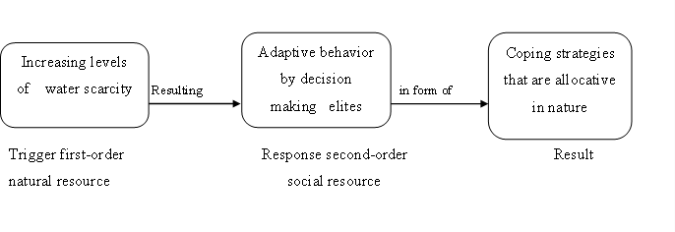

Figure 2.1: Schema of how Water Scarcity generates Adaptive Response Source: Turton and Ohlsson (1999)

The concept of adaptive capacity provides the analytical framework for the social water stress index (Turton and Ohlsson, 1999; Ohlsson, 2000). The Social Water Stress Index (SWSI) is premised on a country’s ability to cope to water shortages given factors as varied as distributional equity, political participation and access to education. The Human Development Index (HDI) is often applied to account for these social factors. As noted by Damkjaer and Taylor (2017) the HDI comprising variables of life expectancy, educational attainment and GDP per capita is considered as a good proxy for adaptive capacity to water shortages. The SWSI allows for a comparison between the original WSI (inverted Falkenmark index) and SWSI after adaptive capacity (which is proxy by HDI) has been accounted for. It was on this analytical basis that Olhsson (2000) empirically demonstrated that countries such as Poland, South-Korea, Iran and UK which are traditionally classified by Inverted Falkenmark index as “water-stressed” countries are now labeled “relatively sufficient” under SWSI due to their higher societal adaptive capacity. Conversely, countries with lower adaptive capacity (Nigeria, Burkina-Faso, Niger and Eritrea) moved from “relatively sufficiency” to “water stress”.

In spite of being considered an acceptable measure of adaptive capacity, the HDI has however been criticized as being oversimplified due to its narrow selection of variables (Kovacevic,

2010) and for being highly correlated with major economic indices such as GDP (Ogwang, 1994).

Therefore, this particular theory was relevant in this study as it has provided the analytical framework on the available water resources, increasing level of water scarcity (first order) which then result to the adaptive behaviour (response, second order) as to how households employ the necessary coping strategies on the increasing water scarcity to yield a meaningful result.

# Water Scarcity, Water Stress and Water Poverty

Water scarcity, water stress and water poverty are conceptually related, yet they are different terms. Explanations of these terms are provided as follows.

# Water scarcity

Water scarcity represents a condition where the demand for water cannot be fully satisfied due to shortage in fresh water availability (Falkenmark *et al.*, 1989; Vorosmarty *et al.*, 2000; Taylor, 2009). It is often defined within the context of available water resources vis-a-vis human population (Cselenyi, 2013) and as such, refers to an area consisting of a large number of people suffering from water insecurity during a long time period. While there is knowledge that water is a naturally scarce resource, water scarcity is a decline in the volume of water available per capita over time (Turton and Ohlsson, 1999). Water scarcity therefore refers to the proportion of water use to water available for use within the region in time and is measured in physical quantity (volume).

The quantification of what actually constitutes water scarcity depends on three different factors as: (1) the actual needs of the population and considerations regarding the environmental needs (2) the actual available resources for the needs to be satisfied and (3)

the temporal and spatial dimensions of the needs (Rijsberman, 2006). Water scarcity is associated with several situations with differing impacts. To distinguish between water uses and its scarcity on the society, Molle and Mollinga (2003) itemized 5 categories of water use/need:

* *Drinking water.* (U1) Which is the most important use of water necessary for human existence in which it has been suggested that human needs are between 1-5 litres per day.
* *Domestic water.* (U2) Domestic use for cooking, laundry and hygiene.
* *Food security* needs (U3) Are additional water needs for agricultural production.
* *Economic production* (U4) This water forms part of the economic production by people who depend economically on such production, but whose domestic and food needs are not affected by the water shortages that might affect this production.
* *Environmental needs impacting on the society.* (U5) Due to human impact on the ecosystem, the lack of water or its scarcity results in loss of biodiversity, pollution, degradation and other negative consequences.

They also highlighted 5 dimensions of water scarcity:

* *Physical scarcity.* (S1) Occurs when water sources are limited by nature.
* *Economic scarcity.* (S2) Is the inability or lack of means to provide water needs/use due to limited human or financial resources.
* *Managerial scarcity.* (S3) May occur when water systems and infrastructure suffer massive neglect or not properly maintained.
* *Institutional scarcity.* (S4) Is an induced scarcity, which depicts a failure on the part of a society to deal with rising supply/demand disequilibrium and the preservation the environment.
* *Political scarcity.* (S5) Occurs where people are barred from accessing an available source of water due to political discrimination/ subordination.

By combing these different layers of water use (denoted by U1-U5) with the different dimensions of water scarcity (described by S1-S5), a variety of at least 25 matrix cases and scenarios are created. For instance, U1S2 is a situation where drinking water is available but not affordable to a person, while U4S3 depicts a situation where irrigators suffer from water shortage because upstream reservoirs were poorly maintained. Generally, water scarcity is characterized by a continuous gap between the water needed and water available, and manifests itself in temporal forms (for example a reduction in the quantity of water earlier used which can induce adjustment or reduce output or a situation where a user can potentially use more water, but the additional supply to meet this intending need is not available).

# Water stress

The World Water Assessment Program (WWAP, 2001), defined water stress as “the condition of insufficient water of satisfactory quality and quantity to meet human and environmental needs”. The relationship between water use and water availability as noted by Nepomiluiva (2017) is also known as water stress. Therefore, regions where water use exceeds the supply of water are most likely experiencing water stress. In addition, water stress is considered within the context of the capacity of meeting the human demand for water. For instance, a country or region with abundant polluted water resource is not suffering

water scarcity, but water stress because its large volumetric available water is grossly underutilized.

Though often used interchangeably, a distinction exists between water stress and water scarcity. As noted by Schulte (2014), in Figure 2.2 water scarcity apparently represents a micro part of the water stress concept. Water stress is therefore a more comprehensive definition which includes accessibility along with environmental flows, qualitative and quantitative water availability.

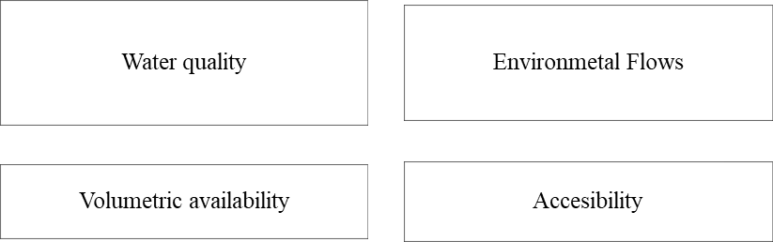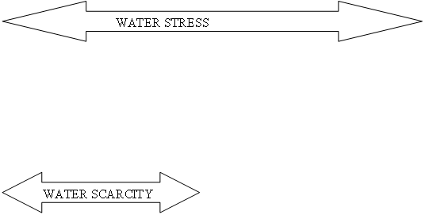

Figure 2.2: Water Scarcity as a Micro Part of Water Stress Source: Schulte (2014)

# Water poverty

Water poverty is a much broader term which encompassed both water scarcity and water stress, together with affordability. For example, it has been theorized by Turton and Ohlsson (1999) that a social entity is in a condition of water poverty if it is confronted by a prevailing condition of water scarcity, alongside low level of adaptive capacity. In other words, water poverty is the concurrent existence of both natural resource scarcity and a social resource scarcity. As aptly noted by Lawrence *et al.* (2002) people, regions or countries are “water

poor” due to either two principal reasons: (1) they have no sufficient water for their basic human needs since it is not available and (2) they are income poor, and although water is available, it is unaffordable. The phenomenon of water poverty therefore exists where people are confronted with water scarcity and lack the adaptive capacity and means to afford the cost of sustainable clean water (Feitelson and Chenoweth, 2002, Fenwick, 2010).

# Poverty

The main increase of the occurrences of poverty has made the issues of poverty a vital one, and this has several meanings to several people or group of people and every sector of life has its perception about poverty. For instance, the political scientists see poverty as lack of empowerment on the part of masses, the economists view it in relation to income while on the other hand the urban geographers and sociologists explain it as lack of social infrastructures and opportunities in the society (Oni and Fashogbon, 2013). Poverty is therefore, referred to a global phenomenon that constitutes social, economic, political and cultural deprivations faced by a person, household, community and nation at any time. Also, Ogwumike (1991) and World bank (2001) defined poverty as a condition of low income or insufficient income to meet the basic needs of life such needs can be categorized as primary (food, water, shelter and housing) and secondary (health, education, transportation, security, liberty, religion, employment and freedom of expression) needs.

# The Dimension of Global Water Scarcity Problem

Water scarcity is a lingering global phenomenon. As evident in the Figure 2.3, while global water availability remained near constant within the last century, human population had increased in connection to water use and withdrawals which spiraled from 500 cubic kilometer in year 1900 to 3830 cubic kilometer in year 2000 (Rijsberman, 2006; Watkins,

2006; Nepomiluiva, 2017). This resultant dynamic of rapid population growth and constant water availability implies that water use and consumption is likely to surpass water supply levels in some regions of the world.

This observation has been further supported by the International Water Management Institute (IWMI) estimates that around 1.2 billion people globally have limited or no access to safe water and the demand is expected to increase by 40% by 2030 (Paulson, 2015). Aside being a global challenge, the characterization of water scarcity also manifest itself severely in developing countries (Jimenez-Cisneros *et al.*, 2014) were substantial proportion of the global population reside (Gerland *et al.*, 2014).

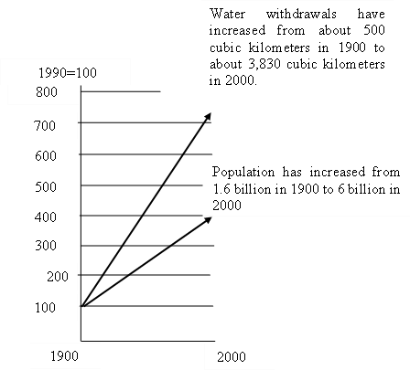

# Figure 2.3: Global Water Withdrawals versus Population Growth

Source: Rijsberman (2006) and White (2012)

Compared to developed countries, water availability per capita index (1950=100) in developing countries (humid and arid) as apparent in figure 2.4 it has been nose-diving, with such decline expected to reach between 15- 25% by year 2025(Watkins, 2006; White, 2012). With 7.9 billion out of 9 billion people projected to live in developing countries by the year 2050 (Ziotnik, 2016), increase in water demand and the lack of water to satisfy the increasingly growing demand will remain severe in developing countries of the world, even in the foreseeable future. In this regard, population growth is expected to directly or otherwise shift about 55% of the world’s population towards severe water scarcity over the next generation (Rockstrum, 2011).

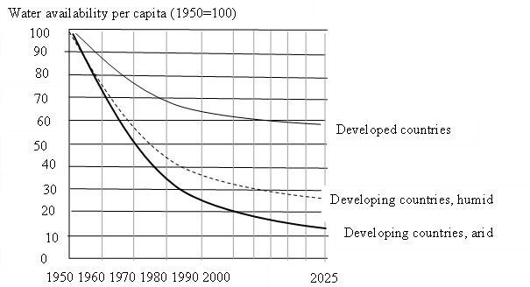

# Figure 2.4: Past, Present and Future Water Availability

Source: Watkins (2006) and White (2012).

# Evolution of Water Scarcity Metrics/ Indicators

The global water resources are highly stressed and given the effect of climate change and the ever-increasing levels of population explosion, water resources will need to be properly managed (Sullivan and Jemmali, 2014). The intensification of water scarcity across the globe

has led to the search for a robust quantitative metric to measure and assess progress towards reducing water scarcity. Several metrics (simple and classical) have been developed since the 1980’s to the start of 2000’s to quantify and assess water scarcity/stress at the global level. A review of both simple (Falkenmark/water stress index and withdrawal-to-availability ratio) and classical/holistic (social water stress index, physical and economic indicators and the water poverty index) assessment metric characterizing human environment and freshwater availability over the last three decades are presented in this section. It is important to mention that while more sophisticated metrics (such as water footprint-based indicators and green- blue water scarcity) have been developed since mid-2000, the current review is limited to the simple and classical metrics.

# Simple water scarcity metrics

The simple/ conventional water scarcity metrics includes both the Water Stress Index (WSI) and Withdrawal-to-Availability Ratio (WTA).

# Simple falkenmark/water stress index (WSI)

The Water Stress/Falkenmark index is the first and most commonly used water scarcity metrics at the global level. Though a formal quantification of water scarcity started with the development of WSI in early 1980s, the earlier research by Falkenmark and Lindh (1974) provided a quantitative linkage between freshwater and human population. The water stress index otherwise known as the Falkenmark index employed the logic that the potential conflict over water availability is best measured by water availability per capital per year (Falkenmark *et al.*, 1989). As apparent in the Figure 2.5, the WSI demonstrates freshwater availability differences in terms of the number of people that can compete to be sustained by a single

flow unit of water- which is defined as 106m3 per capita year (Falkenmark, 1986, Falkenmark

*et al.*, 1989).

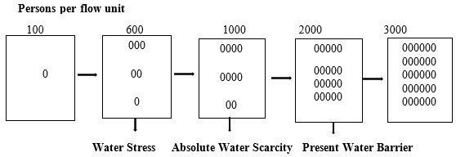

# Figure 2.5: Visualization of Different Levels of Water Competition

Source: Adapted from Falkenmark, (1989).

Each cube indicates the flow of 1million cubic metre per year available in terrestrial water system; each dot represents 100 individuals depending on that water (Falkenmark *et al.,* 1989) stated that water consumption levels in most industrialized countries is in the range of 100-500 people per flow unit (which was later adjusted to 600 people per flow unit (approximately 1700m3) so as not to exaggerate the situation). This value of 1700m3 was therefore proposed as the threshold for water stress, below which varying degrees of water competition emerge. Based on this benchmark, Falkenmark *et al.,* 1989) categorized water condition in most countries based on the three (3) thresholds of water scarcity, water stress and absolute scarcity as shown in Table 2.1.

# Table 2.1: Summary of Water Stress Index thresholds

|  |  |  |
| --- | --- | --- |
| **CATEGORY** | **Inverted WSI (People/Flow Unit)** | **Contemporary WSI threshold**  **(m³/capital/year)** |
| **No Stress** | < 600 people / flow unit | > 1700 |
| **Water Scarcity** | 600 - 1000 people/ flow unit | 1700 – 1000 |
| **Water Stress** | 1000 - 2000 people / flow unit | 1000 – 500 |
| **Absolute water stress** | > 2000 people/ flow unit | <500 |

Note: A flow unit in the second column for the inverted WSI is equivalent to 106m3 and the contemporary WSI can be arrived at by dividing one flow unit by the number people competing for this quantity of water.

Source: Damkjaer and Taylor (2017)

Countries or regions whose water availability cannot sustain the threshold of 1700m3 per capita per year are said to experience “water scarcity”. Countries with water availability below 1000m3 per capita per year are “water stress” and when water availability falls below 500m3 per capita per year, such countries experience “absolute scarcity”. On the basis of the thresholds, the application of the Water Stress Index as a water scarcity metric for assessing the proportion of people suffering from water scarcity around the world as at year 2005 is shown in figure 2.6. An interesting observation is that despite high availability of fresh water in most African countries, Nigeria is perceived water stressed while the north Africa region (with less than 500m3 per capita per year) is suffering from absolute water scarcity.

While the Falkenmark/Water Stress index has wider application because it is simple in use, easy to understand, intuitive and the data is readily available at an international level (Jemmali and Matoussi, 2013; Jemmali, 2018; Liu *et al.*, 2017), it is not without its inherent shortcomings. First, the index has been criticized as a one-dimensional indicator which considers only the physical aspect of water availability by neglecting the socio-political, economic and environmental drivers of water scarcity (Jemmali and Matoussi, 2013; Sullivan and Jemmali, 2014).

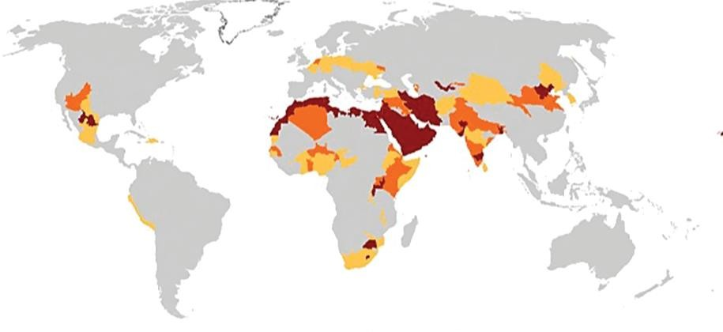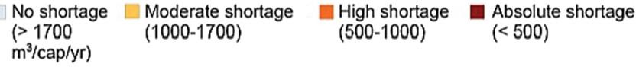

# Figure 2.6: Water Scarcity in year 2005 based on the Water Stress Index

Source: Kummu *et al.* (2010) and Liu *et al.* (2017)

Secondly, apart from the different rationales adduced for the setting of thresholds of water stress and scarcity by Falkenmark, 1986; Savenije, 1999; Gardner-Outlaw and Engelman 1997) the uncritically adoption and assimilation of the value of 1700m3 and1000m3 into the mainstream literature has no empirical justification (Damkjaer and Taylor, 2017). Thirdly, since the Falkenmark index was not initially developed for regional or global comparison of water scarcity (Falkenmark, 1989) it has been argued by Gardner-Outlaw and Engelman 1997) that it would be, inappropriate to propose any precise levels as absolute thresholds of water scarcity, or insist that they apply equally to all countries. Below is a list of countries in sub-Saharan Africa experiencing water stress as shown un Table 2.2.

# Table 2.2: List of Sub-Sahara African Countries Experiencing Water Stress

|  |  |  |  |
| --- | --- | --- | --- |
| **Sub-Saharan African Countries** | | | |
| **Eastern Africa** | **Middle Africa** | **Western Africa** | **Southern Africa** |
| **Algeria** | Angola | Benin Republic | Botswana |
| **Egypt** | Cameroon | Burkina Faso | Lesotho |
| **Libya** | Gabon | Gambia | Namibia |
| **Sudan** |  | Liberia | South Africa |
| **Uganda** |  | Mali |  |
| **Zambia** |  | Nigeria |  |
| **Kenya** |  | Senegal |  |
| **Somali** |  | Ghana |  |
|  |  | Guinea Bissau |  |

Source: UN (2015)

# Withdrawal-to-availability ratio (WTA)

The Withdrawal-to-Availability Ratio (WTA) is otherwise known as the “criticality ratio”. The WTA defined water scarcity in terms of the ratio of the total annual withdrawals (across all sectors of domestic, industrial and agricultural) relative to the available renewable fresh water resources (Alcamo *et al.,* 2003). Based on the WTA, a country is “water stress” if its annual withdrawals are between 20% and 40% of the available water resources and “severely water stressed” if such ratio surpasses 40% (Raskin *et al.*, 1996; Alcamo *et al.,* 2003). Based on this criticality ratio, the proportion of people suffering from water stress is apparent in Figure 2.7 with most stressed countries falling between the low and middle latitude of the northern hemisphere (Liu *et al.*, 2017).

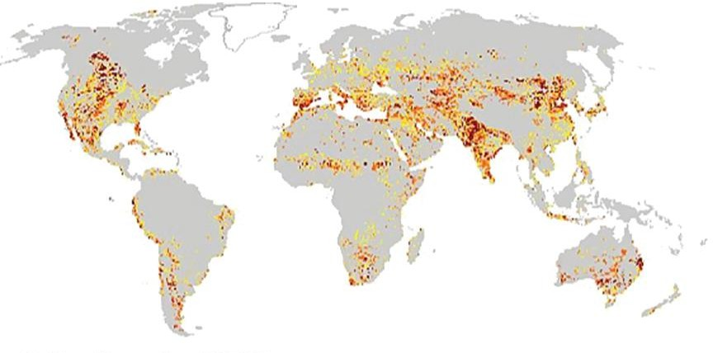

# Figure 2.7: Withdrawal to Availability Ratio for year 2000

Source: Liu *et al.* (2017)

It is worthy of note to mention that in this scarcity metric, water use can be quantified using either water consumption (measures the amount of water extracted from different water sources and evaporated to the atmosphere) or water withdrawals (measures the amount of water extracted from different water sources of which part returns to the system by return flow or leakage), though majority of existing water scarcity studies have employed the latter to indicate water use (Oki and Kanae, 2006; Wada *et al.*, 2011). This water scarcity metric has also been criticized for this lack of consistency. For instance, Munia *et al.* (2016) employed consumption and withdrawal as minimum and maximum levels of scarcity and noted that the ratio of consumption to average available renewable water resources produced an unrealistic low level of water scarcity.

Secondly, as the actual proportion of the return flow to water bodies varies across regions depending on natural and socio-economic and technological conditions, using 40% as water scarcity threshold may not be consistent in reflecting the status of water scarcity across regions. Thirdly, this metric also suffers from the uncritical adoption of its thresholds as they are tagged artificial and not evidence bases (Liu *et al.*, 2017). Finally, Yang (2008) and Liu *et al.* (2017) noted that the withdrawal data in WTA do not take into cognizance how much of it is consumptively uses (evapotranspiration) and how much could be available for recycling in cases where water can be used for multiple purposes.

# Classical/holistic water scarcity metrics

The inability of the conventional water scarcity metrics (WSI and WTA) to account for societal adaptive capacity to cope with stress (Feitelson and Chenoweth, 2002) as well as environmental sustainability (Sullivan, 2002; Sullivan and Jemmali, 2014) associated with fresh water use explicitly paved way for the development of classical water scarcity assessments. These classical indicators (social water stress index, physical and economic water scarcity indicators and water poverty index) are discussed next.

# Social water stress index (SWSI)

As elaborately discussed, the Social Water Stress Index is deeply rooted in the concept of adaptive capacity index (Turton and Ohlsson, 1999; Ohlsson, 2000). This index surmised that the capacity of a country to adapt to water scarcity depends largely on factors such as technological, economical, access to education, political participation, and distributive equity. To derive the SWSI, the number of people in a country that share 106m3 of annual renewable water (inverted Falkenmark WSI) is divided by the Human Development Index

(as seen in equation 2.1). The result is then divided by a scalar, which according to Olhsson (2000) sets at a value of 2.

𝑇ℎ𝑒 𝑆𝑊𝑆𝐼 𝑜𝑓 𝑎 𝐶𝑜𝑢𝑛𝑡𝑟𝑦

Inverted Falkenmark WSI

=

𝐻𝑢𝑚𝑎𝑛 𝐷𝑒𝑣𝑒𝑙𝑜𝑝𝑚𝑒𝑛𝑡 𝐼𝑛𝑑𝑒𝑥

1

𝑋

𝑆𝑐𝑎𝑙𝑎𝑟

(2.1)

The SWSI therefore allows for a comparison between the original WSI (inverted Falkenmark index) and SWSI after adaptive capacity (which is proxied by HDI) has been accounted for. While the HDI has been a widely acknowledged indicator of adaptive capacity (Olhsson, 2000; Damkjaer and Taylor, 2017), it has however been criticized as being an oversimplified indicator due to its narrow selection of variables (Kovacevic, 2010) and for being highly correlated with major economic indices (such as GDP) especially in low-income countries (Ogwang, 1994). As such the risk and misrepresentation in using this low-quality data may further aggravate the conditions of water scarcity which is already in a precarious situation in low-income countries.

# Physical and economic water scarcity

This indicator was developed by the International Water Management Institute (IWMI) for assessing water scarcity noted the significance of adaptive capacity as a measure for distinguishing between physically and economically water scarce nations (Seckler *et al.*, 1998a; Rijsberman, 2006; Molden *et al.,* 2007). The highlight of this approach is that it considers the potential of a country to develop its water infrastructure and to improve its irrigation water use efficiency.

Physical water scarcity occurs when more than 75% of a country’s fresh water availability is withdrawn for domestic, industrial and agricultural (DIA) purposes (Brown and Mattock,

2011) and such country is unable to meet its future water demand even after accounting for its natural adaptive capacity. Economic water scarcity occurs when a country has a sufficient renewable water resources (that is water withdrawals are less than 25% of river flows) but there is a significant water investments and infrastructure to be made in order to make water resources available for consumption.

The application of this indicator at a global scale is shown in figure 2.8. One striking observation based on this metric is the dichotomy between the African continent and other developed economies. The former is suffering from economic scarcity while the latter are either approaching or constrained by physical water scarcity.

The major shortcomings of this approach are:

* + - * + Aside its complexity and being time consuming to compute, the indicator is not widely used to assess global water scarcity. As such it is less attractive for presentation to public and policy audience (Rijsberman, 2006).
        + The assessment of adaptive capacity on the basis of infrastructure have been criticized due to its complexity and opaque nature (Damkjaer and Taylor, 2017)
        + While the distinction between physical and economic water supply is intuitively appealing, both measures have been criticized for its reliance on subjective expert judgment, with most of the experts having access to sensitive remote sensing information (Seckler *et al.*, 1998b).

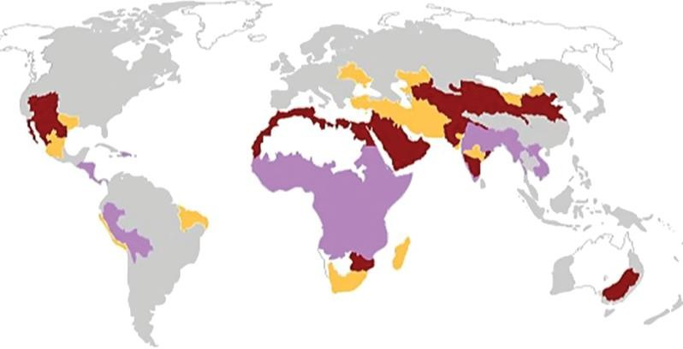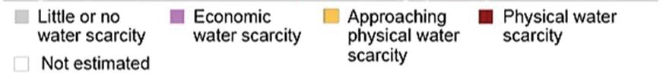

# Figure 2.8: Physical and Economic Water Scarcity (1995)

Source: Liu *et al.* (2017)

# Water poverty index

The complexity of water scarcity and the importance of moving away from the one- dimensional indices to a more robust scarcity metric led to the emergence of the water poverty index (Swatuk, 2002; Sullivan *et al.*, 2003; Salameh and Jaber, 2000; Garriga and Foguet, 2010; Sullivan and Jemmali, 2014; Anju *et al.*, 2017) for effectively assessing water stress.

The water poverty index is an interdisciplinary tool developed by Sullivan (2002) for understanding the complexities associated with water issues by integrating physical, social, economic and environmental aspects and linking water stress to the related poverty in the respective region (Sullivan *et al.*, 2003; Heidecke, 2006; Huang *et al.,* 2017). In other words, it arises due to the perceived need to examine the links between poverty and water availability. For instance, while there is a consensus in literature that water is strongly

correlated with poverty, the nature and direction of such linkages is complex and unclear (Meigh *et al.*, 1999). The concept of water poverty offers a new insight for clarifying this neglected connection.

It was on this basis that Sullivan (2002) captured the linkages between issues relating to water resource availability, economic efficiency, human and ecological needs. The author used a multi-criteria analysis consisting of five (5) major components (Resources, Access, Use, Capacity and Environment) to evaluate progress and development in the water sector. The Resource component consisting of subcomponents such as surface water (RES1), Ground water availability (RES2), Deep ground water availability (RES3), and Variability (RES4) are used to determine the physical availability of water resources. The Access component also have subcomponents like Access to safe water (ACC1), Access to Sanitation (ACC2). The Use components helps to assess the various purposes for water such as safe water use for agricultural, industrial and domestic use. The capacity component helps to manage the water system and sustain access comprising of subcomponents like economic capacity (CAP1), social capacity (employment (CAP2), education (CAP3) and health (CAP4)). And the fifth component which is the Environment assesses the environmental factors impacting on water supply to the ecosystem.

The application of the water poverty index at a global scale is seen in figure 2.9. Based on this water poverty map, it is evident that water poverty is more prevalent in Africa with Nigeria suffering from a very high degree of water poverty. Approaches to water poverty measurement, construction of water poverty index, its advantages and criticisms are presented next.

# Approaches to water poverty measurement

The earliest attempt to systematically provide explanations on the diverse approaches of assessing water poverty was the study by Sullivan (2002) which highlighted four (4) approaches for calculating the water poverty index. The approaches (simple time analysis, matrix, gap and conventional composite index) are discussed as follows:

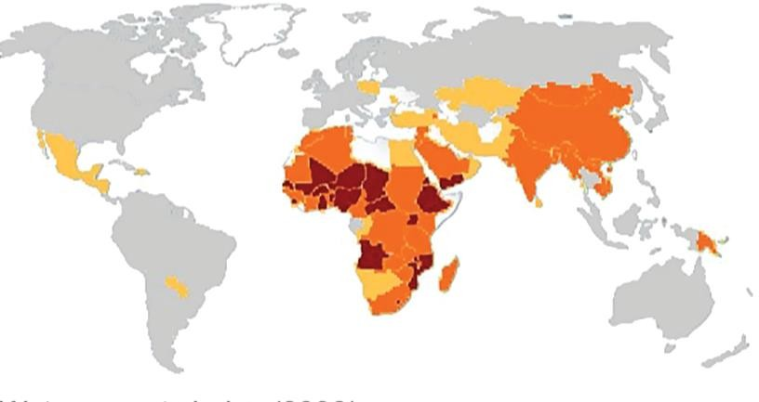

# Figure 2.9: Water Poverty in year 2000

Source: Liu *et al.* (2017)

# Time Analysis Approach

Using the time analysis approach, the water poverty index is determined by the time required per capita to gain access to a specific volume/quantity of water. Time analysis involves is a two-variable approach to water poverty measurement. The variables considered are the time taken to collect water including waiting time (in minutes) and the quantity/volume of water per collection trip (per capita). The time analysis formula is shown in equation 2.2:

T 1000m3

WPI = (2.2)

Where T is the time required for a person or household to collect a quantity of water (1000 cubic metric). In spite its simplicity and ease of comprehension the time analysis approach to water poverty assessment is without ardent criticisms. An obvious weakness of this approach aside its failure to address the supply side of freshwater availability is its neglect of environmental sustainability and commercial concerns in its assessment framework. Based on its water poverty methodology, the final numerical value derived as the water poverty index is only reflective of domestic issues. As such the time analysis approach does not consider water assessment in an interdisciplinary holistic way (Sullivan, 2002).

# Matrix approach

The matrix approach to water poverty assessment combines the principal attributes/indicators of water stress and human welfare on an appropriate scale into a two-dimensional milieu. These indicators or attributes can also be developed from the composite index approach. Utilizing this approach, Sullivan (2002) hypothetically presented a two -dimensional matrix in the figure 2.10 depicting the water poverty positions of 14 countries on the basis of their differing levels of water availability and access and capacity and use.

# Gap method

As analyzed by Sullivan and Jemmali (2014), the gap approach to water poverty assesses the extent of deviation of actual water availability and use from expected or predetermined standards. The expected standards are reflective of the ideal level which ought to exist if water resources are managed in a sustainable manner. Such expected standards are based on

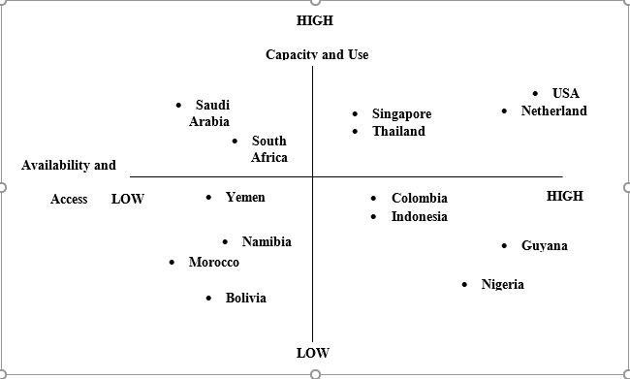four pertinent considerations: (1) ecosystem health (biodiversity and resource depletion); (2) human health (mortality rate, life expectancy and reported cases of water-related illness); (3) community well-being (education level, political participation and crime incidence) and (4) economic welfare (income per head, income distribution and unemployment rates). The difference between the actual and the expected standards gives the water poverty index.

# Figure 2.10: The Matrix Approach to Water Poverty Index

Source: Sullivan (2002).

Similar framework has been employed in the earlier work of Gillis *et al.* (1987) as an assessment basis for poverty measurement. Adopting this approach, Sullivan (2002) evolved an assessment framework for water poverty index as provided in Table 2.3. As noted by Sullivan (2002) the derived water poverty index using the gap approach is not a single numeraire value but an index consisting of four values, based on the data and indicator used. Based on this approach, higher water poverty gaps are associated with higher levels of water stress and vice-versa.

# Composite indicator approach

The composite approach entails the construction of an index from an array of variables or indicators which capture the essence of what is being measured. As mentioned by Sullivan (2002) the indicators which capture the different dimension of water poverty are (1) water availability (2) access to safe water (3) clean water and (4) time taken to collect water for domestic use. In his work, Sullivan (2002) derived the following formula in equation 2.3 for calculating the water poverty index from the indicators:

Water Poverty Index = WaA + WsS +

We (100 ‒ T) (2.3)

Where A is the adjusted water availability assessment expressed as percentage (%). The adjusted water availability is determined based on ground and surface water availability and is related to environmental water requirement and basic human requirement for domestic, agriculture and industrial water purpose. 𝑆 is the percentage of the population/household with access to safe water and sanitation (%). 𝑇 represents the time required for water collection by the households and is indexed between 0 and 100.

**Table 2.3: Gap Approach to Water Poverty Assessment**

|  |  |  |  |  |
| --- | --- | --- | --- | --- |
|  | **Ecosystem health** | **Human health** | **Community well-**  **being** | **Economic welfare** |
| **Predeter mined standard** | Could be based on biodiversity, waste assimilation and resource depletion and could also include a measure of water availability (symbol EH) | could be based on infant mortality rates, incidence of selected diseases and life expectancy (symbol HH) | could be based on crime rates, marital break down, education and political participation (symbol CW) | could be based on per capital incomes, income distribution, reinvestment rates and unemployment (symbol EW) |
| **Actual empirical value** | Symbol AEH | Symbol AHH | symbol ACW | symbol AEW |
| **Water poverty**  **gap WPI** | EH ‒ AEH=eh | HH ‒ AHH=hh | CW ‒ ACW=cw | EW ‒ AEW=ew |

Source: Sullivan (2002).

However, to take into account the negative relationship between time taken per water collection trip and water poverty level, it can be modified as 100 − 𝑇. While 𝑤𝑎, 𝑤𝑠 𝑎𝑛𝑑 𝑤𝑡 are the respective weights given to water availability, proportion of household with access to safe water and sanitation and the time required for water collection trip. To cap it all, the higher the final value of the water poverty index after aggregation of the three components, the lower the degree of water stress. The problem of incommensurability as noted by Sullivan (2002) hardly arise in this method as the index comprises of components which can be compared as they are all expressed as a percentage or index number.

# Water Poverty Assessment Framework

While water poverty has been widely acknowledged as a multidimensional tool for assessing progress in water activities and prioritizing water management decisions (Sullivan *et al.*, 2006; Xin *et al.*, 2011; Sullivan and Jemmali, 2014; El-Gafy, 2018) its assessment framework is in three (3) generic stages consisting of eight steps (Nardo *et al.*, 2008; Garriga and Foguet,

2010; Korc and Ford, 2013). The analytical framework for the assessment of water poverty index is diagrammatically illustrated in the Figure 2.11. As highlighted in the separate studies by Garriga and Foguet (2010) and Korc and Ford (2013), the stages involved in water poverty application can be sequentially surmised as:

1. The selection of water poverty components and water poverty indicators;
2. The construction of the water poverty index and,
3. The validation of the water poverty index.

A detailed explanation of this generic chorological process is provided as follows

# Selection of water poverty indicators

This is the first stage of the water poverty assessment framework. In the selection of water poverty indicators, five (5) basic steps must be followed chronologically. These steps are explained as follows:

# Compilation and validation of available data on water poverty indicators

This entails the preliminary compilation of data on water poverty indicators based on the extant literature (Garriga and Foguet, 2010; Korc and Ford, 2013).

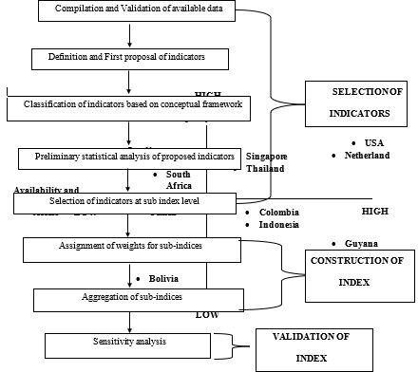

# Figure 2.11: Generic Stages in Water Poverty Application

Source: Garriga and Foguet (2010) and Korc and Ford (2013)

# Definition and first proposal of water poverty indicators

This involves defining whether the compiled water poverty indicators are relevant. At this stage relevant information required for good decision making is rarely available (Feitelson and Chenoweth, 2002) and in most cases an ad-hoc selection of indicators due to data availability might be the most cost-effective solution (Garriga and Foguet, 2010). In view of the above, it has been suggested that the proposed indicators must satisfy the following standard criteria (OECD, 1993; Feitelson and Chenoweth, 2002; Jimenez *et al.*, 2008):available (measurable at no reasonable cost), understandable (well defined as to be easily accepted by likely users), accurate(supported by reliable information), scalable at

different administrative levels, relevant (responsive to changes), regularly updateable and integrative among environmental, social and economic aspects.

# Classification of water poverty indicators based on conceptual framework

As noted by Garriga and Foguet, (2010) this entails the classification of all the proposed indicators along the five dimension of water poverty index (resource, use, capacity, access and environment) and its sub-components, which is a holistic and multidimensional measure for describing the complexity of water sector in an integrated manner. Such classification of the water poverty indicators can be based on expert opinion such as the Delphi method (Korc and Ford, 2013) or different analytical techniques such as multivariate statistical approach to examine the statistical structure/ dimension of the indicators in the dataset (Booysen, 2002; Nardo *et al.*, 2008; Sullivan and Jemmali, 2014).

# Preliminary statistical analysis of the water poverty indicators

This step involves a preliminary statistical analysis of the dataset on water poverty indicators at component (index) and sub-component level prior to the final selection of indicators. The purpose of such analysis at the component level as noted by Korc and Ford (2013) is to determine the nature, appropriateness and robustness of the dataset as measure of water poverty. Similar preliminary analysis should also be repeated at the sub-component level as the underlying nature of the indicators/variables needs to be well analyzed before their final selection.

This preliminary statistical analysis involves striking the right balance between comprehensiveness and avoidance of redundancy (Hajkowicz, 2006). In terms of comprehensiveness, Hajkowicz (2006) mentioned that the set of selected water poverty indicators must be sufficient enough to thoroughly describe the phenomenon to be measured.

A typical example of redundancy is the case of multi-collinearity of two or more indicators. Generally, a lack of correlation is a desirable property, as the presence of correlation among the indicators at the sub-components may lead to redundancy and double counting- which bias the final index value.

For the purpose of preliminary analysis of the water poverty indicators, Fenwick (2010) suggested that the dataset should first be screened for outliers (using box plots so as to account for sensitivity and improve the accuracy of the statistical analyses), normality (by employing histograms to assess whether the data are normally distributed) and linearity (through the use of scatter plots). Furthermore, the author noted that it is extremely difficult to draw precise assumption about the relationship/association between the components/indicator scores and the final index value of the water poverty index without further statistical analyses, hence most case studies have adopted the use of pearsons correlation matrices as a measure of linearity. Since water poverty index is a composite index, an increment in a component’s score will lead to a corresponding increase in water poverty score. Therefore, such relationship is considered linear, and pearsons correlation can be employed to describe the strength (r) of each component’s relationship with respect to the water poverty index. However, similar approach might not be applicable in the relationship among the sub-components. In such cases, the data must be assessed first for linearity through their scatter plots, before examining their linear correlations using pearsons correlations. They cautioned that if a linear relationship among the sub-components does not exist on the basis of their scatter plots, pearsons correlation should not be employed.

An alternative approach which is often employed to ensure that dataset of the water poverty indicators is well-balance (reduce redundancy without sacrificing the comprehensiveness) is

the multivariate technique (Principal Component Analysis). The use of principal component analysis for preliminary analysis at component and sub-components will reduce large set of correlated variables to small dataset of uncorrelated data without the loss of much information.

# Selection of indicators at sub- component level

The preliminary evaluation of the datasets using the varied approaches mention in section

2.7.1.4 will yield the final water poverty indicators to be selected the sub-component level.

It has however been mentioned that the final choice of the indicators for selection should be premised on accurate qualitative and theoretical understanding of the phenomena in question (Booysen, 2002; Saisana and Tarantola, 2002). A requisite condition after the final selection of the water poverty indicators is its normalization as explained in the next sub-section.

# Normalization of water poverty indicators

Most water poverty studies (Fenwick, 2010; Sullivan and Jemmali, 2014) normalized the data on water poverty indicators by employing the minimum-maximum (otherwise known as linear scaling) approach. This normalization procedure complies with the recommendation suggested in the Handbook on Construction of Composite Indicators (Nardo *et al.*, 2008). As stated by Nardo *et al.* (2008), normalization is necessary to render indicators/variables comparable when data are reported with different units or and scales. To standardize the indicators into comparable using the min-max approach, each indicator/variable score Vit for a given locality (community or household) i at a given time t is given in equation 2.3 as:

Vit =

xit −minimum〖(x〗it)

〖maximum (xi〗t )−minimum〖(x〗it)

X 100 (2.3)

Where 〖minimum (xi〗t ) and 〖maximum (xi〗t ) are the minimum and maximum indicator values across the household i at a given time t. The resultant normalized indicator score has a value between 0 (minimum score) and 100 (maximum score).

# Construction of water poverty index

This is the second stage of the water poverty index framework. Basically, it involves two (2) sequential steps namely; assignment of weights for the sub-components and aggregation of sub-components. An explanation of the different weighting approaches and aggregation techniques employed in water poverty construct is provided next.

# Weighting methods

In water poverty context, the relative importance of the five (5) components of the water poverty index is a reflection of the choice of weight assigned to their resultant normalized values (Garriga and Foguet, 2010). Generally, the weights are constrained to be a non- negative value which summed up to a value of one for all the five components of the water poverty index (Garriga and Foguet, 2010; Korc and Ford, 2013; Sullivan and Jemmali, 2014). Weights of each of the five components comprise a number of sub-components/indicators is first combined using a particular technique in order to obtain the components weight.

In view of the fact that the weighting techniques impact on coherence and interpretability of the final values of the water poverty index (Nardo *et al.*, 2008), a variety of weighting techniques have therefore been developed in the construction of water poverty at the sub- index level. Examples include: expert /stakeholders’ opinion, equal average weighting, multiplicative approach to weighting and the statistical weighting scheme. However, the choice of the appropriate weighting technique has always been a major issue in the

construction of composite indicators given that no alternative technique is devoid of ardent criticism, coupled with the fact that different weighting schemes imply different results.

In view of this, it has been mentioned in extant literature that the choice of the weighting scheme must be premised on the following criteria: First, it must be devoid of ambiguity (minimize overestimation) and eclipsing (overestimation). Ambiguity implied that the final index surpassed the critical level without any of the sub-components exceeding the critical level. On the other hand, eclipsing problem occurred when the final/composite index does not exceed the critical level, while one or more of its sub-components surpassed the critical levels (Swamee and Tiijagi, 2000). Secondly, the most appropriate weighting technique should be considered on the basis of simplicity and straight-forwardness of the technique when such weighting technique produced similar results due to ambiguity and eclipsing (Sullivan *et al.*, 2003). The different weighting techniques used in the construction of water poverty index are presented in the next sub-sections.

# Expert / stakeholder opinion

This is a conventional approach involving the selection of weights based on consultation with experts and or stakeholders within a particular locality. Analogous to that employed in the original water poverty index in Sullivan (2002), this approach involves the calculation of the sub-components of the water poverty index based on the average of all the indicators in the respective component (Garriga and Foguet, 2010).

From a practical viewpoint, Sullivan and Jemmali (2014) noted that weights should be established based on consensus opinion of the stakeholders and, argued that the choice of weight attached to the sub-components is an indication of the respective importance of the sub-components, and that such issue is political rather than scientific.

From an empirical viewpoint, studies (Lawrence *et al.*, 2002; Sullivan *et al.*, 2003) have employed expert opinion in weighting the water poverty indicators and following the Sullivan (2002) methodological approach did not attach any weight to the component during the consultation process. In spite its simplicity, transparency and its appealing nature to the non-technical audience (Garriga and Foguet, 2010), such approach to weighting however has been criticized for being relatively subjective and therefore often singled out as being arbitrary (Booysen, 2002). For instance, the study by Feitelson and Chenoweth, (2002) noted that the use of a collective expert judgment to determine the weightings of a multi- dimensional index results in an index that is subject to the value judgments of cultural biases of those who created it.

# Equal weighting

This is the most common weighting technique used in water poverty construct. The equal indicator weighting technique (Table 2.4) in which the water poverty index is estimated using the weighted arithmetic mean entails the determination of weight based on the number of sub-components (indicators) in each of the five components of the water poverty index (Sullivan and Jemmali, 2014).

**Table 2.4: Equal Weighting of Components in Water Poverty Index**

**Component Component weight**

**Sub-component/Indicators Sub-component/ Indicator weights**

**Resources**

(1) Surface water availability (RES1) ( 1 )

5 10

Ground water availability (RES2) 1 ( )

10

**Access**

(1) Access to safe water (ACC1) (1)

5 5

**Use**

(1) Access to safe water (USE1) ( 1 )

5 10

Agricultural safe water (USE2) 1 ( )

10

**Capacity**

(1) Economic capacity (CAP1) ( 1 )

5 20

Social capacity(employment)(CAP2) 1 ( )

20

Social capacity(education)(CAP3) 1 ( )

20

Social capacity(health)(CAP4) 1 ( )

20

**Environment**

(1) Sanitation (ENV1) (1)

5 5

**Total weight (w) 1.00 1.00**

Source: Author’s Input, (2019)

Aside its preference, simplicity, and its appealing nature to the non-technical audience (Sullivan *et al.*, 2003; Sullivan and Meigh, 2007; Korc and Ford, 2013), a tenable justification for this choice weighting is the absence of an objective weighting approach to assess the relative importance of the different aspects (components) included in the water poverty index structure (Garriga and Foguet, 2010). Furthermore, empirical findings have revealed that after experimenting with a variety of weighting systems, the resulting indices is fairly well correlated with the equal weight approach (Booysen, 2002).

However, the choice of equal average weighting is inadequately explained and has been ardently criticized by Molle and Mollinga (2003) as arbitrary weights assigned to unrelated

and correlated components of the water poverty index. Similarly, Feitelson and Chenoweth (2002) argued that the technique is not adequately justified as the weights assigned to the components of the water poverty index are subject to individual judgments. It is on this basis that Heidecke (2006) highlighted the importance of transparent display of the determined weights so as to avoid misinterpretations of the final index value

# Statistical/multivariate approach

Aside the equal weighting technique, weights can also be determined statistically. The choice of statistical approach is premised on the inherent drawbacks of equal weighting: assigning arbitrary weights to unrelated yet correlated components (see, Molle and Mollinga, 2003); subjective individual judgments on weight (Feitelson and Chenoweth, 2002) and the consequent misinterpretation of the water poverty index (Heidecke, 2006). To circumspect these shortcomings, multivariate analysis such as the principal component analysis (PCA) can be employed to objectively derive the optimal statistical weights for the five components of the water poverty index. Apart from its reliability in resolving the problem of multi- collinearity and double counting during weight assignment (Bair *et al.*, 2006), the study by Cho and Ogwang (2006) also noted that this technique has the capacity to solve the problem of arbitrary choice of weighting on an analytical basis.

The PCA employs an orthogonal transformation to extract the largest proportion of the variance in the underlying/ original water poverty indicators without much loss of information. The extracted principal component is then weighted with the proportion of variance by dividing the square root of the eigen value of the components retained. Utilizing this approach, the weight (𝑊𝑖) for each component/ index (i) can be determined using the

following formula in equation 2.4, as suggested by Rovira and Rovira (2008) and Sullivan and Jemmali (2014):

𝑊𝑖

= 𝑃𝐶𝐾𝑖

√𝜆𝐾

∑ 𝑘√𝜆𝐾

(2.4)

Where 𝑊𝑖 is the weight assigned to ith component of the water poverty index such as resource, use, access, capacity, or environment component,〖(𝑃𝐶𝐾〗𝑖) is the factor loading score associated with the ith component (which can be resource, use, access, capacity or environment component) on principal component k, which is called component loading. 𝜆𝐾 is its eigen value. In spite the elegance, objectiveness, and strong analytical base of the principal component analysis for weight assignment, its statistically derived weights are not reflection of the priorities of the decision makers (Esty *et al.*, 2005; Nardo *et al.*, 2008).

# Aggregation techniques

Aggregation is a crucial stage in water poverty index construction (Kumar and Alappat, 2004; Swamee and Tyagi, 2007: Singh *et al.*, 2008). After the assignment of weights to the sub- components and water poverty components, the aggregation will yield both the respective component value and the water poverty value. Generally, two (2) different aggregation functions are usually employed in water poverty index construct: additive and multiplicative aggregation.

# Additive aggregation function

Additive aggregation otherwise known as the *weighted arithmetic mean* method is the most commonly used aggregation process in index construction (Jemmali and Matoussi, 2013; El- Gafy, 2018). It simply involves the addition of the component scores to arrive at the final

water poverty index value. In numeric terms, the additive function at the sub-component and component level can be formulated in equation 2.5 and 2.6 respectively as follows:

𝑋𝑖

∑𝑧

𝑊𝑠𝑥𝑠

= 𝑠=1

(2.5)

𝑧

∑

𝑠=1

𝑊𝑠

𝑊𝑃𝐼

∑𝑛

𝑊𝑖𝑋𝑖

= 𝑖=1

(2.6)

𝑛

∑

𝑖=1

𝑊𝑖

In equation 2.5, 𝑋𝑖 is the WPI component 𝑖 (Resource, Access, Use, Capacity and Environment), 𝑊𝑠 is the weight assigned at each sub-component, 𝑥𝑠 is the respective WPI sub-component and 𝑧 is the number of WPI sub-components. In equation 2.6, 𝑊𝑃𝐼 is the water poverty index value for a particular locality, 𝑊𝑖 is the weight applied to each component, 𝑋𝑖 is the WPI component 𝑖 (Resource, Access, Use, Capacity and Environment) and 𝑛 is the number of WPI components.The additive aggregation has widespread application in most empirical studies (Sullivan, 2002, Sullivan *et al.*, 2003; Yahaya *et al.,* 2009; Garriga and Foguet, 2010; Manandhar, *et al.*, 2012) due to its simplicity and ease of understanding to non-water experts.

However, this aggregation process imposes the problem of compensability (induces high values of some components to sufficiently offset or compensate other poor performing components) (Munda and Nardo, 2005a; Munda and Nardo, 2005b; Nardo *et al.*, 2008) which significantly reduces the usefulness of the water poverty index for decision making. It is on this basis that Garriga and Foguet (2010) suggested that additive aggregation should only be

applied if the components are mutually independent. However, it is far from realistic to assume that no synergy exists among the sub-components of the water poverty index. Compensability among the individual components is therefore implicit in additive aggregation (Munda and Nardo, 2005a).

# Multiplicative aggregation function

This multiplicative aggregation function (weighted geometric mean) is derived based on the product of all the five components of water poverty (Garriga and Foguet, 2010). Multiplicative aggregation though has less wide application, has been acknowledged as the most appropriate aggregation technique (Garriga and Foguet, 2010; Sullivan and Jemmali, 2014; El-Gafy, 2018). Its appropriateness is due to the fact that unlike the additive function, it does not allow compensability among the different components of the water poverty index (Garriga and Foguet, 2010; Sullivan and Jemmali, 2014). Nonetheless, multiplicative aggregation is without the problem of eclipsity - though it is more pronounced in additive aggregation. Regardless of this drawback, it has been aptly suggested by Garriga and Foguet (2010) that the use of multiplicative function might be an in-between solution between non and full compensatory procedures as all components of the water poverty index are equally legitimate.

In numeric terms, the multiplicative function at the sub-component and component level can be formulated in equation 2.7 and 2.8 respectively as follows:

𝑧 ∑𝑧

1

𝑊𝑠

𝑋𝑖 = ⌊ 𝖦 𝑥𝑠𝑊𝑠⌋

𝑠=1

𝑠=1

(2.7)

𝑊𝑃𝐼 =

𝑛 ∑𝑛

1

𝑊𝐼

= ⌊ 𝖦 𝑋𝑖𝑊𝑖⌋

𝑖=1

𝑖=1

(2.8)

In equation 2.7, 𝑋𝑖 is the WPI component 𝑖 (Resource, Access, Use, Capacity and Environment), 𝑊𝑠 is the weight assigned at each sub-component, 𝑥𝑠 is the respective WPI sub-component and 𝑧 is the number of WPI sub-components. In equation 2.8, 𝑊𝑃𝐼 is the water poverty index value for a particular locality, 𝑊𝑖 is the weight applied to each component, 𝑋𝑖 is the WPI component 𝑖 (Resource, Access, Use, Capacity and Environment) and 𝑛 is the number of WPI components.

# Validity of the Index

Validation is the last stage of the water poverty assessment framework. Water poverty index involves three (3) stages of subjective judgment of selection of indicators, the assignment of weight and the choice of aggregation technique (Garriga and Foguet, 2010; Korc and Ford, 2013). A justifiable basis for the index validation as noted by Garriga and Foguet (2010) is that the quality of the water poverty index depends largely on the soundness of these 3 stages, in which critical assumptions were made. At this stage, a sensitivity analysis (comparison of equal vs statistical weights; additive vs multiplicative aggregation procedure) is often conducted to test the robustness of the composite index and improve its parsimony and interpretability of the final results. According to Saisana and Tarantola (2002) sensitivity analysis minimize the risk of producing bizarre composite index.

# Case Studies on Water Poverty Index

Evidence of research case studies on water poverty are presented in two sections, namely across the globe and within the Nigerian context as shown in sections 2.8.1 and 2.8.2 respectively.

# Cross-country evidence

Vast majority of studies have provided evidence of water poverty at community/ local (Sullivan *et al.*, 2003; Cullis and O’Regan, 2004; Garriga and Foguet, 2010), basin/ regional (Huang *et al.*, 2017) and national scale (Lawrence *et al.*, 2003; Jemmali and Sullivan, 2014; Jemmali and Matoussi, 2013; El-Gafy, 2018). However, while there is a wide consensus in the extant literature that the water poverty index has wide applicability to compare performance across localities, such comparison has been limited partly due to the fact that the variables to be operationalized remained loosely defined and selected on adhoc basis across geographical entities (Sullivan *et al.*, 2003; Cullis and O’Regan, 2004; Fenwick, 2010).

In a water poverty context, the study by Sullivan *et al.* (2003) conducted a pilot study to test the water poverty index at the community level. Data were collected from 12 pilot sites in both rural and urban communities in South-Africa, Sri-Lanka and Tanzania. Based on a survey, over 1500 households were sampled during the rainy and dry season, with some of the variables in the dataset not readily available in some locations. In view of this, the study reported only the results of the 4 pilot sites in South Africa and Tanzania respectively. The results of the pentagrams which depicted the visual representation of water situation in a specific location showed that in South Africa, Kwalatha was identified as the neediest community, and that water development priority in any of the five water component areas

would be beneficial to the community. For Wembezi (a formal settlement), the pentagram indicated a very high value for the access component, while very low on the use component. The pentagram for Tanzania revealed that the two rural communities of Samaria and Nkaranga though geographically contagious were quite different in terms of their water needs; with the former much more in need of improved water provision.

Cullis and O’Regan (2004) employed the water poverty index in their case study of a municipal district in South Africa to devise water poverty maps. In the context of the study, the authors highlighted the implications of paucity of data for water poverty index in two folds: (1) the lack of a predetermined of variables tend to hinder its application. (2) time may be a critical constraint for undertaking water poverty assessment using water poverty index. Although the study included a settlement which was previously assessed by Sullivan *et al.* (2003), it was not possible to compare the overall water poverty index as different variables were used in both studies- thus highlighting the problem of lack of predefined variables in water poverty assessment framework. In addition, findings from the study showed that the overall water poverty index at the macro scale (sub-catchment and national scale) significantly masked results at the local enumeration scale.

The specific study conducted by Garriga and Foguet (2010) developed a conceptual framework for water poverty index and applied a battery of 25 indicators sorted into five (5) components of the water poverty construct to Turkana district (comprising 158 sub-locations in the 17 administrative divisions) in Kenya. The battery of data was normalized and, three

(3) alternative weighting approaches and two (2) different aggregation functions were applied.

In the study, the principal component analysis (PCA) employed assessed the appropriateness of the proposed 25 indicators as water poverty construct at both index and sub-index level. In employing the PCA, the variance explained criteria within the PCA enabled enough factors to account for 80% of the variance (Nardo *et al.*, 2008). In all, the initial dataset of 25 variables were reduced to 17 non-correlated variables.

The empirical findings from the study provided evidence that the different weighting techniques produced significant differing results. For example, both use and environment variables do not completely fulfill the criteria of independency (lower weights in PCA) for the multiplicative (geometric) form with similar overlap also exhibited in the additive form for access and capacity components. In addition, the study noted that all aggregation functions suffer to a certain extent from the problem of eclipsity, though it was more pronounced in linear aggregation in comparison to multiplicative function. Though, the authors suggested that additive aggregation should only be applied if indicators are mutually independent, the assumption of synergies among the variables is not realistic with full compensability remaining an undesirable feature of additive aggregation. In water poverty context, the study concluded that all indicators are equally legitimate and the application of non-compensatory aggregation procedures is recommended, in which the use of geometric function might be an in-between solution.

Zahra *et al.* (2012) applied a pressure-state-response model to the analysis of water poverty in urban areas of Punjab. In the study, three (3) panels of five (5) small, five (5) intermediate and five (5) large cities were randomly selected from all areas of Punjab city in order to evaluate its water poverty levels. In terms of methodology, equal weights were used for all

the water poverty indicators and a rating continuum between 0 and 1 was assigned to each

parameter of the water poverty indicator(s). The results of the water poverty index however showed the prevalence of water poverty within the 3 different panels of cities in Punjab area. From a comparative viewpoint, the study provided evidence that, large cities have high water poverty values relative to small cities. They argued that factors such as high population density, urban sprawl, increase in slum and poor water management policy were attributable to this value difference in water poverty rates between large and small cities. The study concluded that there is need for a proper and thorough planning to manage water resources and water demand within the cities.

The study by Jemmali and Matoussi (2013) provided new insights into the methodology for determining water poverty index in Tunisia based on an objective weighting scheme - principal component analysis. First, the PCA was employed in the reduction of large correlated dataset comprising 14 indicators of the five components of water -poverty index to a small sample of 10 uncorrelated dataset. In the study, the authors then combined the indicators using the additive aggregation method. The choice of additive function was premised on: (1) variables in the same indices that can compensate each other’s performance and (2) all the variables were considered as having the same importance and therefore no specific weighting was introduced.

In arriving at the optimal weighting scheme, the principal component retained was weighted with the proportion of variance calculated by dividing the square root of the eigen value of the corresponding principal component by the sum of all the square root of the eigen values. In the study, the comparison of statistically derived weights with the classical (equal) weights revealed that the PCA eliminated the problem of arbitrary choice of weighting scheme.

Secondly, the study mapped the huge difference between inland (relative water resource

abundance) regions and coastal (water poor) regions and showed that coastal regions have good water services while inland regions are characterized by low water poverty index – indicating their poverty in terms of access, sanitation and necessary water services. The authors noted that the empirical investigation in the study would be helpful to authorities to enable them design an adequate policy to tackle the huge regional disequilibrium between inland and coastal regions in Tunisia.

Sullivan and Jemmali (2014) examined the water scarcity situation in MENA (Middle East and North Africa) region and analyzed the multidimensional differences between low income yet water rich nations and high income yet water poor countries using the water poverty index. Data pertaining to 14 indicators of the 5-water poverty index were collected and normalized to a measurable form using the minimum-maximum approach. In the study, the authors compared two different weighting approaches at the sub-component level and adopted the second approach as being more useful in determining the weight id the water poverty index. The first approach was referred to as the ‘classical water poverty index’ involving the use of equal weighting and the second approach as ‘modified water poverty index’ – in which weights were statistically determined using the principal component analysis (PCA).

Aside the kendall’s coefficient of correlation which was employed to determine the degree of association among the five components of water poverty index at the sub-index level, the diagnostic test (Kaiser-Meyer-Oklin test of sampling adequacy) of the PCA revealed that the two components of Environment and Use were not amenable to factorability and, therefore discarded from the analysis. In total, the PCA retained the first two components accounting

for 97% of the variations in water poverty.

The empirical findings from the study showed that countries with lowest modified water poverty index (MWPI) were the water poorest, while countries with higher modified water poverty index MWPI) were categorized as water rich countries. Furthermore, by comparing the MWPI map with the individual map of Resource, Capacity and Access, African countries such as Ethiopia, Eritrea, Djibouti and Somalia were the most water poor, while countries such as Afghanistan and Mauritania exhibited tendencies of paucity of water infrastructure, and hitherto seen as lacking institutional capacity. The results from the study further showed that high- and middle-income country such as Libya, Kuwait, UAE and other gulf countries, though water rich, was occasionally faced with acute water shortage attributable to lack of water resources. However, these countries because of their abundance resources (oil and gas) were able to adapt both in the short and medium term to water scarcity by employing high cost water quality techniques like de-salination, so as to satisfy the ever-increasing demand from their rising population.

The recent study by Hung *et al.,* (2017) examined the spatial-temporal variation in water poverty situation in three (3) independent land-locked river systems (Shule, Heihe and Shiyan basin) of Hexi corridor in northwest China between 2003 and 2015. While the study adopted the equal weighting technique, which is a balanced methodology in calculating the water poverty index so as to avoid the issue of subjective and arbitrary weights (Sullivan and Meigh, 2007), the empirical findings based on the derived water poverty scores showed that Shule and Heihe basins (with an increase in water poverty score of 13.00 and 9.60) exhibited the best water situation respectively, while Shiyan basin (with a decline in water poverty score by 3.50) exhibited the worst.

As a corollary, the results of the pentagrams indicated the contributory order of all the five

(5) components (Resource, Access, Capacity, Use and Environment) of the WPI for the three basins in the study area. Sequentially, the contribution of the WPI components in year 2003 was Resource>Environment>Use>Access>Capacity(Shule),Access>Environment>Use>Resour ce>Capacity(Heihe)and Use>Environment>Resource>Access>Capacity (Shiyan) while by the year 2015 the dimension of the sequence changed to Resource>Environment>Capacity>Access>Use (Shule),Access>Environment> Capacity> Resource>Use(Heihe)andUse>Access>Capacity>Resource>Environment (Shiyan).

While the study revealed that Heihe basin have the most balanced situation in terms of the five (5) water poverty components, the study nonetheless showed that the changing sequence of the WPI over a given instant of time provided evidence of spatial-temporal dimension of water poverty in Hexi corridor in northwest China. Furthermore, the study concluded that more stringent water policy measures are necessary to address the water poverty situation especially in Shule river basin.

The recent study by El-Gafy (2018) examined the application of the water poverty index at the community scale in all the 22 political governorates in Egypt. From a methodological viewpoint, 14 water poverty subcomponents were selected to be applied within the index, and the weighted arithmetic aggregation, which compared to the geometric aggregation method in the study, was evaluated to be more appropriate was employed. The developed water poverty index was subsequently applied to identify the strengths and weaknesses of each governorate in terms of water resources, access, capacity, use, and environment. For ease of interpretation and relative comparison of the water poverty index and its sub-

components among the 22 governorates, the following significant rating cut-offs were established for the purpose of analysis: Very poor = selected component is ≥ 0.00 ≤ 0.20; poor = selected component is > 0.20 ≤ 0.40; good = selected component is > 0.40 ≤ 0.60; very good = selected component is > 0.60 ≤ 0.80, and excellent = selected component is >

0.80 ≤ 1.00).

The results of the analysis of water poverty index for the 22 political governorates illustrated that Al-minya governorate (0.00 – 0.20 water poverty index) have/deserved the first development priority in the water strategy of the country. 11 governorates having between 0.20-0.40 water poverty index were considered in the second priority. 8 governorates having between 0.40-0.60 water poverty index were next in the third priority. Finally, the 2 governorates (Al-Sunazy and Cairo) with water poverty index between 0.60 – 0.80 have the least priority in the water sector strategy compared to other governorates. Based on these empirical findings, the study surmised teshat the water poverty index has wide application as an assisting tool for decision makers in determining and prioritizing development strategies and plan for the Egyptian water sector.

# The Nigerian context

Case study evidence of water poverty in Nigeria is scanty and limited to the Southern part of the country. Yahaya *et al.* (2009) investigated the phenomenon of water poverty in 18 local government area of Ondo state of Nigeria using the composite index and simple time analysis approach. Based on a reconnaissance survey of the local government areas, four (4) most stressed communities were randomly selected in each of the local government areas. The authors applied the water poverty index to data obtained from a questionnaire survey which

was administered to 200 households in each of these four (4) communities across the 18 local

government areas in Ondo state, during rainy and dry seasons for two consecutive years (2007 and 2008). Based on the ranking of the water poverty index values using the composite approach, empirical findings from the study showed that Ese-Odo LGA was the most stressed with the least WPI value of 10.10. Similar findings were drawn using the simple time analysis method with Ese-Odo LGA having the highest minutes per water collection trip (1.4 minsl- 1), while Owo, Ondo-West and Ose LGAs were the less water stressed with WPI values of

0.55 minsl-1(17.80 for the composite index), 0.53 minsl-1 (16.20 for the composite index) and

0.50 minsl-1 (17.10 for the composite index) respectively. Furthermore, the study revealed that WPI is highly correlated the Human Development Index (HDI) both during wet and dry season (r2 values range between 0.707 – 0.811) and concluded that increase in access to safe drinking water is a necessary condition for improved socio-economic and human development capacity of all the communities in the study area.

Ifabiyi and Ogunbode (2014) assessed water scarcity in the rural areas of Oyo state in Nigeria by employing the composite water poverty index. Utilizing a multistage sampling technique, five (5) rural communities were selected from 25 rural local government areas out of the 33 local government areas in Oyo state. Based on a household questionnaire survey administered early in the morning and late in the evening among rural dwellers, so as to achieve a high response rate from the respondents, the sample comprised 1250 rural households from 125 communities in 25 rural local government areas. Based on the methodology employed, the classification of the calculated water poverty index for any local government area with a value greater than 50%, was defined as having a fairly water advantaged position and where it is less than 50% such local government area is deemed water poor. In the study, the authors reported that the values of the water poverty index were generally low, ranging from 11.29%

for Itesiwaju local government area to 47.89% in Atisbo local government area and concluded that all the rural areas in the study area were water stressed.

The study of Ahuchaogu *et al.* (2015) examined the application of water poverty index to 120 households in 4 communities in Uyo metropolis of Akwaibom state by employing both composite water poverty index and time series index approach. The results of the water poverty index using the composite and time analysis method produced differing results. The authors noted that the result of the time analysis index which was based on time of fetching water and the volume of water fetched cannot be linked with that of the composite approach due to its simplicity. Time analysis approach does not cover all the indicators in determining the level of how stressed a region can be as unlike that of composite approach. The study concluded that the composite is preferred to time analysis due to its flexibility in data set and its ability to aid strong decision-making strategies in reducing water stress.

Ogunbode and Ifabiyi (2017) assessed the accessibility of water in the rural suburbs of Ogbomoso zone of Oyo state. Their study applied the water poverty index (WPI) to the data collected from 50 households randomly selected from each of the 3 local government areas of the State amounting to a 150-questionnaire administered across the 3 LGAs. The authors applied the composite index approach of the WPI and showed that there is an abundance of water resources in the study area due to the minimum availability of eight months rainfall across the year in the state. However, the authors recorded that there is poor access to water sources in the studyarea as only Ogo-oluwa LGA has a fair water accessibility of 34.70 among the three (3) LGAs with Orire having a WPI score of 20.60 while Surulere has a score of 15.26 out of the 100 maximum score obtainable. The authors then noted that factors which

were responsible for the poor access to water sources includes; peasantry living of the

respondents, high level of illiteracy, poor maintenance of water facilities, and poor yields of wells among others.

The specific study by Ifabiyi *et al.* (2020) examined water poverty in 10 political wards of Olorunsogo local government area of Oyo state. The authors applied the water poverty index (WPI) to the data sourced at household level through administering 370 questionnaires in the 10 political wards in the study area. The results of the WPI pentagrams and factor analysis revealed that, the level of water scarcity in the 10 political wards were not severe as the value recorded was higher than the 44% national value for Nigeria and also higher than many African Nations.Though findings from these evidence-based studies which investigated the application of the water poverty index at Local Government Areas (LGAs) scale, may not be far from being realistic, the derived LGAs water poverty index from such empirical investigation might significantly mask the actual poverty levels experienced in different communities due to spatial temporal variations of water scarcity drivers (Cullis and O’Regan, 2004; Gine and Perez-Foguet, 2009). Thus, necessitating the need to explore whether the generalization of such findings is applicable in a different geographical location, both at household and neighbourhood level.

* 1. **Conceptual Background on Aversion to Unreliable Water Supply and Coping** The lack of water supply to household’s manifest in different dimension: physical access, quantity, quality, continuity and affordability (Nganyanyuka *et al.*, 2014; Nastiti *et al.,* 2017). Coping with such lack of water connotes living with conditions which are specific to, and dictated by limited available water resources (Pereira *et al.*, 2009). The link between inadequacy relating to the dimensions of access to water supply and household coping

strategies is often presented in literature as “aversion behaviour” (Abraham *et al.*, 2000; Jakus

*et al.*, 2009; Nastiti *et al.*, 2017). In the literature, the concept of aversion behaviour is analogous to that used in behavioral and environmental economics to measure and mitigate economic issues such as damages resulting from environmental externalities. Research on averting behaviour suggests that households tend to implement diverse measures in order to adapt or reduce their exposure to risk and uncertainty resulting from poor water supply (Abraham *et al.*, 2000; Yoo, 2005; Vasquez, 2012; Nastiti *et al.*, 2017). Following Um *et al.* (2002) analytical framework on averting behaviour, households’ adoption of any averting behaviour(s) to unreliable water supply emerges from a two (2) step generic process: First, households form their perceptions of the level of water services when exposed to unreliable water supply services. Secondly, based on their perceptions, households adopt a variety of averting measures that may reduce the perceived risks.

As a starting point, to provide its conceptual clarity, the research by Kudat *et al.* (1993), Humplick *et al.* (1993) and Madannat and Humplick (1993) represent some of the earliest concepts developed to systematically provide explanations on the unreliability of water supply and its negative impact on households in the three countries of India, Turkey and Pakistan. However, the study by Majuru (2015) noted that the subsequent application of their conceptual framework by Kudat *et al.* (1997) to a World Bank funded project in Azerbarjan provided a benchmark for much of the often-cited research on water coping strategies. Based on their conceptual framework, it was noted that water supply to households has the three important attributes of quality, availability in terms of quantity and pressure. The absence of water supply in meeting these three attributes at optimal levels suggests that water supply is unreliable and, households will adopt adaptive strategies to mitigate the perceived risks from such unreliable water supply system.

As proposed in the study by Lyions and Lowery (1986), households tend to respond to unreliable and unsatisfactory situations through one or more combination of the four main strategies of *“Exit, Voice, Loyalty and Neglect”* (EVLN concept). The concept initially developed by Hirschmann (1970) surmised that consumers respond to decline or unsatisfactory conditions in firms and organizations through the three (3) *“Exit, Voice and Loyalty* (EVL) strategies. The study by Rusbult *et al.* (1982) however extended the Hirschmann’s EVL model by including *neglect* as a strategy employed in response to dissatisfaction with a situation.

While the concept has earlier been applied to provide explanations on customers’ responses to urban service provision, the empirical study by Majuru (2015) on the reliability of water supply in developing countries noted that the “exit” strategy entails households exiting or leaving unreliable public water supply by adopting strategies like well drilling, use of capacity storage tanks or relocating to neighbourhoods with good water. The voice strategy involves efforts such as protests, dialogues and complaints to water supply authorities which are geared towards reconciliation (Abubakar, 2012; Majuru, 2015). Loyalty strategy involves waiting for the poor water supply to improve. Loyal households in such case engaged in accommodative strategies such as rescheduling households’ water related activities, collecting water from alternative sources and consuming less water (Abubakar, 2012; Majuru, 2015). Abubakar (2012) mentioned that the neglect strategy entails putting less effort or doing nothing and developing negative attitudes towards the unsatisfactory water supply. The research by Rusbult *et al.* (1982) however mentioned that there are two dimensions to the EVLN strategies of unreliability in public water supply. While voice and loyalty are categorized as constructive response (as they are meant to maintain or revive the subsisting

poor water supply), exit and neglect are deemed classified as destructive responses as they are not meant to revive the declining water situation).When the EVLN strategies are further examined using an alternative lens, Abubakar (2012) noted that voice and exit strategies are active responses ( because something is being done) and loyalty and neglect are passive in nature ( as they entails do nothing responses).

# Coping Strategies in Water Stress/Scarcity

Against the background that public water services are characterized by unreliable and intermittent supply, prior studies in the literature have provided evidence on the way’s urban households cope with this challenge of water scarcity- which poses severe threats to urban livelihood and sustainability. Research on the willingness of 420 households to pay more for improved piped water supply in urban areas of Trinidad indicated that capacity tanks, water purchase, water treatment, rescheduling activities and protest to water authorities are the explaining coping strategies (Mycoo, 1996). Cho *et al.* (1996) noted that residents of urban Dehra in India adopted the use of storage tanks, enhancing pressure and improving the water quality as palliative measures against intermittent water supply.

Kudat *et al.* (1997) provided evidence that boiling was the most common water treatment method employed in Urban Baku, Azerbaijan with low-income households leaning more towards the adoption of accommodative than enhancement water coping measures. Zerah (2000) examined the strategies employed by Delhi households in coping with unreliable water supply in India. The results of a survey of 700 households from 4 residential zones indicated that a substantial proportion of respondents representing 63.10% stored water, while 16.50% drilled boreholes, 11.90% complained and 1.50% intended or changed

residence.

Adekalu *et al.* (2002) examined households’ water supply system, water use practices and water demand in four cities of Lagos, Ibadan, Ife and Ilesha in southwestern Nigeria. Findings based on the in-depth interview and personal observation of 5000 households showed that only 30% of the respondents have access to public piped water supply, and have to purchase storage tanks of various capacities for storing tap and rainwater, and invest in alternative water sources such as the construction of both shallow and deep wells as coping strategies for unreliable public water supply. Utilizing a multistage stratified sampling, the study by Dutta and Tiwari (2005) examined households’ willingness to pay to support a policy for better public piped water supply in 4 unplanned settlements in urban India. Findings from the study showed that drilling wells, the use of storage tanks, and pump installation were the coping strategies employed in the study area.

Nyarko (2008) examined the various coping strategies employed by 170 households in Acccra, Ghana and found that water buying from neighbours, buying from water tanker operators, building water storage facilities, purchase of bottled and sachet water for drinking were the coping strategies employed by households. From an equity perspective, high income consumers who relied on buying directly from tankers pay 7 times the water rate charged by Ghanian water authority. On the other hand, low income who relied on neighbours and private water vendors were paying 10-13 times the rate charged by water authority in the study area.

Acey (2008) analyzed the effects of 389 households’ responses to public-piped water supply problem in the two urban cities of Lagos and Benin city in Nigeria. The survey result indicated that 40% of the dissatisfied households in Lagos exited, 17% voiced, and 19% showed loyalty and 2% employed neglect. In Benin, 15% exited, 37% voiced and showed

loyalty respectively while 1% neglected the water supply problem. Gerlack and Franceys (2009) analyzed the water supply services focusing on poor and vulnerable water users in urban Jordan. The authors reported that the households coping strategies employed were buying of water from private tankers, the use of storage tanks, collection from wells, buying bottled water, scheduling major household activities to when water is available and limiting water use.

Sanusi (2010) examined the problem of water supply and sanitation facilities in five (5) urban fringe settlements of Minna, Nigeria. Based on a questionnaire survey of 80 households and a focus group interview of four women each in two of the five selected settlements the study showed that the households were water-stressed, and exhibited collective action in managing water sources by making contribution for water facilities repairs. Findings from the study also indicated that digging shallow holes near river valleys during dry seasons, water treatment by boiling and adding alum, purchase of sachet water when water quality becomes unbearable and rainwater harvesting during rainy seasons were the major households’ adaptive measures employed across the five fringe urban settlements.

The study by Baisa *et al.* (2010) for instance, examined the unreliable piped water supply in urban Mexico City using the national household and income survey, and found that storage tank is the most common strategy employed by households in coping with their water supply problem. Similar findings have earlier echoed that water storage within households is a well- established practice for providing reserves of tap water or rain harvest (Adekalu *et al.*, 2002; Bartlett; 2003; Gulyani *et al.*, 2005; Caprara *et al.*, 2009). The study by Potter and Darmame (2010) examined the use of piped water from a social equity dimension and showed that high

income households adopted larger storage capacity tanks compared to low income households in urban Jordan.

Similar to the research by Dutta and Tiwari (2005) and Mycoo (1996), the study by Virjee and Gaskin (2010) examined the willingness to pay for change in the service quality experienced among different categories of 1419 water users (piped in residence, piped in residence and other secondary source and no residence connection) at Trindad and Tobago. In their study, storage tanks and water treatment were identified to be the most important water coping mechanisms employed in Trinidad and Tobago. Jamal and Rahman (2012) examined the coping strategies employed to tackle the water supply crisis in Dhaka, Bangladesh. The study revealed that drilling wells, collection from shared sources, buying water and water treatment were the adaptive measures employed as response to unreliable water supply. In line with the findings in Sanusi (2010), the study also reported that community action as a coping strategy was sought by households through contributing towards the establishment of a tube well.

Subbaraman *et al.* (2013) conducted a survey of informal water delivery to 959 households in Kaula Bandar- a non-notified slum in India. The survey results indicated that aside the use of private tanker, 95% of the sampled household’s resort to the use of less than 50 litre of water per capita per day in periods of water supply failure. Chaminuka and Nyatsanza (2013) investigated the cause and extent of water shortage and the coping measures employed by urban residents in Harare, Zimbabwe using convenience sampling. The empirical findings revealed that water collection from boreholes and neighbours, rainwater harvesting during rainy season and drilling of wells were used by the respondents as coping strategies against

water shortage.

Pasakhala *et al.* (2013) examined the coping strategies used by 217 households (111 renters and 106 owners) in Kathmandu, Nepal. Findings from their research showed that water storage tanks and water supply from multiple sources were the predominantly used water coping measures by both renters and owners in the study area. Furthermore, the study concluded that while strategies as varied as water purchase from commercial supply, use of gray water and ground water extraction were employed by both owners and renters, there was significant difference between the two group of households in terms of their adoption of large water storage tank, rainwater harvesting, reduction in water consumption and water efficiency retrofit (efficient shower heads and dual flush toilet system) as coping measures. Utilizing convenience sampling, the study by Adeniji-Oloukoi *et al.* (2013) identified the typology of strategies that are available to households in coping with water supply shortages in Oke-Ogun, Nigeria. Rain water collection; recycling water for other uses, rescheduling of water collection from community wells and households purchasing water from private vendors were adopted as strategies in coping with water shortage in the study area.

The specific study conducted by Ahile *et al.* (2015) examined the coping strategies of 228 households against water scarcity in Makurdi, Nigeria. Based on their questionnaire survey, the respondents identified dredging dry hand dug wells as the most commonly used coping strategy while minimizing water use was the least employed coping strategy. In the study, fisher’s exact test was also employed to examine the level of association between the socio- demographic characteristics of the households and the strategies employed to cope with water scarcity. The study concluded that with the exception of level of education, both place of residence and income level were found to be statistically different from zero at 99%

probability level.

A specific investigation by Majuru (2015) conducted a systematic review of 1398 studies on coping with water scarcity in developing countries using search criteria such as coping strategies, costs and determinants of coping. The study surmised that three categories of coping strategies can be identified from the review: (1) enhancing and conserving water (2) improving water quality and (3) enhancing water flow rate. Abubakar (2018) explored the strategies employed by household in coping with inadequate domestic water supply in Abuja, Nigeria by using in-depth interview and observation aid with focus group discussion. The finding from the study revealed that water fetching from nearby neighbourhoods, conserving water, water recycling, home-based water treatment strategies, the use of surface water and sachet water were the strategies used by households in coping with inadequate domestic water supply in the study.

The research by Achore *et al.* (2020) provide a qualitative evidence on coping with water insecurity at the household level using meta-ethnographic approach. The authors found that key coping strategies employed by households include: water storage, construction of alternative water source, water sharing, buying from private vendor, water harvesting, fetching water from distance source and water treatment. The study noted that some of these coping strategies are not without health and economic implications in terms of water contamination and loss of household savings. Venkataramanan *et al.* (2020), conducted a systematic review of 170 articles which documented water coping strategies and found that diversifying water source and water storage were the first and second most salient coping strategies used to improve physical accessibility to water. In terms of water quality, water treatment using various techniques was the most common strategy while for reliability of water supply, changing of daily routine or relocation to areas with water was most common

in the review. In conclusion, the summary of findings in the empirical studies for which water coping strategies were identified in the extant literature showed that household coping measures are highly localized as there is no clear consensus among the studies regarding water coping strategies employed by households in adapting to unreliable and intermittent public water supply.

**CHAPTER THREE**

* 1. **RESEARCH METHODOLOGY**
  2. **Research Design**

This research is deeply rooted in “positivism” as a research philosophy. As aptly stated by Remenyi *et al.* (1998) positivism involves “working with an observable social reality and that the end product of such research can be likened to generalizations similar to those produced by the physical and natural scientists”. The research design adopted for this research was therefore the survey research approach. The choice of this research design is premised on the nature of the main research objectives: (1) to assess household’s sources of water supply across different neighbourhoods in the study area, (2) to examine the level of water poverty at the neighbourhood scale using water poverty index and (3) to assess households’ adaptation to water poverty in the study area. The nature of these research objectives necessitates the collection of specific quantitative data from a sizeable proportion of households across a wide geographical boundary (Easterby-Smith *et al.*, 2008; Saunders *et al.*, 2012).

The survey design allowed the use of questionnaire for collection of standardized quantitative data that pertain but not limited to: water resource availability (sufficiency of water quantity and reliability of water supply), access (population with access to safe water), use (domestic water consumption per capita), capacity (unemployment and illiteracy rate) and environment (water quality assessment) to be analyzed using descriptive statistics and inferential approach. Such quantitative data was deemed the most appropriate in understanding the magnitude and complexity of real-world problems (Bertrand and Fransoo, 2002) such as the multi-dimensional water scarcity problem. The research process employed in addressing the

research objectives in this study is presented in Figure 3.1. Firstly, a research problem was identified and then a review of literature in relation to the research problem was carried out, the literature reviewed then enhanced the knowledge on the methodology as well as types of data needed to carry out the research to achieve the objectives. The research design shows the need for the construction of a water poverty index to help achieve objectives three (3) and four (4) this then enlightened us more on the research problem. Also, the result from the study was analyzed, the analysis has enabled us draw necessary conclusion and also recommend vital policies in addressing the research problem.

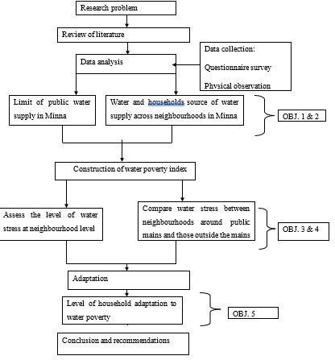

# Figure 3.1: The Research Design Employed for the Study

Source: Author (2021)

# Population of the Study

The population of the study which represents the basis of analysis in this research was the 22,591 urban households residing in the 8 neighbourhoods of Minna. In the absence of household and neighbourhoods survey in the 2006 National Population Commission, recourse was made to the projection of unpublished neighbourhoods population estimates of 2010 based on a 2.60% annual growth rate and an average household size of 8 in all urban centres in Niger state (Niger State Bureau of Statistics, 2014). A breakdown of the 22,591 households by neighbourhoods is shown in Table 3.1 below.

# Table 3.1: Neighbourhood Population and Number of Households in Minna

|  |  |  |  |  |
| --- | --- | --- | --- | --- |
| **S/N** | **Neighbourhoods** | **Population**  **(2010)1** | **Population**  **(2020)** | **No. of Households** |
| **1** | Dutsen Kura | 25,418 | 32,856 | 4,107 |
| **2** | F-Layout | 5,454 | 7,050 | 881 |
| **3** | Kpakungu | 19,724 | 25,496 | 3,187 |
| **4** | Maitumbi | 15,712 | 20,310 | 2,539 |
| **5** | Minna Central | 29,710 | 38,404 | 4,800 |
| **6** | Sahuka Kahuta | 8,049 | 10,404 | 1,301 |
| **7** | Tudun Fulani | 11,819 | 15,278 | 1,910 |
| **8** | Tudunwada South | 23,926 | 30,927 | 3,866 |
|  | **Total** | **139,812** | **180,725** | **22,591** |

Source: Sanusi (2010) Population Estimate.

In addition to this is the State Water Agency (SWA), known as Niger State Water and Sewage Corporation (NSWSC). The state water agency aside being charged with the responsibility of providing portable and reliable water supply to the households, they keep a comprehensive record of all the water points in the study area. In all, the total population for this present study is the 22,591 urban households in Minna, and the State Water Agency (Niger State Water and Sewage Corporation)

# Sample list

The sample list for this study was in two (2) segments. The first sample list was all the households residing in 8 neighbourhoods of Minna which was obtained from a household survey. The second list was a detailed record of the location/coverage of water supply points and this was extracted from the Niger State Water and Sewage Corporation (NSWSC) and complemented by physical and reconnaissance survey.

# Sample element

Apart from the inventory of the water points, the households represent the sampling elements for the assessment of water stress in this research. It was from these diverse elements that pertinent data and information relating to water stress and poverty were drawn and analyzed for meaningful generalization of inferences from the empirical data.

# Sampling unit

The sampling unit where the study took place was the eight (8) neighbourhood areas in Minna (Table 3.1).

# Data Types and Sources

The data for this research was largely based on primary data, though augmented with secondary data. The primary data was drawn by conducting a questionnaire-based survey on the households living in the eight (8) neighbourhoods comprising the study area. Primary data such as the nature and source of households’ water supply was elicited from the households. Information on Resource, Use, Capacity, Environment and Access components for assessing water poverty was also captured from the households. In addition, the coping strategies which were employed by the households in conserving water availability, improving water quality and enhancing the flow rate was also obtained.

The secondary data on all the area of coverage and the location of the public water points in the study area was obtained from the State Water Agency for geo-referencing in the GIS environment. Such information was also complemented with physical survey and observation to fully capture all these water points. Other secondary data for this research was sourced from standard textbooks, journal articles, maps and imageries of Minna.

# Method of Primary Data Collection

The proposed methods that was employed in data collection include:

# Questionnaire

Questionnaire was designed and administered to collect information on water stress and poverty from the households in the study area. The questionnaire was a combination of open and closed item questions that consisted of 4 sections. The first section provided questions on the socio demographic characteristics of the respondents. The various household sources of water for drinking and domestic use was elicited in section two. The third section covered household level of water stress and poverty measurement, with most questions pertaining to the key dimensions of water poverty such as use, resources, capacity, access and environmental sanitation. Finally, the last section dwell on household adaptation (coping strategies) measures to water poverty.

# Physical observation and reconnaissance survey

A reconnaissance survey was undertaken to cross-check the locations and coverage of the public water points provided by the State Water Agency.

# GPS device

The locations and extent of coverage of the public water points in terms of X and Y coordinates was obtained using GPS device in the study area.

# Sample Size Determination

In estimating a sample size which will be representative, and from which meaningful generalizations can be made, the Krejcie and Morgan standard formula for sample size was employed as follows using equation:

𝑛 = 𝑋2∗𝑁∗𝑃∗(1−𝑃)

(𝑀𝐸2∗(𝑁−1)+(𝑋2∗𝑃∗(1−𝑃))

……………………………………………..(3.1)

Where: n = sample size; *X* 2 = chi-square for the confidence level; N= population size; P =

standard deviation of the population size (which in this case is 0.5); and *ME*2 = the square

margin of error (5%). Using equation:

𝑛 = 1.962∗22591∗0.5∗(1−0.5)

(0.052∗(22591−1)+(1.962∗0.5∗(1−0.5))

……………………………………..(3.2)

The application of this sample size formula to the 22,591 households’ population given the chi-square value of 1.96 (which is the critical value of the area under the curve in a normal distribution), with a population proportion of 0.5 and margin of error of ± 5%, will yield 378 as the sample size required for this study. In all, 378 (1.67%) of the households were sampled from the entire population of 22,591 households in the study. By reducing the likely bias in sampling, there is 95% confidence level that this estimate from the entire population will be

± 1.67 % of the margin of error (between – 3.33% and + 6.67% for a 5% margin of error).

# Sampling Method and Technique

Cluster random sampling approach was employed in the selection of households for the study. Such approach involved the selection of samples in three (3) stages. The first stage entailed the identification of the major cities (Minna, Suleja, Kontagora and Bida) in Niger State, in which Minna was chosen as the state capital. The second stage was the delineation of Minna into four (4) regions/zones (North, South, East and West). The third stage involved

the selection of two (2) neighbourhoods each from the four (4) zones, totaling eight (8) neigbourhoods in the study area. The two (2) selected neighbourhoods from each zone comprise one (1) covered by public water mains and one (1) not totally covered by public mains. Finally, the sample element (households) across the sampling units (8 neighbourhoods in Minna was randomly drawn through simple random approach. As rightly noted by Saunders *et al.* (2012) the choice of this approach is premised on the questionnaire survey which is considered suitable for geographical areas requiring face-to-face contact with the 378 households.

# Questionnaire Distribution

The questionnaire for this study was administered on the respondents (households) residing in the study area. A total of 378 questionnaire were administered and distributed on these respondents. A breakdown of the questionnaire administered on the respondents across study area is provided in table 3.2 below.

# Table 3.2: Questionnaire Distribution and Percentage Valid Response

|  |  |  |  |  |  |  |
| --- | --- | --- | --- | --- | --- | --- |
| **S/No** | **Neighbourhood** | **No. of Household** | **Proportion** | **\*Sample size** | **Valid questionnaire** | **Percentage of valid questionnaire (%)** |
| **1** | Dutsenkura | 4107 | 0.182 | 69 | 69 | 100 |
| **2** | Tudunfulani | 1910 | 0.085 | 32 | 32 | 100 |
| **3** | Saukakauta | 1301 | 0.058 | 22 | 22 | 100 |
| **4** | Tudun-Wada South | 3866 | 0.171 | 65 | 62 | 95.38 |
| **5** | Maitumbi | 2539 | 0.112 | 42 | 42 | 100 |
| **6** | F-Layout | 881 | 0.039 | 15 | 15 | 100 |
| **7** | Kpakungu | 3187 | 0.141 | 53 | 42 | 79.25 |
| **8** | Minna-Central | 4800 | 0.212 | 80 | 75 | 93.75 |
|  | **Total** | **22591** |  | **378** | **359** | **96.38** |

**Note: *Number of questionnaires distributed and returned**

Source: Author’s Survey (2020)

As shown in Table 3.2, out of the 378-questionnaire administered, 359 (with a 96.38% response rate) were found useable for analysis after discarding 19 questionnaires due to missing information.

# Method of Data Analysis

The proposed method of data analysis for this study is summarized in Table 3.3. The data required was in accordance to the laid objectives. For objective one which is to examine the area coverage of public water supply in Minna, the type of data required was on public water supply mains (networked) coverage and this was collected from the Niger state water and sewage corporation it was then transferred to the GIS environment to produce a map of areas within and outside public water supply in the state. The type of data required for households’ sources of water supply across different neighborhoods in the study area were the various sources of water (improved and un-improved sources) available to households in the study area and it was collected through questionnaires. The data collected was analyzed using descriptive statistics and ANOVA (to compare if there was any variation between the sources used by household across neighbourhood within and outside the public mains) the data analyzed was presented on Tables.

# Table 3.3: Summary of Data Analysis Techniques

|  |  |  |  |
| --- | --- | --- | --- |
| **OBJECTIVES** | **DATA TYPES** | **COLLECTION**  **METHOD** | **METHOD OF**  **ANALYSIS** |
| 1. To examine the area coverage of public water supply  in Minna. | Public water mains (network) coverage | Physical survey, GPS, and Maps. | GIS |
| 2. To assess households’ sources of water supply across different neighborhoods in  the study area | Household water sources (improved and unimproved) for drinking and domestic uses | Questionnaire | Descriptive statistics and One-Way Analysis of Variance (ANOVA) |
| 3. To examine the level of water poverty at neighborhood scale | WPI (resources, capacity, use, access and environment) | Questionnaire | Linear Scaling Technique, Correlation, PCA and Spider maps  (Pentagrams) |
| 4. To compare water poverty in neighbourhood around the public mains with those neighborhoods outside public  mains | Data from objective three (3) above | Questionnaire | Independent T- Test |
| 5. To assess households’ adaptation to water poverty in the  study area | Household coping measures | Questionnaire | Descriptive statistics and Relative Importance  Index |

For objectives three (3) and four (4), the type of data required was on water poverty indicators (WPI) such as information on the sources, use, access, capacity and environment. The data was also sourced through questionnaires administered to the households and the data was analyzed using the linear scaling technique, descriptive statistics, correlation method, principal component analysis and also the independent T-test. the analyzed data was then presented on tables, charts, maps and on pentagrams. And lastly for objective five (5) the

type of data required was on the various measures employed by households in coping with water poverty and the data was also collected using questionnaires and analyzed using descriptive statistics and relative importance index. The data analyzed were then presented in tables and charts.

**CHAPTER FOUR**

* 1. **RESULTS AND DISCUSSIONS**
  2. **Area Coverage of Public Water Supply in Minna**

Figure 4.1 provides the area coverage of public water supply in the study area. It shows that not all the sampled eight (8) neigbourhoods in the study were totally within the coverage of public/improved water supply. This finding on the limited public water coverage in the study area is at variance with the target of SGD goal 6.1 which recommended 100% improved water coverage for all un-served urban population residing in urban centres. The finding also implied that some households in the study area are more likely to have low access to improved water sources, as the neighbourhoods are partly outside the reach of public water coverage.

In addition, this limited public water supply also have spatial dimensions across the eight (8) neigbourhoods in the study area. For instance, spatial differences exist across the four (4) zones (north, south, east and west) of the study area. Visual explanations in Figure 4.1 and Table 4.1 showed that the 4 neigbourhoods of Dutsenkura (North), Tudun-Wada South (South), F-Layout (East) and Minna-Central (West) were within the coverage of public water supply by the Niger State Water and Sewerage Corporation (NSWSC). Conversely, the 4 neighbourhoods of Tudun-Fulani (North), Saukakauta (South), Maitumbi (East) and Kpakungu (West) were partially outside formal public water supply mains of the NSWSC. Interestingly, these four neigbourhoods which were partly outside the public water mains are located at the fringe of Minna city- meaning that public water supply does not reach most households residing in these neighbourhoods.

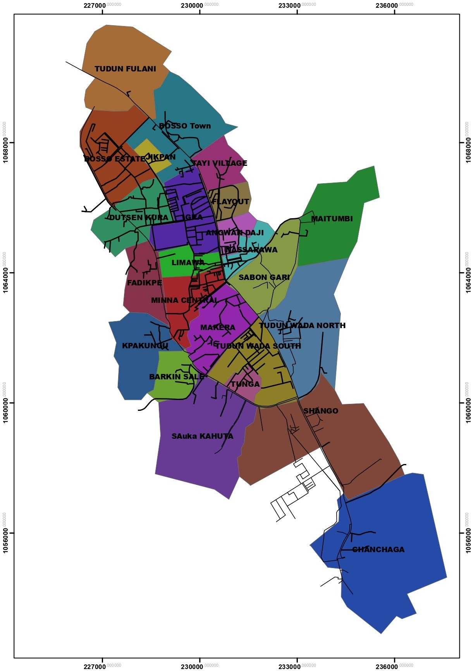

# Figure 4.1: Extent of Coverage of Public Water in the Study Area

Source: Author’s Field Work (2021) and Niger State Water Board (2019)

**Table 4.12: Neighbourhoods and Extent of Formal Water Coverage**

|  |  |  |  |
| --- | --- | --- | --- |
| **S/N** | **Neighbourhood** | **Location** | **Water Coverage** |
| **1** | Dutsenkura | North | Within public mains |
| **2** | Tudun-Fulani | North | Partially outside public mains |
| **3** | Tudun-Wada South | South | Within public mains |
| **4** | Saukakauta | South | Partially outside public mains |
| **5** | F-Layout | East | Within public mains |
| **6** | Maitumbi | East | Partially outside public mains |
| **7** | Minna-Central | West | Within public mains |
| **8** | Kpakungu | West | Partially outside public mains |

* 1. **Households’ Water Sources**
     1. **Households’ water sources for drinking purpose**

Table 4.2 provides the various water delivery sources employed by all the respondents in the study area. As observed in the Table, substantial differences exist in water delivery channels used by the 359 respondents in the provision of drinking water. For example, while pipe water (into dwelling, plot and from neighbor) cumulatively supplies only 15% of the surveyed respondents based on their total responses (N=988) only 8.5% of respondents used public tap in the study area. In addition, only 4.30% of the respondents reported using public protected borehole, while 6.40% of the respondents cited using private covered dug well as their main water source.

Furthermore, 14.10% of the respondents reported the use of rainwater harvest, 3.50% cited using public open borehole, 9.50% used bottled water, 1.20% used water tanker truck while 8.20% employed water vendors. Less than 1% of surveyed respondents reported using private unprotected dug wells (0.50%), river and stream (0.20%) and dugout and shallow well (0.60%) as their water source. However, sachet water is the principal water source for drinking purpose in the study area as reported by 28% of the respondents.

# Table 4.2: Frequency and Percentage of Households by Source of Drinking Water

|  |  |  |  |
| --- | --- | --- | --- |
| **S/N** | **Water sources for Drinking** | **\*Frequency of Responses** | **Percent (%)** |
| **1** | Piped into dwelling | 48 | 4.90 |
| **2** | Piped into yard/plot/compound | 62 | 6.30 |
| **3** | Piped water from neighbor | 38 | 3.80 |
| **4** | Public tap | 84 | 8.50 |
| **5** | Public covered borehole | 42 | 4.30 |
| **6** | Private covered dug well | 63 | 6.40 |
| **7** | Rain water | 139 | 14.10 |
| **8** | Public open borehole | 3 | 3.50 |
| **9** | Bottled water | 94 | 9.50 |
| **10** | Private unprotected dug well | 5 | 0.50 |
| **11** | Tanker truck | 12 | 1.20 |
| **12** | Water vendor/Cart with tank | 81 | 8.20 |
| **13** | River and stream | 2 | 0.20 |
| **14** | Pond and lake | 0 | 0.00 |
| **15** | Dugout and shallow well | 6 | 0.60 |
| **16** | Dam | 0 | 0.00 |
| **17** | Sachet water | 277 | 28.00 |
|  | Respondents with pipe water |  | 15.00% |
|  | **Water from improved sources |  | 48.30% |
|  | Water from unimproved sources |  | 51.70% |
|  | Total number of respondents | 359 |  |
|  | Total number of responses | 988 | 100% |

This result has implications for households’ access to safely managed water in the study area. First, only 48.30% of all the respondents have been estimated to receive access to improved water sources for drinking. This implies that the study area is characterized by low level of access to public water supply and that the burden to provide safe drinking water shift to the households. This research finding can be considered within the context of prior studies which noted that for over two decades, access to improved water supply in urban cities of Nigeria is low and that this level of access to direct water supply would decline further in the foreseeable future (WHO-UNICEF/JMP, 2017; MICS, 2017; Macheve *et al.*, 2015). Secondly, when the 48.30% respondents with access to improved water is reconciled with those 15% respondents who have access to direct pipe water (into dwelling, plot and from

neighbor) it becomes evident that households in the study area rely on other informal non- network water sources to augment improved water.

# Households water sources for drinking in neigbourhoods partially covered by public mains

Table 4.3 reports the proportion of respondents by source of drinking water residing outside the public water supply mains in the study area. As observed in the table, varied water delivery sources were employed for drinking by all the respondents across the 4 neighbourhoods where there is partial or no formal water service coverage. For example, 12.34% of the surveyed respondents in Saukakauta, 14.59% in Maitumbi and 20.48% in Kpakungu used public pipe water (into dwelling, plot and from neighbor). However, Tudun- Fulani had the lowest proportion of households (6.07%) using pipe water across the 4 neighbourhoods. This result reveals the unbalanced/ disproportionate nature of access to public water supply for respondents living outside the formal water service coverage area.

This unbalanced access to water by this category of respondents is not peculiar to only public pipe water supply. It also cuts across all other water sources (public protected borehole, private covered dug well, private unprotected well, bottled water, rain water harvest, tanker truck, water vendors, dugout well, sachet water) used by respondents in their quest to provide drinking water in the four (4) neighbourhoods. Uneven/unbalanced access to water is further noticeable in the percentage (37.88%-59.64%) of the respondents having improved water as their drinking source across the four neighbourhoods outside the public water coverage area.

# Table 4.3 Percentage of Households by Source of drinking Water in Neighbourhoods partially covered by Public Water Mains

|  |  |  |  |  |  |
| --- | --- | --- | --- | --- | --- |
| **S/N** | **Water sources for Drinking** | **Tudun-**  **Fulani** | **Saukakauta** | **Maitumbi** | **Kpakungu** |
| **1** | Piped into dwelling | 4.55 | 3.70 | 4.17 | 9.04 |
| **2** | Piped into yard/plot/compound | 0.00 | 4.94 | 7.29 | 7.83 |
| **3** | Piped water from neighbor | 1.52 | 3.70 | 3.13 | 3.61 |
| **4** | Public tap | 1.52 | 1.23 | 12.50 | 3.61 |
| **5** | Public covered borehole | 21.21 | 1.23 | 3.13 | 9.04 |
| **6** | Private covered dug well | 6.06 | 7.41 | 6.25 | 9.04 |
| **7** | Rain water | 3.03 | 22.22 | 20.83 | 17.47 |
| **8** | Public open borehole | 13.64 | 4.94 | 7.29 | 1.20 |
| **9** | Bottled water | 0.00 | 11.11 | 8.33 | 13.25 |
| **10** | Private unprotected dug well | 0.00 | 0.00 | 1.04 | 0.00 |
| **11** | Tanker truck | 6.06 | 1.23 | 2.08 | 0.00 |
| **12** | Water vendor/Cart with tank | 4.55 | 14.81 | 3.13 | 7.83 |
| **13** | River and stream | 0.00 | 0.00 | 0.00 | 0.00 |
| **14** | Pond and lake | 0.00 | 0.00 | 0.00 | 0.00 |
| **15** | Dugout and shallow well | 1.52 | 0.00 | 2.08 | 0.00 |
| **16** | Dam | 0.00 | 0.00 | 0.00 | 0.00 |
| **17** | Sachet water | 36.36 | 23.46 | 18.75 | 18.07 |
|  | Respondents with pipe water | 6.07% | 12.34% | 14.59% | 20.48% |
|  | Water from improved sources | 37.88% | 44.44% | 57.29% | 59.64% |
|  | Water from unimproved  sources | 62.12% | 55.56% | 42.71% | 40.36% |
|  | Total number of respondents | 32 | 22 | 42 | 69 |
|  | Total number of responses | 66 | 81 | 96 | 166 |

Aside the varied water sources and the uneven access by respondents to drinking water in the four (4) neighbourhoods, it can also be inferred from Table 4.3 that with the exception of Maitumbi, sachet water is nonetheless the predominant source of water used for drinking by respondents outside the formal coverage of public water supply in the study area.

# Households water sources for drinking in neigbourhoods within the public mains

Table 4.4 shows the percentage distribution of households by source of drinking water who reside within the public water mains in the study area.

# Table 4.4: Percentage of Households in Neighbourhoods Within Public Water Mains by Source of Drinking Water

|  |  |  |  |  |  |
| --- | --- | --- | --- | --- | --- |
| **S/N** | **Water sources for Drinking** | **Dutsenkura** | **TudunWada** | **F-**  **Layout** | **Minna-**  **Central** |
| **1** | Piped into dwelling | 4.92 | 0.97 | 0.00 | 6.91 |
| **2** | Piped into yard/plot/compound | 10.66 | 1.45 | 0.00 | 10.14 |
| **3** | Piped water from neighbor | 3.28 | 0.00 | 0.00 | 9.68 |
| **4** | Public tap | 0.82 | 13.04 | 0.00 | 16.59 |
| **5** | Public covered borehole | 1.64 | 0.97 | 0.00 | 2.30 |
| **6** | Private covered dug well | 2.46 | 8.70 | 12.12 | 3.23 |
| **7** | Rain water | 3.28 | 24.15 | 9.09 | 5.99 |
| **8** | Public open borehole | 0.82 | 1.45 | 0.00 | 4.15 |
| **9** | Bottled water | 25.41 | 7.73 | 21.21 | 0.46 |
| **10** | Private unprotected dug well | 0.00 | 0.48 | 6.06 | 0.46 |
| **11** | Tanker truck | 0.00 | 0.97 | 0.00 | 1.38 |
| **12** | Water vendor/Cart with tank | 1.64 | 12.56 | 3.03 | 9.68 |
| **13** | River and stream | 0.00 | 0.97 | 0.00 | 0.00 |
| **14** | Pond and lake | 0.00 | 0.00 | 0.00 | 0.00 |
| **15** | Dugout and shallow well | 0.00 | 0.00 | 9.09 | 0.00 |
| **16** | Dam | 0.00 | 0.00 | 0.00 | 0.00 |
| **17** | Sachet water | 45.08 | 26.57 | 39.39 | 29.03 |
|  | Respondents with pipe water | 18.86% | 2.42% | 0.00% | 54.84% |
|  | Water from improved sources | 27.06% | 49.28% | 21.21% | 54.84% |
|  | Water from unimproved  sources | 72.94% | 50.72% | 78.79% | 45.16% |
|  | Total number of respondents | 69 | 65 | 15 | 75 |
|  | Total number of responses | 122 | 207 | 33 | 217 |

As observed in the table, various water sources are available to the respondents residing within the limit of public water supply coverage. In terms of pipe water which is safe and a reliable source of water for drinking, Minna Central had the highest level of access with 54.84% of the respondents reported to have pipe water either into dwelling, plot or from neighbor. This is followed by Dutsenkura and Tudun-Wada, as 18.86% and 2.42% of the respondents respectively identified public pipe water as their main water source. However, pipe water was not in existent in F-Layout as none of the surveyed respondent provided response on its availability. This result indicates that disparity exist in terms of public water service level in the study area. Moreover, when this result is compared with access to pipe

water outside the public water mains (in Table 4.4), it becomes obvious that residing within the formal water supply coverage of NSWSC those not confer access to public water supply on the respondents.

In view of the observed low/no access to pipe water supply which also characterized the four

(4) neighbourhoods located within the public water mains, it can be implied that the respondents complement pipe water supply with other off-plot water sources to meet their water needs. These off-plot water sources as shown in Table 4.5 are informal non-network water supplies/ other sources such as public water, public covered borehole, private protected dug well, public open borehole, tanker and water vendor. It is further shown in Table 4.5 that, in total, only 27.06% of the households in Dutsenkura, 49.28% in Tudun-Wada, 21.21% in F-Layout and 54.84% in Minna-Central had access to improved source of drinking water within the neighbourhoods covered by public water mains in the study area. With the exception of Minna-Central, water service level is low as water from improved sources for drinking is below the top of the service ladder occupied by unimproved water sources. Surprisingly, it can further be observed that this percentage of respondents with improved water is abysmally lower when compared to those outside public water supply.

# Households’ water sources for domestic purpose

The percentage breakdown of households’ water sources for domestic use (bathing, cooking and hygiene) is shown in Table 4.5.

# Table 4.53: Frequency and Percentage of Households by Source of Domestic Water

|  |  |  |  |
| --- | --- | --- | --- |
| **S/N** | **Water sources for Domestic** | **\*Frequency of Responses** | **Percent (%)** |
| **1** | Piped into dwelling | 59 | 6.40 |
| **2** | Piped into yard/plot/compound | 83 | 9.00 |
| **3** | Piped water from neighbor | 40 | 4.30 |
| **4** | Public tap | 96 | 10.40 |
| **5** | Public covered borehole | 51 | 5.50 |
| **6** | Private covered dug well | 124 | 13.50 |
| **7** | Rain water | 168 | 18.20 |
| **8** | Public open borehole | 57 | 6.20 |
| **9** | Bottled water | 3 | 0.30 |
| **10** | Private unprotected dug well | 13 | 1.40 |
| **11** | Tanker truck | 17 | 1.80 |
| **12** | Water vendor/Cart with tank | 127 | 13.80 |
| **13** | River and stream | 5 | 0.50 |
| **14** | Pond and lake | 0 | 0.00 |
| **15** | Dugout and shallow well | 23 | 2.50 |
| **16** | Dam | 0 | 0.00 |
| **17** | Sachet water | 55 | 6.00 |
|  | Respondents with pipe water |  | 19.30% |
|  | Water from improved sources |  | 67.30% |
|  | Water from unimproved sources |  | 32.70% |
|  | Total number of respondents | 359 |  |
|  | Total number of responses | 921 | 100% |

As shown in Table 4.5, respondents employ various water delivery mechanisms in providing water for their domestic use, based on their total responses (N=921) in the study area. In descending order, the respondents identified rain water collection (18.20%), water vendor (13.80%), private covered dug well (13.50%) and public water (10.40%) as the 4 main sources of water for domestic use in all the 8 surveyed neigbourhoods. This equally implies that rain water harvest is the predominant water source for domestic purpose in the study area.

In addition, 6.40% of the respondents used pipe water into dwelling, 6.20% had public opened borehole, 6.00% used sachet water while 5.50% used public covered borehole as their

domestic source of water supply. In aggregate terms, 24.10% of the respondents have access to public pipe water for domestic use in the study area. However, the least employed sources of domestic water by respondents accounting for less than 5% of the water sources are pipe water from neighbor (4.30%), dugout/shallow well (2.50%), tanker water truck (1.80%), private unprotected dug well (1.40%), river and stream (0.50%) and bottled water (0.30%). In total, improved water represents 67.30% of the water sources used for household domestic uses based on the respondents’ responses. Although this is an improvement over unimproved sources, the provision of pipe water (which constitutes 24.10% of improved water sources) is far below the water service ladder occupied by improved sources for households’ domestic needs.

# 4..2.2.1 Domestic household water sources in neighbourhoods partially covered by public mains

As observed in Table 4.6, despite the partial or no formal water service coverage in these four (4) neighbourhoods, piped water either in residence, yard or from neighbor accounts for 26.81% of households’ water for domestic chores in Kpakungu, 14.13% in Maitumbi, 11.90% in Saukakauta, and Tudun-Fulani with 11.90%, had the least number of households using pipe water. While this result shows a wide disparity in households’ access to pipe water for domestic use across these neighbourhoods, access to water from improved sources was fairly high. For example, Kpakungu (83.33%) has the highest proportion of respondents having access to improved water source for domestic use, followed by Maitumbi (65.22%), Tudun-Fulani (60.00%) and Saukakauta (55.95%). Apart from these improved water sources, respondents also employed other various unimproved sources (public open borehole, bottled water, private uncovered well, tanker truck, water vendor, dugout well and sachet water) to

complement the improved sources of water available for their domestic use. As seen in Table

4.7, various unimproved sources are also used by the respondents across the four neighbourhoods.

# Table 4.6: Percentage of Households partially covered by Public Water Mains by Source of Domestic Water

|  |  |  |  |  |  |
| --- | --- | --- | --- | --- | --- |
| **S/N** | **Water sources for Domestic** | **Tudun-**  **Fulani** | **Saukakauta** | **Maitumbi** | **Kpakungu** |
| **1** | Piped into dwelling | 5.00 | 3.57 | 2.17 | 12.32 |
| **2** | Piped into yard/plot/compound | 3.33 | 4.76 | 8.70 | 10.87 |
| **3** | Piped water from neighbor | 1.67 | 3.57 | 3.26 | 3.62 |
| **4** | Public tap | 3.33 | 0.00 | 17.39 | 4.35 |
| **5** | Public covered borehole | 28.33 | 2.38 | 3.26 | 9.42 |
| **6** | Private covered dug well | 15.00 | 16.67 | 8.70 | 12.32 |
| **7** | Rain water | 3.33 | 25.00 | 21.74 | 30.43 |
| **8** | Public open borehole | 20.00 | 4.76 | 11.96 | 2.17 |
| **9** | Bottled water | 0.00 | 2.38 | 1.09 | 0.00 |
| **10** | Private unprotected dug well | 1.67 | 1.19 | 0.00 | 0.00 |
| **11** | Tanker truck | 6.67 | 4.76 | 1.09 | 0.00 |
| **12** | Water vendor/Cart with tank | 6.67 | 13.10 | 1.09 | 14.49 |
| **13** | River and stream | 0.00 | 0.00 | 0.00 | 0.00 |
| **14** | Pond and lake | 0.00 | 0.00 | 0.00 | 0.00 |
| **15** | Dugout and shallow well | 1.67 | 7.14 | 3.26 | 0.00 |
| **16** | Dam | 0.00 | 0.00 | 0.00 | 0.00 |
| **17** | Sachet water | 3.33 | 10.71 | 16.30 | 0.00 |
|  | Respondents with pipe water | 10.00% | 11.90% | 14.13% | 26.81% |
|  | Water from improved sources | 60.00% | 55.95% | 65.22% | 83.33% |
|  | Water from unimproved  sources | 40.00% | 44.05% | 34.78% | 16.67% |
|  | Total number of respondents | 32 | 22 | 42 | 69 |
|  | Total number of responses | 60 | 84 | 92 | 138 |

However, with the exception of Tudun-Fulani where public covered borehole is the main source of domestic water for households, rain water is the most dominant source of domestic water uses in Saukakauta, Maitumbi and Kpakungu respectively.

**4..2.2.2 Domestic household water sources in neighbourhoods within the public mains** Table 4.7 shows the typology of water sources available to households residing within neighbourhoods with formal coverage of public water mains in the study area.

# Table 4.74: Percentage of Households Within Public Water Mains by Source of Domestic

**Water**

|  |  |  |  |  |  |
| --- | --- | --- | --- | --- | --- |
| **S/N** | **Water sources for Domestic** | **Dutsenkura** | **TudunWada** | **F-**  **Layout** | **Minna-**  **Central** |
| **1** | Piped into dwelling | 13.08 | 1.01 | 0.00 | 8.37 |
| **2** | Piped into yard/plot/compound | 25.23 | 1.51 | 0.00 | 11.16 |
| **3** | Piped water from neighbor | 5.61 | 1.01 | 0.00 | 9.30 |
| **4** | Public tap | 9.35 | 13.07 | 0.00 | 16.74 |
| **5** | Public covered borehole | 3.74 | 2.51 | 0.00 | 3.26 |
| **6** | Private covered dug well | 15.89 | 15.58 | 42.31 | 7.91 |
| **7** | Rain water | 4.67 | 27.14 | 11.54 | 9.77 |
| **8** | Public open borehole | 2.80 | 3.52 | 0.00 | 7.91 |
| **9** | Bottled water | 0.00 | 0.00 | 0.00 | 0.00 |
| **10** | Private unprotected dug well | 0.00 | 1.51 | 15.38 | 1.86 |
| **11** | Tanker truck | 0.93 | 1.01 | 0.00 | 2.33 |
| **12** | Water vendor/Cart with tank | 15.89 | 19.60 | 3.85 | 15.81 |
| **13** | River and stream | 0.00 | 2.51 | 0.00 | 0.00 |
| **14** | Pond and lake | 0.00 | 0.00 | 0.00 | 0.00 |
| **15** | Dugout and shallow well | 2.80 | 2.51 | 11.54 | 0.93 |
| **16** | Dam | 0.00 | 0.00 | 0.00 | 0.00 |
| **17** | Sachet water | 0.00 | 7.54 | 15.38 | 4.65 |
|  | Respondents with pipe water | 43.92% | 3.52% | 0.00% | 28.83% |
|  | Water from improved sources | 77.57% | 61.83% | 53.85% | 66.51% |
|  | Water from unimproved  sources | 22.43% | 38.17% | 46.15% | 33.49% |
|  | Total number of respondents | 69 | 65 | 15 | 75 |
|  | Total number of responses | 107 | 199 | 26 | 215 |

As shown in Table 4.7, about 43.92% of the respondents in Dutsenkura, 28.83% in Minna- Central and only 3.52% in Tudun-Wada reported the use of pipe water supply (into dwelling, plot or from neighbor) as their source of household domestic use. Surprisingly, responses from the respondents in F-Layout showed the absence of pipe water supply for domestic use inspite formal water supply coverage of NSWSC in the neighbourhood.

Generally, the proportion of respondents who hauled water from improved sources ranged from 53.85% -77.57% across the four neigbourhoods within the coverage of public water supply. While these signify a high level of household access to water for domestic purposes,

it also implied that respondents augment their improved water sources with other unimproved sources. As observed in Table 4.7, other water sources though unimproved, used by households based on the respondents’ responses include public tap, private unprotected well and borehole, public open borehole, water vendor, water truck, bottled water, dug well, river and stream, sachet water. Lastly, piped into yard/plot/compound (25.23%), rain water (27.14%), Private covered dug well (42.31%) and Public tap (16.74%) represent the main source of domestic water use by households in Dutsenkura, Tudun-Wada, F-Layout and Minna-Central respectively.

# Analysis of variation in household water sources

The result of the analysis of variance in household sources of water used for drinking and domestic uses is reported in Table 4.8.

**Table 4.8: ANOVA Result of Household Water Source for Drinking and Domestic Use**

|  |  |  |  |  |  |
| --- | --- | --- | --- | --- | --- |
| **Source of Variation** | **Sum of**  **Squares** | **Df** | **Mean square** | **F-statistic** | **Significance level** |
| **Between Group** | 4927 | 1 | 4927 | 4.38 | 0.249 |
| **Within Group** | 114308 | 32 | 3572 |  |  |
| **Total** | 119236 | 33 |  |  |  |

Since the F-statistic (4.38) is lesser, when compared with a 5%, F(1,32), the null hypothesis of variation between household sources of water used for drinking and domestic uses in the study area is accepted (P-value of 0.249 > 0.05). This implies that the water source employed by households for drinking is not different from that employed for domestic uses in the study area.

This insignificant result between household sources of water used for drinking and that employed for domestic use can be attributed to the fact that most households in the study area used public tap, private covered dug well, rain water, water vendor and sachet water for drinking purpose and domestic use.

# Water Poverty in the Study Area

* + 1. **Household water stress**

The section provides an analysis of water stress/scarcity condition as a component of water poverty in the study area in terms of water collection responsibility, crossing during water fetching, daily number of trips to water collection, time taken per water collection trip, waiting time per water collection, water quantity sufficiency status, perceived rainfall pattern, seasonal variation in public water supply, water treatment method, reliability of water quality for drinking purpose, water related conflicts and monthly expenditure on coping for public tap, drinking and domestic water.

# Household water fetching responsibility

Figure 4.2 provides a breakdown of the individuals within households who were responsible for water fetching in the study area. As seen in figure 4.2, responses from all the respondents in the study area on water fetching responsibility showed that 22 (6.10%) were women only, 4(1.10%) were men only, 2(0.60%) were female children only, 1(0.30%) were male children only, while 77(21.40%) were only children. Furthermore, 3(0.80%) were men and female children, 1(0.30%) were men and male children, 6(1.70%) were women and female children, 161(44.80%) were women, men and children, 3(0.80%) were men and children while the remaining 79(22.00) were women and children.

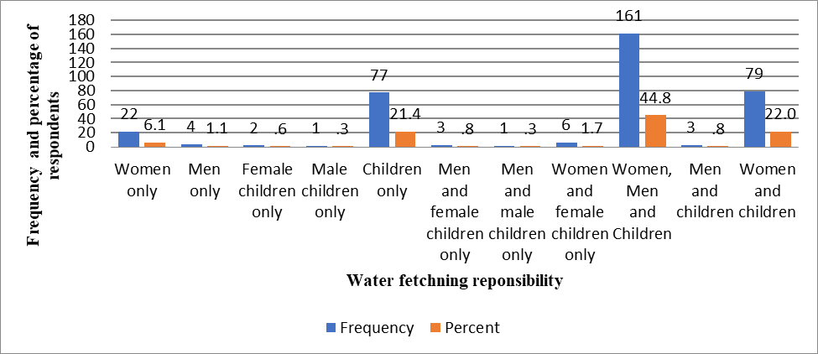

# Figure 4.2: Frequency and Percentage of Persons Responsible for Water Fetching

This nature of responses depicts two interesting inferences. First, gender dimension manifests in household water fetching responsibility in the study area. As observed from figure 4.2, the search and fetching of water is the domestic responsibility of women in most households, though they are assisted by male and female children alike in the study area. Secondly, as water fetching responsibility lies mainly with women and children (the vulnerable group), they suffered the physical burden related to water fetching/abstraction in the study area, aside the associated time collection cost shown in Table 4.11. For example, the water collection time and multiple trips are energy-sapping for women and children (water-carriers) and exposed them to avoidable suffering and other external vulnerability in terms of health outcomes (cough, cold and catarrh).

Aside the physical burden and its consequential attendants, the time cost of water collection also has far reaching implication for household productive activities. As rightly noted in prior studies, excessive time spent on water collection reduces the time available to women to engage in other income generating activities that can contribute to household poverty reduction (Olajuyigbe, 2010; Sanusi, 2010; Pickering and Davies, 2012) with children losing

effective school time in searching and fetching water (Mukuhlani and Mandlenkosi, 2014). Nonetheless, this time and physical burden further translate into reduced quantity of water available for households’ use and consumption in the study area.

# Road crossing during water fetching

The responses of the respondents on road crossing during water fetching are shown in Table

4.9. Only 29(8.10%) of the respondent’s cross road during water fetching whereas the remaining 330(91.90%) did not.

# Table 4.9: Respondents’ Responses on Road Crossing During Water Fetching

|  |  |  |
| --- | --- | --- |
| **Road Crossing** | **Frequency of response** | **Percentage of respondent**  **(%)** |
| **Yes** | 29 | 8.10 |
| **No** | 330 | 91.90 |
| **Total** | 359 | 100 |

This shows that a proportion of the household aside being physically burdened due to water fetching is exposed to mishap such as road accidents in the process of water fetching in the study area. The breakdown of the 29 respondents crossing road during water fetching by means of conveyance/carrier is presented next.

# 4. 3.1.2.1 Cross-Tabulation of gender of road crossers with water conveyance method

Table 4.10 presents a cross-tabulation of the responses on gender of the road-crossers with the means of water conveyance.

The result in the table showed that of the 11 female respondents who crossed road during water fetching, 8(72.73%) conveyed water on their heads while 2(18.18%) hauled water to their respective houses using water truck/wheel-barrow. Only 1(9.09%) respondent conveyed water by hand while cross the road. On the other hand, out of the 18 male respondents who hauled water by crossing the road, 8(44.44%) conveyed water on their heads, whereas 6(33.33%) hauled water to their respective houses by hand, while only 4(22.22%) conveyed water using water truck/wheel-barrow while crossing the road. This result implied that some households’ members, both male and female alike conveyed water on their heads while crossing the road.

**Table 4.10: Respondents’ Responses on Road Crossing During Water Fetching**

|  |  |  |  |  |
| --- | --- | --- | --- | --- |
| **Gender** | **Water Conveyance Method** | |  | **Total** |
|  | **Truck/ Wheel-barrow** | **Head** | **Hand** |  |
| **Female** |  |  |  |  |
| **Frequency** | 2 | 8 | 1 | 11 |
| **Percent (%)** | 18.18 | 72.73 | 9.09 |  |
| **Male** | 4 | 8 | 6 | 18 |
| **Percent (%)** | 22.22 | 44.44 | 33.33 |  |

# 4. 3.1.3 Daily trip, collection and waiting time for water abstraction

Table 4.11 provides a summary descriptive statistic of the average number of daily trips to water fetching by the respondents, the collection and queuing time for water fetching.

# Table 4.11: Water Collection Trip and Time Burden on Water Search

|  |  |  |  |  |
| --- | --- | --- | --- | --- |
| **S/N** | **Water Collection Trip and Time Burden** | **Mean** | **Std.Dev** | **Median** |
| **1** | Average number of daily trips per water collection | 6 | 7.03 | 5.00 |
| **2** | Water collection time per one-way trip(minutes) | 8 | 9.97 | 5.00 |
| **3** | Queuing time before water abstraction/fetching | 10 | 14.80 | 5.00 |

Analysis of the respondents’ responses indicated that households make an average of 6 trips (Std.Dev = 7.03, median = 5trips) daily for an average one-way water collection trip of approximately 8 mins (Std.Dev = 9.97, median = 5 mins) in the study area. The average queuing /waiting time before water fetching could take place was estimated as 10 mins (Std.Dev = 14.80, median =5 mins). This result shows that households in the study area are time burdened in the search for water, as they make multiple trips of at least 6 trips per day to water collection point and spent an average time of 26 min per round trip water collection (waiting time plus two-way trip collection time).

The average water collection time spent by households from their premises to water source is not more than 30 min as specified by WHO-UNICEF/JMP (2017) for a round trip water collection. However, when this 26 min water collection time is considered within the context of the multiple trips taken by households to water source, it implicitly implied a water shortage scenario – less water collection to meet the basic needs of households – in the study area. This excessive water collection time and laborious multiple trips to household water sources sets limitation on the quantity/volume of water fetched by households for consumption and domestic uses in the study area. This current finding corroborates the empirical findings that the quantity/volume of water hauled/available to households decreases sharply with increased number of trips and time per collection trip (Sanusi, 2010; Pickering and Davies, 2012).

# 4. 3.1.4 Household water quantity sufficiency status

The responses of the respondents on the sufficiency of the quantity of water available to households in the study area are presented in Figure 4.3.

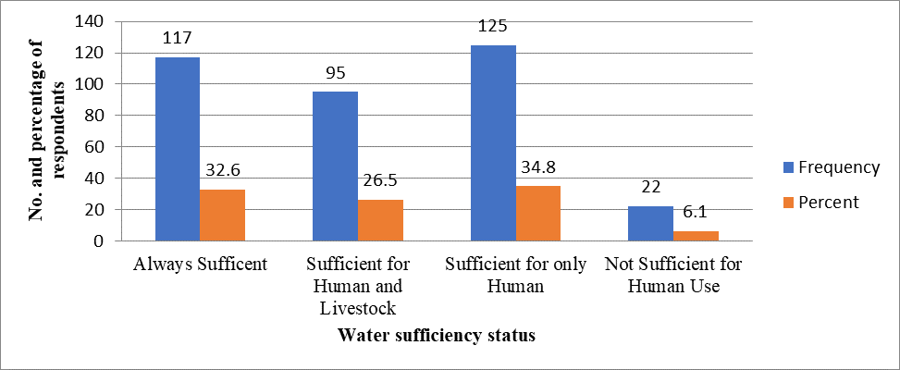

# Figure 4.3: Frequency and Percentage of Water Quantity Sufficiency by Household

In terms of water quantity sufficiency, the result indicates that about 117(32.60%) of the respondents felt that water was sufficient, while a further 95(26.50%) of the respondents reported that it was sufficiency for both human and livestock. However, 125(34.80%) of the respondents stated that the available quantity of water was just sufficient to meet basic human needs. Very few respondents, of about 22(6.10%) considered that water was not sufficient for human/ household needs in the study area. As such, it can be reasonable inferred from the above responses that this condition of insufficient water of satisfactory quantity to meet human and environmental needs suggests that a segment of the households in the study area is water stressed.

# 4. 3.1.5 Household perceived annual rainfall pattern

Figure 4.4 presents the respondents perceived pattern of annual rainfall in the study area. Analysis of responses in Figure 4.4 indicated that a majority of the respondents totaling 258(71.90%) responded that rainfall pattern was fair/moderate throughout the year in the study area, 65(18.10%) rated the yearly rainfall pattern as good, 29(8.10%) observed that it

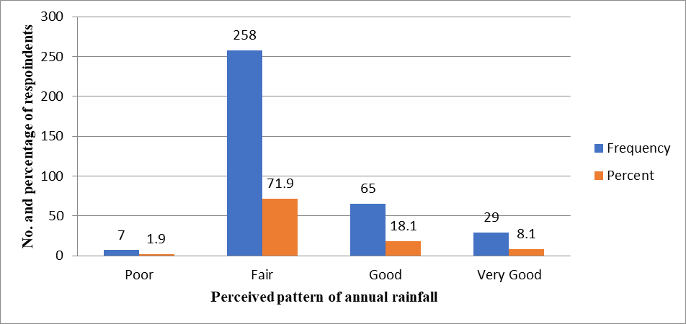was very good, while the remaining 7(1.90%) respondents opined that the annual rainfall pattern was poor.

# Figure 4.4: Frequency and Percentage of Respondents Rating on Water Quality

While the consensus of respondents’ perceived rating of rainfall pattern/variability is ranked between ‘’fair” and “good” rating, it can be concluded that there is evidence of observed variability/change in rainfall pattern in the study area. In line with this finding, previous research (Manandhar *et al.*, 2011; Jemmali and Matoussi, 2013) has however shown that the higher the variability of rainfall, the higher the climate induced risks of water resources. On this basis, this observed rainfall variability by the respondents’ impact significantly on the volumetric availability of water to households in the study area.

# 4.3.1.6 Seasonal variability in public water supply

Figure 4.5 depicts the responses on seasonal variability in public (pipe) water supply as perceived by the respondents in study area.

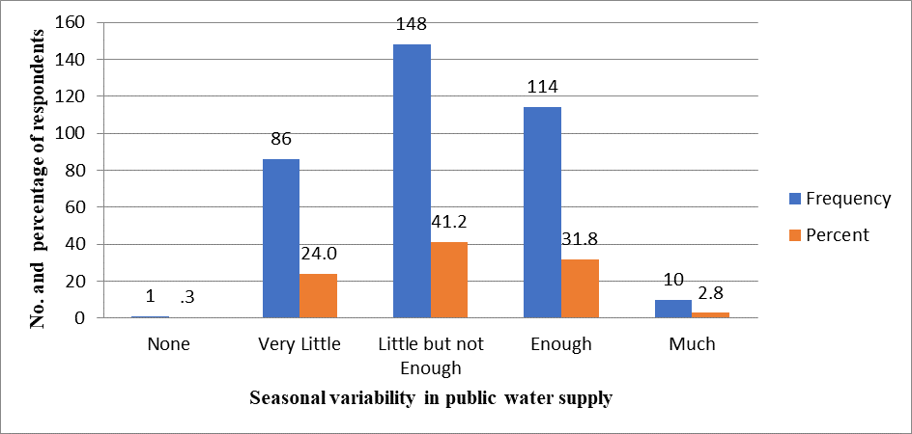

# Figure 4.5: Frequency and Percentage of Respondents Rating on Water Quality

It can be seen that, while 10(2.80%) of the surveyed respondents perceived the seasonal variability in public water supply as being much, in contrast about 86(24.00%) of the respondents observed that the seasonal variability in public water supply was just little in the study area. In addition, 148(41.20%) of the surveyed respondents reported a little but not enough variability in public water supply between rainy and dry season in the study area, whereas 114(31.80%) respondents perceived this variability as being enough to affect the quantity and service reliability of public water supply. Only 1(0.30%) respondent however reported no seasonal variability in the study area. Generally, the perceived assessment of seasonal variability in public water supply varied from “very little”, “little but not enough” to “enough” based on the respondents perceptual rating. This perceived level of variability is an indicator of insufficient water supply, low quality as well as irregular water supply pressure to households in the study area.

# 4. 3.1.7 Quality of drinking water and use

Figure 4.6 shows the respondents’ responses on the quality of drinking water as well as domestic water use by households. In the study area, 45(12.50%) of the respondents identified the water quality as excellent, another 192(53.50%) reported that the water quality was good, while 106(29.50%) rated it as adequate. Few of the respondents, 15(4.20%) and 1(0.30%) respectively observed that the water quality was either poor or terrible. Though, detailed quantitative water analysis was not undertaken, this observational evidence from the respondents suggests that households in the study area have a better water quality.

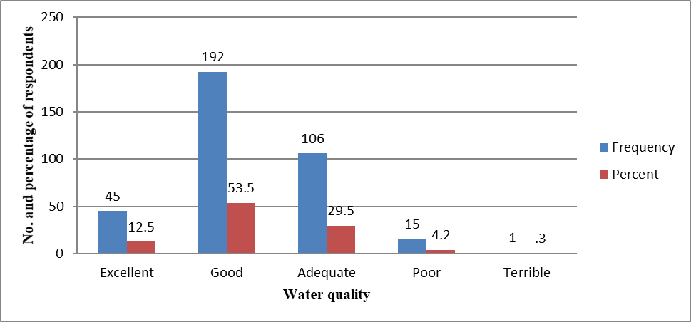

# Figure 4.6: Frequency and Percentage of Respondents Rating on Water Quality

**4. 3.1.8 Water treatment**

Table 4.12 shows the respondents responses on water treatment in the study area. It is important to state that in line with the observational evidence in Figure 4.6 which suggests better water quality in the study area, most of the respondents did not engage any water treatment methods. As seen in Table 4.12, a majority, representing 309(86.10%) of the total respondents did not employ any treatment of water in the study area.

# Table 4.12 Responses on Water Treatment among Respondents

|  |  |  |
| --- | --- | --- |
| **Water Treatment** | **Frequency of**  **response** | **Percentage of**  **respondent (%)** |
| **Yes** | 50 | 13.90 |
| **No** | 309 | 86.10 |
| **Total** | 359 | 100 |

However, only 50(13.90%) respondents affirmed that they engaged in water treatment at the household level. To a somewhat extent, this result implied some self-recognition of unsatisfactory condition of the quality of water for drinking and domestic uses among the households in the study area. The water treatment methods by this category of respondents who engaged in water treatment is presented in Figure 4.7.

# 4. 3.1.8.1Water treatment method

As shown in figure 4.7, water chlorination is the most commonly employed water treatment method in the study area as reported by 19(38.00%) of the respondents. Furthermore, 17(34.00%) of the respondents used water boiling to remove fecal/bacterial contamination, while, 13(26.00%) of the respondents used filtration when the water is muddy by sieving using muslin cloth. Only 1(2.00%) of the respondents employed other conventional method of water treatment such as let it settle down.

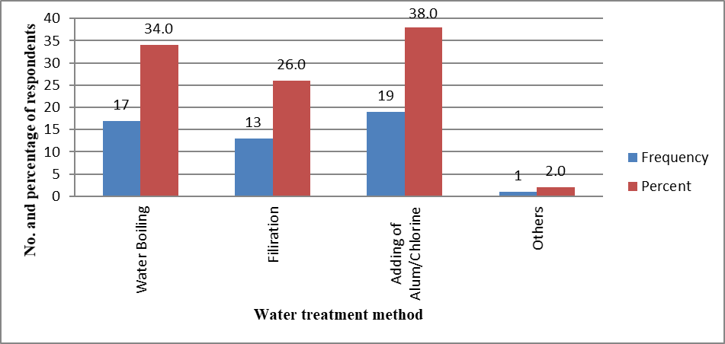

# Figure 4.7: Water Treatment Methods by Respondents

* + - 1. **Conflicts over water**

Table 4.13 provides the responses of the respondents on water conflict experienced in household premises (inside homes) and water point (outside homes).

# Table 4.13: Responses on Water Conflict in Premises and Water Point (Outside)

|  |  |  |
| --- | --- | --- |
| **Response** | **Conflict at Household Premises** | **Conflict at Water Point** |
|  | **Frequency of response** | **Frequency of response** |
| **Yes** | 58(16.20) | 97(27.20) |
| **No** | 301(83.80) | 262(72.80) |
| **Total** | 359 | 359 |

Based on the responses, 58(16.20%) of the respondents reported that they had experienced water conflict within their house premises while 301(83.80%) of the respondents reported they did not experience any in their premises. On the other hand, 97(27.20%) of the surveyed respondents reported water conflict at water points outside house premises, whereas 262(72.80%) of the respondents reported that they experienced no water conflict of such.

Although this result implied the existence of water conflicts among the households, water conflicts were experienced more at water points outside the households’ premises than in their house premises in the study area.

# Nature of water conflict at household level

The typical nature of water conflict which households experienced within their premises is shown in Table 4.14. The Table is based on the 58 respondents reported to have experienced water conflict in the study area as shown in Table 4.13. As seen in Table 4.14, the nature of water conflict in the study area ranged from those associated with water fetching, water use to water conservation. Based on the analysis of responses, 20(34.50%) of the respondents reported water fetching, 16(27.60%) mentioned the use of water while 42(72.40%) reported water conservation as the nature of water conflict experienced inside their household premises.

# Table 4.14: Responses on Typology of Water Conflicts at Household Premises

|  |  |  |  |
| --- | --- | --- | --- |
| **Water Conflict at Household** | | | |
| **Response** | **Water Fetching** | **Water Use** | **Water Conservation** |
| **Yes** | 20(34.5) | 16(27.6) | 42(72.4) |
| **No** | 38(65.5) | 42(72.4) | 16(27.6) |
| **Total** | 58 | 58 | 58 |

An indication of household water stress in the study area is that most of these water conflicts were centered around water conservation. The high proportion of water conflict in respect to conserving water also draws a big question on the adaptive capacity of the households against water scarcity in the study area.

# Occurrence of water conflict at household level

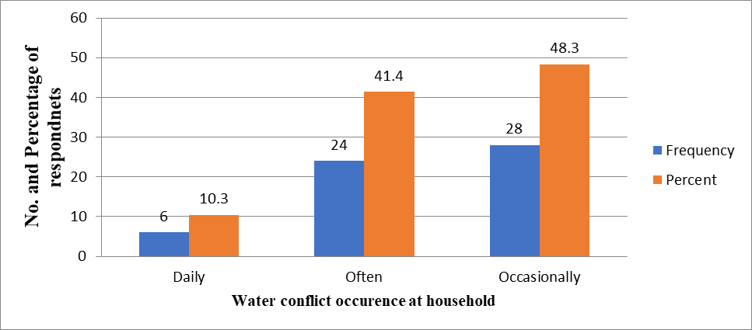Figure 4.8 presents the occurrence of water conflict within the household premises in the study area. As shown in figure 4.8, over one-half of the respondents responded that water conflicts occurred either often (41.40%) or on daily basis (10.30%) while 48.30% of the respondents reported that water conflicts occurred occasionally at household premises.

# Figure 4.8: Occurrence of Water Conflict within Household Premises

* + - * 1. **Nature of water conflict at water point**

Table 4.15 shows the responses of the respondents on the nature of water conflict encountered at water points outside their household premises in the study area. In the table, the various water conflicts experienced at water points outside household premises are related to queuing for water, the time spent and quantity of water. From the analysis of response, 73(75.00%) of the respondents experienced water queuing conflict, 53(55.00%) reported time spent in water collection as water conflict while 44(45.00%) of the respondents said they encountered conflict related to water quantity at outside water points in the study area.

# Table 4.15: Responses on Typology of Water Conflicts at Water Point

|  |  |  |  |
| --- | --- | --- | --- |
| **Water Conflict at Water Point** | | | |
| **Response** | **Queuing** | **Time spent** | **Quantity of Water** |
| **Yes** | 73(75.00) | 53(55.00) | 44(45.00) |
| **No** | 24(25.00) | 44(45.00) | 53(55.00) |
| **Total** | 97 | 97 | 97 |

Water conflicts at water point outside household premises implied that water supplies in the study area are not sustainable. This result is further evidence that at least a segment of household in the study area is not water secured and suffered from water scarcity/stress.

# Occurrence of water conflict at water point

Figure 4.9 provides the occurrence level of water conflicts at water points outside house premises in the study area. As shown in figure 4.9, 58(59.80%) of the respondents reported that water conflicts often occurred at water points outside house premises, whereas 32 (33.00%) of the respondents reported that the occurrence level was occasional. Only 7(7.20%) of the respondents however reported that water conflicts occurred on daily basis at water points outside household premises. Based on the preponderance of responses, it can be surmised that water conflict at water points outside house premises occurred often in the study area. However, such level of occurrence depicts a clear manifestation of water scarcity in the study area.

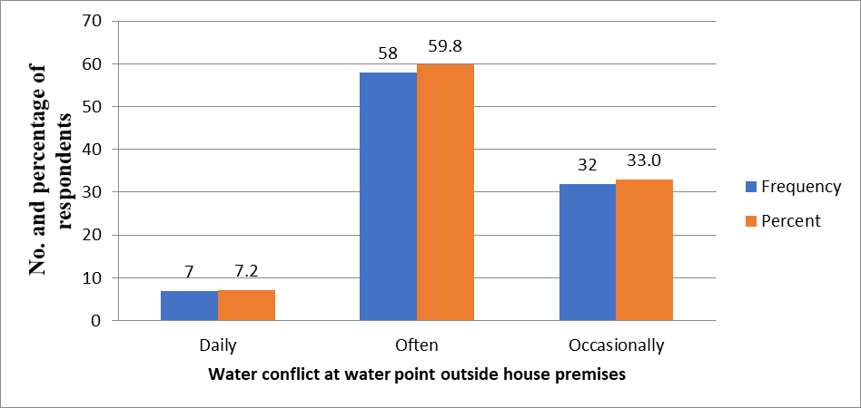

# Figure 4.9: Occurrence of Water Conflict at Water Points Outside Premises

* + - 1. **Household water coping costs**

Table 4.16 shows households monthly coping cost for unreliable water supply in the study. As shown in Table 4.16, the average monthly household expenditure in coping with exposure to unreliable drinking water was N 4164, while the equivalent coping costs for domestic

water was N 3670 on monthly basis. Households however were estimated to spend the sum

of N 3185 monthly on public pipe water. Based on this result, an average household spent

more in coping with the unreliable drinking water compared to what they expended in coping with unsafe domestic water and pay for the water authority for public pipe water supply.

# Table 4.16: Household Monthly Coping Costs and Public Pipe Water Expenditure

|  |  |  |  |  |
| --- | --- | --- | --- | --- |
| **Water** | **Mean(N)** | **Std.Dev** | **Minimum value(N)** | **Maximum value(N)** |
| **Drinking water** | 4164 | 8915 | 0 | 160000 |
| **Domestic water** | 3670 | 9837 | 0 | 36000 |
| **Public pipe**  **water** | 3185 | 5452 | 0 | 160000 |

It can further be inferred from this result that the aggregated coping costs on drinking and domestic far exceeded the expenditure on the utility of public pipe water supply. For example, household on the average spent an aggregate monthly sum of N 7834 in coping with unsafe

and unreliable drinking and domestic water supply, which is almost 8 times higher than the standard water rate of N 1000 they are paying the NSWSC and 2.5 times higher than the

monthly amount (N 3185) expended by an average household on public water in the study

area. This monthly sum of N 7834 spent in coping with unsafe and unreliable drinking and

domestic water supply would otherwise have been channeled to other households’ productive ventures to improve their well-being and living standard of the households in the study.

This empirical finding reinforced the earlier study by Zerah (2000) who noted that Delhi households in India on the average spent 2,000 rupees annually in coping with unreliable water supply, which is 5 times more than they are paying municipal government as their annual water utility cost. Within the Nigerian context, this current finding also confirmed the research by Macheve *et al.* (2015) that the estimated cost of coping with lack and unreliable water supplies to Nigerian households is quite enormous on yearly basis.

# Level of water poverty in the study area

The water poverty measurement aspect and the level of water poverty in the study area are presented next.

# Water poverty measurement

A breakdown of the water poverty measurement employed in this study is depicted by Figure

4.10. The starting point in water poverty measurement will be the validation of the 21 water poverty indicators provided in Table 4.17 as identified from the literature. These indicators captured at household level through the use of a questionnaire-based survey were then

constructed along the 5 dimensions (resource, access, capacity, use and environment) of the water poverty assessment framework. The data matrix for water poverty indicators retrieved from the survey was normalized using the minimum-maximum approach (linear scaling technique). As suggested by Nardo *et al.* (2008) normalization became necessary to standardize the data to a measurable form, as the data for the indicators were reported in different scales and units. Applying the minimum-maximum approach, each indicator value Vit for a given household i at a given time t is given as Nardo *et al.* (2008):

Vit =

xit −minimum〖(x〗it)

〖maximum (xi〗t )−minimum〖(x〗it)

X 100 (4.1)

Where 〖minimum (xi〗t ) and 〖maximum (xi〗t ) represent the minimum and maximum indicator values across the household i at a given time t. The resultant normalized value which takes a value between 0 and 1 is then expressed as a percentage. The normalized indicator values were statistically screened for extreme values/outliers (using box plots) and assessed for normality (using histogram, skewness and kurtosis).

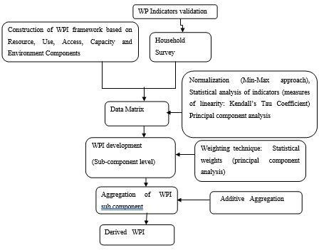

# Figure 4.10: Water Poverty Measurement Flow

**Table 4.17: Indicators for Water Poverty Measurement**

|  |  |  |
| --- | --- | --- |
| **Compon**  **ent** | **Description** | **Indicator** |
| **Resource** | Physical availability of  water resources | [R1]: Sufficiency of water quantity |
|  |  | [R2]: Water supply reliability (hours not operational per  day) |
|  |  | [R3] Perceived variability in rainfall patterns throughout the year |
|  |  | [R4]: Seasonal variability of water supply in dry season |
| **Access** | Level of access to clean water for  human use | [A1]: Household with access to public water supply |
|  |  | [A2]: Household with access to water treatment |
|  |  | [A3]: Number of one-way trips to water source |
|  |  | [A4]: Waiting time for water collection based on one-way trip (minutes) |
|  |  | [A5]: Occurrence of water conflict at water points |
| **Capacity** | Capacity to manage water | [C1]: Level of financial capacity of the household |
|  |  | [C2]: Household level of employment |
|  |  | [C3]: Literacy level in household |
|  |  | [C4]: Frequency of water related illness |
|  |  | [C5]: Household with at least a member with knowledge of hygiene |
|  |  | [C6]: Household aggregate expenditure on drinking water,  domestic and public water supply |
|  |  | [C7]: Presence of water point management committee |
| **Use** | Level of water use for different purposed | [U1]: Domestic water consumption per capita per day |
|  |  | [U2]: Water for green use/ watering crop |
|  |  | [U3]: Drinking water consumption per capita per day |
| **Environ ment** | Environmental sustainability in relation to water  needs | [E1]: Household perceived assessment of water quality |
|  |  | [E2]: Presence of sanitation facilities |

By utilizing Principal Component Analysis (PCA), the 21 indicators were assessed for whether or not they were appropriate measure of the five components of the water poverty index. The PCA examined the statistical dimension of the dataset by reducing the large set of this correlated dataset comprising 21 indicators to a smaller set of uncorrelated data set. Since it has been noted by Lawrence *et al.* (2002) that information is in the components rather that the final single value of the water poverty index, the same process (PCA) was repeated at each of the 5 sub-component level. This is to remove redundancy and check for multiple correlations among the indicators at the subcomponent level (Bair *et al.*, 2006; Hajkowicz, 2006).

The indicators which were finally retained were statistically weighted using the PCA. The choice of this methodology is to avoid the arbitrary imposition of weights associated with the equal weighting (average/arithmetic mean) technique. Rather than the use of equal/averaging weights which is judgmental based opinion, studies have recommended the determination of objective weights of the water poverty index on an analytical base such as the principal component analysis (Cho and Ogwangi, 2006; Garriga and Foguet, 2010; Jemmali and Matoussi, 2013; Sullivan and Jemmali, 2014).

To determine the weights, the principal component(s) retained from the PCA was weighted with the proportion of the variance. The proportion of variance was derived by dividing the square root of the eigen value of each principal component by the sum of the square root of all the eigen values retained in the PCA. Different empirical studies (Rovira and Rovira, 2008; Jemmali and Matoussi, 2013; Sullivan and Jemmali, 2014) have shown that the weight Wi for any index/component i of the water poverty index can be derived using the following

formula:

𝑊𝑖 = 𝑃𝐶𝐾𝑖

√𝜆𝐾

∑ 𝑘√𝜆𝐾

Where 𝑊𝑖 is the weight assigned to ith component of the water poverty index such as resource, use, access, capacity or environment component? 𝑃𝐶𝐾𝑖 is the factor loading score associated with the ith component (which can be resource, use, access, capacity or environment component) on principal component k, which is called component loading. 𝜆𝐾 is its eigen value. These optimally derived weights were aggregated using the additive (arithmetic/linear aggregation) function.

The additive aggregation technique involved summing up of the WPI components to arrive at a single value of Water Poverty Index. Though, Munda and Nardo (2005a) noted that the additive function suffered from compensability problem (likelihood of trade-off in weak performance/value of some indicators for high performance/values of other indicators), its choice was based on its intuitive simplicity and ease of understanding to non-water experts (Garriga and Foguet, 2010). In numeric terms, the water poverty index in its additive form is formulated as:

𝑊𝑃𝐼 = ∑ 𝑊𝑖 𝑋𝑖

Where 𝑊𝑃𝐼 is the water poverty index derived through additive aggregation. 𝑋𝑖 are the water poverty index components (Resource, Use, Access, Capacity and Environment) 𝑊𝑖 is the statistically derived weighted for that component using PCA. It was the derived water poverty index and respective 5 water poverty components for each of the 8 neighbourhoods that served as the output unit for the water poverty analysis in this study. It also provided the basis for the water poverty mapping using GIS and spider map (pentagram) in order to show the spatial manifestation of water poverty in the study area. The derived water poverty index

and component values range from 0 to100 (this index is different from the normalized values derived using the linear scaling method as its weights have been attached and aggregated to arrive at the index). The lower the derived water poverty index in a given neighbourhood in the study area, the higher the extent of water stress and by extension the water poverty level in that particular neighbourhood.

# Operationalization of the water poverty indicators

The indicators used for water poverty measurement are operationalized for normalization as presented in Table 4.18a and b. The recoding of the indicators was done to provide differences in the rating of respondents’ responses in the questionnaire. The recoding of R2, A4, A5, C6 and U1 were however done differently as follows:

* The recoding of R2 indicator which is water supply reliability (hours not operational

per day) was derived using: 𝑅2 = 1 − xi

24

Where xi is the number of hours in which water supply is operational in a day (within 24 hours).

* A4 indicator (number of one-way trips to water source) which is a continuous scale was converted to a categorical form as follows: ≤ 3 trips takes a score rating of 2; 4- 7 trips take a score of 1, while ≥ 8 trips take a score of 0 (trips of 8 and above exceed the mean trip of 7 in the study area and signify the highest level of stress).
* A5 indicator (presence of water conflict at water points) was recoded to take a reciprocal value such that yes = 0 and No = 1.
* C6 indicator (household aggregate expenditure on drinking and domestic water). This is the sum of household expenditure on drinking and domestic water to depict the household cost of coping with unreliable public water supply.
* U1 indicator (domestic water consumption per capita per day) was recoded using similar procedure outlined in Sullivan and Jemmali (2014):

xi , where 𝑥

≤ 50 .

50 𝑖

This threshold implies that any household with less than 50lpcd is suffering from domestic water use.

xi − 50

1 − 𝑋𝑚𝑎𝑥 − 50 , where 50 ≤ 𝑥𝑖 ≤ 150

This threshold implies that households with 50 – 150lpcd have adequate water for domestic use.

xi − 50

1 − 𝑋𝑚𝑎𝑥 − 150 , where 150 ≤ 𝑥𝑖

This threshold implies that households with more than 150 lpcd are wasteful in terms of water for domestic use.

# Table 4.18a: Operationalization of the Water Poverty Indicators for Normalization

|  |  |  |  |  |  |
| --- | --- | --- | --- | --- | --- |
| **Component** | **Indicator** | **Recoding** |  | **Indicator** | **Recoding** |
| **Resource** | [R1]: Sufficiency of water quantity |  |  | Yes | 1 |
|  |  |  |  | No | 0 |
|  | *Always sufficient* | 3 | [A3]: | Number of one-way trips to |  |
|  |  |  |  | water source |  |
|  | *Sufficient for human and livestock* | 2 |  | ≤ 3 trips | 2 |
|  | *Sufficient for only human* | 1 |  | 4 -7 trips | 1 |
|  | *Not sufficient for human use* | 0 |  | ≥ 8trips | 0 |

[R2]: Water supply reliability (hours not operational per day)

[R3] Perceived variability in rainfall patterns throughout the year

1- xi

24

[A4]: Waiting time for water collection based on one-way trip (minutes)

[A5]: Presence of water conflict at water points

*Very good* 3 *Yes* 0

*Good* 2 *No* 1

|  |  |  |  |  |  |  |  |  |
| --- | --- | --- | --- | --- | --- | --- | --- | --- |
| *Fair*  *Poor* | |  |  |  |  | 1  0 | [C1]: Level of financial capacity of the household  [C2]: Household level of |  |
| [R4]: | | Seasonal | variability | of | water |  | employment  Employed | 1 |
|  | supply in dry season  *Much* | | | | | 4 | Unemployed | 0 |
|  | *Enough* | | | | | 3 | [C3]: Literacy level in household |  |
|  | *Little but not enough* | | | | | 2 | *Tertiary education* | 4 |
|  | *Very little* | | | | | 1 | *Secondary education* | 3 |
|  | *None* | | | | | 0 | *Primary education* | 2 |
| **Access** | [A1]: Household with access to public water supply  *Yes* | | | | | 1 | *Quranic/Adult education*  *None* | 1  0 |
|  | *No*  [A2]: Household with access to water | | | | | 0 |  |  |

treatment

# Table 4.18b: Operationalization of the Water Poverty Indicators for Normalization

|  |  |  |  |  |  |
| --- | --- | --- | --- | --- | --- |
| **Component** | **Indicator** | **Recoding** | **Component** | **Indicator** | **Recoding** |
|  | [C4]: Frequency of water related illness |  | Environment | [E1]: Household perceived assessment of water quality |  |
|  | *Frequently* | 2 |  | *Very good* | 4 |
|  | *Occasionally* | 1 |  | *Good* | 3 |
|  | *Never* | 0 |  | *Fair* | 2 |
|  | [C5]: Household with at least a member with knowledge of hygiene |  |  | *Poor* | 1 |
|  | *Yes* | 1 |  | *Very poor* | 0 |
|  | *No* | 0 |  | [E2]: Presence of sanitation facilities |  |
|  | [C6]: Household aggregate expenditure on drinking water, domestic and public water supply |  |  | Yes | 1 |
|  | [C7]: Presence of water point management committee |  |  | No | 0 |
|  | Yes | 1 | | |  |
|  | No | 0 | | |  |
| **Use** | [U1]: Domestic water consumption per capita per day |  | | |  |
|  | [U2]: Water for green use/ watering crop |  | | |  |
|  | [U3]: Drinking water consumption per capita per day |  | | |  |

* + - 1. **Classification of the Water Poverty Index**

Table 4.19 provides the classification and interpretation of the water poverty index. This follows similar approach adopted in the empirical research by El-Gafy (2018). The Table provides the cut-off and interpretation of the water poverty index employed in the study, where between 0.00 to 20 water poverty score implies very poor, > 20 to 40 is classified poor,

> 40 to 60 is rated fair, while > 60 to 80 is good, and lastly >80 to 100 implies excellent water poverty index.

# Table 4.19: Classification and Interpretation of the Water Poverty Index

|  |  |  |
| --- | --- | --- |
| **S/N** | **Water Poverty Index Classification** | **Interpretation** |
| **1** | 0.00 to 20 | Very poor |
| **2** | >20 to 40 | Poor |
| **3** | > 40 to 60 | Fair |
| **4** | > 60 to 80 | Good |
| **5** | > 80 to 100 | Excellent |

* + - 1. **Statistical measure of water poverty indicators**

The results of the preliminary diagnostic tests of the dataset (comprising 359 observations by 21 indicators) was examined through Kendall’s correlation, Kaiser-Meyer-Olkin (KMO) measure of sampling adequacy, Bartlett’s test of sphericity and principal component analysis are presented and discussed next.

# Kendall’s tau correlation

The result of the Kendall’s Tau pairwise correlation matrix (reported in Appendix II) shows the degree of association among the 21 water poverty indicators. From the result, with the exception of U1(domestic water consumption per capita per day) and U3(drinking water consumption per capita per day) which are highly correlated with each other, all the water

poverty indicators in the underlying dataset exhibited low correlations (r < 0.40). As shown in the correlation matrix, U1 and U3 indicators which exhibited a significant high correlation (r = 0.863) at 1% significance level amounts to double counting and variable redundancy as both are likely to provide the same measure to the water poverty index.

# Exclusion of correlated water poverty indicators using PCA

The exclusion of indicators is based on result of the principal component analysis of the water poverty indicators at component and sub-component level as presented in Appendix III. At the component level, 13 principal components account for 80.84% of the global variance in water poverty structure in the study area. Given the total variance of 80.84%, the adequacy of the combinations of the 21 indicators as conceptually related variables of water poverty index is partially confirmed. The 13-component extraction was based on Jollife’s variance explained criteria which is to retain associated eigen values of 0.70 (Jollife, 1972). At the sub-component level, the result shows that with the exception of capacity and use component which account for 90.37% and 92.08% variance respectively in the underlying dataset, all other components (resource, access and environment) account for 100% variance in the component space.

Further examination of the 21 indicators revealed that C7 indicator (presence of water point management committee) has a lower eigen value (< 0.700) and was therefore discarded as redundant and of no meaningful explanation. For the use component, U1 indicator (domestic water consumption per capita per day) is correlated with U3 (drinking water consumption per capita per day). However, U1 was discarded due to its low and negative factor loadings on the components. In total, the original 21 water poverty indicators were reduced to 19

uncorrelated and relatively independent variables representing the water poverty index structure in the study area.

# PCA of retained water poverty indicators at component level

The principal component analysis for the retained 19 water poverty indicators is presented in Table 4.20b. Before proceeding to the PCA result, the factorability and suitability of the dataset as a measure of water poverty was examined as shown in Table 4.20a.

The KMO measure of sampling adequacy of 0.591 which is above the acceptable threshold value of 0.500 outlined in Hair *et al.,* (2006) and those reported in prior studies which employed principal component analysis in water poverty analysis (Jemmali and Matoussi, 2013; Jemmali and Sullivan, 2014). implies that the underlying data on water poverty can be explored using principal component analysis.

# Table 4.20a: Factorability of the Retained Water Poverty Indicators at Component Level

|  |  |
| --- | --- |
| **Test** | **Statistic** |
| **Kaiser-Meyer-Olkin**  **(KMO)** | 0.591 |
| **Bartlett's Test of**  **Sphericity:** |  |
| **Chi-Square value** | 752.784 |
| **Df** | 171 |
| **Sig.** | 0.000 |

This result also shows that the 19 water indicators are relatively independent variables representing some combination of water poverty measure and do not suffer from multi- collinearity problem. In addition, the result of the chi-square of Bartlett’s test of sphericity (χ2 (171) = 752.784, p = 0.000) which is significant at 5% implies that the sample comprising 359 observations by 19 variable indicators is suitable for principal component analysis.

Turning to the PCA result in Table 4.20b, the retained 19 indicators account for approximately 79.54% of the global variance in water poverty. Given this total variation, the adequacy of the combinations of the 19 indicators as meaningful and conceptually related variables of water poverty measure is guaranteed. It further shows that the 12 principal components extracted from the 19 water poverty indicators based on Jollife’s variance explained criteria comprehensively retained as much information as possible in the underlying dataset after discarding the two (2) redundant indicators.

# Table 4.20b: Result of the Principal Component Analysis at the Component Level

|  |  |  |  |  |  |  |  |
| --- | --- | --- | --- | --- | --- | --- | --- |
| **Principal Component** | | | | | | | |
|  | **CO MP**  **1** | **COM P2** | **COM P3** | **COM P4** | **CO MP5** | **COM P6** | **CO MP**  **7** |
| **Eigen values** | 2.28 | 1.90 | 1.69 | 1.41 | 1.27 | 1.09 | 1.05 |
| **Proportion of variance explained (%)** | 12.0  1 | 10.00 | 8.92 | 7.42 | 6.66 | 5.75 | 5.50 |
| **Cumulative proportion of variance explained (%)** | 12.0  1 | 22.01 | 30.93 | 38.35 | 45.01 | 50.76 | 58.2  6 |
|  |  | **Principal Component** | | | |  |  |
|  | **CO MP 8** | **CO MP 9** | **COM P10** | **COM P11** | **COM P12** |  |  |
| **Eigen values** | 1.03 | 0.93 | 0.85 | 0.85 | 0.77 |  |  |
| **Proportion of variance explained (%)** | 5.42 | 4.87 | 4.47 | 4.45 | 4.07 |  |  |
| **Cumulative proportion of variance explained (%)** | 61.6  8 | 66.5  5 | 71.02 | 75.47 | 79.54 |  |  |

* + - * 1. **PCA of retained water poverty indicators at sub-component level**

Table 4.21a and Table 4.21b present the result of the factorability test and principal component analysis respectively at the sub-component level. The factorability test at the sub-component level in Table 4.21a shows that, the Kaiser-Meyer-Olkin (KMO) index fall within the range of 0.500-0.576. These KMO value are nonetheless within the acceptable

benchmark of 0.500 and revealed that PCA is applicable in exploring the variability of the underlying dataset. Furthermore, the Bartlett's test of sphericity which indicates the presence of significant non-zero correlations shows that the dataset is suitable for principal component analysis at the sub-component level. As such the factorability of the individual component was confirmed based on the KMO and Bartlett's Test of Sphericity results**.**

**Table 4.21a: Factorability of the Water Poverty Indicators at Sub-Component Level**

|  |  |  |  |  |  |
| --- | --- | --- | --- | --- | --- |
| **Test** | **RESOURCE** | **ACCESS** | **CAPACITY** | **USE** | **ENVIRONMENT** |
| **Kaiser- Meyer- Olkin**  **(KMO)** | 0.576 | .501 | 0.540 | 0.500 | .500 |
| **Bartlett's Test of Sphericity:** | | | | | |
| **Chi-**  **Square value** | 36.43 | 35.27 | 57.452 | 10.383 | 8.480 |
| **Df** | 6 | 10 | 15 | 1 | 1 |
| **Sig.** | .000 | .000 | 0.000 | 0.001 | .004 |

Turning to the result output of the principal component analysis in Table 4.21b, it can be seen that, the four (4) extracted principal components of the 4 resource indicators, the five (5) extracted principal components of the 5 access indicators and the six (6) extracted principal components of the 6 capacity indicators account for 100% of the variance in the resource, access and capacity component respectively. Similarly, the two (2) extracted principal

components of the 2 use and environment components equally account for 100% variance of their component space.

# Derived statistical weights for water poverty indicators

The derived statistical weights from the PCA vis-à-vis the weights from equal weighting scheme for each water poverty indicator are shown in Table 4.22. A comparison of the PCA derived weight with the equal weights shows that the PCA statistically derived weights produced far more objective and statistically robust weights in contrast to the subjective and arbitrary weight selection used in the equal weighting scheme. Earlier studies (Cho *et al.* 2010; Jemmali and Sullivan, 2014) have shown that the choice of subjective weights leads to mis-interpretation and multi-collinearity problem as the components of the water poverty index are correlated. Another important inference from Table 4.22 is that U2 (water for green use/watering crop) has the highest weight among the 19 water poverty indicators employed in the study.

**Table 4.21b: Result of the Principal Component Analysis at the Sub- Component Level**

|  |  |  |  |  |
| --- | --- | --- | --- | --- |
| **RESOURCE** | | | | |
|  | **COMP1** | **COMP2** | **COMP3** | **COMP4** |
| **Eigen values** | 1.39 | 0.97 | 0.89 | 0.76 |
| **Proportion of variance explained (%)** | 34.70 | 24.15 | 22.17 | 18.98 |
| **Cumulative proportion of variance explained (%)** | 34.70 | 58.85 | 81.02 | 100.00 |
| **ACCESS** | **COMP1** | **COMP2** | **COMP3** | **COMP4** |
| **Eigen values** | 1.28 | 1.16 | 1.00 | 0.80 |
| **Proportion of variance explained (%)** | 25.52 | 23.11 | 20.08 | 15.91 |
| **Cumulative proportion of variance explained (%)** | 25.52 | 48.63 | 68.71 | 84.63 |
|  | **COMP5** |  |  |  |
|  | 0.77 |  |  |  |
|  | 15.37 |  |  |  |
|  | 100.00 |  |  |  |
| **CAPACITY** | **COMP1** | **COMP2** | **COMP3** | **COMP4** |
| **Eigen values** | 1.46 | 1.06 | 0.99 | 0.93 |
| **Proportion of variance explained (%)** | 24.35 | 17.72 | 16.51 | 15.53 |
| **Cumulative proportion of variance explained (%)** | 24.35 | 42.07 | 58.58 | 74.11 |
|  | **COMP5** | **COMP6** |  |  |
|  | 0.88 | 0.70 |  |  |
|  | 14.62 | 11.28 |  |  |
|  | 88.72 | 100.00 |  |  |
| **USE** | **COMP1** | **COMP2** |  |  |
| **Eigen values** | 1.17 | 0.83 |  |  |
| **Proportion of variance explained (%)** | 58.47 | 41.53 |  |  |
| **Cumulative proportion of variance explained (%)** | 58.47 | 100.00 |  |  |
| **ENVIRONEMENT** | **COMP1** | **COMP2** |  |  |
| **Eigen values** | 1.15 | 0.85 |  |  |
| **Proportion of variance explained (%)** | 57.67 | 42.33 |  |  |
| **Cumulative proportion of variance**  **explained (%)** | 57.67 | 100.00 |  |  |

# Table 4.22: Comparison of Statistical and Equal Weights for Water Poverty Index

|  |  |  |  |
| --- | --- | --- | --- |
| **Component** | **Indicator** | **PCA**  **Weigh t** | **Equal Weigh t** |
| **Resource** | [R1]: Sufficiency of water quantity | 0.296 | 0.250 |
|  | [R2]: Water supply reliability (hours not operational per day) | 0.247 | 0.250 |
|  | [R3] Perceived variability in rainfall patterns throughout the year | 0.237 | 0.250 |
|  | [R4]: Seasonal variability of water supply in dry season | 0.219 | 0.250 |
| **Access** | [A1]: Household with access to public water supply | 0.227 | 0.200 |
|  | [A2]: Household with access to water treatment | 0.216 | 0.200 |
|  | [A3]: Number of one-way trips to water source | 0.201 | 0.200 |
|  | [A4]: Waiting time for water collection based on one-way trip (minutes) | 0.179 | 0.200 |
|  | [A5]: Occurrence of water conflict at water points | 0.176 | 0.200 |
| **Capacity** | [C1]: Level of financial capacity of the household | 0.203 | 0.167 |
|  | [C2]: Household level of employment | 0.173 | 0.167 |
|  | [C3]: Literacy level in household | 0.167 | 0.167 |
|  | [C4]: Frequency of water related illness | 0.162 | 0.167 |
|  | [C5]: Household with at least a member with knowledge of hygiene | 0.157 | 0.167 |
|  | [C6]: Household aggregate expenditure on drinking water and domestic water use | 0.138 | 0.167 |
| **Use** | [U2]: Water for green use/ watering crop | 0.543 | 0.500 |
|  | [U3]: Drinking water consumption per capita per day | 0.457 | 0.500 |
| **Environme nt** | [E1]: Household perceived assessment of water quality | 0.539 | 0.500 |
|  | [E2]: Presence of sanitation facilities | 0.461 | 0.500 |

This implied that any priority intervention in this variable indicator will further contribute greatly to the improvement in water provision, especially among the water poor neighbourhoods in the study area.

# Regression of derived statistical weights with equal weights

Table 4.23 shows the result of the regression of equal weights on the derived statistical (PCA) weights. An examination of Table 4.23 shows that the PCA weights have a very high predictive ability (R2= 0.955) for the equal weight scheme. This result also suggests that

without engaging arbitrary weight selection, the PCA produces reliable, accurate and well- balanced weights for the water poverty indicators

**Table 4.23: Regression Model for the Derived Statistical (PCA) Weights**

|  |  |  |  |  |
| --- | --- | --- | --- | --- |
| **Predictors** | **Coefficient** | **Standard Error** | **T-Stat** | **P-value** |
| **Constant** | 0.012 | 0.015 | 0.803 | 0.433 |
| **PCA Weight** | 0.955 | 0.050 | 19.005 | 0.000 |
| **Model Summary** |  |  |  |  |
| **R** |  | 0.977 |  |  |
| **R2** |  | 0.955 |  |  |
| **R-Sq(adj)** |  | 0.952 |  |  |
| **Std. error of the estimate** | | 0.028 |  |  |
| **No. of variables** |  | 19 |  |  |

# Water poverty index for the neighbourhoods

Figure 4.11 depicts the result of the water poverty index for the eight (8) sampled neighbourhoods in the study area. The water poverty index ranged from 32.70(poor) to 44.40(fair) for all the neighbourhoods. However, none of the 8 neighbourhoods has a very poor, good or excellent water poverty condition.

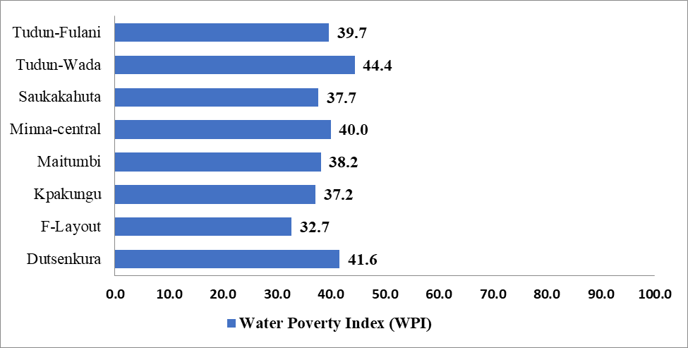

# Figure 4.11: Water Poverty Index for the Neighbourhoods

The results in figure 4.11 further revealed that relative to other neighbourhoods in the study area, Tudun-Wada South shows evidence of the best water situation with a water poverty index of 44.40, while F-Layout with the least water poverty index of 32.70 exhibited the worst case. In the study area, only the two neighbourhoods of Tudun-Wada South (44.40) and Dutsenkura (41.60) exhibited a fair water poverty index/score as shown in figure 4.11. Furthermore, the result of the water poverty index for the neighbourhoods shows that other neighbourhoods such as Minna-Central (40.00), Tudun-Fulani (39.70), Maitumbi(38.20), Saukakahuta (37.70), Kpakungu (37.20) as well as F-Layout(32.70) are water-stressed and therefore are classified as water-poor neighbourhoods. The spatial pattern in water poverty index for the eight (8) neighbourhoods as shown in figure 4.12 confirmed this empirical result.

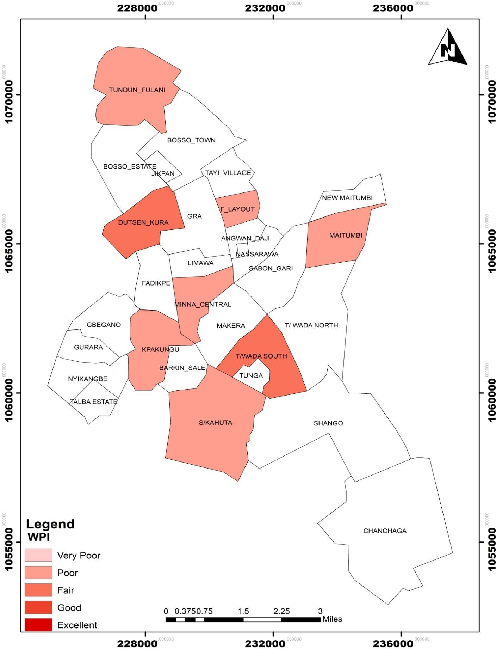

# Figure 4.12: Spatial Variation in WPI across the Neighbourhoods

Source: Author (2021)

# Ranking and prioritizing water poverty index of neighbourhoods for policy intervention

Table 4.24 presents the ranking of the neigbourhoods for prioritization in respect of water policy intervention. The rank (contributory influence) of the water poverty index in decreasing order in the eight (8) neighbourhoods is depict by the following sequence:

𝑇𝑢𝑑𝑢𝑛𝑤𝑎𝑑𝑎 > 𝐷𝑢𝑡𝑠𝑒𝑛𝑘𝑢𝑟𝑎 > 𝑀𝑖𝑛𝑛𝑎 − 𝐶𝑒𝑛𝑡𝑟𝑎𝑙 > 𝑇𝑢𝑑𝑢𝑛 − 𝐹𝑢𝑙𝑎𝑛𝑖 > 𝑀𝑎𝑖𝑡𝑢𝑚𝑏𝑖

> 𝑆𝑎𝑢𝑘𝑎𝑘𝑎ℎ𝑢𝑡𝑎 > 𝐾𝑝𝑎𝑘𝑢𝑛𝑔𝑢 > 𝐹 − 𝐿𝑎𝑦𝑜𝑢𝑡

An important empirical finding from this sequencing is that all neighbourhoods partly outside the public water mains (ranked between 4th -7th) are characterized by poor water poverty index while neighbourhoods within the coverage of public water mains (ranked 1st -3rd) have a mix of fair and poor water poverty index. The only exception is F-Layout (ranked 8th) with a poor water poverty index. In terms of policy intervention, all the eight (8) neighbourhoods in the study require policy intervention in their water development programmes on a sustainable basis. Given that the severity of the water poverty levels differs in the neighbourhoods, relevant strategies should suffice to prioritize the water policy intervention by the relevant water authorities such as the Niger State Government and NSWSC. The prioritization of such water policy intervention implies that six (6) neighbourhoods comprising Minna-Central, Tudun-Fulani, Maitumbi, Saukakahuta, Kpakungu and F-Layout deserved first (1st) level priority in their water development programmes due to their poor water poverty situations. Secondly, the two (2) neigbourhoods of Dusenkura and Tudun- Wada South with fair water poverty levels are next in hierarchy and required second (2nd) level priority for the development of their water programmes.

# Spatial pattern of water poverty components

The maps showing the spatial variation in the various components of the water poverty index are shown in figure 4.13, 4.14, 4.15, 4.16 and 4.17 respectively. Figure 4.13 depicts the spatial pattern in water resource availability/status for the eight (8) neighbourhoods in the study area. The map shows that few of the sampled neighbourhoods lack water resource while others have relatively fair water resource condition. Specifically, three (3) neighbourhoods (F-Layout, Saukakahuta and Tudun-Fulani) are characterized by poor water resource availability while the remaining five (5) neighbourhoods (Kpakungu, Maitumbi, Tudunwada South, Minna-Central and Dutsen-Kura) are considered fair in terms of physical water availability.

# Table 4.24: Ranking and Prioritizing of Neighbourhoods Water Poverty Index for Policy Intervention

|  |  |  |  |  |  |  |
| --- | --- | --- | --- | --- | --- | --- |
| **S/N** | **Neighbourhood** | **Water Coverage** | **Water Poverty Index** | **Rank** | **Classification** | **Prioritization for Intervention** |
| **1** | Tudun Wada South | Within public water  mains | 44.4 | 1 | Fair | 2nd level priority |
| **2** | Dutsenkura | Within public water  mains | 41.6 | 2 | Fair | 2nd level priority |
| **3** | Minna-Central | Within public water  mains | 40.0 | 3 | Poor | 1st level priority |
| **4** | Tudun-Fulani | Partially outside public  water mains | 39.7 | 4 | Poor | 1st level priority |
| **5** | Saukakauta | Partially outside public  water mains | 37.7 | 5 | Poor | 1st level priority |
| **6** | Maitumbi | Partially outside public  water mains | 38.2 | 6 | Poor | 1st level priority |
| **7** | Kpakungu | Partially outside public  water mains | 37.2 | 7 | Poor | 1st level priority |
| **8** | F-Layout | Within public water  mains | 32.7 | 8 | Poor | 1st level priority |

Figure 4.14 illustrates the spatial variation in access to clean water in the study area. As seen from the map, evidence of uneven distribution of access to water also manifest in spatial term. This uneven access is noticeable between neighbourhoods within the coverage of the public water mains and those partly outside the public water mains. For instance, apart from F-Layout, the three (3) neighbourhoods of Dutsenkura, Minna-Central and Tudun-Wada South which are within the coverage of public water mains exhibited a fair access index. On the other hand, all the neighbourhoods which are partly outside the public water mains (Tudun-Fulani, Maitumbi, Saukakauta and Kpakungu) have poor water accessibility index. The spatial variation in the capacity component index in the study area is depict by figure

4.15. The map depicts that the households in all the eight (8) neigbourhoods have a fair capacity to manage water and sanitation services based on their level of education, employment, financial capacity and health status. In other words, all the eight (8) neigbourhoods have a fair capacity to manage water and sanitation services in the study area. Figure 4.16 shows the spatial distribution of water use index in the study area. This illustrates that the use of water in all the eight (8) neighbourhoods is very poor. This reflects a lack and inefficient use of water for drinking and green use.

Finally, Figure 4.17 shows the map of environment component for the study. The map depicts that only Tudun Wada South is characterized by good environment while the remaining seven

(7) neighbourhoods exhibit a fair environment condition in terms of improved water quality and presence of sanitation services necessary for healthy living.

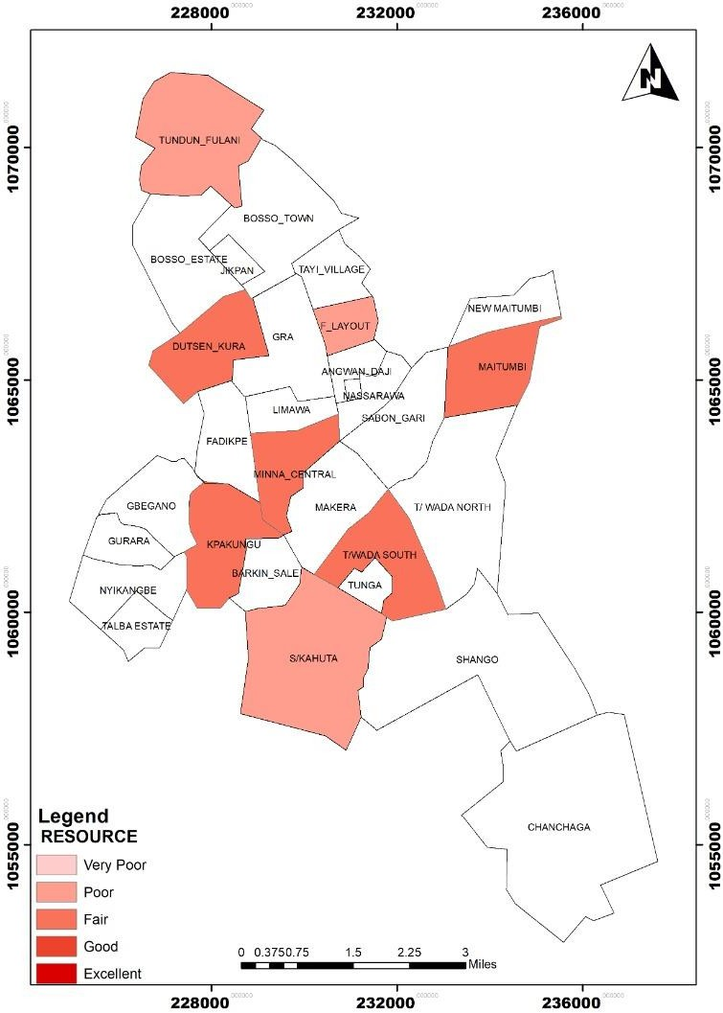

# Figure 4.13: Spatial Variation of Resource Component Index

Source: Author (2021)

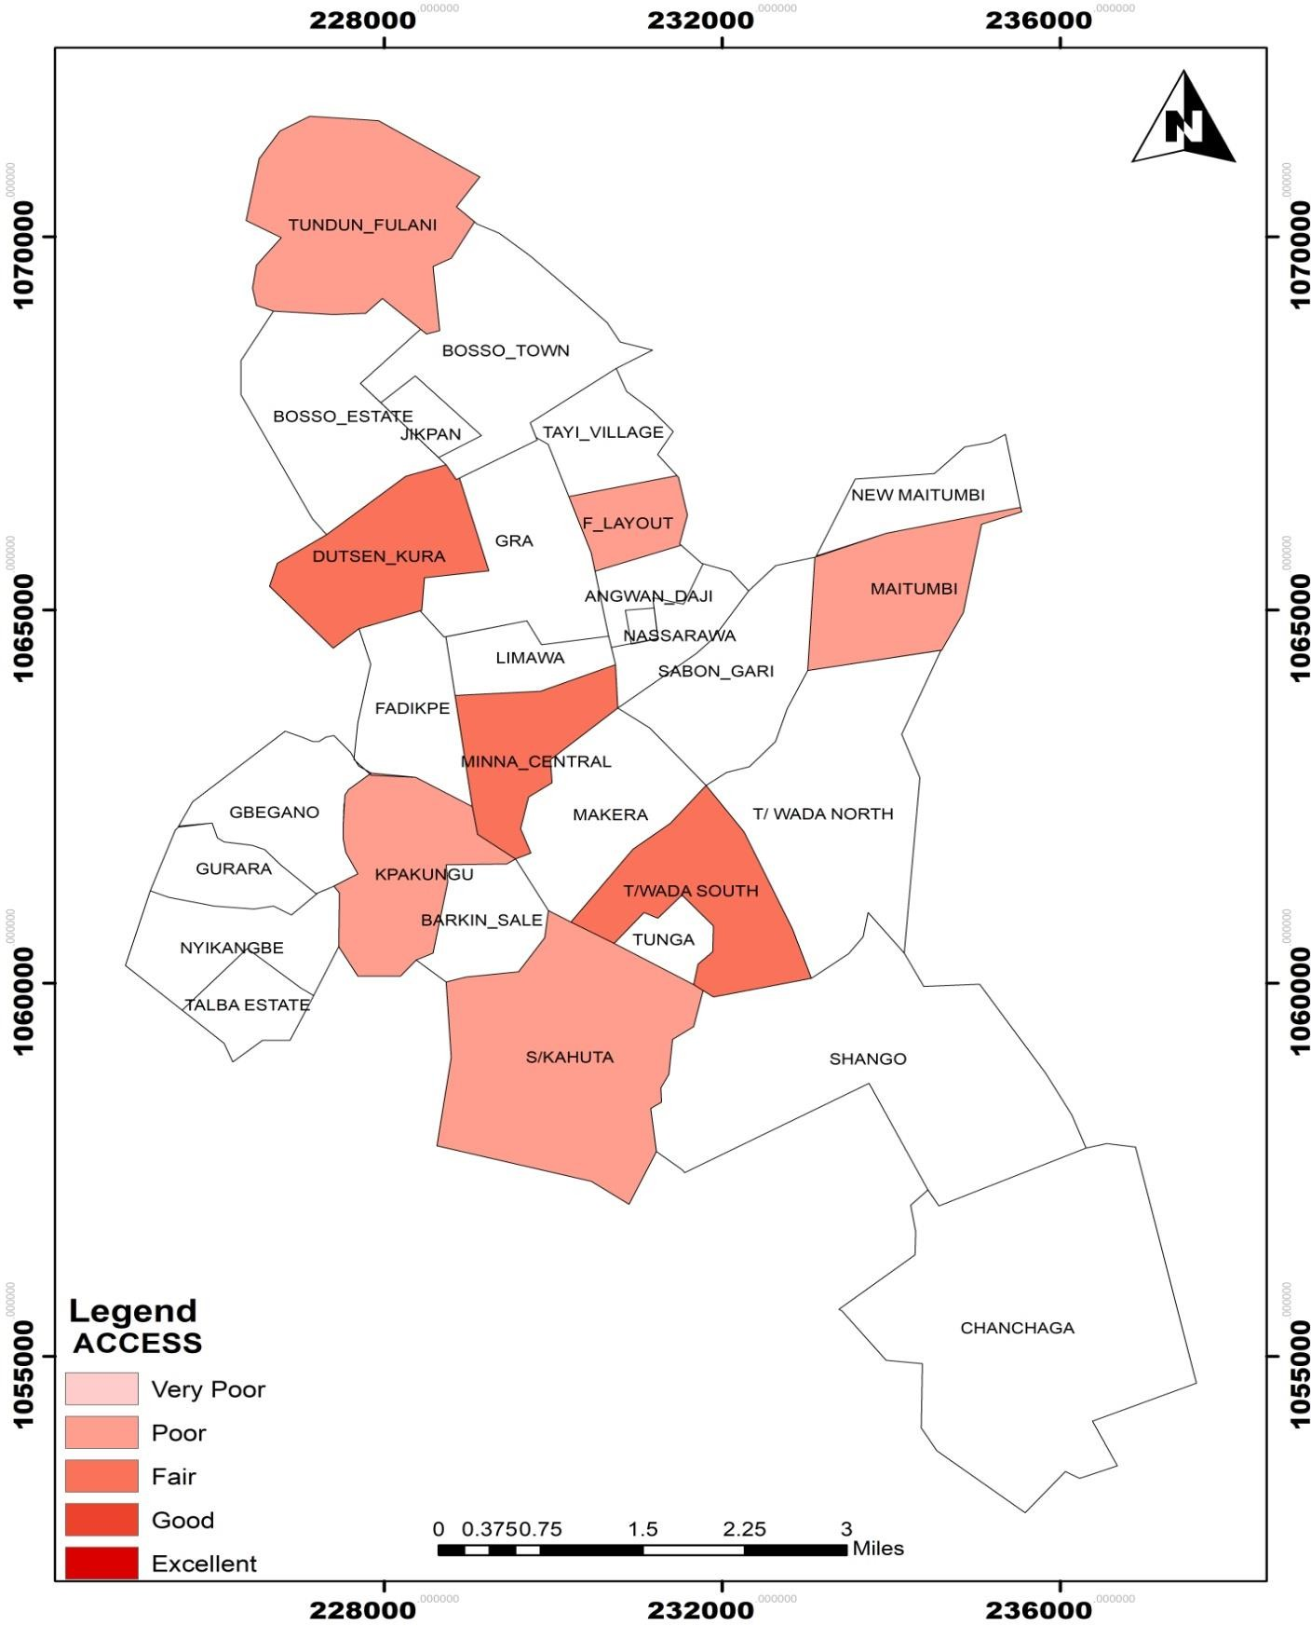

# Figure 4.14: Spatial Variation of Access Component Index

Source: Author (2021)

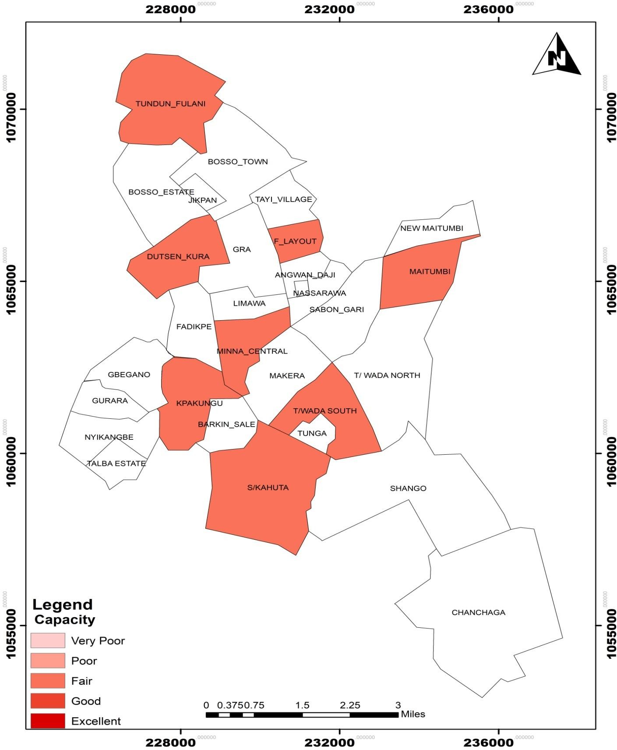

# Figure 4.15: Spatial Variation of Capacity Component Index

Source: Author (2021)

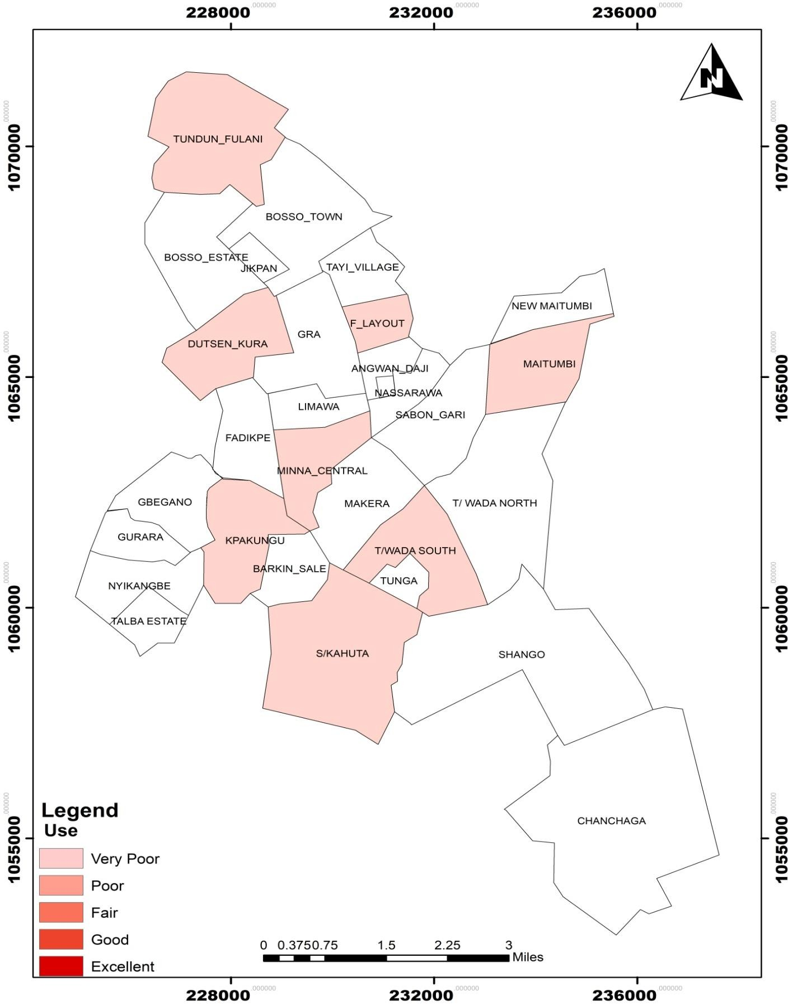

# Figure 4.16: Spatial Variation of Use Component Index

Source: Author (2021)

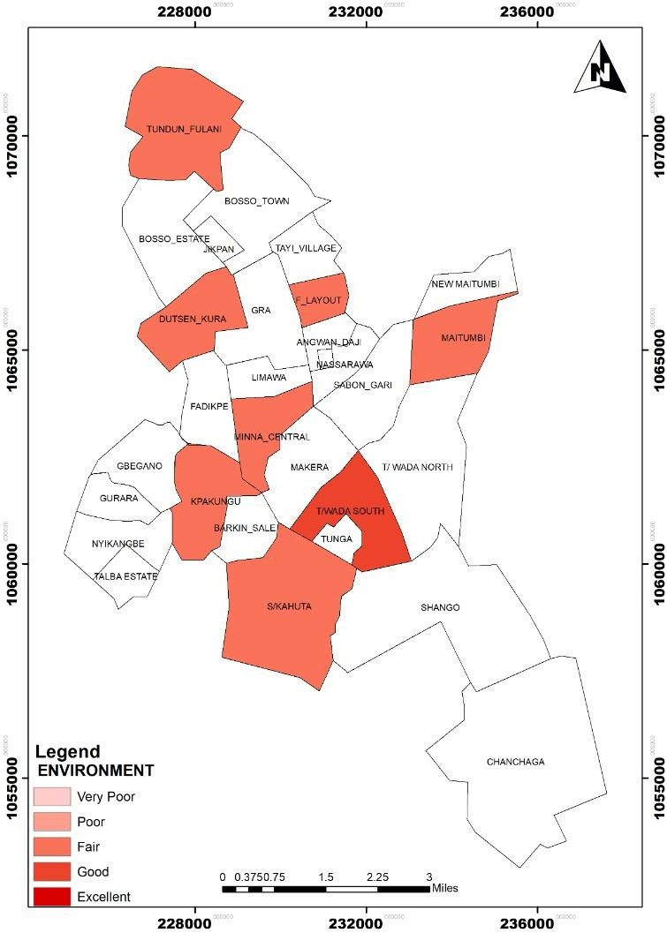

# Figure 4.17: Spatial Variation of Environment Component Index

Source: Author (2021)

* + - 1. **Pentagram representation of water poverty components of neighbourhoods** Figure 4.18a and Figure 4.18b are pentagram representations for each of the eight neigbourhoods in the study area. The results of the pentagrams for the neighbourhoods show that in terms of water resource status, Tudun-Wada (51.08) has the best resource condition while F-Layout (32.80) has the worst condition. In addition, Maitumbi (45.68) has a better water resources than Dutenkura(47.43), Kpakungu(46.29), Minna-Central(45.68), Tudun- Fulani(38.71) and Sukakauta (36.74).

The results of the pentagrams also identified differences in the neighbourhoods in respect of access to water services. Dutsenkura (47.58) has the highest access to water relative to other neighbourhoods. Apart from Dutsenkura, Minna-Central (45.45) and Tudun-Wada South (41.25) are next in hierarchy, followed by Maitumbi(38.61), Tudun-Fulani(38.48) and Kpakungu (28.52) when cognizance is given to households’ access to public pipe water, the number of trips to water collection source, presence or other of water conflict and water treatment. However, F-Layout (26.90) has the least access to water services in the study area. Perhaps this can be attributed to its poor water resource status compared to other neighbourhoods as shown in Figure 4.18b.

The results further show that the neighbourhood capacity to manage water based on the households’ level of education, employment and financial capacity range from 57.68 to 44.07, with Kpakungu having the highest capacity component value. Furthermore, Tudun- Fulani (54.06) exhibits better capacity than Saukakahuta (51.94), Minna-Central (50.37), Maitumbi (48.73), Tudun-Wada South (47.31), F-Layout (44.45), while Dutsenkura (44.07) exhibits the lowest capacity value.

The use component which assesses the result of efficiency in water use revealed that relative to other neighbourhoods, Tudun-Fulani exhibits the highest use value of 24.57 in respect of water efficiency. This is aptly followed by Saukakahuta and F-Layout with a use component value of 19.87 and 18.99 respectively. Next in descending order of the use component value are Minna-Central (18.20), Tudun-Wada South (15.10), Dutsenkura (12.85), Maitumbi(9.44) whereas Kpakungu has the least.

|  |  |
| --- | --- |
|  |  |
|  |  |

# Figure 4.18a: Pentagram Representations of Water Poverty Components for the Neighbourhoods

Source: Author’s Analysis (2021)

|  |  |
| --- | --- |
|  |  |
|  |  |

# Figure 4.13b: Pentagram Representations of Water Poverty Components for the Neighbourhoods

Source: Author’s Analysis (2021)

The pentagrams representation further indentified Tudun-Wada South (67.31) as exhibiting the highest environment impact from water whereas Minna-Central (40.39) has the lowest impact. In addition, Dutsenkura(56.18) is characterized by a higher environment impact compared to Kpakungu(46.25), Maitumbi(45.79), Tudun-Fulani(42.49) and F-Layout(40.51) respectively.

The summary of these findings on water poverty components by neighbourhood rank is shown in Table 4.25.

# Table 4.25: Neighbourhood Ranking of Water Poverty Component

|  |  |  |
| --- | --- | --- |
| **S/N** | **Water Poverty Component** | **Neighbourhood Rank in Descending Order** |
| 1 | Resource | Tudun-Wada South > Maitumbi > Dutsenkura >  Kpakungu >Minna-Central > Tudun-Fulani  >Saukakahuta > F-Layout |
| 2 | Access | Dutsenkura > Minna-Central > Tudun-Wada South >  Maitumbi > Tudun-Fulani > Kpakungu > Saukakahuta >  F-Layout |
| 3 | Capacity | Kpakungu > Tudun-Fulani > Saukakahuta > Minna- Central > Maitumbi >Tudun-Wada South > F-Layout  >Dutsenkura |
| 4 | Use | Tudun-Fulani > Saukakahuta > F-Layout > Minna- Central > Dutsenkura > Tudun-Wada South > Maitumbi  > Kpakungu |
| 5 | Environment | Tudun-Wada South > Dutsenkura > Saukakahuta >  Kpakungu > Maitumbi > Tudun-Fulani > F-Layout >  Minna-Central |

* + - 1. **Ranking water poverty components for neighbourhoods improvement**

The result of the pentagram maps shown in figure 4.18a and figure 4.18b further revealed the strengths and weakness of the neighbourhoods in terms of the water poverty components ranking. The ranking of the five (5) water poverty component values in the pentagrams in decreasing order for the eight (8) neighbourhoods is shown in Table 4.26. A cursory examination of this ranking of water component values on neighbourhood basis indicates some interesting findings in respect of the diverse and related water needs of neighbourhoods.

**Table 4.26: Water Poverty Component Ranking by Neighbourhood**

|  |  |  |  |
| --- | --- | --- | --- |
| **S/N** | **Neighbourhoods** | **Water Coverage** | **Water Poverty Component Ranks** |
| **1** | Tudun Wada South | Within public water mains | Environment > Resource > Capacity > Access > Use |
| **2** | Dutsenkura | Within public water mains | Environment > Access > Resource > Capacity > Use |
| **3** | Minna-Central | Within public water mains | Capacity > Resource > Access > Environment > Use |
| **4** | Tudun-Fulani | Partly outside public water mains | Capacity > Environment > Resource > Access > Use |
| **5** | Saukakauta | Partly outside public water mains | Capacity > Environment > Resource > Access > Use |
| **6** | Maitumbi | Partly outside public water mains | Capacity > Resource > Environment > Access > Use |
| **7** | Kpakungu | Partly outside public water mains | Capacity > Resource > Environment > Access > Use |
| **8** | F-Layout | Within public water mains | Capacity > Environment > Resource > Access > Use |

First, the result identified that each of Dutsenkura, Minna-Central and Tudun-Wada South (which are all located within the public water mains) have different water needs. Secondly, similarities and differences also exist in water needs/requirements of neigbourhoods partly outside the public water mains. For instance, Kpakungu and Maitumbi neighbourhoods exhibit similar water needs in sharp contrast to the two (2) neighbourhoods of Saukakahuta and Tudun-Fulani which are equally similar in their water needs and requirements. Noticeably, F-Layout which is situated within the public water mains also has the same water needs with Saukakahuta and Tudun-Fulani, located partly outside the public water mains.

* + - 1. **Prioritizing water poverty components for neighbourhoods improvement** Furthermore, when the ranking of the neighbourhood by individual water component in descending order (1-highest to 8- lowest) as shown in Table 4.24 is juxtaposed with the interpretation of the Water Poverty Index classification provided in Table 4.19, the specific areas (water poverty components) where improvements or interventions are required in the neighbourhoods becomes clearer/discernible as shown in Table 4.27.

Table 4.27 provides the water situation matrix which summarizes the differences in water poverty components between the neighbourhoods and asterisk areas for improvement. The situation matrix provides several possible outcomes of the current situation of the water poverty components in the study area. For visualization of the results, water poverty components which have been flagged in green colour are areas of weakness and by extension represent areas of improvement for the neighbourhoods. For instance, results from the outcomes of situation matrix confirmed our earlier findings that Tudun Wada South is the most ranked water poverty neighbourhood whereas F-Layout is the most water stressed neighbourhood, and therefore the neediest. Based on the situation matrix, Dutsenkura has a

fair water resource status, fair water accessibility and fair environment impact than Minna- central, Kpakungu, Saukakauta and Tudun-Fulani. These neighbourhoods however exhibit ‘fairer’ capacity compared to Dutsenkura. Furthermore, Minna-Central has fair water resource, fair access and low environment impact than Saukakahuta and Tudun-Fulani. Comparatively, Kpakungu, Maitumbi, Saukakahuta and TDF have poor access to water supply services relative to Dutsenkura, Minna Central and Tudun-Wada with fair access. The former nonetheless fair *better* than the later in terms of capacity.

**Table 4.27: Situation Matrix of Water Poverty Component and Improvement Areas for Neighbourhoods**

|  |  |  |  |  |  |  |
| --- | --- | --- | --- | --- | --- | --- |
| **Neighbourhoods** | **Resource** | **Access** | **Capacity** | **Use** | **Environment** | **Improvement Areas** |
|  |  |  |  |  |  |  |
| **Dutsenkura** | 3Fair | 1Fair | 8Fair | *5Poor* | 2Fair | Use |
|  |  |  |  |  |  |  |
| **F-Layout** | *8Poor* | *8Poor* | 7Fair | *3Poor* | 7Fair | Resource, Use and Access |
|  |  |  |  |  |  |  |
| **Minna-Central** | 5Fair | 2Fair | 4Fair | *4Poor* | 8Fair | Use |
|  |  |  |  |  |  |  |
| **Tudun-Wada South** | 1Fair | 3Fair | 6Fair | *6Poor* | 1Good | Use |
|  |  |  |  |  |  |  |
| **Kpakungu** | 4Fair | *6Poor* | 1Fair | *8Poor* | 4Fair | Access and Use |
|  |  |  |  |  |  |  |
| **Maitumbi** | 2Fair | *4Poor* | 5Fair | *7Poor* | 5Fair | Access and Use |
|  |  |  |  |  |  |  |
| **Saukakahuta** | *7Poor* | *7Poor* | 3Fair | *2Poor* | 3Fair | Resource, Use and Access |
|  |  |  |  |  |  |  |
| **Tudun-Fulani** | *6Poor* | *5Poor* | 2Fair | *1Poor* | 6Fair | Resource, Use, and Access |

With respect to areas of improvement, it is obvious from the situation matrix that, the use component which is a yardstick for efficiency in water use requires improvement in all the eight (8) neighbourhoods of the study area. Moreover, the three (3) neighbourhoods of F- Layout, Saukakahuta and Tudun-Fulani need improvement in resource, use and access component whereas Kpakugu and Maitumbi require improvement in access and use. Generally, improvements in all the water poverty components would also be advantageous to all the eight (8) neighbourhoods.

In terms of prioritization, Table 4.28 presents the priority of water poverty component by neighbourhood (The priority level is determined by considering the improvement areas vis- à-vis the water component ranks as shown in column 3 of Table 4.28). As shown in the Table, the highest priority should be given to improving use component in all the neighbourhoods as water use have been found to be very poor. Access requires second level priority in term of water improvement and it will be beneficial to F-Layout, Kpakungu, Maitumbi, Saukakahuta and Tudun-Fulanir. Resource is the third priority area for attention and is required in F-Layout, Saukakahuta and Tudun-Fulani. This finding implied that F-Layout, Saukakahuta and Tudun/Fulani have the same water priority in terms of improvement and that in descending order highest priorities should be given to use, access and resource. Similarly, Kpakungu and Maitumbi, have similar water priorities and improvement should focus on use followed by access in these neighborhoods.

# Comparison of Water Poverty Index

This section provides a comparison of the leve`l of water poverty in neighbourhoods within public water mains to neighbourhoods partly outside the public water mains

# WPI of neighbourhoods within public manis vs wpi of neighbourhoods partly outside public mains

The difference in the water poverty index for the two categories of neighbourhoods was analysed using the independent T-test as shown in Table 4.29a and Table 4.29b respectively. The result of the independent T-test for the samples indicated difference between the mean water poverty index (WPI) of neighbourhoods within the public water mains and those partly outside the public water mains. The analysis revealed that t (357) = 2.982, p =0.003.

**Table 4.28: Prioritization of Water Poverty Component for Neighbourhood**

|  |  |  |  |  |
| --- | --- | --- | --- | --- |
| **Neighbourhoods** | **Water Poverty Component Ranks** | **First**  **Priority** | **Second Priority** | **Third Priority** |
| **Dutsenkura** | Environment > Resource > Capacity > Access > Use | Use | Nil | Nil |
| **F-Layout** | Environment > Access > Resource > Capacity > Use | Use | Access | Resource |
| **Minna-Central** | Capacity > Resource > Access > Environment > Use | Use | Nil | Nil |
| **Tudun-Wada**  **South** | Capacity > Environment > Resource > Access > Use | Use | Nil | Nil |
| **Kpakungu** | Capacity > Environment > Resource > Access > Use | Use | Access | Nil |
| **Maitumbi** | Capacity > Resource > Environment > Access > Use | Use | Access | Nil |
| **Saukakahuta** | Capacity > Resource > Environment > Access > Use | Use | Access | Resource |
| **Tudun-Fulani** | Capacity > Environment > Resource > Access > Use | Use | Access | Resource |

**Table 4.29a: Statistics of WPI of Neighbourhoods Inside and those Partly Outside Public Water Mains**

|  |  |  |  |  |
| --- | --- | --- | --- | --- |
| **Neighbourhoods** | **No. of Household** | **Mean**  **WPI** | **Std.**  **Deviation** | **Std. Error**  **Mean** |
| **Inside public water**  **mains** | 221 | 41.26 | 9.30 | 0.63 |
| **Partly outside public**  **water mains** | 138 | 38.15 | 10.06 | 0.86 |

**Table 4.29b: Independent T-Test of difference in WPI of Neighbourhoods Inside and those Partly Outside Public Water**

|  |  |  |  |  |  |  |
| --- | --- | --- | --- | --- | --- | --- |
| T | Df | Sig. (2-  tailed) | Mean Difference | Std. Error Difference | 95 % CI  Lower | 95 % CI  Upper |
| 2.982 | 357 | .003 | 3.107 | 1.042 | 1.058 | 5.155 |

As such, the null hypothesis (H0) is rejected while the alternative hypothesis(H1) of a difference between the water poverty index of neighbourhoods located within the public mains and those situated partly outside the public mains is accepted. A cursory examination of the mean WPI for the two class of neighbourhoods (those located within the public water mains and those partly outside the public water mains) and the positive direction of the t- statistic, further revealed that there exists a statistically significant increase in water poverty index of neighbourhoods within the public water mains over neighbourhoods which are partly outside the public water mains from 38.15 ± 10.06 to 41.26 ± 9.30 (p < 0.05).

A mean difference of 3.107 (8.14%) was the noticeable difference between the WPI of neighbourhoods within the public mains and neighbourhoods partly outside the public mains.

Furthermore, as seen in the pentagram representations in figure 4.19a and figure 4.19b, this significant difference is equally noticeable in the water poverty components of the neighbourhoods within the public water mains on the one hand and those located partly outside the public water mains.



**Resource**

100.00

80.00

60.00

40.00

**Environment**

**Access**

20.00

0.00

**Use**

**Capacity**

Dutsenkura

F-layout

Minna-central

Tudunwada-south

# Figure 4.14a: Pentagram of Neighbourhoods within the Public Water Mains

Source: Author’s Analysis (2021)



Tudunfulani

Maitumbi

Kpakungu

**Capacity**

**Use**

20.00

0.00

**Access**

40.00

**Environment**

**Resource**

100.00

80.00

60.00

# Figure 4.19b: Pentagram of Neighbourhoods Partly Outside the Public Water Mains

Source: Author’s Analysis (2021)

# Households Adaptation Measures to Water Poverty

The adaptation measures employed in coping with water poverty and their effectiveness are presented in this section.

# Households adaptation measures to water poverty and unreliable water supply

Figure 4.20 presents

the various adaptive measures employed by the households in coping against water poverty and poor public water supply the study area. The analysis of responses from the study revealed that 23.90% of the respondents utilized store water in drums (with storage capacity of 100 liters and above). This result implies that storing of water in drum with storage capacity of at least 100 litres represents the most utilized coping strategy against water shortage/poverty in the study area. Similarly, the results revealed that as a water coping

strategy, 21.40% of the respondents store water in buckets/containers with storage capacity

of less than 25 litres in the study area, These findings can be considered within the context of other similar research (Nastiti *et al.*, 2017; Achore *et al.*, 2020; Venkataramanan *et al.*, 2020) that water storage is a well-established coping strategy employed by households in many parts of the world in improving physical access to water supply.

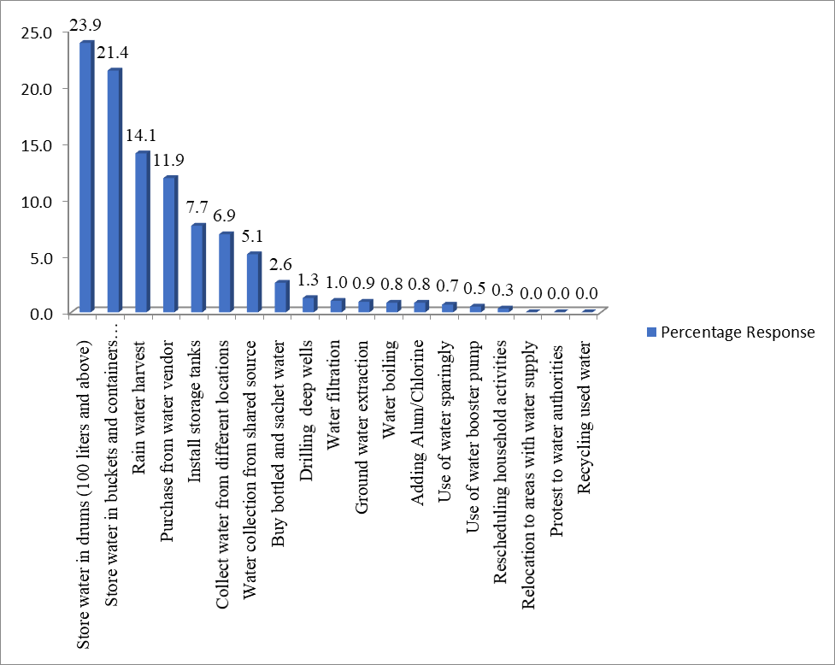

# Figure 4.20: Household Strategies in Coping with Water Shortage and Poor Public Water Supply

Source: Author’s Analysis (2021)

In the study, 14.10% of the respondents were found to engaged in rain water harvest in order to increase or conserve the quantity of water available. While this, water coping strategy is very cheap and a free gift of nature, its availability is contingent upon variability in climatic conditions and the use of appropriate method of harvesting. In addition, 11.90% of the

surveyed respondents purchased water from water vendors. This is an expensive adaptive strategy (Achore *et al.*, 2020) compared to storage of water in drums, bucket and rain water collection, as the water vendors play an intermediary role by reselling the water fetched from the water board or purchased from private borehole owners. Apart from being expensive, most times the source of the water purchased from water vendors is unknown and has health implications on the households as such water is highly susceptible to fecal contamination/ microbial loadings and other water-related germs.

Furthermore, 7.70% of the respondents reported adapting to water shortage and poverty by installation of storage tanks in their premises while 6.90% of the respondents engaged in water collection from different location. In the later scenario, most of the respondents either go around water searching or begging and even resort to buying (Abubakar, 2018; Eichelberger, 2018). A further 5.10% of the respondents adapt to water poverty by collecting water from neighbours or through share connection. As rightly noted by Abubakar (2018) water collection from neighbours or the use of share connection as a strategy is dependent on the extent of one’s relationship with neighbours.

Less than 10% of surveyed respondents however reported the buying of bottle and sachet water(2.60%), drilling of deep wells (2.60%), treatment by water filtration (1.00%) ground water extraction/digging of shallow wells (0.90%), water boiling (0.80%), water purification by adding alum/chlorine (0.80%), use of water sparingly/reduction in water consumption (0.70%), installation of booster pumps (0.50%) and rescheduling activities until when water is available (0.30%) as their adaptive strategies against water shortage and unreliable water supply.

From these results, it can be surmised that most of the adaptive strategies utilized by households against water shortage are accommodative in nature, and geared towards improving the physical access to water. In other words, these salient strategies were utilized to either increase or conserve the available water to households. Few of the households however utilized home-based water treatment strategies (water boiling, filtration and purification by adding alum or chlorination) to enhance poor water quality and strategies aimed at decreasing unreliable water supply (use of booster pump, rescheduling activities till when water is available and relocation to areas with water supply).

# Perception of the effectiveness of adaptive strategies in coping with water poverty

Table 4.30 presents the result of the perception of the respondents on the effectiveness of the nineteen (19) adaptive strategies utilized in the study area. 10 out of 19 adaptive strategies with mean scores ranging from 3.042 to 4.228 were the effective strategies used in coping with water scarcity and poverty based on a threshold value of 3.0 (effective and not effective strategies were determined by adopting a threshold of 3.0 [(1+2+3+4+5)/5] similar to that adopted in Chileshe and Kikwasi (2014) research). In addition, most of the 359 respondents in the study rated these strategies as either very effective, effective or undecided.

Based on the relative importance index, storage of water in drums (100 liters and above), rain water harvest and installation of storage tanks with mean scores of 4.228, 3.894 and 3.889 respectively were the three (3) top ranked adaptive strategies for water poverty based on respondents’ perception in the study area. Based on respondents’ responses, the fourth and fifth most effective strategies with mean score of 3.799 and 3.752 respectively were storage of water in buckets and containers (less than 25 liters) and buying of bottled and sachet water.

Findings on water storage either by installing tanks or the use of drums and containers have

been found to corroborate prior studies which showed that they are most common and well- established strategies employed by households (Zerah, 2000; Baisa *et al.*, 2010; Nastiti *et al.*, 2017; Achore *et al.*, 2020).

Purchase of water from informal vendor with a mean score of 3.717 was ranked the sixth effective strategy. However, the effectiveness of this strategy depends on the water source (Nganyanyuka *et al.*, 2014), ease to water access (Abubakar, 2018; Nastiti *et al.*, 2017) and the water quality (Rosenberg *et al.*, 2008). Based on its mean score of 3.231, drilling of deep wells was the seventh most effective water adaptive strategy in the study area. This strategy which is usually implemented for personal/household usage is an alternative to and at times complements public water source available to most households in the study area. Collection of water from different locations and from neighbourhoods/through share connections with mean scores of 3.175 and 3.128 were both ranked the eighth and ninth effective strategy respectively. The former strategy however is quite time consuming as it involves trekking long distance in search of water. The use of water sparingly with a mean value of 3.042 is ranked the least among the 10 effective strategies in coping with poor unreliable public water supply and water poverty in the study area based on the perception of the respondents.

# Table 4.30: Respondents’ Perception of Effectiveness of Adaptive Strategies to Water Poverty

|  |  |  |  |  |  |  |  |  |  |
| --- | --- | --- | --- | --- | --- | --- | --- | --- | --- |
| **S/N** | **Adaptive/Coping Strategies N=359** | **NE** | **LE** | **UD** | **EF** | **VE** | **Mean** | **RII** | **Remark** |
| **1** | Install storage tanks | 20 | 13 | 53 | 174 | 99 | 3.889 | 3 | Effective |
| **2** | Store water in buckets and containers (less than 25 liters) | 22 | 36 | 39 | 157 | 105 | 3.799 | 4 | Effective |
| **3** | Store water in drums (100 liters and above) | 5 | 14 | 31 | 153 | 156 | 4.228 | 1 | Effective |
| **4** | Collect water from different locations | 14 | 39 | 211 | 60 | 35 | 3.175 | 8 | Effective |
| **5** | Buy /purchase water from vendors | 15 | 36 | 64 | 166 | 78 | 3.713 | 6 | Effective |
| **6** | Water treatment by Filtration | 22 | 47 | 244 | 24 | 22 | 2.936 | 12 | Not Effective |
| **7** | Water treatment by Boiling | 25 | 44 | 251 | 14 | 25 | 2.916 | 16 | Not Effective |
| **8** | Water treatment by adding Alum/Chlorine | 22 | 67 | 218 | 32 | 20 | 2.891 | 18 | Not Effective |
| **9** | Rescheduling of household activities till when water is available | 24 | 37 | 251 | 38 | 9 | 2.919 | 15 | Not Effective |
| **10** | Rain water harvest | 9 | 15 | 41 | 234 | 60 | 3.894 | 2 | Effective |
| **11** | Relocate/move to another location with water supply | 14 | 42 | 265 | 24 | 14 | 2.950 | 11 | Not Effective |
| **12** | Protest / complain to water authorities | 19 | 42 | 264 | 26 | 8 | 2.894 | 17 | Not Effective |
| **13** | Drilling of deep wells | 8 | 28 | 232 | 55 | 36 | 3.231 | 7 | Effective |
| **14** | Recycling used water for other uses/Use of gray water | 22 | 50 | 258 | 24 | 5 | 2.833 | 19 | Not Effective |
| **15** | Buy bottled and sachet water | 13 | 31 | 38 | 227 | 50 | 3.752 | 5 | Effective |
| **16** | Use water sparingly/reduction in water consumption | 12 | 31 | 256 | 50 | 10 | 3.042 | 10 | Effective |
| **17** | Use of water booster pump | 19 | 40 | 258 | 29 | 13 | 2.936 | 12 | Not Effective |
| **18** | Ground water extraction/digging of shallow wells | 24 | 45 | 238 | 37 | 15 | 2.928 | 14 | Not Effective |
| **19** | Water collection from neighbours/shared source | 9 | 45 | 222 | 57 | 26 | 3.128 | 9 | Effective |

NE= Not effective; LE=Less effective; UD=Undecided; EF= Effective and VE= Very effective. RII = Relative Importance Index

On the other hand, 9 adaptive strategies with mean scores below the threshold value of 3.0 were deemed as not effective. The respondents’ responses for these 9 strategies ranged from not effective to less effective and undecided respectively. This suggests an evidence of divergence in the preponderance of the respondents’ opinions. Their mean scores equally ranged from 2.833 to 2.950. Relocate/move to another location with water supply (2.950), water treatment by filtration (2.936), use of water booster pump (2.936), ground water extraction/digging of shallow well (2.928) and rescheduling household activities till water is available (2.919) were ranked 11th, 12th, 13th, 14th and 15th adaptive strategies employed by the respondents, though not effective. In addition, water treatment by boiling (2.916), protest to water authorities (2.894), water treatment by application of alum or chlorination (2.891) and water recycling (2.833) were equally ranked 16th, 17th,18th and 19th adaptive strategies used in coping with water shortage and poverty. These strategies were equally not effective based on the respondents perceptual rating.

# Summary of Findings

The study assessed the level of water poverty in Minna, focusing on eight (8) neighbourhoods. The findings from the study are itemized below according to the objectives of the study.

# Extent of public water supply in Minna

Four (4) of the neighbourhood were within the public coverage of water supply (Tudun- Wada South, Dutsenkura, Minna-Central and F-Layout) while the other four (4) comprising Tudun-Fulani, Maitumbi, Saukakahuta and Kpakungu were partly outside the public/forma water coverage- these neighbourhoods were however observed to be situated at the urban fringe of the city.

# Households’ water sources in the study area

In terms of drinking water, only 48.30% respondents have access to improved water sources (of which 15.00% of the respondents used pipe water) while 51.70% of the respondents depend on unimproved sources. This implied that households in the study area are characterized by low level of access to public water supply and rely on other informal non- network water sources to augment improved water sources. At a disaggregate level, uneven/unbalanced access to water is noticeable in the proportion (37.88%-59.64%) of the households having improved water outside the public water coverage area.

Aside the varied water sources and the uneven access by respondents to drinking water in the four (4) neighbourhoods outside the public water coverage area, sachet water is nonetheless the predominant source of water used for drinking by respondents outside the formal coverage of public water supply in the study area. For neighbourhoods located within the public water coverage, 27.06% of the households in Dutsenkura, 49.28% in Tudun-Wada, 21.21% in F-Layout and 54.84% in Minna-Central had access to improved source of drinking water. As such, with the exception of Minna-Central, water service level in these neighbourhoods is low as water from improved sources for drinking is below the top of the service ladder occupied by unimproved water sources.

For domestic use, improved water accounts for 67.30% of the water sources used for household domestic uses based on the respondents’ responses. Although this is an improvement over unimproved sources, the provision of pipe water (which constitutes 24.10% of improved water sources) is far below the water service ladder occupied by improved sources for households’ domestic needs. Wide disparity in households’ access to

pipe water for domestic use in neighbourhoods outside the formal water service coverage area, though access to water from improved sources was fairly high. For example, Kpakungu (83.33%) has the highest proportion of respondents having access to improved water source for domestic use, followed by Maitumbi (65.22%), Tudun-Fulani (60.00%) and Saukakauta (55.95%).

In neighbourhoods within the formal water service coverage area, the proportion of respondents who hauled water from improved sources for domestic use ranged from 53.85%

-77.57% across the four neigbourhoods. While these signify a high level of household access to water for domestic purposes, it also implied that respondents augment their improved water sources with other unimproved sources.

# Level of water stress and extent of water poverty in the study area

Households in the study area are time burdened in the search for water, as they make multiple trips of at least 6 trips per day to water collection point and spent an average time of 26 min per round trip water collection. Although the entire households are saddled with the responsibility of fetching water, the women and children suffer greatly as they make multiple trips per day and engage in road crossing during abstraction of water for the home. Households spend an average of N7834 on coping with unreliable water supply for drinking

and domestic use compared to N 3185 spent on public water supply on monthly basis.

The study revealed that none out of the eight (8) neighbourhood sampled portrayed a very poor, good or excellent water poverty conditions as their score ranged between poor and fair.

Tudun wada south neighbourhood exhibited the best water situation while F-Layout has the worst water situation. Water resource availability was seen to be poor in F-Layout, Saukakauta, and Tudun-Fulani neighbourhoods whereas the remaining neighbourhoods has a fair water resource. In-term of access the study showed that two neighbourhoods (Tudun- wada and Dutsen kura) within the coverage of public water mains has a fair access except for F-Layout with a poor access (also within coverage of public water mains).

Tudun-wada South is the only neighbourhood that portrayed a good environment the remaining seven (7) neighbourhood has a fair environment condition such as improved water quality and presence of sanitation services necessary for healthy living. While the use component has the lowest water poverty index in all the eight (8) neighbourhood it shows that households exhibited a poor use and management of public water supply. The capacity to manage water and sanitation services was fairly exhibited by all the neighbourhoods in the study area.

# Comparison of water poverty index of neighbourhood within and outside public water mains

The study revealed that there exists water poverty index of neighbourhoods within the public water mains increase by 8.14% over the water poverty index of neighbourhoods which are partly outside the public water mains.

# Households adaptation measures to water poverty and unreliable water supply

The study revealed that storage of water in drums (100 liters and above), rainwater harvest and installation of storage tanks were the three (3) top ranked most effective adaptive strategies for water poverty based on respondent’s perception in the study area. Protest to

water authorities, water treatment by application of alum or chlorination and water recycling were ranked as the three (3) most ineffective adaptive strategies used in coping with water shortage and poverty in the study area.

**CHAPTER FIVE**

* 1. **CONCLUSION AND RECOMMENDATIONS**
  2. **Conclusion**

This research has employed the water poverty assessment framework (Water Poverty Index) to provide evidence on the water poverty situations of the neighbourhoods for policy intervention in the study area. The water poverty index as a multidimensional measure has highlighted the water poverty level and water needs of the neigbourhoods as well as areas where significant transitions are required in terms of improvement and prioritization. From the analysis contained in this thesis, spatial differences exist in water poverty levels of the eight neighbourhoods in the study. In this case, empirical findings from the research has shown that only Tudun-Wada South and Dutsenkura have fair water poverty level, while the six (6) neighbouhoods of Saukakahuta, Maitumbi, Kpakungu, Minna-Central, Tudun-Fulani and F-Layout are water poor and required first level policy priority attention. A further significant highlight of this research is that improvement and prioritization of the use component which is a yardstick for efficiency in water use would be advantageous to all the eight (8) neighbourhoods of the study area. This empirical investigation on water poverty would therefore be helpful to water authorities to enable them design a holistic policy to monitor and tackle the differing water poverty levels in the study area.

Beyond the outcome of the water poverty assessment in the study, limited public water coverage was observed in the study area, as improved public water supply is partly outside the reach of some neighbourhoods, especially those at the urban fringe (Maitumbi, Tudun- Fulani, Saukakahuta and Kpakungu). This limited water coverage in the study is at variance to the Sustainable Development Goal (SDG) 6.1 which requires extending improved public

water coverage by 100%. The implication of this is that un-served households residing in these neighbourhoods lack equitable access and quality water and that the burden to provide safe drinking and domestic water shift to the households. Aside, a significant outcome of this research is that access to pipe water source/supply is below the unimproved water source in the water service ladder, with households using informal non-network sources (private unprotected dug well, pond and lake, dam, water truck and water vendor) to complement their public pipe water supply for drinking and domestic use.

In view of the level of water poverty, the research has revealed that households in the study area have adopted a combination of effective and not effective coping strategies or measure against water poverty and water shortages. Most of these adaptive strategies are however accommodative in nature, and geared towards improving the physical access to water.

# Recommendations

The recommendations for the study are outlined as follows;

1. In view of the limited public water coverage, investment in water infrastructure is required by the water authorities to extend the existing public water supply network to neighbourhoods which are currently served and partly unserved, especially those neighbourhoods located in the periphery/fringe of the study area. The availability of water infrastructure would increase equitable access to safely managed water supply, reduce over-reliance on non-networked water sources/unimproved sources and household stress/burden in water search process.
2. Policy makers as a matter of priority should give first level priority attention to improving water use across all the neighbourhoods in the study area. Access requires second level priority in term of water improvement and it will be beneficial to F-Layout,

Kpakungu, Maitumbi, Saukakahuta and Tudun-Fulani. Resource is the third priority area for attention and would be advantageous to F-Layout, Saukakahuta and Tudun-Fulani.

1. Public water authorities should sensitize and create public/ household awareness on the need for effective water utilization and management of public water supply. This is against the background that virtually all households in the study area lack and engage in ineffective water use for drinking and greenery.
2. Households should imbibe the use of simple and effective technologies such as water seer (which is capable of extracting 37 litres of water per day) in coping with water poverty as most households are more kin at increasing their physical access to water.
3. A joint neighbourhood /community action on evolving effective water poverty adaptation strategies through households’ participation is required to increase the physical availability of water in the study area.

# REFERENCES

Abrahams, N. A., Hubbell, B.J., & Jordan, J.L. (2000). Joint production and averting expenditure measures of willingness to pay: Do water expenditures really measure avoidance costs? *American Journal of Agricultural Economics,* 82(2), 427–437.

Abubakar, I.R. (2012). *Households' Coping Strategies with Unsatisfactory Urban Services in a Planned City of Developing Countries* (Unpublished Doctoral dissertation). Florida State University, USA.

Abubakar, S. D. (2017). An assessment of gully erosion in selected areas of Minna, Niger State, Nigeria. IOSR *Journal of Humanities and Social Science,* 22(8), 54-59.

Abubakar, I. R. (2018). Strategies for coping with inadequate domestic water supply in Abuja, Nigeria. *Water international*, *43*(5), 570-590.

Acey, C. (2008). Neighborhood effects and household responses to water supply problems in Nigerian cities. *The Journal for Transdisciplinary Research in Southern Africa,* 4(1), 123 – 156.

Achore, M., Bisung, E., & Kuusaana, E. D. (2020). Coping with water insecurity at the household level: A synthesis of qualitative evidence. *International Journal of Hygiene and Environmental Health*, *230*, 113598.

[Adekalu, K.O.,](https://www.sciencedirect.com/science/article/pii/S0166497201000566?via%3Dihub&!) [Osunbitan](https://www.sciencedirect.com/science/article/pii/S0166497201000566?via%3Dihub&!), J.A [& Ojo,](https://www.sciencedirect.com/science/article/pii/S0166497201000566?via%3Dihub&!) O.E (2002). Water sources and demand in South Western Nigeria: Implications for water development planners and scientists. *Technovation*, 22(12), 799-805.

Adeniji-Oloukoi, G., Urmilla, B., & Vadi, M. (2013). Households' coping strategies for climate variability related water shortages in Oke-Ogun region, Nigeria. *Environmental Development*, *5*, 23-38.

Agnew, C. & Woodhouse, P. (2011). *Water resource and development*. London: Routledge.

Agrawal A., & Sanjeev, G. (2001). Group size and collective action: third-party monitoring in common-pool resources. Comparative Political Studies, 34(1), 63–93.

Ahile, S.I., Udoumoh, E.F., and Adzande, P. (2015). Residents Coping Strategies with Water Scarcity in Makurdi Town, Nigeria. *Mediterranean Journal of Social Sciences*, 6(4), 100-

108. Doi:10.5901/mj ss.2015v6n4s2p100.

Ahuchaogu, I., Etim, I., & Anwana, E. (2015). Evaluation of Seepage Losses in an Earth Lined Canal: A Case Study of University of Uyo Farm, Uyo, Nigeria. *International Journal of Engineering Sciences and Management Research*, *2*(2), 2349-6193.

Akpor, O.B., & Munchie, M. (2011). Challenges in meeting the MDGs: the Nigerian drinking water supply and distribution sector. *Journal of Environmental Science and Technology,* 4(5), pp 480-489. Doi: 10.3923/jest.2011.480.489.

Alcamo, J., Doll, P., Henrichs, T., Kaspar, F., Lehner, B., Rosch, T. & Siebert, S. (2003). Global estimates of water withdrawal and availability under current and future business as usual conditions. *Hydrological science journal,* 48, 339-348.

Alcamo, J., Florke, M., & Marker, M. (2007). Future long-term changes in global water resources driven by socio economic and climatic changes. *Hydrological science journal,* 52, 247-275.

Allan, J.A., & Karshenas, M. (1996). Managing environmental capital: the case of water in Israel, Jordan, the West Bank and Gaza, 1947 to 1995. In: Allan, J.A. & Court, J.H. (Eds.), *Water, Peace and the Middle East: Negotiating Resources in the Jordan Basin*. I.B. London: Taurus Publishers.

Anabo, A.H. (2013). The myth of ‘tragedy of the commons’ in sustaining water resources. *Mizan Law Review,* 7(2), 309-350. Doi: <http://dx.doi.org/10.4314/mlr.v7i2.5>

Anju, A. M., Vicky, S. E., & Kumar, P. S. (2017). Water poverty analysis using Water Poverty Index (WPI)-A critical review. *International Journal of Environmental Sciences & Natural Resources*, *1*(4), 1-3.

Bair, E., Hastie, T., Paul, D., & Tibshirani, R. (2006). Prediction by supervised principal components. *Journal of The American Statistical Association,* 101(473), 119-137.

Baisa, B., Davis, L., Salant, S., & Wilcox, W. (2010). The welfare costs of unreliable water services. *Journal of Development Economics,* 92(1), 1-12.

Baland, J. M., & Platteau, J.P. (1999). The ambiguous impact of inequality on local resource management. *World Development*, 27(5), 773-788.

Bartlett, S. (2003). Water, sanitation and urban children: the need to go beyond “improved” provision. *Journal of Environment and Urbanization,* 15(57), 57-70.

Bertrand, J.W.M. & Fransco, J.C. (2002). Operations management research methodologies using quantitative modelling. *International Journal of Operations and Production Management,* 22(2), 241-264.

Booysen, F. (2002). An overview and evaluation of composite indices of development. *Social indicators research*, *59*(2), 115-151.

Brown, A. and Matlock, M. (2011). A review of water scarcity indices and methodologies.

University of Arkansas white paper no. 106

Caprara, A., Lima, J. W. D. O., Marinho, A. C. P., Calvasina, P. G., Landim, L. P. & Sommerfeld,

J. (2009). Irregular water supply, household usage and dengue: A bio-social study in the Brazilian Northeast*. Cadernos de Saúde Pública,* 25, 125-136.

Chaminuka, L. & Nyatsanza, T. D. (2013). An assessment of water shortages and coping mechanisms of Harare residents: A case of Msasa Park and Dzivaresekwa Extension. *Journal of Agriculture and Veterinary Science,* 4, 21-35.

Chileshe, N., & Kikwasi, G. J. (2014). Risk assessment and management practices (RAMP) within the Tanzania construction industry: Implementation barriers and advocated solutions. *International Journal of Construction Management*, *14*(4), 239-254.

Cho, D. I., Ogwang, T., & Opio, C. (2010). Simplifying the water poverty index. *Social indicators research*, *97*(2), 257-267.

Cho, D., & Ogwang, T. (2006). Conceptual perspectives on selecting the principal variables in the purchasing managers index. *Journal of Supply Chain Management,* 42(2), 44-52.

Cho, J.S., Ahn, J.K., Kim, H.C., & Lee, D.W. (1996) Radon concentrations in groundwater in Busan measured with a liquid scintillation counter method. *Journal of Environmental Radioactivity.* 75:105–112

Cleaver, F & Toner, A. (2006). The evolution of community water governance in Uchira, Tanzania. The implications for equality of access, sustainability, and effectiveness. *Natural Resource Forum,* 30, pp. 207-218.

Cselenyi, M. N. (2013). *Policy and management of water as a common pool resource in Spain.* The case of aquifier carbonatadis de la lona de ubeda (Unpublished master thesis) Department of Human Geography, Stockholm University.

Cullis, J. and O’Regan, D. (2004). Targeting the water poor through water poverty mapping.

*Water Policy.* 6, 397-411.

Dalil, M., Mohammed, N.H, Yamman, U.M, Hussaini, A & Mohammed, S.L. (2015). An assessment of flood vunerability on physical development along drainage channels in Minna, Niger State Nigeria. *African Journal of Environmental Science and Technology,* 9(1), pp. 38- 46.

Damkjaer, S. & Taylor, R. (2017). The measurement of water scarcity: defining a meaningful indicator. *The Royal Swedish Academy of Sciences,* 46, 513–531. Doi 10.1007/S13280-017- 0912-Z.

Davis, S. & de-Wiest, R. (1970). *Hydrology.* Hoboken, New Jersey: John Wiley and sons.

Dutta, V. & Tiwari, A. P. (2005). Cost of services and willingness to pay for reliable urban water supply: A study from Delhi, India. *Water Economics, Statistics and Finance,* 5, 135-144.

Easterby-Smith, M., Thorpe, R., Jackson, P. & Lowe, A. (2008). *Management research* (3rd edition) Sage: London.

Eichelberger, L. (2018). Household water insecurity and its cultural dimensions: preliminary results from Newtok, Alaska. *Environmental Science and Pollution Research*, *25*(33), 32938- 32951.

El-Gafy, I.K. (2018). The water poverty index as an assistant tool for drawing strategies of the Egyptian water sector. *Ain shams Engineering Journal,* 9, 173-186.

Esty, D., Levy, M., Srebotnjak, T., & de Sherbinin, A. (2005). *Environmental sustainability index. Benchmarking national environmental stewardship.* New haven: Yale center for environmental law and policy.

Falkenmark, M. (1986). Fresh water: Time for a modified approach. *Ambio* 15, 192–200.

Falkenmark, M. (1989). The massive water scarcity now threatening Africa. Why isn’t it been addressed? *Ambio,* 18, 192-200

Falkenmark, M. (1994). The Dangerous Spiral: Near-future risks for water related ecoconflicts in ICRC. *Water and war*. *Symposium on water in armed conflicts.* Montreux*, 21*-23 November 1994. Geneva: International Committee of the Red Cross.

Falkenmark, M. (1997). Water scarcity, challenges for the future. In Brans, E.H.P., de Haan, E.J., Nollkaemper, A. & Rinzema, J. (eds.) 1997. *The scarcity of water: Emerging legal and policy responses*. London: Kluwer Law International

Falkenmark, M., and G. Lindh. (1974). How can we cope with the water resources situation by the year 2015? *Ambio* 3: 114–122.

Falkenmark, M., Lundqvist, J., & Widstrand, C. (1989). Macro-scale water scarcity requires micro-scale approaches: Aspects of vulnerability in semi-arid development. *Natural Resources Forum,* 13(4), 258-267.

Feitelson, E., & Chenoweth, J. (2002). Water poverty: Towards a meaningful indicator. *Water Policy,* 4(3), 263-281.

Fenwick, C. (2010). Identifying the water poor: an indicator approach to assessing water poverty in Rural Mexico. Ph.D. Thesis, London, United Kingdom: University College London.

Franks, T. & Cleaver, F. (2007). Water Governance and Poverty: A Framework for Analysis.

*Progress in Development Studies,* 7(4), 291-306.

Gardner-Outlaw, T., & Engelman, R. (1997). *Sustaining water, easing scarcity: A second update*.

Washington, DC: Population Action International.

Garriga, R.G., & Foguet, A.P. (2010). Improved method to calculate a water poverty index at local scale. *Journal of Environmental Engineering,* 136, 1287–1298.

Gautam, A. P., & Shivakoti, G. (2005). Conditions for successful local collective actions in forestry: Some Evidence from Hills of Napal. *Society & Natural Resources*, 18, 153-171.

Gerlach, E. & Franceys, R. (2009). Regulating water services for the poor: The case of Amman.

*Geoforum*, 40, 431-441.

Gerland, P., Raftery, A.E., Sevakova, H., Li, D., Gu, T., Spoorenberg, L., Alkema, B.K. & Fosdick, (2014). World population stabilization unlikely*. Science,* 346, 234–237.

Gillis, M., Perkins, D., Roemer, M., & Snodgrass, D. (1987). *Economics of Development* (2nd ed.). New York: Norton.

Gine, R., & Perez-Foguet, A. (2009). Enhancing sector data management to target the water poor.

34th WEDC International Conference, Adis Ababa, Ethiopia.

Goodstein, E. (1995). The economic roots of environmental decline: property rights or path dependence? *Journal of Economic Issues* 62, 1029.

Gosling, S. N., & Arnell, N.W. (2016). A global assessment of the impact of climate change on water scarcity. *Climate change,* 134, 371-385. <https://doi.org/10.1007/s10584-013-0853-x>.

Gulyani, S., Talukdar, D. & Kariuki, R. M. (2005). Water for the urban poor: Water markets, household demand, and service preferences in Kenya. *Water Supply and Sanitation Sector Board Discussion Paper Series.* World Bank

Hair, J., Black, B., Babin, R., Anderson, R., & Tatham, R., (2006). *Multivariate Data Analysis*, 6th ed. Prentice Hall, New York: Telex Publishers.

Hajkowicz, S. (2006). Multi-attributed environmental index construction. *Ecological Economics*

57(1), 122–139.

Hanjra, M.A., Fered, T., & Gutta, D.G. (2009). Reducing poverty in sub-Saharan Africa through investments in water and other priorities. *Agricultural Water Management,* 96(7), 1062- 1070.

Hardin, G. (1968). The Tragedy of the commons, *Journal of Science*, 162, 1243-1244. Heidecke, C. (2006). *Development and evaluation of regional water poverty index for Benin*.

Washington, DC: International food policy research institute.

Hirschman, A. O. (1970). *Exit, voice, and loyalty: Responses to decline in firms, organizations, and states.* Cambridge, Mass: Harvard University Press.

Huang, S., Feng, Q., Lu, Z., Wen, X., & Deo, R.C. (2017). Trend analysis of water poverty index (WPI) for assessment of water stress and water management policies: A case study in Hexi corridor, China. *Journal of Sustainability.* 9, 756-804. doi : 10.3390 /su9050f56

Huitema, D., Mostert, E., Egas, W., Moellenkamp, S., Pahl-Wostl, C. & Yalcin, R. (2009). Adaptive Water Governance: Assessing the Institutional Prescriptions of Adaptive Management from a Governance Perspective and Defining a Research Agenda. *Ecology and Society,* 14(1), 26.

Humplick, F., Kudat, A. and Madanat, S. (1993). *Modeling household responses to water supply: A service quality approach*. Washington, DC: World Bank

Hung, A. M., Goodwin, A., & Fini, E. H. (2017). Effects of water exposure on bitumen surface microstructure. *Construction and Building Materials*, *135*, 682-688.

Ifabiyi, P. I., Oladele, B., & Salau, W. (2020). Water poverty assessment in olorunsogo local government area of oyo state, Nigeria. *Geosfera Indonesia*, *5*(1), 92-105.

Ifabiyi, I. P., & Ogunbode, T. O. (2014). The use of composite water poverty index in assessing water scarcity in the rural areas of Oyo State, Nigeria. *AFRREV STECH: An International Journal of Science and Technology*, *3*(2), 51-65.

Ishaku, H.T., Rafee Majid, M., Ajayi, A. P., & Haruna, A. (2011). Water supply dilemma in Nigerian rural communities: looking towards the sky for an answer. *Journal of Water Resource and Protection*. 3, 598-606. doi:10.4236/jwarp.2011.38069 .

Jakus, P., Shaw, W.D., Nguyen, T., &Walker, M. (2009). Risk perceptions of arsenic in tap water and consumption of bottled water. *Water Resource. Research,* 45, (5), 1-8. doi:10.1029/2008WR007427.

Jamal, S. & Rahman, S. (2012). Adopted Community Strategies to Offset Utility Crises in a Middle-Income Locality of Dhaka, Bangladesh. *Developing Country Studies,* 2, 12-21.

Jemmali, H. (2018). Water poverty in Africa: A review and synthesis of issues, potentials, and policy implications. *Social Indicator Resources*, 136, 335-358. DOI 10.1007/s11205-016- 1521-0

Jemmali, H., & Matoussi, M. S. (2013). A multidimensional analysis of water poverty at local scale: application of improved water poverty index for Tunisia.” *Water Policy*, 15(1), 98- 115.

Jimenez, A., Molinero, J., & Perez-Foguet, A. (2008). Monitoring water poverty. A vision from development practioners. *In* llamas. LMC, M.R AND MUKHERJI, A. (eds) *Water Ethics*. Marceimo botim water forum. Oxfordshire United Kingdom**:** Taylor and Francis.

Jimenez-Cisneros, B.E., Oki, T., Arnell, N.W., Benito, G., Cogley, J.G., Doll, P., Jiang, T., & Mwakalila, S.S. (2014). Freshwater resources in climate change: Impacts, adaptation, and vulnerability. Part a: global and sectoral aspects. *In Contribution of working group II to the fifth assessment report of the intergovernmental panel on climate change*.

Jollife, I. (1972). Discarding variables in a principal component analysis. I: Artificial data.

*Applied Statistics* 21(2), 160-173.

Jowett, B. (1941). *The Basic Works of Aristotle* (in Richard Mckenon (ed.) pp.1113-1316.

Korc, M. E., & Ford, P. B. (2013). Application of the Water Poverty Index in border colonias of west Texas. *Water Policy*, *15*(1), 79-97.

Kovacevic, M. (2010). Review of HDI critiques and potential improvements. United Nations Development Programme: Human Development Report Research Paper 2010/33.

Kudat, A., Alikram, A. & Musayev, A. (1997). A social assessment of the Baku Water Supply Project. In: CERNEA, M. M. & KUDAT, A. (eds.). *Social assessments for better development: Case studies in Russia and Central Asia.* Washington, DC: World Bank.

Kudat, A., Bell, M. E., Boland, J. J., Humplick, F., Madanat, S. & Mukherjee, N. I. (1993). Reliability of urban water supply in developing countries: The emperor has no clothes. *Working Paper*. The World Bank.

Kumar, D., & Alappat, B. J. (2004). Selection of the appropriate aggregation function for calculating leachate pollution index. *Practice Periodical of Hazardous, Toxic, and Radioactive Waste Management*, *8*(4), 253-264.

Kummu, M., Guillaume, J. H. A., de Moel, H., Eisner, S., Flörke, M., Porkka, S. & Ward, P. J. (2016). The world’s road to water scarcity: Shortage and stress in the 20th century and pathways towards sustainability, *Science Report* 6, pp. 384-395. [doi.org/](https://doi.org/) 10.1038/srep38495.

Kummu, M., Ward, P.J., de Moel, H., & Varis, O. (2010). Is physical water scarcity a new phenomenon? Global assessment of water shortage over the last two millenia. *Environmental Response Letter,* 5(3), 34-36. Doi.org/10.1088/1748-9326/5/3/034006.

Lawrence, P., Meigh, J., & Sullivan, C. (2002). The Water Poverty Index: An International Comparison, Keele Economic Research Papers 19, Department of Economics, Keele University, Staffordshire, UK,

Lichtenthailer, G. & Turton, A.R**.** (1999). *Water demand management, Natural Resource Reconstruction and Traditional Value Systems: A case study from Yemen.* MEWREW occasional paper No. 14, SOAS water issues study group, University of London.

Liu, J., Oza, S., Hogan, D., Perin, J., Rudan, I., Lawn, J.E., Cousens, S., Mathers, C., & Black,

R.E. (2015). Global, regional and national causes of child mortality in 200-2013, with projections to inform post 2015 priorities: an updated systematic analysis. *Lancet,* 385(9966), pp 430-440.

Liu, J., Yang, H., Gosling, S.N., Kummu, M., Flörke, M., Pfister, S., …& Oki, T. (2017). Water scarcity assessments in the past, present and future. *Earths future* 5, 545-550. Doi:10- 1002/2016EF000518

Lyons, W. E. & Lowery, D. (1986). The organization of political space and citizen responses to dissatisfaction in urban communities: an integrative model. *Journal of Politics,* 48(2), 321- 46.

Macheve, B., Danilenko, A., Bove, A., Abdullah, R. and Moffit, L. J. (2015). *State water agencies in Nigeria: A performance Assessment*. Washington, DC: World Bank.

Madanat, S. & Humplick, F. (1993). A model of household choice of water supply systems in developing countries. *Water Resources Research,* 29, 1353-1358.

Majuru, B. (2015). *Unreliable water supplies and household coping strategies in peri-urban South Africa* (Unpublished Doctoral dissertation). University of East Anglia, Norwich.

Manandhar, S., Pandey, V., & Kazama, F. (2012). Application of water poverty index in Nepalese context. A case study of kali Gandaki river basin. *Water Resource Management,* 26(1), 89- 107.

Manandhar, S., Vogt, D. S., Perret, S. R., & Kazama, F. (2011). Adapting cropping systems to climate change in Nepal: a cross-regional study of farmers’ perception and practices. *Regional Environmental Change*, *11*(2), 335-348.

McCay, J.B. (2009). *Right to Nature: Ecological, Economic, Cultural, and Political Principles of Institutions for the Environment*. In: Hanna, S., Carl Follke, F. and Makler, K. (eds). Island Press, Washington, 115-121.

MICS (2017). *Multiple Indicator Cluster Survey.* Nigeria: NBS

Meigh, J.R., A.A. McKenzie, B.N. Austin, R.B. Bradford, & N.S. Reynard. (1999). “Assessment of Global Water Resources – Phase II, Estimates of Present and Future Water Availability for Eastern and Southern Africa.” DFID report 98/4. Wallingford, United Kingdom: Institute of Hydrology.

Molden, D., Frenken, K., Barker, R., de Fraiture, C., Mati, B., Svendsen, M., Sadoff, C., & Finlayson C.M. (2007). Trends in water and agricultural development. In water for food, water for life, ed. D. Molden. Colombo: Earthscan, London and International Water Mangement Institute.

Molle, F., & Mollinga, P. (2003). Water poverty indicators: Conceptual problems and policy issues. *Water Policy,* 5, 529-544.

Montgomery, M. A., & Elimelech, M. (2009). Increasing functional sustainability of water and sanitation supplies in rural sub-Saharan Africa. *Environmental Engineering Science*, *26*(5), 1017-1023.

Mukuhlani, T., & Mandlenkosi, T.N. (2014). Water Scarcity in Communities, Coping Strategies and Mitigation Measures: The Case of Baluwayo. *Journal of Sustainable Development*; 7(1), 144-152.

Munda, G. & Nardo, M. (2005a). Constructing consistent composite indicators: the issue of weights, Institute for the Protection and Security of the Citizen, EUR 21834 EN.

Munda, G. & Nardo, M. (2005b). Non-compensatory composite indicators for ranking countries: A defensible setting. Joint research centre, European Commission , Ispra.

Munia, H., Guillame, J.H.A., Mirumachi, N., Porkka., M., Wada, Y. & Kummu, M. (2016). Water stress in global transboundary river basins: significance of upstream water use on downstream stress. *Environmental Research Letter,* 11, 01-40.

Mycoo, M. (1996). *Water provision improvements: A case study of Trinidad. Willingness to pay, pricing policy, cost reduction and institutional strengthening*. PhD Thesis, McGill University.

Naiga, R., Penker, M., & Hogl, K. (2015). Challenging pathways to safe water access in rural Uganda: From supply to demand-driven water governance. *International Journal of the Commons,* 9(1), 237-260. URL: [http://www.thecommonsjournal.org.](http://www.thecommonsjournal.org/)

Nardo, M., Saisana, M., Saltelli, A., Tarantola, S., Hoffman, A., & Giovannini, E. (2008). *Handbook on constructing composite indicators:* Methodology and user guide. [e-book] OECD, European Commission, Joint Research Centre. Available at: <http://compositeindicators.jrc.ec.europa.eu/Handbook.htm>l.

Nastiti, A., Muntalif, B.S., Roosmini, D., Sudradjat, A., Meijerink, S.V. & Smits, A.J.M. (2017). Coping with poor water supply in peri urban Bandung, Indonesia: towards a framework for understanding risks and aversion behaviors. *International Institute for Environment Development*, 29(1), 69-88. DOI: 10.1177/0956247816686485

NEPAD (2006). Water in Africa: Management options to enhance survival and growth. Economic Nepomiluiva, D. (2017). *Water scarcity indexes: water availability to satisfy human needs*

(unpublished Bachelor’s degree thesis). Helskini University of applied sciences.

Nganyanyuka, K., Martnez, J., Wesselink, A., Lungo, J.H., & Georgiadou, Y. (2014), “Accessing water services in Dar es Salaam: Are we counting what counts?”, *Habitat International,* 44, 358-366.

National Bureau of Statistics. (2006). *Proceedings 5th Meeting of Directors of Planning, Research & Statistics Departments (PRSDs) of Federal Ministries, Departments and Agencies (MDAs)*. National Bureau of Statistics.

Niger State Bureau of Statistics (2014). Socio- Economic Survey. NSBS with technical support of National Bureau of Statistics, Nigeria.

Niger State Water Board (2019). Making the provision of water a birth right of the people.

*Progress report for the period of October 1975 to October 2015.*

NPC (2006). *2006 National Population Census Data*. Abuja: National Population Commission.

Nyarko, Y. (2008). Is the brain drain good for Africa?. *Brookings Global Economy and Development Working Paper*, (19).

OECD (Organisation for Economic Co-operation and Development), (1993). Core set of indicators for environmental performance reviews. A synthesis reports by the group on the state of the environment. Rep. no. 83 paris.

Offodile, M.E (2002). Ground water study and development in Nigeria. In: C.A. Kogbe (ed)

*Geology in Nigeria*. Minna: publication RD.

Ogunbode, T. O., & Ifabiyi, I. P. (2017). Application of Water Poverty Index (WPI) in Assessing Water Accessibility in the Rural Suburbs of Ogbomoso Zone of Oyo State, Nigeria. *Asian Journal of Environment & Ecology*, 1-9.

Ogwang, T. (1994). The choice of principle variables for computing the Human Development Index. *World Development,* 22, 2011-2014.

Ogwumike, F. O. (1991). A basic needs-oriented approach to the measurement of poverty in Nigeria. *The Nigerian Journal of Economic and Social Studies*, *33*(2), 105-120.

Ohlsson, L. (1999). *Environment, Scarcity and Conflict: A Study of Malthusian Concerns*.

Department of Peace and Development Research. University of Göteborg

Ohlsson, L. (2000). Water conflicts and social resource scarcity. Physics and chemistry of the earth, part B. *Hydrology Oceans and Atmosphere*, 25, 213-230.

Ohlsson, L. & Turton, A. (2000). The turning of a screw. Social resource scarcity as a bottle neck in adaptation to water scarcity. *Stockholm Water Front,* 1, 10-11.

Oki, T., & Kanae, S. (2006). Global hydrological cycles and world water resources. *Science*, 313(5790), 1068-1072.

Olajuyigbe, A. (2010). Some factors impacting on quantity of water used by households in a rapidly urbanizing state capital in South Western Nigeria. *Journal of Sustainable Development in Africa*, *12*(2), 321-37.

Oni, O. A., & Fashogbon, A. E. (2013). Food poverty and livelihoods issues in rural Nigeria. *African Journal of Agricultural and Resource Economics*, *8*(311-2016-5562), 108- 135.

Ostrom, E., & Hess (2001). *Artifacts, Facilities and Content: Information as a common pool resource.* Conference on Public Domain, Duke Law School, November, pp 9-11.

Ostrom, E. (1990). *Governing the Commons: The evolution of institutions for collective action.*

New York: Cambridge University Press, pp. 90-105.

Ostrom, E. (2008). ‘The Challenges of Common- pool Resources’, *Environment: Science and Policy for Sustainable Development,* 50(4), 10-11.

Ostrom, E., Gardner, R., and Walker, J. (1994). *Rules, Games, and Common-Pool Resources.*

*Ann Arbor,* MI: University of Michigan Press.

Ostrom, E., Stern, P.C., and Dietz, T. (2003). Water rights in the commons. *Water Resources Impact*, 5(2), 9-12.

Pasakhala, B., Harada, H., Fujii, S., Tanaka, S., Shivakoti, B. R., & Shrestha, S. (2013). Household coping measures with water scarcity: A case study in Kathmandu, Nepal. *Journal of Japan Society of Civil Engineers Series Giornale (Environmental Research)*, *69*, 73-81.

Paulson, R. (2015). *What Is Water Scarcity*? Available From: [Https://Www.Rwlwater.Com/What-Is-Water-Scarcity/](https://www.rwlwater.com/what-is-water-scarcity/).

Pereira, L.S., Cordery, L. and Lacovides, L. (2009). Coping with water scarcity: Addressing the challenges. New York: Springer.

Pickering, A.J., & Davis, J. (2012). Freshwater availability and water fetching distance affect child health in sub-saharan Africa. *Environmental and Water Studies, Civil and Environmental Engineering.* 46, 2391-2397. dx.doi.org/10.1021/es203177v

Poteete, A. R., Janssen, M.A., & Ostrom. E. (2010). *Working together: Collective Action, the Commons, and Multiple Methods in Practice.* Princeton and Oxford: Princeton University Press.

Potter, R.B., & Darmame, K. (2010). Contemporary social variations in household water use, management strategies and awareness under conditions of “water stress”: The case of Greater Amman, Jordan. *Habitat International*. 34, 115–124

Rached, E., Rathgeber, V., & Brooks, D.B (1996). *Water Management in Africa and the Middle East: Challenges and Opportunities.* Canada: IDRC Books.

Raskin, P., Gleick, P., Kirshen, P., Pontius, G., & Strezepek, K. (1997). Water futures: assessment of long-range pattern sand problems. Background document for Chapter 3 of the *Comprehensive assessment of Freshwater Resources* of the World. Boston, MA: Stockholm Environment Institute.

Raskin, P.D., Hansen, E. & Margolis, R.M. (1996). Water and sustainability: Global patterns and long-range problems. *Natural Resources Forum* 20, 1–15.

Reigh P, Maddocks, A., & Gassert, F. (2013). World’s 36 most water-stressed countries. World Resources Institute.

Remenyi, D., Williams, B., Money, A., & Swartz, E (1998). *Doing research in business and management. An introduction to process and method*. London: Sage .

Rijsberman, F. R. (2006). Water scarcity: Fact or fiction. *Agricultural Water Management*, 80(1), 5-22.

Rockstrum, J., & Falkenmark, M. (2015). Agriculture: Increase in water harvesting in Africa.

*Nature*, 519.

Rockstrum, J. (2011). Green water security for the food makers of tomorrow. Window for opportunity in drought. *Journal of Water Science and Technology,* 43, 71-78.

Rosenberg, D. E., Talozi, S., & Lund, J. R. (2008). Intermittent water supplies: Challenges and opportunities for residential water users in Jordan. *Water International*, *33*(4), 488-504.

Rovira, J.S., & Rovira, P.S. (2008). “Assessment of aggregated indicators of sustainability using PCA: the case of apple trade in Spain.” Conference on Life Cycle Assessment in the Agri- Food Zurich. 133–143.

Rusbult, C. E., Zembrodt, I. M. & Gunn, L. K. (1982). Exit, Voice, Loyalty and Neglect: Responses to dissatisfaction in romantic relationships. *Journal of Personality and Social Psychology,* 43(6), 1230-1242.

Saisana, M., & Tarantola, S. (2002). State of the art report on current methodologies and practices for composite indicator development. Rep. no, EUR 20408 EN, European Commission, JRC, Ispra, Italy.

Salameh, M. K., & Jaber, M. Y. (2000). Economic production quantity model for items with imperfect quality. *International journal of production economics*, *64*(1-3), 59-64.

Salzman, J. & Thompson, B.H (2010). *Environmental Law and Policy*, 3rd Edition, Thomson Reuters, pp. 47.

Sanusi, Y.A. (2006). *An assessment of the spatial relationship between poverty and environmental quality in Minna Metropolis,* Niger state Nigeria. An unpublished PhD thesis submitted to Federal University of Technology Minna Niger State.

Sanusi, Y.A. (2010). Water, sanitation and human development in urban fringe settlements in Nigeria. *Theoretical and Empirical Researches in Urban Management*. 5(8), pp. 14-29.

Saunders, M., Lewis, P. & Thornhill, A. (2012). *Research methods for business students* (6th edition), London: Prentice hall.

Savenije, H.H.G. (1999). Water scarcity indicators: The deception of numbers. Physics and

*Chemistry of the Earth* 25, 199-204.

Schulte, P. (2014). Defining Water Scarcity, Water Stress, and Water Risk: It’s Not Just Semantics [online]. Pacific Institute, Insights. <http://pacinst.org/water-definitions/>.

Seckler, D., Amarasinghe, U., David, M., de Silve, R. & Barker, R. (1998a). World water demand and supply, 1990–2025: Scenarios and issue research report 19. Colombo: *International Water Management Institute.*

Seckler, D., Molden, D., & Barker, R. (1998b). Water scarcity in the twenty-first century.

Colombo: IWMI Water Brief 2, *International Water Management Institute*

Simon, R.F., Duntoye, D.B. & Oyewole, K. (2018). The effects of urbanization on micro-climate of Minna Urban Area. *Journal of Geography, Environment and Earth Science International*, 15(1), 1-13.

Singh, R.P., Nath, S., Prasad, S.C., & Nema, A.K. (2008). Selection of suitable aggregation function for estimation of aggregate pollution index for river Ganges in India. *Journal of Environmental Engineering,* 126(5), 451-455.

Sorenson, S. B., Morssink, C., & Campos, P. A. (2011). Safe access to safe water in low income countries: water fetching in current times. *Social science & medicine*, *72*(9), 1522-1526.

Subbaraman, R., Shitole, S., Shitole, T., Sawant, K., O’brien, J., Bloom, D. E. & Patil-Deshmukh,

A. (2013). The social ecology of water in a Mumbai slum: failures in water quality, quantity, and reliability. BMC Public Health, 13, 173.

Sullivan, C.A. (2002). Calculating a water poverty index. *World Development*, 30(7), 1195-1210.

Sullivan, C. A., Meigh, J. R., Giacomello, A. M., Fediw, T., Lawrence, P., Samad, M., …Steyl,

I. (2003). The Water Poverty Index: Development and Application at the community scale.

*Natural Resources Forum* 27(3), 189-199.

Sullivan, C., Meigh, J., & Lawrence, P. (2006). Application of the water poverty index at different scales: A cautionary tale. *Water International,* 31(3), 412-426.

Sullivan, C. A., & Meigh, J. (2007). Integration of the biophysical and social sciences using an indicator approach: Addressing water problems at different scales. *Water resources management*, *21*(1), 111-128.

Sullivan, C.A., & Jemmali, H. (2014). *Toward understanding water conflicts in Mena Region:* A Comparative analysis using Water Poverty Index. Working Paper 859.

Swamee, P.K., & Tyagi, A. (2000). Describing water quality with aggregate index. *Journal of Environmental Engineering,* 134(8), 689-701.

Swamee, P.K., & Tyagi, A. (2007). Improved method for aggregation of water quality subindices.

*Journal of Environmental Engineering,* 133(2), 220-225.

Swatuk, L. A. (2002). The new water architecture in southern Africa: reflections on current trends in the light of ‘Rio+ 10’. *International Affairs*, *78*(3), 507-530.

Swiss Agency for Development and Cooperation (SADC), (2008). *A human rights-based approach to water and sanitation*. Sweden: SADC.

Taylor, R. (2009). Rethinking water scarcity: The role of storage. Eos. *Transactions American Geophysical Union,* 90: 237–238.

Turton, A. R., & Ohlsson, L. (1999). Water scarcity and social stability: towards a deeper understanding of the key concepts needed to manage water scarcity in developing countries. SOAS Working Paper. (University of London, London).

Um, M., Kwak, S., & Kim, T. (2002). Estimating willingness to pay for improved drinking water quality using averting behavior method with perception measure. *Environment Resource Economy* 21(3), 287–302.

UN (2015). Sustainable Development Goals: 2030 *Agenda for Sustainable Development*.

Available at: <https://sustainabledevelopment.un.org/?menu=1300>.

UNCED (1992). Report of the United Nations Conference on Environment and Development.

New York: United Nations.

UN-Water, & FAO (2007). Coping with Water Scarcity: *Challenge of the Twenty-First Century*

[www.fao.org/nr/water/docs/escarcity.pdf](http://www.fao.org/nr/water/docs/escarcity.pdf)

Vasquez, W.F. (2012). Reliability perceptions and water storage expenditures: Evidence from Nicaragua. *Water Resource Research*, 48, (10), 547-555. doi:10.1029/2011WR011024.

Venkataramanan, V., Lopez, D., McCuskey, D. J., Kiefus, D., McDonald, R. I., Miller, W. M., ... & Young, S. L. (2020). Knowledge, attitudes, intentions, and behavior related to green infrastructure for flood management: A systematic literature review. *Science of The Total Environment*, *720*, 137606.

Virjee, K. & Gaskin, S. (2010). Coping with poor water services and the demand for change in Trinidad and Tobago. *Water International,* 35, 285-297.

Vorosmarty, C. J., Green, P., Salisbury, J., and Lammers, R. B. (2000). Global water resources: Vulnerability from climate change and population growth. *Science*, 289(5477), 284-288.

Wada, Y., van Beek, L.P.H. & Bierkens. M.F.P. (2011). Modelling global water stress of the recent past: On the relative importance of trends in water demand and climate variability. *Hydrology and Earth System Sciences* 15, 3785–3808.

WASH Poverty Diagnostics (2016). *A wake-up call. Nigeria water supply, sanitation, and hygiene poverty diagnostic.* World bank group: Washington DC.

WASH-NORM (2018). *Nigeria water sanitation and hygiene-national outcome routine mapping survey.* Nigeria: Federal Ministry of Water Resources in collaboration with National Bureau of Statistics.

Watkins, K. (2006). Beyond scarcity: power, poverty and the global water crisis. In B. Ross- Larson, M. Coquereaumont & C. Trott. *Human development report summary*. Newyork: Printing Company America.

White, C. (2012). Understanding water scarcity: Definitions and measurements, Global Water Forum. <http://www.iwmi.cgiar.org/News_Room/pdf/Understanding_water_scarcity.pdf>?

WHO/UNICEF/JMP (2017). *Progress on drinking water, sanitation and hygiene*. world health organization and united nations children’s fund, Geneva: WHO/UNICEF/JMP

WHO/UNICEF/ Joint Monitoring Programme for water supply and sanitation (2010). *Data resource and estimates*. Geneva: WHO/UNICEF

World Bank (2014a). Fact Sheet: *Infrastructure in Sub-Saharan Africa*. World Bank (2014b). Water public private partnerships in Africa”,

World Bank. (2001). *World development report 2000/2001: Attacking poverty*. The World Bank.

World Bank. (1999). *Decentralization: Critical implementation Issues for Rural water Supply and Sanitation Sub-sector in Uganda. A consultancy reports.* Washington DC, USA: World Bank.

World Economic Forum (2017). Global risks report 2017.

World Water Assessment Program (WWAP, 2001), World Water Assessment Programme (WWAP) Mid-Term Report.

Xin L, Wan Jun, W., & Jielin, J. (2011). Application of the water poverty index at the districts of yellow river basin. *Advance Master Research,* 250-253: 3469-3474.

Yahaya, O., Akinro, A., Kehinde, M., & Ologunagba, B. (2009). Evaluation of water poverty index in Ondo state, Nigeria. *ARPN Journal of Applied Irrigation Science*, 44(2), 249-265.

Yang, H. (2008). “Globalization of water resources through virtual water trade.” Rosemberg International Forum on Water Policy.

Yoo, S. (2005). Analysing household bottled water and water purifier expenditures: Simultaneous equation bivariate tobit model. *Applied Economic Letter*, 12(5), 297–301.

Zahra, K., Haider, S.H., Mahmood, A. & Ullah, S. (2012). Measuring water poverty index in urban areas of Punjab. *Journal for the Advancement of Development Economics.* 1(1), 40- 52.

Zerah, M. H. (2000). Household strategies for coping with unreliable water supplies: The case of Delhi. *Habitat International,* 24, 295–307

Zlotnik, H. (2016). World Population Will Increase By 2.5 Billion By 2050; People Over 60 To Increase by More Than 1 Billion, United Nations. Available From: [Http://Www.Un.Org/Press/En/2007/Pop952.Doc.Htm](http://www.un.org/press/en/2007/pop952.doc.htm).