

# ASSESSMENT OF WATER AVAILABILITY UNDER THE INFLUENCE OF CLIMATE VARIABILITY IN GORONYO RESERVOIR, SOKOTO STATE, NIGERIA

**Lukman Adesile MUHAMMED**

**DEPARTMENT OF WATER RESOURCES AND ENVIRONMENTAL ENGINEERING,**

**FACULTY OF ENGINEERING, AHMADU BELLO UNIVERSITY, ZARIA, NIGERIA**

**NOVEMBER, 2021**

**ASSESSMENT OF WATER AVAILABILITY UNDER THE INFLUENCE OF CLIMATE VARIABILITY IN GORONYO RESERVOIR, SOKOTO STATE, NIGERIA**

**Lukman Adesile MUHAMMED B.Eng**. **(ABU) 2014 P16EGWR8032**

**A DISSERTATION SUBMITTED TO THE SCHOOL OF POSTGRADUATE STUDIES, AHMADU BELLO UNIVERSITY,**

**IN PARTIAL FULFILLMENT OF THE REQUIREMENTS FOR THE AWARD OF MASTER OF SCIENCE DEGREE IN WATER RESOURCES AND ENVIRONMENTAL ENGINEERING**

**DEPARTMENT OF WATER RESOURCES AND ENVIRONMENTAL ENGINEERING,**

**FACULTY OF ENGINEERING AHMADU BELLO UNIVERSITY ZARIA, NIGERIA**

**NOVEMBER, 2021**

# DECLARATION

I declare that the work in this dissertation entitled ―**Assessment of Water Availability Under the Influence of Climate Variability in Goronyo Reservoir, Sokoto State, Nigeria**‖ has been performed by me in the Department of Water Resources and Environmental Engineering. And all the literature consulted is duly referenced. No part of this dissertation was previously presented for another degree at this or any other Institution.

**Lukman Adesile MUHAMMED**

**P16EGWR8032 Signature Date**

# CERTIFICATION

This dissertation entitled **“ASSESSMENT OF WATER AVAILABILITY UNDER THE INFLUENCE OF CLIMATE VARIABILITY IN GORONYO RESERVOIR,**

**SOKOTO STATE, NIGERIA”** by **Lukman Adesile MUHAMMED** as required by the governing body for the award of Master of Science in Water Resources and Environmental Engineering.

**Prof. (Engr.) A. Ismail**

**Chairman Supervisory Committee Signature Date**

**Dr. B. K. Adeogun**

**Member Supervisory Committee Signature Date**

**Prof. (Engr.) M. A. Ajibike**

**Head of Department Signature Date**

**Prof. Sani A. Abdullahi**

**Dean, School of Post Graduate Studies Signature Date**

# DEDICATION

This work is dedicated to Almighty Allah, Mohammed‘s Family, and my loved ones.

# ACKNOWLEDGEMENTS

Utmost gratitude to Almighty Allah (the creator of the universe, living and non-living things) for providing the ability, good health, and resources to perform this study. May the peace and blessings of Allah be on the noble Prophet, Muhammad (SAW).

Profound appreciation and gratitude to my supervisors, Prof. (Engr.) A. Ismail, Dr. B.K. Adeogun for the patient guidance and mentorship rendered to me through their unquantifiable suggestions, inspiration for hard work, and accuracy. I will forever be grateful. Special thanks to Dr. A.S. Argungu for always accommodating me during my impromptu visits to his office whenever I need consultations.

Undiluted gratitude and thank you to my brother Dr. I.B. Mohammed for all his support morally, physically, and financially. I owe you a lot and I will always make you proud. To my loving family (Entire Mohammed‘s Family) I am indeed grateful for all the continuous love, support, encouragement, and prayer towards my academic endeavours. May we live long to enjoy the fruits of our labour.

Sincere thanks and gratitude to all the staff of this Department, Water Resources and Environmental Engineering. From Academics Staff to Non-Academics staff for every bit of your actions is a motivation to me. To all my friends and Coursemate I said a very big thank you for your support and encouragement. For others too numerous to mention that contributed in one way or the other towards the success of this work. May Almighty Allah reward you all abundantly. Thank you.

# ABSTRACT

Climatic parameters are exposed to variation due to the atmospheric concentration of greenhouse gases. Hence, it is essential to assess the water availability and demand under the climate variation in Goronyo Reservoir, Sokoto State Nigeria. since the supply of water is one of the significant tasks in water resources management. In this study, estimation of available water, demand, and unmet demand was simulated using Water Evaluation and Planning (WEAP) Software with the opinion of assessing the availability of water for its uses under climate change, The Reservoir is situated in Goronyo Local Government Area, Sokoto State, Northwest Nigeria. The study uses Water Evaluation and Planning (WEAP model) software to assess the influences of climate variability on the water availability of the area. This model allows simulation and analysis of various scenarios and water allocations. The water availability, Demand, Supplies, and Unmet were modeled with climatic data and water use rate. The model was satisfactorily calibrated and validated. Simulations were proposed for various climatic situations considering global climate change model (GCM) predictions and the linear trend of the data. Nine (9) selected climate change scenarios of temperature increases (i.e. 0, +0.4, +0.8, +1.2 oC) combined with an increase or decrease in rainfall (0, -10%, +10%) were applied for the study area in the WEAP model software for simulation. The model was used to analyze the linkage between water availability and demand for domestic and irrigation uses. This was projected to the future to analyze what would happen in years to come up to 2070. The demand and unmet were obtained as the output of the model. Results showed that the mean average volume of 737.9 million cubic meters (MCM), the maximum average volume of 824.3 MCM mainly in the wet period ranges from May – October, and the minimum mean average volume of

546.6 MCM mostly in a dried month i.e. April available in the reservoir. The annual total demand for various uses from 2018 to 2070 was obtained to be 7069.4 MCM and the annual average of 133.4 MCM. Meanwhile, the unmet demand was with annual total ranges from 1157.5 MCM to 1199.7 MCM and an annual average of 21.84 MCM to 22.64 MCM. The highest unmet was recorded under Scenario 9 with a 1.2 oC increase in temperature and a 10% decrease in precipitation. In Conclusion, it was found that the demand in the area is 6 times higher in years to come i.e. 50 years from now and the deficit is 61% increased. It is recommended that the irrigation system (furrow irrigation system) should be improved to minimized water demand and also extraction from other means such as groundwater could relieve the stress on the available source, the reused of wastewater for other domestic uses such as the washing of lawn and watering of gardening will also help a lot in utilizing limited available resources.

## Table of Contents

TITLE PAGE ii

DECLARATION iii

CERTIFICATION iv

DEDICATION v

ACKNOWLEDGEMENTS vi

ABSTRACT vii

Table of Contents viii

List of Figures xi

List of Tables xiii

Abbreviations xiv

CHAPTER ONE 1

INTRODUCTION 1

* 1. Background to the Study 1
  2. Statement of The Research Problems 4
  3. Aim and Objectives 5
     1. Aim 5
     2. Objectives 5
  4. Justification 6
  5. Scope of The Study 6
  6. Limitation 7

CHAPTER TWO 8

LITERATURE REVIEW 8

* 1. Climate 8
     1. Climate System 8
     2. Climate Change and Climate Variability 9
     3. Global Climate Change 10
     4. Climate Variability and Change in Nigeria 11
     5. Impacts of Climate Change 13
  2. Climate Change Modelling 14
     1. Climate Change Scenarios 14
  3. Hydrological Modelling and Its Significance 17
     1. Classification of Hydrologic Models 18
     2. Types of Hydrologic Models 19
  4. Climate Change and Its Effect on Water Resources 22
  5. The Water Evaluation and Planning (WEAP) Model 23
     1. Approach of WEAP Model 24
     2. Formulation for Linear Program in WEAP 25
     3. Applications of WEAP (Model) Software 30

CHAPTER THREE 34

MATERIALS AND METHODS 34

* 1. Description of the Study Area 34
  2. The Study Area 34
     1. Climate 36
     2. Topography 37
     3. Demography 38
     4. Features of the Dam 38
     5. Irrigation Scheme within the Area 39
  3. Research Procedure 39
  4. Analysis of the Temperature trend for Generating Climate Scenarios40
  5. Analysis of the Rainfall trend for Generating Climate Scenarios 41
  6. Climate Scenarios Generation 41
  7. Inflow, Outflow and Storage volume 43
  8. Classification of Water Year 43
  9. Calibration and Validation of the WEAP Model 45
  10. Analysis of Climate Change Impact on Water Availability 46
  11. Water Demand 48
  12. Questionnaire Analysis 49

CHAPTER FOUR 50

RESULTS AND DISCUSSION 50

* 1. Introduction 50
  2. Trend Analysis 51
  3. Analysis of the Temperature trend for Generating Climate Scenarios54
  4. Analysis of the Rainfall trend for Generating Climate Scenarios 54
  5. Streamflow Simulation 69
  6. Calibration and Validation Result 69
  7. Simulated Storage Volume 71
  8. Impact of Climate Change on Water Availability 72
  9. Demand Sites 72
  10. Demand Site Reliability on Water Availability 75
  11. Comparison of Scenarios on Water Availability 76
  12. Forecasting the Future Available Water 83
  13. Analysis of Questionnaire 87
      1. Water Consumptive Use. 87
      2. Domestic Water Demand 88

CHAPTER FIVE 88

CONCLUSION AND RECOMMENDATIONS 88

* 1. Conclusion 88
  2. Recommendations 89

REFERENCES 90

APPENDICES 99

APPENDIX A 99

APPENDIX A 99

APPENDIX B 102

APPENDIX C 103

## List of Figures

**Figure Page**

* 1. : Graphical Illustration of the Components of Climatic System 9
  2. : The Established Scenarios from IPCC Special Report on Emission Scenarios 16
  3. : Basic Classification of Models 21
  4. : The Study Area (Goronyo Reservoir) 35
  5. : The Schematic (view) map of the area showing the reservoir and demands nodes 38
  6. : Setting up of all Scenarios 46
  7. : Water year values 46
  8. : Domestic water demand of reference account 48
  9. : Water demand including all branches of reference account 48
  10. : The mean monthly temperature of the area 50
  11. : The annual average temperature of the area 51
  12. : The chart of the mean monthly rainfall of the area 51
  13. : The annual rainfall data of the area 52
  14. Monthly Average Streamflow Measured for Rima River 52
  15. Temperature Trend Analysis 53
  16. Rainfall in mm Trend Analysis 54
  17. : Comparison of simulated and measured streamflow of River. 71
  18. : Reservoir storage volume 71
  19. Domestic water demand for the reference scenario 73
  20. Falalia Irrigation water demand for the reference scenario 74
  21. Taka Kume irrigation water demand for the reference scenario 75
  22. Mai Yali irrigation water demand for reference scenario 75
  23. Demand site reliability before projection 76
  24. : Streamflow below node and reach 77
  25. Streamflow of all scenarios compares with reference scenario 77
  26. : Streamflow for all scenarios compared with scenario 1 78
  27. : Streamflow for all scenarios compared with scenario 2 79
  28. : Streamflow for all scenarios compared with scenario 3 79
  29. : Streamflow for all scenarios compared with scenario 4 80
  30. : Streamflow for all scenarios compared with scenario 5 80
  31. : Streamflow for all scenarios compared with scenario 6 81
  32. : Streamflow for all scenarios compared with scenario 7 81
  33. : Streamflow for all scenarios compared with scenario 8 82
  34. : Streamflow for all scenarios compared with scenario 9 82
  35. : Streamflow of Rima river for all scenarios projected to 2070 83
  36. : Water Demands projected to 2070 84
  37. : Unmet Demand for all Demands 85
  38. : Average Monthly Unmet Demands for reference scenario 85
  39. : Average Monthly Unmet Demands for all scenarios 85

4.31. Water Usage versus Frequency 88

## List of Tables

**Table Page**

* 1. : Demography of the Area 37
  2. : Hypothetical Climate Change Scenarios 41
  3. : Hypothetical Climate Change Reference Scenario Data 43
  4. : Domestic Water Uses Per Capita Per Day 49
  5. : Hypothetical Climate Change Scenario One (1) Data 55
  6. : Hypothetical Climate Change Scenario Two (2) Data 57
  7. : Hypothetical Climate Change Scenario Three (3) Data 59
  8. : Hypothetical Climate Change Scenario Four (4) Data 61
  9. : Hypothetical Climate Change Scenario Five (5) Data 62
  10. : Hypothetical Climate Change Scenario Six (6) Data 63
  11. : Hypothetical Climate Change Scenario Seven (7) Data 65
  12. : Hypothetical Climate Change Scenario Eight (8) Data 66
  13. : Hypothetical Climate Change Scenario Nine (9) Data 68
  14. : The simulated versus measured average monthly streamflow of Rima

river analysis. 70

* 1. : Effect of different climate scenarios to volume of water storage in the

reservoir 72

* 1. : Storage volume of Goronyo dam for all Scenario after Projection 84
  2. Projected Demand and Unmet for all Branches Using 120l/c/d 86
  3. : Projected Demand and Unmet for all branches Using 135l/c/d 87
  4. : Domestic Water Uses of the study area 88

## Abbreviations

|  |  |
| --- | --- |
| IWRM | Integrated Water Resources Management |
| WMO | World Meteorological Organization |
| RCM | Regional Climate Model |
| GCM | General Circulation Models |
| OGCM | Oceanic General Circulation Model |
| AOGCM | Atmospheric – Oceanic General Circulation Models |
| MCM | Million Cubic Meters |
| GRIP | Global Rice Science Partnership |
| AGCM | Atmospheric General Circulation Models |
| WHO | World Health Organization |
| FAO | Food and Agricultural Organization |
| SEI | Stockholm Environmental Institute |
| ITCZ | Inter-Tropical Convergence Zone |
| IPCC | Inter-Governmental Panel on Climate Change |
| SCN | Scenario |

# CHAPTER ONE

# INTRODUCTION

## Background to the Study

The most important element or component to life on earth is water, often it is a scarce

/rare resource that is ultimate for living. It is most imperative and fundamental in many parts of the universe for both domestics and agricultural uses, the means to accomplish and achieve sustainability in production systems. It is crucial to maximizing net return with the resources available but this could be regarded as a complex problem because of factors that affect this process, for example, climatic variation, the configuration of irrigation system, subsidy policies, and costs of production. Numerous districts are confronting daunting freshwater management difficulties, distribution of limited water resources, ecological quality, and policies for maintainable or sustainable water use are issues of expanding concern (Uitto, 2004; Conway et al., 2009).

The human population is fast-growing, the fast advances made in the industry and agriculture have brought about a rapidly expanding or increasing utilization of water by man, to the degree that water availability as well as, the control of unnecessary water use has become an important issue in the advancement of districts of the world (Williams, 2010). Over the last years, it has been established that supply management is inadequate in solving the massive competition for water with increasing per capita water use, population increment, urbanization, pollution, and storage (Wang et al, 2009). Similarly, UNESCO (2006), established that the requirement for various uses such as municipal, industrial, farmland, and supply is increasing, yet lack of demand

management policies implies that increasing demand will likely exceed the supply available, thus water shortage.

The term climate is regularly referred to as the normal weather condition of a place over an extensive period. Likewise, in a detailed form, as the statistical explanation in terms of the mean and variability of pertinent amounts over some time extending from months to thousands or a huge number of years. The usual time frame is 30 years, as characterized by the World Meteorological Organization. The Intergovernmental Panel on Climate Change (IPCC) built up the variation of the earth temperature for as long as 140 years (Abdullahi et al., 2014)

The fourth evaluation report of IPCC demonstrated that the temperature during 1995- 2006 at the global level has increased and the occurrence of hefty precipitation became more recurrent. Additionally, the global average surface temperature as forecasted for 2080 – 2099 will ascend between 1.1oC and 6.4oC greater than what it was from 1980 - 1999, and this leads to an increase in crop productivity (IPCC 2007). It evidently illustrates the effect of variation in climate. The most advanced tool to simulate the global climate system response to greenhouse gas concentrations is General Circulation Models (GCMs), with models, an assessment of the future climate would be possible (Yang et al., 2011; Hsu et al., 2011), and the issue of uncertainty may be moderated by considering multiple models (Liu, et al., 2009; Huang, et al., 2012). In accordance with some literature, there will be additional problems as regards the management of water resources because of differences in rainfall distribution and increase in temperature as a result of a change in the climate. climatic variation increases changes in atmospheric conditions and thereby changed water resources, their circulation in space and time, the hydrological cycle of water bodies, and water quantity. The water cycle is altered by climate change, but due to the complexity of the

hydrosphere in the Earth system, it is challenging to predict how precipitation patterns might go.

According to Abdullahi (2014), the people living in Sokoto consider rivers and streams within the basin as a significant source of surface water for their municipal and agricultural demands. Consequently, even a small reduction in runoff within the watershed could have dramatic effects on the welfare of the region. climate variations will bring about a quick increase in the surface temperature, alterations in the pattern of precipitation, and evapotranspiration rates (Vicuña *et al*., 2011).

Modeling and investigation techniques for assessing the water distribution competencies of reservoir/river systems are essential to the proper management of the highly variable water resources of a watershed. The use of hydrologic and institutional is paramount in evaluating the availability of water and the soundness of such appraisals (Sieber *et al.,* 2002).

WEAP is an acronym for water evaluation and planning model is a software model for integrated water resources planning which operate on the basic principle of the water balance equation, it is a water evaluation and planning system developed by Stockholm Institute which provides capabilities for comparing water demands and supplies as well as forecasting demands. It has an accessible interface and transparent data structure that make it suited as a tool for delibrations between a diverse group of stakeholders (SEI, 2007).

WEAP is a generic computer tool that is suitable mainly for water surface water planning, it doesn‘t take into consideration groundwater input, though improvement is being made over time to increase its suitability, however, because of its generic nature, it is not capable of capturing every fine distinction of water resource system.

The requirement of various water demands would be affected by the variation of meteorological events under the conditions of climatic variability, the reservoir which was constructed to cater for flood control, water supply, recreation, fishing, and so on. This research work is to assess the impact of climate variability on water availability for various usage in Goronyo Reservoir, Nigeria.

## Statement of The Research Problems

Climatic parameters are exposed to variation due to the atmospheric concentration (the composition) of greenhouse gases. These lead many researchers to carry out studies on the influences of climatic variability on various water usage or demands since the supply of water is one of the most significant tasks for water management. An impact evaluation of water demand under climate change is essential.

The countless country is experiencing alarming problems in terms of managing their freshwater. Apportionment of these limited resources, environmental nature, and strategies for usage sustainability are concerned issues. Therefore, it is of utmost importance to study the present and future condition of Goronyo Reservoir under the influence of climate change to come up with strategies to ensure future availability to cater to the water demand.

Climate change cause rises in world temperatures which leads to an increase or exacerbation of the hydrological alternation, resulting in severe or harsh dry periods and wetter periods, also, more recurrent severe events. European Environment Agency, reported that the eminent side effect associated with water resources are temperature increment, alteration in the pattern of precipitation, and the probable rise in prevalence of droughts and flooding. Alterations in precipitation are anticipated to vary from one

part to another with some regions becoming wetter and some dryer. A warming climate

will affect water availability or quantity in different cities or regions of the world. For instance, as predicted by climate models, Northern part of the country (Nigeria), there will be a reduction in streamflow per annum and lake levels. In some locality, extreme persistent heavy rainfalls may result or cause local flooding.

Activities that rely upon tremendous extraction of water for utilization for example, industrial, agricultural and domestic consumption will be affected by climate variation due to changes in flow regimes and reduction in annual water availability. Poor management and/or allocation of water resources may result in conflicts among users during water shortages in the dry season and or drought periods, especially during scarcity.

## Aim and Objectives

## Aim

To assess the impact of climate variability on the Goronyo Reservoir for both current and future water availability Using WEAP Software

## Objectives

* + - 1. To estimate the available water in the study area (Goronyo Reservoir)
      2. To determine water demand for various uses such as domestic and agricultural uses
      3. To forecast water availability in the area of study under climate change influences.

## Justification

Assessment of water availability in reservoirs will enable effective planning and management of water resources, especially during the dry season/period. This will thereby reduce the water crisis in the area. Meanwhile, climate variability is expected to worsen the crisis in the water among users, especially during the dry season (Yilmaz, 2015).

Goronyo Reservoir has been known to provide water for both domestic and agricultural purposes, the research work will therefore provide an estimate of how much more or less water will be available in the reservoir or required from the reservoir by water users if the climate is varied or changed by specified or prescribed amounts.

This research work would provide the necessary information on water availability, demand, and unmet demand in the area and this knowledge will help to come up with mitigating measures to be adopted to ensure continual availability of water in the area. For instance, initiation of effective allocation of water for different purposes to prevent conflicts that may arise particularly during scarcity.

## Scope of the Study

This research is limited to the assessment of the influences of climate variability on water availability in Goronyo Reservoir, Sokoto State, Nigeria using the WEAP software model. Hence, this study does not assess the impact of climate change on groundwater and water quality.

## Limitation

The availability of observed data was a major problem because the study area is situated in a remote area. The Dam operator made it clear that the equipment might be tampered with because no security measure was put in place.

# CHAPTER TWO

# LITERATURE REVIEW

## Climate

A simple definition of climate is the average weather condition of a place. A description of climate over a period (which could be from few years to few centuries) encompasses the averages of appropriate compositions of the weather during that period, together with the statistical variations of those components (IPCC, 1990). Climate is defined in terms of 30 years means, and higher-order moments about those means. It can also be described as the statistical explanation in terms of the mean and variability of meteorological variables such as temperature, rainfall, and wind over a period of time spanning from months to thousands or millions of years, but the usual period is 30 years, a definition given by World Meteorological Organization (WMO, 1988).

## Climate system

The Climate system comprises water on and below the earth, snow, ice, rock, soil, plant, animals, and humans which are further categorized as atmosphere, cryosphere, lithosphere, and biosphere. Which under the influence of solar radiation accepted by the earth, determines the climate of the earth surface, although climate relates to the different states of the atmosphere, only the other portion of the climate system also have important roles in forming climate through their associations with the atmosphere (WMO, 1992). The seasonal and geographical distribution of global climate is dependent on combined interaction between the various part of the climatic system (Miller et al., 2005). The additional illustration is in figure 2.1.

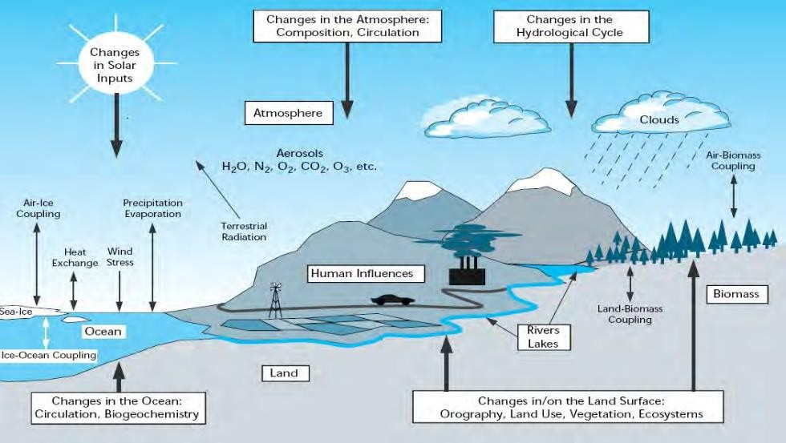

Figure 2.1: Graphical Illustration of the Components of Climatic System

(Source: Miller et al., 2005)

## Climate change and climate variability

Climate change occurs as a result of alterations or modifications of the earth‘s climatic system over a space of time as a result of either natural variability or man-made (IPCC, 2001). On the other hand, UNFCCC (1992) defined change in climate as any alteration in the weather that is caused either directly or indirectly by human activities which change the constituent of the atmosphere coupled with another natural variability that occurred over a longer period. Mitchell et al. (1966) referred to climate change as all forms of climate instability irrespective of their statistical nature or physical causes.

Climate changes are normally classified as long-term, short-term and fluctuations based on the time scale, climate changes happening over time scales higher than or within those found with the orbital forcing frequencies of between 41,000 and 9,508,000 years are known as long-term, climate changes happening for time scales shorter than those found with the orbital forcing frequencies are classified as short-term; while climate abnormalities on time scales less than 100 years are referred to as climate variability (Matondo et al, 2004). The climate experience changes if there exist alteration in climate variable such as temperature (IPCC, 2007), the United States

Agency for International Development (USAID, 2007), reported that while climate variation affects the whole world, the resultant changes would not be the same globally; there may be noticeable variations at country levels, climate change causes a big challenge to Africa‘s economic growth, long-term prosperity, and the living of the already susceptible people.

In contrast, climate variability is defined as the fluctuation in the mean state and other statistics of the climate on all temporal and spatial scales that exceeds that of individual weather events. The variations occur as a result of either natural processes or external forces (anthropogenic). Climate variability can cause sudden changes, such as floods, droughts, or tropical storms. These changes can make great impacts on a country‘s economy especially when the larger portion of the economic growth depends on weather and climate. the influences of climate variability and change have a higher effect on the less privileged in developing countries than those living in more developed nations (USAID, 2007).

## Global climate change

It was reported that the global mean surface temperature has already risen by about 0.07oC per decade in the past centuries (IPCC, 2007). The increase has been more significant (about O.18oC per decade) in the last 25 years, in which decade (2001-2010) was reported as the warmest decade on record. The average temperature in that decade was higher than 1961-1990 mean by 0.46°C, and it was higher than the (1991-2000) decade by 0.21°C. However, 1991-2000 was also wanner than the decades before it, consistent with a long-term warming trend (WMO, 2011).

―However. due to prevailing global warming, mountain glaciers and snow cover have declined in both hemispheres‖. The universal average water level (sea level) has been

rising since 1961 at a mean rate of 1.8 mm/yr. and it was at 3.1 mm/yr. in 1993., in which the expansion is due to heat, melting glaciers, ice caps, Greenland and Antarctic ice sheets play a great role, causing the sea level rise (IPCC, 2007). Moreover, in the eastern regions of South and North America, northern Europe, and northern and central Asia. a noticeable rising in rainfall has occurred. This occurrence of intense precipitation events has risen over most areas which are accompanied by warming and an increase in atmospheric water vapor. However, there has been some rainfall deficit in the Sahel, the Mediterranean, Southern Africa, and parts of southern Asia (IPCC, 2007).

The African Ministerial Council on the Environment (AMCEN, 2011) reported that widespread changes in extreme events occur. It started that, cold days, cold nights, and frost occur less frequently, while hot days, hot nights, and heatwaves occur more frequently, more severe and persistent droughts have been observed over wider areas since the 1970s, particularly in the tropics and subtropics.

## Climate variability and change in Nigeria

(Hengeveld et al., 2005) provided the criteria that can be applied to study evidence of climate change in a region. These include: upward in temperature, rising evaporation, reduction in the quantity of rainfall in the continental interiors, rising rainfall in the coastal region, increasing changes in climate patterns, and increasing rate and severity of extreme weather-related events for example; thunderstorms, lightning, floods, landslides, drought, unpredictable rainfall pattern, sea-level rise, increasing desertification and land degradation, evaporation, loss of forest cover and biological species which have been confirmed to exist in Nigeria. Moreover, the additional proof of climate change in Nigeria is the rise in rainfall quantity in the coastal areas since the 1970s, and a continuous decrease in precipitation amount and length in the continental

interiors of the semi-arid region of Nigeria. The rise in precipitation in the coastal areas could be the major cause of floods affecting the coastal cities of Warri, Lagos, Calabar, and Port Harcourt as observed by Ogundebi, 2004; Ikhile, 2007; Nwafor, 2007; Umoh, 2007; Odjugo, 2010, Moreover, Odjugo (2005; 2007) also found that the number of rainy days has reduced drastically in northeastern Nigeria and in the Niger Delta coastal areas. These two changes in climate patterns are proof of the existence of changing climate in Nigeria.

FME (2011) reported that the Nigerian Meteorological Agency in 2008 studied the Nigerian Climate from 1941 to 2000 periods and observed the following changes:

1. Rainfall: With past periods, from 1941 to 2000 periods, there was late-onset and quick cessation of rainfall, which shortened the length of the rainy season in various parts of the country. From 1941 to 2000, annual rainfall dropped by 2-8 mm across most parts of the country but increased by 2-4 mm in a few places (e.g. Port Harcourt).
2. Temperature from 1941 to 2000. the long-term temperature increase was observed in most parts of the country. The main evaporation was in the Jos area, where a slight cooling was recorded. The most noticeable increases were recorded in the farther northeast. Extreme southwest and extreme northwest where the average temperature rose by 1.4 – 1.9 °C.

Additionally, (Odjugo, 2010) reported that the temperature in Nigeria has risen between 1901 and 1970. The mean air temperature between 1901 and 2005 was 26.6 °C while the rise in temperature for 105 years was 11°C and rainfall has also declined. The rising temperature and falling in Rainfall in the semi-arid region of Sokoto, Kastina, Nguru, and Maiduguri may have led to the rising evaporation, drought, and desertification in

Nigeria as informed by (Odjugo and Ikhuoria, 2003); (Adefolalu, 2007).

Additionally, the loss of forest and biological species constantly in Nigeria is related to global warming and climate change (Ayuba et al., 2007). Nevertheless, the study carried out by (Omojola and Fasona, 2005) on climate variation, human safety, and communal clashes in Nigeria conveyed that all the stations in the Sahel region recorded the greatest rainfall during 6 decades (1941 -2000) periods. The greatest rainfall was recorded in the 1950s and the least was linked with the 1980s from the total decadal mean. The resultant change in land cover between 1976 and 1995 revealed the loss of prime arable lands due to climate change.

## Impacts of climate change

The impacts of climate change could be on natural as well as human systems. The difference between the potential and lingering impacts can easily be recognized based on adaptation consideration (IPCC, 2001). Potential impacts refer to the effects that may occur as a result of the forecasted climate variation without considering adaptation; while residual (lingering) impacts refer to the effects of change in climate that would occur after adaptation (Levina et al., 2006). The various influences of climate change are droughts in some areas while flooding in others affecting agriculture, food security, and properties. Leading to changes in both surface and underground water supply and devastating ecosystems amongst others (Sawa et al., 2011). Also, according to the report by (USAID, 2007), the impacts of climate change include: rise in Sea level, change in intensity, timing and spatial spread of rainfall, changes in temperature and the frequency, intensity, and duration of extreme climate events such as droughts, floods, and tropical storms.

## Climate Change Modelling

The climatic system is a composite interaction between chemicals and physical processes, which has kept on advancing from the 1950s with improvement in the scientific know-how. The established methods of examining our climatic system are through how the atmospheric components relate with one another by illustration. In any case, no matter how transparent the modeling technique is, it nevertheless presents a hurdle because the interactions operate on varied timescales extending from hours to decades. For this reason, influences and individual magnitudes of atmospheric variation are derived from scenarios, which have been established from climate studies to forecast likely changes in the future climate.

## Climate change scenarios

The climate change scenarios are combinations of plausible and/ or likely sequences variations in upcoming or forthcoming climate. These scenarios help in evaluating the future consequences of atmospheric changes and help the authorities concerned to formulate suitable control and formulate adaptive measures to contain or take in these changes.

* + - 1. *Types of Climate Change Scenarios*

(IPCC-TGICA, 2007) Scenarios on climate change are classified into three main categories. They are:

1. Synthetic or Arbitrary Scenarios

In these scenarios, Climate system sensitivity is assessed by altering the key variable (climatic variable) in line with judgments laid by expertise as regards expected future change. In some instances, combined key variables are used. For example, is

considering an increment in temperature between 1- 30C and 10% increases in precipitation or decrease by the same percentage or no changes at all. Scenarios of this trend can be sufficient to showcase or present future value. If the adopted changes in the key factors are based on professional opinion derived from climatologists or climate models.

1. Analogue Scenarios

This type of Scenario makes use of historical records and measured value to reconstruct the climate because the historical record gives the best representation of inter and intra decadal changes in the climatic system and its distribution regionally. But, the quality of the observations matters. This type of reconstruction usually covers hundreds to thousands of years past and this gives detailed variation in climate than the observed records. So, forecasted scenarios would be developed from past climatic behavioral records.

1. Climate Models

These models try to simulate or imitate the processes that characterize the climate models, which recreate the whole Earth‘s climate are referred to as worldwide climate models. These have coarse spatial resolutions (up to 300km grids spacing, which translates to one theoretical value per 300km by 300km grid cell) and range from simple one-dimensional to complex three-dimensional models known as general circulation models (GCMs). GCMs can additionally be broken down into oceanic GCMs (OGCM) and atmospheric GCMs (AGCM). Combinations of the two models are used in the simulation of land surface and atmospheric and are referred to as atmospheric-ocean general circulation models (AOGCMs).

Climate models have been parameterized utilizing four main emission scenarios of anthropogenic driving published by the IPCC Special Report on Emission Scenarios (Nakicenovic et al., 2000) for use in atmosphere change studies. These situations, characterized with respect to four storylines namely A1, A2, B1, and B2, were built to investigate future socio-economic developments in terms of economies, populace development, and technological progression. A comprehensive portrayal of these

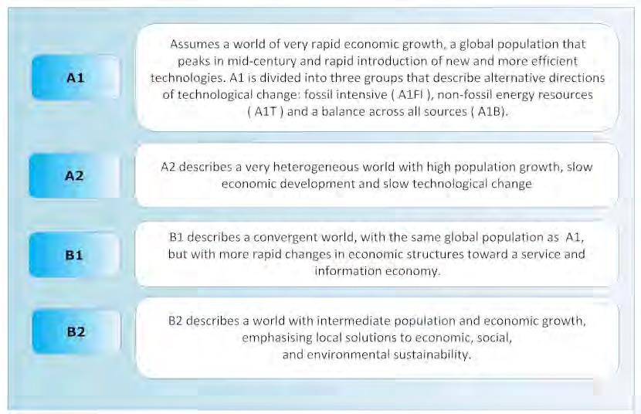

situations is given in Figure 2.2.

Figure 2.2: The Established Scenarios from IPCC Special Report on Emission Scenarios (Nakicenovic., 2000)

Global Climate Models (GCMs) have been used to forecast variations in climate until the end of the 21st century by numerous institutions of climate research specialization. I PCC Data Distribution Centre provides more information on these institutions, their models, and analyses data. Presently, the ideal mechanism for simulation of climate both present and future are AOGCMs according to Hewitson et al, (2005). But, they have to be downscaled to be of use in local impact studies, due to their low spatial resolutions, which require higher resolutions covering from ten to a hundred kilometers.

Therefore, downscaling processes are required to obtain local scale detail from the

AOGCM simulations Engelbrecht, (2005). The three main techniques, according to Mearns et al. (2003), used in downscaling are:

* 1. Variable resolution time-slice GCM experiments: This involves climate simulation at a resolution of a higher grid in an array of 100km globally and 50km locally is viable or feasible over a time scale (usually shorter) of several decades. Specific time slices of interest are identified and modeled in finer spatial detail.
  2. Nested regional climate models: This modeling method uses lower resolution GCM which is embedded with the high-resolution regional climate model (RCM). This is referred to as ‗nesting‘ the RCM within the GCM. Meanwhile, the output from the GCM at its nesting boundary is the input to the nested. These types of models are also recognized as limited area models (LAMs).
  3. Empirical/ statistical interpolation: Statistical downscaling includes modeling the connection between the significant variables from GCMs (predictors) to the local variables (predictands). Afterward, the Global Climate Model predictors are input into the statistical model to evaluate the corresponding regional predictands. A more comprehensive description of the above methods of downscaling can be obtained from Mearns et. al., (2003) and Wilby et. al.,(2004).

## Hydrological Modelling and its Significance

Hydrological modeling contains the comprehensive interpretation of observed, analyzed, and expected interaction of different hydrological forms which differ in duration and space, for example, precipitation, infiltration, runoff. Hydrologic processes are better understood with modeling, hydrological modeling helps us predict or envisage possible results of present and future scenarios, therefore it helps in

providing solutions to actual world‘s problem with which the detail unachievable with conservative analysis method (pen and paper). Additionally, it‘s very important in hydrology because of the difficulty to ascertain the aforementioned interactions physically at a satisfactory typical number of points in a catchment. Moreover, according to Schulze, (2000), there is a need for earlier determination of any likely alteration to the hydrological system as a result of human activities to put control measures in appropriate timing. Hence, modeling happens to be the only means to tap into the future and determine what could happen if present conditions remain unchanged, improve or worsen.

## Classification of hydrologic models

It can be classified as regards its purpose, structure, and complexity as reported by Hughes (2004) and Fu (2005). Below are the details of each category.

1. Purpose of the model

In this type of model, the modeling objectives or its purpose determines the choice of the model to be used. For instance, short event floods modeling requires a single event model whereas, simulation of longer sequences of occurrence requires continuous models. In water resources management, models with combined imitation of hydrology and storage effects, abstraction, and return flows are more ideal or preferred.

1. Model Structure

This type of hydrological modeling tries to describe the response of various outputs such as groundwater, streamflow, and soil moisture in response to the climatic inputs in the hydrological processes. Simple models are known to use few parameters and therefore do not obtain detailed representation whereas, complex models define every

input and output process, though, this required many parameters. Hence, the multiplicity of a model is determined by the extent of the definition above.

1. Spatial complexity

In these types of models‘ techniques, the choice of approach to used verily based on the quality of available data or accessible for the area of interest. in this category, there are two main modeling methods. One seeing or treating the area as a homogeneous unit and generalized the parameters and the other breakdown the total area into sub-areas or units based on geometrics shape or natural drainage. Here the flow processes are described at each point within the total area whereas, the reverse is the case for the homogenous entity type in which the flow processes are treated as a whole.

1. Temporal complexity

Here, the hydrological processes are defined based on the time step of the model used. The time steps can differ from minutes to a year or can vary within the model run to capture distinct events like extreme rainfall or flood.

## Types of hydrologic models

The difference between different types of hydrological models is very tough to identify because every model comprises a collection of modules, which calculate the different components or parts of the hydrological process. The conformity of a particular module to a certain type of model is determined by the quality of available materials (data) and the objectives of the model (Ochieng, 2007). A presentation of completeness hierarchical outline and description of each type of model as compiled from (Linsley Jr. et al. 1982), (Olsson: Pilesjö, 2002), (Skidmore 2002), (Ochieng, 2007), (Ragunath

2006) and (Refsgaard,2007). Generally, models classification can be done in two logical methods:

Deductive models: are kinds of models that develop their conclusion based on general known reasons that are dependent on physical laws, which are well accepted.

Inductive models: This type of model utilize a sequence of realities to originate or prove a conclusion. There is a remarkable link between the fact and conclusion however, the exact process may not be known. This rational approach leads to the discovery of patterns from observed data. Different models type emerges in accordance to the logical approach used, some of which are as follows:

Stochastic models: According to Ragunath, (2006). These models present the idea of probability since they are built on the possibility of the occurrence of input data or the parameters of the model itself. Therefore, the output will also vary.

Deterministic models: These types of models use mathematical relations built on physical laws and not chances of occurrence to describe the catchment processes. It functions within established initial and boundary conditions. These (Deterministic models) are additionally grouped as highlighted below:

1. Black box models: sometimes called empirical models are determined by expression obtained /got from statistical examinations of measured data through correlation and regression and these types of the model don‘t try to comprehend the physical procedures in the catchment.
2. White box model: these are mathematical models that utilize scientific (numerical way) approaches for explanations and are to great extent logical in nature. These models can be classified into theoretical and physical models, in which the former depends on theories to understand or construe regular phenomena instead of physical procedures while the latter is established on the

nitty-gritty depiction of the procedures in the catchment and require quantifiable input data.

Several models are defined as ‗Grey box‘ models with both empirical and physical compositions. Sometimes referred to as semi-empirical models. The above is further categorized considering the catchment characteristics. This is as follows:

1. Lumped models: are models which consider the catchment as a similar

hydrological response unit (HRU) and ignore the spatial variations in parameters.

1. Distributed models: These models treat the catchment as different HRUs

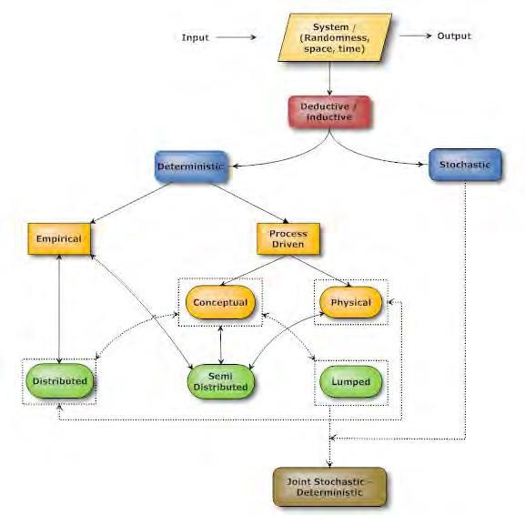

based on their characteristics and provide an explanation of catchment processes at geo-referenced computational grid points within the catchment.

1. Semi distributed models: are mixtures or amalgams of distributed & lumped

models. For this situation, the evaluation of hydrological forms depends on semi-empirical equations. An appropriation is inferred, either in hydrological

response units, or sub-catchments in which the regions with similar key functions are accounted as single units.

Figure 2.3: Basic Classification of Models (Haji Mtech)

Figure 2.3 defines the various forms of the model. The darts indicate probable blends of various sorts in modeling uses. Thus, it will be essential to future the interlaced idea of the sorts of model clarified in segment 2.3.2 For example, a theory can either be stochastic or deterministic in combined form. This is exhibited by the sediment transport model, which has combined parts of both deterministic and stochastics. One sample of deterministic experimental models is the dissemination of flood waves and Nash models. Model dependent on synthetic unit hydrographs describes the deterministic empirical combination (Ragunath, 2006). Thus, the categorization helps only to give the main basis of model types; the user states its real use.

## Climate change and its effect on water resources

The hydrologic cycle will continuously be influenced by environmental change. The spatial circulation of rainfall combined with its sequential event will possibly experience adjustment. Hotter temperatures alter the quantity of rainfall, which will be transformed to snow and influence the timing and extent of ice melt. Also, there will be drier soils due to increases in evaporation. Continuous changes in CO2 concentrations will also influence vegetation evapotranspiration thereby lead to more water loss. There will be an alteration to land cover due to drier soils which may result in longer droughts thus affecting the catchment runoff responses to precipitation. Similarly, the percolation rate is reduced thus affect the recharge of groundwater. This alteration will subsequently change the base flow from groundwater to streamflow Arnell (1999) and Miller et al., (2005).

Additionally, excessive rainfall will lead to runoff increment thus washing away contaminants from agricultural farmland and urban areas to nearby streams thereby affecting not only the quality but also, pose a physical risk to water infrastructures like dams, wastewater treatment systems due to overloads of contaminants and treatment difficulty and water supply. On the other hand, a decrease in stream flows and a reduction in volumes of water available in the water bodies will lead to an increment in contaminant concentrations. Additionally, a rise in the temperature of the water will affect the ecosystem, which perhaps, may base on a cooler environment Arnell (1999) and Miller et al., (2005).

## The Water Evaluation and Planning (WEAP) Model

WEAP was developed by the Stockholm Environment Institute‘s (SEI) Boston Centre, it‘s a desktop tool for integrated water resource planning. For the past fifteen years since its first application carried out by Raskin and Zhu (1992) in the Aral Sea, there have been major improvements on the model like friendly graphical interface, a vigorous algorithm for water allocation, and the integration of hydrologic sub-modules that include a conceptual rainfall-runoff, water quality model for groundwater and surface water. Furthermore, additional combined choices to link to another model for example MODFLOW and QUAL2E. for instance if the inbuilt submodule is not enough. The model is an easily comprehensive tool that incorporates an integrated way to water resource management, which over the past ten years, has set more emphasis on demand-side management, the preservation, and protection of the ecosystem, and water quality. The model placed the demand-side issues for example. Water use pattern, reuse strategies, equipment efficiency, water allocation scheme, and costs on equivalent balance with supply-side resources (such as available surface and groundwater, reservoir storage, and transfer between basin), for integrates simulation of both the

natural and engineered components. This gives the water resources manager the liberty of a detailed view of the results of various decisions on the system. The information provided herewith is to a great extent as extracted from the user guide provided by SEI.

## Approach of WEAP model

WEAP model works or operate based on water balance accounting. It is useful or appropriate to agricultural and domestic systems, singular sub-basins and/ or complex river system. Additionally, the software addresses the extensive scope of concerns, for instance, investigation of demand of a region, water preservation, water rights and distribution (allocations) priorities, rainfall-runoff and baseflow, groundwater and streamflow simulation, hydropower generation, reservoir operations, water quality, ecosystem demands and project benefit-cost analysis (SEI, 2007).

The water system is characterized in agreement to its different supply sources, the process of retraction or withdrawal, and wastewater treatment facilities, ecosystem necessities, demands, and generation of pollution. The data assemblage and details can be personalized (such as, by combining demand sites) to the specific analysis required and limitations imposed by constrained. (SEI, 2007).

Generally, Water Evaluation and Planning model software applications comprise various stages. The study definition sets up the time frame, spatial limit, system components, and problem configuration. A baseline year is defined, known as the

‗current accounts‘ in the model for which the factual data of assured quality is obtainable. Then substitute future assumptions are then established depending on for instance policies, demands, costs, pollution, supply, and hydrology. Afterward, a single or combination of different assumptions is used to construct scenarios and assessed with respect to the adequacy of wa**te**r, economic consideration, environmental sustainability. The area of study can be considered as a single or division of sub-entity based on

available data/topography. The region in question is accordingly classified based on LULC. which is a determinant of runoff and infiltration. A one-dimensional, 2-store, theoretical water balance model calculates the hydrologic reaction of the area and partitions water into various components; evapotranspiration, surface runoff, interflow, and baseflow Yates et al., (2005).

## Formulation for linear program in WEAP

WEAP maximizes the satisfaction of the requirement for demand sites, user-specified in-stream flows, and hydropower subject to constraints; as demand priorities, supply preferences, mass balance, and other constraints a user may set using Linear Program (LP). WEAP uses *LPSolve* which is an open-source linear program solver in solving equations. We will look into mass balance, coverage variables, and constraints, and constraints regarding demand priorities and supply preference as they are our main concerns regarding this work.

1. Mass Balance constraints

Mass balance equations (Equation 2.1) as the foundations of WEAP‘s monthly water

accounting such that every node and link in it(model) has a Mass balance equation, and each of these equations becomes a constraint in the LP.

෍ ࡵ࢔ࢌ࢒ൌ࢕෍࢝ ࡻ࢛࢚ࢌ࢒൅࢕࡯࢝ࢎࢇ࢔ ࢏ࢍ࢔ ࢋࡿ࢚࢕࢘ࢇࢍࢋ ሺ૛Ǥ૚ሻ

Equation 2.1 can be rewritten as Equation (2.2)

ࡵ࢔ࢌ࢒െ࢕ࡻ࢛࢚࢝ࢌ࢒െ࢕࡯࢝ࢎࢇ࢔ ࢏ࢍ࢔ ࢋࡿ࢚࢕࢘ࢇൌࢍ૙ ࢋ ሺ૛Ǥ૛ሻ

Addition to storage applies to reservoirs and aquifers and it is an addition or positive when there is an increase and also negative when there is a decrease. Outflow comprises

losses and consumption. And every flow from one point to another is represented by a variable in LP.

If demand site let's say A is assumed to withdraw from supply site B & C, and their returned flow to these supplied sites after considerable consumptions, then, the water balance equation or expression would be written as Equation (2.3).

ࡵ࢔ࢌ࢒࡮ǡ࢕࡭൅࢝ࡵ࢔ࢌ࢒࡯ǡ࡭࢕െ࢝ࡻ࢛࢚ࢌ࢒࡭ǡ࡮࢕െ࢝ࡻ࢛࢚ࢌ࢒࡭ǡ࡯࢕െ࢝࡯࢕࢔࢙࢛࢓࢖࡭࢚ൌ࢏૙ ࢕ሺ࢔૛Ǥ૜ሻ

B, A in Equation (2.3) is the inflow from supply B to demand site A. The LP constraint would be a row in the LP matrix, with coefficients of 1 for the inflow variables and -1 for the outflow variables. The entire row would be set to equal to 0.

1. Coverage Variables and Constraints

A new LP variable is created for each demand which will equal its ―coverage‖ (percentage of demand satisfied). The Coverage for demand D cannot exceed 100% (Equation 2.4)

࡯࢕࢜ࢋ࢘ࡰࢇ൑ࢍ૚ࢋ૙Ψ૙

ሺ૛Ǥ૝ሻ

The inflow to a demand site (DS) from its entire transmission link (Src) will equal its supply requirement times its coverage (Equation 2.5)

෍ ࡵ࢔ࢌ࢒ࡿ࢕࢘Ǥࡰࢉ࢙࢝ൌࡿ࢛࢖࢖࢒࢟ࡾࢋ࢛ࢗࡰ࢏ࡿ࢘כ࡯ࢋ࢕࢓࢜ࢋࢋ࢔࢚࢘ࡰࢇࡿࢍࢋ

ࡿ࢘ࢉ

ሺ૛Ǥ૞ሻ

And Equation 2.5 can be rewritten as Equation (2.6)

෍ ࡵ࢔ࢌ࢝࢒ࡿ࢕࢘ǡࡰࢉࡿെࡿ࢛࢖࢖࢒࢟ࡾࢋ࢛ࢗࡰ࢏ࡿ࢘כ࡯ࢋ࢕࢓࢜ࢋࢋ࢔࢚࢘ࡰࢇࡿൌࢍࢋ૙ ሺ૛Ǥ૟ሻ

ࡿ࢘ࢉ

However, demand sites cannot take more water than their supply requirement, in-stream flow requirement (IFR) when applicable, can be exceeded by the actual flow. Therefore, the equation is written as an inequality (Equation 2.7)

ࡲ࢒࢕ࡵ࢝ࡲࡾ൒ࡿ࢛࢖࢖࢒࢟ࡾࢋ࢛ࢗࡵ࢏ࡲ࢘ࡾכࢋ࡯࢓࢕ࢋ࢜࢔ࢋ࢚࢘ࡵࢇࡲࢍ ࡾࢋ

ሺ૛Ǥૠሻ

Equation 2.7 can be rewritten as Equation (2.8)

ࡲ࢒࢕ࡵ࢝ࡲࡾെࡿ࢛࢖࢖࢒࢟ࡾࢋ࢛ࢗ࢏ࡵ࢘ࡲࡾכࢋ࡯࢓࢕ࢋ࢜࢔ࢋ࢚࢙࢘ࡵࢇࡲࢍࡾ൒ࢋ૙ ሺ૛Ǥૡሻ

The LP constraint would be a row in the LP matrix, with coefficients of (1) for the flow variables (inflow to demand sites and streamflow at the in-stream flow requirement node), and (-1) times the supply requirement as the coefficient for the coverage variables. The entire row would be set equal to 0 (demand site) or greater than or equal to zero (in-stream flow and requirement).

1. Objective Function and Iterations

WEAP strives to maximize supply to demands sites, subject to all constraints and priorities. Allocations of water to demand sites are done based on the preferences of both demand and supply. WEAP iterates for each priority and reference, so that demands with priority 1 are allocated water before those with priority 2. Hence, the LP is solved at least once for each priority for each time step. When solving for priorit1, WEAP will temporarily turn off (in the LP) allocations to demand priority 2 and lower. Then, after priority 1 allocations have been made, priority 2 demands are turned on (but 3 and lower are still turned off). In cases where there is not enough water to satisfy all demands with the same priority, WEAP tries to satisfy all demands to the same percentage of their demands and satisfies coverage constraints.

If for instance, supply requirement of 100 and 50 is required by Site A and B with both demand sites having equal priority and there exit 60 units of water in the river in the time step, then demand site A will get 40% (40 units) and site B will have 40 % (20 units). On the other hand, a situation may arise such that one demand site will have more access to water than the others. For example, when there is a tributary with an inflow of 200units in between a withdrawal point A and B. such that there is always enough water for B. in such situations; demand site B should be able to withdraw its full requirement, even though demand site A cannot. In this case, the WEAP LP will iterate. The first time it solves, both A and B will get 60%; A gets all 60 (60%) units flowing past its withdrawal point, and demand site B gets 30 units (60%) 50 units that flowed in from the tributary. The equity constraints ensure that both demand sites get the same percentage coverage. The LP at this stage indicates that there is slack in the variable coverage variable in B because it could get more water than it is getting as opposed to A that cannot get any more water. Therefore, the allocation to demand site A is fixed at 60 (Equation 2.9), and the equity constraint is deleted. The LP runs again, and this time demand site B will get its full demand of 50 units (100%).

࡯࢕࢜ࢋࢍ࢘ࢋࡲࢇ࢏࢔ࢇൌ࢒࡯࢕࢜ࢋ࢘࡭ࢇ ࢍ ࢋ

ሺ૛Ǥૢሻ

1. Determination of Slack in WEAP

In the second scenario pointed out iteration above, the introduction of tributary inflow between withdrawal points of demand sites A and B makes demand site B able to receive a higher percentage of its demand than demand site A. For WEAP to determine which coverages are constrained from going higher due to unavailability of supply (e.g., 60% for Demand Site A), and which can get more water (e.g., 100% of demand site B); a new variable called *Epsilon* (which determines which demand site are supplied limited

and which are not) is defined for each demand site and added to the coverage constraints as shown in Equations (2.10) and (2.11).

ܖܗ૚ ܁ܔ۲ܑܛܘ܍۳܏૚൅܁܉۲ܚ܍ܞܗ۱ܔ܍܉ൌ܏ܖܑ܉۴ܚ܍ܞܗ۱

ሺ૛Ǥ૚૙ሻ

ܖܗ૛ ܁ܔ۲ܑܛܘ܍۳܏૛൅܁܉۲ܚ܍ܞܗ۱ܔ܍܉ൌ܏ܖܑ܉۴ܚ܍ܞܗ۱

ሺ૛Ǥ૚૚ሻ

The epsilons are also added to the objective function, but with negative signs, so that they are minimized (Equation 2.12)

ࡹࢇ࢞࢏࢓ǣ࢏ ࡯࢙࢕ࢋ࢜ࢋ࢘ࡲࢇ࢏ࢍ࢔െࢇࢋ࢒࢑כࡱ࢖࢙࢏࢔ࡰ࢒ࡿ࢕ ૛ (2.12)

1. Annual Demand

Water demand for demand site (DS) is calculated as the summation of all demand sites

‗bottom level branches (Br) demands. A branch without any branches below it is called the bottom-level branch. For example, in the structure that comprises, showers, toilets, washing and other (and four others underneath Multifamily that may not be shown) are the bottom-level branches for South City.

*AnnualDemandDS = (TotalActivityLevelBr x WaterUseRateBr) (*2.13) The total activity level for a bottom-level branch is the product of the activity levels in all

branches from the bottom branch back up to the demand site branch (where Br is the bottom-level branch, Br' is the parent of Br, Br'' is the grandparent of Br, etc.).

*TotalActivityLevelBr = ActivityLevelBr x ActivityLevelBr' x ActivityLevelBr'' x ... (2.14)*

For the example above, this becomes

*TotalActivityLevelShowers = ActivityLevelShowers x ActivityLevelSingleFamily x ActivityLevelSouthCity*

= percent of people in single-family homes who have showers x percent of people who live in single-family homes x number of people in South City

The activity level for a branch, and the water use rate for a bottom-level branch, are entered as Data.

1. Monthly Demand

The demand for a month(m) equals that month's fraction (specified as data under Demand\Monthly Variation) of the adjusted annual demand.

*MonthlyDemandDS,m. = MonthlyVariationFractionDS, m. x AdjustedAnnualDemandDS*

*(2.15)*

1. Monthly Supply Requirement

The water required in a month by demand site for utilization is represented by monthly demand. Whereas, supply requirement signifies the quantity needed from the source. The supply requirement takes the demand and adjusts it to account for internal reuse, demand side management strategies for reducing demand, and internal losses. These three adjustment fractions are entered as data

*MonthlySupplyRequirementDS, m. = (MonthlyDemandDS, m. x (1 - ReuseRateDS) x (1*

*-DSMSavingsDS)) / (1 - LossRateDS)*

*(2.16)*

## Applications of WEAP (Model) software

The software has been extensively used around the universe since its development, in different Integrated Water Resources Management projects with varied objectives. Some of its applications are as follows:

Global Projects:

The first project was carried out in 1992 by Raskin and Zhu, (1992) on the Aral Sea which investigates water accounts and examining the management policies in the area in the former U.S.S.R.

Also, applied in hydrological modeling by Amato et al., (2006). In the United State of America, the studies on water usage and distribution or allocation (Yates et al., 2008) and the study of change in climate impacts in agricultural land (Purkey et al., 2008). Additionally, it has been applied incomparable water resources planning in many catchments in the state by Engineers of Centre for hydrological Engineering of U.S Army Corps.

WEAP was utilized to create substitute improvement on water distribution or allocation concerning Palestinian and Israeli. Furthermore, (Assaf and Saadeh, 2008) create or develop management plans for water quality of wastewater to control the discharge of Untreated one into the Upper Litani basin located in Lebanon.

In a program that took place in Beijing- Hebei WEAP was utilized to establish a baseline for achieving Cooperation on water-related issues that involve stakeholders of upstream and downstream. Also, it was used with other models for solid waste management to develop a master plan for Municipal Environmental Planning.

In Africa Continent:

In Kenya, WEAP was applied for modeling water resources management by Alfarra, (2004) in lake Naivasha. Also, its various water distribution works under WatManSup Project in Kitui Droogers et al., (2006) and the project tag ―Green Water Programme‖ in Tana Basin by Hoff et al., (2007).

Haagan (2007). Make use of the software to examine the influence of small reservoirs in a semi-arid and arid part in Ghana.

Levite et al., (2003) used it to assess the ability of River (Steelport) to simultaneously meet demands for various uses and environmental reserve. This was done in the Olifants River Basin. Moreso, various water demand management strategies were examined through series of scenarios. Nevertheless, the streamflow from an earlier study was used in the setting of the hydrology of the area.

Additional research was carried out on the entire Olifants basin by Arranz and McCartney, (2007) used WEAP to assess the influence of three Scenarios created from water demand growth up to 2025, implementation of environmental reserve (ER), International Agreements (IA‘s), and strategies on water resources for conservations and demand management scheme. In simulating the basin hydrology, rainfall and naturalized streamflow were used. The model was calibrated through alteration of assumption of historical demand pattern, changing the demand priorities, and changing the reservoir operation rules. This was done to improve the fit between observed and simulated flows due consideration was given to the influence of climate variation on land use and water resources development. A further study was also done on conservation management plans and infrastructural development.

WEAP model was used in water resources management under environmental scenarios in Hirmand catchment for a period (2015-2030). In the study, the result shows that the average total demand in dust stabilization and animal-plant sustainable ecosystem scenarios increased about 238 and 231 million cubic meters compare to current account respectively and all unmet demand increases to 193 and 200 million cubic meters, approximately. According to the economic assessment calculations, benefit in dust stabilization scenario 160 milliards rials and in animal-plant sustainable ecosystem scenario 209 milliards rials decreased in agriculture sector. Therefore, in order to

preserved and protect the wetlands,despite the reduction in benefit, policy making and water resources management should be given special attention (Shahraki et al., 2016).

In Nigeria:

Effects of probable water demands on the water resources of the Ogun river basin up to the year 2020 was evaluated with the WEAP model. In this work simulation of two scenarios were carried out: the first one involved the past and present feature of water demand in the basin from 2006 to 2011 while the second simulates the future water demand in the basin from 2012 to 2020. Various hydrological components, such as hydrological year cycles, precipitation, and dams were integrated to analyze the water demand utilization, unmet demand, demand site coverage, supply delivered, stream flows, and water storage for each scenario and some key assumptions for the gross domestic product, population growth rate, irrigation efficiency and complementary sources of water were made. the results of the model show that the total unmet water demand to be 4.1 x 109 m3 for previous and current scenarios and this increased to 6.9 x 1010 m3 after model prediction for years 2012-2020 with an average annual rate of 7.7 x 109 m3 this indicated that the basin, therefore, may not be able to satisfy the future water demand of water users in the basin. To reduce unmet demand, wastewater treatment, the introduction of water meters to check wastage, the building of new dams or increasing the capacities of existing ones, groundwater development, information dissemination, and development of manpower in the field of water resources are recommended. (Ojekunle et al., 2011)

A study of influences of climate change on water availability and basin responses to changes in climate, a case study of Sokoto rima river basin was carried out with WEAP software model. In this study the hydrological processes occurrence for six main rivers

in the basin from 1970 to 2013 was successfully model. calibration was done through

visual observation and it was done with twenty-two (22yrs) years‘ climatic data and validated with 8 years‘ data. consideration was given to Global climatic models‘ presumption and six climatic variation scenarios was developed for simulation that is, increase in temperature ;0, +0.5, + 1.0 oC combined with alteration in Precipitation (0, - 10%, +10%).Thereafter, the output of the model was obtained and results indicated that an annual reduction in available water was about 1.70 billion cubic meters (BCM) and monthly demands were 17.11BCM for the driest month that is, April. This was linked to the effects of a 10% reduction in precipitation and an increase in evapotranspiration under a 1oC rise in temperature. A sustainability method was suggested to ensure continuous availability Abdullahi et al., (2014).

# CHAPTER THREE

# MATERIALS AND METHODS

## Description of the study area

## The study area

The study area, Goronyo Reservoir, is situated between Latitudes 13°30'N to 14oN and Longitudes 5o30'E to 6oE. The Reservoir has a length of about 20km with a width of about 10km and an area of about 200km2 with a storage capacity of 942 million cubic meters (Ita et al., 1982; Abubakar, et al., 2017). The study area is located in Goronyo Local Government Area, Sokoto State, Northwest Nigeria. The study area is part of the

Sokoto-Rima basin, which has a total catchment area of about 193,000km2 distributed in Nigeria and the Niger Republic (Gill, 1974).

The Sokoto-Rima basin has a semi-arid tropical climate with a prolonged dry season from October to May and a short-wet season from the end of May to early October (Udo, 1970; Ogheneakpobo, 1988; Adeniyi,1993). Temperatures depict both seasonal and diurnal variations in the area (Davis, 1982). Two temperature maxima of over 35°C are common between April-May and between October-November, two minimum temperature periods below 20°C are also common between December-January and in August (Gill, 1974; Adeniyi, 1993). During the rainy season, the diurnal range of temperature in the area is low but during the dry season, it is high (Davis, 1982). Rainfall in the area shows both spatial and temporal variations (Udo, 1970; Adeniyi, 1993). The mean annual rainfall varies from about 700mm in the northern part of the Rima basin to about 1,100mm in the south (Gill, 1974; Davis, 1982; Adeniyi, 1993). The duration of the rainy season is also longer in the southern part (Davis, 1982) and According to Gill (1974), this was as a result of an early start and ends later than in the north. The study area has mostly sandy soil which have low organic matter and nutrients –nitrogen, phosphorus, and potassium (Swindell, 1986; Yelwa et al., 2012).

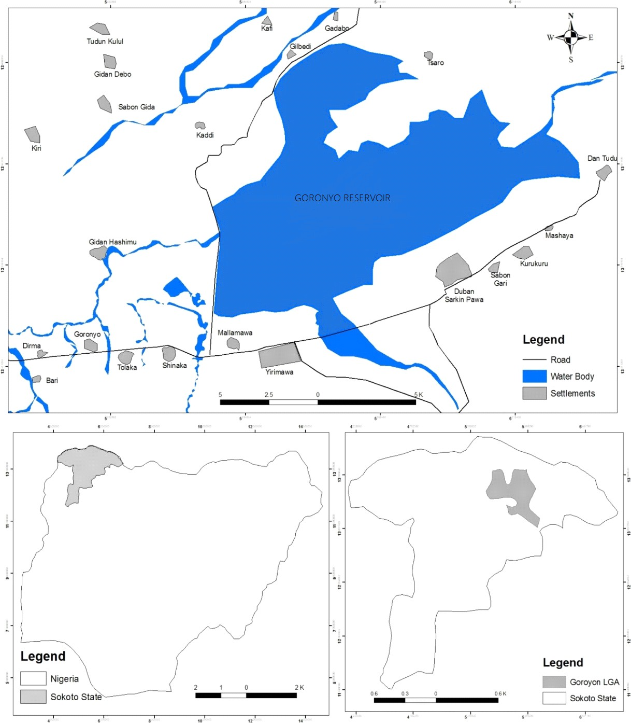

Figure 3.1: The Study Area (Goronyo Reservoir); Source: NASRDA, 2012

## Climate

As it is common to West Africa, the atmosphere in this part is significantly constrained by the two main air masses influencing the sub-district. These are the dry, tropical- mainland air mass (which begins from the Sahara district), and warm, tropical-sea air

mass (which starts from the Atlantic Ocean). The impact of both air masses on the area is resolved to a great extent by the development of the Inter-Tropical Convergence Zone (ITCZ), a zone portraying the surface boundary between the two air masses. The interaction of these air masses offers ascent to two distinct seasons inside the sub-area. The wet season is related to the tropical oceanic air mass, while the dry season is a result of the tropical mainland air mass. The impact and power of the wet season diminish from the west Africa coast northwards. In this way, precipitation in the entire sub-area of West Africa relies upon tempest action which happens along unsettling influence lines called ‖line squall‖ and, around 80 percent of the all-out yearly precipitation for most places is related to line squall exercises which are predominant among June and September (Nicholson, 1980; Dennet, et al., 1985; Adefolalu, 1986; Kamara, 1986). As for climatic insights, the yearly precipitation for Sokoto extends between 300 mm and 800 mm. The mean yearly temperature is 34.50 C, albeit dry season temperatures in the district frequently surpass 400C (Ekpoh and Nsa, 2011).

## Topography

The topography of Sokoto state is subjugated by the well-known Hausa plain of northern Nigeria. It includes broad tracts of practically level to the delicately undulating scene. This dullness is broken in the south and east by gatherings of rough slopes and inselbergs. The most elevated and most noteworthy massifs happen in the south-east. On the fields, the general stature contrast among valleys and adjoining vaults are just 10-20 meters. Regular cross-areas comprise an expansive vault territory; long, straight center slants of under 2o and short, sharp lower inclines giving indications of physical weathering (Schultz, 1975). The immense floodplains (fadama) of Sokoto Rima River dismember the Hausa plain into rich alluvial soils that are appropriate for the

development of an assortment of harvest. There are likewise segregated slopes and hill ranges that disperse everywhere throughout the state.

## Demography

Generally, the growth in the Africa population shows a very swift rate more especially in the urban areas. In 1991, the population in Sokoto State is 2,397,000 people and comprised of rural and urban populations. While the total population according to the 2006 census is 3,702,676 people. Similarly, the local government area of interest with the village has the following populations as shown in Table 3.1. The whole areas within the study area have an average inter census growth rate of 3.03.in the year 2006.

**Local Gov’t Area**

**Census 1991, Total Population**

**Census 2006, Total Population 2017 Total**

**Population**

|  |  |  |  |  |  |
| --- | --- | --- | --- | --- | --- |
|  | | **Male** | **Female** | **Both Genders** |  |
| **Wamako** | 140137 | 91466 | 87780 | 179246 | 248914 |
| **Sokoto North** | - | 124134 | 108878 | 233012 | 323578 |
| **Sokoto South** | - | 103207 | 94479 | 197686 | 274521 |

**Table 3.1 Demography of the Area**

(National Population Census, 2006)

## Features of the dam

The Goronyo Dam (with a reservoir area of 200km2) impounds Rima River in Goronyo local government area of Sokoto State. It was completed in 1984 and commissioned in 1992. The dam is a sand-fill structure with a height of 21 m and a total length of 12.5 km. It has a storage capacity of 942million cubic meters (MCM). The dam is controlling

floods and releasing water in the dry season for the planned Zauro polder project downstream in Kebbi State.

## Irrigation scheme within the area

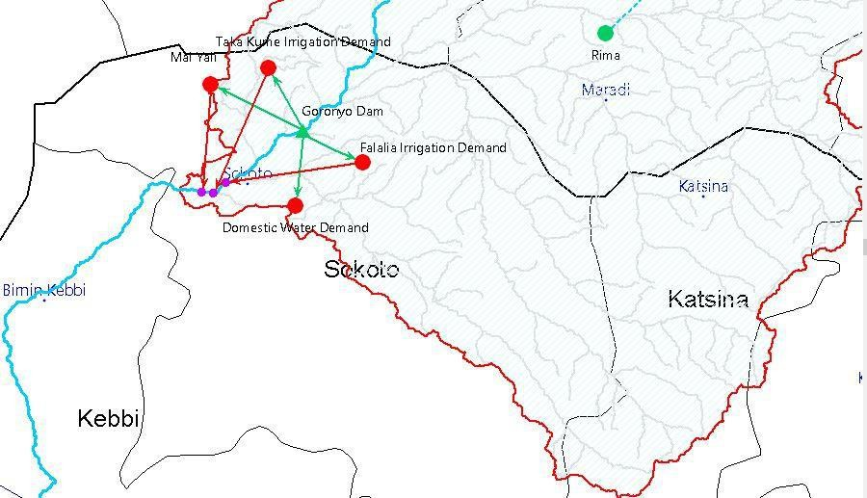Basically, there are three major existing irrigation schemes in the study area namely, Falalia, Taka Kume, and Mai Yali irrigation farmland. The crops cultivated in this area are; rice, cassava, onion, garlic, tomatoes, watermelon, cowpea, and vegetables. The total irrigable land as of present covers an area of 2,776 hectares of land and it is mainly fed by the flood irrigation system.

Figure 3.2: The Schematic (view) map of the area showing the reservoir and demands nodes.

## Research procedure

Here the basic methods adopted to achieve the specific aim of this research were discussed. Firstly, the climatic data were obtained and used to simulate the surface water situation with the model. Secondly, the data was projected based on the initial model output and compared with the existing (observed) data. The comparison involved calibration and validation with the recorded data of river flow. Thirdly, the hypothetical climate change Scenarios were applied to the model to know what to be expected if climate changes. Thus, the model was used to analyze what happened to demand and

water availability in Goronyo reservoir based on the water use of the area. Fourthly, a projection was done to observe and ascertain what may be the nature of the area in future time up to 2070 which is 52 years from 2018. Note, WEAP model software allows extending the trend data.

The following are detailed procedures adopted for the study:

1. Preliminary investigation (i.e. Reconnaissance visit) was conducted to analyze the hydraulic nature and human activities related to water resources in the catchment.

The rainfall, temperature, evaporation, relative humidity, wind speed, and sunshine data was collected from NIMET from 1988 to 2017 and were analyzed statistically.

1. The Catchment was delineated with WEAP inbuilt catchment delineation component and the inland waterway was digitized.
2. The hypothetical climatic change scenarios were applied to the model to observe what happened if climate changes.
3. The model was used to analyze the linkage between the water resources and the demand in the catchment.

## Analysis of the temperature trend for generating climate scenarios

Statistical analysis of the annual average maximum temperature (1988 – 2017 obtained from NIMET) of the area was done. The maximum average annual temperature and minimum temperature with a mean and standard deviation of the data were determined. The linear trend was fit into the data and the gradient of the trend was determined. A linear equation obtained from the trend analysis was used for the projection of temperature increment for this region by considering temperature variation over four decades.

## Analysis of the rainfall trend for generating climate scenarios

Similarly, the average annual rainfall (1988- 2017) of the region was analyzed statistically. The maximum average rainfall value and minimum average value with a mean and standard deviation of the data were determined. The linear trend was fit into the data and the gradient of the trend was determined. The trend analysis leads to a linear equation relating the rainfall to time. This was used for the projection of climate change effect on Precipitation for this region by considering average rainfall value variation over four decades.

## Climate scenarios generation

The method adopted is the hypothetical scenario option which was adopted by scholars in climatic impact or influence studies (Islam et.al, 2005). Several published works were done in this method (e.g. Gleick, 1987; McCabe and Wolock, 1991; Skiles and Hanson, 1994; Yates, 1996; Boorman and Sefton, 1997; Bobba et.al, 1999; Hailemariam, 1999;

Xu, 1999, 2000**;** Islam et.al, 2005; Abdullahi, 2014). From this perspective and aiming at the objective of the study to apply the WEAP model to the area to evaluate the influences of climate variability on water availability for current and future usage using water balance, the hypothetical scenario was chosen to generate scenarios. Whereas the linear trend was used in evaluating the pattern of temperature and rainfall.

The hypothetical scenarios are used in answering the question of what if the climate changes. Nine hypothetical scenarios were implemented as follows, first scenario considered an increase in temperature of about +0.4oC over the entire area (Table 4.1), second scenario considered an increase in temperature of about +0.4oC and an increase in rainfall of around +10% over the entire region(Table 4.2), third scenario considered an increase in temperature of about +0.4oC and decrease in rainfall of around -10% over

the entire area (Table 4.3), fourth scenario considered an increase in temperature of about +0.8oC over the entire area (Table 4.4), fifth scenario considered an increase in temperature of about +0.8oC and an increase in rainfall of around +10% over the entire area(Table 4.5), the sixth scenario consider increase in temperature of about

+0.8oC and decrease in rainfall of around -10% over the entire area(Table 4.6), the seventh scenario consider increase in temperature of about +1.2oC over the entire area (Table 4.7),eighth scenario consider increase in temperature of +1.2oC and increase in rainfall of around + 10% over the entire area (Table 4.8), and the ninth scenario consider increase in temperature of 1.20C and decrease in rainfall of around -10% over the entire area (Table 4.9). The nine (9) developed climate change scenarios are shown in tabular forms (Table 3.2). Meanwhile, Table 3.3 shows the reference scenario.

## Table 3.2: Hypothetical climate change scenarios

|  |  |  |
| --- | --- | --- |
| **Scenarios** | **Change in Temperature** | **Change in Rainfall** |
|  | **∆T(0C)** | **R(%)** |
| **Reference** | 0 | 0 |
| **Scenario 1** | +0.4 | 0 |
| **Scenario 2** | +0.4 | +10% |
| **Scenario 3** | +0.4 | -10% |
| **Scenario 4** | +0.8 | 0 |
| **Scenario 5** | +0.8 | +10% |
| **Scenario 6** | +0.8 | -10% |
| **Scenario 7** | +1.2 | 0 |
| **Scenario 8** | +1.2 | +10% |
| **Scenario 9** | +1.2 | -10% |

## Inflow, Outflow and Storage volume

The reservoir capacity curve was used to determine the storage volume of the reservoir, this was obtained by tracing the elevation in meter to the volume for each month throughout the year, the average value is then obtained for each year as the average storage volume. The respective outflow or discharge data were obtained from the dam operator. Haven gotten the storage and outflow the water balance concept is then introduce to get the inflow to the reservoir.

## Classification of water year

For the analysis of hydrological processes in the Goronyo Reservoir, all-natural hydrological watershed details and demand points for water resources management are represented in the WEAP model (Figure 3.2).

Well Characterized nine (9) scenarios were used to investigate the affectability of climate change. The reference account (Table 3.3) was embraced utilizing the Water Year Method to duplicate the hydrological variation as obtained from the historical records. The rest of the scenarios were adopted using the first as a beginning point, then modifying each water year type as indicated by anticipated impacts of climate change. (i.e. increment in temperature and increment or diminishing in rainfall).

The water-Year Method is the means to represent variation in climate data such as streamflow, rainfall, and groundwater recharged. The method first involves defining how different climate regimes e.g. very dry, dry, very wet, and wet years compare relatively to normal years. With the water year method, it is easier to present the effect of hydrological system change in the future through the use of the current account as the

baseline based on the water year definition the available water can be modeled. Water

year value (WYV) is expressed as the ratio of summation of water available per annum to annual average i.e. WYVൌࡿ࢛࢓࢓ࢇ࢚ ࢕࢏ࢌ࢕ ࡭࢔࢔࢔࢛ ࡾࢇࢇ࢒࢏࢔ࢌࢇ࢒࢒

࡭࢔࢔࢛ ࡭ࢇ࢜࢒ࢋ࢘ࢇࢍࢋ

|  |  |  |  |  |  |  |
| --- | --- | --- | --- | --- | --- | --- |
| **Years** | **Temp.**  **°C** | **Wind**  **Speed (m/s)** | **Relative Humidity (%)** | **Rainfall (mm)** | **Water Year Value** | **Water Year Type** |
| **1988** | 33.37 | 3.15 | 41.17 | 641.4 | 1.067026 | Normal |
| **1989** | 32.96 | 3.20 | 39.60 | 614.7 | 1.022608 | Normal |
| **1990** | 33.98 | 2.80 | 40.95 | 505.1 | 0.840279 | Very Dry |
| **1991** | 33.23 | 2.68 | 45.58 | 712.4 | 1.185141 | Wet |
| **1992** | 32.87 | 3.05 | 42.01 | 535.0 | 0.89002 | Dry |
| **1993** | 33.75 | 2.79 | 40.61 | 498.8 | 0.829798 | Very Dry |
| **1994** | 32.54 | 3.01 | 45.06 | 779.6 | 1.296934 | Very Wet |
| **1995** | 33.13 | 2.87 | 44.68 | 459.6 | 0.764586 | Very Dry |
| **1996** | 33.67 | 2.71 | 42.27 | 544.6 | 0.905991 | Dry |
| **1997** | 33.18 | 2.76 | 44.10 | 520.7 | 0.866231 | Dry |
| **1998** | 34.07 | 2.77 | 41.91 | 654.1 | 1.088154 | Normal |
| **1999** | 34.3 | 2.62 | 40.44 | 716.3 | 1.191629 | Wet |
| **2000** | 34.01 | 2.87 | 42.70 | 512.4 | 0.852423 | Dry |
| **2001** | 34.66 | 2.89 | 37.82 | 509.6 | 0.847765 | Very Dry |
| **2002** | 34.83 | 2.65 | 40.28 | 558.0 | 0.928283 | Dry |
| **2003** | 34.63 | 2.74 | 41.36 | 652.6 | 1.085658 | Wet |
| **2004** | 34.58 | 2.69 | 41.91 | 516.0 | 0.858412 | Dry |
| **2005** | 34.75 | 2.78 | 42.16 | 697.3 | 1.160021 | Very Wet |
| **2006** | 35.08 | 2.61 | 38.82 | 651.3 | 1.083496 | Wet |
| **2007** | 34.63 | 2.80 | 38.82 | 583.2 | 0.970205 | Normal |
| **2008** | 34.04 | 2.94 | 38.17 | 657.8 | 1.094309 | Wet |
| **2009** | 34.78 | 2.60 | 40.73 | 544.7 | 0.906157 | Dry |
| **2010** | 34.46 | 2.72 | 42.02 | 701.1 | 1.166342 | Wet |
| **2011** | 34.52 | 2.88 | 38.03 | 478.9 | 0.796693 | Very Dry |
| **2012** | 33.86 | 2.23 | 42.75 | 553.7 | 0.921129 | Dry |
| **2013** | 34.22 | 2.42 | 42.60 | 506.2 | 0.842109 | Very Dry |
| **2014** | 32.45 | 2.70 | 41.07 | 582.7 | 0.969373 | Normal |
| **2015** | 34.11 | 2.83 | 39.31 | 532.2 | 0.885362 | Dry |
| **2016** | 35.06 | 2.76 | 42.05 | 958.1 | 1.593885 | Very Wet |
| **2017** | 34.58 | 2.86 | 38.60 | 655.2 | 1.089984 | Wet |

## Table 3.3: Hypothetical climate change reference scenario data

The Table3.3 shows the Hypothetical Climate Change Reference Scenario Data of

average annual temperature, wind speed, relative humidity, and rainfall with the corresponding classification of the year type, derived based on the description of the water year method.

## Calibration and Validation of the WEAP model

According to (Abdullahi, 2014 and Trucano et al., 2006). Calibration can simply be interpreted as the adjustment of a set of parameters associated with a computational science and engineering code so that the model agreement is maximized for a set of experimental data. On the other hand, validation can simply be interpreted as quantifying our belief in the predictive capability of a computational code through comparison with a set of experimental data. The Calibration was done manually by using the sixteen years‘ climatological records (1988- 2004) in setting up the model. This calibration was done by visual check of the modeled versus observed streamflow graph (shown in chapter four) to ascertain the accuracy of the output. This adjusts the model structure to attain a representation of the streamflow that satisfies the measured/recorded streamflow data.

The model was validated with eight years of recorded data (2005 -2013) by using enabled statistical analysis describing the Correlation coefficient R2, Nash-Sutcliffe coefficient of efficiency (CE) via Microsoft Excel, and the results were linked to WEAP analysis. Below is a summary of each objective function used:

* + 1. Correlation Coefficient**:**

૛

σ࢔ ൫ࡽ࢕࢈ǡ࢏࢙ షᎡ࢕࢈൯࢙൫ࡽ࢙࢏ǡ࢓࢏ షᎡ࢙࢏൯࢓

ࡾ૛ൌ቎ ࢏స૚ ቏

ටσ࢔ ൫ࡽ Ꭱ ૛ටσ࢔ ൫ࡽ Ꭱ ૛

## (3.1)

࢏స૚ ࢕࢈ǡ࢏࢙ ష ࢕࢈൯࢙Ǥ ࢏స૚ ࢙࢏ǡ࢓࢏ ష ࢙࢏൯࢓

Where, Q obs, i =measured discharge at the ith time interval, Ꭱ࢕࢈࢙= mean of the measured discharge, Q sim, i = simulated discharge at the ith interval, Ꭱ࢙࢏࢓= mean of

the simulated discharge n = number of observations. The range of R2 lies between 0 and 1 for a perfect fit. The coefficient of determination is very important because it gives the proportion of the variance of one variable that is predictable from the other variable. It is a measure that allows us to determine how certain one can be in making predictions from a certain model.

* + 1. Nash-Sutcliffe coefficient of efficiency (CE).

σ࢔ ൫ࡽ ିࡽ ૛

࡯ࡱൌ૚െ ࢏స૚ ࢕࢈ǡ࢏࢙ ࢙࢏ǡ࢓࢏൯

כ૚૙૙ **(3.2)**

૛

σ࢔ ቀࡽ ିᎡ

࢏స૚ ࢕࢈ǡ࢏࢙ ࢕࢈ǡ࢏࢙ቁ

Where: CE is the Nash-Sutcliffe coefficient of efficiency; Qobs, i is the observed discharge at the time step I, Qobs is the mean of the observed discharge; Q sim, I = the simulation discharge at the time step I, and n is the number of observations. The Nash- Sutcliffe coefficient of efficiency indicates how well the plot of observed versus simulated value fits the 1:1 line and is commonly used in most or all hydrologic model evaluations. If the measured variable is estimated mostly accurately by the model, then CE is close to or equal to (1) one; if the CE is negative, it shows or indicates that the quality of the model results is smaller than the average value of the measured variables (Nash and Sutcliffe 2012).

## Analysis of climate change impact on water availability

At this stage, the scenarios set up was carried out following prescribed climate variability and the water availability of all scenarios was analyzed (Figure 3.3). The water availability for different scenarios adopted was obtained by using the water year values as shown in Figure 3.4

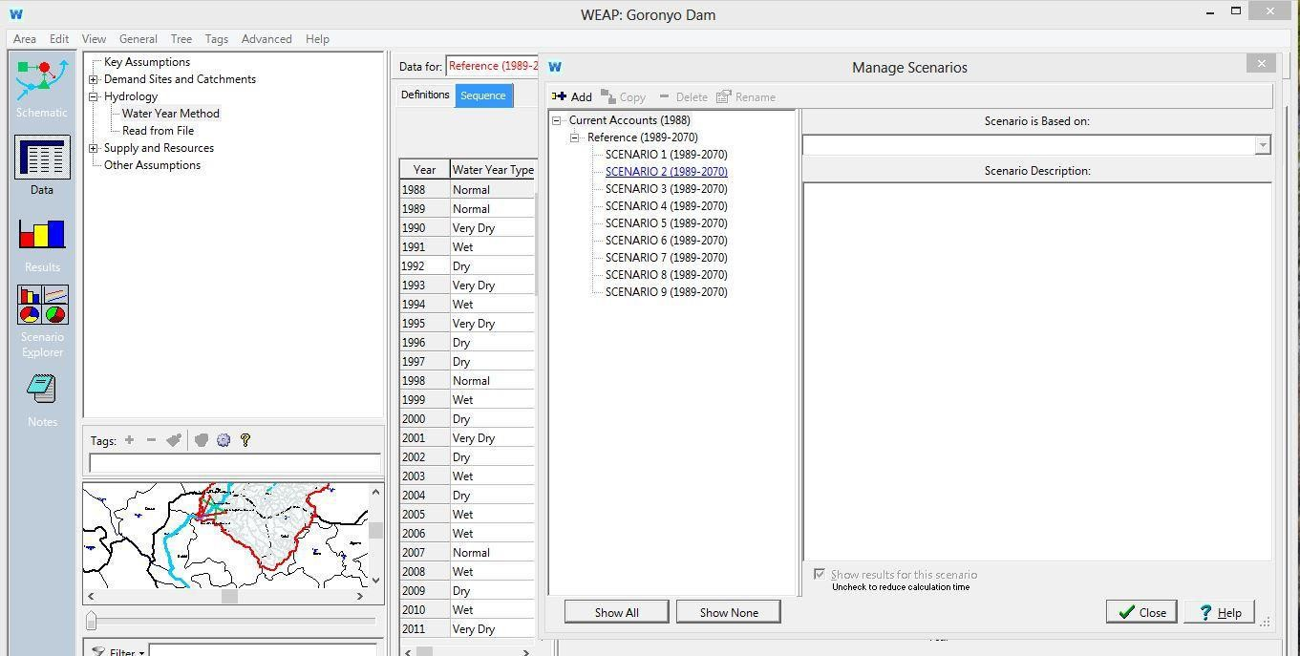

Figure 3.3: Setting up of all scenarios

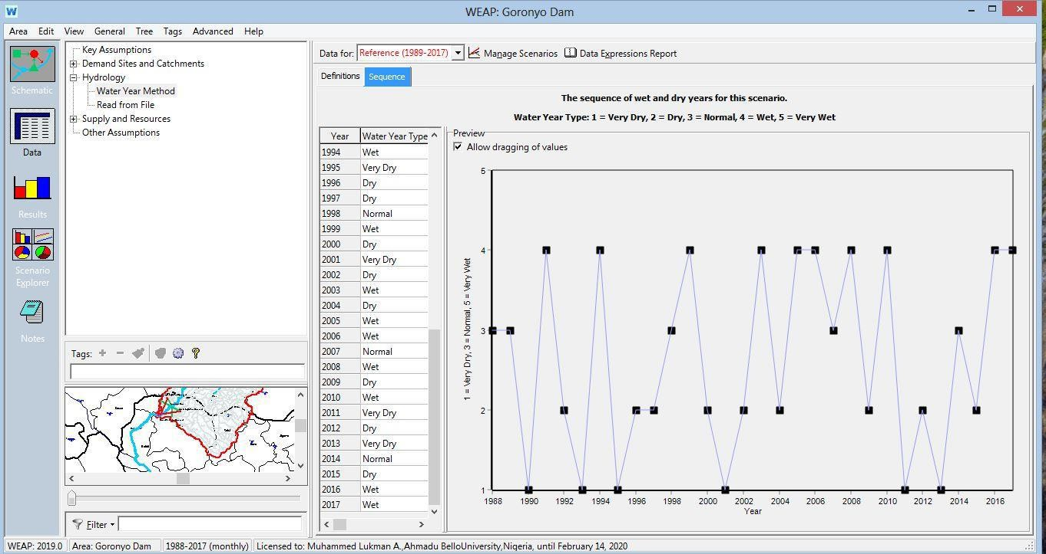

Figure 3.4: Water year values

The obtained values for each scenario generate runoff based on its climatic water year value. These values are shown in chapter (4) four. The water availability was evaluated based on the difference between the total available water within the catchment under scenarios and total water demand from the catchment of the model, the water availability in each scenario is then analyzed to evaluate the sensitivity and reliability of

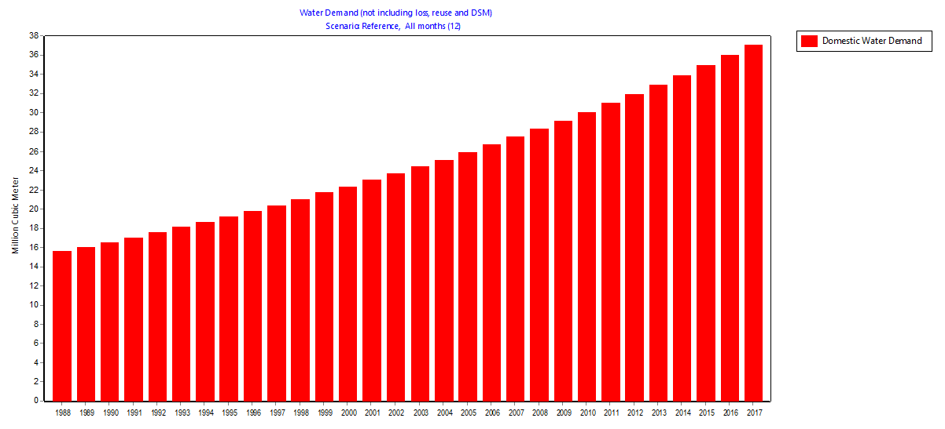the study based on climate change scenario. The impact of climate change on water demand and supply can easily be analyzed based on the availability of water within the area.

## Water demand

In 2010, the Food and Agricultural Organization of the United Nations, online Water use database, indicate that the water use in Nigeria ranges from 78.67 to 118.6 liters per capita per day. Therefore, the value of 120 liters per capita per day was used as the approximate maximum water use-value. The demographic data of the area was projected by using the inter census growth rate of the 1991 and 2006 population census. Therein, the Global Rice Science Partnership (GRIP),2013: Norton *et al.,*2018 indicate that for flood irrigation system, the water use for rice per hectare is 10750MCM. Therefore, the value of 10750MCM was adopted as the water use rate per hectare. since in the area, rice is the most water-demanding crop plant.

**48**

Figure 3.5 Domestic water demand of reference account

Figure 3.6 Water demand including all branches of reference account

Figure 3.6 shows the image of the water demand of the reference account involving all branches i.e. domestics and agricultural demands.

## Questionnaire analysis

A survey was conducted which demanded a response of people in the study area in respect to their water consumptives uses. According to the result analysis considering

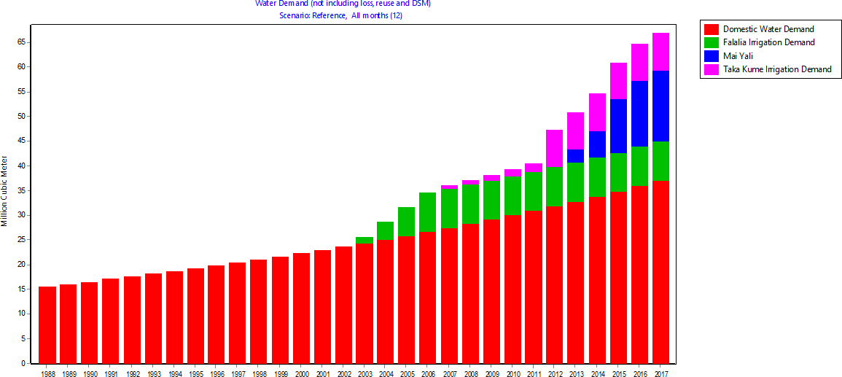

various water consumptive activities, 135 liters per capita per day was adopted for the study area. The breakdown is shown in table 3.4 this was done after consulting different journals. For instance, WHO (1996) reported that in Europe average of 200 liters per person a day, and according to WHO technical report on minimum water quantity needed for domestics uses for developed countries is a 220-liter person a day. Finally, according to Nema (2011), he reported that for developing countries like India the average water requirement per person a day is 135 liters under normal conditions. Therefore, this was chosen to justify the result from the responses of the study area via questionnaires.

|  |  |
| --- | --- |
| **Domestic water uses** | **Average daily uses (Litres)** |
| **Drinking** | 5 |
| **Toilets** | 30 |
| **Bathing** | 30 |
| **Laundry** | 30 |
| **Cooking** | 15 |
| **Cleaning (Others)** | 25 |
| **Total** | 135 |

**Table 3.4: Domestic water uses per capita per day**

# CHAPTER FOUR

# RESULTS AND DISCUSSION

## Introduction

This section displays an outline of the model results, the summary of the various parameters analyses as it is essential to effective recreation of the hydrology of the area, the strategies utilized in parameter data preparation, and the results of the calibration are also presented.



45.0

40.0

35.0

30.0

25.0

20.0

15.0

10.0

5.0

0.0

**Months**

**Temperature oC**

## Trend analysis

Figure 4.1 The mean monthly temperature of the area.

The average monthly temperature value for Sokoto station is 34.1oC, the maximum value is 39.10C in April, the minimum value is 29.10C. The standard deviation and variance of this data are 3.1 and 9.43 respectively.

Figure 4.2 The annual average temperature of the area



35.5

35.0

34.5

34.0

33.5

33.0

32.5

32.0

31.5

31.0

1988 1990 1992 1994 1996 1998 2000 2002 2004 2006 2008 2010 2012 2014 2016

**Years**

**Temperatures oc**

The annual average temperature range of the area has an average temperature value of 34.0oC, the minimum value is 32.50C in the year 1994 and 2014, with the maximum value of 35.10C in the year 2006. The standard deviation and variance of the data are

0.75 and 0.56 respectively.



250.0

200.0

150.0

100.0

50.0

0.0

**Months**

**Rainfall (mm)**

Figure 4.3. The chart of the mean monthly rainfall of the area.

The average monthly rainfall value of 50.1mm, with a maximum value of 203.9mm in August, the months of January, February, November, and December have no rainfall. The standard deviation and variance of the data in this station are 69.7 and 4857.2 respectively.

**Rainfall (mm)**

Figure 4.4 The annual rainfall data of the area.



1200.0

1000.0

800.0

600.0

400.0

200.0

0.0

**Years**

1988

1989

1990

1991

1992

1993

1994

1995

1996

1997

1998

1999

2000

2001

2002

2003

2004

2005

2006

2007

2008

2009

2010

2011

2012

2013

2014

2015

2016

2017

The mean annual rainfall of the area is as shown in Figure 4.4, this displays the annual average pattern of rainfall in the area from 1988 to 2017. The maximum and minimum average values of 958.1mm and 459.6mm are in the years 2016 and 1995 respectively.



4000.00

3500.00

3000.00

2500.00

2000.00

1500.00

1000.00

500.00

0.00

Months

Streamflow in MCM

Figure 4.5 Monthly Average Streamflow Measured for Rima River

The streamflow data used was obtained from literature are the historical data this was done due to lack of adequate hardcopy data. The monthly average measured streamflow patterns of Rima rivers are shown in Figure 4.5. which is the main river dam (i.e.

Goronyo Reservoir). The measured monthly average streamflow volume data indicates a total volume of 9.33 billion cubic meters (BCM)or 9331.9MCM, with a mean of 777.7 million cubic meters (MCM).

## Analysis of the temperature trend for generating climate scenarios

The annual average maximum temperature of the area was analyzed. It indicates a maximum average annual temperature of 35.10C and minimum temperature of 29.10C and a standard deviation of 0.75. The linear trend analysis in Figure 4.6 below indicates a gradient of 0. 044. This designates a decadal increase of about 0.400C. Therefore, the value of 0.40C to 1.20C was selected as the projection of temperature increase for this region by considering temperature variation over four decades.

35.5

**y = 0.0442x + 33.324**

35.0

34.5

34.0

33.5

33.0

32.5

32.0

31.5

31.0

Years

Temperature (0C)

Figure 4.6 Temperature Trend Analysis

1988

1989

1990

1991

1992

1993

1994

1995

1996

1997

1998

1999

2000

2001

2002

2003

2004

2005

2006

2007

2008

2009

2010

2011

2012

2013

2014

2015

2016

2017

## Analysis of the rainfall trend for generating climate scenarios

The average annual rainfall of the area was also analyzed. It indicates a maximum average rainfall value of 958.1mm and a minimum average value of 459mm with a mean of 601.1mm and a standard deviation of 107.32. The linear trend analysis as

shown in Figure 4.7 indicates a gradient of 10.0. This designates an annual increase of about 10%. Therefore, the value of 10% increase in rainfall and 10% decrease in rainfall

1200

1000

**y = 10.056x + 405**

800

600

400

200

0

Years

Rainfall in mm

was selected as the projection for climate change for this region by considering average rainfall value variation over four decades.

1988

1989

1990

1991

1992

1993

1994

1995

1996

1997

1998

1999

2000

2001

2002

2003

2004

2005

2006

2007

2008

2009

2010

2011

2012

2013

2014

2015

2016

2017

Figure 4.7 Rainfall in mm Trend Analysis

**Table 4.1: Hypothetical climate change scenario One (1) data**

# SCENARIO 1: +0.4 °C

|  |  |  |  |  |  |  |
| --- | --- | --- | --- | --- | --- | --- |
| **Years** | **Temp.**  **°C** | **Wind Speed (m/s)** | **Relative Humidity (%)** | **Rainfall (mm)** | **Water Year Value** | **Water Year Type** |
| **1988** | 33.77 | 3.15 | 41.17 | 641.4 | 1.067026002 | Normal |
| **1989** | 33.36 | 3.20 | 39.60 | 614.7 | 1.022608175 | Normal |
| **1990** | 34.38 | 2.80 | 40.95 | 505.1 | 0.840278818 | Very Dry |
| **1991** | 33.63 | 2.68 | 45.58 | 712.4 | 1.185140823 | Wet |
| **1992** | 33.27 | 3.05 | 42.01 | 535.0 | 0.890020129 | Dry |
| **1993** | 34.15 | 2.79 | 40.61 | 498.8 | 0.829798207 | Very Dry |
| **1994** | 32.94 | 3.01 | 45.06 | 779.6 | 1.296934005 | Very Wet |
| **1995** | 33.53 | 2.87 | 44.68 | 459.6 | 0.764585517 | Very Dry |
| **1996** | 34.07 | 2.71 | 42.27 | 544.6 | 0.905990584 | Dry |
| **1997** | 33.58 | 2.76 | 44.10 | 520.7 | 0.866230806 | Dry |
| **1998** | 34.47 | 2.77 | 41.91 | 654.1 | 1.088153583 | Normal |
| **1999** | 34.70 | 2.62 | 40.44 | 716.3 | 1.19162882 | Wet |
| **2000** | 34.41 | 2.87 | 42.70 | 512.4 | 0.852423017 | Dry |
| **2001** | 35.06 | 2.89 | 37.82 | 509.6 | 0.847764968 | Very Dry |
| **2002** | 35.23 | 2.65 | 40.28 | 558.0 | 0.928282677 | Dry |
| **2003** | 35.03 | 2.74 | 41.36 | 652.6 | 1.085658199 | Wet |
| **2004** | 34.98 | 2.69 | 41.91 | 516.0 | 0.858411938 | Dry |
| **2005** | 35.15 | 2.78 | 42.16 | 697.3 | 1.160020629 | Very Wet |
| **2006** | 35.48 | 2.61 | 38.82 | 651.3 | 1.083495533 | Wet |
| **2007** | 35.03 | 2.80 | 38.82 | 583.2 | 0.970205121 | Normal |
| **2008** | 34.44 | 2.94 | 38.17 | 657.8 | 1.094308862 | Wet |
| **2009** | 35.18 | 2.60 | 40.73 | 544.7 | 0.906156943 | Dry |
| **2010** | 34.86 | 2.72 | 42.02 | 701.1 | 1.166342267 | Wet |
| **2011** | 34.92 | 2.88 | 38.03 | 478.9 | 0.796692785 | Very Dry |
| **2012** | 34.26 | 2.23 | 42.75 | 553.7 | 0.921129244 | Dry |
| **2013** | 34.62 | 2.42 | 42.60 | 506.2 | 0.842108765 | Very Dry |
| **2014** | 32.85 | 2.70 | 41.07 | 582.7 | 0.969373326 | Normal |
| **2015** | 34.51 | 2.83 | 39.31 | 532.2 | 0.88536208 | Dry |
| **2016** | 35.46 | 2.76 | 42.05 | 958.1 | 1.593884647 | Very Wet |
| **2017** | 34.98 | 2.86 | 38.60 | 655.2 | 1.08998353 | Wet |

Table 4.1 shows the hypothetical climate change scenario 1 data of average annual temperature, wind speed, relative humidity, and rainfall with the equivalent water year type, derived based on the description of the water year method. The +0.40C increase in temperature is within the range of expected

climate change and is expected to increase evaporation and evapotranspiration,

this will afterward affect the runoff obtained from the rainfall and thereby affect water available in the area, with all other parameters being equal. This scenario will help to answer the question of what if the temperature should increase by

+0.4oC due to climate change.

**Table 4.2: Hypothetical climate change scenario two (2) data**

# SCENARIO 2: +0.4 °C & +10%R

|  |  |  |  |  |  |  |
| --- | --- | --- | --- | --- | --- | --- |
|  | **Temp.**  **°C** | **Wind Speed (m/s)** | **Relative Humidity (%)** | **Rainfall (mm)** | **Water Year Value** | **Water Year Type** |
| 1988 | 33.77 | 3.15 | 41.17 | 705.54 | 1.173729 | Wet |
| 1989 | 33.36 | 3.20 | 39.60 | 676.17 | 1.124869 | Wet |
| 1990 | 34.38 | 2.80 | 40.95 | 555.61 | 0.924307 | Dry |
| 1991 | 33.63 | 2.68 | 45.58 | 783.64 | 1.303655 | Wet |
| 1992 | 33.27 | 3.05 | 42.01 | 588.5 | 0.979022 | Normal |
| 1993 | 34.15 | 2.79 | 40.61 | 548.68 | 0.912778 | Dry |
| 1994 | 32.94 | 3.01 | 45.06 | 857.56 | 1.426627 | Wet |
| 1995 | 33.53 | 2.87 | 44.68 | 505.56 | 0.841044 | Very Dry |
| 1996 | 34.07 | 2.71 | 42.27 | 599.06 | 0.99659 | Normal |
| 1997 | 33.58 | 2.76 | 44.10 | 572.77 | 0.952854 | Wet |
| 1998 | 34.47 | 2.77 | 41.91 | 719.51 | 1.196969 | Wet |
| 1999 | 34.7 | 2.62 | 40.44 | 787.93 | 1.310792 | Wet |
| 2000 | 34.41 | 2.87 | 42.70 | 563.64 | 0.937665 | Dry |
| 2001 | 35.06 | 2.89 | 37.82 | 560.56 | 0.932541 | Dry |
| 2002 | 35.23 | 2.65 | 40.28 | 613.80 | 1.021111 | Normal |
| 2003 | 35.03 | 2.74 | 41.36 | 717.86 | 1.194224 | Wet |
| 2004 | 34.98 | 2.69 | 41.91 | 567.60 | 0.944253 | Dry |
| 2005 | 35.15 | 2.78 | 42.16 | 767.03 | 1.276023 | Wet |
| 2006 | 35.48 | 2.61 | 38.82 | 716.43 | 1.191845 | Wet |
| 2007 | 35.03 | 2.80 | 38.82 | 641.52 | 1.067226 | Wet |
| 2008 | 34.44 | 2.94 | 38.17 | 723.58 | 1.20374 | Wet |
| 2009 | 35.18 | 2.60 | 40.73 | 599.17 | 0.996773 | Normal |
| 2010 | 34.86 | 2.72 | 42.02 | 771.21 | 1.282976 | Wet |
| 2011 | 34.92 | 2.88 | 38.03 | 526.79 | 0.876362 | Dry |
| 2012 | 34.26 | 2.23 | 42.75 | 609.07 | 1.013242 | Normal |
| 2013 | 34.62 | 2.42 | 42.60 | 556.82 | 0.92632 | Dry |
| 2014 | 32.85 | 2.70 | 41.07 | 640.97 | 1.066311 | Wet |
| 2015 | 34.51 | 2.83 | 39.31 | 585.42 | 0.973898 | Normal |
| 2016 | 35.46 | 2.76 | 42.05 | 1053.91 | 1.753273 | Very Wet |
| 2017 | 34.94 | 2.86 | 38.60 | 720.72 | 1.198982 | Wet |

Table 4.2 shows the hypothetical climate change scenario 2 data of average annual temperature, wind speed, relative humidity, and rainfall with the corresponding classification of the year type, derived based on the description of the water year method. The +0.4 0C increase in temperature is within the range of expected climate change and is expected to increase evaporation and evapotranspiration, this will subsequently affect the runoff obtained from the rainfall, with all other parameters being equal. The 10% increase in rainfall is assigned due to the ambiguity in the change caused by climate change in the rainfall. A similar uncertainty effect was described by the IPCC (2014) and emphasis was made on this by Abdullahi (2014). This scenario will tend to answer the question of what will happen to the surface water under an increase

o

in temperature by +0.4 C and 10% rainfall due to climate change.

**Table 4.3: Hypothetical climate change Scenario three (3) data**

# SCENARIO 3: +0.4°C, - %10R

|  |  |  |  |  |  |  |
| --- | --- | --- | --- | --- | --- | --- |
| **Years** | **Temp.**  **°C** | **Wind Speed (m/s)** | **Relative Humidity (%)** | **Rainfall (mm)** | **Water Year Value** | **Water Year Type** |
| 1988 | 33.77 | 3.15 | 41.174 | 577.26 | 0.960323 | Normal |
| 1989 | 33.36 | 3.20 | 39.6 | 553.23 | 0.920347 | Dry |
| 1990 | 34.38 | 2.80 | 40.95 | 454.59 | 0.756251 | Dry |
| 1991 | 33.63 | 2.68 | 45.58 | 641.16 | 1.066627 | Wet |
| 1992 | 33.27 | 3.05 | 42.01 | 481.5 | 0.801018 | Dry |
| 1993 | 34.15 | 2.79 | 40.61 | 448.92 | 0.746818 | Very Dry |
| 1994 | 32.94 | 3.01 | 45.06 | 701.64 | 1.167241 | Wet |
| 1995 | 33.53 | 2.87 | 44.68 | 413.64 | 0.688127 | Very Dry |
| 1996 | 34.07 | 2.71 | 42.27 | 490.14 | 0.815392 | Dry |
| 1997 | 33.58 | 2.76 | 44.10 | 468.63 | 0.779608 | Dry |
| 1998 | 34.47 | 2.77 | 41.91 | 588.69 | 0.979338 | Normal |
| 1999 | 34.7 | 2.62 | 40.44 | 644.67 | 1.072466 | Wet |
| 2000 | 34.41 | 2.87 | 42.70 | 461.16 | 0.767181 | Dry |
| 2001 | 35.06 | 2.89 | 37.817 | 458.64 | 0.762988 | Dry |
| 2002 | 35.23 | 2.65 | 40.283 | 502.2 | 0.835454 | Dry |
| 2003 | 35.03 | 2.74 | 41.361 | 587.34 | 0.977092 | Normal |
| 2004 | 34.98 | 2.69 | 41.913 | 464.4 | 0.772571 | Dry |
| 2005 | 35.15 | 2.78 | 42.158 | 627.57 | 1.044019 | Normal |
| 2006 | 35.48 | 2.61 | 38.821 | 586.17 | 0.975146 | Normal |
| 2007 | 35.03 | 2.80 | 38.824 | 524.88 | 0.873185 | Dry |
| 2008 | 34.44 | 2.94 | 38.174 | 592.02 | 0.984878 | Normal |
| 2009 | 35.18 | 2.60 | 40.731 | 490.23 | 0.815541 | Dry |
| 2010 | 34.86 | 2.72 | 42.017 | 630.99 | 1.049708 | Normal |
| 2011 | 34.92 | 2.88 | 38.028 | 431.01 | 0.717024 | Very Dry |
| 2012 | 34.26 | 2.23 | 42.753 | 498.33 | 0.829016 | Dry |
| 2013 | 34.62 | 2.42 | 42.602 | 455.58 | 0.757898 | Dry |
| 2014 | 32.85 | 2.70 | 41.069 | 524.43 | 0.872436 | Dry |
| 2015 | 34.51 | 2.83 | 39.308 | 478.98 | 0.796826 | Dry |
| 2016 | 35.46 | 2.76 | 42.049 | 862.29 | 1.434496 | Very Wet |
| 2017 | 34.98 | 2.86 | 38.604 | 589.68 | 0.980985 | Normal |

Table 4.3 shows the hypothetical climate change scenario 3 data of average annual temperature, wind speed, relative humidity, and rainfall with the corresponding classification of the year type, derived based on the description of the water year method. The +0.40C increase in temperature is within the range of expected climate

change and is expected to increase evaporation and evapotranspiration, this will subsequently affect the runoff obtained from the rainfall, with all other parameters being equal. The 10% decrease in rainfall is assigned due to the ambiguity in the change caused by climate change in the rainfall. A similar uncertainty effect was described by the IPCC (2014) and emphasis was made on this by Abdullahi (2014). This scenario will tend to answer the question of what will happen to the surface water under an increase in temperature by +0.40C and a 10% decrease in rainfall due to climate change.

**Table 4.4: Hypothetical climate change scenario four (4) data**

# SCENARIO 4: +0.8 °C

|  |  |  |  |  |  |  |
| --- | --- | --- | --- | --- | --- | --- |
| **Year s** | **Temp.**  **°C** | **Wind**  **Speed (m/s)** | **Relative**  **Humidit y (%)** | **Rainfall (mm)** | **Water**  **Year Value** | **Water Year Type** |
| 1988 | 34.17 | 3.15 | 41.174 | 641.4 | 1.067026 | Normal |
| 1989 | 33.76 | 3.20 | 39.6 | 614.7 | 1.022608 | Normal |
| 1990 | 34.78 | 2.80 | 40.95 | 505.1 | 0.840279 | Very Dry |
| 1991 | 34.03 | 2.68 | 45.58 | 712.4 | 1.185141 | Wet |
| 1992 | 33.67 | 3.05 | 42.01 | 535 | 0.89002 | Dry |
| 1993 | 34.55 | 2.79 | 40.61 | 498.8 | 0.829798 | Very Dry |
| 1994 | 33.34 | 3.01 | 45.06 | 779.6 | 1.296934 | Very Wet |
| 1995 | 33.93 | 2.87 | 44.68 | 459.6 | 0.764586 | Very Dry |
| 1996 | 34.47 | 2.71 | 42.27 | 544.6 | 0.905991 | Dry |
| 1997 | 33.98 | 2.76 | 44.1 | 520.7 | 0.866231 | Dry |
| 1998 | 34.87 | 2.77 | 41.905 | 654.1 | 1.088154 | Normal |
| 1999 | 35.1 | 2.62 | 40.4425 | 716.3 | 1.191629 | Wet |
| 2000 | 34.81 | 2.87 | 42.7 | 512.4 | 0.852423 | Dry |
| 2001 | 35.46 | 2.89 | 37.817 | 509.6 | 0.847765 | Very Dry |
| 2002 | 35.63 | 2.65 | 40.283 | 558 | 0.928283 | Dry |
| 2003 | 35.43 | 2.74 | 41.361 | 652.6 | 1.085658 | Wet |
| 2004 | 35.38 | 2.69 | 41.913 | 516 | 0.858412 | Dry |
| 2005 | 35.55 | 2.78 | 42.158 | 697.3 | 1.160021 | Very Wet |
| 2006 | 35.88 | 2.61 | 38.821 | 651.3 | 1.083496 | Wet |
| 2007 | 35.43 | 2.80 | 38.824 | 583.2 | 0.970205 | Normal |
| 2008 | 34.84 | 2.94 | 38.174 | 657.8 | 1.094309 | Wet |
| 2009 | 35.58 | 2.60 | 40.731 | 544.7 | 0.906157 | Dry |
| 2010 | 35.26 | 2.72 | 42.017 | 701.1 | 1.166342 | Wet |
| 2011 | 35.32 | 2.88 | 38.028 | 478.9 | 0.796693 | Very Dry |
| 2012 | 34.66 | 2.23 | 42.753 | 553.7 | 0.921129 | Dry |
| 2013 | 35.02 | 2.42 | 42.602 | 506.2 | 0.842109 | Very Dry |
| 2014 | 33.25 | 2.70 | 41.069 | 582.7 | 0.969373 | Normal |
| 2015 | 34.91 | 2.83 | 39.308 | 532.2 | 0.885362 | Dry |
| 2016 | 35.86 | 2.76 | 42.049 | 958.1 | 1.593885 | Very Wet |
| 2017 | 35.38 | 2.86 | 38.604 | 655.2 | 1.089984 | Wet |

Table 4.4 shows the hypothetical climate change scenario four (4) data of average annual temperature, wind speed, relative humidity, and rainfall with the corresponding classification of the year type, derived based on the description of the water year method. The +0.80C increase in temperature is within the range of expected climate change and is expected to increase evaporation and

evapotranspiration, this scenario will tend to answer the question of what will happen to the surface water under an increase in temperature by +0.80C due to climate change.

**Table 4.5: Hypothetical climate change scenario five (5) data**

# SCENARIO 5: +0.8°C, +10%R

|  |  |  |  |  |  |  |
| --- | --- | --- | --- | --- | --- | --- |
| **Year s** | **Temp.**  **°C** | **Wind Speed (m/s)** | **Relative Humidit y (%)** | **Rainfall (mm)** | **Water Year Value** | **Water Year Type** |
| 1988 | 34.17 | 3.15 | 41.174 | 705.54 | 1.17373 | Wet |
| 1989 | 33.76 | 3.20 | 39.6 | 676.17 | 1.12487 | Wet |
| 1990 | 34.78 | 2.80 | 40.95 | 555.61 | 0.92431 | Dry |
| 1991 | 34.03 | 2.68 | 45.58 | 783.64 | 1.30365 | Wet |
| 1992 | 33.67 | 3.05 | 42.01 | 588.5 | 0.97902 | Normal |
| 1993 | 34.55 | 2.79 | 40.61 | 548.68 | 0.91278 | Dry |
| 1994 | 33.34 | 3.01 | 45.06 | 857.56 | 1.42663 | Wet |
| 1995 | 33.93 | 2.87 | 44.68 | 505.56 | 0.84104 | Very Dry |
| 1996 | 34.47 | 2.71 | 42.27 | 599.06 | 0.99659 | Normal |
| 1997 | 33.98 | 2.76 | 44.1 | 572.77 | 0.95285 | Wet |
| 1998 | 34.87 | 2.77 | 41.905 | 719.51 | 1.19697 | Wet |
| 1999 | 35.1 | 2.62 | 40.4425 | 787.93 | 1.31079 | Wet |
| 2000 | 34.81 | 2.87 | 42.7 | 563.64 | 0.93767 | Dry |
| 2001 | 35.46 | 2.89 | 37.817 | 560.56 | 0.93254 | Dry |
| 2002 | 35.63 | 2.65 | 40.283 | 613.8 | 1.02111 | Normal |
| 2003 | 35.43 | 2.74 | 41.361 | 717.86 | 1.19422 | Wet |
| 2004 | 35.38 | 2.69 | 41.913 | 567.6 | 0.94425 | Dry |
| 2005 | 35.55 | 2.78 | 42.158 | 767.03 | 1.27602 | Wet |
| 2006 | 35.88 | 2.61 | 38.821 | 716.43 | 1.19185 | Wet |
| 2007 | 35.43 | 2.80 | 38.824 | 641.52 | 1.06723 | Wet |
| 2008 | 34.84 | 2.94 | 38.174 | 723.58 | 1.20374 | Wet |
| 2009 | 35.58 | 2.60 | 40.731 | 599.17 | 0.99677 | Normal |
| 2010 | 35.26 | 2.72 | 42.017 | 771.21 | 1.28298 | Wet |
| 2011 | 35.32 | 2.88 | 38.028 | 526.79 | 0.87636 | Dry |
| 2012 | 34.66 | 2.23 | 42.753 | 609.07 | 1.01324 | Normal |
| 2013 | 35.02 | 2.42 | 42.602 | 556.82 | 0.92632 | Dry |
| 2014 | 33.25 | 2.70 | 41.069 | 640.97 | 1.06631 | Wet |
| 2015 | 34.91 | 2.83 | 39.308 | 585.42 | 0.9739 | Normal |
| 2016 | 35.86 | 2.76 | 42.049 | 1053.91 | 1.75327 | Very Wet |
| 2017 | 35.38 | 2.86 | 38.604 | 720.72 | 1.19898 | Wet |

Table 4.5 shows the hypothetical climate change scenario 5 data of average annual temperature, wind speed, relative humidity, and rainfall with the

corresponding classification of the year type, derived based on the description of the water year method. The +0.80C increase in temperature is within the range of expected climate change and is expected to increase evaporation and evapotranspiration. This will subsequently affect the runoff obtained from the rainfall, with all other parameters being equal. The 10% increase in rainfall is assigned due to the ambiguity in the change caused by climate change in the rainfall. A similar uncertainty effect was described by the IPCC (2014) and emphasis was made on this by Abdullahi (2014). This scenario will tend to answer the question of what will happen to the surface water under an increase in temperature by +0.80C and 10% rainfall due to climate change.

**Table 4.6: Hypothetical climate change scenario Six (6) data**

# SCENARIO 6: +0.8°C, -10%R

|  |  |  |  |  |  |  |
| --- | --- | --- | --- | --- | --- | --- |
| **Year s** | **Temp.**  **°C** | **Wind Speed (m/s)** | **Relative Humidit y (%)** | **Rainfall (mm)** | **Water Year Value** | **Water Year Type** |
| 1988 | 34.17 | 3.15 | 41.174 | 577.26 | 0.960323 | Normal |
| 1989 | 33.76 | 3.20 | 39.6 | 553.23 | 0.920347 | Dry |
| 1990 | 34.78 | 2.80 | 40.95 | 454.59 | 0.756251 | Dry |
| 1991 | 34.03 | 2.68 | 45.58 | 641.16 | 1.066627 | Wet |
| 1992 | 33.67 | 3.05 | 42.01 | 481.5 | 0.801018 | Dry |
| 1993 | 34.55 | 2.79 | 40.61 | 448.92 | 0.746818 | Very Dry |
| 1994 | 33.34 | 3.01 | 45.06 | 701.64 | 1.167241 | Wet |
| 1995 | 33.93 | 2.87 | 44.68 | 413.64 | 0.688127 | Very Dry |
| 1996 | 34.47 | 2.71 | 42.27 | 490.14 | 0.815392 | Dry |
| 1997 | 33.98 | 2.76 | 44.1 | 468.63 | 0.779608 | Dry |
| 1998 | 34.87 | 2.77 | 41.905 | 588.69 | 0.979338 | Normal |
| 1999 | 35.1 | 2.62 | 40.4425 | 644.67 | 1.072466 | Wet |
| 2000 | 34.81 | 2.87 | 42.7 | 461.16 | 0.767181 | Dry |
| 2001 | 35.46 | 2.89 | 37.817 | 458.64 | 0.762988 | Dry |
| 2002 | 35.63 | 2.65 | 40.283 | 502.2 | 0.835454 | Dry |
| 2003 | 35.43 | 2.74 | 41.361 | 587.34 | 0.977092 | Normal |
| 2004 | 35.38 | 2.69 | 41.913 | 464.4 | 0.772571 | Dry |
| 2005 | 35.55 | 2.78 | 42.158 | 627.57 | 1.044019 | Normal |
| 2006 | 35.88 | 2.61 | 38.821 | 586.17 | 0.975146 | Normal |
| 2007 | 35.43 | 2.80 | 38.824 | 524.88 | 0.873185 | Dry |
| 2008 | 34.84 | 2.94 | 38.174 | 592.02 | 0.984878 | Normal |
| 2009 | 35.58 | 2.60 | 40.731 | 490.23 | 0.815541 | Dry |

SCENARIO 6: +0.8°C, -10% R Continue

|  |  |  |  |  |  |  |
| --- | --- | --- | --- | --- | --- | --- |
| 2010 | 35.26 | 2.72 | 42.017 | 630.99 | 1.049708 | Normal |
| 2011 | 35.32 | 2.88 | 38.028 | 431.01 | 0.717024 | Very Dry |
| 2012 | 34.66 | 2.23 | 42.753 | 498.33 | 0.829016 | Dry |
| 2013 | 35.02 | 2.42 | 42.602 | 455.58 | 0.757898 | Dry |
| 2014 | 33.25 | 2.70 | 41.069 | 524.43 | 0.872436 | Dry |
| 2015 | 34.91 | 2.83 | 39.308 | 478.98 | 0.796826 | Dry |
| 2016 | 35.86 | 2.76 | 42.049 | 862.29 | 1.434496 | Very Wet |
| 2017 | 35.38 | 2.86 | 38.604 | 589.68 | 0.980985 | Normal |

Table 4.6 shows the hypothetical climate change scenario 6 data of average annual temperature, wind speed, relative humidity, and rainfall with the corresponding classification of the year type, derived based on the description of the water year method. The +0.80C increase in temperature is within the range of expected climate change and is expected to increase evaporation and evapotranspiration, this will subsequently affect the runoff obtained from the rainfall, with all other parameters being equal. The 10% decrease in rainfall is assigned due to the ambiguity in the change caused by climate change in the rainfall. A similar uncertainty effect was described by the IPCC (2014) and emphasis was made on this by Abdullahi (2014). This scenario will tend to answer the question of what will happen to the surface water under an increase in temperature by +0.80C and a 10% decrease in rainfall due to climate change.

**Table 4.7: Hypothetical climate change scenario seven (7) data**

# SCENARIO 7: +1.2 °C

|  |  |  |  |  |  |  |
| --- | --- | --- | --- | --- | --- | --- |
| **Year** | **Temp.**  **°C** | **Wind Speed (m/s)** | **Relative Humidity (%)** | **Rainfall (mm)** | **Water Year Value** | **Water Year Type** |
| 1988 | 34.57 | 3.15 | 41.174 | 641.4 | 1.06703 | Normal |
| 1989 | 34.16 | 3.20 | 39.6 | 614.7 | 1.02261 | Normal |
| 1990 | 35.18 | 2.80 | 40.95 | 505.1 | 0.84028 | Very Dry |
| 1991 | 34.43 | 2.68 | 45.58 | 712.4 | 1.18514 | Wet |
| 1992 | 34.07 | 3.05 | 42.01 | 535 | 0.89002 | Dry |
| 1993 | 34.95 | 2.79 | 40.61 | 498.8 | 0.8298 | Very Dry |
| 1994 | 33.74 | 3.01 | 45.06 | 779.6 | 1.29693 | Very Wet |
| 1995 | 34.33 | 2.87 | 44.68 | 459.6 | 0.76459 | Very Dry |
| 1996 | 34.87 | 2.71 | 42.27 | 544.6 | 0.90599 | Dry |
| 1997 | 34.38 | 2.76 | 44.1 | 520.7 | 0.86623 | Dry |
| 1998 | 35.27 | 2.77 | 41.905 | 654.1 | 1.08815 | Normal |
| 1999 | 35.5 | 2.62 | 40.4425 | 716.3 | 1.19163 | Wet |
| 2000 | 35.21 | 2.87 | 42.7 | 512.4 | 0.85242 | Dry |
| 2001 | 35.86 | 2.89 | 37.817 | 509.6 | 0.84776 | Very Dry |
| 2002 | 36.03 | 2.65 | 40.283 | 558 | 0.92828 | Dry |
| 2003 | 35.83 | 2.74 | 41.361 | 652.6 | 1.08566 | Wet |
| 2004 | 35.78 | 2.69 | 41.913 | 516 | 0.85841 | Dry |
| 2005 | 35.95 | 2.78 | 42.158 | 697.3 | 1.16002 | Very Wet |
| 2006 | 36.28 | 2.61 | 38.821 | 651.3 | 1.0835 | Wet |
| 2007 | 35.83 | 2.80 | 38.824 | 583.2 | 0.97021 | Normal |
| 2008 | 35.24 | 2.94 | 38.174 | 657.8 | 1.09431 | Wet |
| 2009 | 35.98 | 2.60 | 40.731 | 544.7 | 0.90616 | Dry |
| 2010 | 35.66 | 2.72 | 42.017 | 701.1 | 1.16634 | Wet |
| 2011 | 35.72 | 2.88 | 38.028 | 478.9 | 0.79669 | Very Dry |
| 2012 | 35.06 | 2.23 | 42.753 | 553.7 | 0.92113 | Dry |
| 2013 | 35.42 | 2.42 | 42.602 | 506.2 | 0.84211 | Very Dry |
| 2014 | 33.65 | 2.70 | 41.069 | 582.7 | 0.96937 | Normal |
| 2015 | 35.31 | 2.83 | 39.308 | 532.2 | 0.88536 | Dry |
| 2016 | 36.26 | 2.76 | 42.049 | 958.1 | 1.59388 | Very Wet |
| 2017 | 35.78 | 2.86 | 38.604 | 655.2 | 1.08998 | Wet |

Table 4.7 shows the hypothetical climate change scenario 7 data of average annual temperature, wind speed, relative humidity, and rainfall with the corresponding classification of the year type, derived based on the description of the water year method. The +1.20C increase in temperature is within the range

of expected climate change and is expected to increase evaporation and evapotranspiration, this scenario will tend to answer the question of what will happen to the surface water under an increase in temperature by +1.20C due to climate change.

**Table 4.8: Hypothetical climate change scenario eight (8) data**

# SCENARIO 8: +1.2 °C &+10% R

|  |  |  |  |  |  |  |
| --- | --- | --- | --- | --- | --- | --- |
| **Years** | **Temp.**  **°C** | **Wind Speed (m/s)** | **Relative Humidity (%)** | **Rainfall (mm)** | **Water Year Value** | **Water Year Type** |
| 1988 | 34.57 | 3.15 | 41.174 | 705.54 | 1.17373 | Wet |
| 1989 | 34.16 | 3.20 | 39.6 | 676.17 | 1.12487 | Wet |
| 1990 | 35.18 | 2.80 | 40.95 | 555.61 | 0.92431 | Dry |
| 1991 | 34.43 | 2.68 | 45.58 | 783.64 | 1.30365 | Wet |
| 1992 | 34.07 | 3.05 | 42.01 | 588.5 | 0.97902 | Normal |
| 1993 | 34.95 | 2.79 | 40.61 | 548.68 | 0.91278 | Dry |
| 1994 | 33.74 | 3.01 | 45.06 | 857.56 | 1.42663 | Wet |
| 1995 | 34.33 | 2.87 | 44.68 | 505.56 | 0.84104 | Very Dry |
| 1996 | 34.87 | 2.71 | 42.27 | 599.06 | 0.99659 | Normal |
| 1997 | 34.38 | 2.76 | 44.1 | 572.77 | 0.95285 | Wet |
| 1998 | 35.27 | 2.77 | 41.905 | 719.51 | 1.19697 | Wet |
| 1999 | 35.5 | 2.62 | 40.4425 | 787.93 | 1.31079 | Wet |
| 2000 | 35.21 | 2.87 | 42.7 | 563.64 | 0.93767 | Dry |
| 2001 | 35.86 | 2.89 | 37.817 | 560.56 | 0.93254 | Dry |
| 2002 | 36.03 | 2.65 | 40.283 | 613.8 | 1.02111 | Normal |
| 2003 | 35.83 | 2.74 | 41.361 | 717.86 | 1.19422 | Wet |
| 2004 | 35.78 | 2.69 | 41.913 | 567.6 | 0.94425 | Dry |
| 2005 | 35.95 | 2.78 | 42.158 | 767.03 | 1.27602 | Wet |
| 2006 | 36.28 | 2.61 | 38.821 | 716.43 | 1.19185 | Wet |
| 2007 | 35.83 | 2.80 | 38.824 | 641.52 | 1.06723 | Wet |
| 2008 | 35.24 | 2.94 | 38.174 | 723.58 | 1.20374 | Wet |
| 2009 | 35.98 | 2.60 | 40.731 | 599.17 | 0.99677 | Normal |
| 2010 | 35.66 | 2.72 | 42.017 | 771.21 | 1.28298 | Wet |
| 2011 | 35.72 | 2.88 | 38.028 | 526.79 | 0.87636 | Dry |
| 2012 | 35.06 | 2.23 | 42.753 | 609.07 | 1.01324 | Normal |
| 2013 | 35.42 | 2.42 | 42.602 | 556.82 | 0.92632 | Dry |
| 2014 | 33.65 | 2.70 | 41.069 | 640.97 | 1.06631 | Wet |
| 2015 | 35.31 | 2.83 | 39.308 | 585.42 | 0.9739 | Normal |
| 2016 | 36.26 | 2.76 | 42.049 | 1053.91 | 1.75327 | Very Wet |
| 2017 | 35.78 | 2.86 | 38.604 | 720.72 | 1.19898 | Wet |

Table 4.8 shows the hypothetical climate change scenario 8 data of average annual temperature, wind speed, relative humidity, and rainfall with the corresponding classification of the year type, derived based on the description of the water year method. The +1.20C increase in temperature is within the range of expected climate change and is expected to increase evaporation and evapotranspiration, this will subsequently affect the runoff obtained from the rainfall, with all other parameters being equal. The 10% increase in rainfall is assigned due to the ambiguity in the change caused by climate change in the rainfall. A similar uncertainty effect was described by the IPCC (2014) and emphasis was made on this by Abdullahi (2014). This scenario will tend to answer the question of what will happen to the surface water under an increase in temperature by +1.20C and 10% rainfall due to climate change.

**Table 4.9: Hypothetical climate change scenario nine (9) data**

# SCENARIO 9: +1.2°C & -10%R

|  |  |  |  |  |  |  |
| --- | --- | --- | --- | --- | --- | --- |
| **Years** | **Temp.**  **°C** | **Wind**  **Speed (m/s)** | **Relative**  **Humidity (%)** | **Rainfall (mm)** | **Water Year Value** | **Water Year Type** |
| 1988 | 34.57 | 3.15 | 41.174 | 577.26 | 0.96032 | Normal |
| 1989 | 34.16 | 3.20 | 39.6 | 553.23 | 0.92035 | Dry |
| 1990 | 35.18 | 2.80 | 40.95 | 454.59 | 0.75625 | Dry |
| 1991 | 34.43 | 2.68 | 45.58 | 641.16 | 1.06663 | Wet |
| 1992 | 34.07 | 3.05 | 42.01 | 481.5 | 0.80102 | Dry |
| 1993 | 34.95 | 2.79 | 40.61 | 448.92 | 0.74682 | Very Dry |
| 1994 | 33.74 | 3.01 | 45.06 | 701.64 | 1.16724 | Wet |
| 1995 | 34.33 | 2.87 | 44.68 | 413.64 | 0.68813 | Very Dry |
| 1996 | 34.87 | 2.71 | 42.27 | 490.14 | 0.81539 | Dry |
| 1997 | 34.38 | 2.76 | 44.1 | 468.63 | 0.77961 | Dry |
| 1998 | 35.27 | 2.77 | 41.905 | 588.69 | 0.97934 | Normal |
| 1999 | 35.5 | 2.62 | 40.4425 | 644.67 | 1.07247 | Wet |
| 2000 | 35.21 | 2.87 | 42.7 | 461.16 | 0.76718 | Dry |
| 2001 | 35.86 | 2.89 | 37.817 | 458.64 | 0.76299 | Dry |
| 2002 | 36.03 | 2.65 | 40.283 | 502.2 | 0.83545 | Dry |
| 2003 | 35.83 | 2.74 | 41.361 | 587.34 | 0.97709 | Normal |
| 2004 | 35.78 | 2.69 | 41.913 | 464.4 | 0.77257 | Dry |
| 2005 | 35.95 | 2.78 | 42.158 | 627.57 | 1.04402 | Normal |
| 2006 | 36.28 | 2.61 | 38.821 | 586.17 | 0.97515 | Normal |
| 2007 | 35.83 | 2.80 | 38.824 | 524.88 | 0.87318 | Dry |
| 2008 | 35.24 | 2.94 | 38.174 | 592.02 | 0.98488 | Normal |
| 2009 | 35.98 | 2.60 | 40.731 | 490.23 | 0.81554 | Dry |
| 2010 | 35.66 | 2.72 | 42.017 | 630.99 | 1.04971 | Normal |
| 2011 | 35.72 | 2.88 | 38.028 | 431.01 | 0.71702 | Very Dry |
| 2012 | 35.06 | 2.23 | 42.753 | 498.33 | 0.82902 | Dry |
| 2013 | 35.42 | 2.42 | 42.602 | 455.58 | 0.7579 | Dry |
| 2014 | 33.65 | 2.70 | 41.069 | 524.43 | 0.87244 | Dry |
| 2015 | 35.31 | 2.83 | 39.308 | 478.98 | 0.79683 | Dry |
| 2016 | 36.26 | 2.76 | 42.049 | 862.29 | 1.4345 | Very Wet |
| 2017 | 35.78 | 2.86 | 38.604 | 589.68 | 0.98099 | Normal |

Table 4.9 shows the hypothetical climate change scenario 9 data of average

annual temperature, wind speed, relative humidity, and rainfall with the corresponding classification of the year type, derived based on the description of the water year method. The +1.20C increase in temperature is within the range of expected climate change and is expected to increase evaporation and evapotranspiration, this will subsequently affect the runoff obtained from the rainfall, with all other parameters being equal. The 10% decrease in rainfall is assigned due to the ambiguity in the change caused by climate change in the rainfall. A similar uncertainty effect was described by the IPCC (2014) and emphasis was made on this by Abdullahi (2014). This scenario will tend to answer the question of what will happen to the surface water under an increase in temperature by +1.20C and a 10% decrease in rainfall due to climate change.

## Streamflow simulation

The average simulated streamflow volume of the Rima river using WEAP software is shown in Table 4.1 and Figure 4.8, the total mean average of the volume of water was found to be 14.4BCM and has maximum streamflow of 5.4 BCM in August and at the beginning of the rainy years, the average mean monthly value was 3.79MCM. This shows a little increment from what was gotten by Abdullahi 2015. He obtained the overall streamflow volume to be 11.6BCM for the rima river which drains both rivers buguru and gagere.

## Calibration and validation result

After a successful model Set up and Calibration with historical values. An obvious validation was first made by comparing graphically the simulated values with the observed values. Some efficiency criteria such as the Coefficient of regression (R2) and Coefficient of efficiency (C.E) were employed to access how fit the model reproduces

the observed measurement using excel. Table 4.10 shows the calculations of objective functions that were used for the determination of efficiency parameters of rima river streamflow simulation. The obtained values for the Coefficient of determination R2 is

0.98 and Nash- Sutcliffe coefficient (C.E) is 0.56% the value obtain lies within the specified ranges (i.e. 0 -1) to prove that the model performed well.

## Table 4.10: The simulated versus measured average monthly streamflow of rima river analysis.

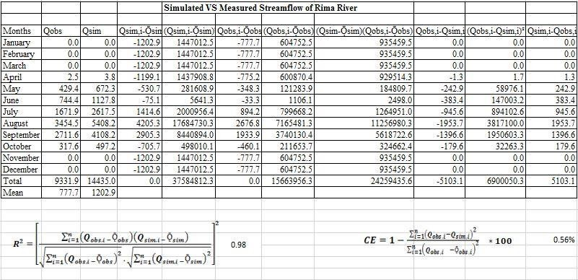



6000.0

5000.0

4000.0

3000.0

2000.0

1000.0

0.0

QSimulated

QObserved

Figure 4.8: Comparison of simulated and measured streamflow of River

Figure 4.8 The comparison of simulated and measured streamflow of River Rima. The visual evaluation of the graph indicates a similar pattern and coincidence in some values.

## Simulated storage volume

The simulated reservoir storage volume of Goronyo dam using the WEAP model is shown in Figure 4.9. The mean monthly average volume of water storage was found to be 737.9MCM and has a maximum storage volume of 824.3 in May, June, July, August, September, October respectively, and a minimum in the volume of 546.6MCM in April.

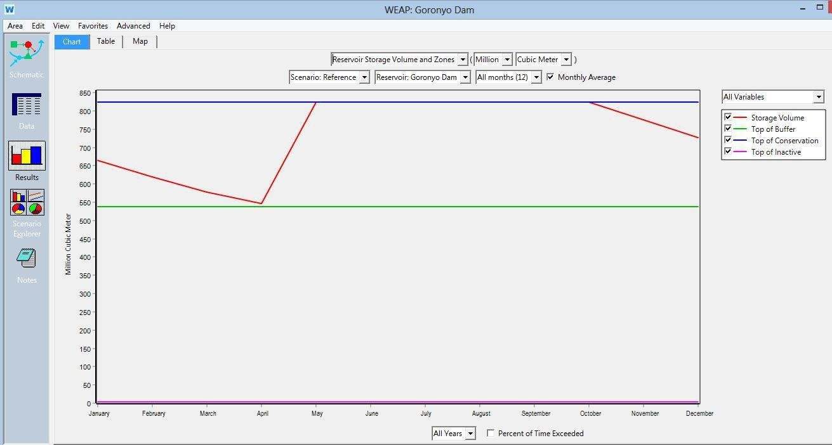

Figure 4.9: Reservoir storage volume.

## Impact of climate change on water availability

According to the simulation and comparison of the storage volume and zone of the reservoir reaches for reference scenario and scenarios 1 to 9, it was observed/detected that the impact varied. The difference in water availability based on simulation as a result of prescribed climate scenarios is as shown in Table 4.11. The reference scenario shows the total average mean volume of water to be 737.9MCM in the reservoir. while scenario 2 gives the highest mean average value of 703.2MCM as compared to other prescribed scenarios. The minimum available mean average under scenario 9 (assumed to be worst scenario) of 1.2oC increase in temperature and 10% decrease in rainfall is 698.7MCM.

## Table 4.11 Effect of different climate scenarios on the volume of water storage in

Amount of Water Available in MCM

|  |  |  |  |  |  |  |  |
| --- | --- | --- | --- | --- | --- | --- | --- |
| **Scenarios Reference Scenario1 Scenario2** | **Scenario3** | **Scenario4** | **Scenario5** | **Scenario6** | **Scenario7** | **Scenario8** | **Scenario9** |
| **+0.4oC +0.4oC,** | **+0.4oC,** | **+0.8oC** | **+0.8oC,** | **+0.8oC,** | **+1.2oC** | **+1.2oC,** | **+1.2oC,** |
| **+10%R** | **-10%R** |  | **+10%R** | **-10%R** |  | **+10%R** | **-10%R** |
| Mean 737.9 703.2 703.7 | 703.1 | 701.0 | 701.0 | 700.9 | 698.8 | 698.8 | 698.7 |

Average Storage volume (MCM)

## the reservoir

## Demand sites

The average annual domestic water demand of the population of 389,79 people based on the 1991 census of the area served by the reservoir was 17.1million cubic meters (MCM). while the 2006 census indicated that the population was 609,944 people. The average domestic water demand was 26.72 MCM. However, projecting the population to 2070 reveals that the future population will be 4,120,660 and their domestic water demand will be 180.5MCM. The annual average water demand for the area under the reference scenario is shown in Figure 4.10.

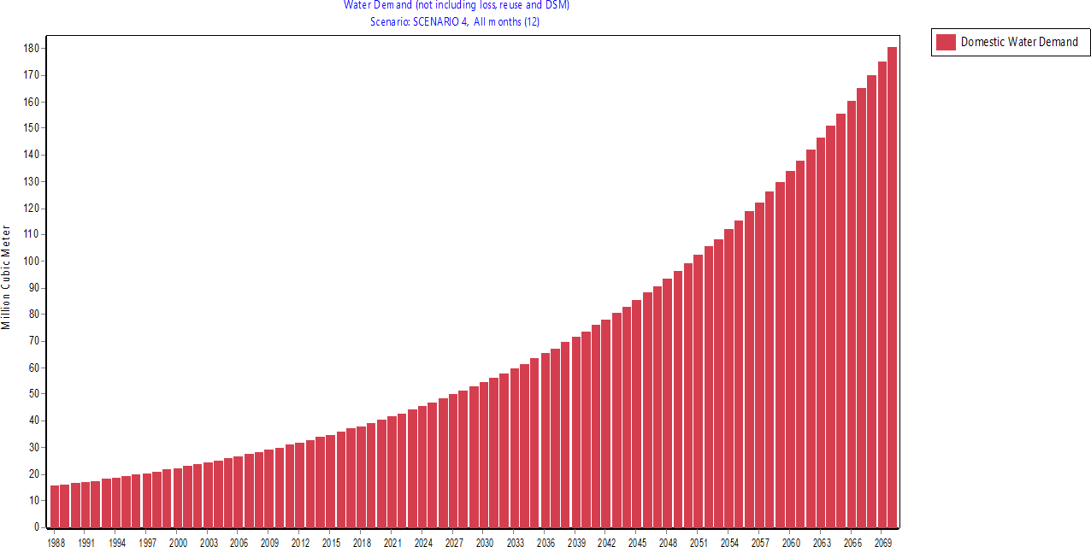

Figure 4.10**.** Domestic water demand for the reference scenario

The annual irrigation demand dated back to 2003 when the Falalia irrigation scheme kicked off occupying an irrigable land of 120ha and a demand of 1.3million cubic meters (MCM), in 2005, the scheme occupied an irrigable land of 530ha and water demand of 5.7million cubic meters (MCM). Finally, in 2006, the scheme came to an end with total irrigable land of 736ha and having a constant water demand of 7.9MCM till 2017. However, in 2007 the Taka Kume irrigation scheme kicked off, occupying an irrigable land of 50ha and the demand was 0.5MCM, in 2010, the scheme occupied an irrigable land of 125ha and water demand of 1.3MCM. Finally, in the year 2012 the

overall available land (690ha) in this scheme was occupied and demand of 7.4MCM. While, in 2013, the Mai Yali irrigation scheme kicked off occupying an irrigable land of 250ha and water demand of 2.7MCM, in 2015, the scheme occupied an irrigable land of 1000ha and water demand of10.8MCM.Finally, in 2017, the scheme came to an end with total irrigable land of 1350ha and having a water demand of 14.5MCM. The

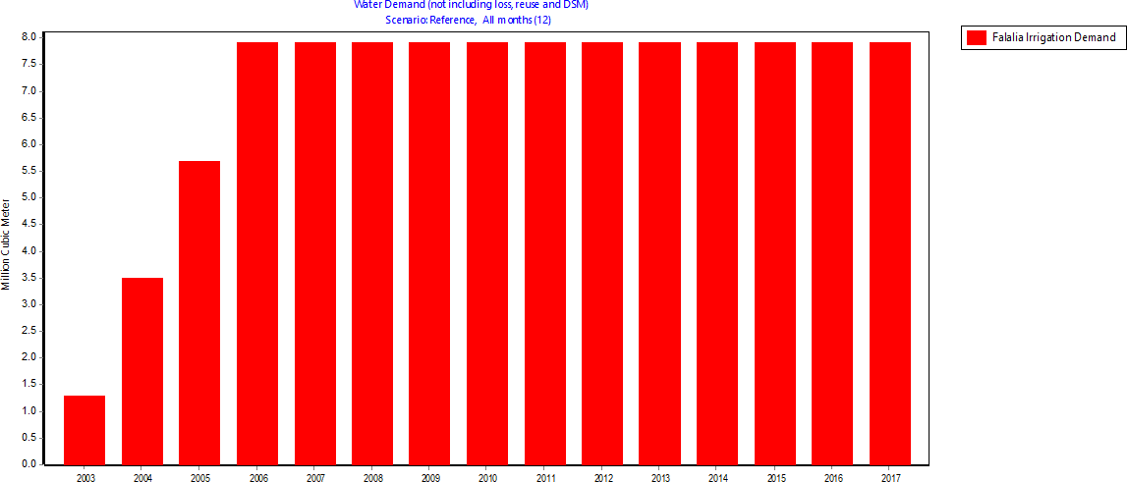

overall irrigation demand from initiation till the present is 202.1MCM. The future projection shows that the demand will be 1783.7MCM. Figures 4.11,4.12 and 4.13 show the annual irrigation water demand under the reference scenario.

Figure 4.11**.** Falalia Irrigation water demand for the reference scenario

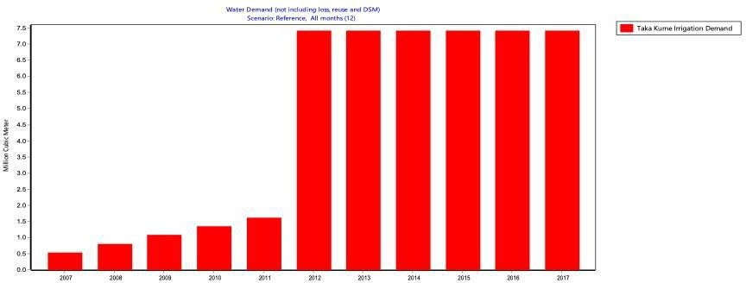

Figure 4.12**.** Taka Kume irrigation water demand for the reference scenario

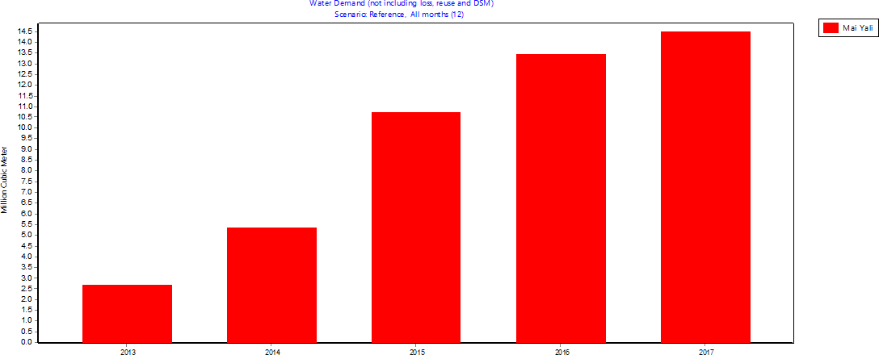

Figure 4.13. Mai Yali irrigation water demand for reference scenario.

## Demand site reliability on water availability

The demand site reliability of the available water for all branches under all scenarios before projection is shown in Figure 4.14 before projection. and Appendix B1. which shows the demand site reliability under climate change influence where a site like Mai Yali shows 91.7% reliability and others ranges from 51.9- 82.7%. while Appendix D. shows the projected water availability reliability under all scenarios due to the influence of climate change with the summary in Appendix B2.

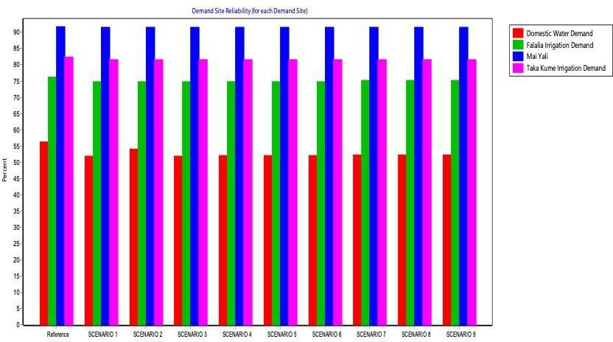

Figure 4.14. Demand site reliability before projection

## Comparison of scenarios on water availability

The streamflow for each node and reaches for both the river and reservoir (i.e. all branches) is shown in Figure 4.15 in this, Scenario two (2) appear to have the highest volume of available water, while scenario 1, scenario 4, and scenario 7 appear to have the same volume, similarly, scenario 3 and 6 have nearly similar value with a slight difference. Scenario 9 has a lower volume than all other scenarios.

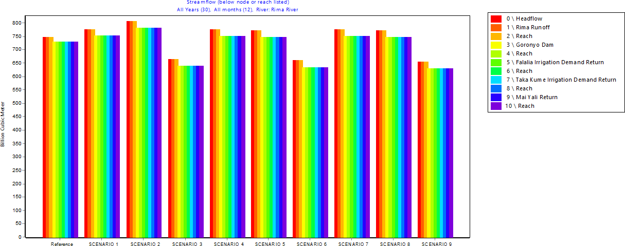

Figure 4.15: Streamflow below node and reach

The reference scenario was compared with all the other scenarios as shown in Figure

4.16. Appendix A1. gives the summary of the minimum and maximum monthly average volume for each scenario difference with the reference scenario shown in Figure 4.16. scenarios 3,6, and 9 show a very high negative volume that occurs under 0.4oC, 1.2oC rise in temperature, and 10% reduction in precipitation. Scenario 2 illustrates or depicts higher positive volume; this may be attributed to a 10% increase in rainfall.

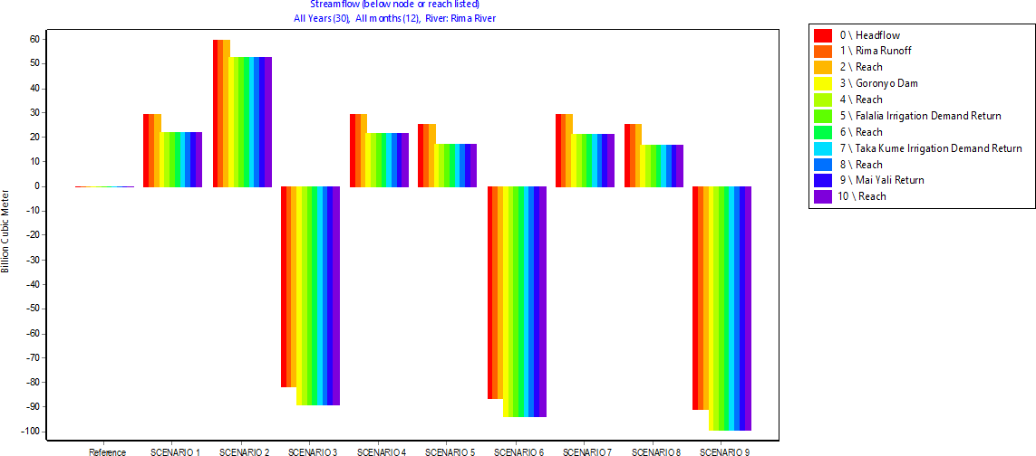

Figure 4.16 Streamflow of all scenarios compares with reference scenario.

The comparison of all other scenarios with scenario 1 is shown in Figure 4.17 and Appendix A2. gives the summary of the minimum and the maximum monthly average volume of each scenario difference with scenario 1. Scenario 2 shows positive and higher volume due to a 10% increase in rainfall over that scenario. The reference scenario,3,4,5,6,7,8, and 9 all show negative volume. However, scenario 3,6 and 9 depicts the high negative volume with scenario 9 shows the highest negative volume due to increase in temperature and reduction in precipitation. While scenarios 4 and 7 have **a** lower negative volume with scenario 4 have a slight negative volume.

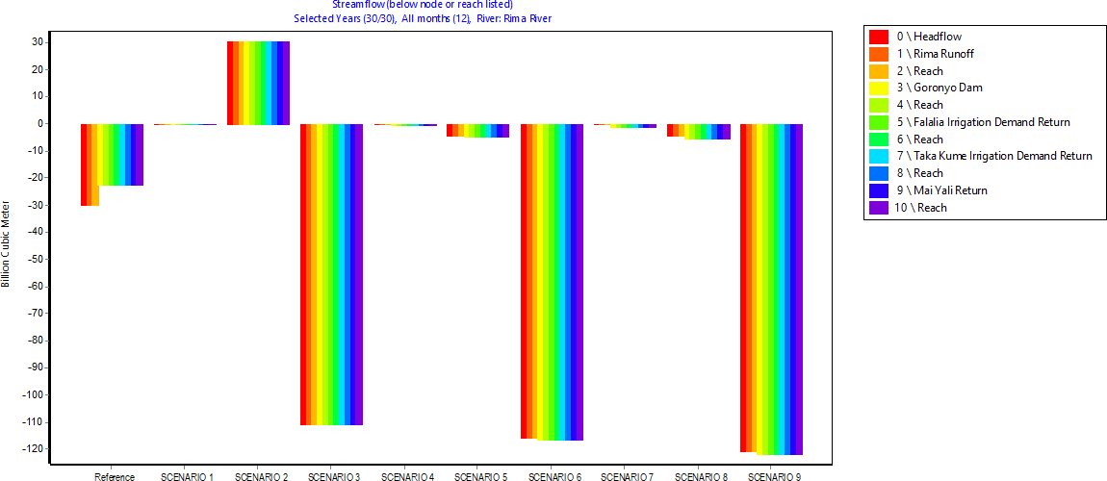

Figure 4.17: Streamflow for all scenarios compared with scenario 1

A graphical comparison of all other scenarios with scenario 2 is shown in Figure 4.18 and summarized in Appendix A3. All the scenarios indicate negative volume difference, which makes it clear that scenario 2 influences all other scenarios negatively. If scenario2 were to use as the reference scenario, all other scenarios will portray a deficit in total available water.

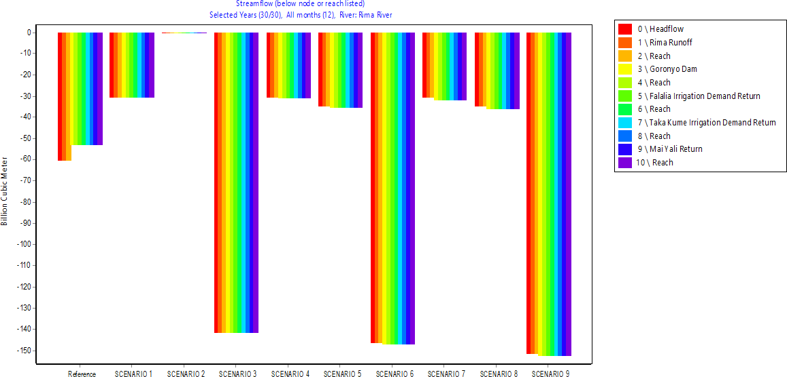

Figure 4.18: Streamflow for all scenarios compared with scenario 2

The graphical comparison of scenario 3 with all other scenarios is also shown in Figure

4.19 and summarized in Appendix A4. All the scenarios indicate positive volume difference except scenario 6 and 9, which shows that scenario 3 influence all other scenarios positively, but scenario 6 and 9 shows a deficit in total available water.

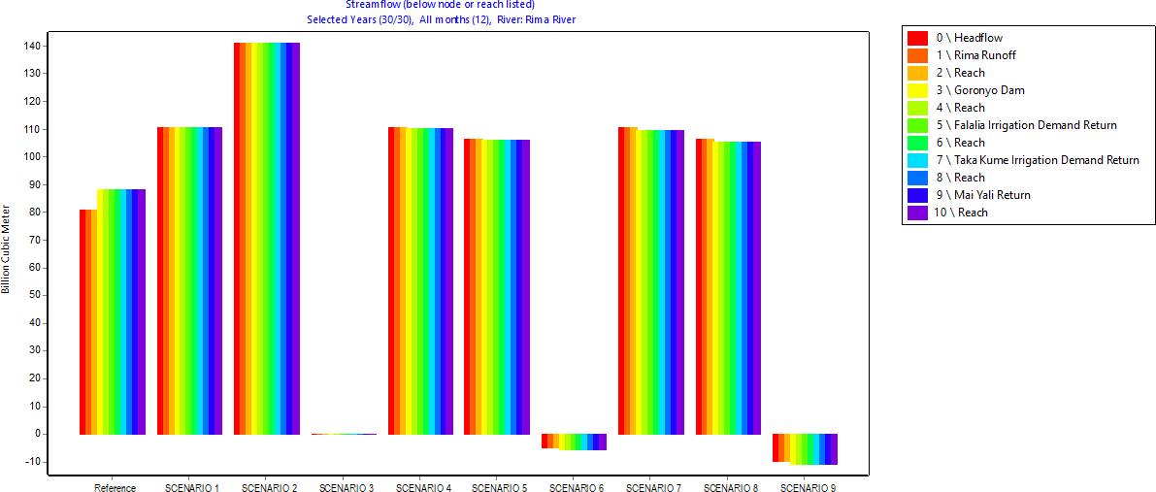

Figure 4.19: Streamflow for all scenarios compared with scenario 3

Comparing scenario 4 with other scenarios as shown in Figure 4.20. Scenarios 1 and 2 depict positive volume with scenario 2 having the higher volume due to the 10% increase in precipitation, while, scenarios 5,7, and 8 shows very small negative volume due to an increase in temperature. Scenarios 3,6 and 9 shows very high negative volume

indicating the difference between the scenario and decrease in volume that occurs under a 10% reduction in precipitation and also an increase in temperature most especially in the worse scenario (9). The summary is shown in Appendix A5.

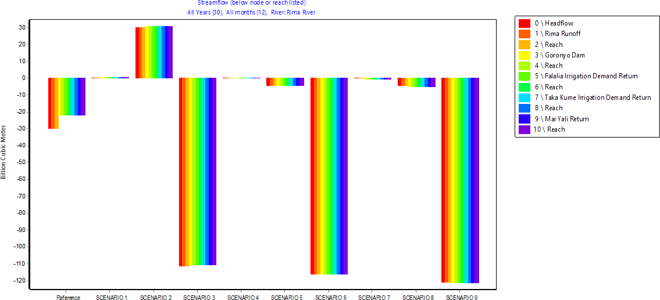

Figure 4.20: Streamflow for all scenarios compared with scenario 4

The comparison of scenario 5 with all other scenarios is also shown in Figure 4.21 and summarized in Appendix A6. four of the scenarios show negative volume. scenario,1,2,4, and 7 showing positive values with scenario 2 showing higher volume, scenarios 1,4, and 7 show close volume. which shows that scenario 5 negatively

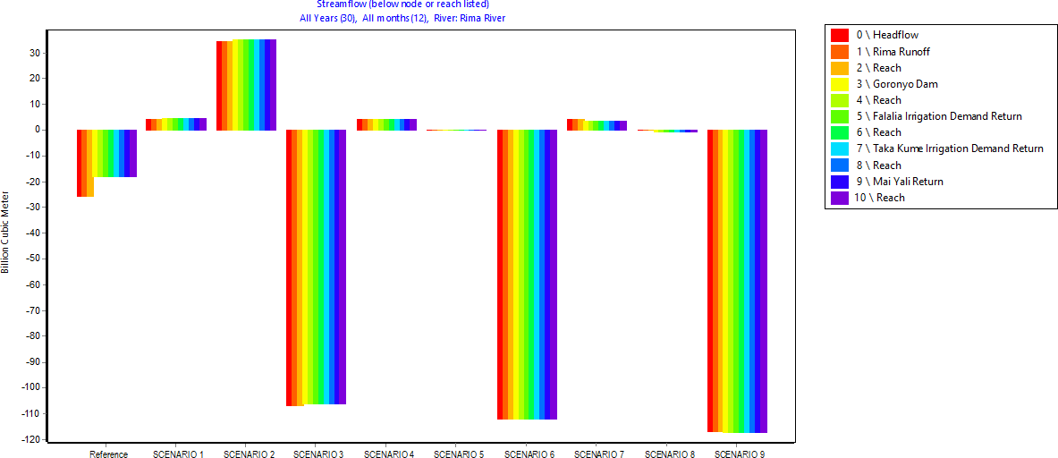

influence scenario 3,6 and 9 respectively.

Figure 4.21: Streamflow for all scenarios compared with scenario 5

The graphical comparison of scenario 6 with all other scenarios is also shown in Figure

4.22 and summarized in Appendix A7. All the scenarios indicate a positive volume difference except scenario 9 with 1.2oC and a 10% reduction in precipitation. This shows that scenario 6 influences other scenarios positively. If scenario 6 is used as the reference scenario, all other scenarios show an increase in total available water. Except

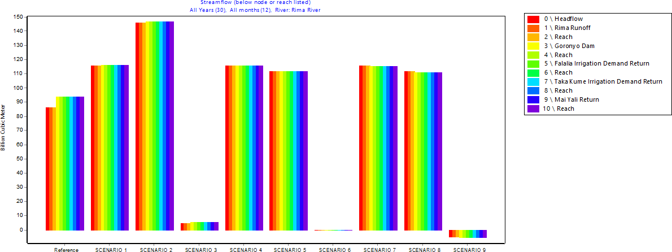

for the case where the temperature increases with a reduction in precipitation**.** Figure 4.22: Streamflow for all scenarios compared with scenario 6

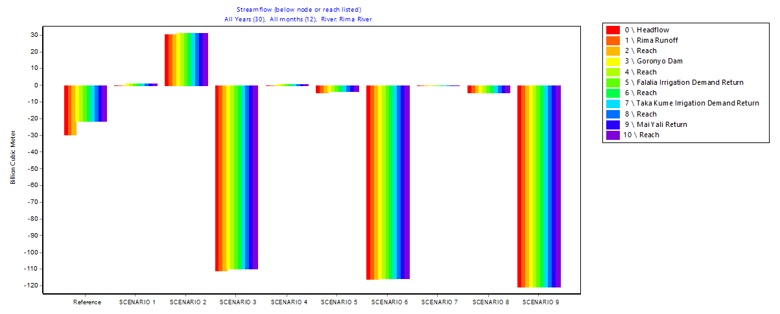Comparing scenario 7 with other scenarios (Figure 4.23) shows that Scenarios 3, 6, and 9 depict Very high negative volume due to a 10% reduction in precipitation while Scenario 1,2, and 4 show positive volume due to an increase in precipitation by 10%. Scenarios 5 and 8 shows very small negative volume indicating decreasing volume that

**81**

occurs under 0.8oC and 1.2oC increase in temperature. A summary is shown in Appendix A8.

The comparison of scenario 8 with all other scenarios is also shown in Figure 4.24 and summarized in Appendix A9. Four of the scenarios show negative volume i.e. reference scenario,3,6, and 9. While scenarios 1,2,4,5 and 7 showing positive volume, though scenario two still have the higher volume. This shows that scenario 8 negatively

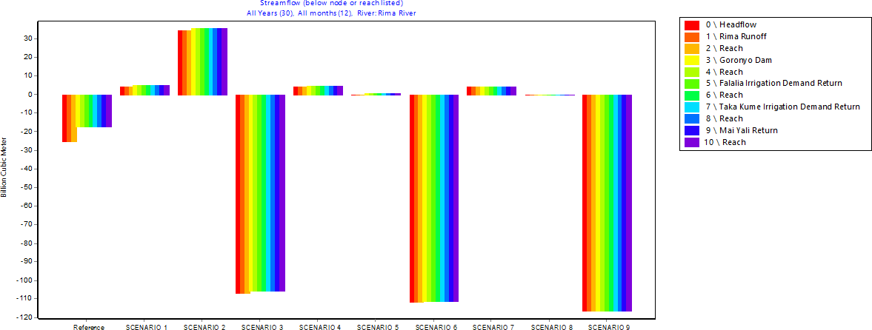

influences four scenarios.

Figure 4.24: Streamflow for all scenarios compared with scenario 8

## 82

The graphical comparison of scenario 9 with all other scenarios is also shown in Figure

4.25 and summarized in Appendix A10. All the scenarios indicate a positive volume difference. This shows that scenario 9 influences all other scenarios positively. If scenario 9 is used as the reference scenario, all other scenarios show an increase in total available water.

Figure 4.25: Streamflow for all scenarios compared with scenario 9

## Forecasting the future available water

The climate change impact on future water availability to meet the demand requirements was assessed for Goronyo Reservoir utilizing nine scenarios-based climate datasets. The situation was projected/forecasted up to the year 2070, which is 51 years from 2019. The result indicates a similar trend of climate change with the previous outcome as shown in Figure 4.26. It indicates higher future streamflow in Scenario 1, 2,4 & 7 with Scenario 2 having the highest volume.

Similarly, the storage volume of the reservoir under different scenarios was observed to vary as it is affected by the scenarios. Table 4.13 shows the summary of all the storage volumes for all scenarios.

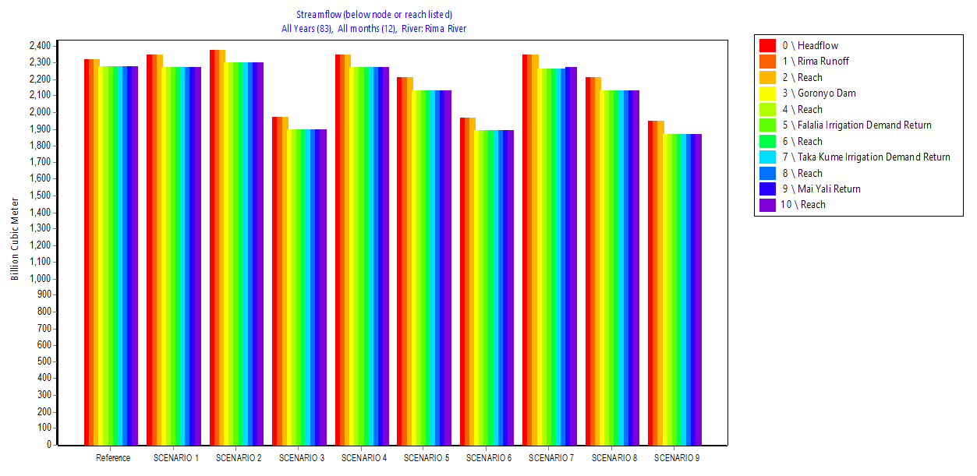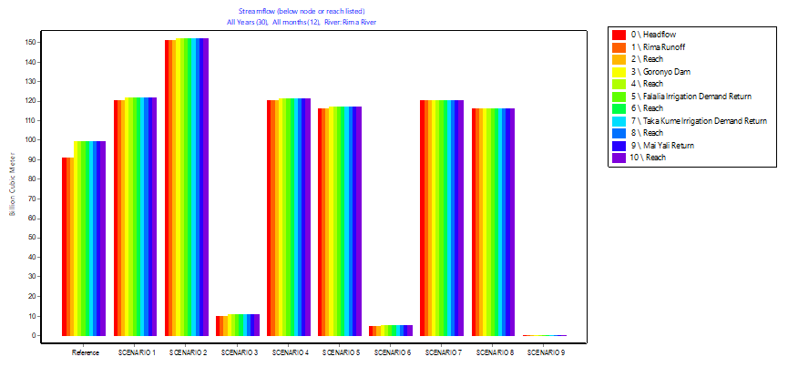

**83**

Figure 4.26: Streamflow of Rima river for all scenarios projected to 2070.

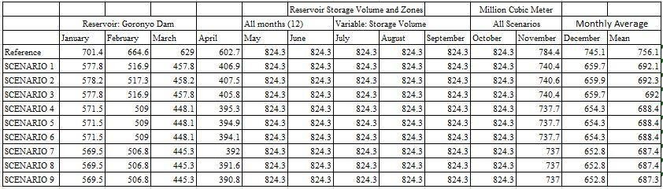

## Table: 4.12 Storage volume of Goronyo Reservoir for all Scenario after Projection.

From Table 4.12, it is observed that Scenario 9 still shown the least mean monthly storage compared to the reference scenario. The water demand from the area was projected, as shown in Figure 4.27 indicating or showing that the demand will be approximately 6 times higher in 50 years to come and that the supply deficit is on the

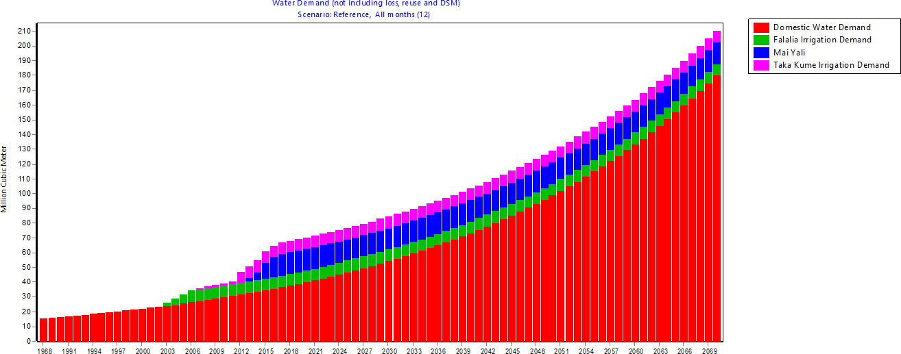

increasing order (61%).

## 84

Figure 4.27: Water Demands projected to 2070.

The unmet demand projected into the future is shown in Figure 4.28. it shows that all the scenarios have a similar trend of not satisfying the demand. However, the domestic demands can be source from alternatives sources most especially during the dry seasons. Hence, it is clearly shown in Figures 4.29 & 4.30 that the unmet demand is

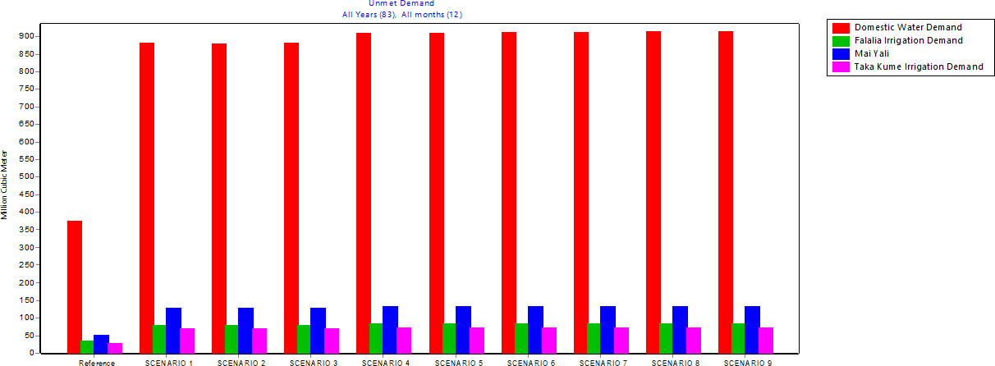

more pronounced during the dry season for both the reference and even all scenarios. Figure 4.28: Unmet Demand for all Demands.

Figure 4.29: Average Monthly Unmet Demands for reference scenario. Figure 4.30: Average Monthly Unmet Demands for all scenarios.

Comparing demand, supplied delivered, and unmet demand, it is seen that there has being a deficit in supply to meet demand right from the reference scenario, however, the situation becomes worsen under scenario 9 with the higher overall volume of unmet

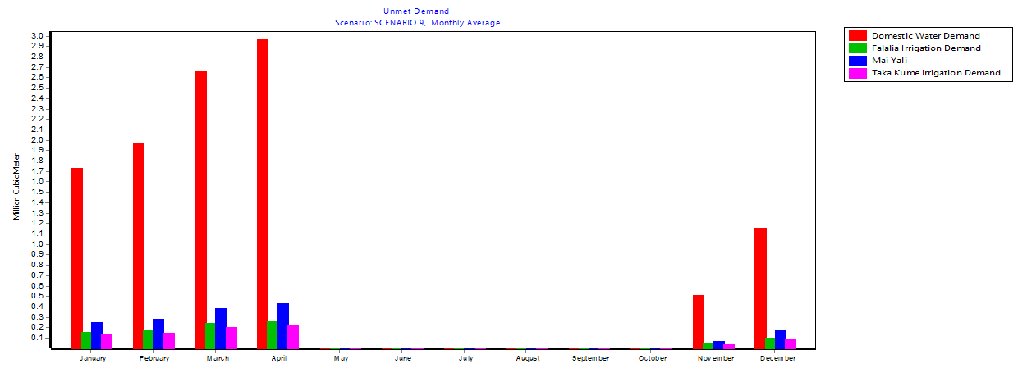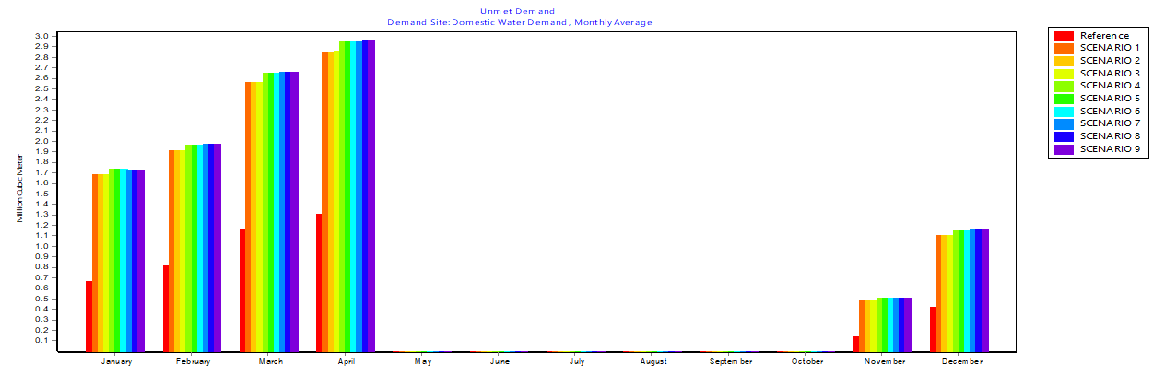

**85**

demand. Table 4.13 shows the summary of projected demands and unmet for all branches from 2018- 2070.

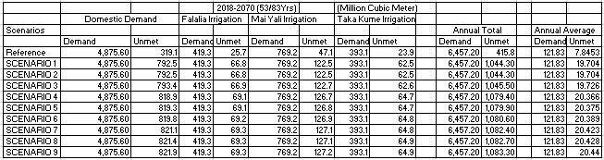

## Table 4.13 Projected demand and unmet for all branches using 120 l/c/d.

From Table 4.13 it can be deduced that the unmet demand increased by 61% that is, reference scenario to scenario 9 which is the worst scenario and with a higher volume annual total of 1,083.30 MCM unmet and annual average of unmet 20.44MCM.

However, considering the water usage analyses and the per capita daily demand of 135 liters per capita per day. as shown in Table 4.14. it can be seen that the demand increases and unmet also increases with scenarios 9 given an annual total of 1,199.7 MCM unmet demand and an annual average of 22.64MCM. Now comparing these two it can be stated that the unmet demand increases with an annual average of 2.20MCM.

## Table 4.14 Projected demand and unmet for all branches using 135l/c/d

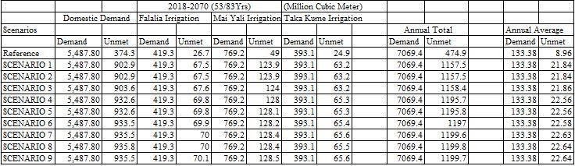

## Analysis of questionnaire

The questionnaire analysis is detailed in the subheadings below

## Water consumptive use.

The Figure 4.31. Shows the chart of water usage against the frequency, the detailed table is in appendix C1 which describes the variation in usage, it can be seen that the response to uses such as Watering of the garden, washing of cars, etc. shows more negative response than the positive which implies few percent or numbers of people using the water for such purposes. Reversed is the case as regards basic necessities such as drinking, bathing, and cooking, etc. the frequency ranges from 386- 396.

99

Yes No

116

11

1

1

3

12

9

Drinking Cooking Washing Bathing Watering Washing Shower

Garden of Car(s)

Water Usage

Water

Closet

Squart Bath Top

97

223

174

281

298

300

388

385

394

396

396

386

450

400

350

300

250

200

150

100

50

0

Frequency

Figure 4.31. Water Usage versus Frequency

## Domestic water demand

Table 4.15 present the water usage and percentage of their responses per combination of different consumptive uses. For instance, those that are used for both Drinking and cooking have a percentage of 97.48% Drinking, Cooking, Washing, and Bathing with

|  |  |
| --- | --- |
| 97.23 and Soon. |  |
| Domestic Water Usages (DWU) | Percentages |
| Drinking Cooking | 97.48 |
| Drinking Cooking Washing | 97.48 |
| Drinking Cooking Washing Bathing | 97.23 |
| Drinking Cooking Washing Bathing | 5.04 |
| Bathtub  Drinking Cooking Washing Bathing | 69.27 |
| Bathtub Water Closet  Drinking Cooking Washing Bathing | 81.36 |
| Bathtub Water Closet Squat  Drinking, Cooking, Washing, Bathing, | 0 |
| Bathtub, Water Closet, Squat, Shower  Drinking, Cooking, Washing, Bathing, | 75.57 |
| Bathtub, Water Closet, Squat, Shower, Washing car  Drinking, Cooking, Washing, Bathing, | 22.42 |
| Bathtub, Water Closet, Squat, Shower, Washing car,  Watering Garden |  |
| **Table 4.15 Domestic water uses** |  |

# CHAPTER FIVE

# CONCLUSION AND RECOMMENDATIONS

## Conclusion

The WEAP model software was successfully applied to estimate or assess the water availability in the area of study and scenarios analyses were carried out under possible climate change variability. The results indicate that the water available in the reservoir

(Goronyo Reservoir) with the mean average volume of 737.9MCM, Maximum of 824.3 MCM mainly in the wet period ranges from May – October, and the minimum mean average volume of 546.6 MCM mostly in a dry month i.e. April.

Meanwhile, under the influence of prescribed climate change, it was detected after simulation and comparison of storage volume and zone of reservoir for reference scenario and Scenarios 1 to 9 that impact varied in respect to water availability. The reference scenario shows a total average mean volume of 737.9MCM while scenario 2 gives the highest mean average value of 703.2MCM as compared to other prescribed scenarios. The minimum available mean average under scenario 9 of 1.2oC increase in temperature and 10% decrease in rainfall is 698.7MCM, therefore, the average storage volume is expected to be reduced by 5.6% as a result of the forecast increase in temperature by 1.2 oC and decreased rainfall of 10%.

The water demand was further analyzed using a questionnaire and projection was made from 2018 to 2070 and the annual total demand is 7069.4 MCM and the annual average demand of 133.4 MCM. Meanwhile, the unmet demand under various prescribed scenarios ranges from 21.84MCM to 22.64MCM.

Generally, the WEAP software model is a desktop tool for combined water resource planning and displays its suitability for water resources availability forecast.

## Recommendations

Owing to the research carried out the following recommendations are proposed:

* + 1. Demand Management Strategies such as rainwater harvest at the household level, wastewater reuse within the commercial facilities, etc. these would help in mitigating increasing demand and pressure on the water resources.
    2. There may be a need to develop other sources of water for irrigation such as the use of groundwater to reduce the growing pressure on the available source.
    3. The irrigation practice in the area is a furrow irrigation system, therefore, the use of improved irrigation systems such as sprinkler or drip (metered) irrigation systems would be of greater advantage.
    4. Further study could be carried out on Developmental Management Scenarios Such as Demand Management scenarios.

# REFERENCES

Abdullahi, S. A., Muhammed, M.M., Adeogun, B.K., Mohammed, I.U. (2014). Assess- ment of Water Availability in the Sokoto Rima River Basin. *Resources and Environment, 4(5): 220-233.*

Abdullahi,. (2014). "Assessment of Water Availability in the Sokoto Rima River Basin.

An MSc Dissertation submitted to Department of Water Resources and Environmental Engineering. Ahmadu Bello University, Zaria.

Abubakar, S. D. and Aliyu, M. (2017). "Examining Sediment Accumulation in Goronyo Reservoir, Sokoto State, Nigeria." IOSR Journal of Humanities and Social Science (IOSR-JHSS) 22(8): 60-65.

Adefolalu, D.O. (1986) Rainfall trends in Nigeria. Theoretical and Applied Climatology, 37:205-219.

Adefolalu, D.O. (2007): Climate change and Economic Sustainability in Nigeria, Paper presented at the International Conference on Climate Change and Economic Sustainability held at Nnamdi Azikiwe University, Enugu, Nigeria, from 12-14 June

Adeniyi, P.O. (1993). Integration of remote sensing and GIS for agricultural resource

management in Nigeria. EARSel Advances in Remote Sensing 2(3): 6 – 21.

Alfarra, A. (2004). Modeling water resource management in Lake Naivasha*.* M.Sc. thesis, International Institute for Geo-Information Science and Earth Observation, Enschede.

AMCEN (201 I): Addressing Climate Change Challenges in Africa; a Practical Guide

Towards sustainable development, Africa Ministerial Council on the Environment

Arnell, N.W. (1999): Climate Change and Global Environmental Change and Global

water resources. Global Environmental Change (9), S31 – S49

Arranz, R., & McCartney, M. (2007): Application of the Water Evaluation and Planning (WEAP) model to assess future water demands and resources in the Olifants catchment, South Africa. (Working Paper 116). Colombo: International Water Management Institute.

Assaf, H., & Saadeh, M. (2008): Assessing water quality management options in the

Upper Litani Basin, Lebanon, using an integrated GIS-based decision support system. Environmental Modelling & Software (23), 1327-1337.

Ayuba, H.K., Maryah, U.M. and Gwary, D.M. (2007): Climate Change Impact on Plant Species Composition in six Semi-arid Rangelands of Northern Nigeria, Nigerian Geographical Journal vol. 5(1), pp 35-42

Bates BC, et al. (eds.) (2008) Climate Change and Water, Technical Paper of the Intergovernmental Panel on Climate Change, IPCC Secretariat, Geneva, 210 pp.

Bobba A. G., Jeffries D. S., Singh V. P. (1999). Sensitivity of Hydrological Variables in the Northeast Pond River Watershed, Newfoundland, Canada, Due to

atmospheric

change. Water Resources Management, 13: 171-188

Boorman D. B., Sefton C. E. M. (1997). Recognizing the Uncertainty in the qualification

of the Effects of Climate Change on Hydrological Response. Climatic Change, 35: 415-434

Conway, D., Persechino, A., Ardoin-Bardin, S., Hamandawana, H., Dieulin, C., & Mahé,

during

G. (2009). Rainfall and Water Resources Variability in Sub-Saharan Africa the Twentieth Century, Journal of Hydrometeorology, 10, 41–59.

Davis, G. (1982). Rainfall and Temperature. In: Abdu, P.S. and Swindell, K. (Eds.) Sokoto State in Maps: An Atlas of Physical and Human Resources. Ibadan: Ibadan University Press.

Dennet, M.D, Elston, Y. and Rodgers, J.A. (1985) A Reappraisal of rainfall trends in

the Sahel Journal of Applied Climatology, 5: 353-361.

Droogers, P., & Van Loon, A. (2006): Water Evaluation and Planning System, Kitui – Kenya: WatManSup research report no. 2. Wageningen

Ekpoh, I. J., & Nsa, E. (2011). The Effects of Recent Climatic Variations on Water Yield in the Sokoto region of Northern Nigeria. *International Journal of Business and Social Science, 2*(Special),7.

Engelbrecht, F. (2005): Simulations of climate and climate change over Southern and

Tropical Africa with the Conformal-Cubic Atmospheric Model. In SCHULZE, R. E. (Ed.), Climate change and water resources in Southern Africa: Studies on scenarios, impacts, vulnerabilities, and adaption (WRC Report 1430/1/05 Chapter 4 ed., 57 - 74). Pretoria, RSA: Water Research Commission.

FAO.FAOSTAT-Crops: Food and Agriculture Organization of the United Nations, Rome, Italy. Available online: [http://faostat.fao.org](http://faostat.fao.org/) (accessed on 6 October

2017).

FME (2011): National Adaptation Strategy and Plan of Action on Climate Change in

Nigeria, Federal Ministry of Environment, Department of Climate Change, Abuja-Nigeria

Fu, G. (2005): Modelling water availability and its response to climate change for the Spokane River watershed. Ph.D. Thesis. Biological Systems Engineering. Washington State University.

Gill, M.A. (1974). Hydrological characteristics of the Sokoto-Rima basin. Savanna 3(1): 61– 76

Gleick P. H. (1987). Regional Hydrologic Consequences of Increases in Atmospheric

CO and Other Trace Gases. Climatic Change, 10: 137-161 2

Global Rice Science Partnership (GRISP), (2013). Rice Almanac, 4th Edn. Los Banos

: International Rice Research.

Haagan, I. (2007): Modelling the Impact of Small Reservoirs in the Upper East Region of Ghana. M.Sc. thesis, Lund University

Hailemariam K. (1999). Impact of Climate Change on the Water Resources of Awash River Basin, Ethiopia. Climate Research, 12: 91-96

Hengeveld, H., Whitewood, B. and Fergusson, A. (2005): An introduction to Climate

Change, a Canadian Perspective Environment Canada, Canada, pp 7-27

Hewitson, B. C., Engelbrecht, F., Tadross, M., & Jack, C. (2005) General conclusions

on Development of Plausible Climate Change Scenarios for Southern

Africa.

In SCHULZE, R. E. (Ed.), Climate Change and Water Resources in

Southern

Africa: Studies on Scenarios, Impacts,

Hoff, H., Noel, S., & Droogers, P. (2007): Water use and demand in the Tana Basin:

analysis using the Water Evaluation and Planning tool (WEAP). Wagenigen: ISRIC - World Soil Information

Hsu, H.H.; Chen, C.T.; Lu, M.M.; Chen, Y.M.; Chou, C.; Wu, Y.C., (2011). Climate

Change in Taiwan: Scientific Report; National Science Council, Executive

Yuan:

Taipei, Taiwan.

Huang, W.C.; Chiang, Y.; Wu, R.Y.; Lee, J.L.; Lin, S.H. (2012) The impact of climate change on Rainfall frequency in Taiwan. *Terr. Atmos. Ocean. Sci*, *23*, 553–564.

Hughes, D. A. (2004): Three decades of hydrological modeling research in South Africa.

South African Journal of Science, 638 - 642.

Ikhile, C. I. (2007). Impacts of Climate Variability and Change on the Hydrology and Water Resources of the Benin- Owena River Basin. Ph.D. Thesis, Unpublished. Benin City, Nigeria: University of Benin.

IPCC (1990): Scientific Assessment of Climate Change, a Report Prepared for Intergovernmental Panel on Climate Change by Working Group I, WG1 Secretariat, UK Meteorological Office, Bracknell

IPCC (2001): Synthesis Report, the contribution of Working Groups I, II, and III to Third Assessment Report of the Intergovernmental Panel on Climate

Change,

Cambridge University Press, pp 397

IPCC (2001): Climate Change Impacts, Adaptation, and Vulnerability, Contribution of the Working Group II to be the third assessment report of the Intergovernmental Panel on Climate Change, Cambridge University Press, Cambridge U.K

IPCC (2007): The Physical Science Basis, Contribution of Working Group I to the Fourth Assessment Report of the Intergovernmental Panel on Climate Change, Cambridge University Press, Cambridge United Kingdom

IPCC-TGICA. (2007): General guidelines on the use of scenario data for Climate Impact and adaptation assessment prepared by Carter, T.R. in Intergovernmental Panel on Climate Change: Task Group on Data and Scenario Support for Impact and Climate Assessment (TGICA) (66).

Islam M. D., Aramaki T., Hanaki K. (2005). Development and Application of Integrated Water Balance Model to Study the Sensitivity of the Tokyo Metropolitan Area and Water Availability Scenario to Climatic Changes. Water Resources Management, 19: 423-445

Ita, E.O., Balogun, J.K. and Adimula, O.A. (1982) Preliminary report of pre-impound - ment fisheries survey of Goronyo reservoir. A report submitted to the Sokoto Rima River Basin Development Authority, Sokoto, Nigeria.

Kamara, S.I. (1986) ―The origin and types of rainfall in West Africa‘‘ Weather, vol. 41, 48-56.

Levina, E. and Tirpak, D. (2006).Adaptation to Climate Change, Key terms,

Organization

for Economic Co-operation and Development, International Energy Agency, Paris, France.

Levite, H., Sally, H., & Cour, J. (2003): Testing water demand management scenarios

in a water-stressed basin in South Africa: application of the WEAP model. Physics and Chemistry of the Earth, 28, 779-786.

Linsley JR, R. K., Kohler, M. A., & Paulhus, J. L. (1982). Hydrology for Engineers (3Ed.)

Japan: McGraw-Hill.

Liu, T.M.; Tung, C.P.; Ke, K.Y.; Chuang, L.G.; Lin, C.Y. Application and development of a decision-support system for assessing water shortage and allocation with climate Change. *Paddy Water Environ.*2009, *7*, 301–311.

Matondo, J.I., Peter, G. and Msibi, K.M. (2004). Evaluation of the Impacts of Climate Change on Hydrology and Water Resources in Swaziland: Part1, Physics, and Chemistry of the Earth, 29, Pp. 1181-1191, Elsevier

Mearns, L. O., Giorgi, F., Whetton, P., Pabon, D., Hulme, M., & Lai, M. (2003) Guidelines for use of climate scenarios developed from regional climate model experiments: IPCC-TGICA.

McCabe G. and Wolock D. (1991). Detectability of the Effects of a Hypothetical Temperature Increase on the Thornthwaite Moisture Index. Journal of

Hydrology

125: 25-35

Miller, K., & Yates, D. (2005): Climate change and water resources: A primer for municipal water providers. Colorado: Awwa Research Foundation and University Corporation for Atmospheric Research (UCAR).

Mitchell, J.M. Jr, Dzerdzeevskii, R, Flohn, H., Hofmeyr, W.L., Lamb, H.H., Rao, K.N., Wallen, C.C, (1966): Climatic Change, WMO Technical Note No 79, World Meteorological Organization, Geneva

Nakicenovic, N., Alcamo, J., Davis, G., De Vries, B., Fenhann, J., Gaffin, S., Gregory

Gregory, K., Grübler, A., Jung, T. Y., Kram, Y., La Rovere, E. L., Michaelis,

L., Mori, S., Morita, T., Pepper, W., Pitcher, H., Price, L., Raihi, K., Roehrl,

A., Rogner, H.-H., Sankovski, A., Schlesinger, M., Shukla, P., Smith, S., Swart, R., Van Rooijen, S., Victor, N. A., & Dadi, Z. (2000): Emissions Scenarios. A Special Report of Working Group III of the Intergovernmental Panel on Climate Change. Cambridge, UK and New York, USA.

Nash, J.E. and Sutcliffe, J.V. (2012). River flow forecasting through conceptual models part I—A discussion of principles. Hydrol. 1970, 10, 282–290. Water 2012, 484

NASRDA, National Agency for Space Research Development Authority (2012) Nigerian

Imagery.

Nema, A. K. (2011). "Water Sources and Requirement." Department of Civil Engineering, I.I.T. Delhi: 5.

Nicholson, S. E. (1980) The nature of rainfall fluctuations in West Africa. 108: 473- 487.

Monthly Weather Review,

Norton G., et al. (2018). Genome-Wide Association Mapping of Grain and Straw Biomass. Traits in the Rice Bengal and Assam Aus. Panel (BAAP) Grown

Under

Alternate Wetting and Drying and Permanently Flooded Irrigation

Nwafor, J. C. (2007). Global climate change: The driver of multiple causes of flood intensity in sub-Saharan Africa. Paper presented at the International Conference on Climate Change and Economic Sustainability held at Nnamdi Azikiwe University, Awka, Nigeria. 12-14 June 2007.

Ochieng, G. M. M. (2007): Hydrological and water quality modeling of the Upper Vaal Water Management Area using a stochastic mechanistic approach. D.Tech thesis, Tshwane University of Technology, Pretoria.

Odjugo, P. A.O. (2005). An analysis of rainfall pattern in Nigeria. Global Journal of Environ Sci,4(2): 139-145.

Odjugo, P. A. O. (2007). The impact of climate change on water resources: Global and regional analysis. Indonesia Journal of Geography, 39(1): 23-41.

Odjugo, P. A. O. and Ikhuoria, A. I. (2003). The impact of climate change and anthropo-

genic factors on desertification in the semiarid region of Nigeria. Global J Environ Sci., 2(2): 118-126.

Odjugo, P.A.O. (2010): Regional Evidence of Climate Change in Nigeria, Journal of Geography and Regional Planning, Vol.3 (6), pp. 142-150

Ogheneakpobo, E.M. (1988). Land use changes as a result of the Goronyo dam construction (B.Sc. Project). Department of Geography, University of Sokoto, Sokoto.

Ogundebi, A.O., (2004). ―Socio-economic Impacts of Flooding in Lagos State‖, Environmental Impact Analysis, Vol. 12(1): pp 16-30.

Ojekunle Z. O., Ojo, K. O., Idowu, O. A., Martins O., Oluwasanya G. O., & O., O. V. (2011). Evaluation of Sustainable Water Demand in a Coastal Environment using WEAP Model. *Proceedings of the Environmental Management Conference, Federal University of Agriculture, Abeokuta, Nigeria*, 539-552.

Olsson, L., & Pilesjö, P. (2002): Approaches to spatially distributed hydrological modeling in a GIS environment. In SKIDMORE, A. (Ed.), Environmental modeling with GIS and remote sensing. London: Taylor & Francis.

Omojola, A.S. and Fasona, M.J. (2005). Effect of Climate Change, Human Security and Communal Clashes in Nigeria, an International Workshop, Helmen Fjord Hotel, Asker.

Purkey, D., Joyce, B., Vicuna, S., Hanemann, M., Dale, L., Yates, D., & Dracup, J. (2008): Robust analysis of future climate change impacts on water for

agriculture

and other sectors: a case study in the Sacramento Valley. Climate Change, 87(Suppl. 1), S109-S122

Ragunath, H. M. (2006). Hydrology: principles, analysis, and design (2nd Ed.). New Delhi: New Age Publishers.

Raskin, E. H., and Zhu, Z. (1992). Simulation of water supply and demand in the Aral sea region. Water International, 17(2), 55-67.

Refsgaard, J. C. (2007): Hydrological modeling and river basin management. D.Sc. thesis, University of Copenhagen.

Sawa, B. A., and Adebayo, A.A. (2011). The Impact of Climate Change on Precipitation

Effectiveness Indices in Northern Nigeria, Research Journal of Environmental and Earth Sciences 3(5): Pp 481 -486.

Schultz (1975) Report on Hadejia Irrigation project, Lagos.

Schulze, R. E. (2000). Modeling hydrological responses to land use and climate change: A Southern African perspective. *Ambio, 29*(1), 12 -22.

SEI. (2007): WEAP: Water evaluation and planning system - user guide. Boston. Shahraki, A. S., Shahraki, J., and Monfared, S. A. H. (2016). An Application of WEAP

Model in Water Resources Management Considering the Environmental Scenarios and Economic Assessment Case Study: Hirmand Catchment. *Modern Applied Science, 10*, 5. doi: 10.5539/mas. v10n5p49

Sieber, J., Huber-Lee, A., & Raskin, P. (2002), WEAP: Water Evaluation and Planning System User Guide (WEAP 21), Stockholm Environmental Institute—Boston, and Tellus Institute, User Guide for WEAP 21, Boston, MA

Skidmore, A. (2002): Taxonomy of environmental models in spatial sciences. In SKIDMORE, A(Ed.), Environmental modeling with GIS and remote sensing. London: Taylor & Francis.

Skiles J. W., and Hanson J. D. (1994). Response of Arid and Semi-Arid Watersheds to Increasing Carbon Dioxide and Climate Change as Shown by Simulation

Studies.

Climatic Change 26:377-397

Swindell, K. (1986). Population and agriculture in the Sokoto Rima basin of north-west Nigeria: A study of political intervention, adaptation, and change, 1800 – 1980. Cahiers d‘etudesAfricaines26 (101 – 102): 75 – 111.

Trucano T.G., Swiler L.P., Igusa T., Pilch M., Oberkampf W. L. (2006). Calibration, validation, and sensitivity analysis: What‘s what. Journal of Reliability Engineering System Safety, 91,1331- 1357. (Available at http://www.sciencedirect.com).

Udo, R.K. (1970). Geographical Regions of Nigeria. London: Heinemann

Umoh, E. (2007). Flooding problems in Rivers State. Journal of Environmental Sciences,

4(2): 4460.

Uitto, J.I. (2004). Multi-country cooperation around shared waters: role of monitoring

and Evaluation, Global Environmental Change, 14, 5–14.

UNESCO (2006), Water: a shared responsibility, The UN World Water Development Report 2, UNESCO, Paris

UNFCCC (1992): Article 1, Definitions, United Nations Framework Convention on

Climate Change, United Nation

USAID (2007): Adapting to Climate Variability and Change, a Guide Manual for Development Planning, U.S Agency for International Development.1300 Pennsylvania Avenue, NW Washington DC

Vicuna S., Garreaud R. D., Mcphee J. (2011). Climate change impacts on the hydrology Of a snowmelt driven basin in semiarid Chile. Climatic Change. Vol. 105. Iss.3

p. 469–488.

Wang Xiao – Jun, Zhang-Jian-Yun, Liu Jiu-Fu, Wang Guo-Qing, He Rui-Min, Wang Yan Can, Zhang Ming and Liu Cui-Shan (2009), Water Demand Management instead of Water Supply Management: A Case Study of Yulin City in North- western China; Improving Integrated Surface and Groundwater Resources Management in Vulnerable and Changing World – IAS Publication, 330 pp.

Williams, J.S. (2010), United State Involvement in UNESCO‘s International Hydrological program, U.S. Geological Survey.

Wilby, R. L., Charles, S. P., Zorita, E., Timbal, B., Whetton, P., & Mearns, L. O. (2004): Guidelines for use of climate scenarios developed from statistical downscaling methods: Data Distribution Centre of the Intergovernmental Panel on Climate Change.

WMO (2011). World Meteorological Organization Statement on the Status of the Global

Climate in 2011, CH-1211 Geneva 2, Switzerland

WMO (1988): Analysing Long Time Series of Hydrological Data with respect to Climate Variability, World Meteorological Organisation, TD-N0.224

WMO (1992): Scientific Assessment of Ozone Depletion, WMO/UNEP, Global Ozone Research and Monitoring Project, Report No 25, Geneva

Xu C. Y. (1999). Climate Change and Hydrologic Models: A Review of Existing Gaps and Recent Research Developments. Water Resources Management, 13: 369-

382

Yang, T.C.; Yu, P.S.; Wei, C.M.; Chen, S.T. (2011) Projection of climate change for daily

25, 1324–precipitation: A case study in Shih-Men reservoir catchment in Taiwan.

Hydrol. Process, 1354.

Yates, D. (1996). WatBal: An Integrated Water Balance Model for Climate Impact Assessment of River Basin Runoff. Water Resources Development, 12: 121-139

Yates, D., Purkey, D., Seiber, J., Huber-Lee, A., Galbraith, H., West, J., & Herrod- Julius, S. (2008): A physically-based water resource planning model of the Sacramento basin, California USA using WEAP 21. Water Resource Management (in press).

Yates, D., Sieber, J., Purkey, D., & Huber-Lee, A. (2005) WEAP21- a demand-, priority- preference-driven water planning model, part 1: model characteristics. Water International, 30(4), 487-500.

Yelwa, S.A. and Eniolorunda, N.B. (2012). Simulating the movement of desertification in Sokoto and its environs, Nigeria using 1km SPOT-NDVI data. Environmental Research Journal 6(3), 175 – 181.

Yilmaz, B. (2015). The Impacts of climate change on water budget and crop yield in Gediz River Basin. American Journal of Environmental Engineering and

Science

vol. 2, No. 6, pp. 93-99.

# APPENDICES

# APPENDIX A

APPENDIX A: Comparison of Scenarios on Water Availability A1 Streamflow from rima for all scenarios compared with reference scenario.

## All Nodes and Reaches, River, All Years 30/30, All months (12) (Billion Cubic Meter)

|  |  |  |  |  |  |  |  |  |  |  |
| --- | --- | --- | --- | --- | --- | --- | --- | --- | --- | --- |
|  | Reference | Scenario1 | Scenario2 | Scenario3 | Scenario4 | Scenario5 | Scenario6 | Scenario7 | Scenario8 | Scenario9 |
| **Min** | 0 | 23.3 | 60 | -88.6 | 21.8 | 17.6 | -94.0 | 21.3 | 17.1 | -99.4 |
| **Max** | 0 | 29.0 | 54.1 | -81.2 | 29.6 | 25.4 | -86.2 | 29.6 | 25.4 | -91.1 |

A2 Summary of Streamflow for all scenarios Compared with Scenario1

## All Nodes and Reaches, River, All Years 30/30, All months (12) (Billion Cubic Meter)

Reference Scenario1 Scenario2 Scenario3 Scenario4 Scenario5 Scenario6 Scenario7 Scenario8 Scenario9

**Min** -29.6 0 30.4 -110.9 -0.5 -4.7 -116.3 -5.1 17.1 -121.7

**Max** -22.3 0 30.5 -110.9 0.0 -4.2 -115.8 0.0 25.4 -120.8

A3 Summary of Streamflow for all scenarios Compared with Scenario 2

## All Nodes and Reaches, River, All Years 30/30, All months (12) (Billion Cubic Meter)

|  |  |  |  |  |  |  |  |  |  |  |
| --- | --- | --- | --- | --- | --- | --- | --- | --- | --- | --- |
|  | Reference | Scenario1 | Scenario2 | Scenario3 | Scenario4 | Scenario5 | Scenario6 | Scenario7 | Scenario8 | Scenario9 |
| **Min** | --60.0 | -30.5 | 0 | -141.4 | -31.0 | -35.2 | -146.3 | -31.4 | -35.6 | -152.2 |
| **Max** | -52.8 | -30.4 | 0 | -141.3 | -30.4 | -34.6 | -146.2 | -30.4 | -34.6 | -151.1 |

**All Nodes and Reaches, River, All Years 30/30, All months (12) (Billion Cubic Meter)**

|  |  |  |  |  |  |  |  |  |  |  |
| --- | --- | --- | --- | --- | --- | --- | --- | --- | --- | --- |
|  | Reference | Scenario1 | Scenario2 | Scenario3 | Scenario4 | Scenario5 | Scenario6 | Scenario7 | Scenario8 | Scenario9 |
| **Min** | 81.2 | 110.9 | 141.3 | 0 | 110.4 | 106.2 | -5.4 | 109.9 | 105.7 | -10.8 |
| **Max** | 88.6 | 110.9 | 141.4 | 0 | 110.9 | 106.7 | -4.9 | 110.9 | 106.0 | -9.9 |

A4 Summary of Streamflow for all scenarios Compared with Scenario 3

## All Nodes and Reaches, River, All Years 30/30, All months (12) (Billion Cubic Meter)

|  |  |  |  |  |  |  |  |  |  |  |
| --- | --- | --- | --- | --- | --- | --- | --- | --- | --- | --- |
|  | Reference | Scenario1 | Scenario2 | Scenario3 | Scenario4 | Scenario5 | Scenario6 | Scenario7 | Scenario8 | Scenario9 |
| **Min** | -29.6 | 0.0 | 30.4 | -110.9 | 0.0 | -4.2 | -115.8 | -0.5 | -4.7 | -121.2 |
| **Max** | -21.8 | 0.5 | 31.0 | -110.4 | 0.0 | -4.2 | -115.8 | 0.0 | -4.2 | -120.8 |

A5 Summary of Streamflow for all scenarios Compared with Scenario4

## All Nodes and Reaches, River, All Years 30/30, All months (12) (Billion Cubic Meter)

|  |  |  |  |  |  |  |  |  |  |  |
| --- | --- | --- | --- | --- | --- | --- | --- | --- | --- | --- |
|  | Reference | Scenario1 | Scenario2 | Scenario3 | Scenario4 | Scenario5 | Scenario6 | Scenario7 | Scenario8 | Scenario9 |
| **Min** | -25.4 | 4.2 | 34.6 | -106.7 | 4.2 | 0.0 | -111.6 | 3.7 | -0.5 | -117.0 |
| **Max** | -17.6 | 4.7 | 35.2 | -106.7 | 4.2 | 0.0 | -111.6 | 4.2 | -0.0 | -116.6 |

A6 Summary of Streamflow for all scenarios Compared with Scenario 5

## All Nodes and Reaches, River, All Years 30/30, All months (12) (Billion Cubic Meter)

|  |  |  |  |  |  |  |  |  |  |  |
| --- | --- | --- | --- | --- | --- | --- | --- | --- | --- | --- |
|  | Reference | Scenario1 | Scenario2 | Scenario3 | Scenario4 | Scenario5 | Scenario6 | Scenario7 | Scenario8 | Scenario9 |
| **Min** | 86.2 | 115.8 | 146.2 | 4.9 | 115.8 | 111.6 | 0.0 | 115.4 | 111.2 | -5.4 |
| **Max** | 94.0 | 116.3 | 146.8 | 5.4 | 115.8 | 111.6 | 0.0 | 115.8 | 111.6 | -4.9 |

A7 Summary of Streamflow for all scenarios Compared with Scenario 6

## All Nodes and Reaches, River, All Years 30/30, All months (12) (Billion Cubic Meter)

|  |  |  |  |  |  |  |  |  |  |  |
| --- | --- | --- | --- | --- | --- | --- | --- | --- | --- | --- |
|  | Reference | Scenario1 | Scenario2 | Scenario3 | Scenario4 | Scenario5 | Scenario6 | Scenario7 | Scenario8 | Scenario9 |
| **Min** | -29.6 | 0.0 | 30.4 | -110.9 | 0.0 | -4.2 | -115.8 | 0.0 | -4.2 | -120.8 |
| **Max** | -21.3 | 0.9 | 31.4 | -109.9 | 0.5 | -3.7 | -115.4 | 0.0 | -4.2 | -120.8 |

A8 Summary of Streamflow for all scenarios Compared with Scenario 7

## All Nodes and Reaches, River, All Years 30/30, All months (12) (Billion Cubic Meter)

|  |  |  |  |  |  |  |  |  |  |  |
| --- | --- | --- | --- | --- | --- | --- | --- | --- | --- | --- |
|  | Reference | Scenario1 | Scenario2 | Scenario3 | Scenario4 | Scenario5 | Scenario6 | Scenario7 | Scenario8 | Scenario9 |
| **Min** | -25.4 | 4.2 | 34.6 | -106.7 | 4.2 | 0.0 | -111.6 | 4.2 | 0.0 | -116.6 |
| **Max** | -17.1 | 5.1 | 35.6 | -105.7 | 4.7 | 0.5 | -111.2 | 4.2 | 0.0 | -116.6 |

A9 Summary of Streamflow for all scenarios Compared with Scenario 8

## All Nodes and Reaches, River, All Years 30/30, All months (12) (Billion Cubic Meter)

|  |  |  |  |  |  |  |  |  |  |  |
| --- | --- | --- | --- | --- | --- | --- | --- | --- | --- | --- |
|  | Reference | Scenario1 | Scenario2 | Scenario3 | Scenario4 | Scenario5 | Scenario6 | Scenario7 | Scenario8 | Scenario9 |
| **Min** | 91.1 | 120.8 | 151.1 | 9.9 | 120.8 | 116.6 | 4.9 | 120.8 | 116.6 | 0.0 |
| **Max** | 99.4 | 121.7 | 152.2 | 10.8 | 121.2 | 117.0 | 5.4 | 120.8 | 116.6 | 0.0 |

A10 Summary of Streamflow for all scenarios Compared with Scenario 9

# APPENDIX B

APPENDIX B: Demand Sites Reliability for all Demands Before and After Projection

**Domestic Demand**

**Falalia Irrigation**

**Mai Yali Irrigation**

**Taka Kume Irrigation**

|  |  |  |  |  |
| --- | --- | --- | --- | --- |
| **Reference** | 56.4 | 76.4 | 91.9 | 82.5 |
| **Scenario 1** | 51.9 | 75.0 | 91.7 | 81.7 |
| **Scenario 2** | 54.2 | 75.0 | 91.7 | 81.7 |
| **Scenario 3** | 51.9 | 75.0 | 91.7 | 81.7 |
| **Scenario 4** | 52.2 | 75.0 | 91.7 | 81.7 |
| **Scenario 5** | 52.2 | 75.0 | 91.7 | 81.7 |
| **Scenario 6** | 52.2 | 75.0 | 91.7 | 81.7 |
| **Scenario 7** | 52.5 | 75.3 | 91.7 | 81.7 |
| **Scenario 8** | 52.5 | 73.3 | 91.7 | 81.7 |
| **Scenario 9** | 52.5 | 75.3 | 91.7 | 81.7 |

B1 Demand sites reliability for all demands before projection

**Demand Site Reliability(for each Demand Site)(Percent)**

Selected Demand Sites (4/5)

|  |  |  |  |  |  |  |  |  |  |  |  |
| --- | --- | --- | --- | --- | --- | --- | --- | --- | --- | --- | --- |
|  | | Reference | SCN1 | SCN2 | SC3 | SCN3 | SCN3 | SCN6 | SCN7 | SCN8 | SCN9 |
| **Domestic Demand** | **Water** | 52.6 | 50.7 | 51.5 | 50.7 | 50.8 | 50.8 | 50.9 | 50.9 | 50.9 | 50.9 |
| **Falalia Irrigation** | | 59.8 | 59.0 | 59.0 | 59.0 | 59.0 | 59.0 | 59.1 | 59.1 | 59.1 | 59.1 |
| **Mai Yali Irrigation** | | 65.5 | 65.1 | 65.1 | 65.1 | 65.1 | 65.1 | 65.1 | 65.1 | 65.1 | 65.1 |
| **Taka Kume Irrigation** | | 62.0 | 61.4 | 61.4 | 61.4 | 61.4 | 61.4 | 61.4 | 61.4 | 61.4 | 61.4 |

B2 Demand Site Reliability for all sites projected to 2070. SCN: Scenario

# APPENDIX C

C1 The Responses of Water Usage with Frequencies and Percentages

**Frequency Percent Valid Percent Cumulative**

**Percent**

|  |  |  |  |  |
| --- | --- | --- | --- | --- |
| Drinking Valid No | 11 | 2.8 | 2.8 | 2.8 |
| Yes | 386 | 97.2 | 97.2 | 100.0 |
| Cooking Valid No | 1 | .3 | .3 | .3 |
| Yes | 396 | 99.7 | 99.7 | 100.0 |
| Washing Valid No | 1 | .3 | .3 | .3 |
| Yes | 396 | 99.7 | 100.0 | 100.0 |
| Bathing Valid No | 3 | .8 | .8 | .8 |
| Yes | 394 | 99.2 | 99.2 | 100.0 |
| Watering Garden Valid No | 385 | 97.0 | 97.0 | 97.0 |
| Yes | 12 | 3.0 | 3.0 | 100.0 |
| Washing Car(s) Valid No | 300 | 75.6 | 75.6 | 75.6 |
| Yes | 97 | 24.4 | 24.4 | 100.0 |
| Shower Valid No | 298 | 75.1 | 75.1 | 75.1 |
| Yes | 99 | 24.9 | 24.9 | 100.0 |
| Water Closet Valid No | 281 | 70.8 | 70.8 | 70.8 |
| Yes | 116 | 29.2 | 29.2 | 100.0 |
| Squirt Valid No | 174 | 43.8 | 43.8 | 43.8 |
| Yes | 223 | 56.2 | 56.2 | 100.0 |
| Bath Top Valid No | 388 | 97.7 | 97.7 | 97.7 |
| Yes | 9 | 2.3 | 2.3 | 100.0 |
| Washing Machine Valid No | 351 | 88.4 | 88.4 | 88.4 |
| Yes | 46 | 11.6 | 11.6 | 100.0 |

# APPENDIX D

APPENDIX D: Representation of demands site Reliability for all demands

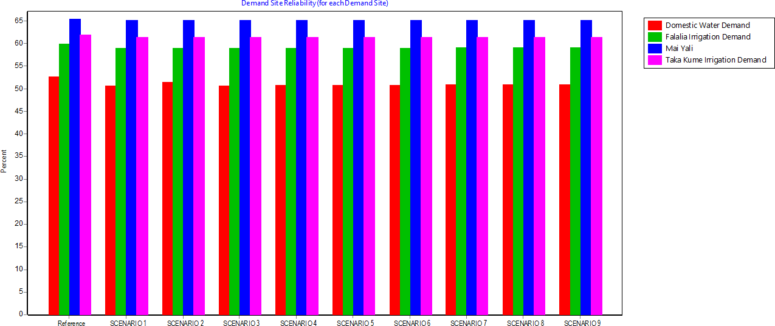

Figure:4.28: Demand Sites Reliability for each Demand.