ASSESSMENT OF URBAN ENCROACHMENT ON AGRICULTURAL LAND
ABSTRACT
Urban expansion constitutes one of the key agents of land use change with the impact felt at local, regional and global levels, such impact include spatial growth on agricultural land. This study assesses urban encroachment on agricultural land in Offa Local Government Area of Kwara State, Nigeria using Remote Sensing and Geographic Information techniques. Three imageries of LandSat TM 1990, LandSat ETM 1999 and Nigeria Sat X 2014 used processed, classified using supervised classification, and analyzed in Erdas Imagine 9.2 and ArcGIS 10.1 environment to assess the total spatial loss of agricultural land to urban expansion. Built – up and Agricultural land were extracted from the imageries and the spatial growth and loss within the study period was established. The findings revealed that the study area witnessed a significant reduction and increase in agricultural land and built – up respectively. Agricultural land occupying the highest coverage of 148.63 km² (65.36%) in 1990 decreased to 107.18 km² (47.14%) in 2014. The total spatial loss was 41.45 km² (27.89%) at an annual rate of 1.73 km² within the same period. While the built-up area expanded from 17.5km² in 1990 to 65.09 km² in 2014, total spatial change of 47.52 km² (270.40%) was experienced with at annual rate of 1.98 km² (11.27%) within the study period (1990 – 2014). The comparison of these results shows that 43.50 km² (19.13%) of agricultural land in the study area was lost to urban expansion within the study period at an annual conversion rate of 1.81 km². From the foregoing, it is recommended that urban spreading to agriculture land should be controlled as this will have serious repercussions on food security, although urban expansion cannot be stopped, but with proper management and planning it can be directed in a desirable and sustainable way.

CHAPTER ONE
INTRODUCTION
1.1 BACKGROUND TO THE STUDY
The world is rapidly urbanizing, and it has witnessed a tremendous shift of its population from being predominantly rural to predominantly urban in the last two decades (De Sherbinin, 2007). The world’s population is estimated to be 7.01 billion and by the year 2030, more than 60% of this population will be living in urban areas especially in developing countries, consuming close to three-quarters of the world‟s natural resources, and generating three quarters of its pollution and wastes (Peters, 2000; Redman and Jones, 2005). This growth will require unprecedented investment in new infrastructure and create serious challenges for political and social institutions. Rapid expansion of urban centers in the world at large and specifically in developing countries has continued to pose great challenges such that evokes interests from ecologists, planners, civil engineers, sociologists, administrators and policy makers on how much expansion is taking place, the effects on agricultural land and possible solution. It serves as a strong agent of land use/land cover change, hence loss of agricultural land (Olawole, Msimanga, Adegboyega, and Adeshina, 2011), and equally contributes to development; a requirement for and a result of economic, cultural and social development, as well as engines of economic growth and poverty alleviation (World Bank, 2009).Remote Sensing offers multiple advantages of wider coverage, long time series of data acquisition which facilitates monitoring and relatively low cost per square kilometre compared to other means of acquiring data (Hastings, 2002). Direct observation and/or interviews with the users in the field represent the most accurate means of collecting detailed information on land cover/use. However, this approach is costly especially when the region of interest is large (Hastings, 2002). Landsat Remote sensing images will be used in this project to monitor how urban developments have been affecting agricultural land in Offa Local Government Area.

Problem Statement
As the country’s population increases it calls for more food production in order to feed the increasing number of people. Unfortunately land is not increasing so we need to utilize the available land in a sustainable manner.

In Offa Local Government Area, encroachment of urban settlements on agricultural land is increasing at an alarming rate. This is due to its proximity to the Ilorin, tracts of land that were previously under coffee plantations and other crops are now characterised by residential estates posing a threat to agricultural production. Multi billions real estate projects are being built while uprooting coffee which once used to be the biggest economic crop.
Those with medium pieces of land are converting from agricultural to residential or commercial use and subdividing them into small portions taking advantage of the increased land prices. Majority of middle class Nigerian prefer to buy this land and build homes away from the noisy and polluted city into the outskirts. This has resulted to subdivision of Agricultural land into small size plots that are uneconomical for farming.

There is need to analyse the Urban Sprawl in Offa Local Government Area and develop strategies on how mitigation measures can be carried out.

Objectives General Objective
    - To analyse the effects of urban sprawl on agricultural land in Offa Local Government Area.

Specific Objectives

- To use Satellite Remote Sensing Technology to delineate Land cover/ use in Offa Local Government Area.
- To map urban development in the sub county.
- To determine size, rate and direction of the urban development in the sub-county.

Justification for the Study

This project will be useful to the policy makers in making decisions especially concerning, zoning in land use planning and protecting of agricultural land. It will also generate knowledge to the general public in terms of investing and future trends in property markets.

Scope of Work

The project aims at using Landsat satellite imagery to analyse effects of urban sprawl on Agricultural land in Offa Local Government Area. Landsat images, Geographic information system (GIS) and Global positioning System (GPS) will be used to acquire, process analyse and present data. Landsat images of three epochs taken in 1988, 2000 and 2016 will be used to analyse the trends of urban development. Most of the developments in the sub-county occurred from 1990s, hence there is need to study the area before and after the developments.

The project will be limited to the change in spatial extent of urban areas and agricultural land in general. This is especially because with 30m resolution Landsat imagery it may not be possible discriminate small land use activities.

CHAPTER 2
LITERATURE REVIEW
Introduction
Studies of Land Cover changes are fundamental for better understanding of interactions between human and the natural environment. Remote sensing technology has played a key role in the studies of land cover/ use changes. Availability of Multi-temporal satellite datasets provides the capability for mapping and monitoring of Land cover/use changes. Landsat have been exploited in several studies to evaluate built-up expansion and to assess urban morphology changes (Masek et al., 2000).
The physical expressions and patterns of sprawl on landscapes can be detected, mapped and analysed using remote sensing and geographical information system (GIS) technologies in conjunction with the secondary and ground truth data. Urban sprawl Mapping and monitoring is one of the operational applications of satellite remote sensing data. From the earliest Landsat-MSS-1973 which had 70metres resolution to the present high spatial resolution data have been proved efficient and more accurate in detecting the changes in urban sprawl.
An urban environment is constantly under transition with new constructions being put up now and then. The rate at which this change takes place can be overwhelming when they have to be monitored by field survey techniques. Remotely sensed data due to its frequency of acquisition can be exploited to alleviate this shortcoming (Karanja, 2002).
Remote Sensing data has become a major source for change detection studies because of its high temporal frequency, digital format suitable for computation, synoptic view and wider selection of spatial and spectral resolutions. (Chen. G., 2012)
Image interpretation algorithm methods may be grouped into statistical pattern recognition and image analysis techniques. Statistical pattern recognition which is mostly used consists of maximum likelihood, minimum distance classifiers among others.
The maximum likelihood classifier quantitatively evaluates both the variance and covariance of the category spectral response patterns when classifying an unknown pixel. An assumption is made that the distribution of the cloud of points forming the category training data is normally distributed. The probability density functions are used to classify an unidentified pixel by computing the probability of the pixel value belonging to each category. (Lillesand, 2004)
Minimum distance is done by first calculating the mean of the spectral value of each band for each category. A pixel of unknown identity is classified by computing the distance between the value of unknown pixel to each of the category means. The unknown pixel is assigned to the ‘closest’ class. Minimum distance to means strategy is mathematically simple and computationally efficient, but it has certain limitations. One of its limitations it that it is insensitive to different degrees of variance in the spectral response data. (Lillesand, 2004)

Change Detection Using Remote Sensing
Ideally a change detection procedure involves use multi-temporal datasets to discriminate areas of Land cover/use change between dates of Imaging (Lillesand, 2004). Urban sprawl development is a long time phenomena, hence requires a long time interval to realize the change.

Singh, (1989) defined change detection as “the process of identifying differences in the state of an object or phenomenon by observing it at different times”.

Ochengo (2003), used post classification change detection method in a study on application of remote sensing in deforestation monitoring. False colour composites of bands 2, 3, 4 were used for two epochs. The results indicated 30% reduction in forest cover from year 1987 to 2000. Post classification change detection method requires accurate and complete training datasets. Its final accuracy depends mostly on classification accuracy of individual method (Ochego, 2003).
Atu et al.. (2012) used two multi-sensor, multi-spatial images. Landsat image 1980 and Spot XP 2005 were used to assess the influence of urban sprawl on farm sizes and densities in Calabar, Nigeria. The limitation of this approach is that different spatial and spectral resolution needs developing fusion strategies, but it allows one to take advantage of different sensors to detect different objects. In time series analysis it’s helpful when one of the sensors may not be available. In the same study the researcher derived the rate of agricultural land loss and the urban sprawl from getting the difference of areas in the two epochs and later dividing the results by the number of years.
In a report by Shalaby (2012), a researcher in Egypt noted that urban sprawl is one of the dominant degradation processes in the Nile Delta. Nile delta is one of the oldest agricultural areas in the world that has been under continuous cultivation, encroachment of urban settlements on the agricultural lands is posing dire consequences. He concluded that considerable increase in urban settlements had taken place on the expense of the most fertile land in the area. These results are similar to another research by Saeed et al (2012) who reported that expansion and sprawl of Tehran and Karaj cities is in the expenses of fertile agricultural land.
Sometimes the conventional multispectral classification may not produce satisfactory accuracy, normally less than 80 percent, due to spectral confusion of the heterogeneous urban built-up land class. Therefore, many studies have not only used a single classification method to extract the urban built-up lands but also combined different methods to improve the extraction. Masek et al. (2000)
Zaha and others (Zaha et al., 2003) used Normalised Difference of Built-up Index in computer mapping urban regions from Landsat images that cover the city of Nanjing in eastern China, and the index has achieved accuracy in determining spatial regions of urban areas, reaching 92.6% accuracy.
The index is used in several studies of two cities in southeast China, including the Hanqui study (Hanqui, 2007) of mapping urban areas from Landsat images using the technology of the NDBI, the Normalized Difference Vegetation Index (NDVI), and the Normalized Difference Water Index (NDWI).
Alwan (2011), has highlighted the application of the NDBI in the study of changes in agricultural and urban areas in the Albramon village of the Dakahlia Governorate in Egypt. In this study, the author depended on the employment of the spectral index to detect and analyse the change in the area of agricultural land through the monitoring of rural building infringement on agricultural land.
Aziz (2012) has studied the growth of urban spread in the city of Fayoum, in which he used the NDBI with Landsat images (Landsat 5 & 7) from 1972 to 2009. A series of digital maps have been produced and modelled with Geographical Information Systems (GIS). These results have been made into the form of animated maps that show the urban growth of cities during the previous period. The NDBI has contributed to properly drawing the sprawl of the city.
The Change detection frameworks use multi-temporal datasets to qualitatively analyse the temporal effects of phenomena and quantify the changes. The general objectives of change detection in remote sensing include identifying the geographical location and type of changes, quantifying the changes, and assessing the accuracy of change detection results (Jensen, 2005). The change detection from remote sensing data is affected by various elements including spatial, spectral, thematic and temporal constraints, radiometric resolution, atmospheric conditions and soil moisture conditions (Jensen, 2005).

In this study, the focus is on change resulting from Urban Sprawl to agricultural land. Different change detection techniques have been developed in the past, depending on the requirements and conditions (Lu et al., 2004). They fall into two main categories namely change enhancement and nature of change detection (Karanja, 2002).

Change Enhancement Techniques
These techniques involve direct combination of the raw data sets at pixel level of two images taken at two different epochs. The algorithms include image differencing, rationing, vector analysis and principal component analysis. However they are hampered by the inability to comprehensively address variations in atmospheric and ground conditions, differences in illumination effects and sensor calibration at the two epochs in question (Karanja, 2002).

More complex change detection at pixel level is the direct multi-date change classification. The data source could originate from the same sensor or different sensors. The temporal data set is classified as a single set i.e. when six Landsat TM channels are in use for each epoch, the complete set will consist of twelve channels. The assumption is that like phenomena i.e. where no change has taken place will have statistically similar properties as opposed to those where change has taken place (Serpico and Bruzzone, 1999). The advantage of this method is that the classification is done in one step; however it has proved to be a very complex procedure particularly in situations where the data is from different sensor sources. It introduces information redundancy and also labelling of the cluster is a difficult endeavour (Karanja, 2002).

Nature of Change Detection Techniques
Some applications require more information to the type of changes. This involves comparing extracted land use classes at the two epochs i.e. post classification comparisons. The advantage of such change detection techniques is that they avoid the problems encountered at pixel level through independent classification of images taken at the two different epochs. Thus the comparison is at a higher level of abstraction whereby the pixels contain not only the digital number but an additional attribute of the land use class assigned through interpretation (Karanja, 2002).

Regardless of the technique used, the success of change detection from imagery will depend on both the nature of change involved and the success of the image pre-processing and the classification procedures. If the nature of the change within a particular scene is either abrupt or at a scale appropriate to the imagery collected then the change should be relatively easy to detect. Problems occur only if spatial change is subtly distributed and hence not obvious within any image pixel (Milne, 1988).

CHAPTER 3
METHODOLOGY

Data Collection
Landsat imageries were in bands in zipped files which were obtained from Regional Centre for Mapping of Resources for Development (RCMRD). Images of three epochs were obtained i.e. 1988, 2000, and 2016, the selection was done ensuring that the imageries were free of clouds. Also sufficient gap was observed so as to appreciate the sprawl.

Table 3.1. List of Satellite images collected for the study area.

Satellite Data | No. of Bands | Date Acquired | Spatial Resolution
Landsat 4 TM  (Path 168 Row 061) | 7 bands | 17-10-1988 | 30M
Landsat 7 ETM+  (Path 168 Row 061) | 8 bands | 21-02-2000 | 30M  15M- Panchromatic
Landsat 8 OLI-TIRS  (Path 168 Row 061) | 11 bands | 25-02-2016 | 30M  15M- Panchromatic
Source: Author (2016)

All the three satellite images above had a map projection of UTM WGS84 zone 37N. The bands to be used for the project had a resolution of 30 M Pixels. Band 6 of Landsat 4 TM was acquired at 120M resolution but products resampled to 30M pixels. In Landsat 7 ETM+, band 6 was acquired at 60M resolution and resampled to 30M pixels. For Landsat 8 OLI-TIRS, TIRS bands are acquired at 100M resolution but resampled to 30M in delivered data product. Landsat 7 ETM and Landsat 8 OLI-TIRS have a band 8 which is panchromatic and has a resolution of 15 M, it is used to sharpen the image definition.

Field data consisting of Eastings and Northings coordinates, heights, land use and description of the area were collected using a handheld GPS on March 2016. The data will be used as reference data during validation or accuracy assessment.

Table 3.2. Sample of GPS data collected.

Eastings | Northings | Altitude | Description | Comments
248829 | 9868401 | 1847 m | Built up area | Ndenderu
248496 | 9868516 | 1860 m | Built up area
247905 | 9868981 | 1871 m | Built up area
247415 | 9869368 | 1881 m | Built up area | Kianjogu
246578 | 9869910 | 1907 m | Built up area
245988 | 9870385 | 1913 m | Green houses
246377 | 9870590 | 1908 m | Agricultural | Tumaini SCh
247856 | 9869261 | 1858 m | Agricultural | mixed crops
247657 | 9869653 | 1877 m | Agricultural | mixed crops
247141 | 9870086 | 1900 m | Agricultural | mixed crops
246977 | 9870294 | 1905 m | Agricultural | mixed crops
249525 | 9869067 | 1862 m | Agricultural | mixed crops
249340 | 9869671 | 1898 m | Built up area
249813 | 9870246 | 1936 m | Built up area
250157 | 9870318 | 1908 m | Built up area
250426 | 9870648 | 1904 m | Built up area | Banana Town
249932 | 9871193 | 1946 m | Built up area
249565 | 9871405 | 1947 m | Forest
248878 | 9871979 | 1983 m | Built up area | Raini
248881 | 9872111 | 1984 m | Built up area
249746 | 9872637 | 1977 m | Agricultural | Nduota( Nazareth Junction)
249675 | 9872928 | 1991 m | Bareland | Kibubuti Farm
249531 | 9873220 | 1993 m | Agricultural | Flower Farms
250481 | 9874151 | 1953 m | Built up area | Kawaida Pri
251625 | 9874309 | 1897 m | Agricultural | Kibubuti Tea Farm
251681 | 9874500 | 1891 m | Agricultural | Cemetry
249583 | 9874254 | 1937 m | Water Body | Dam
249630 | 9875014 | 1929 m | River | Bridge
249999 | 9875103 | 1946 m | Agricultural | Coffee plantation
250169 | 9875332 | 1946 m | Agricultural | Coffee plantation
250269 | 9875480 | 1940 m | Agricultural | Dam
250559 | 9875317 | 1910 m | Agricultural | Fish ponds
251113 | 9875258 | 1925 m | Agricultural | Tea Plantation
250521 | 9875635 | 1934 m | Agricultural | Tea Plantation
249863 | 9876389 | 1974 m | Agricultural | Tea Plantation
249197 | 9876649 | 1991 m | Agricultural | Tea Plantation
248764 | 9876979 | 2001 m | Agricultural | Tea Plantation
248487 | 9877075 | 2005 m | Built up area | Ngorongo Tea Factory
251273 | 9875173 | 1928 m | Agricultural | plantation
253039 | 9866873 | 1767 m | Built up area | Ruaka
Source: Author (2016)
The above GPS data were acquired using UTM WGS 84 projection Zone 37 S.

Other data collected included roads data which contained attributes like class of the road, condition of the road, number of lanes, surface type and length of the road from Kenya National Highways Authority (KeNHA).

Image Pre-Processing

The first procedure was to layer stack the bands, which is a process of merging two or more registered bands together in order to enhance details contained across multiple exposures of the same scene. Since Landsat satellite images are acquired through bands with each sensor containing several bands, these bands need to be merged to form a scene image. Layer stacking brings all bands together for multi-layer or band operations. The layers to be layer stacked were done with consideration that there has been evolutions in Landsat 8 that were not there in Landsat 7 as shown in the table below.

Table 3.3.Comparison of Landsat-7 ETM and Landsat-8 OLI-TIRS.
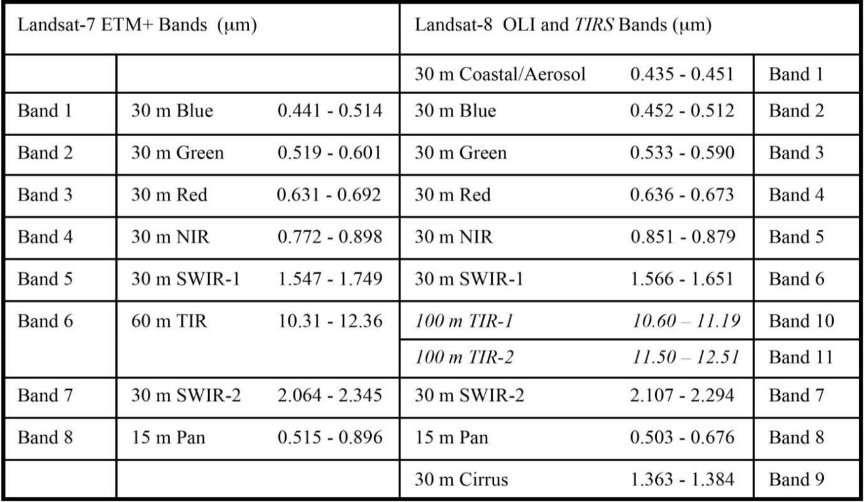
Source: (Irons, 2016)
The above table shows comparison between Landsat 7 ETM+ bands and Landsat 8 OLI- TIRS. It helps to decide which bands to layer stack and in which order. This is especially necessary when doing a comparison or change detection between images with differing bands. The OLI collects data for two new bands, a coastal band (band 1) and a cirrus band (band 9). TIRS collects data for two more narrow spectral bands in the thermal region formerly covered by one wide spectral band on Landsats 4 and Landsat 7.

Layer stacking was done for six bands as shown in the table below.

Table 3.4.Bands layer stacked for each scene.

Sensor | Bands Merged
Landsat 4 TM | Bands 1,2,3,4,5 and 7
Landsat 7 ETM+ | Bands 1,2,3,4,5 and 7
Landsat 8 OLI-TIRS | Bands 2,3,4,5,6 and 7
Source: Author (2016)

Band 1 in Landsat 8 was not used since it’s a coastal band which is not necessary for the project; thermal bands were also not used. The output of layer stacking is a composite image as shown below.

Figure 3.3. False Colour composite image for year 2016.
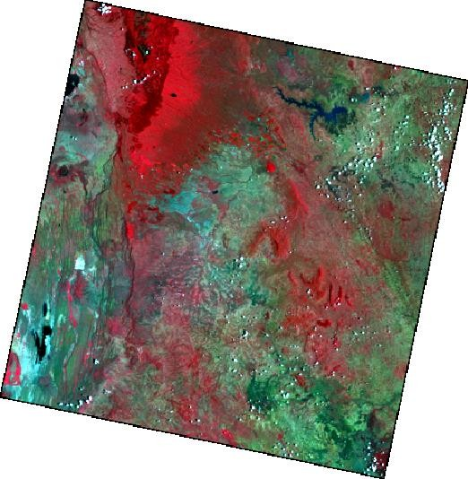

Source: Author (2016)

The above figure shows layer stacked bands producing a composite for 2016, false colors composite 4, 3, 2 are used to enhance feature interpretation. True colour composites were also used to enhance interpretation of the different scenes. The process was done for all the other scenes i.e. 1988 and 2000.

A subset is a section of a larger image, since satellite data downloads usually covers more area than is needed; it is possible to select a portion from the larger image. The project area of interest was clipped using the Offa Local Government Area boundary shape file. Subset removes data outside the area of interest reducing the file size and improving the processing time for many operations.

Figure 3.4. False Colour composite image showing study area.
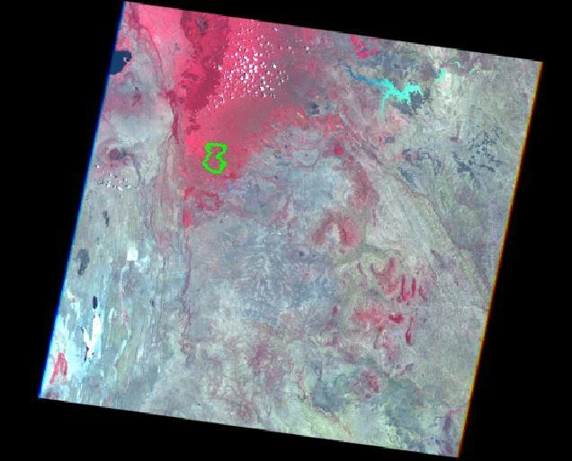

Source: Author (2016)

The above figure shows the boundary of the study area shown in light green. The study area is small compared to the entire scene. The processing time will be greatly reduced when we concentrate on just the area of interest which is Offa Local Government Area.

Image registration is an important step to avoid spurious results as image displacement will cause false change areas in the scene.

Image Classification
Image classification is defined as the process of categorizing all pixels in an image or raw remotely sensed satellite data to obtain a given set of labels or land cover themes (Lillesand, Keifer 1994). The overall objective of image classification is to automatically categorize all pixels in an image into a finite number of individual classes. Supervised classification will be used in this project where the operator determines the areas where a particular type of land cover is present and then the computer computes the spectral signatures.
The first and most important step in a supervised classification is the selection of training samples. The areas with known land cover are digitized, then the image processing software computes the spectral signatures of the land cover types. The training areas are established by viewing portions of full scene in an enlarged format on an interactive colour display device. Training sites were developed for the seven land use/ land cover classes based on goggle earth and familiarity with the study area. The classes include Coffee plantations, Tea Plantation, Forest, Cultivated Land, Other vegetation, Settlements and Water bodies.

Figure 3.5. Training Areas.
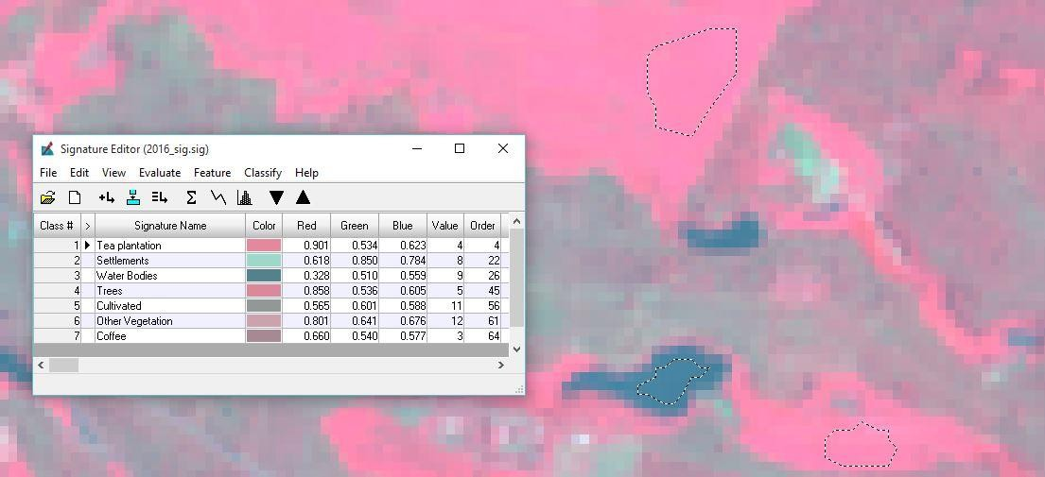

Source: Author (2016)

The above figure shows some of the training areas polygons delineated on a computer monitor. The signature editor shows the information classes given to the various training areas chosen. The information classes for the year 2016 scene were chosen based on the google image, the 1988 and 2000 scenes information classes were based on familiarity and knowledge of the land cover/ land use that existed then.

The maximum likelihood classifier is one of the most popular methods of classification in remote sensing, in which a pixel with the maximum likelihood is classified into the corresponding class. The method is used in this project because it has some advantages in that: The classifier quantitatively evaluates both the variance and covariance of the category spectral response patterns when classifying an unknown pixel. This is done by assuming that the distribution of the cloud of points forming the category training data is normally distributed. The probability density functions are used to classify an unidentified pixel by computing the probability of the pixel value belonging to each class.

Classification Accuracy Assessment
Accuracy assessment is an important step in the process of analyzing remote sensing data. It determines the value of the resulting data to a particular user. Users with a variety of applications should be able to evaluate whether the accuracy of the map suits their objectives or not. There are different ways of accuracy assessment; confusion matrix or error matrix is the most common means of expressing classification accuracy. It compares, on a category- by-category basis, the relationship between known reference data and the corresponding results of an automated classification.

Ground truthing points were collected using a handheld GPS which were used to assess the accuracy of classified image for the year 2016. These points were later used to assess the accuracy of the classified images.

Instead of using the actual category names, codes were used at this stage. Recoding was done as shown in the table below.

Table 3.5.Recoding of Land use Cover classes

No. | Land use/ Land cover class | Code
1. | Coffee Plantations | 1
2. | Tea Plantations | 2
3. | Cultivated Land | 3
4. | Forest | 4
5. | Settlement | 5
6. | Water Bodies | 6
7. | Other Vegetation | 7
Source: Author (2016)

Each Land use was given a code which will assist in its identification during and after accuracy assessment. The same codes were also given to the points to be used as reference data during accuracy assessment. The reference data which was in excel format was saved as text file and later imported in Erdas imagine.

Urban Sprawl on Agricultural Land Analysis
Change detection involves the use of multi-temporal datasets to discriminate areas of Land cover/use change between dates of Imaging. In this project post classification change detection method was used to analyse change in agricultural land to urban areas.

Reclassification of data entailed aggregating the different classes of land cover/use into those classes that represent urban or built up area and Agriculture land. At the end of the study, analysis of effects of urban sprawl on the agricultural land during the duration of study will be given.

Since the main interest of the project was to analyse effects of urban development on agricultural areas, the information classes were merged to have three main classes. The three classes were identified as:

    - Agriculture- This includes tea plantation, coffee plantation, other vegetation, forest and cultivated areas. Other vegetation consisted of maize, beans and all other crops and vegetation planted in small scale. Forests were also included in agriculture since they largely influence the food production in terms of rainfall and also due to the fact that in some areas it was not easy to delineate them.
    - Urban- This included all the built up areas and the roads.
    - Water bodies – Natural and man-made dams and rivers were classified in this class.

Recoding was for the three classes. Agriculture was given code 1, Settlement code 2 and Water bodies’ code 3. Change detection has to be carried out between different times, in this project change was analysed between 1988 to 2000 and 2000 and 2016.

Table 3.6. Change Detection Codes

 | First Image
Second image | Class Codes | 1 | 2 | 3
Second image | 1 | 11 | 21 | 31
Second image | 2 | 12 | 22 | 32
Second image | 3 | 13 | 23 | 33
Source: Author (2016)
The shaded boxes on the table above shows where there was no change e.g. 11 means the land was agricultural in image 1 and still agricultural in image 2, hence no change. Other values shows change from one category to the other. This project will mainly be interested with the change areas from agricultural land to urban which is 12. After which the size, rate and direction of urban sprawl can be calculated.

GIS Analysis

To assist in analysing the urban sprawl existing datasets covering the same geographical area were merged in a GIS environment. Roads and towns data when overlayed with urban development data enables one to understand why the settlements are found there. These data are important since they provide general orientation of the study area and also enable verification of the interpreted details by supplementing it with information that cannot be obtained directly from the satellite imagery.

4.0 Results
CHAPTER 4 RESULTS AND ANALYSIS
Three classification maps for the three scenes under investigation are produced as shown below. The Maps below shows the classified images for 1988,2000 and 2016.

Figure 4.1 Classified Images

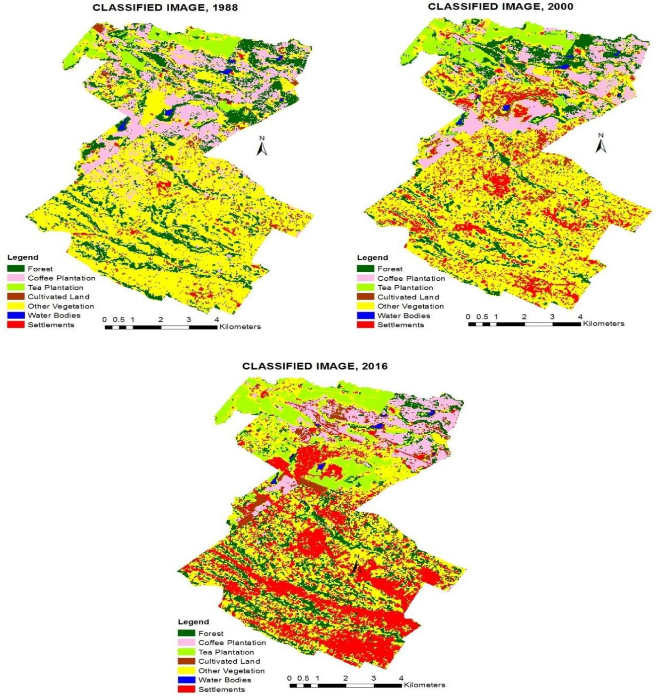

Source: Author (2016)
The classified images show that there are also two main cash crops grown in the sub county which are coffee and tea. These plantations are mainly in the upper area of the county, with settlements in the lower part of the sub county. Other crops grown in the area could not be delineated due to the resolution of the image. Maize, beans, potatoes are some of the crops grown in small scale.

Figure 4.2. Graph showing areas covered by each Land Use.
Area covered by each Land Use
4500
4000
3500
3000
2500
2000
1500
1000
500
0
Forest
Coffee
Tea
Cultivated
Water
Settlements
Area 1988Area 2000Area 2016
Area in Hactares

 |  | Plantation | Plantation | Land Other Veg | Bodies
Area 1988 | 1595 | 1492 | 393 | 320 4217 | 27 | 122
Area 2000 | 1199 | 983 | 525 | 207 4177 | 26 | 1051
Area 2016 | 1093 | 879 | 966 | 270 2735 | 23 | 2202
 |  |  |  | Land cover/ use

Source: Author (2016)

Figure 4.2 above shows the different categories of land cover/use found in the Offa Local Government Area in tabular form. The total area under consideration was 8167 hectares approximately. Seven information classes were produced as shown above. It can be realized that forest cover has declined with approximately 396 hectares from 1988 to 2000 and 105 hectares from 2000 to 2016. This may have been brought about by the high population as they seek for land to cultivate.
Coffee plantation reduced by approximately 509 ha. from 1988 to 2000 and 104 hectares from 2000 to 2016. This confirmed a report by daily nation of December 14th 2015 which stated that the Kenya’s coffee production has reduced from 150,000 tonnes in 1980s to the current 35,000 tonnes. Coffee production is facing numerous challenges including: high cost of labour and inputs; erratic rains; high incidences of pests and diseases; competition from other farm enterprises; and poor governance of farmer’s organizations, (Gitonga, 2015).
Immediately from figure 4.1 an increase in tea plantations can be noted. This is also confirmed by figure 4.2 where the values of tea plantations have increased with approximately 131 hectares from 1988 to 2000 and 441 hectares from 2000 to 2016. From the ground and from classified images we note that most of the land that was under coffee has been converted to tea. The rate of increase may not be the same as the reduction for coffee since their suitability areas differs. Therefore in those areas that are not suitable for tea, farmers have opted to other crops and land use instead.
The spatial extent of water bodies reduced by 0.99 hectares from 1988 to 2000 and 3.2 hectares from 2000 to 2016. This may have been caused by degradation caused by the urban sprawl. Settlements increased by approximately 929 hectares from 1988 to 2000 and 1151
hectares from 2000 to 2016.

Classification Accuracy Assessment.

Table 4.1. Error Matrix Resulting from Classified Image, 2016.

Reference Data
Classified  Data | Coffee | Tea | Cultivated | Forest | Settlement | Water  Bodies | Other  Vegetation | Row  Total
Coffee | 53 | 0 | 0 | 0 | 0 | 0 | 0 | 53
Tea | 0 | 57 | 0 | 0 | 1 | 0 | 0 | 58
Cultivated | 16 | 0 | 21 | 0 | 0 | 0 | 0 | 37
Forest | 1 | 1 | 0 | 32 | 0 | 4 | 1 | 39
Settlements | 7 | 0 | 3 | 0 | 162 | 2 | 1 | 175
Water  Bodies | 0 | 0 | 0 | 0 | 0 | 31 | 0 | 31
Other  Vegetation | 0 | 0 | 0 | 0 | 1 | 0 | 80 | 81
Column  Total | 77 | 58 | 24 | 32 | 164 | 37 | 82 | 474
Source: Author (2016)

The above table shows error matrix results for year 2016 classified image. The training set pixels that were classified into proper land use categories are located along the major diagonal of the error matrix indicated in blue colour. Omission errors are shown as non-

diagonal column elements while commission errors correspond to the non-diagonal row elements.
From the table we can say that coffee had the highest value of omissions errors where we find that 16 pixels were classified as cultivated land, 7 as settlements and 1 as forest instead of being classified as coffee. Cultivated land had the highest number of commission errors with 16 coffee pixels being classified as cultivated land. This has been explained in figure 4.2 values and percentages.

Table 4.2. Accuracy Totals for 2016 Classified Image.

Class Name | Reference Totals | Classified Totals | Number Correct | Producers Accuracy | Users Accuracy
Coffee | 77 | 53 | 53 | 69% | 100%
Tea | 58 | 58 | 57 | 98% | 98%
Cultivated | 24 | 37 | 21 | 88% | 57%
Forest | 32 | 39 | 32 | 100% | 82%
Settlement | 164 | 175 | 162 | 99% | 93%
Water Bodies | 37 | 31 | 31 | 84% | 100%
Other Vegetation | 82 | 81 | 80 | 98% | 99%
Totals | 474 | 474 | 436
Source: Author (2016)

The user accuracy ranged between 57% and 100%, it measures the commission error. This indicates the probability that a pixel classified into a given category actually represents that category on the ground. The Producer’s accuracies range from 69% to 100%, this indicates how well training set pixels of the given cover type are classified.
The overall classification accuracy for 2016 was 92%, which means the classification is acceptable and can be used for analysis.

Urban Sprawl on Agricultural Land Analysis
The areas for the three land use types in the three epochs considered are as shown in the figure below:

Figure 4.3 Land use coverage
Areas covered by each Land Use
9000
8000
7000
6000
5000
4000
3000
2000
1000
0

Area 1988
Area 2000
Area 2016
Agricultural
8018
7090
5942
Urban
122
1051
2202
Land Cover
Water bodies
27
26
23
Area 1988Area 2000Area 2016
Area ( Ha.)

Source: Author (2016)

The above figure shows the area in hectares how agricultural land has been affected by the increased urban settlements. The Agricultural land reduced by approximately 928 hectares from 1988 to 2000 and 1148 hectares from 2000 to 2016. The reductions in agricultural land have been caused by urban development in the study area.

Figure 4.4. Trend of Land Cover/Use in percentage

1.5%
1988
0.3%
Agriculture
Urban
Water Bodies
98.2%
2000
0.3%

12.9%
Agriculture Urban
Water Bodies
86.8%

2016
0.3%
27%
Agriculture
Urban
72.7%
Water Bodies

Source: Author (2016)

The figure above shows three pie charts for the three epochs in consideration. The area under each category land use is shown in percentage. Agriculture land reduced by 11.4% from 1988 to 2000 and 14.1% from 2000 to 2016. It can also be noted that the change in water bodies are minimal. Therefore it can be realised that the urban areas are expanding in expense of agricultural land.

Table 4.3 Rate of change of Agricultural Land

YEARS | AREAS (Ha.) | LOSS (Ha.) | No. OF YEARS | RATE OF CHANGE  (Ha.)
1988 | 8018 | - | - | -
2000 | 7090 | 928 | 12 | 77
2016 | 5942 | 1148 | 16 | 72
Source: Author (2016)

The table above shows the agricultural land in hectares that was lost to urban from 1988 to 2000 and from 2000 to 2016. Agricultural land reduced with 928 hectares from 1988 to 2000 and with 1148 hectares. From 2000 to 2016. The rate of change was calculated and it was found that approximately 77 hectares of agricultural land was lost to urban development between 1988 and 2000 and approximately 72 hectares from 2000 to 2016.
The result shows a reduction in rate of loss in agricultural land to urban, this may be due to several reasons: government initiative, increased land prices or lack of favorable land for building in terms of landscape, security etc.

Analysis of Results

In 1988 most of the study area was agricultural with few settlements in the lower part of the sub county, the upper portion had coffee, tea plantations and even forest cover. Classified image for 2016 shows increase in spatial extent of urban areas in lower and middle part of the state.
Classification accuracy assessment for 2016 was done image and had an overall accuracy of 92%. These good results may have been attributed by the quality of the image used which was clear and free from clouds.
Change analysis which was done using post classification change detection method compared three land use categories which are agricultural land, urban land and water bodies. Figure 4.4 shows the trend, how agriculture land reduced by 11.4% from 1988 to 2000 and 14.1% from 2000 to 2016. Agricultural land reduced by approximately 26 percent in spatial extent in 2016 compared to 1988. The urban areas were found to have increased by more than 18 times in 2016 in the spatial extent more than in 1988. Therefore urban land has affected the spatial extent of agricultural land. No significant change is seen on water bodies extent. This may be because the sub county have sufficient rainfall hence it does not really heavily on irrigation for farming.
The rate of change of agricultural land to urban reduced from 77 hectares per year from 1988- 2000 to 72 hectares from 2000-2016. The rate of urban sprawl is not as high as one would have imagined due the huge developments on the ground. This reduction may have been caused by high prices of land in the area or inaccessibility to the remaining areas.
From figure 4.5 and 4.6 we find that the sprawl started with leapfrogged settlements where we had scattered settlements. The direction of the urban sprawl is now moving along the roads emanating from the Nairobi City County. Leapfrogging and continuous strip developments are some of the characteristics of urban sprawl realised in the study area. The sprawl is also spreading towards the upper part of the sub county where large farms are found.

Conclusions
CHAPTER 5 CONCLUSIONS AND RECOMMENDATIONS
The main objective of the study was to analyse the effects of urban encroachment on agricultural land in Offa Local Government Area and have been achieved. Availability of Landsat images on the USGS web site at low cost assisted in reducing the cost of the project. Satellite remote sensing technology was used to delineate land Cover/ Use in the sub county for three epochs. From these images it is possible to understand the major land cover/use in the sub county and detect any positive or negative change. For example, the classified images show spatial extent reduction in coffee plantations and increase in settlements or built up areas. These results are useful to the policy makers in making decisions.
Large area views on Landsat images are quite informative as they provide a complete spatial view which is virtually impossible to obtain with ground survey data. To obtain data using ground survey takes time and is costly. In remote sensing only training data and ground truth data are collected directly from the ground and it is possible to get them from other secondary sources.
The amount of urban sprawl increased by 2080 hectares from 1988 to 2016.In 1988 we had clustered settlements which are villages where the natives lived. These clustered settlements have increased radially, which may have been brought about by mainly population increase. Again there were no settlements along the roads before 1988, but we find linear settlements along the roads from 1988 to 2016. Considerable increase in urban settlements has taken place in the expense of agricultural land.
It was noted from the study that the direction of the sprawl was along the roads. These roads emanated from the Nairobi City and it was likely for it to flow to the neighbouring sub counties which are Limuru and Kabete. Another direction of urban sprawl was towards the upper part of the Sub County which currently has large plantations.
The rate of change was found to be 77 hectares per year between 1988 and 2000. The rate reduced to 72 hectares per year between 2000 and 2016. The rate of sprawl was not high as expected, the 2009 census showed Offa Local Government Area ranked second highest in population density. This combined with huge developments on the ground one would expect a high rate of sprawl. The reduction in the rate of sprawl may be due to lack of suitable area for settlement or due to the high increase in land prices in the study area.
Post classification change detection method proved to be an effective way of detecting change in urban sprawl. It was also noted that the final accuracy largely depends on the classification technique used. Remote sensing has proved to be efficient and effective way of collecting, processing and analysing data.

Recommendations

The government should incorporate use of remote sensing and GIS in its entire sectors to enhance data sharing. County governments should also consider using Remote Sensing and GIS technologies to monitor Land cover/ use changes.
There is need for an up to date zoning system for ensuring efficiency in granting construction permits and approving or rejecting construction proposal. Developing this system can be done using remote sensing and GIS technologies, by obtaining valuable information necessary for planning.
Low detailed image resolution prevents clear delineation of land use classes, therefore high resolution images though expensive will produce better results.
For sustainability of agricultural activities measures need be taken on management and conservation of the existing land.

References

Agriculture Act. (2012). Agriculture Act. National Council for Law. Government Printers.

Alwan, A. (2011). Indexes of analyzing change in agricultural land, a study case of Albramon village in Dakahlia. Magazine of Egyptian Geographic Organization, fifty seven Version, pp. 1-24.
Atu, J. E., Offiong R. A., Eni D. I. and Eja E. I. (2012). “The Effects of Urban sprawl on peripheral Agricultural lands in Calabar, Nigeria,” International Review of social sciences and Humanities, Vol 2 (2): pg 75.
Aziz, M.A. (2012). A moving, digital and periodic simulation to building growth in the city of El Fayoum. The Seventh National Forum for geographic information systems (GIS), the Eastern Province of Saudi Arabia, 29 April - 1 May, 2012.
Bekele, H. (2005). Urbanisation and Urban Sprawl. Stockholm. Royal Institute of Technology.
Chen. G., H. G. (2012). Object-based change detection. International Journal of Remote Sensing, 33,4434-4457.
Hanqui, Xu (2007). Extraction of Urban Built-up Land Features from Landsat Imagery Using a Thematic Oriented Index Combination Technique. Photogrammetric Engineering & Remote sensing, 73(12): 1381-1391.
Hartman, E. C. (2006). The Population Fix. Moraga. Canada: Think Population Press.

Hastings, R. T. (2002). Global Environmental Databases. Chiba, Japan: International Society for Photogrammetry and Remote Sensing.
Irons, J. R. (2016, 02). Landsat 8. NASA. Retrieved 04 15, 2016, from http://landsat.gsfc.nasa.gov/:
Jain, M. (2009). GIS and Remote Sensing Techniques. Udaipur O New Delhi: Himanshu publications.
Jensen, J. I. (2005). A change detection Model based on neighbourhood correlation image analysis and decision tree classification. Remote Sensing of Environment, 99,326.
Karanja, F. (2002). Use of Knowledge Based Systems for the Detection and Monitoring of Unplanned Developments. Hannover.
Kenya National Bureau of Statistics, (2009) “Kenya 2009 population Census and Housing highlights. Government printers.
Kiambu County. (2013). County Intergrated Development Plan 2013-2017. Government Printers.
Kiambu(a), C. G. (2013). Kiambu Agriculture, Livestock and Fisheries. Strategic Plan 2013 - 2017 .Government Printers.
Lillesand T.M, Kiefer R.W. and Chipman J.W., (2004). Remote Sensing and Image Interpretation, Fifth Edition, John Wiley & Sons, New York.
Lillesand, T.M. & Keifer, R.W. (1994). Remote Sensing and Image Interpretation, Fourth Edition, John Wiley & Sons, New York.
Masek, J.G., F.E. Lindsay, and S.N. Goward, (2000). Dynamics of urban growth in the Washington DC metropolitan area, 1973–1996, from Landsat observations, International Journal of Remote Sensing, 21(18):3473–3486.
Mbuta Shadrack, “Mapping Urban sprawl and its Impacts, Ruiru sub-county,” University of Nairobi, 2015.
Melesee A. and Kwameh S. (2014), “Impact of Urban sprawl on the livelihood of fringe farmers in Mekelle. Ethiopia,”
Milne, A. K. (1988). Change Detection Analysis Using Landsat Imagery a review of Methodology. Proceedings of IGARSS, 88 Symposiums, (pp.541- 544). Edinburgh, Scotland.
Ngugi, B. (2015, December 14). Lobbies propose tax reduction to revive coffee industry.
Daily Nation.

Ochego, H. (2003). Application of Remote Sensing in Deforestation Monitoring. A case study of Aberdares. 2nd FIG Regional Conference, (p. 4). Marrakech, Morocco.
Rosenberger, R. S.et al, (2002). An Economic Analysis of Urbanisation of Agricultural land in West Virginia, Division of Resource West Virginia University, July 8.
Saeed Z. S., Selfolddini F. and Pourahmad A., (2012).” Urban Sprawl and fertile agricultural lands in Iranian Cities, Journal of Civil Engineering and Architecture, vol 6(2):pg 219,220.
Serpico S.B and Bruzzone L., (1999). Change Detection Information Processing for Remote Sensing. World Scientific Publishing C.,pp. 317-336.
Shalaby,A, (2012). “Assessment of urban impact on the Agricultural land in the Nile Delta of Egypt using Remote sensing and Digital soil map,” International Journal of Environmental Sciences, vol 1(4):pg 253, 260.
Singh, A. (1989). Review Article Digital change detection techniques. International Journal of Remote Sensing, pp. 989-1003.
Tarawneh, W. M., (2014). Urban Sprawl on Agricultural Land, A case study of Jordan, Shihan areas. Journal of Environmental and Earth Science, Vol 4 (20):Pg.97.
UN-Habitat, (2010). The state of African Cities, Nairobi, UN-Habitat.

Wafah Madallah Al Tarawneh, (2014). Urban Sprawl on Agricultural Land, A case study of Jordan, Shihan areas”. Journal of Environment and Earth Science, vol 4(20): pg 97.
Zaha, Y. et al. (2003). Use of normalized difference built-up index in automatically mapping urban areas from TM imagery. International journal of Remote Sensing, 24(3): 583- 594.

