**ASSESSMENT OF THE PRACTICE OF ALHADANAH (CHILD CUSTODY) AFTERDIVORCE AMONG MUSLIMS IN KATSINA STATE NIGERIA (2007-2017)**

### BY

### GARBA Fatima

### DEPARTMENT OF ARTS AND SOCIAL SCIENCE EDUCATION FACULTY OF EDUCATION, AHMADU BELLO UNIVERSITY, ZARIA, NIGERIA

### DECEMBER, 2017

**ASSESSMENT OF THE PRACTICE OF ALHADANAH(CHILD CUSTODY) AFTER DIVORCE AMONG MUSLIMS IN KATSINA STATE NIGERIA (2007-2017)**

### BY

### FATIMA GARBA

### (B.A BUK, PGDE ABU, M, ED ABU) M.ED/EDUC/02329/2008-2009

### P13 EDAS 8065

### SUPERVISORS:

### Prof. A.A LADAN

### DR. MUHAMMAD YAHYA

### DEPARTMENT OF ARTS AND SOCIAL SCIENCE EDUCATION FACULTY OF EDUCATION, AHMADU BELLO UNIVERSITY, ZARIA, NIGERIA

### DECEMBER,2017

### DECLARATION

#### I declare that this is a product of an original research work conducted by me. It has never been presented to the best of my knowledge for the award of any degree in any university within and outside Nigeria. The ideas, observations, comments and expressions herein represent my own convictions, except quotations which have been duly acknowledged in accordance with the conventional academic traditions, rules and regulations.

_

**FATIMA GARBA M.ED/EDUC/02329/2008-2009 P13 EDAS 8065**

##### CERTIFICATION

This dissertation titled―Assessment of the Practice of Alhadanah (child custody) after divorce among Muslims in katsina state.**”** ―byFatima *Garba*, meets the regulation governing the award of masters degree in Education (Islamic Studies) of Postgraduate School, *AhamaduBello* University Zaria.

Prof A.A LAdan.

Chairman, Supervisory Committee. Date

Dr, Muhammad Yahya Date

Member, Supervisory Committee.

DrAbdullahiDalhatu Date

Head of Department.

Prof. Sadiq Z. AbubakarDate Dean, School of Postgraduate Studies

##### DEDICATION

I dedicate this work to my parents; late*Alhaji.GarbaFaskari and HajiyaZainabGarbaFaskari,*and to all thosewho lost their lives in the course of the upliftment of the word of Allah and his Messenger,Prophet Muhammad (S.A.W);and to the believing Men and Women all over the world.

##### ACKNOWLEDGEMENTS

All praises be to the Almighty Allah who sustained my life and gave me good health to complete this research work. May His peace and blessings be upon His Prophet and Messenger Muhammad (S.A.W) his companions and those who follow their footsteps till the day of Resurrection.

The researcher wish to express sincere appreciation and profound gratitude to my supervisors, thechairman supervisory committee; Prof A.A *Ladan*, and member supervisory committee; Dr. Muhammad *Yahya*, for their careful scrutiny, corrections, advice and encouragement without which the completion of this research work may not be possible. I would also like to express my sincere appreciation to my parents Late *Alh. GarbaFaskari*and *Haj.ZainabGarbaFaskari* for their immense contribution and fruitful advice May Allah Reward them abundantly . I also acknowledge the efforts and constructive criticism of the entire staff of this great Department (Arts and social science). Similarly, I appreciate all those who assisted me in one way or the other towards making this work a success, particularly my Husband *Alh. SaniTukur*, Brothers Abdullahi*GarbaFaskari*, *ShehuGarbaFaskari*, my children Abdullahi, *khadijat*, Ahmad, *Hauwa’u, Zainab, Maryam* and *A’isah*;likewise my special thanks go to my colleagues in studies such as*MalamaAi’shaMu’azu Muhammad*, for her tremendous contributions to thedevelopment of this study, also to Mal. AbdulkarimIsah CILS Kongo, may Allah (SAW) grant all of them *JannatilfirdausiAmeen*.Last, but not the least, I am indebted to all the authors whose works have been cited or used in this research work.

##### ABBREVIATIONS

A.B.U Ahmadu Bello University A.H: After *Hijrah*

A.S Alaihis-Salam Bn: Ibn

P.G Post Graduate School

N.D No date NO: Number

Q: Qur‘an

R.A RadhiyallahuAnhu.

S.W.T SubhanahuWaTa‘ala

S.A.W SallallahuAlayhiWasallam

U.K United Kingdom VOL: Volume

**OPERATIONAL DEFINITION OF TERMS**

#### Muhallilone who marries a divorced with the intention of making her lawful for her former husband.

MuhallallahuOne who connivedwith another to make his divorced wife lawful

MahrDowry.

Kafala Surety HadanaChild Custody

IddahWaiting period: a period withinwhich a woman is hindered from -- marriage either because of divorce or death of her husband.

Dalaq: Divorce Hadana: Custody

SadakatulJariya: Charity that exist after the death of a person. Taqwa: God fearing

Sunni Divorce: A kind of divorce that fulfills some conditions

Bid‘iy Divorce A kind of divorced that doesn‘t fulfill some conditions. Dalaq al-Ba‘in: Irrevocable divorce

Quru‘: Menstrual period or purity after menstruation. Ahlukufah: People of kufah

Ahluhijaz: People of Hijaz

Qasdun: motive

Ausiya‘u: Trustees

Waif: A stranded child roaming the street and his parents areno were to be found.

Aql: Sound mindedness

Kafa‘ah: Capability Hirzulmakan: Secured accommodation Amanah: Trust worthiness

Rushd: Maturity of mind

Al-hifzwaalsiyana- protection and Preservation.

**Table of The Contents**

Items Page

Cover page i

Title page ii

Declaration iii

Certification iv

Dedication v

Acknowledgements vi

Abbreviations vii

Operational definition of terms xiii

Table of contents X

Abstract… xiii

CHAPTER ONE: INTRODUCTION

1.0 Background to the study 1

* 1. Statement of the Problem 6
  2. Objectives of the Research 7
  3. Research Questions 7
  4. Significance of the study 8
  5. Scope/ Delimitation of the Study 9

CHAPTER TWO LITERATURE REVIEW

* 1. Introduction 10
  2. Concept, Classification, Types/Kinds and Pillars of divorce (Talaq*)* in Islam 10
     1. Concept of Talaq (divorce) in islam 100
     2. Classifications of divorce 11
     3. Kinds of divorce 12
     4. Pillars of Divorce 21
  3. Child Upbringing in Islam 22
  4. Concept, Position, Types,and nature of Hadana 23
     1. Concept Of Hadanah (Custody) In Islam 23
     2. Hadanah in the Qur‘an and Hadith of the Prophet (S.A.W) 24

2.34 Wisdom and essence of Islamic System on child custody 29

* + 1. Islamic ruling on child custody 30
    2. Parties of Custody 30
    3. Rights of child under custody 31
    4. Sources of Custody 40
    5. Conditions of Hadanah (Custody) 42
    6. Right to custody 43
    7. Criteria for the transfer of Custody 44

2.4.4- Nullification of the right of Custody 46

2.3.11Responsibility of financing the child‘s care 48

2.3.12.Duration of custody 49

* 1. An Overview Of the Study Area 51
     1. Katsina State 52
     2. Katsina Emirate 54
     3. People & Culture 55
     4. Weather/Climate 56

2.4.6.Education 56

CHAPTER THREE; METHODOLOGY

* 1. Introduction 58
  2. Research Design And Instrumentation 57
  3. Population 57
  4. Sample And Sampling Technique 58
  5. Instruments For Data Collection 58
  6. Validation And Reliability Of The Nstruments 58
  7. Procedure For Data collection 59

1.2 Procedure for Data Analysis… 59

CHAPTER FOUR DATA PRESENTATION AND ANALYSIS

* 1. Introduction 60
  2. General Response of Practice of Hadana by People of Katsina state 61-89

4.3**. -** Treatment of a child under custody/care of social welfare office especially those with single parent 89**-**94

4.4Findings of the study 94-95

CHAPTER FIVE: SUMMARY, CONCLUSION AND RECOMMENDATIONS

* 1. Summary, Conclusion And Recommendations 96
  2. Summary 96
  3. Conclusion 98
  4. Recommendations 98

Bibliography 100-

102Appendices 102-

117

**ABSTRACT**

#### This research work Titled―the practice of people of katsina stateon child custody after termination of marriage‖ endeavored to look into the situation of children after marriage separation, in order to present the Islamic rules and regulations of child custody, and to appraise the implications of negligence of a child after marriage termination….etc. In order to attain the aforementioned goals, the researchadopted the descriptive statistical method distributed questionnaires, and made some personal observations. A total of our hundred and five (405) questionnaires were distributed in some selected local governments within the three political zones of Katsina State. Therefore, the selected local governments in Katsina Zone are; Katsina, Dutsin-ma and Kaita local governments.FromDaura Zone are; Daura, Mai‘adua and Kankia local governments, From Funtua zone are; Funtua, Malumfashi and Musawa local governments areas. The questionnaire was distributed to four (4) categories of respondents i.e. Fathers, Mothers, Social Welfare Workers, and Court Workers. Three hundred and seventy seven out of the distributed questionnaires were successfully retrieved(377); the opinions of the respondents were gathered, analyzed and presented with the use of Frequency tables and percentages. More ever; the research concluded with a number of results, the most important of which include: - A divorce hurts all the family members, including the children. On the other hand,mothers are showing more concern on the child after separation, than fathers.- According to the Court in katsina state ―parents in broken homes are not performing their obligations towards their children as prescribed by the*Shari’ah*. e.tc. Lastly;, the research recommends that, - Fathers, whose power of divorce is mostly at their hands, should be reminded of Allah‘s injunction on divorce and its potential negative consequences for themselves, their partners and their children in general 2- supreme council affairs in collaboration with government agencies should execute public punishment on any husband who divorced his wife and neglected the children without strong reasons, for it will serve as a deterrent to other parents.

##### CHAPTER ONE INTRODUCTION

* 1. **Background to the study**

Marriage is ordained in Islam in order to safeguard faith, attain the pleasure and acceptance of Allah and Procreation, for the continuity ofthe human race, as well as to enjoy the prayer and blessings of children. Perhaps on this basis, the Prophet (SAW) made marriage and procreation as one of the sources of reward. He says:

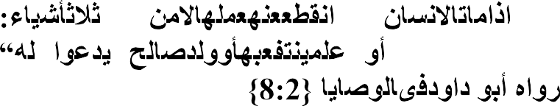

**…**

…when a person dies his deeds come to an end except for

three things. *Sadaqatul Jariya* (ceaseless charity); a knowledge which is beneficial, or a virtuous descendant who prays for him (for the deceased).‖(*AbuDawud* 2011:2:8).

The above narration states that when a person dies, his deeds come to an end‖. This is an indication that he will no longer receive any reward for his actions except from three categories of actions. These are: charities that exist after him(*Sadaqatul Jariya*) such as building a mosque, hospital or digging a well, a school or any charitable asset which continues to be useful to the society as long as people continue to benefit from it, he will get a reward for his kindness.Similarly, knowledge, which a person made effortto educate others or to participate in the propagation of knowledge by either writing books orfinancing education. Furthermore, parents who trained and guided their children, and who continued in righteous acts even after their death, shall therefore continue to enjoy the reward oftheir activities. On this basis, the Prophet (S.A.W) has enjoined his followers to marry and procreate to add to the numberof his followers who are righteous persons,whoseeffort in the religion shall beuplifted.

The above citedTradition of the Prophet (SAW) indicates the importance of children to man. The Qur‘an further explains that children are gifts and blessingsof Allah (SWT) to married couples. Therefore, they should be honourably received with all concern and not to harm or destroy them. Allah says in this regard;

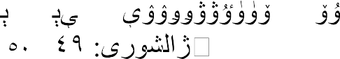

-

To Allah belongs the dominion of the heavens and the earth, He creates what He wills (and plan). He bestowed (children) male or female according to His will (and plan), or He makes them (Both) male and female and He renders whom He wills barren. Indeed, He is Knowing and competent. *(*Ash- Shura*Q.42:49*).

The Qur‘an further states:



Lost, indeed, are they who, in their weak-minded ignorance, slay their children and declare as forbidden that which Godhas provided for them as sustenance, falsely ascribing(such prohibitions) to God: they have gone astray and have not found the right path. (Q6:140)

Ibn kathir in his *Tafseer* to this verse said; ―As for this life, they lost when they killed their children and made it difficult for themselves by prohibiting some types of their wealth, as an act of innovation that they invented on their own. As for the Hereafter, they will end up in the worst dwellings, because they used to lie about Allah and invent falsehood about Him. In this regard,Allah (SWT) says;



**-**

Say: "Verily, those who invent a lie against Allah will never be

successful." (A brief) enjoyment in this world! And then unto us will be their return, then We shall make them taste the severest torment because they used to disbelieve.) (10:69-70

Therefore, the religion of Islam considers one of its basic objectives among the five fundamental objectives that it seeks to achieve is the protection of progeny. The

parents are obliged to properly take care of the children by feeding them, educating them, and inculcating in them the love of the Islamic religion and the Prophet (S.A.W). The Quran commands:

 

Enjoin prayer on thy people and be constant therein, we ask them not to provide sustenance we provide it for thee, but the (fruit of) the Hereafter is for righteousness.(Q20:133)

Ibn kathir in his commentary to the above cited verse he said; it means that Allah does not ask of you a provision: We provide for you.thus,

if you establish the prayer, your sustenance will come to you from where you did not expect. As further elaborated in the verse.

## …



…

-

…And whosoever has *Taqwa* of Allah, He will make a way for him to get out (from every difficulty). And He will provide him from (sources) he never could imagine. Q 65:2-3)

Imam Tirmidhi (nd) and *Ibn Majah*(nd) recorded that Abu *Hurayrah* said that the Messenger of Allah said, Allah the most exalted said;

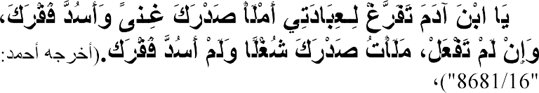

…"O son of Adam, perform My worship and I will fill your

chest with wealth and fulfill your needs. If you do not do so, then I will fill your chest with toil and I will not fulfill your needs.) (Ahmad V. 16/8681)

It is also reported from *Zayd bin Thabit* that he heard the Messenger of Allah saying,

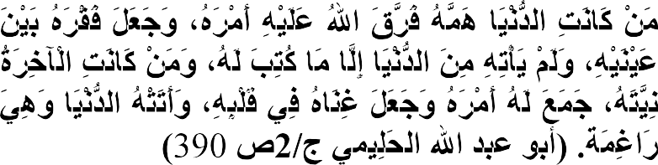

Whoever makes the worldly life his major concern, then Allah will scatter his situation for him (i.e. make it difficult) and his

poverty will be placed between his eyes. He will not get from this world anything except that which has already been written for him. Whoever makes the Hereafter his intention, then his situation will be gathered for him (i.e. made easy) and his wealth will be placed in his heart. The worldly life will come to him anyway (in spite of his not seeking it).(Abu abdul-halimy V. 2: p 390)

In the light of the above immediate cited *hadith*, the Prophet (SAW) elaborated in the following saying:

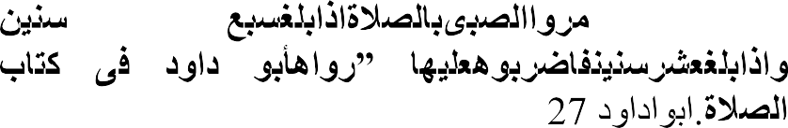

**…**

Teach the kid how to pray at age seven; and beat him against his refusing at the age of ten. (Transmitted by Abu Dawud2011:V1: p 127)

The foregoing evidence, from the Qur‘an and Hadith indicate the obligation of training a child in line with the religious instructions. This responsibility must be shouldered by the two parents, the father and the mother, and any negligence is a violation which will attract heavy penalty from Allah (S.W.T). In view of this, the Qur‘an warns:

  

O ye who believe betray not the trust of Allah and the Messenger nor misappropriate knowingly things entrusted to you. (Q.8:27)

The above *Qur’anic* quotation indicates that children are a trust of Allah (S.W.T). The importance Islam attaches to children,therefore, neverallows children to suffer or become the victim ofmarriage separation. Islam gives a high and befitting concern to children and hence frowns at divorce by emphasizing patience and tolerance between couples, instead of separation.

Betrayal includes both minor and major sins, as well as those that affect others. `Ali bin Abi Talhah (nd) said that Ibn `Abbas commented on the *Ayah*,

Nor betray your *Amanat*

The *Amanah* refers to the actions that Allah has entrusted the servants with, such as what He ordained. Therefore, Allah says*;****nor betray***.

`do not abandon the obligations.''

Ibn kathir in his tafseer said Abdur-Rahman bin Zayd commented that ―Allah forbade you from betraying Him and His Messenger, as hypocrites do.'' Allah (S.W.T) says;

 

And know that your possessions and your children are but a trial (from Him to you.) (Q64:15)

He grants these to you so that He knows which of you will be grateful and obedient to Him, or become busy with and dedicated to them instead of Him. Allah (S.W.T) also says;,

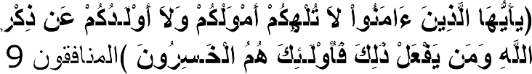

O you who believe! Let not your properties or your children divert you from the remembrance of Allah. And whosoever does that, and then they are the losers.(Q.63:9

Ibn kathir V 7: 321-325) here we understand that both wealth and children are trus*t (amanat)* from Allah to man so man should not in what so ever betrays the trust.

However, in spite of several invitations in the Qur‘an for couples to reconcile their differences and not to divorce, some Muslims in the contemporary periodare heedless to such instructions and are also heedless to most of the *Shari’a* provisions in respect to children when divorce occurs. In view of this, children become the victims of separation of marriage; it is either the mother would be left with the child without due assistance or the father collects the child and exposes him to the danger

and mal-treatment of his other wife or wives. In view of this, this research is designed to study how children are treated after the separation of marriage, with special reference to *Katsina* State.

##### Statement of the Problem.

The essence of marriage is to attain to the pleasure and acceptance of the Lord.However, this cannot be attained to unless all the injunctions of Allah (SWT) are respected and practised. Divorce in Islam is permissible when its conditions are strictly adhered to.

The children, as the products of marriage, are neglected after separation today. It is either they are left at the hands of the financially handicapped, the mother, whose alternative to sustain the child is to either employ him in hawking or allow him to roam about for his livelihood. In such a situation, the child becomes likely to miss the chances ofschooling or to have a goodmoral training. On the other hand, the husband collects the children and leaves them at the hands of his other wife or wives whose rivalry with the mother of the child would instigate her to subject the child to hardship that may have an adverse effect on his life, without the father allowed toknow the true condition of the child. The bone of contention is what would be the outcome of such negligence and maltreatment of the children after the separation of marriage? Are people really aware of the provisionsof Islam as regards children after marriage separation? Who is responsible for the obligations or rights of a child after the separation of marriage and what process should be followed? Are there resulting punishments on the parents who deliberately become unaware of the neglected right of children after separation of marriage?.

##### Objectives of the Research

The objectives of this research include:

* + 1. To examine the attitude of parents, (fathers and mothers,) to children after termination of marriage.
    2. To present the Islamic rules and regulations of child custody.
    3. To evaluate the problems and challenges of child custody in the contemporary

*Katsina*state.

* + 1. To appraise the implications of negligence of a child after marriage termination.
    2. To proffer solutions according to *Shari’ah* provisions to the problems and challenges of the child custody in the contemporary *Katsina*state*.*

##### Research Questions

In conducting research on the practices of*Katsina* State people on child custody after marriage separation, there is the need to answer certain questions, such as:

1. What are the attitudes of parents to children after the termination of marriage?
2. What are the rules and regulations of child custody in Islam?
3. Are there problems and challenges to child custody in the contemporary

*Katsina* state*.*?

1. What are the implications of negligence of child‘s rights?
2. What are the solutions to the problems and challengesof child custody in

*Katsina* state*.*?

##### Significance of the study

Many Qur‘anic verses emphasize on the need for a Muslim to strictly adhere to the teachings of the religion. However, some children in *Katsina* state*.*have turned to be beggars, some have become nuisance to the society; some become psychologically

affected not because they have no parents, but because of the separation of their parents‘ marriage. Some husbands thought of punishing their wives after divorce by transferring all their responsibilitiesof caring for the child to the mother, whose incapability isapparently clear. Similarly, some men, because they hate the wife, equally hate the children; on the other hand, some women are not ready to surrender their children to their husband, even where it is evident that they cannot cater for the need of the children. Indeed, the resultant effects of the actions ofthe parents are on the children.Therefore, any research that stands to guide the parents about their obligations to children especially after separation of marriage would not only be significant in the moral up-bringingof the children, but it would curtail the rate of crime and promote virtue in societies.This will in turn improve the economy of the people. More importantly, it would invite the pleasure of the Creator, Allah (SWT), because of the respect accordedto His laws and, thus the society will be secured. Certainly,neglecting children is tantamount to putting the society in jeopardy and hence the future of leadership and societies will be at stake.

##### Scope and Delimitation of the Study

The scope of this study will cover the practiceof custodianship of children after terminationof marriage in *Katsina* State. However, this research is restricted to only nine local governments. The selected places include: *Katsina*, *Batagawara* and *Dutsinma* local government from *Katsina* zone;*Daura zango* and *Sandamu* local government from Daura zone, and finally from *Funtua zone Funtua, Bakori* and *Faskari* local government areas.The study will be limitedto only ten years, that is from 2008 -2017.

##### CHAPTER TWO LITERATURE REVIEW

* 1. **Introduction**

In this chapter, the research discusses two important issues in Islam; these are some aspectsof divorce and some aspectsof*Hadanah* or child Custody. In discussing some aspectsof divorce, the researchviewed the conceptof divorce, classification ofchild divorce, categories of divorce and pillars of divorce in Islam. In discussing the aspect of*Hadanah*,the research examined the concept of custody, Custody in the Quran and Hadith of the Prophet (S.A.W), Juristic views on observing custody, requirements for custody, preference on custody, duration of custody, nullification of custody andtherights of the child under custody in Islam.

* 1. **Concept, Classification, Types/Kinds and Pillars of divorce (*Talaq*) in Islam** Islam has permitted divorce, but has set out guiding principles within which divorce must be obtained. Therefore, this section viewed the concept, classification, types and pillars of divorce.

###### Concept of Talaq (divorce) in Islam.

The word ―*Talaq*‖ is an Arabic word which, accordingto Lane (1968:5: 1871 – 1874) literallymeans: loose, divorceandquitting‖.Al-Abididi (n.d: 1: 330) inhis*Jawahirul Ikhlil*, opined ***Talaq***literallymeanssending, quittingorleaving (al-irsalwaal-Tark p 330).

Al-Abididi(nd) alsodefined*Talaq* technically as ―loosing?Themarriage contract (Halli Uqdat al- Nikah p 121).

The above definition given by Al-Abidishowstherelationshipbetweenthe literal meaning oftheword*Talaq* anditstechnicalmeaning; hence thecentremeaningof thewordislooseningwhatwasundercontrol. By loosening,it reflectsthe absence of

mutual relation.On this basis, if a marriage gets loose by repudiating the contract, it signifies the absence ofmutual relation of the marriage bond.

Al-Khattabi (1978: 4: 18) defined *Talaq* literally as ―going or moving‖, and technically as ―legal description oflooseningthe marital intimacy‖. The literal definition of the word *Talaq* given in Khattabi‘s definition here has relation with what he offered in thetechnical meaning of the word. However, the differences between what Khattabi provided and whatAl-Abididi presents shows what *Khattabi* calls

―Legal‖, hence it proposes some conditions and requirements before pronouncing it legally.

The wisdom behind proposing some conditions and requirements before pronouncing it legally is to protect marriage from social collapse which may tend to the collapse of family.

###### Classifications ofDivorce.

Muslim scholars haveclassified *Talaq* (divorce) into two categories, the *Sunni* type of divorce and the *Bid’iy* type of divorce. The *Sunni* type ofdivorce is that which, according to Ibn Juzaiy (n.d:150) has fulfilled four conditions,which include the woman is in purity state; ii) no consummation ever happened in that purity; iii) thepronunciation should be for a single repudiation; iv) another pronunciation of divorce should not be made up till the end of waiting period(*Iddah*)

The *Bid’iy* type of divorce, according to Ibn. Juzaiy (nd:150) is that which negates the above four requirements or conditions. What the research recapitulates from what Ibn Juzaiy opined here is: divorcing a woman in her menstrual periodis a *Bid’iy* divorce; Divorcing a woman in her purity period,but after consummation is a *Bid’iy* divorce; Pronouncing more than one divorce at a time or repeating the pronouncement at a

time is *Bid’iy* divorce; and adding another number of separation during a period of waiting (*Iddah*) due to last separation, is a *Bid’iy* divorce.

Al-Dardir (n.d:2:361-365)also agreed with the opinion expressed, above, on the differences between *Sunni* divorce and *Bid’iy* divorce. But he added that the *Sunni* divorce is also classified into four, which includes ―the prohibited type(*Hurmatun*), the detestable or repulsive type(*Karahatun*), the obligatory type(*Wujubun*) and the requested type (*Nadbun or Mandubun*).

In his commentary to *Dardiri’s* classification, (Dasuqi n.d:2:361) elaborated that:

―For who is prohibited from divorcing his wife is he who if he divorces his wife will turn to committing adultery (*zina*) because of his intimacy with the wife or his inability to marry again;and it will be repulsive (*Makruh*)for a person to divorce his wife when he has the interest of having a number of children and if he maintains the wife, it will not hinder him from the act of worship (*Ibadah*). A divorce will be obligatory (*Wajib*) for a person to his wife if living with her will make him commit prohibited actions in *Shari’ah*;and in some situations,divorcing a wife is preferable (*Mandub*) if she is a person who cannot control herself from insulting him or his relatives.‖

In relation to *Bid’iy* divorce*, al-Dardir* and *Dasuq*i all went with the idea that if a deviation happened to any of the *sunni*guide of divorce, the process could be considered as *Bid’iy*.

###### Kinds of divorce

Muslim scholars, as cited by Al-Bagdadi (nd), haveclassified divorce in to two kinds, these are the *Raj’iy* type of divorce and the *Ba’in* type of divorce. The *Raj’iy* type of divorce is that revocation in which the husband has legal right to restore the wife he consummated with her; and the *Ba’in* type of divorce is that revocation inwhich the

husband has no legal right to restore the wife. The woman could be one who has already been consummated or is yet to be consummated.‖(Al-Bagdadi nd::601).

El-Imairi,M.T(1978) also explained that ―*Talaqba’in*( ) may be as follows: 1 – any*Talaq* before consummation

1. – any*Talaq*after consummation for the first or second time if there was consideration,
2. – any*Talaq* for third time,
3. – any*Talaq* passed by the court of law for any other than lack of maintenance or illah‘‖(El-Imairi, M.T (1978: p 149-150).

Also, the *Talaq ba’in* could be divided into two that is the *Talaq ba’in bainuna sugura and Talaq ba’in bainuna Kubra*. The *Talaq ba’in bainuna sugra* are those enumerated above under No 1,2,and 3. And *Talaq bainuna Kubra*, as explained by El-Imairi(1978) is the *Talaq*for the third time by the husband or by thejudicial court. The word *Kubra* means ―big‖, i.e. the distance between those parties has become big and they cannot come together unless and until that woman marries a stranger, and that the marriage is fully consummated and after that,the man dies or divorces her for some reasons or another, without having prior intention to do so. If anyone marries such a woman with the intention of making her lawful for her former husband it is described as the male of sheep and has been cursed by the Prophet (SAW).‖ the Prophet (SAW) says;

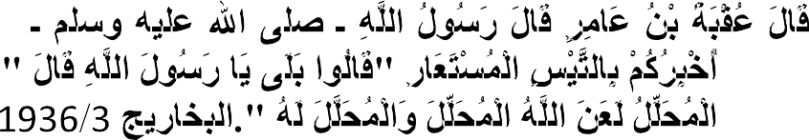

Uqbah bin 'Amir narrated: that the Messenger of said: 'Shall I not tell you of a borrowed billy goat.‖ They said: ―Yes, O Messenger of!‖ He said: ―He is *Muhallil*. Allah cursed the *Muhallil* and the *Muhallal lahu*.‖ (Bukhari Vol. 3,Book 9, :1936)

Muslim scholars have shared the same opinion with Al-Imairi as explained above, perhaps due to the *Qur’anic* guide elaborated in some verses of the Qur‘an and sayings of the Prophet(S.A.W). Forinstance, Allah (SWT) says:



And divorced women shall wait (as regards their marriage) for three menstrual periods, and it is not lawful for them to conceal what Allah has created in their wombs, if they believe in Allah and the last Day. And their husbands have the better right to take them back in that period, if they wish for reconciliation…. (Q2:228).

Imam *Al-Qurtubi* in his commentary to this verse said; Allah(SWT) follows the mention of *llai*' ( ) by talking about women who have been divorced and clarifies the rulings applying to women after divorce has taken place. The husband can take his wife back within the waiting period (*'idda*) unless he has divorced her three times. This applies to consummated marriages. The purpose of the waiting period, in this instance, is to ascertain whether or not the woman is pregnant, whereas the waiting period at the time of bereavement is for worship. If the woman does not menstruate due to immaturity or old age, then it is counted in months rather than menstrual cycles.

The waiting referred to here is a command rather than a suggestion. The term "menstrual cycles" (*quru'*) refer to the actual time of menstruation or to the period of purity between them. Scholars defer about which of them is meant here. The people of *Kufa*say that it is the time of menstruation which is meant, based on what 'Umar, 'Ali, Ibn Mas 'ud, Abi Musa, Mujahid, Qatada, Al-dhahhak, 'Ikrima and as-Suddi said, while the people of the hijaz say that it is the period of purity which is meant, which is the position of 'A'isha, Ibn 'Umar, Zayd ibn Thabit, az-Zuhri, ibn 'Uthaimin,

and ash-Shafi'i. Those who consider it to be menstruation do so because the blood collects (*qara '*) in the womb and those who consider it to be purity do so because the

blood collects in the body.( Ibn kathir 2003 v.2:153)

## …



……And it is not lawful for them to conceal what Allah has created in their wombs‖ Q2:228

'Ikrima, az-Zuhri, and an-Nakha'i, among others, (nd) said that this refers to the concealment of menstruation, whereas others, including 'Umar and Ibn 'Abbas and *Mujahid,* said that; it is the concealment of pregnancy which is meant, and still others said that it is about both menstruation and pregnancy. This is because the length of the waiting period (*'idda*) depends on the statement of the women concerned and their word is accepted. The reason for prohibiting concealment is to prevent harming the husband and taking away his right. *Qatada* also mentions that it was the custom in the time of *Jahiliyya* for women to conceal their pregnancy so that the child could be ascribed to a new husband and that is the reason that the *ayah* was revealed.

## … …

Their husbands have the right to take them back

within that time, if they desire to be reconciled.Q 2:228

Imam Qurtubi in his *tafseer*was saying; the "right to take them back" can be exercised in two ways: one is during the waiting period and the other is after the waiting period has come to an end, because the verse is not specific. If the waiting period has finished, the man has to propose a new marriage with a new dowry and witnesses. This is the consensus of the scholars. Taking back is either by sexual intercourse or verbal declaration. If the man has not made his intention clear, the woman should refuse intercourse until he declares that he has taken her back according to *Ishaq* since "actions are by intentions." If someone else marries her during the waiting

period, the marriage is invalid. The word "right" is used in the comparative form here, " " (lit. "More right") because there are two rights in any conflict and one has to be preferred. So the husband has the right during the waiting period to take his wife back, which is not the case when the waiting period has ended. The husband is recommended to take his wife back, but on the condition that he puts things right between himself and her. If he just desires to harm her more and to prolong her waiting period, it is forbidden and the person does wrong.( Al-Qurtubi, V1;P 575- 578).

Furthermore, Allah (S.W.T) says:

## …



The divorce is twice, after that either you retain her on reasonable terms or release her with kindness… (Q2:230)

Ibn kathir (2003p 123) said; this honorable verse abrogated the previous practice in the beginning of Islam, when a man had the right to take back his divorced wife even if he had divorced her a hundred times, as long as she was still in her *`Iddah* (waiting period). This situation was harmful for the wife, and this is why Allah made the divorce thrice, where the husband is allowed to take back his wife after the first and the second divorce (as long as she is still in her `*Iddah*). The divorce becomes

irrevocable after the third divorce, as Allah said:

## …

The divorce is twice, after that, either you retain her on reasonable terms or release her with kindness…‖(Q 2:229)

In his *Sunan*, Abu Dawud (1996 p. 546) reportedthat; "Taking the Wife back after the third (Divorce) is an abrogated practice," Ibn `Abbas (nd) also commented on the Ayah;





And divorced women shall wait (as regards their marriage) for three menstrual periods, and it is not lawful for them to conceal what Allah has created in their wombs, (Q 2:228)

The man used to have the right to take back his wife even if he had divorced her thrice. Allah abrogated this and said:  (The divorce is twice.) The following Hadith was also collected byIbn Abu Hatim;

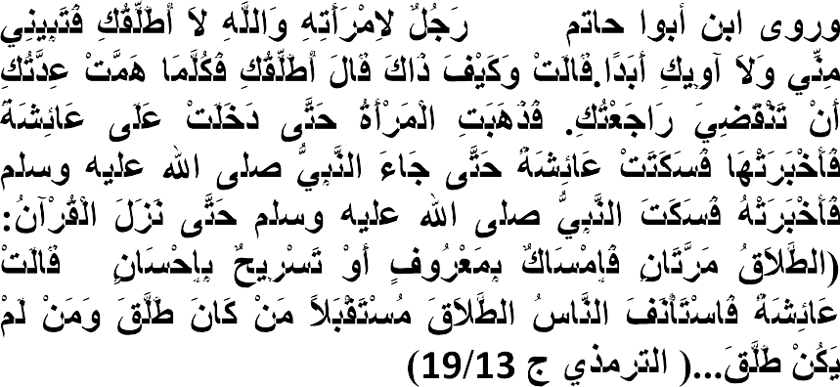

**(**

Ibn Abu Hatim reported that `*Urwah* said that …A man would divorce his wife when he wanted to divorce her, and she remained his wife when he wanted to take her back while she was in her Iddah, and he could divorce a hundred times, or even more, such that a man could say to his wife: 'By Allah! I will neither divorce you irrevocably, nor give you residence ever!' She would say: 'And how is that?' He would say: 'I will divorce you, and whenever your *Iddah* is just about to end I will take you back. So a woman went to Aisha to inform her about that, and Aisha was silent until the Prophet came. So she told him and the Prophet was silent, until the Qur'an was revealed: Divorce is two times, after that, retain her on reasonable terms or release her with kindness.'" So Aisha said: "So the people could carry on with divorce in the future, (knowing) who was divorced, and who was not divorced."( *Altirmithy*; Book 13 Hadith 19)

Ibn Jarir At-Tabari(nd) also reported this Hadith in his Tafsir Ja‘mi‘i Albayan (V.2: p.136).

Furthermore Allah (S.W.T) says:



...after that, either you retain her on reasonable terms or release her with kindness. Q 2;229

This means that, `If you divorce her once or twice, you have the choice to take her back, as long as she is still in her `*Iddah*, intending to be kind to her and to mend differences. Otherwise, await the end of her term of `*Iddah*, when the divorce becomes final, and let her go her own way in peace, without committing any harm or injustice against her.' Ali bin Abu Talhat reported that Ibn `Abbas said, "When the man divorces his wife twice, let him fear Allah, regarding the third time. He should either keep her with him and treat her with kindness, or let her go her own way with kindness, without infringing upon any of her rights.'' Allah (SWT) said:



And it is not lawful for you (men) to take back (from your wives) any of (the dowry) what you gave them, (Q; 2:229)

This means that, you are not allowed to bother or pressurize your wife or wives to end this situation by giving you back the *Mahr* and any gifts that you have given them (in return for divorce). Similarly, Allah (S.W.T) says:

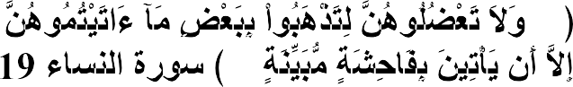

**...**

**...**

(...and you should not treat them with harshness, that

you may take away part of what you have given them, unless they commit open illegal sexual intercourse.) (Q.4:19)

However, if the wife willingly gives back anything with a good heart, then Allah said

regarding this situation:

# ...

**...**

...but if they, of their own good pleasure, remit any part of it to you, take it, and enjoy it without fear of any harm. (Q:4:4).

When the spouses have irreconcilable differences wherein the wife ignores the rights of the husband, dislikes him and becomes unable to live with him any longer, she is allowed to free herself (from married life) by giving him back what he had given her

(in gifts and *Mahr*). There is no sin on her in this case nor on him if he accepts such offer.

This is why Allah (S.W.T) says;

 …

## …

… And it is not lawful for you (men) to take back (from your wives) any of what you gave them, except when both parties fear that they would be unable to keep the limits ordained by Allah…(e.g., to deal with each other on a fair basis. (Q:2:229)

Then if you fear that they would not be able to keep the limits ordained by Allah, then there is no sin on either of them if she gives back, Sometimes, the woman has no valid reason and she still asks for her marriage to be terminated. In this case, Ibn Jarir Al-tabari (nd) reported that *Thawban* said that Allah's Messenger said:

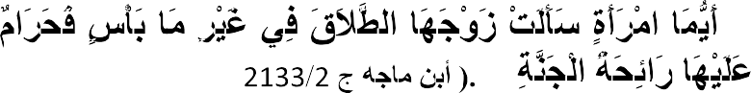

**"**

**"**

… Any woman who asks her husband for a divorce when it is

not absolutely necessary, the fragrance of Paradise will be forbidden to her.'" ( Ibn majah, Vol:3 Book 10 Hadith 2055)

Ibn Jarir said (V4 P.538) that the Ayah (Q.2:229) was revealed concerning *Thabit bin Qays* bin *Shammas* and his wife *Habibah bint* `Abdullah bin *Ubayy bin Salul*… The following is the text of the Hadith,

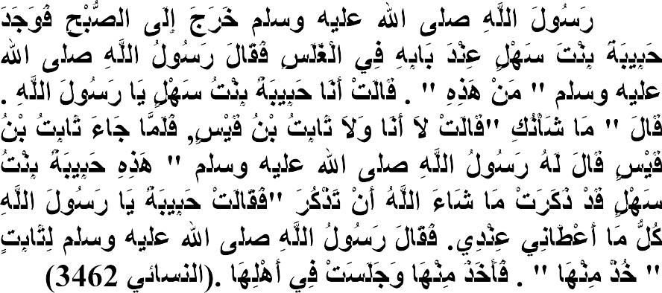

. The Messenger of Allah went out to pray *As-Subh* and he found

*Habibah bint Sahl* at his door at the end of the night. The Messenger of Allah said: 'Who is this?' She said: 'I am *Habibah bint Sahl*, O

Messenger of Allah.' He said: 'What is the matter?' She said: 'I cannot live with *Thabit bin Qais'* her husband.) When *Thabit* bin Qais came, the Messenger of Allah said to him: 'Here is *Habibah bint Sahl* and she has said what Allah willed she should say.' *Habibah said*: 'O Messenger of Allah, everything that he gave me is with me.' The Messenger of Allah said: 'Take it from her.' So he took it from her and she stayed with her family."( Nasa‘i Vol.4 Book 27,Hadith no 3462).

More so, Allah (S.W.T) says:

## …



Then when they are about to attain their term appointed, either take them back in a good manner or part with them in a goodmanner. And take as witness two just persons from among you,and establish the testimony for Allah…‖ (Q65:2).

In the following*Hadith* the Prophet (S.A.W) returned *Suhaimah* wife of*Rukanah Ibn Abd Yazid* after he divorced her three times,But he informed the Prophet (S.A.W) about it and said, I call Allah to witness that I intended only a single (divorce). This

is the text of the Hadith.

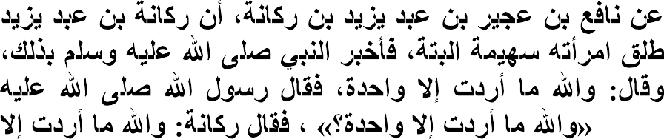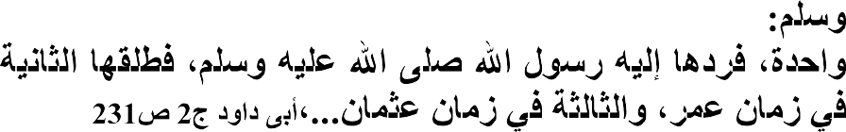

…On the authority ofRukanah Ibn Abd Yazidwho reported that

hedivorced his wifeSuhaimah thrice and informed the Prophet(S.A.W) about it and said, I call Allah to witness that I intended only a single (divorce). TheMessengerof Allah (S.W.T) said: Dost thou call Allah to witness that you did notintend but a single (divorce)?‖He said, Yes, I call Allah to witness that I did not intend, but a single (divorce). So the Messengerof Allah (S.W.T) returned her back to him, and he divorced her a second time in the time of Umar, and a third time in the time ofOthman(Abu Dawud 1996 V.2 231).

##### Pillars ofDivorce

Abubakar A-ljazairi listed the following as the pillars of divorce;

**The husband;** the husband who has full competence, No one has the right to divorce a woman except her husband, for his saying (P.B.U.H) ― divorce is the right of him, who raised the legs ― ( who raised the legs) means the husbands as he is the only one to do so.

The divorce of a husband, who is insane or a lad or obligated, is not sound for his saying (P.B.U.H) ― there are three persons whose actions are not recorded; a sleeper till he wakes up a boy till he reaches puberty, and a lunatic till he comes to reason.‖ And: ―my people are exempted from the responsibility for the actions of owing to a wrong, forgetfulness, or if they are obligated.‖

**The wife;** the wife she is the woman who is bonded in marriage by the husband, she is either still in his bond of marriage , ie she is not divorced nor their contract is repealed, or she is in temporary divorced ( TALAQ Raj‘i) and is still in her IDDAH so, the man cannot divorce the following women: a foreign woman, ie any woman who is never marriage to him. A woman who is divorced three separated time, a woman whose contract of marriage is repealed due to any legal reason.A woman who is divorce before consummation but after tying the contract. If a man says the words of divorce on the part of one of the mention women, his words are voide and valueless at all because they have not meet with the suitable position, for his saying (P.B.U.H) ―No vow by a human being would be tied in what he does not own, no emancipation is sound for a slave one does not own him, and no divorce is sound on the part of a foreign woman‖.

**The words pointing to divorce:** these words may be open and obvious or may be indirect ( metaphorically) as said above, but the mere intention is not enough to divorce a woman, for evil promptings which arise within their hearts as long as they did not speak about them or did not act upon them.‖ Abubakar J.

##### 2.2- Children Upbringing in Islam

Proper upbringing of the child is one of the rights of children on their parents in Islam. There are many verses of the Qur‘an and Hadith of the Prophet which discuss this aspect. One ofsuch verses is as follows:

Allah (S.W.T) says:





O ye who believe save yourselves and your families from a fire whose fuel is men and stones over which are (appointed) angels stern (and) severe who flinch not (from executing the command they receive from Allah. But doprecisely what they are commanded‖ (Q66:6)

The above verse calls the attention of Muslims to strive in taking care of their families, to train them and guard them against what will take them to the hell fire. They should make sure they do what are supposed to do in protecting them against worldly stress and thedoom of the Day of Judgment.

In the *Hadith*, the Prophet (S.A)says:

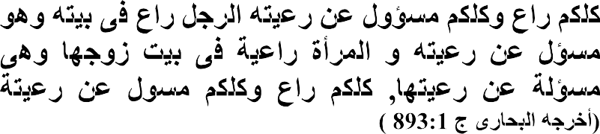

…. All of you are shepherds and each ofyou is responsible for his flock. A man is the shepherdof the people of his house and he is responsible. Awomanis the shepherd of the house of her husbandand she is responsible. Each of you is a shepherdand each is responsible for his flock.( Bukhari Vol.1:no 893).

A personwill therefore be exonerated onlyfrom the blameofthe upbringing of a child when he engages in giving him goodtraining, watching over hismovements, correcting his mistakes andwrongs andencouraging him to practise religious rites.

Therefore, children are trust of Allah (SWT) to parents, in view of this, Allah (SWT) warns:



O you who have believed do not betray Allah and the Messenger or betray your trust while you know. (Q. 8:27)

The above Qur‘anic verse and *Hadith* indicate the obligationofmoral training of a child on his parents, therefore, it should not be taken lightly because it is a commandfrom Allah (S.W.T) and His Messenger,Muhammad (S.W.T). This responsibility must be jointly shouldered by the parents. Therefore, the parents should do their best in this regard in following the commandmentsof Allah (S.W.T) by giving proper guidanceto their children, even aftermarriage.

##### Concept, Position, Types, and Natureof*Hadanah*(Custody) in Islam.

In the process of exhibiting what Islam says about custody, there is a need to discuss the concept, position, types, consensus views, requirements, preference, duration and nullification ofchild custody in Islam. Below are elaborations of the issues.

###### Concept ofHadana (Custody) in Islam

There are different interpretations given by Muslim scholars on the meaning of custody. The differences may be due to ways of conceptualizing the meaning. Al- Tantawi (2011: 199)definesHadana from its literal meaning as: ―Preservation and Protection‖(*al-Hifz wa al-Siyana)*, and technically he defines it as ―Preserving the rightsof the weak and doing what will be goodfor them‖.

The above technical definition is similar to what al-A‘bi(2011:1:738) provided in hiscommentary to*Mukhtasar al- Khalil*. However, the technicalinterpretation provided above didnot interpret what is meant by the word

*A’aajiz*. The word *A’aajiz* indeedneeds to be legally interpreted, in orderto attain the proper meaning of the subject matter.

Abdulhaqq (nd:2:682)defined *al-Hadana* literally as ―The protection which birds do to their nestling when it covers them with its wings‖;and technically,he defined it as ―Preserving the minor‘s rights related to his bed, his feeding, his clothesandcleaning his body ―.

Zarruq (1914:2:97) defined*al-Hadana*as ―Taking care andtraining (*al-Kafalah wa al- Tarbiya*) and taking responsibility of thechild‘s interest, because the child needs someone who would provide what will benefit him and protect him from what will harm him.

However, the prevalent word used in many verses of the Qur‘an and Ahadith of the Prophet(S.W.T.) on aspect of custody is*Kafala.*(Zarruq 1914 :2:99)

###### Hadanah in the Qur’an and Hadith of the Prophet (S.A.W)

There are many verses of the Qur‘an and *Ahadith*of the Prophet (S.A W) which discuss child custody and its importance in child care. The Qur‘an used *Kafalah*in the connection of*Hadanah* as in the following Qur‘anic verse:



This is part of the tidings of the things unseen, which We reveal

untothee (OProphet) by inspiration: Thou wast notwith them When they cast lots with pens, as to which of them should be charged (*Yakfulu*)with the care of Mary: Nor wastthou with them When they disputed (the point). (Q3:44).

Meaning,according toIbn.Kathir (2003) ―You were not present,O Muhammad, when this occurred, so you cannot narrate what happened to the people as an eye witness. Rather, Allah disclosed these facts to you as if you were a witness, when they conducted a lottery to choosethe custodian of Maryam, seeking the reward of this gooddeed‖(Ibn. Kathir 2003:2:158).

Similarly, *Kafalah* is used in the meaning of *Hadanah* in the following narration about Prophet Musa (A.S):

And Wefavoured you) when your sister went and said, 'Shall I direct you to someone who will be responsible for him?' So We restored you to your mother that she might be content and not grieve**..**…‖ (Q.20:40)

Ibn Kathir, (2003:6:340) also, as cited inhis abridged *tafsir*stated that She meant by her saying, ―shall I show you one who will nurse and rear the child ―to mean one who takes care of the responsibility of the child and she took himand they went to her mother. When her breast was presented to the child, he accepted it and *Fir’awn’s* family was extremely happy for this. Thus, they hired her to nurse the childand hence achieved great happiness and comfort for the return of her child. Likewise, Allah (S.W.T) used the word *Kafalah*in the following narration:



And we ordained that he refused suck at first, until (His sister came up and) said; ―Shall I point out to you the people of a house that will nourish and bring him up for you and take care of him. (Q28:12).

Ibn Kathir (2003)said, as citedinhis*abridged tafsir Ibn Abbas* ―When she said that, they had some doubts about her, so they seized her and asked her, howyou know these peoplewill be sincere and will care for him? She said to them,―They will be sincere and will care for him because they want the king to be happy and because they hope for some reward.‖ (Ibn Kathir (2003: 7: 383).

Furthermore, Allah (S.W.T) used the word *Kafala* for *Hadana*in the followingverses and narrations:

 

―This man is my brother; He has nine and ninety Eaves, and I have (but) one; yet he says, ‗commit her to my care; and he overcame me in the arguments.‖ (Q38:23).

And Allah (S.W.T) says;







Right gracious did her lord accept her: He made her grow in purity and beauty: To the care of*Zakariyya* was she assigned. Every time that he entered (Her) chamber to see her, He found her supplied with sustenance. He said: ‗O Mary! Whence (comes) this to you? She said: From Allah: for Allah provides sustenance to whom he pleases, without measure.‖ (Q3:37)

Ibn Kathir (2003:2:151) said as cited in his Abridge *Tafsir*that; the assignment taken by *Zakariyya*was that: ―Allah made himher sponsor and guardian for herbenefit, so that she would learn from his tremendous knowledge and righteous conduct.

Similarly, there are many Prophetic *Ahadith*thatdiscuss aboutcustody. of a child Some of these *Ahadith* are as follows:

(

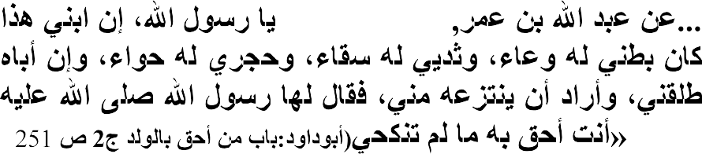

…On the Authority of Abdullahi *bn Amr* who says: A woman said: O Allah‘s Messenger. I carried my son in my womb, suckled him my breast and held him on my lap, yet his father has divorced me and want to take him away from me ―Allah‘s Messenger (S.A.W) replied her, ―You have more right to him as long as you do not marry‖(*Abu Dawud*1996:1:525:).

From the above Hadith, one could understand that a preference is given to the mother over the father because of the benefits the child may get from the mother exceptif there is any reason that after the child and dictates otherwise..

According to *Al’ba’di*(1979:6:371)Ibn *Al-Munzir*reported that Muslim scholars have agreed on this opinion, though, *AbuHanifa* added thatif the mothermarried to a close relation of the child, the right of the mother for observing the custody of the child will still not be abrogated. He then cited the following;

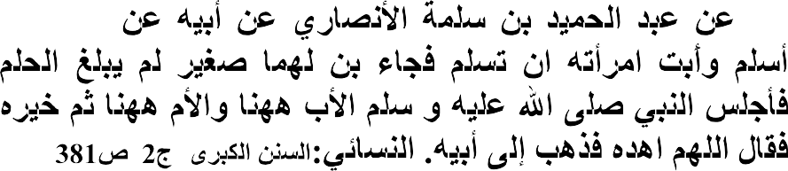

**…**

**-**

…On the Authority of*Abdul Hamid bn Salama al-Ansari*, from his

father and from his grandfather who said; He converted to Islam but his wife refused to convert to Islam. He came along with his son who is a child, does not reach the ageof puberty. The Prophet(S.A.W) then made the father sit down to a side and the mother to another side and made the son to choose who he will live with among them. The Prophetinvoke and said; ―O Allah! Guide him‖. He (the son) then inclined (went) to his father.(Al-Nasa‘i nd:v3:381)

Imam *Assanadi*, (1930: p185)in his commentary to the above Hadith(*Hashiya*) presented the views of some scholars which indicated that a childwill not be given a right to choose who among his parents will be inclined to, because of his inability to know the preference among them. The child that the Messengerof Allah offered a right to choose among his parent is an exception due to a supplication invoked by the Prophet (S.A.W).for Allah (S.W.T) to guide him.

In another Hadith; Abu *Hurairah* (R.A) said;

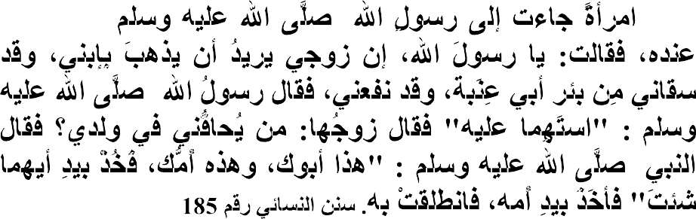

**------**

… A woman came to the Messengerof Allah (S.A.W) and said; my

husband wants to take away my son, and yet he has availed me and

provided me with drinking water from *Abu Inaba’s*well ―then her husband came and said: Who is disputing my legality on my son. The Messengerof Allah (S.A.W) said: ‗Lad, this is your father and this is your mother, so take whoever of them you wish by the hand: He took his mother‘s hand and she went off with him‖.(Nasa‘i6: P185-186)

This Hadith is referring to a specific level ofchildhoodafter custody. The mother shows that she is in need of his assistance in her life more than the father. She therefore puts her request to allow the child to live with her, as observed by As- Suddi,.(1973. p 22).

##### Wisdomand essence of IslamicSystemon child custody.

In any law provided in Islam there is a wisdom behind it. In Islamic law ofchild custody, there are several wisdoms that could be found related to it. Among these wisdoms are the following.

* + 1. Protecting the interest of the child on spiritual ground. The parent is the spiritual builder of the child, and the mother is the most provider of spiritual thought. If the spiritual interest of the child suffers negligence, the future of the child faces destruction.
    2. Protecting the interest of the child on material ground. The separation of the child‘s parent may be due to two different reasons, either due to a conventional divorce, or due to the death of the father of the child. If the father of the childdied leaving a number of material things that could be inherited, if the inherited property are left without anylaw guiding the protection of the wealth, the wealth may finally be destroyed. Therefore, the Islamic law of custody protects the wealth of the child.
    3. Protecting the interest of the child on health ground. In Islamic law of custody, a rule has been outlined on the health condition of who will be a guardian to the child. If the mother of the child is prompted with ill-health, a milady which could

be infested, the right of custody then could be transferred to another party of custody, this is because, by doing that, the health condition of the child could be protected;and the child could be protected against being infected by any diseases.

* + 1. Protecting the interest of the child on social grounds. Indeed, the parentsof the child have relatives, and the mother of the child and her sisters are the best group to show their concern over the relationship of the relatives. If the child is left with his father at that very moment, the relations of both relatives may be neglected. Therefore, providing Islamic law of custody protects the social interest of the child, hence it paves way for having close contact with the child‘s relatives.
    2. One of the greatestbenefitsof Islamic law of custody is to effect channel of reconciliation between the two parties, which is the husband and wife. If the separation that occurs was caused by the negligence of the husband, the law of custody will teach him a lesson where the husband will be required to manage the spiritual, material and social condition of the child. Likewise, the mother will be disturbed by the condition she may findherself in taking care of the child in the absence of the child‘s father. These conditions will, eventually, clear the ground of reconciliation between them.

##### Islamic ruling on child custody.

There are no divergent views of Muslim scholars, according to Ibn Rushd (2012:1:435) in his *Muqaddimah,* concerning the obligatory condition of child custody, because, naturally man was created weak: looking for who would take care of him up to a stage where he can take care of himself. However, custody, despite being its obligation is not upon everybody (*Fardul Kifaya*) except if the relative of the child neglected it. Thus, custody is optional in as much as somebody has taken

care of it;and it is obligatory upon every human being if they refuse to address the minor‘s care‖.

###### Parties of Custody

The parties of custody refer to the group of persons who are legally supposed to be custodiansof a child. Muslim scholars have discussed this aspect in their writings. *Ibn Rushd* (2012:1:435) elaborated on this aspect and itemized them as follows;

1. The relation of the child on the side of a woman who could be a custodian to the child must possess two qualities. The woman must have a uterine relation with the child, and she must be among the list of women forbidden to him to marry. If the woman has uterine relation with the child, but is not among the forbidden women for him to marry, she has no right to be his custodian. Similarly, if the woman is among the forbidden women for him to marry, but has no uterine relation with the child, she has no right to be his custodian.
2. The relation of the child on the side of his agnate or consanguinity. The child‘s relation under agnate has right for being his custodian.
3. Awsiya‘i or Trustees. If the father of a child or sultan appointed somebody as a trustee to the child or guardian, the guardian has right to be a custodian to the child.

What the researcher observed from what *Ibn Rushd* presented above is that, the parties of custody are three, they are: relations of the child on the side of woman (qaraba minan Nasa‘i); Agnates (*Usbah*) and trustee or guardian (*wasiy*).

IbnQudamah (n.d:7:612-613) also opined that the guardianship of the child relies on his relatives because they have legal right to exercise the custodianship of the child. However, the right could not be exercised by the following relatives, they are:

1 – A minor, because he also needssomeone who would take care of him,

2– Immoral life, because he cannot be trusted to take care of the child, due to his bad conduct. This is the view of*Ata’, Thauri,Shafi’iy*and many scholars from *Hanafiy* school of Islamic law.

##### Rights of child under custody

There are many verses of the Qur‘an and *Ahadith*of the Prophet (S.A.W) which showsthat the child under custody has rightsto be fulfilled. Neglecting these rights is a great sin in Islam. The following verses elaborated this point.

And Allah (S.W.T) says:

## …



The mother shall give suck to their children for two whole years (that is) for those (parent) who desire to complete the term of suckling, but the father of the child shall bear the cost of the mother‘s foodand clothing on a reasonable basis… (Q2:233).

Imam al- qurtubi (2003,V1 p 607-609 ) said mothers should nurse their children for two full years -those who wish to complete the full term of nursing. When Allah has mentioned marriage and divorce He then speaks about children since a couple may separate when they have children. So the *ayat* is about divorced women who have children by their ex-husbands.

As-Suddi, (1973 p 231) opines thatAI-.dhahhak and others says that;this mean that they are more entitled to nurse their children than other women because they will be more compassionate towards them and it is harmful to both mother and child to remove a small child from her. This also indicates that even if the child is weaned, the mother is still more entitled to custody because of her compassion for him. She remains more entitled unless she remarries.

It is also the duty of the fathers to feed and clothe the children; because divorced women are not entitled to clothing if it is not a revocable divorce. They are entitled to

a wage. Noble character, however, would ensure that the wage was adequate for both her food and her clothing.

The most evident position is that it is about wives while the marriage remains because they are entitled to maintenance and clothing, whether they nurse or not. Maintenance and clothing are according to the man's ability. Nursing is mandatory for some and recommended for some. (As-Suddi, 1973 p 220).

Furthermore Allah's words "those who wish to complete the full term of nursing‖ indicates that the two full years is not a definitive term. Weaning can take place before the completion of two years. A limit is set merely to eliminate any dispute between the couple about the length of suckling. The father does not have to pay for more than two years and if the father wants the child to be weaned before two years and the mother does not consent, he cannot enforce that. An increase or decrease in the two years can be made provided that the child is not harmed and that the parents agree.(Salim 2002: P 132).

Imam Malik and those who follow him and another group of scholars deduce from this verse that; the nursing which creates a milk relationship only occurs within this first two year period and ends when those two years end, so that any nursing after that, is not considered. ( Salim 2002: P 136).

A group of commentators say that the period is two years for each child. It is related from Ibn Abbas that when the child is in the womb for six months. If it remains for seven months, the nursing period is twenty-three months. If it is nine months, the nursing is twenty-one months going by Allah's words, "His bearing and weaning is thirty months." (Q 46: 15)

Furthermore Allah (S.W.T) Says;

## …



but the father of the child shall bear the cost of the mother‘s food and clothing on a reasonable basis… (Q2:233).

This is evidence for the obligation of the father to maintain the child since he is weak. The feeding referred to the nourishment which reaches the child by means of the mother through nursing. Scholars agree that a man must support all his children who have no money.When Hind bint 'Utba said to the Prophet, may Allah bless him and grant him peace, "Abu Sufyan is miserly and does not give me adequate maintenance and what is enough for my son. If I take from his property without his knowledge, do I do anything wrong?" he told her, "Take what is adequate for you and your child in a correct manner." "Ma'ruf" (correctness).( Tannukhiy 1914 p.78).

This means that what is customary in the usage of the Shari'a without excess or negligence. Allah made it clear that a man's duty of maintenance is according to his wealth and position and no specific amount is stipulated by His words.

Imam Malik (nd) thought this *ayat*( ) indicates that a mother should have custody of her sons until puberty and of her daughters until marriage. That is her right, and Abu *Hanifa* stated the same. Ash-Shafi‘'i said that when the child is eight years old, which is the age of discrimination, he is given a choice between his parents. At that stage his interest and desire should be stimulated to learn the Qur'an, *adab* and the duties of worship, this is the same for both boys and girls. (Bagdadi n.d p 321) An-Nasa'i and others reported from Abu Hurayra that a woman came to the Prophet, peace be upon him, and said,

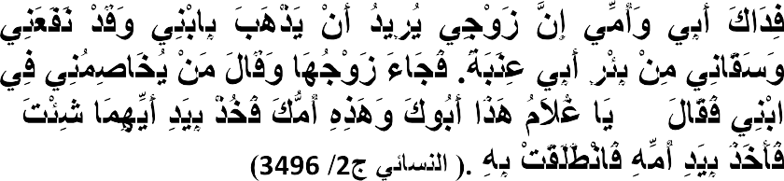

**"**

**"**

…May my father and mother be ransomed for you! My husband wants to take my son away, but he helps me, and brings me water from the well of Abu 'Inabah. Her husband came and said: Who

is going to take my son from me? The Messenger of Allah said: "O boy, this is your father and this is your mother; take the hand of whichever of them you want." He took his mother's hand and she left with him.'"(Nasa‘i Vol.4 Book 27 Hadith 3496).

Ibn 'Umar said, "I do not know of any disagreement among scholars that a divorced woman, as long as she does not marry again, is more entitled to her child while he is still young than the father." They disagree about the child being given a choice when he understands the situation and who is most entitled to look after the child then. (Bagdadi n.d p 333)

Ibn al-Mundhir (nd) said "It is confirmed that the Prophet, may Allah bless him and grant him peace, judged that the daughter of *Hamza* should go to her maternal aunt." The Prophet did not give *Hamza' s* daughter a choice. Abi Dawud (2011) reportsthat;

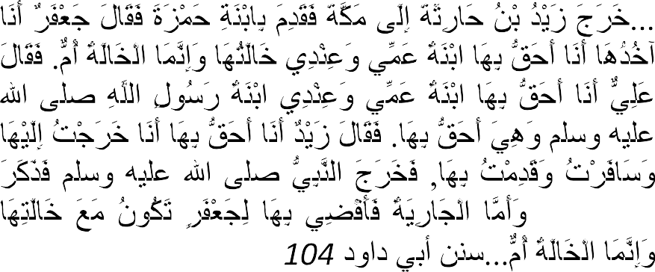

"

…:Zayd ibn Harithah went out to Mecca and brought the daughter

of Hamzah with him. Then Ja'far said: I shall take her; I have more right to her; she is my uncle's daughter and her maternal aunt is my wife; the maternal aunt is like mother. Ali said: I am more entitled to take her. She is my uncle's daughter. The daughter of the

Messenger of Allah ( ) is my wife, and she has more right to her. *Zayd* said: I have more right to her. I went out and journeyed to her, and brought her with me. The Prophet ( ) came out. The narrator mentioned the rest of the tradition. He (i.e. the Prophet)

said: As for the girl, I decided in favour of *Ja'far*. She will live with her maternal aunt. The maternal aunt is like mother. (Sunan Abi Dawud Book 12 Hadith 104).

The maternal aunt is in the position of the mother. When a mother forgoes or sacrifices the right to custody and she is not married to another man and then later wants to take the child, she can only take him if she left him with a legitimate excuse. If she left him out of dislike for the child, then she cannot take him.

Ulama‘a disagree on what happens to a couple who are divorced if the wife is a *dhimmy*. One group say that there is no difference between a *dhimmy* and a Muslim mother: they are both entitled to the child. This is the position of *Abi Thawr*, the People of Opinion, and *lbn al-Qasim. lbn al-Mundhir*.says that there is a *marfu hadith*which states this, although there is some dispute about its *isnad*.

The second position is that the child is with the Muslim. This is the position of*Imam Malik, Sawwar*, and 'Abdullah ibn al-hassan, and is reported from ash-Shafi 'i. There is the same disagreement when one of the couple is free and the other a slave.(Bagdadi n.d p 350)

Allah (SWT) in another verse says:

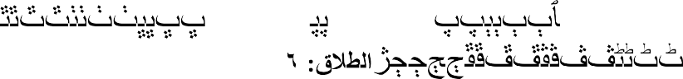

Lodge them(the divorced women) where you dwell, according to

your means, and do not harm them so as to straighten them (that they be obliged to leave your house). And if they are pregnant, then spend on them till they lay downtheir burden. Then if they give suck to the children for you, give them their duepayment, and let each of you accept the advice of the otherin a just way. But if you make difficulties for one another, then some other womenmay give suck for them (the father of the child) (Q.65:6).

Allah the Exalted orders His faithful servants that when one of them divorces his wife; he should provide housing for her until the end of her *`Iddah* period, He said; Lodge them where you dwell, it means, with you,according to whatyou have.Ibn

*`Abbas, Mujahid* and several otherssaid, it refers to "Your ability.'' *Qatadah* said, "If you can only afford to accommodate her in a corner of your house, then do so.''(Ibn kathir 2003 V.8 p 52).

Allah's statement, (and do not harm them in order to suppress them.) Muqatil bin Hayyan (nd) said, "itmeans that; do not annoy her to force her to pay her way out nor

expel her from your house.'' *Ath-Thawri* said from Mansur, from Abu Ad-Duha; and do not harm them in order to suppress them.That is; He divorces her, and when a few days remain, he takes her back.(Ibn kathir 2003 V.8 p 56).

Allah (S.W.T) says;

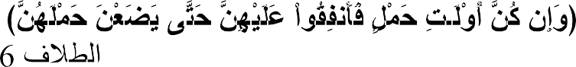And if they are pregnant, then spend on them till they lay down their burden. (Q 65:6)

This is about the woman who is irrevocably divorced. If she is pregnant, then she is to be spent on her, until she lays down her burden. This is supported due to the fact that if she is revocable divorced, she then has right to receive her support (maintenance) whether she is pregnant or not.

Allah (S.W.T) says;

## … …



…Then if they suckle them for you, (Q65:6)

This means that, when pregnant women give birth and they are irrevocably divorced by the expiration of the `*Iddah*, then at that time they may either suckle the child or not. But that is only after she nourishes him with the milk that is the early on milk which the infant's well-being depends upon. Then, if she suckles, she has the right to compensation for it. She is allowed to enter into a contract with the father or his representative in return for whatever payment they agreed to. This is why Allah the

Exalted says;

## …



…give them their due payment, Q. 65:6

Allah (S.W.T) said;

## …

…and let each of you deal with each other in a mannerly way.(Q. 65:6)

meaning, the affairs of the divorced couple should be managed in a just way without causing harm to either one of them, just as Allah the Exalted said in *Surat Al-*

*Baqarah*,

## …



No mother shall be treated unfairly on account

of her child, nor father on account of child.(Q. 2:233)

Allah (S.W.T) says;

## …



…But if you make difficulties for one another, then some other woman may suckle for him. (Q. 65:6)

Meaning, if the divorced couple disagrees, because the woman asks for an unreasonable fee for suckling their child, and the father refuses to pay the amount or offers an unreasonable amount, he may find another woman to suckle his child. If the mother agrees to accept the amount that was to be paid to the woman who agreed to suckle the child, then she has more right to suckle her own child. (Ibn Juzaiy n.d: p 96).

Allah's statement,





Let the rich man spend according to his means; Q 65:7

This means that; the wealthy father or his representative should spend on the child according to his means,

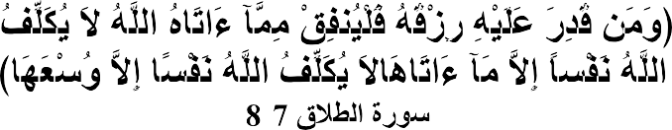

**-**

and the man whose resources are restricted, let him spend

according to what Allah has given him. Allah puts no burden on any person beyond what He has given him.( Q. 657-8)

This is as Allah (S.W.T) says; Allah does not place a burden on a person beyond what He can bear. (Q:2:286)

Allah's statement;



Allah will grant after hardship, ease.(Q:65: 7)

This is a sure promise from Him, and indeed, Allah's promises are true and He never

breaks them, this is Allah's saying;

# --

Verily, along with every hardship is relief. Verily along with every hardship is relief.) (Q: 94:5-6)

There is a relevant Hadith that need to be citedhere. Imam Ahmad recorded that Abu

*Hurayrah*(nd) said,

"A man and his wife from an earlier generation were poor. Once when the man came back from a journey, he went to his wife saying to her, while feeling hunger and fatigued, `Do you have anything to eat' She said, `Yes, receive the good news of Allah's provisions.' He again said to her, `If you have anything to eat, bring it to me.' She said, `Wait a little longer.' She was awaiting Allah's mercy. When the matter was prolonged, he said to her, `Get up and bring me whatever you have to eat, because I am really hungry and fatigued.' She said, `I will. Soon I will open the oven's cover, so do not be hasty.' When he was busy and refrained from insisting for a while, she said to herself, `I should look in my oven.' So she got up and looked in her oven and found it full of the meat of a lamb, and her mortar and pestle was full of seed grains; it was crushing the seeds on its own. So, she took out what was in the mortar and pestle, after shaking it to remove everything from inside, and also took the meat out that she found in the oven.'' Abu Hurayrah added, "By He in Whose Hand is the life of Abu Al-Qasim (Prophet Muhammad )! This is the same statement that Muhammad said*,****Had she taken out what was in her mortar and not emptied it fully by shaking it, it would have continued crushing the seeds until the Day of Resurrection.***''( Ibn kathir V.6: 457).

And Allah (S.W.T) says:





O you who believe! Wards off yourselves and your families against a fire (hell) whose fuel is men and stones, over which are angels stern (and) severe, who disobey not (from executing) the commands they receive from Allah, but do that which they are commanded. (Q.66:6).

The above verse indicates that the child under custody has right over his parents, and Muslim society to take care of him, and the verse show that it is a great sin to neglect a child without paying surveillance for his protection or preservation.

Similarly, there are many Prophetic *Ahadith* which guide Muslims and encourage them in providing care for the minor; hence it is his right. The following is the Hadith concerning the aspect:

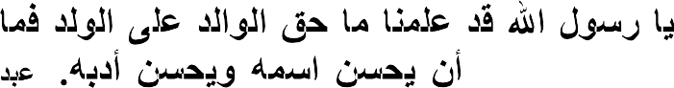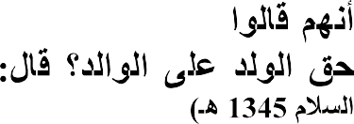

**)**

Baihaqi in Zuhaili (2008: p.70) reported from Ibn Abbas who said: the

companions asked the Messengerof Allah (S.W.T) saying: Oh Messengerof Allah! We know now the right of parent over his child, what is the right of a child over his parent? He answered: ―you should choose a proper (good) name for him and you should train him properly.(Abdussalam: 1345A.H).

##### 2.4- Reasons for Custody

Factors that make the child to be under custody are three, namely: Divorce; Death and Waif condition. Some verses of the Qur‘an and some practical aspectsof the life of the Companions of the Prophet (S.A.W) have established the above three factors. Below are elaborations of the above three factors:

##### Divorce:

If the dissolution of marriage occurs between a husband and his wife, theirchild goes to the state of need forsomebody who will take care of him.This separation could be by divorce (*Talaq)* or by redemption (*Khul’*). The Qur‘anic verse which discusses about type of custody is the following:

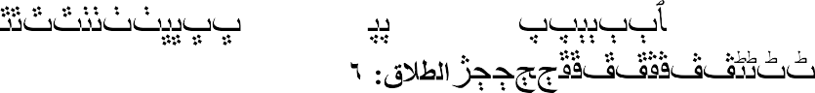

Lodge them(the divorced women) where you dwell, according to your means, and do not harm them so as to straighten them (that they be obliged to leave your house). And if they are pregnant, then spend on them till they lay downtheir burden. Then if they give suck to the children for you, give them their duepayment, and let each of you accept the advice of the otherin a just way. But if you make difficulties for one another, then some other womenmay give suck for them (the father of the child) (Q.65:6)

##### Death:

If one of the parentdies, leaving an offspring, the child goes under the care of somebody. The verse which discusses this type of condition is that which Allah (S.W.T) says:

 

3. **Waif**:

And let those (executers and guardians) have the same fear in

theminds as they would have for their own if they had left weak offspring behind. So let fear Allah and speak right words. (Q.4:9)

If a child is left stranded roaming the street or found in the forest or any other places and the parents of the child could not be found, the child‘s care goes to the Muslim community or Muslim leadership. Ulwan (1981:1:337) related that Umar bnAl- Khattab (R.A) when a waif orphan was brought to him, said: ―His sustenance is on us, he is free (i.e. not a slave) and a child.‖

###### 2.4.1Conditions of Custody( )



The basic requirement for being custodian of a child, according to Khalil Ibn Ishaq (2011:199) is sound mind (*Aql*); capability (*Kifa’ah*); secured accommodation

(*Hirz al-makan*) trustworthiness (*Amanah*); healthy (*sahih min al suqm*) and maturityof mind or prudence (*Rushd*).

Al-Dardir, Dasuki and Al-Abididi, elaborated the meaning of the above conditions as follows;

1. Sound mindedness (Aql). Al-Dardiri (n.d:3:470) said ―A mad person will not be accepted to be a custodian even if the madness disappears at intervals. Similarly, a half minded person,i.e prodigal or psychologically imbalance cannot be a custodian‖.
2. Al-A‘bi (2011) added that ―Custody cannot be handed to a cruel person or obdurate person‖.
3. Capability (*Kafa’ah*) Al-Dardiri says what it means here is the ability to provide what the child needs. ―This indicates an old man or woman or a sick person who cannot do anything for himself, neither to the child and cannot be a custodian to the child.
4. Secured accommodation (Hirz Al-Makan), Al-Dardiri (n.d:3:470) elaborated this point and said; this is referring to a person under custody who reaches a state of maturity; a woman reaches a state of maturity where she could be consummated; or a man reaches the state of maturity, and both are not safe to be in unsecured apartment. A custodian living in unsecured place could not be left with a child for custody.
5. Trustworthiness (Amanah) Dasuki (n.d:2:470) observed that what trustworthiness means here is being careful concerning religion. Dardiri (n.d:2:470) also commented that the trustworthiness here refers to religious practices of the custodian even if the custodian is the father or mother of the child. If a person is a drunkard or adulterer, he could not be allowed to be a

custodian;and Khalil Ibn Ishaq, opined that if somebody argues that he is trustworthy, he should prove his argument.

1. Healthy (*sahih min al suqm)* Al-Abidi (2011) observed what this condition means. The condition proposes thatthe custodian must be free from any infected diseases like leprosy etc.
2. Maturity ofMind (*Rushd*). Al-Abidi (2011) observes what this condition means, is the ability of the custodian to protect the wealth of the child. If the custodian cannot safeguard the wealth of the child, he may squander it at the expenseof the child.

###### 2.4.2-Right to Custody.

A child basically relies on his parents, but in the event of separation or dissolution of marriage, the mother of the child has moreright to take care of him in Islamic law except for other reasons. There are many *Ahadith*that shows this preference, among which are as follows:

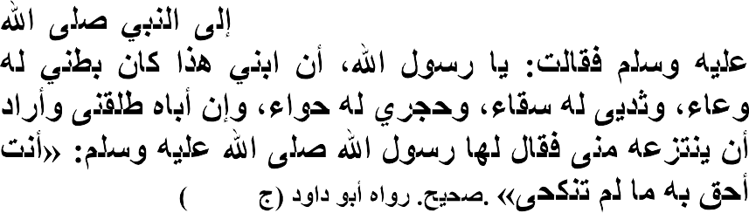

**.227/6**

On the Authority of Abdullahi bn Amr who says: A woman said: O Allah‘s Messenger. I carried my son in my womb, suckled him my breast and held him on my lap, yet his father has divorced me and want to take him away from me ―Allah‘s Messenger (S.A.W) replied her, ―You have more right to him as long as you do not marry (Abu Dawud 2276).

In another Hadith;

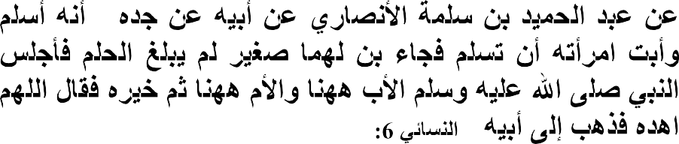

**185**

**- .**

On the Authority ofAbdul Hamid bn Salama al-Ansari, from his father

his grandfather who said; He converted to Islam but his wife refused to convert to Islam. He came along with his son who is a child, does not reach the year of puberty. The Prophet (S.A.W) then made the father to sit down to a side and the mother to another side and made the son to choose who he will live with among them. The Prophetinvokes and said; ―O Allah! Guide him‖. He (the son) then inclined (went) to his father.(Nasa‘i 6:185).

The *Ahadith* mentionedabove indicate that if the parents are all Muslims, the mother of the child has more right to look for custody of the child in as much as she did not remarry. But if one of the parentsisnot a Muslim, the preference goes to the Muslim‘s side.

###### 2.4.3-Criteria for the transfer of Custody

Whattransfer of custody means here is the changing of thelegal right ofcustodian. There are many factors which causes the transfer ofcustody. Salim (2002:3:415), explained that: "the child's mother is given priority over others, but if there is any factor that prevents her from being the custodianof her child, then the custody is to be transferred to the eligible custodian"

Salim, further explained that, according to Maliki school of law, the order of priority is as follows:

* 1. The mother of the child
  2. Mother's mother
  3. Mother's grandmother (maternal, then paternal)
  4. Mother's sister (full, then maternal, then paternal)
  5. Grandmother's sister
  6. Mother's aunt
  7. Father's mother, or father's grandmother
  8. Father
  9. Child's sister
  10. Father's sister.

Ismail (1997:2:160 – 161) maintains that in the absence of anyone from amongst the above mentioned hierarchy of child's relative or if such relative though available, is not competent to be the custodian, then the right of the custody shall be transferred to the child's *Asaba* (agnatic relatives),in order of their priority in inheritance as arranged below:

1. Father
2. Father's father (HHS)
3. Germane brother
4. Consanguine brother
5. Germane brother's son
6. Consanguine brother's son
7. Germane, paternal uncle
8. Consanguine paternal uncle
9. Father's germane paternal uncle
10. Father's consanguine paternal uncle

Ismail (1997,2:160 – 161) further explained that: "Where none of the above mentioned child's relatives (*among the Asabah*) is available or competent, then the *Hadanah* shall be transferred to his non agnatic relatives in the following order".

1. Maternal grandmother
2. Uterine brother
3. Uterine brother's son
4. Uterine paternal uncle
5. Germane maternal uncle
6. Consanguine maternal uncle
7. Uterine maternal uncle

Ismail (1997,2:160 – 161) also stated that: "Then in the absence of any relative of the child the judge shall appoint a hadinah (a female custodian for the child)"

##### 2.4.5- Nullification of the right of Custody

Right of custody given to the relatives of the child in the order of priority can be nullified or withdrawn, due to some reasons stated by various scholars as follows: *Aljaza’iri*, (2001) maintains that; the actual purpose of guardianship is to maintain the child's life, and his physical, rational and spiritual upbringing and care. Therefore, the right of upbringing and care of the child will be taken away from whoever does not fulfil the very aim and purpose of the guardianship. For example, when the mother gets married to a person who is not a relative of the child, her right to custody will be lost". This is due to the saying of the Messengerof Allah (S.W.T), to a woman that she has more right to have the custody of her child as long as she does not marry.

This is because her marriage to a person, who is not related to the child, renders her unable to fully maintain and protect the child.

Moreover, in the following situation, the right of custody will be taken away from a female guardian:

1. If she is insane or mentally deranged.
2. If she has a serious disease, such as leprosy.
3. If she is a minor.
4. If she is unable to protect the child or guard his body, intellect and religion.

Rashid in *Minhaj* (2007:2, 767) states that:as long as the aim of the child's custody is to bring him up in both physically and mentally and spiritually, the right of custody should be void if these aims are subjected to danger, so, that of the mother becomes void if she is remarried to a strange man who is not related to the child, as it is difficult that she would observe both her new husband's right along with her child's. Added to this, any custodian may lose the right in the following cases:

1. If she is insane.
2. If she (or he) has an infectious disease like leprosy.
3. If she has not reached puberty.
4. If she is not able to charge for the custody.
5. If she is an unbeliever, lest the child creed should be liable to distortion.

Idris in his thesis (1996:87) explains that the right is lost or may be forfeited in the following circumstances:

1. Where the woman who has right of custody of a minor neglects the proper care of the child.
2. Where the woman is leading an immoral or infamous life or is guilty of misconduct or cruelty.
3. Where she marries a person who is a complete stranger to the minor or who is related to the minor, but not within the prohibited degree; but where she marries a relation that is within the prohibited degree, to the child, the right is not forfeited.
4. Where she apostates, (riddah).

###### 2.4.5-Responsibility for financing the child’s care

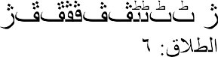There are many verses of the Qur‘an which shows that the responsibility of financing a child‘s care is on his father. Some of these verses are as follows: Allah (S.W.T) said;

… And if they suckle your (offspring), give them their recompense. And take mutual counsel together, according to what is just and responsible. (Q65:6)

And Allah (S.W.T) says:



The mothers shall give suck to their offspring for two whole years, for him who desires to complete the term. But he shall bear the cost of their foodand clothing on equitable terms**.** (Q2:233**)**

Muslim scholars held a consensus opinion that, the responsibility of financing the care of the child rest on his father, as the above verses indicated. However, in the absence of the father, due to his death, or the father becomes bankrupt, the responsibility of financing the care of the child is left onthe child‘s wealth, as opined by Al‘Abi(2011:1:738) ―If the child has no money‖, Al‘Abi also stated ―his Mother will finance his care‖.

###### 2.4.6 Duration of custody

Muslim scholars have differed in their views regarding the duration of custody. Zarruq (1914:2:97) in his commentary to *Risala*ofIbn Abi Zaidal-Qairawani, provided divergent views of Muslim scholars concerning the duration of custody. In relation to male child, Ibn Al-Qasim, was of the opinion that the duration prolongs up to the child maturity or puberty. ButAbdul Malik went with the view that it is up to the growthof hair in his private part;and*Ibn Wahab* and al-Lakhami went with the view that it is up to the growth of teeth in his mouth. Ibn*Majishun*, according to

*Tannukhiy* (1914:2:97) prefer relying on the growth of hair in the private part of the child, because it is to identifythe truthfulness of the statement.

In relation to female child, Zarruq went with the opinion that she will be under custody up till the time she gets married and the husband makes a marital relation with her.

*AL-Jazairi (*2001:394) maintained that the period of guardianship and care is valid until theyoung boy reaches the age of puberty; in the case of the young girl, it is until she gets married and the marriage is consummated. However, when the wife is separated from her husband, and the child's mother, or other than she intends to take the child's custody, she maintains the custody to look after the young girl until she reaches seven years of age. Therefore, her guardianship should be transferred to her father, since he is more suitable to look after her, after seven years old than other female guardians.When the boy reaches the age of seven,thenhe is given the choice between his father and his mother orwhoever out of them he chooses to stay with, his guardianship will be transferred to the one he chooses. If he fails to choose anyone of them and his parent‘shad a dispute over his guardianship, then it should be decided by drawing lots.

*Salim*, (2002 3:421 – 422) stated that, if the child reaches the age whereby he is independent of women services and support, in terms of conducting his affairs on his own (such as eating, wearing cloth, bathing, going to toilet,etc.) his period of custody elapses,and there is no prescribed age for the child to be capable of doing things by himself; therefore, it should be left to the judge to state the age at which a child can take care of himself.

*Salim*, further explains that if the period of custody is over, according to Maliki school of law, the child's mother has more right to stay with the child until he

reaches the age of puberty, and in the case of female child, she is to stay with her mother until she gets married and the marriage is consummated.

According to *Suhnun,* (2005) a child will stay under the custody of his mother up to the age of puberty, then the child can stay with any one of them;and if the child's father wants to train the child, he can do so from morning to evening, he can also send him to school and the child should go back to his mother in the night for her care. They can be doing so and the father should not separatethem unless if the child's mother gets married.*( Suhnun,* V. 2,p 486).

*Suhnun* further explained that if the child's mother gets married, then the child should be taken to the next custodian, the child should not be returned to her even if the second husband divorced her. As regard the female child, the duration is for her to stay with her mother until she gets married, if the mother is capable of taking goodcare of her daughter she is to stay with her mother up to the time of her marriage even if the daughter reaches the age of 30 or 40 as long as she does not get married she is under custody. But if the mother cannot take goodcare of the daughter or she has bad behaviour that will affect the daughter, then the girl should be taken away from the mother to the next eligible custodian.

Ismail (1997). maintained that if the child on custody grows to the extent of taking care of himself he should be returned to his father if he is alive, but if he is dead or he is nowhere to be found, then the child should be returned to his father's relatives in the order of priority and he should be given to the one who is capable of taking goodcare of the child. There is no doubt that taking or returning the child to his father's relative will help in taking goodcare of the child at this stage after getting female's care; also a male child can acquire skills and other male behaviour from them.(Ismail 1997:2:166).

In the light of the above discussion, therefore, custody of children by the mother or any eligible relative as mentioned above lasts until marriage consummation, in the case of a girl, and until puberty in the case of a boy, after which he is free to stay with his father or mother or elsewhere according to the circumstances.

##### 2.5. An overview of the Study Area:

###### 2.5.1- Katsina State

The *Katsina*we are talking about is located some260 kilometres (160 ml) east of the city of Sokoto, and 135 kilometres (84) northwest of Kano, close to the border with Niger. in2006 national census was conducted, *Katsina*‘s estimated population was 459,022. The exact population of *Katsina* will be found in the result of the 2016 Nigerian Census. The city is the centre of an agricultural region producing groundnut, cotton, hides, millet and guinea corn, and also has mills for producing peanut oil steel. The city is largely Muslim and the population of the city is mainly from the Fulani and Hausa groups.

Former Nigerian President Umaru Musa Yar‘adua was anindigene of *Katsina*.

###### 2.5.2 Katsina Emirate

The *Katsina* Royal Palace ‗Gidan Korau‘ is a huge complex located in the centre of the ancient city. It is a symbol of culture, history and traditions of ‗*Katsina*wa‘. According to historical account, it was built in 1348 AD by Muhammadu Korau who is believed to be the first Muslim King of *Katsina*. This explains why it is traditionally known as ‗Gidan Korau‘ (House of *Korau*). It is one of the oldest and among the first generation palaces in Hausaland. The rest are that of *Daura*, Kano and Zazzau. The palace was encircled with a rampart ‗*Ganuwar Gidan* Sarki‘ (Which is now extinct). The main gate which leads to the Palace is known as ‗Kofar Soro‘ while the gate at the backyard is called ‗Kofar Bai‘ (now extinct). The Emir‘s residential

quarters which is the epicentre of the Palace, is a large compound built in the typical Hausa traditional architecture. The current Emir of *Katsina* is Alhaji *Abdulmumini Kabir Usman*.

The Historic Kingdom and emirate in northern Nigeria.according to tradition, the katsina kingdom, was one of the Hausa *Bakwai* (―Seven True Hausa States‖), founded in the 10th or 11th century C.E. Islam was introduced in the 1450s, and Muhammad*Korau* (reigned late 15th century) was *Katsina*‘s first Muslim king. During his reign, the camel caravans crossed the Sahara from Ghudamis (Ghadames), Tripoli, and Tunis southward to *Katsina* and brought such prosperity to the state that it became caught in the rivalry between the great West African empires of Songhai (Gao) and Bornu. In 1513 *Katsina* was conquered by the Songhai. Smith M.G(1962).

The Original walls around *Katsina* town, the kingdom‘s capital, were built in the mid- 16thcentury, in 1554 *Katsina* defeated the forces of Songhai and, in 1570, those of Kano, its principal rival in the trans-Saharan trade. After the Moroccan armies had vanquished Songhai in 1591, *Katsina* was (until the end of the 18th century) a tributary state of Bornu,*Katsina* entered its greatest period of prosperity in the early 18th century. Besides being the leading Hausa commercial state, it replaced Timbuktu (*Tombouctou*) as the chief West African centre of Islamic studies. Later in the century, wars with Gobir, a Hausa state to the northwest, marked the beginning of *Katsina*‘s decline.Smith M.G(1962).

Fulani herdsmen settled in *Katsina* by the 15th Century, and in 1804 the Sokoto Jihad leader, shaykh*Usmanbn Fodio,* led a revolt (beginning in Gobir) against the Hausa overlords. The sokoto jihad flag bearer Umaru Dallaji captured *Katsina* in 1806 and was named the first sokoto caliphate Emir with *Katsina* as his seat. The Emirate was

governed by the representative of the sultan of Sokoto (a town 160 miles (258km) west) as well as the local emir. Many of the Hausa nobility and people fled to Dankama (25 miles [40km] northeast) and to *Tassawa* (Tessaoua) and *Maradi* in Niger, where they proclaimed a Hausa *Katsina* chiefdom. Their raids throughout the 19th century weekend the*Katsina* town (which was surpassed by Kano).(Ulwan (1981:p.337).

In 1903 *Katsina*‘s Emir pledged allegiance to the British rulers of Northern Nigeria. When the British and French set the present Niger-Nigeria boundary in 1904, *Katsina* emirate was reduced in size and made a part of Kano province. Much of its former territory is now in *Katsina* State.(Smith M.G(1962).

Located in northern-west geopolitical zone of Nigeria, *Katsina* States was created out of the old Kaduna State in 1987 and it was divided into thirty-four (34) local government areas which include Bakori, Batagarawa, Batsari, Baure, Bindawa, Charanchi, Danja, Dandume, Dan-Musa, Daura, Kusada, Mai-Adua, Malumfashi, Mani, Mashi, Matazu, Musawa, Rimi, Sabuwa, Safana, Sandamu and Zango.

The area known as *Katsina* State today was originally part of the old Kaduna State until 1987 when *Katsina* was created. The state is made up of two Emirates namely katsina and daura Emirates which feature prominently in the establishment of the seven Hausa kingdoms. The lineage between *Bayajida* and *Daurama* produced the founders of Daura, *Katsina*, Zazzau, Kano, Rano *Gobir* and *Biram.*Katsina city was founded by *Kumayo* before the sokoto jihad conquest. katsina had been an important seat of learning and a commercial centre of the trans-Saharan trade.

###### 2.5.3- People & Culture

*Katsina* is a predominantly Hausa-Fulani area and most people speak only Hausa and Fulfulde. The state is also made up of two emirates, which feature prominently in the establishment of the seven Hausa Kingdoms. The famous *Bayajidda* lineage has produced the founders and king of *Katsina*, Zazzau, *Biram*, *RanoGobir* and *Daura*. The legendary *Kusugu* well in which the snake called Sarki was slained serves as a major tourist attraction in *Daura*. A sizeable number of migrants from southern Nigeria, especially the *Yorubas* and *Igbos*, are found in *Katsina*state and they dwell mostly in major towns.

Covering a total land mass of24,192km, *Katsina* state is bounded in the east by Kano and Jigawa States, in the south by Kaduna state, in the west by Zamfara State and in the north by Niger Republic. *Katsina* State forms part of the extensive plains known as the high plains of Hausaland.

###### 2.5.4- Weather/Climate

The state can be classified into two zones in terms of climate which are the tropical continental and semi-arid continental. The southernpart of the state (from Funtua to Dutsin-ma) belong to the former with total annual rainfall figures ranging from 1000mm around *Funtua* to over 800m around Dutsin-ma. The north of *Katsina* State (from around *Kankia* to the extreme northeast) has total rainfall figures ranging from 600-700mm annually.(Ulwan 1981:p.337).Generally, climate varies considerably according to months and seasons.

A cool dry (*harmattan*) season from December to February; a hot dry season from March to May; a warm wet season from June to September; a less marked season after rains during the months of October to November, characterized by decreasing rainfall and a gradual lowering of temperature.

###### 2.5.5- Education

*Katsina* State is a centre of both formal and informal Islamic education. Currently it has Federal College of Education, *Katsina*; Hassan Usman *Katsina* Polytechnic, *Katsina*, Federal University of Agriculture, Dutsin-ma; Al-Qalam University katsina *Katsina* State University, which was renamed after the late President Umaru Musa Yar‘adua University; Yusufu Bala Usman College of Legal and General Studies, Daura,school of nursing Katsina School of health technology in daura, kankiya and malumfashi. and the School of Basic and Remedial Studies, Funtua (SBRS/ABU Funtua).

After the British colonial conquest in 1903, the erstwhile *Katsina* and Daura Emirates became *Katsina* Province of the former Northern region of Nigeria. Later, *Katsina* and Zaria Provinces together formed the North Central State under the *Katsina* Province of the defunct Northern Region.

Its creation along with *Akwa Ibom* State in September 1987, raised the number of states from nineteen to twenty-one under the then Babangida military administration. Henceforth, the agitation for the creation of *Katsina*State, came to rest.(Udo and Mamman, 1993).

**Administrative Structure:** Three tiers of government exist in the state namely; executive, legislative and the judiciary. The executive arm is administered through the State Executive Council which is headed by the state governor.

##### CHAPTER THREE METHODOLOGY

* 1. **INTRODUCTION**

This chapter focuses on the step-by-step procedural activities taken by the researcher in this study.

This includes the research design, area of study, population, sample and sampling procedure, instrument for data gathering, validation and reliability of the instrument and procedure for data analysis.

##### Research Design and Instrumentation

In this study, the researcher has selected her design on methodcategory and consider descriptive as the procedure. The research is based on survey where a questionnaire was used in collecting data. This enables researchers to administer questionnaire to many respondents, the questionnaire was an open ended form or unstructured.

This research therefore adopted the following steps:

1. Consulted*Al’Qur’anil-karim* and *Ahadith*of the Prophet (SAW) as the primary source of*Shari’ah*.
2. Consulted some related literature written by Muslim scholars on the subject matter especially scholars from Maliki Schoolof law.
3. Distributed questionnaire to parents, court officials and, social welfare officers of the selected Local Government Areas.

##### Population

The Population of this study comprises some selected local governments within the three political zones of*Katsina* State. Therefore, the selected local governments in *Katsina* Zone are *Katsina*, *Dutsin-ma* and Kaita local governments. The selected local governments from *Daura*Zone are: *Daura, Mai’adua* and

*Kankia*local governments. And the selected local governments from *Funtua* zone are:

*Funtua, Malumfashi* and *Musawa* local governments‘ areas.

##### Sample and Sampling Technique

Sampling refers to a part of the entire population of a particular study. It is not economical indeed to use the entire population because of its wideness which technically attracts much time and logistics.

In this study, the researcher has identified parents, social welfare officers and court workers in the selected local governments of*Katsina* State of Nigeria to be her sample.

A total number of four hundred and five questionnaires were distributed, three hundred and sixty questionnaires for parents, thirty-six questionnaires for courts as well as nine questionnaires for social welfare offices.

##### Instruments for Data Collection

The instrument for data gathering is the research designed questionnaire. It is divided into two sections. The first section contains biographical data ofthe respondents such as gender, sex, marital status, working experience…etc, the second section consist of research variables which are divided into four categories, the items are used to get information from the respondents on the issue of child custody in *Katsina* State.

##### Validity and Reliability of the Instruments

For the purpose of this study, the initial draft of the instrument was vetted by four Experts opinions comprising the researcher‘s supervisors in the Department of Arts and Social Science Education Ahmadu Bello University, Zaria all of them not below the rank of senior lecturer. The corrections and suggestions were incorporated in the construction of the final copy of the instrument. All the inputs were to enhance

a thorough validation in order to ensure that the instrument actually measures what it is intended to measure in relation to the null hypotheses.

##### 3.6 Procedure for Data Gathering

The researcher engaged four research assistants.The research assistants were trained. The researcher and the research assistants administered the questionnaires in schools, local governments Secretariat Vocational Centres, courts and social welfare offices.

The researcher strictly complied with the ethics of research as there was no coercions, the right to the respondent privacy was respected and every respondent remains anonymous.

##### 1.7 Procedure for Data Analysis

The data collected from the field were subjected to statistical analysis for appropriate interpretations to achieve the set items and objectives of the study. The descriptive statistical techniques such were used in the analysis of data. The bio-data of the respondents were analysed with descriptive statistics which involves the use of frequencies and percentage. The justification for the use of descriptive statistics to answer research question was based on the fact that the statistics is easily obtainable and can be easily interpreted by the reader without any complication.

##### CHAPTER FOUR

**DATA PRESENTATION, ANALYSIS AND DISCUSSION OF FINDINGS**

##### Introduction

Chapter four of this project work involves the presentation of dataanalysis and discussion of majorfindings as it relates to the issues presented in chapter one. In the same manner, the opinions of the respondents were gathered, analysed and presented with the use ofFrequency tables and percentages: and in achieving this aim, Statistical Programme for Social Science (SPSS) was used to analyse the data collated from the various respondents.

More so, a total of fourhundred and five (405) questionnaires were distributed among four (4) categories of respondents i.e. Fathers, Mothers, Social Welfare Workers, and Court Workers. The table below shows the number of questionnaires distributed to respondents respectively.

##### Table 4.0 Distributed and returned Questionnaires

|  |  |  |  |  |  |  |  |  |  |
| --- | --- | --- | --- | --- | --- | --- | --- | --- | --- |
| FATHERS | | MOTHERS | | SOCIAL WELFARE | | COURT | | GRAND TOTAL | |
| Questionn  aires Distribute d | Questionn  aires Received | Questionn aires Distribute d | Questionn aires Received | Questionn aires Distribute d | Questionn aires Received | Question naires Distribute d | Question naires Received | Questionn aires Distribute d | Questionn  aires  Received |
| 180 | 158 | 180 | 175 | 9 | 9 | 36 | 35 | 405 | 377 |

Table 4.0 above clearly indicated the number of questionnaire distributed to the respondents and the returned, out of 180 questionnaires distributed to father 158 where received, 180 questionnaire of mother 175 where received also 9 questionnaires of the social welfare workers the same number where returned as well as 36 questionnaires distributed to the court workers 35 were received.

* + 1. Gender of the respondents for the questionnaire.

|  |  |  |  |  |  |  |  |  |  |  |  |
| --- | --- | --- | --- | --- | --- | --- | --- | --- | --- | --- | --- |
| Father | | | Mother | | | Social welfare | | | Court | | |
| Gender | Freq. | % | Gender | Freq. | % | Gender | Freq. | % | Gender | Freq. | % |
| Male | 158 | 100 | Male | - | - | Male | 9 | 100 | Male | 31 | 88.6 |
| Female | - | - | Female | 175 |  | Female | - |  | Female | 4 | 11.4 |
| Total | 158 | 100 | Total | 175 |  | Total | 9 | 100 | Total | 35 | 100 |

The table above shows the gender of the respondents 158 represented by 100% are fathers so also 175 of the respondents represent by 100% are mother and welfare are male i.e. 9 (100%) while 31 represented by 88.6% of the court workers are male and only 4 represented by 11.4% are female.

* + 1. Age range and marital status of the respondents.

|  |  |  |  |  |  |  |  |  |  |  |  |
| --- | --- | --- | --- | --- | --- | --- | --- | --- | --- | --- | --- |
| Father | | | Mother | | | Social welfare | | | Court | | |
| Age | Freq. | Percen tage | Age | Freq. | % | Age | Freq. | % | Age | Freq. | % |
| 18 – 35  Years | 60 | 38.0 |  | 115 | 65.7 |  | 6 | 66.7 |  | 31 | 88.6 |
| 36 – 55  Years | 75 | 47.5 |  | 49 | 28.0 |  |  |  |  | 4 | 11.4 |
| 56 – 60  Years | 20 | 12.6 |  | 11 | 6.3 |  | 3 | 33.3 |  |  |  |
| Above 60Years | 3 | 1.9 |  |  |  |  |  |  |  |  |  |
| Total | 158 | 100 |  | 175 | 100 |  | 9 | 100 |  | 35 | 100 |
| Marital status | Freq. | Percen tage | Mari tal statu  s | Freq. | % | Marit al status | Freq. | % | Marit al status | Freq. | % |
| Single | 23 | 14.6 |  | 155 | 886 | Singl  e | - | - | Singl  e | 5 | 14.3 |
| Married | 135 | 85.4 |  | 20 | 14.4 | Marri  ed | 9 | 100 | Marri  ed | 30 | 85.7 |
| Total | 158 | 100 |  | 175 | 100 |  | 9 | 100 |  | 35 | 100 |

The table above shows the demographic characteristics of respondents where it can be seen that out of the total number of 158 respondents (fathers) 60 represent by 38.0% fall within the age range of 18 – 35 year followed by 75 represent by 47.5% of those within the age range of 36 – 55 while 20 (12.6%) fall within the age range of 56 – 60 years and 3 (1.9%) above 60 years.

Meanwhile 115 represent by 65.7 of the members are within the age range of 36 – 55 and 11 (6.3) within the age range of 56 – 60 years.

Also 6 represent by 66.7 of the social welfare workers are within the age range of 18- 35 years and 3 respondent by 88.6% fall within the age range of 36 – 55 years.

The table above also shows that 23 represented by 14.6% of the fathers are single while 135 presented by 85.4% are married meanwhile 160 represented by 88.6% of the mothers are single only 20 by 14.4 are married, so also a

9 by 100% of the social welfare workers are married while 5 represented by 14.3% of the court workers are single and 30 represented by 85.7% are married.

* + 1. Educational Qualification.

|  |  |  |  |  |  |  |  |  |
| --- | --- | --- | --- | --- | --- | --- | --- | --- |
| Educational F  Qualification | ather | | Mothers | | Social welfare | | Court | |
| Secondary | 37 | 23.4 | 27 | 15.4 | - | - | - | - |
| NCE | 49 | 31.0 | 24 | 13.7 | 3 | 33.3 | 3 | 8.6 |
| BA,B/sc B.ed  L.L.B HND | 43 | 27.2 | 68 | 38.9 | 6 | 66.7 | 25 | 71.4 |
| Masters | 13 | 8.3 | 5 | 2.9 | - | - | 3 | 8.6 |
| Islamic Education | 7 | 4.4 | 31 | 17.7 | - | - | - | - |
| Others | 9 | 5.7 | 20 | 11.4 | - | - | 4 | 11.4 |
| Total | 158 | 100 | 175 | 100 | 9 | 100 | 35 | 100 |

The above table shows that 37 represented by 23.4% of the father had secondary school certificate, while 49 represented by 31.0% of the respondent acquired N.C.E and 43 by 27.2 had BA, BED, BSC, HND as their qualification and 13 by 8.3% had Masters also 7 by 4.4 of the respondents acquire Islamic education and 9 by 5.7% had other qualification. More so 27 by 15.4 of the mothers had secondary school certificate and 24 represented by 13.7% of them had NCE and 68 represented by 38.9 of the respondents acquire BA, BED, BSC, HND as their qualification also 5 2.9% of the mothers had Masters and 31 by 17.7 of the respondents had Islamic education as while as 20 by 11.4 are having other qualification.

More so, 3 represented by 33.3 of the social welfare workers had N.C.E. as their qualification while 6 represented by 66.7 of the respondents are having BA, BED, BSC and HND as their qualification. Also the above table shows that 3 represented by 8.6 of the court workers had N.D as their qualification and 25 represented by 71.4 acquired BA, BED, LLB, HND and 3 by 8.6 had masters as while as 4 represented by 11.4% acquired other qualification.

##### General response of practice of Katsina people on child custody after marriage separation.

**Table 4.1.a Fathers response**

##### Have you ever separated from a wife that you have a child with

|  |  |  |
| --- | --- | --- |
| **Response** | **Frequency** | **Percentage (%)** |
| Yes | 150 | 94.9 |
| No | 8 | 5.1 |
| **Total** | **158** | **100** |

In respect to responses gathered from fathers, table 4.29 above shows that, 150 represent by 94.9% of the fathers stated ―yes‖ which also implies that they have been divorced or separated from a wife that they have child, with, while few of them, i.e. 8(5.1%) admitted not to have been divorced from their spouses.

##### 4.1.b: If yes the child is under whose custody?

|  |  |  |
| --- | --- | --- |
| **Response** | **Frequency** | **Percentage (%)** |
| Myself | 86 | 54.4 |
| Under the wife | 53 | 33.5 |
| Her relatives | 7 | 4.4 |
| My relatives | 3 | 2.0 |
| None of the above | 9 | 5.7 |
| **Total** | **158** | **100** |

In table 4.1 b: above, majority of the fathers, 86 represented by 54.4% stated that the child is under their custody, 53 (33.5%) indicated under their wives while 7 (4.4%) stated that the child is under her relatives custody and 3 by 2.0% indicated that the child under the custody of their relatives 9 represent by 5.7% stated none of the above.

##### Table 4.1.cIf the child is under your custody, which of the following reasons make you keep the child with you?

|  |  |  |
| --- | --- | --- |
| **Response** | **Frequency** | **Percentage (%)** |
| Not aware of the religion instruction | 57 | 36.1 |
| Custom and tradition | 16 | 10.1 |
| Irresponsible nature of the mother | 46 | 29.1 |
| All of the above | 28 | 17.7 |
| None of the above | 11 | 7.0 |
| **Total** | **158** | **100** |

Information gathered in table 4.2 c shows that the majority of the fathers, i.e. 57 (36.11%) are not aware of religious instructions, 49 (29.1%) indicated that it is due to the irresponsible nature of the mother, while 28 (17.7%) of the fathers indicated that all of the above reasons made them keep the child with them, and 11 (7.0%) indicated none of the above mentioned reasons.

##### Table 4.1.d If the child is with the mother, why did you the child with her?

|  |  |  |
| --- | --- | --- |
| **Response** | **Frequency** | **Percentage (%)** |
| Religious instruction | 56 | 35.4 |
| I have no ability to keep the child with me. | 29 | 18.4 |
| Sympathy to the child | 32 | 20.3 |
| refusal of the mother to allow the child to stay with me. | 17 | 10.7 |
| Culture & Tradition | 12 | 7.6 |
| None of the above | 9 | 5.7 |
| Others | 3 | 1.9 |
| **Total** | **158** | **100** |

In table 4.1.d above, 56 (35.4%) of the fathers stated that they allow the child to stay with the mother because of religious instructions 29 represent by (18.4%) indicated they have no ability to keep the child with them 32 (20.3%) of the fathers stated that it is due to the sympathy they have for the child while 17 (7.6%) stated that is due to the refusal of the mother allow the child to stay with the father, 12 (7.6%) stated culture and tradition, 9 (5.7%) stated none of the above reasons, 3 (1.9%) stated other reasons.

##### Table 4.1.e Who takes responsibility and needs of the child?

|  |  |  |
| --- | --- | --- |
| **Response** | **Frequency** | **Percentage (%)** |
| Myself | 99 | 62.7 |
| The mother | 16 | 10.1 |
| Both of us | 34 | 21.5 |
| Her relatives | 6 | 3.8 |
| None of the above | 3 | 1.9 |
| **Total** | **158** | **100** |

Table 4.1.e Also shows that 99 respondent by 62% of the father went on to indicate that they takes the responsibilities and needs of the child; 34(21:5%) of the father stated both of them take the responsibilities and needs of the child. More so 6 represented by 3.8% indicated her relatives takes the responsible and needs of the child and 3(1.9%) stated none of the above.

##### Table 4.1.f Which among the following responsibilities do you shoulder as a father?

|  |  |  |
| --- | --- | --- |
| **Response** | **Frequency** | **Percentage %** |
| Full payment of the school  fees | 6 | 3.8 |
| Partial payment of the school fees | 6 | 3.8 |
| Feeding | 4 | 2.5 |
| All of the above | 139 | 88.0 |
| None of the above | 3 | 1.9 |
| **Total** | **158** | **100** |

Table 4.1.f The above shows that 6 represented by 3.8% indicated that they make full payment of their child school fees also 6 by3.8% partial payment of the school fees, 4 by 2.5% indicated feeding a vast number of the respondents 139 by 88% indicated that they shoulder all of the above responsibilities whereas 3 none of the above responsibilities.

##### Table 4.1.h Do you appropriate the child staying under the custody of his Mother?

|  |  |  |
| --- | --- | --- |
| **Response** | **Frequency** | **Percentage** |
| Yes | 70 | 44.3 |
| No | 88 | 55.7 |
| **Total** | **158** | **100** |

Table 4.1.h also shows that 70 respondents by 44.3% indicated yes which implies that they appropriate the staying of a child under the custody of his mother while majority of the fathers stated no which shows that they didn‘t appreciate the child to stay under his mother.

##### Table 4.1.i If no which of the following reasons made you not to appreciate the child being with his mother?

|  |  |  |
| --- | --- | --- |
| **Response** | **Frequency** | **Percentage** |
| The child is not having proper cane | 45 | 28.4 |
| The child will be well take care when he is  under me. | 20 | 12.7 |
| The child is exposed to danger in faith and  morality. | 34 | 21.5 |
| Fear of maltreatment from the other wife  (wives) | 35 | 22.2 |
| All of the above | 24 | 15.2 |
| **Total** | **158** | **100** |

The table above also shows that 45 (28.4%) of the respondents (fathers) indicated that they don‘t appreciate the staying of the child under his mothers custody because they feel, the child will not have proper care; 20 (12.7%) of the respondents indicated that the child is well taken care of when he is under them; 34 (21.5%) stated that the child is exposed to danger in faith and morally and 35 (22.2%) of the fathers indicated that it is due to the fear of maltreatment from the other wife (wives) and 24 (15.2%) indicated all of the above mentioned reasons.

##### : Mothers response

**Table 4.2.a Have you ever been divorced or separated from a husband that you have a child with?**

|  |  |  |
| --- | --- | --- |
| **Response** | **Frequency** | **Percentage** |
| Yes | 158 | 90.3 |
| No | 17 | 9.7 |
| **Total** | **175** | **100** |

From the responses gathered from mothers in relation to the practice of Katsina people on child custody after marriage separation, table 4.2.a above shows that, 158 represent by 90.3% of the mothers stated yes which also implies that they have been divorced or separated from a husband that they have a child with, while few of them

i.e. 17 (9.7%) admitted not to have been divorced from their spouse.

##### Table 4.2.b If yes the child is under whose custody?

|  |  |  |
| --- | --- | --- |
| **Response** | **Frequency** | **Percentage** |
| Myself | 71 | 40.6 |
| Under the husband | 95 | 54.3 |
| My relatives | 8 | 4.6 |
| His relatives | 1 | 0.5 |
| **Total** | **175** | **100** |

In the above table a vast number of the mothers, 71 represent by 40.6% stated that the child is under their custody, 95(54.3%) indicated under their husband, 8 represented by 4.6% stated that the child is under their relatives, while very few 1(0.5%) stated that the child is under the custody of their father‘s relatives.

##### Table 4.2.c If the child is under your custody, which of the following reasons make you keep the child with you?

|  |  |  |
| --- | --- | --- |
| **Response** | **Frequency** | **Percentage%** |
| Not aware about religious  instruction | 11 | 6.3 |
| Custom and tradition | 17 | 9.7 |
| Irresponsible nature of father | 51 | 29.2 |
| All of the above | 31 | 17.7 |
| None of the above | 65 | 37.1 |
| **Total** | **175** | **100** |

Information gathered from table 4.2.c above shows that 11(6.3%) of the mothers stated that they are not aware of religious instruction; 17 by 9.7% indicated custom and tradition 51 represented by (29.2%) indicated that it is due to the irresponsible nature of the father, while 31(71.7%) of the mothers indicated that all of the above mentioned reasons made them keep the child with them; 65(37.1) indicated none of the above.

##### Table 4.2.d If the child is with the father, why did you allow the child with him?

|  |  |  |
| --- | --- | --- |
| **Response** | **Frequency** | **Percentage%** |
| Religious instructions | 43 | 24.6 |
| I have no ability to keep the child with me | 25 | 14.3 |
| Sympathy to the child | 19 | 10.9 |
| Refusal of the father to allow the child with me | 72 | 41.1 |
| Cultural and tradition | 16 | 9.1 |
| **Total** | **175** | **100** |

In the above table 43 represented by 24.6% of the mothers stated that they allow the child be with the father because of religious instructions; 25 by 14.3 indicated they have no ability to keep the child with them; 19 represented 10.9% of the mothers stated that it is due to the sympathy they have for the child, while 72 represented by 41.1% stated that it is due to the refusal of the father to allow the child stay with them. Other reasons include culture and tradition as stated by 16(9.1%) of the mothers.

##### Table 4.2.e Who takes the responsibility and need of the child?

|  |  |  |
| --- | --- | --- |
| **Response** | **Frequency** | **Percentage** |
| Myself | 31 | 17.7 |
| The father | 79 | 45.2 |
| Both of us | 61 | 34.9 |
| His relatives | 2 | 1.1 |
| Muslim | 2 | 1.1 |
| **Total** | **175** | **100** |

The above table shows that 31 represented by 17.7% of the mothers went on to state that they take the responsibilities and care of the child by themselves, 79 represented by 45.2% indicated that father of the child take the responsibilities and need of the child; while 61 by 37.9 stated both of them take the responsibilities and need of the child; 2 by 1.1% indicated that his relatives and Muslim community.

##### Table 4.2.f Which amongs the following responsibilities do you shoulder as a mother?

|  |  |  |
| --- | --- | --- |
| **Response** | **Frequency** | **Percentage%** |
| Full payment of his school  fees | 4 | 2.2 |
| Partial payment of his  school fees | 15 | 8.6 |
| Feeding | 25 | 14.3 |
| Clothing | 26 | 14.9 |
| All of the above | 63 | 36.0 |
| None of the above | 41 | 23.4 |
| Others | 1 | 0.6 |
| **Total** | **175** | **100** |

The table above shows that 4 represented by 2.2% of the mothers indicated that they shoulder full payment of the child school fees. 15 by 8.6 stated that they make partial payment of school fees 25 by 14.3% indicated that they shoulder the responsibility of feeding the child. 26 represented by 14.9 of the mothers indicated that they buy clothes for the child, while 63 represented by 36.0% of the mothers stated all of the above i.e. payment of school fees, feeding, clothing, etc. also 41 234% indicated none of the above and 1 represented by 0.6 stated other responsibilities.

##### Table 4.2.g Did you appreciate the child being under the custody of his father?

|  |  |  |
| --- | --- | --- |
| **Response** | **Frequency** | **Percentage %** |
| Yes | 53 | 30.3 |
| No | 122 | 69.7 |
| **Total** | **175** | **100** |

The table above shows that 53 by 30.3 of the respondents (mothers) stated ‗yes‘ which implies that, they appreciate the child staying with the father, while a vast number of the respondents 122 represented by 69.7 indicated ‗no‘ i.e. they don‘t appreciate the child being under the custody of his father.

##### Table 4.2.h If no, which of the following reason(s) made you not to appreciate the child staying with his father?

|  |  |  |
| --- | --- | --- |
| **Response** | **Frequency** | **Percentage %** |
| The child is not having proper care | 55 | 31.4 |
| The child is well taken care when he  is under me. | 46 | 26.2 |
| The child is expose to danger in faith  and morality | 4 | 2.3 |
| Fear of maltreatment from the other  wife (wives) | 33 | 18.9 |
| All of the above | 11 | 6.3 |
| None of the above | 26 | 14.9 |
| **Total** | **175** | **100** |

The table above shows that 55 (31.4%) of the respondents (mothers) indicated that they don‘t appreciate the child being under the fathers custody because the child will not get the proper care. 46(26.2%) of the respondents indicated that the child is well taken care of when he is under them. 4(2.3%) stated the child is exposed to danger in faith and morality; and 33 (18.9%) of the mothers indicated that it is due to the fear of maltreatment from other wife or wives of the child father also 11 by 6.3 state of the above reasons made them not to appreciate the child being with the father while 26 (14.9%) of the mothers stated none of the above reasons made them not to appreciate the child being with the father.

##### Social welfare workers response on practice of Katsina people on child custody after marriage separation.

* + 1. **Do you have children from broken homes?**

|  |  |  |
| --- | --- | --- |
| **Response** | **Frequency** | **Percentage %** |
| Yes | 6 | 66.7 |
| No | 3 | 33.3 |
| **Total** | **9** | **100** |

Table 4.3.a above shows that 66.7% of the respondents (social welfare workers) indicate that they have children from broken homes while 33.3% of the respondents stated no which also implies that they don‘t have children from broken homes.

##### Who brought such children to your custody?

|  |  |  |
| --- | --- | --- |
| **Response** | **Frequency** | **Percentage %** |
| Father | 7 | 77.8 |
| Mother | 2 | 22.2 |
| **Total** | **9** | **100** |

Table 4.3.b the above table shows 77.8% of the respondents indicated that the father brought such children to their custody while 22.2% stated is the mother who brought such children to their custody.

##### Who is responsible for shouldering responsibility of the child brought under your custody?

|  |  |  |
| --- | --- | --- |
| **Response** | **Frequency** | **Percentage %** |
| Father | 2 | 22.2 |
| Both father and mother | 5 | 55.6 |
| Relatives | 1 | 11.1 |
| Government | 1 | 11.1 |
| **Total** | **9** | **100** |

In table 4.3.c above shows that 2 represented by 22.2 of the respondents stated that father of the child shoulder the responsibilities of a child brought under their custody while 5 represented by 55.6% indicated both father and the mother and 1 represented by 11.1 stated relatives and government.

##### Have you ever experience violation of a child‟s right?

|  |  |  |
| --- | --- | --- |
| **Response** | **Frequency** | **Percentage %** |
| Yes | 6 | 66.7 |
| No | - | - |
| Undecided | 3 | 33.3 |
| **Total** | **9** | **100** |

The table above shows the majority of the respondents i.e. 66.7% stated ‗yes‘ which implies that, they experience right violation of a child under their custody while 33.3% indicated ‗no‘ which implies that they don‘t experience right violation of a child.

##### Who amongst the parent shows concern to the child under your custody

|  |  |  |
| --- | --- | --- |
| **Response** | **Frequency** | **Percentage %** |
| Father | 6 | 66.7 |
| Mother | 2 | 22.2 |
| The society | 1 | 11.1 |
| **Total** | **9** | **100** |

The above shows that 66.7% of the respondents indicated that the father is shows more concern for the child under their custody while 22.2% of the respondents indicated that the mother shows more concern for the child under their custody, and 11.1% of the respondents indicated the society shows concern to a child under their custody.

##### Is there any duration for stay of the child under your custody?

|  |  |  |
| --- | --- | --- |
| **Response** | **Frequency** | **Percentage %** |
| Yes | 3 | 33.3 |
| No | 6 | 66.7 |
| **Total** | **9** | **100** |

On the other hand, the table above shows the majority of the respondents i.e. 66.7% stated ‗no‘ which implies that, there is no duration for the stay of the child under their custody while 33.3% indicated ‗yes‘ that, there is duration for stay of child under their custody.

##### If yes, who receive the child after the duration?

|  |  |  |
| --- | --- | --- |
| **Response** | **Frequency** | **Percentage %** |
| Father | 4 | 44.4 |
| Mother | 5 | 55.6 |
| **Total** | **9** | **100** |

The table above shows that the majority of the respondent i.e. 55.6% indicated mother is to receive a child after the duration and 44.4% of the respondents are of the view of father to receive a child after the duration.

##### What is the responsibility for guiding your selection of duration of a child under your custody?

|  |  |  |
| --- | --- | --- |
| **Response** | **Frequency** | **Percentage %** |
| Shari‘ah ruling | 1 | 11.1 |
| Status of the child | 2 | 22.2 |
| Status of the parent | 5 | 55.6 |
| In accordance to our regulations | 1 | 11.1 |
| **Total** | **9** | **100** |

Furthermore, the table above show the majority of the respondents indicated 55.6% as the status of the parent 22.2% indicated status of the child and 11.1% indicated Shari‘ah ruling and another 11.1% also indicated in accordance to our regulation.

##### 4.3.i What nature of activities do you expose a child under your custody?

|  |  |  |
| --- | --- | --- |
| **Response** | **Frequency** | **Percentage %** |
| Islamic learning only | 2 | 22.2 |
| Islamic and western learning | 5 | 55.6 |
| All education and skill acquisition | 2 | 22.2 |
| **Total** | **9** | **100** |

Furthermore, the above table shows 55.6% of the respondents stated the Islamic and Western learning is the nature activities they expose a child under their custody, while 2 22.2% of the respondents indicated that it is Islamic learning only and 2 by 22.2% of the respondents stated all education and skills acquisition.

##### 4.3.Who amongst the parents violates the child‟s right most after marriage separation as you observe?

|  |  |  |
| --- | --- | --- |
| **Response** | **Frequency** | **Percentage %** |
| The mother | 1 | 11.1 |
| Both the father and mother | 7 | 77.8 |
| Father | 1 | 11.1 |
| **Total** | **9** | **100** |

The table above shows 77.8% of the respondents indicated that both father and mother violate the Childs rights after marriage separation as it appear in the table.

##### 4.3.k Whom do you give a child to at the period of marriage separation?

|  |  |  |
| --- | --- | --- |
| **Response** | **Frequency** | **Percentage %** |
| Mother | 5 | 55.6 |
| Father | 1 | 11.1 |
| Relatives | 2 | 22.2 |
| Based on the agreement reached between the father  and the mother | 1 | 11.1 |
| **Total** | **9** | **100** |

The above table shows that 55.6% of respondents indicated that they give a child to the mother at the period of marriage separation while 22.2% indicated that they give to the relatives at the period of marriage separation, and 11.1% of the respondents stated that it is based on the agreement reached between the mother and father.

##### Table 4.3.l What is the responsible for guiding your offer of child to custody?

|  |  |  |
| --- | --- | --- |
| **Response** | **Frequency** | **Percentage %** |
| Shari‘ah | 2 | 22.2 |
| Situation of the father | 0 |  |
| Situation of the child | 7 | 77.8 |
| None of the above | **-** |  |
| Others | **-** | 0 |
| **Total** | **9** | **100** |

Table 4.3.l above shows that 2 represented by 22.2% of the respondents indicated that shari‘ah is responsible for guiding their offer of child to custody while majority of the respondents 7 represented by 77.8 indicated that situation of the child guide their offer of a child to custody.

##### Table 4.3.m Do you make an investigation about the person you intend to handing over a child‟s custody?

|  |  |  |
| --- | --- | --- |
| **Response** | **Frequency** | **Percentage %** |
| Yes | 7 | 77.8 |
| No | 2 | 22.2 |
| **Total** | **9** | **100** |

More so, 77.8% of the respondents clearly stated ‗yes‘ which implies that they make investigation about the person they intend handing over child custody to while 22.2% indicated ‗no‘ which implies they don‘t make any investigation about the person they intend handing over a child custody to.

##### 4.3.n In case you handed a child to the custody of a person and he/she violate the right of a child would you penalize him/her.

|  |  |  |
| --- | --- | --- |
| **Response** | **Frequency** | **Percentage %** |
| Yes | 5 | 55.6 |
| No | 2 | 22.2 |
| Undecided | 2 | 22.2 |
| **Total** | **9** | **100** |

On the other hand 55.6% of the respondents indicate ‗yes‘ which implies that they penalize anyone who violated the rights of the child in his/her custody while 22.2% of them indicated ‗no‘ and this implies they don‘t penalize anyone who violates the child‘s right; another 22.2% of the respondents indicated undecided.

##### 4.3.o If yes, what types of punishment would you give?

|  |  |  |
| --- | --- | --- |
| **Response** | **Frequency** | **Percentage %** |
| Depend on the court  judgment | 1 | 11.1 |
| By reporting him/her to the authority i.e. Mai  Unguwa and others | 5 | 55.6 |
| By advising through counseling | 1 | 11.1 |
| Through legal action | 1 | 11.1 |
| No response | 1 | 11.1 |
| **Total** | **9** | **100** |

The table also shows 11.1% of the respondents stated that they penalized openders of child right‘s depending on the court judgment, 55.6% of them indicated by reporting the offenders to the authority, and 11.1% of the respondent stated that through advice and counselling another 11.1% stated that they penalize offenders through legal action and another 11.1% of the respondent gave no response.

##### Court response on the practice of Katsina people on child custody after marriage separation.

**Table 4.4.a Did you have any case on child custody after marriage separation?**

|  |  |  |
| --- | --- | --- |
| **Response** | **Frequency** | **Percentage %** |
| Yes | 27 | 77.1 |
| No | 8 | 22.9 |
| **Total** | **35** | **100** |

Owing to the information gathered from the court. Table 4.4.a above shows that 77.1% of the respondents indicate that they have cases of child custody after marriage separation, while only 22.9% indicated ‗no‘ which also implies that they don‘t have any case of child custody after marriage separation.

##### Were parents in broken homes able to perform their duties to wards children as prescribed by *Shari’ah*?

|  |  |  |
| --- | --- | --- |
| **Response** | **Frequency** | **Percentage %** |
| Yes | 10 | 28.6 |
| No | 25 | 71.4 |
| **Total** | **35** | **100** |

On the other hand, 71.4% of the respondents stated that parent in broken homes are able to perform their duties towards children as prescribed by *Shari’ah* while 28.6% of the respondents stated ‗no‘ which also implies parents don‘t perform their duties toward that.

##### Do you place children after separation of marriage under transition of parental care?

|  |  |  |
| --- | --- | --- |
| **Response** | **Frequency** | **Percentage %** |
| Yes | 24 | 68.6 |
| No | 6 | 17.1 |
| Undecided | 5 | 14.3 |
| **Total** | **35** | **100** |

The above table shows that 24 represented by 68.6% of the respondents place children after separation of marriage under the transition of parental care, while 17.1% indicated no that they don‘t place children after separation of marriage under the transition of parental care, 14.3% indicated undecided.

##### If yes which of the following reasons made you place children under such arrangement?

|  |  |  |
| --- | --- | --- |
| **Response** | **Frequency** | **Percentage %** |
| In ability of the father to take  proper care of the child | 14 | 40.0 |
| In ability of the mother to take proper care of the child | 8 | 22.9 |
| *Shari’ah* instruction | 13 | 37.1 |
| **Total** | **35** | **100** |

Furthermore, 40% of the respondents stated that they place children under such arrangement because of the inability of the father to take proper care of the child, 22.9% indicated that it is the inability of the mother to keep the child with her and 37.1% of the respondent stated that it is due to *Shari’ah* instruction.

##### If the child is under one of the parents, who takes the responsibility of the child?

|  |  |  |
| --- | --- | --- |
| **Response** | **Frequency** | **Percentage %** |
| Father | 24 | 68.6 |
| Mother | 8 | 22.9 |
| His relatives | 2 | 5.6 |
| All of the above | 1 | 2.9 |
| **Total** | **35** | **100** |

More so, 68.6% of the respondents indicated that, the father take the responsibility of the child, 22.9% stated that the mother take the responsibility of the child, 5.6% indicated his relatives and only 2.9% of the respondents indicated that both father and mother take the responsibility of the child.

##### What is the fixed amount to be given to all mothers for custody of child after marriage separation?

|  |  |  |
| --- | --- | --- |
| **Response** | **Frequency** | **Percentage %** |
| Condition of the period | 5 | 14.3 |
| Status of the father | 18 | 51.4 |
| Status of the mother | 10 | 28.6 |
| All of the above | 2 | 5.7 |
| **Total** | **35** | **100** |

The table above further shows that, 51.4 of the respondents indicated that the fixed amount to be given to all mothers for custody of child after marriage separation depend on the status of the father while 14.3% stated that it is due to the condition of the period while 28.6% stated that it is due to the status of the mother and only 5.7% of the respondent stated all of the above.

##### Which of the following guided your amount stipulated?

|  |  |  |
| --- | --- | --- |
| **Response** | **Frequency** | **Percentage %** |
| Feeding only | 5 | 14.3 |
| Feeding schooling and clothing | 6 | 17.1 |
| Feeding schooling and health care | 24 | 68.6 |
| **Total** | **35** | **100** |

On the other hand, 68.6% of the respondent went ahead to state clearly the feeding, schooling and health care guide their amount stipulated, while 17.1% indicated feeding, schooling and clothing and 14.3% stated feeding only.

##### Is the amount stipulated by the court able to cater for the need of child at this contemporary period?

|  |  |  |
| --- | --- | --- |
| **Response** | **Frequency** | **Percentage %** |
| Yes | 4 | 11.5 |
| No | 25 | 71.4 |
| Undecided | 6 | 17.1 |
| **Total** | **35** | **100** |

On the other hand, the table above shows that, the majority of the respondents i.e.

71.4 stated ‗no‘ which implies that the amount stipulated by court will not cater for the need of the child in the contemporary period and 17.1% stated undecided while 11.4% of the respondents indicated ‗yes‘.

##### 4.4.i If not what criteria do you follow in stipulating the amount?

|  |  |  |
| --- | --- | --- |
| **Response** | **Frequency** | **Percentage %** |
| Condition of the father | 4 | 11.4 |
| Status of the mother | 20 | 57.1 |
| Status of the relatives | 7 | 20.0 |
| All of the above | 3 | 8.6 |
| Others | 1 | 2.9 |
| **Total** | **35** | **100** |

Furthermore, the table above shows 51.1% of the respondents indicated that the fixed amount to be given to all mother for custody after separation depend on the status of the mother, while 20% depend on the relatives and 11.4% depend on father and on 2.9% respondents indicated others.

##### 4.4.j The payment of the stipulated amount is directed on - ?

|  |  |  |
| --- | --- | --- |
| **Response** | **Frequency** | **Percentage %** |
| Daily basis | 1 | 2.9 |
| Monthly basis | 29 | 82.8 |
| At the discretion of the husband | 4 | 11.4 |
| At demand of the wife | 1 | 2.9 |
| **Total** | **35** | **100** |

More so, the majority of the respondents i.e. 82.2 clearly indicated that the payment of the stipulated amount is directed on monthly basis and only 2.9% of the respondent stated that the payment of stipulated amount is directed on a daily basis and at the demand of wife respectively while 4 represented by 11.4% of the respondents stated at the discretion of the husband.

##### - Treatment of a child under custody/care of social welfare office especially those with single parent.

Social welfare is said to be very busy and much more concerned about children who do not know their fate in terms of parental ship. There are a lot of children who spends 24 hours away from their biological parents, spending their right times in the

markets, streets and other hidden places and their parent do not care about that they are unmindful about the activities of their children. It is only when the child brings something which is a trouble to them, then they appreciate those children. And most of those childrentheir parents are not together i.e. separation of marriage has occurred.

When the researcher reaches those offices she conducted extensive interview with the peoples/staffover there,after she tossed Some Questions to them they said …

―When such children are brought to our office through the channel listed above, we welcome the case, address it officially. We makes intensive social investigation report coupled with personal interview with the child, we make several consultations just to start the case. The child is given food before the interview and sometimes clothes so as to have clear picture of the problem. Any food from outside is forbidden unless the food is tested by the person who brings it to the child during the treatment.

When a father or mother of a child comes here he/she will not have total control and free hand with the child as the child is under custody of our office until the situation warrant.‖

##### Methodology of Treatment

* + - 1. Taking responsibilities of a child right from when he/she was brought to the office officially to the time agreement and reconciliation were reached i.e. when the child will be cared for whether by the father, mother or any reasonable person related to the child depending on his/her socio-economic status.
      2. Conducting interview with the child: Here is a situation where the child is interviewed so that the officer will have light on starting point.
      3. Serving of invitation letters to putative parents? It is necessary for the officer to invite the parents separately for interview and discussion on their child‘s problem and fate for future smooth life.

In this case, more effort is made to show the parents the danger of abandoning their child and the effect of such an act At that time, we advise the father to be taking care of the child since there is separation considering his socio- economic and psychological status and if by social investigation we confirmed that the mother showed interest in receiving the child and the father agreed and the condition of the child will be more better in the hand of the mother, we make possible reconciliation there.

* + - 1. Drawing the attention of other relatives from both side i.e. father and mother‘s side. This is done when both the father and mother of the child are considered suitable in handling the child. We go back to relatives of both sides we sit and have intensive discussion with them so as to attach the child to a responsible person who can cater and care for him/her. This is documented under certain conditions.
      2. Other ways for treatment are the juvenile delinquent under social welfare office are:
         1. Taking them to reformatory school
         2. Keeping them in remand home

Reforming school is a place where the juvenile delinquents are kept for reform. Admissions in to such schools are offered after getting a mandate form signed by the magistrate and recommended by the commissioner of social development youth and sports. The juvenile delinquent receives both western and Islamic studies as well as skill acquisition of different kinds for the period of three years.

Remand home: home of delinquent where the juvenile are kept i.e. children with abnormal behaviours in order to reform their character.

They are serving different kinds of punishment which they not doing at in order to reform the juvenile offender.

Below are some of the cases treated in Zonal Social Welfare Office Funtua from August 2016 – date.

##### Funtua Zone:

|  |  |  |  |  |  |
| --- | --- | --- | --- | --- | --- |
| **S/n** | **Name of the client** | **Institution brought the**  **case** | **Nature of the case** | **Treatment** | **Remark** |
| 1. | JamilaTukur 10yrs old | District Head of Funtua | Maltreatment | Social investigation, caring, and counseling of  parent | Handed over to father under conditions |
| 2. | Yusuf Iliya 6yrs old | District Head of Funtua | Abandonmen t after separation of marriage of  parent | Social investigation, caring, and counseling of  parent | Handed over to father under conditions |
| 3. | Fatima Ali 8yrs old | District Head of Funtua | Problem of single parent | Invitation of mother and relative for  discussion as the father died | Handed over the child to fathers  relative for care |
| 4. | Hajara Abdu 11  yrs old | District Head Office Funtua | Maltreatment by single  parent (father) | Counselling of the father | Successful and hand over |

Source: Official Record 2016.

##### Daura Zone:

|  |  |  |  |  |  |
| --- | --- | --- | --- | --- | --- |
| **S/n** | **Name of the client** | **Institution brought the**  **case** | **Nature of the case** | **Treatment** | **Remark** |
| 1. | Yusuf Umar | The father | 1. Beyond parent control. 2. Maltr eatment by the father. | It was suggested that the child to be enrol in reforming school for a  certain period | Enrolled in the reforming school. |
| 2. | Abu (Talatu) | Social welfare messenger | Roaming about due to maltreatment by the mother after the separation of their  marriage. | The mother was invited to the office she was advice on how to handle the girl. | The girl was handed over to the mother after serious warning |

Source: Official Record Daura Social Welfare Office.

##### Katsina Zone

|  |  |  |  |  |
| --- | --- | --- | --- | --- |
| **S/n** | **Name of the client** | **Institution brought the**  **case** | **Nature of the case** | **Remark** |
| 1. | Suleman Yusuf | Magajin Garin Katsina Office | The client brought to Katsina simply on street begging due to the separation of their parent because their step mother has seriously  maltreating them. | The client found wondering here in Katsina at Gwabron Gida Quarters. The Ag.  Chairman provide money to repatriated them back to the biological parent strongly working to take proper care of them to avoid such act |
| 2. | Abdullahi Yusuf | MagajinGarin Katsina Office | The client was brought to Katsina simply on street begging due to the  separation of their parent | The client found wondering here in Katsina at GwabronGida Quarters. The Ag. Chairman provide money to repatriate them back to the biological parents strongly working to take proper care of them to avoid such act |

|  |  |  |  |  |
| --- | --- | --- | --- | --- |
|  |  |  | because their step mother has seriously maltreated  them. |  |
| 3. | NazifiAbubakar | Jibia Local Government Repatriated the client | Lost and found along Magama central Mosque sleeping about 3 months maltreatment by the step  mother | The interview conducted by the client state that he was brought to (Qur‘anic school) his mother was separated from the father. Sometimes his step mother deserted and packed his belonging and threw it away.  The father was invited and he was seriously warned and then he was allowed to go with the child. |

**4.2 MAJOR FINDINGS.**

Based on the questionnaire distributed to the fathersmothers and social welfare the study discovers the following;

1. A large number of children are under the custody of their father for many reasons such as: refusal of the father to allow the child to remain with the mother, due to lack of awareness of religious instructions by both of the parents and also most of the parents do not appreciate the staying of the child under the mother and vice- versa; for lack of proper care and the fear of maltreating the child by other wives of the child‘s father. ( i.e step mothers )

2 - A father is required to provide, within his means and limits,all the essencitial and basic requirements of his children after marriage separation, this include provision of all the necessities of life like affordable housing,lawful food, beneficial education and teaching them good moral behavior,warningthem against bad habits such as lying,cheating, deception, selfishness, as stipulated by Islamic *shari’a*but in

some instances the children that are under the custody of their mother are being abandoned by their fathers.hencethe mother takes all their responsibilities.

**3-** The children of divorced parents are being placed under transition of parental for in ability of any custodian to take proper care and needs of child.

1. Cases of child custody after marriage separation are mostly reported to social welfare homes in *Katsina* State by the father of the child so also the child‘s responsibilities in such welfare homes are shouldered by the child‘s father government and sometimes relatives of the child.
2. The finding also shows that, social welfare workers are contributing a lot in taking care of the children under their custody, by making good investigation about a child and also they expose the child to Islamic and Western education as well as skill acquisition of different kind,they also sometimes provide a punishment for child‘s right violation.

##### CHAPTER FIVE

**SUMMARY, CONCLUSION AND RECOMMENDATIONS**

##### SUMMARY

The study examined the activities of custodianship of children after separation of marriage in *Katsina* state. The study was carried out with the objectives to; examine the attitude of parents (father and mother ) to children after termination of marriage; present the Islamic rules and regulations of child custody; evaluate the problems and challenges of child custody in the contemporary *Katsina state*; appraise the implications of negligence of a child after marriage termination and proffer solutions according to sharia provision to the problems and challenges of the child custody in the contemporary *Katsina* state. The study adopted survey research design and the population was selected from three political zones of*Katsina* state, which are *Katsina*, *Daura and Funtua* zones. The local governments selected are: *Katsina*, *Dutsin-ma, Kaita*, *Daura, Maiadua, Kankia, Funtua, Malumfashi* and *Musawa*. Data for the study were collected through the use of four hundred and five questionnaires which were distributed to the parents, social welfare office workers and court workers respectively. The data collected were analyzed statistically through the use of frequencies and percentages. Findings show that, most of the times the attitude of fathers toward theirs wards after separation of marriage in *Katsina state*was unpleasant and worrisome, as they (fathers) transfer the aggression to both the divorce mother and her children. As a result, mothers after shoulders the father‘s responsibilities which are abhorrent to Islamic law. The research also revealed that, separation of parents after marriage permanently weakens the family and the relationship between children and parents. It frequently leads to destructive conflict management methods, diminishes social competence and for children, the early loss

of virginity, as well as diminished sense of masculinity or femininity for young adults as prescribed by Islam. It also results in more trouble with dating, more cohabitation, higher expectations of divorce later in life, and a decreased desire to have children. Based on the findings, family is the building block of the society, and marriage is its foundation. Therefore, four major institutions of society- the family, the mosque, the school and government should shoulder the responsibility to end the ramphant culture of separation after marriage amongst spouses in *Katsina* state.

##### Conclusion

Conclusion was made based on the findings of the study, the family is the building block of the society, and marriage is its foundation. Divorce has pervasive weakening effects on children and on all of the four major institutions of society—the family, the mosque, the school, and government itself. However, this foundation is becoming weaker as fewer adults marry, more adults divorce, and more adults choose single parenthood or cohabitation. Society‘s major institutions (family, mosque, school and government) all have a great interest in reducing divorce to almost zero, for it weakens each institution by weakening the human capacities of each labourer, citizen, worshiper, and student that it touches.

It is necessary to know reality and the facts, in order that we see and understand the whole bleak picture and are moved to set about the task of rebuilding a culture of families based on marriage, a culture of love and belonging in Islamic perspectives;with all the societal proves and protections necessary to make this Islamic familial norm normal once again and make the children of separated parents feel adjusted in the society as ordained by Islamic law.

##### Recommendations

Based on the findings of the study, the following recommendations were drawn:

* + 1. Fathers, whose power of divorce is mostly at their hands, should be reminded of Allah‘s injunction on divorce and its potential negative consequences to themselves, their marriage partners and their children in general.
    2. Parents, especially fathers, should be educated about the moral obligations of child maintenance after divorce.
    3. Religious leaders or Imams should organise interactive sessions periodically, enlightening parents about the Islamic ruling on divorce and its consequences on children, and the entire Muslim Ummah.
    4. Islamic council and government agencies in collaboration should execute public punishment on any parent that divorces his wife, and neglectstheir children withoutstrong valid reasons, for this may serve as a deterrent to other parents.
    5. Katsina State Government should intensify efforts in providing some social welfare offices with adequate facilities and manpower for them to contribute in reforming the bad character of the children taken to Social welfare offices. Lastly; there is also a need for mobilizing the parents and the society at large of the functions of such places i.e. social welfare homes for them to be reporting children who are roaming about beyond parent control or those who were lost, so that they can be treated according to their conditions

##### Bibliography:

* Abdulhaqq M. (n.d) **Tahqiq wa dirasah al-ma‟una ala mazhabi Alimi al-madina*.***Al qahira: maktabat Nizzar.
  + Abu Dawud I. (2011) **Sunnan Abi Dawud***. Beirut-Lebanon*: Darul Fikr
  + Al-A‘bidi M. (n.d) **Jawahirul Ikhlil. “Alsahoh linnashr wa al-Tauzi‟i** ‖ Darul Fikr Beirut
* Bagdadi T. (n.d) **Al-Ma‟una ala mazhabi Aa‟limil Madina al-** -

**imamMalik bn Anas*.*** *Alqahira:* Maktabat Nizzar.

* + Dardiri Y. (n.d) **Sharhil kabir***. Bierut:* Darul Al–Fikr.
  + Dasuki I. (n.d) **Hashiyatud – Dasuki***. Beirut:* Darul Al-Fikr
* El-Imairi, M.T (n.d) **Personal status in Islamic Law**. C.I.L.S,Institute of Administration, A.B.UZaria.
  + Ibn Juzaiy I. (n.d) **Al- Qawanin al-Fiqhiyyah*.*** *Beirut-Lebanon:* Darul kutub al-Ilmiyya.
  + IbnQuddamah (n.d)**Almugniy LiIbn Qudamah**. Riyadh,: Maktabat al-Riyadh al-Hadithah.
  + Ibn Rushd M. (2012) **Almuqaddimat al-mumahhidat***. Misr:* Bidaya
  + Idris T.Z (1996) **Parent-child relationship under Islamic law**.unpublishedmasters Theses presented to the Postgraduate school, ABU . Zaria, department of sharia and civil law.
  + Ismail Y. (1997)**Al-Fiqhul Wadhih Minal Kitab wassunna ala Mazahibul Arba‟ah*.*** Al-Qahira: Dar al-Manar.
  + Jaza‘iri A. (2001) **Minhaj al-Muslim**. Riyadh,Saudi Arabia; Darus-salam

- Khattabi I. (1978) **Mawahibul jalil lisharhi Mukhtasar Khalil***.*

Darul kutub Islamic publication center, dimachq.

- Khalil Ibn Is‘haq (2011) **Mukhtasar Khalil. Al-Qahirah***,* Darul Fadhilah Lane (1968).

* Krejcie, R.V., & Morgan, D.W., (1970). **Determining Sample Size for ResearchActivities.*Educational and Psychological Measurement.***Small- Sample Techniques (1960).*The NEA Research Bulletin*, Vol. 38 Labco Press London.
  + Lane (1968:5: 1871 – 1874) ***The established Caliphate: Sokoto, The Emirates***

***and their neighbours***. (ed) *Ground work of Nigerian History*, Heinemann, Ibadan,

* Mawwaq S. (1978) **Al-Taj wal-Iklil limukhtasar Khalil***.* Dar Al- Fikr*Beirut-Lebanon*
  + Muslim (1983) **Sahih Muslim. Beirut-Lebanon**Darul Fikr
  + Nasa‘i (1930) ***Sunan Nasa’i. wa Hashiyat Sanadi***Beirut;Darul Al- Fikr.
* Suddi, Y. (1973)**Raising Children In Islam ( Moral and Social Upbringing**. Al- falah Foundation for translation, Publication and Distribution.
  + Salim M. S. (2002) **Sahih Fiqhussunna wa Adillatuha wa tauhidi**. **Madhahib al-a‟immah*.***Cairo: Egypt: Almaktabah al-

Taufiqiyya.

* Siddiqiy G. (nd).**The rights and duties of Women in Islam**, United Kingdom.The Islamic Foundation. England.
  + Suhnun G.I (2005) *Al-Mudawwanatul Kubrah.* Al-Qahira: Darul Hadith.
  + Smith M.G(1962) ***“Exchange and marketing among the Hausa’ In paul Bohanna and G. Dalton (eds) market in Africa***, North-western University Press, U.S.A
* Tannukhiy I. (1914) **sharh wa Ta‟aliq ala Matni Risalat Ibn- Abi Zaid**.

*Misr:* Maktabat Jamaliyya.

* + Tahtawi A. (2011) **Al-Taisir lima‟an Mukhtasar Khalil***. Al-Qahira:*

Darul Fadhilah.

* + Ulwan (1981:p.337) ***The political economy of a Pre-colonial African State****: Ibadan 1830- 1900*, U.I.P. Ibadan,

-

* Zarruq Y. (1914) **Hashiyatis-shaikh Zarruq ala Matni al-Risalah***. Misr;*

Matba‘at Jamaliyya



-



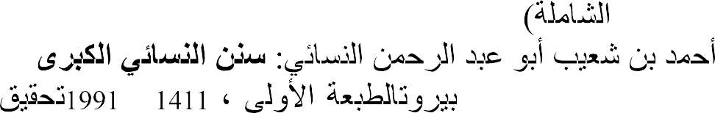

––

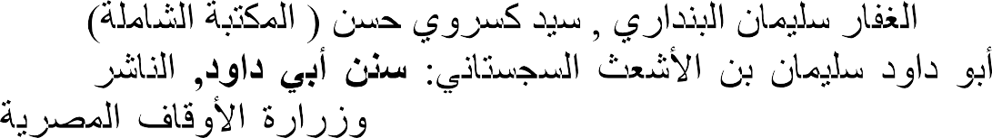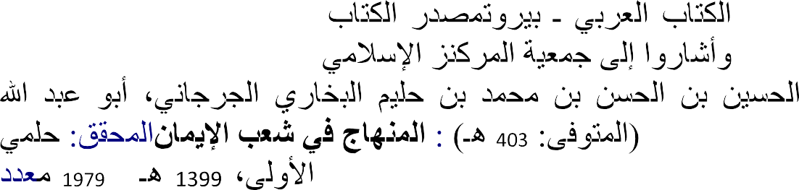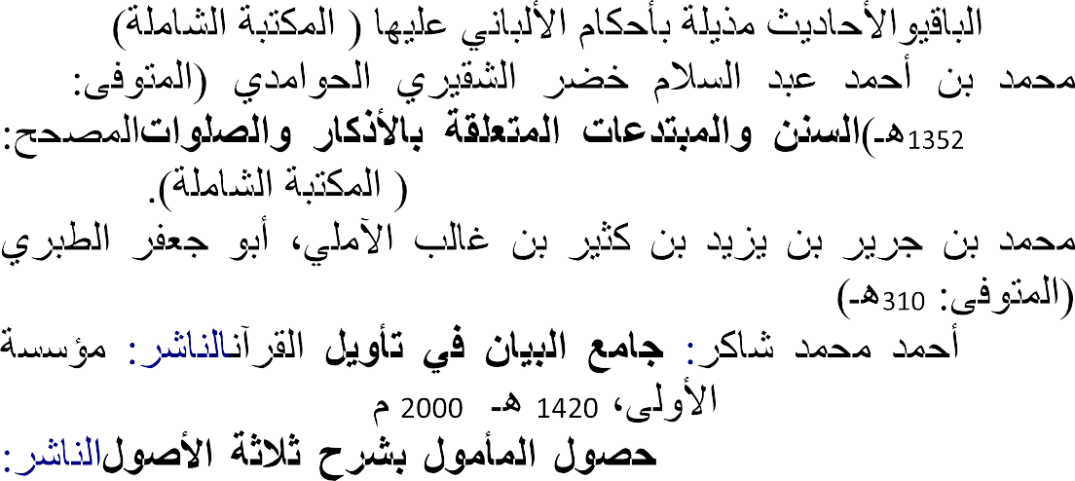

-

–

-

##### Appendix 1

Table 1: Table for Determining Sample Size for a Finite Population

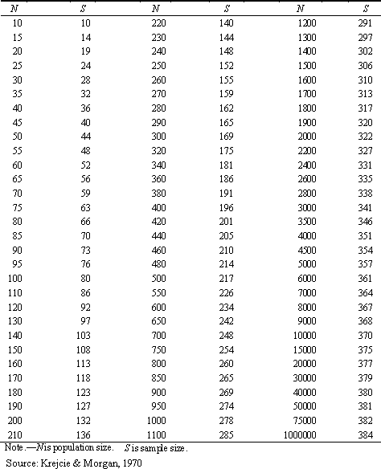

The Table is constructed using the following formula for determining sample size:

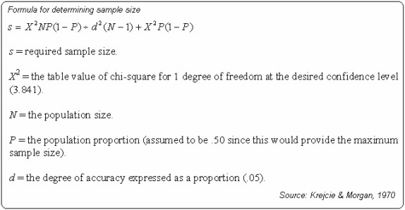

##### APPENDIX 11

**QUESTIONNAIRES**

Department of Education, Islamic Studies Section, Faculty of Education, Ahmadu Bello University, Zaria.

Dear Respondent,

**LETTER OF INTRODUCTION**

I am a student of the above address, I am conducting a research on med Degree Programme the topic of the research work is ―Practice of Katsina People on child custody after marriage separation‖. I wish you would sincerely respond to the questions that appear in this questionnaire. All your responses shall be strictly used for the purpose of the research and you are assured confidentiality in your responses.

In case you have any question as regard the content of the questionnaire, please do not hesitate to contact me through my GSM number: 08065679626.

Thanks in anticipation of your co-operation.

Yours faithfully, Fatima Garba

##### PARENTS QUESTIONNAIRE

**SECTION „A‟ BIO DATA**

Please tick the column where appropriate.

1. Male ( ) Female( )

2. Age: 18 – 35 ( ) 36 – 55 ( )56 – 60 ( )60 and above ( )

1. Marital Status: Single ( ) Married ( )
2. Educational Qualification

|  |  |
| --- | --- |
| 1. Primary 2. Secondary | ( )  ( ) |
| c. N.C.E | ( ) |
| d. Diploma | ( ) |
| e. B.A/B.Sc/Bed | ( ) |
| f. Masters | ( ) |

* 1. Islamic Education ( )
  2. Others, please specify …………………………………………

##### QUESTIONNAIRE FOR THE FATHER

**SECTION „‟B‟ QUESTIONS**

Please tick ( ) where necessary and fill in the blank space according?

1. Have you ever divorced or separated from a wife that you have a child her? Yes/No
2. If yes, the child is under whose custody?
   1. Myself ( )
   2. Under the wife ( )
   3. My relatives ( )
   4. Her relatives ( )
   5. None of the above ( )
   6. Others, Please Specify …………………………………………
3. If the child is under your custody which of the following reasons made you to keep the child with you?
   1. Religious instructions ( )
   2. Selfish interest ( )
   3. Irresponsible nature of the mother ( )
   4. All of the above ( )
   5. Others, Please specify …………………………………………
4. If the child is with the mother, why do you decide to allow the child with her?
   1. Religious instructions ( )
   2. I have no ability to keep child with me ( )
   3. Sympathy to the child ( )
   4. Refusal of the mother to allow the child with me( )
   5. Culture and tradition ( )
   6. None of the above ( )
   7. Others, Please specify ( )
5. Who takes the responsibilities of the child?
   1. Myself ( )
   2. The Mother ( )
   3. Both of us ( )
   4. My relatives ( )
   5. Her relatives ( )
   6. Muslim community ( )
   7. None of the above ( )
   8. Others, please specify ( )
6. Which among the following responsibilities you shoulder as a father?
   1. Full payment of his school fees ( )
   2. Partial payment of his school fees ( )
   3. Feeding ( )
   4. Clothing ( )
   5. All of the above ( )
   6. None of the above ( )
7. Do you appreciate staying of the child under the custody of the mother?
   1. Yes ( )
   2. No ( )
   3. Undecided ( )
8. If no which of the following reasons made you not to appreciate staying with his mother?
   1. The Child is not having proper attention ( )
   2. The child is exposed to danger in faith and morality ( )
   3. The child is well taking care when he is under me ( )
   4. All of the above ( )
   5. None of the above ( )

Department of Education,

Islamic Studies Section, Faculty of Education, Ahmadu Bello University, Zaria.

Dear Respondent,

**LETTER OF INTRODUCTION**

I am a student of the above address, I am conducting a research on med Degree Programme the topic of the research work is ―Practice of Katsina People on child custody after marriage separation‖. I wish you would sincerely respond to the questions that appear in this questionnaire. All your responses shall be strictly used for the purpose of the research and you are assured confidentiality in your responses.

In case you have any question as regard the content of the questionnaire, please do not hesitate to contact me through my GSM number: 08065679626.

Thanks in anticipation of your co-operation.

Yours faithfully, Fatima Garba

##### PARENTS QUESTIONNAIRE SECTION „A‟ BIO DATA

Please tick the column where appropriate.

1. Male ( ) Female ( )

2. Age: 18 – 35 ( ) 36 – 55 ( )56 – 60 ( )60 and above ( )

1. Marital Status: Single ( )Married ( )
2. Educational Qualification

|  |  |
| --- | --- |
| 1. Primary 2. Secondary | ( )  ( ) |
| c. N.C.E | ( ) |
| d. Diploma | ( ) |
| e. B.A/B.Sc/Bed | ( ) |
| f. Masters | ( ) |

1. Islamic Education ( )
2. Others, please specify …………………………………………

##### QUESTIONNAIRE FOR THE MOTHER SECTION „A‟ QUESTIONS

Please tick ( ) where necessary and fill in the blank space accordingly.

1. Have you ever been divorced or separated from a husband that you have a child with him?

Yes/No

1. If yes, the child is under whose custody ?
   1. Myself ( )
   2. Under the husband ( )
   3. His relatives ( )
   4. My relatives ( )
   5. None of the above ( )
2. If the child is under your custody which of the following reasons made you to keep the child with you?
   1. Not aware about religious instruction ( )
   2. Custom and tradition ( )
   3. Irresponsible nature of the father ( )
   4. All of the above ( )
   5. None of the above ( )
3. If the child is with the father why do you allow the child with him?

|  |  |
| --- | --- |
| a. Religious instruction | ( ) |
| b. I have no ability to keep child with me | ( ) |
| c. Sympathy to the child | ( ) |
| d. Refusal of the father to allow the child with me | ( ) |
| e. Culture and tradition | ( ) |
| f. None of the above | ( ) |

g. Others, Please specify …………………………………………

1. Who takes the responsibilities and need of the child?
   1. Myself ( )
   2. The father ( )
   3. Both of us ( )
   4. My relatives ( )
   5. His relatives ( )
   6. Muslim community ( )
   7. None of the above ( )
   8. Others, Please specify ………………………………………
2. Which among the following responsibilities you shoulder as a mother?
   1. Full payment of his school fees ( )
   2. Partial payment of his school fees ( )
   3. Feeding ( )
   4. Clothing ( )
   5. All of the above ( )
   6. None of the above ( )
   7. Others, please specify ( )

Did you appreciate staying of the child under the custody of his father? Yes/No

1. If no which of the following reasons made you not to appreciate staying with his father?
   1. The child is not having proper care ( )
   2. The child is well taking care when he is under me ( )
   3. The child is exposed to danger in faith and morality ( )
   4. Fear of maltreatment from the other wife(ves) of the father( )
   5. All of the above ( )
   6. None of the above ( )
   7. Others, please specify ( )

Department of Education, Islamic Studies Section, Faculty of Education, Ahmadu Bello University,

Zaria.

Dear Respondent,

**LETTER OF INTRODUCTION**

I am a student of the above address, I am conducting a research on med Degree Programme the topic of the research work is ―Practice of Katsina People on child custody after marriage separation‖. I wish you would sincerely respond to the questions that appear in this questionnaire. All your responses shall be strictly used for the purpose of the research and you are assured confidentiality in your responses.

In case you have any question as regard the content of the questionnaire, please do not hesitate to contact me through my GSM number: 08065679626.

Thanks in anticipation of your co-operation.

Yours faithfully, Fatima Garba

##### SOCIAL WELFARE QUESTIONNAIRE SECTION „A‟ BIO DATA

Please tick the column where appropriate.

1. Male ( ) Female( )

2. Age: 18 – 35 ( ) 36 – 55 ( )56 – 60 ( )60 and above ( )

1. Educational Qualification

|  |  |
| --- | --- |
| 1. Primary 2. Secondary | ( )  ( ) |
| c. N.C.E | ( ) |
| d. Diploma | ( ) |
| e. B.A/B.Sc/Bed | ( ) |
| f. Masters | ( ) |

1. Islamic Education ( )
2. Others, please specify …………………………………………
3. Rank
   1. Court worker ( )
   2. Welfare Officer ( )
   3. Assistant Welfare Officer ( )
   4. Others, please specify ( )
4. Working Experience
   1. 5 – 15 years ( )
   2. 16 – 25 years ( )
   3. 26 – 35 years ( )

##### SECTION „B‟ QUESTIONS

Please tick ( ) where necessary and fill in the blank space accordingly.

1. Do you have children from broken homes under your custody? Yes/No
2. Who brought such children to your custody?
   1. Father ( )
   2. Mother ( )
   3. Social welfare workers ( )
   4. Relatives ( )
   5. Others, please specify ( )
3. Which of the following reasons made a child to be under your custody?
   1. Irresponsible nature of the parents ( )
   2. Inability of the society to take care of the child ( )
   3. All of the above ( )
   4. None of the above ( )
   5. Others, please specify …………………………………………
4. Who is responsible for shouldering the responsibilities of the child brought under your custody?
   1. Father ( )
   2. Mother ( )
   3. Both of them ( )
   4. Relatives ( )
   5. Government ( )
   6. All of the above ( )
5. Have you ever experience rights violation of a child under your custody by the person responsible for the child.
   1. Yes ( )
   2. No ( )
   3. Undecided ( )
6. Who among the parents show concern to the child under your custody?
   1. Father ( )
   2. Mother ( )
   3. Society ( )
7. Is there duration for stay of a child under your custody? Yes/No
8. If yes, who receives the child after the duration
   1. Father ( )
   2. Mother ( )
   3. Society leadership ( )
   4. None off the above ( )
9. What is responsible for guiding your selection of duration to a child under your custody?
   1. Shari‘ah rulings ( )
   2. Status of the child ( )
   3. Status of the parents ( )
   4. Request of the society ( )
   5. In accordance to our regulations ( )
   6. None of the above ( )
   7. Others, please specify ( )
10. What nature of activities do you expose a child under your custody?
    1. Islamic learning only ( )
    2. Islamic and Western learning ( )
    3. All education and skill acquisition ( )
    4. None of the above ( )
    5. Others, please specify …………………………………………
11. Who among the parents violates the child‘s rights more after marriage separation as you observed?
    1. The father ( )
    2. The mother ( )
    3. Both the father and the mother ( )
    4. Undecided ( )
12. Whom do you give a child at the period of marriage separation.
    1. Mother ( )
    2. Father ( )
    3. Relatives ( )
    4. Based on the agreement reached between the mother and the father ( )
    5. None of the above( )
    6. Others, please specify ………………………………………….
13. What is responsible in guiding your offer of child to custody?
    1. Shari‘ah ( )
    2. Situation off the father ( )
    3. Situation ( )
    4. None of the above ( )
    5. Others, please specify …………………………………………
14. Do you make an investigation about the person you intend handing over a child custody to him
    1. Yes ( )
    2. No ( )
    3. Undecided ( )

a. ……………………