## ASSESSMENT OF THE IMPACTS OF GULLY EROSION ON LIVELIHOOD OF RESIDENTS OF OHAFIA, ABIA STATE

Although there are abundant natural resources in the world; however, the soil is one of the most valuable amongst all. Consequently, the major destroyer of this valuable natural resources is erosion which comes in different forms; sheet, rill, or gully. The impact of erosion particularly has become a cause of concern for many, especially in the Southeast region of Nigeria. This study therefore examined the impact of gully erosion on livelihood of residents in Ohafia LGA, with a view to developing gully erosion vulnerability map of the study area. The study relied on quantitative and remote sensing data acquired from primary and secondary data source. The quantitative data were gathered from the residents in the study area, while Shuttle Radar Topographic Mission (SRTM), and Digital Soil Map of the World (DSMW) were sourced from United States Geological Survey (USGS) and Food and Agriculture Organisation (FAO) website. The elevation data, terrain, and slope characteristics were extracted from the SRTM, while the soil types and clay properties were extracted from the DSMW. A total of 346 questionnaires was administered in four communities (Abariba, Ndi Nduma, Ebem and Ohafia) to gather quantitative data on the causes and impact of gully erosion using simple random sampling technique. The data collected were subjected to descriptive (percentage, mean, Jenks), inferential (ANOVA), and spatial (slope, nearest neighbourhood analysis, and terrain) analysis was adopted. The study revealed that there are 34 gully erosion sites in Ohafia LGA, these gullies are dispersed across Ohafia LGA with varing length, width, and height. The study also shows that topography, slope, and soil accounted for 49%, 25%, and 86.2% of the gully erosion suffered in Ohafia respectively. The study established that gully erosion had significant impact on the livelihood of residents through loss of farmland (4.29), destruction of crops (4.17), and destruction of roads (4.07) needed to transport the farm produce to the market. The conclude that adequate attention must be paid the soil properties and human practices in the study area when selecting sites for the development of various land uses. The study recommends the development of gully erosion risk maps to guide future development and sustainable farming practices in Ohafia.

**CHAPTER ONE**

## INTRODUCTION

* 1. **Background to the Study**

Although there are abundant natural resources in the world; however, the soil is one of the most valuable amongst all (Abegunde *et al.,* 2006). Virtually all forms and types of man’s activities are conducted on the soil, which makes it a very important resources for human existence (Ehiorobo, 2012). The major destroyer of this valuable natural resources is erosion which comes in different forms. Abegunde *et al.,* (2006) asserted that of all the numerous environmental challenges faced in the world, soil erosion remains the most predominant. The destruction of the soil across the world as become a major source of concern for the both the developed and developing countries of the world (Ownegh, 2003).

The term soil erosion can be conceptualized as a process that occurs within the environment through either naturally or human induced, hence, leads to the disintegration, movement and deposition of sediment downstream through the gravitational force, wind or water (Adedeji *et al.,* 2010; Boardman, 2013). Abate (2011) asserted that in the context of water-induce soil loss, the movement of sediment is made possible through raindrops and runoff. The degradation of soil is more prominent with water than air; over 1100 Mha of land has been degraded as against 550 Mha of land degraded by wind (Saha, 2003). The erosion induced by water is second to human induce erosion which was estimated to have degraded over 2 billion hectare of land.

Ananda & Herath (2003) argued that soil erosion is not a problem that is peculiar to certain parts of the world, although the severity varies from countries to countries and region to region. The environmental challenge of soil erosion is more predominant in the developing countries than the developed countries, of which Nigeria is not an exception. Many soil degradation problems has been attributed to soil erosion; these problems include loss of soil nutrient, loss of economic, biological activities and other ecological productivity among others. Overtime, scholars (Abate, 2011; Kertesz and Gergely, 2011; Meshesha *et al.,* 2014; and Mekonnen, *et al.,* 2017) suggested that the interaction between rainfall, relief, soil, human activity and deforestation is the main cause of soil loss/erosion. There is an increasing concern the effect of soil erosion in Abia state; erosion menace has affect both the social and economic life of the people, through the destruction of arable farmland and displacement of people. The onsite and offsite effect of erosion in Abia state can be easily detected through the loss of soil and sediment yield on the river networks respectively, a situation that result to poor soil and water quality as well as damage to the hydraulic structures.

It is important to make known that with the rapid increase in population which result to increase soil erosion, government at various levels, international organizations, community and individuals had undertaken and proposed several soil conservation measures and practices (Tripathi, *et al.,* 2003), yet little has been achieved in this direction. However, the major problem is that addressing all the conservation problems in one attempt is not possible, it is therefore important that we concentrate on areas that are highly vulnerable to soil erosion for effective soil conservation implementation (Tripathi, *et al.,* 2003).

So far, numerous soil erosion prediction models had been developed and applied. Notable among the models developed for soil loss estimation are: Modified Universal Soil Loss Equation (MUSLE), the Universal Soil Loss Equation (USLE), Morgan-Morgan-Finney (MMF), Agricultural Non-point Source Model (AGNPS), Erosion Productivity Impact Calculator (EPIC), Water Erosion Prediction Project (WEPP), Soil and Water Assessment Tool (SWAT), and European Soil Erosion Model (EUROSEM) (Wischmeier and Smith, 1978; Young, *et al.,* 1989; Morgan *et al.,* 1998). Among these models, the RUSLE is the most widely applied empirical model for offering quantitative soil erosion estimation and conservation planning around the globe (Knapen, *et al.,* 2006; Arekhi, *et al.,* 2012).

These aforementioned models have been criticized on several grounds. Hence the need for the development of effective and systematic approach to soil loss and sediment yield estimation (Barakat, *et al.,* 2014; Ganasri and Ramesh, 2016). Again it is important to say that, significant efforts have been made at local and global levels to assess the magnitude of soil erosion risk. This has certainly made a promising ground for sustainable land use planning and an appropriate soil water conservation strategy development at the watershed or basin scales (Kirchhoff *et al.,* 2017).

There is no doubt that the existing conventional approach to soil erosion risk estimation is time consuming and expensive. It is in lieu of this that some scholars argued that (Fernandez *et al*., 2003; Gitas *et al*., 2009, Yue-Qing *et al.,* 2009) the integration of field data, data acquired through remote sensing and erosion models within the GIS platform is germane to further soil loss and sediment yield estimation. Kim (2006) posited that effective estimation of soil loss requires the use of DEM (Digital Elevation Model), which can either be created

through remote sensing data or analysis of stereoscopic optical and microwave (SAR).

Shinde *et al.,* (2010) asserted that a cell by cell erosion potential prediction is possible with RUSLE model, a method that is veritable in the identification of the pattern of spatial soil loss occurring within a large area. GIS can serve as a tool for isolating and querying locations with the aim of identifying the role of individual variables contributing to the observed erosion potential value.

Lawal *et al.* (2007) suggested that the recent advancement and development in GIS techniques, and availability of spatial data such as high quality digital elevation models has increase the rate and reliability of soil loss estimation, which is a requisite tool in future land use planning. Erosion modeling within GIS generally focuses on describing the spatial distributions, rather than calculating the values of soil loss. Predicting the location of high risk areas with the highest possible accuracy is extremely important for erosion prevention as it allows for identification of the proper location and type of erosion prevention measures needed (Mitasova and Mitas, 1996). Based on this premise, this study therefore, attempt to assess the impact of gully erosion on livelihoods of Ohafia LGA, with a view to estimating the level of gully erosion risk in the LGA.

## Statement of the Research Problem

The concern on environmental problems is global, international organizations, government and individual across the world are concerned about the increasing pace of environmental problem. The engine that drives all forms of man’s activities such as social, human, economic and cultural activities have continuously been abused, neglected and destroyed by man (Adugna, *et al.,* 2015). Pollution, deforestation, erosion, flooding, landslides, global warming etc. are the aftermaths of this abuse in and on the ecosystem. By virtue of Nigeria’s spatial

extent and its location, in the tropical latitudes, the country encompasses various climatic

regions and physiographical units, which has severely exposed the country to the destructive influence of climatic induced hazards including flooding, erosion, drought and desertification.

Soil erosion poses a very serious setback to agricultural productivity in most part of the southeastern states, and the extent of the spread and damage has reached an alarming proportion that if efforts are not intensified to remedy the ugly situation, it could cause untold hardship and put the communities in a state of jeopardy (Adugna, *et al.,* 2015). The implication of the continuous spread of erosion was identified by Lal (1998) as disruption of hydrological systems, poor water quality, low agricultural production among others, and these is an anathema to achieving sustainable livelihood and human sustainability.

The interplay and interaction of both natural factors (rainfall, relief, soil) and human activities (crop management and land use) makes the evaluation of soil loss and sediment yield difficult. Ananda and Herath, (2003) asserted that soil erosion is also influence economic, social and political component aside the biophysical parameters also play significant role in influencing soil erosion. In view of this, evaluation and assessment of soil loss and sediment yield in an accurate and timely manner is imperative.

The continuous destruction of agricultural land resources across the globe has led to the development of numerous models for soil loss estimation (MUSLE, USLE, MMF, EPIC, WEPP, and SWAT) among others. There has been many prediction based model studies conducted across the globe; For instance, Gebreyesus *et al.,* (2014) examined the soil erosion risk in the Mai-Negus catchment in northern Ethiopia by using the Morgan-Morgan-Finney Model, while Dunne *et al.* (2011) reported the mean annual soil loss rate of 58.30 t ha-1 y-1

and recommended that to reduce the on-site and off-site effects of soil erosion in the Dire Dam Watershed effective conservation measures must be implemented. Although the findings of this study provide quantitative information on soil loss, it failed to provide a vivid evidence on the areas susceptible to the soil loss.

Achieving soil loss and sediment yield estimation can be made feasible at lesser cost with improved accuracy especially in larger areas with the use of GIS and remote sensing (Millward and Mersey, 1999; Wang *et al.,* 2003). For example, the integration of RUSLE, GIS and remote sensing techniques provides the tool for effective and accurate estimation of soil erosion on a cell by cell basis (Millward and Mersey, 1999). Studies that have adopted the use of remote sensing and GIS in modelling the risk of erosion abound in literature (Wilson and Lorang, 2000; Boggs *et al*., 2001; Bartsch *et al.,* 2002; Wang *et al.,* 2003). These studies established that better result can be achieved through the use of remote sensing and GIS as analytical tool compared to the conventional method. In general, remote-sensing data were primarily used to develop the cover-management factor image through land-cover classifications (Millward and Mersey, 1999; Reusing *et al.,* 2000; Ma *et al.,* 2003), while GIS tools were used for derivation of the topographic factor from DEM data, data interpolation of sample plots, and calculation of soil erosion loss (Cerri *et al.,* 2001; Bartsch *et al.,* 2002; Wang *et al.,* 2003).

Going by the extant literature review, two major research gaps has been identified. First, there is need for a model that will provide spatial distribution of soil erosion and not just the estimated quantity of soil loss. This will help to identify areas that need urgent attention for soil erosion mitigation through soil erosion mapping. Secondly, extant review of literature has shown that GIS is a veritable tool that can be employed in assessing the spatial

distribution of soil erosion. However, the applicability and use of this tool is still low; a situation that can be attributed to the availability of data required and the expertise needed to manipulate the data within the GIS and remote sensing environment to provide the spatial distribution of soil erosion and areas prone to soil erosion. Therefore, this study seek to examine the risk and impact of gully erosion in Ohafia LGA.

## Research Questions

To achieve the aim and objectives of the study, the following research questions were raised;

* + 1. Where and what is the characteristics of Gully in the study area?
    2. What are the causes of gully erosion in the study area?
    3. How impactful is gully erosion on the livelihood of the residents?
    4. Where are the gully erosion vulnerable sites in the study area?

## Aim and Objective of the Study

* + 1. **Aim of the study**

The aim of this study is to assess the impact of gully erosion on livelihoods in Ohafia local government area, with a view to developing gully erosion vulnerability map for the study area.

## Objectives of the study

The aim of the study will be achieved through the following objectives:

* + - 1. Asses the characteristics of gullies in the study area
      2. Examine the causes of gully erosion in the study area.
      3. Examine the impact of Gully erosion on land use and livelihood of the people.
      4. Develop a multidimensional gully vulnerability map of the study area.

## Justification for the Study

The findings of this study is expected to provide (developers, land and environmental managers, town planners, officials of Local Government Areas and State agencies, GIS administrators, public and private investors) with the requisite tool for effective land management, which will enhance proper monitoring and land use planning in the state and beyond. The erosion model developed is also expected to provide land managers and developers with little or no knowledge on GIS and remote sensing an opportunity to have access to detailed information on the characteristics of the land in form of slope, slope length, soil erodibility, and rainfall erosivity, which are the major factors of soil erosion.

The finding of this study is expected to provide requisite information about the general topographic feature of Abia State, especially in terms of the slope and length of slope. Topographic features have been identified as a major factor in soil erosion estimation. Therefore, this study will avail the residents, policy makers and other stakeholders’ relevant information on the slope characteristics of the study area for proper agricultural practices and management. The study will also provide information on the soil texture characteristics across the study area to enhance proper soil management by all stakeholders.

The rate of soil loss across all parts of the study area was determined, this information is expected to help relevant agencies in proper planning and land conservation in order to mitigate soil loss in the study area through efficient farming practices and compatible land use practices. The study provides a spatial distribution of soil erosion prone areas in the study area which will help in identifying areas that need urgent attention for proper soil management. Consequently, this study will develop a module for estimating soil erosion loss

using ARCGIS. This module will make it easy for professionals and agencies such as the

land management authority to be able to easily assess soil loss, identify soil erosion prone areas and the distribution of soil erosion in the study area rather than absolute value of soil loss.

Erosion is one of the main problems in agriculture and natural resources management. It reduces soil productivity, pollutes the streams and fills the reservoirs (Fangmeier *et al.,* 2006). Going by the daunting damage caused by the menace of soil erosion, it is important to know that no amount of attention directed towards addressing the issue of soil erosion can be too much. Although, studies on soil erosion and soil loss abound in various parts of the Nigeria, and beyond, however, the evaluation of soil erosion risk within Abia State, and Ndi Iyima-Ebem Ohafia in particular has not attracted sufficient scientific attention. Therefore, it is important to apply more scientific and technological approach in form of GIS/remote sensing to soil erosion assessment.

## Scope of the Study

The study focuses on identifying the distribution and characteristics of gullies in Ohafia LGA. In the course of this, the study described the topography characteristics of the study area with emphasis on slope and length of slope. The soil texture characteristics was also assessed; this include the clay, silt, sand, and organic components of the soil. This study also examines the rate of soil loss in the study area, while erosion prone areas was also identified using GIS/remote sensing technique. Soil erosion estimation was estimated using three factors; rainfall data (erosivity factor), digital elevation model (DEM), and soil data.

The study is restricted to the geographical boundary of Ndi-Iyima, Ebem Ohafia. Nigeria. The erosion risk model was developed using the ARCGIS 10.3 model builder. The arcgis

module used in the development of the erosion risk module include, the map algebra tool, the slope tool, the reclassification tool among others.

## Study Area

* + 1. **Geographical location of the study area**

Ndi-Iyima Ebem is located in ohafia local government area of Abia state. It is an igbo speaking region and Abia State is one of the 36 states of Nigeria, Ndi-Iyima, Ebem Ohafia. lies between longitude 5.634029 and latitude 7.81912. Ndi-Iyima, Ebem Ohafia. is bounded to the north by Elu community and to the east by Asaga, Amaekpu community, to the west by Amangwu community and to the south by Eziukwu community. Ndi-Iyima Ebem can be accessed through a major tarred road that runs from Elu to Asaga community linking other minor untarred roads and footpaths (OFigure 1.1 shows the geographical location of Ndi- Iyima, Ebem Ohafia.

## Relief and topography of Ohafia

The dominant topographic feature in the study area is the North-South Ndi Iyima escarpment, which runs from Ebem in Abia State through isiukwuato to Umuahia in Abia State. Ndi- Iyima, Ebem Ohafia. lies in the Minor escarpment of the uplands, revealing steep slopes through these places. Sandstone and laterite form the highlands while shale/clay form lowlands. Terrain Observation reveals a ravine complex with hanging hills, slopes and valleys as plains of weakness that trigger off gully erosion in the area. These hills show a gentle slope on the western part and slopes in the east (Onyegbule *et al.,* 2010).

## Weather and climate of the study area

The climate in the study area is characterised by two main seasons-the rainy (wet) season and dry season. The rainy season which lasts between April and October is characterised by thunderstorms. The dry season (harvest season) extends from November to March annually. This is typically an equatorial tropical rainforest climate type. Rainy (wet) season is characterised by relatively high temperature (33oc) and high relative humidity (Onyegbule *et al.,* 2010). Chilly and dry harmattan wind is experienced in the dry season. This lowers environmental temperature appreciably, especially in December and January. Its main features are excessive evaporation, low relative humidity, low rainfall and general dryness. The effect is the drying of vegetal cover and shedding of leaves by deciduous trees. It also ushers in the harvest of farm produce; some of which are sun-dried. The study area records average maximum and minimum temperatures of about 320c and 250c respectively and annual mean rainfall of about 2000mm (Onyegbule *et al.,* 2010).

## Vegetation of the study area

The study area falls within the rainforest belt and characterised by the growth of tall trees amidst thick undergrowth. Climbers and epiphyte forming complex tangles are common, and trees have luxuriant foliage. Oil palm trees are common while swampy areas have a thick cover of raffia palm (Obiadi *et al.,* 2011). Lowlands are thickly vegetated with forest trees, while the highlands consist mainly of grasses with trees and shrubs sparsely distributed- typical of derived Guinea-Savannah. In some areas, only isolated stands of a few forest emergent trees remain as evidence of the original forest. This is due to the high rate of human activities in the form of deforestation as lands are cleared for purposes of farming and construction (Onyegbule *et al.,* 2010).

## Drainage pattern of the study area

The drainage is mainly dendritic pattern. Ndi-iyima lake occupies the southwest facing part of the minor escarpment while Elu lake in Ohafia occupies the southeastern part. Dendrite pattern formed by streams in the area is as a result of the bed-rock lithology. All streams flow Northeast with fourth order Odo (Awdo) and Ota-Alu rivers as the major drainages (Obiadi, *et al.,* 2011).

## Geology of the study area

The geology of the area exposes two main lithologic formations. They are Imo Shale (Paleocene-Eocene) and Ndi-iyima Sandstone (Eocene) a lateral equivalent of Ameki Formation (Onyegbule *et al.,* 2010). Imo Shale is the older of the two geological formations cover about twenty-five (25) per cent of the study area. Light grey coloured Imo Shale is characteristically fissile and fine-grained. Three sandstone units of about 25-40 meters thick separated by 2-3 meters thick Clay/Shale beds were observed in Ndi-Iyima, Ebem Ohafia. erosion site. The Sandstone Units consists of poorly sorted unconsolidated sand of various colour; yellow to brown to iron stained on the weathered surface and white to milky white on the fresh surface (Obiadi, *et al.,* 2011). The Clay/Shale beds are dark grey to grey with specks of mica and pyrite. Sandstone consists of quartz arenites with predominantly monocrystalline quartz. This is evidence of great transportation and mineralogical and textural maturity (Onyegbule *et al.,* 2010).

## Occupation

The people of Ndi-Iyima, Ebem Ohafia. Southeastern Nigeria are primarily dependant on arable agriculture and livestock raising for their economic sustenance. Crops grown in Ndi- Iyima, Ebem Ohafia. include cassava, yam, maize, melon and pepper. Cash crops found in

the area are oil palm, cashew and mango. These also form primary economic sustenance in the area. Plantations of these cash crops were found at different locations in the study area.

## Settlements

The original settlement of the area is gradually giving way to urban or modern settlement, which is because the area is sandwiched by Abia state capital and Ohafia (a growing metropolitan centre). Few muds and thatched roof houses stand as original house pattern in the area. Houses are separated only by a concrete fence, mud fence or wood fence. This is typical of nuclear settlement. Farmlands are located far from the villages. However, vegetable gardens are found around the homes.

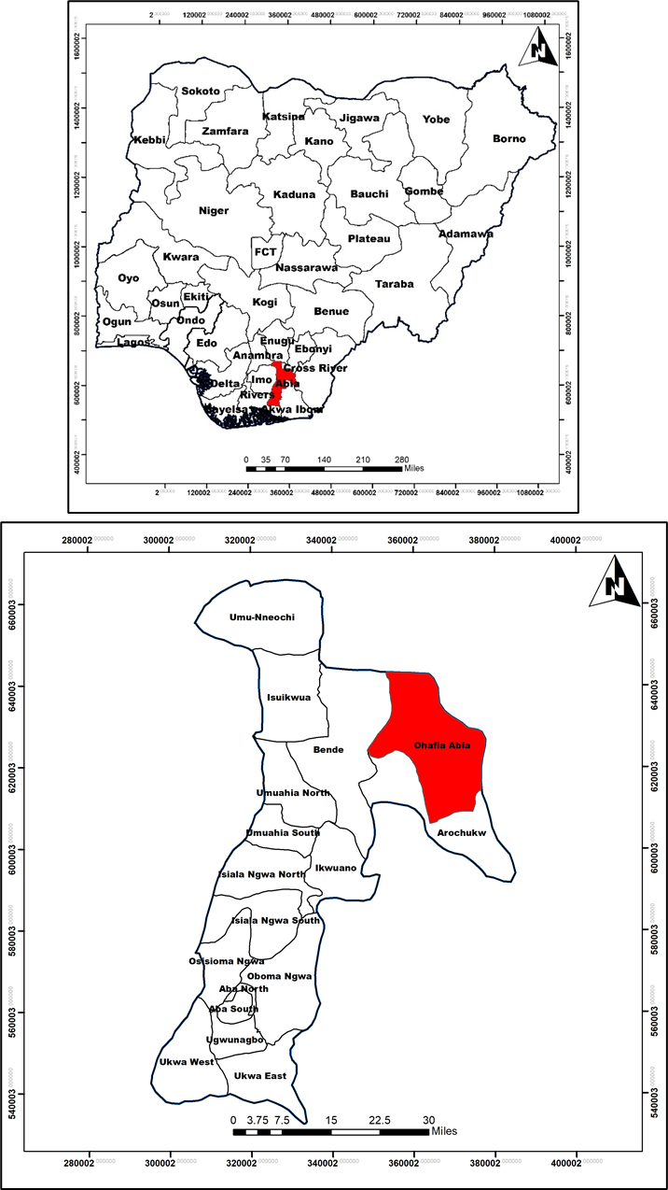

**Figure 1.1:** Abia State in the Context of Nigeria

Source: Digitized by the Department of Urban and Regional Planning FUTMINNA

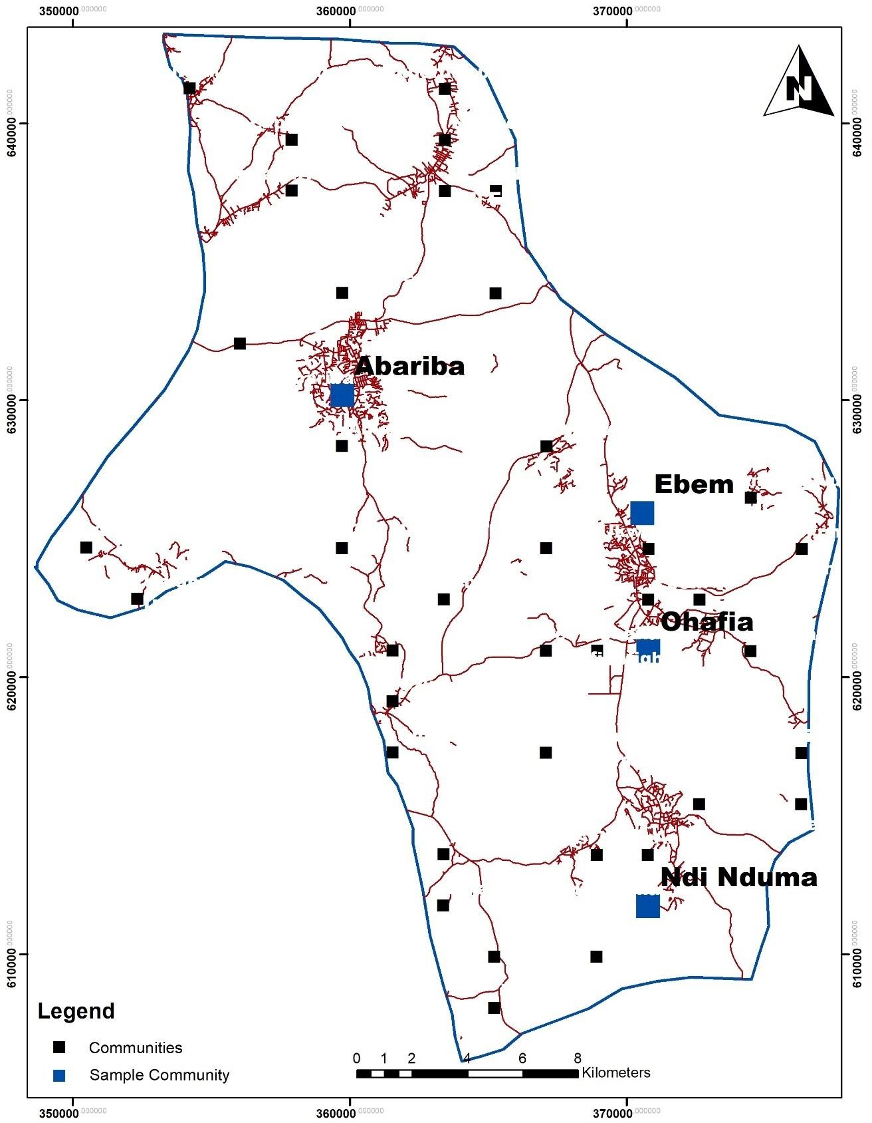

**Figure 1.2:** Map of Ohafia Local Government

Source: Digitized by the Department of Urban and Regional Planning FUTMINNA

# CHAPTER TWO

## LITERATURE REVIEW

* 1. **Conceptual Framework**

Over time, the attention paid to soil erosion and movement of sediment is driven by professionals from the various field of work. This attention has led to the formulation of numerous erosion model (Foster, 1980). Differentiating the available models of soil erosion into distinctive areas can be difficult. However, it can be done through the combination of attribute of the soil; this attribute include duration, model output, spatial scale, and hydrological processes. It is possible to differentiate between catchment and slope based on aerial extent. Model of soil erosion are also differentiated temporarily ranging from years to years or isolated events. The focus on this study is on the distributed parameter and lumped model, with emphasis on the lumped parameter model named Universal Soil Loss Equation (USLE) or Revised Universal Soil Loss Equation (RUSLE) model.

## Lumped parameter model (LMPs)

LPMs use averaging techniques to lump the influences of non-uniform spatial processes of a given area, such as basin-averaged precipitation for runoff computation. The concern of the LPM model is how to evaluate the average long-term soil erosion on a large scale. The impact of agricultural management activities especially in the ’60s and ’70s and soil erosion on the productivity of soil and quality of water is a major concern (Renschler and Harbor 2002).

Wischmeier and Smith developed the USLE model first in 1960. In an attempt to improve the USLE estimation parameter, the model was later reviewed in 1997. In the USLE model, five factors are considered when estimating soil loss. Every individual parameter is the arithmetic estimate of a condition which affects the depth of erosion in a site. The output of the model in terms of the erosion value which vary significantly as a result of climatic variation. The output of the USLE model provides a more concise long-term average.

RUSLE model which was a revised version of the USLE model developed by Wischmeier and Smith (1978) is the most recognised LPM model (Ahamed *et al.,* 2000). This model is used for the prediction of long-term average of soil erosion under specific agricultural practice or management. It is important to know that RUSLE is an empirical model, hence its application is premise on data collected from field, while the equation are only valid within the extent of the data from which it is developed. However, a major fallout of the model is that erosivity factor is not a suitable tool for estimating the rainfall erosivity of intense rainfall, a situation that is common in the humid tropics (Jeje *et al.,* 1997).

In a bid to make the factors of RUSLE adaptable and improved its attributes, the SLEMSA model was developed by Ewell and Stocking (1982). However, both the SLEMSA and RUSLE also had their shortcomings which is evident in their inability to measure the deposition of sediment. This situation birthed the GLEAMS, EPIC, and CREAMS model. The major concern of the CREAMS model is the evaluation of the agricultural practice effect on the pollutants, while GLEAMS which is an extension of the CREAMs focus on nutrient movement in the root zone (Leonard *et al.,* 1995). Williams *et al,* (1983) suggested that the EPIC model focus on the measurement of the impact of soil erosion on the productivity of

the crop.

## Soil Erosion Models

Though the earliest soil erosion prediction model was developed in the U.S.A. Over time, numerous soil erosion model had been developed by professionals from diverse works of life. The development of new models led to the improvement of the soil erosion model, variables and parameter. One of the foremost soil erosion model is presented by Smith and Whitt (1948), which is used in soil loss estimation using claypan soil. The model equation is expressed mathematically below:

A= C*S*L*K*P (2.1).

Where

A–Annual soil loss; C–Average annual soil loss; S–Slope steepness; L–Slope length; K–Soil erodibility; and P–Support practice

Further studies on soil erosion had highlighted the shortcomings of the earlier model, hence, the upgrade of the USLE model. One of the response is the development of the Modified Universal Soil Loss Equation (MUSLE) by Williams (1975). Other notable model include the ANSWERS, USPED, and RUSLE developed by Beasley, *et al.* (1980); Hofierka and Suri, (1996); and Renard *et al.* (1997)

## Concept of Gully Erosion

Gully erosion is defined as the process whereby runoff water concentrates in narrow flow paths, displacing soil or soft rock particles, resulting in incised channels larger and deeper than rills and usually carries water only during and immediately after heavy rainstorms (Poesen *et al*., 2003). Such incised channels are called gullies and bear many local names such as dongas, sluits, vocarocas, ramps and lavakas (Bull and Kirkby, 1997; Huggett, 2007). The names dongas or sluits are mainly used in SA (Rowntree, 2013). Gullies are

morphologically defined by steep sidewalls and stepped channel slope with actively eroding head scarp which make them different from stream channels (Bradford and Piest, 1980; Poesen *et al*., 1996; Al-Soufi, 2004). The words deep depressions, channels or ravines have also been used to describe gullies (Stocking and Murnaghan, 2000). Many criteria are used to distinguish gullies such as the nature, planform, position in the landscape and shape of a cross section (Poesen *et al*., 2002).

## Nature of a gully

Gullies may be of an ephemeral or permanent nature. An ephemeral gully is often defined for agricultural land, implying small incised channels larger than rills, which can be refilled by normal tillage equipment, only to reform again in the same location even from a single rainfall event (Casali *et al*., 2000; Wilson *et al*., 2008; Kertész, 2009). Permanent or classical gullies are large and deep incised channels that cannot be easily destroyed by ordinary farm tillage equipment (Bergsma *et al*., 1996; Poesen *et al*., 2003). Related to ephemeral gullies and permanent gullies is rills, which are intermittent erosion channels smaller than ephemeral gullies that are less likely to form in the same position once obliterated (Grissinger, 1996; Bull and Kirkby, 1997).

The rills, ephemeral and permanent gullies are usually differentiated by the size of a channel (Poesen *et al*., 2003). Grissinger (1996) acknowledged that distinguishing rill erosion, ephemeral and permanent gullies as well as first order streams can be challenging and subjective. The transition from rills to ephemeral and to permanent gullies is a continuum and any distinction of these classes is vague and to some extent subjective (Poesen *et al*., 2003). Bergsma *et al*. (1996) classified gullies (ephemeral and permanent) as any erosion channel

with a depth of 0.3m to 30m. Vanwalleghem *et al*. (2003) define gully based on a minimum

depth of 0.2m and minimum length of 15m. They regarded those channels less than or equal to 0.3m as ephemeral gullies and those greater than 0.3m as permanent gullies. Later, Vanwalleghem *et al*. (2003) defined two categories of ephemeral gullies, namely deep and shallow, by a depth equal to or more than 0.8m and less than 0.8m respectively. Hancock and Evans (2006) define gully channels ranging from 0.2m to 2.5m deep and 0.2m to 14m wide, with an average depth of 0.55m and width of 1.4m. Clearly, distinguishing gullies from the rills and ephemeral from permanent gullies based on the size of a channel has not yet been fully resolved and classification on this basis requires further clarification. As illustrated here, gullies of various dimensions have been observed in different landscapes with varied climatic conditions (Jahantigh and Pessarakli, 2011).

Poesen *et al*. (2002) recognised both riverbank gullies and slope gullies forming badland areas. Bank gullies are caused by wearing away of the banks on the outer curves of streams or rivers associated with undercutting and slumping due to the concentration of water flow in rills, dead furrow or ephemeral gullies particularly where they cross the earth bank (Poesen *et al*., 1998; Poesen *et al*., 2003). Badlands are deeply dissected landforms of highly degraded relative relief and drainage density (Di Tommaso *et al*., 2009). Badlands are the worst stage of degradation by gullies and they are characterised by a high densities of uncontrolled progression of rilling, mass-wasting, piping and overland flow (Calvo-Cases and Harvey, 1996; Liberti *et al*., 2009; Rowntree and Foster, 2012) often separated by short steep un- vegetated slopes (Boardman *et al*., 2003).

## Plan form of a gully

Gullies are also classified and defined by their plan form. Ireland *et al*. (1939) recognised six categories of gullies based on plan form such as linear, bulbous, dendritic, trellis, parallel and

compound. Linear gullies are long and narrow, with a narrow head and few tributaries along the sides. They commonly occur along natural or man-made drainage lines. Bulbous gullies are broad and spatulate at the upper end but may be linear in the downstream part. They are often incised upland and have a semi-circular head with small tributaries or rills entering from the sides. Dendritic gullies have many branching tributaries with headward cutting that accentuates the dendritic character. Trellis gullies are characterised by tributary branches entering the main channel at approximately 90° angles. Parallel gullies are composed of two or more parallel tributaries which empty into the main gully (Ireland *et al*., 1939).

Twidale (2004) observed deep parallel gullies believed to have developed as rills in the WC province of SA. Compound gullies are a combination of two or more of the above drainage patterns (Ireland *et al*., 1939). Generally, the classification of gullies in this manner follows drainage patterns, since gullies occur along natural drainage lines (Stocking and Murnaghan, 2000; Ehiorobo and Audu, 2012). Al-Soufi (2004) observed most of the gullies in Iran that are formed around natural drainage lines including rivers and streams. Drainage patterns illustrated in Figure 2.1 are determined by the slope and the structural weakness of the rock properties (Twidale, 2004).

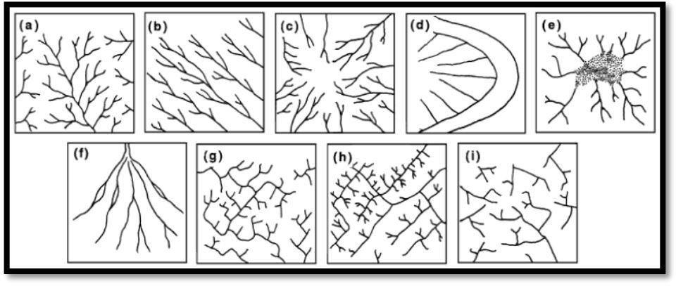

**Figure 2.1:** Typical sketches of various drainage patterns (a) dendritic, (b) parallel, (c)

radial, (d) centrifugal, (e) centripetal, (f) distributary, (g) angular, (h) trellis, (i) annular

## (Source: Twidale, 2004)

Ireland *et al*. (1939) classified the plan form of active gully heads as pointed, rounded, notched and digitate (Figure 2.2B). In a pointed gully, channel deepens and broadens gradually and uniformly from the narrow-pointed head that is usually shallow. Rounded gully heads are semi-circular, usually with steep or vertical walls. A notched gully head is rounded, but with a sharp notch at the semicircle. Digitate comprises multiple heads arranged as fingers. Higgins *et al*. (1990) observed that most gullies formed by seepage erosion have rounded or digitate heads but sometimes are notched. Ireland *et al*. (1939) further classified gully heads based on their vertical profiles into four groups as inclined, vertical, cave and vegetated (Figure 2.2a). Inclined gully heads comprise lower and higher heads within one soil horizon or soils with approximately uniform resistance across all horizons, respectively.

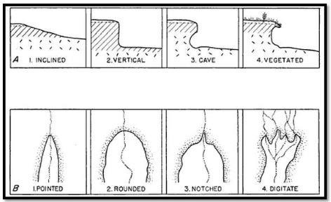

**Figure 2.2:** Illustration of the characteristics of gully heads (A) vertical profiles and (B) plan views (Source: Ireland *et al*., 1939)

Vertical heads may be a temporary condition representing an inclined head. Cave is the most common type of head in deep gullies where soil horizons have different resistance to erosion.

Vegetated is characterised by an overhanging root mat that keeps the flow of water away from its bank.

## Position in the landscape

Gullies have been classified based on their position in the landscape such as valley floor, valley side and valley head (Poesen *et al*., 2002; Morgan, 2005) and each can be continuous or discontinuous (Higgins *et al*., 1990; Poesen *et al*., 2002). Valley floor gullies take the form of ephemeral gullies, developed in topographic swales in a landscape where runoff concentrates (Al-Soufi, 2004; Morgan, 2005). They occur where the surrounding hillslopes are convexo-concave, and land is used for arable farming where soils are freshly tilled and loose. Valley side gullies occur approximately at right angles to the main valley line where local concentrations of surface runoff cut the hillside, subsurface pipe collapse or local mass movements create a linear depression in the landscape. Once valley side gullies are formed, they grow upslope by headward retreat and downslope by the incision of a channel floor (Morgan, 2005). The origin and development of valley head gullies and valley side gullies is the same and both reflect the expansion of a drainage network (Higgins *et al*., 1990; Poesen *et al*., 2002). Valley head gullies differ with valley side gullies in their location and orientation in respect to the valley axis (Higgins *et al*., 1990).

Valley floor, valley side or valley head gullies are continuous when they are part of a drainage network and discontinuous when they are isolated from the drainage network (Poesen *et al*., 2002). Continuous gullies have a main channel and many mature or immature branches (Desta and Adugna, 2012). They normally start in the upland area as rills that join to form the main gully on the valley floor. During formation, continuous gullies reach relatively

greater depths which are maintained until the lowest reach above the gully mouth is attained

(Heede, 1970). Discontinuous gullies are also known as independent gullies and may develop on a hillslope after for example a landslide. During their initiation, discontinuous gullies do not have a distinct connection with the main gully or stream channel. They are often scattered around the continuous gully systems or channels but have also been observed where no continuous gully exists. Discontinuous gullies decrease in depth rapidly downstream, thus their bottom gradient is much gentler than the original valley floor. They begin with the head cut associated with the knick point along the flow path (Desta and Adugna, 2012).

## Shape of a gully cross-section

The morphology of gullies may be interpreted as the product of gully erosion initiation processes (Al-Soufi, 2004). Various studies classified gullies based on the shape of their cross-sections such as the U-shaped, V-shaped and trapezoidal shaped ( Desta and Adugna, 2012) as shown in Figure 2.3. The shape explains the soil material from which the gully developed (Poesen *et al*., 2002) The U-shaped gullies develop where both topsoil and subsoil have the same resistance against erosion. Due to similar erodibility of topsoil and subsoil, nearly vertical walls are formed on each side of a gully.

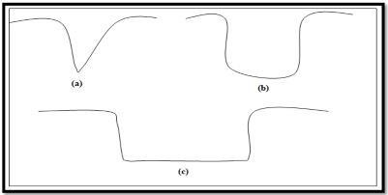

**Figure 2.3:** Illustration of the cross section of gullies (a) V-shaped, (b) U-shaped and (c) trapezoidal shaped (adapted from Poesen *et al*., 2002)

The V-shaped gullies develop where subsoil has more resistance against erosion than topsoil.

Trapezoidal gullies are formed where the gully floor is made of more resistant material than the topsoil and subsoil, leading to greater erosion rate along the banks (Desta and Adugna, 2012). Al-Soufi (2004) associated the appearance of the V-shaped and U-shaped gullies to the main processes involved during its initiation, such as surface runoff and subsurface runoff respectively.

## Mechanisms of Gully Erosion

As already mentioned, gully erosion is a complex phenomenon, often controlled by a combination of processes, making it difficult to describe its mechanism for development (Oygarden, 2003). The main processes involved during gully initiation include overland flow, expansion due to deepening and slumping of side walls of the rills (Watson, 1990), subsurface flow or piping (Sjörs, 2001; Le Roux and van der Waal, 2006; Shit *et al*., 2013) and gully head retreat at the knick point (Oostwoud Wijdenes and Bryan, 2001; Poesen *et al*., 2003). These mechanisms are discussed below.

## Overland flow

Gully erosion is primarily caused by overland flow processes (Shit *et al*., 2013). There are two recognised mechanisms of overland flow generation, namely Hortonian and saturation (Huggett, 2007). Hortonian overland flow occurs when rainfall exceeds the infiltration rate and is more common on bare rock surfaces and deserts (Huggett, 2007). Saturation overland flow occurs during rainfall events on a saturated surface. While Hortonian overland flow extends to the catchment divide, saturation overland flow is usually confined to slope concavities and hollows (Bull and Kirkby, 1997).

According to Le Roux and van der Waal, (2006), erosion by saturation overland flow occurs when a persistent rain results in a saturated surface in such a way that water can no longer

pass through the soil. The inherent resistance of the soil necessitates that certain critical condition be exceeded before saturation overland flow could cause soil erosion. This critical condition is normally described by the shear stress of the flow larger than the surface resistance (Svoray and Markovitch, 2009) and is influenced by the runoff intensity (Howard, 1999). After the exceedance of the critical condition, soil particles then detach from the soil surface at a rate dependent on the shear velocity of the flow and the unit discharge. If the soil particles are small or are of low mass, they may move as suspended load, but if the particle sizes are larger or have higher mass, they may fall to the underlying surface bed and depending on the flow velocity, they move as bed load (Le Roux and van der Waal, 2006). The convergence or accumulation of overland flow into existing channels may cause gullies (Strunk, 2003). Saturation overland flow is the dominant process during the initiation of ephemeral gully erosion (Desta and Adugna, 2012).

## Rill expansion

Gullies may also be established due to the deepening and slumping of a rill side walls through the shearing effect of concentrated overland flow (Pathak *et al*., 2006). Stocking and Murnaghan (2000) define rills as shallow linear channels usually aligned perpendicular to the slope and occur in a series of parallel erosion lines. Rills initiate when runoff water is channelled into natural depressions or along lineation’s caused by roads, culverts and tracks left by tillage equipment. A particular rill amongst a series of parallel rills may erode faster than others due to the localised variations in soil erodibility or slope roughness. As the principal rill develops, water flow is diverted laterally into it and in the process the neighbouring rills are overtopped and destroyed. A progressive increase in runoff associated with a wet spell or poor land use practises may deepen and widen the dominant rill to the

extent that it is classified as a gully. Cobban and Weaver (1993) observed gullies that formed

when a series of parallel rills deepen downslope in the Tsolwana Game Reserve, former Ciskei. Most gullies in the Mfolozi catchment, KZN developed from rills expansion (Watson, 1990).

## Gully head retreat and deepening

Gully erosion, particularly a bank gully is initiated by knick points or small surface natural depressions, or depressions caused by livestock tracks, furrows and ruts left by farm machineries (Svoray and Markovitch, 2009). The concentration of runoff or overland flow at the knick points or at the intersection with rivers or streams may cause waterfalls and plunge pools leading to undercutting and slumping, exposing a gully head. Subsequent to the formation of a gully head, the expansion or spread occurs rapidly through headward retreat and channel wall failures (Vandekerckhove *et al*., 2000; Oostwoud *et al.,* 2001; Poesen *et al*., 2003). Gully head retreat involves through-flow from the scarp and surface flow concentrated over the head of a scarp which scours a plunge pool at the base of the head. As the gully deepens, undercutting of the scarp leads to collapse (Watson, 1990). The gully expands and deepens until soil is completely removed from the ground or until bedrock is reached (Pathak *et al*., 2006; Le Roux and van der Waal, 2006; Nwilo *et al*., 2012). The failure of channel walls involves slumping due to flow saturation and undercutting of the base of the banks caused by scouring action of the water flow, leading to collapse (Watson, 1990). Scouring at the base of the scarp causes deepening of the channel.

## Subsurface erosion or piping

Gullies are also caused by subsurface flow or piping (Le Roux and van der Waal, 2006; Kertész, 2009). Subsurface erosion is the process whereby soils are removed below the surface (Beckedahl, 1996) due to underground water channels (Henkel *et al*., 1938).

Subsurface flow takes place under localised saturation flow conditions mainly in silt-clay materials containing cracks, fissures and discontinuities which promote the through-flow (Huggett, 2007). The gully formation process occurs when water reaches and super saturates the relatively slowly permeable subsoil, and moves soil particles laterally as seepage, thereby developing subsurface channels. Clay dispersions may occur along the flow lines and lead to the formation of tunnels (Beckedahl, 1996). The movement of water through subsurface flow may be slow until the water breaks through the soil surface further downslope (Desta and Adugna, 2012).

The process is then advanced by steep hydraulic gradients in a soil of high infiltration capacity, but low intrinsic permeability, so that water does not move readily into subsurface matrix. Subsequently, water passes rapidly into the soil until reaching an impermeable layer where it moves along as subsurface erosion. Rapid flow results in headward erosion within soil and enlarges a pipe. When the ground surface subsides, pipe networks are exposed as gullies (Henkel *et al*., 1938; Beckedahl and De Villiers, 2000; Le Roux and van der Waal, 2006; Desta and Adugna, 2012). The progressive development of piped areas may lead to the development of non-piped badlands where surface or near surface erosion processes dominate (Vandekerckhove *et al*., 2000).

## Geographic Information System and Soil Erosion Modeling

The geographic information system is a system that accept input, stores the input, syntheses the input, analyse the input, to produce an output that can be visualize on a spatial scale. GIS comprises of statistical analysis, database, and cartography which avails the user an opportunity to determine relationships, trends and patterns (Omar, 2010). The use of GIS dates back to the 70s notably in the field of environmental management (Kim, 2006).

However, it is important to assert that the use of GIS in hydrologic modelling, mapping of flood and management only came into existence at about 20 years later. The advantage that the DEM provides is the opportunity to portray landscape and topography which is the reson for its breakthrough into the field of geomorphological analysis (Kim, 2006). The DEM provides a tool for effective demonstration of landscape changes over time.

GIS is no doubt a veritable tool for erosion modelling. The use of GIS in the analysis of erosion is increasing as a result of the advantages that the combination of erosion model and GIS provides. It is important to understand that combining RUSLE and GIS tools provide a quick result and graphic information on the likely soil erosion potential (Blaszczynski, 2001). The combination of RUSLE and GIS tools in erosion estimation remains relevant bacause it provides the opportunity for the simulation of large scale studies through the use of voluminous data requiring a relatively short processing time. This is possible due to the fact that the GIS has a spatial function used in the georeferencing and overlays of spatial data in little or no time (Sharma *et al.,* 1996). In addition, the combination of both the GIS and RUSLE model can be used as an automation tool that can be used for the normalization of the RUSLE model for application in large area. The combination of both tool can aslo adopted for other hydrologic applications such as watershed condition analysis, and non-point pollution (Blaszczynski, 2001).

## Soil Erosion Factors

* + 1. **Slope length and slope steepness factor (LS)**

The LS factor as a parameter of the RUSLE model shows the impact of relief on soil erosion, through the combination of gradient and the length of gradient. Wishmeier and Smith (1978) defined slope length as the distance from the point of origin to the point

where the slope decreases to an extent that the deposition begins or the point where runoff becomes concentrated at a point. Slope steepness reflects the influence of slope gradient on soil erosion (Wischmeier and Smith, 1965). Continuous accumulation increases the runoff down slope as the length of slope increases, while increase in the gradient is as a result of increase in velocity of the runoff. Equations for estimating LS factor abound. However, this study will adopt the Urban Storm water Management Manual equation defined by Wischmeier (1975):

LS = (λ/ Ψ)m(0.065+0.045s + 0.0065s2) (2.2)

λ – Sheet length (m); Ψ – Constant 22.13; s – Average slope gradient (%) m - Refer to Table 2.1. Equation 13 (Bizuwerk, *et al.,* 2008) for ArcGIS purpose is expressed thus:

LS = (λ/ 22.1)m(0.065+0.045s + 0.0065s2) (2.3)

Where X= slope length and S= slope gradient

The slope length and slope can be derived from DEM, while the flow a ccumulation was was derived through the process of flow direction

X= (flow accumulation x Cell value) (2.4) LS = (flow accumulation*cell value/ 22.13)m * (0.065+0.045s + 0.0065s2) (2.5)

Slope i n p e r c e n t a g e (%) is also directly derived from the DEM using the same software.

**Table 2.1: m Value for LS factor**

|  |  |
| --- | --- |
| **M value** | **Slope (%)** |
| 0.5 | >5 |
| 0.4 | 3-5 |
| 0.3 | 1-3 |
| 0.2 | <1 |

Source: Omar (2010)

## Soil erodibility factor

The erodibility of soil (K factor) measures the vulnerability of soil or surface materials to transportation and detachment by inout runoff and volume of rainfall (Renard, *et al.,* 1997). It is known that the most easily eroded particles of soil are silt and very fine sand and the less erodible soil particles are aggregated soils because they are accrued together making it more resistible (Kim, 2006). The K factor soil survey data comprises measurement under a standard unit plot; the standard unit plot has a 9 percent gradient slope and a length of 22.1 m in a continuous fallow condition (Weesies, 1998). Soil erodibility nomograph is the most popular and widely adopted way of estimating K factor across literature using measurable properties. The nomograph has five soil profile variables which are: percent of modified silt (0.002- 0.1mm), modified sand (0.1-2mm), organic matter (OM), soil structure (s) and permeability (p). For this study, soil erodibility was the basis of the nomograph development and the features to estimate soil erodibility according to their texture analysis, organic matter content, structure and permeability (Wischmeier & Smith, 1978).

Even with the numerous study directed towards the Development of USLE, it was obvious that the application of the nomograph is widely accepted outside the USA. Taking Brazil as an example the K-factor values derived from the nomograph are not consistent due to the variability in the soil properties, behavior and features. Based on this premise, Denardin (1990) adopted the procedure of the nomograph earlier proposed by Wischmeier & Smith (1978) so as to come up with an estimation model for K-factor estimation model based on the soil features in standard plots for Brazil. The introduction or the development of the RUSLE model prompted scholar’s world over to introduce an indirect K-factor estimation method that will be applicable to data across the world, this will ensure that the method can be applied

in any part of the world. Therefore, As such, they grouped erodibility data directly assessed in standard plots (225 taxonomic soil units in the world) into texture classes and elaborated an equation relating the mean geometric particle diameter (obtained from texture analyses) to the K-factor (Renard *et al.,* 1997).

The EPIC model developed by Sharpley & Williams, (1990) gained promotion due to the shortcoming of previous soil erosion models. The EPIC model was is a tool used by the United Nations and other international organizations to determine the impact of erosion on the productivity of agricultural produce. The EPIC model comprises of majorly two components; which is the economic and physical components. The major difference between the EPIC and model and the USLE model is that the USLE model is empirical while the EPIC model is physical. Whereas the EPIC model also contains the K-factor which also estimates this factor indirectly.

Quite a number of studies conducted, the experimental data obtained in the required plot is in contrast with the K-factor values estimated (Wang *et al.,* 2013; Zhang *et al.,* 2004; Zhang *et al.,* 2008). The studies shows that when the soil is subjected to an indirect erodibility estimation the K-factor estimation fit better and they experience a similar condition to that adopted for model validation. Having known that the use of direct method in the measurement of erodibility is time consuming and expensive, then it is imperative that soil erodibility should be done indirectly through the use of models that allow the use of secondary data whose outputs are in tandem with the conditions of the study area.

In view of the burgeoning argument on the use of indirect assessment of soil erodibility, it is therefore pertinent that we undergo a critical evaluation of the indirect assessment models for

soil erodibility for specific areas, as well as the consistence of the result examined based on satisfactory hypothesis and not according to the procedures adopted. Therefore, soil erodibility assessment will be estimated through the use of indirect method. Invariably, this means that the indirect method was adopted through the use of equations premised on physical properties of soil such as organic matter and texture as input as developed by the following scholars Wischmeier & Smith (1978 ), Eq. (2.7); Renard *et al.* (1997), Eq. (2.8); Bouyoucos (1935), Eq. (2.9); Denardin (1990), Eq. (2.10); and Sharpley & Williams (1990),

Eq. (2.11).

K =2.1 x 10-4*M*1.14 (12-a) + 3.25 (b-2) + 2.5( c-3) x (0.1317/100) (2.6)

where: M is the % x 100 - % clay; a =organic matter content;

b = non-dimensional code (structure);

c = non-dimensional code (permeability).

log 𝐷𝑔+1.659 2

K =

0.0034 + 0.0405 ∗ exp[ −0.5 ( )

0.7101

(2.7)

where: Dg is the geometrical particle diameter,

𝑆𝐴𝑁+𝑆𝐼𝐿

K =

(

) ∗ ( 1

) (2.8)

𝐶𝐿𝐴 100

where: CLA=clay, SIL=Silt, and SAN=Sand

K = 0.00000748(M) + 0.00448059(b) – 0.0631175(DMP) + 0.010396 (REL) (2.9)

where:

DMP = weighted mean of the particles smaller than 2.0 mm;

REL = is the ratio between organic matter content and the content of particles between 0.1 and 2.0 mm.

K = A x B x C x D x 0.1317 (2.10)

Where A is a factor that describes the low soil erodibility factors for soils with high coarse-sand contents and high values for soils with little sand, B is a factor that gives low soil erodibility factors for soils with high clay to silt ratio, C is a factor that reduces soil erodibility for soils with high organic carbon content, and D is a factor that reduces soil erodibility for soils with extremely high sand contents.

A = (0.2 + 0.3 exp [−0.256 . 𝑚𝑠

. (1 − 𝑚𝑠𝑖𝑙𝑡)]) (2.11)

100

B = 𝑚𝑠𝑖𝑙𝑡

(

0.3

)

𝑚𝑐+ 𝑚𝑠𝑖𝑙𝑡

(2.12)

C = (1 − 0.0256.𝑜𝑟𝑔𝐶

𝑜𝑟𝑔𝐶+exp[3.72−2.95.𝑜𝑟𝑔𝐶]

0.7 .(1− 𝑚𝑠 )

) (2.13)

D = (1 −

𝑚

100

𝑚 ) (2.14)

(1−

𝑠 )+exp[−5.51+22.9 (1−

100

𝑠 )

100

where: SAN, SIL and CLA are percent sand, silt and clay, respectively; C is the organic carbon content; and SN1 is sand content subtracted from 1 and divided by 100.

## Rainfall erosivity factor (R)

MNREM (2010) asserted that factors such as velocity, rainfall and intensity of rainfall, shape of raindrops, size, kinetic energy and duration of rainfall has great impact on the level of erosion. This is because, when rain drops rich the ground they supply the required energy for soil detachment. Omar (2010) also shows that varied rainfall attributes such as total rainfall, intensity, volume, and duration are major players that result in soil runoff. The rainfall erosivity factor popularly known as the R-factor is the factor that depicts the level of erosion that can be caused by rainfall (Renard, *et al.,* 1997). The mean annual total of storm values which is represented as EI30 values is what is called rainfall erosivity factor or R-factor (Renard, *et al.,* 1997). The storm value (E30) is the storm index that is derived from the total

kinetic energy (E) multiplied by the maximum intensity of rainfall represented as I30 in half and hour (30 minutes). The product of total kinetic energy (E) and maximum rainfall intensity in 30 minutes (I30) is a reflection of the highest intensity and total energy recorded in a particular storm. It is therefore imperative that multiple and continuous data on rainfall be collected for the calculation of half an hour rainfall intensity. In a similar vein, if a near accurate to accurate rainfall erosivity (R-factor) must be estimated, then R-factor must be estimated using multiple years, and continuous data collected at numerous stations situated within the study area. One of the most widely accepted rainfall erosivity equation is that developed by Wischmeier and Smith (1965) and it is shown in equation 2.15.

𝑅 = 1 ∑𝑛

[∑𝑚

(𝐸)(𝐼 ) ]

(2.15)

𝑛

Where:

𝑗=1

𝑘=1

30 𝑘

R = R factor;

E = Total kinetic energy (MJ/ha);

I30 = Max rainfall intensity for half and hour; j = Number of years;

k = storms in a year;

n = Number of year used for mean, and; m – The number of storms in each year

Deriving the E, which is the total kinetic energy for each storm is through the addition of the product of volume of rainfall for the overall increment in rainfall event and kinetic energy unit. The equation is depicted in equation 13 (Omar, 2010).

𝑘

𝑅 = ∑

𝑟=1

𝑒𝑟𝑉𝑟

(2.16)

Where:

E = overall kinetic energy (MJ/ha); K = Storm intervals;

R = Storm intervals index number;

er = Unit kinetic energy for rth interval; and Vr = Total rainfall depth for rth interval

Wischmeier & Smith, (1978) asserted that the amount of rainfall and the overall element of intensities is highly related to the rainstorm energy. Increase in the median size of raindrop is a product of terminal velocity and higher intensity. There is a high correlation between intensity of rainfall and the energy of rainfall because the velocity squared is proportional to the energy of a mass in motion. This relationship is represented mathematically in equations

2.18 and 2.19 developed by Zainal (1992), where er is the kinetic energy for rth interval:

er = 210 +89 log10 (ir) im< 7.6 cm/hr (2.18)

er= 288.4 im< 7.6 cm/hr (2.19)

Nonetheless, variations have been reported in the estimation of soil erosion. The variation reported are as a result of the limited data and requisite information required for the calculation of the R-factor. Practical estimation of the R-factor on monthly basis comes with the need for pluviographic data collected over a long period at 15 minutes interval or less. Studies has shown that in most part of the world, with particular emphasis on developing countries like Malaysia, pluviographic data coverage in space is an ardous task. Less

accurate determination of R-factor is like to occur due to the fact that annual, seasonal, and monthly information on rainfall are mostly available longer periods (Omar, 2010).

## 2.7 Estimation of soil erosion using RS and GIS

One of the earliest work on soil erosion estimation using remote sensing and GIS is the work of Jain *et al.* (2001). The study focus on the fragile ecosystem of the Himalayas, a situation that has become a great concern for professionals from both the water resources and ecological field. Factors such as high seismicity, high gradient, and decreasing nature of forest cover are the main drivers of sedimentation and soil erosion in the river reaches. The USLE and Morgan model was used in this study for the determination of soil erosion from watersheds in the Himalayas. The variables required for the application of both models was derived from subsidiary and RS data in GIS mode. The study further shows that the USLE model recorded a higher rate than the Morgan model. However, the result of Morgan model assessment is within the range reported for the Himalayas region which is 2200tkm−2 yr−1.

The susceptibility of soil to erosion was determined by Jain and Goel (2002) using GIS techniques and RS. The vegetation and soil indices was evaluated through the use of satellite data, the relief and the shape related attribute was determined through the use of GIS system. For the purpose of the study the area was stratified into sixteen watershed, separate estimation was carried out for different morphology, relief, soil and vegetation of each watershed. The cumulative impact of the overall parameters is then assessed to determine soil erosion vulnerable areas.

In a similar study, average annual water erosion was evaluated using RUSLE, while the SEDD (sediment delivery distributed) was adapted to assess the transportation of sediment to streams that are perennial. ArcView provided a suitable platform for the integration of SEDD, RUSLE, and raster data to understand sediment yield and spatial pattern of annual soil erosion. The study concluded that the integration of the three tools (SEDD, RUSLE, and Raster data) provides a fast, easy and cost-effective way of soil erosion estimation and sediment delivery. This shows that RS, GIS, and erosion model can be a veritable tool for long term prediction of water induced erosion potential and determination of the impact of various agricultural practices and conservation.

Sumathi and Bosu, (2004) adopted the use of GIS to facilitate the estimation of sediment. Sumathi and Bosu, (2004) integrated sediment yield model with GIS in other to arrive at an improved soil erosion evaluation. Modified Universal Soil Loss Equation (MUSLE) and GIS was adopted as analytical tool to estimate sediment yield of Ebbanad watershed of Lower Bhavani Catchment, Nilgiris district, India. The relief map, drainage network and drainage area were derived from DEM developed by India survey toposheet at 1:50000 scale through the use of IDRISI-32 GIS software. A sediment yield map of Ebbanad watershed from GIS predicts the degrees of erosion areas. The sediment yield was observed to be minimum in the range of 0 –2 tons on reserve forest and perennial crop areas for all the storm events and an average between 4 to 20 tons from annual crop areas.

Onyando *et al.* (2005) used USLE alongside GIS Arc/Info and ILWIS to assess the level of erosion in Perkerra River catchment. Various physical variables were derived by analyzing spatial data and processing imagery acquired from the satellite of the study area. The study reported 1.73 million tons/year of soil loss in the area and a sediment yield of 1.47 million

tons/year. A significant proportion of the sediments derived in the area are transported to the outlet, which was obtained through use of empirical equation. GIS also provide the platform for mapping of soil erosion vulnerable areas, which is a useful tool in the identification of areas in need of urgent attention and intervention if soil erosion must be curtailed.

In the study conducted by Singh and Phadke (2006), USLE model was adopted, data on landuse and land cover was obtained from the revenue department, while soil data was extracted from India soil and land use survey. These tools were used to in the determination of the rate of soil loss on the Mapinfo 5.5 platform. The map of the various variables was integrated to derive a composite erosion vulnerability map. The output map is expected to provide an opportunity for the location of vulnerable areas of the basin and effective planning of the basin for sustainable development.

Bhattarai and Dutta (2007) also adopted the use of GIS in the estimation of sediment yield and erosion with watershed area of Mun River Basin in Thailand. To capture the homogeneity of the catchment, the catchment was disintegrated spatially into individual cells. The total loss of soil within each cell was determined through the use of USLE model and parameters. Routing of surface erosion from individual cells to the catchment outlet was achieved through the application of sediment delivery ratio concept. Topographic characteristics of the cells was used to represent the sediment delivery from gridded cells to the catchment outlet. GIS techniques provides the analytical tool for assessing the derivation of the physical parameters and the spatial discretization of the catchment related to erosion in the cell.

The annual mean sediment yield and soil loss was estimated for individual cell by Pandey *et al.* (2007) on a 200x200 grid cells with a bid to map out highly vulnerable soil erosion areas

for prioritization purpose. Having known that the use of hydrological model is limited by the inability of the model to be able to process voluminous data that depicts the heterogeneity of the river system; the annual sediment yield was estimated using USLE on a grid basis. The analysis was carried out on the remote sensing and GIS platform of ERDAS IMAGINE 8.4, which provides the technology as well as spatial and temporal on the parameters. The difference in the observed values and the estimated sediment yield was in the range of 1.37

% to 13.85 %. This is an indication of the accuracy of the sediment yield estimation from the watershed.

The quantitative assessment of soil loss and sediment yield using grid and USLE was carried out by Dabral *et al.* (2008) with the aim of understanding the spatial distribution of erosion in the watershed. The estimation of the spatial allocation of the USLE parameters was made possible through the use of remote sensing and GIS tools. Land use and land cover data which are essential variables for the application of the USLE was derived from remote sensing. The watershed areas were classified into six ranging from low to very severe based on the vulnerability of erosion in the area. The impact of land use scenarios in the event of sediment control structures or without sediment control measures was tested using modelling.

Transportation analysis and sediment yield of Managawa river basin was carried out by Chadin and Tetsuya (2008). The evaluation of the soil erosion was conducted through the use of sediment yield model and GIS. The soil erosion on the Managawa river was calculated using MUSLE after proper verification of its ability to estimate soil losses. In the sediment conveyance routing module, total load equation is applied to transmit sediment from soil surface erosion to deposit in Managawa dam.

In an attempt to estimate the rate of soil erosion for the prioritisation of micro-sheds, Yaragal *et al.* (2009) adopted the use of USLE to 219 watersheds. The thematic map and base map were prepared through the use of GIS and remote sensing, while the R-factor was derived from the isopleth map. Consequently, the LS factor which is the topographic factor was calculated from the topographic sheet using equation developed by Wischemeir and Smith (1965), while the land use and land cover map provide information on the soil conservation factor (C-factor). The soil factor (K-factor) was derived from the nomograph provided by Wischmeier and Smith (1978).. Lastly, soil loss in 219 micro watersheds was calculated using the USLE.

The sediment yield of Kengir watershed in Iyvan City, Ilam Province of Iran was estimated by Arekhi and Shabani (2010) using Modified Universal Soil Loss Equation (MUSLE). The measured values of the peak rate of runoff and runoff at the outlet of the watershed was used to compute the MUSLE runoff factor. The LS and C factor estimated using field survey and GIS, while the P-factor was derived from extant literature review. The sediment yield at the outlet was subjected to simulation, the simulation was spread over year 2000 for six storm event and verified with the measured value. The study recorded a high coefficient value of 0.99, hence, the study concluded that the sediment yield predictions are satisfactory for practical purposes

A similar study was conducted by Shinde *et al.,* (2010) in Konar Basin. The aim of the study was to evaluate the soil loss based on micro watershed on the Konar Basin. The annual mean soil loss was calculated from daily rainfall data of nine (9) years. The study revealed that areas of the micro watershed that fell within the very high or high category are areas that calls for urgent and immediate attention in form of improved agricultural practices and crop

management. The erosion vulnerability map was prepared with the aid of GIS and remote sensing techniques, the vulnerability map correlated with 65% of the vulnerability map produce from field-based sediment yield index method. This is an indication that GIS and remote sensing techniques can be used as alternative method to the conventional approach to erosion vulnerability assessment and mapping of micro watershed for effective and efficient implementation of improved agricultural and conservation practice. The study recommends the use of earthen check dams, trenching, masonry structures and afforestation among others to manage soil loss in Konar Basin

The use of GIS and USLE was integrated by Sheikh *et al.* (2011) to estimate sediment yield and soil loss at the watershed scale in the Himalayan region. The large volume of information and data collected from diverse sources, formats and scale were calculated using GIS. The study established that most factors that influence soil loss are majorly associated with the soil properties, relief, type of vegetation, and land use/land cover of the area under study. The study also revealed that minimal soil loss was recorded in the forested areas than in the agricultural area where the highest soil loss was recorded.

In 2011, quantitative assessment of annual soil loss rate was conducted by Corina and Viorel (2011) using Codrului Ridge and Piedmont as a case study. The choice of the study area was informed by the level of pluvial and sheet erosion experienced within the area. The study applied the use of GIS and Romanian Soil Erosion Model (ROMSEM), while the relief factor was derived from a 10m resolution DEM, including soil map, land use map, with an R-factor map of Romania. The study was conducted in two phases; in the first phase the potential soil loss was estimated on the premise of the natural factors such as relief, rainfall and soil, while

the soil loss map was determined in the final stage through the use of mathematical erosion modeling technique which involves the integration of natural and man-made effect.

Prasannakumar *et al.* (2012) was one of the recent scholars that have attempted to interrogate the possibility of combining GIS techniques with RUSLE with the aim of developing a priority map of soil loss, using the forested mountainous sub-watershed of Kerala, India as a case study. The spatial distribution of erosion vulnerability was achieved through the integration of geographical and environmental variables in raster format on GIS platform. The P-factor (conservation practice), K-factor (soil factor), LS-factor (relief factor), C-factor (Crop management factor), and the R-factor (rainfall factor) were the GIS layers used to determine the sediment yield and soil loss in the area. The result of the analysis shows that the maximum soil loss recorded in the area per annum is 17.73 tons/ha/yr, which is observed in the degraded forest and on the steep sided slopes with a high LS-factor value. Improved land use planning and management strategies can be derived from the output of the maps generated from the integration of GIS and RUSLE model especially for mountainous areas that are environmentally sensitive.

Similar to the study of Prasannakumar *et al.* (2012) conducted in India, Praveen and Kumar (2012) also estimate soil loss risk in the Upper South Koel Basin of Jharkhand. GIS techniques and the USLE model was integrated to estimate the rate of soil loss and soil loss risk. The five components of the USLE model (relief, crop management, rainfall, land use/cover, and soil) served as the data for the assessment. The value of the K-factor lies within the range of 0.32 – 0.47, while the LS factor lies within the range of 0-21%. The C- factor was derived from the NDVI values obtained from the Landsat data, with an R-factor

of 546 MJ mm/ha/hr/yr. The study further established that the rate of annual soil loss in the area is 13.3 tons/ha/yr using USLE model.

The study of Sharda *et al.* (2013) took another dimension from the earlier studies by assessing the risk of soil loss by integrating soil erosion tolerance limit and spatial information on potential soil loss in India. The risk of erosion in the study area was categorized into five erosion vulnerability level based on the premise of the permissible erosion limit and the current rate of erosion. The study established that 91% of the total land area had a potential soil loss of 4-41 tons/ha/yr, while 50% of the India land fall into the five erosion vulnerability levels identified. This is an indication that a significant proportion of the land requires effective soil conservation measure to forestall soil erosion in the area. The study further reveal that Bihar, Gujarat, Haryana, Kerala and Punjab states does not require any form of conservation practice for 75% of her geographical area because the soil loss within the state is within the acceptable limit. However, all other states require effective soil conservation practice in most part of the states depending of the soil loss potential.

Ahmed and Mir (2014) revealed that 30% of the land area experience moderate –severe soil erosion, while slight-moderate soil erosion was experienced in 49% of the geographical area of Jammu watershed in Kashmir state. The soil loss and sediment yield in Jammu watershed in Kashmir state was determined through the use of three factors, gradient, soil texture and land use map, while satellite data of 23.5m resolution, Erdas imagine 9.2 and ArcGis 9.3 were also employed as analytical tool for the study. The land use map was classified into seven classes of different land uses.

In the study of Rahaman *et al.* (2015) on the integration of RS/GIS and RUSLE model for soil loss risk assessment. The five components of the RUSLE model were integrated using ARCGIS 10.2 to calculate the impact of mean annual soil erosion in the study area. The result of the analysis was classified into five erosion vulnerability classes, ranging from very low to critical, while the RUSLE was further divided into two broad groups of erosion vulnerability and erosion hazard. The output of the study shows that the crop management and land use /land cover factor can be controlled to achieve a meaningful soil erosion reduction through effective conservation and management practices.

Viswas and Pani (2015) also argued that the role of GIS and RS in soil loss and sediment yield estimation can never be over emphasis in present time as it provides an implementation tool for RUSLE output. The GIS and remote sensing tool also makes the estimation of soil loss and sediment yield faster with lesser cost than the conventional method of soil erosion estimation. The GIS function also provides a useful output that describes the spatial distribution of erosion risk potential in the area. Viswas and Pani (2015) suggested that the improved output can be achieved through the provision of high resolution and reliable spatial data.

A study conducted by Markose and Jayappa (2016) in the sub-watersheds of Kali River basin titled “An assessment of Soil Risk in sub-watersheds of Kali River basin” established that 45% of the geographical area fall within the low risk erosion areas, while 8.57% lies within the very high erosion risk areas. The study was carried out using RUSLE model in thematic layers such as the R-factor, LS factor, C-factor, P-factor, and K-factor, which were prepared through the use of non-spatial and spatial data sets. The thematic layers were integrated into

GIS layers to determine soil loss risk in the area. The sub-watershed was consequently

classified into four groups ranging from low, moderate, high, to very high erosion risk. The study indicates that the main factors influencing soil loss in the area is rapid urbanization, deforestation and construction of dams.

# CHAPTER THREE

## RESEARCH METHOD

* 1. **Research Design**

This study is hinged on the descriptive research design approach. The descriptive research approach can be quantitative, qualitative or both. However, the quantitative research design approach was adopted for this study. The study relied on quantitative data and remote sensing data. Both spatial and non-spatial data were collected and analyzed to provide answers to the research question. The data required for the study were gathered from primary and secondary data source. The data were subjected to descriptive, inferential, and spatial analytical tool in Excel, and ArcGIS 10.2 environment.

## Types and Sources of Data

The study relied on quantitative data (non-spatial) and spatial data in other to provide answers to the research questions. The data required were sourced from primary and secondary sources. The primary data collected for the study are causes of gully erosion and impact of gully erosion on livelihood of the people. The data were gathered primarily from the residents of the communities sampled for the study using survey. Secondary data were also collected for the study. The secondary data collected include Shuttle Radar Topographical Misssion (SRTM) 30M resolution from USGS, and Digital Soil Map of the World (DSMW) from Food and Agricultural Organisation (FAO).

## Digital elevation model (DEM) of Abia State

The digital elevation model of Ohafia was extracted from 30 x 30-meter resolution SRTM map downloaded from earthexplorer.com (USGS). The Digital terrain model (DTM) was masked and extracted using ARCGIS 10.2.

## Soil texture property/map of Abia State

The Digital Soil Map of the World (DSMW) was download from the Food and Agricultural Organization (FAO) website ([www.fao.org](http://www.fao.org/)*).* The soil map of Abia State was then masked

and extracted using the mask tool on ARCGIS 10.3 platform. The attribute data of the map was also added to the soil map.

## Slope in degree

The slope characteristics of the study area was extracted from the Digital terrain model using the surface extension tool in ArcGIS 10.2 environment. The [Slope](https://pro.arcgis.com/en/pro-app/2.7/tool-reference/spatial-analyst/slope.htm) tool identifies the steepness at each cell of a raster surface. The lower the slope value, the flatter the terrain; the higher the slope value, the steeper the terrain. The output slope raster can be calculated in two types of units, degrees or percent (percent rise). The percent rise can be better understood if you consider it as the rise divided by the run, multiplied by 100. The Slope tool calculates the maximum rate of change between each cell and its neighbors, for example, the steepest downhill descent for the cell (the maximum change in elevation over the distance between the cell and its eight neighbors).

Every cell in the output raster has a slope value. The lower the slope value, the flatter the terrain; the higher the slope value, the steeper the terrain. The output slope raster can be calculated as percent of slope or degree of slope. The slope was mask to the study area and the reclassified into five classes using Jenks natural breaks. The Jenks optimization method, also called the Jenks natural breaks classification method, is a [data clustering](https://en.wikipedia.org/wiki/Data_clustering) method designed to determine the best arrangement of values into different classes. This is done by seeking to minimize each class's average deviation from the class mean, while maximizing each class's deviation from the means of the other classes. In other words, the method seeks to reduce

the [variance](https://en.wikipedia.org/wiki/Variance) within classes and maximize the variance between classes (Robert and Sussana, 2002).

## Instrument Used for Data Collection

A well structured closed ended questionnaire was developed to elicit information from the resident of Abariba, Ndi Nduma, Ebem, and Ohafia community. The questionnaire was developed into sections. Section A covers issues on the socioeconomic attribute of the respondents (gender, age, Occupation, and household size), while Section B and C covers issues on causes of gully erosion (environmental factors and Human factors) and impact of gully erosion on livelihood, respectively.

## Study Population

This study is household base; however, the household population of the study area is not readily available. Therefore, a surrogate approach was employed to estimate the population of households in the communities. The study focused on four communities in Ohafia LGA, Abariba, Ndi- Nduma, Ebem, and Ohafia community. Therefore, the number of households connected to the national electricity grid in the four community was adopted as the study population. According to Enugu Electricity Distribution Company (EEDC), there is a total of 3427 households connected to the nation public electricity grid in the four companies. Hence, the study population is 3427 household. The household distribution of the communities according to the data from EEDC is presented in Table 3.1.

## Table 3.1: Household Distribution in the Ohafia

|  |  |
| --- | --- |
| **Community** | **Household Population** |
| Abariba | 638 |
| Ndi Nduma | 829 |
| Ebem | 893 |
| Ohafia | 1068 |
| **Total** | **3427** |

* 1. **Sample Size**

The study arrived at a representative sample size for the study using the Taro Yamane (1967). The mathematical expression of Taro Yamane sample size formula is presented in equation

3.1.

Sample Size = 𝑁 1+𝑁(𝑒)2

3.1

Where N= sample population and e= error margin

The sample size for the study was determined using 5% (0.05) error margin and 95% confidence level. The study arrived at a sample size of 358. Therefore, a total of 358 questionnaires were administered to households in the four selected communities. However, only 346 questionnaires were returned completed. The sample size distribution among the

selected communities is presented in Table 3.2.

Sample Size = 3427

1+3427(0.05)2

3.2

Sample size = 358

## Table 3.2: Sample Size distribution in the Selected Communities

|  |  |  |
| --- | --- | --- |
| **Community** | **Household Population** | **Sample Size** |
| Abariba | 638 | 67 |
| Ndi Nduma | 829 | 87 |
| Ebem | 893 | 93 |
| Ohafia | 1068 | 112 |
| **Total** | **3427** | **358** |

* 1. **Sampling Technique**

The study adopts the probability sampling technique in the selection of households to be sampled for the study. The probability sampling technic is a scientific method of selecting representative samples from a large population. The study adopts the simple random sampling technique for the selection of households in the four communities sampled for the study. The random sampling technique provide equal opportunity of being selected to all the members of a population. Hence the choice of the sampling technique. The number of households in each community were wrapped in a paper and dropped in a container. Afterwards, one sample was drawn without replacement until we arrived the number of households to be sampled in the community.

## Method of Data Analysis

The data collected for this study was subjected to descriptive, inferential, and spatial analysis. The descriptive analytical tools used include, mean, frequency, and percentage. Conversely, the Analysis of variance (ANOVA) was used to analyse the spatial variation in erosion vulnerability indicators among the communities studied. Slope analysis, reclassify, nearest

neighbourhood analysis, and map algebra tool was used to analyse the remote sensing data collected for the study.

# CHAPTER FOUR

## RESULTS AND DISCUSSION

* 1. **Distribution and Characteristics of Gullies in Ohafia**

## Spatial distribution of gully erosion in Ohafia

The study identified a total of 34 gully erosion sites in Ohafia. The characteristics of the gully erosion sites identified is presented in Table 4.1. The length of gullies identified in the studies area ranges from 19.2m to 124m. The average length of gullies in the study area is estimated as 70m, while the median is 66.5m. The minimum width of the gullies identified is 3m, maximum of 7.6m, while the average and the median value of the gullies is 5, respectively. The height of the gullies lies between 1-6m (Table 4.1). The average height of gully recorded is 3.7 and a median of 3.5. The distribution of gullies in Ohafia is depicted in Figure 4.1. The Figure shows that most of the gullies are mostly found in the northern and southern region of Ohafia. A typical example of a gully erosion site in Ohafia is presented in Plate 1. The plate shows the height and the width of a gully typical gully erosion profile in Ohafia

However, the spatial distribution pattern of the gullies was assessed using the nearest neighbourhood analysis (NNA). The result of the nearest neighbourhood analysis is depicted in Figure 4.2. The study reported a nearest neighbourhood ratio of 90.8, a z-score of 1002 and a p-value of 0.0000. Since the z-score is greater than 2.58 (critical value), the distribution of the gullies is dispersed. Given the z-score of 1002, at a confidence level of 95%, there is a less than 1% likelihood that the dispersed pattern could be the result of a random chance. This indicates that the dispersed pattern of distribution exhibited by the gullies is not a result of chance, rather is influenced by certain factors.

## Table 4.1: Characteristics of Gullies in Ohafia

|  |  |  |  |
| --- | --- | --- | --- |
| **Statistic** | **Length** | **Width** | **Height** |
| **Minimum** | 19.0 | 3.0 | 1.0 |
| **Maximum** | 124.0 | 7.6 | 6.0 |
| **Mean** | 70.0 | 5 | 3.7 |
| **Median** | 66.5 | 5 | 3.5 |

|  |  |
| --- | --- |
|  |  |
|  |  |

**Plate 1:** Typical Picture of a Gully Erosion Site in Ohafia

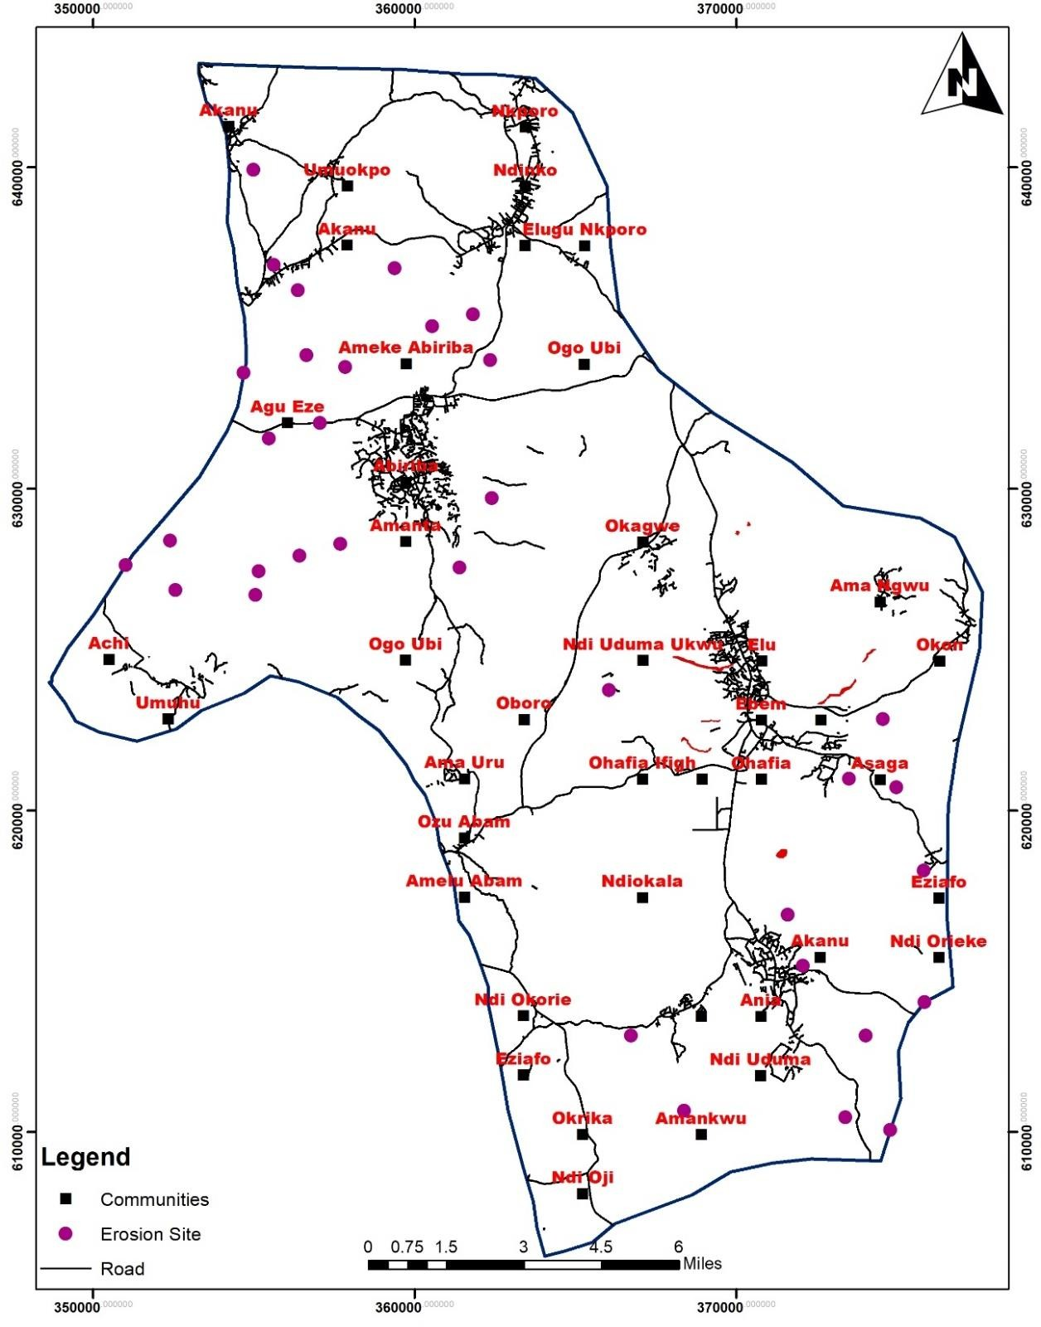

**Figure 4.1:** Distribution of Gullies in Ohafia

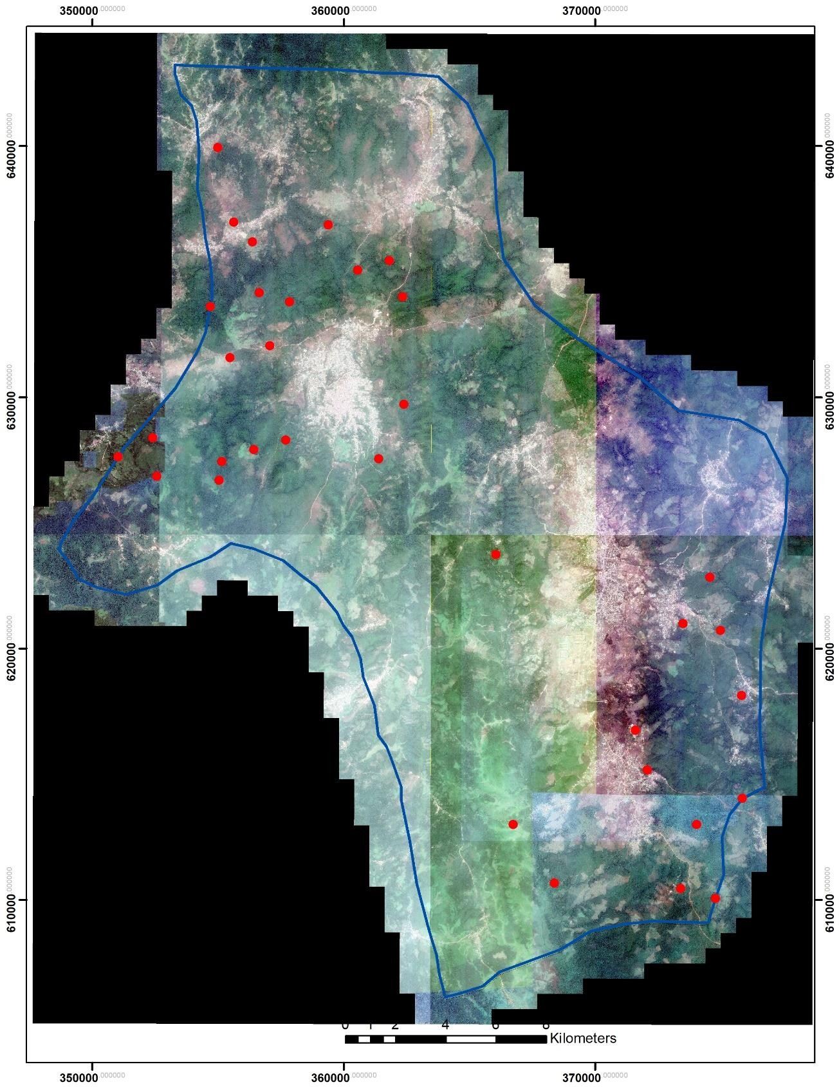

**Figure 4.1a:** Distribution of Gully Erosion Sites in Ohafia (Google Earth)

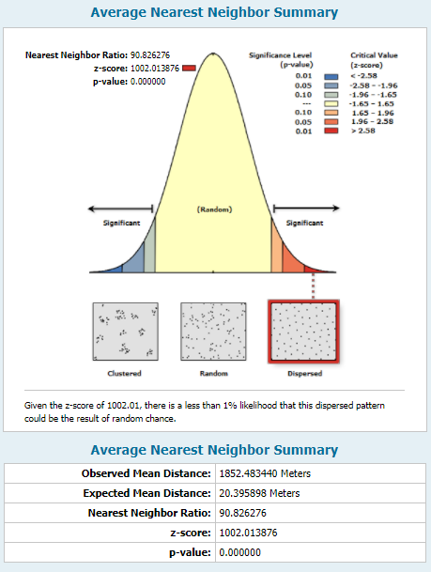

**Figure 4.2:** Spatial Distribution Pattern of Erosion Sites in Ohafia

## Slope characteristics of the study area

The study area is characterized by a steep slope with slope greater than 49 (Figure 4.3). The slope was calculated using the surface analysis tool extension in ARCGIS 10.2 environment. The slope of Ohafia was found to be 0-49°, and it favours erosion activities. Areas with less than 10o slope are less prone to gully erosion. However, areas with more than 10o slope are more prone to gully erosion. This is as a result of the great kinetic energy gained at the plane

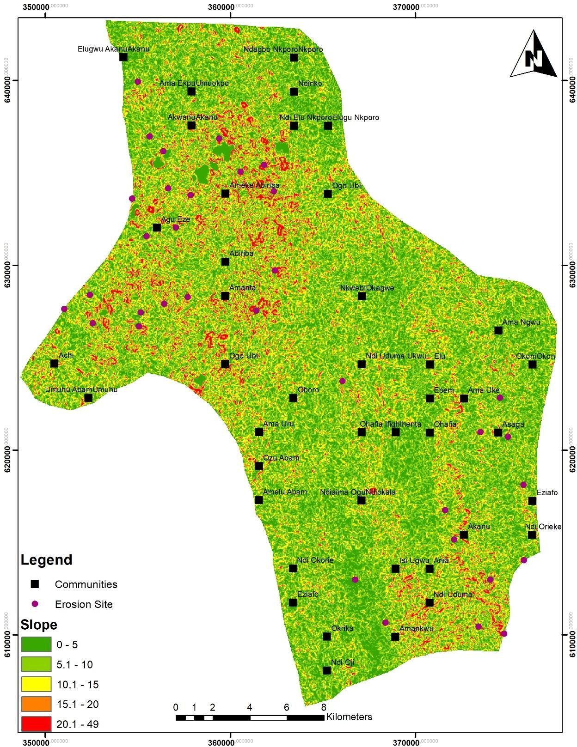

**Figure 4.3:** Slope Characteristics of Ohafia

with the highest slope angles. The energy increases downward thereby carrying eroded materials from deep incision made from those points. About 35% of the gully erosion sites have slope angles greater than 10o while a moderate slope (less than 10o) dominates the rest. Figure 4.4 shows the profile A-A of Ohafia which runs from the northern part to the southern part of Ohafia. The Figure shows the steep undulating nature of the terrain as one moves from the north to the south. The undulating and steep slopes observed in the Figure is an indication of the susceptibility of the study area to gully erosion.

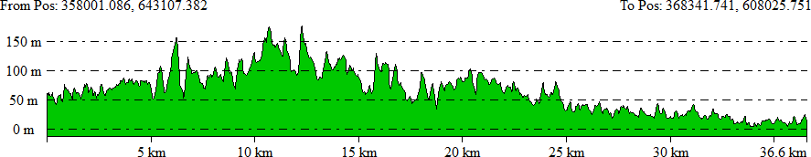

**Figure 4.4:** Profile A-A (North to South)

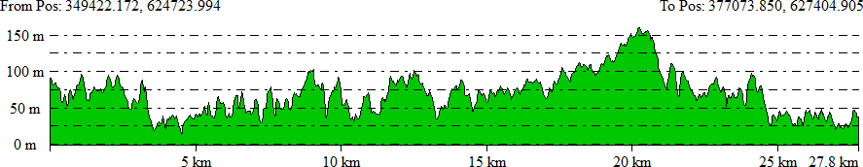

**Figure 4.5:** Profile X-X (West to East)

## Dominant type of soil in Ohafia

The dominant types of soil in Ohafia was examined and the result is presented in Table 4.2. The study shows that, Ohafia is characterised by three dominant types of soil; dystric gleysols (Gd), dystric Fluvisols (Jd), and the dystric Nitosols (Nd). Table 4.2 shows that 85% of Ohafia is has Dystric Nitosols (Nd) as the dominant soil type, while the dystric gleysols (Gd) and dystric fluvisols (Jd) covers 1.2% and 13.8% of the total land area of Ohafia.

## Table 4.2: Dominant Soil Types in Ohafia

|  |  |  |
| --- | --- | --- |
| Type of Soil | **Area (Ha)** | **Percentage** |
| Dystric Gleysols (Gd) | 48135.6 | 1.2 |
| Dystric Fluvisols (Jd) | 7783.93 | 13.8 |
| Dystric Nitosols (Nd) | 655.83 | 85.0 |
| **Total** | **56575.37** | **100** |

Furthermore, the percentage of clay in the different soil types is presented in Table 4.3. According to digital soil map of the world data developed by Food and Agricultural organization (FAO), dystric gleysols have 59.3% of clay at the topsoil, and 48.2% at the subsoil. In contrast, dystric fluvisols have 24.8% and 28.9% clay content at the top and subsoil, respectively. However, the topsoil and subsoil clay content for dystric nitosols is 43.6% and 54.4% respectively. The higher the clay content the more susceptible to erosion and vice versa. Dystric gleysols have the highest percentage of clay content (53.75%). However, Gd account for only about 1.2% of the land area in Ohafia. Dystric Nitosols have 49% of clay content, second only to Gd, however, Nd accounted for 85% of the land area.

## Table 4.3: Clay Properties of the Dominant Soil Types

|  |  |  |  |
| --- | --- | --- | --- |
| **Type of Soil** | **clay % topsoil** | **clay % subsoil** | Average |
| Dystric Gleysols (GD) | 59.3 | 48.2 | 53.75 |
| Dystric Fluvisols (JD) | 24.8 | 28.9 | 26.85 |
| Dystric Nitosols (ND) | 43.6 | 54.4 | 49 |

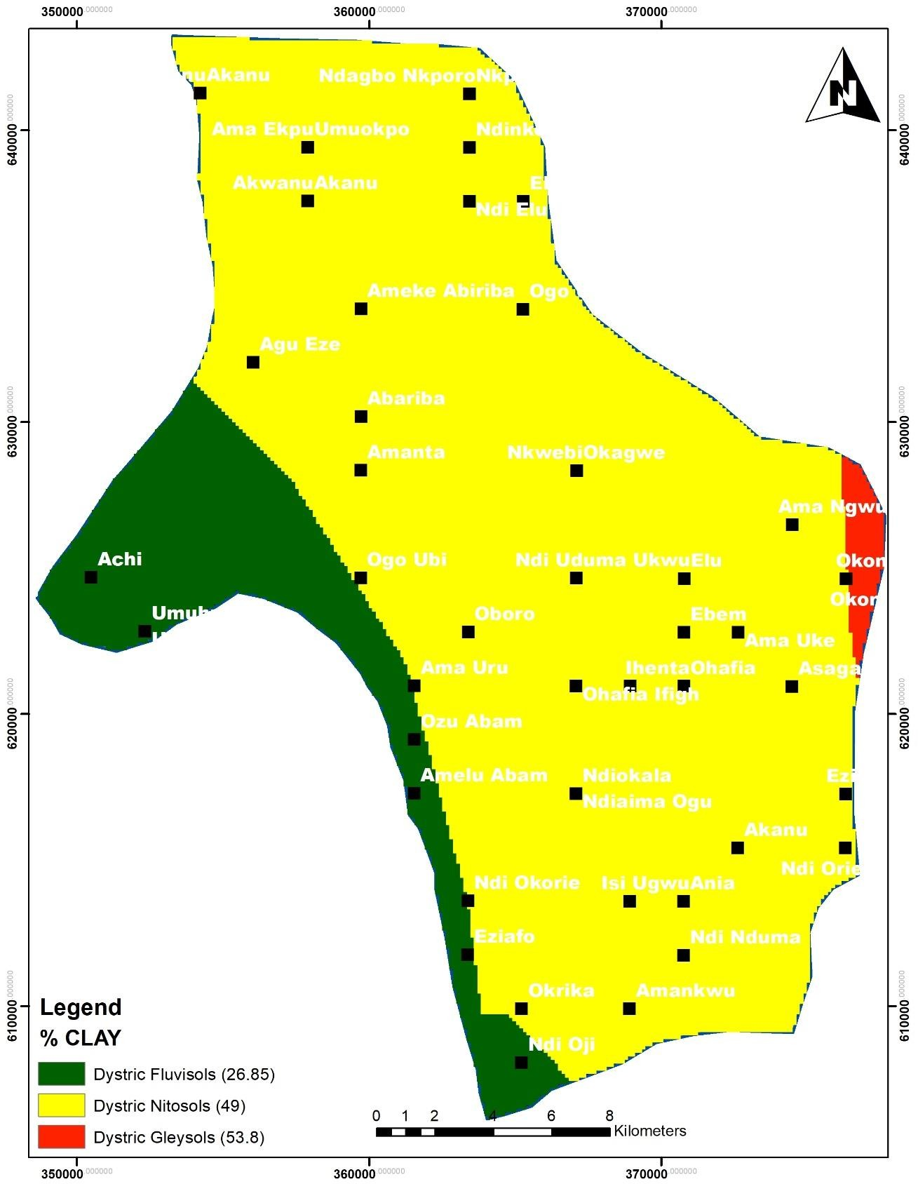

**Figure 4.6:** Soil Types and Clay Properties of Soil in Ohafia

## Causes of Gully Erosion in Ohafia LGA

The study assessed the causes of gully erosion in Ohafia LGA with consideration for the human and environmental factors. The environmental causes identified include soil type/structure, flooding, topography, rainfall intensity and slope characteristics. However, seven human factors were identified and they are: bad agricultural practice, poor drainage, over grazing, bush burning, deforestation, removal of vegetal cover, and road construction. The causes of gully by factor in each of the four communities sampled is presented in the sections below.

## Environmental causes of gully erosion in the study area

Table 4.4 revealed the environmental causes of gully erosion in Abiriba. Causes of gully erosion according to the respondents was attributed to slope (3.62), flooding (3.58), and poor soil type and structure (3.55). Rainfall intensity/runoff (3.51) and topographic (3.21).

## Table 4.4: Environmental Causes of Gully Erosion in Abaribe

|  |  |  |  |
| --- | --- | --- | --- |
| **Environmental Factor** | **Weighted Value** | **Mean** | **Rank** |
| Soil type | 142 | 3.55 | 3 |
| Slope characteristics | 145 | 3.62 | 1 |
| Rainfall intensity/runoff | 140 | 3.51 | 4 |
| Topographic | 128 | 3.21 | 5 |
| Flood | 143 | 3.58 | 2 |
| **Average** | **140** | **3.49** |  |

The environmental causes of gully erosion in Ndi Nduma are presented in Table 4.5. flooding was identified as the most daring cause of gully erosion in Ndi Nduma (3.71), rainfall intensity (3.69) and slope characteristics (3.62) ranked second and third respectively. Poor

soil type/structure (3.55) and topographic characteristics (3.54) were the least ranked causes of gully erosion in Ndi Nduma. However, all the five environmental causes contribute highly to the development of gully erosion in the study area.

## Table 4.5: Environmental Causes of Gully Erosion in Ndi Nduma

|  |  |  |  |
| --- | --- | --- | --- |
| **Environmental Factor** | **Weighted Value** | **Mean** | **Rank** |
| Poor Soil type/structure | 185 | 3.58 | 4 |
| Slope characteristics | 188 | 3.60 | 3 |
| Rainfall intensity/runoff | 192 | 3.69 | 2 |
| Topographic | 184 | 3.54 | 5 |
| Flooding | 193 | 3.71 | 1 |
| **Average** | **188** | **3.62** |  |

Furthermore, the environmental causes of gully erosion in Ebem is presented in Table 4.6. The result shows that flooding (3.69) is the primary cause of gully erosion in Ebem, followed by rainfall intensity/runoff (3.68) and poor soil type/structure (3.66). Topography (3.60) and slope characteristics (3.57) were the least ranked causes identified by the respondents from Ebem.

## Table 4.6: Environmental Causes of Gully Erosion in Ebem

|  |  |  |  |
| --- | --- | --- | --- |
| **Environmental Factor** | **Weighted Value** | **Mean** | **Rank** |
| Poor Soil type/structure | 205 | 3.66 | 3 |
| Slope characteristics | 200 | 3.57 | 5 |
| Rainfall intensity/runoff | 206 | 3.68 | 2 |
| Topographic | 202 | 3.6 | 4 |
| Flood | 207 | 3.69 | 1 |
| **Total** | **204** | **3.64** |  |

In addition, the environmental causes of gully erosion in Ohafia community is presented in Table 4.7. The result revealed that rainfall intensity/runoff is the number cause of gully erosion in Ohafia community with a mean index of 3.72. flooding ranked the second most prominent cause of gully erosion with a mean index of 3.65, while poor soil type/structure (3.48) and topographic characteristic (3.43) ranked third and fourth, respectively. However, slope characteristics is the least rated cause of gully erosion in Ohafia community with a mean index of 3.21.

## Table 4.7: Environmental Causes of Gully Erosion in Ohafia Community

|  |  |  |  |
| --- | --- | --- | --- |
| **Environmental Factor** | **Weighted**  **Value** | **Mean** | **Rank** |
| Poor Soil type/structure | 233 | 3.48 | 3 |
| Slope characteristics | 215 | 3.21 | 5 |
| Rainfall intensity/runoff | 249 | 3.72 | 1 |
| Topographic | 230 | 3.43 | 4 |
| Flood | 245 | 3.65 | 2 |
| **Total** | **234** | **3.50** |  |

Figure 4.7 shows the environmental causes of gully erosion in Ohafia LGA. The study revealed that flooding (3.66) and high intensity of rainfall/ runoff (3.65) is the most prominent cause of gully erosion in the study area. Poor soil type/structure (3.57), and slope characteristics (3.50) of the study area also had high impact on the development of gullies in the study area. However, topography was the least rated environmental cause of gully erosion in the study area with a mean of 3.45. This shows that the frequent flood incidence occasioned by high rainstorm/runoff and poor water retaining capacity of the soil are the primary environmental factors that exposes the soil to gully erosion.

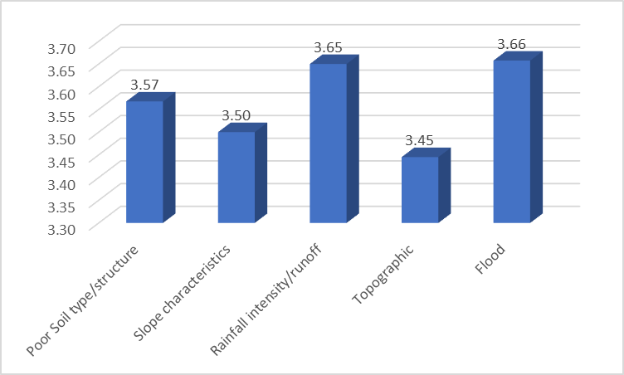

**Figure 4.7:** Environmental Causes of Gully Erosion in the Study Area

To determine the variation in the effect of environmental factors on the development of gully erosion in Ohafia, one factor analysis of variance was carried out and the result is presented in Table 4.8. A one-factor analysis of variance has shown that there is no significant variation between the categorical variable Factors and the variable Mean *F* = 2.02, *p* = 0.143. Since, the p-value is greater than 0.05, the null hypothesis is accepted while the alternative hypothesis is rejected.

**Table 4.8: Analysis of Variance Test**

|  |  |  |  |  |  |  |
| --- | --- | --- | --- | --- | --- | --- |
|  | **Sum of**  **Squares** | **df** | **Mean**  **Squares** | **F** | **p-**  **value** | **Critical F-**  **Value** |
| Between Groups | 0.14 | 4 | 0.03 | 2.02 | 0.143 | 3.06 |
| Within Groups | 0.26 | 15 | 0.02 |  |  |  |
| Total | 0.39 | 19 |  |  |  |  |

* + 1. **Human induced causes of gully erosion in Ohafia**

The human induced factors responsible for gully erosion in Abiriba is presented in Table 4.9. The respondents believed poor drainage is the primary cause of gully erosion in Abiriba

(3.86). Deforestation (3.48) and road construction and excavation activities (3.20) were also among the high rated factors influencing the development of gully erosion. However, over grazing was the least rated factor with a mean of 1.53, followed by bad agricultural practice (2.23). This shows that the poor drainage system and construction activities in Abiriba are the primary human induced factor of gully erosion.

**Table 4.9:** Human Induced Causes of Gully Erosion in Abiriba

|  |  |  |  |
| --- | --- | --- | --- |
| **Human Factor** | **Weighted Value** | **Mean** | **Rank** |
| Bad agricultural practice | 89 | 2.23 | 6 |
| Removal of vegetation cover | 106 | 2.65 | 5 |
| Poor drainage | 154 | 3.86 | 1 |
| Road construction and excavation | 128 | 3.2 | 3 |
| Over grazing | 61 | 1.53 | 7 |
| Bush burning | 114 | 2.86 | 4 |
| Deforestation | 139 | 3.48 | 2 |
| **Average** | **113** | **2.83** |  |

Similarly, in Ndi Nduma community, the respondents were also of the believe that the absence or poor drainage system and deforestation are major contributors to gully erosion having recorded a mean of 4.01 and 3.78 respectively. Table 4.9 shows that road construction and excavation activities (3.41), removal of vegetal cover (3.34), and bush burning (3.19) contribute moderately to the development of gully erosion in Ndi Nduma. However, bad agricultural practices (2.51) and over grazing were the least rated cause of gully erosion in the study area. Grazing activities is quite minimal in these communities. Hence, the reason for the low rating.

**Table 4.10** Human Induced Causes of Gully Erosion in Ndi Nduma

|  |  |  |  |
| --- | --- | --- | --- |
| **Human Factor** | **Weighted Value** | **Mean** | **Rank** |
| Bad agricultural practice | 131 | 2.51 | 6 |
| Removal of vegetation cover | 174 | 3.34 | 4 |
| Poor drainage | 209 | 4.01 | 1 |
| Road construction and excavation | 177 | 3.41 | 3 |
| Over grazing | 104 | 2.00 | 7 |
| Bush burning | 166 | 3.19 | 5 |
| Deforestation | 197 | 3.78 | 2 |
| **Average** | **165** | **3.18** |  |

In addition, Table 4.11 shows the human induced causes of gully erosion in Ebem community. The study revealed that poor drainage system (3.94), construction activities, particularly roads (3.61), and deforestation (felling of trees) activities (3.54) had high impact on the development of gullies in Ebem community, the factors were ranked first, second and third, respectively. Removal of vegetal cover had a mean of 3.44, bush burning 3.28, and bad agricultural practice 2.69. This shows that the bush burning, removal of vegetal cover and bad agricultural practice contribute fairly to the development of gully erosion in the stud area.

**Table 4.11:** Human Induced Causes of Gully Erosion in Ebem

|  |  |  |  |
| --- | --- | --- | --- |
| **Human Factor** | **Weighted Value** | **Mean** | **Rank** |
| Bad agricultural practice | 151 | 2.69 | 6 |
| Removal of vegetation cover | 193 | 3.44 | 4 |
| Poor drainage | 221 | 3.94 | 1 |
| Road construction and excavation | 202 | 3.61 | 2 |
| Over grazing | 118 | 2.11 | 7 |
| Bush burning | 184 | 3.28 | 5 |
| Deforestation | 198 | 3.54 | 3 |
| **Average** | **181** | **3.23** |  |

Lastly, Table 4.12 shows the causes of gully erosion in Ohafia community. The study revealed that gully erosion development in Ohafia community is as a result of poor drainage system (4.21) in the community, construction activities (4.06), and deforestation (3.78). Removal of vegetal cover (3.36) for the purpose of construction or development is also a significant cause of gully erosion in Ohafia community, followed by bush burning (3.01), and bad agricultural practices (2.64). Overgrazing remains the least rated factor with a mean of 1.98, which shows over grazing has minimal effect or does not occur frequently in Ohafia community.

**Table 4.12:** Human Induced Causes of Gully Erosion in Ohafia Community

|  |  |  |  |
| --- | --- | --- | --- |
| **Human Factor** | **Weighted Value** | **Mean** | **Rank** |
| Bad agricultural practice | 177 | 2.64 | 6 |
| Removal of vegetation cover | 225 | 3.36 | 4 |
| Poor drainage | 282 | 4.21 | 1 |
| Road construction and excavation | 272 | 4.06 | 2 |
| Over grazing | 133 | 1.98 | 7 |
| Bush burning | 202 | 3.01 | 5 |
| Deforestation | 253 | 3.78 | 3 |
| **Average** | **221** | **3.29** |  |

Figure 4.8 shows the human induced causes of gully erosion in the study area. The study revealed that the poor drainage system in the study area is the most prominent factor of gully erosion development with a mean value of 4.01. Deforestation (3.65) and construction activities (3.57) were among the factors with high impact on development of gullies. However, over grazing had the least effect on gully erosion development in the study area with a mean value of 1.91, followed by agricultural practice (2.52). Removal of vegetal cover

and bush burning also contributed significantly to the development of gullies in the study area.

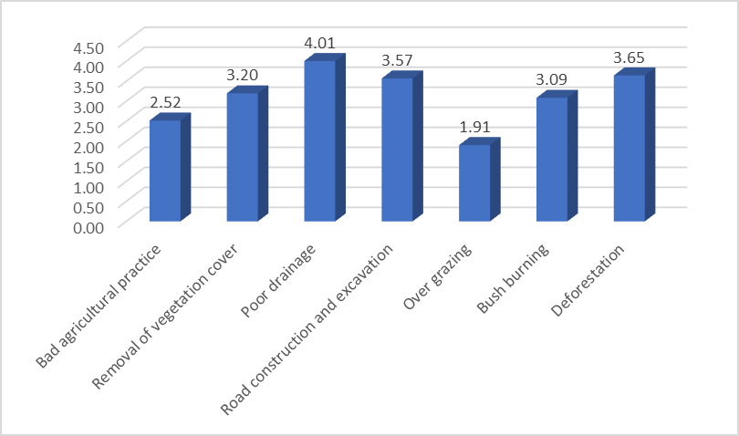

**Figure 4.8:** Human Induced Causes of Gully Erosion in the Study Area

## Impact of Gully Erosion on Landuse and Livelihood of the Residents

* + 1. **Impact of Gully Erosion on Landuse and Livelihood of Abariba Residents**

The impact of gully erosion in Abariba community was assessed using a Likert scale and the result is presented in Table 4.13. The revealed that loss of farmland (4.31), is the most common impact of gully erosion experienced in the community, the residents also submitted that the impact of gully erosion on destruction of farmland (4.07), loss of economic trees (3.67), and destruction of roads (4.00) is high. The respondents also reported a fair impact of gully erosion on the siltation of farmland (3.18), destruction of house (3.35), and sales of farm produce (3.01). However, the impact of gully erosion on loss of lives (1.53), and land slide (2.35) is low. It is important to note here that, as the respondents indicated, agriculture which is predominant economic activity in the area was the most affected by the gully erosion

problem. Apart from washing away of the topsoil, the gullies cut agricultural lands into uneven plots, which no doubt reduces the efficiency of tillage operations in the area.

**Table 4.13:** Impact of Gully Erosion on Landuse and Livelihood of Abariba Residents

|  |  |  |  |
| --- | --- | --- | --- |
| **Impact of Gully Erosion** | **Weighted Value** | **Mean** | **Rank** |
| Siltation of rivers | 127 | 3.18 | Fair |
| Loss of farmland | 172 | 4.31 | High |
| Destruction of crops | 163 | 4.07 | High |
| Loss of economic Trees | 147 | 3.67 | High |
| Destruction of roads | 160 | 4 | High |
| Destruction of houses | 134 | 3.35 | Fair |
| Loss of lives | 61 | 1.53 | Low |
| Land slide | 94 | 2.35 | Low |
| Sales of farm produce | 120 | 3.01 | Fair |
| **Average** |  | **3.27** | **Fair** |

Table 4.14 shows the impact of gully erosion on livelihood of residents in Ndi Nduma community. Similarly, loss of farmland (4.46) is the most rated impact of gully erosion identified by the resident in Ndi Nduma. Gully erosion impact highly on crops (4.19), roads (3.89), loss of economic trees (3.58), siltation of rivers (3.52), and sales of farm produce (3.50). The primary economic activities of the people revolve round the agricultural chain: farming and selling of farm produce, among others. However, it has become difficult for the people to go through this chain of activities seamlessly due to gully erosion. Gully erosion had fair impact on destruction of house (3.41) and land slide (2.77). However, gully erosion in Ndi Nduma rarely leads to loss of live: hence the low index of 1.99 reported by the residents.

**Table 4.14:** Impact of Gully Erosion on Livelihood of Ndi Nduma Residents

|  |  |  |  |
| --- | --- | --- | --- |
| **Impact of Gully Erosion** | **Weighted Value** | **Mean** | **Rank** |
| Siltation of rivers | 183 | 3.52 | High |
| Loss of farmland | 232 | 4.46 | High |
| Destruction of Crops | 218 | 4.19 | High |
| Loss of economic Trees | 186 | 3.58 | High |
| Destruction of roads | 202 | 3.89 | High |
| Destruction of houses | 177 | 3.41 | Fair |
| Loss of lives | 103 | 1.99 | Low |
| Land slide | 144 | 2.77 | Fair |
| Sales of farm produce | 182 | 3.5 | High |
| **Average** |  | **3.48** | **Fair** |

Conversely, the impact of gully erosion in Ebem community, particularly on livelihoods of the inhabitant is presented in Table 4.15. The study revealed that gully erosion had impacted highly on livelihood activities of the inhabitants. For example, many of the respondents indicated that gully erosion had led to the destruction of crops (4.31), loss of farmland (4.18), destruction of roads (4.15), and loss of economic trees (3.87). Gully erosion had on several occasion wash away crops or led to the destruction of farmland which is the primary source of livelihood for the people in the community. Gully erosion is also reported to impact highly on sales of farm produce (3.78) through the destruction of roads, therefore making it difficult to transport farm produce from one community to the other or the market. Siltation of rivers (3.67) is also a major product of gully erosion in Ebem community. The situation was so serious that even the attempts made to protect the affected farmlands were themselves observed during the field survey to have themselves been eroded. The respondents also indicated that rivers and lakes, which were their main source of water for fishing in the area, were being silted up by eroded sands from the uplands.

**Table 4.15:** Impact of Gully Erosion on Livelihood of Ebem Residents

|  |  |  |  |
| --- | --- | --- | --- |
| **Impact of Gully Erosion** | **Weighted Value** | **Mean** | **Rank** |
| Siltation of rivers | 206 | 3.67 | High |
| Loss of farmland | 234 | 4.18 | High |
| Destruction of Crops | 241 | 4.31 | High |
| Loss of economic Trees | 217 | 3.87 | High |
| Destruction of roads | 232 | 4.15 | High |
| Destruction of houses | 203 | 3.62 | High |
| Loss of lives | 142 | 2.53 | Fair |
| Land slide | 185 | 3.31 | Fair |
| Sales of farm produce | 211 | 3.76 | High |
| **Average** |  | **3.71** | **Fair** |

The impact of gully erosion in Ohafia cuts across all areas of their economic and social lives. Table 4.16 shows the impact of gully erosion on livelihoods of residents in Ohafia community. The study revealed that gully erosion has high impact on all the areas of assessment except loss of lives (1.83), which is low and land slide (2.84), which is fair. The high impact areas include destruction of roads (4.25), which hinders effective movement for both social and economic purposes. Loss of farm land (4.21), destruction of crops (4.11), destruction of houses (4.00), sales of farm produce (3.62), and siltation of rivers (3.56) were among the areas that were affected highly by gully erosion in Ohafia.

Table 4.16: Impact of Gully Erosion on Livelihood of Ohafia Community Residents

|  |  |  |  |
| --- | --- | --- | --- |
| **Impact of Gully Erosion** | **Weighted Value** | **Mean** | **Rank** |
| Siltation of rivers | 239 | 3.56 | High |
| Loss of farmland | 282 | 4.21 | High |
| Destruction of Crops | 275 | 4.11 | High |
| Loss of economic Trees | 253 | 3.77 | High |
| Destruction of roads | 285 | 4.25 | High |
| Destruction of houses | 268 | 4 | High |
| Loss of lives | 123 | 1.83 | Low |
| Land slide | 214 | 2.84 | Fair |
| Sales of farm produce | 262 | 3.62 | High |
| **Average** |  | **3.58** | **Fair** |

Figure 4.9 shows the impact of gully erosion in all the communities assessed for the study. The result shows that loss of farmland (4.29) is the most severe form of livelihood impact of gully erosion in the communities, followed by destruction of crops (4.17), and destruction of roads (4.07). Gully erosion has low impact on loss of lives (1.97), the impact of gully erosion on land slide (2.82), sales of farm produce (3.47), and siltation of river (3.48) is fair. However, the impact of gully erosion on destruction of houses (3.60) and loss of economic trees (3.72) is high.

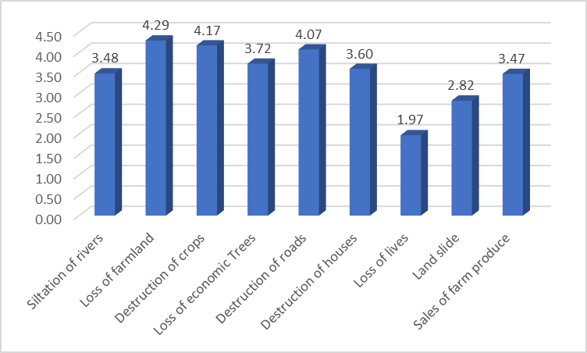

**Figure 4.9:** Impact of Gully Erosion in Ohafia LGA, Abia State

In addition, the study assessed the variation in the level of impact from gully erosion among the four communities using one factor analysis of variance (Table 4.17). A one-factor analysis of variance has shown that there is a significant variation in the level of gully erosion impact in the communities. The variable Index are: *F* = 30.19, *p* = <0.001. Since the p-value is less than 0.05, it is an indication that impact of gully erosion varies across the communities. **Table 4.17:** Variation in the Level of Impact of Gully Erosion in the Communities

|  |  |  |  |  |  |  |
| --- | --- | --- | --- | --- | --- | --- |
|  | **Sum of**  **Squares** | **df** | **Mean**  **Squares** | **F** | **p-**  **value** | **Critical F-**  **Value** |
| Between Groups | 17.06 | 8 | 2.13 | 30.19 | <0.001 | 2.31 |
| Within Groups | 1.91 | 27 | 0.07 |  |  |  |
| Total | 18.97 | 35 |  |  |  |  |

## Modelling Gully Erosion Vulnerability in Ohafia

The study modelled soil erosion vulnerability in the study area using three parameters: digital terrain model (DTM), slope, and soil. Gully erosion vulnerability was derived from the product of DTM, slope (degrees) and Soil (% clay). The vulnerability induced by each of the parameters is discussed accordingly in the sections below.

## Digital terrain model of Ohafia

The study analysed the DTM of Ohafia to understand the pattern and extent of vulnerability resulting from the topographic characteristics of the study area. The analysis shows that (5297ha) 9% of the land area has very high susceptibility to gully erosion, while 16% (8819ha) of the had high susceptibility to gully erosion (Table 4.18). Similarly, 24% (13806ha) of the land area is susceptible to gully erosion. This shows that about 49% of the area is susceptible to gully erosion occasioned by the topographic characteristics of the study area. Figure 4.10 shows the pattern of gully erosion from DTM of the study area. The study shows that Akanu, Ndi Nduma, Ukwu, Agbu, and Ogo community are highly susceptible to gully erosion. However, Ndi Oji, Eziafo, Ama Ngwu, were among the communities with less susceptibility to gully erosion as a result of the topographic characteristics of the study area. **Table 4.18:** Gully Erosion Vulnerability from Topography

|  |  |  |
| --- | --- | --- |
| **Vulnerability level** | **Area (ha)** | **Percentage** |
| Very Low | 11501.04892 | 20 |
| Low | 17159.79093 | 30 |
| Fair | 13806.3448 | 24 |
| High | 8819.415095 | 16 |
| Very High | 5297.541534 | 9 |
| Total | 56584.14128 | 100 |

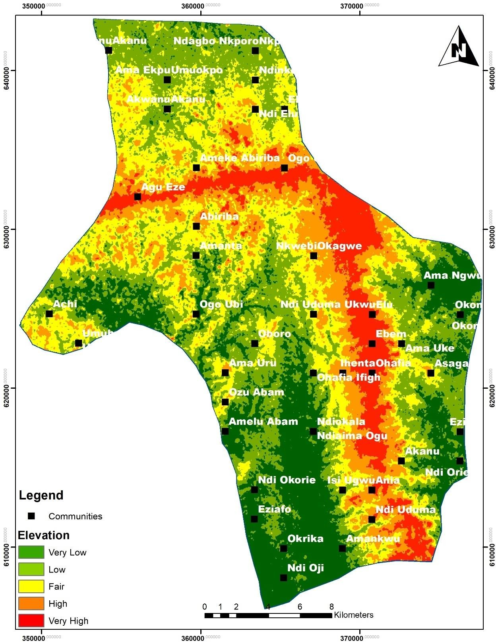

**Figure 4.10:** Digital Terrain Model of Ohafia

## Distribution of slope induced gully erosion in Ohafia

The pattern of slope induced gully erosion in Ohafia is depicted in Figure 4.11. The slope characteristics of the study is divided into five classes using the slope in degrees. Table 4.19 shows that 40% of the area had very low susceptibility to gully erosion, while 32% of the area had low susceptibility to gully erosion. This implies that about 72% of the area is not susceptible to gully erosion as a result of the slope characteristics of the area. However, 3% of the land area had very high susceptibility gully erosion, while 4% had high susceptibility to gully erosion, and 21% is susceptible to gully erosion. The pattern of gully erosion susceptibility is presented in Figure 4.8. The Figure shows that Ndi Nduma community is located on high slope area which exposes it to gully erosion, while Ebem community is located on a very low slope, which implies low susceptibility to gully erosion.

## Table 4.19: Gully Erosion Vulnerability from Slope

|  |  |  |
| --- | --- | --- |
| **Vulnerability level** | **Area (ha)** | **Percentage** |
| Very Low | 22633.6 | 40 |
| Low | 18106.9 | 32 |
| Fair | 11882.6 | 21 |
| High | 2263.3 | 4 |
| Very High | 1697.5 | 3 |
| **Total** | **56584.14128** | **100** |

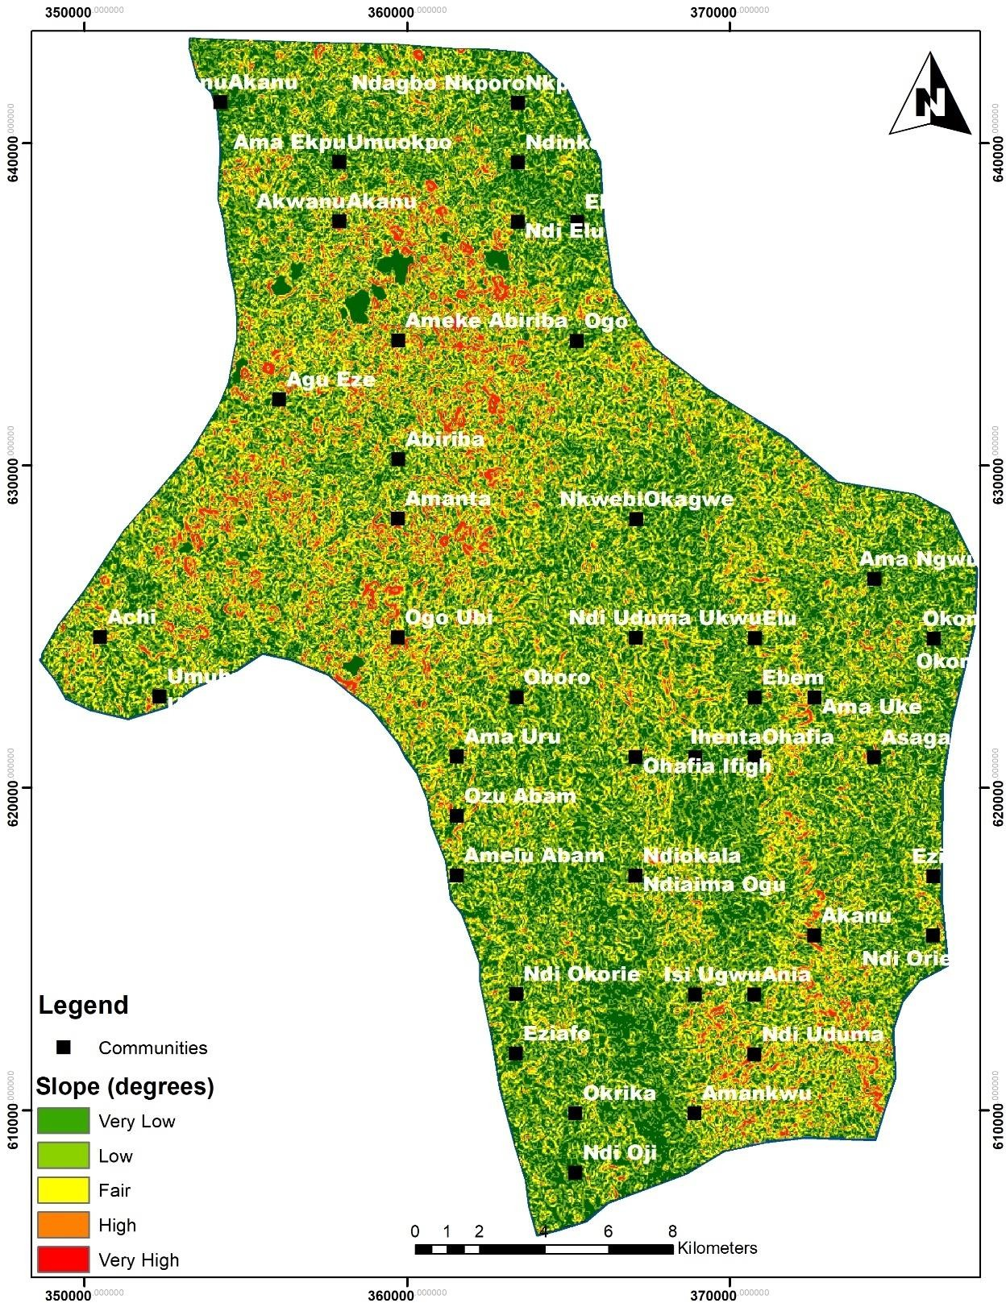

**Figure 4.11:** Slope Analysis of Ohafia LGA

## Clay properties of soil types in Ohafia

Lastly, the spatial distribution of soil induced gully erosion is presented in Figure 4.9. The Figure shows that about 85% of the land area is susceptible to gully erosion, while 13% of the land area is less susceptible to gully erosion, and 1.2% is highly susceptible to gully erosion. All the communities in Ohafia are located in the areas susceptible to gully erosion except Ndi Oji, Eziafo, Amelu, Dzu Abam, and Achi communities. This shows that most of the communities are likely to be exposed to gully erosion as a result of the poor retention capacity of the Dystric Nitosols due to its high clay content.

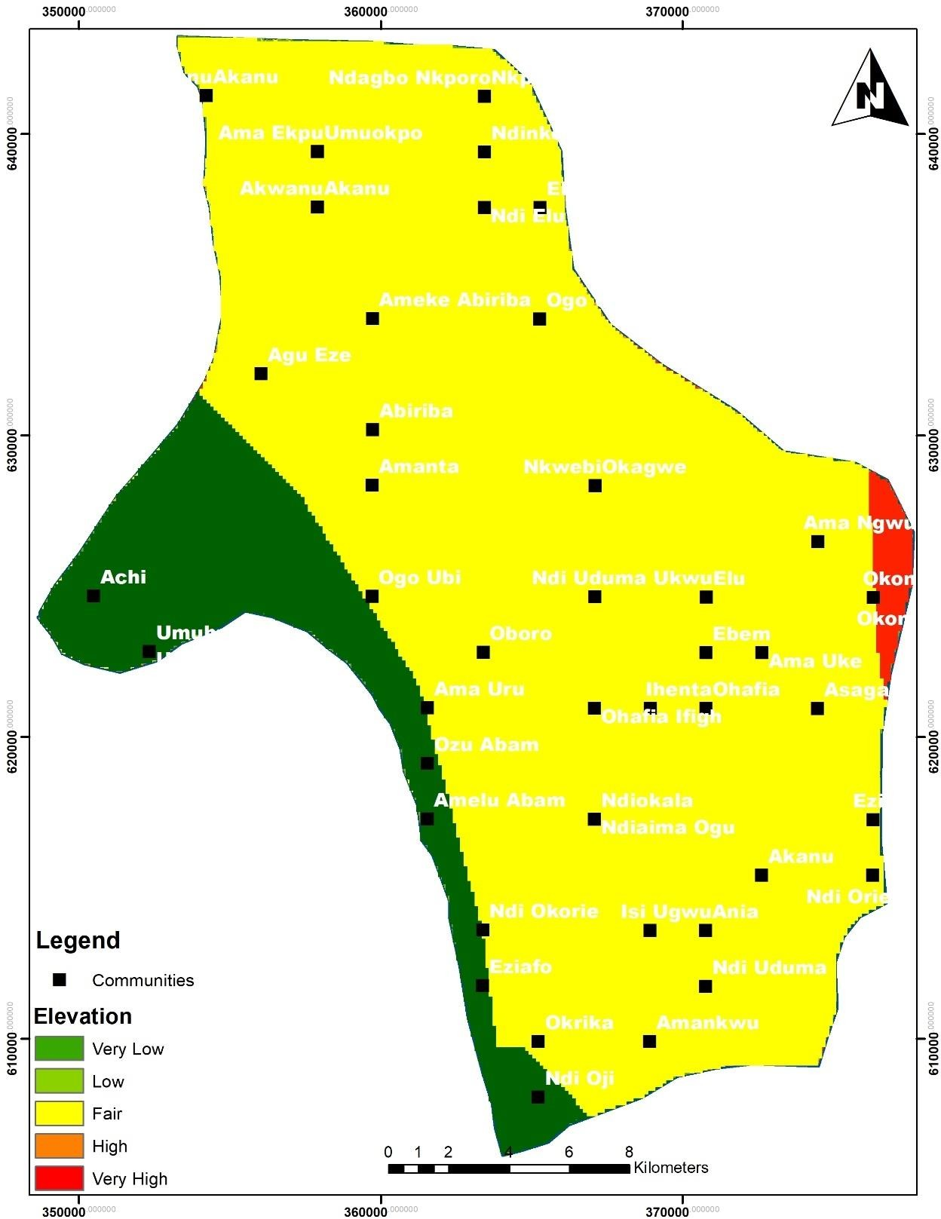

**Figure 4.12:** Soil Characteristics of Ohafia

## Multidimensional gully erosion vulnerability in Ohafia

The study assessed the vulnerability of Ohafia to gully erosion using three environmental indicators, digital elevation model, slope, and soil. Table 4.20 shows that 48% of the land area had very low vulnerability to gully erosion, 26% had low vulnerability. However, 17% of the land area are vulnerable, 7% and 1% of the land area had high and very high vulnerability to gully erosion. This shows that about one-quarter of the area is vulnerable to gully erosion. Figure 4.13 shows the multidimensional gully vulnerability pattern of Ohafia. The Figure shows that Achi, Ebem, Akano, Ameke, and Agu community are located on high gully erosion vulnerable site. On the contrary, communities like Ndi Okorie, Eziafo, Okrika, Ndi Oji, Amelu, Ama Ngwu, and Okon communities are in less vulnerable areas.

**Table 4.20:** Gully Erosion Vulnerability in Ohafia

|  |  |  |
| --- | --- | --- |
| **Vulnerability level** | **Area (ha)** | **Percentage** |
| Very Low | 27142.1 | 48 |
| Low | 14792.0 | 26 |
| Fair | 9444.4 | 17 |
| High | 4209.8 | 7 |
| Very High | 789.4 | 1 |
| **Total** | **56377.7** | **100** |

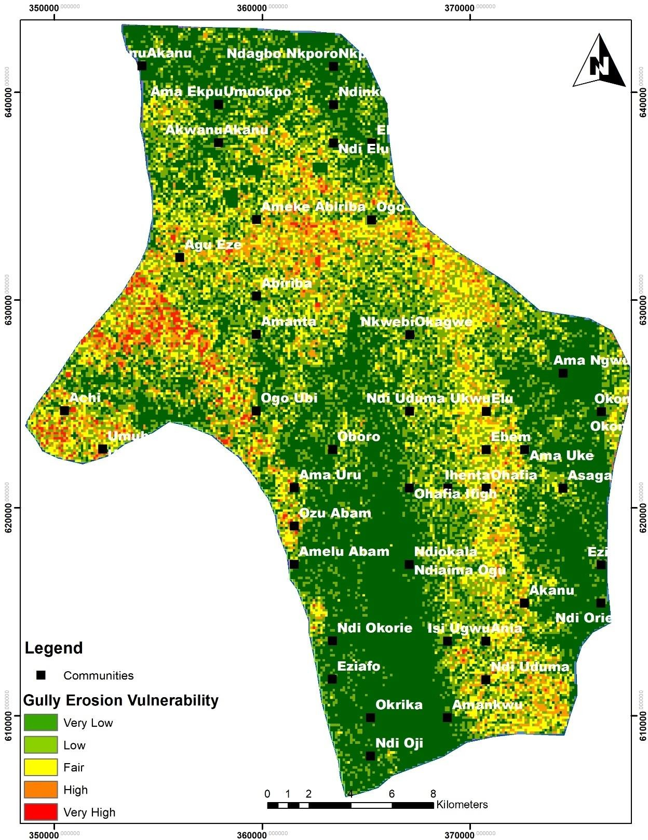

**Figure 4.13:** Gully Erosion Vulnerability Map

## Summary of Findings

The study reveal that Ndi-Iyima, Ebem Ohafia is located on an elevation of 25.4m – 373.4 meters, which shows that a significant part of the state is below 100m elevation. The state slopes southwards from the north. The highest elevation lies towards the northern parts of the state, while the lowest elevation areas are dominants at the southern parts of the state. The study established that 188.9sqkm and 25.6sqkm of the land area have steep gradient of 12-22% and above 22% respectively.

The LS factor shows that 9.74sqkm of Ndi-Iyima, Ebem Ohafia is susceptible to high erosion, while 6.09sqkm is susceptible to very high erosion as a result of the slope and length of slope. This shows that a significant part (15.83sqkm) of land may be loss to erosion as a result of the slope and length of slope, which is likely to destroy arable farmlands and properties if not checked. The soil erodibility map also shows that 243.46sqkm and 2230.52sqkm of land is highly susceptible to erosion due to the soil composition. In general about 45% of the land area are highly erodible due to the high silt content of the soil which is easily eroded by water and wind. The study also depict the rain erosivity of Ndi-Iyima, Ebem Ohafia showing areas with high and low intensity of erosivity.

Furthermore, the study developed a model for soil erosion estimation and monitoring using ARCGIS 10.3 model builder, using slope, soil, and rainfall data. The model was developed from the RUSLE model using remote sensing and GIS data. The output of the model was compared with the existing situation to determine the accuracy and level of predictability for the model which is significantly high.

## CHAPTER FIVE

* 1. **CONCLUSION AND RECOMMENDATION**

## Conclusion

The study conclude that it is relatively simple and easier to interpret erosion models physically; it requires less resources with available inputs of the areas exposed to erosion risk. Therefore, this study attempt to empirically demonstrate RUSLE soil erosion model using GIS and remote sensing tool to estimate soil erosion potential and the spatial distribution of soil erosion risk areas. Going by the analysis and result of the study the areas with steep slope accounted for 25.6sqkm, while 2230.5sqkm has very high erosion risk. It is also observed that the quantity of erosion varies mainly on topography and land use-land cover.

The analysis shows that areas that are highly prone to erosion risk accounted for 711.75sqkm. The study shows the contribution of gradient, slope length, soil texture and rainfall erosivity using remote sensing data and GIS tool. GIS-based RUSLE methodology was used to identify the spatial distribution of different erosion prone areas in Ndi-Iyima, Ebem Ohafia. The outcome would help to take suitable erosion control measures in the severely affected areas. The results obtained from the study can assist in developing management scenarios and provide options to policy makers for managing soil erosion hazards in the most efficient manner for prioritization of different areas of the state for treatment. The study also shows that GIS and remote sensing can be integrated to enhance to work of land management personnel in effective management of land.

## Recommendation

This study has been able to demonstrate the importance of GIS and remote sensing in land management and development. Therefore the following recommendations were made:

* + 1. Town planners, land managers, and other agencies of government and private organization saddled with the responsibility of land management and development should be trained and introduced to GIS and remote sensing data and technique to enhance the efficiency and effectiveness of their job.
    2. Adequate awareness should also be provided for personnel of various land management and town planning agencies on the capability of RUSLE, GIS, and remote sensing in land management and planning.
    3. Institutions of learning should encourage research in this direction to develop and simplify existing models for easy application in land use management. Incentives should be provided to encourage the integration of existing models into GIS models for easy prediction, monitoring and control of land use.
    4. The government should also ensure that adequate data (rainfall and soil data) that will enhance the workability and sustenance of the model are readily available. This will enhance the efficiency in soil erosion prediction for proper land use management and development.

## Contribution to Knowledge

This study developed a GIS model for soil erosion estimation using the RUSLE model and ARCGIS model builder. The study shows that existing soil loss model can be integrated into GIS and simplified for easy manipulation for people with little or no knowledge of GIS to produce adequate information on soil management and erosion control.

## REFERENCES

Abate, S. (2011). Estimating soil loss rates for soil conservation planning in the Borena woreda of South Wollo highlands, *Ethiopia. Journal of Sustainable Development in Africa*.13(3), 87 – 106.

Abegunde A.A., Adeyinka S.A., Olawuni P.O., & Oluodo O. (2006). An Assessment of the socio economic impact of soil erosion in South-eastern Nigeria. Special Valuation Situation. XXIII FIG Congress.

Adedeji, A., Tukur, A.M., & Adepoju, K.A. (2010). Assessment of Revised Universal Soil Loss Equation (RUSLE) in Katsina Area, Katsina State of Nigeria using Remote Sensing (RS) and Geographic Information System (GIS). *Iranica Journal of Energy & Environment,* 1, 255-264.

Adugna, A., Abegaz, A., & Cerdà, A. (2015). Soil erosion assessment and control in Northeast Wollega, Ethiopia. *Solid Earth Discussions*, *7*(4), 45-62

Ahamed, T. R.N., Rao, K.G., & Murthy, J.S.R. (2000) Fuzzy class membership approach to soil erosion modelling. *Agricultural Systems*, 63, 97-110.

Ahmed, P., & Mir, A.A. (2014). Sediment yield estimation for watershed management in Lolab Watershed of Jammu & Kashmir state using geospatial tools. *International Journal of Advanced Remote Sensing and GIS*, 3(1), 616-626.

Al-Soufi, R. (2004, July). Soil erosion and sediment transport in the Mekong basin. In *Proc. of 2nd APHW conference, Singapore* (47-56).

Ananda, J., & Herath, G. (2003)”Soil Erosion in Developing Countries: a Social Economic Appraisal. *Journal Environmental Management,* 68(4),343-53

Arekhi, S., & Shabani, A. (2010). Applcation of modified universal soil loss equation in prediction of sediment yield case study: kengir watershed Iran. *Saudi Society of Geo since*.

Arekhi, S., Niazi, Y., & Kalteh, A. M. (2012). Soil erosion and sediment yield modeling using RS and GIS techniques: a case study, Iran. *Arabian Journal of Geosciences*, *5*(2), 285-296.

Barakat, M., Mahfoud, I., & Kwyes, A.A. (2014). Study of soil erosion risk in the Basin of Northern Al-Kabeer River at Lattaki-Syria using remote sensing and GIS techniques. *Mesopotamia Journal Marine Science*. 29:29-44.

Bartsch, K.P., van Miegroet, H., Boettinger, J., & Dobrwolski, J.P. (2002). Using empirical erosion models and GIS to determine erosion risk at Camp Williams. *Journal of Soil and Water Conservation*, 57: 29–37.

Bhattarai, R., & Dutta, D. (2007). Estimation of Soil Erosion and Sediment Yield Using

GIS at Catchment Scale. *Water Resource Management*, 21:1635–1647.

Beasley, D. B., Huggins, L. F., & Monke, A. (1980). ANSWERS: A model for watershed planning. *Transactions of the ASAE*, *23*(4), 938-0944.

Beckedahl, H. R. (1996). *Subsurface soil erosion phenomena in Transkei and southern KwaZulu-Natal, South Africa* (Doctoral dissertation).

Beckedahl, H. R., & De Villiers, A. B. (2000). Accelerated erosion by piping in the Eastern Cape Province, South Africa. *South African Geographical Journal*, *82*(3), 157- 162.

Bergsma, E., Charman, P., Gibbons, F., Hurni, H., Moldenhauer, W. C., & Panichapong, S. (1996). *Terminology for soil erosion and conservation*. ISSS: ITC: ISRIC.

Bizuwerk, A., Taddese, G., & Getahun, Y. (2008). *Application of GIS for Modeling Soil Loss Rate in Awash Basin, Ethiopia*. Ethiopia: International Livestock Research Institute (ILRI).

Blaszczynski, J. (2001). Regional Sheet and Rill Soil Erosion Prediction with the Revised Universal Soil Loss Equation (RUSLE)-GIS Interface. *Resource Notes*, *46*.

Boardman, J., Parsons, A.J., Holmes, P.J., Holland, R., & Washington, R. (2003). Development of Badlands and Gullies in the Sneeuberg, Great Karoo, South Africa. *Catena,* 50, 165 – 184.

Boardman, J. (2013). Soil erosion in Britain: updating the record. *Agriculture*, 3(3), 418-442.

Boggs, G., Devonport, C., Evans, K., & Puig, P. (2001). GIS-based rapid assessment of erosion risk in a small catchment in the wet/dry tropics of Australia. *Land Degradation & Development*, 12: 417–434.

Bouyoucos, G. J. (1935). Clay ratio as a criterion of susceptibility of soils to erosion. *Journal of the American Society of Agronomy*.

Bradford, J. & Piest, R. (1980). Erosional development of valley-bottom gullies in the upper midwestern United States. *In,* Coates, D.R. and Vitek, J.D. (eds) *Geomorphic Thresholds*. Pennsylvania: Dowden and Culver, Stroudsburg.

Bull, L. J., & Kirkby, M. J. (1997). Gully processes and modelling. *Progress in Physical Geography*, *21*(3), 354-374.

Calvo‐Cases, A., & Harvey, A. M. (1996). Morphology and development of selected badlands in southeast Spain: implications of climatic change. *Earth Surface Processes and Landforms*, *21*(8), 725-735.

Casali, J., Bennett, S. J., & Robinson, K. M. (2000). Processes of ephemeral gully erosion.

Cerri, C.E.P., Dematte, J.A.M., Ballester, M.V.R., Martinelli, L.A., Victoria, R.L.,& Roose,

E. (2001). GIS erosion risk assessment of the Piracicaba River Basin, southeastern Brazil. *Mapping Sciences and Remote Sensing* 38, 157–171.

Chadin, C., & Tetsuya, S. (2008). Sediment Yield And Transportation Analysis Case Study on Managawa River Basin. *Proceedings of Hydraulic Engineering*, *52*, 157-162.

Cobban, D. A., & Weaver, A. V. B. (1993). A preliminary investigation of the gully features in the Tsolwana Game Reserve, Ciskei, southern Africa. *South African geographical journal*, *75*(1), 14-21.

Cornia, A., & Viorel, A. (2011) **‘**The quantitate estimation of the soil erosion using USLE type Romsen model’**,** *Carpathian journal of earth and environmental*, 6, 59-66.

Dabral, P.P., Baithuri, N., & Pandey, T. (2008). A Soil Erosion Assessment in a Hilly Catchment of North Eastern India Using USLE, GIS and Remote Sensing. *Water Resource Management*, 22,1783–1798.

Denardin, J.E. (1990). Erodibilidade de solo estimada pormeio de par‚metros fÌsicos e quÌmicos. Piracicaba: USP-Esalq. 81p. Tese de Doutorado.

Desta, L., & Adugna, B. (2012) A field guide on gully prevention and control. Nile Basin Initiative Eastern Nile Subsidiary Action Program (ENSAP), Addis Ababa, Ethiopia 67

Di Tommaso, T., Lovelli, S., Amato, M., & Perniola, M. (2009). Shrinking Behaiviour of Badland Soil under different Soil Covers. *Italian Journal of Agronomy*, 4, 27-38.

Dunne, T., Western, D., & Dietrich, W. E. (2011). Effects of cattle trampling on vegetation, infiltration, and erosion in a tropical rangeland. *Journal of arid environments*, *75*(1), 58-69.

Ehiorobo, J. O., (2012). Monitoring of gully erosion in an urban area using geoinformation technology. *Scholarlink Reseacrh Institute of Journals*, *3*(2), 270-275.

Ehiorobo, J. O., & Audu, H. A. P. (2012). Monitoring of gully erosion in an urban area using geoinformation technology. *Journal of Emerging Trends in Engineering and Applied Sciences*, *3*(2), 270-275.

Ewell, H. A. & Stocking, M. A. (1982) Developing a simple yet practical method of soil loss estimation. *Tropical Agriculture*, 59, 43-48.

Fangmeier, D.D., Elliot, W.J., Workman, S.R., Huffman, R.L., & Schwab, G.O. (2006). *Soil and Water Conservation Engineering, fifth ed. Clifton Park, NY:* Thompson Delmar Learning,

Fernandez, C., Wu, J. Q., McCool, D. K., & Stöckle, C. O. (2003). Estimating water erosion and sediment yield with GIS, RUSLE, and SEDD. *Journal of Soil and Water Conservation*, *58*(3), 128-136.

Foster, G. R. (1980). Process-based modelling of Soil Erosion by Water on Agricultural land. In *Soil Erosion on Agricultural Land*, eds. J. Boardman, I. D. L. Foster &

J. A. Dearings, 429-445. New York: John Wiley and Sons Ltd

Ganasri, B. P., & Ramesh, H. (2016). Assessment of soil erosion by RUSLE model using remote sensing and GIS-A case study of Nethravathi Basin. *Geoscience Frontiers*, *7*(6), 953-961.

Gebreyesus, B., Lulseged, T., & Paul. L.G. (2014). Soil erosion prediction using Morgan- Morgan-Finney Model in a GIS environment in northern Ethiopia Catchment. *Applied and Environmental Soil Science, 9*(3), 142-156

Gitas, I. Z., Douros, K., Minakou, C., Silleos, G. N., & Karydas, C. G. (2009). Multi-temporal soil erosion risk assessment in N. Chalkidiki using a modified USLE raster model. *EARSeL eProceedings*, *8*(1), 40-52.

Grissinger, E. H. (1996). Rill and gullies erosion. *Soil erosion, conservation and rehabilitation.*, 153-167.

Hancock, G. R., & Evans, K. G. (2006). Channel head location and characteristics using digital elevation models. *Earth Surface Processes and Landforms: The Journal of the British Geomorphological Research Group*, *31*(7), 809-824.

Heede, B. H. (1970). Morphology of gullies in the Colorado Rocky Mountains. *Hydrological Sciences Journal*, *15*(2), 79-89.

Henkel, J.S., Bayer, A.W., & Coutts, J. R. H. (1938). Sub surface erosion on a Natal Midlands farm. *South African Journal of Science*, *35*(12), 236-243.

Higgins, C. G., Parker, G. G., & Wood, W. W. (1990). Piping and pseudokarst in drylands. *Groundwater Geomorphology: The Role of Subsurface Water in Earth- surface Processes and Landforms. Geological Society of America, Special Papers*, *252*, 77-110.

Hofierka, J., & Suri, M. (1996, March). Soil water erosion modelling using GIS and aerial photographs. In *Geographical Information. Second Joint European Conference & Exhibition on Geographical Information, Barcelona, Spain* (pp. 376-381).

Howard, A. D. (1999). Simulation of gully erosion and bistable landforms. *Incised river channels*, 277-300.

Huggett, R. (2007). A history of the systems approach in geomorphology. *Géomorphologie: relief, processes, environment*, *13*(2), 145-158.Hussein, M.H., Kariem, T.H.,

Ireland, H.A., Sharpe, C.F.S. & Eargle, D.H. (1939). Principles of gully erosion in the Piedmont of South Carolina. U.S. Dept. Agric. Tech. Bull. 633.

Jahantigh, M., & Pessarakli, M. (2011). Causes and effects of gully erosion on agricultural lands and the environment. *Communications in soil science and plant analysis*, *42*(18), 2250-2255.

Jain, S.K., Kumar, S., & Varghese, J., (2001). Estimation of soil erosion for a Himalayan watershed using GIS technique. *Water Resources Management,* 15, 41-54

Jain S.K., & Goel, M.K. (2002). Assessing the vulnerability to soil erosion of the Ukai Dam catchments using remote sensing and GIS. *Hydrological Sciences Journal,* 47(1): 31-40.

Jeje, L. K., Ogunkoya, O. O., & Adediji, A. (1997) Adapting the Universal Soil Loss Equation(USLE) to Southwerstern Nigeria. *Nigerian Journal of Science*, 31, 139- 149.

Kertész, Á. (2009). Environmental conditions of gully erosion in Hungary. *Hungarian Geographical Bulletin*, *58*(2), 79-89.

Kertész, Á., & Gergely, J. (2011). Gully erosion in Hungary, review and case study.

*Procedia-Social and Behavioral Sciences*, *19*, 693-701.

Kirchhoff, M., Rodrigo-Comino, J., Seeger, M., & Ries, J. B. (2017). Soil erosion in sloping vineyards under conventional and organic land use managements (Saar-Mosel valley, Germany). *Cuadernos de Investigación Geográfica*, *43*(1), 119-140.

Kim, H. S. (2006). *Soil erosion modeling using RUSLE and GIS on the Imha watershed, South Korea* (Doctoral dissertation, Colorado State University).

Knapen, A., De Baets, S., Poesen, J., & Gyssels, G., (2006). Effects of grass roots on the erodibility of topsoils during concentrated flow. *Geomorphology*, *76*(1-2), 54-67.

Lal, R. (1998). Soil erosion impact on agronomic productivity and environment quality.

*Critical reviews in plant sciences*, 17(4), 319-464.

Lawal, O., Thomas, G., & Babatunde, N. (2007) Estimation of potential soil losses on a regional scale: a case of Abomey-Bohicon region, Benin Republic. *Agricultural Journal* 2:1–8

Leonard, R. A., Knisel, W. G. & Davis, F. M. (1995) Modelling pesticide fate with GLEAMS. *European Journal of Agronomy*, 4, 485-490.

Le Roux, J., & van der Waal, B. (2006). Gully erosion susceptibility modelling to support avoided degradation planning. *South African Geographical Journal*, *102*(3), 406- 420.

Liberti, M, Simoniello, T., & Carone, M, T. (2009) Mapping badland areas using LANDSAT TM/ETM satellite imagery and morphological data. *Journal of Geomorphology, 106: 333-343*

Ma, J.W., Xue, Y., Ma, C.F., & Wang, Z.G. (2003). A data fusion approach for soil erosion monitoring in the Upper Yangtze River Basin of China based on Universal Soil Loss Equation (USLE) model. *International Journal of Remote Sensing* 24: 4777– 4789.

Markose, V.J., & Jayappa, K.S. (2016). Soil loss estimation and prioritization of subwatersheds of Kali River basin, Karnataka, India, using RUSLE and GIS. *Environmental Monitoring Assessment*, 188: 225-232.

Mekonnen, M., Keesstra, S. D., Stroosnijder, L., Baartman, J. E., & Maroulis, J. (2017). Soil conservation through sediment trapping: a review. *Land Degradation & Development*, *26*(6), 544-556.

Meshesha, D., Haregeweyn, N., Tsunekawa, A., Nyssen, J., Poesen, J., Tsubo, M., ... & Tegegne, F. (2014). Soil erosion and conservation in Ethiopia: a review. *Progress in Physical Geography*, *39*(6), 750-774.

Millward, A. A., & Mersey, J. E. (1999). Adapting the RUSLE to model soil erosion potential in a mountainous tropical watershed. *Catena*, *38*(2), 109-129.

Ministry of Natural Resources and Environment Malaysia (MNREM). (2010). Malaysia Second Communication to the UNFCCC. Putrajaya: Ministry of Natural Resources and Environment Malaysia.

Mitasova, H. & Mitas, L. (1996). Distributed soil erosion simulation for effective erosion prevention. *Water Resources Research*, *34*(3), 505-516.

Morgan, R.P.C., (2005). Soil Erosion and Conservation. 3rd edition. Malden, MA, USA: Blackwell Publishing company.

Morgan, R. P. C., Quinton, J. N., Smith, R. E., Govers, G., Poesen, J. W. A., Chisci, G., & Torri, D. (1998). The EUROSEM model. In *Modelling Soil Erosion by Water* (pp. 389-398). Berlin, Heidelberg: Springer,

Nwilo, P. C., Olayinka, D. N., & Adzandeh, A. E. (2012). Flood modelling and vulnerability assessment of settlements in the Adamawa state floodplain using GIS and cellular framework approach. *Global Journal of Human Social Science*, *12*(3), 11-20.

Obiadi, I. I., Nwosu, C. M., Ajaegwu, N. E., Anakwuba, E. K., Onuigbo, N. E., Akpunonu,

E. O., & Ezim, O. E. (2011). Gully erosion in Anambra State, south east Nigeria: Issues and solution. *International Journal of Environmental Sciences*, *2*(2), 795- 804.

Omar, A. J. (2010). *Digital Modeling Evaluation on Tidal Effect of the Galing River* (Doctoral dissertation, UMP).

Onyando, J.O., Kisoyan, P., & Chemelil, M.C. (2005). Estimation of Potential Soil Erosion for River Perkerra Catchment in Kenya. *Water Resources Management* 19: 133– 143.

Onyegbule, A. F., Adelusi, S. A., & Omogbai, E. K. (2010). Tissue chloroquine levels in diabetic rats. *International Journal of Pharmaceutical Science Research,*

*9*, 110-114.

Oostwoud Wijdenes, D. J., & Bryan, R. (2001). Gully‐head erosion processes on a semi‐arid valley floor in Kenya: a case study into temporal variation and sediment budgeting. *Earth Surface Processes and Landforms*, *26*(9), 911-933.

Ownegh, M., (2003). Comparing applicability of 4 quantitative and semi-quantitative models in landslide hazard zonation in Chehel-Chay watershed, Golestan province.

Øygarden, L. (2003). Rill and gully development during an extreme winter runoff event in Norway. *Catena*, *50*(2-4), 217-242.

Pathak, P., Wani, P. P., & Sudi, R. (2006). Gully control in SAT watershed. *International Crops Research Institute for the Semi-Arid Tropics*, *2*(1), 28.

Pandey, A., & Mal, V.M. (2007). Identification of critical erosion prone areas in the small agricultural watershed using USLE, GIS and remote sensing. *Water resources management,* 21(4):729-746.

Poesen, J. W., Boardman, J., Wilcox, B., & Valentin, C. (1996). Water erosion monitoring and experimentation for global change studies. *Journal of soil and water conservation*, *51*(5), 386-390.

Poesen, J., Vandaele, K., & van Wesemael, B. (1998). Gully erosion: importance and model implications. In *Modelling soil erosion by water* . Berlin, Heidelberg: Springer.

Poesen, J., Nachtergaele, J., & Govers, G. (2002). The impact of sowing density of small grains on rill and ephemeral gully erosion in concentrated flow zones. *Soil and Tillage Research*, *64*(3-4), 189-201.

Poesen, J., Nachtergaele, J., Verstraeten, G., & Valentin, C. (2003). Gully erosion and environmental change: importance and research needs. *Catena*, *50*(2-4), 91-133.

Prasannakumar ,V., Vijith, H., Abinod, S., & Geetha, N. (2012). Estimation of soil erosion risk within a small mountainous sub watershed in Kerala, India, using Revised Universal Soil Loss Equation (RUSLE) and geo-information technology. *Geoscience Frontiers*, 3(2): 209-215.

Praveen, R., & Kumar, U. (2012). Integrated Approach of Universal Soil Loss Equation (USLE) and Geographical Information System (GIS) for Soil Loss Risk Assessment in Upper South Koel Basin, Jharkhand. *Journal of Geographic Information System*, 4:588-596.

Rahaman, S.A., Aruchamy, S., Jegankumar, R., & Ajeez, S.A. (2015). Estimation of annual average soil loss, based on RUSLE model in Kallar watershed, Bhavani basin, Tamil Nadu, India. *ISPRS Annals of the Photogrammetry, Remote Sensing and Spatial Information Sciences*, Volume II-2/W2, 2015 Joint International Geoinformation Conference, Kuala Lumpur, Malaysia.

Renard, K. G., Meyer, L. D., & Foster, G. R. (1997). Introduction to remote sensing.

*International Journal of Remote Sensing,* 21: 1685–1696.

Renschler, C. S. & Harbor, J. (2002) Soil erosion assessm ent tools from point to regional scales--the role of geomorphologists in land management research and implementation. *Geomorphology*, 47, 189-209.

Reusing, M., Schneider, T., & Ammer, U. (2000). Modeling soil erosion rates in the Ethiopian Highlands by integration of high-resolution MOMS-02/ D2-stereo-data in a GIS. *International Journal of Remote Sensing,* 21: 1885–1896.

Robert-Bierman, P., & Sussana, K. K. (2004). Rock to sediment; slope to sea with 10B rates of landscape change. *Annual Review of Earth Planet Science.*, *32*, 215-255.

Rowntree, K. M., & Foster, I. D. (2012). A reconstruction of historical changes in sediment sources, sediment transfer and sediment yield for a small, semi-arid Karoo catchment, South Africa. *Zeitschrift fur Geomorphologie, Supplementary Issues*, *56*(Supp 1), 87-100.

Rowntree, K. M. (2013). The evil of sluits: A re-assessment of soil erosion in the Karoo of South Africa as portrayed in century-old sources. *Journal of Environmental Management,* 130, 98–105. <https://doi.org/10.1016/j.jenvman.2013.08.041>

Saha S.K. (2003), Water and Wind Induced Soil Erosion Assessment and Monitoring Using Remote Sensing and GIS. *Satellite Remote Sensing and GIS Applications in Agricultural Meteorology* (2003), 315-330

Sharda, V.N., Mandal, D., & Ojasvi, P.R. (2013). Identification of soil erosion risk areas for conservation planning in different states of India. *Journal of Environment Biology*, 34, 219-226.

Sharpley, A. N., & Williams, J. R., (1990). Assessing the impact of erosion on soil productivity using the EPIC model. In *Soil erosion on agricultural land. Proceedings of a workshop sponsored by the British Geomorphological Research Group, Coventry, UK.* New York: John Wiley & Sons Ltd.

Sharma, K., Menenti, M., & Huygen, A. (1996). Modeling Spatial Sediment Delivery in Arid Region using Thematic Mapper Data and GIS. *Transactions of the ASAE,* 39 (2), 551-557.

Shinde, V., Tiwari, K.N., & Singh, M. (2010). Prioritization of micro watersheds on the basis of soil erosion hazard using remote sensing and geographic information system. *International Journal of Water Resources and Environmental Engineering* 2 (3), 130-136.

Shit, P. K., Bhunia, G. S., & Maiti, R. (2013). Assessing the performance of check dams to control rill-gully erosion: small catchment scale study. *International Journal of Current Research*, *5*(04), 899-906.

Sheikh, A.H.,, Palria, S., & Alam, A. (2011). Integration of GIS AND Universal Soil Loss Equation (USLE) for soil loss estimation in a Himalayan watershed. *Recent Research in Science and Technology*, 3(3): 51-57.

Singh, R., & Phadke, V.S. (2006). Assessing soil loss by water erosion in Jamni River Basin, Bundelkhand region, India, adopting universal soil loss equation using GIS. *Current Science*, 90(10),1431-1435.

Sjors, A. B. (2001). Erosion History of Ragen and Nyalunya Area, Nyando District, Kenya. *Sweden: Uppsala University*.

Smith, D. D., & Whitt, D. M. (1948). Estimating soil losses from field areas of claypan soil. *Soil Science Society of America Journal*, *12*(C), 485-490.

Stocking, M., & Murnaghan, N. (2000). *Hand book for the field assessment of land degradation. London: Earthscan publications Ltd.*

Strunk, H. (2003). Soil degradation and overland flow as causes of gully erosion on mountain pastures and in forests. *Catena*, *50*(2-4), 185-198.

Sumathi, I., & Bosu S.S. (2004). Using GIS for facilitating sediment yield estimation. Agricultural Engineering College and Research Institute, Tamil Nadu Agricultural University, Coimbtoore, Tamil Nadu, India.

Svoray, T., & Markovitch, H. (2009). Catchment scale analysis of the effect of topography, tillage direction and unpaved roads on ephemeral gully incision. *Earth Surface Processes and Landforms: The Journal of the British Geomorphological Research Group*, *34*(14), 1970-1984.

Tripathi, M. P., Panda, R. K., & Raghuwanshi, N. S. (2003). Identification and prioritisation of critical sub-watersheds for soil conservation management using the SWAT model. *Biosystems Engineering*, *85*(3), 365-379.

Twidale, C. R. (2004). River patterns and their meaning. *Earth-Science Reviews*, *67*(3-4), 159-218.

Vandekerckhove, L., Poesen, J., Oostwoud Wijdenes, D., Nachtergaele, J., Kosmas, C., Roxo, M. J., & De Figueiredo, T. (2000). Thresholds for gully initiation and sedimentation in Mediterranean Europe. *Earth Surface Processes and Landforms*, *25*(11), 1201-1220.

Vanwalleghem, T., Van Den Eeckhaut, M., Poesen, J., Deckers, J., Nachtergaele, J., Van Oost, K., & Slenters, C. (2003). Characteristics and controlling factors of old gullies under forest in a temperate humid climate: a case study from the Meerdaal Forest (Central Belgium). *Geomorphology*, *56*(1-2), 15-29.

Viswas, S.S., & Pani, P. (2015). Estimation of soil erosion using RUSLE and GIS techniques: a case study of Barakar River basin, Jharkhand, India. Model. *Earth System Environment*., 42(1),1-13.

Wang, G., Gertner, G., Fang, S., & Anderson, A. B. (2003). Mapping multiple variables for predicting soil loss by geostatistical methods with TM images and a slope map. *Photogrammetric Engineering & Remote Sensing*, *69*(8), 889-898.

Wang, B., Zheng, F., Römkens, M. J., & Darboux, F. (2013). Soil erodibility for water erosion: A perspective and Chinese experiences. *Geomorphology*, *187*, 1-10.

Watson, H. K. (1990). *A comparative study of soil erosion in the Umfolozi Game Reserve and adjacent Kwazulu area from 1937 to 1983* (Doctoral dissertation).

Weesies, G. A. (1998). K factor. Soil erodibility. *Guidelines for the use of the Revised Universal Soil Loss Equation (RUSLE), version*, *1*.

Williams, J. R., Jones, C. A., & Dyke, P. T. (1983). A modeling approach to determining the relationship between erosion and soil productivity. *Transactions of the ASAE*, *27*(1), 129-0144.

Williams, J.R., (1975). Sediment-yield predictions with universal equation using runoff energy factor. Present and Prospective Technology for Predicting Sediment Yields and Sources, *USDA-Agricultural Research Service*, 40, 244–252.

Wilson, G. V., Cullum, R. F., & Römkens, M. J. M. (2008). Ephemeral gully erosion by preferential flow through a discontinuous soil-pipe. *Catena*, *73*(1), 98-106.

Wilson, J.P., & Lorang M. S. (2000). Spatial models of soil erosion and GIS. In Spatial Models and GIS: New Potential and New Models, Fotheringham AS, Wegener M (eds). Taylor & Francis: *Philadelphia*, PA; 83–108.

Wischmeier, W. H. (1975). Estimating the soil loss equations cover and management factor for undisturbed areas. *Present and prospective technology for predicting sediment yields and sources*, 118-124.

Wischmeier W.H., & Smith D.D. (1978). *Predicting rainfall erosion losses: A guide to conservation planning. - USDA Agricultural Handbook 537*. Washington, D.C: US Government Printing Office.

Wischmeier, W. H., & Smith, D. D. (1965). *Predicting rainfall-erosion losses from cropland east of the Rocky Mountains: Guide for selection of practices for soil and water conservation* (Vol. 282). Washington DC: Agricultural Research Service, US Department of Agriculture.

Yaragal, S.C., Nagaraj, M.K., Yogananda, B.C., & Dodamani, B.M. (2009). Application of Universal Soil Loss Equation (USLE) in Micro-Water Sheds – A Case Study of the Kudremukh National Park Area, Karnataka, India. *International Journal of Earth Science and Engineering*, 02(6):576-587.

Young, R.A., Onstad, C.A., Bosch, D.D., & Anderson, W.P., (1989). A non-point-source pollution model for evaluating agricultural watersheds. *Journal Soil Water Conservation,* 44(2), 168–173.

Yue-Qing, X., Jian, P., & Xiao-Mei, S. (2009). Retracted Article: Assessment of soil erosion using RUSLE and GIS: a case study of the Maotiao River watershed, Guizhou Province, China. *Environmental Geology*, *56*(8), 1643-1652.

Zainal-Abidin, M. (1992). *Alternative industrial strategies and effects of fiscal incentives and trade policy in achieving employment objectives in Malaysian industrialisation*. London School of Economics and Political Science (United Kingdom).

Zhang, K., Li, S., Peng, W., & Yu, B. (2004). Erodibility of agricultural soils on the Loess Plateau of China. *Soil and Tillage Research*, *76*(2), 157-165.

Zhang, G.S., Chan, K.Y., Oates, H., Heenan, D.P., & Huang, G.B., (2008). Relationship between soil structure and runoff/soil loss after 24 years of conservation tillage. *Soil Tillage Research*. 92, 122–128.