# ASSESSMENT OF THE IMPACT OF RESIST TECHNIQUES OF FABRIC DECORATION ON STUDENTS’ INTEREST IN CLOTHING AND TEXTILES IN BORNO STATE, NIGERIA

**BY**

**Yarmi NGGUSHAM**

**DECEMBER, 2017**

**ASSESSMENT OF THE IMPACT OF RESIST TECHNIQUES OF FABRIC DECORATION ON STUDENTS’ INTEREST IN CLOTHING AND TEXTILES IN BORNO STATE, NIGERIA**

**BY**

**Yarmi NGGUSHAM,**

**BSC.ED HOME ECONOMICS (2009, ABU ZARIA) P13EDVE8029**

**A THESIS SUBMITTED TO THE SCHOOL OF POSTGRADUATE STUDIES, AHMADU BELLO UNIVERSITY, ZARIA, NIGERIA**

**IN PARTIAL FULFILLMENT OF THE REQUIREMENTS FOR THE AWARD OF MASTER DEGREE IN HOME ECONOMICS (CLOTHING AND TEXTILES)**

**DEPARTMENT OF HOME ECONOMICS, FACULTY OF EDUCATION,**

**AHMADU BELLO UNIVERSITY, ZARIA, NIGERIA**

**DECEMBER, 2017**

**DECLARATION**

I declare that this dissertation work entitled**ASSESSMENT OF THE IMPACT OF RESIST TECHNIQUES OF FABRIC DECORATION ON STUDENTS’ INTEREST IN CLOTHING**

**AND TEXTILES IN BORNO STATE, NIGERIA** has been carried out by me in the Department of Home Economics. The information derived from the literature has been duly acknowledged in the text and a list of references provided. No part of this project was previously presented for another degree or diploma at this or any other Institution.

Yarmi, NGGUSHAM Date P13EDVE8029

# CERTIFICATION

This dissertation report entitled**ASSESSMENT OF THE IMPACT OF RESIST TECHNIQUES OF FABRIC DECORATION ON STUDENTS’ INTEREST IN CLOTHING AND**

**TEXTILES IN BORNO STATE, NIGERIA**by Yarmi NGGUSHAM meets the regulations governing the award of the Master degree of the Ahmadu Bello University, and is approved for its contribution to knowledge and literary presentation.

Dr. M. F. Ahuwan Date

Chairperson, Supervisory Committee

Prof. S. L. Ajayi Date

Member, Supervisory Committee

Prof. E. E. Adamu Date

Head, Dept. of Home Economcis

Prof. S. Z. Abubakar Date

Dean, School of Postgraduate Studies

# DEDICATION

This research work is dedicated to my husband Mr. Joab B. Lassa (Bulama) and children.

# ACKNOWLEDGEMENTS

Special thanks go to God Almighty for His divine protection, guidance, knowledge and wisdom throughout the period of this research work.

The researcher would like to express her profound gratitude to the members of the supervisory committee Dr. M. F. Ahuwan and Professor S. L. Ajayi for their untiring efforts, constructive criticisms, advice and guidance throughout the period of the research work. The researcher would like to acknowledge the internal examiners Professors Gwari Williams and A. Z. Mohammed for their valuable contributions to the research work. The researcher would like to acknowledge the Head of Department of Home Economics Prof. E. E. Adamu. The researcher would like to acknowledge the lecturers of the Department of Home Economics Professors T. O. Ojo, P. E. Onuigbo, E. Ike and others for their individual and collective contributions towards the successful completion of this research work.

She wishes to thank her beloved husband Mr. Joab B. Lassa for love, patience, care, encouragement and financial support throughout this research work. May the Almighty God bless and reward him abundantly. The researcher also expresses her gratitude to her children, Naomi, Minagkur, Danladi, Japari, Kimberly, Hannatu, Godiya, Jagila and David (Big man) for their prayers, patience and understanding throughout the period of this research work.

The researcher would like to acknowledge the encouragement and assistance of Kashim Ibrahim College of Education, Maiduguri Borno State. She would like to acknowledge the encouragement from Dr. M. A. Abubakar for her motherly advice and assistance. Also, her profound gratitude goes to Dr. I.O. Bongotons of the Department of Arts and Social Science and Dr. Yunusa of the Department of Psychology and Counselling for their contributions, advice and

encouragement. Special appreciation goes to Professor J. A. Gwani for his fatherly support, advice and encouragement during the period of the research work. Also, the researcher would like to acknowledge Mrs. Ladu B. Ndahi, Mrs. Rose Dauda and Mrs. Rebecca Pogu for their prayers, support and advice during the period of the research work. She would like to acknowledge her course mates Mrs. Aishatu, Miss Ruth Simon, Aishatu Gidado, Mrs. Jummai, Rukkaya,, Mrs. Rejoice, Mrs. Sherifat and Mrs. Janet for their support and effort towards the successful completion of this work.

The researcher also wants to appreciate the contributions and understanding of Alhaji A. Buhari (Secretary to PG Coordinator) and Mr. Moses, Department of Home Economics. The researcher would like to acknowledge the statistician Mr. John for analyzing the data generated for this research work.

# ABSTRACT

This research work was carried out to assess the impact of resist techniques of fabric decoration on students‘ interest in clothing and textiles in Borno State, Nigeria. The study had four specific objectives, four research questions and four null hypotheses which were formulated and tested at 0.05 level of significance. The research design adopted for the study was quasi experimental. The population for the study was all JSS3 students that offer home economics in one hundred and eighty (180) secondary schools in both public and private. A purposive sampling technique was used to select two secondary schools, one from public, government secondary school Uba Borno and one from private, AbdulkadirBenishiek Staff School, Maiduguri. One intact class was used in each of the schools and a sample size of one hundred and eighty-eight (188) students was used for the study. The instrument used for data collection was a self-designed questionnaire. Mean and standard deviation were used to answer the stated research questions. Two sample t-test was used to test all the null hypotheses. From the result of the study, hypotheses one, two and four were rejected, while hypothesis three was retained. The major findings from the data analysis and test of the hypotheses revealed that students who were exposed to resist techniques of fabric decoration had their interest in clothing and textiles significantly motivated when compared to their counterparts who were not exposed. Based on the findings of this study, it was recommended among others that prospective students should be exposed to resist technique of fabric decoration as early as possible in the course of teaching and learning of the subject so as to motivate and sustain their interest. There is a need for career awareness and counseling at the onset of the junior secondary school such that students get acquainted with the different career opportunities before making their choice of subjects in their final examinations.

# TABLE OF CONTENTS

# TITLE PAGE

COVER PAGE I

TITLE PAGE II

DECLARATION III

CERTIFICATION IV

DEDICATION V

ACKNOWLEDGEMENTS VI

ABSTRACT VIII

LIST OF TABLES XII

LIST OF APPENDICES XIII

LIST OF PLATES XIV

OPERATIONAL DEFINITION OF TERMS XV

CHAPTER ONE: INTRODUCTION

* 1. Background to the Study 1
  2. Statement of the Problem 4
  3. Objectives of the Study 5
  4. Research Questions 6
  5. Research Hypotheses 6
  6. Significance of the Study 7
  7. Basic Assumption 8
  8. Delimitation of the Study 9

CHAPTER TWO: REVIEW OF RELATED LITERATURE

* 1. Theoretical Framework 10
  2. Learning Theories of Motivation and Interest 11
  3. Theory of Colour in Resist Techniques of Fabric Decoration 14
  4. Concept of Clothing and Textiles 17
  5. Fabric Decoration 23
  6. Origin of Resist Techniques 26
  7. Types of Resist Techniques 28
  8. Concept and Application of Interest 38
  9. Review of Related Empirical Studies 44
  10. Summary of Literature Review 51

.CHAPTER THREE: RESEARCH METHODOLOGY

* 1. Research Design 52
  2. Population for the Study 53
  3. Sample Size and Sampling Procedure 54
  4. Instrument for Data Collection 55
     1. Validation of the Instrument 55
     2. Pilot Study 56
     3. Reliability of the Instrument 56
  5. Collection of Materials 57
  6. Procedure for Data Collection 58
  7. Procedure for Data Analysis 60

CHAPTER FOUR: DATA PRESENTATION AND ANALYSIS

* 1. Answers to the Research Questions 61
  2. Test of Hypotheses 71
  3. Summary of Major Findings 75
  4. Discussion of Results 76

CHAPTER FIVE: SUMMARY, CONCLUSION AND RECOMMENDATIONS

* 1. Summary 79
  2. Conclusion 80
  3. Recommendations 81
  4. Contribution to Knowledge 81
  5. Suggestion for Further Studies 82

REFERENCES 83

APPENDICES 92

PLATES 99

# LIST OF TABLES

**TABLES PAGES**

* 1. Population for the Study 54
  2. Sample Size 55
  3. Mean Scores of Students Interest in Resist Technique of Fabric Decoration in Clothing and Textile by the two Groups after the Experiment 62
  4. Mean Scores on Perception of Career in Clothing and Textiles by the two Groups 65
  5. Mean Scores of the Male and Female Students Interest Exposed Resist Techniques of Fabric Decoration in Clothing and Textiles 67
  6. Mean Scores of the two Groups on the Ways of Motivating Students‘ Interest in Clothing and Textile at the State Senior Secondary Schools. 69
  7. Two Sample t-test on Interest Level in Resist Techniques of Fabric Decoration in Clothing and Textile of the two Groups 72
  8. Two Sample t-test on Perception of Resist Techniques of Fabric Decoration on Career in clothing and textiles by the two groups 73
  9. Two Sample T-test on Interest of Male and Female Students Exposed to Resist Techniques of Fabric Decoration in Clothing and Textile 74
  10. Two Sample T-test on Ways of Motivating Interest of Students in Clothing and Textile by the two Groups 75

# LIST OF APPENDICES

|  |  |  |
| --- | --- | --- |
| **Appendix** | **Pages** |  |
| A. Letter of introduction |  | 92 |
| B. Questionnaire |  | 93 |
| C. Reliability result of the instrument |  | 96 |

# LIST OF PLATES

**PLATES PAGES**

1. Researcher introducing herself to the students 99
2. Research assistant drawing motif on the board 99
3. Researcher and research assistant showing the motif 99
4. Research assistant demonstrating how to tie the fabric 99
5. Researcher showing how to apply the motif on the fabric 100
6. Students tying the fabric 100
7. Researcher and research assistant demonstrating Pleating method 100
8. Students tying the pleated fabric 100
9. Students applying wax on fabric 101
10. Students stamping the fabric 101
11. Students mixing dye 101
12. Students dyeing the fabric 101
13. Students and researcher dyeing the fabric 102
14. Finished stamped fabric 102
15. Finished pleating method 102

# OPERATIONAL DEFINITION OF TERMS

Batik A piece of cloth made in the traditional manner by applying coloured design to

fabric by the use of wax resists.

Resist An act, technique or material that creates pattern on a cloth by preventing

dye from penetrating fabric.

Stamp A small wood with a raised design that can be printed onto fabric by waxing the wood and pressing it to the fabric.

Stencil A thin sheet of material either cardboard or steel sheet with designs of

different shapes cut out of it through which wax is applied to mark the shape on fabric surface.

Tie-dye A method of dyeing by hand in which colour patterns are produced on the fabric by gathering together many small portions of materials and tying them tightly with string before amercing the cloth in the dye bath.

Wax Any oily, water resistant substance normally

long chain hydrocarbon, alcohols or esters used to resist dye from penetrating a fabric.

# CHAPTER ONE INTRODUCTION

## Background to the Study

Borno Stateis one of the thirty six (36) states of Nigeria, in the North Eastern part of the Country with its Capital in Maiduguri. The State like other States of Nigeria has public and private Secondary Schools. The Secondary Schools offer a variety of academic programmes, one of which is Home Economics, with Clothing and Textiles as an area of study. The Clothing and Textile Education Curriculum provides a study in resist techniques of fabric decoration to prepare students to be self-reliant and job creators rather than job seekers. Since the inception of clothing and textiles into Senior Secondary Schools level, the subject has not been taught in many Borno StateSecondary Schools. Lack of qualified Clothing teachers, inadequate instructional materials and infrastructure, gender stereotype seem to contribute to the decline in the subject and students enrolment. The effectiveness of Clothing and Textiles as a means for global survival will be compromised if the problems that plague the study of the subject in Borno StateSecondarySchools are not unveiled and tackled.

Clothing and Textiles Education is an area of study that exposes students to diversify curriculum. Arubayi (2003) viewed Clothing and Textiles as that type of education that inculcates in the students attitudes, knowledge, skills and values that are required in the society. This is a means of producing healthy, literate and self-reliant citizens that will create wealth for human development when they become self-employed thereby resulting to sustainable nation‘s development at large. According to Mberengwe (2004), Clothing and Textiles Education is primarily education for vocation. It is a training system that encourages the students to acquire skills that fit them into the

world of work. Clothing and Textiles Education encompasses attitudes, knowledge and skills needed for any level of employment and advancement in broad range of clothing career.

Resist technique is a traditional method of dyeing textiles with patterns. Methods are used to resist or prevent the dye from reaching all the cloth thereby creating a pattern and ground. Potter as cited in Alheri (2014) stated that the most common forms of resist decorated fabrics in Nigeria are tie-dye such as Adire-oniko and Alabare, Batik or wax resist and the cassava paste resist method (Adire-eleko). These resist decorated fabrics are produced mostly by the Yoruba of the Southern part of Nigeria, particularly in Ibadan and Abeokuta. They are also produced in some parts of Northern Nigeria, in States such as Kaduna, Kano and Sokoto.

Design is a common term used in many endeavours such as textiles design, graphics design, engineering design, architectural design and all processes of purposeful visual creations which are coordinated together to make a meaningful whole. According to Ogunduyile (2007), design is a creative activity whose aim is to establish the multi-faceted quality of objects, processes, services and their systems in whole lifestyles. Therefore, design is the central factor of innovating humanization of technology and the crucial factors of cultural and economic exchange. Decorative design refers to decorations applied to a garment. It is not an intergral part of the type of trims, braids, embroidery, buttons that do not fasten and tucked on bows.

Interests are often defined as the focused interaction between an individual and an object (or class of objects and ideas,) that results in an enduring affective disposition or orientation towards the object(s) (Eccles and Wigfield, 2002). Individual interests are conceptualized as consisting of feeling- and value- related valences. ―Feeling- related valences refer to the feelings that are associated with an object or an activity-feeling such as involvement, stimulation, or flow. Value-

related valences refer to the attribution of personal significance or importance to an object or activity‖ (Eccles and Wigfiled, 2002).

In the context of school learning, the development, maintenance, and enhancement of positive student-academic content domain relationships is often referred to as interests.Interest improved the quality of learning and promote intrinsic motivation. Thus, academic interests should not only be considered important facilitators of academic outcomes, but also as valued Educational outcomes in their own right (Corno, 2002). According to Arubayi (2003), the students‘ interest if known would help the teachers in the Clothing and Textiles to encourage, make them realize themselves or know themselves. It would help the students to discover the areas of which they could be steadfast so as to be themselves. Attention should be given to individual students in their various areas of interest so as to stimulate them. The researcher is of the view that it is not to say that Clothing and Textiles programme is being implemented. It will be more pleasing to see what the teachers and students are doing which will reveal how much of the students interest is involved.

Since learning leads to change in behaviour, and motivation plays an active part in activating behaviour, there is a relationship between learning and motivation. Motivation refers to ―the reasons underlying behaviour‖ (Guay, Chanal, Ratelle, Marsh,Larose and Boivin 2010). Motivation is the attribute that moves us to do or not to do something. Intrinsic motivation is motivation that is animated by personal enjoyment, interest, or pleasure. As Deci, Koestner, and Ryan (1999) observe, intrinsic motivation energizes and sustains activities through the spontaneous satisfactions inherent in effective volitional action. It is manifested in behaviours such as play, exploration, and challenge seeking that people often do for external rewards. Motivated students display interest in activities, motivated teachers feel that they can help students learn and motivated administrators make possible teaching and learning in their buildings. Students‘ motivation is rooted in students‘

subjective experiences, especially those connected to their willingness to engage in lessons and learning activities and their reasons for doing so. Many researchers have examined different methods to increase students‘ motivation and have linked motivation and interest in learning to students‘ achievement in school. Increasing students‘ motivation to learn is a key to success in this day of high stakes testing, implementation of common core standards, and realization of the global economy. Students need to be able to compete with their peers throughout this country as well as other countries as far as knowledge and ability to obtain careers (Finn, 2006).

## Statement of the Problem

Clothing and Textiles as one of the three major areas of Home Economics has been concerned with the study of the origin of fibres, and how fibres are produced into fabrics for both personal and household uses. The other two areas of Home Economics which appear to be more of interests to students are Food and Nutrition and Home Management. Clothing along with food and shelter are some of the primary needs of mankind since the origin of man. Apart from the provision of economic self-reliance in the face of dwindling employment opportunities in the country, the importance of Clothing and Textiles to the development of individuals and groups in our society is not in doubt.

There is a dearth of interest among studentsin secondary schools across Borno Stateon the study of clothing and textiles. This lack of interest has led to the subject not being taught in manyBorno StateSecondary Schools**.** Presently, the enrolment and learning of clothing and textiles is very low. Attitudes of teachers associated with teaching of Home Economics and gender stereotype appear to affect students‘ enrolment in Clothing and Textiles as a subject.

Study of clothing and textiles in Borno StateSecondary Schools has therefore been a matter of serious concern to parents and stakeholders generally. Since the clothing and textiles Education was

introduced into senior Secondary Schools, students lacked interest in the subject. Some Secondary Schools in Borno Statefailed to attend Clothing and Textiles course on the timetable. Clothing and textiles is omitted on the timetable and other courses are taught instead. Also school authority, teachers and students do not appear to have positive attitude towards the subject. This is in line with the West Africa Examination Council (WAEC) 2015 chief examiners‘ report during May/June Home Economics coordination, who stated that only one school offers Clothing and Textiles in the whole Borno StateSecondary Schools and that only twenty students registered for May/June Examination between 2010-2015. The reports further maintained that this has been the trend since the introduction of Clothing and Textiles into Senior Secondary Schools which is practically very low compared to Home Management and Foods and Nutrition over the years.

It was against this background that this study sought to assess the impact of resist technique of fabric decoration on students‘ interest in Clothing and Textiles in Borno State, Nigeria with the aim of enhancing better students enrolment into the course, especially when the students see items produced using resist techniques of fabric decoration that could be used for fashionable garments and home furnishings.

## Objectives of the Study

The main objective of this study was to apply resist technique of fabric decoration to see the impact on students‘ interest towards the study of Clothing and Textiles in Borno State. The specific objectives are to:

1. Examine the impact of students‘ exposure to resist technique of fabric decoration on students‘ interest in clothing and textiles in Borno State Secondary Schools.
2. Examine the impact of students‘ exposure to resist technique of fabric decoration on students‘ perception of career in Clothing and Textiles in Borno State Secondary Schools.
3. Identify gender difference in students‘ interest exposed toresist technique of fabric decoration in the study of Clothing and Textiles in Borno StateSecondary Schools.
4. Identify various ways of motivating students‘ interest in the study of Clothing and Textiles in Borno StateSecondary Schools.

## Research Questions

* + 1. What is the level of difference in students‘ interest who were exposed toresist technique of fabric decoration and those not exposed to resist technique of fabric decoration in Clothing and Textiles in Borno StateSecondary Schools?
    2. What is the impact of students‘ exposure to resist technique of fabric decoration on students‘ perception of career in Clothing and Textiles in Borno State Secondary Schools?
    3. What is the difference in genderon students‘ interest exposed to resist technique of fabric decoration in the study of Clothing and Textiles in Borno StateSecondary Schools.?
    4. What are the variousways of motivating students‘ interest in the study of Clothing and Textiles in Borno StateSecondary Schools?

## Research Hypotheses

The following null hypotheses were postulated to guide the study

H0 1 There is no significant difference between interests of students exposed to resist technique of fabric decoration and students not exposed to resist technique of fabric decoration in Borno StateSecondary Schools.

H0 2 There is no significant difference between perceptions of career in Clothing and Textiles by students exposed to resist technique of fabric decoration and students not exposed to resist technique of fabric decoration in Borno State Secondary Schools.

H0 3 There is no significant difference between male and female students‘ interest exposed to resist techniques of fabric decorationin the study of Clothing and Textiles in Borno StateSecondary Schools.

H0 4 There is no significant difference between students‘ exposed to resist technique of fabric decoration and students not exposed to resist technique of fabric decoration on the ways of motivating students‘ interest in Clothing and Textiles in Borno StateSecondary Schools.

## Significance of the Study

This study will add value to behavioural modification and cognitive development; most especiallyresist techniques, interest and motivation in fabric decoration in Home Economics. The findings of this study will be significant to Home Economics teachers, students, the school, Home Economics curriculum planners, government, societies and industries.

**Teachers:** the findings will help teachers of Clothing and Textiles to broaden their knowledgeon what to teach when the area of students‘ interest is identified.

**Students:** students of Clothing and Textiles stand a better chance to reap from findings of this study as it will help them to be self-reliant, self-employed and even employers of labour through resist techniques of fabrics decoration that could be used for indoor and outdoor apparels.

**The Schools:** school counselors will make use of the result to counsel and encourage the interested students to continue with Clothing and Textiles Education at higher level especially when students have been exposed to resist technique of fabric decoration.

**Home Economics Curriculum Planners:** the study will equally be useful to Home Economics Curriculum Planners as it will help them to suggest relevant topics in Clothing and Textiles especially practical topics for skill acquisition and self-reliance.

**Government:** the study will benefit the Government as products of resist fabric decoration can be sold to foreign markets and also to tourists that come to the country thereby serving as economic growth of the country. It will help in creating public awareness for gender stereotype to the study of Home Economics.

**The Society:** the study will be of significance to the society in that resist fabric decoration can create job opportunities thereby bringing about reduction of unemployment in the communities that practice it. Culturally, Nigeria has cultures and traditions that are rich in motif and design concepts which enhance beautification and help in presentation of cultural heritage. It will be of benefit to the Ministry of Arts and Culture promotes Nigerian culture.

**Industries:** the study will promote the use of resist techniques of fabric decoration by the industries and will contribute positively to the growth of Nigerian industries in producing most of the soft furnishings and other items that could be used in garment construction, hotels, restaurants and offices.

## Basic Assumption

The basic assumptions for this study are:

1. It is assumed that resist technique of fabric decoration have impact on students‘ interest in the study of Clothing and Textiles in Borno StateSecondary Schools.
2. It is assumed that resist technique of fabric decoration have impact on career opportunities for students in Clothing and Textiles in Borno State Secondary Schools.
3. It is assumed that resist technique of fabric decorationcan motivate students to study Clothing and Textiles in Borno StateSecondary Schools.

## Delimitation of the Study

The study was delimited to the impact of resist technique of fabric decoration on students‘ interest in Clothing and Textiles in Borno StateSecondary Schools because it was what the researcher manipulated to see its impact on students‘ interest towards the study of Clothing and Textiles. The study was also delimited to tie-dye and batik because they are the terms familiar to students at secondary school level. It was also delimited to four techniques that is stitching, stenciling, stamping and pleating because they are simple to handle by beginners. The study was delimited to JSS3 students of Government Secondary School Uba Borno and A. K. Beneshiek Staff School Maiduguri of 2016/2017 academic session because they are yet to choose from the three areas of Home Economics.

# CHAPTER TWO

**REVIEW OF RELATED LITERATURE**

This chapter was concerned with the review of various studies that have been carried out by other researchers relating to this research work. The aim was to collect knowledge and ideas to help the researcher fill in the gaps identified as the new area of the study. Topics reviewed include the following:

* 1. Theoretical Framework
  2. Learning Theories of Motivation and Interest
  3. Theory of Colour in Resist Technique of Fabric Decoration
  4. Concept of Clothing and Textiles
  5. Fabric Decoration
  6. Origin of Resist Techniques
  7. Types of Resist Techniques
  8. Concept and Application of Interest
  9. Review of Related Empirical Studies
  10. Summary of Literature Review

## Theoretical Framework

This research work is based on the theoretical frame work of learning theories of motivation and interest. Since learning leads to change in behaviour, and motivation plays an active part in activating behaviour, there is a relationship between learning and motivation to increase the learner‘s interest in Clothing and Textiles.

John Dewey (1913) came up with constructivism which emerged in the 1970s and 1980s, giving rise to the idea that learners are not passive recipients of information, but that they actively construct their knowledge in interaction with the environment and through the reorganization of their mental structures. Learners are therefore viewed as sense-makers, not simply recording given information but interpreting it. This view of learning led to the shift from the ―knowledge- acquisition‖ to ―knowledge-construction‖ metaphor. The growing evidence in support of the constructive nature of learning was also in line with and backed by the earlier work of influential theorists such as Jean Piaget and Jerome Bruner (1972). While there are different versions of constructivism, what is found in common is the learner-centred approach whereby the teacher becomes a cognitive guide of learner‘s learning and not a knowledge transmitter.

## Learning Theory of Motivation

Motivation is an urge which emanates from a stimulus or push; the stimulus may be internal or external. The learning based theory of motivation emanates from stimulus response learning theory and cognitive field theory. Theorists have developed several approaches to motivation which fall in four broad categories. Adopting these approaches can assist teachers in their endeavor to provide the right conditions for student learning:

1. The behavioural view
2. The cognitive view
3. The humanistic view and
4. The achievement motivation theory.

For this research work, cognitive view of approach in motivation was used.

## The Cognitive View

The cognitive view of motivation emphasizes the arousal of cognitive disequilibrium as a means to motivate students to learn something new. For example, if students face a problem, they will desire to solve it. This is consistent with Piaget‘s concepts of organization, adaptation, and schemes. According to Piaget, when people experience a discrepancy between something new and what they already know or believe, it produces a state of disequilibrium they are driven to eliminate in order to achieve equilibration. To achieve this state of disequilibrium, Jerome Bruner recommends posing questions that will cause students to recognize gaps in their thinking, which they will want to fill. Cognitive theory emphasizes intrinsic motivation. When teachers utilize intrinsic motivation techniques, such as the arousal of disequilibrium, students value learning for its own sake. The major limitation of the cognitive view of motivation is that it is very difficult to "induce students to experience a cognitive disequilibrium sufficient to stimulate them to seek answers" (Biehler and Snowman, 1991).

This theory is related to this work because motivated students have interest to learn and resist techniques of fabric decoration on exhibition can motivate the students to develop interest in the learning of Clothing and Textiles.

## Learning Theory of Interest

Theoretically, interests are often defined as the focused interaction between an individual and an object (or class of objects, ideas) that results in an enduring affective disposition or orientation towards the object(s) (Eccles and Wigfield, 2002). Individual interests are conceptualized as consisting of feeling- and value- related valences. Feeling- related valences refer to the feelings that are associated with an object or an activity—feelings such as involvement, stimulation, or flow. Value-related valences refer to the attribution of personal significance or

importance to an object or activity (Eccles and Wigfiled, 2002). In the context of school learning, the development, maintenance, and enhancement of positive student-academic content domain relationships (i.e., interests) can improve the quality of learning and promote intrinsic motivation. Thus, academic interests should not only be considered important facilitators of academic outcomes, but also as valued Educational outcomes in their own right (Hidi, 2006).

In writing about interest, Dewey emphasized that interest is not some one thing; it is a name for the fact that a course of action, an occupation or a pursuit absorbs the powers of an individual in a thorough, on-going way. This statement reveals a number of characteristics of interest; firstly, there are different types of interest and actions that signify it, as well as different objects in which, or processes by which, individuals become absorbed. Secondly, in order for an individual to be thoroughly engaged and thus interested, the activity or pursuit must have the potential to continue and grow over time. Thirdly, Dewey stated that despite the diversity of interests, they all mark an identification in action, and hence in desire, effort and thought, of self with objects, thus stressing the importance of value through absorption and identification.

Four types of educative interest were distinguished by Dewey: physical, constructive, intellectual and social interest. In discussing these types, Dewey emphasized the need to conceptualize activity in sufficient breadth, especially to enable realization of the meaning and significance of what is being done. He related the appropriateness of the kinds of activity to children‘s ages, individual differences, prior knowledge and social opportunities.

According to Dewey, it is the emotional aspect of interest that brings pleasure, through engaging in activities that are increasingly complex, of importance and personal to the individual. This results in a sense of fulfillment, personal satisfaction and well-being. Research by Hidi (2006) presented interest as emerging from the interaction of an individual with objects of interest in his or

her environment (Hidi, 2006; Krapp, 2002). Interest, therefore, has been conceptualized as comprising distinct situational and individual aspects that are used to identify and measure interest.

The most related theory the researcher applied is the Dewey (1913) theory of constructivism where he emphasized that the learner is not a passive receiver of information but participates actively in learning activities. The study emphasizes on using resist technique of fabric decoration in Clothing and Textiles on students‘ interest to see its impact practically. Even if the teacher is not there, the students can practice different motifs of their interest and apply them on fabrics as designs and dye them for their consumption or income generation.

## Theory of Colour in Resist Technique of Fabric Decoration

We live in a world of colour (Huchendorf, 2007). The colour that surrounds us in our daily lives has a profound effect on our mood and on our behavior (Babin, Hardesty and Suter, 2003). In clothing, interiors, landscape, and even natural light, a colour can change our mood from sad to happy, from confusion to intelligence, from fear to confidence. It can actually be used to ―level out‖ emotions or to create different moods. Colour is the visual perceptual property corresponding in humans to the categories called red, green, blue, and others. Colour, is one of the effective factors in a space which influences to express one‘s emotion. A single colour can have series of meanings and interpretations to various people in various regions of the world; for example the people of China who see white as a sad colour because they wear white when mourning whereas some other societies in Europe perceive it as purity, virginity, and cleanliness. De Bortoli and Maroto (2001) also stated that in Asia, orange is a positive, spiritually enlightened, and life-affirming colour, whereas in the United States, it is a colour of road hazards, traffic delays, and fast-food restaurants. Colours can be used to also distinguish between a series of activities like fun and serious, old and young, and female and male.

It must be noted that there is a great difference between colour psychology and colour symbolism. The context of colour can be understood to be colour symbolism whereas the psychological properties of colour are associated with moods of people in general. Colour derives from the spectrum of light (distribution of light energy versus wavelength) interacting in the eye with the spectral sensitivities of the light receptors (Brodie, 1998.). Being the longest wavelength, red is a powerful, strong, and very basic colour. It has the property of appearing to be nearer than it is and therefore it grabs people‘s attention first. It may activate the ―fight or flight‖ instinct. Pure red is the simplest colour, with no subtlety. It is stimulating and lively, very friendly. At the same time, it can be perceived as demanding and aggressive. Although the red coloured spaces have courage, strength, warmth, energy, basic survival, ―fight or flight,‖ stimulation, masculinity, excitement impact on people (Wright, 1998). According to Eiseman (2006), Yellow is thought of as joyful, outgoing, open, and friendly. Psychologically, yellow is the strongest colour. In colour-mood association studies, yellow is associated with comedy, a happy mood, and playfulness. Green is considered an emotionally calming colour. It gives a sense of refreshment, harmony, and equilibrium. It symbolizes universal love, environmental awareness, and peace. LeatriceEiseman (2006) claims that people find cool shades of blue and green and neutral earth tones to be relaxing because these colours remind of nature. Because green has the power to help people adjust to new environments, skillful designers use lots of plants and other forms of green in hotel lobbies, offices, and restaurants, Blue encourages intellectual activity, reason, and logical thought. It is the colour of the intellect. In the same evidence about raising blood pressure with red, blue is deemed to lower the blood pressure. Certainly, it is a soothing, calming colour, encouraging reflection. Nature uses it in the sky and the sea. Strong blues stimulate clear thought and lighter, soft blues calm the mind and aid concentration.

The seven colours of the spectrum are produced by light waves of varied lengths that reflect off tangible animate and inanimate objects. Light and colour are simply a matter of vibrational frequency. Chromatics, the science of colour, is the study of this relationship. The narrow band of energy that the human eye can detect extends from 380 nm at the red end to 760 nm at the violet end. Sunlight produces all colour wavelengths. When human eyes interpret the wavelengths of light reflected from an object, they see colour (Day and Rich, 2009). Wright (2008) defines colour as,

―colour is light, which travels to us in waves from the sun, on the same electro-magnetic spectrum as radio and television waves, micro waves, x-rays etc.‖ The human eye is capable of seeing over 7 million colours. These colours are gotten from the basic blocks of the primary, secondary, and tertiary colours.

## The primary colours

The primary colours are the three basic hues red, blue, and yellow. These colours cannot be created by mixing others, and they are the basis of all the other shades of colours which they generated. If the primary colours are mixed in equal amounts, the resulting colour is always secondary colour.

## The secondary colours

These are the colours that are achieved by mixing equal amounts of two primaries. There are three secondary colours: green (a mixture of red and yellow), orange (a mixture of blue and yellow), and violet (a mixture of red and blue).

## The tertiary colours

Tertiary colours are achieved by mixing equal amount of primary and secondary hues. There are six tertiary colours which are lime as a mixture of green with yellow, purple as a mixture of

violet with red, saffron as a mixture of orange and red, lavender as a mixture of violet with blue, amber as a mixture of yellow with orange, and turquoise as a mixture of green with blue. When blending black or white to these colours, tints and shades will be the results, while tones describe the depth of a colour. Neutrals are subtle shades from the palest range of colours (beige, cream), and are used for balancing vibrant or rich colours. Cool colours have a high proportion of blue in their make-up such as violet blue and some greens and they have a calming impact. Warm colours are energizing, have more red and yellow in their make-up.

## Combining Colours

Colours can look quite different in combination; they play a trick on the brains at times, it is therefore important when designing interior spaces to use the colour wheel. The colour wheel shows the relationships between the colours of the spectrum. Wright claimed that, the complementary colours are red/green, blue/orange, and yellow/violet. In colour psychology, the importance of this becomes clearer when we realize that complementary colours, when put together, present perfect balance, as all the pigment primaries are then present: Red and (Blue + Yellow) Blue and (Red + Yellow) Yellow and (Red + Blue) (Wright, 1998) . The contrasting colours sit opposite each other on the colour wheel. They are also referred to as complementary colours by interior designers (―Understanding Colour,‖ 2004). On the colour wheel, harmonious or complementary colours are next to each other, warm colours are on the orange side, and cool on the blue side.

## Conceptual Framework

## Concept of Clothing andTextiles

Clothing and Textiles is among the elective Home Economics subjects which students are expected to study at the senior secondary school level of Education. Arubayi (2003) implied that the

aim of Clothing and Textiles is to help learners acquire knowledge, skills and techniques for meeting personal and societal clothing needs. The aim of Clothing and Textiles curricular at the Secondary Schools is to teach the learners how to strategically plan and use available resources in his/her environment to improve his/her home, family and societal Clothing needs. Osisefo(2004) stated that Clothing and Textiles in schools curricula also provides students with an apprenticeship in Clothing, Textiles and Fashion, which if properly carried out will equip them with strategies for earning income in the future. Through the subject, students would be trained for homemaking and employment in textiles mills and Clothing factories (Anyakoha, 2008). In addition, Clothing and Textile skills are needed not just for the home and classroom, but for the job market. Students are supposed to learn practical skills which wold be useful to them in higher Education or enable them get jobs in industries or other formal sectors of the economy. Hence, self-reliance and income generation activities were stressed in Clothing and Textiles. Ajoma (2009) remarked that in study of Clothing and Textiles, one begins to appreciate the feasibility and value in teaching the subject in schools. It however, appears that issues such as students‘ attitudes, teachers‘ quality/quantity, gender, instructional materials, school authority and curriculum hamper the study of Clothing and Textile in Nigeria.

Clothing is one of the basic necessities of life. The value of clothing and textiles to man has been variously stressed undisputedly and unequivocally. Clothing is the general term for the various coverings design to protect and adore the human body. It may be woven, knitted, felted or made by other methods of making cloth. It could be made from natural or manmade fibres. Anyakoha (2008) pointed out that clothing is all forms of body ornamentation and porTable articles which are worn or carried by a person. It also includes ornaments, decorations such as body adornment and body painting. Clothing as defined by the author is apparel worn by men and women or set for covering

the body such as clothes and accessories. She explains further that clothing can be influential in meeting psychological needs. It contributes to the need for self-reliance. Clothing and textiles is a subject that deals with the outward appearance of the individual and the home. Clothing along with food and shelter has been recognized as a primary need of mankind. In view of this, Horn (2000) stated that there is probably no sphere of human activities in which our values and life styles are reflected more vividly than they are in the clothes we choose to wear. He explains further that the dress an individual wears is a kind of sign language that communicates a complex set of information and usually has basis on which immediate impression are formed. Anyakoha (2008) is of the opinion that clothing like food, housing, religion and arts is an important expression of every culture and that taboos, religion, belief, geographical location and technological progress have all influenced clothing. She went further to explain that man wears clothe for protection against weather, insects bites and human economics, modesty, and adornment. He also stated that man wears clothe for ceremonial use, group identity, sex attraction or self-expression.

In CESAC (1980) fabric are expressed as very essential to our daily lives. They are used for personal clothing, household linen, soft furnishing, needle work and dress making. There is need to acquire the right clothing to protect the body from heat and cold and prevent unnecessary loss of heat and moisture from the body. The above fact was confirmed that clothes may serve the demands of protection and comfort, decorative purposes or to be used to attract the opposite sex.

Needle craft in clothing and textiles brings out the creativity and novelty in an individual. Amubode (2006) supported this idea when she said that needle work enables the individual to express himself freely and encourages originality of ideas. It arouses love for self-creativity and encourages students to have interest in clothing and textiles. Furthermore, she points out that clothing can activate a sense of colour decoration, build up character, and develop manipulative

skills needed for garment construction and also activate the spirit of cooperation and enthusiasm for work. No matter how good mass-produced and machine made things are, there is a special satisfaction in making something with hands. Sewing as opined by Asakitipi (2007) is a creative craft and gives scope to individual tastes and skills whether in producing beautiful and unusual things for the house or in making clothes for oneself and the family members. Ryan (1976) stipulated that man's first adoption of clothing was rooted in their theories of motivation such as instinct, needs drives and psycho-analytical theories. Okeke (2005) reported that needle craft in clothing and textiles is a fascinating and satisfying craft, while being at the same time a most useful and essential one. He explains further that in this machine age, there is still great scope for skill in handwork as well as in the use of the many machines now in the market. Great pleasure he added can be derived from making clothes. In his opinion, needle craft is the craft every person should learn without regretting the time spent in acquiring the skills derived from it.

In teaching of clothing and textiles there are many approaches employed by teachers which make their lessons interesting, clear, purposeful and meaningful to the learners. It is doubtful if any subject lends itself to a greater variety of approaches than clothing and textiles. If properly handled, the subject matter becomes exciting and stimulating. The process of teaching and learning of clothing and textiles begins with rudimentary needle work to more complex form of the tie and dye, pattern making, garment constructions and designs. According to Asakitipi (2007) the purpose of needle work in Education is to help the learner to think and develop creative abilities. It develops muscle control in the learners and teaches them appreciation of good workmanship and also gives them pleasure. Basic skills in clothing and textiles as explained by her are not merely manuals, but involve intellectual reasoning, problem solving, managing and communication. Tomori (2011) is of the view that sewing and construction of clothing in schools; and Colleges give one firsthand

experience in creating designs, handling materials and appreciating various qualities in fabrics. They state that learning to sew in a group is stimulating because as more problems arise, more possible solutions are presented and one becomes more aware of thinking procedures. The author remarked that a well-planned clothing curriculum is concerned with a wide range of activities of importance to the learners. An individual learner she further suggests should be able to differentiate between types of fabrics, choose suiTable materials for different seasons and occasions, and know how to handle the chosen materials.

Teaching of clothing and textiles involves sharing of facilities *so* that learners learn to appreciate the importance of social attitudes. According to the author, ideally the work should be planned to give learners feelings for the craft disciplines and an understanding of the tools of the trade. This she explained will involve them in the aesthetic awareness of colour, texture and shapes. She further explains that experimental work by students will help reveal the principles underlying the choice of the fabric for clothing and the home; and awareness of the importance of dress as a social and psychological factor in modern times. In her own view, there is nothing revolutionary in the ideas of teaching clothing and textiles skills to boys. She stated that there is a long tradition of masculine skills in the field of tailoring. She reported that soldiers and sailors always have managed to sew for themselves while the latter during voyage adopt a most creative attitude towards knitting, netting, and patch work, a hobby shared with old soldiers. Kashim, Adije and Oladumiye (2012) stated that clothing generally help people to work together through group projects, team work and joint reports. They explained that students in schools can as well be enlightened on clothing creativity, a rich environment for students to explore can be provided. Students, they stated, can be given the chance to experiment with many methods, fabrics, colours and tools in clothing construction. The environment for learning as suggested by them can include attractive

surroundings, suitable materials and very good equipment. In support of learning of clothing and textiles for boys, Mc-Jimsey (1976) mentioned some names of fashion leaders in the world and majority of them were males. Some examples include Charles Worth who after working as a sailor opened his own business in designing, and Cristobal Balenciaga who learned dress making from his mother and became the greatest tailor in Madrid.

Through the study of clothing and textiles, the learner can gain experiences in budgeting, purchasing of clothing and textiles materials and confidence that comes from being well dressed and groomed. Skills acquired may bring satisfaction for an immediate, useful and personal end (Anyakoha, 2008). In her opinion the task of the teachers is to encourage work, so that steady and progressive development of quality work is ensured. A learner she stated may develop a sense of imagination, creativity, observation and concentrate in things that interest him/her. She further explained that Education of the child is the responsibility of the teacher. It becomes necessary therefore, that the teacher listens to ideas suggested by the students or questions during the course of their work in the classroom. These she is of the view that should be welcomed and discussed as they may solve some major problems of the learners.

In view of the vital role of the teacher in the learning of clothing and textiles, the teaching of the subject should be handled by the professionally qualified teachers because such teachers have the ability to select the appropriate teaching strategies that can help in accomplishing the task. She suggested above all that, any approach used for teaching clothing and textiles should be geared towards developing the various domains of knowledge that is cognitive, affective and psychomotor domains of the individual learner.

Report by Agwasim and Yaroson (1985) stipulated that instructional materials possess the characteristics of appropriateness and relatedness. They suggested that the instructional materials should be related to the .curriculum of study, daily lesson and appropriate for a particular age and level of study. To them this means that instructional materials for the teaching of clothing and textiles should be appropriate and related to the content of the curriculum. It should also be suitable for the age and level of the students. It is a known fact that the various fields of knowledge do not exist in isolation. Therefore no subject can be treated in isolation from others. Clothing and textiles as a subject should be seen as an integral part of the curriculum for the complete development of the individual. In view of this, the authors suggested that clothing and textiles should be linked with other subjects. For example, during primary science lessons the students can collect different leaves for printing on paper and on fabrics. Students can arrange seeds, pets, pretty shells, and flower petals which they have collected to produce attractive designs and colour. Craft activities can be connected clearly with other subjects. In a classroom shop, fabrics of different colours and designs could be sold to the students to choose their materials, measure the required length and work out the cost. Sociology and social studies could also be correlated with clothing and textiles in the study of different costumes mode of dressing and cultural assimilation. The relationship between needle works with Arts and Crafts is obvious. There is endless creative work in the tie and dye, using variety of materials and creating individual design fabric printing and simple weaving and spinning can be explored as they are closely related to clothing and textiles. Hence there are elements of arts in Home Economics, especially in area of the tie and dye.

## Fabric Decoration

From the earliest recorded history, man has decorated the fabric surfaces of his environment. Boehike (2005) stated that man‘s clothing was decorated first, then other items necessary to his

environment. He further posits that, decoration may also have served as a means of identification within and between cultural groups. Keriogue (2007) stated that other designs may have occurred by accident, such as hand or footprints of mud or clay on fabrics. Whatever, the origin of the earliest fabrics, decoration has been a significant and dynamic force in man‘s cultural history. Religion and economy are recurring factors in the continued development of this aspect of the fabric arts.

Designs according to Weber (1990) cannot be separated from fabric decoration. They could either be woven, printed, knitted, dyed or drawn on pieces of fabric to beautify, decorate, identify, add more value and also serve other purposes to the wearer, the designer and the admirer. These designs on fabric comprise of motifs which are often arranged in repetitive form by the designer showcasing different patterns. These designs convey lots of meanings. Africans produce lots of designs in textiles which depict their culture and world views; and to achieve this, Weber (1990) stated that principles and elements of designs are crucial.

## Principles of Design

The principles of design are artistic guidelines for using the various design elements within a fabric. These principles include balance, proportion, emphasis, rhythm and harmony.

**Balance:** ishow the internal spaces of a shape work together. The area of the design may be broken up by structural lines, trims or colour. Balance can be symmetrical or asymmetrical, having equal parts or unequal parts.

**Proportion:** is the size relationship of each of the internal space within a fabric to one another and to the total look.

**Emphasis:** the aspect of design which creates a focal point or centre of interest and brings attention to a specific area. Emphasis, like balance, can be achieved through the well planned use of the elements of design.

**Rhythm:** rhythm in design is achieved through some form of repetition that creates a feeling of movement or flow on a fabric surface.

**Harmony:** is the pleasing arrangement. Harmony is achieved when the design elements work well together. The designer should consider the compatibility of the various qualities of the basic units in order to achieve a harmonious result. When the elements of design have been combined in such a way that the fabric surface has a satisfying sense of rhythm, the design can be said to possess unity (Weber 1990).

## Elements of Design

Designers, those who make images and objects that we see and use have universal language of design which they use as building blocks called elements of design. They include line, shape, space, texture and colour (Weber, 1990).

**Line**: is a series of points connected together to form a narrow path. In fabric decoration, it is important to know the direction of the lines in order to produce good and attractive patterns on the fabric.

**Shape**: is the outline of an object.

**Space:** is the area inside the shape or outline of an object. It may be divided by lines. Pattern designs on fabric are created by different space. They come in an endless variety to make decorations on fabrics attractive. Texture is the surface characteristic or feel of an object, whether

soft or crisp, smooth or fuzzy. It is important that designers learn how to combine the elements of design within an object to create a finished project. A good design is one that is pleasing to look at time and time again.

**Colour:** colour in fabric decoration is unique because it has the potential for creating additional colour by means of overprinting. In fabric decoration, the designer is dealing with a fabric surface which may have strong textual qualities (Weiber, 1990).

## Origin of Resist Techniques

Resist dyeing using wax (batik) was a highly accomplished art form in Java and Bali by the 13th century as a pastime for fine ladies. The exact origin of batik is uncertain, but fragments probably of Indian origin have been found in 1st century Egyptian tombs. Meilach (1973), and Banjoko (2000) state that batik is an Indonesian word, derived from the word ―tik‖ meaning ―a little bit‖ or ―a drop‖.

The dyeing of textiles is usually understood to mean giving fabric colours, which is of comparative permanence, meaning that it should not be possible to wash the colour out easily in laundering, nor should it fade rapidly when exposed to light. In Africa, two of the most popular resist dyeing techniques are the tie and dye (Adire Oniko), the wax resist (batik) and the cassava paste resist (Adire eleko). In tie and dye, designs are first tied or stitched into the cloth according to the kind of motif, using cotton or raffia threads. African nations have used tie-dye for years and are still doing it. Americans practicing the craft today learned tie-dye natural recipes from Africa. During the depression, girls in America cut up cottons flour sacks tie-dyed them and sewed them into clothing, curtains and table cloths (Dunsmore, 1996).

According to Banjoko (2000) resist technique is a process where fabric sections are tied off, folded, clamped with blocks or covered with wax to keep cloth areas from the dye. Resist dyeing is

probably the oldest method of producing non-woven patterns on fabric using dyes. Dyeing of fabrics has been found in almost every culture outside Europe. In Europe, it was not adopted until the 18th century. And then, only the paste resist and clamp methods were used in Indonesia.While in wax and cassava resists dyers draw on the cloth using an impermeable substance to get the design onto the fabric. The fabric, after being decorated is then dipped into solutions typically made from vegetable dyes, which colour all but the covered areas.

In many African societies, men and women are responsible for different stages of cloth decoration. Indigo dyeing is women‘s work among the Yoruba and the Soninke of West Africa, but among the Hausa people in the northern part of Nigeria, fabric dyeing is traditionally men‘s crafts. Meilach (1973) posits that the methods of resist techniques vary but yet have many similarities. The differences come mostly from the kind of cloth used in the resist procedure. Fine cloth is more adaptable to fine binding and small pattern while heavier cloth adapt itself to larger patterns.

Cassava resist dyeing known as paste resist according to Gillow (2005) was not used in Africa until the early 1900s. But tie and dye was used as early as the 11th century. ―Adire eleko‖ which is the Yoruba name for starch resist originated in Ibadan, Nigeria around 1910, and commercially owes its existence to the colonial policies. In the 1920s and 30s adire was a major local crafts in the towns of Abeokuta and Ibadan, attracting buyers from all over West Africa. More complex and beautiful starch resist designs continued to be produced until the early 1970s. Like transition stages in other crafts according to Stanfield et al (1971), the earliest starch patterns tended to copy the stitched designs, but as the craftswomen became familiar with their methods the designers developed their own characteristics.

## Types of Resist Techniques

There are basically two types of resist dyeing techniques mostly used for decorating fabrics in Nigeria. These methods include the tie and dye known as Adire Oniko in the Yoruba land, and the cassava paste resist which is known as Adire eleko also in the Yoruba land, then the batik, where wax rather than starch is used to create designs on the fabric, before dyeing it.

## Tie-dye and Batik

Tie and dye is a technique for decorating fabrics by the use of resist which includes crumpling, pleating, folding the fabric into various patterns and tying with string, hence, the name. The protected sections do not absorb the dye and an un-dyed pattern against a dyed background is the result. Tie and dye from each country has exhibited distinguishing design and colour characteristics by which many scholars have been able to chart the origin and types of fabric produced throughout the world at different times in a particular culture. The methods of tie and dye vary from one country to another one century to another, but yet have many similarities. Tie and dye existed along with beads, shells and other ornamentation. Tie and dye was probably well developed in India earlier than in Japan. The Indian tie and dye technique Bandhani also known as Bandhni and Bandhej, is the oldest tie and dye tradition that is known to be still in practice. The Malay-Indian name for this technique is Plangi. The technique involves a design made of dots in which many small points are tied with thread before putting the fabric in dye.

## Patterns in Tie and Dye

1. Marble tie-dye pattern: crumble your fabric until it is very crumpled then plunge it inside the dye bath for one colour, for more than one colour use a tray.
2. Folding methods: This is the common modern tie-dye pattern‖
3. Spiral patterns which are created by gathering a small section, usually with a cloth pin or kitchen fork in the middle of the fabric and slowly rotating the piece creating pleats.

**Folding Ideas:** There are hundreds of ways to fold and dye fabrics to achieve exciting results with dyes. It is a good idea to practice on paper the folding techniques, because it is stiffer than fabric and less expensive. Unusual, exciting patterns can be created by applying pressure to areas of folded cloth. Pressure applied using clamps with objects between them and dipped in dye can come out with very fine design.

**Random Circles:** The impact is made by tying knots with strings in different places on the fabric depending on the kind of design The more fabric that is tied the larger the pattern.

**Tying in Objects** Exciting patterns can be achieved in tie dye process or variations when objects like wood, marbles, stones, rings, tin covers and so on, that can create a shape when tied on the fabric are used. Banjoko (2000) and Anyakoha and Eluwa (2008) reported that pattern interest depends on the shape of the object, how it is tied and arranged.

## Stitching or Tritik

Tritik or stitching method of tie-dye consists of drawing up a thread sewn into the fabric so the folds that results after pulling resist the dye. With this method one can draw any shape from diamond, square, curve, line and so on and then outlined by stitching with string or thread. The main rule when tritik or stitching is always to knot the thread at each end and leave extra length for grabbing it and pulling it from both ends, tie-dye methods always come out in unique and very beautiful, designs.

## Wax Resist (Batik)

Wax resist is both an art and a craft which is becoming more popular and well known in the west as a wonderful creative medium, as stated by the ―Batik Guide‖ what is Batik (2016). Wax resist is a process in which melted candle wax is applied on the fabric to resist the dye. Batik according to Banjoko (2000) is recognized widely for its unusual impact and creative possibilities. Batik according to the Batik guide (2016) is historically the most expressive and subtle of the resist methods. The art of decorating cloth in this way, using wax and dye, has been practiced for centuries. In Java Indonesia, Batik is part of an ancient traditional art, and some of the finest Batik cloth in the world is still made there. The Batik process was modified for use in textiles factories and quickly adopted in Europe since there was a great demand for this beautiful and exotic fabric. As production methods became more advanced, Europeans mastered the art and soon the Swiss and Germans were mass producing Batik fabric. Modern Batik patterns and processes can now be controlled by computers, a development that is giving rise to interesting, new and never before seen geometric designs. The earliest Batiks were monochrome patterns against an indigo background but multicoloured ones were produced from the 18th century, onwards using methods learnt from expert Muslim dyers in India. Nigerians are involved in the production of tie-dye and Batik especially the Nupes and Hausas in the North and Yorubas in the South.

## Starch Resist (Adire eleko)

As a distinctive textiles type, adire first emerged in the city of Abeokuta, a center for cotton production, weaving, and indigo-dyeing in the nineteenth century. Adire is the name given to indigo dyed cloth produced by Yoruba women of South Western Nigeria using a variety of resist dye techniques as reported by Amubode (2009), Adire eleko is one of such techniques. It involves the

use of cassava paste to create motifs on the fabric to be dyed. Designs are applied on the cloth surface with the cassava starch paste; the paste is applied with a feather or a broom straw and carefully dried after which it is dyed, mostly in indigo dye as reported by the Hart author. The Yoruba women that design the cloth with starch are known as ―aladire‖, they use cassava paste to paint, or stencil repeated abstractions of animals and plants onto the cloth before dyeing it in indigo dye. Adire according to the author is an inherited craft. Young girls work with their mothers and at an early age become skilled in painting and tying patterns. The early Adire were dyed on handspun and hand-woven cotton material.

In the early decades of the twentieth century, a vast trade network for adire spread across West Africa. Adire wrappers were sold as far away as Ghana, Senegal, and the Congo Byfield (2002), at the height of adire production in the 1920‘s Senegalese merchants came to Abeokuta to buy as many as 2000 wrappers in one day. In the twenty-first century, the new colourful adire continues to meet fashion challenges and to be an alternative to machine prints. In Nigeria one can still buy indigo dyed adire made by the older women in Abeokuta and Ibadan and by artisans at the Nike Center for the Arts and culture in Oshogbo where the artist Nike Davies Okundaye trains students in traditional adire techniques.

## Materials for the Production of Resist Fabrics

Product design and development require the use of certain materials that are peculiar to its production. Three basic resist methods of fabric design namely, wax resist, tie and dye and the cassava resist (Adire eleko), were considered. The materials required for each differ from one another and a rundown of the materials for each of the methods is here treated.

## Wax Resist (Batik)

As mentioned before, wax resist is another popular dye resist technique in which the design is applied to the material with a substance that will resist the action of the dye. Banjoko (2000) further aver that the wax (Batik) resist is the process in which hot wax is poured on a fabric in the form of a design. The materials required for its production includes:

1. White cloth, preferably vegetable fibre – not synthetic. Natural fibres include – cotton, linen, silk and wool. Cotton and linen come from plants, silk from the cocoon of the silkworm, and wool from sheep.
2. Wooden Frame –Adjustable wooden frames especially made for Batik are convenient. They are adjustable to any size as reported by authors like Banjoko (2000), and Anyakoha (2008)
3. Pins to hold the fabric to frames.
4. Brushes for applying wax, which are preferably material bristle; of assorted sizes and inexpensive.
5. Kerosene cooker
6. Aluminum pan to hold melted wax
7. Rubber gloves
8. Lots of old newspaper to remove wax after it has been dyed.
9. Plastic bucket/bowls to mix and hold dyes
10. Dyes of various colours
11. Chemicals for dyeing
12. Mixing cans /spoons

## Tie and Dye

Tie and dye is another way to create an explosion of beautiful colours. It is also a resist where protected sections do not absorb the dye and an un- dyed pattern against a dyed background is the result. Materials are also needed to achieve the above goal. The materials required are:

* 1. 100% clean cotton fabric, silk or wool
  2. Strings, ropes and raffia. These are used on the fabric to resist places that the dye is not entering.
  3. Plastic bowls: They should be large enough to accommodate the fabric in ample solution to cover.
  4. Heat source (cooker, stove and so on).
  5. Rubber gloves: for protection from chemicals and dyes.
  6. Sticks: to stir dye baths
  7. Dyes of assorted colours
  8. Chemicals

## Starch Resist (Adire eleko)

Starch resist or Adire eleko on the other hand has been defined as the resist method in which cassava paste is painted on fabric to resist dye as stated by Ogunduyile (2004). Ibadan is the chief centre of this method where it is a ―luxury‖ cottage industry with seldom more than one or two girls

painting the cloths in any one house. The process also requires its own kind of materials in order to produce.

|  |  |
| --- | --- |
| 1. | Cotton materials |
| 2. | Alum which serves as a binder |
| 3. | Brushes: Hen‘s feathers, fine mid ribs of palm leaf taken from the house sweeping broom. Match stick or similar piece of hardwood. Small knife with a point. |
| 4. | A flat surface on which to work. This is generally the cement floor of the house verandah. |
| 5. | Cassava flour, in some places yam flour is added to the cassava flour. |
| 6. | Stencil: The stencil making is the work of men; it also has its own materials. |
| a. | Board for cutting on stencil |
| b. | Piece of flattened ―pan‖ (corrugated iron sheet, thin variety) or thin zinc. |
| c. | Hammer or mallet |
| d. | Knife, chisels, nails for making the design |
| e. | Straight edge ruler |
| f. | Pencil or pen |
| 7. | Stick for removing stencil from cloth to drying pole. |

## Process of Resist Techniques

The process of resist techniques is done mainly with some portion of the fabrics prepared to resist colour when dyed. The procedures to resist can be through traditional use of molten wax or starch paste and also the use of ties, folds, and knots to resist the colourants.

## Tie and Dye process

Tie and dye is a technique for dyeing natural fabrics that results in interesting, colourful patterns. The procedure of tie and dye, according to scholars like Banjoko (2000) and Anyakoha (2008) can be done with slight variations; different types of designs can be tied, folded and stitched to get different beautiful design and patterns. In the process of making tie and dye it is important to select natural fabrics as synthetic materials do not readily accept dye. Making cotton a very excellent choice silk and wool can also be tie and dyed. The procedure of tie and dye is as follows.

1. Wash the Fabric

Fabrics used for tie and dye are constructed from the natural fibers like cotton, linen, silk and wool, which must be washed to remove sizing. Banjoko (2000) stated that the fabric should be washed vigorously with soap and hot water, while Anyakoha (2008) reported that after washing the fabric ironing should also take place.

1. Plan the design to be produced

By planning the design one needs to decide what kind of design is to be on the fabric. Anyakoha (2008) posited that for a circular pattern pull the fabric up towards the centre like a closed umbrella and bind downwards at intervals. Other methods include marbling, folding, clamping wrapping in objects and stitching. In planning it may be wise to first experiment with a scrap of cloth.

1. Prepare the dye, wear gloves and follow the instructions. Dyes used for tie and dye can be hot water dyes as well as cold water dyes.
2. Dip the rinsed fabric in the dye solution; leave the material in the dye for only a few minutes or as one desire, but not unnecessarily longer, so that the dye will not penetrate the tied places.
3. Remove the fabric from the dye and rinse in cold water.
4. If another colour is to be used, re-tie at other spots and dip into the next dye solution. Always start with the lightest colours and end with the darkest e.g. Yellow should come before green or blue.
5. Allow to drip dry or squeeze out excess water untie the fabric and then press cloth, with hot iron when cloth is still damp which will help fix the colours

## Adire eleko procedure

The procedure of Adire eleko is as that of the wax-resist, the difference is that in place of wax the designers use starch paste gotten from cassava tubers.

1. The starch is painted on the cloth to resist the dye from penetrating through it when it is in the dye pot. It is painted on one side of the cloth only, and allowed to dry thoroughly, before being dyed.
2. The basic lines of the design are made by folding the new cloth. This gives the painter some guide lines. A plain strip is left either end of the cloth approximately five inches wide.
3. During painting the designer takes care not to disturb and so crack the starch. If the starch is left in a rusty bond the rust will mix with it making a yellowish brown colour. This ―coloured‖ starch appears on the cloth but disappears after dyeing.
4. The complete painted cloth is carefully lifted over a thick bamboo pole to dry. Drying can take up to three days or more depending on the weather.

## Process of Stenciled Cassava Resists

The fabric to be starched is placed on the table, one yard wide and two and a half yards long is nailed on to the table. A stencil is placed in the position that the dyer wants according to the design. The starch is applied through it with a semicircular piece of pliable metal. It is pressed on the fabric and any surplus scrapped back into the bowl. The lifting and drying is just as mentioned above like that of the painted cassava starch type, eleko. After all these procedures the fabric is then dyed in indigo dye stuff. The process of indigo dyeing according to Clarke (2002) is a lengthy one. The dye is obtained from a plant and a mordant is also made by the dyer to mix with the colour in the water. The actual preparation of the ingredients according to Amubode (2009) is hard work and the process of dyeing, can be quite tedious.

## Wax Resist (Batik) Procedure

Wax resist procedure should always be done in a well-ventilated area.

1. Wash the material to remove any sizing (cotton materials are the best for wax resist), and starch will be removed when washed because it retards dye penetration.
2. Designing the fabric: The fabric for wax resist should be spread flat, and lightly draw the design with pencil, pen or charcoal. One can place a paper beneath the fabric and trace. Another way of designing is by just drawing directly with the wax. Anyankoha (2008).
3. Prepare the melted wax (wax need not be boiling because it can catch fire) use only enough heat to render the wax liquid.
4. Paint the melted wax on the fabric with soft inexpensive, natural, bristle paintbrushes of different widths, artist‘s brushes or paste brushes. Make sure the wax penetrates through the cloth.
5. Crumple and submerge the material in the bowl of dye (dye bath). For Batiking the dye water must be cold so that the wax does not wash off. The longer the cloth stays in the dye bath, the stronger the colour. Colour tint is also controlled by the amount of dye used in relation to the size of the material.
6. Remove the fabric from the dye and rinse in cold water; spread the fabric out on a wax paper or plastic to dry. If the design has more than one colour, wax is then painted over the area just dyed to retain the colour and then put into another solution of dye.
7. Remove the wax from the material in boiling water or by ironing for wax removal, change the papers often. After removal of wax, the cloth is then given final ironing, folded and ready as a Batik material.

## Concept and Application of Interest

People usually use inward and outward expression to show like or dislike for a thing, place, event, programme or occupation. This expression by man is described as interest. According to Hidi (2006) interest is to make a difference as to why an organism tends to favour some situations and then come to react to them in a very selective manner. He further records that interest in adolescents play an important role in the development of their behaviour and personalities. The author stated that there are three major interpretations of interest. They are expression, manifestation and inventories. He noted that the expressed interest is verbal pronouncement of interest for object, activity, task or an occupation, otherwise called specific interest. Manifested interest according to him is synonymous with participation in a task, activity or occupation. Inventory interest measures

experimentally, the factors of interest using questionnaire. Interest therefore bears direct relationship to drives, or need, attitudes, values, aptitudes, orientation and performance.

The concept of interest is often applied in the field of Education, career counseling, vocational and occupational choice. Learners are grouped according to their interest in courses, programmes and vocation, where it is hoped they will perform better. Hence Brown (2006) proposed activities that can help develop innate interest in learners. His proposed activities are:

1. Organizing formal and informal social functions;
2. Arranging excursions, field trips, games;
3. Arranging debates and seminars.

In support of this Osuala (2007) provided strategies that could be adopted to motivate students‘interest in vocational competences as follows:

* 1. .Describing the programme to students;
  2. Working with guidance personnel;
  3. Providing occupational information;
  4. Counseling students about entering a programme;
  5. Gathering information on students' socio-economic background;
  6. Programming and scheduling;
  7. Helping learners with career placing.

Interest of students in a subject depends on the pedagogical approach. Abalage (1996) stressed that students interest can be stimulated in subjects where there is provision of adequate instructional and learning facilities augmented with field trips and subject based extracurricular activities. To further arouse learners' interest, Chikwelu (1997) advised that Home Economics teachers should encourage Home Economics' students to form Home Economics clubs and set out a

day in every term as Home Economics day in which Home Economics activities would be arranged to create awareness in the students.

The students‘ interest on subject and vocational choice is influenced by many factors. Olaitan (1996) gave some of these factors as:

Physical development of the learners, Sex differences,

Environmental, social and economic status of learners, Intelligence of learners,

Father's occupation,

Play and reading interest.

In addition to the factors militating against interest, measurement of interest is equally a difficult task. Anaestesia (1988 in Alheri 2014) pointed out that measurement of interest in students is affected by instability of learner overtime, faking of data, and maturity of the learner, parents‘ occupation and low ability on the task. The author provided the following remedies to some of the problems of measuring interest:

* + 1. Use of projective technique such as Rorschach in Blot Test or Thematic Apperception Test (TAT) to eliminate faking response,
    2. Use of naturistic observation and role playing,
    3. Prompt use of information collected in students‘ placement of occupational choice.

There are many types of interest. These are social interest, personal interest and vocational interest. Summative of these determine the students personality, choice of career or occupation and performance. According to Cohen (2010), students see little value in the course or its content. Regardless of the objective value of an activity or topic, if students do not recognize its value, they

may not be motivated to expend effort. However, if students clearly see how coursework connects to their goals, interests, and concerns, they will be more likely to value it, and thus more motivated to invest time and effort.

## Strategies for Arousing Students’ Interest

The strategies for arousing students‘ interest according to Brekelmans (2005) are outlined and explained below:

## Clearly articulate learning goals.

Students will be more interested to work if they know what goals they are working towards. Thus, it is a good idea not only to articulate goals for the course, but also for specific lectures, discussions, and assignments. For example, before beginning a lecture, an instructor might write on the board the skills, knowledge, and perspectives students will gain that day (with appropriate effort), using concrete, student-centered language—Articulating learning goals is important for a variety of reasons, but it plays a key role in motivation by showing students the specific value they will derive from a particular course, unit, or activity (Brekelmans, 2005).

## Show relevance to students’ academic lives.

Students will be more interested to work hard if they see the value of what they are learning to their overall course of study. Consequently, it is important to explain to students how your course will help prepare them for subsequent courses. This gives students a better appreciation of the combined value of the courses they take and lets them see how each contributes to their overall Education. It is also helpful to point out when students are learning skills that will help them later in the same course-especially when the material is difficult and potentially frustrating seeing the value of the material within a broader academic framework can help students sustain interest and persist through challenges and setbacks (Brekelmans, 2005).

## Demonstrate relevance to students’ professional lives.

Students are more likely to exert effort in a course if they anticipate an eventual payoff in terms of their future professional lives. Consequently teachers, can enhance interest by linking their course content to students‘ intended professions, pointing out how the skills and knowledge students are gaining in class will help them after they graduate (Brekelmans, 2005).

## Highlight real-world applications of knowledge and skills.

One effective way to harness student interest is to have students apply what they are learning to real-world contexts. This kind of task allows students to work within authentic constraints, interact with real clients, and explore possible professions. Such assignments may also create possibilities for future internships or jobs. All of these factors are likely to increase student interest. Even in courses that are more theoretical than applied, teachers can convey the relevance of course content simply by pointing out its significance in the real world (Brekelmans, 2005).

## Connect to students’ personal interests.

Interest is often enhanced when teachers connect course material to students‘ personal interests. For example, a chemistry professor might link a lesson on chemical transformations of carbohydrates to students‘ interest in cooking. A history instructor might motivate interest in colonial history by showing how it helps to explain contemporary geopolitical conflicts or environmental problems. Similarly, well-constructed courses that tap into issues that are important to students can capitalize on students‘ interest without sacrificing intellectual or disciplinary rigor (Brekelmans, 2005).

## Allow students some degree of choice.

One possible way to enhance student interest is to allow students to choose what they want to do that connect the course content to their outside interests and passions. However, while flexibility and choice can be motivating, it is also important to recognize that weighing and choosing among alternatives requires cognitive effort and can create an extra burden for students. Thus teachers might want to provide a restricted set of options and sufficient time to choose among them. This can enhance interest without overwhelming students with too many choices (Brekelmans, 2005).

## Show your own passion and enthusiasm.

Teachers‘ enthusiasm about the course content can be powerful and contagious. Even if students are not initially attracted to or interested in the material, by clearly demonstrating your own enthusiasm, you can often raise students‘ curiosity and motivate them to find out what excites you about the subject. This can lead them to engage more deeply than they had initially planned and to discover value they had overlooked (Brekelmans, 2005).

## Learning Principles That Arouse Interest

According to Brekelmans (2005), the learning principles that arouse students‘ interest are:

1. Students‘ prior knowledge can help or hinder learning.
2. How students organize knowledge influences how they learn and apply what they know.
3. Students‘ interest determines, directs, and sustains what they do to learn.
4. To develop mastery, students must acquire component skills, practice integrating them, and know when to apply what they have learned.
5. Goal-directed practice coupled with targeted feedback enhances the quality of students‘ learning.
6. Students‘ current level of development interacts with the social, emotional, and intellectual climate of the course to impact learning.
7. To become self-directed learners, students must learn to monitor and adjust their approaches to learning.

## Review of Related Empirical Studies

Many Home Economics Educationists have conducted various researches related to this work. Olaosebikan (2002) conducted a research on the Mechanism for Motivating Students in Developing Interest in Learning Clothing and Textiles in Colleges of Education in North-Eastern Nigeria. The study was designed to determine the hindrances to interest of students in learning clothing and textiles. The study also sought to examine ways that can be employed to improve interest of students in learning clothing and textiles at NCE level in the area of study. Two research questions and two null hypotheses were formulated. A survey research design was used for the study covering a population of 42teachers in Colleges of Education in North-eastern States of Nigeria. A 42 item structured questionnaire was developed, validated, tested for reliability and administered on the entire population and t-test was used to analyse the data. The hypotheses were tested at.0.05 level of significance. The study revealed that 22 out of the 24 factors presented in the questionnaire as hindering interest of students in the learning of clothing and textiles were rated as hindrances. All 18 suggested ways for improving interest of students in the learning of clothing and textiles were rated as required. It was also found that both the teachers and students need to be motivated to enhance their performance and learning respectively. The motivation could be a combination of provision of adequate funds, training facilities and equipment, training and retraining of Home Economics teachers and provision of practical materials for the students among others. The study revealed that there was no significant difference between the mean ratings of the

responses of experienced Home Economics teachers and those without experience on 22 of the 24 items presented on factors hindering interest of students in learning clothing and textiles. It also revealed that there was no significant difference between the mean ratings of the responses of experienced Home Economics teachers and those without experience on 17 out of the 18 items listed as ways for improving interest of students in learning clothing and textiles in Colleges of Education.

The current research work is related to Olaosebikan‘s (2002) work because both were carried out on students‘ interest in Clothing and Textiles, mean and standard deviation were used in analyzing both research works. The past research work is relevant to the present work because it helped the present work in literature development. Despite their similarities, these research works differ to the extent that the previous work was conducted in North-Eastern Nigeria in Colleges of Education while the present work was conducted in Borno State Secondary schools. Moreso, the previous work was on mechanisms for motivating students‘ interest in Clothing and Textiles while the present work was conducted on impact of resist techniques of fabric decoration on students‘ interest in Clothing and Textiles, hence they differ in location, topic and institution. The past research work formulated only two research questions and two null hypotheses which were not enough or scantyfor the study while the present work used four research questions and four null hypotheses. The past work used survey research design which did not really expose the students to certain degree to observe their interest while the present work used experiments to expose the students to certain treatments. The past work used teachers as sample which cannot really tell the level of students‘ interest while the present work used students as sample for the study.

Subramaniam (2010) conducted a research in New York, USA on Motivational Impact of Interest on Student Engagement and Learning in Physical Education. The purpose of this review

was to highlight the "power" of interest on student engagement and learning. Specifically, it presented the key role situational interest plays as a motivator in enhancing student engagement in the learning process. Interest-based research in general Education and physical Education indicate that situational interest has the potential to influence individual interest and predict future intention. Situational interest is the affective reaction triggered by specific or appealing stimuli in the environment. Research indicated that situational interest can be enhanced through the manipulation or the modification of certain aspects of the learning environment and contextual factors such as teaching strategies, task presentation, and structuring of learning experiences. Situational interest, therefore, is a viable medium that can be harnessed by teachers to motivate the unmotivated and disengaged learners to learn.

The similarities of the past and present research works is that both works focused on students‘ interest in learning a particular subject. Both researches were conducted in secondary schools. However the past study differed from the present study in the following ways: the past study did not highlight population and sample for the study while the present study used a population of 182 and a sample of 120 secondary school students. Also, the past study was conducted in USA while the present study was conducted in Nigeria. Hence they differ in location. The past study did not highlight research questions and research hypotheses while the present work has four research question and four null hypotheses. The past work did not indicate statistical tool to be used and at what level of significance the hypotheses were tested while the present study used two way sample t-test for the difference and the hypotheses were tested at 0.05 level of significance. The past work did not identify the research design used while the present work used quasi- experimental research design. The past research is useful to the current work because it explained some concepts which were used to develop literature for the present study.

Jekayinfa (2012) conducted a research on Study of Factors Associated with Interest in History. The main objective was to determine factors associated with the interest of students in studying History. Four hundred and ninety six final year History students in six selected Secondary Schools in Kwara State were used for the study. A 30 item questionnaire, made from a variety of previously published factor and attitude scales was used for the study. The result indicated that majority of respondents have interest in History because of its social benefits. The results also showed that more boys are interested in History because of the peer group influence.

The similarities between the past and the present work lies in the fact that both works were conducted in secondary schools and both works were conducted on students‘ interest in a subject. Both works involved male and female students. However, the differences are in the following areas: the previous work was on factors associated with interest in History while the present work was on impact of resist techniques of fabric decoration on students‘ interest in Clothing and Textiles. Hence, topic and subject differ. The previous work did not identify objectives, research questions and null hypotheses while the present work has four objective, four research questions and four null hypotheses. The previous research did not identify research design while the present study used quasi-experimental research design. In the same vein, the past work did not use statistical tools to analyse data while the present study used two way sample t-test for the analysis. The past work is relevant to the present wok because literature was developed from the past work that helped the current work.

Odo and Odo (2014) conducted a research to investigate the Impact of Simulation Method on Students‘ Interest in Programming Language in Secondary Schools in Enugu Education Zone of Nigeria using quasi-experimental design.The main purpose of this study is to determine the effect of simulation on students‘ interest in programming language in secondary schools in Enugu education

zone. The instrument for data collection was pretest – posttest non equivalent control group. The population for the study comprised all senior secondary school class 2 (SS2) science students in a single sex school in Enugu Education Zone of Enugu State. Data were collected from a sample of 225 students selected from four Secondary Schools two boys‘ schools and two girls‘ schools. A reliability coefficient of 0.89 was obtained from the instrument through test retest. Mean and standard deviation scores were used to answer the research questions, while two-way analysis of Covariance (ANCOVA) was used to test the hypotheses at 0.05 level of significant. The findings show that students taught using simulation method achieved higher than those taught with traditional method.

The current research work is related to Odo and Odo‘s work because both of the works were on students‘ interest in a particular subject. Both works used secondary school as a target group. Both works used experimental research design and male and female students. Both works tested hypotheses at 0.05 level of significance. The differences are in the following areas: the past work was conducted to investigate the impact of simulation method on students‘ interest in programming language in secondary schools in Enugu State while the present work was on the impact of resist techniques of fabric decoration on students‘ interest in Clothing and Textiles in Borno State. Hence the difference in subject and location. Also, the past work used 225 secondary school students as sample which is too large for an experimental work while the present work used 120 secondary school students. The past work used ANCOVA for testing of hypothese while the present work used two way sample t-test. The past work is relevant to the present work because literature was developed from the past work.

Alheri (2014) conducted a research on Development of Resist Decorated Fabrics for Modern Fashionable Clothing in some Selected Parts of Kaduna and Kano States in Nigeria. The study was

inspired by the need to identify, and assess the decorated fabrics for use in fashionable clothing for occasional and everyday wears in Samaru Zaria, Kaduna state and Kano municipal, Kano state. The overall objective of the study was to indentify the available types of the decorative fabrics like the tie-dye, Batik and the adire- eleko as well as to examine which was the most preferred of the decorated fabrics for fashion. Descriptive survey method was adopted as the research design. The population for the study was 50 dress makers and 60 consumers. The population was used as sample for the research. Questionnaires, interviews, and observational schedules were designed and administered on the sample population that was made of designers and consumers, and the data was analysed using frequency and percentage Table. Major findings from the data analysis shows that the designers and consumers liked the tie- dye more, followed by Batik then the adire eleko. Other findings from the study were that resist techniques of fabric decoration are a source of supply in fashion business in Nigeria. Also, job opportunities and self-reliance can be enhanced in the production of resist decorated fabrics in Nigeria. The study also highlighted the usefulness and beauty of the decorated fabrics as an averTable tool in providing more income and appreciation of cultural fabrics for usage in everyday and occasional wears.

Alheri‘s (2014) wok is similar to the present work in that both works used resist techniques of fabric decoration. Both works used population and sample and both works used questionnaires to generate data. However, the differences are in the following ways: the past work was on development of resist decorated fabrics for modern fashionable clothing in some selected parts of Kaduna and Kano States while the present study is on impact of resist techniques of fabric decoration on students‘ interest in Clothing and Textiles in Borno State, hence the difference in location. The past study did not identify research questions and null hypotheses while the present study has four research questions and four null hypotheses. The past work focused on dress makers

and consumers while the present work focused on Students‘ interest. The past work is useful to the present work because literature was developed from the past work especially on resist design techniques, its origin and types.

Ngwu (2015) conducted a research to explore the Impact of E-Learning on Secondary School Students‘ Interest in Basic Statistics. The study adopted a non-equivalent quasi experimental design. Three Secondary Schools from Enugu State of Nigeria were used for the study. Purposive sampling was used because of the equipment involved and because school type was one of the variables. Two intact classes were randomly drawn from each school through balloting. One of the classes was assigned to experimental group. Two research questions and two null hypotheses guided the study. The research questions were used to ascertain the level of interest of students in teaching and learning using CAI. Data were collected using Statistics Interest Inventory (SII). Research questions were answered using mean and standard deviation while the hypotheses were tested at 0.05 using the analysis of Co-variance (ANCOVA). The result revealed that the students taught with E-Learning had higher mean interest than the control group. The result also shows that students in boys alone school have slightly higher mean interest than those of girls‘ alone school but it‘s not significant. However, it was recommended that teachers should be exposed to the use of E- Learning in teaching and learning by training and retraining as to keep them abreast of the innovation in Education which will also help boosting the quality of learning.

The past study is similar to the present study because both worked on students‘ interest in a particular subject. Both of the works used secondary school students. Both works used purposive sampling techniques and intact classes. Both studies used experimental research design and hypotheses were tested at 0.05 levels of significance. The two studies vary in the following areas: the past work used only two objectives, two research questions and two null hypotheses which are

scanty for the study while the present work used four objectives, four research questions and four null hypotheses. The past study was to explore the impact of E-learning on secondary school students‘ interest in basic Statistics in Enugu State while the present study was on impact of resist techniques of fabric decoration on students‘ interest in Clothing and Textiles in Borno State, hence the difference in location and subject. The past study used ANCOVA to analyse data while the present study used two way sample t-test to analyse data. The past work is relevant to the present work as literature was developed from the past work to help the present work.

## Summary of Reviewed Literature

Different literatures related to this work under study were reviewed under several subheadings. The study was based upon the learning theories of motivation, interest and colour. Different concepts were examined as endorsed by different authors and authorities. From the works studied, authors were found coming focused on the concepts of Clothing and Textiles and its nature of skills acquisition. The reviews looked at the concept of Clothing and Textiles, concept and application of interest, history of resist techniques, origin of resist techniques, types of resist techniques, fabric decoration, primary, secondary and tertiary colours and empirical studies were all examined.

After reviewing related literature, it was observed that most of the researchers recommended that teachers should motivate students by various means in order to develop their interest in the study of any subject. Despite all the literature reviewed to the best of the researcher‘s knowledge, none was found on impact of resist techniques of fabric decoration on students‘ interest in Clothing and Textiles in secondary schools of Borno State, Nigeria. This was the gap this study tried to fill.

# CHAPTER THREE RESEARCH METHODOLOGY

This chapter presented the methodology used for this study which are discussed under the following headings.

* 1. Research Design
  2. Population for the Study
  3. Sample Size and Sampling Procedure
  4. Instrument for Data Collection
     1. Validation of the Instrument
     2. Pilot Study
     3. Reliability of the Instrument
  5. Procedure for Data Collection
  6. Procedure for Data Analysis

## Research Design

A research design according to Musa (2012) is the plan or studies practice based strategy adopted to carry out research project. It is the blue print of the research which outlines the procedure of data collection and analysis relating to a given problem.This study adopted quasi experimental research design because Musa (2012) reported that experimental research attempts to answer the question ‗if this thing is done under careful controlled conditions, what will happen‘? The researcher manipulated certain variables and observed the change in order to answer the question. The researcher was interested in assessing the impact of resist technique of fabric decoration on students‘ interest in studying clothing and textiles.

The researcher prepared a stencil and stamp for Batik work, and then twine for tie-dye work for the design techniques. The stencils and the stamp designs were applied on the surface of 100% cotton fabric (white) using wax resist and cold water dying process. Hot water dying was used for the tie and dye design techniques on the 100% cotton fabric (white). By doing this the variable was controlled in such a way that the change observed attributed to the variable manipulated therefore, it was useful to adopt quasi experimental research design so as to have practical information on the outcome of the study. Musa (2012) stated that quasi experimental design assists the investigator to be aware of the impact (product) of the treatment and the behavioural characteristics of subject as the change occurs (process). Also, quasi experimental research design is that type of design in which there is only one independent and one dependent variable that is to say teaching of the resist design techniques of fabric decoration in clothing and textiles depends on students‘ interest.

## Population for the Study.

The population for this study comprised of all students offering Home Economics in one hundred and eighty (180) Secondary Schools (both public and private) in Borno State. The population for the study is shown on Table 3.1

## Table 3.1 Population for the Study

|  |  |  |
| --- | --- | --- |
| S/N | School type | No. that offer home economics |
| 1 | Public | 30 |
| 2 | Private | 150 |
| Total |  | 180 |

**Source:** Borno StateMinistry of Education (2016)

## Sample Size and Sampling Procedure.

A purposive sampling technique was used in selecting the sample from the population. Two Secondary Schools were selected and JSS 3 students were used for the study. These schools are Government Secondary School Uba Borno and A. K. Beneshiek Staff School Maiduguri. These two schools were chosen because one school was chosen from public schools, and the other from private schools. One intact class was selected from the two schools for the study. From the classes selected, the researcher wrote 47 E (experimental)and the rest C (control) on a piece of paper and students from the intact class were asked to pick. Those who picked E formed experimental group, those who picked C formed control group. A total number of 188 JSS3 students wereused for the study from the two schools. 47 students that formed the experimental group from each school were used for the study as recommended by Musa (2012) that a sample size of thirty to fifty (30-50) is appropriate in an experimental research.

## Table 3.2 Sample Size

|  |  |  |
| --- | --- | --- |
| S/N | Schools | Sample size |
| 1 | A. K. Benishiek | 94 |
| 2 | GSS Uba Borno | 94 |
| Total |  | 188 |

**Source:** Schools‘ record office(2016).

## Instrument for Data Collection

A research instrument according to Musa (2012) is a tool that helps a researcher in collecting, recording or measuring data, which are required to provide answers to research questions and to test hypotheses.

The research instrument used in collecting data for this study was questionnaire. Questions were prepared by the researcher for the collection of data.

## Validation of the Instrument

In order to ensure the validation of the instrument, the researcher employed the services of some undergraduate students in the department of textiles science, a staff of industrial design and the supervisors of this research work during the construction of the test instruments. The instrument was validated by supervisors of this research work, two experts from psychology department and a statistician. They examined and vetted the instrument in respect to its relevance to this study. Their corrections and criticisms improved the instrument format.

## Pilot Study

The designed instrument was subjected to a pilot test in order to establish its feasibility for the study. Among others, the pilot study was to enable the determination of ease with which the subject will respond to the items, determine the reliability of the instrument and the internal consistency of the items with the instrument. A total number of 40 JSS3 students of Home Economics of GSS Uba in Adamawa state were selected for the pilot study. This was because GSS Uba Adamawa has similar characteristics with the area of this study.

## Reliability of the Instrument

Data collected with the instrument in the pilot study were then coded and submitted for reliability and internal consistency test. The Statistical Package for the Social Sciences (SPSS) IBM Version 20 was used for the statistical analysis. For the determination of the reliability and item consistency index, the Cronbach Alpha option was selected because of the interval scaling used in the instrument. According to Natasha (2014), a reliability coefficient of between 0.5 and 1 is expected to be obtained for an instrument which would imply that it is reliable and internally consistent for a study. From the result of the test (see Appendix C), a reliability index of 0.870 was obtained with the Cronbach‘s Alpha procedure. The internal consistency coefficient obtained for the items within the instrument with the intra class average measure was established at 0.870. These observed coefficients are consistent with Chaturvedi (2015) who reported that an instrument could be said to be reliable and internally consistent for a study and studies of similar nature if the reliability index could be approximated to 1.

## Collection of Materials

**Stencil:** The researcher produced a stencil using floral design.

**Stamp:** The researcher produced a stamp with organic design for the Batik work.

**Fabric to dye:** The researcher used 100% cotton fabric (white). The researcher prewashed the cotton fabric and dry before using in order to remove all factory finishes. This fabric was bought in Monday market, Maiduguri.

Salt, caustic soda, soda ash and sodium sulphate are called dye fixers. They were obtained from Monday market Maiduguri from the tie-dye suppliers and chemical stores. Dyes of different colours were also obtained there.

Rubber containers, rubber gloves, rubber buckets, measuring cups and spoons, stirring spoon or wooden spoon, wax, pencils, card board, string and twine and kerosene were bought from Monday market, Maiduguri.

Solvent (water) was gotten from tap.

## Procedure for the Tie-Dye and Batik Design Techniques

The researcher washed the fabric to be dyed and dried it. This was to remove all factory treatment and finishes that was given. The researcher showed the designed motifs prepared for the students and allow the students to think of any motif or work round to see any motif that interest them. The motif seen by the students or thought by them were drawn individually by the students. The researcher demonstrated how the motif will be cut out on a strawboard or cardboard paper. The students were allowed to transfer the motifs onto the fabric provided by the researcher. This was for resist technique (Batik).

The researcher used the fabric and string to demonstrate how to tie it to produce design either by pleating, marbling or stitching. For the stitching technique, the researcher drew a motif on

the fabric to be dyed and show the students how to stitch and tie. The researcher asked the students to draw any motif of their choice on the fabric and stitch, then pull and tie.

## Preparation of the dye for two yards of fabric

2 Table spoon-vat dye

¼ cup-caustic soda 250ml boiled water

½ cup-hydrosulphate 1 litre cold water

Mix the dye appropriately in a plastic bowl and put the fabric into the dye solution and turn continually until oxidation of the dye. The measurement can be increased to give greater quality as required. Remove the fabric from the dye and rinse. Untie and dry.

## Procedures for Data Collection

The researcher obtained a letter of introduction from the Head of Department of Home Economics, Ahmadu Bello University Zaria for permission from the principals of GSS Uba Borno and A. K. Benishiek both in Borno StateNigeria. This was for effective access and smooth conduct of the practical work with the students. The experiment lasted for five weeks using two hours, forty minutes for selection and eighty minutes for experiment. The first week was for introduction of the researcher to the principal and the students to establish rapport (Plate1) with the students for the study. The second week was for selecting the experimental and control groups from the intact class and also administering the instrument to the groups to establish their level of interest in clothing and textile which lasted eighty minutes. The third and fourth weeks were used to expose the experimental group to the treatment which lasted for two hours each(Plates 2-16). The fifth week

was used to administer the instrument to the control and experimental groups. This exercise was done with the assistance of two instructed research assistants.

## Experiment Procedures for Tie-dye Pleating and Stitching Techniques

1. Pre-wash the fabric to remove factory treatment and dry.
2. Plan the design to be produced.
3. Stitch and tie the fabric using twine.
4. Prepare the dye.
5. Dip the fabric in the dye bath solution.
6. Remove the fabric from the dye and rinse in cold water and un-tie the fabric.
7. Allow to drip dry and press cloth with hot iron to help fix colours.

## Procedure for Batik

1. Wash the fabric to remove any sizing.
2. Spread the fabric on a table and design the fabric.
3. Heat the wax and dip the stamp into the wax and stamp on the fabric or paint the fabric.
4. Mix the chemical with hot water and allow it to cool or add cold water.
5. Carefully dip the waxed fabric into the dye bath and allow it to absorb the dye.
6. Remove the fabric and rinse it in cold water.
7. Boil water in a big pot and dip the waxed fabric to remove the wax.
8. Rinse the fabric, starch, dry and iron.

.

## Procedures for Data Analysis

The data collected with the instrument was analyzed with the Statistical Package for the Social Sciences (SPSS) IBM Version 20. Statistical option included frequencies and percentages for the demographic variables. Summary statistics of frequencies and percentages along with mean scores for the analysis of the research questions. The hypotheses were tested with inferential statistics. All hypotheses were tested with two sample t-test because of the two independent groups involved. All the hypotheses were tested at the probability level of 0.05.

Decision rule: when the calculated value was greater than or equal to the alpha value (p≥0.05), the null hypothesis was retained and when the calculated value was less than the alpha value (p≤0.05), the null hypothesis was rejected.

# CHAPTER FOUR

**DATA PRESENTATION AND ANALYSIS**

Two groups of students were involved in this experiment. One group (experimental) was exposed to the tie-dye and batik design/techniques while the other group (control) was not exposed to the tie-dye and batik design/techniques. After the experiment, data were collected on their Interest in the study of clothing and textiles,perception of career in Clothing and Textiles and various ways of motivating the interest of students in the learning of Clothing and Textiles in secondary schools. The chapter was organized under the following sub-headings.

* 1. Answer to Research Questions
  2. Test of Hypotheses
  3. Summary of Major Findings
  4. Discussion of Results

## Answer to the Research Questions

The research questions formulated to aid the establishment of students‘interest, perception of career, and ways of motivating interest in the study of clothing and textiles are:

**Research Question one:** What is the level of difference in students‘ interest who were exposed to resist technique of fabric decoration and those not exposed to resist technique of fabric decoration in clothing and textiles in Borno State Secondary Schools? To examine the impact or impact of resist design technique on students‘ interest in clothing and Textile at the State Secondary Schools, the mean scores on items of interest in clothing and Textile were computed for the two groups (control and Experimental). Table 4.1 shows the scores of the two groups on the items used to assess their interest after the experiment.

## Table 4.1: Mean Scores of Students Interest in Resist Technique of Fabric Decoration in Clothing and Textile by the two Groups after the Experiment.

|  |  |  |  |  |  |  |
| --- | --- | --- | --- | --- | --- | --- |
| **Sn** | Interest in clothing and textiles in secondary schools | **Control** |  |  | | Mean  diff. |
|  |  | Experimental | |
|  | Mean | SD | Mean | SD | 1.69 |
| 1 | I would like to study clothing and textiles in  tertiary institution | 2.13 | .650 | 3.82 | .390 |  |
|  |  |  |  |  | 1.04 |
| 2 | tie-dye and batik is very interesting | 2.23 | .647 | 3.27 | .516 | 1.11 |
| 3 | I have interest in creating motif for tie-dye and batik work | 2.32 | .701 | 3.43 | .621 |  |
|  |  |  |  |  | 0.92 |
| 4 | I can tell my friend to study clothing and textiles | 2.30 | .766 | 3.22 | .585 |  |
|  |  |  |  |  | 1.03 |
| 5 | I have the feeling that there is a good career prospect in clothing and textiles | 2.42 | .671 | 3.45 | .622 |  |
|  |  |  |  |  | 0.89 |
| 6 | I am interested in clothing education because clothing and textiles is very interesting | 2.28 | .640 | 3.17 | .740 |  |
|  |  |  |  |  | 1.15 |
| 7 | I would like to generate income from tie-dye and batik production | 2.38 | .613 | 3.53 | .566 |  |
|  |  |  |  |  | 1.21 |
| 8 | I am interested in tie-dye and batik work because it is very simple | 2.22 | .613 | 3.43 | .563 |  |
|  |  |  |  |  | 1.17 |
| 9 | I am interested in tie-dye and batik because of the beautiful colouration an combination that  could be use for house decoration | 2.55 | .746 | 3.72 | .454 |  |
|  |  |  |  |  | 0.08 |
| 10 | I am interested in earning a living from tie-dye  and batik production | 2.67 | .837 | 2.75 | 1.144 |  |

Table 4.1 revealed a major variability in mean interest of students in the two groups (Control and Experimental) across the Table. Going by the midpoint average of 2.5, students in the control group did not show much interest in the clothing and textiles when compared to their counterparts in experimental group who were exposed to the resist technique of fabric decoration. The impact of the students‘ exposure is clearly seen from the mean scores. In item 1 none of the students in the control group agreed that they would like to study clothing and textiles in tertiary institution. Their mean score was 2.13 with a standard deviation of 0.650. For students who were exposed to the tie- dye and batik design techniques, the mean score was 3.82 with a standard deviation of 0.390. The mean (3.82) clearly shows that most of the student‘s interest was enhanced by the exposure to the extent that they were willing to study clothing and textiles in tertiary institutions. To students in the experimental group, the subject wasinteresting but students in the control group did not perceive the

subject to be interesting. For students exposed to the resist technique of fabric decoration, their interest was enhanced to the level that they were willing to convince others into the study of the subject. This is shown in item 4 where the mean score for the group is 3.22 while the score for the control group is 2.30.

On career prospect, students in the experimental group who were exposed to the techniques agreed that there is a good career prospect in clothing and textiles. Their mean score is 3.45. But the mean score of students in the control group was 2.42 meaning that they did not agree that there is any good career prospect in clothing and textiles. This could explain the dichotomy between the two groups in item 6 where the experimental group agreed with the suggestion that they were interested in clothing education because clothing and textiles is very interesting and those in the control group disagreed with such interest. This difference of interest could be attributable to the exposure of the experimental group to the techniques.

For those students exposed their interest in generating income from the production of tie-dye and batik design materials. In item 7 of the Table, there was major difference in the mean scores of the two groups with those in the experimental group having 3.53 while students in the control group had 2.38 with a mean difference of 1.69. The mean scores shows that students who were not exposed to the techniques did not know and therefore have no interest in generating income from resist design materials production. Students who were exposed agreed that the resist design was simple which further demonstrated their enhanced interest. But students in the control group did not agree with the simplicity of the resist technique of fabric decoration and therefore were not interested.

The two groups however agreed that the colour combinations used in the materials produced with the resist technique of fabric decoration arose their interest. This is seen in item 9 of the Table

where students in the control group scored 2.55 while those in the experimental group scored 3.72. The difference here could still be associated with the exposure of the experimental group to the resist technique of fabric decoration used in the experiment. This attraction of the materials‘ colouration could explain the sudden willingness of the students in the experimental group in item10 of the Table where they agreed to earn a living from resist design technique materials production. From the mean interest expressed by the two groups, exposure of students to resist technique of fabric decoration could greatly enhance students‘ interest in clothing and textiles in the state secondary schools.

**Research Question two:** What is the impact of students‘ exposure to resist technique of fabric decoration on students‘ perception of career in clothing and textiles in Borno State Secondary Schools? To examine the impact of students‘ exposure to resist techniques of fabric decoration on perception of clothing and textiles, a number of questions were posed to the two groups after the experiment. Their scores were scaled on a four point and the mean scores for each group on the item were then computed and compared. The mean scores on the items used for assessing their perception of the tie-dye and batik design materials are shown in Table 4.1. The midpoint average score used for decision is 2.5 based on the four point scale used for the assessment.

## Table 4.2: Mean Scores on Perception of Career in Clothing and Textiles by the two Groups.

|  |  |  |  |  |  |  |
| --- | --- | --- | --- | --- | --- | --- |
| Sn | Perception of tie-dye and batik design | Control |  | Experimental | | Mean Diff. |
|  | material | Mean | SD | Mean | SD |
| 1 | The colour of the material is very attractive | 3.72 | .490 | 3.80 | .546 | -0.08 |
| 2 | Texture of the material is coarse | 3.52 | .624 | 3.22 | .885 | 0.3 |
| 3 | The intensity of the colour of the material produced is dull | 3.28 | .691 | 3.03 | 1.041 |  |
|  |  |  |  |  | 0.25 |
| 4 | tie-dye and batik design material can be used for sewing fashionable wears | 3.25 | .600 | 3.48 | .596 |  |
|  |  |  |  |  | -0.23 |
| 5 | tie-dye and batik design fabrics can be used for home furnishing | 3.15 | .606 | 3.52 | .596 |  |
|  |  |  |  |  | -0.37 |
| 6 | Creativity can be developed through tie-dye and batik design technique | 3.17 | .668 | 3.45 | .534 |  |
|  |  |  |  |  | -0.28 |
| 7 | Job opportunity and self-reliance can be enhanced in tie-dye and batik design  technique | 3.07 | .710 | 3.45 | .534 |  |
|  |  |  |  |  | -0.38 |
| 8 | tie-dye and batik design techniques can be as  source of entrepreneurship for contemporary Nigerian society | 3.12 | .691 | 3.52 | .504 |  |
|  |  |  |  |  | -0.4 |
| 9 | Students interest in clothing and textiles can be developed through tie-dye and batik design  technique | 3.15 | .685 | 3.38 | .555 |  |
|  |  |  |  |  | -0.23 |
| 10 | Materials required for clothing and textiles  production could be improvised easily by students | 2.98 | .833 | 3.45 | .649 |  |
|  |  |  |  |  | -0.47 |

Table 4.2 revealed that perception of the resist designed material by the two groups in terms of colour did not differ much as both agreed that the colour of the material was very attractive. The students in the control group scored 3.72 with a standard deviation of 0.490 while those in the experimental group scored 3.80 with a standard deviation of 0.546. The mean difference was only

0.08 in favour of students in the experimental group. For the texture quality of the material, both groups were of the perception that it was coarse but that the intensity of materials‘ colourproduced was dull. These were indicated with high mean scores for items 2 and 3 by the two groups in the Table. There was no much difference between the two groups on the various ways the designed materials could be used. The mean score for the students in the experimental group was 3.48 while

that of the control group was 3.25 which shows that both groups were of the view that resistdesigned material can be used for sewing fashionable wears.

There was a relatively high variability in the means by both groups‘ agreement on the suggestion that resist designed fabrics can be used for home furnishing. Students in the experimental group had a mean score of 3.52 compared with those in control group with a mean score of 3.15. In terms of creativity students exposed to the resist design technique had a slightly higher mean score (3.45) than those who were in the control group (3.17). But the variability was not high with a mean difference of 0.28. The indication from the mean scores is that both groups were of the view that creativity can be developed through resist design technique. This could explain their agreement with the suggestion that job opportunity and self-reliance can be enhanced in resist design technique as a subject in the secondary school.

On the prospect of entrepreneurship using resist design techniques as source of career, the two groups agreed that the subject has potential for such career orientation. However, students in the experimental group had a slightly higher mean score of 3.52 with a standard deviation of 0.504 compared to those in the control group whose mean score was 3.12 and a standard deviation of 0.691 for item 8 of the Table where they agreed that resist technique of fabric decoration can be a source of entrepreneurship for an individual in contemporary Nigerian society. Both groups agreed in item 9 that students‘ interest in clothing and textiles can be developed through resist design technique. For the control group the mean score is 3.15 while that of the experimental group is 3.38. These scores are all higher than the midpoint average of 2.5 used in the assessment. On the sourcing of materials for resist design, the two groups were in agreement that materials required for clothing and textiles production could be improvised easily by students. But the awareness level of students exposed to the tie-dye and batik design technique was relatively higher than those in the control

group with mean scores of 2.98±0.833 and 3.45±0.649 for the control and experimental group respectively. From the mean scores, exposure to the tie-dye and batik design techniques tended to enhance awareness of students‘ prospect in clothing and textiles than when they are not exposed.

**Research Question three:** What is the difference in gender on students‘ interest exposed to resist technique of fabric decoration in the study of clothing and textiles in Borno State Secondary Schools? To determine possible gender difference in students‘ interest exposed to the resist technique of fabric decoration in the study of clothing and textiles at the state Secondary Schools level, the mean interest of students in the experimental group were computed for the male and female students and compared. Table 4.3 shows the scores.

## Table 4.3: Mean Scores of the Male and Female Students Interest Exposed Resist Techniques of Fabric Decoration in Clothing and Textiles

|  |  |  |  |  |  |  |
| --- | --- | --- | --- | --- | --- | --- |
|  | Interest in clothing and textiles in secondary schools | **Male** |  | **Female** |  | **Mean Diff.** |
| Sn | Mean | SD | Mean | SD |
|  | I would like to study clothing and textiles in  tertiary institution | 3.87 | .346 | 3.77 | .430 |  |
| 1 |  |  |  |  | -0.10 |
| 2 | tie-dye and batik is very interesting | 3.23 | .504 | 3.30 | .535 | 0.07 |
|  | I have interest in creating motif for tie-dye  and batik work | 3.30 | .596 | 3.57 | .626 |  |
| 3 |  |  |  |  | 0.27 |
|  | I can tell my friend to study clothing and  textiles | 3.17 | .592 | 3.27 | .583 |  |
| 4 |  |  |  |  | 0.10 |
|  | I have the feeling that there is a good career  prospect in clothing and textiles | 3.37 | .669 | 3.53 | .571 |  |
| 5 |  |  |  |  | 0.16 |
|  | I am interested in clothing education because  clothing and textiles is very interesting | 3.13 | .681 | 3.20 | .805 |  |
| 6 |  |  |  |  | 0.07 |
|  | I would like to generate income from tie-dye  and batik production | 3.53 | .507 | 3.53 | .629 |  |
| 7 |  |  |  |  | 0.00 |
|  | I am interested in tie-dye and batik work  because it is very simple | 3.40 | .498 | 3.47 | .629 |  |
| 8 |  |  |  |  | 0.07 |
|  | I am interested in tie-dye and batik because of  the beautiful colouration an combination that could be used for house decoration | 3.63 | .490 | 3.80 | .407 |  |
| 9 |  |  |  |  | 0.17 |
|  | I am interested in earning a living from tie- dye and batik production | 3.07 | .980 | 2.43 | 1.223 |  |
| 10 |  |  |  |  | -0.64 |

The mean scores inTable 4.3 did not reveal major variability in the interest of the male and female students involved in the experimental group that were exposed to the resist technique of fabric decoration. This would imply that gender has no major role in the interests of students enhanced by their exposure to the resist technique of fabric decoration in the experiment. Using the midpoint average of 2.5, the observed difference in the interest of the male and female in the experimental group is clearly negligible. It could therefore be concluded that the interest of male and female students did not differ when exposed to the tie-dye and batik techniques in the study of clothing and textiles in the state secondary schools.

**Research Question four:** What are the ways of motivating students‘ interest in the study of clothing and textiles at the Senior Secondary Schools level in Borno state? To identify ways through which the students‘ interest in clothing and textiles could be motivated, a number of items were assessed. The opinions of the two groups (control and experimental) was solicited and the scores on the suggested items are indicated in Table 4.4.

## Table 4.4: Mean Scores of the two Groups on the Ways of Motivating Students’ Interest in Clothing and Textile at the State Senior Secondary Schools.

|  |  |  |  |  |  |  |
| --- | --- | --- | --- | --- | --- | --- |
| **Sn** | Ways of motivating the interest of students in learning clothing and textiles in secondary schools. | Control |  | Experimental | | Mean Diff. |
|  | Mean | SD | Mean | SD |
| 1 | Encouraging fieldtrips to industries, shops,  organizations and factories dealing with clothing and textiles | 3.63 | .637 | 3.80 | .403 |  |
|  |  |  |  |  | -0.17 |
| 2 | Giving regular practical assignments to students in clothing and textiles when justified | 3.17 | .693 | 3.45 | .534 |  |
|  |  |  |  |  | -0.28 |
| 3 | Encouraging group practical assignments for students in clothing and textiles providing individualized  instructions | 3.23 | .698 | 3.47 | .566 |  |
|  |  |  |  |  | -0.24 |
| 4 | Students to independently carryout practical work in  clothing and textiles when required | 3.63 | .610 | 3.40 | .527 |  |
|  |  |  |  |  | 0.23 |
| 5 | Encouraging process product evaluation of students  practical in clothing and textiles | 3.37 | .736 | 3.38 | .585 |  |
|  |  |  |  |  | -0.01 |
| 6 | Making the clothing and textiles curriculum relevant  to contemporary needs of the society | 3.35 | .685 | 3.47 | .536 |  |
|  |  |  |  |  | -0.12 |
| 7 | Providing adequate infrastructure like laboratories,  classrooms and storage spaces for teaching and learning clothing and textiles | 3.23 | .673 | 3.40 | .527 |  |
|  |  |  |  |  | -0.17 |
| 8 | Providing adequate raw materials like fabric, brown paper for teaching and learning clothing and textiles | 3.27 | .686 | 3.55 | .502 |  |
|  |  |  |  |  | -0.28 |
| 9 | Providing chemicals, dyes and other items for tie-dye and batik work | 3.32 | .676 | 3.47 | .623 |  |
|  |  |  |  |  | -0.15 |
| 10 | Converting finished products of student‘s practical into commercial value will motivate student‘s interest | 3.47 | .650 | 3.57 | .593 |  |
|  |  |  |  |  | -0.1 |
| 11 | Using vocational guidance and counseling to motivate interest in the area of clothing and textiles | 3.33 | .705 | 3.68 | .504 |  |
|  |  |  |  |  | -0.35 |
| 12 | Provides special training and retraining programme for Home Economics teachers in the area of clothing  and textiles | 3.33 | .705 | 3.50 | .537 |  |
|  |  |  |  |  | -0.17 |
| 13 | Employing skilled personnel to handle the various  aspects of clothing and textiles e.g knitting, tie-dye and batik work | 3.48 | .651 | 3.37 | .520 |  |
|  |  |  |  |  | 0.11 |
| 14 | Providing adequate facilities like sewing machines, Tables, stools for teaching clothing and textiles | 3.53 | .566 | 3.45 | .534 |  |
|  |  |  |  |  | 0.08 |
| 15 | Encouraging the use of team teaching in clothing and textiles by Home Economics teachers in line with  area of interest | 3.35 | .755 | 3.30 | .619 |  |
|  |  |  |  |  | 0.05 |
| 16 | Encouraging Home Economics department to engage in consultancy work like sewing academic gowns, curtains and blends and tie-dye and batik work to  motivate students‘ interest and enable them to improve their skills in practical work | 3.57 | .593 | 3.57 | .500 |  |
|  |  |  |  |  | 0 |

Table 4.4 revealed that students in both groups agreed with the suggested measures for motivating the interest of students in clothing and textiles in the secondary schools of the state. Among such measures is the use of fieldtrips which the students agreed, in the first item of the Table will motivate and enhance students‘ interest through what they see and learn in such trips to industries, shops, organizations and factories dealing with clothing and textiles. For students already in the subject, regular practical assignments is seen as another measure that would boost their interest in the teaching and learning of the subject. This is indicated with mean scores of 3.17 and 3.45 for control and experimental groups in item 2 of the Table.

Coupled with this strategy, the students were of the agreement that use of group practical assignments for students in clothing and textiles along with provision of individualized instructions would enhance their interest in the subject. Other strategies the students unanimously agreed could be used to motivate interest in the subject included use of independent practical work in clothing and textiles for individual students and use of product evaluation of students‘ practical in clothing and textiles which would boost the individual students‘ morale and thus enhance their interest in the subject.

At the education managerial level, the students supported the suggestion that clothing and textiles curriculum should be made more relevant to contemporary needs of the society and that adequate infrastructure like laboratories, classrooms and storage spaces for teaching and learning clothing and textiles should be provided. Along with these are the provision of adequate material resources like fabric, brown paper, chemicals, dyes and other items for tie-dye and batik work for effective teaching and learning of the subject at the secondary schools of the state. Aside these provisions, the students agreed that equipment like sewing machines, Tables, stools should be provided in the laboratories for teaching clothing and textiles in the secondary schools. The students

supported encouraging Home Economics departments to engage in consultancy work like sewing academic gowns, curtains and blends and tie-dye and batik work as a form of interest motivation and improving skills in practical work in the teaching and learning of the subject.

On human resources requirement, the students agreed that professional personnel would be required at two levels. The first would be those involved in vocational guidance and counseling to create awareness of the career prospects and motivate students‘ interest in clothing and textiles. The second would be professional Home Economics teachers in the area of clothing and textiles who should have the abilities to converting finished products of student‘s practical into commercial value which will improve student‘s interest in the subject and they supported that such professionals should have the opportunity of special training and retraining programme. From the mean scores, the two groups agreed that the suggested measures could help in motivating students‘ interest in the subject at the secondary school level in the state.

## Test of Hypotheses

The null hypotheses formulated to test the statistical significance of the impact of exposure to resist techniques of fabric decoration on students‘ interest in clothing and textiles are tested here at the fixed probability level of 0.05 (P = 0.05). The hypotheses were formulated along the specific objectives and research questions of the study and were tested with two sample t-test. The tests were carried out as follows:

**Null Hypothesis**I: There is no significant difference between interests of students exposed to resist technique of fabric decoration and students not exposed to resist technique of fabric decoration in Borno State Secondary Schools. The interest level of the two groups was assessed in Table 4.1. To determine the impact of the exposure to resist technique of fabric decoration on the interest of the

experimental group, the mean scores of the two groups were computed and compared here using the two sample t-test procedure. The result of the test is summarized in Table 4.5.

## Table 4.5: Two Sample t-test on Interest Levelin Resist Techniques of Fabric Decoration in Clothing and Textile of the two Groups

|  |  |  |  |  |  |  |  |  |
| --- | --- | --- | --- | --- | --- | --- | --- | --- |
| Group | N | Mean | S. D. | S E | t-value | DF | P-value | Remark |
| Control | 94 | 2.35 | 0.550 | 0.058 | 15.596 | 186 | 0.000 | Significant |
| Experimental | 94 | 3.38 | 0.468 | 0.035 |  |  |  |  |

(critical value for t = 1.96)

The result in the Table 4.5 revealed that students who were exposed to the resist technique of fabric decoration in the experiment had a significantly higher interest in the clothing and textiles than those in the control group who were not exposed to the techniques. This is shown by an observed t- value of 15.596 obtained at 186 degree of freedom and an observed probability level of 0.000 (P < 0.05). With these observations, there is enough evidence to reject the null hypothesis. The null hypothesis that there is no significant difference between interests of students exposed to resist technique of fabric decoration and students not exposed to resist technique of fabric decoration in Borno State Secondary Schools is therefore rejected. The mean scores revealed that students who were exposed to the tie-dye and batik design techniques have their interest in the subject enhanced by the exposure while those in the control showed no much interest in the subject after the experiment.

**Null Hypothesis** II: There is no significant difference between perceptions of career in clothing and textiles by students exposed to resist technique of fabric decoration and students not exposed to resist of fabric decoration in Borno StateSecondary Schools. In the test of this hypothesis, the scores of the two groups in Table 4.2 where their perception of clothing and textiles was assessed are

compared to determine the level of difference between students who were exposed to the resist techniques of fabric decoration (experimental) and those not exposed (control group). The two sample t-test was used to compare the means because of the two groups. The result of the test is summarized in Table 4.6

## Table 4.6: Two Sample t-test on Perception of Resist Techniques of Fabric Decoration on Career in clothing and textiles by the two groups

|  |  |  |  |  |  |  |  |  |
| --- | --- | --- | --- | --- | --- | --- | --- | --- |
| Group | N | Mean | S. D. | S E | t-value | DF | P-value | Remark |
| Control | 94 | 3.24 | 0.396 | 0.048 | 2.924 | 186 | 0.004 | Significant |
| Experimental | 94 | 3.43 | 0.355 | 0.043 |  |  |  |  |

(Critical value for t = 1.96)

From Table 4.6 the observed t-value of 2.924 obtained at 186 degree of freedom compared with the critical value of 1.96, the variability between the mean could be considered statistically significant. The observed probability level obtained for the test is 0.004 (P < 0.05). With these observations, there is sufficient evidence to reject the null hypothesis. The null hypothesis that there is no significant difference between perceptions of career in clothing and textiles by students exposed to resist technique of fabric decoration and students not exposed to resist technique of fabric decoration in Borno State Secondary Schools is therefore rejected. The mean scores indicated in the Table shows that the two groups have positive perception of clothing and textiles materials. But the group exposed to the resist technique of fabric decoration had their rating significantly higher than those in control group who were not exposed to the techniques, a development that could be associated to the exposure in the experiment.

**Null Hypothesis** III: There is no significant difference between male and female students‘ interest in the study of clothing and textiles in Borno State Secondary Schools. This hypothesis was tested with the rated interest of the male and female students who were exposed to the resist technique of

fabric decoration after the experiment. The means were compared with the two sample t-test procedure. The result is summarized in Table 4.7.

## Table 4.7: Two Sample t-test on Interest of Male and Female Students Exposed to Resist Techniques of Fabric Decoration in Clothing and Textile

|  |  |  |  |  |  |  |  |  |
| --- | --- | --- | --- | --- | --- | --- | --- | --- |
| Sex | N | Mean | S. D. | S. E | t-value | DF | P-value | Remark |
| Male | 47 | 3.37 | 0.255 | 0.047 | 0.339 | 92 | 0.812 | Significant |
| Female | 47 | 3.39 | 0.285 | 0.052 |  |  |  |  |

(critical value at 92 DF = 1.983)

The result inTable 4.7 did not reveal significant difference between the male and female students who were exposed to the tie-dye and batik design techniques after the experiment. The observed t- value (0.339) is lower than the critical value of 1.983 and the observed level of significance for the test is 0.812 (P > 0.05). These are clear evidence that the null hypothesis cannot be rejected. The null hypothesis that there is no significant difference between male and female students‘ interest in the study of clothing and textiles in Borno State Secondary Schools is therefore retained. The mean scores showed that exposure to the resist technique of fabric decoration is significantly motivated the interest of the students irrespective of gender.

**Null Hypothesis** IV: There is no significant difference between students‘ exposed to resist technique of fabric decoration and students not exposed to resist technique of fabric decoration on the ways of motivating students‘ interest in clothing and textiles in Borno State Secondary Schools. The mean ratings of the suggested strategies for enhancing the students‘ interest in clothing and textiles assessed in Table 4.4 were compared here with the two sample t-test. The result of the tests is summarized in Table 4.8.

## Table 4.8: Two Sample t-test on Various Ways of Motivating Interest of Students in Clothing and Textile by the two Groups

|  |  |  |  |  |  |  |  |  |
| --- | --- | --- | --- | --- | --- | --- | --- | --- |
| Group | N | Mean | S. D | S. E | t-value | DF | P-value | Remark |
| Control | 94 | 3.89 | 0.323 | 0.040 | 1.970 | 186 | 0.051 | Significant |
| Experimental | 94 | 3.61 | 0.217 | 0.028 |  |  |  |  |

(critical value for t = 1.96)

The result inTable 4.8 revealed that the observed variability in the mean scores of the two groups on ways of motivating students‘ interest in clothing and textiles in Table 4.4 is significant. The observed t-value for the test is 1.970 compared with a critical value of 1.96 and the observed probability level of significance for the test is 0.051 (P ≤ 0.05). By these observations, there is sufficient evidence to reject the null hypothesis. The null hypothesis that there is no significant difference between students‘ exposed to resist technique of fabric decoration and students not exposed to resist technique of fabric decoration on the ways of motivating students‘ interest clothing and textiles in Borno State Secondary Schools is therefore rejected. From the mean scores, it is clear that the observed significance is associated with the degree of rating of students in the experimental group since there was no difference in opinion.

## Summary of Major Findings

The major findings from the data analysis and test of the hypotheses are summarized as follows:

1. Students who are exposed to resist technique of fabric decoration have their interest in clothing and textiles significantly motivated when compared to their counterparts who were not exposed.
2. Exposure of students to resist technique of fabric decoration generally improve their perception of career in clothing and textiles at the senior secondary school level in Borno state.
3. Students‘ exposure to resist technique of fabric decoration has no gender bias in clothing and textiles interest among senior secondary schools in Borno state.
4. Both groups of students have the same view on the strategies required for motivating students‘ interest in clothing and textiles among secondary school students in Borno state.

## Discussion of Results

This study assessed the impact of resist techniques of fabric decoration on students‘ interest in clothing and textiles in Borno State, Nigeria through an experiment. Four null hypotheses were tested in line with the objectives and research questions of the study. In the test of hypothesis I of the study, the impact of sthe exposure to resist technique of fabric decoration was tested by comparing the interest levels in clothing and textiles of students who were exposed to the techniques and those who were not exposed to the techniques. The result of the test revealed that students who were exposed to the tie-dye and batik resist techniques of fabric decoration was significantly higher than those who were not expose to the techniques. The null hypothesis was therefore rejected. The related data revealed that the interest level of students who were not exposed was below the midpoint average of 2.5 used in the assessment. This improvement in the students (Experimental group)‘ interest was therefore attributable to their exposure in the experiment. The finding here agrees with the report of Olaosebikan (2002) from a study conducted on the mechanism for motivating students in developing interest in learning clothing and textiles in colleges of education in North-Eastern Nigeria. The report stated that students‘ interest in clothing and textiles needed to be improved upon and that both the teachers and students need to be motivated to enhance their performance and learning respectively. The finding here are in agreement with Subramaniam (2010) who reported that students‘ situational interest can be enhanced through the manipulation or the modification of certain aspects of the learning

environment and contextual factors such as teaching strategies, task presentation, and structuring of learning experiences.

From the test of hypothesis II, where perception of clothing and textiles by the students was tested to determine the impact of the exposure to resist techniques of fabric decoration on their perception of career in clothing and textiles, it was found that both groups have positive perception on the produced clothing and textiles materials used in the experiment. But students who were exposed to the resist technique of fabric decoration were found to have significantly higher perception of the resist designed materials of the clothing and textiles materials when compared to those in the control group. The null hypothesis was therefore rejected. The result showed that exposure of students to the resist technique of fabric decoration improved their perception of career in clothing and textiles. The finding here agrees with Arubayi (2003) who opined that Clothing and Textiles is among the elective Home Economics subjects which students are expected to study at the senior secondary school level of education and Ukpore (2006) who in reporting from a study stated that Clothing is one of the basic needs of man, which influences an individual‘s health, wellness and status.

Hypothesis III tested for significant difference between interest of male and female students who were exposed to the resist technique of fabric decoration to determine whether the exposure have gender bias in terms of motivating the students‘ interest in clothing and textiles at the senior secondary school level. The result revealed that the difference in interest was not significant between the male and female students. The null hypothesis was therefore retained. Hypothesis IV tested for significant difference between the control and experimental group on the ways of motivating the interest of students in clothing and textiles at the senior secondary schools of the state. The result revealed that students who were exposed to resist technique of fabric decoration

had a significantly higher rating of the suggested strategies than their counterparts in the control group. The null hypothesis was therefore rejected. From the related data, it was observed that both groups strongly supported the suggested strategies. The rating of the students in the experimental group was only higher in magnitude. The finding here is consistent Brekelmans, (2005) postulation that articulating learning goals is important for a variety of reasons, but it plays a key role in motivation by showing students the specific value they will derive from a particular course, unit, or activity and that it is helpful to point out when students are learning skills that will help them later in the same course-especially when the material is difficult and potentially frustrating and that seeing the value of the material within a broader academic framework can help students sustain motivation and persist through challenges and setbacks

# CHAPTER FIVE

**SUMMARY, CONCLUSION AND RECOMMENDATIONS**

This chapter summarizes the investigation into the impact of exposure to resist techniques of fabric decoration on students‘ interest in clothing and textiles in Borno State, Nigeria. The chapter is presented under the following sub-headings:

* 1. Summary
  2. Conclusion
  3. Recommendations
  4. Contribution to Knowledge
  5. Suggestions for Further Studies

## Summary

There has been a consistent decline in the enrolment of students into clothing and textiles, major areas of Home Economics among secondary schools in Borno State. The importance of Clothing and Textiles to the development of individuals and groups and society especially in this era of economic down turn cannot be overemphasized. But the subject is very unpopular among secondary school students. This lack of interest in the subject is of concern not just for the individual but even for the education authority in relation to the school curriculum. In view of the career prospect in the field, the problem has been what is responsible for the lack of interest in the subject among senior secondary school students in the state. This study was therefore aimed at ways of motivating the interest of students in the subject by looking at the impact of students‘ exposure to the resist technique of fabric decoration on their interest in the subject through an experiment. To

carry out the experiment, two sets of students were selected. One group (Experimental) was exposed to the resist technique of fabric decoration. The other group (control) was not exposed to the techniques. A four point scale questionnaire was used to assess theirinterest in clothing and textiles, their perception of career inclothing and textiles, and the ways to motivate students‘ interest in the subject after the experiment. Data collected were analysed using the Statistical Package for the Social Sciences (SPSS) IBM version 23. The study is structured into five chapters.

In chapter one, the background study was highlighted along with theoretical framework, statement of the problem, the research objectives, questions and hypotheses formulated to establish the statistical significance of the findings. Other aspects of the chapter are significance of the study and delimitation. Chapter two featured a review of the related literatures. Chapter three described the methodology used in selecting the sample size for the experiment, process of experimentation and procedure for data analysis among others.Chapter four consisted of the statistical analysis of the data from the experiment, provision of answers to the research questions and tests of the study‘ hypotheses. In all, four null hypotheses were tested along the research objectives and questions; three were rejected while one was retained. Chapter five dealt with summary, conclusion, recommendations, contribution to knowledge and suggestion for further studies.

## Conclusion

Based on the findings from the experiment the researcher concluded that exposing students to resist techniques of fabric decoration earlier could enhance better enrollment into the study of clothing and textile.Decline in enrollment by secondary school students in clothing and textile could be partly traced to lack of awareness of the potential career prospect. Both males and females could study clothing and textile since there was no gender bias. Students need to be

motivated to read clothing and textile. This could be done through various measures that are generally compactible to normal school schedule of activities like field trips, practical assignments and effective coordination of students‘ activities through supervision and inspection.

## Recommendations

Based on the findings of this study, the following recommendations were made:

1. Prospective students should be exposed to practical learning of fabric decoration using resist techniques by the teachersteaching the subject in the course of teaching and learning of the subject so as to motivate and sustain their interest.
2. There is a need for career awareness and counseling at the onset of the Senior Secondary school such that students get acquainted with the different career opportunities before making their choice of subjects in their final examinations.
3. All students should be encouraged in the teaching and learning of the subject since no gender bias has been identified.
4. There is a need to improve the provision of facilities, equipment and personnel for effective teaching and learning of the subject as ways of motivating students‘ interest by the Borno State Ministry of Education.

## Contribution to Knowledge

This study has contributed to knowledge in the following:

* 1. The level of students‘ interest in clothing and textiles could be improved by exposing them to resist technique of fabric decoration.
  2. Exposure of students to resist technique of fabric decoration could enhance their perception of career in clothing and textiles which could make them to be self-reliant, self-employed and source of entrepreneurship.
  3. Interest in Clothing and Textiles generated by students‘ exposure to resist technique of fabric decoration have no gender bias.
  4. The use of fieldtrips, provision of facilities and equipment along with human resources could help in motivating interest in the subject.

## Suggestion for Further Studies

This study was an experimental investigation covering only senior secondary school students in Borno State. The study could be expanded to cover other states of North East geopolitical zone of Nigeria.

# REFERENCES

Abalega, N. C. (1996). Teaching Agriculture in Schools and Colleges. In K. Ishaku: MAG Akale and M. Olokun (Eds). *Vocational and technicalEducation in the 21" century.* Kaduna Ade Cear Type Press Ltd. pp 92-97.

Agwasin, B. J. & Yaroson, M. C. (1985). Teaching Home Economics in Colleges of Education and Universities.Zaria, Nigeria: AhmaduBelloUniversity Press.

Ahuwan, M. F. (2014). Lecture Notes Taken During Clothing tie-dye Lectures in the Department of Vocational and Technical Education, Home Economics Section, AhmaduBelloUniversityZaria.

Ainley, M. (2001). Interest in Learning and Classroom Interactions. In D. Clarke (Ed.), *Perspectives on practices and meaning in mathematics and science classrooms* (pp. 105-130). Dordrecht: Kluwer Academic Press.

Ainley, M. (2006). Connecting with learning: Motivation, Affect and Cognition in Interest Processes.

*Educational Psychology Review, 18*(4), 391-405.

Ainley, M., & Hillman, K. (1999). Individual and Situational Interest: Gender and Interest in Prescribed English Texts.Paper presented at the Eighth European Conference for Research on Learning and Instruction, Goteborg, Sweden.

Ainley, M., Hidi, S. & Berndorff, D. (2002). Interest, learning, and the Psychological Processes that Mediate the Relationship. *Journal of Educational Psychology, 94*(3), 545-561.

Ainley, M., Hillman, K. & Hidi, S. (2002). Gender and Interest Processes in Response to literary Texts: Situational and IndividualIinterest. *Learning and Instruction, 12*(4), 411-428.

Ajayi, K. (1998). Breaking the Barriers to Full Professionalization of Teaching in Nigeria by the year 2010. *Journal of Education for nationaldevelopment.* J- (I)*5*

Ajoma, U. C. (2009). Analysis of Methods and Strategy for Teaching and Learning in Business Education. The Place of Information and Communication Technology in Nigeria. *Business Education Journal* 5(1) 110-122.

Alheri, H. (2014). Development of resist Decorated Fabrics for Fashionable Clothing in Some Selected Parts of Kaduna and Kano StatesNigeria. Unpublished Masters Thesis, Ahmadu Bello University Zaria.

Amubode, A. A., Adebowde, K. K. & Awosika, B. I. (2015).Consumers‘ Acceptability and Creative Use of Local Fabrics as Graduation Gown for Primary School Pupils. *Journal of Review of Arts and Humanities* 4(2), 81-89.

Amubode, A.A. (2009). Strategies for Economically Sustainable resist Dyeing Industries in Abeokuta, Ogun State Nigeria. Unpublished PhD. Thesis.

Amubode, A. A. (2006). Consumers‗ Acceptability and Creative Use of Traditional Woven Fabric.

*International Journal of Consumer Studies,* 30(2),150-154.

Anaestasia, A. (1988). Psychological Training.New York: Hill Prime Ltd in Anyakoha (Ed.): Research Imperative and Challenges for Home Economics in Nigeria. Home Economics Research Association of Nigeria (HERAN), Department of Vocational Teacher Education, University of Nigeria, Nsukka.

Anyakoha, E. & Eluwa, M. (2008). Home Management for Schools and Colleges. Onitsha: Africana First Publishers Limited. Benue.

Arubayi, D. O. (2000). Class Levels and Relevance of Home Economics and Education Courses to a Degree Programme. *Journal of Education and Society*, 3(2), 42-46.

Arubayi, D. O. (2002). Students‘ Appraisal of the Teaching of Clothing and Textiles in Tertiary Institutions in DeltaState. Unpublished Doctoral Dissertation,Abraka: DeltaStateUniversity, Abraka, Nigeria.

Arubayi, D. O. (2003). Problems Confronting the Teaching of Clothing and Textiles in Tertiary Institutions. *Journalof Educational Research and Development*, 2(1), 53- 62.

Arubayi, D. O. (2004). A Case Study of Teaching Area Preference of Home Economics Part time degree Students in DeltaStateUniversity, Abraka. *Journalof Research and Development in Education(JORDE),* II(1), 56-62.

Arubayi, D. O. (2006). Student Enrolment,Academic Staff Quantity and Teachers Students Ratio in Home Economics in Colleges of Education in Nigeria. *Journal of Educational Research and Development*, 5(1),118-204.

Arubayi, D. O. & Obunadike, J. C. (2011). Problems of Teaching and Learning Clothing and Textiles as Perceived by Senior Secondary Schools in Anambra State Nigeria. *Journal of Educational Research and Development.* 5(2), 113-119.

Asakitipi, A.O. (2007) Functions of Hand-woven Textiles of Yoruba Women in Southwestern Nigeria.

*Nordic Journal of African Studies*, 16(1),101-115.

Babin, B. J., Hardesty, D. M. & Suter, T. A. (2003)*.* Colour and Shopping Intentions: The intervening impact of price fairness and perceived affect. *Journal of Business Research, 56, 541-551.* Retrieved from <http://linkinghub.elsevier.com/retrieve/>CrossRef

Banjoko, I. (2000). Visual Arts Made Easy Textbook for Schools and Colleges. Movic Publishing Company Limited Lagos.

Belfer, N. (2009). Designing in Batik and Tie-dye.Worcester, MA;Davis publication.

Bergin, D. A. (1999). Influences on Classroom Interest. *Educational Psychologist, 34*(2), 87-98.

Bessant, J. & Tidd, J. (2007), *Innovation and Entrepreneurship*, England, John Wiley and Sons Ltd, The Atrium, Southern Gate, Chichester

Biehler, Robert, F., Snowman & Jack. (1993). Psychology Applied to Teaching (7th ed.). Boston: Houghton Mifflin Company.

Birren, F. (2006). Colour Psychology and Colour Therapy: A Factual Study of the Influence of Colour on Human Life. Whitefish, MT: Kessinger.

Boehike, H. (2005). Encyclopedia of Clothing and Fashion volume1.USA: Academic Dress to Eyeglasses, Thomos Gale Corporation, pp123-130.

Brekelmans, M.(2005) Teacher-Student Relationships across the TeachingCareer. *International Journal of Educational Research,* this issue, doi:10.1016/j.ijer.2005.03.005.

Brodie, A. (1998). The Basics About Colour. Retrieved from [http://www.andrew.cmu.edu/user/abrodie/colour/index.html](http://www.andrew.cmu.edu/user/abrodie/color/index.html)

Brown, A. L. (2006). Transforming Schools into Communities of Thinking and Learning About Serious Matters. *American Psychologist, 52*(4), 399-413.

Burden, I. Morrison, J. & Twyford, J. (1989), Design and Designing. Longman Inc. New York.

Byfield, J. (2002), The Bluest Hands: A Social and Economic History of Women Dyers in Abeokuta (Nigeria) 1890-1940.

C.E.S.A.C. (1980). Clothing and Textiles-Nigeria : Comparative Educational Study and Adaptation Centre, University of Lagos.

Camila, J. (2012). Surface and Pattern Design. http//noaleco.com/blog/what-is-surface-design? Retrieved 4/4/2016

Chaturvedi H. K. & Shweta, B. R.C. (2015), Evaluation of Inter-Rater Agreement and Inter-Rater Reliability for Observational Data: An Overview of Concepts and Methods. Army College of National Institute and Research in Law, India.

Chikwelu, J. (1997). Strategies for Increasing the Interest of Youth in Home Economics Education in BenueState. *Bichi journal of Education BIJE,* -1 (2), 62-72.

Clarke, D. (2000). The Practice of Researching Practice: Inevitable Reflexivities.Paper presented at the Contemporary Approaches to Research in Mathematics, Science, Health and Environmental Education, Deakin University, Melbourne.

Craig, H. T. (1973). Clothing: A Comprehensive Study*.* Philadelphia, U.S.A.: Lippincott Company

Dada, J. (2007). Enhancing Practical in Home Economics Towards Self Influence; Traditional Fabric Printing In Focus. *Journal of Home Economics Research.* 3(2), 11-17.

Day, T. D. & Rich, C. (2009). A Theoretical Model for Transforming the Design of Healing Spas: Colour and Platonic Solids. *Health Environments Research & Design Journal, 2(3), 84-107*

De Bortoli M. & Maroto J. (2001). Colours Across Culture: Translating Colours in Interactive Marketing Communications. In Russow R., Barbereau D. (Eds.), Elicit 2001: Proceedings of the European Languages and the Implementation of Communication and Information Technologies (Elicit) conference (pp. 3-4). UK: PaisleyUniversity Language Press.

Deci, E. & Ryan, R. (1985). Intrinsic Motivation and Self-Determination in Human Behaviour. New York: Plenum.

Deci, E. L., Koestner, R., & Ryan, R. M. (1999). A Meta-Analytic Review of Experiments Examining The Impact of Extrinsic Rewards on Intrinsic Motivation. *Psychological Bulletin, 125*(6), 627–668.

Dewey, J. (1913). Interest and Effort in Education. Cambridge, Massachussets: Riverside Press.

Dewey, J. (1916). Democracy and Education: An Introduction to the Philosophy of Education. New York: The Free Press.

Dunsmore, S. (1996). The Dictionary of Artvol 1. USA: OxfordUniversity press Inc. pp.378-380 Dylon (2014). Fabric Dye for Hand use. [www.dylon.co.uk/products/dyes/fabric.](http://www.dylon.co.uk/products/dyes/fabric) Retrieved on June 26.

Eccles, J. S. & Wigfield, A. (2002). Motivational Beliefs, Values, and Goals. *Annual Review of Psychology, (53)*, 109–132.

Eiseman L. (2006). Colour: Messages and Meanings—A Pantone Colour Resource. Gloucester, MA: Hand Books Press Distributed by North Light Books.

Epand, V. (2010). The Techniques Used in Batik Art, Batik, (Available: from) <http://yositsmita.blogspot.com/2010/01/techniques-used-in-Batik-art-by-victor.html)> (Accessed 15/4/2016).

Finn, J. D. (2006). The Adult Lives of At-Risk Students: The Roles of Attainment and Engagement in High School(NCES 2006-328). U.S. Department of Education, Washington, DC: NationalCenter for Education Statistics.

Frick, R. W. (1992). Interestingness. *British Journal of Psychology, (83)*, 113-128. Gery, G. (2009). Understanding Clothing and Textile. Virginia. McGraw Hill.

Gillow, J. (2005).Africa Textile. San Francisco USA: Chronicle Books LLC. pp. 78- 83

Guay, F., Chanal, J., Ratelle, C. F., Marsh, H. W., Larose, S. & Boivin, M. (2010). Intrinsic, Identified, and Controlled Types of Motivation for School Subjects In Young Elementary School Children.*British Journal of Educational Psychology, 80*(4), 711–735.

Harackiewicz, J. M., Durik, A. M., Barron, K. E., Linnenbrink-Garcia, L. & Tauer, J. M. (2008). The Role of Achievement Goals in the Development of Interest: Reciprocal Relations between Achievement Goals, Interest, and Performance. *Journal of Educational Psychology, 100*(1), 105-122.

Hidi, S. (2001). Interest, Reading And Learning: Theoretical and Practical Considerations. *Educational Psychology Review, 13*(3), 191-209.

Hidi, S. (2006). Interest: A Unique Motivational Variable. *Educational Research Review, 1*(2), 69-82. Hidi, S. & Anderson, V. (1992). Situational Interest and its Impact on Reading and Expository Writing. In

K. A. Renninger, S. Hidiand Krapp (Eds.), The Role of Interest in Development and Learning(pp.

215-238). Hillsdale, NJ: Lawrence Erlbaum Associates.

Hidi, S. & Berndorff, D. (1998). Situational Interest and Learning. Interest and Learning: Proceedings of the See on Conference on Interest and Gender (pp. 74-90). Kiel: IPN.

Hidi, S. & Harackiewicz, J. M. (2000). Motivating the Academically Unmotivated: A Critical Issue for the 21st century. *Review of Educational Research, 70*(2), 151-179.

Hidi, S. & Renninger, K. A. (2006). The Four-phase Model of Interest Development. *Educational Psychologist, 41*(2), 111-127.

Hidi, S., Ainley, M., Berndorff, D. & Del Favero, L. (2006). The Role of Interest and Self-Efficacy in Science-Related Expository Writing. In S. Hidi& P. Boscolo (Eds.), *Writing and Motivation*. Oxford: Elsevier Science.

Hidi, S., & Baird, W. (1986). Interestingness - a Neglected Variable in Discourse Processing. *Cognitive Science, 10*, 179-194.

Hidi, S., Berndorff, D. and Ainley, M. (2002). Children's Argument Writing, Interest and Self-efficacy: An Intervention Study. *Learning and Instruction, 12*(4), 429-446.

Hidi, S., Renninger, K. A. & Krapp, A. (2004). Interest, a Motivational variable that Combines Affective and Cognitive Functioning. In D. Y. Dai & R. J. Sternberg (Eds.), Motivation, Emotion and

Cognition: Integrative Perspectives on Intellectual Functioning and Development(pp. 89-115). Mahwah, NJ: Lawrence Erlbaum Associates.

Hidi, S., Renninger, K. A., & Krapp, A. (1992). The Present State of Interest Research. In K. A. Renninger, S. Hidi& A. Krapp (Eds.), *The Role of Interest in Learning and Development* (pp. Chapter 17). Hillsdale, N.J.: Lawrence Erlbaum Associates.

Horn, J.M. (2000). The Second Skin. *An Interdisciplinary Study of Clothing.* Boston: Munlin Company.

<http://www.Batikguild.org.uk/historyAfrica.asp)> (Accessed 4/4/2016).

Huchendorf, L. *(2007).* The Impact of Colour on Memory*. Journal of Undergraduate Research.* Retrieved from <http://www.uwlax.edu/urc/jur-online/PDF/2007/huchendorf.pdf>

Huston, Y. U. (2000). Proper Teaching of Clothing and Textiles. *International Journal of Home Economics.* 7(1), 67-71.

Iremgard, N. (2007). Skill Development in Skill Development Policies and International Corporation in East and South East Asia. China. Hong-Kong Publishers. 111-140.

Ireogbu, O. N. (1988). Interest Test. A seminar paper presented at Department of Psychology at University of Lagos, Lagos, 8th February.

Jekayinfa, A. A. (2012). Factors Associated with Interest in History. *Journal of Educational Research and Development* 9(2), 120-132.

Johnson, E. E. (2015). Presenting the Splash-dye Fabric Surface Decoration Technique. *International Journal of Innovative Research and Advanced Study.* 2(8), 12-15.

Kashim,I. B., Adije, B. E.& Oladumiye, E. B. (2012). The Impact of Cottage Textile Industry on Students of Textile Designs in Tertiary Institutions in South Western Nigeria. *Educational Research Journal.* 2(3), 75-86.

Kerlogue, F. (2004). Batik, Design, Style and History, New York, Thames & Hudson, Inc. Kerloque, F. (2007). The Book of Batik.Singapore: published by Archipelago press.pp 17-29.

Krapp, A. (2002). Structural and Dynamic Aspects of Interest Development: Theoretical Considerations from an Ontogenetic Perspective. *Learning and Instruction, 12*(4), 383-409.

Krapp, A. (2005). Basic Needs and the Development of Interest and Intrinsic Motivational Orientations.

*Learning and Instruction, 15*(5), 381-395.

Krapp, A. (2006). Structural and Dynamic Aspects of Interest Development: Theoretical Considerations from an Ontogenetic Perspective. *Learning and Instruction, 12*(4), 383-409.

Krapp, K. A. Renninger, J. Baumert (2004), Interest and Learning: Proceedings of the Seeon Conference on Interest and Gender(pp. 165-174). Kiel, Germany: IPN.

Larson, E. (2013). Wax-resist Techniques. [www.abeutifulness.com.](http://www.abeutifulness.com/) Retrieved on June 26, 2016.

Lawani, D. O. (1997). Abraham Maslow Hierarchy of Needs: Theory and its Applicability in Nigerian Schools. *Journal of Technical Teacher Education* . (JOTTED). 2 (I), 16-20.

Lemchi, S. N. (2001). Incorporating Contemporary Issues into Nigeria Home Economics Curriculum. Machugh, D.G. (1 974). Understanding Textiles. London: Macmillan.

Marberry, S. (1995). The Power of Colour: Creating Healthy Interior Spaces. New York, NY: John Wiley.

Mberengwa, L. (2004). Curriculum Change in Home Economics Education at Gweru Teachers College, Zimbabwe, 1975-1995 *Journal of Family and Consumer SciencesEducation*, 22(2), 17-23.

Meinke, T. (2012). Fabric Surface Design Techniques. http//meinketoy.com/blog/fabric surface design.

Retrieved 16/4/2016

Mukherjee, A. (1978). Educational psychology. India: Bassu, *K.P.* Publishing Company. Musa, P. M. (2012). Research Process in Arts Education. Muspal press, Zaria.

Natasha, Elsner (2014) Computing inter-rater Reliability for Observational Data. [elsner@hsmgroup.com.](mailto:elsner@hsmgroup.com)

Odo, E. A. & Odo, B. E. (2014). Impact of Simulation Method on Students‘ Interest in Programming Language in Secondary Schools in Enugu Education Zone Nigeria. *Journal of Educational Research and Development*. 5(4), 21-28.

Ogunduyile, S.R. (2007) Indigo Dyeing as a Craft among the Yoruba‘s of Southwestern Nigeria. *Journal Nigeria. Crafts and Technique.* Federal University of Technology, Akure

Okeke, C. A. & Anyakoha, E. U. (2004). Identify of Problems Trainers and Trainees Encounter in Dress Making Apprenticeship in AnambraState. *Journal of Home Economics Research*. 9(5), 67-69.

Okeke, C. S. (2005) Distinctiveness in West-African Textiles, Nigerian journal of Art 4(1&2):

Oladele, J .O. (1994). Fundamentals of Psychological Foundations of Education.Lagos: Johns-Lad Publishers Ltd.

Olaitan, S. O. (1986). Vocational Education and National Manpower Development: Constraints and Strategies. In Ojo, F. (Ed.). *ManpowerDevelopment and Utilization in Nigeria: Problems and Policies.* Lagos: LagosUniversity Press.

Olaitan, S. O. (1996). Vocational and Technical Education in Nigeria: Hues and Analysis.Onitsha: Noble Graphic Press.

Olaofe, I. A. (2010). Research Writing for Academic Growth. AhmaduBelloUniversity press Ltd, Zaria, Nigeria.

Olaosebikan, V. B. (2002). Mechanism for Motivating Students‘ in Developing Interest in Learning Clothing and Textiles in Colleges of Education in North Eastern Nigeria. Unpublished Med. Thesis.

Osifeso, G. A. T. (2004). Professional Obligations of Home Economics Towards a Better National Development in the 21st Century. In: AO Noah, D Shonibere, A. Ojo, T. Olajuwon (Eds.): *Curriculum Implementation andProfessionalisation of Teaching in Nigeria*. Lagos: ATraid

Osuala, E. C. (2006). A Hand Book on Vocational and Technical Education for Nigeria,Obosi, Nigeria: Pacific Publishers.

Renninger, K. A. (1998). The Roles of Individual Interest(s) and Gender in Learning: An overview of Research on Pre-school and Elementary School-aged Children/students. In L. Hoffmann, A.

Renninger, K. A. (2000). Individual Interest and Its Implications for Understanding Intrinsic Motivation. In C. Sansone and J. M. Harackiewicz (Eds.), *Intrinsic and Extrinsic Motivation: The Search for Optimal Motivation and Performance* (pp. 373-404). San Diego: Academic Press.

Renninger, K. A., Ewen, L. & Lasher, A. K. (2002). Individual Interest as Context in Expository Text and Mathematical word Problems. *Learning and Instruction, (12)*, 467-491.

Roojen, P. V. (1993) Batik Design, Traditional Textile of the Malay World*.* Malaysia: Pepin Van Roojer Productions. 9-34

Schiefele, U. (1991). Interest, Learning and Motivation. *Educational Psychologist, 26*(3 & 4), 299-323. Schiefele, U. (1998). Individual Interest and Learning - What we Know and What we Don't Know. In L.

Hoffmann, A. Krapp, K. A. Renninger& J. Baumert (Eds.), Interest and Learning: Proceedings of the Seeon Conference on Interest and Gender (pp. 91-104). Kiel, Germany: IPN.

Schiefele, U. & Krapp, A. (1996). Topic Interest and Free Recall of Expository Text. *Learning and Individual Differences, 8*(2), 141-160.

Schraw, G., Flowerday, T. & Lehman, S. (2001). Increasing Situational Interest in the Classroom.

*Educational Psychology Review, 13*(3), 211-224.

Shodeinde, W. A. (2007). Learning by Doing Leads to Development of Skills. *Journal of Home Economics Teachers of Nigeria*. 2(2), 45-51

Skinner, E. & Belmont, M. (1993). Motivation in the Classroom: Reciprocal Impact of Teacher Behaviour and Student Engagement Across The School Year. *Journal of Educational Psychology, 85, 571– 581*.

Stuart, R. (1969). A History of Dyed Textiles*.* London, Studio Vista Ltd.

Subramamiam, P. R. (2010). Motivational Impact of Interest on Students‘ Engagement and Learning in Physical Education. International Journal of Physical Education. 46(2), 11-19

The Batik Guild, (1992). Batik in Africa, History of Batik, (Available: from <http://www.Batikguild.org.uk/historyAfrica.asp)> (Accessed 4/4/2016).

Tomori,, S. (2011) The Impact of Adire on Cultural Heritage and Economic Growth of Ogun State.

Unpublished Thesis of the Achiever University, Owo.

Ugbe, L. (1997). Vocational Education for Rural Women: A Tool for Self-employment. In Akorede, Y. (Ed.). *Actualising vision* 207*0: challenges forNigerian women.* National Association of Women in Colleges of Education (WICE). Nigeria.

Ukpore, B. A. (2006). Fundamentals of Consumer Education. Ibadan: Jodus Publishing Enterprise. Weber, J. (1990). Clothing, Fashion, Fabric Construction. McGraw-hill New York, USA.

Wikipedia, the free encyclopedia (2010) Malaysia Batik, Available: from htpp//[www.en.wikipedia.org/wiki/Batik).](http://www.en.wikipedia.org/wiki/Batik)) (Accessed 4/4/2016)

Wikipedia.org/wiki/file:Batik Indonesia. Retrieved 16/04/2016

Wright ,A. (1998). Beginner‘s Guide to Colour Psychology. London, England: Colour Affects.

Wright, A. (2008). How it Works. Retrieved from <http://www.colour-affects.co.uk/how-it-works> Retrieved 4/4/2016

# APPENDIX B

**QUESTIONNAIRE**

SECTION A (BIO DATA)

Name of school………………………………………. Sex/Gender (a) Male ( ) (b) Female ( )

Please indicate by ticking appropriately under the following headings SA= Strongly Agreed… 4

A= Agreed… 3

D= Disagreed… 2

SD= Strongly Disagreed… 1

SECTION B: Production of tie-dye and Batik design material Please tick appropriately

|  |  |  |  |  |  |
| --- | --- | --- | --- | --- | --- |
| SN | QUESTIONS | SA | A | D | SD |
| 1 | The colour of the material is very attractive |  |  |  |  |
| 2 | Texture on the material is coarse |  |  |  |  |
| 3 | The intensity of the colour of the material produced is dull |  |  |  |  |
| 4 | tie-dye and Batik design material can be used for sewing fashionable wears |  |  |  |  |
| 5 | tie-dye and Batik design fabrics can be used for home furnishing |  |  |  |  |
| 6 | Creativity can be developed through tie-dye and Batik design technique |  |  |  |  |
| 7 | Job opportunity and self reliance can be enhanced in tie-dye and Batik  design technique |  |  |  |  |
| 8 | tie-dye and Batik design techniques can be as source of entrepreneurship  for contemporary Nigerian society |  |  |  |  |
| 9 | Students interest in clothing and textiles can be developed through tie-dye  and Batik design technique |  |  |  |  |
| 10 | Materials required for clothing and textiles production could be improvised easily by students |  |  |  |  |

SECTION C: Interest in clothing and textiles in Secondary Schools

|  |  |  |  |  |  |
| --- | --- | --- | --- | --- | --- |
| SN | QUESTIONS | SA | A | D | SD |
| 1 | I would like to study clothing and textiles in tertiary institution |  |  |  |  |
| 2 | tie-dye and Batik work is very interesting |  |  |  |  |
| 3 | I have interest in creating motif for tie-dye and Batik work |  |  |  |  |
| 4 | I can tell my friend to study clothing and textiles |  |  |  |  |
| 5 | I have the feeling that there is a good career prospect in clothing  and textiles |  |  |  |  |
| 6 | I am interested in learning clothing and textiles Education |  |  |  |  |
| 7 | I would like to generate income from tie-dye and Batik  production to earn my living |  |  |  |  |
| 8 | I am interested in tie-dye and Batik work because it is very  simple |  |  |  |  |
| 9 | I am interested in tie-dye and Batik because of the beautiful  colouration and combination that could be use for house decoration and garment construction |  |  |  |  |
| 10 | tie-dye and batik design techniques in Clothing and Textiles  should be taught to girls only |  |  |  |  |

SECTION D: Ways motivating students in learning clothing and textiles in Secondary Schools. Please tick appropriately as above

|  |  |  |  |  |  |
| --- | --- | --- | --- | --- | --- |
| SN | QUESTIONS | SA | A | D | SD |
| 1 | Encouraging fieldtrips to industries, shops, organizations and factories and  institutions dealing with clothing and textiles |  |  |  |  |
| 2 | Giving regular practical assignments to students in clothing and textiles  when justified |  |  |  |  |
| 3 | Encouraging group practical assignments for students in clothing and  textiles providing individualized instructions |  |  |  |  |
| 4 | Students to independently carryout practical work in clothing and textiles  when required |  |  |  |  |
| 5 | Encouraging boys to participate in tie-dye and Batik design work in  Clothing and Textile |  |  |  |  |
| 6 | Making the clothing and textiles curriculum relevant to contemporary  needs of the society |  |  |  |  |
| 7 | Providing adequate infrastructure like laboratories, classrooms and storage  spaces for teaching and learning clothing and textiles |  |  |  |  |
| 8 | Providing adequate raw materials like fabric, brown paper and chemicals  for teaching and learning clothing and textiles |  |  |  |  |
| 9 | Encouraging the teaching and learning of clothing and textiles as a career |  |  |  |  |

|  |  |  |  |  |  |
| --- | --- | --- | --- | --- | --- |
|  | from primary level. |  |  |  |  |
| 10 | Converting finished products of student‘s practical into commercial value will improve student‘s interest |  |  |  |  |
| 11 | Using vocational guidance and counseling services to improve interest in the area of clothing and textiles |  |  |  |  |
| 12 | Provides special training and retraining programme for Home Economics  teachers in the area of clothing and textiles |  |  |  |  |
| 13 | Employing skilled personnel to handle the various aspects of clothing and  textiles e.g knitting, tie-dye and Batik work |  |  |  |  |
| 14 | Providing adequate facilities like sewing machines, Tables, stools for  teaching clothing and textiles |  |  |  |  |
| 15 | Encouraging the use of team teaching in clothing and textiles by Home  Economics teachers in line with area of interest |  |  |  |  |
| 16 | Encouraging Home Economics department to engage in consultancy work like sewing academic gowns, curtains and blends and tie-dye and Batik  work to motivate students‘ interest and enable them to improve their skills in practical work |  |  |  |  |

Source: from extensive literature reviewed

# APPENDIX C

## Reliability result for the instrument Case Processing Summary

|  |  |  |  |
| --- | --- | --- | --- |
|  | | N | % |
| Cases | Valid | 12 | 100.0 |
|  | Exclude  d(a) | 0 | .0 |
|  | Total | 12 | 100.0 |

a Listwise deletion based on all variables in the procedure.

## Reliability Statistics

|  |  |
| --- | --- |
| Cronbach's  Alpha | N of  Items |
| .986 | 36 |

**Intraclass Correlation Coefficient**

|  |  |  |  |
| --- | --- | --- | --- |
|  | Intraclass  Correlation (a) | 95% Confidence Interval | F Test with True Value 0 |

|  |  |  |  |  |  |  |  |
| --- | --- | --- | --- | --- | --- | --- | --- |
|  |  | Lower  Bound | Upper  Bound | Value | df1 | df2 | Sig |
| Single Measures | .668(b) | .495 | .855 | 73.58  5 | 11.0 | 38  5 | .000 |
| Average  Measures | .986(c) | .972 | .995 | 73.58  5 | 11.0 | 38  5 | .000 |

Two-way mixed impact model where people impact are random and measures impact are fixed.

a Type C intraclass correlation coefficients using a consistency definition-the between-measure variance is excluded from the denominator variance.

b The estimator is the same, whether the interaction impact is present or not.

c This estimate is computed assuming the interaction impact is absent, because it is not estimable otherwise.

1. **The items are:** The colour of the material is very attractive, Texture on the material is coarse, The intensity of the colour of the material produced is dull, tie-dye and Batik design material can be used for sewing fashionable wears, tie-dye and Batik design fabrics can be used for home furnishing, Creativity can be developed through tie-dye and Batik design technique, Job opportunity and self-reliance can be enhance

ed in tie-dye and Batik design technique, tie-dye and Batik design techniques can be as source of entrepreneurship for contemporary Nigerian society, Students interest in clothing and textiles can be developed through tie-dye and Batik design technique, Materials required for clothing and textiles production could be improvised easily by students, I would like to study clothing and textiles in

tertiary institution, tie-dye and Batik is very interesting, I have interest in creating motif for tie-dye and Batik work, I can tell my friend to study clothing and textiles, I have the feeling that there is a good career prospect in clothing and textiles, I am interested in clothing Education because clothing and textiles is very interesting, I would like to generate income from tie-dye and Batik production, I am interested in tie-dye and Batik work because it is very simple.

1. **The items are:** I am interested in tie-dye and Batik because of the beautiful colouration an combination that could be used for house decoration, I am interested in earning a living from tie-dye and Batik production, Encouraging fieldtrips to industries, shops, organizations and factories dealing with clothing and textiles, Giving regular practical assignments to students in clothing and textiles when justified, Encouraging group practical assignments for students in clothing and textiles providing individualized instructions, Students to independently carryout practical work in clothing and textiles when required, Encouraging process product evaluation of students practical in clothing and textiles, Making the clothing and textiles curriculum relevant to contemporary needs of the society, Providing adequate infrastructure like laboratories, classrooms and storage spaces for teaching and learning clothing and textiles, Providing adequate raw materials like fabric, brown paper for teaching and learning clothing and textiles, Providing chemicals, dyes and other items for tie-dye and Batik work, Converting finished products of student‘s practical into commercial value will improve student‘s interest, Using vocational guidance and counseling to improve interest in the area of clothing and textiles, Provides special training and retraining programme for Home Economics teachers in the area of clothing and textiles, Employing skilled personnel to handle the various aspects of clothing and textiles e.g knitting, tie-dye and Batik work, Providing adequate facilities like sewing machines, Tables, stools for teaching clothing and textiles.

Plate 1 Plate 2

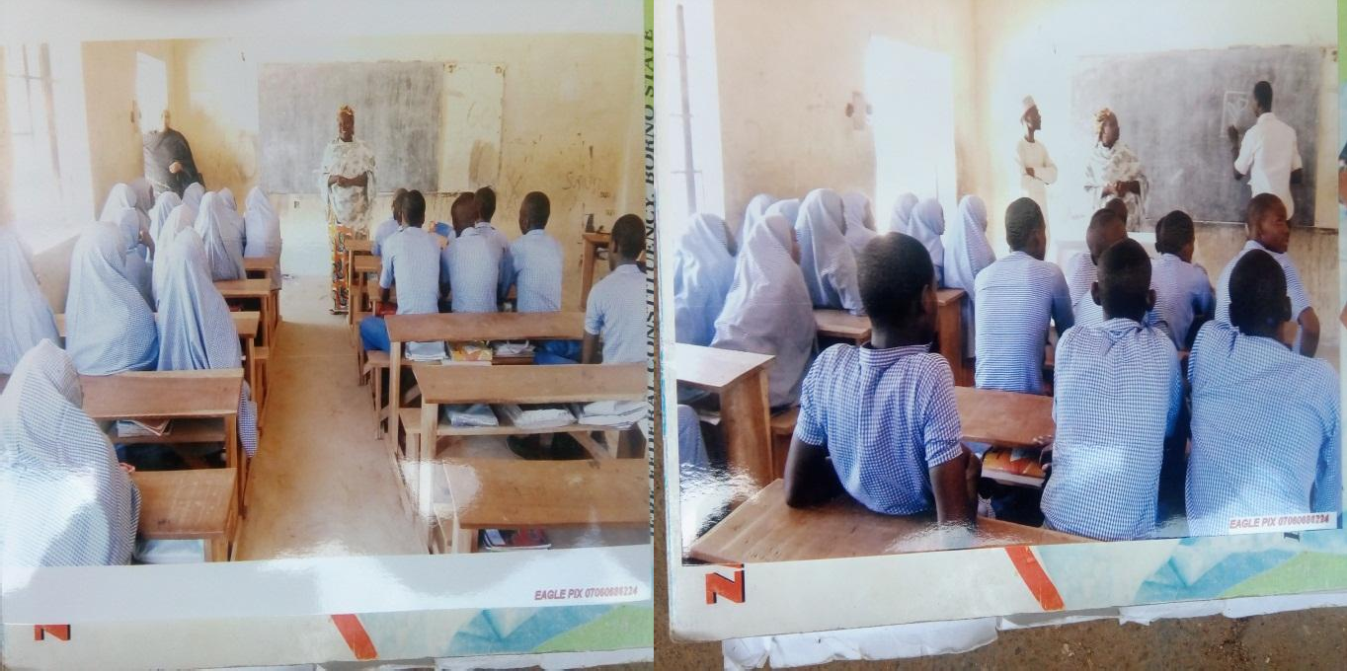

Researcher introducing herself to the students Research assistant drawing motif on the

board

Source: field work 2017 source: field work 2017

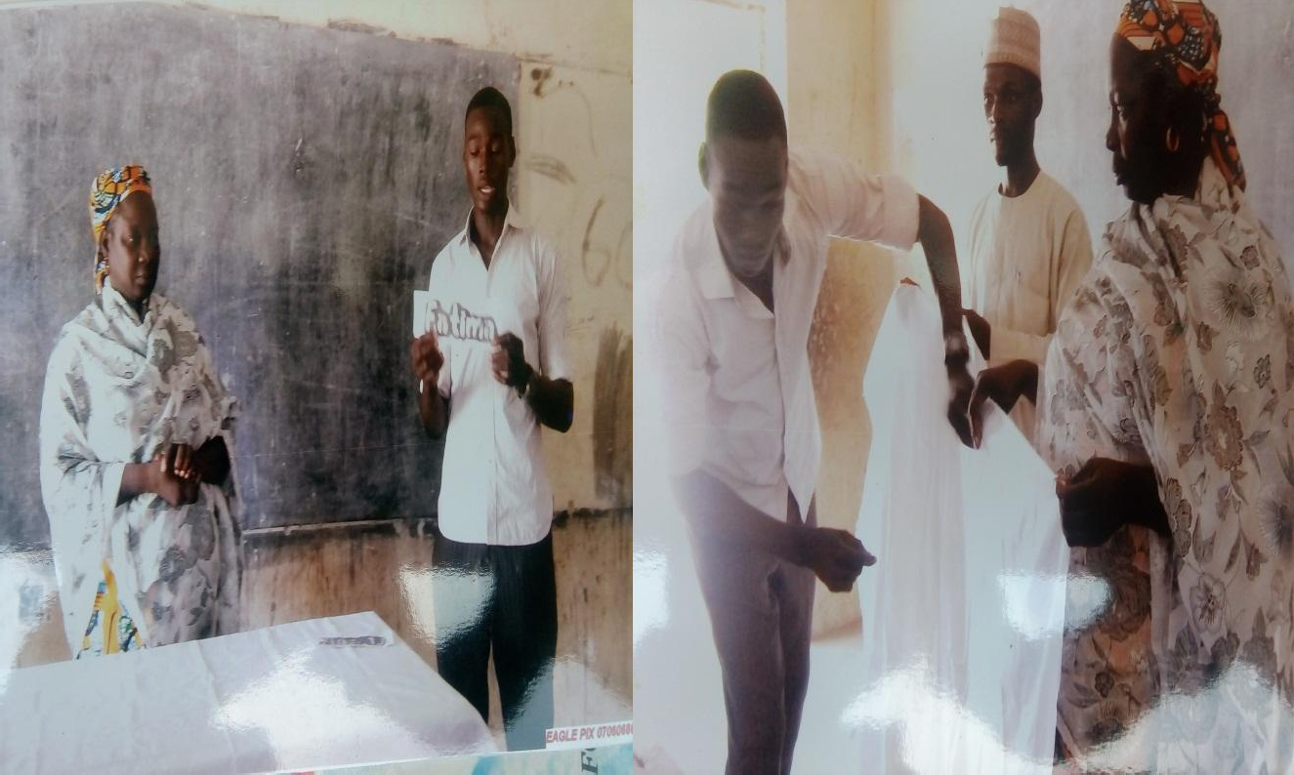Plate 3 Plate 4

Researcher and research assistant showing the motif Research assistant demonstrating how to tie the

fabric

Source: field work 2017 Source: field work 2017 Plate 5 Plate 6

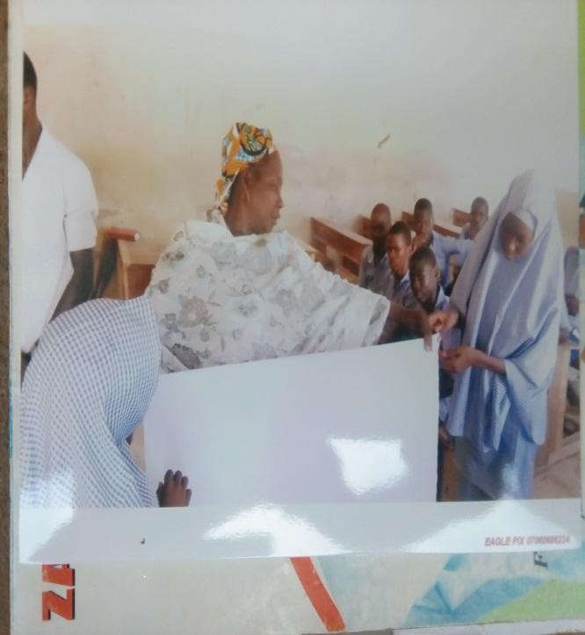 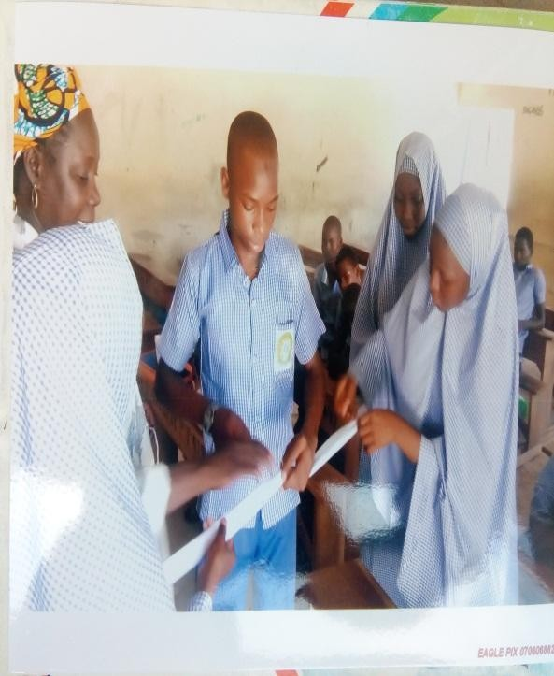

Researcher showing how to apply the motif Students stitching the fabric On the fabric Source: field work 2017

Source: field work 2017

Plate 7 Plate 8

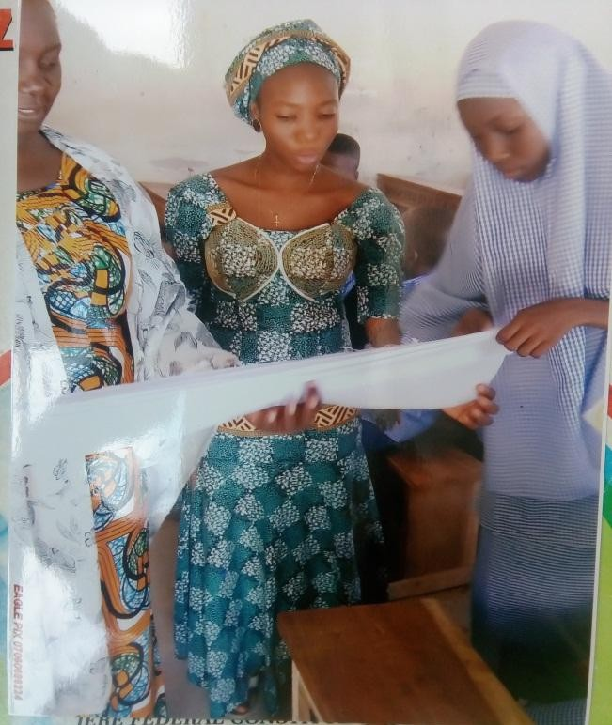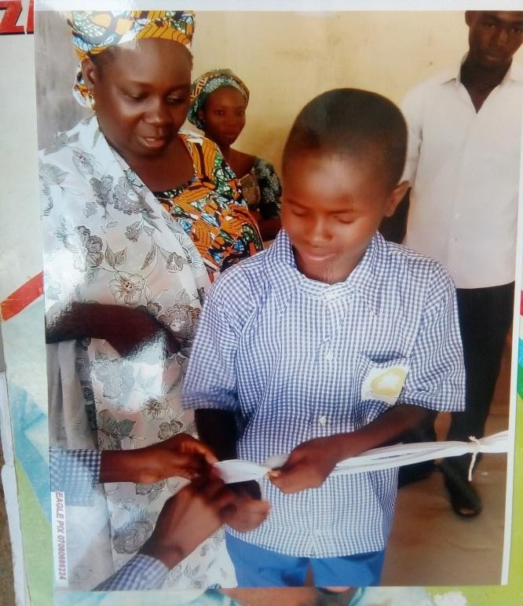

Researcher and research assistant demonstrating Students tying the pleated fabric Pleating method

Source: field work 2017 Source: field work 2017

Plate 9 Plate 10

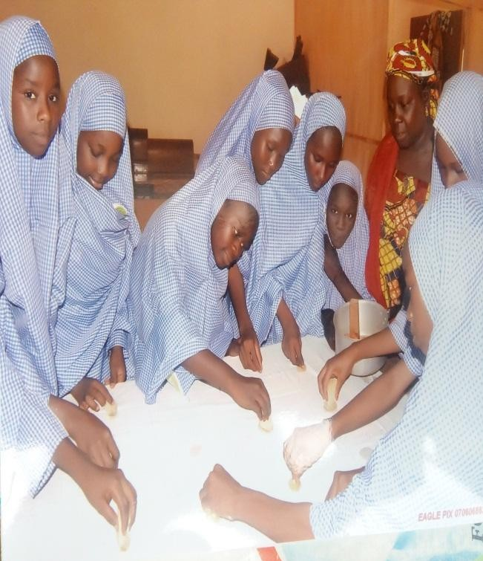 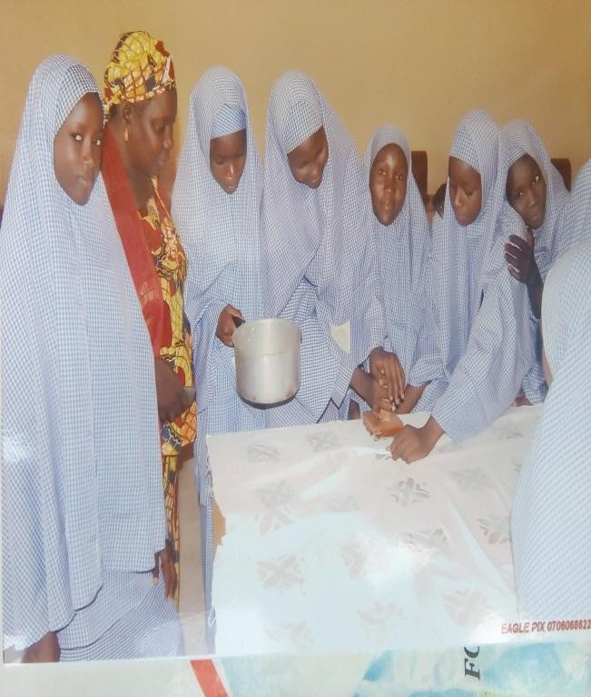

Students applying wax on fabric Students stamping the fabric

Source: field work 2017 Source: field work 2017

Plate 11 Plate 12

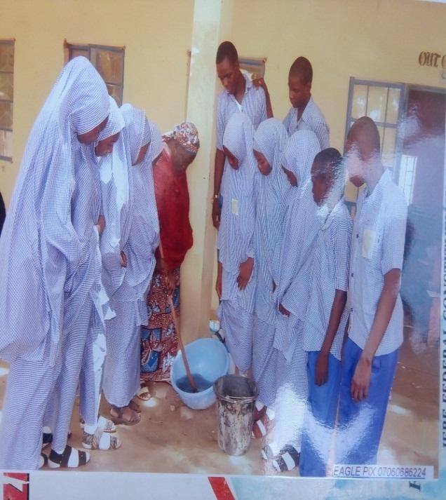 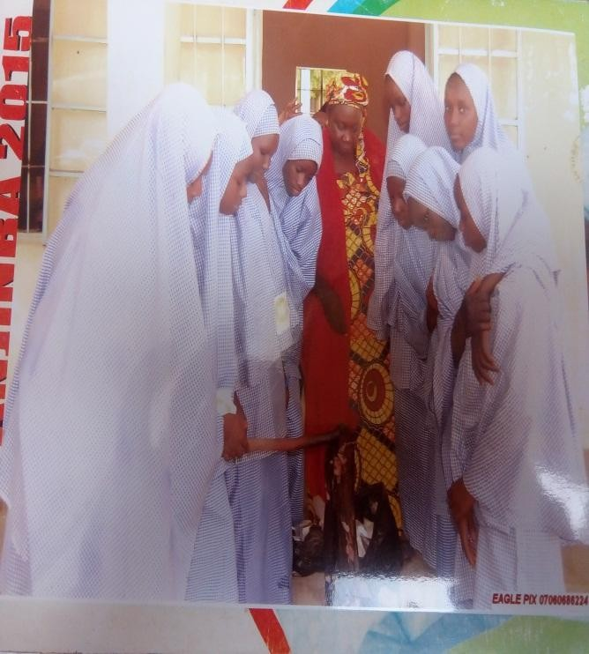

Students mixing dye Students dyeing the fabric

Source: field work 2017 Source: field work 2017

Plate 13 Plate 14

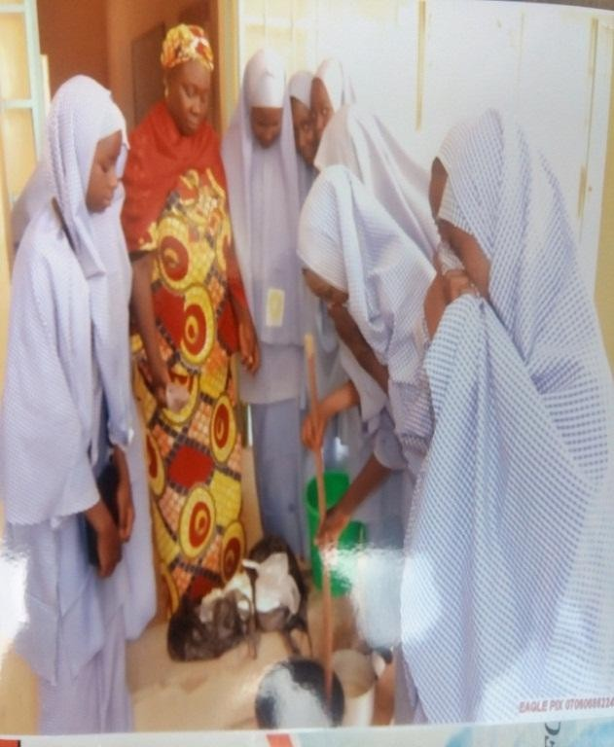 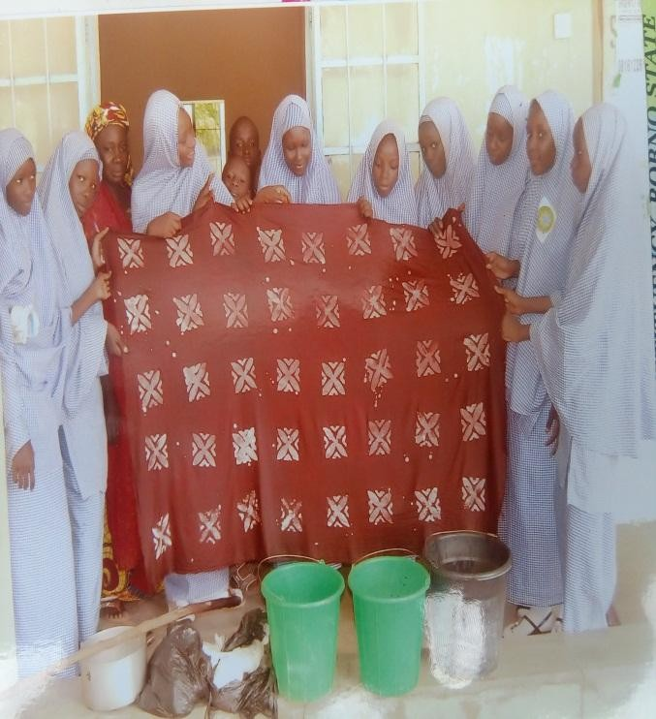

finished stamping method Students and researcher dyeing the fabric Source: field work 2017

Source: field work 2017

Plate 15 Plate 16

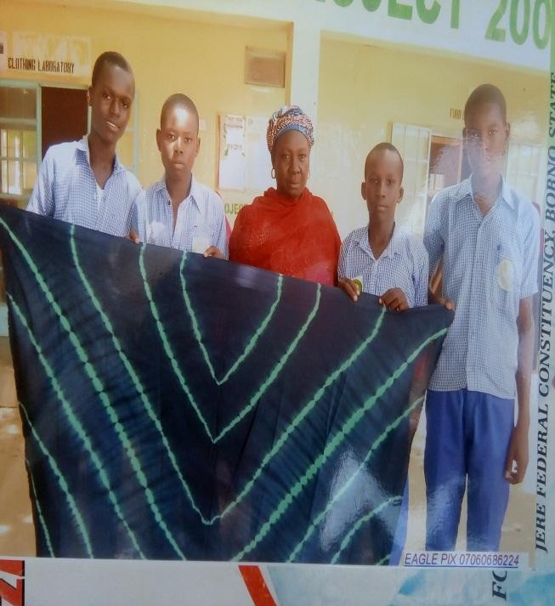 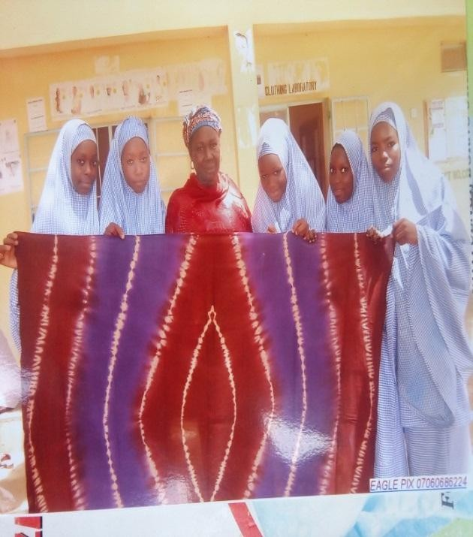

Finished pleating method Finished stitching method

Source: field work 2017 Source: field work 2017