# ASSESSMENT OF THE HYDROPOWER POTENTIAL OF GORONYO DAM IN SOKOTO STATE, NIGERIA

**BY**

**TINKE,** Ibrahim Peni

# DEPARTMENT OF WATER RESOURCES AND ENVIRONMENTAL ENGINEERING,

**AHMADU BELLO UNIVERSITY ZARIA**

MARCH, 2018

## ASSESSMENT OF THE HYDROPOWER POTENTIAL OF GORONYO DAM IN SOKOTO STATE, NIGERIA

**BY**

**TINKE** Ibrahim Peni

## P14EGWR8026

**A DISSERTATION SUBMITTED TO THE SCHOOL OF POSTGRADUATE STUDIES, AHMADU BELLO UNIVERSITY, ZARIA IN PARTIAL FULFILLMENT OF THE REQUIREMENTS FOR THE AWARD OF MASTER OF SCIENCE DEGREE IN WATER RESOURCES AND ENVIRONEMNTAL ENGINEERING**

## DEPARTMENT OF WATER RESOURCES AND ENVIRONMENTAL ENGINEERING FACULTY OF ENGINEERING

**AHMADU BELLO UNIVERSITY, ZARIA, NIGERIA**

**SUPERVISORS**: **PROF A. ISMAIL DR B. K. ADEOGUN**

**MARCH, 2018**

# DECLARATION

I declare that the work in the Dissertation HQWLWASOSEHSSGM EN³T OF HYDROPOWER

POTENTIAL OF GORONYO DAM IN SOKOTO STATE, NIGERIA´ KDV EedHoHut Qby FDUUL

me in the Department of Water Resources and Environmental Engineering. The information derived from the literature has been duly acknowledged in the text and a list of references has been provided. No part of the dissertation was previously presented for another degree or diploma at this or any other institution.

Name of Student Signature Date

# CERTIFICATION

This dissertationWLWAOSHSEGS SM³ENT OF HYDROPOWER POTENTIAL OF GORONYO

DAM IN SOKOTO STATE, NIGERIA´by IbrahimPeni TINKEhas meets theregulations governing the award of Master of Science degree in the Department ofWater Resources and Environmental Engineering, Ahmadu Bello University, Zaria, Kaduna State.

Engr. Prof. A. Ismail (Chairman, Supervisory Committee) (Signature) Date

Dr. B.K. Adeogun (Member, Supervisory Committee) (Signature) Date

|  |  |  |
| --- | --- | --- |
| Engr. Prof. A. Ismail |  |  |
| Head of Department | (Signature) | Date |

|  |  |  |
| --- | --- | --- |
| Prof. S.Z. Abubakar |  |  |
| Dean, School of Postgraduate Studies | (Signature) | Date |

# ACKNOWLEDGEMENT

With full joy, I would like to thank almighty God who gave me the strength and patience throughout the period of my project. By His love and power I was able to write, defend and finish this Dissertation degree programme.

I wish to express my profound gratitude to the PG CoordinatorProf.C.A.Okuofu, my supervisors Prof. A. Ismail and Dr. B. K. Adeogun for their assistance, advices, guidance, criticism and certification in the course of this research work.

I also like to express my profound sincere gratitude to all the lecturers of the department for their effort throughout the period of my Dissertation.

I would also wish to thank my lovely wife Aisha H.Musa for being patience to ensure that this Dissertation has come to a brighter conclusion.

I would like to thank Mr. Kure and the entire nonacademic staff of the department for their assistance.

Finally I wish to thank my children for their prayers.

# DEDICATION

I thank God for giving me the power and mental ability from the beginning to the end of this Dissertation. I dedicate this Dissertation to my parents late Tinke and late Kasuwa for bringing me up with the fear of God, discipline and hardwork. I love and miss you both.

# TABLE OF CONTENTS

7LWOH SDJH ««««««««««««««««««««««««««i

'HFODUDWLRQ ««««««««««««««««««««««««ii

««««

«««««

&HUWLILFDWLRQ «««««««««««««««««««««««iii ««««««

$FNQRZOHGJHPHQW «««««««««««««««««««««iv ««««««

Dedication «««««««««««««««««««««««««««««« v

Table of Content ««««««««««««««««««««««««««« vi

List of Tables««««««««««««««««««««««««««««« xiii

List of Figures «««««««««««««««««««««««««««« xv

List of Appendices ««««««««««««««««« ««««««««« xvi

$EEUHYLD«W«L«R«Q« «««««««««««««««««««««««« xvii

$EVWUDFW ««««««««««««««««««««««««««««xix« ««

**CHAPTER ONE INTRODUCTION**««««««««««««««««««««««««««« 1

* 1. Background of the Study Area ««««««««««««««««««« 1
  2. Location of Goronyo Dam on Rima River ««««««««««««««« 2
  3. Some Geological Details of Goronyo Dam ««««««««««««««« 3
  4. Salient Features of Goronyo dam and Major Components ««««««««« 3 1.5 Dam «««««««««««««««««««««««««««««« 7

1.5.1 Seepage through Earthen Dams ««««««««««««««««««« 7 1.5.2 Detection «««««««««««««««««««««««««««« 8 1.5.3 Control ««««««««««««««««««««««««««««« 9 1.5.4 Monitoring «««««««««««««««««««««««««««« 10

* + 1. Water Resources of Goronyo Dam «««««««««««««««««« 11
    2. Evaporation Losses over Reservoir Area «««««««««««««««« 11
    3. Minimization of Evaporation LRVVHV «««««««««««««««11«««
    4. Foundation and Embankment Drainage «««««««««««««««««12 1.5.9 Instrumentation «««««««««««««««««««««««««« 12 1.5.9.1 Seepage and Leakage «««««««««««««««««««««««« 13

1.5.9.2 Embankment Movements «««««««««««««««««««««« 13 1.5.9.3 Piezometric Pressure «««««««««««««««««««««««« 13 1.5.10 Forces on Dams «««««««««««««««««««««««««« 14

1.6 Statement of the Research Problem «««««««««««««««««« 1 4 1.7 Justification ««««««««««««««««««««««««««« 1 5 1.8 Aim and Objectives «««««««««««««««««««««««« 15

1.9 Scope and Limitations of the Study «««««««««««««««««« 16

## CHAPTER TWO

**LITERATURE REVIEW**«««««««««««««««««««««««« 1 7

2.1 Small Hydro Power«««««««««««««««««««««««««17

2.1.1 Civil Work««««««««««««««««««««««««««««

2.1.1.1 Dam «««««««««««««««««««««««««««««««

2.1.1.2 Spill Ways ««««««««««««««««««««««««««««

2.1.1.3 Energy Dissipaters««««««««««««««««««««««««« 23

2.1.1.4 Low Level Outlets««««««««««««««««««««««««« 23

2.1.1.5 Power Intakes««««««««««««««««««««««««««« 23

2.1.1.6 Gate «««««««««««««««««««««««««««««««

2.1.1.7 Penstock««««««««««««««««««««««««««««« 24

2.1.1.8 Wicket Gates ««««««««««««««««««««««««««« 24

2.1.1.9 Draft Tube«««««««««««««««««««««««««««« 24

2.1.1.10 Shift Ring «««««««««««««««««««««««««««« 25

2.1.1.11 Tailrace««««««««««««««««««««««««««««« 25

2.1.1.12 Head«««««««««««««««««««««««««««««« 25

2.1.2 Electro mechanical equipment «««««««««««««««««««« 2.2 Micro Hydropower «««««««««««««««««««««««« 26

* + 1. Conversion of Hydropower to Electricity «««««««««««««««« 27
    2. Micro Hydropower in the Nineties «««««««««««««««««« 2 7
    3. Micro Hydro as Catalyst to Modern Enterprises ««««««««««««« 29 2.3 Eroded Sediment ««««««««««««««««««««««««« 3 2

2.3.1 Soil Erosion and its Impacts ««««««««««««««««««««« 32 2.3.2 Sediment Properties «««««««««««««««««««««««« 36 2.3.3 Particle Size and Shape ««««««««««««««««««««««« 37

2.3.4 Bulk Properties of Sediment ««««««««««««««««««««« 37 2.3.5 Settling Velocity ««««««««««««««««««««««««« 3 8

2.3.6 Sediment Sources and Sediment Yield ««««««««««««««««« 38 2.3.7 Sediment 7UDQVS«R«U«W« ««««««««««««««««««« 39

2.3.8 Reservoir Sedimentation «««««««««««««««««««««« 39

2.3.9 Reservoir Trap Efficiency «««««««««««««««««««««« 40

2.3.10 Sedimentation Measurement Techniques «««««««««««««««« 41 2.4 Dams of West Africa «««««««««««««««««««««««« 41

2.5 Available Flow for Hydropower Generation ««««««««««««««« 44 2.6 Water Budget ««««««««««««««««««««««««««« 44 2.7 Water Turbines «««««««« . .. 47

2.7.1 Impulse turbines«««««««««««««««««««««««««« 47

2.7.2 Reaction Turbines ««««««««««««««««««««««««« 47

2.8 Classification of Head ««««««««««««««««««««««« 4 8

2.9 Classification of Hydropower Schemes DQG VXLWDELOLW\ ««48««««««««

## CHAPTER THREE

**MATERIALS AND METHODS**«««««««««««««««««««««« 50

3.1 Study Area «««««««««««««««««««««««««««« 50

* + 1. Description of the Study Area «««««««««««««««««««« 5 0
    2. Uncompleted and Completed Structures of Goronyo Dam ««««««««« 52
    3. Upstream and Downstream Face of Goronyo Dam «««««««««««« 53
  1. Collection of Hydrological and other essential Data«««««««««««« 54
  2. Determination of Geological Condition of Goronyo Dam ««««««««« 5 4
  3. Determination of the Hydropower Potential of Goronyo Dam ««««««««« 5 5
     1. Available Flow for Hydropower Generation ««««««««««««««« 56
  4. Estimation of Hydraulic Power and Electrical Power « 56

3.5.1 Sequent - Peak Method ««««««««««««««««««««««« 57

* + 1. Monthly Evaporation of Goronyo Dam «««««««««««««««« 58
       1. Converted Evaporation calculation «««««««««««««««««« 5 8 3.5.3 Water Supply Demand ««««««««««««««««««««««« 58 3.5.4 Water for Irrigation «««««««««««««««««««««««« 5 9

3.5.5 Monthly Direct Rainfall «««««««««««««««««««««««59

3.6 Goronyo Dam Water Budget ««««««««««««««««««««« 60

3.6.1 Evapotranspiration ««««««««««««««««««««««««« 60

3.6.2 Precipitation ««««««««««««««««««««««««««« 6 0

* 1. Goronyo Dam sedimentation ««««««««««««««««««««« 60
     1. Determination of Goronyo Dam Sediment Volume ««««««««««« 60
     2. Bulk Density Measurements««««««««««««««««««« 61
     3. Calculation of Sediment Mass and Average Sedimentation Rate «««« 62
     4. Determination of Reservoir Sediment Trap Efficiency «««««««« 63
     5. Determination of Sediment Yield ««««««««««««««««« 64
     6. Goronyo Reservoir Stage Capacity Curve «««««««««««««««« 65

## CHAPTER FOUR

**RESULTS AND DICUSSIONS** «««««««««««««««««««««« 67

* 1. Geological Condition of Goronyo Dam «««««««««««««««« 67
     1. Areas where Seepage occur at Goronyo Dam «««««««««««««« 68
     2. Mean Monthly Seepage of Goronyo Dam from 1986 - 2015«««««««« 70 4.2 Goronyo Dam Water Budget ««««««««««««««««««««« 72 4.3 Rainfall Data««««««««««««««««««««««««««« 72

4.3.1 Results extracted from HEC- HMS Software «««««««««««««« 7 2

4.4 Monthly Evaporation of Goronyo Dam «««««««««««««««« 76

4.4.1 Direct Method «««««««««««««««««««««««««« 7 6

4.4.2 Converted Evaporation calculation «««««««««««««««««« 7 7 4.5 Water Supply Demand ««««««««««««««««««««««« 79

4.6 Water for Irrigation «««««««««««««««««««««««« 8 1

4.7 Monthly Direct Rainfall «««««««««««««««««««««««82

4.8 Mean Monthly Runoff from 1986-2015 «««««««««««««««« 8 4

4.9 Mean monthly Reservoir Inflow««««««««««««««««««« 85

4.10 Goronyo Dam Sedimentation ««««««««««««««««« .. . 86

4. 10.1 Bulk Density ««««««««««««««««««««««««««« 8 6

4. 10.2 Sediment Mass and Average Sedimentation Rate ««««««««««««« 88

4. 10.3 Trap Efficiency «««««««««««««««««««««««««« 9 0

4. 10.4 Sediment Yield «««««««««««««««««««««««««« 9 1

* + 1. Specific Sediment Yield of Goronyo ««««««««««««««««««92
    2. Goronyo Reservoir Stage Capacity Curve «««««««««««««««« 92
    3. Goronyo Reservoir Sediment Volume ««««««««««««««««« 93
  1. Analytical Method for computing Reservoir Required Storage ««««««« 9 4
     1. Explanation of Table 4.19 computation «««««««««««««««««94
     2. Deduction from Analytical Determined Safe Yield or Required Storage «««« 95

## CHAPTER FIVE

**CONCLUSION AND RECOMMENDATIONS**««««««««««««««« 97

5.1 Conclusion ««««««««««««««««««««««««««« 97

5.2 RecommendatioQ «««««««««««««««««««««««« 98

5HIHUHQFHV «««««««««««««««««««««««««««««« 99

$SSHQG«L«F«H«V« «««««««««««««««««««««««« 110

# LIST OF TABLES

Table 1.1 (QHUJ\ 6HFWRU 'LVWULEXWLRQV LQ 2

Table 1.2 Some Geographical Details of Goronyo Dam «««««««««« 3 Table 1.3 Features of the Reservoir«««««««««« « « ««««««4

Table 1.4. Features of the Main dam «««««««««««««««««« 4

Table 1.5. Features of the Secondary Dam «««««««««««««««« 5

Table 1.6. Features of the Saddle Dyke ««««««««««««««««« 5

Table 1.7. Intake and Outlet works ««««««««««««««««««« 6 Table 1.8. Hydraulic and Electromechanical Equipments «««««««««« 6 Table 1.9. Additional Intake Gate ««««««««««««««««««« 7

1LJHULD

Table 2.1 Classification of HydropowHU EDVHG RQ FDSDFLW1\7 «««««««

Table 2.2 Classification of HydropRZHU EDVHG RQ +HDG ««17««««««««

Table 2.3 Some selected large DamV RI :HVW $IULFD «««4«3 «««««««

|  |  |  |
| --- | --- | --- |
| Table 2.4. | Classification of hydropower Scheme and suitability ««««««« | 49 |
| Table 4.1. | Mean Monthly Seepage of Goronyo Dam ««««««««««« | 70 |
| Table 4.2. | Mean Monthly Pan Evaporation of Goronyo Dam from 1986 - 2015« | 77 |
| Table 4.3. | Mean Monthly Converted Evaporation from 1986 -2015 ««««« | 78 |
| Table 4.4. | Monthly Water Supply Demand for a Year ««««««««««« | 80 |
| Table 4.5. | Monthly Water Demand for Irrigation from Goronyo Reservoir ««« | 81 |
| Table 4.6. | Mean Monthly Direct Rainfall on Goronyo Dam Reservoir from |  |
|  | 1986 - 2015 «««««««««««««««««««««««« | 83 |
| Table 4.7. | Mean Monthly Runoff from 1986-2015 ««««««««««««« | 84 |

Table 4.8. Mean Monthly Reservoir Inflow from 1986- 2015 «««««««« 85

Table 4.9. Bulk Densities of Goronyo Reservoir Sediments with Sample Location and Depth «««««««««««««««««««««««««« 87

Table 4.10. Parameters used to calculate the trap efficiency of Goronyo Reservoir« 90 Table 4.11. Parameters used to calculate the Sediment Yield of GoronyoReservoir... 91 Table 4.12. Determination of Safe Yield (Required Useful Storage) from Goronyo

Reservoir ««««««««««««««««««««««««« 9 4

## LIST OF FIGURES

Figure 1.1. Location of Goronyo Dam on Rima River «««««««««««« 2 Figure 2.1: Silver Lake Water Budget «««««««««««««««««« 46

Figure 2.2: Boulder Water Budget ««««««««««««««««««« 46

Figure 3.1. Study Area «««««««««««««««««««««««« 50

Figure 3.2. Uncompleted structure of Goronyo Dam «««««««««««« 52 Figure 3.3. Completed Structure of Goronyo Dam ««««««««««««« 53 Figure 3.4. Upstream face of Goronyo Dam ««««««««««««««« 5 3 Figure 3.5. Downstream face of Goronyo Dam «««««««««««««« 54 Figure 4.1. First seepage area of Goronyo Dam «««««««««««««« 68 Figure 4.2. Second Seepage Area of Goronyo Dam ««««««««««««« 69 Figure 4.3 Graphs of mean Precipitation and mean Potential Evapotranspiration

versus Time of Goronyo Dam««««««««««««««««« 71 Figure 4.4. Cumulative Precipitation for the entire duration of rainfall extracted

from HEC-HMS ««««««««««««««««««««« 72

Figure 4.5. Summary Result extracted from HEC-HMS««««««««««« 73 Figure 4.6. Daily discharge from 1986-2015 ««««««««««««««« 73 Figure 4.7. Hydrograph of flow/depth against time extracted from HEC-HMS«« 74 Figure 4.8. Average Monthly Discharge for the month of June «««««««« 74 Figure 4.9. Average Yearly Discharge «««««««««««««««««« 75

Figure 4.10. Graph of Various Discharges ««««««««««««««««« 75

# LIST OF APPENDICES

Appendix A The average monthly discharge of Goronyo Dam from 1986 - ««11«0 Appendix B The average yearly discharge of Goronyo Dam from 1986 - ««1«14

Appendix C The peak Discharge of the Dam from 1986 - ««««««« 1 15

Appendix D The max, mean, peak discharge DQG SHDN SRZHU RI 11*6 RURQ\R

Appendix E Is a Data Table of with Mean Monthly Precipitation and Potential

Evapotranspiration for Goronyo Dam Water Budget from 1986-2015« . 11 7

Appendix F Is the Monthly and total compares Precipitation and Potential (YDSRWUDQVSLUDWLRQ IRU 6LOYHU /DNH DQG

# ABBREVIATIONS

|  |  |
| --- | --- |
| AC | - |
| BASIN | - |
| DC | - |
| ECN | - |
| EDE | - |
| FAO | - |
| FDC | - |
| FEMA | - |
| G | - |
| GPS | - |
| GW | - |
| H | - |
| ha-m | - |
| HEC - HMS | - |
| HT | - |
| ICOLD | - |
| IPP | - |
| kW | - |
| LT | - |
| MW | - |
| NESAT | - |
| NESCO | - |

Alternative Current

Boulder Area Sustainability Information Network Direct Current

Energy Commission of Nigeria Engineers at Electricity De France Food and Agriculture Organization Flow Duration Curve

Federal Emergency Management Agency Acceleration due Gravity

Global Positioning System Giga Watt

Head

hectare meters

(Hydrological Engineering Centre - Hydrologic Modeling System) High Tension

International Commission on Large Dams Independent Power Producers

Kilo Watt Low Tension

Mega Watt

Nigerian Environmental Study / Action Team Nigerian Electricity Supply Company

P - Power

PHCN - Power Holding Company of Nigeria Q - Flow rate (Discharge)

SHP - Small Hydropower

SMEs - Small and Medium Enterprises

SRRBRDA - Sokoto Rima River Basin and Rural Development Authority V - Volt

# ABSTRACT

Energy is one commodity on which provision of goods and services depend. Its availability and consumption rate is an economic index to measure the development of any community. Nigeria

KDV OLPLWDWLRQ WR SRZHU VXSSO\ IURP WKH 1DWLR

economic and social development. This necessitates the need for other sources of viable alternative to which hydropower schemes is the best and sustainable. Goronyo Dam was built across River Rima in 1984 and was commissioned in 1992 in Sokoto State of Nigeria. It has a storage capacity 942,000000 m3and a catchment of 21,445 km2. The aim of this research to investigate and assess the hydropower potential of Goronyo Dam using Rainfall Data from 1986

- 2015.The research was carried out using HEC - HMS (Hydrological Engineering Centre - Hydrologic Modeling System) Software designed U.S Army Corps of Engineers, Sequent - Method or Analytical Method. The HEC-HMS was used for analyzing rainfall Data. The parameters (evaporation, direct rainfall, inflow etc.) needed for computing the required storage capacity were calculated separately using appropriate equations. The sediment volume of the Reservoir was also determined. This study revealed that the volume of sediments in the Reservoir was 26,179,302m3and has lost storage capacity at about its dead storage (21,500,000m3) with an excess of 4,679,302m3.The discharge required for estimating hydropower potential of Goronyo Reservoir was computed as 268m3/s.The head of the Reservoir was 9.5 m.It was also found that the Reservoir isexperiencing seepage mostly during periods of high flow at some areas with annual discharge of146, 684.81L/yr. The water collected from the relief wells was clean indicating the absence of piping through the dam embankment.

The peak discharge (18624m3/s) of the dam was used for calculating the peak power as 1735.667 MW for hydro power and 1388.531MW for hydroelectric power while the discharge (268m3/s)

gotten from water balance analysis was used for calculating the theoretical power and actual power of the Dam. The theoretical power of the dam was calculated as 25MW while the actual power was calculated as 20MW. With generation capacity of 20 MW, reveals that Goronyo Reservoir has the hydropower potential for hydroelectric power generation and by classification of hydropower Goronyo dam belong to the medium hydropower scheme. In order to maintain the design live span of the Dam, there is need for rehabilitation and dredging.

# CHAPTER ONE INTRODUCTION

## Background of the Study

The idea of the study of hydropower potential of Goronyo dam is to seehow a power plant can be installed using the dam water to produce electricity for areas where national power supply is not sufficient or none at all in the state.

The name hydroelectricity originates IURP D *UHHN ZRUG NQRZQ DV ³

Hydroelectric power was initiated in India in 1897 with a run-off river unit near Darjeeling (Kumar, 2004).

Hydroelectric power comes from the natural flow of water. The energy is produced by the fall of water turning the blades of a turbine. The turbine is connected to a generator that converts the energy into electricity and this is only possible when a dam is built to trap water, usually in a valley where there is an existing lake. The amount of electricity a system can produce depends

RQ WKH TXDQWLW\ RI ZDWHU SDVVLQJ WKURXJK D W

(head). The greater the flow and the head, the more electricity produced. The structure that houses the turbine and generator is called the power house (Kumar, 2004). Hydropower is one of the three principal sources of energy used to generate electricity. The other two being fossil fuels and nuclear fuels. Hydroelectricity has certain advantages over other sources. It is pollution free during operation. It has longer live spans compared to those of coal and nuclear plants. The dams that are used in the power plants help prevent flooding and supply a regulated flow of irrigation water and water supply to the areas below the dam.

The exploitable hydropower potential in Nigeria is conservatively estimated to be about 10,000 MW (Francis, 2004). Only about 19% is currently been trapped or developed. The hydropower potential in Nigeria accounts for about 29% of the total electricity supply (Sambo, 2005).

The energy sector distribution in Nigeria is as shown in Table 1.1

|  |  |
| --- | --- |
| **Table 1.1.** | **Energy Sector Distribution in Nigeria** |
| **Source** | **Percentage Distribution** |
| Petroleum | 60% |
| Natural gas | 9% |
| Hydropower | 29% |
| Coal | 2% |
| Total | 100% |

Source: Energy Information Administration US department of energy 12 July, 2003

## Location of Goronyo Dam on Rima River

The location of Goronyo Dam on Rima River is shown in Figure 1.1

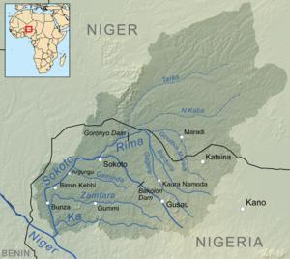

Figure 1.1. Location of Goronyo Dam on Rima River Source: SRRBRDA, 1991

## Some Geographical Details of Goronyo Dam

Some of the Geographical details of Goronyo Dam are shown in Table 1.2

**Table 1.2. Some Geographical Details of Goronyo Dam Location** Sokoto State, Nigeria

## Coordinates

**Latitude**  ƍ Ǝ1

**Longitude**  ƍ Ǝ(

**Opening date** 1992

## Dam and Spillways

Impounds Rima River

Height 21m

Length 12.5km

## Reservoir

Total capacity 976 million m3

Source: SRRBRDA, 1991

## Salient Features of Goronyo dam and Major Components

The salient features of the reservoir, main dam, secondary dam, saddle dyke are as shown in Table 1.3.to Table 1.4 respectively.

## Table 1.3. Features of the Reservoir

Parameter Value

Maximum storage level 288 m

Minimum useful storage level 279.50m

Gross Storage capacity 942 x 106m3

Dead storage 21.50 x 106 m3

Lake area 200 ݉݇2

Tributaries River Gagare, River Bunsuru and Gada/Maradi River

Catchment Area 22,445 ݉݇2

## Table 1.4. Features of the Main dam

Parameter Value

Length 5,285 m

Crest elevation 294.00m

Crest width 8.50 m

Maximum Height above ground 20.00 m

Total fill 4.45×106 m3

## Table 1.5. Features of the Secondary Dam

|  |  |
| --- | --- |
| Parameter | Value |
| Length | 1,792 m |
| Crest elevation | 294.00m |
| Crest width | 8.50 m |
| Maximum Height above ground | 12.00m |
| Total fill | 0.5×106 m3 |

**Table 1.6. Features of the Saddle Dyke**

|  |  |
| --- | --- |
| Parameter | Value |
| Length | 5,385 m |
| Safety spillway length | 2,000 m |
| Crest elevation (Non-over flow section) | 290.50 m |
| Overflow section | 9.00 m |
| Maximum Height above ground | 9.00 m |
| Total fill | 0.35 ×106 m3 |

The description of intake and outlet works is as shown in Table 1.7 while Hydraulic and

Electromechanical EquipmenW¶V SDUDPHWHUV DU. H DV VKRZQ LQ 7D

## Table 1.7. Intake and Outlet works

|  |  |
| --- | --- |
| Parameter | Value |
| Spillway sill level | 279.00 m |
| Spillway capacity | 1,540 m3/s |
| Irrigation intakes sill level | 279.00 m |
| Low outlet sill level | 277.00 m |
| Irrigation intake and Low level outlet capacity | 157.00 m3/s |
| Total Excavation | 0.99 ×106 m3 |
| Total volume of concrete | 43,450 m3 |
| Old Relief Well | 140 no |
| New Relief Well | 134 no. |
| Stand pipe Piezometers | 57 no. |

**Table 1.8. Hydraulic and Electromechanical Equipments**

|  |  |  |
| --- | --- | --- |
| Parameter | Dimension | Quantity |
| Radial Gate | 14m x 10.5m high | 2 |
| Spillway Stop logs | 14m x 10.5m high | 6 |
| Intake Gates | 3m x 1.5m high | 2 |
| intake stop log | 3m x 3m: | 1 |
| Low outlet Gate | 4 x 2.55m high | 1 |
| Low outlet Stop log | 4m x 4m | 1 |

Additional intake gate parameter is as shown in Table 1.9.

## Table 1.9. Additional Intake Gate

Parameter Description Quantity

For Goronyo Polder 2m x 2.5m high 1

Gantry Crane with raking machine 16 tones capacity 1

Diesel Generating sets 50kVA 2

Oleo dynamic and Electrical Control System

Set 1

## Dam

A dam is a hydraulic structure constructed across a waterway to increase head for the purpose of power generation, water supply, irrigation, etc.

## Seepage through Earthen Dams

Wet areas downstream from dams are not usually natural springs, but seepage through or under the dam. Even if the natural spring exists they should be treated with suspicion and carefully observed. Flows from groundwater springs in existence prior to the reservoir would probably increase due to the pressure by the pool of water behind the dam.

All dams have some seepage as the impounded water seeks paths of least resistance through the dam and its foundation. Seepage becomes a concern if it is carrying material with it, and should be controlled to prevent erosion of the embankment, or foundation, or damage to concrete structure.

## Detection

Seepage can emerge anywhere on the downstream face, beyond the toe, or on the downstream abutments at elevations below normal pool. Seepage may vary in appearance from a soft wet area to a flowing spring. It may show up first as an area where the vegetation is lush and darker green. Cattails, reeds, mosses and other marsh vegetation often become established in a seepage area. Another indication of seepage is the presence of rust-colored iron bacteria. Due to their nature, the bacteria are found more often where water is discharging from the ground than in surface water. Seepage can make inspection and maintenance difficult. It can also saturate and weaken portions of the embankment and foundation, making the embankment susceptible to earth slides.

If the seepage forces are large enough, soil will be eroded from the foundation and be deposited in the shape of a cone around the outlet. If these boils appear, professional advice should be sought immediately. A seepage flow which is muddy and carries sediment (soil particles) is evidence of piping, and is a serious condition that if left untreated can cause failure of the dam.

Piping can most often occur along a spillway or other conduit, through the embankment, and these areas should be closely inspected. Sink holes may develop on the surface of the embankment as internal erosion takes place. A whirlpool in the lake surface may follow and then likely a rapid and complete failure of the dam. Emergency procedures, including downstream evacuation should be implemented immediately if any of these conditions are noted.

Seepage can also develop behind or beneath concrete structure such as chute spillways or headwalls. If a concrete structure does not have a means such as weep holes or relief drains to relieve the water pressure, the concrete structure may heave, rotate or crack. The effects of the freezing and thawing can amplify these problems. It should be noted that the water pressure

behind or beneath structures may also be due to infiltration of surface water or spillway discharge, but should still be addressed.

A continuous or sudden drop in the normal lake level is another indication that seepage is occurring. In this case, one or more locations of flowing water are usually noted downstream from the dam. This condition, in itself, may not be a serious dam safety problem, but will require frequent and close monitoring and professional assistance.

## Control

The need for seepage control will depend on the quantity, content and location of the seepage. Reducing the quantity of seepage that occurs after construction is difficult and expensive. It is not usually attempted unless the seepage has lowered the pool level or is endangering the dam or appurtenant structures. Typical methods used to control the quantity of seepage are grouting or installation of an upstream blanket. Of these methods, grouting is probably the least effective and is most applicable to leakage zones in bedrock, abutments and foundations. These methods must be designed and constructed under the supervision of a professional engineer experienced with dams.

Controlling the content of the seepage or preventing seepage from removing soil particles is extremely important. Modern design practice incorporates this control into the dam design through the use of cutoffs, internal filters and adequate drainage provisions. Control at points of seepage exit can be accomplished after construction by installation of toe drain, relief wells or inverted fitters.

Weep holes and relief drains can be installed to relieve water pressure or drain seepage from behind or beneath concrete structures. These systems must be designed to prevent migration of soil particles but still allow the seepage to drain freely. The owner must retain a professional

engineer to design toe drains, relief wells, inverted filters, weep holes, or relief holes and regular monitoring of these features is critical.

## Monitoring

Regular monitoring is essential to detect seepage and prevent dam failure. Knowledge of the

GDP¶V KLVWRU\ LV LPSRUWDQW WR stGeaHdyWorHchFanWgi ngZKHWKHU

state. It is important to keep written records of points of seepage exit, quantity and content of flow, size of wet areas, and type of vegetation for later comparison. Photographs provide invaluable records of seepage.

All records should be kept with the inspection and maintenance plan for the dam. Every inspector should always look for increase in flow and evidence of flow carrying soil particles, which would indicate that a more serious problem is developing.

Instrumentation can also be used to monitor seepage. V-notch weirs can be used to measure flow rates easily and inexpensively, and Piezometers may be used to determine the saturation level (phreatic surface) within the embankment.

Regular surveillance and maintenance of the internal embankment and foundation drainage outlets is also required. The rate and content of flow from each pipe outlet for toe drains, relief wells, weep holes and relief drains should be monitored and documented regularly. Normal maintenance consists of removing all destructions from the pipe to allow for free drainage of water from the pipe. Typical obstructions include debris, gravel sediment, mineral deposits, and calcification of concrete and rodent nests. Water should not be permitted to submerge the pipe outlets for extended period of time. This will inhibit inspection and maintenance of the drains and may cause them to clog. Rodent guards are readily available and should be installed where needed.

## Water Resources of Goronyo Dam

To decide on the hydropower potential of the dam, it is of paramount important to begin with an evaluation of the available water resources of the rivers.

The energy potential of the scheme is directly proportional to the flow and head. To fairly select

the most appropriate hydUDXOLF HTXLSPHQW DQG HVWLPDWH WKH analysis must take into consideration the following:

* + - 1. The water to meet the primary responsibility (Mandate) of the dam.
      2. The evaporation losses over the reservoir area.
      3. The reservoir sediments which may have reduced the storage.
      4. The direct rainfall on the reservoir and
      5. The inflow into the reservoir.

## Evaporation Losses over Reservoir Area

Considerable quantity of stored water in a reservoir is lost due to evaporation, seepage and leakage. Among these, the most active is evaporation.

The main factors which determine its rate include net radiation, water availability, wind velocity, atmospheric temperature and flexibility of land surface (Fetter, 2007). Free water evaporation is measured by using shallow pans, called class A Pans. However, evaporation pan data cannot be directly applied to free water surfaces like reservoir because of physical and climatologically factors (Subramanya, 2002).

## Minimization of Evaporation Losses:

The rate of evaporation is dependent on the vapour pressure at the water surface and air above, air and water temperatures, wind speed, atmospheric pressure, quality of water, and size of the water body. Evaporation losses can be minimized by constructing deep reservoirs, growing tall

trees on the windward side of the reservoir, plantation in area adjoining the reservoir, removing weeds and water plants from the reservoir periphery and surface, releasing warm water and spraying chemicals or fatty acids over the water surface.

## Foundation and Embankment Drainage

Soil allows water to seep through at different intensities. Therefore, seepage control is very important in earth embankment dams design.

Filter and drainable systems must have adequate capacity but still control the movement of fine soil grain particles (piping) through the dam embankment which could lead to the dam failure.

Seepage from the reservoir water through the embankment depend on: (1) Reservoir Level, (2) Degree of permeability of the embankment materials in both horizontal and vertical directions,

1. The amount of the remaining pore water pressures caused by compressive forces during construction, and (4) The distance over which the seepage travels. The upper surface of the seepage line is called the phreatic line.

Drainages are provided in dam embankment and foundations for the following reasons:

* 1. To control pressure built-up by allowing free drainable of seepage flow.
  2. To prevent piping by controlling migration of soil particles under seepage flow.

## Instrumentation

Instrumentation refers to the provision of continuous surveillance of the dam structure often associated with large high hazard dam and also for dams with unusual design features. Instrumentation involves the method and equipment used to make physical measurement of dams. Visual inspections are aided by monitoring instruments that measure seepage and leakage through and around the embankment, the embankment movement and foundation, and water

levels and pressure within the embankments and foundation. In general, there are three types of instrumentation applied to dams among which are:

* + - 1. Seepage monitoring instrument
      2. Embankment movements
      3. Water pressure instruments (Piezometer)

## Seepage and Leakage

Seepage is the movement of water through a medium per unit time. All dams have degree of seepage and any seepage through a dam need to be monitored and recorded. For visible flows, the quantity of water needs to be measured by channeling the seepage and by installing pipes, weir or flumes. Record of discharge rate, temperature of seepage, and reservoir elevation should be maintained. Wet spots, its location, size and condition should be recorded.

## Embankment Movements

$IWHU GDP FRQVWUXFWLRQ li kelDy d ueOtRo fWou ndRatiIon seWttleKmHen t uGndDer P¶V PR

the dam embankment weight. Filling of the dam reservoir may also result in the movement of the dam embankment. Movements anchored in the dam embankment and abutments are used to monitor the dam movement.

## Piezometric Pressure

Piezometers are instruments used to measure the pore pressures in embankments and foundations. Piezometers could be hydraulic (open system) that measures water pressure directly by measuring the elevation of water standing in pipe or vertical tube. The second type is the electronic piezometer (closed system) in which water pressure is measure electronically. The third type called the gas pressure unit diaphragm system in which water pressure is measured by balancing the pressure gas in a calibrated unit.

## Forces on Dams

The forces on dam include the following:

* + - 1. Weight of the dam
      2. Water pressure
      3. Uplift pressure
      4. Wave pressure
      5. Silt pressure
      6. Ice pressure
      7. Wind pressure
      8. Earthquake forces

## Statement of theResearch Problem

The motivation of this Dissertation came up due to the epileptic nature of power supply in Nigeria which leads to the collapse of many companies in Nigeria. This seriously constitute a bottle neck to development in Nigeria. Nigeria has hydropower potential in abundance but harnessing it becomes the major problem. The exploitable hydropower potential in Nigeria is conservatively estimated to be about 10,000 MW (Fancis, 2004).National Electric Power Supply is either not sufficient in some areas or nonexistent at all especially in urban, semi urban and rural areas where medium and small scale businesses were mostly affected. In order to solve the problem or reduce it, Hydropower Stations can be designed and constructed in the areas where we have hydropower potential which Goronyo dam is among.

Another motivation is numerous floods that occurred in SokotoState. Among which are the September 2010 from Goronyo Dam destroyed farmlands and crops, caused loss of human lives, submerged villages and damage many properties including roads, bridges and houses

(Abdulrahim, 2012).It also caused temporary homelessness, social dislocation and severe economic hardship to many local communities in Sokoto and Kebbi States (Abdulrahim, 2012).The flood was attributed to high precipitation, climate change and damage of Goronyo 'DP¶V VSLOkaOrimZ,D20\12 ). $EGXO

Also August 2015 floodthat leads to widespread in 27 villages in Wurno and September 2015 leaving 11 people death and 86,710 hectares of land destroyed. Considering the environmental impact of these floods mentioned above, a hydropower plant is of paramount important in preventing the flood.

## Justification

Hydropower is a very important infrastructure in the overall development of a nation. Hydropower is a continually renewable source of energy and emits little or no pollution. If designed, constructed and maintained, hydropower is sustainable compared to other sources likepetroleum, solar, wind, nuclear, biomass etc.

Hydropower is more profitable compared to other sources because the raw material (water) involved, flows freely and does not cost a kobo.

Population growth is increasing every day so also demand for power in urban, semi-urban and rural areas of any state in Nigeria. Therefore, there is need to increase power generation so as to enhanced effective power supply to every community in the state.

Apart from generating electricity, hydropowerplant is very important in preventing floods.

## Aim and Objectives

The aim of this research is to determine the hydropower potential of Goronyo dam in Sokoto State. The objectives are as follows:

1. To analyze the hydrological data of the dam
2. To determine and assess the geological condition of the dam
3. To assess the hydropower potential of the dam
4. To classify the hydropower scheme of the dam

## Scope and Limitations of the Study

This project is mainly concerned with the production of power by appropriate use of running/falling water of Goronyo dam to generate power for different purposes.

It involves collection and analyzing hydrological data of Goronyo dam, conversion of hydropower potential to produce electricity using turbines, generators etc.

This research is limited to the use of adequate quantity of perennial flowing water of Goronyo dam for power generation.

# CHAPTER TWO LITERATURE REVIEW

## Small Hydro Power

World Wide hydropower is classified in terms of its generation capacity, but the norms vary from country to country. In India, a hydropower plant of capacity lower than 15MW is termed small hydro (Kumar, 2004). Small hydropower schemes are classified depending on the capacity and on the head as shown in table 2.1 and table 2.2 respectively.

## Table 2.1. Classification of Hydropower based on Capacity Size Installation

Micro hydropower plant 30-100 Kilo watts (kW)

Mini hydropower plant 101 kW-2Mega Watts (MW)

Small hydropower plant 2MW ±25MW

**Source :** Kumar, 2004

## Table 2.2. Classification of Hydropower based on Head

**Size Installation**

Ultra Low Head Below 3 meters

Low Head 4m-40 meters

Medium/High head Above 40 meters

Source: Kumar, 2004

The first recorded use of waterpower was from a clock built around 250BC (Harvey and Brown, 1993). Since that time, people have been using falling water for different tasks such as wheels

with paddle attached for milling grain and driving saw mils. The first use of moving water to produce electricity was in a water wheel built on the Fox River in Wisconsin, USA in 1882 (Sayann, 2004), two years after Thomas Edison unveiled the incandescent light bulb. The first of many hydroelectric power plants at Niagara Fall in the USA was completed shortly thereafter. Hydropower continued to play a major role in the last century in NorthAmerican, Africa and in other part of the world.

The development of small hydropower started in India in 1897 with the installation of a 130kW in Sidrapong-Darjeeling (Saini, 2004).Few other installations among which areShivasamundram in Mysore (2MW) and Chamba (40kW) in 1902, Galogi in Mussoorie(3MW)in 1907, Jubbal (50kW) in 1911 and Chhada (1.75MW) in Shimla in 1913 (Chandrasekhar, 2004). These plants were used primarily for lightning purpose in the important towns. Soon after independence several small hydropower stations were installed in different parts of India but only to serve as stand alone for isolated remote areas in majority of the cases. In the 70s rural electrification based on grid extension was launched (Singla, 2004).

The preliminary statistics of recent survey shows that the capacity of small hydropower that can be explored in China amount to 130GW (Zhoa, 2004). They are widely distributed in more than 1600 countries (i.e. Local Government Area) of 30 provinces, which are both regions and metropolis. From 1949 up to 1990s most of the countries have been electrified by small hydropower, which goes a long way to settle the electrification difficulties of about 600 million Chinese in over 1500 countries, and presently there are more than 4800 small hydropower stations built. Thus small hydropower has become an important infrastructure and public establishment in the vast rural areas of China (Zhoa, 2004).

Guyana is a country oQ 6RXWK $PHULFDCo¶asVt. Th1e GRuUyaWnaK, t he $FiWrstOSDmaQll WLF

Hydropower Station of Capacity 1.5MW was built in the mid 1950s at Tumatumari fall on the Potaro River in Guyana. Presently its hydropower potential is approximately 700 MW. Among the existing small hydropower stations are Moco-Moco small Hydro station with installed capacity of 0.5MW and the Tumatumari small hydropower with an installed capacity of 50MW (Naraine, 2004).

Jordan has three small hydropower station (Saleh, 2004) the first is the Aquaba power station that has two recovery turbines and the capacity of each is 3MW Francis type. The second is the king Talal dam power plant with a turbine capacity of 5MW pelt on type and the third is Wadi Arab Dam, which generate 350kW.

Sri-Lanka has a total hydropower potential of about 2000MW. The growth of small hydropower project in Sri-Lanka dates back to the early 20th century in the colonial era when the first grid connected small hydropower project was commissioned in 1997(Nelugolla, 2004). There are about 100-150 potential sites for small hydropower plants with capacity up to 10MW. 32 small hydro plants were commissioned with a total capacity of 49MVA by the end of 2003 and by the end of the year 2004; 80 MVA was commissioned (Yatawaka and Anura, 2004).

Kenya has small hydro site of about 680MW and so far less than 3% of the potential sites have been developed for hydroelectric power in Kenya (Ngiela, 2004).

Small hydropower plants make up to 20MW in the total electricity installation capacity of 600MW in Nepal. It has 34 small hydro projects (isolated and grid) in operation. 11MW, out of 20MW of small hydro, leased to small-scale industries, 8MW leased out to residential consumers for operation while 4 small hydropower project of 500 kW are in construction, 9 small

hydropower plants with total installed capacity of 65 MW are in progress for implementation (Dhital and Pokhrel, 2004).

From previous survey (Aliy and Elegba, 1990; Danshehu, 2004), Nigeria favors large hydro schemes and thermal power plant. In Nigeria there are eight main power stations; three hydropower stations are situated at Kainji, Jebba and Shiroro. According to studies conducted by (Esan ,2002), the overall cumulative installed capacity of these three hydrogenation plant stands at 1900MW while the proposed hydrogenation at various stages of completion stands at 567MW using only large hydro at Mambilla, Zungeru, Katsina-Ala and Gwanawa.

The development of small-scale hydropower in Nigeria started with 19MW NESCO installation in Jos (Plateau State) in the early 1970s (Esan, 2002). Few other installations e.g. Bagel in Ankwa (2MW), Kura in Kurra (2MW), Bakalori in Sokoto (3MW) and Tiga in Kano (6MW) are the known SHP station working still in full capacity. These plants, which are, now largely restricted to rural electricity supplies were used primarily for lighting purposes in the town where they are situated. It is worthy to mention that rural electrification based on grid extension was launched since eighties.

There are being a revival of interest in SHP schemes in recent years in a totally different context and Nigerian also has taken this up in earnest. This is the context of pulling all sources of energy, new and renewable energy to fill in the expected gap. These include solar wind, ocean and biomass resources. Recently small hydropower units for isolated rural electrification scheme and other multi-purpose applications are technically feasible in Nigeria (Aliyu and Elegba, 1990). An average flow rate and available heads at some suitable sites of numerous rivers and streams offer good prospects for small hydropower development. Hence proposals are advanced for the development of distributed small hydropower schemes, particularly within the existing river

basins in Nigeria to augment other renewable energy sources mainly for use in the rural areas. The federal government of Nigeria has just declared a state of emergency on the power sector to give concerted technical and administrative support in developing new and renewable source of energy. Specialized organization like Energy Commission of Nigeria (ECN), Independent Power Producers (IPP) were set up to devote attention to appropriate technology for this purpose, to render assistance to individuals and to departments in various ways and to carry out research and training activities.

In a paper presentation (Danshehu, 2004), argued that the renewable energy potentials in Nigeria,

the position of the hydropower energy in the nDWLRQ¶V HQHUJ\ PL[ FDQ EH technically feasible hydro potentials as well as the ongoing development in small hydropower

SURMHFWV LQ 1LJHULD FDQ LPSURYH WKH HOHFWULF

position and future priority on hydropower projects was also highlighted.

Incorporation of small hydropower project in addition to other competing users such as irrigation water supply will improve the socio-economic viability and cost benefit ratio by reducing the payback period. The cost effectiveness of constructing a small hydro power station at Monkin village in Taraba state, which is presently not connected to the national grid of PHCN (Power Holding Company of Nigeria), was investigDWHG E\ (2000X4).D¶D]X

(Weber and Prillwitz, 2003) ³6LPXODWLRQ 0RGHOVla nt Rin IM aceWdoKniHa and+\GURS

<XJRVODYLD´ PHDVXUHPHQWV ZHUH SHUIRUPHG WR

important functional parts of the hydropower plant to be able to identify the most important parameters of the mathematical models Using the least square method with the mat lab software they are able to identify all the necessary parameters of the mathematical models. They found

that using the same measured input signals the response from the developed mathematical models, shows nearly the same behavior as the real power plants.

A small hydro generating station can be described under two main heading which are Civil Work and Electro Mechanical Equipment.

## Civil Work

The main civil work of a small hydropower development is the diversion dam or Weir, the water passages and the powerhouse. The diversion dam or Weir directs the water into a canal, tunnel, penstock or turbine inlet. The water then passes through the turbine spinning it with enough force to create electricity in a generator. The water then flows into the river via a tailrace (Fraenkel*et al*., 1990).

The elements of the civil work composed on the following:

## Dam

A dam is a hydraulic structure constructed across a waterway to increase head by storing enough water on its upstream side. It is an impervious or fairly impervious barrier put across a natural stream so that a reservoir is formed for the purpose of power generation, water supply, irrigation etc. Due to the construction of the dam, water level in the river at its upstream side is very much increased, and a large area may be submerged depending upon the water spread of the reservoir so formed. Dams may be classified into different categories, depending upon the purpose or basis of the classification (Punmia*et al*., 2004).The dam can also be used for storage during the high flow seasons.

## Spill Ways

These are overflow channels built to control the level of water in a dam reservoir; flood water is drained from a dam through spillways. The excess water is safely discharged over a spillway to

prevent the dam from damage. Energy dissipaters are usually provided at the base of the spillway to prevent the effect of high velocities of the spilling water. Water must never be allowed to spill over the top of an earth dam. To prevent overtopping, spillways are built to channel the flood water away. They must be built clear of the dam in solid ground. Often, two spillways are built; one is located lower for regular overflow, the other higher for safety during times of abnormal flooding.

## Energy Dissipaters

The discharge from a spilling outlet is usually supercritical which can produce severe erosion at the toe of the dam. To avoid such, a dam transition structure known as a stilling basin must be constructed through the formation of a hydraulic jump, where the water flow changes from supercritical to sub-critical (Harvey, 1992).

## Low Level Outlets

Low-level outlets is small hydropower scheme are used to perform together or independently, the downstream release and the evacuation of the reservoir, either in emergency or to permit dam maintenance.

## Power Intakes

The power intake is usually located at the end of the power canal, although some time it can substitute it. Its hydraulic requirements, by the fact that it has to supply water to the penstock are more stringent than those of a conveyance intake.

## Gate

Gate is a hinged barrier used to close an opening in a wall, fence or hedge.

Some of the gates and valves suitable for intakes in small hydro system include the following: Stop-logs made up of horizontally placed timbers.

Sliding gates made of cast iron, steel, plastic or timber Flap gates with or without counterweights.

Sleeve-type valves, rotary, butterfly or spherical valves Gates and valves control the flow through power conduits.

## Penstock

The purpose of a penstock is to convey water from the intake to the powerhouse.. Penstocks can be installed over or under the ground, depending on factors such as the nature of the ground itself, the penstock material, the ambient temperatures and the environmental requirement.

A penstock installed above the ground can be designed with or without expansion joints. Variations in temperature are especially important if the turbine does not function continuously, or when the penstock is dewatered for repair, resulting in thermal expansion or contraction. Usually the penstock is built in straight or nearly straight lines, with concrete anchor blocks at each bend and with an expansion joint between each set of anchors.

The anchor blocks most resist the thrust to the penstock plus the frictional forces caused by its expansion and contraction, so when possible they should be founded on rocks.

## Wicket Gates

They are controlled hydraulically in such a way that their control keeps the system frequency stable by feeding the required quantity of water to the runner blades (Harvey, 1993).

## Draft Tube

This can be described as a conduit pipe of tapering cross-sections, the smaller end is connected with the runner exit and the larger end is immersed in the tail race to discharge water from the turbine runner to the tailrace (Harvey, 1992).

## Shift Ring

The shift rings moves the gate arms that turns the wicket gates which controls the water flowing to the runner blade (Harvey, 1992).

## Tailrace

After passing through the turbine the water returns to the river through a short canal called a tailrace. The tailrace is usually designed in such a way that the powerhouse would not be undermined during relatively high flows so that the water in the tailrace does not rise that it interferes with the turbine runner. Protection with rock riprap or concrete aprons is provided between the power house and the stream.(Harvey,1992).

## Head

The head is defined as a vertical difference between the upper reservoir and the level of the turbine. The water falling through a specified head gains kinetic energy, which it imparts on the turbine blade (Chandrasekhar, 2004).

There are three major classes of heads:

* + - * 1. High head (Above 40 meters).
        2. Medium head (26m-40m)
        3. Lower head (4m-25m).

## Electro mechanical equipment

The major electro mechanical equipments are listed below (Kumar *et al*, 2003)

## Electrical equipment

* 1. Generator(Synchronous and Induction)
  2. Control and protections
  3. Transformers
  4. HT switchgear
  5. LTswitchgear

## Mechanical Equipment

* 1. Hydraulic Turbine(Pelt on, Cross Flow,Francis,Kaplan,Tubular,Pit,Bulb,Propeller)
  2. Governor(Mechanical, Electrical, Digital)
  3. Inlet control (valve/gate)
  4. Speed Increaser (low head application)

## Micro Hydropower

There is no single definition for micro or mini hydropower schemes and no general agreement on the technology because for many centuries it is a new concept. For example, Engineers at Electricity De France (EDE) and French manufactures generally agreed with the definition that micro power stations are those whose power generating capacity is less than 200kW. In related associations, the concept of small hydro with low head, say less than 6m or even 13m in height (Rober, 1980).

Again, in France for example, mini hydro has always been favored to a greater or lower degree so that a large number of station having 277 small sets producing between 50-200kW having an aggregate of 824MW. Independently owned generators in France existed in 1997 at 913 plants producing 1588GW with a total installed capacity of 303MW. Today, there is a great deal of public interest in renewable energy sources such as solar, biomass, wind, tides and hydro for generating power for homes, shops, farm appliances etc. many of the technologies for converting these renewable sources into useful power have been with us for centuries now once again receiving widespread attention, the generation of electrical power from moving water of falling

water is not an exemption since it is one of the oldest and most common technologies (Alayande,2005).

## Conversion of Hydropower to Electricity

$ERXW D TXDUWHU RI WKH VRODU HQHUJ\ WKDW UHD

lakes and ponds to evaporate. Part of this energy is used to make water vapour rise, against gravitational pull of the earth into the atmosphere, where it eventually condenses to form rain or snow. When it rains in the hills or snow, in the mountains, some of the solar energy input remains stored. Therefore, water at any height above sea level represents stored gravitational energy (Morse, 1942).

This energy is naturally dissipated by eddies and currents as the water runs downhill in streams and rivers until it reaches the sea. The greater the volume of water stored and the higher up it is, then the more available energy it contains. For example, water stored behind a dam in a reservoir contains considerable potential energy. To capture this energy in a controlled form, the water can be diverted into a pipe (Penstock). It can then be directed as a stream of water under pressure onto a water-wheel or turbine wheel. The water striking the blades causes the wheel (or turbine) to turn and create mechanical energy.

The hydroelectric plants convert the kinetic energy of the falling water into electric energy. This is achieved from water powering a turbine, and using the rotation movement to transfer energy through a shaft to an electric generator.

## Micro Hydropower in the Nineties

Micro hydro power was once the most well-known source of mechanical power for manufacturing. Micro hydro is making a comeback for electricity generators in homes. Increasing members of small hydro systems are being installed in remote sites in North America.

7KHUH¶V DOVR D JURhydZroLelQectJric ityPinDdUevNeloHpiWng coIunRtriUes (UPmLaruFaUndR

Adeboye, 2008).

Micro hydropower is gradually assuming the decentralized form it once had. Water power predates the use of electricity. At one time hydro power was employed on many sites in Europe and North America. It was primarily used to grind grains where water had a vertical drop of more than a few meters and sufficient flow less common, but of no less importance, was the use of hydropower to provide shaft power for textile plants, sawmills and other manufacturing operations. Over time thousands of small mills were replaced by centrally-generated electric power. Many hydroelectric projects were developed using large dams, generating several Megan tilts of power. In many areas hydroelectric power is still used on a small scale and is arguably the most cost-effective form of energy. Renewable energy sources such as wind and solar are being scaled up from residential to electric utility size. In contrast, hydropower is being scaled down to residential size. The small machines are similar in most ways to the large once except for their scale.

It electric heating loads are excluded; 300-400 watts of continuous output can power a typical North American house. This includes a refrigerator/freezer, washing machine, lights, entertainment and communication equipment, all of standard efficiencies. With energy efficient appliances and heights and careful use management, it is possible to reduce the average demand to about 200 watts continuous.

Power can be supplied by micro hydro system in two ways. In a battery-based system, power is generated at a level equal to the average demand and stored in batteries. Batteries can supply power as needed at levels much higher than that generated and during times of low demand, the excess can be stored. If enough energy is available from the water, an Alternating current (AC)

direct system can generate power as alternating current (AC). This system typically requires a much higher power level than the battery-based system (Umaru and Adeboye, 2008).

Most home power systems are battery-based. They require far less water than AC systems and are usually less expensive. Because the energy is stored in the batteries, the generator can be shut down for serving without interruption the power delivered to the loads. Since only the average load needs to be generated in this type of system, the pipeline, turbine, generator and other components can be much smaller than those in an AC system. Every reliable inverter is available to convert DC battery power into AC output (120V, 60Hz). These are used to power most or all home appliances. This makes it possible to have a system that is nearly indistinguishable from a house utility power.

## Micro Hydro as Catalyst to Modern Enterprises

Reviewed literature has shown that access to modern energy is of paramount important but not enough for the startup and development of micro hydro enterprises. Another key finding is that, while lack of modern energy is often characterized as a barrier to micro-enterprise development removing this barrier (through, for example, energy development such as (Rural electrification does not necessarily result in micro-enterprise development. In other words, access to modern energy is neither the only nor even necessarily the most significant factor influencing micro- enterprise development. Other factors such as access to finance, markets, and other infrastructure are also significant. Support for the notion that modern energy can and does act as a stimulus for the emergence, growth and continued development of micro-enterprises is relatively strong in the literature reviewed (Fakira, 1994; Foley, 1990; Karekezi and Majoro, 2002).

Energy is one of the critical resources needed to librates micro-enterprises from low value, low

productivity and low income activities.(Allerdice and Rogers, 2000 VXJJHVW WKDW ³DF

limited amounts of electricity for micro-enterprises in non-grids-connected areas can be important to the establishment and growth of those businesVH(VK han´, 2001) demonstrated that importance of better lighting for increased income generation attributable to extension of business hours into the evenings. The author cites examples of tailors who worked for four more hours and thereby increased their revenue by 30% in Bangladesh. Opening hours for shops were also found to increase by an average of three hours a day and in terms of new businesses, Khan

FRQFOXGHG WKDW DGHTXDWH OLJKWLQJ LV D ³GHFLGL

based businesses.(Foley,1990) study reports increased economic activity and higher living standards following electrification and concluded that the arrival of electricity supply in certain areas seems to be a crucial factor in precipitating decisions by local entrepreneurs to invest in a variety of productive enterprises.

(Rogerson, 1997) cites evidence from Kwazulu-Natal of positive impacts of on-existing small and medium enterprises (SMEs) that benefited from the switch to electricity including welding shops and tailor. In other sectors such as brick making and garment manufacturing, the availability of electricity determines levels of technology and also has strong influence on cost and levels of production. In Northern Province of South Africa, the contrast between rural SMEs without access to electricity and those in electrified industrial estates is instructive. Rural SMEs owners indicated that lack of electricity was among the main limitations to their competiveness while those operating in the industrial estates mentioned the presence of electric service as one of the benefits of location in the estate, in addition to other significant infrastructure available there (Rogerson,1997).

Anecdotal evidence is commonly used to support the argument that can and does play an important role in stimulating micro-enterprise. For example,(Rana-Deuba,2001) suggests that

access to modern energy produced micro hydropower in Nepal has been found to result in or contribute to the establishment of bakeries, photo studios, battery charging, grocery stores, agricultural and sawmills and small-scale agricultural activities such as poultry farming and goat keeping. A similar variety of SMEs established and/or electrification protects in Kirinyaa and Meru District of Kenya.

(Dube,2001), cited in (Karekezi and Majoro,2002) suggests that the security lighting on high- masts (poles) in poor urban areas of South Africa has resulted in the urban poor setting up of small enterprises in the evenings.

Similarly, Nairobi City Council in Kenya has embarked on a program to repair and install streetlights along the inner roads, walks always and shuns with a view to relocating hawking businesses from the congested central business district into the outer parts of the city. Installation of streetlight has increased visibility, attracted more customers, improved security and extended the lows of operating businesses into the might, thus improving sales and profitability (Kurubi, personal observation, 23July, 2005).

For example, a local appliance repair shop, using power to undertake repairs, was reported to increase income by US $ 25 per day. A lamp-renting enterprise which rented out 5 solar lamps system earned the owner an estimated US $ 30 a day extra. Extended working hours at a local barbershop using solar lighting was found to increase income by US $ 5 a day. In addition to these financial indicators, other direct impacts experienced by these enterprises included better work quality and efficiency, a better working environment and a greater income from ancillary sales associated with attracting customers in the evening (Kurubi, personal observation, 23 July, 2005). Other impacts of these enterprises using micro hydro systems were identified as greater and customers increased living standards for locals and increased employment opportunities.

## Eroded Sediment

Sediment pollution of water bodies, as a result of accelerated soil erosion, is a serious and widespread problem in Nigeria (Nigerian Environmental Study/ Action Team, 1991) .The areas particularly affected are the Northern States, the erosion disaster areas of Anambra and Imo states, as well as other parts of the Southern States where agricultural practice leaves the soil bare at the start of the rainy season. Introduction of mechanized farming, especially in the middle belt, without due regard to the nature of the environment is aggravating the erosion and sediment problem.

Sediment pollution of water creates several problems: early silting up of reservoir, low water transparency in rivers and reservoirs, which adversely affects fish populations, and high water treatment costs, reduce navigability, increased flooding and blockage of irrigation canals (NESAT, 1991).

## Soil Erosion and its Impacts

The study of soil erosion helps in understanding of the interaction between sediment generation and sediment yield in a drainage basin (Msadala, 2009). There is need for an integrated approach in the determination of soil erosion, sediment yield, sediment transport and reservoir sedimentation in all catchments (Saenyi, 2002).Sediments that are transported and deposited in reservoirs are derived from catchment erosion (Hassanzadeh,1995).The computation of reservoir sedimentation is a good estimate of erosion rate in any drainage basin (Valero-Graces*et al*., 1997). Thus, there is a close relationship among soil erosion, sediment yield and reservoir sedimentation (Reynolds, 1999; Hrissanthou, 2006). In addition to this, reservoir sediments

SURYLGH DQ LPSRUWDQW UHFRUG LQ D FDWFKPHQW¶

reservoirs after they are eroded by water and transported by rivers (Morris and fan, 1998).

soil erosion involves detachment and transport of weathered material from one location to

DQRWKHU GHQXGLQJ WKH HDUWK¶V VXUIDFH DQG GHO

and geological force (Morris and fan,1998;Shaozu *et al* .,2003).soil erosion can be classified by the agent of denudation (wind, water, ice, gravity), the erosion site or source (sheet, rill, interrill, gully, channel,), or the erosive process (raindrop, channel, mass wasting) (Morris and Fan, 1998; Shaozu*et al*., 2003).similarly based on the agents causing and effecting erosion, two major categories are recognized geologic(natural) erosion and accelerated erosion (Morris and Fan, 1998;Shaozu *et al*.,2003; Ma, 2006). Geologic erosion occurs under natural, undisturbed condition of environmental factors and it ensures the formation of a normal soil profile as well as maintenance of equilibrium between soil formation and soil loss(Morris and Fan, 1998; Shaozu*et al*., 2003).accelerated erosion occurs when human activities increase the rate of geologic erosion cause by removal of protective vegetation cover which leads to exposure of the soil to erosive agents (Morris and Fan,1998;Shaozu *et al*., 2003;Bowen, 2004; Ma, 2006).The accelerated erosion rate is greater than the rate of soil formation (Morris and Fan, 1998; Shaozu*et al* ., 2003). The aim of all good sediment management techniques is to reduce the accelerated erosion (Desta, 2005).

Soil erosion by water is an issue of global concern (Engida, 2010) and it is related to the subject matter of this research. Soil erosion by water is the most common and widespread from of erosion in the world (Shaozu*et al*., 2003). Soil erosion by water consists of detachment of soil particles and their transportation as a result of raindrop impact and over land flow or runoff (Kim, 2006; Yujra, 2010; Lovefall, 2011). Raindrop impact and overland flow are characterized by sediment entrainment, transport and deposition (Msadala, 2009). Entrainment means particles lifting by the agent of erosion which is water in this regard (Msadala, 2009). The sediment

particles produced by water erosion are made available for further transport to water bodies (Msadala, 2009).

Soil erosion by water is affected by rainfall erosive and soil erosive (Oduro- Afiriyie, 1996).Rainfall erosive is a measure of the capacity of rain fall to cause soil erosion and it is a function of rain fall characteristics such as amount, intensity, duration, drop size or diameter, mass of rain drops, drop-size distribution, velocity of raindrops, and kinetic energy of the raindrop (Oduro-Afiriyie, 1996; Salako, 2006). Soil erosion is the vulnerability or susceptibility of the soil to erosion processes (Veihe, 2002; Igwe, 2003). It is a function of the physical characteristics of the soil and the soil management techniques (Oduro-Afiriyie, 1996).

There are five main types of soil erosion by water :splash, interrill (sheet), rill, gully and river erosion (bank erosion and stream bed erosion )(Morris and Fan, 1998;Amegashie, 2009; Yujra , 2010).Splash erosion is cause by raindrop impact on bare soil and it leads to detachment and displace of soil particles (Shaozu*et al*., 2003;Yujra,2010).Interrill (sheet) erosion is the detachment and transport of soil particles due to raindrop impact and shallow pre-channel flow (Morris and Fan, 1998; Yujra, 2010). rill erosion is the detachment and transport of soil particles by concentrated flow in small channels or rills not more than a few centimeter deep that are eliminated by normal cultivation techniques (Morris and Fan, 1998; Yujra, 2010).Gully erosion occurs where erodible soil is exposed to concentrated runoff from rain fall and may be initiated by an enlargement of a rill to from a gully which is a large erosion channel too large to be removed by normal cultivation techniques or crossed by a wheeled vehicle (Morris and Fan, 1998; Shaozu*et al*.,2003).River erosion is a types of channel erosion which may be vertical (bottom erosion which is called incision or valley deepening) or lateral erosion (bank erosion or valley widening) (Morris and Fan, 1998;Shaozu *et al*., 2003).Total erosion or gross erosion

within a catchment is the sum of all types of erosion : splash, rill, gully and river (Morris and Fan, 1998).

The factor affecting soil erosion can be grouped in to two natural factors and human activities (Shaozu*et al*., 2003). The natural factors include precipitation, geology, topography, soil characteristics and vegetation cover (Shaozu and Fan, 2003). The human activities include deforestation, overgrazing, bush burning mining, construction activities, urbanization and poor or improper land use (Shaozu*et al*., 2003). The processes and impact s of soil erosion are more pronounced in tropical regions due to intensive rainfall, highly weathered erodible soils, poor vegetation cover and greater potential energy of water flow in steeper areas (Olofin, 1990; Desta, 2005; Amegashie, 2009).

Soil erosion has many on-site and off-site consequences (Morris and Fan, 1998; Desta, 2005; Amegashie, 2009).On-site impacts of erosion are those that occur at the site where erosion originated (Amegashie, 2009).The on-site impacts of soil erosion include loss of topsoil, reduction in soil depth, decline in soil organic matter, soil nutrient depletion, and soil degradation (Morris and Fan, 1998; Desta, 2005; Amegashie, 2009; Engida, 2010). Other on-site impacts of soil erosion include reduced infiltration capacity, reduction in soil moisture, creation of deep and wide gullies, and reduction in crop productivity (Morris and Fan, 199: Desta, 2005; Amegashie,2009; Engida, 2010).

Off-site impacts of erosion occur outside the area where the erosion originated (Amegashie, 2009). The off-site consequences of soil erosion are more costly and severe than the on-site consequences (Desta, 2005; Amegashie 2009). The off-site impacts of soil erosion include reservoir sedimentation, changes in channel morphology and habitat, pollution of water resources, and reduction in water quality of lakes and reservoirs (Morris and Fan, 1998; Desta,

2005; Amegashie, 2009; Engida, 2010). Other impacts include increase in downstream runoff and flooding; and damage to property and infrastructure such as road, bridges, irrigation canal and hydro-electric supplies (Morris and Fan, 1998; Desta, 2005).

## Sediment Properties

Sediment are fragments of rocks and minerals that are broken down by weathering and erosion, and are subsequently transported by water, wind or ice (Hoven, 2010).Sediments in reservoirs

are heterogeneous mixture of soil particles and rock fragments, detached from the earWK¶V FUXVW

transported and deposited in the reservoir basin (De Villiers, 2006). The sediments undergo series of processes in their downstream journey: erosion entrainment, transportation and deposition (Mahmoud, 1987). Sediment is products of erosion which are transported through the river to the reservoir (ICOLD, 1996; Hassanzadeh, 1995; Bayes, 2000). They determine the rate of reservoir sedimentation (Mahmoud, 1987).

According to (Abu, 2009), there are three types of sediment: bed load, suspended load and dissolved load. The bed load consists of course materials which are in contact with the channel bed. Suspended sediment is fine materials transported through the river by suspension. Dissolved loads are solute loads which are transported in chemical solution. The sediments can also be grouped in to two based on their cohesion and particles size: cohesive sediments and non- cohesive sediments (Mahmoud, 1987; De Villiers, 2006). Cohesive sediments are homogeneous mixtures of clay and silt which are bound by cohesion [electrochemical forces] and they are fine- textured. The non-cohesive sediments are heterogeneous mixtures of sand, gravels and rock fragments which are coarse-textured and constitute the bed load (Mahmoud, 1987; De Villiers, 2006).

Sediment properties define how each individual particle or aggregate behaves in flowing water (Mamede, 2008). Size, shape and density affect the settling velocity, which in turn affects sediment transport rate and at what point particles deposit (Mamede, 2008). These characteristics are important for reservoir sedimentation as the rate of entrainment; transport deposition and compaction are functions of the properties of the sediment particles (Compos, 2001; Mamede, 2008).

## Particle Size and Shape

Grain size is the most important feature describing sediment behavior in water, and a variety of terms may be used to describe the size characteristics of individual grains and aggregates (Morris and Fan, 1998). Coarse is used to represent sand and larger grains while fine refers to clays and silt (Morris and Fan, 1998). The sediment size properties are related with the space occupied (Campos, 2001). Particle size influences the transportability of the sediment (Abu, 2009). The shape of particle is a significant feature determining the porosity, permeability and cohesion of soil (Campos, 2001). It also affects the average velocity of water flow, the fall velocity and bed load transport (Campos, 2001; Mamede, 2008). There are two main shape coefficients used to describe shape: sphericity and roundness (Morris and Fan, 1998; Mamede, 2008). Sphericity or shape factor is the ratio between the surface area of a sphere with the same volume as the particle and surface area of the actual particle (Campos, 2001). Roundness is the ratio of the average radius of a circle projected in the maximum projected area of the particle (Morris and Fan, 1998).

## Bulk Properties of Sediment

Bulk properties of sediment include the specific weight and the bulk density. The specific weight is defined as the weight of the sediment deposit divided by its volume, whereas the bulk density is the dry weight of the sediment deposit (Morris and Fan, 1998). The density is for both solid

grains and voids and it is obtained after drying the sediments at a constant weight at 105Ԩ (Morris and Fan, 1998; Mamede, 2008).Bulk properties determine the space occupied by sediment deposits (Mamede, 2008). The bulk density of clay and silt deposits can vary significantly over time due to compaction (Mamede, 2008).Therefore; it is an important factor in determining sediment accumulation in reservoirs

## Settling Velocity

Settling velocity can be defined as the average rate of descent of a particle falling alone in quiescent distilled water at 24°ܥ(Morris and Fan, 1998). It is also called fall velocity (Mamede, 2008). It is generally considered as the most important individual property of the particle for sedimentation (Campos, 200). It is a primary determinant of sediment behavior in a fluid (Morris and Fan, 1998). A sediment particle can be transported in suspension only if its settling velocity is less than the vertical component of hydraulic turbulence (Morris and Fan, 1998). Settling velocity is also a primary determinant of the percentage and grain size of the inflowing load that becomes trapped in a reservoir, and the pattern sediment distribution along the length of a reservoir (Morris and Fan, 1998). The settling velocity of sediment particle depends on characteristic such as size, shape, and density, and also on fluid characteristics such as temperature, salinity, and sediment concentration which affect fluid density and viscosity (Morris and Fan, 1998).

## Sediment Sources and Sediment Yield

The processes controlling sediment yield can be described using the sediment source-transport- sink concept (Lane *et al*., 1997; Lopez-Tarazon, 2011). This concept considers rivers as complex natural systems which transfer water and sediments from erosion site to sedimentation zones .According this concept , the fluvial system consist of three zone :sediment generation

zone (sediment source), transport zone, and sedimentation zone (sediment silk). The sediment generation zone of drainage basin is characterized by erosion and it is a source of runoff and sediments; the sediment transport zone represents the main drainage channels or transfer component; the sedimentation zone or silk represents the alluvial channels, floodplains, deltas, lakes and estuaries which are sites of deposition (Lane *et al*., 1997; Lopez-Tarazon, 2011).

## Sediment Transport

The understanding of the process of sediment transport in rivers is fundamental to the understanding of reservoir sedimentation (Campos, 2001). However, sediment transport is so complex that there is yet to be a complete understanding of the issue (Morris and Fan, 1998; Yang, 2006; Mamede, 2008).This complexity is due to occurrence of different flow and sediment conditions in natural rivers ( Yang, 2006). There are two main sources of fluvial sediment: the bed erosion and the catchment erosion (Campos, 2001). The journey of catchment sediment to the river begins when soil particles are detached by raindrop impacts and overland flow (Campos, 2001).Hence, the initial step in sediment transport is erosion (Lovfall, 2011).The sediments are carried to the rivers by runoff water (Campos,2001). Rivers transport many quantities of sediment under the influence of different flow regimes (Otoo, 2010).

## Reservoir Sedimentation

A reservoir is a body of water used for storage, regulation and control of water resources (Saenyi, 2002). (Rupasingha, 2002) cited (Julien, 1995) defining sedimentation as the processes of erosion, entrainment, transportation and deposition of sediments. Sediment can simply classify as bed material load and wash load, or bed load and suspended load (Zhaohui, 2003). The two set of classification are distinct and should not be intermingled (Zhaohui, 2003). Bed material load and wash load are classification based on origin (source), particle size and effect on fluvial

processes (Zhaohui, 2003; Otoo, 2010). Bed load and suspended load are classification based on mode of transport or patterns of movement (Zhaohui, 2003; Otoo, 2010). Bed material load may move as both bed load ad suspended load, and the same is true for wash load (Zhaohui, 2003; Mamede, 2008). Wash load is fine and moves only as suspended load (Zhaohui, 2003; Otoo, 2010). It is not correct to identify the bed material load with bed load and wash load with suspended load (Campos, 2001; Zhaohui, 2003).

## Reservoir Trap Efficiency

Reservoir trap efficiency is the ratio of the deposited sediment to the total sediment inflow (Rupasingha, 2002;Licher, 2003;Letsie, 2005; Ji,2006).It is simply the proportion of the total incoming sediment that is deposited or retained in the reservoir (Verstraeten and Poesen,2000; Letsie,2005;Kim,2006). Trap efficiency is often expressed in percentage (Campos, 2001). Trap efficiency is influenced by many factors such as the fall velocity of the various sediment particles, flow rate and velocity though the reservoir, detention-storage time, the ratio of the reservoir storage capacity to the average annual runoff, the specific storage of the reservoir, and the reservoir operation (Campos, 2001; Rupasingha, 2002; Randle *et al*., 2006).The particle fall velocity is a function of particle size, shape, and density; water viscosity; and the chemical composition of the water and sediment .The rate of flow through the reservoir can be computed as the ratio of reservoir storage capacity to the rate of flow (Randle *et al*.,2006). A greater relative reservoir size yields greater trap efficiency. The detention-storage time in respect of the character of sediments is the most significant control factor in most reservoirs (Randle *et al*., 2006).

## Sedimentation Measurement Techniques

According to (Ferrari and Collins, 2006), the primary objective of a reservoir survey is to measure the current reservoir area and capacity .Other objectives are to determine current

UHVHUYRLU WRSRJUDSK\ HVWLPDWH WKH UlHictVs. HUYRLU

Repeated reservoir capacity surveys are used to determine the total volume occupied by sediment and the sedimentation pattern (Morris and Fan, 1998). (Abu, 2009) stressed the need for periodic survey of reservoirs so that the quantity of sedimentation taking place can be assessed for appropriate remedial measures. (Morris and Fan, 1998) recommended that reservoirs should be surveyed and sampled after a major flood which has a significant impact on the reservoir.

There are many methods used to estimate or measure volume changes in reservoirs (Morris and Fan, 1998; Desta, 2005; Amegashie, 2009). Such techniques include used of distributed physically based models, sediment rating curves and river sampling, sediment cores, and the bathymetric survey (Morris and Fan, 1998; DE Vente*et al*., 2004; Desta, 2005; Amegashie, 2009).

## Dams of West Africa

West Africa has low level of dam infrastructure despite high potentials of dams and water resources in the Africa continent (Strobl and Strobl, 2011). The level of dam development in a region is directly proportional to the level of human development (Jia*et al*., 2011). Scarcity of large dam projects is an indicator of the low level of development and economic progress of West Africa because dam shows the level of technology of an area and the ability of man to harness nature (Tanko, 2011). The construction of dams in West Africa started during the colonial period such as in the case of the Kurra dam of Nigeria in 1929 and the Tougouri dam of Burkina Faso in 1950 (Skinner *et al* ., 2009).

West Africa has more than 150 of the 1,300 large dams spread throughout the African continent and the 45,000 throughout the world (Skinner *et al*., 2009). There are two main reasons for the limited number of large dams when compared to the rest of the world (Skinner *et al*., 2009). First, poverty of the countries of the sub-region discourages dam construction. Second, national and international opposition of large dam projects also discourages dam construction.

The two largest dams in West Africa are the Akosombo dam on the Volta River (Ghana) and the

.RVVRX GDP RQ WKH %DQGDPD*e* *t a*5*l*., L20Y09H). UTa ble 2&.1sRhoWwsHs omGe ¶,YRLU

selected large dams of West Africa. West Africa dams are multipurpose. They are used for hydropower, for industry, for navigation, and for drinking water and irrigation. The Dams of West Africa increase the level of food productionthrough irrigation agriculture and also enhance the level of development of the region (Skinner *et al*., 2009).

## Table 2.3. Some selected Large Dams of West Africa

|  |  |  |  |  |  |
| --- | --- | --- | --- | --- | --- |
| S./N | Name | Country | Date  comp. | Height  (m) | Storage  Capacity(m3) |
| 1 | Lery | Burkina Faso | 1976 | n/a | 600,000,000 |
| 2 | Kompienga | Burkina Faso | 1984 | n/a | 1,400,000,000 |
| 3 | Ayme 1 | Cote d¶,YRL | 1959 | 30 | 900,000,000 |
| 4 | Kossou | Cote GI¶voire | 1972 | 58 | 27,675,400,000 |
| 5 | Buyo | Cote d¶,YRL | 1980 | 37 | 8,300,000,000 |
| 6 | Akosombo | Ghana | 1965 | 134 | 147,960,000,000 |
| 7 | Kpong | Ghana | 1981 | 20 | 200,000,000 |
| 8 | Selingue | Mali | 1982 | 23 | 2,170,000,000 |
| 9 | Manantali | Mali | 1988 | 70 | 11,270,000,000 |
| 10 | FoumGleita | Mauritania | 1988 | 38 | 500,000,000 |
| 11 | Kainji | Nigeria | 1968 | 79 | 15,000,000,000 |
| 12 | Bakolori | Nigeria | 1978 | 48 | 450,000,000 |
| 13 | Tiga | Nigeria | 1974 | 48 | 1,874,000,000 |
| 14 | Chalawa | Nigeria | 1992 | 42 | 930,000,000 |
|  | Gorge |  |  |  |  |
| 15 | Goronyo | Nigeria | 1983 | 20 | 942,000,000 |
| 16 | Nangbeto | Togo | 1987 | 44 | 1,710,000,000 |

Source: FAO, 2014

N.B.: n/a means data is not available

## Available Flow for Hydropower Generation

It is not economically feasible to collect the entire runoff of a river during flood as this will require large storage. In this case, the storage is defined and fixed and the firm yield for power generation is dependent on overflow and some other quantity available from the reservoir without infringing on the water for irrigation and water supply requirement. The firm yield of the Rima River has been increased by the construction of the Dam. This makes it a regulated flow. In the event of multiple uses, an adaptation of the sequent-peak analysis is one of the methods that are suitable for developing the storage-yield relationship (Bilewu, 2009). This will give a fair idea of the available flow power generation as against the Flow Duration Curve (FDC) method which can also be used but is more suitable for unregulated flow. Sequent-peak method computes the cumulative sum of the inflows minus the reservoir releases over the time interval chosen for analysis. The analysis assumes that, the time interval includes the critical period which is the time period over which the flows have reached a minimum causing the greater drawdown of the reservoir. The other assumption is that, the total release over time interval of analysis does not exceed the total reservoir inflow (Mays and Tung, 1992).

## 2. 6 Water Budget

Water Budget is one of the fundamental activities underlying the management of water resources (Ward, 1993). The depiction of individual elements of a river basin as homogeneous entities is frequently referred to as a water-resources system (Linsley and Franzini, 1964; Loucks, 1996; Loucks and van Beek, 2005). When these individual elements are further lumped on a continental or global scale, the resulting water budget depicts the hydrological cycle (Chow *et al*., 1988, Dingman, 2002). Overviews of water-budget modeling are provided by Zhang *et al*. (2002) and Kirby*et al*. (2008).

A water budget is essentially data-driven: that is to say, it relies upon measurements of key meteorological, hydrological and hydraulic variables. In setting up a water budget, the level of spatial aggregation and time integration must be decided. This is largely dictated by the objectives of the analysis, and by the resolution in available measurement data, which are used to quantify the various transfers and storages of water (Zhang *et al*., 2002).

In delineating the spatial elements of the water budget, perhaps the only hard-and-fast rule is that the boundary of each element outside of the watercourse itself should coincide with the drainage area. (Otherwise, the flow into the element due to runoff across its boundary must be explicitly determined, which introduces unnecessary complexity.) Planning and conceptual engineering generally consider the entirety of a basin or sub watershed, and employ a spatial resolution in which each structural change, such as a tributary confluence, dam, or fall-line, whether natural or manmade, defines the boundary of a spatial element. The resulting spatial network is frequently formulated as a link-QRGH RU- Q HDW Z³RIUONR´Z F(LRoQuckI, L19J96X). UDWLRQ

A water budget reflects the relationship between input and output of water through a region (BASIN, 2005). The Figures 2.5 and 2.6 are water balance graph of precipitation versus potential evapotranspiration both as line graphs. It is possible to identify the periods when there is plenty of precipitation and when there is not enough (BASIN, 2005).

The following terms will be used in the questions of when there is plenty of Precipitation and when there is not enough:

 **Potential Evapotranspiration (PE**): All the water that could enter the air from plants and evaporation if present.

 **Precipitation (P)**: All moisture from the atmosphere, rain, snow, hail and sleet.

 **Surplus**: Water above what is lost naturally from the soil (when P is greater than PE)

 **Deficit**: Water that would be lost above what is in the soil if it were present (when P is less than PE)

Data for precipitation and evapotranspiration is as shown in Appendix F and their monthly relationships are as shown in Figure 2.1 and 2.2.

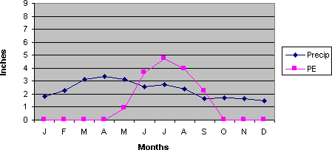

Figure 2.1: Silver Lake Water Budget Source: BASIN, 2005

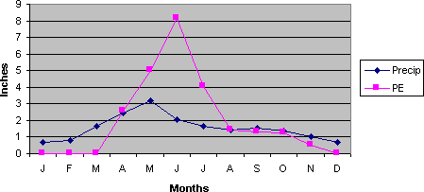

Figure 2.2: Boulder Water Budget Source: BASIN, 2005

## Water Turbines

A water turbine is basically a device that converts the energy in falling water into rotating mechanical energy. This energy in rotation is used to generate power in electrical form.

Basically the conversion involves two types of turbines:

* + 1. Impulse turbine
    2. Reaction turbine

## Impulse turbine

Impulse turbines generally used the velocity of the water to move the runner rather than pressure as in the case of reaction propeller design. This is because they generally discharge to atmosphere since there is no friction on the down site of the turbine; the water supply falls out at the bottom of the turbine. This is widely used in micro hydro power stations. Pelt on wheel is an application of the impulse turbine (Rolt, 1958).

In general terms, a pelt on wheel is a disc with paddles and buckets attached to the outside edge. The water passes through a nozzle and strikes the paddles once at a time, thus causing the wheel to spin. The buckets are shaped so that the water stream is split into two and carry to change direction to the original water stream for greatest efficiency. Because the power developed by the pelt on wheel is depending on the velocity of water, it is well suited for high head/low flow installation (Rolt, 1958).

## Reaction Turbines

Reaction turbines while doing the same as impulse turbine works on different principles. The runner is placed directly in the water flowing over the blades rather than sticking each individually. Reaction turbines operations are based on pressure rather than velocity. They function more like that of a centrifugal water pump in its reverse mode (Rolt, 1958). The Kaplan

design is intended to address that problem. Reaction units are usually used in very large installations. An example of this is the Francis turbine (Rolt, 1958).The Francis units are typically installed in every large hydropower stations. Francis units are designed for specially valve system and they are not generally used in micro hydro applications.

## Classification of Head

The objective of a hydropower scheme is to convert the potential energy of a mass of water

IORZLQJ LQ D VWUHDP ZLWK D FHUWDLQ IDOO WR WK

lower end of the scheme, where the powerhouse is located .The power output from the scheme is proportional to the flow and to the head .Hydropower systems varies in size and application. Water reservoir at higher altitudes is a prerequisite for hydroelectric generation. Power house is

located at a lower level. The difference between two levels is known DV ³+HDG´ +HDG

grouped according to (Theraja, 2002).

1. Low head: up to 60 meters
2. Medium head: between 60& 300 meters
3. High heads: above 300 meters

## Classification of Hydropower Schemes

The water turbines which convert the potential energy of water to shaft rotation are coupled to suitable generators. Hydropower generation stations are classified according to sizes. The classification of the hydropower schemes and suitability to Mega, Large, Medium, Small, Mini, Micro and Pico hydropower scheme (Mustafa and Yusuf, 2012) is presented in Table 2.4.

## Table 2.4. Classification of hydropower Scheme and suitability

|  |  |  |
| --- | --- | --- |
| **Classification** | **Range of Power** | **Purpose** |
| **Mega hydro** | > 500MW | National electricity grid |
| **Large hydro** | >100MW | Feeding national electricity grid |
| **Medium hydro** | 15 to 100MW | Feeding national electricity grid |
| **Small hydro** | 1 to 15MW | Feeding national electricity grid |
| **Mini hydro** | >100kW | Suitable for rural communities |
| **Micro hydro** | 5kW to 100kW | Small and isolated communities |
| **Pico-hydro** | <5kW | Suitable for small households |

Source: Mustafa and Yusuf (2012)

.

# CHAPTER THREE MATERIALS AND METHODS

## Study Area

The Study Area is located near Kuta Village about 25 km East of Goronyo town. Figure 3.1 is the Study Area.

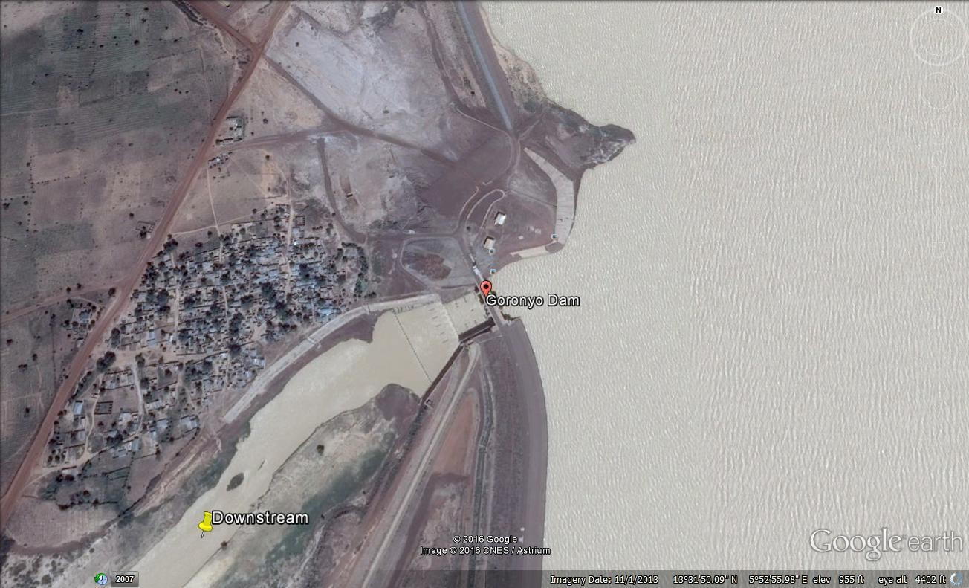

Figure 3.1. Study Area Source: SRRBRDA, 1991

## Description of the Study Area

Goronyo dam is a reservoir built across River Rima in 1981. It was completed in 1984 and commissioned in 1992. The estimated terrain elevation above sea level is 295m. It lies on latitude: 13° ¶ ´1 DQG° /¶R Q J L´W(X GH

Goronyo Dam impounds the Rima River in Goronyo local government area of Sokoto state in the north of Nigeria.

The dam is the key structure for the water resources and agricultural development of the middle Rima Valley and Second phase of the Sokoto and Rima River Basin Development Plan. It is a

multipurpose storage DDP GHVLJQHG WR VWRUH fo r iPrriLgaOtioOn aLndRQ FXE

development of downstream areas from Goronyo to Argungu. The project is located near Kutavillage about 25km East of Goronyo town and 90km North East of Sokoto City. The project comprises of 3 Earth fill Dams with total length of 12km, a concrete intake and outlet structure including spill way of 1,540 cubic meters capacity as well as other infrastructures. The reservoir created by the dam is the second largest man-made lake in Nigeria and covers an area of 200 km2 or 20000 hectares. The dam will provide water for irrigation and development of downstream areas that is, the Middle Rima Valley and Zauro polder projects, covering over 17,000 hectares. The dam is also designed to provide as annual regulated flow of 425million cubic meters to double the present rice cultivated Fadama from 40000 to 80000 hectares. The project will also

VXSSO\ PLOOLRQ FXELF PHWHUV¶ RI ZDWHU DQQX

200km2 lake formed by the dam is expected to boost the fishing industry in the state. Messes Impresit Bokolori (Nig) Limited were the contractors for the design and construction of the project while Engineering and Consulting Associations (Nig) Ltd. were the consultants for the review of detailed design and supervision of the projects.

The project was completed and is under operation and maintenance, as present, the releases from Goronyo reservoir are used in Wurno irrigation scheme, in Sokoto water supply project and in Fadama area in downstream. After construction of the planned projects (i.e. Middle Rima Valley

and Zauro polder project,17,244 hectares area would receive dependable irrigation supply to support year round cropping.

## Uncompleted and Completed Structures of Goronyo Dam

Figure 3.3 and Figure 3.4 are the Uncompleted and Completed Structure of Goronyo Dam.

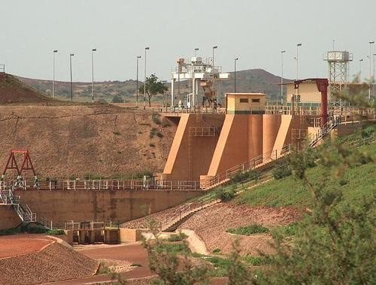

Figure 3.2.Uncompleted structure of Goronyo Dam Source: SRRBRDA, 1991

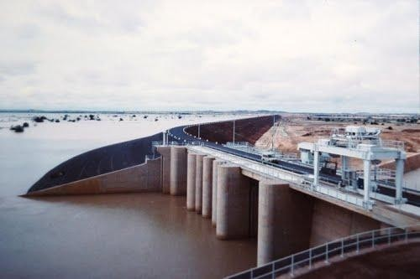

Figure 3.3. Completed Structure of Goronyo Dam Source:SRRBRDA, 1991

## Upstream and Downstream Face of Goronyo Dam

Figure 3.4 and Figure 3.5 are the Upstream and Downstream of Goronyo Dam.

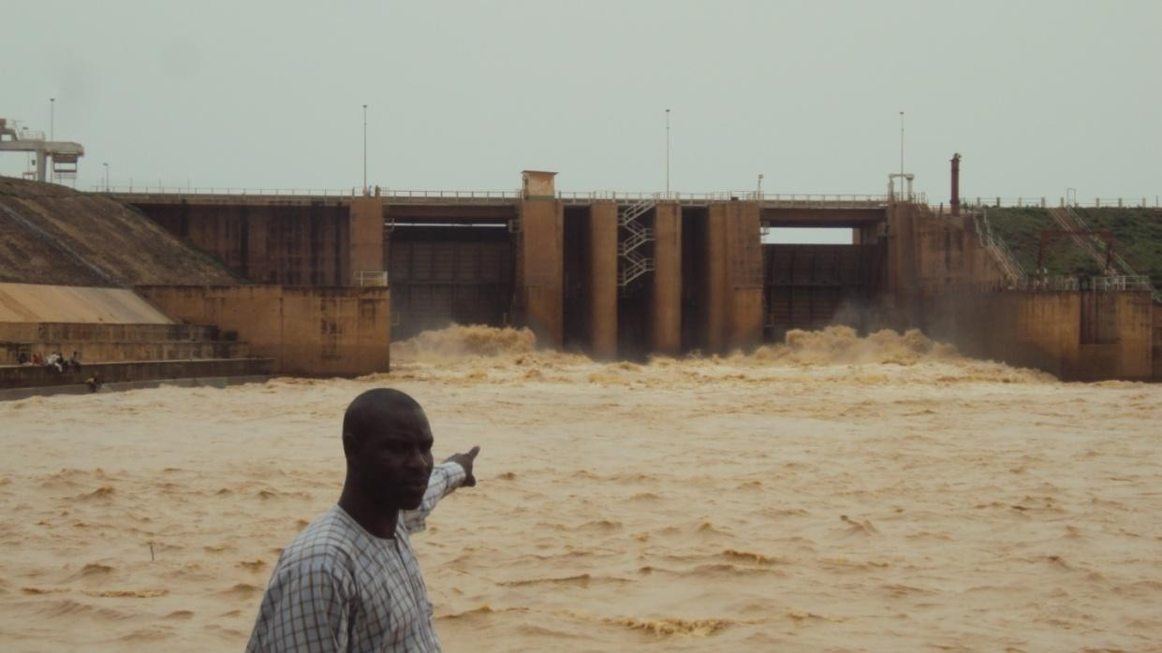

Figure 3.4.Upstream face of Goronyo Dam Source: SRRBRDA, 1991

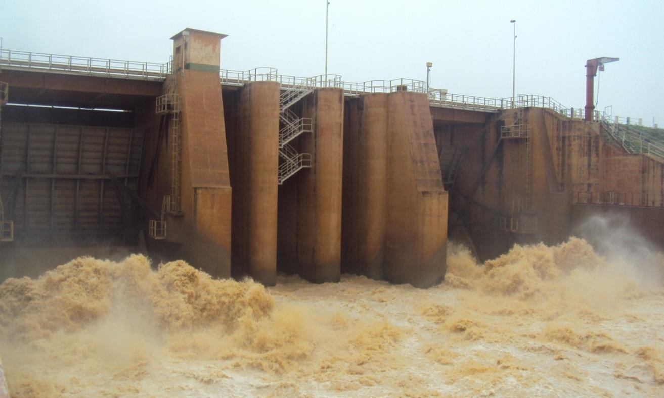

Figure 3.5. Downstream face of Goronyo Dam Source: SRRBRDA, 1991

## Collection of Hydrological and other essential Data.

Twenty six years (26yrs) Rainfall Data and other essential data like evaporation, seepage, evapotranspiration, silent features of the dam, and others were collected from Sokoto Rima River Basin and Rural Development Authority. Therainfall data wasanalyzed using Hydrological Engineering Centre-Hydrologic Modeling System (HEC-HMS), Sequent-Peak method or Analytical Method for determining the required storage, required discharge (Q) for power generation. These parameters (ܳ, H etc) was used to determine the hydropower potential of Goronyo dam.

## Determination of Geological Condition of Goronyo Dam

Geological condition of a dam simply refers to the stable or unstable condition of the dam which occurred as a result of seepage, piping, undermining, etc, that leads to the failure of the dam structure if proper measures are not taken. Goronyo Dam is made up of three segments. The first

segment is known as Main Dam, the second segment is known as Secondary Dam and the third segment is known Saddle Dyke.

Investigation of the Dam was carried out with the aid of the Dam instrumentation, Global Positioning System (GPS) to locate the coordinates where seepage occur trough embankment and Measuring Cylinder to measure seepage water from the relief wells.

## Determination of the Hydropower Potential of Goronyo Dam

7R IDLUO\ VHOHFW WKH PRVW DSSURSULDWH K\GUDX

potential, the water resources analysis must be taken into consideration (Bilewu. 2009). Water resources analysis of Goronyo Dam includes the following:

1. The water to meet the primary responsibility of the Dam which includes irrigation and potable water.
2. Evaporation losses over the reservoir area.
3. The reservoir sediments which may have reduced the storage
4. The direct rainfall on the reservoir
5. The inflow into the reservoir
6. The energy potential of the scheme is directly proportional to the flow and head.

The discharge (Q) required for hydropower estimation can be obtained using Flow Duration Curve, Sequent-Peak Method or Analytical Method etc. The Sequent-Peak Method or Analytical Method is the most suitable for regulated flow such as Dams while the Flow Duration Curve (FDC) is most suitable for non-regulated flow such as rivers, streams, waterfalls etc. Analytical Method was used to determine the required storage of Goronyo Dam The available water that is obtainable throughout the year (firm power) will guarantee the continuous power generation.

## Available Flow for Hydropower Generation

It is not economically feasible to collect the entire runoff of a river during flood as this will require large storage. In this case, the storage is defined and fixed and the firm yield for power generation is dependent on overflow and some other quantity available from the reservoir without infringing on the water for irrigation, water supply requirement etc. The firm yield of the Rima River has been increased by the construction of Goronyo Dam. This makes it a regulated flow. In the event of multiple uses, an adaptation of the sequent-peak analysis is one of the methods that are suitable for developing the storage-yield relationship (Bilewu, 2009). This will give a fair idea of the available flow for power generation as against the Flow Duration Curve (FDC) method which can also be used but is more suitable for unregulated flow (Bilewu, 2009). The analysis assumes that, the time interval includes the critical period which is the time period over which the flows have reached a minimum causing the greater drawdown of the reservoir

.The other assumption is that the total release over time interval of analysis does not exceed the total reservoir inflow (Mays and Tung, 1992).

## Estimation of Hydraulic Power and Electrical Power

The hydropower potential is determined using basic equation for power estimation (Kumar *et al*, 2003).

Hydraulic Power and Electrical Power of Goronyo Dam was calculated using the Basic Equation for Power estimation.

The hydraulic power in watts and electrical energy produced are given by:

(3.1) ܪܳߩ݃ =ܲ

(3.2) ݐᢡܪܳߩ݃ = ܹ

|  |  |  |
| --- | --- | --- |
| Where, | ܲ | the hydraulic power in watts |
|  | ܹ  ݃ ߩ  ܳ | the electrical energy produced in kWh the acceleration due to gravityൎ9.81m/s2 the water densityൎ1000kg/m3  the flow or discharge rate, m3/s |
|  | ܪ | the height of fall of water or head in m |

ᢡ efficiency of turbine-generator assembly ranges between 0.5 and 0.9

ݐ the operating time in hours (8760h/year)

The overall efficiency of turbine, generator and gear-box may be taken as 80% initially (Kumar

*et al*, 2003).

## Sequent - Peak Method

The sequent-peak method is implemented using:

3.3) ( െ1ݐܵ +ݐܧ +ݐܴെݐܫെݐܹ =ݐܵ

Equation 3.3 is used if ݐܵis positive, otherwise (i.e. if ݐܵis negative) take ݐܵ= 0

Where, ݐܵ storage at time t

ݐܹ water supply demand

ݐܫ Inflow

ݐܴ Direct Rainfall on Rainfall

ݐܧ Evaporation from reservoir

ݐܵെ1 Previous storage

The maximum value of ݐܵis the required active reservoir storage capacity for the flow sequence and the considered releases.

## Monthly Evaporation of Goronyo Dam

The Dam evaporation readings measured using Class A pan from 1986 to2015 was collected from Sokoto Rima River Basin and Rural Development Authority (SRRBRDA). The Data was analyzed using Direct Method. The surface area of the reservoir is 200 km2 or 20000 ha. Direct method is the most widely used method of finding reservoir evaporation by means of evaporation pans (Punmia *et al*., 2002).

(3.4) ሻ݁ݑ݈ܽݒ݊ܽ݌݊݋݅ݐܽݎ݋݌ܽݒ݁ሺ݊ܽ݌ܥ =݊݋݅ݐܽݎ݋݌ܽݒ݁݁݇ܽܮ co-efficient a is ݊ܽ݌ܥ Where,

The value of ݊ܽ݌ܥ for the Standard US National Weather Service Class A pan is 0.7 but varies during the year from month to month (range of 0.67 - 0.82).

## Converted Evaporation calculation

The value of converted evaporation is calculated from the relation:

)ݐ݊݁݅ܿ݅**݂**݁݋ܿ݊݋݅ݐܽݎ݋݌ܽݒ݁݊ܽ݌൯(݊݋݅ݐܽݎ݋݌ܽݒ݁݊ܽ݌ܥሻ൫ܽ݁ݎܽݎ݅݋ݒݎ݁ݏܴ݁ሺ 100 =ܧ

(3.5)

## Water Supply Demand

It is necessary to determine the amount of water needed to fulfill the primary mandate of the dam which is irrigation and water supply. According to 2017 National Population Commission Update of Sokoto City population density, that Sokoto State City has a population of 564,585 (NPC, 2017) and Nigeria has a geometric rate of population increase of 2.83 (Bureau of Statistics, 2007).

The expected increase for the next 20 years is computed as follows using geometrical increase methodofuniform percentage growth method:

݃ܫ ݊ (3.6)

݊ܲ= ܲ൬1 + 100൰

Where : *Pn* Population after *n* decades

*n* Decades

P Present population

݃ܫ Average percentage increase per decade

The Water Supply Demand (W) was determined by using World Bank recommended per capital consumption (120L/d) for urban areas. The following relation was used

*W =* Population Per capita consumption

## Water for Irrigation

Supply of Water for Irrigation is one of the primary mandates of the Dam. It was primarily designed to provide annual regulated flow of 425,000,000 m3 in order to double the rice cultivation from 40,000 ha to 80,000 ha (SRRBRDA,1991).The annual regulated flow (425,000,000 m3) was divided by thirty to make it per month.

## Monthly Direct Rainfall

The Mean Monthly Direct Rainfall is the amount of rainfall that fall directly on the Reservoir in percentage. It was assumed that 30 % of the rainfall on the land area to be flooded by the reservoir has reached stream and only 70 % of the precipitation has been included in the

computation (Punmia *et al*., 2002). Thus, the precipitation (P) is calculated from the relation, and each month in a column is computed using the same procedure of that column

(3.7) 70 × **݈**݂ܽ݊݅ܽݎݕ݈݄ݐ݊݋ܯ݊ܽ݁ܯ× ܽ݁ݎܽݎ݅݋ݒݎ݁ݏܴ݁ =ܲ

100

## Goronyo Dam Water Budget

The Water Budget was determined using Precipitation and Evapotranspiration Data. The graphs of these Data were plotted against time.

## Evapotranspiration

The readings of evapotranspiration from 1986 to 2015 were collected from SRRBRDA. The monthly mean evapotranspiration (PE) was computed using excels and the results were used for plotting water balance graph.

## Precipitation

Monthly Mean Precipitation (P) was computed using excels. The results were used for plotting water balance graph.

## Goronyo Dam sedimentation

* + 1. **Determination of Goronyo Dam Sediment Volume**

Two stages were followed to determine the volume of sediment deposited in the Reservoir. The first stage is the determination of the current total volume of water in the Reservoir. The second stage involves subtracting the current total volume of water in the Reservoir from the initial Reservoir storage capacityto find the volume of deposited sediment (Adediji, 2005; Adwubi *et al*.,2009).The original storage capacity of

the reservoir was obtained from the information of pre-impoundment survey in the

'DP¶V 7HFKQLFDO 5HSRUW E\ ,PSU. HVLW %DNRORUL

After getting the current total volume of water in the Reservoir by using the reservoir stage capacity curve, it was then subtracted from the original reservoir storage capacity to obtain the volume of sediment deposited in the Reservoir (Adediji, 2005; Adwubi ***et al.,*** 2009). This is determined by:

SV=Initial Reservoir Storage Capacity െCurrent Total Water Volume in Reservoir (3.8) Where, SV is the sediment volume (m3).

## Bulk Density Measurements

The sediment samples collected from the Reservoir were taken to the Department of Soil Science laboratory at Ahmadu Bello University, Zaria for det ermination of bulk density (Adediji, 2005). In the laboratory, the collected samples were dried in the oven at 105°C for 24 hours to allow for the drying of the wet samples ( Adwubi *et al.,*2009). After drying, the weight of the oven-dried sediments and the volume of the core sampler were determined (Adediji, 2005).

According to Adediji (2005),the bulk density of the deposited sediments was

calculated as:

1ܹെ 2ܹ = ݉ = ݐ݊݁݉݅݀݁ݏ݀݁݅ݎ݀െ݊݁ݒ݋݂݋ݐ݄ܹ݃݅݁ = dBD

(3.9)

ݎ݈݁݌݉ܽݏ݁ݎ݋݄ܿ݁ݐ݂݋݁݉ݑ݈݋ܸ

݄ 2ݎߨ ݒ

|  |  |  |
| --- | --- | --- |
| Where, | dBD | Dry bulk density (gcm-3) |
|  | M | mass or dry weight of sediment (g) |
|  | V | volume of the weight sample (cm3) |
|  | W2 | Weight of sample container + the weight of oven-dried sediment |

W1 Weight of empty sample container R Radius of the core cylinder

After calculation of the bulk densit y of the 12 samples, the mean average of the bulk densities was calculated.

## Calculation of Sediment Mass and Average Sedimentation Rate

There is need to convert the calculated sediment volume (m3) in the Reservoir into sediment mass (tones) (Haregeweyn *et al.,* 2008). This is required for calculation of average sedimentation rate and sediment yield. The calculated mean bulk density of the sediment samples is required to enable the sediment mass calculation (Adwubi *et al.,* 2009). To convert the sediment volume into sediment mass, the sediment volume was multiplied by the mean bulk density (Adediji, 2005; Haregeweyn *et al.,* 2005, 2006, and 2008). This is calculated as shown by the formula:

The sediment mass of Goronyo Reservoir is computed as follows:

SM = SV dBD (3.10)

Where SM Sediment mass SV Sediment volume

dBD Mean bulk density

The average annual Sedimentation Rate (RS) of the Reservoir was calculated through dividing the sediment mass by the age of the reservoir in years (Adediji, 2005;

Adwubi *et al.,* 2009). The formula is given as:

ܦܤ݀ ×ܸܵ= RS

ݕ

(3.11)

|  |  |  |
| --- | --- | --- |
| Where | RS | Average annual sedimentation rate |
|  | SV | Sediment volume |
|  | dBD | Mean bulk density |
|  | ݕ | Reservoir age (years) |

## Determination of Reservoir Sediment Trap Efficiency

Sediment trap efficiency is the percentage of the total incoming sediment which is retained in the reservoir (Verstraeten and Poesen, 2000; Haregeweyn *et al.,* 2006; Tamene *et al.,* 2006). It is normally expressed as the ratio of deposited sediments to the total sediment inflow of a reservoir (Adediji, 2005; Adwubi *et al.,* 2009). The trap efficiency of the reservoir is required in the calculation of catchment sediment yield. This is because it adjusts the sediment mass by accounting for the out flowing sediment to give a good estimate of sediment deposition (Tamene *et al.,* 2006; Adwubi *et al.,* 2009).

This study used the empirical method proposed by Brown (1943) to calculate the sediment trap efficiency (Verstraeten and Poesen, 2000; Tamene-et *al.,* 2006; Adwubi*et al****.,*** 2009). According to this method, the sediment trap

efficiency (TE) of reservoir is given as:

1

(3.12)

TE = 100 ቆ1 െ ܥቇ

1+0.0021 ܦ

ܣ

|  |  |  |
| --- | --- | --- |
| Where | TE | Trap efficiency (%) |
|  | D | Coefficient (0.046 to 1 and a mean value of 0.1) |
|  | C | Total Reservoir storage capacity (m3) |

ܣ Catchment area of the Reservoir (km2)

In this case; the mean value was used in the calculation.

There are two main reasons for selecting the empirical method of trap efficiencycalculation in this research work. First, Verstraeten and Poesen (2000) stressed that there is difficulty in obtaining suspended load measurements at the point of inlet (sediment inflow) and outlet (sediment outflow) of the reservoirs as used by Adediji (2005). This is because such measurements are both expensive and time consuming (Verstraeten and Poesen, 2001a). Second, the empirical methods are better used to calculate trap efficiency based on medium to long term periods spanning decades rather than short-term, single events (Verstraeten and Poesen, 2000).

## Determination of Sediment Yield

Sediment yield is the total sediment outflow from a catchment measured at the point where the reservoir is located for a specific period of time (Haregeweyn *et al.,* 2008). It can be expressed in absolute terms as sediment yield (SY) or as area specific sediment yield (SSY) (Haregeweyn *et al.,* 2008; Adwubi *et al.,* 2009). The specific sediment yield (SSY) is the mass of sediment per unit area of a catchment that enters thereservoir (Haregeweyn *et al.,* 2008). Sediment yield from catchments is an important indicator of the difference in erosion susceptibility between catchments (Verstraeten and Poesen, 2001 b).

The following equations were used to calculate the sediment yield and the area specific sediment yield:

The sediment yield of the Reservoir is given by:

SY = 100 S.V × dBD

ܻ ×ܧܶ

Where SY Sediment yield (ty -1)

SV Sediment volume (m3) dBD mean bulk density (gcm3) TE Trap efficiency (%)

ܻ Age of the Reservoir in year

The Area Specific Sediment Yield of the Reservoir is given by:

SSY = SV

ܣ

Where SSY Area Specific Sediment Yield SV Sediment volume

A Catchment area of the reservoir

## Goronyo Reservoir Stage Capacity Curve

(3.13)

(3.14)

Goronyo Dam Stage Capacity Curve is a graph of water level (Y-axis) plotted against reservoir volume (X-axis).It was designed by Impresit Bakolori Nigeria Limited in1979 with storage capacity of 942,000,000 m3 at 288 m elevations.

The bathymetric survey was carried out when the elevation of the reservoir was at 286.4m.The original storage capacity of the Reservoir was obtained from the information of pre-

LPSRXQGPHQW VXUYH\ LQ WKH 'DP¶V FRQVWUXFWLRQ

Limited (1979).Stage Capacity Curve based on the initial topographic contour map was used to obtain the original storage capacity of the Reservoir that corresponds to 286.4m. It is used to determine the initial and current volume of water in the reservoir. From the stage capacity curve

of Goronyo reservoir, the volume of water in the reservoir corresponding to 286.4 m elevation is 650,000,000 m3 as initial volume while at286.6m elevation is 623,820,698m3 as current volume. The initial and current volume is used in determining the sediment volume (SV) of the reservoir.

# CHAPTER FOUR RESULTS AND DISCUSSIOS

## Geological Condition of Goronyo Dam

Haven completed the investigation successfully, it was observed that the two main control or radial gates were leaking due to the wearing away of the rubber seal washers of the two gates. This subsequently results in head loss which may lead to inaccurate measurement of the inflow and outflow of the dam. Some of the relief wells constructed at various points along the collector drain contain water while some do not contain water. Those that contain water indicate the presence of seepage within their locations while those that do not contain water indicate the absence of seepage within the locations. The water in these relief wells drained through the pipes connected to the collector drain. The collector drain conveys the water to River Rima. It was also observed that the water in the relief wells was clean and this indicates that the dam is safe from piping. The presence of soil particles (sand, silt, etc) in the water indicates piping which is hazardous because it can cause dam failure.

Based on the investigation information obtained, it shows that Goronyo dam is facing problem of seepage in some locations which needs urgent attention to avoid failure or incapacitation (ineffectiveness) of the dam. The seepage normally occurs during the period of high flow (June, July, August and September). Seepage occurred at the right toe drain of the dam at GPS coordinate of N13º29.92 E005º52.776, N13º29.949 E005º52.776, and N13º29.943 E500º52.776

along chain age number 3+392 to 3+417 relief well number 132 and 133. Considering the whole length of the dam embankment, the areas where seepage occurred will not affect the aim of the research.

## Areas where Seepage occur at Goronyo Dam

The areas where seepage occurs at Goronyo Dam are shown in Figures 4.1 and 4.2.

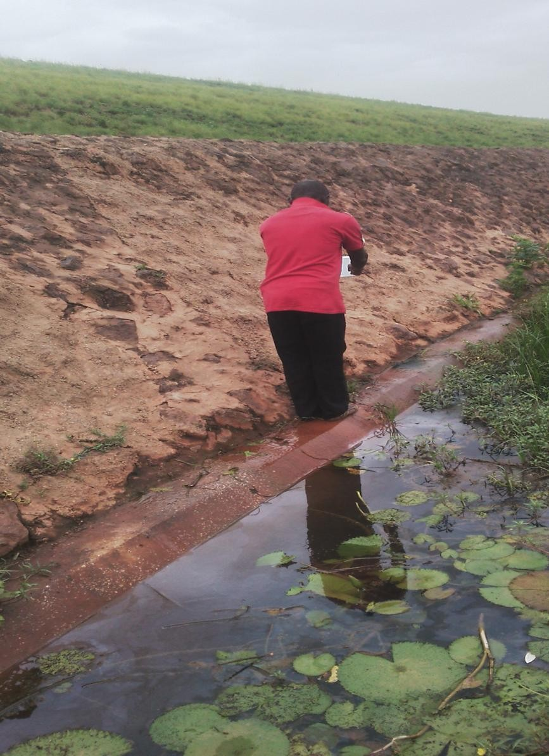

Figure 4.1.First seepage area of Goronyo Dam

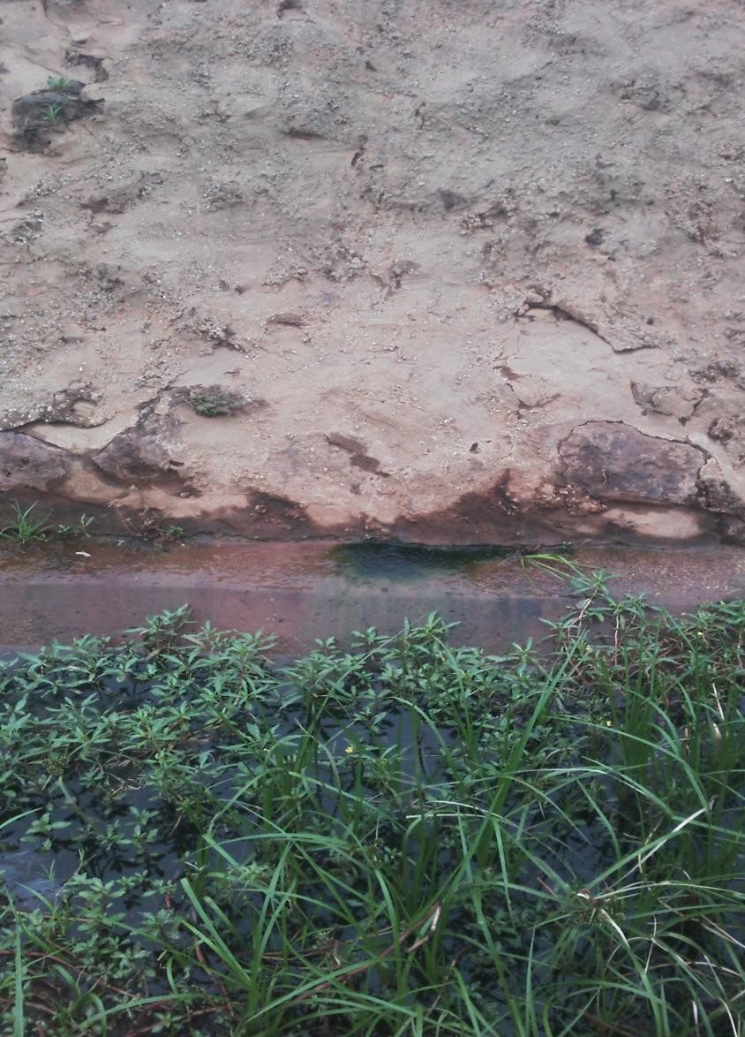

Figure 4.2. Second Seepage Area of Goronyo Dam

## Mean Monthly Seepage of Goronyo Dam from 1986 - 2015.

Mean Monthly Seepage of Goronyo Dam is as shown in Table 4.1

## Table 4.1. Mean Monthly Seepage of Goronyo Dam

|  |  |  |  |
| --- | --- | --- | --- |
| Month | Discharge per day (l) | Discharge per month  (l) | Water Level (m) |
| January | 260.95 | 8,089.45 | 284.86 |
| February | 219.62 | 6,149.36 | 283.60 |
| March | 89.45 | 2,772.95 | 283.38 |
| April | 43.77 | 1,313.10 | 283.10 |
| May | 15.64 | 484.84 | 282.83 |
| June | 17.89 | 536.70 | 282.77 |
| July | 30.78 | 954.18 | 283.62 |
| August | 116.35 | 3,606.85 | 284.48 |
| September | 1,678.47 | 50,353.50 | 286.40 |
| October | 112,977.00 | 35,022.87 | 285.82 |
| November | 743.25 | 22,297.50 | 285.42 |
| December | 484.21 | 15,103.51 | 285.12 |
| **Sum** | **116,677.38** | **146,684.81** | **3,411.40** |
| **Mean** | **9,723.12** | **12,223.73** | **284.28** |
| **Max** | **112,977.00** | **50,353.50** | **286.40** |
| **Min** | **15.64** | **484.84** | **282.77** |
| **SD** | **32,520.04** | **16,015.46** | **1.23** |

(4.1)݁݃ݎ݄ܽܿݏ݅ܦ݈ܽݐ݋ܶ =ܳ drams in Seepage Annual

200

Therefore, ሺQሻ= 146684 .81 = 733.42 drams/year

200

Monthly Seepage in dramsሺQሻ= Annual sepage

12

Dail1y Seepage in drams ሺQሻ= Monthly seepage

30

= 733 .42 = 61.11 drams/month

12

= 61.11 = 2.037 ൎ2 drams/day

30

The result of the Monthly Mean Seepage of Goronyo in Table 4.1 shows that the Reservoir losses 146,684.81 L /year or 733.42 drams/year. September has the highest seepage discharge of 50, 353, 50 .L The Reservoir has the mean seepage discharge of 12,223.73 L/year. Comparing the annual seepage (146,684.81 L) and the storage capacity of Goronyo Dam, it shows that the quantity of seepage water will not hinder the aim of the research.

## Goronyo Dam Water Budget

Figure 4.3 is a water balance graph of monthly mean precipitation and monthlymean potential evapotranspiration versus time both as line graph.

400

350

**Precipitation & Evapotranspiration**

300

250

200

150

100

50

0

Jan Feb Mar Apr May Jun Jul Aug Sep Oct Nov Dec



**Months**

Precipitation (mm) Evapotranspiration (cm)

Figure 4.3Graphs of mean Precipitation and meanPotential Evapotranspiration versus Time of Goronyo Dam.

The Figure 4.3shows that Goronyo Reservoir experiences the highest Evapotranspiration (PE) in the monthof April while the highest Precipitation (P) occurred in September. This means that Goronyo Dam has water surplus in September and has water deficit in April. Surplus water is when P is greater than PE while Deficit is when PE is greater than P.

## Rainfall Data

Rainfall data from 1986 to 2015 was collected from Sokoto Rima River Basin and Rural Development Authority. It was analyzed by using software (HEC-HMS). Cumulative Precipitation, Daily Mean Discharge, Mean Monthly Discharge and Yearly Discharge for the entire duration of rainfall were obtained.

## Results extracted from HEC- HMS Software

The results extracted from HEC-HMSare as shown in the figures 4.4 to 4.9. Each Figure except Figure 4.5 shows the rise or fall with time of each point in the Figures. Each value on the graph indicates its degree of significance in the event. The highest point in the graph indicates the highest value.

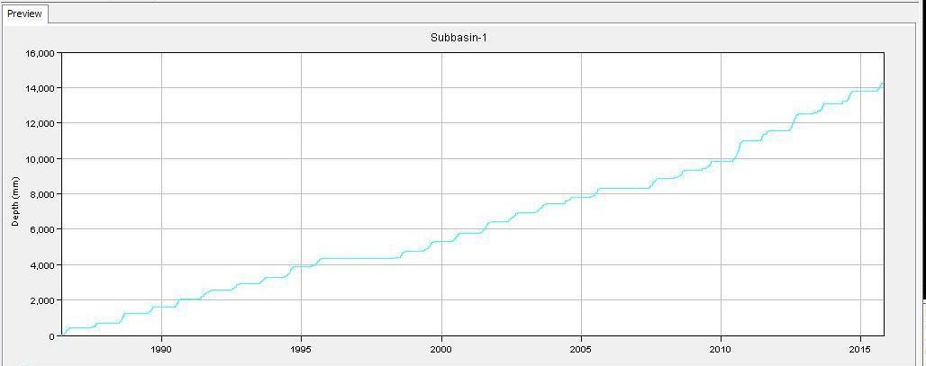

Figure 4.4.Cumulative Precipitation for the entire duration of rainfall extracted from HEC-HMS

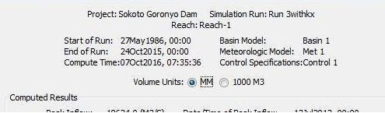

Figure 4.5.Summary Result extracted from HEC-HMS

20000

18000

16000

14000

12000

10000

8000

6000

4000

2000

0

**Time (Day)**

**Daily Discharge**

Figure4.6.Daily discharge from 1986-2015