ASSESSMENT OF RESIDENTS’ ATTITUDES TOWARDS RECREATION IN BIDA-NIGERIA

ABSTRACT
Attitudes are essentially important in determining a people’s peculiarities and response to services provided. This study, titled ‘assessment of residents’ attitudes towards recreation in Bida-Nigeria’ was achieved through field observation and the administration of 969 structured questionnaires using systematic sampling to select respondents from four strata of men, women, youths and children in Cheniyan and Nassarafu wards. With the aid of the SPSS and EXCEL packages, data were coded and presented in statistical diagrams and tables, and analyzed using percentage, Chi-Square Test and the Spearman’s Rank Correlation. Study evidence revealed that though residents commonly preferred recreational activities such as dancing, gardening, walking, traditional recreation and football, they were constrained from participating in active recreation due to pre-occupation with family and fear of sustaining injuries. The result of the Chi-Square Test, which showed that men and women demonstrated poor attitudes towards physical exercises, confirmed that finding, and revealed that though gender did not influence residents’ attitudes towards active recreation, occupation and marital status did. Further findings indicated that though youths and children had positive attitudes towards active recreation, the recreational facilities desired by the youths were lacking in Bida. The study concluded by suggesting enlightenment programmes, building and maintenance of desired neighbourhood recreational facilities for residents, recreation insurance schemes and recreation with pay to address poor attitudes and encourage more residents’ participation in the active form of recreation.

vi
 | TABLE OF CONTENTS
Title page |  | ii
Declaration |  | iii
Certificationiv
Dedication |  | v
Acknowledgementvi
Abstract |  | vii
List of tables |  | 70
List of figures |  | 71
CHAPTER ONE
1.0 | Introduction | 1
1.1 | Statement of research problem | 2
1.2 | Research hypothesis | 3
1.3 | Aim and objectives | 4
1.4 | Scope of the study | 4
1.5 | Significance of the study | 4
1.6 | Definition of terms | 5
CHAPTER TWO
2.0 | Literature review | 7
2.1 | Definition and value of recreation | 7
2.2 | Types of recreational activities9
2.3 | Recreation demand and its determinants | 11
2.4 | Factors responsible for physical inactivity | 14
2.5 | Description of attitudes | 14
2.6 | Components of attitudes | 16
2.7 | Development of attitudes | 17
2.8 | The roles of attitudes19

vii
2.9 Summary |  | 19
CHAPTER THREE
3.0 | Research methodology 20
3.1 | Study area | 20
3.2 | Data requirement and sources | 26
3.3 | Methods of data collection | 27
3.4 | Population and sample | 29
3.5 | Sampling techniques | 31
3.6 Summary |  | 32
CHAPTER FOUR
4.0 | Analysis of residents’ attitudes: major findings | 33
4.1 | Preferences for active recreations | 33
4.2 | Militating attributes in active recreation | 38
4.3 | Attitudes of women | 41
4.4 | Perceptions of children | 44
4.5 | Correlation analysis of residents’ attitudes | 45

4.5.1 | Gender and active recreation |  | 45
4.5.2 | Occupation and active recreation |  | 47
4.5.3 | Correlation analysis of men’s attitudes |  | 50
4.5.4 | Correlation analysis of women’s attitudes |  | 52
4.5.5 | Correlation analysis of youth’s attitudes |  | 54
4.5.6 | Correlation analysis of children’s attitudes |  | 55
4.5.7 | Summary |  | 56
CHAPTER FIVE
5.0 Summary, recommendations and conclusion58
5.1 Summary |  | 58
5.2 Recommendation |  | 59

viii
5.3 Conclusion | 60

References61

APPENDICES

Appendix 1- Questionnaire 66

Appendix 2- List of tables 69

Appendix 3- List of figures70

ix
CHAPTER ONE

INTRODUCTION

Every human being needs a leisure time which could be utilized in certain recreational activities for rejuvenation. Positive recreation is neither a luxury nor unproductive activity, but a fundamental human need required to stay healthy. However, attitude can be one of the most difficult barriers to recreation participation (Bedni, 2000; Smith et al., 2005). Obinna et al. (2009) equally contend that attitude to recreation is one of the recreation challenges in the rural and urban areas of Nigeria.

Kachoub (2010) reports that attitude is an intrinsic component that reveals one’s thoughts and beliefs on a language, culture, people or an activity which consequently helps to predict the behaviour of the individual. Crow and Crow (1999) describe attitude as the effective by-product of an individual’s experience, have their bases in his inner urges, acquired habits, and the environmental influences by which he is surrounded. Henry (1991) explains attitudes as serving as an index of how we think, and feel about people, objects and issues in our environment. They provide clues to future behaviour, predicting how we will act when we encounter the objects of our beliefs. All peoples of the world have their peculiarities, likes and dislikes, which distinguish them from others and explain the manner they accept or reject a programme or service. Peoples’ response to services is a function of their culture and belief. These are important factors that shape the way they behave (their attitudes). Moinpour and MacLachlan (2009) emphasize that attitude toward a product is a function of the sum of perceived attributes weighted as to the importance possessed by that product. That is, an individual’s attitude toward any product is a function of his perception about the product in terms of product attributes and the importance of these attributes; people prefer the product toward which they express more favorable attitude.

1

In attaining objectives of any recreational programme, therefore, it is imperative to consider peoples’ attitudes because attitudes play significant role in recreation participation. This consideration, in the context of this study is the assessment of the attitudes of Bida residents towards active recreation. Assessment is actually a word used to qualify evaluation, judgment and appraisal. For, example, Allen, Long, Perdue and Kieselbach (1988) propose that residents’ perceptions and attitudes towards tourism must be continually assessed to ensure that action is taken in good time and through such action the residents are willing partners in the development process. Going forward, Andriotis and Vaughan (2003) state that awareness of residents’ perceptions of tourism development and its impact can help planners and developers to identify real concerns and issues in order for appropriate policies and action to take place, optimizing the benefits and minimizing the problems. It is leisure that gives rise to recreation because without the availability of the former, it will be impracticable to engage in the latter. Gontul and Allu (2007) concur and observe that leisure time is the main determinant of recreation habit. A regular and substantial leisure time will create a more effective participation especially in outdoor recreation, while insufficient leisure time will significantly suppress participation. For these reasons, it is important for providers of leisure and recreation services to identify the desirable behaviours of beneficiaries and to then set goals that reinforce these behaviours most sustainably.

1.1 Statement of research problem

Observations in Bida show a high rate of inactivity among its residents, which is a primary concern because the impact of that behaviour is likely to affect their wellbeing. Previous studies show that many residents of Bida are yet to fully understand the values of active recreation and embrace adequate participation in it (Akogun, 2006 and Ugbabe, 2009). Patronage for passive

2

recreation is on the increase in Bida as almost every street boasts of viewing centres where many residents pay to watch live football matches on the satellite. In Bida, occupational groups such as traders, artisans, farmers, and government employees work nearly all days of the week in order to earn a living. Only a negligible number of the population can be observed at some sports grounds actively involved in recreational activities. Landon and Locander (2009) corroborate these observations and report that for working class men, their recreation orientation slowly subsides under the pressure of family obligations and does not return until most of the nest-building demands have been met. This development may threaten good health and result into low productivity because according to the American Institute of Stress (2011) lifestyles like inappropriate competitiveness and preoccupation with work lead to conditions such as stress and heart problems. Residents’ attitudes towards recreation may be responsible for this recreation pattern in Bida because attitudes define levels of indulgence in activities. In an attempt to provide explanations for these gaps therefore, this study is required to know why there are poor attitudes towards active recreation among the major compositions of the population of Bida in order to propose steps at addressing the problem.

1.2 Research hypotheses

The study sought to test the following hypotheses:

1. Residents’ attitudes towards active recreation are independent of their gender, occupations and marital status

- Men’s attitudes towards active recreation are independent of their occupations

- Women’s attitudes towards active recreation are independent of their marital status

- Youths attitudes towards active recreation are independent of their occupations

3
5. Children’s attitudes towards active recreation are independent of their gender

1.3 Aim and objectives

The aim of the study is to assess the attitudes of residents of Bida towards active recreation, as a basis for determining their recreational interests and improving engagement.

The aim was achieved using the following objectives:

- Determine residents’ preferences for active recreation in Bida

- Identify the characteristics of Bida population that hinder participation in active recreation

- Establish whether or not residents’ gender, occupations and marital status determine their attitudes towards active recreation.

- Suggest recommendations for enhancing engagement in active recreation in Bida.

1.4 Scope of the study

For the purpose of this study, the attitudes of residents of Bida were determined, as an index for improving their participation in active recreation. In this wise, the attitudes of children, youths, women and men were studied. While children in this study referred to boys and girls of 4 -12 years old, youths comprised of males and females of 13-36 years old. Also men and women in this study consisted of both young men and women of 37-60 years old and old men and women of 61 years old and above.

1.5 Significance of the study

The result of this study will enable government and recreation planners to take developmental measures that will improve attitudes and promote physical activity among the residents of Bida.

4

When attitude is improved upon, participation in active recreation will be increased and this will reduce disease conditions caused by inability to participate in it. The multiplier effect of this will reside in the domain of improved productivity at school and workplace as well as enhanced profitability (Etnier et al., 1997 and Lindner, 1999).Moreover, the study will help get residents of Bida meaningfully engaged in active recreation, improve their skills in certain sports, and strengthen their capacity to contest in major sports competitions. This thesis also contributes to recreation planning literature by surveying books and articles from a variety of disciplines, explaining issues in recreation participation and summarizing steadily emerging themes. The study therefore contributes to recreation planning profession by expanding the frontiers of knowledge on active recreation and serving as a reference material for students and other researchers

1.6 Definition of terms

Assessment: In this work, assessment refers to an act of rating, evaluating, estimating or checking to arrive at a result that will be useful in making informed decisions. Both tangible and intangible matters like attitude can be assessed. The attitude of a person can be evaluated to know about his feelings, likes and dislikes as well as ideas or positions concerning socio-economic or cultural issues.

Attitude: is predisposition or tendency to respond positively or negatively towards certain idea, object, person, or situation. Attitude influences an individual’s choice of action, and responses to challenges, incentives, and rewards (WebFinance Inc., 2011). For this study, attitude is used to encompass the way an individual thinks, feels, and reacts towards participation in active recreation.

5

Recreation: refers to any pursuit taken up during leisure time other than those to which people have high commitments such as over time, second job, home study and various maintenance jobs about the house (Baud-Bovy and Lawson, 1998). Boniface and Cooper (1987) and Roberts (2001) agree that recreations are the varieties of activities we choose to undertake during leisure time. Recreational activities therefore involve an element of enjoyment and happiness obtained from engaging in something one likes. Different recreational activities serve as the sources of immense pleasure and provide relaxation to one’s mind and body. Recreation in this study therefore is used to explain those physical activities engaged in during free time for the purpose of personal sensation of wellbeing, increasing life expectancy, entertainment, rejuvenation and stress management.

Active Recreation: Active recreation, as used in this study, describes physical activities that demand some elaborate effort (energy) and direct involvement without passive participation from people taking part in them, e.g., playing football, tennis, swimming, sprinting, dancing etc.

Leisure: can be regarded as a measure of time: it is the time remaining after work, sleep and necessary personal and household chores have been completed, i.e., time available for doing as one chooses for enjoyment, wellbeing and personal growth and satisfaction (Wall & Mathieson, 2006). Leisure time precedes any engagement in recreational activities, i.e., there would be no recreation without leisure. In this study, the term ‘‘leisure’’ is used to describe the time spent in engaging in active, pleasurable and entertaining activities.

6
CHAPTER TWO

LITERATURE REVIEW

The literature review was an attempt to discover related works of other authors on the subject of attitudes and recreation. The purpose was to remove the limitation of having a research containing only the researcher’s opinions about the facts discovered, thus building a stronger foundation for the study.

2.1 Definition and Value of Recreation

Recreation is from two Latin words- ‘Re’, meaning to do again and ‘Creare’, meaning to create. Recreation is a renewing experience, a different and refreshing change from daily routine and work day experience (Fadamiro, 2003). Leisure, according to Nixon (2003) is from the Latin word- ‘Licere’, meaning to be allowed, or licensed.

Recreation is the expenditure of time with intent to gain some refreshment. It is a break from monotony and a diversion from the daily routine. It is a positive change from the stereotypical lifestyle and involves an active participation in some entertaining activity (Oak, 2010). Recreational activities involve an element of enjoyment and happiness obtained from engaging in something one likes. Different recreational activities serve as the sources of immense pleasure and provide relaxation to one’s mind and body. Boniface and Cooper (1987) and Roberts (2001) agree that recreations are the varieties of activities we choose to undertake during leisure time. Recreation, therefore, are pursuits taken-up during leisure time other than those to which people have a high commitment. Recreation also, is a means of escaping from work boredom and/or a body renewal in preparation for routine and necessary work. Leisure, according to Boniface and Cooper (1987) is a measure of time, usually used to mean the time left over after work, sleep, and personal and household chores have been completed. Akogun (2006) reports that leisure and

7

recreation are classified as tourism activities which involve other sectors of the economy (transportation, education, industry, urban development, forestry, telecommunications, etc.); national, state and local socio-economic policies, and socio-political traditions. While caught in the rut of hectic jobs and routine chores, everyone needs some time to revitalize their mind and body, and indulge in recreational activities. Opportunities to combine work, rest and play should not be taken for granted because as Swann (2004) explains, recreation is an essential component of emotional, physical and cultural wellbeing required for balanced lifestyle and a complete person. Recreational activities give us an opportunity to spend time with our near ones and ourselves. They give us an opportunity to meet new people, make new friends and socialize. Some of the recreational activities help us in developing leadership qualities and interpersonal skills. Aside work to meet the basic needs of man (i.e. hunger, warmth and safety), recreation and leisure are regarded as one of the basic human needs as sources of pleasure, relaxation and excitement (Fadamiro, 2003).

The California State Parks (2005) outlines the value of recreation this way: physical activity reduces obesity (overweight), diminishes risk of chronic diseases like heart diseases and diabetes. In fact there are over 2 million people in California with diabetes mellitus. Physical activity also boosts immune system (physically fit person is less prone to illness); increases life expectancy (increases longevity and reduces many causes of mortality); reduces depression, relieves stress; improves quality of life (a medium to change self-image and gain personal satisfaction); reduces crime, unites families, supports youth (improves their education and deter negative behaviours)

Okunrotifa (1995) observes that recreation could be seen as an antidote to work, that is, it reduces depression among the individuals that participate in it after the day’s tedious work.

8

Recreation provides the capacity to escape from boredom. Recreation may be the main reason for participating in tourism, and tourism may represent a particular form of recreation.

Industrial recreation for employees cuts down drastically the man-hour lost in going to health clinics (Okafor, 1986). Recreation therefore increases the efficiency of workers. This is the reason why many developed nations have set aside specific periods in between working hours for compulsory recreation for workers. Umeasiegbu (1988) is of the view that the practice is paying them huge dividends in terms of productivity and efficiency. Recreation also promotes social bonds, improves support and development of youths. Driver and Burns (1999) highlights important outcomes derivable from participation in recreation to include psychological, personal development and growth, personal appreciation and satisfaction, psycho physiological, social and cultural, economic, and environmental benefits.

2.2 Types of recreational activities

Swann (2004) identifies three basic types of activities:

- Passive activities- requiring slight participation from the residents. Examples are: aromatherapy; listening to music; watching a concert; watching television.

- Semi-active activities- involving more participation. These include: computer skills; quizzes; discussions; debates; reminiscence; reality orientation.

- Active activities- requiring more physical involvement from the residents. Examples are:

art and craft; movement to music; yoga; table games; gardening; local outings; cookery; dancing. Others are football, tennis, athletics etc.

Some activities are individual and others are more group-focused. The list of activities is endless and will depend upon the resident’s abilities and skills, as well as available resources and budgets.
9
Roberts (2001) supports the submissions of Swann (2004) and elaborates thus:

- Passive Recreation- is when an individual receives or consumes entertainment or activities by other people, e.g. watching T.V. (including watching sports); listening to music; reading; playing computer games; going to a restaurant or a public park.

- Active Recreation- is when an individual personally participates in an activity which involves physical or mental exertion to a significant degree. (E.g. playing sports/badminton, basketball, sailing, football, etc.); playing a musical instrument, acting

in amateur dramatics; gardening and crafts and other hobbies, etc.

Both passive and active recreation could still be classified as home based and non-home based (Tribe, 1998 and Roberts, 2001). Gontul and Allu (2007) opine that recreation is of different types. It is indoor or outdoor, active or passive, free or involves cost, organized as in team games or unorganized.

Oak (2010) categorizes recreational activities into two. Passive recreation involves activities like strolling on the beach or taking a walk on the riverside while active recreational activities are about engaging in adventure sports and outdoor games. Udo (1988) believes that active recreation is the real or true recreation while the passive recreation is connoted as an entertainment. The two are, however, vital forces of rejuvenation which recreation seeks. Hence, a reasonable balance between active and passive participation can have a greater deal of merit to every individual. The active recreational activities are usually done outdoors because according to the Queensland Government (2009), outdoor recreation activities have been defined as those activities that:

- are undertaken outside the confines of buildings (i.e., in the outdoors) and

- do not involve organized competition or formal rules; and

10
- can be undertaken without existence of any built facility or infrastructure; and

- may require large areas of land, water and/or air; and

- may require outdoor areas of predominantly unmodified natural landscape Facilities, site modification or infrastructure may be provided to manage the impacts generated by the activities. However, outdoor recreation activities can be undertaken without facilities, site modification or infrastructure.

2.3 Recreation demand and its determinants

The Bureau of Reclamation (2010) defines recreation demand as the estimated number of people who are projected to participate in a particular recreation opportunity at some predetermined future time and location. The estimated number of people is typically expressed as a number or numeric range of individuals or groups (e.g., 10,000 visitors, 120 to 150 groups). The number of people can also be expressed as a percentage of the population in the market area or as a percentage increase or decrease in participation from some baseline year (e.g., year 2005). Another option is that the estimated number of people refers to some attribute of the visitors such as vehicles, motorized recreation vehicles, motorboats, horseback groups, boat launches, snowmobiles, campers versus day-use groups, or local versus non-local parties.

Historically, recreation demand has focused on the visitor’s primary recreation activity (i.e., hiking, fishing, boating, camping and skiing). Today, the recreation profession recognizes that not all hiking, boating, or fishing is the same because of the diverse outdoor settings where the activity may be enjoyed. Estimating demand for just activities may be too vague and misleading.

The FAO (2010) highlights five important determinants of demand for products and services:

11
1. Levels of income

A key determinant of demand is the level of income evident in the appropriate country or region under analysis. Generally, the higher the level of aggregate and/or personal income the higher the demand for a typical commodity, including recreation. More of a good or service will be chosen at a given price where income is higher. Thus determinants of demand normally utilize some form of income measure, including Gross Domestic Product (GDP).

2. Population

Population is of course a key determinant of demand. Growing populations positively correlate to higher demand for recreation activities, sometimes leading to carrying capacity problems where adequate planning is not made to address this.

3. End market indicators

The use of end market indicators as determinants of demand is frequently incorporated into demand analysis. For example, much of the final use of recreation is linked to health reasons. Indicators and trends related to participation in recreational activities provide indirect estimates of the influence of these activities as a source of good health and wellbeing.

4. Availability and price of substitute goods

The availability of potential substitute products, and their prices, weighs heavily in determining the elasticity of demand, both in the short run (static) sense and over time (long run).

12
5. Tastes and preferences

All markets are shaped by collective and individual tastes and preferences. These patterns are

partly shaped by culture and partly implanted by information and knowledge of products and

services (including the influence of advertising). The demand for recreational activities, for

example, is a function of the tastes and preferences of a particular people. Where provisions are

made for recreational activities which people have little interest in, demand definitely will be

low.

Table 1: Determinants of recreational demand

Positive |  |  | Negative
 | Population increase |  |  |  | competing activities: television
 | Leisure time |  |  |  | complacency
 | Mobility |  |  |  | poverty
 | Income level |  |  |  | religious attitudes
 | Educational level |  |  |  | generation gap
 | Age |  |  |  | discrimination
 | Health / physical condition |  |  |  | lack of opportunities
 | Urbanization |  |  |  | physical conditioning
 | Mass media conditioning |  |  |  | commuting
 | Outdoor living |  |  |  | crime
 | Easy credit |  |  |  | racial tension
 | Technology and automation |  |  |  | pollution
 | Social status |  |  |  | inflation: competing needs
 | Work ethic decline |  |  |  | cultural heritage
 | Boredom of job |  |  |  | crowding/peak use
 | Environmental quality of cities |  |  |  | poor assess
 | Environmental stress |  |  |  | lack of programme
 | Inflation: low cost vacations |  |  |  | deviant behaviour
 | Experience levels |  |  |  | civil disorder
 | Habit custom/heritage |  |  |  | fees and charges
 | Early retirement |  |  |  | energy shortages
 | Extended weekend holidays |  |  |  | natural disasters, Second jobs
 |  |  |  |  | Working wives
 |  | Source: Gold, 1980
 |  |  |  |  | 13

Table 1 above indicates the factors that encourage or discourage participation in recreational activities. These determining factors of recreational participation could be said to be environmental, economical, religious and cultural and could apply to all societies.

2.4 Factors responsible for physical inactivity

The factors that influence physical inactivity may vary from one place or country to another. Some studies have implicated certain factors for the poor attitude people have shown towards the active form of recreation. Findings from the work of Im et al. (2011) show that the reasons for African American low participation rate in physical activity included a lack of safe places to exercise or walk. Other factors influencing physical inactivity are lack of time because of work and family responsibilities (Landon and Locander, 2009; Heesch et al., 2000; Williams et al., 2006). Researchers like Balsamo (1996) and Wolf (1992) reported gender roles as a militating factor against African American participation in physical activity. Child care (Thompson et al., 2000) and low perceived access to sports equipment (Felton et al. 2002) are also reasons for physical inactivity. Time and economic constraints as a result of gender roles and family commitments also affect attitudes towards physical activity (Eyler et al., 2002; Henderson and Ainsworth, 2003; King et al., 2000). Going forward safety issues and environmental factors, including weather problems (e.g., hot weather, cold weather) also discourage participation in physical activity (Eyler et al., 2002; Felton et al., 2002; Heesch et al., 2000; Williams et al., 2006).

2.5 Description of attitudes

Henry (1991) explains attitude as serving as an index of how we think, and feel about people, objects and issues in our environment. They provide clues to future behavior, predicting how

14
we will act when we encounter the objects of our beliefs. Affirming the foregoing, Sarwar

(2004) elaborates thus:

Attitudes play central role in the explanation of social behavior. They are functions of what we think and what we feel. That is, attitudes are the pro-duct of related beliefs and values. They are a state of readiness that arises from motives. Attitude is an enduring organization of motivational, percep-tional and cognitive process with respect to some aspect of the individual’s world. Attitude is characterized as a learnt implicit response that varies in in-

tensity and tends to guide an individual’s responses to an object.

Choudry (1995) states that attitude is a particular cognitive, emotional or behavioural reaction to

an object, individual, group, situation or action. Johns (1996) believes that an attitude is a fairly

stable emotional tendency to respond consistently to some specific object, situation, person, or

category of people. Crow and Crow (1999) describe attitude as the effective by-product of an

individual’s experience, have their bases in his inner urges, acquired habits, and the

environmental influences by which he is surrounded. In other words, attitudes result from

personal desires and group stimulation. They are actually a part of an individual’s own

personality but are affected by the attitudes and behavior of the group with which he associates.

These are valid submissions because when one grows up in an environment where little regard is

given to participation in recreational activities, this individual may eventually not be able to

develop the instincts or positive attitude for recreation. On the other hand, the culture of active

recreational participation tends to be imbibed by both old and young people at destinations where

recreation is made a priority in terms of provision and participation.

The Standard Bank (2010) claims that attitudes are:

Predispositions towards action.


About or towards people and things.


15
Evaluative of people, objects and ideas.

Made up of emotional reactions (affective), thoughts and beliefs (cognitive), and actions (behavioral) components.

Strength of attitude increases with accessibility and knowledge about the topic in question. Attitudes are often learned from other people and are often a defining characteristic of groups. It can also be genetic. A strong attitude is very resistant to change. To this extent, attitudes can be (are) driven by people’s values and they influence (among other things) our beliefs and behavior towards people and circumstances. Also, attitudes are a combination of beliefs and feelings that predispose a person to behave in a certain way (Noe, 2002, cited by Brostrand, 2006).

2.6 Components of attitudes

Attitude is a lasting evaluation of people, objects, or ideas which may be positive or not. The concept of attitude is composed of three components which include cognitively-based attitudes, affectively-based attitude, and behaviourally-based attitude (Lopez, 2010). The National Disability Authority (2012) records that Cognitive, Affective and Behavioural evaluations are central to the notion of attitudes. Cognitive evaluations refer to thoughts people have about the attitude object. Affective evaluations refer to feelings or emotions people have in relation to the attitude object.Behavioural evaluations refer to people’s actions with respect to the attitude object.

The affective response, for example, expresses a person’s level of preference for something.It describes how we are to act towards somebody or something. The behavioral intention is a verbal indication or typical behavioral tendency of an individual. If we have a positive attitude for a

16

particular object, it is likely to be translated into a particular type of behavior such as buying or procuring that object. Employment Tips (2011) describes the behavioural component of attitude as the tendency to react to objects in a certain way. It is the active component of attitude. It highlights the expression of the consumer purchase intent. The cognitive response is a cognitive evaluation of the entity that constitutes an individual's beliefs about the object. This aspect of attitude focuses on our feelings towards particular products or services. Most attitudes are the result of either direct experience or observational learning from the environment.

2.7 Development of attitudes

The process of social interaction brings about certain developments including formation of attitudes. There are various social groups which result in the development of attitudes. These would include the role of the family, cultural factors, the influence of education, the interrelationship of culture and individual experiences and the role of media in imparting information within a particular social group (Sarwar, 2004).

- The influence of the family

The family may be defined as a group of persons united by the ties of marriage, blood or adoption, constituting a single household interacting and communicating with each other in their respective social role of husband and wife, mother and father, son and daughter, brother and sister creating and maintaining a common culture. According to Uroog (2000), family is an association and is a group defined by sweet relationship sufficiently precise and enduring to provide for the procreation and upbringing of children. The family is the first social group that a child communicates and interacts with in a special way. Parents play the vital role of rearing their children, and not only showing concern

17

regarding normal physical growth and development, but also converting their children into social beings. Parents often project their own belief systems, moral values and various other attitudes. Thus their children develop the tendency to develop their respective attitudes.

- Peers group influences

According to Bourne (2011), peers are the individuals with whom a child or adolescent identifies, who are usually but not always of the same age-group. Peer pressure occurs when the individual experiences implicit or explicit persuasion, sometimes amounting to coercion, to adopt similar values, beliefs, and goals; to participate in the same activities as those in the peer group. Akhtar (2001) asserts that peer relationship is an essential component of child’s development. Sarwar (2004) opines that although the child’s relationship with parents is more intense and enduring than with peers, interaction among age mates is more free and egalitarian. This quality of relationship with peers permits a new kind of interpersonal experimentation and exploration and most particularly a new kind of sensitivity, which will serve as one of the cornerstones for the development of social justice and the capacity of love. According to Saleem (2001), peers not only serve as reinforcing agents for behavior but also as standards against which children evaluate themselves.

- Cultural determinants

Culture is an important part of our blueprint for operation within our physical and social worlds. We are an insecure species and culture offers us a reduction lens that tints, magnifies, shrinks and otherwise shapes our perceptions. Our culture is a mindset that we developed childhood socialization. The structural integrity, coherency and stability of our

18

personalities are rooted in our culture (Barnlund, 2011). The foregoing illustrates that there is a relationship between culture and the personality of an individual.

Cultural differences among societies will be reflected in differences in attitudes among the individuals in those societies (Sarwar, 2004).

2.8 The roles of attitudes

In the opinion of Whitehouse (2011) attitude refers to a particular predisposed tendency, derived from the individual predefined likes and dislikes and the differentiator between what is right, wrong, good or bad according to the intensity or preference of those governing personal values. This can be described as individual’s inner laws or standards. Actually, humans react to things or situations that are important to them, sometimes described as convictions. Our self-beliefs would actually determine the way we behave. These convictions are often seen as a person’s viewpoints. Brown (2011) states that attitude can be likened to a simple engine that can either slow you down, or help you move forward. It is your attitude that determines what and how much you can do.

2.9 Summary

The various literature reviewed show that attitudes are very strong in determining the direction an individual takes especially in recreation participation. Though recreation is essential in a person’s wellbeing, the influence of the family, peers culture and availability of facilities are key in determining participation in it.

19
CHAPTER THREE

RESEARCH METHODOLOGY

The methodology is concerned with the procedures and techniques used in the collection and analysis of data. The purpose of this section is to facilitate understanding and the attainment of the research objectives.

3.1 Study area

Bida is a traditional, modern and heterogeneous society with two Polytechnics {one owned by the Federal Government and the other, a campus of the Niger State Polytechnic}, a Federal Government Girls’ College, Federal Medical Centre, Army Barracks and Nigeria Telecommunications {NITEL}. Others are the Federal Aviation Authority of Nigeria {FAAN}, Banks, State General Hospital, Bida Local Government Secretariat, Nigeria Television Authority, over nine state secondary schools, several public and private nursery schools, hotels, restaurants and two major markets.Bida is the headquarters of Bida Local Government and located in the South West of Niger State, Nigeria. It is located southwest of Minna, the capital of Niger State. It is a dry, arid town. The town is on the Bako River, which is a minor tributary of the Niger, and lies at the intersection of roads from Jebba, Zungeru, and Agaie. Bida lies between longitude 9⁰ 06¹ N and 9⁰ 20¹ N and latitude 6⁰ 0¹ E and 6⁰ 25¹ E. Bida has average temperature as shown in the table below.

20
Table 2: Average temperature in Bida

Jan. | Feb. | Mar. | Apr. | May | June | July | Aug. | Sept. | Oct. | Nov. | Dec.
34°C | 37°C | 38°C | 36°C | 33°C | 31°C | 29°C | 29°C | 30°C | 31°C | 34°C | 35°C
21°C | 25°C | 27°C | 26°C | 24°C | 23°C | 23°C | 23°C | 22°C | 23°C | 22°C | 21°C
Sunmap (2010)

Tabiti (2004) explains that Bida experiences two distinct seasons. The dry season called ‘Yinkere’ and the Wet season called ‘Zumzuba’. Zumzuba always lasts for about 200 days. It normally starts from April to October with July and September recording the highest rainfall of 22.6mm to 24.8mm. The Yinkere season is always ushered in by cold dry harmattan winds.

The people of Bida are mainly farmers and have a famous traditional head referred to as ‘‘EtsuNupe’’, the leader of the Nupe Kingdom or Bida Emirate. Bida boasts of a few recreational facilities located in some schools and public places such as the AliyuNdayako Recreational Centre, Bida, the Bida Sports Club, the Federal Polytechnic, Bida and Federal Medical Centre, Bida Recreational Facilities, as well as the Sultan Saia’d Horse Racing Facilities. Though many of these recreational facilities are in deplorable conditions, a very little number of residents keep using them for recreation.

Like some other societies, the stakeholders in recreation in Bida are the Government, private entrepreneurs and individuals, who are mostly children, youths, men and women. The ownership of recreational facilities in Bida rests squarely on the shoulders of Government, with the provision of facilities in schools and institutions. Other owners of facilities are the private entrepreneurs, who provide such facilities in their schools. Whether facilities are owned by Government or private entrepreneurs, recreational facilities provided consist of playgrounds for football, badminton, gym, handball, basketball, etc. The traditional recreation activities are

21
mostly performed around the neighborhood among the residents. The traditional recreations

include the following events:

- Banja-Taekwondo

- Egbe- hunting

- Ganni- local boxing

- Etungwa- arts and crafts

- Ma’aba- pressing

- Barraki- riding of horses and carmels among all moslems in Bida Emirate especially at Salah.

- Baba Minin- on special request during wedding, naming ceremony and political

campaigns.

Bida is an ancient town with interesting tourist attractions. Some of these attractions include the

following:

- The Wadata Forestry and Garden: This is a feature in an area that is mainly for leisure purposes. With tall trees scattered within the area, the Wadata Forestry and Garden has the potential of attracting tourists who visit it for relaxation, picnic, entertainment and other pleasurable experiences.

- The Masaga Glass Works: The center is a tourism attraction with a high record of tourist visit. The Masaga Glass Works is reputed for the manufacture and sales of native beads for ceremonies and bangles for fashion.

- The Bida City Walls/Gates: These walls used to serve as defence for the people of Bida against any external aggression. The walls, most of which have fallen, were about 40ft high from the pit. Underneath the walls werethorn plants to serve as security measure for the people living in Bida

22

- The Bariki Celebrations: This cultural celebration is now referred to as Bida Emirate Durbar. The Bariki Celebrations come up five days after the Islamic Festivals of Idel-Fitir and Idel-Adha {Idel-Kabir}. It involves all the chieftaincy titleholders and village heads in Bida leading their wards to pay homage to the Emir {EtsuNupe}, the traditional ruler of the Nupe Kingdom. The procession involving the village heads and their subjects is usually characterized by drumming and beautifully decorated horses on which the titleholders and the village heads sit upon. Other features of the Bariki Celebrations are cultural displays and dances.

- The Landzu Stream: This Stream divides Bida town into two equal halves and maintains its course in both wet and dry seasons. The Stream supplies fresh fish, the Fadama for wet and dry season farming, and the water for spiritual bath, and washing of household items.

The maps of Niger State and Bida, the study area, are as shown in figures 1 and 2. These maps are important in giving direction and locating the study area.

23
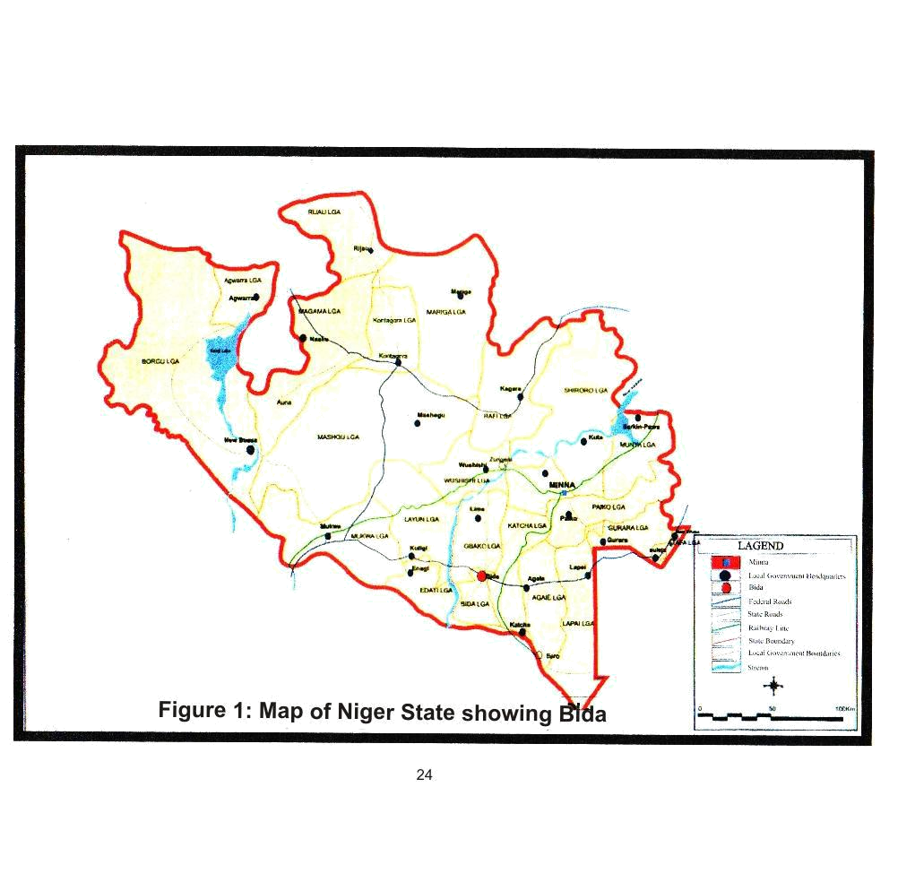

24
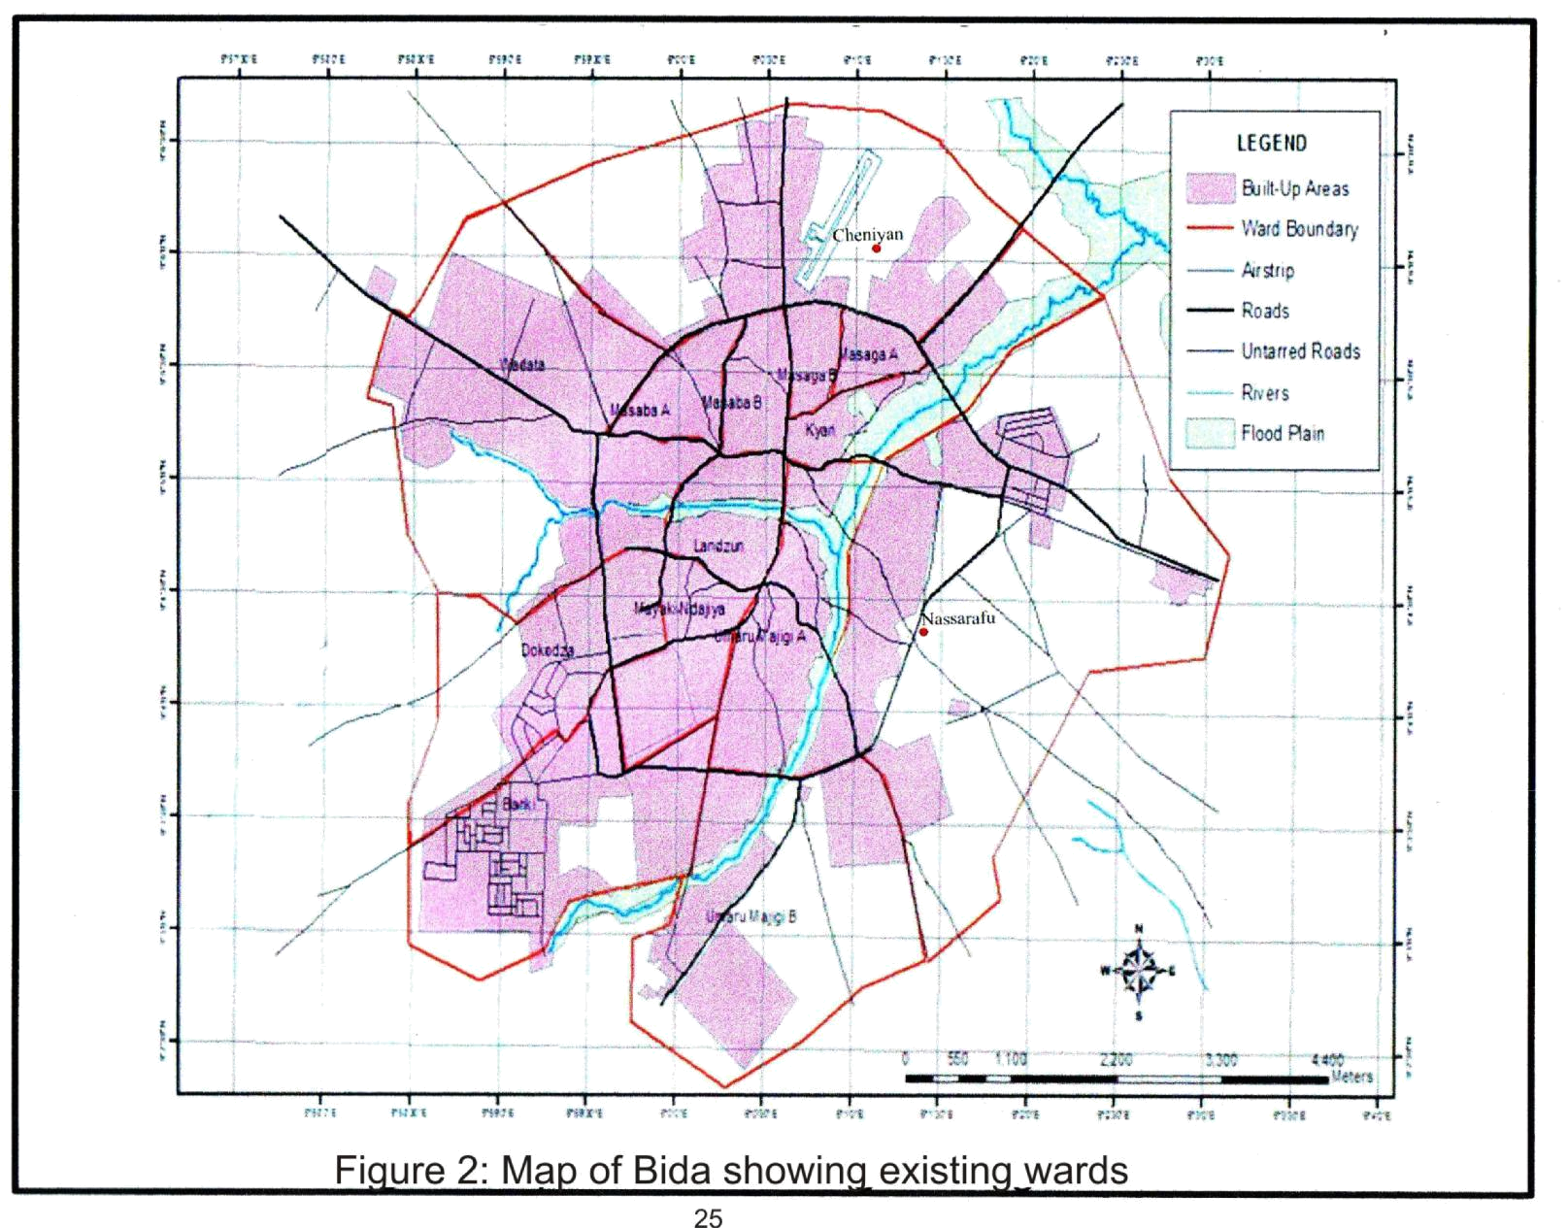

25
3.2 Data requirement and sources

For this study, relevant data was obtained in order to achieve the objectives stated. In this circumstance, data drawn were as shown in table 3.

Table 3: Data required and sources
Type of data | Data requirement | Relevance of data | Sources of data
Primary | Characteristics of the population | These data are important in knowing | Questionnaire
 | such as age, gender, occupation | the extent they facilitate or inhibit | survey.
 | (job type), religion, marital | recreation participation
 | status and educational
 | attainment
 | Barriers (family, work, finance, | These data set are required in order to | Questionnaires.
 | etc.) to active recreation | gather information that will help in
 | participation. | determining constraints against
 |  | recreation participation
 | Feelings and thoughts of the | Information about the population’s | Questionnaires
 | population towards active | attitudes towards active recreation is
 | recreation, Perceptions and | relevant to aid proper planning.
 | preferences for recreational
 | activities
Secondary | Description of attitudes, | The relevance of these data is clearly | Thesis and
 | components of attitudes, | seen in the preparation of the review | dissertations,
 | development of attitudes, roles | of literature. A good review of | Internet library,
 | of attitudes, value of recreation, | literature will remove the limitation of | books, journals
 | categories of recreational | having a research containing only all | and conference
 | activities, recreation demand and | of the researcher’s opinions about the | papers.
 | determinants. | facts discovered, thus building a
 |  | stronger foundation for the study.
 | Population of Bida and the | The essence of obtaining the | National
 | sampled wards | population of Bida and the sampled | Population
 |  | wards is to take a part of the whole | Commission,
 |  | population of Bida that will stand as a | Nigeria and
 |  | representative of the entire population | National Bureau
 |  |  | of Statistics,
 |  |  | Nigeria
 | .
 | .

26
3.3 Methods of data collection

Primary sources

A. Personal (field) observation: The purpose of this method is to obtain firsthand (but superficial) information for the study. Personal observation is useful because it takes less time and also eliminates the possibility of bias, which may frustrate the realization of the research objectives. As a preliminary field survey, the researcher used it to obtain data relating to the study from the sampled wards in Bida. The researcher’s observations show that there are two levels of active recreation in Bida- traditional and conventional/ modern. The modern recreational activities were mostly done at the institutions and schools, while the traditional recreations were performed around the neighborhoods especially during important occasions. The conventional facilities available include those of badminton, football, handball, basketball, gym and volleyball. On the other hand, the traditional recreation activities comprise of the following events:

- Banja-Taekwondo

- Egbe- hunting

- Ganni- local boxing

- Etungwa- arts and crafts

- Ma’aba- pressing

- Barraki- riding of horses and carmels among all moslems in Bida Emirate especially at Salah.

- Baba Minin- on special request during wedding, naming ceremony and political campaigns.

27

Most of the recreational facilities around Bida were in very bad condition, which could be a reason for low turn-out at recreation venues in Bida. Observations also indicate that children and youths participated more than the adult population in Bida.

- Questionnaire: The questionnaire is very cost effective when compared to face to face interviews especially for studies involving large sample sizes and large geographic areas. For the avoidance of doubt, Milne (2011) identifies the following advantages of questionnaires:

  - The responses are gathered in a standardized way, so questionnaires are more objective, certainly more so than interviews.

  - Generally it is relatively quick to collect information using a questionnaire

  - Potentially, information can be collected from a large portion of a group.

The questionnaire was designed to generate data relevant in achieving the objectives and testing the hypotheses. It was constructed for questions to appear under specific sections. The questions conformed to the pattern of the restricted type of questionnaire, with few open ended ones; they were simple and easy to understand by the respondents. Also, questions were presented in good psychological order, proceeding from general to more specific responses. This order, according to Key (2002) helps the respondents to organize their own thinking, so that answers are logical and objective. This is an attitudinal study, and so the Likert or Summative Scale was used to measure the intensity of agreement by the respondents to questions pertaining to their feelings, fears, willingness, preferences and perceptions towards active recreation. In this light, the 5-point Likert Scale was adopted for this study. The questionnaires were administered on children, youths, men and women in the sampled wards, which comprises of literate and

28

illiterate fellows. It is in this thinking that the researcher hired eight Nupe speaking HND students, from Marketing and Public Administration Departments of the Federal Polytechnic, Bida, to complement the researcher in administering the questionnaires. Besides, these students served as interpreters where necessary for those respondents who might not be able to read or write in English, the language in which questions were written. The questionnaires were administered personally by the research assistants after some training by the researcher. The training was basically on the subject of interpersonal relations.

Secondary sources

Secondary data for this study were sought and used to prepare the literature review. The literature review enables the researcher to establish the course and position of literature on the subject. This study therefore, utilized the following literature sources:

- Books

- Journals

- Published electronic sources

- Unpublished personal records

3.4 Population and sample

According to Cooper, Fletcher, Fyall, Gilbert and Wanhill (2008), the term ‘population’ or ‘universe’ is used to describe all those under consideration. In actual sense, it is very difficult to study the entire population. The usual thing is for researchers to choose among the population a convenient number that can be studied (Umoru, 2003). The population of this study therefore was made up of major compositions in Bida including children, youths, women and men to whom questionnaires were administered at Cheniyan and Nassarafu wards.

29

The Bida Local Government Area has 14 wards, with a population of 188,181 people according to the National Bureau of Statistics (2011). 7 of the 14 wards are situated in Bida North and the other 7 in Bida South.

In this study therefore, 2 wards were selected, with 1 ward each drawn from Bida North and Bida South. The two wards were chosen because they are the wards with the largest number of residents, consisting of both the Nupe speaking indigenes and non-indigenes who are mainly the Hausa, Yoruba, Igbo, Ibira and other tribal nationalities of Nigeria. Therefore a better representation of Bida population might not have come from any other wards.The population of the sampled wards is as depicted in Table 4.

Table 4: Population of sampled wards in Bida

WARDS | POPULATION
Cheniyan | 19,024
Nassarafu | 18,426
Total
Total | 37,450
Source: National Population Commission, 2006.

The number of questionnaires used was based on the population of the sampled wards. To determine the sample size for this study, Zonkwa (2011) cited from Krejcie and Morgan (1970) method of determining sample size was adopted which states that for an area with a population ranging from 75,000 – 999,999, the sample size to be used is 382. This amounts to 0.5% on the average. Since the population of the sampled wards falls within this range, the sample size used for this research is 0.5%.

30
Table 5: Determination of sample size

Wards | 2006 Popn. | 2011 | Absolute nos. | Sample size (n)
 | Census | projected | (N)
Cheniyan | 19,024 | 98449 | 492 | 0.5
Nassarafu | 18,426 | 95355 | 477 | 0.5
Total | 37450 | 193804 | 969 | 0.5

3.5 Sampling techniques

In this study, stratified sampling was adopted. Questionnaires were administered to respondents at the households and the systematic sampling used to select the number of respondents. The strata considered were:

- Children

- Youths

- Women

- Men

The systematic sampling was based on a physical count of the houses. In each of the two wards sampled, numbers were given to the houses for the computer to select the second house out of every five houses in a street or compound. The questionnaires were distributed to the children, youths, men and women in equal proportion at the two wards.

31
Table 6: Distribution of questionnaires

Wards | Popn. | Respondents/no. of questionnaires
 | Projected
 |  | Children |  | Youths |  | Women |  | Men |  | Total
 |  | Boys | Girls | males | females | young | Old | young | Old
Cheniyan | 98449 | 70 | 70 | 70 | 70 | 70 | 36 | 70 | 36 | 492
Nassarafu | 95355 | 66 | 66 | 66 | 66 | 66 | 40 | 66 | 41 | 477
Grand Total | 193804 | 136 | 136 | 136 | 136 | 136 | 76 | 136 | 77 | 969

3.6 Summary

The research method employed in this study was mainly field observation, documentation about the situation on ground in the study area and administration of 969 questionnaires allocated in equal proportion to gather data to aid the achievement of the research objectives. Two wards- Cheniyan and Nassarafu were sampled systematically to select respondents(men, women, youths and children) at 0.5% sample size.

32
CHAPTER FOUR

ANALYSES OF RESIDENTS’ ATTITUDES: MAJOR FINDINGS

In this chapter analyses were made of the attitudes of the four groups of men, women, youth and children studied. These analyses are important in the area of making developmental plans for the study area.

4.1 PREFERENCES FOR ACTIVE RECREATIONS

Findings in figures 3,4,5 and 6 show that residents of Bida accepted dancing, gardening, horse riding and walking and football. The culture of the people of Bida might have informed this attitude especially because most of the traditional recreation activities of the people of Bida reside in the domain of dancing. Also the preference for horse riding may not be unconnected to the culture of the people, especially as it concerns the Bariki Celebrations. This cultural celebration comes up five days after the Islamic Festivals of Idel-Fitir and Idel-Adha (Idel-Kabir), and involves all the chieftaincy title holders and village heads in Bida leading their wards to pay homage to the Emir (EtsuNupe), the traditional ruler of the Nupe Kingdom. The procession involving the village heads and their subjects is usually characterized by drumming and beautifully decorated horses on which the title holders and village heads sit upon. Indeed horse riding in Bida Emirate has both cultural and religious undertones. The preference for gardening is not surprising because of the agrarian lifestyle of the people of Bida. Other active recreations preferred by the residents were football and traditional recreation activities. Residents also showed significant preference for table tennis, though with the exception of women who simply declined in their choice for that activity. Similarly, all residents emphatically accepted swimming, but the youths who showed no particular likeness for that recreation activity. This situation calls for concern especially in the light of the prospects from swimming at both national

33

and international sports competitions. The implication of this situation when allowed to persist is national loss of medals and laurels at important sports meet. For football, the men, youths and children demonstrated unmistakable inclination and love for the activity, leaving the women the odd ones out in that list. On the other hand, results in figures 3, 4, 5 and 6 also show that residents indicated absolute dislike for boating and lawn tennis activities. This clearly reveals the attitudes of the residents and indicates that any effort to invest in these areas of active recreation may not yield expected dividends. The dislike for boating, no doubt, might have contributed to the dislike for fishing among the men, women and youths in Bida. The children were the only exception in that bargain.
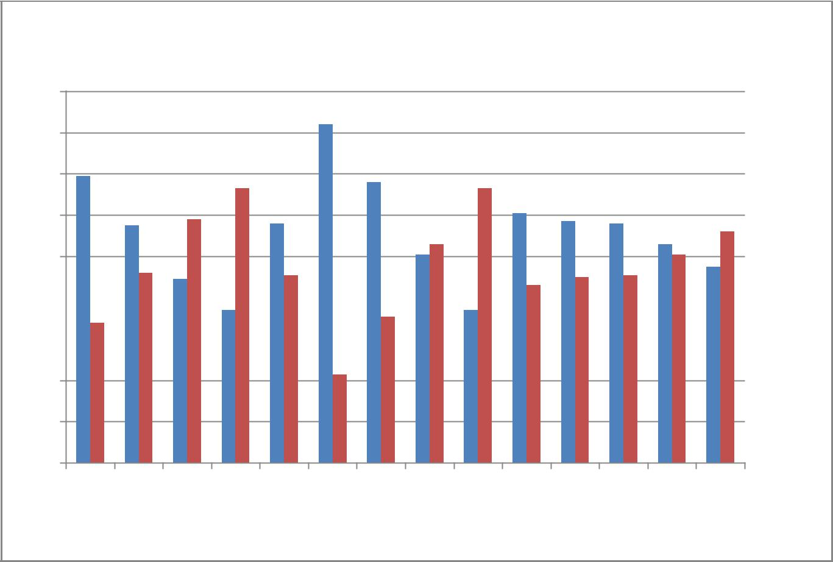

Preference for active recreation among Men

180

160

140

120

100

80 |  |  |  | Yes
60 |  |  |  | No

40

20

0

A B C D E F G H I J K L M N

Recreation activities (coded)

Figure 3: Preferences for active recreation among men

Source: Field Survey, 2012

34
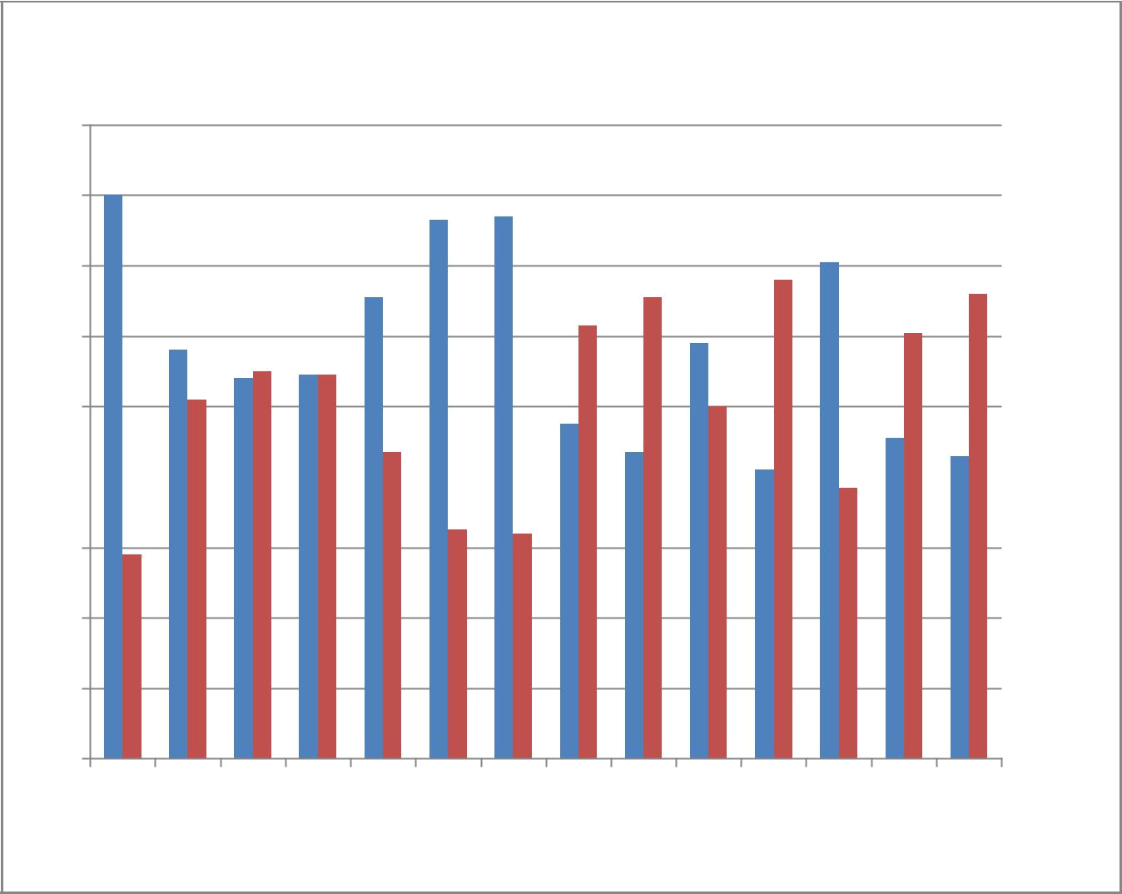
Preference for active recreation among Women

180

160

140

120

100

80 |  |  |  | Yes

No
60

40

20

0

A B C D E F G H I J K L M N

Recreation activities (coded)

Figure 4: Preferences for active recreation among women

Source: Field Survey, 2012

35
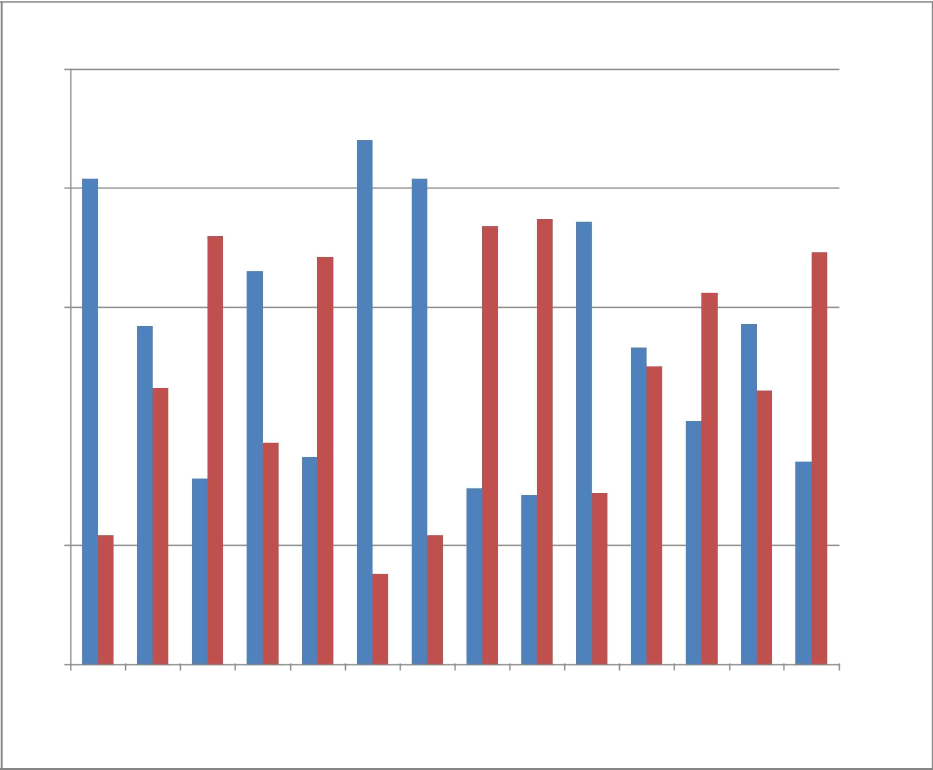
Preference for active recreation among Youths

250

200

150

Yes

100 |  |  |  | No

50

0

A B C D E F G H I J K L M N

Recreation activities (coded)

Figure 5: Preference for active recreation among youths

Source: Field Survey, 2012

36
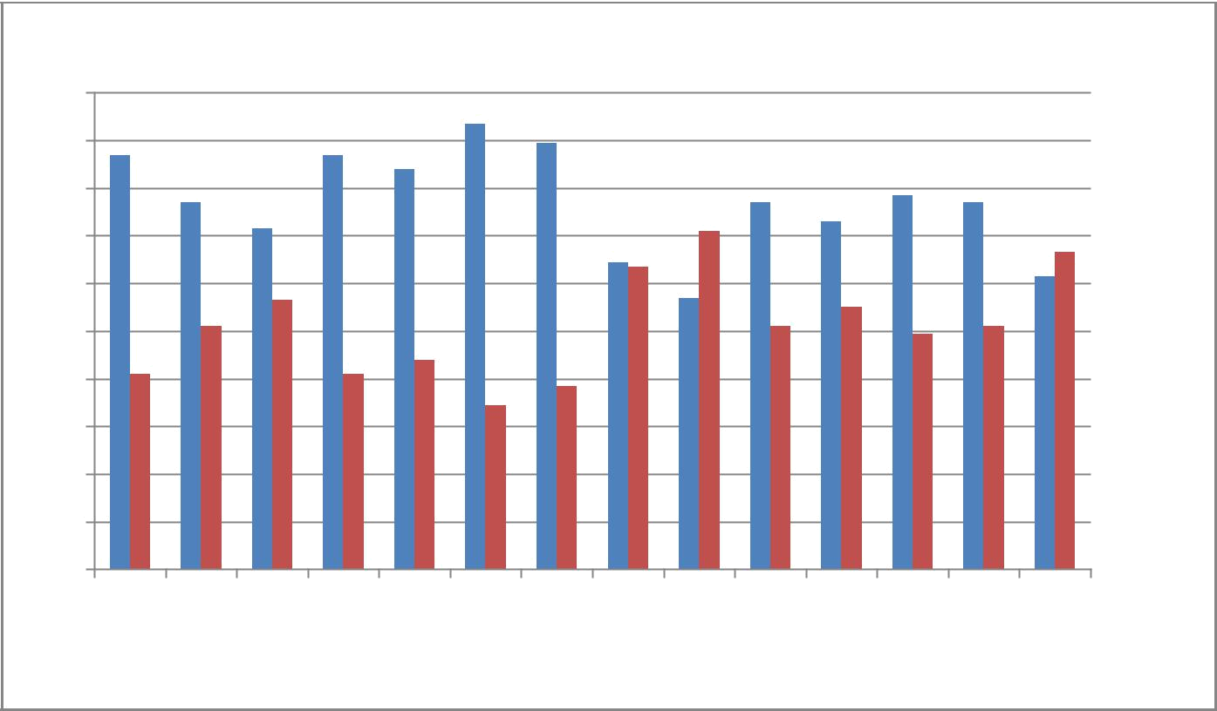

Preference for active recreation among Children

200

180

160

140

120

100

80

60

40

20

Yes

No

0

A B C D E F G H I J K L M N

Recreation activities (coded)

Figure 6: Preference for active recreation among children

Source: Field Survey, 2012

KEY

- Dancing

- Gardening

- Wrestling

- Craft making

- Horse riding

- Walking

- Traditional recreation

- Fishing

- Boating

- Football

- Table tennis

- Swimming

- Handball

- Lawn tennis

37

4.2 MILITATING ATTRIBUTES IN ACTIVE RECREATION

In table 7, results show that the four groups of residents were mostly hindered from participating in active recreation because they were too busy with their families. This represents 96, 96, 85 and 117 of the men, women, youths and children respectively. Previous studies have also shown that lack of time because of work and family responsibilities influenced the recreational inactivity of African American women (Heesch et al., 2000; Williams et al., 2006) and decline in active recreation among working class men due to the pressure of family obligations (Landon and Locander, 2009). The study conducted by Opinion Research Corp. International (2012) to find out how teens and adults feel about physical activity and physical education upholds this result and reports that most adults who reported they do not get enough physical activity were of the view that work prevented their being physically active. This situation calls for concern because engagement in active recreation is important in maintaining a healthy life, and reducing the risk of obesity, boosting the immune system and increasing life expectancy (California State Parks, 2005). Inability to engage in active recreation, therefore, should be seen as a prelude to bad health, which affects the prospects of family and marriage, school, career and business. Stress, for example, has become a major modern-day factor affecting men’s health. The Sunday Trust (2012) supports this assertion and reports that the tension and emotional strain of day-to-day living has been linked to heart disease, high blood pressure, migraine headaches, back pain, diabetes, cancer, and a weakened immune response to disease.

38
Table 7: Recreational constraints of residents

Residents |  | Frequency | Percent | Valid Percent | Cumulative
MEN
Valid | High Fee | 12 | 5.6 | 6.4 | 6.4
 | Busy with family | 96 | 44.9 | 51.1 | 57.4
 | Physically unable to take part | 48 | 22.4 | 25.5 | 83.0
 | Old age | 12 | 5.6 | 6.4 | 89.4
 | Others | 20 | 9.3 | 10.6 | 100.0
 | Total | 188 | 87.9 | 100
Missing | System | 26 | 12.1
Total |  | 214 | 100.0
WOMEN
Valid | High Fee | 17 | 3.9 | 8.1 | 8.1
 | Busy with family | 96 | 22.2 | 45.5 | 53.6
 | Physically unable to take part | 73 | 16.9 | 34.6 | 88.2
 | Old age | 20 | 4.6 | 9.5 | 97.6
 | Others | 5 | 1.2 | 2.4 | 100.0
 | Total | 211 | 48.7 | 100.0
Missing | System | 222 | 51.3
Total |  | 433 | 100.0
YOUTHS
Valid | High Fee | 83 | 31.1 | 33.3 | 33.3
 | Busy with family | 85 | 31.8 | 34.1 | 67.5
 | Physically unable to take part | 36 | 13.5 | 14.5 | 81.9
 | Old age | 11 | 4.1 | 4.4 | 86.3
 | Others | 34 | 12.7 | 13.7 | 100.0
 | Total | 249 | 93.3 | 100.0
Missing | System | 18 | 6.7
Total |  | 267 | 100.0
CHILDREN
Valid | High Fee | 62 | 23.8 | 24.4 | 24.4
 | Busy with family | 117 | 45.0 | 46.1 | 70.5
 | Physically unable to take part | 51 | 19.6 | 20.1 | 90.6
 | Old age | 12 | 4.6 | 4.7 | 95.3
 | Others | 12 | 4.6 | 4.7 | 100.0
 | Total | 254 | 97.7 | 100.0
Missing | System | 6 | 2.3
Total |  | 260 | 100.0
Source: Field Survey, 2012

Table 8 shows the opinions of the respondents concerning the availability of their choice of active recreation facilities. The table indicates that men, women and children strongly affirmed that their types of active recreation facilities were provided in Bida. This submission runs contrary to the opinion of the youths (128 representing 47.9% of the population) who maintained that they did not have provision made for their type of facilities. This result

39

therefore suggests that the youths, as a dynamic and active segment of the population desire and deserve engagement in active recreational activities that help them express themselves, seek for fulfillment and self-confidence. This characteristic nature of the youths can indeed hinder them from participating in active recreation; constitute a barrier to their educational improvement and encourage anti-social behaviours like prostitution and armed robbery.

Table 8: Availability of resident’s choice of recreational facilities.

Residents |  | Frequency | Percent | Valid Percent | Cumulative
 |  |  |  |  | percent
MEN
Valid | YES | 128 | 59.8 | 63.7 | 63.7
 | NO | 73 | 34.1 | 36.3 | 100.0
Total |  | 201 | 93.9 | 100.0
Missing | System | 13 | 6.1
Total |  | 214 | 100.0
WOMEN
Valid | YES | 153 | 35.3
 | NO | 56 | 12.9 | 73.2 | 73.2
Total |  | 209 | 48.3 | 26.8 | 100.0
Missing | System | 224 | 51.7 | 100.0
Total |  | 433 | 100.0
YOUTHS
Valid | YES | 121 | 45.3 | 48.6 | 48.6
 | NO | 128 | 47.9 | 51.4 | 100.0
Total |  | 249 | 93.3 | 100.0
Missing | System | 18 | 6.7
Total |  | 267 | 100.0
CHILDREN
Valid | YES | 199 | 76.5 | 78.3 | 78.3
 | NO | 55 | 21.2 | 21.7 | 100.0
Total |  | 254 | 97.7 | 100.0
Missing | System | 6 | 2.3
Total |  | 260 | 100.0
Source: Field Survey, 2012

40
4.3 ATTITUDES OF WOMEN

Table 9: Women’s perception of work and participation in active recreation

Marital status |  | Strongly | Disagree | Undecided | Agree | Strongly | Total
 |  | Disagree |  |  |  | agree
Single | Count | 3 | 5 | 4 | 2 | 5 | 19
 | Percentage | 15.8% | 26.3% | 21.1% | 10.5% | 26.3% | 100.0%
Married | Count | 3 | 23 | 13 | 30 | 18 | 87
 | Percentage | 3.4% | 26.5% | 14.9% | 34.5% | 20.7% | 100.0%
Divorced | Count | 5 | 43 | 3 | 1 | 8 | 60
 | Percentage | 8.3% | 71.7% | 5.0% | 1.7% | 13.3% | 100.0%
Widowed | Count | 1 | 19 | 0 | 1 | 12 | 33
 | Percentage | 3.0% | 57.6% | .0% | 3.0% | 36.4% | 100.0%
Separated | Count | 3 | 1 | 3 | 2 | 0 | 9
 | Percentage | 34.3% | 11.1% | 33.3% | 22.2% | .0% | 100.0%
Total | Count | 18 | 91 | 23 | 36 | 43 | 208
 | Percentage | 7.2% | 43.75% | 11.05% | 17.31% | 20.68% | 100.0%
Source: Field Survey, 2012

In table 9 results show that the single, divorced, widowed and separated women in Bida did not feel that their work do not allow them to take part in active recreation. This group of women are indeed single, not having much commitments and under the authority of a husband, making it much easier for them to be predisposed to participate in recreation. On the contrary, married women completely felt that their work made it difficult for them to engage in physical activities. This may not be faulted especially looking at it from the angle that though Bida is a heterogeneous society, it is really an Islamic enclave where religion, culture and caring for the home makes it extremely difficult for women to be involved in outdoor recreations.

41
Table 10: Women’s perception of benefits in active recreation

Marital status |  | Strongly | Disagree | Undecided | Agree | Strongly | Total
 |  | Disagree |  |  |  | Agree
Single | Count | 5 | 5 | 5 | 2 | 3 | 20
 | Percentage | 25.0% | 25.0% | 25.0% | 10.0% | 15.0% | 100.0%
Married | Count | 14 | 20 | 16 | 16 | 23 | 89
 | Percentage | 15.7% | 22.5% | 18.0% | 18.0% | 25.8% | 100.0%
Divorved | Count | 4 | 5 | 3 | 2 | 45 | 59
 | Percentage | 6.8% | 8.5% | 5.0% | 3.4% | 76.3% | 100.0%
Widowed Count |  | 1 | 5 | 6 | 0 | 21 | 33
 |  | 3.0% | 15.2% | 18.2% | .0% | 63.6% | 100.0%
Separated Count |  | 2 | 0 | 5 | 1 | 0 | 8
 | Percentage | 25.0% | .0% | 62.5% | 12.5% | .0% | 100.0%
Total | Count | 26 | 35 | 35 | 21 | 92 | 209
 | Percentage | 12.4% | 16.8% | 16.8% | 10.0% | 44.0% | 100.0%
Source: Field Survey, 2012

Table 10 shows the expression of the feelings of Bida women on whether engagement in physical activities is of any benefit to them or not. Though the single and separated women in Bida believed there are gains to be derived from active recreation, the married, divorced and widowed simply differed in their own submission. The latter’s difference in opinion may not be unconnected to strong Islamic dominance and adherence in Bida. Education, which brings exposure, enlightenment and awareness, may have informed the thoughts and perceptions of the former.

42
Table 11: Women’s fears for injuries in active recreation

Marital Status |  | Strongly | Disagree | Undecid | Agree | Strongly | Total
 |  | disagree |  | ed |  | Agree
Single | Count | 2 | 4 | 6 | 3 | 4 | 19
 | Percentage | 10.5% | 21.0% | 31.6% | 15.8% | 21.1% | 100.0%
Married Count |  | 8 | 28 | 17 | 20 | 17 | 90
 | Percentage | 8.9% | 31.1% | 18.9% | 22.2% | 18.9% | 100.0%
Divorced Count |  | 4 | 39 | 8 | 0 | 9 | 60
 | Percentage | 6.7% | 65.0% | 13.3% | .0% | 15.0% | 100.0%
Widowed Count |  | 2 | 20 | 1 | 1 | 8 | 32
 | Percentage | 6.3% | 62.5% | 3.1% | 3.1% | 25.5 | 100.0
Separated Count |  | 2 | 0 | 4 | 3 | 0 | 9
 | Percentage | 22.2% | .0% | 44.4% | 33.3% | .0% | 100.0%
Total | Count | 18 | 91 | 36 | 27 | 38 | 210
 | Percentage | 8.6% | 43.3% | 17.1% | 12.9% | 18.1% | 100.0%
Source: Field Survey, 2012

Table 11 shows that many women are not ready to take part in active recreation because they have the fear of sustaining injuries. Women in this category include the singles ( 36.9%) as against 31.6% who did not belief that fear of sustaining injuries would be capable of restraining them from taking part in physical activities. For the married women, 41.1% of them obliged that fears of sustaining injuries would hinder them from taking part in active recreation, but 40% of the married indicated that they would participate in active recreation, the possibility of injuries notwithstanding. The separated women also showed unwillingness to engage in active recreation because of fear of injuries. This represents 33.3% of the separated women as against 22.2% of them that were willing to take part in physical exercises.

43

Further findings in table 11 indicate that the divorced and widowed concurred that fear of sustaining injuries would not hinder them from taking part in active recreation. For the divorced, this represents 71.7% as against 15% of them who showed unwillingness to take part in physical exercises because of injuries. In the case of the widowed, while 68.8% of them were of the perception that sustaining injuries would not pose any setback in taking part in active recreation, only 28.6% were in opposition to that assertion.

4.4 PERCEPTIONS OF CHILDREN

Table 12: Children’s perception of active recreation and school performance

Religion |  | Strongly | Disagree | Undecided | Agree | Strongly | Total
 |  | disagree |  |  |  | Agree
Islam | Count | 10 | 42 | 21 | 12 | 50 | 135
 |  | 7.4% | 31.1% | 15.6% | 8.9% | 37.0% | 100.0%
Christianity | Count | 16 | 32 | 7 | 11 | 52 | 118
 |  | 13.6% | 27.1% | 5.9% | 9.3% | 44.1% | 100.0%
Total | Count | 26 | 74 | 28 | 23 | 102 | 253
 | Percentage | 10.3% | 29.2% | 11.1% | 9.1% | 40.3% | 100.0%
Source: Field Survey, 2012

Table 12 shows an attempt by children to express how they feel about school work and participation in active recreation. Results in this table indicate that while 62% of Islamic children agreed that they would record poor grades in school if they participated in active recreation; only 52% of them looked to the contrary. On the other side, table 13 also reveals that 63% of Christian children unanimously supported the point that they would not do well in school if they took part in physical exercises. In this particular bargain, only 48% of Christian children argued in opposition.

44
4.5 CORRELATION ANALYSIS OF RESIDENTS ATTITUDES

In this aspect of the analysis, certain factors that determine residents’ attitudes towards active recreation were examined. The variables which influence the demand for active recreation may include discretionary income, paid holiday entitlement, age, etc. In this study, three variables were tested to determine if they influence residents’ attitudes towards physical activities. These three variables are gender, occupation and marital status. The essence of applying the Tests was to arrive at a result that will make significant sense in planning for the recreational need of the residents of Bida. The Chi-Square Test was then used to determine the association or relationship between the independent and dependent variables, and the Spearman’s Correlation used to measure the degree of relationship.

4.5.1 GENDER AND ACTIVE RECREATION

One’s gender or sex determines to a great extent his preferences and inclinations. The fact that an individual is of the masculine or feminine gender may naturally, culturally or religiously affect his choice, demand or willingness to engage in certain activities. 
Table 13: Cross tabulation of residents’ gender and willingness to participate in active recreation
GENDER |  | Strongly | Disagree | Undecided | Agree | Strongly | Total
 |  | Disagree |  |  |  | Agree
MALE | Count | 44 | 64 | 56 | 131 | 160 | 455
Expected count |  | 46.9 | 74.1 | 53.8 | 116.6 | 163.5 | 455.0
% within Sex |  | 9.7% | 14.1% | 12.3% | 28.8% | 35.2% | 100.0%
% within Q11 |  | 46.3% | 42.7% | 51.4% | 55.5% | 48.3% | 49.4%
% of Total |  | 4.8% | 6.9% | 6.1% | 14.2% | 17.4% | 49.4%
FEMALE | Count | 51 | 86 | 53 | 105 | 171 | 466
Expected Count |  | 48.1 | 75.9 | 55.2 | 119.4 | 167.% | 466.0
% within Sex |  | 10.9% | 18.5% | 11.4% | 22.5% | 36.7% | 100.0%
% within Q11 |  | 53.7% | 57.3% | 48.6% | 44.5% | 51.7% | 50.6%
% of Total |  | 5.5% | 9.3% | 5.8% | 11.4% | 18.6% | 50.6%
Total | Count | 95 | 150 | 109 | 236 | 331 | 921
Expected Count |  | 95.0 | 150.0 | 109.0 | 236.0 | 331.0 | 921.0
% within Sex |  | 10.3% | 16.3% | 11.8% | 25.6% | 35.9 | 100.0%
% within Q11 |  | 100.0% | 100.0% | 100.0% | 100.0% | 100.0% | 100.0%
% of Total |  | 10.3% | 16.3% | 11.8% | 25.6% | 35.6% | 100.0%
Source: Field Survey, 2012

45
Chi-Square Tests

 | Value | df | Asymp. Sig.
 |  |  | (2-sided)
Pearson Chi-Square | 6.925ª | 4 | .140
Likelihood Ratio | 6.942 | 4 | .139
Linear-by-Linear
Association | 1.242 | 1 | .265
N of Valid Cases | 921
a. 0 cells (.0%) have expected count less than 5. The minimum expected count is 46.93

Hypothesis of interest:

H_{O:} Residents’ attitudes towards active recreation are independent of their gender.

H_{i:} Residents’ attitudes towards active recreation are dependent of their gender.

Decision rule: Reject Ho if P-value ˂ 0.05 (i.e. 5% level of significance).

Since the P-value = .140> 0.05, then we do not reject the Ho. Therefore the gender of residents do not influence or determine their attitudes towards active recreation.


Symmetric Measures

 |  |  | Asymp.
 |  | Value | Std. Errorª | Approx. T^{b} | Approx. Sig.
Interval by Interval | Pearson's R | -.037 | .033 | -1.115 | .265^{c}
Ordinal by Ordinal | Spearman Correlation | -.025 | .033 | -.752 | .452^{c}
N of Valid Cases |  | 921

a. Not assuming the null hypothesis.

b. Using the asymptotic standard error assuming the null hypothesis.

c. Based on normal approximation.

Ho: = 0 (not significant)

Hi: ≠ 0 (significant)

Decision rule: Reject Ho if P-value ˂ 0.05

r (Spearman’s Correlation) = -.025 (negative but very weak). Then the P-value = .452> 0.05 and so not significant

46
4.5.2 OCCUPATION AND ACTIVE RECREATION

The occupation or career of a person may exert a strong influence on the things he does. Occupation to a reasonable extent may permit or bar an individual from recreation. Table 14 presents a correlation between occupation and residents participation in physical activities in Bida.

Table 14: Cross tabulation of residents’ occupation and their perception of active recreation
Occupations | Strongly | Disagree | Undecided | Agree | Strongly | Total
 | Disagree |  |  |  | Agree
Civil Service Count | 32 | 93 | 10 | 28 | 41 | 204
Expected Count | 29.5 | 80.8 | 16.3 | 35.3 | 42.1 | 204.0
% within Q4 | 15.7% | 45.6% | 4.9% | 13.7% | 20.1% | 100.0%
% within Q9 | 24.2% | 25.8% | 13.7% | 17.7% | 21.8% | 22.4%
% of Total | 3.5% | 10.2% | 1.1% | 3.1% | 4.5% | 22.4%
Schooling Count | 69 | 158 | 33 | 74 | 80 | 414
Expected Count | 59.9 | 163.9 | 33.1 | 71.7 | 85.3 | 414.0
% within Q4 | 16.7% | 38.2% | 8.0% | 17.9% | 19.3% | 100.0%
% within Q9 | 52.3% | 43.8% | 45.2% | 46.8% | 42.6% | 45.4%
% of Total | 7.6% | 17.3% | 3.6% | 8.1% | 8.8% | 45.4%
Farming Count | 8 | 51 | 21 | 21 | 37 | 138
Expected Count | 20.0 | 54.6 | 11.0 | 23.9 | 28.4 | 138.0
% within Q4 | 5.8% | 37.0% | 15.2% | 15.2% | 26.8% | 100.0%
% within Q9 | 6.1% | 14.1% | 28.8% | 13.3% | 19.7% | 15.1%
% of Total | .9% | 5.6% | 2.3% | 2.3% | 4.1% | 15.1%
Trading Count | 20 | 53 | 9 | 30 | 27 | 139
Expected Count | 20.1 | 55.0 | 11.1 | 24.1 | 28.7 | 139.0
% within Q4 | 14.4% | 38.1% | 6.5% | 21.6% | 19.4% | 100.0%
% within Q9 | 15.2% | 14.7% | 12.3% | 19.0% | 14.4% | 15.2%
% of Total | 2.2% | 5.8% | 1.0% | 3.3% | 3.0% | 15.2%
Others Count | 3 | 6 | 0 | 5 | 3 | 17
Expected Count | 2.5 | 6.7 | 1.4 | 2.9 | 35 | 17.0
% within Q4 | 17.6% | 35.3% | .0% | 29.4% | 17.6% | 100.0%
% within Q9 | 2.3% | 1.7% | .0% | 3.2% | 1.6% | 1.9%
% of Total | .3% | .7% | .0% | .5% | .3% | 1.9%
Total Count | 132 | 361 | 73 | 158 | 188 | 912
Expected Count | 132.0 | 361.0 | 73.0 | 158.0 | 188.0 | 912.0
% within Q4 | 14.5% | 39.6% | 8.0% | 17.3% | 20.6% | 100.0%
% within Q9 | 100.0% | 100.0% | 100.0% | 100.0% | 100.0% | 100.0%
% of Total | 14.5% | 39.6% | 8.0% | 17.3% | 20.6% | 100.0%
Source: Field Survey, 2012

47

Chi-Square Tests

 |  |  | Asymp. Sig.
 | Value | df | (2-sided)
Pearson Chi-Square | 32.473ª | 16 | .009
Likelihood Ratio | 33.905 | 16 | .006
Linear-by-Linear | 3.361 | 1 | .067
Association | 3.361 | 1 | .067
N of Valid Cases | 912

- 4 cells (16.0%) have expected count less than 5. The minimum expected count is 1.36.

Hypothesis of interest

H_{O:} Residents’ attitudes towards active recreation are independent of their occupations.

H_{i:} Residents’ attitudes towards active recreation are dependent of their occupations.

Decision rule: Reject Ho if P-value ˂ 0.05 (i.e. 5% level of significance).

Since the P-value = .009˂ 0.05, then we reject the Ho.Therefore, residents’ occupations influence or determine their attitudes towards active recreation.

Symmetric Measures

 |  |  | Asymp.
 |  | Value | Std. Errorª | Approx. T^{b} | Approx. Sig.
Interval by Interval | Pearson's R | .061 | .033 | 1.836 | .067^{c}
Ordinal by Ordinal | Spearman Correlation | .073 | .033 | 2.201 | .028^{c}
N of Valid Cases |  | 912

- Not assuming the null hypothesis.

- Using the asymptotic standard error assuming the null hypothesis.

- Based on normal approximation.

Ho: = 0 (not significant)

Hi: ≠ 0 (significant)

Decision rule: Reject Ho if P-value ˂ 0.05; r (Spearman’s Correlation) = .073 (negative but very weak).

Then the P-value = .028> 0.05 and so not significant.

48
Table 15:Cross tabulation of residents’ marital status and participation in active recreation
Occupations | Strongly | Disagree | Undecided | Agree | Strongly | Total
 | Disagree |  |  |  | Agree
Single Count | 89 | 105 | 11 | 11 | 19 | 235
Expected Count | 63.2 | 105.8 | 17.5 | 13.3 | 35.3 | 235.0
% within Q6 | 37.9% | 44.7% | 4.7% | 4.7% | 8.1% | 100.0%
% within Q15 | 49.2% | 34.7% | 22.0% | 28.9% | 18.8% | 34.9%
% of Total | 13.2% | 15.6% | 1.6% | 1.6% | 2.8% | 34.9%
Married Count | 75 | 121 | 20 | 17 | 56 | 289
Expected Count | 77.7 | 130.1 | 21.5% | 16.3 | 43.4 | 289.0
% within Q6 | 26.0% | 41.9% | 6.9% | 5.9% | 19.4% | 100.0%
% within Q15 | 41.4% | 39.9% | 40.0% | 44.7% | 55.4% | 42.9%
% of Total | 11.1% | 18.0% | 3.0% | 2.5% | 8.3% | 42.9%
Divorced Count | 9 | 45 | 7 | 1 | 6 | 68
Expected Count | 18.3 | 30.6 | 5.1 | 3.8 | 10.2 | 68.0
% within Q6 | 13.2% | 66.2% | 10.3% | 1.5% | 8.8% | 100.0%
% within Q15 | 5.0% | 14.9% | 14.0% | 2.65% | 5.9% | 10.1%
% of Total | 1.3% | 6.7% | 1.0% | .1% | .9% | 10.1%
Widowed Count | 4 | 17 | 6 | 2 | 6 | 35
Expected Count | 9.4 | 15.8 | 2.6 | 2.0 | 5.3 | 35.0
% within Q6 | 11.4% | 48.6% | 17.1% | 5.7% | 17.1% | 100.0%
% within Q15 | 2.2% | 5.6% | 12.0% | 5.3% | 5.9% | 5.2%
% of Total | .6% | 2.5% | .9% | .3% | .9% | 5.2%
Separated Count | 4 | 15 | 6 | 7 | 14 | 46
Expected Count | 12.4 | 20.7 | 3.4 | 2.6 | 6.9 | 46.0
% within Q6 | 8.7% | 32.7% | 13.0% | 15.2% | 30.4% | 100.0%
% within Q15 | 2.2% | 5.0% | 12.0% | 18.4% | 13.9% | 6.8%
% of Total | .6% | 2.2% | .9% | 1.0% | 2.1% | 6.8%
Total Count | 181 | 303 | 50 | 38 | 101 | 673
Expected Count | 181.0 | 303 | 50.0 | 38.0 | 101.0 | 673.0
% within Q6 | 26.9% | 45.0% | 7.4% | 5.6% | 15.0% | 100.0%
% within Q15 | 100.0% | 100.0% | 100.0% | 100.0% | 100.0% | 100.0%
% of Total | 26.9% | 45.0% | 45% | 5.6% | 15.0% | 100.0%
Source: Field Survey, 2012


Chi-Square Tests

 |  |  | Asymp. Sig.
 | Value | df | (2-sided)
Pearson Chi-Square | 73.129ª | 16 | .000
Likelihood Ratio | 72.321 | 16 | .000
Linear-by-Linear | 32.834 | 1 | .000
Association | 32.834 | 1 | .000
N of Valid Cases | 673

- 5 cells (20.0%) have expected count less than 5. The minimum expected count is 1.98.

H_{O:} Residents’ attitudes towards active recreation are independent of their marital status.

H_{i:} Residents’ attitudes towards active recreation are dependent of their marital status.

Decision rule: Reject Ho if P-value ˂ 0.05 (i.e. 5% level of significance).

Since the P-value = .000 ˂ 0.05, then we reject the Ho.Therefore the marital status of residents influences or determines their attitudes towards active recreation.

49

Symmetric Measures

 |  |  | Asymp.
 |  | Value | Std. Errorª | Approx. T^{b} | Approx. Sig.
Interval by Interval | Pearson's R | .221 | .038 | 5.871 | .000^{c}
Ordinal by Ordinal | Spearman Correlation | .242 | .035 | 6.460 | .000^{c}
N of Valid Cases |  | 673

a. Not assuming the null hypothesis.

b. Using the asymptotic standard error assuming the null hypothesis.

c. Based on normal approximation.

Ho: = 0 (not significant)
Hi: ≠ 0 (significant)
Decision rule: Reject Ho if P-value ˂ 0.05

r (Spearman’s Correlation) = .242 (negative but very weak). Then the P-value = .000 ˂ 0.05 and so significant.

4.5.3 CORRELATION ANALYSIS OF MEN’S ATTITUDES
Table 16: Cross tabulation of men’s occupations and perception of benefits in active recreation

Occupations | Strongly | Disagree | Undecided | Agree | Strongly | Total
 | disagree |  |  |  | Agree
Civil service Count | 17 | 21 | 7 | 4 | 28 | 77
% within Q4 occup. | 22.1% | 27.3% | 9.1% | 5.2% | 36.4% | 100.0%
% within Q12 | 50.0% | 38.2% | 28.0% | 14.3% | 48.3% | 38.5%
Schooling Count | 0 | 4 | 6 | 5 | 12 | 27
% within Q4 occup. | .0% | 14.8% | 22.2% | 18.5% | 44.4% | 100.0%
% within Q12 | .0% | 7.3% | 24.0% | 17.9% | 20.7% | 13.5%
 | 1 | 2 | 8 | 7 | 12 | 30
Farming Count | 3.3% | 6.7% | 26.7% | 23.3% | 40.0% | 100.0%
% within Q4 occup. | 2.9% | 3.6% | 32.0% | 25.0% | 20.7% | 15.0%
% within 12
Trading Count | 13 | 25 | 4 | 9 | 6 | 57
% within Q4 occup. | 22.8% | 43.9% | 7.0% | 15.8% | 10.5% | 100.0%
% within 12 | 38.2% | 45.5% | 16.0% | 32.1% | 10.3% | 28.5%
Others Count | 3 | 3 | 0 | 3 | 0 | 9
% within Q4 occup. | 33.3% | 33.3% | .0% | 33.3% | .0% | 100.0%
% within 12 | 8.8% | 5.5% | .0% | 10.7% | .0% | 4.5%
Total Count | 34 | 55 | 25 | 28 | 58 | 200
% within Q4 occup. | 17.0% | 27.5% | 12.5% | 14.0% | 29.0% | 100.0%
% within Q12 | 100.0% | 100.0% | 100.0% | 100.0% | 100.0% | 100.0%
Source: Field Survey, 2012

50

Chi-Square Tests

 |  |  | Asymp. Sig.
 | Value | df | (2-sided)
Pearson Chi-Square | 56.930ª | 16 | .000
Likelihood Ratio | 68.651 | 16 | .000
Linear-by-Linear | 5.174 | 1 | .023
Association | 5.174 | 1 | .023
N of Valid Cases | 200

- 10 cells (40.0%) have expected count less than 5. The minimum expected count is 1.13.

Hypothesis of interest:

Ho: Men’s attitudes towards active recreation are independent of their occupations.

Hi: Men’s attitudes towards active recreation are dependent of their occupations.

Decision rule: Reject Ho if P-value ˂ 0.05 (i.e. 5% level of significance).

Since the P-value = 0.000 < 0.05, then we reject the Ho.


Symmetric Measures

 |  |  | Asymp.
 |  | Value | Std. Errorª | Approx. T^{b} | Approx. Sig.
Interval by Interval | Pearson's R | -.161 | .070 | -2.299 | .023^{c}
Ordinal by Ordinal | Spearman Correlation | -.155 | .074 | -2.204 | .029^{c}
N of Valid Cases |  | 200

a. Not assuming the null hypothesis.

b. Using the asymptotic standard error assuming the null hypothesis.

c. Based on normal approximation.

Ho: = 0 (not significant)

Hi: ≠ 0 (significant)

Decision rule: Reject Ho if P-value ˂ 0.05

r (Spearman’s Correlation) = -.155 (negative but weak). Then the P-value=.029 ˂ 0.05 and so significant.

51
4.5.4 CORRELATION ANALYSIS OF WOMEN’S ATTITUDES

Table 17: Cross tabulation of women’s marital status and perception of benefits in active recreation

Marital status |  |  | Strongly disagree |  |  | Disagree |  | Undecided |  | Agree |  | Strongly |  | Total
 |  |  |  |  |  |  |  |  |  |  |  | agree
Single |  | Count | 5 |  |  | 5 |  | 5 |  | 2 |  | 3 |  | 20
 |  | % within Q6 | 25.0% |  |  | 25.0% |  | 25.0% |  | 10.0% |  | 15.0% |  | 100.0
 |  | % within Q12 | 19.2% |  |  | 14.3% |  | 14.3% |  | 9.5% |  | 3.3% |  | %
 |  |  |  |  |  |  |  |  |  |  |  |  |  | 9.6%
Married |  | Count | 14 |  |  | 20 |  | 16 |  | 16 |  | 23 |  | 89
 |  | % within Q6 | 15.7% |  |  | 22.5 |  | 18.0% |  | 18.0% |  | 25.8% |  | 100.0
 |  | % within Q12 | 53.8% |  |  | 57.1% |  | 45.7% |  | 76.2% |  | 25.0% |  | %
 |  |  |  |  |  |  |  |  |  |  |  |  |  | 42.6%
Divorved Count |  |  | 4 |  |  | 5 |  | 3 |  | 2 |  | 45 |  | 59
 |  | % within Q6 | 6.8% |  |  | 8.5% |  | 5.1% |  | 3.4% |  | 76.3% |  | 100.0
 |  | % within Q12 | 15.4% |  |  | 14.3% |  | 8.6 |  | 9.5% |  | 48.9% |  | %
 |  |  |  |  |  |  |  |  |  |  |  |  |  | 28.2%
Widowed Count |  |  | 1 |  |  | 5 |  | 6 |  | 0 |  | 21 |  | 33
 |  | % within Q6 | 3.0% |  |  | 15.2% |  | 18.2% |  | .0% |  | 63.6% |  | 100.0
 |  | % within Q12 | 3.8% |  |  | 14.3% |  | 17.1% |  | .0% |  | 22.8% |  | %
 |  |  |  |  |  |  |  |  |  |  |  |  |  | 15.8%
Separated Count |  |  | 2 |  |  | 0 |  | 5 |  | 1 |  | 0 |  | 8
 |  | % within Q6 | 25.0% |  |  | .0% |  | 62.5% |  | 12.5% |  | .0% |  | 100.0
 |  | % within Q12 | 7.7% |  |  | .0% |  | 14.3% |  | 4.8% |  | .0% |  | %
 |  |  |  |  |  |  |  |  |  |  |  |  |  | 3.8%
Total |  | Count | 26 |  |  | 35 |  | 35 |  | 21 |  | 92 |  | 209
 |  | % within Q6 | 12.4% |  |  | 16.7% |  | 16.7% |  | 10.0% |  | 44.0% |  | 100.0
 |  | % within Q12 | 100.0% |  |  | 100.0% |  | 100.0% |  | 100.0% |  | 100.0% |  | %
 |  |  |  |  |  |  |  |  |  |  |  |  |  | 100.0
 |  |  |  |  |  |  |  |  |  |  |  |  |  | %
Source: Field Survey, 2012
 |  |  | Chi-Square Tests
 |  |  |  |  |  |  |  |  |  |  | Asymp. Sig.
 |  |  |  | Value |  |  |  | df |  |  |  | (2-sided)
 | Pearson Chi-Square |  |  |  | 72.667ª |  |  | 16 |  |  |  | .000
 | Likelihood Ratio |  |  |  | 78.580 |  |  | 16 |  |  |  | .000
 | Linear-by-Linear |  |  |  | 12.194 |  |  |  | 1 |  |  | .000
 | Association
 | N of Valid Cases |  |  |  | 209


- 11 cells (44.0%) have expected count less than 5. The minimum expected count is .80.

Hypothesis of interest:

H_{O}: Women’s attitudes towards active recreation are independent of their marital status.

H₁: Women’s attitudes towards active recreation are dependent of their marital status.

52
Decision rule: Reject Ho if P-value ˂ 0.05 (i.e. 5% level of significance).

Since the P-value = 0.000< 0.05, then we reject the Ho.


Symmetric Measures

 |  |  | Asymp.
 |  | Value | Std. Errorª | Approx. T^{b} | Approx. Sig.
Interval by Interval | Pearson's R | .242 | .067 | 3.590 | .000^{c}
Ordinal by Ordinal | Spearman Correlation | .316 | .065 | 4.789 | .000^{c}
N of Valid Cases |  | 209

a. Not assuming the null hypothesis.

b. Using the asymptotic standard error assuming the null hypothesis.

c. Based on normal approximation.

Ho: = 0 (not significant)

Hi: ≠ 0 (significant)

Decision rule: Reject Ho if P-value ˂ 0.05

r (Spearman’s Correlation) = .316 (positive but weak). Then the P-value= .000 <0.05 and so significant

53
4.5.5 CORRELATION ANALYSIS OF YOUTHS’ ATTITUDES

Table 18: Cross tabulation of youths’ perception of active recreation and feeling of laziness
 | Occupations | Strongly |  | Disagree | Undecided |  |  | Agree |  |  | Strongly | Total
 |  | disagree |  |  |  |  |  |  |  |  | Agree
 | Civil service Count | 22 |  | 34 | 3 |  |  | 6 |  |  | 13 | 78
 | % within Q4 occup. | 28.2% |  | 43.6% | 3.8% |  |  | 7.7% |  |  | 16.7% | 100.0%
 | % within Q15 | 44.0% |  | 35.4% | 30.0% |  |  | 50.0% |  |  | 35.1% | 38.0%
 | Schooling Count | 6 |  | 17 | 1 |  |  | 2 |  |  | 3 | 29
 | % within Q4 occup. | 20.7% |  | 58.6% | 3.4% |  |  | 6.9% |  |  | 10.3% | 100.0%
 | % within Q15 | 12.0% |  | 17.7% | 10.0% |  |  | 16.7% |  |  | 8.1% | 14.1%
 |  | 5 |  | 11 | 3 |  |  | 1 |  |  | 10 | 30
 | Farming Count | 16.7% |  | 36.7% | 10.0% |  |  | 3.3% |  |  | 33.3% | 100.0%
 | % within Q4 occup. | 10.0% |  | 11.5% | 30.0% |  |  | 8.3% |  |  | 27.0% | 14.6%
 | % within 15
 | Trading Count | 14 |  | 31 | 2 |  |  | 2 |  |  | 10 | 59
 | % within Q4 occup. | 23.7% |  | 52.5% | 3.4% |  |  | 3.4% |  |  | 16.9% | 100.0%
 | % within 15 | 28.0% |  | 32.3% | 20.0% |  |  | 16.7% |  |  | 27.0% | 28.8%
 | Others Count | 3 |  | 3 | 1 |  |  | 1 |  |  | 1 | 9
 | % within Q4 occup. | 33.3% |  | 33.3% | 11.1% |  |  | 11.1% |  |  | 11.1% | 100.0%
 | % within 15 | 6.1% |  | 3.1% | 10.0% |  |  | 8.3% |  |  | 2.7% | 4.4%
 | Total Count | 50 |  | 96 | 10 |  |  | 12 |  |  | 37 | 205
 | % within Q4 occup. | 24.4% |  | 46.8% | 4.9% |  |  | 5.9% |  |  | 18.0% | 100.0%
 | % within Q15 | 100.0% |  | 100.0% | 100.0% |  |  | 100.0% |  |  | 100.0% | 100.0%
Source: Field Survey, 2012
 |  |  | Chi-Square Tests
 |  |  |  |  |  |  |  |  |  | Asymp. Sig.
 |  |  |  | Value |  | df |  |  |  |  | (2-sided)
 | Pearson Chi-Square |  |  | 14.082ª |  |  |  | 16 |  | .593
 | Likelihood Ratio |  |  | 13.105 |  |  |  | 16 |  | .665
 | Linear-by-Linear |  |  | .050 |  |  |  | 1 |  | .824
 | Association |  |  |  |  |  |  | 1
 | N of Valid Cases |  |  | 205


- 13 cells (52.0%) have expected count less than 5. The minimum expected count is .44.

Hypothesis of interest:

H_{O}: Youth’s attitudes towards active recreation are independent of their occupations.

H₁: Youth’s attitudes towards active recreation are dependent of their occupations.

Decision rule: Reject Ho if P-value ˂ 0.05 (i.e. 5% level of significance).

54
Since the P-value = .593>0.05, then we do not reject the Ho.

Symmetric Measures

 |  |  | Asymp.
 |  | Value | Std. Errorª | Approx. T^{b} | Approx. Sig.
Interval by Interval | Pearson's R | .016 | .069 | .222 | .824^{c}
Ordinal by Ordinal | Spearman Correlation | .021 | .071 | .304 | .761^{c}
N of Valid Cases |  | 205

a. Not assuming the null hypothesis.

b. Using the asymptotic standard error assuming the null hypothesis.

c. Based on normal approximation.

Ho: = 0 (not significant)

Hi: ≠ 0 (significant)

Decision rule: Reject Ho if P-value ˂ 0.05

r (Spearman’s Correlation) = .021 (positive but weak). Then the P-value= .7610>05 and so significant

4.5.6 CORRELATION ANALYSIS OF CHILDREN’ ATTITUDES

Table 19: Cross tabulation of children’s gender and fear of sustaining injuries in active recreation

 | GENDER | Strongly | Disagree | Undecided | Agree | Strongly | Total
 |  | disagree |  |  |  | agree
Male | Count | 10 | 42 | 21 | 12 | 50 | 135
 | % within Sex | 7.4% | 31.1% | 15.6% | 8.9% | 37.0% | 100.0%
 | % within Q13 | 38.5% | 56.8% | 75.0% | 52.2% | 49.0% | 53.4%
Female | Count | 16 | 32 | 7 | 11 | 52 | 118
 | % within Sex | 13.6% | 27.1% | 5.9% | 9.3% | 44.1% | 100.0%
 | % within Q13 | 61.5% | 43.2% | 25.0% | 47.8% | 51.0% | 46.6%
Total | Count | 26 | 74 | 28 | 23 | 102 | 253
 | % within Sex | 10.3% | 29.2% | 11.1% | 9.1% | 40.3% | 100.0%
 | % within Q13 | 100.0% | 100.0% | 100.0% | 100.0% | 100.0% | 100.0%
Source: Field Survey, 2012

55

Chi-Square Tests

 |  |  | Asymp. Sig.
 | Value | df | (2-sided)
Pearson Chi-Square | 8.716ª | 4 | .069
Likelihood Ratio | 9.018 | 4 | .061
Linear-by-Linear | .107 | 1 | .744
Association | .107 | 1 | .744
N of Valid Cases | 253

- 0 cells (.0%) have expected count less than 5. The minimum expected count is 10.73.

Hypothesis of interest:

Ho: Children’s attitudes towards recreation are independent of their gender.

H₁: Children’s attitudes towards recreation are dependent of their gender.

Decision rule: Reject Ho if P-value ˂ 0.05 (i.e. 5% level of significance).

Since the P-value = .069 >0.05, then we do not reject the Ho.


Symmetric Measures

 |  |  | Asymp.
 |  | Value | Std. Errorª | Approx. T^{b} | Approx. Sig.
Interval by Interval | Pearson's R | .021 | .063 | .326 | .745^{c}
Ordinal by Ordinal | Spearman Correlation | .015 | .064 | .241 | .810^{c}
N of Valid Cases |  | 253

a. Not assuming the null hypothesis.

b. Using the asymptotic standard error assuming the null hypothesis.

c. Based on normal approximation.

Ho: = 0 (not significant)

Hi: ≠ 0 (significant)

Decision rule: Reject Ho if P-value ˂ 0.05

r (Spearman’s Correlation) = .015 (positive but very weak). Then the P-value= .810 > 0.05 and so not significant.

4.5.7 Summary

The analyses in chapter four were achieved using SPSS and EXCEL packages in coding the data. Results obtained were also subjected to Chi-Square Tests to determine the relationship
56

between the dependent variables and the independent variables, while the Spearman’s Correlation was used to measure the degree of the relationships. In these analyses, it was discovered that the gender of residents does not determine their attitudes towards active recreation. However, the Chi-Square Tests show that occupation and marital status were very significant in influencing residents’ attitudes towards active recreation. The implication of these analyses poses a huge threat to health and wellbeing. Therefore, proper planning is required to reverse the situation and stimulate active participation in physical activities among the residents of Bida.

57
CHAPTER FIVE

SUMMARY, RECOMMENDATIONS AND CONCLUSION

This chapter introduces the findings of the study, outlines recommendations on the way forward

and then concludes.

5.1 Summary

Based on the analysis of the data collected, findings show that pre-occupation with family was a major hindrance to residents’ ability to take part in active recreation. Also, women (the married) were mostly hindered from taking part in active recreation because of their work. Study evidence also reveal that the single, married and separated women showed unwillingness to take part in active recreation because of the fear of sustaining injuries. In fact women (married, divorced and widowed) had difficulty in partaking in physical activities because they did not see any benefits in engaging in them. Children particularly felt that they would not do well in school if they took part in active recreation. Thus, these findings show that the study objective number two which seeks to determine the characteristics of the population of Bida that hinder participation in physical activities has been achieved.

Findings also reveal that though residents’ attitudes towards active recreation are independent of their gender, their occupations and marital status purely determine their attitudes towards active recreation. Further findings show that unlike the children and youths, men and women had poor attitudes towards physical activities. Though the youths have positive attitudes towards physical activity, yet the types of recreational facilities they needed were not available in Bida. By this study evidence, therefore, the objective number three, which is to establish whether or notresidents’ attitudes towards active recreation are independent of their gender, occupations and marital status has been achieved.

Result also show that men indicated strong preference for recreational activities such as dancing, gardening, horse riding and walking. Other activities they showed interest in included traditional recreational activities, football, table tennis, swimming and handball. The recreational activities popular and preferred among women in Bida were dancing, gardening, horse riding, walking and traditional recreation. Football

58

and swimming also got the interest of the women folk in Bida. On the part of the youths, they indicated interest and choice for recreational activities like dancing, gardening, craft making and walking. Other activities preferred by youths were traditional recreation, football, table tennis and handball. Dancing, gardening, wrestling, craft making, horse riding and walking were the activities children preferred in the study. Others were traditional recreation, fishing, football, table tennis, swimming and handball. Obviously these evidence also prove that the research objective number one, which seeks to determine residents’ preferences for active recreation in Bida has been achieved, as well.

5.2Recommendation

5.2.1 Sustainable advocacy programmes

There should be sustained advocacy campaigns through collaborative efforts of the government, non-governmental organizations, faith and community based organizations using symposia, workshops and the radio to enlighten and correct poor attitudes towards active recreation in Bida. This should be done in the local language and English to enhance participation in active recreation and help prevent disease conditions caused by the inability to participate in physical activities.

5.2.2 Insurance schemes and paid recreation policy

In order to encourage residents’ participation in physical activities, the government and corporate organizations should float insurance covers for them so as to eliminate the fear of sustaining injuries, which hinders many from taking part in the active form of recreation. Backed up with appropriate legislation, there should be recreation with pay i.e. the Government and corporate organizations respectively should pay the residents and employees some amount of money for taking part in active recreation each month. This will encourage and increase residents’ participation in the active form of recreation in Bida.

5.2.3 Provision of residents’ choice of recreational facilities

Revival of the few existing recreational facilities is important. Desired recreational facilities should be provided for the youths to encourage them to participate in active recreation, and enhance their skills in competitive recreational activities. As the most active and dynamic segment of society, this will enable

59

them participate more frequently and willingly in the active forms of recreation. The multiplier effect of that will include better representation of the country in crucial global sports competitions. Besides, and bearing in mind the issue of culture and religion, preferred recreational facilities by the four groups of men, women, youths and children should be built and maintained specifically around the neighbourhoodsfor easy access.This should be done with the understanding that, though in bad shape, there are recreational facilities for badminton, football, handball, basketball, volleyball and gym in Bida.

5.3 Conclusion

The personality of an individual is shown through his attitudes towards the things around him. His attitudes determine whether or not he will take part in any activity. For this study, an assessment was made of the attitudes of the residents of Bida towards active recreation. The results indicate residents’ unwillingness to participate in active recreation due mainly to pre-occupation with work or family and absence of preferred recreational facilities for the youths.

The Chi-Square Test reveals that residents’ gender does not influence their attitudes towards active recreation. However, residents’ occupations and marital status determine their attitudes towards active recreation. On a group level, Chi-Square Test have proved that while men and women showed poor attitudes towards active recreation, the youths and children demonstrated positive attitudes towards physical exercises.

It is nevertheless advocated that further studies should focus on enhancing the active recreational behaviour of the adult population in Bida. Conclusively, it is expected that if the recommendations proffered in this study are applied, Bida residents will not only overcome their recreational inactivity but also experience an unprecedented turnaround in their health status, productivity and general wellbeing.

60
REFERENCES

Akhtar, S. (2001). Relationship of Children’s and Peer’s Attitude. An Unpublished M.A. Thesis, College Govt. for Women, Gujranwala.

Akogun, J.F. {2006}. Community Knowledge and Use of Existing Recreational Facilities in Bida, Niger State, Nigeria. An Unpublished Master’s Thesis, University of Ado-Ekiti, Ado-Ekiti, Nigeria.

Allen, L.R., Long, P.T., Perdue, R.R. and Kieselbach, S. (1988). The Impact of Tourism Development on Residents’ Perceptions of Community Life. Journal of Travel Research, 27(1): 16-21

American Institute of Stress (2011). Stress and Heart Disease, Type A Behaviour and Heart Disease Prevention and Treatment of Heart Disease, Heart Disease and Job Stress. Retrieved: 26/7/2011 from http://www.stress.org/topic-heart.htm

Andriotis, K. & Vaughan, D. R. (2003). Urban Residents’ Attitude Towards Tourism Development: the Case of Crete. Journal of Travel Research, 42, 2.

Balsamo, A. (1996). Technologies of the Gendered Body. Durham, NC: Duke University Press.

Barnlund, D. (2011). The All-pervading Influence: Culture as a Mindset. Retrieved: 24/2/2011 from http://www.comfsm.fm/socscie/allpervading.htm

Baud-Bovy, M. and Lawson, F. (1998). Tourism and Recreation: A Hand Book of Planning and Design.
England: Architectural Press.

Bedni, L.A. (2000). Just Sit Down So We Can Talk: Perceived Stigma and Community Recreation.

Therapeutic Recreation Journal, 34, 1.

Boniface, B.G. and Cooper, C.P. (1987). The Geography of Travel and Tourism (4th ed.).England:

Heinemann.

Bourne, H. (2011). The Influence of the Social Group on an Individual. Retrieved: 24/2/2011 from http://psychology.jrank.org/pages/479/peer-pressure.html

Brostrand, H.L. (2006). Tilting at Windmills: Changing Attitudes Towards People with Disabilities.Journal of Rehabilitation72 (1), 4 –9

Brown, D. (2011). The Roles of Attitude and Aptitude in Success. Retrieved: 24/2/2011 from
http://www.pickthebrain.com/blog/the-roles-of-attitude-and-aptitude-in-success

Bureau of Reclamation (2010). Estimating Future Recreation Demand: a Decision Guide for the
Practitioner. Retrieved: 3/3/2011 from
http://www.usbr.gov/recreation/publications/recreationdemand.pdf, /

California State Parks (2005). The Health and Social Benefits of Recreation. Sacramento, CA:California State Parks Planning Division.

61

Choudry, I.Y. (1995). Areas of Applied Psychology. Lahore: Imperial Book Depot.

Crow, L.D. & Crow, A. (1999). Educational Psychology. New Delhi: Eursia Publishing House.

Driver, B.L.&Bruns, D.H. (1999). Concepts and Uses of the Benefits Approach to Leisure. States College, PA: Venture Publishing.

Employment Tips (2011). The Three Components of Attitudes.

Retrieved: 3/3/2011 from http://www.freelance job.com/employment/what-are-the-three-components-of-attitude/

Etnier, J.L., Salazar, W., Landers, D.M., Petruzzello, S.J., Han, M. & Nowell, P. (1997). The Influence of Physical Fitness and Exercise Upon Cognitive Functioning: A Meta-analysis.

Journal of Sport and Exercise Psychology, 11, 249

Eyler, A. E., Wilcox, S., Matson-Koffman, D., Evenson, K. R., Sanderson, B., Thompson, J.,Rohm-Young, D. (2002). Correlates of Physical Activity Among Women from Diverse Racial/Ethnic Groups. Journal of Women’s Health & Gender-Based Medicine, 11, 239-253.

Fadamiro, J.A. (2003). Recreation and Parks Design. Nigeria: Department of Architecture, Federal University of Technology, Akure, Nigeria

FAO (2010). Determinants of Demand and Consumption. Retrieved: 17/11/2010 from http://www.fao.org/docrep/w4388e0t.htm

Felton, G. M., Boyd, M. D., Bartoces, M. G., & Tavakoli, A. S. (2002). Physical

Activity in Young African American Women. Health Care for Women International, 23, 905-918.

Gold, S.M. (1980). Recreation Planning and Design. United States: McGraw-Hill.

Gontul, K.T &Allu, E.L. (2007). University of Jos Academic Staff Recreational Activities. Journal of Research in Tourism, 1, 1.

Heesch, K. C., Brown, D. R., & Blanton, C. J. (2000). Perceived Barriers to Exercise
and Stage of Exercise Adoption in Older Women of Different Racial/Ethnic Groups.

Women & Health, 30, 61-76.

Henderson, K. A., & Ainsworth, B. E. (2003). A Synthesis of Perceptions about Physical Activity Among Older African American and American Indian Women. American Journal of Public Health, 93, 313-317.

Henry, G. (1991). Psychology. London: Norton & Company Inc.

Im, E., Ko, Y., Hwang, H., Yoo, K.H., Chee, W., Stuifbergen, A., Walker, L., Brown A., McPeek, C., &Chee E. (2011). Physical Activity as a Luxury”: African American

62
Women’s Attitudes Toward Physical Activity.
Retrieved: 30/6/2012 from http://wjn.sagepub.com/content/34/3/317
 

Johns, G. (1996). Organizational Behavior. USA: Harper Collins College Publishers.

Kachoub, B. (2010). The Relationship of L2 Attitudes and Learning: a Study of Moroccan University Students. An unpublished Master’s Thesis, Ohio University, United States.

Key, J.P. (2002). Research Design in Occupational Education.Retrieved:26/2/2010 from http://www.okstate.edu/ag/agedcm4h/academic/aged5980a/5980/index.htm

King, A. C., Castro, C., Wilcox, S., Eyler, A. A., Sallis, J. F., & Brownson, R. C.

(2000). Personal and Environmental Factors Associated with Physical Inactivity Among Different Racial-Ethnic Groups of U.S. Middle-aged and Older-aged Women. Health Psychology, 19, 354-364.

Landon, E.L &Locander, W.B. (2009). Family Life Cycle and Leisure Behaviour

research.Retrieved: 28/7/2011 from www.acrwebsite.org/volumes/display.asp?id=9546

Lindner, K.J. (1999). Sport Participation and Perceived Academic Performance of School Children and Youth.Pediatric Exercise Science, 11, 129

Lopez, K. (2010). The Three Components of Attitudes.Retrieved: 3/3/2011 from http://www.articledashboard.com/Article/The-Three-Components-of-Attitudes/1507073

Milne, J. (2011). Advantages of Questionnaires. Retrieved: 5/3/2011 from

http://ww.icbl.hw.ac.uk/ltdi/cookbook/info_questionnaires/index.html

Moinpour, R. &MacLachlan, D.L. (2009). The Relationship Among Attribute and Important Components of Rosenberg-FishbeinType Attitude Model: An Empirical Investigation. Retrieved: 6/10/2010 fromhttp://www.acrwebsite.org/volumes/display.asp?=11975

National Bureau of Statistics (2011). Federal Republic of Nigeria 2006 Population Census. Retrieved:
6/3/2011from http://www.nigerianstat.gov.ng/nbsapps/connections/pop2006.pdf

National Disability Authority (2012). Literature Review on Attitudes Towards Disability. Retrieved:
21/4/2012 from
http://www.nda.ie/cntmgmtnew.nsf/0/B89C8098F9D7A0C8802573B800430A9B/$File/Literature
Review.pdf

National Population Commission (2006). National Population and Housing Census of Nigeria.

Nixon, P. (2003). Leisure Industry, Microsoft R Encarta R Premium Suite 2004, Retrieved November 2, 2006 from 1993-2003 Microsoft Corporation Packages.

Noe, RA (2002). Employee Training and Development (2nd Ed)
New York: McGraw Hill

Oak, M. (2010). List of Different Recreational Activities. Retrieved: 26/10/2010 from

63
http://www.buzzle.com/articles/list-of-different-recreational-activities.html

Obinna, V., Owei, O., Ayodele, A. &Okwakpam (2009). Patterns and Determinants of Recreational Behavior in Portharcourt, Rivers State, Nigeria. Theoretical and Empirical Researches in Urban Management, 3, 12.

Okafor, C.O. (1986). Fundamentals of Health Education. Ibadan: Heinemann.

Okunrotifa, E.B. (1995). Contemporary Trends in Special Sport Education Programmes. Akure,
FAMFAL.

Opinion Research Corp. International (2012).How Teens and Adults Feel about Physical Activity and Physical Education.Retrieved: 14/4/2012 from http://www.thesportjournal.org/article/adultsteens-attitudes- toward-physical-activity-and-physical-education

Queensland Government (2009), ‘‘What is Outdoor Recreation?''

Retrieved: 27/10/2010 from http://www.qorf.org.au/01_cms/details.asp?ID=686

Roberts, I. (2001). Advanced Leisure and Recreation. Oxford: Heinemann.

Saleem, N. (2001). The Development of Peer Relationship in Children. An Unpublished M.A.
Thesis, College. Govt. Post Graduate for Women, Gujranwala.

Sarwar, M. (2004). Relationship of Study Attitude and Academic Performance of Students at Secondary Level in Punjab. An Unpublished PhD Thesis, University of Arid Agriculture, Rawalpindi, Pakistan.

Smith, R.W., Austin, D.R., Kennedy, D.W., Lee, Y., & Hutchinson, P. (2005). Inclusive and Special Recreation: Opportunities for Persons with Disabilities. New York: McGraw Hill.

Standard Bank (2010). Attitude. Retrieved: 8/12/2010 from
http://changingminds.org/explanations/theories/attitude.htm

Sunday Trust (2012). Ten Ways for Men to Reduce Stress. January 22, p. 42

Sunmap (2011). Actual News Bida. Retrieved: 14/3/2011 from
http://www.sunmap.eu/weather/Africa/Nigeria/wester-state/bida

Swann, J. (2004). The Value of Recreational Activities Within a Care Setting. Nursing and Residential Care, 6, 9.

Tabiti, S.T. (2004). The Role of Women in Urban Environmental Management in Bida, NigerState. An unpublished Master’s Thesis, University of Ibadan, Nigeria

Thompson, P., Anderson, L., &Bakerman, R. (2000). Effects of Racial socialization

and Racial Identity on Acculturative Stress in African American College Students. Cultural Diversity & Ethnic Minority Psychology, 6, 196-210

64

Tribe, J. (1998). The Economics of Leisure and Tourism. Oxford: Butterworth Heinemann.

Udo, C.O. (1988). Recreation: An Indispensable Factor for Healthful Living in Contemporary
Nigeria. Ibadan: University of Ibadan Press.

Ugbabe, P. (2009). A Comparative Study of the Recreation Habits of Corporate Employees and Self-employed Individuals in Bida Town. An unpublished Post Graduate Diploma Project, Institute for Hospitality and Tourism, Abuja, Nigeria.

Umeasiegbu, G.O. (1988). Recreation Pursuits During Economic Recession: Need for Alternative
Approaches in Nigeria. Ibadan: University of Ibadan.

Umoru, T.A. (2003). Basic Research Methods: Competencies and Application (2nd ed.).
Lokoja:Gloti Publishsers.

Urong, I. (2000).The Development of Self-confidence in Children. An Unpublished M.A. Thesis, College. Govt. Post Graduate for Women. Gujranwala.

Wall, G. & Mathieson, A. (2006).Tourism: Change, Impacts and Opportunities. England: Pearson Prentice Hall.

WebFinance Inc. (2011). Attitude. Retrieved: 14/3/2011 from .

http://www.businessdictionary.com/definition/attitude.html

Whitehouse, N. (2011). What Role Does Attitude Play in Your Life? Retrieved: 3/3/2011 from http://ezinearticles.com/?what-role-does-attitude-play-in-your-life?&id=5527967

Williams, B. R., Bezner, J., Chesbro, S. B., & Leavitt, R. (2006). The Effect of aWalking Program on Perceived Benefits and Barriers to Exercise in PostmenopausalAfrican American Women. Journal of Geriatric Physical Therapy, 29, 43-49.

Wolf, N. (1992).The Beauty Myth: How Images of Beauty are Used Against Women.
New York, NY: Anchor Books.

Zonkwa, K. (2011). An Appraisal of the Perception, Adaptation and Copping Strategies of Climate Change Issues Among Indigenous Farmers in ZangonKataf Local Government Area Kaduna State. An unpublished Msc. proposal. Department of Geography, Ahmadu Bello University, Zaria-Nigeria.

65
APPENDICES

APPENDIX 1 - QUESTIONNAIRE

ASSESSMENT OF RESIDENTS’ ATTITUDES TOWARDS RECREATION IN BIDA INTRODUCTION

This research questionnaire aims at collecting data for purely academic purpose. The researcher, Kingsley Ononogbo is a M.Sc. student of Tourism and Recreation Planning, Ahmadu Bello University, Zaria. The information obtained through this medium will be treated absolutely as confidential. The researcher therefore, wishes to stress the need for sincerity and accuracy in giving information as vital ingredients for a successful research. Thank you.

INSTRUCTIONS: Please tick where appropriate, and rate how strongly you agree or disagree where applicable.

Check mark: Strongly agree = 5, Agree = 4, Undecided = 3, Disagree = 2, strongly disagree = 1

 |  |  |  | Section A: General information
1. | Age: a. Between 4-12 years [ |  |  |  |  |  |  | ] b. Between 13-36 years [ ] c. Between 37-60 years [ ] d.
 | Between 61 years and above [ |  |  |  |  |  |  | ]
2. | Gender: a. Male [ ] b. Female [ ]
3. | Monthly income: a. between |  |  |  |  |  | N | 1000- | N | 30,000 [ ] b. |  |  | N | 31,000- | N | 60,000 [ | ] c. | N | 61,000-
 | N | 90,000 [ ] d. | N | 91,000- | N | 120,000 [ ] e. |  |  |  |  | N | 121,000 and above [ ]
4. | Occupation: a. Civil service [ |  |  |  |  |  |  | ] b. Schooling [ ] c. Farming [ ] d. Trading [ |  |  |  |  |  |  |  |  |  | ]
 | e. Others, please specify………………………………..
5. | Religion: a. Islam [ ] b. Christianity [ ] c.Others, please specify………………………..
6. | Marital status: a. Single [ ] b. Married [ ] c. Divorced [ ] d. Widowed [ |  |  |  |  |  |  |  |  |  |  |  |  |  |  |  | ]
 | e. Separated [ ]
7. | Highest educational attainment: a. Primary { } b. Secondary { } c. Tertiary { |  |  |  |  |  |  |  |  |  |  |  |  |  |  |  |  | }

e. Others, please specify…………………………………………………………

66
Section B: Information about Attitudes

S/no. | Questions
 |  |  |  | Rating
 |  | Strongly | Agree | Undecided | Disagree | Strongly
 |  | agree |  |  |  | disagree
8 | You are afraid to fail in school if you
 | participate in physical exercises.
9 | Your work/study does not allow you to
 | take part in physical exercises
10 | You feel participation in physical exercises
 | will reduce your business profits
11 | You are willing to take part in physical
 | exercises
12 | You feel engaging in physical exercises
 | will not benefit you
13 | You do not take part in physical exercises
 | because you are afraid of getting injuries
14 | You feel your religious duties will be
 | neglected if you take part in physical
 | exercises
15 | You feel you will be considered a lazy
 | person if you engage in physical exercises

Participation and its frequency

16.Do you take part in physical exercises? A. Yes [ ] b. No [ ]

17. How often do you take part in physical exercises? a. daily [ ] b. weekly [ ] c. quarterly [ ]

d. yearly [ ] e. others, please specify……………………………………………………….

18. When last did you take part in physical exercises? a. within the last 3 months [ ] b. within

the last 6 months [ ] in the last 1 year [ ] d. more than 1 year ago

67
Section C: Constraints against recreation participation

19. What reasons hinder you from participating in physical exercises? a. high admission fees [ ] b. being too busy with family [ ] c. physically unable to take part [ ] d. old age [ ]

e. others, please specify………………………………………………….

20. Are there facilities for your type of physical activities? a. Yes [ ] b. No [ ]

Section D: Preference for recreational activities

- Show your choice and participation by ticking Yes or No in one of the boxes provided against the following recreation activities.

  - Dancing: Yes [ ] No [ ]

  - Gardening: Yes [ ] No [ ]

  - Wrestling: Yes [ ] No [ ]

  - Craft making: Yes [ ] No[ ]

  - Horse riding: Yes [ ] No [ ]

  - Walking {trekking}: Yes [ ] No [ ]

vii. Traditional recreational activities: Yes [ ] No [ ]

- Fishing: Yes [ ] No[ ]

- Boating: Yes [ ] No [ ]

- Football: Yes [ ] No [ ]

- Table tennis: Yes [ ] No [ ]

- Swimming: Yes [ ] No[ ]

- Handball: Yes [ ] No [ ]

- Lawn tennis: Yes[ ] No [ ]

68
Appendix 2 – list of tables

Table 1 – Determinants of recreational demand

Table 2 – Average temperature in Bida

Table 3 – Data required and sources

Table 4 – Population of sampled wards in Bida

Table 5 – Determination of sample size

Table 6 – Distribution of questionnaires

Table 7 – Recreation constraints of residents

Table 8 –Availability of residents’ choice of recreational facilities

Table 9 – Women’s perception of work and participation in active recreation

Table 10 – Women’s perception of benefits in active recreation

Table 11 – Women’s fears for injuries in active recreation

Table 12 – Children’s perception of active recreation and school performance

Table 13 – Cross tabulation of residents’ gender and willingness to participate in active recreation Table 14 – Cross tabulation of residents’ occupations and their perception of active recreation Table 15 – Cross tabulation of residents’ marital status and participation in active recreation Table 16 – Cross tabulation of men’s occupation perception of benefits in active recreation Table 17 – Cross tabulation of women’s marital status and perception of benefits in active recreation

Table 18 – Cross tabulation of youths’ perception of active recreation feeling of laziness

Table 19 – Cross tabulation of children’s gender and fear of sustaining injuries in active recreation

69

Appendix 3 – List of figures

Figure 1 – Map of Niger state showing Bida Figure 2 – Map of Bida showing the existing wards Figure 3 – Preferences for active recreation among men Figure 4 – Preferences for active recreation among women Figure 5 – Preferences for active recreation among youths Figure 6 – Preferences for active recreation among children

70

 

 

 

 

 

71

