ASSESSMENT OF PROSTATE VOLUME AND PROSTATE SPECIFIC ANTIGEN AMONG APPARENTLY HEALTHY ADULT MALES IN PORT HARCOURT, NIGERIA

ABSTRACT

This study was aimed at establishing a relationship between prostate volume (PV) and prostate specific antigen (PSA).This was a cross -sectional survey design involving 500 asymptomatic male subjects aged 30 -45 years in Port Harcourt, South-South, Nigeria between January, 2014 and October, 2015. This was conducted with a view to establish the basis for inferences when screening the populations for benign prostatic hyperplasia and other prostatic pathologies such as prostatitis and prostate carcinoma. Subjects were recruited prospectively and a digital rectal examination (DRE) was performed to exclude potential obstructing masses and to determine the appropriate angle for probe insertion to lessen the discomfort of the patient. They were subsequently scanned trans-rectally in a left lateral decubitus position with knees flexed. Prostate Specific Antigen of subjects was assessed with Enzyme Linked Immunosorbent Assay (ELISA) kit utilising the Quantitative Sandwich Immunoassay technique at Image Diagnostics, Port Harcourt Nigeria. The mean prostatic volume was 19.47+ 7.9 cm³. A good correlation was found between PV and PSA ( r = 0.5; p = 0.000) while the relationship was very weak with age (r = 0.05,p = 0.31) and very good with Body Mass Index (r = 0.01;p = 0.80). A coefficient of determination, R² of 22.9% was derived from regression analysis (y = 0.031x + 0.894). A nomogram of prostate volume across various age groups was established.

TABLE OF CONTENTS

Title page i

Certification ii

Dedication iii

Abstract iv

Acknowledgement v

Table of contents vi

CHAPTER ONE

INTRODUCTION

1.1 Background of the study 1

1.2 Statement of the problem 2

1.3 Objective of the study 4

1.4 Significance of the study 4

1.5 Scope of study 5

1.5.1 Operational Definition of Terms 6

CHAPTER TWO

LITERATURE REVIEW

2.1 Theoretical Framework 8

2.2 Empirical literature review 12
2.2.1 Relationship between prostate volume and prostate specific

antigen 12

2.2.2 Association between the anthropometrics of BMI and age; prostate volume

and prostate specific antigen 13

2.2.3 Prostate specific antigen, prostate specific antigen density, percentage free

prostate specific antigen and total prostate specific antigen 15

2.2.4 Relationship between prostate specific antigen, anthropometrics,

demographics, and life characteristics 15

CHAPTER THREE

RESEARCH METHODOLOGY

3.1 Research Design 18

3.2 Study population 18

3.3 Sample size 18

3.4 Subject selection criteria 19

3.5 Ethical clearance and informed consent 20

3.6 Equipment 20

3.7 Procedure for data collection 20

3.7.1 Prostate specific antigen procedure 22

3.8 Statistical analysis 23
CHAPTER FOUR

RESULTS

4.0 Tables and Graph 24

CHAPTER FIVE

DISCUSSION, CONCLUSION AND RECOMMENDATIONS

5.0 Discussion 37

5.1Conclusion 40

5.2 Areas for further research 41

References 42

Appendices .........................................................................
CHAPTER ONE

INTRODUCTION

1.1Background of the study
The prostate is a fibro muscular glandular organ which surrounds the proximal part of the male urethra. Anatomically, prostate is divided into five lobes namely anterior lobe or isthmus, posterior lobe, lateral lobe and median or middle lobe. In the Imaging of prostate by ultrasound, the organ is not depicted in terms of lobes but by zonal anatomy thus, the central zone, peripheral zone and transition zone (Roger and Tom, 2007).

Normal prostate gland is a rather symmetric triangular or ellipsoid structure surrounded by bright echogenic peri-prostatic fat. The urethra runs through the center. The end closest to the bladder is known as the base and the end nearest to the penis is called the apex. The area round the urethra is known as the central and transition zone. The glandular peripheral zone and central zone are light gray area based on multiple echogenic interfaces produced by the gland wall. Thus the morphologic appearance of adult prostate gland consists of two well delineated regions within the prostate rather than lobes (Doore and Morley, 2004).

Transrectal ultrasound, TRUSS is the most accepted scanning approach for evaluating the prostate (Roger and Tom, 2007). It is an extremely important but available imaging method in the evaluation of the prostate volume to the fact that it is easy to use, provides real-time images, and does not utilize radiation. In case of gross enlargement of the prostate, confirmation of enlarged prostate is easy. In

case, where there is only mild enlargement, making decision about the size can be difficult. Notably, the prostate gland is one of the most commonly diseased internal organs of the human body (Asafadullah, 2009). Nodular hyperplasia of prostate (NHP) and prostatic carcinoma are the two major entities affecting the human prostate.

Nodular hyperplasia of the prostate can present as prostatitis or benign prostatic hyperplasia (BPH). Adenomatous prostatic growth is believed to begin at approximately age 30 years. An estimated fifty percent of men have histologic evidence of BPH by age 50 years, seventy five percent by age 80 years; in forty to fifty percent of these men, BPH becomes clinically significant (Rubenstein, 2008). In fact, the line between benign prostatic hyperplasia and prostatitis is blurred. Benign prostatic hyperplasia and prostatitis cannot be distinguished by symptoms, and some believe that they may be the same disease (Hennenfent, 2007). Prostate cancer is among the most frequently encountered male cancers in any population accounting for 33% of all malignant tumors in men and being responsible for 9% of all deaths due to cancer (Fletcher, 2007).

About two-third of prostate cancers are slow-growing (Sam, 2009), symptom-free and individuals undergo no therapy and eventually die of other causes unrelated to prostate cancer. Symptomatic prostate diseases often affect urination, ejaculation and rarely defeacation. Usually prostate cancers affect the cells of these prostate glands causing them to mutate into cancer cells.

Accordingly, PSA is a well established and reliable predictor of disease progression in BPH. Estimation of serum prostate specific antigen (PSA) has been considered as valuable non-invasive biochemical diagnostic tool for early detection of prostatic carcinoma (Asafudullah, 2009). According to Byung et al, (2006),
prostatic volume (PV) is a key predictor of disease progression and response to medical therapy.

Serum PSA has been shown to correlate with prostate volume among white men without prostatic cancer hence, the development of nomogram for predicting prostatic volume (Bo et al, 2003). Most of the numerous reports establishing PSA as predictive of PV have been studies on Caucasian men (Bo et al., 2003, Mochtar, 2008, Hochberg, 2006). Moreover, few studies in Nigerian population evaluated men who had BPH, symptomatic prostate cancer and or prostatitis as their study samples (Udeh et al., 2010) .Thus, the difference in PV between Nigerian and Caucasian men might also result in a different relationship between PV and serum PSA level in Nigerian men. Also anthropometric variables of body mass index (BMI) and age as they relate to PSA and PV have been understudied in our environment. Therefore, there appears a paucity of sonographic literature establishing PSA and PV in healthy adult Nigerian males. The purpose of this study is to correlate free PSA with PV in normal adult individuals, with a view to establishing a nomogram in our locality for predicting prostatic volume.

1.2 Statement of the problem

Cancer is the cause of 6 million deaths every year or 12% of deaths worldwide (WHO, 2009). More so, prostate cancer rates are higher and prognosis poorer in developing countries (Murray, 2008). In one report, it was stated to be the most

common cancer in Nigerian men contributing 11% of male cancers. Many of the risk factors for prostate cancer are more prevalent in the developing world (Ferlay et al., 2010).

Prostatic diseases (e.g. prostate cancer, benign prostatic hyperplasia and prostatitis) are important reasons for increased healthcare costs, especially due to the need for
hospitalization (Roberts et al., 2008). Previous study has established relationship between PSA and PV among Nigerian population with BPH (Udeh et al., 2010) but, normative correlations between PSA and PV in apparently healthy adult Nigerian males have not been well documented.

1.3 Objective of the study

1.3aThe purpose of this study is to correlate sonographic PV, with PSA among apparently healthy Nigeria men and to develop a normogram of normal values for the two indices.

1.3b Specific objectives

- To establish normal values of prostate volume with respect to age and BMI by transrectal sonography.

- To correlate PV with PSA with respect to age and BMI among the study population.

- To determine normal PSA/PV index among the studied population.

1.4 Significance of the Study

- The study will provide baseline values for free PSA/PV ratio for apparently healthy Nigerian male thus serving as a reference for the diagnosis of abnormality using PSA/PV ratio in prostate disease conditions.

- This study will help in the interpretation of PSA levels in considering prostate biopsy in obese men with or without lower urinary tract symptoms (LUTS).

- The result of the study will help clinicians in assessing the normality of prostate size with regard to anthropometric variables of BMI and age.
- When the PSA differs from the corresponding volume, it is a suggestion for further monitoring. The study will therefore isolate prostates among apparently healthy men which are subject to further observation although the subjects are in the healthy group, in order to detect early possible prostatic disorders among healthy men.

- Furthermore, understanding the nature of the association between body size and prostate enlargement may identify a modifiable risk factor for many common lower urinary tract symptoms, and also possibly contribute to the epidemiologic investigation of obesity and prostate cancer.

1.4 Scope of the Study

Apparently healthy adult Nigerian males within the age of 30-45 years were available for the study which was carried out using transrectal ultrasound of the prostate and Enzyme Linked Immunosorbent Assay method to obtain the prostate volume and prostate specific antigen respectively. The study was carried out at Image Diagnostics Ltd, Port Harcourt, Nigeria.

1.5 Hypothesis

H₀:

- There is no relationship between free PSA and PV values with reference to anthropometric variables of BMI and age among apparently healthy Nigerian males.
- The PSA/PV ratio in apparently healthy Nigerian male does not relate with anthropometric variables of BMI and age.
H₁:

- There is relationship between free PSA and PV values with reference to anthropometric variables of age and BMI among apparently healthy Nigerian males.

- The PSA/PV ratio in apparently healthy Nigerian male correlates with BMI and age.

1.5.3: Operational Definition of Terms

Prostatitis: This is defined as inflammation or infection of the prostate gland. Prostatitis is usually classified as acute or chronic, or non infectious. Causes are not understood fully but may include mechanical or chemical process. (Roger and Tom, 2007).

Benign Prostate Hyperplasia: Benign prostatic hyperplasia (BPH), also called benign enlargement of the prostate (BEP), adenofibromyomatous hyperplasia and benign prostatic hypertrophy, is an increase in size of the prostate (Bostwick, 2002).

Prostate cancer: This is a form of cancer that develops in the prostate, a gland in the male reproductive system most of which are slow growing, however, there are cases of aggressive prostate cancers (Sam, 2009).

Prostate Volume: This is a common clinical procedure used in assessing the volume of the prostate. Its use also include the pre-treatment or assessment of prostate size, interpretation of elevated prostate specific antigen (PSA) levels,(PSA density) and in the field of research, measurement of the effects of prostate shrinking drugs. The Prolate ellipsoid formula, multiplying the largest anteroposterior (height), transverse (width) and cephalocaudal (length) prostate
diameters by 0.524(H x W x Lx 3.142/6) is probably the most common used method in its measurement. (Roger and Tom, 2007)

Prostate Cancer: This is a form of cancer that develops in the prostate, a gland in the male reproductive system most of which are slow-growing, however, there are cases of aggressive (Sam, 2009).

Ultrasonography: This is a radiological procedure that uses high-frequency sound waves greater than 20 KHz to scan the body part, creating a picture (sonogram) of the body part imaged (Robin et al., 2007).

Prostate-specific antigen (PSA): This is also known as gamma-seminoprotein or kallikrein-3 is a glycoprotein enzyme encoded in humans by the KLK3 gene. (Balk et al, 2003).

Body mass index (BMI): This is a measure for human body shape based on

an individual's weight and height. BMI = mass (kg)/ height (m²)(WHO, 2006).
CHAPTER TWO

LITERATURE REVIEW

2.1 Theoretical Framework: Brief Anatomy of the Prostate

The prostate gland, mainly consisting of a fibro muscular glandular part and the stroma, has the shape of a pyramid and lies on the pelvic musculofascial floor, being surrounded by thin layer of connective tissue (Doore and Morley, 2009).The gland has a base and an apex, anterior and posterior surfaces and two infero-lateral surfaces .The base is connected to the bladder neck and the apex is surrounded inferiorly by the external sphincter, all forming together the proximal urethra, the main continence mechanism in the male. The prostate is separated posterior from the rectum by the anterior layer Dennonvillier’s fascia and is fixed anteriorly to the pubic bone with the puboprostatic ligaments, being held in the dorsal vein plexus between these structures (Dixon et al, 2006).

The main arterial supply to the prostate gland is from the prostatic branches of the inferior vesical artery, and it is also supplied by small branches from the middle rectal and pudendal vessels. The veins are situated mainly between the “true” and “false” capsules (Dixon et al, 2006). The prostatic urethra is about 3cm long, and two ejaculatory ducts (one or two orifices) open in the colliculus seminalis or verumonatum) near the external sphincter as seen in Fig 2.1. Histologically, the prostate gland can be divided into three parts as illustrated in Fig. 2.2 and 2.3. The peripheral zone forms about 70% of glandular part, and its ducts open into the distal prostatic urethra. The central zone forms about 25% of the glandular prostate, the ducts which open mainly into the middle prostatic urethra. The transitional zone (about 5%) consists of two small lobes, and the ducts open almost into the sphincter part of the urethra.
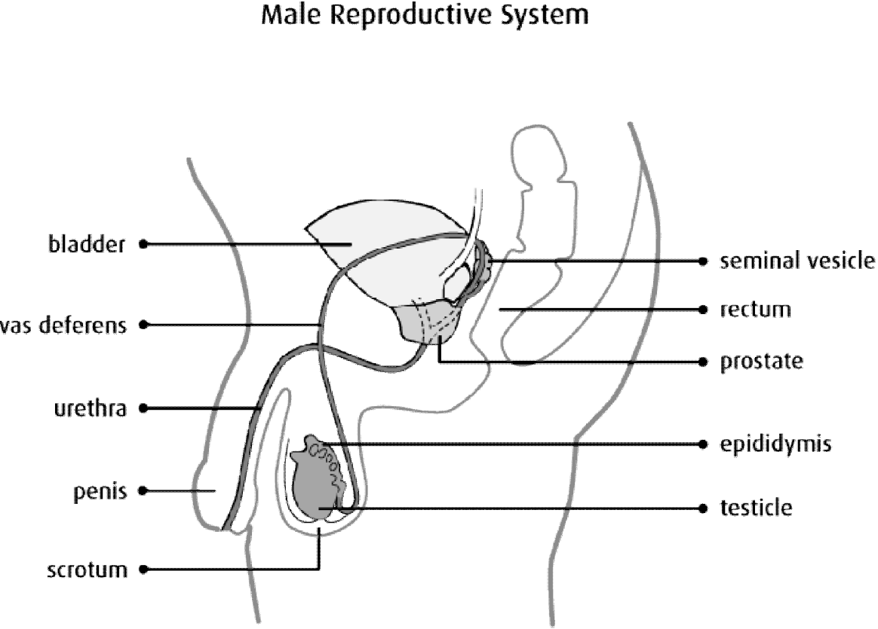

Fig. 2.1 Diagram of the male reproductive system

The entire duct-acinar system with the exception of the main lateral ejaculatory ducts is lined by columnar secretory cells, which are separated from the prostatic stroma by a layer of basal cells belonging to the basement membrane (More and Dorley,2009).The human prostate gland receives dual autonomic innervations from both parasympathetic (cholinergic) and sympathetic (noradrenergic) nerves in the prostatic nerve plexus, a part of the pelvic autonomic plexus that lies adjacent to the prostate gland. The pelvic plexus receives its parasympathetic input from the sacral segments of the spinal cord (S2-4) and sympathetic fibres from plexus excort from the hypogastric presacral nerves (T10-L2). The autonomic nerves arising from the pelvic plexus then escorts the vascular supply. Both cholinergic and noradrenergic fibres innervate the prostate stroma, and cholinergic nerves innervate the smooth muscle of the capsule and the space around
the blood vessels and are responsible for the secretory function of the epithelial part. The sympathetic nerves control the prostatic musculature, and their excitation closes the bladder neck during ejaculation of the seminal fluid into the urethra (Dixon et al, 2006).The ejaculate from the human prostate is a slightly acid (pH 6.5), serous fluid in which several major secretory products can be identified, notably acid phosphatase, citrate, zinc, soluble fraction proteins, carbohydrates, electrolytes, polyamines, hormones, lipids and growth factors (Sam, 2009).
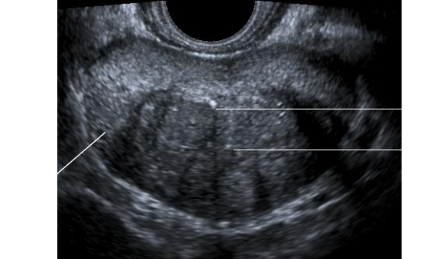

T ZONE

C ZONE

P ZONE

Fig. 2.2 Sonogram image of a normal prostate

KEY: T zone = Transitional zone C zone = Central zone

P zone = Peripheral zone
Up to 57 major protein groups of which 27 are non–serum proteins (i.e. presumably exuded by the epithelial cells) have been identified. Major prostatic– specific proteins are prostatic acid Up to 57 major protein groups of which 27 are non–serum proteins (i.e. presumably exuded by phosphatase (PAP), prostate specific antigen (PSA) and prostate binding protein (PBP), which are expressed at pubertal and adult ages. Proteolysis is the major function of prostate secretion, being rich in exopeptidase and endopeptidase. The most extensively studied protease is PSA, also known as seminal protease or chymotrypdin-like protease (Dixon et al., 2006).
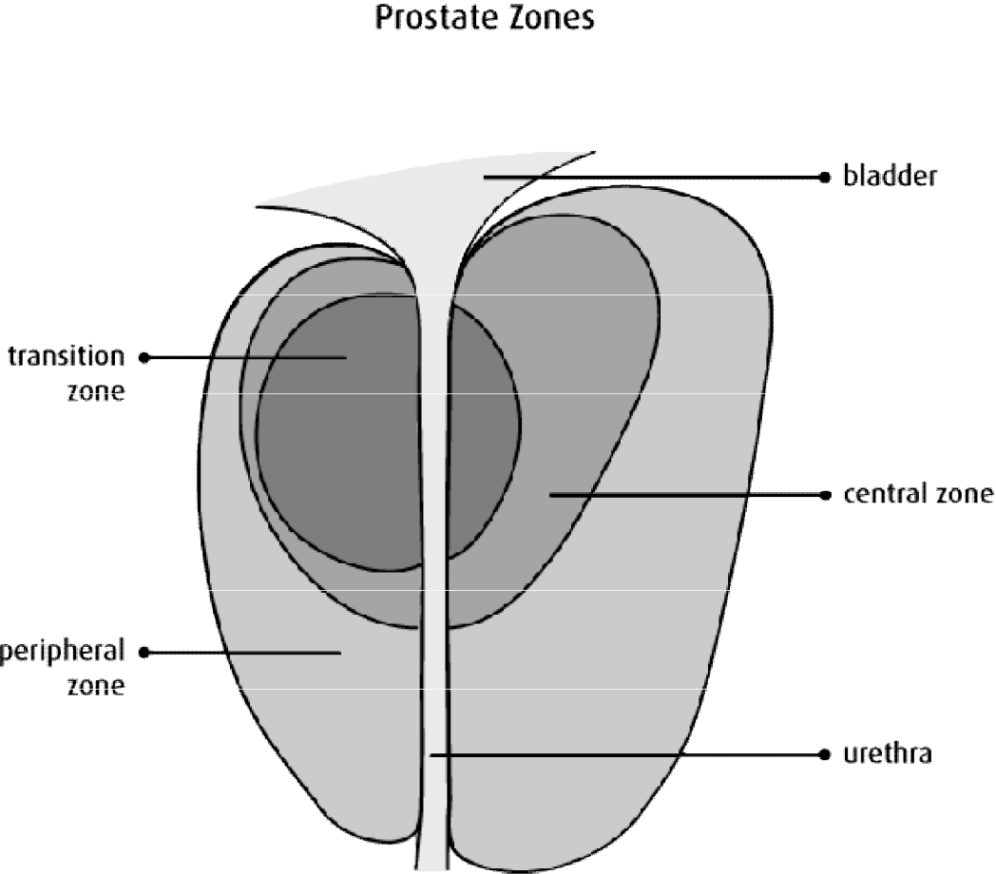

Fig. 2.3 The prostate zonal anatomy
2.2 Empirical literature review

Accurate correlation between prostate volume and prostate specific antigen among other indices may be a useful ancillary parameter to establish a normogram of values.

2.2.1 Relationship between Prostate Volume and Prostate Specific Antigen

Tanaka et al., (2007) evaluated prostate volume and volume-adjusted prostate specific antigen as predictive for prostate cancer patients with intermediate PSA levels. Their results showed that both prostate specific antigen density (PSAD) and specific antigen transitional zone density (PSATZD) have significant predictive values in discriminating prostate cancer –with PSATZD having the strongest predictive value according to the step wise regression analysis.

Shim et al., (2007) carried out a study on Korean men to evaluate prostate value with lower urinary tract symptoms .Their result showed that serum PSA identifies men with large prostate reasonably well. It also showed that Korean men may produce and/or release more PSA per volume than white men. The limitation of this study is that the cut-offs for PSA and prostate volume response to lower urinary tract symptoms therapy was not determined in this population thus making it difficult to generalize their results.

Tamsel et al., (2008) evaluated the efficiency of transrectal ultrasound in detecting prostate cancer with serum total prostate-specific antigen levels. Their findings suggest that transrectal ultrasound alone has a limited potential to identify prostate cancer, especially in patients with tPSA levels lower than 20ng/mL. Their result therefore suggest that increased numbers of biopsy cores must be taken or alternative imaging methods are required to direct TRUS-guided biopsy for improving prostate cancer detection.
2.2.2 Association between the anthropometrics of BMI and age; prostate volume and prostate specific antigen

The association between body mass index, prostate volume and prostate specific antigen was studied by Fowke et al., (2006). Their work showed that obesity and height were significantly associated with prostate volume, particularly among men with a negative biopsy. Their result also suggests that obesity management may be an effective method to reduce prostate volume among men without high grade prostatic intraepithelial neoplasia or prostate cancer.

Furthermore, random or systematic errors in reporting past weight may equally limit the result of this expository research.

Peter, (2011) evaluated the effect of body mass index on serum prostate – specific Antigen levels among patients presenting with lower urinary tract symptoms. Their result showed that in symptomatic male patients, a higher BMI was significantly associated with lower PSA levels.

They opined that BMI should be considered in the interpretation of serum PSA levels in or overweight and obese patients presenting with LUTS. This is also in line with the work of Chia, et al., (2009).

Ochia et al., 2010 evaluated the influence of anthropometric measurements, age, and prostate volume on prostate-specific antigen levels in men with a low risk of prostate cancer. Their work showed that the PSA level correlated with age (P < 0.001) and prostate volume (P < 0.001), but not with height, body weight, body mass index, or BSA. The prostate volume correlated with age (P < 0.001), body weight (P < 0.001), body mass index (P < 0.01), and BSA (P < 0.01), but not with height. Multivariate analysis revealed that prostate volume and BSA were significant factors for predicting the PSA level. Of the variables tested, prostate
volume was most significantly related to the PSA level. They noted that anthropometric parameters were not directly associated with the PSA level, but were associated with the prostate volume. These findings thus suggest that differences in the PSA level may be influenced by body size, if the prostate volume is held constant in men with a low risk of having prostate cancer.

Mahmuda et al.,(2012) in their correlative study between transabdominal sonographically measured prostate volume with anthropometric factor in normal healthy subjects used correlation co-efficient or r test to find out the relationship between the variables. They considered P value <0.05 as statistically significant. Total prostatic volume correlation coefficient with age, weight and BMI were 0.907, 0.883 and 0.352 (p<0.001) respectively, but no significant correlation (r=0.133; p>0.05) was found between prostatic volume and height. They noted that total prostate volume has a strong significant linear relationship with age, weight and BMI. However, height does not correlate significantly with total prostate volume. They therefore concluded that anthropometric factors like age, weight, BMI can therefore be used to predict prostate volume prior to ultrasound.

Ohagwu et al, 2008 carried out a study in Nigeria on the topic correlation between total prostate volume and anthropometric variables in normal subjects. Their study showed that there is significant correlation between prostate volume with age.

Moreso, in the work of Lee et al, (2006) on central obesity as a risk factor for prostatic hyperplasia, prostatic volume was found to be greater in obese men than normal. This findings are also in line with the observational study done in China by Xie et al, (2007) on obesity and benign prostatic enlargement.
2.2.3 Prostate specific antigen, prostate specific antigen density, percentage free prostate specific antigen and total prostate specific antigen.

Stephan et al, (2005) carried out a study to evaluate the prostate specific antigen (PSA) density (PSAD) (the quotient of PSA and prostate volume) compared with the percent free PSA (%fPSA) in different total PSA (tPSA) ranges from 2 ng/mL to 20 ng/mL. They sort out to establish possible cut-off levels depending on the tPSA. They found out that PSAD showed a better performance than %fPSA at tPSA concentrations < 4 ng/mL for detecting prostate carcinoma, with a significantly larger AUC for PSAD (0.739) compared with %fPSA (0.667). Their work equally revealed that PSAD did not perform better than %fPSA when the tPSA range of 4-10 ng/m was analysed. They therefore concluded that different PSAD cut-off values of 0.05 at tPSA 2-4 ng/mL, 0.1 at tPSA 4-10 ng/mL, and 0.19 at 10-20 ng/mL were necessary to reach 95% sensitivity.

2.2.4 Relationship between PSA, anthropometrics, demographics and life characteristics

Hee-Yeon et al., (2012) investigated the relationship between demographics, lifestyle Characteristics, and serum total prostate specific antigen (PSA) concentration among Korean men. They found significant association of several demographic and lifestyle characteristics with PSA concentration. Notably, PSA concentration above the cut off were related to age, height, alcohol consumption, and nutrition supplement as well as age. Their study have the following limitation

- Inability to determine if specific kinds of nutritional supplements affect PSA as the questionnaire employed did not ask for the detailed name of nutritional supplements, (b)there may be undetected prostate infection and inflammation among the subjects that might cause increased PSA and (c) their was no exclusion
of subjects who had a recent digital examination or other maneuvers that may cause artificial PSA elevation.

Yin and Jing, (2013) did a systematic review and meta analysis on body mass index, prostate cancer specific mortality and biochemical recurrence. They observed that elevated BMI is associated with risk of prostate cancer-specific mortality and biochemical recurrence in prostate cancer patients.

In another study, Sing-Eng et al, (2008) evaluated the effect of ageing and body mass index on prostate-specific antigen levels among Chinese men in Singapore from a community based study. Their study suggested that the BMI in Chinese men in Singapore is significantly associated with PSA levels, especially among obese men aged 70-79 years. The association between urine prostate specific antigen levels and anthropometric variables in children aged 5-14 years was studied by Efthimiou ,(2010). They did a cohort study that utilized boys and girls (42 boys/16 girls). Height, weight, body mass index (BMI) and the respective stature-for-age, weight-for-age and BMI-for-age percentiles of the sample were determined. They measured uPSA levels using a third generation immunodiagnostic method (DPC) Immulite that has a lower limit of detection of 3 ng/L. The uPSA levels tend to be higher in male than female children (p = 0.091, linear regression analysis). Notably, uPSA was measurable only in 3/16 girls (18.75%). Measurable uPSA was found in 18/42 boys (42.8%). The range of urine PSA in boys was 0-161000 ng/L (mean 10561.9 +/- 31830.48ng/L). Statistical analysis with linear regression showed correlation with height and age in boys. The values of this variable are measurable in both sexes and related with gender. They found out that in boys, uPSA was correlated with age and height but not with other variables tested. However, this study was limited by the low number of subjects
used i.e.58 subjects; thus, further studies are required to clarify this field as recommended by these researchers.

Moreso, Ukoli et al., (2007) carried out a population based study among rural and urban Nigerians to determine the anthropometric predictors of elevated prostate specific antigen. They measured the weight, height, skin as well as the fold thickness of men aged 40 years and older; computed their respective waist-to-hip ratio (WHR), body mass index (BMI) and determined their prostate specific antigen (PSA) status and prostate size. Mean anthropometric indices were compared across groups using student's t-test, association between anthropometry and PSA was by Spearman's correlation, and mean PSA was tested for linearity across tertiles of anthropometry. Prediction of elevated PSA was determined by multivariate logistic regression controlling for age and prostate size. They therefore concluded that central adiposity may be a more important predictor of elevated PSA than BMI in this population. However, the sample size utilized for this population based study is small (281) which may make generalization of findings impossible.

There is need to assess the correlation between prostate volume, prostate specific antigen, the anthropometrics of body mass index and age among apparently healthy adult males in our locality so as to compare it with previous literatures to determine the normal range of prostate values. This is important as most of the previous literatures were carried out using subjects without normal prostate values especially in Caucasians with none carried out on apparently healthy males in our locality.

.
CHAPTER THREE

RESEARCH METHODOLOGY

3.1 Research design

This is a prospective cross-sectional study.

3.2 Study population. These subjects were drawn from all male staff of the Niger Delta Development Commission (NDDC) who live and work in the South-South geopolitical zone of Nigeria referred to our centre for routine medical check-up for prostate cancer and other prostate pathologies from January 2015 -June, 2015 as well as other patients refered for prostate study without prostate symptom within this period.

3.3 Sample size

The sample size were determined according to the following formula by

Magnani, Roberts (1997):

n= t² x p (1-p)
m²

where : n = desired sample size

t = confidence level

- = proportion of the population with the desired variable m = margin of error
For this study: t = 95% (z score = 1.96)

P=50% (unknown population proportion)

m= 5% (0.05)

This gives: 1.962 x 0.5 (1-0.5) = 3.8416 x 0.25 = 384.16 (384)

0.0025 0.052
10% of the sample size (384) was added to correct the extraneous variables, improve accuracy and make calculations easier. The total sample size therefore was increased to 500 to improve accuracy.

3.4 Subject Selection Criteria

Inclusion criteria

- Subjects aged between 30-45 years were included in this study. This is in line with the work of Monowara et al., (2012) as this is considered a medium age for establishing prostatic disorders.
- Subjects with no present history of urine retention or clinical diagnosis of benign prostatic hyperplasia, prostate cancer, prostatitis or any other disease condition that may alter prostate specific antigen value.
- Those who show normal prostatic profile on preliminary scan.

- During scanning, subjects with sonographic evidence of prostatism, (inflammation of the prostate) benign prostatic hyperplasia and prostatic cancer were excluded.
- Subjects without valid birth certificates were excluded for the study.

- New employees who had not been screened in the previous years were excluded so as to ensure that those who participate in the study are apparently healthy men with normal prostate.

3.5 Ethical clearance and informed consent

Ethical approval were sought and obtained from the Research and Ethics Committee of Image Diagnostics Ltd, Port Harcourt, Nigeria. Also written informed consent were dully obtained from participating individuals before recruiting them for the study.
3.6 Equipment

All scans were carried out using Siemens – 3D/4D X-class machine with a 7.5MHz endocavitory probe. The scanner has good resolution. It was manufactured in Japan in 2006.

Moreso, the Enzyme Linked Immunosorbent Assay (ELISA) machine Model A3, serial number 1620 was used for analysis of the PSA. This was manufactured in Italy in 2012.

Research Assistant: A nurse was employed to help in measuring height and weight as well as in recording the age of the subjects. The age of patients were obtained from their birth certificate.

3.8 Procedure for data: At baseline, all participants had a physical examination, including height and weight measurements, Estimation of serum PSA, postvoid residual urine and transrectal ultrasound (TRUSS).

Anthropometric data: Basic anthropometric measurements include those for body mass (weight), stature (height) and BMI. The procedure for taking the measurements is as illustrated by the following instructions for measuring height. The individual must stand straight against an upright surface, touching it with heels, buttocks, and back. The heels should be together and on the floor. It should be measured in meter. Weight was taken in kg. The following table gives an indication of what BMI scores mean (WHO, 2009)

Underweight | <20kg/m²
Healthy range | 20-24.9
 | kg/m²
Overweight | 25-29.9
 | kg/m²
Obese | >30 kg/m²


Table 1: BMI scores
Height and Weight measurement were obtained with Height meter - to the nearest 0.1cm and weighing scale - to the nearest 1.0 kilogramme (Kg) respectively. Medtrue weighing scale were used which was manufactured in China in 2013.

PV Procedure: Prostate volume was measured by transrectal ultrasound, TRUSS. Transrectal ultrasound of the prostate is the most accepted scanning approach when evaluating the prostate (Roger and Tom, 2007). The procedure is as follows. Patient preparation and position was in line with Roger and Tom (Roger and Tom, 2007). The patient was placed in a left lateral decubitus with the knees bent. Probe was inserted and then angulated slightly posterior, following the curve of the rectum. This was continued until the prostate was visualized. A digital rectal examination (DRE) were performed before inserting the probe to exclude any potential obstructing masses and determining the appropriate angle for probe insertion to lessen the discomfort of the procedure. A midline image of the prostate using the distal urethra at the apex and the proximal urethra at the base as land marks was used to obtain measurements in both the longitudinal and anterior- posterior planes. Scans were performed in transverse and longitudinal planes.

Transverse plane: The scan starts above the base of the prostate at the level of the seminal vesicles. The symmetry of the seminal vesicles was documented. Multiple images of the prostate from the base to the level of the apex was documented. A transverse measurement of the prostate at its widest point was obtained in line with Roger and Tom, (2007)

Longitudinal plane: Multiple longitudinal images were obtained from one lateral aspect of the prostate to the other, and images appropriately labelled as “left”, “right” or midline” as earlier described by Roger and Tom,(2007).
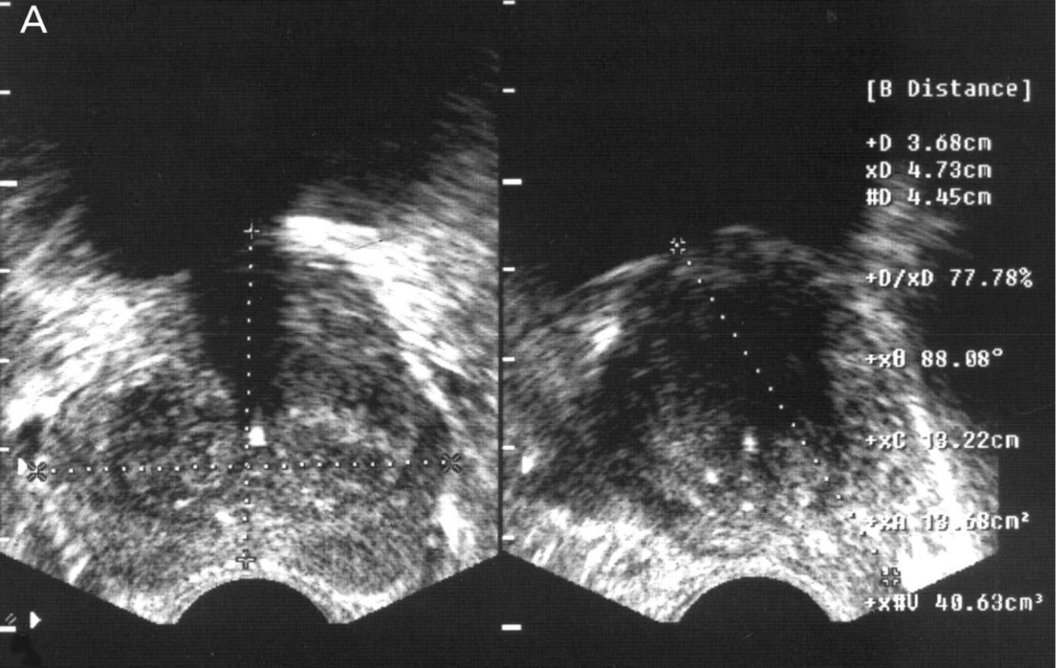

Sonogram image showing the measurement of prostate in transverse and longitudinal planes

3.7.2. PSA Procedure

Prostate Specific Antigen of participants was assessed with Enzyme Linked Immunosorbent Assay (ELISA) kit utilising the Quantitative Sandwich Immunoassay technique.
3.8. Statistical Analysis:

The result was displayed in tables and graphs. Data were analyzed using MicrosoftTM statistical software package for social sciences (SPSS) version 15.0. The normogram for Prostate Volume and the normal biochemical values of Prostate Specific antigen in relation to age and BMI was established using descriptive statistics. The relationship as well as the ratio between Prostate volume (PV) and Prostate Specific antigen (PSA) was established using Pearson correlation and regression analysis.
CHAPTER FOUR

RESULTS

Table 1: Characteristics of the subjects (Dispersion and central tendencies of the measured variables)

Parameters |  |  |  |  |  | n = 500
 |  | Range |  | Mean ± SD | Skewne | Mode |  | Percentiles
 |  |  |  |  | ss |  | 5th | 25th | 50th |  | 75th | 95th
Age (years) |  | 30 | – 45 | 37.80 ± 4.7 | 0.20 | 35 | 30 | 34 | 38 |  | 41 | 45
BMI (kg/m²) |  | 14.19 – |  | 28.00 ± 5.3 | 0.7 | 23.66 | 20.70 | 24.30 | 27.3 |  | 30.8 | 38.2
PV (cm³) |  | 47.45 |  |  |  |  |  |  | 4 |  | 3 | 0
 |  | 8.50 | – 92.0 | 18.98 ± 7.2 | 4.2 | 16.40 | 11.90 | 15.43 | 17.9 |  | 20.2 | 32.0
PV (cm³), |  |  |  |  |  |  |  |  | 5 |  | 0 | 0
 |  | 8.50 | – 48.8 | 18.70 ± 5.2 | 2.0 | 16.40 | 12.40 | 15.90 | 18.0 |  | 20.1 | 32.0
less 20 |  |  |  |  |  |  |  |  | 0 |  | 8 | 0
outliers
PSA (ng/mL) |  | 0.50 | – 3.90 | 1.38 ± 0.53 | 0.99 | 1.40 | 0.6 | 1 | 1.3 |  | 1.7 | 2.2
500 males | aged | 30-45 years |  | with a mean age ± standard deviation of |  |  |  | 37.80 ± 4.7 |  | were
involved in | the | study. The mean value of |  |  | the Prostatic volume, PSA and BMI |  |  |  | are | 18.98
± 7.2 cm³, | 1.38 ± 0.53 ng/mL |  |  | and 28.00 ± 5.3 kg/m² respectively. The percentiles |  |  |  |  | are |  | also
given.


Table 2: Correlation and regression analyses of prostatic volume with age, BMI and PSA

Variable |  |  |  | n = 500
Variable | R | P | Clinical | p is significant | Regression | R²
 | ( |  | significan | at < 0.05 level, | equation | (Coefficient of
 | correlatio |  | ce | 2-tailed) |  | determination)
 | n |  | (high r)
 | coefficient
 | )
Age | 0.13 | 0.003 | No | Yes | y = 0.223x + 10.56 | 2.0%
BMI | 0.01 | 0.951 | No | No | y = 0.004x + 18.87 | 0.0%
PSA | 0.50 | 0.000 | Yes | Yes | y = 0.036x + 0.69 | 23.6%

Prostatic volume correlated positively and moderately with PSA(r= 0.5; p = 0.000). This was both statistically and clinically significant. A regression analysis gave an r-squared value of 23.6%, indicating that only that percentage of the dependent variable (PSA) is explained by the independent variable (Prostatic volume). The correlation of prostatic volume with BMI (r = 0.01; p = 0.991) and age (r = 0.13; p = 0.003) was however, very poor.

Table 3: Nomogram of prostatic volume according to age
Age groups |  | Range (cm³) |  | n = 500 |  |  |  | PV/Age
Age groups | Frequency | Range (cm³) | Mean ± SD |  | Median | Mode | Skewness | PV/Age
(years) |  |  | (cm³) |  | (cm³) | (cm³) |  | index
30 | 25 | 12.0-24.70 | 15.7 ± 2.14 |  | 15.1 | 15.0 | 3.1 | 0.5
31 | 25 | 14.70-18.10 | 16.24 ± 1.0 |  | 16.20 | 15.30 | 0.32 | 0.5
32 | 29 | 9.50-33.90 | 18.8 | ± 7.0 | 17.70 | 33.90 | 1.2 | 0.6
33 | 27 | 13-20 | 17.40 ± 1.8 |  | 17.50 | 19.0 | -0.84 | 0.5
34 | 27 | 9.2-92.0 | 21.10 | ± 14.6 | 18.5 | 17.4 | 4.7 | 0.6
35 | 49 | 8.5-36.9 | 18.6 | ± 5.8 | 18.5 | 16.4 | 1.21 | 0.5
36 | 31 | 10.9-48.8 | 19.80 ± 6.2 |  | 19.3 | 20.6 | 3.4 | 0.6
37 | 22 | 10.40-20-20 | 16.00 ± 3.6 |  | 15.60 | 10.4 | -0.22 | 0.4
38 | 30 | 11.8-36.4 | 19.6 | ± 5.3 | 19.2 | 19.2 | 1.20 | 0.5
39 | 42 | 11.90-50.20 | 20.0 ± 6.54 |  | 18.85 | 11.90 | 2.55 | 0.5
40 | 47 | 9.70-34.0 | 18.5 | ± 5.1 | 17.9 | 16.90 | 1.2 | 0.5
41 | 25 | 11.6-32.0 | 19.04 ± 5.6 |  | 18.3 | 11.6 | 0.9 | 0.5
42 | 25 | 12.30-27.10 | 19.00 ± 4.0 |  | 19.2 | 12.3 | -0.02 | 0.5
43 | 33 | 9.20-41.0 | 20.40 | ± 7.10 | 20.0 | 13.30 | 1.4 | 0.5
44 | 25 | 10.10-63.40 | 20.24 | ± 13.7 | 16.3 | 19.3 | 2.81 | 0.5
45 | 38 | 13-51 | 21.14 ± 9.2 |  | 18.45 | 18.5 | 2.4 | 0.5
Total | 500 | 8.50 – 92.0 | 19.0 ± 7.15 |  | 18.0 | 16.40 | 4.2 | 0.5
The PV has | a range of | 8.50 – 92.0 cm³ | and with a |  | mean, median and mode |  | of 19.0 ±


17.15 cm³, 18 cm³ and 16.40 cm³ respectively. The result does not show any predictable pattern, an indication that prostatic volume in this population has a poor relationship with age and cannot be justifiably used as nomogram for the population. The distribution is positively skewed (4.2).

Table 4: Nomogram according to BMI |  |  | n = 500
Parameter
Parameter | BMI (Kg/m²) | Frequency | Mean ± SD | Median | Mode | Skewnes | PV/BMI
 |  |  | (cm³) | (cm³) | (cm³) | s | Index
Underweight | <18.5 | 11 | 17.60 ± 7.03 | 17.3 | 8.50 | 1.0 | 1.1
Normal weight | 18.5-24.9 | 146 | 18.50 ± 5.80 | 18.3 | 20.10 | 2.6 | 0.8
Fat | 25-29.9 | 192 | 19.50 ± 1.40 | 19.9 | 16.40 | 4.6 | 0.7
Obese | >30 | 151 | 19.00 ± 6.00 | 18.0 | 16.20 | 2.2 | 0.6
Total | 18.5 - >30 | 500 | 19.00 ± 7.15 | 18.0 | 16.40 | 4.2 | 0.7


The nomogram according to BMI shows a fairly consistent increment in mean PV from 17.60 ± 7.03 cm³ (underweight subjects) to 19.00 ± 6.0 cm³ (obese subjects). This is an indication that prostatic volume in this sample has a relationship with BMI and can may justifiably be used as nomogram for the population. The distribution is positively skewed.

Table 5: Nomogram according to PSA values
 |  |  | n = 500
PSA Range | Frequency | Mean ± SD | Median | Mode | Skewness | PSA/PV index
0-0.4 | 0 | (ng/mL) | (ng/mL) | (ng/mL)
0.5-0.9 | 112 | 18.8 ± 9.14 | 16.5 | 15.3 | 5.0 | 0.04
1.0-1.4 | 186 | 19.00 ± 6.4 | 18.4 | 19.2 | 3.5 | 0.1
1.5-1.9 | 145 | 19.10 ± 6.80 | 18.3 | 16.4 | 3.2 | 0.1
2.0-2.4 | 40 | 18.60 ± 5.8 | 18.2 | 17.20 | 3.6 | 0.1
2.5-2.9 | 13 | 20.70 ± 7.30 | 19.2 | 12.4 | 2.0 | 0.1
3.0-3.4 | 0
3.5-3.9 | 4 | 17.20 ± 2.60 | 17.0 | 14.50 | 0.4 | 0.2


The mean and median of the PV show a fairly progressive increment as the value of PSA increases until it got to a low sample size (4). This result shows a predictable pattern if the sample sizes are consistently high. This is an indication that prostatic volume in this sample has a good relationship with PSA (r = 0.5; p = 0.000). This is a justifiable nomogram for the population.
Table 6: PSA/PV ratio according to age in the |  |  |  |  | population
 |  |  |  | n = 500
Age | Frequency | PSA | PV | PSA | PV | Upper |  | PSA/PV PSA/PV
 |  | Range | range | Value | Value | limit | of | Ratio | ratio
 |  |  |  |  |  | Normal |  | (a) | (b)
 |  |  |  |  |  | PSA/PV
 |  |  |  |  |  | ratio
30 | 25 | 1.5 | 12.70 | 17.10 | 393.10 | 0.1 |  | 0.04 | 1:23
31 | 25 | 0.6 | 3.40 | 19.20 | 406.20 | 0.2 |  | 0.05 | 1:22
32 | 29 | 1.0 | 24.40 | 25.10 | 544.60 | 0.04 |  | 0.05 | 1:22
33 | 27 | 1.4 | 7.0 | 28.90 | 470.0 | 0.2 |  | 0.06 | 1:16
34 | 27 | 1.4 | 82.8 | 35.10 | 568.30 | 0.2 |  | 0.06 | 1:16
35 | 49 | 1.4 | 28.4 | 69.40 | 913.10 | 0.05 |  | 0.08 | 1:13
36 | 31 | 1.9 | 37.9 | 46.30 | 612.70 | 0.05 |  | 0.08 | 1:13
37 | 22 | 2.0 | 9.80 | 29.20 | 352.10 | 0.2 |  | 0.08 | 1:12
38 | 30 | 1.8 | 24.60 | 48.20 | 586.60 | 0.07 |  | 0.08 | 1:12
39 | 42 | 1.9 | 38.30 | 71.40 | 836.40 | 0.05 |  | 0.08 | 1:12
40 | 47 | 1.8 | 24.30 | 69.60 | 870.40 | 0.07 |  | 0.08 | 1:12
41 | 25 | 2.0 | 20.40 | 39.90 | 475.90 | 0.1 |  | 0.08 | 1:12
42 | 25 | 2.8 | 27.10 | 42.30 | 475.20 | 0.1 |  | 0.09 | 1:11
43 | 33 | 1.8 | 31.80 | 50.20 | 673.80 | 0.06 |  | 0.08 | 1:13
44 | 25 | 3.2 | 53.30 | 39.60 | 506.0 | 0.06 |  | 0.08 | 1:13
45 | 38 | 1.7 | 38.00 | 56.90 | 803.0 | 0.05 |  | 0.07 | 1:14
Total | 500 | 3.40 | 83.50 | 688.4 | 9487.7 | 0.04 |  | 0.07 | 1:14
The PSA/PV ratio |  | shows a | fairly predictable pattern from |  |  | least | to | maximum. However,
ages | 32,35,36, 38,39,40,43-45 |  | years | have abnormal ratio as |  | their | ratio was |  | higher than


the normal range. This age groups may need further evaluation for prostatic pathology.

For the entire population the normal limit is 0.04 whereas a ratio of 0.07 was derived,

indicating that this population needs further assessment to rule out prostatic pathologies,

especially benign prostatic hyperplasia.
Table 7: PV/PSA ratio in BMI categories
 |  |  |  | n = 500
BMI | BMI | Freque | PSA | PV | PSA | PV | Upper limit | PSA/PV | PSA/PV
category | range | ncy | range | range | value | value | of Normal | ration | ratio (b)
 |  |  |  |  |  |  | PSA/PV | (a)
 |  |  |  |  |  |  | ration
Underweight | <18.5 | 11 | 1.10 | 8.80 | 12.60 | 166 | 0.13 | 0.08 | 1:13
Normal | 18.5-24.9 | 146 | 3.40 | 83.5 | 211.7 | 2946.8 | 0.04 | 0.07 | 1:14
weight |  |  |  |  |  | 0 | 0.11 | 0.08 | 1:13
Fat | 25-29.9 | 192 | 3.20 | 28.4 | 259.8 | 3478.8 | 0.11 | 0.08 | 1:13
Obese | >30 | 151 | 2.30 | 31.8 | 204.3 | 2896.1 | 0.07 | 0.07 | 1:14
 |  |  |  |  |  | 0
Total | 18.5 - | 500 | 3.40 | 83.50 | 688.4 | 9487.7 | 0.04 | 0.07 | 1:14
 | >30


The PSA/PV ratio in BMI categories does not show any predictable pattern. Also, the normal upper limit of 0.04 is higher than the 0.07 of the entire population. This population may qualify for further evaluation to rule out prostatic abnormalities.

- similar work done in Nigeria with trans-rectal transducer consistently produced higher values at each age bracket than ours. However, the means are almost comparable. A test of statistic however indicates that this narrow range has statistically significant differences. This may indicate under-estimation of prostate volume in our population.

Analysis of Hypothesis: Null Hypothesis 1: There is no relationship between free PSA and PV values among apparently healthy Nigerian males

PSA Class (ng/mL)

60
50 |  |  |  |  |  |  | 3 Percentile
40 |  |  |  |  |  |  | 3 Percentile
40 |  |  |  |  |  |  | 5 Percentile
30 |  |  |  |  |  |  | 10 Percentile
20 |  |  |  |  |  |  | 25 Percentile
20 |  |  |  |  |  |  | 50 Percentile
10 |  |  |  |  |  |  | 50 Percentile
10 |  |  |  |  |  |  | 75 Percentile
0 |  |  |  |  |  |  | 95 Percentile
0 | 0.5 | 1 | 1.5 | 2 | 2.5 | 3 | 97 Percentile
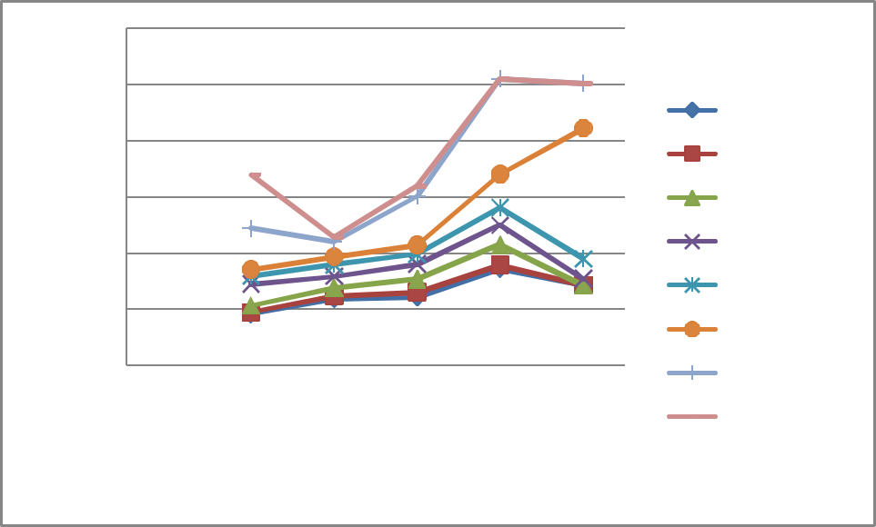

PV(cm3)

Class Marks

.

Figure 4: Percentile Curve of PSA of Different Categories of Patients' PV levels (NB: PV Value in the X Axis represents class values of 0.75 = 0.5-1.0 PV score, 1.25= >1.0-1.5 PV Scores, 1.75 = >1.5-2 PV Scores, 2.25 = >2.0-2.5 PV and 2.75= >2.5-3.0 PV Scores)
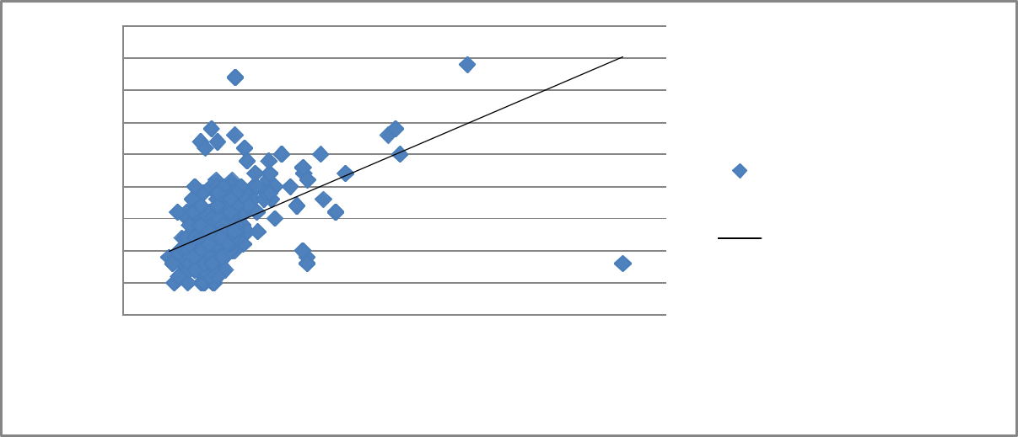

PSA (ng/ml)

4.5
4
3.5 |  |  | y = 0.036x + 0.688
3
2.5 |  |  |  | R² = 0.237 | Prostate Specific Antigen
2 |  |  |  |  | Prostate Specific Antigen
2 |  |  |  |  | ,PSA(ng/mL)
1.5 |  |  |  |  | ,PSA(ng/mL)
1.5 |  |  |  |  | Linear (Prostate Specific
1 |  |  |  |  | Linear (Prostate Specific
1 |  |  |  |  | Antigen ,PSA(ng/mL))
0.5 |  |  |  |  | Antigen ,PSA(ng/mL))
0
0 | 20 | 40 | 60 | 80 | 100

PV (CM3)

Figure 5: Scatter Diagram of PSA (ng/ml) levels for different PV (cm³) levels

The result above indicates that there is a positive correlation between PSA and PV levels (R² = 0.24 approximately). Results of bivariate regression done to confirm the extent of relationship between the two variables gave an F-statistic of 154.654 (p<0.01) implying that the explanatory power of the independent variable was strong as it was significant at 1 percent. Similarly, the slope coefficient of the explanatory variable hypothesized, PV, (See Table 1 ) was 0.0362, and had t-ratio estimate which was significant at 1 percent (P<0.01). The implication of this finding is that a unit increase in PV of the patients was associated with an increase in PSA by 0.0362 ng/mL. The outcome of the t-test from the regression analysis in the foregoing gave ample evidence to suggest that there is a significant positive relationship between PSA estimates of our sample and their PV levels. We therefore reject our first null hypothesis which held that there was no significant relationship between PSA estimates and PV levels.

RESULTS OF CORRELATION ANAYSIS BETWEEN PSA AND PV LEVELS

Prostate

Volume

,PV(cm3)

Prostate

Specific

Antigen

,PSA(ng/mL)

Prostate Volume ,PV(cm3)

1

Prostate Specific Antigen

,PSA(ng/mL)

0.486787702

1

FORECAST OF RELATIONSHIP BETWEEN PSA AND PV
6 |  |  |  |  |  |  |  |  | Forecast: PSAF
5 |  |  |  |  |  |  |  |  | Actual: PSA
5 |  |  |  |  |  |  |  |  | Forecast sample: 1 500
4 |  |  |  |  |  |  |  |  | Included observations: 500
4 |  |  |  |  |  |  |  |  | Root Mean Squared Error | 0.464557
 |  |  |  |  |  |  |  |  | Mean Absolute Error | 0.349251
3 |  |  |  |  |  |  |  |  | Mean Abs. Percent Error | 31.46986
 |  |  |  |  |  |  |  |  | Theil Inequality Coefficient | 0.161587
2 |  |  |  |  |  |  |  |  | Bias Proportion | 0.000000
2 |  |  |  |  |  |  |  |  | Variance Proportion | 0.345182
1 |  |  |  |  |  |  |  |  | Covariance Proportion | 0.654818
0
50 | 100 | 150 | 200 | 250 | 300 | 350 | 400 | 450 | 500
 |  |  | PSAF |  | ± 2 S.E.
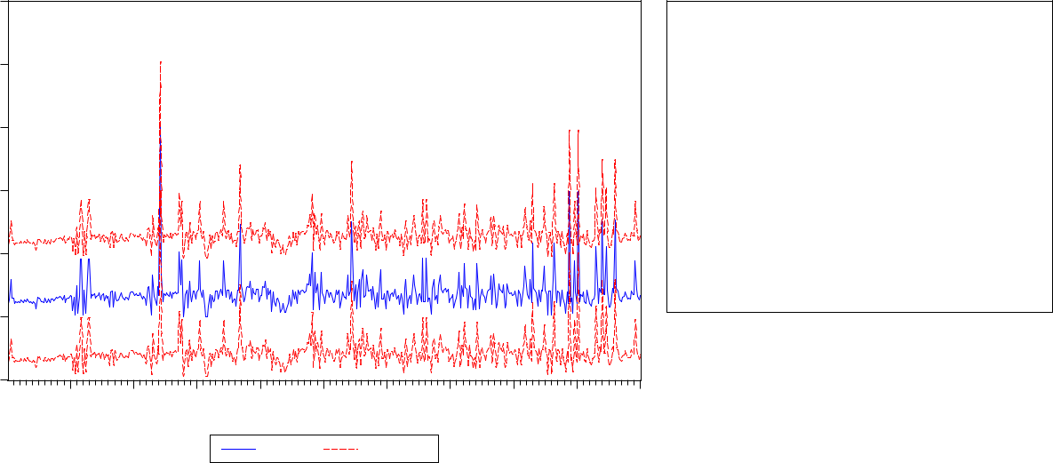

 | 0.5-1.0 | >1.0-1.5 | >1.5-2 | >2.0-2.5 | >2.5-3.0
 | PV score | PV Scores | PV Scores | PV Scores | PV Scores
3 Percentile | 9.2 | 11.916 | 12.15 | 17.2 | 14.3
5 Percentile | 9.5 | 12.34 | 13.075 | 17.925 | 14.3
10 Percentile | 10.68 | 13.78 | 15.4 | 21.5 | 14.3
25 Percentile | 14.5 | 15.8 | 18.05 | 25 | 15.475
50 Percentile | 15.9 | 18 | 19.85 | 28.1 | 19
75 Percentile | 17.1 | 19.4 | 21.475 | 34 | 42.2
95 Percentile | 24.35 | 21.98 | 30.1 | 51 | 50.2
97 Percentile | 33.9 | 22.872 | 32 | 51 | 50.2


Results of Analysis for Hypothesis Two (a): The PSA/PV ratio in apparently healthy Nigerian

male does not relate with anthropometric variables of BMI .
PSA/PV RATIO CORRELATION WITH BMI SCORES
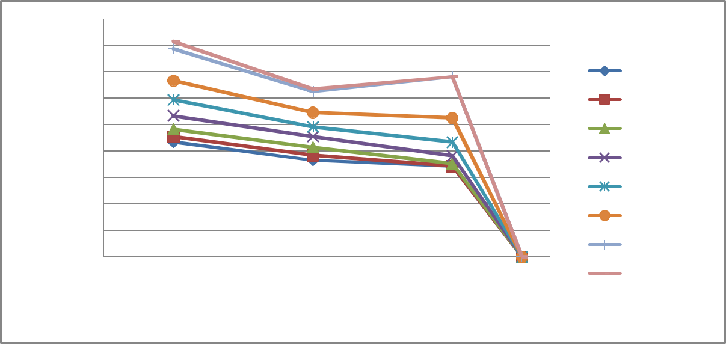

BMI Kg/m2

45.00
40.00
35.00 |  |  |  |  |  |  |  |  | 3 Percentile
30.00 |  |  |  |  |  |  |  |  | 5 Percentile
25.00 |  |  |  |  |  |  |  |  | 10 Percentile
20.00 |  |  |  |  |  |  |  |  | 25 Percentile
15.00 |  |  |  |  |  |  |  |  | 25 Percentile
15.00 |  |  |  |  |  |  |  |  | 50 Percentile
10.00 |  |  |  |  |  |  |  |  | 50 Percentile
10.00 |  |  |  |  |  |  |  |  | 75 Percentile
5.00 |  |  |  |  |  |  |  |  | 75 Percentile
5.00 |  |  |  |  |  |  |  |  | 95 Percentile
0.00 |  |  |  |  |  |  |  |  | 95 Percentile
0.00 |  |  |  |  |  |  |  |  | 97 Percentile
0 | 0.02 | 0.04 | 0.06 | 0.08 | 0.1 | 0.12 | 0.14 | 0.16 | 97 Percentile

PSA/PV Ratio (Class Marks)

Figure 3: Percentile Curve of PSA/PV Ratios of different categories of patients' BMI scores. (NB:PSA/PV ratios in the X Axis represents class values of 0.025 = 0.01-0.05, 0.075 = >0.05-0.10, 0.125= >0.10-0.15 and values of PSA/PV ratios of 0.15=>0.10-0.20.)
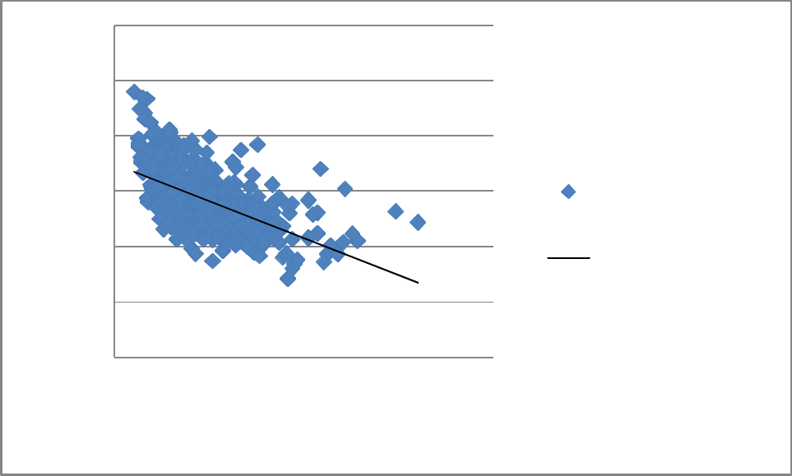

BMI (Kg/m2)

60
50
40 | y = -134.7x + 34.94
40 | R² = 0.347
30 | Body Mass Index
 | ,BMI(Kg/m2)
20 |  | Linear (Body Mass
10 |  | Index ,BMI(Kg/m2))

0

0.00 0.05 0.10 0.15 0.20

PSA/PV Ratio

Figure 4: Scatter Diagram of anthropometric variable of BMI estimates for different categories of PSA/PV ratios

Results in Figures 3 and 4 show the graphs of the percentile scores relating BMI estimates with PSA/PV ratios of the sampled subjects. The result indicates a negative relationship between BMI and PSA/PV ratios. The estimated correlation coefficient, 35% (0.347) was subjected to further analysis using a bivariate regression analysis. The explanatory power of the model was validated with an F-ratio estimate of 264.668 significant at 1 percent (P<0.01). The estimated slope coefficient of the BMI was -0.0025, with t-ratio estimate (-16.268) significant at p<0.01 (i.e. 1% level of statistical significance. See Table 2). With this result we had sufficient evidence to reject the null hypothesis that there is no significant relationship between BMI and PSA/PV ratios and accept the alternative which holds that there is a significant relationship between BMI and PSA/PV ratios.

Table 2 REGRESSION RESULT SHOWING CORRELATION ANAYSIS BETWEEN PSA/PVA RATIO AND BMI levels (Please modify this table to the right format)

Variable | Coefficient | Std. Error | t-Statistic | Prob.
 |  |  | -
 |  |  | 16.26864**
BMI | -0.002576 | 0.000158 | * | 0.0000
C | 0.123849 | 0.004508 | 27.47540 | 0.0000
R-squared | 0.347030 | Mean dependent var |  | 0.051809
Adjusted R-squared | 0.345718 | S.D. dependent var |  | 0.023298
S.E. of regression | 0.018845 | Akaike info criterion |  | -5.101118
Sum squared resid | 0.176862 | Schwarz criterion |  | -5.084259
Log likelihood | 1277.279 | Hannan-Quinn criter. |  | -5.094502
F-statistic | 264.6686 | Durbin-Watson stat |  | 1.578249
Prob(F-statistic) | 0.000000

'NB: "***" implies that estimated t ratio significant at 1% level of significance implying that BMI levels significantly explains the variation in the PSA/PVA ratio recorded in the study at 1 percent level of statistical significance. The F-ratio estimated (264.67) is significant at 1% level (P<0.01).

Result of Correlation Test in Tabular Form
Body Mass

PSAPVA

Index

Ratio

,BMI(Kg/m2)

PSAPVA Ratio

1

Body Mass Index ,BMI(Kg/m2)

-0.58909

1

.16 |  |  |  |  |  |  |  |  | Forecast: PSAPVA_RATF
 |  |  |  |  |  |  |  |  | Actual: PSAPVA_RATIO
.12 |  |  |  |  |  |  |  |  | Forecast sample: 1 500
 |  |  |  |  |  |  |  |  | Included observations: 500
.08 |  |  |  |  |  |  |  |  | Root Mean Squared Error | 0.018808
.08 |  |  |  |  |  |  |  |  | Mean Absolute Error | 0.014506
 |  |  |  |  |  |  |  |  | Mean Abs. Percent Error | 34.73080
.04 |  |  |  |  |  |  |  |  | Theil Inequality Coefficient | 0.170374
.04 |  |  |  |  |  |  |  |  | Bias Proportion | 0.000000
 |  |  |  |  |  |  |  |  | Variance Proportion | 0.258580
.00 |  |  |  |  |  |  |  |  | Covariance Proportion | 0.741420
-.04
50 | 100 | 150 | 200 | 250 | 300 | 350 | 400 | 450 | 500
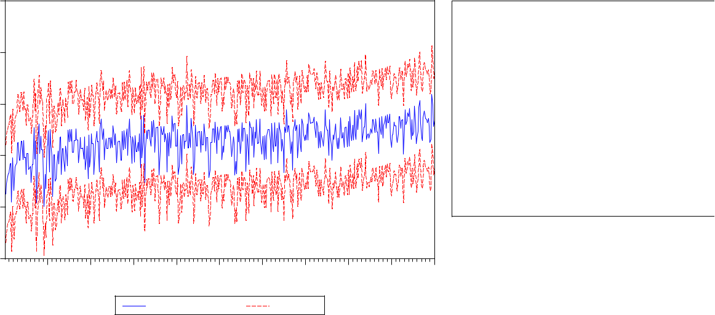

PSAPVA_RATF ± 2 S.E.

Hypothesis Two (b) : The PSA/PV ratio in apparently healthy Nigerian male does not relate with anthropometric variable of age.
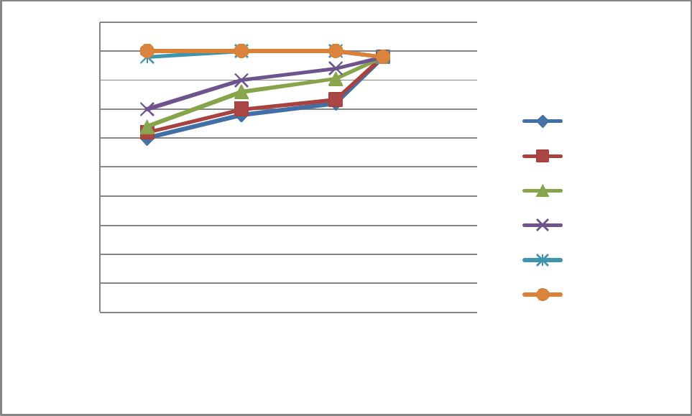

Age in Years

50
45
40
35 |  |  |  | 3 Percentile
30 |  |  |  | 3 Percentile
30 |  |  |  | 10 Percentile
25 |  |  |  | 10 Percentile
25 |  |  |  | 25 Percentile
20 |  |  |  | 25 Percentile
15 |  |  |  | 50 Percentile
10 |  |  |  | 95 Percentile
5 |  |  |  | 97 Percentile
0 |  |  |  | 97 Percentile
0.00 | 0.05 | 0.10 | 0.15 | 0.20

PSA/PV Ratio Class Midpoints

Figure 5: Percentile Curve of PSA/PV Ratios of different categories for different ages of subjects. (NB:PSA/PV ratios in the X Axis represents class values of 0.025 = 0.01-0.05, 0.075 = >0.05-0.10, 0.125= >0.10-0.15 and values of PSA/PV ratios of 0.15=>0.10-0.20.)
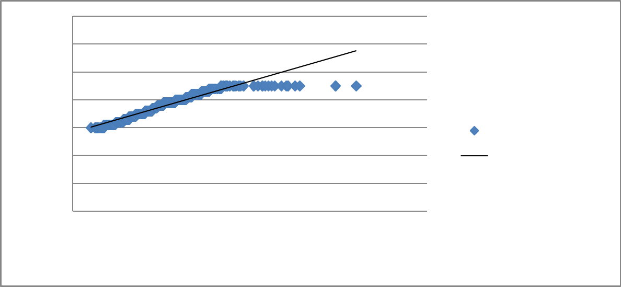

Age in Years

70
y = 183.6x + 28.19
60
R² = 0.915

50

40

30 |  |  |  | Age in Years
20 |  |  |  | Linear (Age in Years)
10
0
0.00 | 0.05 | 0.10 | 0.15 | 0.20

PSA/PV Ratios (Class Midpoints)

Figure 6. Scatter diagram illustrating the relationship between anthropometric variable of age of apparently healthy patients and their respective PSA/PV ratios .

Results in Figures 5 and 6 show the graphs of the percentile scores relating ages of subjects with their estimated PSA/PV ratios. The result, coupled with parameter estimates in Table 3 (regression analysis) indicates a significant positive relationship between age of patients and their PSA/PV ratios. The estimated correlation coefficient of 0.91 (91%) is very high - almost a perfect positive correlation. Further analysis with a bivariate regression analysis gave a very high F-ratio estimate of 5421.543 which was significant at 1 percent level (p<0.01) implying a strong explanatory power of the equation. The slope coefficient estimate of age, 0.004986, had a t-ratio estimate (73.631) which was significant at 1 percent level of statistical significance. The slope coefficient estimate indicated that an increase in age of patients by 1 year is associated with an increase in PSA/PV ratio of 0.004986. With the outcome of the analysis we found sufficient evidence to reject the third null hypothesis which held that PSA/PV ratio in apparently healthy Nigerian male does not relate with anthropometric variable of age.

CONCLUSION

We therefore conclude from our various hypothesis tests that : (1) significant positive relationship exists between PSA estimates and PV levels; (2) estimated PSA/PV ratio in apparently healthy Nigerian male exhibit statistically significant negative relationship with anthropometric variables of BMI; and finally, (3) the PSA/PV ratio in apparently healthy Nigerian males is positively related with anthropometric variable of age.
Recommendations from the findings therefore are as follows:

........................................................................................................................................................

Table 3 REGRESSION RESULTS FOR EFFECTS OF AGE ON PSA/PV RATIO

Variable | Coefficient | Std. Error | t-Statistic | Prob.
AGE | 0.004986 | 6. 77E-05 | 73.63113*** | 0.0000
C | -0.136215 | 0.002571 | -52.97199 | 0.0000
R-squared | 0.915872 | Mean dependent var |  | 0.051809
Adjusted R-squared | 0.915703 | S.D. dependent var |  | 0.023298
S.E. of regression | 0.006764 | Akaike info criterion |  | -7.150309
Sum squared resid | 0.022787 | Schwarz criterion |  | -7.133450
Log likelihood | 1789.577 | Hannan-Quinn criter. |  | -7.143693
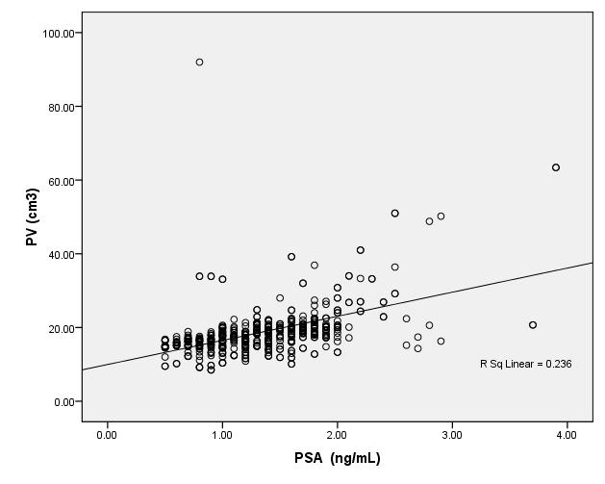

Figure i: Scatter plot and trend line of prostatic volume with PSA
The plots are close fitting around the trend line but with several outliers, especially above the line. The value of the coefficient of determination, R² from regression analysis was 23.6%, effectively indicating that only that percentage of PSA is explained by the prostatic volume. Despite the multiple and widespread outliers, the r (0.5) and R² (23.6%) have proven that there is a relationship between prostatic volume and PSA in the population.
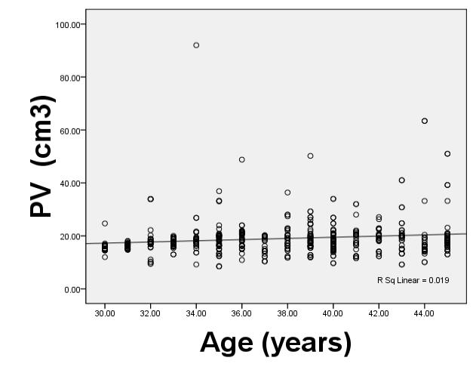

Figure 2: Scatter plot and trend line of prostatic volume with Age
Although |  | many plots |  | are | central | about | the | trend | line, the | majority lie
outside it but |  |  | in close proximity while quite |  |  |  |  | a significant number of plots
are | seen | as | extreme | outliers. The R² value |  |  | of | 0.2% | is poor, | an indication
that | only | that | percentage of |  | PSA is | explained |  | by the | prostatic volume.
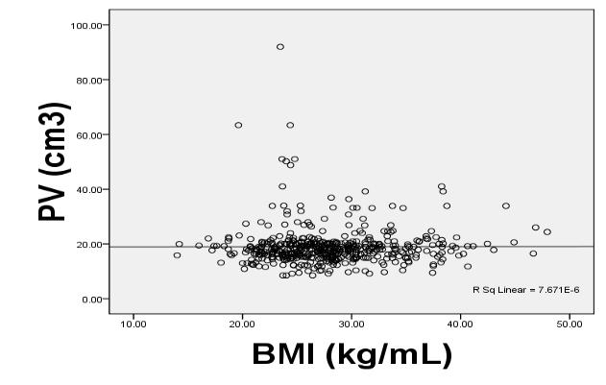

Figure 3: Scatter plot and trend line of prostatic volume with body mass index.
The plots appear to be tight about the trend line. But there are outliers, and with some widely displaced.The the R² value of 0.0% (adjusted R² = 2%) is an indication that predictions from this regression equation for this population may be flawed. Moreover, the poor correlation of prostatic volume with BMI ( r = 0.03) with a p-value of 0.951 shows that whatever relationship that exists in this analysis has neither clinical nor statistical significance.

Percentile curve of age and BMI
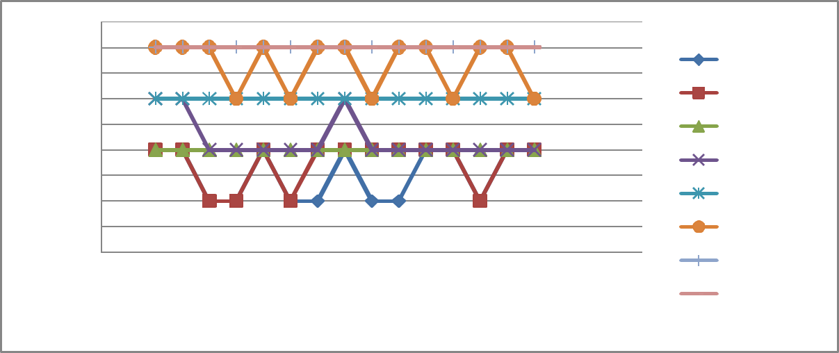

BMI Class

4.5
4 |  |  |  |  | 3 Percentile
3.5 |  |  |  |  | 3 Percentile
3.5 |  |  |  |  | 5 Percentile
3 |  |  |  |  | 5 Percentile
2.5 |  |  |  |  | 10 Percentile
2 |  |  |  |  | 25 Percentile
1.5 |  |  |  |  | 25 Percentile
1.5 |  |  |  |  | 50 Percentile
1 |  |  |  |  | 50 Percentile
0.5 |  |  |  |  | 75 Percentile
0 |  |  |  |  | 95 Percentile
28 | 33 | 38 | 43 | 48 | 95 Percentile
 |  |  |  |  | 97 Percentile
Age

Figure 5: Percentile Curve of BMI of Different Ages of Patients (NB: BMI Value in the Y Axis represents class values of 1 = <18.5, 2= 18.5-24.99, 3 = 25-29.99, and 4
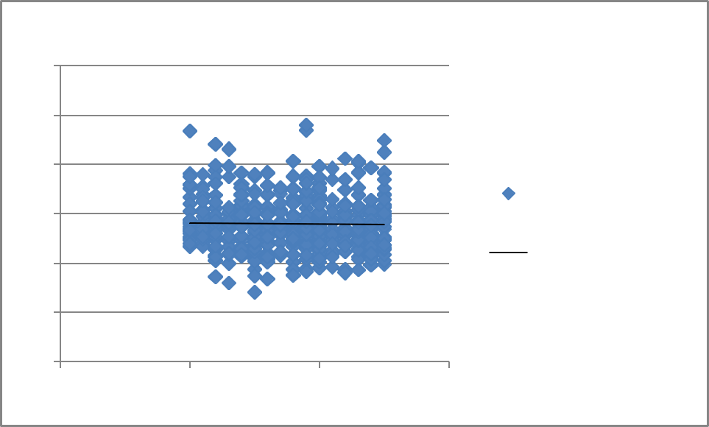

 | BMI(Kg/m2) with Age Correlation Scatter Diagram
60
50
40
30 |  |  | Body Mass Index
30 |  |  | ,BMI(Kg/m2)
20 |  |  | Linear (Body Mass
20 |  |  | Index ,BMI(Kg/m2))
10 |  | y = -0.022x + 28.80
0
20 | 30 | 40 | 50
= >30)

Figure 2: Scatter Diagram of Body Mass Index, BMI(Kg/m2) for different Ages (in years)

From the above table, the R-square for this relationship is about 0 indicating that there is no correlation between BMI and Age of patients in the population sample experimented with.
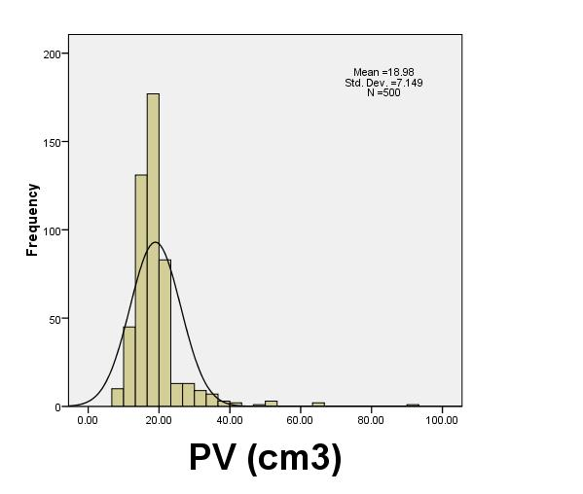

Figure 5: Histogram of prostate volume in the population

The histogram shows that the distribution is positively-skewed but with several positively-skewed values outside the curve. An extreme outlier (92 cm³) is also noted. This has the tendency to lower the mean of the distribution.
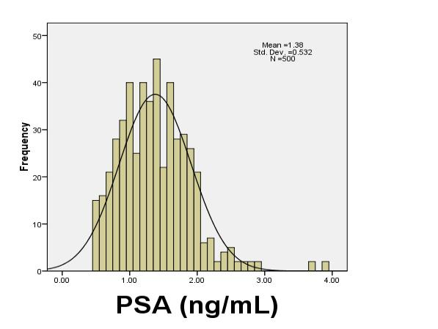

Figure 6: Histogram of serum PSA value in the population

The histogram shows that the distribution is positively-skewed but with a few positively-skewed outliers. An extreme outlier (3.8 ng/mL) is also noted.
Although these outliers have the tendency to lower the mean of the distribution, the effect would be mild because of the few numbers.
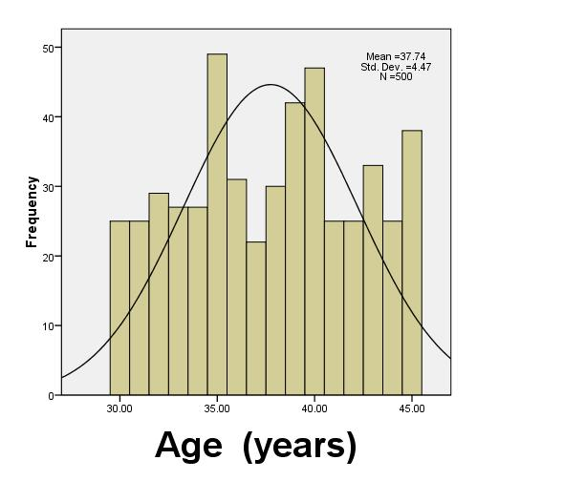

Figure 7: Histogram of age distribution of the population

The histogram is a normal distribution with comparable tails in both directions. No outliers are noted.

CHAPTER FIVE

5.1 DISCUSSION

Prostate volume quantification

Prostate volume (PV) is a key predictor of disease progression and response to medical therapy and there is also a linear relationship existing between serum PSA and PV (Murray & Lopez,2008 ; & Byung, 2006). Serum PSA has been shown to correlate with prostate volume in men free of prostate cancer hence, necessitating the development of nomogram for predicting prostatic volume (Bo, 2003). It has however been suggested that the assessment of prostate volume through the trans-rectal route is the most valid method
(Witjes,1997). Our work therefore used this recommended approach to improve accuracy.

In this study 500 males aged 30-45 years with a mean age ± standard deviation of 37.80 ± 4.7 years participated. The wide range of the body mass index (14.19 – 47.95 kg/m²) is an indication that all four strata of BMI (underweight, normal weight, fat and obese) were sampled . Their mean BMI however, tended towards fatness (28.00 ± 5.3 kg/m² ), an indication that the population was not an obese one, a situation having attendant cardio-metabolic risks. It is estimated that at 50 years of age 50% of men have histologic evidence of BPH at 80 years the figure rises to 75% . In 40 – 50% of these men, BPH becomes clinically significant (Rubenstein, 2008). This premise formed the basis for recruiting volunteers below 50years.

The findings from this work show the prostate to have a range and mean volume of 8.50 – 92.0 cm³ and 18.98 ± 7.2 cm³ respectively. When 20 extreme outliers, that is values which fell outside the normal curve, were excluded from the analysis the range became narrower (8.50 – 48.8 cm³) whereas the mean decreased marginally (18.70 ± 5.2 cm³). However, a further statistical analysis using one-sample t-test yielded p < 0.213, indicating that there is no statistically significant difference between both means. The range of serum prostate specific antigen and the mean in the same population are 0.50 – 3.90 ng/mL and 1.38 ± 0.53 ng/mL respectively. No outliers were noted or excluded.

The mean PV (18.98 ± 7.2 cm³) from our work is comparable to a previous work done in Enugu, Southeast Nigeria with a mean of 20.93 ± 1.79 cm³ (Okeji, 2007). Trans-rectal transducer was used in that work just as was done by us. However, a further statistical analysis using one-sample t-test yielded p < 0.000, indicating that there is a statistically significant difference between our derived means and that of Okeji et al.,(2007). The difference may be as a result of formula used in our calculations. Okeji derived prostate volume using Ðiameter/6 x length x width x height while the scanner we used directly quantified the prostate volume. We state with caution that our method may have under-estimated the prostate volume. Peculiar variability in the different populations used may also be a factor

Relationship between prostate volume, prostate specific antigen, age and BMI

The correlation of prostatic volume with prostate specific antigen was both statistically and clinically significant (r = 0.50 ; p = 0.000). This is an indication
that prostatic volume in this sample has a good relationship with PSA (r = 0.5; p = 0.000). Thus our basis for using it to establish a nomogram is justified. However, a regression analysis (y = 0.031x + 0.894) yielded a low coefficient of determination, R² value of 22.9%, an indication that only a low percentage of PSA can be explained by the PV in the regression equation. Similar regression analyses in prostate with age as well as BMI yielded an R² value of 2% and 0% respectively, an indication that extrapolations using our regression formula will be hardly reliably. Our finding on correlation is however in tandem with a work done amongst non-negroid populations where it was shown that Serum PSA had a strong linear relationship with prostate volume in subjects without prostatic cancer (Ochia, 2010; Murray and Lopez, 2008; and Bo, 2003). This is an indication that the relationship between PV and PSA has no geographical limitation.

In our work, a further correlation of PV with both age ( r = 0.13; p = 0.003) and BMI ( r = 0.01; p = 0.951) did not yield any statistical or clinically significant result (table 2). This implication is that a nomogram of PV on the basis of age and BMI in this population may not be valid. This however differs from closely-similar and earlier works by Eze et al, 2006 (r = 0.5) and Okeji, 2007 (r = 0.734, p<0.05) where it was found that PV showed significant correlation with age.

Our contrary result may be as a result of our narrower age range (30-45) since Okeji (2007) and Eze (2006) used a more widely dispersed range of 25-45 years and 9-100 years respectively. It has also been noted that the certainty of BPH using PV criteria was guaranteed with increasing age (Rubenstein, 2008), further confirming that prostatic volume and age have a significant relationship.

Previous works have also found a relationship, although a negative one, between PV and BMI. Here it was established that higher BMIs were significantly associated with lower PSA levels (Peter, 2011; and Chia,2009). The authors advised that BMI should be considered in the interpretation of serum PSA levels in overweight and obese patients presenting with lower urinary tract symptoms (LUTS). We are unable to give an unequivocal advice on this because of the weak relationship noted in our population.

Prostate specific antigen/ prostate volume ratio

The normal value of PSA/PV ratio established was 0.04. The PSA/PV value in age category however, showed a fairly predictable pattern from the minimum age (30 years) with a value of 0.04 (1:23) to age 42 with value of 0.09
(1:11). Subsequently, the ratio |  |  | decreased |  |  | progressively. |  |  |  | Ages |  | 32,35,36,
38,39,40,43-45 years were noted with |  |  |  |  | abnormal |  |  | ratio as |  | they were higher
(0.05 – 0.08) than | the | normal | range (0.04). The |  |  |  |  | PSA/PV |  |  | ratio | in | BMI
categories did not show any predictable |  |  |  |  | pattern. Also, |  |  |  | the | normal upper |  |  | limit
of 0.04 derived is | higher than |  | the 0.07 |  | of | the | entire |  | population (tables |  |  |  | 6 &
7). This age groups may need further |  |  |  | evaluation |  |  | for prostatic |  |  |  | pathology. For
the entire population the |  | normal | limit | is 0.04 whereas a |  |  |  |  |  | ratio of |  | 0.07 | was
derived, indicating that this population needs further assessment to rule out
prostatic pathologies, especially benign |  | prostatic | hyperplasia. | As | noted
previously, a earlier work established a relationship |  |  | between PV | and | BMI.
It | was observed that higher BMIs were | significantly associated with lower
PSA levels (Peter, 2011; and Chia,2009). We noted a higher BMI with |  |  |  |  | age in
our | population. The sudden decrease in PSA/PV ratio |  | may be in tandem with
this observation.
5.2 | 5.2 Limitation of the study:

- This study was done in the south-south geopolitical region of the country which does not have equal representation of all Nigerian tribes. A multicentre study in other other regions of the country may improve the precision of the estimates and also the generalizability of the data.

- The narrow age range of 30-45 years used is also a limitation to this study .We also acknowledge as a limitation the fact that the transrectal route is invasive and cumbersome and necessitates more stringent patient preparation to get maximum cooperation.

- The socio-economic status of the children studied was not recorded. It is hoped that further studies will address these limitations.

- The inability to compare our normogram with patients with evidence of BPH.

5.3 Conclusion: To the best of our knowledge, this is the first study in Nigeria which correlated the prostate volume with prostate specific antigen and anthropometric variables of age and body mass index in a large cohort of adult aged 30-45years representing a diverse body morphology, thus establishing a nomogram of prostate size across various age groups.
This work has also confirmed that there is a good relationship between prostate volume and PSA ( r = 0.5; p = 0.000 ) but a weak one with age ( r = 0.13; p = 0.003) and BMI ( r = 0.01; p = 0.951) in our narrow age range of 30 45 years. Our alternative hypothesis (H₁ :There is relationship between PV and serum PSA as well as BMI and age ) is therefore valid, but only for PSA and not for BMI or age.

A regression equation (y = 0.031x + 0.894) that can predict prostate volume from PSA value has also been established.

Data was presented in a tabular and graphic forms with the aim of enabling a more practical evaluation during a sonographic and laboratory examination of the prostate.

5.4 Recommendations:

- The established normal parameters can be used to determine the pathologic changes in the volume and specific antigen level of the prostate in routine sonographic and laboratory examinations of apparently healthy adult Nigerian men.

  - The method of measurements and analysis used in this study are standardized and easy to apply. Findings are handy and reliable and are suitable particularly for sonography and laboratory units with large number of patients

  - The prediction model of of the normal prostate volume and PSA can serve as an alternative method for sonographers and medical laboratory scientists assessing the PV and PSA levels in a busy practice setting or in remote remote locations in the studied population.

Areas for further research:

1. A further study in the same population with a wider range of ages should be done to ascertain the relationship between prostate volume and age.

- Also further studies in patients with sonographic evidence of BPH may be helpful in scrutinizing our nomogram, in view of several PSA/PV ratio that were outside normal ranges.

- A multicentre study in other other regions of the country may improve the precision of the estimates and also the generalizability of the data.
4.

REFERENCES

Balk S.P, Ko Y.J, Bubley G.J (2003).Biology of prostate-specific antigen. Journal of Clinical Oncology; 21 (2): 383–91.

Bo M, Ventura M, Marinello R,Capello S, Casetta G, Fabris F(2003). Relationship between prostatic specific antigen (PSA) and volume of the prostate in benign prostatic hyperplasia in the elderly. Journal of oncology and haematology; 47:207-11.

Efthimiou I, Ferentinos G, Tsachouridis G, Sardana G, Diamandis E. (2010). Determination of association of urine prostate specific antigen levels with anthropometric variable Okeji M.C.,

Okoye I. J., Nwobi I.C.,Okpaleke M.S. Transretal Ultrasonographic Assessment of Prostate Volume in Normal Adult Nigerians. Nigerian Journal of Medical Imaging and Radiation Therapy, 2012; 1(1): 33-35.
Eze, C.U; Ohagwu, C.C.; Okaro, A.O.; and Nwobi, I.C. Sonographic assessment of normal prostate sizes within age groups among benue people of Nigeria. Journal of Experimental and Clinical Anatomy, 2006; 5 (2): 13-17.

Guyton and Hall Textbook of medical physiology 11th edition, Churchill livingstone, London: (2006): P 1042.

Isyaku K and Tabari AM. Transabdominal ultrasonographic estimation of prostate volume in nigerian adults. West African Journal of Ultrasound, 2006; 7(1):13-17.

MacKay, N.J. (2010). Scaling of human body mass with height: The body mass

index revisited. Journal of Biomechanics; 43 (4): 764–6.

Mahmuda Monowara, Akhter Uddin Ahmed, Abu Saleh Mohiuddin, Mohammad Abu Taher, Zinat Nasrin, Mohammad Mahbub Hossain (2012). Correlation between transabdominal sonographically measured prostate volume with anthropometric factor in normal healthy subjects. Birdem Medical Journal; 2(1) 29-3.

Moore, K; Dalley, A. (2004). Clinically Oriented Anatomy. Baltimore, Maryland:

Lippincott Harvard University Press.P.44

Murray C.J. L, Lopez A.D (2006).The global burden of disease: a comprehensive assessment of mortality. Urology; 34:14-18.

Naing L, Winn T, Rusli B.N (2006). Practical issues in calculating the sample size for prevalence studies. Arch of Orofacial Science; 32(4): 9-14.

Okeji M.C., Okoye I.J., Nwobi I.C. and Okpaleke M.S. Transretal Ultrasonographic Assessment of Prostate Volume in Normal Adult Nigerians.Nigerian Journal of Medical Imaging and Radiation Therapy,;1(1):34-36

Roehrborn C.G, Boyle P, Gonald A.L, Waldstreicher J. (1999). Serum Prostate-specific antigen as a predictor of prostate volume in men with benign prostate hyperplasia. Urology; 53:581-9

Sam Lister, (2009). Urine test could speed treatment of prostate cancer. Journal of Oncology and Haematology; 32:125-9.
Stephan C, Stroebel G, Heinau M, Lenz A, Roemer A, Lein M, Schnorr D, Loening S.A, Jung K. (2005).The ratio of prostate-specific antigen (PSA) to prostate volume (PSA density) as a parameter to improve the detection of prostate carcinoma in PSA values in the range of < 4 ng/mL. Cancer; 104(5):993-1003.

Ukoli F.A, Egbagbe E, Zhao B.B, Lyamu E, Young D, Oside P, Osime U, Adams-Campbell L.L (2007).Anthropometric predictors of elevated prostate specific antigen among rural and urban Nigerians: a population-based study. Cancer; 6(1):7-13.

WHO (2006). BMI classification". Global database on body mass index.

International Journal; 521: 231-8.

WHO (2009), Disease and injury country estimates". International Journal; 32:

321-8.

Witjes WPJ, Aarnink RG, Ezz-el-din K, Wijkstra H, Debruyne FMJ and de la Rosette JJMCH. The correlation between prostate volume, transition zone volume, transition zone index and clinical and urodynamic investigations in patients with lower urinary tract symptoms. British Journal of Urology, 1997; 89(1):84-90.

Yoon Dong Kim, Won Jae Yan Yun Seob Song and Young Ho Park (2008).

Correlation between prostate volume and metabolic or anthropometric factors in Male Visitors to a Health Promotion Center. Korean Journal of Urology. 2008 49(2):139-144.
APPENDIX

Calculation of minimum sample size, n

The sample size were determined according to the following formula by

Magnani, Roberts (1997):

n= t² x p (1-p)
_{m}2

where : n = desired sample size

t = confidence level

- = proportion of the population with the desired variable m = margin of error

For this study: t = 95% (z score = 1.96)

P=50% (unknown population proportion)

m= 5% (0.05)

This gives: 1.962 x 0.5 (1-0.5) = 3.8416 x 0.25 = 384.16 (384)

0.0025 0.052

10% of the sample size (384) was added to correct the extraneous variables, improve accuracy and make calculations easier. The total sample size therefore was 500.


