### CHAPTER ONE

**INTRODUCTION**

### Background of the Study

Surface water bodies such as lakes, streams and rivers are the earth’s most vital renewable and widely distributed natural resources of providing man’s comfort, means of livelihood, circulation of the earth’s moisture (Barlkrishan, 2011). Mbo River system contribute significantly to food availability and security, income generation, trade and improved living standard as well as preservation of biodiversity. Mbo river system water is being used for drinking in the study area. Mbo River system is also a nursery ground for cultivation and breeding of different fish and seafood species for fishermen. Its water ways are used as transportation route for ferrying people and goods to the fishing settlements. Mbo River system is a source of major income earner as tourists flood the area during it fishing and boat regatta festival. The flooded shoreline is loaded with alluvial sediments that irrigate the adjourning soils and improves the yield of planted Okro, pepper and all sorts of vegetables (AKSG 2008).

In recent time, Mbo River system is deteriating in quality due to heavy metal pollution. Heavy metal pollution of surface and underground water (Islam *et al* 2012) sediment (Jared 2002) and fishes (Udosen et al 2014) are among the most central environmental problem of this century.

Generally, heavy metals have been defined as those classes of metals that are electropositive, transition, chemical elements having a relative high

specific gravity greater than (>5) (Roebuck 1992, Sorensen, 1991 and Deuffus, 2002).

Heavy metals like zinc, copper, iron, manganese, cobalt, chromium and nickel are beneficial when it comes to their use in plants, animals and human nutrition, This is because, they are required for metabolic activities in organs (Hossain, 2001). Others such as Mercury, Cadmium, and Lead have no known biological functions in living organism whatsoever. They exhibit extreme toxicity at low concentration (Hu, 2002).

When heavy metals are introduced into fresh river water or sea water they degrade (Ajibola *et al* 2008) the natural quality for water. It also affects negatively (Dahilia *et al* 2003) the organisms living in it. This is because they are stable and non-biodegradable (Offem and Ayotunde, 2008), persistent (Tam and Wong, 2011), toxic (Koto *et al* 2008). Other water pollutants are urine, feaces, bath water, cloth washing water (Lloyd, 1992). They also include leaves, grass chippings nitrates and phosphates (Oguzie, 1996) detergent, salts (NaCI), crude oil film and hot coloured dye (Purves, 1985). Water pollutants have their sources. They are generated mostly from anthropogenic sources (Udosen *et al* 2006). These include manufacturing activities (Ogbeibu and Ezennwa 2002, agricultural activities Eja *et al*, 2003), dumpsite (Moodley *et al* 2007, Okoyo and Agbo 2011). Others are untreated domestic sewage, municipal waste water discharges (Shriedah 1998), boat construction, accidental spills, combustion of fossil fuels (Agbugai et al 2012). Occasionally, heavy metal pollution also comes from natural source

through atmospheric deposition (Nriagu 1989), erosion (Ojiako *et al*, 2010) weathering (Asaolu and Olaifa 2004).

Heavy metals can alter the quality of water body by increasing the odour, pH, BOD and PO43- (Davies and Abowei *et al* 2009) by distrupting sediment nutrients,the natural quality of fish and fish tissue (Abu *et al*, 2012). This can lead to increasing fish disease and mortality, (Saxena *et al* 2005) and also influence physiological rates of fish reproduction (Korisiakpere and Ubogu 2001 Abu *et al* 2012). Previous cases of endemic exposure of heavy metals reported from the time of Iraq mercury poisoning (Harrison, 1999) to the time of Ita-Itai disease (Lister and Renshaw, 1991) to the time fo Zamfara metal poisoning (Nigeria Daily Thrust, 2010), all the cases had always result to health problems and death. Apart from few physiochemical parameters reported by (Essien-Ibok *et al*, 2010) on Mbo river, bioaccumulation of five metals in fish from Ibaka river reported by Akpanyung, (2006) and occupational distribution studies by AKSG (2009), there is no known history of assessment of environmental samples that is linked to people’s health and welfare in the study area as is done in this work.

### Statement of the Problem

Major problems noticed in the study area are:

* + - Lack of toilets and wastes disposal facilities
    - Open defaecation into river water and frequent reports of diseases
    - Increased generation and disposal of metal containing wastes into

waterways

* + - Leaching and decreased quality of run off waste waterf (Monechot *et al.* 2014).
    - Use of metal components in fishing gears and nets
    - Unauthorized sand excavation and dredging
    - Corrosion of sunked metal scraps

### Aim and Objectives of the Study

The aim of this study is to assess the pollutant levels of surface water, sediment and fishes from Mbo River System, Akwa Ibom State, Nigeria.

The specific objectives are to determine:

1. Microbial loads in surface water
2. The physicochemical properties of surface water and bottom sediments.
3. Texture, particle grain size and percentage composition of the bottom sediments.
4. The heavy metals concentration in surface water, bottom sediments and organs of xenomystas nigri (catfish), ilisha africanus and pseudolithus elongate (croaker).
5. Calculate the risk health assessment of dietary intake consumption of heavy metals from the fish organs.

### Scope of Study

Seven sampling locations were selected for water, sediments samples and two locations for fish samples. The sampling was done for a period of eight months comprising four months peak period of wet (June –September 2015) and four months peak period dry (December 2015 – March 2016) seasons. Sampling time started from 8.00am – 11.00am for 112 water and 112 sediment samples collected. Fish sample (72) were caught between 6.00pm in the evening and 6.00am in the morning

### Significance of the Study

The result of this work will be useful to:

1. Maritime bodies in monitoring discharge processes and water pollutant.
2. Environmental managers in comparing concentrations, occurrence and sources of heavy metal pollution and evaluating furthers effect in the study area and other Nigerian rivers.
3. Residents and fishermen in understanding the consequences of direct defeacation into river water as one of the causes of their ailments.
4. Akwa Ibom State water company in the assessment of all the surface water in the study area used for drinking and the setting of a water treatment plant in the study area.
5. Mbo Local Government council in providing waste disposal facilities, setting of waste management committee and enforcement of enabling environment laws of Akwa Ibom State.

### The Study Area

Mbo River System is made up of Mbo River and Ibaka River. Both rivers are located in Mbo Local Government Area. Mbo Local Government Area is one of the 31 Local Governments in Akwa Ibom State.

### 1.6.1. Location

Within Mbo Local Government Area, Mbo river lies within latitude 40 381 011N to 40 401 011N and longitude 80 121 011E to 80 191 011E. It runs through Mbo Local Government Area longitudinally dividing it into two. This river links Uko Akpan in Enwang community at the downstream and pass below a

¾ km bridge behind Mbo Local council premise to Ebughu community at the upstream where it empties into Ibaka river.

Ibaka river is in Ibaka community of Mbo Local Government Area. It lies within latitude 40 381 011N to 40 421 011N and longitude 80 181 011E to 80 191 011E, as shown in Figure 1.1. It borders vertically the eastern flank of Cross River and occupies a considerable length of littoral portion of Atlantic Ocean far beyond the low water mark.

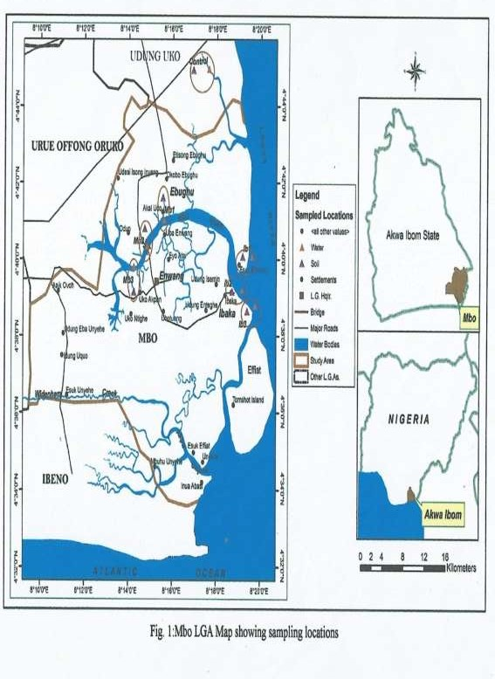

**Fig. 1.1: Mbo LGA Map Showing Sampling Locations**

### Climate

The study area is characterized by dry season (November-April) and wet season (May-October). The rainfall is heavy above 3000mm along the coast but records 2000mm along the fringe. Greater of Mbo River System becomes inundated with flood during wet season. This is because the topographical feature of the area has flat to undulating wavelike shapes.

The study area experiences an average annual temperature which varies between 260C and 280C with a maximum temperature of 30.30C and a minimum of about 4.10c. The relative humidity varies between 75% and 85% while salinity fluctuates significantly.

### Population

Mbo Local Government Area has a population of about 104,012 made up of 55, 395 male and 48617 females (FRN official gazette 15th May, 2001). Mbo Local Government Area is also made up of five communities with groups of villages namely, Ebughu, Enwang, Ibaka, Uda and Effiat. For this work the study area covers only Ebughu, Enwang and Ibaka communities.

Apart from the indigenes, the study area is populated by Bakassi returnees, fishermen from Ilayes, Ijaw, Yoruba, Ghana (Wasa) and Cameroon.

### Economic Activities

The economy of the study area is highly private sector driven. The most important sources of economic livelihood is fisheries capture. This resulted to the Federal Government of Nigeria citing the defunct fishing

terminal at Ebughu. Male dominate the fishing enterprise within the creeks and offshore using big fishing trawlers. Their women gather periwinkle crabs from the shallow swamps and engage in fish drying and smoking. According to AKSG (2009) report of study distribution of occupational group in the study area, fishing (45%) is reflected as the predominant occupation followed by farming (40%), trading (10%) civil service (3%) and artisan (2%). Thus fish and major farm crops and economic trees products are main income earner.

Besides fishing and farming, other economic activities practiced in the area include trading. Women traders form themselves into corporative and own seafood trading posts where they make their sales in market that hold every Monday of the week which attracts patronage from all over Akwa Ibom State. Others exploits the mangrove forest for firewood and non-timber forest produce (mushroom, wild forest and vegetables) for sales, marketing of palm wine and illicit gin. Men on their part are involved in sand excavation and dredging, wood logging, timber work and extraction especially fuel wood which serve as a boast to the local economy as those involved in them earn a good income. Engine boat operations and marine transportation of good between the study area and local markets is another source of income.

Distribution study still revealed that non-indigenes mostly operate hotels, restaurants, shops, supermarkets, filling stations and oil sales from petroleum depots, carpentry, boat making, welding, vulcanizing, masons, electric/mechanical workshops, sales of cows at abattoirs centers. Oil

companies also carry out oil business operations offshore, busy sea-crafts owned by security agencies and Naval Base Formation, Ibaka, dry dock facilities for super tanker vessels and Nigerian National petroleum corporation floating station are part of business facilities in the area.

### Hydrology

The study area is washed with major rivers and smaller network of smaller rivers, tributaries, swamps and creeks. Generally the static water level is variable and records indicate a range from 2.37 to 4.35m (mean 3.147m) below ground surface for the dry season. For the wet season the value varied from 2.30 to 4.30m (mean 3.07m). This indicates an average increase of water during wet by 0.07m. For dry season the river depths varied from 0.7 to 7.3m while the width ranges from 36 to 365m. The mean velocity and discharge for the rivers wre 0.12 and 49.2m/sec. The data for the wet season showed that the river depths varied from 0.9 to 8.2m while the width ranges from 43.0 to 410.0m. The mean velocity and discharge for the rivers are 0.1m/sec and 56.9m3/sec (AKSG 2009)

The specific water bodies the study is focusing on are Mbo River and Ibaka River. Mbo River has a depth of (4-7) m, water current velocity (3.5- 5.8cmsec-1), water transparency (40.20-70cm) according to Essien - Ibok et al (2010) whereas Ibaka River has a depth of (11-16m), water current velocity (6.2-9.5cmsec-1) and water transparency (30.30-52.81cm) as reported by Umar (2012). Moreso, Ibaka River has a long stretch that opens into gulf of Guinea and the water is brackish and highly saline.

### Table 1.1: Sampling locations and their coordinates on rivers water for water/sediment/fish samples

**SAMPLING COORDINATES HUMAN ACTIVITIES AT LOCATION**

**Code Locations**

MB1 Fishing Terminal Jetty Beach along Mbo river in Ebughu community

N044108.7 E0081441.5

Fishing, boat construction, car wash, fish dreks, open defaecation, sunk trawlers, nypa palm decay, oil storage farms, onshore operations.

MB2 Seacraft/fish market beach along Mbo river bridge head in

Enwang community

MB3 Uko Akpan Beach along Mbo river in Enwang community.

N044120.7 E0081450.5

N044106.7 E0081439.8

Fishing, sand excavation, laundry, car wash, gin production, boat operation abattoir, market wastes.

Fishing, laundry, car wash lumbering activities, gin production and agricultural run off.

MB4 Arrival/Esuk Ifia /fish market beach along Ibaka river in Ibaka community.

N043909.7 E0081853.5

Fishing, wood industry, abattoir market dumpsites, fuel stations, car wash, mechanic workshops, erosions & urban drainage, boat parks.

MB5 Fishing settlement beyond Naval forward base along Ibaka river in Ibaka community.

MB6 Fishing settlement beyond NNPC floating station along Ibaka river in Ibaka community.

N043904.7 E0081923.7

N043913.2 E0081950.9

Chemical fishing, Naval operations maritime transportation.

Chemical Fishing, wood & lumbering activities, engine boats operations, NNPC flow station.

MB7(con trol 1)

Asana-Ikan river Udung Uko Local government

N044323.99 E0081656.22

No fishing, water calm and suitable for drinking.

Area.

The sample locations selected were based on how severely they were disturbed by human activities. GPS (Garmin GP 12 Model, UK satellite navigator and position system operating in “stand alone” mode were utilized in positioning the sampling locations in the study area. The

global positioning system (GPS) geographical coordinates of the sampling locations were measured based on the world “Geodetic System” Datum of 1984.

The profile of the designated sampling locations were MB1, MB2, MB3, (Mbo River), MB4, MB5, MB6, (Ibaka River) and MB7 (control 1) for collection of water, sediment and fish samples.

### CHAPTER TWO LITERATURE REVIEW

The review of literature that are related to this study are discussed under the following subheadings:

### Surface Water Physicochemistry, Microbiological and Metal Pollution

* 1. **Surface Water Physicochemistry**

Reports on the physicochemical properties of rivers abound everywhere some of which are reported here. Mohammed and Caleb, (2014) determined some physicochemical parameters of water samples along River Galma in Zaria, Nigeria. In his report, only total suspended solids and total hardness were above permissible limits.

Ajiwe *et al.* (2014) analyzed the physicochemical components of three satellites rivers (Nworie, Otamiri and Oramirikwa) in Owerri Local Government Area of Imo State using World Health Organisation (WHO) standards to compare the results. The three rivers were to a large extent found to be safe for human consumption except PO43- in Nworie and Oramirika rivers and pH of the three rivers. Equally too, Maitera *et al.* (2011) had higher total hardness than total carbonate in wet season with the two parameters almost the same in dry season and higher conductivities than total dissolved solids. Adamu *et al.,* (2014) investigated into some physicochemical parameters of Watari reservoir Kano state, Nigeria. The mean values of TDS, conductivity, turbidity, total hardness suspended solids

BOD, Cl-, NO-2, NO-3, COD and PO42- indicate the effectiveness of the treatment process. The high values for nitrates observed may be as a result of the use of nitrous based fertilizer in the locality.

Udo *et al.* (2013) investigated spatial variation in physicochemical parameters of Eastern Obolo estuary and the result reveal that TDS, BOD values from all station exceeded the recommended limits indicating Eastern Obolo estuary may not be efficient source of drinking water. The physicochemical measurements of water quality of Great Kwa river had been reported by Akpan *et al.,* (2012). and the results showed water temperature, transperancy, salinity and DO values are significantly higher during the dry season than the wet season except BOD.

Okolo *et al.* (2014) reported average concentrations (mg/l) of anions of Nkisi River The concentration of these physicochemical characteristics where within World Health Organisation (WHO) acceptable standards of drinking water. According to Dibofori-Orji and Marcus, (2011), physicochemical analysis of Orashi River at Mbiama and Ogbema communities in River State recorded tempreature of 29.2C for the two sampling points. The slight hardness of water samples observed is temporary and attributable to the presence of bicarbonates. Though the level of sulphate in the river water is an indication of some element of organic matter in the water. This could have its origin either from human waste and or industrial wastes.

Physicochemical parameter of the river Niger at Onitsha bank, Nigeria had been investigated by Egereonu and Ozuzu, (2005) to establish the levels

of pollution of land and water on the river bank. The metallic and non- metallic ions, alkalinity, total solids, sulphate, chloride, hardness and other physicochemical parameters had been reported to a have adverse impacts on the water quality thus rendering the water unfit for human consumption.

The water quality of ponds at the university of Jos, Nigeria was also accessed by Jabbo *et al.* (2011). The values obtained fell within permissible units and the water was recommended to be good for irrigation.

### Physiochemical characteristics and bacteriological load in surface water

Ameen *et al.* (2011) had reported the mean physicochemical and bacteriological analysis of Asa treated water before and after refurbishment of the treatment plant. All samples were negative to *E.coli*. Similarly, Agwu *et al*. (2011) assessed the quality of drinking water sources from Aba South and Abayi areas of Abia State and reported all physicochemical parameters of water analyzed as within World Health Organisation (WHO) standard except for pH which ranged from (5.20 – 5.80) against WHO range of 6.5 – 8.5. All samples contained (staphylococcus sp. Streptococcus and *E.coli*, etc) to varying degrees. The three spring’s water in Bende LGA of Abia State assessed by Okolo *et al*. (2014) showed mean pH of 5, temperature of 28.3C against 6.5 – 8.5 and temp (25C) approved by WHO.

### Heavy Metal Pollution of Surface Water

Previous cases of metal pollution of water bodies in Niger Delta are well documented. The levels of trace metals in drinking and ground water source in Ota, Nigeria had been assessed by Anako *et al*., (2004). Fe and Ni in some drinking and ground water sources were found in concentrations that exceeded the WHO guidelines while Pb levels were below detection in all the samples under investigation. Pollution indices evaluated indicated significant pollution by Pb, Fe and Ni and the mean metal levels in the sample water sources were of the under Fe>Cu>Zn>Ni>Pb>Mn.

Ebong *et al.* (2001) had earlier reported estuary waters of Qua River as having mean concentrations of Pb, Ni, V, Fe, Cu and Cd higher in wet season samples than in dry season samples and also the high mean metal concentrations of its associated creek co-related positively. However, mean concentrations later reported for surface water quality for the same Qua Iboe river system revealed indicating supersaturation which led to mineral precipitation condition of water (Umoren and Onianwa, 2012). Umoren *et al*., (2014) assessed the levels of environmentally toxic metals and their potential risk to the biota in surface and groundwater samples obtained from six different locations in Ibeno local government area of Akwa Ibom State. The predominant species in both surface and ground water were the free hydrated ions of Ni2+ (99.8%), Zn2+(99.4.4%), Cu2+ (72.7% - 96.4%), Pb2+(54.2% -

99.8%) as well as the hydroxyl complexed species of CrOH+ (24.5%).

Inyinbor *et al.,* (2011) studied concentrations of Pb, Cu, Zn, Mn and Fe in Onyi river in Obajana community of Kogi State, Nigeria. The concentrations of these metals in water were however found to be higher than those of WHO standard for drinking water in certain location due to other anthropogenic activities. In Sokoto, Izuagie *et al.,* (2011) examined heavy metals in running water sample from limestone mining site. Results of heavy metals concentration gave Zn (0.29 mg/L) while Pb, Mn, Ni, Cu and Fe were not detected. Sanyaolu *et al*., (2014) had investigated levels of Cd, Co, Cu, Cr, Fe, Mn, Pb and Zn in river Ogun, Nigeria and mean concentration of these metals and their ranges reported were within WHO tolerable limits.

Okorie, (2011) determined Cd, Co, Hg, Pb and Fe in Imo river from source to tributaries for dry and wet seasons and analysis showed Cd and Co occurred in trace amounts and so were not detected for the two seasons, but low levels of Hg were detected while the river contained high amount of Pb in the dry season with annual mean Pb level.

### Physicochemical Properties and Heavy Metal Status of Surface Water

It had been reported that the pollution status of surface water around Yauri abattoir analysed by Ibrahim *et al*., (2013) recorded mean concentration values of TDS, TSS, DO, PO43-) and BOD as well as Cd, Ni and Pb higher than the national and international standard limits and control water sample where the pH values, SO43-, NO3- and COD, CO, Cu, Fe and Zn were above the control but below WHO, EU, SON, USEPA safe limits for

physicochemical variables and metals in water. Comparative assessment of physicochemical and heavy metals analysis of river water samples from Ekpan, Ubeji and NPA environs of Warri, Delta State investigated by Ogbuagu *et al.,* (2013) produced lower mean concentrations for pH, turbidity, NTU, TSS, COD, DO, TDS, conductivity, Cl-, HCO3-, SO42-, PO42- except turbidity at around NPA was slightly above WHO standard while Fe, Mn, Cd, Cr, Cu, Zn and Pb at all stations of the samples were mostly less.

The physicochemical characteristics and heavy metal levels in water samples from five rivers system in Delta State, Nigeria for 12 months (January to December, 2009) were also examined by Kaizer and Osakwe, (2010). On comparison with international guidelines, the rivers were not significantly contaminated but were suitable for domestic and industrial uses.

### Sediment Physicochemistry and metal pollution

Sediments form a natural buffer in rivers and are important habitat as well as a main nutrient source of aquatic organisms.

### Physicochemical properties of Sediment and Water

A much interesting work on the physicochemical properties of sediment is that of benthic sediments of Qua Iboe estuary. For this estuary Essien and Benson*,* (2007) reported monthly concentrations for NH3-, Cl-, CO32-, SO 3- and NO3- in its benthic sediment during the wet season (June 2003 – Sept. 2003). Similarly, the mean monthly values for the dry season (Nov, 2003 – February 2004) also were reported.

4

### Heavy Metals Pollution of sediment

Within the Niger Delta environment and other ecological zones in Nigeria, some authors have reported metals in sediment. Within the Niger Delta, Essien *et al*., (2008) reported the mean concentration (mg/kg) of Cu, Cr, Fe, Ni, Pb, V and Zn in epipelic and benthic sediments of cross river estuary mangrove swamp. Threshold effect level (TEL) values in the majority of the samples also studied indicated there may be some ectoxicological risk to organisms. High concentration of Cr, Ni and Cd content in sediment from Warri coastal region had been reported by Olowoyo *et al*., (2009) as coming from areas associated with crude oil and logging area respectively.

According to Clarke and Sloss, (1992) Cd value may be due to prevailing logging activities since Cd is known to be found at the bark of woody and herbaceous tree. Uwah *et al.* (2013) had reported evaluation of heavy metals pollution of sediments in Qua Iboe estuary and associated creeks.The result showed calculated enrichment factor (Igoe) indicating that sediment were enriched with Cd, Zn, Cu and Pb.The geo-accumulation index (Igoe) result revealed that the sediments are unpolluted with Fe, moderately polluted with Cr, Cu, Pb, strongly polluted with Cd and extremely polluted with Ni. All these were attributed mainly to oil contaminating wastes and metal scraps. However, the modified degree of contamination (MCD) revealed that the sediments studied fall between 8  MCD  16 indicating high degree of contamination. Many other researchers have also used sediment cores to study heavy metal pollution behaviour. Ovum and Dickson,

(2004) had reported Cd, Cr, Pb, Cu, Zn, Mn, V, Ni, Fe levels in sediment cores from Brass river system situated few kilometers from Nigerian liquefied natural gas and obtained results associating V and Ni concentration with crude oil while heavy metals examined showed a horizontal distribution tendency increasing towards probably to the point of discharge while vertical distribution appeared constant, indicating that the river has large anthropogenic metal input. Shauib, (2011) determined the levels of heavy metals in sediments of Aluko stream and Asa river in Ilorin metropolis Nigeria and the levels of Pb, Ni, Zn and Mn down streams of Asa river (ASD) and Aluko Stream (ASD) were respectively higher than those of ASA river upstream (ARU) and Aluko stream upstream (ASU) except Mn which showed almost the same levels in all the sites.

There are also good numbers of reports in sediment outside Nigeria. Salomans and Forstner, (1980) reviewed the processes affecting heavy metals in deposited sediments – the toxic layer sediments, anoxic layer sediment, and the oxic-anoxic interface sediment are available. Results showed that heavy metals like Cu, Zn and Cd occurred as sulphides in marine and estuarine anoxic sediments. Xraoyu-Liu *et al.,* (2006) investigated forty (40) surface sediments from river, estuary and bay and one (1) sediment core from Jinzhon bay of the coastal industrial city, North East China. Data obtained revealed a remarkable change in the contents of Cu, Zn, Pb, Mn and Cd among the sampling sediment. All the mean values of heavy metals concentration were higher than the National Guidelines values of marine sediment quality of

China. The correlation analysis and geo-statistical analysis showed that Cu, Zn, Pb and Cd have a very similar spatial pattern and must have come from industrial activities. The concentration of Mn may have mainly caused by natural factors. On the other hand, the metal concentration in (mg/kg) reported by Barakat *et al.* (2012) in surface sediments obtained from Day river at Beni-Mellal region of Morocco: showed significant variation with metal content controlled by organic matter and Fe contents. Pollution load index and sediments with guideline showed the metal levels exceeded local and regional background concentration. This is an indication that contaminant is high enough to be of risk to human health and ecosystem.

The levels of trace metals in surface sediments from kalabari creeks in Rivers State of Nigeria from June 2009 to April 2010 which covers the rainy and dry season was studied by Kpee and Ekpeta (2014). The results obtained revealed that the mean levels of the meals occurred in the order Fe>Ni>Cu>Pb>V=Cd. V and Cd were below detection limits (<0.001) in all samples.

Marcus *et al*. (2013) determined the levels of organic matter and trace metals in sediment of Bonny river and creeks around Okrika in Rivers State. These result revealed anthropogenic trace metal enrichment and also suggest a common source of pollution, likely from land-derived wastes brought in by runoff water.

Focus on sediment-water quality of rivers vis-à-vis their heavy metal load had been widely reported by many authors. On average, the sediment and water of Ijora canal was moderately polluted with respect to lead and cadmium and highly polluted with respect to mercury (Osuntogun and Nsenwu, 2004). Umoren *et al*. (2014) assessed the surface water quality of Qua Iboe river system and obtained levels of Cd, Pb, Cu, Zn and Ni in surface water and bottom sediments.

Udosen and Benson, (2006) examined the spatio-temporal distribution of heavy metals in sediment and surface water in stubbs creek, a fresh water tributary of Qua Iboe river, Nigeria for six months (May to October, 2003). Six metals (Co, Fe, Pb, Ni, V & Zn) were analyzed using inductively coupled plasma spectrometer. The concentration of heavy metals were higher in the sediment than in the water. The coefficient of variation of the metals under investigation were high and in the Pearson’s correlation analysis (at P<0.05) revealed a positive correlation between metals in surface water and sediment.

El-bourarine *et al*. (2010) examined heavy metals concentration in surface river water and bed sediment at Nile Delta in Egypt from August 2007 to April 2008 covering wet and dry season. The heavy metal concentration in the river and sediment, were found to be remarkably high, but varied among sampling points and the concentration were within permissible limits of international guidelines.

### Fisheries and Heavy Metal Pollution

* + 1. **Fisheries**

Worldwide the major aquatic organisms that constitute an important part of human diet are fishes. For more than 80% of Nigeria’s population fish is their popular food item, while at least 65% entirely depends on its as their major sources of animal proteins. From available record, out of a total fish landing of 10.6 million metres tons from fifteen countries including Senegal to the Congo, within this region, Nigerian contributed 32.7% (Nsentip, 1983). The annual estimated total marine fish catch in Nigeria for the period was 0.3299 million metric tons. This has been drastically improved as a result of fishing technology and participants (Tomori *et al*., 2012). According to Nsentip (1983), Akwa Ibom and Cross River States are the first largest contributors (68.49%) of marine fish landing followed y Edo and Delta States, then Lagos state. However, the problem of eating fish is the risk of their contamination with chemicals such as PCB’s and methylmercury, dioxins and chlorinated hydrocarbon pesticides as well as heavy metals such as mercury, cadmium, lead, selenium and arsenic (Connel, 1995).

Heavy metals bioaccumulation in aquatic biota varies, thus variability in fishes may be due to size of the fish, species of the fish, ecosystem type where fish is found and location where fish is monitored, feeding patterns, solubility of chemicals used in chemical fishing or heavy metals and their persistence in the environment (Price, 1992).

Heavy metals are accumulated in living things such as fish faster than they are broken down (Oyewo and Don Pedro, 1998; Osibanjo *et al*., 1981). In marine sediments, bacteria may convert the less toxic inorganic forms of mercury to the more toxic form of methyl mercury which is relatively mobile in the environment and tends to bioaccumulate in fish (Wood, 1974; World Environment systems, 1997). Similarly, lead, cadmium, nickel, vanadium are not biologically essential but associated with various deleterious effluent (Prater, 1995) while some are teratogen, carcinogen and possible mutagen (Eisher, 1985) and in some species of fishes their concentrations increase in size and length (Thompson, 1990). This accumulation has been observed in various fish tissues, mainly in liver and in gills (Ashraf, *et al*., 1991). On the other hand, little accumulation has been observed in muscle (Kargin, 1998).

### Heavy metal pollution of fish

Much work have been done on metal pollution of whole fish than on their internal organ. Whole fish here include seafoods like periwinkle, crabs, etc. Alinor, (2009) investigated bioaccumulation of elemental toxicants in periwinkle and crab from Ibeno river near Exxon Mobil tank farm. Results revealed that Pb and Fe were identified in appreciable amount in periwinkle tissue with mean values 8.08 ppm and 456.32 ppm respectively, but Pb was not detected in periwinkle shell but appreciable amount of Fe, Pb with mean value 1754 ppm whereas crab sample had appreciable amount of Zn and Cu of mean value 39.41 ppm and 38.22 ppm respectively. This therefore suggests an associated health hazard may arise from the effect of these elemental

toxicants. Similarly, Okoye *et al*. (2009) who had earlier worked on both fresh and dried crabs obtained from Epe and Warri environment and had reported the pollution level of the area as manifesting the presence of As, Zn, Pb and Hg.

Odoemelam, (2005) determined heavy metals in four species of fish from Oguta Lake and reported Pb, Zn and Fe having the highest concentrations. The results indicated the possibility that deleterious effects could manifest after a long period of consumption as trace metal contaminations cannot be rule out. However Abdularaham and Tsafe, (2004) had reported three fishes caught from Sokoto Rima river and analysed for metal toxicity as safe for human consumption but he explained that this may probably be because there is no single industry or any human activity in the river basin. Bioaccumulation factor is an important index in measuring metals pollution level in fishes. Obodo, (2003) reported bioaccumulation factors of 300 and 220 for Mn and Pb respectively in catfish and bioaccumulation of

254 and 250 for Mn and Pb respectively in tilapia obtained from lower reaches of river Niger. Similar report by Obodo, (2004) on Anambra river revealed bioaccumulation of 224 and 210 for Mn and Pb for tilapia. It was explained that there exist an inverse relationship between Pb concentration in fish and size of fish noticed for small size catfish species caught in Warri river weighing 58g and 47g respectively with higher concentration when compared to *synodontis Batensoda* (electric fish) with a mass of 227.89. This was attributed to the inter specie differences in Pb accumulation to metabolism

and feeding habits of these species accordingly. According to Udosen *et al*. (2014) concentration of trace metals determined in some edible fishes collected from Enyong creek, Itu, Nigeria recorded the trend of Mn > Zn > Cu

> Cr > Pb and were accumulated in the fish species in the trend of *Hermichromus bimaculoutuss*, *Xenomystus nigri*> Hyperopisus bebe occidentalis >*Heterotis niloticus*>*Chrysichthys nigroditanus*. Abah *et al.* (2012) reported concentrations of some trace metals content of *Orechromis niloticus* from river Okpokwu, Apa, Benue state, Nigeria and results obtained showed that trace metal contents of *Oreochromis niloticus*are are posivitely correlated.

The concentrations of heavy metals in fishes from Aba river in Abia State, Nigeria analyzed by Mbgemena and Obodo, (2011) showed Fe higher in dry seasons than in wet season having the highest level of 1465.45  5.45 mg/kg in channa fish, 1631.25  21.25 mg/kg in electric fish and 1685  5.00mg/kg in catfish in the rainy season whereas Catfish had the highest concentration of heavy metals followed by the electric fish and lastly by the channa fish while manganese had the highest bioaccumulation factor of 1136.11 in catfish, 771.65 in channa fish and 492.98 in electric fish and since the level of these metals determined were far higher than the legal limits Tebia river should be seriously monitored. Ezigbo, (2010) investigated the levels of heavy metals in four fresh water fishes-*Synodontis*species, *Lepido sirenidae*, *Orechromis niloticus*, *Clarias niloticus.* The results obtained when compared P<0.05 indicates the fish species are contaminated. There are

reported findings on comparative analysis of heavy metal pollutants between fish and soil, fish and water, fish and sediment and among fish, water, sediment.

### Heavy Metals in fish and sediment sample

There are also some works, on fish sediment metal pollution. Work carried out by Chindah and Perrude (2005) on Elechi creek reported *Bostrychus africanus* and sediment as having highest Pb concentrations.

### Heavy Metals in fish and water sample

The concentration of heavy metals toxicants Al, Fe, Pb and Cr from water samples of Ibeno River have mean values. The elemental toxicants Fe and Cr were identified in appreciable amounts in fresh species of *Hetretis niloticus.* The mean values were comparable to these four Cd, Pb, Cu, Ni, Co, Cr concentrations determined in all fishes studied from Lagos lagoon mean values of heavy metals in Fishes from industrialized nations show that Nigerian fishes have generally lower levels. Alinor, (2004) also reported appreciable amount of mean values of Fe and Cr among metals determined in water and fresh species of *Hetietis niloticus* from Aba river located behind five industries.

The concentration of heavy metals in catfish tissues, water and sediment from Epe and Badagry lagoons in Lagos, Nigeria had been determined by Oluwa *et al*., (2010). The sediment was found to contain higher concentration of Fe with a value of 13.30mg/g, fish: 8.40mg/g,

sediment and water 7.30mg/g.Studies on different part of the fish revealed higher concentration of 4.00mg/g, Ni on the head of tilapia followed by 2.40mg/g; Ni in the intestine of catfish. The concentration of Zn in the water was found to be within the permissible values of WHO (1995).

### Heavy metals pollution of fish, sediment, water samples

Investigations on comparison of metal pollution among fish, water and sediment samples are generally well reported in literature. Davies *et al.* (2006) reported sediments concentrated more heavy metals than water in Elechi Creek, while periwinkle accumulated more Cr, Cd and Pb than the sediment. Though, the observed heavy metals concentration in these samples were below the recommended limits for human consumption. Ayotunde *et al*., (2012) had also reported Zn, Cu, Fe, Co, Pb, Cd and Cr profiles in water, sediments and muscle of catfish, *chrysichthys, nigrodigitatus* (saluriformes, Bagnidare) obtained from cross river and the results showed the wastes assimilation capacity of the river to be high and even the fish was safe for consumption since most of the metals reported fall below USEPA, WHO and FEPA maximum limits.

Shabanda *et al*. (2012) determined trace metals distribution in fish tissues, bottom sediments and water from river Jega, Kebbi State, Nigeria. The sediments contain high concentration of Cr with a mean value of 0.59 mg/kg followed by Ni and Mn with mean values of 0.50 mg/kg and 0.41 mg/kg respectively against *synodontis* with Cr mean value of 0.49 mg/kg in its organs higher than other fish species and 0.19 mg/kg water sample also

with higher concentration of 0.51 mg/kg Cr in the gills of *synodontis* while the lowest concentration of 0.22 mg/kg was detected for the gills of milgi fish. The highest concentration of 0.38 mg/kg, Mn was detected in the flesh of synodontis while the lowest value of 0.15 mg/kg was recorded in tilapia gills.

From other countries of the world there are reports of concentration of Zn, Pb, Cd and Cr, in 3 most consumed fishes (*Corpeis carpino, Mugilen auratus, Retilus firskutium*) water and sediment sampled from Caspian sea in Iran. The result showed highest concentration of heavy metals in the samples related to Pb and Zn while Cd and Cr showed elevating levels in the environment (Tabart 2010). Abu *et al*., (2012) determined the level of bioaccumulation of Pb, Cd, Cr and Cu in water, sediment and fresh fish Ayre collected from Dhaleshwari River in Bangladesh. Results showed average bioaccumulation levels in fish were showing that the level of bioaccumulation in Dhaleshwari River exceeded all the standard levels. Similar work done on the concentration of metals, sediment and fish (*Cyrinus carpio*) obtained from a control water tank at Tumkur India was reported by Nakaya (2009). Bioaccumulation indices of the heavy metals showed that the tanks were moderately polluted. This is an indication that there could be growing health risk of the metals which could find their way into the human food.

William *et al.* (2007) investigated the trend in trace metal burdens in sediments Galeoides decadactylus and filtered water of Igbede River, Lagos, Nigeria. The results from the comparative statistical analysis of the metals

revealed that the distribution of the metals investigated followed the order. The result reported fell within tolerable limits stipulated by WHO.

Ekeanyanwu *et al.*(2010) examined the trace metal distribution in fish tissues, bottom sediments and water from Okumeshi river in delta State, Nigeria. From the results reported, the fishes contained higher concentrations of Mn (7.77mg/g); sediment (2.76mg/g) and water (0.13mg/l). Investigation of different parts of the fish revealed higher concentration of Mn (1.97mg/g) in the muscle of tilapia while the gills of catfish contained 0.13mg/kg of Mn. Cadmium was highest in the tilapia muscle (0.62mg/kg) while the lowest concentration of Cd was 0.04mg/kg in the tilapia bone in most of the fish samples. Cd concentration was above the maximum tolerable values as recommendable by international guidelines.

Vincent-Akpu and Babatunde, (2013) determined the levels of trace metals in water sediment and fish (*saronthern melanotheron) Tympanus fuscatins* and *tilapia guineensis*, collected from Elechi creek in Port Harcourt, Nigeria. *Tympanus fuscatus* recorded the lowest concentration of all metals. The Pearson product moment correlation among the metals were positively correlated (P<0.05) in water, fish and sediment samples. It was also reported that the fishes from Elechi Greek were not heavily burdened with trace metals. Other works done in details on heavy metals in water and fish have also been reported by (Otitujo and Otitujo, 2012; Opaluwa *et al.* 2012; Usero *et al.* 1996). Their results are in agreement with earlier work done on similar topics in Niger Delta by many workers.

### Heavy Metal Pollution of Fish Organs

Heavy metals accumulate more and relatively higher in internal organs of fish compared to the flesh of the fish and surrounding water from which they are found (Ekpo *et al*., 2008). Accumulation of Cd and Pb in fish species from Elechi Creek reported by Chindah and Braide, (2005) showed the liver of each specie tended to accumulate more Cd than the body tissue. *Bostrychus africanus* had the highest concentration of Cd among the 3 species and Pb concentrations were of considerably high values, while the concentration decreased down the stream for the liver and the fish body tissue. Again Zn, Cd, Pb, Ni accumulation in fresh water fishes *Clarates Lateapac* and *Tilipia nilostus* from Niger river were greater in internal organs than the whole fish flesh except Cu, and for Pb and Cd. (Jacob, *et al*. 2011).

Iweghue *et al.,* (2011) had reported accumulation of heavy metals in 3 fishes from Orogodo River, Benin. Results of the mean concentration of Cd, Cu, Cr, Ni, Zn, Pb and Mn bioaccumulated more in livers than other organs of the fish. Auzariu *et. al.* (2007) determined the mean concentrations of Pb, Zn, Cr, Ni and Cd accumulated in the liver, gill, muscle and bone of *C. gariepirus* an oniliticus obtained from Kubani river Zaria. Results showed that human health risk for the metals in muscles were low, but individuals consuming fish livers might be at the risk from ingestion of toxic metals at unacceptable concentrations. Obielumani and Eze, (2012) had also determined the levels of Hg, Pb and Cd in muscles, livers and kidneys of local and imported fishes within Warri environ and Hg level in the muscles organs of the fishes were

found within ranges of 0.01 – 0.008 mg/kg wet and 0.002 – 0.008 mg/kg wet respectively.

The distribution of heavy metals in bones, gills livers and muscles of *Orechromisniloticus* of 29cm size from Henshaw town beach market in Calabar, Nigeria were studied by Edem *et al*. (2009). Five heavy metals including Pb, Zn, Cd, As and Hg were investigated. The results revealed the distribution of the heavy metals in the order Zn>Pb>Cd.

Akpanyung *et al*. (2014) analysed for the levels of heavy metals in kidney, heart, gills and liver of silver catfish, *Chrysichthys nigrodigitatus*, from Ifiayong and Ibaka beaches. The results obtained showed that the concentration of Zn and Cu were significantly higher than the permissible tolerable levels at both location (P<0.05). The concentration of Cu and Zn were also significantly higher in Ifiayong than Ibaka in all the organs (P<0.05). The levels of Pb, As, Cd and Cr were significantly higher (P<0.05) in Ibaka than Ifiayong in all the organs of the fish analysed. The results showed that the levels of Zn, Cu, Pb, Cr and As in the fish from Ibaka were above the recommended levels while those from Ifiayong were significantly lower (P<0.05) than the WHO/FAO guidelines.

Hassan *et al*., (2011) also analysed for the levels of cadmium and lead in tissues of dried *Clarias gariepinus* and *chromis niloticus* fish sold in Bauchi. The results revealed mean Cd levels of 0.0015, 0.0015 and 0.0025 mg/g for bones, gills and flesh respectively with a mean of 0.0018mg/g in dried *Clarius gariepinus*. The mean Pb levels of 0.00384, 0.0752 and 0.0299

ug/g were recorded for bones, gills and muscles respectively. The mean for Pb was 0.0478mg/g for *Clarius gariepinus*. Furthermore Cd levels recorded were 0.0016mg/g, 0.0014mg/g and 0.0012mg/g for bones, gills and muscles respectively with a mean of 0.014mg/g. The Pb concentration for the tissues of *Oreochromis niloticus* were found to be 0.0451, 0.0575.

Crafford and Avanant, (2006) reported the concentration of Sr, Al, Pb and Ni in fish body tissues and organs of *Clarias garispirus* from the Vaal river system and Vaal river barrage. The results obtained showed that the heavy metals did accumulate in *C. ganopinus* tissues. No clear trends emerged with regards to difference between localities (Vaal Dam and Vaal river barrage), rather Sr concentration in gills were often significantly (< 0.05) higher in fish from Vaal Dam whereas highest metal concentrations were recorded in gill (both filaments and archies) followed by muscle, liver and lastly skin. This general trend appears to be in agreement with trends observed by other workers and reported in the literature.

Abida *et al*. (2009) had reported Pb, Cd, Cr, and Ni concentration in fish obtained from Madivala Lake in India with maximum concentration of heavy metals analyzed found in kidney and liver.The presence of elevated levels of Pb and Cd in almost all organs is a serious matter of concern and the potential risk of human exposure to heavy metal for eating fish caught in this lake. Corroborating on the public health effect of metal pollution of fishes, El- Sayeed *et al.* (2011) reported a public health hazard associated heavy metals pollution of 3 fish species collected from industrial drainage canal, sewage

waste water canal and agricultural drainage canal in Egypt and results obtained revealed industrial drainage and sewage wastewater canals had the highest concentration of Zn, Cu, Pb, Cr, Al, Mn, Ni and Co followed by agricultural drainage canal. Thus the muscle, gills, kidney and liver tissue of *Oreochomis niloticus, Clarias gariepinus* and *Bagras bayed* collected from industrial and sewage canals also had the highest levels of heavy metals followed by agricultural drainage canals.

Few works reported in literature about Mbo River System include: some apects of physicochemical parameters of Mbo River by Essien-Ibok *et al.* (2009) report on few metals bioaccumulated in organs of catfish from Ibaka River reported by Akpanyung (2014) and Occupational distribution studies of Mbo people by AKSG (2010). These works are limited in scope. There is no work reported on assessment of physicochemical parameters and heavy pollution of water, sediment and fishes; their effect on the health of people and aquatic organisms in Mbo River System. The present work has been designed to fill all the needed gaps in literature as it concerns Mbo River System.

According to Balkrishan *et al.* (2001), water quality is a vital concern to mankind, since it is directly linked with human welfare. Thus the literature gap which this work has filled is new information reported for Mbo River System. These include concentrations of eleven heavy metals in water and sediments, microbiological data on surface water and eleven metal concentrations in tissues of three most consumed fishes. Consumption of heavy metal contaminated water and fishes from the study area, have been linked to the outbreak of disease and the poor health of the people and that of aquatic organisms. Previous studies in

the study area had never reported these information before. (Ekpenyong *et. Al.*

2014).

### CHAPTER THREE MATERIALS AND METHODS

* 1. **MATERIALS**

The study materials used in this work include the following: Sediment samples, Surface water (rivers) samples and Fish samples – (Catfish (*Xenomystus nigri*), Croaker (*Pseudotolithus elongates)* and mudfish *llishaafricanus*). The choice of using the 3 fishes in this study are based on the fcats that the 3 fishes are palatable, nutritious, cheap affordable and available all year round.

### Equipments/Glassware/Apparatus

GPS Instrument (76AM Garmin) 12 model UK.

AAS (Unicam 939 model/Flame Photometer/Analyzer (model 360 Sherwood scientific, UK).

Spectronic 70 electro colorimeter.

Bouyocous Hydrometer

Shipex grab sampler (0.1m2)/Glass plate 5” x 5”. Sand bath/water bath.

Hot plate/vacuum oven (Gallenkamp)/Chamber/Muffle furnace. Weighing balance (mettle PK4800 scale)/Watch glass/crucible. HACH 6035 turbidimeter.

Hannah pH meter (H1991301 model/Orion 290A pH meter). Portable mercury glass thermometer (model Horiba Ltd.).

Incubator/BOD bottle.

NATOP P85 (LONDON, UK) electrical conductivity meter. Suntex digital pH meter.

Jenway 370 pH meter glass electrode. Jenway D.C. Digital conductivity meter.

Micro Kjedahl digestion/distillation unit/Reflux condenser. Measuring cylinder (1000 mL and 100 mL)/Beakers.

Buchner funnel, filter glass and plastic funnels. Burette/automotor pipette and suction pump.

Polythene bags/plastic bottles/aluminium foil.

Mesh sieve (0.1mm) size, (0.5mm) size, (2mm) size. Seine nets/set gill nets/baited hooks (various sizes). Agate mortar and pestle.

Ice box/deep freezer.

42 Whatman paper /No. 44 Whatman paper.

### Chemicals& Reagents

Chemicals and reagents used were of Analar grade and were obtained from BDH Ltd (London, England).

**Acid:** Dil. & Conc. H2SO4, HNO3, HClO3, HCl, salicylic acid, Acid phenoldisulphide, boric acid.

**Catalyst:** Nickel catalyst

**Reagents:** zincon reagent, hydrated 2, 9-dimethyl-1, 10-phenanthroline and 1,10-phenanthroline, BaCl2 reagent, gelatin-BaCl2 Nahexametaophosphate reagent.

**Base:** NaOH, KOH

**Salts:** Ferric thiocyanate, Ferrous aluminium sulphate.

**Solution:** AgNO3 solution, Platinum, cobalt solution, BaSO4. K2Cl2O7 solution, NH4 Boric solution, NH3 solution, AgSO4.H2SO4 solution, HgSO4 solution, Ferrous sulphate solution, MgSO4, CaCl2, FeCl3 solutions

**Water:** Distilled, deionized

**Indicators:** Methyl red, Erio, chrome black T indicator, O-phenanthroline, EDTA, phenolphthalein, calcein indicator, boric acid indicator, meroxide indicator, ferroin indicator

**Extractant:** Bray P.I. extractant

### METHODS

* + 1. **Sample Collection**

Surface water, bottom sediments and fishes from Mbo River System were randomly sampled and collected at seven designated locations in triplicate and were pulled together to form composite samples as recommended by (Odoemelan, 2005). The entire exercise lasted for 8 months, covering 4 months (June-September, 2015) wet and 4 months (December 2015-March 2016) dry season.

### Procedure for Surface Water Collection

Plastic bottle (1L) with a screw cap previously washed with detergent soaked overnight with 10% (v/v) HNO3 and rinsed with deionized water was used to collect water samples. A total of 112 water samples were collected at 30cm below the surface water at several points within designated sampling locations along Mbo river and Ibaka river. The water samples collected were shared into three precleaned sample bottles that had been rinsed twice with water resource and labeled for microbial study, physicochemical measurement and metal analysis.

**N/B:** Non conservable water parameters like pH, temperature, total soluble solid, electrical conductivity were measured using HANNA H1991301 model equipment according to standard procedure by APHA (2005) while dissolved oxygen (DO) was measured by DO meter according to manufacturer’s operating instruction. In all cases, the non conservable water parameters were measured in situ (field).

### Procedure for Sediment Sample Collection

A total of 112 bottom sediment samples were collected from Mbo river and ibaka river at the same place as water samples. A Shipex grab sampler (0.1m2) was used to collect the bottom sediment (Radojevic and Bashin, 1999). The bottom sediment samples for heavy metal determination were wrapped in polythene bags. The ones for other parameters were wrapped in aluminum foil. The two bags were immediately placed in an ice box as soon

as they were retrieved and then taken to the laboratory. At the laboratory, the bottom sediment samples were analysed for metal analysis, particle size measurement and physiochemical analysis.

### Procedure for Catching and Collection of Fish Samples

Catfish *(Xenomystus nigri)*is the most consumed and economic fish in the study Area. Its production is all year round followed by Croaker (*Pseudotolithus elongates*) and Mudfish *Ilisha africanus* in that order a total of 72 fish sampels were caught at Mbo river and Ibaka river. Three inch seine nets, set gill nets, baited hooks of various sizes were used and set overnight prior to collection. The collected fishes were identified as species from Mbo Riversby Prof. I. Udoidiong of Fisheries Department, Faculty of Agriculture, University of Uyo.Thereafter the fishes were washed with deionized water, put in clean plastic bags, placed in an ice box and transported to laboratory of Fishery Department, University of Uyo.

### Sample Preparation and Treatment

* + 1. **For measurement of physicochemical properties**

The raw surface water samples kept in the first labeled sterile plastic container rinsed at least three (3) times with distilled water was preserved in the laboratory by addition of 0.5ml of 0.5MHCl so as to prevent oxidation. This was stored in deep freezer at 4C until use. There was no digestion.

### For microbiological analysis

The raw surface water samples kept in the second labeled an already dried plastic bottle was neither filtered nor refrigerated but was analysed within 24 hrs of collection. The plastic bottle was tightly covered to prevent interferences while in transit to the microbiology laboratory, University of Uyo. In the laboratory, it was first sterilized in an oven at 160C for 1 hour, petri dishes, test tubes and pipettes for the microbiological analysis were also sterilized in an oven at 160C for one hour. The test tubes were immediately cotton plugged, sterilized lactose broth inoculated with sterilized distilled water with inverted Durham tubes were used as a control for coliform count, while the sterilized distilled water incubated on nutrient Agar medium was used as control for bacterial count (APHA, 2005).

### For metal analysis

At the Chemistry Laboratory, University of Uyo, the raw unfiltered (550ml) surface water kept in the third plastic bottle was emptied into Taylor flask and evaporated to about 100ml. Then 0.5ml conc. H2SO4 was added and the content boiled down to obtain a white fumes. When cooled 1.0ml of 60% HClO3 and 5.0ml Conc. HNO3 were added to the flask. The resulting mixture was then digested until a clear digest was obtained. The flask was cooled and the clear digest was filtered using No. 44 Whatman paper into a 500ml volumetric flask, diluted to volume with distilled water.

### Particle – size analysis of sediment

The sediment samples were spread on a glass plate (5” x 5”) and sun dried for three (3) days. After drying the sediment, samples were sent for Bouyocous (1951) hydrometer test for grain size analysis of silt, clay and sand.

### 3.3. 5 Physicochemical properties of sediment

Sediment samples obtained from different points in a particular site in one sampling location were pooled together, homogenized into a composite sample. The composite samples in the sediment were spread on a polythene sheet and sundried for 3 days but were not ground.

### Metal analysis of sediment

**Drying:** The composite sediment samples were dried in chamber at 70 - 80C for 48 hrs.

**Sieving:** The sediment grains were broken down and sieved to collect 2mm sizes.

**Digestion:** The sediment grains were digested as described by Miroslav and Vladmir, (1999). The sediment grain (2.0g) was digested with a solution 5.3ml of conc. HNO3 and 6.0mL of HCl to near dryness and allowed to cool after which 20mL of 5M HNO3 solution was added. The solutions were allowed to stay overnight and filtered. The filtrates were transferred into 100 mL volumetric flask and made up to mark (Binning and Baird, 2001).

### Preparation and treatment of fish samples

1. **Storage:** At the fishery laboratory, University of Uyo, the three fish specimens (Catfish (*Xenomystus nigri*), Croaker (*Pseudotolithus elongates)* and *llishaafricanus*)) were stored in a deep freezer prior to dissection.
2. **Dissection:** At the time of dissection, each fish was defrosted and the mass (g) and length (cm) recorded. With the aid of dissecting sets, each weighed fish was placed on a tray and the gills, intestine, liver, kidney and muscle were separated, weighed and evaluated (Obasohon *et al*., 2007) separately on wet basis.
3. **Drying:**Each sample organ (gills, intestine, liver, kidney and muscles) was then dried to a constant weight at 105C.
4. **Digestion:** About 1.0g of each prepared organ sample (dry weight) was subjected to digestion by adding 10mL of freshly prepared 1:1 conc. HNO3 – HClO3 in a beaker covered with a watch glass till initial reaction subsides in about 1 hour. The covered beaker was then gently heated at 160C in a sand bath on a hot plate till there was reduction of volume to 2 – 5 mL. The digest were kept in labeled plastic bottles for heavy metal determination. (Olaifa *et al*. 2004) according to the technique described by Frank *et al*., (1987).

### Sample Determination

* + 1. **Determination of physicochemical properties of water sample**

### Determination of temperature (C) measured at site

Temperature was measured at source using a portable mercury glass thermometer in degree Celsius (C) (model U7, Horiba Ltd) according to APHA (1998) standard procedure. The thermometer was placed vertically immersing the tip containing the mercury bulb in the raw surface water sample and allowed to stay for about 4 minutes. The reading was taken and recorded as the mercury thread rose to a steady state (Panday *et al*., 2005).

### pH measured at site

The pH of the raw surface water samples were measured immediately at site after collection according to (ASTM, 2004) standard method. 100cm3 of the sample was placed in a sample bottle after which the Orion 290A meter electrode was placed in the water sample and the instrument was electrically operated. This measured and recorded the pH reading directly.

### Electrical conductivity measured at site

Electrical conductivity of surface water samples were measured by electrical conductivity meter NATOP P85 (LONDON, UK) in the field according to WHO/UNDP, (1996) guideline. Four tubes containing potassium chloride solution and two tubes containing raw surface water samples were placed in water bath at a temperature of 25C for 30 minutes. Conductivity

cell was then rinsed three times with KCl solution and the resistance of the seconds measured. The cell constant K was calculated as:

K = R (KCl) x CtScm-1 (3.1)

Where R(KCl) = measured resistance of standard KCl

Ct (1413Scm-1 = conductivity (Scm-1) of the standard KCl at 25C

Cs = 𝐾

𝑅𝑆

= R(KCl) x CtScm-1 (3.2)

Rs = measured resistance of water sample.

### Dissolved Oxygen (DO) measured in Laboratory

This was determined by Winkler’s method with azide modification as described by (Ademoroti, 1996). The surface water samples (300ml) was placed in a BOD bottle with 2 ml MgSO42- and 2ml alkaline-iodide acid reagent (solution containing KOH, Kl, and KN3). The bottle was stoppered and inverted several times until a supernatant was formed and brown precipitate seen. Care was taken to avoid air bubbles. The content of the bottle was allowed to settle and 2ml of conc. H2SO4 ran down the neck of the bottle into the mixture. The bottle was stoppered and mixed gently until dissolution was completed. 20.3ml of this solution was titrated against 0.0125 molar sodium thiosulphate solution with starch as indicator. Titration was done until the blue colour disappeared at the end point. The titration was repeated two more times. Reading taken was used to calculate the values of DO. Dissolved oxygen was then calculated usisng the formula:

16,000 × 𝑚 × 𝑣

DO (mg/l) =

𝑉2/𝑉1(𝑉1

(3.3)

− 𝑉2)

Where: M = molarity of the thiosulphate solution

V = volume of thiosulphate solution used for titration V1 = volume of bottles with stopper in place

V2 = volume of aliquot taken for titration

### Turbidity

The turbidity of water was measured using a standard HACH 6035 turbidimeter according to ASTM, (2004) standard method. Distilled water as a blank sample was used to zero the equipment to show zero NTU, and a standard set according to manufacturer’s specifications. Each water samples was transferred into a curvette and place in the sample holder. The turbidity value was obtained when the read button was pressed to display the reading in NTU.

### Total Dissolved Solids (TDS)

The TDS was carried out with APHA and ASTM procedure. The TS and TSS determinations were first carried out before the deductions on TDS values.

**Total Solids (TS):** was determined by gravimetric method (APHA, 1998). A water sample (100ml) placed in an evaporating dish was evaporated over a water bath. The dish and residue were dried at 106C in an oven and cooled in a desiccator. Heating, cooling and weighing were repeated two more times to get a constant weight. The difference in evaporating dish/water weights

before and after evaporating, heating and cooling was used to calculate TS (mg/L). (3.4)

**Total suspended solids (TSS)** was determined by gravimetric method (APHA, 1998). An aliquot (100mL) of the water sample was filtered through dried pre-weighed 0.45 filter paper placed in a Buckner funnel. The filter paper was then over dried at 105C for one hour. After drying, the filter paper was cooled and weighed. The difference in filter paper weights before and after was used to calculate the TSS (mg/l).

In order to obtain the total dissolves solids (TDS), the values of TSS were subtracted from values of TS.

**TDS(mg/l) = TS – TSS** (3.5)

### Biochemical Oxygen Demand (BOD5)

This process makes use of diluted water. Dilution water was first prepared as follows: To a previously aerated distilled water was added 1ml each of phosphate butter, magnesium sulphate, calcium chloride and iron (III) chloride solutions.

100ml of surface water sample was taken and 10ml dilute sulphuric acid (1:5) and 10ml potassium iodide were added to it. The iodine liberated was titrated with 0.0125 molar thiosulphate solution to a colourless end point using starch as indicator. The sample was diluted to the extent of 3% with dilution water first prepared above and two (2) 300ml BOD bottle filled with it. The dissolved oxygen in one bottle was determined immediately while the other was incubated for five (5) days and the dissolved oxygen determined as

described by Ademoroti (1996). The difference between the initial DO and the 5 days DO gave BOD5.

mg⁄l BOD5 =

𝐹𝑖𝑛𝑎𝑙 𝐷𝑂 − 𝑖𝑛𝑖𝑡𝑖𝑎𝑙 𝐷𝑂

1

(3.6)

### Chemical Oxygen Demand (COD) (Dichromate method)

Raw surface water sample (50ml) was pipette into a 250mL conical flask and 10ml of 0.00833M potassium dichromate solution, 1g of HgSO4, 10mL of silver sulphate acid (AgSO4.H2SO4) solution were added in a reflux condenser and heated gently to boiling and then boiled for exactly 10 minutes. This was left to cool and condenser rinsed with 50mL of distilled water and the flask cooled under running tap. Then two (2) drops of ferroin indicator solution was added and titrated with 0.025M ferrous ammonium sulphate solution till colour changed from blue green to red brown. A blank determination as above was done on 50 mL distilled water. The difference in value between the two titrates gave the COD of the sample (Udo and Ogunwale, 1986).

### Calculation:

mg/l COD = (𝑉𝑏−𝑉𝑎)𝑥 𝑀 𝑥 16,000

1

(3.7)

Where: Vb = ml FAS (Ferrous Ammonium sulphate) used in sample Va = ml FAS used in Black

M = Molarity of FAS

### Nitrate (NO-3) Determination in water sample

A number of reaction tubes were set up in a wire rack. They were spaced so that empty space surrounded each tube. About 100ml water sample was concentrated to 10ml so that the water sample volume taken for analysis contained 0.1 and 8gNO3 – N. The rack was set in a cool water bath and 2mL NaCl solution added, mixed thoroughly by swirling and then 10ml H2SO4 solution added and swirled again to mix thoroughly and was allowed to cool. The rack of tubes in the cool water bath were replaced and 0.5ml brucine (sulphanilic acid) reagent was added. Once again each tube was swirled to get it thoroughly mixed. The rack of tubes were placed in well- stirred boiling water bath to maintain a temperature of not less than 95C after which they were left for 2 minutes. Later the samples were removed and immersed in cool water bath. When the temperature of the tubes and the cold water was about that of room temperature, the tubes were removed and dried with tissue paper. Different volume of pipette (0mL, 1ml, 2-10ml) containing standard nitrate solution were made up to volume with distilled water and tested to remove chlorine. The samples were read against the reagent blank at 410nm in the spectrophotometer. Values for the calibration curve were obtained by subtracting the values of sample blanks from the final reading of the standard solutions, the resultant absorbance values were plotted against the corresponding concentrations of NO3-N. (Ademoroti, 1996).

### Calculation:

NO3-N(mg/l) = 𝜇𝑔𝑁𝑂3−𝑁

𝑣𝑜𝑙(𝑚𝑙)𝑠𝑎𝑚𝑝𝑙𝑒

(3.8)

**NO3(mg/l) = NO3-N(mg/l) x 4.43.**

Where 4.43 is the standard conversion factor

### Sulphate (SO42-) Determination in Water samples

100ml of raw surface water sample was filtered and mixed with acid with 1:1 hydrochloric acid. The mixture was concentrated to 50ml and barium chloride solution was added until all the sulphate had precipitated. The mixture was left on a boiling water bath and allowed to settle, and later filtered using suction. The residue was washed many times until the filtrate was chloride free. The residue was put in a clean dry crucible and dried at 105C to a constant weight (Ademoroti, 1996).

### Chloride (Cl-) determination in water sample

100ml of sample was treated with aluminium hydroxide to remove colour, with hydrogen peroxide to remove sulphate, acidified with dilute sulphuric acid and heated to expel cyanide, sulphide and sulphate. Its pH was then neutralized with NaOH. Then 1 ml of potassium chromate was added to 100mL of treated sample and later titrated against 0.0282 molar silver nitrate solution. A blank was made with 100ml distilled water, 1ml potassium chromate and 0.2ml silver nitrate solution.

### Calculations:

M moles/l of Cl = 7000 𝑥 (𝑚𝑙𝐴𝑔𝑁𝑂3)− 𝐵𝑙𝑎𝑛𝑘/𝑚𝑙 𝑖𝑛 𝑎𝑙𝑖𝑞𝑢𝑜𝑡

1

(3.9)

### Phosphate (PO43-) determination in water samples

50ml of raw surface water sample measured into an evaporating dish was acidified to pH 3.0-4.0 with conc. HNO3 and another 5ml conc.HNO3 added and evaporated on a hot plate to 15 – 20ml. To avoid losses through splashing, the dish was covered with a watch glass. The evaporated sample was evaporated into a 150ml flask and the evaporating dish rinsed carefully with 5ml conc.HNO3 followed by 10mL 70-77% HClO4. Boiling chips (glass beads) were put into the flask to reduce bumping while the flask was heated on a hot plate until dense white fumes of HClO3 appeared. The solution was then well digested as all organic and inorganic phosphates would have now been converted to orthophosphate. About 10ml of 6M NaOH was put drop by drop until solution became neutral and this was filtered because of the precipitate that formed.

The filtrate solution was made up to 50ml mark with distill water in volumetric flask. The colour of the orthophosphate formed was developed and absorbance of the sample read against the blank at the (690 nm) wavelength

(APHA, 1980).

mg/l total phosphate = 𝑟𝑒𝑎𝑑𝑖𝑛𝑔 𝑓𝑟𝑜𝑚 𝑐𝑢𝑟𝑣𝑒 𝑥 1000 𝑥 𝐷1

𝑚𝑙 𝑠𝑎𝑚𝑝𝑙𝑒

(3.10)

Where D1 = Dilution factor (Ademoroti, 1996/AWWA (1980).

### Determination of acidity in water sample

50ml of raw surface water sample was measured accurately into a titration flask. One (1) drop of mixed methyl orange/phenolphthalein indicator was added and titrated with barium hydroxide solution to the end point

(yellow – red violet).

**Calculation:** Acidity as mg(CaCO3) = 𝑉 𝑥 𝑀 𝑥 100

𝑚𝑙 𝑠𝑎𝑚𝑝𝑙𝑒

(3.11)

Where V= vol. of barium hydroxide titrant M = Molarity of barium hydroxide

Molecular weight of CaCO3 = 100g

(Ademoroti, 1996/AWWA (1980).

### Determination of alkalinity in water sample

100ml of raw surface water was measured into the conical flask where phenolphthalein indicator was added. The colour remained unchanged. A methyl orange indicator was added which changed the colour to yellow. 0.1M HCl was titrated against the mixture in the conical flask up to the attainment of reddish coloration. This marked the end point of the first titration, where the reading was taken. The mixture in conical flask was boiled and allowed to cool and the same 0.1M HCl was again titrated against the mixture i.e. the second titration up to the formation of faint yellow colouration. The second reading was taken. The first reading and the second were summed and multiplied by fifty (50) which was the approved standard conversion factor to obtain the total alkalinity of water sample expressed in mg/l.

Calculation: = (𝑉𝑎+ 𝑉𝑏)𝑥 50

1

Where Va = 1st volume reading,

(3.12)

Vb = 2nd volume reading (Ademoroti, 1996/AWWA (1980).

### Determination of Sodium (Na) and Potassium (K)

Sodium (Na+) and potassium (K+) were analysed photometrically (APHA, 1980). This involved aspirating the sample solution into a flame photometer (model 360 Sherwood scientific, UK).

### Determination of Calcium (Ca2+) and Magnesium (Mg2+) hardness in water sample

50ml of raw surface water samples were measured into separate conical flask and 2mL of 0.1M NaOH were added to the water samples. Their colours remained unchanged. A small amount of meroxide was added to the samples and violet coloration was obtained. The samples were titrated with 0.1M ethylenediaminetetracetic acid (EDTA) to permanent pink colour. The titre values of each raw surface water sample was multiplied with (18.025) as the standard conversion factor, the concentrations were expressed in mg/L.

### Calculation:

Ca(mg/L) = 40080 x m x B

𝑚𝑙.𝑠𝑎𝑚𝑝𝑙𝑒

(3.13)

Where B = volume (ml) of EDTA for titration

M = molarity of EDTA (Ademoroti, 1996/AWWA (1980).

### Magnesium hardness in water sample

In order to determine the magnesium hardness, immediately after the end point of calcium hardness, to the same raw surface water sample was added 3ml of 5.0M HCl, then 6ml of concentrated ammonia (NH3) solution was also added with small amount of eriochrome black T indicator. This was titrated with 0.1M EDTA until it changed from wine red to a faint blue colour appeared then the colour.

### Calculation:

Mg(mg/l) = 2430 𝑚 × 𝐴

𝑚𝑙 𝑠𝑎𝑚𝑝𝑙𝑒

(3.14)

Where A = vol (ml) of EDTA for magnesium titration

M = molarity of EDTA (Ademoroti, 1996/AWWA (1980).

### Microbiological Analysis of Water Sample

The pour plate method was used for the isolation of micro-organism, in line with American Public Health Association (APHA, 1992) regulations.

The raw water samples were diluted, to space out the organisms, to the sixth factor (10-6 factors) were plated out on different growth media appropriate for the evaluation of microbial organisms and densities. Total heterotrophic bacteria were isolated on Bacto Nutrient agar, Coliform bacteria was plated on McConkey Agar. Salmonella/Shigella Agar was employed for enumeration of both salmonella and shigella while total *E. coli* was isolated on Eosin methylene blue agar. All growth culture media were prepared according to the manufactures specifications. Growth inhibitors for bacteria (gentimycin) was added to Sabourand Dextrose Agar (SDA) (fungi plates)

while growth inhibitor for fungi (nystatin) was added to Nutrient Agar (NA) (bacteria plates) to stop the appearance of unwanted organisms. Prepared petric dishes (plates) were incubated at difference temperature ranges needed for optimum growth of the organisms. Nutrient Agar plates were incubated at 37°C for 24hrs (Chessbrough, 2000; APHA, 2003) while MacConkey plates, Salmonella plates were incubated at 35-37°C for 48 hours. *E. coil* plates were incubated at 44.5°C for 24 hours while fungal plates were incubated at room temperature (28°C for 5 – 7 days).

At 44.5°C Colonies after incubation were counted using a colony counter. Colonies on the primary plates were subcultured to obtain pure isolates. Pure cultures were stocked on agar slants for characterization. The taxonomic schemes of APHA, (2003) and APHA (2005), were used for identification of fungi and Fawole (2011) and Fawole (2013) for identification of bacterial species.

### Determination of Physicochemical Properties of Sediment Samples

* + 1. **Particle size analysis of soil by Bouyocous (Hydrometer) method (1951)**

About 50g of oven dry soil sample was placed in the bottled cup. The cup was half full with distilled water and 50ml of sodium hexametaophosphate reagent added and allowed to stand overnight. The following morning the cup was placed on a multimix machine and shaken for

10 mins. until soil aggregates were broken down. The suspension was transferred from the cup to a 100ml cylinder and filled to the lower mark with distilled water while the Bouyoucos hydrometer was placed in suspension.

To determine percent sand in the suspension, the hydrometer was removed and the cylinder stopped and inverted several times to get the content thoroughly mixed after which the cylinder was placed on desk and time recorded. At the end of the 20 second, the hydrometer was carefully inserted and it reading taken at the end of 40 seconds and recorded on a data sheet. After this, the hydrometer was removed from, the suspension and the suspension temperature recorded. The sand settles to the bottom of the cylinder within 40 seconds. Therefore the 40 seconds hydrometer reading actually gave the amount of silt and clay in suspension.

**Calculation:**Wt of sand = total wt of soil sample + corrected hydrometer reading

% sand = 𝑤𝑡.𝑜𝑓 𝑠𝑎𝑛𝑑

𝑤𝑡 𝑜𝑓 𝑠𝑜𝑖𝑙 𝑠𝑎𝑚𝑝𝑙𝑒

𝑥 100

1

(3.15)

To determine percent clay in the sample, the suspension was re-shaken and hydrometer inserted just before the reading taken at the end of 2 hrs after which the temperature of suspension was taken and the reading corrected as described for sand. At the end of 2 hours, the silt in addition to the sand would settled out of suspension.

**Calculation:** Wt of clay = the corrected hydrometer reading

% clay = 𝑤𝑡.𝑜𝑓 𝑐𝑙𝑎𝑦

𝑤𝑡 𝑜𝑓 𝑠𝑜𝑖𝑙

𝑥 100

1

(3.16)

To determine the % silt in the sample. This is determined by difference

**Calculation:** % silt = 100 – (sum of % of sand and clay) (3.17)

To determine the **textual class**. Name or texture of the soil from either the United States Department of Agriculture (USDA) or international soil science society (ISSS) textural triangle was used.

### Determination of Sediment pH in water

Air dried sediment samples (10.5) were weighed into a 50ml beaker and 10ml distilled water added to the beaker mixture (1:1 soil/water ratio) was allowed to stand for 30 minutes with occasional stirring with glass rod. The electrodes of suntex digital pH meter was first immersed in a buffer the pH adjusted to the buffer value. The buffer was then replaced with soil samples solution and the electrodes were cleaned with cotton wool, then inserted into partly settled suspension and the pH of was measured accordingly. (Ademoroti, 1996/AWWA (1980).

### Determination of Measurement of electrical conductivity of sediment sample

About 10g of soil was weighed into 100mL polyethylene tube, and 20mL of distilled water added and the tube stoppered and agitated on a mechanical shaker for 15 minutes and allowed to stand for at least an hour. The tube was returned to shaker for 2 hours, centrifuged and supernatant solution carefully decanted. With the help of a D.C. Jenway electrical conductivity meter, the conductivity of the solution was measured.

### Calculation:

Salt concentration (mg/l) = conductivity reading x a factor of 8 (3.19)

i.e. 1 x 10-2 mmho/cm/ds/m x 8

Similar procedure was used for sediment samples. (Ademoroti, 1996/AWWA (1980).

### Determination of sulphate (SO42-) content in sediment samples

About 10mL of the sediment sample aliquot was pipette into a 25ml volumetric flask and distilled water was added to bring the volume to approximately 20ml. 1ml of the gelation – BaCl2 reagent was added and the volume was made up with distilled water. The content was mixed thoroughly and allowed to stand for 30 minutes. Percentage (%) and optical density (OD) was determined at 420nm within 30 minutes on spectronic 70 electro- colorimeter. The content as shaken before pouring into the photo-test tube. A set of standard solutions containing 1, 25, 50, 75, 100, 125g MgSO4 per 25ml from the working standard solution were prepared. Each standard solution contained 1 ml of gelatin Barium chloride reagent and 10ml of the blank digest (extracting solution). (Ademoroti, 1996/AWWA (1980).

### Determination of Nitrate (NO32-) in Sediment Samples

10g of sediment was weighed into the 250ml bottle and 100ml of 2M KCl added, and the bottle stoppered and shaken on a mechanical shaker for 1 hour. The suspension was filtered through Whatman No. 42 filter paper and aliquot taken for the analysis of the nitrogen form required.

150ml of the aliquot was pipette into ammonia distillation flask and 5ml of 2% H3BO3 indicator solution was added into an Erlenmeyer flask placed under the condenser of the distillation apparatus; such that the end of

the condenser was 2cm above the surface of the H3BO3 solution. The distillation flask was attached to the distillation apparatus. Then about 50mL of 40% NaOH solution was poured though the distillation flask through the opened stopcork. Distillation was immediately commenced and continued until 50mL distillate was collected. NH4-boric solution was titrated with 0.01M H2SO4 using micro burette. The green colour changed to pinkish blue marking the end point. A blank sample (distilled water) was ran for distillation and titration (Keeney and Nelson, 1982).

### Calculations:

Milliequivalent of NH4 in 10ml of extract = (T-B) x 2M (3.22) Where T = sample titration

B = blank titration

M = molarity

### Determination of Heavy Metals Concentration in Samples

* + 1. **Analysed samples:**

The treated samples that were analyzed for heavy metal concentrations were water samples solution, soil samples solution, sediment samples solution, and fishe organs samples solution.

### Analyzed heavy metals:

The extractable heavy metals analyzed for were iron, lead, copper, cobalt, chromium, cadmium, nickel, manganese, zinc, vanadium and mercury.

### Instruments used for analysis:

Determination of heavy metals contents of each sample solution and the blank were analyzed for the extractable heavy metals using Atomic Absorption Spectrophotometer (AAS) Unican 939/959 model.

### Preparation of working standard from stock solutions

Before determination of the heavy metal concentration in each sample solution, a calibration curve of heavy metal was prepared using aliquots from standard stock solution (Analar grade) of metal ions Fe2+, Pb2+, Cu2+, Cr2+, Co2+, Cd2+, Ni2+, Mn2+, Zn2+, V2+ and Hg2+. This was obtained by using metals salts from a mixture of commercially available 100mg/kg stock solutions. The preparation procedures for each metallic element are as described below:

### Iron (Fe) 1000 ppm

1g of Iron II ammonium sulphate was dissolved in 20mL of 5M HCl and 5 mL of HNO3. The mixture was heated until completely dissolved. It was filtered and the volume made up to 1l with distilled water.

### Cobalt (CO) 1000ppm

2.2032g of anhydrous cobalt (II) chloride was dissolved in distilled water to a volume of 1 litre.

### Manganese (Mn) 1000ppm

1.8g of potassium tetraoxomanganate was dissolved in a 450ml distilled water in 1l conical flask and was heated to 4-5 hrs at 70 - 80C. thereafter it was filtered hot through glass-fire into a 500 ml volumetric flask

previously washed thoroughly. When cooled 2ml conc. H2SO4 was added and finally made up to 500ml mark with distilled water.

### Zinc (Zn) 1000ppm

A clean 100mg 30 – mesh zinc metal was dissolved in a slight excess of either Hydroiodic acid and then diluted to 1 litre with distilled water.

### Chromium (Cr) 1000ppm

Approximately 1.0g of Cr metal was weighed and dissolved in 50mL of concentrated HNO3 acid. This was diluted to one litre in a volumetric flask with distilled water and a standard solutions of 0.05, 0.10, 0.15 and 0.20 ppm were prepared from the stock solution.

### Cadmium (Cd) 1000ppm

1.0g of Cd metal was dissolved in 2mL of 5M HCl acid and 2 drops of concentrated HNO3 acid. This was diluted to one litre in a volumetric flask with distilled water. From the stock solution a standard solution of 0.5, 0.10,

0.20 ppm was prepared and a calibration curve was also prepared. (Ademoroti, 1996/AOAC (1980).

### Copper (Cu) 1000ppm

Accurately weighed 1.0g of copper metal was dissolved in 50mL of 5M HNO3 acid. This was diluted to one litre with distilled water. (Ademoroti, 1996/AOAC (1980).

### Vanadium (V) 1000ppm

Vanadium metal (1.0g) was dissolved in 25mL of concentrated HNO3 acid and diluted to one litre in a volumetric flask with distilled water. From the stock solution a standard solution was prepared at different dilution. (Ademoroti, 1996/AOAC (1980).

### Magnesium (Mg) 1000ppm

1g magnesium ribbon was dissolved in 20mL 5MHCl. The solution was made up to 1 litre. (Ademoroti, 1996/AOAC (1980).

### Principles of AAS

AAS spectrophotometer Unicam 939/959 model was installed on a level and stable platform. The burner was placed under a vent and the correct hollow cathode lamp for each heavy metal (Fe, Pb, Cu, Co, Cr, Cd, Mn, Zn, V and Hg) was chosen, installed and aligned in the instrument. Monochromator at the correct instrument wavelengths as specified by the manufacturers for each element were set as Fe (249.5nm), Pb (281nm), Cu (323 nm), Co (206.5nm), Cr (353nm), Cd(258.8nm), Ni (232nm), Mn(278 nm), Z(212nm)

and V (246nm) and Hg (315mm). The manufacturer’s instruction was also followed for setting instrument detection limit (IDL) between 0.002 – 0.01mg/kg for selection of the instrument slit and setting of light source current. An aliquot of standard stock solution of desired element was then plugged into the instrument curvette for straight reading. This was to reduce detrimental effects of overlapping spectral interferences on element

quantification during metal analysis. The flame was lighted with fuel and oxidant (air-Acetylene) regulated while the burner was adjusted for stability and maximum absorption. Photometer was balanced and the standards for working curves were run.

The intensity of light was caused by the presence of the free unexcited atoms. This occurred when the light beam was directed through the flame into monochromator and then onto detector from which the light intensity absorbed was measured. The measured light intensity absorbed was proportional to the concentration of the required element in any of the sample (water, soil, sediment, fish). The concentrations of standards were plotted against the absorbance. This gave the calibration curve.

The concentration of each heavy metal in each sample was determined by measuring the absorbance and extrapolated from the calibration curve. Duplicate and blanks were employed to test precision, accuracy and reagent purity used in digestion procedure.

### Calculation:

Heavy metal concentration mg/l 𝑟𝑒𝑎𝑑𝑖𝑛𝑔 𝑜𝑓 𝐴𝐴

𝑣𝑜𝑙 (𝑚𝑙)𝑠𝑎𝑚𝑝𝑙𝑒

x 100

𝑣𝑜𝑙 (𝑚𝑙)𝑎𝑙𝑖𝑞𝑢𝑜𝑡

(3.26)

Where: AA is reading of atomic absorption of heavy metal.

### Determination of Metal Pollution Index

This was the examination of the entire concentration of heavy metal investigated in the water, sediments, soils and fish at every sampling location. Calculation of the geometrical mean of concentration of all the metals

investigated in water, sediment, soil and fish gave metal pollution index (MPI) (Usero, *et al.* 1996).

MPI (mg/kg) = (Cfi ×cf2 × … cfn)1/n (3.28)

Where cf = concentration of the metal n = total number of metals

### PERCENTAGE MAGNIFICATION

This is obtained by comparison of the mean value of heavy metals in water to that of sediment in percentages and is computed as follows:

% magnification = 𝑜𝑣𝑒𝑟𝑎𝑙𝑙 𝑚𝑒𝑎𝑛 𝑜𝑓 𝑠𝑒𝑑𝑖𝑑𝑚𝑒𝑛𝑡−𝑜𝑣𝑒𝑟𝑎𝑙𝑙 𝑚𝑒𝑎𝑛 𝑜𝑓 𝑤𝑎𝑡𝑒𝑟

𝑣𝑜𝑒𝑟𝑎𝑙𝑙 𝑚𝑒𝑎𝑛 𝑜𝑓 𝑤𝑎𝑡𝑒𝑟

× 100 (3.29)

### STATISTICAL ANALYSIS

Statistical analysis carried out made use of statistical package for social sciences (SPSS version 13) for mean, standard deviation (SD), t-tests (0.05) and correlation coefficients. Principal components analysis (PCA), cluster analysis (CA), regression analysis (RA) were performed using stagraphical @centurion XV 2005 software while Microsoft Excel was used for simple statistics and bar charts. The risk of heavy metal accumulation in different organs of fishes were assessed and evaluated based on Chronic daily intake (CDI) and Hazard quotients HQ model.

### CHAPTER FOUR

**RESULTS AND DISCUSSION**

* 1. **WATER**
     1. **Spatial Variation in Physicochemical Characteristics of Water**

The mean,  Standard Deviation wet and dry season results of the physicochemical analysis of the surface water samples from the study are presented on Tables 4.1- 4.3.

**Table 4.1: Physicochemical characteristics of (mg/l) wet and dry seasons of surface water from Mbo River (June 2015 – March. 2016)**

**Heavy metals Wet Season Dry Season Standards**

|  |  |  |  |  |  |  |  |  |
| --- | --- | --- | --- | --- | --- | --- | --- | --- |
| **(mg/l)** | **Mean** | **SD** | **SE** | **Mean** | **SD** | **SE** | **WHO** | **SON** |
|  |  |  |  |  |  |  | **2011** | **(2007)** |
| Temp (C) | 25.87 | 0.28 | 0.14 | 29.18 | 1.36 | 0.68 | 25.00 |  |
| pH | 5.88 | 0.17 | 0.08 | 6.48 | 0.35 | 0.18 | 6.5-9.2 | 6.5-8.5 |
| Ec (Scm-1) | 2159.50 | 90.44 | 45.22 | 1362.50 | 35.65 | 17.82 | 1400 | 1000 |
| Turbidity (NTU) | 5.78 | 0.35 | 0.18 | 5.08 | 0.57 | 0.28 | 5 | 5 |
| TDS (mg/l) | 838.50 | 76.23 | 38.11 | 1105.05 | 135.10 | 67.57 | 1200 | 500 |
| COD (mg/l) | 8.67 | 0.05 | 0.29 | 8.82 | 0.04 | 0.02 | 8 | NDL |
| DO (mg/l) | 4.81 | 0.73 | 0.36 | 4.05 | 0.48 | 0.24 | 5 | NDL |
| BOD (mg/l) | 2.25 | 0.02 | 0.01 | 2.14 | 0.20 | 0.10 | 28-30 | NDL |
| Cl (mg/l) | 602.00 | 23.42 | 11.71 | 747 | 49.00 | 24.50 | 250 | 250 |
| NO3 (mg/l) | 56.45 | 0.94 | 0.47 | 59.78 | 0.92 | 0.46 | 50 | 50 |
| SO4 (mg/l) | 466.25 | 20.10 | 10.05 | 521.75 | 13.37 | 6.68 | 500 | 100 |
| PO4 (mg/l) | 336.75 | 2.98 | 1.49 | 354.75 | 8.46 | 4.23 | 250 | NS |
| Acidity (mg/l) | 83.75 | 3.59 | 1.79 | 95.50 | 3.10 | 1.55 | 50 | NS |
| Alkalinity (mg/l) | 137.00 | 7.30 | 3.65 | 122.00 | 6.83 | 3.41 | 500 | NS |
| Na (mg/l) | 2.94 | 0.08 | 0.04 | 3.22 | 0.12 | 0.06 | 2.5 | 2 |
| K (mg/l) | 7.19 | 0.57 | 0.28 | 9.15 | 0.637 | 0.31 | 20 | NDL |
| Ca (mg/l) | 9.76 | 0.82 | 0.91 | 33.83 | 0.750 | 0.37 | 50 | <100 |
| Mg (mg/l) | 4.66 | 0.21 | 0.10 | 5.70 | 0.293 | 0.14 | 0.20 | NS |

N = 3

NDL = Not wihin detection limit of the instrument used

### Table 4.2: Mean, standard deviation, standard error of mean for wet and dry seasons of physicochemical characteristics of surface water from Ibaka river (June 2015 – March. 2016)

**Heavy metals Wet Season Dry Season Standards**

|  |  |  |  |  |  |  |  |  |
| --- | --- | --- | --- | --- | --- | --- | --- | --- |
| **(mg/g)** | **Mean** | **SD** | **SE** | **Mean** | **SD** | **SE** | **WHO** | **SON** |
|  |  |  |  |  |  |  | **2011** | **(2007)** |
| Temp (C) | 26.93 | 0.49 | 0.24 | 30.40 | 1.57 | 0.78 | 25 |  |
| pH | 6.04 | 0.11 | 0.58 | 8.83 | 0.24 | 0.12 | 6.5-9.2 | 6.5-8.5 |
| Ec (Scm-1) | 2187.56 | 90.85 | 45.42 | 1678.25 | 47.52 | 23.76 | 1400 | 1000 |
| Turbidity (NTU) | 7.52 | 0.43 | 0.28 | 6.00 | 0.15 | 0.07 | 5 | 5 |
| TDS (mg/l) | 994.50 | 96.06 | 48.03 | 1261.00 | 101.22 | 50.61 | 1200 | 500 |
| COD (mg/l) | 9.39 | 0.45 | 0.22 | 10.59 | 0.45 | 0.22 | 8 | NDL |
| DO (mg/l) | 7.91 | 0.74 | 0.37 | 4.08 | 0.45 | 0.22 | 5 | NDL |
| BOD (mg/l) | 4.26 | 0.02 | 0.01 | 2.65 | 0.31 | 0.15 | 28-30 | NDL |
| Cl (mg/l) | 866.75 | 39.81 | 19.90 | 1076.75 | 98.83 | 49.41 | 250 | 250 |
| NO3(mg/l) | 64.48 | 1.04 | 0.52 | 69.23 | 1.41 | 0.70 | 50 | 50 |
| SO4(mg/l) | 525.00 | 17.94 | 8.97 | 553.25 | 24.00 | 12.00 | 500 | 100 |
| PO4(mg/l) | 361.00 | 30.76 | 15.38 | 392.50 | 7.32 | 3.66 | 250 | NDL |
| Acidity (mg/l) | 241.50 | 5.44 | 2.72 | 260.75 | 6.94 | 3.47 | 50 | NDL |
| Alkalinity(mg/l) | 176.75 | 5.05 | 2.52 | 125.00 | 6.34 | 3.16 | 500 | NDL |
| Na (mg/l) | 3.64 | 0.05 | 0.02 | 3.81 | 0.03 | 0.01 | 25 | 2 |
| K (mg/l) | 15.06 | 1.08 | 0.54 | 20.52 | 1.21 | 0.60 | 20 | NDL |
| Ca (mg/l) | 39.90 | 1.18 | 0.59 | 47.65 | 2.48 | 1.24 | 50 | <100 |
| Mg (mg/l) | 6.58 | 0.10 | 0.05 | 7.92 | 0.34 | 0.17 | 0.20 | NDL |

N = 3

NDL = Not wihin detection limit of the instrument used

### Table 4.3: Mean, standard deviation, standard error of mean for wet and dry seasons of physicochemical characteristics of surface water from Asana-Ikan river (June 2015 – March. 2016)

**Heavy metals Wet Season Dry Season Standards**

|  |  |  |  |  |  |  |  |  |
| --- | --- | --- | --- | --- | --- | --- | --- | --- |
| **(mg/g)** | **Mean** | **SD** | **SE** | **Mean** | **SD** | **SE** | **WHO** | **SON** |
|  |  |  |  |  |  |  | **2011** | **(2007)** |
| Temp (C) | 25.40 | 0.14 | 0.07 | 26.08 | 0.31 | 0.15 | 25 | NDL |
| pH | 6.83 | 0.05 | 0.02 | 7.63 | 0.17 | 0.08 | 65-9.2 | 6.5-8.5 |
| Ec (Scm-1) | 1017.00 | 6.32 | 3.16 | 1008.00 | 0.81 | 0.40 | 1400 | 1000 |
| Turbidity (NTU) | 5.23 | 0.12 | 0.06 | 5.05 | 0.19 | 0.09 | 5 | 5 |
| TDS (mg/l) | 555.00 | 4.24 | 2.12 | 564.25 | 2.98 | 1.49 | 1200 | 500 |
| COD (mg/l) | 8.69 | 0.28 | 0.08 | 8.68 | 0.14 | 0.04 | 8 | NDL |
| DO (mg/l) | 5.10 | 0.14 | 0.08 | 5.10 | 0.07 | 0.04 | 5 | NDL |
| BOD (mg/l) | 2.22 | 0.02 | 0.01 | 2.20 | 0.01 | 0.00 | 28-30 | NDL |
| Cl (mg/l) | 271.00 | 34.66 | 17.33 | 241.75 | 17.84 | 8.92 | 250 | 250 |
| NO3(mg/l) | 50.18 | 0.55 | 0.27 | 50.10 | 0.08 | 0.04 | 50 | 50 |
| SO4(mg/l) | 283.00 | 90.16 | 45.08 | 377.75 | 22.51 | 11.25 | 500 | 100 |
| PO4(mg/l) | 247.00 | 1.82 | 0.91 | 255.25 | 12.52 | 6.26 | 250 | NDL |
| Acidity (mg/l) | 49.15 | 3.52 | 1.76 | 48.25 | 2.36 | 1.18 | 50 | NDL |
| Alkalinity(mg/l) | 489.00 | 26.67 | 13.33 | 448.00 | 38.23 | 19.11 | 500 | NDL |
| Na (mg/l) | 2.35 | 0.05 | 0.02 | 2.35 | 0.05 | 0.029 | 2.5 | 2 |
| K (mg/l) | 18.70 | 0.31 | 0.15 | 19.18 | 0.25 | 0.125 | 20 | NDL |
| Ca (mg/l) | 65.75 | 4.34 | 2.17 | 75.50 | 5.32 | 2.661 | 50 | <100 |
| Mg (mg/l) | 0.21 | 0.01 | 0.00 | 0.20 | 0.01 | 0.08 | 0.20 | NDL |

N = 3

NDL = Not wihin detection limit of the instrument used

### Temperature

The temperature of the water samples varied remarkably across the locations, ranging from 25.40C at Asana-Ikan river (control) in wet season to 30.40C at Ibaka river location. Mbo river location (Tables 4.1-4.3) recorded a mean temperature ranging from 25.87  0.287 to 29.18  1.36C for wet and dry seasons respectively. At Ibaka river location (Table 4.2) the temperature of water samples recorded a mean temperature ranging from

26.93  11C to 30.40C  1.57C for wet and dry seasons respectively. In all locations, the temperature value recorded during dry seasons were slightly higher than values in wet season probably due to low rainfall. Location MB5 had the highest temperature with a mean value of 30.4  1.57C. The slight variation in temperature values between locations could be attributed to time of sampling, river gradient, rate of flow of the river and weather condition.

However, temperature plays a vital role in controlling chemical reactions in water and metabolic process in fishes (Udosen, 2000). Increase in temperature leads to growth of algae which chokes aquatic organisms to death (Koto, 2008) whereas decrease in temperature allows most substances become insoluble in water. Again the temperature effect on oxygen concentration in water is very significant as solubility of oxygen in water decrease from 14.74 mg/l at 0C to 40C for 7.03 mg/Ll.Thus values of temperature recorded in this study were within FEPA and WHO recommended limits of 29.30 to 30.30C except those on locations MB4 and MB6 in Ibaka river.

### pH

The pH ranged between 5.88 at MB1 location to 8.33 at MB4 location. Location MB4 in Ibaka river recorded the highest pH value of 8.83  0.24 while location MB1 in Mbo river recorded the lowest pH value (5.58  0.09). pH values obtained for Mbo river locations are close to values reported by Maitera, (2011) for river Benue while values obtained for Ibaka river locations are closed to that reported by Akpan, (2012) for Qua Iboe river. The lower pH values as shown in most locations in Ibaka river can increase corrosion in water and make metal bioavailability higher (Waiter and Moral, 1984). The values of pH from this study are however outside the WHO, (2008) recommended pH values (6.50 – 8.50) for drinking and fishing water. A good knowledge of pH of water is important. According to APHA, (1995) processes such as water softening, corrosion control, coagulation, acid-base neutralization, precipitation and disinfection are pH dependent. Even aquatic organisms metabolic activities (Adeyemo *et al*., 2005) and Osmotic effects (Manahan, 2000) largely depend on pH.

### Electrical conductivity (EC)

Electrical conductivity in water is defined as the capacity of water to conduct electricity and this varies both with number and types of ions the solution contains. In this study, a mean conductivity value of 2159.20  90.142Scm-1 for the wet season was recorded for Mbo river while a mean value of 1362.50  35.651Scm-1 was recorded for the same river in dry

season. For Ibaka river a mean conductivity level of 2187.50  90.850cm was recorded in wet season while a mean of 1678.25  47.521Scm-1 was recorded in dry season. Values obtained for Asana-ikan river recorded a mean of 1017.00  6.320Scm-1for wet season and a mean of 1008.00  0.817Scm-1for dry season. The electrical conductivity values determined between locations in wet and dry seasons were all higher than the WHO limit of 250Scm-1for drinking water. The high conductivity values obtained in this study could be linked to ions containing wastes dumped into Mbo and Ibaka rivers. Electrical conductivity measurements of 0 – 1,990 indicates fresh water, thus, Asana-ikan river (control) could be classified as fresh water. Similarly electrical conductivity measurements of 1,990 – 19,900 indicates brackish water, hence, Mbo and Ibaka rivers could be grouped as both fresh in dry season and brackish water in wet season based on results recorded for them. The little disparity in seasonal values may be due to high volume of water and dilution effect caused by heavy rainfall.

### Turbidity

This measures the loss in transparency in water caused by presence of suspended particles in water such as phytoplankton and silt from run-off (Koto, 2008). Turbidity also refers to water clarity (Carr and Neary, 2006). Surface waters have a range from 1-300 NTU, tap water is limited to a maximum of 5 NTU, after which water becomes very turbid. This is why high turbidity (>5 NTU) can stop light penetration. This can affect photosynthetic

process and reduction of DO thereby affecting aquatic life. In all locations of Mbo and Ibaka rivers, levels of turbidity were significantly lower during the dry season than the wet season. This is because turbidity increases significantly after a heavy rain. The Ibaka river locations results recorded a higher mean turbidity value of 7.52  0.43 NTU during wet season a mean value of 6.00  015 NTU during dry season. Mbo river recorded 5.780.35 and 5.08 0.57 during wet and dry season respectively, while that of Asana- river (control) conductivity value recorded were 5.23  0.12 and 5.05  0.19 for wet and dry seasons respectively. The higher concentrations of turbidity observed in Mbo and Ibaka river locations is indication of heavy toxic load being discharged probably by domestic sewage found in the study area. This result is within the range reported by Ibok *et al.,* (2010) for Mbo river.

### Dissolved Oxygen (DO)

This is the volume of oxygen contained in water. Oxygen naturally dissolves in water by contact with air – a process called aeration (Steen, 2003). Dissolves oxygen simply measure the amount of oxygen in water. High amount of dissolved oxygen is necessary for fish and other aquatic life to survive. Oxygen deficiency in water is fatal to many kinds of anaerobic bacteria. Therefore, oxygen is often used as an indicator of water quality such that high concentration of oxygen usually indicate good water quality (Carr and Neary, 2006). The mean values of dissolved oxygen recorded in this study ranged from 4.91  1.02 mg/l in wet season to 4.08  0.95 mg/L in dry

season for Ibaka river, while mean DO value recorded for Mbo river locations ranged from 4.81  1.01 mg/l in wet season to 4.05  0.84 mg/l in dry season. The highest value of 4.91  1.01 mg/L was recorded at MB4 in wet season. The low values of DO indicates a higher pollution status of Mbo and Ibaka rivers under study. This could be attributed to pollution facilities (e.g. engine turbines, effluent towes and outlets) of companies that are existing in the study area.

### Biochemical Oxygen Demand (BOD)

Biochemical oxygen demand (BOD) measure all the biodegradable materials present in water and high BOD value indicate the eutrophic status of a water body. For example, considering the ranking of Moore and Moore, (1976), water bodies with BOD levels between 1.0 and 2.0 mg/l were considered clean, 2-3 mg/l fairly clean, 5.0 mg/l doubtful and 10.0 mg/l definitely bad and polluted. The range of results were 2.22 – 2.26 mg/l for wet season and 2.20-2.65 mg/l for dry season. These values are however below the 10.00 mg/l (SON, 2007) permissible levels of BOD, but then from Moore & Moore, (1976) ranking, it is only the control that is fairly clean, whereas Mbo and Ibaka rivers are doubtful.

### Chemical Oxygen Demand (COD)

The highest COD value was recorded in location MB4 in Ibaka river with a mean value of 10.59  0.75 mg/l in dry season and 9.39  0.59mg/l in wet season. In Mbo river, the highest COD value was recorded in MB5 with a

mean value of 8.82  0.63mg/l in dry season and 8.67 0.72mg/l in wet season. A higher values COD indicates a higher pollution status.

### Total dissolved solids (TDS)

Total dissolved solids provide information on the aesthetic value, turbidity status and density of water. The contributors to the total dissolved solids in water are bicarbonate, sulphate, phosphate, nitrate, magnesium, calcium, sodium, heavy metals and organic ions (Dunlop*et al*. 2005). Total Dissolved solids therefore influences water used for drinking, irrigation and water meant for industrial and recreational use. TDS recorded at control range from 555mg/l wet season to 564.25 mg/l in dry season. Similarly, mean TDS values recorded for Mbo river locations (838.50  5.72 mg/l) in wet and 1105.05  10.04 mg/l) in dry and for Ibaka river locations (994.50  7.35 mg/l) in wet season and 12561.00 3.16 mg/l) in dry season though were high were below 1200 maximal allowable limit except 1261.00  3.16 mg/l) value recorded at location MB5 in Ibaka river. According to Taiwo *et al.* (2012) high TDS could cause a reduction in the development and survival of salmond eggs and larva and clogging on fish gills. Therefore, cations and anions containing wastes should not be dumped into these rivers again.

### Acidity

Acidity measures the presence of free CO2 and dissolution of carbonate rocks found on the ground, produce high acidity which do not encourage the survival of aquatic life. Except the control at Asana-ikan river, acidity level of

other two rivers – Mbo and Ibaka rivers were just too high in both wet and dry seasons than the WHO permissible limit of 50 mg/l set for acidity in water. At Mbo river locations acidity level recorded ranged from 83.75  12.36 mg/l in wet season to 95.50  15.61 mg/l in dry season whereas at Ibaka river locations acidity level rose from 241.50  7.98 mg/L in wet season to 260.75

 11.84 mg/l in dry season.

### Alkalinity

The alkalinity values obtained in the entire study area were low as compared to WHO permissible limit of 500mg/l set for alkalinity in water. The least alkalinity values were recorded at Mbo river locations (122  10.45 mg/l – 137.00  12.75 mg/l) in dry and wet seasons respectively followed by Ibaka river locations (125  6.37 mg/l – 176.75  8.15 mg/l) in dry and wet season respectively. Values for Asana river location (448  15.36 mg/l) in wet season and 489  16.11 mg/l) in dry season were closed.

### Sulphate (SO42-)

The mean values recorded for MB4, MB5, MB6 locations in Ibaka river were 525  10.25 mg/l in wet season and 553.25  11.18 mg/l in dry season. However, it was only location MB3 in Mbo river that recorded SO2- level (521.75  7.20 mg/l) as high as those at Ibaka river in dry season while it recorded SO42- value of 466.25  7.51 mg/l in MB1 location in wet season. These values were higher than the WHO permissible limit of SO42- (250 mg/l)

4

in water (Egereonu and Ozuzu, 2005). The high sulphate level must have come from mostly run off of human waste. The Ca and Mg of sulphate contribute to hardness of water and this causes diarrhea. Thus, Mbo and Ibaka rivers are not safe for drinking as far as sulphate level is concerned.

### Nitrate (NO3-)

The mean NO3- levels determined in Mbo river locations recorded

56.45  4.35 mg/l in wet season and 59.78  8.01 mg/l in dry season whereas Ibaka river locations recorded a mean NO3- level of 64.48  12.58 mg/l in wet season and 69.23  10.42 mg/l in dry season. Except those of the control (Asana Ikan river), the values were far much higher than the range reported by Egereonu and Ozuzu, 2005) for the River Niger at Onitsha bank and that of Osakwe, (2010) for five river systems in Delta State, Nigeria. The NO3- values obtained in this study when compared with WHO permissible limits 50mg/l for nitrate in water (Kaizer and Osakwe, 2010) showed that the water from Mbo and Ibaka rivers are not safe for use. The source of high nitrate level in the two rivers could be traced to the use of nitrous based fertilizer in farms for plant growth in the locality and when there is a run off, NO3- in the soil are leached into the two rivers.

### Phosphate (PO43-)

Highest PO43- concentrated were determined at Ibaka river location (392.50  15.67 mg/l) in dry season and (361.00  10.74 mg/l) in wet season. At Mbo river locations a mean PO43- level of 354.75  18.11 mg/l were

recorded in dry season and 336.75  16.92 mg/l in wet season. These mean values apart from being above PO43-values obtained at control were higher WHO permissible limit of 250 mg/l. The high values of PO43-may be linked to use of phosphate based fertilizer in soil when leached through run off get into water body. Phosphate in the form of Ca3(PO4) degrade plant and animal tissue. In water high amount of it like PO42- stimulate rapid growth of algae that make use of water. Hence, PO42-levels here can seriously contribute towards the eutrophication of the two rivers under study.

### Chloride (Cl)

In Mbo river locations the mean levels of Cl- recorded 602.00 12.57 mg/l in wet season and 747.00  30.10 mg/l in dry season. Ibaka river locations recorded a mean Cl- concentration of 866.75  26.30 mg/l in wet season and 1076.25  31.12 mg/l in dry season. At the control mean concentration recorded were 271.14  11.77 mg/l in wet and 241.75  14.80 mg/l in dry season whereas the WHO permissible limit of Cl- in water is 200 mg/l (Kaizer and Osakwe, 2010). The negative effect of too much chloride in surface water is that it breaks up organic matter thereby restrain algae growth, cause infertility in fish eggs, fasten corrosion of metal and also affect plant growth. This is the case of the results of the present study. Chloride content in water from Mbo and Ibaka river locations were too high. This may be the reason for the difficulty in finding fish to catch along the shoreline. High chloride content in Ibaka and Mbo rivers may have come from dumping of

sewage and run-off through lands cultivated with fertilizer. Another reason for high Cl-content in the two rivers especially in Ibaka river could be due to intrusion from the sea.

Nutrients parameters especially sulphates, nitrates, phosphates and chloride reveal significance locations difference; similar to ones obtained for Eastern Obolo estuary by Udo *et al.,* (2003) and that reported by Akpan *et al.,*(2012) for Great Kwa river but were higher than those reported by Dibotori-Orji *et al.,* (2011) for Orashi river in Mbiama and Ogbema communities and by Egereonu and Ozuzu (2005) for the river Niger at Onitsha bridge and Kaizer and Osakwe (2010) for five rivers system in Delta State.

### Sodium (Na)

Highest Na (3.81  0.91 mg/l) value was recorded at Ibaka river locations in dry season and the lowest value (2.35  0.58 mg/l) at Asana-Ikan river in wet season. However, Na values obtained at Mbo river (2.94  0.08 mg/l – 3.22  0.11mg/l) and Ibaka river (3.64  0.24 mg/l – 3.81  0.91 mg/l) in wet and dry season respectively, were all above WHO permissible limit of

2.5 mg/l set for Na. This is not surprising being that the two rivers are blackish and therefore naturally have salt in them such as NaCl and MgCl2.

### Potassium (K)

Mean value of K ranged from 7.19  1.01 mg/l at Mbo river location during wet season to 20.52  5.10 mg/l at Ibaka river location during dry season. However, values were within the WHO permissible limit of 2.09 set for K in water.

### Calcium (Ca)

Surprisingly, high Ca values (65.75  10.38 mg/l – 75.75  12.88 mg/l) were recorded at control than Mbo river (9.76  1.35 mg/l – 33.83 4.02 mg/l) and Ibaka river (39.90  7.20 mg/l – 47.65  9.07 mg/l). High Ca in water at control than 50mg/L WHO allowable limit set.

### Magnesium (Mg)

The mean value of Mg ranged from (4.66  0.92 – 5.70  0.96 mg/l) in Mbo river locations and (6.58  1.01 mg/l – 7.92  1.04 mg/l) at Ibaka river locations in wet and dry season respectively. These values as obtained in the present study are much higher than WHO permissible limit of 0.20 mg/l set for Mg in water.

Exchangeable bases values obtained in the present study were within WHO permissible limit except Mg and Ca with higher values due to natural clay formation from hills close to Asana-Ikan river.

### Seasonal Variations of Physicochemical Characteristics of Water

Tables 4.4 – 4.6 showed the temporal dynamics in the physicochemical parameters of Mbo River, Ibaka River and Asana-ikan River across the seven locations in wet and dry season.

Results obtained from Table 4.4 show that electrical conductivity was only significant in location MB1 (t = 13.27, p=0.05), turbidity was significant in location MB2 (t = 1.71, p=0.05), while dissolved oxygen (t = 13.53, p=0.05) and alkalinity (t = 15.00, p=0.05) were significant in location MB3. Similar results were obtained from Ibaka River. Turbidity (t = 7.072, p=0.05), electrical conductivity (t = 7.602, p=0.05), dissolved oxygen (t = 6.013, p=0.05), and alkalinity (t = 60.60, p=0.05), differed significantly between seasons in location MB4 MB5 and MB6 (Table 4.5). From Table 4.16, results obtained for Asana-Ikan river (control) seems to be different as many physicochemical parameters were not greatly affected across the seasons at location MB7. This include turbidity (t = 1.849, p=0.05), electrical conductivity (t = 2.546, p=0.05), alkalinity (t = 1.286, p=0.05), biochemical oxygen demand (t = 0.975, p=0.05), chloride (t = 1.237, p=0.05) and magnesium (t = 0.816, p=0.05).

The major causes for the seasonal variations in the physicochemical parameters of rivers water under study arose from dilution effect from rain, diversity in nature and volume of coastal activities around the rivers, intensity and influence of rifarian vegetation (Udo *et al.,* 2013, Dibofori-orgi *et al.,* 2011, Akpan *et al.,* 2012).

### Spatial Variation of Heavy Metals Concentrations in Water from the Study Area

The results of heavy metals concentration determined for Mbo river, Ibaka river and Asana-ikan rivers (control) for wet and dry season are contained in Tables 4.7 - 4.9.

### Table 4.4: Mean, standard deviation, standard error of mean for wet and dry seasons of heavy metal levels in surface water from Mbo river (May 2015 – Feb. 2016)

**Heavy metals Wet Season Dry Season Standards**

|  |  |  |  |  |  |  |  |  |  |
| --- | --- | --- | --- | --- | --- | --- | --- | --- | --- |
|  | **Mean** | **SD** | **SE** | **Mean** | **SD** | **SE** | **WHO** | **SON** | **USEPA** |
|  |  |  |  |  |  | **2011** | **(2007)** | **(1999)** |
| Fe | 0.35 | 0.02 | 0.01 | 0.53 | 0.03 | 0.01 | 0.30 | 1.0 | 0.30 |
| Pb | 0.21 | 0.13 | 0.06 | 0.42 | 0.01 | 0.00 | 0.01 | 0.01 |  |
| Cu | 0.01 | 0.00 | 0.00 | 0.02 | 0.00 | 0.00 | 1.00 | 2.00 | 1.00 |
| Co | 0.01 | 0.00 | 0.00 | 0.26 | 0.45 | 0.22 | 0.00 | NS |  |
| Cr | 0.01 | 0.00 | 0.01 | 0.01 | 0.00 | 0.00 | 0.05 | NS | 0.10 |
| Cd | 0.02 | 0.01 | 0.00 | 0.07 | 0.01 | 0.00 | 0.00 | 0.00 |  |
| Ni | 0.03 | 0.00 | 0.00 | 0.11 | 0.07 | 0.04 | 0.02 | 0.02 |  |
| Mn | 0.02 | 0.00 | 0.00 | 0.02 | 0.00 | 0.00 | 0.2 | 0.4 |  |
| Zn | 1.03 | 0.00 | 0.00 | 2.48 | 0.07 | 0.03 | 3.00 | 3.00 | 5.00 |
| V | NDL | - | - | NDL | - | - |  |  |  |
| Hg | NDL | - | - | NDL | - | - |  |  |  |

### Table 4.5: Mean, standard deviation, standard error of mean for wet and dry seasons of heavy metal levels in surface water from Ibaka river (June 2015 – March. 2016)

**Heavy metals Wet Season Dry Season Standards**

|  |  |  |  |  |  |  |  |  |  |
| --- | --- | --- | --- | --- | --- | --- | --- | --- | --- |
|  | **Mean** | **SD** | **SE** | **Mean** | **SD** | **SE** | **WHO** | **SON** | **USEPA** |
|  |  |  |  |  |  |  | **2011** | **(2007)** | **(1999)** |
| Fe | 0.44 | 0.05 | 0.02 | 0.65 | 0.03 | 0.01 | 0.30 | 1.0 | 0.30 |
| Pb | 0.03 | 0.00 | 0.00 | 0.11 | 0.14 | 0.07 | 0.01 | 0.01 |  |
| Cu | 0.01 | 0.00 | 0.00 | 0.03 | 0.00 | 0.00 | 1.00 | 2.00 | 1.00 |
| Co | 0.04 | 0.05 | 0.03 | 0.02 | 0.00 | 0.00 | 0.02 |  |  |
| Cr | 0.03 | 0.00 | 0.00 | 0.03 | 0.00 | 0.00 | 0.05 |  | 0.10 |
| Cd | 0.06 | 0.00 | 0.00 | 0.07 | 0.00 | 0.00 | 0.00 | 0.00 |  |
| Ni | 0.06 | 0.00 | 0.00 | 0.06 | 0.03 | 0.01 | 0.02 | 0.02 |  |
| Mn | 0.02 | 0.00 | 0.00 | 0.03 | 0.00 | 0.00 | 0.2 | 0.4 |  |
| Zn | 1.62 | 0.47 | 0.23 | 2.10 | 1.05 | 0.52 | 3.00 | 3.00 | 5.00 |
| V | NDL | - | - | NDL | - | - |  |  |  |
| Hg | NDL | - | - | NDL | - | - |  |  |  |

### Table 4.6: Mean, standard deviation, standard error of mean for wet and dry seasons of heavy metal levels in surface water from Asana-Ikan (control) river (June 2015 – March. 2016)

|  |  |  |  |  |
| --- | --- | --- | --- | --- |
| **Heavy metals** | **Wet Season** | **Dry Season** |  | **Standards** |
|  | **Mean SD SE** | **Mean SD SE** | **WHO 2011** | **SON USEPA**  **(2007) (1999)** |
| Fe | 0.30 0.00 0.00 | 0.32 0.02 0.01 | 0.30 | 1.0 0.30 |
| Pb | 0.01 0.00 0.00 | 0.03 0.00 0.00 | 0.01 | 0.01 NDL |
| Cu | 0.01 0.00 0.00 | 0.01 0.00 0.00 | 1.00 | 2.00 1.00 |
| Co | NDL - - | NDL - - | 0.02 | NDL NDL |
| Cr | 0.01 0.01 0.00 | NDL - - | 0.05 | NDL 0.10 |
| Cd | NDL - - | NDL - - | 0.00 | 0.00 NDL |
| Ni | NDL - - | NDL - - | 0.02 | 0.02 NDL |
| Mn | 0.01 0.00 |  | 0.2 | 0.4 NDL |
| Zn | 1.02 0.00 |  | 3.00 | 3.00 5.00 |
| V | NDL - - | NDL - - | NDL | NDL NDL |
| Hg | NDL - - | NDL - - | NDL | NDL NDL |

From Table 4.4 Mbo river locations had mean concentration (mg/l) for Fe (0.53 0.03), Pb (0.42 0.01), Cu (0.02 0.00), Co (0.26 0.05), Cd (0.07

0.01), Ni (0.11 0.07) and Zn (2.48 0.07) higher in dry season samples than in wet season samples with Fe (0.35 0.02), Pb (0.21 0.13), Cu (0.01 0.00), Co (0.01 0.00), Cd (0.02 0.01), Ni (0.02 0.00) and Zn (1.03 0.00). Table

4.5, at Ibaka river locations mean concentrations (mg/l) recorded for Fe (0.65

0.03), Pb (0.11 0.04), Cu (0.03 0.05), Cd (0.07 0.00), Mn (0.020.00),

Ni (0.060.00) and Zn (1.62 0.47) were higher in dry season samples than wet season samples, except Co (0.04 0.05) that was higher in wet season

than Co (0.02+ 0.00) in dry season. There was no difference in Cr (0.03

0.00) and Ni(0.06 0.00) values between wet and dry season (Table 4.5).

Results obtained for Ibaka river in this work is said to be polluted with Fe, Pb, Cd, Ni, in wet season when their values are compared to standard limits set by WHO, SON and USEPA for drinking water and polluted in dry season when the Co concentration is considered. Also the concentration of heavy metal varied from one location to another. Heavy metal concentration in water from Mbo river locations were lower when compared with that obtained from Ibaka river locations. This could be a result of the frequency of human activities in Ibaka area.

The high iron (Fe) content of the water may be due to run-off/flooding through mechanic workshops, illegal petrol depots, construction sites close to water. Another source of Fe showed high presence in water is from corrosion of abandoned, discarded tanks, iron made boats and fishing trawlers in water. Lead accounts for most of the cases of paediatries metal poisoning and targets bones, brain, kidney and thyroid glands in humans (Udosen, 2014). Its high concentration in location MB4 in Ibaka river could be attributed to frequent washing of car engines, dumping of already used Pb batteries and other Pb coated car parts with chemicals into water. High Cd presence in Ibaka river water could be linked to much logging activities going on at the water front and the shore line. The presence of Ni could be traced to ongoing petroleum activities in the area closed to Ibaka.

At Asana-ikan River (control) nearly all the metals investigated fall between range of WHO, SON and USEPA permissible limits for drinking water. V and Hg were not within detection limit of the instrument (Table 4.6). Absence of any industrial and commercial activities in Asana Ikan river area could account for metal free water increased daily human activities in Mbo and Ibaka and dumping of metal containing wastes into two rivers may be responsible for their high metal pollution status.

Generally, heavy metals concentrations analyzed in water at the study area were at par with values reported for similar metals in estuary water of Qua river by Ebong *et al.,* (2001) and for surface waters in Ibeno local Government area of Akwa Ibom State by Umoren *et al.,* (2014), but higher than some heavy metals levels in five river system in Delta State reported by Kaizer and Osakwe (2010). However, the values for similar heavy metals obtained in the study area were lower than those of surface water at Nile Delta in Egypt reported by El-bouraine *et al.*, (2010). However, as far as heavy metals bioaccumulation in drinking water is concern, it must be treated before consumption (Akpor and Muchie 2013).

### Seasonal Variations of heavy metals in water

From the t-test results, the concentration of Pb in water at location MB1 of Mbo river differed significantly (t = 2.25, p<0.05) in relation to seasons, whereas the concentration of heavy metals obtained from Ibaka river were not significantly different except cobalt at MB4 location (t = 0.771, p<0.05).

Though vanadium and mercury were not detected or consistently found in minute amount in waters from Asana-Ikan river (control), all other metals investigated were not significantly influenced by seasons except Cr at MB7 location (t = 0.79, p<0.05).

Again, dilution effect of rain and increased human activities may be the reasons for seasonal differences. Influence of surface run-off in the wet season could affect the hydrology of the river thereby affecting the heavy metals content. Around the coastline there are a lot of fuel wood burning, fish smoking such that during rainy seasons, much dreks containing metals are washed down the river waters. This observation is in consonance with the findings of Ibok *et al.* 2010 on Mbo River.

### Correlation between Physicochemical Parameters of Water

The relationship between physicochemical parameters of water from Mbo river, Ibaka river and Asana-Ikan river in wet and dry season are shown in tables 4.7– 4.12.

Table 49, Asana-ikan river in dry season witness a significant change as positive correlation was observed between TDS & temp (r = .983*), EC & pH (r = .956*), NO3& pH (r = .956*), K & pH (r = .956*), and negative correlation between COD & turbidity (r = -.957*), PO4& COD (r = -.972*), PO4& Cl (r = -.999**), water here was neutral. Positive correlation means the pollutants are increasing showing strong presence in the sample and the two pollutants in the sample may have come from the same source whereas negative correlation means the pollutants correlating is decreasing their presence in the sample. In terms of pollution status, Ibaka river is seriously polluted followed by Mbo River.

### Principal Component Analysis (PCA) of Water

In terms of both evaluation and interpretation of water quality, principal component analysis serves as a very important tool for giving useful information (Praus, 2007; Gajbhiye *et al.,* 2015). However, when using PCA, three variables stands out, they are percentage variance, amount of loading and position of various components. The higher the percentage variance the more information the components bear about the variance in the data set. Ayeno and Sonenye, (2015) classified component loading as strong loading for a loading value >0.750 and moderate loading for values between 0.750 and 0.500. Values <0.500 are generally ignored.

### PCA for parameters of surface water from Mbo River (wet season)

The ordination of 18 physicochemical parameter and 11 heavy metals using PCA with Varimax rotation extracted three principal components in water from Mbo river during wet season. The components of wet season were as follows:

**Component 1:** This component could be described as physicochemical and metal component. The higher loadings of physical parameters, nutrients, exchangeable salts and many heavy metals investigated at first component with eigen values of 20.565 explained up to 76.168% of variation in the data set as caused by man-made activities. The first component therefore bears vital information required for explaining most of the variations in the data set of physicochemical and heavy metal properties of Mbo River than other component. Presence of high Fe loadings in water could be linked to

corrosion of parts of trawlers and boats sunk so many years into Mbo River where high Pb loading could be attributed to lead additives washed into water from fuel used in water transportation. High nutrient could be as a result of rainfall leaching of agricultural soil cultivated with fertilizer. This showed that the high loaded parameters must have come mainly from anthropogenic activities as the primary source.

**Component 2:**The second component could be termed as a metallic component because 80% of the water are highly loaded with Cu, Co, Zn and moderately loaded with Mn, Ni and Pb. Apart from temperature that showed a moderate presence, nearly all nutrient showed very weak loading. This second component there explains only 16.885% of data set with eigen values of 4.559 (Table 4.23).

**Component 3:** In terms of water quality analysis, component 3 gives a little information and mainly on conductivity, turbidity and Mn. The loadings of these three parameters influenced all 24 parameters.

The size, percentage and cumulative variance on the three principal component and the ordination diagram are shown on Table 4.13 and Fig. 4.1.

### Table 4.13: Rotated component Matrix of Ordination of Physicochemical and Metal in water from Mbo River (Wet season)

**Component**

|  |  |  |  |
| --- | --- | --- | --- |
|  | **1** | **2** | **3** |
| Temp | 0.730 | 0.669 | -0.137 |
| pH | 0.845 | 0.457 | 0.277 |
| Turbid | 0.195 | 0.025 | 0.981 |
| Ec | 0.768 | 0.077 | 0.636 |
| TDS | 0.966 | 0.141 | 0.219 |
| COD | -0.930 | -0.228 | -0.290 |
| DO | 0.890 | 0.010 | 0.457 |
| BOD | 0.931 | 0.130 | 0.342 |
| Cl | 0.902 | 0.427 | 0.060 |
| Nitrate | 0.918 | 0.219 | 0.331 |
| Sulphate | 0.957 | 0.261 | 0.129 |
| Phosphate | 0.956 | 0.204 | 0.209 |
| Acidity | 0.806 | 0.578 | -0.129 |
| Alkalinity | -0.875 | -0.348 | -0.336 |
| Na | 0.943 | 0.326 | 0.071 |
| K | 0.841 | 0.417 | 0.344 |
| Ca | 0.963 | 0.203 | 0.175 |
| Mg | 0.877 | 0.469 | 0.102 |
| Fe | -0.946 | -0.170 | 0.277 |
| Pb | -0.843 | -0.536 | 0.040 |
| Cu | 0.493 | 0.870 | -0.026 |
| Co | 0.175 | 0.938 | 0.298 |
| Cr | 0.978 | 0.189 | -0.083 |
| Cd | 0.951 | -0.255 | 0.173 |
| Ni | 0.845 | 0.531 | 0.056 |
| Mn | -0.009 | 0.705 | -0.709 |
| Zn | 0.006 | 0.995 | -0.103 |
| Eigen values | 20.650 | 4.559 | 1.89 |
| % variance | 76.168 | 16.885 | 6.946 |

Extraction method: Principal component Analysis Rotation method: Verimax with Kaiser normalization

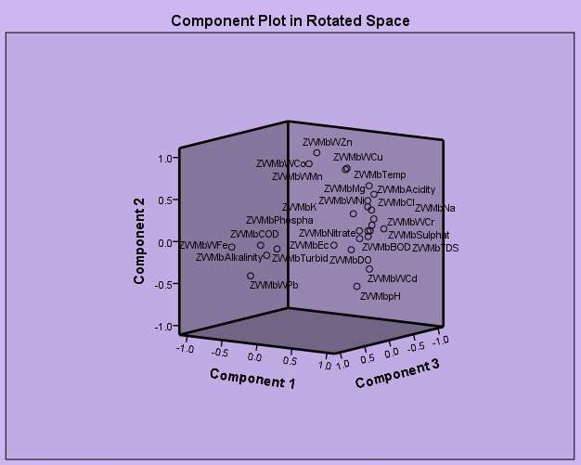

### Fig. 4.5: Ordination diagram showing 3 principal components of surface water in Mbo river in wet season

**Table 4.15: Rotated component Matrix of Ordination of Physicochemical and Metal in water from Mbo River (Dry season)**

|  |  |  |  |
| --- | --- | --- | --- |
|  | **Component** |  | |
| **1** | **2** | **3** |
| Temp | 0.526 | 0.788 | 0.321 |
| pH | -0.283 | -0.947 | -0.150 |
| Turbidity | -0.195 | -0.846 | -0.496 |
| Ec | -0.666 | -0.476 | -0.574 |
| TDS | 0.408 | 0.774 | 0.484 |
| COD | 0.504 | 0.652 | 0.558 |
| DO | 0.959 | 0.246 | 0.141 |
| BOD | 0.960 | 0.241 | 0.142 |
| Cl | 0.732 | 0.620 | 0.283 |
| Nitrate | 0.629 | 0.690 | 0.358 |
| Sulphate | 0.549 | 0.731 | 0.404 |
| Phosphate | 0.829 | 0.525 | 0.193 |
| Acidity | 0.508 | 0.732 | 0.454 |
| Alkalinity | -0.691 | -0.600 | -0.403 |
| Na | 0.048 | -0.140 | -0.989 |
| K | 0.608 | 0.735 | 0.299 |
| Ca | 0.476 | 0.799 | 0.367 |
| Mg | 0.667 | 0.633 | 0.393 |
| Fe | 0.156 | 0.486 | 0.860 |
| Pb | 0.086 | 0.631 | 0.771 |
| Cu | .0519 | 0.503 | 0.691 |
| Co | -0.954 | -0.266 | 0.139 |
| Cr | 0.548 | 0.673 | 0.496 |
| Cd | 0.614 | -0.550 | 0.566 |
| Ni | -0.960 | -0.278 | -0.034 |
| Mn | 0.946 | 0.310 | 0.095 |
| Zn | 0.940 | 0.319 | 0.125 |
| V | 0.000 | 0.000 | 0.000 |
| Hg | 0.000 | 0.000 | 0.000 |

**Table 4.16: The size, percentage total variation and cumulative percentages of Co-relation matrix of the first three components in the original data set of plots composition of water from Mbo river (dry season)**

|  |  |  |  |
| --- | --- | --- | --- |
| **Components** | **Initial eigen value**  **Total** | **% of variation** | **Cumulative %** |
| 1 | 22.523 | 83.419 | 83.419 |
| 2. | 3.428 | 12.696 | 96.115 |
| 3. | 1.049 | 3.885 | 100.00 |

# Extraction method: Principal component Analysis Rotation method: Verimax with Kaiser normalization

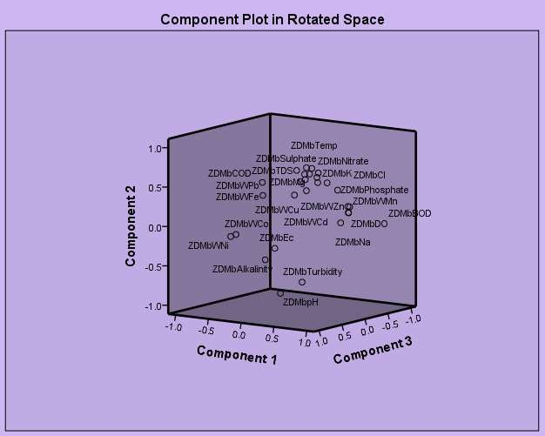

### Fig. 4.6: Ordination diagram showing 3 principal components of surface water in Mbo river in dry season

**Component 1:** The physicochemical parameters such as DO, BOD, Ec, alkalinity and exchangeable bases like K, Mg, greatly influenced this component. It accounts for about 83.419% of the total variation in data sets. Some nutrients such as PO43-, NO-3, Cl-, showed some level of prominence in this component as observed from their high loadings. Heavy metals like Co, Ni, Mn, Zn and Cd exerted some influence too in this component. From their high loadings, it was proposed that these heavy metals presence in water system may have their origin from an anthropogenic source.

**Component 2:** This could be described as mainly physicochemical component with eigen value of 3.428, this component accounts for about

12.695% of the total variation of the data set. In this component, parameters such as temperature, pH, turbidity, TDS showed high loadings. CA showed high loading while K, Mg, COD, Cl-, NO-3, SO2- and acidity showed moderate loadings. Pb, Cr, and Cd also exerted moderate influence.

4

**Component 3:** This component has eigen value of 1.049 and accounted for 3.885% of the total variation of the data set. In this component Na, Fe, Pb showed strong loadings in water while EC, COD, Na and Cd showed moderate loading in water.

### PCA for parameter of surface water from Ibaka river (wet season)

Tables 4.27 to 4.28 and fig 4.7 showed the PCA for water from Ibaka river in wet season.

### Table 4.17: Rotated component Matrix of Ordination of Physicochemical and Metal in water from Ibaka River (Wet season)

|  |  |  |  |
| --- | --- | --- | --- |
|  | **Component** |  | |
|  | **1** | **2** | **3** |
| Temp | 0.170 | 0.985 | -0.004 |
| pH | -0.175 | 0.927 | -0.331 |
| Turbid | 0.967 | 0.091 | 0.237 |
| Ec | 0.935 | -0.298 | -0.194 |
| TDS | 0.984 | -0.166 | 0.067 |
| COD | -0.980 | 0.043 | -0.193 |
| DO | 0.889 | -0.426 | -0.169 |
| BOD | 0.810 | -0.582 | 0.073 |
| Cl | 0.952 | 0.188 | 0.244 |
| Nitrate | 0.973 | -0.168 | 0.155 |
| Sulphate | 0.966 | -0.025 | 0.259 |
| Phosphate | 0.990 | -0.003 | 0.144 |
| Acidity | 0.972 | 0.005 | 0.237 |
| Alkalinity | -0.973 | 0.053 | -0.223 |
| Na | 0.975 | 0.060 | 0.214 |
| K | 0.984 | 0.003 | 0.178 |
| Ca | 0.982 | 0.001 | 0.186 |
| Mg | 0.706 | -0.202 | 0.679 |
| Fe | -0.806 | 0.489 | -0.333 |
| Pb | -0.866 | 0.205 | -0.455 |
| Cu | 0.938 | 0.015 | 0.347 |
| Co | 0.747 | 0.585 | 0.316 |
| Cr | 0.997 | -0.021 | -0.074 |
| Cd | -0.247 | 0.860 | 0.446 |
| Ni | 0.697 | 0.518 | 0.497 |
| Mn | 0.015 | 0.996 | -0.083 |
| Zn | 0.682 | -0.527 | 0.507 |

**Table 4.18:** The size, percentage total variation and cumulative percentages of Co- relation matrix of the first three components in the original data set of plots composition of water from Ibaka river (wet season)

### Components Initial eigen value

|  |  |  |  |
| --- | --- | --- | --- |
|  | **Total** | **% of variance** | **Cumulative %** |
| 1 | 20.346 | 76.356 | 75.356 |
| 2. | 5.318 | 19.696 | 95.052 |
| 3. | 1.336 | 4.948 | 100.000 |

Extraction method: Principal component Analysis Rotation method: Verimax with Kaiser normalization

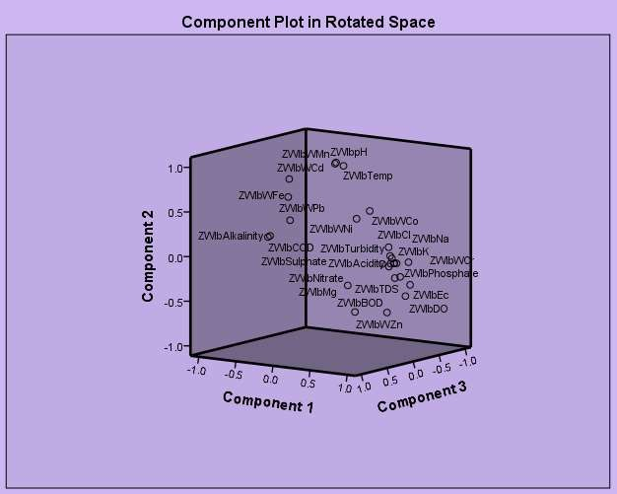

### Fig. 4.7 Ordination diagram showing 3 principal components of surface water in Ibaka river in wet season

**Component 1:** Except Temp. pH, Cd and Mn, all other parameters exerted much influence on this component effectively. The component has eigen value of 20.346 and 76.356 of variation in the data set. This is an indication that water quality may be very poor due to the nature of anthropogenic activities in the study area.

**Component 2:** had only temperature, pH, Cd and Mn as domineering parameters and had eigen value of 5.318 and 19.696% of variation.

**Component 3:** Eigen value of this component recorded 1.336 and 4.948% variation in the data set. It was only magnesium that managed to exert a moderate influence.

The impact of over 70% of the 35 water parameters examined that water from Ibaka river has high pollution status caused by nature of anthropogenic activities in the study area.

### PCA for parameter of surface water from Ibaka river (dry season)

Tables 4.29 and 4.30 and Fig. 4.8 showed PCA for Ibaka river in dry season.

**Table 4.19:** Rotated component Matrix of Ordination of Physicochemical and Metal in water from Ibaka River (Dry season)

|  |  |  |
| --- | --- | --- |
|  | **Component** |  |
| **1** | **2** |
| Temp | 0.966 | 0.171 |
| pH | 0.970 | -0.086 |
| Turbid | 0.376 | -0.863 |
| Ec | -0.883 | -0.465 |
| TDS | 0.964 | 0.231 |
| COD | 0.778 | 0.603 |
| DO | 0.043 | 0.999 |
| BOD | 0.042 | 0.952 |
| Cl | 0.988 | 0.143 |
| Nitrate | 0.998 | 0.064 |
| Sulphate | 0.812 | 0.556 |
| Phosphate | 0.980 | 0.092 |
| Acidity | 0.958 | 0.211 |
| Alkalinity | -0.932 | -0.346 |
| Na | 0.969 | 0.237 |
| K | 0.979 | 0.158 |
| Ca | 0.975 | 0.214 |
| Mg | 0.998 | -0.040 |
| Fe | 0.804 | -0.594 |
| Pb | 0.935 | -0.302 |
| Cu | 0.999 | -0.005 |
| Co | 0.677 | 0.689 |
| Cr | 0.892 | 0.357 |
| Cd | 0.997 | 0.030 |
| Ni | 0.794 | 0.566 |
| Mn | 0.677 | 0.689 |
| Zn | 0.678 | 0.689 |

**Table 4.20:** The size, percentage total variation and cumulative percentages of Co- relation matrix of the first three components in the original data set of plots composition of water from Ibaka river (dry season)

### Components Initial eigen value

|  |  |  |  |
| --- | --- | --- | --- |
|  | **Total** | **% of variance** | **Cumulative %** |
| 1 | 21.066 | 78.022 | 78.022 |
| 2. | 5.077 | 18.803 | 96.826 |
| 3. | .857 | 3.174 | 100.000 |

Extraction method: Principal component Analysis Rotation method: Verimax with Kaiser normalization

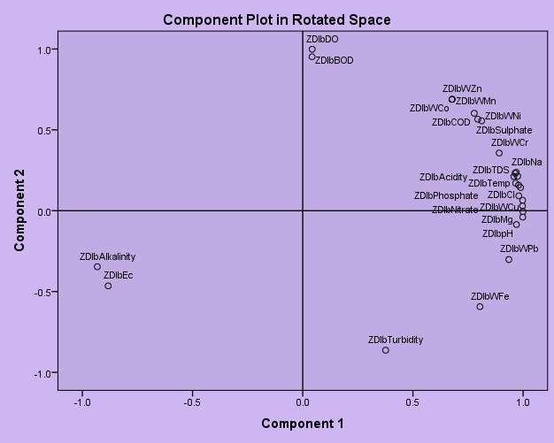

### Fig. 4.8 Ordination diagram showing 3 principal components of surface water in Ibaka river in dry season

**Component 1:** This component had the highest eigen value 21.066 and 78.022% of variation and was strongly influenced by nearly all physicochemical parameters except turbidity, DO, BOD and all the heavy metals. This component best described the water quality studied.

### Component 2

Turbidity, DO, BOD, strongly dominated this component followed by CO, Ni, Zn and Mn with moderate effect. It has eigen value 5.077 and 18.803% of variation.

Water from Ibaka river during dry season has a high pollution status. The high Cl content may be attributed to municipal discharge into waterways, the high CO3, SO4 content in water were also associated with anthropogenic sources. The high PO43- and NO3- levels may contributed towards autrophication where there is municipal discharges during rainy season.

### PCA for parameter of surface water from Asana-Ikan river (wet season)

Tables 4.31 and 4.32 and Fig. 4.9 outlined the PCA for Asana-Ikan river in wet season.

**Table 4.21:** Rotated component Matrix of Ordination of Physicochemical and Metal in water from Asan-Ikan River (Wet season)

|  |  |  |  |
| --- | --- | --- | --- |
|  | **Component** |  | |
| **1** | **2** | **3** |
| Temp | 0.984 | -0.168 | 0.051 |
| pH | 0.166 | 0.985 | 0.054 |
| Turbid | -0.440 | -0.560 | -0.792 |
| Ec | 0.981 | 0.039 | 0.189 |
| TDS | -0.976 | -0.146 | -0.161 |
| COD | 0.801 | -0.575 | -0.167 |
| DO | 0.441 | -0.123 | 0.889 |
| BOD | 0.190 | 0.979 | 0.069 |
| Cl | 0.890 | 0.453 | 0.049 |
| Nitrate | 0.293 | 0.956 | -0.014 |
| Sulphate | -0.919 | 0.390 | -0.063 |
| Phosphate | -0.535 | 0.498 | -0.682 |
| Acidity | 0.304 | 0.080 | 0.949 |
| Alkalinity | -0.876 | 0.480 | -0.046 |
| Na | -0.348 | 0.606 | 0.715 |
| K | 0.385 | -0.230 | -0.894 |
| Ca | -0.569 | 0.773 | -0.282 |
| Mg | 0.149 | 0.056 | 0.987 |
| Fe | 0.937 | 0.198 | 0.288 |
| Pb | 0.567 | 0.285 | -0.772 |
| Cu | -0.407 | 0.766 | 0.497 |
| Co | -0.823 | 0.168 | -0.543 |
| Cr | 0.081 | 0.997 | -0.002 |
| Mn | 0.882 | -0.124 | -0.4555 |
| Zn | -0.957 | -0.271 | 0.103 |

**Table 4.22: The size, percentage total variation and cumulative percentages of Co-relation matrix of the first three components in the original data set of plots composition of water from Asan-Ikan river control (wet season)**

**Components Initial eigen value**

|  |  |  |  |
| --- | --- | --- | --- |
|  | **Total** | **% of variance** | **Cumulative %** |
| 1 | 11.438 | 45.752 | 45.752 |
| 2. | 7.794 | 31.175 | 76.927 |
| 3. | 5.768 | 23.073 | 100.000 |

# Extraction method: Principal component Analysis Rotation method: Verimax with Kaiser normalization

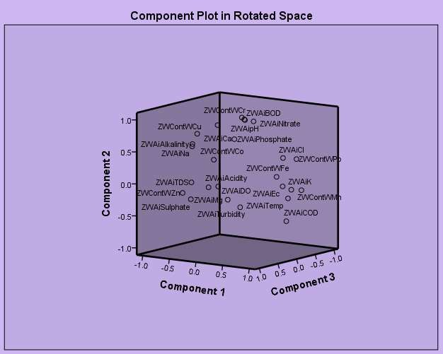

### Fig. 4.9 Ordination diagram showing 3 principal components of surface water in Asana-Ikan river in wet season

**Component 1:** This component has eigen values of 11.438 with 45.752% of variation. It could be described as both physical and metallic component, and the high loading of temp, electrical conductivity, TDS, SO42- and Pb could impart bad odour, and take to the water and make it unfit for consumptions.

**Component 2:** COD, Cl, pH, BOD, NO3- and Cr exerted stronger effect on water with moderate effect from Cu, Ca and Na. The high loading of BOD and Cr determines the component eigen value of 7.794 and 31.175% of variation.

**Component 3:** With eigen value of 5.768 and 23.073% of variation, component 3 was much influenced strongly by K, Mg, acidity, P and moderately by PO42-, DO and turbidity.

### PCA for parameter of surface water from Asana-Ikan River (dry season)

Tables 4.33 and 4.34 showed the dry season PCA values of Asana-Ikan

River.

**Table 4.23:** Rotated component Matrix of Ordination of Physicochemical and Metal in sediment from Asan-Ikan River control (dry season

|  |  |  |  |
| --- | --- | --- | --- |
|  | **Component** |  | |
| **1** | **2** | **3** |
| Temp | 0-.062 | 0.979 | -0.192 |
| pH | 0.526 | 0.642 | -0.558 |
| Cond | -0.940 | 0.202 | 0.274 |
| Alkalinity | 0.382 | -0.860 | 0.339 |
| Nitrate | 0.790 | 0.586 | -0.182 |
| Sulphate | -0.303 | 0.929 | 0.214 |
| Phosphate | -0.111 | -0.256 | 0.960 |
| Fe | -0.859 | 0.296 | 0.418 |
| Pb | 0.554 | -0.787 | 0.271 |
| Cu | 0.876 | -0.480 | 0.054 |
| Co | -0.943 | 0.294 | 0.153 |
| Cr | 0.958 | -0.276 | -0.071 |
| Cd | 0.916 | 0.084 | 0.393 |

**Table 4.24: The size, percentage total variation and cumulative percentages of Co-relation matrix of the first three components in the original data set of plots composition of water from Asan-Ikan river control (dry season)**

### Components Initial eigen value

|  |  |  |  |
| --- | --- | --- | --- |
|  | **Total** | **% of variance** | **Cumulative %** |
| 1 | 7.404 | 56.953 | 56.953 |
| 2. | 4.251 | 32.703 | 89.657 |
| 3. | 1.345 | 10.343 | 100.000 |

Extraction method: Principal component Analysis Rotation method: Verimax with Kaiser normalization

**Component 1:** This component was about 48% dominated with physical parameters while the heavy metals exerted much influence.Presence of high, Cd loadings in water could be attributed to much loggng activities. This component has eigen value of 7.404 and 56.953% of variation.

**Component 2:** This component has eigen value of 4.251 and 32.703% variation in the set data. The component is purely physicochemical in description as temperature, pH, alkalinity, nitrate, sulphate exerted great influence exclusivelyby all heavy metals except lead.

**Component 3:** Except phosphate, all other parameters exerted no influence.

The results so far obtained are in agreement with the observations made by Ajayi and Osibanjo (1981) for Nigerian rivers.



### Fig 4.10: Ordination diagram showing 3 principal components of surface in Asana-Ikan in dry season

* + 1. **Microbiological analyses of surface water**

The results of microbiological analyses of surface water as shown in figures 4.10 – 4.17 and Tables 4.25 – 4.26 for two seasons sampling.

TECC - Total Eshesichia coli counts TSSC - Total Salmonella shigella counts TCC - Total coliform count

HFC - Heterototrophic faecal count HBC - Heterototrophic bacterial count

HFC

25%

HBC

20%

TECC

33%

TSSC

20%

TCC

1%

**Fig. 4.10 Bacterial load during wet season for the month of June,**

HFC

22%

HBC

11%

TECC

30%

TSSC

35%

TCC

2%

**Fig. 4.11 Bacterial load during wet season for the month of July,**

HFC

21%

HBC

9%

TECC

27%

TSSC

21%

TCC

22%

## Fig. 4.12 Bacterial load during wet season for the month of August,

HBC

12%

HFC

26%

TSSC

3%

TECC

32%

TCC

27%

**Fig. 4.13 Bacterial load during wet season for the month of September,**

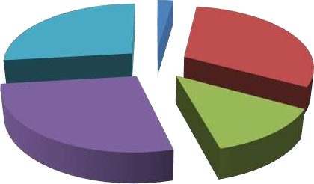

HBC

2%

HFC

27%

TECC

31%

TSSC

27%

TCC

13%

## Fig. 4.14: Bacterial load during dry season for the month of December, 2015

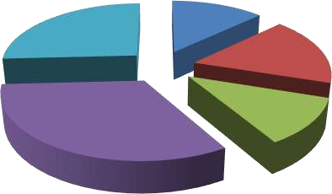

HFC

26%

HBC

13%

TECC

17%

TSSC

33%

TCC

11%

**Fig. 4.15: Bacterial load during dry season for the month of January, 2016**

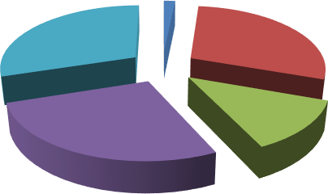

HBC

2%

HFC

30%

TECC

29%

TSSC

27%

TCC

12%

## Fig. 4.16: Bacterial load during dry season for the month of February, 2016

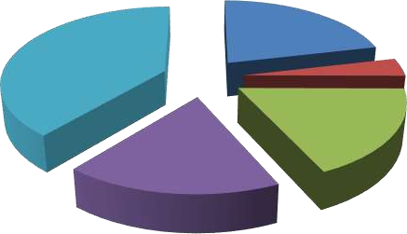

HFC

39%

HBC

21%

TECC

4%

TCC

18%

TSSC

18%

### Fig. 4.17: Bacterial load during dry season for the month of March, 2016

**Table 4.25 Distribution and Prevalence of Microorganisms isolated during Wet Season**

**Isolate Sampling Location %Prevalence**

|  |  |  |  |  |  |  |  |
| --- | --- | --- | --- | --- | --- | --- | --- |
|  | **MB1** | **MB2** | **MB3** | **MB4** | **MB5** | **MB6** |  |
| **Bacteria:**  *E.coli* | + | + | - | + | + | + | 83.3 |
| *Streptococcus* | + | + | + | + | - | - | 66.7 |
| *faecalis*  *Streptococcus* | + | - | - | - | - | - | 16.7 |
| *pyogenes*  *Staphylococcus* | + | - | + | - | - | - | 33.3 |
| *epidermidis*  *Staph. albus* | - | + | - | - | - | + | 33.3 |
| *Shigella* sp. | + | - | - | - | - | - | 16.7 |
| *Salmonella typhi* | - | + | - | - | + | - | 33.3 |
| *Klebsiella* | + | - | - | - | - | - | 16.7 |
| *aerogenes*  *Klebsiella* | - | + | - | - | - | - | 16.7 |
| *azenae*  *Micrococcus* | - | - | + | - | - | - | 16.7 |
| *varians*  *Micrococcus* | - | - | - | - | - | - | 0 |
| *roseus*  *Micrococcus* | - | - | - | - | + | - | 16.7 |
| *luteus*  *Aerococcus* | - | - | - | + | + | - | 33.3 |
| *viridians*  *Corynebacterium* | - | - | - | - | + | + | 33.3 |
| sp.  *Bacillus* sp. | - | - | - | - | + | + | 33.3 |
| *Listeria grayii* | - | - | - | - | + | - | 16.7 |
| **Fungi:**  *Sacchromyces* | + | + | - | + | - | + | 66.7 |
| sp.  *Aspergillus* | + | - | - | - | - | + | 33.3 |
| *fumigates*  *Aspergillus niger* | - | + | - | + | - | + | 50.0 |
| *Microsporum* | - | - | + | - | - | - | 16.7 |
| *gypsum*  *Cladosporium* | - | - | - | + | - | - | 16.7 |
| sp.  *Eurotium* sp. | - | - | - | + | - | - | 16.7 |
| *Sacchromyces* | - | - | - | - | + | - | 16.7 |
| *estuarii*  *Candida* | - | - | - | - | - | + | 16.7 |
| *tropicalis* |  |  |  |  |  |  |  |

**Table 4.26: Distribution and Prevalence of Microorganisms isolated during Dry Season**

**Isolate Sampling Location %Prevalence**

|  |  |  |  |  |  |  |  |
| --- | --- | --- | --- | --- | --- | --- | --- |
|  | **MB1** | **MB2** | **MB3** | **MB4** | **MB5** | **MB6** |  |
| **Bacteria:**  *E.coli* | + | + | + | + | + | + | 100.0 |
| *Streptococcus* | + | + | + | + | - | - | 66.7 |
| *faecalis*  *Streptococcus* | + | - | - | - | - | - | 16.7 |
| *pyogenes*  *Staphylococcus* | + | - | + | - | - | - | 33.3 |
| *epidermidis*  *Staph. Albus* | + | + | - | + | - | + | 66.7 |
| *Shigella* sp. | + | - | - | + | - | - | 33.3 |
| *Salmonella typhi* | + | + | - | + | + | - | 66.7 |
| *Klebsiella* | + | - | - | + | - | - | 33.3 |
| *aerogenes*  *Klebsiella* | + | + | - | - | - | - | 33.3 |
| *azenae*  *Micrococcus* | - | - | + | - | - | - | 16.7 |
| *varians*  *Micrococcus* | + | - | - | - | - | - | 16.7 |
| *roseus*  *Micrococcus* | + | + | - | - | + | + | 66.7 |
| *luteus*  *Aerococcus* | - | - | - | + | + | + | 50.0 |
| *viridians*  *Corynebacterium* | - | - | + | - | + | + | 50.0 |
| sp.  *Bacillus* sp. | + | + | + | - | + | + | 83.3 |
| *Listeria grayii* | - | - | + | + | + | - | 50.0 |
| **Fungi:**  *Sacchromyces* | + | + | - | + | - | + | 66.7 |
| sp.  *Aspergillus* | + | - | - | - | - | + | 33.3 |
| *fumigates*  *Aspergillus niger* | - | + | - | + | - | + | 50.0 |
| *Microsporum* | - | - | + | - | - | - | 16.7 |
| *gypsum*  *Cladosporium* | - | - | - | + | - | - | 16.7 |
| sp.  *Eurotium* sp. | - | - | - | + | - | - | 16.7 |
| *Sacchromyces* | - | - | - | - | + | - | 16.7 |
| *estuarii*  *Candida* | - | - | - | - | - | + | 16.7 |

*tropicalis*

All the bacterial parameters analyzed during wet season (May, 2015), TECC showed high prevalence followed by HFC which accounted for 26% prevalence and the least was TCC (1%). Still on wet period of May, 2015, equal amount of HBC and TSSC was isolated. In the month of June, high number of *Shigella*-*Salmonella* was isolated while TCC was still the least. High percent of TECC was recorded in the months of July and August.

During dry season precisely November, 2015 TECC dominated other bacterial isolates and in December, 2015 TSSC showed highest percent prevalence. In the months of January and February,2016 HFC showed high density and TECC was the least in the month of February, 2016.

In Tables 4.41 and 4.42, *E. coli* showed high percent prevalence amongst bacterial isolates followed by *Streptococcus faecalis* and several genera were less densely distributed. *Micrococcus roseus* was not isolated at all during wet season. Fungal population almost showed the same pattern of distribution and prevalence but their densities were minimal.

The mean bacterial counts of 4.07 × 104 cfu/m3 and 2.19 × 103 cfu/m3 were recorded during the wet and dry seasons respectively as compared to the mean fungal counts. The loads of bacteria were generally found to be higher than fungi during rainy period and the onset of dry season. Although observed only in the dry season, the mean fungal counts also out-numbered the bacterial counts during peak period of dry season. These findings have shown that regardless of the season; bacteria were detected in all the surface water samples. Eleven bacterial genera were isolated in all location comprising

*Escherichia, Streptococcus, Shigella, Salmonella, Klebsiella, Micrococcus, Staphylococcus, Aerococcus, Corynebacterium, Bacillus* and *Listeria,* while the fungal genera included: *Aspergillus, Sacchromyces, Microsporium, Cladosporium, Eurotium, Candida* and *Penicillium.*

High percentage prevalenceof TECC and TSSC noticed in the rivers water was generally higher than those reported by Abu *et al.,* (2008) for new Calabar river. Based on WHO zero limit for microorganism in water, it could be referred that water from Mbo river system is polluted by faecae matters and as such not fit for drinking (Itah *et al.* 1989).

Generally, the results on water from the study area are in conformity with observations made by Brown *et al.* (2008) for bacterial load, ISIS (2010) for physiochemical properties and Olutana *et al.* (2013), and Moore *et al.* (2009) for heavy metal.

### SEDIMENT

* + 1. **Variations of Physicochemical Parameters in Sediment**

The results of variations of physicochemical parameters of the sediment in the study area in wet and dry season are shown on Table 4.37 –

**Table 4.27: Variations of Physicochemical characteristics of sediments in the study area in wet season (May 2015 – August 2015)**

|  |  |  |  |  |  |  |  |
| --- | --- | --- | --- | --- | --- | --- | --- |
| **Parameters** | **MB1**  **locations** | **–** | **MB3** | **MB4 –**  **locations** | **MB6** | **MB7**  **(control)** | **locations** |

|  |  |  |
| --- | --- | --- |
| Temperature (oC) 26.97 1.38 | 28.70 1.46 | 25.41 0.78 |
| pH 6.38 0.17 | 6.51 0.57 | 6.97 0.20 |
| Electrical Conductivity (Scm-1) 43.56 16.03 | 1853.50 75.45 | 1006.08 2.76 |
| Alkalinity (mg/kg) 31.57 16.63 | 15.29 5.06 | 48.15 5.51 |
| Nitrate (mg/kg) 3.17 0.67 | 3.04 0.78 | 3.38 0.50 |
| Sulphate (mg/kg) 2.29 0.36 | 2.16 0.28 | 2.53 0.40 |
| Phosphate (mg/kg) 5.68  0.88 | 1.40 0.21 | 1.66 0.14 |
| Sand (%) 79.20  | 61.80 7.34 | 83.10 4.07 |
| Silt (%) 6.0  | 12.00 1.37 | 5.90 .92 |
| Clay (%) 14.80  | 26.20 2.85 | 11.00 2.38 |
| Texture (%) SL | SL | SL |
| N = 4 SL = Sandy Loamy |  |  |

**Table 4.28: Variations of Physicochemical characteristics of sediments in the study area in dry season (Nov. 2015 – Feb. 2016)**

|  |  |  |  |  |  |  |  |  |
| --- | --- | --- | --- | --- | --- | --- | --- | --- |
| **Parameters** | **MB1**  **locations** | **–** | **MB3** | **MB4**  **locations** | **–** | **MB6** | **MB7**  **(control)** | **locations** |
| Temperature (oC) | 27.93 1.45 | | 29.23 2.31 | | | | 26.53 0.62 | |
| pH | 6.82 0.07 | | 5.49 0.44 | | | | 6.85 0.21 | |
| Electrical Conductivity (Scm-1) | 48.07 12.03 | | 1720.75 144.38 | | | | 1001.02 2.43 | |
| Alkalinity (mg/kg) | 25.07 1.13 | | 15.29 5.06 | | | | 47.31 6.23 | |
| Nitrate (mg/kg) | 3.909  0.55 | | 3.049  0.78 | | | | 3.10 0.30 | |
| Sulphate (mg/kg) | 4.290  1.21 | | 2.16 0.28 | | | | 2.00 0.15 | |
| Phosphate (mg/kg) | 5.29 0.62 | | 4.65 0.45 | | | | 1.38 0.17 | |
| Sand (%) | 75.20  4.91 | | 68.80  8.212 | | | | 81.90  5.72 | |
| Silt (%) | 8.0  1.75 | | 16  2.11 | | | | 7.01  0.54 | |
| Clay (%) | 16.20  3.08 | | 20.20  3.17 | | | | 13.09  1.99 | |
| Texture (%) | SL | | SL | | | | SL | |

N = 4 SL = Sandy Loamy

### Comparison of levels of physic-chemical properties in the study areas.

**Table 4.29: Variation in mean concentration, standard deviation of physicochemical properties of sediment obtained between Mbo, Ibaka and Asan Ikan Rivers in wet and dry seasons.**

**Parameter statistics Mbo river Ibaka river Asana Ikan river (control)**

|  |  |  |  |  |  |  |
| --- | --- | --- | --- | --- | --- | --- |
|  | **Wet** | **Dry** | **Wet** | **Dry** | **Wet** | **Dry** |
| Temperature (oC) Mean | 26.97 | 27.93 | 28.71 | 29.24 | 25.42 | 26. 54 |
| SD | 1.38 | 1.45 | 1.46 | 2.311 | 0.78 | 1.62 |
| pH Mean | 6.38 | 6.83 | 6.51 | 5.50 | 6.98 | 6.85 |
| SD | 0.17 | 0.07 | 0.57 | 0.44 | 0.20 | 0.21 |
| Electrical Conductivity (Scm-1) Mean | 43.57 | 48.08 | 18.50 | 72.75 | 106.08 | 001.02 |
| SD | 16.64 | 12.03 | 75.45 | 144.38 | 2.76 | 2.43 |
| Alkalinity (mg/kg) Mean | 31.57 | 25.07 | 15.30 | 15.30 | 48.15 | 47.31 |
| SD | 16.63 | 1.13 | 5.06 | 5.06 | 5.51 | 26.23 |
| Nitrate (mg/kg) Mean | 3.18 | 3.91 | 3.05 | 3.05 | 3.39 | 3.10 |
| SD | 0.67 | 0.55 | 0.78 | 0.78 | 0.50 | 0.30 |
| Sulphate (mg/kg) Mean | 2.29 | 4.29 | 2.17 | 2.16 | 2.54 | 2.01 |
| SD | 0.36 | 1.21 | 0.28 | 0.28 | 0.40 | 0.15 |
| Phosphate (mg/kg) Mean | 5.65 | 5.30 | 1.40 | 4.65 | 1.66 | 1.38 |
| SD | 0.88 | 0.62 | 0.21 | 0.45 | 0.14 | 0.17 |
| Sand (%) Mean | 79.20 | 75.20 | 61.80 | 68.80 | 83.10 | 81.90 |
| SD | 4.87 | 4.91 | 7.34 | 8.21 | 4.07 | 5.72 |
| Silt (%) Mean | 6.0 | 8.0 | 12.0 | 16.0 | 5.90 | 7.01 |
| SD | 1.49 | 1.75 | 1.37 | 2.11 | 0.92 | 0.54 |
| Clay (%) Mean | 14.80 | 16.20 | 26.0 | 20.20 | 11.0 | 13.09 |
| SD | 3.08 | 3.16 | 2.85 | 3.17 | 2.38 | 1.99 |
| Texture Mean  SD | SL | SL | SL | SL | SL | CL |

SD – Standard Deviation SL – Sandy Loamy

### Temperature

MB4 – MB4 recorded the highest temperature of 29.23 2.31oC (Table 4.28) while location MB7 at Asana-ikan river recorded the least temperature value of 25.41 0.78oC (Table 4.33). However, temperature in dry season were higher than those in wet season (Table 4.28).

### pH

Location MB7 recorded highest mean pH of 6.97 0.20 (Table 4.27)

and location MB4 – MB6 recorded the least 5.49 0.44 (Table 4.28).

### Electrical Conductivity

Electrical conductivity was highest in location MB4 – MB6 with mean value of 1853.50 75.45 at Ibaka river location, while location MB1 – MB3 at Mbo river location had the least mean value of 43.56 16.03δcm-1 (Table 4.29).

### Alkalinity

Location MB7 recorded the highest value of 48.15 5.51mg/kg (Table 4.27) while location MB4 – MB6 had the least value of 15.29 5.06 (Table 4.28).

### Nitrate

Nitrate content was highest in location MB1 – MB3 with mean value of 3.90 0.55mg/kg (Table 4.28) while location MB4 – MB7 recorded the least nitrate content 3.04  0.78 mg/kg (Table 4.28).

### Sulphate

Highest mean value of sulphate 4.29 1.21 mg/kg- was obtained in location MB1-MB3 (Table 4.34) while location MB7 accounted for 2.00 0.15 which was the least for sulphate content of sediment (Table 4.28).

### Phosphate

Phosphate content was highest in location MB1 – MB7 (5.64 0.88mg/kg) (Table 4.27) and least in location MB7 (1.38 0.17 mg/kg) (Table 4.28).

Values obtained for physicochemical parameters of river sediments from the study area falls within the range of values for Qua Iboe estuary reported by Essien *et al.,* (2007) are lower than the corresponding values obtained for river water sample within the same study area, but tallied with physicochemical and nutrients load of river sediments in Ibadan as reported by Adeyemo *et al.* 2008.

**Sand:** Sand mean content was highest in control location ranging from 81.90 5.72% - 83.10 4.07% in dry and wet season respectively (Table 4.29) while Ibaka river location had the lowest ranging from 61.80  7.34 – 68.80  8.21% (Table 4.29).

**Silt:** silt content of sediment was highest in Ibaka river location with a mean value ranging from 12.00  1.37 – 16.0  2.110% in wet and dry season respectively while control location had the lowest mean value ranging from

5.90  0.92 – 7.01  0.54%. Confirming that the water system studies is polluted.

**Clay:** High clay content of sediment was observed in Ibaka river location ranging from 20.20  3.17 – 26.0  2.85% in dry and wet sseason respectively while the control recorded the lowest mean clay content ranging from 11.0  2.38 – 13.09  1.99% (Table 4.29).

The sediments from the study area had brownish, dark bluish grey colour. In terms of textural composition the control was more sandy followed by Mbo river, then Ibaka river with a natural depth of 6-16m. After high percentage of sand, was clay ranging from 11.0% to 14.80%. Highest percentage of silts (16%) was recorded at Ibaka during dry season and heaviest level at control (5.90%). The sand grain found in the sediments were of medium size (0.2mm – 0.8mm). The spatial variability in the textural sediment composition according to Anosike *et al.* (1996) may be due to influx of terigenous material from onshore.

### Seasonal Variations of Heavy Metals Concentration in Sediments from Study Area

The concentration of heavy metals in sediment from Mbo and Ibaka rivers in wet and dry seasons from the six examined locations and one reference location (Asana Ikan river control) are presented in Tables 4.30 and Figs. 4.18 and 4.19.

### Comparison of levels of heavy metals in the studied Rivers/areas

**Table 4.30: Variation in mean standard deviation of heavy metals level in sediment obtained between Mbo, Ibaka and Asan Ikan Rivers in wet and dry seasons.**

**Heavy metal**

**Statistics**

|  |  |  |  |  |  |  |  |
| --- | --- | --- | --- | --- | --- | --- | --- |
| **(mg/kg)** |  | **Wet** | **Dry** | **Wet** | **Dry** | **Wet** | **Dry** |
| Fe | Mean | 709.00 | 862.75 | 707.75 | 890.75 | 665.00 | 777.50 |
|  | SD | 49.72 | 69.52 | 49.92 | 34.71 | 36.96 | 98.47 |
| Pb | Mean | 18.51 | 30.05 | 19.37 | 32.15 | 5.20 | 2.40 |
|  | SD | 0.90 | 5.19 | 1.89 | 5.09 | 4.60 | 0.68 |
| Cu | Mean | 21.30 | 26.75 | 20.93 | 26.60 | 2.52 | 1.14 |
|  | SD | 1.24 | 1.42 | 1.51 | 1.31 | 1.95 | 0.51 |
| Co | Mean | 11.76 | 17.99 | 12.15 | 18.60 | 0.43 | 10.23 |
|  | SD | 1.07 | 2.20 | 1.14 | 1.88 | 0.04 | 0.81 |
| Cr | Mean | 21.06 | 27.03 | 20.93 | 27.02 | 16.35 | 14.00 |
|  | SD | 1.23 | 1.36 | 1.23 | 1.33 | 3.86 | 0.81 |
| Cd | Mean | 1.60 | 4.24 | 1.80 | 4.53 | 0.20 | 0.18 |
|  | SD | 0.46 | 0.56 | 0.53 | 0.46 | 0.67 | 0.65 |
| Ni | Mean | 3.74 | 6.03 | 3.93 | 6.32 | NDL | NDL |
|  | SD | 0.45 | 0.56 | 0.44 | 0.56 |  |  |
| Mn | Mean | 0.50 | 0.85 | 0.64 | 0.80 | NDL | NDL |
|  | SD | 0.07 | 0.05 | 0.04 | 0.07 |  |  |
| Zn | Mean | 26.17 | 46.41 | 26.35 | 46.88 | 17.13 | 20.51 |
|  | SD | 0.70 | 2.31 | 0.63 | 2.08 | 4.97 | 1.29 |
| V | Mean | 15.31 | 23.55 | 16.36 | 24.48 | NDL | NDL |
|  | SD | 2.28 | 1.96 | 1.85 | 2.04 |  |  |
| Hg | Mean | <0.20 | <0.20 | <0.20 | <0.20 | NDL | NDL |
|  | SD | 0.00 | 0.00 | 0.00 | 0.00 |  |  |

**Mbo river Ibaka river Asana Ikan**

**river (control)**

SD: Standard deviation

NDL: Not within the Detectection limits of the instruments used

1000

900

800

700

600

500

**(Conc mg/kg)**

Wet Dry

400

300

200

100

0

Fe Pb Cu Co Cr Cd Ni Mn Zn V Hg

**Metals**

## Fig.4.18: Seasonal variation of heavy metals concentrations in sediment sample from Mbo River

1000

900

800

700

600

500

**(Conc mg/kg)**

Wet

Dry

400

300

200

100

0

Fe Pb Cu Co Cr Cd Ni Mn Zn V Hg

**Metals**

## Fig.4.19: Seasonal variation of heavy metals concentrations in sediment sample from Ibaka River

### Iron:

The highest value of 890.75 mg/l was recorded for iron in sediment from Ibaka river location in the dry season (December, 2015) while the lowest value of 665 mg/l was recorded at Asana-Ikan river location in the wet season (May 2015). The mean concentration of Fe in Mbo locations were 709.00

49.72 mg/l and 862.75  69.52 mg/l in the wet and dry seasons respectively, while sediments from Ibaka river locations recorded mean Fe level of 707.75

 49.92 mg/l and 890.75  34.71 mg/l for wet and dry season respectively. The higher values recorded in the dry season can be attributed to the concentration of the element due to evaporation of river water. Opaluwa *et al*., (2012) is of the opinion that concentration of Fe in sediment and water could be due to the nature of the soil along the aquatic ecosystem. Olowu *et al*., (2010) also reported a high level of Fe in Nigerian soils. However, Fe values in the present study were far below consensus based sediment quality guideline of Wisconson (CBSQGW) limits 20,000 mg/l set for Fe in sediment, but falls within the range reported for sediment from Warri coastal region reported by Olowoyo *et al.,* (2012), and that of Adeniyi *et al.* (2011) for water, sediment from Ebuta Ogbo, Ojo, Lagos.

### Lead

Bioaccumulation of Pb could be poisonous (CDC 2010). The highest value of 32.5 mg/l was recorded for lead at Ibaka in dry season of the month of December while the lowest value of 18.51 mg/l was recorded at Mbo in the

wet season month of May. The mean levels of Pb recorded in sediment from Mbo river locations were 18.51  0.90 mg/l in wet season 30.15  5.19 mg/l in dry season mean Pb wet at IBaka location were higher in wet (19.37  1.89) and dry (32.15  5.09) season than that of Mbo. Lead in aquatic environment poses risk to life because aquatic organisms used for food are particularly sensitive to level of Pb and are often retain about a percent of ingested lead which could be taken up by man through the food chain (Udosen and Benson, 2006). The levels of Pb recorded in this study were comparable to those reported by Udosen and Benson, (2006) for sediment in Stubbs Creek, Nigeria, but values obtained at all locations were lower than 36mg/kg set by CBSQGW.

### Copper

The highest value of copper recorded in the study was 26.74 mg/l at Mbo in the dry season month of December. The least value of 20.93 was recorded at Ibaka in the wet season month of May. Cu concentration in sediment from the control were too low during wet and dry season whereas in wet season Cu mean concentration in sediment from Mbo river recorded

21.30  1.24 mg/l and Ibaka river recorded 20.93  1.51 mg/l. These values were normal but the dry season mean value 26.75  1.42mg/l for Mbo and

26.60  1.31 mg/l for Ibaka were slightly above USEPA std <25 (Matera & Skeen, 2005) but below interim sediment quality standard of 32 (Alan *et al*., 2009). Udosen, (2015) stated that copper is a very common substance that

occurs naturally in the environment and spreads through natural phenomena and long term exposure to copper can cause irritation of the nose, mouth and eyes. However, the level of Cu in this study is comparable to those reported by Barakat, (2012) for sediment in day river, Morocco.

### Cobalt

The highest value of cobalt was 18.60 mg/l at Mbo river location in the dry season month of December. The lowest value was again recorded at Mbo in the wet season month of May with a value of 10.58 mg/l while mean level of Co recorded for Ibaka river locations ranged from 12.151.141 mg/l to

18.60 1.88 mg/l in wet and dry season respectively. Co value 0.05 mg/l set by WHO was far exceeded by Co values recorded for sediment from all river locations including control.

### Chromium

The highest mean value of chromium in this study was 27.03  1.36 mg/l recorded at Mbo in the dry season month of December and a mean value of 21.06  1.23 in the wet season. The lowest mean value was 20.93  1.23 mg/l recorded at Ibaka in the wet season month of May and with a mean value of 27.02  1.33 mg/l in dry season. These values are higher than that reported by Williams *et al.,* (2007) for Igbede River. Chromium has different sources of occurrence in water. It may come from alloying of chromate ore with metals as iron, nickel and cobalt to form various kinds of chromium metals and ferro chromium metals. Again possible corrosion of these metals may be

responsible for the high levels of Cr in the river sediment under study. Chromium presence in sediment could also come from chromium oxide used as an inorganic colour additive in soap and paint products which may be introduced as domestic waste into the aquatic ecosystem. The interim sediment quality guideline (ISQG) for Cr in sediment is 37.3 mg/l (El Bourain *et al*., 2010), while the National Oceanic and atmospheric administration (NOAA) 2009 standard for threshold element level (TEL) for Cr is 43.4 mg/l, probable effect concentration (PEC) for Cr is 111 and severe effect concentration (SEC) for Cr is 116. Therefore the Cr range in Mbo river system understudy is below these standard values and so Cr does not pose a threat to aquatic ecosystem.

### Cadmium

Adenola *et al.,* (2013) reported mean Cd concentration from sediment from Oke Afa canal in Lagos Nigeria from June to October, 2011 as 0.076 mg/l while results from Adeniyi *et al*., (2010) were below detection limit for Cd in sediment collected from Ebute Ogbo river catchment. Cadmium in high concentrations disrupts soil processes of microorganisms. Human uptake of Cd mainly takes place through food chain. The mean level of cadmium analyzed in sediment in this study ranged from 1.60  0.46 mg/l – 1.80  0.53 mg/l in the wet season and 4.24  0.56 mg/l – 4.53  0.46 mg/l in dry seasons at Mbo river and Ibaka river locations respectively. Therefore high Cd (4.53 mg/l) level in sediment from MB4 location in Ibaka river may be traced to frequent logging activities since Cd is known to be found in woody and

herbaceous plants materials sold as firewood in the study area. This report is in agreement with the work done in sediment in Niger Delta (Clarke, (1992); Essien, (2008); Uwah, (2013); Ovum (2004).

### Nickel

The highest value of nickel in this study was 6.87 mg/kg in the dry season month of December at Ibaka while the lowest value was 3.23 mg/l recorded at Mbo in the wet season month of May. These values are slightly lower than those reported by Marcus *et al.* (2013) for sediment from Bonny River and creeks. The nickel content of sediment is linked to the fact that nickel is transported, absorbed on particulate matter and is associated with organic matter and clay particles (Ahmad *et al*., 2010). However, in this case, the presence of nickel in sediment could be due to the effect of crude oil operations from the neighbouring community at Unyenehe. Cd is teratogen, carcinogen and possible mutagen (Eister, 1985).

### Manganese

The mean concentration of Mn recorded in sediment from Mbo River location was 0.50  0.07 mg/l for wet season and 0.85  0.05 mg/l for dry season. At Ibaka River location, mean concentration were 0.64  0.04 mg/l for wet season and 0.90  0.07 mg/l in dry season. All the Mn values obtained from the study area are lower than Mn values of sediment obtained from Kalabari River reported by Kpee and Ekpeta (2014). Presence of Mn as reported here posed no problem in sediment of Mbo River System.

### Zinc

The mean levels of zinc analysed in the sediment from Mbo River location recorded 26.17  0.70 mg/l in wet season and 46.41  2.31 mg/kg in dry season. Sediment from Ibaka River locations had 26.35  0.63 mg/kg as mean level of zinc in wet season and 46.88  2.08 mg/kg mean in dry season. The value obtained in the present study are below the interim freshwater quality guidelines (ISQG) for zinc 123 mg/kg (El-Bouraine *et al*., 2010). Thus Zn content in the sediment may not have any lethal effect on water, including aquatic life. However, the values are higher than those reported by Udosen and Benson, (2006). Lethal effects of accumulated Zn are fatigue, dizziness and neutrophenia.

### Vanadium

Wet season mean concentration of V in sediment from all rivers locations recorded high values. However, high mean concentration of V in sediment from Mbo (23.55  1.967 mg/l) and Ibaka (24.48  2.04 mg/l) river location were reported in dry season. These values are comparable with those reported by Spiff *et al.* (2010) for New Calabar River. Petroleum products leakages during discharge into Nigeria National Petroleum Corporation floating vessel with fuel station at Ibaka River may be responsible for the high level of V in MB4 river location in Ibaka. Sediments analysed from Asana- Ikan River (control) showed no detection of Ni, Mn, V and Hg. Other metals detected recorded low values below the threshold effect level (TEL).

### Mercury

Wet and dry season mean concentration of mercury though detected in sediment occurred in minute quantity at all locations indicating that chemical fishing may be on especially in Ibaka open sea. Further accumulation of it may result to serious injury to fish and aquatic organism. Hg was not detected at control.

### Cluster Analysis of heavy metals in sediment

Cluster analysis (CA) was applied to data using Euclidean distances and further neighbour method of agglomeration. The results of cluster analysis are displayed in dendograms from Figs. 4.20 to Fig. 4.24. Generally sites with similar characteristics clustered together.

Similarity

## Heavy Metals distribution

11.00

40.67

70.33

100.00

Fe

Pb

Cu

Co

Cr

Cd

Ni

Zn

V

Mn Hg

**Fig. 4.20:** Diagram showing heavy metals similarities and their spatial distribution in sediment from Mbo river in wet season

Similarity

## Heavy Metals distribution

73.29

82.19

91.10

100.00

Fe

Pb

Co

Zn

Ni

Cu

V

Cr

Mn

Cd

Mbo river sediment Dry season (Metals Source apportionment)

**Fig. 4.21:**Diagram showing heavy metals similarities and their spatial distributions in sediment from Mbo river in dry season

Similarity

## Heavy Metals distribution

16.24

44.16

72.08

100.00

Fe

Mn

Pb

Cu

V

Zn

Cr

Ni

Co

Cd

Ibaka river sediment Wet season (Metals Source apportionment)

**Fig. 4.22:**Diagram showing heavy metals similarities and their spatial distributions in sediment from Ibaka river in wet season

Similarity

**Heavy Metals distribution**

92.89

95.26

97.63

100.00

Fe

Zn

Co

V

Pb

Cr

Cu

Ni

Mn

Cd

Ibaka river sediment Dry season (Metals Source apportionment)

**Fig. 4.23:** Diagram showing heavy metals similarities and their spatial distributions in sediment from Mbo river in dry season

From (Fig.4.20) three clusters were identified from metals source apportionment in wet season sediment from Mbo river. First cluster showed Fe as highly crustal, while the second cluster grouped Mn and Hg as from purely anthropogenic source while the third cluster put Pb, Cu, Co, Cr, Ni, Zn and V as from both litogenic and anthropogenic sources.

In the dry season, metals source apportionment in sediment from Mbo river showed that Fe was found to be highly crustal, while Cd was anthropogenic, whereas Pb, Co, Zn, Ni, Cu, V, Cr and Mn are from both soruces. Therefore three clusters were identified (Fig. 4.21).

Here two main clusters in metals source apportionment in wet season sediment from Ibaka river were identified. Fe and Mn are clusteral while Pb, Cu, V, Zn, Cr, Ni, Co and Cd tend to come from anthropogenic sources (Fig. 4.22).

Sediment obtained from Ibaka river in the dry season identified 3 clusters as follows: Fe, Zn and Co, V; then Pb, Cr, Cu and Ni; Mn and Cd. These clusters confirm the result of PCA results on sediment. (Fig. 4.23). Cluster analysis results of sediments as discussed above are in agreement with the work of Martin *et al.* (2011).

### Principal Component Analysis between Physicochemical Parameters Levels and Heavy Metals Concentration in Sediment from the Study Area in wet and dry seasons

**PCA for sediment from Mbo River (wet season)**

Principal component analysis ordination using varimax rotation method yielded three (3) principal components. The 1st, 2nd and 3rd components gave 12.648, 4.081 and 2.270 eigen values respectively. The 1st component build vital information about variations in the original data sets having explained up to 66.571% variance in the data while the 2nd, 3rd components explained 21.481% and 11.948% respectively. The size, percentage and cumulative variance on the 3 principles components and ordination are shown on Tables 4.39 &4.40 and Fig. 4.24.

**Table 4.33:** Rotated component matrix

|  |  |  |  |
| --- | --- | --- | --- |
| **Parameter** | **Components** |  | |
|  | **1** | **2** | **3** |
| Temp. | -0.079 | .906 | .415 |
| pH | .517 | -.185 | -.836 |
| Conductivity | .939 | .010 | .343 |
| Alkalinity | -.355 | -.891 | -.281 |
| Nitrate | -..904 | .384 | .187 |
| Sulphate | .208 | .098 | .973 |
| Phosphate | -.180 | -.585 | -.791 |
| Fe | .394 | -.010 | .919 |
| Pb | .939 | .329 | .100 |
| Cu | .937 | .335 | .098 |
| Co | .918 | .375 | .131 |
| Cr | .899 | .401 | .178 |
| Cd | .915 | .404 | .014 |
| Ni | .899 | .431 | .070 |
| Mn | .444 | .890 | -.102 |
| Zn | .834 | .515 | .197 |
| V | .974 | .126 | .187 |

**Table 4.44: The size, percentage, total variation and accumulative percentages of correlation matrix of the first three components in the original data set of plots composition of sediment from Mbo river (wet season)**

|  |  |  |  |
| --- | --- | --- | --- |
| **Component** | **Initial eigen values** |  | |
|  | **Total** | **% of variance** | **Cumulative %** |
| 1. | 12.648 | 66.571 | 66.571 |
| 2 | 4.081 | 21.481 | 88.052 |
| 3 | 2.270 | 11.948 | 100.000 |

Extraction Method: Principal component analysis Rotation Method: Variable with Kaiser Normalization

a. Rotation converged in 5 interactions

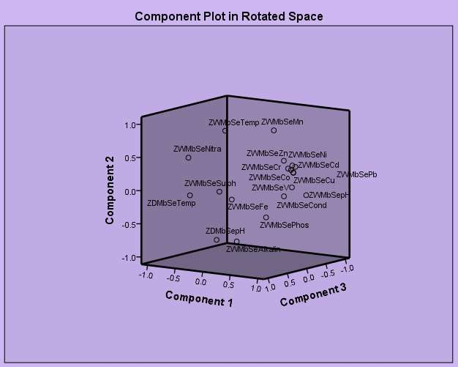

**Fig. 4.24:** Ordination diagram showing 3 principal components of sediments from Mbo river in wet season.

### PCA for sediment from Mbo river (dry season)

Principal component analysis of sediment from Mbo river in wet season produced 3 components. Their loadings are described in Tables 4.51 &4.52.

|  |  |  |  |
| --- | --- | --- | --- |
| **Table 4.35:** | Rotated component matrix |  | |
| **Parameter** | **Components** |  |  |
|  | **1** | **2** | **3** |
| Temp. | -.976 | .212 | .045 |
| pH | -.533 | -.846 | -.013 |
| Conductivity | -.086 | .959 | -.270 |
| Alkalinity | -.929 | -.149 | .338 |
| Nitrate | .955 | -.297 | -.007 |
| Sulphate | -.020 | -.064 | .998 |
| Phosphate | -.974 | .225 | .013 |
| Fe | .846 | .075 | .527 |
| Pb | .939 | .343 | .025 |
| Cu | .983 | .173 | .069 |
| Co | .926 | .373 | .059 |
| Cr | .966 | .258 | .011 |
| Cd | .345 | .917 | .200 |
| Ni | .814 | .579 | .054 |
| Mn | .958 | .124 | .258 |
| Zn | .884 | .467 | -.010 |
| V | .969 | .228 | .093 |

**Table 4.46: The size, percentage, total variation and accumulative percentages of correlation matrix of the first three components in the original data set of plots composition of sediment from Mbo river (dry season)**

|  |  |  |  |
| --- | --- | --- | --- |
| **Component** | **Initial eigen values** |  | |
|  | **Total** | **% of variance** | **Cumulative %** |
| 1. | 11.169 | 74.461 | 74.461 |
| 2 | 2.345 | 15.636 | 90.096 |
| 3 | 1.486 | 9.904 | 100.000 |

Extraction Method: Principal component analysis Rotation Method: Variable with Kaiser Normalization

a. Rotation converged in 5 interactions

**Component 1** could be described as dominantly metallic as it is influenced strongly by Fe, Pb, Cu, Co, Cr, Ni, Mn, Zn, followed by physicochemical parameters such as temperature, alkalinity, NO3. PO32- and pH with moderate loading with eigen values of 11.169 and 74.461% of total variation, the presence of these parameters in sediment may be traced to anthropogenic source.

**Component 2** had eigen value of 2.341 and 15.636% only pH, conductivity and Cd with strong loading and Ni with moderate loading tried to provide information of sediment quality.

**Component 3** had eigen value of 1.486 and percentage variation of 9.904 and this gave very scarce report of sediment quality.

The finding here is that during dry season, sediment quality from Mbo river was mostly influenced by metals investigated.

### PCA for sediment from Ibaka river (wet season)

Three principal components were identified for quality of sediment obtained from Ibaka river in wet season (Tables 4.53 &4.54).

### Table 4.37: Rotated component matrix

**Parameter Components**

|  |  |  |  |
| --- | --- | --- | --- |
|  | **1** | **2** | **3** |
| Temp. | -.130 | -.898 | 0-.291 |
| pH | -.011 | .922 | -.387 |
| Conductivity | -.741 | .174 | -.649 |
| Alkalinity | -.441 | .896 | .057 |
| Nitrate | -.722 | -.688 | 0.070 |
| Sulphate | .151 | -.074 | .986 |
| Phosphate | -.711 | .702 | -.019 |
| Fe | .360 | -.040 | .932 |
| Pb | .956 | .171 | -.239 |
| Cu | .986 | -.108 | .130 |
| Co | .990 | .066 | .127 |
| Cr | .984 | -.074 | .161 |
| Cd | .994 | .078 | .076 |
| Ni | .984 | -.053 | .171 |
| Mn | -.545 | .206 | .812 |
| Zn | .978 | -.149 | .145 |
| V | .986 | -.100 | .130 |

**Table 4.38: The size, percentage, total variation and accumulative percentages of correlation matrix of the first three components in the original data set of plots composition of sediment from Ibaka river (wet season)**

|  |  |  |  |
| --- | --- | --- | --- |
| **Component** | **Initial eigen values** |  | |
|  | **Total** | **% of variance** | **Cumulative %** |
| 1. | 10.328 | 60.756 | 60.756 |
| 2 | 3.598 | 21.167 | 81.923 |
| 3 | 3.073 | 18.077 | 100.000 |

Extraction Method: Principal component analysis Rotation Method: Variable with Kaiser Normalization

a. Rotation converged in 5 interactions

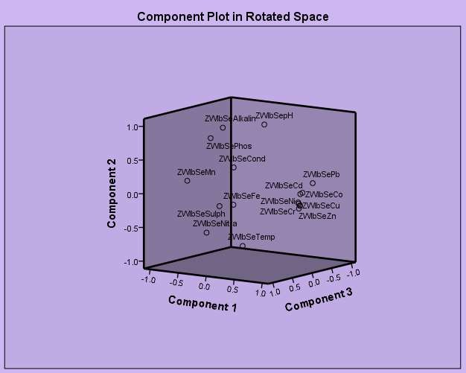

**Fig. 4.25:** Ordination diagram showing 3 principal components of sediments from Ibaka river in wet season.

**Component 1**, except Fe, all other metals investigated strongly influenced this component followed by conductivity, NO3 and PO42-. This component therefore explained mainly 60.75% of data set with eigen value of 10.325.

**Component 2** had purely physicochemical influence with eigen value of

3.598 and percentage variation of 21.167%, only temperature, pH, alkalinity, NO3- and sulphate described the sediment quality.

**Component 3** had eigen value of 3.073 and percentage valiance of 18.077 and could only provide information on Fe and conductivity of the sediment. The plot of the 3 principal components are shown in ordination diagram in Fig. 4.25.

Based on PCA findings, it could be intermed that in wet season, quality of sediment obtained from Ibaka river was principally affected by metallic influence, then moderately by physicochemical parameters.

### PCA for sediment from Ibaka river (dry season)

**Component 1** with the highest eigen value of 10.328 and 60.756 of variance, this component was mostly influenced by all the heavy metals investigated followed by temperature, conductivity, alkalinity. So component 1 could be described as a metallic component.

**Component 2.** This component had only little information on sediment from Ibaka in dry season as only pH and SO2- influenced 3.598 eigen value and 21.167 of variance recorded for this component.

4

**Component 3.** No heavy metal exerted influence in this component. Only NO-3 and PO42- dominated the component. The component recorded eigen value of 3.073 and percentage variance of 18.077. The component plot is displayed on Tables 4.55 &4.56and Fig. 4.26.

### Table 4.39: Rotated component matrix

|  |  |  |  |
| --- | --- | --- | --- |
| **Parameter** | **Components** |  | |
|  | **1** | **2** | **3** |
| Temp. | .988 | .083 | -.132 |
| pH | .384 | .917 | -.104 |
| Conductivity | .894 | -.232 | .383 |
| Alkalinity | -.977 | .089 | -.192 |
| Nitrate | .093 | -.162 | .982 |
| Sulphate | .018 | -.988 | -.153 |
| Phosphate | .168 | .323 | .931 |
| Fe | .986 | .158 | .048 |
| Pb | .943 | .275 | .190 |
| Cu | .928 | .244 | .281 |
| Co | .946 | .305 | .115 |
| Cr | .948 | .240 | .207 |
| Cd | .949 | .166 | -.267 |
| Ni | .995 | -.017 | .101 |
| Mn | .965 | .038 | .258 |
| Zn | .988 | .145 | .049 |
| V | .934 | .351 | .060 |

**Table 4.40: The size, percentage, total variation and accumulative percentages of correlation matrix of the first three components in the original data set of plots composition of sediment from Ibaka river (dry season)**

|  |  |  |  |
| --- | --- | --- | --- |
| **Component** | **Initial eigen values** |  | |
|  | **Total** | **% of variance** | **Cumulative %** |
| 1. | 10.328 | 60.756 | 60.756 |
| 2 | 3.598 | 21.167 | 81.923 |
| 3 | 3.073 | 18.077 | 100.000 |

Extraction Method: Principal component analysis Rotation Method: Variable with Kaiser Normalization

a. Rotation converged in 5 interactions

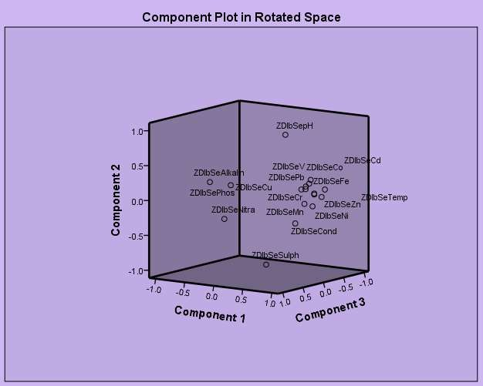

**Fig. 4.26:** Ordination diagram showing 3 principal components of sediments from Ibaka river in dry season.

### PCA for parameter sediment from Asana-ikan river (wet season)

The three principal components observed from Tables4.57 &4.58.

**Table 4.41:** Rotated component matrix

|  |  |  |  |
| --- | --- | --- | --- |
| **Parameter** | **Components** |  | |
|  | **1** | **2** | **3** |
| Temp. | .062 | . 979 | -.192 |
| pH | .526 | .642 | -.558 |
| Conductivity | -.940 | .202 | .274 |
| Alkalinity | .382 | -.860 | .339 |
| Nitrate | .790 | .586 | -.182 |
| Sulphate | -.303 | .929 | .214 |
| Phosphate | -.111 | -.256 | .960 |
| Fe | -.859 | .296 | .418 |
| Pb | .554 | -.787 | .271 |
| Cu | .876 | -.480 | .054 |
| Co | -.943 | .294 | .153 |
| Cr | .958 | -.276 | -.071 |
| Cd | .916 | .085 | .393 |

**Table 4.42: The size, percentage, total variation and accumulative percentages of correlation matrix of the first three components in the original data set of plots composition of sediment from Asana-ikan river (wet season)**

|  |  |  |  |
| --- | --- | --- | --- |
| **Component** | **Initial eigen values** |  | |
|  | **Total** | **% of variance** | **Cumulative %** |
| 1. | 7.404 | 56.953 | 56.953 |
| 2 | 4.251 | 32.703 | 89.657 |
| 3 | 1.345 | 10.343 | 100.000 |

# Extraction Method: Principal component analysis Rotation Method: Variable with Kaiser Normalization

a. Rotation converged in 5 interactions

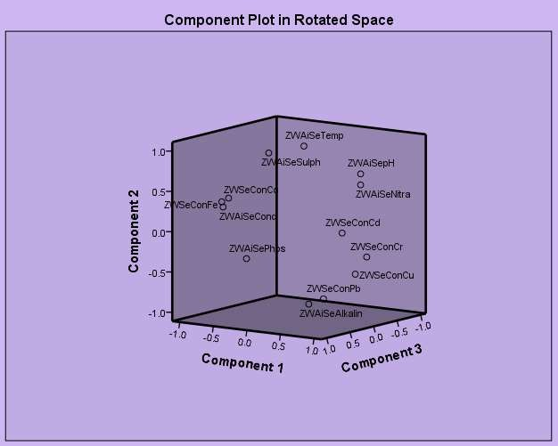

**Fig. 4.27:** Ordination diagram showing 3 principal components of sediments from Asana-ikan river in wet season.

**Component 1** – this component could be said to be metallic as all heavy metals determined showed strong loadings. With eigen values of 7.404 and percentage of 56.953, the heavy metals best described sediment quality, followed by conductivity, nitrate strongly and pH moderately.

**Component 2** – physicochemical parameters like temperature, pH, alkalinity, nitrate and SO2-4 influenced component 2 strongly than all the heavy metals except Fe. Component recorded eigen values of 4.251 with percentage variance of 32.703.

**Component 3** – Of all parameters examined in this study, only PO3-4 showed a strong loading and pH showing a moderate influence. This component eigen value is 1.345 with percentage variance of 10.343%. The component plot is shown in Fig. 4.27.

### PCA for parameter sediment from Asana-ikan river (dry season)

**Table 4.43:** Rotated component matrix

### Parameter Components

|  |  |  |  |
| --- | --- | --- | --- |
|  | **1** | **2** | **3** |
| Temp. | .951 | -.282 | .129 |
| pH | .148 | -.982 | -.117 |
| Conductivity | .066 | -.998 | -018 |
| Alkalinity | -.204 | .067 | -.977 |
| Nitrate | .074 | .644 | .762 |
| Sulphate | .671 | -.142 | .728 |
| Phosphate | .738 | -.241 | -.630 |
| Fe | -.611 | .197 | .766 |
| Pb | -.764 | .636 | .109 |
| Cu | -.289 | .888 | .358 |
| Co | .974 | -.145 | -.177 |
| Cr | -.066 | .587 | .821 |
| Cd | -.974 | .145 | -.177 |
| Zn | .894 | .153 | -.420 |

**Table 4.44: The size, percentage, total variation and accumulative percentages of correlation matrix of the first three components in the original data set of plots composition of sediment from Asana-ikan river (dry season)**

|  |  |  |  |
| --- | --- | --- | --- |
| **Component** | **Initial eigen values** |  | |
|  | **Total** | **% of variance** | **Cumulative %** |
| 1. | 7.207 | 51.476 | 51.476 |
| 2 | 4.562 | 32.586 | 84.062 |
| 3 | 2.231 | 15.938 | 100.000 |

# Extraction Method: Principal component analysis Rotation Method: Variable with Kaiser Normalization

a. Rotation converged in 5 interactions

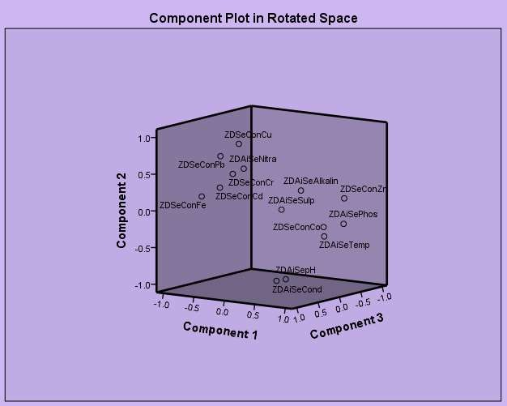

**Fig. 4.28:** Ordination diagram showing 3 principal components of sediments from Asana-ikan river in dry season.

**Component 1** –was a major component with eigen value of 7.207 and 51.476% of variance – Temp. SO2-4, NO- , Fe, Pb, Co, Cd and Zn exerted a strong influence on the component.

3

**Component 2:** recorded 4.562 as eigen value and percentage variance of 32.586. pH, conductivity, NO-3 and Pb, Cu and Cr exerted influence. So, this component could be described as both physicochemical and heavy metal component.

**Component 3.** This component had the least eigen value of 2.231 and percentage variance of 15.938. Alkalinity, NO-3, sulphate, PO43-, Fe and Cr were dominant. The component plot is shown on Fig. 4.28.

The principal component analysis values obtained for sediments in the study area is the agreement with values reported by Kebede and Kebedee (2012). The higher metal loadings in sediment samples than physicochemical parameters is in accordance to Ayeno and Sionenye (2013) classification.

The magnification of metals in water and sediment are outlined in Table 4.45

**Table 4.45: Magnification of Metals in Water and Sediment**

**Parameters Mbo River Ibaka River Asana-Ikan river (Control)**

|  |  |  |  |  |  |  |  |  |  |  |
| --- | --- | --- | --- | --- | --- | --- | --- | --- | --- | --- |
|  | | **Surface**  **waters** | **Sedi-**  **ment** | **% mg** | **Surface**  **waters** | **Sedi-**  **ment** | **% mg** | **Surface**  **waters** | **Sedi-**  **ment** | **% mg** |
| Fe | WS | 0.35 | 709 | 202471 | 0.44 | 707 | 160581 | 0.30 | 665 | 221566 |
|  | DS | 0.53 | 862 | 162541 | 0.65 | 890 | 136823 | 0.32 | 777 | 242712 |
| Pb | WS | 0.21 | 18.51 | 8714 | 0.03 | 19.37 | 64466 | 0.01 | 7.23 | 72200 |
|  | DS | 0.42 | 30.04 | 7052 | 0.11 | 31.95 | 28945 | 0.03 | 8.40 | 27900 |
| Cu | WS | 0.01 | 21.13 | 211200 | 0.01 | 20.93 | 209200 | 0.01 | 2.52 | 25100 |
|  | DS | 0.02 | 26.74 | 133600 | 0.03 | 26.62 | 88633 | 0.01 | 0.89 | 8800 |
| Co | WS | 0.01 | 11.79 | 117800 | 0.04 | 12.15 | 30275 | - | 8.50 | - |
|  | DS | 0.26 | 17.99 | 6819 | 0.02 | 18.59 | 92850 | - | 10.25 | - |
| Cr | WS | 0.01 | 21.06 | 210500 | 0.03 | 20.93 | 69666 | - | 16.40 | - |
|  | DS | 0.01 | 27.03 | 270200 | 0.03 | 27.02 | 89966 | - | 14.00 |  |
| Cd | WS | 0.02 | 1.60 | 7900 | 0.06 | 1.79 | 2883 | - | 0.20 | - |
|  | DS | 0.07 | 4.18 | 5871 | 0.07 | 4.53 | 6371 | - | 0.20 | - |
| Ni | WS | 0.03 | 3.74 | 12366 | 0.06 | 3.93 | 6450 | - | - | - |
|  | DS | 0.11 | 6.03 | 5381 | 0.06 | 6.32 | 10433 | - | - | - |
| Mn | WS | 0.02 | 0.49 | 2350 | 0.02 | 0.64 | 3100 | - | - | - |
|  | DS | 0.02 | 0.85 | 4150 | 0.03 | 0.89 | 2866 | - | - | - |
| Zn | WS | 1.03 | 26.18 | 2441 | 1.62 | 26.35 | 1526 | 1.02 | 17.13 | 1579 |
|  | DS | 2.48 | 47.63 | 1820 | 2.10 | 46.88 | 2132 | 2.34 | 20.50 | 776 |
| V | WS | - | 15.31 | - | - | 16.36 | - | - | - | - |
|  | DS | - | 23.55 | - | - | 24.45 | - | - | - | - |
| Hg | WS | - | <0.2 | - | - | <0.2 | - | - | - | - |
|  | DS | - | <0.2 | - | - | <0.2 | - | - | - | - |

N = 4, %mg – Percentage magnification, WS – wet season, DS – Dry season

From Table 4.51 the trend followed Cr > Cu > Fe > Co > Ni > Pb > Cd > Zn

> Mn >> for Mbo river during wet and dry season; Cu > Fe > Co > Cr > Ni > Cd

>>>> for Ibaka river during both seasons. Asana-Ikan river followed similar pattern. In all cases, the sediment showed much higher concentration than the water column. Similar findings were reported by Bears, (1980) working on the Scheldt estuary in

the Netherlands. The study also observed that the dry season concentrations of heavy metals are generally higher than that observed at Wet season. This implies that since most fishing activities are done in the moving hour of dry season when there is ebb tide period, the sediment, seafood, fishes are at danger as they are exposed to greater contamination and repositories of very large dose of other heavy metals except V and Hg in sediment particularly from Ibaka river and Mbo river.

### 4.4 Heavy Metals in Fish organs

The heavy metals in fish organs are shown in Tables 4.46 to 4.47.

**Table 4.46:**Mean level of some heavy metals (mg/kg) in organs of

*Xenomystus nigri* (catfish) in wet & dry season.

**Metal Mbo River Location Ibaka River Location Asana-ikan Location**

|  |  |  |  |  |  |  |
| --- | --- | --- | --- | --- | --- | --- |
|  | **W** | **D** | **W** | **D** | **W** | **D** |
| **Fe** | Mean 5.22 | 5.30 | 5.22 | 5.19 | 0.22 | 0.23 |
|  | SD  0.00 |  0.01 |  0.11 |  0.12 | 0.00 | 0.00 |
| **Pb** | Mean 0.90 | 0.92 | 0.91 | 0.94 | 0.14 | 0.16 |
|  | SD  0.00 |  0.35 |  0.08 |  0.01 | 0.00 | 0.00 |
| **Cu** | Mean 7.82 | 8.26 | 8.11 | 8.35 | 1.80 | 2.07 |
|  | SD  0.19 |  0.09 |  0.11 |  0.00 | 0.28 | 0.50 |
| **Co** | Mean 0.00 | 0.03 | 0.51 | 0.00 | ND | ND |
|  | SD  0.00 |  0.00 |  0.49 |  0.00 | Nil | Nil |
| **Cr** | Mean 0.04 | 0.05 | 0.04 | 0.04 | 0.03 | 0.03 |
|  | SD  0.00 |  0.01 |  0.00 |  0.00 | 0.00 | 0.00 |
| **Cd** | Mean 0.33 | 0.32 | 0.00 | 0.46 | 0.10 | 0.10 |
|  | SD  0.00 |  0.00 |  0.00 |  0.14 | 0.05 | 0.05 |
| **Ni** | Mean 0.53 | 0.54 | 0.53 | 0.54 | 0.20 | 0.27 |
|  | SD  0.01 |  0.00 |  0.00 |  0.00 | 0.06 | 0.03 |
| **Mn** | Mean 0.01 | 0.02 | 0.02 | 0.07 | 0.00 | 0.00 |
|  | SD  0.00 |  0.00 |  0.00 |  0.00 | 0.00 | 0.00 |
| **Zn** | Mean 13.45 | 15.10 | 13.83 | 14.73 | 11.53 | 12.43 |
|  | SD  0.34 |  0.30 |  0.26 |  0.08 | 0.29 | 0.21 |
| **V** | Mean 0.00 | 0.05 | 0.038 | 0.06 | ND | ND |
|  | SD  0.00 |  0.00 |  0.03 |  0.00 | Nil | Nil |
| **Hg** | Mean ND | ND | <0.01 | <0.01 | ND | ND |
|  | SD Nil | Nil |  0.000 |  0.000 | Nil | Nil |

Fish organs - Gills, intestine, liver, kidney, muscle W: Wet season; D: Dry season

### Table 4.47: Mean level of some heavy metals (mg/kg) in organs of

*Pseudotolithus elongatus***(croaker**) **fish in wet & dry season**

**Metal Mbo River Location Ibaka River Location Asana-ikan River**

**Location**

|  |  |  |  |  |  |  |  |
| --- | --- | --- | --- | --- | --- | --- | --- |
|  | | **W** | **D** | **W** | **D** | **W** | **D** |
| **Fe** | Mean | 3.13 | 3.63 | 3.44 | 3.62 | 0.21 | 0.22 |
|  | SD |  0.23 |  0.01 |  0.04 |  0.00 | 0.03 | 0.02 |
| **Pb** | Mean | 0.68 | 0.82 | 0.78 | 0.81 | 0.14 | 0.15 |
|  | SD |  0.8 |  0.00 |  0.01 |  0.00 | 0.06 | 0.06 |
| **Cu** | Mean | 8.11 | 8.14 | 8.12 | 8.13 | 1.69 | 2.02 |
|  | SD |  0.00 |  0.01 |  0.03 |  0.00 | 0.00 | 0.00 |
| **Co** | Mean | 0.00 | 0.02 | 0.00 | 0.00 | ND | ND |
|  | SD |  0.00 |  0.00 |  0.00 |  0.00 | Nil | Nil |
| **Cr** | Mean | 0.03 | 0.03 | 0.03 | 0.05 | 0.02 | 0.03 |
|  | SD |  0.00 |  0.00 |  0.02 |  0.01 | 0.00 | 0.02 |
| **Cd** | Mean | 0.23 | 0.24 | 0.25 | 0.26 | 0.09 | 0.10 |
|  | SD |  0.00 |  0.00 |  0.02 |  0.03 | 0.00 | 0.00 |
| **Ni** | Mean | 0.70 | 0.71 | 0.70 | 0.79 | 0.19 | 0.21 |
|  | SD |  0.00 |  0.00 |  0.00 |  0.11 | 0.00 | 0.00 |
| **Mn** | Mean | 0.01 | 0.014 | 0.01 | 0.16 | 0.00 | 0.00 |
|  | SD |  0.00 |  0.00 |  0.00 |  0.00 | 0.00 | 0.00 |
| **Zn** | Mean | 11.39 | 13.27 | 11.62 | 12.73 | 11.99 | 12.37 |
|  | SD |  0.12 |  0.18 |  0.00 |  0.00 | 0.11 |  0.19 |
| **V** | Mean | 0.03 | 0.03 | 0.03 | 0.03 | ND | ND |
|  | SD |  0.00 |  0.00 |  0.00 |  0.00 | Nil | Nil |
| **Hg** | Mean | ND | ND | ND | ND | ND | ND |
|  | SD | Nil | Nil | Nil | Nil | Nil | Nil |

Fish organs - Gills, intestine, liver, kidney, muscle W: Wet season; D: Dry season

Fish in most cases have advantages over other source of protein. According to Fawole *et al*., (2013), fish has a tender flesh, low cholesterol content and palatable taste. In Akwa Ibom, fish is a very important source of animal protein in human diet. Among species of fishes found in the area, the people prefer catfish (*Xenomystus nigri*), croaker (*Pseudotolithus elongatus*) and *Ilisha Africanus* for their consumption. These species of fishes are found all year round, affordable and most edible and hence popular (Ekpenyong, 2014). Unfortunately human exposure to heavy metals is through human diet

(Udosen *et al*. 2014) and so consumers of seafoods from Mbo River System are beginning to raise concern about fishes obtained from the area. The complaints are based on the facts that indiscriminate dumping of domestic chemical and heavy metal containing waste seems to be on the increase in the study area. Some heavy metals Fe, Pb, Cu, Co, Cr, Cd, Ni, Mn, Zn, V and Hg concentration in organs of the most consumed fishes in the area – (catfish) *Xenomystus nigri*, croaker (*Pseudotolithus elongatus*) and *Illisha africanus*collected from Mbo, Ibaka and Asan-Ikan rivers (ctrl) in two seasons from seven locations have been investigated and presented in Tables 4.46 to 4.47.

### Iron in fishes organs

Fe mean concentrations in catfish (*Xenomystus nigri*) organs, during dry season ranged between 5.19 0.12 mg/l at Ibaka river location and 5.30

0.01 mg/l in Mbo river location (Table 4.46). At Mbo river locations Fe level in croaker (*Pseudotolithus elongatus*) fish organs ranged between 3.13 0.23mg/l in wet season and 3.63 0.01 mg/l in dry season (Table 61) whereas *Ilisha africanus* organs Fe content ranged between 1.00 0.00 mg/l in Mbo river during wet season to 1.09 0.07 mg/l in Ibaka during the same wet season (Table 4.47). There values are above the recommended dose of 0.3mg/l weight for fish set for Fe (WHO, 2015).

### Lead in fish organs

Pb levels in catfish (*Xenomystus nigri*) (Table 4.56) and *Ilisha africanus* organs (Table 4.58) obtained from Mbo locations during wet season ranged from 090 0.00 mg/l and 0.52 0.80mg/l to 0.94 0.01mg/l and 0.65 0.00mg/kg respectively at Ibaka river during dry season. The values are far higher than 0.5mg/l recommended by (WHO, 2015) and 0.5mg/l set by (FAO, 1976) but comparable to values obtained by Etim and Akpan (1991) for tissues of Egeria radiate from Cross river. However, the values are also far below the lethal dose of 2.0mg/l weight set for Pb by USFDA (Goyer & Myom, 1975, Udosen *et al*., 2006). The high level of Pb especially in catfish (*Xenomystus nigri*) organs from Ibaka River location in both wet and dry seasons may be attributed to increase of Pb additives in petrol sold by hawkers in unauthorized depots along Ibaka River beach and from lead compounds in paints also sold in the area.

### Copper in fish organs

The mean level of Cu in organs of catfish (*Xenomystus nigri*) obtained from Mbo river ranged from 7.82 0.19mg/l during wet season and 8.35 0.00mg/l at Ibaka river during dry season (Table 4.56).Organs of croaker (*Pseudotolithus elongatus*) fish obtained from Mbo river recorded a mean Cu concentration of 8.11 0.00 mg/l during wet season (Table 4.57). Also, in wet season, Cu concentration in organs of *Ilisha africanus* caught from Ibaka river location ranged from 6.83 mg/l and 7.65mg/l for similar fish caught at Mbo river location Table 4.58. The levels of Cu recorded in fish samples in this

study were lower than the 120mg/l limit set by (WHO, 2015) and 30mg/l limit set by the Australian National Health Council for Cu in seafoods (Udosen,*et al*. 2011). At the study area, there is increased metal and wood logging activities. The result of this study seems to agree with observations by (Udosen, 2006) that Cu found in environment can come from mining metal activities, wood production and can preservation besides wind blown dust, decaying vegetations and seapages.

### Cobalt in fish organs

The least mean value of Co in organs of catfish (*Xenomystus nigri*) caught at Mbo river location during wet season and at Ibaka river location during dry season recorded 0.000.00 mg/l while the highest Co concentration in organs of catfish (*Xenomystus nigri*) caught from Ibaka river location during wet season recorded 0.51 0.04mg/l (Table 4.56). On the other hand, organs of croaker (*Pseudotolithus elongatus*) caught from Ibaka river location recorded 0.00 0.00mg/l as the lowest concentration of Co during wet and dry season and highest Co value of 0.26 0.00mg/l for same croaker (*Pseudotolithus elongatus*) caught from Mbo river location during dry season. The least mean value of Co (0.01 0.00mg/l) in organs of Ilisha africanus was recorded at Ibaka river location during dry season while the highest value of Co (0.02 0.00mg/l) was obtained during dry season at Mbo river locations (Table 4.58). Although no value is set for amount of Co in fish,

waste laden with Co waste if allowed to run-off into Ibaka river and Mbo rivers may in future adversely affect fishes and eventually consumers.

### Chromium in fish organs

Mean level of Cr in organs of catfish (*Xenomystus nigri*)caught from Mbo river recorded values which ranged from 0.04  0.00mg/l during wet season and 0.05  0.01mg/l during dry season from Ibaka river locations. Mean chromium concentration in organs of croaker (*Pseudotolithus elongatus*) fish ranged from 0.30  0.02mg/l during wet season to 0.05 0.01 mg/l during dry season and 0.02mg/l during wet season to 0.04 0.00mg/l during dry season for *Ilisha africanus*. The concentrations of Cr for now do not constitute health problems to fish consumers. This is because the lethal dose for children is 0.01 – 0.06mg/l and for adults 5.00mg/l (Gayer & Myron, 1977).

However, continuous accumulation of Cr in Mbo and Ibaka rivers, means depriving children of consuming fish in future. The values obtained in the present study shows Cr values in fish organs to be closer to recommended values. Therefore, chromated but spoilt and discarded electronic materials be it plastic, glass or metal should not be thrown into the two rivers again.

### Cadmium in fish organs

From Ibaka river locations, organs of *Ilisha africanus* accumulated the highest amount of Cd (0.95 0.10mg/l) during wet season (Table 4.58). This was followed by organs of catfish (*Xenomystus nigri*) (0.46 0.14mg/l) during

dry season (Table 4.58) whereas the least Cd level was recorded for organs of Ilisha (0.16 mg/l) during dry season and organs of croaker (*Pseudotolithus elongatus*) fish (0.23  0.00mg/l) from Mbo river location during wet season (Table 4.58).

In comparison with standard permissible level of 0.05 to 5.5 mg/l fish dry weight for Cd (FAO, 1983), the organs of the three fishes investigated from Mbo and Ibaka rivers including those from the control are safe for consumption. However, from the perspective of Gayer and Myron (1977), the values obtained in present study especially for organs of *Ilisha africanus*(0.95

 0.16 mg/l) obtained from Ibaka river during wet season is higher than the lethal dose range of 0.4 – 0.5 mg/l for infants and 0.6 – 0.7 mg/l for adults. Thus organs of this fish species is not therefore suitable for consumption. Moreso, long term exposure to cadmium could results to slight anaemia, renal, hepatic and testicular injury. It is therefore recommended that wood logging and boat construction activities along Ibaka beach be minimized.

### Nickel in fish organs

The recommended concentration of Ni in fish is 0.2 mg/l (WHO, 2015) to 0.5mg/l (FAO, 1983). In this study, the lowest mean Ni level in organs of catfish(*Xenomystus nigri*), croaker (*Pseudotolithus elongatus*) and *Ilisha africanus* obtained from Mbo river were 0.53 0.01 mg/l, 0.23  0.00mg/l during wet season and 0.44  0.00 mg/l during dry season respectively. The highest Ni level during dry season recorded in organs of croaker fish (*Pseudotolithus elongatus*) (0.79  0.11 mg/l) from Ibaka river was followed

by organs of catfish (*Xenomystus nigri*) (0.54 0.00 mg/l) from Mbo river and then organs of Ilisha (0.40  0.00mg/l) from Ibaka river. Except for organs of croaker (0.77  0.11mg/l) from Ibaka river location recorded during dry season, other mean values of Ni in the organs of the three fishes are in agreement with Ni standards set by WHO and FAO, but higher than Ni exposure in gill of oriectromis milotus reported by Alef (2009).

### Table 4.48: Mean level of some heavy metals (mg/l) in organs of *Ilisha africanus*fish in wet & dry season

|  |  |  |  |  |  |  |  |
| --- | --- | --- | --- | --- | --- | --- | --- |
| **Metal**  **mg/l** | **Mbo**  **Location** |  | **River** | **Ibaka**  **Location** | **River** | **Asana-ikan River** | |
|  | **W** | **D** |  | **W** | **D** | **W D** | |
| Fe Mean | 1.00 | 1.02 |  | 1.01 | 1.09 | 0.21 0.21 | |
| SD |  0.00 |  0.00 | |  0.00 |  0.07 | 0.00 | 0.00 |
| Pb Mean | 0.52 | 0.65 | | 0.63 | 0.65 | 0.13 | 0.14 |
| SD |  0.08 |  0.00 | |  0.00 |  0.00 | 0.04 | 0.01 |
| Cu Mean | 7.05 | 6.90 | | 6.83 | 6.95 | 1.54 | 1.98 |
| SD |  0.09 |  0.20 | |  0.12 |  0.04 | 0.02 | 0.05 |
| Co Mean | 0.02 | 0.02 | | 0.01 | 0.01 | NDL | NDL |
| SD |  0.00 |  0.00 | |  0.00 |  0.00 | Nil | Nil |
| Cr Mean | 0.02 | 0.02 | | 0.02 | 0.04 | 0.01 | 0.02 |
| SD |  0.00 |  0.00 | |  0.00 |  0.00 | 0.00 | 0.00 |
| Cd Mean | 0.17 | 0.16 | | 0.95 | 0.48 | 0.06 | 0.08 |
| SD |  0.01 |  0.00 | |  0.10 |  0.03 | 0.00 | 0.00 |
| Ni Mean | 0.44 | 0.44 | | 0.44 | 0.44 | 0.14 | 0.20 |
| SD |  0.00 |  0.00 | |  0.00 |  0.00 | 0.05 | 0.08 |
| Mn Mean | 0.01 | 0.01 | | 0.01 | 0.01 | 0.00 | 0.00 |
| SD |  0.00 |  0.00 | |  0.00 |  0.00 | 0.00 | 0.00 |
| Zn Mean | 8.89 | 9.61 | | 9.10 | 10.02 | 11.18 | 12.20 |
| SD |  0.27 |  0.06 | |  0.11 |  0.00 | 0.35 | 0.38 |
| V Mean | 0.02 | 0.05 | | 0.02 | 0.02 | NDL | NDL |
| SD |  0.00 |  0.00 | |  0.00 |  0.00 | Nil | Nil |
| Hg Mean | NDL | NDL | | NDL | NDL | NDL | NDL |
| SD | Nil | Nil | | Nil | Nil | Nil | Nil |

Fish organs - Gills, intestine, liver, kidney, muscle W: Wet season; D: Dry season

NDL – Not within the dectection limit of the instrument used SD – Standard deviation

### Manganese in fish organs

During wet season, mean levels of Mn in organs of fishes from Mbo river locations were catfish (*Xenomystus nigri*) (0.17  0.00mg/l), croaker fish (*Pseudotolithus elongatus*) (0.01 0.00mg/l), Ilisha africanus (0.01 0.00 mg/l), and during dry season, Mn mean levels in organs of fishes from Ibaka river locations were catfish (*Xenomystus nigri*) (0.07 0.00mg/l), croaker fish (*Pseudotolithus elongatus*) (0.01 0.00mg/l). The least mean concentration of Mn was recorded for organs of Ilisha africanus (0.01 0.00mg/l) from Ibaka river location during wet season. The levels of Mn recorded in all organs of the three fish samples investigated in the study area were lower than the 0.5mg/l limit set by WHO, (2015). Thus, Mn poses no threat to any of the fish consumed from the study area.

### Zinc in fish organs

As one of the essential metals needed for animals and humans, Zn recommended daily allowance (RDA) is 10mg/l for growing children and 15mg/day for adults (Oguzie and Achegbulu, 2010). Zn is required for many metabolic activities in humans, thus its deficiency can lad to growth retardation, loss of appetite and skin changes (Udosen, 2006). However efficient homeostatic control mechanisms also make Zn toxicity from dietary sources rare.

During wet season, fishes caught from Mbo river locations recorded Zn levels in organs of catfish (*Xenomystus nigri*) (13.45  0.34mg/l) organs of croaker fish (*Pseudotolithus elongatus*) (11.390.12 mg/l) and organs of

*Ilisha africanus* (8.89 0.27 mg/l). During dry season the mean value of Zn in organs of both catfish (*Xenomystus nigri*) and croaker (*Pseudotolithus elongatus*) caught from Mbo river were 15.10 0.30 mg/l and 13.2700.180 mg/l respectively. Also during the dry season organs of *Ilisha africanus* caught from Ibaka river location recorded 10.02 0.00 mg/l (Table 4.3). Results obtained in this work with respect to Zn are low compared to standard value from maximum Zn level of 50 mg/l permitted for fish (Fawole *et al*., 2013), 150 mg/l (WHO, 2015) and 30 mg/l (FAO, 1983).

### Vanadium in fish organs

V highest mean level reported for organs of fishes were catfish (*Xenomystus nigri*) (0.06 mg/l), croaker (*Pseudotolithus elongatus*) (0.03 mg/l) obtained from Ibaka river location followed by Ilisha africanus (0.05 mg/l) from Mbo river during dry season. During wet season V lowest mean concentration recorded in organs of catfish (*Xenomystus nigri*) (0.00 mg/l) obtained from Mbo river. From Ibaka river locations, croaker (*Pseudotolithus elongatus*) caught there during wet season recorded V mean level of 0.03 mg/l in it organs while *Ilisha africanus* caught from the same river during dry season recorded V mean concentration of 0.02 mg/l in it organ. These values are higher than <0.05 limit of V in fish recommended by FAO, (1983).

### Mercury in fish

The problem of eating fish is the risk of their contamination with heavy metal such as mercury and with/or it compound methyl mercury. No trace of mercury was detected in any of the fish.

### 4.4.2 Seasonality differences in metal accumulation in fish organs.

With regards to seasonality, heavy metals accumulated in appreciable quantity in organs of the three fishes more in dry season than in wet season (Table 4.56 – 4.58). This may be attributed to the dilution and leaching factors by much rainfall during wet (rainy) season. Heavy metal concentration in organs of the three fishes followed the following trend:

**Metals in organs of catfish**(*Xenomystus nigri*)

Wet season: Zn>Cu>Fe>Pb>Ni>Cd>Cr>V>Mn>Co Dry season: Zn>Cu>Fe>Pb>Ni>Cd>Cr>V>Co>Mn

**Metals in organs of croaker fish**(*Pseudotolithus elongatus*) Wet season: Zn>Cu>Fe>Ni>Pb>Cd>Cr=V>Mn>Co

Dry season: Zn>Cu>Fe>Pb>Ni>Cd>Cr=V>Mn>Co

**Metals in organs of *Ilisha africanus***

Wet season: Zn>Cu>Fe>Pb>Ni>Cd>V>Cr>Co>Mn Dry season: Zn>Cu>Fe>Pb>Cd>Ni>Cr>V>Co>Mn

As shown there was no significantly seasonal difference (p<0.05) in trend as the pattern here appear to be generally in accord with other worker observations as reported in literature.

### 4.4.3(a) Concentration of Heavy Metals in different Fishes

The concentration of heavy metals in organs of fishes caught from the study area are presented on Fig 4.29 – Fig 4.31. The bar charts indicate heavy metal concentration in the fish.

9

8

7 ~~M~~bo w

**C**

**o** 6 Mbo d

**n**

**c**

**.** 5 Ibaka w

**(**

Ibaka d

**m** 4

**g**

**/** Asana-ikan w

**k** 3

**g**

**)**

Asana-ikan d

2

1

0

Catfish

Croaker Iron

Ilisha

Catfish

Croaker Lead

Ilisha

Catfish

Croaker Copper

Ilisha

**Heavy metals**

**Fig. 4.29:**Concentration of Fe, Pb, Cu in different fishes

1.2

Catfish Croaker Ilisha Catfish Croaker Ilisha Catfish Croaker Ilisha

Cobalt

Chromium

Cadmium

1

0.8

**C**

**o n c**

**.**

0.6

**(**

**m g**

**/ k g**

**)**

0.4

Mbo W Mbo D Ibaka W Ibaka D

Asana-Ikan W Asana-Ikan D

0.2

0

**Heavy Metals**

**Fig. 4.30:**Concentration of Co, Cr, Cd in different fishes

16

Nickel

Manganese

Zinc

Vanadium

14

12

**C**

**o** 10

**n c**

**.**

8

**(**

**m g**

**/**

**k** 6

**g**

Mbo W Mbo D Ibaka W Ibaka D

Asana-Ikan W Asana-Ikan D

4

2

0

Catfish

Croaker

Ilisha

Catfish

Croaker

Ilisha

Catfish

Croaker

Ilisha

Catfish

Croaker

Ilisha

**Heavy Metals**

**Fig. 4.31:**Concentration of Ni, Mn, Zn & V in different fishes

### 4.4.3(b) Distribution of heavy metals in organs of fishes

The distribution of heavy metals in gills, liver, intestine, kidney and muscles of catfish (*Xenomystus nigri*), croaker (*Pseudotolithus elongatus*) and *Ilisha africanus* caught from Mbo, Ibaka and Asana-Ikan rivers in wet and dry seasons are represented in Fig. 4.32 to Fig. 4.35. The point charts indicate heavy metal accumulation in fish organs and it also consists of error bars and focal point. The error bars are evidence that the data is statistically treated.

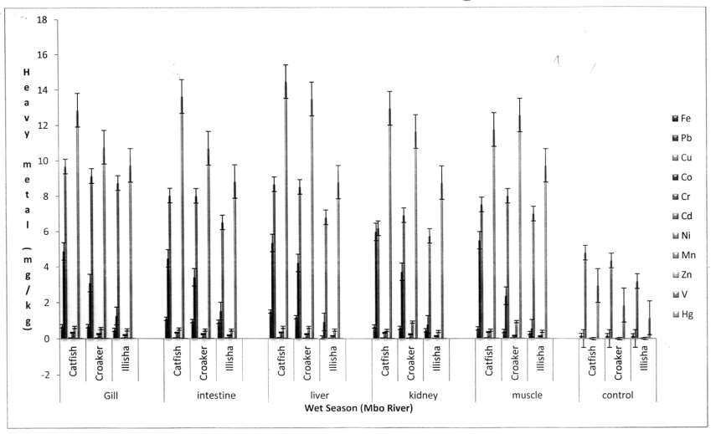

### Fig. 4.32: Point Chart showing heavy metals concentration (mg/kg) in organs of Fishes in Wet Season (Mbo River)

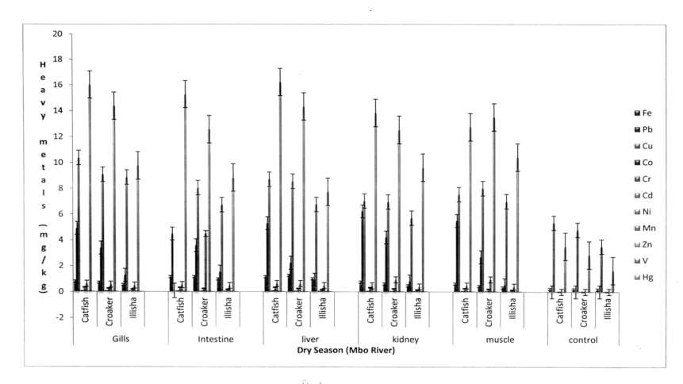

Fig. 4.33: **Point Chart showing heavy metals concentration (mg/kg) in organs of Fishes in Dry Season (Mbo River)**

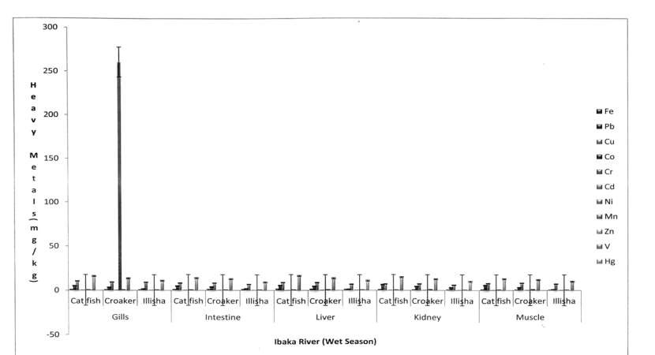

### Fig. 4.34: Point Chart showing heavy metals concentration (mg/kg) in organs of Fishes in Wet Season (Ibaka River)

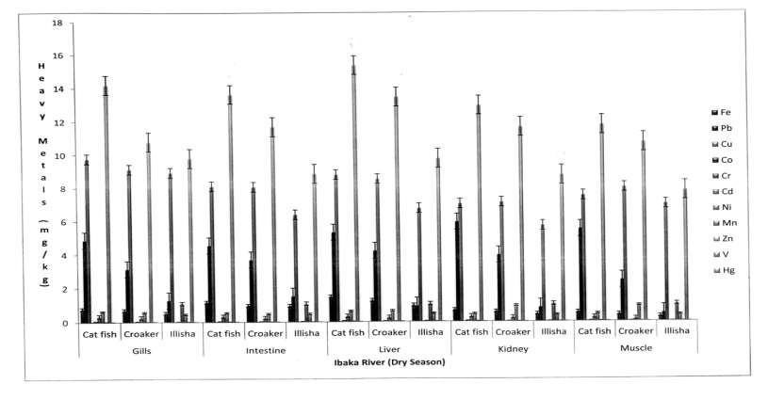

Fig. 4.35: **Point Chart showing heavy metals concentration (mg/kg) in organs of Fishes in Dry Season (Ibaka River)**

From Fig. 4.32 Mbo wet season, highest Cu accumulation was found in the liver of catfish (*Xenomystus nigri*), followed by Fe in the intestine of catfish (*Xenomystus nigri*) and then Cd in the liver of croaker (*Pseudotolithus elongatus*).

In the dry season, the gill of catfish accumulated Fe as the highest. This was followed by Cu and Zn in the liver and intestine of catfish (*Xenomystus nigri*) respectively, then Cd in the liver of croaker (*Pseudotolithus elongatus*) (Fig. 4.33).

From Ibaka river, highest Cr accumulation was found in gills of croaker (*Pseudotolithus elongatus*) in wet season (Fig. 4.34). In dry season, gills and liver of catfish (*Xenomystus nigri*) and croaker (*Pseudotolithus elongatus*) recorded highest amount of Fe respectively (Fig. 4.35), followed by Ni in intestine of catfish (*Xenomystus nigri*), Cd in kidney of *Ilisha africanus* and V in muscle of croaker (*Pseudotolithus elongatus*).

Accumulation and distribution of Fe, Pb, Cd, Ni and V in organs of fish species from the study area had comparable values with similar metals reported for catfish and other fishes from Nenshan town beach as reported by Edem *et al.,* (2009) and from Ibaka river as reported by Akpanyung *et al.,* (2014). These values here however lower than that reported by Abida *et al.,* (2009) for similar metals in some fishes from Madivala lake in India and from vial river system in Egypt as reported by Crafford *et al.,* (2006).

Bioaccumulation of heavy metals in the three fishes investigated compared to values obtained for selected fishes as reported by Gyampo *et al.* (2013) are

above consumption level (EU 1996). If bioaccumulation of heavy metals continues, this may lead to biological risk (Birch and Olmos 2008), health risk (Mohammed *et al.* 2011) and carcinogenic risk (Mansouri *et al.* 2013).

### 4.5.4 Correlation analysis between heavy metals in sediment and heavy metals in fish

Relationship between heavy metals in sediment and heavy metals in fish from Mbo river, Ibaka river and the control Asana river in wet and dry season are presented on Appendices 17-34.

Appendix 17 show Mbo river sediment – Catfish metal correlates in wet season.There were strong positive correlation of Cd-Pb (r=0.996**) Ni- Cr (r=0.953**), Zn-Fe (r=0.969**), Ni-Pb (r=0.945**), Cu-Pb (r=0.995**) as well as strong, though negative correlation between Zn-Mn (r=-0.985**) in sediment – catfish from Mbo river in wet season. A very strong positive correlation was observed between Ni-Pb (r=0.971**), Cd-Co (r-0.981**), Hg- Cr (0.956**) and strong negative correlation between Cd-Fe (r=0.977**), V- Pb(r=-0.971**). Ni-Cd (r=0.945*) and Hg-Mn (r=0.944*) also correlated positively in sediment – croaker fish from Mbo river in wet season (Appendix 18).

From appendix 19, both Co-Pb and V-Pb (r=-0.971**) correlated strongly but negatively, so also Hg-Cr (r=0.966**). Strong positively correlation was noticed for Ni-Pb (r=0.971**), Zn-Cd (r=0.947**), even Cd- Cu (r=0.917*) and Hg-Mn (r=0.983*) correlated positively in sediment –

Ilisha africanus fish from Mbo river in wet season. During dry season, metals in sediment and catfish from Mbo river mostly correlated negativelyas in appendix 20. Cu-Pb (r=0.966*), Ni-Pb ((r=-0.951*), Co-Cu (r= 0.960*), and strongly negative for Cu-Fe and Cu-Zn (r=-0.957*), Mn-Pb (r=-0.969**), Zn- Cu (r=-0.968**) but strongly positive for Zn-Fe (0.996**) and Cd-Cr (0.990**) (Appendix 20).

Appendix 21 showed metal correlates between Mbo river sediment and croaker fish in dry season.Correlation between Cr-Fe (r=-0.951*) and Ni-Pb (r=-0.959*) were negative but positive for Ni-Cd (r=0.980*) and Hg-Co (r=0.956*). Mn-Fe(r = 0.991**), Zn-Co(r=-0.976**) and V-Ni(r=-0.981**),

correlation were strongly negative while correlation for Cd-Pb (0.900**) and Mn-Ni (0.905**) were strongly positive.

Negative correlation of metals in sediment and ilisha africanus fish from Mbo river in wet season was mostly observed for Ni-Cr (r=-0.937*) while strong negative correlation was noticed for Cu-Fe (r=-0.987**), Cd-Fe (r=-0.997**), Zn-Fe (r=-0.974**), V-Fe (r=-0.981**), V-Pb (r=-0.968**) and

Zn-Cu and V-Co (r=-0.987**) but V-Pb (r=0.968**) was strongly positive ((Appendix 22)).

Similarly, from Appendix 23, negative correlation of metals in sediment and catfish from Ibaka river in wet season were mostly noticed for Pb-Fe (r=- 0.987*) and strong negative correlation for Ni-Fe (r=-0.975**), Co-Pb (r=- 0.971**), V-Pb (r=-0.997**), Hg-Cr (r=-0.966**) and strong positive correlation for Ni-Pb (r=-0.971**) and V-Ni (r= 0.966**).

From Appendix 24, a very strong positive correlation existed between Ni-P Croaker (r= 0.971**) and Cd-Co (r= 0.981**) while strong, but negative correlation were observed for Zn-Cd (r= -0.99**), Zn-Pb (r= -0.998**) and Ni-Fe (r= -0.975**). Cd-Pb (r= 0.975*), Ni-Pb (r= 0.990*), Ni-Cu (r=

0.905*), correlated positively and Zn-Pb (r= -0.995*) negatively in sediment

– croaker fish (*Pseudotolithus elongatus*) from Ibaka river in wet season.

Few strong positive correlations were noticed between Cd-Pb (r= 0.991**), Fe-Mn (r= 0.998**) and Ni-Cr (r= 0.898**) in sediment – Ilisha *africanus fish* from Ibaka river in wet season while the only strong negative relationship was observed for Zn-Mn (r= -0.991)(Appendix 25).

Many metal – metal negative correlation were observed in sediment – catfish (*Xenomystus nigri*) from Ibaka river in dry season; Pb-Fe (r= -0.991*), Cr-Fe (r= -0.921*), Cd-Fe (r= -0.950*) and strong negative correlation between Zn-Pb (r= -0.984**), Zn-Cr (r= -0.970**). However strong positive correlation existed for both Mn-Pb and V-Cr (r= 0.987**) while Ni-Co (r= 0.984**) and Cd-Cu (r= 0.932*) were positively correlated (Appendix 26).

Relationship can either be very strong, very strong, weak or very weak. All of these could either be positive/significantly positive or negative or significantly negative. These are determined by their coefficient values. Coefficient values of r = 0.999*** means the relationship between two in a sample is very strong and positively significant. This also mean that two pollutants say Cr and Pb in sample are present in good quantity, with two increasing simultaneously but r = -0.999*** means the relationship between

two pollutants is also very strong but the presence of the two pollutants in samples are drastically decrease as the other decrease equally and may have come same source. Metals from Ibaka river sediment correlated very well with metals in Croaker *(Pseudotolithus elongatus)*in dry season (Appendix 27) records positive correlation for Ni-Co (r= 0.980*), Zn-Ni (r= 0.981*), strong positive correlation for both Cu-Fe and Cd-Cr (r= 0.978**) and Ni-Cr (r= 0.954**) while negative correlation for V-Zn (r= -0.984*), Pb-Fe (r= - 0.933*), Zn-Cr (r= -0.925*) and strong negative relationship for both Mn-Cd and V-Ni (r= -0.997**).

For Ibaka river (sediment – *Ilisha africanus*) metal correlated in dry season as shown in Appendix 28. It recorded two positive Cu-Mn (r= 0.984*), Ni-Co (r= 0.966*) and two negative Co-Pb (r= -0.931*) and V-Ni (r= - 0.935*) relationships while the only strong positive correlation recorded was for Pb-Mn (r= 0.933**).Many strong negative relationship existed among Pb- Fe (r= -0.972**), Co-Fe (r= -0.991**), Cd-Fe (r= -0.981**), Zn-Ni (r= -

0.980**), Zn-Mn (r= -0.961**) and V-Zn (r= -0.990**).

At control, Asana-ikan river (sediment – catfish) (*Xenomystus nigri*)) metal correlation in wet season recorded strong negative relationship for only Zn-Mn (r= -0.917**) (Appendix 29).

Appendix 30 still at control, Asana-ikan river in wet season, strong positive correlation was observed for Cr-Fe (r= 0.819**) while negative relationship was recorded between Mn-Cu (r= -0.996*) and Zn-Mn (r= - 0.997*) for Croaker *(Pseudotolithus elongatus)*.

Cu-Fe (r= 0.976*) correlated positively in sediment - *Ilisha africanus*

from Asana-ikan river in wet season (Appendix 31).

There existed strong negative correlation for Cu-Fe (r= -0.844**), Zn- Cu (r= 0.814**), strong negation relationship between Mn-Cr (r= -0.887**) and negative correlation for Zn-Mn (r= -0.950*) in sediment – catfish (*Xenomystus nigri*) from Asana-ikan river in dry season (Appendix 32).

There was strong negative correlation for Zn-Mn (r= -0.807**) and strong positive correlation for Cr-Cu (r= 0.879**) in sediment – croaker (*Pseudotolithus elongatus* from Asana-ikan river in dry season (Appendix 33).

Negative correlation was recorded for Cr-Cu (r= -0.942*) in sediment

– *Ilisha africanus* from Asana-ikan river in dry season (Appendix 34).

Similar relationships between heavy metals in sediments and heavy metals in edible fishes from Enyong Creek were reported by Udosen *et al.,* (2014).

### 4.4.6 Regression Analysis of Heavy Metal Contaminants from sediment to fishes

Regression analysis result of some heavy metals contaminants from sediment to fishes obtained from the study area on wet and dry seasons are shown in Figs. 4.36 to 4.51. Positive slope irrespective of the nature of intercept always indicate the likelihood that the fish obtained metal contaminants from the sediment.

**(**

**Fig. 4.36:** Lead contaminant from sediment to fishes from Ibaka river (wet season)



6

**F**

**i s**

**h**

y = -0.7667x + 5.765

5

4

y = -2.8x + 5.422

**P** 3

**b**

**m** 2

**g**

y = -0.3x + 1.223

Cat

Croaker Illisha

**/**

**k g**

1

0

0.68

0.69

0.7

0.71

0.72

0.73

**Ibaka Sediment Pb (mg/kg)**

**Wet Season**



1.2

**F**

**i s**

**h**

y = 8.3x - 7.032

1

y = -1.1x + 1.847

0.8

**F**

**e**

**m** 0.4

**g**

0.6

y = -0.6x + 1.213

Cat

Croaker

Illisha

**/**

**k g**

0.2

0

0.955

0.96 0.965

0.97

**Wet Season**

0.975 0.98 0.985

**Ibaka Sediment Fe (mg/kg)**

**)**

**Fig. 4.37:** Iron contaminant from sediment to fishes from Ibaka river (wet season)

**(**

**)**

**(**

**Fig. 4.38:** Iron contaminant from sediment to fishes from Ibaka river (dry season)



1.2

**F**

**i s**

**h**

y = 0.2909x + 0.7616

1

y = 0.0182x + 0.8006

0.8

y = 0.0182x + 0.6446

**F**

**e**

**m g**

**/ k**

**g**

0.6

0.4

Cat

Croaker Illisha

0.2

0

0.55

0.6

0.65

0.7

**Ibaka Sediment Fe (mg/kg)**

**Dry Season**



8

**F**

**i**

**s h**

7

6

5

y = 5.747x - 3.0686

**P**

**b** 4

y = -8.3045x + 13.148

**m** 3

**g**

**/**

**k g**

2

Catfish

Croaker illisha

1

0

0

0.5

1

1.5

2

**Ibaka Sediment Pb (mg/kg)**

**Dry season**

**)**

**(**

**Fig. 4.39:** Lead contaminant from sediment to fishes from Ibaka river (dry season)

**)**

**(**

**Fig. 4.40:** Cadmium contaminant from sediment to fishes from Ibaka river (wet season)



1.8

**F**

**i**

**s**

**h**

1.6

y = 3.194x - 1.3401

1.4

1.2

**C** 1

**d** 0.8

y = 1.597x - 0.668

0.6

**m**

**g**

**/ k g**

0.4

Catfish

Croaker

Illisha

0.2

y = 0.1592x + 0.1511

0

0

0.2

0.4

0.6

0.8

1

**Ibaka Cd (mg/kg)**

**Dry Season**



1.2

**F**

**i s**

**h**

y = 2.913x - 0.2839

1

0.8

**C**

**d** 0.6

Catfish

**m** 0.4

**g**

y = 0.0145x + 0.3123

Croaker

Illisha

**/**

**k g**

0.2

y = -0.7391x + 0.5727

0

0.38

0.4

0.42

0.44

0.46

0.48

**Ibaka Sediment Cd (mg/kg)**

**Wet Season**

**)**

**Fig. 4.41:** Cadmiumcontaminant from sediment to fishes from Ibaka river (dry season)

**(**

**)**

**(**

**Fig. 4.42:** Vanadium contaminant from sediment to fishes from Ibaka River (wet season)



0.08

**F**

**i s**

**h**

0.07

0.06

0.05

**V**

0.04

**m** 0.03

**g**

Catfish

Croaker

**/**

**k**

**g**

0.02

y = -0.8136x + 0.1459

Illisha

0.01

0

y = -0.7288x + 0.1304

y = -1.0339x + 0.1848

0 0.05

0.1

**Ibaka Sediment V Wet (mg/kg)**

0.15

0.2



0.07

**F**

**i s h**

**V**

0.06

y = -0.008x + 0.0685

0.05

0.04

y = 0.208x - 0.1105

**m** 0.03

**g**

**/**

**k g**

0.02

y = 0.188x - 0.1003

Catfish

Croaker Illisha

0.01

0

0

0.2

0.4

0.6

0.8

1

**Ibaka Sediment V**

**Dry**

**)**

**Fig. 4.43:** Vanadium contaminant from sediment to fishes from Ibaka river (dry season)

**(**

**)**

**(**

**Fig. 4.44:** Iron contaminant from sediment to fishes from Mbo river (wet season)



**F**

**i s**

**h**

1

0.9

y = 0.0074x + 0.8969

0.8

0.7

0.6

y = -0.6437x + 1.5658

**F**

**e**

0.5

0.4

**m** 0.3

y = 0.5956x - 0.2845

Catfish

Croaker Illisha

**g**

**/ k g**

0.2

0.1

0

0

0.5

1

**Mbo Sediment Fe Wet**

1.5

2



1.2

**F**

**i s**

**h**

1

y = 0.5462x - 0.0702

0.8

y = -0.1462x + 1.0862

0.6

**F**

**e**

**m g**

**/ k**

**g**

y = -0.0231x + 0.6966

0.4

Catfish

Croaker Illisha

0.2

0

1.75

1.8 **Mbo Sedimen**1**t** .**F**8**e**5**(mg/kg)**

**Dry**

1.9

**)**

**Fig. 4.45:** Iron contaminant from sediment to fishes from Mbo river (dry season)

**(**

**)**

**(**

**Fig. 4.46:** Lead contaminant from sediment to fishes from Mbo river (wet season)



6

y = 0.0286x + 5.1108

**F**

**i s**

**h**

5

4

**P**

**b**

y = 0.7277x + 0.1943

3

**m**

**g**

**/ k g**

2

Catfish

Croaker Illisha

y = 0.0129x + 0.9561

1

0

3.6

3.8

4

**Mbo Sediment Pb Wet**

4.2

4.4



6

**F**

y = -0.04x + 5.512

**i**

**s h**

5

4

y = -0.04x + 3.842

**P**

**b** 3

Catfish

Croaker

**m**

**g**

**/ k g**

2

y = 0.01x + 0.971

Illisha

1

0

4.8

4.9

5

5.1

5.2 5.3

5.4

5.5

**Mbo Sediment Pb**

**Dry**

**)**

**Fig. 4.47:** Lead contaminant from sediment to fishes from Mbo river (dry season)

**(**

**)**

**(**

**)**

**Fig. 4.48:** Cadmium contaminant from sediment to fishes from Mbo River (wet season)



0.4

0.35

y = 0.0042x + 0.3341

**F**

**i s**

**h**

0.3

**m** 0.25

**g**

y = 0.0058x + 0.2249

0.2

**C**

**d**

**/**

**k g**

0.15

y = -0.1758x + 0.3231

0.1

Catfish

Croaker Illisha

0.05

0

0

0.2

0.4

0.6

0.8

1

**Mbo Sediment Cd**

**Wet**



0.35

y = -0.0062x + 0.3233

**F**

**i s**

**h**

0.3

y = -0.05x + 0.262

0.25

**C**

**d**

0.2

y = -0.0062x + 0.1643

0.15

**m**

**g**

**/ k g**

0.1

Catfish

Croaker Illisha

0.05

0

0 0.1 0.2 0.3 0.4 0.5 0.6

**Mbo Sediment Cd (mg/kg) Dry**

**Fig. 4.49:** Cadmium contaminant from sediment to fishes from Mbo River (dry season)

**(**

**)**

**(**

**Fig. 4.50:** Vanadium contaminant from sediment to fishes from Mbo River (wet season)



0.007

**F**

**i s**

**h**

y = 0.006

0.006

y = -0.0008x + 0.0064

0.005

y = -0.0017x + 0.0062

**V** 0.004

0.003

**m**

**g**

**/ k**

**g**

0.002

Catfish

Croaker Illisha

0.001

0

0

0.2

0.4

0.6

0.8

1

1.2

**Mbo Sediment V (mg/kg)**

**Wet**



0.07

**F**

**i s**

**h**

y = -0.1x + 0.128

0.06

0.05

y = 0.0667x + 0.0107

**V** 0.04

0.03

y = 0.5111x - 0.3109

**m**

**g**

**/ k**

**g**

0.02

Catfish

Croaker

Illisha

0.01

0

0.6

0.62

0.64

0.66

0.68

0.7

0.72

**Mbo Sediment V (mg/kg)**

**Dry**

**)**

**(**

**Fig. 4.51:** Vanadium contaminant from sediment to fishes from Mbo River (dry season)

**)**

In dry season only *Ilisha africanus* obtained both Pb (Fig. 4.39) and V (Fig. 4.43) contaminants from Ibaka sediment. In wet season no fish obtained any Pb (Fig. 4.36) and any V (Fig. 4.42) from the Ibaka sediment. Fe (Fig. 4.38) accumulated in Ibaka sediment was ingested by all the fishes – catfish (*Xenomystus nigri*), croaker (*Pseudotolithus elongatus*) and *Ilisha africanus* in dry season, but in wet season it was only catfish (Fig. 4.37). Cd (Fig. 4.41) in Ibaka sediment was ingested by all the fishes – catfish (*Xenomystus nigri*), croaker (*Pseudotolithus elongatus*) and *Ilisha africanus* in dry season and in wet season Cd (Fig. 4.40) in Ibaka sediment accumulated only in catfish (*Xenomystus nigri*) and *Ilisha africanus*.

Fe contaminants found in Mbo sediment were taken up by both catfish (*Xenomystus nigri*) and *Ilisha africanus* in the wet season (Fig. 4.44) and by catfish (*Xenomystus nigri*) alone in the dry season (Fig. 4.45). In wet season, for Pb contaminants in Mbo sediment were inhaled by all the fishes, investigated (Fig. 4.46) except only *Ilisha africanus* had it in dry season (Fig. 4.47). None of the fishes received Cd contaminant from Mbo sediment during dry season (Fig. 4.49) except both catfish (*Xenomystus nigri*) and croaker (*Pseudotolithus elongatus*) acquired Cd in the wet season (Fig. 4.48). For V contaminants in Mbo sediment only catfish (*Xenomystus nigri*) acquired it in wet season (Fig.4.50) while both *Ilisha africanus* and croaker (*Pseudotolithus elongatus*) acquired it during dry season (Fig. 4.51).

The results obtained from regression analysis, revealed some importants information about river sediments as the major sink for heavy metal pollutants and as important source of nutrients for fishes. Unfortunately fishes that feeds on sediments as nutrients may pose serious danger. The fishes that ingest high lethal dosage of toxic metals may likely pose health problem to consumers. The result from this study shows that heavy metal from the river sediments that bioaccumulates in fish follow this order: Fe>Cd>Pb>V. The fish that bioaccumulate heavy metals from river sediment most is Catfish (*Xenomystus nigri)* closely followed by *Ilisha africanus*, then Croaker (*Pseudotolithus elongatus*). The river sediment that accumulate highest amount of heavy metal is Ibaka river sediment. These observations are in agreement with similar findings on ingestion of heavy metals from river sediment from Elechi Creek by fishes as reported by Chindah *et al.,* (2006).

**MODEL OF RISK ASSESSMENT OF HEAVY METALS IN ORGANS OF FISH**

# - - - 4.1

- - - - - 4.2

|  |  |  |
| --- | --- | --- |
| Where |  | |
| EF | = | exposure frequency = 365 days/year |
| ED | = | exposure duration = 70years average time |
| IR | = | ingestion rate (100g/day) |
| C | = | Concentration of trace metal (US/S) |
| RFD | = | Oral reference close (mg/kg/day) |
| BW | = | average body weight (72kg for adult) |
| AT | = | averaging time for non-carcinogens = 70 x 365days/year = |
| 25550 |  |  |
| CDI | = | Chronic daily intake |

HQ = hazard quotient i.e. HQ > 1 posits a high risk, HQ < 1 little or no risk (Yietal, 2011)

**TABLE 30: HUMAN HEALTH RISK ASSESSMENT OF CADMIUM IN ORGANS OF FISHES MBO & IBAKA WATERS IN WET & DRY SEASONS**

|  |  |  |  |  |  |  |  |  |  |  |
| --- | --- | --- | --- | --- | --- | --- | --- | --- | --- | --- |
|  | **Gill (HQ)** |  | **Intestine (HQ)** |  | **Liver (HQ)** |  | **Kidney (HQ)** |  | **Muscles (HQ)** |  |
| **From Mbo River** | **WS** | **DS** | **WS** | **DS** | **WS** | **DS** | **WS** | **DS** | **WS** | **DS** |
| ***Xenomystus nigri*** | **0.972** | **0.969** | **0.964** | **0.963** | **0.961** | **0.957** | **0.958** | **0.953** | **0.981** | **0.979** |
| ***Psuedolithus elongata*** | **0.959** | **0.954** | **0.965** | **0.961** | **0.957** | **0.952** | **0.953** | **0.948** | **0.949** | **0.944** |
| **From Ibaka River** |  |  |  |  |  |  |  |  |  |  |
| ***Ilisha africanus*** | **1.091** | **1.081** | **1.087** | **1.080** | **1.065** | **1.059** | **1.051** | **1.046** | **1.042** | **1.029** |
| ***Psuedolithus elongata*** | **0.950** | **0.941** | **0.947** | **0.939** | **0.935** | **0.931** | **0.928** | **0.924** | **0.925** | **0.923** |

## TABLE 31: ORAL REFERENCE DOSAGE OF HEAVY METALS IN FISH

|  |  |
| --- | --- |
| **Metal** | **R +D** |
| **Cd** | **5 x 10-4** |
| **Pb** | **3.6 x 10-2** |
| **Cr** | **1.5** |
| **Cu** | **3.7 x 10-2** |
| **Zn** | **3.0 x 10-1** |
| **Fe** | **8.0 x 10-1** |
| **Co** | **3.0 x 10-4** |
| **Ni** | **2.6 x 10-2** |
| **V** | **7.0 x 10-3** |
| **Hg** | **1.6 x 10-4** |
| **Mn** | **1.4 x 10-1** |

**SOURCE USEDA, 2005**

The results from the above table revealed the Cd Hazard Quotient (HQ) to be greater than 1 in all Organs of fishes obtained from all locations in both wet and dry season. Again, Cd values were above RDA of Australian National and Medical Research Council (ANMRC) and also tolerable limits set by WHO and FAO. Cadmium is mutagenic, cacogenic, terogenic and therefoe can pose a serious health threat to the

consumers who eat fishes from the study area. (Amirah *et al.* 2013, Ekere *et al.* 2014, Naveedullah *et al.* 2014).

## CHAPTER FIVE

**SUMMARY, CONCLUSION AND RECOMMENDATIONS**

## SUMMARY

Physicochemical analysis of 112 water and 112 sediments samples were determined by American Water Works Association (AWWA) standard Method, levels of interaction between water parameters were subjected to correlation analysis; microbial assay were by membrane filtration method; sediment texture and particle grain size by Bouyocous hydrometer test; water, sediments and fish organs were determined using atomic absorption spectrophotometric method (AAS); while heavy metals due to dietary intake through fishes were calculated using Hazard quotient (HQ). Results showed that in water, percentage prevalence of Bacterial and Fungi isolates were very high; temperature, EC, DO, COD, Fe, Pb, Cd and Ni were above WHO standards; COD, and Alkalinity and temperature and TDS of water showed positive and negative correlation respectively; while physiochemical, total variance of water was the major influencing factor. In sediment, sand-grain, sand, silt, clay were moderate; nutrients, temperature, pH and conductivity values were lower than their corresponding values for water. CO, Cd, Ni and V in sediment recorded higher values above permissible limits and strong metallic dominance, total variance was noticed for river sediment. Fe, Mn, CO, Zn enrichment source in sediment classified the metals as litogenic

whereas Cd, Hg in sediment as anthropogenic while others came from both sources. In organs of fishes, Fe, Pb, Cd, Ni, V bioaccumulate above tolerable limits of FAO. Bioaccumulation followed the pattern; gill>liver>intestine>kidney> muscle; trend as: Zn>Cu>Fe>Pb>Ni>Cd>V>Cr>CO = Mn. Ni and Pb from sediment to fish, Cr and Ni from water-fish showed strong positive association while Pb and Cu from water to fish showed negative correlation. *Xenomystusnigri* organs acquired Pb, V, Fe and Cd most, followed by *Illishaafricanus,* then *Pseudolithuselongata* organ. Cd recorded HQ > 1 for all the fishes.

### Conclusion

From the results generated through various determinations and statistical analysis of data, the following conclusions were made:

**Water:**High percentage prevalence of different isolated microbial organismswereobserved in water samples.Nutrients levels were found to be above international guidelines of WHO, USEPA and FMEV.

The concentration of heavy metals were generally above international guidelines except Fe, Pb, Co, in wet and dry season thatwhere lower than WHO permissible limit but higher than SON, USEPA permissible limit. The high presence of Fe, Pb and Co in Mbo river system could be linked to discharges of metal – laden effluents or water run-off into the river and atmospheric depositions. The Pearson Correlation revealed that in water, there was strong positive correlation between temperature and pH, TDS and pH,

SO32- and PO3-4, in wet season and DO correlated positively with BOD in the dry season. The PCA revealed three components.The first component was influenced in wet season by heavy metals and with temperature, exchangeable bases and PO3-4, in dry season. The PCA revealed influence in wet season by heavy metals and with temperature, exchangeable bases and PO34, in dry season. In both wet and dry season only physicocemcial parameters exterted influence.

**Sediment:** Bottomed river sediments from the study area were bluish grey in Ibaka river locations and brownish in Mbo river locations. The sediments were also found to contain heavy metals whose values were within ISQG guidelines, except high concentration of Fe, Pb, Cd, Ni and even V in sediment.Strong positive correlation existed between Fe in sediments and Cd in fish, Pb in fish and Ni in sediments.

**Fish**: The various organs of the fishes analyzed bioaccumulated varying amounts of some heavy metals.The of bioaccumulation trend as per organs followed gills>liver>intestine>kidney>muscle whereas the pattern for organ, fish, bioacumulatedwas catfish >croaker>*ilisha africanus*. Zn, Fe followed by Cu, Cr, Cd accumulated more in organs of fishes.

### Recommendations

To sustain the viability of Mbo Rivers System and it water ways the following recommendations are made:

* + - Waste disposal facilities can be set up and refuse, gabages be evacuated promptly.
    - Government clinic at Ibaka be upgraded to a General hospital to take care of various ailments.
    - Water supply sources and water treatment plant should be installed in each of the communities in the study area.
    - Further researches on some other water pollutants affecting Mbo River System be conducted.
    - More studies on heavy metal metabolism rates in organs of fish species be conducted.

### Contribution to Knowledge

1. The research has provided information on the environmental status of Mbo River Stystem, sediment quality and Fish quality and has therefore increased existing knowledge and data base of heavy metal pollution in Nigerian River system generally.
2. The attendant health risk involved in eating *Xenomystus Nigri, Pseudotolithus elongate* and *lllisha africanus* that biaccumulate higher amount of Pb, Fe, Cd, N, V from river system, had been established.
3. The three fishes investigated could be good bio-accumulators fro Nigerian Rivers and so could be used as indicators for monitoring heavy metals pollution in any environment.
4. The research for now is the only one study area that have investigated the relationship between heavy metals pollution and human health hence the results have proven to be useful in the area of human risk assessment and protection.

### REFERENCES

Abah, J., Ubwa, S. T. and Onyejefu, F. (2012). Survey of some trace metals content of *Oreochronis nuoticus* from river Okpokwu, Apa Benue State, Nigeria. Proceedings of the 35th International Annual Conference of CSN (1): 215-220.

Abdallah, M., Sidi, J. and Aris, A. Z. (2007). Heavy metal (Cd, Cu, Cr, Pb and Zn) in meretrix roding, water and sediments from estuaries in Sabah, North Bormeo. *International Journal of Environmental & Science Education*, 2(3): 69-74.

Abdulrahman, F. W. and Tsafe, A. I. (2004). Trace metals composition in fishes from Sokoto river. Proceedings of 37th Annual Conference of CSN Benin, pp. 219-223.

Abida, B., Harikrishma, S., Irfanulla, K. (2009). Analysis of Heavy metals in water, sediments and fish samples of Madivala lakes of Banglore, Kamatakar. *Internatinal Journal of Chemical Technology & Research* CODEN USA, IJCROG ISSN: 0974-4290 2: 245-249.

Abu, G. O., Egereonu, C. (2008). The current pollution status of the new Calabar river in the Niger Delta region of Southern Nigeria. A survey of antibiogram profiles of its bacterial isolates. *African Journal of Environmental Science Technology*, 2(6): 134-141.

Abu, T. A. H., Suman, M. Didarul, A. C., Abu, R. M. and Mizanur, R. (2012). Bioaccumulation of some heavy metals in fish (Separator Hamilton, 1822) Sediment and water of Dhaleshwari River in dry season. *Bangladesh Journal*, 2012, 40(1): 147-153.

Ada, F. B., Ayotunde, O., Offem, B. O. (2012). Surface and ground waters concentrations of metal elements in central Cross River State, Nigeria, and their suitability for fish culture. *International Journal of Environmental Suitability,* 1(2): 9-20.

Adamu, G. A., Sallau, M. S., Idris, S. D. and Agbaji, E. B. (2014). Seasonal varieties of some physicochemical parameters of Water Reservoir, treated and potable water in Kano State, Nigeria, proceedings of the 37th Annual Int. Conf. of Chemical Soc. Of Nig. (CSN), 370-376.

Adekola, F. A. and Eletta, O. A. A. (2006). A study heavy metal pollution of Asa River, Ilorin, Nigeria. *Erosion Monitoring Assessment.*, 125: 157- 163.

Adekola, R. and Saidu, M. (2005). Determination of pollution levels of water and sediment samples of lanzu river, Bida, Nigeria. *Journal of Chemical Society of Nigeria,*30(2): 180-185.

Ademoroti C.M.A (1996). Environmental Chemistry and Toxicolosy, Foludex Press Ltd; Ibadan Pp 79 – 208.

Ademoroti, M. A. (1996). Standard Methods of water and effluent analysis in Environmental chemistry and toxicology ed. Foludex press Ltd., Ibadan, Nigeria, pp. 125-250.

Ademoroti, M. A. (1996). Standard Methods of Water and effluent analysis.

Benin: March Prints and Consultancy, pp.168.

Adeniyi A.A, O.J. Shotonwa, I.D. Okedeyi, O.O. Ajibade, A.A. Sallu, A.R. Olawore, M.A. and Okpe, K.A (2011). Monitoring metals pollution using water and sediments collected from Ebute Ogbo river catchments Ojo Lagos, Nigeria. *African Journal of Pure and Applied Chemistry* 5/8 219 – 223.

Adenola, O. J., Kusemijie, V. and Clarke, E. O. (2011). Trace metal distribution in surface water, sediment and tissues of fresh water catfish (*Clarias gariepinus*) from Oke-Afa canal, Lagos, Nigeria. <http://aess.web.com/journal.detailphp?id=5011> retrieved 23rd March,2016.

Adenola, O.J., Jusemiju, V. and Clarke, E. O. (2013). Trace metal distribution in surface water, sediment and tissues of fresh water catfish (*Claris gariepinus*) from Oke-Afa canal, Lagos, Nigeria. *International Journal of Geography and Geology*, 1(1): 10-20.

Adeyemo O.K, Adedokun, R.A, Yusuf, R.K. and Adeleye E.A. (2005). Seasonal changes in physiocochemical parameters and nutrient load of river sediments in Ibadan city, Nigeria. *Global Nest Journal* 10(3) 326

– 336.

Agwu, A., Avoaja, A. G. and Kalu, A. U. (2011). Assessment of the quality of drinking water sources in Aba metropolis, Abia State. Proceedings of the 34th Annual International Conference Chemical Society of Nigeria held in Kwara 2011 E.No 109.

Ahmad, M.K., Islam, S., Rahman, S., Haque, M. and Islam, M. (2010). Heavy, metals in water, sediment and some fishes of Buriganga River, Bangladesh. *Int’l Journal Environment Resource* 4(2):321-332.

Ajayi S.D and Osibanjo O. (1981). Pollution studies on Nigerian rivers II. Water quality of some Nigerian rivers. Environmental pollution (series B) 2.87-95

Ajiwe, V. I. E., Okeke, D. D., Akagha, I. C., Nwosu, A. C. and Okeke, O. R. (2014). Physicochemical analysis of three satellite rivers (Otamiri, Oramirikwa and Nworie) in Owerri Local Government Area of Imo state. Proceedings of the 34thAnnual International Conference Chemical Society of Nigeria held in Kwara 2014, END 194.

Akomeah A.A., Edmund, F.C, Daniel, A., Rebecca A., Ayamba, A.A., John, O.D, Dontoh, D. (2012). Occurrence of toxic metals (High Pb and Cd) in fish on Ghanaian markets. Food science, 48:9669-9671.

Akpan, E. R. (1999). Spatio-seasonal trends of physicochemical characteristics of Cross River Estuary, Nigeria, *Progress in Biometereology*, 13:127-131.

Akpan, E. R. and Offem, J. O. (1991). Season variation in water quality of the Cross River System, Nigeria. Review of Hydrobiology Tropica 26(2): 93-103.

Akpanyung, E. O. (2014). Heavy metals in gills, heart, kidney, liver in catfish from Ifiayong and Ibaka beaches. *Environmental*, 24:123-128.

Akpayung, E.O., Udoudo, M.E., Ekam, I.M. and Andoze, N.O. (2006). Levels of heavy metals in fish obtained from two fishing sites in Akwa Ibom State Nigeria. *African Journal of Environmental Science and Technology.*

Akpor O.B and Muchie, M. (2013). Remediation of heavy metals in drinking water and waste water treatment system. Processes and applications. *International Journal of Physical sciences* 5(12), 1807-1817.

Akporido, S. O., Izah and Igbotose, O. (2009). Heavy metals around Urashi river, Obiodi/Obrokam oil spillage area cited in Proceedings of the 32nd Annual International Conference of Chemical Society of Nigeria held in Benin, p. 337.

AKSG (2008). Geography and location about Akwa Ibom State. [www.aksgonline.com](http://www.aksgonline.com/). Retrieved 19/5/2017.

Alan V, Vemugopal T, Gridharam (2009) Characterization and Risk Assessment Studies of Bed Sediments of River Adeyeran. Application of speciation study, *International Journal of Environmental Resources* 3(4): pp 581 598.

Alef, M.A. (2009). The influence of nickel explosive on selected physiological parameters and gill structure in telecast fish orienchromis nibotus. *Journal of Biological Sciences* 7(1); 77-85.

Alinor, I. J. (2004). Studies on heavy metal contaminants in water and fishes from Aba river CSN Book of proceeding of 27th Annual International Conference of Chemical Society of Nigeria held in Benin, pp.145-197.

Alinor, I. J. (2009). Bioaccumulation of elemental toxicants of periwinkle and crab from Ibeno River CSN Book of proceedings of 30th Annual Conference of CSN 2007 held in Abuja, pp.37-40.

Alinor, I. J. and Obiji, I. A. (2010). Assessment of trace metal composition of fish samples from Nworie river. *Pakistan Journal of Nutrition*, 9(1): 81-85.

Al-Kehtani, M.A (2009). Accumulation of heavy metals in Tilapia fish (Oreoromis nitoticus) from Al-khadoud spring, Saudi Arabia. *American Journal of Pure Science,* 6(12): 2024-2029.

Ama, O. K., Uyom, U. U., Mowang, D. A. and Ephraim (2014). Evaluation of Akpa Yate Rivers, Bakassi, Cross River State, Nigeria. *Journal of Academia and Industrial Research* (JAIR), 2(11): 606-611.

Ameen, A. B., Oyeyele, Y., Musa, R. T. (2011). Comparative Assessment of treated water from Asa Dam Headwork in Illorin before and after refurbishment; Proceedings of the 34thAnnual International Conference Chemical Society of Nigeria, Illorin End 88, pp.88.

American Public Health Association (APHA 1992) “Standard Method for the examination of Water and waste Water” 18TH Edition American Public Health Association, Washington, DC, USA.

American Public Health Association (APHA)(1998). Standard methods for the examination of water waste water 20th ed. Washington DC, USA. pp. 445.

American society for testing and materials (ASTDR) (2007). Toxicological profile of lead. US department of health and human services. Public health service centre for diseases control, Atlanta G.A.

American Society for testing and materials (ASTM)(2004). Philadelphia: Annual Book of ASTM standard, water and environmental technology.

11.01 water (1) ASTM International, west Conshohocken, pp. 352-371.

American Water Works association (AWWA) (1980). Standard methods of the examination of water and waste water including bottom sediment and sludge, 18th edition. ADHA-AWWA-APCF, New York pp1530 – 1585.

Amirah. M, Afiza A, Fiazal W, Nurliyana M, and Laili S, (2013); Human Risk Assessment of Metal Contamination Through consumption. *Journal of Environmental Pollution and Human Health* 1 (2): 7783.

Anako, W. U., Benson, N. U., Akinsiku, A. A., Ebi-Eromosele, C. O., and Adeniyi, I. O. (2004). Assessment of trace metals in drinking water and groundwater sources in Ota, Nigeria. *International Journal of Scientific and Research Publication*, 4(5): 1-4.

Andriano, D. C. (2001). Trace elements in the terrestrial environments: Biogeochemistry, Bioavailability and risks of metal, 2nd edn. P. 860, Springer New York. p. 860

Andriano, O. C. (1986). Trace elements in the terrestrial environment. New York, Springer-verlag, pp.23-58.

Ano, A. O., S. A. Odoemelam and P. O. Ekwueme (2007). Lead and cadmium levels in soil and cassava along Port Harcourt expressway. *Nigeria Electronic Journal of Environmental Agriculture and Food Chemistry,*6(5): 2024-2031.

APHA (1980) Methods for the examination of water and waste water. American Public Health Association, 5th Edition, USA, Pp 230 – 241, 249 – 256, 182 – 263.

APHA (1991). Standard methods of examination of water and waste water., New York. American Public Health Association p. 193.

APHA (1998) Standard Methods for examination of water and waste water 18th Edition, American Public Health Association, Washinton DC, USA.

APHA (2003). Microbiology of drinking water part 1 – water quality and public health, Department of the Environment. Washington DC pp. 1530-1720.

APHA (2005). American public health association, American Works Associations, American Water works Association, Water Environment federation (APHA, AWWA, WEF, 2005). Standard methods for the examination of water and waste 21st edi. Washington DC, pp.2380- 2400.

Asaolu, S. S. and Olaifa, S. S. (2011). Magnifications of some heavy and essential metals in sediments, fish and crayfish, Ondo State Coastal region park. *Journal Sociology. And Industrial Research,*48:96-102.

Asgedom, A.G., Desta, M.B. and Gebremedhin, V.W. (2012). Bioaceumulation of heavy metals in fishes of Hashenge Lake, Tigray Northern Highlands of Ethiopia. *American Journal of Chemistry* 2(6): 326-334.

Ashraf, M. Taria, J. and Jaffar, M. (1991). Contents of trace metals of fish sediments and water from three fresh water reservoir on the Indus river. *Pakistan, Fisg. Research* 12:355-364.

Association of Official Analytical Chemist (AOAC)(1996). Official method for soil analysis (12th ed.) Washington DC, USA, pp. 653-671.

Asuquo, F.E., Ita, I. and Asuquo, E. (2004). Fish species used as biomarketers for heavy metal and hydro carbon contamination for Cross river, Nigeria. The Environment, 24:29-37.

ATSDR. Toxicological profiles for Cadmium (1999a) Lead (1996b). US Department of Health and Human Services, Public health service 205- 93-0606.

Australian and New Zealand Environmental Consecration Council (ANZECC) (200). Australian and new Zealand guidelines for fresh and marine water quality. Natural water quality management strategy, ANZECC 4(1):3-5.

Auzariu, A., Harrison, G. F. S., Balarabe, M. C. and Nnaji J. C. (2007), Concentration of trace metals in the fish, sediment and water from Kubani river, Northern Nigeria book of proceeding of the 30th Annual International conference of CSN 2007 held in Abuja, pp.168-170.

Ayenimo, J.E. Adeyimino and Armoo I. (2005). Heavy metal pollutants in Warri River, Nigeria. *Kraguijera Journal of Science*, 27:43-51.

Ayeno, I. O. and Sionenye, A. S. O. (2013). Interpretation of surface water quality using principal components analysis and cluster analysis. *Journal of Geography and Regional Planning*, 6(4): 132-141.

Ayotunde E. O. Offem, B. O. and Ada, F. B. (2012), Assessment of heavy metal profile of water, sediment and fresh water catfish, *Chrysichthys nigrodigitatus* (Ieeped, 1802) of Cross River, Cross River State, Nigeria. *International Review Biotropica (International Journalof Tropical Biology*), ISSN – 0034-7744; 60:3.

Azzaauri, S. M., Hanbalu and Blac, M. L. (2002). Cooper, lad, iron and manganese in the sebou drainage basin sources of impact on surface water quality waster dual, *Res., J. Canada*, 37(4): 774-784.

Barakat, A. Bagridadi, M. E., Rais, J. and Nadema, S. (2012). Assessment of heavy metal in surface sediment of Day River at Beni-Mela region, Morocco. *Research Journal of Environmental and Earth Science*, 4(8): 797-806.

Barlkrishan , P. Abdul Saleem and N.D. Mallikarjun (2011). Groundwater quality mapping using geographic information system (GIS): A case study of Gulbarga City, Karnataka, India. *African Journal of Environmental Science and Technology,* 5(12): 19-25.

Bears R. K (1980) Heavy Metals concentration in sediment and water column from Schelt estruary, Netherlands: Water Science Technology: 29(9 – 20): 245 – 262.

Bendicho, C. and Lavilla, I. (2003). Ultrasound assisted metal extractions.

*Encyclopedia of Separation Science*, 3:4421-4426.

Benin, E. R. and Macaulitte, C.A. (1995). *Chemistry and Pollution*. The Ann Press Limited, London, p. 789-102.

Benson, N. U. and Etesin, U. M. (2008). Metal Contamination of surface water, sediments tympanusfuscatus var, radula of Iko River and environment impact due to utape gas flare station, Nigeria. *Environmentalist,* 28: 195-202.

Benson, N. U., Udosen, E. D. and Akpabio, O. (2008). Inter-seasonal distribution and partitioning of heavy metals in subtidal Qua Iboe estuary and associated Creeks, Niger Delta, Nigeria. *Environmental Monitory and Assessment*, 146: 253-265.

Bhattacharya, A. K., Mandal, S. N. and Das, S. K. (2007). Bioaccumulation of Zinc, Copper and lead in upper stretch of gangetic west Bengal. *Trends Applied Science Research,*2:492-499.

Binning, J. and Baird, D. (2001). Survey of heavy metals in the sediments of the swat. Hops river estuary, Port Elizabeth South Africa. *Water A. S*. 24(4): 461-466.

Birch, G and Olmes, M. (2008). Sediment-bound heavy metals as indicators of human influence and biological risk in coastal water bodies. *ICES Journal of Marine Sciences* 68(8):1407-1413.

Birth, G. A. (2003). Scheme for assessing human impacts on coastal aquatic environments using sediments in: Woodcoffe C. D. & Furness, R. A. (eds). Coastal GIS.

Bouyoucos, G. H. (1951). A Recalibration of the hydrometer for making medical analysis of soils. *Agronomu Journal,* 43:434-438.

Brown, J. M. Proum, S. and Sobsey, M.D., (2008). Esherichia coil in household drinking water and diarral disease risk: Evidence from Cambodia water science and Technology. 58(4)757-763.

Bryan, G. W. (1976). Some aspect of heavy metals tolerance in aquatic organisms. In: A.P.M. Lookwood (ed.) Effects of Pollutants on aquatic organism, Cambridge University, Press, Cambridge, 7-34.

Butu, A. W. and Iguisi, E. O. (2013). Concentration of heavy metals in sediment of River Kubanni, Zaria, Nigeria. *Comprehensive Journal of Environment and Earth Science,* 2(1): 10-17.

Calabrese, E. J., Canada, A. T. and Sacco, C. (1985). Trace element and public health.*Annual Review of Public Health*, 6(1): 131-146.

Carr, G. M. and Neary, J. P. (2006). Water quality for ecosystem and human health. Ontario: United Nations Environmental Programme pp.132.

Celik, A., Kartal, A. A., Akdogan, A. and Kaska Y. (2005). Determining the heavy metal pollution in Deniz (Turkey) by using *Robinio Pseudoacacia L*. *Environmentand Nature,* 31:105-112.

Centre for Disease control (CDC) (2010). Lead poisoning investigation in northern Nigeria.

Cheesbrough, M. (2000). District Laboratory practice for tropical countries.

Part 2: Cambridge University Press, Cambridge.p. 25-30.

Chinda, A. C. and Braide, S. A. (2005). Cadmium and lead concentrations in fish species of a Brakish wetland/Upper Bonny Estuary, Niger Delta. *Journal of Nigerian Environmental Society* (JNES), 1(3): 399-405.

Chou, C. L., Apaon, J. D., Moffat and Zwikker, B. (2000). Heavy metals in the bay of fundy. *Bulletin of Environmental Contamination and Toxicology,* 65:470-477.

Clarke, L. B. and Sloss, L. L. (1992). *Trace elements emissions from coal combustion and gasification*. IEA Coal Energy, Germini House, London.

Connel, J. J. (1995). *Control of fish quality*, 4th edition. Fishing news book, Oxford.

Cook, J. (1976). Environmental pollution by heavy metals. *Journal of Environmental Studies*, 9: 253-266.

Crafford, D. and, Avanant, A. (2006). Bioaccumulation of non-essential trace metals in tissue and organs of *Claris gariepinus* (sharptooth catfish) from the vial rivers system, South Africa. *Strontum, Aluminium, Lead & Nickel Food Chemistry*, 101:120-125.

Dahilia, A., Apodaca, C., Emerson, J., Tui, N. G. & Allyn, S. V. (2003). Remediation of Pb2+, Ca2+ and Zn2+ metal ions in waste water samples using iota-carrageenan. *Research Journal of Chemistry and Environment*, 7(2): 23-25.

Davies, A. O. and Abowei, J. F. N. (2009). Sediment quality of lower reaches of Okpoka Creek, Niger Delta. *European Journal of Scientific Research*, 26(3): 437-442.

Davies, A., Tomlinson, K. and Stephenson, T. (1991). Heavy metals in River Tees estuary sediments. *Environmental Technology*, 12:961-972.

Davies, C. A. and Benett, B. G. (1983). “Exposure Commitment Assessment of Environmental Pollutants”, University of London Monitoring Assessment and Research Centre, London, (MARC Report), 3(30).

Davies, O. A., Alison, M. E. and Uyi, H. S. (2006). Bioaccumulation of heavy metals in water, Sediment metals in sediment and periwinkle (*Tympanotonus fuscatus* var redula) from the Elechi Creek, Niger Delta. *African Journal of Biotechnology,* 5(10): 968-973.

Diborfori-Orji, A. N. and Marcus, A. C. (2011). Analysis of some physic- chemical properties of the Orashi river water at Mbiama and Ogbemo communities in Rivers State. Proceedings of the 34th Annual International Conference of Chemical Society of Nigeria, Illorin En(1):270-274.

Dueffus, J. H. (2002). Heavy metals – A meaningless term? *Pure and Applied Chemistry,* 79(5): 793-807.

Dun to Pot VA, Root PA, Mann E.V (2005) Source of TDS, Nutrients and Heavy Metals Content of Municipal Sewage Sludge. Water science and technology; vol 42, pp 67 – 78.

Ebong, G. A, Udoessien, E. I., Ita, B. N. (2001). Seasonal variations and environmental implications of heavy metal concentration in Qua Iboe estuary and its associated creeks in Akwa Ibom State, Nigeria, CSN Book of Proceeding of 21ast Annual International conference of 2001 held in Abuja. pp. 35-39.

Edem, C. A., Osabor, B., Iniama, G., Eluma, R. and Eke, J. (2009). Distribution of heavy metals in bones, gills, livers and muscles of Tilapia (*Orechramis niiloticus*) from Henshaw Town beach market in Calabar, Nigeria. *Pakistan Journal of Nutrition,* 8(8): 1209-1211.

Edema, M. O., Omemu, A. M. and Fapetu, O. M. (2001). Microbiological and Physicochemical Analysis of Different Sources of Drinking Water. *Nigeria Journal of Microbiology*, 5:57-61.

Edimeh, P. O., Eneji, I. S., Oketunde, O. F., Shaato, R. (2011). Physicochemical parameters and some heavy metals content of rivers Inachalo and Niger in Idah, Kogi State. *Journal of Chemical Society of Nigeria,* 36(1): 95-101.

Egboh, S. H. O. and Emeshili, E. M. (2007). Physicochemical characteristics of River Ethiope Source in Umuaja, Delta State. *Journal of Chemical Society of Nigeria,* 32(2): 72-76.

Egboka, B. C. E. and Okpoko, E. I. (1984). Gully erosion in Aguata Nanka region of Anambra State, Nigeria. Challenge in African hydrology and water resource (Proceeding of Haare Symposium, 333-347, IAHS publication No. 144.

Egeremu, U. U., Ukiwe, L. N. Oti, S. and Egeremu, J. C. (2012). Investigation of pollution index of surface and Ground water of Ndibe River Catchment, Afikpo, Nigeria. *Journal of Chemical Society of Nigeria,* 37(2): 27-31.

Egereonu, U. U. and Ozuzu, C. L. U. (2005). Physicochemical analysis of the river Niger at Onistha Bank, Nigeria. *Journal of Chemical Society of Nigeria,* 30(2): 197-203.

Egwaikhide, A. P., Lawal, U., Azeh, Y. and Adisa, M. J. (2013). Trace metals level in sediments from River Kaduna, North West Nigeria. *The International Journal of Engineering and Science* (IJES), 2(10): 118- 123.

Ehsanal, K. Sharmila, R., Ki-Hyun, K., Hye-on, Y. and Richard, B. (2002). Current status of trace metal pollution in soils obtained from central

Transylvania affected by Industrial activities. *The Scientific World Journal* (D. 916705), 22(1)1-8.

Eisler, R. (1985). Cadmium hazards to fish wildlife and invertebrates: a synoptic review U. S. Fish and Wildlife Services, Biological Reproduction, 85(1,2) Washington D.C.

Eja, M. E., Ogri, O. R. and Arikpo, G. E. (2003). Bioconcentration of heavy metals in surface sediments from the Great kwa River Estuary, Calabar, South Eastern Nigeria. *Journal of Nigerian Environment Society*, 1:247-256.

Ekeanyanwu, C. R., Ogbuinyi, C. A., and Etienajirrhevwa, O. F. (2010). Trace metal distribution in fish, tissues, bottom sediments and water from Okumeshi river in delta State, Nigeria. *Ethiopian Journal of Environment Studies and Management,* 3(3): 12-17.

Ekere, N., Ihedioha, J., Eze, S. and Agbazue, V. (2014). Health risk assessment in relation to heavy metals in water sources in rural regions of South-East, Nigeria. *International Journal of Physical Science.* 9(6): 109 – 116.

Ekpenyong, E. O. (2005). Some physicochemical parameters and total hydrocarbon content of water, sediment, fishes and soils from Qua Iboe Coastal Area. *International Journal of Science and Technology,* 12(4): 48-52.

Ekpenyong, E.O., Okoye, P. A. C. and Agartha, U. (2014). Investigation into some heavy metal pollution in water and fresh fish species from Ibaka River. Proceedings of the 37th Annual International Conference of Chemical Society Nigeria, Uyo, END (1): 252-258.

Ekpo, K. E., Asia, I. O., Amayo, and Jegede, D. A. (2008). Determination of lead, cadmium and mercury in surrounding water and organs of some species of fish from Ikpoba River in Benin City, *Nigeria. International Journal of Physical Science,* 3:289-292.

El Bouraine, M. M., El Barbary, A. A., Yehia, M. M. and Motawea, E. A. (2010). Heavy metal concentrations in surface river water and bed sediments at Nile Delta in Egypt. SUO, 61(1): 1-12.

El-Sayeed, E. A., El-Ayat, M. S., Nasi, E. and Khatar, Z. Z. K. (2011). Assessment of heavy metals in water, sediment and fish tissues from sharkia province, Egypt. *Egypt Journal of Aquatic Biological& Fish*, 15(2): 125-144.

Environmental Impacts Assessment Report (2005). “Construction of Mbo- Esit Eket Expressway” In: Ekugo, E. I. (1998), Public health and Urban Sanitation. Environment News, 5:7.

EPA (2001). Parameters of water quality: Interpretations and standards.

Watford, Ireland Environmental Protection Agency, 132pp.

Essien, J. P. and Benson, U. (2007). Seasonal dynamic of physicochemical properties and heavy metal burden in mangrove sediments and surface water of Qua Iboe Nig. *Toxicological & Environment Chemistry,* 90(2): 259-273.

Essien, J. P., Antai, S. P. and Olajire, A. A. (2008). Distribution, seasonal variations and ecotoxicological significance of heavy metals in sediment of cross River Estuary mangrove swamp. *Journal of Water, Air, Soil Pollution,*Trill 11270 ARHD 9793.

Essien-Ibok, M. A., Akpan, A. W., Udo, M. T., Chude, L. A., Umoh, I. A. and Asuquo, I. E. (2010). Seasonality in the physical and chemical characteristics of Mbo River, Akwa Ibom State, Nigeria. *Journal Agriculture, Food and Environment,* 6(1&2): 60-72.

Etim, L. and Akpan, E. (1991). Seasonal variation of metals (Hg, Pb, As) in the body tissue of Egria radiate from Cross River, Nigeria. *Journal of African Zoology.* (105): 465-472.*.*

European Union (E.U) (1996). The quality of intended for human consumption. *Official Journal of the European communities council directive*. 98/83/EC.

Eyo, A. A. (2001). Fish processing technology in the tropics. University of Ilorin, Nigeria. pp.403.

Ezigbo, V. O. (2010). Investigation into the level of heavy metals in fresh water fish sold in Onistha market. *Journal of Chemical Society of Nigeria.* 7(2): 112-114.

F.A.O. (1985). Water quality guidelines of agricultural surface irrigation and drainage. Geneva food and agricultural organisation, pp.29.

F.A.O. (2013). Food and Agricultural Organisation of the United Nations statistical Database – FAOSTAT. http:/faostal.fao.org/:2013/Accessed/14th July, 2013

F.A.O. (Food and Agricultural Organisation of the United Nations) (1983). Compilation of legal limits for hazardous substances in fish and fishery

product food and Agricultural Organisation. *Fishery Circular*, 464:5- 100.

Farkas, A.Salanki, J., Varanka, I. (2000). Heavy metals concentration in fish of Lake Baloton, Lakes and Reservoirs. *Journal of Research and Management*, 5: 271-279.

Fawole, A. A., Yakeen, T. A., Adewoye, S. O., Ogundira, M. A., Ajayi, O. E. and Nwaiya, M. N. (2013). Nutritional qualities and trace metal concentration of six fish species from Oba reservoir, Ogbomoso, Nigeria. *African Journal of Food Science,* 7(8): 246-252.

Fawole, M. O. nad Oso. BA (2011) Laboratory Manual of Microbiology; Revised Edition Spectrum Book Ltd IbADAN, No 127.

Federal Republic of Nigeria (FRN) official gazette (2001). Total population census of Mbo Local Government Area.

Fedral Ministry of Environment (FMENV)

Feng, H., Han, X., Zhang, W. and Yu, L. (2009). A preliminary study of heavy metal contamination in Yangize river intertidal zone due to urbanization. *Marine Pollution Bulletin*, 49:910-915.

Ferdadez-Leborars, G. and Olulla-Nenero, Y. (2000). Toxicity and Bioaccumulation of lead and cadmium in marine protozoa communities. *Ecotoxical. and Environmental Safety,* 47: 266-276.

Forstner, U. & Wittmann, G. T. W. (1981). Metal pollution in aquatic environment. New York: Springer [http://dx.dor.org/10.1007/978-3-](http://dx.dor.org/10.1007/978-3-642-69385-4) [642-69385-4](http://dx.dor.org/10.1007/978-3-642-69385-4).

Forstner, U. (1982). Accumulative phases for heavy metals in limnic sediment. *Hydrobiologia*, 91:269-284.

Forstner, U., Wittman, G. T. W. (1979). Metal pollution in the Aquatic Environment, Springer, p.486.

Frank. P, Gleen. J, Grittin T (1987) Metal Pollution of Fishes; A Hand Book on Digestion Procedures R. C. Dress. Florida USA pp 241 – 245.

Gajbhiye, S., Sharma, S. K. and Awasthi, M. K. (2015). Applications of principal components analysis for interpretation of grouping of water quality parameters. *International Journal of Hybrid Information Technology*, 8(4): 89-96.

Galadima, A. and Garba, Z. N. (2012). Heavy metals pollution in Nigeria: Causes and Consequences. *Elixir Pollution*, 45:7917-7922.

Gayer T & Myron U. (1977) Health of heavy metals dosage on Adults and Infants. Environment Health 92; (3); 6 – 9.

Gyampo, M.., Kumi, M. and Zango, M. (2013) heavy metal concentration in some selected fishes in Tono irrigation reservation in Navrongo Ghana. *Journal of Environmental Eart Science* 3(1):109 – 120

Hahne, H. C. H. and Kroontje, W. (1973). Significance of pH and Chloride concentration of behaviour of heavy metals pollutants: Mercury (II), Cadmium (II), Zn (II), Pb (II). *Journal of Environment Quality,* 2:444- 450.

Hakanson, S. L. (1980). An ecological risk index for quality pollution control: sedimentological approach. *Water Research*, 14: 975-1001.

Hamson, R. M. (1990). *Pollution causes: Effects and Control. Royal Society of Chemistry,* London, pp. 297-307.

Harada, M. (1994). Environmental Contamination and Human Rights, Case of Mimata Disease. *Industrial Environment Crisis and Quality*, 8:141- 154.

Hassan, U. F., Haruna, B. Gender, H. U. and Adamu, A. A. (2011). Cadmium and lead in tissues of two fish species (dried) sold in Bauchi, Nigeria. *Journal of Chemical Society of Nigeria*, 36(2): 34-37.

Higgings, T. E. and Dasher, D. P. (1986). Electroplating metal finishing and cyanide wastes. *Journal of Water PollutionControl* 58:586-589.

Hookman, T. (1972). Metallic contaminants and human health. 1st edition.

Academic Press, New York, pp.100-150.

Horsefall, M. Jnr., Horsfall, M. N. and Spiff, A. (1991). Specification of heavy metals in inter-tidal sediments of the Okrika River system, Rivers State, Nigeria. *Bulletin and Chemical Society Etiopia*, 73(1): 1- 9.

Hossain, Mass, Khan, (2001). Trace metals in penaeid shrimp and spring lobster from the Bay of Bengal, Science. Asia: 27: 165-168.

Hu, H. (2002). Human Health and heavy Metals Exposure, in: Life Support. The Environment and Human Health, Michael McCally (ed.) MIT Press.

Ibe, K. M., Sowa, O. and Osundu, O.C. (1992). Environmental contamination and other anthropogenic impacts on Otamiri and Nworie rivers, Owerri, Nigeria. Nigeria Journalof Minneral Geology., 26:28-29.

Ibok, U. J., Udosen, E. D. and Udoidiong, O. M. (1989). Heavy metals in fishes from some streams in Ikot Ekpene area. *Nigerian Journal of Technological Research,*1:6-68.

Institute of standards and industrial research of Iran (ISE) (2010). Drinking water: physical and chemical specifications: 5th ed. 1053. Institute of standards and industrial research of Iran.

Inyinbor, A. A., Adekola, F. A., Abdulraneem, A. M. O. (2011). Heavy metal pollution study of Onyi River in Obajana community of Kogi State, Nigeria. Proceedings of the 34th Annual International Conference of Chemical Society of Nigeria. Illorin. END (1): 062-068.

Irerhiewie, G. (2001). Physicochemical characterization and distribution of heavy metals in fish water and sediment of a stream receiving industrial and municipal waste in Warri. CSN 29th International Annual Conference Proceeding, Abuja.

Islam, M. Z., Noori, A., Islam, R., Azim, M. A. and Quraishi, S. B. (2012). Assessment of the contamination of trace metal in Baluy river water, Bangladesh. *Journal of Environment Chemistry and Ecotoxicology*, 4(4): 242-249.

Itah, A. Y., Etukudoh, S. M. and Akpan, E. J. (1996). Bacteriological and chemical analysis of some rural water supplies in Calabar, Nigeria, West African. *Journal of Biological and Applied Chemistry*, vol.1010.

Itumoh, E. J., Izuagie, T., Omaka, N. O., Uba, A., Shaaibu, M., Dogonyaro, I. A., Isah, A., Dange, A. U. and Isah S. K. (2011). Trace metal analysis of soil and water samples from a limestone mining site in Sokoto State, Nigeria. *Journal of Physical Sciences and Innovation*, 3: 62-71.

Iwegbue, C. M. A., Aomoro, F. O., Iwegbue, C. E. and Eguawen, I. (2011). Levels of Cd, Cu, Cr, Ni, Zn, Pb and Mn in some fish species from Orogodo river, Nigeria. *Journal of Chemical Society of Nigeria,* 36(1): 37-41.

Izuagie, T., Itumoh, J. E., Uba, A., Shuaibu, M., Yaro, I. S. D., Isah, A. and Isah, I. S. (2011). Heavy metals analysis of running water sample from limestone mining site in Sokoto State, Nigeria. Proceedings of the 34th Annual International Conference of Chemical Society of Nigeria. ED(1): 285-288.

Jabbo, J. N., Gin, N. S., Ogezi, A. E. and Dass, P. M. (2011). Water quality assessment of mined ponds at the University of Jos Permanent Site. *Journal of Chemical Society of Nigeria*, 36(2).

Jackson, P. (2007). Heavy metals deposit from wastewater arising from informal settlements. *Journal of Environmental Science Health A*., 29(7): 1357-1365.

Jacob, J. O., Ndamuso, M. M., Ajai, A. I. and Fayomi, (2011). Heavy metals concentration in some fresh water fishes of Niger State, Nigeria. *Journal of Chemical Society of Nigeria,* 36(2): 990-994.

Jared, M. (2002). Concentration, Distribution and comparison of selected heavy metals in bed sediments in River Ravi stretch and related Tributaries. *Pakistan Journal of Biological Sciences* 8(10): 1337-1341.

Jernehv, A. and Lann, H. (1971). Mercury accumulation in food chains.

Oikos, 22:403-406.

Kaizer, A. N and Osakwe, S. A. (2010). Physicochemical characteristics of heavy metal levels in water samples from five rivers systems in Delta State, Nigeria. *Journal Applied Environmental Management*, 14(1): 83-87.

Kargin, F. (1998). Metal Concentration in tissues of the fresh water fish capoeta barroisis from the seyhan River (Turkey) *BulletinEnviron. Inter*., 5: 49-53.

Kebede, Y. K. and Kebedee, T. (2012). Application of principal components analysis in surface water quality monitoring In: Sangauansat, P. (ed). *Principal components analysis; engineering applications*. Shanghai: In-Tech publishers, pp. 83-100.

Khadka, R., Paudyal, L. and Sobba (1979). Experimenting to solve water management problems. *Lee Community in Nepal*. PLA Notes, 35: 56- 58.

Kori-siakpere, D. and Ubogu, E. (2008). Sub-lethal haematological effects of zinc on the fresh water fish. *Heteroclarias* sp. (Osterichthyes: Claride). *African Journal of Biotechnology,* 7(12): 2068-2073.

Koto, O. A., Bruce, T. N. and Darko, G. (2008). Heavy metal pollution profile in streams serving the Owabi reservoir. *African Journal of Environmental Science and Technology*.

Kpee, F. and Ekpete, O. A. (2014). Levels of trace metals in surface sediment from Kalabari creeks, River State, Nigeria. *Journal of Applied Environmental Management,* 18(2): 189-195.

Lambert, M., Leven, B. A. and Green, R. M. (2001). New Methods of cleaning up heavy metals in soils and water, New Jersey: Hazardous substances Research Centre.

Langston, J., Burt, G. R. and Pope, N. D. (1999). Bioavailability of metals in sediments of the dogger bank (Central North Sea): a Mesocosm study, Estuaries Coastal and Shelf Science, 48:519-540.

Langston, W. J. and Bryan, C. W. (1984). Organic complexation of heavy metals in estuarine and surface water sampler In: C. J. Crammer and J.

C. Duinker (eds) Complexation of trace metals in natural waters. The Haque Martinus Nijhoff, W. Junk Publishers p. 375.

Langston, W. J., Bebianno, M. J. and Burt, G. R. (1998). Metal handling strategies in molluses in: Langston, W. J. and Bebianno, M. J. (eds.) *Metal Metabolism in Aquatic Environments*, London: Chapman and Hall, pp.121-123.

Larson, A., Haux, C. and Sjobeck, M. (1985). Fish physiology and metal pollution.*Ecotox. Enviro. Safe*, 9: 250-281.

Leivouri, M. (1998). Heavy metal contamination in surface sediment in the Gulf of Finland and comparison with Gulf of Bothnia Chemosphere, 36: 45-59. <http://dx.doi./10-/50045-6535(97)00285-3>.

Liao, I., Chen, B., Chingh, S., Lin, Linc and Han, B. C. (2003). Acute toxicity and Bioaccumulation of arsenic in tilapia (*Oreochromis mossambicus*) from a black foot disease area in Taiwan. Wiley periodicals Inc. ([www.interscience.wiley.com](http://www.interscience.wiley.com/)). Doi10/002/tox/0122. Retrieved 12/8/2016.

Likuku, A. S., Mmolawa, K.B. and Gaboutloeloe, G. K. (2013). Assessment of heavy metals enrichment and degree of contamination around the copper-nickel mine in selebi phikwe region astern Botswana. Environmental ecological Reserves, 1(2): 32-40.

Lilyflorence, P., Paulraj, A. and Ramachandramoorthy, T. (2012). Water quality index and correlation study for the assessment of water quality and its parameters of Yercaud Talukisalem District, Tamit Nudu, India. *Chemical Science Transaction,* 1(1): 139-149.

Lister, T. and Rendshaw, J. (1991). Understanding chemistry for advance level. 1st edition. John Wiley and Sons, New York, pp.230-241.

Lloyd, P.L.(1992). Acute toxicity of heavy metals from mining sites on juveniles of *Oreochromis niloticus*. *Extoxicalogy Environment Safety* 74(5): 1262-1285.

Mahakalhar, G. and Nandeswar (2011). Bioaccumulation of heavy metals (Cu, Mn, Fe, Zn, Ni and Pb) in water and soil from river water in India.

Maitera, O. N., Oguygbuaja, V. D. and Zira, S. P. (2011). An Assessment of the physical parameters of river Benue in Adamawa State, Nigeria. Proceedings of the 34th Annual International Conference of the Chemical Society of Nigeria. Illorin EN (1): 155-163.

Mance, G. (1994). Pollution threat of heavy metals in aquatic environment.

Elsevier London. <http://w.w.w.lentech.com.periodic/elements>.

Mansouri, N., Khorasani, N., and Monavaris (2013). Non-caranogenic risk estimation of Cr, Cd, Pb in human to fish consumption from Anzalli Wetland. *Journal of fish and marine sciences*. 5(6): 603-610.

Marcus, D. C., Okoye, W. B. and Ibeto, C. N. (2013). Organic matter and trace metal levels in sediment of Bonny River and Creeks around Okrika in Rivers State, Nigeria. *International Journ. Of Physical Sciences*, 8(15), 652-656.

Martin, G., George, R. Shaiju, R. and Muraleedhera, S. (2011). Toxic metals enrichment in surficial sediment of a tropical estuary, Southwest, India. *Science world Journal* 54(8): 1295 – 1299.

Martin, G., George, R., Shaiju, R. and Muraleodhera, S., (2011). Toxic metals enrichment in surficial sediment of a tropical estuary, southwest, India science. *World Journal* 54(8): 1295-1299.

Matera and Skeen (2005).

Mathis, B. J. and Cummings, T. F. (1973). Selected metals in sediments, water and Biota in the Illinois River. *Journal of Natural Pollution Cont. Fed.* 45:1573-1583.

Mazlum, M., Ozer, A. and Mazlum, S. (1999). Interpretation of water Quality Data by Principal Components Analysis. *Journal of Engineering and Environmental Science*, 23:19-20.

Mbgemena, M. M. and Obodo, G. A. (2011). The level of heavy metals pollution in fishes from Aba River in Abia State, Nigeria. Proceedings of the 34th Annual International Conference of the Chemical Society of Nigeria. Illorin EN(1): 231-235.

Miroslav, R. and Vladimir, N. B. (1999). Practical Environmental Analysis.

The Royal Society of Chemistry, Cambridge, UK: p.466.

Mohammed, S. Shari, M. and Khan (2016). Health risk assessment of heavy metaks and their sources appointment in drinking water of Koshistan region Northern Pakistan. *Microchemical Journal* 93: 334 – 343

.

Mohammed, Y. and Caleb, J. J. (2014). Physicochemical properties of water samples along river Galma in Zaria, Nigeria. Proceedings of the 37thAnnual International Conference of the Chemical Society of Nigeria held in Uyo Anal & En (098): 35-44.

Moles, A. and Norcoss, B. I. (1998). Effects of oil laden sediments on growth and health of Juvenile flatfishes. *Canadian Journals Fish Awa. Science,*(55): 506-610.

Monechot, Walters O., Enobong Sunday Nicholas and Onyekachi Chidinma I. (2014). Heavy metals characteristics of soils at the municipal solid Wastes Dumpsite at Uyo metropolis, Akwa Ibom State South-South, Nigeria. Proceedings of the 37th Annual International Conference of the Chemical Society of Nigeria (CSN), Vol II 79-87.

Moodley, L. (2007). Landfills. Heavy metals leachels impact on soils. *Wis.*

*Soil Science Society of America*.Madison.

Moore, F. Forghani, G. and Qishlaqi, A. (2009). Assessment of heavy metals contamination in water and surface sediments of the Maharlu saline lake, South West Iran. *Internationa Journal of Scienc and technology transactions. A, 33:43-45.*

Moore, W. J. and Moore E. A. (1976). Environmental Chemistry. Academic Press. Inc. London. Pp. 360-368.

Mwashtoe, B. M. (2003). Levels of cadmium, Lead in water sediment and selected fish species in Mombasa, Kenya. *Western Indian Ocean Journal of Marine Science*, 2(1):25-34.

Nakaya, (2009). Impact of heavy metals on water, sediments and fish from a water-tank at Tumkur, India.

National Oceanic and Atmospheric Administration (NOAA)(2009). Screening quick reference tables for metals in sediment, http//response.restoration.naoo.gov./books-shelf/122-new-SQUIRTS. Retrieved 10th October, 2016.

Navedullah N.Z. Yu C, Shen H, Duan D, Shen C, Lou L, and Chen Y, (2014) Concentration and Human Health Risk Assessment of Selected Heavy Metal in Surface Water of The Siling Reservior Watershed in Zheing Province China Poll J. Environment Studies, 23, (3): 801.

Nduka, J. K. and Orisakwe, O. E. (2010). Water quality issues in the Delta of Nigeria. A look at heavy metal levels and some physicochemical properties. *Environmental Science Pollution Research*, 7(2): 45-52.

Ney, J. I., Van-Hussel, J. H. (1983). Sources of variability in accumulation of heavy metals by fishes in a roadside stream. *Arch. Environ. Ciontam. Toxicoi.*, 12:701-706.

Nigerian Daily Trust June (2010). Zamfara lead poisoning. Death tool reach 300, editorial report, p.4.

Nriagu, J. O. (1989). A global assessment of the natural sources of atmosphere trace metals. Nature, 338:47-49. <http://dx.doi.org/10.1038/338047a0>.

Nriagu, J. O. (1990). Global meal pollution. *Poisoning the biosphere.*

*Environ*. 32:7-33.

Nriagu, J. O. (1996). History of Global Pollution. *Science*, 272: 223-224.

Nsentip, N. U. (1983). A review of the commercially exploited marine fishing resources of Nigeria. Proceedings of the 2nd Annual Conference of the Fisheries society in Nigeria (FISON), Kamji Lake Research Institute, New Bussa, pp.35-37.

Ntekim, E. U., Ekwere, S. J. and Okon, E. E. (1992). Trace metal distribution in the sediments of the Bight of Bonny, South Eastern Nigeria. *Tropical Journal of Applied Science*, 2: 8-14.

Nunez R., Garcia M, Alonso, J., Melgar, M.J. (2018). As Cd and pb in fresh and processed tuna marketed in Galicia (New spain), Risk assessment of dietery exposure. Science of the total environment, 627:322-331.

Nwadozie, J. M. (1998). The Determination of Heavy Metals is Pollutant in fish samples from river, Kaduna. *Journalof Chemical Society of Nigeria*, 23:21-22.

Nwajei, G. E. and Okriga, B. O. (2004). Cadmium, Chromium, Lead, Zinc concentrations in fishes, Earth worms and soil from Warri River, in Proceedings of Annual Conference of C. S. N., 115-118.

Obasohon, E. E., Oroseye, J. A. O. and Eguavoen, O. I. (2007). Determination of post-dredging concentrations of selected trace metals in water, sediment and the freshwater mudfish (*Clarias gariepinus*) from Ikpoba river in Benin City, Edo State, Nigeria. *African Journal of Biotechnology,* 6:470-474.

Obielumani, J. O. and Eze, P. N. (2012). Level of Hg, Pb and Cd in the muscles, organs of local and imported fishes within Warri environment. Proceedings of the 35th Annual Int. Conf. of Chemial Society of Nigeria held in Owarri ENV(1): 146.

Obodo, G. A. (2003). The bioaccumulation of heavy metals form the lower reaches of River Niger. *Journal of Chemical Society of Nigeria,* 27(2): 173-176.

Obodo, G. A. (2004). The bioaccumulation of heavy metals in fish from Anambra River. *Journal ofChemial Society of Nigeria,* 29(1): 60-62.

Odoemelam, S. A. (2005). Bioaccumulation of trace elements in fish from Oguta Lake in Nigeria. *Journal of Chemical Society of Nigeria,* 30(5): 18-20.

Offem, B. O., and Ayotunde, E. O. (2008). Toxicity of lead to fresh water invertebrates (water fleas Dapnoia and Cyclop sp.) in fish ponds in a tropical flood plain. Water, Air and Soil Pollution.*Springer Science,* 192: 39-46.

Ogbeibu, A. E. and Ezeanara, P. U. (2002). Ecological impact of brewery effluents on Ikpoba river in Benin using the fish communities as bio indicators. *Journal of Agua. Researchm* 17: 35-44.

Ogbuagu, A. S., Okoli, I. J., Ekpunobi, E. U., Ogbuagu, J. O. and Onuegbu,

T. U. (2013). Comparative physicochemical and heavy metal analysis of some water resources for potable drinking water supply in some parts of Warri, Delta State. Proceedings of the 36thAnnual International Conference of the Chemical Society of Nigeria, Minna, 222-226.

Ogbunwo, C. C. and Braide, S. A. (2013). Determination of Water quality index and seasonal variation of the freshwater stretch of Miniweja stream – A swamp forest in Eastern Niger Delta. *Journal of Chemical Society of Nigeria*, 38(1): 108-112.

Ogukwe, C. E., Nnadozie, C. F. and Njoku, D. I. (2014). Evaluation of indoor air pollutants in selected hostels of some tertiary institutions in Owerri

– Nigeria. *Journal of Chemical Society of Nigeria,* 39(2): 59-64.

Oguzie, E. A. and Achegbulu, C. E. (2010). Heavy metals concentrations in commercially important prawns of Ovia river in Edo State, Nigeria, *Research Journal of Fisheries and Hydrobiology*, 5(2): 179-184.

Oguzie, E. E., Agochukwu, I. B. and Onuchukwu, A. I. and Offem, J. O. (2002). Ground Water Contamination: A stimulating study of buried waste metallic contaminant penetration through the aquifer. *Journalof Chemical Society of Nigeria* 27(1): 32.

Oguzie, F. A. (1996). Heavy metals in fish, water and effluents of the lower Ikpoba river in Benin, Ph.D. Thesis, University of Benin, Benin City, Nigeria (Links).

Ojiako, E. N., Eboatu, A. N. and Ajiwe, V.I. E. (2010). Elemental soil composition of Aguata, Dunukofia and Oyi Local Government Areas of Anambra State and their effects on Gully erosion. Proceedings of the 33th Annual International Conference of the Chemical Society of Nigeria held in Ogun, 121-124.

Okolo, V. N., Okoye, P. A. C., Akawu, I., Egwuonwu, G. (2014). Investigation into Anion characteristics of Nkissi River, Onitsha, Anambra State, Nigeria. Proceeding of the 37thAnnual InternationalConference of the Chemical Society of Nigeria held in Uyo Anal & Env. 036: 49.

Okorie, D. O. (2011). Seasonal Toximetals in Imo River from source to tributaries. Proceeding of the 34th Annual Int. Conf. of Chem. Of Nig. Illorin, ENV(1): 29-35.

Okoye, B. C. O. (1991). Heavy metals and organisms in the Lagos Lagoon.

*International Journal of Environmental Studies,* 3(7): 265-292.

Okoye, P. A. C., Enemolo, R. E. and Ogunjiofor, J. C. (2009). Heavy metals in dried crabs from Epe and Warri environment. *Journal of Chemical Society of Nigeria,* 27(1): 76-77.

Olaifa, F. E., Olaife, A. K., Adelaja, A. A. and Owolabi, A. G. (2004). Heavy metal contamination of garias gariepinus from a lake and fish farm in Ibadan, Nigeria. *African Journal of Biomedical Research,* 7:145-148.

Olajire, A. and Imeokpara, E. E. (2001). Water Quality assessment of Osun river: studies on inorganic nutrients. *Environmental Monitoring and Assessment,* 69:17-28.

Olalade, I.A, Lajide, l., Amoo, I.A., and oladoja, N.A. (2008). Investigation of heavy metals contamination of edible marine seafood. *African Journal of pur and applie chemistry,* 2(12): 121-131

Olowoyo, D. N., Pinmoriti, K. O. and Ayayi, O. O. (2009). Distribution of some heavy metals in sediment of Warri coastal region of Delta State, Nigeria, proceedings of 30thAnnual International Conference of the Chemical Society of Nigeria held in

Olowu, R. A., Ayejuyo, Adewuyi, G. O., Adeoro, I. A., Denloye, A. A. B., Babatunde, A. O. and Ogundajo, A. L. (2010). Determination of heavy metals in fish tissues, water and sediments from Epe and Badagry Lagoon, Lagos, Nigeria. *Electric Journal of Chemistry,* 7(1): 215-221.

Olowu, R. Onwordi, C.T., Denloye A.A., Osundiya, M.O., Adebayo, N.O. Owolabi, M.S., Tovide, O.O., Moron Kola B.A., Omoyeni, O.A., Ajuwon, R.A., (2012). Heavy metals in Oreochromics niloticus (Limaeus, 1758) (persiformes: cichlidae) lictalurus punctanus (rafines que, 1818) ( suliriformes: keta luridae) and Both sediments from Lagos Proximial to Egbin Power Plant, Ijede, Ikorodu, Lagos Nigeria. *Research Journal of Environment and Earth Sciences* 4(3): 237-243.

Olutana, G.O., Ajaeh, J.A., and Damoda, M.O., (2012). Evaluation of trace metal levels and speciation pattern in surface water of Alba reserviour, after sorption on Amberlite AD-16 resin, report and opinion 4: 4- 13.

Opaluwa, O.D., Aremu, M.O., Ogbo, L.O., Magaji, J.I., Odiba, I.E., and Ekpo, E.R. (2002). Assessment of heavy metals in water, fish and sediments from Uke stream, Nassarawa State, Nigeria. Curriculum World Environment 7(2):213-220.

Osakwe J.O (2014) Human Health Risk, Assessment of Selected Heavy Metal in Imo River, Nigeria Ph. D. Thesis Presented to faculty of Chemical Sciences Department of Pure and Industrial Chemistry; University of Port Harcourt Nigeria. Pp 26 – 35.

Osuntogun, B. A. and Nsenwa, M. U. (2004). Heavy metals pollution in Ijora in Lagos Nigeria. Proceeding of 27thAnnual International Conference of the Chemical Society of Nigeria held in Lagos (1): 178-183.

Otitoju, O. and Otitoju, G. (2013). Heavy metal concentration in water, sediment and perinwinkles (tympanostus fiscatus) samples harvested

from the Niger Delta Region of Nigeria. *African Journal of Environmental Science and Technology,* 7(5): 245-248.

Ovum, S. S. and Dickson, A. A. (2004). Trace metals in sediment cores from the Brass River System, Nigeria. *Journal Nigeria Environmental Society* (JNES) 2(1): 1-5.

Oyewo, E. O. and Don-Pedro, K. N. (2003). Influence of Salinity variability on heavy metals toxicity of three tropical estuarine organisms. *Journal of Nigeria Environmental Society,* 1(2): 145-155.

Oyewo, E. O. O. (1998). Industrial Sources and distribution of Heavy Metals in Lagos Lagoon and their Biological Effects in Estuarine Animals. Ph.D Thesis. University of Lagos, Lagos.

Panday, P. N. and Jha, B. C. and Gorai, B. K. (2005). Economies of fisheries

– ApH Publishing Co-operation, New Helhi, pp. 12-34.

Perintal, G. (1991). Heavy Metal pollution in central venice Lagoon bottom sediments. *Environmental Technology*, 18: 593-604.

Prater, J. C. (1995). Environmental Contaminant reference databook vol. 1 Van Nostrand Reinhold, New York. pp.118-126.

Praus P. (2007). Urban Water Quality Evaluation using multivariate analysis.

*Acta Montanistica Slovaca*, 12(2): 150-158.

Price, R. J. (1992). “Residue concerns in sea food”. *Diary Food and Environmental Sanitation*, 12: 139-143.

Prusty, A. W. (1994). The use of fish in monitoring water pollution. *Tour Biotechnology*, 4-7

Purves, D. (1985). Trace Element Contaminant of the Environment. Elsevier Science publishers, Amsterdam, 13:53-233.

Rabee, A. M., Al-patawy, Y. R., Abdow, A. and Nameer, M. (2011). Using pollution load index and geoacccumulation index for the assessment of Heavy metals pollution in tigris river sediment in Baghdad. *Journal of Al-Nahran University,* 9(1): 108-114.

Radojevic, M. and Bashin, V. N. (1999). Practical Environmental analysis.

Royal Society of Chemistry, UK, 138:365-465.

Rahman, M. Molla, A., Saha, N. and Rahman, A. (2012). Studies on heavy meals buds and its risk assessment in some edible fishes from Bangshi River, Bangladesh. *Food Chemistry*, 134: 1847-1854.

Ravera, R. C., Beone, G. M., Dantas, M., Lodigiani, P. (2003). Trace elements concentrations in fresh water muscles and macrophytes as related to those in their environments. *Journal of Limnology*, 62(1): 61- 70.

Roberts, T. A. (1999). Heavy metals toxicity. [www.emedicine.com/toxicity](http://www.emedicine.com/toxicity), 4-5.

Roebuck, P. (1992). Attempting heavy metals definition – Electropositive element,properties and chronic toxicity. Training manual: Cornell University, 62-68.

Salomons, W. and Forstner, U. (1980). Trace metal analysis on polluted sediments. Part II Evaluation of Environmental Impact. *Environmental Technology 1 Lett*., 1: 506-517.

Sanyaolu, O. P., Williams, A. and Inegbenebor, A. A. (2014). Level of some heavy metals in river Ogun, Nigeria. Proceedings of the 37thAnnual International Conference of the Chemical Society of Nigeria (CSN)(20): 90-93.

Saturg, S., Haswell, Elkins, M. R., Moore, M. R. (2000). Safe levels of cadmium intake to prevent renal toxicity of human subject. *British Journal of Nutrition*, 84:791-802.

Saxena, M. and Saxena, J. and Kaur, K. (2008). Effect of heavy metal pollution of water on response of fish lumphoeytes to mitogenic stimulation. *The Internet Journal of Veterinary Medicine*,15(2): 13-15.

Shabanda, I. S., Siaka, A. A. and Zagga, A. B. (2012). Trace metals distribution in fish tissues bottom sediments and water from river JEGA, Kebbi State, Nigeria. Proceeding of the 35thAnnual International Conference of the Chemical Society of Nigeria, (1): 252- 255.

Shauib M. (2011). Determination of levels of heavy meals in sediments of Aluko stream and Asa river in Ilorin metropolis Nig. Proceedings of 34th International Conference of Chemical Society of Nigeria, Kwara, Illorin, 21-24.

Shriadah, T. (1998). Municipal waste water disposal system. *Journal of Environmental Quality,* 26:581-589.

Sinha, D. K. and Kumar, N. (2006). Monitoring of trace metals in Gagan River Water at Moradabad. *Indian Journal of Environmental Protection,* 26(6): 516-510.

Sinha, R.K. (1997). The nature and extent of poisoning. *The Environmentalist*, 17(4): 225-231.

SON (2007) Nigeria Standard for drinking water quality CNSDW(Q), Standard Organisation of Nigeria (SON), Abuja.

Sorensen, E. M. (1991). *Heavy metal poisoning in fish*. C.R.C Boca, Raton, Florida, USA.

Soylak, M., Divrikli, U., Saracoglu, S. and Elci, L. (2002). Monitoring trace metal level in Yozgat-Turkey, Copper, Iron, Nickel, Cobalt, Lead, Cadmium, Manganese and Chromium levels in stream sediments. Polish Journal of Environmental Studies 11(1): 47-51.

Spiff, A. I. and Horsefall M. Jnr. (2004). Trace Metal Concentrations in Inter- tidal flat sediments of the upper new Calabar River in the Niger Delta Area of Nigeria.*Scintia Africana*, 3(1): 19-28.

Steen, M. (2003). Nutrient levels and dissolved oxygen levels. Are they related? A correlation of nutrient levels and dissolved oxygen levels in samples of nanochoropis water. *Oasucoedu*, 03.

Stronkhorst, J. Brills, J., Loquery, M. Gelner, M., Manid, J. Odonneil, C., Steenwijk, J. and Fintop, P. (2004). Discussion document on sediment monitoring guidance for E. U. Water Framework Directive, (2): 242- 265.

Tam, N. F. Y. and Wong, Y. S. (2000). Spatial Variation of heavy metals in surface sediments of Hong Kong Mangrove Swamps. *Environmental Pollution,* 110:612-622.

Tarbart, L. F. (2010). Concentration of Zn, Pb, Cd and Cr in fishes, water and sediment from sea of southern Caspian Sa, Iran.

Thompson, Tomasso M.I, Wright B.A, Simco and Davis, KB(Progressive Fish Culturist 46 : 144

Tomillison, D. C., Wilson, J. G., Haris, C. R. & Jeffery (1980). Problems in the assessment of heavy metals levels in estuaries and the formation of Pollution. *Index HM*, 33:566-569.

Tomori, W. B., Aiyseanmi, A. F.and Obijola, O. A. (2004). Heavy meal quality assessment of Marine fishes of Lagos Lagoon. Proceedings of Annual International Conference of C.S.N, 232-256.

Toze, S. (1999). PCR and the defection of microbial pathogens in crater and waste water. *Wet Press*, 33: 3545-3556.

Udo, E. J. and Ugounwale, J. A. (1986). Water Analysis, second edition.

Ibadan, Nigeria, pp. 22-45.

Udoh, J. P., Ukpatu, J. E. and Otoh, A. J. (2013). Spatial variation in Physicochemical parameters of Eastern Obolo estuary, Niger Delta, Nigeria. *Journal of Environment and Earth Science,* ISSN 2224-3216, 3(12): 163-171.

Udosen, E. D. and Benson, N. U. (2006). Spatial and temporal distribution of heavy metals in sediment and surface water in stubbs creek, Nigeria. *Trends in Applied Sciences Research*, 1(3): 292-300.

Udosen, E. D., Offiong, N. O., Alalade, I. G. (2014). Human Health risk assessment of trace metals due to dietary intake of edible fish species collected from Enyong Creek, Itu – Nigeria. Proceeding of the 37thAnnual International Conference of the Chemical Society of Nigeria, Uyo, ENV. 224-231.

Umar, M.(2011). Ibom Industrial City Complex (IICC). Fmr. Fed. Minister of Transport Commenting on Ibaka Seaport. Daily times editorial report. 2.

Umoren, I. U. and Onianwa, P. C. (2012). Surface water quality status and chemical speciation of Qua Iboe River system, Niger Delta, Nigeria. *Elixir pollution*, 47:9064-9073.

Umoren, I. U., Udousoro, O. O. and Moses, E. A. (2014). Assessment of surface water quality of Qua Iboe River System, Akwa Ibom State, Nigeria. Proceedings of 37thAnnual International Conference of the Chemical Society of Nigeria held in Uyo ANAL & ENV (046): 54.

UNEP/WHO (1996). Water Quality Monitoring – A Practical Guide to the design and implementation of fresh water. Quality Studies and Monitoring Programme.

United States Environmental Protection Agency (USEPA)(1997). <http://www.epa.gov/watertrain/ava/grossinghtml>. Retrieved 15/8/2015.

Usero, J. Gonzales-Regalado, E. and Gracial. (1996). Trace metals in bivalve mollus channeling gralluriation the Atlantic of Southern Spain Marine pollution Bulletin: 32: 305 – 310.

Uwah, I. E. and Dan, S.P., Etiuma, R. A., Umoh, U. E. (2013). Evaluation of status of heavy metals pollution of sediments in Qua Iboe estuary and associated creeks – South-Eastern Nigeria. *Environments and Pollution*, 2(4): 110-122.

Vincent-Akpu, L. F., and Babatunde, B. B. (2013). Trace metals in water, fish and sediments from Elechi Creek, Port Harcourt, Rivers State, Nigeria. *Tropical Freshwater Biology*, 22:13-21.

Wagner, R. H. (1974). *Environment and Man*. W. W. Norton & Company Inc.

2nd ed. 56-57.

Waldron, T. (1989). *Diet and Crafts in Towns and Bar*. Oxford, 55. Wikipedia, the Free Encyclopedia (2008). [www.wikipedia.com](http://www.wikipedia.com/)

Williams, A. B., Ajeyuyo, O. O. and Adekoya, J. A. (2007). Trends in the trace metal burdens in sediments, fish species and filtered water of Igbede River, Lagos, Nigeria. *Journal of Applied Sciences*, 7(13): 1821-1823.

Wogu, M. D. and Okaka, C. E. (2011). Pollution Studies on Nigerian River: Heavy Metals in surface water of Warri River, Delta State. *Journal of Biodiversity and Environmental Science,* 1(3): 7-12.

Wood, J. M. (1994). Biological Cycles for Elements in the Environment.*Science* 83: 1049-1052.

World Environment Systems (1997). Special Report for the Lagos State Ministry of Environment and Physical Planning, Ikeja; p.85.

World Health Organisation (WHO) (2008). Guidelines for drinking water quality. 3rd ed. Incorporating 1st and 2nd Addenia. Vol. 1: recommendation. Geneva: Health Criteria and Supporting information.

World Health Organisation (WHO) (2011). Guidelines for Drinking Water Quality and their health impact. 4th ed. WHO Press, Geneva, Switzerland, p. 564.

Yang, H. and Rose, N. L. (2005). Trace element pollution records in some UK lake sediments, their history, influence factors and regional differences. *Environmental International*, 31:63-75.

Yi Y, Yang. Z, Zhangrs (2011). Ecological Risk Assessment of Heavy Metal in Sediment and Human Health Assessment of Heavy metals in Fishes from Yangtze River Basin, Environmental Pollution 159 – 2575 – 2585.

Young, G. J. and Bevins, R. D. (1981). Heavy metal concentration in the Holston River Basin (Tennessee) *Archives of Environmental Contamination and Toxicology*, 10:541-560.

Zraogu, L. L., Yugang, W. Geping, L. and Chen, X. (2006). Integrated assessment of Heavy metal contamination in sediment form coastal basin. N. E. China. *Marine Pollution Bulletin*, 42:1236-1263.

### GLOSSORY

**Anthropogenic:** Man-made or induced pollution on the environment. **Bacteria:** Microscopic living organisms that can aid in pollution control by breaking down or consuming organic matter. Bacteria in soil, air and water can also cause human, animal and plant health problems.

**Bioaccumulation factor:** This is the ratio of the heavy metals in the concentrating matrix to the concentration in the ambient matrix under

equilibrium conditions e.g. Cf: 𝑚𝑒𝑡𝑎𝑙 𝑐𝑜𝑛𝑐.𝑖𝑛 𝑓𝑖𝑠ℎ

𝑚𝑒𝑡𝑎𝑙 𝑐𝑜𝑛𝑐.𝑖𝑛 𝑠𝑒𝑑𝑖𝑚𝑒𝑛𝑡.

it is also known as

accumulation factor, contamination factor, bioconcentration factor or metal transfer factor.

**Bioaccumulation:** Denotes the accumulation of substances in living organisms as a result of its intakes both in food and also from the environment.

**Biodegradation:** The breakdown of organic material to simple chemicals by micro-organisms.

**Dump Site:** Location or areas where waste are dispose of.

**Environment:** The sum of all external conditions affecting the life, development and survival of an organism.

**Heavy metals:** These are inorganic metallic elements which in high concentrations may impact negative effect on environment, animals and plant life.

**Leachates:** Dissolved organic/inorganic compounds of solid waste form as water percolates intermittently through the refuse file/waste dumps.

**Leaching:** Washing down or removal of chemical or mineral from the soil or waste as a result of water passing through it.

**Non-biodegradable materials:** Substances that are not affected during degradation of organic waste or substances that cannot be broken down into simple non-toxic substance by organic.

**P.P.M.:** Part-per-million

**Pollutant:** Any substance introduced into the environment that adversely affects the usefulness of a resource.

**Pollution:** This is a man-made or induced alteration of the physical, biological and radiological integrity of environment.

**Refuse:** Remains that are considered to have no value and thus are rejected or disposed of.

**Surface Water:** All water naturally open to the atmosphere (river, lake, stream, seas, estuaries, etc) and all springs, wells or other collectors which are directly influence by surface water.

**Toxicity:** The degree of danger posed by a substance to environment, animal or plant life.

**Waste Disposal:** An aspect of water management which in practice consists of waste collection, transportation, processing and final disposal.

Appendix 1: MBO River Water-Catfish Metal correlates (wet season)

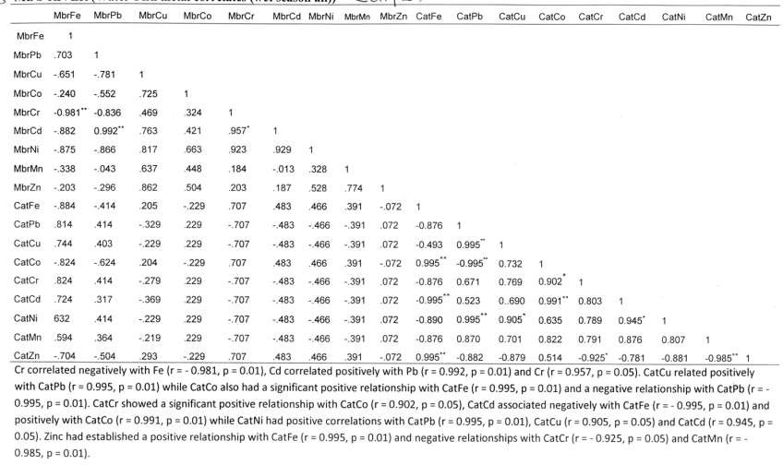

Appendix 2: MBO River Water-Croaker Metal correlates (wet season)

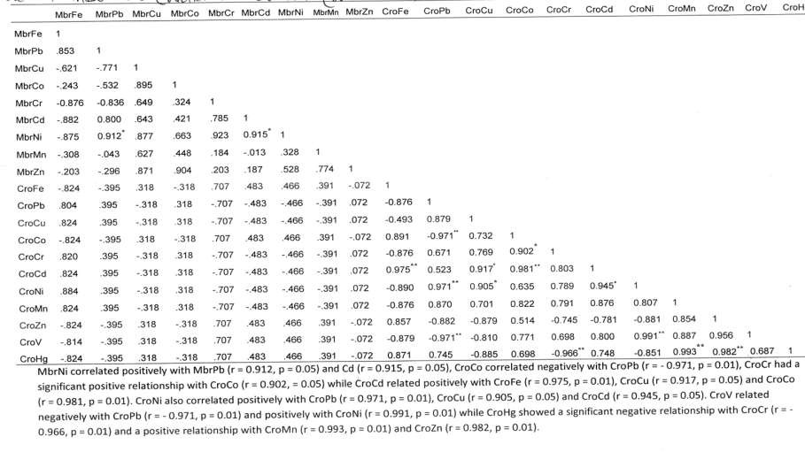

Appendix 3: MBO River Water-*Ilisha africanus* Metal correlates (wet season)

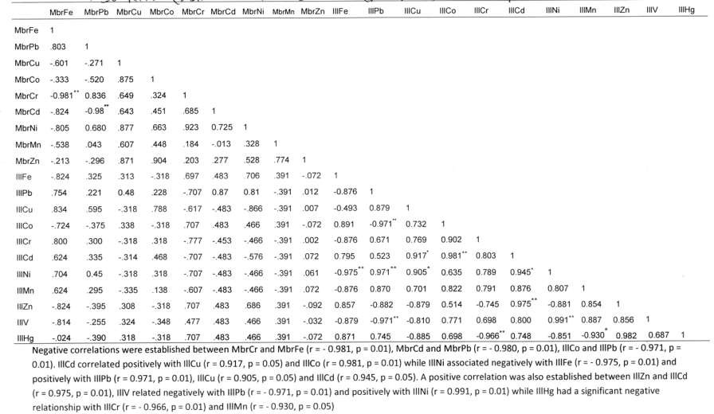

Appendix 4: MBO River Water-Catfish Metal correlates in dry season

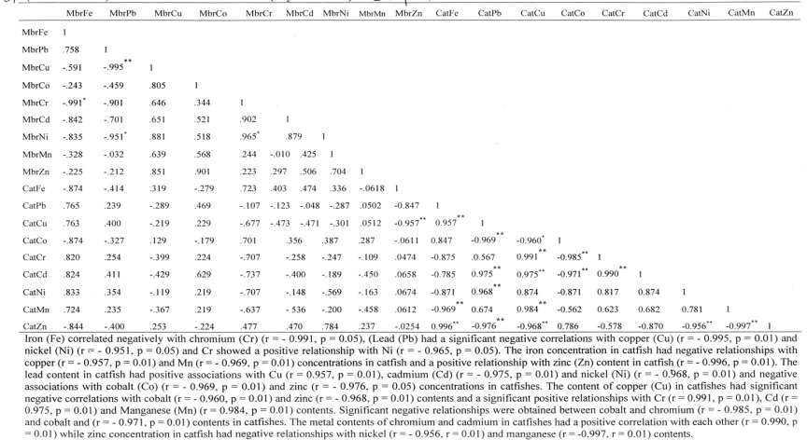

Appendix 5: MBO River Water-Croaker Metal correlates in dry season

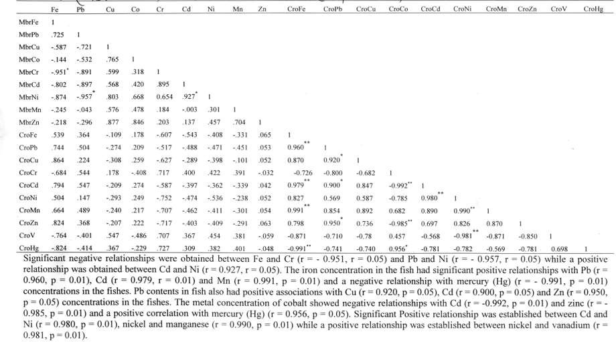

Appendix 6: MBO River Water-*Ilisha africanus* Metal correlates in dry season

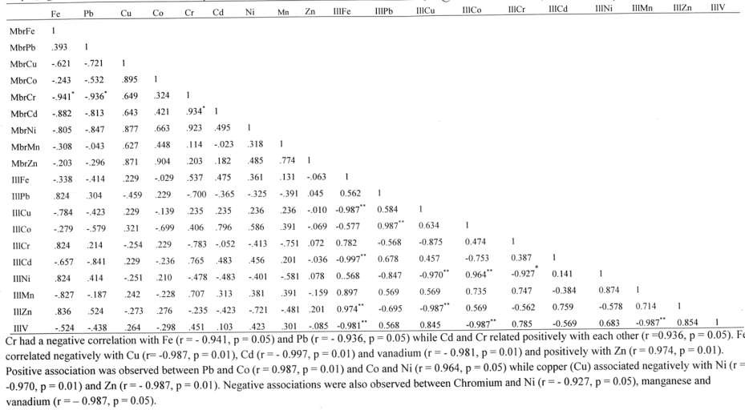

Appendix 7: Ibaka river water-Catfish Metal correlates ion wet season

|  |  |  |  |  |  |  |  |  |  |  |  |  |  |  |  |  |  |  |  |  |  |  |  |  |  |
| --- | --- | --- | --- | --- | --- | --- | --- | --- | --- | --- | --- | --- | --- | --- | --- | --- | --- | --- | --- | --- | --- | --- | --- | --- | --- |
| IbaFe | | IbaPb | IbaCu | ibaCo | IbaCr | ibadd | IbaNi | IbaMn | IbaZn | CatFe | CatPb | CatCu | CatCo | | CatCr | | CatCd | | CatNi | | CatMn | CatZn | | CatV | CatHg |
| IbaFe  IbaPb .813 | | I |  |  |  |  |  |  |  |  |  |  |  | |  | |  | |  | |  |  | |  |  |
| IbaCu -.611 | | -.371 | 1 |  |  |  |  |  |  | *'* |  |  |  | |  | |  | |  | |  |  | |  |  |
| IbaCo -.570 | | -.460 | .805 | 1 |  |  |  |  |  |  |  |  |  | |  | |  | |  | |  |  | |  |  |
| IbaCr -0.911* | | 0.836 | .609 | M24 | 1 |  |  |  |  |  |  |  |  | |  | |  | |  | |  |  | |  |  |
| IbaCd -.884 | | -0.98** | .663 | .441 | .605 |  |  |  |  |  |  |  |  | |  | |  | |  | |  |  | |  |  |
| IbaNi -.721 | | 0.770 | .877 | .613 | .783 | 0.725 |  |  |  | - |  |  |  | |  | |  | |  | |  |  | |  |  |
| IbaMn -.548 | | .047 | .670 | .448 | .184 | -.013 | .328 | 1 |  |  |  |  |  | |  | |  | |  | |  |  | |  |  |
| IbaZn -.219 | | -.206 | .873 | .904 | .203 | .277 | .528 | .774 | ; |  |  |  |  | |  | |  | |  | |  |  | |  |  |
| CatFe -.744 | | .325 | .313 | -.318 | .697 | .483 | .706 | .391 | -.072 | 1 |  |  |  | |  | |  | |  | |  |  | |  |  |
| CatPb .714 | | .225 | 0.48 | .228 | -.707 | 0.87 | 0.81 | -.391 | .012 | -0.876 | 1 |  |  | |  | |  | |  | |  |  | |  |  |
| CatCu | .874 | .595 | -.348 | .788 | -.617 | -.483 | -.866 | -.391 | .007 | -0.493 | 0.879 | 1 |  |  | |  | |  | |  | |  |  |  | |
| CatCo | -.724 | -.375 | .338 | -.318 | .707 | .483 | .466 | ,391 | -.072 | 0.891 | -0.971" | 0.732 | 1 |  | |  | |  | |  | |  |  |  | |
| CatCr | .800 | .395 | -.308 | .318 | *-111* | -.453 | -.466 | -.391 | .002 | -0.876 | 0.671 | 0.769 | 0.902 | 1 | |  | |  | |  | |  |  |  | |
| CatCd | .544 | .335 | -.311 | .468 | -.707 | -.483 | -.576 | -.391 | .072 | 0.795 | 0.523 | 0.917" | 0.981" | 0.803 | | 1 | |  | |  | |  |  |  | |
| CatNi | .704 | 0.45 | -.370 | .318 | -.707 | -.483 | -.466 | -.391 | .061 | -0.975" | 0.971 " | 0.905" | 0.635 | 0.789 | | 0.945" | | 1 | |  | |  |  |  | |
| CatMn | .624 | .295 | -.335 | .138 | -.607 | -.483 | -.466 | -.391 | .072 | -0.876 | 0.870 | 0.701 | 0.822 | 0.791 | | 0.876 | | 0.807 | | 1 | |  |  |  | |
| CatZn | -.884 | -.395 | .308 | -.018 | .707 | .483 | .686 | .391 | -.092 | 0.857 | -0.882 | -0.879 | 0.514 | -0.745 | | 0.975** | | -0.881 | | 0.854 1 | |  |  |  | |
| CatV | -.750 | -.300 | .234 | -.348 | .477 | .483 | .466 | .391 | -.032 | -0.879  * | -0.971" | -0.810 | 0.771 | 0.698 | | 0.800 | | 0.991" | | 0.887 0.856 | | 1 |  |  | |
| CatHg | -.024 | -.395 | .318 | -.318 | .707 | .483 | .466 | .391 | -.072 | 0.871 | 0.745 | -0.885 | 0.698 | -0.966 | | 0.748 | | -0.851 | | -0.930 0.982 | |  | 0.687 | 1 | |

**Negative** correlations were established between IbaCr and IbaFe (r - - 0.911, p - 0.05), IbaCd and IbaPb (r - - **0.98,** p - **0.01),** CatNi and CatFe (r=-0.,915,p=0.,05)

Appendix 8: Ibaka River Water-Catfish Metal correlates in dry season

|  |  |  |  |  |  |  |  |  |  |  |  |  |  |  |  |  |  |  |  |  |  |
| --- | --- | --- | --- | --- | --- | --- | --- | --- | --- | --- | --- | --- | --- | --- | --- | --- | --- | --- | --- | --- | --- |
|  | IbaFe | IbaPb | IbaCu | IbaCo | IbaCr | IbaCd | IbaNi | IbaMn | *V* IbaZn | CaFe | CaPb |  | CaCu | CaCo | | CaCr | | CaCd | CaMn | CaZn | CaV |
| IbaFe | I |  |  |  |  |  |  |  |  |  |  |  |  |  | |  | |  |  |  |  |
| IbaPb | .457 | 1 |  |  |  |  |  |  |  |  |  |  |  |  | |  | |  |  |  |  |
| fbaCu | -.414 | -.997*" | 1 |  |  |  |  |  |  |  |  |  |  |  | |  | |  |  |  |  |
| IbaCo | -.432 | -.451 | .809 | 1 |  |  |  |  |  |  |  |  |  |  | |  | |  |  |  |  |
| IbaCr | -.709 | -.805 | .919 | .689 | 1 |  |  |  |  |  |  |  |  |  | |  | |  |  |  |  |
| IbaCd | .461 | .183 | -.064 | .412 | -.210 | 1 |  |  |  |  |  |  |  |  | |  | |  |  |  |  |
| IbaNi | -.474 | -.422 | .833 | .984* | .611 | .595 | 1 |  |  |  |  |  |  |  | |  | |  |  |  |  |
| IbaMn | .413 | .429 | .000 | .568 | .000 | .786 | .685 | 1 |  |  |  |  |  |  | |  | |  |  |  |  |
| IbaXn | -.871 | -.870 | .028 | .302 | .654 | -.415 | .565 | -.507 | 1 |  |  |  |  |  | |  | |  |  |  |  |
| CaFe | -.461 | -.660 | .621 | .577 | .243 | .396 | .765 | .044 | .453 | 1 |  |  |  |  | |  | |  |  |  |  |
| CaPb | .743 | .458 | -.625 | -.537 | -.152 | -.538 | -.568 | .000 | -.799 | -0.991** | 1 |  |  |  | |  | |  |  |  |  |
| CaCu | .523 | .485 | -.624 | -.577 | -.313 | -.458 | -.690 | .007 | -.816 | 0.685 | 0.810 | 1 |  |  | |  | |  |  |  |  |
| CaCo | -.469 | -.671 | .662 | .427 | .357 | .296 | .477 | .016 | .231 | 0.569 | 0.541 | -0.687 | | 1 | | | | | | | |
|  |  |  |  |  |  |  |  |  | * |  |  |  | |  | | | | | | | |
| CaCr | .361 | .688 | -.625 | -.517 | -.413 | -.479 | -.530 | .560 | -.652  ** | -0.921 | 0.687  * | 0.991** 0.871 | | | | 1 | | | | | |
| CaCd | .471 | .628 | -.724 | -.527 | -.653 | -.368 | -.698 | .000 | -.606  ** | -0.958 | 0.887  ** | 0.902 | | -0.882 | 0.694 | | 1 |  |  | | |
| CaMn | .533 | .610 | -.625 | -.757 | -.570 | -.227 | -.549 | .120 | -.688 | 0.784 | 0.987 | 0.881 | | -0.990 | 0.891 | |  | 0.986 | 1 | | |
|  |  |  |  |  |  |  |  |  | *,* | ** |  |  | |  | * | | |  |  |  |  |
| CaZn | -.302 | -.641 | .605 | .527 | ,693 | .458 | .208 | .000 | .476 | 0.951 | 0.984 | -0.655 | | 0.718 | -0.970 | | | -0.954 | -0.857 | i |  |
| CaV | -.451 | -.678 | .601 | .537 | .482 | .330 | .534 | .110 | .540 | 0.751 | 0.871 | -0.789 | | 0.910* | -0.987** | | | -0.820 | -0.569 | 0.980" | 1 |

Cu had a significant negative relationship with Pb(r = - 0.997, p = 0.01) while a significant positive relationship was observed between nickel (Ni) and cobalt (Co) (r = 0.984, p = 0.05). Fe also correlated negatively with Pb (r = - 0.991, p = 0.01), Cr (r = - 0.921, p = 0.01), Cd (r = - 0.958, p = 0.01) and positively with Zn (r = 0.951, p = 0.05). Mn related positively with Pb (r = 0.987, p = 0.01), Cd (r = 0.986, p = 0.01) and negatively with cobalt (Co) (r = - 0.990, p = 0.01). Copper had a positive relationship with Chromium (r = 0.991, p = 0.01) and cadmium Cd (r = 0.902, p = 0.05). Zinc had a negative significant relationship with Cr (r = - 0.970, p = 0.01) and Cd (r = - 0.954, p = 0.05) while vanadium correlated positively with Co (r = 0.910, p = 0.05) and Zn (r = 0.980, p = 0.01) and negatively with Cr (r = 0.987.0 = 0.01).

Appendix 9: Ibaka river water – Croaker Metal correlates in dry season

|  |  |  |  |  |  |  |  |  |  |  |  |  |  |  |  |  |  |  |  |
| --- | --- | --- | --- | --- | --- | --- | --- | --- | --- | --- | --- | --- | --- | --- | --- | --- | --- | --- | --- |
|  | IbaFe | IbaPb | IbaCu | IbaCo | IbaCr | IbaCd | IbaNi | IbaMn | Iba/n | CrokFe | CrokPb | CrokCu | CrokCr | CrokCd |  | CrokNi | CrokMn | CrokZn | CrokV |
| IbaFe | 1 |  |  |  |  |  |  |  |  |  |  |  |  |  |  |  |  |  |  |
| IbaPb | .817 | 1 |  |  |  |  |  |  |  |  |  |  |  |  |  |  |  |  |  |
| IbaCu | -.851 | -.967** | 1 |  |  |  |  |  |  |  |  |  |  |  |  |  |  |  |  |
| IbaCo | -.572 | -.701 | .807 | 1 |  |  |  |  |  |  |  |  |  |  |  |  |  |  |  |
| IbaCr | -.754 | -.685 | .651 | .720 | 1 |  |  |  |  |  |  |  |  |  |  |  |  |  |  |
| IbaCd | .321 | .207 | -.064 | .414 | -.297 | 1 |  |  |  |  |  |  |  |  |  |  |  |  |  |
|  |  |  |  | * |  |  |  |  |  |  |  |  |  |  |  |  |  |  |  |
| IbaNi | -.474 | -.734 | .821 | .980 | .647 | .495 | 1 |  |  |  |  |  |  |  |  |  |  |  |  |
| IbaMn | .541 | .242 | .000 | .587 | .000 | .816 | .415 | 1 |  |  |  |  |  |  |  |  |  |  |  |
| Iba/n | -.956" | -.800 | .808 | .354 | .654 | -.395 | .450 | 0.698 | 1 |  |  |  |  |  |  |  |  |  |  |
| CrokFe | .225 | .115 | .030 | .324 | .310 | .000 | .140 | .607 | -.435 | 1 |  |  |  |  |  |  |  |  |  |
| CrokPb | .195 | .110 | .090 | .483 | .425 | .000 | .140 | .513 | -.755 | 0.981** | 1 |  |  |  |  |  |  |  |  |
| CrokCu | .214 | .210 | .090 | .372 | .400 | .000 | .140 | .453 | -.405 | 0.978 | 0.912 | 1 |  |  |  |  |  |  |  |
| CrokCr | -.631 | -.718 | .625 | .563 | .220 | .438 | .625 | .010 | .526 | -.257 | -.507 | .427 | 1 |  |  |  |  |  |  |
| CrokCd | -.453 | -.691 | .630 | .500 | .583 | .448 | .605 | .020 | .606 | -.750  ** | -.547  ** | -.627 | 0.968 | 1 |  |  |  |  |  |
| CrokNi | .527 | .358 | -.245 | -.507 | -.303 | 0.407 | -.368 | .000 | -.503 | .569 | .500 | .581 | 0.994 | -0.981 | 1 |  |  |  |  |
| CrokMn | .651 | .645 | -.755 | -.541 | -.265 | -.423 | -.808 | .047 | -.656 | .421 | .473 | .781 | .796 | -0.997** 0.568 | | | 1 | | |
|  |  |  |  |  |  |  |  |  |  | ** |  | * |  |  | | |  | | |
| Crok/.n | .273 | .710 | -.610 | -.563 | -.2.58 | -.454 | -.450 | .096 | -.406 | .500  ** | .507 | .401  ** | -0.985 | -0.611 | 0.951 | | 0.881 | 1 |  |
| CrokV | -.530 | -.528 | .642 | .510 | .212 | .351 | .709 | .000 | .106 | -.527 | .437 | -.537 | 0.871 | 0.852 | -0.993 | | 0.812 | -0.974 | 1 |

Negative correlations were established between Zn and Fe (r = - 0.956, p = 0.05), Cu and Pb (r = - 0.967, p = 0.01) while Ni and Co had positive a correlation with each other (r= 0.980, p = 0.05). Fe correlated positively and significantly with Pb (r = 0.981, p = 0.01) and Cu (r = 0.978, p = 0.05), Pb related positively with Cu (r = 0.912, p = 0.05), Cr had significant positive relationships with Cd (r = 0.968, p = 0.05) and Ni (r = 0.994, p = 0.01) and a negative relationship with Zn (r = 0.985, p = 0.01), Cd had significant negative relationships with Ni (r = - 0.981, p = 0.01) and Mn (r = - 0.997, p = 0.01), Ni associated positively with Zn (r = 0.951, p = 0.05) while vanadium associated negatively with Ni (r--0.993, p = 0.01) and Zn (r = - 0.974, p = 0.01)

Appendix 10: Ibaka River Water-Coaker Metal correlates io dry season

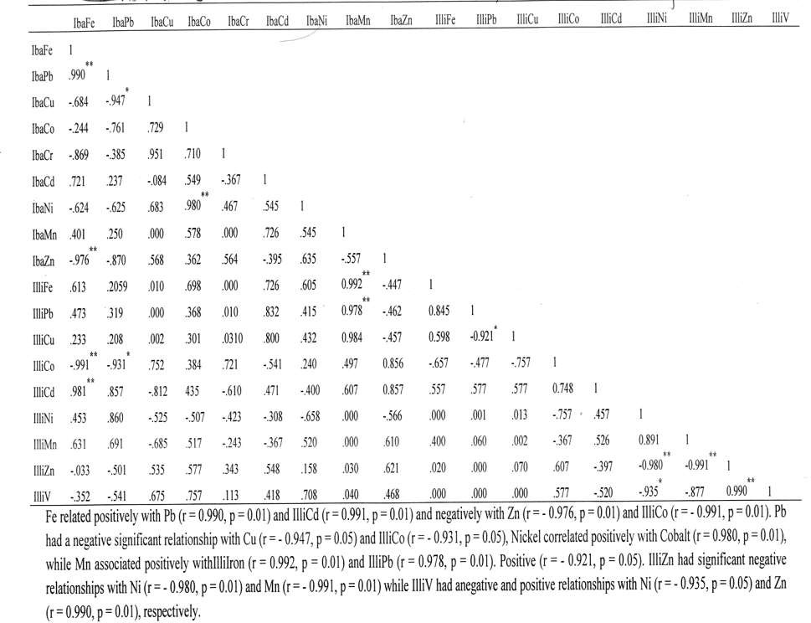

Appendix 11: Asana Ikang river water-catfish metal correlates in wet season

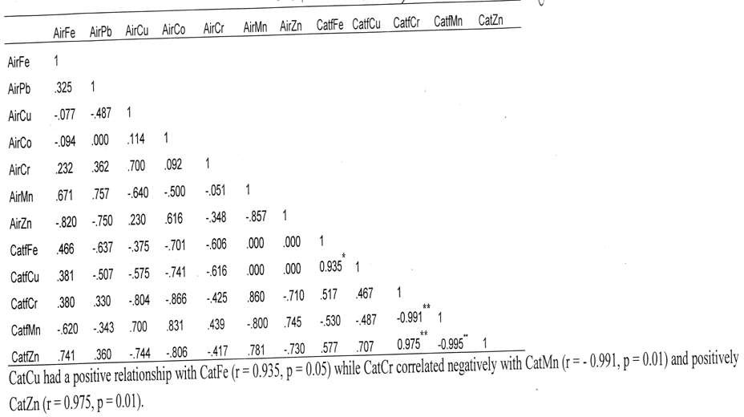

Appendix 12: Asana Ikang river water-croaker metal correlates in dry season

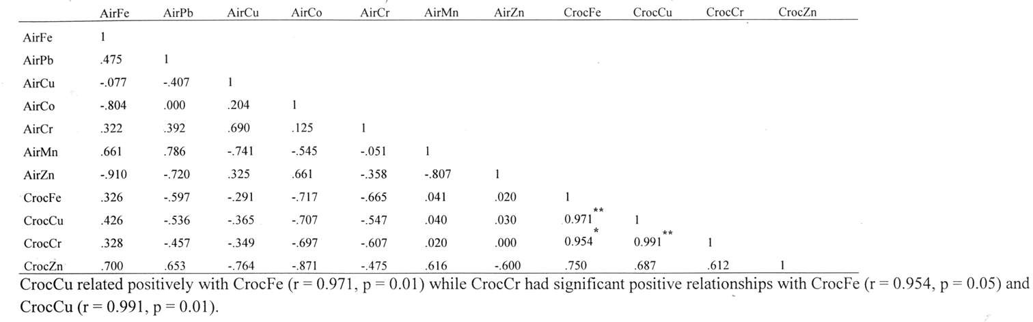

Appendix 13: Asana Ikang river water-*Ilisha africanus* metal correlates in dry season

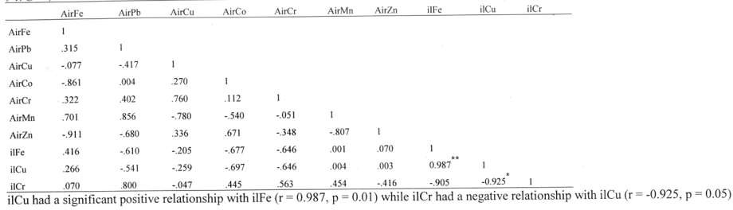

Appendix 14: Asana Ikang river water-catfish metal correlates in wet season

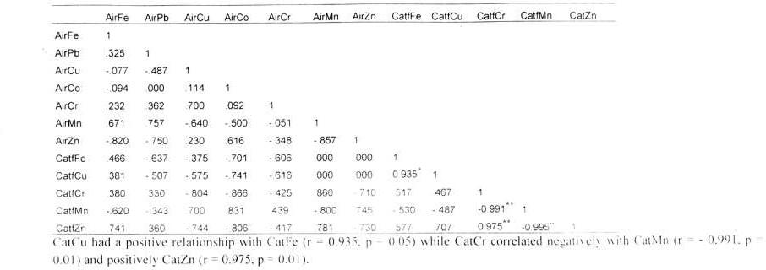

Appendix 15: Asana Ikang river water-croaker metal correlates in dry season

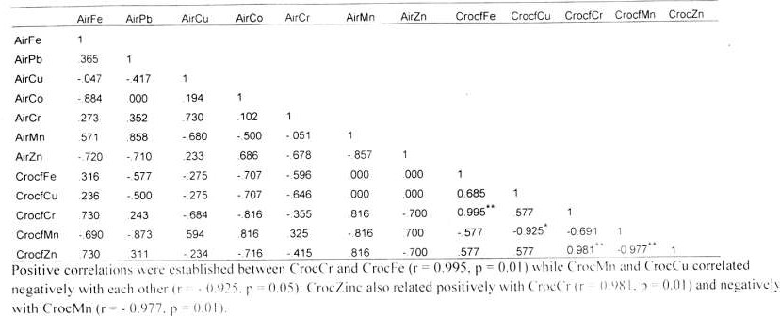

Appendix 16: Asana Ikang river water-*Ilisha africanus* metal correlates in wet season

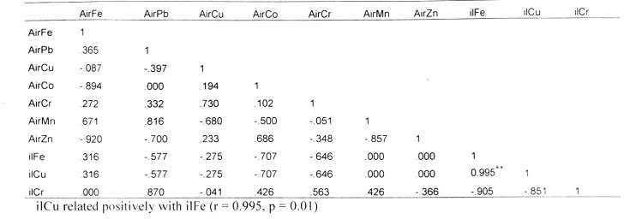

Appendix 17: Mbo River (Sediment – Catfish metal correlates (wet season)

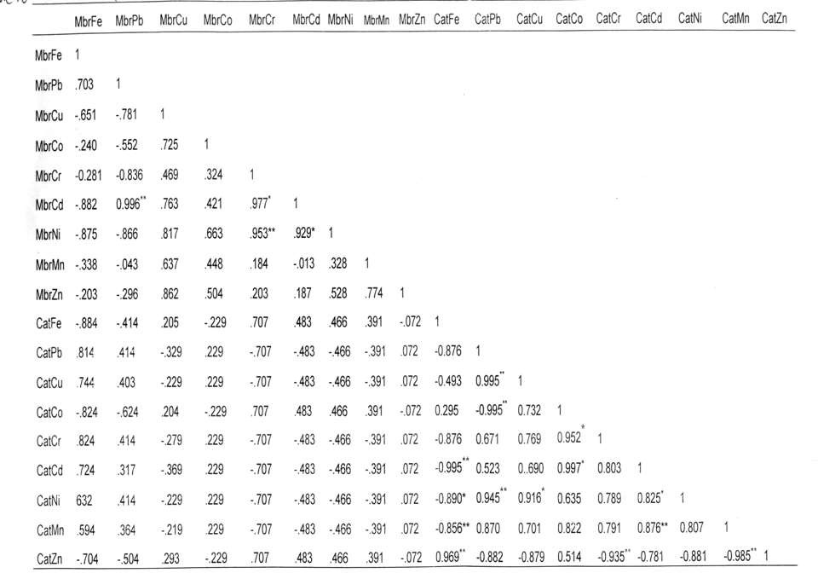

Appendix 18: Mbo River (Sediment – Croaker metal correlates (wet season)

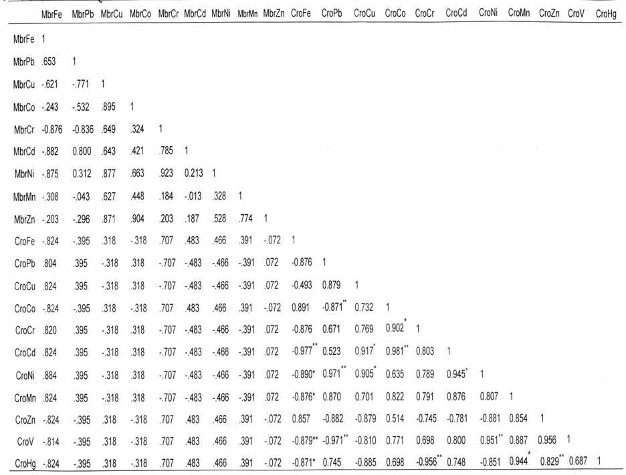

Appendix 19: Mbo River (Sediment – *Ilisha africanus* metal correlates (wet season)

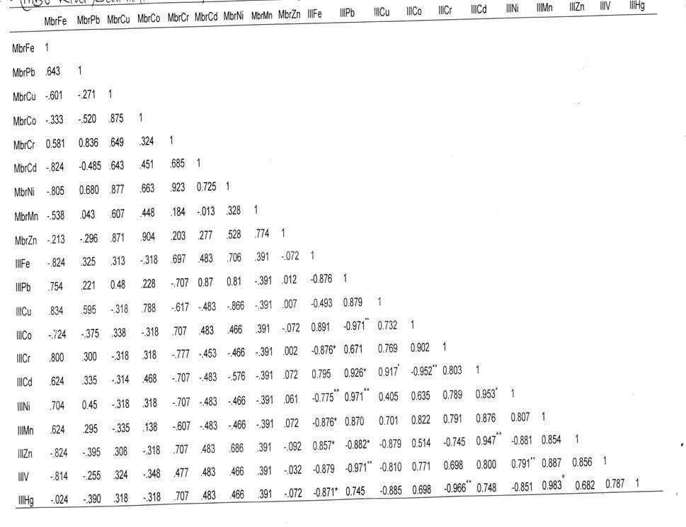

Appendix 20: Mbo River (Sediment – Catfish metal correlates (dry season all)

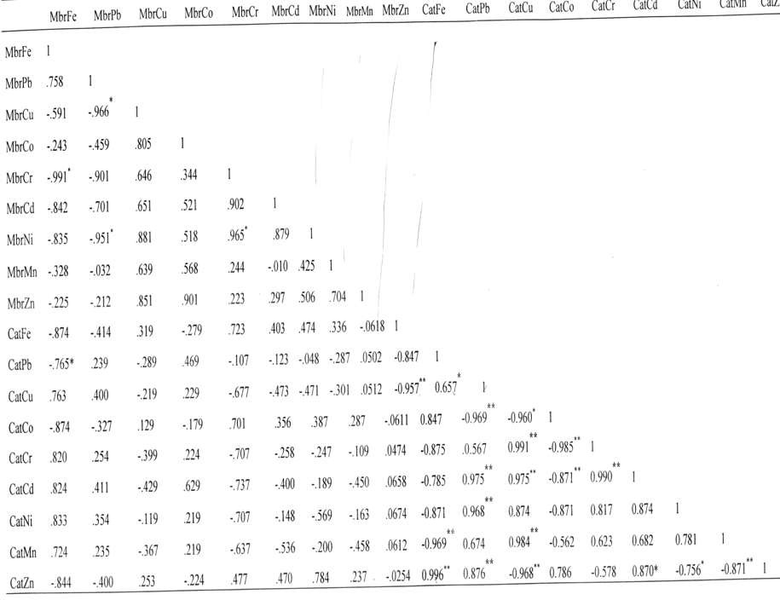

Appendix 22: Mbo River (Sediment – Croaker metal correlates (dry season)

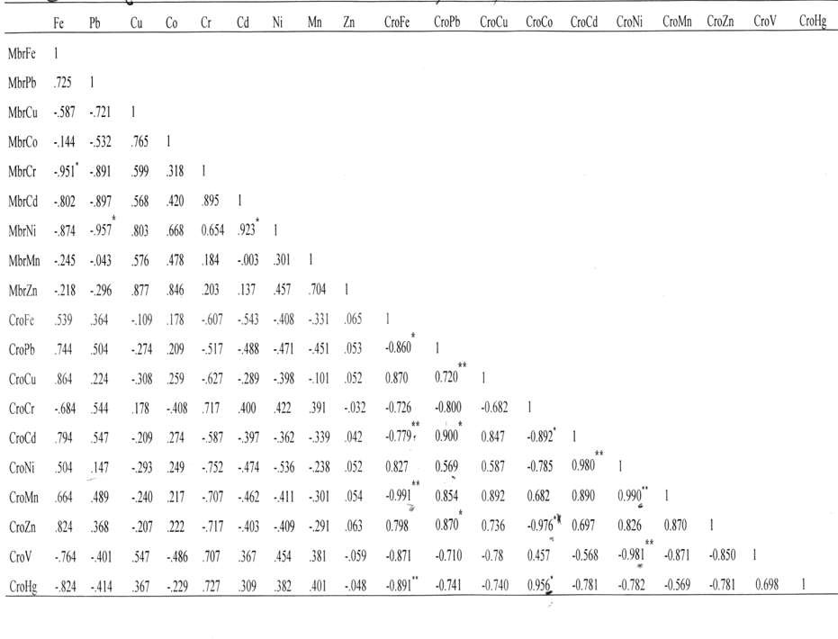

Appendix 22: Mbo River (Sediment – *Ilisha africanus* metal correlates (dry season)

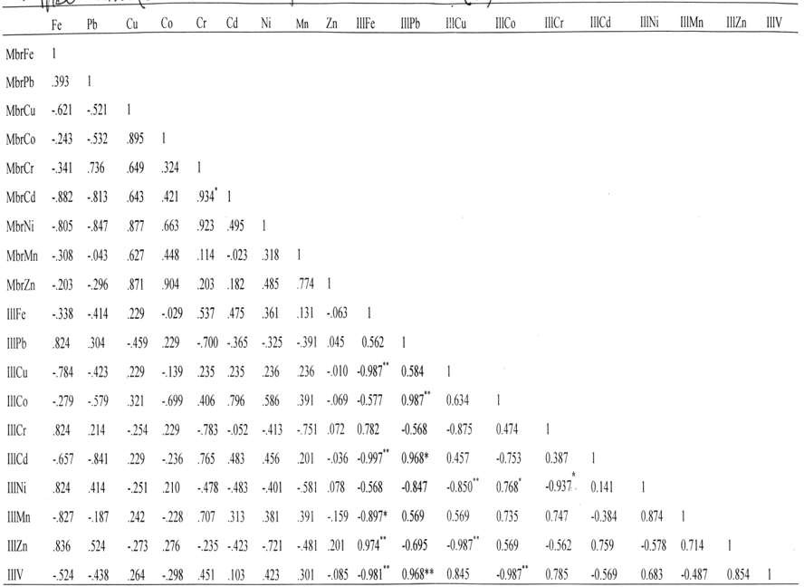

Appendix 23: Ibaka River (Wet Season) -Sediment – Catfish metal correlates

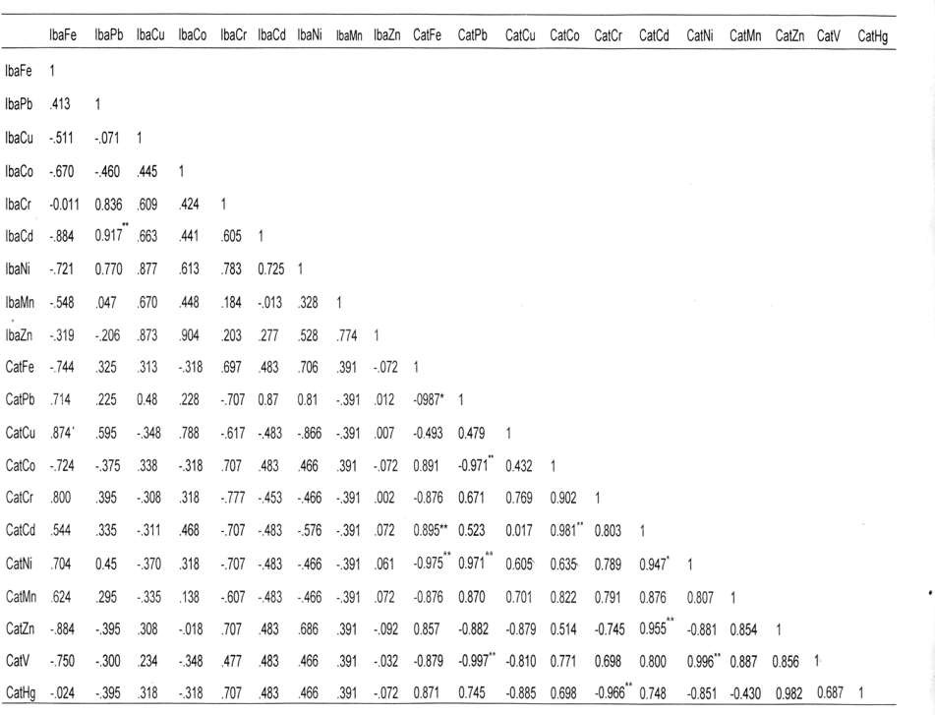

Appendix 24: Ibaka River -Sediment – Croaker metal correlates (Wet Season)

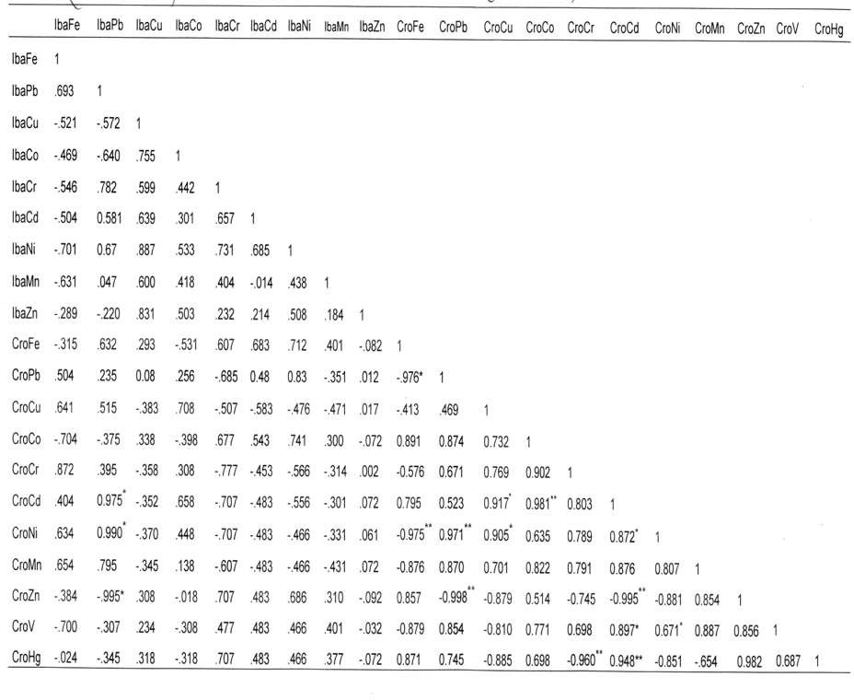

Appendix 25: Ibaka River -Sediment *Ilisha africanus* metal correlates (Wet Season)

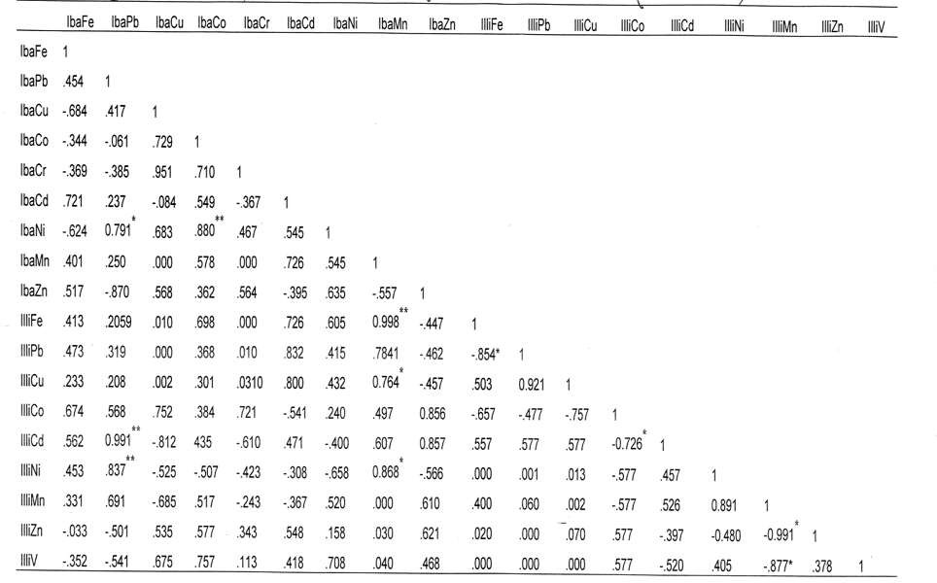

Appendix 26: Ibaka River (Dry Season)Sediment-Catfish metal correlates

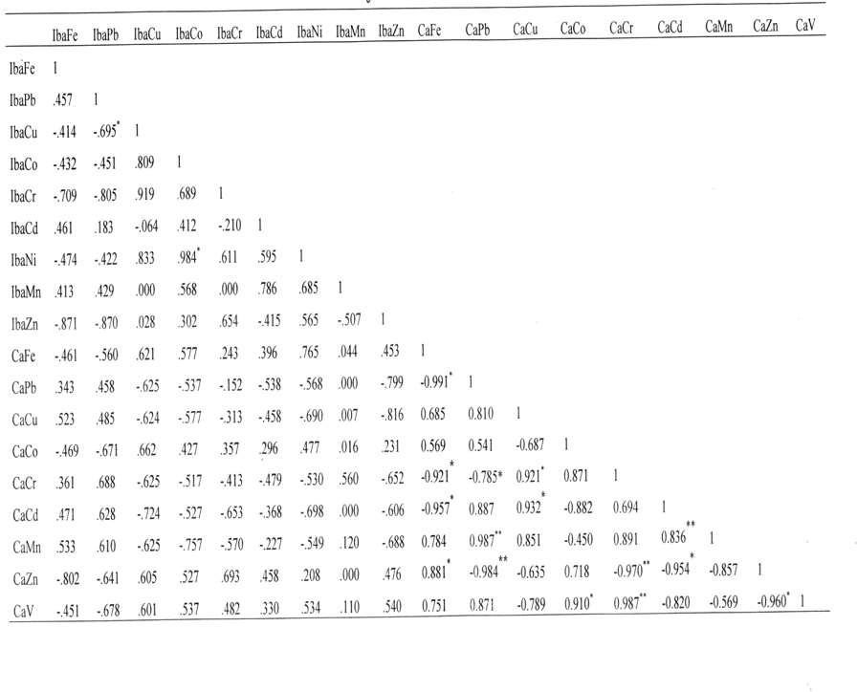

Appendix 27: Ibaka River Sediment- Croack metal correlates (dry season)

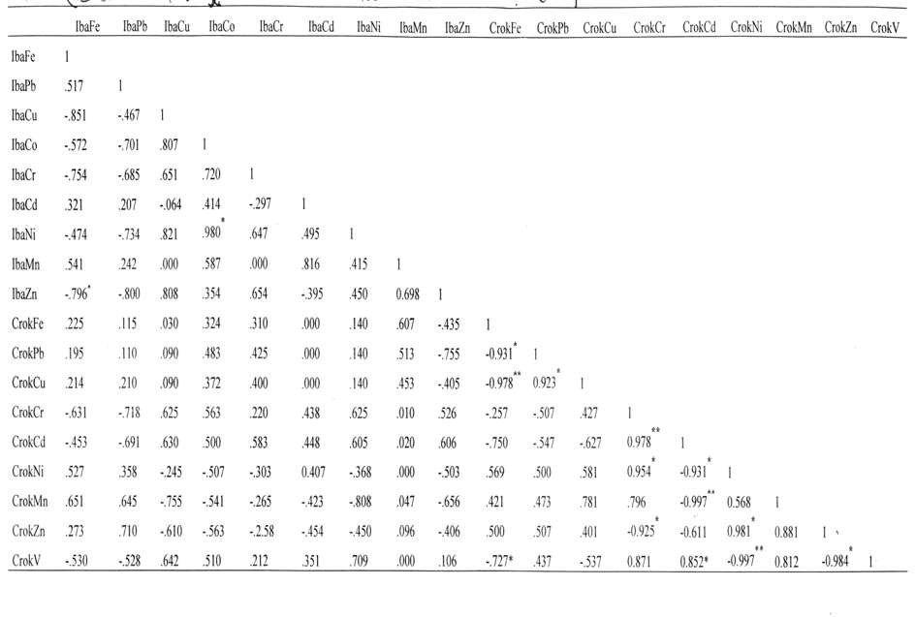

Appendix 28: Ibaka River Sediment- *Ilisha africanus* metal correlates (dry season)

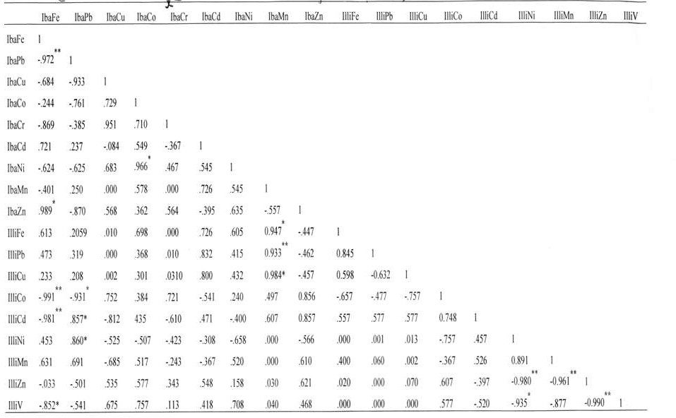

Appendix 29: Asana Ikang (Wet Season) Sediment- Catfish metal correlates

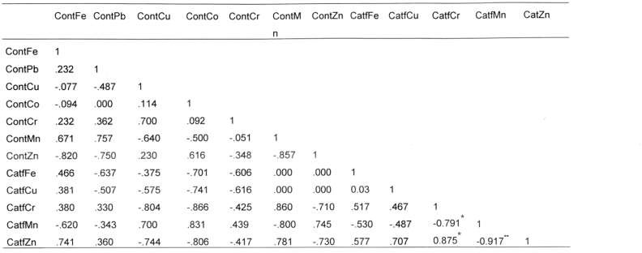

Appendix 30: Asana Ikang (Wet Season) Sediment- Croaker metal correlates

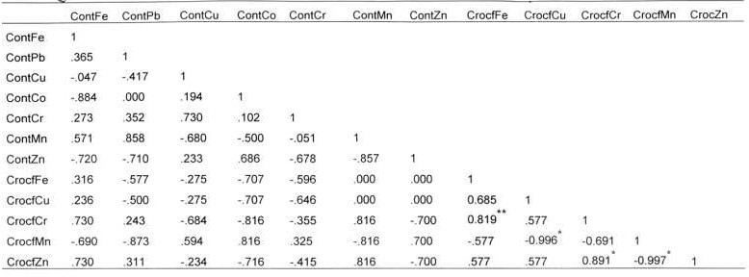

Appendix 31: Asana Ikang (Wet Season) Sediment- *Illisha africanus* metal correlates

