## ASSESSMENT OF PASSIVE SECURITY MEASURES IN THE DESIGN OF A HOTEL IN MINNA, NIGER STATE

**BY**

**IKANI, Victor Ugbede MTech/SET/2017/7457**

**THESIS SUBMITTED TO THE POSTGRADUATE SCHOOL, FEDERAL UNIVERSITY OF TECHNOLOGY MINNA, NIGERIA IN PARTIAL FULFILMENT OD THE REQUIREMENTS FOR THE AWARD OF THE DEGREE OF MASTER OF TECHNOLOGY (MTech) IN ARCHITECTURE**

## APRIL, 2021

## ABSTRACT

Security and safety are important factors to be considered in every design. This has in recent times become an issue of concern especially in Northern Nigeria. This research sought to assess the effectiveness of the security measures employed in hotel designs by identifying available passive security features within existing hotel layouts and proposing a design that employs these measures in addition to others discovered in literature. The study adopts the principles of crime prevention strategies through environmental design (CPTED), physical security design and layered approach to security for its assessment. A descriptive survey method was adopted for the research and data was collected by observation guided by a well-structured observation schedule as well as a questionnaire administered to determine the nature of security threats faced in hotel facilities. Data obtained was documented and analysed using Microsoft excel package. The results revealed that there was a heavy reliance on active means to secure hotel premises within the study area. Architectural design elements were not fully utilized as a means to deter offenders and potential threats from the hotel facilities, this makes the building susceptible to security risks. Recommendations were made suggesting techniques through which the understudied passive security elements can be implemented in design while stressing the need for passive security considerations in the design phase of every construction work.

# TABLE OF CONTENTS

### Content Page

Title Page i

Declaration ii

Certification iii

Dedication iv

Acknowledgements v

Abstract vi

Table of Contents vii

List of Tables xi

List of Figures xii

List of Plates xiii

List of Appendices xiv

CHAPTER ONE

* 1. INTRODUCTION 1
  2. Background to Study 1
  3. Statement of Research Problem 1
  4. Aim and Objectives 2
     1. Aim 2
     2. Objectives 2
  5. Scope and Limitation 2
  6. Justification 3
  7. Contribution to Knowledge 3
  8. Study Area 4

CHAPTER TWO

* 1. LITERATURE REVIEW 5
  2. History of Hotels 5
  3. Hotel Classification Criteria 6
     1. Classification by location 7
     2. Classification by length of guest stay 8
     3. Classification by facilities offered 8
     4. Star rating of hotels in Nigeria 9
  4. Concept of CPTED (Crime Protection through Environmental Design) 10
     1. Natural surveillance 10
     2. Natural access control 11
     3. Territorial reinforcement in buildings 11
     4. Target hardening 12
  5. Physical Security Design 13
     1. Principles of physical security design 13
     2. Layered approach to security in design 14
  6. Passive Security 16
     1. Passive security measures 16
     2. The concept of stand-off distance 17
  7. Active Security Measures in Buildings 17
     1. External areas 18

CHAPTER THREE

* 1. RESEARCH METHODOLOGY 21
  2. Data Sources 21
  3. Instrument for Data Collection 22
  4. Sampling Technique 22
  5. Method of Data Presentation 22

CHAPTER FOUR

* 1. DATA PRESENTATION AND DISCUSSION 23
  2. Assessment of Various Passive Security Design Measures 23
     1. Stand-off distance 23
     2. Hardened landscape elements 24
     3. Passive access control features 25
     4. Features that define site’s boundaries 26
     5. Sill height for windows 27
     6. Height of Kerbs 28
     7. Number of entry points to the site 29
     8. Material for glazing 30
     9. Lighting fixtures on site 31
  3. Design Consideration and Planning Principles 32
     1. Conceptual analysis 32
     2. Construction system 33
     3. Materials and finishes 33
     4. Landscape and external works 34
     5. Building services 34
     6. Maintenance 34

CHAPTER FIVE

* 1. CONCLUSION AND RECOMMENDATION 35
  2. Conclusion 35
  3. Recommendations 36

REFERENCES 38

APPENDICES 42

|  |  |  |
| --- | --- | --- |
|  | **LIST OF TABLES** |  |
| **Table**  3.1 | List of Sampled Hotels in Minna, Niger State | **Page**  22 |
| 4.1 | Standoff distance observed by the Hotels | 23 |
| 4.2 | Passive access control measures employed by the Hotels | 25 |
| 4.3 | Nature of site boundaries at the Hotels | 26 |
| 4.4 | Nature of material used for glazing | 30 |
| 4.5 | Lighting within the hotel premises | 31 |

# LIST OF FIGURES

### Figure Page

* 1. Map of Niger State with the shaded portion indicating the location

of Minna 4

* 1. (a) and (b) Buildings used to define territories 12
  2. The different layers of protection 14
  3. An illustration of stand-off zone, clear zone and uncontrolled area 17
  4. Active vehicular barriers at the entrance to a facility 18
  5. Different types of perimeter fencing 19
  6. A typical loading dock 20
  7. Percentage distribution of the various sill heights observed by the Hotels 27
  8. Percentage distribution of heights observed for kerbs 29

|  |  |  |
| --- | --- | --- |
| LIST | OF PLATES |  |
| **Plate**  I | Stand-off observed at hydro hotel, Minna | **Page**  24 |
| II | Hardened landscape elements as seen at Shiroro Hotel, Minna | 24 |
| III | Passive access control elements at Azhara lodge, Minna | 25 |
| IV | Low fence and railings at Hydro hotel, Minna | 26 |
| V | 1500mm sill height observed at Haske hotel, Minna | 28 |
| VI | 100mm height observed for kerbs at NSDC Suites, Minna | 29 |
| VII | A gated entrance leading to Azhara lodge, Minna | 30 |
| VIII | Translucent glazing material used at Hydro Hotel, Minna | 31 |
| IX | Light fixtures at Azhara lodge, Minna at night | 32 |

|  |  |
| --- | --- |
| LIST OF APPENDICES |  |
| **Appendix** | **Page** |
| A Sample of Questionnaire | 72 |
| B Sample of Observation Schedule | 73 |
| C Site Plan | 46 |
| D Ground Floor Plan | 47 |
| E First Floor Plan | 48 |
| F Second Floor Plan | 49 |
| G Third Floor Plan | 50 |
| H Fourth Floor Plan | 51 |
| I Fifth Floor Plan | 52 |
| J Roof Plan | 53 |
| K Sections | 54 |
| L Sections | 55 |
| M Elevations | 56 |
| N Elevations | 57 |
| O An exterior 3D view of the main building | 58 |
| P An exterior 3D view of the main building | 59 |
| Q An aerial view of the facility showing bumps, concrete seats and bollards | 60 |
| R View showing kerb placement on site | 61 |
| S View showing speed bumps and bollards placed on site | 62 |
| T View showing concrete seats along the sporting facility on site | 63 |

## CHAPTER ONE

## INTRODUCTION

### Background to Study

The hospitality industry plays a vital role in the development and growth of any economy. It provides services which are necessary in sustaining this growth and include (but not limited to) restaurant and hotel accommodation. Often regarded as a “home away from home” (Chauchan *et al*., 2018), a hotel is a commercial establishment which provides paid lodging usually on a short term basis. It offers facilities ranging from a small room with shared bathrooms to large ensuite rooms sometimes with a lounge and dressing area and some cases, a kitchen or kitchenette.

Safety and security are crucial in selecting a location for temporary lodging (Achumba *et al*., 2013). It is human nature to place security above all else especially when such a service is paid for. Security itself is coined from the Latin word ‘securus’ meaning ‘safe’. It refers to measures taken in protecting a place and ensuring only authorized personnel gain access to it. Although a building’s aesthetic appeal plays an important role in attracting tourist and the public to it, security concerns come second only to food and shelter in the scale of man’s basic needs (Aynifar, 2002). Passive security comprises measures which prevent the loss of lives and property (Zarepoor *et al.*, 2011). These measures when correctly and adequately employed enhance the safety of the users of the facility and a corresponding boost in the productivity of the staff.

### Statement of Research Problem

Public buildings have been observed to come under a lot of attack recently. Buildings whose functions range from administrative to commercial, institutional to religious have been known to have experienced one form of attack or another across Nigeria. The

nature of hotel establishments makes them susceptible to various forms of threats as visitors are allowed access to its vicinity at all times. Active security fixtures which are in most cases mechanical, are not always reliable and most often incur extra cost as they are only procured and installed upon completion of all construction works. Passive security measures provide cheaper and more dependable solutions to these issues. It is for this reason that this study focuses on the provision of passive security measures in hotel designs.

### Aim and Objectives

### Aim

The research seeks to assess passive security measures in the design of hotels with a view to propose a design that ensures the safety and security of hotel users.

### Objectives

The objectives of this research work is to:

* + - 1. Examine the security challenges within hotel facilities in Minna.
      2. Identify passive design considerations that can be adopted in hotel layouts to reduce security challenges.
      3. Assess the application of these passive security design considerations in hotel layouts.
      4. Propose a design for a hotel in Minna that employs passive security elements.

### Scope and Limitation

Passive security can be further categorized into two that is passive security features within the structure and on-site passive security features. This thesis will cover the use of passive design measures to provide maximum security within the site and within the structure. This will be achieved by ensuring the number of perimeter and building

openings are minimized, Planning perimeter protection at the design stage, avoiding the use of low sill heights for windows on lower floors, Providing protection for points of possible access or escape that breach the exterior of the building.

The security situation across the nation will be a limitation to this work. People have grown to be conscious of their safety at all times. As such, getting feedback on security related issues and gaining access to study certain areas of hotel facilities might be a herculean task

### Justification

In recent times, security has become an issue of concern within the country. Attacks have been observed to occur in facilities with functions ranging from administrative to religious as well as commercial establishments. Explosions at the famous Banex shopping plaza in the commercial axis of Wuse in Abuja, suicide bomb attacks at St. Theresa’s Catholic Church at Madalla in Niger State and most recently, terrorist attacks in schools within the North eastern region are a few of such acts of terrorism within the country (Human Rights Watch, 2019). A common feature in buildings that have been attacked in the past is the fact that they attract a lot of traffic; a hotel facility is no exception. Hence the need to design putting the security and safety of users into consideration.

### Contribution to knowledge

It is hoped that findings from this research work and the design to be developed will serve as a prototype and guide for designers and other professionals in the built environment on measures which can be taken through design to ensure the safety and security of the staff and users of a facility.

### Study Area

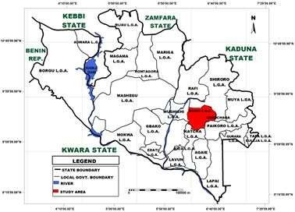

**Figure 1.1: Map of Niger State with the shaded portion indicating the location of Minna**

**(Source: New Nigerian Newspaper, 2018)**

Located in the north central area of Nigeria, Minna, the capital city of Niger state is home to the Nupe and Gbagyi ethnic groups. With an estimated population of 304,113 (National Population Commission, 2007), the city boasts of educational institutions, privately owned establishments, banking institutions and government agencies. Tourist attractions within the state include the kainji national park, Kainji Lake, borgu game reserve, zugurma game reserve, gurara waterfalls and lord lugard colonial ruins. It is bounded by kebbi and Zamfara states to the north, Kaduna to the north and north east, Kogi to the southeast, Kwara to the south and the Abuja to the east. These and more sees people troop into the state on a daily basis.

## CHAPTER TWO

## LITERATURE REVIEW

### History of Hotels

Facilities offering guests hospitality have existed even during biblical times (Levy, 2003). The history of hotels can be linked to that of various civilizations. The early hotels were small family businesses which offered beds and boards and lacked most of the luxuries that can be observed in modern hotels. The Greeks were known to have developed thermal baths in villages which served both for relaxation and recuperation for those recovering from certain illnesses. The romans erected mansions which provided temporary accommodation to travelers on government trips. Over the next couple of years, hostelries sprung up which comprised of a reception and public rooms in front, covered arcades where guests dined and partook of other social activities (Lane, 2018). Food was prepared at the rear of the building while the proprietor alongside a few assistants welcomed guests at the front desk. This was the point where the necessary arrangements were made for guest’s food and lodging.

The upper class was however not lodged in these hostelries as provision was usually made for their accommodation with fellow upper class individuals. The romans were the first to build thermal baths in Switzerland, England and parts of the middle east. These were later replaced by caravanserais which provided resting places for caravans that plied Middle Eastern routes. Monasteries and abbeys run by religious orders sprung up in the Middle Ages and offered refuge to travelers. The monasteries and abbeys were later replaced by the inns of medieval Europe. In addition to providing temporary accommodation to travelers, provision was also made for food, stable and fodder for the horses ridden by some travelers.

The layout of an inn comprised an inner court with bedrooms positioned on both sides, a kitchen and waiting area at the front while the stables were usually located at the back (Duensing, 2014). In the mid-17th century, coaching inns were developed to provide lodging for travelers by coach. The end of the industrial revolution in England saw a boost in the inn-keeping business with the invention of steam powered ships and rail transportation which made travelling easier. This eventually led to Europe taking the lead in the hotel business. The 19th century saw a rapid rise in the popularity of hotels especially in America where for many Americans, a hotel was home (Bowie, 2018). They were often times residents of urban hotels and not just travelers passing by. The comfort it offered, the ease with which relocation became, paid helps available at their beck and call were some contributing factors to the popularity of hotel accommodation amongst Americans. Various terms have been used to describe temporary accommodation.

In England, “inn” was used to describe first establishments and “taverns” were for less sophisticated lodges. In France, “hotellerie” and “caberet” were used to describe first establishments and less sophisticated lodges respectively. Hostel, a term coined from the word “host” was used at some point in the early stage of hotel development “hotel” was first used to describe paid accommodation in England in 1760 while paid lodges in America were referred to as “inns” or “coffee house” (O’Gorman and Kevin, 2010). The city hotel in New York was the first building erected to serve solely as a hotel.

### Hotel Classification Criteria

A hotel can be classified using its location, the length of guest stay, the types of facilities offered and the size of the hotel (Shantimani, 2010).

### Classification by location

**City hotel;** A city hotel is situated in the city centre within a short distance from theatres, malls, and super markets. Guests are usually businessmen on business trips for 1 or 2 days. These hotels reflect the ambiance and character of the cities in which they are located (Kosar, 2014).

**Suburban hotel:** These are located in suburban areas away from the busy city often in a serene environment. Guests mostly comprise of the elderly whose stay is for about a month or more. Staff members also consist mostly of old-aged individuals. Suburban hotels make provision for kitchenette and similar facilities (Ryan, 2006).

**Resort hotels:** Resort hotels are located near a beach, wild life park or pilgrimage site. Guests to such facilities are generally holiday makers whose stay extends from a week to perhaps two and visit with the sole intention of enjoying the serenity the resort hotel offers. Resort hotels are usually spread across a large expanse and often make provision for recreational activities (Faizan *et al.,* 2013).

**Motels:** Motels are believed to have originated from the United States. With the industrial revolution and the invention of motor vehicles, there was a consequent increase in traffic. Congestion on high ways was inevitable with no parking spaces in sight. Motels sprung up to cater for the needs of motorists with the intention to pass the night and continue their journeys the next day. As such, they were located along highways and offered ample parking spaces within their premise (Indian Ministry Of Tourism, 2018). Motels do not provide room service, as guests only stay with the intention of passing a night.

**Floatel:** These are hotels which suspend on a water body or sea. In some cases, they serve as accommodation for crews working for drilling industries and are referred to as

“floatels” coined from the words “floating” and “hotel” (Sharda, 2016). They are stationery in nature with no permanent connection to the surrounding main land. A typical example of a floatel is the [Aswan Oberoi of the Nile, in Egypt](http://www.oberoihotels.com/oberoi_zahra/travel_guide/directions.asp).

**Boatel:** Boatels are hotels on a moving boat usually found on lakes and rivers. These facilities are often used to organise business and conference tours, congress cruises and educational tours (Kim and Loksha, 2014). Typical examples of such facilities include the Botel Golf Yacht in Prague, Czech Republic and the [Shikara on Dal Lake in](http://www.kashmirhouseboats.com/shikara-rides-dal-lake.html) [Kashmir.](http://www.kashmirhouseboats.com/shikara-rides-dal-lake.html)

### Classification by length of guest stay

Hotels can be classified on the basis of length of stay into two. These are transient hotels and residential hotels. When people settle permanently or sojourn on open ended stays or regularly cycle through because the management of certain hotels allow such, this in a way becomes their place of abode hence the term “Residential hotel” is used to describe such a situation (Leslie, 2006). A hotel where guests check in only for a few days or less is referred to as a *"*[Transient Hotel](http://maps.google.com/maps?ll=53.5855555556%2C-113.442666667&spn=0.01%2C0.01&q=53.5855555556%2C-113.442666667%20(Transit%20Hotel)&t=h)*".* Most transient hotels incorporate features of both Transient and Residential Hotels in their operations*.*

### Classification by facilities offered

Hotel classification by facilities provided involves the ranking of hotels using nomenclature such as stars (or diamonds), with one star denoting basic facilities and standards of comfort and five stars denoting luxury in facilities and services (World Tourism Organization, 2015). The purpose is to inform intending guests in advance on what can be expected in order to reduce the gap between expected and experienced facilities and service delivery. The terms ‘grading’, ‘rating’, ‘classification’ and ‘star rating’ are used to rank hotels by their facilities and standards. Although there is no

globally accepted bench mark for the grading, rating and classification of these hotels and similar hospitality establishments, large hotel chains and associations in various countries establish globally recognized guides which are only implemented within the hotel chain in each of these countries (Oserogho, 2015).

The star rating is used by hotels in Nigeria; hotels of the same star rating often differ in standard from one country to another. A four star hotel in Nigeria might be regarded as a 3 star hotel in the U.K. it therefore becomes necessary to specify the location where such rating is being referred (Jane, 2014).

### Star rating of hotels in Nigeria

A hotel can be rated on a 5-star scale depending on the facilities it offers (Ikenwa, 2019). The classifications include;

Five Star Hotel; Common features of a five star hotel besides its high room rates include the presence of outdoor and indoor pools, 24 hour room service, amazing views from its balconies as well as internet access. Examples of 5 star hotels in Nigeria include international hotel chains such as Transcorp Hilton, Starwood and intercontinental hotels in Abuja.

Four Star Hotel; four star hotels are often owned and run by the local hotel industry. Room rates are significantly lower than the five star hotels but they offer similar standard of luxury. The best hotels in Nigeria from the 4 star category can compete favourably well with 3 star hotels in developed countries.

Three Star Hotel; three star hotels offer exceptionally low prices and are specifically targeted towards guests looking towards experiencing comfort without breaking the

bank. Its rooms are equipped with air conditioning, television and refrigerator. Three star hotels are the most common within the Nigerian hospitality industry.

Two Star Hotel; A two-star hotel is usually setup to provide comfort. It is clean and provides restaurant services in its layout. Décor and furnishings are moderately enhanced in quality.

One Star Hotel; One-star hotel is described as clean, reliable and comfortable hotels which provide limited services and amenities. They focus on providing value experiences while striving to meet the lodger’s expectations.

### Concept of CPTED (Crime Protection through Environmental Design)

The design of buildings and the arrangement of streets, parks and other outdoor spaces can influence the opportunity for crime within such spaces. Crime Prevention through Environmental Design, CPTED, is based on the idea that the proper design and effective use of the built environment can lead to a reduction in the incidence and fear of crime, and an improvement in the quality of life. In other words, if a site is laid out well, the likelihood of it being targeted for a crime may be reduced (Schneider, 2005). In applying the principles of CPTED, it is necessary to determine the purpose for which a space is intended, how such space is defined and how well such design fits its intended function. There are four underlying principles to the application of crime protection through environmental design (Davey and Wootton, 2016).

### Natural surveillance

Natural surveillance is a conspicuous design concept of the physical environment for crime prevention which facilitates observation of intruders. It can be enhanced through physical design that provides opportunities of watching the environment by residents

and their agents as a part of capable guardianship. Inter-visibility is the main component of surveillance, this can be achieved by ensuring clear visibility of a building’s, choice of materials to be used as glazing for windows and clear lines of sight without obstacles (Sefi *et al.,* 2019). By positioning a building and activities in a manner that maximizes natural visibility and observation, Offenders/defaulters are constantly given the impression of being watched thus discouraging the perpetuation of crimes.

### Natural access control

Access control refers to interventions that improve the perimeter security of locations that have been identified as experiencing high levels of malicious damage, such as public transport facilities, high-density housing estates and the areas around licensed premises. Specific strategies can include installing or upgrading physical security (such as installing perimeter fencing or self-closing secure doors) restricting access to an area during certain times, bollards, paved walk ways, and reinforced planters to deny offenders access to targets hence reducing escape opportunities and also serve as guide for legitimate users of a facility (Cozens *et al.,* 2005).

### Territorial reinforcement in buildings

Territoriality is a concept that clearly marks out private spaces thus creating a sense of ownership. It is common knowledge that people have a desire to protect or defend their own space and seek to expose criminals to scrutiny making them feel they are vulnerable to detection (Cozens *et al*., 2005). A symbolic barrier can provide a psychological deterrent to some potential offenders. Territoriality in buildings can be achieved by defining property lines (through the use of fence), employing landscape elements to designate areas which are off limit, designing pathways, gates, or signs to emphasize the differences between spaces. The use of security lighting or security

systems to establish boundaries, ensuring customers walk past a “checkpoint” staffed by a person or camera and mounting display security signage at access points (Sarita, 2011). Figure 2.1 shows an example of buildings used as territorial boundaries.

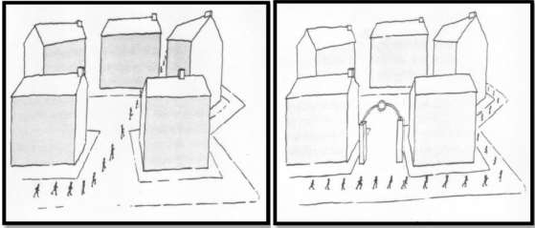

### Figure 2.1: (a) and (b) Buildings used to define territories (Source: Katyal, 2002).

### Target hardening

Target hardening consists of measures taken to make targets more resilient to attacks. The vulnerability of potential targets (buildings) is reduced by ensuring elements capable of slowing down intruders or increasing the chances of such being detected are employed. Walls around a building’s perimeter and burglar bars on windows and similar openings are the most common features adopted in achieving this CPTED strategy. Other features such as bollards, concrete planters and bumps can also be used in achieving target hardening within a building’s vicinity. Target hardening is often the first solution that occurs to residents and designers because it often physically reduces opportunities for crime. However, the common mistake is that while trying to incorporate some of these features, other principles are violated. If target hardening of buildings obstruct lines of sight or provides havens that cannot be surveyed, the hardening is unlikely to be an effective crime prevention tool (Reynald, 2015).

### Physical Security Design

The physical security of facilities requires the use of concentric levels of control and protection to provide progressively enhanced levels of security to deter, prevent, detect, delay, and respond to threats in the protection of assets. The concept of concentric levels of control is to protect the central asset behind layers of security measures such that it is least exposed to the threats. Where a single line of defense might be easily breached, the concentric levels approach offers redundancy in lines of defense that is less likely to be breached (Knoke and Peterson, 2015).

Physical security involves the installation of environmental structures (walls, fences, barbed wires, vehicle barriers and speed bumps) which either prevent or stop an attack from occurring (Elert and associates, 2013). Other physical security measures that can be implemented in design include limiting the number of entrances into the building, directing movement through the building’s design to ensure movement through the various checkpoints provided and reinforcing the building envelope with steel or concrete to ensure it withstands diverse forms of attack.

### Principles of physical security design

Physical security adopts four (4) basic principles which involves the use of layered defense systems and barriers, segregation and minimizing the number of users of a space (Baker, 2012).

Layered Defense System involves setting out multiple defense mechanisms such that if one fails, another will be in place to sustain the line of defense against threats. This reduces drastically the vulnerability of an asset to an attack. Barriers can also be used as a primary defense mechanism against attacks in place of other forms of security control

measures (Clarke, 2009). With a pre-established strength, a good barrier should be capable of preventing attackers from gaining entry into a building.

Segregation entails designing such that if one segment of the building comes under attack, only the attacked segment is affected. Other segments of the building are still able to function without the part that is under attack. The Number of Users can be minimized **by** Reducing the number of people with access to the building because the more the number of people who can access the building, the higher the risk of the building coming under attack (Fennelly and Perry, 2016).

### Layered approach to security in design

A successful security approach is one which is most effective upon implementation in multiple geographic layers. There are four layers to the security of a facility (Michael and Jeff, 2012) as shown in figure 2.3.

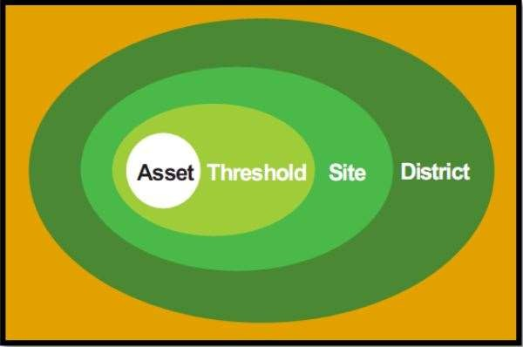

**Figure 2.2: The different layers of protection**

**(Source: Centre for the Protection of National Infrastructure, 2011).**

* + - 1. **District level**

This refers to the outer level protection and as the name implies, is offered at the district level which must include considerations for a wider site planning, access control and traffic management. The asset is best protected when security is implemented on a wider scale (Centre for the Protection of National Institutes, 2011).

### Site level

The site level of protection involves considerations for site planning, traffic management and control of access into the site as well as the physical characteristics of the surrounding area, building types and the nature of activities will be scrutinized as they relate to the security of the facility to be evaluated. Sometimes, these factors have positive security implications and at other times, it might be negative. Through effective site planning, vehicle approach could be directed away from the building to reduce impacts from hostile vehicle approach speeds and also maximize stand-off distances through careful site planning.

### Threshold

This typically describes the last line of defense before the asset, it is the zone that lies immediately around the asset. It must be designed to prevent and, in some cases, control vehicular access and minimize blast effects in the event of an explosive attack (vehicle borne). Factors such as topography and level changes, fences, walls, hedges, bollards could be employed in the building’s landscape design to achieve this. Blast stand-off is also an important consideration at the threshold layer of security.

### Asset

This refers to the interior parts of the building. It includes people (staff and users) as well as physical components i.e. building structures, equipment and other sensitive materials (National Institute of Building Sciences, 2014).

### Passive Security

Passive security in architecture consist of design features which deter threats while remaining largely invisible to users of a facility. Passive security entails designing to ensure privacy, security and protection (Fenelly, 2012). In determining the desired level of security of a building, it is important to consider the value of the asset, identify the possible threats and the facility’s vulnerability to the threats thus identified. Upon evaluation, the basis for the implementation of security measure that meets the desired level of security is established.

### Passive security measures

These define the various means through which passive security design is incorporated into architecture. It essentially entails incorporation of CPTED concepts which cover architecture, lighting and landscape and boost security by deterring potential threats (Smith, 2012).

Some of these measures include, making provision for adequate setbacks and stand-off distances, carefully planning the building’s layout and orientation to minimize the effects of forceful intrusions, employing the use of physical barriers such as bollards, reinforced planters and other site furnishings that can withstand impacts from on- coming threats and positioning parking spaces far away from the main building to minimize blast impacts from potential vehicular borne threats while ensuring basement

parking is discouraged in design. The use of one of the above strategies can be effective but a combination of two or more provides a more reliable solution.

### The concept of stand-off distance

Stand-off is a security measure that focuses on preventing unscreened people and vehicle from approaching a certain distance to the building. Maximum use of stand-off distance ensures that opportunity is created for upgrades in the future to accommodate high levels of protection. Stand-off aims at keeping terrorists as far away from the building as possible (Russ, 2013). Fig 2.3 shows that stand-off refers to the distance from a property line to the main building within the site’s perimeter.

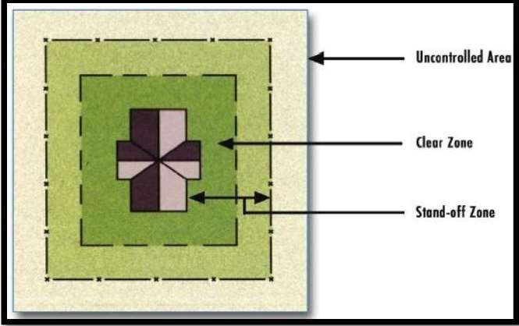

### Figure 2.3: An illustration of stand-off zone, clear zone and uncontrolled area (Source: National Counterterrorism Centre, 2012)

### Active Security Measures in Buildings

Active security measures use systems and technologies designed to prevent, identify, report and respond against threats (Terrence, 2005). This involves the use of security personnel, installation of surveillance systems, motion and smoke detectors as well as sprinklers. Active security measures generally cover access control, security screening

and surveillance. This is seen in the use of security personnel at check points, installation of surveillance systems in public areas of buildings and screening at entrances into public facilities. For security to be effective, a combination of active and passive security measures must be put in place in order to compliment themselves. Examples of active security elements include retractable bollards, boom barriers and hinged or sliding gates.

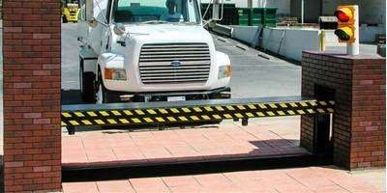

**Figure 2.4: Active vehicular barriers at the entrance to a facility (Source: U.S. Department of the Army, 2010)**

### External areas

* + - 1. **Perimeter Fencing**

Perimeter fencing defines a legal boundary around a site, and should be located as close to boundaries as zoning or existing site constraints allow. Fencing creates a barrier against outside encroachment or intrusion, whether intentional or unintentional (Leskosky, 2009). A security fence defines the outermost boundary of a restricted area thus preventing accidental or casual intruders from gaining access while channeling and controlling the flow of authorized personnel and vehicles through designated entry points into the site. Fences define the surveillance region of an exterior intrusion

detection system causing a dedicated forced-entry threat to initiate an overt action which starts the timeline for the security system response. The different methods through which fences are adopted along the perimeter of facilities are indicated in Fig 2.6.

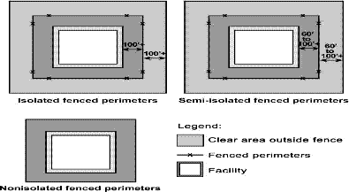

### Figure 2.5: Different types of perimeter fencing (Source: U.S. Department of the Army, 2010)

* + - 1. **Parking area**

Building and property owners can enhance employee safety by reviewing parking lot locations and routes for circulation between parking and workplace areas. Adequate lighting should be provided and entry points should be kept at a minimum to deter the likelihood of vandalism, theft, or muggings (Shehata, 2012). Every design of parking lots and drop-off locations should consider zoned parking areas, the minimum standoff requirements for the facility, clear distinction between visitors and staff parking, provision should be made for drop-off points and a special consideration should be made for handicapped users. Hierarchy of parking areas may include restricted areas for staff and trusted individuals closer to the facility, and more remote visitor lots. Internal roads should be designed for efficient circulation between site access points and should never breach standoff areas or pass over areas of critical infrastructure distribution (He *et al.*, 2012).

### Loading docks

If a truck with explosives was parked and detonated next to a loading dock, the explosion could cause severe damage to a facility. In designing a loading dock therefore, incoming utility lines above or below the grade as well as emergency generators, fuel storage tanks or pipelines and building fire protection systems should be located adjacent to these loading docks (Walt, 2004).

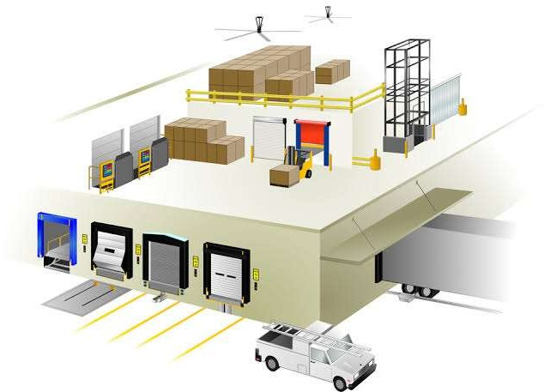

### Figure 2.6: A typical loading dock (Source: Low, 2005)

* + - 1. **Roofing**

Roof access is an aspect that is often overlooked when designing for security. Low roof sections, cat walks, exposed gutters, utility boxes and railings are amongst the building features which allow easy roof access. Roofing levels can compromise a building’s security if they are easily accessible due to grades, ladders or adjacent structures. As such, roof level access should be secured and monitored for authorized personnel only. Skylights should be designed to anticipate a blast incident. And critical equipment should be protected at all times (Michael and Jeff, 2012).

## CHAPTER THREE

## RESEARCH METHODOLOGY

This work adopts a quantitative research approach and employs the use of a questionnaire and observation as research instruments. Seven (7) hotels were purposively selected within the study area (Minna, Niger State). Purposive sampling technique involves making selections based on certain qualities possessed by the participants. The Tunga area of Minna has the highest concentration of hotels and majority of the facilities found outside this area are mostly regarded as guest inns. As such, more samples were taken from this part of the city. Although a few hotels were also selected outside this zone (but still within the study area, Minna).

### Data Sources

Primary data for the study was obtained through physical observation and survey. A checklist was developed by the researcher for the physical observation and a questionnaire for the survey. These were both structured to enable the researcher collect relevant information for analysis.

The elements considered while structuring the checklist and questionnaire include the access control measures put in place for vehicles and pedestrians, definitive features for site’s boundaries, the nature of glazing material used for doors and windows, the basic security features available within the facility, the number of access and exit points to the facility and the distance between the building and potential threats (stand-off distance). Sources of secondary data for the study include review of relevant literature, reports, journals and manuals by security bodies as well as literary works from experts on passive security. The approach to tackling security challenges and recommendations by security experts were also studied.

### Instrument for Data Collection

Primary data was collected using a checklist and questionnaire structured to collect relevant information that was analysed later in the course of this work.

### Sampling Technique

In determining the sample size, purposive sampling technique was employed. Seven (7) hotels selected by critical case method were analysed

Variables

The variables considered as they relate to security in hotels include records of criminal activities at the facility in the past, the nature of such criminal activity, the period of day when such activity occurred and the factors (design related) responsible for such occurrences.

### Method of Data Presentation

Data gathered from administered questionnaires and checklists were collated and tabulated using excels spreadsheets and results were presented using pie charts and tables. Images captured were presented in plates and were used to buttress points made by the charts and tables. The table below shows a list of the sampled hotels as well as their locations within Minna metropolis

**Table 3.1: List of Sampled Hotels in Minna, Niger State.**

|  |  |  |
| --- | --- | --- |
| **S/No** | **Name of Hotel** | **Location** |
| 1. | Hydro Hotel | Tunga |
| 2. | Yayi Hotel | Nnamdi Azikiwe Road |
| 3. | Haske Luxury Hotel | Tudun Wada |
| 4. | Ajuba Hotel | Tunga |
| 5. | Shiroro Hotel | Nnamdi Azikiwe Road |
| 6. | NSDC Suites | G.R.A |
| 7. | Az-hara Lodge | G.R.A |

**(Source: Researcher, 2019)**

## CHAPTER FOUR

## DATA PRESENTATION AND DISCUSSION

The data collected from the field by the researcher using the research instruments generated were analysed using the Microsoft excel software. Information was presented using plates, figures, tables and charts. Below are the results from the researcher’s field work.

### Assessment of Various Passive Security Design Measures

### Stand-off distance

Standoff refers to the allowance/distance between an asset and a potential threat. Of all the seven selected samples, it was observed that while 57% of the samples made provision for a standoff distance between 1 – 5 meters. 43% gave an allowance between 6 – 10 meters and none of the observed samples gave an allowance of up to 15 meters as stipulated by the United States army for facilities of this nature. It is also noteworthy that even in some of the facilities that were observed to make slight provision for standoff, vehicle users were still seen parking their cars at spots designated for drive through and drop-offs.

**Table 4.1: Standoff distance observed by the Hotels**

|  |  |  |
| --- | --- | --- |
| HOTELS | 1 – 5 | 6 – 10 11 - 15 15 - above |
| Ajuba hotel  Yayi Hotel | ✓  ✓ |  |
| Haske Hotel  Shiroro Hotel | ✓ | ✓ |
| Nsdc Suites  Azhara Lodge | ✓ | ✓ |
| Hydro Hotel |  | ✓ |

**(Source: Researcher, 2019)**

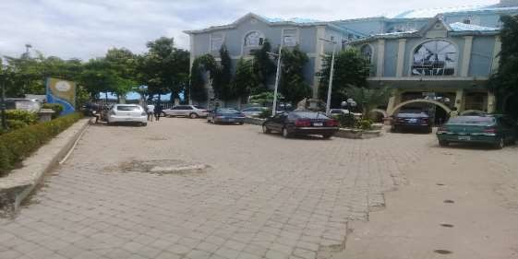

**Plate I: Stand-off observed at hydro hotel, Minna (Source: Researcher's Fieldwork, 2019)**

### Hardened landscape elements

This refers to anti-intrusion features employed in landscaping to deter potential threats from advancing towards an asset. All samples employed atleast one hardened landscape element within their layout. Majority of the studied samples adopted either one or both of kerbs and concrete planters. While 57% of the selected samples employed kerbs as the only hardened landscape feature in their layout, 43% adopted both kerbs and concrete planters in their layout.

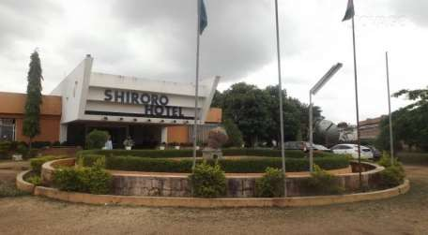

### Plate II: Hardened landscape elements as seen at Shiroro Hotel, Minna (Source: Researcher's Fieldwork, 2019)

* + 1. **Passive access control features**

Access control features includes elements that are introduced on site to guide pedestrian and/or vehicular navigation within the premises. Such elements include concrete planters, concrete seating, kerbs, bollards, bumps and hedges. 86% of the samples employed the use of kerbs as a passive access control measure, 57% used hedges. Kerbs and hedges were employed by 43% of the selected samples and 43% made use of kerbs alone as an access control measure. In most of the samples studied, both vehicular and pedestrian paths were merged.

**Table 4.2: Passive access control measures employed by the Hotels.**

|  |  |  |  |  |
| --- | --- | --- | --- | --- |
| **Hotels** | **kerbs** | **bumps** | **bollards** | **hedges** |
| Ajuba hotel |  |  |  | ✓ |
| Yayi hotel | ✓ | | | |
| Haske hotel | ✓ | | | |
| Shiroro hotel | ✓ ✓ | | | |
| NSDC suites | ✓ | | | |
| Azhara lodge | ✓ ✓ | | | |
| Hydro hotel | ✓ ✓ | | | |

**(Source: Researcher, 2019)**

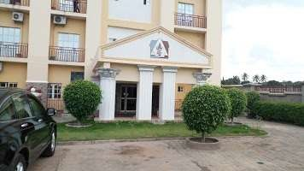

**Plate III: Passive access control elements at Azhara lodge, Minna (Source: Researcher's Fieldwork, 2019)**

* + 1. **Features that define site’s boundaries**

Fence appears to be a typical feature for demarcating property boundaries in hotels within Minna metropolis. At hydro hotel however, it was observed that low fences with railings were used alongside higher fences at the site’s boundaries. Alternatives such as hedges and meshes could be used both as soft and hard landscape elements which in addition to serving as a security feature could also double as an added aesthetic component to the facility’s overall outlook.

**Table 4.3: Nature of site boundaries at the Hotels**

**Hotels Fence Hedges Mesh Low walls**

|  |  |
| --- | --- |
| Ajuba Hotel | ✓ ✓ |
| Yayi Hotel | ✓ |
| Haske Hotel | ✓ |
| Shiroro Hotel | ✓ |
| NSDC Suites | ✓ |
| Azhara Lodge | ✓ |
| Hydro Hotel | ✓ |

**(Source: Researcher, 2019)**

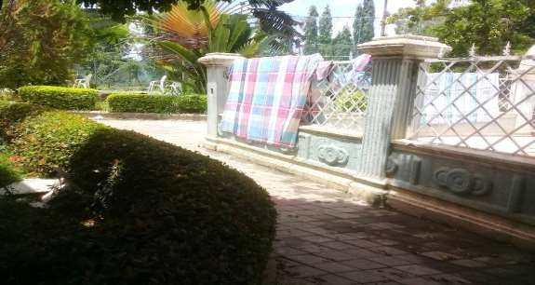

**Plate IV: Low fence and railings at Hydro hotel, Minna (Source: Researcher's Fieldwork, 2019)**

* + 1. **Sill height for windows**

The sill height for window openings refers to the distance from the natural ground level to the base of these window openings. The higher this distance, the more difficult it becomes for intruders to gain access to spaces via these openings. It was observed from the studied samples that while 14% observed a sill height of 900 millimeters, 57% and 29% of these samples observed sill heights 1.5 meters and 1.2 meters respectively. The incidence of theft and burglary is tremendously reduced by raising heights to 1.5 meters or more as it becomes difficult for humans to view/ access the facility (illegally) at such heights.



**sill height**

14%

57%

29%

900 1200 1500 1800

**Figure 4.1: Percentage distribution of the various sill heights observed by the Hotels**

**(Source: Researcher, 2019)**

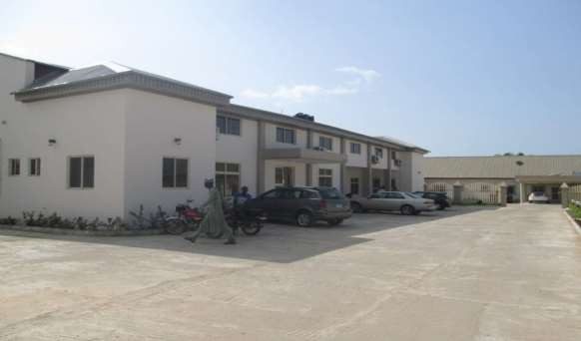

**Plate V: 1500mm sill height observed at Haske hotel, Minna (Source: Researcher's Fieldwork, 2019)**

* + 1. **Height of kerbs**

Kerbs are hardened anti-intrusion fixtures which mostly separates green areas from paved walk and drive ways. They also serve as tools in directing the flow of movement of traffic (human and vehicular). Findings revealed that a vast majority of hotels in Minna utilized kerbs of about 100mm depth and only 14% of the studied samples observed a height of up to 300mm for kerb installations. At a depth of 300mm, it becomes difficult for vehicles to cross to the opposite side of the kerbs. For the purpose of passive security therefore, it is advisable to use kerbs of heights 300mm or higher.



**kerb height**

14%

86%

100 200 300

**Figure 4.2: Percentage distribution of heights observed for kerbs (Source: Researcher, 2019)**

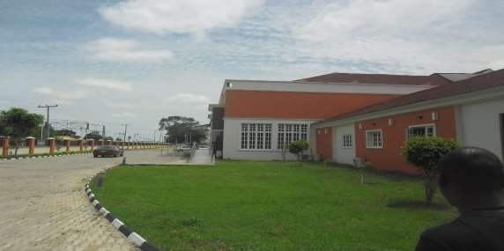

**Plate VI: 100mm height observed for kerbs at NSDC Suites, Minna (Source: Researcher's Fieldwork, 2019)**

* + 1. **Number of entry points to the site**

The number of entry points to the vicinity of the proposed facility is a very important factor to be considered in designing for security. The fewer the number of entry points to the site, the less prone it becomes to possible threats and attacks. All samples studied had one gated entrance to their premise. These gates were also maned by security personnel responsible for controlling access to the premise.

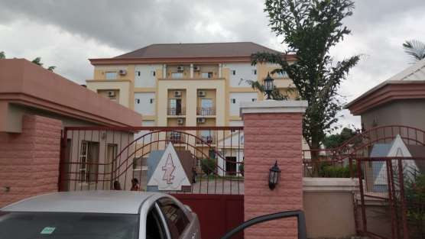

### Plate VII: A gated entrance leading to Azhara lodge, Minna (Source: Researcher's Fieldwork, 2019)

* + 1. **Material for glazing**

Glazing refers to the glass material used over openings. Translucent glazing refers to a type of glazing where one is only able to see through from one side of the material while a transparent glazing allows one to see through from both sides. The materials used for glazed openings were analysed for the chosen samples and it was observed that while 57% of the sampled hotels utilized translucent glass materials for fenestrations, 43% made use of transparent glass materials. The results were tabulated as shown below.

**Table 4.4: Nature of material used for glazing**

|  |  |  |
| --- | --- | --- |
| **Hotels** | **translucent** | **transparent** |
| Ajuba Hotel | ✓ |  |
| Yayi Hotel Haske Hotel Shiroro Hotel  NSDC Suites | ✓ | ✓  ✓  ✓ |
| Azhara Lodge | ✓ |  |
| Hydro Hotel | ✓ |  |
| **(Source: Researcher, 2019)** |  |  |

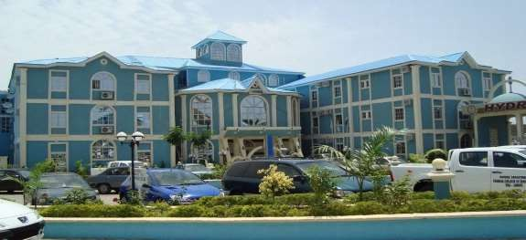

**Plate VIII: Translucent glazing material used at Hydro Hotel, Minna (Source: Researcher's Fieldwork, 2019)**

* + 1. **Lighting fixtures on site**

This refers to the various devices employed in lighting up the hotel premises. They include lamp posts, and other lighting fittings. While 43% of the studied samples had no light fixtures in place within their vicinity, 57% ensured lighting was provided within their layout. Of this 57%, 50% of the samples were observed to be adequately lit while the other 50% was not. The inadequacy of the lighting onsite can be attributed to inadequate maintenance practice on the part of the hotel management.

**Table 4.5: Lighting within the hotel premises**

**Hotels Light Fixtures**

**Light Fixtures**

**Adequate Inadequate**

|  |  |  |  |
| --- | --- | --- | --- |
|  | **Present** | **Absent** |  |
| Ajuba Hotel Yayi Hotel Haske Hotel  Shiroro Hotel | ✓ | ✓  ✓  ✓ | ✓ |
| Nsdc Suites  Azhara Lodge Hydro Hotel | ✓  ✓  ✓ |  | ✓  ✓  ✓ |

**(Source: Researcher, 2019)**

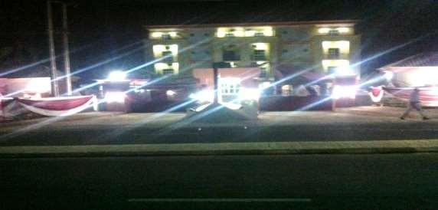

**Plate IX: Light fixtures at Azhara lodge, Minna at night. (Source: Researcher's Fieldwork, 2019)**

**4.3 Design Consideration and Planning Principles**

The design is for a 3-star hotel equipped with a pool and pool bar, ample parking space, three categories of rooms (classic, executive and presidential suites), a restaurant and rooftop bar as well as lawn tennis courts. Considerations were made for well defined walkways and paths for vehicular movement. Hardened landscape elements (concrete seats and bollards) were put in place at strategic points to serve as barriers to potential threats to the building.

### Conceptual analysis

Circular forms were used for the building’s layout with activities spread across the building’s entire circumference. Glazed openings introduced around the façade serve as a passive security measure that promotes natural surveillance (visual impression that intruders are being watched from all sides thereby preventing the perpetuation of crimes). By using three of such circular forms, segregation is achieved. A security term that describes a situation in which other segments within a facility are able to function when one segment comes under attack.

### Construction system

The pile foundation system will be used in constructing the foundation for this project to ensure adequate stability as the building extends upwards to five floors. Pile foundations consist of unvarying pile columns made with ground beams positioned at a 6m spacing to structural engineer’s specifications. Box frame construction will be adopted in the erection of the super-structure. This ensures the structural members (columns, beams and slabs) are erected first and the internal spaces are partitioned using sandcrete blocks. This construction technique saves time and errors in design are easily discovered while erecting the frame.

The roof members comprise steel girders so as to withstand the building’s large span. The roof shields the interior spaces from natural elements such as rainfall, direct sunlight, high temperature and storms. The roof components are enveloped by polycarbonate roofing sheets.

### Materials and finishes

The proposed design utilises various building materials for its construction. Concrete which is carefully made by mixing water, cement, fine and coarse aggregates was used to make the building’s structural frame. Steel will be employed for the construction of the structural roof members and the reinforcement for column and suspended floors. Sandcrete block will be used as the wall material to support the structural frame.

The building façade will be made of glazing envelope. It is used as covering for openings to allow passage of light and air through the space. The glass utilized for the proposed design will enable proper surveillance of the property. The unglazed tiles will be used in the toilet while the glazed ceramic tiles will be used in offices spaces, and

marble tiles will be used on areas with much population as it can withstand wear and tear, is easy to clean and durable.

### Landscape and external works

The site comprises mostly of shrubs, a few trees and grasses. Shrubs and trees which are likely going to obstruct construction will be felled while those which do not, will be retained as part of landscape elements on site. These landscape elements will be utilised to direct movement of pedestrian and vehicle within the site. The building will be harmonized with the immediate environment by the use of the hard and soft landscape element. The parking lot for visitors is situated far away from the building to ensure adequate stand-off distance is observed between vehicles and the building.

### Building services

As electricity is very important for the proper functioning of a building. The building will utilise a renewable form of energy, to ensure there is an un-interrupted power supply within the facility. Portable water will be made available to the proposed site through bore-hole which will be used for sanitation, general maintenance of the surroundings landscape and firefighting.

### Maintenance

The building will be under the periodic maintenance of the management’s maintenance department, which will ensure that any defective part of the building receives prompt attention before affecting the entire structure. The building will also be under supervision for any corrective defect work that may arise either due to construction or due to the effect of wear and tear of the building due to usage.

## CHAPTER FIVE

## CONCLUSION AND RECOMMENDATION

### Conclusion

In the course of working on this research, the researcher discovered that securing a building can be achieved in either of two ways i.e. employing either active or passive security measures. Several elements were also discovered to fall under either of the above mentioned categories. The research investigated these elements and their impacts on the security of hotel buildings.

From reviewed literature, it was noted that passive security measures when employed, boost the security of a building by disrupting and deterring a potential threat. The passive security features which were observed to have been employed by the hotels included adequate stand-off, perimeter fencing, hardened landscape elements, lighting fixtures, glazing and vegetation. While none of the sampled hotels observed the 15- meter stand-off distance benchmark set for hotels, 43% and 57% respectively observed between 1 – 5 meters and 6 – 10 meters.

All the facilities studied employed the use of fence to define their boundaries. 14% of these however combined both fence and low walls (with railings on-top). Although all samples were seen to employ the use of kerbs in their layouts, 43% in addition to the use of kerbs also employed concrete planters as hardened anti-intrusion elements. The kerbs employed were mostly of 100mm height except for 14% of the studied samples where a height of 300mm was observed for kerb installations. At a height of 300mm, motorists and oncoming vehicles (potential threats) find it difficult to navigate over the kerbs to get their targets.

For surveillance, lighting fixtures were observed to be present in 57% of the samples. It was only noted to be sufficient in 50% of the samples with these fixtures. Adequate lighting of the surrounding vicinity reduces the incidence of theft within the hotel premises. 43% of the studied samples made use of a translucent glass material for glazing and 57% utilized a transparent glass material. Natural surveillance is best achieved when a translucent glass material is employed.

### Recommendations

* + 1. Adequate provision should be made for stand-off particularly at the design stage.

In cases where the site is limited by space, the walls along the site perimeter/fence should be reinforced to minimize the impact of explosive threats on the building.

* + 1. Hardened landscape elements such as bumps, bollards, concrete planters and concrete seating should be used in directing or controlling vehicles while preventing them from getting too close to the building. These should however be positioned in a way that they allow pedestrian circulation within the site’s premises.
    2. Hedges could be introduced on some parts of the property line instead of a fence.

Some hedges are known to grow substantially in height with thorny stems. Such hedges when grown along the property line can offer a great deal of resistance to potential intruders.

* + 1. A laminated and translucent glass with blast mitigating properties should be employed on the building’s façade (around openings). This in addition to being blast resistant to a large extent also enhances the building’s surveillance properties as a result of its translucency.
    2. Stair cases, lifts and escalators should be positioned in areas with clear visibility.

This is done this way to prevent attacks on the users as a result of isolation of certain spaces.

* + 1. A sill height of 1.5 meters and above should be maintained especially on ground floor window openings to deter intruders from having access to the building via these openings.
    2. The security of hotel users should be put in consideration by building professionals right from the design stage of a project.

## REFERENCES

Achumba, I. C., Ighomereho, O. S. and Akpo-Robaro, M.O.M (2013). Security challenges in Nigeria and the implications for business activities and sustainable development, *Journal of Economics and Sustainable Development*, 4(2),79-99. Retrieved (02/12/2018) from *online*[*www.iiste.org.*](http://www.iiste.org/)

Ayinfar, K. (2002). The strategies of passive defense in architecture of old districts in Kerman city.

Baker, Paul R. (2012). ["Security Construction Projects".](https://books.google.com/books?id=U7U6Lc2ZYaYC&pg=PA47) In Baker, Paul R.; Benny, Daniel J. (Eds.). *The Complete Guide to Physical Security*. CRC Press. [ISBN](https://en.wikipedia.org/wiki/ISBN_(identifier)) 9781420099638. Archived from the original on 2018-01-05.

Bowie, D. (2018). Innovation and 19th century hotel industry evolution. *Tourism Management 64*. 314-323. <https://doi.org/10.1016/j.tourman.2017.09.005>

Centre for the Protection of National Institute (2011). Protecting Crowded places. In

*Design and Technical issues*.

Centre of the Protection of National Infrastructure. (2011). *Integrated Security Guide: A Public Realm for Hostile Vehicle Mitigation* (Vol. I).

Chauchan, A., Shukla, A. and Negi, P. (2018). Safety and security measures adopted by hotels and their impact on customer relationship management, *International Journal of Research – granthaalayah,* 6:118-125

Clarke, H. E. (2009). *What makes a Good Architecture.* London: HMSO Press.

Cozens, P., Saville, G. and Hillier, D. (2005). Crime Prevention through Environmental Design (CPTED): A Review and Modern Bibliography. *Property Management*, 23:328-356. <https://doi.org/10.1108/02637470510631483>

Davey, C. and Wootton, A. (2016). Integrating crime prevention into urban design and planning. *Journal of Place Management & Development.* Advance online publication. <http://dx.doi.org/10.1108/JPMD-09-2015-0043>

Duensing, S. N. (2014). *Taverns, Inns and Alehouses? An Archaeology of Consumption Practices in the City of London, 1666–1780* (Doctoral dissertation, School of Arts, Language and Cultures, University of Manchester, Manchester, England). Retrieved from https://pdfs.semanticscholar.org/e104/c3427f3d01 55960df09e 3085df0119773259 .pdf (Placeholder1)

Elert and Associates, (2013). *The Four Necessary Basic Layers Required for Proper Physical Security*. Retrieved June 18th, 2019, from [*http://www.elert.com/the-*](http://www.elert.com/the-) *four-necessary-basic-layers required- for-proper-physical-security.*

Faizan A., Rosmini O. and Muslim, A. (2013). An examination of the relationships between physical environment, perceived value, image and behavioural Intentions: A SEM approach towards Malaysian resort hotels. *Journal of Hotel and Tourism Management*, 27 (2), 9-26.

Fenelly, L. (2012). *Effective Physical Security* (4th ed.). Butterworth-Heinemann, London

Fennelly, L. & Perry, M. (2016). *Physical security: 150 things you should know.*

Oxford, United Kingdom: Butterworth – Heinemann

He, Y., Sun, X., Du, L., Jinmei, R. and Das, S. (2012). Level of Service for Parking Facilities. *Journal of Traffic and Transportation Engineering.* 3. <http://doi.org/10.17265/2328-2142/2015.01.004>

Human Rights Watch (Organization). (2019). *Human Rights Watch world report*. New York, NY: Human Rights Watch

Ikenwa, C. (2019). *Hotel rating: All you need to know.* Retrieved February 1, 2020, from <https://nigerianinfopedia.com.ng/hotel-rating/>

Indian Ministry of Trourism. (2018). *Guidelines for approval of motels* (6-TH- II(4)/2017-H&R). Retrieved from [http://tourism.gov.in/guidelines-approval-](http://tourism.gov.in/guidelines-approval-operational-motels) [operational-motels](http://tourism.gov.in/guidelines-approval-operational-motels)

Jane, C. (2014). Hotel ratings in Nigeria, *Hotels NG Travel.* Retrieved from https://hotels.ng/travel/hotel-ratings-in-nigeria/

Karam, M. (2015). Safety and Security Measures in Egyptian hotels. [http://dx.doi.org/10.4172/2169-0286.1000116,](http://dx.doi.org/10.4172/2169-0286.1000116) 2015.

Katyal, K. (2002). Architecture as Crime Control. *The Yale Law Journal*, pp. 1046- 1137.

Kim, A. G. and Loksha A. V. (2014). New directions of the accommodation development in the world tourism market. *Life Science Journal,* 11(10s), 379-

384. Retrieved from <http://www.lifesciencesite.com/>

Knoke, M. and Peterson, K. (2015). *Physical security principles.* Alexandria, USA/Virginia: ASIS International

Kosar, L. (2014). Lifestyle hotels: New paradigm of modern hotel industry. *Turisticko poslovanje, 2014*. 39-50. <https://doi.org/10.5937/TurPos1414039K>

Lane, C. (2018). *From Taverns to Gastropubs: Food, Drink and Sociality in England*: Oxford Scholarship online

Leskosky, W. R. (2009). *Perimeter Security for Historic Buildings.* Cleaveland, Ohio: Technical Pilot.

Leslie, A. (2006). *People who live in hotels: An exploratory overview* (Report No. 23).

United States: U.S. Census Bureau.

Levy, B. J. (2003). Hotels: Industry update. Retrieved 30th July, 2019 from hospitalitynet: <https://www.hospitalitynet.org/opinion/4017990.html>

Low, S. (2005). Building and Sustainability Controls in Singapore: A Journey in Time.

Procedia Engineering. 20. 22-40. 10.1016/j.proeng.2011.11.136.

Michael, C. and Jeff, C. (2012). Defence in Depth, Protection in Depth and Security in Depth: A Comparative Analysis Towards a Common Usage Language. *Proceedings of the 5th Australian Security and Intelligence Conference,* 2012, 27-35 DOI: 10.4225/75/57a034ccac5cd

National Counterterrorism Center (2012). *Bomb Threat Stand-Off Distances*. Retrieved from https://[www.nctc.gov/site/technical/bomb_threat.html](http://www.nctc.gov/site/technical/bomb_threat.html) on 5th July, 2015.

National Institute of Building Sciences, (2014). *Landscape Architecture and Site Security Design Process.* Retrieved 1st July, 2015, from Whole Building Design Guide: [*http://www.wbdg.org/resources/landscape/sitesecurity.php*](http://www.wbdg.org/resources/landscape/sitesecurity.php)*.*

National Population Commission (2007). *Population and Development Review, 33*(1), 206-

210. Retrieved March 17, 2020, from <http://www.jstor.org/stable/25434601>

New Nigerian Newspaper (2018). *Map of Niger State showing Minna.* Retrieved from [www.newsnigeriannewspaper.com](http://www.newsnigeriannewspaper.com/) on 28 August, 2018.

O’Gorman, B. and Kevin, D. (2010). Introduction to the Origins of Hospitality and Tourism. *The origins of Hospitality and Tourism.* 7-12. Retrieved from [https://www.researchgate.net](https://www.researchgate.net/)

Oserogho, E. (2015). Hotels and hospitality establishments grading, classification regulations. *The Guardian*. Retrieved from [https://guardian.ng](https://guardian.ng/)

Reynald, D. (2015). Environmental Design and Crime Events. *Journal of contemporary criminal justice,* 31(1), 71-89. <http://doi.org/10.1177/1043986214552618>

Russ, T. (2013). *Site and Layout Design Guide*. Newyork: McGraw-Hill.

Ryan, C. (2006). *Big city, smaller rooms: suburban hotel chains go urban* [PDF].

Retrieved from <https://www.wsj.com/articles/SB116719130852960264>

Sarita, H. (2011). CPTED: Safer Communities by Design. *Security Magazine.* Retrieved from [https://www.securitymagazine.com](https://www.securitymagazine.com/)

Schneider, R. (2005). Introduction: Crime Prevention Through Environmental Design (CPTED): Themes, Theories, Practice, And Conflict. *Journal of Architectural and Planning Research, 22*(4), 271-283. Retrieved February 3, 2020, from [www.jstor.org/stable/43030746](http://www.jstor.org/stable/43030746)

Seifi, M., Abdullah A., Haron, S. & Salman, A. (2019). Creating Secured Residential Places: Conflicting Design Elements of Natural Surveillance, Access Control and Territoriality. *IOP Conference Series: Materials Science and Engineering,* 636(2019), 1-10. <https://doi.org/10.1088/1757-899X/636/1/012017>

Shantimani, S. (2010). *Classification of Hotels* [PowerPoint slides]. Retrieved from <https://www.slideshare.net/Shantimani/classification-of-hotels>

Sharda, H. (2016). *Types of Ships.* Retrieved October 12, 2019 from <https://www.marineinsight.com/types-of-ships/what-is-a-flotel/>

Shehata, W. (2012). Perceived attractiveness and security of design features in urban parking lots. *Environment and Quality of Life*, 59-80.

Smith, S. (2012). Crime Prevention through Environmental Design in Parking Facilities. *Journal of National Institute of Justice*, 13:1-11. Retrieved from <https://www.ncjrs.gov/App/Publications/abstract.aspx?ID=157310>

Terrence, G. (2005). *Taking Security to the Next Level* [HTML website]. Retrieved from [https://www.facilitiesnet.com/security/Taking-Security-To-the-Next-Level--](https://www.facilitiesnet.com/security/Taking-Security-To-the-Next-Level--2566) [2566](https://www.facilitiesnet.com/security/Taking-Security-To-the-Next-Level--2566)

U.S. Department of the Army. (2010). *Loading dock levelers: Army regulation 608-18.* Retrieved from [https://armypubs.army.mil/epubs/DR_pubs/DR_a/pdf/web/r](https://armypubs.army.mil/epubs/DR_pubs/DR_a/pdf/web/r608_18.pdf) [608_18.pdf](https://armypubs.army.mil/epubs/DR_pubs/DR_a/pdf/web/r608_18.pdf)

Walt, S. (2004). Loading Dock Security. Occupational Health and Safety. (May 2004). Retrieved from [https://ohsonline.com/Articles/2004/05/Loading-Dock-Security.](https://ohsonline.com/Articles/2004/05/Loading-Dock-Security.aspx) [aspx](https://ohsonline.com/Articles/2004/05/Loading-Dock-Security.aspx)

World Tourism Organization, (2015). Hotel Classification Systems: Recurrence of criteria in 4 and 5 stars hotels, UNWTO, Madrid.

Zarepoor, M. Jafari, S. and Banii, S. (2011). Security of moving systems, Islamic Azad University, Tehran.

## APPENDIX A

### Sample of Questionnaire

This checklist is designed to obtain data for the ASSESSMENT OF PASSIVE SECURITY FEATURES IN HOTEL BUILDINGS IN MINNA, Niger State. The aim

of this checklist is to gather information regarding the passive security elements available in hotel buildings. This information is purely for academic purposes.

Thank you for responding.

**NAME OF HOTEL:……………………………………………………………....... LOCATION: ……………………………………………………………………....... *Instruction: please tick or underline the correct options appropriately.***

1. How many times have you visited the facility?

□ 1 □ 2 □ 3 □ 4 or more □ I work here

1. What supporting facilities would you like to be included in the hotel layout?
   * sporting facilities
   * swimming pool
   * bar
   * events centre
   * mosque
   * retail shops
   * others, specify……………………….
2. What are the supporting facilities available at the hotel?
   * sporting facilities
   * swimming pool
   * bar
   * events centre
   * mosque
   * retail shops
   * others, specify……………………….
3. Which of the selected facilities above attract the most crowd?
   * sporting facilities
   * swimming pool
   * bar
   * events centre
   * mosque
   * retail shops
   * others, specify……………………….
4. How many categories of rooms were provided in the hotel?
   * 1
   * 2
   * 3
   * 4 or more
5. What is the total number of rooms available at the hotel?
   * 1 - 20
   * 21 - 50
   * 51 - 100
   * Above 100
6. Did you during any of your visits to the hotel witness any security threat?

□ yes □ no

1. What was the nature of such threat?
   * Bombing
     + Shooting
     + Theft/burglary
     + kidnapping

Others, specify……………………………………………………………….

1. In your opinion, is the vicinity of the facility adequately lit?
   * yes it is
   * no it isn’t
   * it is fairly lit
2. What are the lighting fixtures available on site?
   * street lights
   * lamp posts
   * fence mounted lights
3. Will you feel more secured if additional lighting fixtures are put in place within the facility?

□ Yes □ No □ Not sure

1. For the purpose of security, would you prefer a centrally positioned staircase or staircases strictly at the end of lobbies (hidden)?

□ central staircase □ staircases at lobby ends □ Doesn’t matter

**APPENDIX B**

**ASSESSMENT OF PASSIVE SECURITY MEASURES IN THE DESIGN OF A HOTEL IN MINNA, NIGERIA OBSERVATION SCHEDULE/CHECK LIST**

**NAME OF HOTEL: ………………………………………… LOCATION:…………………………………………………..**

**TARGET HARDENING, ACCESS CONTROL & STAND OFF**

|  |  |  |  |  |  |  |  |  |  |  |  |  |  |  |  |  |  |  |  |  |  |  |  |  |  |  |
| --- | --- | --- | --- | --- | --- | --- | --- | --- | --- | --- | --- | --- | --- | --- | --- | --- | --- | --- | --- | --- | --- | --- | --- | --- | --- | --- |
| **S/N** | **Variables** | **1-**  **5m** | **6-**  **10m** | **11-**  **15m** | **Above**  **15m** | **Bumps** | **Kerbs** | **Conc**  **Seating** | **Conc**  **planters** | **Bollards** | **Fence** | **Pavement** | **Hedges** | **Low**  **walls** | **900** | **1200** | **1500** | **1800** | **100** | **150** | **200** | **300** | **1** | **2** | **3** | **4** |
| 1 | Standoff distance  landscape elements used |  |  |  |  |  |  |  |  |  |  |  |  |  |  |  |  |  |  |  |  |  |  |  |  |  |
| 2 | Hardened landscape  elements |  |  |  |  |  |  |  |  |  |  |  |  |  |  |  |  |  |  |  |  |  |  |  |  |  |
| 3 | Passive access control  elements empty |  |  |  |  |  |  |  |  |  |  |  |  |  |  |  |  |  |  |  |  |  |  |  |  |  |
| 4 | Features that define  site’s boundaries |  |  |  |  |  |  |  |  |  |  |  |  |  |  |  |  |  |  |  |  |  |  |  |  |  |
| 5 | Sill height for windows |  |  |  |  |  |  |  |  |  |  |  |  |  |  |  |  |  |  |  |  |  |  |  |  |  |
| 6 | Height of kerbs |  |  |  |  |  |  |  |  |  |  |  |  |  |  |  |  |  |  |  |  |  |  |  |  |  |
| 7 | Number of entry points  to the site |  |  |  |  |  |  |  |  |  |  |  |  |  |  |  |  |  |  |  |  |  |  |  |  |  |
| 8 | Number of entry points  to the main building |  |  |  |  |  |  |  |  |  |  |  |  |  |  |  |  |  |  |  |  |  |  |  |  |  |

**NATURAL SURVEILLANCE**

|  |  |  |  |  |  |  |
| --- | --- | --- | --- | --- | --- | --- |
| **S/N** | **VARIABLES** | **YES** | **NO** |  | **Translucent** | **Transparent** |
| 1 | Material for glazing |  |  |  |  |  |
| 2 | Are there lighting fixtures on site? |  |  |  |  |  |
| 3 | Are the lighting fixtures adequate? |  |  |  |  |  |

**Appendix C (Site Plan)**

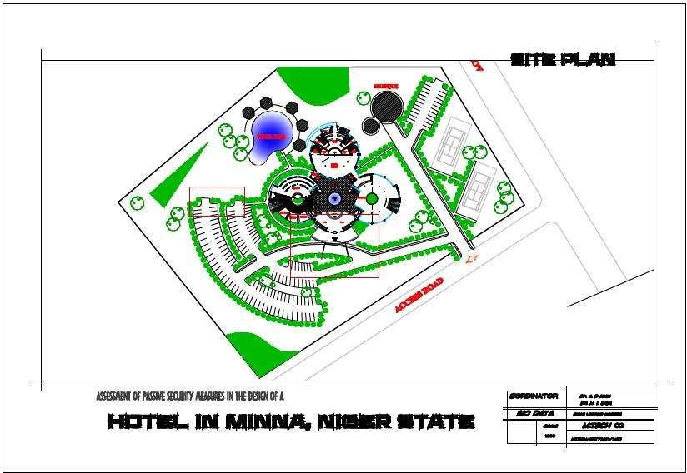

**Appendix D (Ground Floor Plan)**

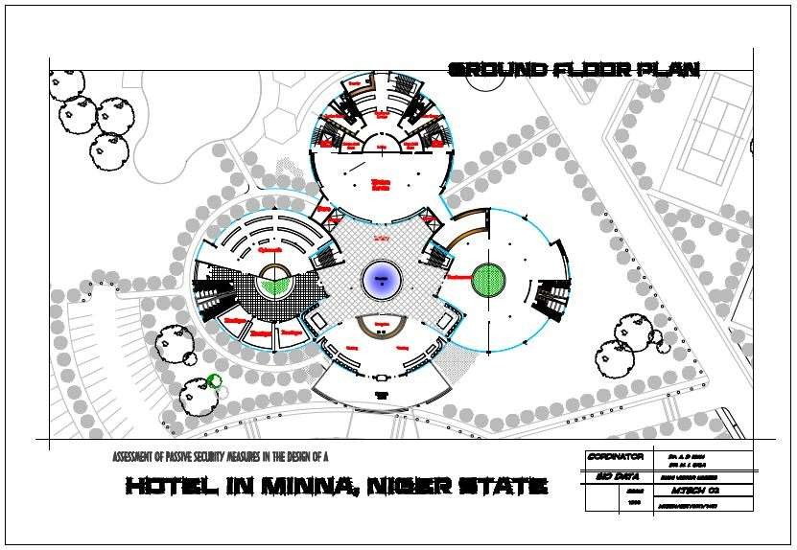

**Appendix E (First Floor Plan)**

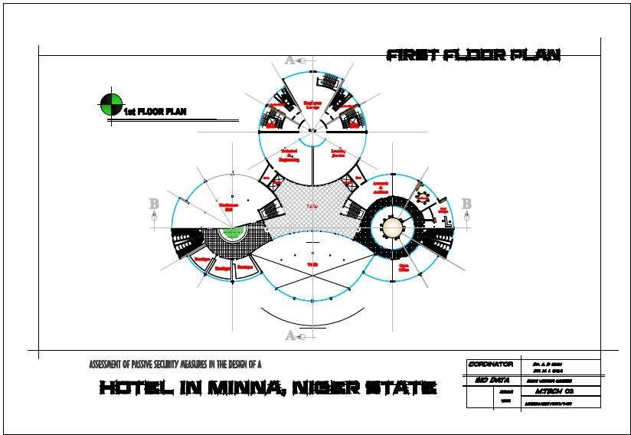

**Appendix F (Second Floor Plan)**

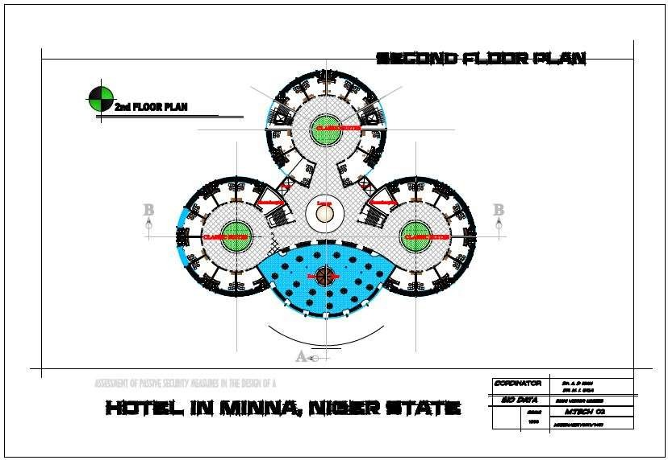

**Appendix G (Third Floor Plan)**

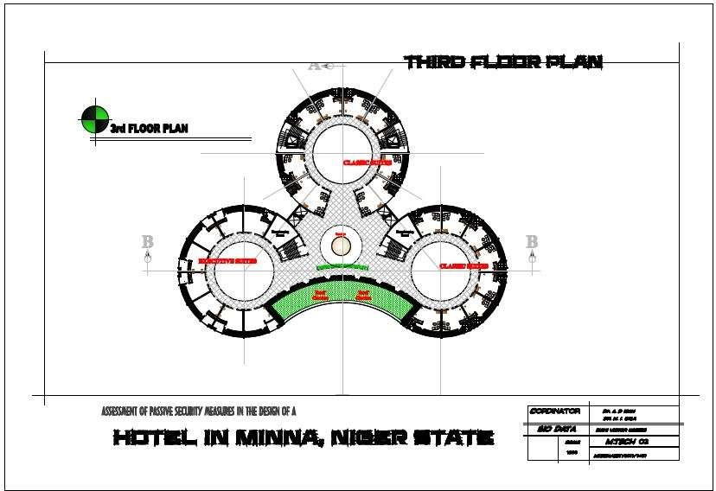

**Appendix H (Fourth Floor Plan)**

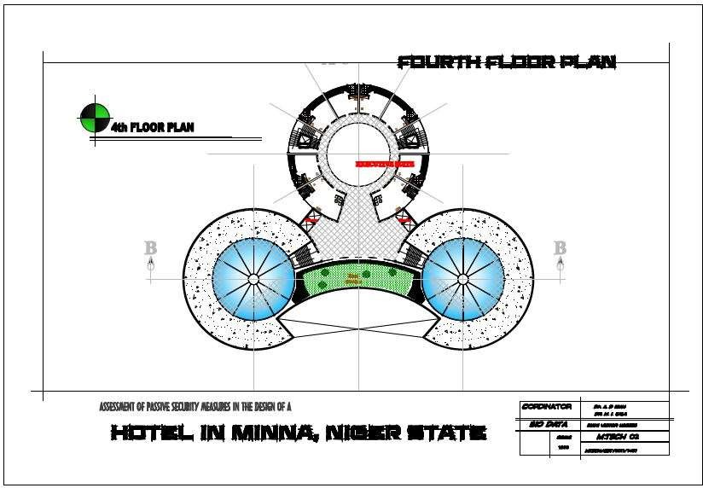

**Appendix I (Fifth Floor Plan)**

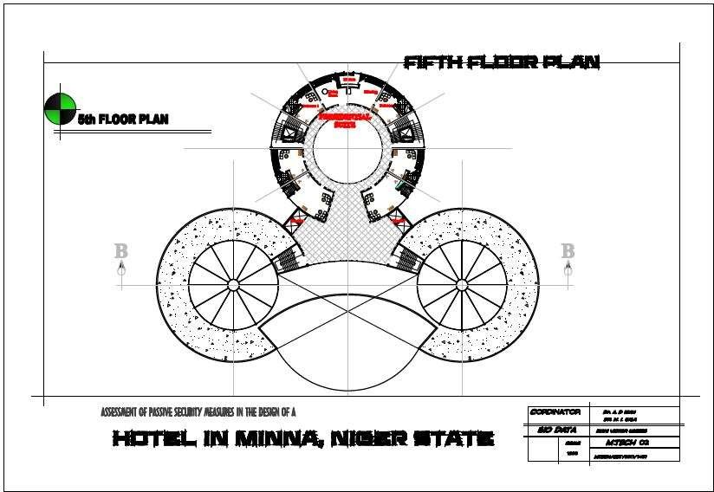

**Appendix J (Roof Plan)**

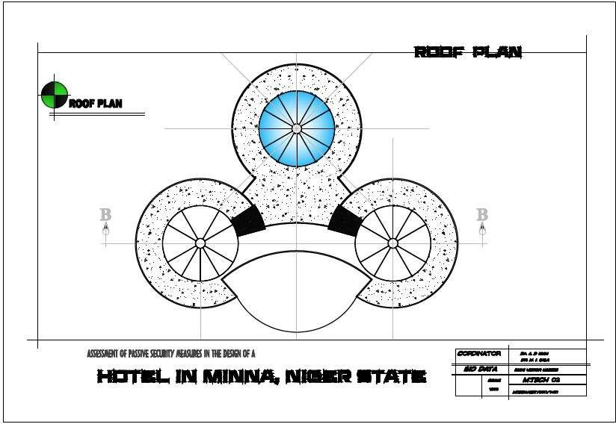

**Appendix K (Sections)**

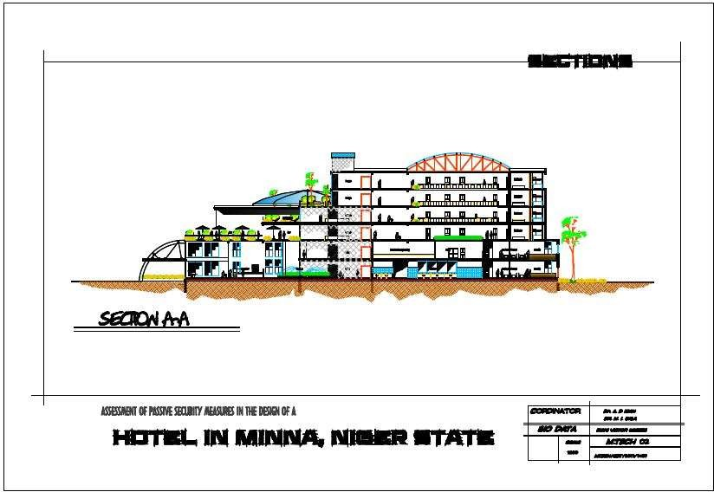

**Appendix L (Sections)**

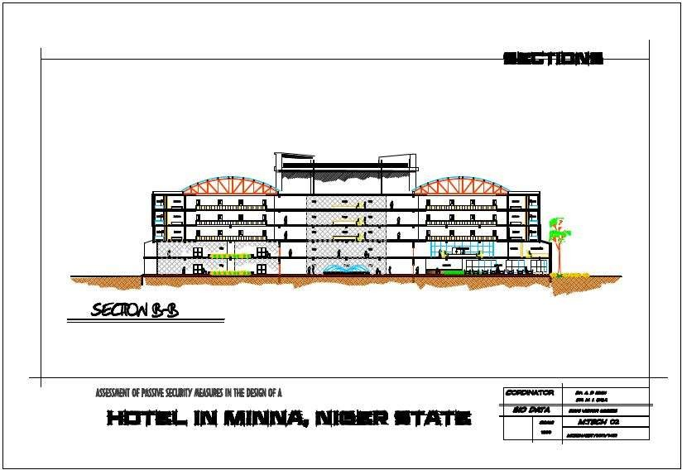

**Appendix M (Elevations)**

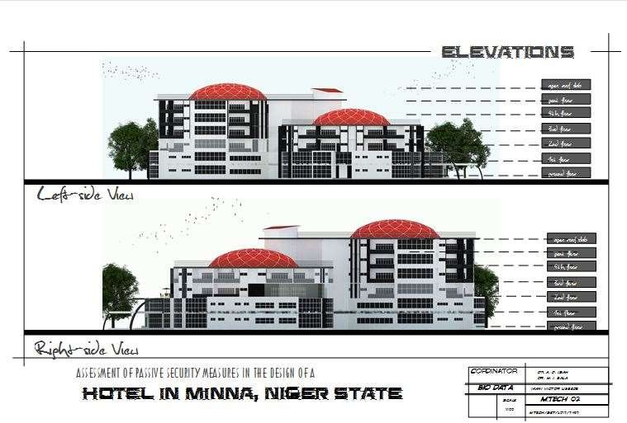

**Appendix N (Elevations)**

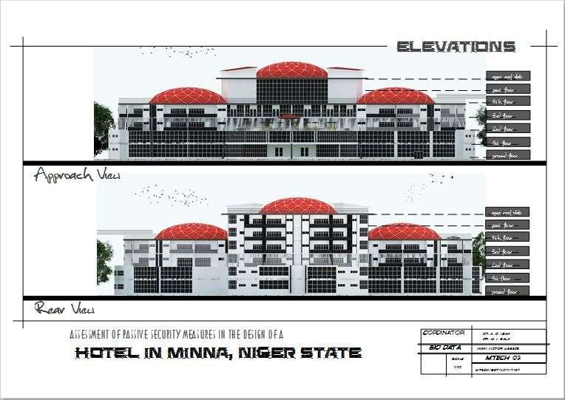

**Appendix O (An exterior 3D view of the main building)**

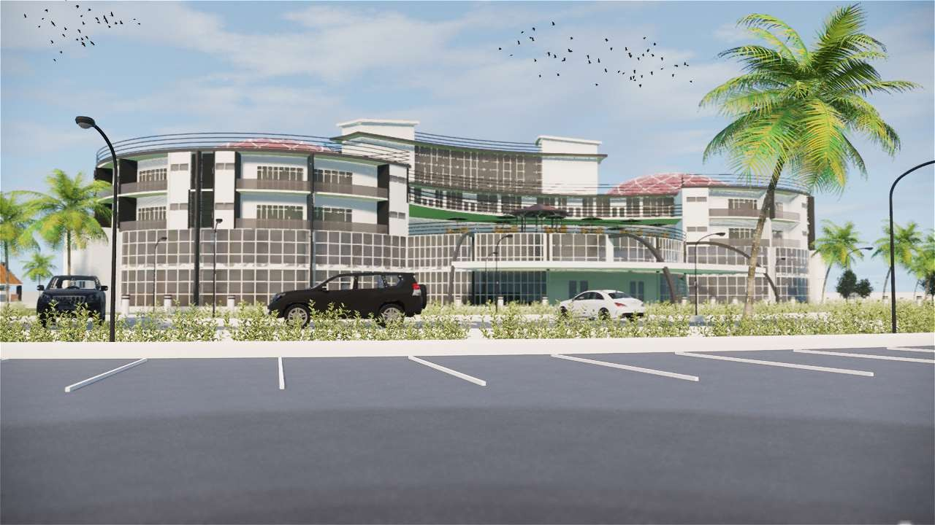

**Appendix P (An exterior 3D view of the main building)**

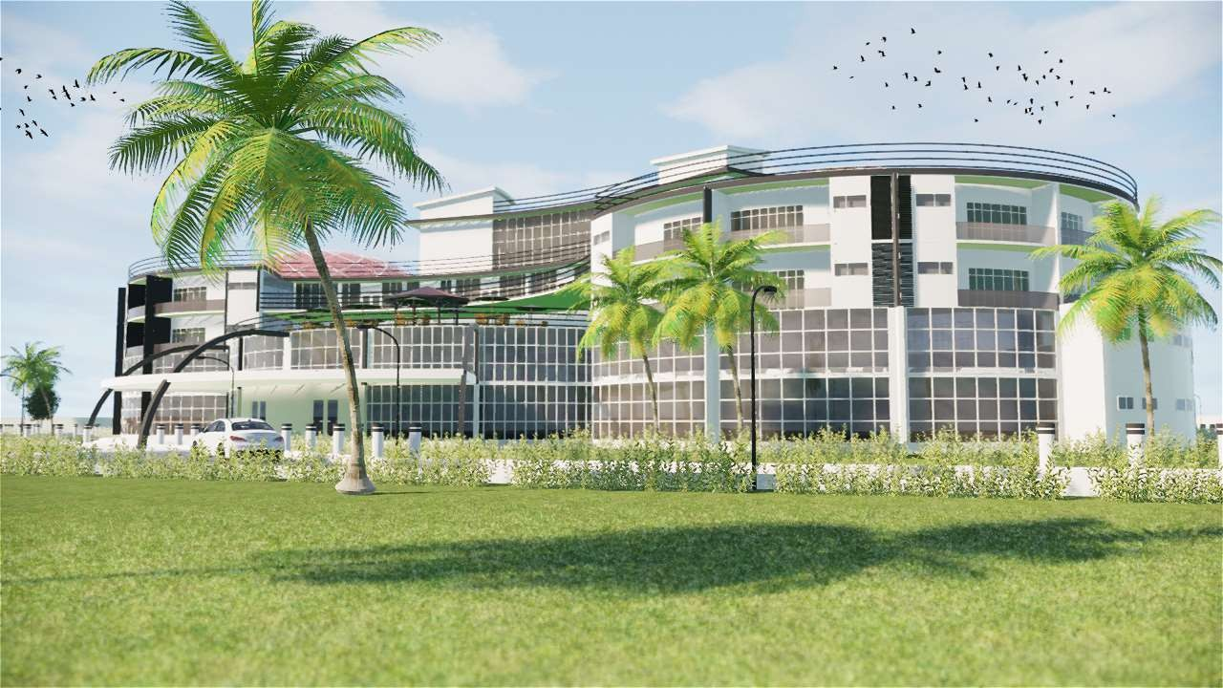

**Appendix Q (An aerial view of the facility showing bumps, concrete seats and bollards)**

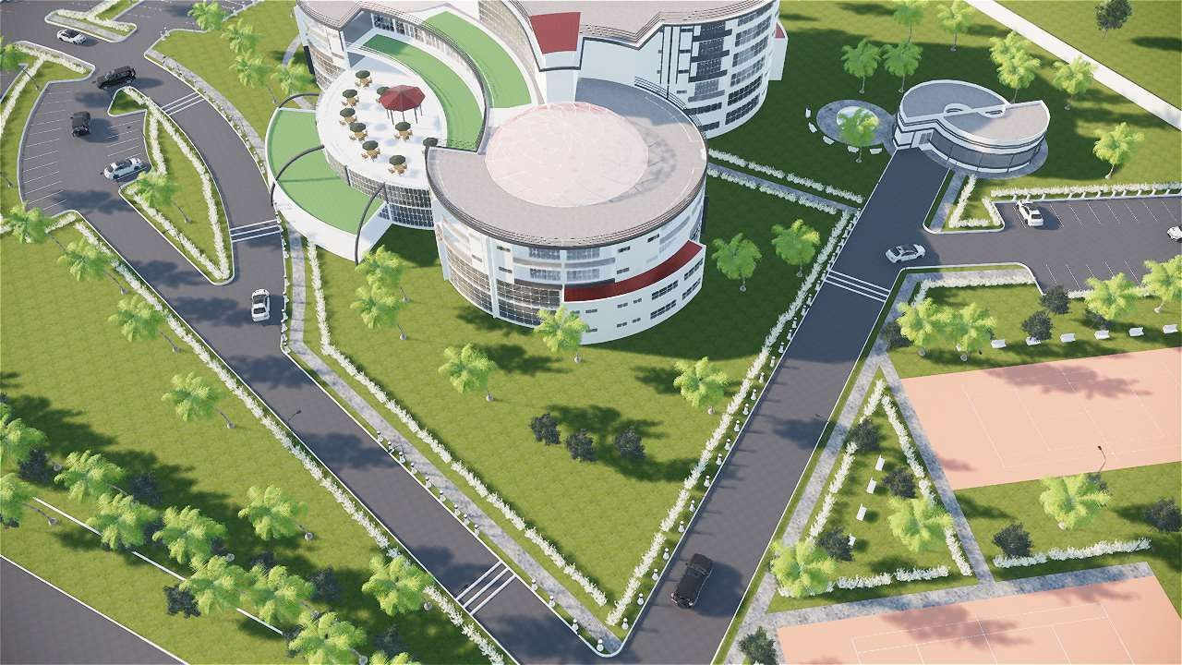

**Appendix R (View showing kerb placement on site)**

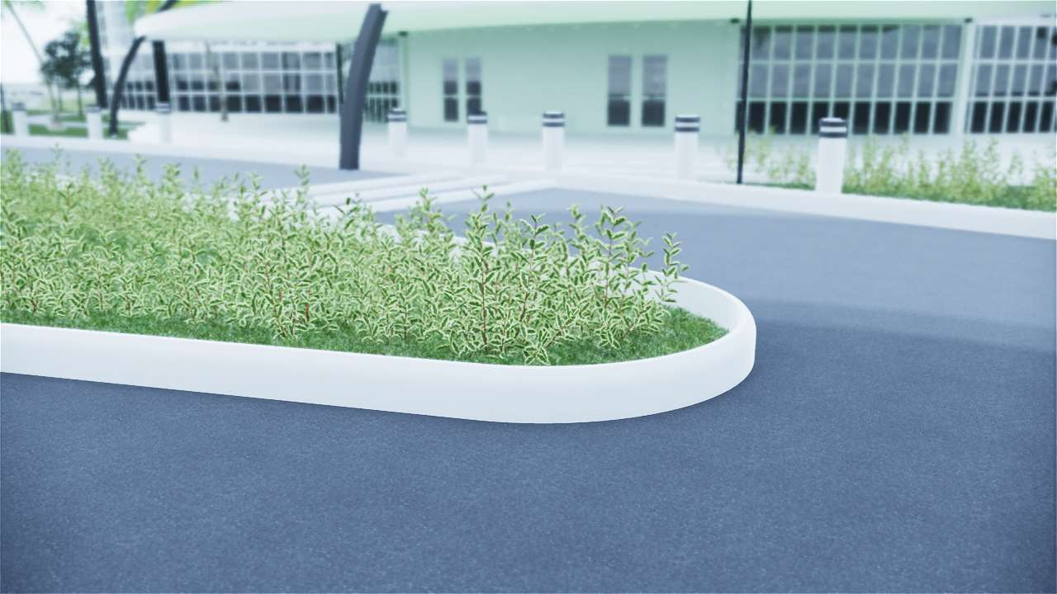

**Appendix S (View showing speed bumps and bollards placed on site)**

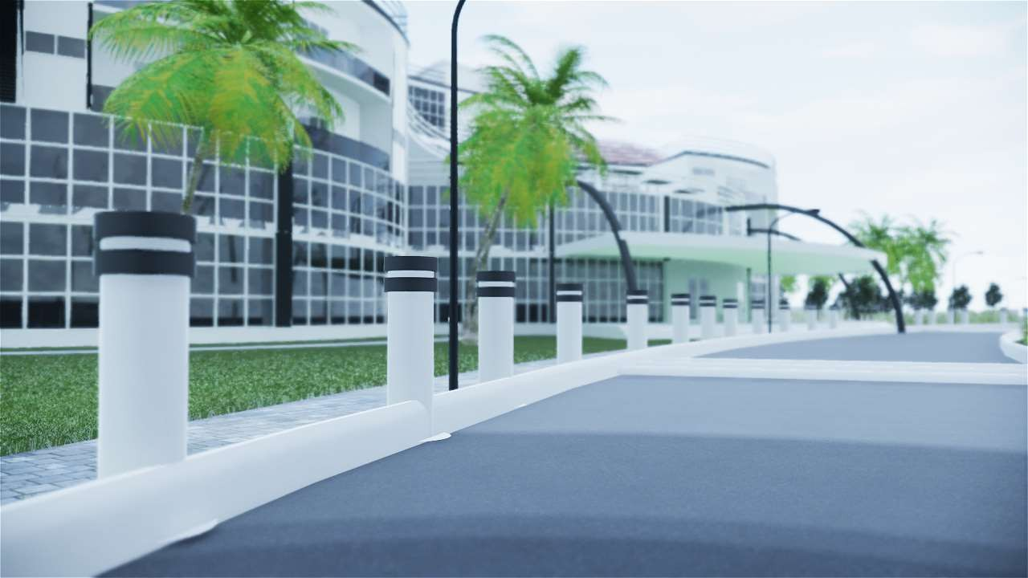

**Appendix T (view showing concrete seats along the sporting facility on site)**

