# **ASSESSMENT OF OCCUPATIONAL RADIATION DOSE TO RADIOGRAPHERS IN ANAMBRA STATE AND THEIR OPINION ON RADIATION PROTECTION MEASURES**

# **ABSTRACT**

# Occupationally, radiographers are exposed to chronic low doses of ionizing radiation, hence it is important that they are regularly monitored and occupational dose kept as low as possible. This study determined the occupational dose to radiographers and their opinion to radiation protection measures in Anambra State. A prospective cohort survey of 60 radiographers who dispense ionizing radiation in both public and private centres, chosen from across Anambra state was conducted. After a short seminar on the need for monitoring, an adopted self-completion questionnaire was distributed to the radiographers on the first day to elicit data on their opinion on radiation protection in their places of employment. Afterwards, the radiographers were given first batch of labelled thermoluminescent dosimeter (TLD) chips which they wore outside the white laboratory coat, between the chest and abdomen. They wore the 1st batch of the TLDs for three months before it was collected from them and sent for reading. A 2nd batch of the TLDs were given to them which they also wore for three months before it was collected from them and sent for reading. The TLD chips were read at the Centre for Energy Research and Training Zaria using Harshaw 4500 TLD reader connected to a computer with winREMs software application. The mean effective dose of radiation received by radiographers in six months in Anambra state was 0.56 ± 0.03 mSv (range: 0.34 – 0.90 mSv) with an annual equivalence of 1.12 ± 0.06 mSv (range: 0.68 – 1.80 mSv). There was a significant (p<0.05) difference between radiographers in government-owned facility, whose doses are higher than those in privately owned centres (mean difference 0.17 mSv). Personnel monitoring was provided for 81.6% (n = 49) of the radiographers. Lead was used for shielding in all the centres studied (100%) while TLD which are seldom worn, dominated as the material of choice for personnel monitoring and are fairly read every six months on the average. Greater no (83.3%; n = 50) of the radiographers do not wear PPDs while working and only 26.7% (n = 16) are involved in annual radiation protection training. Radiation safety officers and certified physicists were not available in all the centres. In conclusion, the occupational annual dose in Anambra state is far below the ICRP set limit of 20 mSv averaged over 5 years. Despite the poor radiation monitoring conditions in Anambra state, the study has shown that work environment is safe and radiographers in Anambra state are not overly exposed to harmful effects of ionizing radiation occupationally.

# CHAPTER ONE INTRODUCTION

## Background of Study

Radiation consists of energy and particles that are given off by unstable atoms as part of a natural process to become stable or generated during the operation of high energy devices, e.g., accelerators (Office of Health, Safety and Security, 2012). There are both naturally occurring radiation and man- made sources of radiation. Besides its scientific and industrial uses, radiation is used medically for diagnoses and therapeutic purposes. However, these are not without the risk of potential harmful effects to both patients and staff.

Medical exposure accounts for 90% of exposure to man-made radiation (Ishiguchi, 2001; United Nations Scientific Committee on the Effects of Atomic Radiation (UNSCEAR), 2008). X-ray is the most frequently used ionizing radiation for diagnostic imaging and it plays a significant role in effective healthcare delivery both in the developed and developing countries (Olowookere *et al*., 2012). It is known that of all man-made sources of ionizing radiation, diagnostic x-ray contributes the largest part to the collective population dose leading to somatic and genetic effects on human beings (UNSCEAR, 2012).

Occupational doses are energies of radiation deposited or absorbed by individuals working in radiological industry. The basic quantity used to measure absorbed dose from ionizing radiation is the gray (Gy). It is defined as 1 Joule of initial energy (of charged particles released by the ionization events) per Kg of tissue (UNSCEAR, 2000b). The biological effects per unit of absorbed dose differ with the type of radiation and the part of the body exposed, so that a weighted quantity called the effective dose is used, for which the measure is the sievert (Sv) (UNSCEAR, 2000a).

One of the hazards of working in radiology department is the possibility of long term exposure to low level radiation which may have deleterious biological effect (Al-Abdusalam and Brindhaban, 2014). Radiation hazards were reported few months after the discovery of x-rays in 1895 by Wilhelm Conrad Roentgen and ever since then efforts have been geared towards the reduction of patients and personnel radiation exposure (Okeji, *et al*., 2010). The earliest studies of occupational exposure to radiation were those of underground miners exposed to inhaled alpha-emitting radon progeny (Gilbert, 2009). Epidemiological data from research has indicated and thus suggested that the exposure to even low-dose radiation may be a cause for concern because such exposure can result in leukemia, thyroid malignancies and other cancers (Al-Lamki, 2011). Such studies has provided the necessary data for quantifying cancer risks as a function of dose (Wakeford, 2009) and for setting radiation protection standards (Gilbert, 2009). Studies of persons exposed for occupational and environmental reasons allow a direct evaluation of exposure at low doses and dose rates, (Gilbert, 2009). Consequently, an individual exposed to radiation in the course of his or her work is at some increased risk of cancer albeit small in relation to the background risk from other causes (Wakeford, 2006). This means a significant cancer risk can be induced by long term chronic exposure to low dose ionizing radiation when the cumulative dose reaches a certain level (Wang *et al*., 2002). The importance of protection practices by radiographers to keep ionizing radiation doses as low as reasonably achievable can never be over emphasized given its obvious detrimental effects. Despite this obvious reason, most centers continue to operate without monitoring their employees in South Eastern Nigeria (Okaro, *et al*, 2010).

It is often argued that the private sector is more efficient (Bitran, 1995), accountable and sustainable than the public sector health service delivery (Basu, *et al*., 2012). Among other factors, this is assumed based on the mindful attention to detail and the acquisition of state of the art equipment by private sector. Radiographers in government hospitals has been classified as being generally apathetic to radiation protection practices while radiographers with the private sector has been adjudged to show better committed to radiation protection practices (Eze, *et al*., 2013). This however is contrary to the general opinion that most private radiology centers are concerned more with profit than precautionary measures to minimize radiation hazards when compared to government establishments. Therefore, it is worthy of interest that the dose output in government and private sector be compared in Anambra state, Nigeria. Since Nzotta and Chiaghanam (2010) has documented that radiographers in Nigeria are exposed to high radiation risk due to dependence on refurbished equipment, it is therefore necessary that the values gotten from both the government and private establishment be compared for the sake of review.

Radiographers are trained personnel who are licensed to dispense radiation, particularly ionizing radiation. Radiographers, as a result of their job, are exposed to chronic low doses of radiation mainly from scattered radiation and this constitutes an occupational hazard. Regular monitoring of radiation doses received by staff in radiology department is of great importance. This is to protect the staff, patients and the public from the effect of excessive radiation during and after radiological examinations of patients (Okaro, *et al*., 2010). This will ensure occupational safety as dose limits will consciously not be exceeded. The accepted dose limits for occupational staff as reported by the International Commission on Radiological Protection (ICRP) is 20 mSv per year averaged over five

(5) years (100 mSv in 5 years) (ICRP, 1991). The United Nations Scientific Committee on the Effects of Atomic Radiations has reported that the world wide mean annual occupational dose in diagnostic radiology and nuclear medicine is below 2 mSv (UNSCEAR, 2010).

In recent times, accessibility to modern medical imaging machines in the healthcare facilities in Anambra has increased tremendously. This has resulted in increased risk of radiation exposure to the patients and health workers particularly radiographers who are daily involved in dispensing ionizing radiation. The Nigerian Basic Ionizing Radiation Regulations (NBIRR) has recommended an effective dose limit of 100 mSv in any period of five consecutive years (i.e., average of 20 mSv per year). It also recommended a maximum effective dose of 50 mSv in any single calendar year for an employee aged 18 years and above and 6 mSv for a trainee under the age of 18 years (NBIRR, 2003).

Studies of occupational radiation dose has focused mainly on the physicians who carry out interventional radiological procedures (Chida *et al*., 2013). There are limited data on the exposure records of radiographers in Anambra state who are essential in the radiology department. Subjectively, it has been observed in Anambra state that radiographers are often concerned about chronic radiation doses they absorb occupationally, more so when a radiographer died of acute Myeloblastic leukemia two (2) years ago at the South West of Nigeria. Radiographers in private practice has been adjudged mindful of radiation practices which reduces dose both to patient and staff when compared to their government counterpart in the western world. This is not exactly so locally. Studies has been majorly regional in Nigeria, with few states studied mainly in the west. In Anambra state, no published study on radiographers dose is known to the best of the researchers knowledge. The dangers of chronic exposure to ionizing radiation which can cause somatic and or genetic damage to radiographers in Anambra state and indeed to mankind can be mitigated when factual studies from the state are documented. Thus, this study is aimed at determining the occupational radiation dose to radiographers and their opinion on radiation protection measures in Anambra State, Nigeria.

## Statement of Problem

Radiographers in Nigeria are exposed to very high radiation risk because of great dependence on refurbished x-ray equipment (Nzotta and Chiaghanam 2010) and should have their absorbed doses monitored. Radiation doses received by radiographers in South Eastern Nigeria are not monitored in most radio-diagnostic centers and personnel radiation monitoring devices, where available, are not consistently read (Okaro, *et al*., 2010). Studies on occupational radiation dose in Nigeria has been mainly regional with only a few states studied independently. As it has been observed subjectively, over the past three (3) years, there has been an increase in the number of radio-diagnostic centres in Anambra state. These invariably could lead to extra radiation dose to practitioners as well as patients and the public. Sadly, there is paucity of data on the exposure and dose record of radiographers who dispense ionizing radiation in Anambra state to verify the extent of dose received by them. The dose to radiographers in Anambra state against international levels are not known due to lack of this dose record. Literature from other parts of Nigeria and other countries on dose received by practitioners are available for comparison and this could provide the benchmark for local works. More so, the variation of occupational dose to radiographers between government and private radio-diagnostic centres is not known. The current state of radiation protection practices in radio-diagnostic facilities in Anambra state is also not known. The foregoing provides the basis to investigate the radiation dose absorbed by radiographers in Anambra state and their opinion on radiation protection measures.

## The Aim of the Study

The aim of this study is to determine the occupational radiation dose to radiographers in Anambra state and their opinion on radiation protection measures.

## Specific objectives

1. To determine the occupational radiation dose received by radiographers in Anambra State, Nigeria.
2. To compare the occupational radiation dose received by radiographers in this locality with international values.
3. To compare the radiation dose received by radiographers in government and private establishments in Anambra State.
4. To assess the radiation protection measures in Anambra State through the self-reports (opinion) of the radiographers practicing in the locality.

## Significance of Study

1. Radiation is associated with health hazard. This study will help radiographers in Anambra state know the average radiation dose in the state and thus ascertain their risk from occupational exposure.
2. Where in the risk is low, this will allay the fears radiographers have while working with ionizing radiation and thus, they will be more relaxed, putting in their best effort to become more efficient and productive.
3. The average value and range of occupational dose within the state when compared with international values will help radiographers either to tighten up on lapses in radiation protection practices or maintain the current level of practice if optimal, all in an effort to reduce dose to the barest limits as possible.
4. Government and private establishment will know their respective dose output. This can induce both sectors to reduce radiation dose both to patient, staff and the general public to as low as reasonably achievable, by promoting safe practices involving the use of ionizing radiation.
5. Rather than individual notion, the general state of radiation protection measures as perceived by radiographers in the state will be brought to the fore. Personal lapses on protection practices while working with radiation can be noted and corrected.
6. This study will serve as a data base for future researchers, thus forming a yardstick for dose related comparison.
7. It will also guide the management of the hospitals outside the state on the need to protect radiographers and any other staff who work with ionizing radiation by adopting the practice of ALARA.

## Scope of Study

Radiographers in one government and six private hospitals with x-ray facilities in Anambra state were studied. The hospitals involved in the study are Nnamdi Azikiwe University Teaching Hospital (NAUTH), Nnewi, New Hope Hospital, Onitsha; General Hospital, Onitsha; St. Charles Borromeo Hospital, Onitsha; Iyienu Hospital, Ogidi; Crown Hospital, Eke - Nkpor; and Our Lady of Lourdes Hospital, Ihiala. Most of the selected hospitals have more than one imaging equipment that emit ionizing radiation. The study was conducted within a six month period; March to August 2016.

# CHAPTER TWO

**REVIEW OF RELATED LITERATURE THEORETICAL FRAME WORK**

## The concept of radiation

The origin of the term radiation comes from a Latin word *radiare* meaning ‘emit rays’. Energy that comes (emission) from a source in the form of waves or particles, travels through space or material medium is called ionizing radiation. Simply put, radiation is energy in motion. It can be produced by radioactive decay of an unstable atom (radionuclide), or by the interaction of a photon or particle with matter. Radioactive decay are usually spontaneous while emission as result of interaction depends on both incoming photon or particle and the material of interaction. Radiation is described by its type and energy. The two main categories of radiation are particulate and electromagnetic radiation. For the purpose of this study, we shall focus on Electromagnetic radiation which shall be discussed later.

Interestingly life evolved in the presence of radiation. There is *background* natural radiation everywhere (ubiquitous) in our environment (Health Physics Society, 2016). Radioactivity, the process undergone by unstable atoms to become stable is naturally present in the soil, rocks etc. Thus, human beings are always exposed to background radiation in the air, soil, rock, water, and building materials (Shahbazi-Gahrouei, *et al*., 2013). The IAEA safety Glossary (2007) has defined background radiation in radiation safety as "Dose or dose rate attributable to all sources other than the one(s) specified. This means that if no specific radiation source is of concern, background radiation implies the total radiation dose measurement taken at a location and this is usually the case where an ambient dose rate is measured for environmental purposes (Wikipedia, the free encyclopedia 2017). Natural background radiation is always present in every environment and includes the following:

*Cosmic radiation* - Cosmic radiation originates in outer space (sun, stars) and is composed of penetrating ionizing radiation (both particulate and electromagnetic).

*Terrestrial radiation* – The earth itself is a source of radiation. They are from natural radioactive elements (uranium, thorium, and radium) in the ground, stones, trees, and walls of houses. They significantly vary from place to place.

*Internal radiation* - All people have internal radiation, mainly from radioactive potassium-40 and carbon-14 and lead-210 inside their bodies from birth and, therefore, are sources of exposure to others. The sources are usually from food, water and air. The variation of dose from one person to another is not as great as that associated with cosmic and terrestrial sources.

Man-made sources of radiation include:

*Medical* – This mainly constitutes the highest significant dose of all man-made sources.

*Consumer Items* - Certain human man made consumer items are sources of radiation. Cigarettes contain polonium-210, originating from the decay products of radon.

*Atmospheric nuclear testing* - Nuclear explosion scatter some substantial amount of radionuclides in the air.

*Nuclear Fuel Cycle and Nuclear Accident* - To a lesser degree, the public is also exposed to radiation from the nuclear fuel cycle, from uranium mining and milling. The public receives some minimal exposure from the transportation of radioactive materials and fallout from nuclear weapons testing and reactor accidents.

Worldwide, the average human exposure to radiation from natural sources is 2.4 mSv per year, about half of which is due to the effects of radon daughters (UNSCEAR, 2000).

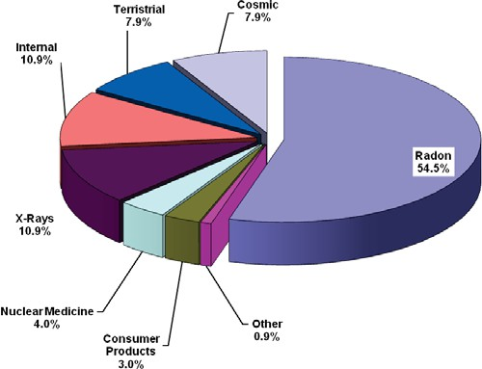

**Figure 2.1**: Radiation from Natural Background and Man-made sources as described by NCRP

## 2.11 Electromagnetic spectrum (EMS)

Electromagnetic spectrum is the term used to describe the entire range of radiation that exists. Most of the light in the universe is in fact invisible to us. EMS can be defined as the spectrum of distribution of electromagnetic radiation according to energy, frequency, or wavelength. It extends from radio waves to gamma rays. The different forms of electromagnetic radiation are distinguished by their wavelength and frequency (Australian Radiation Protection and Nuclear Safety Agency, 2012). The shorter the wavelength, the higher the frequency which determines the amount of energy the particular radiation has.

In the Electromagnetic spectrum, radiation is majorly divided into two: non-ionizing and ionizing radiation.

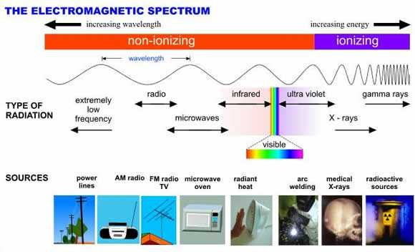

**Figure 2.2:** The Electromagnetic Spectrum (Australian Radiation Protection and Nuclear Safety Agency, 2012)

**Non-ionizing** *-* radiation may be regarded as ‘weak radiation’ because they do not have sufficient energy to remove an electron from an atom. At most, they excite electrons causing molecules and atoms to get to a higher energy state and thus vibrate faster producing heat. When these radiations pass through the tissues of the body they, do not have sufficient energy to damage DNA directly. They are usually located to the left of electromagnetic spectrum and include radio waves, microwave, infrared, visible light and near portion of ultraviolet radiation.

**Ionizing radiation** - The process in which an electron is given enough energy to break away from an atom is called ionization. Thus ionizing radiation is any type of radiation that has enough energy to remove (eject) tightly bound electrons from an atom. This process results in the formation of two charged particles or ions: the molecule with a net positive charge, and the free electron with a negative charge (Australian Radiation Protection and Nuclear Safety Agency, 2012). The threshold

energy possessed by most ionizing radiation is 10 eV, which is enough to ionize atoms and molecules, and break chemical bonds (Wikipedia the free encyclopedia 2015). Radiation in this range has high energy. Characterized by shorter wavelength and higher frequency, they have the ability to excite and ionize atoms of matter they interact with. If the energy is so high, they can break up the nucleus of an atom. They can cause damage to living tissues by breaking chemical bonds. Health Physics Society (2015) has identified the four most common ionizing radiation typically encountered and has outlined their respective characteristics as follows:

**Alpha Radiation:** Alpha radiation is a heavy, very short-range particle and is actually an ejected helium nucleus. Some characteristics of alpha radiation are:

* Most alpha radiation is not able to penetrate human skin.
* Alpha-emitting materials can be harmful to humans if the materials are inhaled, swallowed, or absorbed through open wounds.
* A variety of instruments has been designed to measure alpha radiation. Special training in the use of these instruments is essential for making accurate measurements.
* A thin-window Geiger-Mueller (GM) probe can detect the presence of alpha radiation.
* Instruments cannot detect alpha radiation through even a thin layer of water, dust, paper, or other material, because alpha radiation is not penetrating.
* Alpha radiation travels only a short distance (a few inches) in air, but is not an external hazard.
* Alpha radiation is not able to penetrate clothing.

Examples of some alpha emitters: radium, radon, uranium, thorium.

**Beta Radiation:** Beta radiation is a light, short-range particle and is actually an ejected electron. Some characteristics of beta radiation are:

* Beta radiation may travel several feet in air and is moderately penetrating.
* Beta radiation can penetrate human skin to the "germinal layer," where new skin cells are produced. If high levels of beta-emitting contaminants are allowed to remain on the skin for a prolonged period of time, they may cause skin injury.
* Beta-emitting contaminants may be harmful if deposited internally
* Most beta emitters can be detected with a survey instrument and a thin-window GM probe (e.g., "pancake" type). Some beta emitters, however, produce very low-energy, poorly penetrating radiation that may be difficult or impossible to detect. Examples of these difficult-to-detect beta emitters are hydrogen-3 (tritium), carbon-14, and sulfur-35.
* Clothing provides some protection against beta radiation.

Examples of some pure beta emitters: strontium-90, carbon-14, tritium, and sulfur-35

**Gamma and X - Radiation:** Gamma radiation and x rays are highly penetrating electromagnetic radiation. Some characteristics of these radiations are:

* Gamma radiation or x rays are able to travel many feet in air and many inches in human tissue.

They readily penetrate most materials and are sometimes called "penetrating" radiation.

* X-rays are like gamma rays. X-rays, too, are penetrating radiation. Sealed radioactive sources and machines that emit gamma radiation and x-rays respectively constitute mainly an external hazard to humans.
* Gamma radiation and x rays are electromagnetic radiation like visible light, radiowaves, and ultraviolet light. These electromagnetic radiations differ only in the amount of energy they have. Gamma rays and x-rays are the most energetic of these.
* Dense materials are needed for shielding from gamma radiation. Clothing provides little shielding from penetrating radiation, but will prevent contamination of the skin by gamma- emitting radioactive materials.
* Gamma radiation is easily detected by survey meters with a sodium iodide detector probe.
* Gamma radiation and/or characteristic x rays frequently accompany the emission of alpha and beta radiation during radioactive decay.

Examples of some gamma emitters: iodine-131, cesium-137, cobalt-60, radium-226, and technetium-99m.

N/B: Alpha and beta particles are not part of the electromagnetic spectrum; they are energetic particles as opposed to pure energy bundles (photons).

The most common unit of energy used to describe radiation is the electronvolt (eV). An electronvolt is the amount of kinetic energy an electron gains when accelerated through a potential difference of one volt.

## Radiation (photon) interaction with matter

Photons (x-ray and gamma) are absorbed in the media by transferring their energy to electrons contained in matter. X-ray interactions with matter are important in diagnostic examinations for many reasons: the selective interaction of x-ray photons with the structure of the human body produces the image; the interaction of photons with the image receptor enables the latent images of the medium to be created or recorded (Sprawls, 2012). Photon passing through a matter will either transmitted, be absorbed or produce scattered radiation. The three major interactions of photon with radiation are as follows:

*Photoelectric effect* – This is the process by which a photon ejects an electron from an atom. In this interaction of a photon with an atom, the atom absorbs all energy of the photon. Some of the energy is used to overcome the binding energy of the orbital electron which is removed from the atom. The ejected electron is called photoelectron. This interaction is only possible when the photon has sufficient energy to overcome the binding energy of the electron. The photoelectric effect usually occurs with K or L shell (inner shell) electron (Sprawls, 2012). As the electron is ejected from the atom (causing ionization of the atom), a more loosely bound outer orbital electron drops down to

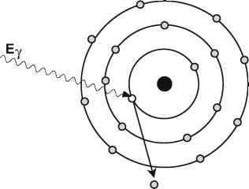occupy the vacancy. In doing so it will emit radiation itself due to the differences in the binding energy for the different electron levels. This is a characteristic X-ray. The incident photon completely disappears and all of its energy is carried off by the photoelectron which acts in the medium just like any other electron of that energy. It will ionize and excite other atoms until all of its energy is dissipated. This is why photons are also termed indirectly ionizing radiation because they bring about one ionization, but the vast majority of ionization that occurs are caused by photoelectron and not the photon itself (Stabin, 2007). The photoelectric effect dominates in human tissue at energies less than approximately 100 keV (European medical Alliance, 2016).

**Figure 2.3:** Illustration of photoelectric effect (European medical Alliance, 2016).

*Compton Scattering* – This is an interaction between a photon and a loosely bound orbital electron. As the photon interacts with an atom, a portion (not all) of the energy is absorbed by the loosely bound electron which is ejected off a direction because the binding energy is so small when compared to that of the photon. The incident photon leaves the site of the interaction in a direction different from that of the original photon, hence it is termed scatter. The energy loss by the photon is divided between the small binding energy of the energy level and the kinetic energy imparted to the Compton recoil electron. This effect dominates in human tissue at energies above approximately 100 keV and less than 2 MeV (European medical Alliance, 2016). The most significant object producing scattered radiation in an x-ray procedure is the patient's body and the portion of the

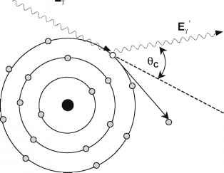patient's body that is within the primary x-ray beam becomes the actual source of scattered radiation (Sprawls, 2012).

**Figure 2.4:** Illustration of Compton Scattering (European medical Alliance, 2016).

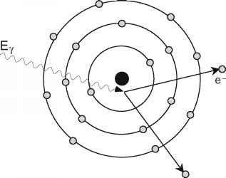*Pair – production* – This is photon-matter interaction that occurs with photon threshold energies equals or in excess of 1.02MeV and thus not readily applicable in diagnostic procedures. As a photon passes close to the nucleus of an atom, it interacts in such a manner as matter such that spontaneous formation of positive and negatively charged electrons can occur. The interaction produces a pair of particles, an electron and a positively charged positron. These two particles have the same mass, each equivalent to a rest mass energy of 0.51 MeV (Sprawls, 2012). At energies above four rest- mass equivalents of the electron, pair production can take place in the vicinity of an electron. In this case it is referred to as "triplet production" as there is a third member of the interaction, the recoiling electron (European medical Alliance, 2016).

**Figure 2.5:** Illustration of Pair production. The threshold energy required for this is equal to the sum of the rest masses for the two particles 1.022 MeV (European medical Alliance, 2016).

*Coherent Scatter* - There are actually two types of interactions that produce scattered radiation. One type, referred to by a variety of names, including coherent, Thompson, Rayleigh, classical, and elastic, is a pure scattering interaction and deposits no energy in the material. Although this type of interaction is possible at low photon energies, it is generally not significant in most diagnostic procedures (Sprawls, 2012).

## Biological effects of radiation

The Law of Bergonie and Tribondeau is related to the radio-sensitivity as a function of the metabolic state of tissue being irradiated – tissue with higher metabolic rate are more sensitive to radiation. The law states that the radio-sensitivity of cell is directly proportional to their reproductive activity (mitotic rate) and inversely proportional to their degree of differentiation. Cells that are most active in reproducing themselves and cells not fully matured will be most harmed by radiation. On the other hand, cells that are more mature and specialized in performing their functions are less sensitive to radiation. Experiments have shown that the effects of ionizing radiation on a cell also depend on the total dose and exposure rate. Thus a large dose given in a short amount of time is more damaging than the same dose given over a longer period of time. Radiation effects on human cells has two main effects; direct and indirect cellular damage. Biological effects of radiation can be divided into two; *somatic effects* which are effects that appear in the individual exposed to radiation and may be classified by the nature of the exposure, e.g. Acute or chronic and also by the time scale of expression

e.g. Short term or long term. *Genetic effects* which are effects that occur in future, expressed in the descendants of the exposed person. Hazards of human exposure to radiation depends largely on the nature of the exposure and duration of exposure. This brings another category of division termed *deterministic* and *stochastic* effects of radiation.

## 2.31 Deterministic effects

Deterministic effect is synonymous with threshold value, thus they are also called non-stochastic effects. They generally occur only after high dose exposure (mostly >0.1Gy) and are characterized by non-linear dose responses, with a threshold below which the effects do not occur (Little, 2003). Below a certain threshold value, it is thought that the rate of injury to the cells is such that they can repair themselves. Because of these features, deterministic effects are of most relevance in radiotherapy where normal tissue therapy doses are limited to avoid these effects (Little, 2003). Several studies have it that deterministic effects are thought to arise from large killing of cells in the tissue concerned. When this happens, cells fail to multiply or carryout their usual function leading to deterioration in the organs affected. Acute radiation syndrome (ARS) stems from acute life- threatening exposure which leads to deterministic effect and they generally arise within days. Acute Radiation Syndrome is subdivided into three:

*The hematopoietic syndrome* – Hematopoietic stem cell and progenitor cells of the bone marrow that are rapidly dividing cells are highly sensitive to the effects of ionizing radiation. Hematopoietic syndrome is seen with radiation doses exposures exceeding 1 Gy (Garau, *et al*., 2011). At dose below 1 Gy, surviving proliferating cells will be able to replenish mature functioning cells and thus there will be only minor decrease in blood cell count. As the absorbed dose increases, mitotically active precursor cells are sterilized by the radiation and the subsequent supply of mature red cells, white cells and platelets is therefore diminished. It is only when the mature circulating cells begin to die off and the supply of the new cells from the depleted precursor population becomes inadequate to replace them that the full effect of the radiation becomes apparent. The severity of signs and symptoms and the probability of recovery depends on the absorbed dose, dose rate and the size of bone marrow irradiated. If no regeneration occurs, death will usually occur due to infection and or hemorrhage at doses of 4.5-6 Gy (Garau, *et al*., 2011).

*Gastrointestinal syndrome* – Gastrointestinal syndrome occur at doses between 6 and 15 Gy (Garau, *et al*., 2011). Clinical signs and symptoms are due to the lack of replacement of cells in the surface of the villi because stem and rapidly dividing (proliferative) cells (crypt cells) in the lining of the gastrointestinal tract suffer significant mitotic inhibition. Between 7 and 10 days after exposure, the denudation of intestinal mucosa produces watery diarrhea, dehydration and electrolyte loss, gastrointestinal bleeding and perforation. The breakdown of the mucosal barrier facilitates the entry of bacteria into the blood stream. The immunosuppression associated with the hematopoietic syndrome favours opportunistic infections and thrombocytopenia favours hemorrhage. Death occurs due to sepsis, bleeding, dehydration and multisystem organ failure (Garau, *et al*., 2011).

*The neurovascular syndrome* – The nervous system is resistant to radiation when compared to the GIT system and blood forming organs. The exact mechanism of the neurovascular syndrome is not well understood. Assumptions are the damaging effect of endothelial cells with consequent vascular leak associated with oedema which increases intracranial pressure. Cerebrovascular syndrome occurs at doses higher than 20 Gy (Stabin, 2007) and is characterized by very short prodromal and latent phases followed by symptoms such as headache, abnormal cognition, neurological deficit, somnolent state and finally loss of consciousness and death (Garau, *et al*., 2011). Death occurs within hours to one or two days.

## 2.32 Stochastic effects

They are random in nature and occur by chance. Stochastic effects have no threshold value. The probability of occurrence is proportional to the dose and its severity is independent of dose. The assumption is that damage from radiation is cumulative over a life time (Singer, 2005). Stochastic effects are the main late health effects that are expected to occur in populations exposed to ionizing radiation; somatic risks dominate the overall estimate of health detriment (Little, 2003). The lowest dose may cause damage to cells, which might later lead to malignancy, or hereditary effects if the

cells irradiated are the germ cells in the gonads (Usen and Umoh, 2014). This means that any exposure whether medical, occupational or accidental exposure have a probability of carcinogenesis or hereditary effect. Stochastic effects are usually associated with *chronic radiation doses* which are small amounts of radiation received over a period of time. This gives the human body time to repair or replace damaged and dead respectively.

*Hereditary effects of radiation* – The irradiation of the reproductive organs carries the risk of causing a mutation in the germ cells, i.e., the spermatozoa or the ova. Mutations can occur in the chromosome or in the genes that make up the chromosome. Chromosomal mutations are of two types involving changes in the number of chromosomes or structural change in the chromosomes themselves. A familiar example of the former is Down syndrome in which there is extra chromosome of 23 (Seeram and Travis, 1997). Gene mutation can be a change in the composition or the sequence of basis, or both on the DNA molecule as seen in sickle cell anemia which results from substitution of a single base on the DNA.

Very little information is available on the mutational effects of radiation on humans except the Japanese survivors of Hiroshima and Nagasaki (Seeram and Travis, 1997). Estimation of risks to human population are largely based on extrapolation of studies of radiation effects from animals such as mice. From such studies, extrapolations are made and useful deductions made as to effects of radiation to humans.

*Carcinogenic effects of radiation* – Cancer is the major stochastic effect of radiation upon which occupational dose limits are based. Much of the knowledge used in radiation safety comes from studies of high-dose exposures, such as atomic bomb survivors (Wakeford, 2009). It is thought that the risk of malignancy after low-dose x-ray exposure is approximately directly proportional to the cumulative dose received, and there is no threshold below which excess risk does not exist

(Wakeford, 2009). Therefore, an individual exposed at work is at some increased risk, although this increase is very small relative to the background risk from other causes (Brown and Rzucidlo, 2011). Check point genes that control cellular proliferation and differentiation may be disrupted, or cells may be converted from normal to malignant by either the activation of oncogenes or the loss of suppressor genes (Seeram and Travis, 1997). In some cancers, more than one of these mechanisms may be involved. Acute myelogenous leukemia (AML), and to a lesser extent, chronic myelogenous and or acute lymphocytic leukemia are among the most likely forms of malignancy resulting from whole-body exposure to radiation (Stabin, 2007). Other types of cancers known to be associated with radiation include breast, lung, bone (osteosarcoma) and thyroid carcinoma. At this point, it is safe to assume that radiation may be carcinogenic to any tissue in the body although the ones mentioned above are particularly susceptible (Seeram and Travis, 1997).

## Principles of radiation protection

The overall objective of radiation protection is to provide an appropriate standard of protection for man without unduly limiting the beneficial practices giving rise to radiation exposure (ICRP, 1991). This is to guard against occurrence of deterministic and stochastic effects of radiation. In their publication titled The 2007 Recommendation of radiological protection, the International Commission on Radiological Protection has recognized three types of *exposure situations*. These three exposure situations are intended to cover the entire range of exposure situations. They are: Planned Exposures – which are situations involving the planned introduction and operation of sources (ICRP, 2007).

Emergency Exposure – which are unexpected situations such as those that may occur during the operation of a planned situation or from a malicious act, requiring urgent attention (ICRP, 2007).

Existing Exposure – which are exposure situations that already exist when a decision on control has to be taken, such as those caused by natural background radiation (ICRP, 2007).

The three key principles of radiological protection are:

*The Principle of Justification***:** Any decision that alters the radiation exposure situation should do more good than harm (ICRP, 2007). This is to say that any practice involving the use of ionizing radiation should provide sufficient benefit as against the risk of radiation. Thus the benefit must outweigh the risk. In a diagnostic setting, the Clinical history of the patient, the reliability and specificity of ionizing radiation producing equipment such as x-ray and Computed Tomography must be justified while taking cognizance of other imaging modalities such as MRI, USS which may benefit the patient as well.

*The Principle of Optimization***:** The likely hood of incurring exposure, the number of people exposed and the magnitude of their individual doses should all be kept as low as reasonably achievable, taking into account economic and societal factors (ICRP, 2007).

*The Principle of Application of Dose Limits*: the total dose to any individual from regulated sources in planned exposure situations other than the medical exposure of patients should not exceed the appropriate limits specified by International commission on Radiological Protection (ICRP, 2007).

## 2.41 Radiation protection actions

The philosophy inherent in radiation protection program is to reduce the absorbed dose to the minimum level. The actions taken to achieve this lies in the triad – **time**, **distance** and **shielding**. Reducing the exposure time and the time spent around a radiation source, increasing distance from point of radiation emission or source and shielding of patients and occupationally exposed workers are essential ways of protection against radiation risk.

Time – Reducing the time for exposure, reduces the effective dose proportionally. Exposure time is

related to radiation exposure and exposure rate (exposure per unit time) as follows:

Exposure time = Exposure OR Exposure **x** Exposure rate Exposure rate

22

This means that for the dose to be small, the time needs to be short. The time taken to handle a radiation source is a determinant to the amount of dose to be received.

Distance – The inverse square law is a principle that expresses the way radiant energies propagate

through space. It states that intensity is inversely proportional to the square of distance. The mathematical expression is as follows:

Intensity α 1 Distance2

The further we are from the point source of radiation, the lesser the radiation dose we absorb. When the distance is doubled, the exposure is reduced by a factor of four (Seeram and Travis, 1997). Radiographers are to maintain at least a distance of not less than 2m from the x-ray tube during exposure. This reduces occupational dose absorbed. Example of distance can also be handling of radiation sources with forceps rather than by bare hands.

Shielding – This implies that a barrier be paced between the source of radiation and the operator.

Lead (Pb), and adequate concrete have been proven to attenuate (reduce in intensity) radiation when they are used as a shielding material. The four aspects of shielding in diagnostic radiology are:

*X-ray tube shielding* - X-rays produced in the tube are scattered in all directions. To guard unwanted or unnecessary exposure, the x-ray tube housing is lined with thin sheets of lead. This shielding is intended to protect both patients and personnel from leakage radiation (Seeram and Travis, 1997). *Room shielding (structural shield)* – In radiology outfits, the walls are compulsorily lead lined or concrete wall of adequate thickness is built. The sole aim is to protect the people outside the exposure room from unwanted exposure to radiation. Radiation workers routinely stay in the control area and receive doses referred to as occupational dose. The shielding in this area should be such that exposure is reduced to <26mC/kg/week (Seeram and Travis, 1997). Buildings not related to radiology are sited farther away in application of inverse square law.

*Personnel shielding* – This is achieved via secondary shielding barriers such as lead aprons, gonad shield, lead glasses, thyroid shield and lead gloves which are to be worn when necessary during while working with radiation emitting devices or source. They protect against scatter radiation. The thickness of lead in the protective apparel determines the protection it provides. It is known that 0.25 mm lead thickness attenuates 66% of the beam at 75kVp and 1mm attenuates 99% of the beam at same kVp (Seeram and Travis, 1997).

Patient shielding involves shielding of organs not required in the direction of beam. During investigations such as CT brain, a potent lead thyroid shield has been known to shield the thyroid from unwanted radiation.

## Radiation dosimetry

Radiation dosimetry entails the measurement of dose rate or dose absorbed as result of interaction of ionizing radiation with matter. To be able to measure radiation, they need to be detected first. According to (Seeram and Travis, 1997), there are several methods of detecting radiation based on their physical and chemical effects produced by radiation exposure. They are as follows:

*Ionization* - The ability of radiation to produce ionization in air is the basis for radiation detection by the ionization chamber. It consists of an electrode positioned in the middle of a cylinder that contains gas. When x-rays enter the chamber, they ionize the gas to form negative ions (electrons) and positive ions (positrons). The electrons are collected by the positively charged rod, while the positive ions are attracted to the negatively charged wall of the cylinder. The resulting small current from the chamber is subsequently amplified and measured. The strength of the current is proportional to the radiation intensity.

*Photographic effect* – This is the ability of radiation to blacken photographic films. This is the principle of detection by radiation detectors that use films.

*Luminescence* - Luminescence describes the property by which certain materials emit light when stimulated by a physiological process, a chemical or electrical action, or by heat. When radiation strikes these materials, the electrons are raised to higher orbital levels. When they fall back to their original orbital level, light is emitted. The amount of light emitted is proportional to the radiation intensity. Lithium fluoride, for example, will emit light when stimulated by heat. This is the fundamental basis of thermo-luminescence dosimetry (TLD), a method used to measure exposure to patients and personnel.

*Scintillation* - This refers to a flash of light. It is a property of certain crystals such as sodium iodide and cesium iodide to absorb radiation and convert it to light. This light is then directed to a photomultiplier tube, which then converts the light into an electrical pulse. The size of the pulse is proportional to the light intensity, which is in turn proportional to the energy of the radiation.

## 2.51 Personnel dosimetry

Radiation Workers are constantly exposed to some doses of radiation in the course of their work, thus they need to be constantly and correctly monitored. Personnel dosimetry is the monitoring of individuals who are exposed to radiation while working. This is done with aid of a dosimeter which is a device used to measure the amount of energy deposited by ionizing radiation mainly from an external source. The personnel dosimeter is mandatory for all workers occupationally exposed to ionizing radiation because it is the principal means by which personnel (workers) are aware of their absorbed dose. The data from the dosimeter are reliable only when the dosimeters are properly worn, receive proper care, and are returned on time. Proper care includes not irradiating the dosimeter except during occupational exposure and ensuring proper environmental conditions (Seeram and Travis, 1997). Usually, a period of three months is the time interval for dose to be measured and estimated as the effective dose equivalent to the whole body in milisievert (Seeram and Travis, 1997). The common personnel dosimeters are:

*Pocket Dosimeter* - It consists of an ionization chamber with an eyepiece and a transparent scale, as well as a hollow charging rod and a fixed and a movable fiber (Seeram and Travis, 1997). When a particle of ionizing radiation passes through the chamber, it collides with molecules of air and creates positively and negatively charged atoms in the air. Opposite charged ions are attracted to the electrode and reduce the charge on it. This reduced charge reduces the force on the fibre causing it to move back towards the electrode. The movable fibre provides an estimate of gamma or x-ray dose rate (Seeram and Travis, 1997). Pocket dosimeters measure ongoing levels of exposure. They are called active devices because they provide direct instant reading without being processed in the lab. *Film Badges* – Film badges consist of a small sealed film packet (similar to dental film) inside a plastic holder than can be clipped to clothing. The film badge typically is worn on the part of the body that is expected to receive the greatest radiation exposure. Radiation striking the emulsion causes darkening that can be measured with a densitometer (Singer, 2005). Although they are useful for detecting radiation at or above 0.1 mSv (10 mrem), they are not sensitive enough to capture lower levels of radiation. Their susceptibility to fogging caused by high temperatures and light means that they cannot and should not be worn for longer than a 4-week period at a stretch. Another major drawback to film badge monitoring is that it is an enormous task to chemically process a large number of small films and subsequently compare each to some standard test film (Seeram and Travis, 1997).

*Thermoluminescent Dosimeters (TLDs)* – The word thermo signifies heat while luminescence represents emission of light by phosphor materials. Thus, thermo-luminescence is the property of certain materials to emit light when they are stimulated by heat. It is a delayed luminescence where light emission occurs long after excitation by radiation. Materials such as lithium fluoride (LiF), lithium borate (Li2B4O7), calcium fluoride (CaF2), and calcium sulfate (CaSO4) have been used to make TLDs.

When an incident radiation hits a TL material, electrons are freed from some atoms and they move to a higher energy state in another orbital leaving behind holes of positive charge. Subsequently, when the TL material is heated, electrons return to their stable state by falling back to their previous band (electron-hole recombination) and light is emitted because of the energy difference between two orbital levels. The amount of light emitted is measured (by a photomultiplier tube) and it is proportional to the radiation dose.

The measurement of radiation from a TLD is a two-step procedure. In step 1, the TLD is exposed to the radiation. In step 2, the LiF crystal is placed in a TLD analyzer, where it is exposed to heat. As the crystal is exposed to increasing temperatures, light is emitted. When the intensity of light is plotted as a function of the temperature, a glow curve results. The glow curve can be used to find out how much radiation energy is received by the crystal because the highest peak and the area under the curve are proportional to the energy of the radiation. These parameters can be measured and converted to dose (Seeram and Travis, 1997).

The three personnel dosimeters discussed above can be used to measure occupational exposure. Whereas the TLD can measure exposures to individuals as low as 1.3µC/kg (5 mR), the pocket dosimeter can measure up to 50 µC/kg (200 mR). The film badge, however, cannot measure exposures < 2.6 µC/kg (10 mR). TLDs have the advantage in that they can withstand a certain degree of heat, humidity, and pressure; their crystals are reusable; and instantaneous readings are possible if the department has a TLD analyzer (Seeram and Travis, 1997). In addition, they are physically small and light weight allowing convenient appendage to the collar or trunk of radiation worker while working. The greatest disadvantage of a TLD is its cost. Again some TLD crystals are energy dependent and they must be calibrated to the appropriate energy range (Seeram and Travis, 1997).

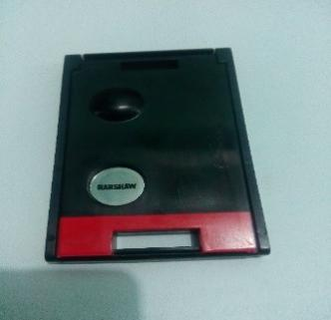

**Figure 2.6:** Thermoluminescent dosimeter chip in a casing.

## Processes required for the processing of dosimeters for calibration

*Anneal Dosimeters* - Reader, anneals the dosimeters to clear them of all residual exposure by processing them through appropriate Time-Temperature Profile (TTP).

*Store Dosimeters* - Between preparation (anneal) and irradiation, store the dosimeters in a subdued ultraviolet (UV) environment at a temperature at no higher than 30oC.

*Expose Dosimeters* - Expose the dosimeters to a known radiation source (eg. 500 mR of 137Cs) within two hours of annealing them.

*Store Dosimeters* - Store the dosimeters for the time established above. The cards should be stored in a subdued UV environment at a temperature at no higher than 30oC.

*Read Dosimeters* - The dosimeters may now be read for calibration purposes.

## Radiation protection surveys and programme

Radiology facilities must be constantly surveyed. According to (Seeram and Travis, 1997), the purpose of such survey is to check the status of radiation safety mechanism and practice, ensure equipment is working optimally, and ensure the radiology department is absolutely safe for both patients and personnel (staff). The NCRP has recommended that the Radiation Safety Committee (RSC) comprise of a radiologist, a medical physicist, a nuclear medicine personnel, a senior nurse and an internist. A senior radiological technologist, particularly one trained in Quality Control procedures, might also serve a useful role on such a committee (Seeram and Travis, 1997). It is the duty of RSC to perform a regular radiation protection survey. According to NCRP, this survey has

five phases; investigation, inspection, measurement, evaluation and recommendation. Of these phases, evaluation is the most important in that it provides the foundation on which future recommendations are based.

## Empirical review

* 1. **Dose records**

Exposure to radiation has origin such as medical diagnostic and therapeutic procedures; background radiation; accidents such as the one at Chernobyl in 1986 and occupations that entail increased exposure to artificial or naturally occurring sources of radiation (UNSCEAR, 2008). Ionizing radiation is a known carcinogen at high doses, and clinical symptoms are known to be associated with the chronic low-dose exposure especially as the use of ionizing radiations in medicine is expanding rapidly due to the introduction of new ionizing radiation oriented diagnostic and therapeutic practices (Khaled *et. al.,* 2016). It is on this backdrop that the ICRP, (1991) introduced occupational dose limit of 20 mSv averaged over five years to protect radiation workers and guard against deleterious effects of ionizing radiation. Records of radiation dose received by staff ideally should be an important inevitable documentation in every established radiology department. These dosimetric records are kept and are required to be disclosed when workers change jobs (Jean, 1998) to ensure lack of breech of protection for radiation workers. With the aim to determine the occupational dose absorbed by radiographers in Anambra state and the current level of state of protection practices, other works are surveyed which will serve as a yardstick to this study.

Proper adherence to radiation protection guidelines and regulation has been noted to reduce dose to both patient and staff. Such was the opinion of Nzotta and Chiaghanam, (2010) in a study of Occupational Radiation Dose to X-ray workers in Radiological units in South Eastern Nigeria carried out between 2005-2007. The study incorporated three (3) tertiary hospitals. Values obtained

from their study showed that the minimum dose received by the staff within the three years is

0.41mSv and the highest dose value received is 5.29 mSv per annum by a resident doctor. The dose distribution for the various occupational groups show that the technicians received more radiation in the three hospital, while the Radiographers and the radiologists received normal values in the three centres. The highest individual cumulative annual dose value of 5.29 mSv is lower than the ICRP recommended 1/3 of the permissible dose of 20mSv/yr.

To further reduce radiation dose, while Nzotta and Chiaghanam, (2010) suggested that radiographers are exposed to very high radiation doses due to dependence on refurbished x-ray equipment whose output are higher than the European Committee reference value. Samerdokiene *et. al*., (2013) corroborated it by pointing out that dose reduction were achieved because equipment were changed to digital units, renovations and reconstructions were made which improved protection and working condition of radiation workers. They analyzed the Radiation exposure received by the medical radiation workers in Lithuania at The Institute of Oncology, Vilnius University. Different occupational groups in Radiology, Radiotherapy and Nuclear medicine were monitored. They pointed out that the majority of the workers during the period of study received annual doses <5.00 mSv. They opined that reduction in doses were achieved because major attention is paid to radiation protection of all workers.

The general features of occupational radiation protection dosimetry in Nigeria within the period 1990-1999 was summarized by (Farai and Obed, 2001). About 640 personnel, representing about 25% of the estimated number of radiation workers in Nigeria, were monitored by the TL dosimetry technique during the period, with the majority being the personnel of the teaching hospitals across the country. The weighted mean of the annual effective dose ranged between 0 and 28.97 mSv. Most private establishments especially x-ray diagnostic centres operated without dosimetric coverage. They opined that the dose record could be more if all radiation workers in the country were

monitored.

TLD was the detective material used for occupational radiation monitoring in Ghana. Hasford *et. al*., (2012) assessed the annual whole-body occupational radiation exposure of those in medical practice. Monitored dose data of diagnostic radiology, radiotherapy and nuclear medicine were extracted from Ghana Radiation Protection Institute. Of these three categories, diagnostic radiology facilities comprised of 98%. Average dose per exposed worker for the 10 year period of exposure was highest in diagnostic radiology with a value of 1.05mSv and a range of 0.32 – 2.614 mSv.

Ogundare and Balogun (2003) studied the whole-body doses of occupationally exposed female workers in Nigeria for three years. Their data was from the national dose registry kept by federal radiation protection service, thus their work incorporated the medical and industrial workforce. When summed up (both medical and industrial workforce), they noted that the mean annual doses of all radiation workers increased from 3.6 mSv in 1999 to 4.7 mSv in 2000 and 7.7 mSv in 2001. This general increase was mainly from the increase in mean annual doses to workers in industrial sector. Female radiation workers received the highest annual doses in 1999 and 2001. Their result indicated the need for the regulatory authority to pay more careful attention to the control of female radiation workers exposure.

Some longitudinal studies have also noted a decreasing order of radiation dose among radiation workers. Such decrease was noted to base largely on improvement of radiation protection practices. In South Korea, Won *et. al.,* (2009) detailed the distribution of occupational radiation doses among diagnostic radiation workers by using the national dose registry between 1996 – 2006. TLD was used for dose measurement quarterly. The average annual effective doses of all monitored workers decreased from 1.75 - 0.80 mSv over the study period. Among all diagnostic radiation workers, radiologic technologists received both the highest effective and collective doses. They concluded by suggesting intensive monitoring of occupational radiation exposure of diagnostic workers in South

Korea.

Jabeen *et. al.,* (2010) studied the occupational exposure from external radiation used in medical practices in Pakistan by film badge dosimetry. Categories of practice was divided into Nuclear medicine (NM), radiotherapy and Diagnostic radiology (DR). Annual average effective dose in NM, radiotherapy and DR varied in the range of 1.39 – 1.80, 1.05 – 1.45 and 1.22 – 1.71 mSv respectively. These values are quite low and well below the annual limit of 20 mSv averaged over a period of 5 consecutive years. They observed that the decreasing trend of annual average dose values in aforementioned categories of work during the period under study indicates the improvement of radiation protection status.

In a similar study that described the annual effective dose status among the radiation staff of Lagos University Teaching hospital, Lagos, Nigeria, (Ibitoye *et. al.,* 2011) studied the dose records of two groups- radiodiagnosis and radiotherapy, comprising of 75 medical radiation workers. Average Quarterly Effective Dose (AQED) and Average Annual Effective Dose (AAED) were calculated and results presented in Deep Dose Equivalent (DDE) and Shallow Dose Equivalent (SDE). Diagnostic radiographers received average DDE of 0.580 mSv and SDE of 0.511 mSv which is the highest in the department. The average annual effective dose was highest with medical physicists with DDE and SDE values of 0.844 mSv and 0.857 mSv respectively. The results showed that occupationally exposed staff in Radiotherapy and Radiodiagnosis department received doses lower than the recommended annual limit of 20 mSv. They suggested that the low radiation exposures can be attributed to establishment of strict compliance with local rules, restriction of traffic and working procedures of radiation workers as well as periodic calibration and quality assurance practices.

A representative sample of occupationally exposed workers was surveyed in an effort to estimate annual occupational effective doses from external ionizing radiation at medical institutions in Kenya by (*Korir et. al*., *2011).* Monthly dose measurements were collected for a period of one year using

thermoluminescent dosimeters. A total of 367 medical radiation workers comprising of radiologists,

oncologist, dentists, physicists, technologists, nurses, film processor technicians, auxiliary staff and radiology office staff were monitored. The average annual effective dose for all subjects ranged from

1.19 to 2.52 mSv. Among these technologists received the largest annual effective dose. The study also found shortcomings in various regulations governing radiation exposure of workers wherein additional safety measures for pregnant women was lacking.

Memom *et. al*., (2012) studied the evaluation of radiation workers occupational doses working at Nuclear Institute of Medicine and radiotherapy (NIMRA) Jamshoro, Pakistan. Their study employed the use of film batches with unique identification number for a particular worker. The radiation dose received in 2011 and the total dose received in the last five years (2007-2011) by 35 radiographers were evaluated. Their result show that annual doses of workers were ranging from 0.1 mSv to 3.60 mSv for year 2011, whereas the summed up total dose for the last five years (2007-2011) ranged from 2.57 mSv to 22.04 mSv out of 100 mSv (total dose for 5 years). They concluded from the dose data of annual and last five years of all radiation workers of NIMRA Jamshoro, the radiation doses of all radiation workers were in the acceptable range of National and International organizations.

In Japan, Chida *et. al.,* (2013) described the occupational dose in Interventional radiology procedure. Using two monitoring badges, they compared the annual occupational dose (effective dose and dose equivalent) among interventional radiology staff (Physicians, nurses and radiologic technologists). The annual mean ± SD effective dose (range) to the physicians, nurses, and radiologic technologists was 3.00 ± 1.50 (0.84–6.17), 1.34 ± 0.55 (0.70–2.20), and 0.60 ± 0.48 (0.02–1.43) mSv/y,

respectively. They concluded that the annual occupational dose for interventional radiology staff was in the order physicians > nurses > radiologic technologists. This shows that the technologists received the least dose.

Radiation Workers’ Occupational Doses: Are We Really Careful or Overconscious was a study done by (Memon *et. al.,* 2013) in Nuclear Institute of Medicine and Radiotherapy (NIMRA) Jamshoro Pakistan. The data of annual doses for selected radiation workers (8 in number) whose radiation doses were high showed that the occupational doses of radiation workers were ranging from 1.21 mSv (6.1% of annual dose) to 7.78 mSv (38.9% of annual dose). Although the doses of selected workers were somehow higher than other radiation workers due to their nature of duties, they were in the annual dose range of 20mSv as recommended by the International and their National regulator organizations.

Al-Abdusalam and Brindhaban (2014) studied the occupational radiation exposure among the staff of departments of nuclear medicine and diagnostic radiology in Kuwait. The whole-body dose or effective dos, i.e. Hp(10) and skin dose, i.e. Hp(0.07) of the staff involved were obtained using TLD for the years 2008 and 2009. Their data was extracted from the national thermoluminescent dosimetry database. Particularly for diagnostic radiology technicians, the 2008 mean annual effective dose i.e. Hp(10) is 1.05mSv with a range of 0.08 – 2.81 mSv. There was a reduction in 2009 with a mean Hp(10) of 0.99 (0.07 – 2.11) mSv. In all other categories, no significant difference was found. They concluded that the annual average Hp(10) was well below the limit of the ICRP.

Yahaya and Hassim (2015) studied the Radiation Risk Estimation from Occupational Medical Imaging Exposure in Malaysia. Their objective was also to determine the knowledge of occupational radiation exposure and radiation safety among workers. The assessment was made based on the collective doses collected from film badge of the workers. The results of risk assessment show the mean annual collective effective dose based on type of X-ray procedure in this study was 5.445mSv, which is much lower compared to the whole body exposure dose limit, set by the ICRP. Majority of the respondents are aware of radiation safety, however only a few fully understood the hazards they

are exposed to. They concluded that even though the status of radiation protection in Malaysian

hospitals can be considered as adequate at the moment, efforts need to be put in place to reduce the occupational radiation exposure among workers.

Razaq *et al*., (2016) evaluated radiation workers occupational doses for newly established medical centre NORIN Nawabshah in Pakistan. The study involved three sections of the hospital namely- Nuclear medicine, Radiology and Radiotherapy Units. Particularly in Radiology, an average dose of

1.67 mSv is recorded in 2013. In 2014, an average dose of 1.91 mSv was recorded an increase by

0.24 mSv (12.57%). The percentage increment in radiation exposure is due to increased patient workload. They concluded from the annual dose data of all radiation workers of NORIN Nawabshah, the radiation doses of all radiation workers were in the acceptable range of National and International organizations which verifies that the facilities for radiation protection are satisfactory.

## 2.81 Evaluation of Radiation protection practices

Australian Radiation Protection and Nuclear Safety Agency (2008) pointed out that the radiation dose to the operator can be minimized by prudent positioning relative to the X-ray tube, patient and or by structural shield. Where there is no structural shield and the operator has to remain in the room during general radiography, such as with mobile radiography, the operator should stand at least two (2) metres away from the X-ray tube and outside the primary beam. In these circumstances the operator should, wear protective lead aprons.

In Nigeria, Awosan *et. al.,* (2016) assessed the knowledge of Radiation Hazards, Radiation Protection Practices and Clinical Profile of Health Workers in a Teaching Hospital in Northern Nigeria. A universal sampling technique was used to select staff from Radiology, Radiotherapy and Dentistry whom were issued questionnaire. Their result showed that (59.1%) had good knowledge of radiation hazards, (52.7%) had good knowledge of Personnel Protective Devices (PPDs) and less than a third, (27.3%) consistently wore dosimeters at work. Very few, (10.9% and below) consistently wore other PPDs at work. The average annual radiation exposure ranged from 0.04 -

1.87 mSv. They concluded that their study demonstrated poor radiation protection practices despite good knowledge of radiation hazards among participants.

Ishiguchi, T. (2001) concluded that in performing radiological examinations, it is necessary to make an effort to keep exposure as low as possible while maintaining clinically satisfactory image quality.

In Iran, it was revealed that some radiographers are exposed to doses greater than 4 mSv in any two month routine monitoring. While carrying out a study on root cause of the high occupational doses of industrial radiographers in Iran, (Mianji *et al*., 2016) issued questionnaire to such radiographers with greater doses of radiation. The responses showed that more than 50% of the radiographers did not agree with their recorded TLD doses, although the majority of the alternative explanations were weak. The main causes of overexposures were found to be difficult working conditions and ignoring safety principles.

In the Eastern province, Saudi Arabia, Khaled *et. al.,* (2016) assessed the occupational radiation exposure among medical staff in health care facilities using questionnaire. Their result showed that most hospitals have lead aprons and thyroid shields in place, but only about 50% have lead glasses and lead shields, showing that many hospitals still lack essential equipment. Most health care workers (99%) wear lead apron however, actual utilization of lead glasses is very low. They observed low interest among workers in radiation monitoring as 68.9% only utilize their radiation dosimeters.

Okaro, *et al*., (2010) evaluated personnel radiation monitoring in radiodiagnostic centres in South Eastern Nigeria and discovered that Personnel radiation monitoring was available in only 4 out of 10 hospitals (40%) surveyed and in two of the hospitals radiation monitoring does not cover all the radiographers on employment. Radiation monitors were found to be read fairly regularly at about every quarter of the year but it takes more than 3 years for fresh supplies of radiation monitoring devices to be made in the hospitals. Radiation protection advisers or supervisors were available in

only 4 hospitals (40%). They concluded by noting that Personnel radiation monitoring in South Eastern Nigeria is abysmally poor.

The above finding and conclusion are also consistent with the state of occupational radiation protection and monitoring in public and private X-ray facilities in Edo state, Nigeria. Eze, *et, al.,* (2011) revealed that out of 18 functional X-ray facilities comprising 10 (55.56%) publicly owned and eight (44.44%) privately owned, only two (20%) of the public and five (62.5%) of the private X-ray units have personnel and environmental monitoring. All the X-ray centers in both public and private hospitals have effective lead aprons. All the public (100%) and only four (50%) of the private centers have gonadal shield although none is using them on a routine basis. Only one (10%) of the public centers and one (12.5%) private X-ray centre have a purpose-built adequately designed X-ray unit with barium plasters and lead lining of walls and doors. There is also only limited lead lining of doors and walls in three (37.5%) private units while no lead lining or barium plasters are used in five (62.5%) of the private units. They concluded that there are inadequate radiation protection and monitoring practices in most of the functional X-ray facilities in Edo state.

After evaluating the level of protection in Radiology department of Kermanshah, Iran, Ayoob *et al.,* (2015) based on their analysis found out that, 56.8% of radiation protection devices were accessible to radiographers. Overall, 81.3% of radiographers stated that they utilized film badges for radiographic procedures, while only 71.7% had used these badges in practice. Additionally, 54.2% of radiographers claimed that they regularly performed medical check-ups; however, based on the documents available at personnel offices, only 43.8% had taken this measure into account. Also, 60.4% of radiographers claimed that they had participated in annual training courses, while based on the records, only 41.7% had participated in such courses. They stated that the majority of radiographers had no regard for radiation protection principles for either themselves or the patients.

At Urmia in Iran, Zhaleh *et al.,* (2015) conducted a study on assessment of radiation protection practices amongst radiographers and quality control of diagnostic radiology devices. They discovered application of shielding devices such as gonad shield for protection was ignored mostly in hospitals. Most x-ray machines were quite old and evidence of quality assurance tests performed on such machines were lacking. While radiographers showed an excellent knowledge of radiation protection within the study period, adherence to radiation protection practices among radiographers during the period studied was, however, poor. They concluded that radiographers should embrace current trends in radiation protection and apply their knowledge in protecting themselves and patients from harmful effects of ionizing radiation.

On the aspect of Quality assurance, they conclude from there study that there are no QA programmes and QA committees in hospitals and none in any X-ray departments. In most X-ray departments QC tests are not conducted and for those that indicated they do, there were no examples of test films to confirm that the tests are indeed conducted except in one case. A hospital needs to have a QA committee to ensure proper implementation and monitoring of the QA programme in all departments of the hospital. The lack of QA programmes for the X-ray equipment in Urmia has led to frequent breakdown of machines and poor quality of radiographs resulting in greater risks of ionizing radiation. Radiographers in-Charge also have to take responsibility to ensure that the condition of X-ray equipment is well monitored and faulty parts replaced to avoid frequent breakdowns.

Studies above have demonstrated regional and international dose data for different occupational groups. It is particularly observed that radiographers are not separately studied as they are merged in a broader scope with other occupational groups such as in many diagnostic radiology departments (DR). Though some studies has been done in South East in general regarding occupational dose, individual states has not been studied to either corroborate the regional study or otherwise. Apart

from the fact that years has passed by since such studies has been made, many diagnostic centres are

springing up across Anambra state necessitating a current (maiden) study to be conducted. Again radiation workers has also been assessed on radiation protection practices and the near consensus is that of abysmal protection practices amongst radiation workers. It is important that radiation practices in the state be checked for best practices. The above lacuna necessitates the need to undertake this study in Anambra state to check that radiation dose are below set limits and its protection practices checked for best practices.

**CHAPTER THREE**

# MATERIALS AND METHODS

## Research Design

A Prospective cohort survey approach was adopted to measure the occupational dose to radiographers in Anambra state as well as obtain their responses to basic radiation protection measures in the state. Cohort study, a type of longitudinal study, samples a group of people who shear a common characteristic in a selected period of time. Survey research has been defined as the collection of information from a sample of individuals through their responses to questions (Julie, 2015). The above research design allowed for this work to study same group of people overtime prospectively and also used questionnaire material to obtain information from them.

## Location of Study

The study was carried out among radiographers in government-owned and six private hospitals in Anambra state. The radiographers practicing in hospitals located at Onitsha, Ogidi, Eke-Nkpor, Ihiala and Nnewi as shown in table 3.1. Some hospitals in these towns were chosen because they have more than one installed and functional radiological equipment that emit ionizing radiation.

**Table 3.1** Names and locations of hospitals involved in the study.

|  |  |  |  |
| --- | --- | --- | --- |
| **S/n** | **Name of hospital** | **Location** | **Designation** |
| **1** | New Hope Hospital | Onitsha | Centre 1 |
| **2** | General Hospital Onitsha | Onitsha | Centre 2 |
| **3** | St. Charles – Borromeo Hospital | Onitsha | Centre 3 |
| **4** | Iyienu Mission Hospital | Ogidi | Centre 4 |
| **5** | Crown Hospital | Eke-nkpor | Centre 5 |
| **6** | Our Lady of Lourdes Hospital | Ihiala | Centre 6 |
| **7** | Nnamdi Azikiwe University Teaching Hospital (NAUTH) | Nnewi | Centre 7 |

## Ethical Consideration

Ethical approval for this study was obtained from the Research Ethics Committee of the Faculty of Health Sciences and Technology, Nnamdi Azikiwe University, Nnewi Campus. The confidentiality of the information elicited from the participants was maintained. They were made aware of their option to withdraw from the study at their will without being victimized.

## Target Population

Total population of radiographers who are involved in dispensing ionizing radiation in Anambra state is estimated at 60. This figure was arrived at from the following: A letter from Radiographers Registration Board of Nigeria (RRBN) enlisting all x-ray centres in Anambra state. Phone calls and visit were made to most centers for proper identification. Again, the opinion of one of the most senior radiographer who has practiced for over three (3) decades in the state was also sought.

## Sample Size Determination

The entire study population sixty (60) were recruited for the study. This is more statistically representative.

## Inclusion Criteria

The radiographers included in this study were those that satisfied the following criteria:

1. Licensed Radiographers by RRBN: This is to make sure that no quarks were involved in the study.
2. Radiographers whose primary place of occupation is in Anambra state: This is to avoid radiographers on holidays from other states to be part of the study since they may likely not be around to complete the study.
3. Radiographers whose jobs include dispensing of ionizing radiation: This is to exclude those radiographers who are sonographers or who deal with non-ionizing radiation.

## Instrument Used for Data Collection

The instruments used for data collection include the following:

1. *Annealed Thermoluminescent Dosimeter (TLD) chips* - Lithium Fluoride (LiF100) TLD chips in plastic holders were used to measure the radiation dose received by radiographers while at work. TLD is a convenient method of personnel radiation monitoring as it is portable, lightweight, reusable and can always be worn by the radiographer during work sessions (Okaro, *et al*., 2010). Its high sensitivity to radiation detection, low fading for a longer period of time, good precision and accuracy, good stability under standard environmental conditions are some of its greater qualities for personnel dosimetry (Juan, 2004). To measure the radiation dose, a TL material frees some electron to a higher energy state when exposed to radiation leaving behind holes of positive charge. When the TL material is heated, electrons return to their stable state by falling back to their previous band and light is emitted because of the energy difference between two orbital levels. The amount of light emitted is measured and it is proportional to the radiation dose (Seeram and Travis, 1997). Lithium Fluoride TLD chips are almost tissue equivalent (Juan, 2004) and are thus very desirable for personnel dosimetry.
2. *Black cellophane envelopes* to store the TLD chips and shield it from atmospheric moisture and luminous radiation.
3. *Harshaw 4500 TLD reader* outsourced from the Centre for Energy Research and Training (CERT) Zaria, Kaduna state, Nigeria for annealing the TLD and reading the radiation dose. The Harshaw 4500 Manual TLD Reader provides versatile readout of TLD dosimeters. It incorporates both hot gas and planchet heating to read TLD cards. Dual photomultiplier tubes and associated electronics enable it to read cards in two positions simultaneously. A start button and four indicator lights control and monitor the operation. The Model 4500 connects via a serial interface to an external PC, which provides control over the setup, time-temperature

profiles (TTPs), analysis and data recording (Harshaw 4500 Dual TLD Reader and Workstation, 2007).

1. *A 21-item self-completion questionnaire* adopted in a modified form from a previous study by Okaro et al. (2010). The questionnaire was used to elicit information from radiographers on their opinion on radiation protection measures in Anambra State. The questionnaire is divided into two sections: A – Socio demographic data and section B – Occupational radiation protection measures. The questions posed to respondents came in a closed ended polytomous format from where the respondents choose their options.

## Method of Data Collection

*Brief Orientation:* Each participating radiographer in the study was given a short explanation on the need for radiation dose monitoring among radiographers and the TLD being an inevitable tool for this purpose. This was to raise the awareness of radiation regulation among radiology staff in Nigeria which has been reported to be low (Nzotta and Chiaghanam, 2010).

*Distribution of Questionnaire*: The questionnaire to obtain opinion of radiographers on radiation protection measures was distributed to all the radiographers directly by the researcher. The radiographers filled out the questionnaires and returned all the copies to the researcher same moment. *TLD Identification and distribution*: Each TLD was marked with a black ink, each bearing Personal Identification Number (PIN) for easy reference and identification. The TLDs were then distributed, one per radiographer.

*Position of TLD*: Each participating radiographer wore the TLD between the chest and the abdomen, outside the lab gown. During the use of a lead apron, the radiographers were instructed to wear the TLD under the apron. Each participating radiographer was also instructed that should he or she at any time become a patient during the data collection period, he or she should ensure removal of their TLD before being exposed to radiation as this is termed medical exposure and does not contribute

to occupational exposure (Brateman, 1999). They were also instructed to wear the TLDs only within the department.

*Duration of TLD Wear (Quarterly)*: The first batch of the TLDs were worn for three (3) months. At the end of each working day within the first three months, a research assistant entrusted with proper care and daily storage of the TLDs in each centre collected them and stored them up in a common safe place (a drawer). At the end of the first quarter, the TLDs were collected from the radiographers on a set date which enable each radiographer to properly hand in his or her TLD, before they were sent for reading.

A fresh set of TLDs (second Batch) were given to the radiographers immediately after collecting the former batch from them. The second batch of TLDs were also worn for another three months (second quarter). A research assistant daily took them at the end of the work from radiographers and stored them up in a common safe (drawer). At the end of the second quarter, the TLDs were collected from the radiographers on a set date which enable each radiographer to properly hand in his or her TLD, before they were sent for reading.

*Reading of TLDs:* First, after the first quarter, the first batch of the TLDs collected from the radiographers were immediately sent to the Centre for Energy Research and Training (CERT) Zaria, where a dosimeter reading facility is available. A Harshaw model 4500 TLD reader connected via a serial communication port to a computer with the program - Windows Radiation Evaluation and Management System (winREMs) was used to evaluate the TLD readings. The visual display unit of the computer displayed the glow curve of the TLD readings as they were being generated. After the second quarter, retrieved TLDs from radiographers was also immediately sent to CERT, Zaria for reading just as the first batch.

*Precaution:* As a precaution, a TLD similar to those used to measure occupational exposure was used to measure the background radiation dose in each centre. They were placed at a central location

in the department for three months, outside the rooms where ionizing radiation equipment are housed. The background radiation dose in each centre was subtracted from the measured occupational dose to radiographers in the centre.

## Method of Data Analysis

The data obtained were analyzed using the Statistical Package for Social Sciences (SPSS) version

21.0 (SPSS Incorporated, Chicago Illinois). Descriptive statistical tools were used to analyze the quantitative variables which were expressed as mean ± SD, percentages and frequencies. Student T- test was used to analyze the correlation of effective dose between public (Government) and private centers, (p ≤ 0.05) was taken as the significant level. The results of the analysis were presented with the aid of tables and texts.

# CHAPTER FOUR RESULTS

## Demographic data

Sixty (60) Radiographers made up of 37 (61.7 %) from a federal establishment, 12 (20.0%) from a religious organization, 6 (10.0%) from private establishment and 5 (8.3%) from state establishment. There were more male subjects (n = 39, 65 %) than female (n = 21, 35.0 %). The respondents all had tertiary-level education. The least educated had diploma from a monotechnic (n = 2; 3.3 %). The bulk of the subjects (n=54; 90.0%) had a B.Sc., 4 (6.7 %) had an M.Sc. while none had a Ph.D. Also, 29 (48.3%) of the Radiographers were Intern, 27 (45.0%) were Radiographer I and II while 4 (6.7%) were Chief Radiographers. Finally 39 (65%) of the Radiographers had less than 5 years experience, 12 (20%) had 6 – 10 years experience while 9 (15%) had more than 10 years experience. These are summarized in Table 4.1

**Table 4.1:** Demographic Data of Respondents

|  |  |  |  |
| --- | --- | --- | --- |
| **Items** | **Options** | **Frequency** | **Percentage**  **(%)** |
| **Gender** | Male Female  **Total** | 39  21  **60** | 65.0  35.0  **100** |
| **Highest Qualification** | DCR B.Sc.  M.Sc.  Ph.D.  Others (specify)  **Total** | 2  54  4  0  0  **60** | 3.3  90.0  6.7  0  0  **100** |
| **Post-Graduation Experience** | <5 years  6 – 10 years  >10 years  **Total** | 39  12  59  **60** | 65.0  20.0  15.0  **100** |
| **Ownership of the Establishment** | Federal Government State Government Religious Organization Private individual  **Total** | 37  5  12  6  **60** | 61.7  8.3  20.0  10.0  **100** |
| **Position** | Intern Radiographer I & II Chief  **Total** | 29  27  4  **60** | 48.3  45.0  6.7  **100** |

## Dose data

Table 4.2 below shows the values of the mean effective dose for six months received by radiographers in the sampled centres in Anambra State. The dose ranges between 0.34 – 0.90 mSv with a mean of 0.56 ± 0.03 mSv. The percentage contribution to the dose ranged between 11.8 to 18.3%. Centres 7 (0.65 mSv) and centre 2(0.71 mSv) had values higher than the mean.

**Table 4.2:** Bi-annual radiation dose received by radiographers in Anambra state.

|  |  |  |  |  |  |
| --- | --- | --- | --- | --- | --- |
| **Centre** | **n** | **Range**  **(mSv)** | **Mean ± SD**  **(mSv)** | **% contribution to dose** | **Type of Equipment** |
| Centre 1 | 3 | 0.41 – 0.71 | 0.56 ± 0.03 | 14.4 | X-Ray, CT |
| Centre 2 | 5 | 0.41 – 0.84 | 0.71 ± 0.05 | 18.3 | X-Ray, CT |
| Centre 3 | 4 | 0.35 – 0.54 | 0.52 ± 0.01 | 13.4 | X-Ray, CT |
| Centre 4 | 5 | 0.35 – 0.53 | 0.51 ± 0.01 | 13.1 | X-Ray, CT,  Mammography |
| Centre 5 | 3 | 0.36 – 0.49 | 0.48 ± 0.01 | 12.3 | X-Ray |
| Centre 6 | 3 | 0.35 – 0.48 | 0.46 ± 0.01 | 11.8 | X-Ray |
| Centre 7 | 37 | 0.35 – 0.90 | 0.65 ± 0.06 | 16.7 | X-Ray, CT,  Mammography, Fluoroscopy |
| Total | 60 | 0.34 – 0.90 | 0.56 ± 0.03 | 100.0 |  |

## Comparative data between current and previous works

Table 4.3 gives a comparison of the present work with others. Five Nigerian, two African and seven Asian authors with comparable works were reviewed. The range and mean for many works are given. The annual range and mean in this work is comparable to most other studies especially that of Hasford in Ghana.

**Table 4.3:** Comparison between present study and other works

|  |  |  |  |  |
| --- | --- | --- | --- | --- |
| Centre | Location | Year | Range  (mSv) | Mean  (mSv) |
| **Present work** | **Anambra** | **2017** | **0.34 – 0.90**  **Annual range**  **0.68 – 1.80** | **0.56± 0.03**  **Annual mean**  **1.12 ± 0.06** |
| Farai | Nigeria | 2001 | 0 – 28.97 |  |
| Ogundare | Nigeria | 2003 |  | 7.7 |
| Nzotta | Nigeria(SE) | 2010 | 0.11 – 5.29 |  |
| Ibitoye | Lagos | 2011 |  | 0.58 |
| Awosan | Nigeria | 2016 | 0.04 – 1.87 |  |
| Korir | Kenya | 2011 | 1.19 – 2.52 |  |
| Hasford | Ghana | 2012 | 0.32 – 2.61 | 1.05 |
| Won | S/ Korea | 2009 | 0.80 – 1.75 |  |
| Jabeen | Pakistan | 2010 | 1.22 – 1.71 |  |
| Memon | Pakistan | 2012 | 0.72 – 1.12 |  |
| Chida | Japan | 2013 | 0.02 – 1.43 | 0.60 |
| Memon | Pakistan | 2013 | 1.21 – 7.78 |  |
| Al-Abdulsalam | Kuwait | 2014 | 0.08 – 2.81 | 1.05 |
| Rasaq | Pakistan | 2016 | 0.84 – 2.52 | 1.67 |

## Comparative data between establishments and genders

Given in Table 4.4 is a comparison of mean effective dose output in Anambra State for six (6) months between public and private centres and between genders. There was significant (p < 0.05) difference in mean effective dose output between the public (Government) and private centres. In the public facility the dose output between genders was variable (male: 0.62 mSv; female: 0.70 mSv) while in the private facilities, both genders had comparable dose output (male: 0.49 mSv; female: 0.48 mSv). Overall, the female population had significant (p < 0.05) higher mean dose output (0.22) mSv in comparison with the male population (0.13) mSv.

**Table 4.4:** A correlation of mean effective dose (mSv) between public and private centres in Anambra state for six months.

|  |  |  |  |  |
| --- | --- | --- | --- | --- |
| Subjects  n = 60 | Government; n = 37  (mSv) | Private; n = 23  (mSv) | Mean difference  (mSv) | P - Value |
| Male  (n = 39) | 0.62 ± 0.12 | 0.49 ± 0.34 | 0.13 | 0.002 |
| Female  (n = 21) | 0.70 ± 0.16 | 0.48 ± 0.03 | 0.22 | 0.000 |
| Combined (Male and Female)  (n = 60) | 0.66 ± 0.04 | 0.49 ± 0.03 | 0.17 | 0.000 |

*Significant difference (p < 0.05)

## Data on awareness of radiation protection

All (100 %) the centres in the state had evidence of structural shielding. Personnel monitoring did not cover all radiographers in the state. Responses to other radiation-based questions shows that there were inconsistent radiation protection practices in the centres. These are summarized in Table 4.5

**Table 4.5:** Responses to questionnaire on availability of radiation protection

|  |  |  |  |
| --- | --- | --- | --- |
| **Question** | **Response** | | **Inference** |
| **No** | **Yes** |
| Personnel radiation monitoring (PRM) provided? | 11  (18.3%) | 49  (81.4%) | Inconsistent |
| Radiation shielding provided? | 0 | 60  (100.0%) | Available |
| Do you always use the PPDs on a routine basis? | 50  (83.3%) | 10  (16.7%) | Inconsistent |
| Annual Radiation Protection Training | 44  (73.3%) | 16  (26.7%) | Inconsistent |
| Presence of RSO or RSA? | 28  (46.6%) | 32  (53.4%) | Inconsistent |
| Registered with a certified physicist? | 33  (55.0%) | 27  (45.0%) | Inconsistent |
| Quality control measures available? | 34  (56.6%) | 26  (43.4%) | Inconsistent |

## Data on specific policies of radiation protection

Some specifics on radiation protection, modalities and work culture are as shown in Table 4.6. Lead (n = 60) is the material of choice for structural shield. TLD dominated as the material of choice for personnel monitoring and are read by the sixth month on the average. Greater no of radiographers (n=29) do not always wear their TLDs at work. The equipment at the centres benefit from calibration at regular intervals.

**Table 4.6: Responses to questionnaire on specifics questions on radiation protection**

|  |  |  |  |
| --- | --- | --- | --- |
| **Questions** | **Responses** | | |
| Structural shield used | Pb lining (60) | Ba plaster (0) | Concrete (0) |
| Type of Personnel Radiation Monitor (PRM) provided | TLD (46) | Film badge (3) | PIC (0) |
| How often PRM is worn | Always (20) | Not always (29) | Not at all (11) |
| How often the PRM is read | 3 months (14) | 6 months (35) | > 6 months (0) |
| Who does equipment calibration? | Radiographer (24) | Physicist (13) | Engineer (23) |
| Regularity of calibration | Quarterly (20) | Yearly (24) | Breakdown (16) |

# CHAPTER FIVE DISCUSSION AND CONCLUSION

## Discussion

This study measured the occupational radiation dose to radiographers in Anambra state, Nigeria. Sixty (60) radiographers made up of (61.7%) from a government (public) establishment and (38.3%) from six private establishments were studied (Table 4.1). The research subjects are more in number from the public establishment because of its greater employment of radiographers. More males (n = 39, 65%) participated in the study than females (n = 21, 35%). They were all involved in dispensing ionizing radiation at their various centres.

Thermoluminescent dosimeter chips were used to measure the radiation dose received by radiographers in Anambra state. This study recorded a dose range of 0.34 - 0.90 mSv with a mean effective dose value of 0.56 ± 0.03 mSv for six months as shown in Table 4.2. The different ranges of effective doses is expected owing to the difference in no of patients attended to in these centres as well as exposure conditions peculiar to each centre. International Committee on Radiological Protection (ICRP, 1990) has set the dose limit for occupational staff as effective annual dose limit of 20 mSv averaged over five (5) years. For purposes of annual dose value, the dose range and mean value was multiplied by two (2) to give 0.68 – 1.80 mSv and 1.12 ± 0.06 mSv respectively. Even in its annual extrapolated value, the mean dose obtained is far below the ICRP occupational dose limit and lower than the (UNSCEAR, 2010) reported worldwide average of 2 mSv. This is a similar finding by (Ibitoye *et. al.,* 2011; Chida *et. al.,* 2013 and Jabeen *et. al.,* 2010) where their mean annual dose are far lower than the set standard. Thus, this study provides sufficient evidence that the work environment is safe among radiology centers in Anambra state. It is particularly noted that five centres (centre 1, 2, 3, 4 and 7), had high dose ranges and mean doses when compared to the remaining two centres (centre 5 and 6). One common factor among these five centers is that they

operated Computed Tomography (CT) machine, a known high radiation dose emitter. A centre (centre 2) which operated CT machine contributed highest (18.3%) to the total occupational dose in Anambra state. This could be as a result of poor radiation practices as noted by these authors (Awosan *et. al.,* 2016; Eze, *et, al.,* 2011) and inadequate or non-rotation of staff on duty especially in the CT suite. Centre 2 (0.71 ± 0.05) mSv and Center 7 (0.65 ± 0.06 mSv) have mean doses higher than the average (0.56 ± 0.03) mSv. Reduced optimized protection of standards and particularly the sheer volume of workload are likely the peculiar reasons applicable to these two centres since both are state and federal (public) establishment respectively receiving greater patient inflow.

The dose range and annual mean values gotten in this study are comparable to other works done locally and internationally as shown in Table 4.3. Similar studies in Nigeria have demonstrated occupational doses of radiation workers. In northern Nigeria, despite good knowledge of radiation hazards but poor demonstration of radiation protection practices, Awosan *et. al.,* (2016) recorded an annual radiation dose with its highest range (1.87) mSv comparable to this study (1.80) mSv. Though Nzotta and Chiaghanam (2010) who did a similar study in south eastern Nigeria got a higher effective dose range of 0.11 – 5.29 mSv, their highest value (5.29) mSv in their work was from a junior resident doctor and not a radiographer. This dose value could be attributable to the fact that their study spanned for three years involving various occupational groups. They opined that radiographers in their study received normal dose values probably due to adherence to recommended radiation protection rules and regulations. Such opinion of strict compliance to protection rules and restriction of traffic and working procedures of radiation workers was also demonstrated in another Nigerian study conducted in Lagos University Teaching Hospital by (Ibitoye *et. al.,* 2011). Radiographers in the radio-diagnostic department received an average annual effective dose of 0.58 mSv (very minimal). Their recorded mean value is far lower than the value in this study and indeed lower than all studies compared in this work. The values reported in these local studies are similar

to this work as they are far below the occupational dose limit set by international and local bodies. Though the values reported by Ogundare and Balogun (2003) are also well below the set limit, they recorded the highest successive mean values than the local studies above (3.6mSv in 1999 to 4.7mSv in 2000 to 7.7mSv) in 2001 across all radiation workers in Nigeria. This successive increases in radiation doses was mainly contributed by radiation workers in industry and not from medical sector. However, with the increasing utilization of radiation in radiology (diagnostic) centers in Anambra state, there is need for regulatory bodies to checkmate the radiation protection standards and ensure all radiation workers are duly monitored and dose limits not exceeded.

Nigerian studies are not far different from some international studies as well. In Pakistan, Memon *et al*, (2013) selection criteria of eight persons who received doses higher than orders ensured their highest range of value 7.78 mSv is higher when compared to other works in this study. Just the previous year, Memom, *et. al.,* (2012) combined all radiation workers (radiology unit inclusive) and got an annual dose range of 0.1 - 3.6mSv. Their work shows that in radiology unit, the annual dose range is 0.72 – 1.12mSv. Though this study recorded an annual value slightly higher than their work, both annual range values are comparable. In South Korea, while Won *et. al.,* (2009) noted that radiologic technologists received both the highest effective and collective doses, in Japan, Chida *et. al.,* (2013) contrasted it. They opined that Radiologic technologists received the least dose (0.02 – 1.43) mSv with mean dose value of 0.60 mSv. When compared between same occupational team in both studies, the range of values from both studies and the annual mean dose from Won’s study are not farfetched from this present study as seen in Table 4.3.

African studies too are not left out. For a ten (10) year study in Ghana, Hasford *et. al*., (2012) obtained an effective dose range of 0.32 – 2.61 mSv in diagnostic radiology. Workers in diagnostic radiology received most of the individual doses probably because they constituted 98% of the study.

The above study is similar to the findings by Korir *et. al*., (2011) when they revealed in their work

that technologists who constitute nearly half the population study of 367 received the highest annual effective dose in their one year study. The average annual effective dose for all subjects ranged from

1.19 – 2.52 mSv with a mean value of 2.15 mSv. When compared to this study, the above African studies had range of doses higher than what was obtained in this present study likely because diagnostic radiology staff studied are far higher in numerical number than other occupational groups. However they are all far lower than the values obtained in a Nigerian study by (Ogundare and Balogun 2003).

The mean effective dose gotten in this study and its extrapolated annual equivalence are far less than the dose limit set by the international bodies. When compared to other works locally and internationally, the dose range and mean doses of other works are at variance as expected because of different occupational groups involved in their respective studies, different method of sample selection and inherent different exposure conditions. Generally, they are similar in the sense that they are far less than the occupational dose limit of 20 mSv set by ICRP (1990).

Comparing the government and private establishments, this study has revealed that the government facilities had significant (p<0.05) higher dose output (0.66 mSv) than the private facilities (0.49 mSv) as shown in Table 4.4. This may be due to the fact that the government centre contributed more (n = 37) to the total study population. More importantly, the government facility which is a teaching hospital employs more staff than the private establishment because of the sheer high number of patient’s inflow with varying cases necessitating several radiographic projections. Again, its teaching obligations and research purposes are another contributing factor. The more patients are exposed to radiation, the more the occupational dose to radiographers. Thus in view of the above, it is expected that more radiation exposures are carried out in the government facility than in the private facility which will inevitably lead to increase in occupational dose to the radiographers. Though the females contributed less to the population study, they received mean dose difference (0.22) mSv

significantly (p<0.05) higher than that of males (0.13) mSv. This dominance in female dose is also a similar finding by (Ogundare and Balogun, 2003) who advocated the need for regulatory authority to pay more attention to the control of female radiation dose exposures.

The importance of personnel radiation monitoring cannot be over emphasized as it is one of the core protective measures in occupationally exposed workers. Structural shielding is inevitable in radiation protection as it limits exposure to staff and members of the public. There is evidence of structural shield in all the centres studied in the state as shown in Table 4.5. This finding is different from a study at Edo state, Nigeria where it was found out that Only one (10%) of the public centers and one (12.5%) private X-ray centre have a purpose-built adequately designed X-ray unit with barium plasters and lead lining of walls and doors (Eze, *et al.,* 2011). Lead is the material of choice (100%) used for structural shield in the State (Table 4.5). The choice of lead could be attributed to its efficiency in attenuating incident x-ray (Seeram and Travis, 1997). The IAEA, (2004) safety guidelines has provided that every occupationally exposed worker must have a personal radiation monitoring device. Majority of the personal monitors used in Anambra state are Thermoluminescent Dosimeters (n=46) while Film badges (n=3) are on the minor. This study reveals that not (18.3% - inconsistent) all radiographers are provided with Personnel Radiation Monitoring (PRM) device similar to a finding by Okaro *et. al*., (2010) where they noted that most radio-diagnostic centers are not monitored. Given the stochastic effect of radiation, inconsistency with the provision of PRM is appalling since radiation is dispensed in all these centres. In an ideal working situation, all centres are to be monitored properly. Where personnel monitoring devices are provided, most radiographers seldom wear them at work, a similar finding by (Ayoob *et. al.,* 2015) at Iran. This study showed that (n =29; 48.3%) do not always wear their monitoring device while (n=11; 18.3%) do not wear them at all (Table 4.6). Khaled *et. al.,* (2016) supports the above findings when they observed low interest among workers in radiation monitoring as 68.9% only utilize their radiation dosimeters.

While Okaro *et. al*., (2010) noted that TLDs are fairly read in three months interval in South Eastern Nigeria, this study found out that in Anambra, TLDs are fairly read with majority of the reading (68.3%) taking place about six months in these centres. These practices are not in line with local and international regulations which require that TLD must be changed and submitted for reading every month or at most 3 months to prevent loss of stored information (Botwe *et. al.,* 2015). The implication of this non-compliance with international regulation is that occupational doses are not correctly monitored. Thus the recorded doses ascribed to each radiographer may be considered safe whereas the actual doses absorbed may be high, gradually culminating towards deleterious effects of ionizing radiation.

Personnel Protective Devices (PPDs) are necessary and vital in protecting oneself from scatter radiation. This study has revealed that about 83.3% of radiographers do not wear their lead apron, gonad shield and lead glass while attending to patients on routine basis. This obviously will gradually lead to chronic exposure to low dose radiation which is injurious given time. While Khaled *et. al.,* (2016) noted that most health care workers (99%) wear lead apron however whereas actual utilization of lead glasses is very low, Awosan *et. al.,* (2016) corroborated the finding of this present work when he noted that (10.9% and below – very poor) consistently wore PPDs at work.

Greater no of radiographers (73.3%) are not annually involved in radiation protection training courses. This is a similar finding by Ayoob *et. al.,* (2015), who based on records noted that only 41.7% of radiographers are involved in annual radiation protection training courses in Iran. Lack of such periodic training puts the radiographer in the dark on current trend and safe method of practice involving ionizing radiation.

It was also noted in this study that Radiation Safety Officers (RSO) are not in all the centres when ideally, they should be in all the centres. This is similar to the findings by (Okaro, *et. al.,* 2010 and

Botwe *et. al.,* 2015). Radiation Safety Officer (RSO) is a trained personnel employed and responsible for safe handling and use of radiation and radioactive materials. They are responsible for identifying radiation safety issues and ensuring compliance with regulations. Since they are not readily available in some centres, detection of immediate radiation safety concerns and possible timely aversion of any short or long time detrimental effect associated with radiation will certainly be hampered. This shows the extent of poor radiation protection practices in Anambra state.

Quality assurance and quality control are both crucial concepts in radiology. Quality control is a part of quality assurance that ensures a set of procedures intended to ensure a product or service meets a predetermined set of quality or criteria. X-ray equipment are to be subjected to sets of quality control to guarantee that an exact input will yield a desired output. This study shows that some centres in Anambra state (56.6%) are inconsistent in their quality control measures. This is in line with the findings of Zhaleh *et al.,* (2015) at Urmia, Iran who noted that in most X-ray departments QC tests are not conducted. Ideally, all staff concerned with ionizing radiation in radiology are required to be part of quality assurance procedure. Calibration, an important part of quality control was seen to be carried out by radiographers, physicists and engineers.

## Conclusion

The mean effective dose incurred by radiographers for six months (6) and its extrapolated annual equivalence while working with ionizing radiation in Anambra state is lower than the occupational dose limit of 20 mSv averaged over five (5) years set by ICRP.

Radiation protection practices are merely taken for granted in Anambra state. Generally, monitoring conditions in Anambra state did not meet international standards, depicting the extent of poor radiation protection practices in the state.

However, despite the poor monitoring conditions, the study has shown that work environment is safe and radiographers in Anambra state are not overly exposed to harmful effects of ionizing radiation occupationally. Rather than adherence to safe practices, this study suggests that low doses are likely due to nonchalant attitude on the part of radiographers not to always wear their TLD during work.

## Recommendation

Given the poor radiation protection outcome:

1. It is therefore very important that the arm of government responsible for formulating laws especially in Anambra state promulgate laws that will be sacrosanct on uses and safe practices involving ionizing radiation.
2. Government regulatory agencies such as the Nigerian Nuclear Regulatory Authorities (NNRA), and the Radiographers Registration Board of Nigeria (RRBN) and any other agency associated with radiation monitoring need to be pro-active to halt the menace of unsafe practices involving the use of radiation.
3. Local seminars, training and periodic re-training of radiographers and all staff involved in the use of ionizing radiation in the same working environment should be encouraged. Local and inherent difficulties can be tackled, current trend and safe method of practice upheld with the likely limited protective devices available to them.
4. The management of hospitals should as a matter of dire need engage the services of radiation experts to ensure standard of operations, accurate documentation and recommendation.
5. Heads of unit or authorities in the radiology department see to it and possibly punish erring staff who do not wear their personal monitor during work instances.
6. All establishment dealing with ionizing radiation should ensure a strict compliance to internationally acceptable radiation safety practices to protect radiographers amongst all other

staff, patients and the general public from harmful effects of ionizing radiation.

## Limitation of study

1. Some centres at the time of this study had equipment breakdown and this hindered data collection from such centres.
2. Some private establishment were not willing to be part of the study for fear of being spied upon possibly on their wrong practices.
3. The mean value gotten in this study for six months was extrapolated to an annual equivalent for purposes of comparison with other studies and the annual set limit of ICRP. It assumed the exposure conditions to be the same for a year using the six months study which may not necessarily hold.

## Area of further study

1. Comparative occupational dose audit among all staff cadre in radiology centres where ionizing radiation is dispensed in Anambra state.
2. Quantification of occupational dose from different imaging modalities.

REFERENCES

Al-Abdusalam, A. and Brindhaban, A. (2014). Occupational radiation exposure among the staff of departments of nuclear medicine and diagnostic radiology in Kuwait. *Medical Principle and practice: international journal of the Kuwait University, Health Science Centre*, 23(2): 129- 133.

Al-Lamki, L. (2011). Radiation Exposure from Medical Imaging: A Wake-up Call for Oman! *Sultan Qaboos University Medical Journal,* 11(1): 1-4.

Australian Radiation Protection and Nuclear Safety Agency (2008). Safety guide: Radiation Protection in Diagnostic and Interventional Radiology. *Radiation Protection Series* Publication, 14: 35 – 37.

Australian Radiation Protection and Nuclear Safety Agency (2012). Radiation Basics – Ionizing and Non-ionizing Radiation. Available at: http:// [www.](http://www/) arpansa.gov.au/ radiationprotection/ Basics/ ion_nonion.cfm [Accessed 12 march, 2017].

Awosan, K.J., Ibrahim, M., Saidu, S.A., Ma’aji, S.M., Danfulani, M., Yunusa, E.U., Ikhuenbor, D.B. and Ige, T.A. (2016). Knowledge of Radiation Hazards, Radiation Protection Practices and Clinical Profile of Health Workers in a Teaching Hospital in Northern Nigeria. *Journal of Clinical and Diagnostic Research*, 10(8): 7 – 12.

Ayoob, R., Mohammad, F. and Daryoush, F. (2015). Evaluation of the level of protection in Radiology department of Kermanshah, Iran. *Iranian Journal of Medical Physics* 12(3) 200 – 208.

Basu, S., Andrews, J., Kishore, S., Panjabi, R and Stuckler, D. (2010). Comparative Performance of Private and Public Healthcare Systems in Low- and Middle-Income Countries: A Systematic Review. *PLoS Medicine,* 9(6): e1001244

Bitran, R. (1995). Efficiency and quality in the public and private sectors in Senegal. *Health Policy Plan,* 10(3): 271 – 83.

Botwe, B,O., Antwi, W, K., Adesi, K,K., Anim-Sampong, S., Dennis, A, M, E., Sarkodie, B,

D. and Opoku, S, Y, (2015). Personal radiation monitoring of occupationally exposed radiographers in the biggest tertiary referral hospital in Ghana. *Safety in Health,* 1:17.

Brateman, L. (1999). Radiation Safety considerations for domestic radiology personnel.

*Radiographics,* 19: 1055-1087.

Brown, K.R. and Rzucidlo, E. (2011). Acute and Chronic Radiation Injury. *Journal of Vascular Surgery*, 5: 15.

Chida, K., Kaga, Y., Haga, Y., Kataoka, N., Kumasaka, E., Meguro, T. and Zuguchi, M., (2013). Occupational dose in interventional radiology procedures. *American Journal of Roentgenology*, 200(1): 138–141.

European medical Alliance, (2016). Interactions of photons with matter. Available at: <http://www.europeanmedical.info/emission-tomography/interaction-of-photons-with-> matter.html [accessed 14 March 2017].

Eze, CU., Abonyi, LC., Njoku, J., Irurhe, N.K. and Olowu, O. (2013). Assessment of radiation protection practices among radiographers in Lagos, Nigeria. *Nigerian Medical Journal,* 54(6): 386 -391.

Eze, K.C., Nzotta, C.C., Marchie, T.T., Okegbunam, B. and Eze, T.E. (2011). The state of occupational radiation protection and monitoring in public and private X-ray facilities in Edo state, Nigeria. *Nigerian Journal of Clinical Practice,* 14(3): 308 – 10.

Farai, I.P. and Obed, R.I. (2001). Occupational radiation protection dosimetry in Nigeria. *Radiation Protection Dosimetry,* 95(1): 53 – 58.

Garau, M.M., Calduch, A.L. and Lopez E.C. (2011). Radiobiology of the Acute Radiation Syndrome. *Reports of Practical Oncology and Radiotherapy*, 16(14): 123-130.

Gilbert, E.S. (2009). Ionizing Radiation and Cancer Risks: What Have We Learned From Epidemiology? *International Journal of radiation Biology*, 85(6): 467-482.

Grover, S.B., Kumar, J., Gupta, A. and Khnanna, L. (2002). Protection against radiation harzards: Regulatory bodies, safety norms, dose limits and protection devices. *Indian Journal of Radiology imaging* 12(2): 157–167.

Harshaw 4500 Dual TLD Reader and Workstation (2007). Product Specifications. Available at: https://assets.thermofisher.com/TFS-Assets/LSG/Specification-Sheets/D16603~.pdf [Accessed 28 February, 2018].

Hasford, F., Owusu-Banahene, J., Amoako, J.K., Otoo, F., Darko, E.O., Emi-Reynolds, G., Yeboah, J., Arwui, C.C. and Adu, S. (2012). Assessment of annual whole-body occupational radiation exposure in medical practice in Ghana (2000-09). *Radiation Protection Dosimetry* 149(4): 431 – 437.

Health Physics Society (2015). What type of radiation are there? Page last updated: 31 August 2015. Available at: <http://hps.org/publicinformation/ate/faqs/radiationtypes.html> [accessed 21 January, 2016].

Health Physics Society (2016). What is radiation? Available at: <http://hps.org/publicinformation/ate/faqs/whatisradiation.html> [Accessed 12 March 2017].

IAEA Safety Glossary (2007). *Terminology used in nuclear safety and radiation protection,* (2007 ed.): International Atomic energy Agency, 1290: 29.

Ibitoye, Z., Aweda, M. and Irurhe, N. (2011). Annual Effective Dose status among the Radiation Staff of Lagos University Teaching hospital, Lagos, Nigeria. *African Journal of Basic and Applied Sciences,* 3(4): 126 – 130.

ICRP (1991). Recommendations of the International Commission on Radiological Protection (ICRP) publication 60. Ann ICRP 1991, 1-3.

ICRP, (2007). The 2007 Recommendations of the International Commission on Radiological Protection. ICRP Publication 103. Ann. ICRP 37 (2-4).

Ishiguchi, T. (2001). Optimization and Guidance Levels for Radiation Protection in Diagnostic X- ray Examinations. *Japan Medical Association Journal,* 44(11): 480–483.

Jabeen, A., Munir, M., Khalil, A., Masood, M. and Akhter, P. (2010). Occupational exposure from external radiation used in medical practices in Pakistan by film badge dosimetry. *Radiation Protection Dosimetry,* 140(4): 396 – 401.

Jean, M.C., (1998). Community legislation on medical radiation protection in the context of internal market. *Radiation Protection Division, DG XI, Commission of the European Communities, Luxembourg,* 3:179

Juan, A.N. (2004). Thermoluminescence Dosimetry (TLD) and its Application in Medical Physics.

*AIP Conference Proceedings,* 724: 20.

Julie, P. (2015). Understanding and evaluating research. In: Check, J., Schutt, R. K. (2012). editors. *Research methods in education*. Thousand Oaks, CA: Sage Publications;. 159–185. Khaled, F. S., Abdulrahman, A., Mohammed, A., Yuosef, A., and Mohammed, A. (2016).

Assessment of occupational radiation exposure among medical staff in health-care facilities in the Eastern Province, Kingdom of Saudi Arabia. *Indian Journal of Occupational and Environmental Medicine* 20(1): 21 – 25.

Korir, G.K., Wambani, J.S. and Korir, I.K. (2011). Estimation of annual occupational effective doses from external ionizing radiation at medical institutions in Kenya. South African Journal of Radiology, 15(4): 116-119.

Little, M.P (2003). Risk associated with ionizing radiation. *British Medical Bulletin*, 68: 259-275.

Memon, S.A., Laghari, N.A., Cheema, A.A. (2012). Evaluation of radiation workers occupational doses working at NIMRA Jamshoro. *Journal of the Liaquat University of Medical and Health Sciences,* 11 (03): 190 – 194.

Memon, S.A., Qureshi, S.T., Laghari, N.A., Khuhro, N.M. (2013). Radiation Workers Occupational Doses: Are We Really Careful or Overconscious. *International Journal of Mathematical, Computational, Physical, Electrical and Computer Engineering,* 7: 8.

Mianji, F., Hosseini Pooya, S.M., Zakeri, F. and Dashtipour, M.R., (2016). A root cause analysis of the high occupational doses of industrial radiographers in Iran. *Journal of radiological protection*, *36*(1): 184-194.

National Council on Radiation Protection and Measurements (2009). Ionizing radiation exposure of the population of the United States*. Bethesda, Md.: NCRP No. 160.*

Nigerian Basic Ionizing Radiation Regulations (2003). *Official Gazette*: *The Federal Government Press, Lagos, Nigeria*, 90: 42-43.

Nzotta, C.C. and Chiaghanam, N.O. (2010). Occupational Radiation Dose to X-ray workers in Radiological units in South Eastern Nigeria. *African Journal of Medical Physics, Biomedical Engineering & Science*, 2: 64 - 66.

Office of Health, Safety and Security, (2012). A basic Overview of Occupational Radiation Exposure: Monitoring, Analysis and Reporting. *U.S Department of energy*. Available at: <http://energy.gov/sites/prod/files/2014/06/f16/A_Basic_Overview_of_Occupational_Radiat> ion_Exposure.pdf [Accessed 17 January, 2016].

Ogundare, F.O. and Balogun, F.A. (2003). Whole-body doses of occupationally exposed female workers in Nigeria (1999 – 2001). *Journal of Radiological Protection,* 23 (2): 201 – 208.

Okaro, A.O., Ohagwu, C.C. and Njoku, J. (2010). Evaluation of Personnel Radiation Monitoring in Radiodiagnostic Centres in South Eastern Nigeria. *African Journal of Basic & Applied Sciences,* 2 (1-2): 49-53.

Okeji, M.C., Anakwue, A.M. and Agwuna, K. (2010). Radiation exposure from diagnostic radiography: an assessment of x-ray beam collimation practice in some Nigerian Hospitals. *Internet Journal of Medical Update,* 5(2): 31-33.

Olowookere, C.J., Babalola, I.A.,Jibrin, N.N., Obed, I.R., Bamidele, L. and Ajetumobi, E.O. (2012). A Preliminary Radiation Dose Audit in some Nigerian Hospitals: a need for determination of Diagnostic Reference Level (NDRLs). *Pacific journal of science and technology*, 13(1): 487-494.

Razaq, A., Waqar, M., Soomro, Q. and Javed, M.A. (2016). Evaluation of radiation workers occupational doses for newly established medical centre NORIN Nawabshah in Pakistan. *Journal of Medical Physics and Biophysics,* 3: 1.

Samerdokiene, V., Atkocius, V. and Ofomala, R (2013). Radiation exposure received by the medical radiation workers in Lithuania at The Institute of Oncology, Vilnius University, 2004–2011. *Radiation Protection Dosimetry,* 157(1): 152-157.

Seeram E and Travis E.C. (1997). Radiation protection. Philadelphia, New York: Lippincott.

Shahbazi-Gahrouei, D., Gholami, M, and Setayandeh, S (2013). A review on natural background radiation. *Advanced Biomedical Research,* 2: 65.

Singer, G. (2005). Occupational Radiation Exposure to the Surgeon. *Journal of the American Academy of Orthopaedic Surgeons*, 13: 69-76.

Sprawls, P. (2012). Interaction of radiation with matter. Available at: <http://www.sprawls.org/ppmi2/INTERACT/> [accessed 14 March 2017].

Stabin, M.G. (2007). Radiation Protection and Dosimetry: An Introduction to Health Physics. New York: Springer.

United Nations Scientific Committee on the Effects of Atomic Radiation (UNSCEAR) (2000a). *Sources and Effects of Ionizing Radiation. Report to the General Assembly, with Scientific Annexes. Volume I: Sources.* New York: United Nations.

UNSCEAR (2008a). Sources and Effects of Ionizing Radiation, *UNSCEAR Report*: Volume I: Annexes A and B; New York: United Nations.

UNSCEAR (2000b). Sources and Effects of Ionizing Radiation. *Report to the General Assembly,*

with Scientific Annexes. Volume II: Effects. New York: United Nations.

UNSCEAR (2010). Summary of low-dose radiation on health. UNSCEAR report, New York, UN Press 1 – 14.

UNSCEAR (2012). Sources and effects of ionizing radiation. *United Nations Scientific Committee on the effects of Atomic Radiation, Report to General Assembly.* Annex B, exposure from Natural Radiation Sources. United Nations New York.

Usen, M.M and Umoh, G.V (2014). Radiation Protection among radiation Workers in Teaching Hospitals. *Advances in physics theory and application*, 37:

Wakeford, R. (2006). Occupational exposure, epidemiology and compensation. *Occupational Medicine*, 56 (3): 173-179.

Wakeford, R. (2009). Radiation in the workplace-a review of studies of the risks of occupational exposure to ionizing radiation. *Journal of Radiological Protection*, 29(2): 61-79.

Wang, J.X., Zhang, L.A., Li, B.X., Zhao, Y.C., Wang, Z.Q., Zhang, J.Y. and Aoyama, T. (2002). Cancer incidence and risk estimation among medical x-ray workers in China, 1950-1995. *Health Physics*, 82(4): 455-466.

Wikipedia, the free enclopedia. (2015). Radiation. Available at: https://en.wikipedia.org/wiki/Radiation. [Accessed 21 January, 2016].

Wikipedia, the free encyclopedia (2017). Background radiation. Available at: https://en.wikipedia.org/wiki/Background_radiation [Accessed 12 March 2017].

Won, J.L., Eun S.C., Mina, H., Young-Woo, J., Seung-Sik, H., Kyoung, A.K., Seung W.L., Hyun, K.L., Kwang-Yong, L. and Hyeog, J.K. (2009). Occupational radiation doses among diagnostic radiation workers in South Korea, 1996 – 2006. *Radiation Protection Dosimetry*, 136 (1): 50 – 55.

Yahaya, S.R. and Hassim, M.H. (2015). Radiation Risk Estimation from Occupational Medical Imaging Exposure in Malaysia. *Journal Teknologi (Sciences and Engineering),* 75(6): 87- 94.

Zhaleh, B., Reza, Zohdi. A. and Paria, Y (2015). Assessment of radiation protection practices amongst radiographers and quality control of diagnostic radiology devices in selected hospitals of Urmania City in Iran. *Research Journal of Pharmaceutical, Biological and Chemical Sciences*, 6(3): 1329.

## Appendices

Ethical approval



# QUESTIONNAIRE

My name is Anene Chukwuziem, an M.Sc. student of Radiation and Environmental Protection and Dosimetry in Nnamdi Azikiwe University, Nnewi Campus. I am equally your colleague, a radiographer working with Iyi-Enu Mission Hospital, Ogidi.

I am carrying out a research on **“Assessment of occupational radiation dose to radiographers in Anambra state and their opinion on radiation protection measures.”** I would be very glad if you kindly supply answers to the questions below.

The information supplied here will be treated with utmost confidentiality and used only for the purpose of this study.

**Tick [√] for Any Option Chosen:**

# SECTION A

SOCIO- DEMOGRAPHIC DATA

1. Gender? **Male [ ] Female [ ].**
2. Highest qualification: **DCR [ ] B.Sc.[ ] M.Sc.[ ] PhD[ ] others**

**………………………...**

1. Post-graduation experience: **<5 years[ ] 6-10 years[ ] > 10 years[ ]**
2. Name of your hospital/clinic: **………………………………………………………………**
3. Ownership of your hospital/Centre: **Federal government[ ] State government[ ] Religious organization[ ] Private individual(s) [ ]**
4. What is your position? **Intern[ ] Radiographer I [ ] or II [ ] Senior Radiographer [**

**] Chief Radiographer[ ]**

# SECTION B

**OCCUPATIONAL RADIATION PROTECTION MEASURES**

1. Which imaging modality/modalities do you work with? (You can tick more than one option).

## X-ray [ ] CT [ ] Mammography [ ] Fluoroscopy [ ]

1. Is there Personnel Radiation Monitoring plan in place in your hospital/Centre: **Yes[ ] No[ ]**
2. Is there any evidence of Radiation Shielding in your hospital/Centre: **Yes[ ], No[ ]**
3. Type of radiation shielding: **Lead lining[ ] Barium plaster[ ] Thick block wall[ ]**
4. Are you provided with any Personnel Radiation Monitoring (PRM) device? **Yes [ ] No [ ].**

## If yes, what type? Thermoluminescence dosimeter (TLD) [ ] Film badge [ ]

**Pocket lonisation dosimeter [ ] others: (specify)............................................................**

1. How often do you wear your TLD during work instances? **Always [ ] Not always [ ] Not at all [ ]**
2. How often is this taken for reading? **Every month [ ] Every 2 months [ ] Every 3 months [ ] Every 6 months [ ] Yearly [ ] I don’t know [ ]**
3. Do you always use Lead apron, Gonad shield or Lead glass on a routine basis?**Yes [ ]No [ ]**
4. Do you have any Radiation safety Adviser (RPA) or departmental Radiation safety Officer (RPO) in your department? **Yes [ ] No [ ].**
5. Is your radiology outfit currently registered with a certified Physicist? **Yes [ ] No [ ]**
6. How often are equipment(s) calibrated**? Daily [ ] weekly [ ] monthly [ ] quarterly [**

## ] yearly [ ] Never [ ]

1. Who does the calibration? **Radiographers [ ] Radiologists [ ] Physicists [ ] Others…………..**
2. Are there any quality control measures carried out on the equipment? **Yes [ ] No [ ]**
3. Are you involved in annual training courses for radiation protection? **Yes [ ] No [ ]**

# DOSE READING / MEASUREMENT

**CENTRE FOR ENERGY RESEARCH AND TRAINING**

***Ahmadu Bello University, Zaria***

**RADIATION PROTECTION SERVICES RECORDS**

ANENE CHUKWUZIEM NNAMDI Date: 13th July 2016

Dept. of Radiography,

College of Health Sciences & Tech, Okofia Campus.

|  |  |  |
| --- | --- | --- |
| **S/No** | **TLD ID** | **Dose (mSv)** |
| 1. | RAD 001 | 0.73 |
| 2. | RAD 002 | 0.37 |
| 3. | RAD 003 | 0.62 |
| 4. | RAD 004 | 0.62 |
| 5. | RAD 005 | 0.65 |
| 6. | RAD 006 | 0.35 |
| 7. | RAD 007 | 1.69 |
| 8. | RAD 008 | 0.64 |
| 9. | RAD 009 | 0.56 |
| 10. | RAD 010 | 0.53 |
| 11. | RAD 011 | 0.77 |
| 12. | RAD 012 | 0.71 |
| 13. | RAD 013 | 0.63 |
| 14. | RAD 014 | 0.74 |
| 15. | RAD 015 | 0.69 |
| 16. | RAD 016 | 0.54 |
| 17. | RAD 017 | 0.64 |
| 18. | RAD 018 | 0.62 |
| 19. | RAD 019 | 0.67 |
| 20. | RAD 020 | 0.45 |
| 21. | RAD 021 | 0.57 |
| 22. | RAD 022 | 0.81 |
| 23. | RAD 023 | 0.58 |
| 24. | RAD 024 | 0.62 |
| 25. | RAD 025 | 0.65 |
| 26. | RAD 026 | 0.61 |
| 27. | RAD 027 | 0.70 |
| 28. | RAD 028 | 0.56 |
| 29. | RAD 029 | 0.63 |
| 30. | RAD 030 | 0.59 |

|  |  |  |
| --- | --- | --- |
| 31. | RAD 031 | 0.58 |
| 32. | RAD 032 | 0.36 |
| 33. | RAD 033 | 0.40 |
| 34. | RAD 034 | 0.72 |
| 35. | RAD 035 | 0.63 |
| 36. | RAD 036 | 0.36 |
| 37. | RAD 037 | 0.54 |
| 38. | RAD 038 | 0.34 |
| 39. | RAD 039 | 0.48 |
| 40. | RAD 040 | 0.53 |
| 41. | RAD 041 | 0.48 |
| 42. | RAD 042 | 0.41 |
| 43. | RAD 043 | 0.84 |
| 44. | RAD 044 | 0.80 |
| 45. | RAD 045 | 0.70 |
| 46. | RAD 046 | 0.41 |
| 47. | RAD 047 | 0.41 |
| 48. | RAD 048 | 0.35 |
| 49. | RAD 049 | 0.71 |
| 50. | RAD 050 | 0.41 |
| 51. | RAD 051 | 0.38 |
| 52. | RAD 052 | 0.35 |
| 53. | RAD 053 | 0.54 |
| 54. | RAD 054 | 0.38 |
| 55. | RAD 055 | 0.45 |
| 56. | RAD 056 | 0.36 |
| 57. | RAD 057 | 0.44 |
| 58. | RAD 058 | 0.60 |
| 59. | RAD 059 | 0.71 |
| 60. | RAD 060 | 0.50 |

***Compiled by:*** S. Abdullahi

***Checked and approved by:*** Dr. D.J. Adeyemo

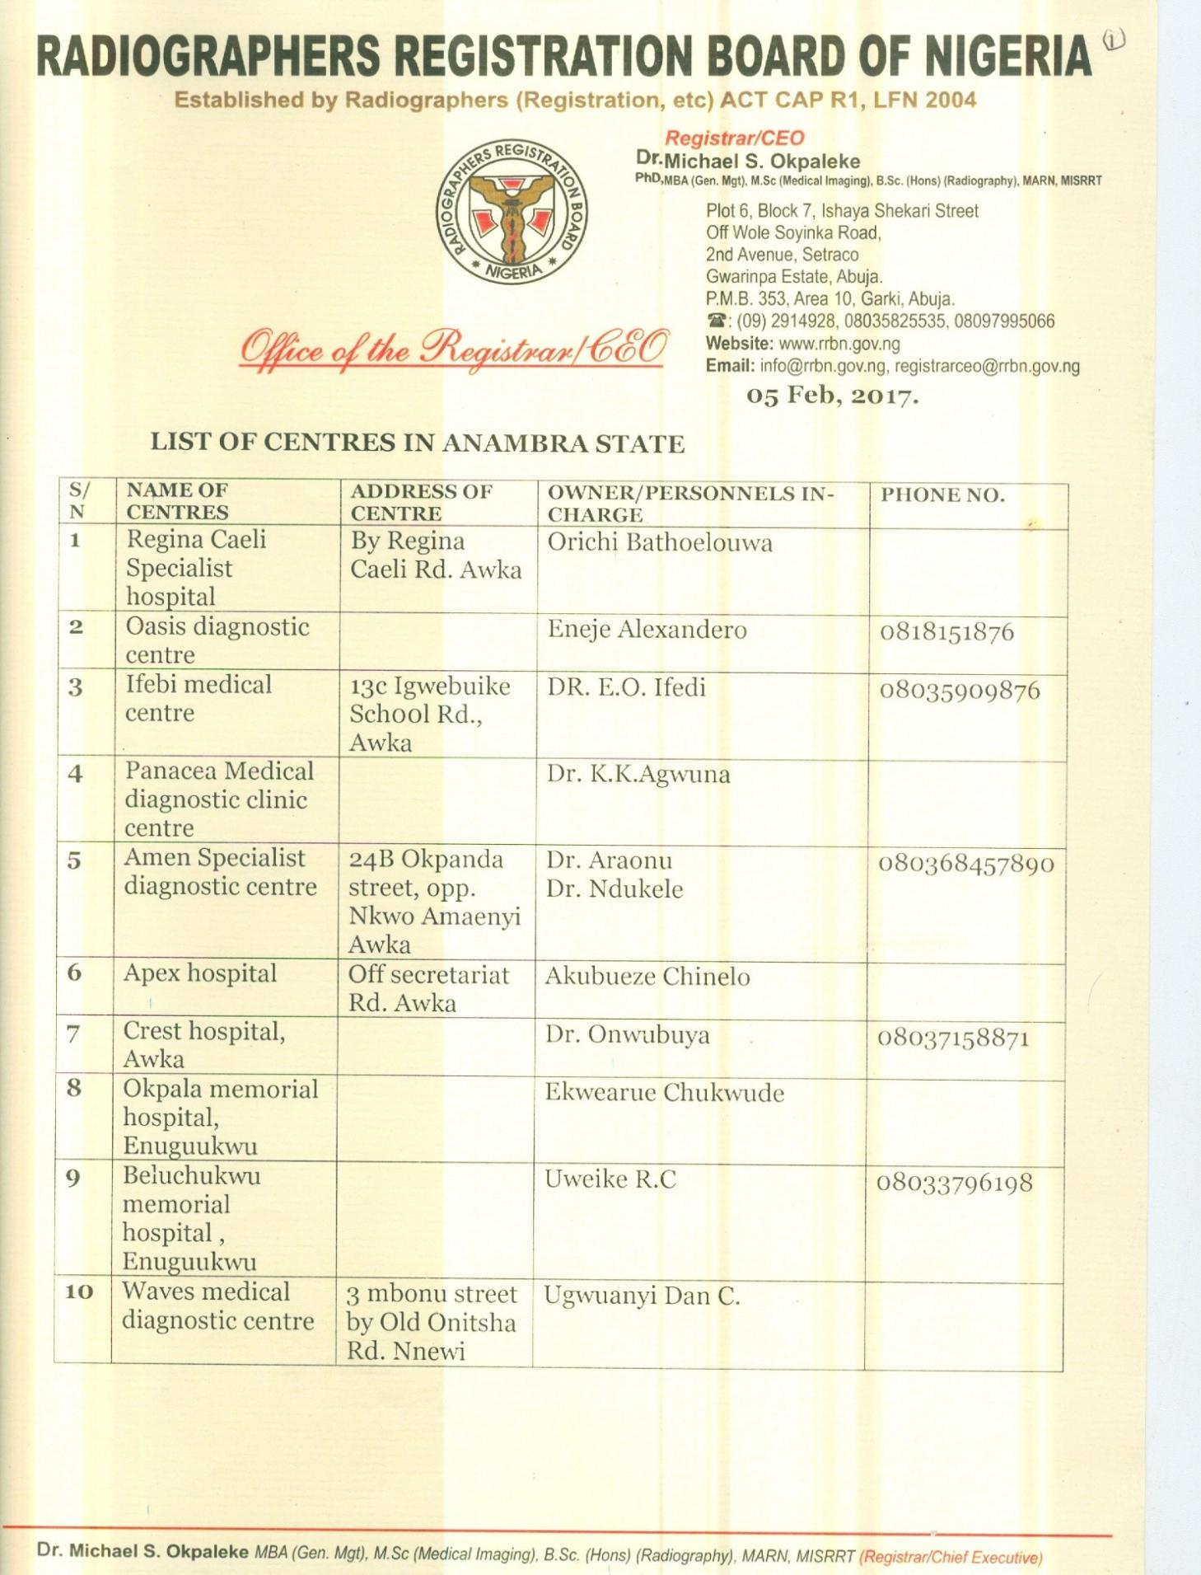

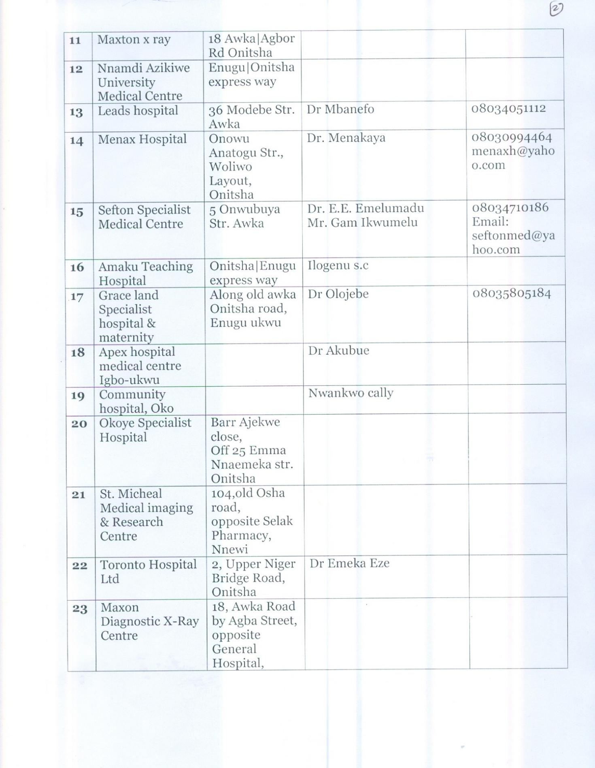

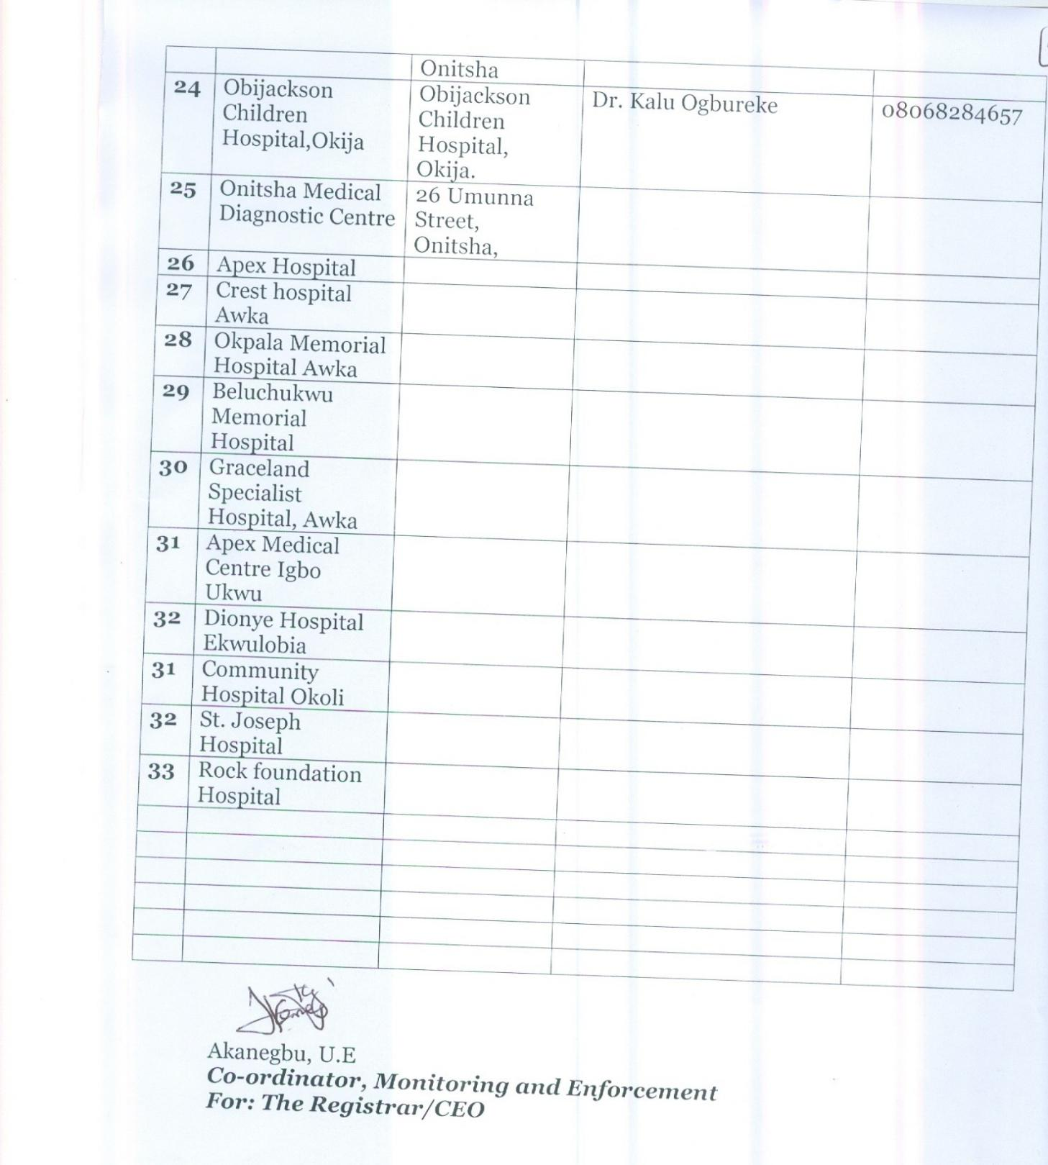

**THERMOLUMINESCENT DOSIMETER GLOW CURVES**

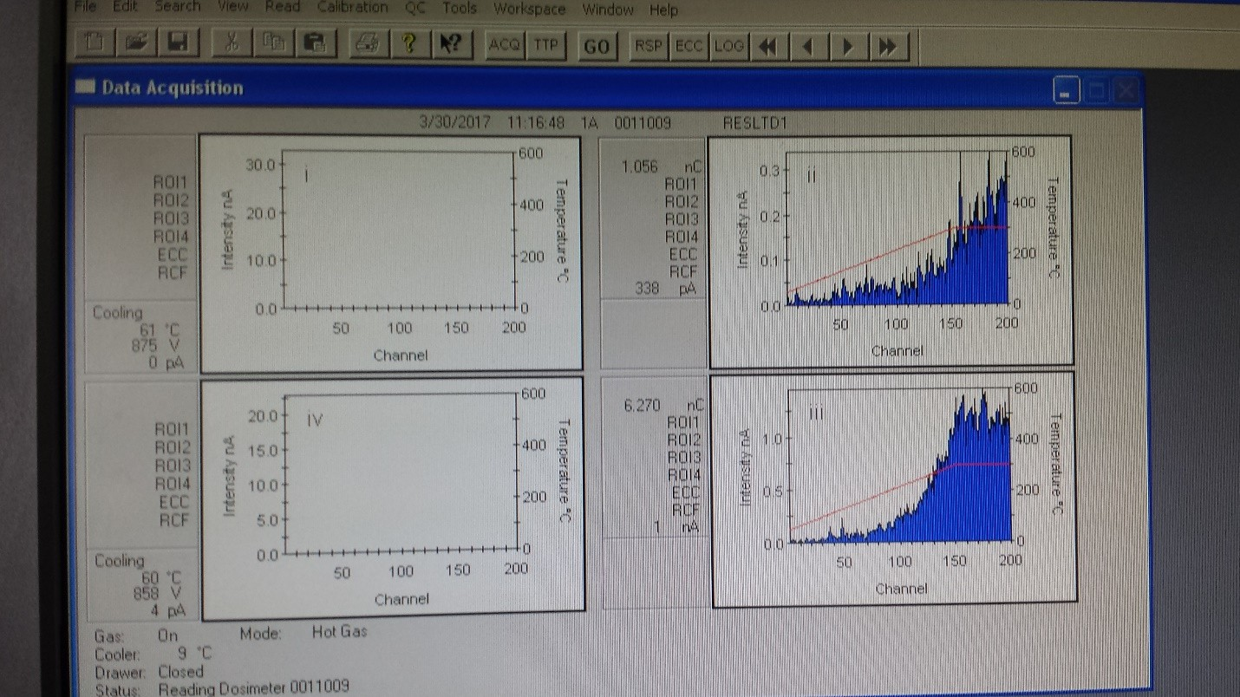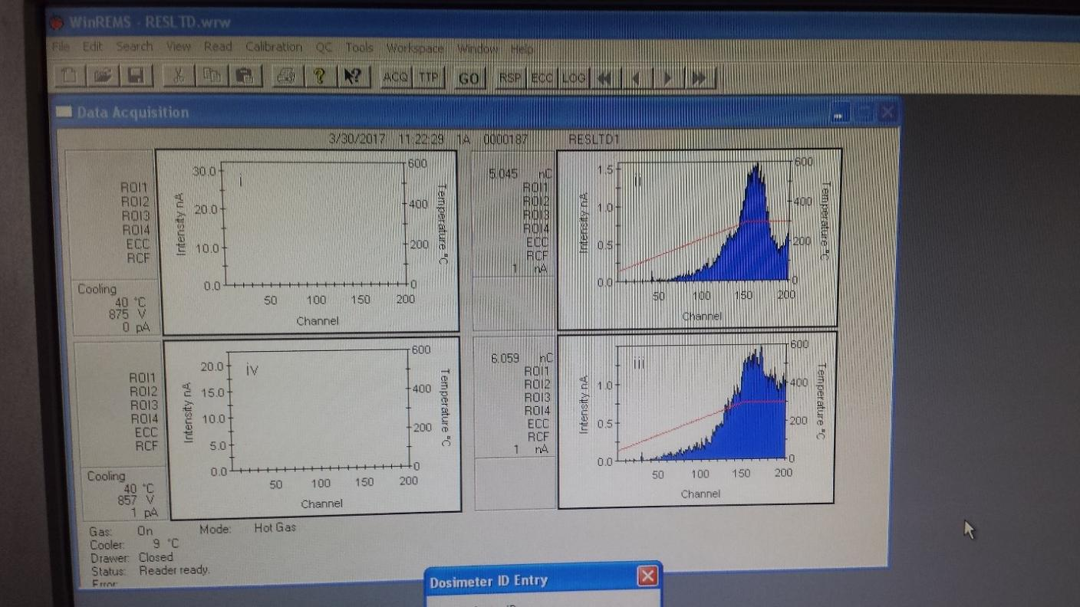

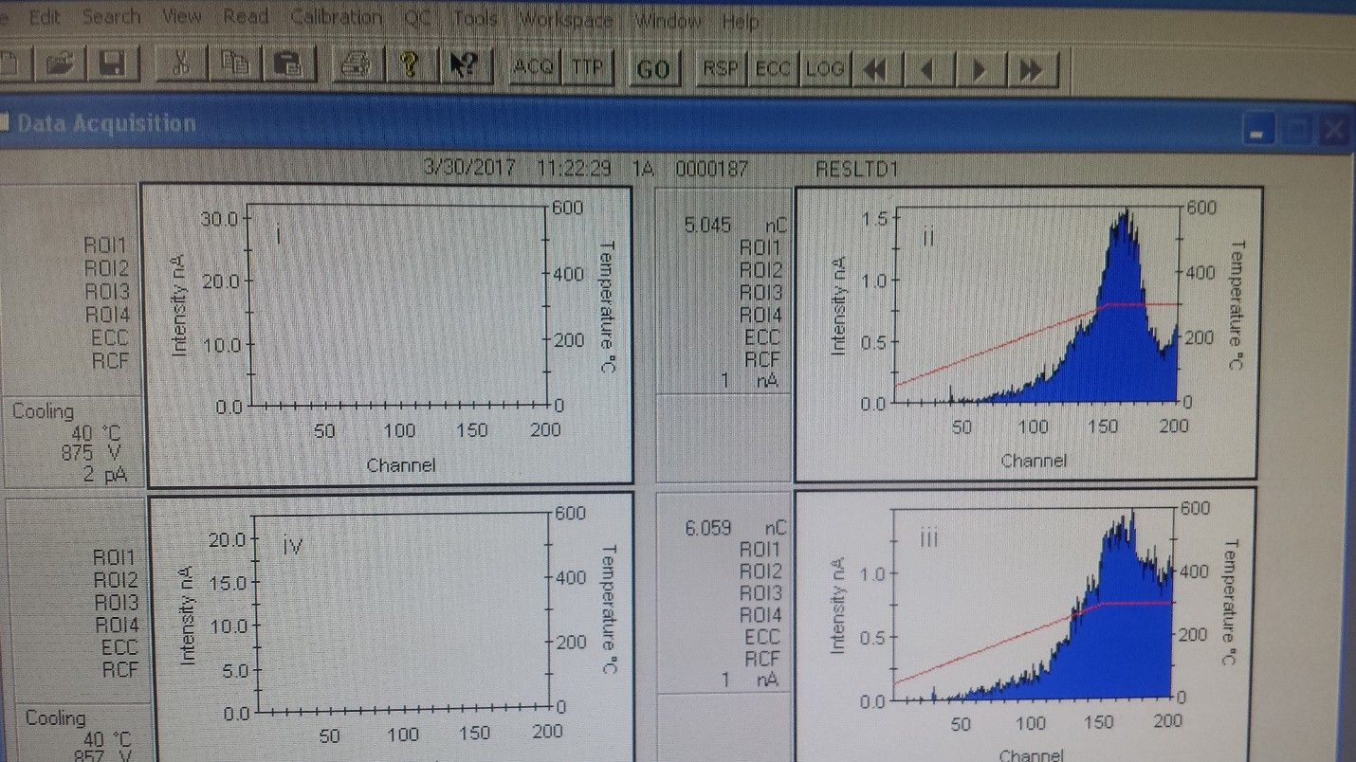

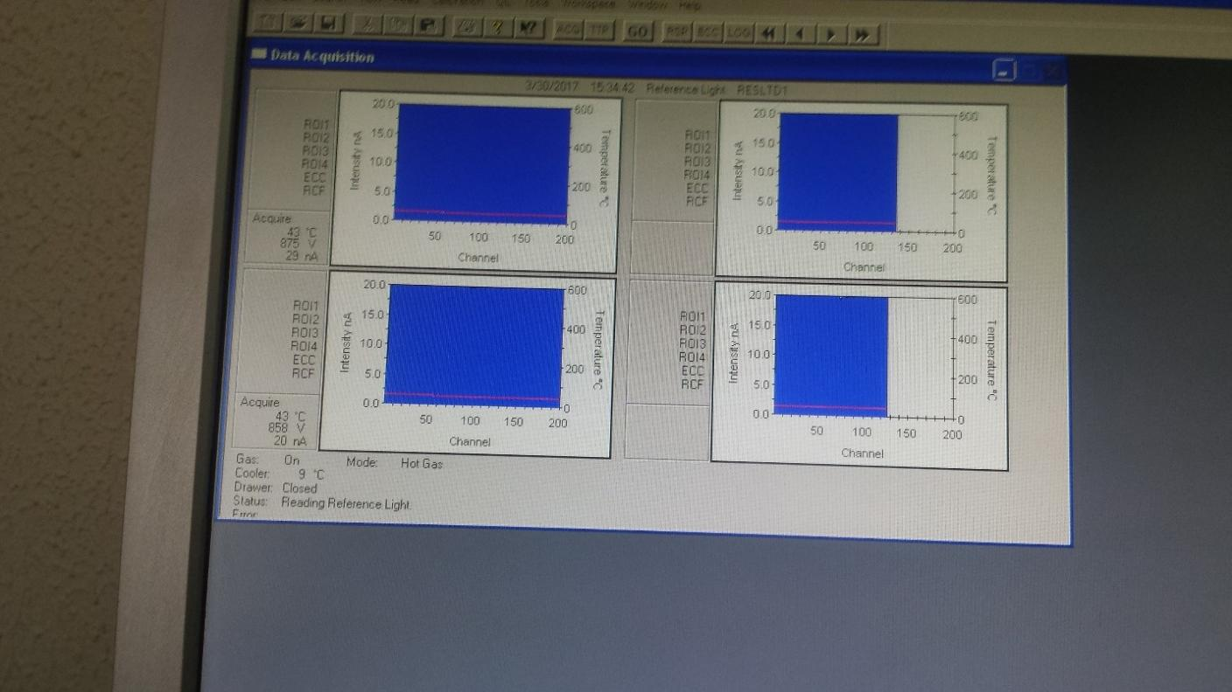**THERMOLUMINSCENT DOSIMETER PROFILE**

**HARSHAW 4500 THERMOLUMINISCENT DOSIMETER READER WORK STATION**

