# ASSESSMENT OF MUNICIPAL SOLID WASTE IMPACT ON GROUNDWATER QUALITY OF SOME SELECTED AREAS IN MAIDUGURI, NIGERIA

**BY**

# USMAN YUNUSA MAMZA

**DEPARTMENT OF WATER RESOURCES AND ENVIRONMENTAL ENGINEERING, AHMADU BELLO UNIVERSITY ZARIA, NIGERIA.**

# ASSESSMENT OF MUNICIPAL SOLID WASTE IMPACT ON GROUNDWATER QUALITY OF SOME SELECTED AREAS IN MAIDUGURI, NIGERIA.

**BY**

# USMAN, Yunusa Mamza

**B. ENG (AGRICULTURAL, 2004, UNIMAID) P15EGWR8054**

# A DISSERTATION SUBMITTED TO THE SCHOOL OF POSTGRADUATE STUDIES

**AHMADU BELLO UNIVERSITY, ZARIA**

# IN PARTIAL FULFILLMENT OF THE REQUIREMENTS FOR THE AWARD OF

**MASTERS DEGREE IN WATER RESOURCES AND ENVIRONMENTAL ENGINEERING**

# DEPARTMENT OF WATER RESOURCES AND ENVIRONMENTAL ENGINEERING,

**FACULTY OF ENGINEERING AHMADU BELLO UNIVERSITY ZARIA, NIGERIA**

# SEPTEMBER, 2018

# DECLARATION

I declare that the work in this dissertation HQWL**A**W**ss**O**es**H**sm**G**en** **t o**³**f municipal solid waste impact on groundwater quality of some selected areas in Maiduguri, Nigeria´**has been carried out by me in the Department of Water Resources and Environmental Engineering. The information derived from the literature has been duly acknowledged in the text and list of references provided. No part of this dissertation was previously presented for another degree at this or any other institution.

|  |  |  |
| --- | --- | --- |
| USMAN, Yunusa Mamza |  |  |
| Name of Student | Signature | Date |

# CERTIFICATION

This dissertation HQWLW**AS**O**S**H**ES**G**SM** **EN**³**T OF MUNICIPAL SOLID WASTE IMPACT ON GROUNDWATER QUALITY OF SOME SELECTED AREAS IN**

**MAIDUGURI, NIGERIA**´ EU\SM AN, Yunusa Mamza meets the regulations governing the award of the degree of Masters of Science in Water Resources and Environmental Engineering of Ahmadu Bello University, Zaria and is approved for the contributions to knowledge and literary presentation.

|  |  |  |
| --- | --- | --- |
| Dr. E.M. Shaibu Imodagbe Chairman Supervisory Committee (Name)  Dr. U.A. Abubakar | (Signature) | Date |
| Member Supervisory Committee (Name) | (Signature) | Date |
| Dr. M. A.Ajibike |  |  |
| Head of Department (Name) | (Signature) | Date |
| Prof. S.Z. Abubakar |  |  |
| Dean, School of Postgraduate Studie  (Name) | (Signature) | Date |

**ACKNOWLEDGEMENT**

I would like to express my sincere gratitude to the Almighty ALLAH for his protection and guidance throughout this programme. My gratitude goes to my employer; Ramat polytechnic Maiduguri for their generosity of sponsoring and granting me the study leave that enabled me to accomplished my postgraduate study. Furthermore, my special gratitude goes to my supervisors; Dr. E.M. Shaibu Imodagbe and Dr. U.A. Abubakar for their intellectual advice, guidance and constructive criticisms that make this research a success. I would like to thank my Head of Department; Dr. M. A.Ajibike and the Departmental Postgraduate Coordinator; Dr. B. S. Saulawa for their cooperation and assistance throughout this programme. I would like to appreciate the effort of my lecturers and colleagues for their contribution, more especially Engr. Mohammed Idi Dansuleiman.

I also appreciate the assistance done by the Laboratory technicians of sanitary chemistry laboratory, Department of Water Resources and Environmental Engineering, Soil Science laboratory, Department of Soil Science and the Multi-user Science laboratory, Ahmadu

Bello University Zaria, more especially 0DOODPz u 0AbXduDlla¶hi and Abubakar

Muhammad. Finally, I will like to acknowledge the effort of my family members and all those who contributed either direct or indirectly for the successful completion of this programme.

# ABSTRACT

This study assessed the impact of open dumpsites on the quality of groundwater within the vicinity of solid waste dumpsites in Maiduguri. The problem of rapid urbanization and poor waste management has resulted in an increased of hand dug wells with some located within the premises of an open dumpsites. The mean percentage composition of solid waste at the two dump sites were earth/garbage (26%), metal (21%), glass (20%), plastic (19%), polythene (13%), textile (7%), battery (5%) and paper (3%). Soil sampling was conducted using soil auger for dry and wet season. Total of 34 soil samples and 4 water samples were collected and analysed for physico-chemical characteristics; turbidity, temperature, total dissolved solids (TDS), electrical conductivity (EC), pH, nitrate (NO3), dissolved oxygen (DO), biochemical oxygen demand (BOD), chemical oxygen demand (COD), zinc (Zn) iron (Fe), copper (Cu), cadmium (Cd), chromium (Cr), lead (Pb), arsenic (As) and manganese (Mn). Particles size analysis was carried out using Bonyoucos hydrometer method and the texture determined on the USDA triangle. The soil pH and electrical conductivity was measured using Turbo pH/mV/temp. and EC meter and the soil BOD was determined using Winkler method from the soil filtrate. Potassium chloride (KCl) extraction method was used to determine the soil nitrate (NO3). The heavy metals (Cu, Zn, Mn, Cd, Pb, As, Cr and Fe) of the soil extracts were analysed using the multi-wave plasma atomic emission spectrophotometer (MP-AES 4200). The textural class of soil samples analyzed for dumpsites A and B were sandy loam with mean percentage ranged from 75-77%, 15.25-17.25% and 6.75-7.757% for sand, silt and clay respectively. The mean concentrations of pH, EC, NO3 and BOD of the soil samples for dumpsite A and B ranged from 6.8-8.17, 0.2-1.27 ds/m, 0.01-0.24 mg/Kg and 68- 1180 mg/Kg in dry and wet season respectively, and all the mean concentrations were within NES limit for soil quality. The mean concentrations of Zn, Fe, Cu and Pb for dumpsite A and B ranged from 103-1412 mg/Kg, 3226-9670 mg/Kg, 10.72-55.7 mg/Kg and 8.21-81.4 mg/Kg for dry and wet season respectively. The mean concentrations of As, Cd, Cr and Mn for dumpsite A and B ranged from 71-134 mg/Kg, 0.31-2.67 mg/Kg, 24.91-62.5 mg/Kg and 172-474 mg/Kg for dry and wet season respectively. All the mean concentrations were within NES limit for soil quality except Zn and As for both seasons, while Cd for wet season. The concentrations of temperature, turbidity, pH, EC, and TDS ranged from 24.2- 30oC, 0.28-4.73 NTU, 7.35-9.8, 131-1329 ȝV aFndP70-906 mg/l for dry and wet seasons respectively. All the concentrations were within NSDWQ and WHO standard limit in the dry season except turbidity and pH in the wet season. The concentrations of DO, COD, BOD ranged from 25-70 mg/l, 150-2000 mg/l, 4-30 mg/l and 1.18-53.62 mg/l for dry and wet seasons respectively. All the concentrations were above NSDWQ and WHO standard limit except NO3. The concentrations of Zn, Fe, Cu, and Pb ranged from 0.01-0.122 mg/l, 0.11-0.812 mg/l, 0.011-0.226 mg/l and 0.003-0.3 mg/l for dry and wet seasons respectively. All the concentrations were within NSDWQ and WHO standard limit except Fe in the wet season. The concentrations of As, Cd, Cr and Mn ranged from 0.029-514 mg/l, 0.001-0.24 mg/l, 0.001-0.184 mg/l and 0.001-0.357 mg/l for dry and wet seasons respectively. All the concentrations were above NSDWQ and WHO standard limit. The results obtained in this study shows that the leachate generated from the solid waste dumpsites had impacted negatively on the soil.

# TABLE OF CONTENT

Title page ii

Declaration iii

Certification iv

Acknowledgement v

Abstract vi

Table of Content vii

List of Figures xi

List of Tables xii

List of Plates xiv

Appendices xv

List of Abbreviations and Acronyms xvi

CHAPTER ONE INTRODUCTION 1

* 1. Background of the study 1
  2. Statement of Research Problem 3
  3. Significance of the Study 4
  4. Aim and Objectives of the study 5
  5. Scope and Limitation of the study 5

CHAPTER TWO LITERATURE REVIEW 7

* 1. Groundwater Resources 7
  2. Groundwater Flow 8
     1. Confined aquifer 10
     2. Unconfined aquifer 11
  3. Groundwater Quality 12
  4. Factors that Influence Groundwater Quality 13
     1. Geological formation 14
     2. Climate 15
     3. Anthropogenic activities 16
  5. Water Quality Standards and Guidelines 18
  6. Water Quality Parameters 20
     1. Temperature 20
     2. Turbidity 20
     3. Electrical conductivity (EC) 21

2.6.4 pH 21

* + 1. Total dissolved solid (TDS) 22
    2. Nitrate 22
    3. Dissolved Oxygen (DO) 23
    4. Biochemical Oxygen Demand (BOD) 24
    5. Chemical Oxygen Demand (COD) 24
    6. Heavy metals 24
  1. Seasonal Variations in Groundwater Quality 27
  2. Soil Quality 28
  3. Soil Pollution 30
  4. Municipal Solid Waste 32
  5. Waste Generation and Disposal 33
  6. Characteristics of Municipal Solid Wastes 34
  7. Waste Management Practice 36
     1. Methods of waste management 38
     2. Methods of Waste Management in Maiduguri 41
  8. Previous Studies on Solid Waste Management 41
  9. Previous Studies on Soil Composition and Quality at Dumpsites 46
  10. Previous Studies on Groundwater Quality at Dumpsites 49
  11. Water Quality Index 54
      1. National sanitation foundation water quality index 55
      2. Canadian council of ministers of the environment water quality index 57
      3. Oregon water quality index 58
      4. Weighted arithmetic water quality index method 59

CHAPTER THREE MATERIALS AND METHOD 62

* 1. Materials 62
  2. The Study Area 62
     1. Climate 64
     2. Hydrogeology of the study area 64
  3. Sample Collection 68
     1. Solid waste sampling 68
     2. Soil sampling 70
     3. Water sampling 70
  4. Laboratory Analysis 75
     1. Soil analysis 75
     2. Water analysis 77
  5. Data Analysis 77

CHAPTER FOUR RESULTS AND DISCUSSION 81

* 1. Solid Waste Composition 81
  2. Biophysico-chemical Characteristics of the Soil Samples 86
  3. Correlation Coefficient and Anova Analysis of the Soil Samples 95
  4. : Physico-chemical Characteristics of the Water Samples in the Study Area 99
  5. Correlation Coefficient and Water Quality Index of the Sampling Wells 107

CHAPTER FIVE SUMMARY, CONCLUSION AND RECOMMENDATIONS 111

5.1 Summary 111

* 1. Conclusion 112
  2. Recommendations 113

REFERENCES 114

APPENDICES 131

# LIST OF FIGURES

Figure 1: Flow through a saturated porous medium 9

Figure 2: Flow through an unconfined aquifer 9

Figure 3: Map of Nigeria showing the study area (Maiduguri) 63

Figure 4: Mean monthly rainfall of Maiduguri from 1995 ±2014 63

Figure 5: Cross-section of the Chad Formation showing the three aquifer zones 67

Figure 6: GIS Mapping of Maiduguri showing the sampling points 70

Figure 7: Solid waste composition of dumpsite A (%) for dry season 83

Figure 8: Solid waste composition of dumpsite A (%) for wet season 83

Figure 9: Solid waste composition of dumpsite B (%) for dry season 84

Figure 10: Solid waste composition of dumpsite B (%) for wet season 84

Figure 11: Regression analysis of the Bio physico-chemical characteristics

of sites A and B 98

Figure 12: Regression analysis of the Bio physico-chemical characteristics

of sites A and B 98

Figure 13: Water quality index of the sampling wells 110

# LIST OF TABLES

Table 1: Models and Manufacturers of the Materials 62

Table 2: Sampling coordinates of the hand-dug wells and dumpsite A 69

Table 3: Sampling coordinates of the hand-dug wells and dumpsite B 69

Table 4: Characterization of the dumpsites 73

Table 5: Description of sampling points of dumpsites A and B 73

Table 6. Weight Arithmetic Water Quality Index method ratting 80

Table 7: Relative weight (*W*i) for each parameter 80

Table 8: Anova analysis of solid waste composition for two sites 85

Table 9: Anova analysis of solid waste types for two sites 85

Table 10: Particles size analysis (%) of the soil samples for dumpsite A 87

Table 11: Particles size analysis (%) of the soil samples for dumpsite B 88

Table 12: Mean and standard deviation of particles size analysis (%)

for dumpsites A and B 88

Table 13: Mean and standard deviation of Bio physic-chemical characteristics

of the soil samples for dry and wet season (Dumpsite A 93

Table 14: Mean and standard deviation of Bio physic-chemical characteristics

of the soil samples for dry and wet season (Dumpsite B 94

Table 15: Correlation coefficient (5%) of Bio physic-chemical characteristics

of the soil samples for dry season (Dumpsite A) 96

Table 16: Correlation coefficient (5%) of Bio physic-chemical characteristics

of the soil samples for wet season (Dumpsite A) 96

Table 17: Correlation coefficient (5%) of Bio physic-chemical characteristics

of the soil samples for dry season (Dumpsite B) 97

Table 18: Correlation coefficient (5%) of Bio physic-chemical characteristics

of the soil samples for wet season (Dumpsite B) 97

Table 19: Anova analysis of Biophysico-chemical characteristics of soil

samples for two sites (5%) 98

Table 20: Physico-chemical characteristics of the water samples for dry and

wet season in mn/l 105

Table 21: Mean and standard deviation of physico-chemical characteristics

of water samples 106

Table 22: Correlation coefficient (5%) of the sampling wells 108

Table 23: Anova Analysis of physico-chemical characteristics for two Sites 108

Table 24: The relative weight and water quality rating of well GWA 110

# LIST OF PLATES

Plate 1: Soil sampling at dumpsite A 74

Plate 2: Water sampling at well GWBc 74

Plate 3: Soil analysis 76

# LIST OF APPENDICES

Appendix i: Biophysico-chemical characteristics of the soil samples for

dry season in mg/kg (Dumpsite A) 131

Appendix ii: Biophysico-chemical characteristics of the soil samples for

wet season in mg/kg (Dumpsite A) 132

Appendix iii: Biophysico-chemical characteristics of the soil samples for

dry season in mg/kg (Dumpsite B) 133

Appendix iv: Biophysico-chemical characteristics of the soil samples for

wet season in mg/kg (Dumpsite B) 134

# ABBREVIATIONS AND ACRONYMS

ANOVA - Analysis of variation BGS ±British Geological Survey

BOSEPA ±Borno State Environmental Protection Agency Df ±Degree of freedom

FAO ±Food and Agricultural Organisation MC ±Moisture content

MS ±Mean square ND ±Not detected

NES ±National Environmental standard for soil quality NSDWQ ±Nigerian standard of drinking water quality NS ±Not specified

SD ±Standard deviation SS ±Sum of square

UNDP ±United Nation Development Programme USEPA ±United State Environmental Protection Agency WHO ±World Health Organization

# CHAPTER ONE

**INTRODUCTION**

# Background of the Study

Groundwater is one of the most important natural resources which contribute to the global freshwater supply. In Nigeria, groundwater provides much of the public and domestic water supply, supports agricultural and industrial economies, and contributes its flow to rivers, lakes and wetlands; and this helps in maintaining balance in the ecosystem (Aizebeokhai, 2011). Groundwater is the primary source of potable water in most parts of Nigeria, particularly in rural areas, which rely on domestic (private) hand-dug wells (Aizebeokhai, 2011). According to Kumar (2013) despite its reliability, this precious and vital resource is under increasing threats attributed to above ground anthropogenic activities related to uncontrolled urbanization, incessant waste disposal and poor land use management. In addition, the usefulness of groundwater to humans essentially depends on its chemical status, thus, assessment of groundwater quality is important for the socioeconomic development of most developing and developed countries of the world (Kumar, 2013).

Groundwater quality is an important factor in the context of sustainable water management, the integrity of underlying aquifers is mainly affected by pollution from above ground sources, particularly solid waste disposal (Kumar, 2013). Uncontrolled urban growth and its resultant effect, especially in developing nations like Nigeria, can adversely affect the quality of underlying groundwater if not properly controlled (Putra and Baier, 2008). With a rapid population growth of about 2.5% per annum, the demand

for water supply has progressively increased over the last three decades. The provision of safe drinking water has actually deteriorated - access in urban areas fell from 55 million people to 27 million people in 2002 in African cities (Jacobsen et al., 2012). This is largely due to poor management, inadequate technical capabilities, lack of investment and insufficient manpower and their training (Hanidu, 1990). Furthermore, the institutions responsible for water supply in Nigeria are both ineffective and fragmented; thus, a transition is needed to bring about a thorough and holistic change to the current system (Jefferies and Duffy, 2011).

Solid waste dumpsites which have been identified as one of the major threats to groundwater resources receive a mixture of municipal, commercial and mixed industrial wastes. Moreover, studies on the effects of unlined waste dumps on the host soil and underlying shallow aquifers have shown that soil and groundwater systems can be polluted due to poorly designed waste disposal facilities (Amadi et al., 2012). Groundwater contamination in a dumpsite facility occurs mainly due to the contaminant potential of leachate from the waste body. These leachates are solutions, essentially organic or inorganic complexes of biodegradation components of solid wastes flowing from the refuse dumps, saturated with rainwater (Kassenga and Mbluligwe, 2009).

As reported by Sankoh et al. (2013) open dumpsite approach as solid waste disposal method is a primitive stage of solid waste management in many parts of the world. It is one of the most poorly rendered services by municipal authorities in developing countries as the systems applied are unscientific, outdated and inefficient. Moreover, solid waste disposal sites are commonly found both within and on the outskirts of developing urban

cities. According to Nguyen (2011), many cities in developing countries face serious environmental degradation and health risks due to the poorly developed municipal solid waste management system. The compositions of municipal solid wastes are influenced by certain factors, which include the area (residential and commercial), the economic level (differences between high and low income areas), the season and weather (differences in the amount of rainfall in a year and duration) and culture of people living or doing business in the area (Napoleon et al., 2011).

# Statement of Research Problem

The problem of rapid urbanization has lead to increase in municipal solid waste generation because of increasing population and some socio-economic factors in Nigeria. (Butu and Mshelia, 2014). Majority of the municipal solid waste disposal sites in Nigeria are still open dumps. Moreover, in most cases the landfills are not properly engineered and operated to accepted world standards. Improper management of solid waste areas has resulted in serious ecological, environmental and health problems. Such practices contribution to widespread environmental pollution as well as spread of diseases (Susu and Salami, 2011). Solid waste disposal by landfill poses a threat to groundwater and surface water quality through the formation of polluting liquids known as leachate (Mohammed *et al*., 2013). Although groundwater quality within the aquifer varies, it is of high quality on the average, with some decline from south to north in Nigeria. Total dissolved solids are high in the Pliocene aquifer of Chad basin formation. Investigations of water quality in the Upper, the Middle and the Lower aquifer in the Maiduguri area (Nigeria) have found considerably high concentrations of fluoride (BGS, 2003).

According to Kola-Olusanya (2011) the risk of groundwater pollution is increasing both from disposal of solid waste and the widespread use of potentially polluting chemicals in agriculture. In this study the problem of acute water supply has resulted in the rapid increase of hand dug wells with some located within the premises of an open dumpsites in Maiduguri. This negative impact is significant in some of the areas within Maiduguri where tons of residential and commercial solid wastes were inappropriately dumped. These problems potentially pose a significant threat to the upper unconfined aquifer system of the Chad Basin around Maiduguri and this aquifer is the major water supply source for the city. This consequently poses health risks to the local population, more especially the urban poor who largely depend on the groundwater without any form of treatment (Bakari, 2014).

# Significance of the Study

Understanding the quality of groundwater is a very important factor in determining whether the source could be used to supply suitable water for human consumption and use. As a scarce resource, groundwater requires continuous monitoring through quality assessments and management for sustainable use against contamination. Groundwater is the primary source of potable water in most part of Maiduguri metropolis, which relies on domestic (private) hand-dug wells from the upper aquifer (Bakari, 2014). The ability for municipalities, particularly Maiduguri to ensure reliable protection of public health and the environment through efficient wastes management, there is a need to identify a relationship between the solid waste, soil and groundwater that will help to understand the quality of the groundwater reservoirs in the study area. This study will provide useful knowledge on water quality awareness to reduce problems associated with water and its

implications on health related risks. Application of quality assessments of groundwater in

Maiduguri DUHD KDV LPSRUWDQW LPSOLFDWLRQV LQ WK

and can indicate where negative impacts may be mitigated and efficiency of water conservation programs can be evaluated.

# Aim and Objectives of the Study

The aim of this study is to conduct a water quality assessment on some selected wells within the proximity of an open dumpsite in Maiduguri with the following objectives;

1. To determine the composition of the solid wastes.
2. To evaluate the Biophysico-chemical characteristics of the soil at the open dumpsites.
3. To evaluate the physico-chemical characteristics of the well water near and way from an open dumpsites.
4. To compare the physico-chemical characteristics of the soil and water samples with National Environmental Standard of soil quality (USEPA) and NSDWQ and WHO standard limit of water quality,
5. To determine the water quality index of the water samples using Weighted Arithmetic Water Quality Index Method.

# Scope and Limitation of the Study

The research work is mainly on groundwater quality of well in relation to municipal solid wastes in Maiduguri. Two dumpsites at Kumshe and Bakasi were identified to examine the characteristics of solid wastes, physico-chemical characteristics of soil at the dumpsites and physico-chemical characteristics of the wells within the proximity of the dumpsites. The time frame for this research was conducted for eight months within which

the assessment of solid waste composition, soil samples within the dumpsites and water samples for both the dry and wet seasons were carried out. The research is limited to soil characteristics as leachate in able to obtain from the dumpsites.

# CHAPTER TWO

**LITERATURE REVIEW**

# Groundwater Resources

Groundwater (in aquifers) makes up about 41.3% of the world water and 20% of the fresh water supply, which is about 61% of the entire worlds domestic fresh water supply. In addition, many consider ground water as a potential source of drinking water that cannot be polluted because it is naturally protected from pollution by layers of soils and rocks, yet pollution of ground water has always been with us, because of the close links to human activities (Philip, 2004). Water-well is an excavation or structure made vertically to the ground by digging, driving, boring or drilling to have access to ground water (Garba *et al*., 2008). Groundwater in the alluvial aquifers is usually fresh; however, high salinity related to dissolution of evaporated minerals has been recognized in some cases (Aizebeokhai, 2011).

According to Kola-Olusanya (2011) groundwater forms that part of the natural water cycle present within underground strata or aquifers. Groundwater is not only abstracted for supply or river regulated purposes, it also naturally feeds surface-waters through springs and passages into rivers and it is often important in supporting wetlands and their ecosystems. The development and efficient management of groundwater resources is of particular concern in Africa especially in humid tropics of Nigeria in which groundwater accounts for 80% of its water supply. There are relative scarcity of water resources, quality degradation, high evaporation rates and high levels of anticipated future demands in Nigeria (Offodile, 2002). Groundwater is the most reliable water supply source for

domestic, agricultural and industrial use in Nigeria and other countries across the world. However, despite its reliability, this precious and vital resource is under increasing threats attributed to above ground anthropogenic activities related to uncontrolled urbanization, incessant waste disposal and poor land use management (Bakari, 2014).

# Groundwater Flow

Groundwater flow in the subsurface is driven by differences in energy, water flows from high energy areas to low energy. The energy content of a unit volume of water is determined by the sum of gravitational potential energy, pressure energy and kinetic energy (Raghunath, 2002). It may be noted that the total energy (also called head, h) at any point in the groundwater flow per unit weight is given as

Where, Z - elevation at the point above a chosen datum  - pressure head

 - velocity head

*g* - gravitational acceleration

*Z* - elevation of the measuring point relative to a datum

*P*- fluid pressure at the measurement point

*v -* fluid velocity.

Since the ground water flow velocities are usually very small,  is neglected and h = is termed as the potentiometric head (or piezometric head).

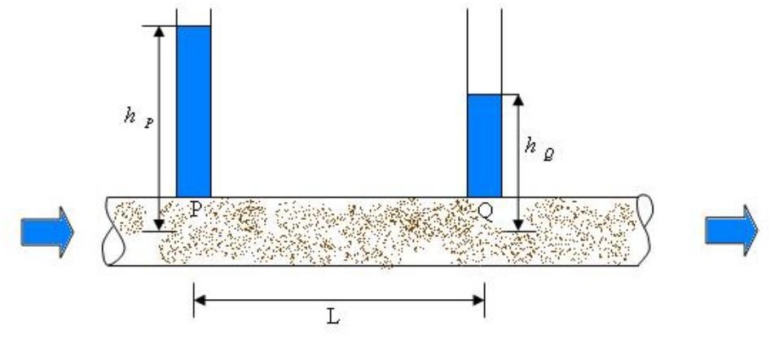

# Figure 1: Flow through a saturated porous medium

Source: (Raghunath, 2002)

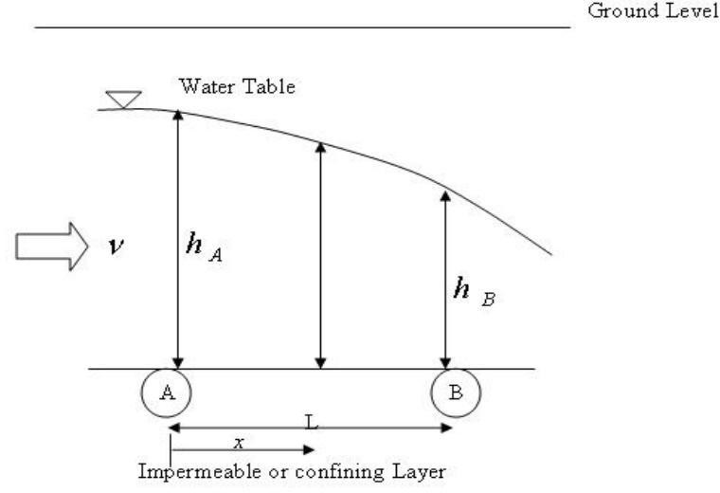

# Figure 2: Flow through an unconfined aquifer

Source: (Raghunath, 2002)

Thus,  ii

Introducing proportionality constant K, the expression becomes

 iii

Since the hydraulic head decreases in the direction of flow, a corresponding differential equation would be written as

 iv Where  is the hydraulic gradient

The coefficient K has dimensions of L/T, or velocity, Thus, the velocity of fluid flow would be;

V  v

Groundwater therefore flows from regions of high hydraulic head to areas of low hydraulic head. Because groundwater flows through a porous media, the rate of flow depends on soil properties such as the degree to which pore spaces are interconnected as shown in Figure 1(Raghunath, 2002).

Unsteady flow takes place in an confined and unconfined aquifer would be either due to change in hydraulic head (unconfined aquifer) or potentiometric head (confined aquifer) with time. Due to compressibility of the mineral grains of the soil matrix forming the aquifer or the water stored in the voids within the soil matrix (Raghunath, 2002).

# Confined aquifer

If there is a steady movement of groundwater in a confined aquifer, there will be a gradient or slope to the piezometric surface of the aquifer. The gradient again would be decreasing in the direction of flow. Assuming unit thickness in the direction

perpendicular to the plane of the surface, the flow rate q (per unit width, b) would be expressed for an aquifer of thickness (Raghunath, 2002).

q = b x 1 x v vi

$FFRUGLQJ WR 'DUF\¶V ODZ WKH YHORFLW\ Y

 vii

Where, the piezometric head (h) is measured above a convenient datum. Note that the DFWXDO YDLOVX HQ RRWI U³HKT´XLUHG inEtXheWdi recRtioQn Oof\flo wLx.W¶V JU

Here K is the hydraulic conductivity

Hence,  viii

The partial derivative of h with respect to x may be written as normal derivative since we

DUH DVVXPLQJ ¶Q RL QY DWUKLHD WGLLRUQHs uFrRfWacIeL. RµQK QRUPDO WR W

Thus,  ix

For steady flow, q should not vary with time, t, or spatial coordinate, x.

# Unconfined aquifer

In an unconfined aquifer, the saturated flow thickness, h is the same as the hydraulic head at any location, as shown in Figure 2.

Considering no recharge of water from top, the flow takes place in the direction of fall of the hydraulic head (h), which is a function of the coordinate, x taken in the flow direction. The flow velocity (v) would be lesser at location A and higher at B since the saturated flow thickness decreases. Hence v is also a function of x and increases in the

direction of flow. Since v acFRUGLQJ WR 'DUF\¶V ODZ LV VKRZQ

x

The gradient of potentiometric surface  would (in proportion to the velocities) be

smaller at location A and steeper at location B. Hence the gradient of water table in unconfined flow is not constant; it increases in the direction of flow. An analytical solution to the flow would be obtained by using the Darcy equation to express the velocity (v) at any point x, with a corresponding hydraulic gradient  as

 xi

Considering the origin of the coordinate x at location A where the hydraulic head as hA and knowing the hydraulic head hB at a location B, situated at a distance L from A, known as the Dupuit equation;

 xii

# Groundwater Quality

According Gupta (2011) the term water quality is used to describe physical, chemical, and biological characteristics of water, usually with reference to its suitability for a particular purpose. According to Schutte (2006) a number of groundwater quality investigations have been carried out in Nigeria, though these are usually on local scales and consider a limited number of chemical constituents. Although some high concentrations of other trace elements (barium, boron, chromium, nickel, molybdenum, lead and uranium) were found in Nigeria, these appear in only a few numbers of samples (BGS, 2003). The accepted quality of water is subjective to what the water is going to be used for and this directly translate to the procedures that can be used to determine the

availability and presence of ion species in the water (Cordoba *et al*., 2010). According to Ravikumar *et al*. (2011) the composition of groundwater in a region can be altered by processes such as evaporation and transpiration, wet and dry deposition of atmospheric salts, oxidation and reduction.

According to WHO (2008), safe drinking water should conform to the following water quality characteristic; it should be free from pathogenic organisms, low in concentration of compounds that are toxic to man, livestock, and plants, and finally free from compounds that causes offensive taste and odour. This concern has attracted overwhelming studies on the quality status of groundwater abstracted from shallow wells (hand dug wells) and deep wells (boreholes) for human consumption in urban areas of Nigeria (Ocheri *et al*., 2010). Groundwater in the arid and semi-arid regions plays an important role as freshwater source for different uses such as domestic, agricultural and industrial purposes. So, the groundwater quality needs to be given greater attention in

WKHVH DUHDV ,W LV HVWLPDWHG WKDW DSSUR[L

groundwater for drinking (Nickson *et al*., 2005). Assessing groundwater quality and developing strategies to protect aquifers from contamination are necessary for proper planning and designing water resources (Akinbile and Yusoff, 2011).

# Factors that Influence Groundwater Quality

There are three major factors that affect groundwater quality; geological formation, climate and anthropogenic activities.

# Geological formation

Soil filtration capacity depends on its mechanical characteristics (including the degree of fracturing, particle size, and porosity) and on its chemical and physical composition (including the presence of clay, soluble organic substances, cations, and pH). Contamination is more frequently detected in sedimentary rock than in igneous or

metamorphic rock (Atherholt *et al*., 2013). Several micro organisms may be adsorbed and remain in the soil for a long time; these are affected by sunlight, temperature, moisture, and organic matter. For example, clay soils, which contain hematite and magnetite, promote the adsorption of viruses. The degree of groundwater contamination is also affected by soil porosity. Sandy soils (defined as porous) may hinder the spread of microorganisms, while karst soils (non-porous) are known to be more vulnerable (Goeppert and Goldscheider, 2011) and most influenced by agricultural activities and wastewater emission. Porous soil therefore may better improve water quality compared to non-porous soils, because it causes real purification depending on several factors, including thickness, grain size, the chemical composition of soil, the type and quantity of pollutants, the rate of water percolation, and the degree of environment saturation. Groundwater quality also varies as a function of its chemical composition, influenced by the solubility of the soil it passes through and by the depth of an aquifer (Sonkamble *et al*., 2012).

Generally, water will be low in salts if it passes through poorly soluble soils, follows short distances, and flows only for a short time. In contrast, water will be rich in salts if it passes through soluble soils (carbonate rocks) or remains in the subsoil for a long time (Atherholt *et al*., 2013). According to Stuart *et al*. (2012) the direct pathways for municipal, agricultural and industrial pollutants are largely through the pore spaces and fractures that exists in the sedimentary formations of the area; where the contaminants infiltrate into the unsaturated zone and then to the saturated zone. In addition, the presumption that some of these pollutants may infiltrate into the upper aquifer of the study area is because of the unconfined nature of the upper aquifer system. Other potential pathways results from improper drilling of wells or poor well development activities, abandoned old wells can also serve as conduit for direct vertical migration to depths closer to shallow municipal aquifers (Bakari, 2014).

# Climate

Seasonal variation and climatic factors affect the quality and quantity of groundwater (Idoko, 2010). Changes in groundwater recharge rate caused by seasonal variation also affect the concentration of water parameters (Makwe and Chup, 2013). Under normal environmental conditions (in the absence of heavy rain) micro organisms are retained efficiently by the soil and are only detectable in trace amounts in groundwater. Serious weather events, including high-intensity rain or drought, can greatly influence the water quality (Tornevi and Bergstedt, 2014), contributing to the dissemination of pathogenic micro organisms to geographic areas in which they were previously absent. In certain regions, recent climate changes have led to a tropicalization of rain consisting of uneven rainfall distribution throughout the year and large and intense rains (Kim *et al*., 2013).

As a result, gastrointestinal diseases are increasing, depending on temperature and soil overflow, causing the contamination of coastal waters and inland surfaces water (Tryland *et al*., 2014). Global climate change also influences the availability of water: poor rain and an altered rainfall distribution during the year cause a significant reduction in the flow of water for aquifer recharge and for irrigation (Sun *et al*., 2014). In particular, in some coastal areas, decreased groundwater resources and their depletion by humans have caused marine intrusion. This increases the risk of microbiological contamination and of salinization of water. Some authors report that high salinity is associated with a remarkable increase in bicarbonate content during the crop-growing season because of more intense biological activity in irrigated soils (Rea *et al*., 2014).

# Anthropogenic activities

As reported by Huang *et al*. (2012), human activities can cause contamination of aquifers, resulting both from industrial activities (including uncontrolled discharges of potentially toxic chemical substances, processing residues, and waste) and agricultural activities (including the use of herbicides, anti-parasitic, and pesticides). In particular, intensive agriculture is often inadequate for the characteristics of the area and the chosen produce, creating a substantial increase of nitrates, which are usually present in low quantities in groundwater (Widory *et al*., 2004). The intensive raising of livestock in confined areas can also contribute to groundwater contamination through animal manure discharged on areas overlying aquifers. In some regions, it is still customary to spread manure on the ground to fertilize it and make it more productive. Regrettably, this turns the nitrogen contained in the manure into nitrate, contaminating the underlying aquifers, especially when the soil temperature exceeds 5°C additionally, and the amount of nitrogen in groundwater from livestock waste or chemical fertilizers increases when overlain by permeable soil (Burkart *et al*., 2007).

The groundwater quality is influenced by diverse natural and anthropogenic activities such as local climate, geological factors, and agricultural practices. Once the groundwater is contaminated, its quality cannot be restored by stopping the pollutants from the source. The chemical characteristics of groundwater play an important role in assessing the water quality. Geochemical studies of groundwater provide a better understanding of possible changes in quality (Ramesh and Elango, 2012). The contamination of ground water through the infiltration of leachates via the soil and rocks needs to be avoided, but due to lack of proper waste management ground water is usually affected by the refuse dump

sites. Groundwater pollution is a growing environmental problem, especially in many cities and small towns of developing countries like Nigeria, which depend on groundwater for water supplies, mainly because of its abundance and stable quality (Widory *et al*., 2004).

However, urbanization process threatens groundwater quality through domestic and industrial wastes disposal. Water-soluble wastes and other materials that are dumped, spilled or stored on the surface of the land or in sewage disposal pits can be dissolved by precipitation, irrigation waters or liquid wastes and eventually seep through the soil in the unsaturated zone to pollute the groundwater (Kola-Olusanya, 2011). WHO (2004) stated that many water sources in developing countries are unhealthy and contain harmful

SK\VLFDO FKHPLFDO DQG ELRORJLFDO DJHQWV

vulnerable to pollution from agricultural fertilizers, domestic waste dumpsites, latrines and industrial sources, except where surface layers are of poor permeability and afford some protection of the underlying aquifers (Stuart *et al*., 2012). Waste deposited in landfills or refuse dumpsites immediately becomes a part of the prevailing hydrological system. Fluids derived from rainfall, groundwater, along with liquids generated by the waste itself through processes of hydrolysis and solubilisation, percolate through the soil (Ugwu and Nwosu, 2009).

The untreated rubbish being placed in the landfill or dumpsite comprises biodegradable solids such as vegetables, paper and waste food, inert solids such as glass and plastics constitute a great threat to groundwater quality (Kola-Olusanya, 2011). The contamination occurs through leaching; which is formed when rain or irrigation water

infiltrates the landfill and dissolves the solute fraction of the waste. The soluble product is formed as a result of the biochemical processes occurring within the decaying wastes. The resultant effluent will then impose their Chemical Oxygen Demand (COD) and Biochemical Oxygen Demand (BOD) on the groundwater (Kola-Olusanya, 2011). Longe and Balogun (2010) observed that groundwater pollution in Nigeria is mainly due to the process of industrialized urbanization that has progressively developed over time without regard for environmental consequences. The increased population, industrialization and technological revolution have resulted in the increase in waste generation with resultant production of wastes which have become too complex to manage and control.

# Water Quality Standards and Guidelines

To ensure that water is suitable for human consumption and use, standards and guidelines were developed by standard organization of Nigeria (SON); Nigerian Standard for Drinking Water Quality (NSDWQ) and World Health Organization (WHO) as criteria to determine suitability. The guidelines are in the form of numerical values for constituents of water or indicators of water quality (WHO, 2008). The primary purpose of the guidelines for drinking water quality is the protection of public health and to improve access to safe drinking water (WHO, 2004). The WHO water guidelines are divided into four aspects. That is; microbial, chemical, radiological and the acceptability aspects (physical aspect). According to WHO (2008) the biological properties refer to the presence of organisms that cannot be seen by the naked eye and these include microorganisms such as protozoa, bacteria and viruses.

The physical properties define the water quality properties that may be determined by physical methods such as conductivity and turbidity measurement. The physical quality

mainly affects the aesthetic quality (taste, odour and appearance) of water. The physical quality of water is determined by intrinsic characteristics; temperature, viscosity, and surface tension as well as by dissolved and colloidal substances in the water (WHO, 2008). Other physical properties such as electrical conductivity, colour, taste and odour are determined by the presence of dissolved and colloidal substances in the water. Some characteristics of water are often indicated as physical characteristics, while they are in fact chemical in nature, pH being an example (WHO, 2008).

The chemical aspects describe the nature and concentration of dissolved substances such as salts, metals and organic chemicals. Generally, many chemical substances at the appropriate concentrations in water are essential nutrients that are required as daily intake but at high concentrations, they make water unpalatable and cause illnesses (WHO, 2008). The guideline values by WHO have been selected to represent the concentration of a constituent that does not result in a significant risk to the health of the consumer after long-term consumption. Guideline values have been set based on the practical level of treatment achievability or analytical achievability (WHO, 2004).

# Water Quality Parameters

# Temperature

According to Schutte (2006) the temperature of water influences its overall quality as it can harm aquatic organisms if it is outside the normal range. Temperature of the air above the water body may affect water temperature depending on the depth of the water. Shallow water bodies are more susceptible to temperature changes than deep water. Temperature also plays an important role in the aqueous geochemical processes occurring in groundwater. Water temperature is a very important parameter because it enables better understanding of other measurements such as dissolved oxygen, pH, and conductivity (Schutte, 2006). Temperature can be easily measured by using a calibrated thermometer or some other type of calibrated probe and is read while the bulb of the thermometer or probe is still in water (Gupta, 2011).

# Turbidity

According to Schutte (2006) turbidity gives an indication of the concentration of colloidal particles in water. Turbidity is expressed in NTU, it is determined in a Nephelorometer by comparing the intensity of light scattered by the water sample to the intensity of light scattered by a standard reference in the turbidity meter. Turbidity can be measured using either an electronic turbidity meter or a turbidity tube. The turbidity of raw water can be

as low as a 1 or 2 NTU in groundwater and up to several hundred in turbid surface water, after a rain storm Higher level of turbidity are associated with disease causing bacteria and the WHO standard for drinking water is 5 NTU to 10 NTU (WHO, 2011).

# Electrical conductivity (EC)

This is a measure of the ability of the water to conduct an electric current. Since the electric current is conducted through the movement of ions in solution, EC also gives an indication of the concentration of the ions or total dissolved solids (TDS) in the water (Schutte, 2006). According to Gupta (2011) identifying and mapping these water quality parameters provides the base data for developing mitigation measures and to:

 estimate distribution of saltwater in an aquifer;

 assess the life span of an aquifer being affected by seawater intrusion;

 determine suitability of an aquifer for irrigation;

Conductivity shows significant correlation with ten parameters which include temperature, pH value, alkalinity, total hardness, calcium, total solids, total dissolved solids, chemical oxygen demand, chloride and iron concentration of water (Patil, 2012). Electrical conductivity (EC) of water is measured in units of milli Siemen per metre (mS/m). Other units that are also used include micro siemen (µS/cm). The EC value may be used to estimate the TDS concentration in mg/l by multiplying the EC by a factor established for the type of water (Schutte, 2006).

# pH

According to Gupta (2011) pH value of water is determined by the relative concentrations of H+ ion and OH- ion. Water with a pH of 7 has equal concentrations of H+ ion and OH- ion and is considered to be a neutral solution. If a solution is acidic (pH<7), the concentration of H+ ion is greater than the concentration of OH- ion. If a solution is basic (pH>7), the concentration of H+ ion is less than the concentration of OH- ion. The measure of pH is very important as an indication of water quality due to the sensitivity of organisms to the pH of their environment. pH is most important in determining the corrosive nature of water. The lower the pH value the higher is the

corrosive nature of water. pH is positively correlated with electrical conductance and total alkalinity (Gupta, 2011).

# Total dissolved solid (TDS)

Dissolved solids in freshwater include soluble salts that yield ions, nutrients such as nitrates and phosphates, and dissolved salts such as sodium chloride, contribute to total dissolved solids (Gupta, 2011). The salt acts to dehydrate the skin of animals and high concentrations of dissolved solids can add a laxative effect to water or cause water to have an unpleasant mineral taste. Even at higher levels of 1000 mg/l, or higher water may have only minor effects such as a laxative effect to consumers not used to drinking the water, and a salty or brackish taste (Gupta, 2011). TDS is measured collectively as mg/l or indirectly as electrical conductivity in milli Siemen/m. Groundwater often has a much higher TDS and hardness than surface water with TDS values of several hundred to a few thousand (Shutte, 2006).

# Nitrate (NO3)

Nitrates are found in freshwater samples result from a variety of natural and manmade sources. Nitrates are an important source of nitrogen necessary for plants and animals to synthesize amino acids and proteins. Through the process called the Nitrogen Cycle, nitrogen (N) from air is converted to useable forms for plants and animals (Abudaya *et al*., 2014). High levels of nitrate in groundwater are usually indicative of the contamination from anthropogenic activities. The sources of nitrate (NO3-) in groundwater include decaying organic matter, legume plants, sewage, nitrate fertilizers, and nitrates in soil. (Abudaya *et al*., 2014). Nitrate is the principal nutrient in most fertilizers and it is also very soluble, when leached into groundwater it becomes very mobile (BGS, 2009). According to WHO (2011) high nitrate concentration in drinking water can cause a potentially fatal disease in infants called Blue baby Syndrome, where nitrate converts hemoglobin into a form that can no longer transport oxygen.

# Dissolved oxygen (DO)

This is a measure of how much oxygen is dissolved in water; it is vital to aquatic life as a necessary component of cellular respiration. Most aquatic organisms have an optimal range of dissolved oxygen and it is a key indicator of water quality (Shutte, 2006). As reported by Vikal (2009), dissolved oxygen concentrations can range from 0 to 15 mg/l depending on the conditions, DO could be from 7-15 mg/l depending on the water temperature and atmospheric pressure, whereas in water closer to sea level, readings may be between 2 and 11mg/l. Sources of dissolved oxygen are: diffusion from the atmosphere and water at the surface, aeration as water flows over rocks and uneven surfaces, aeration through churning action of wind and waves and photosynthesis from aquatic plants.

# Biochemical oxygen demand (BOD)

This is a measure of organic material contamination in water, specified in mg/l. BOD is the amount of dissolved oxygen required for the biochemical decomposition of organic compounds and the oxidation of certain inorganic materials (iron, sulfites). Typically, the test for BOD is conducted over a five-day period (Shutte, 2006).

# Chemical oxygen demand (COD)

This is another measure of organic material contamination in water specified in mg/l. COD is the amount of dissolved oxygen required to cause chemical oxidation of the organic material in water. Both BOD and COD are key indicators of the environmental health of a surface water supply. They are commonly used in waste water or analysis but rarely in general water analysis. (Shutte, 2006).

# Heavy metals

1. **Iron (Fe)** LV WKH VHFRQG PRVW DEXQGDQW PHWDOOLF

of iron in groundwater is due to dissolved iron from soil and rock formation as iron sulfide and iron rich clay minerals when rainwater percolates and drains down the soil profile. The chemical behaviour of iron and its solubility in water depends strongly on the oxidation intensity in the system in which it occur. Iron can also have anthropogenic sources including industrial effluents, landfill leakages and acid mine drainage. Well casing, pump parts, piping and storage tank can also contribute iron to groundwater (Orjiekwe *et al*., 2006).

1. **Zinc (Zn)** occurs naturally in soil (aERXW í inௗrPocJks)ௗ, bNutJZn concentrations are rising unnaturally, due to anthropogenic activities. Most Zn is released during industrial activities, such as mining, coal, and waste combustion and steel processing. Drinking water also contains certain amounts of Zn, which may be higher when it is stored in metal tanks. Water-soluble zinc that is located in soils can contaminate groundwater (Greany, 2005).
2. **Cadmium (Cd**) is a naturally occurring heavy metal that is rare and not abundant, it enters into the environment either by natural means or through anthropogenic activities such as residential sludge and manure (phosphate and fertilizer), plating and galvanizing, plastic and battery industries ( WHO 2010). In its compounds, Cd occurs as the divalent Cd (II) ion. It has a chemical similarity to that of Zn, an essential micronutrient for plants

DQG DQLPDOV 7KLV PD\ DFFRXQW LQ SDUW IRU

trace element, its substitution by Cd may cause the malfunctioning of metabolic processes (Campbell, 2006).

1. **Chromium (Cr)** is one of the less common elements and does not occur naturally in elemental form, but only in compounds. Chromium is mined as a primary ore product in the form of the mineral chromite (FeCr2O4). Major sources of Cr contamination include releases from electroplating processes and the disposal of Cr containing wastes. Chromium (VI) is the form of Cr commonly found at contaminated sites. It occur in the

+III oxidation state, depending on pH and redox conditions (Izah et al., 2016). Chromium is one of the toxic essential heavy metals. It is highly detrimental to humans when its concentration exceeds tolerable limits by humans. It aids in the biosynthesis of glucose tolerance factor, utilization of sugar protein and fats (Orisakwe and Ajaezi, 2014), catabolism of fat and carbohydrates, and the maintenance of blood glucose, especially in diabetic patients (Salako *et al*., 2016).

1. **Lead (Pb**) there is many sources of lead in our environment including paint, gasoline, water distribution systems, food, and various hobby supplies. The lead is transported to the environment by atmospheric deposition, as well as solid and liquid waste disposal. Groundwater receives lead contamination from the mobilization of lead either naturally or enriched from anthropogenic activities in the soil and in some cases, mineral weathering of WKH HDUWK¶V 0F5).UXVW 86(3$
2. **Copper (Cu)** is the third most used metal in the world and is an essential micronutrient required in the growth of both plants and animals. Copper normally occurs in drinking water from Cu pipes. In the soil, Cu strongly complexes to the organic implying that only a small fraction of copper will be found in solution as ionic copper, Cu(II). Copper is one of the essential heavy metals found in the environment, including water and soil. Copper concentration in potable water has been reported to exceed 1 mg/l and 2 mg/l which are the NSDWQ and WHO limits, respectively (Izah et al., 2016).
3. **Arsenic (As)** occurs in a wide variety of minerals, mainly as arsenate (As2O3), and can be recovered from processing of ores containing mostly Cu, Pb, Zn, Ag and Au (Izah

*et al*., 2016a). Arsenic is ZLGHO\ GLVWULEXWHG LQ WKH HDUWK¶

in natural groundwater aquifers. Concentrations in groundwater are often associated with geological formations such as igneous and sedimentary rocks, and ores of different metals (Lenz and Lens, 2009). They are introduced naturally into groundwater through weathering processes of geogenic mineral rocks, leaching of wet deposition and microbial activities (Katsoyiannis *et al*., 2004). Contamination can also be caused by anthropogenic activities such as mining, groundwater abstraction, industrial effluent

sources and pesticide application in agricultural fields (Wilson *et al*., 2010) More often, it is natural processes that play a dominant role in arsenic mobility in groundwater (Mengchang *et al*., 2012). However, arsenic has been reported in potable water resources in Nigeria (Izah and srivatay, 2015).

1. **Manganese (Mn)** Manganese occurs naturally in groundwater, especially in oxygen depleted or anaerobic systems. The concentrations of manganese in groundwater are dependent upon a number of factors such as rainfall chemistry, geological formation, geochemical environment, groundwater flow paths and residence time (Ahmad, 2012). Manganese can be leached from overlying soils and minerals in underlying rocks as well as from the minerals of the aquifer itself. Concentrations of manganese in groundwater generally have a greater range than those in surface water (Ahmad, 2012).

# Seasonal Variations in Groundwater Quality

Season is believed to influence the concentration level of the physico-chemical and bacteriological loading in water sources. Agbaire and Oyibo (2007) investigated seasonal variability of physico-chemical elements in boreholes in Abraka town. The result show total dissolved solids were lower in the dry season. Ocheri *et al*. (2010) assessed seasonal variation in nitrate level in Makurdi metropolis and found 80% of the wells had nitrate concentrations above the WHO allowable limit for drinking water in the wet season. Other parameters whose concentrations were higher in the wet season are pH, turbidity, electrical conductivity, chloride, iron, calcium, chromium, biochemical oxygen demand and faecal coliform bacteria. Nwafor *et al*. (2013) anlysed the seasonal influence on the physico-chemical concentrations in hand dug wells in Akure town noted that the

parameters studied, pH, total dissolved solids, total alkalinity, potassium, iron, sulphate had higher concentrations in the wet season. Whereas, temperature, turbidity, total hardness, chloride, magnesium, electrical conductivity, sodium, nitrate are lower than in dry season.

# Soil Quality

Soil quality is the capacity of a specific kind of soil to function, within the natural or managed ecosystem boundaries, to sustain plants and animals productivity, maintain or enhance water and air quality, and to support human and habitation growth (Karlen *et al*., 1997). The necessity for regular investigation of soil in order to evaluate its quality is important because of the capacity of the soil to function (USDA, 2002). Soil does not only serve as a medium upon which plants grow, but also provides habitat for animals and other microorganisms. Schjonning *et al*. (2004) stated that the soil quality as a term is related to sustainability concerns such as the soil productivity, impact on the environment, and effect on human health. The stability of the environment is maintained through natural cycles of energy, water, and matter. Soil is a filtration medium for groundwater and its quality is a huge retention space for water.

Infiltration means the entering and percolating of water through the soil profile. It ensures the purity of groundwater and water sources. The assessment of each soil function (soil function potential) can be performed for units of the Soil Taxonomic Classification

6\VWHP *e*1*t*

Č*al*.P, 2H00þ1)HINn

addition; the increase in industrial activities has

intensified environmental pollution problems and the deterioration of several aquatic ecosystems with the accumulation of metals in biota and flora. These trace metals are

dangerous because they tend to bio accumulate resulting in heavy metal poisoning (Abolude *et al*., 2009). Heavy metal pollution of soil is believed to be a long-term threat to the environment. The application of solid wastes containing toxic metals contaminates the arable land and ultimately affects the biodiversity of that ecosystem (Esmaeilil, 2010).

The roles of heavy metals in soils are important due to the potential environmental and health implications posed by the heavy metals. Heavy metals have been known to play a variety of role in the environment which ranges from known human health hazard to ecological hazards due to their toxicity and bio-accumulative behavior (Dudka and Miller, 1999). Pollutants are the causes of alterations in water quality in soil degradation around the world. Major water and soil pollutants include microbes, nutrients, organic chemicals, oil, heavy metals and sediments (Sunday *et al*., 2013). Although some metals like Cu, Fe, Mn, Ni and Zn are essential as micronutrients for life processes in plants and microorganisms, other like Cd, Cr and Pb have no known physiological activity and have been proved detrimental beyond a certain limit (Bruins *et al*., 2000 and Adakole and Abolude, 2012).

Vegetables cultivated in soils polluted with toxic and heavy metals take up such metals and accumulate them in their edible and non-edible parts in quantities high enough to cause clinical problems both to animals and human beings consuming these metal-rich plants as there is no good mechanism for their elimination from the human body (Alan *et al.*, 2003, Arora *et al*., 2008 and Bhuiyan *et al*., 2011). Toxic metals are known to have serious health implications, including carcinogenesis induced tumor promotion, and hence the growing consciousness about the health risks associated with environmental chemicals has brought a major shift in global concern towards prevention of heavy metal accumulation in soil, water and vegetables (Ahmed *et al*., 2009, Mortula and Rahman, 2012).

Solid Waste application to agricultural land is a common practice as it contains organic matter and some essential plant nutrients like nitrogen (N) and phosphorus (P), which have fertilizer value. Its application enhances soil productivity and improves soil physical conditions. Prolonged exposure to heavy metals such as copper, cadmium, lead, zinc, and nickel can cause harmful health effects in humans. Previous studies revealed carcinogenic effects of several heavy metals such as chromium (Cr), cadmium (Cd), lead (Pb),

mercury (Hg) and arsenic (As) (Bhata, 2002). Agricultural soil contamination with heavy metals through the repeated use of solid waste compost application of chemical fertilizers and pesticides is one of the most severe ecological problems in Nigeria.

# Soil Pollution

According to Susu and Salami (2011), the visible negative impact of open dumps is the aesthetic deterioration of villages and cities, and the consequent devaluation of land where the garbage dumps are located, and the surrounding areas. As reported by Hunachew and Sandip (2011) the pollution of soils is another harmful impact, because of the toxic substances disposed at the dumpsite and the failure of the environmental authorities to put an end to this practice. Heavy metals from various sources may finally reach the surface soil, and their fate depends on soil physical and chemical properties especially their speciation. Soil contamination in a dumpsite facility occurs mainly due to the contaminants potential of leachate from the waste body (Kassenga and Mbluligwe, 2009). Wastes dumped at dumpsites over the years are expected to have bio-degenerated and generate leachates which could become point source of pollution into soil and groundwater (Bayode *et al*., 2012). These leachates are solutions, essentially organic or inorganic complexes of biodegradation components of solid wastes flowing from the refuse dumps, saturated with rainwater (Kassenga and Mbluligwe, 2009).

The rate and characteristics of leachate production depends on a number of factors such as solid waste composition, particle size, and degree of compaction, hydrology of the sites, age of the landfill, mixture, temperature and availability of oxygen (Ogundiran and Afolabi, 2008). The volume of leachate depends principally on the area of the landfill, the

meteorological and hydro-geological factors and effectiveness of capping. The volume of leachate generated is therefore expected to be high in humid regions with high rainfall, or high runoff and shallow water table (Ogundiran and Afolabi, 2008). The rate and characteristics of leachate production depends on a number of factors such as solid waste composition, cover design, interaction of leachate with environment and landfill design operation, particle size, degree of compaction, hydrology and hydrogeology of site, age of landfill, moisture and temperature condition, and available oxygen (Longe and Balogun, 2010).

According to Irina (2006), concentration (mg/l) of leacheate constituent are in phases namely; transition (0-5 years), acid formation (10-20 years) and finally maturity (>20 years). Thus, groundwater may not be contaminated at the inception of waste deposition in the landfill; however with time, the age of a landfill significantly affects the quality of leachate formed. Leachate generated at the initial period of waste deposition (up to five years) in refuse dumpsite has a pH value range of 3.5-6.5 indicating the presence of carboxylic acids and bicarbonate ions. With time, pH of leachate becomes neutral or weakly alkaline ranging between 7.0 and 7.6. Landfills exploited for long period of time gives rise to alkaline leacheate with pH range of 8.0 to 8.55 (Longe and Balogun, 2010). According to Raman and Sathiyanarayanan (2011), the degradated end products of waste components like food, paper and textiles consumes oxygen thereby changing the oxidation-reduction potential of the liquid present and probably influence quality of different constituents. In addition, due to the decomposition of organic matter, leachate derived from landfills or dumps comprises primarily dissolved organic carbon, for the most part within the form of fulvic acids.

# Municipal Solid Waste

According to Omole and Alakinde (2013) municipal solid waste are regarded as discarded materials arising from operational activities taking place in different land use such as residential, commercial and industrial. Domestic or residential wastes are those that are collected from dwelling places on a regular basis, such waste include organic matter resulting from preparation and consummation of food, rags, nylon and ashes which are the remains after various cooking and heating processes. In addition, the commercial wastes are those that arise from shops, supermarkets, market and others; they include paper carton, polythene bags and nylons (Omole and Alakinde, 2013). Sharma (2010) classified solid waste as garbage which includes man made waste from food, rubbish which comprise of non-biodegradable or non-decomposable waste either combustible (such as papers, wood and cloths) or non-combustible (such as metals, glass, ceramics and polythene).

# Waste Generation and Disposal

Abila and Kantola (2013) indicated that there has been a continuous increase of municipal solid waste production by households, educational institutions and commercial institutions among others. They observed that indiscriminate disposal of municipal waste is increasingly becoming a prominent habit in most urban cities of Nigeria. According to them, municipal waste generators in Nigeria include household, commercial, industrial, agricultural and institutiosnal establishments among others. Increasing rate of urbanization, rapid economic growth and the rise in community living standards has no

GRXEW EHHQ UHVSRQVLEOH IRU WKH ODUJH YROXP

urban centers. Thus, the quantity and rate of solid waste generation in a city is largely a function of population, level of industrialization, socio-economic status and the kinds of commercial activities (Anyanwu and Adefila, 2014**)**.

According to Ogwueleka (2009), Nigeria generates 25 million tonnes of municipal solid waste annually and the waste generation rates ranged from 0.66 kg/cap/d in urban areas to 0.44 kg/cap/d in rural areas as opposed to 0.7-1.8 kg/cap/day in developed countries.

Discarded materials generated from domestic and community activities or from industrial, commercial and agricultural operations commonly referred to as solid wastes has remained a major source of concern to government at all levels particularly at this period of dwindling economic resources. Proper establishment of solid waste management systems require basic information on the nature of wastes, its composition, physical & chemical characteristics and generated quantities (Ogwueleka, 2009). Composition of Municipal Solid Waste provides a description of the constituents of the wastes and it differs widely from place to place. The most striking difference is the difference in organic content which is much higher in the low income areas than the high income areas. Generally wealthy individuals are toward to discard more recyclables and items that can be repaired or reused (Martin and Medina, 2000). Maiduguri expands in size, population and economy due to population movement from rural area into the city as a result of insurgency which resulted into an increase in total waste generation. In Borno state, 2,690 tons of municipal solid wastes are generated daily, with internally displaced person (IDP) movement contributing to shift of 825 tons daily wastes generated from the urban locations. In Maiduguri daily waste generation rose from 390 to 570 tons per day (UNDP, 2016).

# Characteristics of Municipal Solid Wastes

According to Abila and Kantola (2013), characterization of municipal solid wastes is simply a descriptive means of identifying the various constituent of the waste stream in terms of quantity and quality generation taking into account location as well as seasons in which these wastes are generated. It is a means of finding out how much paper, glass and food waste is discarded in the municipal waste stream. In addition, characterization of

municipal solid waste helps in determining the quantity of waste generated in a particular location at a particular time of the year. It makes proper planning of solid waste management, determination of the size and number of functional units and equipment required for managing the waste, the needed resources for the protection of the environment and public health. The solid waste composition in developing countries like Nigeria is heterogeneous and mixed; the harmful components are made up of electronic waste (e-waste) and other hazardous left over (Atiemo *et al.,* 2012).

Sharma (2010) classified solid waste as garbage which includes man made waste from food, rubbish which comprise of non-biodegradable or non-decomposable waste either combustible (such as papers, wood and cloths) or non-combustible (such as metals, glass, ceramics and polythene). Electronic waste refers to end of-life electronic products including computers, printers, photocopy machines, television sets, mobile phones and toys which are made of sophisticated blend of plastics, metals, among other materials (Atiemo *et al.,* 2012). As reported by Alamgir *et al.* (2005) characterization is also important to determine its possible environmental impacts on nature as well as on society. Municipal Solid Waste (MSW) data are sometimes measured both in volume (m3/capita/day) and in weight (kg/capita/day). Waste characterization data consists of information on the types and amounts of materials (paper, food waste, glass, yard waste) in the waste stream. It depends on a number of factors such as food habits, cultural tradition, socioeconomic and climatic conditions. It varies not only from city to city but even within the same city (Atiemo *et al.,* 2012).

High-income areas usually produce more inorganic materials such as plastics and paper, while low-income areas produce relatively more of organic waste. Uncontrolled or improperly sited open solid waste dumpsites constitute health hazards and damage the aesthetic beauty of many cities in Nigeria (Napoleon *et al*., 2011). It make proper planning of solid waste management, determining the size and number of functional units and the composition of refuse generated in an area determines the type of disposal method suitable for a particular form of waste and the effectiveness of a collection system depends on the cooperation of households and individuals in various sectors of the city in providing containers for storing refuse in accordance with the regulation and regularly placing the materials for collection. However, solid waste can be classified as biodegradable, or non-biodegradable, soluble or insoluble, organic or inorganic, toxic or non-toxic (Afon, 2003).

# Waste Management Practice

Waste management has become increasingly complex due to the increase in human population, industrial and technological revolutions and the processes that control the fate of wastes in the soil is complex and many of them are poorly understood. Issues such as nutrients release rate and other chemicals, leaching of nutrients, metals through macro pores as suspended solids and sludge organic matter on the sorption degradation are often not understood by many (Mohamed *et al*., 2009). Abila and Kantola (2013) have defined municipal waste management as the collective process of sorting, storage, collection, transportation, processing, resource recovering, recycling and disposal of waste. In Nigeria, several efforts have been made towards the management of solid wastes in most urban centers such as the establishment of waste management and sanitation agencies, provision of waste management vehicles and facilities, yet these efforts have not translated into effective and efficient solid waste management. Indiscriminate dumping of solid wastes in undesignated areas remains a major challenge to wastes management agencies.

The management of solid waste is among the issues of major concern in protecting and preserving the environment. Municipal solid waste management is a problem that is experienced by all countries in the world. It is considered as one of the most serious environmental and social problems challenging municipal authorities in developing countries (Berisa and Birhanu, 2015). Waste was an early problem of mankind, and a growing one that is of major concern to every nation of the world (Allende, 2009). It is an issue mostly witnessed in urban areas as a result of high surge in population growth rate and increase in per capita income, thus posing a danger to environmental quality and human health (Javaheri *et al*., 2006).

The most common problems associated with improper management of solid waste include diseases transmission, fire hazards, odor nuisance, atmospheric and water pollution, aesthetic nuisance and economic losses (Jilani, 2002). The rapid population, economic growth, and rise in community living standards has been a major contributor to generation rate of municipal solid waste, managing it has been a major challenge worldwide. Despite the existence of Borno State Environmental Protection Agency (BOSEPA), collection, transport, storage, treatment and disposal of waste within the Metropolis is still facing pre-mature operation (Wunubo *et al*., (2017).

In Maiduguri, there are communal storage locations in the form of concrete enclosures, while other enclosure where originally dedicated for bus stops and are currently used as temporary dumps sites. As the number of bins proves insufficient, coverage is limited to main streets and some public places. Open dumping and burning is widespread across the city of Maiduguri: open spaces and unused plots of land are used as dumping grounds for

household and construction waste. The topology of the state capital makes natural water bodies and drainage ditches the second destination for dumping household and commercial waste (Wunubo *et al*., (2017). Improper handling of solid waste has resulted in serious ecological, environmental and health complications, open dumping of solid waste remains the prevailing form of waste disposal in developing countries like Nigeria (Salami *et al*., 2014).

Environmental friendly management of municipal solid waste has become a worldwide challenge due to increasing population, unplanned urbanisation and industrialisation. Sustainability in waste management is also more complex in developing country due to rapid industrialisation and urbanisation and changing the waste composition and generation (Agamuthu *et al*., 2007). Pollution of air, water, and soil, due to the unmanaged landfill wastes leads to risk for disease, disability and death, also hamper economic growth and development in most of the developing countries (Dermatas, 2017). Sustainable waste management implies less reliance on landfill and greater amounts of recycling and composting. Recycling is the reprocessing of discarded materials into new useful products, and it is usually a better alternative compared to burning or dumping wastes (Cunningham and Saigo, 1995).

# Methods of waste management

The four common methods of managing waste according to Seo (2004) are land filing, incineration, composting and anaerobic digestion. Incineration, composting and anaerobic digestion are volume reducing technologies.

1. **Land filling** a sanitary landfill is a site for the disposal of waste materials by burial and is the oldest form of waste management. Land filling involves pitching refuse into a depression or closed mining sites.
2. **Composting** waste decomposes in an enclosed chamber due to activities of bacteria, using the oxygen that combined chemically with waste. Composting is a process of biological decomposition of waste under aerobic and hemophilic conditions, which breakdown organic materials leaving a humus rich residue.
3. **Incineration** is a process of destroying waste material by burning. It is the most practical method of disposing hazardous waste. Incineration is the high temperature, combustion of solid waste after separating the non combustibles.

Ayodele (2007) viewed waste management as source reduction, refuse recycling, controlled combustion and controlled landfill. Furthermore, value can be recovered by generating energy from waste (energy recovery) and lastly, solid waste should only be disposed, if the aforementioned do not offer appropriate solution.

1. **Source reduction:** involves efforts to reduce hazardous waste and other materials by modifying industrial production. This method includes change in manufacturing technology, raw material input and change in product formulation. Re-Use is using an object or material again, either for its original purpose or for a similar purpose, without significantly altering the physical form of the object or material.
2. **Recycling** offer one means of reducing the impacts of waste disposal on the atmosphere. It involves using waste as material to manufacture a new product. Recycling involves altering the physical form of an object or material and making a new object from the altered material.
3. **Energy recovery** modern incinerators can use waste to generate electricity, thus preventing the energy in waste from being wasted. Waste disposal is a global problem contributing to the ongoing climate change by large emissions of greenhouse gases. By using waste material as a resource instead of land filling, the greenhouse emissions from landfills would be reduced.
4. **Waste Disposal:** open dumping occurs when large quantities or piles of waste are deposited in areas, not designed to handle such materials. Improper disposal of waste is not only unsightly; it may affect the public health and the environment.
5. **Landfill leachate treatment**: treatment of landfill leachate is therefore vital to remove the hazardous components before it enters the surrounding environment.

However, it has become a challenging task due to high fluctuations in its composition and quality, and high concentration of specific pollutants, ammonia nitrogen and COD. There are two strategies which have been used in landfill leachate management, the leachate recirculation and single pass leaching. Leachate recirculation process is simple method with low operational cost. However, this is most appropriate for warm areas with low rainfall. The single pass leaching strategy is widely used in landfills where the generated leachate is collected and treated to remove most of the contaminants before it is discharged into the environment. There are different methods which have been used to treat landfill leachate. Some methods are inefficient, and some are expensive and energy consuming and thus not suitable for many landfill sites, particularly in rural areas of developing countries (Clabaugh, 2001).

# Methods of waste management in Maiduguri

According to Wunubo *et al*. (2017), to address the rise in generated wastes, estimated to be 45% increase from the pre-crisis level; Borno State Environmental Protection Agency has adopted the following waste disposal methods.

**(i). Recycling:** Borno State Environmental Protection Agency is currently piloting a recycling project to make interlocking paving blocks out of plastic bags. The process is labour intensive and on a small scales due to its reliance on manual tools. The informal sector dominates the recycling activities in Borno. Waste pickers collect metallic waste and plastic bottles from dumpsites and sell them to scrap yards and junk shops, who also collect metal scrap from mechanical workshops. In turn, scrap yard and junk shop owners sell recovered materials to the companies for recycling.

(ii) **Open dumping:** there are four (4) dumpsites in Maiduguri designated by Borno State Environmental Protection Agency as official disposal sites. These are excavation pits from road and construction works located in the city outskirts, which are managed under a semi controlled dumping regime. Refuse were dumped on a daily basis, before compaction, sanitized and capped with a laterite.

# Previous Studies on Solid Waste Management

Wunubo *et al*., (2017) examines the waste management activities of Borno State Environmental Protection Agency, the results indicated that most waste generated is from domestic activities, where plastic containers and waste disposed openly were practiced. The regular collection of refuse is not carried out by Borno State Environmental Protection Agency as expected. The study concludes that the metropolis is lacking waste

collection points, collection containers and lack proper environmental sanitation enlightenment to educate the populace on negative impacts of indiscriminate dumping of refuse.

Akeh and Shehu (2018) examined the problems of solid waste disposal and management in Ramat Polytechnic Maiduguri, Nigeria. The results obtained indicated that food wastes, polythene bags and polystyrene food packs constituted the largest component of wastes in the Hostel area. Other forms of solid wastes generated in other locations chosen for the study were paper waste, plastic/rubber bottles, leaves and metal cans. The results showed that solid waste receptacles provided by the institution were inadequate. The findings also revealed that solid wastes were regularly collected by the polytechnic sanitation workers. Inadequate personnel, lack of solid waste vehicles and funding were identified as the major challenges in solid waste management.

Ogwueleka (2009) argues that some of the approaches used in tackling the waste problems in Nigeria have recorded very little success. He observed that, the approaches do not distinguish the different needs and diversities of the different cities in the country. He added that these approaches are capital intensive and bureaucratic. Ezeah and Roberts, (2013) observed that the state of solid waste management in Nigeria has been a major concern to stakeholders. Ogwueleka (2009) reported that inefficient collection and unsafe disposal are some of the characteristics of waste management in Nigeria. Ogu (2000) highlighted that about 80 ±90% of the wastes generated in some low level income communities in Africa are not collected for safe disposal. Imam *et al*, (2009) reported that piles of waste are dumped by the road side and other open spaces thereby posing environmental risk. It is in response to these flaws that (Imam *et al*., 2008) submitted that solid waste has indeed becomes an important issue in Nigeria. To corroborate these submissions, (Izugbara and Umoh, 2004) reported that the waste management crisis in the country is already visible. They added that to a large extent, waste management contributes to social, political and environmental costs.

Adeyemi *et al*. (2001) observed that in Nigeria the management of municipal solid waste revolves mainly around open burning, open dumps, land filling, reuse/recycling and

waste conversion. The only management practice adopted widely throughout Nigeria involves disposal of waste on open dumps. Ezeah and Roberts (2013) stated that the Lagos state agency responsible for waste management was recognised for its effort by the Federal ministry of commerce and industry in 2010. They added that other organisations such as United Nation Development Program, Clinton Foundation and USAID have recognised the effort of the body through awards or sponsorships. However, they noted that there are still some governance issues in the state as regards waste management. Ezeah and Robert (2012) noted that the legal framework on waste management is weak. Their view is that the waste policies in place do not have strategies for realisation. Hence, they suggested a review of the legislative aspects of solid waste management in other to work towards achieving the objectives of waste hierarchy. In addition, they suggested a management approach which should incorporate re-use and recycling, composting and energy generation and waste prevention.

Adewole (2009) criticised the enforcement and implementation of environmental laws in Nigeria. He argues that, generally the enforcement of environmental laws in the country has been a source of concern. He added that the management and regulation of environmental laws have had very little success. His view is that some of the enforcement problems in Nigeria have political, social and economic undertones. Similarly, Imam *et al*. (2008) argues that for there to be sustainability in waste management, proper policy and planning in addition to an aggressive enforcement of waste management legislation must be implemented. Nabegu, (2010) observed that, in Kano, wastes were dumped indiscriminately on the streets and in public places and water bodies. His study shows that householders are only interested in their immediate vicinity. Imam *et al*. (2008) concluded that the level of awareness and the attitude of the people can greatly affect solid waste management process. They observed that the level of awareness can impact on domestic waste storage, segregation, littering and fly tipping, recycling, collection frequency among others. Furthermore, Nabegu (2010) pointed out that the level of environmental awareness will influence the effectiveness and sustainability of municipal waste management system.

Adewole (2009) reported that the negative waste disposal habit of most people in Lagos is fuelled by ignorance and poverty. He added that the manner in which people discharge garbage into drains or highways seems to suggest that Nigerians are permanently accustomed to dirt. Kofoworola (2007) suggested that government should use all media resources available to them to enlighten the people on the need to dispose their wastes at designated drop off points. He pointed out that indiscriminate dumping should be penalised. To a large extent inadequate funding has been identified by several researchers as one of the most predominant factor affecting solid waste management in Nigeria, (Ezeah and Roberts, 2012; Ogu, 2000 and Ogwueleka, 2009).

Afon and Okewole, (2007) noted that solid waste management is not regarded as important in the scheme of things by the three tiers of government in the country. Hence, there are some ccasional long periods of financial neglect of the solid waste management agencies. Moreover, Ezeah and Roberts (2013) argues that since waste management agencies are not involved in budgetary allocations. Waste management departments are overlooked and underfunded. Hence, it is difficult and retain for them to employ experts in waste management. Ezeah and Roberts (2013) pointed out that as a result of shortage of funds waste management agencies are unable to purchase some of the equipment needed for efficient service delivery. From the literature it is clear that, in Nigeria, the local conditions are not taken into consideration before the adoption of a waste management strategy.

Ogwueleka, (2009) revealed that irrespective of the local conditions most cities in Nigeria adopt open dumping or uncontrolled landfills as their disposal route. This may be attributed to the fact that in most cases state environmental bodies are headed by politicians and their associates. The management system is usually haphazard since the people in charge have very little or no training on solid waste management. Ogwueleka (2009) suggested that in other to achieve a sustainable level of solid waste management, institutional, political, social, financial, economic and technical aspect of solid waste management should be studied. The finding of a survey in Kano by Nabegu (2010) reveals that only a small fraction of the state has access to waste collection service. The survey noted that this is mainly due to the inaccessibility of most parts of the city.

Nwaka (2005) reveals that this haphazard planning by the government result in the type of development observed in Kano where residential areas are inaccessible to waste management agencies. He added that the increase in informal settlements is mainly due to the fact that the informal sector has been at the forefront of urban housing. Afon and Okewole (2007) pointed out that as the growth in population continues more land will be needed to cater for the extra waste that will be generated. He argues that Oyo Township will need an additional 1.3 acres of land annually to accommodate the projected annual growth rate of 3%. He noted that about 39.5 acres of land was acquired to cater for the wastes risings of the 394,632 inhabitants of the town in 2005. He therefore projected that

in the next 20 ±30 years an additional 26.9 ±48.7 acres will be needed for the dumping of waste in the town going by the annual population growth.

# Previous Studies on Soil Composition and Quality at Dumpsites

According to (Stefan and Gurpal, 2017), soil is a complex body composed of mineral matter, organic matter, water and air or gases. The clay fraction, because of its high surface area, is the most active part of the soil controlling many of the chemical and physical properties of the soil. It is the seat of soil fertility. The sand and silt fractions influence mainly the physical properties of the soil. The elemental composition of the inorganic component (mineral matter) of two soils formed from two types of rocks. The inorganic component (mineral matter) of the soil is composed of many types of minerals which influence the properties of the soil. The differences among soils are due mainly to the differences in the type and relative abundance of such minerals (Stefan and Gurpal, 2017).

As reported by Stefan and Gurpal (2017), minerals are naturally occurring inorganic compounds having definite crystalline structures. They are classified into primary and secondary minerals. Primary minerals are those formed at elevated temperature and inherited unchanged from igneous and metamorphic rocks whereas secondary minerals are formed at low temperature reactions and either inherited from sedimentary rocks or formed directly by weathering in soils. Soil organic matter could be considered to consist of two general groups: fresh or partially decomposed plant and animal residues having some physical structures traceable to its origin and the humus, which is a more resistant product of decomposition and colloidal in nature.

Mohammed and Folorunsho (2015) assessed the heavy metals concentration in soil and Amaranthus grown on irrigated farmlands along the Makera Zaria, Nigeria. The results indicate that concentration values of Cr and Fe in the soil samples were higher than the FEPA maximum permissive limits while the concentrations of Pb, Cd, Cu, and Zn in soil samples were lower than the FEPA maximum permissive limits except for samples from control site. Also the study revealed that the concentration of heavy metals considered are usually higher at upstream portions of drain which is normally the point of effluent discharge than the downstream. Similarly, dry season samples showed higher concentration of heavy metals than in wet season. Furthermore, it was observed that agronomic practices such as application of fertilizers use of compost wastes as manures, and waste water can affect are main contributing factor.

Funtua *et al*. (2014) examines the heavy metals contents in soils and some crops irrigated along the Bindare stream Zaria, Nigeria, noted that the crops contained substantial amount of heavy metals like Pb, Cr, Zn and Fe as compared to similar crops irrigated far distance from the stream. The concentration of the heavy metals (Zn, Cr and Fe) in the crops and the farm soil were found to be within FAO/WHO safe limit, while the concentration of Pb was above FAO/WHO safe limit. The crops and soils along the stream were contaminated by these heavy metals as result of domestic and industrial waste discharge. Contamination factors and Geo-accumulation index revealed that the soils are currently polluted with Pb and Zn.

Azeez *et al*. (2011) assessed the soil distribution of heavy metals caused by municipal solid waste deposition and its implications municipal solid wastes management system in Abeokuta, Nigeria revealed that the highest concentrations of Cu, Cr, Mn, and Zn were observed at 0-40 cm while Pb, Fe, and Ni accumulated at depths below 40 cm. Soils affected by waste deposits from market and auto-mechanic sites showed high levels of Fe, Cr, Pb, Cu, Mn, and Zn. The accumulation of heavy metals in the soils was probably due to the formation of metal organo-complexes. The study also revealed that the use of the dump site for crop cultivation, as compost materials, and as a forage site is a potential source of pollution for soil, vegetables, other plants, and the grazing animals. Temilola *et al.* (2014) compare the impact of functional and abandoned waste dumpsites on the quality of soil and neighbouring groundwater in Lagos, Nigeria. The results revealed that

the soil samples in both dumpsites show a considerable level of contamination of heavy metals within the two dumpsites, which were above specified FAO/WHO limit. The comparative analysis of the abandoned dumpsite with the active dumpsite reveals no significant difference in the concentration of soil parameters measured.

Olasehinde *et al.* (2012) assessed the effects of leachate from unlined open waste dumps on the soil and aquifer system in Avu and Ihie area of Southeastern Nigeria, noted that the soil pH in both dumpsites were acidic and it is a reflection of the microbial action in the process of decomposition of waste materials as well as the acid-rain formation via gas flaring. It was established that the mean concentrations of manganese, lead, iron and bacteria count were higher in Avu as compare to Ihie dumpsite soil. The soil samples collected far away from the dumpsites have lower concentrations compared to the samples collected in the vicinity of the dumpsites suggesting a possible soil contamination via leachate from the nearby dumpsites. Olajumoke *et al*. (2015) examines the implications of heavy metals in soil of Ido-Osun waste dump site Osogbo, Nigeria, the results revealed soil geo-accumulation index to be moderately to strongly polluted with zinc, copper and lead. Inter-element correlation was in the range 0.90 ±0.99. Near- by farmlands are exposed to these heavy metals. Surface water near the site will not be usable for irrigation and other categories of water usages.

# Previous Studies on Groundwater Quality at Dumpsites

According to Ocheri and Odoma (2013) the Nigeria urban groundwater quality is influenced by the geology and geochemistry of the environment, rate of urbanization, industrialization, landfill/dumpsite leachates, heavy metals, bacteriological pollution, and effect of seasons. Groundwater quality from basement complex of Abeokuta and Kano towns in the southwest and north central Nigeria were assessed by Ufoegbune *et al.* (2009) and Adamu *et al*. (2013) respectively, the results showed that zinc, iron and lead had elevated concentrations above WHO prescribed limit in Abeokuta, while pH, conductivity, alkalinity, total dissolved solids were found to be lower in quartzite area than those of granite, schist and gneiss areas of Kano town. Dan-Hassan *et al*. (2010) found water to be acidic in some areas; low total dissolved solids and dissolved oxygen.

In a hydro chemical assessment of groundwater in Dadin-Kowa area of Bauchi, Anudu *et al*. (2010) identified groundwater to be slightly acidic to slightly alkaline, hard to very hard, and concentration of ions range are calcium (Ca), magnesium(Mg), sodium (Na), potassium (K), iron(Fe), bicarbonate (HCO3), sulphate (SO4), and (Cl). Concentrations of iron (Fe), cupper (Cu) and lead (Pb) were above the prescribed limit for drinking water.

In a related study, Tse and Adamu (2012) in the chemical and bacteriological analyses of hand-dug wells in Makurdi town noted water to be slightly acidic, moderately hard and low in total dissolved solids. Heavy metal such as iron, zinc, copper, lead and cadmium

occur in traces, while high concentration of coli-form was noted in all the wells. Damo *et al*. (2013) in Bama and Konduga towns in Bornu State in Sudan Sahelian ecological zone, noted that nitrate, manganese and faecal coliform concentrations in both hand dug wells and boreholes were above the WHO permissible limit for drinking water.

Idris-Nda *et al*. (2011) appraised the chemical quality of groundwater quality of Minna metropolis and found high concentrations of magnesium, copper, arsenic and lead. Cations with highest concentration are manganese, sodium and dominant anions. In Ibadan Metropolis, Ayantobo *et al*. (2012) assessed the quality of water from hand-dug wells and noted nitrate, faecal coliform and total coliform at objectionable levels and are pronounced in wells located close to domestic wastes, abattoir, pit latrine and stagnant water and drainage. Bakari (2014) in his hydrochemical assessment of groundwater quality in Chad basin around Maiduguri, found that for the parameters analysed which were pH, TDS, EC, Ca, Mg, Na,K, PO4,SO4, No3 and Cl, the concentrations were within WHO prescribed limit except for Cl, SO4 and PO4.

Ocheri and Odoma (2013) in a baseline study analysed the quality of water from boreholes in Lokoja town, noted concentrations of total coliform, and Pb were above the Nigerian drinking water standard limit. Correlation was noted between coliform and nitrate, total dissolved solids, Ca, Pb. Ocheri and Ode (2012) assessed the quality of water from hand dug well in Oju town, Benue State, found the concentrations of Fe, nitrate (NO3), and coliform above the WHO prescribed limit for drinking water. They attributed this to the shallow depth of the wells, distance to latrine/soak away, improper well construction as well as land use. Babagana *et al*. (2009) assessed tap and borehole water in Maiduguri and found that the concentrations of Na, K, Ca, Mg and Fe were within WHO limit, while Zn, Cr, and Cd were above WHO limit.

In Ilupeju and Agbara industrial area, Odukoya and Abimbola (2010) discovered that effluents discharged were noted to pollute the groundwater sources of the area. High concentrations of elements above WHO allowable limit in drinking water were observed in cadmium, antimony, barium, tellurium, tungsten, copper, lead and nickel were all linked to industrial effluent. Oladunjoye *et al*. (2011) used geo-electrical imaging to measure the impact of waste dump on groundwater quality in Ibadan and concluded that high concentration of leachate towards lower elevation means the adjoining stream is prone to pollution from leachate from dumpsite. Bayode *et al*. (2012) assessed the impact of some waste dumpsite on the groundwater quality in some parts of Akure metropolis and of the parameters analysed, pH, electrical conductivity, total dissolved solids, calcium, and nitrate concentrated exceeded WHO prescribed limit for drinking water. This was especially true of water samples collected within the vicinity of the dumpsite implying leachates may have contributed to the concentration level.

Oyeku and Eludoyin (2010) assessed heavy metal pollution of groundwater resources in Ojota area of Lagos metropolis and it was noted that hand dug wells and boreholes near Olusosun landfill were contaminated with heavy metals. The uncontrolled disposal of lead and batteries, spent petroleum products probably caused the relatively high level of lead, copper and iron in groundwater. Nwankwoala *et al*. (2011) investigated heavy metal pollution of groundwater of Yenegoa town, and found the concentrations of iron, manganese, nickel, chromium, lead, arsenic, cadmium, mercury and copper to be above the WHO allowable limit for drinking water. They attributed this to industrial discharges and subsurface injection of chemicals being an oil producing area. Mile e*t al*. (2013) assessed heavy metal pollution in groundwater sources of Makurdi and sub-urban, noted high concentrations of chromium, cadmium, iron and copper above the WHO prescribed limit for drinking water. They attributed this to soil mineralogy, use of chemical fertilizers and agro-chemicals and other land uses.

Afolayan *et al*. (2012), in a research conducted on hydrological implication of solid waste disposal on groundwater quality in urbanized area of Lagos state Nigeria, discovered from analysis of the water samples that the temperature of the groundwater samples was found to be at average with the exception of three wells. Total suspended solid concentration was found to be greatly high in three wells, not detected in seven and remaining were average and less than standard limit. It was discovered that most of the water samples had high level of heavy metals that are higher than WHO standard limit. Akinbile (2012), also on environmental Impact of landfill on groundwater quality and agricultural soils in Akure, Nigeria, discovered from the physical, chemical and bacteriological analysis of turbidity, temperature, pH, dissolved oxygen total dissolved solids, total hardness, iron, nitrate, chloride, calcium, copper, zinc and lead, carried out in water samples, that most of the parameters indicated pollution but were below the WHO limits. The results showed that all the boreholes were not strongly polluted but require treatment before use while the soil is absolutely unsuitable for the crop production.

Sunmonu *et al*. (2012), in a research conducted on effect of refuse dumpsite on groundwater quality of Aarada Area, Ogbomoso, South Western Nigeria, revealed that the surrounding soil and groundwater in the research area near the waste disposal site was contaminated to depths exceeding 5 meters, which happens to be within the first aquifer unit in the research area. High level of toxic substances such as lead, nitrate and cadium were observed in the sampled wells. It was therefore recommended that the Oyo state government should enforce law against dumping of refuse indiscriminately. Yusoff (2012), on assessment of groundwater quality near a municipal landfill in Akure Nigeria, discovered from the research of analysis of physico-chemical properties and heavy metal analysis of eight well water samples that all the wells except two have a relatively high concentration of chemical properties, and very low level of heavy metal concentration. The researcher therefore recommended that all the water samples should not be

consumed directly but treated before consumption. Olayemi *et al*. (2013) conducted a research on assessment of the impact of open waste dumpsites on groundwater quality in Onibu-Eja dumpsite, south, western Nigeria. In conducting the research, twenty water samples were collected and analyzed for physico- chemical parameters, major ions and trace metals. All major ions revealed concentrations within the acceptable limits of both WHO and NSDQW standards except chloride and sodium in some of the wells, for most of the trace elements, the concentrations were below detectable limits except for zinc, iron and manganese.

# Water Quality Index

Water quality index was developed by Horton (1965) in United States by selecting 10 most commonly used water quality variables like dissolved oxygen (DO), pH, coliforms, specific conductance, alkalinity and chloride. The assigned weight reflected significance of a parameter for a particular use and has considerable impact on the index.

)XUWKHUPRUH D QHZ ZDWHU TXDOLW\ LQGH[ V

developed by the group of Brown *et al*. (1970), which was based on weights to individual parameter. Recently, many modifications have been considered for water quality index, concept through various scientists and experts (Bhargava *et al*.,1998).

The suitability of water sources for human consumption has been described in terms of water quality index, which is one of the most effective ways to describe the quality of water. Water quality index utilizes the water quality data and helps in the modification of the policies, which are formulated by various environmental monitoring agencies. It has been realized that the use of individual water quality variable in order to describe the water quality for common public is not easily understandable (Bharti and Katyal, 2011). Water quality index has the capability to reduce the bulk of the information into a single value to express the data in a simplified and logical form (Babaei *et al*., 2011). It takes

information from a number of sources and combines them to develop an overall status of a water system (Karbassi *et al*., 2011and Chowdhury *et al*., 2012).

Water quality index is defined as a technique of rating that provides the composite influence of individual water quality parameter on the overall quality of water (Brown *et.al*, 1972 and Dhirendra *et al*., 2009). Water quality index is one of the most effective tools to communicate information on the quality of water to the concerned citizens and policy makers (Yisa and Jimoh, 2010). Water quality indices are such approaches which minimises the data volume to a great extent and simplifies the expression of water quality status. Water quality index can be evaluated on the basis of various physical, chemical and bacteriological parameters. Numerous water quality indices have been formulated all over the world which can easily judge out the overall water quality within a particular area promptly and efficiently. These indices are based on the comparison of the water quality parameters to regulatory standards and give a single value to the water quality of a source (Tirkey *et al*., 2015).

# National sanitation foundation water quality index

A usual water quality index method was developed by paying great rigor in selecting parameters, developing a common scale and assigning weights. The attempt was supported by the National Sanitation Foundation to calculate water quality index of various water bodies critically polluted. The proposed method for comparing the water quality of various water sources is based upon nine water quality parameters such as temperature, pH, turbidity, fecal coliform, dissolved oxygen, biochemical oxygen demand, total phosphates, nitrates and total solids (Brown *et al*., 1970 and Kumar and

Alappat, 2009). The water quality data are recorded and transferred to a weighting curve chart, where a numerical value of Qi is obtained.

The mathematical expression for National Sanitation Foundation Water Quality Index is given by equation xiii.



Where,  = sub-index for ith water quality parameter

 = weight associated with ith water quality parameter;

n = number of water quality parameters.

The advantages and disadvantages of national sanitation foundation water quality Index method as given by Mnisi (2010) and Wills and Irvine (1997).

# Advantages

1. Summarizes data in a single index value in rapid and reproducible manner.
2. Evaluation between areas and identifying changes in water quality.
3. Index value relate to a potential water use.
4. Facilitates communication with lay person.

# Disadvantages

1. Represents general water quality, it does not represent specific use of the water.
2. Loss of data during data handling.
3. Lack of uncertainty and subjectivity present in complex environmental issues.

# Canadian council of ministers of the environment water wuality index

Canadian Council of Ministers of the Environment water quality index provides a consistent method, which was formulated by Canadian jurisdictions to convey the water quality information for both management and the public. This can be applied by many water agencies in various countries with slight modification (CCME, 2001, Khan *et al*., 2003 and Lumb *et al*., 2006). This method has been developed to evaluate surface water for protection of aquatic life in accordance to specific guidelines. The parameters related with various measurements may vary from one station to the other and sampling protocol requires at least four parameters, sampled at least four times (Khan *et al*., 2005 and Kankal *et al*., 2012). The calculation of index scores in this method can be obtained by using equation xiv.

Where, Scope (F1) = Number of variables, whose objectives are not met F1= (No. of failed variables /Total no. of variables) x 100

Frequency (F2) = Number of times by which the objectives are not met.

F2 = (No. of failed tests/Total no. of tests) x 100 Amplitude (F3) = Amount by which the objectives are not met.

* + - 1. Excursioni = (Failed test valuei /Objectivej ) -1
      2. Normalized sum of excursions (nse) =  (c) F3 = (nse/0.01nse+0.01)

xiv

The advantages and disadvantages of Canadian Council of Ministers of the Environment water quality index method as given by Terrado *et al*. (2010).

# Advantages

1. Represent measurements of a variety of variables in a single number.
2. Adaptability to different legal requirements and different water uses.
3. Suitable tool for water quality evaluation in a specific location
4. Tolerance to missing data.
5. Suitable for analysis of data coming from automated sampling.

# Disadvantages

1. Sensitivity of the results to the formulation of the index.
2. Loss of information on interactions between variables.
3. Lack of portability of the index to different ecosystem types.
4. Easy to manipulate (biased).
5. The same importance is given to all variables.
6. Only partial diagnostic of the water quality.

# Oregon water quality index

Oregon Water Quality Index creates a score to evaluate the general water quality of 2UHJRQ¶V VWUHDP DQG WKH DSSOLFDWLRQ RI WK

combines eight water quality variables into a single number. The parameters covered in this method are temperature, dissolved oxygen, biochemical oxygen demand, pH, ammonia and nitrate nitrogen, total phosphorus, total solids and fecal coliform

{Dunnette, 1979 and Dinius, 1987). The original Oregon Water Quality Index was designed after the National Sanitation Foundation Water Quality Index, where the Delphi method was used for variable selection. The index is free from the arbitration in

weighting the parameters and employs the concept of harmonic averaging. The mathematical expression of this method is given by equation xv.

xv

Where, n = number of subindices

SI = subindex of ith parameter

The advantages and disadvantages of Oregon Water Quality Index method as given by Cude (2001) and Hubler *et al*. (2009).

# Advantages

1. Un-weighted harmonic square mean formula used to combine sub-indices.
2. It acknowledges significance to overall water quality at different times and locations.
3. Formula is sensitive to changing conditions and to significant impacts on water quality.

# Disadvantages

1. Does not consider changes in toxics concentrations, habitat or biology.
2. To make inferences of water quality conditions outside the actual ambient network site locations is not possible.
3. It cannot evaluate all health hazards (toxics, bacteria, metals).

# Weighted arithmetic water quality index method

Weighted Arithmetic Water Quality Index method classified the water quality according to the degree of purity by using the most commonly measured water quality variables. The method has been widely used by the various scientists (Chauhan and Singh, 2010, Chowdhury *et al*., 2012, Rao *et al*., 2010 and Balan *et al*., 2012) and the calculation of

water quality index was made (Brown *et al*., 1972) by using the following equation: The quality rating scale (Qi) for each parameter is calculated by using this expression: Where, is estimated concentration of ith parameter in the analysed water is the ideal value of this parameter in pure water = 0 (except pH =7.0 and DO = 14.6 mg/l) is recommended standard value of ith parameter.The calculation of water quality index for this method can be obtained by using equation xvi which was originally proposed by Horton (1965) and developed by Brown *et al* (1972).

Water quality index (WQI) is given as



Where, *n =* number of variables or parameters,

*W*i = relative weight of the *i*th parameter

Qi = water quality rating of the *ith* parameter. n = number of parameters.

The advantages and disadvantages of Weighted Arithmetic Water Quality Index method as given by Akoteyon *et al*., (2011) and, Yogendra and Puttaiah (2008).

# Advantages

1. Incorporate data from multiple water quality parameters into a mathematical equation that rates the health of water body with number.
2. Less number of parameters required in comparison to all water quality parameters for particular use.
3. Useful for communication of overall water quality information to the concerned citizens and policy makers.
4. Reflects the composite influence of different parameters i.e. important for the assessment and management of water quality.
5. Describes the suitability of both surface and groundwater sources for human consumption.

# Disadvantages

1. WQI may not carry enough information about the real quality situation of the water.
2. Many uses of water quality data cannot be met with an index.
3. The eclipsing or over-emphasizing of a single bad parameter value
4. There are many other water quality parameters that are not included in the index.
5. Water Quality Index based on some very important parameters can provide a simple indicator of water quality.

# CHAPTER THREE MATERIALS AND METHOD

# 3.1 Materials

The following materials were used for this study as presented in Table 1.

# Table 1: Models and Manufacturers of the Materials

|  |  |  |
| --- | --- | --- |
| Material | Model | Manufacturer |
| Soil auger | A15-30 | local |
| Sorting platform/bins | - | - |
| Sampling bottles | P120 | - |
| Weighing balance | ISO900 | Panomex Inc. New Delhi, India |
| pH/mV/temperature | T352 | Turbo WF6, United Kingdom |
| Hanna EC Meter | H198311 | Hanna Woonsocket, Rome, Italy |
| Hach turbidity meter | 2100N | Hach Company, Colorado, USA |
| Hach colorimeter | DR/890 | Hach Company, Colorado, USA |
| TDS meter | TDS-3 | Turbo WF6, United Kingdom |
| Spectrophotometer | MP-AES 4200 | Spectro Kleve, Germany |
| **3.2 The Study Area** |  |  |

Maiduguri is located between latitude 110 5´-110 55´N and longititude 130 02´-130 16´E. It lies on a vast sedimentary basin, with gentle undulating gradient of altitude 345m above mean sea level as shown in Figure 3. The vegetation of the study area is of Sahel Savannah, surface water is very limited within the location and its environment. Hence, the people they depend on groundwater for meeting water needs of the metropolis. The area dominantly derives its groundwater resources from the Chad Formation, which is the youngest stratigraphic unit of the Chad Bsasin and the most prolific in terms of groundwater resources (Hess *et al.,* (1996). Maiduguri is estimated to have a population of about 1,197,497 in 2009 (NPC, 2006). More than 80% of this population depends on groundwater resources, with per capita water consumption of 10-40 litres of water per day (UN, 1988).

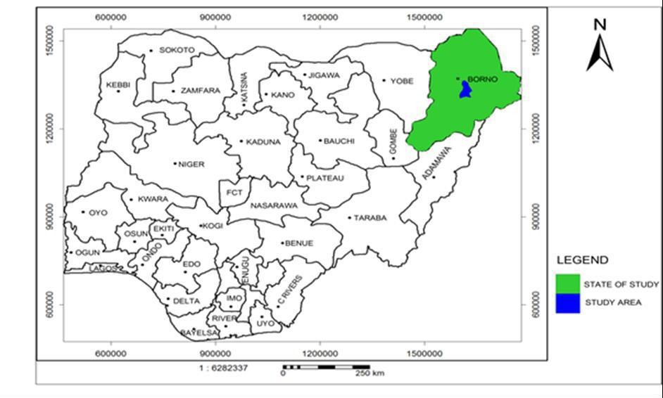

# Figure 3: Map of Nigeria showing the study area (Maiduguri)

Source: (Bakari, 2014)

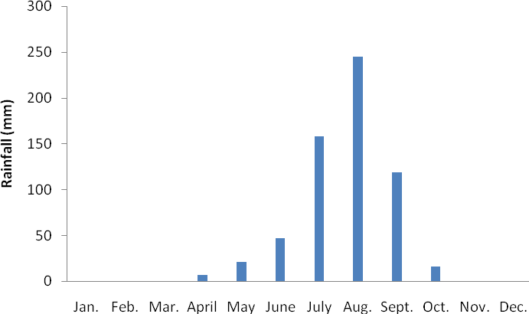

# Figure 4: Mean monthly rainfall of Maiduguri from 1995 ±2014

# Climate

According to Hess *et al.* (1996), the climate is semi-arid with three distinct seasons, cool- dry season (October to March), hot season (April to June) and a rainy season (July to September). The annual rainfall ranges from 560 to 600mm and Mean monthly rainfall of Maiduguri from 1995 ±2014 as shown in Figure 4. The cold (dry harmattan) season runs from November to March when temperatures fall to about 20°C and a dry dusty wind blows from the Sahara desert (Jaekel, 1984). The area is fragile and highly susceptible to drought with relative humidity of 13% in dry seasons and 65% in rainy seasons.

# Hydrogeology of the study area

The stratigraphy of the Chad Basin (Bornu sub-Basin) shows a depositional sequence from top to bottom which includes the younger Quaternary sediments, Plio-pleistocene Chad Formation, Turonian-Maastrichtian Fika shale, the late Cretaceous Gongila formation and the Albian Bima Formation (Maduabuchi *et al*., 2006). The Bima sand stone forms the deeper part of the aquifer series and rests uncomfortable on the basement complex rocks. Its thickness ranges from 300 to 2000 m and the depth between 2700 and 4600 m (Obaje, 2009). A pioneer investigation was carried out by Barber and Jones (1960) which revealed that the Chad formation reaches a thickness of at least 548 m at Maiduguri; in the central part of the basin the thickness may reach 600 to 700 m (Offodile, 1992).

The Plio-pleistocene Chad Formation and the Quaternary sediments are the main sources of groundwater supply in the Maiduguri area as shown in Figure 5, which dips gently east and northeast towards Lake Chad in conformity with the slope of the land surface. Except

for a belt of alluvial deposits around the edge of the basin, the formation is of lacustrine origin and consists of thick beds of clay intercalated with irregular beds of sand, silt and sandy clay (Miller *et al*., 1968). Barber and Jones (1960) divided the Chad Formation into three water bearing zones designated upper, middle and lower aquifers shown in Figure 5. It is Plio-Pleistocene in age and consists mainly of argillaceous sequence with three well-defined erinaceous horizons referred to as phreatic (Upper), Early Pliocene (Middle) and Continental Terminal (Lower) aquifer zones (Maduabuchi, 2005).

1. **The upper aquifer system:** consists of three sub-zones in most part of the area. These zones, referred to as A,B and C, are found at depth of 10-40 m, 40-70 m and 78-99 m respectively (Bunu, 1999). The reservoir in this system is composed of inter-bedded sands, clays, silts and discontinuous sandy clay lenses which give aquifer characteristics ranging from unconfined, through semi-confined to confined types (Maduabuchi et al., 2006). It extends from the surface to an average depth of 60 m but locally to 180 m. The transmissivity of this aquifer system ranges from 0.6 to 8.3 m2/day and the aquifer yield in Maiduguri is between 2.5 to 3 l/s (Akujieze *et al*., 2003).
2. **The middle aquifer system: t**his is the most widespread and best-exploited confined aquifer in the Nigerian sector of the Chad Basin with a surface area in excess of 50,000 km2. Its depth ranges from about 200 to 350 m. Litho-logically it is the most varied aquifer, consisting mainly of sand and gravels with silt and clay intercalations (Bunu, 1999). Recharge to this aquifer is reported to occur by horizontal inflow around the ridge of the rocky areas fringing the Chad basin and by lateral percolation from a ridge popularly referred to as the Bama ridge. Yields of boreholes tapping this aquifer range between 5 and 10 l/sec (Bunu, 1999). The Lower Zone aquifer is also separated from the Middle Zone aquifer by a thick clay layer of about 120 m. It consists of sand of various grain sizes and shapes. It occurs at a depth range of 500-650 m with average thickness of 90 m (Dar Al Handasah, 1981). Most of the wells tapping the aquifer are artesian and some are sub artesian. However, this aquifer is not tapped as much as the others due to high cost of drilling to that depth and is also kept as strategic reserve of groundwater to the inhabitants of the area.
3. **The lower aquifer system:** is found at depths of 420-650 m, with varying yields according to location ranging from about 15 l/s to as high as 30 l/sec. Initially it was thought that the aquifer was mainly confined to the Maiduguri area but a recent geophysical survey indicates its presence beyond Maiduguri (UN, 1988). Typically, the

depth to water table in the unconfined parts range from 15 to 75 m. Artesian conditions occur in confined aquifers at 75 to 100 m depth at the eastern edge of the basin; however, the piezometric levels are usually about 50 m depth further west. The upper and middle aquifers are exploited intensively in the Maiduguri area (UN, 1988). Recent decline in groundwater levels in the Chad Basin is believed to be due to over-exploitation of the aquifers in the basin. This has necessitated drilling to greater depths in order to tap the lower aquifer.

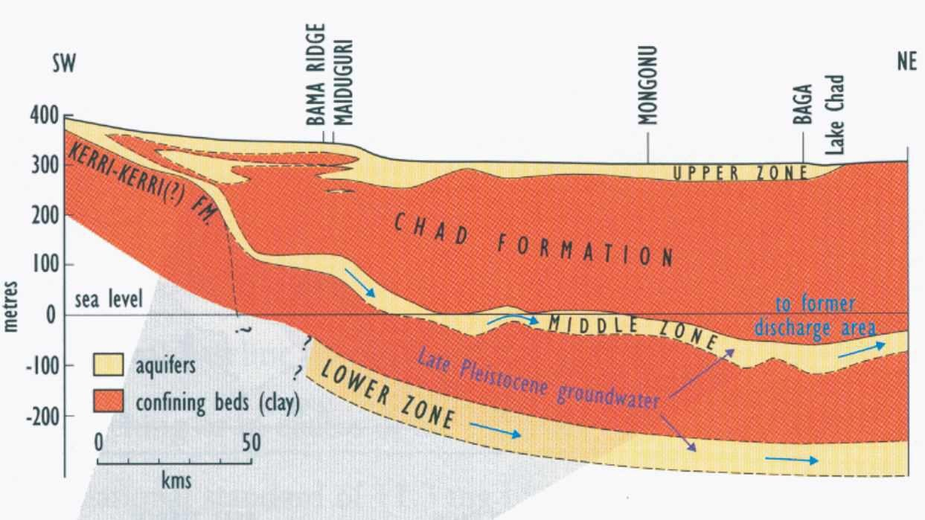

# Figure 5: Cross-section of the Chad Formation showing the three aquifer zones

Source: (Goni *et al*., 2005)

# Sample Collection

Purposive sampling technique was adopted to identify two open Municipal solid waste (MSW) dumpsites A & B which ranged from 18-23 years in age at Kumshe and Bakasi in Maiduguri respectively at a distance of 7.16km apart. Four hand-dug boreholes with depth ranging from 24 ±32m with a distance of 55.2m and 657.8m between the centre of dumpsite A and the two boreholes respectively. While, for dumpsite B the distance was 25.7m and 317.3m respectively as shown in Figure 6. The sampling coordinates for the dumpsites and wells were presented in Table 2 and 3. Composite sampling method was adopted for both the water and soil samples.

# Solid waste sampling

Characterization of the solid waste from the disposal sites was carried out according to the ASTM (2004) as presented in Table 4. The sampling was conducted in the month of January and August 2017 for the dry and wet season respectively. The procedure involved random collection of 10kg of solid waste at each dumpsite (three times in a week) for a month. The collected solid waste samples were air dried and weighted before sorting into different categories of plastics, polythene, waste battery, paper, textile, glass, metal and earth/ garbage. The categorized wastes were then weighed using a digital weighting scale and their percentage weight was calculated.

**Table 2: Sampling coordinates of the hand-dug wells and dumpsite A**

|  |  |  |
| --- | --- | --- |
| Sampling point | Latitude (o) | Longitude (o) |
| GWA | 11.857836 | 13.147581 |
| GWAC | 11.864072 | 13.148281 |
| SAO | 11.858228 | 13.147317 |
| SAN1 | 11.858269 | 13.147347 |
| SAN2 | 11.858289 | 13.147319 |
| SAE1 | 11.858242 | 13.147422 |
| SAE2 | 11.858278 | 13.147458 |
| SAEc | 11.857994 | 13.147511 |
| SAS1 | 11.858214 | 13.147381 |
| SAS2 | 11.858181 | 13.147411 |
| SASc | 11.858419 | 13.147261 |
| SAW1 | 11.858222 | 13.147361 |
| SAW2 | 11.858194 | 13.147317 |
| SAWc | 11.858022 | 13.146950 |

**Table 3: Sampling coordinates of the hand-dug wells and dumpsite B**

|  |  |  |
| --- | --- | --- |
| Sampling point | Latitude (o) | Longitude (o) |
| GWB | 11.799939 | 13.119197 |
| GWBC | 11.798961 | 13.116678 |
| SBO | 11.799906 | 13.119431 |
| SBN1 | 11.799919 | 13.119436 |
| SBN2 | 11.799947 | 13.119436 |
| SBNc | 11.800094 | 13.119464 |
| SBE1 | 11.799928 | 13.119450 |
| SBE2 | 11.799939 | 13.119472 |
| SBEc | 11.799964 | 13.119672 |
| SBS1 | 11.799903 | 13.119428 |
| SBS2 | 11.799847 | 13.119625 |
| SBSc | 11.799550 | 13.119689 |
| SBW1 | 11.799902 | 13.116667 |
| SBW2 | 11.799908 | 13.119389 |
| SBWc | 11.799833 | 13.122419 |

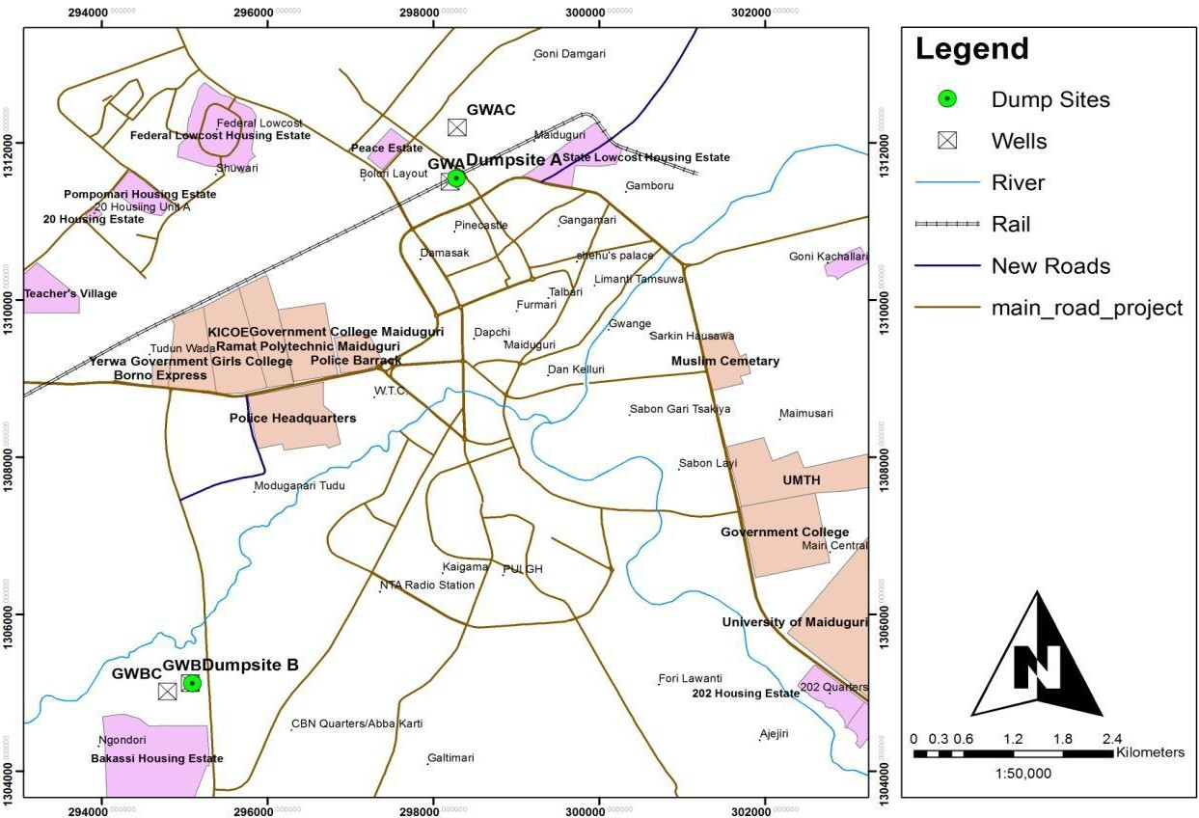

# Figure 6: GIS Map of Maiduguri showing the location of the sampling points

# Soil sampling

Soil sampling was conducted according to Soil Sampling for Environmental contaminants (ASTM, 2004). The soil sampling was conducted in the month of January and August 2017, under average temperature and relative humidity of 24.4o C and 16.4% and 32.25oC and 59.8% for dry and wet season respectively. The two dumpsites were divided into four cardinal points (North, West, and South & East), two sampling points were located along each cardinal point at interval and a control away from the dumpsites as shown in Plate 1. The soil samples were labeled SAO, SAN, SAE, SAEc, SAS, SASc, SAW, SAWc and SBO, SBN, SBNc SBE, SBEc, SBS, SBSc, SBW, SBWc for dumpsite A and B respectively as described in Table 5. Three replicates at each site were collected at the depth of 0- 30cm and 31- 70cm using soil auger. The soil samples were air-dried in the laboratory at room temperature and sieved under 2 mm mesh for digestion and laboratory analysis.

# Water sampling

Water sampling was carried out according to the National Field Manual for the Collection of Water-Quality Data (USGS, 2006). Four boreholes were identified, two each from the two dumpsites (one each within the proximity of the dumpsite and a control), with depth ranged from 24 - 32m. The water sampling was conducted in the months of January and August 2017 under average temperature and relative humidity of 24.40C and 16.4%, and 32.250C and 59.8% for the dry and wet season respectively. Three replicates of each sample was collected in a 120ml of sterilized plastic bottles and placed in an ice block container (the sampling was repeated three times for each borehole) for laboratory analysis as shown in Plate 2. The water samples were labeled GWA & GWAc, and GWB & GWBc for dumpsite A and B respectively.

# Table 4: Characterization of the dumpsites

|  |  |  |
| --- | --- | --- |
|  | **Dumpsite A** | **Dumpsite B** |
| Elevation (m) | 312 | 323 |
| Area (m2) | 17.25 | 14.46 |
| Depth (m) | 1.27 | 1.45 |
| MC of solid waste (%) | 17 | 14 |
| Topography | Flat | Slopy |
| Drainage | No | No |
| Human activities | Industrial/Commercial | Farming |

**Table 5: Description of sampling points of dumpsites A and B**

Sampling point Description Dumpsite A

SAO Soil sample at the dump site centre

SAN Soil sample along the north axis

SAE Soil sample along the east axis

SAEc Control sample along the east axis

SAS Soil sample along the south axis

SASc Control sample along the south axis

SAW Soil sample along the west axis

SAWc Control sample along the west axis Dumpsite B

SBO Soil sample at the dump site centre

SBN Soil sample along the north axis

SBNc Control sample along the north axis

SBE Soil sample along the east axis

SBEc, Control sample along the east axis

SBS Soil sample along the south axis

SBSc Control sample along the south axis

SBW Soil sample along the west axis SBWc Control sample along the west axis

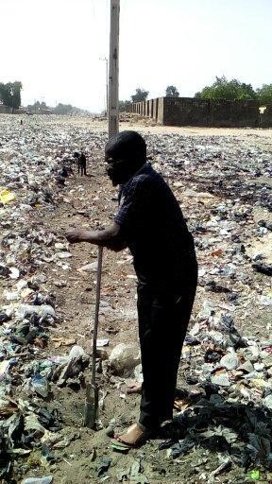

# Plate 1: Soil sampling at dumpsite A

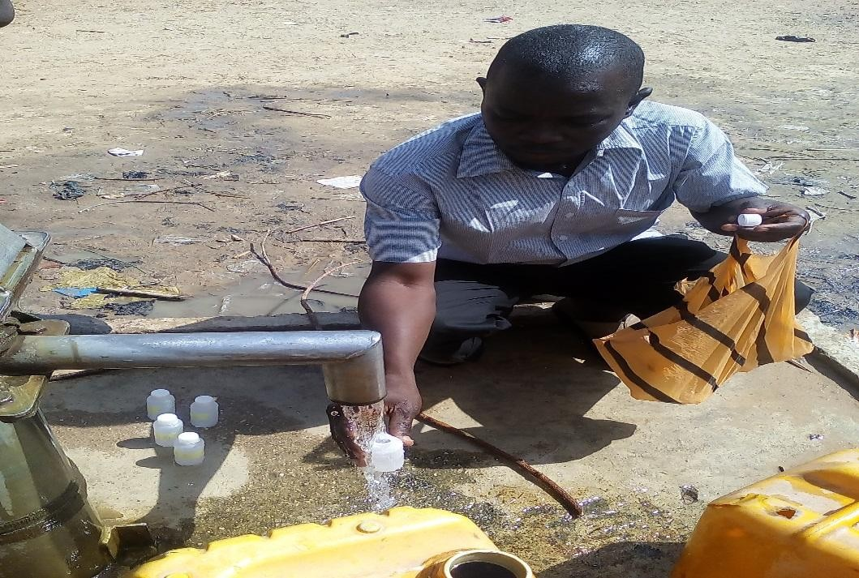

**Plate 2: Water sampling at well GWBc**

# Laboratory Analysis

The laboratory analysis of water and soil samples were carried out at sanitary chemistry laboratory, department of Water Resources and Environmental Engineering, Soil Science laboratory, department of Soil science and Multi-user Science laboratory, Ahmadu Bello University Zaria.

# Soil analysis

The soil samples for dry and wet seasons were analysed for physico-chemical properties; particles size analysis, electrical conductivity (EC), pH, nitrate (NO3), biochemical oxygen demand (BOD), Zinc (Zn) iron (Fe), copper (Cu), cadmium (Cd), chromium (Cr), lead (Pb), arsenic (As) and manganese (Mn). Particles size analysis was carried out using Bonyoucos hydrometer method and the texture determined on the USDA textural triangle. The soil pH and electrical conductivity was measured using Turbo pH/mV/temp. and EC meter at 1:2 soil to water ratio for 30 minutes and 24 hours respectively. The soil BOD was determined using Winkler method from the soil filtrates, which was obtained by soaking the soil samples in distilled water at a ratio of 1:16 for 24 hours. Potassium chloride (KCl) extraction method was used to determine the soil nitrate (NO3). The soil

samples were digested in a mixture of concentrated nitric acid (HNO3), concentrated hydrochloric acid (HCl) and 27.5% hydrogen peroxide (H2O2) according to the USEPA method 3050B for the analysis of heavy metals and major ions (USEPA, 1996) as shown in Plate 3. The heavy metals (Cu, Zn, Mn, Cd, Pb, As, Cr and Fe) of the soil extracts were analysed using the multi-wave plasma atomic emission spectrophotometer (MP-AES 4200). 5ml of each soil extracts was measured and placed in the system, standard code for each heavy metal were selected after calibration and run the system for analysis.

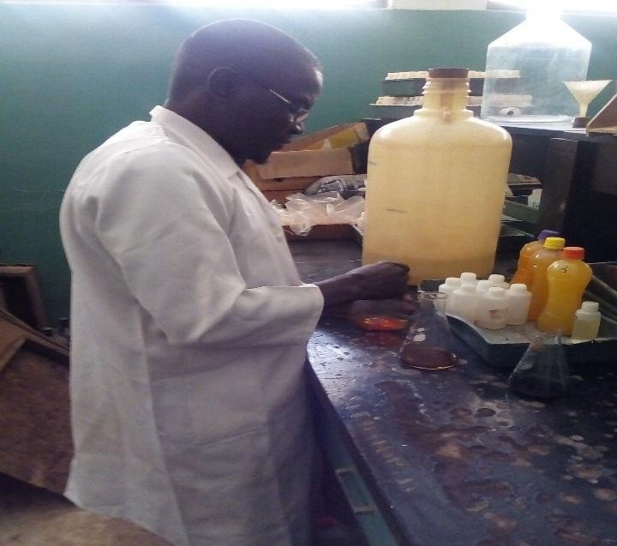

# Plate 3: Soil analysis

# Water analysis

The water samples for dry and wet seasons were analysed for physio-chemical properties; temperature, turbidity, electrical conductivity (EC) , pH, dissolved oxygen (DO), biochemical oxygen demand (BOD), chemical oxygen demand (COD), total dissolved solids (TDS), nitrate (NO3), Zinc (Zn), iron (Fe) , copper (Cu), cadmium (Cd), chromium (Cr), lead (Pb), arsenic (As) and manganese (Mn). Temperature and pH were measured in situ using Turbo pH/mV/temp. meter. Total dissolved solid was measured using TDS meter (TDS-3). Turbidity and electrical conductivity were measured using Hach turbidity meter (2100N) and Hanna electrical conductivity meter (HI98311) respectively. The BOD and DO were determined using Winkler method while the COD was analysed using Refluxing method. Colorimetric method was used to determine Nitrate by Hach colorimeter (DR/890). The heavy metals (Cu, Zn, Mn, Cd, Pb, As, Cr and Fe) were analysed using the multi-wave plasma atomic emission spectrophotometer, (MP-AES 4200). 5ml of each water samples was measured placed in the system and standard code for each heavy metals were selected after calibration and run the system for analysis.

# Data Analysis

Geographical information system (GIS) was used to map out the soil and water sampling point in the study area. Physio-chemical variables of the soil and water samples were analysed using descriptive statistical analysis to produce a table, which contain the minimum, maximum, mean and standard deviation (SPSS V. 20). Correlation coefficient of physic-chemical variables of the soil and water samples was compared using Microsoft excel (2013). Correlation analysis is a bivariate statistical method used to describe the degree of relation between two variables (Venkatramanan *et al*., 2013). A correlation coefficient (r) is used to represent the association between the variables. A correlation coefficient near 1 or -1 indicates a strong relationship between two variables, while r

closer to zero suggests no relationship between the variables (Ha and Ha, 2011). A positive value of r indicates a direct relationship between the variables while a negative value of r indicates an inverse relationship (Salvendy, 2012). Parameters showing *r* > 0.7 are considered to be strongly correlated, whereas if the r-value is between 0.5 and 0.7, the two parameters have a moderate correlation (Venkatramanan, 2013).

Weighted Arithmetic Water Quality Index was adopted for this study because it incorporates data from multiple water quality parameters into a mathematical equation that rates the health of water body with number and is widely used by various scientists in the word as reported by Brown *et al*. (1972).

# Constant of proportionality (k)

Where, k = constant of proportionality

Si = standard permissible limit for the ith parameter N = number of parameters.

# Relative weight (Wi)

 xviii

The unit weight (wi) of the various water quality parameters are inversely proportional to the recommended standards for the corresponding parameters as presented in Table 7.

# Water quality rating of the ith parameter (Qi)



Where, Vi = observed value of the ith parameter,

Vid = ideal value of the ith parameter in pure water.

All the ideal values (Vid) are taken as zero (0) for drinking water except pH and dissolved oxygen. For pH, the ideal value is 7.0 (for natural/pure water) and the standard permissible value is 8.5 for drinking water. Therefore, the quality rating for pH is calculated from equation iii

Where, pH = observed value of pH.

For dissolved oxygen, the ideal value is 14.6 mg/l and the standard permissible value for drinking water is 5 mg/l. Therefore, its quality rating is calculated from equation iii

Where, ܸDO = observed value of dissolved oxygen.

# Water quality index (WQI)



Where, n = number of variables or parameters, Wi = relative weight of the ith parameter

Qi = water quality rating of the ith parameter.

# Table 6. Weight Arithmetic Water Quality Index method ratting

|  |  |  |
| --- | --- | --- |
| Range | Rating of Water Quality | Grading |
| 0-25 | Excellent water quality | A |
| 26-50 | Good water quality | B |
| 51-75 | Poor water quality | C |
| 76-100 | Very Poor water quality | D |
| Above 100 | Unsuitable for drinking purpose | E |

Source: (Brown *et al.,* 1972).

# Table 7: Relative weight (Wi) for each parameter

|  |  |  |  |  |  |
| --- | --- | --- | --- | --- | --- |
| P (mg/l) | Si | 1/Si | K |  | *W*i |
| Turb |  |  |  | 548 |  |
| pH |  |  |  | 087 |  |
| EC |  |  |  | 01774 |  |
| TDS |  |  |  | 03548 |  |
| DO |  |  |  | 548 |  |
| COD |  |  |  | 222 |  |
| BOD |  |  |  | 548 |  |
| NO3 |  | 74 |  | 355 |  |
| Zn |  |  |  | 913 |  |
| Fe |  |  |  | 133 |  |
| Cu |  |  |  | 7 |  |
| Pb |  |  |  |  |  |
| As |  |  |  |  |  |
| Cd |  |  |  | 333 |  |
| Cr |  |  |  | 8 |  |
| Mn |  |  |  | 7 |  |

Total Temp.(o& 7XUELGLW\ 178 DQG (& ȝV FP

# CHAPTER FOUR

**RESULTS AND DISCUSSION**

# Solid Wastes Composition

The results of field work comprised the average values of the mass-based composition of waste materials generated in the study area; the percentage composition of the municipal

wastes for dry and wet season of dumpsites A and B as presented in Figure 7 - 10. Figure 7 and 8 for dumpsites A revealed that Earth/garbage constitute the highest proportion of wastes generated with 30% and 34% for dry and wet season respectively. The higher proportion of Earth/garbage waste consist of biodegradable materials like waste food and vegetables, and these could be responsible for the inherent odour problems arising from most of the refuse transfer depots in the study area. Metals constitute 20% and 22% of the wastes for dry and wet season respectively. Other waste materials generated include; polythene 16% and 13%, plastic 12% and 11%, glass 11% and 13%, textiles 6% and 5%, and paper 5% and 2% for dry and wet season respectively. The percentage composition of these materials depends largely on the community needs and standard of living, as reported by (Napoleon *et al*., 2011), that low-income areas produce relatively more of organic wastes.

Figures 9 and 10 for dumpsites B revealed that glass waste constitute the highest proportion of wastes generated with 27% and 29% for dry and wet season respectively. The high percentage of glass was due to car repairing garages round the area. Plastics constitute 25% and 26% of the wastes for dry and wet season respectively. Other waste materials generated include; earth/garbage 20% and 21%, polythene 12% and 11%,

textiles 9% and 6%, paper 5% and 3%, and waste battery 2% and 4% for dry and wet season respectively. The seasonal variation of solid waste composition could be due to the demanding period of the material, like increase in percentage composition of earth/garbage, plastic, glass, and waste battery from dry to wet season for dumpsite B. The high composition of non-biodegradable wastes from these results bears implication of the requirement for alternative waste management solutions for attaining sustainable and environmental friendly waste management system in the study area and this study agreed with Amori *et al*. (2013).

The mean percentage composition of solid waste at the two dump sites were earth/garbage (26%), metal (21%), glass (20%), plastic (19%), polythene (13%), textile (7%), battery (5%) and paper (3%). At 95% confidence level there was a significant difference between the compositions of the solid wastes at the two dump sites as presented in Table 8. This was due to the differences in socio-economic status of the people around the two sites, solid waste variation depends on food habits, cultural tradition, socioeconomic and climatic conditions, not only from city to city but even within the same city. The effect of seasons on the compositions of the solid wastes at the two sites was not significant at 95% confidence level. There was a significant difference at 99% confidence level between the compositions at each of the dump sites as presented in Table 9.

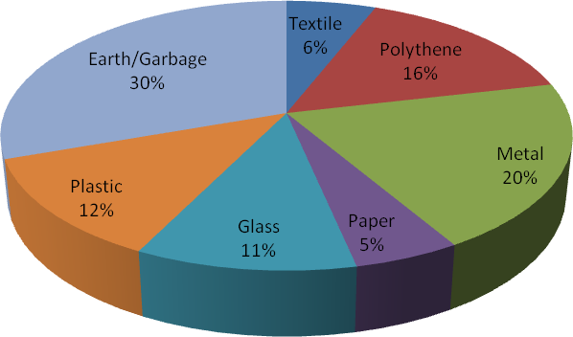

# Figure 7: Solid waste composition of dumpsite A (%) for dry season

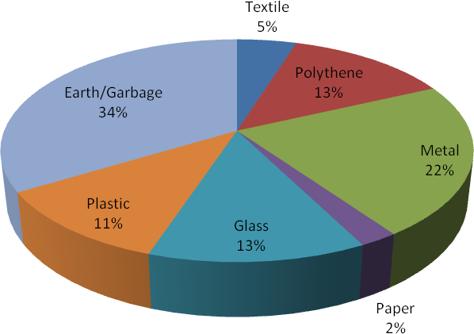

**Figure 8: Solid waste composition of dumpsite A (%) for wet season**



# Figure 9: Solid waste composition of dumpsite B (%) for dry season

**Figure 10: Solid waste composition of dumpsite B (%) for wet season**