AMERICAN UNIVERSITY OF NIGERIA DEPARTMENT OF NATURAL AND ENVIRONMENTAL SCIENCES

Senior Research Project

ASSESSMENT OF KNOWLEDGE, ATTITUDES AND PRACTICES OF BIOMEDICAL WASTE MANAGEMENT AMONG WASTE HANDLERS AT FMC, YOLA AND AKTH, KANO

by

AMINA IBRAHIM TURAKI

by

Submitted in partial fulfillment of the requirements for the degree of Bachelor of Science
2015

AMERICAN UNIVERSITY OF NIGERIA DEPARTMENT OF NATURAL AND ENVIRONMENTAL SCIENCES

ASSESSMENT OF KNOWLEDGE ATTITUDES AND PRACTICES OF BIOMEDICAL WASTE MANAGEMENT AMON WASTE HANDLERS AND FMC, YOLA AND AKTH, KANO

This thesis represents my original work in accordance with the American University of Nigeria regulations. I am solely responsible for its content.

AMINA IBRAHIM TURAKI

Signature Date

I further authorize the American University of Nigeria to reproduce this thesis by photocopying or by any other means, in total or in part, at the request of other institutions or individuals for the purpose of scholarly research.

AMINA IBRAHIM TURAKI

Signature Date

ASSESSMENT OF KNOWLEDGE ATTITUDES AND PRACTICES OF BIOMEDICAL WASTE MANAGEMENT AMON WASTE HANDLERS AND FMC, YOLA AND AKTH, KANO

Approved by Research Supervisor: Dr. J. D SIEBERT PhD
Professor of Natural and Environmental Sciences

Signature Date

Second Reader: Dr. JESSICA BOYD Ph.D. Assistant Professor and Chair
Natural and Environmental Sciences

Signature Date

DEDICATION

This project is dedicated to all members of the American University of Nigeria community. I am also dedicating this project to my hardworking parents in person Mr. and Mrs. Turaki Ibrahim for their financial assistance throughout my stay at the University.

ACKNOWLEDGEMENT

First and foremost, the greatest thanks to the almighty Allah SWT for his support, guidance and blessing to complete this thesis successfully. I would also like to acknowledge my gratitude to the department of environmental sciences for helping through and enhancing my knowledge throughout my stay at the American University of Nigeria.

Specifically, it is imperative to thank my primary supervisor Dr. Siebert, my second reader and project coordinator Dr. Jessica Boyd and Dr. Tyndall for their endless support. Thank you very much for giving me the ability to complete this research successfully.

I would also like to give special thanks to the Gaby Cord waste handlers, Gaby Cord CEO, Mr. Gabriel and the Gaby Cord Manager, Mr. David. I must also acknowledge the Environment and Health Department AKTH, specifically the HOD, Malam Galaudu and the Chief Environmental Officer, Malam Sanusi. Thank you very much for agreeing to be part of this research.

ASSESSMENT OF KNOWLEDGE ATTITUDES AND PRACTICES OF BIOMEDICAL WASTE MANAGEMENT AMON WASTE HANDLERS AND FMC, YOLA AND AKTH, KANO

AMINA IBRAHIM TURAKI

American University of Nigeria, 2015

Major Professor: J. D. Siebert, PhD., Professor of Natural and Environmental Sciences

ABSTRACT
The study uses FMC and AKTH as a case study in order to assess the knowledge, practices and attitudes of waste handlers on biomedical waste management. The study investigates the major problems associated with management and handling practices and the possible solutions to tackle those problems. Based on the findings from this study, recommendations will be proposed to the hospitals on ways to improve the system of biomedical waste management and handling.
A total of 12 individuals from a private company named Gaby-cord limited were involved in the survey at FMC, sample size was chosen based on the idea of saturation. Questionnaires, semi-structured interviews and direct observation were used to gather all the data required for the study at FMC. On the other hand, semi- structured interviews, direct observation and hospital records were used to acquire

information at Aminu Kano teaching hospital (AKTH), Kano. A total of three individuals were involved in the survey including the head of department, data collection was carried out at AKTH.
FMC waste handlers have limited knowledge on biomedical waste management legislations and guidelines. Waste handlers have positive attitudes towards biomedical waste management and are aware of common practices of biomedical waste management. Generally biomedical waste management is poor at FMC. On the other hand, AKTH has the potential to meet the standard biomedical waste management system proposed by the World Health Organization. However, it is recommended for both hospitals to aim for positive goals based on fixed standards and set a time frame at which the goals are expected to be achieved.

Key words: Biomedical Waste, Biomedical Waste Management, Waste Handlers, Knowledge, Attitude and practices.

TABLE OF CONTENTS

Title page i
Certification ii
Readers’ approval iii
Dedication iv
Acknowledgement v
Abstract vi
Table of contents vii
List of table ix-x
List of abbreviations x
  - Introduction 1
  - Statement of problem 2
  - Aim/Objectives 2
  - Hypothesis 3
  - Study Area 3
  - Literature Review 5
  - What is biomedical waste? 5
  - Classification of Biomedical waste 5
  - Categories of Biomedical waste 8
  - Sources of Biomedical waste in Yola/Nigeria 10
  - Biomedical waste management 11
  - Standard for biomedical waste management system 11
  - Need for biomedical waste management 14
  - Impacts of poorly managed biomedical waste 14
  - Problems faced by healthcare centers in Nigeria 17
  - Materials and Methods 21
  - Federal Medical center 21
    - Research strategy 21
    - Questionnaire administration 21
    - Semi structured interviews 22
    - Direct observation 22
  - Aminu Kano Teaching Hospital 22
    - Research strategy 22
    - Semi structured interviews 23
    - Direct observation 23
  - Analysis and Results 24
  - Federal Medical center (FMC) 24
    - Observation outside wards (FMC) 25
    - Qualitative data from interview ....... 34
  - Aminu Kano Teaching Hospital (AKTH) 36
    - Data from interview/ hospital records 37
  - Discussion 44
  - Problems encountered during survey 44
  - Findings from FMC, Yola 45
  - Findings from AKTH, Kano 48
  - Comparison of BMWM practice at AKTH and FMC 51
  - Conclusion and recommendations 52
References 54
Appendix 57

LIST OF TABLES/FIGURES
Table: 1 Classification of BMW (FMC) 9

Table 2: Diseases associated with BMW (FMC) 16

Table 3: Observation within wards (FMC) 24

Table 4: Knowledge of BMWM hazard/legislations (FMC)….. 29

Table 5: Awareness of BMWM practices (FMC) 31

Table 6: Attitude towards BMWM (FMC) 33

Table 7 Observation within wards (AKTH) 36

Fig 1 FMC, Yola 4

Fig 2 Biohazard symbol 7

Fig 3 Landfill Disposal 13

Fig 4 Color-coding segregation of waste 13

Fig 5Yearly progression of waste collection 20

Fig 6 Waste bins at the emergency ward 27

Fig 7 Waste bins at the laboratory ward 28

Fig 8 Graphical representation of Knowledge assessment 30

Fig 9 Graphical representation of awareness assessment 32

Fig 10 Attitude assessment towards BMWM 34

Fig 11 Temporary dumpsite 36

Fig 12 AKTH segregation of waste 37

Fig 13 Ballet incinerator 38

Fig 14 Mechanical incinerator 38

Fig 15 Needle pit 39

Fig 16 Face Mask 40

Fig 17 Googles 40

Fig 18 Protective clothing for waste handlers 41

Fig 19 Staff involved in BMWM 42

Fig 20 Training sessions for healthcare workers 43

List of abbreviations

BMW- Biomedical Waste

BMWM- Biomedical Waste Management WHO- World health Organization AKTH- Aminu Kano Teaching Hospital FMC- Federal Medical Center
USAID- United States Agency for International Development NHMCR- National Health and Medical Research Council LAWMA- Lagos State Waste Management Agency

INTRODUCTION

Healthcare Waste, also referred to as Biomedical Waste (BMW) is rated to be the second most hazardous form of waste after radioactive waste. People with diverse form of infections visit the hospital for treatment; this involves the use of medical equipment which is regarded as BMW after use. A reasonable number of hospitals especially in underdeveloped countries fail to manage BMW properly therefore putting lives at risk. Considering the fact that this category of waste is generated in medical facilities, its threats can go beyond the facility premises and affect other people and organisms. It has been noted that an estimated sixteen million injections are administered globally in a year, but not all of the needles and syringes are properly disposed of afterwards (WHO, 2011). Improper management of BMW further promotes higher occurrence and prevalence of diseases both within and outside the medical facility.
Poor management of BMW has become more prominent especially in the northern part of Nigeria due to the insufficient attention given to the issue. In most Nigerian hospitals, waste handlers are employed without considering their level of knowledge and certification (Longe, 2006). Within healthcare centers waste segregation can be said to be a major drawback, infectious wastes are usually mixed up in the same containers with non-infectious waste; thereby increasing the quantity of infectious waste (Sanusi, 2014). Other factors that promote improper healthcare waste handling and management in Nigeria include: handling by poorly trained workers, insufficient resources to carry out the necessary practices and ignorance of responsibility to handle the waste produced (Khopar, 2009).

Statement of problem
Considering the fact that BMW has been rated as one of the most hazardous categories of waste in the world, insufficient attention is given to the topic. To be more precise, BMWM has become a major problem over the years in Nigerian hospitals. Regarding the health of individuals, proper management of waste has to be considered as a top priority in both government and owners of private hospitals.
Ignorance of responsibilities to safeguard the health of individuals from the hazards associated with BMW is a primary issue as well. It is usually assumed that waste handlers are in charge of waste management but ironically, the 1998 rule on biomedical waste handling and management clearly states that the responsibility lies among all those that generate, treat, transport and dispose biomedical waste in healthcare centers disposal (Ministry of Environment & Forests , 1998).
The question is, despite the fact that BMW is highly and potentially infectious, why is its proper disposal still a major issue in Nigerian hospitals today? Results from several studies have investigated several reasons behind this major drawback. The study in progress uses FMC and AKTH to know the stance of biomedical waste management in both hospitals.

Aim/Objectives
This study aims at assessing knowledge, awareness and practices of biomedical waste management among waste handlers at FMC and AKTH.
    - To promote awareness of biomedical waste management among waste handlers at the hospitals.

    - To provide feedback and recommendations based on the research to the hospitals.
    - To understand the major drawbacks that result in improper biomedical waste management in the country.

Hypothesis

    - Practices of BMWM will be poor at FMC and AKTH because they are tertiary healthcare centers and therefore will not be easy to maintain.
    - Knowledge and awareness of BMWM will not be common among waste handlers due to their level of education.

Study area
Adamawa state which was formally part of Gongola State was established in 1991 and is located in the northeastern Nigeria. The state occupies almost 40,000 square kilometers and is populated with about 3,106,585 people (Federal republic of Nigeria, 2006). It has twenty one local governments with Yola as the State capital. Compared to other states in Nigeria, Yola is yet to develop to meet with the development level in Nigeria.
FMC is located on Lamido Zubairu way; Yola bye-pass and is a tertiary health care center in north eastern Nigeria. The vision of the facility is to be the best healthcare center in north eastern Nigeria and to be the one of the top ten best hospitals in the country (Taking It Global, 2014). The hospital has several departments including casualty wards/ emergency, major operating theatre, minor operating theatre, laboratory and maternal ward.
Tertiary hospitals are known to have units or organizations in charge of their waste management. In the case of FMC, Gaby-Cord Company is responsible for

its waste disposal. The branch of the company is located near the hospital at Lamido Zubairu Way; Yola bye-pass, it provides laundry services, office and home cleaning, industrial waste management and disposal and environmental beautification.

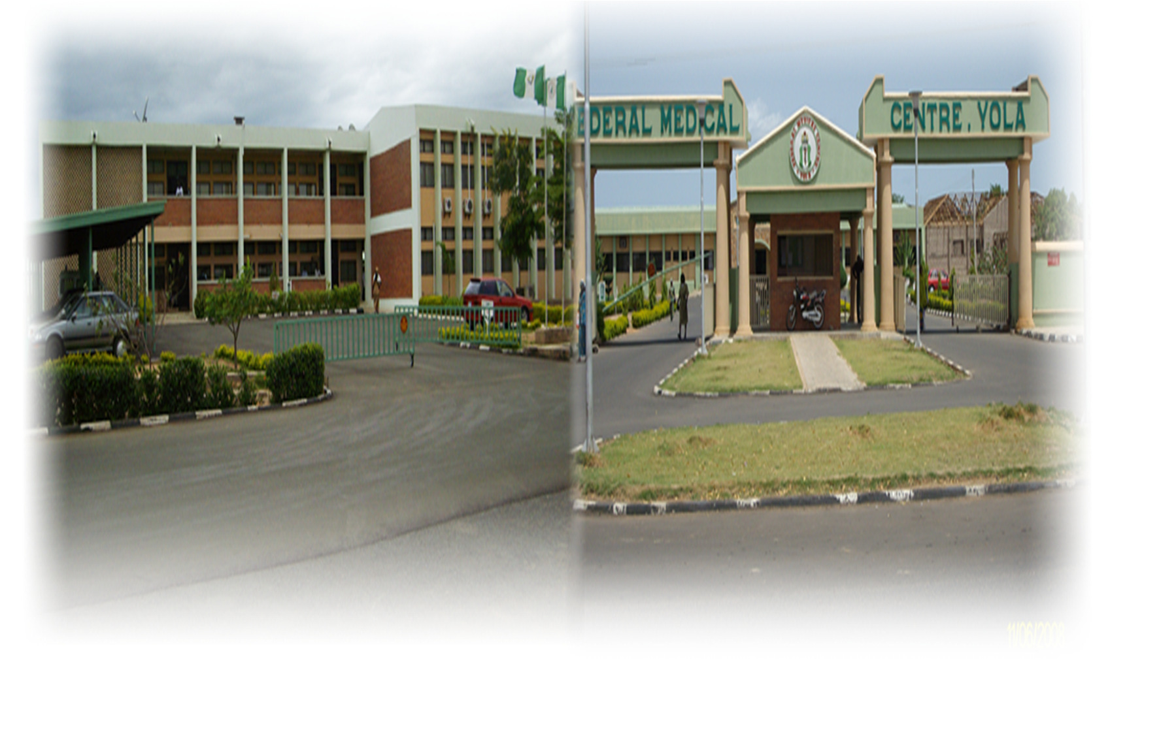

Fig 1: FMC, Yola
Source: FMC official website

On the other hand, Kano State which is located the north western part of Nigeria is a well-developed and populated city. AKTH is a well-known federal hospital in northern part of Nigeria and it is located along Zaria Road, Kano. It was established in 1988 and it is well known for its constant records of effectiveness and professionalism. The hospital’s goal is to ensure that patients are satisfied with their services and to provide job opportunities for less privileged people in the society. The hospital has several departments including dental and maxillofacial, hematology

and blood transfusion, histopathology, microbiology and parasitology, pediatric, pharmacy, and physiotherapy.
The environment and horticulture department is responsible for managing and handling biomedical waste and other aspects of maintaining a fit and healthy hospital environment. Some of these include the following:
-Ensuring general sanitation of the hospitals

-Undertaking pest and /vector control

-Undertaking fumigation in operating theatres

-Disposing corpses and displacement of from histopathology department

-Collecting and disposing of safety boxes and expired unit of blood

LITERATURE REVIEW

What is biomedical waste?
By definition, biomedical waste is any substance or material that no longer serves a purpose and is produced from medical bodies. Biomedical wastes are usually produced in hospitals, clinics, nursing homes, laboratories, funeral homes etc. This group of waste can be in form of solid, liquid, and gases as well; examples include medical sharps, expired units of blood, cultures from laboratories, broken glass, saws, nail, blades, scalpels, packaging material, paper, wrappers, plastics etc.

Classification of biomedical waste
Biomedical waste is broadly classified into two groups; hazardous health care waste and non-hazardous health are waste. This classification is based on how infectious these wastes are.
Non-hazardous health care waste: These are biomedical wastes that are not infectious and therefore have less negative impact on humans and other organisms. According to the WHO, 80% of the waste generated in medical centers is classified

under this category (WHO, 2011). Despite the fact that this classification of wastes is not infectious, they do have some negative impacts on the environment if not properly disposed. The major disadvantage is basically pollution of the environment and clogging of drainages; some animals also ingest some of these materials which can be toxic to their systems, biodegradation of soil, sharps inflicted injuries among scavengers and healthcare workers, contamination of underground water from leachates, unpleasant smell from dumpsites, air pollution from toxic gases, bioaccumulation of toxic substances in different tropic levels and most importantly, presence of carcinogens and neurotoxins in some medical waste. Wastes in this category include worn out scrubs, bed sheets, food disposed from wards, nylons, and other materials that not infected. Disposal of non-infectious waste does not require much attention compared to infectious wastes. For instance, most non-hazardous wastes do not require treatment, protective clothing of waste handlers, extra carefulness in waste transport and segregation. Instead, non-infectious wastes are usually disposed in general waste dumpsites and burnt all together. Non-hazardous biomedical waste do not pose potential risks of infections among healthcare workers or dump site scavengers compared to infectious biomedical waste.
Hazardous health care waste: According to WHO, 20 percent of biomedical waste generated are hazardous (WHO, 2011). Biomedical wastes in this category are highly or potentially infectious and therefore improper disposal and maintenance could result to occurrence of infections among healthcare personnel, patients and dump site scavengers. Countries with higher income produce an estimate of 0.5kg of hazardous waste per bed in a day while countries with less income produce about 0.2kg (WHO, 2011). However, low income countries do not differentiate hazardous

and non-hazardous wastes; rather they are all mixed up together making the amount of hazardous waste higher. Hazardous healthcare wastes serve as major sources or reservoirs for infectious diseases, especially within healthcare centers. Most nosocomial infections such as pseudomonas and staphylococcal infections result from improper management of infectious biomedical wastes. Occurrence of infectious diseases does not occur only at healthcare centers; scavengers and people living around dumpsites can be affected as well. Other health threatening conditions include radiation burns from radioactive waste and injuries from medical sharps such as needles. In most Nigerian hospitals, wastes from the laboratory such as blood and urine samples are usually found to be the most infectious among others; this is due to presence of pathogenic microorganisms in the laboratory samples.
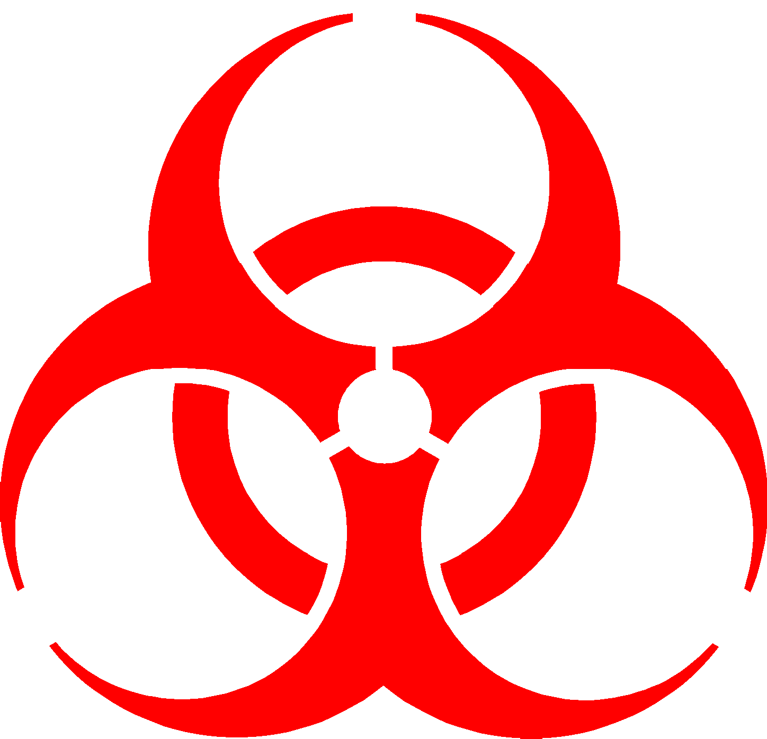

(designing the biohazard sign, 2008)

Fig 2: Biohazard Symbol
Source: Designing the biohazard symbol

However, several techniques have been innovated to ensure hazardous biomedical waste is being disposed safely but due to ignorance and lack of awareness, these techniques are not put into consideration.

2.3

Categories of biomedical waste
Hazardous health care waste can be of ten different categories based on the site of its production or the component of the waste. The table below shows the classification of biomedical waste according to the WHO.
- Human anatomical waste: includes human parts, organs and tissues.

Such wastes usually require incineration and burial

- Chemical waste: includes chemicals used in the hospitals such as formalin, insecticides, and pesticides. Chemicals are treated then disposed in drainages and landfills
- Discarded medicine and cytotoxic waste: include drugs that are expired and are no longer useful, requires incineration and safeguarded landfill dumping.
- Medical sharps: Include needles, blades, and scalpels, razors, glass and syringes. Wastes in this category are disposed by the means of incineration and mutilation shredding.
- Microbiological waste: lab cultures, live vaccines and disposable lab devices can be classifies under this category. Devices can be sterilized by local autoclaving.

- Infected general waste: these are solid wastes that have been infected with blood or other fluids from the body. Examples are beddings, cotton, bandages, plasters etc. The most common form of disposal for these wastes is local incineration (joshi, 2014).

Waste Category | Type of waste
Category 1 | Human anatomical waste
Category 2 | Animal waste
Category 3 | Microbiological waste and Biotechnology waste
Category 4 | Waste sharps
Category 5 | Discarded medicine and Cytotoxic waste
Category 6 | Soiled waste
Category 7 | Solid waste
Category 8 | Liquid waste
Category 9 | Incineration Ash
Category 10 | Chemical waste

Table 1: Classification of biomedical waste
Source: WHO website

Sources of biomedical waste in Nigeria/Yola
Among all the problems associated with BMW in Nigeria, the most common is finding biomedical waste mixed up with domestic wastes at dump sites in Nigeria. It has become a habit for children in the rural areas and even the less privileged from the urban regions to use waste dumping sites as a source of materials they need such as toys and other things that could be of use to them. By correlating improper disposal of biomedical waste and the habit of picking from dump sites, children and scavengers are at high risk of becoming infected. In order to tackle the problems associated with biomedical wastes, sources of biomedical wastes must be addressed. Sources of biomedical waste in Nigeria include hospitals and other medical centers, laboratories and research institutes, mortuary and autopsy centers, animal research laboratories, blood banks, nursing homes etc.
Despite the fact that biomedical waste requires proper management, it is unfortunate that only a few hospitals in most developing countries consider this as a priority; this has become a serious problem and a major source of nosocomial infection outbreaks. The lifespan of some infecting organisms is very long; notoriously, anthrax can remain alive in the soil for several years (Healthcare environmental resource center). Previous researches have shown that management of infectious waste is a major barrier to public health in India, especially in terms of defined guidelines for disposal (Khopar, 2009). Some hospitals manage a particular category of waste properly but fail to do so for other categories. Such a situation has been identified in some Nigerian hospitals such as AKTH in Kano State. Disposal of most waste is properly done but yet staphylococcal and pseudomonas infections are common among surgical patients. This is due to improper treatment of surgical materials such as scalpels (Ukey, 2012).

Biomedical waste management
Health care waste management is described as the proper disposal of waste materials generated from a medical body in such a way that it has no negative effect to humans and the environment (Yadavannavar, 2010). Different categories of waste have different disposal methods based on contents of the waste and its physical properties. Therefore applying the right course of action for different categories of waste will promote the wellbeing of individuals and a healthy environment.

Standard for biomedical waste management system
Although Nigeria does not have a standard system for biomedical waste management, it is the responsibility of all medical bodies that generate waste to develop comprehensive waste management systems for the organization. Depending on the location, size, professionalism and access to disposal amenities, implementation of waste management systems may vary. Nevertheless, implementation of waste management systems should be similar, wherever possible, within and between organizations (NHMRC, 2009). By doing so, the medical body reduces the possibility of confusion and accidents because it familiarizes the staff with the systems in similar organization. The stages involved in the BMWM system that was implemented by the WHO is as follows;
- Segregation: This is the first stage in healthcare waste management which primarily entails isolating biomedical waste from other hospital trash. Waste is further segregated into different categories based on its content and physical properties as mentioned earlier (3-Stage Healthcare Waste Management Plan for Emergencies).

- Labelling: This stage includes proper tagging of containers containing biomedical waste. In most cases, containers are labelled “BIOHAZARDS”. Another common procedure is using coloured bins for specific categories of waste (Healthcare environmental resource center).
- Treatment: The primary procedures of treating health care waste are chemical disinfection using disinfectants such as formalin and Autoclave decontamination. Incineration could also be classified under the treatment stage in which waste materials are burnt at an extremely high temperature so as to kill pathogenic microorganisms. This helps to safely transport waste materials to the site of disposal and reduces the rate of infection (Healthcare environmental resource center).
- Transportation: Treated waste materials are packed in safety containers or bags to ensure no leakage or outflow occurs. Waste materials are then transported to storage areas or site of disposal (Healthcare environmental resource center).
- Storage: Waste materials such as sharps and anatomical waste that do not necessarily require immediate disposal can be kept temporarily before disposal. For instance, sharps can be stored in safety boxes and anatomical wastes could be stored in containers and kept under extremely cold temperature (Healthcare environmental resource center).
- Disposal: Medical wastes are disposed using several procedures depending on the nature of the waste and the policies of the medical institution. Based on the lectures I had during my internship, I learnt that most medical wastes require deep burial. Furthermore, biomedical wastes are disposed in landfills

and lastly could be discharged into drains (Healthcare environmental resource center).

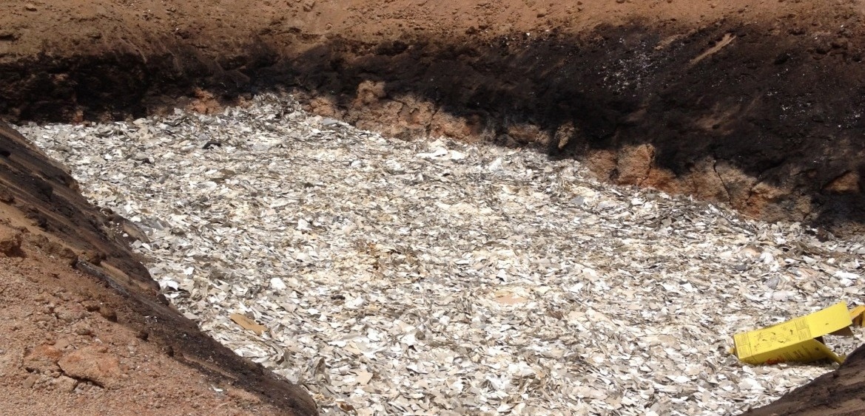

Fig 3: landfill disposal of shredded syringes and safety boxes
Source: FMC disposal site
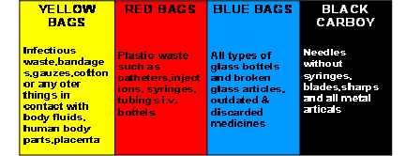
Fig 4: Color-coding segregation of waste
Source: Healthcare environmental resource centre

Need for biomedical waste management
The primary goal of health care waste management is to ensure the health of individuals is not jeopardized. In a more narrow aspect, occupational risk is extremely high and the condition of patients can become worse if biomedical waste is not managed properly. Since a hospital can be characterised as a closed community, the rate at which outbreaks can occur can be grossly enhanced. Regarding the environmental effect, some biomedical wastes are highly toxic and therefore can bio accumulate and affect different organisms in different tropic levels. This can further result in loss of biodiversity. Reducing risk and liability, cost control, planning and declaring instrumental commitment for protection of human life can be described as possible remedies (Khopar, 2009).

Impacts of poorly managed biomedical waste on the environment and health
Biomedical waste that is not properly managed has several hazards linked with it. This could be chemical, physical or biological hazards. To be more precise, disease causing microorganisms, medical sharps and toxic chemicals from biomedical waste can infect healthcare personnel, patients, the general public and the environment. Specifically, human impacts and environmental impacts of poorly managed biomedical waste include radiation burns from radioactive waste, sharp- inflicted injuries, poisoning and pollution from pharmaceutical products, waste water and toxic elements such as mercury (WHO, 2011).
All individuals that have access to infectious healthcare waste are possibly at risk, this includes individuals that generate the wastes such as doctors and those who are responsible for managing the waste or are exposed to it as a result of

improper management and handling. Individuals at high risk include healthcare workers such as nurses, lab technicians and doctors, patients, waste handlers and scavengers. These sets of individuals at risk could be infected through puncture and other breaks in the skin, mucous membranes, inhalation, ingestion and vector transmission (Ekaete, 2010).
According to reports from the WHO, there are about 8 to 16 million new cases of hepatitis B virus (HBV), 2.3 to 4.7 million cases of hepatitis c virus (HCV) and 80,000 to 160,000 cases of human immune deficiency virus (HIV) due to careless management of injections and other medical wastes (Ekaete, 2010). Diseases that emerge as a result of improper management of biomedical waste include Arboviral infections, Brucellosis, Creutzfeldt-Jakob disease, Hepatitis C, Leptospirosis, Malaria, Rabies, Syphilis, Tularemia and Viral Hemorrhagic Fevers (Exther, 1981). Bacteria resistant to antibiotics and chemical disinfectants may also contribute to the hazards created by poorly managed waste (joshi, 2014).
Chemical substances and cytotoxic wastes are known to be highly genotoxic, corrosive, combustible and volatile and may affect the health of individuals, either by short-term or long-term exposure, and injuries, including punctures. Looking at the environmental effects of biomedical wastes, improper disposal can promote biodegradation of soil and put aquatic life at risk and also contamination of underground water as well. However, waste treatment also has environmental effects such as release of toxic gases from incineration and burning.

ORGANISM | DISEASE CAUSED | RELATED WASTE ITEM
VIRUSES: | AIDS, infectious | Infected needles,
HIV, hepatitis B, A, | hepatitis, dengue, | body fluids, human
and C, Arboviruses, | Japanese | excreta.
Enteroviruses | encephalitis, tick-
 | borne fevers
BACTERIA: | Typhoid, Cholera, | Human excreta,
Salmonella typhi, | Tetanus, Wound | body fluids, sharps.
Vibrio Cholerae, | infections,
Costridium Tetani, | septicemia,
Pseudomonas, | rheumatic fever,
Streptococcus. | skin and soft tissue
 | infections
PARASITES: | Cutaneous | Human excreta,
Wuchereria | Leishmaniasis, | poorly managed
Bancrofti, | Malaria | sewage systems in
Plasmodium |  | the hospitals

Table 2: Diseases associated with biomedical waste
Source: Healthcare Environmental Resource Center

Problems faced by healthcare centers in Nigeria
Considering the fact that Nigerian government has developed legislative/regulatory implements to further address the issue of public health, the general health of Nigerian citizens is still at stake, especially in less developed regions (Environmental Health Watch, 2008). One of the major factors that drive the general issues on public health is the problem Nigerian hospitals face in terms of proper waste management. As Engr. Mokuolu stated, “the waste management plan for Nigeria should begin at the Hospital facility level, most Health Care Facilities in Nigeria do not have proper plans for the management of their wastes” (Mokuolu, 2010). Lack of awareness about the health hazards related to health-care waste, inadequate training in proper waste management, absence of waste management and disposal systems, insufficient financial and human resources and the low priority given to the topic are the main problems Nigerian hospitals are facing (WHO, 2011). Another problem is the ignorance of the “polluter pays” principle, which emphasizes attribution of responsibility. To be more precise, the responsibility lies with the waste producer, usually the health-care provider, or the establishment involved in related activities (Environmental Health Watch, 2008).
It has been estimated that about 2,000,000 kg of biomedical waste is produced in Nigeria annually, of which 80 percent is non-hazardous and 20 percent is hazardous (Longe, 2006). On the state level, a study that was conducted in Katsina State to assess the healthcare waste generated in Katsina public hospitals showed that about 15,000 kg of biomedical waste is produced daily in four major hospitals (Umar, 2009). It was found that most hospitals and nursing homes improperly dispose of the waste in their neighborhoods. This was due to insufficient disposal amenities, operational inadequacies, and lack of awareness.

Another study that was conducted in four different hospitals in Lagos State assessed processes involved in medical waste management. It was estimated that about 0.562 to 0.67 kg of biomedical waste is produced per bed on daily basis in Lagos State private hospitals. The observed medical waste practices in all hospitals that were studied show absence of adherence to protocol for handling medical waste as specified in the important sections of the guidelines and standard for environmental pollution control in Nigeria (Longe, 2006).

Legislation and policies on biomedical waste management in Nigeria

Biomedical waste is known to have associated hazards and the potential to pose risk to human health. In order to prevent such threat to human health and the environment, several developing countries and international organizations have introduced and enforced standards, regulations, laws and guidelines for the management of biomedical waste. Such regulations and standards could be on the international, national, state, regional and private levels.
Several reports have shown that Nigeria does not have a set standard for biomedical waste management. The director of the United State Agency for International development stated that “Nigeria does not have healthcare waste management plans thus putting its citizens at risk of infecting blood related diseases” (Soyande, 2008). According to Dr. Soyande, the government has been working with the ministries of environment, health and other non-governmental organizations to develop three key documents. These are healthcare waste management guidelines, healthcare waste management policies and healthcare waste management implementation plans (Soyande, 2008). This was a project that was first introduced in 2002 and still hasn’t been completed.

Lagos State which is one of the most developed states in Nigeria stood out to be the only state with a fixed standard healthcare waste management system that was developed by the state government. The organization responsible for this is the Lagos State Waste Management Authority (LAWMA). LAWMA created a program known as the healthcare waste management program (HCWM) in 2006 after discovering the improper management of waste from hospitals and laboratories. In June 2012, LAWMA provided services to 2,900 healthcare centers in 22 local governments. Recent reports have shown that 435 tons of biomedical waste received treatment before disposal in Lagos State.
Free distribution of colored bins for waste segregation and safety boxes to healthcare facilities was identified to be the most effective way of promoting the BMWM program. Other initiatives were put into practice in order to ensure the effectiveness of the program. This includes training sessions for healthcare workers, effective monitoring and implementation, yearly healthcare conference with stakeholders and strict legislations on infectious waste management (LAWMA, 2011).

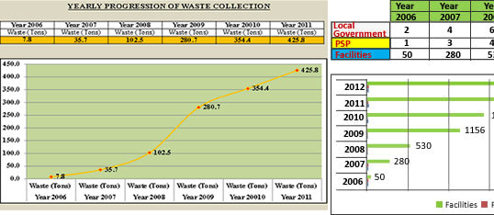
(LAWMA, 2011)

Fig 5: Yearly progression of waste collection, Nigeria
Source: LAWMA official website

However, it is common to find an individual hospital with a unique set of policies on the hospital’s waste management. In the case of AKTH, the public health department has set guidelines on proper clothing of waste handlers, segregation of waste and treatment of waste. FMC has also set policies to avoid the disposal of waste within the hospital premises. But the question is do these policies meet up the standard waste management system in developed countries? Do these policies solve the problems of disease occurrence and environmental pollution? The answer to these questions is obviously “NO.” Therefore it is the responsibility of the government to set a general standard, policies, and legislations for all accredited hospitals in the country or to adapt the same strategy as the LAWMA for individual states.

MATERIALS/METHODS

Federal Medical Center (FMC)

Research Strategy
Due to the nature of the study conducted at FMC, the target population required to conduct the study were the waste handlers from Gaby-Cord Company. In order to assess the knowledge practices and attitudes of this set of employees, a total of 12 individuals were involved in the survey including the Gaby-Cord waste manager who was the key informant. I chose the sample size for the study based on the idea of saturation, to be more precise, same answers were repeated at some point and therefore I was convinced that there was enough information required for the study. Questionnaires, semi-structured interviews and direct observation were used to gather all the data required for the study. Data collection was carried out at the federal medical center, Gaby-Cord Company and American University of Nigeria.

Questionnaire administration
Gaby-Cord Waste handlers at FMC happen to be the same set of workers that handle waste at the AUN cafeteria. Due to the ongoing strike at FMC, I assessed the knowledge, attitudes and practices of BMW at the university by the means of a questionnaire. Questionnaires were distributed to 9 employees on Monday, 17th of November 2014. However questionnaires were not self-administered due to the language used, waste handlers were guided throughout with the aid of translation in Hausa language. The questionnaires have three different sections; the first section assesses the knowledge of respondents on policies and legislations regarding biomedical waste handling and management. The second and third sections assess respondent’s level of awareness and attitudes towards biomedical waste management practices. Respondents were selected using the simple random sampling and

convenience sampling methods. In other words, there was an unbiased selection of respondents which also included selecting any individual I came across.

Semi-structured interviews
A semi-structured interview was used to collect data at the Gaby-Cord office branch on the 3rd of November 2014. I used a targeted sampling method to interview the chief executive officer, the waste manager and a random employee using a fixed set of questions. Questions were set with the aim of gathering general information on waste handling and management at the FMC.

Direct observation
In order to assess the actual practices of waste handling and the organization and coordination of workers at the federal medical center, I directly observed the waste handlers during their working hours. An observation checklist was used to record practices in six different wards including laboratory complex, male and female ward, accidents/emergency ward, theater, and the pediatric ward on the 12th of November 2014. With the assistance of the Gaby-cord waste manager, I conducted a detailed analysis of stages in waste handling including transportation to dump sites and disposal methods.

Aminu Kano Teaching Hospital

Research strategy
The study conducted at AKTH required employees from the environmental/public health department, three individuals from the department were involved in the study. Due to some constrains which will be discussed in the last section of the paper, I wasn’t able to assess the knowledge, attitudes and practices

among the waste handlers. However, semi-structured interviews, direct observation and hospital records were used to attain the data required for the study. I collected all data at AKTH, environmental and horticulture department.

Semi-structured interview/Hospital records

I interviewed three employees from the environmental and horticulture department on the 7th and 8th of January 2015. This included the head of department (Dr. Galaudu), the Chief environmental health officer (Malam Sanusi) and a waste handler (Malam Yusuf). Interview took at least 30minutes for each interviewee because most of data was attained at this session. I also used monthly and daily records to attain some data as well.

Direct observation

Similar to that of FMC, I used an observation checklist to assess the practices of biomedical waste management such as waste segregation within wards. Two departments including the female medical ward and the male medical ward were observed. Ward observation was conducted on the 8th of January, 2015 with the assistance of an employee from the environmental health department. In addition, I took part in a tour round the hospital which was organized by the head of department; this enabled the observation of some practices such as incineration and landfill disposal in the hospital.

ANALYSIS AND RESULT

Federal Medical Center (FMC)

Table 3: Observation within wards (FMC)
Name of | Waste | Color of | Description of | Warning signs | Safety boxes
ward | generated in | waste | waste | around | in wards
 | wards | bins | dumped in | hazardous
 |  | available | each bin | areas
 |  | in wards
Laboratory | Syringes, urine | Blue and | Blue: cotton | None, only | Yes
complex | and blood | black | wool nylon, | biohazard
 | samples, cotton |  | syringes | symbol on
 | wools, plaster |  | Black: cotton, | safety boxes
 |  |  | lab samples,
 |  |  | syringes
Male/femal | Syringes, food, | Black bin | Black bin: All | None, only | Yes
e ward | bandages, |  | waste listed | biohazard
 | catheter, drips, |  |  | symbol on
 | hand gloves, |  |  | safety boxes
 | discarded drugs
Theater | Gloves, | Green bin | Green bin: All | None, only | Yes
 | bandages, | with | waste from | biohazard
 | materials such | nylon | theater | symbol on
 | as cotton and |  |  | safety boxes
 | sheets with
 | blood,
 | amputated body
 | parts, surgical
 | waste

Name of ward | Waste generated in wards | Color of waste bins available  in wards | Description of waste dumped in each bin | Warning signs around hazardous areas | Safety boxes in wards
Accidents and emergency | Syringes, bandages, bed sheets, cotton wool, worn out cloths | Green, blue and black bins | Green bin; all the waste listed  Black bin; all the waste listed  Blue bins; general noninfectious  waste | None, only biohazard symbol on safety boxes | Yes
Pediatric ward | Diapers,  syringes, cotton, bandages | Black bin | Black bin; All waste listed | None | Yes
Source: Field work (FMC Yola)

Observation outside wards (FMC)

      - Segregation of waste outside wards: General noninfectious wastes such as faro bottles, dry leaves, food etc. are put in a separate bin, but during disposal and transport are mixed up with other hospital waste. However, before disposal, waste from theater is put in a separate nylon. There are three different colors of bins used but the colors do not indicate any means of color coding.
      - Treatment of waste: no treatment at all

      - Transportation to dump sites: All waste from all departments are emptied in a truck and transported to dump sites. Waste is transported with five workers

including the driver. This is done once or twice a day. Quantity of waste is not measured.
      - Disposal: There are two dumpsites for the waste disposal. One is located at Fufore local government, which is the main dump site, but due to distance and road damage from rainfall, a temporary site is now used. The temporary site is located behind the hospital and it’s a general waste dump site. To be more precise, the dump site is not meant specifically for medical waste from the hospital. Waste disposal is the same for all kind of waste; everything is packed together and burnt.
      - Protective clothing for workers: Waste Handlers use masks, thick gloves, and boots.
      - Organization and coordination of workers: Waste Handlers start working as early as six in the morning during both weekdays and weekends. Waste is transported to dumpsites latest by 7am every weekday; workers are coordinated by the waste manager.

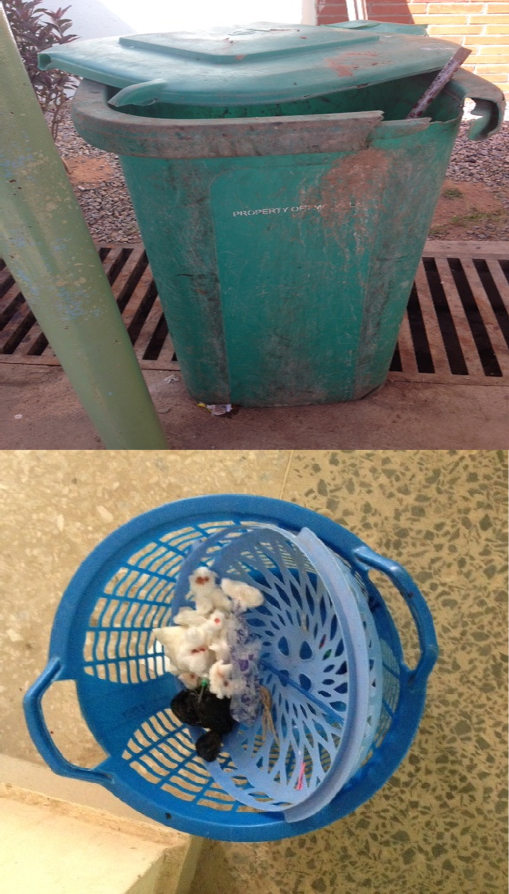

Fig 6: waste bins at the emergency/accident ward
Source: FMC, yola

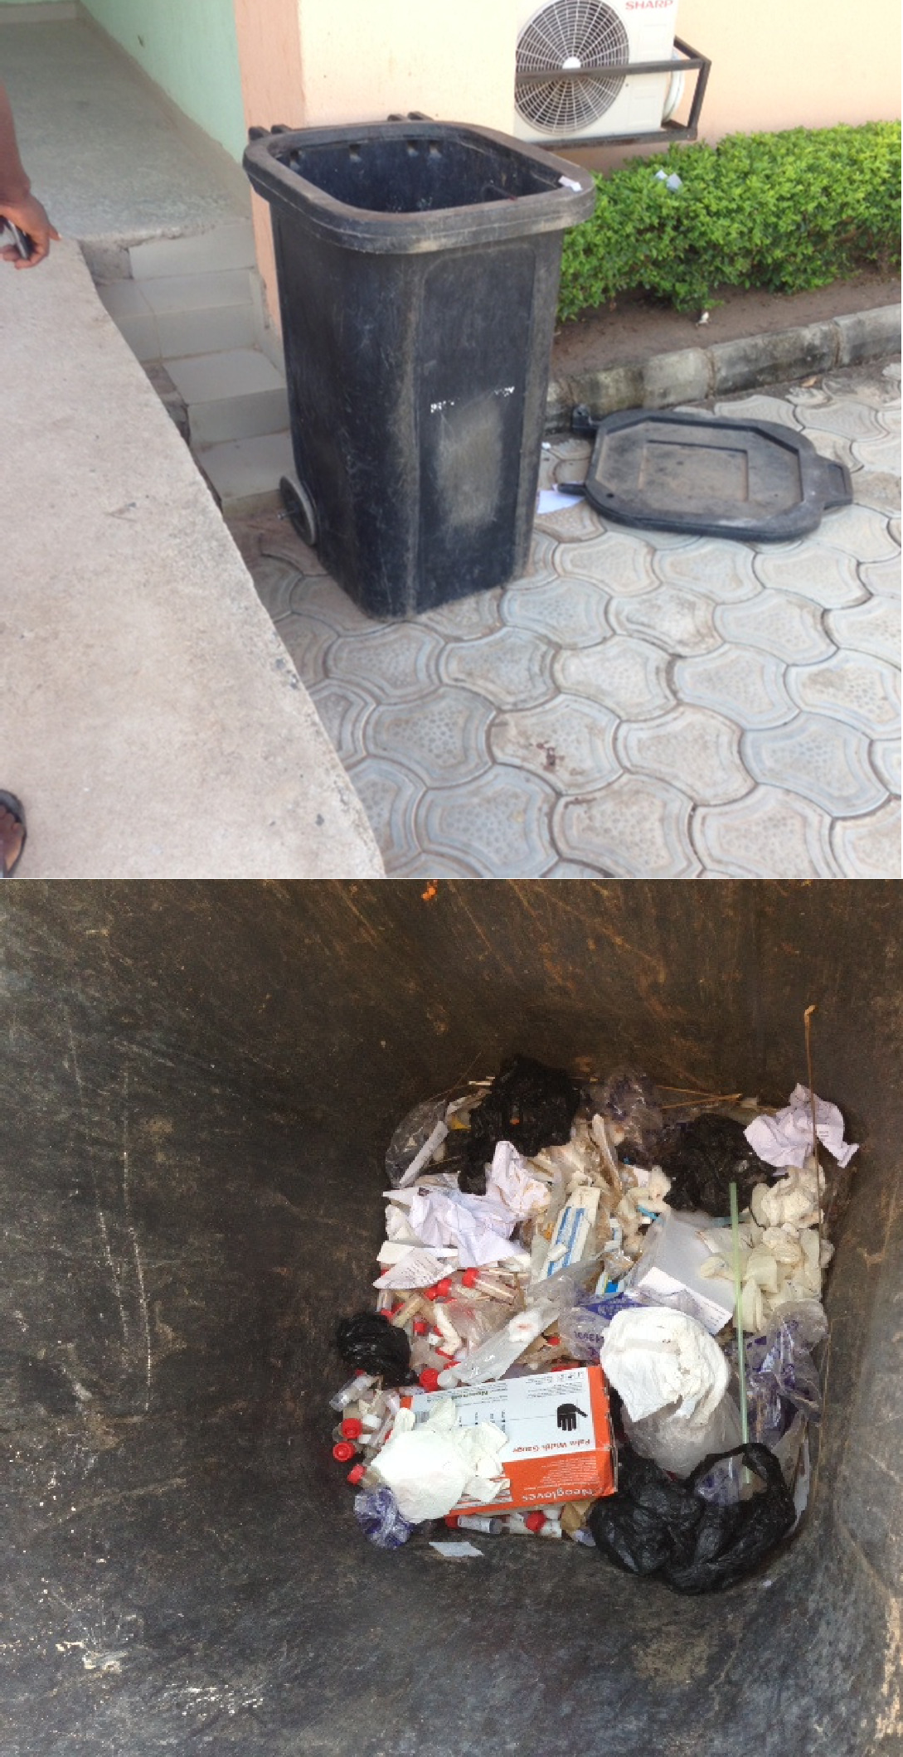
Fig 7: Waste bins at the laboratory ward
Source: FMC, Yola

Table 4: Knowledge of biomedical (BM) waste generation, hazards and legislation (FMC)

Knowledge  parameter | Waste Handlers  (n=9) | Percentage (%)
Level of education
Primary education | 1 | 11.1%
Secondary education | 8 | 88.9%
University | 0 | 0%
Perception on the importance of biomedical waste knowledge
Important | 8 | 88.9%
Not important | 0 | 0%
Somewhat | 1 | 11.1%
1998 BMW management and handling rules
Known | 0 | 0%
Not known | 9 | 100%
Amendments of the 1998 BMW management and handling rules
Known | 0 | 0%
Not known | 9 | 100%
Waste storage time limit according to the WHO
Known | 0 | 0%
Not known | 9 | 100%
Are there any Biomedical waste policies in the hospitals?
Yes | 6 | 66.7%
No | 3 | 33.3%
NOTE: Hospital policies include waste should not be disposed within the hospital, use proper clothing before handling waste

Source: field work (FMC, Yola)

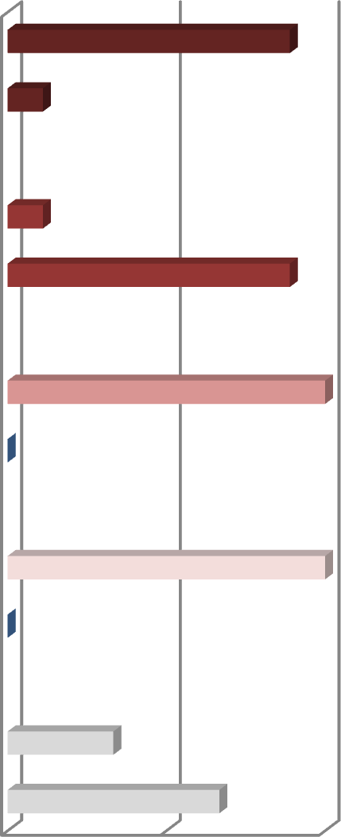
Fig 8: Graphical representation of Knowledge assessment on BMWM legislations
Secondary Education
Primary Education
Somewhat
Important
RESPONS Not known
ES Known
Not Known
Known
NO
Yes
0
50
100
PERCENTAGE OF RESPONDENTS
Level of education
Importance of the knowledge on BMWM legislations
1998 BMWM and handling rules
Waste storage time limit according to the WHO
BMWM policies in the hospital

Table 5: Knowledge/awareness on biomedical waste management practice (FMC)

Awareness parameter | Waste handlers  (n=9) | Percentage (%)
Awareness of steps involved in BMW management
Aware * | 9 | 100%
Not aware | 0 | 0%
Color-coding segregation of BMW
Aware | 0 | 0%
Not aware | 9 | 100%
Importance of waste segregation
Aware | 6 | 66.7%
Not Aware | 3 | 33.3%
Disposal method for medical sharps
Aware | 7 | 77.8%
Not aware | 2 | 22.2%
Disposal method for anatomical waste
Aware | 2 | 22.2%
Not aware | 7 | 77.8%
Adherence to color-coding at the hospital
Yes | 0 | 0%
No | 9 | 100%
Awareness of hazards associated with BMW
Aware | 8 | 88.9%
Not aware | 1 | 11.1%
NOTE: Waste handlers are aware of only few health hazards. They say they are aware of the steps involved but fail to mention them properly; most of them mentioned emptying the waste in the truck as the first step, then transporting it to dump site, then burning everything together after
24hrs.
Source: Field work (FMC Yola)

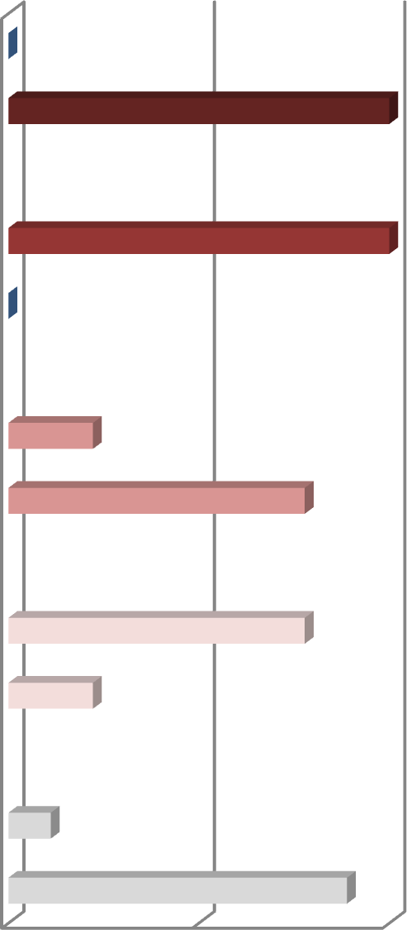
Fig 9: Graphical representation of awareness assessment on BMWM practices
Not Aware
Aware
Not Aware
Aware
RESPONS
ES
Not Aware
Aware
Not Aware
Aware
Not Aware
Aware
0
50
100
PERCENTAGE OF RESPONDENTS
Steps involved in BMWM
Color-coding segregation of BMW
Disposal method for medical sharps
Disposal method for anatomical waste
Awareness of hazards associated with BMW

Table 6: Attitude/behavior assessment towards biomedical waste (FMC)
Attitude/behavior  parameter | Waste handlers  (n=9) | Percentage (%)
Is safe management of BMW an issue in your hospital?
Agree | 2 | 22.2%
Disagree | 6 | 66.7%
Cannot comment | 1 | 11.1%
Does waste management require team work?
Agree | 9 | 100%
Disagree | 0 | 0%
Cannot comment | 0 | 0%
Is safe management of BMW an extra burden on work?
Agree | 1 | 11.1%
Disagree | 8 | 88.9%
Cannot comment |  | 0%
Would you like attend voluntary programs to upgrade your knowledge on
BMW?
Yes | 9 | 100%
No | 0 | 0%
Cannot comment | 0 | 0%
Would labelling waste bins be of any importance in the hospital?
Yes | 5 | 55.6%
No | 1 | 11.1%
Cannot comment | 2 | 22.2%
NOTE: Regarding the importance of labelling bins, some say it’s important but do not why exactly it is important. However, a single respondent mentioned the importance of segregation of syringes while others argue that the gloves they use will prevent any accident.
Qualitative data: “We will be very happy to attend voluntary training sessions,
knowledge is never too much, and everyone wants more.” (male respondent)

Source: Field work (FMC Yola)

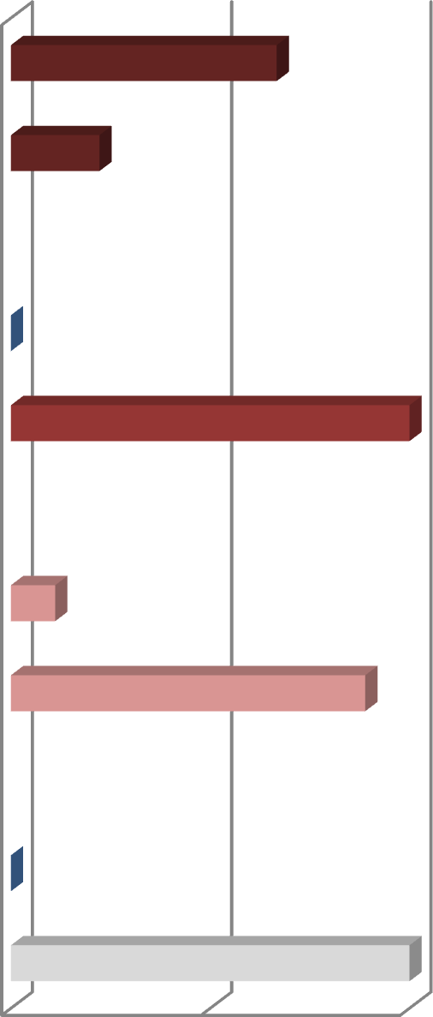
Fig 10: Graphical representation of attitude assessment towards BMWM
Disagree
Agree
Disagree
Agree
RESPON
SES
Disagree
Agree
Disagree
Agree
0
50
100
PERCENTAGE OF RESPONDENTS
BMWM is an issue at the hospital
Waste management require team work
BMWM is an extra burden on work
Attendance of voluntary programs

Qualitative data from semi-structured interview (FMC)

      - How would you describe the quantity of waste produced per day in the hospital?
We don’t measure the quantity of waste. (Gabriel Ofuokwu, C.E.O Gaby-Cord)

How often is waste taken out of the hospital?

Once or twice a day (Gabriel Ofuokwu, C.E.O Gaby-Cord)

How do you employ workers?

Anyone that is interested and can speak English can be employed, but most of our employees have primary or secondary school certificate. (Gabriel Ofuokwu, C.E.O Gaby-Cord)

Is there a training session for workers?

Yes, before they start the work, a lecture is given on the hazards associated with the waste and new employees are assigned to old ones for guidance. (Gabriel Ofuokwu, C.E.O Gaby-Cord)

Does your company or the hospital have a system of waste management?

Yes, there is a system. We start work as early as 6 or 7am, we empty all bins in the truck and transport to dumpsite, and after 24hours we burn the waste using gas. (David, Gaby-cord manager)

How is waste transported to dumpsite?

Waste is transported to dumpsite in a truck with an aluminum floor. Five workers including the driver transport the waste (David, Gaby- cord manager)

Are you responsible for waste treatment

We do not treat waste; we just burn them all together (Yakubu, worker)

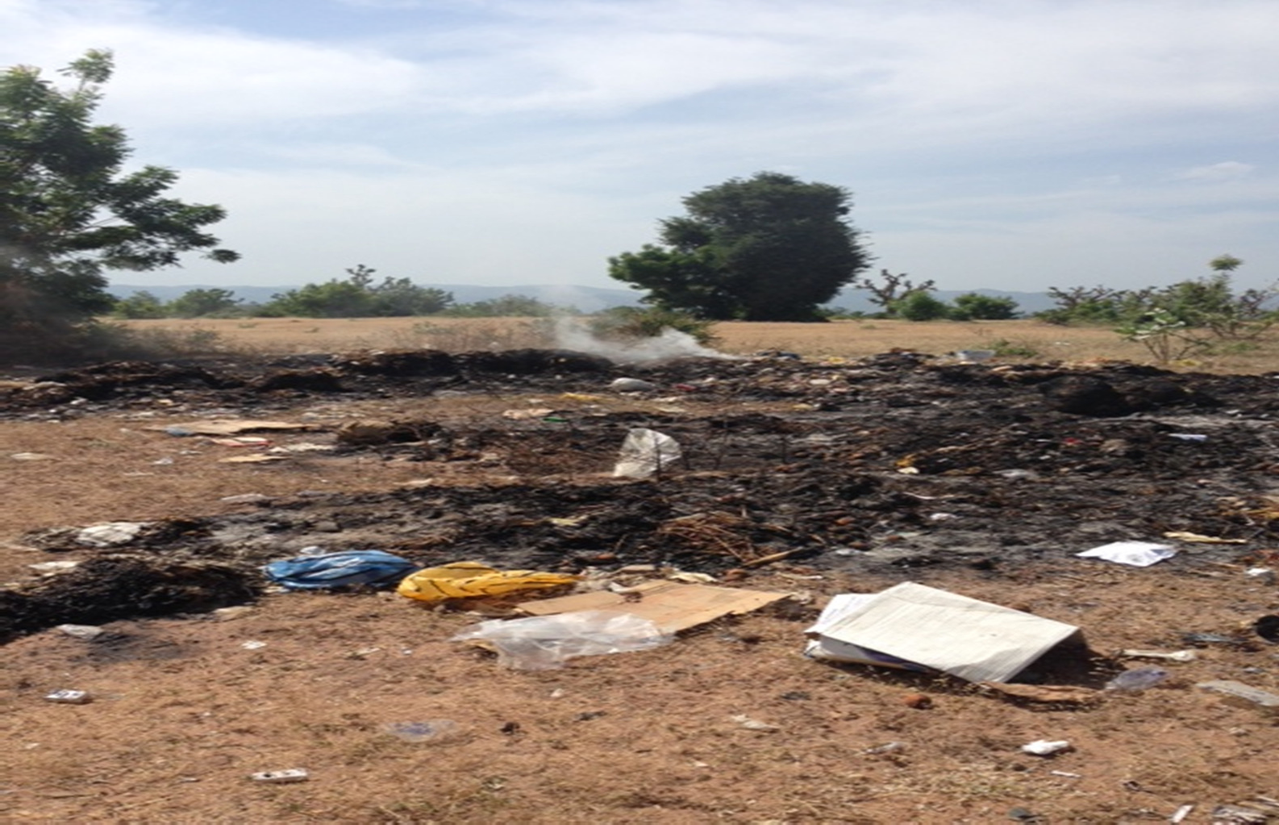

Fig 11: Temporary Dumpsite
Source: Federal medical center, yola

Aminu Kano Teaching Hospital (AKTH)

Table 7: Observation within wards (AKTH)
Name of | Waste | Color of | Descriptio | Warning | Waste | Safety
ward | generated | waste bins | n of waste | signs | segregatio | boxes in
 | in wards | available | dumped in | around | n in wards | wards
 |  | in wards | each bin | hazardous
 |  |  |  | areas
Female | Syringes, | Green, | --- | Safety | --- | Available
medical | drips, | yellow, |  | boxes, and
ward | plasters, | black |  | sharps
 | cotton |  |  | containers
 | wool, food
 | leftovers
Male | Syringes, | Green, | --- | Safety | --- | Available
medical | drips, | yellow, |  | boxes, and
ward | plasters, | black |  | sharps
 | cotton |  |  | containers
 | wool, food
 | leftovers

    - Data from semi-structured interview and hospital records (AKTH)

      - Segregation of waste outside wards: Three colored bins are used which are green, yellow, and black. Green bins are used for highly infectious waste, yellow bins are used for less infectious waste, black bins are used for municipal waste that are not infectious, polythene bags are used for pathological waste such as amputated body parts and puncture-proof/safety boxes are used for medical sharps. Waste is segregated from the point of generation in every ward. As it was said by the chief environmental health officer, “to be frank, it is common to find a mix-up between domestic and biomedical waste. But in a situation like this, the mix-up waste is referred to as hazardous and therefore requires proper disposal”.

Highly infectious waste:  amputated body parts, laboratory waste | Less infectious waste:  Cotton wool, plaster, cytotoxic waste | Non-infectious waste: Food remains, nylons

Fig 12: color coding segregation of waste
Source: AKTH, Kano

      - Treatment of waste: All hazardous waste is treated by incineration before disposal. Highly infectious waste is incinerated using the mechanical incinerator at a temperature of 900⁰C to 1200⁰C. The hospital also uses a sewage treatment plant before disposing any liquid waste. Biomedical equipment that is reused is treated using Autoclave machines.

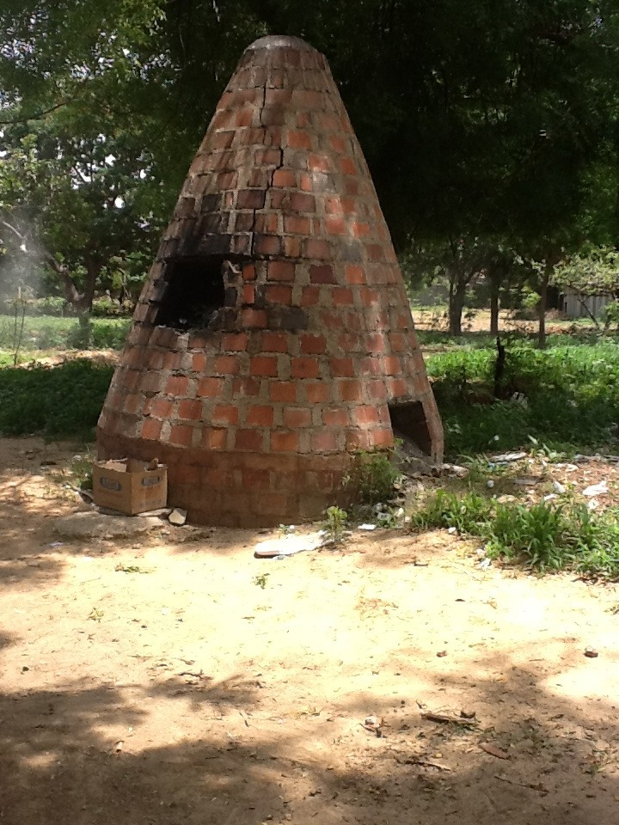

Fig 13: Ballet incinerator
Source: AKTH, Kano
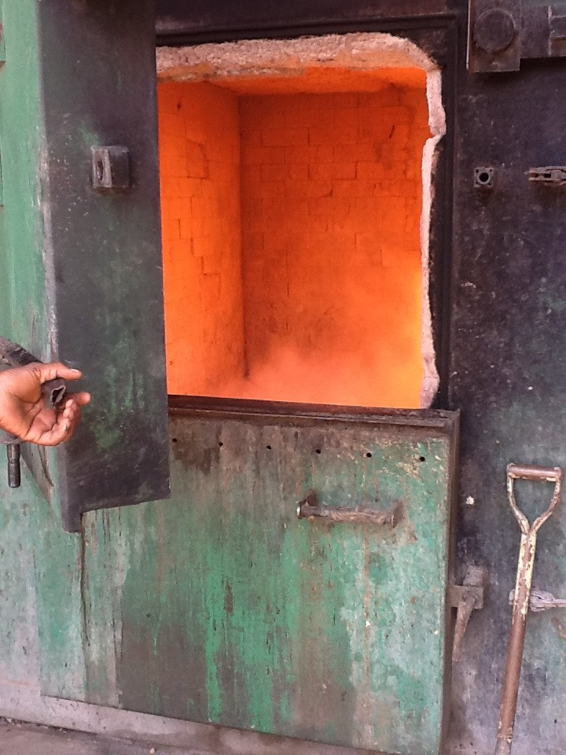
Fig 14: Mechanical incinerator
Source: AKTH, Kano

      - Transportation to dump sites: There are two landfills and all are located within the hospital. Waste is transported using the mobile ground bins (MGB) of 120L to 240L. A precaution taken to avoid spillage during transportation is conveying the waste when it’s just one-quarter full.
      - Storage: Medical sharps are being stored in safety boxes before disposal; unclaimed corpses are stored in mortuaries before disposal.
      - Disposal. Waste is segregated up till the point of disposal, therefore each category of waste is disposed accordingly. There are two landfills and all are located within the hospital, one is used for disposing municipal waste and the other is used for hazardous waste. Liquid waste is treated then disposed in drainages, amputated body parts; placenta, unclaimed corpses, and ashes from incinerator are buried using a method called simple sanitary landfill. Municipal waste is also burnt in local incinerators to reduce the volume before disposing in landfill. When disposing waste in landfills, water level is being considered to avoid any form of groundwater contamination.

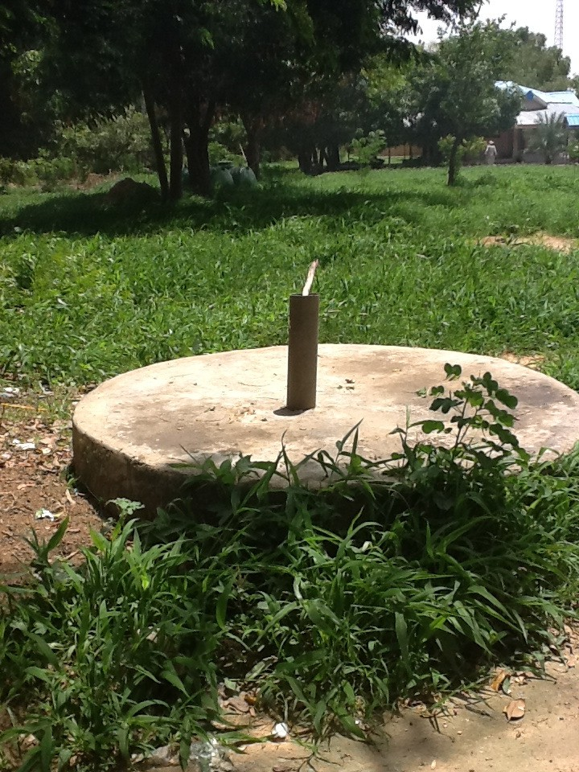

Fig 15: Needle pit
Source: AKTH, Kano

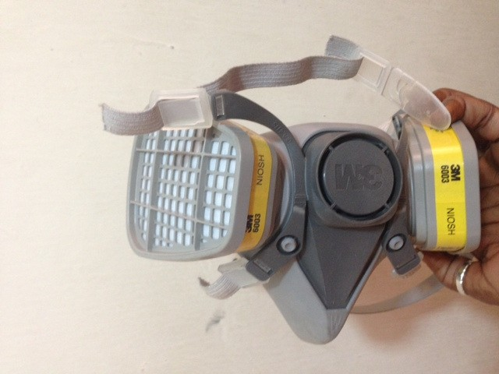
      - Protective clothing for workers: workers use masks, thick gloves, and boots, protective gowns. All of these are referred to as the personal protective equipment (PPE) and every waste handle is required to have a set.

Fig16: Waste handler Face Mask
Source: AKTH Kano

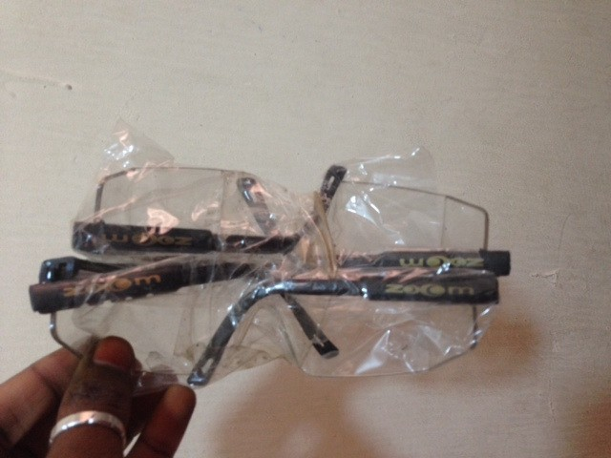

Fig 17: Waste handler Goggles
Source: AKTH, Kano

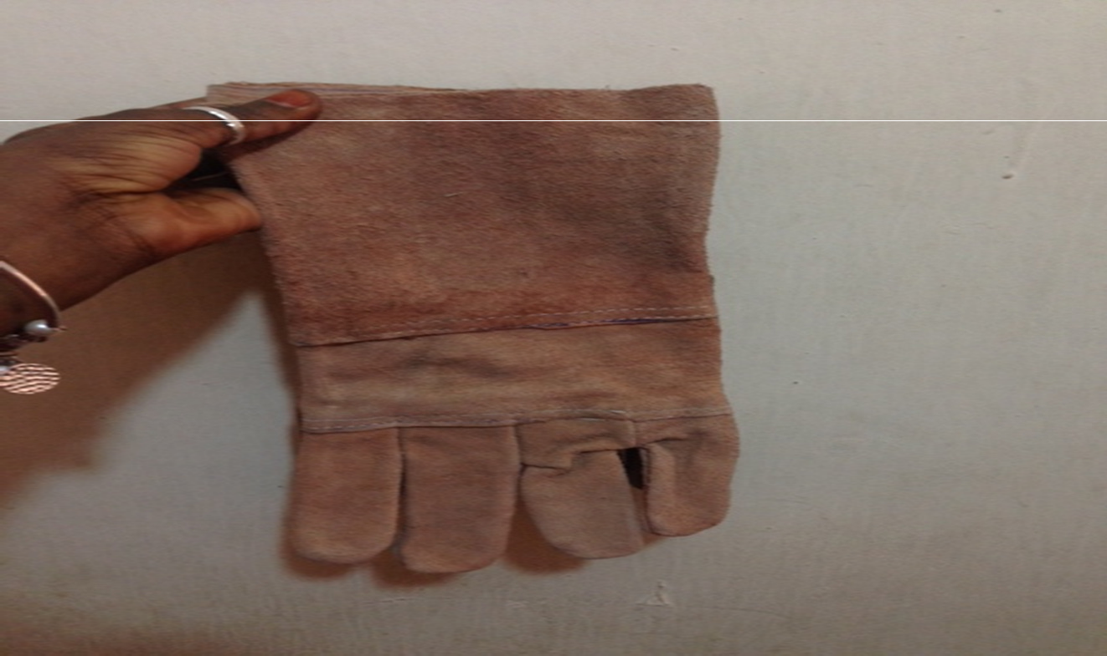

Fig 18: Protective clothing for waste handlers

Source: AKTH Kano

      - Organization and coordination of workers: The Chief environmental officer (Malam Sanusi) is in charge of all waste generated in the hospital. Each ward has two or three attendants that are in charge of waste handling within wards. Waste handlers from the public health department are in charge of transporting waste that is handled by the attendant to the site of disposal. Lastly, there is staff available at the incineration that collects the waste from the waste handlers.

Cheif environmen tal officer

Ward attendants
Waste handlers (transportin g waste)
incinerator staff/ waste handlers(di sposal)

Fig 19: staff involved in waste handling
Source: AKTH, Kano

      - Training sessions for workers: All healthcare workers including those who generate, handle, and transport waste attend training sessions organized by the public health department. Healthcare workers are grouped into three different categories for training which are; high, middle, and low manpower, the diagram below shows members of each group. Workers are trained separately according to their groups because not all health workers have the same level of understanding and experience. Training sessions include lectures and presentations on color-coding, risks associated with biomedical waste and precautions to be taken etc. Training sessions are being led by the chief environmental health officer of the hospital (Malam Sanusi).




- Senior nurses, doctors, lab technicians and consultants

- pharmacists, and interns


Fig 20: Grouping of healthcare workers for training sessions
High level
Man- power
Middle
level Man- power
Low level
Man- power

- Ward attendants, incinerator staff, laborers, workers from private cleaning company
Source: AKTH

      - Volume of waste generated: Biomedical waste is measured and recorded weekly considering the fact that quantity of waste varies based on several factors such as strike. The average quantity of waste produced weekly is 3640kg which is equivalent to ten 240liter mobile ground bins. Whereas for medical sharps, 120kg is produced daily (Sanusi, 2014).

DISCUSSION

Problems encountered during survey

Due to the strike that started in early November 2014, some important aspects of the research were not able to be investigated. However, the major goals of the study were managed to be attained.
At the federal medical center, waste handlers could not be interviewed at the hospital but it was fortunate that the same set of workers manage waste in the cafeteria at the American university of Nigeria. With the help of the Gaby-cord manager, the survey was organized at the university cafeteria. Also, the main waste disposal site of the hospital which is located at Fufore local government could not be visited due to some transport issues that were encountered. To be more precise, the road to the main disposal site was affected by the rain and therefore a temporary disposal site was created close to the hospital. Lastly, the waste handlers were not able to understand the questionnaires that were administered, therefore translation and guidance was required.
The strike situation at AKTH was worse than that of FMC which made it almost impossible to conduct the research at the hospital. Healthcare workers were totally out of service and therefore knowledge and attitudes of healthcare workers which is a major goal of the study was not assessed. Also, most of the wards had no patients and therefore wastes were not generated. Nevertheless, the head of the public health department and the chief environmental officer were interviewed intensively. Also all records on waste management and handling were kept safely which provided a lot of data on practices of biomedical waste management at the hospital.

The study has been affected due to some of the problems encountered because comparing the knowledge and attitudes of the waste handlers in both hospitals couldn’t be done. However, practices involved in biomedical waste management and handling has been analyzed vividly in both hospitals and therefore comparisons were made based on that.

Findings from FMC, Yola
The present study conducted at the FMC assessed the general practices of biomedical waste management in six different wards, the level of knowledge regarding generation, legislations and hazards associated with biomedical waste among Gaby-cord waste handlers and lastly the attitude and behavior of same set of workers towards biomedical waste. All respondents that were assessed were male workers and most of them had secondary school education certificates.
The semi-structured interview that was conducted at the beginning of the study was carried out in order to get the general idea on how waste is handled in the hospital. From the interview, it was obvious that the work on handling waste is given to the wrong set of people. This is because Gaby-cord workers initially handled general cleaning of wards and hospital surrounding such as sweeping and mopping but were later assigned to handle hazardous medical waste. In other words, Gaby- cord workers were not trained to handle such wastes. Although the manager mentioned that a brief lecture is given to workers before starting the work and new workers are assigned to older ones for guidance, this approach is not efficient enough. It was also mentioned that the quantity of waste is not measured in the hospital; this is a major issue because without knowing the quantity, waste reduction will not be considered. To be precise, the quantity of waste would determine if

reduction is required through recycling and other means. Also, knowing the quantity will help in figuring out why the quantity of the waste produced varies.
Based on direct observation, biomedical waste management at the federal medical center can be said to be poor. This conclusion was made because most of the processes involved in the standard waste management system are omitted. The major problems with the practices of waste management at FMC are segregation and waste disposal. Although colored bins such as blue, green and black are found in different sections of the hospital, these colors don’t mean anything in terms of color-coding segregation of waste. All sorts of wastes from different sources are dumped all together in the same bin. These bins containing hazardous wastes are placed on walkways were visitors, patients and other people coming to the hospital pass; without any indication of the hazardous materials contained in the bins. Some of these bins are even left without being covered and people dump any sort of waste in them. Even though safety boxes are used in each ward, syringes are still disposed in waste bins together with other BMW which is very risky for the waste handlers.
FMC has only one disposal method which is burning of waste, and different categories of waste require different disposal methods. Waste is not treated to destroy pathogenic microorganisms; instead they are all packed together in a truck and transported to dumpsites. After 24hrs wastes are put together and burnt using gas. This method of disposal does not solve the major environmental and health issues because some infectious microorganisms require a certain temperature before they get destroyed. Also some medical sharps and radioactive materials may not be completely destroyed at that temperature. Lastly liquid wastes are usually disposed in drainages after treatment but in the case of FMC, liquid waste is allowed to penetrate into the soil.

However, Gaby cord waste handlers are averagely organized and coordinated properly. Workers start working as early as six in the morning during both weekdays and weekends. Waste is transported to dumpsites latest by 7am in the morning; workers are coordinated by the waste manager, protective clothing such as boots, masks and gloves are used by the waste handlers.
Considering the fact that knowledge on biomedical waste legislation was assessed at FMC on an advanced level, none of the respondents had a clue regarding policies and rules on biomedical waste management legislations. It would have been more appropriate if the study assessed knowledge on the local level, but there is no fixed legislation specific to biomedical waste around the region or even the hospital itself. This can be said to be one of the hitches that was encountered during the study because the questions that were administered to assess this parameter were far beyond the level of the waste handlers. Nevertheless, most respondents think it is important to know about legislations regarding biomedical waste.
Understandings the steps involved in BMW management is the key to tackling the environmental and health impacts of biomedical waste. Unfortunately, respondents are not aware of these steps although their responses were the opposite. They believe what they know is right because that was what they’ve been told to do even though it does not meet the standard. It was also put into consideration that the respondents are not aware of the color coding segregation of BMW; this is because the hospital doesn’t have a color coding system. Lastly, respondents were aware of different disposal methods for different BMW such as sharps and anatomical waste, but such practices are not part of the work they do.
Based on the responses from the survey, it was concluded that the Gabycord waste handlers have a positive attitude towards biomedical waste

management. Even though most respondents believe management of healthcare waste is not an issue at all in the hospital, they are willing to attend voluntary programs that will enhance and upgrade their knowledge on BMWM.
When conducting the survey, there was an argument and confusion about who is responsible for implementing polices, proper handling and management of the waste generated at FMC. According to 1998 rule on biomedical waste management and handling, responsibilities apply to all those that generate, collect, receive, store, transport, treat, dispose, or handle biomedical waste in any form (Biomedical waste management and handling rules, 1998).

Findings from AKTH, Kano

The study that was conducted at AKTH assed the practices of biomedical waste management and handling in the hospital. Assessment was carried out through the means of observation, hospital records and interviews. It is very common to find most Nigerian hospitals with a very low standard of biomedical waste management practices due to some reasons but in the case of AKTH, biomedical waste management can be concluded to be above average when compared to the standard biomedical waste management system.
Segregation which is the most difficult part of biomedical waste management is given attention to at AKTH although the Chief Environmental officer at AKTH mentioned that segregation is the most difficult practice to be adhered to at the hospital. This is because segregation is required from the point of generation to disposal and therefore every individual associated with the waste must have knowledge of segregation. Also most workers especially the newly employed usually encounter issues like confusion with color coding.

Waste segregation is done at the hospital using the color coding method of segregation, three colors of waste bins are used including black, yellow and green. Green colored waste bins are used for highly infectious waste like waste from the microbiology laboratory. Yellow colored bins are used for less infectious waste such as plasters and cotton wool and black colored bins are used for non-infectious waste. Other forms of segregation include puncture proof containers for medical sharps and polythene bags for pathological waste such as amputated body parts. Each ward and department has a particular or all kinds of bins depending on the type of waste generated; an example is the catering department that has only the black bins for non-infectious wastes. Weekly inspection is also conducted by the sanitarians from the public health department to ensure proper segregation and other related practices are taking place. Proper segregation of waste helps the hospital to carry out proper disposal for each category of waste, in such a way the risk of causing infections or environmental degradation is drastically reduced.

AKTH has adopted several treatment methods for infectious waste including those that are reused. The major forms of waste treatment in AKTH are mechanical incineration, autoclaving and sewage treatment. Waste is incinerated at a temperature of 9000 C -1200⁰ C and ashes are being disposed on monthly basis. Surgical equipment such as scalpels are being autoclaved after use, this is done using the autoclaving machine. Lastly, the hospital has a sewage treatment plant for treating all liquid waste before disposal. According to the chief environmental officer, treating the waste before disposal makes it safer for disposal.
Transporting hazardous waste to disposal site is associated with various risks including spillage, contamination of the environment and also the risk of infections.

However, AKTH has precautions to limit the risks associated with this stage of BMWM. To avoid spillage, waste is transported using the mobile ground bins when they are only one-quarter full. Also the disposal sites are located within the hospital therefore only the hospital premises is given attention to and the safety of the people and the environment outside the hospital is not a concern. Waste is conveyed from every ward to disposal site every morning which meets the WHO policy on the maximum time waste can be stored before disposal.
Considering groundwater level during disposal of waste especially during the construction of landfill is an integral part of managing all sort of waste. AKTH considers this as a top priority before disposing any waste. Another precautionary practice at AKTH is the disposal of all waste within the hospital premises where only workers have access to. This is done to ensure the containment of any infection and hazard related risks within the hospital. The classification of waste into different categories at AKTH makes it easier for the waste handlers to use the right disposal approach for each category. Highly infectious waste with the exclusion of amputated body parts and corpses are burnt in the mechanical incinerator at a very high temperature to destroy any infectious organisms in waste, waste that is not infectious is burnt using the ballet incinerator. The method of incineration at AKTH is not only for treatment purpose, it also helps reduce the quantity of the waste which makes it easier to dispose.
Generally, AKTH has a BMWM system that has the potential to meet the guidelines and standards of BMWM formed by the WHO. Although some stages of BMWM such as segregation are yet to be mastered by the workers, AKTH is putting a lot of effort to ensure that all steps of BMWM are put into the system.

Based on the researcher’s observation, a crucial part of AKTH’s waste management that contributes the most to the effectiveness of the work is the organization and coordination of the waste handlers. The job is distributed to various set of workers in every stage of the waste management which makes the job more organized and effective. Among the staffs are those responsible for keeping records such as the volume of waste generated. By doing so, the department is able to analyze the variations of waste quantity An example of this is; the hospital was able to investigate the reasons behind high prevalence of cholera during raining seasons in Kano State. Also, the hospital was able to analyze the differences in waste quantity during strikes and when the hospital is fully functional.

Comparison of BMWM practice at AKTH and FMC

From a general perspective, the results that were attained from this study have shown a dramatic difference in BMWM at AKTH and FMC. Looking at the most obvious difference,
AKTH provides the appropriate attention, training and materials to the waste handlers. To be more precise, it was mentioned above that waste handlers attend compulsory training sessions organized by the chief environmental officer before starting the work. By doing so, it is convincible to say that BMW at AKTH is handled and managed by the appropriate employees. In contrast, proper training is not delivered to the waste handlers at FMC. Instead, waste handlers manage and handle waste based on their knowledge which is not appropriate because BMWM requires rules and guidelines to be handled properly.
Although BMWM cannot be said to be perfect at AKTH, the hospital is making efforts to meet up with the standard and I have noticed some progress from the year 2013 when I did my internship at the hospital to date. AKTH has attempted

practicing all the six stages of BMWM formed by the WHO appropriately which is totally different for FMC. Transportation and disposal are the only stages that are practiced at FMC, segregation; treatment and labelling are completely out of the system. In terms of safety and precautions taken in BMWM, results have shown that AKTH has a better system that considers the safety of the waste handlers, other employees and the environment when compared with FMC. Lastly, record keeping which plays an important role in BMWM is well considered at AKTH which in contrast FMC fails to do so.

6.0 RECOMMENDATIONS AND CONCLUSION
Practices of biomedical waste management have been assessed to be very poor due to lack of standard system of waste management at FMC. This issue cannot be blamed on the waste handlers because the hospital is responsible for offering the job to well trained workers. As the CEO of Gaby Cord emphasized, the problem of segregation starts from where the waste is generated; and this includes the doctors, nurses and other employees. The job of the waste handlers starts from packing and transporting the waste to dumpsites, therefore responsibility of waste segregation also lies on those that generate the waste. In a broader view, proper biomedical waste management at the federal medical system will only work if there is cooperation and acceptance of responsibility among employees. Also, since waste handlers have a positive attitude towards biomedical waste management, enhancing their knowledge and awareness on the waste management and handling would solve the major problems.
Considering the fact that Nigeria does not have a BMWM standards to guide medical facilities, AKTH has overlooked the issue and went ahead to adapt systems

that were introduced by international organizations and other foreign countries. Therefore AKTH as a federal hospital has proven to be exquisite in terms of proper management and handling of BMW.
Over the past few decades, the population of Nigerians has increased dramatically especially in the northern states. It has been investigated that increase in population size is accompanied with higher prevalence and occurrence of diseases probably due to changes in lifestyle. This obvious change has made the demand for healthcare services prominent which further resulted to the increase in the number of medical facilities. With this current status, it has become obligatory for Nigerian hospitals to consider appropriate management of biomedical waste as major concern. It is therefore recommended for both hospitals that were studied to introduce effective strategies to fill up the spaces that have been identified to be a drawback in their BMWM, aim for positive goals based on fixed standards and set a time frame at which the goals are expected to be achieved and lastly, adapt strategies from other hospitals that have been credited for their commitment to biomedical waste management.

REFERENCES

3-Stage Healthcare Waste Management Plan for Emergencies. (n.d.). Retrieved from clinical quality and infection control: http://www.beckershospitalreview.com/quality/3-stage-healthcare-waste- management-plan-for-emergencies.html
Biomedical waste management and handling rules. (1998). Retrieved 11 21, 2014, from http://www.medindia.net/indian_health_act/bio-medical-waste-rules- 1998-introduction.htm
Biomedical waste management, Segregation. (n.d.). Retrieved from Biomedical waste management: http://www.envirovigil- bmwm.com/Management/Segregation.html
designing the biohazard sign. (2008, january 28). Retrieved from creative bits: http://creativebits.org/designing_the_biohazard_sign
Dix, H. (2005). Environmental Pollution . Wiley Interscience .

Ekaete, T. (2010). Assessment of healthcare waste management pracices in primary health care facilities in a lassa fever endemic local government area of Edo state, Nigeria. Edo state: Thopson F.
Environmental Health Watch. (2008, July 5). Retrieved October 20, 2014, from http://tsaftarmuhalli.blogspot.com/2011/07/national-environmental- sanitation.html
Exther, J. (1981). Detoxication of hazardous waste. Ann Arborc .

Federal republic of Nigeria. (2006, August 27). Retrieved October 20, 2014, from http://www.nigeria.gov.ng/2012-10-29-11-06-21/north-east-states/adamawa- state
(2013, August 12th). health care waste management, Mr. Nura Yaro. (M. N. yaro, Interviewer)
Healthcare environmental resource center. (n.d.). Retrieved from Pollution, prevenion and compliance assistance iinformation for the health care industry: http://www.hercenter.org/rmw/me-rmw.cfm
joshi, p. (2014). A comparative study of knowledge and attitudes regarding biomedical waste (BMW) management with a preliminary intervention in an academic hospital. International journal of medicine and public health, 4(1), 91-95.

Khopar, S. (2009). Environmental Pollution: Monitoring and Control. In S. Khopar, Environmental Pollution: Monitoring and Control (pp. 377-380). India: New Age International Publishers.
LAWMA. (2011). Retrieved 12 29, 2014, from http://www.lawma.gov.ng/lawma_mwm.html
Likhar, B. (2012). Knowledge assesment of hospital staff regarding biomedical waste management in a tertiary healthcare center. National Journal Of Community Medicine, 3(2), 197-200.
Longe, E. (2006). A preliminary study of medical waste management in lagos metropolis, Nigeria. Environmental Health sciences vol.3., 133-139.
Ministry of Environment & Forests . (1998, july 20). Retrieved 11 9, 2014, from http://envfor.nic.in/legis/hsm/biomed.html
Mokuolu, O. (2010, JUNE 12). SANITATION UPDATES: News, Opinions and Resources for Sanitation for All . Retrieved OCTOBER 20, 2014, from http://sanitationupdates.wordpress.com/2009/03/23/nigeria-country-doesnt- have-health-care-waste-management-plan-usaid/
NHMRC. (2009, october 11). Retrieved october 20, 2014, from National guidelines for waste management in health industry: https://www.nhmrc.gov.au/_files_nhmrc/publications/attachments/eh11.pdf
Sanusi, M. (2014, janary 6). biomedical waste management in AKTH. (A. Ibrahim, Interviewer)
Soyande, D. A. (2008). Nigeria: Country does not have health care waste management plan-USAID. Abuja : wordpress.
Taking It Global. (2014). Retrieved October 18, 2014, from http://orgs.tigweb.org/federal-medical-centre-yola
Ukey, U. U. (2012). Awarness abot biomedical waste management in undergraduate medical and nursing students at a teaching institute in Andhra Pradesh. journal of community medicine , 3(3), 428-432.
Umar, A. (2009). Assessment of healthcare waste generated by some by some selected public hospitals in katsina state, Nigeria. Bayero journal of pure and applied sciences 2(2): , 13-15.
WHO. (2011, November). Retrieved october 17, 2014, from http://www.who.int/mediacentre/factsheets/fs253/en/
Yadavannavar. (2010). Knowledge, Attitude, and Practices about Biomedical Waste Management among Healthcare Personnel: A Cross-sectional Study. Indian

jornal of comunity medicine: official publication of indian associationof preventive and school medicine, 3(5), 170.

Appendix

OBSERVATION CHECKLIST

(Observations within wards)

- Name of ward

- Type of waste generated in ward:

- Color of waste bins available in the ward: RED YELLOW BLUE

BLACK OTHER COLORS

- Biohazard symbol or any warning signs around hazardous areas
- Description of waste dumped in colored bins (BLACK: GENERAL WASTE / YELLOW: SOILED INFECTED WASTE/ BLUE: SHARP OBJECTS/ RED: PLASTIC WASTE)

- Waste segregation in wards, or during disposal

- Are there safety boxes in the ward, if no, how are syringes disposed.

YES NO

- ​

- Do waste handlers have proper clothing and equipment for waste disposal

(Observation outside wards)

- Organization and Coordination of waste handlers

- Treatment of waste: Chemical treatment chemical decontamination

other

- Describe the Transportation to dump

site

- Disposal of waste at dumping

site

- Additional notes

QUESTIONNAIRE

BIOMEDICAL WASTE MANAGEMENT AWARNESS, KNOWLEDGE AND PRACTICES AT TETIARY HEALTHCARE CENTERS: A CASE STUDY OF FMC HOSPITAL, YOLA.
.

INTRODUCTION

As a student of the America University of Nigeria, I intend to conduct a study on biomedical waste management as part of a senior research project. The purpose of this survey is to assess knowledge, practices and awareness on biomedical waste management among employees at the Federal Medical Centre, yola. With this valuable information, the federal medical center can improve its practices on managing biomedical waste and also promote awareness among health care personnel. Your participation and honest answers are vital to the success of this survey. Thank you!

Please: Answer all questions. Tick best choice (only one choice). Your identity and answers will be kept Confidential.

Section 1: Knowledge of biomedical (BM) waste generation, hazards and legislation‰
- What is your highest level of qualification

Primary education b) secondary education c) other
- Do you think it is important to know about BM waste generation, hazards and legislation?

Yes ‰ b) No ‰ c) Somewhat ‰
- Biomedical Waste (Management & Handling) Rules were first proposed in:

‰a) 1997 ‰b) 1998 ‰c) 1999 ‰d) don’t know
- According to the World Health Organization (WHO), biomedical waste should not be stored beyond:

‰a) 12 hours ‰b) 48 hours ‰c) 72 hours ‰d) 96 hours
- What other biomedical waste management agencies/organizations do you know about
- Is there any biomedical waste disposal policy in your hospital/clinic? If yes, state few

Yes b) No c) Don't know

Section 2: Level of awareness on biomedical waste management practice

- Are you aware of the steps involved in waste management system? If yes, list them

Yes b) no

- Do you know about color-coding segregation of BM waste?

Yes ‰ b) No ‰ c) Not sure ‰
- If yes, what are the standard color codes?

- Objects that may be capable of causing punctures or cuts, that may have been exposed to blood or body fluids including scalpels, needles, glass ampoules, test tubes and slides, are considered biomedical waste.
How should these objects be disposed of?

‰Black bags ‰b) Yellow bags ‰c) Clear bags ‰d) Rigid/puncture-proof container
- How are anatomical wastes disposed

Incineration b) deep burial c) landfill disposal
- Do you follow color-coding for BM waste in your hospital?

Yes ‰b) No ‰ c) Sometimes ‰‰
- Are you aware of the hazards associated with poorly managed biomedical waste? If yes mention few.

Yes b) No c) not sure

Section 3: Attitude/behavior assessment towards biomedical waste

- Safe management of health care waste is not an issue at all.

Agree ‰ b)Disagree ‰ c) Cannot comment ‰
- Waste management is team work/no single class of people is responsible for safe management.

Agree ‰b) Disagree ‰ c) Cannot comment ‰
- Safe management of health care waste is an extra burden on work.

Agree ‰ b) Disagree ‰c) Cannot comment ‰
- Will you like to attend voluntarily programs that enhance and upgrade your knowledge about waste management?

Yes ‰b) No ‰c) Cannot comment ‰‰
- Do you think that labelling the container before filling it with waste is of any clinical significance?
  - Yes ‰ b) No ‰ c) Cannot comment ‰

