**ASSESSMENT OF GROUNDWATER POTENTIAL ZONES IN OKE- ERO LGA OF KWARA STATE NIGERIA USING GIS-BASED INTEGRATED APPROACH**

**BY**

**Akeem AlabiAGBOOLA**

**DEPARTMENT OF WATER RESOURCES AND ENVIRONMENTAL ENGINEERING,**

**FACULTY OF ENGINEERING, AHMADU BELLO UNIVERSITY, ZARIA, NIGERIA**

**FEBRUARY, 2021**

# ASSESSMENT OF GROUNDWATER POTENTIAL ZONES IN OKE-ERO LGA OF KWARA STATE NIGERIA USING GIS-BASED INTEGRATED APPROACH

**BY**

# Akeem AlabiAGBOOLA P16EGWR8045

**A DISSERTATION SUBMITTED TO THE SCHOOL OF POSTGRADUTE STUDIES AHMADU BELLO UNIVERSITY**

# IN PARTIAL FULFILLMENT OF THE REQUIREMENTS FOR THE AWARD OF

**MASTER DEGREE IN WATER RESOURCES AND ENIRONMENTAL ENGINEERING**

# DEPARTMENT OF WATER RESOURCES AND ENVIRONMENTAL ENGINEERING,

**FACULTY OF ENGINEERING, AHMADU BELLO UNIVERSITY, ZARIA, NIGERIA**

# FEBRUARY, 2021

**DECLARATION**

I declare that the work in this dissertation entitled ASSESSMENT OF GROUNDWATER POTENTIAL ZONES IN OKE-ERO LGA KWARA STATE NIGERIA USING GIS-

BASED INTEGRATED APPROACH has been carried out by me in the Department of Water Resources and Environmental Engineering. The information derived from the literatures has been duly acknowledged in the text and a list of references provided. No part of this dissertation was previously presented for another degree or diploma of this or any other institutions.

AGBOOLA Akeem Alabi

___ _ _ _ _ _

___ _ _

Signature Date

# CERTIFICATION

This dissertation entitled ASSESSMENT OF GROUNDWATER POTENTIAL ZONES IN OKE-ERO LGA KWARA STATE NIGERIA USING GIS-BASED INTEGRATED

APPROACH by Akeem Alabi AGBOOLA Meets the regulations governing the award of the degree of Master of Science Water Resources and Environmental Engineering of the Ahmadu Bello University, and is approved for its contribution to knowledge and literary presentation

Dr. B. K. Adeogun

___ _ _ _ _ __

___ _ _

Chairman, Supervisory Committee Signature Date

Prof. M.A. Ajibike

___ _ _ _ _ _

___ _ _ _

Member, Supervisory Committee Signature Date

Prof. M.A. Ajibike

___ _ _ _ _ _

___ _ __

Head of Department Signature Date

Prof. Sani. A. Abdullahi

___ _ _ _ _ _

__ Dean,

Postgraduate School Signature Date

# DEDICATION

This work is dedicated to Almighty Allah, my late mum Mrs. A.A Agboola and Alhaji

S.W. Sanusi.

# ACKNOWLEDGEMENTS

My profound gratitude goes to almighty Allah for his mercy and protection over me, I praise Him, seek help from Him and thank Him for taking me this far in my career.

I am very grateful to my beloved parent Mr. and Mrs. Agboola, whom almighty Allah spares my life through them and for their support as a parent over my success for assisting me financially, morally and their advice from childhood to this time.

The highest appreciation goes to my late mum Mrs. A.A Agboola in terms of all round support, who provides me with my entire necessities mum you remain my best forever, thank you dozens of times, I remember you often. And to my lovely brother and sisters Rukayat, Siraj, Suliyat, and Monsurat Agboola for their love, support and hospitality, I FRXOGQe a¶skWed foKr aDbeYtter family.

To Alhaji S. Wole Sanusi I sincerely appreciate you, thank for your persistence moral support and encouragement. Your financial support has contributed a lot towards a successful completion of this program, which without your assistance, it would have been much more difficult. May Allah continue to bless you. I thank sister Yesirat, Mr.S.Ogundele, Mr. Gbanga Ogundele, Alhaji Abdullahi Nurudeen. Mr. S Yusuf, Alhaji Waheed, Alfa Hakeem, Seun Paparo, Abey Oni, uncle Lare, Iya Balkis, Fati, Kunle, my one and only Rofia Opeyemi Shittu and all my family and friends for their love, I love you all.

I express my gratitude and appreciation to my supervisors Dr B. K. Adeogun and Prof. M.

A. Ajibike for their contribution, advice, constructive criticisms and invaluable assistance to this work, they have been tremendously kind to me. I equally thank Prof. Abubakar Ismail, Dr A. Umar, Dr Al-Amin Danladi, Prof. Ajayi, Alhaji S. Fatai, to mention few.

Finally, my appreciation goes to my course-mate and all the lecturers in Department of Water Resource and Environmental Engineering, ABU, Zaria. Thank you all.

# ABSTRACT

In this study, Remote Sensing (RS), Land-sat 8 digital data, and digital elevation models (DEMs) from the Advanced Space-borne Thermal Emission and Reflection Radiometer (ASTER), Food and Agricultural Organization (FAO) along with other stereotypical data such as geology and rainfall were digitized and analyzed to create various thematic maps (geology, land use/cover, soil, drainage density, rainfall and slope maps) required for groundwater modelling in the study area. These thematic maps were assigned well-chosen weights and different rankings to the individual categories within each thematic map using Saaty's Analytical Hierarchy Process (AHP). The groundwater potential zones were achieved by overlaying the thematic maps using the spatial analysis tool in Arc-GIS 10.4.

The result gotten was verified with pumping test data and well water levels. The results

reflected that the study area had three groundwater potential zones namely, µKLJK¶ µPRGHUDWH¶ DQG µORZ¶ FRYHULQJ the total area is 438km2 out of which 132.58km2 is high potential zone, 273.1km2 is

moderate zone and 32.32km2 is low zone. In addition, this study established that Oke-ero LGA has 65.7 million cubic meters (MCM) groundwater potential annually. From the survey output the average daily water demand in Oke-Ero is 75l/c/d, the total water demands across the LGA based on 2016 population estimate is 2.11 MCM/year with anticipated increase of 4.34MCM/year by 2040 and expected water demand increase rate of 3.2% annually. The result of correlation between final groundwater potential map and sample data from borehole yields showed90% accuracy while that of well levels indicated 84% close agreement. The results of this study set out that the GIS technology is a mighty instrument for larger area to assess groundwater potential, whereon apt locations for

groundwater withdrawals could be indicated with greater certainty. This can be used as standard procedure for future planning and management of this paramount resource to ensure sustainable groundwater use and forthcoming magnification of drinking water and irrigation amplification in the area. Further, it is observed that the immediate methodology can be used as a clue for further research.

# TABLE OF CONTENTS

7LWOH 3DJH«««««««««««««««««««««««««««««««« Declaration ii

Certification iii

Dedication iv

Acknowledgements v

Abstract vi

List of Figures vi

List of Tables xii

List of Plates xiii

List of Appendices xiv

Abbreviations xv

CHAPTER ONE 1

INTRODUCTION 1

1.1 Background of the Study«««««««««« « «««««««««««« 1 1.2 Aim and Objectives«««««««««««««««««««««««««««««««« 3

1.3 Statement of Research Problems«««««««««««««««««««««««« 4 1.4 Justification«««««««««««««««««««««««««««««««««««« 4 1.5 Scope of Work and Limitation««««««««««««««««««««««««««6 1.7 Study Area«««««««««««««««««««««««««««««««««««««6

CHAPTER TWO 9

LITERATURE REVIEW 9

2.1 Preamble«««««««««««««««««««««««««««««««««««««« 9

2.2 Water Resources Development««««««««««««««««««««««««« 11

* + 1. Water Resources Development in Africa 12
    2. Water resource Development in Nigeria 12
  1. Groundwater Resource Development««««««««««««««««««««««13
     1. Groundwater Resource Development in Nigeria 13

2.4 Groundwater Potential««««««««««««««« « ««««««««««««« 1 5

2.5 Groundwater Exploration«««««««««««««««««««««««««««« 1 6

* + 1. Remote Sensing and GIS Applications to Groundwater Exploration 17
    2. Groundwater Exploration Using Integrated Methods 17

2.6 Groundwater Hydrology«««««««««««««««««««««««««««« 19

* + 1. Factors Affecting Groundwater Storage 21
    2. Groundwater recharges 22
    3. Potential evapotranspiration 26

2.7 Analytic Hierarchy Process (AHP) Processing««««««««««««««««« 2 6 2.8 Correlation Coefficient«««««««««««««««««««««««««««««« 27 2.8.1 The three types of correlation 27

2.82 Degree of Correlation 28

CHAPTER THREE 29

MATERIALS AND METHODS 29

3.1 Materials««««««««««««««««««««««« « « ««««««««««« 2 9

3.2 Data Collection««««««««««««««««««««««««««««««««««29

* + 1. Parameters 29
    2. Layers generation 30

3.3 Data Types, Sources and Analysis««««««««««««««««««««««« 3 0

* + 1. Land use/cover 30
    2. Soil media 31
    3. Geology 31
    4. Rainfall 32
    5. Slope and Drainage density 32

3.4 Methods«««««««««««««««««««««««««««««« « « «««««32

* + 1. Assigning Rank and Weight 33
    2. GIS Analysis 35
    3. GIS Modelling of Groundwater Potential Map 36
    4. Estimation of Groundwater potential 38

3.5 Validation of the potential zones«««««««««««« « « ««««««««39

3.6 Water demand investigation«««««««««««««««««««««««« 4 0 CHAPTER FOUR 41

RESULTS AND DISCUSSION 41

4.1 Analysis and Discussions««««««««««««««««««««««««« 4 1

* + 1. Rainfall 41
    2. Geology 42
    3. Drainage Density 43
    4. Land use/cover 44
    5. Soil 45
    6. Slope Map 46

**4.2 Groundwater Prospects Map«««««««««««««««««««««««« 47**

**4.3 Groundwater Potential Estimation«««««««««««««««««««« 4 9 4.3 Validation of Result«««««««««««««««««««««««««««« 52**

**4.4 Water demand for Oke-Ero LGA««««««««««««« « « «««««« 5 6 CHAPTER FIVE** «59

# CONCLUSIONS AND RECOMMENDATION 59

**5.1 Conclusions««««««««««««« ««« ««««««««««««««« 59**

**5.2 Recommendations«««««««««««« «««««««««««««««6«0**

# REFERENCES 61

# LIST OF FIGURES

Figure 1.1 Map of Oke-Ero LGA«««««««.«««««««««.««««« « 8

Figure 3.1 Flow chart of the methodology«««««««««« « «««««««37

Figure 4.1Mean Annual Rainfall Map of Oke-Ero LGA«««««««««««« 42 Figure 4.2 Geology Map of Oke-Ero LGA««««««««««««««...««« 43 Figure 4.3 Drainage Density Map of Oke-Ero LGA«««««««««««..«« 4 4 Figure 4.4 Land Use/Cover Map of Oke-Ero LGA«««««««««««.«««45

Figure 4.5 Soil Map of Oke-Ero LGA««««««««««««««««.«« 46

Figure 4.6 Slope Map of Oke-Ero LGA««««««««««««««««.«« 47

Figure 4.7 Groundwater ProspectsMap««««««««««««««««« 48

Figure 4.8 Distribution patterns of PET and rainfall««««««««««««.« 5 1 Figure 4.9 Groundwater potential and borehole yield correlation..«« ««««« 54

Figure 4.10 Correlation between potential result and well depth.«««««« « 5

Figure 4.11 Boreholes and wells Locations««««««« 56

Figure 4.12 Population PrRMHFWLRQ««««««««««««««««««««

Figure 4.13 Comparison of water demand and the available recharge«««««« .5 8

# LIST OF TABLES

Table 2.1 6DDW1-\9 s¶caVle of relative importance«..««««««««««««««.27

Table 3.1 Data required and their source«««««««««««««««««« 3 0 Table 3.2 Parameters, Weightings, Attributes and Ratings««««««««.««« 3 5

Table 3.3 Borehole Yield Ranges in Basement Complex Terrain«««««««« Table 4.1 Summary of Groundwater Potential Evaluation««««««««« « 4 9

Table 4.2 Net recharge from rainfall data« « ««««.«««««««««««.50

Table 4.3 Pumping test and groundwater potential results««««««««««« 5 2

Table 4.4 Well depth and Groundwater potential results«««««««««««.« 53 Table 4.5 Population projection«««««««««««««««««««««.«57

Table 4.6 Water demand«««««««««««««««««««««««« 58

# LIST OF PLATES

Plate i: Taking well water level«««««««««««««««««««««69

Plate ii: Soil sampling«««««««««««««««««««««««« 6 9

Plate iii: Yield test operation«««««««««««««««««««««« 69

# LIST OF APPENDICES

Appendix A. Water Usage Survey form ««««««««««««.« «« « «68

Appendix B. Photographs of field test operations « « «««««« « « ««« 69

# ABBREVIATIONS

ADB Asian Development Bank

AHP Analytic hierarchy process

DEM Digital Elevation Model

DFRRI Department of Food, Roads and Rural Infrastructure EER Energy Efficiency Ratio

EM Electromagnetic

ETM+ Earth Thematic Mappser

FAO Food and Agricultural Organization FMWR Federal Ministry of Water Resources GIS Geographical Information Systems GPZ Groundwater Potential Zone

IDW Inverse Distance Weighted

IDWSSD International Drinking water supply and sanitation decade IEPA Illinois Environmental Protection Agency

JICA Japanese International Cooperation Agency LGA Local Government Area

LNRB Lower Niger River Basin MCDM Multi-criteria decision making

MCED Ministerial Conference on Environment and Development MDGs Millennium Development Goals

MSS Multispectral Scanner

PAN + LISS-III panchromatic + linear imaging self-scanning sensor

|  |  |
| --- | --- |
| PET | Potential evapotranspiration |
| PTF | Petroleum Trust Fund |
| RS | Remote Sensing |
| SPSS | Statistical Package for the Social Sciences |
| SRTM | Shuttle Radar Topographic Mission |
| SWAT | Soil and Water Assessment Tool |
| U.S.G.A | United State Groundwater Association |
| UN | United Nation |
| UNDP | United Nation Development Programme |
| UNESCO | United Nation Development Programme |
| UNICEF | 8QLWHG s C1hiDldrWenLFRunQd ¶ |
| USGS | United State Geological Survey |
| VES | Vertical Electric Sounding |
| WHO | World Health Organization |

# CHAPTER ONE

# INTRODUCTION

# Background of the Study

It is not possible to think of any natural resource that supports human needs and economic development than water and it is the main source of fresh water availability on earth (Ravindran, 2012). The great increase in industrial, agricultural and domestic activities in recent years has resulted to increase in demand for potable water to meet the increasing demand for water. Groundwater has always been considered most suitable for this growing demand due to its chemical composition, lower level of contamination, easy exploration and wider distribution. The interaction of climatic, geological, hydrological and ecological factors is the one that resulted to variation in occurrence of groundwater at different locations on earth, it was not a matter of chance. Arkoprovo *et al*., (2012) said WKDrWou nd³waJter exploration is essentially a hydro-geological and geophysical inference operation and is dependent on the good interpretation of the hydrological indicators and evidences´.

The freshness, lower pollution coefficient, chemical compounds, constant temperature, cost effective and higher reliability level of groundwater has made it the major source for communities, industries and agricultural uses in the world, in both urban and rural areas groundwater has been considered as a fundamental source of supplying fresh water. Recently, ³DERXW RIa terWreKsoHurc esZbeRloUngOtoGg¶roVun dwZater and is an important source of drinkable water´(Zeinolabedinia and Esmaeily, 2015). In the world scenario, over exploitation and the deficiency of groundwater management has led to gradual reduction of groundwater availability. Now, one the world greatest problem is the

lack of fresh groundwater resource. Therefore, it is important to know the methods and various way to access groundwater potential zones, going from traditional to modern methods, practicing surface water conservation and improve the groundwater level at the urban and rural area should be improved for sustainable livelihood (Rajkamal *et al.,*2014).Groundwater exploration simply means searching or investigating the presence or absence of groundwater. Increasing demand on groundwater has called the attention of experts and researchers in the hydrological field of studies to find more ways of groundwater exploration. ³In many parts of the world groundwater abstraction has exceeded safe yield, resulting in over exploitation and overstressing of the aquifer. Therefore, the quantum of available groundwater resource has to be assessed correctly for its optimum extraction and utilization´(Meijirik *et al.,* 2007).

Recently, with the help of GIS technology, potential detection of groundwater resources can be done easier, more accurate and in short-time. GIS is a mighty instrument access a large number of spatial data and can be used to find groundwater potential of an areas. Many studies have been carried out through indices of groundwater potential models, some of them are as follows: frequency ratio, weights of evidence and Analytic Hierarchy Process (AHP), Zeinolabedinia and Esmaeily (2015). Several studies on delineation of groundwater potential zones using Geographical Information Systemsand Remote Sensing (GIS and RS) technologies have been conducted both in abroad (Ajaykumar *et al*., 2016).

Assessment of groundwater potential in Nigeria has been carried out through delineating the aquifers by many researchers. Okoro *et al*. (2010) for example, evaluated groundwater potentials in parts of escarpment areas of South-Eastern Nigeria, Adewale (2017) and

Akinwumiju *et al*. (2016) also worked on this in the South-Western and Rilwanu (2015) in North-Western Nigeria.This study evaluated the water resources of the area by analyzing effective parameters on groundwater aquifers by means of analytic hierarchy process and combining layers in ArcGIS environment. As a result of increasing in the demand of groundwater, greater emphasis is now being placed on planning and optimal utilization of the mentioned resource. Therefore, the present study concentrated on the identification of groundwater potential zones in Oke-Ero, Kwara State, Nigeria using GIS to develop groundwater prospect map for sustainable development.

# Aim and Objectives

The aim of this study is to assess the groundwater potential zones in Oke-Ero LGA using GIS technique.

The objectives set towards achieving the aim of this study are to: -

* + 1. Development of a groundwater prospect map through the integration of various thematic maps with GIS techniques.
    2. Determine the groundwater recharge available annually within the study area.
    3. Determine the water demand of the area and compare it with available water.
    4. Determine the specific yield of existing boreholes and wells water level and correlate the two with groundwater potential zones map.

# Statement of Research Problems

Many studies and debates have been done on the problems opposing the protection and management of water. The spatial and temporal variations in the occurrence of rainfall at

different location had resulted to the explicit meaning RI ZDWHU µVUXFUHS¶O XUVL¶Y HDU

basins in Nigeria. This has brought about the thought of planning this essential resource

in a more reasonable way, so that thH VXUSOXV ZDWHU IUcaRn Pbe WKH µ

redirected to the deficit region. A study on groundwater resources of an area highlights the surplus and deficit areas so that appropriate and just utilization of water resources and inter-basin plans can be drawn (Rilwnu, 2015).

Because of the current need of water in the study area together with the insufficient surface water sources, there has been an enhanced interest in the use of groundwater as the whole of Oke-Ero depends principally on boreholes and hand dug wells for their water supply without any scientific record and a general map on a groundwater potential zones as a reference material.

In view of this couple with the increasing population and economic growth, many hand dug wells and boreholes that were sunk in the study area without incipient prudent investigation, and application of scientific methods later failed and so, they were forsaken.

# Justification

The importance of groundwater in any nation as a major source of water supply for socio- economic development cannot be waived. Hence, the hindrance in exploration and exploitation usually faced in the areas where aquifers are both single and divided requires

the use of multi-disciplinary approach involving geological and hydro-geological mapping.

Due to expanding population and economic growth, many hand dug wells and boreholes that were sunk in the study area without an incipient acceptable investigation, later failed and so, were neglected. There are several reasons for the failure of boreholes and these include inadequate or improper of pre-drilling investigation, lack of expertise on the part of personnel handling the drilling and sometimes lack of proper development of a successfully dug hole. However, the general idea about the groundwater potential, a systematic and scientific approach to the problem is therefore inherent for the study area in order to vanquish these mysteries.

The geological characteristics of the anchor rock formation, hydrological and meteorological data are what the quantity and disposition of groundwater depends on. The search for groundwater suffer a lots of unpredictability; GIS technique was employed to abate if not eradicate failures altogether, it is important that the right exploration methods are utilized in the demarcation of groundwater bearing formations, the GIS approach will be used because in the JICA report 2014 on Nigeria water resource Master Plan, it was stated that ³for any method to be suitable for evaluation of groundwater potential, the method of evaluation shall take into account not only the hydro-geological condition but also certain meteorological condition of the area´. Also, Ramu *et al.,*(2014) reported that the study conducted by Godebo (2005) proved that GIS and RS techniques are advisable way to find out the Groundwater Potential Zones (GPZs) among other things, it can reduce the time and cost and human power compare to the traditional methods. The purpose of this push is to provide a general knowledge and zone

groundwater potential aquifers to plan, improve, manage and optimize exploitation for sustainable development in the study area.

# Scope of Work and Limitation

The scope of this project involved collecting of all relevant data of existing hydrological information, geological reports, hydro-geological, physical field measurement, presentation and analysis of data to determine the groundwater potential of the study area. The parameters (thematic maps) that contribute to groundwater potential were weighted, rated and overlaid in GIS environment and the groundwater potential map was validated.

This work is faced with many problems such as the paucity of existing data, the high cost of data gathering and pumping test.

# 1.7 Study Area

[Kwara](https://en.wikipedia.org/wiki/Kwara_State) has 16 Local Government Area in which Oke-Ero is one of them, Its headquarters is in Iloffa with Latitude (width): 8°05'36.3"N and Longitude (length): 5°08'32.4"E. Other main towns in Oke Ero are Ekan-Nla, Ayedun, Idofin, Kajola, Ilale, Erin Mope others are Imode, Idofin Odo-Ase, Odo-owa and Egosi. Oke-Ero Local Government Area was carved out of the present Ekiti Local Government Area of Kwara State with a population of 56,970 at the 2006 census and area extent of 438 km², the population has sithen grown steadily with a projection of 76,900 in 2016 by national population commission of Nigeria. This local government area has three districts namely; The Iloffa/Odo-Owas District, the Idofin District and the Ekan Meje District which comprises of 10 political wards; Iloffa, Ayedun, Ekan, Idofin/Odo-ashe, Idofin Igbana I, Idofin Igbana II, Imode/Egosi, Odo-owa I, Odo-owa II and Imoji/Ilale ward. Oke Ero is bounded

by the Osi-Ekiti Local Government area of Kwara State to the South and Omu-Aran in Irepodun Local Government to the North Otun Ekiti in Moba Local Government area of Ekiti State and Ila in Osun State.

The climate is tropical in Oke Ero LGA. The area has a very little winter while summers have good deal of rainfall. Köppen and Geiger classify the climate is as Aw. Oke-Ero has average annual temperature of 24.7°C with average rainfall of 1281mm in a year. January is the driest month with 9mm of precipitation, September usually has highest average precipitation of 237mm with an average temperature of 27.0°C and March is the warmest month. August is the coldest month, with average temperatures of 22.6°C. The precipitation defers by 228mm between the driest month and the wettest month considering the whole year, temperatures vary by 4.4°c.

Oke-Ero has tropical vegetation; hence cash crops are the hub for local economy. Agriculture is the main industry of the people is in the area as her citizens are mostly farmers. Her climate too is tropical having cocoa, sugar cane, bananas, oranges, cotton and jute are common cash crops. A tropical palm tree is common here and it fruits are used to make palm oil which is available in all part of the local government.

Soil in the whole of Kwara state: this state is characterized by ferruginous tropical soil on crystalline acid rocks. The is predominated by red ferralsols on loose sandy sedi-guinea savanna prevails in Baruten, Kaiama while the bank of River Niger is characterized by luvisol predominates in Moro, Asa, Patigi, Edu and lfelodun. Alluvial and hydromorphic soils on river savanna is the major feature of llorin South, llorin East, llorin West, Offa

and part of Ekiti, Oke Ero, Irepodun, Isin, and Oyun local government areas; the last five have more lixisol with some lowland rain forest (Bamidele, 2018)

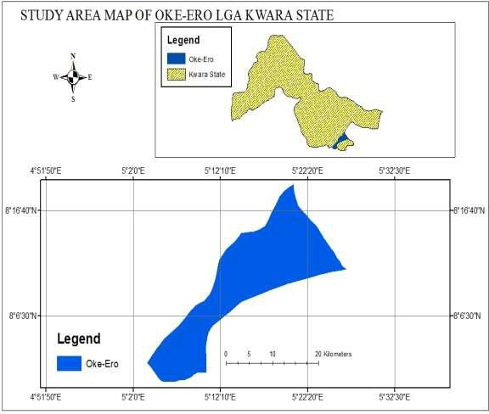

Figure 1.1 Map of Oke Ero LGA

# CHAPTER TWO

# LITERATURE REVIEW

# Preamble

On earth the most remarkable substance is water. The usefulness of water to both plants and animal survival cannot be overlooked, all living things depends on water, we use it to wash, drink, cook, swim and lot more as it is human beings cannot live more than a few days in the absent of water. The quantity and quality of water determine the rate of public health, energy, cell functional, food production, and other components of life. The social and economic developments of any nation are determined by availability and accessibility of water and it is cumbersome to ponder of a resource that is more vital to the human health and communities rather than water. Even, just, adequate and equitable access to water for most domestic and other uses reduce high level of hunger and poverty in the rural for the helpless persons.

Water deficiency in Nigeria is rising because the demand for water resources is increasing for irrigation, generation of energy and water supply, it also increases with increase in population and economic development, Federal Ministry of Water Resources and Japanese International Cooperation Agency (FMWR-JICA, 2014). Recently, unlike before during dry season the source of groundwater and some rivers dry up utterly (FMWR-JICA, 2014). Hence, proper planning, development and management of water resources is very important more than earlier in order to surpass environmental hazard and for a proper groundwater resources utilization, adequate planning and management of the groundwater potential assessment qualitatively and quantitatively are required. In many places today groundwater has been their suitable resources, in order to maintain

groundwater supply sustainability, necessary evaluations have to be carried out to keep groundwater a renewable resource (European Commission, 2006)

The extraction of groundwater can be done by boreholes and a hand-dug well (protected and unprotected) happens in permeable geological formations refer to as aquifers which allow storage and passage of water through them. In Nigeria, the number of boreholes for public water supply is approximately 57,600 boreholes for general water distribution with total pumping of 458 m3/day (Hisashi, 2011).

The main challenge in the world today is planning and management of water resource with an increase in water demand. For the demand of various users to be met, ample attentions have to be drawn on the thorough planning, effective distribution and use of other sources of water (surface water, ground water, and rainfall) is essential to maximize the outcome economic returns to limited water resources and, also, protect the destructible ecosystem.

The most important factor to the consider effective planning and management of water resources is availability of required data and information, overall, insufficient of required data is the major challenge in groundwater development (FMWR-JICA, 2014).

The physical reality of life can only be explained by water; the existence of human depends on it and thus is the most vital resource supplied by earth systems (Robert, 2007). During dry season when drinking water is not near or absent, people can cover a long distance in search of it for their various house consumption. This is because water is regarded as life and life is also regarded as water, since we drink and utilize it in various ways.

,W ZDV UHSRUWHG E\ 7DQQHU DQG 5RDGHV 78% water, depending on the size of the body and to function properly, the body needs

between one and seven litres of wateU SHU GD\ WR HVFDSH GHK\G

religious right are performed in the present of water; it serves as a means of purification in most religious of the world. Ritual washing in Islam, Christianity, Hinduism, Judaism and many more involve the use of water, for activities like ablution, baptism and ritual washings of other religions (Marks, 2001). Generally, water is a means of life. Among all sources groundwater appears to be the most vital one.

# Water Resources Development

In the world today there is a wide discrepancy between water resources management and its utility. This discrepancy is as a result of some catastrophe regarding water in many parts of the world. Yatsuka (2002) projected that by 2025, roughly 3.5 billion persons-

approximately 6.5 times of persons LQ WKH \HDU ZLOO OLYH L

This shows that the level of water resource deteriorates globally.

In Asian and other part of the world including Africa by year 2025, water availability per capital will likely be between 15 and 35 less than that of 1950 Asian Development Bank (ADB, 2001).

A lot of world conferences on water shortage and scarcity have been held. WHO report

VKRZV WKDW ³PLQLVWHULDO FRQIHUHQFH

the Pacific (MCED) in the year 2000 identified conservation and integrated management

RI IUHVK ZDWHU UHVRXUFHV DV RQH RI WKH HL

ministerial declaration issued at the international conference on fresh water held at Bonn

in December 2011 also made a call to the United Nation (UN) Secretary General to strengthen the coordination coherence of activities within the UN system on water issues in an exclusive manner. Outcomes of world water forum conducted by Global water partnership increases global awareness of water crisis and promote actions for sustainable use and development of water resources.

* + 1. Water Resources Development in Africa

Africa has the largest desert in the whole world. It is known with a prolonged periods of drought because of this it is important for African continent to develop and plan water resource adequate. The scientists have found out that the dry continent of Africa is sitting on a huge reservoir of groundwater (Bonsor, 2012).

Africa has widely adopted water resources development planning and often enough water resources development has come to be synonymous with river basin development (Adams, 1992). Irrespective of these Africa has not overcome the problem of water shortage.

* + 1. Water resource Development in Nigeria

Issues of water quality and scarcity in Nigeria have led the experts and researchers in the field of hydrology to be more concerned on water resources. During the colonial period the pattern of water resources development in Nigeria has been reviewed by Mabogunje (1965). His aim was to solve the problem of water quantity and quality deterioration. In Nigeria today, especially in rural areas people that have access to drinkable water are less than 50% of the population (WUP, 2001).

Many water development plans had been set up in order to overcome all problems relating to water. Lagos established the first modern water supply scheme in Nigeria in the year 1915 and within 38 years up to 27 more water works had been built across the country (Ayoade, 1975) the performance of these schemes was abated due to insufficient fund. Water consumption of the country also increased as a result of A rapid and continuous increase in population of this country as equally increase the water

FRQVXPSWLRQ IRU LQVWDQFH $\RDGH in Ni ge ria VWD

URVH IURP PLOOLRQ JDOORQV LQ WR

# Groundwater Resource Development

High demand of water or access to groundwater resources of a watershed had led to groundwater resources development plans. These comprise of the following interrelated phases: (i) surveying (ii) construction of abstraction systems (iii) design, construction, operation and optimization of networks (iv) Mathematical modeling.

* + 1. Groundwater Resource Development in Nigeria

United Nations Millennium Development Goals (MDGs) came with a basic conceptual structure of providing potable water and basic sanitations. This concept can only be achieved through a proper water resource development of any nation. Nigeria as example, many health and environmental hazard are related to surface water development such consequences include collapse of dams, spread of various diseases, flood and so on. This alerted the government to commence groundwater resource development by established Nigerian Geological Survey in 1917 and its objective among other is to search for groundwater in northern Nigeria. The instance efforts were made by the following

organizations focusing on groundwater resource management: The World Bank, Earth Summit, WHO, World Water Forum, FAO, UNICEF UNESCO, and UNDP (Nwankwoala, 2011).

Government carried out a global Survey of Nigeria in 1950s with the aim of developing groundwater resources. Lake Chad Basin and Sokoto Rima authorities were set up for developing groundwater resources in 1973 and 1974, to achieve extensive development of groundwater Federal Government established Federal Ministry of Water Resources in 1975. All these were done in order to meet the water needs of the people in Nigeria in line with United Nations International Drinking water supply and sanitation decade (IDWSSD). The National Borehole Project in 1980, Department of Food, Roads and Rural Infrastructure (DFRRI) between1986-1994 and Petroleum Trust Fund (PTF) water project between 1995-1999 all were established to enhance nations access to adequate and even water supply.

Generally, data availability for development in Nigeria is insufficient at all and groundwater is not excluded. According to Ajayi *et al.* (2003) the major challenges to groundwater development in Nigeria is inadequate data and information for planning and manpower and expert shortage to mention few.

An efficient and effective policy on groundwater through data collection and formulation of proper water supply in Nigeria are characterized by uncoordinated development and supply to all sectors: small and large scale users, rural and urban users, industrial and agricultural users this was reported by Nwankwoala (2011). From this it can be concluded

that groundwater development is an excellent option for sustainable water supplies in Nigeria.

# Groundwater Potential

There are various methods and procedures to assess groundwater potential of an area successfully; some of these methods are groundwater quantification oriented while other are focused on the determination of groundwater viable zone of an area.

The groundwater potential zone of an area has been many times determine by GIS and RS techniques. Various data such as land use/cover, drainage density, lineament, soil, geology, geomorphology, all have been used to generate of groundwater likelihood regions (Biswajit *et al.* 2018). Individual thematic data were assigned a ranks and weightages to and further integrated using GIS weighted overlay and indicated the groundwater likelihood areas (Arulbalaji *et al* 2019).

In recent years the importance of RS and GIS in groundwater potential assessment has been done by many workers like Tesfa and Girum (2019); Veeraswamy*et al*. (2018); Govindaraj*et al*. (2017); Ramu*et al*. (2014); for identification and location of groundwater resources. In Nigeria, assessment of groundwater potential was conducted through delineation of aquifers by many researchers. Okoro *et al*. (2010) for instance, evaluated groundwater potentials in parts of escarpment areas of south-eastern Nigeria, Adewale (2017) and Akinwumiju *et al*. (2016) also worked on this in the south-western and Rilwanu (2015) in north-western Nigeria.

A Vertical Electric Sounding (VES) and field data collection were employed in Southwestern part of Nigeria which is characterized by a basement complex formation to

assess the groundwater potential zone of this area in which Spatial and temporal distributions of saturated thickness of the available aquifers were successfully determined (Yinusa and Joy, 2013).

# Groundwater Exploration

Exploration groundwater has been done in various ways ranging from traditional to modern methods. A continuous effort of groundwater exploration is advancing everyday through new means and various approaches using many devices. A lot work has been by Ray (1960) which has been assisting beginners in the field of hydrogeology, Meijirink *et*

*al.,*  UHSRUWV WKDW ³H[SOR-geUolDogWy LwaRs Qa m ajIorRU JUR

field of interest in the past and still is in areas covered in adequately by geological maps,

WKLV LV ZLWK UHJDUGV WR JHRORJLFDO SRLQW R

Geophysical surveys are means of groundwater exploration using seismic methods, Schulumberger array and Wenner array methods, resistivity, electromagnetic, nuclear magnetic resonance methods, all these are commonly used in groundwater exploration, majorly because of close agreement between electrical conductivity and some hydrological parameters (Sultan *et al*., 2009).

Weathered basement is regarded has high recharge zone. In Nupe Basin Kwara State Bello and Makinde (2009) undertake groundwater exploration using VES survey and boreholes yield data. Electrode spacing of AB/2 presented in Bilogarithmic graph sheet was used, this identified 3-5 layers and the water was shown in the weathered basement. The VES outcomes were explained in accordance with standards of resistivity values created by Grant and West (1965) and also Archie law stated by Barnard (2003).

Remote sensing and GIS techniques are now employed to search for absent and present of groundwater, thus potential detection of groundwater resources can be done easier, more accurate,cost effective and fast extraction in short-time. Which make it the most appropriate new alternative tools for groundwater exploration (Moore, 1982).

* + 1. Remote Sensing and GIS Applications to Groundwater Exploration

Apart from other conventional methods, remote sensing and GIS have been added to other means of groundwater exploration. Remote sensing has been defined by Lillesan and Kiefer (2000) as a way of obtaining information about an object or phenomenon without a physical contact with the object itself, it is a phenomenon that makes use of satellite or aircraft sensor technologies to assess categories object on earth. GIS is a designed system which incorporate computer hardware, software, data and human expertise to capture, store, analyze, manage and present all kinds of geographic and spatial data which has been commonly used to solve data management problems. Remote sensing and GIS are widely used now in groundwater exploration because it is cost effective for selecting well sites and equally the time and cost spend on geophysical methods can be reduced thoughtfully (Taylor *et al*., 1999). Raghu and Venkata (2009), Candra *et al*. (2010); Arulbalaji *et al.* (2019) and Veeraswamy *et al.* (2018) have identified groundwater potential zones of different area using remote sensing and GIS with the help of geology, slope data, land management and soil classes as their input parameters.

* + 1. Groundwater Exploration Using Integrated Methods

Another method called Integrated Method has been used to explore and exploit groundwater, in this approach different parameters that influence accumulation of

groundwater need to be studied in detain, integration of these parameters can minimize

GRXEW DQG OHDG WR µVDIHU¶ GHFLVLRQ PDNLQJ

Complicacy in groundwater exploration has reduced if not completely eradicate through integrated approach, this approach is based on advanced use of remote sensing and GIS which lead to an efficient and effective result-oriented method for studying the development and management of water resources. This approach is useful, not only to reduce the prejudice on single theme but also to increase accuracy of the result (Srinivasa and Juran 2003).

Nagarajan and Singh (2009) used GIS, Remote Sensing and wells data to assess groundwater potential zones of Kattakulathur district in India. Thematic map which includes geology, land use/cover, soil map, drainage maps and slope map were prepared from DEM has been produced map of the study area. Weighted overlay tool in arcGIS10.3 was used to analyze the data. The result zones the area into 3 groundwater potential zones which shows good, moderate and poor zones with 49.70 km2, 261.61 km2 and 46.04 km2 respectively and the result was put to check using wells data. The same method was used by Peter *et al*. (2011) to assess groundwater recharge sites of Sadat industrial City of Egypt which integrates some factors using weighted overlay tools in Arc GIS Boolean logic true or false method and SRTM was used to generate slope map.

Shahid and Kumar (2009) combines, GIS, remote sensing and geophysical data in assessing groundwater potential of Midnapur District in India. Data from VES surveys were interpolated for the estimation of the subsurface parameters using Krigging method

and thematic maps were generated. The result categorized the area to 18% higher prospect, 39% moderate zone and 43% poor zone.

Integrated approach studies have improved groundwater exploration in Nigeria. Anudu *et al*. (2011) assessed groundwater potential in Wamba Nassarawa State Nigeria using slope map, Drainage density, contour map and lineament density. The outcome of the result showed that lineament and drainage are the most important parameters of groundwater detection in the area. Abel and Monshood (2011) categorized Ekiti South-West Nigeria into very good, good, moderate and poor groundwater potential zone through integrated approach study and subjected the aquifer parameters to weighted overlay analysis, he came up with a result that divided the study area into very good, good, moderate and poor groundwater potential and among the factors lineament was found to be the most influential. These among other works done in Nigeria using integrated approach.

# Groundwater Hydrology

The word hydrology means study of the occurrence, movement, distribution and management of water resources while groundwater hydrology is the aspect of hydrology that focus on groundwater resources. The water found in a saturated zone of variable thickness and EHORZ WKH HisDcaUlleWd KGr¶ouVnd waVteXr, tUheIrefDorFe tHhe water which occurs EHQHDWK WKH thrHouDghUwWhiKch¶weVll s, sVprXingUs,IanDd FgroHun dwater run-off are supplied (Ralph, 1987). A geologic formation which can yield significant amounts of groundwater through pump for domestic, municipal, or agricultural uses are called aquifer. The availability and suitability of groundwater resources for development depends on aquifers hydrological characteristics and its chemical content.

Below the land surface is groundwater which occupies pore spaces and cracks within the rocks and mineral grains. Water filled the pores spaces especially in the saturated zone (Buddemeier and Schloss, 2000). Groundwater is the part of Precipitation is the one that recharge groundwater, it percolates through unconsolidated materials and opening in bedrock down the ground until it reaches the water table. The surface of groundwater is referred to as water table, before the water table and up to the land surface called unsaturated zone through which water replenish the groundwater. An aquifer is a geologic formation that can yield significant amount of water. a formation that stands as barrier for water passage between aquifers is called aquitered, an aquiclude contain groundwater but will not transmit it fast enough as aquifer. (Thomas, 2003).

Groundwater is of two kinds of principal aquifers namely unconfined/water table aquifer and confined/ artesian aquifer. Aquifer that is utterly filled with water and lies under aquitard or between aquitards is said to be a confined aquifer here the pressure is more than hydrostatic pressure, the water level in this aquifer is called potentiometric surface while the aquifer that has no overlaying aquitard or aquiclude is said to be water table aquifer.

All rocks have holes; these holes are called voids or a pore which allows water to pass through them. Void fraction or porosity is the measurement of a void space in the rock, it is the ratio of the volume of pore spaces over total bulk rock volume. Thus it is expressed as percentage or fraction of bulk volume of rock that is filled with water. The amount and interconnection of inter-granular pores space of rock is determined size, shape and sorting of material. In terms of size, shape and sorting gravels deposits have highest ratio of pore

space and high permeability, a fine-grained clay deposits have a greater proportion of pore spaces too but a lower degree of permeability (Claudia, *et al.*, 2006).

* + 1. Factors Affecting Groundwater Storage

Groundwater storage is the discrepancy between recharge and discharge over time for the processes to occur, this may take days to thousands of years. Groundwater reservoir storage depends greatly on aquifer characteristics, groundwater movement rate and aquifers recharge, movement of groundwater similar to surface water depends on the nature of slope or elevation, Thomas (2003) states that "groundwater moves from higher elevations to lower elevations and from location of higher pressure to location of lower pressure". Movement of groundwater is very slow; it moves less than one foot in a day to a few tens of feet in a day. Groundwater hydraulics described the science of groundwater movement and in groundwater hydraulic, groundwater movement is determined by hydraulic head. Movement of groundwater in gravels and sands is rapid compare with clay and tiny rock features. The rock or geologic formation capacity to move water is

called hydraulic conductivity. David *et al*., LQ KLV UHSRUsW VWDW

determining groundwater movement and storage in any form of aquifer are hydraulic properties or dimension of aquifers, type of aquifer confined or unconfined and climate

WKDW LV LQ WHUPV RI UDLQIDOO UHFKoDr fUacJtorH´ 7K

affecting groundwater storage (transmission capacity, storage and aquifer geometry) which are controlled by type and its size.

Aquifer features which includes hydraulic conductivity, aquifer thickness, aerial extent, storability, groundwater levels and available recharge are mainly what groundwater development potential yield depends on as stated by Buddemeir and Schloss (2000). This

shows that movement and storage of groundwater in any nation is controlled mainly by geology formation, soil type, properties of aquifer and climatic factors. In a shallow unconfined aquifer groundwater recharge and storage is very complex and it depends on intensity and occurrence of meteorological elements, vegetation cover, land use and hydro-geological conditions above water table Memon (1995) cited in Arnold *et al*. (2000) and this was equally stated in FMWR-JICA 2014 report.

Chang-HawLee *et al*., 2006 carried out a thesis on groundwater storage in Taiwan using water balance approach concurrently with base flow record estimation, stable base flow analysis, long term mean annual rainfall data and it was mapped by geo-statistics and GIS. This result pointed out that mean annual groundwater is below 0o at western edge and total groundwater recharge is 18 billion tons in a year. Chang-HawLee also stated in this report that the groundwater storage and movement does not only depends on geophysical factors and climatic conditions but also on all meteorological conditions, including soil type and moisture, vegetable and cultivation practices, slope and above all, evapotranspiration, which is a function of the other factors.

* + 1. Groundwater recharges

The major source of groundwater recharge is rainfall. When rain falls, part of it infiltrates into the soil i.e. its moves downward from [surface water](https://en.wikipedia.org/wiki/Surface_water) through pore spaces in an unsaturated zone to the [groundwater](https://en.wikipedia.org/wiki/Groundwater). Part of the water that reaches the water table is known as the recharge from rainfall to the aquifer, this process takes place in the [vadose](https://en.wikipedia.org/wiki/Vadose_zone) [zone](https://en.wikipedia.org/wiki/Vadose_zone) below plant [roots](https://en.wikipedia.org/wiki/Root) and is usually termed as a [flux](https://en.wikipedia.org/wiki/Flux) to the [water table](https://en.wikipedia.org/wiki/Water_table) surface. Hydro- meteorological and topography, soil characteristics and depth to water table are the various factors that groundwater recharge depends on. A groundwater system consists of

rainfall recharge percolating into the ground from the surface through rocks and soils of varying permeability to the water table and later tends towards natural discharge points. The average annual recharge an area is the one that determines groundwater potential of that area, this can be obtained by getting the product of potential recharge value (in millimeters) and the area extends of the aquifer (Rick, 2007).

Several methods have been used in estimating groundwater recharge; among them are field measurement, groundwater resource estimation committee norms, soil moisture data based methods, and empirical method (Lerner *et al.,* 1990). Field measurements are also referred to as groundwater balance approach which based on field work like the water table fluctuation method, tracer experiments and lysimeter. The sum of every input and output components is equated to the different in groundwater storage, as reflected by the water table fluctuation, which in turn yields the single unknown in the equation, namely, the rainfall recharge (Lerner *et al*., 1990). Hence, the validity of this method is for a short time of a few days and further issue is the difficulty in estimating the realistic specific yield (Lerner *et al*., 1990).

Soil moisture data based methods as a way of groundwater estimation is a method that uses the interaction between water and air in the pores of a permeable medium, though

WKLV LV FXPEHUVRPH WR GHWHUPLQH ,Q VDWXU

estimate the flow in a saturated condition using saturated hydraulic conductivity and the

KHDG JUDGLHQW 'DUF\¶V ODZ VWLOO DSSOLHV L

In evaluating the groundwater resources estimating the speed in which aquifer replenishment is doubtless the most difficult of all measures, since the factors

such as [evaporation,](https://en.wikipedia.org/wiki/Evaporation) [transpiration](https://en.wikipedia.org/wiki/Transpiration) and [infiltration](https://en.wikipedia.org/wiki/Infiltration_(hydrology)) processes that determines it must be measured first to know the balance. Several empirical formulae have been used for various regions in the world by many researchers and experts in the hydrology field the most eminent of them are Some of the commonly used formulae are Krishna Rao model, Kumar and Seethapathi, Amritsar model and Chaturvedi model. Estimating groundwater recharge due to rain Chaturvedi formula has been used widely, he used rainfall amount and water level fluctuations relationship to arrive at the recharge as a function of precipitation.

Rr = 2.0 (P െ15)0.4 2.1

where,

Rr = net recharge from precipitation during the year, in inches; and P = annual precipitation, in inches

The above formula was further work on and modified, Roorkee and the modified form of it is

Rr = 1.35 (P െ14)0.5 2.2

A regression analysis was used to arrive at the Amritsar formula in 1973 for Irrigation and Power Research Institute, Punjab. The formula was said to be suitable for areas where rainfall was between 60 and 70 cm.

Rr = 2.5 (P െ16)0.5 2.3

Krishna Rao Relationship was used in 1970 to estimate groundwater recharge for a limited climatological homogenous areas and the empirical relation was stated as follow

Rr = K(P െ X) 2.4

The following relation is stated to hold good for different parts of Karnataka:

Rr = 0.20 (P െ400) for areas with annual normal rainfall (P) between 400 and 600 mm

Rr = 0.25 (P Ȃ400) for areas with P between 600 and 1000 mm

Rr = 0.35 (P െ 400) for areas with P above 2000 mm where, Rr and P are expressed in millimetres.

The above empirical relations have been intensively used in every regions of the world. Sophocleous, (1992) estimated and regionalized groundwater recharge in central Kanasa statistically placing an emphasis on easily measured parameters and field data, the result indicated that the area-weighted average annual recharge for this region is 36 mm.

Kumar, (2012) described the methodologies to understand and evaluate the various recharge and discharge components of groundwater balance equation in his work assessment of groundwater potential. He reported that for a proper assessment of potential, current and additional exploitability of water resources at ideal stage, a water balance study is required.

Oke *et al.* (2014) compared empirical methods to analysis groundwater recharge estimation value in Ogun-Osun River Basin and concluded that in estimating groundwater recharge any of these methods can be used, although the Kumar and Seethapathi formula is preferred. He selected those formulas because of the similarities between the monsoons climate of Indian where the formulas were created and the humid sub-tropical climate of southwest Nigeria.

* + 1. Potential evapotranspiration

The factors that affect evapotranspiration includes extent of crop cover, climatic factors, stage of crop growth and stomatal opening. Many researchers in the field of hydrology have developed empirical formulae to figure out factors which affect evapotranspiration using meteorological data which are readily available time. Other methods different from empirical methods are pan and lysimeter though there are no perfect methods among them but all can provide reliable are required data. The notion of potential evapotranspiration was first put forward by Thornthwaite (1948) Penman (1948) others like Doorenbos and Pruitt (1997), Sibbons (1956), Cruff (1967) etc. Where required

PHWHRURORJLFDO LQSXWV DUH DYDLODEOH 3HQPDQ

most comprehensive formula to estimate potential evapotranspiration (PET), this is because it take almost all factors which control it into consideration.

Sibbons (1956) Thornthwaite method for estimating potential evapotranspiration has been widely used over a vast range of climatic conditions, it application to the estimation of potential evapotranspiration in every climatic types of the world gave it an experimental and documentary evidence. As every other method Thornthwaite approach also has some limitation (only day length and temperature are used as climatic inputs).

# Analytic Hierarchy Process (AHP) Processing

AHP is one of the most reliable MCDM methods which help in solving complex problems and conflict facing decision maker. This method was first introduced by Saaty (1980), Every MCDMs among which is AHP and others have 4 steps 1) modelling, 2) weights evaluation, 3) combination of weights and 4) sensitivity analyses. Expert choice

software was used in executing AHP methodbecause access to it is easy and its application and steps in estimating it are done automatically. (Arulbalaji *et al.,* 2019).

Table 2.1 6D-9DsWcal\e o¶f rVela ti ve importance

# Intensity of relative importance Definition

1. Equal importance
2. Weak or slight
3. Moderate importance
4. Moderate plus
5. Strong importance
6. Strong plus
7. Very strong
8. Very very strong
9. Extreme importance

# Correlation Coefficient

[Correlation](http://www.statisticssolutions.com/correlation)is a statistical method which indicates the mutual relationship, degree of agreement or connection between two variables. For instance, if we have the size and type data of pam sandal and shoe, as well as the correlation between them, we can discover how these two variables are connected. It can also be used to find out the correlation between two variables and say that their sizes are positively, negatively or not related to type. A correlation coefficient measures the strength and direction of a linear connection between variables, the correlation coefficient always ranges from of -1 to 1 (Park, 2018).

* + 1. The three types of correlation:

1. Positive and negative correlation: A correlation is said to be positive if the values of one variable increase and the values of the other variable also increase while the

negative correlation is the one that the values of one variable increase and the values of the other variable

1. Linear and nonlinear or curvi-linear correlation: A correlation is said to be linear when both variables change at the same ratio whereas when both variables do not change in the same ratio, then they are said to be in curvi-linear correlation.
2. Simple and multiple correlations: If two variables in correlation are studied, then it is called simple correlation. A correlation is said to be a multiple correlation when multiple variables are considered for correlation.

2.82 Degree of Correlation

1. Perfect correlation: If the two variables change in the same ratio, then it is called perfect correlation.
2. High degree of correlation: The correlation coefficient that range above 0.75 is referred to as high degree of correlation.
3. Moderate correlation: If the correlation coefficient ranges between 0.50 to 0.75 it is referred to as moderate degree of correlation.
4. Low degree of correlation: If the correlation coefficient range is between 0.25 to

0.50 it is referred to as low degree of correlation.

1. Absence of correlation: If the correlation coefficient is between 0 to 0.25 indicates that there is no correlation. Mahdavi (2012).

# CHAPTER THREE

# MATERIALS AND METHODS

# Materials

The following materials and software were used;

1. Arc GIS 10.4
2. ERDAS 14
3. Google Earth Satellite Images
4. GPS
5. Microsoft Excel2016
6. AHP Expert Choice

# Data Collection

Firstly, with the aid of Google Earth satellite images, the whole local government was studied in detail. After which the area was zoned in terms of groundwater potential, the following steps were done:

* + 1. Parameters

In this study, 8 parameters including rainfall, slope, soil type, geology, drainage density, land use/ cover layers, temperature and borehole yields/well levels were examined, their categories and sources are listed in Table 3.1;

Table 3.1: Data required and their source

|  |  |  |  |  |
| --- | --- | --- | --- | --- |
| **Data Category** | **Data** | **Date** | **Source** | **Pertinence** |
| Meteorological  data | Rainfall | 1988-2017 | LNRB | Rainfall Map of the LGA and  Net recharge determination |
|  | Temperature |  |  | Potential Evapo-transpiration |
| Geological data | Geology | 2011 | NGSA | Geologic (rock type) map |
|  | Soil type | 2016 | FAO | Soil layer for the LGA |
| Landsat8  ETM+ | Land use/cover | 2018 | Glovis USGS | Land use/cover map of the area |
|  | Drainage density |  |  | Drainage Density |
| ASTER DEM |  | 2018 [www.earthexplore.con](http://www.earthexplore.con/) | | slope map of the area |
|  | Slope gradient |  |  |  |
| Borehole data | Boreholes yield  and wells water level | 2019 | Field work | Depth of water table and validation of data |

* + 1. Layers generation

Land use and cover layer which is a product of Landsat 8 (30m) from USGS, and ASTER DEM with spatial accuracy of 30m and altitudinal accuracy of 20m were used to generate drainage density and slope map. Information of annual rainfall and temperature (1987- 2017) obtained fromLower Niger River Basin(LNRB) Ilorin was presented here and the geological and soil layer were acquired.

# Data Types, Sources and Analysis

* + 1. Land use/cover

The Landsat 8 satellite image from glovis was downloaded to determine the land use and land cover of Oke-Ero LGA, the imagery was subjecting to colour composition, haze and

noise reduction, histogram equalization, pan sharpen, subset, bands of various numbers were combined for color composite. The supervised classification method was used in ERDAS 14 for the classification which gave a general form of the land use/cover classes of the area. The area covered by vegetation holds more water in root of plants while the rocky and built-up land use reduce the recharge of groundwater by increasing runoff during and after rain, this make it necessary to study land use land cover of the study area in details.

* + 1. Soil media

The base data for the soil map of the Oke-Ero was obtained from the Food and Agriculture Organization (FAO).Harmonized World Soil Database (HWSD) was imported into ArcGIS 10.4 environment where it was projected based on the map projection of Geographic Coordinate System and clipped using the local government shape-file and was ground truth.

* + 1. Geology

The geologic map of Oke-Ero was prepared from existing geologic and mineral resources map of Kwara State produced by the Nigerian Geological Survey Agency with scale of 1:600,000. The map was collected from office of surveyor general of the federation, all covering the study area, it was imported into ArcGIS 10.4 environment and geo- referenced in accordance with the map projection of Coordinate System and clipped using the shape-file to extract the concerned rock type of the study area. Geology is one of the major factors which play an important role in the distribution and occurrence of groundwater.

* + 1. Rainfall

The rainfall amount is not alike at every places, it varies depends on environmental conditions of a place. The availability of groundwater is high in a place where the rainfall is high and vice versa. The rainfall does not only vary spatially it also varies temporally because of this, the influence of rainfall in any region can be determined using long time period of rainfall data and elevation from ASTER DEM. The present study considered the rainfall from year 1988 to 2017 Kriging interpolation method was used to determine the rainfall distribution in the study area and it union with elevation map produced the Oke- Ero rainfall map.

* + 1. Slope and Drainage density

Advanced Space-borne Thermal Emission and Reflection Radiometer (ASTER) data covering the whole study area was downloaded from earth explorer using Oke-Ero path and row (190 & 54). The data was added to ARCGIS 10.4 using 3D analytical tool and raster surface to produce the slope and the shape-file of Oke-Ero which was imported and clipped to produce the slope map ofOke-Ero LGA. In this thesis DEM was gotten to create stream data, the corrected streams data was used to determine the drainage density of the study area. The drainage density map of the study area was prepared from the drainage map.

# Methods

The thematic layers were changed to raster format using conversion tools ArcGIS software. All the thematic raster maps had an equal square grid size of 30 m resolution before they were brought into weighted overlay inside of Spatial Analyst Tools in ArcGIS which was used to carry out overlay analysis. During weighting overlay analysis using the

Multi-Criteria Decision Analysis (MCDA), data such as: drainage density, slope, rainfall, soil type, land use and geology, were assigned appropriate weights employing expert choice software; the ranking was given to individual parameter of each thematic map and weights were assigned to each class of that particular feature depending on its influence on the occurrence, movement and storage of groundwater employing the spatial analysis tool in ArcGIS 10.4. Relative weights were added to each theme and the rates of the respective thematic unit were also added according to the modified DRASTIC index to obtain different groundwater potential zones. The groundwater potential zones were obtained by superimposing all these thematic raster maps using overlay function of ArcGIS and this was further integrated over one another using GIS add function. The result of the study was compared with the collected data and field data of borehole yields and well water levels to assess the accuracy and reliability of results. The resultant map was classified into three prospect zones namely high potential, moderate potential and low potential.

* + 1. Assigning Rank and Weight

Groundwater potential mapping require the analysis of different thematic layers such as geology, drainage density, land use/cover, rainfall, soil, and slope. Each theme is of different necessity in the event of determining the likely zones.

The weights were assigned for each parameters using AHP method (termed expert choice software) and the ranks were adopted considering past works carried out by researchers (Krishnamurthy *et al*. 1996; Arlbalaji *et al.* 2019). Each thematic layer was assigned a weight values from 1 to 100% which expressed the relative importance of the parameter with regards to each other pertained on the influence of infiltration characteristics and

groundwater occurrences. Expert Choice implements the [Analytic Hierarchy Process](https://en.wikipedia.org/wiki/Analytic_Hierarchy_Process) (AHP), the higher the score, the finer the fruition of the choice with esteem to the considered standard (Saaty, 1994), assigning the weight, the geology was assigned a higher weight, whereas the land use and rainfall were assigned a lower weight. Once a weight has been assigned to different parameters, individual ranks were specified for the sub-variable. Thus, the GIS layer on geology, drainage density, land use/cover, rainfall, soil, and slope were studied attentively and ranks were given to their sub-variable, the maximum figure was assigned to the one with the highest groundwater prospectively and the smallest was assigned to the lowest prospect feature. Considering the slope, the highest value was given to nearly level and low rank valence was given to the higher slope. The higher rank factors were given to truncated drainage density area because this zone encourages infiltration than runoff and lower value was assigned to higher drainage density. The area with highest rainfall class was assigned a higher rank value as this class has a greater water to recharge the groundwater, lower value was assigned to other regions with low rainfall. The overall analysis is tabulated in Table 3.2.

Table 3.2: Parameters, Weightings, Attributes and Ratings (source Expert Choice software)

|  |  |  |  |  |  |  |  |
| --- | --- | --- | --- | --- | --- | --- | --- |
|  | **Raster** |  | **Attributes** |  | **Weight (%)** |  | **Ratings (1-5)** |
|  |  |  | Low |  |  |  | 5 |
|  | **Drainage** |  | Moderate |  | 15 |  | 3 |
|  | **Density** |  | High |  |  |  | 1 |
|  |  |  | Porphyritic granite |  |  |  | 4 |
|  | **Geology** |  | Magmatite |  | 25 |  | 2 |
|  |  |  | Vegetation |  |  |  | 5 |
|  |  |  | Bare land |  |  |  | 4 |
|  | **Land Use** |  | Settlement |  | 10 |  | 3 |
|  |  |  | Rock |  |  |  | 1 |
|  |  |  | High |  |  |  | 5 |
|  | **Rainfall** |  | Moderate |  |  |  | 3 |
|  |  |  | Low |  |  |  | 2 |
|  |  |  | Nearly level |  |  |  | 5 |
|  | **Slope** |  | Gently sloping |  |  |  | 3 |
|  |  |  | Strongly sloping |  | 20 |  | 1 |
|  | **Soil** |  | Gleysols |  |  |  | 5 |
|  |  |  | Lixisols |  | 20 |  | 3 |
|  |  |  | Luvisols |  |  |  | 2 |

10

* + 1. GIS Analysis

The parameters of the study area were mapped and inputted into a GIS environment for A proper analysis for the hydrological parameters of the study area was done, mapped and inputted in ArcGIS environment. This was done by creating a geo-database for apt data management which involves all dataset used for groundwater potential, namely as rainfall, slope, soil type, geology, drainage density, land use/ cover layers and borehole dept. These parameters were rasterized using same cell and resolution.

* + 1. GIS Modelling of Groundwater Potential Map

The grid raster data structure was adopted and each raster cell weigh was assigned as a result of the score sum from the hydro-geological factors focused on their groundwater potential. The weight was assigned in percentage, based on their importance with regard to groundwater prospect and rate was assigned to each factors varying from 1-5 as presented in Table 3.2. the weight and rate was assigned according to important of each parameters to groundwater prospect. At the end, all the factors were overlay in ArcGIS

10.4 software using the spatial analysis function to get the final result of groundwater potential zones of the area apt for the modified DRASTIC index given by Khairul *et al*. (2000):

GP=GrGw+RrRw+ErEw+MrMw+DrDw+SrSw+LrLw 3.1

where;

r= rating, w= weight, GP= groundwater potential

G=Geology, R=rainfall, E=slope, M=geomorphology D=Drainage Density S=Soil, L=Land cover

The flow chart of the methodology is shown in the figure 3.2.

Start



Data Collection

DEM Secondary data





Groundwater potential zones map

GIS overlay & integration

Assigning weight & Rate

GIS process &Digitization

Net Recharge

Statistical analysis

Validation of potential zones

End

Figure 3.1: Flow chart of the methodology

* + 1. Estimation of Groundwater potential 3.4.4.1Net Recharge

The monthly rainfall data from (1988-2017) was refined into annual value and the

empirical relationships between recharge and rainfall was used to calculate groundwater recharge. Krishna Rao gave this empirical relationship in 1970 to determine

the groundwater recharge in limited climatological homogenous areas.

R = k (P െx) 3.2

Area with annual rainfall between 600-2000mm/year R is given as;

R = 0.25(P െ400) 3.3

where R= net recharge due to rainfall. P= precipitation both R and P are expressed in mm

* + - 1. Potential Evapo-transpiration

The Potential Evapo-transpiration was produced from 30 years daily air temperature collected to generate the mean monthly air temperature. The annual mean monthly air temperature for 30 years were used to estimate the potential evapo-transpiration Thornthwaite Model of potential evapo-transpiration was used to estimate potential evepo-transpiration for the area. The rainfall and potential evapo-transpiration differences were estimated to have a vivid picture of the amount of rainfall vacant for recharge. This gave actual groundwater potential because rainfall and potential evapo-transpiration are the fundamentals of hydrological water balance. Thornthwaite Model was selected because of availability of data required.

Estimation of potential evaporation is given by Thornthwaite (1948) as

PET=

ߙ ܽܶ10 ܰ ܮ

16 ቀ ቁቀ ቁቀ ቁ

3.4

12 30 ܫ

where PET= potential evapo-transpiration (mm/month)

ܽܶ= is the average daily temp. (oC if this is negative, use 0) of the month being calculated N= is the number of days in the month being calculated

L= is the average day length (hours) of the month i.e. Hours between sunrise and sunset in the month

ߙ= (675 x 10-9) I3 െ (771 x 10-7)I2 + (179 x 10-4)I + 0.4924 3.5

I=σ12

݅ܽܶ1.514

݅=1 ቀ ቁ

5

3.6

ߙ= coefficient,

I= annual heat index, which depends on the 12monthly mean temperature݅ܽܶ.

# Validation of the potential zones

The study area has no similar study that has been carried out earlier to give the insight of how the groundwater potential of the area looks like. This make it not feasible to correlate the results obtained with the outcome of the former researches. In this work, a field survey was done by randomly selecting wells in different zones using GPS to locate boreholes and wells and equally determine their yields and groundwater levels, these results were used to check the accuracy of groundwater potential zone map generated by correlating them. Table 3.3 shows the borehole yield intervals that ranges from 0 to

>1.5l/s which was reclassified into 0.0-0.9l/s (low zone), 1.0-1.5l/s (moderate zone) and greater than 1.5 as high zone and well water level which ranges from 0.8 to 15.2 m which was also reclassified into 0.8-6.6m (high zone), 6.61-9.5m (moderate zone), 9.5-15.2m

(low zone) by Ajaykumar *et al.* (2016) were used to cross check groundwater potential map.

Table 3.3: Classified weighted overlay Values, Borehole Yield and well depth Ranges.

|  |  |  |
| --- | --- | --- |
| Zone | Yield interval (l/s) | GWP |
| 1 | 0.0-0.9 | (Low) |
| 2 | 1.0-1.5 | (Moderate) |
| 3 | >1.5 | (High) |

Sources: Modified from Akiwumiju *et al.* 2017

Data from field work for borehole yields and well levels were used to test the accuracy, reliability and limitation of the adopted approach by correlating the map with the yields. Excel was employed to assess the correlation and possible relationship between borehole yields and the groundwater potential. Table 3.3 presents the classification of weighted overlay values, borehole yields and well depth ranges.

# Water demand investigation

A questionnaire was prepared and distributed across the length and breadth of Oke-Ero LGA for data acquisition on water demand/consumption using the survey device created and presented in appendix. This survey was used to determine the amount of water consume by individual per day, 2006 population census figures and projected population up to 2040 were used to arrive at the domestic water demand of the area incorporating the germane documents that talks about consumption rate in various kinds of settlement. Thus other activities like agricultural related economic and loss at 15% and 5% were also considered respectively and added to the result of domestic demand. 2006 population figure was projected using geometrical method with growth rate of 3.05.

# CHAPTER FOUR

# RESULTS AND DISCUSSION

# Analysis and Discussions

As stated in the methodology six selected parameters consisting rainfall, slope, soil type, geology, drainage density, land use/ cover layers were analyzed using GIS techniques and

they were ranked according to 6DWW\¶V DQDO\WLFDThOe d isKcuLssiHonUofDUFKLF

each parameter follows.

* + 1. Rainfall

Rainfall is the source of groundwater supply and also naturally controls groundwater recharge, therefore it is assumed that area with high rainfall availability is liable to high infiltration and percolation and low rainfall zone with low infiltration. Rainfall varies from annual rainfall of 1182.5mm/year in 2010 to 1348.3mm/year in 2011across the study area and decrease toward the North of the Local Government. The mean annual rainfall thematic map is presented in Figure 4.1. After the rainfall spatial distribution was found, the whole local government area was grouped into three regions using equal interval subsequently, suitable weightage was given to each class, based on the importance of rainfall to groundwater prospect, the area that received highest rainfall was assigned a value of 5 and value of 1 was assigned to least area in term of rainfall amount considering the short interval between the amounts of rainfall. The weight of 10 % was assigned to rainfall in line with modified weighted overlay.

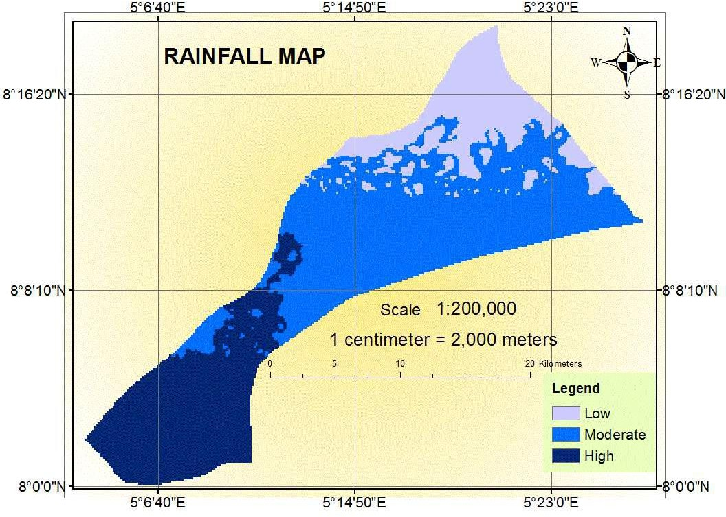

Figure 4.1: Mean Annual Rainfall Map of Oke-Ero LGA

* + 1. Geology

The result of geology of the study area showed two rock types: porphyritic granite and migmatite. The major rock found in the study area is migmatite with a wider spatial spread in the north and south part of the area while porphyritic granite occupied about one fifth of the area and can be found in the central part of the local government as shown in Figure 4.2. Number of fractured within the rock is the factor that groundwater aquifer directly depends on, the hydro-geological properties of these rocks differ from each other as they mostly depend on their formations types and compactness of the pores. The porphyritic granite is considered as most suitable for groundwater potential as it is more porous, and has high permeability and specific yield values. The weight of 25% was

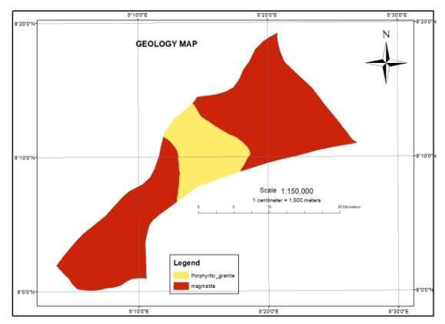assigned to geology due to its relevant to groundwater occurrence. Each attributes of the geology were rated according to their partiality to transmission capacity and groundwater storage as shown in Table 3.2.

Figure 4.2: Geology Map of Oke-Ero LGA 4.1.3Drainage Density

The density of drainage is play important role in Potential Groundwater Zones as it determines how well or poor a watershed drained. Figure 4.3. after analyzing the result obtained, it can be seen from the map that all drainage areas are spread across in the study area and it was delineated into parts for drainage density: low; moderate; and high drainage densities. Low delineated areas were disseminated and found towards the edge of the study area while moderate and high are evenly scattered across the study area. Low

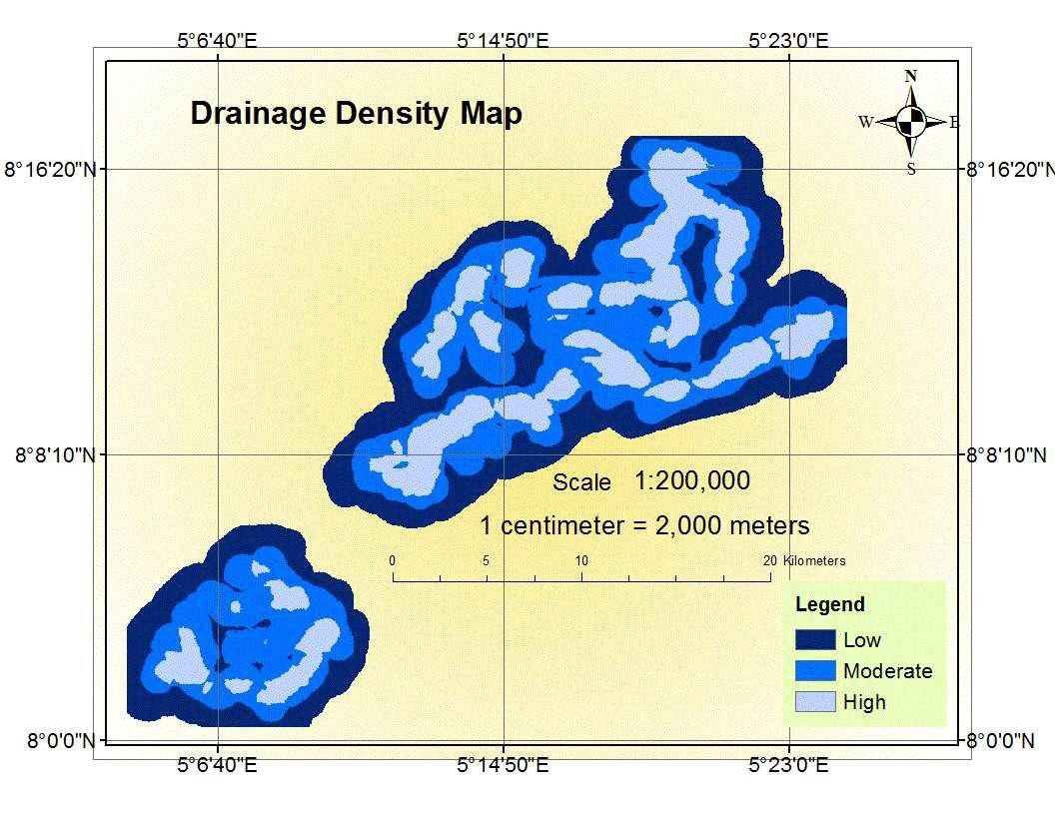drainage areas retain water for long period thereby encouraging infiltrations more than high drainage area, this form the basis for rating. Low drainage density is ranked high while high drainage is ranked low. Drainage density was assigned weight of 15% based on its relative importance to groundwater prospect and in line with modified weighted overlay.

Figure 4.3 Drainage Density Map of Oke-Ero LGA

* + 1. Land use/cover

The Land use/cover map of the study area is shown in Figure 4.4 with four main sorts: Vegetation, settlement, bare land and rock. Most of the vegetation in the study area was found in the south-west, the north-eastern part is mainly rocky with settlement and little vegetation and the central part is with settlement, vegetation and small bare land.

Vegetation encourage infiltration most while bare land follow, next was settlement area and rocky area was the least. Land cover is not as important as geology, slope, soil and drainage density in relation to passage of water (infiltration) thereby it was assigned the weight of 10% in line with weighted overlay.

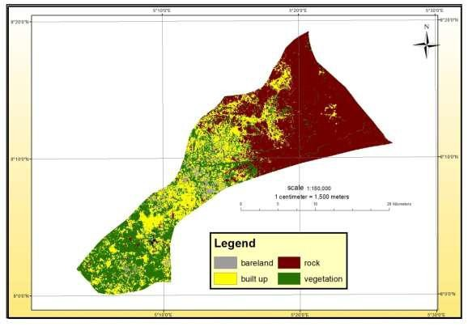

Figure 4.4: Land Use/Cover Map of Oke-Ero LGA

* + 1. Soil

The soil classification result showed three major types of soils luvisols, Lixisols and Gleysols in the study area. The motion and percolation of water for the three types of soil are not alike. Because of the different on its property each, suitable weights have been assigned in Table 3.2. The soil present in the study area was studied in detail and classified according to the Soil Taxonomy (1961), Ministry of Agriculture, and the Food

DQG $JULFXOWXUH 2UJDQL]DWLRQ RI WKH 8QLWHG

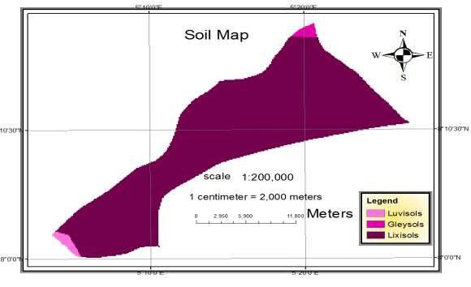area is shown in Figure 4.5. The lixisols occupied more than 90% of the total area with small luvisols and Gleysols towards the south and north respectively.LixisolsandLuvisols were rated low value because it contains appreciable clay which retain water and hinder its passage. Gleysols is more permeable which makes it to be ranked high. Among other factors that ascertain the ample of groundwater is soil types and properties. Soil porosity and permeability are the soil properties that determines the infiltration of water into the ground from the surface and movement of groundwater.

Figure 4.5: Soil Map of Oke-Ero LGA.

* + 1. Slope Map

The slope map of the study area, shown in Figure 4.6 is prepared from ASTER DEM data. The slope was grouped into three classes (Table 3.2) nearly level, gently sloping, and strongly sloping, each class was rated and weightage of 20% was assigned to the slope as a whole. When rainfall on a nearly level area the runoff is slow and it takes

longer time for rainwater to percolate, this make it best for groundwater potential accumulation zone and the strong slope area encourages high runoff which makes it have less accommodating time for rainwater; for this reason, the infiltration is less in strong sloppy area and it results to poor groundwater potential.

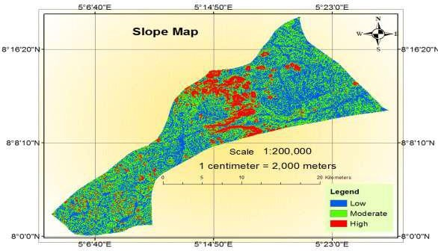

Figure 4.6: Slope Map of Oke-Ero LGA

# Groundwater Prospects Map

The groundwater potential zones with high, moderate and low occurrences within the entire area was delineated and showed in Figure 4.7. From the map the groundwater potential zones on a colour scale. The cretan blue colour shows high potential zone while peridot green show moderate and mars red show low groundwater potential zones. The result of groundwater potential map shows that the high potential zones occur in central and in the Southwest part; low potential is towards the northeast and moderate potential

zones spread in all parts of the study area, high potential zone occurs in Northeast parts as small to scatter patches.

From the total land mass, 30.27% which cover 132.58km2 of the area is rated as high groundwater potential zone, 62.35% of the area which covers 273.09km2 of the area is rated as moderate groundwater potential zone and 7.38% of the area spans 32.33km2 is identified as low potential zone. The general analysis shows that the moderate potential zone occupies more areal extent in the study area. The high groundwater potential zones found in the central and southwest parts and the moderate potential zones spread in all parts of the study area are apt for groundwater expansion, irrigation and can be safely utilized to meet the water demands of all sectors in development in the study area.

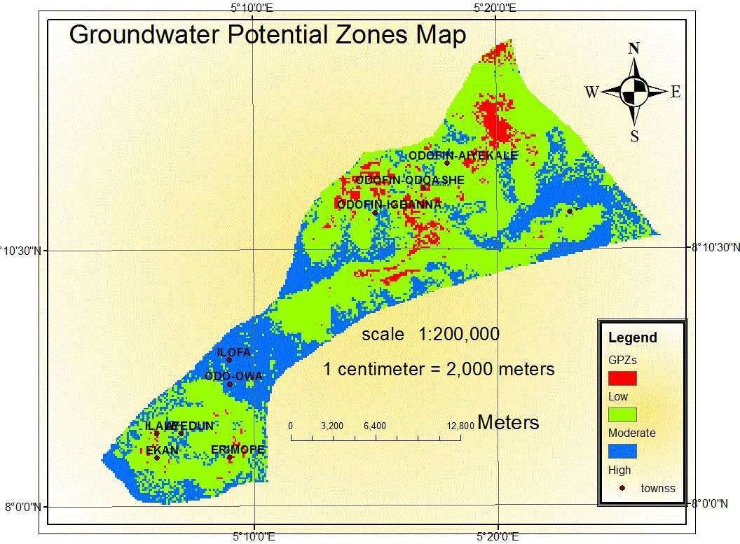

Figure 4.7: Groundwater Prospects Map

# Groundwater Potential Estimation

The groundwater recharge was calculated using empirical relationships stated in Equation 3.2, it was used to estimate annual recharge using the annual precipitation and the results were presented in the appendix. The groundwater potential available annually in the area was the product of the annual net recharge and the total area which gave 65,656,200m3/year. The summary of the results was presented in Table 4.1.

Table 4.1: Summary of Groundwater Potential Evaluation

|  |  |
| --- | --- |
| Total Area (Km2) | 438 |
| Average Annual Rainfall (mm/year) | 1,258.1 |
| Average GW recharges(mm/year) | 149.9 |
| Rainfall-recharge (%) | 12.0 |
| GW Potential (m3/year) | 65,656,200 |

The outcome of the average groundwater recharge estimated is close to the average value estimated in the JICA, 2014 master plan for the whole Niger central (HA-2) with the mean groundwater recharge of 132mm/year which is akin to the result obtained in this research and the increment might be because the area in consideration is close to the western littoral (HA-6) with a value of 236mm/year. It should be noted that the estimated available groundwater reserve is the amount of groundwater replenished yearly.

Rainfall net recharge is the major parameter in estimating groundwater potential. The result procured from the chosen model for each year from 1988 to 2017 varies from 136.9mm/year to 166.0mm/year. The highest and lowest result took place in 2011 and 2010 years respectively. The estimated value 149.9 mm/year was the mean value of recharge used in this work. The maximum rainfall net recharge occurred a year after the

minimum and both happened in the last ten years of the data used as shown in Table 4.2. This simply means that the lowest and the highest rainfall over the year1988 to 2017 happened at the last ten years of the data used. The calculated average annual rainfall is 1,258.1mm/year and the average annual rainfall that turns to recharge is 12% of the rain.

Table 4.2: Net recharge from rainfall data having the average of 149.9mm/year

|  |  |  |  |
| --- | --- | --- | --- |
| year | Rainfall (mm/year) | Recharge (mm/year) | % Annual Rainfall turn to recharge |
| 1988 | 1270.6 | 152.4 | 12.0 |
| 1989 | 1244.6 | 147.8 | 11.9 |
| 1990 | 1194.8 | 139.1 | 11.6 |
| 1991 | 1278.1 | 153.7 | 12.0 |
| 1992 | 1285.8 | 155.0 | 12.1 |
| 1993 | 1264.9 | 151.4 | 12.0 |
| 1994 | 1273.2 | 152.8 | 12.0 |
| 1995 | 1241.6 | 147.3 | 11.9 |
| 1996 | 1253.6 | 149.4 | 11.9 |
| 1997 | 1185.3 | 137.5 | 11.6 |
| 1998 | 1289.4 | 155.7 | 12.1 |
| 1999 | 1249.7 | 148.8 | 11.9 |
| 2000 | 1229.5 | 145.2 | 11.8 |
| 2001 | 1263.4 | 151.1 | 12.0 |
| 2002 | 1299.3 | 157.4 | 12.1 |
| 2003 | 1226.0 | 144.6 | 11.8 |
| 2004 | 1239.8 | 147.0 | 11.9 |
| 2005 | 1258.7 | 150.3 | 11.9 |
| 2006 | 1281.3 | 154.2 | 12.0 |
| 2007 | 1289.9 | 155.7 | 12.1 |
| 2008 | 1255.1 | 149.6 | 11.9 |
| 2009 | 1260.6 | 150.6 | 12.0 |
| 2010 | 1182.5 | 136.9 | 11.6 |
| 2011 | 1348.3 | 166.0 | 12.3 |
| 2012 | 1193.5 | 138.9 | 11.6 |
| 2013 | 1241.5 | 147.3 | 11.9 |
| 2014 | 1287.3 | 155.3 | 12.1 |
| 2015 | 1272.6 | 152.7 | 12.0 |
| 2016 | 1244.8 | 147.8 | 11.9 |
| 2017 | 1308.7 | 159.0 | 12.2 |

Evapotranspiration is a very importance key process in hydrologic balance, therefore, in order to have a clear picture of net rainfall recharge that is available to replenish groundwater the potential Evapotranspiration (PET) was estimated. Thornthwaite model was used to estimate PET and the obtained PET values are very similar to the values from

DOLJQPHQW FKDUWV VROXWLRQ RI 7KRUQWKZDLWH¶

The variation in the result of annual PET values is from1262.6mm/year in 1995 to 1519.4mm/year in 1993 while the variation in the result of annual rainfall is from 1182.5mm/year in 2010 to 1348.3mm/year in 2011, the result for all the years was presented in Figure 4.8. The rainfall distribution pattern is not too consistent as it reduced towards the north as shows in rainfall map. The value of the mean monthly PET over 30 years was calculated using the mean temperature value show that the PET occurred highest in March (185.7 mm/month) and lowest in August and December (121.7mm/month).

1800

1600

1400

1200

1000

800

600

400

200

0

1988 1990 1992 1994 1996 1998 2000 2002 2004 2006 2008 2010 2012 2014 2016

year

Annual Rainfall

PET (mm/year)

Rainfall and PET (mm/year)

Figure 4.8: Distribution patterns of PET and Rainfall

# Validation of Result

To validate the result of this study borehole yield data from nine locations with 20 wells level data was generated. Five locations were selected randomly from each zones anddue to accessibility 3 boreholes from each zones were chosen. The 20 wells too were selected randomly within the local government and the results were presented in Table 4.3 and 4.4 and the locations of wells and boreholes were indicated in Figure 4.11.

Table 4.3: Pumping test and groundwater potential results.

|  |  |  |  |  |  |  |  |
| --- | --- | --- | --- | --- | --- | --- | --- |
| Zone | Map | Borehole | Borehole | Static | Groundwater | Coordinate | Remarks |
|  | Groundwater yield(l/s) | depth(m) | yield (l/s) | water level(m) | potential zone |  |  |

1 0.45 58 0.452 19.7 Low 80 ¶ ¶

50 ¶

1 0.45 55 0.810 9.8 Low 80 ¶ ¶¶

50 ¶ ¶

Agree Agree

1 0.45 60 0.522 14.5 Low 0

8 ¶

Agree

0

5 ¶

2 1.25 45 1.461 7.7 Moderate 80 ¶ ¶

50 ¶ ¶

2 1.25 47 1.281 8.9 Moderate 80 ¶

50 ¶

2 1.25 60 1.343 13.8 Moderate 80 ¶ ¶¶

50 ¶ ¶

3 2.25 48 2.512 4.2 High 80 ¶ ¶¶

50 ¶ ¶

3 2.25 45 1.431 9.6 Moderate 80 ¶

50 ¶

3 2.25 55 2.320 5.0 High 80 ¶ ¶

50 ¶ ¶

Agree Agree Agree Agree Less Agree

Table 4.4: Well depth and Groundwater potential results.

Zone Map Well water level (m)

Well water

Groundwater potential zone

Coordinate Remark

|  |  |  |  |  |  |  |
| --- | --- | --- | --- | --- | --- | --- |
|  | | level (m) | of | area |  | |
| 3 | 3.7 | 5.83 |  | High | 80 ¶ 0 ¶ ¶¶1¶ | Agree |
| 3 | 3.7 | 7.92 |  | Moderate | 80 ¶ 0 ¶ ¶¶1 | Less |
| 3 | 3.7 | 3.41 |  | High | 80 ¶ 0 ¶ ¶¶1 | Agree |
| 3 | 3.7 | 4.75 |  | High | 8°9'35"N 5°12'23"E | Agree |
| 3 | 3.7 | 5.65 |  | High | 80 ¶ ¶0¶ 1¶  ¶¶ | Agree |
| 3 | 3.7 | 6.97 |  | Moderate | 80 ¶ ¶0 ¶ 1¶ ¶ | Less |
| 3 | 3.7 | 7.72 |  | Moderate | 80 ¶ ¶0 ¶¶1 ¶ | Less |
| 3 | 3.7 | 5.8 |  | High | 80 ¶ ¶0 ¶ 1¶ | Agree |
| 2 | 8.1 | 8.41 |  | Moderate | 80 ¶ ¶0 ¶¶1 ¶ | Agree |
| 2 | 8.1 | 8.99 |  | Moderate | 80 ¶ ¶0 ¶¶1 ¶ ¶ | Agree |
| 2 | 8.1 | 9.15 |  | Moderate | 80 ¶ ¶0 ¶¶1 ¶ | Agree |
| 2 | 8.1 | 7.89 |  | Moderate | 80 ¶ ¶0 ¶ 1¶ | Agree |
| 2 | 8.1 | 10.1 |  | Low | 80 ¶ 0 ¶ ¶¶1 | Less |
| 2 | 8.1 | 6.54 |  | High | 80 ¶ 0 ¶ ¶¶1 | Excess |
| 2 | 8.1 | 7.27 |  | Moderate | 80 ¶ 0 ¶ ¶¶1 | Agree |
| 2 | 8.1 | 8.2 |  | Moderate | 80 ¶ 0 ¶ ¶¶1 | Agree |
| 1 | 12.4 | 9.26 |  | Moderate | 80 ¶ ¶0 ¶¶1 ¶ ¶ | Excess |
| 1 | 12.4 | 11.25 |  | Low | 80 ¶ 0 ¶ ¶¶1 | Agree |
| 1 | 12.4 | 13.45 |  | Low | 80 ¶ 0 ¶ ¶¶1 | Agree |
| 1 | 12.4 | 12.9 |  | Low | 80 ¶ 0 ¶ ¶¶1 | Agree |

The borehole yield values ranged between 0.45 to 2.51 l/s, showing a wide ratio between the lowest and the highest yield value, with an average yield of borehole is 1.35 l/s, which shows that borehole yield is commonly moderate across the study. The values of borehole depth ranged from 45 to 60 m with a computed average of 52m with a static water level

that range from 4.2 to 19.7m, this suggested that boreholes are mostly depthless in Oke-

Ero LGA, which shows that groundwater can easily be assessed at low cost within Oke- Ero LGA.

The results of these data have been correlated with the final result of the yield. The outcomes reflected that the groundwater potential zones identified through integrated weighted overlay was in close agreement with the result of boreholes yield and the spatial relationship between the groundwater potential model and well water levels are presented in Figure 4.9 - 4.10.



3

2.5

y = 0.8254x + 0.2599 R² = 0.8108

2

1.5

1

0.5

0

0

0.5

1

1.5

2

2.5

Map Groundwater yield value (l/s)

Borehole yield (l/s)

Figure 4.9: Groundwater potential and borehole yield correlation

Well water level (m)

|  |  |  |  |  |  |  |
| --- | --- | --- | --- | --- | --- | --- |
|  |  |  |  |  |  |  |
|  |  | y = 0.636 | 7x + 3.48 | 86 |  |  |
|  |  | R² = | 0.6997 |  |  |  |
|  |  |  |  |  |  |  |
|  |  |  |  |  |  |  |
|  |  |  |  |  |  |  |
|  |  |  |  |  |  |  |
|  |  |  |  |  |  |  |

Figure 4.10: Correlation between groundwater potential result and well depth



16

14

12

10

8

6

4

2

0

0

2

4

6

8

10

12

14

Map Well water level value (m)

The linear plot in Figure 4.9 - 4.10 indicates a strong positive relationship with correlation value of 0.90 and 0.84 between boreholes yield against the map groundwater yield values and water depth data against the map well water level values respectively. The three boreholes yield tests done in the area of low potential map fall in low yielding boreholes ranged between 0.0 and 1.0, the three yield tests done in the area of moderate potential map fall in moderate yielding boreholes ranged between 1.0 and 1.5. Similarly, two out of the three yield tests done in the area of high potential map fall in high yielding boreholes greater than 1.5 and similar thing happened for the well water depth base and it classification.

This relationship between them elaborated regression plain of 81.1 and 70.0%,stressed the efficiency of the regression model generated in this study. However, the groundwater

potential parameters that were used in this study are strong variables that can significantly explain borehole yield in the study area.

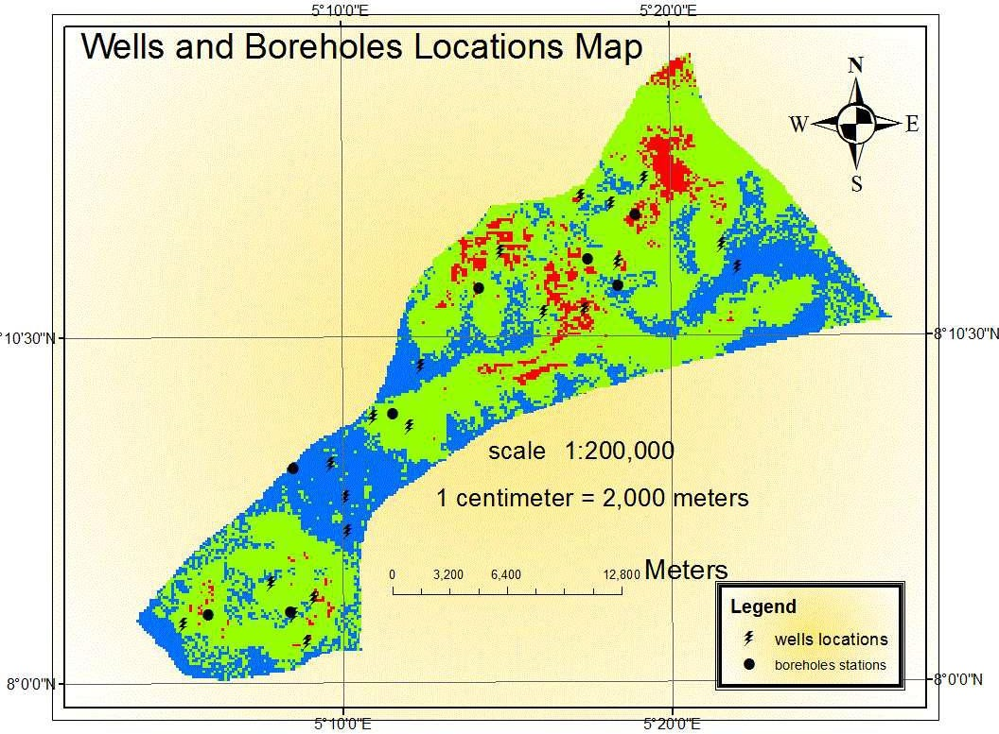

Figure 4.11: Boreholes and wells Locations

# Water demand for Oke-Ero LGA

Oke-Ero LGA was estimated to have a population of 56,970 in 2006 census figures with a projection of 76,900 in 2016 by national population commission of Nigeria and the population was projected in this work to 2040using geometric population projection formula and 3.05% growth rate, the population was projected to be 158,226 in 2040 as presented in Figure 4.12 and Table 4.5.

Table 4.5: Population Projection

|  |  |  |  |  |  |  |  |
| --- | --- | --- | --- | --- | --- | --- | --- |
| Oke-Ero  LGA | Census  2006 | Projected population | | | | | |
| Year | 2016 | 2020 | 2025 | 2030 | 2035 | 2040 |
| Population | 56,970 | 76,935 | 86,760 | 100,823 | 117,156 | 136,156 | 158,226 |

|  |  |  |  |  |  |  |  |  |
| --- | --- | --- | --- | --- | --- | --- | --- | --- |
|  |  |  |  |  |  |  |  |  |
|  |  |  |  |  |  |  |  |  |
|  |  |  |  |  |  |  |  |  |
|  |  |  |  |  |  |  |  |  |
|  |  |  |  |  |  |  |  |  |
|  |  |  |  |  |  |  |  |  |
|  |  |  |  |  |  |  |  |  |
|  |  |  |  |  |  |  |  |  |
|  |  |  |  |  |  |  |  |  |

Figure 4.12: Population projection

From the survey output the average daily water demand in Oke-Ero is 2.5 gallons/capita/day which is the same as 62.5liters/capital/day plus agricultural related economic activities and loss at 15% and 5% respectively which is equal to 75l/c/d in total. Table 4.6 provided the water demand, total water demands across the LGA in year 2016 according to the population estimated was 2.11MCM/year. This is anticipated to increase to 4.34MCM/year by 2040 with anticipated 3.2% water demand increase rate every year.