# ASSESSMENT OF GNSS-BASED INTEGRATED WATER VAPOUR OVER NIGERIA CORS NETWORK

Water vapour is a very dynamic component of the atmosphere. It greatly influences the atmospheric stabilization mechanism. Hence, it is very difficult to measure or model using classical meteorological systems or models. Tropical atmosphere holds the largest amount of water vapour, thus its characteristics of high climate uncertainty. Interestingly, geodesists have devised methods for estimating the extent to which signals propagated from GNSS satellites to ground‐based GNSS receivers are delayed by atmospheric water vapor. This delay is parameterized in terms of a time‐varying zenith wet delay (ZWD) which is retrieved by stochastic filtering of the GNSS data. Given surface temperature and pressure readings at the GNSS receiver, the retrieved ZWD can be transformed with very little additional uncertainty into an estimate of the integrated water vapor (IWV) overlying that receiver. Therefore, this study is to assess the integrated water vapor over NIGNET CORS using GPS data. Three specific objectives were set for the study which was conducted in three phases. The first objective assessed the Zenith Path Delay (ZPD). The highest and the lowest ZPD estimates are respectively 2731.104mm at station ULAG and 2129.924mm at station CGGT and the analysis showed good correlation with the IGS (ZPD). The average correlation (R2) of 70% was obtained showing a very strong agreement with IGS estimation. The second objective was the estimation of IWV. Surface temperature and pressure data were utilized to obtain the integrated water vapor (IWV). The surface temperature and pressure data of the NIGNET CORS were not readily available, therefore the GPT2w_1 model was used to generate the surface temperature and pressure. The surface temperature and pressure were then used to compute the weighted mean temperature which was combined with the ZWD to obtain IWV. Spatial and seasonal variation of IWV value over the NIGNET CORS was performed and it was found that the highest IWV values were obtained over the southern stations just as the rainy season presents the period of high IWV values over all stations. The estimated IWV was validated with IWV generated from ECMWF ERA-5 interim data and it shows a considerable correlation with the estimated NIGNET IWV, the average correlation of 0.6 was obtained. It was deduced from the study that GPS-based IWV properly captured the IWV trend over Nigeria. It is strongly recommended that assessment of IWV over all the NIGNET CORS should be extended for longer years for better spatial and temporal analysis.

# CHAPTER ONE

* 1. **INTRODUCTION**

## Background to the study

Water vapour is the most dynamic component of the atmosphere, and it also plays a key role in atmospheric processes. Water vapour has a very significant impact on GNSS data operational analyses (OA) in term of precision. Therefore, it is important that the amount of water vapour in the atmosphere is experimentally quantified accurately (Choy *et al.,* 2015). More so, atmospheric water vapour is the dominating greenhouse gas, and so estimating the quantity of water vapour feedback of global warming is of great importance. Indeed, numerical experiments suggest that this effect is substantial. As the climate is warming due to increasing carbon dioxide and other anthropogenic greenhouse gases, water vapour is expected to increase rapidly as models broadly conserve relative humidity (Soden *et al.,* 2005).

However, commencement of studies on atmospheric water vapour through ground-based GPS technique started in 1992, Bevis *et al*. (1992) which has been on a continuously increasing curve of improvement and evaluation Tregoning *et al.* (1998) because of its significance in operational weather forecasting, climate management and monitoring, atmospheric exploration, among other vast applications. In addition to the GNSS data, site dependent surface pressure and weighted mean temperature values are unavoidable parameters to derive the precipitable water vapour (PWV) from the atmospheric delay, which can be obtained from a collocated meteorological sensor. The meteorological sensor records the surface pressure and temperature data concurrently at the GNSS site to an acceptable degree of accuracy (Wonnacolt, 2005). The required Tm values for PWV estimation can be

estimated from the surface temperature using models turned to the specific area and season (Davis *et al.,* 1985; Bevis *et al.,* 1992, 1994; Mendes *et al.,* 2000; Schueler *et al*., 2001; Musa et al., 2017). In absence of collocated meteorological sensors these station-specific meteorological parameters can be derived from the available numerical weather prediction (NWP) models’ predicted meteorological data using a variety of interpolation techniques (Opaluwa *et al.,* 2014b). (Bevis *et al*. 1994) have given a simple ratio for PWV/ ZWD = Q

0.15 (where ZWD is zenith wet delay), but the actual values of Q can vary to a magnitude as much as 20% with respect to location, altitude, season, and weather. Availability of the aforementioned parameters has to some extent eliminated the need of ***Tm*** values to retrieve PWV from ZWD. Osah *et al.* (1996) investigated the possibility of using global meteorological data from the National Centres for Environmental Prediction (NCEP) to derive the surface pressure at a few International GNSS Service (IGS) tracking stations by interpolating upper level atmospheric fields in order to eliminate the use of high-precision barometers. For this research the GPT model is used for the interpolation of temperature and pressure which are used for the computation of IWV data using the ZPD data computed from Bernese 5.0 software.

Tropical atmosphere holds the largest amount of water vapour; thus, it is characterized with high climate uncertainty (Opaluwa *et al.,* 2014b). Unfortunately, available meteorological systems and models have challenges in properly capturing the atmospheric dynamics due to poor temporal and spatial resolutions. Interestingly Geodesists have devised methods for estimating the extent to which signals propagating from GNSS to ground‐based GNSS receivers are delayed due to atmospheric water vapour*.* Hence, a GNSS-based estimate of atmospheric water vapour has become a valuable input parameter for Numerical Weather

Prediction (NWP) (Bock *et al.,* 2007). Thus, assimilation of the GNSS Integrated Water Vapour (IWV) into Numerical weather models has become popular recently across the globe and has greatly improved weather outlook. This is valuable for flood inundation modelling and prediction. However, flooding has assumed a disaster status in most part of Nigeria recently but availability of GNSS infrastructure in Nigeria is relatively new, hence, adopting GNSS for meteorology. Subsequent section presents a review of the integrated water vapour from GNSS data over Nigerian Continuously Operating Reference Stations (CORS).

## Global Navigation Satellite System (GNSS)

A GNSS is an ensemble of satellites gyrating about the Earth, constantly transmitting signals that provide three-dimensional (3D) positions globally to the users with a GNSS signal receptor/sensor. Over years, US Global Positioning System (GPS) has been the only fully operational GNSS system. In December 2011, the Russian GLObal NAvigation Satellite System (GLONASS) was reinstated to full operation. The Chinese COMPASS and BEIDOU, European GALILEO and EGNOS systems (Sarkar *et al.,* 2018). The Japanese MSAS, QZSS and SBAS and the Indian IRNSS are currently under development, notwithstanding BEIDOU commenced preliminary operating service (Phase II) in December 2011. Principle of GNSS positioning is based on solving a fundamental geometric problem, consisting of the distances (pseudo-ranges) of points on Earth to a group of at least four (4) GNSS satellites with well-known coordinates. The ranges and coordinates of satellites are computed by the user’s receiver using navigation data and signals transmitted by the satellites; the determined coordinates can be computed to an accuracy of several meters. Nonetheless, centimeter-level positioning is feasible and realizable using more advanced techniques (Fisher & Raquet., 2011).

## GPS Meteorology

GPS meteorology otherwise, GPSMET is a state-of-heart application of GPS to climatological and meteorological studies. It takes its basis in the fact that navigational signals passes through the atmospheric layers before they are received by the GPS receivers located on or near the earth surface. The signals in their process of transmission, carry diverse information about the atmosphere among others; the zenith path delay, the water vapour. The zenith path delay is a very useful parameter to the meteorologists as it can be decomposed into zenith dry delay (ZHD), and zenith wet delay (ZWD). ZHD is a function of pressure content of the atmosphere while the ZWD is a function of atmospheric temperature (Niell *et al.,* 2001).

These components are key parameters in atmospheric science and weather prediction can be measured or estimated with GPS in a near real time sense, this give even a large sensitivity to the use of GPS in meteorology (Stensrud, 2009).

## Statement of Research Problem

Water vapour is a very dynamic composition of the atmosphere. It greatly influences the atmospheric stabilization mechanism (Opaluwa *et al.,* 2014a*)*. Hence, it is very exhaustive to measure or model using classical meteorological systems or models. Tropical atmosphere holds the largest amount of water vapour, thus it characterizes high climate uncertainty (Opaluwa *et al.,* 2014b). Interestingly, Geodesists have devised methods for estimating the extent to which signal propagating from GNSS to ground‐based GNSS receivers are delayed by atmospheric water vapour.

Nigeria as a tropical nation is also faced with the challenges posed by the dynamics of atmospheric water vapour. Unfortunately researches into understanding the characteristics of

this highly variable greenhouse gas has been limited to the use of data from meteorological tools and models from synoptic and satellite remote sensing. However, these data sources are known to be subjected to atmospheric influence such as cloud cover and others have poor spatial and temporal resolutions due to high cost of deployment. In 2010, Nigerian Government in collaboration with African Reference Frame (AFREF) project established a network of GNSS CORS across the country and it is being developed further. The capacity of GNSS for meteorological applications has been widely affirmed in literature (e.g. Vey *et al., 2010,* Opaluwa *et al.,* 2014b*,* Bevis *et al.,* 1994) but yet to be explored in Nigeria. Hence, this study seeks to explore the applicability of GNSS data for estimation of atmospheric water vapour.

## Aim and Objectives of the study

The aim of this study is to assess the integrated water vapour from GNSS data over Nigerian Continuously Operating Reference Stations (CORS) for a period of one year (2011). The specific objectives are to:

1. Estimation of Zenith Path Delay (ZPD) over NIGNET GPS CORS using Bernese

5.0 software

1. Estimation of GNSS-Based Integrated water vapour (IWV) over Nigeria
2. Validation Analysis of the estimated water vapour using integrated water vapour (IWV) from Meteorological observation with Numerical Weather Model (NWM).

## Justification for the study

The application of GPS in meteorology and other area of space and atmospheric study has offered a more flexible and prompt access to atmospheric data. Tropospheric delay is a function of local temperature, pressure and relative humidity. Therefore, the current practice

across the globe is the use of the GNSS data to support meteorology to improve weather outlook and climate studies (Opaluwa *et al.,* 2017). This is important to capture the dynamics of tropical climate. Unfortunately, Nigeria as a tropical nation is not well studied as regards GNSS meteorology, available studies have based their findings on few days to few weeks GNSS data (e.g. Dodo *et. al.,* 2015). Also, the seasonal and annual trend of this highly dynamic parameter over Nigeria is yet to be known, hence the justification for this study. The availability of the expanded GNSS CORS provide a robust platform for continuous R and D of GNSS meteorology

## Scope and limitation of the study

* + 1. **Scope of the study**

This research work focuses mainly on estimation of water vapour content using a GNSS technique. A year span of GPS data was acquired across Nigeria over the Nigerian Geodetic Network and processed using Bernese GPS software version 5.0 in the estimation of ZPD. Then data from IGS stations were downloaded for validation of the estimated ZPD values using appropriate statistical tools. Also, Global Temperature and Pressure wet model (GPT2W_1) was adopted in the estimation of local temperature, pressure at the respective GPS stations. Sofware like panoply was utilized in visualization of the atmospheric data in the NETCDF format. Also MATLAB program was developed and utilized in the estimation of ZHD, ZWD and IWV. A Numerical Weather Model data was downloaded for the validation of the estimated IWV and a statistical approach was adopted in the validation of the results.

## Limitations of the study

Due to the inaccessibility of the latest version of the GNSS scientific software (Bernese 5.2), the previous version was employed in this research. The archive data of NIGNET 2011 was employed in this research due to the unavailability of the NIGNET website as at the time of this research for current data. The success of GNSS data processing using Bernese GPS Software 5.0 is largely dependent on the Bernese processing engine (BPE) and the BPE also on Central Processing Unit (CPU) of the computer system. The CPU should possess quite high specification properties for a successful GNSS data processing (e.g. the processor’s speed of above 2.0 GHz, the RAM capacity of at least 8 GB, the hard disk’s memory space of not less than 500GB).

## Significance of the Study

The result of this research will be of great benefits to the geodesists in their practice considering the fact that the importance of accuracy/precision in survey cannot be over emphasized. The existence of integrated water vapour (IWV) in the atmosphere (medium of signal transmission) poses a serious challenge in our observation knowing fully the role it plays in precise point positioning (PPP) of GNSS positioning. This study therefore, will be of great use to the surveying and other geodetic studies and researchers. It will similarly be a great improvement to the meteorological communities in retrieval of data for examining the state of the atmosphere in a near real time sense for weather prediction and other applications.

## Study Area

The study area, Nigeria, lies between latitudes 4°and 14°N and longitudes 2°and 15°E, and is located in the western part of Africa. The total area of the country is about 923,768km2

making it the thirty-second (32nd) largest country in the world. It shares about 4,047km borders with four (4) countries (Benin Republic to the west, Niger Republic to the north, Chad to the north east and Cameroon to the east). It has a coastline of at least 853 km stretching along the Atlantic Ocean in the southern border. Figure 1.1 depicts the map of Nigeria and the location of NIGNET CORS.

Nigeria has a varied landscape; to the southwest of the Niger is a rugged highland and to the southeast of the Benue is the Mambilla Plateau, which forms the highest Plateau in the country. The highest elevation point in Nigeria (2,419metres above sea level) is located in Chappal Waddi in the Northern State of Taraba. The country has two major rivers, namely; the River Niger and River Benue that converged in a “Y” shaped valley in Lokoja, and emptied its waters into the Atlantic Ocean in the Niger Delta area of the southern part of the country.

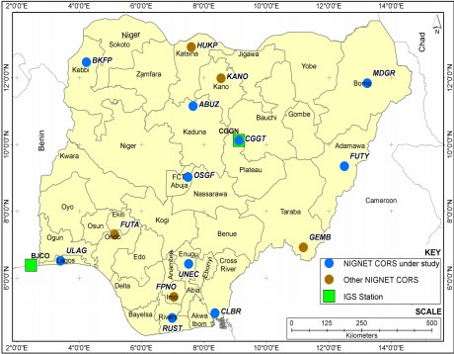

Figure 1.1: Nigeria map showing the GNSS stations available in Nigeria Source: (Ayodele, *et a.,* 2019)

# CHAPTER TWO

* 1. **LITERATURE REVIEW**

## Ground-Based GPS Meteorology

GNSS radio waves are delayed by the neutral atmosphere, which results in a positive bias in the range measurements. This delay is one major error source in GNSS processing and is traditionally known as the “tropospheric delay.” This error must be dealt with appropriately to achieve precise positioning. In GPS processing, the tropospheric delay can be computed as zenith path delay (ZPD) (often used inter-changeably with “zenith tropospheric delay” abbreviated as ZTD). The equations (1) up to (4) are used in the computation of ZPD, ZHD and PWD as documented by (Hajj *et al.*, 2004).

𝑍𝑃𝐷 = (𝑚𝑓h(θº) ∗ 𝐻𝐷) + (𝑚𝑓𝑤(θº) ∗ 𝑊𝐷) (1)

Where, mh (θº) and mw (θº) are the dry and wet mapping functions respectively while, HD and WD are the dry and wet delay thus, and we have:

𝑍𝑃𝐷 = 𝑍𝐻𝐷 + 𝑍𝑊𝐷 (2)

From ZPD, ZWD can be obtained by subtracting ZHD from ZPD. If the surface pressure (𝑃𝑠) at the station is known as well as the station latitude (∅) and height (ℎ), thus, ZHD can be computed by

(2.27688 ± 0.0005)𝑃𝑠

𝑍𝐻𝐷 = 1 − 0.00266𝑐𝑜𝑠20𝑜 − 0.00028ℎ (3)

Where Ps is the surface pressure ZHD is the Zenith hydrostatic delay. ZPD is defined as the sum of the hydrostatic (ZHD) caused by the atmospheric gases such as nitrogen, oxygen, argon and carbon dioxide, and non-hydrostatic or wet (ZWD) delays, which is mainly contributed by water vapor contained in the atmosphere, as shown in

ZHD is generally very stable and is easily determined using an empirical model such as the Hopfield models (Hopfield *et al.,* 1969) and constitutes more than 80% of the total path delay. ZHD can reach up to about 2.3m in the zenith direction and up to 30m for a slant path close to the Earth’s surface (Jennifer *et al.,* 2003). Given surface pressure measurements, it is usually possible to model and remove the hydrostatic delay with accuracy of a few millimeters or less, at the zenith the Hydrostatic is direct and opposite which is -90 ZHD and

+90 ZHD. On the other hand, the ZWD delay is more spatially and temporally variable and is more difficult to eliminated than the ZHD. The ZWD can be as small as a few centimeters or less in arid regions and as large as 35 cm in humid regions it is actually 10%. As it is impossible to accurately measure the wet delay from surface meteorological measurements, GNSS scientists determine the hydrostatic delay from surface measurements and then attempt to estimate the wet delay as part of the data processing. ZWD may be converted to PWV via a dimensionless conversion factor (Π)

𝑃𝑊𝑉 = 𝑍𝑊𝐷. 𝛱 (4)

## Zenith Path Delay

The Global Positioning System (GPS) is an important tool for the estimation of atmospheric water vapour. The GPS signals traveling from satellite to receiver propagate through the atmosphere. The signals are delayed due to the amount of dry gases and water vapour in the troposphere layer as the result of refraction and diffraction. This increase the time taken for the signal when it travels through the troposphere. The effects are called tropospheric refraction, tropospheric path delay or simply tropospheric delay (Hirahara, 2000). The tropospheric delay can be divided into dry and wet components. The dry component is caused by the dry air gases in the atmosphere such as nitrogen (78%) and oxygen (21%) with only

small concentrations of other trace gases. The wet component however depends on the humidity content of the troposphere and contains significant levels of water vapor (Bevis *et al.,* 1992). The total delay in the GPS signal is known as the slant path delay, or in zenith direction known as Zenith Total Delay (ZPD) or Zenith Path Delay (ZPD). The ZPD also consists of the hydrostatic and wet component which are known as the zenith hydrostatic delay (ZHD) and the zenith wet delay (ZWD) also known as zenith non hydrostatic delay, respectively. The ZWD can be expressed in terms of Integrated Water Vapor (IWV) and the IWV was realized as a useful quantity for meteorological applications (Bevis *et al.,* 1992). In a study by Musa *et al.* (2011), the ZPD estimation was conducted from two CORS networks – the Australian Regional GPS Network (ARGN) and the Malaysian Real-Time Kinematic network (MyRTKnet), which stretches from the low latitude to the mid latitude region. Moreover, the IGS (International GNSS Service) stations were included in the ZPD estimation process so as to provide an opportunity to assess the estimated ZPD against the IGS derived troposphere products. The estimated ZPD are expected to be valuable for a wide variety of climate and weather applications.

## Zenith Path Delay (ZPD) Estimation

∆𝐿 = ∫𝑛(𝑠)𝑑𝑠 − 𝐺

𝐿

(5)

Where 𝑛(𝑠) is the refractive index as a function of position s along the curved ray path 𝐿, and 𝐺 is the straight-line geometrical path length through the atmosphere. Equation (1) is further re-written as (Opaluwa *et al.,* 2014).

∆𝐿 = ∫[𝑛(𝑠) − 1]𝑑𝑠 + [𝑆 − 𝐺] (6)

Were 𝑠 is the path length along 𝐿 the first term on right is due to slow bend and the second term is due to refraction in the signal propagation.

Thus;

𝑃𝑑

𝑃𝑣

𝑃𝑣

𝑃𝑐

𝑁 = 𝑘1 ( 𝑇 ) + 𝑘2 ( 𝑇 ) + 𝑘3 (

𝑇

) + 𝑘 (

𝑇

2 4

2) (7)

Where𝑃𝑑 , 𝑃𝑣 , and 𝑃𝑐 are the partial pressure of dry air, water vapour and carbon dioxide respectively (in millibars) and 𝑇 is the absolute temperature (in Kelvin). While 𝑘1, 𝑘2, 𝑘3 and

𝑘4 are the refraction coefficients given (Opaluwa *et al.,* 2014). Since the troposphere is neutral and non-dispersive, its refractive index depends on temperature, pressure, humidity, compressibility and electric characteristics of the molecules (Opaluwa *et al.,* 2014b).

However, the total tropospheric delay depends on the zenith distance or elevation angle of

the satellite. If zenith distance is z then the propagation path delay is proportional to 1

𝑐𝑜𝑠𝑧

interactions between the GPS radio signal and the atmosphere is depicted in figure 2.1

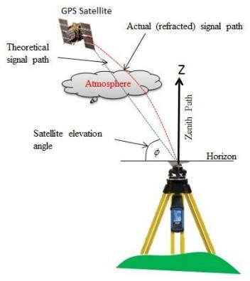

Figure 2.1: Atmospheric effect on GPS signal Source: (Opaluwa *et al.,* 2014).

. The

𝑧 = 90𝑜 − ∅ (8)

Hence, 1

𝑐𝑜𝑠𝑧

= 1

𝑠𝑖𝑛

∅ (9)

Where ∅ is the satellite elevation angle, this angle help to estimate tropospheric delay zenith direction in the GPS computation separately including station coordinate and the receiver clock delay? The zenith path delay (ZPD) consist of two component which are the zenith hydrostatic delay (ZHD) and the zenith non-hydrostatic delay also known as the zenith wet delay (ZWD) in computing zenith total delay also known as the zenith path delay (ZPD) is given by the equation. (2). It then means if zenith path delay (ZPD) can be estimated and the zenith hydrostatic delay (ZHD) which is the dry delay then zenith wet delay can be computed. Thus the zenith hydrostatic delay (ZHD) is about 90% of the zenith path delay (ZPD); it varies smoothly with surface pressure which means that at the zenith ZHD is equal and opposite therefore, it can be effectively modelled as given in equation. (10) and (11) by (Wickert *et al.,* 2012).

𝑃𝑠

𝑍𝐻𝐷 = (2.2779 ± 0.00024)

𝑓(∅, ℎ)

(10)

Where 𝑃𝑠 is the total pressure (in millibars) at the Earth's surface, and

ƒ (, ℎ) = 1 − 0.00266𝑐𝑜𝑠2 ∗  − 0.00028ℎ 11

## Integrated Water Vapour (IWV)

Water vapour, the most variable of the major constituents of the atmosphere, plays a key role in atmospheric processes and also it has a significant impact on radio propagation at millimeter wavelengths. Therefore, it is important that the amount of water vapour in the atmosphere is experimentally quantified accurately, with frequent sampling and under all

weather conditions. For instance, the knowledge of water vapour field comes usually from radio-soundings and ground or space based water vapour radiometers (WVR). Radiosonde observations (RAOB’s) produce accurate measurements of the water vapour profile, but the availability of data does not meet the requirements of frequent sampling of such parameter, taking into account the high degree of variability. Ground-based microwave radiometers are able to work continuously for the retrieval of integrated precipitable water vapour (*IPWV*) with a high temporal resolution, but providing measurements not reliable during rainfall.

Considering the growing employment of Global Positioning System (GPS) ground-based receivers as a microwave (LBand)

Remote sensing tool for the estimation of integrated precipitable water vapour, *IPWV* becomes available with high temporal and spatial resolution, taking into account that GPS estimates are not affected by rainfall, and GPS can therefore be considered an all-weather system.

## Water vapour modelling

The information about content of water vapour (2-D model) above GNSS stations, represented by Integrated Water Vapour (IWV), is obtained directly from ZWD. The relation between ZWD and the water vapour content in the atmosphere is expressed by IWV (Bosy *et al.,* 2012) and given by the equation

𝐼𝑊𝑉 =

𝑍𝑊𝐷 10−6 . 𝑅𝑤

(𝑘′ +

2

𝑘3 −1

)

𝑇𝑀

(13)

Where 𝑅𝑤 = specific gas content for water vapour K1, k2 are the refractive content of the water TM is weighted mean water vapour temperature atmosphere T0, is the surface temperature. The ZWD is derive from equation (14)

𝑍𝑊𝐷 = 𝑍𝑃𝐷 − 𝑍𝐻𝐷 𝑜𝑟 𝐼𝑊𝑉 = 𝑍𝑃𝐷 − 𝑍𝐻𝐷 (14)

ZHD are derived from Saastamoinen model (1972). The input parameters for ZHD computation are surface meteorological parameters (temperature, pressure) interpolated for Nigeria CORS. Therefore, it is possible to derive IWV for any location inside the NEGNET network as presented in equation (18) (Bosy *et al.,* 2012).

## The Estimation of Integrated Water Vapour from GPS ZWD

This process involves the conversion of the GPS derived ZWD to the IWV. The two parameters required are the weighted mean temperature (*Tm*) of the atmosphere and the conversion parameter (K) thus, if the surface pressure and temperature at the GPS stations are known, the *Tm* parameter can be obtained as (Davis *et al.*, 1985):

𝑒

𝑇𝑚 = ∫ (𝑇) 𝑑𝑧

𝑒

∫ ( ) 𝑑𝑧

2

𝑇

(15)

Where *e* is water vapour pressure, *T* is as defined earlier.

The commonly used global *Tm* parameters are usually derived from radiosonde and surface temperature (*Ts)* in Kelvin (K) using linear regression technique. (Opaluwa *et al.*, 2017): derived the global *Tm* parameters as:

𝑇𝑚 = 70.2 + 0.72𝑇𝑠 (16)

𝑊ℎ𝑖𝑙𝑒 𝐾 𝑖𝑠 𝑔𝑖𝑣𝑒𝑛 𝑎𝑠:

𝐾 =

106

𝐾3

(17)

(( ⁄𝑇𝑚) + 𝐾2) 𝑅𝑣

Where Rv, is a gas constant for the water vapour, Pw is the partial water vapour K2 and K3 are as defined earlier while, *Tm* is the weighted mean temperature of the atmosphere. Then the IWV can be derived as given in equation 18 (Opaluwa *et al.*, 2017):

𝐼𝑊𝑉 = 𝐾(𝑇𝑚). 𝑍𝑊𝐷 (18)

This procedure as detailed in this section summarized the fundamental background for the GPS meteorology especially, using the ground-based GPS observations. Therefore, developments in ground-based GPS meteorology are subsequently examined.

## Water vapour observing techniques

Concerning its important role in the climate system as well as high spatiotemporal variability, tremendous efforts based on a variety of platforms, like ground-based remote sensing techniques, have been made for sensing the atmospheric water vapour. In this section, an overview of several commonly used water vapour observing techniques, apart from GNSS, are presented. This includes the radiosondes, water vapour radiometers, Very Long Baseline Interferometry (VLBI), Doppler Orbitography Radio positioning Integrated by Satellite (DORIS), and numerical weather models.

## Radiosonde

Traditionally, radiosondes are considered as the predominant upper air observing systems. Radiosondes are balloon-borne instruments equipped with different sensors that measure temperature, pressure, humidity, and wind velocity and transmit the results to the ground station using radio signals. The radiosonde profiles provide atmosphere information up to an

altitude of approximately 30 km. The radiosonde balloons are launched every 12 or 24 hours per day in most cases. The atmospheric water vapor can be retrieved from the integration of the vertical absolute humidity profiles given by the radiosonde profiles. A global network consisting of more than 1300 radiosonde stations has been deployed, including in ocean areas, where the radiosonde observations are taken by about 15 ships equipped with automated shipboard upper-air sounding facilities (Kawatani *et al.,* 2016).

## Water vapor radiometer

The water vapor radiometer (WVR) is able to measure the background microwave radiation emitted by the atmospheric water vapor, so as to infer the wet tropospheric delays and integrated water vapor from the measurements (Pacione *et al.,* 2001). Normally, the spectral line of water vapor is centered at 22.235 GHz. The sky emission at a frequency close to this line can be observed by WVR, which is then used to infer the wet delay. Meanwhile, the WVR is capable of providing the integrated water vapor (IWV) along the line of sight, with a considerably good temporal resolution. Typically, two different frequencies are performed in WVR in order to distinguish the contribution of water vapor from that of liquid water. One frequency that is more sensitive to water vapor is about 22.2 GHz, while the other one that is sensitive to the liquid water is usually close to 30 GHz (Teke *et al*., 2011). Based on the measurements of sky brightness temperature at two frequencies, the wet tropospheric delay can be calculated (Elgered, 1993). The accuracy of a WVR is determined by the choice of frequencies as well as the absolute accuracy of brightness temperature. Calibrations are always required for the sake of derivation of atmospheric water vapor with high accuracy.

The most obvious advantage of a WVR is its capacity of providing almost continuous water vapor measurements (Diedrich, *et al.,* 2016).

## Numerical weather models

The numerical weather prediction (NWP) aims to providing weather forecasts, especially for the short-term severe weather events and precipitation. In NWP, a couple of non-linear partial differential equations that describe the change of the atmospheric conditions including pressure, temperature, humidity, wind etc. are considered as the principal factor, along with the numerical solutions with regard to these equations (Gutman and Benjamin, 2001). The realization of NWP models is accomplished after solving the initial value problem, i.e. the initial conditions or state of the atmosphere. This process is referred as the so-called data assimilation, while the resolved atmospheric state is named as an analysis. The numerical weather models (NWM) use a large variety of meteorological observations to describe the atmospheric dynamics and compute weather forecasts. They are largely dependent on the thermodynamics, conservation laws, and the physical laws of fluid dynamics. Unlike the existing observation systems, no new observations are generated from a NWM. Instead, the NWM assimilates a great number of different meteorological observations into a prediction based on the model background provided by atmosphere physics. They are able to provide the whole information for describing the neutral atmosphere, from which the meteorological parameters like temperature, pressure, humidity and wind velocity can be obtained at any location and at any time by applying interpolation, within the area and time window considered by the model (Pany *et al.,* 2001). In addition, the information of tropospheric delays and horizontal gradients, as well as the precipitable water vapor or integrated water vapor at a given location can also be supplied by a modern NWM.

## Global Navigation Satellite System (GNSS)

The Global Navigation Satellite Systems (GNSS), including the US’s Global Positioning System (GPS), Russia’s GLONASS, EU’s GALILEO and China BEIDOU (also known as COMPASS). There are several regional navigation satellite systems, this satellite systems can be characterized as a more precise, continuous, all-weather and near real-time microwave (L-band) technique with signals through the Earth’s atmosphere. These characteristics of GNSS shows more and wider applications and potentials. Each GNSS satellite continuously broadcasts radio signals in two or more frequencies in L-band (1–2 GHz) with wavelength around 20 cm, the direct signals are been used for navigation, positioning and timing. The refracted signals from GNSS Radio Occultation satellites together with ground GNSS observations can provide the high-resolution tropospheric water vapor, temperature and pressure, troposphere parameters and ionospheric total electron content (TEC) and electron density profile as well. (Khojasteh *et al* 2016).

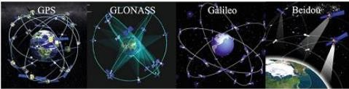

Figure 2.2: Global Navigation Satellite Systems (GNSS).

Source: (Khojasteh, *et al* 2016)

## GNSS Signals

GNSS signals are summarized in Table 2.1 (Hofmann-Wellenhof *et al.* 2007). For instance, GNSS satellites continuously broadcast right-hand circularly polarized signals with both the navigation message and ranging codes modulated on two L-band microwave carrier

frequencies, i.e., the L1 (f1=1.57542 GHz, λ1≈19.0 cm) and L2 (f2=1.2276 GHz, λ2≈24.4 cm). Starting from 2006, as part of GPS modernization effort, two new GPS users use signals L2C (L2 frequency, C denoting user) and L5 (fL5=1.17645 GHz, λL5≈25.5 cm) were broadcasting on the new generation GPS satellites. Also another user use frequency L1C is down the road in the near future. The navigation message includes the ephemeris data, used to calculate the position of the individual GPS satellite in orbit at the time of signal transmission, and the almanac data with the information about the time and status of the entire satellite constellation. On the other hand, the ranging code enables the user’s receiver to determine the transit (or propagation) time of the signal and thereby determine the satellite- to-user range (Khojasteh *et al.,* 2016.)

Table 2.1: GNSS Signals (Khojasteh, 2016)

|  |  |  |  |
| --- | --- | --- | --- |
| **SYSTEM** | **CARRIER** | **MODULATION** | **MULTIPLE ADDRESS** |
| GPS | L1/L2/L5 | BPSK/MBOC/QPSK | CDMA |
| GLONASS | L1/L2/L3 | BPSK/QPSK | FDMA/CDMA |
| Beidou | B1/B2/B3 | MBOC/BOCAlt BOC QPSK |  |
| Galileo | E1/E5/E6 E5a/E5b | BOCc/CBOC Alt BOC BPSK | CDMA |

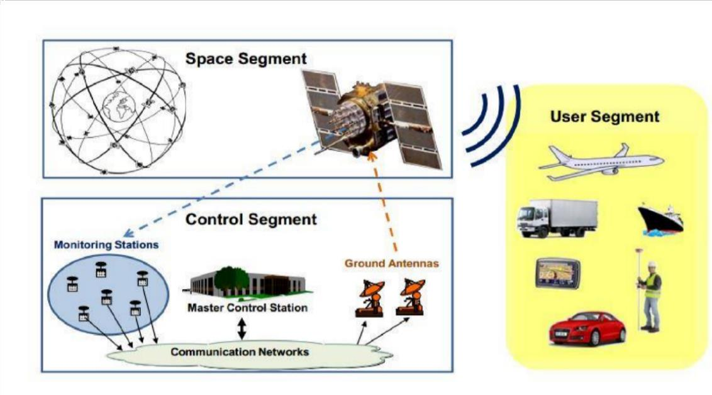

Figure 2.3: GNSS Architecture and segments Source: (Subirana, 2011)

GNSS satellites constantly transmit navigation signals at two or more frequencies in Lband. These signals consist of ranging codes and navigation data allowing users to compute the travel time from the satellite to the receiver and the coordinates of satellites at any epoch. The primary signal components are illustrated as follow:

1. Carrier: Sinusoidal Radio frequency signal at a given frequency.
2. Ranging code: Sequences of zeroes and ones allowing the receiver to compute the travel time of the radio signal from the satellite to the receiver. They are referred to as Pseudo-Random Noise sequences or Pseudo-random Noise codes.
3. Navigation data: A binary-coded message supplying information on the satellite ephemeris (Pseudo-Keplerian elements or satellite position and velocity), clock bias parameters, almanac (with a reduced-accuracy ephemeris data set), satellite health status and other complementary information.

As GNSS signal travels from the satellite in space to the receiver on the earth’s surface, it is influenced by a number of factors (Figure 2.2) that affect the precision of the final coordinates.

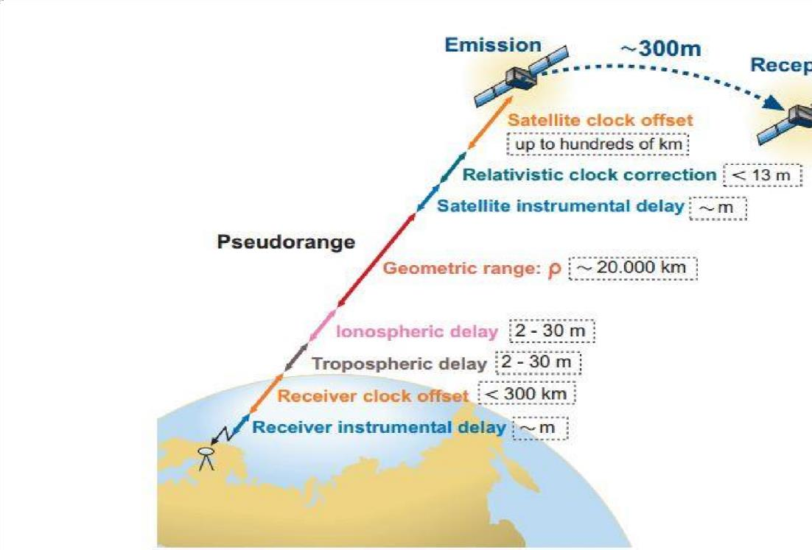

Figure 2.4: Reception and emission of satellite signals with the errors in observables Source: (Subirana, 2011).

## GNSS Errors

* + - 1. **GNSS Constellation Satellite Error**

GNSS constellation satellite error mainly includes inherent orbital position error of the satellite and clock error. The former is mainly caused by influences of various perturbative forces, number of monitoring station and spatial distribution, number and precision of orbital parameters, and non-real-time property of ephemeris, and the range error caused thereby is approximately within 1.5 m–7.0 m; ( Khojasteh *et al. 2016* ) influences on range error are tried to be weakened generally through simultaneous observation to work out the difference or method of orbit improvement to limit it within the error scope of 1 m. The latter refers to the nonsynchronous deviation between satellite clock and GNSS standard time due to

frequency offset and frequency drift between clock of GNSS constellation satellite and GNSS standard time; total quantity of such deviation may reach 1 ms, and equivalent range error caused thereby may reach 300 km; the deviation may correct the clock error model through continuous measurement of the ground station to limit the equivalent range error within 6 m; if residual error of GNSS constellation satellite clock is further weakened, it may be realized through differential technology. GNSS Signal Propagation Error (Khojasteh *et al.,* 2016).

## GNSS signal propagation error

This type of error mainly includes ionospheric refraction, tropospheric refraction, multipath error, etc.

* + - * 1. **Ionospheric refraction error:** Ionospheric refraction error is in direct proportion to atmospheric electron density and inversely proportional to the penetrated electromagnetic wave frequency. (Khojasteh *et al.,* 2016). Atmospheric electron density varies with radiation intensity of the Sun and other celestial bodies, season, time, geographic position, etc. For GNSS constellation satellite signal, randomness of solar activity is large, so the difference of impact of ionospheric refraction on GNSS navigation and positioning error is large, and it is impossible to establish precise mathematical model for it. During GNSS navigation and positioning, methods may be generally adopted to weaken the impact of ionosphere on the precision of GNSS navigation and positioning includes: (Khojasteh *et al.* 2016) correction through double frequency observation; (Hoffmann-Wellenhof & Walse, 2007) correction through simultaneous observation value to work out the difference, i.e., relative positioning method.
        2. **Tropospheric refraction error:** Tropospheric refractive index is irrelevant to frequency or wave length of electromagnetic wave, and reduces gradually with increase of altitude; it is also closely related to atmospheric pressure, humidity, and temperature. Since atmospheric convection is intensive and changes of pressure, humidity, and temperature are complicated, it is difficult for precise modelling, and range error generally caused thereby may reach nanometer. An effective method to reduce influence of tropospheric refraction on navigation and positioning error is to estimate the propagation delay of electromagnetic wave in the troposphere. Measures commonly taken at present mainly include working out the difference through simultaneous observation to effectively reduce or even eliminate influences on delay of troposphere; (Hoffman-Wellenhof *et al.,* 2007) improving atmospheric model of troposphere through measured data nearby the monitoring station.
        3. **Multipath error:** Besides directly receiving signals sent by GNSS constellation satellite, GNSS receiver also receives GNSS constellation satellite signals bent for once or many times by buildings surrounding the receiver antenna, i.e., during actual measurement, signals received by GNSS antenna are signals superimposed by direct and reflected wave. Phase delay may exist between reflected and direct wave since the length of path passed by the two signals is different, and multipath error is thereby caused (Khojasteh *et al.,* 2016). It is difficult to establish accurate error model due to the uncertainty of reflection coefficient of reflector and the distance between it and the receiver antenna. Measures may be taken to reduce multipath error at present mainly include trying to make GNSS receiver antenna avoid object surface with large reflection coefficient; using GNSS receiver antenna with good directivity such as the choking coil antenna (Hoffmann-Wellenhof *et al.,* 2007).

## Signal Reception Error

Such errors mainly include GNSS receiver measurement error, GNSS receiver clock error, antenna phase center error, etc. Among them, besides related to measurement resolution of software and hardware of GNSS receiver for constellation satellite signals, GNSS receiver measurement error is also related to installation precision of GNSS receiver antenna. GNSS receiver clock error is related to the receiver, so the clock error may be taken as an unknown parameter to estimate such error by working out the pseudo range equation; influences of such error may also be eliminated by working out the differential treatment through observation quantity. Antenna phase center error is caused by different incident angles, and equivalent range error may reach a few millimeters or even a few centimeters according to conditions of antenna performance.

## GNSS Error Sources

GNSS User Errors are classified into the three segments of GNSS structure. The segments are space segment, control segment and the user segment. In space segment, the source of error can be satellite clock stability, satellite perturbations or selective availability (turned off in May 2001). The control segment the feasible error is ephemeris prediction and the user segment contain the major part of errors due to Ionospheric delay, Tropospheric delay, receiver noise, multi-path, indoor positioning or due to urban gorges. The following are the error sources.

1. Satellite and receiver clock errors
2. Satellite orbit errors
3. Atmospheric effects (ionosphere, troposphere)
4. Multipath: signal reflected from surfaces near the receiver
5. Antenna phase centre
6. Solar radiation pressure
7. Satellite Geometry
8. Relativistic Effects
9. Receiver noise
10. Signal Obstruction

GNSS employs RINEX (Receiver Independent Exchange) format for storing and processing data.

The RINEX format consists of the followings:

* + Observation Data File
  + Navigation Message File
  + Meteorological Data
  + File GLONASS Navigation
  + Message File
  + Galileo Navigation Message File
  + GEO Navigation Message File
  + Satellite and Receiver Clock Date File
  + SBAS Broadcast Data File
  + Satellite Ambiguity file
  + Satellite Velocity file

## Continuously Operating Reference Station (CORS)

Nicholas. (2010) defined CORS as Continuously Operating Reference Station, which can take the place of a traditional base station used in differential GNSS positing. CORS can give

an instant high positional accuracy of ±20 mm. CORS Network began in 1994 when NGS officially installed permanent GPS receiver in the National Institute of standards and Technology, Gaithersburg Campus, Maryland, and few months later in Colorado, which were later incorporated with three other continuously operating GPS stations that are originally part of CIGNET to become the first five stations in CORS Network. By 2000, more than 200 CORS stations are installed and incorporated into the NGS’ CORS Network. By the first quarter of 2014, the CORS network increased to more than 1,900 sites, which is why it is now regarded as the primary source for geodetic survey community to access National Spatial Reference System (NSRS) data. CORS networks are now established in different countries and by different organizations due to its high geodetic data accuracy (±20 mm). The development of CORS networks are categorized into three tiers as noted by (Rizos & Satirapod, 2011). These are as follows;

1. Tier 1 stations are the stations with International Global Service (IGS) grade 1 standards
2. Tier 2 stations as National Geodetic Network, and
3. Tier 3 stations are networks established by private institutions, state and local agencies.

The Tier 1 stations are high accuracy stations (±20 mm) with class 1 geodetic receivers and well stabilized antenna monument capable of tracking any Regional Navigation Satellite System (RNSS) and GNSS signals (Naibbi and Ibrahim, 2014). These stations are used to define and establish global reference frame and are also used in scientific research and geodetic sciences. Similarly, the Tier 2 are also high accuracy stations, but are maintained at state and national government levels. They are also equipped with good quality geodetic

receivers and their antennas are stationed on a stabilized monument. They can also track signal broadcast from GNSS and RNSS (Snay & Soler, 2008). These stations are mostly established for the purpose of national geospatial reference frame (geocentric datum). Conversely, the Tier 3 are high stations but with minimum requirements compared to tier 1 and 2 stations. The Tier 3 stations are mostly established by local government, state, private organizations and agencies for positioning purposes. They are also referred to as “fit for purpose” stations (Schwieger *et al.,* 2009). They are equipped with receivers that can track interoperable GNSS and RNSS signals. CORS stations are now established as networks that define regions at local, continental and global level due to its stability, continuity and effectiveness (Rizos & Satirapod, 2011). However, associations of scientists, geodesists and other earth observing bodies that form the first global reference frame (consisting of GNSS sites) established specifications for establishing CORS stations across the globe through the ITRF. The ITRF reference systems are made to be a standard for all geodetic and earth science fields. The main task of the ITRF is to*”* maintain the stability and to provide open access to the geometric and gravimetric reference frames as well as time series of data and products, by ensuring the generation of uninterrupted state-of-the-art global observation*”.* It should be noted that all the stations are situated in open accessible areas (see Figure 2.5) to provide security and less obstruction to the sky by tall buildings and trees, which may cause multipath errors and reduces accuracy (Naibbi & Ibrahim, 2014).

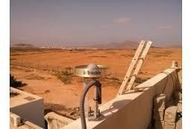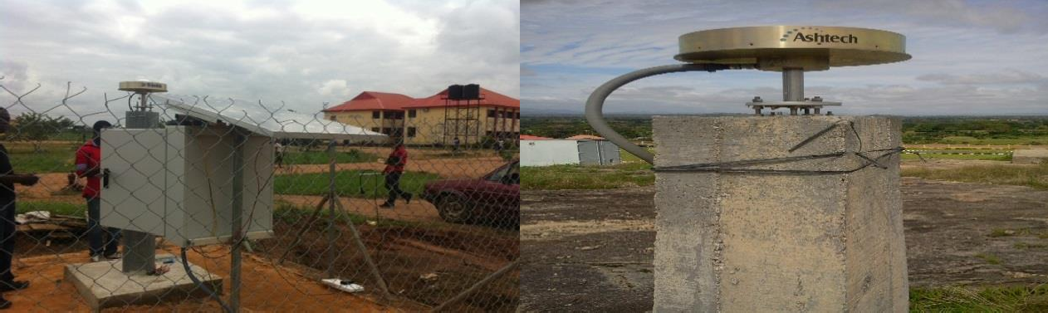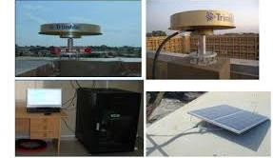

Plate I: Nigeria GNSS CORS mounted Source: (Onoriode *et al.,* 2017).

CORS technology has been used in the oil and gas industry to establish primary (geodetic) control pillars, as-built surveys and large-scale seismic acquisition project with significant cost savings and reduced HSSE exposure. The deployment has enabled geodetic data integrity, data harmonization, reduced turnaround time, and HSSE exposure which have eased project delivery within the difficult terrain of the Niger Delta. The implementation of GPS CORS technology obviously is a game changer in survey service delivery within the oil and gas industry, and should be extended to developing Land information system speedily throughout Nigeria and cost effective, quick and accurate update of Nigeria utility infrastructure (Onoriode *et al.,* 2017).

Traditionally, most Survey activities in the Nigeria Oil industry are executed using conventional methods involving the use of Theodolites and Total stations which require extensive control pillar search and in-situ checks in often difficult terrain, with significant costs and serious Health, Safety, Security and Environment (HSSE) exposures. Also, projects

executed with conventional methods are prone to coordinate inconsistences across oil fields, due to discrepancies in control origins. Hence, need to re-strategize and deploy the Continuously Operating Reference Station (CORS) Geographic Positioning System (GPS) technology to address these issues. These permanent, unmanned, automated and highly precise reference stations (standalone or networked) continuously collect and store Global Positioning System (GPS) data to provide precise spatial positioning, data harmonization that enables assured geodetic data integrity.

Generally, in order to improve positional accuracies of GPS observations to sub centimeters, a relative positioning technique is employed. Relative GPS positioning involves the collection of observables by a GPS reference station whose position is known. These data are then combined with data collected by other receivers, whose positions are to be determined. This process may be performed real-time where corrections are applied instantaneously or in a post-processed mode with relative positioning accuracy in sub- centimeter (Onoriode *et al.,* 2017).

## Contributions of GNSS CORS to national Development.

The impact and contribution of GNSS-based geodetic reference frame to national and local development programmes cannot be overemphasized because so many problems today which became difficult to resolve, with the advent of the GNSS CORS are been solve. In recognition of this, the implementation strategy of the cross cutting spatial data infrastructure (SDI) initiative at every level has placed great emphasis on geodetic controls and frames by dedicating working groups for them. (Kufoniyi 2016).

* The United Nations Global Geospatial Information Management (UN-GGIM) initiative has a working group on Global Geodetic Reference Frame (GGRF), created

in January 2014 to develop a global geodetic roadmap for the GGRF among other activities

* The African cluster of the GGIM (UN-GGIM: Africa) has African Geodetic Reference Frame (AFREF) as one of its working groups. The GGIM: Africa declaration further encourages Member States to adopt unified national geodetic reference frames that are consistent with the African Geodetic Reference Frame (AFREF) and the Global Geodetic Reference Frame (GGRF).
* The ECOWAS Geospatial Data Infrastructure (EGDI) has geodetic controls as part of the terms of reference of its working group on Geospatial Datasets.
* GNSS play the role of weather prediction in other to predict the amount of rainfall so as to enable the government plan and allocate project.
* Now-casting is weather forecasting on a very short term or near real time broadcasting of information about weather and natural disasters.

Nigeria’s NGDI has geodetic control as one of the infrastructure’s ten fundamental datasets and has a working group devoted to it .Mobile technologies are now playing, and will continue to play a big role in the use of geospatial information for sustainable development and daily human activities. Many of the mobile phones now come with geospatial solutions such as GNSS-based location.

The regional contribution of the GNSS CORs are however listed below

* Spatial Data Infrastructure Development
* Aerial and Satellite Mapping
* Water Resources Management
* Regional Development Initiatives
* Volunteered Geographic Information (VGI)
* Contribution to Earth Sciences
* Application in Systematic Land Tenure and Registration

## Nigerian Permanent GNSS Network (NIGNET)

In recognition of geodetic network as an essential framework dataset for the implementation of Spatial Data Infrastructure (SDI) at any level, the country has included it as one of the ten fundamental datasets of Nigeria’s National Geospatial Data Infrastructure (NGDI), even before the advent of AFREF. Until the year 2006 when the first continuously operating reference station was established in the Regional Centre for Training in Aerospace Surveys (RECTAS) as part of AFREF, all the survey controls in the national geodetic network were passive. As at 1997, there were 600 passive GPS controls, 550 other passive conventional geodetic controls and unspecified number of (many) lower order controls. In an effort to provide a unified national geodetic frame for surveying and mapping as well as other national and regional developmental projects, the Office of the Surveyor General of the Federation (OSGOF) commenced the establishment of the Nigerian Permanent GNSS Network (NIGNET) in 2008 and by 2011 the Office has established 11 GNSS Continuously Operating Reference Stations (CORS). By May 2013, the country already has 16 zero-order CORS comprising one established by the Regional Centre for Training in Aerospace Surveys (RECTAS) for AFREF in 2006 and 15 NIGNET stations 11 by OSGOF and three (Enemark 2013) by the Presidential Technical Committee on Land Reform) all strategically located in different parts of the country. The NIGNET stations are shown in figure 1.1 (Edozie *et al.,* 2013). Many other State Governments have established or are also planning to establish

CORS in their respective states as part of their mapping and GIS projects; these include one

(1) by Lagos State Government and three (3) by the Osun State Government.

## NIGNET (Nigerian GNSS Reference Network)

Continuous Operating Reference Stations (CORS) use the Global Positioning System (GPS) technology to provide precise spatial positioning, data harmonization, and enables geodetic data integrity assurance with real-time data streaming and management in a network mode with Leica Spider software to extend the data coverage and enables real time field crew monitoring. Usually, most survey activities in Nigeria are executed using conventional methods which require extensive control pillar search and in-situ checks in often difficult terrains with significant costs and serious health, safety, security and environment (HSSE) exposures. The survey is also prone to coordinate inconsistences between fields due to discrepancies in control origins. Hence, a compelling reason to establish CORS technology to address these issues. Leveraging the GPS technology, site were selected (see Figure 2.6), installed with GPS system and configured to acquire process and transmit differential corrections on a continuous basis to reference survey projects (Onoriode *et al.,* 2017).

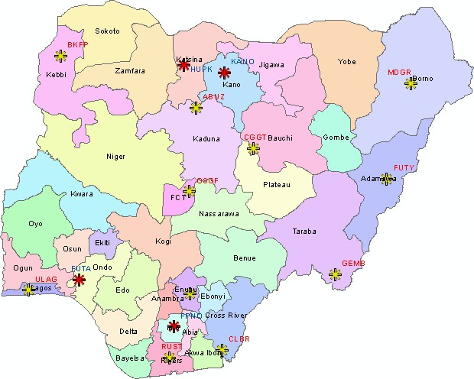

Figure 2.6: Distribution of the NIGNET stations. Yellow – stations already installed (December 2009). Red – stations being installed in January/February 2010.

Source: (Paolo *et al., 2020*).

## The Nigeria geodetic datum system

Minna datum which happen to be in Niger State Nigeria, assuming to be the point of intersection between the geoid and ellipsoid therefore selected to be the reference datum station Nigeria (Minna datum (L40), but then it is not compatible with satellite derived positioning system, suggests that the new geocentric datum (CORS networks) should be adopted. This need prompted the Office of the Surveyor General of Nigeria (OSGOF) to initiate the NIGNET project in 2008 that derive the establishment of the 11 CORS stations in various locations in the country. These stations are coordinated by nine international

Global Navigational Satellite System (GNSS) and IGS that are part of the International Terrestrial Reference Frame (ITRF2008). However, since the establishment of the 11 CORS stations in the country covering only 25% of the country, no attempt has been made to upgrade and extend their coverage. Conversely, developed countries with more CORS stations focuses on both improving the integrity of their CORS stations as well as improving the distribution and density of the spatial coverage of these stations. Such countries include Australia with about 250 CORS stations at regular intervals of between 50km to100km, United States of America with over 1,350 stations (as of 2008) at an average spacing of 70km between stations, and United Kingdom with about 110 stations at an average spacing of 60km. Naturally, the availability and spatial coverage of the stations increases the number of IGS stations globally to strengthen the ITRF. Overall, geospatial applications are better with higher spatial coverage (density of the stations), because higher density provides good reception coverage for positioning results, prediction and monitoring of natural disasters. In 2007, prior to the establishment of CORS by OSGOF, the GPS team of OSGOF obtained the WGS 84 values of L40 (Nigerian Datum) by repeated GPS measurements using differential positioning techniques on the station (L40). A mean of means was obtained from the measurements and the value was used for adjusting a nationwide surveying campaign that commenced from Minna in Niger state, Nigeria. By the end of 2007, the Regional Centre for Training in Aerospace Surveys. RECTAS established the first permanent reference station (CORS) in Ile Ife, Ibadan, Nigeria, which consist of a receiver, an antenna, operating software, site server software for quality control and data analysis. This was done in line with the African Reference Frame’s (AFREF) project initiative (Naibbi and Ibrahim, 2014).

The 11 CORS networks in the country are linked with ITRF2008 by acquiring GPS data from nine International GNSS Service stations (IGS). NIGNET, which is a tier 1 station, was set up with up-to-date geodetic equipment. The data from these stations are processed at the central station located in Abuja where it is corrected, computed and provided to the users. The optimization of efficiency is a priority to the system and their location, which are mostly positioned on concrete rooftops for security reasons and signal obstruction. The objectives of creating the 11 CORS stations by the OSGOF is to cover the country with a relatively homogenous distribution of CORS stations in order to increase the spatial coverage of the networks and to provide an up to date networks that are compatible with

GNSS, GIS and ITRF based datum. Overall, the existing 11 CORS stations in Nigeria (with an average spacing distance of over 300km apart) seems inadequate given the size of the country (about 923,768km2) as compared with the less than 100km spacing (based on the NGS’s requirements) adopted in the USA and United Kingdom (Naibbi and Ibrahim, 2014). Therefore, increasing the number of the CORS network in Nigeria as suggested in various studies will improve the signal multipath issues, site issues, and signal environment issues experienced in the country. Also, sufficient and well-defined networks of geocentric datum (CORS) will provide among others; direct compatibility with GNSS measurements, mapping and GIS. It will also promote and optimize the use and application of spatial data through single user friendly data environment, thereby increasing efficiency in spatial data resource by reducing duplication and unnecessary translation (Naibbi and Ibrahim, 2014).

Table 2.2: The IGS stations used to establish NIGNET stations (Isioye *et al.,* 2015).

|  |  |  |  |
| --- | --- | --- | --- |
| **Station ID** | **Station location** | **Country** | **Ellipsoidal height** |
| **HARB** | Pretoria | Republic of south  Africa | 1555.000 |
| **NKLG** | Libreville | Gabon | 31.4800 |
| **RABT** | Rabat | Morocco | 90.1000 |
| **RBAY** | Richard bay | South Africa | 31.7927 |
| **SUTH** | Sutherland | South Africa | 1799.7659 |
| **CAGZ** | Capoterra | Italy | 238.000 |
| **MAS1** | Maspalomas | Spain | 197.3000 |
| **NOT1** | Noto | Italy | 126.2000 |
| **SFER** | Sanfernando | Spain | 85.8000 |

The literature over Nigeria with emphasis on application of GNSS for Metrology in Nigeria. Were sourced from web-based archives such as Google scholar, web of science, IEEE- Xplore, Google. However, considering the fact that GNSS infrastructure became available in Nigeria from 2009, related literature from 2010 to 2019 in the region of Africa. The summary of this literature is given in Table 2.3.

Table 2.3: List of Publications on GNSS-Based Water vapour Estimation and related determinants in Africa Between 2010 to 2019

|  |  |  |  |  |  |  |
| --- | --- | --- | --- | --- | --- | --- |
| **S/N** | **Author( s)** | **Paper Title** | **Technique**  **Used** | **Focus Area** | **Country/ Year** | **remark** |
| 1 | A.A.Ach  eampong  , C. Fosu,  L. K.  Amekud zi, and E. Kaas (2015) | Compariso n of  precipitabl e water over Ghana using GPS signals and reanalysis products | radio occultation technique | delayed signals due to tropospheri c and  stratospheri c effects  was used retrieved atmospheric Integrated Water Vapour (IWV) | Ghana/201 5 | retrieved atmospheric Integrated Water Vapour (IWV) |
| 2 | Acheam pong, A. A., Fosu, C.,  Amekud zi, L. K.,  Kaas, E. (2017) | Precipitabl e Water Compariso ns Over Ghana using PPP Techniques and | PPP  Technique s | highly precise tool for water vapor sensing based | Ghana/201 7 | the study results indicate that with a more densified network of GNSS base stations the retrieved PW or IWV  will greatly improve numerical weather predictions in Ghana |
| 3 | Joseph D. DODO,  Tahir, A. YAKUB U,  Lazarus | Determinat ion of the best-fit Tropospher ic Delay Model on the | Saastamoi nen model | Determinati on of the best-fit | Nigeria/20 13 | The longer the baseline; the more the effect of the troposphere. The refined Saastamoine |

M. OJIGI,

and Samuel TSEBEJ E.

Nigeria (2013)

Dodo Joseph Danasab e, Ojigi

4 Lazarus

Mustaph

a ,

Tsebeje Samuel Yabayan ze (2017)

5

Isioye A.O.,

Combric k L.,

Botai J. O.,

(2015)

Nigerian Permanent GNSS

Network (NigNet)

Determinat ion of the best-fit Tropospher ic Delay Model on the Nigerian Permanent GNSS

Network

Retrieval and analysis of precipitabl e water vapour based on GNSS,

AIRS, and reanalysis models over Nigeria

The Refined Saastamoi nen Model

PWV

estimates from the different techniques

Determinati on of the best-fit for Nigeria CORS

Precipitate water vapour

Nigeria/20 17

Nigeria/20 15

n model gives a

better result

This result is in agreement with. The

longer the baseline, the more the effects of the troposphere. And Niell model gave a better result. .

The agreement between the various techniques was better at monthly and seasonal scales. In

terms of bias, precision,

Ayodele, E.G,

Okolie, C.J., and

6 Mayaki,

O.A.

(2018)

An assessment of the

reliability of the

Nigerian GNSS

Mahalanob is distance method of outlier detection and filtering

Displaceme nt associated with the NIGNET

CORS to understand reliability.

Nigeria/20 18

88% of the network showed a high level of positional accuracy

7

R. T.

Wonnac ott (2015)

network data

The use of gps for the estimation of precipitabl e

Water vapour for weather forecasting and

Monitoring in south Africa

double differencin g technique

estimation of PWV using GPS and

meteorologi cal data

South Africa/201 5

South African network of permanent GPS base stations,

TrigNet, is suitable for the operational estimation of PWV supersede all

8 Houaria

NAMAO UI,

Salem KAHLO UCHE,

Ahmed Hafid

GPSWater Vapor and Its

A good agreement

Radiosond

|  |  |  |  |
| --- | --- | --- | --- |
| BELBA CHIR,  Roeland Van MALDE REN,  Hugues | Compariso analyze the  n with sensitivity Remote  e and PW  ERA- estimates  Interim Data in | | is found Algeria/20 between  17 GPS-PW  and PW  calculated from radiosonde |
| BRENO | Algeria |  |  |
| T, and |  |  |  |
| Eric |  |  |  |
| POTTIA |  |  |  |
| UX |  |  |  |
| (2017) |  |  |  |

sensing

of the GPS

In this study, about 31 publications were reviewed only 4 papers were for Nigeria and 8 for Africa on integrated water vapour and most of these papers did not focus on GNSS Based integrated water vapour (IWV) over Nigeria NIGNET CORS Table 2. 1 show the summary of literature carried out in Africa considering the fact that the estimation of integrated water vapour can make serious impact in monitoring flood over Nigeria but the amount of researches been carried out in Nigeria is not enough to give information for the control of flood in Nigeria. From table 2 which shows the number of publications across countries in Africa between 2010 - 2019, in this paper is been observed that 4 publications were for Nigeria, 1 publication was for South Africa, 1 publication was for Algeria, and 2 publications were for Ghana. A total publication for integrated water vapour (IWV) in Africa for papers reviewed were 8 and 4 were for Nigeria and out of this 4 papers only one by (Isioye *et al* 2015) who emphasis on Retrieval and analysis of precipitable water vapour based on GNSS, AIRS, and reanalysis models over Nigeria, these means that little effort have been put in, on integrated water vapour in Africa figure 2 shows a Graph showing numbers of publication in Africa and figure 2.3 shows pie chart showing the percentage of researches carried out in Africa.

Table 2.3: The summary of the number of publications done in some countries in Africa

|  |  |  |  |
| --- | --- | --- | --- |
| S/N | Country | Number of research | Percentage of research  % |
| 1 | Nigeria | 4 | 50% |
| 2 | South Africa | 1 | 12.5% |
| 3 | Algeria | 1 | 12.5% |
| 4 | Ghana | 2 | 25% |
|  |  | 8 | 100 |



4.5

4

3.5

3

2.5

2

1.5

1

0.5

0

Nigeria

South Africa

Algeria

Ghana

Number of research

Number of research

Figure 2.7: Graph showing number publications on GNSS water vapour per country in Africa

Nigeria

25%

South Africa

50%

Algeria

12.5%

Ghana

12.5%

Figure 2.8: Pie chart showing percentage publications on GNSS water vapour per country in Africa.

In conclusion, GNSS-based water vapour estimation in Nigeria has been reviewed and it was discovered that little effort has been made in GNSS-based estimation of integrated water vapour (IWV) in Nigeria. The review revealed that it is difficult to estimate IWV using classical meteorological system and that there exist a relationship between atmospheric water vapour and prediction events.

However, GNSS-based method is to support aviation and weather but not the most efficient way, because GNSS receiver/antenna are for isolated points/vertical integrated water vapour and lacks spatial and temporal coverage that are possible with hyper spectral infrared and microwave satellite remote sensing. The Global meteorological /atmospheric precipitation/rain estimation are from specialized meteorological satellites; GOEs / NOAA, METEOSAT / CRYOSAT / MODIS (Behrangi *et al.,* 2014).

Thus, improving the knowledge of water vapour dynamics would be beneficial for weather monitoring and prediction in Nigeria. Therefore more researches are needed to be carried out in Nigerian on integrated water vapour using GNSS infrastructure (NIGNET CORS) which will enhance climate studies and weather outlook in Nigeria.

# CHAPTER THREE

* 1. **METHODOLOGY**

This section presents the materials and methods employed in the process of this research. The methodology is classified into three major phases, thus: data acquisition, data processing and analysis of results. Figure 3.1 summarizes the phases of the methodology and procedures employed.

## Flowchart and work planning

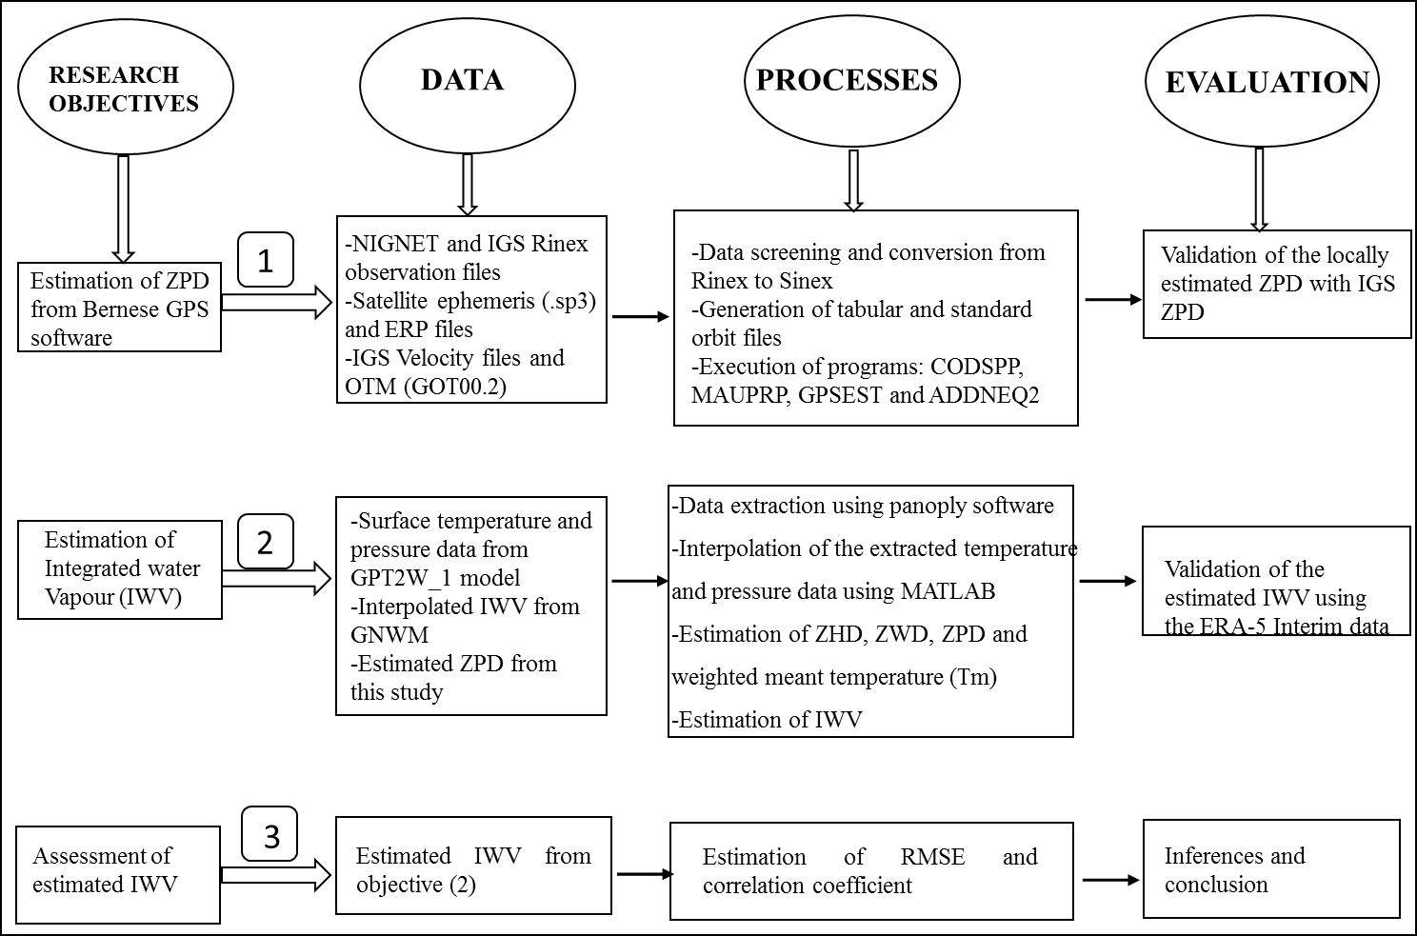

Figure 3.1: The adopted methodology for the study

The methodology adopted for this research is predominantly established on the opportunity offered by the expanded application of GNSS in meteorology. The study

specifically looked into assessment of integrated water vapor (IWV) otherwise called total column water vapour through the GPS data over Nigerian geodetic stations. The Rinex observation data of these GPS (COR) stations were acquired and processed for the estimation of the Zenith Path Delay (ZPD) also called the Zenith Total Delay (ZTD) using Bernese GPS software package, version 5.0. In order to achieve a reliable result of this study, a year span data of 2011 Rinex observation was utilized. Apart from the CORS data, other data acquired for the processing are; the ephemerides data, the earth rotation parameters, the IGS station files, the IGS station velocity file, the ocean loading file and the IGS clock files.

The processing strategy, options, models and functions applied in the data processing are discussed in detail in subsequent sections. In order to estimate the IWV, the Nigerian COR stations were found not co-located with the weather stations i.e. with radiosondes otherwise meteorological sensors which measure or retrieve the weather parameters such as the temperature, pressure, relative humidity, vapour pressure, and the dew point for climatic studies and weather prediction. It was due to this challenge of non-availability of radiosonde data that the study resolved into using the Global Pressure Temperature wet (GPT2w_1) model which was built upon the climatological parameters from ERA- Interim model at a resolution of 10 by 10 latitude and longitude. The procedure for obtaining the mean weighted temperature, Zenith Hydrostatic Delay, the Zenith Wet Delay and the IWV were discussed in the second phase of the study and finally, the obtained result of IWV was validated using ECMWF numerical weather model data because of its high resolution. The phases and sub-phases or methods are as summarized and presented in figure 3.1 above.

## Estimation of Zenith Path Delay from Bernese GPS Software V.5.0

Zenith path delay is an atmospheric phenomenon specifically, the troposphere that caused a delay in the arrival of navigational signals in positioning as a result of thickened layer of the troposphere. The delay effect is estimable by using a set of models and mapping functions to correct for the effect among which are saastamonien, Hopfield, marini-mur, Niell tropospheric models. The estimation of the ZPD involves three phases as stated in the previous section. They are discussed as follow:

## Data acquisition

* + - 1. **GPS Rinex observation files**

In determining the ZPD values over the Nigerian COR (GPS) stations, the Rinex observations files of nine NIGNET stations were accessed through the NIGNET proprietary website at [www.nignet.gov](http://www.nignet.gov/), but unfortunately, the site was found non- functional at the time of this study, this necessitated the utilization of the available archived data of the year 2011. It was unfortunate that none of the stations was coupled with a weather sensor such as thermometer and barometer for retrieval of temperature and pressure values.

IGS CORS are global network of geodetic stations established for the realization of the international terrestrial reference frames. These stations are of highest order of accuracy required in any geodetic positioning. Though, as at year 2011, none of such stations was established in Nigeria, therefore, a need for IGS stations around Africa for the corresponding year arose and five of the stations around African plate were adopted based on their proximity in consideration of the baseline lengths with a range of 90km for an accurate processing. Table 3.1 presents the five adopted IGS stations and their geographical locations thus:

Table 3.1: List of IGS stations used for the study.

|  |  |  |
| --- | --- | --- |
| S/N | IGS CORS ID | Geographical Locations |
| 1 | ADIS _31502M001 | Ethiopia, Africa |
| 2 | BJCO_32701M001 | Benin Republic |
| 3 | NOT1_12717M004 | Italy |
| 4 | RABT_35001M002 | Morocco |
| 5 | YKRO_32601M001 | Coted’ivoire |

Figure 3.2 shows the current distribution of IGS CORS around Africa. It is worth stating that after 2011, the station CGGT was included in the IGS CORS and became the only IGS station in Nigeria.

The observation files of the stations were downloaded using Rtklib software as it provides a means for multiple download and automatic conversion of the data from the compact Rinex format to the standard Rinex format.

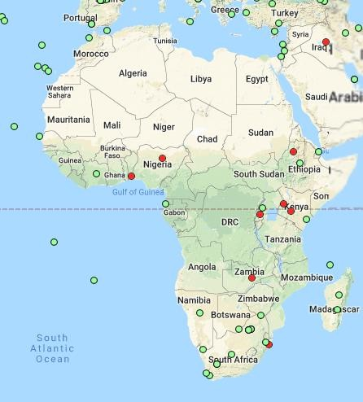

Figure 3.2: The distribution of IGS CORS around Africa (IGS proprietary website) Other data used are final orbit data (.sp3), Earth rotation parameter (ERP), and receiver code bias (DCB) which was all sourced online from Centre for Orbit Determination in Europe (CODE). Ocean loading parameter (.BLQ) was also obtained from Onsala Space Observatory website as discussed in the subsequent section.

## Ocean loading parameters

Crustal deformation is a significant station displacement effect induced by the varying mass distribution resulted from marine tides (ocean tidal loading). The coefficients or magnitude of the ocean loading impact (amplitude and phase shift for the eleven most important constituents) were substituted at appropriate phase of data processing (i.e. programs GPSEST, GPSSIM, and CLKEST). However, the use of the file is not mandatory, its use is only encouraged, and otherwise vertical and horizontal displacement may not be corrected.

The ocean loading parameters of the CORS were computed by the ocean tide loading provider and sent to the submitted email ([survddan4real@gmail.com](mailto:survddan4real@gmail.com)). The mailed ocean loading parameters are then copied and saved in a notepad environment for subsequent data processing. For this research, Goddard Ocean Tide Model (GOT00.2) was adopted.

## Satellite Ephemerides

The ephemerids files contain information about the status and health of satellite, and stability of the orbits. This file was used in correcting for any anomaly in the orbit and other external effects encountered by the satellites, in order to obtain accurate positioning information from the signals received. Orbit, station and satellite clock products are found in the standard product directories at the IGS proprietary website.

## Earth Rotation Parameter (ERP)

Earth orientation parameters (EOP) are collection of [parameters](https://en.wikipedia.org/wiki/Parameter#Mathematical_functions) that describe irregularities in the [rotation of the Earth.](https://en.wikipedia.org/wiki/Earth%27s_rotation) The effects are addressed in the processing software by using the IGS estimated corrections.

## Preliminary velocity files

This file was used to estimate and compensate for the shift /displacement of the IGS stations in it becomes a strong necessity to supply the initial coordinates of stations, it is equally important to supply initial velocity information to the processing software (Bernese) which is also an input parameter in the processing phase. There are several agencies around the world that provides this information and among them are; the Scripps Orbit and Permanent Array Center (SOPAC), International GNSS Service (IGS), National Aeronautic and Space Administration (NASA) etc. The velocity files of the selected IGS stations data under consideration were downloaded with respect to the ITRF 2008 from the SOPAC website at [http://www.sopac.com.](http://www.sopac.com/)

## Satellite clock synchronization files

Satellite clock corrections are necessary in order to synchronize between the satellite clock and receiver clocks. The synchronization is performed in the data preprocessing step using program CODSPP.

## Data Processing

The data processing procedures are discussed under data preparation, data preprocessing and final processing.

## Data Preparation

This phase include the process of data filtering and conversion. After downloading the Rinex data, both the local and global data were combined and campaign was created for the processing on a monthly basis, altogether, a number of 14 stations per campaign. Each campaign was screened and filtered for any anomaly, incompletion or cycle slip, as reflected by the data file size. After the data treatment, campaign was created for the processing in the Bernese software, where station information was updated and coordinated a priori coordinate was generated with which the a priori velocity of the IGS stations were obtained from the SOPAC based on the ITRF 2008 as the proximal realization. The a priori coordinates was also used in the acquisition of the ocean loading correction (GOT00.2) which accounts for the site displacement as a result of crustal deformation due to ocean tide loading. The loading correction coefficient at each station was computed by the Onsala Space Observatory (online ocean tide loading provider) using green function. Goddard

Ocean Tide Model was adopted on the basis of the study by Abbas *et al*. (2019) on optimal choice of ocean tide model for processing GNSS data over Nigeria, where the

model, GOT00.2 was reported with best performance over Nigeria. The phases of the processing are summarized in Figures 3.3, 3.4 and 3.5 respectively.

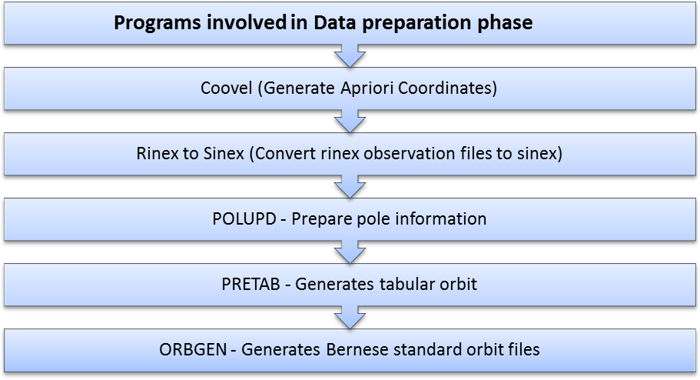

Figure 3.3: The procedures in data preparation

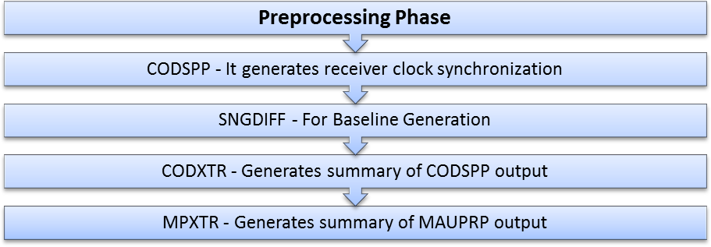

Figure 3.4: The procedures involved in data pre-processing.

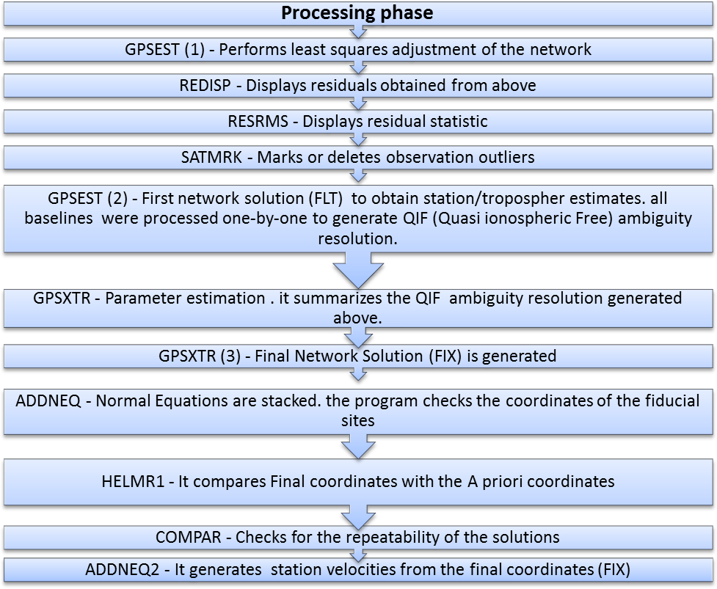

Figure 3.5: The data processing steps

## Method of ZPD estimation

Using the foregoing procedures for data processing using Bernese 5.0 version, the NIGNET CORS data was processed. Option “Site-specific troposphere parameters” in panel “GPSEST 5.1: Setup of Parameters and PreElimination1” of the software was set to activate the estimation of the ZPD parameters. In panel “GPSEST 6.3.1: Site-Specific- Troposphere Parameters 1” selection was made of an appropriate mapping function, a priori tropospheric model and desired time resolution equivalent to the option “Parameter spacing” which in case of this study are: Niell mapping function, Saastamonien a priori

model and 30-180 seconds respectively. The processing strategy employed, models, options and parameters adopted are summarized in Table 3.2

Table 3.2: The processing strategy adopted (Opaluwa *et al.,* 2017).

|  |  |
| --- | --- |
| Parameters | **Processing Strategy** |
| Network design | OBS-MAX |
| Measurement type | Phase |
| Elevation cut-off angle | 30 |
| Weighting of GPS observations | Cos2(z); z = zenith angle. |
| Sampling rate | 30-180s. |
| A priori sigma | 0.01 meters |
| Orbits/EOP | IGS final Orbit and Earth Orientation parameters (EOP). |
| Station coordinates | Minimally constrained to the ITRF2008 reference frame. |
| Cycle slip screening mode | Combined L1 & L2 frequency |
| Outlier rejection | Enabled |
| Absolute antenna phase center Corrections | PHAS COD.I08, SATELLIT.I08. |
| Ocean loading model | Goddard Ocean Tides model (GOT00.2) |
| Ionosphere | Double-difference ionospheric-free (IF) linear combination. |
| Ionosphere model for ambiguity  fixing | Global ionosphere model from CODE. |
| Gradient estimation | Horizontal gradient parameters: tilting at 24hrs interval. |
| A-priori model | A-priori Saastamoinen hydrostatic model with dry Neill mapping function. |
| Mapping function | Wet-Neill mapping function (1hr interval). |
| IGS Ref. Frame | ITRF 2008 |
| Relative troposphere constraints | Loose. |
| ZPD estimates rate | Hourly (1hr). |

The input data as mentioned earlier were plugged in to their respective directories and processing options set, and the BPE was run for the estimation. Thus, the station-specific

tropospheric delay alongside their standard deviations as well as station coordinates was generated.

## Validation of estimated ZPD

The estimated ZPD was assessed by comparing the most probable values of the daily estimate of ZPD for the IGS stations provided at every 5 minutes by IGS Analysis Centres (ACs) to their corresponding estimates from this study. Since ZPD estimated from a local campaign are strongly correlated, the IGS stations were processed together with the local stations to decorrelate the correlated ZPD (Opaluwa, *et al.,* 2017). The trend obtained in the validation of the IGS estimated ZPD was used to characterize the ZPD for the local stations in the absence of the external data source to compare them with and the stations were not equipped as well with meteorological sensors for retrieval of atmospheric data. The statistics of the comparison was computed i.e. the mean, minimum, maximum values of ZPD estimated, the Root Mean Square (RMS) and standard deviations are presented in chapter four.

## Estimation of Integrated Water Vapour

In order to estimate the IWV which is the cardinal focus of this study, the pressure and temperature data were sourced from ECMWF global atmospheric Global Pressure Temperature 2 wet (GPT2w_1) model by Bohm *et al.* (2015). The model has a horizontal resolution of 10 in latitude and longitude over the globe which enhances valid interpolation of positions on the earth surface and accurate access to surface meteorological data of the location. The model assimilates its climatological parameters from monthly mean pressure level data of ERA – Interim which makes the model suitable to calculate slant hydrostatic and wet delays down to 30 elevation at any location on the earth surface. Validity of this model was examined by Opaluwa *et al.* (2017) and it was found that the model is reliable for sourcing surface meteorological data. The GPT2w_1

model unlike some other empirical weather model takes interested sites’ geodetic latitude, longitude and ellipsoidal height as well as the day of the year as the input parameters. MATLAB codes were developed to implement the model for generation of surface meteorological data over the nine Nigerian continuously operating reference stations considered in this study. The date of the year has to be defined in a Julian mean date system as one of the constants input for the model and the geodetic latitude and longitude in radians. The model output are the coefficient of the wet mapping function, water vapour decrease factor and geoid undulation in addition to pressure and temperature which are the main output required in the further process of estimation of IWV.

The hourly estimated ZPD for the stations ABUZ, BKFP, CGGT, FUTY, MDGR, OSGF, RUST, ULAG and UNEC from the local data processing for the whole year as validated in the above section is a key parameter in the estimation of IWV though, data inconsistency of some of the stations posed a serious challenge to the program developed in the estimation of IWV.

Due to the volume of the data involved, a MATLAB code was developed implementing equations 1, 3, 6, and18 which respectively yield Zenith Total Delay (ZTD), Zenith Wet Delay (ZWD), Weighted Mean temperature (Tm) parameter and Integrated Water Vapour (IWV). Since this study focuses on estimation of IWV over the GNSS CORS over Nigeria. The estimated IWV were validated, analyzed and inferences made and discussed in the next chapter.

## Evaluation of the estimated IWV

In order to accomplish the objective three of the study that is, validation of the estimated precipitable water vapour, a Global Numerical Weather Prediction Model (GNWPM) was adopted from the ECMWF reanalysis center. Climate re-analyses combine past observations with models to generate consistent time series of multiple climate variables.

Re-analyses are among the most-used datasets in the geophysical sciences. They provide a comprehensive description of the observed climate as it has evolved during recent decades, on 3D grids at sub-daily intervals. ERA5 data are available in the Climate Data Store on regular latitude-longitude grids at 0.25o x 0.25o resolution, with atmospheric parameters on 37 pressure levels.

The collection of earth orientation parameters is fitted to describe the observed rotation irregularities. Technically, they provide the rotational transform from the [International](https://en.wikipedia.org/wiki/International_Terrestrial_Reference_System) [Terrestrial Reference System](https://en.wikipedia.org/wiki/International_Terrestrial_Reference_System) (ITRS) to the [International Celestial Reference System](https://en.wikipedia.org/wiki/International_Celestial_Reference_System) (ICRS), or vice versa, as a function of time.

The RMS misfit was computed on a daily basis for the estimated IWV. In ech case, the time series misfit was analysed based on the RMS of the ZPD values hence, the RMS was then computed as.

*RMS* 



*i*1

*n* *x*

(*i*) (*i*)

*n*

− *y*

2

19

where, 𝑥(𝑖)and 𝑦(𝑖) are respectively, the hourly and mean IWV values, while *n* is the number of observations.

# CHAPTER FOUR

* 1. **RESULTS AND ANALYSIS**

The results from this study include the ZPD and IWV estimates. These results are presented and discussed in this chapter.

## Estimation and Assessment of GPS ZPD

The summary of the estimated ZPD is as shown in Table 4.1

Table 4.1: Summary of the estimated ZPD

|  |  |  |  |  |
| --- | --- | --- | --- | --- |
| ***STATIONS*** | ***AVERAGE***  ***(m)*** | ***MIN (m)*** | ***MAX***  ***(m)*** | ***STDDEV***  ***(m)*** |
| ABUZ | 2310.239327 | 2181.104 | 2485.092 | 1.943175132 |
| BKFP | 2442.103158 | 2297.516 | 2650.216 | 2.073376238 |
| CGGT | 2251.168197 | 2129.924 | 2399.856 | 2.004981804 |
| FUTY | 2468.207491 | 2299.741 | 2651.268 | 2.101234933 |
| MDGR | 2432.694501 | 2271.576 | 2600.788 | 2.322702543 |
| OSGF | 2422.951122 | 2251.412 | 2538.736 | 2.05873861 |
| RUST | 2625.734182 | 2429.032 | 2725.38 | 1.88267607 |
| ULAG | 2603.830806 | 2408.168 | 2731.104 | 2.028874886 |
| UNEC | 2527.656282 | 2314.612 | 2649.772 | 1.952264213 |

The results of the estimated ZPD as shown in Table 4.1 indicated the least ZPD value (2129.924m) was obtained at station CGGT in the Northern part of Nigeria while, the highest ZPD value of 2731.104m was observed at station ULAG in the Southern part of Nigeria. This is justified by the proximity of these two regions to the equator. The southern region lies more proximal to the equatorial belt than the Northern regions which usually experience high humidity and as such, high ZPD values are expected.

## Validation of Estimated ZPD

In order to validate the estimated ZPD over the local CORS, the estimated ZPD for the IGS CORS were compared to their corresponding values as archived by IGS analysis centers, hence, the comparative analysis. The summary of the comparative statistics is shown in Table 4.2.

Table 4.2: Summary of statistics of estimated ZPD

|  |  |  |  |
| --- | --- | --- | --- |
| Stations | Mean diff.  (ZPDest – ZPDIGS) | Min. Diff. | Max. Diff. |
| ADIS | 17.7385 | 5.951236 | 37.0853 |
| BJCO | 5.951236 | 0.559167 | 9.355167 |
| RABT | 37.0853 | 32.738 | 43.688 |

Figure 4.1 depict a graphical representation of the trend or pattern of the estimated ZPD and IGS ZPD (ZPD_Est. and ZPD_IGS) for the year 2011.

(a)

ADIS: TREND IN IGS_ZPD & ZPD_ESTIMATED

1870

1860

1850

1840

1830

1820

1810

90

92

94

96

98

Days

100

102

104

106

ZPD_Est.

ZPD_IGS

ZPD Values (m)

ZPD_IGS

ZPD_Est.

106

104

102

100

98

Days

96

94

92

90

2660

2640

2620

2600

2580

2560

2540

(b)

BJCO: TREND IN IGS_ZPD & ZPD_ESTIMATED

ZPD Values (m)

Figure 4.1: The trend of ZPD_Est. and ZPD_IGS for the year 2011.

ZPD_IGS

ZPD_Est.

106

104

102

100

98

Days

96

94

92

90

2540

2520

2500

2480

2460

2440

2420

2400

2380

2360

(c)

RABT: TREND IN IGS_ZPD & ZPD_ESTIMATED

ZPD Values (m)

The comparison was conducted as presented in Figure 4.1 (a), (b), (c) respectively and a perfect correspondence was observed. It was also observed that the length of the baseline is a function of accuracy in the estimation. The shorter the baseline length the higher the accuracy and vice-versa. Station BJCO was found with least mean difference of 5.951236m , followed by station ADIS with mean difference of 17.7385m and lastly station RABT with the highest mean difference of 37.0853m. This result is in agreement with study by Wickert *et al.* (2014) that ZPD values are spatially correlated.

The result of the assessment gave room to the acceptability of the estimated ZPD for further processes in this study. Nevertheless, some of the weaker correlation (larger discrepancy) could be attributed to difference in elevation angle utilized as the study used elevation angle of 30 while the IGS analysis center uses elevation of 70 and the length of the baseline from each station.

This comparative analysis was found impossible for the NIGNET CORSs Since there were no meteorological sensors attached to the stations as at 2011. But the IGS stations included in the data processing were at a minimal baseline length. The minimum and maximum baseline length considered were 1000km and 9000km respectively to compensate for differential tropospheric effect. It was observed that station BJCO with an average baseline length of 698km show the least difference in comparison with IGS ZPD product. Subsequently, station ADIS with an average mean greater than that of BJCO and lastly station RABT with largest difference. Generally, a direct proportionality exists between the difference and the baseline length and more so, it is shown schematically in figure 4.1 that the locally estimated ZPD follows a similar pattern as the IGS estimated ZPD.

Conclusively, the results show a consistent and significantly common trend in the estimated ZPD with the IGS estimated ZPD. It was observed that the Bernese based estimated ZPD are larger than the IGS estimated which is a function of the elevation angles difference (i.e. 30 and 70 respectively). So the trend obtained for the comparison analysis of the IGS stations was adopted for local NIGNET COR stations.

## Assessment of Integrated water vapour (IWV)

The summary of the estimated IWV are presented in Table 4.3. The minimum, maximum and mean IWV are presented for January, the other months are contained in the appendix.

Table 4.3: Estimated IWV for January, 2011

|  |  |  |  |
| --- | --- | --- | --- |
| **STATIONS** | **MEAN**  **(kg/m2)** | **MIN**  **(kg/m2)** | **MAX**  **(kg/m2)** |
| **ABUZ** | 10.70474271 | 7.1639515 | 19.20694 |
| **BKFP** | 11.88173553 | 8.4959035 | 17.59606 |
| **CGGT** | 10.33193417 | 7.1360949 | 17.73192 |
| **FUTY** | 29.60908944 | 17.114794 | 42.95044 |
| **ULAG** | 37.89081 | 25.45482 | 52.56353 |
| **UNEC** | 27.78556 | 17.77152 | 45.29188 |

As discussed in chapter 3, the ZWD recovered from the ZPD were used to estimate the IWV and the trend over each NIGNET CORS for the year 2011 as shown in Figure 4.2.

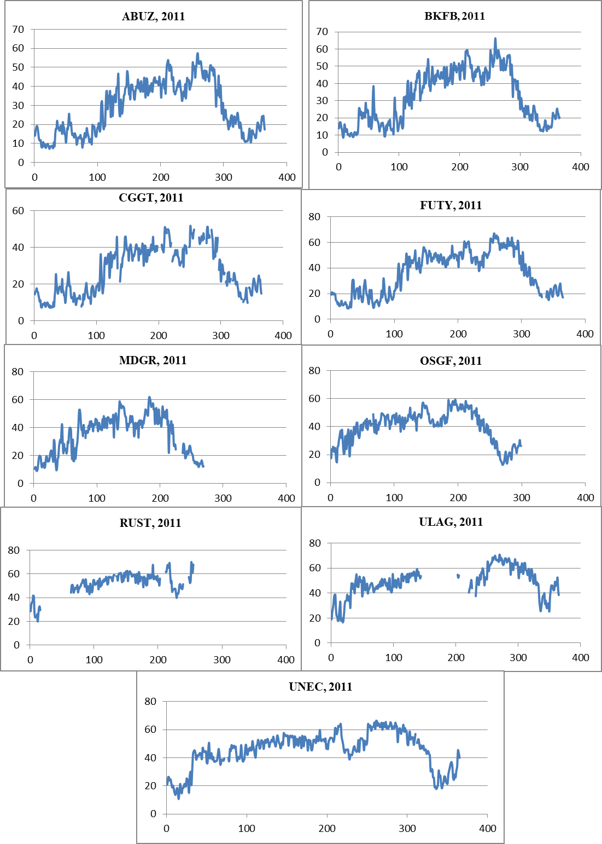

Figure 4.2: IWV mean daily estimates over NIGNET CORS from DOY 001 to 365 in 2011.

The time-series IWV trend as generated from the mean daily IWV estimates was considered all through the year for the IWV time series plot, showing its temporal dynamics. This is evident in Figure 4.2 as low IWV value were noticed for the first and the last three months of the year which represent dry season over Nigeria. In order to further appreciate the spatial characteristics of the GPS IWV estimate, IWV map over Nigeria were generated from the mean daily estimates as shown in Figure 4.3.

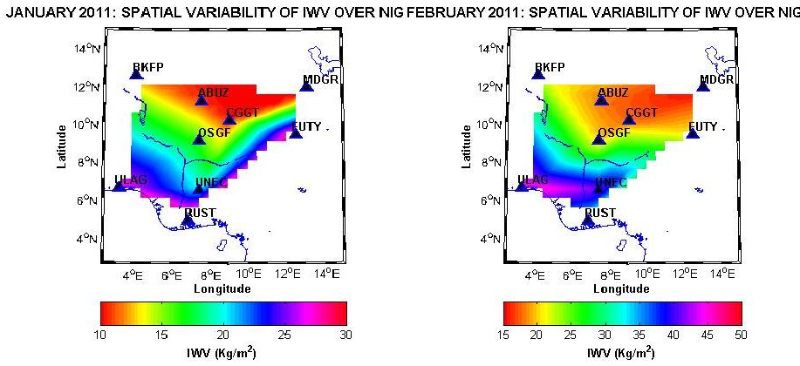

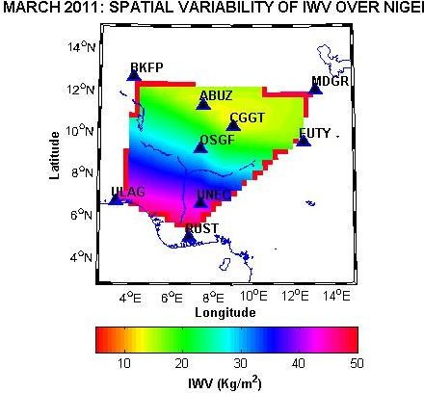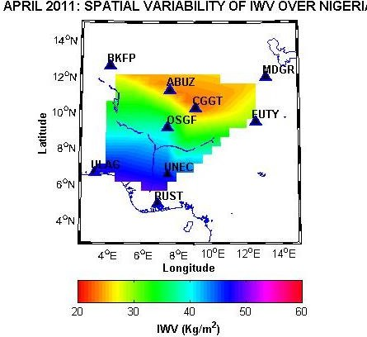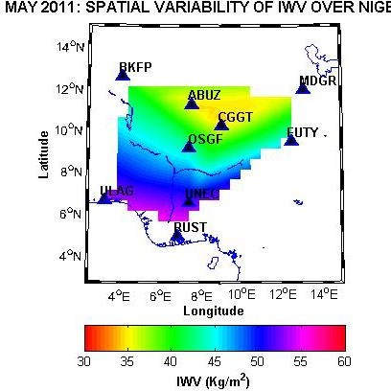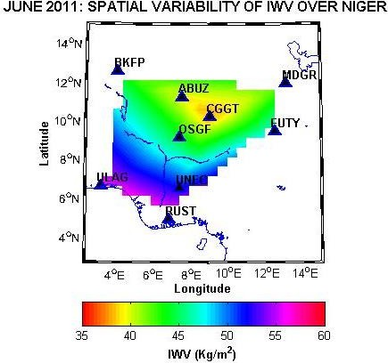

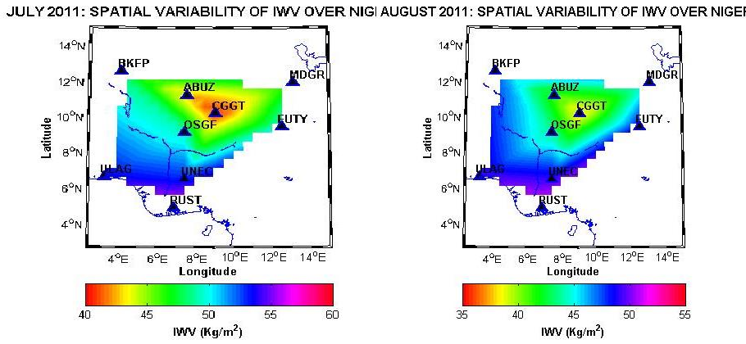

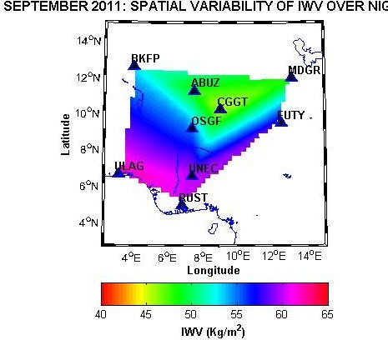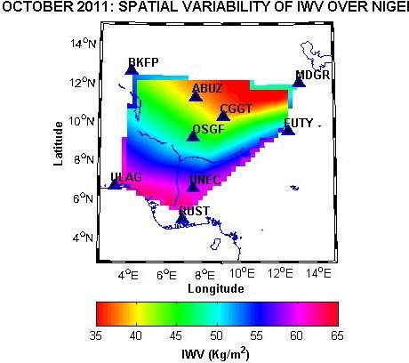

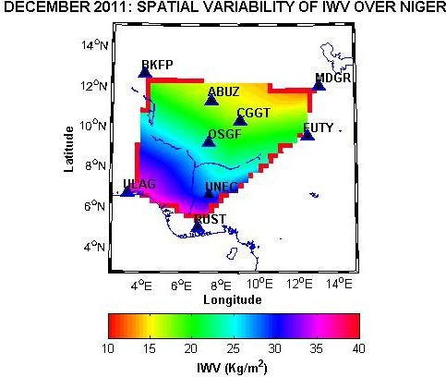

Figure 4.3: Spatio-temporal map of IWV distribution over NIGNET CORS in 2011

## Analysis of Estimated IWV

The analysis of the results from this study was performed under two considerations, these are: the spatial and seasonal analyses.

## Spatial analysis:

A consistent high value of IWV values around locations of stations: RUST in Port Harcourt and ULAG in Lagos shows that the climate in those regions is ever damp (monsoon) and could be so due to their proximity to the equator i.e. low latitude regions. On the other hand, stations BKFP, CGGT, MDGR and ABUZ possess drastically low IWV value which as a consequence, low rainfall is expected in those locations as they are proximal to Sahara desert and the dry wind and high temperature consequentially dry up the water in the atmosphere, resulting in low IWV estimates.

The stations BKFP, CGGT and MDGR constitute the northern stations. This is justified by the fact that they possess the least IWV values. Averagely, the mean annual IWV estimates are: ABUZ: 31.83719416 Kg/m2, FUTY: 40.26014 Kg/m2, BKFP: 35.84606838, UNEC: 48.77747 Kg/m2, MDGR: 38.05527, OSGF: 43.16578, RUST:

55.36414, ULAG: 52.68024, FUTY: 40.26014 Kg/m2 respectively. A significant rise in

the IWV values indicate the shift in climatic condition of stations OSGF, FUTY and ABUZ, as they were found in the middle belt region with a lower temperature and higher IWV. And lastly, the highest magnitude of IWV was observed in the southern region which is characterized with cool climate over the region. Figure 4.4 summarized the results with the IWV values on the ordinate and the days of the month on the abscissa.

U

|  |  |  |  |  |
| --- | --- | --- | --- | --- |
|  |  |  |  |  |
|  |  |  |  |  |
|  |  |  |  |  |
|  |  |  |  |  |

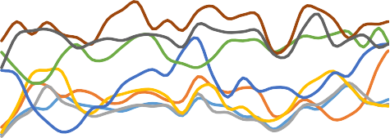0

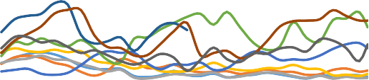

|  |  |  |  |  |  |
| --- | --- | --- | --- | --- | --- |
|  |  |  |  |  |  |
|  |  |  |  |  |  |
|  |  |  |  |  |  |
|  |  |  |  |  |  |
|  |  |  |  |  |  |
|  |  |  |  |  |  |

|  |  |  |  |  |  |  |  |
| --- | --- | --- | --- | --- | --- | --- | --- |
| MONTHLY ESTIMATED IWV FOR JANUARY, 20 | | | | | | | MONTHLY ESTIMATED IWV FOR FEBRUARY,  60  50  40  30  20  10  0  0 5 10 15 20 25  ABUZ BKFB CGGT FUTY OSGF RUST ULAG UNEC |
| 50  40  30  20  10 |  |  |  |  |  |  |
|  |  |  |  |  |  |
|  |  |  |  |  |  |
|  |  |  |  |  |  |
|  |  |  |  |  |  |
| 0 5 10 15 20 25  ABUZ BKFB CGGT FUTY OSGF RUST ULAG UNEC | | | | | | |

|  |  |  |  |  |  |
| --- | --- | --- | --- | --- | --- |
| MONTHLY ESTIMATED IWV FOR MARCH, 2011. | | | | | MONTHLY ESTIMATED IWV FOR APRIL, 2011.  80  60  40  20  0  0 5 10 15 20 2  ABUZ BKFB CGGT FU OSGF RUST ULAG UN |
| 60  50  40  30  20  10 |  |  |  |  |
|  |  |  |  |
|  |  |  |  |
|  |  |  |  |
|  |  |  |  |
|  |  |  |  |
| 0  0 10 20 30  ABUZ BKFB CGGT F OSGF RUST ULAG | | | | |

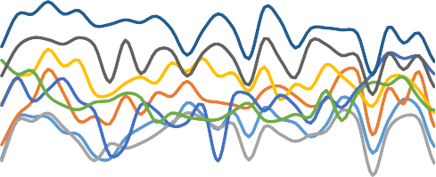80

|  |  |  |  |  |  |
| --- | --- | --- | --- | --- | --- |
|  |  |  |  |  |  |
|  |  |  |  |  |  |
|  |  |  |  |  |  |
|  |  |  |  |  |  |

|  |  |  |  |  |  |  |  |
| --- | --- | --- | --- | --- | --- | --- | --- |
| MONTHLY ESTIMATED IWV FOR MAY, 2011. | | | | | | | MONTHLY ESTIMATED IWV FOR JUNE, 2011.  65  55  45  35  25  0 5 10 15 20 25  ABUZ BKFB CGGT  FUTY MDGR OSGF  RUST ULAG UNEC |
| 60  40  20 |  |  |  |  |  |  |
|  |  |  |  |  |  |
|  |  |  |  |  |  |
|  |  |  |  |  |  |
| 0 5 10 15 20 25  ABUZ BKFB CGGT FUTY  OSGF RUST ULAG UNEC | | | | | | |

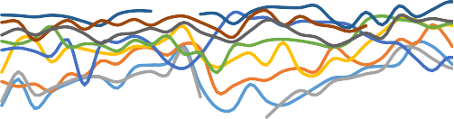

0

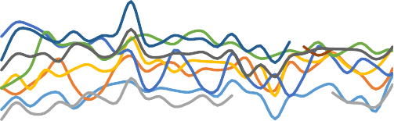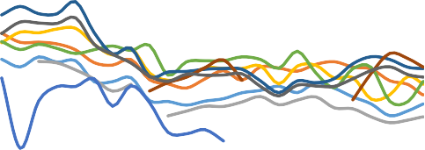

MONTHLY ESTIMATED IWV FOR

JULY, 2011.

MONTHLY ESTIMATED IWV FOR

AUGUST, 2011.

80

70

60

50

40

30

20

80

70

60

50

40

30

20

0 5 10 15 20

ABUZ BKFB CGGT

OSGF RUST ULAG

25

FUTY

UNEC

0

5

10

15

20

ABUZ

OSGF

BKFB

RUST

CGGT

ULAG

|  |  |  |  |  |
| --- | --- | --- | --- | --- |
|  |  |  |  |  |
|  |  |  |  |  |
|  |  |  |  |  |
|  |  |  |  |  |
|  |  |  |  |  |
|  |  |  |  |  |

80

R

N

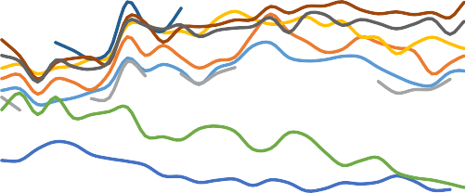

|  |  |  |  |  |  |
| --- | --- | --- | --- | --- | --- |
|  |  |  |  |  |  |
|  |  |  |  |  |  |
|  |  |  |  |  |  |
|  |  |  |  |  |  |

|  |  |  |  |  |  |  |  |
| --- | --- | --- | --- | --- | --- | --- | --- |
| MONTHLY ESTIMATED IWV FOR SEPTEMBE | | | | | | | MONTHLY ESTIMATED IWV FOR OCTOBER, 2  80  60  40  20  0  0 5 10 15 20 25  ABUZ BKFB CGGT FUTY OSGF RUST ULAG UNEC |
| 60  40  20 |  |  |  |  |  |  |
|  |  |  |  |  |  |
|  |  |  |  |  |  |
|  |  |  |  |  |  |
| 0  0 5 10 15 20 25  ABUZ BKFB CGGT FU OSGF RUST ULAG U | | | | | | |

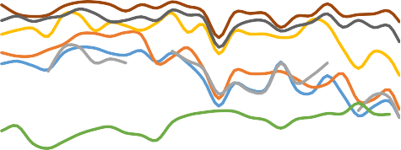

|  |  |  |
| --- | --- | --- |
|  |  |  |
|  |  |  |
|  |  |  |
|  |  |  |
|  |  |  |
|  |  |  |

Figure 4.4: Spatial estimated IWV from January to December 2011.

G

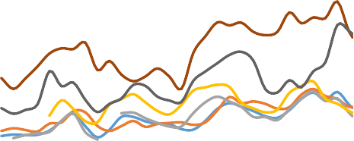

MONTHLY ESTIMATED IWV FOR NOVEMBER, 20

80

MONTHLY ESTIMATED IWV FOR DECEMBER

60

40

20

0

0

10

ABUZ

FUTY RUST

20

BKFB MDGR ULAG

30

CG OS UN

60

50

40

30

20

10

0

0

ABUZ

10

BKFB

20

CGGT

3

FUTY

OSGF

RUST

ULAG

UNEC

## Seasonal analysis

This section examined the seasonal behavior of the integrated water vapour (IWV). The IWV for the 12 months of the year were examined. It was found that for all the stations, there are consistently low IWV estimates during the first and the last three months of the year (Figure 4.2). Those periods of the year represent the dry season over Nigeria. On the other hand, a relatively high IWV estimates were noticed from April to October which represents the rainy season. This results pattern suggests that the atmosphere usually hold high vapour during the rainy than the dry season because of the frontal effect that usually precedes every rainfall. However, it can also be seen from Figure 4.2 that stations ULAG and RUST generally present some level of inconsistency in the pattern of the IWV time series due to the presence of monsoon system occasioned by their close-equatorial location.

## Validation of the estimated IWV

In order to validate and assess the estimated IWV, the IWV from ECMWF re-analysis data was generated and compared to the IWV estimated from GPS data. The estimated GPS-based IWV were compared with the IWV obtained from the ECMWF re-analysis and the RMS were computed using equation 20. The summary of statistics for the mean monthly estimates for January and February are shown in Table 4.4. See appendix B for the other months.

Table 4.4: Summary of statistics of the mean monthly IWV estimates.

|  |  |  |
| --- | --- | --- |
| Station | Mean Diff.  (kg/m2) | RMS  (kg/m2) |
| JANUARY | | |
| ABUZ | 5.396144 | 1.062605 |
| BKFP | 0.204126 | 0.337104 |
| CGGT | 8.168365 | 1.467082 |
| FUTY | 2.830501 | 1.137948 |
| RUST | 18.76307 | 3.369947 |
| ULAG | -18.4986 | 3.322451 |
| UNEC | -6.82578 | 1.255759 |
| FEBRUARY | | |
| ABUZ | 2.042842 | 5.8969 |
| BKFP | 1.506261 | 0.828227 |
| CGGT | 23.12556 | 4.370321 |
| FUTY | 28.45987 | 5.37841 |
| ULAG | 31.12826 | 5.882687 |
| UNEC | 20.33608 | 3.843157 |

The mean differences range from 10.3319kg/m2 at station CGGT to 18.76307kg/m2 at station RUST with corresponding RMS at a range of 0.337 kg/m2 and 3.369947kg/m2 which will translate to a minimal error (less than 4Kg/m2 ) in IWV estimates (Musa *et al.,* 2011).

The GPS-based IWV estimates were compared to the ECMWF-based IWV, the results are as shown in Figure 4.5.

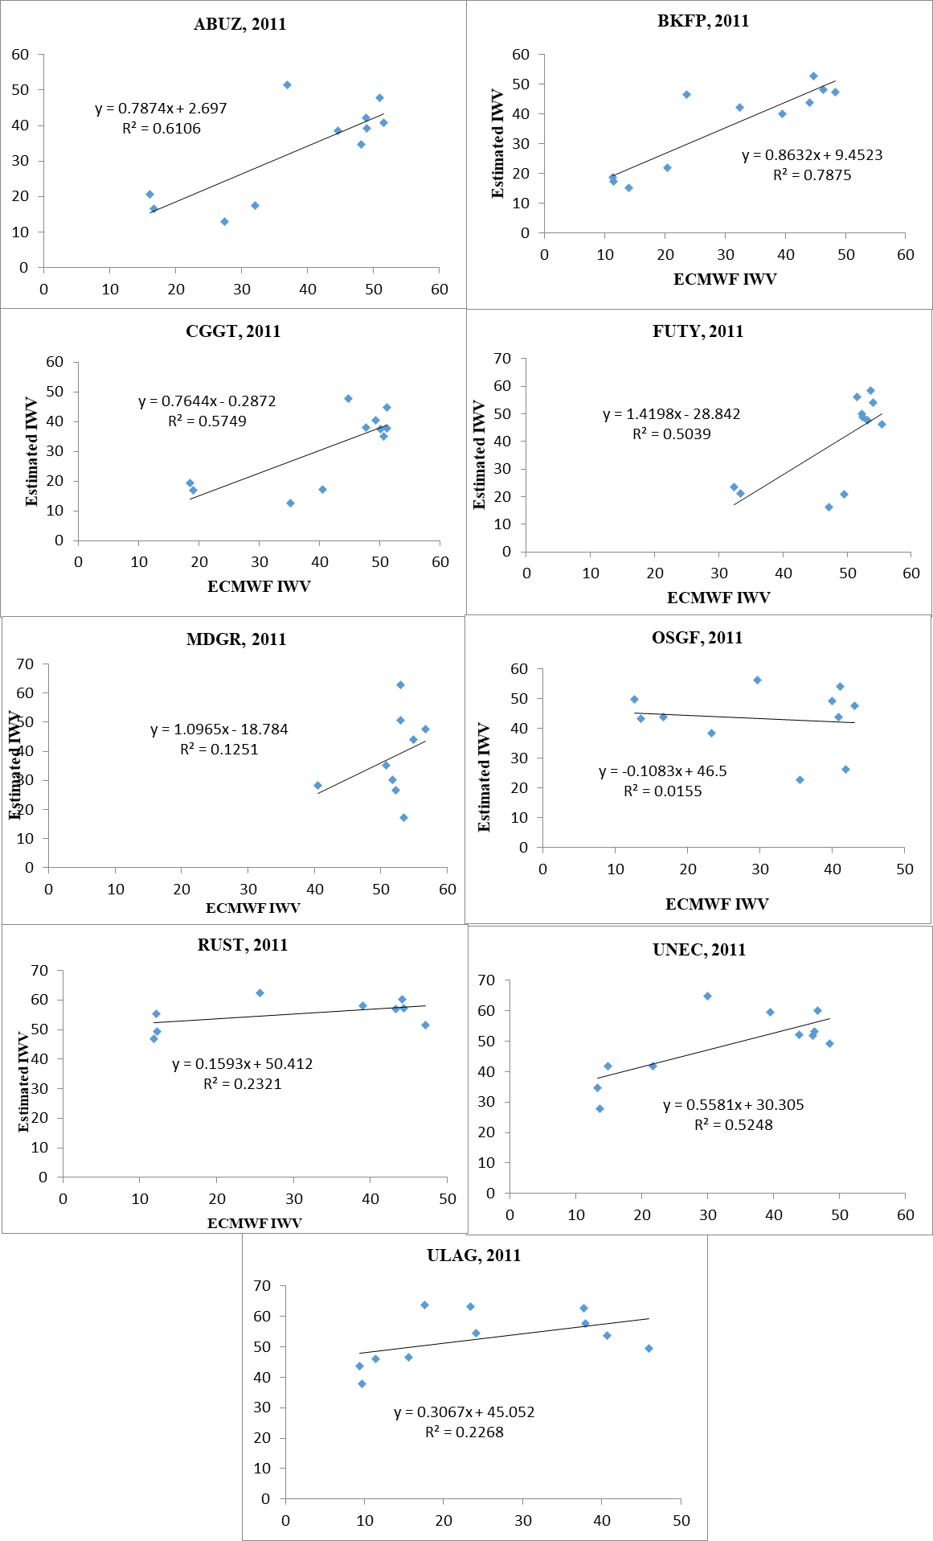

Figure 4.5: IWV scatterplot showing the correlation between GPS and ECMWF IWV Estimates.

From Figure 4.5, the R2 (i.e. correlation coefficients) are respectively; *ABUZ: 0.6106, BKFP: 0.7875, CGGT: 0.5749, FUTY: 0.5039, MDGR: 0.1251, OSGF: 0.0199, RUST:*

*0.2931, ULAG: 0.2268, UNEC: 0.5248.* It was observed that stations ABUZ, BKFP, CGGT, and FUTY located in the Northern regions are having a relatively strong correlations except for MDGR and OSGF that show weak correlation. This could be attributed to the fact that the two stations have inconsistent data over the year and specifically no data for January, February and March. Similarly, stations RUST and ULAG in the Southern region present level of data inconsistency. Generally, an averagely correlation of 60% level was realized.

The mean monthly estimates of IWV from ECMWF and GPS at each station were generated and plotted as depicted in figure 4.6.

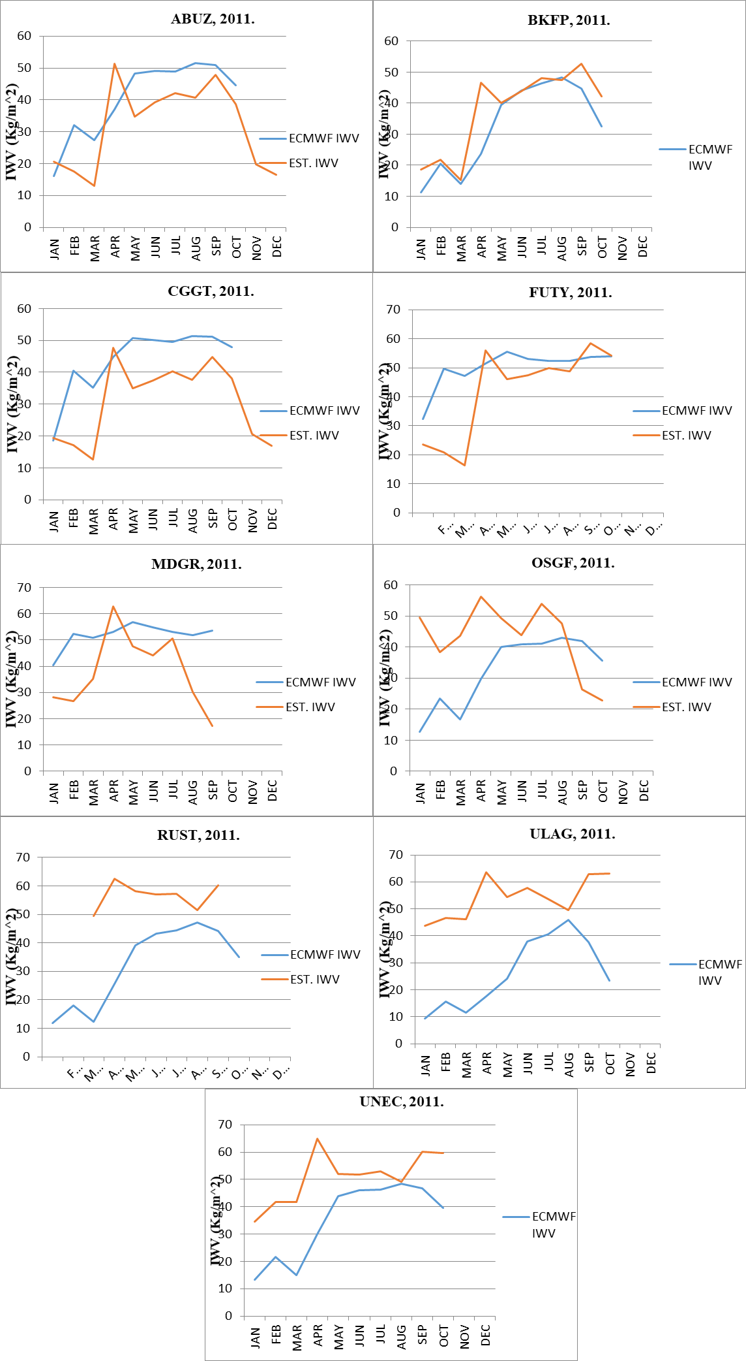

Figure 4.6: The mean monthly IWV estimates for the year 2011 from ECMWF and GPS showing the correlation pattern at each GPS station.

It can be seen from Figure 4.7 that the estimated IWV from the two concepts showed similar pattern at all the station except for OSGF, MDGR and RUST. This is found to be consistent with the correlation coefficient values as earlier shown in Figure 4.5.

# CHAPTER FIVE

* 1. **CONCLUSION AND RECOMMENDATIONS**

This research was executed in several phases to address three specific objectives stated in the previous section of the thesis.

The first objective i.e. estimation of Zenith Path Delay was achieved by processing GNSS data over NIGNET CORS using Bernese GPS software version 5.0. The Saastamonien ZPD model and Neil mapping function were adopted for estimation of the ZPD. The ZPD estimates as shown in table 4.1 indicated that Northern part of Nigeria experiences less delay along the zenith with the least ZPD value (2129.924m) at station CGGT (Toro, Bauchi State) while, the highest ZPD value of 2731.104m was observed at station ULAG (Lagos State) in the Southern part of Nigeria.

The ZPD obtained was validated by correlating the locally estimated ZPD values with the IGS archived ZPDs over the IGS stations adopted as fix stations (ADIS, BJCO, and RABT) in this study. The mean daily differences were computed as well as the RMSEs. The average difference obtained for the stations ADIS, BJCO and RABT are respectively; 17.7385m, 5.951236m, and 37.0853m. A perfectly similar pattern was noticed between the estimated ZPD and the IGS ZPD with an average correlation of 0.7.

It was realized that the ZPD is strongly a function of location. Station BJCO has the least baseline length 685km consequentially yield strongest correlation coefficient of 0.9596 while station RABT on the other hand has longer baseline length yielded low correlation coefficient of 0.45.

The second objective which is the estimation of IWV adopted the estimated ZPD coupled with the surface temperature and pressure obtained from GPT2w_model.

Furthermore, Spatial and seasonal variation of IWV value over the NIGNET CORS was performed and it was found that the highest IWV values were obtained over the southern

stations just as the rainy season presents the period of high IWV values over all stations. The estimated IWV was validated with IWV generated from ECMWF ERA-5 interim data and it shows a considerable correlation with the estimated NIGNET IWV, the average correlation of 0.6 was obtained. It was deduced from the study that GPS-based IWV properly captured the IWV trend over Nigeria.

The estimated GPS-based IWV was validated with ECMWF ERA-5 Interim IWV, the RMSE obtained over the NIGNET stations ABUZ, BKFP, CGGT, FUTY, RUST, ULAG, and UNEC are respectively: 1.062604816 kg/m2, 0.33710427kg/m2, 1.467081633kg/m2, 1.137948323 kg/m2, 3.369947301kg/m2, 3.322451441kg/m2, and 1.255758948 kg/m2.

## Conclusion

In conclusion, this study has been able to assess a year span IWV over NIGNET using GNSS approach. The study has concluded on the following:

1. ZPD is a key input parameter in the estimation of IWV and as such it ought to be estimated as accurate as possible using an adequate validation strategy.
2. Also, the most reliable data for validation of the estimated IWV are the meteorological data (surface temperature and pressure) observed by a sensor collocated with the CORS. This study used an ERA 5 hourly data as a proxy.
3. The variation in IWV estimated was found to be dependent on location, baseline length and time as presented in section 4.1.
4. This study found also that the atmospheric dynamics (variation of vapour in the atmosphere) are much affected (delayed) in the rainy season or much humid or cloudy weather than the dry season as evidenced by the seasonal analysis conducted in this study.

## Problem encountered

Estimation of IWV as established in this study is a pure application of GNSS to meteorology, and due to the dichotomy in the nature and form of data used by the both practitioners, the challenge of data accessibility;

Data used by meteorological agencies is a large data format which requires a substantial computer memory for processing. In this vein, an hourly temperature and pressure data could not be accessed from ECMWF due to high system requirements which was not available to the researcher as at time of this study. Consequentially, a blind model GPT2w_1 model which is based on numerical modelling was adopted for retrieval of pressure and temperature data not the ECMWF nor a direct surface measurement.

Another major challenge in the study that influence the analysis is the gap in the GPS Rinex observation data stem from inconsistency of data over some stations. As a result of the gaps, it became mandate to be tracing the data epoch by epoch for coincidence in the estimated results and the standard values (IGS_ZPD and ECMWF data) adopted for validation.

NIGNET CORSs are not collocated with weather sensors which would have been the most accurate weather data based on measurement for validation of this study.

## Contribution to Knowledge

The following are the contribution to knowledge

* + - 1. The IWV assessment was done for Nigeria NIGNET station for the the year 2011
      2. The IWV estimation depended on the location and help to know the value of estimate in the raining season and the dry season
      3. ERA 5 Eterim was us to validate the estimated IWV
      4. Regions closer to the tropical region are found to have higher integrated water vapour

## Recommendations

This study is one of the earliest form of it in Nigeria, it is recommended by the author that subsequent studies in this area should consider the following:

1. A directly observed surface temperature and pressure data collocated with the GPS stations are recommended for validating the results from this study.
2. More work should be done to assess accuracy of ECMWF numerical weather model and GPT2w_1 model using observed surface data from radiosonde in order to inform the coming researchers the best substitute for radiosonde data in the estimation and validation of results for their studies.
3. Extended study should be conducted in developing a regional weighted mean temperature for Nigeria.

# REFERENCES

Abbas, M. A., Fuad, N. A., Idris, K. M., Opaluwa, Y. D., Hashim, N. M., Majid, Z., & Sulaiman, S. A. (2019). Reliability of Terrestrial Laser Scanner Measurement in Slope Monitoring. In *IOP Conference Series: Earth and Environmental Science* 385( 1), p. 012042.

Ayodele, E. G., Okolie, C. J., & Mayaki, O. A. (2019). An Assessment of the Reliability of the NIGNET Data. *Nigerian Journal of Environmental Sciences and Technology*, *3*(1), 18-29.

Behrangi, A., Andreadis, K., Fisher, J. B., Turk, F. J., Granger, S., Painter, T., & Das, N. (2014). Satellite-based precipitation estimation and its application for streamflow prediction over mountainous western US basins. *Journal of Applied Meteorology and Climatology*, *53*(12), 2823-2842.

Bevis, M., Businger, S., Herring, T. A., Rocken, C., Anthes, R. A., & Ware, R. H. (1992). GPS meteorology: Remote sensing of atmospheric water vapor using the Global Positioning System. *Journal of Geophysical Research: Atmospheres*, *97*(D14), 15787-15801.

Bevis, M., Businger, S., Chiswell, S., Herring, T. A., Anthes, R. A., Rocken, C., & Ware,

R. H. (1994). GPS meteorology: Mapping zenith wet delays onto precipitable water. *Journal of applied meteorology*, *33*(3), 379-386.

Bock, O., Bouin, M. N., Walpersdorf, A., Lafore, J. P., Janicot, S., Guichard, F., & Agusti‐Panareda, A. (2007). Comparison of ground‐based GPS precipitable water vapour to independent observations and NWP model reanalyses over Africa. *Quarterly Journal of the Royal Meteorological Society: A journal of the atmospheric sciences, applied meteorology and physical oceanography*, *133*(629), 2011-2027.

Bosy, J., Kaplon, J., Rohm, W., Sierny, J., & Hadas, T. (2012). Near real-time estimation of water vapour in the troposphere using ground GNSS and the meteorological data. *Annales Geophysicae,* 30(9), pp. 1379-1391.

Choy S., Zhang K., Manning T., Wu S., Rohm W., and Silcock D., (2015). Capturing the Signature of Severe Weather Events in Australia Using GPS Measurements, in *IEEE Journal of Selected Topics in Applied Earth Observations and Remote Sensing*, 8(4), 1839-1847

Davis, J. L., Herring, T. A., Shapiro, I. I., Rogers, A. E. E., & Elgered, G. (1985). Geodesy by radio interferometry: Effects of atmospheric modeling errors on estimates of baseline length. *Radio science*, *20*(6), 1593-1607.

Diedrich, H., Wittchen, F., Preusker, R., & Fischer, J. (2016). Representativeness of total column water vapour retrievals from instruments on polar orbiting satellites. *Atmospheric Chemistry and Physics*, *16*(13), 8331-8339.

Dodo J. D., Ojigi L. M., Tsebeje Samuel Yabayanze (2015). Determination of the best- fit Tropospheric Delay Model on the Nigerian Permanent GNSS Network. *Journal of Geosciences and Geomatics*, 3(4), 88-95.

Edozie, R. U., & Adebomehin, A., Nwilo, P. C., & Dodo, J. D., (2013). The Nigerian Geocentric Datum (NGD2012): Preliminary Results. In *FIG Working Week,* (6- 10).

Elgered, G. (1993). Tropospheric radio-path delay from ground-based microwave radiometry. *Atmospheric remote sensing by microwave radiometry*, 215.

Enemark, S. (2013). Fit-for-purpose: Building spatial frameworks for sustainable and transparent land governance. In *Annual World Bank Conference on Land and Poverty*. The World Bank.

Fisher, K. A., & Raquet, J. F. (2011). *Precision position, navigation, and timing without the global positioning system*. AIR UNIV MAXWELL AFB AL AIR FORCE RESEARCH INST.

Gutman, S.I. and Benjamin S.G. (2001). The role of ground-based GPS meteorological observations in numerical weather prediction, *GPS Solut.*, 4(4), 16-24.

Hajj, G. A., Ao, C. O., Iijima, B. A., Kuang, D., Kursinski, E. R., Mannucci, A. J., ... & Yunck, T. P. (2004). CHAMP and SAC‐C atmospheric occultation results and intercomparisons. *Journal of Geophysical Research: Atmospheres*, *109*(D6).

Hirahara, K. (2000). Local GPS tropospheric tomography. *Earth, planets and space*, *52*(11), 935-939.

Hofmann-Wellenhof, B., Lichtenegger, H., & Wasle, E. (2007). *GNSS–global navigation satellite systems: GPS, GLONASS, Galileo, and more*. Springer Science & Business Media.

Hopfield, H. S. (1969). Two‐quartic tropospheric refractivity profile for correcting satellite data. *Journal of Geophysical research*, *74*(18), 4487-4499.

Isioye, O. A., Combrinck, L., & Botai, J. (2015). Performance evaluation of Blind Tropospheric delay correction models over Africa. *South African Journal of Geomatics*, *4*(4), 502-525.

Jennifer H., Maorong G., Henrik V., and Eric C. (2003). Accuracy and variability of GPS tropospheric delay measurements of water vapor in the western Mediterranean. *Journal of Applied Meteorology* 42(11), 1547-1568.

Kawatani, Y., Hamilton, K., Miyazaki, K., Fujiwara, M., & Anstey, J. A. (2016). Representation of the tropical stratospheric zonal wind in global atmospheric reanalyses. *Atmospheric Chemistry and Physics*, *16*(11), 6681-6699.

Khojasteh, A. N., Jamshidi, M., Vahedi, E., & Telikani, S. (2016). Introduction to Global Navigation Satellite Systems and Its Errors. *International Academic Institute for Science and Technology*, *3*(3), 53-61.

Kufoniyi, O. (2016). GNSS CORS, the Bedrock of Sustainable Development. *Presented at the International Training Workshop on Global Navigation Satellite Systems (GNSS)* (8, p. 13).

Mendes, V. B., Prates, G., Santos, L., & Langley, R. B. (2000). An evaluation of the accuracy of models for the determination of the weighted mean temperature of the atmosphere. In *Proceedings of the 2000 National Technical Meeting of The Institute of Navigation* (433-438).

Musa, T. A., Amir, S., Othman, R., Ses, S., Omar, K., Abdullah, K., & Rizos, C. (2011). GPS meteorology in a low-latitude region: Remote sensing of atmospheric water vapor over the Malaysian Peninsula. *Journal of Atmospheric and Solar- Terrestrial Physics*, *73*(16), 2410-2422.

Musa, T. A. Salihin, S. Zahira M. R., (2017). Spatio-Temporal Estimation Of Integrated Water Vapour Over The Malaysian Peninsula During Monsoon Season. *International Archives of the Photogrammetry, Remote Sensing & Spatial Information Sciences*. 42(4W/5), 165-175.

Naibbi, A. I., & Ibrahim, S. S. (2014). An assessment of the existing continuously operating reference stations (CORS) in Nigeria: An exploration using geographical information system (GIS). *American Journal of Geographic Information System*, *3*(4), 147-157.

Nicholas, G. (2010). Network CORS, who wants it? Un-published Thesis. University of New South Wales, Australia. [Online]. <http://www.gmat.unsw.edu.au/currentstu> dents/ug/projects/Gowans/Thesis/Introduction.html (Retrieved 7, 2014).

Niell, A. E., Coster, A. J., Solheim, F. S., Mendes, V. B., Toor, P. C., Langley, R. B., & Upham, C. A. (2001). Comparison of measurements of atmospheric wet delay by radiosonde, water vapor radiometer, GPS, and VLBI. *Journal of Atmospheric and Oceanic Technology*, *18*(6), 830-850.

Onoriode B., Ajani O. and Mpaka E. (2017). GPS CORS Technology Implementation in the Oil Industry: Benefits and Challenges. *Geomatics Department. The Shell Petroleum Development Company of Nigeria Limited, 1 – 12.*

Opaluwa, Y. D., T. A. Musa, A. H. Omar, M. D. Subari, and L. M. Ojigi(2014a). Preliminary Design for near Real-Time GPS Meteorology over Peninsular Malaysia (G-MeM), *Terr. Atmos. Ocean*. Sci., 25(6), 813-826.

Opaluwa Y. D., Norazmi M. F., Musa T. A., Othman R. and Eyo E (2014b). Trend in Ground-Based Gps Sensing of Atmospheric Water Vapour: The Malaysian Perspective. *Jurnal Teknologi (Sciences & Engineering*). 71(4), 35–47.

Opaluwa, Y. D., T. A. Musa, K. Omar, H. A. Samaila-Ija, and N. L. Izah (2017). Applicability of Global Pressure and Temperature Model (GPT2w) for GPS Meteorology in Peninsular Malaysia." *3rd international Conference on Science Engineering and Social Sciences (ICSESS), UTM Johor Bahru, Malaysia,* 29 (2017), 75.

Osah, S., Acheampong, A. A., Fosu, C., & Dadzie, I. (1996). Deep learning model for predicting daily IGS zenith tropospheric delays in West Africa using TensorFlow and Keras. Advances in Space Research.

Pacione, R., Sciarretta, C., Faccani, C., Ferretti, R., & Vespe, F. (2001). GPS PW assimilation into MM5 with the nudging technique. *Physics and Chemistry of the Earth, Part A: Solid Earth and Geodesy*, *26*(6-8), 481-485.

Pany, T., P. Pesec, and G. Stangl (2001). Elimination of tropospheric path delays in GPS observations with the ECMWF numerical weather model, *Phys. Chem. Earth. A* 26(6- 8),487-492.

Paolo, Dabove., Linty, N., & Dovis, F. (2020). Analysis of multi-constellation GNSS PPP solutions under phase scintillations at high latitudes. *Applied Geomatics*, *12*(1), 45-52.

Rizos, C., & Satirapod, C. (2011). Contribution of GNSS CORS infrastructure to the mission of modern geodesy and status of GNSS CORS in Thailand. *Engineering Journal*, *15*(1), 25-42.

Sarkar, S., Banerjee, P., & Bose, A. (2018). A review of 36 years of GLONASS service from India. *Gyroscopy and Navigation*, *9*(4), 301-313.

Schueler, Torben, P., Andrea, Hein, Guenter W., Biberger, & Robert, (2001). "A Global Analysis of the Mean Atmospheric Temperature for GPS Water Vapor Estimation," *Proceedings of the 14th International Technical Meeting of the Satellite Division of The Institute of Navigation (ION GPS 2001)*, Salt Lake City, UT, pp. 2476-2489.

Schwieger, V., Lilje, M., & Sarib, R. (2009). GNSS CORS-Reference frames and services. In *7th FIG Regional Conference, Hanoi, Vietnam* 19(22), 10.

Snay, R. A., & Soler, T. (2008). Continuously operating reference station (CORS): history, applications, and future enhancements. *Journal of Surveying Engineering*, *134*(4), 95-104.

Soden, B. J., Jackson, D. L., Ramaswamy, V., Schwarzkopf, M. D., & Huang, X. (2005). The radiative signature of upper tropospheric moistening. Science, 310(5749), 841-844.

Stensrud, D. J. (2009). *Parameterization schemes: keys to understanding numerical weather prediction models*. Cambridge University Press.

Subirana, J., Zornoza, J., & Hernández-Pajares, M. (2011). Reference Frames in GNSS. Teke, K., Böhm, J., Nilsson, T., Schuh, H., Steigenberger, P., Dach, R., & Shimizu, S.

(2011). Multi-technique comparison of troposphere zenith delays and gradients

during CONT08. *Journal of Geodesy*, *85*(7), 395-413.

Tregoning, P., Boers, R., O'Brien, D., & Hendy, M. (1998). Accuracy of absolute precipitable water vapor estimates from GPS observations. *Journal of geophysical research: atmospheres*, *103*(D22), 28701-28710.

Vey, S., Dietrich, R., Rülke, A., Fritsche, M., Steigenberger, P., & Rothacher, M. (2010). Validation of Precipitable Water Vapor within the NCEP/DOE Reanalysis Using Global GPS Observations from One Decade, *Journal of*

*Climate*, *23*(7), 1675-1695.

from [https://journals.ametsoc.org/view/journals/clim/23/7/2009jcli2787.1.](https://journals.ametsoc.org/view/journals/clim/23/7/2009jcli2787.1.xml)

Wickert, J., Ge, M., Chen, J., Douša, J., & Gendt, G. (2012). A computationally efficient approach for estimating high-rate satellite clock corrections in realtime. *GPS solutions*, *16*(1), 9-17.

Wickert, J., Li, X., Dick, G., Ge, M., Heise, S., & Bender, M. (2014). Real‐time GPS sensing of atmospheric water vapor: Precise point positioning with orbit, clock, and phase delay corrections. *Geophysical Research Letters*, *41*(10), 3615-3621.

Wonnacott, R. T. (2005). The estimation of precipitable water vapour from GPS measurements in South Africa (Master's thesis, University of Cape Town).

# APPENDICES

APPENDIX A: Time-series mean daily IWV estimates over the NIGNET CORS for the corresponding Day of Year (1 to 365).

|  |  |  |  |  |  |  |  |  |  |
| --- | --- | --- | --- | --- | --- | --- | --- | --- | --- |
|  | ABUZ | BKFB | CGGT | FUTY | MDGR | OSGF | RUST | ULAG | UNEC |
| 1 | 14.06244 | 13.9257 | 14.41724 | 19.21769 |  |  | 28.55116 | 18.95092 | 21.11069 |
| 2 | 16.77864 | 16.96299 | 15.72718 | 21.10428 |  |  | 34.46535 | 24.676 | 26.32327 |
| 3 | 18.46023 | 17.59606 | 16.33838 | 19.77633 |  |  | 36.06441 | 27.72356 | 26.24703 |
| 4 | 19.20694 | 16.68614 | 17.73192 | 19.42445 |  |  | 36.94347 | 31.18208 | 23.75485 |
| 5 | 18.28076 | 14.38486 | 16.0002 | 20.44824 |  |  | 41.8602 | 37.08428 | 24.61151 |
| 6 | 16.02341 | 13.11877 | 15.71383 | 19.28124 |  |  | 41.27756 | 38.7826 | 21.75966 |
| 7 | 13.04672 | 10.24437 | 13.8584 | 19.73789 |  |  | 27.24729 | 38.70713 | 18.91466 |
| 8 | 11.66312 | 8.495904 | 12.257 | 15.43584 |  |  | 23.32752 | 27.14862 | 20.20435 |
| 9 | 11.43815 | 10.68649 | 10.41865 | 14.33121 |  |  | 24.30185 | 21.66947 | 17.9036 |
| 10 | 11.6825 | 16.12203 | 11.2066 | 13.56428 |  |  |  | 21.23358 | 15.21531 |
| 11 | 8.324892 | 14.73784 | 7.594532 | 11.71496 |  |  | 26.12642 | 17.76401 | 13.60865 |
| 12 | 7.849384 | 11.97285 | 7.210699 | 12.97202 |  |  | 19.92215 | 17.93937 | 15.52051 |
| 13 | 8.598416 | 12.29525 | 8.102076 | 10.56379 |  |  | 25.68719 | 23.11152 | 18.51987 |
| 14 | 10.70822 | 13.54755 | 9.180485 | 10.36959 |  |  | 31.37525 | 28.93223 | 16.83601 |
| 15 | 8.757501 | 11.10151 | 8.81644 | 10.60517 |  |  | 32.69542 | 32.80417 | 10.71183 |
| 16 | 8.352376 | 10.07416 | 9.045705 | 12.07677 |  |  | 29.50116 | 17.85945 | 15.74543 |
| 17 | 9.422838 | 10.21369 | 9.928281 | 14.4578 |  |  |  | 18.93842 | 21.42177 |
| 18 | 7.629298 | 10.53065 | 7.737448 | 12.10339 |  |  |  | 19.90544 | 16.10087 |
| 19 | 8.511603 | 9.302624 | 8.086236 | 11.00793 |  |  |  | 16.50847 | 14.78663 |
| 20 | 8.885593 | 10.28698 | 9.245822 | 10.95164 |  |  |  | 18.50607 | 18.77258 |
| 21 | 9.850381 | 11.36701 | 10.00383 | 11.98755 |  |  |  | 24.2225 | 18.58494 |
| 22 | 9.052597 | 10.31448 | 9.655807 | 11.92135 |  |  |  | 31.12898 | 21.01589 |
| 23 | 8.010071 | 10.19259 | 8.378607 | 13.4514 |  |  |  | 33.58176 | 21.4905 |

|  |  |  |  |  |  |  |  |
| --- | --- | --- | --- | --- | --- | --- | --- |
| 24 | 7.163951 | 8.868318 | 7.410073 | 11.71614 |  | 33.84474 | 19.55319 |
| 25 | 8.455654 | 9.139277 | 8.467661 | 11.47723 |  | 34.42443 | 25.22462 |
| 26 | 8.382681 | 11.17418 | 7.136095 | 8.629518 |  | 38.66529 | 24.62131 |
| 27 | 8.680336 | 11.75857 | 7.961062 | 8.974701 |  | 35.96355 | 21.17535 |
| 28 | 8.688447 | 10.31479 | 7.287734 | 8.373565 |  | 33.85454 | 15.21871 |
| 29 | 7.548813 | 11.11089 | 7.61618 | 9.906346 |  | 34.32921 | 27.94509 |
| 30 | 7.713759 | 9.983238 | 7.507291 | 10.06265 |  | 37.2903 | 30.04493 |
| 31 | 10.6173 | 11.82403 | 10.24849 | 13.4948 |  | 28.06331 | 20.47829 |
| 32 | 8.493065 | 11.01793 | 7.811296 | 9.227143 | 31.05735 | 41.23126 | 31.85487 |
| 33 | 14.47418 | 16.47115 | 13.63888 | 18.02229 |  | 47.92343 | 43.09831 |
| 34 | 17.72507 | 25.73658 | 17.19586 | 29.51641 |  | 43.50907 | 44.72735 |
| 35 | 17.46012 | 25.58488 | 25.44283 | 30.91601 |  | 47.71812 | 45.26256 |
| 36 | 21.93135 | 21.63378 | 20.05171 | 30.41698 |  | 43.53549 | 43.20385 |
| 37 | 19.29806 | 23.84861 | 17.87721 | 18.84884 |  | 42.36399 | 38.70237 |
| 38 | 18.27238 | 22.82408 | 14.8299 | 15.96686 |  | 40.10288 | 40.58468 |
| 39 | 17.49241 | 19.67283 | 16.03658 | 20.93712 |  | 48.50925 | 42.0127 |
| 40 | 16.6399 | 19.73061 | 17.55542 | 22.61097 |  | 52.02428 | 41.35506 |
| 41 | 18.35404 | 22.99016 | 18.75132 | 23.91593 |  | 54.7755 | 43.0695 |
| 42 | 19.37023 | 22.8982 | 18.33383 | 24.17219 |  | 45.42848 | 43.41991 |
| 43 | 18.31448 | 20.39982 | 18.60943 | 21.5856 |  | 48.41398 | 42.21043 |
| 44 | 15.06076 | 20.28255 | 15.60902 | 15.96103 |  | 44.82381 | 39.0657 |
| 45 | 21.12966 | 28.69493 | 22.79567 | 24.19728 |  | 51.58994 | 47.04776 |
| 46 | 19.06709 | 25.19137 | 16.72271 | 25.46111 |  | 53.27518 | 45.33976 |
| 47 | 18.14724 | 23.1687 | 16.17541 | 17.5705 |  | 48.96331 | 44.1469 |
| 48 | 14.86575 | 24.77975 | 13.79379 | 18.08703 |  | 50.28854 | 44.41367 |
| 49 | 14.41735 | 23.76742 | 13.35622 | 14.05814 |  | 50.10719 | 44.66489 |
| 50 | 10.33249 | 15.06348 | 9.753526 | 13.40589 |  | 37.45871 | 36.69539 |
| 51 | 13.64607 | 16.33343 | 12.27624 | 16.87226 |  | 39.82168 | 36.09839 |
| 52 | 18.03457 | 20.67236 | 18.58327 | 24.62193 |  | 52.65654 | 45.55169 |

|  |  |  |  |  |  |  |  |  |  |
| --- | --- | --- | --- | --- | --- | --- | --- | --- | --- |
| 53 | 17.37868 | 18.05464 | 18.94232 | 28.11569 |  |  |  | 52.2401 | 50.56223 |
| 54 | 21.56993 | 13.68551 | 22.48338 | 30.62804 |  |  |  | 48.88118 | 39.7237 |
| 55 | 25.62666 | 15.01665 | 26.54293 | 25.76753 |  |  |  | 42.14593 | 41.54136 |
| 56 | 19.93025 | 19.74635 | 22.48836 | 20.42503 |  |  |  | 46.73219 | 43.23969 |
| 57 | 19.51939 | 32.64491 | 18.62786 | 18.72584 |  |  |  | 47.06032 | 38.90777 |
| 58 | 20.93674 | 38.40387 | 19.03425 | 17.85913 |  |  |  | 47.54565 | 40.76266 |
| 59 | 17.05236 | 27.26156 | 14.15117 | 13.38794 |  |  |  | 39.80586 | 37.68395 |
| 60 | 14.44726 | 19.99058 | 12.3804 | 12.01872 | 10.42004 | 17.52655 |  | 42.24309 | 37.09877 |
| 61 | 15.20778 | 18.7077 | 12.88247 | 22.63735 | 11.17251 | 23.9504 |  | 43.34716 | 37.74648 |
| 62 | 14.41118 | 22.08723 | 12.57 | 19.19432 | 11.65314 | 22.85927 |  | 44.37486 | 37.55946 |
| 63 | 13.11988 | 19.95065 | 10.33631 | 16.40754 | 9.357659 | 25.67225 |  | 46.5262 | 38.5292 |
| 64 | 15.35302 | 19.0949 | 15.09581 | 22.90068 | 8.870389 | 23.18499 | 44.22342 | 47.22227 | 42.87184 |
| 65 | 14.46952 | 17.87232 | 14.2564 | 15.0461 | 9.778006 | 21.973 | 50.11918 | 48.13827 | 46.31785 |
| 66 | 13.39455 | 17.14543 | 12.10794 | 12.09677 | 13.34927 | 24.90183 | 50.93332 | 47.70837 | 41.53362 |
| 67 | 9.438781 | 14.01445 | 8.713334 | 9.069859 | 17.66616 | 21.18057 | 50.27321 | 45.3535 | 35.19393 |
| 68 | 10.70504 | 12.19618 | 9.950768 | 9.250586 | 19.73741 | 15.71835 | 44.40277 | 41.53119 | 37.02894 |
| 69 | 12.59981 | 15.16762 | 11.87603 | 12.16326 | 18.98227 | 14.67041 | 45.5032 | 40.70673 | 38.74599 |
| 70 | 13.16202 | 14.85513 | 12.45739 | 13.54609 | 19.10983 | 25.56416 | 47.25449 | 43.79941 | 38.41692 |
| 71 | 13.44879 | 17.01084 | 12.25252 | 13.45506 | 14.15884 | 26.10033 | 48.5084 | 42.93213 | 37.9665 |
| 72 | 12.7147 | 16.30605 | 12.25181 | 14.51741 | 11.45271 | 29.83998 | 47.82594 | 44.08409 | 39.70923 |
| 73 | 14.50154 | 17.2441 | 13.87336 | 14.94061 | 13.7016 | 32.73232 | 47.66411 | 45.50458 |  |
| 74 | 12.47383 | 15.66618 | 11.75273 | 12.97145 | 13.44469 | 35.56413 | 50.51775 | 44.10891 |  |
| 75 | 12.68786 | 13.52911 |  | 11.49188 | 14.61141 | 37.02158 | 44.53294 | 43.53918 |  |
| 76 | 7.874604 | 9.400403 | 7.767872 | 10.29657 | 11.13858 | 31.93697 | 47.1129 | 46.84785 |  |
| 77 | 9.746718 | 9.191734 | 9.144339 | 12.91362 | 11.91866 | 37.85831 | 47.80477 | 44.95736 | 40.07737 |
| 78 | 10.31492 | 11.83876 | 8.813825 | 14.1073 | 16.09704 | 30.69456 | 49.35757 | 45.92946 | 37.67183 |
| 79 | 13.77119 | 15.59175 | 14.51181 | 17.07013 | 19.49531 | 23.6105 | 49.58847 | 49.3546 | 46.25874 |
| 80 | 15.51988 | 12.79368 | 11.51472 | 22.35633 | 18.74344 | 20.37771 | 51.64622 | 45.36648 | 44.77763 |
| 81 | 13.16062 | 16.64829 | 13.08139 | 17.03685 | 15.66379 | 21.93467 | 52.31589 | 50.54943 | 49.06316 |

|  |  |  |  |  |  |  |  |  |  |
| --- | --- | --- | --- | --- | --- | --- | --- | --- | --- |
| 82 | 14.15878 | 16.80569 | 16.39456 | 20.67782 | 16.01017 | 33.20036 | 54.13777 | 51.36351 | 46.7581 |
| 83 | 18.06218 | 18.04389 | 18.61819 | 31.79115 | 15.77358 | 25.91869 | 55.36769 | 46.08048 | 47.80321 |
| 84 | 16.18462 | 15.63445 | 20.59945 | 27.68853 | 17.7263 | 24.23965 | 53.13114 | 49.59004 | 48.57736 |
| 85 | 14.56991 | 19.05537 | 16.27365 | 20.33065 | 20.81144 | 34.13872 | 51.27943 | 48.46006 | 46.93361 |
| 86 | 13.40793 | 14.44302 | 14.03402 | 18.47364 | 22.9271 | 34.79301 | 49.27151 | 51.27385 | 47.98655 |
| 87 | 10.91592 | 12.95032 | 12.53115 | 14.80569 | 23.49058 | 37.6933 | 55.51747 | 49.36788 | 42.33348 |
| 88 | 10.51651 | 12.88549 | 12.32443 | 13.93651 | 19.65378 | 25.79338 | 50.96059 | 46.27602 | 37.59991 |
| 89 | 11.11326 | 12.57912 | 12.12585 | 12.75825 | 18.53267 | 18.78997 | 45.02095 | 45.72572 | 40.50132 |
| 90 | 12.51299 | 13.7163 | 12.90901 | 15.52699 | 15.73717 | 26.7591 | 49.04259 | 48.12997 | 40.08115 |
| 91 | 9.703226 | 10.58928 | 9.311631 | 14.57031 | 30.92061 | 37.24759 | 49.62339 | 42.91674 | 39.29823 |
| 92 | 19.69504 | 21.59572 | 17.15851 | 25.12767 | 29.31737 | 31.26232 | 46.50925 | 44.65493 | 42.40437 |
| 93 | 18.09863 | 31.8143 | 18.4886 | 23.05012 | 18.67453 | 26.53903 | 43.11828 | 50.02816 | 49.06561 |
| 94 | 18.76499 | 22.46315 | 19.05478 | 19.91762 | 12.96067 | 27.87821 | 51.72349 | 51.79583 | 41.33866 |
| 95 | 19.01189 | 23.65948 | 17.51803 | 17.58334 | 9.356806 | 36.06166 | 49.01872 | 42.2333 | 37.37621 |
| 96 | 15.30523 | 19.7983 | 13.70303 | 16.05809 | 11.1841 | 39.95026 | 45.29404 | 42.43347 | 38.01734 |
| 97 | 13.81913 | 17.60736 | 13.04946 | 15.20019 | 17.51206 | 34.67228 | 44.63407 | 40.48303 | 39.276 |
| 98 | 13.59255 | 12.42076 | 13.44529 | 16.27472 | 18.81541 | 34.93088 | 48.25261 | 42.98126 | 46.08846 |
| 99 | 16.17069 | 13.39578 | 16.19284 | 17.82306 | 25.77029 | 39.1276 | 54.91523 | 55.31492 | 49.31365 |
| 100 | 18.3574 | 15.89372 | 18.89813 | 22.23649 | 29.1071 | 42.89942 | 54.88549 | 47.44381 | 43.40157 |
| 101 | 18.78127 | 17.07795 | 18.8483 | 22.23125 | 31.22046 | 42.81038 | 52.1367 | 44.93201 | 42.10593 |
| 102 | 20.67597 | 20.0312 | 19.62309 | 23.817 | 29.24913 | 35.16278 | 50.86735 | 47.17228 | 46.35044 |
| 103 | 17.9136 | 20.9977 | 20.39113 | 28.60069 | 37.68049 | 33.26563 | 52.23094 | 50.64882 | 44.99368 |
| 104 | 16.27093 | 19.31877 | 16.35933 | 24.53799 | 42.06823 | 31.88217 | 51.69783 | 48.1308 | 47.31946 |
| 105 | 19.81125 | 14.80342 | 17.47478 | 26.34172 | 28.95372 | 35.23625 | 53.01598 | 44.34339 | 45.33779 |
| 106 | 30.65323 | 13.81269 | 27.62266 | 38.92059 | 21.5211 | 40.98963 | 54.13379 | 49.26456 | 45.38262 |
| 107 | 32.26893 | 15.61904 | 36.34268 | 43.41194 | 28.27372 | 41.22445 | 47.04891 | 50.65964 | 51.88846 |
| 108 | 27.34772 | 31.76151 | 27.855 | 35.6756 | 23.67243 | 41.46465 | 54.14148 | 51.53831 | 48.33566 |
| 109 | 19.61307 | 28.65945 | 20.29743 | 30.37992 | 24.85019 | 37.3576 | 56.15548 | 46.81727 | 45.59345 |
| 110 | 17.41978 | 25.50208 | 14.99473 | 22.35941 | 24.55539 | 39.64024 | 49.48026 | 44.58349 | 42.0395 |

|  |  |  |  |  |  |  |  |  |  |
| --- | --- | --- | --- | --- | --- | --- | --- | --- | --- |
| 111 | 20.85131 | 32.53626 | 17.49406 | 27.5725 | 21.37575 | 42.88475 | 51.70245 | 44.14333 | 40.35864 |
| 112 | 19.15951 | 29.09049 | 20.17222 | 38.37759 | 23.95667 | 42.1908 | 50.62685 | 44.47316 | 48.52344 |
| 113 | 29.1898 | 30.49647 | 30.52766 | 37.00709 | 29.99239 | 43.5909 | 53.438 | 54.86765 | 49.09821 |
| 114 | 37.22411 | 39.99278 | 34.43622 | 43.14595 | 28.93906 | 44.44807 | 54.47549 | 55.52244 | 52.83833 |
| 115 | 37.61825 | 41.40483 | 33.8741 | 42.22606 | 36.30065 | 39.02264 | 53.26062 | 53.12365 | 50.18404 |
| 116 | 28.08996 | 28.3397 | 30.94094 | 42.99022 | 39.69566 | 45.67852 | 55.70202 | 49.63355 | 46.56096 |
| 117 | 31.57445 | 27.19824 | 32.1041 | 42.75721 | 39.8052 | 37.95959 | 54.29984 | 52.74818 | 47.95837 |
| 118 | 35.13538 | 30.734 | 34.25088 | 44.37943 | 38.2735 | 41.35381 | 54.54126 | 53.29161 | 52.45232 |
| 119 | 34.20879 | 33.12215 | 36.32164 | 51.38165 | 22.91832 | 43.8377 | 57.62458 | 52.9801 | 51.89698 |
| 120 | 37.32091 | 40.37041 | 36.51257 | 47.27409 | 17.38059 | 44.07307 | 54.80086 | 53.44347 | 51.47698 |
| 121 | 24.06375 | 25.41929 | 23.65308 | 30.89605 | 31.39613 | 44.30566 | 51.19246 | 48.75606 | 46.32474 |
| 122 | 25.54557 | 34.03631 | 27.03692 | 37.37639 | 15.95055 | 41.12474 | 52.06736 | 54.99456 | 50.53808 |
| 123 | 34.87903 | 32.26644 | 37.49178 | 48.69192 | 15.9714 | 41.20119 | 57.63364 | 55.24522 | 52.71837 |
| 124 | 24.47366 | 33.19109 | 29.30416 | 48.91161 | 25.17148 | 42.06293 | 57.43668 | 48.67521 | 50.56685 |
| 125 | 30.31274 | 30.60549 | 31.63675 | 40.93981 | 17.70422 |  | 56.93786 | 52.71629 | 52.54948 |
| 126 | 33.26961 | 36.63676 | 33.95183 | 46.22644 | 20.7752 | 48.96301 | 57.55348 | 55.75442 | 53.38859 |
| 127 | 35.37529 | 36.02903 | 35.80586 | 45.48923 | 26.39821 | 40.25463 | 56.94403 | 52.51208 | 51.01447 |
| 128 | 35.60253 | 41.39922 | 35.55777 | 44.22654 | 28.94678 | 35.89423 | 55.25834 | 55.67515 | 47.66177 |
| 129 | 31.69453 | 40.25465 | 33.8877 | 43.86023 | 35.33724 | 35.95953 | 53.94866 | 54.02543 | 50.57827 |
| 130 | 38.92859 | 45.27741 | 36.42298 | 46.4423 | 43.6302 | 44.85263 | 57.87732 | 56.10778 | 51.23924 |
| 131 | 39.88679 | 45.97235 | 37.6371 | 46.54401 | 52.60171 | 35.14717 | 59.11568 | 53.93021 | 52.90733 |
| 132 | 40.5316 | 43.3958 | 36.30222 | 49.38319 | 52.72968 | 38.69515 | 59.00936 | 56.48956 | 51.60249 |
| 133 | 46.57751 | 47.42725 | 45.72589 | 53.66942 | 48.94012 | 41.28004 |  | 57.23055 | 55.0136 |
| 134 | 32.53397 | 45.6213 | 28.57191 | 43.1443 | 41.43099 | 37.71748 |  | 55.07393 | 51.59221 |
| 135 | 24.73663 | 30.31754 |  | 39.07691 | 37.93748 | 42.93459 | 57.90942 | 52.52167 | 49.64176 |
| 136 | 24.28891 | 32.58284 | 25.98378 | 41.9009 | 38.54485 | 41.50349 | 58.10553 | 49.7537 | 48.09158 |
| 137 | 33.09029 | 35.00772 |  | 44.16806 | 33.83536 | 43.94578 | 54.45573 | 56.95391 | 51.9928 |
| 138 | 27.14192 | 34.49904 | 21.37668 | 39.88338 | 41.83529 | 45.2183 | 58.59914 | 59.18435 | 55.87652 |
| 139 | 25.6465 | 37.73377 | 26.83537 | 47.95858 | 36.13187 | 49.46009 | 60.43572 | 54.03354 | 54.14115 |

|  |  |  |  |  |  |  |  |  |  |
| --- | --- | --- | --- | --- | --- | --- | --- | --- | --- |
| 140 | 28.42993 | 38.75493 | 30.87455 | 37.89973 |  | 49.51135 | 60.31888 | 57.20163 | 50.82919 |
| 141 | 32.08345 | 37.59811 | 29.29848 | 36.29558 | 32.467 | 49.02573 | 60.21603 | 54.41781 | 49.75421 |
| 142 | 35.30989 | 46.29692 | 34.018 | 42.13089 | 37.48751 | 48.51685 | 60.91603 | 53.49671 | 46.74445 |
| 143 | 35.83829 | 42.30505 | 35.23489 | 41.5807 | 36.49479 | 47.78136 | 55.65951 | 51.78959 | 48.55325 |
| 144 | 38.93273 | 39.97579 | 36.74469 | 47.24054 | 36.07335 | 46.79726 | 53.11865 | 53.80386 | 51.2362 |
| 145 | 39.48735 | 42.54302 | 38.41474 | 51.66382 | 36.56475 | 40.57201 | 58.63421 |  | 49.46926 |
| 146 | 40.30038 | 48.97297 | 45.78909 | 56.19421 | 41.41 | 45.72903 | 54.09561 |  | 57.45647 |
| 147 | 47.8848 | 47.41157 | 45.91399 | 55.89511 | 38.50089 | 47.55857 | 60.88382 |  | 55.46718 |
| 148 | 46.55976 | 54.21452 | 42.21425 | 52.95738 | 44.08012 | 48.17948 | 57.02841 |  | 56.36926 |
| 149 | 41.42036 | 48.46855 | 39.01378 | 54.15896 | 43.08372 | 48.61036 | 59.51629 |  | 55.44584 |
| 150 | 35.77663 | 38.50466 | 38.38023 | 51.65213 | 44.49708 | 44.74809 | 62.31851 |  | 55.39296 |
| 151 | 36.76542 | 37.94125 | 38.71886 | 49.50372 | 40.57053 | 44.19268 | 61.57813 |  | 55.84618 |
| 152 | 33.21324 | 35.73198 | 32.75257 | 43.49211 | 42.75818 | 38.28912 | 62.59676 |  | 48.59821 |
| 153 | 40.81441 | 41.12599 | 40.19293 | 48.24686 | 37.27077 | 43.75544 | 54.02422 |  | 53.93895 |
| 154 | 40.92126 | 43.91507 | 40.09508 | 49.19395 | 42.22651 | 41.4768 | 59.99943 |  | 55.69127 |
| 155 | 40.85783 | 49.81772 | 41.64808 | 53.54083 | 41.39661 | 44.09073 | 60.09816 |  | 55.36338 |
| 156 | 38.05931 | 45.37479 | 38.99635 | 50.38418 | 41.56846 | 47.70615 | 62.42213 |  | 54.4882 |
| 157 | 37.57553 | 40.09094 | 36.14256 | 51.44133 | 46.22501 | 46.59587 | 60.10978 |  | 55.72446 |
| 158 | 33.68329 | 41.02528 | 32.73257 | 45.31303 | 44.32489 | 48.41102 | 60.76368 |  | 54.26411 |
| 159 | 33.06343 | 39.61149 | 35.93619 | 45.07309 | 45.34762 | 48.19613 | 57.95253 |  | 47.39391 |
| 160 | 36.91609 | 44.86543 | 35.06266 | 47.1796 | 40.61314 | 45.00085 | 58.19296 |  | 55.24822 |
| 161 | 38.86786 | 41.38058 | 36.02481 | 48.36707 | 37.38239 | 41.80935 | 59.03395 |  | 48.98526 |
| 162 | 40.2127 | 45.40107 | 37.65638 | 47.26821 | 43.25961 | 49.45099 | 58.52182 |  | 53.27158 |
| 163 | 39.39994 | 44.75574 | 39.82466 | 51.00686 | 42.94879 | 46.40829 | 59.71514 |  | 53.20579 |
| 164 | 43.59697 | 47.56748 | 41.67572 | 49.37451 | 40.67862 | 43.325 | 57.22113 |  | 48.5249 |
| 165 | 41.30171 | 44.28529 | 40.69611 | 51.85453 | 38.55391 | 43.01435 | 52.44006 |  | 52.79355 |
| 166 | 38.61158 | 43.6596 | 38.88768 | 48.54326 | 40.04429 | 44.41968 | 56.96536 |  | 54.53759 |
| 167 | 41.83488 | 43.17171 | 39.63233 | 49.1083 | 38.20923 | 47.94854 | 60.15241 |  | 51.84604 |
| 168 | 37.17889 | 42.67453 | 32.87813 | 45.74892 | 45.9254 | 46.5647 | 57.45268 |  | 46.86748 |

|  |  |  |  |  |  |  |  |  |  |
| --- | --- | --- | --- | --- | --- | --- | --- | --- | --- |
| 169 | 42.68218 | 45.93009 | 39.09626 | 50.26573 | 39.95417 | 36.42775 | 51.75884 |  | 55.5459 |
| 170 | 40.60307 | 46.67635 | 37.71144 | 44.2062 | 48.14462 | 45.00035 | 61.37415 |  | 51.72924 |
| 171 | 39.7706 | 44.84123 | 36.36113 | 47.01964 | 39.97069 | 43.78315 | 59.04851 |  | 48.21194 |
| 172 | 37.20269 | 42.86126 | 37.56687 | 46.23114 | 40.8831 | 46.63902 | 53.78062 |  | 55.1086 |
| 173 | 39.4476 | 44.2831 | 38.25938 | 50.70775 | 46.46047 | 39.74178 | 57.43433 |  | 54.42631 |
| 174 | 44.55853 | 49.22251 | 42.16945 | 48.54595 | 45.24948 | 38.215 | 57.5197 |  | 52.36517 |
| 175 | 42.57618 | 49.42554 | 40.4887 | 45.95759 | 39.52565 | 39.67932 | 57.15546 | 57.77557 | 52.33284 |
| 176 | 34.16876 | 37.6017 | 30.0373 | 42.89626 | 47.19831 | 46.45135 | 56.5582 |  | 45.11355 |
| 177 | 40.15726 | 46.27353 | 38.52647 | 47.96827 | 47.32561 | 42.76428 | 48.77308 |  | 52.71134 |
| 178 | 44.21721 | 43.34194 | 41.06975 | 48.45459 | 46.49496 | 43.41781 | 57.63376 |  | 49.73202 |
| 179 | 42.5342 | 49.35273 | 40.46362 | 45.92061 | 45.50474 | 44.27199 | 54.68754 | 57.79456 | 52.36236 |
| 180 | 35.40826 | 39.11939 | 32.26642 | 41.69159 | 42.76205 | 44.07188 | 56.58379 |  | 46.4813 |
| 181 | 37.44974 | 40.79934 | 32.14509 | 40.59372 | 45.20982 | 48.33354 | 51.23793 |  | 45.2522 |
| 182 | 36.75369 | 43.13403 | 33.92962 | 42.86119 | 45.97609 | 47.3815 | 50.31796 |  | 48.12365 |
| 183 | 40.41592 | 41.14019 | 38.80489 | 46.77246 | 44.74668 | 49.43713 | 50.96506 |  | 52.71788 |
| 184 | 37.72026 | 43.89088 | 35.78622 | 42.64223 | 43.04619 | 53.57167 | 59.30373 |  | 51.95632 |
| 185 | 40.86308 | 46.98398 | 35.7456 | 48.11587 | 48.88659 | 46.35691 | 59.70798 |  | 52.88304 |
| 186 | 41.57421 | 51.36028 | 38.96531 | 46.30326 | 32.83565 | 47.39909 | 57.38931 |  | 50.539 |
| 187 | 37.10715 | 43.76667 | 37.74923 | 48.31457 | 47.52125 | 46.97202 | 56.14145 |  | 55.41603 |
| 188 | 40.36758 | 39.68326 | 41.58488 | 49.72127 | 47.87158 | 44.88264 | 59.19026 |  | 54.51792 |
| 189 | 43.182 | 42.27173 | 39.97838 | 47.78926 | 50.15884 | 48.68104 | 56.42395 |  | 51.83052 |
| 190 | 44.32906 | 49.35083 | 38.74352 | 49.2989 | 47.3167 | 47.0517 | 58.0083 |  | 53.39506 |
| 191 | 44.70138 | 52.19909 | 45.77462 | 57.48609 | 40.92297 | 50.28902 | 58.59406 |  | 59.81722 |
| 192 | 41.93651 | 47.74036 | 40.02475 | 50.21438 | 38.68572 | 43.78924 | 67.78154 |  | 52.7021 |
| 193 | 42.94952 | 49.75779 | 40.50678 | 50.97329 | 43.52155 | 44.23547 | 55.75769 |  | 51.79909 |
| 194 | 42.2697 | 50.11144 | 37.6025 | 47.50253 | 51.73087 | 37.18451 | 55.79429 |  | 52.92636 |
| 195 | 41.72904 | 46.46826 | 38.66646 | 50.67745 | 58.58247 | 46.72963 | 58.08121 |  | 52.70748 |
| 196 | 42.62734 | 48.46907 | 40.86712 | 50.59239 | 56.50678 | 46.76017 | 56.91778 |  | 53.27153 |
| 197 | 40.51524 | 48.09203 | 37.96333 | 50.3752 | 56.72834 | 48.59564 | 57.0337 |  | 51.38835 |

|  |  |  |  |  |  |  |  |  |  |
| --- | --- | --- | --- | --- | --- | --- | --- | --- | --- |
| 198 | 45.1548 | 48.82427 | 40.75775 | 49.73838 | 53.74914 | 49.0285 | 54.76647 |  | 53.65541 |
| 199 | 41.96787 | 51.59848 |  | 45.82966 | 55.37737 | 48.47682 | 58.47664 |  | 46.50029 |
| 200 | 40.75833 | 44.03422 | 39.36171 | 49.37008 | 55.16725 | 47.42383 | 53.52192 |  | 49.66905 |
| 201 | 34.08289 | 42.27179 |  | 40.71056 | 55.02965 | 46.19734 | 55.04935 |  | 46.10542 |
| 202 | 40.73097 | 50.3907 | 38.70543 | 52.11153 | 54.14437 | 48.18575 | 50.2225 |  | 51.88314 |
| 203 | 40.64495 | 47.43032 |  | 50.93359 | 50.46101 | 55.72575 | 56.16069 | 54.80016 | 52.84813 |
| 204 | 43.05117 | 49.99138 |  | 50.50906 | 47.9778 | 57.26761 |  | 52.31194 | 54.26988 |
| 205 | 43.92743 | 53.12005 | 41.58524 | 52.67967 | 47.43467 | 56.04863 |  | 54.20351 | 54.16092 |
| 206 | 38.87405 | 49.57619 | 38.95989 | 49.30999 | 42.24651 | 55.21238 |  |  | 54.07101 |
| 207 | 40.50034 | 46.66524 | 38.55162 | 46.98954 | 37.85717 | 53.1664 |  |  | 53.61212 |
| 208 | 36.22503 | 42.645 | 37.45717 | 48.59638 | 42.63598 | 54.60222 |  |  | 51.2245 |
| 209 | 45.31825 | 46.97622 | 42.67372 | 53.50281 | 40.66043 | 54.95624 |  |  | 53.73385 |
| 210 | 51.16016 | 58.62697 | 50.96211 | 60.63374 | 42.46103 | 54.00417 |  |  | 61.16536 |
| 211 | 52.56861 | 57.94988 | 49.29856 | 59.02098 | 43.07017 | 51.50238 |  |  | 60.25324 |
| 212 | 53.81398 | 59.49983 | 50.04873 | 56.99079 | 48.28588 | 48.88927 | 61.73196 |  | 56.76589 |
| 213 | 50.64572 | 59.08303 | 47.7164 | 55.97848 | 43.88036 | 49.50709 | 61.67087 |  | 58.97433 |
| 214 | 48.15654 | 56.12642 |  | 59.43101 | 46.01884 | 44.93627 | 64.9879 |  | 62.69398 |
| 215 | 51.41017 | 56.17734 | 49.95241 | 59.20113 | 48.06894 | 43.06084 | 67.75369 |  | 62.38179 |
| 216 | 49.70084 | 55.60101 | 49.45899 | 60.43621 | 43.94806 | 42.28985 | 65.37742 |  | 62.22557 |
| 217 | 50.18651 | 53.69578 | 47.19805 | 60.66223 | 41.99741 | 43.63854 | 65.34924 |  | 64.07089 |
| 218 | 43.40355 | 49.55798 | 44.25889 | 55.5419 | 33.75694 | 43.98103 | 69.26885 | 59.43356 | 55.48046 |
| 219 | 43.40265 | 48.75263 | 40.32109 | 52.02366 | 35.59695 | 45.32546 | 59.29533 |  | 52.21692 |
| 220 | 44.69315 | 50.55845 | 42.54507 | 54.28464 | 43.15556 | 44.50379 | 52.39876 |  | 49.41776 |
| 221 | 37.25286 | 44.02971 |  | 46.21499 | 42.05892 | 39.98445 | 54.22174 | 40.36199 | 45.16291 |
| 222 | 36.99778 | 42.68291 | 32.33663 | 43.86315 | 39.25128 | 41.65653 | 45.05241 | 43.10231 | 43.54591 |
| 223 | 35.80481 | 41.33425 | 33.87438 | 44.93543 | 39.89122 | 40.88804 | 46.53328 | 44.86597 | 45.81628 |
| 224 | 37.11798 | 44.29449 | 35.45197 | 47.87207 | 43.22408 | 40.44612 | 46.72195 | 47.92435 | 45.47174 |
| 225 | 37.88781 | 46.97038 | 35.38255 | 47.70746 | 32.71708 | 40.45201 | 47.40728 | 50.46458 | 45.54005 |
| 226 | 39.79935 | 43.85537 | 36.81719 | 47.64338 | 44.85574 | 42.02868 | 47.63763 | 43.90071 | 45.96193 |

|  |  |  |  |  |  |  |  |  |  |
| --- | --- | --- | --- | --- | --- | --- | --- | --- | --- |
| 227 | 40.57134 | 48.17204 | 38.60672 | 48.52958 | 45.09606 | 43.46879 | 47.40821 |  | 41.87012 |
| 228 | 41.95457 | 47.79049 | 35.91174 | 42.70733 | 42.03219 | 40.31603 | 43.6749 |  | 38.77756 |
| 229 | 39.83692 | 46.80417 | 37.44333 | 48.45288 | 44.99542 | 40.31709 | 39.84694 |  | 42.2753 |
| 230 | 43.07446 | 48.99825 | 38.48456 | 48.68691 | 43.01369 | 41.41425 | 43.69107 |  | 41.99019 |
| 231 | 41.27581 | 49.85035 | 34.921 | 44.5538 | 39.76713 | 40.97842 | 43.04482 |  | 41.89653 |
| 232 | 38.47733 | 48.12901 | 34.64474 | 44.72594 | 44.61939 | 45.85174 | 44.38172 | 37.51416 | 44.31955 |
| 233 | 36.19342 | 47.47695 | 31.98821 | 37.73114 | 42.64986 | 40.23213 | 49.19589 | 46.14133 | 47.0104 |
| 234 | 32.38089 | 43.71459 | 30.12516 | 39.15665 | 46.05696 | 45.25832 | 51.48559 | 52.55905 | 48.23315 |
| 235 | 34.00717 | 42.48278 | 30.99425 | 45.11075 | 48.95446 | 47.39777 | 50.57641 | 50.81788 | 45.65362 |
| 236 | 36.58302 | 38.93103 | 32.17721 | 42.04167 | 52.86318 | 46.89098 | 48.03839 | 47.65746 | 44.75484 |
| 237 | 37.39397 | 44.38766 | 31.77501 | 42.58077 | 51.82466 | 48.35914 | 47.64016 | 46.59678 | 44.32956 |
| 238 | 34.88265 | 42.28866 | 32.25157 | 45.22325 | 52.21195 | 44.46151 | 47.39576 | 51.51302 | 45.93937 |
| 239 | 41.18702 | 46.38109 | 39.17301 | 49.74962 | 48.93747 | 42.24069 | 51.42706 | 54.79647 | 52.61616 |
| 240 | 33.69837 | 39.31128 | 29.34998 | 40.45112 | 48.50008 | 46.68183 |  | 50.9871 | 44.22153 |
| 241 | 38.02064 | 43.08545 | 38.12551 | 52.19069 | 57.73591 | 42.86214 |  | 56.79742 | 52.1949 |
| 242 | 44.42787 | 48.50999 | 41.24547 | 50.78747 | 61.78897 | 45.22735 |  | 55.77469 | 53.97983 |
| 243 | 43.59847 | 49.20261 | 39.16732 | 51.50993 | 60.93843 | 48.73895 |  | 59.84481 | 53.77119 |
| 244 | 42.73999 | 46.35407 | 40.64658 | 49.57854 | 58.69386 | 58.96665 |  | 58.3302 | 53.50528 |
| 245 | 43.28664 | 47.56122 | 36.70126 | 50.78493 | 54.83394 | 55.45502 |  | 53.35852 | 51.69003 |
| 246 | 38.38134 | 41.58097 |  | 47.84433 | 55.864 | 55.7525 |  | 46.21235 | 45.32968 |
| 247 | 39.46136 | 46.31146 | 37.91702 | 49.65263 | 55.47779 | 55.38624 |  | 51.18458 | 52.0083 |
| 248 | 40.4309 | 45.22814 |  | 50.32142 | 57.28847 | 51.18679 | 57.49109 | 52.6215 | 49.99875 |
| 249 | 42.26065 | 42.94501 | 40.20842 | 52.41674 | 52.82257 | 53.00323 | 55.03659 | 52.87699 | 49.30545 |
| 250 | 44.48979 | 48.23936 | 40.47189 | 52.94006 | 53.39207 | 56.92383 | 52.39351 | 51.16558 | 51.76785 |
| 251 | 52.6876 | 59.25165 | 51.65649 | 62.86379 | 42.67666 | 58.2722 | 54.92449 | 65.22477 | 64.00529 |
| 252 | 48.78577 | 53.49344 | 47.21606 | 63.0453 | 45.04061 | 56.71168 | 69.99939 | 63.5973 | 62.73729 |
| 253 | 50.76418 | 56.62172 |  | 60.56801 | 53.81826 | 55.55895 | 62.96667 | 57.58567 | 61.58983 |
| 254 | 48.80101 | 52.91424 | 47.83432 | 60.99446 | 49.66284 | 58.64499 | 61.07473 | 62.20244 | 62.92684 |
| 255 | 44.57453 | 49.61975 | 44.82212 | 59.8307 | 42.76089 | 59.2005 | 68.03079 | 62.34858 | 59.32801 |

|  |  |  |  |  |  |  |  |  |
| --- | --- | --- | --- | --- | --- | --- | --- | --- |
| 256 | 49.54595 | 51.89869 | 47.97225 | 64.76079 | 42.51619 | 55.4216 | 62.90999 | 61.22951 |
| 257 | 51.49562 | 52.99876 | 49.77742 | 67.08676 | 52.88151 | 55.99145 | 64.42574 | 61.95572 |
| 258 | 56.42953 | 60.14131 |  | 64.79006 | 46.35186 | 53.64883 | 64.5637 | 62.4256 |
| 259 | 57.39812 | 66.25092 |  | 63.14826 | 42.9009 | 51.40628 | 68.59554 | 65.14669 |
| 260 | 52.86694 | 60.77952 |  | 63.79945 | 46.88676 | 52.41438 | 66.56655 | 60.54811 |
| 261 | 51.82904 | 57.77132 | 51.75269 | 65.4127 | 40.5917 | 53.71496 | 68.62964 | 66.30823 |
| 262 | 52.17126 | 54.55609 |  | 62.64452 | 46.33808 | 53.1116 | 68.77081 | 66.13702 |
| 263 | 53.2399 | 55.38916 | 49.8054 | 64.08076 | 54.92176 | 56.11852 | 70.03862 | 62.79219 |
| 264 | 53.01246 | 59.22797 |  | 59.32515 | 51.80528 | 52.2492 | 67.60739 | 64.56258 |
| 265 | 49.82345 | 57.45112 | 45.48944 | 58.92779 | 47.24944 | 53.97905 | 66.3436 | 63.37873 |
| 266 | 47.12368 | 55.82228 | 41.94875 | 54.04398 | 51.31436 | 55.79711 | 66.91455 | 61.72673 |
| 267 | 44.86461 | 54.80212 | 42.99574 | 57.04755 | 49.25797 | 52.8885 | 66.07525 | 63.17084 |
| 268 | 44.27164 | 47.81151 | 43.2028 | 59.1311 | 46.64322 | 53.95601 | 66.71944 | 64.80872 |
| 269 | 48.30575 | 51.18477 | 46.17116 | 57.11492 | 51.88838 | 51.02906 | 65.14571 | 59.99755 |
| 270 | 48.32372 | 53.53302 |  | 55.62829 | 52.63294 | 50.79187 | 70.75018 | 64.74107 |
| 271 | 43.14085 | 51.03591 | 43.85297 | 58.20414 | 41.87281 | 58.14273 | 69.30685 | 62.44595 |
| 272 | 48.14372 | 47.63617 | 47.72031 | 59.73528 | 44.58201 | 56.3897 | 66.35758 | 61.97366 |
| 273 | 47.722 | 54.78771 | 44.63335 | 57.3836 | 21.84553 | 53.77655 | 68.06731 | 65.52756 |
| 274 | 45.01187 | 49.14641 |  | 55.92495 | 37.15455 | 55.47376 | 66.83624 | 61.03523 |
| 275 | 45.97671 | 47.86305 |  | 57.48237 | 41.82523 | 54.14288 | 63.45362 | 62.69199 |
| 276 | 44.35889 | 47.94196 |  | 58.23212 | 41.82773 | 52.50266 | 62.54066 | 60.70506 |
| 277 | 42.82212 | 50.21765 | 42.25847 | 55.1779 | 44.33005 | 53.74038 | 63.13047 | 61.99079 |
| 278 | 49.05935 | 52.26466 | 51.16238 | 63.33449 | 35.44495 | 54.94634 | 66.38432 | 62.89481 |
| 279 | 51.13037 | 56.03693 | 51.22881 | 63.19658 | 42.09102 | 53.50622 | 67.84067 | 65.31731 |
| 280 | 50.8326 | 56.28413 | 45.33294 | 57.27993 | 36.63977 | 55.17549 | 67.95773 | 63.74595 |
| 281 | 48.93737 | 55.13215 | 46.83538 | 60.35167 | 27.00357 | 45.51388 | 66.96771 | 60.66656 |
| 282 | 48.21802 | 56.61667 | 45.34372 | 59.13274 | 26.53743 | 49.83609 | 64.55314 | 61.13078 |
| 283 | 49.92139 | 55.77769 |  | 57.41791 | 27.8838 | 50.1676 | 66.94957 | 62.43315 |
| 284 | 45.70665 | 45.16045 |  | 60.2076 | 24.21176 | 50.17545 | 65.64379 | 61.04867 |

|  |  |  |  |  |  |  |  |  |
| --- | --- | --- | --- | --- | --- | --- | --- | --- |
| 285 | 49.09608 | 47.5086 | 49.67119 | 63.85631 |  | 51.42095 | 67.98715 | 64.9712 |
| 286 | 45.25574 | 50.97636 | 46.13138 | 56.67326 |  | 50.5973 | 66.27193 | 63.08506 |
| 287 | 39.28414 | 43.46562 | 43.23734 | 59.55619 |  | 47.72753 | 64.35673 | 62.17323 |
| 288 | 29.33865 | 32.13476 | 33.82572 | 48.71076 |  | 53.27016 | 54.71403 | 51.16455 |
| 289 | 37.79106 | 42.4921 | 38.04747 | 57.08829 |  | 46.22454 | 63.96696 | 58.2678 |
| 290 | 35.4329 | 41.3849 | 34.91216 | 56.01281 |  | 41.46652 | 63.6417 | 60.84645 |
| 291 | 35.44616 | 41.41044 | 34.92086 | 56.02898 |  | 47.58484 | 63.64094 | 60.84165 |
| 292 | 45.6663 | 42.17212 | 45.30613 | 54.74576 |  | 48.00096 | 58.47165 | 57.13541 |
| 293 | 35.50483 | 39.44547 | 37.79725 | 55.63568 |  | 37.04638 | 62.64226 | 58.99194 |
| 294 | 34.24426 | 36.3528 | 40.6336 | 61.38478 |  | 37.02674 | 62.959 | 60.3976 |
| 295 | 40.63229 | 37.60543 | 45.29458 | 59.60128 | 21.62421 | 44.59142 | 67.24591 | 63.53655 |
| 296 | 33.5652 | 41.36549 |  | 50.57955 | 28.38843 | 44.30483 | 62.70287 | 58.56411 |
| 297 | 25.71693 | 31.18939 | 27.68384 | 43.30953 | 27.87085 | 41.0288 | 63.25325 | 61.16597 |
| 298 | 29.25948 | 31.86636 | 33.44904 | 49.61668 | 23.26745 | 41.73201 | 63.50141 | 58.4425 |
| 299 | 31.13038 | 35.33276 | 32.52448 | 47.05558 | 18.00684 | 45.29548 | 64.5052 | 59.00644 |
| 300 | 22.43505 | 25.00629 | 21.66481 | 38.31088 | 18.46231 | 36.164 | 57.9863 | 50.15699 |
| 301 | 25.38015 | 31.59223 | 24.21542 | 42.74303 | 20.78468 | 35.79168 | 51.93974 | 48.97826 |
| 302 | 27.4986 | 31.10164 | 30.67979 | 52.4985 | 23.21625 | 38.59487 | 58.17347 | 55.05355 |
| 303 | 27.67074 | 27.27626 | 29.73628 | 43.73131 | 21.17441 | 36.78939 | 61.22764 | 58.75816 |
| 304 | 23.53966 | 24.67462 | 26.28393 | 34.28408 | 21.1459 | 41.91175 | 56.77844 | 53.025 |
| 305 | 22.80289 | 23.68651 | 25.25855 | 37.61215 | 24.73908 | 35.31093 | 58.69406 | 54.77528 |
| 306 | 22.03246 | 25.5648 | 26.21541 | 42.95044 | 26.95588 | 40.69219 | 63.95209 |  |
| 307 | 18.99157 | 20.37473 |  | 40.30937 | 26.13662 | 34.21196 | 59.81282 | 54.6389 |
| 308 | 17.49731 | 21.17233 | 20.98266 | 34.87457 | 22.9765 | 35.31741 | 55.4137 | 49.22929 |
| 309 | 21.61989 | 26.93072 | 21.62592 | 33.31339 | 21.74741 | 36.23958 | 58.79289 | 52.28241 |
| 310 | 19.10855 | 25.15982 | 19.23434 | 34.15451 | 20.9095 | 37.57384 | 64.12404 | 57.00976 |
| 311 | 23.12907 | 22.21445 | 26.00209 | 37.1037 | 19.7182 | 28.73731 | 64.18105 |  |
| 312 | 24.50418 | 24.44765 | 26.03961 | 41.00022 | 16.44045 | 28.46516 | 58.77095 | 50.44246 |
| 313 | 24.80532 | 26.92227 | 26.59301 | 39.71254 | 16.17644 | 27.50109 | 58.32241 | 52.47847 |

|  |  |  |  |  |  |  |  |  |
| --- | --- | --- | --- | --- | --- | --- | --- | --- |
| 314 | 20.5711 | 22.83033 | 21.17833 | 28.17224 | 14.39819 | 30.92051 | 57.41381 | 53.17339 |
| 315 | 18.74172 | 21.10492 | 22.04288 | 26.5705 | 15.08086 | 31.70869 | 54.55989 | 49.2936 |
| 316 | 21.82295 | 18.69889 | 22.88671 | 30.27783 | 15.41436 | 30.12065 | 57.66657 | 46.34167 |
| 317 | 24.24683 | 21.20712 |  | 32.29014 | 13.45923 | 24.62902 | 59.31206 | 48.81792 |
| 318 | 21.01559 | 21.97405 |  | 29.689 | 15.21564 | 24.86683 | 52.79236 | 46.90612 |
| 319 | 20.58765 | 19.89921 | 21.90874 | 26.70155 | 14.27219 | 29.70149 | 49.822 | 46.75854 |
| 320 | 22.15605 | 18.29674 | 22.19539 | 30.21905 | 11.77552 | 28.74074 | 55.38217 | 48.62296 |
| 321 | 24.25925 | 22.88905 | 26.03141 | 30.89529 | 12.47059 | 23.88837 | 59.22034 | 45.35877 |
| 322 | 26.15048 | 27.05399 | 25.15339 | 30.75978 | 14.29717 | 19.65882 | 58.38421 | 46.02133 |
| 323 | 23.9271 | 26.95713 | 22.69876 | 28.92027 | 13.9318 | 21.07525 | 54.27341 | 45.85053 |
| 324 | 20.39808 | 24.6055 | 19.80362 | 27.41744 | 14.54655 | 22.04997 | 49.23268 | 42.8068 |
| 325 | 18.15241 | 23.06958 | 21.00237 | 24.37675 | 16.42878 | 17.55492 | 47.57147 | 44.10689 |
| 326 | 21.09929 | 18.84481 | 21.25308 | 25.10253 | 14.79773 | 15.85722 | 53.0613 | 44.78956 |
| 327 | 19.74078 | 20.6595 | 18.56341 | 21.81852 | 12.04153 | 15.12846 | 55.10223 | 42.61087 |
| 328 | 17.30324 | 22.05535 | 16.43135 | 20.28494 | 12.23137 | 13.94902 | 49.47834 | 41.83277 |
| 329 | 12.70968 | 15.24913 | 13.27332 | 18.39048 |  | 12.72977 | 46.43368 | 30.28864 |
| 330 | 13.52784 | 15.25571 | 14.35461 | 19.30565 |  | 13.31762 | 48.82649 | 30.98643 |
| 331 | 15.75075 | 16.42213 | 15.51291 | 19.71683 |  | 14.2936 | 46.60477 | 31.83935 |
| 332 | 12.46118 | 15.20572 | 13.1587 | 17.11479 |  | 16.8774 | 47.52149 | 26.06575 |
| 333 | 11.37725 | 12.72191 | 11.99348 |  |  | 20.18647 | 42.49442 | 25.83039 |
| 334 | 10.91974 | 12.6696 | 11.731 |  |  | 22.03668 | 33.15153 | 19.08481 |
| 335 | 10.89399 | 12.47486 |  |  |  | 15.52761 | 28.80706 | 19.49718 |
| 336 | 11.33334 | 13.27476 | 10.22725 |  |  | 13.67997 | 25.4642 | 17.77152 |
| 337 | 11.14334 | 12.74683 | 11.14866 |  |  | 16.19952 | 28.73079 | 18.96101 |
| 338 | 11.25361 | 12.24796 | 11.70001 |  |  | 18.93986 | 32.39921 | 20.61031 |
| 339 | 12.55498 | 14.72165 | 12.12358 | 17.17777 |  | 20.75705 | 36.43934 | 30.98283 |
| 340 | 15.42915 | 15.06204 | 15.61612 | 21.94564 |  | 21.703 | 38.04369 | 26.30172 |
| 341 | 17.81698 | 18.61672 | 17.89559 | 19.22907 |  | 19.4067 | 37.80493 | 27.42184 |
| 342 | 13.88203 | 18.20716 | 11.97588 | 15.43661 |  | 18.57337 | 39.8115 | 22.03687 |

|  |  |  |  |  |  |  |  |
| --- | --- | --- | --- | --- | --- | --- | --- |
| 343 | 10.45566 | 13.98736 | 9.785684 | 15.14203 | 16.65865 | 31.27973 | 18.28477 |
| 344 | 12.83 | 12.45089 |  | 20.61705 | 23.376 | 34.14777 | 20.8424 |
| 345 | 16.83122 | 13.95052 | 17.94334 | 22.30461 | 25.9373 | 29.88982 | 22.51543 |
| 346 | 16.79107 | 15.56022 | 18.1448 | 23.84529 | 26.98991 | 27.84912 | 26.73859 |
| 347 | 15.41254 | 13.70548 | 16.38132 | 21.30052 | 27.57732 | 29.3279 | 26.40779 |
| 348 | 14.66235 | 14.63051 | 14.94957 | 18.66645 | 27.38159 | 31.81182 | 23.06144 |
| 349 | 14.54896 | 14.92732 | 13.81263 | 17.57127 | 25.2052 | 29.28731 | 21.87916 |
| 350 | 12.99065 | 15.10903 | 13.8301 | 20.55951 | 24.18646 | 25.45482 | 21.43407 |
| 351 | 12.85268 | 14.3391 | 18.01299 | 24.97708 | 21.14769 | 36.69336 | 28.02127 |
| 352 | 15.57727 | 15.11878 | 21.35312 | 25.9617 | 24.45598 | 41.77082 | 30.87813 |
| 353 | 19.33544 | 18.85677 | 23.07442 | 26.74732 | 25.24741 | 46.09878 | 33.44997 |
| 354 | 21.0492 | 22.97129 | 21.55685 | 26.1231 | 26.62296 | 45.1373 | 35.98134 |
| 355 | 19.94343 | 21.0591 | 19.90836 | 21.20752 | 26.5694 | 45.99834 | 36.96935 |
| 356 | 18.59678 | 21.59963 | 16.78645 | 19.4406 | 30.448 | 43.12989 | 34.23871 |
| 357 | 17.01721 | 20.83267 | 16.74302 | 18.22894 | 26.4888 | 42.12193 | 25.3611 |
| 358 | 16.51096 | 19.3461 | 15.76986 | 19.05623 | 26.29536 | 43.12668 | 24.34552 |
| 359 | 18.89395 | 19.82246 | 19.23457 | 24.264 |  | 49.17648 | 28.17314 |
| 360 | 22.38565 | 23.71626 | 22.49191 | 26.37497 |  | 45.78968 | 25.95649 |
| 361 | 24.33968 | 25.45044 | 24.70632 | 27.83458 |  | 47.6263 | 30.93552 |
| 362 | 22.03658 | 23.25765 | 21.69259 | 22.47241 |  | 47.3762 | 33.69705 |
| 363 | 24.5383 | 22.33085 | 22.56364 | 20.86868 |  | 52.56353 | 45.29188 |
| 364 | 20.47616 | 19.88226 | 17.92884 | 18.56971 |  | 43.03115 | 43.30872 |
| 365 | 17.30121 | 20.40849 | 14.84639 | 16.97826 |  | 38.42552 | 39.99723 |

# APPENDIX B:

Continuation of Table 4.3 on the validation of the estimated IWV.

|  |  |  |
| --- | --- | --- |
| MARCH | | |
| STATIONS | MEAN  DIFF. | RMSEs |
| MABUZ | -14.3847 | 2.583576 |
| BKFP | 1.486971 | 0.495664 |
| CGGT | -22.3973 | 4.022679 |
| FUTY | 31.0179 | 5.570979 |
| MDGR | -35.2684 | 6.334396 |
| OSGF | 9.943942 | 1.821054 |
| RUST | 37.17511 | 6.676847 |
| ULAG | 34.69962 | 6.232236 |
| UNEC | 26.78772 | 4.811217 |
| APRIL | | |
| ABUZ | -13.3751 | 2.417053 |
| BKFP | 1.185243 | 1.245107 |
| CGGT | -22.0367 | 4.023332 |
| FUTY | -4.29397 | 0.783969 |
| MDGR | -26.5499 | 4.847321 |
| OSGF | 8.765077 | 1.661485 |
| RUST | 26.03149 | 4.752679 |
| ULAG | 30.82887 | 5.628555 |
| UNEC | 15.9566 | 2.913262 |
| MAY | | |
| ABUZ | -13.7393 | 2.467642 |
| BKFP | 0.231679 | 0.972645 |
| CGGT | -16.1026 | 2.892111 |
| FUTY | -9.79118 | 1.771926 |

|  |  |  |
| --- | --- | --- |
| MDGR | -20.8931 | 3.752504 |
| OSGF | 3.71145 | 0.865995 |
| RUST | 18.51464 | 3.110791 |
| ULAG | 30.0587 | 5.398701 |
| UNEC | 8.071755 | 1.44973 |
| JUNE | | |
| ABUZ | -9.81928 | 1.792748 |
| BKFP | -0.2508 | 0.498804 |
| CGGT | -12.5801 | 2.296802 |
| FUTY | -5.63296 | 1.033157 |
| MDGR | -12.1161 | 2.212091 |
| OSGF | 3.278401 | 0.746214 |
| RUST | 14.10589 | 2.575372 |
| UNEC | 5.793209 | 1.076218 |
| JULY | | |
| ABUZ | -6.76344 | 1.33861 |
| BKFP | 1.868359 | 0.730639 |
| CGGT | -9.00636 | 1.646583 |
| FUTY | -2.40223 | 0.739275 |
| MDGR | -5.53346 | 1.240081 |
| OSGF | 8.22575 | 1.523098 |
| RUST | 12.53459 | 2.25128 |
| ULAG |  |  |
| UNEC | 6.912283 | 1.242365 |
| AUGUST | | |
| ABUZ | -10.7486 | 1.930497 |
| BKFP | -0.93426 | 0.707231 |
| CGGT | -13.6475 | 2.451163 |

|  |  |  |
| --- | --- | --- |
| FUTY | -3.76686 | 1.119225 |
| MDGR | -6.29381 | 1.438839 |
| OSGF | 0.57267 | 0.417009 |
| RUST | 4.733407 | 1.175297 |
| ULAG | 3.578798 | 1.021012 |
| UNEC | 0.632398 | 1.023653 |
| SEPTEMBER | | |
| ABUZ | -3.04088 | 0.833319 |
| BKFP | 8.079963 | 1.534355 |
| CGGT | -6.35477 | 1.176031 |
| FUTY | 4.746248 | 1.137917 |
| MDGR | -4.99002 | 1.112022 |
| OSGF | 12.93926 | 2.362375 |
| RUST | 16.08198 | 2.936154 |
| ULAG | 25.06686 | 4.576562 |
| UNEC | 13.38928 | 2.461375 |
| OCTOBER | | |
| ABUZ | -6.00041 | 1.539957 |
| BKFP | 9.665241 | 2.026472 |
| CGGT | -9.45729 | 1.823718 |
| FUTY | 0.105679 | 1.059165 |
| MDGR | -26.9266 | 4.836152 |
| OSGF | 10.90535 | 1.958659 |
| ULAG | 39.74212 | 7.137896 |
| UNEC | 20.09682 | 3.609495 |
|  |  | |
| DECEMBER | | |
| ABUZ | -0.32773 | 0.589746 |

|  |  |  |
| --- | --- | --- |
| BKFP | 5.923422 | 1.063878 |
| CGGT | -2.10692 | 0.686426 |
| FUTY | -12.2351 | 2.197492 |
| OSGF | 9.29841 | 1.670044 |
| ULAG | 28.15759 | 5.057252 |
| UNEC | 14.12545 | 2.537006 |