# ASSESSMENT OF DEVELOPMENT CHALLENGES IN UNPLANNED SETTLEMENTS OF SULEJA, NIGER STATE NIGERIA

**BY**

# MUSA, Adamu Fuka MSUD/CHSUD/2016/6481

**CENTRE FOR HUMAN SETTLEMENT AND URBAN DEVELOPMENT FEDERAL UNIVERSITY OF TECHNOLOGY**

# MINNA

**JULY, 2019**

# ABSTRACT

Poor urban planning in the face of rapid urbanization and unplanned settlements is regarded as one of the major problems many urban areas in Niger State. In unplanned settlements, the decline in living conditions is accompanied by rapid deterioration of existing housing and homelessness. Residents of unplanned area are unable to obtain adequate clean water and other basic services, as well as education. The aim of this study is to analyze the development challenges in unplanned Settlements of Suleja, and the opportunities for participatory development upgrade. Quantitative techniques were used, Structural questioners were administered to the residents of the study area, which limited to four communities. Namely Madallah, Polosa, Chechenia and Bakin kasuwa. A total of 354 questioners were administered and descriptive statistical analysis was adopted. The findings show that development challenges in unplanned settlement in Suleja 13.7% indicated that lack of adequate land as the treats to development challenges in Suleja. 14.7% also indicate that lack of coordination amongst various stakeholders are treat to development challenges in Suleja town. The infrastructural need of the unplanned settlement, 9.93% indicate the need of drainage network, access to portable water was chosen by 10.9% and those with the view that electricity is 10.62%. The study thereby recommends that all stakeholders are to be involved in the effective and sustainable upgrading of unplanned settlement through an urban renewal plan. It further recommends a new town development around Suleja that will comprise high rise public housing of mixed mode to accommodate the demand for sustainable house and commercial activities in Suleja.

# TABLE OF CONTENTS

**Content Page**

Title Page i

Declaration ii

Certification iii

Dedication iv

Acknowledgements v

Abstract vi

Table of Contents vii

List of Tables x

List of Figures xi

List of Plates xii

CHAPTER ONE

* 1. INTRODUCTION 1
  2. Background of the Study 1
  3. Statement of the Problem 2
  4. Aim and Objectives of the Study 4
     1. Aim 4
     2. Objectives 4
  5. Research Questions 4
  6. Justification of the Study 5
  7. Scope of the Study 5
  8. Relevance of the Study 6
  9. The Study Area 6
     1. Climate 7

CHAPTER TWO

* 1. LITERATURE REVIEW 11
  2. Concept of Unplanned Settlement 11
  3. General Characteristics of Unplanned Settlement 12
     1. Physical Characteristics 12
     2. Social Characteristics 13
     3. Legal Characteristics 13
  4. Causes of Unplanned Settlement 13
     1. Inadequate Formal Land Distribution 14
     2. Poverty 14

2.3.2 Unplanned Land Market 15

* 1. Formation and expansion of Unplanned settlement 15
  2. Major Challenges of the Unplanned Settlements 16
     1. Environmental Challenges 16
        1. Pollution of Water Sources 16
        2. Pollution from Solid and Liquid Wastes 16
        3. Flooding 17
        4. Deforestation 17
     2. Economic and Social Challenges 17
        1. Encroachment of Agricultural Land 17
        2. Haphazard or uncoordinated development 18
        3. Haphazard or uncoordinated development 18
        4. Construction with Substandard Materials 18
        5. Crime 19
  3. Upgrading of Unplanned Settlements 19
  4. Elements of Unplanned Settlement Upgrading 21
  5. Institutional arrangements for Unplanned Settlement upgrading 21
  6. Community Role in Managing Development challenges in

Unplanned Settlements 23

CHAPTER THREE

* 1. MATERIALS AND METHODS 25
  2. Field Tools 25
  3. Quantitative Research Design 25
  4. Units of Analysis 26
  5. Sample size 26
  6. Method of Data Collection 27
  7. Methods of Data Analysis 27

CHAPTER FOUR

* 1. RESULT AND DISCUSSION 28
  2. Treats or obstacle to the development of unplanned settlement in Suleja 31
  3. Infrastructural needs of the unplanned settlements 33
  4. The Role of Government in the Upgrade of Unplanned Settlement 34
  5. The Role of Dwellers Participatory in the Upgrade of

Unplanned Settlement 36

CHAPTER FIVE

5.0 CONCLUSION AND RECOMMENDATIONS 38

* 1. Conclusions 38
  2. Recommendations 39
  3. Area for Further Research 39

REFERENCES 40

APPENDIX 44

|  |  |  |
| --- | --- | --- |
|  | **LIST OF TABLES** |  |
| **Table** |  | **Pages** |
| 4.1 | Distribution of respondents by Sex | 29 |
| 4.2 | Distribution of respondents by Age group | 29 |
| 4.3 | Distributions of respondents by Marital Status | 30 |
| 4.4 | Distributions of respondents by level of education | 30 |
| 4.5 | Distributions of respondents by occupation | 31 |
| 4.6 | Distributions of respondents on treats or obstacle to the development of unplanned settlement | 32 |
| 4.7 | Distributions of respondents on Infrastructural needs of the unplanned settlements | 33 |
| 4.8 | Distributions of Respondents on the Role of Government in the Upgrade of Unplanned Settlement | 34 |
| 4.9 | Distributions of Respondents on the Role of Dwellers Participatory in the Upgrade of Unplanned Settlement | 36 |

|  |  |  |
| --- | --- | --- |
|  | **LIST OF FIGURES** |  |
| **Figure**  1.1 | Locational map of Suleja | **Pages**  8 |
| 1.2 | Administrative Map of Suleja LGA | 9 |
| 1.3 | Quick Bird Satellite imagery of Suleja Town | 11 |

# CHAPTER ONE

# INTRODUCTION

# Background of the Study

The search for solutions to urban and social problems prompted by unplanned settlements is gaining importance in the development agenda of most large cities in Latin America. Nearly 60% of the population lives in unplanned, often centrally located settlements (Lupala, 2002). The significance of the issue is emphasized by the inclusion of an objective in the Sustainable Development Goals to reduce the number of people living in unplanned settlement by 100 million by 2025 (UN Habitant, 2013). Within Latin America, municipalities are tackling the land tenure, sanitation, and urban services deficiencies of unplanned settlements either with their own resources or with transfers from other government tiers. A wide array of practical experience has come from the region, mainly from programs executed in the settlements located in the periphery of cities (Brakarz et. al. 2002).

According to Mowud, (2006), The state of the physical environment particularly the urban centers, today is a major source of global concern. This is greater in respect of developing nations like Nigeria. This is because of the fact that the urban environment is greatly of man‟s making. The safeguarding of the urban areas from negative human physical, social, economic and political activities should be man‟s paramount responsibility. The syndrome of “Housing, Health and Education for all by 2020 will bring along easy life to all the populace. Though, this thought could be achieved, but achieving them poses other problems.

In essence, the issue of agglomeration of population into urban areas leads to the quest for more basic utilities and facilities to commensurate with the demographic structure.

Nigeria is the most urbanized countries south of the Sahara on African continent with many of her large towns growing at between 4 and 5% per – annum despite the present economic recession (Olujimi, 2009). This thesis is an attempt to assess the Development challenges and its consequences in Suleja town as a case study.

# Statement of the Problem

The fact is that so many researches have been undertaken in the past by various scholars on the challenges of development in unplanned settlement but with particular reference to continent or countries on the world scale (Nabegu, 2014). It becomes pertinent for the researcher to do so bearing in mind that, the nature and impact of contemporary Development challenges differs from place to place.

The study is an attempt to understand the challenges in unplanned settlements in the context of Suleja via planning, which is experienced in many similar cities. The study is significant due to the lesson learned from developing cities in which urban planning is still a delusional fact. By understanding these constrains and failure factors the stakeholders can recognise and avoid them in order to accomplish a sustainable urban planning.

Unplanned settlement has grown as a seemingly inevitable part of urban area. In the urban centres in Nigeria, slums have reached an alarming state, as almost 75 percent of the urban dwellers live in an unplanned settlement and in conditions that are degrading of human dignity (Olotuah & Ajenifujah, 2005). Unplanned settlement form and grow in many different parts of the world for many different reasons. Some causes include rapid rural-to-urban migration, economic stagnation and depression, high unemployment, poverty, unplanned economy, poor planning, politics, natural disasters and social conflicts (Lanrewaju, 2012). The urban poor are in some places even worse-

off than their rural counterparts within the many cities in Nigeria. The cities incorporate a mix of well-planned areas with modern facilities as well as poorly built and obsolete buildings which makes living standard deplorable.

According to Simple Mail Transfer Protocol (2015), the establishment of Abuja as the Federal capital of Nigeria and the use of Suleja as a satellite town lead to the evolution and development of unplanned settlement in Suleja and environs, which has been accompanied by enormous deficiencies in housing, water supply, sewage, electricity, formal education, health facilities and so on, including transportation and communication facilities. As the core of towns and cities are too crowded, this uncontrolled and unplanned urban sprawl is capable of impacting negatively on the environment as this can affect the aquifer, the ecosystem, pond life, wood land, soil erosion and recreational facilities, with people and vehicle in conflict while the peripheral areas (suburbs) are sprawling fast. It is further associated with poor environmental sanitation, houses with poor ventilation, crime and gross under development, lack of water, electricity, stagnant dirty water that provides breeding ground for mosquitoes with the attendant diseases as malaria and cholera, among others which forms the subject matter of this study or research work. Hence, the need to assess the Development challenges in unplanned settlement of Suleja in Niger State.

# Aim and Objectives of the Study

# Aim

The aim of the study is to analyze the development challenges in unplanned Settlements of Suleja, and the opportunities for participatory Development upgrade.

# Objectives

The objectives are to;

* + - 1. Identify the threat to development in the unplanned settlement.
      2. Assess infrastructural needs of the unplanned settlements of Suleja.
      3. Examine the role of government in the area.
      4. Determine the participatory role of dwellers in the unplanned settlement upgrade.

# Research Questions

The research questions for this study are as follows;

1. What is the threat or obstacles to development in the unplanned settlement?
2. What is the infrastructural needs of the unplanned settlement of Suleja?
3. What is the role of government in the upgrade?
4. What is the participatory role of dwellers in the upgrade of unplanned settlement?

# Justification of the Study

World Health Organization (WHO, 2012) notes that unplanned habitants are frequently ill as a result of the poor quality of their environment and exposure to disease. They are in a state of persistent poverty and frustration. Disasters may cause death and loss, while the poor housing and sanitation also threaten their health. Poor urban planning in the face of rapid urbanization and unplanned settlements is regarded as one of the major problems facing many urban areas in Nigeria (Nabegu, 2014) including urban neighbourhoods in Suleja town in Niger State.

In Nigeria, enforcement of development control is ineffective due to rapid urbanization and has led to cities decay and development of shanty and slums settlements at the periphery of cities. All these made local planning authorities not to be able to carry out their functions effectively and have resulted to construction of buildings without

layouts approval. The situation seems generating a vicious circle on poverty- environment-health-poverty as improper waste water management have been undergoing for years and worsened by irreconcilable natural environment that makes poor people powerless to bring the environment works for them.

Also, for policy implication, the research findings may render information to government, environmental organisation, and urban planning institution. The information may be used to frame urban settlement planning to facilitate the work to discourse the problem of unplanned settlements in general. The outcome may also help in tackling urban planning problems that is associated with urban planning in mid-sized cities sharing boundary with state capitals in particular. The study can also be beneficial for the academe being a product of comprehensive research involving specific approaches and tools for analyses in coming up with the research**.** This calls for a study of a specified area to provide checks and balances in order to strike sustainability between man‟s environment and other components of the earth and to improve the well- being of the dwellers.

# Scope of the Study

The study will be limited to the degree at which Development challenges such as Housing, Road network, Drainage, security of Tenure, Health facilities, Educational facilities affect the unplanned settlement of Suleja which will cover Bakin Kasuwa, Chechenia, Polosa and Madalla.

# The Study Area

Suleja is located on Lat. 9°31‟ to 9°56‟ North of the Equator and Longitude 7°58‟ to 8°43‟ East. It is situated very close to the boundary between Niger State and the Federal Capital Territory. It is sometimes confused with the Federal Capital City Abuja (see

figure 1.1), due to its proximity (43km), and the fact that it was originally called Abuja before the Nigerian government adopted the name from the then Emir Suleiman Barau for its new federal capital in 1976.

Apart from its closeness to the Nigerian federal capital, it is also recognized as a centre of excellence for traditional West African pottery, namely the world famous LadiKwali Pottery Centre, established by Michael Cardew in 1950. The leading exponent of this school of pottery was Dr. LadiKwali, who received worldwide acclaim for her works which are on display worldwide. Initially the settlement pattern of suleja is the linear type (see figure 1.2). The socio-economic life in this area is in transition from rurality (extractive based) to semi-urban life through rural-urban migration. Agricultural land is actually giving way to semi-urban commercial life (urban sprawl) of which in the case of Suleja and its environ is not unconnected to the influence of the Federal Capital Territory (FCT) The demand for residential houses for FCT workers and allied professionals within and outside the town actually calls for the development of social services and other infrastructure which are in deficit and lead to unplanned settlement. Cottage industries and retailing activities are on the increase in Suleja which act as a pull to population concentration in the area. Along the major Minna - Suleja road are the concentrations of roadside hawkers and allied commercial activities (see figure 1.2 and 1.3)

# Figure 1.1: Locational map of Suleja

REPUBLIC OF BENIN

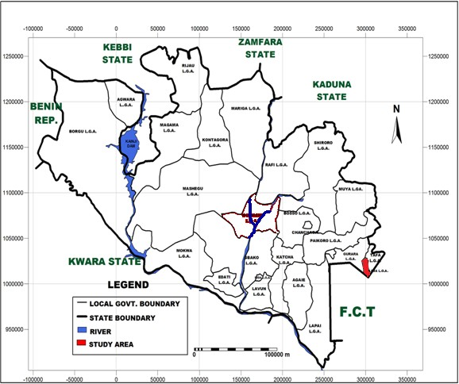

2 ° 0 0 ' 3 ° 0 0 ' 4 ° 0 0 ' 5 ° 0 0 ' 6 ° 0 0 ' 7 ° 0 0 ' 8 ° 0 0 ' 9 ° 0 0 ' 1 0 ° 0 0 ' 1 1 ° 0 0 ' 1 2 ° 0 0 ' 1 3 ° 0 0 ' 1 4 ° 0 0 ' 1 5 ° 0 0 '

2 4 6 8 1 0 1 2 1 4

1 4 ° 0104' 114

R E P U B L I C O F N IG E R

1 3 ° 0 0 '

S o k o to

1 3

K a ts i n a

i g a w a

Y o b e

1 2 ° 0102'

Z a m f a r a

K a n o

B o r n o

112

K e b b i

1 1 ° 0 0 '

1 1

B a u c h i

G o m b e

N

1 0 ° 0100'

110

9 ° 0 0 '

P l a t e a u

9 °

K w a r a

N a s a r a w a

8 ° 0 08'

O y o

8 °

8

O s u n

E k i ti

K o g i

B e n u e

7 ° 0 0 '

O g u n

O n d o

7 °

L a g o s

E d o

E n u g u

6 ° 0 06'

A n a m b r E o n y i

Im o A ia C r o s s R iv e r s

66°

A T L A N T IC O C E A N

D e l t a

5 ° 0 0 '

B a y e ls a

R i v e r s m

5 °

2

4

6

8

1 0

1 2

1 4

2 ° 0 0 ' 3 ° 0 0 ' 4 ° 0 0 ' 5 ° 0 0 ' 6 ° 0 0 ' 7 ° 0 0 ' 8 ° 0 0 ' 9 ° 0 0 ' 1 0 ° 0 0 ' 1 1 ° 0 0 ' 1 2 ° 0 0 ' 1 3 ° 0 0 ' 1 4 ° 0 0 ' 1 5 ° 0 0 '

**IN T E R N A T IO N A L B O U N D A R Y N IG E R S T A T E**

**S T A T E S IN N IG E R IA**

**3 0 0 0 0 0**

**0**

**3 0 0 0 0 0 M e t e**

**Source:** Ministry of Land and Housing, Minna, (2018).

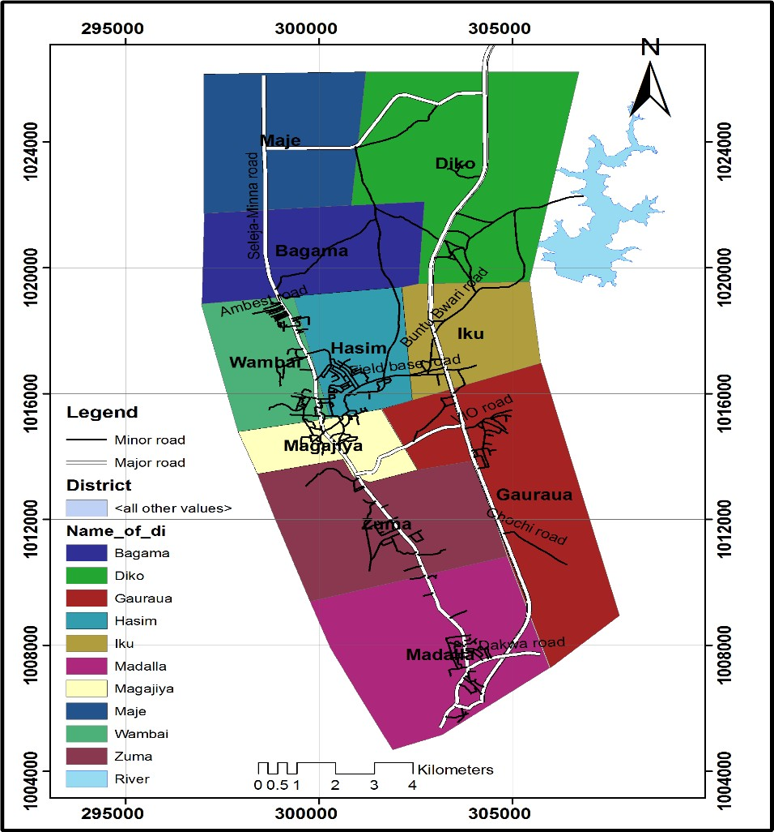

**Chechenia**

**Bakin Kasuwa**

**Polosa**

**Fig. 1.2: Administrative Map of Suleja LGA Source:** Suleja LGA, (2018)

# Climate

Climatically, Suleja have similar weather condition as Abuja the Federal Capital Territory. There is little departure from the major North-East (November to March) and South-West (April to October) trade wind. The North-East wind is dusty, dry and cold while the south-west wind brings in rain as wet season. Temperature sometimes can be as high as 45 degree Celsius in March and as low as less than 10-degree Celsius December/January. The rain fall pattern is convectional in nature with occasional flooding activity.

# Vegetation

Suleja falls within the Guinean forest-savanna mosaic zone of the West African sub- region. Patches of rain forest, especially in the rugged terrain to the south southeastern parts of the territory, where a landscape of gullies and rough terrain is found. These areas of Niger state form one of the few surviving occurrences of the mature forest vegetation.

# Relief

The study area has a long range of hills and ridges on the western side of the town, which has restriction in that direction slope in certain area of the developed town are up to 30% and that is responsible for the rapid erosion and gully formation which are common in the area.

# Drainage System

The town is well drained in to a system of streams and as a result of the steep slopes there is incidence of flash flood in certain part of the town particularly in areas with high development density.

# Soil

Like most alluvial soils, the soil in Suleja is the flood plain type and is characterized by considerable variations. The soil is of two main types which could be used for agriculture and are rich in minerals for the manufacture of various products. The two types of soil are: the Ku-soil which has little hazards and the Ya-soil which has a better water holding capacity.

# Economy

Today Suleja is well known as an exporter of Gbagi pottery. Cotton weaving and dyeing, with locally grown indigo, and mat making are traditional activities, but farming remains the chief occupation. Local trade is primarily in agriculture products.

# Genesis of the Development Challenges of Suleja

Nowhere has the truism “he who fail to plan, has Plan to fail” become glaringly evident as the sorrowful state of the good people of Suleja town (formerly Abuja town). Up to 1976 when the then Federal Military Government decided to move the nation‟s capital from Lagos to Abuja, Suleja was, substantially, a traditional Hausa settlement with the typical Hausa-Fulani traditional setup.

The Federal Military Government decided not to include Suleja in the Federal Capital Territory, for a variety of reasons including its predominant ethnic composition. Despite their exclusion, the good people of Suleja, former Abuja Local Government, contributed about 80% (6,400 km2) of the total area of FCT, (albeit on the instruction of the Military Government). The remaining 20% was contributed by the former Keffi and KotonKarfe Local Governments of former Plateau and Kwara States respectively. Another piece of land within Suleja was contributed for constructing a newly established Federal Capital Development Authority (FCDA) Field Base. This remained in Suleja for about five

years during the planning stages of Abuja‟s development before the physical construction activities could take-off in 1982 (Shuaibu, 2006).

The genesis of the seeming intractable development challenges of Suleja have to do with the decision not to locate Suleja within the boundaries of the Federal Capital Territory (FCT); not to designate it as one of its Satellite Towns (or declare it a Special Development Area), as was done to Gwagwalada, Bwari and Kuje; failings on the part of both Federal and Niger State Governments to develop and implement measures to protect Suleja from the, inevitable, influx of workers and businesses that were to participate in the construction of Abuja; and the seeming extraordinarily high and evidently unsustainable standard set for construction of the FCT that priced most workers out of its property market, among others.

However, within a space of about thirty years when the construction of FCT started, Suleja town had lost virtually all its developable land; a large percentage of its indigenous population, who could not resist the temptation of money, sold their houses and plots of land to the business men and women, from other parts of the country, who moved to the town due to its proximity to Abuja or as a base to transact business with FCT. From all indications the new owners of the town do not appear to have any more allegiance to it beyond the convenience it offers them and the potential for making a huge profit. They all have states, towns and villages to go back to, while the real Suleja indigenes appear to be stuck in the ever shrinking corners of the town, their rapidly increasing population notwithstanding.

However, it must be acknowledged that these people are known for their high level of self-reliance driven by a well-established tradition of entrepreneurship; and a very effective clan-based “Safety Net” they provide to their members and relations. In

Planning terms, Suleja appears to be a town choking itself to death-with a huge and rapidly growing population- unemployed, informal sector operators, small and medium sized business operators- looking up to Abuja for the greener pasture and business and investing virtually nothing in Suleja. The entire town has become one giant slum, growing in size and density in the most unplanned and uncontrolled manner imaginable; virtually all its streets are littered with signboards, in a “riot” of forms, shapes and colours, of mostly informal sector operators; provision of urban basic services, especially water and sanitation has virtually collapsed; with a cacophony of noise coming out of electric generators that have become the main stay of power supply in the town, with huge implication on the health of the residents; unplanned peri-urban expansion; high levels of vulnerability to natural disasters; poor mobility systems; environmental degradation; and sight and sound of social conflict over land resources.

Experience has shown that were the FCT to have been moved to any other part of Nigeria, the same fate would have awaited the indigenous population without requisite safeguards and deliberate effort to protect their interest. It is inevitable that the construction of such an ambitious project (FCT) will attract large number of people- business men and women; unemployed; skilled and unskilled workers; honest and dishonest people etc.

# CHAPTER TWO

# LITERATURE REVIEW

# Concept of Unplanned Settlement

According to UN-Habitat unplanned settlement has many definitions. Many synonymous words have been used in literature to refer to unplanned settlements. These include spontaneous, irregular, marginal, and unplanned settlements (Lamba, 2005). Some literatures have used the term slums and unplanned settlements interchangeably (UNHSP, 2003).

The UN Habitat categorizes unplanned settlements in to two (UN-Habitat, 2005) (i.) Unplanned settlements- settlements where land and/or building have been occupied without the permission of the owner. (ii.) Illegal land development- settlements where initial occupation is legal but where unauthorized land developments have occurred (e.g. Change of land use that breach zoning plans, building extensions without building permit, subdivisions without regard to services and infrastructure etc.). Unplanned settlements (often referred to as unplanned settlements, slum areas, or shanty towns). They are common features in developing countries and are typically the product of an urgent need for shelter to the urban poor. As such they are characterized by a dense proliferation of small, makeshift shelters built of diverse materials, degradation of the local ecosystem and characterized by severe social problems.

Unplanned settlement has been regarded by Aadipo, (2003) as informality/illegality include any form of construction (such as houses, fence, notice board, sewerage lines, containers, temporary/movable kiosks, etc.) which have been erected or built on public lands without having legal basis. Furthermore, it also includes any unauthorized expansion/ encroachment made on public rental houses.

Definitions of unplanned settlement vary widely from country to country depending on a variety of parameters such as economic, social and environmental factors. An important issue in defining unplanned settlement is the distinction between unplanned and informality, the borderline between planed and unplanned when applied to economic, social and environmental activities (Hoffman &Shirhan, 2006). UN Habitat (2003) added that unplanned settlements are the residential areas where a group of housing units have been constructed on land to which the occupants have no legal claim, or which they occupy illegally, and it is an area where housing is not complied with current planning and building regulations. According to Kombe (2010), the unplanned settlements refer to groups of housing in an area which are not complying with planning and building regulations.

# General Characteristics of Unplanned Settlement

It has essentially three defining characteristics that help us understand it; these are the Physical, the Social and the legal with the reasons behind them being interrelated (Srinivas, 2010).

# Physical Characteristics

Unplanned settlement, due to its inherent (non-legal) status, has services and infrastructure below the adequate or minimum levels, such services are both network and social infrastructure like water supply, sanitation, electricity, road and drainage,

school, health center, market place etc. Water supply, for example, to individual household may not be afforded. However, few public or community stand by pipes may have been provided, using either the City networks or a hand pump itself. On the other hand, unplanned networks for the supply can be applied if water may available (Srinivas, 2010).

# Social Characteristics

Unplanned settlement households belong to the lower income group, either working and wage earning or in various sector enterprises. On average, most of them earn at or near the minimum wage level. Household income level can also be high due to perhaps income earn and part time jobs. Unplanned settlers are predominantly migrants, rural urban or urban-urban; but may also be second or third generation unplanned settlers (Srinivas, 2005).

# Legal Characteristics

The key characteristic that delineates unplanned settlement is the lack of owner ship of the land parcel on which they have built their houses. These could be vacant government or public land when the land is not under productive use by owner; it is appropriated by unplanned owner for building houses (Srinivas, 2010).

# Causes of Unplanned Settlement

The critical factors affecting the formation of unplanned settlements are notably related to several major interrelated challenges. Studies show that rapid urbanization and influx of people to urban area, lack of development control mechanisms, inadequate formal land

distribution, lack of resources, poverty and socio-cultural factors are major causes of unplanned settlements (Gossaye, 2007). Similarly, in regions of Europe, Africa, Central and South America or Asia insufficient planning and unrealistic zoning regulation, inconsistent and complex legislation, unnecessary bureaucracy for land development and permitting, marginalization, poverty and lack of financing mechanism For affordable housing, illegal sub division and construction on agricultural lands, political reluctance to confront the situation and lack of important spatial information is the common for unplanned settlement. However, unplanned settlements do not have the same characteristics for the formation and expansion everywhere.

# Inadequate Formal Land Distribution

Throughout the history of the existence of the unplanned settlements, one of the major causes has been failure or inability of the responsible institution to provide residential plots to the ever-increasing urban population. While official applications for residential plots in Zanzibar Town have been steadily increasing, supply of the same is staggeringly inadequate, an average of between 20 and 30 percent per year (Ali and Sulaiman, 2006).

# Poverty

Unplanned settlement as the result of poverty and manifestation of social injustice have covered a wide range of low quality housing conditions: in particular slums (formal buildings dilapidated due to age and neglect) and unplanned settlements (settlements characterized by unauthorized land occupation, lack of building permit and/or a violation of building and planning regulations). In Nepal, 30,381 people were identified as landless family and 41,035 were identified as unplanned settlements (landlessness solution high level commission, 2000). The incomes of unplanned settlers are mostly

too low for formally regulated markets to provide them with any kind of permanent housing. One of the inhabiting factors is that the poor have a low propensity to save and hence a low propensity to borrow money from lending institutions (Daniel: 2011). Poverty is the center of unplanned settlement, majority of the squatters categorized as extremely poor. To construct a house in a planned area one needs to have enough money to buy a plot and build a “decent house” (Ali and Sulaiman: 2006).

# 2.3.2 Unplanned Land Market

Access to serviced land for housing is one of the major problems faced practically by practically all developing countries. In most cities of developing countries, the urban poor and even the middle-income group often have to step outside the formal land market to gain access to land and housing. Generally, in cities of developing countries the unplanned land market is much bigger than the formal market (<http://www.sciencedirect.comp/science>).

# Formation and expansion of Unplanned settlement

Mechanism of land acquisition through inheritances and gifts in most cases are normal, and in some systems, they are legal and it is the right of the original owner to do so. Even though the nature of Sub division of land for inheritances and gifts appear to be slow their contribution to the formation and expansion of unplanned settlements is high (Ali and Sulaiman: 2006). The other mechanism of land airing is through organized way of urban land invasion, this system is obviously illegal from the beginning and they create their own urban unplanned neighborhoods on both suitable and unsuitable sites they occupied. This mechanism often depends on situations like conflict over the ownership of land but it is not common in all urban centers. For instance, land invasion

in unplanned settlement in Egypt took place as soon as land tenure was in doubt. During the transaction of land property among various governors, the transformation of economy or regulation takes place when national or local election is conducted within the country, (Gossaye, 2007). The other one is the most complicated mechanism of acquiring land, which is unplanned land market. Its complication is because of three major reasons; I) Land can be bought directly from the original owner and transferred to many other owners, II) It is the second stage and way of land transfer from lands acquired through inheritance, gifts, and land obtained through invasion to new owners as stated by Payne then later, these processes became commercialized and entry was only possible at a cost determined by the unplanned market. III) It is fast and unpredictable. Therefore, many sources put unplanned land markets first for the formation and expansion of unplanned settlements.

# Major Challenges of the Unplanned Settlements

Settlements make housing more affordable and reduced transaction cost, but it cannot be mortgaged or used as collateral for other business purpose (Desoto, 2003). The sprawling of poorly controlled settlement developments has resulted in many environmental, Economic and Social impacts.

# Environmental Challenges

Unplanned settlements are characterized by the following environmental challenges:

# Pollution of Water Sources

Expansion of the unplanned human settlements has been the major cause for pollution of ground water sources, most of which are located on the periphery of the Zanzibar town. Loss of vegetation around water sources reduces water flow while poor disposal

of liquid and solid wastes causes water pollution that have been frequent outbreak of water borne diseases like cholera and dysentery, particularly during high rainfall seasons, due to contamination of the drinking water (Fadairo, 2006).

# Pollution from Solid and Liquid Wastes

One of the fundamental problems faced by the residents of Suleja is the lack of a proper system for waste management. The problem is even more severing in the unplanned settlement areas. Due to the lack of established collection points, piles of garbage are scattered in and around residential. Areas which leads to environmental and health problems few residents opt to bury or burn their wastes close to their residences. As there is no centralized sewerage system, liquid waste which includes water from washing, laundry, kitchen, both and other domestic uses is haphazardly discharged on- site. This disposal practice pollutes the ground water and marine environments and is a major cause of water borne diseases (Fadairo, 2006).

# Flooding

Another effect of unplanned settlement is that the necessary municipal services and infrastructure like roads, water supply, sanitation and waste collection are never provided. Within this neighborhood, wastes generated are thrown indiscriminately into drainage channels thereby causing blockages (Fadairo, 2006); which might eventually result in the flooding and erosion of the area.

# Deforestation

Natural forests and catchment areas are being invaded by the expanding human settlements. The ongoing shrinkage of the mainlining forest on the out skirts of Zanzibar town due to the expansion of settlements this practice has reduced the amount of ground water and resulted in environmental degradation (Fadairo, 2006).

# Economic and Social Challenges

The economic and social challenges associated with unplanned settlement are:

# Encroachment of Agricultural Land

The uncontrolled expansion of human settlements has led to conversion of the agricultural land into settlements. Occupiers usually do not pay property tax or user fees, thus reducing the revenue of the municipality to provide essential services. Records show that between 1977 and 1994 the Zanzibar town has expanded by 2100 hectares mostly into the best agricultural land. There have been genuine complaints and warnings by the ministry agriculture that the agricultural land is consistently decreasing due to over expansion of human settlements. The loss of agricultural land means a decrease of crop production and income of poor agricultural families (Tsenkova, 2008). In economic terms, unplanned settlements mobilized significant public and private investments, which remain outside of the formal economy and investment cycle (Desoto, 2003).

# Haphazard or uncoordinated development

Where squatting is on government or any derelict land; layouts are never prepared and developments are not subject to any control. In cases where the land-owning families design layouts; such layout in most cases may not conform to acceptable standard and development meaningful development control in these cases will invariably lead to haphazard or uncoordinated development which characterizes slum formation. (Tsenkova, 2008).

# Haphazard or uncoordinated development

Where squatting is on government or any derelict land; layout is never prepared and developments are not subject to any control. In cases where the land-owning families design layouts; such layout in most cases may not conform to acceptable standard and development meaningful development control in these cases will invariably lead to haphazard or uncoordinated development which characterizes slum formation. (Tsenkova, 2008).

# Construction with Substandard Materials

Most unplanned settlers belong to the low-income groups of the community that are either unemployed or looking in the unplanned sector like street hawking or unplanned service provision and daily laborers (Meseret,2010). Since residents of unplanned settlements lack legal titles; they are usually suffering from the problem of uncertainty in tenure. They live daily with the perpetual fear of eviction and demolition by authority. As a result of which there is no incentive to spend on housing improvements; hence they live in houses constructed with substandard materials (Tsenkova, 2008).

# Crime

The problem of the low income affects the level of capital formation, which deprives the people of sufficient resources to utilize in improving their homes and keep their environment healthy for comfortable living (George, 1999). The slum residents lack the basic municipal facilities; and thus, are exposed to disease, and natural disasters (The World Bank, 2002).

# Upgrading of Unplanned Settlements

The term upgrading generally refers to an effort to improve living conditions in particular urban areas characterized by poor-quality housing and inadequate

infrastructure and service delivery (Hardoy, Mitlin, Satterthwaite, 2001). The global emphasis on the upgrading programmes and self-help housing emerged broadly in the 1970s when the World Bank searching for an alternative to widespread slum clearances and evictions started to stress a new „paradigm‟ for the urbanizing world. The Bank‟s initiative was considerably affected by John Turner, the English architect, who advocated slum improvements free of government intervention to allow their residents to change their living conditions by themselves (Werlin, 1999).

Both upgrading programmes in temporary settlements and sites-and-services projects face large criticism because of their effects on the most marginalized slum residents. A reproof for the self-help loans under the sites-and-services/upgrading schemes is partly based on the estimation that in the 1980s the bottom 30 to 60 per cent of the urban population (depending on the country) was unable to meet the financial obligations (Davis, 2007), he further laments that a limited number of low-income urban households together with lower middle-income households access the loans more easily than the poorest slum families. An example from Mumbai shows that only 9 per cent of loan recipients belonged to lowest-income groups. Although many slum dwellers benefited from the programmes in early years, most of them were exposed to greater exploitation and housing related problems in the long term. Frequently asked full cost recovery affected especially the poorest through „mechanisms include self-selection in group-credit schemes, incentives for well-endowed people in entrepreneurship development and benefits for homeowners in upgrading‟ (Berner & Phillips, 2005). The early faithful beliefs in Turner‟s idea of „development from below‟ (Werlin, 1999) had been replaced by doubts and disbelief to address increasing urban crisis without greater government involvement.

Since the 1970s the „participatory rhetoric‟ has appeared in the Bank‟s upgrading programmes. The role of beneficiaries‟ participation was recognized, although mostly it has been much developed on paper rather than in reality lacking donor and government eagerness (Werlin, 1999, Berner & Phillips, 2005). Governments show no real interest in involving slum dwellers in planning or decision-making processes before a programme or policy is implemented. Slum dweller participation has been more likely perceived as a tool to control them and to legitimize a government policy (Botes& Rensburg, 2000). The odd understandings of „participation‟ have become the common practice.

# Elements of Unplanned Settlement Upgrading

Experience shows that slum upgrading does require political will and firm commitment of local governments that can sustain long-term programming and implementation. In operational terms, it requires the establishment of an institutional and organizational setting through which (1) the participation of the target groups can be facilitated, (2) the partnerships between public, private and community stakeholders can be realized, (3) financial resources can be mobilized and allocated on a sustained basis, (4) local implementation capacities can be strengthened and (5) the coordination, planning and management of programs and projects can be organized (Acioly, 2007).

According to slum upgrading and housing infrastructure development report (2012) generally, the reduction of unplanned settlement or the upgrading of the environments and the lives of those in these settlements consists of but not limited to physical, social, economic, organizational and environmental improvements undertaken cooperatively

and locally among citizens, community groups, businesses and local authorities. The activities that have been taken by many countries include: improving or installing basic infrastructure; mitigation or removal of environmental hazards; providing incentives and improving governance; rehabilitating or constructing community facilities; regularizing security of tenure; relocation/compensation or home improvement; improvement of access and affordability of social/health/education services; promotion of income-earning opportunities; and, building institutional frameworks and social capital/assets to sustain improvements (Syagga, (2011).

# Institutional arrangements for Unplanned Settlement upgrading

Many human settlement development policies and strategies have been used in the past to deal with unplanned settlement all over the world as well as in Nigeria, such policies and strategies have ranged from forced eviction, resettlement, site and service schemes and upgrading(UN-HABITAT, 2003). Experience has shown that forced eviction, demolition of slums and resettlement of slum dwellers create more problems than they solve. Eradication and relocation destroys large stock of housing affordable to the urban poor, while new housing provided has frequently turned out to be unaffordable resulting to the movement of relocated households back to slum accommodation (Gong and van Soest, 2002).

Resettlement also shifts unplanned settlement dwellers from their employment sources, destroys their productivity and disrupts their livelihood networks. National approaches to unplanned settlements all over the world have generally shifted from negative policies such as eviction, benign neglect and involuntary resettlement to more positive policies such as self-help housing, in site upgrading and enabling and rights based policies. Where appropriate upgrading policies have been put in place, slums have

become increasingly financially cohesive, offering opportunities for security of tenure, local economic development, improvement of income and shelter among the urban poor. The accepted best practice for housing interventions in developing countries is now participatory.

Unplanned settlement upgrading, with wholistic neighbourhood improvement approaches taking into account health, education, housing, livelihoods and gender (UN- HABITAT, 2003). Although such success stories have been few in comparison to the magnitude of Development challenges, experience accumulated over the last few decades suggest that in site unplanned settlement upgrading is more effective and should be the norm in most unplanned upgrading programmes and projects. The key to success in such Programme, however, lies in creating easy access to livelihood opportunities as the central pillar (Syagga, Mitullah, and Karira-Gitau, 2001).

According to UNCHS (2001), effective unplanned settlement upgrading requires active involvement of the target beneficiaries. Building on this assertion, they further assert that political will is essential for a successful upgrading process. Other writers describe transport as core to the livelihood of slum dwellers. A research conducted among the pavement dwellers of Bombay indicates that 80 per cent walked to work (Gopalan, 1998). This shows that many slum dwellers live in the impoverished conditions to be able to access their work places. Godehart (2008) gives similar sentiments by noting that the location of housing should be accessible to the working places of the poor. The literature indicates that slums upgrading should go beyond house improvements and incorporate other expressed needs that are key to holistic livelihood such as infrastructure, security of tenure and cultural aspects.

# Community Role in Managing Development challenges in Unplanned Settlements

Kombe (2005) pinpointed out that, multifaceted management of Development challenges in unplanned settlements requires action of both national and local levels, the private sector and civil societies including community organizations to be involved, affordable land housing options, environmental education, basic services and settlements infrastructures must have made available, community must plan for better settlements in respect to environmental infrastructure and be responsible in daily activities related to environmental management.

Management of unplanned settlements could be improved by developing strategic vision through effective participation of local and national stakeholders by identifying priority issues and actions to improve housing conditions and its surrounding environment, urban services and local economy. The vision should provide a road map for developing the city over the next two decades that will enhance urban and land management through training of local authorities and community in information management, strategic urban planning, land regulations and urban administration (UN Environmental Program, 2006). The sustainable management of these challenges should address the political relationship between government and all citizens by redefining new effective ways of working with local communities, people‟s organizations, the private sectors and other stakeholders in the underpinning of modern urban municipal governance of communities should strengthen their roles because they are main agents and victims of Development challenges (Lasserve& Durand, 2006).

# CHAPTER THREE

* 1. **RESEARCH METHODOLOGY**

# Introduction

This study was carried out in Suleja, Niger State, Nigeria. It analyzed the development challenges in unplanned settlements. For the purpose of this study, two sets of data were gathered; that is qualitative and quantitative data type which is also called mixed method or the multi method because. According to Creswell (2012), research problems can better be understood through the use of both methods in a complementary approach.

# Research Design

Research design is a blueprint for conducting a research with maximum control over factors that may interfere with the validity of the findings (Burns and Grove (2003). It is also known as a plan that describes how, when and where data are to be collected and analysed (Parahoo, 1997; Cresswell, 2012). This research is empirical in nature and

intends to investigate the development challenges, factors responsible for unplanned settlements in Suleja. It was designed to collect information from all parameters that is needed to solve the research problems stated in chapter one. The research makes use of both theoretical and investigative method for collection of data. Also, data was collected from residents of these neighbourhoods, the infrastructure available, and its adequacy and otherwise. This provide opportunity to assess the coping strategies adopted and planning implication to sustainable development of Suleja and Nigeria in general.

# Population and Sample Size

According to National Demography Survey 2018, a total number of 2,610 household were identified in the study area. From the total of 2,610 households in the study area, 6.2% which is approximately 102 were administered. Therefore, the calculated sample size using the above equation is 102.Based on household population 6.2% of the calculated sample size was given to each of the selected neighborhoods under study based on their household population as shown in table 3.1 below.

**Table 3.1:** The Sample size and Number of Questionnaire Administered

|  |  |  |  |
| --- | --- | --- | --- |
| **Peri-Urban Area** | **Population in 1991** | **Estimated Population in 2017** | **No. of Households** |
| BakinKasuwa | 2,472 | 4387 | 348 |
| Chechenia | 1,869 | 3315 | 414 |
| Polosa | 4,131 | 7332 | 617 |
| Madalla | 7,566 | 13537 | 1303 |
| Total | 27,796 | 48,687 | 2,610 |

Source: National Demography Survey, NPC, 1991 and modify by Author, 2018

The sample size was drawn from 2,610 household populations so as to get a manageable representation in relation to time, fund and nature of the data required for carrying out the study. To minimize errors, Nassiuma (2000) standard formula was used to select the required sample size to represent the respondent population.

n = NC²

C ² + (N-1) e²

Where: n = Sample Size

N= Household Population (2,610) C= Coefficient of variation (10 %) e = Sampling Error 1 %

Hence n = (2,610) (10 %)²

(10 %) ² + (2,610-1) 1 %²

n = 346.8

Therefore, the study included 347 household respondents and 7 key informants from ward heads, Land officer, health and environment officers as well as urban development officers, thus, made a total of 354 respondents.

# Method of Data Collection

* + 1. **Source and Types of Data**

The data for this study were collected from both Primary and Secondary sources. Primary sources involve generation of data using direct data acquisition methods. While secondary data were obtained from both published and unpublished information and data. The primary data were sourced from the field with the aid of questionnaire and photographs. The secondary was obtained from Niger State Urban Development Board, research records and other published works of different authors.

# Method of Data Collection

The data used to achieve the objectives of this study were gotten through field survey by the use of the following data collection instruments as follows:

* + - 1. Reconnaissance survey
      2. Structured questionnaire
      3. Published documents

# Reconnaissance Survey

A reconnaissance survey of some selected neighborhood of Suleja were carried out in order to acquaint the researcher with a comprehensive knowledge of challenges on ground. The survey provides useful information for this research. The data was based on the nature and arrangement of buildings, adherence to building codes, infrastructure facilities, waste management etc.

# Structured Questionnaire

Structured questionnaires was prepared and administered to the residents of selected neighbourhoods in study area, for the purpose of generating their responses arising from the quality of their environment. The questionnaire was designed to get useful data that were required for the analysis which includes; data on specific infrastructure, spatial development and the general demographic and socio- economic characteristics of inhabitant of Suleja town. The questionnaire provided questions in line with the analysis needed: spatial development, infrastructure and waste management, as well as basic socio-economic and demographic characteristics. The questions were organized in such a way that they flow sequentially and attract the interest of respondents to answer all the questions.

1. **Published documents:** Government publications, newspapers, journals, textbooks and other materials that relate to the research were sourced directly from the internet to provide vital information to analyse and interpret the results.

# Method Data Analysis

Data analysis was based on two statistical techniques. These techniques are the Frequency-Percentage Technique which is a convectional technique analysis. Its suitability and relative ease of analysis and interpretation was responsible for its choice.

The entire questionnaires werepainstakingly analyzed using the Statistical Package for the Social Sciences (SPSS 21) to make deduction from them. Descriptive statistics was used to summarize the data. The results were presented in tables and pie chart.

# CHAPTER FOUR

* 1. **FINDINGS AND DISCUSSION**

This chapter attempts to present the Development challenges of unplanned settlement in Suleja, Niger State. The analysis of data would be based on the objective of the study.

# Socio-economic and General Characteristics of the Respondents

The socio-economic characteristics of the respondents include the sex of the respondents, educational status, occupation of the respondents. The distribution of these respondents according to sex is indicated in Table 4.1.

# Table 4.1: Distribution of respondents by Sex

|  |  |  |
| --- | --- | --- |
| **Category** | **No of respondent** | **Percentage** |
| Male | 170 | 76 |
| Female | 122 | 24 |
| **Total** | **292** | **100** |

**Source**: Field Survey, 2018

Table 4.1.1indicates that 70% of the household heads are males and the remaining 22 % are females. This indicates that majority of the respondents participating in unplanned settlements are male. According to age category 49% percent of the respondents are between the age group (44 and above), 32.5% of the respondents are between the age of (31-43), 22.26% are between (18-30) while 17.81% are below 18 years. This indicates that majority of the respondents for this study are within the age group of 44 years and above in unplanned settlement as indicated in table 4.2 below.

# Table 4.2: Distribution of respondents by Age group

|  |  |  |
| --- | --- | --- |
| **Age-group** | **No of respondent** | **Percentage** |
| Below 18Years | 52 | 17.81 |
| 18 – 30 Years | 65 | 22.26 |
| 31 – 43 Years | 80 | 27.40 |
| 44 and above | 95 | 32.53 |
| **Total** | **292** | **100** |

**Source**: Field Survey, 2018

# Table 4.3: Distributions of respondents by Marital Status

|  |  |  |
| --- | --- | --- |
| **Marital Status** | **No of respondent** | **Percentage** |
| Married | 160 | 54.79 |
| Single | 124 | 42.47 |

|  |  |  |
| --- | --- | --- |
| Others | 8 | 2.74 |
| **Total** | **292** | **100** |

Source: Field Survey, 2007

Table 4.3 indicates that the marital status of the respondents illustrates that 160 out of the 292 respondents are married representing 54.79%, those that are single constitute

124 representing 42.7%, while others are 2.7%. This means that majority of the respondents are married.

Table 4.4 indicate that the total respondents who are illiterate are 20 out of 292 respondents representing 6.85%, those with primary education are 62 respondents representing 21.23%, secondary education are 25%, those with adult class represent 20%, while 26% are collage and above. This means that majority of the respondent‟s educational level are collage and above.

# Table 4.4: Distributions of respondents by level of education

|  |  |  |
| --- | --- | --- |
| **Level of education** | **No of respondent** | **Percentage** |
| Non | 20 | 6.85 |
| Primary | 62 | 21.23 |
| Secondary | 73 | 25.00 |
| Adult | 61 | 20.89 |
| Collage and Above | 76 | 26.03 |
| **Total** | **292** | 100.00 |

Source: Field Survey, 2018

Table 4.5 indicates that, the total respondents who are students are 53 out of 292 that is (18.15%), those employed constitute 25.32%, self-employed constitute 28.7% and the non are 81 (27.7%).This means that majority of the respondent are self-employed, in farming, trading and other small-scale economic activities.

# Table 4.5: Distributions of respondents by occupation

|  |  |  |
| --- | --- | --- |
| **Occupational status** | **No of respondent** | **Percentage** |
| Student | 53 | 18.15 |
| Employed | 74 | 25.34 |
| Self Employed | 84 | 28.77 |
| Non | 81 | 27.74 |
| **Total** | **292** | 100.00 |

Source: Field Survey, 2018

# Threat to the development in unplanned settlements in Suleja.

The study findings on the development challenges in unplanned settlement in Suleja are presented on Table 4.6 from the respondents respectively. The result indicates that, 10.9% (32) respondents are of the view that complexities of unplanned settlements with regard to tenure arrangements is the treats /obstacle to development of unplanned settlement, 10.6% (31) of the respondents claimed that competing interests of various groups, 11.30 % (33) respondents indicated Partnership concepts that often derail the implementation schedules, Politicization of development of unplanned settlement programme was ticked by 11.9% (35) respondents choose Non-genuine NGOs, 36 out of the total respondents representing 12.3% (36) were of the opinion that Lack of coordination amongst various stakeholders is the major treats/obstacle of Development challenges in Suleja of the respondents representing 14.7% (40) said it is the issue of Community not knowing their roles as stakeholders, 13.7% (40) respondents representing indicated lack of adequate land as the treats/obstacle of Development challenges in Suleja. This means that majority of the respondent are of the view that lack of coordination amongst various stakeholders the treat/obstacle of Development challenges in Suleja town.

# Table 4.6: Distributions of respondents on treats to the development

|  |  |  |
| --- | --- | --- |
| **Threat /Obstacles of Development Challenges** | **No of respondent** | **Percentage**  **(%)** |

|  |  |  |
| --- | --- | --- |
| Complexities of unplanned settlements with regard to tenure arrangements | 32 | 10.96 |
| Competing interests of various groups | 31 | 10.62 |
| Partnership concepts that often derail the implementation schedules | 33 | 11.30 |
| Politicization of development of unplanned settlement programme | 35 | 11.99 |
| Non-genuine NGOs | 36 | 12.33 |
| Lack of coordination amongst various stakeholders | 43 | 14.73 |
| Community not knowing their roles as  stakeholders | 40 | 13.70 |
| Lack of adequate land | 42 | 14.38 |
| **Total** | **292** | **100.00** |

Source: Field Survey, 2018

# Infrastructural needs of the Unplanned Settlements

Table 7 indicates that, 10.2% (30) out of the 292 respondents representing are of the opinion that security of tenure is the infrastructural need of the unplanned settlement in Suleja, 8.9% (26) respondents indicated development control, 8.56% (25) said political

will, 9.59% (28) choose good road network, 9.93% (29) of the respondents thick drainage network, 9.25% (27) of the respondents said good security network, Access to potable water was chosen by 10.9% (32) of the respondents, those with the view that is electricity are 10.62% (31) of the respondents, 11.6% (34) out of the total of 292 respondents said health care facilities while 10.27% (30) of the respondents are of the view that educational facilities is the need of the unplanned settlement in Suleja. Plate I show the nature of the only culvert that lead to a community, Plate II – III show the condition of road in the study area. This means that majority of the respondent are of the view that health care facilities is the major need of the unplanned settlement in Suleja.

# Table 4.7: Distributions of respondents on Infrastructural needs of the unplanned settlements

|  |  |  |
| --- | --- | --- |
| **Infrastructural Needs of the Unplanned** | **No of** | **Percentage** |

|  |  |  |
| --- | --- | --- |
| **Settlements** | **Respondent** |  |
| Security of tenure | 30 | 10.27 |
| Development control | 26 | 8.90 |
| Political will | 25 | 8.56 |
| Good road network | 28 | 9.59 |
| Good drainage network | 29 | 9.93 |
| Good Security network | 27 | 9.25 |
| Access to potable Water | 32 | 10.96 |
| Electricity | 31 | 10.62 |
| Health care facilities | 34 | 11.64 |
| Educational facilities | 30 | 10.27 |
| **Total** | **292** | **100** |

Source: Field Survey, 2018

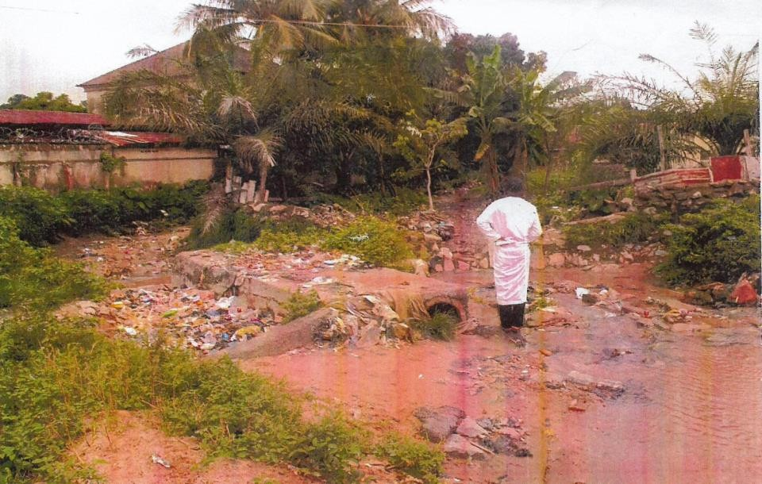

# Plate I: The Only pedestrian culvert that leads to the community

**Source: Authors Field Survey, 2018**

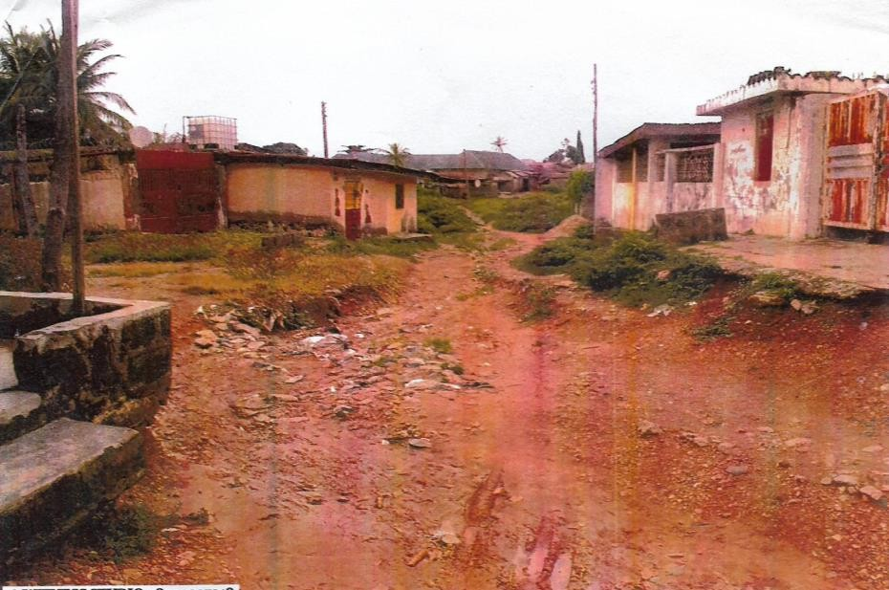

# Plate II: The condition of road in the area Source: Authors Field Survey, 2018

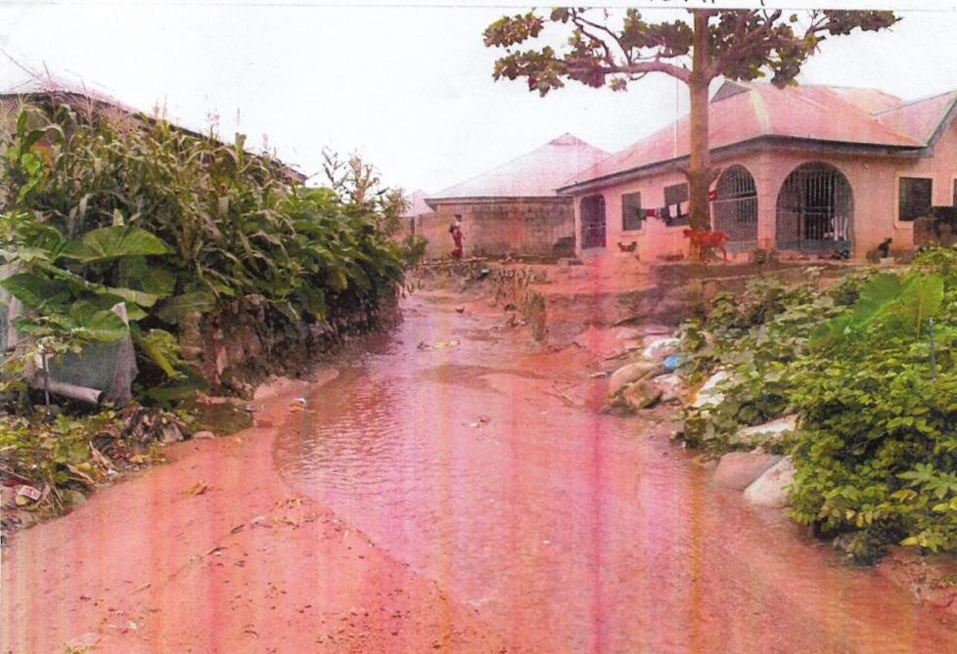

**Plate III: The condition of road in the area Source: Authors Field Survey, 2018**

# 4.3 The Role of Government in the Upgrade of Unplanned Settlement

Table 8 present the outcome of respondents on role of government in upgrading of unplanned settlement, 12% (31) out of the total respondents are of the view that secure land tenure in unplanned settlement is the role of government in the upgrade of unplanned settlement, 14% (38) of the respondents agree that it is Improve basic infrastructure and service delivery whereas, 17.3% (41) said upgrading housing and retrofitting infrastructure, 5% (30) thick provision of water supply, 4.3% (29) of the respondents said effective waste management facilities, Good transportation network was chosen by 7.6% (22) of the respondents indicates good energy services, 8.7% (8) are of the view of good educational facilities, 16.3% (15) said good health care facilities, 10.9% (300) chose Involving community duelers in playing active roles in preparing and executing plans for unplanned settlement upgrading as the role of government in the upgrade of unplanned settlement.

Plate IV shows the nature of drainage in the area, Plate V show nature of indiscriminate waste disposal in the area. This means that majority of the respondents are of the view that upgrading housing and retrofitting infrastructure is the major role of role of government in the upgrade of unplanned settlement in Suleja.

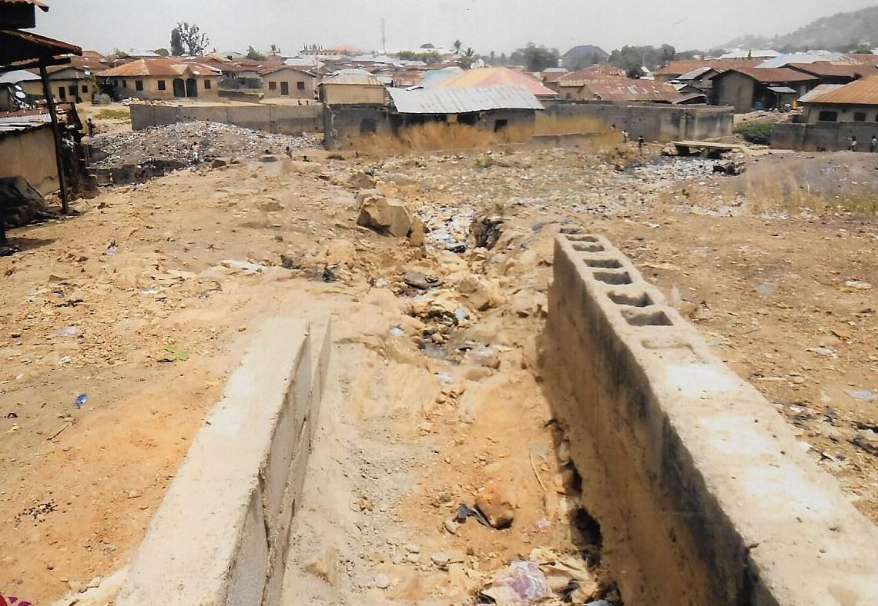

# Plate IV: The condition of drainage in the area Source: Authors Field Survey, 2018

This is in consistence with the study of Arimah (2011) contended that any attempt at improving the lives of unplanned settlement dwellers and providing alternatives to new slum formation in African countries, must be preceded by a proper appreciation of the factors that underlie the formation and proliferation of unplanned settlement. On this strand, Sticzay and Koch (2015) opined that the fundamental issue in urban development and unplanned settlements upgrading is related to the growing number of urban residents and how housing and infrastructure services can be financed for the future urban generations.

# Table 4.8: Distributions of Respondents on the Role of Government in the Upgrade of Unplanned Settlement.

|  |  |  |
| --- | --- | --- |
| **Role of government in the upgrade of unplanned**  **settlement.** | **No of**  **Respondent** | **Percentage** |

|  |  |  |
| --- | --- | --- |
| Secure land tenure in unplanned settlement | 36 | 12.0 |
| Improve basic infrastructure and service delivery | 38 | 14.0 |
| Upgrading housing and retrofitting infrastructure | 41 | 17.3 |
| Provision of water supply | 30 | 5.4 |
| Effective waste management facilities | 29 | 4.3 |
| Good transportation network | 32 | 7.6 |
| Good energy services | 28 | 3.2 |
| Good educational facilities | 34 | 8.7 |
| Good health care facilities | 15 | 16.3 |
| Involving community duelers play active roles in preparing and executing plans for unplanned settlement  upgrading. | 10 | 10.9 |
| **Total** | **292** | **100** |

Source: Field Survey, 2018

**4. 4The Role of Dwellers Participatory in the Upgrade of Unplanned Settlement** Table 9 indicates that, 14.7% (43) of the respondents said financial contribution is the role played by dwellers participation in the upgrade of unplanned settlement, 1.7% (43) said material contribution, formulation of community upgrading committee was chosen by 14% (14) of the respondents. Implementation of bylaws in upgrading of unplanned settlement was agreed by 13% (38) of the respondents, 13% (40) respondents selected minimization of domestic waste, 12% (37) of the respondents Concore to environmental education, while, 16.1% (47) out of the total respondentsare of the view that the role played by dwellers participation in the upgrade of unplanned settlement is implementation of Community Infrastructure Upgrading.

Plate VI is the nature of building condition and Plate VII is the way erosion is being manage in the area. This means that majority of the respondents are of the opinion that

Implementation of Community Infrastructure Upgrading is the major role by dwellers participation in the upgrade of unplanned settlement Suleja. This is in line with UNCHS (2001b), emphasized that lack of participation by the dwellers in the upgrading programme is also a major problem. Furthermore, effective unplanned settlement upgrading requires active involvement of the target beneficiaries. The Participatory approach also emphasizes that participation is an essential component of successful lasting development.

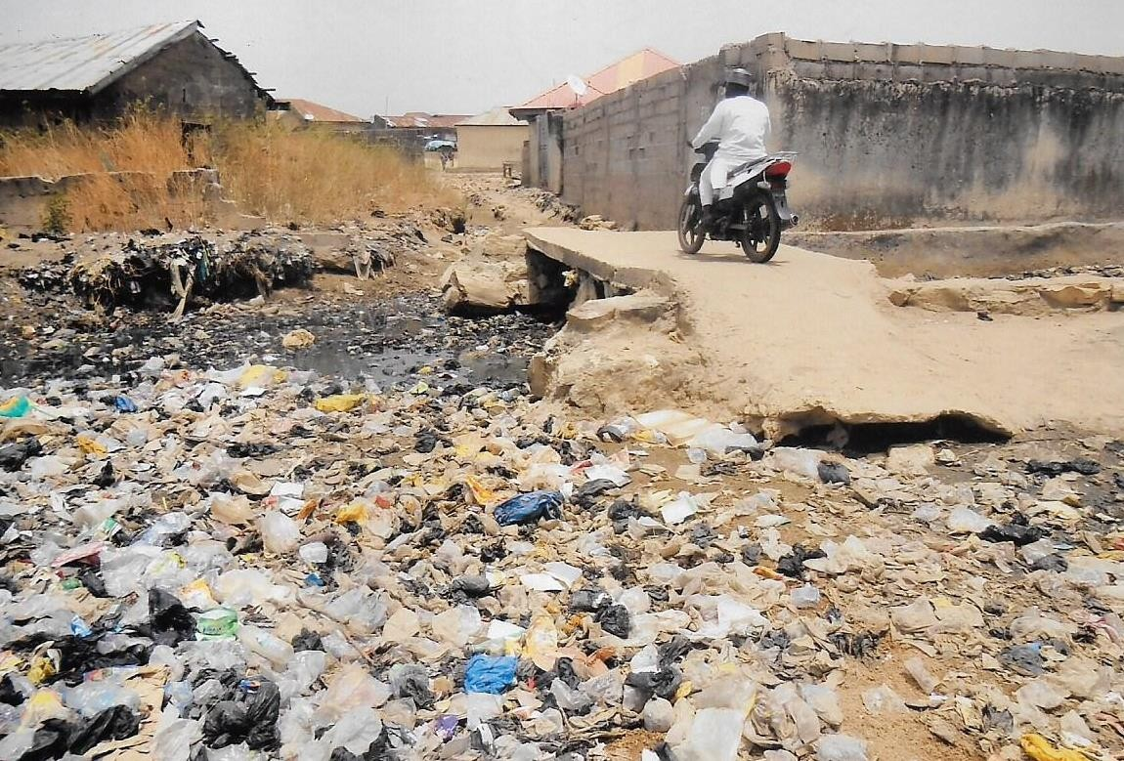

# Plate V: Nature of waste disposal in the area Source: Authors Field Survey, 2018

Governments also have an added layer of internal dilemmas where coordination and decision-making between agencies at the national and municipal levels comes into play (Belsky, 2012). This is highlighted in countries that have a multitude of agencies involved in the urban process, as well as the degree of centralization. For example, Nigeria alone has several states holding companies, a ministry of housing and another for utilities, and special agencies such as the unplanned Settlements Development Facility; all tackling issues in unplanned areas. Yet, while this type of interaction takes place, there is complete marginalization of unplanned communities even though the

poor may have the best knowledge of at least where new infrastructure should be placed (Belsky, 2012).

The World Conference on Agrarian Reform and Rural Development (WCARRD), in Rome 1979, declared it a „basic human right‟ that rural people should participate in the governing of their lives and thus since then participation has been described as the “new orthodoxy of development” (De Campos Guimaraes, 2009, p.5). As such governments, donors and international organizations have adopted different shades of participation including “bottom-up planning, acknowledging indigenous knowledge, and claiming to empower local people” (De Campos Guimaraes, 2009, p.5).

# Table 4.9: Distributions of Respondents on the Role of Dwellers Participatory in the Upgrade of Unplanned Settlement.

|  |  |  |
| --- | --- | --- |
| **Role of Dwellers Participatory in the Upgrade of Unplanned Settlement.** | **No of Respondent** | **Percentage** |
| Financial contribution | 43 | 14.73 |
| Material contribution | 43 | 14.73 |
| Formulation of community upgrading committee | 41 | 14.04 |
| Implementation of bylaws in upgrading of unplanned settlement | 38 | 13.01 |
| Minimization of domestic waste | 40 | 13.70 |
| Environmental education | 37 | 12.67 |
| Implementation of Community Infrastructure Upgrading | 47 | 16.10 |
| **Total** | **292** | **100** |

Source: Field Survey, 2018

# CHAPTER FIVE

* 1. **SUMMARY, CONCLUSION AND RECOMMENDATIONS**

# Summary of Findings

The study findings on the development challenges in unplanned settlement in Suleja indicated that:

* + 1. Lack of adequate land as the treats/obstacle of development challenges in Suleja,
    2. Lack of coordination amongst various stakeholders the treat/obstacle of Development challenges in Suleja town.
    3. Respondents are of the view that upgrading housing and retrofitting infrastructure is the major role of government in the upgrade of unplanned settlement in Suleja.

The findings are also of the opinion that Implementation of Community Infrastructure Upgrading is the major role by dwellers participation in the upgrade of unplanned settlement in Suleja. This is in line with UNCHS (2001b), emphasized that lack of participation by the dwellers in the upgrading programme is also a major problem. Furthermore, effective unplanned settlement upgrading requires active involvement of the target beneficiaries. The Participatory approach also emphasizes that participation is an essential component of successful lasting development.

# Conclusion

Based on the findings of the study the following conclusions are made:

The major treat/obstacle of Development challenges in Suleja is lack of coordination amongst various stakeholders this is as a result of political will and non-challenge attitude by other stake holders in relation to the development of unplanned settlement.

Provision of good healthcare facilities is the major need of the unplanned settlement in Suleja, there are very few that cannot cater for the population of this area and were they are available, they are mostly obsolete or lack basic necessity and equipment for the

provision of better health care to the unplanned duelers. Upgrading housing and retrofitting infrastructure is the major role of role of government in the upgrade of unplanned settlement in Suleja. Because most of the houses are below standard and lack basic facilities and amenities and need serious intervention.

Implementation of Community Infrastructure Upgrading is the major role by dwellers participation in the upgrade of unplanned settlement Suleja. These is one of the greatest challenge. Most of the issues of upgrading of unplanned settlement are left for government to handle, but in reality, is a collective responsibility of all stake holders i.e., The government, community duelers, NGO‟S, CBO and other relevant organizations/ agencies.

# Recommendations

The Development challenges of unplanned settlement in Suleja are too diverse to be talked by simplistic approaches. It requires a holistic approach based on people mandate. Its thereby recommend that:

* + 1. There should be a new town development around Suleja that will make available more lands for development.
    2. Government should implement a community infrastructure upgrading that will involve all stakeholders in the effective and sustainable upgrading of unplanned settlement through an urban renewal plan.
    3. There should be an urban renewal program in most of the neighborhood in Suleja
    4. Public housing should be introduced to care for the rising demand of house to public civic servants. e.ghousing estate.

# Area for Further Research

This study was descriptive in nature and only a single study at that. Any one study can only go so far in terms of demonstrating validity; a series of research studies is always preferred over a single study (Calder *et al*., 1982). Replication of such a study to other Development challenges of unplanned settlement is required to explore other challenges and the way forward. Further research would be vital on “the importance of land tenure as a necessary precondition for successful unplanned settlement upgrading” as well as on “the synergy of urban unplanned settlements upgrading with environmental improvements”.

# REFERENCES

Acioly, Claudio (2007) The Challenge of Slum Formation in the Developing World, Land Lines, Cambridge: Lincoln Institute of Land Policy. pp. 2-7.

AADIPO (2003), Informal Settlement in Addis Ababa, Addis Ababa Development and Improvement Project Office, Addis Ababa.

Ali, M. H., & Sulaiman, M. S. (2006, October). The causes and consequences of the informal settlements in Zanzibar. In *a conference on ‘Shaping the Change’, Munich, Germany* (pp. 8-13).

Arimah, B. C., 2011, Slums as expressions of social exclusion: Explaining the prevalence of slums in African countries, OECD International conference on social cohesion and development, Paris, 20-21.

Berner, E. & B. Phillips (2005) Left to their own devices: Community self-help between alternative development and neoliberalism. *Community Development Journal*, 40, 17 - 29.

Belsky, E. (2012). Planning for inclusive and Sustainable Urban Development. In State of the World 2012: moving Toward Sustainable prosperity. (Chapter 3) World watch institute.

Brakarz, J., Greene, M. and Rojas, E. (2002) Cities for All Washington DC 2002, Interamerican Development Ban.

Bryman, A. (2008). Social Research Methods. New York.

Botes, L. & Rensburg, D.v. (2000) Community participation in development: Nine plagues and twelve commandments. Community Development Journal, 35, 41 - 58.

Burns, A. and Grove, C.( 2003) “Compendium of Sanitation Systems and Technologies. 2nd Revised Edition.,” Swiss Fed. Inst. Aquat. Sci. Technol., p. 180,

Calder, B J., L, W Phillips and A, M Tybout (1982) The concept of External Validity.

Journal of Consumer Research 9 (December): 240-244.

Creswell, J.W. (2012). Educational research, planning, conducting and evaluating Quantitative and qualitative research. (4thed.). Edward brothers, inc.

Daniel, Ambaye (2011), informal settlement in Ethiopia, the case of two kebeles in Bahir Dar city.

Davis, M. (2007) Planet of slums. London: Verso, 70 – 94.

De Campos Guimaraes, J.P. (2009). Paricipatory Approaches to Rural Devleopment and Rural Poverty Alleviation. Working paper: Emerging issues in rural poverty reduction: The role of participatory approaches. UNESCAP.

Desoto H. (2003), the misty of capital: why capitalism triumphs in the west and fails elsewhere. New York.

Fadairo, Gabriel (2006). Erosion Crisis and its Effects on Housing in Akure. *Urban Environment Sustainability, Urban Design Research Team, Akure. Fadamiroet al (ed)*, 161-168.

Godehart, S., & Vaughan, A. (2008). Research reviewing the BNG in relation to upgrading informal settlements. *Research paper for Theme*, *1*, 231-249.

Gossaye, Bekel(2007). Learning from Informal Settlement thesis, the case of Adama city, master‟s

Hardoy, J, D Mitlin and D Satterthwaite (2003) Environmental Problems in Third World Cities. Earthscan: London.

Godehart, S., & Vaughan, A. (2008). Research reviewing the BNG in relation to upgrading informal settlements. *Research paper for Theme*, *1*, 231-249.

Gopalan, P (1998) Circumscribed existence: Women‟s mobility and settlements development SUSTRAN Network General Assembly, Manila, Swayam Shikshan Prayog (SSP), Mumbai.

Gong, X and A van Soest (2002) Labour Economics Wage differentials and mobility in the urban labor market: A panel data analysis for Mexico, 510–528.

Hair, J., Celsi, M., Money, A., Samouel, P., & Page, M. (2011). Essentials of business research methods (2nd edition ed.): ME Sharpe Inc.

Hoffman, A. &Shirhan, J. (2008). Spatial Analysis of Differences in variation of Building impacts of urban development in a central India landscape, Journal of Urban Learning and Development, Volume 5 Page 34.

Kahneman, D. (2011). *Thinking, fast and slow*. Macmillan.

Kombe, W. J, (2005). Land Use Dynamic in Perl-Urban areas and their Implication on Urban Growth. United Nation – HABITAT Article, volume 29 (1).

Kombe, W.J. (2010). Land Use Dynamic in Peri-Urban Areas and their Implication on The Urban Growth, Oxford Press, London.

Kramer, M., (2006) Dispossessed: Life in Our World‟s Urban Slums. Orbis Books: New York.

Kumar, M., Abdul Talib, S., &Ramayah, T. (2013). Business research method,. New York: Oxford University press.

Lamba, A.O. (2005), Land Tenure Management Systems in Informal Settlement: the case of Nairobi, Master thesis, ITC, Netherlands.

Lanrewaju, A.F. (2012). Urbanization, housing quality and environmental degeneration in Nigeria, Journal of Geography and Regional Planning, 5(16): 422-429.

Lasserve, A. Durand (2006) Informal settlements and the Millennium Development Goals: Global Policy Debates on Property Ownership and security of tenure. Global Urban Development Magazine 2 (1) pp.1-15.

Lupala, J. (2002). Urban Types in Rapidly Urbanising Cities: Analysis of Formal and Activity in Greece, Management of International Business and Economic Cited Retrieved 3rd August 2012 From World Wide Web: [www.ccitz.com](http://www.ccitz.com/)

Kombe, W. J, (2005). Land Use Dynamic in Perl-Urban areas and their Implication on Urban Growth. United Nation – HABITAT Article, volume 29 (1)

Mesert (2010), Informal Settlements and its Effect on Socio-Economic developmen of Burayu town, master‟s thesis ECSC, Addis Ababa.

Ministry of works and urban development (2006), urban upgrading and Renewal manual, Federal urban planning institute, Addis Ababa

Mowud, O., (2006). Urban Planning Problems in Nigeria: A Case of Onitsha Metopolis of Anambra State. Singaporean Journal of Business Economics, and Management Studies, 1(1), pp.41–59.

Nassiuma D. K. (2000). Survey Sampling: Theory and Methods. Nairobi Press, Kenya Nabegu, A. Baba, 2014. Domestic Wastewater Management In Peri-Urban Settlements

Of Kano Metropolis, Nigeria. (June 2014).

Olotuah, A.O. (2005): Urbanisation, Urban Poverty, and Housing Inadequacy, Proceedings of Africa Union of Architects Congress, 23-28 May, Abuja, Nigeria, pg. 185-199.

Olujimi, J. (2009). “Evolving a planning strategy for managing urban sprawl in Nigeria”. Kamla - Ray 2. Journal of Human Ecology, 25(3) (201-208).

Paraho, O. (1997), Assessing the deference‟s in sensitivities of runoff to changes in climatic conditions across a large basin. Journal of Hydrology, 406(3{4): 234

Sticzay, L. and Koch, M. (2015) “Planners‟ Role in Creating Family Friendly Communities: Action, Participation and Resistance,” *Journal of Urban Affairs*

Srivves, H. (2010). Upgrading Urban Communities: A resource for practitioners. Retrieved 2nd February 2018 from World Wide Web: htpp://[www.gdrc.org/uem/squatters/define-squatter.](http://www.gdrc.org/uem/squatters/define-squatter)

Suleja Local Government Medium Term Development Plan (2015).Document on medium term plan of Suleja L.GA.

Syagga, P.M. (2011) Land Tenure in Slum Upgrading Projects. Nairobi, IFRA.

Syagga, P., Mitullah, W., and Karira-Gitau, S. (2001) Nairobi Slums Upgrading Initiatives: Nairobi Situation Analysis Nairobi: GoK/UNCHS (Habitat).

Tsenkova, S. (2008). Managing change: the comeback of post-socialist cities. *Urban Research & Practice*, *1*(3), 291-310.

Udom, E. (2004). “Growth of Uyo city” Responsive environment. Journal of Environmental Studies ,University of Uyo. Pp 22-25.

United Nations Environment Programme (2009) Planning for Sustainable Cities. Retrieved on 25th February 2018 from World Wide Web: http//[:www.globalplannersnetwork.or](http://www.globalplannersnetwork.org/)g

UN – HABITAT (2003), The Challenge of Slums: Global Report on human settlements 2003. London, UK: Earthscan publications.

UN-HABITAT,United Nations Human Settlements Programme (2005). Situation Analysis of Informal Settlements in Kisumu. Nairobi: UNON Publishing Section Services.Tillgänglig: <http://www.unhabitat.org/pmss/listItemDetails.aspx?publicationID=2084> [2018-02-

09].

UN- HABITAT, (2006). The State of the World Cities, East Inc. Geneva-Swiss. UN – HABITAT (2007), Business partnership for sustainable urbanization, Nairobi.

UN HABITAT (2013). Global Report on Human Settlement. Oxford University Press.

London, 2013.

UNCHS (Habitat) (2001a) Cities in a Globalizing World: Global Report on Human Settlements. UNCHS (Habitat)/Earthscan, London.

UNCHS (Habitat) (2001b) Implementing the Habitat Agenda. The 1996–2001 Experience. UNCHS (Habitat), Nairobi.

UNHSP (2003), Slums of the World: the face of urban poverty in the new millennium, United Nations Human Settlement Program, Nairobi.

United Nations (2001) The Review and Appraisal of Progress Made in the Implementation of the Habitat Agenda. 25th special session of the General Assembly. United Nations.

Werlin, H (1999) The slum upgrading myth Urban Studies 36: 1569–1596.

Word Health Organization (WHO, 2012). Sustainable development: From Brundland to Rio, Background paper prepared for consideration by the high level panel on Global Sustainability, at its first meeting, 19th Sept (2007), UN HQTs NY.

# APPENDIX I

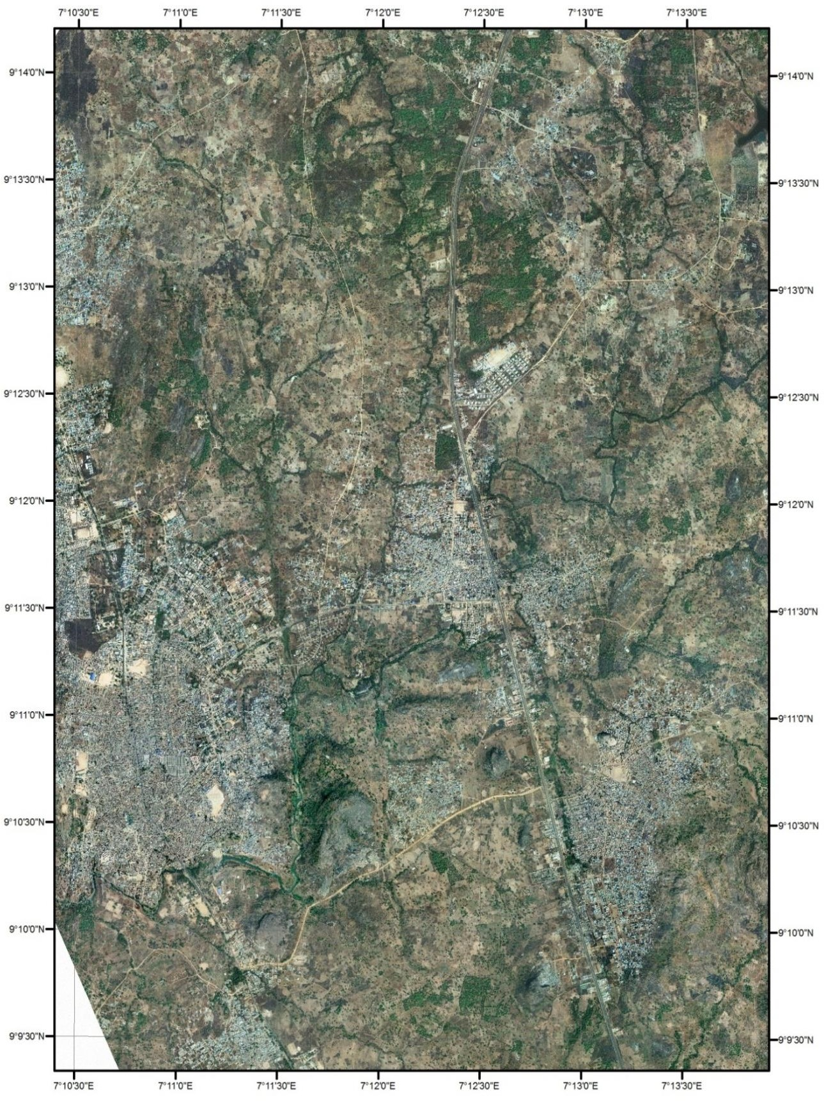

**Fig. 1.3: Quick Bird Satellite imagery of Suleja Town Source:** Data Net Consult, (2018)

# The only access road to Damaduna Kperegede Community



**Plate I: The Only pedestrian culvert that leads to the community Source: Authors Field Survey, 2018**



# Plate II: The condition of road in the area Source: Authors Field Survey, 2018



**Plate III: The condition of road in the area Source: Authors Field Survey, 2018**

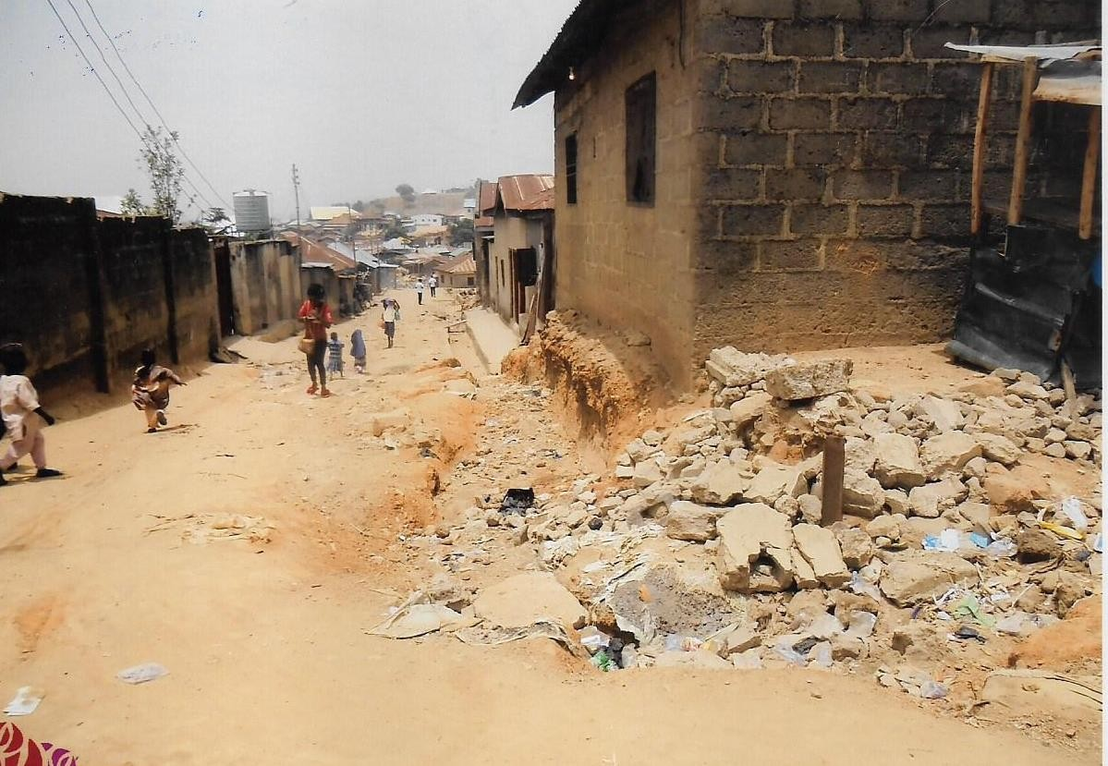

# Plate VI: The nature of building condition in the area Source: Authors Field Survey, 2018

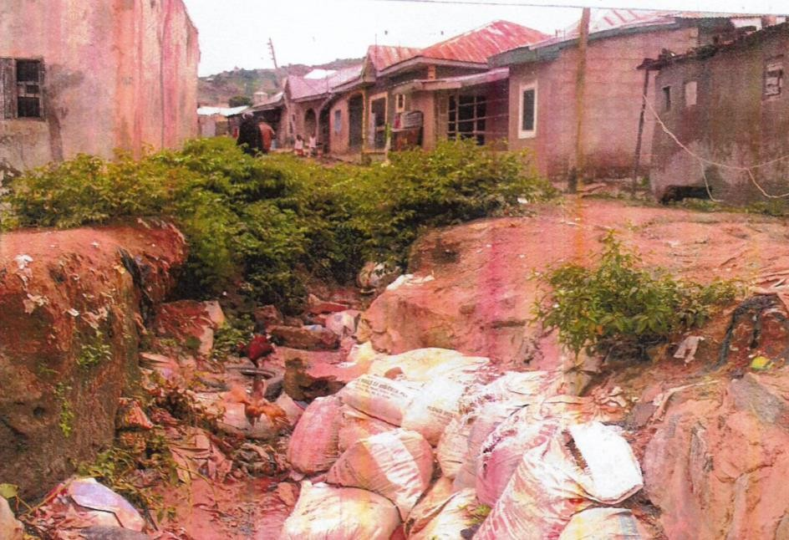

Plate VII: Road Damaged by Erosionin the area

# Sources: Field Survey, 2018