ASSESSMENT OF CROWD CONTROL STRA TEGIES IN THE DESIGN OF NATIONAL STADIUM AT MINNA, NIGER STATE, NIGERIA

BY

MUHAMMAD, Naimu Sufiyanu MTech/SET/2017/7241

DEPARTMENT OF ARCHITECTURE FEDERAL UNIVERSITY OF TECHNOLOGY MINNA

JANUARY, 2020

ASSESSMENT OF CROWD CONTROL STRA TEGIES IN THE DESIGN OF NATIONAL STADIUM AT MINNA, NIGER STATE, NIGERIA

BY

MUHAMMAD, Naimu Sufiyanu MTech/SET/2017/7241

A THESIS SUBMITED TO THE POSTGRA DUATE SCHOOL, FEDERA L UNIVERSITY OF TECHNOLOGY, MINNA, NIGERIA IN PARTIAL FULFILMENT OF THE REQUIREMENTS FOR THE AWARD OF THE DEGRE E OF MA STER OF TECHNOLOGY (MTech) IN ARCHITECTURE

JANUARY, 2020



**ABSTRACT**

Stadium crowd referred to the number of people corning together in cluster for sporting activities and other events in the stadium. The stadium crowd is usually associated with certain problems that include but not limited to problems of movement, ventilation, temperature, and crime, whereas this research is limited to the problem of circulation. The researcher reviewed past studies in which FIFA guide/recommendations and other similar areas of interest were made useful. The study aimed at providing football stadium that can allow safer crowd environment for sustainable spectatorship. A survey research was adopted. The study population comprised of 25 management staff, 20 technical staff, 20 security staff including police men, 1049 spectators for both the Uyo and Abuja stadia. The study utilised purposive sampling of the non-probability sampling technique. Questionnaire was used as the research instrument, in which 485 number was administered at the Uyo stadium, while 660 was administered at the Abuja stadium. A total of 1114 was possibly retrieved out of 1145. The researcher used research assistant to collect some of the data, and the entire data was then coded and organised for analysis using SPSS and Excel software, and were summarised in tables and charts for easy interpretations. The result indicated that the crowd management strategies used in most stadia were adequate except at the situation of full capacity evacuation. The result is shown in percentage for adequate, fair and inadequate scores for CCTV (17%, 15%, 9%), stadium entrance (86.9%, 7.3%, 5.8%), lighting (13%,

85%, 2%), signage (8.5%, 84.4%, 7.1%), peak period evacuation (18.6%, 7.6%, 73.8%),

ticketing (11.9%, 74.6%, 13.5%), seating plan (48.4%, 40.1%, 11.5%), security personnel

posting (42.2%, 40.3%, 17.5%), queuing and assembly of fans (64.4%, 35.6%, 0%), gate opening (77.6%, 13.6%, 8.8%). In conclusion, the evacuation at peak periods at stadia is usually inadequate. The concept of the research solution was made in three main ways; Improvement on the ingress/egress system, open circulation from upper levels of the sitting bowl to allow for easy evacuation, improving the emergency/vehicular access ways as improvement ofthe full capacity evacuation. and also awareness programs on the proper use of stadium facilities should be provided to all visitors as key recommendations of this research.

**TABLE OF CONTENTS**

**Content Page**

Title page

Declaration **11**

Certification **lll**

Dedication **1v**

Acknowledgements **V**

Abstract **VI**

List of Tables **X1**

List of Plates **Xll**

List of Figures **Xlll**

List of Appendices **xv**

List of Abbreviations xVI

CHAPTER ONE 1

* 1. INTRODUCTION 1
  2. Background to the Study 1
  3. Statement of the Research Problem 2
  4. Aim and Objectives 2

Aim 2

Objectives 2

vii

* 1. Research Questions 3
  2. Assumptions of the Study 3
  3. Scope of the Study 4

1. 7 Justification for the Study 4

CHAPTER TWO 5

* 1. LITERATURE REVIEW 5
  2. The Inception of Football 5
  3. Crowd Violence and the Causes of Disaster at Football Grounds 6
     1. Event characteristics and spectator violence 7
     2. Venue characteristics and spectator violence 10
     3. Staff characteristics and spectator violence 14
  4. Basic Safety and Security Considerations for Stadium Design 16
  5. .1 Safer venue design 17
     1. Management of crowds during football events 18
     2. The stadium capacity 18
     3. Maintenance of the stadium 18
     4. Safer location of the stadium 18
     5. Specific safety requirements 20
        1. Fire prevention in stadium 21
        2. The emergency services and disabled spectators 21
        3. Arena power supply and lighting 22
  6. Summary of Literature Review 23

CHAPTER THREE 24

* 1. METHODOLOGY 24
  2. Method of Data Collection 24

viii

* 1. Variables of the Study 24
  2. Location of the Study 24
  3. Population of the Study 26
  4. Sample Size and Sampling Procedure 26
  5. Study Instruments 27
  6. Data Analysis and Presentations 28

CHAPTER FOUR 29

* 1. RESULTS AND DISCUSSION 29
  2. Stadium Crowd Control Features 29
     1. Adequacy of CCTV surveillance cameras 29
     2. Adequacy of stadium main entrance 29
     3. Adequacy of stadium lighting 30
     4. Adequacy of posted instructional signs 31
     5. Adequacy of full capacity evacuation 32
  3. Strategies of Crowd Safety Before Events 32
     1. Adequacy of entry ticketing 33
     2. Adequacy of sitting plans 33
     3. Adequacy of posting security personnel 34
  4. Crowd Strategies During and After Football Events 35
     1. Adequacy of spectators queuing and assembly 35
     2. Adequacy of stadium gate opening 35

ix

* 1. Crowd Control Design (Proposed) 36
     1. The site location 36
     2. Site analysis 37
     3. Site plan 39
     4. Ground floor plan 40
     5. First floor plan 41
     6. Second floor plan 42

CHAPTER FIVE 43

* 1. CONCLUSION AND RECOMMENDATIONS 43
  2. Conclusion 43
  3. Recommendation 44

REFERENCES 45

APPENDICES 49

**X**

**Table**

**LIST OF TABLES**

**Page**



* 1. Adequacy of surveillance system (CCTV) and voice control 29
  2. Adequacy of multiple main entry/exits to the stadiums 30
  3. Adequacy of stadium lighting 31
  4. Adequacy of stadium signage 31
  5. Adequacy of stadium full capacity evacuation 32
  6. Adequacy of entry ticketing 33
  7. Adequacy of sitting plans 34
  8. Adequacy of posting security/control personnel 34
  9. Adequacy of spectators queuing and assembly 35
  10. Adequacy of gate opening 35

xi

|  |  |  |
| --- | --- | --- |
|  | **LIST OF PLATES** |  |
| **Plate**  Plate I | 1936 Berlin Olympic stadium | **Page**  5 |
| Plate II | Deutsches Stadion (Berlin) | 6 |
| Plate III | Heysel stadium disaster | 8 |
| Plate IV | Stadium fans alcoholism | 10 |
| Plate V | Full-size entry/exit turnstiles | 13 |
| Plate VI | Half-size entry/exit turnstiles | 14 |
| Plate VII | Spectators information/signposting | 15 |
| Plate VIII | Abuja stadium aerial view | 25 |
| Plate IX | Akwaibom stadium aerial view | 26 |



xii

|  |  |  |
| --- | --- | --- |
|  | **LIST OF FIGURES** |  |
| **Figure** |  | **Page** |
| 2.1 | Stadium seating plan | **11** |
| 2.2 | Half-size of the entry/exit turnstiles | **14** |
| 2.3 | Process of crowd disaster | 17 |
| 2.4 | Stadium location | 20 |
| 2.5 | Required swing direction for stadium exit doors and gate | 21 |
| 2.6 | Stadium camera positioning | 22 |
| 3.1 | Map of Nigeria | 25 |
| 4.1 | Google map of the main site | 37 |
| 4.2 | Satellite view of the main site | 37 |
| 4.3 | Proposed site plan | 39 |
| 4.4 | Section of the ground floor plan | 40 |
| 4.5 | Proposed first floor plan | **41** |
| 4.6 | Halfview of the second floor plan | 42 |



xiii

|  |  |  |
| --- | --- | --- |
|  | **LIST OF APPENDICES** |  |
| **Appendix** |  | **Page** |
| A | Questionnaire | 49 |
| B | Site plan | 52 |
| C | Proposed ground floor plan | 52 |
| D | Proposed first floor plan | 53 |
| E | Proposed second floor plan | 53 |
| F | Proposed third floor plan | 54 |
| G | Proposed roof plan | 54 |
| H | Proposed sections | 55 |
| I | Proposed elevations 'a' | 55 |
| J | Proposed elevations 'b' | 56 |
| K | Proposed details 'a' | 56 |
| L | Proposed details 'b' | 57 |
| M | Proposed 3d view 'a' | 57 |
| N | Proposed 3d view 'b | 58 |
| 0 | Proposed 3d view 'c' | 58 |
| p | Proposed 3d view 'd' | 59 |
| Q | Proposed 3d view 'e' | 59 |
| R | Proposed 3d view'f | 60 |
|  | xiv |  |



|  |  |  |
| --- | --- | --- |
| s | Proposed 3d view 'g' | 60 |
| T | Proposed 3d view 'h | 61 |
| u | Proposed 3d view 'i | 61 |



**xv**



**LIST OF ABBREVIATIONS**

DCMS

Department for Culture, Media & Sport

FIFA

F~d~ration Internationale de Football Association

FIST

Force, Information, Space and Time

IRFU

Irish Rugby Football Union

LMC

League Management Company

TV

Television

UEFA

Union of European Football Associations

**xvi**

**CHAPTER ONE**

* 1. **INTRODUCTION**
  2. **Background to the Study**

Football has become one of the most popular if not the most popular sporting game commonly played and watched by enormous number ofpeople all around the world. The evidence of this is noticed in all comers of villages, towns and cities of the world. Stadium arenas were considered amongst the largely populated areas within a community leading to crowd generation (Liu *et al.,* 2011).

Crowd could be seen according to Powell (1994) as group or number ofpeople attending a common gathering such as that ofpolitics, sport, and public events. Crowding is created by strong involvement in human agitation especially the crowd experienced at event grounds (Price, 2003). The crowd caused by population in a football stadium usually results to instabilities in pedestrian movement (Powell, 1994). One significant part of making sure that there is safer crowd at venues is by designing proper systems of circulation which can enable effective and strategic evacuation (Liu *et al.,* 2011).

Niger state been one of the states of the federation of Nigeria, is among the states that was blessed with large number ofstate income generating potentials like market business opportunities, tourism, agriculture and education. However, when we look at the movement of sports, football is another concern that gain popularity with huge number of players from different parts of the state playing on a typical grounds and fields. According to a report by Unaeze (2018), the present Niger state government proposes the construction of International Stadium at Maikunkele Niger State to cover for the old Bako Kontagora stadium that is 5000 in capacity, which cannot support the increasing user population, as it results in low effective pedestrian circulation especially when

1

people move, sit, exiting and on general use of the stadium. This is the main reason for the conduction of this research work.

At the end of this research work, a new modem stadium will be planned and designed which shall adopt necessary modem stadium planning and design approaches where necessary, and also try to incorporate and blend multiple space management that will enhance crowd control in the new Niger State National Stadium.

* 1. Statement of the Research Problem

The Niger state football stadium named as the Bako Muhammed Kontagora stadium in Minna was closed down for lack of upgrade and functioning for about two football seasons, now gained simple rehabilitation for continuation of usual football matches. Unaeze (2018) also reported that following the near completion ofthe rehabilitation work on Bako Muhammed Kontagora stadium in Minna, the Niger State Sport Council has written to the League Management Company (LMC) to come and inspect the stadium. The outcome of the report was that the work was good but the stadium cannot support the increasing crowd and that results to ineffective circulation management during top matches or events. It is from these two main reasons that this research work was carried out to solve the stated problem through an entirely new design consideration.

* 1. Aim and Objectives Aim

The aim ofthis research is to provide strategies that could help in improving the state of crowd generated in the stadium especially at peak period.

Objectives

The following are provided as considerable objectives for use by this research work:

2

1. To use the local technical approaches for football stadium construction to create a design of a circulation effective stadium for Niger State

11. To create effective access ways and concourse circulation for enhancing movement within the stadium.

iii. To use recommendations related to stadium circulation by F~d~ration Internationale de Football Association (FIFA) and Union of European Football Associations (UEFA).

* 1. Research Questions

These questions are used by the author in carrying out the research work, and the questions are asked by him.

1. What crowd control strategies can be adequately adopted for the stadium design?

11. How could the crowd control strategies be adequately used during planning od the stadium?

111. How could the relationship between the indoor and outdoor spaces of the entire stadium structure relate to help in controlling crowd at the stadium?

IV. How effective are the spaces to the users coming to visit the stadium?

v. In what ways can the existing stadium crowd be improved through new design approach?

* 1. Assumptions of the Study

The basic assumption proceeded by this research work is that stadia that are used in most part ofthe country especially in north, are those designed below FIFA standard because of lack of the following:

1. Adequate incorporation of circulation spaces that will enable crowd control

3

11. Considerations for future expectations related to size of population and its associated problems

* 1. Scope of the Study

Areas where the content scope of this research work will cover includes the following functions:

1. Local International Olympic stadia of 60 thousand plus capacity

11. Local National and Inter-state stadia of 30- 40 thousand capacity

111. Foreign Olympic stadia 90 thousand plus capacity

* + 1. Foreign football stadia of 45 thousand plus capacity
    2. Historical stadia. Berlin and Deutsches
  1. Justification for the Study

Just as earlier stated by Faces International Magazine website 2018, that the state government had made proposal to carry out a new stadium project work that would support the increasing population as well as the future target (large capacity of people). Therefore, whenever there is population in large number especially in this type of gathering, there is always creation of crowd menace, which requires proper considerations in such a place.

This is the main reason that brought to justice the carrying out of this research work in the vain that how can the research be able to develop design which supports the large population as well as addressing the problem of crowd associated with the size of population expected.

4

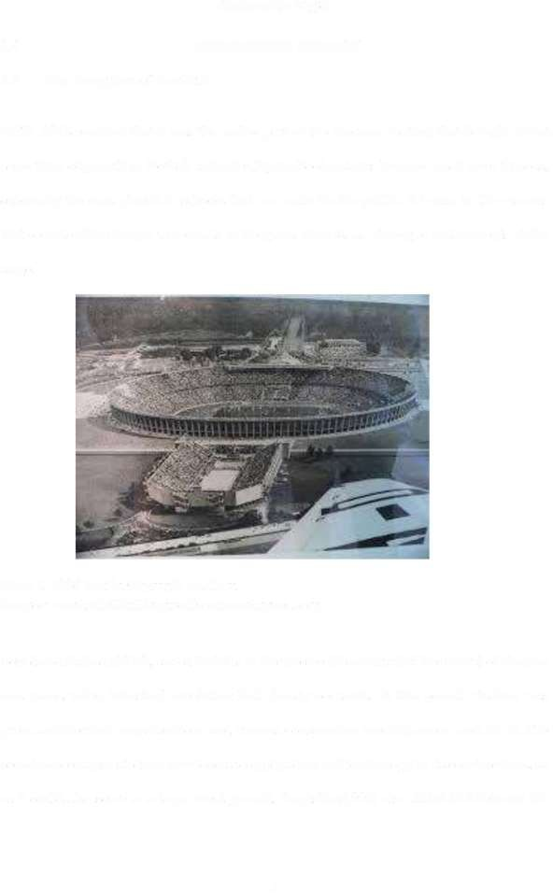**CHAPTER TWO**

* 1. **LITERATURE REVIEW**
  2. **The Inception of Football**

FIFA, 2018 reported that it was the earlier part of the nineteen century that brought about some form of growth in football and when high school matches become much more famous, especially the ones played in schools that are made for the public. It is due to this reasons that considerable changes were made in the game. New ideas, strategies and concepts at this stage.

Plate I. 1936 Berlin Olympic stadium

**Source:** [**www.thethinkingarchitect.wordpress.com**](http://www.thethinkingarchitect.wordpress.com/)

Seyed and Farhad (2014), stated that it is in the nineteenth century that the revival ofstadium was made, when industrial revolution had already occurred. At this period, stadium was given architectural considerations and various construction methods were used for it. The society encourages stadium developers to apply advanced technology to its constructions, so as it could also serve as a large event ground. Augustin (1995) also stated that between the

5

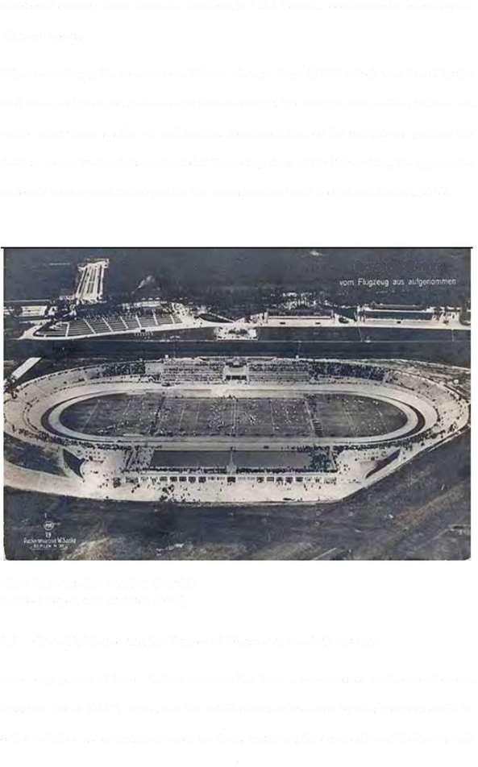nineteenth century Baron Pierre de Couberin in 1894 formed a conference to redevelop the Olympic sports.

When considering the remains of a historic stadium from 33 lBC which was found by the well kwon architect and archaeologist from Germany, the reconstruction of the stadium was made using Greek's style of architecture. Documentation of the regulations guiding the stadium reconstruction was conducted at the ending stage of the 19" century, the appropriate materials were agreed to be used for the reconstruction work (Seyed and Farhad, 2014).

Deutsches **Stadion**

Plate II. Deutsches Stadion (Berlin) Source: Seyed and Farhad, (2014)

* 1. Crowd Violence and the Causes of Disaster at Football Grounds

Over long period of time, stadium violence has been a reoccurrence incidence of crowd disasters. Lewis (2007), stated that the notable forms of violence by the spectators could be either verbal or use ofirritating words to others, gesturing, throwing ofharmful objects, rush 6

movements, swarming, property destructions which includes burning and braking of objects to serve as weapons.

According to a statement by the Department of Culture, Media and Sports (DCMS), that Inspection by experts for competency check of the stadium should be done after the basic consideration of keeping the stadium free of any obstructions that will slow down movement or cause traffic congestions. Also the stadium should have good flooring that will ensure smooth movement and there should not be on the floor objects that could be used by spectators as weapons against others (DCMS, 2008).

Violence that usually occur in stadia could either be created by a small group of individuals or large group. That is, among two or more individuals (could be between the stadium players, officials and other staff) on the main arena or within the site structures and properties that are fixed or movable such as plants, tress, statures and vehicles (O'Reilly, 1999).

According to Smith (2007), Causes or factors contributing to spectator violence in stadiums can be divided into three categories; (1) event characteristics, (2) venue characteristics and

(3) staff characteristics, but the factors does not possess any characteristic that will ensure the occurrence of the violence or not. Smith (2007), further explained that an unfunctionally planned venue, staff that are not properly trained and events of high resources are the elements that help in the possibilities of violence among spectators. This study further explained as Lowrey (2002) stated that 27 out of 100 of the total detentions made during football events within Wales and England between 2000 and 2001 were from offences that are related to alcohol.

* + 1. Event characteristics and spectator violence

According to Westin (2003), violence becomes an accepted copmg behaviour in any situation where people, especially male, are faced with a combination of five types of

7

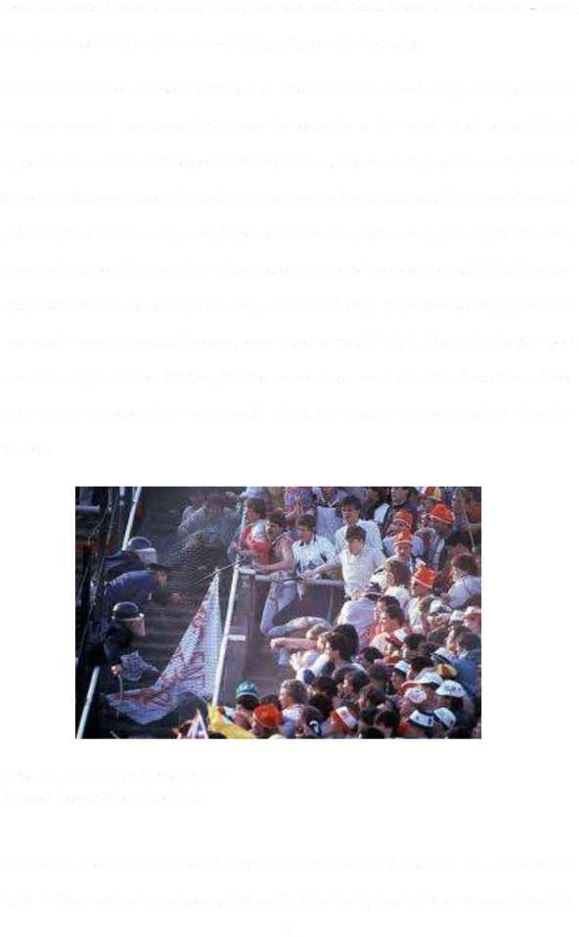personal threats: threats to moral worth, threats to adult status, threats to physical well-being, threats to masculinity and threats to feelings of personal adequacy.

According to Veno and Veno (1993), a lot of event factors were having relationship with violence amongst spectators in the past. An example is the event which is capable of supporting larger male folks especially the youth age, these tends to possibly create violence than crowd that comprised of mixed group. violence in the stadium usually comes after initial player fight at the time of game play/event. When the players engage in fight, this often attracts others from the spectators that could trigger the violence (Simpson, 2000). The cause of spectator violence is usually from simple riot. The fleeing of spectators during sport event can actually result to loosing lives and properties (Zezima, 2005). In 1985 at the Heysel Sport ground in Belgium where thirty-eight lives were lost as a result of suffocation, other injuries were as well recorded (Arms and Russell, 1997). The English referred it as their forgotten tragedy.

Plate III. Heysel stadium disaster Source: telegraph.co.uk (2018)

A selection and presentation of Television (TV) football matches from top games which differ in their level of aggressions, that could either be higher, lower or intermediate. The

8

match is watched by all gender and each of the group were rated as intermediate at the end. The level of aggression goes hand in hand with the pleasure derived from watching of football match. The result of this finding brought that aggression is a key factor for the better pleasure derived from watching TV football match (Bryant *et al.,* 1982).

Football match attracting more home fans produces higher probability of occurrence of aggression/violent acts, unlike when it attracts otherwise. To identify a territory, is an important factor of creating a rowdy way ofidentification and forming violent group (Spaaij, 2006). There is higher probability of occurrence of stadium violence in arenas where top class teams that has highly committed supporters are gathered (Wann, 2006).

Most of the cause of supporter's aggression in the time of sport event is usually related to performance of a club in which the supporters may feel not satisfied (Kizito, 2012). According to Lowrey (2002), the referee's decisions in most cases had been the cause of creating aggression amongst the spectators and players if not properly handled. This had been a common problem in the Nigerian football leagues, with several cases witnessed. Like the case of the supporters of Abia Warriors, they attacked two referees after a draw match (1-1) between the supporter's club and FC Ifanyi Uba, the attacking fans disagreed with the way the referee handled the refereeing ofthe match (Chibiuke, 2017). Also in 2016, the Sun• shine Stars supporters aggressively descended into the playing area causing disturbances by trying to fight the referee and stadium officials, the supporter's claimed that their team have been denied a free kick during the game play (Chibiuke, 2017). Another case was the one where a female centre referee was beaten by the supporters of Akwa United afeter a free kick award was given to the visiting team (Chibiuke, 2017).

9

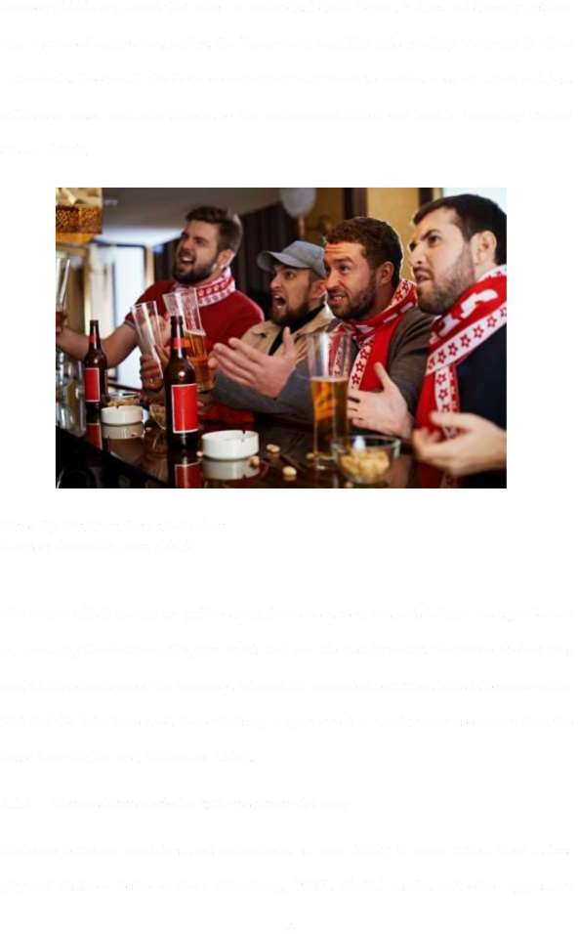Lowrey (2002) explained that when an individual drink liquor, it does not directly get him into a state of aggression, rather, the liquor may lead him into reacting violently to other individuals. Too much alcoholic consumption may result to carelessness of action and loss of human senses and mindfulness to the environment which can lead to becoming violent (Jones, 2014).

Plate IV. Stadium fans alcoholism Source: fwweekly.com (2018)

The way in which people are gathered and their evacuation in sport stadium has significance in increasing the duration ofbigger events that are attended by many. Therefore, violent fans could take advantage ofthe increased interval for unwanted activities. This is because ofthe fact that the total time used for actualising a sport event is usually increased more than the basic time (Miller and Gillentine, 2006).

* + 1. Venue characteristics and spectator violence

Violence between spectators and entertainers is more likely to occur when there is less physical distance between them (Roadburg, 1980). Verbal insults and other aggressive

10

behaviour by spectators close to the action can also prompt retaliatory behaviour from entertainers who feel threatened or disrespected (Sappenfield, 2004). Extreme noise levels increase the likelihood of interpersonal aggression by causing high level of irritation to spectators (Branscombe and Wann, 1992).

Arbiter and Holy (1994) wrote that in order to have orderliness at the time of an event, seating should be allocated since the stadium allow people to come in and out with their mobility. When seats are not properly allocated, aggressive spectators might trample over people around the activity area (Russel, 2004). The triggering of aggression could be as a result of movement of people around vacant seats or railings as they obstruct others along the way. Movable seats inside the venue could be used in fighting by violent people (Russell, 1983).

**west Stand**

AN

nr

**l**

**UY Entrance**

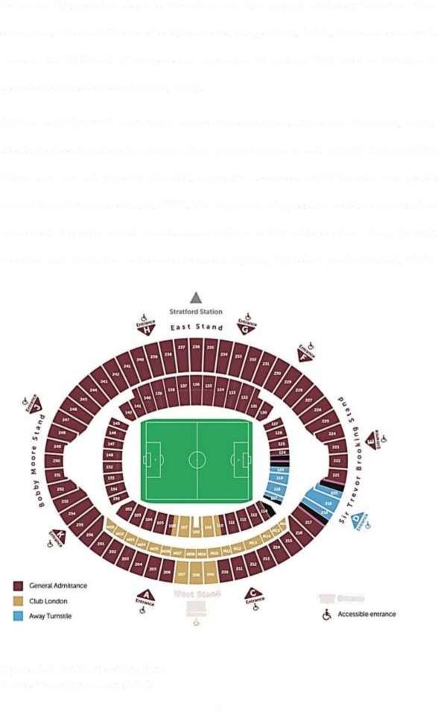

Figure 2.1. Stadium seating plan Source: wordpress.com (2018)

11

According to Russel (2004), the seating planning made for fans defines the likelihood of spectator's aggressions because of the existing relationship between the occurrence of violence and the and the seating planning. Much reservation of seats could result to the generation of crowd on entry points, making the sets to be minimal for large users. Stolf and Adang (2005), revelled that sport arenas where fighting becomes tradition, this can help in getting young people into acting violently.

The possibility of creating violence may be based on crowd due to certain reasons; number of mobility and increased unwanted spectator's meetings (grouping) during entry/exits. According to FIFA (2008), crowd disaster could occur as a result of forceful entry to stadium, by trespassing the site fence or other entry points. This problem can be solved by creating strong and safer height of walls, fences and gates that will not allow for easy trespassing. Police and surveillance cameras should be supporting that (Taylor, 1989). Relatively, the venue temperature and active aggression goes hand in hand, violence may erupt as a result of temperature rise inside the stadiums activity area (Madensen and Eck, 2008). The selling of fast food in soft packages should be encouraged than in packages like bottles that are made of glass or can, these could be used as weapons (DCMS, 2008).

City centre stadium has higher probability of experiencing violence than the one located outside the city centre. A stadium can experience violence as a result of the drive by the problems in the city centre (Bale, 2000). The stadium ingress capacity ( amount of individuals capable of passing through turnstiles or any monitored entrance per hour), and this is based on; how much is the turnstiles per point of entry, how adequate is communication and signage, how conversant are the spectators with the sections of the stadium (positive way finding), zoning of the entry points by taking account the provisions for special needs like ramps for the disabled ones, and the state of the turnstiles should be considered (FIFA, 2008).

12

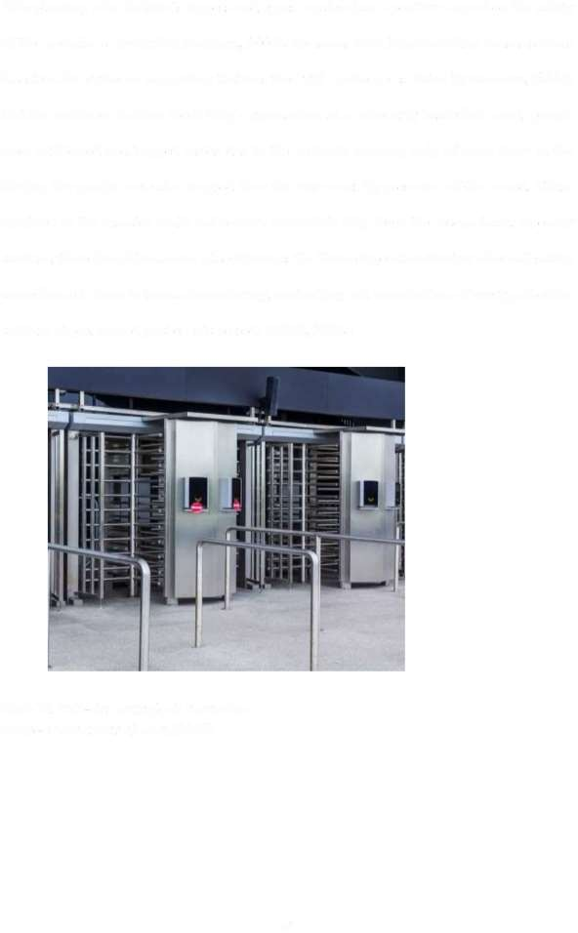The planning of a stadium's ingress and egress system has a positive impact on the safety of the spectator's circulation (Connors, 2007). Pressures from large crowding causes serious disasters. An evidence supporting that was the 1991 incidence as stated by Connors, (2007) that the incidence in New York City's gymnasium at a university basketball court, people were suffocated and trapped inside due to the outwards opening only of some doors in the facility, the people were also trapped from the stair ways by pressures of the crowd. Those involved in the disaster could not receive immediate help from the rescue team. In every stadium, there should be a room (also known as the Venue Operation Centre) where all safety surveillance is done in terms of monitoring, controlling and coordination of every part of the stadium at pre, on and post events periods (FIFA, 2008).

Plate V. Full-size entry/exit turnstiles Source: [www.sznanj.com](http://www.sznanj.com/) (2019)

13

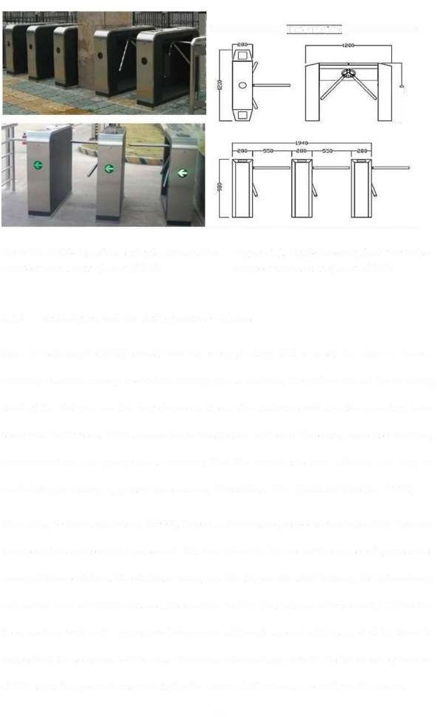l **Mg**

**±** {product se )

-.;,

_p

*II* ;

.. / J

*'*

Plate VI. Half-size of the entry/exit turnstiles Figure 2.2. Half-size entry/exit turnstiles Source: [www.sznanj.com](http://www.sznanj.com/) (2019) Source: [www.sznanj.com](http://www.sznanj.com/) (2019)

* + 1. Staff characteristics and spectator violence

Rees & Schenepel (2008) stated that for every strategy that is made in order to have a minimal violence among spectators coming into a stadium, the police and all the working staff of the stadium are the key elements there. The stadium staff and the operators have some vital behaviours that is connected to the stadium violence, these are; expertise, training, communication and promptness, meaning that the overall stadium officials can help in minimizing or raising aggressiveness among the stadium fans (Stott and Reicher, 1998)

According to Stott and Adang (2005), there is a diminished responsive relationship between the spectators and security personnel, this was found to be one of the cause of aggressions amongst the spectators. The stadium managers should provide staff training for determining and taking care of intoxicants and intoxication within the stadium. The security/ police has been dealing well with aggressive behaviours, although special skill is needed by them to understand the solutions to the cause of violence during large events. A statement by Connor (2007) says that promptness in duty by the venue staff serves as security to the venue.

14

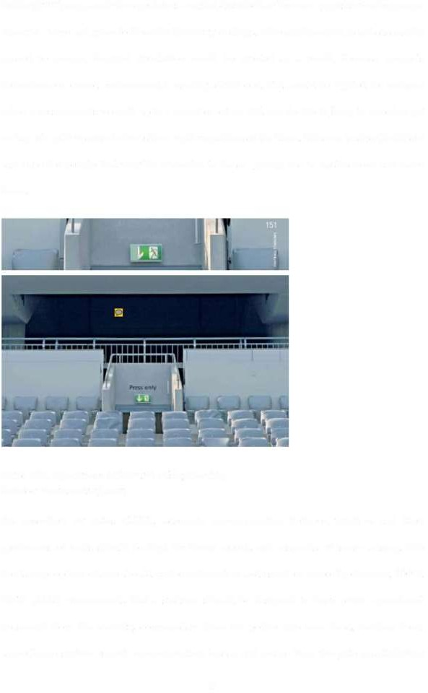Miller (1997) explained that spectators can feel disturbed or become aggressive when proper directives were not given to them for their way findings. When information is not adequately passed to people, delayed circulation could be created as a result, because people's behaviours on crowd environment is usually selfish one. This could be sighted for instance when a person wants to catch up to a match event on TV, can decide to jump to a roof or get on top of a pole in order to have clear sight regardless ofthe harm. This can lead to the follow suit by other people that may be interested to do so, giving rise to destructions and more harm.

**Press only**

**f**

Plate VII. Spectators information/signposting Source: [www.sznanj.com](http://www.sznanj.com/)

As described by Estes (2004), adequate communication between workers and their performers of tasks should be kept for better reports and responds of issues arising. The heads or people in charge should gather information and use them correctly (Connor, 2007). FIFA (2008) recommends that a stadium should be designed to have active operational personnel from the security, commanders from the police, fire men head, medical head, surveillance system expert, communication leader and leader from the gate pass/ticketing

15

unit. In a multi-floor facility, the lower level management are responsible for every safety/ security worker is capable of engagement (FIFA, 2008)

* 1. Basic Safety and Security Considerations for Stadium Design

In all forms of construction processes for any project type, there is always need to firstly put in to consideration the basic safety design factors for the safety of lives and properties. Billington *et al.* (2002) stated that when design factors like access points where unsuitable for safety and security personnel in large gathering arena like stadium, it tends to increase the design problems there. Young (2002) revealed that most of the occurring disasters of lives and properties during large gathering like in stadium is as a result ofinadequate designs leading to increased problems instead of the solutions, and that the design of the building should relate people or user movements the with their characters (gender, age and abilities) and also to the dimensional environmental and structural factors.

Fruin (2002) explained from his FIST instances that the initial crowd situation which is the Force, the crowd Information (true or false) that determine the crowd action, the Space (space for seating, chair, floor, gates and so on) used and the time period of the occurrence of mass entry and exit has great influence on the creation of high crowd density which is mass population in one area unit, and the increased movements (high velocity). Sometimes, these results to a heavy injury or death by suffocative, trampled and violent actions. The figure below shows the process of crow disaster.

16

Structural Failures Human Errors Natural Calamity

Attendance Level Action by Performer Improper/inadequate Arrangement

Panic/

Excitement

Circumstances Force Information Space

Time

[PP] Overcrowding

Crush Disasters (Compressive Asphyxia)

Suffocation

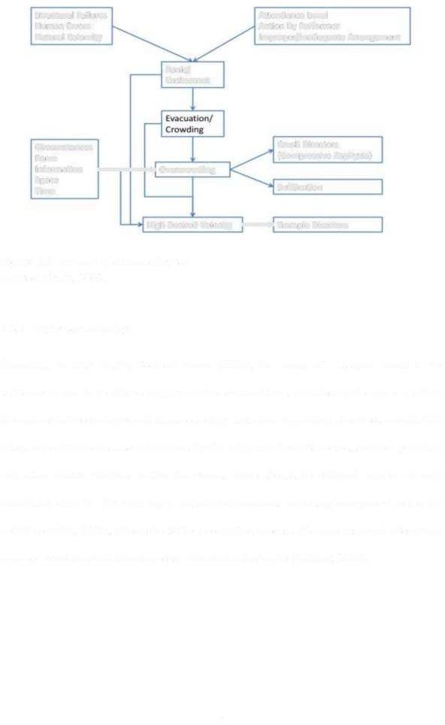

High Desired Velocity **]Trample Disasters**

Figure 2.3. Process of crowd disaster Source: Fruin, 2002.

* + 1. Safer venue design

According to Irish Rugby Football Union (2008), the venue of a stadium needs to be sufficient in size to be able to support number of spectators, considering the space in which the main structure occupies and its surroundings and other supporting structures around. The adequacy of the venue also determined by the entry and the exits routes, services provided and other related facilities within the venue. There should be efficient number of well distributed exits to allow for rapid and safer evacuations including emergency routes for vehicles (IR.FU, 2008). There should be a controlled process of crowd dispersal after every game or event to avoid the occurrence of crowd catastrophe (Talalay, 2007).

17

* + 1. **Management of crowds during football events**

Fruin (2002) explained that even though the word crowd control and crowd management are usually alternately used, each has its own different meaning. Crowd management, it involves planning and monitoring of the circulation and coming together of group of individuals in an organised manner. While crowd control has to do with restraining of certain human behaviour as a whole.

* + 1. The stadium capacity

FIFA (2007) questioned that what should the capacity be? Should the stadium be built to accommodate only the domestic needs of the club who will use it? Or should it attempt to attract matches at a higher level? It is not unusual for clubs to find that the provision of a bright, new, clean and comfortable stadium brings with it a dramatic increase in attendance levels. In such circumstances, a club which normally attracts an attendance ofaround 20,000 and is thinking of building a new stadium with a capacity of 30,000 might find it preferable to think in terms of nearer 40,000. The capacity of each stadium will depend on whatever is required locally but ifdevelopers hope that the stadium will be used occasionally for major international football events (Brindley, 1982).

* + 1. Maintenance of the stadium

Alpert and Flynn (2007) stated that stadium designers should be cautious ofthe planning, so that the future management and maintenance, services, cleanliness and general operations of the stadium would be simply and effectively taken care of at low cost.

* + 1. Safer location of the stadium

The location of a stadium should be made in a place that is adequately spaced and the area should be safe for public movements, vehicular parking. As the stadium spectators makes

18

their way simply into the stadium with the help of coordinating turnstiles in different invals of time, most of the people would rather want to evacuate the venue at equal time which will actually require a lot of space (Aladejana *et al.,* 2015). When there is sufficiently provided space (exterior), this will enable future expansions. Some of the globally well known stadiums are highly planned such that features like access roads, buildings and water bodies are used as part of design planning. The future development here depends on the size of the site. Sites that are significantly large, tends to have less possibilities oflong run abandonment which could be due to the failure of the site to support redevelopments that could be unforeseen (FIFA, 2007).

In most developed countries the location of the stadium would usually be in the city centre having adequate accessibility to main roads, vehicular parking and public transportations which are made useful at periods when there is no active match going on in the stadium. The probability that parking places that are large, useful for as small as one hundred to two hundred hours/year is minimised. If it is expected by a stadium to host matches at higher levels, the stadium should be located in an area not far from city hotel buildings, and a lively business district/commercial areas and if possible a unit airport for international flights (FIFA, 2007).

19

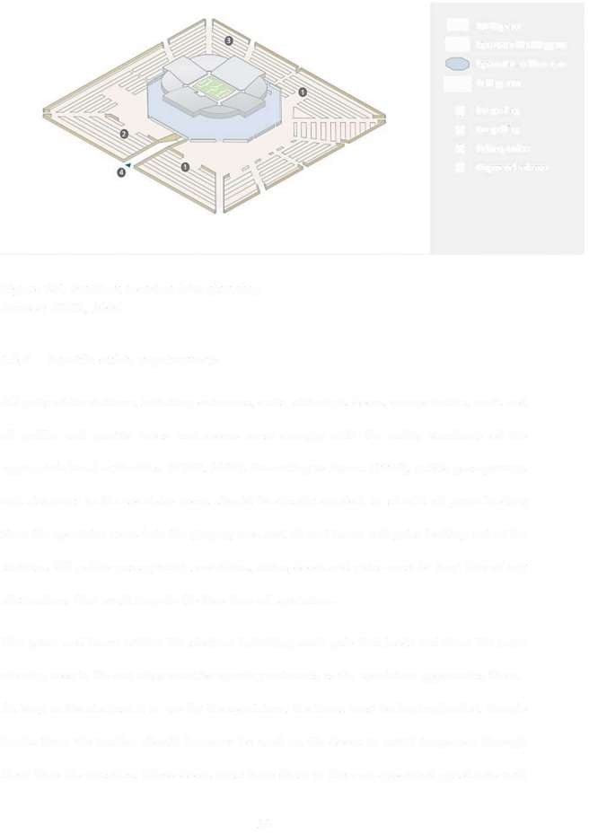

<> Activity area

& spectatorswenarea

spectators' sen«ices area Paring area

<<>

**0** Car parking

**0** Bus parking

**e** Railway station

**0** Players and referees

Figure 2.4. Stadium location /site planning Source: FIFA, 2007

* + 1. Specific safety requirements

All parts ofthe stadium, including entrances, exits, stairways, doors, escape routes, roofs and all public and private areas and rooms must comply with the safety standards of the appropriate local authorities. (FIFA, 2007). According to Hanna (1994), public passageways and stairways in the spectator areas should be clearly marked, as should all gates leading from the spectator areas into the playing area and all exit doors and gates leading out of the stadium. All public passageways, corridors, stairs, doors and gates must be kept free of any obstructions that could impede the free flow of spectators.

The gates and doors within the stadium including each gate that leads out from the main viewing area to the out sides must be opening outwards as the spectators approaches them. As long as the stadium is in use by the spectators, the doors must be kept unlocked. Simple Locks from the insides should however be used on the doors to avoid trespasses through them from the outsides. These doors must have close to them an appointed guard who will

20

ensure safety against trespass and evacuation in emergency situations. Theses doors should

never be key locked at the time of game play or other usages (FIFA, 2007)

INSWING

**X**

**OUTSWING**

**Left Mand**

**Left Mand utswing Door**

**"**

**Right Mand**

**Inswing Door**

**t**

V

**Right Mand Outswing Door**

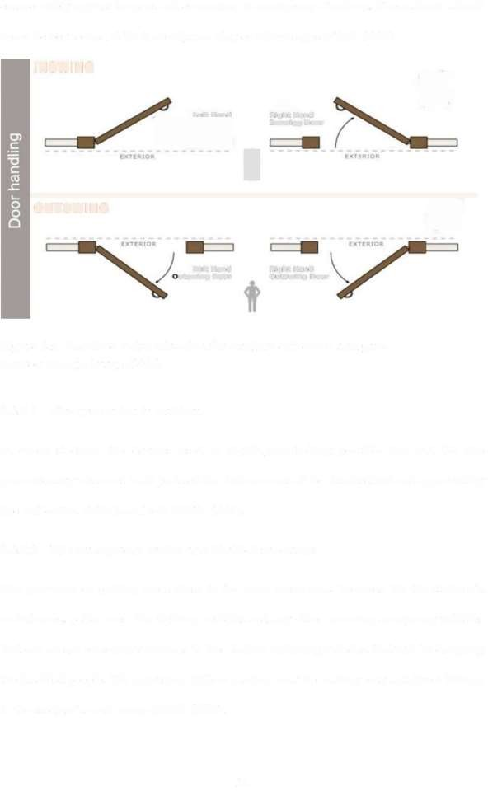

Figure 2.5. Required swing direction for stadium exit doors and gate Source: Google image (2014)

* + - 1. Fire prevention in stadium

In every stadium, the devices used in fighting/controlling possible fire and the fire precautionary measures in all parts ofthe stadium must all be standardized and approved by fire authorities at the local level (FIFA, 2007).

* + - 1. The emergency services and disabled spectators

The provision of parking areas close to the main arena must be made for the stadium's ambulances, police cars, fire fighting vehicles and any other incoming emergency vehicles that can render emergency services to the stadium including vehicles that will be dropping the disabled people. The provision of these parking must be making easy and direct linkage to the stadium's main venue (FIFA, 2007).

21

* + - 1. 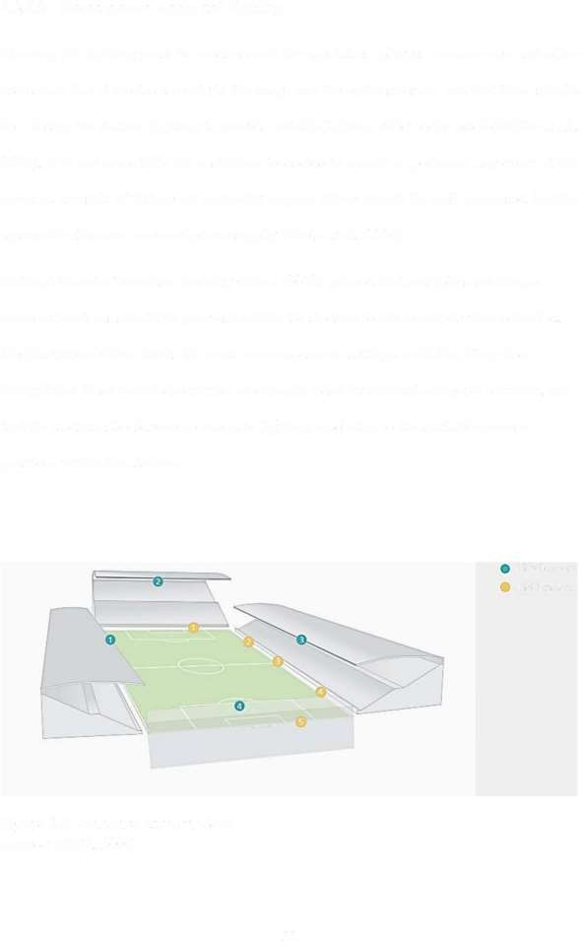**Arena power supply and lighting**

Planning for lighting must be made to suit the spectators, players, camera men and other users such that it creates serenity to the usage and the entire stadium, and that there should be a design for stadium lighting to provide suitable lighting effect to the pitch (knibbe *et al.,* 2018). It is not acceptable for a stadium to decide to cancel or postpone any event at the arena as a result of failure of electricity supply. There should be well organised backup system for alternate source of power supply (Beetz *et al.,* 2006)

National Counter Terrorism Security Office (2012) pointed that multiple surveillance cameras locations should be provided within the stadium to aid recorded video activities, the illustration below shows the most common camera settings available. They also brought that these recorded activities are usually aided by relevant computer software, and that the stadium should receive adequate lighting in relation to the available camera positions within the stadium.

Fixed camera Field camera

Figure 2.6. Standard camera views Source: FIFA, 2007

22

* 1. **Summary of Literature Review**

The game offootball was initially associated with some form ofroughness and disorderliness and the use of hand until the corning of nineteenth century that revival was made to football and the stadium. These initial acts resulted to a lot ofproblems like violence.

The major causes of violence and crowd disasters in the stadium today could either be from the design and planning of the stadium, human character (aggressions and mode of ongoing event) or from structural failure, suffocation and fire. These problems could be categorized as evet based, venue based or staff based. The event factor has to do with considerations such as supporting capacity. The venue factor has to do with considerations such as site location and safety. While the staff factor has to do with general managements and coordination of spectators in the stadium. In solving these crowd related problems in the stadium, certain factors like capacity utilization, maintenance safer stadium location (area that is widely spaced and not prone to violence threat), specific safety needs (That is, considerations for adequate doors, gates, passage ways and emergency exits).

23

**CHAPTER THRE E**

* 1. **METHODOLOGY**
  2. **Method of Data Collection**

A survey research method was adopted. Initially prior to travelling for research information, the researcher obtained adequate guidance from the supervisor of the research in the department ofarchitecture ofthe university. A research assistant was used for the Akwaibom stadium data collection, while the researcher conducted the data collection of the Abuja stadium. The respondents were in groups the first group were the supporters of fans, they were provided with the questionnaires at the instance of a local friendly football match at the end of the first forty-five minutes (halftime period). The stadium operators were the second respondents, they include the working staff of the stadium, they were given the questionnaires and they responded to the questions at their seat or desk of work. All these was gotten within a period of five days. Most of the distributed questionnaires were gained back at that same day, while others were gained back until the following day.

* 1. Variables of the Study

This study utilized strategies of stadium safety and crowd management as variables, these includes; CCTV surveillance system, egress (exit ways) and ingress (entry ways), siting arrangements, personnel coordination technique, evacuation during full capacity, walk ways, signages or posted information and communication system (audio communication).

* 1. Location of the Study

The two study areas chosen for this research work are Abuja and Akwa Thom states of Nigeria with Abuja (FCT) located along the earth axis oflatitude 9.06313° N, and longitude 7.46179° E, and having land area ofabout 8,000 square kilo-meters with elevation above sea

24

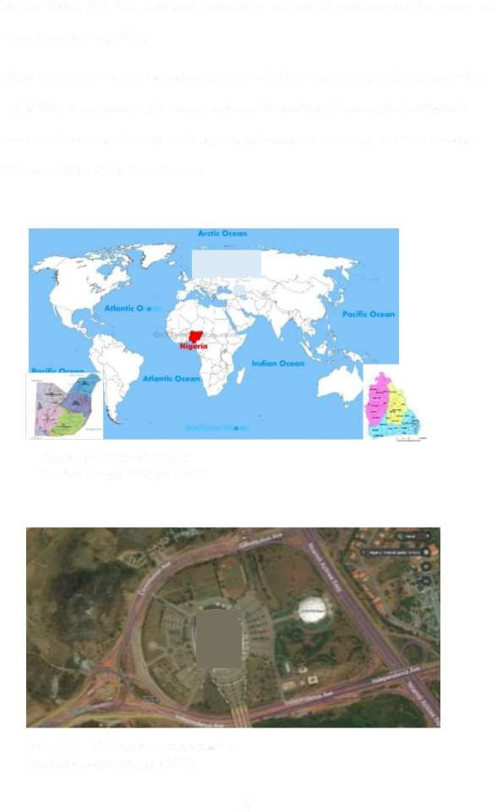level of 840m. The FCT is situated centrally to north of the confluence of the Benue and Niger Rivers (Rimi, 2014).

While Akwa Thom state is located along latitude 4°32'N and 5°33'N, and longitude 7°25'E and 8°25'E. it is situated in the coastal region of the southern Nigeria (the South-South zone) also known as the Niger Delta region. Its boundaries are Cross river from the east, Rivers and Ahia States from the west.

... - .

~

***--~ ,J • ,***

&«-,

**can ,**

**Southern Ocean**

Figure 3.1. Map of Nigeria Source: Google Images (2018)

.·-.,. a...

Plate VIII: Abuja stadium areal-view Source: Google Images (2018)

25

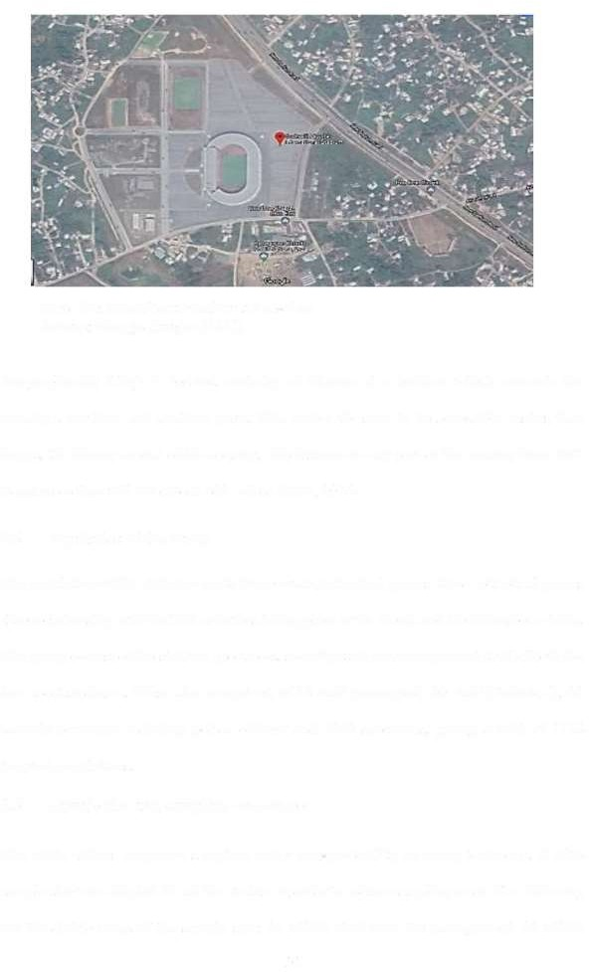

**Plate IX: Akwaibom stadium areal-view Source: Google Images (2018)**

Geographically Abuja is located centrally of Nigeria at a position which connects the country's northern and southern parts. This makes the state to be accessible easilys than Lagos, the former capital of the country. The distance to any part of the country from FCT is not more than 970 km (about 600 miles) (Rimi, 2014).

* 1. Population of the Study

The population ofthis study are made from certain individual groups, these individual groups share relationship with football activities taking place in the Abuja and the Akwaibom stadia. The group consist ofthe stadium spectators, security staff and management staff of both the two sport stadiums. These also comprised of 25 staff (managers), 20 staff (Technical), 20 security personnel including police officers and 1049 spectators, giving a total of 1114 targeted populations.

* 1. Sample Size and Sampling Procedures

The study utilizes purposive sampling under non-probability sampling technique. A 70% sample size was adopted for all the stratum in order to reduce sampling error. The following are the distributions of the sample size: 25 (70%) staff from the management, 20 (70%) 26

technical staff and 20 (70%) security personnel including police officers, these sums the first group, the operators/staff. The second group is the spectators/fans, consisting of a total of 1049 numbers selected based on the fisher's formula, n =Zpq/dz. Where "°'n?is equal to the required size of sample for the target population greater than ten thousand, '' Z'' is equal to the standard deviation at acceptable level, ''p'' is equal to the proportionality of the target population considered to have the ability to be measured, "q" is equal to the subtraction of

1 from p, ''d'' is equal to the set of significance of the statistics. Before commencement of

the events (football), supporters were purposively chosen for sampling at the two study areas (Abuja and Akwaibom stadia).

* 1. Study Instruments

Under this study, questionnaire was used as the main instrument for the collection ofresearch data in which 485 number was administered at the Uyo stadium, while 660 was administered at the Abuja stadium. A total of **1114** was possibly retrieved out of 1145. The questions were well constructed and developed by the researcher in terms of related study fields including demographic analysis, safety considerations in the stadiums, strategies considered prior to football match, crowd management at the time of the event and management strategies after the stadium events.

The questionnaire was constructed to provide the respondents with options to choose based on what suits them. Also, an observation schedule was constructed and is used in collecting data on what is available or not and how many are they, state or conditions of the safety features available in the research areas by observing them side by side with the ones recommended by FIFA (2007). Research assistant was used but was initially guided and trained.

27

* 1. **Data Analysis and Presentations**

The information gathered from the questionnaires were computed and interpreted as codes. Then the analysis was carried out using Microsoft Excel software and Statistical Package for Social Sciences software. The data was then put to summery using tables and charts (bar and pie) for easy interpretations. The analysed data was based on the adequacy of stadiums crowd control planning.

28

**CHAPTER FOUR**

* 1. **RESULTS AND DISCUSSION**
  2. **Stadium Crowd Control Features**
     1. **Adequacy of CCTV surveillance cameras**

Table 4.1 shows the responses in summary of adequacy of surveillance system (CCTV) and voice control as observed by the management staff/security staff and the main spectators.

**Table 4.1: Adequacy of surveillance system (CCTV) and voice control RESPONDENTS RESPONSES TOTAL**

|  |  |  |  |  |
| --- | --- | --- | --- | --- |
|  | **Adequate** | **Fair** | **Inadequate** |  |
| **Operators/Security Staff** | 32(49.5%) | 16(24.6%) | 17(26.6%) | **65(100%)** |
| **Main Spectators** | 813(77.5%) | 150(14.3%) | 86(8.2%) | **1049(100%)** |
| **TOTAL** | **845(75.8%)** | **166(14.8%)** | **103(9.4%)** | **1114(100%)** |

**Source:** Author's work, 2018

From the above table in which the analysis findings were represented, higher fraction of the respondents (population) indicated surveillance system and voice control as adequate with a score of 75.8%, 14.8% as fair and 9.4% as the score for inadequate.

* + 1. **Adequacy of stadium main entrance**

The provision of adequate number of main entrances is one of the key factors in assessing crowd control strategies, below is a table showing the responses in summary of adequacy of provision ofmain entrances as observed by the management staff/security staff and the main spectators.

29

**Table 4.2: Adequacy of multiple main entry/exits to the stadiums**

**RE SPONDENTS RE SPONSES TOTAL**

|  |  |  |  |  |
| --- | --- | --- | --- | --- |
|  | **Adequate** | **Fair** | **Inadequate** |  |
| **Operators/Security**  **Staff** | 48(73.8%) | 17(26.2%) | 0(0%) | **65(100%)** |
| **Main Spectators** | 921(87.8%) | 64(6.1%) | 64(6.1 %) | **1049(100%)** |
| **TOTAL** | **969(86.9%)** | **81(7.3%)** | **64(5.8%)** | **1114(100%)** |

**Source:** Author's work, 2018

The above analysis shows that 86.9 percent of the respondents indicated that main entrance provision in the stadiums is Adequate, 7.3 percent indicated as fair, while 5.8 percent indicated as Inadequate.

* + 1. **Adequacy of stadium lighting**

The system of lighting of the stadium is an important aspect to consider when it comes to the planning and design of stadium facility, and it is of important for crowd control in the same type of facility. The below table is indicating the summary of responses by the direct users of the stadium, it is indicating the adequacy of lighting systems available in the stadium. The management staff/security staff and the main spectators are the direct beneficiaries of the stadium.

30

**Table 4.3: Adequacy of stadium lighting**

|  |  |  |  |  |
| --- | --- | --- | --- | --- |
| **RESPONDENTS** |  | **RESPONSES** |  | **TOTAL** |
|  | **Adequate** | **Fair** | **Inadequate** |  |
| **Operators/Security**  **Staff** | 17(26.2%) | 48(73.8%) | 0(0%) | **65(100%)** |
| **Main Spectators** | 86(8.2%) | 920(87.8%) | 43(4.1%) | **1049(100%)** |
| **TOTAL** | **157(13%)** | **968(85.0%)** | **43(2.0%)** | **1114(100%)** |

**Source:** Author's work, 2018

From the above analysis, 13.0 percent of the respondents indicated that lighting systems in the stadiums are adequately provided, with 85.0 percent ofthe respondents indicating as fair, while 2.0 percent of the respondents indicated as Inadequate.

* + 1. **Adequacy of posted instructional signs**

When graphics or text is posted within a public facility, these tells a lot of information and self-explanation for way finding. Therefore, signage in public buildings is very important. The following table analysis explains the adequacy of signage at the two study stadia.

**Table 4.4: Adequacy of stadium signage**

|  |  |  |  |  |
| --- | --- | --- | --- | --- |
| **RESPONDENTS** |  | **RESPONSES** |  | **TOTAL** |
|  | **Adequate** | **Fair** | **Inadequate** |  |
| **Operators/Security Staff** | 9(13.9%) | 19(29.2%) | 37(56.9%) | **65(100%)** |
| **Main Spectators** | 86(8.2%) | 921 (87.8%) | 42(4.1%) | **1049(100%)** |
| **TOTAL** | **95(8.5%)** | **940(84.4%)** | **79(7.1** %) | **1114(100%)** |

**Source:** Author's work, 2018

31

From the above analysis, 8.5 percent of the respondents indicated that signage systems in the stadiums are adequately provided, with 84.4 percent of the respondents indicating as fair, while 7 .1 percent of the respondents indicated as Inadequate.

* + 1. **Adequacy of full capacity evacuation**

This is the capacity of the stadium when 100 percent or when almost all the seating is being occupied by viewers during football match or other events. The report ofthe analysis is given below showing the adequacy of evacuation at full capacity in the two stadia.

**Table 4.5: Adequacy of stadium full capacity evacuation**

|  |  |  |  |  |
| --- | --- | --- | --- | --- |
| **RESPONDENTS** |  | **RESPONSES** |  | **TOTAL** |
|  | **Adequate** | **Fair** | **Inadequate** |  |
| **Operators/Security Staff** | 14(21.5%) | 20(30.8%) | 31(47.7%) | **65(100%)** |
| **Main Spectators** | 193(18.4%) | 64(6.1%) | 792(75.5%) | **1049(100%)** |
| **TOTAL** | **207(18.6** %) | **84 (7.6%)** | **823(73.8%)** | **1114(100%)** |

**Source:** Author's work, 2018

The above analysis shows that 18.6 percent score is the choice for adequate respondents, 7 .6 for fair. While the remaining 73.8 percent is the choice of the respondents for inadequate, this is the highest score under this analysis.

* 1. **Strategies of Crowd Safety Before Events**

These are the pre-event safety strategies that are considered and utilised before any stadium activity is engaged. The pre-event safety strategies are the key factors for the control of crow in public facilities.

32

* + 1. **Adequacy of entry ticketing**

The table below shows the result of the mode of ticketing from the two stadia as indicated by the respondents under this study.

**Table 4.6: Adequacy of entry ticketing**

|  |  |  |  |  |
| --- | --- | --- | --- | --- |
| **RESPONDENTS** |  | **RESPONSES** |  | **TOTAL** |
|  | **Adequate** | **Fair** | **Inadequate** |  |
| **Operators/Security Staff** | 25(38.5%) | 40(61.5%) | 0(0.0%) | **65(100%)** |
| **Main Spectators** | 106(10.2%) | 791(75.5%) | 150(14.3%) | **1049(100%)** |
| **TOTAL** | **131(11.9%)** | **831(74.6%)** | **150(13.5%)** | **1114(100%)** |

**Source:** Author's work, 2018

From the ticketing analysis, it is found that lowest score of 11.9 percent of responds was indicating inadequate, 74.6 percent of the responses is recorded for fair score as the highest.

13.5 percent of the score is recorded for the adequate responses.

* + 1. **Adequacy of sitting plans**

This is the arrangement of the stadium seats in terms of the category of visitors corning to the venues as spectators. The analysis below shows the adequacy as indicated by the questionnaire.

33

**Table 4.7: Adequacy of sitting plans**

**RESPONDENTS RESPONSES TOTAL**

|  |  |  |  |  |
| --- | --- | --- | --- | --- |
|  | **Adequate** | **Fair** | **Inadequate** |  |
| **Operators/Security**  **Staff** | 45(69.2%) | 20(30.8%) | 0(0%) | **65(100%)** |
| **Main Spectators** | 493(47%) | 427(40.8%) | 127(12.2%) | **1049(100%)** |
| **TOTAL** | **538(48.4%)** | **447(40.1** %) | **127(11.5%)** | **1114(100%)** |

**Source:** Author's work, 2018

The table above indicated that 48.4 of the respondents believed that sitting planning at the stadium is adequate. Also with 40.1 percent ofthe respondents are going for fair. While 11.5 percent of them are for inadequate score.

* + 1. **Adequacy of posting security personnel**

**Table 4.8: Adequacy of posting security/control personnel**

**RESPONDENTS RESPONSES TOTAL**

|  |  |  |  |  |
| --- | --- | --- | --- | --- |
|  | **Adequate** | **Fair** | **Inadequate** |  |
| **Operators/Security Staff** | 43(66.1 %) | 20(30.8%) | 2(3.1 %) | **65(100%)** |
| **Main Spectators** | 427(40.8%) | 428(40.8%) | 193(18.4%) | **1049(100%)** |
| **TOTAL** | **470(42.2%)** | **448(40.3%)** | **195(17.5%)** | **1114(100%)** |

**Source:** Author's work, 2018

The information above is showing the result of the analysis of posting security/control personnel at the two stadia, with 42.2 percent of the respondents indicating as adequate (highest score), 40.3 percent of the respondents indicating as fair (middle score), and 17 .5 percent score for the inadequate.

34

* 1. **Crowd Strategies During and After Football Events**
     1. **Adequacy of spectators queuing and assembly Table 4.9: Adequacy of spectators queuing and assembly**

**RESPONDENTS RESPONSES TOTAL**

|  |  |  |  |  |
| --- | --- | --- | --- | --- |
|  | **Adequate** | **Fair** | **Inadequate** |  |
| **Operators/Security Staff** | 33(50.8%) | 32(49.2%) | 0(0%) | **65(100%)** |
| **Main Spectators** | 685(65.3%) | 364(34.7%) | 0(0%) | **1049(100%)** |
| **TOTAL** | **718(64.4%)** | **396(35.6%)** | **0(0%)** | **1114(100%)** |

**Source:** Author's work, 2018

From the above analysis, 64.4 percent score is indicated by the questionnaire as the percentage for adequate in spectators queuing and assembly, 35.6 percent score for fair class and zero percent for inadequate class.

* + 1. **Adequacy of stadium gate opening**

**Table 4.10: Adequacy of gate opening**

**RESPONDENTS RESPONSES TOTAL**

|  |  |  |  |  |
| --- | --- | --- | --- | --- |
|  | **Adequate** | **Fair** | **Inadequate** |  |
| **Operators/Security Staff** | 51(78.4%) | 2(3.1%) | 12(18.5%) | **65(100%)** |
| **Main Spectators** | 813(77.5%) | 150(14.3%) | 86(8.2%) | **1049(100%)** |
| **TOTAL** | **864(77.6%)** | **152(13.6%)** | **98(8.8%)** | **1114(100%)** |

**Source:** Author's work, 2018

35

From the above table, adequate score for stadium gate opening is 77 .6 percent as indicated by the respondents, fair score is 13.6 percent and lastly under this analysis is 8.8 percent for inadequate score.

* 1. Crowd Control Design (Proposed)

The crowd control design here is the architectural design and planning of stadium that can provide crowd safety through certain basic considerations such as adequate sign posting, egress/ingress planning, seating planning, circulation and walkways emergency and exit ways. The evolution of this design is from the research question under this study "In what ways can the existing problems ofthe old stadium be solved through new design approach?" The site location, site plan, site analysis and the typical stadium structure are investigated.

* + 1. The site location

The location of the site is on latitude 9°40'24.47"N and longitude 6°29'52.17"E of the earth axis, adjacent to the Minna airport, which is along the Minna- Zungeru road of Niger state. The design criteria for selecting the site as the location for the proposed design ofthe stadium are as follows:

1. The site is located away from the city centre because city centre stadium has higher probability of experiencing violence than the one located outside the city centre (Bale, 2000).

11. The present state government (administration) had chosen the site for stadium development.

36

Markee

r

**o""**

Minna 4atpeort

**¢**

**MA 4 SITE**

u **arty rue10%, Q**

**Go gle**

Minna

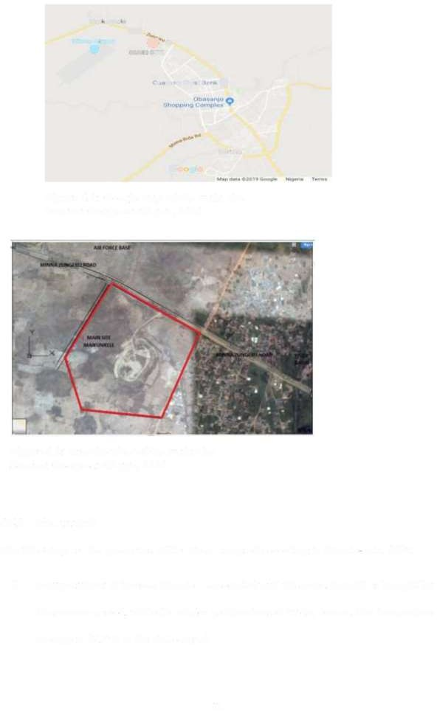

Figure 4.1: Google map of the main site Source: Google earth pro, 2018

**Figure 4.2: Satellite view of the main site Source: Google earth pro, 2018**

* + 1. Site analysis

The following are the properties of the site as analysed according to climate-data, 2019.

* + - 1. **Temperature:** A tropical climate is associated with this zone. Rainfall is brought by the summer period, while the winter is characterised by dry breeze. The temperature average is 27 .5°C in the state capital

37

* + - 1. **Rainfall:** There are significantly three distinct climatic seasons in this area; the cold, hot and the rainy seasons. The rainy season comes during the summer period. Rainfall is minimal around month of January averaging 1mm, and at September, the average is higher reaching up to 1229mm.
      2. **Sun rise and fall:** The sun rises at about 6:20 am and falls at about 6:30pm in January to August and slightly different in the other months.
      3. **Site accessibility:** the site can easily be accessed few meters from the main Minna• Zungeru road.
      4. **Services:** Electricity supply lines from main source can be easily directed to the site for adequate power supply usage. Water supply at this area could be provided by drilling bore hole source as the topography is about 270m above sea level and the area has less ground rock formation than close-by Bosso.
      5. **Vegetation:** The area is characterised by ground cover that stay green during wet season only. Dispersed shrubs and tree can be found on the land form.

38

* + 1. **Site plan**

t**ta**r**o [} in tat**

tine ,

**et** A .,,.

#### zy"%

*,,.,*

•

~,. •

-f

0

.»

t 0

,.,

,.. ?

* .°

**NOT!**

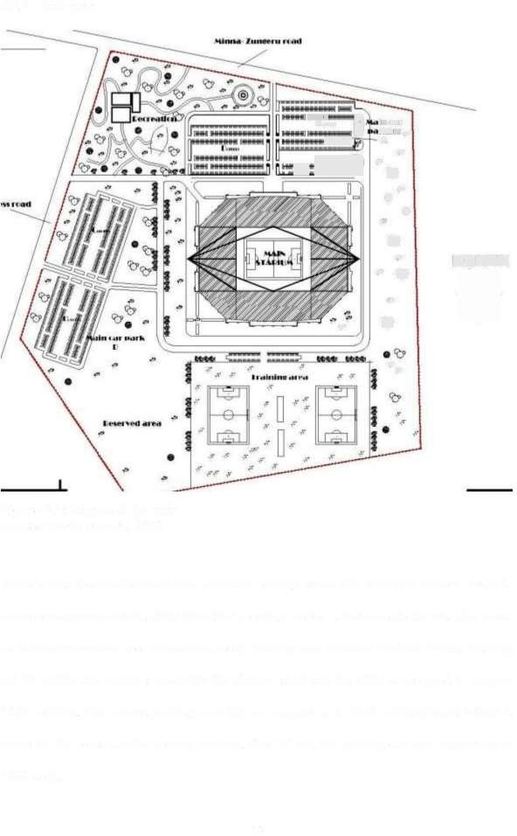

Figure 4.3: Proposed site plan Source: Author work, 2018

The site was designed to have four separated parking areas. The zoning is made in order to achieve maximum crowd safety from the incoming visitor's. Parts of site the was also made as outdoor recreation area (relaxation area), training area (outdoor football fields). Parking lot 'A' of the site which is made for the players, staff and the VIPs is designed to support 1200 vehicles. The second parking zone (B) can support up to 1000 mobility (cars) which is made for the press and the general parking. The 'C' and 'D' parking can also support up to 1000 each.

39

* + 1. **Ground floor plan**

D

**floor lobby**

**I** ! **11**

**emergenc**

/

>

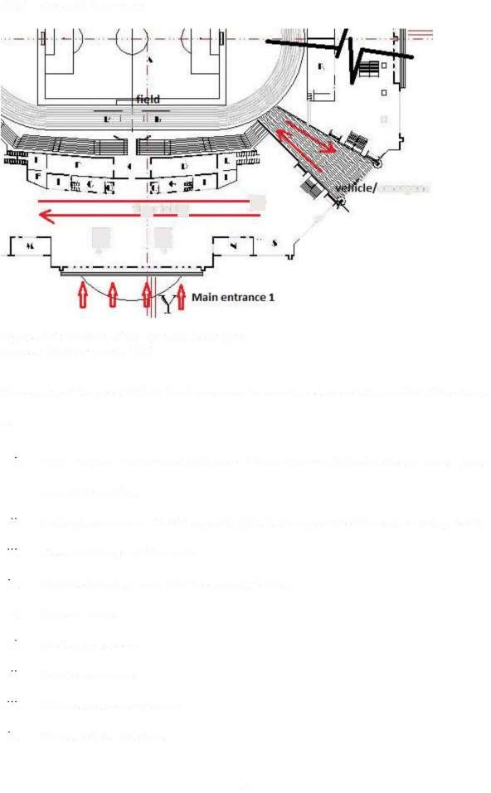***0*** 0

Figure 4.4: Section of the ground floor plan Source: Author work, 2018

The design ofthe ground floor level was made to accommodate certain number of functions as:

1. Main stadium pitch or field with area= 115mx 78m = 8,970m2 including recess grass area of lOmx 1 Om.

11. Seating/concourse= 30,000 capacity (this is the capacity of the entire seating bowl)

111. Floor walkways of 20m wide

1. Players changing room (for two playing teams)
2. Referee rooms
3. Media/ press room vi1. Conference rooms
4. Offices and security rooms
5. Shops, toilets and stores

40

1. 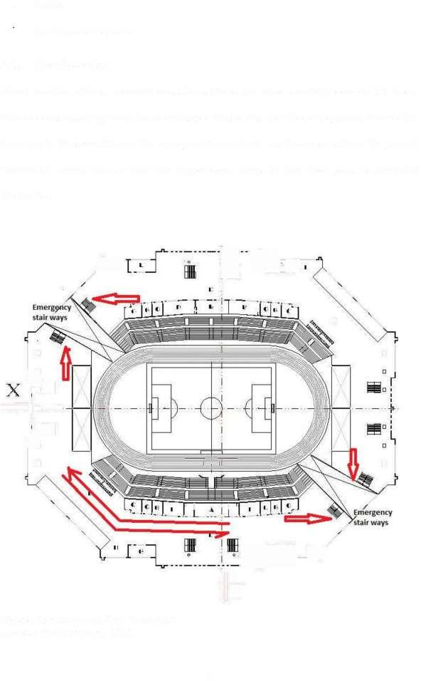Banks

X1. Restaurants and more

* + 1. First floor plan

There are other offices, conveniences, shops, stores and other security rooms on this floor. The concourse (seating bowl) is a continuation the seating deck from the ground floor to this floor and to the second floor. The emergency/ramp ways can be accessed from the ground floor to the second floor as well. The figure below shows the first floor plan. As drawn by the Author.

## ++tr

"

(:

□ □

**cs**

__ 1

**--l**a.'

•

I **=s**

I

□ □

*y.*

lll4 Y

Figure 4.5: Proposed first floor plan Source: Author work, 2018

41

* + 1. **Second floor plan**

The second floor shows the continuation of the seating bowl from the ground floor. There only passage/ walk ways on this floor. It serves as the stadium gallery area where. The figure below shows the second floor.

I **=s!**I

vs

4p

+.

D □

\

\ /

5

Figure 4.6: half view of the second floor plan Source: Author work, 2018

*j*

Ill

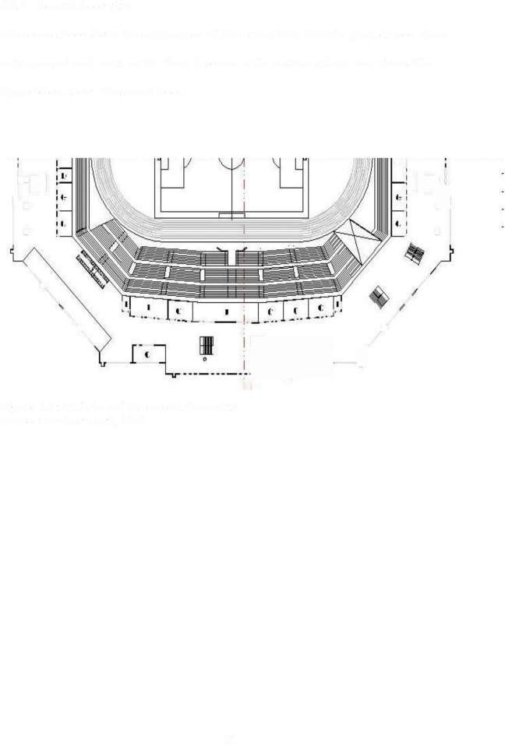

42

**CHAPTER FIVE**

* 1. **CONCLUSION AND RECOMMENDATIONS**
  2. **Conclusion**

The creation of large crowds in football stadia, just like any other sport arena is something that is definite as long as taking place of events are concerned. Violence, chaos and other crowd related problems continue to occur among the spectators corning to these sport grounds. The result of these violence, chaos and the other crowd related problems could be either be injuries to many people, loss ofproperties and loss of lives in most cases.

The strategies/factors considered in investigating crowd safety in stadia under this study are; the effective surveillance system, the design of exit/entry ways, lighting system, signage and post, peak/ full capacity evacuation, ticketing, sitting planning, security coordination, and opening of main stadium gate.

As the results of the analysis revealed under chapter four above, CCTV camera systems in theses stadia are providing adequate surveillance and monitoring of activities. The doors and access ways are sufficient for the incoming visitors to the stadia at normal individual entry/exit. Fair result was found to the use of lighting in the stadia. Post and signage was at 50 percent adequate (Fair) as well. The result of evacuation when the stadia attained maximum or peak capacity was found to be drastically inadequate, showing that the other factors mentioned earlier could only be effective when the stadium is not at its peak state. The other results are; For stadium ticketing, a fair result was found, meaning that the ticketing system has a minimal help to crowd control in the in the investigated arenas. For sitting arrangement, there was a total positive response from the respondents (adequate result was found here) meaning that the arrangement of seat/seating at the stadia had helped in accommodating the incoming crowd (people). Another factor is the security personnel

43

coordination, that is, how the security officials are been able to provide spectator's coordination into the main venue, this was found to be adequate also. Lastly, the result of main gate opening had shown that adequate opening is achievable at the stadia.

All the above investigated crowd safety strategies/factors in the stadia could be brought to a summery as being either adequate or fair in crowd management and control except for evacuation situation at which the stadia reaches peak/maximum capacity, and that crowd related problems mostly occur.

* 1. Recommendations

This research provided a proposal design which is extensively explained under chapter four (4.4) above as part of recommendation for this work. The proposed design was mainly improvement of the factors so investigated under this research, but this was done precisely in three ways as follows;

i- Improvement on the ingress/egress, considering their sizes and number

ii- Open circulation from upper levels of the concourse/ seating deck to allow for easy evacuation.

111- Creation of vehicular access into the stadium playing area that can as well be used for spectator's evacuation at peak period only. The wideness ofthese exits is mm from inside the main building and mm from the outsides. These exits can also be used as emergency routes.

It is also recommended by this research, the provision of educative programs for the incoming visitors/spectators of stadia about adequate behaviour in the crowded environment, adherence to instructions/ use of public facility and sanctions for violence characters.

**44**

**REFERENCES**

Aladejana, J. A., Talabi, A. 0., Oke, S. A., & Oyelami A. C. (2015). Geophysical and geotechnical investigations of a proposed site for afijio local government stadium ilora, southwestern Nigeria, *International Journal of Scientific and Research Publications,* 5, 2250-3153

Arbitter, L., & Holy. **P.** (1994). Major League Security Hits the Minors, *Security Management* 38, 40-45

Arms, R. & Russell, G. (1997). Effects of Viewing Aggressive Sports on the Hostility of Spectators. *Social Psychology Quarterly* 42. (3), 275-279

Augustin, J. (1995). *Sport, G~ographie et Am~nagement.* Bordeaux: Edition Nathan.

Aysu, S., Dino, B., & Chimay J.A. (2008) *Building design information and requirements for crowd safety during disasters.* United Kingdom. i-Rec

Alpert, G. & Flynn, D. (2000).Community Policing and major special Events: A case study of Super Bowl xxxiii. *In* C. *Brito and E Gratto (eds.), Problem Oriented Policing* Washington, D.C: Police Executive Research Forum.

Bale, **J.** (2000). The Changing Face of a Football: Stadiums and Communities *Soccer and Society,* **1(1),** 91-101

Beetz, M., Bandouch, J., & Gedikli, S. (2006). *Camera-based Observation of Football Games for Analyzing Multi-agent Activities.* Munchen, Munich: Intelligent Autonomous Systems Group

Billington, M.J., Ferguson, A. and Copping, A.G. (2002) *Means of Escape from*

Fire.Blackwell Science, Oxford, UK.

Branscombe, N.R. & Wann, D.L. (1992). Physiological Arousal and Reactions to outgroup members that implicate an important social identity. *Human Relations.* 45(10):1013-1033

Bryant, J., Brown, D., Comisky P.W., & Zillman, D. (1982). Sports and Spectators: Commentary and appreciation. *The Journal ofCommunication,* 32 (1), 109-119.

Brindley, J. (1982). 'Disruptive Crowd Behavior- A Psychological Perspective'. *Police Journal* 55 (1) 28-37.

Chibiuke, C., (2017). Hooliganism and Nigerian Football. Retrieved from https:/[/www.independent.ng/hooliganism-and-nigerian-football/amp.26th](http://www.independent.ng/hooliganism-and-nigerian-football/amp.26th) November, 2018

Climate-data. (2019). Climate-Minna. Retrieved, from data.org/africa/nigeria/niger/minna-5038. February 16 2019

https://en.climate•



Connors, E. (2007). *Planning and Managing Securityfor Major Special Events.* Washington,

D. C: U.S. Department of Justice.

Department for Culture, Media and Sports (2008). Football Licencing Authority Guide to Safety at Sports Grounds (5th ed.). United Kingdom. The Stationery Office.

45

Estes, A. 'Super Bowl Chaos Detailed in Transcripts.' (23rd April 2004), The Boston Globe.

P. Al.

F~d~ration Internationale de Football Association. (2007). *Football Stadiums: Technical recommendations and requirements* (4" ed). Zurich, Switzerland. FIFA Executive Committee.

Fruin, J.J. (2002). *The causes and prevention of crowd disasters.* Retrieved from https:/[/www.semanticscholar.org/paper/the-causes-and](http://www.semanticscholar.org/paper/the-causes-and) prevention-of-crowd• disasters Fruin/467d5d641b43f4f7eaca3703e0b2390c60a685b2

Hanna, J. A. (1994). *Emergency Preparedness Guidelines for Mass, Crowd- Intensive Events.* Office of Critical Infrastructure Protection and Emergency Preparedness. Canada. DK Publishing Inc.

Irish Rugby Football Union, (2008) *Event management handbook for event organisers of larger events (greater than 3,000 spectators).* Ireland: AIB publishers.

Jones, D., (2014). *Football Money League,* Manchester: Deloitte Sports Business Group. knibbe, E. J., Stadler, F., Hoof, W. P. V., & Simpson, M. D. (2018). *US. Patent No.*

*9,924,578 B2.* Washington, DC: U.S. Patent and Trademark Office.

Kizito, N. FKF Takes Over Security and Ticketing ofKPL Garnes, Leopards Protest. Sports News Arena, 19th March, 2012

Lewis, J. (2007). Sport Fan Violence in North, America. Lanham, Md: Rowman & Littlefield.

Liu, Y., Liu, D., Badler, N., & Malkawi, A. (2011). Analysis of evacuation performance of rnergiing points in stadiums based on crowd simulation, *12th Conference of International Building Performance Simulation Association, Sydney,* 14-16

Lowrey, J. (2002). *Football and Football Hooliganism.* Sir Norman Chester Centre for Football Research. The FA Premier League 2001 Fans Survey, Fact Sheet 14.

Madensen, T. D & Eck, J.E. (2008). *Spectator Violence in Stadiums.* Pop Centre. Washington DC: US Department of Justice, Office of Community Oriented Police Services.

Miller, J. & Gilhentine, A. (2006). An analysis of risk management policies for tailgating activities at selected NCAA Division. Football Garnes. *Journal ofLegal Aspects of Sport,* 16(2), 197-215.

Miller, K.L. (1997). *Sports Business Management.* Gaithersburg, MD: Aspan Publishers. National Counter Terrorism Security Office, (2012). *Counter Terrorism Protective Security*

*Advicefor Stadia and Arenas.* England, Wales.

O'Reilly, S. (1999). World Cup 2006.An Examination of the Policing of Risk in the Context of Major Football events. Risk Management: *An International Journal.I* (2), 21-33

Powell, J. T. (1994). Crowd Management: Contemporary Issues. United States Sports Academy: Bookmark. Retrieved from https://thesportjournal.org/article/crowd• management-past-and-contemporary-issues/

46

Price, S. (2003). When Fans Attack. Sports Illustrated 98, pp 48-53. Retrieved from https://rems.ed.gov/docs/COPS_SpectatorViolence.pdf&ved=2ahUKEwjNxpLvo ZvmAhWNbsAK.Hc9MBOsQFjAVegQIBBAB&usg=AOvVaw0N4xjzT6mCkBr• qZqiZ8Mf

Rimi, A. I. (2014). Abuja city profile. *Elsevier science,* 41, 81-91, doi: 10.1016/j.cities.2014.05.008.

Rees, D. & Schnepel, K. (2008). *College Football Games and Crime. Working Paper Series No. 08-01.* Boulder: University of Colorado.

Roadburg, A. (1980). Factors precipitating Fan Violence: A comparison of professional Soccer in Britain and North America. *The British Journal ofSociology.* 31(2), 265- 276.

Russell, G. (1983). Crowd Size and Density in Relation to Athletic Aggression and Performance. *Social Behaviour and Personality,* 2 (1) 9-15.

Russell, G. (2004). Sports Riots. A Social- Psychological Review. *Aggression and Violent Behaviour,* 9, 353-378

Sappentield, M. (2004). Sports Violence Fed by Both Fans, Athletes; Incidents Throw harsh Light on a culture Fed by Talk Radio and Disrespect Authority. The Christian Science Monitor. Retrieved from [www.csmonitor.com.](http://www.csmonitor.com/) 05/Feb/2018

Seyed, A.H. M. P., & Farhad K. (2014). The architectural formation of stadiums in different periods of time, *European Online Journal of Natural and Social Sciences,* 3, 4.1805-3602.Retrieved from [http://european-science.com.](http://european-science.com/) 7" Oct. 2018

Smith, H. (2007). Faith hill causes stir after fan gets a handful. Retrieved from [www.cmt.com.](http://www.cmt.com/) 24 February, 2019

Spaaji, R. (2006). *Aspects ofHooligan Violence. A reappraisal ofSociological Research into Football Hooliganism.* Amsterdam: ASSR Working Paper Series.

Stott, C. & Adang C (2005). *Crowd Dynamics, Policing, and "Hooliganism: Euro2004.*

Research Report for the Economic and Social Research Council.

Simpson, S. (2000). *Crowd Dynamics/Crowd Control.* Institute for Non-Lethal Defense Technologies. Pennstate.

Stott, C. & Reicher, S. (1998). Crowd Action as Intergroup Process: Introducing the Police Perspective. *European Journal ofSocial Psycholog.* 28, 505-529

Talalay, S. (2007). *Marlins Super Saturdays Boost Attendance.* University of Califonia: Sun• Sentinel.

Taylor, Rt, Hon. L. J. (1989). *The Hillsborough Stadium Disaster.* Final Report. London: HMSO.

Unaeze, 0. (2018). NFF approves Bako Kontagora stadium for Niger tornadoes: MH Magazine WordPress. Retrieved from https://sundiatapost.com/2018/02/23/nff• approves-bako-kontagora-stadium-for niger-tomadoes-fc/

Union of European Football Associations (2011 ). *UEFA Guide to Quality Stadiums* (2011 ed.). Nyon 2, Switzerland.

47

Union of European Football Associations (2016). *UEFA Stadium Lighting Guide.* Nyon 2, Switzerland.

Veno, A. and Veno E. (1993). *Situational Prevention ofPublic Disorder.* Crime prevention studies. Monsey, New. York: Criminal Justice Press.

Wann, D.L. (2006). *The Causes and Consequences ofSport Team Identification.* Handbook of Sports and Media. Mahwah, New Jersey: Laerence Erlbann.

Westin, C. (2003). *What Strategies will a Large Urban Police Department use to ensure effective police response to disturbances at large Venues?* Sacramento publishers.

Watt C. D. (1998). *Event Management in Leisure and Tourism.* England: Addison Wesley Longman.

Young, K. (2002). Standard deviations. An update on North American Sports Crowd Disorder. *Sociology ofSport Journal,* 19 (3) 237-75.

Zezima, K. (2005). *Panel Blames Boston Policefor Errors in Fan's Death.* The New York Times- May.

48

**APPENDICES**

**Appendix A. Questionnaire**

**QUESTIONNAIRE OF MASTERS DEGREE RESEARCH FEDERAL UNIVERSITY OF TECHNOLOGY MINNA, NIGER STATE**

**Introduction**

I am a student of Architecture Department of Federal University of Technology Minna, pursuing a Master Degree in Architecture (M.Tech). This questionnaire was constructed purposely to assess the crowd management strategies during football match or event in the Abuja national stadium in FCT and Minna stadium, Niger state.

The information provided here is intended for academic research work only. It will be used as confidential and all necessary treatment will be applied. Respond adequately please.

Thank you

Muhammad Naimu Sufiyanu.

SECTION A. STADIUM CROWD CONTROL FEATURES

Indicate the level of adequacy of the following features of safety in the stadiums

1. Surveillance systems and voice control (CCTV)

a. Adequate ( ) b. Fair ( ) c. Inadequate ( ) d. Not provided ( )

1. Use of passive means like line dividers

a. Adequate ( ) b. Fair ( ) c. Inadequate ( ) d. Not available ( )

1. Emergency exits

a. Adequate ( ) b. Fair ( ) c. Inadequate ( ) d. Not available ( )

1. Provision of multiple main entries/exits ways

a. Adequate ( ) b. Fair ( ) c. Inadequate ( ) d. Not provided ( )

1. Walkways/Passageways

a. Adequate ( ) b. Fair ( ) c. Inadequate ( ) d. Not provided ( )

1. Signages/instructional posters

a. Adequate ( ) b. Fair ( ) c. Inadequate ( ) d. Not provided ( )

1. Security control/coordination

49

a. Adequate ( ) b. Fair ( ) c. Inadequate ( ) d. Not provided ( )

1. Opened floors from upper concourse/decks

a. Adequate ( ) b. Fair ( ) c. Inadequate ( ) d. Not provided ( )

1. Use of other strategies

a. Adequate ( ) b. Fair ( ) c. Inadequate ( ) d. Not available ( )

SECTION B. STRATEGIES PRIOR TO EVENT

How effective is the pre-event strategies carried out in the stadium? Please indicate

1. Advanced ticketing system

a. Effective ( ) b. Fair ( ) c. Ineffective ( ) d. Not provided ( )

1. Vehicle parking strategies

a. Effective ( ) b. Fair ( ) c. Ineffective ( ) d. Not provided ( )

1. Users safety awareness

a. Effective ( ) b. Fair ( ) c. Ineffective ( ) d. Not provided ( )

1. Sitting arrangements

a. Effective ( ) b. Fair( ) c. Ineffective ( ) d. Not provided ( )

1. Adequate security staff planning

a. Effective ( ) b. Fair( ) c. Ineffective ( ) d. Not provided ( )

1. Use of audio coordination systems

a. Effective ( ) b. Fair ( ) c. Ineffective ( ) d. Not provided ( )

1. Advertisement of penalties for violent characters

a. Effective ( ) b. Fair ( ) c. Ineffective ( ) d. Not provided ( )

1. Provision of adequate police posts

a. Effective ( ) b. Fair( ) c. Ineffective ( ) d. Not provided ( )

ix Use of passive means like line dividers

a. Effective. ( ) b. Fair( ) c. Ineffective ( ) d. Not provided ( )

SECTION C. CROWD CONTROL DURING SPORT EVENTS

The following are crowd control/management strategies used in the process of sport event.

Please indicate the effectiveness of each

1. Spectators control/regulation

50

a. Effective ( ) b. Fair( ) c. Ineffective ( )

1. Allocation of securities to strategic points

a. Effective ( ) b. Fair( ) c. Ineffective ( )

1. Directing and coordination of spectators

a. Effective ( ) b. Fair( ) c. Ineffective ( )

1. Removal of violent spectators

a. Effective ( ) b. Fair( )

1. Audio communications

a. Effective ( ) b. Fair( )

c. Ineffective ( )

c. Ineffective ( )



SECTION D. STRATEGIES AFTER EVENT

How effective is the dispersal and evacuation of crowds at full capacity and at the end of events period at the stadium? in terms of:

1. Signals and communication of the emergency situations

a. Effective ( ) b. Fair ( ) c. Ineffective ( )

1. Opening of main exit gates

a. Effective ( ) b. Fair( ) c. Ineffective ( )

1. Opening of extra doors and gates at peak period

a. Effective ( ) b. Fair( ) c. Ineffective ( )

1. Movement within the seating area

a. Effective ( ) b. Fair( ) c. Ineffective ( )

1. Extra crowd safety measures

a. Effective ( ) b. Fair( ) c. Ineffective ( )

51

**SILLAN**

•

€

**t4**

*@»*

'

0

6·?,

4 if ft4 4MM4D 4 j 4 + %4 641f la

w

wt fir4/47 144 L4Lil44.« AA4

**n~Cm€nT Or OROD OOTROI**JTRRT&G I6 In **TH€**

**pun1Ga or anonRt fTApum** n **manna n1Gen srRrt**

□

Ildiutsn tuft± st vi+wt. D. Ape tit pt4

Appendix B. Site plan

-

**€AN** [['Y

e.es.

*r*

sl

]

**Ai«ff 4**

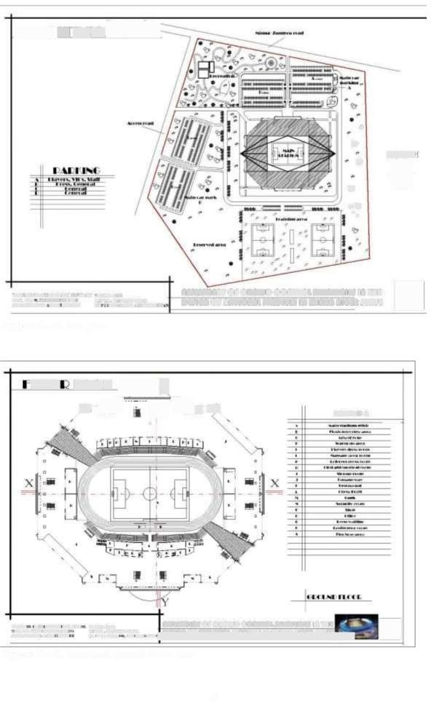

###### I

□

we ow»was +ro **we** u **At#tis4nr Or 0OD 00nTROL STRTtG} A TH&** r

» nrwrrsr ts»u. wrri en. oc@ten **o¢** nrjeans **gr9ptu** if tiff **@&pm gpg'(**

iiwsino-iii sos» w so w ""

Appendix C. Proposed ground floor plan

52

**€ LA**

*t*r,l*>*

I I +

***tr«i***f

, t; « .a

I

'>

*c*

n a

-x-}+s.. _,

###### jm

a

•

<4,

'

*v*s1I y>.

##### :11y

i{ 3

I- ~-~=~ - -

5

4+ti #4if.444 4 n44M i AL# it

wuf,

r+ft8frMJ L.TL.. urT. mN 1

slut tuth At inn44 et Mt ++unM. A +aw A

**aieismenr or coup onrnousmaRreGii i rt**

**pn or naTIonnt rTA DIuI** In nan Gen **STA T**

□

Appendix D. Proposed first floor plan

**€€LA** "[Y

_...... ·-··L

*r* t:- **is** i E·.J J_ **tttt «**

4

' l

'

l

'> t

,

6

n +

fa

###### Xiii

.

* -;X

4.de

===la i

'•a~ I,,

.

i 44n 44 4

J + . ~~

;

•

14

' · . El

l'5

1

###### 4 }

,, /

,

*J*

1,u o.onc.•·1

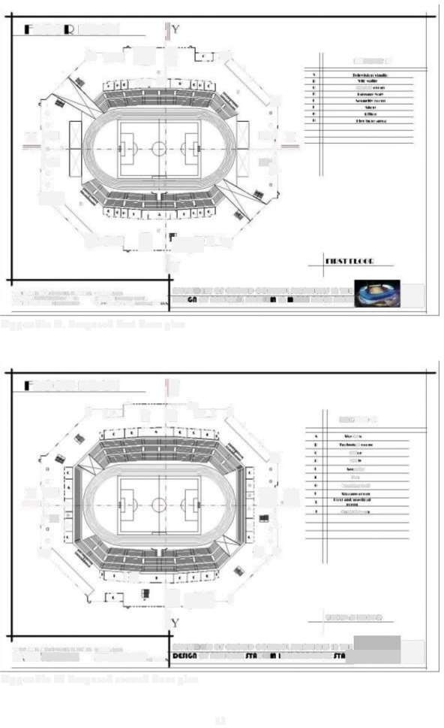""'•• 11,■11ut•••t1., "''"' ,,A.Lt. .... UHu■llrrOr ottOWD COftTitOllTIITt4Wll 181'NI **R"l:I**□

*zifzzi* zz:.. ornron ow anm Ea

Appendix E. Proposed second floor plan

53

Y

## refs

$

Xx

### '

it 4444f.4n4 «4 n4. tAAt d

*v*r3.y*+*

l I **n 1t1,ruu:**

□

M uto fr»wn-TM LJY KIM 4rT. ft

Isl'tl+Att4At#t t rs, a« « A-.

**Appendix F.** Proposed third floor plan

4+, 44 4444tu 444.4 n144 4AL4 L.

_ I**"n c·i-.1 n •** ◄ **1: _**

**a#ii#mnr or onoup oonmoumrmrGti a rt**

□

**otnGn ta sTa T**

Ir±tu'i+MM±Kf#.t t+r ue 4. t+4in ------------------ -

rvr mr4#Y4444 14YI Mus1+mnI,

4

Appendix G. Proposed roofplan

**or nenoant nraptun** sinnn **AG4n**

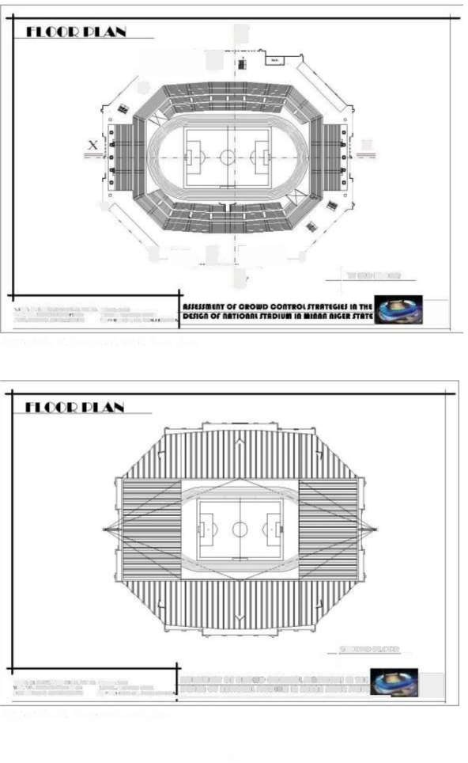

54

@yy

t he + +

ors.moor

s ·-r.mo«r

**g7"7"**l **7**

·am.wvw mo.s.us+ 2-±.1oo Ti(Sf4#T OF CROD COnTIOI4TR9TE6It I TH4

rnrrw.n Lr=It. «ese D651Gn1 or n1TIO1R4 fTDIUii In1 a Inn nGGR IT#TE

Appendix H. Proposed sections

**ttvAnt6**

#### 0

+.ti 4444044t.Mi4 A.At1

Muto ff1n44 .tsTA+ 41,

isl te l At 4tt gt+wt • 4.wt +

**ismsnr or onoup onmoufrnsreGti** in rt

**ptnGn or nanionn rapius in** inan **aGtn Tart**

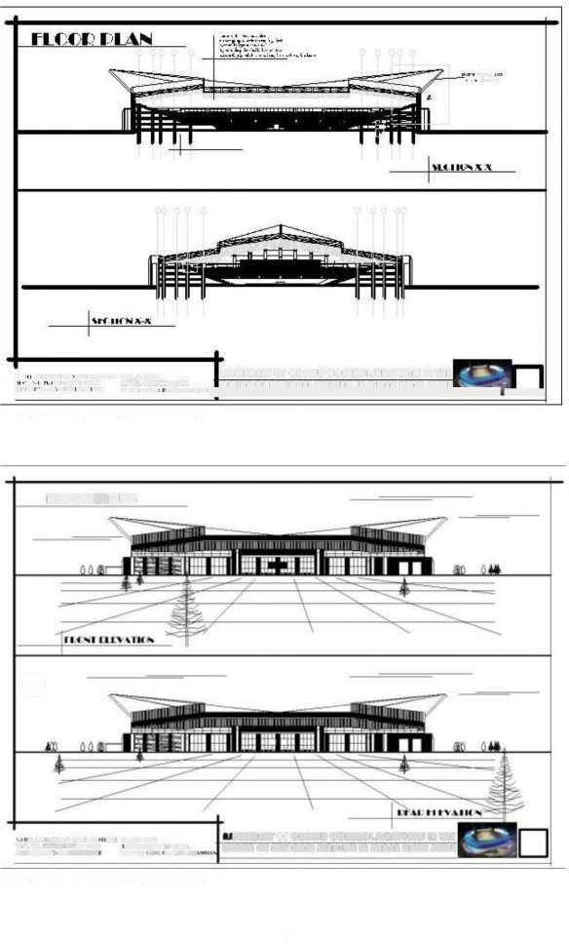

Appendix I. Proposed elevations 'a'

55

**LILY**41**It** 0

ti,rt.art it.i.11 44 Lu:1400

s ·1 m.Et LEEL.-CA&TEES LCM

prs "H . Mufti 1 -t.: UK 4/L.1.41144

I **l.'lf:lfTFI F\'~Tlf...**

**at#tdr Or CROND COATIOI4TR9Tt6It** In TH4

**DG51Gn or nnrion9 rTaDIUi In ti Iann n1GR TTAT E**

Appendix J. Proposed elevations 'b'

1300

11,rl:\II~

c

IA ' (4:t4.)

Ai *#r'*

(1:ff)

gm.c':.

rt:nd

Jal

'~slawsr.t *''Le* e.

ta110: nu wu

aug eae.ii! eh'wt

em tntgresat -

twtr

cre~ol6ex:tcur.a

175

ti4 ' (1£

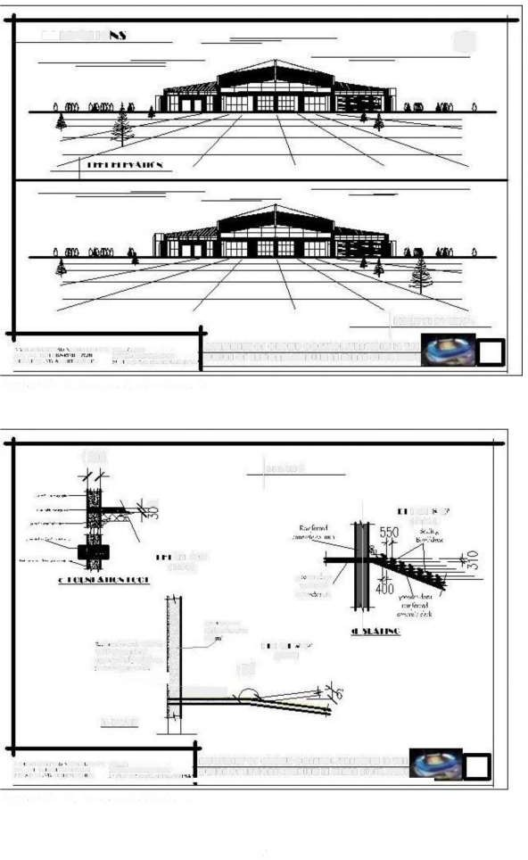-l --.

t-I.Ai4f

·a.mo.es+ rot.nsw **fi@Sf4T Or ROD COnYIOL4YR9Tt6I** In TH4

2--.

•• rrnrr.n Lr=r-±rpsa¢ **D65Gn1 Or nnTIon94 rTEDIUii in a Inn nIGGR TATE**

p4inf4 A4intuit r4ii;i,4;UK 44A4.4..44 E

Appendix K. Proposed details 'a'

56

tu+fit 4 nun 4iii.t it44r ul; •

++1 ; mi.Irr IE'EL.MA:IER? ACY

**DETAIL AT**'A'

JI&SSGAT O¥ OR0UD O0TR0I FTRRTGGIE I TH€

□

DtlGn of tan1OR ST4DI In **mint** IGR /TRT€

rs+¢ row unr s r • ·«rs .»was

Appendix L. Proposed details 'b°

t,rt.art » « It.i.11 4i .:140

s ·1 .Ex· r LEEL.CA&TEES LCX

**ans4smr or cRoD COnYOIiTRAT6 It** In TH

**psGn or nnnionnu rarrua** in aisnn n**IGGR fTTE**

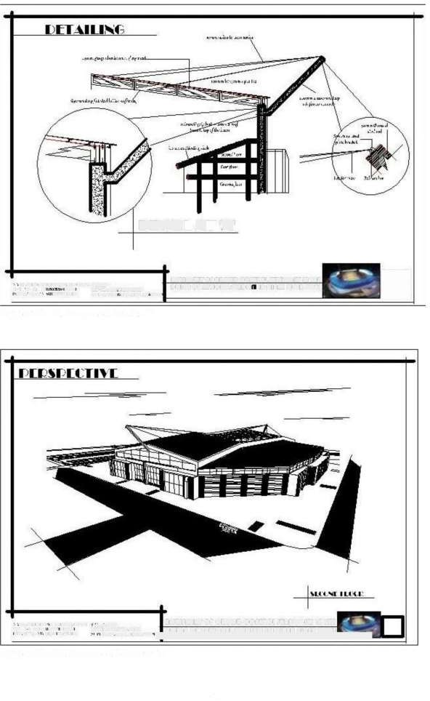Writ "H • Ai4it'ft tit so«wow Ti77'ETT7"Tr'_Tr 7TT7Tr"_rr7rm

Appendix M. Proposed 3d view 'a'

57

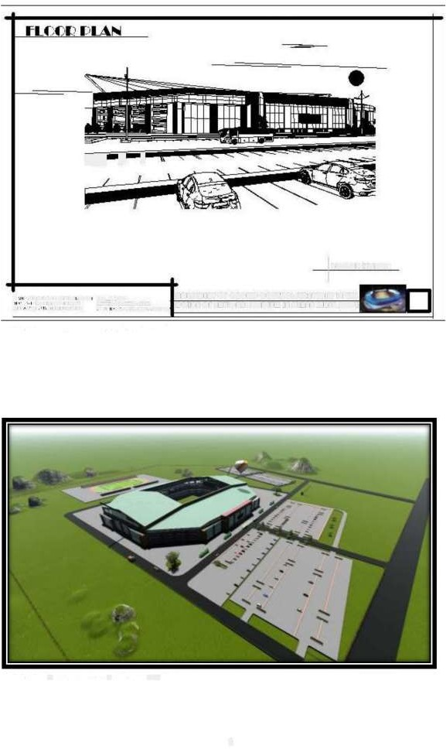

1. 9j ' T

I ~Ln.-.i1· 1 u:,u.~

·.m.wt» so.ns s2.2.1-o **Rf54i5tit#T** O **CROD** COTIOI**4TR9TE6 It** In TH

mrnrrrwn Lr Et<ems ua¢ D651Gn] or nnTIon94 fTRIUi In iIenn 1G£R fTTE

pl'iii Ai44titunitff ii'ii.:ii t44.A.44l"

Appendix N. Proposed 3d view 'b

Appendix 0. Proposed 3d view 'c'

58

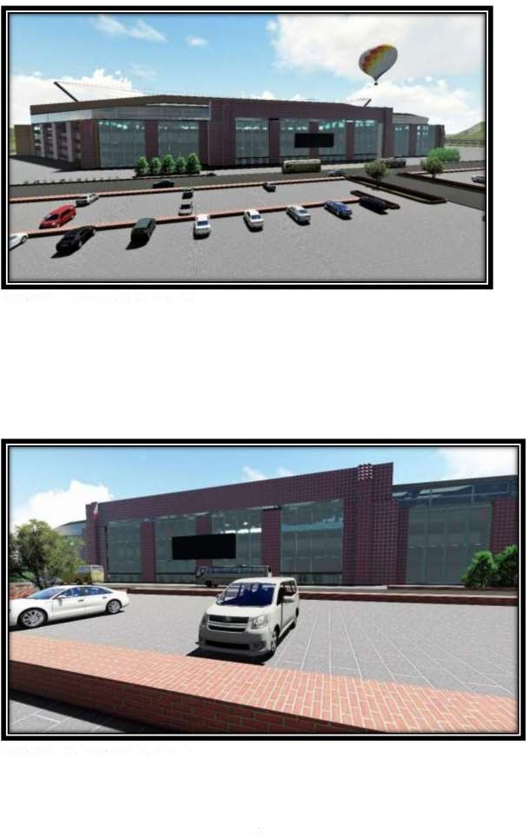

**Appendix P.** Proposed 3d view 'd'

# - -

**Appendix Q.** Proposed 3d view 'e'

59

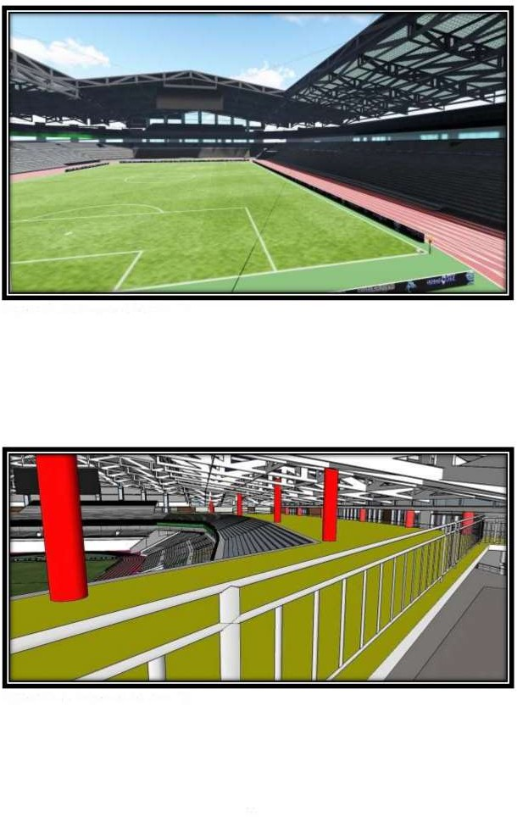

**Appendix R.** Proposed 3d view 'f

**Appendix S.** Proposed 3d view 'g

60

**[2j=** a _,~e la

~,;;;:i~~~-•,~-~:-~-'--cc •------

-~ - _•

z: **suss!** iii tr*-=.*

**'1t,-~--- ,··** I

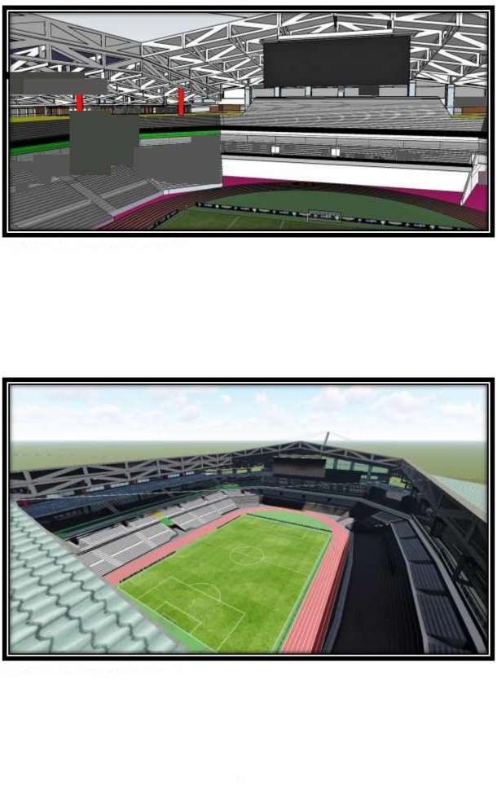

. .

**Appendix T.** Proposed 3d view 'h'

**Appendix U.** Proposed 3d view 'i

61