# ASSESSMENT OF CRIME PROLIFERATION AND PREVENTION STRATEGIES FOR SUSTAINABLE DEVELOPMENT OF SULEJA, NIGER STATE, NIGERIA

**By**

UMAR, Ahmed

MSUD/CHSUD/2015/6055

# CENTER FOR HUMAN SETTLEMENT AND URBAN DEVELOPMENT FEDERAL UNIVERSITY OF TECHNOLOGY, MINNA

**MARCH, 2019**

# ABSTRACT

Security is the most fundamental need of human beings. There are several interrelated domains of security – physical, emotional, social, economic and political. Urban security issues cover areas of security of lives and properties, healthy security, food security, economic security, protection from natural and man-made hazards among others. This study examined the level of people‘s consciousness of their security, safety and coping strategies against crime in Suleja, examine the incidences of crime in the study area, examine the level of safety consciousness of the people in the study area and evaluate the coping capacity of the people and the strategies for crime prevention in the area and also map out crime hotspot areas in the area. Quantitative techniques which involve the use of both primary and secondary data. Questionnaire were administered and response were subjected to descriptive statistics analysis, Geospatial techniques was also used to mapout crime hotspot areas. The study revealed that 46.9% of the residents in the study area have experienced one form of crime or the other in the last one year. Armed robbery accounts for 28.8% of crime followed by burglary (49.4%), Snatching of cars accounts for 0.8% and others 21.0%. The study also revealed that 35% of crimes in the area were caused by drug abuse, unemployment (39.2%), poverty (23.5%) and others accounts for 2.3%. The effects of the crime according to the findings were loss of valuables 57.7%, injury and death (10.8%), economic loss (14.0%), fear (17.3%) and others (0.2%). the study thereby recommended that employment opportunity should be created, since unemployment recorded the highest of the causes of crime in the area. Provision should be made for skills acquisition where people will be trained to become self-reliant and job creators rather than job seekers.

.

# TABLE OF CONTENTS

**Contents Page**

Title Page i

Declaration ii

Certification iii

Acknowledgements iv

Dedication v

Abstract vi

Table of Content vii

List of Tables x

List of Figures xi

CHAPTER ONE

* 1. INTRODUCTION 1
  2. Background of the study 1
  3. Statement of Research Problem 3
  4. Aim and Objectives 4
  5. Scope of the study 4
  6. Justification 4
  7. The Study Area 5

CHAPTER TWO

* 1. LITERATURE REVIEW 9
  2. Concepts of Insecurity 9
  3. Theories of crime 10
  4. Urban Crime – Explaining Variation in Urban Crime 15
  5. Global Perspectives of Urban Strategies for safer Cities 20
  6. Crimes and Insecurity in Nigeria 27
  7. Types of Policy Response to Problems of Crime 28

CAHPTER THREE

* 1. RESEARCH METHODOLOGY 30
  2. Procedure for Data Collection 30
  3. Research Instrument 30
  4. Population of Sampling Techniques 31
  5. Method of Data Analysis and presentation 33

CHAPTER FOUR

* 1. RESULTS AND DISCUSSION 34
  2. Socio-Economic Characteristic of the Respondents 34
  3. Incidence of crime in the study areas 37
  4. Level of Safety consciousness of the people in the study Area 43
  5. Crime coping mechanisms in the study areas 45

CHAPTER FIVE

* 1. CONCLUSION AND RECOMMENDATIONS 56
  2. Summary of Findings 56
  3. Conclusion 57

5.2 Recommendations 57

# REFERENCES 58

**APPENDICES**

|  |  |  |
| --- | --- | --- |
|  | **LIST OF TABLES** |  |
| **Table**  4.1 | Time of occurrence of crime in neighbourhoods | **Page**  40 |
| 4.2 | Types of losses suffered by residents | 41 |
| 4.3 | Causes of crime in neighbourhoods | 42 |
| 4.4 | Existence of security outfit in the area | 43 |
| 4.5 | Security outfit in the area | 44 |
| 4.6 | Observation of houses with safety measures | 47 |
| 4.7 | Measures employed towards crime | 48 |

# LIST OF FIGURES

**Figures Pages**

|  |  |  |  |
| --- | --- | --- | --- |
| 1.1 | Study area map | 7 |  |
| 4.1 | Age of Respondents |  | 34 |
| 4.2 | Educational Status of Respondents |  | 35 |
| 4.3 | Occupation of Respondents |  | 36 |
| 4.4 | Income Status of Respondents |  | 36 |
| 4.5 | Duration of Stay of respondents in neighbourhood |  | 37 |
| 4.6 | Residents‘ experience of crime |  | 38 |
| 4.7 | Types of Crime |  | 39 |
| 4.8 | Level of Safety |  | 45 |
| 4.9 | Relocation out of the Area |  |  |

# CHAPTER ONE

# INTRODUCTION

# Background of the Study

Criminal activity continues to be a major concern in contemporary society. Most nations are faced with unacceptable levels of delinquency and crime. In many of the world‘s industrialized countries crime rates recorded by the police are many times those recorded 30 years ago. The International Crime Victim Survey (ICVS) has collected data on 55 countries, spread over six major world regions including Africa, Asia, Central and Eastern Europe, Latin America, and Western Europe. Findings showed that for the 1989–1996 period, more than half of the urban respondents reported being victimized at least once regardless of what part of the world they inhabit (Ackerman & Murray 2004). Also, it was stated that high crime rates are not unique features of a few nations, but a statistically normal feature of life all over the world. Research efforts seeking to explain the geographic variation in the rate of crime has been ongoing for more than 150 years (Eck and Weisburd, 1995). Quite a lot of researches have been carried out on integrating GIS application to crime

The existence of crime is as old as the creation of man itself and man has always looked for ways to combat it and reduce it as much as possible. The occurrence of criminal activity in the form of thefts, assaults, homicide, etc is something that takes place every day in almost all reaches of our world. There is a great deal of debate on the causes of crime. In the 1980s, the rate of crime occurrence grew sharply to nearly epidemic proportions, particularly in Lagos and other urbanized areas due to population explosion by stark economic inequality and deprivation, social disorganization, inadequate government service and law enforcement incapability,

unemployment, socio-political conditions etc. (Murray and Brit. J. Criminol 2001). A community with a high rate of criminal activities is unattractive or less attractive to both local and foreign investment and this is the present situation that prevails in parts of Nigeria. The Nigerian security agents, especially Nigerian Policemen, are not particularly effective in foreseeing where and when specific future crimes will take place.

The distribution of crime across the landscape is geographically random since crimes are human phenomena. For crimes to occur, offenders and their targets - the victims and/or property - must exist at the same location for a period of time. Several factors, including the lure of potential targets and simple geographic convenience for an offender, influence where people choose to break the law. Therefore, geography plays an important role in law enforcement and criminal justice. A popular slogan says criminals are not spirits. They move from one place to the other, and live in the society just like every one of us (GIS team, 2005).

GIS helps crime officers determine potential crime sites by examining complex seemingly unrelated criteria and displaying them all in a graphical, layered, spatial interface or map. It also helps them map inmate populations, fixtures, and equipment to provide for the safety of inmates by separating gang members, identifying high-risk or potentially violent inmates, and identifying hazardous locations in an area. It reduces the potential for internal violence by providing better command and control (Johnson, 2000).

Computerized crime maps have recently begun to emerge as a significant tool only in crime and justice that assists police departments in strategic planning, operations and crime analysis. They may display information about the relationships between geographic areas, crime and a number of risk factors. As crime and delinquency are known to be localized processes, criminological

maps have proved useful in assisting police operations and in supporting crime prevention initiatives (Weisburd David, Wim Bernasco, Gerben Bruinsma 1997). Maps also assist in the assessment of the regional distribution of crime. Computerized crime mapping is rapidly a developing technology that assists police departments in strategic planning. The method of investigation is to quickly view and compare patterns of the crime events. Crime has abundant references relating crime patterns to specific geographic features for example, some crimes such as robbery, snatching and pocket picking, may be particularly enhanced by the existence of commercial areas, parking places and industrial complexes (Coffey, Canterand and Alison 2000).

Criminal activity is costly to both individuals and society. In the United States, crime resulted in a total loss to victims of almost $16 billion in 2004, and expenditures for police, the criminal judicial system, and corrections exceeded $185 billion in 2003 (Sedgwick 2006). The indirect costs of crime are also substantial. For example, children with imprisoned fathers have high rates of poverty, are more likely to grow up without a father, and are often stigmatized, all of which can limit their future labor market opportunities in the legal sector and increase the likelihood that they, like their fathers before them, will engage in criminal activity (Wildeman, 2009)

According to Freeman (1996), crime is an activity of individuals with low legitimate earnings prospects, and involvement with the criminal justice system has become part of normal economic life for many young men.‖ For example, over half of 25- to 34-year old black men who are high school dropouts are either incarcerated, on probation, or on parole (Freeman 1996). Yet, many disadvantaged men do not commit crimes, and between the ages of 25 and 35 many offenders either decrease their level of criminal activity or desist altogether (Kerner 2005).

Applications of GIS to crime mapping and management have been successful in many developed countries. Information associated with crime in Lima and Columbus (Ohio) was acquired and integrated in a GIS environment (Murray *et al*, 2005). Analysis in Lima has spanned crime from 1999 to the present. As a result, the work informed policy and decision making in Lima Police Department activities, particularly with respect to community policing *(*Murray *et al*, 2005).

GIS can be used as an investigative methodology that uses the locations of a connected series of crimes to determine the most probable area of the residence of the offender. It can serve as the building block for several investigative strategies, including suspect and tip prioritization, address-based searches of police record systems, patrol saturation and surveillance, neighbourhood canvasses and searches, and DNA screening prioritization. GIS technology, by high-end spatial analysis and querying, highlights the crime location, any physical boundaries that were present (that might not otherwise be noticed), and the types of roads and highways that come into both the abduction and body dump sites (Karthik, 2004).

For more than one year in Kaduna State, armed robbers and car snatchers enjoyed a field day terrorising people, operating both day and night unhindered It is acknowledged that concerns about personal safety are obstacles to regular participation in physical activity and local walking (Duncan and Mummery 2005; Van Cauwenberg *et al.* 2011).

# Statement of Research Problem

As people continue to migrate from rural to urban centers in search for food, shelter and income which lead to urbanization. Large population concentration in an area often lead to crime. Some criminologists assert that certain offenders are born into environments (such as extreme poverty or discriminated-against minority groups) that tend to generate criminal behavior. Others argue

that since only some persons succumb to these influences, additional stimuli must be at work. One widely accepted theory is Edwin Sutherland's concept of differential association, which argues that criminal behavior is learned in small groups. Psychiatry generally considers crime to result from emotional disorders, often stemming from childhood experience. The criminal symbolically enacts a repressed wish, or desire, and crimes such as arson or theft that result from pyromania or kleptomania are specific expressions of personality disorders; therefore, crime prevention and the cure of offenders are.

Security situation in Suleja appears to be getting worse. The rich and ordinary man express feelings of insecurity. As a matter of fact, there are frequent cases of attacks by hoodlums in Chaza area, Anguwan Sarki, and Kwamba among others. This trend, if not checked is capable of not only derailing the entire Suleja, but also the corporate existence of the State.

# Aim and Objectives

This research is to examine crime incidence and prevention strategies in Suleja town with view to identifying crime hotspot and make appropriate recommendation. The following objectives will be achieved

* + 1. Examine the incidences of crime in the study area.
    2. To examine the level of safety consciousness of the people in the study area.
    3. To evaluate the coping capacity of the people and the strategies for crime prevention in the area.
    4. Create crime hot and cold spots map of the study area
    5. Assess the relationship between the police divisional stations and the crime hotspots areas

# Scope of the Study

This study focuses on insecurity in Suleja and is limited to crime which is fundamental threats to human security and safety. Thus, the study examine the level of safety consciousness of residents with regards to crime in some selected neighborhoods in Suleja town.

# Justification

Urbanization as brought about an increase in crime and violence resulting to serious problems in the study area, because it threatens the quality of life, economic stability and hinders sustainable development. Effort is needed to address this situation in the study area. The prospects of future development and of poverty reduction are limited, since poverty, violence and insecurity is hostile to investment and sustainable development. Increase in crime and civil unrest if left unchecked could result into abysmal situation. As result to these reasons, the study is important since it intends to identify crime and violence prevalent with regards to the safety consciousness imbibed by the residents in the study area with a view of coming up with remedial measures toward enhancing security and safety in the area.

Various studies has being carried out such as, Steffensmeier and Harere, (1999), the study explaining variation in urban crime, another study was conducted by Sanidada-Leones, (2006) on crime and insecurity, another studies was carried out by Agbola (1997) on the strength of Nigeria Police and population growth, but no specific studies that was carried out on crime and prevention strategies particularly to Suleja, Niger State. The study will have an operational role, assisting law enforcement agencies with allocation of resources and planning crime-reduction activities. The operational role guides leaders in setting near-term policing priorities. Identifying

―hot spots‖ of criminal activity to guide officer deployments is a prime example of operational analysis. It will also play a strategic role, providing analysis geared toward long-term planning and problem solving. Strategic analysis usually informs command staff decisions and requires more-advanced analytical skills and tools. An analyst working in a strategic capacity might examine trends in critical incident response time to help decision makers determine whether the department needs an additional station.

The results of the research will provide useful information for assisting in the design of crime prevention programmes. Thus, the research output will go a long way in promoting the e- policing programme of the Federal Government of Nigeria.

# The Study Area

Suleja is a city in Niger State of Nigeria just north of Abuja, capital of Suleja emirate, it lies between latitude 9 º6 ‘13.8 ‘‘ and 9 º17 ‘49.35 ‘‘ north of the equator and longitude 7 º6 ‘58.6 and 7 º12 ‘18.41 ‘ east of Greenwich Meridians (See figure 1.1). It has an area of 136.33 sq k

.with the total population of approximately ( 635,314 people) as at 2012. It is sometimes confused with the nearby city of Abuja. Due to its proximity, and the fact that it was originally called Abuja before the Nigerian government adopted the name from the then Emir Sulayman Barau for its new federal capital in 1976.Suleja Emirate is made up of three Local Governments, namely Suleja, Tafa and Gurara. However, the social and economic influence of Suleja city covers the two other local governments.

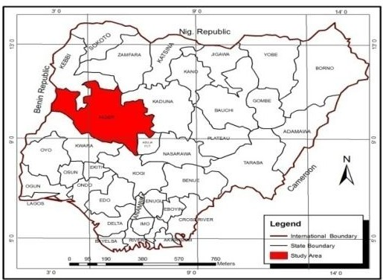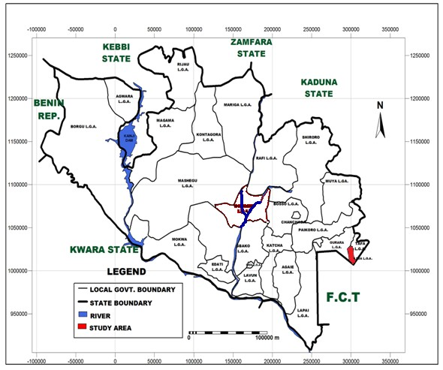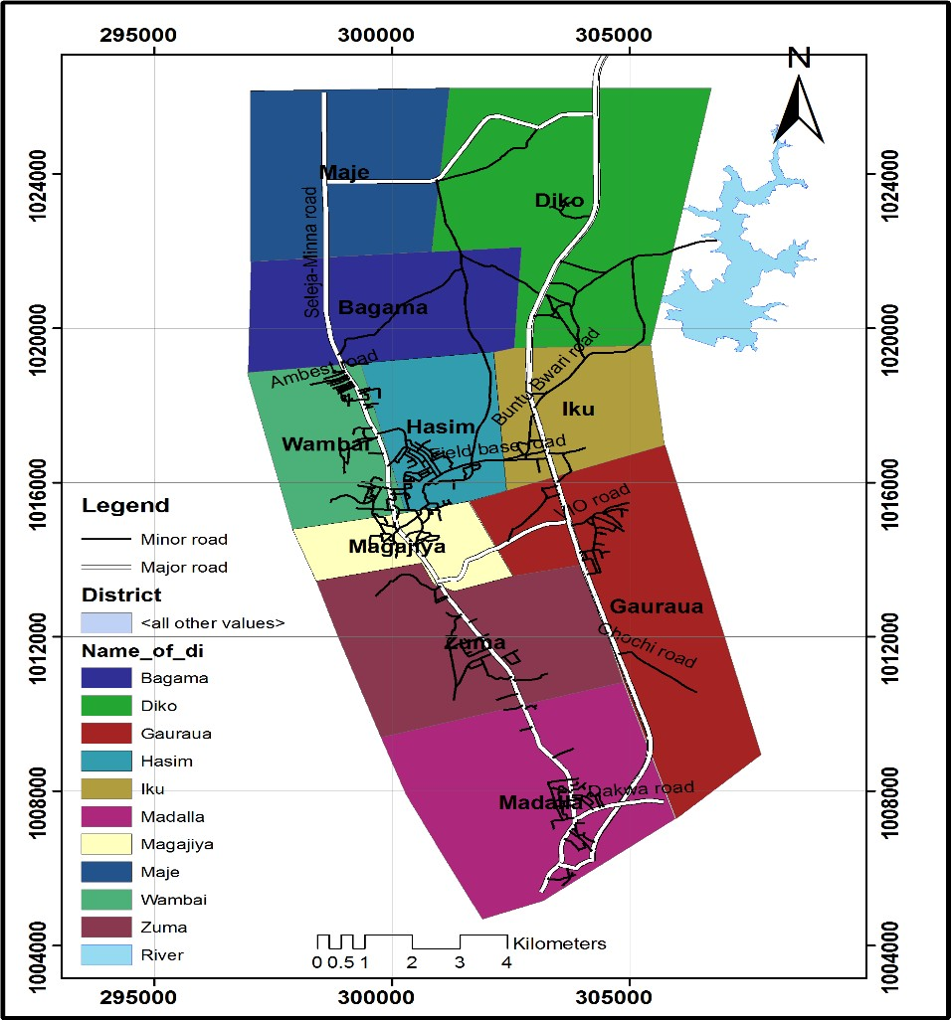

**Figure 1.1:** Location of Suleja

Source: Niger State Ministry of Land and Housing, Minna and Modify by Researcher, 2017

# History of Suleja

The emirate’s wooded savanna area of about 1,150 square miles (2,980 square km) originally included four small koro chiefdoms that paid tribute to the Hausa kingdom of Zauzau. After warriors of the Fulani jihad (holy war) captured Zaria (Zauzau’s capital, 220km north- northeast) about 1802, MuhammedMakau, sarkin (king) Zauzau, led many of the Hausa nobility to the Koro town of Zuba (10km) south of Abuja, Jatau his brother and successor or sarkinZauzau, founded Abuja town in 1828, began construction of its wall later, and proclaimed himself the first emir of Abuja.

Withstanding Zaria attacks, the Abuja emirate remained and independent Hausa refuge. Trade with Fulani emirate of Bida (to the west) and Zaria began in Emir Abu Kwaka’s reign (1851- 1877), but, when Abuja’s leaders disrupted the trade route between Lokoja (160km) south- southeast and Zaria in 1902, the British occupied the town. Alluvial tin mining began in Emir Musa Angulu’s reign (1917-1944).

Suleja was established in the early 19th century by Mohamed Makau, the last Hausa emir of Zaria and his followers who were fleeing the Fulani jihadist engaged in the conquest of the northern Nigeria. Zaria was one of the hausa city of the northern Nigeria which were being conquered by the Fulani jihadist under the charismatic sheik, Usman bin Fodio.

Apart from its closeness to the federal capital, it is also recognized as a centre of excellence for traditional West African pottery, namely the world famous Ladikwali pottery centre, established by Michael Cardew in 1950. The leading exponent of this school of pottery was DrLadiKwali, who received worldwide acclaim for her work, the originals of which are on display worldwide.

# Climate

Suleja is within the tropical continent zone with average annual rainfall of 1600mm and a raining season of over 7 months in the year. There is a single maximum in the rainfall of August. Temperatures are generally high in the summer month, which last from November to March.This includes a warm humid rainy season and a blistering dry season. In between the two, there is a brief interlude of harmattan occasioned by the northeast trade wind, with the main feature of dust haze, intensified coldness and dryness.

The rainy season begins from April and ends in October, when daytime temperatures reach 28°C (82.4°F) to 30°C (86.0°F) and nighttime lows hover around 22°C (71.6°F) to 23°C (73.4°F). In the dry season, daytime temperatures can soar as high as 40°C (104.0°F) and nighttime temperatures can dip to 12°C (53.6°F). Even the chilliest nights can be followed by daytime temperatures well above 30°C (86.0°F). The high altitudes and undulating terrain of Suleja act as a moderating influence on the weather of the territory.Rainfall in the Suleja reflects the territory's location on the windward side of the Jos Plateau and the zone of rising air masses with the city receiving frequent rainfall during the rainy season from March to November every year.

# Vegetation

Suleja falls within the Guinean forest-savanna mosaic zone of the West African sub-region. Patches of rain forest, especially in the rugged terrain to the south southeastern parts of the territory, where a landscape of gullies and rough terrain is found. These areas of Niger state form one of the few surviving occurrences of the mature forest vegetation.

# Relief

The study area has a long range of hills and ridges on the western side of the town, which has restriction in that direction slope in certain area of the developed town are up to 30% and that is responsible for the rapid erosion and gully formation which are common in the area.

# Drainage System

The town is well drained in to a system of streams and as a result of the steep slopes there is incidence of flash flood in certain part of the town particularly in areas with high development density.

# Soil

Like most alluvial soils, the soil in Suleja is the flood plain type and is characterized by considerable variations. The soil is of two main types which could be used for agriculture and are rich in minerals for the manufacture of various products. The two types of soil are: the Ku-soil which has little hazards and the Ya-soil which has a better water holding capacity.

# Economy

Today Suleja is well known as an exporter of Gbagi pottery. Cotton weaving and dyeing, with locally grown indigo, and mat making are traditional activities, but farming remains the chief occupation. Local trade is primarily in agriculture products.

# Genesis ofthe Development Challenges of Suleja

Nowhere has the truism ―he who fail to plan, has Plan to fail‖ become glaringly evident as the sorrowful state of the good people of Suleja town (formerly Abuja town). Up to 1976 when the then Federal Military Government decided to move the nation‘s capital from Lagos to Abuja,

Suleja was, substantially, a traditional Hausa settlement with the typical Hausa-Fulani traditional setup.

The Federal Military Government decided not to include Suleja in the Federal Capital Territory, for a variety of reasons including its predominant ethnic composition. Despite their exclusion, the good people of Suleja, former Abuja Local Government, contributed about 80% (6,400 km2) of the total area of FCT, (albeit on the instruction of the Military Government). The remaining 20% was contributed by the former Keffi and KotonKarfe Local Governments of former Plateau and Kwara States respectively. Another piece of land within Suleja was contributed for constructing a newly established Federal Capital Development Authority (FCDA) Field Base. This remained in Suleja for about five years during the planning stages of Abuja‘s development before the physical construction activities could take-off in 1982 (Shuaibu, 2006).

The genesis of the seeming intractable development challenges of Suleja have to do with the decision not to locate Suleja within the boundaries of the Federal Capital Territory (FCT); not to designate it as one of its Satellite Towns (or declare it a Special Development Area), as was done to Gwagwalada, Bwari and Kuje; failings on the part of both Federal and Niger State Governments to develop and implement measures to protect Suleja from the, inevitable, influx of workers and businesses that were to participate in the construction of Abuja; and the seeming extraordinarily high and evidently unsustainable standard set for construction of the FCT that priced most workers out of its property market, among others.

However, within a space of about thirty years when the construction of FCT started, Suleja town had lost virtually all its developable land; a large percentage of its indigenous population, who could not resist the temptation of money, sold their houses and plots of land to the business men

and women, from other parts of the country, who moved to the town due to its proximity to Abuja or as a base to transact business with FCT. From all indications the new owners of the town do not appear to have any more allegiance to it beyond the convenience it offers them and the potential for making a huge profit. They all have states, towns and villages to go back to, while the real Suleja indigenes appear to be stuck in the ever shrinking corners of the town, their rapidly increasing population notwithstanding.

However, it must be acknowledged that these people are known for their high level of self- reliance driven by a well-established tradition of entrepreneurship; and a very effective clan- based ―Safety Net‖ they provide to their members and relations. In Planning terms, Suleja appears to be a town choking itself to death-with a huge and rapidly growing population- unemployed, informal sector operators, small and medium sized business operators- looking up to Abuja for the greener pasture and business and investing virtually nothing in Suleja. The entire town has become one giant slum, growing in size and density in the most unplanned and uncontrolled manner imaginable; virtually all its streets are littered with signboards, in a ―riot‖ of forms, shapes and colours, of mostly informal sector operators; provision of urban basic services, especially water and sanitation has virtually collapsed; with a cacophony of noise coming out of electric generators that have become the main stay of power supply in the town, with huge implication on the health of the residents; unplanned peri-urban expansion; high levels of vulnerability to natural disasters; poor mobility systems; environmental degradation; and sight and sound of social conflict over land resources.

Experience has shown that were the FCT to have been moved to any other part of Nigeria, the same fate would have awaited the indigenous population without requisite safeguards and

deliberate effort to protect their interest. It is inevitable that the construction of such an ambitious project (FCT) will attract large number of people-business men and women; unemployed; skilled and unskilled workers; honest and dishonest people etc.

# CHAPTER TWO

# LITERATURE REVIEW

# Concept of Insecurity

The concept of insecurity would be best understood by first presenting the concept of security. In the view of Akin (2008) security refers to ―the situation that exists as a result of the establishment of measures for the protection of persons, information and property against hostile persons, influences and actions‖. It is the existence of conditions within which people in a society can go about their normal daily activities without any threats to their lives or properties. It embraces all measures designed to protect and safeguard the citizenry and the resources of individuals, groups, businesses and the nation against sabotage or violent occurrence (Ogunleye, et al, 2011).

According to Igbuzor (2011) it demands safety from chronic threats and protection from harmful disruption. Security however, can be described as stability and continuity of livelihood (stable and steady income), predictability of daily life (knowing what to expect), protection from crime (feeling safe), and freedom from psychological harm (safety or protection from emotional stress which results from the assurance or knowing that one is wanted, accepted, loved and protected in one‘s community or neighborhood and by people around. It focuses on emotional and psychological sense of belonging to a social group which can offer one protection). This description structured the concept of security into four dimensions. However, these dimension can be weaved together to give a composite definition of security as the protection against all forms of harm whether physical, economic or psychological. It is generally argued however that security is not the absence of threats or security issues, but the ability to rise to the challenges

posed by these threats with expediency and expertise. Insecurity on the other hand, is the antithesis of security.

However, because of the very many ways in which insecurity affects human life and existence, the concept of insecurity has usually been ascribed different interpretations in association with the various ways which it affects individuals. Some of the common descriptors of insecurity include: want of safety; danger; hazard; uncertainty; want of confidence; doubtful; inadequately guarded or protected; lacking stability; troubled; lack of protection; and unsafe, to mention a few. All of these have been used by different people to define the concept of insecurity. These different descriptors, however, run into a common reference to a state of vulnerability to harm and loss of life, property or livelihood. (Beland, 2005) defined insecurity as ―the state of fear or anxiety stemming from a concrete or alleged lack of protection.‖ It refers to lack or inadequate freedom from danger. This definition reflects physical insecurity which is the most visible form of insecurity, and it feeds into many other forms of insecurity such as economic security and social security. A major point about insecurity implied in these definitions is that those affected by insecurity are not only uncertain or unaware of what would happen but they are also not able to stop it or protect themselves when it happens (Beland, 2005).

# Theories of Crime

Several theories have been developed in deferent disciplines of study explaining certain phenomenon of interest to researchers and professionals alike. In criminology, examining why people commit crime is very important in the ongoing debate of how crime should be handled and prevented. Many theories have emerged over the years, and they continue to be explored,

individually and in combination, as criminologists seek the best solutions in ultimately reducing types and levels of crime (Kandel and Mednick, 1991).

Theories to Explain Differences in Offending among Individuals; the most intense theoretical efforts have focused on individual variations. Those theories can be classified by their dominant themes, although few theories can be regarded as completely limited to the theme they emphasize. The various themes appear to reflect prevailing modes of thought in academe and the larger society at the time the theories featuring them were first enunciated. Yet articulations have evolved beyond the intellectual contexts out of which the themes emerged, and some theories within each of the themes now incorporate elements from other themes.

The themes of individual-level theories, six major themes in theories of individual differences in criminal behavior have emerged: Personal defects, social Learning, Strain/deprivation, Identity, Rational choice, Control/integration, social Learning. Each promotes a fundamental idea, or causal process, that is plausible and empirically viable, at least given the limited bounds within which it has been tested. And each of the themes has shown steady evolution and improvement.

Personal defects theory: The earliest theme was dominant until the late 1930s. Beginning with Lombroso (1878), but also encompassing psychoanalysis (for example, Abrahamsen 1944; Aichhorn [1925] 1968) and other psychological arguments (for example, Eysenck and Gudjonsson 1989; Wilson and Herrnstein 1985), criminal behavior has been attributed to personal defects—either physical or psychic. Deficiencies have been traced to genetic inheritance (for example, Mednick and Kandel 1988; Raine 1993), to such damaging influences as pre-mature birth or environmental poisoning (for example, Kandel and Mednick 1991; Moffitt 1990), and to life experiences that distort psychic or social development (Kendall-Tackett,

Williams, and Finkelhor 1993; Smith and Thornberry 1995; Widom 1989. Modern theories featuring personal defects usually contend that pathology alone is not enough to produce crime, and they attempt to spell out how personal defects come about and get translated into criminal outcomes, often incorporating insights from a variety of other themes. These features can be seen most clearly in Moffitt‘s (1993) two-path theory. The theory identifies two causal paths to misbehavior. One characterizes the ―life course persistent‖ offender, who is already antisocial at an early age and continues so throughout life. The second is exemplified by the ―adolescence limited‖ offender, who does not start offending until mid- or late adolescence, and typically stops in early adulthood.

Social learning theory: People develop motivation to commit crime and the skills to commit crime through the people they associate with. The social learning theory mainly explains the behavior of individuals, some theorists have also used it to try to explain variations in crime rates among social entities (Akers 1998; Sutherland 1924).

Other learning theorists have gone a little further. Akers (1998) theorizes that variations in social structure and culture affect crime rates through their influences on the average reinforcements for criminal behavior that individuals within societies or other social entities experience. Among the structural characteristics that impinge on the overall likelihood of criminal learning, he includes such things as demographic composition, regional and geographical attributes, and other characteristics that concern the way social entities and sub-cultural systems are organized. This latter category could include weak neighborhood and family organizations.

Reified macro level themes some macro level theories are simply applications of those that explain micro level phenomena, but with the assumption that whatever applies to individuals can

be aggregated to explain rates of crime from one social entity to another. For instance, deterrence theory basically explains why individuals commit crimes. However, some scholars contend that differences in crime rates among social entities stem from differences in characteristics of enforcement bearing on the certainty and severity of punishment. Similarly, since demo- graphic characteristics are influential in predicting individual probabilities of law violation (for various theoretical reasons encompassed in individual theories of crime), one can explain variations in rates of crime from place to place by considering the age and proportion of the population that is male, minority, and freed from familial and institutional affiliations (Steffensmeier and Harer 1999; Wellford 1973). Hence, almost any of the causal processes of the individual-level theories previously reviewed can be aggregated to explain variations in crime rates.

General strain theory: attempts to identify the conditions that can lead from strain to crime. One such category involves aspects of the strain itself: its magnitude, how recently it began, how long it has lasted, and the extent to which different straining stimuli converge. In strain theory, most people have similar aspirations, but they don‘t all have the same opportunities or abilities. When people fail to achieve society‘s expectations through approved means such as hard work and delayed gratification, they may attempt to achieve success through crime.

Because so many things can affect strain, the theory has been extraordinarily integrative. Moreover, the strain theme is woven into many theories not directly focused on strain, though it is less pervasive than the learning theme. For example, theories about personal defects often suggest that individual deficiencies come into play mainly under stressful circumstances (Raine 1993). Labeling arguments portray crises of self as stimuli for identity change (Gove 1980; Payne 1973). And even learning theories especially sub-cultural ones (Cohen 1955; Miller 1958) often see behavioral responses, which eventually come to be shared and passed on to those in

similar circumstances, as reactions to strain. Since strain theories overlap with other theories, it is reasonable to imagine that all would benefit from explicit integration.

Rational choice theory: People generally act in their self-interest and make decisions to commit crime after weighing the potential risks (including getting caught and punished) against the rewards. The rational choice idea that people weigh potential benefits against possible costs and decide rationally whether to commit crimes was in disrepute among criminologists for the better part of this century. But beginning with a surge in the late 1960s and early 1970s (Andenaes 1974; Becker 1968; Chambliss 1967; Zimring and Hawkins 1973), theorizing about rational decisions and criminal behavior has continued at a consistent pace (for example, Cornish and Clarke 1986; Geerken and Gove 1975; Grasmick and Bursik 1990; Stafford and Warr 1993.

Impulsivity, risk taking, and intelligence all affect the process, and theoretically there are differences in moral feelings that make some things more costly and less rewarding. In addition, individuals differ in their emotion- al commitments to certain behaviors (Chambliss 1967). There are also reasons to expect gender differences in assessment of costs and benefits, as well as variations by age, with youths perhaps being less sensitive to cost and more sensitive to reward. Finally, these theories point toward disparity in deterrence among cultural groupings around race, ethnicity, region, religion, and marital or family status. In general, those with more social responsibilities presumably anticipate more potential cost from criminal behavior, while the deprived presumably fear costs less and appreciate the potential rewards more.

Control/integration: the final theme to explain individual criminal conduct concerns the inhibiting effect of social and psychological integration with others whose potential negative response, surveillance, and expectations regulate or constrain criminal impulses. It has also been

a major focus for theories explaining why some individuals are more prone to crime than others. Perhaps more than any other theme, this one has maintained a steady influence in criminology. Its popularity may stem from the extraordinarily clear presenta- tion of its theoretical rationale by Hirschi (1969), whose work has epitomized social control theorizing for nearly three decades.

Hirschi captured the arguments of a number of theorists when he specified that those with strong bonds to conventional social groups or institutions will be less likely to violate the law because they have less freedom to do so (Horwitz 1990).

Control theories usually ignore the motivation, or strength of motivation, for criminal behavior, assuming that everybody is at least sufficiently inclined toward crime that it need not be treated as a variable. Some see differing degrees of motivation as an important contingency, but they often do not specify how strong the motivation must be in the face of different degrees of constraint in order for crime to occur. Clearly, this is one aspect of the theory that would benefit from some incorporation of causal arguments from other theories about criminal motivation. In addition, many theories with this theme focus exclusively on the central process of control, neglecting contingencies that might come into play.

# Urban Crime- Explaining Variation in Urban Crime

Although there is general consensus among criminologists that urban areas have higher rates of crime than rural areas, of less certainty is why certain urban settings have higher crime rates than other urban settings. That is, not all cities or neighborhoods experience similar levels of crime and violence; there is widespread variation in crime levels across urban spaces. Thus, the question of interest for criminologists is what is the source of this variation? What causes certain

cities or neighborhoods to experience high levels of crime while other cities or neighborhoods enjoy relatively low levels of crime (Steffensmeier and Harer 1999)

Criminologists address these questions by attempting to uncover the correlates of urban crime rates. In line with social disorganization theory mentioned earlier, most research of this type focuses on city or neighborhood characteristics associated with high crime levels in an area. Although the range of correlates studied is quite extensive, the most common characteristics include socioeconomic and demographic characteristics of the area, such as the poverty level,

`racial composition, residential mobility, labor force characteristics, age structure, and divorce rate. These correlates appear again and again in studies of urban crime rates. Here we will focus on three important correlates that have received continued attention among criminologists— poverty and other economic characteristics, racial composition, and labor force characteristics

# Poverty, Inequality and Urban Crime

Within the extensive body of literature on the relationship between social class and crime exists a smaller but nonetheless important group of studies that examine the effects of poverty on crime. Interestingly enough, this smaller group of studies mirrors the larger body of literature from which it extends; essentially, there seems to be as much controversy and disagreement over whether poverty is related to crime (Steffensmeier and Harer 1999).

The significance of urban socioeconomic conditions for the incidence of crime was early recognized in ecological studies at the University of Chicago. In the most famous of these, Shaw and McKay compared delinquency rates in various areas within twenty-one cities and concluded

that three urban conditions promote high delinquency rates: poverty, racial heterogeneity, and mobility, with poverty surfacing as the most important factor.

Over the decades, numerous aggregate studies have empirically supported the poverty and crime relationship. Many of these studies have observed the highest crime rates within the poorest urban slums (Curtis, 1974). A linkage between crime and economic conditions has also been found at higher levels of aggregation, such as cities and states (Loftin and Hill; Smith and Parker). Many leading criminologists believe that the poverty-crime relationship is clear and direct.

This positive relationship between poverty and crime, for the most part, went uncontested until Blau and Blau put forth the hypothesis that racial economic inequality, more than poverty, spells the potential for violence. Socioeconomic inequalities associated with ascribed positions (i.e., being a minority), they argue, engender pervasive conflict in a democracy. While great economic inequalities generally foster conflict and violence, ascriptive inequalities do so particularly. Pronounced ascriptive inequalities transform the experience of poverty for many into the hereditary permanent state of being one of the poor. Blau and Blau also argue that ascriptive socioeconomic inequalities undermine the social integration of a community by creating social differences and conflict that widen the separations between ethnic groups and social classes.

Together, the work of Messner and Blau and Blau challenged common conceptions concerning the relationship between poverty and crime and pointed out that areas with high populations of people in poverty do not necessarily have corresponding higher rates of violent crime, as previously theorized. More recent studies on the poverty-crime relationship continue to report conflicting results. Thus, many argue that it is too premature to make a confident conclusion

about the role that poverty plays in the production of criminal violence. A promising line of inquiry focuses on underclass neighborhoods that are characterized by the isolation and concentration of people in poverty. It may be that in the context of these "concentration effects" urban poverty may be related to higher crime rates (Sampson and Wilson, 2002).

# Racial Composition and Urban Crime

Unlike poverty, studies that analyze racial composition and crime clearly find that there is a strong positive relationship between criminal violence and an area's racial composition. This has been shown to be true across all levels of aggregation, including states (*Huff-Corzine et al*.), SMSAs (Balkwell), cities (Sampson), and neighborhoods (Warner and Rountree), as well as for all types of crime, including both violent (Messner, 1982) and property (Kubrin). In many of these studies, racial composition is defined in terms of the percentage of the population that is black. More recently, however, there have been attempts to incorporate additional racial groups outside of blacks and whites into measures of racial composition. These measures more accurately represent racial heterogeneity or levels of racial diversity within an area. Interestingly, race effects have been documented in both studies that use percent black and white heterogeneity as their measure of racial composition. Given consistent findings, researchers interested in the race-crime relationship have moved away from the question of whether race effects exist to a more difficult question: Why do race effects exist?

To a great extent, the answer to this question is linked to the type of racial composition measure used in the study. For example, studies that use percent black as a proxy for racial composition, and find that it is a significant predictor of the crime rate, often proposes subcultural explanations to explain the race effect (Messner, 1982, 1983). These researchers argue that if the subcultural

explanations are correct, there should be an effect of racial composition on the crime rate that is independent of socioeconomic and demographic factors. When such an effect appears, it is frequently interpreted as support for the subculture of violence thesis.

Significant race effects have also been documented in criminological literature that focuses on changes in an area's racial composition and its relation to changes in violent and property crime rates. One of the most important findings of the classic Shaw and McKay delinquency research is that the spatial distribution of delinquency in a city was the product of "larger economic and social processes characterizing the history and growth of the city and of the local communities which comprise it" (p. 14). Further, in a 1982 study by Bursik and Webb using neighborhoods in Chicago, the authors find that changes within the ecological structures of localities had an appreciable impact on changes in community delinquency levels during the 1950s and 1960s. They interpret these findings in terms of the disruptive influence that community reorganization (processes of invasion and succession) has on the maintenance of social institutions, social networks, and informal social controls. In light of their findings, Bursik and Webb remind researchers of the crucial differences between static and dynamic spatial approaches to crime and delinquency. Since their work, recent studies that examine the relationship between changes in racial composition and changes in urban crime levels continue to find a strong positive relationship between the two (Miethe, Hughes, and McDowall; Kubrin, 1982).

# Global Perspectives of Urban Strategies for Safer Cities

* + 1. **Bordeaux (Gironde), FRANCE.**

Bordeaux is a relatively calm city in terms of crime and insecurity, at least in relation to other disadvantaged urban zones. Insecurity is mostly the result of minor day-to-day crime, sometimes

coupled with incivilities, even if more serious events sometimes require strong police action. In this context, better articulating prevention and security and responding to local circumstances involves recognizing the needs specific to each neighbourhood in each territorial agreement of the city contract. It has also involved the installation over the past three years of local prevention and security councils presided over by the mayor, especially in neighbourhoods covered by the city contract.

The objectives are:

* + - 1. Involve local actors who do not take part in the plenary sessions of the city-wide crime prevention council.
      2. Provide citizens with a clear understanding of the actions taken by the city, the national police, and the justice system in relation to problems affecting them daily.
      3. Share the diversity of views on observed or felt insecurity in neighbourhoods; and
      4. Reach consensus on the problems which need addressing and necessary solutions.

Seven Local Advisory Councils on Prevention and Security (Conseilslocaux de prévention et de sécurité -CLPS) have been established in 2001. Their aim is to bring the policies and interventions addressing insecurity and crime prevention as close to neighbourhoods and their inhabitants as possible. The CLPS responded to the need to decentralize in certain neighbourhoods the plenary session of the citywide advisory council on crime prevention, in relation to the severity of security problems. The orientation of the Local Advisory Councils on Security and Crime Prevention (Conseil local de sécurité et de prévention de la délinquance - CLSPD) evolves over time in relation to the reality and severity of insecurity issues in these neighbourhoods. Such flexibility allows CLPS to meet as needed to address a particular problem

in a neighbourhood. They bring together the main institutions concerned as well as citizens‘ representatives and socio-educational operators of the neighbourhood.

A brief assessment on feelings of insecurity is undertaken in a survey of citizens (30 to 50 depending on the neighbourhood) conducted by two members of the city‘s security-prevention team usually precedes the bi-annual meetings of the CLPS. Citizens are particularly sensitive to the fact that public authorities are at their service and take the time to listen to their concerns of their day-to- day security issues. Every six months, the prefecture and police forces present their report on the situation observed in the neighbourhood and the actions taken during this period. Everyone present may then express their opinion on the evolution of the neighbourhood‘s situation and on the measures deemed necessary for improving the situation, as well as the sense of security in the neighbourhood. Careful analysis of the actual situation of each neighbourhood and its specific problems allows for a focused approach, and a continually adjusted response. This phase also provides an opportunity for exchange between community-based and institutional actors on the reality and severity of the insecurity complaints and the relevance of the intended measures.

The citywide local safety and prevention councils help adapt responses to the specificities of each area, work to reassure citizens, and they help to educate citizens about prevention and safety measures. This community-based work also brings a useful contribution to the local safety audit which precedes the implementation of interventions outlined in the local security and prevention contract of Bordeaux.

City contract, prefecture, city of Bordeaux, prosecutor, delegated security prefect, departmental director of public security, academy inspection, heads of educational institutions, prevention

clubs, Centre for Local Social Action, local mission, merchants‘, tenants‘ and social workers‘ associations.

# Antananarivo, Madagascar

Crime, insecurity and sometimes violence threaten the quality of life in Antananarivo (4 million inhabitants) and stigmatize certain neighbourhoods. Property crimes in particular have been a rapidly growing phenomenon over the past decade. In addition, there is a rapid increase in drug use, and in the less visible phenomena of family and domestic violence. Due to an unstable socio-economic situation, there has been a significant increase in groups at risk.

The objectives are to:

* + - 1. Facilitate the coordination of preventive measures through a participatory process which reinforces social cohesion.
      2. Establish meeting centres in targeted poor neighbourhoods.
      3. Mobilize locally-based groups and implement pilot projects targeting at risk groups.
      4. Strengthen the capacity of local authorities and NGOs to prevent crime and violence.

The Volunteer Service Against Violence (VCV) project began in 2002. It promotes a strategy of urban governance in two neighbourhoods of the Antananarivo Urban Community (CUA). The purpose of the VCV project is to reduce violence in these communities through the coordination of urban crime prevention action. It uses a two-tiered approach. On one hand, it uses a Volunteer strategy based on community mobilization, participatory and partnership approaches, as well as campaigns to reduce violence through socio- cultural and sporting activities and events. On the

other hand, it applies the UN Habitat Safer Cities strategy, in which all actors work together to improve safety and local development, and which promotes the role of municipal leadership.

Specific tools to promote the Volunteer strategy have been developed in the course of the project. These include community mobilization through the creation of groups known as Neighbourhood Volunteers (VQ). The VQ are local inhabitants, the majority of whom are women, who were identified and recruited through visits to local authorities, volunteer organizations, and women‘s groups.

They work together to increase awareness within their community and help to identify and implement prevention activities. The participatory and partnership approach uses participatory diagnosis techniques and partnership strategies developed by the project. One of the strengths of the project has been the dynamic partnership created among diverse groups from civil society and the State, including police services and the justice sector, national ministries, representatives of the CUA, the private sector, and the two communities involved. The mobilization against violence campaigns have been organized through cultural and sporting events, and have contributed to increasing public awareness. In addition to helping to mobilize those communities, the impact of these campaigns has given the project visibility far beyond the neighbourhoods of intervention.

The VCV project, currently in its third year, will conclude in August 2005. An evaluation will determine the extent to which the two aspects of the project (Volunteer and Safer Cities) have been incorporated into municipal structures. The project partnership, and in particular the Antananarivo Urban Community, hope to extend this type of intervention to other areas of city. A project based more specifically on the development of physical, sports and cultural activities is also currently in development with the Minister of Youth and Sports.

# Crimes and Insecurity in Nigeria

The incidence of crimes tends to increase in any region, where we have high population of people, and such incidence is reduced in a region with low population of people. Sanidad-Leones (2006) opines that rapid urbanization, industrialization, and migration to the cities are major factors that contribute to higher crime rates in Philippine urban centres. This is not in contrast to the urbanization challenges as regards crimes in Nigerian urban centres.

The prevailing crimes in Nigerian urban centres include robbery, kidnapping, rape, murder, child trafficking, murder, political violence, fraud, suicide, and prostitution among other crimes, which are the resultant factors of urbanization. All these crimes are urban affairs and not rural affairs because many inhabitants of the countryside are related in one way or the other. The Nigerian Police numerical strength is not commensurate with the total population, as one Policeman to 5,000 Nigerians; unlike in developed countries with one Policeman to about 400 people (Agbola, 1997). Moreover, with the disproportion between the security strength and population in Nigeria, the study by Robert (2007) shows that in Nigerian urban centres, a number of army soldiers and police officers have been sentenced to death for armed robbery involvement in Nigerian urban centres. In many urban centers of Nigeria today, criminal activities and violence are assuming dangerous tendencies as they threaten lives and properties, the national sense of well-being and coherence, peace, social order and security, thus, reducing the quality of life of the citizens (Ahmed, 2010).

At least, one of these crimes is committed on daily basis in Nigerian urban centre, while in some cases the culprits are always at large, due to the exploded population growth of urban centres with millions of people. Out of all the crimes in Nigeria, robbery incidence is the highest with

27.3% (Robert, 2007). Small Arms Survey (2007) shows that 1.6% of households own a firearm in Nigeria. It is unlawful for any person in Nigeria, apart from the government security agents to own or carry firearm. But the number of persons with firearms continues to increase as robbery incidence has become an order of the day in many urban centres in developing countries. Rapid urban expansion in Africa is connected to a crisis in urban governance fueling unemployment and the inability of public police forces and the security sectors of many countries to provide adequate protection (Robert, 2007).

# 2.6 Types of Policy Response to Problems of Crime

There are many kinds of responses to issues of crime and violence, with evidence suggesting that the most successful ones are those that are tailored to the particular circumstances being addressed, rather than those that are essentially standardized based upon experience elsewhere. It is possible to classify these responses into six broad groups of approaches as follows:

1. Enhancing urban safety and security through effective urban planning, design and governance: Poor planning, design and management have been identified as among the constellation of factors associated with crime and violence. This group of activities is therefore mainly about manipulating and maintaining the physical environment, which is the setting within which most crimes take place.
2. Community-based approaches to enhancing urban safety and security:

Activities of this nature are essentially about getting communities to take ownership of initiatives. Very often this will mean that community groups or individuals will either be the source of project ideas or will play leading roles in implementing them.

1. Strengthening formal criminal justice systems and policing:

This could be seen as the ‗classical‘ approach to problems of crime and violence, regarding them as being the primary territory of the police and the criminal justice system. Initiatives in this area are also often undertaken at the city or even broader scale.

1. Reduction of risk factors: These approaches tend to focus on groups that are likely to be perpetrators of crime or on groups that are at risk of being victims of crime. The aim here is either to reduce the likelihood of such groups getting involved in criminal activities or to reduce the problems faced by victims.
2. Non-violent resolution of conflicts: This essentially is about seeking to manage situations in which conflicts often arise in order to reduce the likelihood of this happening or to find solutions to the problems that do not result in violence.
3. Strengthening of social capital: This includes improving the ability of people, groups and communities as a whole to challenge the problems of crime and violence and the provision of community facilities that facilitate or provide more opportunities for processes of this nature. UN-Habitant,[2007].

# CHAPTER THREE

# RESEARCH METHODOLOGY

# Research Design

Data acquisition is the process of data gathering, this process involves the use of high resolution remote sensing image in analyzing, and mapping out the existing road network within the study area. Structural questionnaire was adapted to capture relevant attribute data from commuters, and transporters and other well-placed citizens in areas of implementation. For the purpose of this project, a street guide map of Suleja and High Resolution Satellite Imagery of Suleja was used. The positions in terms of spatial data x and y coordinates of the map were taken before on-screen scanning and digitization in order to provide spatial information about the project area. In this study, two types of data were captured.

# Research Instruments

For the purpose of the research and to achieve the aim of the study, the following data collection instruments were used:

* + 1. **Questionnaires:** Structured questionnaire was design and administered to the heads of households in the study area. The questionnaire was used to elicit relevant socio- economic characteristics of residents, characteristics of crime or violence in the study area, safety measures employed by residents, causes of crime or violence in the study area amongst others.
    2. **Field Observation:** field observation was conducted during the period of the study by visits to the selected neighborhood in Suleja. Digital camera were used to capture necessary notable features in the study area.

# Sample Size

According to Yamane (1974) who provide a formula for determining sample size from a heterogeneous population;

n = N/ 1+N (e) 2

Applying the formula; n = N/ 1+N (e) 2

Where n = sample size sought N= Population size

e= level of significance chosen (0.05) 1= constant

Therefore n=? N=7,187 households e=0.05

n= 6085/ 1+6085 (0.05)2

n=6085/ 1+6085(0.0025) n=6085/1+15.2125 n=6085/16.2125

n=375.33 round off to 375.

A total numbers of 6,085 household were identified in the study area (NPC, 2011). From the total of 6,085 households in the study area, 6.2% which is approximately 375 was picked to administered questionnaire

Therefore the calculated sample size using the above equation (in respect to the total households) is 375.Based on household population 6.2% of the calculated sample size was given to each of the selected neighbourhoods under study based on their household population as shown in table

3.1 below.

**Table 3.3:** The Sample size and Number of Questionnaire Administered

|  |  |  |  |  |
| --- | --- | --- | --- | --- |
| **Sampled Area** | **Population in 1991** | **Estimated Population in 2014** | **No. of Households** | **Sample Size (6.2%)** |
| Kwamba | 6,405 | 11367 | 1,421 | 88 |
| Maje | 1,038 | 1843 | 230 | 14 |
| Diko | 3918 | 6906 | 863 | 54 |
| Gauraka | 2,472 | 4387 | 548 | 33 |
| RafinSanyi | 1,869 | 3315 | 414 | 25 |
| BakinIku | 4,131 | 7332 | 917 | 57 |
| Madalla | 7,566 | 13537 | 1692 | 104 |
| Total | 27,796 | 48,687 | 6,085 | 375 |

Source: National Demography Survey, NPC, 2006 and modify by Author, 2017.

* 1. **Sample Techniques**

Cresswell (2012) opined that complete inventory is usually a difficult task particularly with large number of population. This is exactly the issue with city of Suleja. Therefore, systematic random sampling was employed. Systematic random sampling is a method of choosing a random sample from among a large population. The process of systematic random sampling involve first selecting a fixed starting point in the large population and then obtain subsequent observations by using constant interval between samples taken. It uses the same statistical principles as simple random sampling, which is p values and confidence interval are calculated the same way. The sample interval was calculated by dividing the number of households in the population by the number of households needed to be sample.

* + 1. Sample interval= households population/ households needed to be sample.
    2. From table 3.3, household population = 6,085
    3. households needed to be sample=375
    4. Therefore, sample interval= 6,085/375
    5. Sample interval = 16.23 round offto16.

Therefore a sample size of 375 respondents chosen from the household heads from different neighbourhoods or locality was sampled at interval of 16th that is between 1 and interval of 16th households until the 375 calculated sample size is exhausted.

# Crime Mapping Techniques

The mapping depends on the use of computer-assisted interpretation of QuickBird Satellite imagery. Field survey was carried out to compliment the imagery, GPS coordinates of crime hotspots were captured in the field, it enable the GIS techniques to develop the crime hotspot area. Buffer width of 300ft recommended by Palfrey and Bradley, (2002) were used to provide a buffer zone along the neighborhood. This was performed in order to obtain and document element vulnerable to crime in the area. High Resolution Satellite imagery map was used for physical identification of communities. Captured coordinates were referenced on the imagery for boundary demarcation. ArcMap 10.1 was used to develop the crime hotspot area map of the study.

# Method of Data Analysis and Presentation

The data collected from the field were coded appropriately into the computer system and analyzed through descriptive, analytical, quantitative and comprehensive methods, using SPSS for Windows; version 16 to produce results. The data was subjected to frequency analysis. The results was presented in simple frequency tables, charts and write ups. This is to ease the reading and understanding of the finding.

# Summary of Research Methology

|  |  |  |  |
| --- | --- | --- | --- |
| **S/No** | **Objectives** | **Data** | **Methodology** |
| i | Examine the incidences of crime in the study area. | Field survey, Structural Questionnaire | Descriptive Statistics |
| ii | To examine the level of safety consciousness of the people in the study area. | Field survey, Structural Questionnaire | Descriptive Statistics |
| iii | To evaluate the coping capacity of the people and the strategies for crime prevention in the area. | Field survey, Structural Questionnaire | Descriptive Statistics |
| iv | Create crime hot and cold spots map of the study area | Geospatial Coordinates, QuickBird Imagery and Suleja Township Map | Geospatial techniques |
| v | Assess the relationship between the police divisional stations and the crime hotspots areas | Geospatial Coordinates, QuickBird Imagery and Suleja Township  Map | Geospatial techniques with neighborhood analysis |

# CHAPTER FOUR

# RESULTS AND DISCUSSION

* 1. **Socio – economic characteristics of the Respondents**

The socio-economic characteristics of the respondents were analysed.. It was observed from the analysis in Figure 4.1 that 21% of the respondents were between the age group of 20-30 years, 33% were within 31-40, 38% of the respondents are within 41-50 years while 80% were above 51 years of age.

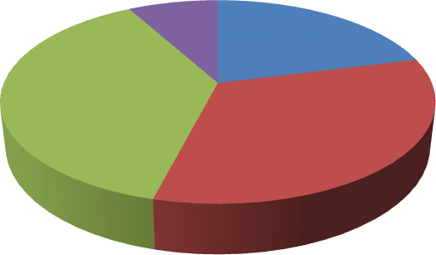

51 and above

8%

20-30

21%

41-50

38%

31-40

33%

# Figure 4.1 Age of the respondents

Source: Authors Field Survey, 2017

Educational level of the respondents were analysed in Figure 4.2 It shows that 6% of the respondents were illiterate that do not have any formal education at all, 13% attended primary school, 32% attended secondary school while 49% attended up to tertiary education level. The analysis shows that majority of the respondents are literate enough to do justice to the research questions.

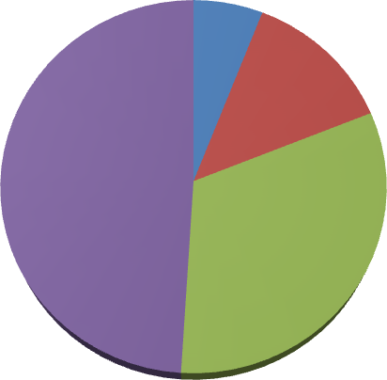

Illiterate 6%

Primary 13%

Tertiary 49%

Secondary 32%

# Figure 4.2 Educational Level of the respondents

Source: Authors Field Survey, 2017

Analysis in Figure 4.3 shows the occupation of the respondents. It was observed that 9% of the respondents were self-employed, 6% were farmers, 11% were into trading, 29% were civil servants, 19% were artisans while 26% were unemployed.

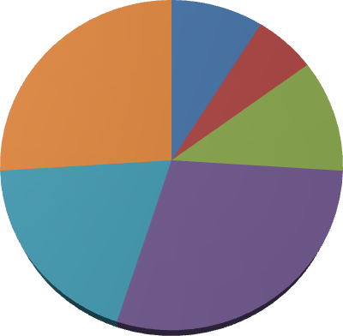

Self-employed

9%

Farming

6%

Unemployed

26%

Trading

11%

Artisan

19%

Civil Servant

29%

# Figure 4.3 Occupational level of the respondents

Source: Authors Field Survey, 2017

Income status of the respondent are shown in Table 4.4. 12.2% of the respondents earn between 5,000 – 10,000 monthly, 3.4% earned between N10,001 – N20,000, 25.2% of the respondents earned between N20,001 – N30,000, higher percentage of the respondents (36.7%) earned between N30,001 – N40,000 while 22.4% earned between N40,001 and above.

40

35

30

25

20

15

10

5

0

5,000 - 10,000 10,001 - 20,000 20,001 - 30,000 30,001 - 40,000 40,001 and

above

**Income (Naira)**

**Percentage**

# Figure 4.4 Monthly Income of the respondents

Source: Authors Field Survey, 2017

The duration of stay of the respondents in the study area is shown in Figure 4.5, 43% of the respondents had stayed in the area between 1-10 years, 28% had stayed between 11-20 years, 18% had stayed between 21-30 years while 11% had stayed in the area since birth. This indicates that majority of the respondents had stayed in the area for more than 10 years.

**Percentage**

# Figure 4.5 Duration of Stay

50

45

40

35

30

25

20

15

10

5

0

1-10 years

11-20 years

21-30 years

Since birth

**Years**

Source: Authors Field Survey, 2017

# Incidence of Crime in the study areas

* + 1. **Crime Experienced in the area**

Figure 4.6 shows the percentage of respondents from each selected study area that has experienced crime acts. 9.2% had experienced crime in Kwamba, 15.6% have never experienced crime in the area, 28.7% of the respondents had experienced crime in Maje while 22% had not experienced crime. The analysis also shows that in Diko, 26.8% of the respondents had experienced crime, 31.5% have not experienced any form of crime in the area. It shows that respondent from Gauraka, it was observed that 18.4% have experienced crime and 13.9% had no experienced. Response from Rafin Sanyi shows that 11.5% had experienced while 5.4% had not.

**Percentage**

# Figure 4.6: Residents’ Experience of Crime

80

70

60

50

40

30

Yes

No

20

10

0

Kwamba

Maje

Diko

Gauraka

RafinSanyi

BakinIku

**Neighbouhood**

Source: author‘s field survey, 2017.

# Types of Crime Experienced in the area

The types of crime experienced in the study area are shown in Figure 4.7. Armed robbery, burglary, car snatching and other related crimes were identified in the area. In Kwamba, armed robbery accounted for 41.7%, burglary 54.2%, other crimes 4.2% of all crime committed. In Maje, Armed robbery was 18.7%, burglary 36%, car snatching 0% and other crime was 45.3%. In Diko, armed robbery is 32.9%, burglary was 61.4%, car snatching was 2.9% and other related crimes in the area were 2.9%. In Gauraka, armed robbery accounted for 27.1%, burglary 45.8%, car snatching 0% and other related crimes 27.1%. In Rafin Sanyi, the analysis shows that armed robbery was 23.3%, burglary was 56.7%, 0% car snatching and 20% other crime

while in Bakin iku the analysis shows that; armed robbery was 42.9%, burglary was 50%, 0% for car snatching and 7.1 for other related crime in the area. From the analysis it was observed that Burglary is highest crime committed in the selected study area and car snatching is the lowest experience crime in the area.

80

70

60

50

40

30

Armed Robbry

Buglary

Car Snatching

20

10

0

Kwamba Maje

Diko

Gauraka RafinSanyi BakinIku

**Neighborhood**

**Percentage**

**Figure 4.7: Types of crime experienced by the residents**

Source: Author‘s Field Survey, 2017

# Time of Occurrence of Crime

Time of occurrence of crime in the selected neighbourhood is shown in Table 4.1. The analysis shows that crime in the area occurs at all time of the day. It was observed that 21% of crime in Kwamba occurred in the morning, 16.7% in afternoon, 37% in the evening and 25% at night. It shows that in Maje 17% of the crime committed in the area were in the morning, 17.5% in the afternoon, 25.3% in the evening and 40% in the night. The analysis shows that 8.6% of the crime

in Diko occurr in the morning, 11.4% in the afternoon, 12.9% in the evening while 67.1% at night. In Gauraka, 29.2% of the crime are committed in the morning, 18.8% in the afternoon, 16.7% in the evening and 35.4% in the night. At Rafin Sanyi 10% of the crime were in the morning, 16.7% in the afternoon, 53.3% in the evening and 20% at night. The analysis also shows that in Bakin iku, 21.4% of the crime occur in the morning, 28.6% in the afternoon, 14.3% in the evening while 35.7% in the night. It was observed from the analysis that majority of crimes committed in the selected neighbored occurred in the evening.

# Table 4.1: Time of occurrence of Crimes among neighborhoods

Time of occurrence

|  |  |  |  |  |  |  |  |
| --- | --- | --- | --- | --- | --- | --- | --- |
|  | Morning | Afternoon |  | Evening |  | Night | Total |
| Area | (Frq) (%) | (Frq) | (%) | (Frq) | (%) | (Frq) |  |

Kwamb Maje Diko Gaurak RafinS BakinI

|  |  |  |  |  |  |
| --- | --- | --- | --- | --- | --- |
| 74 | 16.70% | 101 | 37.50% | 98 | 362 |
| 79 | 17.30% | 98 | 25.30% | 139 | 484 |
| 40 | 11.40% | 76 | 12.90% | 98 | 257 |
| 155 | 18.80% | 77 | 16.70% | 84 | 506 |
| 101 | 16.70% | 87 | 53.30% | 49 | 287 |
| 90 | 28.60% | 76 | 14.30% | 72 | 335 |

|  |  |
| --- | --- |
| a 89 21% | |
| 168 | 17.30% |
| 43 | 8.60% |
| a 190 | 29.20% |
| anyi 50 | 10.00% |
| ku  97 | 21.40% |

Source: Author‘s Field Survey, 2015.

# Losses Suffered by Residents

The types of losses suffered by residents in the area is shown in Table 4.2 in Kwamba, 25% of the respondents suffered personal injury, (37.5%), loss of money (37.5%), loss of personal effects (4.2%) and loss of properties (33.3%). In Maje, 21.3% suffered from personal injury,

25.3 suffered loss of money 18.7% suffered loss of personal effects and 34.7% lost of properties. In Diko, 17.1% suffered personal injury, 24.3% lost money, 12.9% lost personal effects and 45.7% suffered loss of property. In Rafin sanyi, 31.3% suffered personal injury, 20.8% lost money, 6.3% loss of personal effects and 41.7% loss of property. At Bakin iku 13.3% of the respondents suffered personal injury, 23.3% lost money, 10% lost personal effects and 53.3% lost their properties while in Bakin Iku 42% suffered personal injury, 14.3% lost money and 42.9% suffered loss of properties.

# Table 4.2 Types of losses suffered by residents

|  |  |  |  |  |
| --- | --- | --- | --- | --- |
| Area | Personal Injury | Loss of money | Loss of  Personal effects | Total |
| Kwamba | 25% | 37.5% | 4.20% | 100% |
| Maje | 21.30% | 25.30% | 18.70% | 100% |
| Diko | 17.10% | 24.30% | 12.90% | 100% |
| Gauraka | 31.30% | 20.80% | 6.30% | 100% |
| RafinSanyi | 13.30% | 23.30% | 10.00% | 100% |
| BakinIku | 42.90% | 14.30% | 0.00% | 100% |

**Source: Author’s Field Survey, 2017.**

# Causes of Crime

Table 4.4 shows causes of crime in the selected neighbourhoods. It was discovered that in Kwamba 41.4% of the crime were caused by drug abuse, 35.7% by unemployment, 22.9% by poverty. At Maje, 40% of crime were caused by drug abuse, 34.3% were caused by unemployment, 20.75 were caused by poverty while 5% were caused by other unspecified reason. The analysis shows that at Diko, 22.7% of crime were caused by drug abuse, 49.1% caused by unemployment, 27.6% caused by poverty while .6% caused by unspecified reason. The analysis also shows that at Gauraka 43.8% of crime in the area were

caused by drug abuse, 24.7% caused by unemployment, 28.10% caused by poverty and 3.4% caused by unspecified reason. It also shows that 60.9% of crime in Shango were caused by drug abuse, 8.7% caused by unemployment, 10.9% caused by unemployment, 8.7% of the causes caused by poverty. It was also seen that in Rafin sanyi that 37.5% of the crime in the area were caused by drug abuse, 52.1% caused by unemployment, 8.3% caused by poverty while 2.1% caused by unspecified causes. It was observed from the analysis that majority of the crime the study neighborhood were caused by unemployment and 10.9% were caused by unspecified reasons.

**TABLE 4.3 Causes of Crime among Neighborhoods**

|  |  |  |  |  |  |  |  |
| --- | --- | --- | --- | --- | --- | --- | --- |
| Area | Drug  abuse (Frq) | (%) | Unempl  oyment (Frq.) | (%) | Poverty (Frq) | (%) | Total |
| Kwamba | 127 | 41.40 | 95 | 35.70 | 81 | 22.90 | 100.00% |
| Maje | 119 | 40.00 | 92 | 34.30 | 77 | 20.70 | 100.00% |
| Diko | 86 | 22.70 | 138 | 49.10 | 37 | 27.60 | 100.00% |
| Gauraka | 130 | 43.80 | 90 | 24.70 | 40 | 28.10 | 100.00% |
| RafinSanyi | 111 | 37.00 | 95 | 39.10 | 33 | 21.70 | 100.00% |
| BakinIku | 111 | 37.50 | 121 | 52.10 | 21 | 8.30 | 100.00% |

Source: Author‘s Field Survey, 2017.

# Level of Safety Consciousness of the people in the study area

* + 1. **Existence of Security Outfit**

Existence of security outfit in the area was analysed in Table 4.5. It was discovered from the analysis that 94.3% of the respondents said Yes to existence of security outfit was present in Kwamba and 5.7% said there was no security outfit. It shows that in Maje; 70.7% said there is security outfit and 29.3% said there is no security outfit. In Diko; 85% of the respondents said

there is security outfit and 14.7% said there is no security outfit. In Gauraka 78.7% said there is security outfit and 21.3% said there is no security outfit. The analysis also shows that 76.1% of the respondents in Bakin iku said Yes and 23.9% said No while in Bakin iku 95.8% said Yes and 4.2% said No. The analysed shows lack of good security outfit in all the sampled neighborhoods which makes the area prone to crime.

# Table 4.5: Residents awareness of the presence of security outfit in selected neighbourhood

|  |  |  |  |
| --- | --- | --- | --- |
| Area | Security outfit  present | Security outfit  not present | Total |
| Kwamba | 94.30% | 5.70% | 100.00% |
| Maje | 70.70% | 29.30% | 100.00% |
| Diko | 85.30% | 14.70% | 100.00% |
| Gauraka | 78.70% | 21.30% | 100.00% |
| RafinSanyi | 76.10% | 23.90% | 100.00% |
| BakinIku | 95.80% | 4.20% | 100.00% |
| Total | 81.80% | 18.20% | 100.00% |

Source: Author‘s Field Survey, 2017.

# Security Outfit Available in the study areas

Table 4.6 shows the types of security outfit present in each of the study areas. In Kwamba (5.7%) said there was no security outfit in the area, (92.9%) of the respondents said Vigilante and (1.4%) said Yanbanga. In Maje it was discovered that (29.3%) said no security, (40%) said vigilante and (30.7%) said Yanbanga. Response from Diko shows that 14.7% said no security, 64.4% said Vigilante and 29.9% said Yanbanga. Respondents from Gauraka said no Security (21.3%), cooperation of individual (2.2%), vigilante (58.7%) and Yanbaga (15.2%). In Rafin Sanyi (23.9%) Said No security, Vigilante (58.7% ) and Yanbanga (15.2%) while in Bakin iku

(4.2%) said No security, (52.1%) said vigilante and (15.2%) said Yanbanga. It shows from the analysis that Vigilante is major security outfit in the study areas.

**Table 4.6: Security outfits in the area**

|  |  |  |  |  |
| --- | --- | --- | --- | --- |
|  | Cooperation | Vigilante | Yanbanga |  |
|  |  |  |  | Total |
| Area |  |  |  |  |
| Kwamba | 0.00% | 92.90% | 1.40% |  |
|  |  |  |  | 100% |
| Maje | 0.00% | 40.00% | 30.70% |  |
|  |  |  |  | 100% |
| Diko | 0.00% | 64.40% | 20.90% |  |
|  |  |  |  | 100% |
| Gauraka | 0.00% | 59.60% | 19.10% |  |
|  |  |  |  | 100% |
| RafinSanyi | 2.20% | 58.70% | 15.20% |  |
|  |  |  |  | 100% |
| BakinIku | 0.00% | 52.10% | 43.80% |  |
|  |  |  |  | 100% |
| Total | 0.20% | 59.50% | 22.10% | 100% |

Source: Author‘s Field Survey, 2017

* + 1. **Residents’ Perception of Safety of Neighbouhood**

Level of safety in the area at night was analysed. It is shown in Figure 4.8 that in Kwamba 37.2% of the respondents felt very safe at night, 44.3% felt safe, 18.6% felt unsafe. At Maje, 5% felt very safe, 50.7% felt safe, 38.6% felt unsafe and 5.7% felt very unsafe. Response from Diko shows that 21.5%, felt very safe (40.5%), unsafe (30.1%), very unsafe (8%). It shows that in Gauraka the level of security is very safe (4.3%), safe (60.9%), unsafe (32.6%) and very unsafe (2.2%) while in Rafin Sanyi very safe (4.3%), safe (60.9%), unsafe (32.6%) and very unsafe (6.7%).

**Percentage**

**Figure 4.8 Level of Safety In the Area at Night**

40

35

30

25

20

15

Very Safe

Safe Unsafe

Very unsafe

10

5

0

Kwamba

Maje

Diko

Gauraka RafinSanyi BakinIku

**Neighbouhood**

Source: Author‘s field Survey, 2017.

# Crime coping mechanisms in the study areas

* + 1. **Thinking of Relocation**

Table 4.7 shows respondents response on relocation out of the area due to insecurity. It was discovered that 7.1% in Kwamba said Yes and 92.9% said No. In Maje; 19.3% said Yes and 89.7% said No, In Diko 24.5% said Yes and 75.5% said No. It was also seen that in Gauraka 38.2% said Yes and 61.8% said No and in Rafin Sanyi 21.7% said Yes and 78.3% said No and in Bakin iku 12.5% said Yes and 87.5% said No. The findings shows that majority of the respondents wish to relocate to another safer place.

# Safety Measures

Observation of houses with safety measures were analysed, In Table 4.7; it was discovered that in Kwamba 48.6% had burglary, 32.9% safety fence and 18.6% kept a Dog. In Maje 33.6% had

burglary, 40% safety fence and 21.4% Dogs. It was also found out that in Diko 36% has burglary, 29.2% safety fence 34.8% kept dogs and in Gauraka it shows that 41.3% used burglary, 45.7% safety fence and gate and 13% kept dogs while in Rafin sanyi 43.8% had burglary, 33.3% safety fence and gate and 22.9% kept dog.

**TABLE 4.7: Coping Mechanism in Neighbouhood (%)**

|  |  |  |  |  |  |  |
| --- | --- | --- | --- | --- | --- | --- |
| Safety Measures | Kwamba | Maje | Diko | Gauraka | Rafin  sanyi | Bakin  iku |
| Relocation | 29.5 | 31.4 | 27.4 | 33.2 | 39.5 | 42.6 |
| Burglary | 48.6 | 38.6 | 22.1 | 36 | 41.3 | 43.8 |
| Safe fence and gate | 32.9 | 40 | 43.6 | 29.2 | 45.7 | 33.3 |
| Keeping a Dog | 18.6 | 21.4 | 34.4 | 34.8 | 13 | 22.9 |

Source: Author‘s field survey, 2017.

# Community measures for crime prevention

Table 4.8 shows crime measures in the selected neighbourhoods, in Kwamba 5.7% of the respondents used personal watch man, 77.1% joined neighborhood association and 17.1% worked with the police. At Maje 26.4% used personal watch, 46.4% joined neighborhood association, 27.1% worked with the police. The table shows that in Diko15.7% used personal watch man, 31.5% joined neighborhood association and 52.8% working with the police, in Gauraka 8.7% personal watch, 60.9% joining neighborhood association, 30.4% working with the police while in Rafin sanyi 2.1% personal watch, 31.3% joining neighborhood association and 66.7% working with the police and civil defense. The findings shows majority of the

respondents used joined neighborhoods association as a measures for crime prevention in the areas.

**TABLE 4.8: Measures Employed Towards Addressing Crime in the Neighborhood**

|  |  |  |  |  |  |  |  |
| --- | --- | --- | --- | --- | --- | --- | --- |
|  | Personal Watch Man  (Frq.) |  | Joining Neighborhood Association  (Frq.) |  | Working with the Police and Civil  Defense |  | Total |
| (%) | (%) |  |  |
| Area |  |  |  |  |  |  |
| Kwamba | 11 | 5.70 | 297 | 77.10 | 26 | 17.10 | 100.00% |
| Maje | 47 | 26.40 | 189 | 46.40 | 39 | 27.10 | 100.00% |
| Diko | 32 | 22.10 | 173 | 41.10 | 43 | 36.80 | 100.00% |
| Gauraka | 31 | 15.70 | 65 | 31.50 | 146 | 52.80 | 100.00% |
| RafinSanyi | 18 | 8.70 | 226 | 60.90 | 98 | 30.40 | 100.00% |
| BakinIku | 4 | 2.10 | 89 | 31.30 | 156 | 66.70 | 100.00% |

Source: Author‘s field survey, 2017

# Create crime hot and cold spots map of the study area

Geospatial techniques was used to mapout crime hotspot within the study area, a total of 19 (nineteen) crime hot spot were identified in the study area. The crime hotspot spread across all the district in the area, Zuma district and Madala district with the highest hotspiot area, other districts like Bakin Iku, Hasim and Wambai district has a less hotspot areas. Figure 4.9 shows the crime hotspot map of the study area.

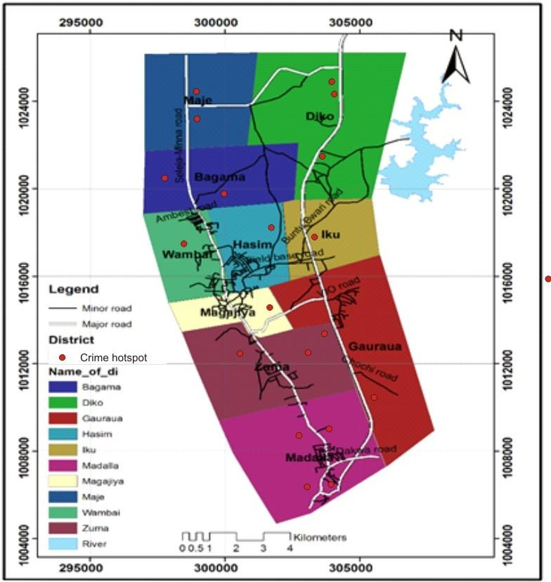

# Figure 4.9: Crime hotspot map of the study area

* 1. **Relationship between the police divisional stations and the crime hotspots areas**

The relationship between the crime hotspot and police divisional station was examine, Figure

4.10 shows the location of Police divisions in Suleja and their relationship with crime.

Neighborhood analysis showing the distance between police division and crime hotspot was used to examine the relationship.

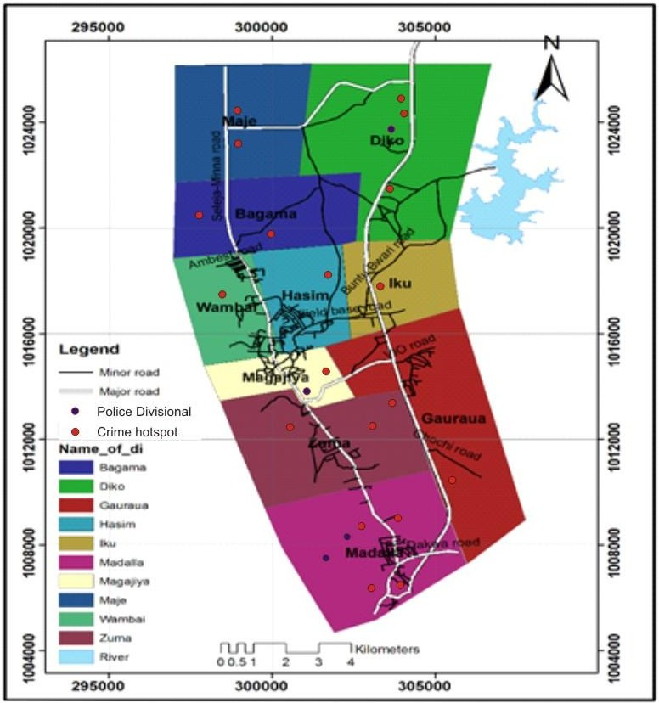

# Figure 4.10: Location of Police division and Crime hotspot in the study area

**4.6 Summary of Findings**

The study shows that 46.9% of the respondents in the study area have experienced one form of crime or the other in the last one year. robbery accounts for 28.8% of crime followed by burglary 49.4%, snatching accounts for 0.8% and others 21.8%. The study also revealed that 35% of crimes in the area were caused by drug abuse, unemployment 39.2%, poverty 23.2% and others accounts for 2.3% respectively. Thus, the effects of the crime according to the findings were loss of valuables 57.7%, injury and death 10.8%, economic loss 14.0%, fear 13.3% and other 0.2% respectively.

The findings shows that in Maje and Kwamba had the highest crime of 28.7% and 26.8%, followed by Diko and Gauraka with 18.4% and 11.5% while Rafin sanyi and Bakin iku recorded the lowest incidence of crime (9.2% and 5.4%) respectively. 81.8% of the area has jointly established community based security outfits called Yan-banga in order to reduce crime rate in the area. 18.5% of the houses in the study area have put some security measures to compliment the security of the area while 81.5% did not put in place any security measure but solely depend on God and other security outfits.

Geospatial techniques was used to mapout crime hotspot within the study area, a total of 19 (nineteen) crime hot spot were identified in the study area. The crime hotspot spread across all the district in the area, Zuma district and Madala district with the highest hotspiot area, other districts like Bakin Iku, Hasim and Wambai district has a less hotspot areas. The relationship between the crime hotspot and police divisional station was examine, Neighborhood analysis showing the distance between police division and crime hotspot was used to examine the relationship.

# CHAPTER FIVE

* 1. **CONCLUSION AND RECOMMENDATION**

# Conclusion

This work has eventually served as eye-opener to some hidden facts about criminal activities in Suleja, Niger State. The work has demonstrated the effect of social structure on human beings leading to crime incidence in various hot-spots in the state. The reaction of human beings for survival within the social structure has constituted a corpus of knowledge relevant to examination of youth‘s engagement in urban violence. Youths who are found in criminal activities absorb crime as a method of adjusting to social malignant. To eradicate crimes, therefore fundamental societal survival techniques must be dissociated from crime. This requires a fundamental restructuring of the society towards productive engagement in the sector that can provide the need and positive aspiration of the people in cities all over the world. Positive achievement is obtained through educational institutions, community participation in productive engagements, and above all, where governments perform its tasks appropriately. To reduce youths‟ perceived negative attitude, societal negatives must be ameliorated.

# Recommendation

The incidence of crime wave and its intensity has been on increasing not only in Nigeria but all over the world. Therefore, urgent needs for safety and security through diverse means are overdue in order to make global cities‟ environment livable. The spread of crime in cities world- wide are becoming a foremost phenomenon and a proper consideration by all stakeholders such as; the government, the security personnel and the communities‟ participation in crime reduction is duly warranted. To make this suggestions work therefore, it is recommended that:

* + 1. Residents of states need to maintain positive attitude and remain calm at any crime alert condition; they should not feed their minds with much fear from unnecessary apprehension and panic (Ahmed, 2010). They must always remain unruffled, steadfast, and help one another especially when there is a need for help in their neighbourhoods.
    2. People should always mind their own business, but be cautious and vigilant about all that go around them mostly among the people living in cities.
    3. Residents of Suleja should avoid carrying or displaying some criminogenic items such as; huge sum of money or attractive wares that can invite criminals to their neighbourhoods.
    4. Efficient security coping mechanism should be taken up by the government and the security agents, such that the police patrols is extended to all nooks and corners of the city centers.

It is when all these suggestions are put in place that would attract a more stable society which encourages investment (domestic and international), a more secure community with abundant opportunities for all ethnic groups in the country. Any contrary propositions to the above would not enhance a free flow of commerce and ideas, freedom of speech and the press, as well as new innovation into the country.

# REFERENCE

Abrahamsen, J. (1944) Abrahamsen's Theory of the Etiology of Criminal Acts. *Journal of Criminal Law and Criminology* Vol. 40 No. 4

Adagba, O, Ugwu, S.C, & Eme, O.I. (2012). Activities of Boko Haram and insecurity question in Nigeria, *Arabian Journal of Business and Management Review* 1(9), 77-99.

Aguda, A.A. Okagbue, I. *Principles of Criminal Liability in Nigeria* 2nd ed. Heinemann Educational Books Nig., 1990.

Ahmed, A. (2010). Responding to the emerging trends of terrorism in Nigeria, 5th Policing Executive Forum Conference proceeding organized by CLEEN Foundation.

Agbola, F. (1997). The political and security implications of cross border migration between Nigeria and her francophone neighbours, *International Journal of Social Science Tomorrow* 1(3), 1-9.

Akpobibibo, O. (2003). Confronting the human security delimma-Towards building sustainable peace in Nigeria Delta, A presentation in the ceremony in honour of Ms Ibiba Don Pedro, the winner of the 2003 CNN African Journalism of the year award at the Lambeth Council Building, London, Saturday, 18th October.

Akers, L (1998) Genius: The natural history of creativity. Cambridge: Cambridge University Press

Aluko, O. A. (2010) Ethnic militia, public security and police roles in Nigeria, paper prepared for SASA congress held in South Africa, June 29th – July 2nd.

Andenaes, O. (1974): Parent and family management training. In L.W. Craighead, W.E. empirical approach to mental health problems (pp 251-266). Bostom Allyen & Bacon

Azazi, A. (2011). Responding to the emerging trends of terrorism in Nigeria, 5th Policing Executive Forum Conference proceeding organized by CLEEN Foundation.

Beland, D. (2005). The political construction of collective insecurity: From moral panic to blame avoidance and organized irresponsibility, *Centre for European Studies, Working Paper series* 126.

Bassey, R.E. (2004). *General principles of security*, Jos: The African council on Narcotics and crime Prevention.

Cornish, E. and Clarke, O. (1986), *Delinquency in a Birth Cohort.* Chicago: University of Chicago Pres

Chambliss, J. Daryl (1967) ―Continuities and Consequences of Interactional Styles Across the Life Course‖, *Journal of Personality, V.* 57, pp. 375- 406.

CLEEN Foundation (CLEEN, 2012). Summary of findings of 2012 national crime and safety survey, Retrieved (10/02/2013) from E: *summary-of*-*findings-of-2012- national.ntml.*

Chukkol, K.S., *The Law of Crimes in Nigeria*. A.B.U. Press Zaria, 1988.

Dambazau, A.B., *Criminology and Criminal Justice*. Spectrum Books Ltd, Ibadan, 2007. Dukiya, J. (2008) Digital Mapping of Crime Statistics In Minna, Niger State

Etannibi E.O (2004) Analysis of Police and Policing in Nigeria: A Desk study of the role of

policing as Barrier to change or Driver of change in Nigeria .Lagos: Centre for Law Enforcement Education in Nigeria

Edeko, S.E. (2011). The proliferation of small arms and light weapons in Africa: A case study of the Niger Delta in Nigeria, *Sacha Journal of Environmental Studies* 1(2), 55-80.

Eysenk, H.J., and Gudjonsson, G. (1989). The causes cures of criminality. New York: Plenum Press.

Ehindero, S.G., *The Nigerian Police and Human Rights*, Ehindero Press, Jos, 1988.

Federal Republic of Nigeria (1999). *Constitution of the Federal Republic of Nigeria*: Federal Government Press, Abuja.

Gerber, S.B., et al *Criminal Investigation and Interrogation* Cincinnati, 1962.

Global Peace Index (GPI, 2012). Global peace ranking, Institute for economics and peace, Retrieved from (10/05/2013) *Wikipedia, the Free Encyclopaedia*.

Gove, M., (1980): Personality and the biosocial model of anti-social and criminal behavior. New York: Plenum Press

Hurff, C., Bartol, Anne M. and Bartol, Curt A. (2005). *Criminal behavior: A psychosocial approach.* Upper Saddle River, New Jersey: Pearson Prentice Hall.

Horwitz, A. E (1990). *Nigerian defence policy: Issues and problems,* Lagos: Malt House press. Hirischi, K. (1969), ―Criminal Career Research: Its Value for Criminology‖, *Criminology,* V. 26,

pp.1-35.

Horwitz, R., (1990), ―Characterizing Criminal Careers‖, *Science, V.*237, pp.985–991.

Human Security Report (2003): Human Security Report CHA – 1st quarter issues affecting human security in North-East Province, Sri-Lanka.

Ibrahim J. & Igbuzor, O. (2002). Memorandum submitted to the Presidential Committee on National Security in Nigeria (unpublished).

Igbuzo, O. (2011). People and security education: A critical factor for sustainable peace and national development, International *Journal of Peace and Development Studies* 2(1), 1-7, January.

Imobighe, T.A. (1990). Doctrines for and threats to internal security, A.E Ekoto & M.A Vogt (eds.) *Nigerian Defence policy: Issues and problems, Lagos:* Malt-House Press, 225-236.

Jack, H. (2000). The post-colonial state and insecurity in Africa: The Nigerian state experience

C. Ikonne, I.O. William & E.U. Nwagbara (eds.) *Security, Services and Sustainable Development in Nigeria*, Port Harcourt: Uniport press.

Kandel G. L. and Mednick, F. O. (1991) The political and security implications of cross border migration between Nigeria and her francophone neighbours, *International Journal of Social Science Tomorrow* 1(3), 1-9.

Kendall, A., Williams, U., and Frinkelhor J. (1993), ―Moving Against the World: Life-Course Patterns of Explosive Children‖, *Developmental Psychology,* V. 23, pp. 308- 313.

Kufour, J. (2012). Nigeria: Imbalanced development causes insecurity in Nigeria, *Thisday Newspaper*, Lagos.

Ladan, M.T.,(2008) *Criminal Prevention and Control and Human Rights in Nigeria*. A.B.U. Press,

Lottin, R., Smith, O and Smith, H. (2001). An introduction to criminological theory. *Criminal Justice Review,* 377‐381.

Nwagboso, C.I. (2012). Security challenges and economy of the Nigerian state (2007-2011),

*American International Journal of Contemporary Research* 2(6), 244-250.

Nweze, A. (2004). Internal security threats in Nigeria, D.A. Briggs & J.G. Sanda (eds) *Issues of Peace and Security*, Jos: National Institute of peace Kuru.

Ogunleye, U. O., Achumba, I.C, Ighomereho, O.S, & Akpo-Robaro, M.O.M (2011). Security challenges in Nigeria and the implications for business activities and

sustainable development, *Journal of Economics and Sustainable Development*, 4(2), 79-99. Retrieved (02/12/2014) from *online-*[*www.iiste.org.*](http://www.iiste.org/)

Messners, K. (1983). Cesare Lombroso as a single criminologist. *Criminology and Criminal Justice,7,* 117‐133.

MacRae David (2000), The Root Causes of Crime. *Montréal,* 10 June 2000 / No 63

[http://www.quebecoislibre.org/000610-9.htm;](http://www.quebecoislibre.org/000610-9.htm%3B) Assessed on the 30th January, 2012

Moffitt, E. Terrie, (1993) ―Adolescence-Limited and Life Course Persistent Antisocial Behavior: A Developmental Taxonomy‖, *Psychological Review,* V.100, pp. 674-701.

Robert, C. (2007). New beginnings, Retrieved (11/08/2014) online from:[*www.cliffordchamce.com/content/…*](http://www.cliffordchamce.com/content/)*/Clifford chance/…/new beginning.*

Sampson , K., and Wilson, E. (2002). Social conflict theories of the family. In P.G. Boss, W. J. Doherty, R. LaRossa, W. R. Schumm, & S. K. Steinmetz (Eds.), Sourcebook of family theories and methods: A contextual approach (pp. 357‐381). New York: Plenum.

Steffensmeier, T. N. and Harer, J., (1999) Shifting paradigms for sustainable development: Implications for management theory and research, *The Academy of Management Review* 20(4), 874-907.

Sanidad, L. (2006). Forcing the horse to drink or making it realize its thirst? Understanding the enactment of anti-terrorism legislation (ATL) in Nigeria, *Perspective on Terrorism* 5(3-4), 64-92.

United Nation (UN, 2007). Sustainable development: From Brundtland to Rio (2007), Background paper prepared for consideration by the high level panel on Global Sustainability, at its first meeting, 19th Sept (2007), UN HQTs N.Y.

Warners, M. and Rountree J. (2006). *Essentials of abnormal psychology.* California: Thomas Wadsworth.

# Appendix

**FEDERAL UNIVERSITY OF TECHNOLOGY, MINNA. SCHOOL OF POSTGRADUATE STUDIES**

# CENTER FOR HUMAN SETTLEMENT AND URBAN DEVELOPMENT

**Questionnaires Topic:**

# ASSESSMENT OF CRIME PROLIFERATION AND PREVENTION STRATEGIES FOR SUSTAINABLE DEVELOPMENT OF SULEJA, NIGER STATE

A research work is proposed to be done on the above topic in pursuit of Degree of Master. The aim of this survey is to obtain useful information needed for the success of the research. All information obtained would be treated with utmost confidentiality and respect for this research work only.

Instruction: Fill in the blank spaces or tick where it applies.

1. Age of the respondents

|  |  |  |  |
| --- | --- | --- | --- |
| (a) 20-30 | ( ) | (b) 31-40 | ( ) |
| (c) 41-50 | ( ) | (d) 51 and above | ( ) |

1. Level of Education
   1. Illiterate ( ) (b) Primary ( ) (c) Secondary ( )

(d) Tertiary ( )

1. Occupation
   1. Self-employed ( ) (b) Farming ( ) (c) Trading (d) Civil servant ( )

(e) Artisan ( ) (f) Unemployed ( )

1. Income per month

(a) N18, 000 – N30, 000 ( ) (b) N31, 001 – N40, 000

(c) N40, 001 -N 50, 000 ( ) (d) N50, 001 - N 60, 000 ( )

(e) N60, 000 ( ) and above

1. Years of stays in the area
   1. 1-10 years
   2. 11-20 years
   3. 21-30years
   4. Since birth
2. Have you ever experienced crime in this area?
   1. Yes (b) No
3. If yes, what are the types of crime experienced by the residents?
   1. Armed robbery
   2. Burglary
   3. Car / motorcycle snatching
   4. Others specify
4. What is the main time of occurrence of Crimes in your neighborhoods (tick only one)
5. Morning ( )
6. Afternoon ( )
7. Evening ( )
8. Night ( )
9. What are the types of losses suffered by residents as a results of crime?
   1. Personal Injury ( )
   2. Loss of money ( )
   3. Loss of Personal effects( )
   4. a and c above ( )
   5. b and c above ( )

10 What are the causes of crime in your Neighborhood?

1. Drug abuse ( )
2. Unemployment ( )
3. Poverty ( )
4. Others specify
5. Do you have security outfit in your area?
   1. Yes (b) No
6. If yes, mention the security outfits available
   1. ii iii
7. What is the Level of Safety in the Area at Night

(a) Very Safe (b) Safe (c) Unsafe (d) Very unsafe

1. Are you thinking of relocation out of the area because of Insecurity?
   1. Yes (b) No
2. What are the safety measures put in place to safe guard your house and your family
   1. Burglary (b) Safety fence and gate (c) Keeping a Dog (d) Other

17 What are the measures employed towards addressing crime in the neighborhood

1. Personal watch man (b) Joining neigbborhood association (c) working with the police and

civil defense (d) Others

# Umar Ahmed

MSUD/CHSUD/2015/6055