# ASSESSMENT OF ACADEMIC ACHIEVEMENT OF SENIOR SECONDARY SCHOOL STUDENTS ON STANDARDIZED ECONOMICS ACHIEVEMENT TEST IN BAUCHI, BAUCHI STATE, NIGERIA

**BY**

# YAYA, Mohammed P15EDPC8052

**A DISSERTATION SUBMITTED TO THE SCHOOL OF POSTGRADUATE STUDIES, AHMADU BELLO UNIVERSITY, ZARIA IN PARTIAL FULFILLMENT OF THE REQUIREMENTS FOR THE AWARD OF MASTER DEGREE IN MEASUREMENT AND EVALUATION**

# DEPARTMENT OF EDUCATIONAL PSYCHOLOGY AND COUNSELLING, FACULTY OF EDUCATION,

**AHMADU BELLO UNIVERSITY, ZARIA**

# FEBRUARY, 2019

**DECLARATION**

I hereby declare that the work in this Dissertation on title *Assessment of Academic Achievement of Senior Secondary School Students on Standardized Economics Achievement Test in Bauchi, Bauchi State, Nigeria* have been carried out by me in the Department of Educational Psychology and Counselling Ahmadu Bello University, Zaria. The information derived from the literature had been duly acknowledged in the text and a list of references was provided. No part of this Dissertation was previously presented for another Degree or Diploma at this or any other Institution.

Mohammed YAYA

Name of Student Signature Date

# CERTIFICATION

This Dissertation on title „*Assessment of Academic Achievement of Senior Secondary School Students on Standardized Economics Achievement Test in Bauchi, Bauchi State, Nigeria’* by Mohammed YAYA meets the regulations governing the award of the Master of Educational Measurement and Evaluation Degree in the Department of Educational Psychology and Counselling, Faculty of Education, Ahmadu Bello University, Zaria and is approved for its contribution to knowledge and literacy presentation.

DR. L. E. ADAMU Date

(Chairman, Supervisory Committee)

DR. M. O. IBRAHIM Date

(Member, Supervisory Committee)

DR. A. I MOHAMMED Date

(Head of Department of Educational Psychology and Counselling)

Prof. S. Z. Abubakar Date

(Dean School of Post-Graduate Studies)

# DEDICATION

This research study is dedicated to my late father, MalamYaya Jingudo and my mother Malama Aishatu Abubakar.

# ACKNOWLEDGEMENTS

In the name of Allah, the Beneficent the Merciful, all praise is due to Allah who helped and sustained the researcher through the period of this research work. First and foremost a deep sense of gratitude goes to the Chairman Supervisory Committee Dr. L .E Adamu for her immense, unquantifiable and invaluable contribution towards the successful completion of this work. The researcher appreciates the kind guidance, support, acceptance and warmth she offered for critically examining this research work to make it up to standard. May Almighty Allah bless her and her family. Equally special thanks goes to the second supervisor Dr. M.O Ibrahim for his tireless support and guidance offered to this research work for the successful accomplishment. May Allah help and guide him abundantly.

The researcher equally appreciate the contributions of internal Examiners in person of Prof. K. Mahmud and Dr. S Ibrahim. Also, a special thanks go to lecturers in the Department of Educational Psychology and Counselling, Ahmadu Bello University, Zaria especially Prof. M.I Abdullahi, Prof E.F Adeniyi Prof. M. Balarabe, Dr.Y. Umar, Prof. R. M. Bello, Dr. L. K Maude, Prof. S. Sambo, Dr. H Tukur, Prof. D. Oliagba and non-academic Staff of the University. The researcher‟s sincere thanks to all for your contribution and support in ensuring that, this academic endeavour is realised.

The researcher acknowledges the contribution of Dr. M. Sagir Dean of School of Social Science Aminu Sale College of Education Bauchi, State. His tireless advice, assistance and were propellants in seeing this study accomplished. A special gratitude also goes to Malam Itami Department of Business Education State College of Education Bauchi, State. The researcher also extends gratitude to the researcher‟s Uncle Alhaji InuwaYahya Darma who contributed academically and financially for the accomplishment of this research work. The research

Assistants who assisted in carrying this study were Malam Mohammed Gimba, I C T master, Usman Muhammed, late Malam Mohammed Mohammed, Malam Ibrahim Tela, Yusuf Isa, Sallau Adam John Bala, Godiya Markus Sa;adatu Jibirin Mustapha Zakari, Patience Adebayo and many others.

Members of family are commended for their supports which ensured that this noble academic career is realized. The researcher must also appreciate the contributions of children Shafia, Nafisa and Nabila who endured my absence and supported the researcher with word of courage and prayers may Allah continue to bless and protect them, Ameen. Finally, the researcher cannot forget a beloved, caring, and supporting wife, Zainab Ja‟afar who endured my absence and divided attention during the period of this programme, and may Allah reward her abundantly.

# ABSTRACT

The study examined the Assessment of Academic Achievement of Senior Secondary School Students on Standardized Economics Achievement Test in Bauchi, Bauchi State Nigeria. The study adopted Expost facto research design. The population of the study consisted of 18,389 Senior Secondary students. Clusters sampling technique was used to select a sample size of 377 from Eight Senior Secondary School Students across three Educational zones by the application of Kcrejcie and morgan table of determining sample size. Standardised Economic achievement Test (SEAT) was used for data collection. Kendall coefficient of concordance and KR20 were applied for the establishment of validity and reliability index. Index of 0.40-0.63 and 0.3-0.5 were found for difficulty and discrimination respectively for the selection of proficient items. Z- score and T-score were also used to transform raw scores into standard scores. Seven objectives, seven research questions were asked and four hypotheses were formulated. Mean and standard deviation were also used to answer research questions 4-7. t-test was used to test all the formulated hypotheses and all the hypotheses were tested at 0.05 levels of significance. This was used to confirm that there was a significant difference between the mean achievement of students in rural single sex schools and their coeducational schools in Standardized Economics achievement test was in favor of single sex school students. (t = 5.598, p = 0.00 two tailed); there was a significant difference between the mean achievement of students in urban single gender schools and their coeducational schools in Standardized Economics achievement test was in favor of single gender school students. (t = 7.998, p = 0.00 two tailed); there was no significant difference between the mean achievement of students of coeducational schools in rural areas and urban schools in Standardized Economics achievement test.(t = 2.53, p = 0.800 two tailed);there was significant difference between the mean achievement of students of single sex schools in rural areas and urban single sex schools in Standardized Economics achievement test in favor of urban single gender school students.(t = 2.708, p = 0.007 two tailed). Base on the findings of the study this research recommended among others; Government should give an adequate consideration by creating more single sex schools and single gender classes among the existing coeducational schools in the rural areas. The outcome of the study revealed that, rural single sex schools‟ students achieved higher than the rural coeducation schools‟ students. Government should give an adequate consideration by creating more single sex schools and single gender classes among the existing coeducational schools in the urban areas. The outcome of the study revealed that, urban single sex schools‟ students achieved higher than the urban coeducational schools‟ students.

|  |  |  |
| --- | --- | --- |
|  | **TABLE OF CONTENTS** |  |
| Title Page |  | i |
| Declaration |  | ii |
| Certification |  | iii |
| Dedication |  | iv |
| Acknowledgements |  | v |
| Abstract |  | vi |
| Table of Contents |  | vii |
| List of Tables |  | viii |
| List of Appendices |  | ix |
| Operational Definitions of Terms |  | x |

# CHAPTER ONE: INTRODUCTION

* 1. Introduction 1
  2. Background to the Study 1
  3. Statement of the Problem 6
  4. Objectives of the Study 7
  5. Research Questions 8
  6. Research Hypotheses 9
  7. Significance of the Study 10
  8. Basic Assumptions 11
  9. Scope and Delimitation of the Study 12

CHAPTER TWO: REVIEW OF RELATED LITERATURE

* 1. Introduction 13
  2. Conceptual Framework 13
     1. History of Economics in Secondary Schools in Nigeria 15
     2. Concept of Economics 16
     3. Concept of Test and Test Standardization 18
     4. Concept of Achievement Test 20
     5. Concepts of Validity and Reliability 21
     6. Procedure for Test Construction and Standardization 25
        1. Developing Test Blue-Print 26
        2. Writing Test Items 27
        3. Face Validation 27
        4. Trial Testing 28
        5. Item Analysis 28
           1. Qualitative Item Analysis 29
           2. Quantitative Item Analysis 30
     7. Item Selection 31
     8. Test Assembly 32
     9. Final Testing and Norming 33
     10. Printing and Production 33
     11. Gender and Academic Achievement 33
     12. School Location and Academic Achievement 36
     13. School Type and Academic Achievement 39
  3. Theoretical Framework 40
     1. Item Response Theory 40
     2. Classical Test Theory 42
  4. Review of Empirical Studies 43
  5. Summary 52

CHAPTER THREE: METHODOLOGY

* 1. Introduction 53
  2. Research Design 53
  3. Population of the Study 54
  4. Sample Size and Sampling Technique 54
  5. Instrumentation 55
     1. Test Assessment 55
  6. Validation of the Instrument 56
     1. Pilot Study 57
  7. Reliability of the Instrument 57
  8. Procedure for Data Collection 57
  9. Procedure for Data Analysis 58

CHAPTER FOUR: RESULTS AND DISCUSSION

* 1. Introduction 59
  2. Demographic Characteristics of Respondents 59
  3. Answers to the Research Questions 60
  4. Test of Null Hypotheses 63
  5. Summary of Findings 66
  6. Discussion of Major Findings 68

CHAPTER FIVE: SUMMARY, CONCLUSION AND RECOMMENDATIONS

* 1. Introduction 73
  2. Summary 73
  3. Contribution to Knowledge 75
  4. Conclusion 76
  5. Recommendations 76
  6. Suggestions for Further Studies 77
  7. Limitation of the Study 78

References 79

List of Appendices 88

**LIST OF TABLES**

|  |  |  |
| --- | --- | --- |
| **Table** | | **Page** |
| 1 | Population Distribution for the Study | 54 |
| 2 | Sample Size Distribution for the Study | 54 |
| 3 | Distribution of Respondents by their School Type and School Location | 59 |
| 4 | Kuder -Richardson (KR20) Analysis on Standardized Economics Achievement Test (SEAT) Reliability | 61 |
| 5 |  |  |
|  | Psychometric analysis of Standardized Economics Achievement Test  (SEAT) | 61 |
| 6 | The analysis of T-score for the Standardized Economics Achievement Test (SEAT) | 62 |
| 7 | Independent t-test Analyses on Difference in Performance of Students in Standardized Economics Achievements Test based on School Type in Rural schools | 63 |
| 8 | Independent t-test Analyses on difference in performance of students in Standardized Economics Achievements based on School Type in Urban Schools | 64 |
| 9 | Independent t-test Analyses on Difference in Performance of Students in Standardized Economics Achievements Test based on Location of Coeducation Schools | 64 |
| 10 | Independent t-test Analyses on Difference in Performance of Students in Standardized Economics Achievements Test based on location of Single Sex Schools | 66 |

# LIST OF APPENDICES

**Appendix Page**

|  |  |  |
| --- | --- | --- |
| I | Letter of Introduction | 88 |
| II | Economics | 89 |
| III | Percentage Allocation to Content Covered | 101 |
| IV | Table of Specification (first draft) | 102 |
| V | Table of Specification (final draft) | 103 |
| VI | Standardized Economics Achievement Test (SEAT) | 106 |
| VII | Marking Scheme | 115 |
| VIII | Analysis of KR20 ofStandardized Economics Achievement Test | 116 |
| IX | KR20 Statistics | 117 |
| X | Psychometric Analysis | 118 |
| XI | Independent t-test Analyses on Difference in performance of Students in Standardized Economics Achievements Test Based On School Type in Rural Schools | 120 |
| XII | Independent t-test Analyses on Difference in Performance of Students in Standardized Economics Achievements Based on School Type in Urban Schools | 121 |
| XIII | Independent t-test Analyses on Difference in Performance of Students on Standardized Economics Achievements Test Based on location on Coeducational Schools | 122 |
| XIV | Independent t-test Analyses on Difference in Achievement of Students on Standardized Economics Achievements Test Based on location on Single Sex Schools | 123 |
| XV | Invigilation Manual | 124 |
| XVI | Analysis of Scores (T and Z-score) | 127 |

# OPERATIONAL DEFINATION OF TERMS

The following terms were operationally defined :

**Test Assessment**: A process of estimating instrument, estimating average achievement of the individual learners, comparison of average achievement of individual norm with another group who take the same test.

**Standardization**: A process of dividing Test Takers into separate groups (norms) in which all Test Takers are given the same questions, instructions, condition of administration, scoring procedure, grading and interpretation irrespective of any condition of the Test Takers.

**Academic Achievement test**: An academic work gained or achieved by the effort of the students under the guide of teacher. It could be an experience gained or accomplishment under the guide of the teacher.

**Urban Schools:** Categories of Schools which are within towns and cities which have available created structures, civic and social amenities and with a high population density.

**Rural Schools:** Categories of Schools which are within villages and hamlets which have less created structures, civic and social amenities and with less a population density.

# CHAPTER ONE INTRODUCTION

# Background to the Study

The success of Education of a nation is wholly depends on the efficiency of its Educational Assessments. Educational Assessment could estimate the adequacy of the test instruments, provision of average performance of the individual students, comparison of average performance obtained within the same test or different test in the same domain and thus, assessment could allowed for comparison among the established norms in the interest of the teacher or the School, which include, gender, interclass, interschool and many more. Anikweze (2014) reported that Educational Assessment is the process of investigating the status or standard of the individuals‟ achievement or the achievement of the group of individuals where group instructions prevail, with reference to expected outcomes which must have been specified as objectives. Assessment in this extent simply means to engage in determination of the worth or value of a test or individual or group Achievements. Obioma (2016) lamented that assessment is the process of using the result obtained from measurement to take relevant decision about the phenomenon being measured. In Educational assessment, a test instrument is a bedrock and indispensable aspect which require to be adequately assessed in order to guaranty the achievements status of the individuals‟ learners or the instrument being used.

The overall quality of a test is depending on the proficiency of the instrument used and the manner in which the instrument administered and scored. Usually proficient or valid instruments, better test scoring procedure with an established norm provide a desire outcome that a test was made to achieve. Odikwu, Obinne andAmali (2014) viewed that a valid test serves as a machinery whose functions to include, motivation of students to learn, determination of how

much students have learned, identification of students‟ special difficulties, determination of the strength and weakness of teaching methods and identification of adequacy or otherwise of instructional materials and finally the extent of achievement of objectives. This has revealed that one of the key roles of a test is determination of how much students have learned a specific skill, instruction or unit of lesson. This is regarded as one of the role of achievement test.

Achievement Test is prepared to assess students‟ knowledge in the subject matter and it, sometimes, signifies accomplishment or proficiency of performance in a given skill or body of knowledge. According to Kumar and Patel (2012) Achievement Tests are examinations that are designed to determine the degree of knowledge and proficiency exhibited by an individual in specific area or set of areas. An achievement test is sometimes administered as part of the acceptance process into an educational programme or to qualify an individual for employment or a promotion with a current employer. Nwagu (1992) conceptualized achievement testing, as a systematic and purposeful quantification of learning outcomes. This is to say that achievement testing involves the determination of the extent of attainment of individuals in a task, course or programme to which the individuals were sufficiently exposed. Jayanthi (2014) opined that an Achievement test scores obtained either from Teacher Made Test or Standardized Test. And this was supported by Lehmann (2013) who classified an Achievement Test in two categories. A Teacher Made Test and Standardized Test. Although the teacher Made Test is purposely not the researcher‟s focus in this study but it needs to be highlighted because it is part of the concept of achievement test, as perceived by many researchers. Teacher Made Tests are frequently the basis of evaluating student‟s progress in school. These are more specifically focused and they usually reflect the content of a particular unit or course, they are tailored to measure the achievement of students after completing a series of learning tasks for the subject (Ekta, 2015).

By test development, a Teacher Made Test is uncoupled with standardized Test. A Teacher Made Test has a specific and focused toward the objectives of a particular teacher in a particular subject, class and school. A Teacher Made Test of one School will never be in any way being the same for another school even if the teachers use the same contents. This is so because each teacher develops a test based on his own biased mind. Teacher made tests do not have specified procedures of test construction administration and test scoring procedure. Kubir (2016) opined that, a Teacher Made Test is questions set by a paper setter according to his subjective judgment. This has related to the opinion of Nwagu (2003) who stated that, a Teacher Made Test is characterized by low quality because there is no, pre-test, norms, set standard, and specific instructions on its administration and scoring.

Standardized achievement tests are carefully developed to include measurement of objectives common to many school systems. They measure knowledge of facts, concepts and principles. Standardized Achievement Test plays a significant role in Nigerian system of Education .When there is a need for assessment of more than a school at a time, this will enable relevant agencies to ascertain actual students‟ Achievement status thus their Achievements are comparable to other groups who have participated in the test. Unlike teacher made test that comparison will not be possible due to inconsistency in their development by different teachers. A standardized test is essential in determining the overall amount of knowledge common to many students that will be achieved within a specified time, level or programme. Okoye (2013) reported that, a Standardized Achievement test that is accused of being unfair, biased and discriminatory from test construction, test administration and test scoring is considered to be a non-standardized test. Standardized Test unlike Teacher Made Test is always directed toward achieving the objectives of many teachers at the same time and also to cover some setting,

geographical area, whether between schools, district, states or country and to compare their relevant experiences on the contents being measured. A standardized test has an underlined guide in its development.

Development of test items for a standardized test refers to a development of test items to ensure that, an instrument (test) used, measures what it was designed to measure (Nworgu,2006). The general trend in the of achievement test has been, the review of the content and developing test blue-print, writing of test items, face validation, trial testing, Items analysis such as retaining and rejection of items and item modification, Items selection, Items assembly final testing, norming, printing and production (Ritter, Boone and Rubba, 2012). A valid and reliable test should have test characteristics that fall within the accepted range of values, for each characteristic such as validity, reliability, discrimination index, difficulty index, readability and it should not be biased against any designated sub-group of test takers.

Ivonva (2012) viewed that; there are four stages in development for a standardized test. The planning, who is the test to be administered to, what is to be measured, and when is the measurement to take place. In support of Nwagu (2006), Ivanova (2012) affirmed that, items in the draft should be arranged from simple to complex and the mode of response should also match with the items written. The number of test items written should be more than actually required for the test because items which may not prove to be satisfactory need to be discarded or modified. This will certainly reduce the potential of favouritism, bias, and subjective evaluation, which is usually associated with teacher made achievement tests. Standardized test tries to ensure that items are put into pre-test, norms for a given raw scores and many set standards for the items which include Table of specification or blueprint, items analysis, norms and so on. Specific instructions are given on administration and scoring to the level that is fair to all students because

every student will take the same test and be evaluated in the same way irrespective of gender, school type and location of students.

Economics is part of Achievement tests which students undertake whether in a promotional or end of term examination in a Senior Secondary School in Bauchi State. Osadebe (2015) viewed that knowledge of Economics allows students to learn how to manage resources and the effective use of scarce resources such as time and money. The researcher elaborated that those students with Economics knowledge offer courses such as Banking and finance, Accounting, Business Administration and so forth at higher levels of Education. Economics is defined as a Science which studies human behaviour as a relationship between ends and scarce resources which means have an alternative uses. Standardised tests provide a means of preventing subjectivity and bias in assessment from test construction to administration and scoring. Standardised Achievement procedures are more significant in evaluating student‟s performance in Secondary schools due to their accuracy and dependability. The instruments constructed by many teachers at most of these schools may not be standardized in one way or the other. This is because some of the test is poorly constructed without face and content validity, lack of use of psychometric properties for selection of proficient items, poor test administration, as well as scoring procedures which may lead to a weak and false reporting of a student‟s performance.

# Statement of the Problem.

Testing in education is a very crucial systematic device which tells or measures what has been learnt and the extent of the learning behaviour. Tests are aimed at measuring students‟ knowledge and intelligence or other characteristics in a systematic way. Testing, therefore, involves the use of test items that will enable measurement to be effective and accurate. The researcher observed that, there was no Standardised Economics Achievement (instrument) that was commonly used among Senior Secondary II students in Bauchi State. Each and every school developed its own different instrument which on many occasions lacks the basis of test development procedures. These Include review and coverage of test contents, used of Blue print, experts validation, trial testing, items validity or analysis, test assembly and norming and many other important procedures that could add more value to the instrument. This lack of uniformity and sameness on the procedures of test development among schools in Bauchi State may result in poor reporting of students‟ academic achievement status. The researcher observed that, most of teacher made tests assessed only the ability of students to recall some specific facts and they suffered from poor sampling of the topics taught, and they were carelessly and ambiguously worded. However, Teacher made tests differ considerably from teacher to teacher. A test developed by a teacher for a particular senior secondary school II students will not provide any useful information if the same test is given to a different senior secondary school II students.

Also, the researcher observed that, teachers in some of these Secondary Schools in Bauchi State are characterized with lack of competencies required in test administration and are not conversant with test administration procedures. In many cases teachers administer tests in noisy environments, dilapidated classrooms and overcrowded class with insufficient space to make effective invigilation. Students sometimes borrow test materials, and move about during

testing and do many other things. These may result in examination malpractice. The only countermeasure to such ineffectiveness is standardized test because it involves expert validation it usually covers the objectives of many schools, which has effective procedure of administration and scoring which will ensure the objective assessment of students‟ achievements.

It should be noted that the problems of teacher made tests was negatively influence the reporting of student‟s achievement and these achievement are used to take decisions on students, in promotion, demotion, prizes giving, award of scholarships and many other opportunities by government, parents, and guardians and so on. Attempts to correct these flaws prompted the researcher to assess the standardised Economics Achievement test for senior secondary school students in Bauchi State.

# Objectives of the Study:

The specific objectives were to

* + 1. find out the Validity and Reliability of the Standardised Economics Achievement Test for Senior Secondary School Students in Bauchi State.
    2. estimate items parameters (psychometric properties) on Standardised Economics Achievement Test (SEAT) for Senior Secondary School Students in Bauchi State.
    3. determine the norms on Standardised Economics Achievement Test (SEAT) for Senior Secondary Schools Students in Bauchi State.
    4. determine the influence of Coeducational and Single Sex Schools (Male or Female) in rural areas on Standardised Economics Achievement Test (SEAT) for Senior Secondary School Students in Bauchi State.
    5. determine the influence of Coeducational and Single Sex Schools ( Male or Female) in Urban area on Standardised Economics Achievement Test (SEAT) for Senior Secondary School Students in Bauchi State.
    6. examine the influence of location (Urban or Rural) of Co-educational Schools on Standardised Economics Achievement Test (SEAT) for Senior Secondary School Students in Bauchi State.
    7. examine the influence of location (Urban or Rural) of Single Sex schools (Male or Female) on Standardised Economics Achievement Test (SEAT) among Senior Secondary School Students in Bauchi State.

# Research Questions

The following research questions were answered

* + 1. What is the Validity and Reliability of the Standardised Economics Achievement Test for Senior Secondary School Students in Bauchi State?
    2. What are the psychometric properties of each item on the Standardized Economics Achievement Test for Senior Secondary School Students in Bauchi State?
    3. What are the norms of Standardized Economics Achievement Test for Senior Secondary School Students in Bauchi State?
    4. What is the difference of Co-educational and Single Sex (Male or Female) Schools in Rural area on Standardised Economics Achievement Test (SEAT) for Senior Secondary School Students in Bauchi State?
    5. What is the difference of Co-education and Single Sex Schools (Male or Female) in Urban area on Standardise Economics Achievement Test (SEAT) for Senior Secondary School Students in Bauchi State?
    6. What is the difference in location of Co-educational Schools on Standardised Economics Achievement Test (SEAT) for Senior Secondary School Students in Bauchi State?
    7. What is the difference in location of Single Sex Schools on Standardised Economics Achievement Test (SEAT) for Senior Secondary School Students in Bauchi States?

# Hypotheses

The following Null hypotheses were formulated and tested for the study:

* + 1. There is no significant difference in the mean of Standardized Economics Achievement Test (SEAT) for Senior Secondary School Students from Co-educational and Single Sex Schools in Rural area in Bauchi State.
    2. There is no significant difference in the mean of Standardized Economics Achievement Test (SEAT) for Senior Secondary School Students from Co-educational and Single Sex Schools in Urban area in Bauchi State.
    3. There is no significant difference in the mean of Co-educational Schools on standardized Economics Achievement Test for Senior Secondary School Students from Urban and Rural areas in Bauchi State.
    4. There is no significant difference in the mean of Single Sex Schools on Standardized Economics Achievement Test (SEAT) for Senior Secondary School Students from Urban and Rural areas in Bauchi State.

# Significance of the study

The result of this study would be of benefit to the followings. Test developers; practicing teachers; Counsellors; School Administrators; Students; and Potential researchers.

* Test developers: This category will find this study useful in the area of determining the presence or absence of item bias. A test is said to be unbiased if all individuals have equal probability of getting the item; correct or not. It will also permit identification of each examinee‟s strength and weakness in testing situation and to be used for diagnosis to find what the examinee needs next. This is possible through the analysis of examinee‟s answer pattern on the Achievement Test developed.
* Practicing teachers: This category will be provided with the knowledge of testing in the selection of test items, so that items of appropriate difficulty are chosen for each examinee. It will enable Practicing teachers in validating class room achievement test. It would also provide practicing teachers with the knowledge of estimations of items parameters from any group of examinees. Teachers need an already validated instrument of high quality to complement the poor ones they make use of. This is possible through adopting the already validated instrument.
* Counsellors: This Category will benefit from this study by identifying strength and weakness of students, diagnoses of learning difficulties, students learning patterns and

many other psychological implications through the administration of the Standardised Economics Achievement Test (SEAT) in their various Schools.

* Schools administrators, who are moderators of all kind of tests in their schools, would ensure Standardised Economics Achievement Test (SEAT) would be administered into their various Schools to ensure effective school planning and good decision making process. This is possible through revision and remedial lessons, new instructional programmes for students who failed in Standardized Economics Achievement Test (SEAT).
* Students of Economics would benefit from the findings of this study which would enable students to be familiar with standardized tests. This would enable them to pass some other standardised examinations since they were familiar with standardized tests, especially in Economics.
* It will serve as a reference material to future researches which can be used as literature, text reference and empirical studies in the Department of Educational Psychology and Counselling, Ahmadu Bello University, Zaria and beyond.

# Basic Assumptions:

This study had the following basic assumptions that

1. there may be an effect of validity and reliability of instrument on the academic Achievement of students on Economics Achievement Test in Bauchi State.
2. there may be influence of psychometric properties of an instrument on the Achievement of Students on Economics Achievement Test in Bauchi State
3. School norm have a significant impact on the Performance of Students on Economics Achievement Test in Bauchi state.
4. there may be influence of School Type on the Achievement of Rural Students on Economics Achievement Test in Bauuchi State.
5. there may be influence of School Type on the achievement of Urban Students on Economics Achievement Test in Bauuchi State.
6. there may be influence of School Location on the Achievement of Coeducational Schools Students in Economics Achievement Test in Bauuchi State.
7. there may be influence of School location on the Achievement of Single Sex Schools Students in Economics Achievement Test in Bauchi State.

# Scope and Delimitation of the Study

The study was to cover whole year contents of Economics in order to avoid some other intervening variable mostly attached to some topics. Thus some topics are prerequisite to others especially in first term, second term and third term. The study was restricted to two models items validity base on classical theorist; objectives type multiple choices of five alternatives. Many researches showed that, objective type is the best test format because it illuminates the subjectivity in marking and scoring. The study also covered schools running morning session.

The study is purposely delimited to all Public Senior Secondary School students offering Economic in Bauchi State, Nigeria. This was because most of these problems were identified in Government Senior Secondary Schools. The research has also delimited this study to SS II Student, because they are stable in SSS system. SSI students are not fully adjusted to academic activities while SSS III are busy preparing for their final Examination.

This is because some secondary schools in Bauchi State operate in the morning while some in the afternoon session.

# Introduction:

**CHAPTER TWO**

# REVIEW OF RELATED LITERATURE

This chapter reviewed the study of other researchers whose works were relevant and related to this research, as they provide the theories and empirical basis that guided and supported this research. This study focused on the following sub-headings.

* 1. Conceptual Framework
     1. History of Economics in Secondary Schools in Nigeria
     2. Concepts of Economics
     3. Concepts of Test and Test Standardization
     4. Concepts of Achievement Test
     5. Concepts of Validity and Reliability
     6. Procedure for Test Construction and Standardization
     7. Gender and Academic Achievement
     8. School location and Academic Achievement
     9. School Type and Academic Achievement
  2. Theoretical Framework
     1. Item Response Theory
     2. Classical Test Theory
  3. Review of Empirical Studies
  4. Summary

# History of Economics Education in Secondary Schools in Nigeria

According to Obemeata (1980), Economics was first taken in the West African School Certificate Examination as a school subject in Nigeria in 1967. It is therefore obvious that Economics was introduced into the Secondary School curriculum in Nigeria in1962. According to Obemeata, Economics was introduced much later than most of the other Secondary School subjects. However, Secondary School Students offered Economics in the Higher School Certificate Examination before Economics became a Secondary School Subject. This showed that, Economics was at the heart of the Nigerian society. Since 1962 Economics was not taught as an organized discip1ine in Nigerian Secondary Schools. Subjects such as Geography, History, Civics and Current affairs were the subjects offered in 1962 by most of the Secondary Schools in Nigeria. Economics was first taken as a School subject in the West African School Certificate Examination in 1967. Since then the number of schools that teach economics, and the numbers of students that offer it as School candidates in the West African School Certificate Examination have greatly increased.

Dele (1983) stated that in 1967 only 10 candidates offered Economics in the West African School Certificate Examination. This constituted 0.07% of the total number of candidates in that year. From then on the yearly percentages were 1969-12.56%, 1970-17.16%, 1974 -58.69%, 1975- 68.52% and 1976 76.9%. The Number of students that offered Economics as against some other subjects has continued to rise. In 1985, 441,448 school candidates registered for Economics, while in the same year, 474,534 School candidates registered for Mathematics, 474,061 for English and 373,507 for Biology. In 1986, it was 511,377 for Economics, 548,239 for Mathematics, 548,984 for English Language and 419,568 for Biology.

In 1981, there was a general decline in entries for the West African School Certificate Examinations, but the relative position of Economics remained unchanged. In that year entries were Economics 393,320, Mathematics 422,441, English Language, 422,484 and Biology, 321,200. Virtually all school candidates in the West African School Certificate Examination offered English Language because it is mandatory as a course in Post-Secondary Educational institutions and for Employment. Mathematics is compulsory for all students who wish to offer science subjects and some social science subjects. Similarly, Biology is taken by many students because it is used to meet the requirement of offering at least one Science subject. It is said that Economics is one of the most popular subjects in Secondary School Curriculum, even though it is an optional subject. English Language and Mathematics are compulsory. Against this background Economics is easily the most popular subject in Secondary School curriculum in Nigeria. Furthermore, Since Economics became a Secondary School subject in Nigeria only in 1966, it may be said that the growth in its popularity as a Secondary School subject in Nigeria has been outstanding.

# Concept of Economics

The word Economics was derived from the Greek word Oikonomikos‟ which is made of Oikos which means „Home and „Nomos‟ which means management. Thus Economics means Home management. According to Ola (2011) Economics is a study of man in the ordinary business of life. It enquires how man gets his income and how he uses it. Thus, it is on one hand, the study of wealth and on the other of the study of man. Economics is the study of how people and society end up choosing with or without the use of money. It is also the study of how to employ scarce productive resources that have alternative uses. Economics is refers to production and distribution of commodities for immediate or future use of persons or groups in the society.

It analyses costs and benefits of improving patterns of resource allocation (Samuelson, 2013). Economics occupies a very important position in the life of man and society. It is therefore one of the subjects taught in senior secondary schools in Nigeria.

Many people think "Economics" is all about money. Economics is not just about money. It is about weighing different choices or alternatives. Some of those important choices involve money, but most do not. Most of our daily, monthly, or life choices have nothing to do with money, and yet they are subjects of Economics. For example, a decision is to be made whether the researcher or his roommate should clean up or do the cooking, or whether the researcher should spend an hour or more for the research work daily, or whether the researcher should take a job that can help and support his siblings, parents or save for the future. In most Economics decisions money is merely a helpful tool or a veil standing in for a partial way to evaluate some goals. Ochuba (2013) opined that, Economics is concerned with the efficient utilization or management of limited productive resources for the purpose of attaining the maximum satisfaction of human wants.

According to Anyaele (2011) Economics is a social science which studies human behaviour as a relationship between ends and scarce means which have alternative uses. Given this definition there is need the need to add that Economics as a science helps man to understand and manage his scarce resources in order to meet his numerous wants. Is economics a science like physics or is it a social science, or even an art? What is the difference? Ayedele (2011) stated that Economics is concerned with human behaviour. It is therefore a social science unlike Physics which is a branch of pure science dealing the nature and properties of matter and energy, or art which is concerned with the study of objects in their historical development.

Economics needs to be taught and assessed with an appropriate content and valid instrument. The aims of teaching Economics at the Secondary School level, according to Kene (2014) include; to develop the capacity to think clearly and as objectively as possible about Economic problems drawing conclusions logically from informed analysis of factual knowledge and restrictive material of the subject; to develop a knowledge and understanding of the Economic dimensions of the environment in terms of the basic Economics concepts, and to achieve Economic literacy and numeracy.

Developing the capacity of Economics and the effective construction and Standardization of the subject with some precision and clarity is required for the purpose of effective communication of Economic ideas. In order to achieve these aims in Secondary School Economics, a fundamental framework of Economics has to be laid at the Secondary School level, not just for those intending to pursue a career in Economics, but generally as a part of educational foundation which every student should have before leaving school. According to Bako (2013) difficulties in test construction is mostly a result of lack of basic knowledge of assessment.

# Concept of Test and Test standardisation

Testing is a systematic procedure of presenting a set of questions, tasks or problems to test takers and expecting them to respond to the items either orally or in written form, and sometimes by performance within a specified time schedule. Testing is an act of giving written or oral assignments, quizzes, projects or tasks to a group of test takers or students. Generally the process of testing involves testers and test takers, or examiners and examinees which aim is to establish the occurrence of any change in the behaviour of test takers or examinees (Ugodulunwa, 2014**).** Drover (2013) articulated what can be considered a much elaborate and

technical definition of test as a Standardized type of examination given to a group of individuals which may be qualitative or quantitative. It will determine the presence or absence of a particular capacity, knowledge or skill or determine the degree to which such is present. The degree may be determined by the relative position of an individual in the group or the population, or by assigning a definite numerical value in terms of some selected unit.

Peter (2011) viewed a test as any kind of device for measuring ability, achievement, interest and other traits. It can be a set of questions, tasks or problems, intended to measure an individual‟s knowledge. Simple dictionary meaning of test is a trial of something to find out its value or quality, or composition. Encarta Dictionary (2009) equated test to examination consisting of a series of questions, problems or practical tests to gauge somebody‟s knowledge, ability or experience. It is also viewed as a trial run of a process or an equipment to find out if it works. Such tests serve the purpose of evaluating or judging something or somebody in terms of certain qualities, attributes or capacities and skills, aptitude, intelligence and so on.

A standardized test is any form of test that requires all test takers to answer the same questions or selection of questions from a common Bank of questions in the same way and scored in a standard or consistent manner. This makes it possible to compare the relative performance of individual students or group of students. However, a test is considered standardized when the test covers a large population of students or group of students, in a District, State, and Country, (Ndimi, 2015). According to Jamil, (2011), standardized test is a test that is administered and scored with limited human error, bias, or subjective decisions. This idea is supported by Ndimi, (2015). A standardized test is considered as a fair and objective method of assessing the academic performance of students. It reduces the potential of favourism, bias, and subjective evaluation.

Test standardisation means fairness to all students. Every student takes the same tests and is evaluated in the same way with others irrespective of gender, school type or location of students. Samuel ( 2016) viewed that, a standardized test is designed in such a way that the questions, conditions for administrating, scoring procedures and interpretations are consistent and are administered and scored in a predetermined, standard manner. He added that, a standardized test does not need to be necessarily, a high stake test, time limit test or multiple choice tests. The questions can be simple or complex, multiple choices, true or false, fill in the blank. The researcher emphasized that, in standardized tests, questions, format, instructions, scoring and reporting of scores are the same for all test takers. The same test given to the different test takers should not be assigned under significantly different conditions; for instance one group should not be permitted less time to complete the test than the next group or evaluated differently. The same answer should not be counted right for one student, but wrong for another student. This procedure is referred to as non-standardized test in contrast to standardized test which gives the same test and used the same grading system (Alim, 2017).

# Concept of Achievement Test

Achievement testing means a systematic and purposeful quantification of learning outcomes. It involves the determination of the degree of attainment of individuals on tasks, courses or programmes to which individuals were sufficiently exposed (Nworgu, 2010). Often times, teachers ask questions before, during and/or after their lessons to ascertain how much information, issues and skills concerning the instructional theme at hand, the students have mastered. They also organize tests at the end of the term, school year or school programme to assess the students in terms of achievement in the various content areas of instruction. These are

instances of measurement of achievement in classrooms called achievement test. Test is very crucial and important in teaching, learning, educational administration and planning.

Test means a set of questions to be answered. It could be regarded as an instrument for evaluating learning in schools. It is administered to the test takers for determining the extent they have attained previously identified objectives. Nwagu (2004) defined achievement measurement as a systematic and purposeful quantification of learning outcomes. The researcher further explained that it involves the determination of the degree of attainment of individuals in courses or programmes to which individuals were sufficiently exposed. Juji (2012) defined an achievement test as an instrument given at the end of teaching-learning programme. And went to explain that it is used to assess how much a student is able to achieve in a course he has gone through. According to the researcher , whereas an aptitude test is given before the candidate commences a course in order to predict the probability of his succeeding in the course, an achievement test is given at the end of teaching/learning encounter to assess how much of the teaching objective, the learner has been able to master. Juji‟s explanations is in line with the view of Remon (2012) who explained that an aptitude test as a test used to predict or determine the maximum possible achievement, whereas achievement test is that used to determine what has actually been attained after a teaching/learning process. The researcher explained that, while aptitude testing aims at determining the possible maximum achievement attainable, an achievement test aims at determining the level of achievement so far attained.

There are different objectives of achievement testing. Tildal (2013) explained that a teacher teaching a course may give a series of tests in form of oral questions, home work, and class assignments based on various units of the course. The results of such evaluation provide the teacher and the students with some feedback on the students‟ progress in the course. This will

enable a teacher to decide whether he will carry on with his lessons for each group of students planned or readjust certain areas for a specific group or groups. Plim (2017) stated that achievement tests accomplish two major objectives: namely, to discriminate among individuals according to their degree of achievement or measure differences between individuals or between the reactions of the same individual or different occasions. Okoye (2016) defined a norm referenced test as a test in which an individual‟s obtained score is interpreted in relation to the scores of other people who took the same test. In this case an individual score is regarded as high or low on the basis of scores of other members of the group that took the same test. An individual‟s high raw score, say 90% may not be highly valued if it is obvious that many other members of the group scored above him. The second objective of achievement test has to do with the determination of the extent to which an individual has been able to reach the set standards. This means, the determination of whether a person has achieved a specific set of objectives or not.

According to Ubaha (2013), this form of evaluation is known as criterion referenced testing which some educators feel should be more emphasized by test experts and theorists. Abdulahi (2013) stated that the most important characteristic features of an achievement test include validity, reliability, objectivity, discrimination, comprehensiveness, ease of administration, and ease of scoring. Of all these characteristics, Post express (2012) identified validity as the most important feature of achievement tests. A number of properties must be built into an achievement tests in order to make it appropriate and acceptable.

# Concept of Validity and Reliability

In attempts to validate an instrument a researcher, must add more value, quality and confidence to the study. This is important for those who use this finding. This made to realize

that, is the process of establishing a strong and firm empirical basis, and considered valuable that can be defended and used in certain conditions. This view held by Nworgu (2004) who stated that, Validation is an instrument that is acceptable because it is logical and made with correct formalities. Validation should occur when test items are being written, then subjected to validity. The reliability of the test items will depend on which type of validity and reliability the researcher needs for the developed instrument. A validity is the extent to which an instrument measures what it is intended or purports to measure which is determined by the correlation between its results and some other criterion of what it was devised to measure. It is agreed among educationists and measurement experts that one of the most important single consideration in test evaluation is the degree of validity of the test. Obe (2016) explained that the validity of a measuring instrument is its truthfulness or the extent to which the instrument measures what it purports to measure. In a similar statement Onyike (2011) explained validity to mean the capacity of an evaluation device to provide evidence of measuring what it is intended to measure. The researcher holds that validity refers to the appropriateness of learning experiences presented in school. According to the researcher, if a question is asked about learning experience, whether it has resulted in a change in behaviour with respect to the objective, and if the answer is a positive one, then the experience is said to be valid. Ali (2017) stated that the validity of a test is the degree of accuracy with which the test measures what it is intended to measure.

Onuka and Durowuju (2011) stated that the validity of an instrument means the degree to which it measures qualities, abilities, skills, traits, information which it was designed to measure. The researcher explained that if a test is designed to measure students‟ acquisition of science process skills, it is only valid if it measures the students‟ acquisition of science process skills and

nothing else. Based on all these definitions, it can be inferred that no instrument can claim absolute validity to all situations. A measuring instrument may be valid in one situation and for a specific purpose, but quite invalid in another situation or purpose. This view was expressed by Ede (2003) who stated that no instrument can be valid in the abstract. Its validity must be determined with reference to the particular use for which it is being considered. It has to be noted that one of the pertinent problems confronting the classroom teacher is that of constructing a valid instrument. Akande (2016) affirmed this by indicating that the construction of a valid test is not only difficult but equally time consuming. He further stated that for a test to be successful, careful planning must precede its construction. He also stressed that the objectives to be measured, the purpose the scores are to serve and the conditions under which the testing is being carried out are to be considered. The reliability of a measuring instrument is the degree of consistency with which it measures whatever it is measuring. The more reliable the test is, the more confidence the researcher has on the scores obtained from the administration of the test. The same scores should be obtained if the test were re-administered. Chales (2005) defined reliability as the extent to which the test gives the same results with the same samples on different occasions. Reliability in research is essentially a synonym for dependability, consistency and reliability over time, over instruments, and over groups of respondents. It is concerned with precision and accuracy.

For research to be reliable it must demonstrate that if it were to be carried out on a similar group of respondents in a similar context, similar results will be found. A reliable instrument for a piece of research will yield similar data from similar respondents over time. There are different types of reliability and each is determined in a different manner and deals with a different kind of

consistency. Different types of reliability include test, retest, split half reliability, and corresponded or alternate reliability and so on. Each of them have different kinds of reliability.S

# Procedure of test construction for standardized test

Datta, Sen and Mukhopadhyay (2013*)* defined standardized test as one that has norms. The norms are sets of descriptive data which make it possible to determine the standing of a student in relation to a specified reference group. In essence, the normative data make possible for comparison of different aspects of performance by an individual or group; an individual‟s or group‟s performance can be compared to other individuals or groups on whom the test was standardized or normed. This comparative function is the primary role of standardized test

( Nwagu, 2006)**.** Test construction and standardization have well defined procedures Abarghoie, Saniir & Ben (2012*).* Sen and Mukhopadhyay (2013) summarized the major steps in a flow chart as follows.

|  |  |  |  |
| --- | --- | --- | --- |
| Review of Content and Developing a Test Blue-Print | | | |
|  | |  | |
|  | Writing of Test Items | |  |
|  | |  | |



Items Selection

Test Assembly

Final Testing

Norming

Printing and Production

Items Modification

Items Analysis

Trial Testing

Face Validity

# Developing Test Blue-Print

Ado and Musa (2015) defined a test blue print as a two dimensional diagram with the subject matter to be examined listed along the rows and the different educational objectives to be tested listed along the columns. The number of questions to be asked which ideally reflects the degree of importance of various cognitive levels of objectives is entered into appropriate cells.

The subject matter is usually analyzed into themes, sub-themes and topics, and then weighted according to their relative Educational importance. The objectives are defined in specific behavioral terms (Bloom‟s 1956). According to Oberoi (2017), the type of items suitable

for use are dependent on (a) how much time is available for test construction and marking (b) how much time is available to students for answering the questions (c) the nature and the emphasis of subject matter being tested (d) the test makers familiarity with the technique of constructing test items. Based on the researcher‟s decisions on time convenient for students to answer the test, the nature and emphasis of content, the maturity level of students for whom the test is being planned, this expert‟s approach is adopted in this research work.

# Writing Test Items

Items writings or selection of original items of a test can be based on (a) analysis of the content of most commonly used test books (b) Analysis of the best available contents of the study (c) Analysis of examination questions (d) consensus of opinions of competent judges, teachers and others who have studied the material with which the test is concerned (e) a combination of some or all the above methods (Oberoi, 2017).

Mohammed, Zuhaio and Dominick (2012), recommend the construction of many more items for each section of the table of specification than is actually required by the test constructor. This is a precautionary measure which allows for questions review and discarding of some faulty items. It ensures that enough items are available to make a complete test even after discarding of some faulty items. This method was also adopted for this study.

# Face Validation

This involves the distributing of copies of a test, its table of specification and the syllabus upon which it based, to test experts and subjects specialists. The expert will vet the items in terms of relevance to the subject contents, the appropriateness of objectives, class level, clarity and ambiguity in phrasing. The test developer or constructor then reviews the items in the light

of the flaws indicated by the resource persons. Later the items are compiled and the test produced in reasonable number for trial testing.

# Trial Testing

Oguzor and Opara (2013) identified some specific purposes of pilot testing. They include

* + - * 1. To estimate the reliability of the final version of the test instrument
        2. To determine the suitability of the test to the intended culture and group
        3. To identify and select good items and eliminate or modify faulty or poor items by items analysis
        4. To determine the most appropriate duration of the test
        5. To identify any situation or problems that may hamper effective testing conditions
        6. To determine the power of each item to discriminate between good and poor students
        7. To ascertain from the students any unsuspected error or ambiguity in the test

Trial testing according to them involves administering the test to a small number of students (about 50) similar to those on whom the final test will be administered. The responses are scored and the scripts arranged in order of magnitude of the scores. This is for the preparation of the next step, which is items analysis.

This study is set to develop tests for all SSII students in Bauchi State with due consideration to school type and location.

# Item analysis

According to Harbor (2012), test item analysis deals with the processes involved in determining the psychometric qualities of the whole test. The assessment of the equalities of items in a test constitutes item analysis. Item analysis can be qualitative or quantitative.

# 2.1.6.5. Qualitative Item Analysis

Qualitative item analysis deals with the consideration of content validity, how effective the items are and their writing procedures. Content validity is one of the most important of validity considerations for an achievement test. According to Nworgu (2003) content validity involves Systematic examination of the test content to determine whether it covers a representative sample of the behaviour domain to be measured. This implies analysis of a test to ascertain if the importance of each section and if the skills‟ resulting from the behaviour are covered. In the light of the above, it can be seen that

1. Ordinary inspection of a test is not enough to ensure its content validity
2. The behaviour domain to be sampled by a test has to be well defined before the test is developed. Consequently a number of specific procedures can be adopted in evaluating the content validity of an achievement test. One of such procedure involves incorporating content validity into the test from the beginning of the test construction based on close inspection of relevant course syllabus, textbooks and consulting the subject experts. In this way the content area to be covered and objectives to be tested and relative importance of each area in the syllabus are given a thorough survey, thereby ensuring the content validity. The second procedure adopted in ensuring content validity of an achievement test is supplementary and empirical in nature (Nworgu, 2003). The total score on the test and performance are checked for grade progress. Items that show large gains in the proportion of student passing them from lower to upper grade are retained. This procedure is not applicable at the class level. In this type of situation a better performance at lower level does not necessarily mean some defects in items. It may imply that the items represent content areas that the higher class was not exposed to.

# 2.1.6.5.2 Quantitative Item Analysis

Quantitative item analysis deals with analysis of statistical properties of the items such as item facility and item validity. This entails the assessment of the desirability of the item facility and item validity. Item facility also known as item easiness or item difficulty is defined as an index that describes the level of difficulty of a test item. Harbor and Peter (1999) relate the item facility to the proportion of students answering each item correctly. It helps in ensuring that items that are suitable are included in the final version of items in the parallel form of test and arranging such items of the test in an approximate order of decreasing facility. Such differential sequencing of test items has been shown by Ezeanya (2011) to produce superior performance than any other ordering. The facility of the test items determines the test means facility, the lowest and the highest scores, and the spread of the test scores. This implies that if the distribution of the test scores deviates sufficiently from normality, when a large sample was used, then the facility of the items included in the test may be considered unsuitable. The item facility will need to be readjusted until the distribution of the test scores shows normality (Nworgu, 2003).

Item validity indices are however based on item criterion relationship. The criterion may have been the one employed in the validation process of the test. Over fifty of such indices have been developed and employed in test construction. According to Nworgu (2003), these indices could be differentiated depending on whether they are applicable to dichotomous or continuous measures or they are dependent or not on item facility. That means that some item validity indices apply only to dichotomous measures and others apply only to continuous measures. More-so, some item validity indices are dependent on item facility, while others are not. Those that are dependent on item facility yield high validities for item facilities near to 0.50;

irrespective of these differences, all the indices should yield very close result. Even if their numerical values vary a bit, items selected or rejected through different validity indices are more or less the same. On these bases, researchers for the purpose of item analysis should choose the index that can be computed with ease.

Two item validity indices are worthy of mention because they are more commonly used. The item validity indices are: Discrimination Index: This is a measure of the proportion of testee passing each item in the upper and lower criterion group. Discrimination index ranges from -1 to +1. Items with higher values are preferred. Discrimination index of 0.3 and above is recommended (Nworgu, 2003). The criterion group is frequently selected on the basis of total test scores. Other criteria that may be employed are cumulative grade point, job rating, course, grades, teachers rating, etc. The important thing is the consideration of criterion measure vis-à- vis the ability being assessed by the test. The extreme group has sharp differentiation but the reliability of the test result is reduced. Nworgu (2003) identified the following characteristics for discrimination index:

1. It is simple in calculating and in concord with most other measures of validity indices.
2. The size of sample where it was obtained does not affect the interpretation of the index.
3. There is a relationship between the mean discrimination index and the reliabilities of the test, the higher the mean index, the higher the reliability coefficient.
4. It is independent of item but in favor of intermediate values of item facility.

# Item Selection

Items selection involves deciding on which of the items to include in the final test. Osadebe (2014) suggested the use of rational procedure as a basis for initial selection of test

items and then the use of statistical technique to check on the judgment. For him Judgment of the quality of an item should be predicated upon more by the fact of whether or not it measures an important instructional objective rather than by the magnitude of its difficulty and discrimination indices Nworgu (2003) recommended that, the most discriminating item within each taxonomical category be selected rather than the most discriminating items from the entire pool of items where the taxonomical structure was ignored. He however, declared that, as long as an item discriminates positively, clear and unambiguous and at the same time free from technical error, it should be retained.

In another notion Nwogu (2006) warned that, although much was said about item discrimination, item easiness and the lot, the single most important thing according to him was the validity of a test. If a other factors of discrimination easiness, and even reliability are present, a test would not be worthy if it possessed no validity. It seems more acceptable from the practical point of view, if the test is valid but fails to meet all other conditions set out.

Based on the present study test items selection had been based on the blue-print, statistical evidence, validity and the reliability of the instrument. Few items with singular and inappropriate answer options were reviewed and discussed with some of the students who took part in the test and finally retained.

# Test assembly

Dillashaw and Okey (2015) contended that, items dealing with the same content or skill should be grouped together. According to them, this organization might help to enable the examinees concentrate on a single area at a time rather than having to shift back and forth among areas of content. It also helps to ease the teacher‟s job of analyzing the test result for the group or

individuals. However many researchers (Gourav, 2015, Ivonva, 2012 Nwagu 2006) recommended that items should be arranged in order of difficulty with the more difficult ones in all sections of the test proceeding. These principles were applied in the present study.

# Final Testing and Norming

This involves administering the validated test to a large representative sample of students for whom the test was designed and validated (Anastasi, 1961). The final testing of the Standardized Economics Achievement Test (SEAT) will cover a sample of three Educational zones.

# Printing and production

These are not within the scope of this study. The researcher can only report on the construction; validation and standardization of Economics Achievement Test (EAT) for Senior Secondary School Students in Bauchi State.

# 2.2.7 Gender and Academic Achievement

Achievement test results conducted by Onekutu (2002) revealed that boys and girls inearly ages perform equally in all subjects including English language, and as they grow to higher classes, the girls begin to get more interested in language Arts, while the boys take more to sciences and Social Sciences. This has resulted in a situation where there are more boys than girls offering Social Sciences. However, the issue of gender and students‟ academic achievement has remained a controversial one. While some propose people that, males perform better than females in academics; others argue that, the reverse is the case.

Veinon (2002) reported that, many comparisons show average scores of boys and girls to be the same on general intelligence test. Declare girls do a little better on most verbal tests and on tests involving rote memory than boys. On tests of inductive reasoning and arithmetical ability, though with a great deal of overlapping, the average differences, he said, seldom exceeds about four points of intelligence quotient. Added the most marked difference occurs on spatial and mechanical tests, and wonders if such ability might be attributed to the cultural influences on our civilization, which encourages boys to develop physical, constructional and mechanical interests. Conclude many surveys demonstrate that the range or spread of ability is slightly more restricted in girls.

Gessell (2004) asserted that girls under the age of fourteen years usually perform better in English language than boys of the same age. However, after that age, the boys usually overtake the girls. The initial higher achievement by girls than boys, according to Okoye (2013) was as a result of girls over attachment to their mothers in household chores involving social interaction with their mothers and measuring out of food items, quantities of water and other liquids, timing the period for which a particular food needs to boil on fire. In addition, cooking involves estimation of how much each person in the family needs and making allowance for necessary wastages. All these are practical interactions of English language which girls are exposed to as they under-study their mothers, hence, their initial higher achievements as asserted by (Gessell, 2004). Denga (1998) posited that no evidence is clear as to whether differences exist between male sand females in academic achievement. He however stated that, girls tend to do better than boys in language Arts like English language and music while the boys tend to outperform the girls in Mathematics and Sciences. In the same vein, Kelly (2005) pointed

out that attempting tolerate specific intellectual abilities to achievement in specific subject areas is prone to considerable problems.

Gender differences in intellectual abilities can be as a result of gender role stereotyping. Gender differences in academic performance cannot therefore be assumed to be due to inherent biological differences between the genders even if they exist. The theory of innate gender differences in ability that might be used to account for gender differences in academic performance has weak evidence. According to Kelly, in many psychological areas, it is virtual impossibility to separate completely the innate from the acquired. Gender is a strong predictor of human conduct and many differences have been documented on attitude and behavior that affect academic performance in between males and females,(Block, 2006). Academic performance differs between boys and girls in basic subjects like Social Studies both in primary and secondary levels. Calsmith (2007) explained that, the influence of gender and differences in academic performance is a complex task, thus many studies appear to be contradictory.

A tremendous amount of work has been done in an attempt to find out potential causes of differences between girls‟ and boys‟ academic performances in Social Sciences and this has clearly demonstrated that male students are superior to their female counterparts in qualitative courses. Maccoby (2003) for example, pointed out that girls are more conforming, suggestible and dependent on the opinions of others. The traits in turn have been related to dependency, inability to break a set of tasks. Maccoby (2003) then suggested that, the sesame traits in females might also account for their superior performance on tests involving analytic thinking, spatial and abilities.

In western societies, females possess higher ability in verbal test English language than males. Sweeney, (2003) notes that female students are lower in mathematics and spatial ability, as males were superior to females on problem solving tasks and on specific abilities related to problem solving. Messies (2006) contended that there are gender differences in intellectual functioning that attempts to account for both mean differences and differences in correlation patterns between the genders. Messies (2006) concluded that in the period of secondary school and beyond, the intellectual domain reveals few consistent differences between the genders. Ayayo (2007) indicated in an investigation spanning twelve industrialized countries the ability of both male and female students in their general academic performance. The result revealed that males were superior over females. This superiority was not confined to the United States of America alone. The findings also confirmed that, even with the level of instruction held constant, males achieved higher levels than females.

* + 1. **School location and Academic Achievement**

Many studies which investigated location difference on student‟s academic achievement acceded that type of school did not make a contribution to academic achievement. Alokon (2010) revealed that school location make a difference in students‟ academic performance. According to Carpenter, Considine and Zappa (2012), the question of whether the type of school attended affect the academic achievement of Students is a continuing debate among researchers. They affirmed that, a significant difference existing rural-urban academic performance of 480 primary six school finalist on the aptitude subtests of the National Common Entrance Examination into Secondary Schools. They concluded that children from urban schools were superior to their rural counterparts. Gana (2010) held similar view as Considine and Zappa (2012) that there was a significant difference between academic achievement of students in rural and urban areas in public examinations.

Another finding on the influence of location on academic achievement of students, observed a significant difference in urban-rural performance of 480 primary six school finalists in the aptitude sub-tests of the (Nigeria) National Common Entrance Examination (NCEE) into secondary schools. In another study tagged scholastic aptitude test, students from urban schools were found to be superior to their rural counterparts. Scholastic Achievement Test (SAT) have been described as a broad based achievement measure. Obemeata (1976) held similar views with Gana‟s findings. Kemjika (2013) in his studies on urban and rural differences in general showed that location of the community in which the school is situated had effect on the achievement of students. This reinforced the view that, there was significant difference in academic achievement of students in urban and rural areas. Kemjika (2013) concluded that the achievement must have been borne out of many facilities used to which was not available in the rural set up.

Omoluwa (2012) observed a significant positive relationship between size and location of school and performances in examinations in Oyo State. Omoluwa (2012) concluded that large schools in urban areas tend to performed better in examinations than small schools in rural areas. However, found that students from rural areas perform significantly better than their urban counterparts in verbal aptitude, English Language, and total score using the National Common Entrance as a base. In another development, a research team at the University of Aston found that secondary school students from small rural schools were not only well prepared academically as pupils from other schools, but generally had better attitude to work. Having been accustomed to working most of the time on their own, they can be given more responsibility for the organization of their work. Size could not exert significant direct effect on pupils‟ attitude towards science.

Similar views were expressed by Dockrell (2010) in his study on the effect of using designed visual teaching models on the learning of Mathematics Junior Secondary school level in Niger State. He found that there was no significant difference in Mathematics achievement scores of students in urban and rural locations. From the various review of literature, their influence of location on academic achievement is not the same. While some maintain that urban students performed better in examinations than their rural counterparts, others had found that rural students (in spite of all odds) achieved better. Others had from their findings concluded that no particular set up (urban or rural) can claim superiority over the other because their achievements are the same.

Alokan (2012) in another study found out that students‟ problems were strongly associated with poor performance and that sex and location did not affect the negative relationship between student problems and academic achievement. In another development, Obenya (2014) studied and found out that geographical location did not significantly predict outcomes in school performance. Shield (2013) looking at the effects of classroom and environmental noise on children‟s academic achievement found out that both conic and acute exposure to environmental and classroom noise had a detrimental effect upon children‟s learning and performance. In view of these inconclusive findings, it is necessary to carry out further research to confirm or annul the otherwise protracted issue on the effect of interaction of location (urban/rural dichotomy) on academic achievement of Secondary School students with particular reference to Bauchi State Nigeria.

# School Type and Academic Achievement

School type is a state of being coeducational or single sex schools. Studies have indicated that boys and girls are adversely affected in Coeducational schools; particularly the effect of size was more on girls. One possible explanation lies in the socio-cultural traditions in which boys and girls are not encouraged to mingle together and they feel pressure in the presence of each other. Another possible explanation is the learning style differences between boys and girls. According to Malik and Mirza (2014) the kind of learning environment that is best for boys is not necessarily best for girls. They also believed that, physiological and psychological differences between girls and boys require different teaching techniques at different times. In separate sex schools, the teacher can concentrate on the learning abilities of one sex and use different teaching pedagogies to bring out the maximum potential in each student. Martino (2005), noted that teachers‟ supervision and discipline are better in coeducational classrooms.

Warrington (2013) and Francis, Gaba and Dalass, (2016) found that in situations where girls and boys work together, boys are more troublemakers and dominant in the classroom. Jones and Dindia (2004) conducted Meta-Analysis of eleven studies on classroom interactions concluded that teachers have negative behaviours (scolding, disapproval) more often towards boys than to girls. Derry and Philps (2004) suggested that girls same sex classes provide them more time for improved learning and also more students are able to interact with teachers. Streitmatter (1999) reported that in all girls‟ classrooms, teachers are able to have continuous dialogue with the students and encouraged girls to discuss their problems.

Martino (2005) carried out an observational study on girls and boys in separate sex classrooms. They found that teachers were able to give more attention to teaching pedagogies in separate sex classrooms as compared to monitoring students' behaviour in the coeducational classes. All these studies, suggested that in separate sex schools, the teacher was not over

burdened with behaviour management tasks. The teacher had more time to facilitate all aspects of the instructional process leading towards higher academic achievement and better personality development. Single sex environment allows teachers to adjust their curriculum and teaching style to the particular behavioural patterns of males or females (Matino 2005). The Students in single sex schools are more able to get involved in discussions and engage in learning process without coming into unnecessary competition.

# Theoretical framework:

Theories related to this study were discussed thus

# Item Response Theory

Item Response Theory (IRT) is also known as latent trait theory or strong true theory. The theory tries to identify the paradigm, analysis and scoring of test instrument for measuring abilities. The theory assumes that items are not equally difficult and they are assumed to be replicable to each other. In other words items are considered to be parallel instruments. The name IRT focuses on the items, as opposed to classical test theory. Thus IRT considers that each examinee of a given ability to each item in a test demonstrates examinee pattern of response in a particular test. The term item is generic; they may be multiple choice questions that have correct and incorrect responses or other forms. The theory is to provide a framework for evaluating how assessment works, and how well individual items of assessment work.

Andrich (1970) stated that most application of IRT is in Education where psychometricians use it for developing and designing exams, maintaining banks of questions for exams and improve the difficulties of items for successive versions. The theory believes that, the choice of one item being used is not related to any other items being used and the response to an item in each and every test taker is an independent decision. Item Response functions have the

probability that a person with a given ability level will answer correctly. A person with a lower ability will have less of a chance than the person with a higher ability to answer correctly.

According to Singh and Sharrma (2014) there are three models for items analysis based on the item response theory. These include one parameter model, two parameter models and three parameter models. One parameter model (1PL) assumes that guessing is a part of ability and that all items that fit the model have equivalent discrimination, so that items are only described by a single parameter (difficulty index). According to Singh and Sharrma (2014) the two parameter models assume that the data have no guessing, but that the items can vary in terms of difficulty and discrimination.

This theory is related to construction and standardisation because the study adopted two models of Items Response Theory (IRT) this according to Singh and Sharrma (2014) the two parameter models assume that the data have no guessing, but that the items can vary in terms of difficulty and discrimination. The study also adopted the assumption that that each examinee of a given ability to each item in a test demonstrates examinee pattern of response in a particular test and the multiple choice questions of five alternative that have correct and incorrect responses were adopted in this study. This is to supplement the other subjective approaches made by teachers to develop faulty and very weak items for student assessments, use items of low validity, items that are unable to discriminate between students and many issues attached to items. Therefore item response theory provides a remedy to items construction.

# Classical Test Theory

Chales Spearmans theory assumed that a person‟s score (Xi) on an achievement may be regarded as consisting of two additive components, the true score (Ti), and error score (Ei). Therefore, XI = TI +EI. The true score (Ti) is a parameter of the testing, while the error score (EI) is due to minor fluctuations caused by irrelevant factors (Guil Ford, 1979). The theory stressed that, as the number of persons or number of measurement increases, the mean error decreases, and approaches zero.

The classical test item analysis, in a classical test theory, assumes both qualitative and quantitative dimensions. According to Anastasi (1976), qualitative item analysis addresses the content and form of the test. This involves the consideration of content validity and evaluation of the items in terms of effective item writing procedure. According to this standpoint, test validity can be examined by relating the test to a defined domain (Pophan, 1971).Once an item is concluded in the domain no empirical information or test analysis can or should lead to reformulating the item or eliminating it from the test (Pophan 1971). The qualitative analysis focuses on the specification of domain, content, item writing and elimination of any kind of subjectivity in the test items development procedure.

The second approach under qualitative analysis is judgemental. This is the approach to a process in which content specialists are retained. Agreements are reached by who among experts independently classify the items. Quantitative approach, in a classical test analysis is concerned with the statistical properties of test items. Essentially this entails the assessment of item difficulty (facility index) and item validity (discrimination, bi serial and point bi-serial). These indices are organised into three broad categories representing the three classical approaches to item analysis, discrimination index, bi serial correlation coefficient, phi-coefficient and factor analysis (Henrysson, 1971).

Classical test theory is very much related to this study, the study adopted a qualitative dimension of the theory. This is the approach to a process in which content specialists are retained. Agreements are reached by who among experts independently classify the items. The items of the instrument developed were agreed by the team of five experts with coefficient of agreement of 0.78 Quantitative approach was also adopted because it concerned with the statistical properties of test items. Essentially this entails the assessment of item difficulty (facility index) and item validity (discrimination).

# Review of Empirical Literature

Studies carried out by some researchers that are related to this study were reviewed. Among them are: Adonu (2016) conducted an intensive study on “Development and Preliminary Validation of an Instrument for Assessment of Psychomotor Skills in Physics”. The purpose of the study was to develop and validate preliminarily an instrument for assessment of eighteen identified psychomotor skills in senior secondary school physics and to establish the validity, reliability and gender as a factor in the performance of students based on instruments for assessment of psychomotor skills in physics (IAPSP). Senior Secondary class‟ two students in Enugu State formed the population. Random sampling was used to sample eight secondary schools from Nsukka and Obollo. One hundred and fifty nine students were selected as the sample. Responses of the students based on IAPSP were scored and used for analysis. Methods of data analysis included calculation of mean, standard deviation, chi square statistic and z-test statistic. Based on the three research questions and hypotheses that guided the study, the following findings were made:

1. 88-96% of the items are of impeccably high suitability (validity)
2. The reliability coefficient of IAPSP (0.87) was confirmed as very high
3. There was a significant gender related difference in the performance of male and female students in psychomotor tasks. This difference is in favor of the males.
4. There was no significant difference among the raters in their rating of the student‟s psychomotor skills on the instrument. The instrument was valid, reliable and measured student psychomotor skills. Therefore, the instrument was recommended for use. In all, the researcher did not consider the influence of location and school type on the response of students to the items of the instrument.

Onah (2014) conducted a research on “Development and Standardization of Agricultural Science Achievement Test for Senior Secondary Schools. The purpose of the study was to develop and standardize two sets of achievement tests (ASATS) in Agricultural Science as well as explore the influence of sex, school location and educational zone on ASATS. Senior Secondary school classes one and two students in Enugu State formed the population. Sample for the study was drawn through multi- stage cluster proportionate random sampling of 3220 students (1,642 for SS1 and1,578 for SS2). Responses of the students based on ASATS were scored and used for analysis. Methods of data analysis included calculation of mean, standard deviation. ANOVA, and Schaffer test statistics. Based on the five research questions and four hypotheses that guided the study, the following findings were made:

1. There was significant difference in the mean achievement scores of urban school students and rural school students.
2. There was rejection of null hypothesis on the influence of sex on students’ achievement in ASAT in favor of males.
3. There was significant difference in the mean achievement of Agriculture Science students across the various education zones. For SS1 the items‟ reliability index (KR-20) was 0.76 and for SS2 the items‟ reliability index (KR-20) was 0.78 showing that the instruments are reliable. The researcher did not consider the influence of school type on the responses of students to the items of the instrument.

Okereke (2008) conducted another study on “Development and Preliminary Validation of Instrument for the Identification of Mathematically Gifted Pupils”. The purpose of the study was to develop and validate an instrument for the identification of mathematically precocious pupils in primary

school system, and determine how the items of the instrument function as a result of gender and parental educational status. Primary school pupils in Ebonyi State formed the population. Only the pupils who were nominated by their class teachers as being mathematically gifted were used and a total of five hundred and one children were selected as the sample. Responses of the students based on the items of the instrument were scored and used for analysis. Based on the seven research questions and seven hypotheses, it was concluded that the instrument yielded, measures of stability of 0.8, 0.71, 0.78 and 0.63 for the subscales and 0.6 for the entire instrument which permit its use. Okereke failed to consider the influence of gender, location and school type on the response of students to the items of the instrument.

Kazeni (2005) conducted a study on Development and Validation of a Test in Integrated Science Process Skills for Further Education and Training Learners”. The purpose of the study was to develop and validate a reliable, convenient and cost effective paper and pencil test for measuring integrated science process skills competence effectively and objectively in the natural sciences further education training band, and which favor no particular subject discipline, school type, gender and location. Grade 9, 10 and 11 learners in Capricorn district of the Limpopo province of South Africa formed the population. The sample used in the study was derived from the stated population and comprised of 104 science learners in high schools. The responses of the students based on the instrument were scored and used for analysis. The method of data analysis included calculation of mean, standard deviation and ANOVA. Based on the two research questions that guided the study, the following findings were made:

1. The developed instrument was valid and reliable enough to be used to measure learners competence in the stated science process skills with a reliability index of 0.81.
2. There was no significant difference between the performance of different groups of learners, white and black, boys and girls. This result suggested that the test instrument is not race or gender biased. Despite that the study was on integrated science process skills, Kazen failed to

consider the influence of school type on the response of students to the items of the instrument.

Njoku (2016) conducted an intensive study on Development and Preliminary Validation of a Scale for the Assessment of Students Interest in O level Practical Chemistry Activities. The purpose of the study was to develop and validate an interest scale for assessing students‟ interest in practical Chemistry activities at the secondary school level. Senior secondary school II students in Nsukka Education zone of Enugu State formed the population. The method of data analysis included calculation of mean, standard deviation, Cronbach Alpha and factor analysis. Based on the scores obtained from the students, the internal consistency reliability of the instrument was calculated to be 0.78 and was considered to be highly reliability.

Nafsah (2011) conducted a study entitled An Analysis of Economics Multiple Choice Questions Test for senior secondary school students. Nafsah examined Economics Multiple Choice Questions that were constructed by Economics teachers in a school. The research used descriptive qualitative research. The aim was to find the quality of the test that was independently designed by the Economics teachers. The researcher used a population of 6700. 252 out of the total population were selected randomly as a sample for the study and t-test was used for data analyses. The sources of the data in the study was Economics final test items designed by the teachers, the students‟ answer sheet and the students‟ scores of senior students especially for SS II and III. The findings concluded that Economics Multiple Choice Questions (MCQ) Test constructed by the Economics teachers had good test based on the characteristics of a good test, good face validity and high content validity, high reliability, good index of difficulty but poor index of discrimination.

Handayani (2009) conducted an analysis on Economics formal test entitled “An Analysis of Economics National Final Examination for Junior Secondary School. The Researcher used descriptive and content analysis. The study investigated the appropriateness of Economics test- packs used in National Final Examination to the School-Based Examination. The main data of this research are material of Economics for the academic year of 2006/2007 and 2007/2008. The units of analysis were determination of difficulty and discrimination index. In analyzing the data, ANOVA was used. The results showed that most of the materials (test-items) of the Economics National Final Examination academic year of 2006/2007 and 2007/2008 match with Content Standard and Competencies of Economics syllabus. There were five items of the Economics academic year of 2006/2007, and all the materials contained competencies for all skills. However in Economics academic year 2007/2008 the test was not able to contain all content covered and most of the items had a very low difficulty index.

Sunday (2015) carried out a study on school location and Academic achievement of secondary schools in Ekiti metropolis. The researcher used descriptive survey ex-post facto type. The population of the study comprises of 16 public secondary schools in Ekiti metropolis. T-test was used to analyse the data collected. The findings of the research revealed that there was a significant difference in the academic achievement in the performance of urban and rural schools in relation to school type and location.

Osadebe (2015) carried out a research on construction of valid and reliable Tests in Economics‟ for Secondary School Students. Two research questions were drawn to guide the establishment of validity and reliability of Economics Achievement Test (EAT).The researcher used multiple choice questions with five options, and constructed 40 items. A sample of 1000 was randomly selected, the difficulty index or p value of 0.4 to 0.5 for each item was considered.

The discrimination index was established through point bi-serial statistics for each item with a correction coefficient of at least 0.65 established through the use of Richardson formula 20. The result showed that the test was valid and reliable for assessing students internally and prepared them internally for external examinations.

Adekunle (2012) investigated on school type, facilities and academic achievement of senior secondary school students in Ondo State. The researcher used descriptive survey research design. The population of the study was 420 senior secondary III students. The data collected was analysed using t-test and ANOVA and all the hypotheses were tested using 0.05levelofsignificance. Through the help of SPSS package the result showed that there was a significant difference in Education between coeducational and single gender schools and second hypothesis reveal that there was significance difference between public and private schools.

Jayanthi (2014) investigated the development and validation of Achievement tests in Economics for Senior Secondary School one. Multiple-choice tests of 150 items were constructed from 10th standard Economics syllabus. The test was administered to a sample of 327 students. The instrument used was Economics Achievement Test. The statistical technique used was simple random technique to select the sample size for the study. The statistical methods used were both the descriptive and inferential statistics. The result of this study showed that facility index lie between 0.20 and 0.78. Item number 19 has largest value of 0.78 and item number 139 has smallest value of 0.20. The value of discrimination power 0.579 of item number 67 and item 81 had the least discrimination power 0.98 correlated items; correlation was between 0.204 and

0.546. Item number 124 had the least and item 67 had greatest correlation. The reliability coefficient was calculated as 0.88 and the validity coefficient was calculated as 0.67.

Aamir, Khamil and Amman (2015) conducted a study on construction and validation of an aptitude test for secondary school mathematics students. The main objectives of the study were to construct and validate an aptitude test for secondary school Mathematic students. A multiple choice test of 50 items was finalized after a pilot study. The test was administered to a sample of 288 boys and 166 girls. Through the traditional item analysis difficulty index, discrimination index and phi coefficient were calculated. The validity and reliability was 0.82

.The result of the study showed that, difficulty index was between 0.13 and 0.83. Item numbers 22 had the largest value of 0.83 and item number 23 smallest values of 0.13. The value of discriminatory index varied from 0.06 to 0.07. Item number 22 had the greatest discrimination power and number 23 had the smallest discriminatory power of 0.13 .The value of Coefficient varied from 0.09 to 0.72. Item number 23 had the minimum value of 0.09 and item number 28 had maximum value of 0.72. The reliability coefficient was 0.82.

Abdul and Kurukkan (2014) carried out a study on the construction and validation of scale of parenting style for secondary school students. The researchers considered two styles, authoritative and authoritarian. The statistical tool for computing coefficient o reliability was test-retest. The study used a population of 832 out of which 265 was selected as sample for the study. The design used for this study was instrumentation. The result of the study showed that those items having t-value exceeding 2.58 were selected for the scale. The validity coefficient was found at 0.80 for responsiveness and 0.76 for control sub scale. The reliability of the scale was established by test retest. The scale had a reliability coefficient of 0.67 for control 0.71.

Abarghoie, Saniir and Ben (2012*)* carried out a research titled development and standardization of achievement tests in Public high Schools in Chiraz. The population used was 39,039 students and random sampling technique was used to draw a sample of 300 students. For

data analysis one and two items response theory model was used. The instrument developed was to assess student‟s knowledge and comprehension in seven contents of the curriculum. Difficulty indices ranged between 0.25 to 0.75 and discrimination indices only 0.3.Items were considered and biserial correlation coefficient of each item 0.20 was regarded as benchmark. In establishment of reliability Cronbachs Coefficient Alpha was used. The coefficient of the reliability found at 0.88 and t-test was used to analyse hypothesis 1 which showed that there was no significance different between the performance of boys and girls. Also the result shown all derived scores based on classical theory using frequency table converted to Z-scores, T-scores (with mean of 50 and standard deviation of 10). Urban schools had higher achievement than the rural schools.

Osadebe (2014) investigated on a research titled Standardization of Tests for the Assessment and comparing of students „Measurement. The population of this study was 3000 and the researcher used all the population as the sample. K-R20 was used, the reliability coefficient was found at 0.65 and norm statistics used were T-scores, Z-score Percentile rank and stanine to standardise the scores. The result revealed that, T-score, Z-score, Percentile, and stanine were suitable for standardisation of Achievement test in Chemistry. The Result showed normal distribution of SSS III student scores based on sex norm, location norm and school type norm.

Mehta (2015) carried out a research in development and standardization of achievement test in accountancy. The population of the study was XII who just finished their under Punjab School Education Board. The aim was to measure Knowledge, Comprehension and Application of Accounting Concept, of78 items were developed out of which 57 items were used for the final test. The Difficulty indices 0.25 to 0.75 were considered good items and Discrimination indices

from 0.22 to 0.75 were retained. Test retest methods of establishing reliability were adopted. The coefficient of reliability was found at 0.76.

Abarghoie, Saniir and Ben (2012*)* carried out a research on Construction and Standardization of a Mathematical Aptitude Test for Secondary School Students. Purposive sampling and stratified sampling techniques were used. The sample size was 800 students of (class IX and X). 50 items were used. In establishing reliability, split half method was adopted. The reliability coefficient was found at 0.72.For the other instrument Kuder Richardson 20 was used and the r value found at 1.0. The coefficient of validity was also ranked. Intrinsic validity varied from 0.29 to 0.77, predictive validity 0.72 and concurrent validity 0.63. Norm for the test was Z-score and Percentile rank.

# Summary

This chapter reviewed the concepts related to this study and consequently reviewed the theories which are related and relevant to the study. The chapter started by reviewing the historical background of Economics in secondary schools in Nigeria, Concept of Economics, Concept of Test and Test Standardization, Concept of Achievement test, Concept of Validity and Reliability, Procedure for Test Construction and standardization, Concept of School location and Academic performance, Concept of school type and Academic performance. The chapter however, reviewed the theories related to the study and finally reviewed the relevant empirical studies.

There are many studies on construction and validation and Standardization of Achievement test but very few on Assessment of standardized Achievement, empirical studies

reviewed did not directly address assessment of standardized Economics achievement test. In fact, most of the studies conducted were mostly related to development and validations and were foreign oriented. Nigerian researches were mostly carried out at the southern part of the country and none; of these researches carry out directly to address Assessment of Academic Achievement of Senior Secondary School Students on Standardized Economics Achievement Test, therefore this study filled these gaps.

# Introduction

# CHAPTER THREE METHODOLOGY

This chapter presents the methodology used for this study. These include research design

,population of the study, sample size and sampling techniques, Instrumentation; validation of the Instrument, reliability of the Instrument ,procedure for data collection and procedure for data analysis.

# Research Design

This study adopted Expost factor design, Expost facto design according to Kerlinger and Rint (1986) is a design which aims at investigating and seeks to reveal possible relationships by observing an existing condition or state of affairs and searching back in time for plausible contributing factors. Therefore the design is in line with this study since it aims at investigating actual students Achievements across School location and types in Bauchi State.

# Population of the Study

The Population of this study consisted of 108 Senior Secondary Schools which were operating morning session. The Population comprised of Public Senior Secondary School Students offering Economics in Bauchi State, Nigeria. The total number involved was eighteen thousand three hundred and eighty nine (18389) Senior Secondary two (SSII) students. Tables 1 described the population Distribution.

# Table 1 Population Distribution

|  |  |  |  |  |  |  |
| --- | --- | --- | --- | --- | --- | --- |
| **S/N** | **SCHOOL TYPE** | **URBAN** |  | **RURAL** |  | **Total** |
|  |  | M | F | M | F |  |
| **1** | CO-EDUCATIONAL | 2,685 | 3,572 | 1,586 | 848 | **8,691** |
| **2** | SINGLE-SEX | 3,784 | 3,238 | 1,442 | 1,234 | **9,698** |
|  | **Total** | **6,469** | **6,810** | **3,028** | **2,082** | **18,389** |

Source: Bauchi State Ministry of Education (2017)

# Sample and Sampling Techniques

Cluster sampling technique was used to divide the population into separate clusters. Krenjcie and Morgan (1970) Table of determining sample size was used to determine the sample size. According to them a population of 18,389 would require a sample of 377. Therefore the researcher proportionately drew a sample of 377 students from nine secondary schools across Educational Zones. The sample size was the representation of the population, the sample of this study was drawn from the total population. Table 2 describe the distribution of the sample size.

# Table 2 Distribution of Sample by School

|  |  |  |  |
| --- | --- | --- | --- |
| **S/N** | **School** | **Population** | **Sample** |
| **1** | Government Girls Secondary School Bauchi | 546 | 65 |
| **2** | Government day Secondary School Kofaridi | 640 | 75 |
| **3** | Government Science Darazo | 381 | 45 |
| **4** | Government comprehensive Day Secondary  Bununu | 253 | 30 |
| **5** | Government Day secondary School Akuyam | 211 | 25 |
| **6** | Government Girls college K/Madaki | 432 | 51 |
| **7** | Government Day Secondary School Azare | 521 | 61 |
| **8** | Government Day Secondary School Cinade | 212 | 25 |
|  | **Total** | 3196 | 377 |

# Instrumentation

The instrument used for this study was titled “Standardized Economics Achievement Test (SEAT)” Appendix vi and the marking scheme see Appendix vii. The test comprised of 50 multiple choices A-E. The instrument is divided into two sections A and B. Section A was designed to solicit demographic information about the respondents and section B was designed to test the respondents‟ cognitive ability.

The items were to measure the knowledge, comprehension, application, analysis, synthesis and evaluation on the following instructional content such as Basic tools for Economic analysis, Production, Labour Market, Money, Agriculture, Inflation, Industrialization, Alternative Economics System, Theory of Costs, Consumer Theory, Theory of Demand and Supply and Price Determination, Public Finance and Financial Institution. These were contained in Senior Secondary School Syllabus SSII see Appendix ii

# Test Assessment

The contents of the test were assessed by the numbers of durations covered in each, learning behaviour (topic) see Appendix iii. The contents were corresponded with the mental ability. Chales (2015) stated that, mental abilities are stated in an increasing order. Knowledge and comprehension are lower level of thinking while the last four applications, analysis, synthesis, and evaluation are the higher level of thinking. Table of specification was used to assess numbers of items in each learning behaviour (topic) and level of thinking see Appendix iv and Appendix v.

To assess the quality of the test ideal method of the Standardized Test the researcher applied two model Item Response Theory. 0.4 -0.5 index of difficulty consider to be a very good difficulty level and the theory assume that the ability level is range between -3 to +3. Therefore

Discrimination level of +.3 was considered as appropriate discrimination level. Among the 60 items 50 were satisfied items based on the criteria of the theory that the range of .4 - .5 and +.3 for difficulty and discrimination level were selected respectively. Six (6) of the items were range between .30 - .39 and the discrimination lower than +.3. They were good but subjected to improvement. Eventually the Four (4) items were between .20 - .29 these were marginal items subjected to modification.

The researcher used item analysis after pilot testing for the selection of valid items in addition to the face and content validity see (Appendix ix and x). This is in line with Osadebe (2014) who stated that the higher the discrimination power of an item the better. +.3 is a moderate power to select items. During the item analysis, items with appropriate difficulty level, appropriate discrimination power were retained. Therefore 50 items were eventually selected from the 60 items initially drafted.

# Validation of the instrument

The instrument was validated by the assigned supervisor five subject teachers and five other experts in the Department of Educational Psychology and Counselling and two more experts in Department of Business Education Ahmadu Bello University Zaria. This was done with a view to ascertain whether it measured the required content it ought to measure. The experts helped in editing of the 60 required items which were used for preliminary testing. All the corrections were effected to the satisfaction of the supervisors and other experts within and outside the Department of Educational Psychology and Counselling. In the final test, 50 items were used based on the suggestions of experts and the results of items analysis.

# Pilot study

In order to establish the reliability of the Standardised Economics Achievement Test (SEAT), a pilot study was carried out using fifty two (52) students of SS II in Government day Secondary school Kiyawa. The School has been offering Economics for more than 20 years and its characteristics are in line with the researcher‟s target population and also the School was outside the entire study area. The School also shared similar characteristics with that of the study population. The researcher used K-R 20 formula. Herbor and Peter (2009) posited that, K-R20 formula is applicable when Test items are dichotomous in order to ensure internal consistency of the instrument.

# Reliability of the instrument

The reliability of the Standardised Economics Achievement Test (SEAT) was found using K-R20 formula see appendix viii. The reliability coefficient was found at 0.89. This is in line with Spiegel, Stevens and Olayiwole (2010) who stated that, instrument is considered reliable if the reliability coefficient lies between 0 and 1 and that the closer the calculated reliability coefficient is to zero, the less reliable the instrument and that the closer the calculated reliability coefficient is to 1, the more reliable the instrument. This therefore confirmed that, the coefficient is highly reliable for use in this study.

# Procedure for Data Collection

The researcher collected a letter of introduction from the Department of Educational Psychology and Counselling, Faculty of Education, Ahmadu Bello University, Zaria see (Appendix i). This letter served as a permit for conducting the study as well as introducing the researcher to the School authorities of selected Secondary Schools in order to allow the

researcher to administer the instrument to the respondents. The researcher used research assistants known as test administrators and proctor to facilitate the testing process.

The researcher used eight research assistants in the schools were the numbers of respondents were more than twenty five. They were briefed before the examination commenced in order to handle some other examination distortion and misbehaviour. Before the instrument was administered the researcher visited the schools to interact with the students in order to create a kind of motivation and at the same time make students to feel free with the examiners. The students were assured that their academic achievement would not be used against them or their schools.

# Procedure for Data Analysis

For the analysis of data, Kendall coefficient of concordance and KR20 were used to answer research question one. The difficulty and discrimination index were used to answer research questions two, norms statistics such as Z-score and T-score were used to answer research question three the result of Z-score was transformed to T-score in order to remove the negative sign attached to scores below an average marks. Finally research questions four; five and six were answered using mean and standard deviation. For testing the formulated null hypotheses, parametric statistic was adopted. t-test was used to test hypothesis 4, 5, 6 and 7. A statistical package SPSS was used to analyse the data collected. The entire null hypotheses were tested at 0.05 levels of significance

# CHAPTER FOUR RESULTS AND DISCUSSION

* 1. **Introduction**

The chapter presented the collected data for analysis and discussion. The analyses were presented under the following sub-headings: Demographic characteristics of the respondents; Answers to the research questions; Hypotheses Testing; Summary of major Findings; Discussion of major Finding. .

# Demographic Characteristics of the Respondents:

**Table 3 Distribution of Respondents by School Type and School Location**

|  |  |  |  |
| --- | --- | --- | --- |
| **Schools** | **Location** | **N** | **Percentages** |
|  | Urban | 121 | 32.10 |
| **Coeducation** | Rural | 83 | 22.01 |
|  | Urban | 97 | 25.73 |
| **Single Sex** | Rural | 76 | 20.16 |
| **Total** |  | **377** | **100** |

Table 3 showed that there are four groups of the respondents (Students) Coeducation located in urban and rural. The number of the urban group was 121 representing 32. 10% while the rural group was 83 representing 22.01%. The single sex school located in urban and rural. The number of urban was 97 representing 25.7% while the rural group was 76 in number representing 20.16%.

# Answers to the Research Questions

Answers to the seven research questions raised in chapter one of this studies were provided in this section. The researcher employed statistical tools namely mean and standard deviation of the groups in providing answers to the research questions.

**Research Question One**: What is the validity and the reliability of the Economics Achievement Test (Instrument) developed for Senior Secondary school Students in Bauchi State.

# The Validity of Standardised Economics Achievement Test (SEAT) developed

Appendix II, III and VI shows the content validity of Standardized Economics Achievement Test (SEAT). Drafted SEAT items was submitted to the team of supervisors, experts in Department of Educational Psychology and counseling and specialists in Economics, at Colleges of Education and the subject teachers in some selected schools. For a detailed editing, careful and critical review of the wordings of the test items. The coefficient of concordance was found at 0.78, this decision was taken in order to avoid the inclusion of irrelevant, misleading and defectives items. The experts were used for the establishment of both contents and face validity of the test items.

# The Reliability of Standardized Economics Achievement Test (SEAT)

**Table 4 Kuder –Richardson (KR20) Analysis on Standardized Economics Achievement Test (SEAT) Reliability**

|  |  |  |  |  |  |  |  |
| --- | --- | --- | --- | --- | --- | --- | --- |
| **No of Students** | **No of Items** | **∑pq** | 𝒙̅ | **SD** | **SD2** | **R** | **SEM** |
| **52** | 50 | 12.3 | 23.2692 | 10.0198 | 100.397 | 0.89 | 3.32 |

Table 4 revealed the distribution of Economics Achievement Test reliability of 50 items Using KR20 the calculated ∑ 𝑝𝑞 was found at 12.3 and the variance was also calculated at

100.397. The coefficient of reliability (internal consistency) was found at 0.89 using 52 students sas a sample. The calculated Standard error of measurement was also found at 3.32 this indicated that the instrument achieved very high reliability coefficient. Appendixes VIII and IX showed the detailed computation of the reliability.

**Research Question two:** What are the psychometric properties on each item of the Economics Achievement Test developed for Senior Secondary school Students in Bauchi state?

# Table 5 Psychometric Analysis of Standardized Economics Achievement Test (SEAT)

|  |  |  |  |  |  |
| --- | --- | --- | --- | --- | --- |
| **No of Items** | **Facility index** |  | **Discrimination index** | | |
| Lower | 𝑥̅ | High | Lower | 𝑥̅ | High |
| **50** |  |  |  |  |  |
| 0.62 | 0.47 | 0.40 | 0.30 | 0.34 | 0.53 |

Table 5 showed the item facility index and discrimination index of each of the items of the instrument. In terms of item facility, all of the items of the achievement test instrument had item facilities between 0.40 to 0.62 and the mean of 0.47. This showed that the items are mostly

ideal items in terms of the degree of easiness or difficulty of the items. In terms of discrimination index of the items, 21 items had their discrimination indices between 0.30 - 0.53. The mean of discrimination index was found at 0.34. This implied that most of the items are also ideal items in terms of item‟s ability to discriminate between the lower and higher achievers. Thus, the Standardized Economics Achievement Test Instrument developed had high item facility as well as discrimination index. The results of the item analysis showed the survival of 50 items of SEAT. All the selected items had a moderate measure of difficulty and discrimination indices. Appendix X clearly gave detailed information on the item analysis.

**Research Question three:** What are the norms of students‟ scores on the basis of school type and location in Economics achievement test for Senior Secondary school Students in Bauchi State?

# Table 6 Analysis of T-score for the Standardized Economics Achievement Test (SEAT)

|  |  |  |  |  |
| --- | --- | --- | --- | --- |
| **Norms** | **RURAL SCHOOLS URBAN SCHOOLS** | | | |
|  | T-score average  𝑥̅ = 50 𝑆𝐷 = 10 | | T-score average  𝑥̅ = 50 𝑆𝐷 = 10 | |
|  | Above | Below | Above | Below |
| **Co-education Schools** | 42 | 41 | 71 | 50 |
| **Single Sex Schools** | 59 | 17 | 77 | 20 |

The analysis presented in table 6 showed that the Urban Single sex Schools achieved higher with 77 students passed with an average of 50 marks representing 79%, only 20 students fell below 50 marks. These were represented by 21% of the test takers, followed by Rural single sex schools which 59 students scored average and above which were represented by 77%, the remaining 17 students felled below an average which are represented by 23%. Next Urban Co- Education schools which 71 students scored above the average mark of 50 which were

represented by 58%, the remaining 50 students scored below the average mark of 50 which were also represented by 32% of the participants. Finally rural coeducational schools which were the lowest Achievers whose only 42 students were able to score an average and above and are represented by 51%. The remaining 41 students scored below an average whose were represented by 49% of the participants. Appendix XVI showed a detailed computation.

# 4.2 Test of Null Hypotheses

The hypotheses formulated in this study were tested using Independent t-test statistics

**Hypothesis 1:** There is no significant difference in the mean of standardized Economics achievement Test (SEAT) for Senior Secondary school Students from coeducation and single gender Schools in Rural Area in Bauchi State.

# Table 7 Independent t-test Analyses of Difference in Achievement of Students on Standardised Economics Achievements Test Based on School Type in Rural Schools

|  |  |  |  |  |  |  |  |
| --- | --- | --- | --- | --- | --- | --- | --- |
| **Variable** | **Groups** | **N** | **Mean** | **SD** | **t-cal** | **df** | **P-value** |
|  | Coeducation | 83 | 36.36 | 17.20 | 5.598 | 157 | 0.000 |
| **Rural** |  |  |  |  |  |  |  |
|  | Single Sex | 76 | 50.29 | 13.87 |  |  |  |

## Calculated p < 0.05, calculated t > 1.96 at df 157

The result of the Independent t-test statistics showed that there is significant difference in the academic achievement of Senior Secondary School Students in Economics who are from Rural Co-education and Rural Single Sex schools (t = 5.598, p = 0.00). Their computed mean scores are 36.36 for Rural Co-Education Schools and 50.29 for Rural Single gender Schools. This signifies that there is significance mean difference in favor of Single gender Schools. Therefore the formulated null hypothesis which stated that there is no significant difference in

the means responses of rural students based on School type in Standardized Economics achievement Test for Senior Secondary school Students in Bauchi state hereby rejected. See appendix XI.

**Hypothesis 2:** There is no significant difference in the mean of standardized Economics achievement Test (SEAT) for Senior Secondary school Students from coeducation and single Sex Schools in Urban Area in Bauchi State.

# Table 8 Independent t-test Analyses of Difference in Achievement of Students on Standardized Economics Achievements Based on School Type in Urban Schools

|  |  |  |  |  |  |  |  |
| --- | --- | --- | --- | --- | --- | --- | --- |
| Variable | Groups | No | Mean | SD | t-cal | Df | P-value |
|  | Coeducation | 121 | 35.82 | 17.81 | 7.998 | 216 | 0.000 |
| **Urban** |  |  |  |  |  |  |  |
|  | Single Sex | 97 | 56.74 | 20.85 |  |  |  |

## Calculated p < 0.05, calculated t > 1.96 at df 216

The result of the Independent t-test statistics showed that there is significant difference in the academic achievement of Senior Secondary School Students in Economics who are from Urban Coeducation and Urban Single sex schools (t = 7.998, p = 0.00). Their computed mean scores are 35.82 for urban Coeducation schools and 56.74 for Urban Single gender Schools. This signifies that there is significance mean difference in favor of Urban Single Sex Schools. Therefore the formulated null hypothesis which stated that there is no significant difference in the means responses of urban students based on school type on Standardized Economics achievement Test for Senior Secondary school Students in Bauchi State hereby rejected. See appendix XII.

**Hypothesis 3** There is no significant mean difference of co-education Schools in standardized Economics Achievement Test for Senior Secondary school Students from Urban and Rural Areas in Bauchi State.

# Table 9 Independent t-test Analyses of Difference in Achievement of Students on Standardized Economics Achievements Test Based on Location of Coeducational Schools

|  |  |  |  |  |  |  |  |
| --- | --- | --- | --- | --- | --- | --- | --- |
| **Variable** | Groups | **No** | **Mean** | **SD** | **t-cal** | **Df** | **P-value** |
|  | Urban | 121 | 35.27 | 17.81 | 2.53 | 202 | 0.800 |
| **Coeducation** | | | | | | | |
|  | Rural | 83 | 35.90 | 17.26 |  |  |  |

## Calculated p >0.05, calculated t >1.96 at df 202

The result of the Independent t-test statistics shows that there is no significant difference in the academic achievement of Senior Secondary School Students in Economics who are from urban coeducation and Rural coeducation (t = 2.53, p = 0.800). Their computed mean scores are

35.27 for urban co-education and 35.90 for Rural Coeducation. This signifies that there is no significance mean difference between urban coeducation and rural coeducation. Therefore the formulated null hypothesis which stated that, there is no significant difference of location on Co- education schools in the means responses of students in Standardized Economics Achievement Test for Senior Secondary school Students in Bauchi State was hereby retained. See appendix XIII.

**Hypothesis 4** There is no significant mean difference of Single Sex Schools in standardized Economics achievement Test (SEAT) for Senior Secondary school Students from Urban and Rural Areas in Bauchi State.

# Table 10 Independent t-test Analyses of Difference in Achievement of Students on Standardized Economics Achievements Test Based on Location on Single Sex Schools

|  |  |  |  |  |  |  |  |
| --- | --- | --- | --- | --- | --- | --- | --- |
| **Variable** | **Groups** | **No** | **Mean** | **SD** | **t-cal** | **Df** | **P-value** |
|  | Urban | 97 | 57.67 | 20.41 | 2.708 | 171 | 0.007 |
| **Single gender** | Rural | 76 | 50.29 | 13.87 |  |  |  |

## Calculated p < 0.05, calculated t > 1.96 at df 171

The result of the Independent t-test statistics shows that there is significant difference in the academic achievement of Senior Secondary School Students in Economics who are from urban single sex and rural Single Sex Schools (t = 2.708, p = 0.007). Their computed mean scores are 57.67 for Urban Single Sex Schools and 50.29 for Rural Single sex schools. This signifies that there is significance means difference exists between Urban Single sex schools and Rural Single gender schools. Therefore the formulated null hypothesis which stated that, there is no significant difference of location on single gender schools on the means responses of students on Standardised Economics achievement Test for Senior Secondary school Students in Bauchi State was rejected. See appendix XI

# Summary of Findings:

From the findings of this study has been established that:

* + 1. The result of research question one revealed that Standardized Economics Achievement instrument for Senior Secondary Schools had content and face validity with high coefficient of concordance of 0.78 and the reliability index of 0.89
    2. The outcome of research question two revealed that all the items form a moderate difficulty index of 0.40-0.62 and the average difficulty index of 0.47. While the discrimination index ranged from 0.30-0.53 with an average of 0.34
    3. The analysis of scores on the basis of schools norms revealed that urban single sex schools achieved higher with 79%, followed by rural single gender with 77% above the average score of 50 marks, next, urban coeducation with 58% and finally rural coeducation with a least achievement of 51% above the average marks.
    4. Outcome of hypothesis one revealed that, there was a significant difference between the mean achievement of students in rural single sex schools and their counterpart‟s coeducational schools on Economics Achievement test in favor of rural single sex school students. (t = 5.598, p = 0.00).
    5. Outcome of hypothesis two revealed that there was a significant difference between the mean achievement of students in urban single sex schools and their counterpart‟s coeducation schools on Standardized Economics achievement test in favor of single gender school students. (t = 7.998, p = 0.00)
    6. Result of hypothesis three revealed that there was no significant difference between the mean achievement of students of coeducational schools in rural areas and their counterpart‟s urban schools on standardized Economics Achievement test.(t = 2.53, p

= 0.800).

* + 1. Result of hypothesis four revealed that there was a significant difference between the mean Achievement of Students of single sex schools in rural areas and their counterpart‟s urban single sex schools on Standardized Economics Achievement Test in favor of urban single sex school students.(t = 2.708, p = 0.007).

# Discussion of Findings:

The discussion of findings was done according to the research questions and hypotheses which guided the study as follows: The analysis of the data collected revealed that the standardized Economics achievement test instrument was valid and has a reliability coefficient of 0.89. This value is similar to value of reliability coefficients calculated by Adonu (2016), who conducted an intensive study on Development and Preliminary Validation of an Instrument for Assessment of Psychomotor Skills in Physics which was found at 0.87. And Onah (2014) conducted a research on Development and Standardization of Agricultural Science Achievement Test for Senior Secondary School. The reliability value was found at 0.92. Okereke (2008), found the reliability index for mathematics achievement test at 0.80. Kazeni (2005) reported a study on Development and Validation of a Test in Integrated Science Process Skills for Further Education and Training Learners the reliability index of 47 items achievement test to be 0.81. These values of reliability indices were considered high reliability, thus the present study is equally considered to have developed a reliable instrument. The high reliability index calculated for the present study instrument is not surprising because the instrument was adequately face and content validated before administration.

The result of analysis showed that all the items of the standardized Economics achievement test instrument have item facilities between 0.40 - 0.63.This shows that the items are mostly ideal items in terms of the degree of easiness or difficulty of the items. In terms of discrimination, 28 of the items had discrimination indices between 0.30 - 0.47. This implied that most of the items were also ideal items in terms of ability to discriminate between the lower and higher achievers. Thus, the Standardized Economic achievement test that was developed had high item discrimination and discrimination index. This finding is similar to the findings of Osadebe (2015) carried out a research on construction of valid, the difficulty index or p value 0f

0.4 to 0.5 for each item was considered d and reliable Tests in Commerce for Secondary School Students.

Another study by Jayanthi (2014) investigated on development and validation of Achievement tests in Economics for Senior Secondary one. Multiple-choice tests of 150 items were constructed from 10th standard Economics syllabus. The 150 items had a facility index which ranged from 0.30 to 0.70 and a discrimination index of 0.20 to 1.00. Also the finding is similar to the study result of Agwagah in Ubada (2000). In the study, 50 items tests were developed in Mathematics achievement test. The facility indices of range 0.30 to 0.8 and discrimination indices range of 0.20 to 0.70 were determined. These earlier facility and discrimination indices calculated which close range with the present values of facility and discrimination indices indicate that the developed Economics achievement can be used for estimating students‟ achievement in Economics. The instrument could therefore be used to discriminate between lower and higher achievers as well as between easy and difficult test items.

The finding of the study with regard to comparison of students performance between schools using standard scores such as Z-score and T-score showed that urban single sex schools had more achievement than it counterpart coeducation schools and as well as rural single gender schools and coeducation. This finding is in line with earlier findings by Abarghoie at el, (2012), carried out a research titled development and standardization of achievement tests in Public high Schools in chiraz. The result showed all derived scores based on classical theory using frequency table converted to Z-scores, T-scores with mean of 50 and standard deviation of 10 urban schools achieved higher than the rural schools with significant different. In another related study using Z- score and T-score by Olatunde (2012) that students in urban school performed better than their counterparts in rural schools on achievement tests involving school subjects in general. The

observed difference may be attributed to the provision of adequate facilities in urban schools than in rural schools. The higher achievement of students in Economics from urban schools may be attributed to higher calibre of Economics teachers in urban schools compared to those in rural school location. These observations have educational implications as described.

The outcome of the present study revealed that there was significance difference between rural single gender and rural coeducation in favor of single gender school. This was in line with the view of Price and Rosemier (2013) who examined academic achievement of class one children in the areas of arithmetic, word meaning and reading in the separate sex and coeducational schools. Boys in the separate sex schools were found doing better in arithmetic, word meaning and reading as compared to boys in the co-educational schools. In another research by Sax (2015) which conducted a three year study and compared separate classrooms with coeducational classrooms in America with a sample size of 322 students. After one year, it was found that among the 4th class boys in the coeducational classrooms, 37 percent boys scored

3.5 or higher grade on the writing test, while among the 4th class girls assigned to coeducational classrooms, 59 percent girls got 3.5 or higher grade. This may be as a result of creating an environment especially for girls where they will feel compatible, speaking up and voicing their opinions and at the same time they will not compete the attentions of boy and vice versa. Many researches indicated that girls and women speak less than boys in a mixed environment and tend to be less discipline problem than mixed schools.

The above result therefore supported this finding that there was significant difference between urban single sex school and urban coeducation despite both schools enjoy the same advantage of better Educational facilities good roads, adequate communication, caliber of teachers, and more advantage on social and environmental factors. This school type definitely

can influence student achievement more specifically in Economics Achievement test. This corroborates the finding of Sunday (2012) who carried a study on school type and academic achievement of secondary school in Ekiti metropolis. The findings showed that single gender schools have more achievement than coeducation schools. He concluded that school type has a great effect on pupils‟ intellectual performance than the size of the class. In the same vein, Adekunle (2012) acceded that type of school make a contribution to academic performance while Ajayi (2011) in his own study revealed that school type make a difference in students‟ academic performance.

The outcome of the present study revealed that, there is no significant difference of location on Coeducation schools in the means responses of students on Standardised Economics Achievement Test for Senior Secondary school Students in Bauchi State. This may be attributed to the same factors that have been affecting both schools. Which include lack of effective discipline, lack of courage to speak up their mind before other opposite sex, competing relationship with opposite sex and many more, this study has showed that school location had no significant influence on students‟ academic performance. This finding implies that whether a student attends rural coeducation or urban co-education secondary school it does not make a difference in his academic performance. The finding contradicts the assumption of some parents that students in urban coeducation had better academic performance than those in rural coeducation schools. Ra‟ana, Malik, Munawa and Mirza (2014) reported that boys and girls were adversely affected in the coeducational schools particularly the effect of size was more for girls. One possible explanation lies in the socio-cultural traditions in which boys and girls are not encouraged to mingle together and they feel pressure in the presence of each other. They

reaffirmed that, coeducation school should be conscious of other factors that can improve the students‟ academic performance rather than to defend on a location as a factor.

The result of this study revealed that there was a significant difference in the academic achievement of Senior Secondary School Students in Economics who are from Urban Single gender and Rural Single sex Schools. This may be as the result of effective discipline, courage of students to speak up their mind before others, lack of competing relationship with opposite sex and many other possible factors, and it may be attributed to student‟s socio-economic communication and environmental influence of the urban areas. This was reaffirmed by Alokan (2012), on study of Influence of Sex and Location on Relationship between student problems and Academic Performance. The result revealed that urban single sex schools achieved higher than it counterpart in rural schools. However, Ajayi (2017), found out that school type and location make a difference in student academic performance. In addition, Philias and Wanjobi (2011) reiterated that the type of schools, (single sex: urban, rural or mixed, private or public) has effect on the academic performance of students in Mathematics. Separate gender schools, the teacher can concentrate to improve the learning abilities of one sex and use different teaching pedagogies to bring out the maximum potential in each student. Robinson (2014) suggested that girls‟ same gender classes provides them more time for improved learning and also more students are able to interact with teachers. Ra‟ana, Malik, Munawar and Mirza (2014) reported that in all girls classrooms, teacher is able to have continuous dialogue with the students and encouraged girls to discuss their problems. Robinson, (2014) carried out an observational study on girls and boys in separate sex classrooms. They found that teachers were able to give more attention to teaching pedagogies in the separate sex classrooms as compared to monitoring students' behaviour in the co-educational classes.

# CHAPTER FIVE

**SUMMARY, CONCLUSION AND RECOMMENDATION**

# Introduction

This chapter presents the summary of the major findings, Contribution to Knowledge Conclusion, Recommendation, Suggestions for further research and Limitation of the study.

# Summary of the Study

Five chapters formed the structure of this research. The study was carried out to construct and standardize Economics Achievement Test for senior secondary schools students in Bauchi State, Nigeria. In order to achieve this, the study was divided into five chapters. The background of the study, statement of the problem, seven specific objectives were raised, seven research questions were asked and four hypotheses were formulated and tested which include:there is no significant difference in the means responses of rural students based on School type on Standardized Economics Achievement Test for Senior Secondary school Students in Bauchi State; there is no significant difference in the means responses of urban students based on school type on Standardized Economics Achievement Test for Senior Secondary School Students in Bauchi State; there is no significant difference of location on Coeducation schools in the means responses of students on Economics Achievement Test for Senior Secondary school Students in Bauchi State; there is no significant difference of location of single sex schools in the means responses of students on Standardised Economics achievement Test for Senior Secondary School Students in Bauchi State.

Review of related literature, many literature were consulted which include journals, text books, bulletin and many others. Concept of Economic, History of Economics, Concept of test

and standardization, concept of achievement test, concept of validity and reliability, Procedure for Test Construction and Standardization, School location and Academic Performance, School type and Academic Performance were discussed. Two related theories which include items response theory (IRT) and classical test theory were adopted as a theoretical framework. Several studies as empirical studies were also reviewed.

Expost facto research design was adopted for this study. The total population for this study was 18,389 senior secondary school students in Bauchi State Nigeria. The sample size of 377 students was selected using stratified random sample technique. Researcher constructed Standardized Economics Achievement test was used for data collection. T-test was used to analyse the data collected using special Statistical Package in Social Science (SPSS) and the results presented in chapter four of this study. KR20 and kendall coefficient of concordance, difficulty and discrimination index, norms statistics, mean and standard deviation were used to answer research question. While null hypotheses 1-4 were tested using t-test statistic at 0.05 level of significance.

The result revealed that the validity and the reliability of the Standardized Economics achievement test found, showed that the Instrument was valid and reliable for measuring achievement of students in Economics at Senior Secondary II level in Bauchi State. The finding showed that the developed Economics Achievement test instrument for Senior Secondary II students in Bauchi State has high psychometric properties in terms of facility and discrimination index. The comparison of Achievement among senior secondary II students in Standardized Economics achievement test in Bauchi State showed that, urban single sex schools have higher Achievement than it counterpart‟s co-educational and all rural schools. Hypothesis one result revealed that, School type has significant influence on rural Senior Secondary school II students in Economics Achievement Test in Bauchi State in

favor of single sex schools .Hypothesis two results shown that, School type has significant influence on urban senior Secondary School II students on Economics Achievement Test in Bauchi State in favor of single sex schools. Hypothesis three result showed that, co-education school type had no significant influence on the performance of Senior Secondary II students in Standardized Economics Achievement Test based on Schools location Hypothesis three result showed that single sex school type has significant influence on the Performance of Senior Secondary II students on Standardized Economics Achievement Test based on Schools location.

# Contribution to Knowledge

This study could contribute to knowledge under the following ways

* + 1. Standardized Economics Achievement Test (SEAT) instrument is valid and reliable with high content face validity.
    2. The Items of the (SEAT) could help test developers and teachers to select moderates items to provide some solution to problems of test construction and as well as test standardization at various fields.
    3. Standardized Economics Achievement Test could serve as template to establish other norms by the teacher, test developers, counselors and others who might find the study useful, which will enable students to redouble effort which could also help the students enrich the knowledge of Economics.
    4. Standardized Economics Achievement Test is an effective instrument for measuring students, Academic Achievement in Rural Areas.
    5. Standardized Economics Achievement Test is an effective instrument for measuring students‟ Academic Achievement in Urban Areas.
    6. Standardized Economics Achievement Test is an effective instrument for measuring students‟ Academic Achievement based on the location of Coeducational Schools.
    7. Standardized Economics Achievement Test is an effective instrument for measuring students‟ Academic Achievement based on the location of Single Sex School.

# Conclusion

From the result of this study the following conclusion were made:

The study concluded that Standardized Economics Achievement test (SEAT) found to be valid and reliable for measuring students Achievement in Economics at Senior Secondary II. The items of Standardized Economics Achievement Test (SEAT) had a moderate level of indices of difficulty and discrimination. Urban single sex School students achieved higher than the other school type and location in Bauchi State.

# Recommendations

From the findings, the following recommendations were made

1. The valid and reliable Standardized Economics Achievement Test (SEAT) instrument should be used by Teachers, School Psychologists, Counselors School management and many others whom the findings remain relevant to assess ability, response in Economics achievement.
2. The items of the Standardized Economics Achievement Test (SEAT) should serve as template to other achievement instrument. This is based on the fact that SEAT has high psychometric properties in terms of item difficulty and discrimination.
3. Standardized Economics Achievement test (SEAT) should be used by other researchers to compare other norms such as sex, parental background of the students, socio-economic status of the student, and Educational qualification of their parent and Parental professions. Teachers should be encouraged to establish a gender, age, Class and inter schools norms.
4. Government should give an adequate consideration by creating more Single Sex schools and single Sex classes among the existing co-education schools in the rural areas. The outcome of the study revealed that, rural single sex schools‟ students achieved higher than the rural coeducation schools students.
5. Government should give an adequate consideration by creating more Single Sex schools and single sex classes among the existing coeducational schools in the urban areas. The outcome of the study revealed that, urban single sex schools‟ students achieved higher than the urban co-education schools‟ students.
6. Government should consider other factors rather than the location of Coeducational schools such as training and retraining of teacher to handle all Sex and behaviour problems, and government should ensure adequate provision instructional material in both rural and urban coeducational schools. Creation of single Sex classes in the existing co-educational schools.
7. Government should reinforce a rural single Sex schools and to be given more consideration by adequately provided with all necessary resources human and materials by provision of a well train teachers, better educational facilities, adequate provision and establishing of a good environment for teaching and learning

# Suggestions for Further Research

This study has revealed some areas for further research to include:

* + 1. Development and Standardization of Achievement test in other areas like Mathematic, Accounting, English and Physics for Senior Secondary School students in Bauchi State.
    2. Construction and Validation of Achievement Test in Economics for senior secondary schools students in Bauchi State.
    3. Construction of valid and reliable instrument for the Assessment of students Problems and their academic achievement in Senior Secondary schools in Bauchi State.
    4. Assessment of Teacher‟s test construction skills and teaching methods on students‟ academic achievement in Economics for Senior Secondary schools students in Bauchi State.

# 4.7 Limitation of the study

This study has encountered the following limitations which include:

1. The statistical analysis carried out, serve as second decisions concerning the strategy used by each item. This is particularly necessary as some item misfits could not be determined alone by statistical results.
2. Omitted items on the Economics achievement test were treated as wrong answers. This introduced some inaccuracies in estimating the ability parameter especially for students who did not have time to complete the test.
3. The researcher‟s inability to control other variables such as teacher variable, student variable (IQ) and educational opportunities that might influence students achievement in Economics

# Reference

Aamir, B.N., Khamil, M.J., & Amman, K.I (2015). Aptitude test for secondary school student mathematic, *Bulletin of Education and Research,* 34 (1), 65-76.

Abarghoie, H. Saniir D. & Ben M. (2012*). Development and standardization of achievement tes*t, *Journal of American Measurement and Evaluation*, retrieved from www.jame.ng,com

Abdullahi , G. (2013). Construction and validation of parenting style, *Guru Journal of behavioural and social Sciences*, 2(4). Retrieved on August 2nd, 2016 from www.gjbss. org.

Adekunle, A. (2012). School types, facilities and academic performance of students in senior secondary schools in Ondo State, Nigeria, International Education Studies 5 (3) pp 34-38.

Ado A. & Musa A., (2017). Assessing correlation between continue assessment and examination scores. *American International Journal of Research.* 16(2) pp 290-294, Retrieved from[www.iasir.net](http://www.iasir.net/)

Adonu, I. I. (2016). Development and preliminary validation of an instrument for assessment of psychomotor skills in physics. (Unpublished M. Ed. Thesis), University of Nigeria Nsukka.

Ajayi, O. A. (2017). Unit cost of secondary education and students‟ academic achievement in Ondo state. Seminar Paper Presented at the Faculty of Education, University of Ibadan.

Akande, O. (2016). 16 PF Profiles and typologies for patients seen in marital therapy.

*Psychological Reports*, 77(2): 187–94.

Ali, M. (2017), educational assessment and quality assurance: The West African Examinations Council (WAEC) Experience.

Alim, Z. (2017). Parental background, secondary school tracks choice, and wages Department of Economics, University of Nigeria (NSUKA), Nigeria. Economics paper (56) 203-207 retrieved on 5, Aug, 2017.

Alokan, F.B., (2012). Influence of sex and location on relationship between student problems and academic performance. *The Social Sciences (TSS)*, 5(4), 340 – 345.

Anastasi, A. (1976). Psychological Testing. New Jersey: Pretice hall.

Ayale, B. (2011). School Location as a Correlation to Economics Students, Achievement in cooperate learning Class. *Journal of Education in Leadership Development,* 3:5-8 Retrieved from [http://www.cenrensinpub.org](http://www.cenrensinpub.org/)

Ayayi, U. E. (2007). *Computer assisted instruction versus extrinsic motivation based traditional method: its effects on female gender’ schools performance in chemistry*. 42nd Annual conference proceedings of science teachers association of Nigeria, 255 – 259.

Ayayo, O. (2007). Effect of gender attitude on academic performance in economics: *An Unpublished M. Ed Dissertation, University of Calabar*.

Bako, K. (2013). *The case for public single-sex education, Harvard Journal of Law & Public Policy.* 18(1), 227-291.

Block, J. H. (2006). *debatable conclusions about sex differences*. *Contemporary psychology about sex differences, 21 (4), 517-523*.

Bloom, B.S (Ed) (1956). *Taxonomy of educational objectives the classification of educational goals,* handbook 1: Cognitive domain. Cited by Nwana (1982), New York: David Mackay

Calsmith, J. (2007) *Gendered and racialized pathways of Latina and Latino youth*: Different struggles, different resistances in the urban context. Anthropology and Education Quarterly, 35(1), 53-74.

Charles, A. (2014). Measurement & Evaluation (3rded) Constellations Lagos, pp.1-3.

Considine, R. & Zappa, C., (2012). Coeducational or single-sex school: Does it make a difference on high school girls‟ academic motivation? Educational Studies, 34(2), 129– 144. doi:10.1080/03055690701811180

Dalass, A. C. & Gaba V. C. (2016). The level of understanding of selected ecology concepts among Nigeria school certificate candidates. *Journal of science teachers association of Nigeria*, 25 (1), 123 – 140.

Datta, S., Sen M.K & Mukhopadhyay R. (2013). Construction and Standardization of Mathematic Aptitude Test for Secondary Students. *International Journal of Mathematics and Statistic Inventory*, 2(3) pp 67-69, retrieved from [www.ijsi.org.](http://www.ijsi.org/)

Datta M. J., Sen, J. W. & Mukhopadyay, P. A. (2001). Development of an instrument to assess perspective elementary teacher‟s self-efficacy beliefs about equitable teaching and learning. *Journal of Science Teacher Education*, 12 (3), 175-198.

Dele, O.P (1983). The Teaching of economics schools and universities. *Economics Journal*, 6: 71-811.

Denga, D. I. (1998). *Educational measurement, continuous assessment and psychological testing*. Calabar: Rapid Educational publishers.

Derry, J. A., & Phillips, D. A. (2004). Comparisons of selected student and teacher variables in all-girls and coeducational physical education environments. *Physical Educator,* 61(1), 23-34.

Dillaswa, D. Considine U. & Zappa, G (2015), The influence of social economic disadvantage in the academic performance of school students in Australia. *Journal of sociology*, 38, 127 - 148.

Docrell, R. (2010). Girls and mathematics-A hopeless issue? An analysis of girls‟ and boys‟ emotional experiences in mathematics. Paper presented at the Biennial Meeting of the European Association of Research on Learning and Instruction, Nicosia, Cyprus.

Drover, R.L (2013). Accountability: Responsibility and reasonable expectations. *Educational researcher*, 32(7), 3-13.

Drover, J. (1979). Adequacy of psychology herky wallaste middles exipecylin books Limiled.

Expand. [http://www.ripunal.com.ng.](http://www.ripunal.com.ng/)

Ede, C. N. (2013). Standards, accountability and school reform: Perils and pitfalls. *Teachers College Record* 100 (1): 164-180.

Ekta, M. (2015). *Development and standardization of achievement test in accountancy.*

International E-journal 16 (1) pp 234-239, retrieved from [www.oiirj.org](http://www.oiirj.org/).

Emmanuel, D. R (2014). *Analysis validity, reliability, for interpretation hasil test.* Bandung: pt Remaja Rosd akarya Retrieved on 31st,6 2016 from http/[/www.An.habsil.com](http://www.An.habsil.com/).

Ezeanya, L. E. (2011). Development and preliminary validation of a chemistry achievement test Unpublished M. Ed. Thesis; University of Nigeria Nsukka.

Francis, B. Hutchings, M., Archer, L. & Melling, L. (2003), Subject choice and occupational aspirations among pupils at girls‟ schools. *Pedagogy, Culture and Society,* 11, 425-442*.*

Gana, E. S. (2010). Effects of using visual designed training models on the learning of mathematics at J.S.S. Unpublished Ph, D. Thesis, University of Ibadan.

Gessell, N. R. (2004). *Classroom management: Principles and practice*. London: George Allen and unwin

Gourav, C. (2015). The relationship between multiple choice and essay response questions in assessing economics understanding. *Economic Record,* 75(2):348-357. Retrieved from onlinelibrary.wiley.com/ doi/10.1111/j.1475- 4932.1999...x/abstract

Gulford F. B. ( 1979). Education and achievement in the early career of the University of B graduates. Report of a Tracer Study Sponsored by SIDA for Association of African Universities.

Harbor, E. & Peter V. F. A. (1999). Note worthy point on measurement and evaluation. Enugu: Snap Press Ltd.

Herbor E. & Peter, V. F. A (2009). *Ethics and educational, process*, Chicago, Chicago University press: pp 145-148. Retrieved on March 2nd, 2016 from [www.bookrest.org](http://www.bookrest.org/).

Ivanova, V. (2012). *Construction and evaluation of achievement test in English. Paper presentation*, university of Plovdiv, 236 Bulgeria. Retrieved on 5th 2016 from [vontod@uni-plovdiv.bg.](mailto:vontod@uni-plovdiv.bg)

Jamil, N. (2011). Effect of standardized and non standardized test on the performance of Senior secondary school students in North Middle belt-political zone. Dissertation Submitted to Department of Psychology. University of Nasarawa Keffi.

Jayanthi, J. (2014). Development and standardization of an achievement test in Mathematic, *International Journal of Mathematic & Statistics invention* 2(4) pp 40-46 retrieved from [www.ijnsi.org.](http://www.ijnsi.org/)

Jones, S. & Dindia, K. (2004). A meta-analytic perspective on sex equity in the classroom.

*Review of Education Research,* 74(4), 443-471.

Juji, B. (2012). M*easurement and evaluation for effective teaching and learning*, Borno: Salbilla Educational Publishers (Nig.) Limited.

Kazeni, M. M. (2005). *Development and validation of a test of integrated science process skills for the further education and training learners*. (Unpublished M. Ed. Thesis), University of Pretoria, South Africa. Retrieved on 30/08/2012 from upetd. up.ac.za/thesis/available/etd-04302008-145702/un.

Kelly, D. A. (2001). Towards gender equity in the 21st century. In C.V. Nnaka and Anaekwe,

M. C. (eds) Towards gender equality in Nigeria in the 21st century. Enugu: Podik.

Kemjika, O.G (2013). Urban and rural differences in creativity talents among Primary School pupils in lagos state. *Lagos Education Review*, Vol. 5, No. 1.

Kerlinger, F.N & Rint N. (1986) Foundation of Behavioural Research. London: Winston inc.

Krejcie R.V & Morgan D.W. (1970). Method of determining Sample Size for research. The NEA research bulletin, 38 pp 99

Kubir, G. F (2016). The effects of high-stakes testing: Preliminary evidence about generalization across tests. In R.L. Linn (Ed.), The effects of high stakes testing. Symposium presented at the annual meeting of the American Educational Research Association and the National Council on Measurement in Education, Chicago.

Kubir, R. (2009). Need Approaches to Measurement of Evaluation, Sterling Publisher pvt.ltd.

New Delhi. vol.2, pp.10.

Kumar S. B & Patel H. A., (2012).Construction and standardization of an Achievement test for the Student of std. VIII in the subject. Hindi *International Journal* 8(1) pp 20-25.

Lehmann, I. J. (2008). Measurement *and evaluation in education and psychology.* Fort worth, TX: Harcourt Brace College Publishers Ltd.

Lehmann L. J (2013). Large scale testing: Current practices and new directions. Rand Corporation.

Macccoby, S.T (200). Gender conformity. *Journal of school psychology*, 7 (4) 22-28

*Malik & Mirza (2014),* Gender differential academic achievement of students in single Sex and coeducational primary school in Parkistan. *Bulletin of Education and Research, 34(1)1- 14.*

Martino, W., Mills., & Lingard, B. (2005). Interrogating single-sex classes as a strategy for addressing boys” educational and social needs. *Oxford Review of Education,* 8, 213-236*.*

Mehta, O. A. (2015). Effect of Self-Directed Instructional method on secondary school students‟ achievement in Social studies. An Unpublished Ph. D Thesis, Ebonyi State University, Abakaliki.

Messie, E. F. (2006) High school dropout and completion rates in the United States: 2007 (NCES 2009-064). Washington, DC.

Mohammed A. Zuhaio D. & Dominick N. (2012). *Development and validation of an aptitude test for secondary school mathematic students*. Bulletin of Education and research 34(1) pp 65-76.

Nafsah, M. (2011). An analysis of economics multiple choice question test for senior secondary school students: Paper presentation At the Association for the study of evaluation in education, South Africa International Conference.

Ndimi, G. (2015). Psychological sense of community on campus. A paper presentation in Department of Education University of Sokoto.

Njoku, C. S (2016). Enhancing girls acquisition of science process skills in coeducational schools: an experience with sex grouping for practical chemistry, *Journal of science teachers’ association of Nigeria, 37(1&2),* pp *69 – 75.*

Nkpone, H. L. (2001). The use of latent trait modes in the development and validation

Nwagu E. K. (1992). *Evaluating achievement* in Nworgu B. G. (ed). Educational measurement and evaluation: Theory and application. Nsukka: Hallman publishers.

Nwargu E .K.N. (2006). *Development and standardization of social sciences* achievement *test (SSATS).* Ph.D Thesis, Department of Education, University of Nigeria Nsukka

Nwana, O.C. (1979). Educational measurement for teachers Lagos. Thomas Nelson (Nigeria)Limited.

Nworgu, B.G. (2003). Education measurements and evaluation*: Theory and practice*.

Awka: Hallman publishers.

Nworgu, B.G. (2003). Education measurements and evaluation*: Theory and practice*.

Awka: Hallman publishers.

Nworgu, B. G. (2006). *Educational research: Basic issues and methodology* (2nd Ed).

Nsukka: University trust publishers.

Obe, E. (2016).s Assessment of Measuring Instrument and evaluation. *Journal of Psychology*, 3(4): 55-61

Obeameta, D.O. (1980). Examinationers claims that Eco is Easy to pass in the West African School Certificate examination. In must Issues all Curriculum Education in Nigeria, Curri.org of ules clep 22.

Obenya, E.O. (2014). Urban –Rural and Sex Differences in Scholastic Aptitude of primary School Finalists in Lagos „State. *Education and Development,* 4 (1 & 2) pp 34-38

Oberoi B. (2017).Construction and standardization of three tier concept achievement test CAT in science. *International Journal of education* 7(3) pp 5634-5636, retrieved from [www.ijes.org](http://www.ijes.org/)

Obioma G. R. (2016). Statistics in measurement and evaluation: Owerri. Wisdom Publishers ltd.

Ochuba, D. (2013). Pupils perspectives of the purpose of economics education in my secondary grammar schools. *West African Journal of Education*, 21 (2):122-129

Odikwu, O. Obinne A.D & Amali, A.O (2014). Challenging factors in educational assessment in Nigerian secondary school. *Asian Journal of Education and E-learning* 18(1) pp 219-222

Ogodulunwa T. (2015). Construction of Valid and Reliable Test for Assessment Student; *Journal of Education and Practice,* 6(1):51-56. Retrieved on June 20th 2016 via [www.liste.org](http://www.liste.org/)

Oguzor N.S & Opara J.A (2013). Teachers perception of evaluation and testing in Nigerian secondary system. *Academic Journal,* 8 (2) 1850- 1858. Retrieved on 20thjune 2017 from [www.Academicjournal.org](http://www.academicjournal.org/)

Okebukola, P. (2007). Science technology and mathematics education for sustainable development. Keynote address presented at the golden jubilee anniversary conference of the STAN. Sokoto.

Okereke, S. C. (2008). Development and preliminary validation of an instrument for the identification of mathematically gifted pupils in Ebonyi State. (Unpublished Ph.D Thesis), University of Nigeria Nsukka.

Okoye, L. (2016). In the Construction and Validation of Mathematics Achievement Test in Senior Secondary in Lafia Metropolis thesis summated to faculty of education Nasarawa State University.

Okoye, R. J. (2013. Factors that influence introductory technology education in Nigeria schools.

Unpublished B. Ed. Project. University of Nigeria.

Onah, F. E. (2006). Development and standardization of agricultural science achievement test for senior secondary schools in Enugu State. (Unpublished Ph. D Thesis), University of Nigeria Nsukka.

Ola, T. A. (2011). Effect of class size and students‟ Academic Achievement In Economics in a Rural state, Dissertation submitted to department of Economic Education faculty of Education Bayero University Kano.

Omoluwan, A. (2012). Comprehensive certificate physics, Ibandan: University press PLC.

Onah, F. E. (2014). Development and standardization of agricultural science achievement test for senior secondary schools in Enugu State. (Unpublished Ph. D Thesis), University of Nigeria Nsukka

Onekutu, P. O. (2002). Gender Differences in Achievements in Junior Secondary School Examination in Integrated Science: Implications for National Development. *Review of Gender Studies in Nigeria, 1(3), 4-12*

Onuka, A. O & Durawuju, E.O (2011). Curtailing examination malpractice / fraud for Improving Quality Assurance in African Examination System

Onunkwo, G. I. N. (1995). Development and validation of a test of science process skills in integrated science. Unpublished Ph. D. dissertation, University of Nigeria, Nsukka.

Onwu, G. O. M., & Mozube, B. (1992). Development and validation of a science process skills test for secondary science students. Journal of science teachers association of Nigeria (2), 37-43.

Onyike, C. (2011). The relationship between multiple choice and essay response questions in assessing economics understanding. *Economic Record,* 75(2):348-357. Retrieved from onlinelibrary.wiley.com/ doi/10.1111/j.1475- 4932.1999...x/abstract

Oragwam, E.O. (2004). *Development and standardization of a national consciousness scale for federal unity secondary schools in Nigeria*, Unpublished Ph.D Thesis Department of Science Education, University of Nigeria, Nsukka.

Osadebe P.U (2014), *Standardization of test for assessment and comparing students measurement*. Canadian Center of science and education 7(2) pp 94-103

Osadebe P.U (2014). *Construction and standardization of Social studies Achievement Test,*

World Journal of Education 4(2) pp 58-64, retrieved from [www.sciedu.ce/wje](http://www.sciedu.ce/wje)

Osadebe P.U (2015), Construction of valid and reliable test for assessment student. *Journal of Education and practice* 6(1) pp 51-56

Owoeye, J. S., & Yara, P. O. (2010). School location and academic achievement of secondary school in Ekiti State, Nigeria. Asian social science, vol. 7, (5), 170- 175. Retrieved on 18/02/2013 from [www.ccsenet.org/journal/index.php/ass/article/download/](http://www.ccsenet.org/journal/index.php/ass/article/download/)

Partricia D. Morrell & James B. Carroll, (2010) Conducting Educational Research, Sense publishers: New York U. S. A

Peter, R. (2011). What is Educations Process: The Routege & Kengaupaul London.

Philias, O. Y. & Wanjobi, W. C. (2011). Performance determinants of Kenya certificate of secondary Education(KCSE) in Mathematics of Secondary Schools in Nyamaiya Division, Kenya. *Asian Social Science, 7* (2), 107-112

Plim, D. (2017). Educational principle of psycopest & code of conduct. American Psychology Association, Retrieved on August 1 from [www.apa.org.educ/code/index.aspex](http://www.apa.org.educ/code/index.aspex).

Popphan D. (1978). Simplified Advance Measurement and Evaluation for College Students.

Malys Publishers, (pp.8-7).

Post Express (2003). Road map for Education by the Youth of Nigeria: *European Journal of Educational Studies,* 1(3):109-106. Retrieved on Friday, December 9, 2016 <http://www.pinigeria.org/download/edu_full.pdf>

Prince, S. & Rosemier K. (2013). Gender literacy and the classroom. Victoria, Australia: Australian Reading Association.

Ra‟ana, E., Malik, P., Munawa, R., & Mirza, A. (2014). Girls‟ participation in physics in single- sex classes in mixed schools in relation to confidence and achievement. International Journal of Science of Education, 21, 349–362.

Ramon W. J. (2012). Classroom assessment: What teachers need to know. Boston: Allyn and Bacon

Remon, E. (2012), *Validity of teacher made economics questions used in Anambra state secondary schools*, Unpublished M.Ed Thesis. Department of Education: University of Nigeria Nsukka.

Ritter, M. J., Boone, J. W. & Rubba, P. A. (2001). Development of an Instrument to Assess Perspective Elementary Teacher‟s Self-Efficacy. Beliefs about equitable teaching and learning. *Journal of science teacher education,* 12 (3), 175-198

Robinson, P. (2014). Should the sex be separated for secondary education comparisons of single- sex and coeducational schools. *Research Papers in Education: Policy and Practice* 14(1), 23-49.

Samuel, F. B. ( 2016). Education and achievement in the early career of the University of Benin graduates. Report of a Tracer Study Sponsored by SIDA for Association of African Universities.

Samuel, B. (2016). Testing our children: A report card on state assessment systems. FairTest.org Retrieved on March 18, 2006 from [http://www.fairtest.org/states/survey.htm.](http://www.fairtest.org/states/survey.htm)

Samuelson, R. (2013). School location as a Correlation to Economics Students, Achievement in Cooperates Learning Class. *Journal of Education in Leadership Development*, (3):5-8 Retrieved from http/[/www.c](http://www.cenrensinpub.org/)e[nrensinpub.org](http://www.cenrensinpub.org/)

Sax, G. T. (2015). The Location Cost Implication of Secondary Education in Oyi Local Government Area of Kwara State of Nigeria. Unpublished Ph.D Dissertation, University of Ibadan.

Shield, P. (2013). Theories of Change among Single-Sex Schools for Black and Latino boys: An intervention in search of theory. New York, NY: Metropolitan Center for Urban Education.

Singh G. & Sharma M. (2014). C*onstruction and Standardization of Achievement in Economics for Secondary School Students.* International Journal of Science and Research 7(2) pp 2072-2074 retrieved from [www.](http://www/) Ijsr.net.

Spiegel, M., Stevens, J. & Olayiwole,O. (2010). Multivariate statistic for social sciences.

Hillsdale: NJEribanm.

Streitmatter, J.L. (1999). *For Girls only: Making a case for single-sex schools.* New York: State University of New York Press.

Sunday, C. (2013). Location and academic achievement gender difference in cognition: A function of maturation role. Ekiti, (pp 193-190, 157-163).

Sweeney, P., (2003). Girls‟ Academic Achievements: Single-Sex versus Co-Educational Schools in Australia. Sociology of Education, 60, 156–167.

Tildal P. L. (2013). *Evaluation in Higher Education*, Essentials of Educational Measurement, 3rd Ed. New Jersey, Prentice Hall Inc.

Ubade, O. C (2013). Exploring Effective Evaluation of Social Studies in Nigerian secondary Schools”. *Social Studies Quarterly,* 2(3):10-14.

Ubaha, F. (2014). Development and Validation of Achievement Test in Mathematic. *Informational Journal of Mathematic and Statistics Invention*, 2 (4):40-46. Retrieved on April, 2016 via www,ijmsi.org.

Ugodulunwa, E. E. (2014). Construction and validation of chemistry achievement test for senior Secondary schools in Akwa Ibom state. Unpublished M. Ed. Thesis, University of Benin, Nigeria.

Veinon, A. A. (2002). Gender and acquisition of science process skills among senior schools students: implication for science teaching. 42nd Annual conference proceeding of science teachers association of Nigeria, 206 – 209.

Wanjobi, S. T. (2003). Gender conformity. *Journal of school psychology*, 7 (4), 22-28. Warrington, M. & Younger M. (2013). We decided to give it a twirl: Single-sex teaching in

English comprehensive schools. *Gender and Education,* 15 (2), pp 339-35.

Weather, H & Groen G. (2017). Sex difference in verbal performance discrepancies. *American Journal of Educational Psychology*, Vol. 47, part 1, pp.85-90.

Worrinton, V. (2013). State Test Score Trends 2007–2008, Part 5: Are there gender differences between boys and girls? Washington, DC: Center on Education Policy.

# APPENDIX I: LETTER OF INTRODUCTION



**APPENDIX II: ECONOMICS CURRICULUM**

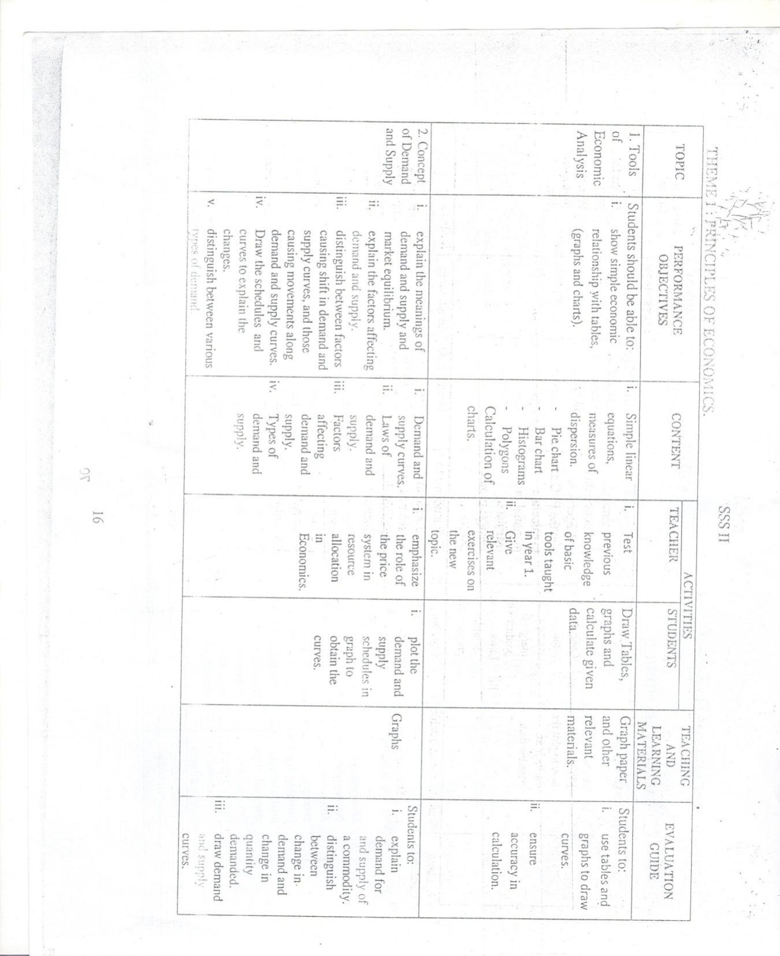

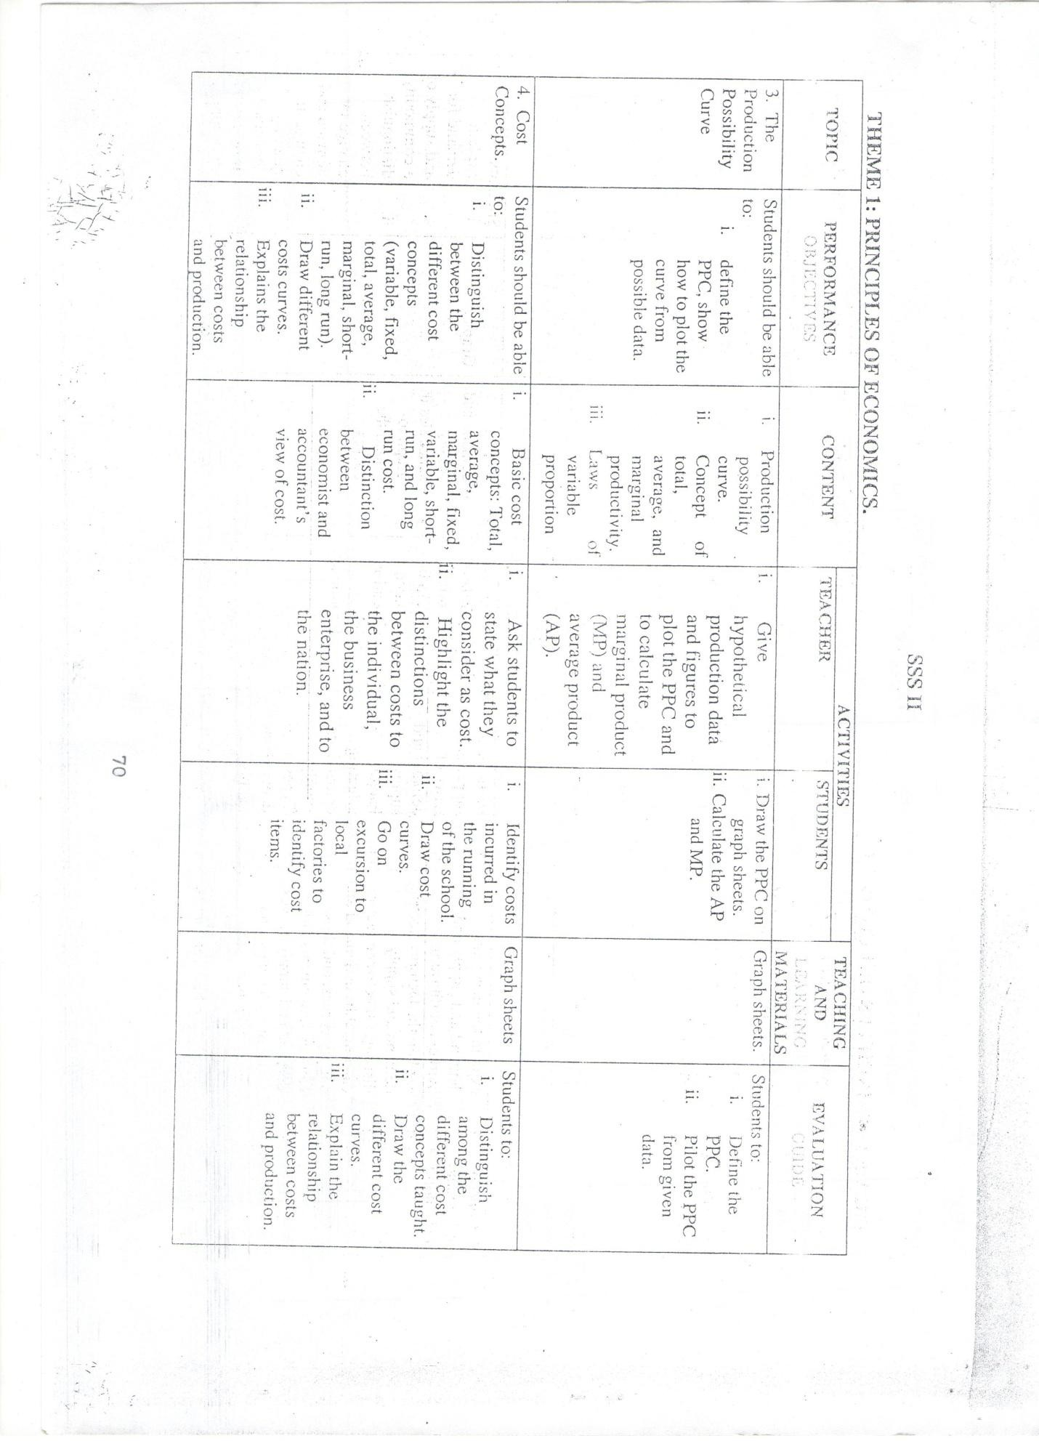

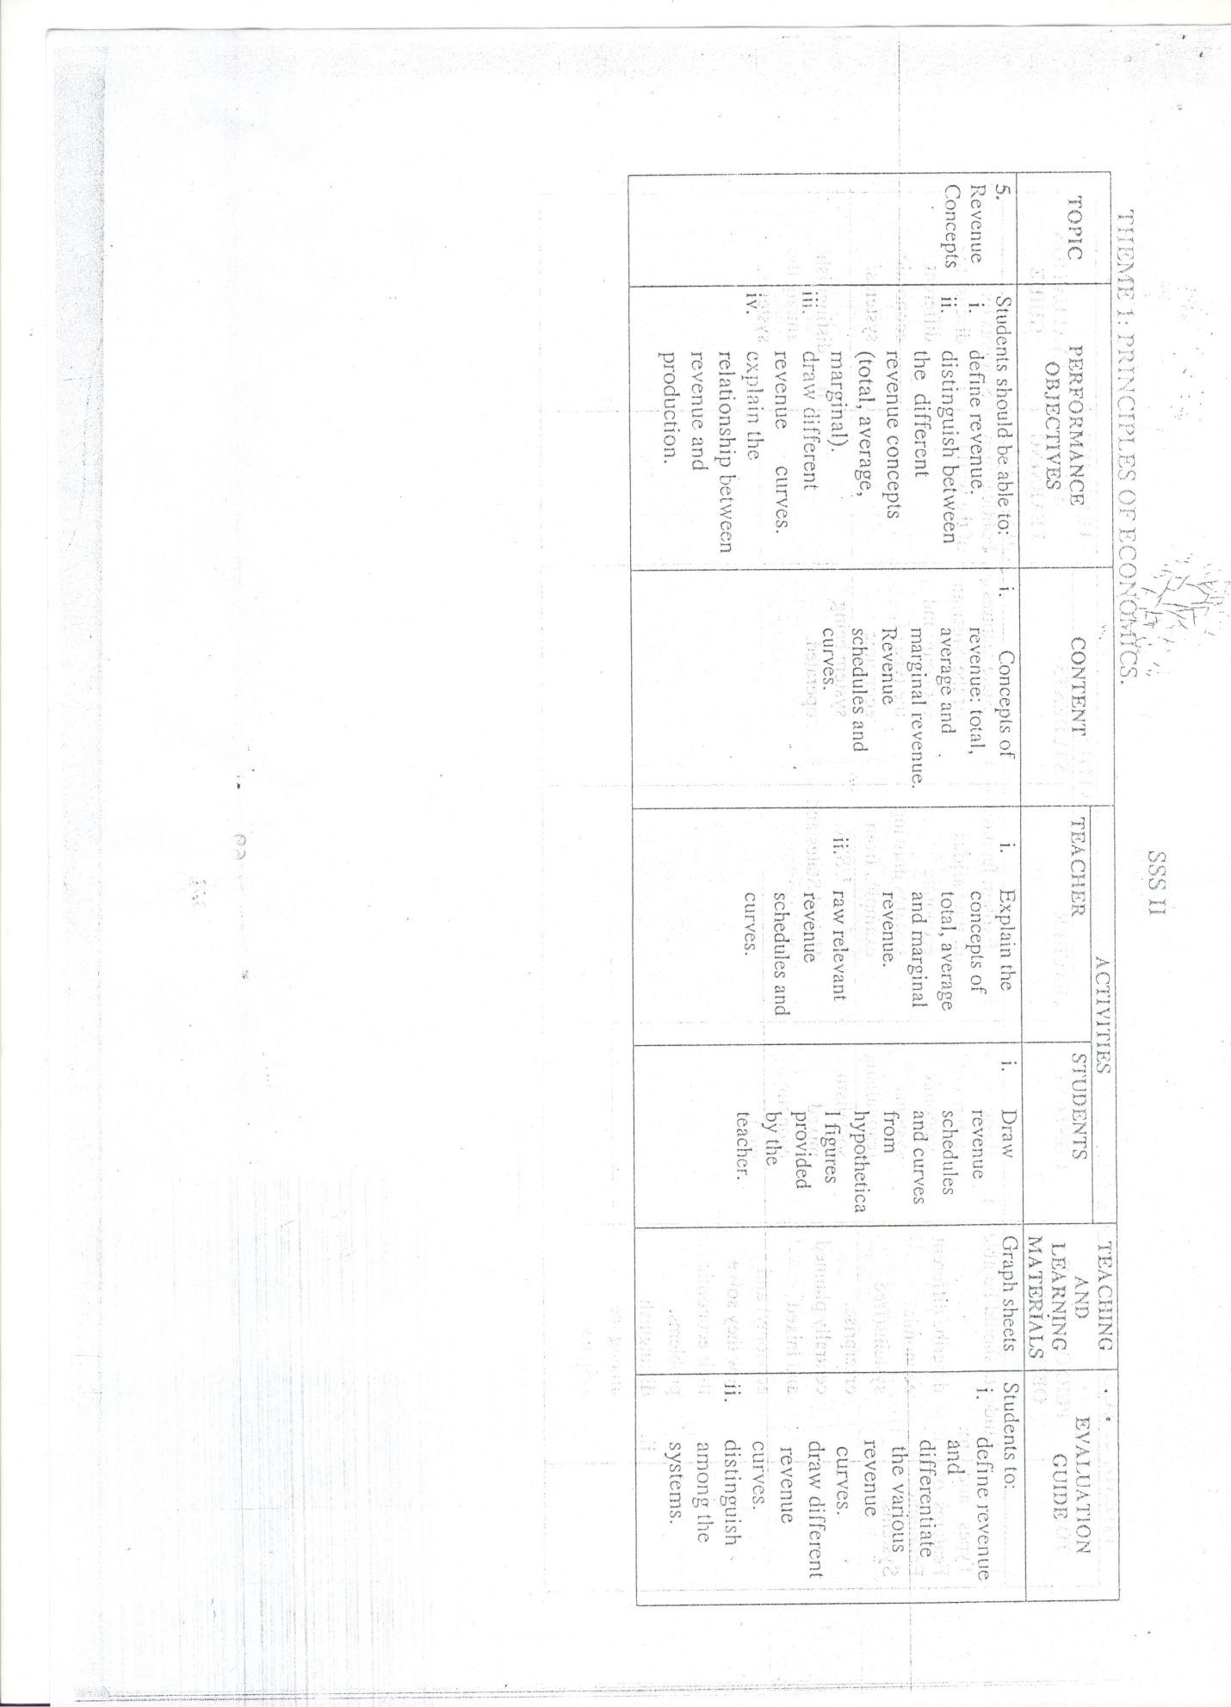

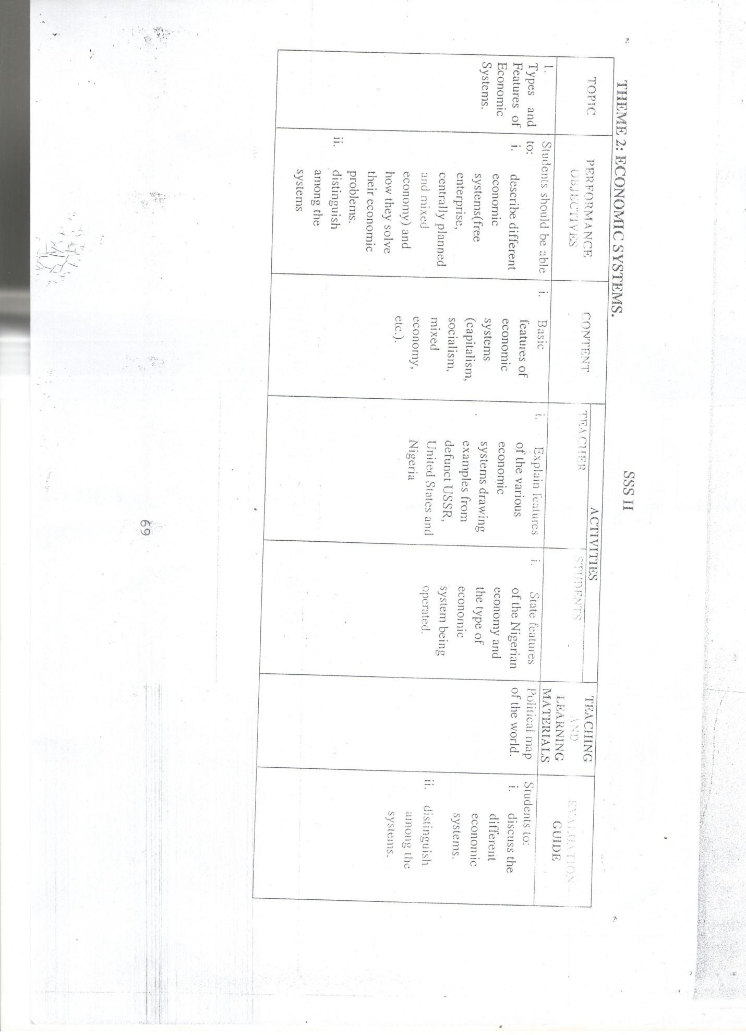

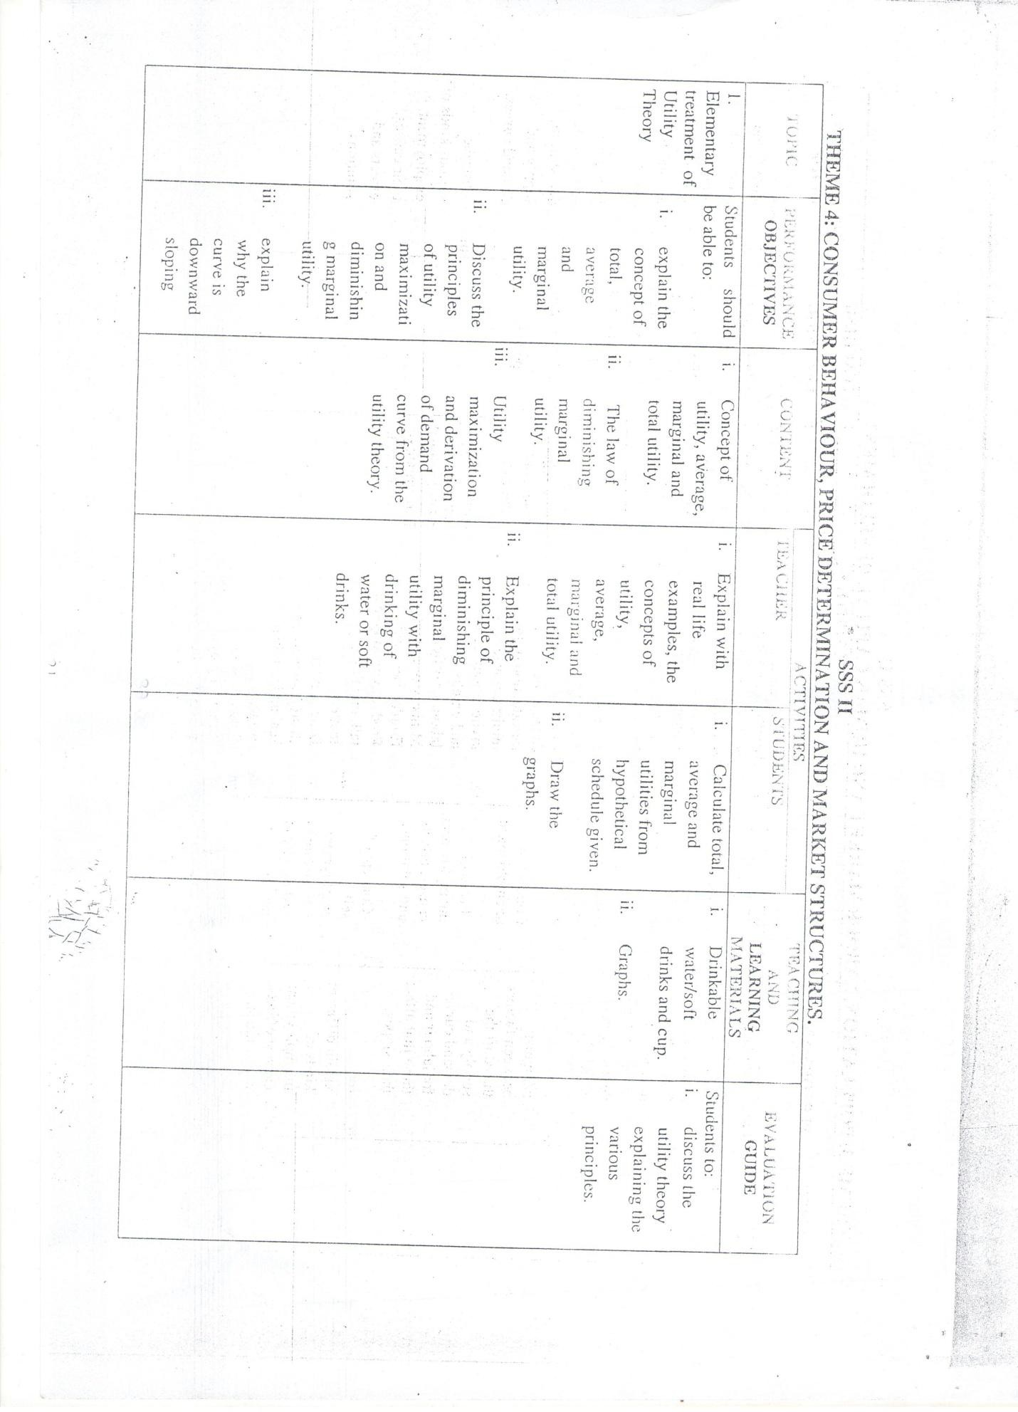

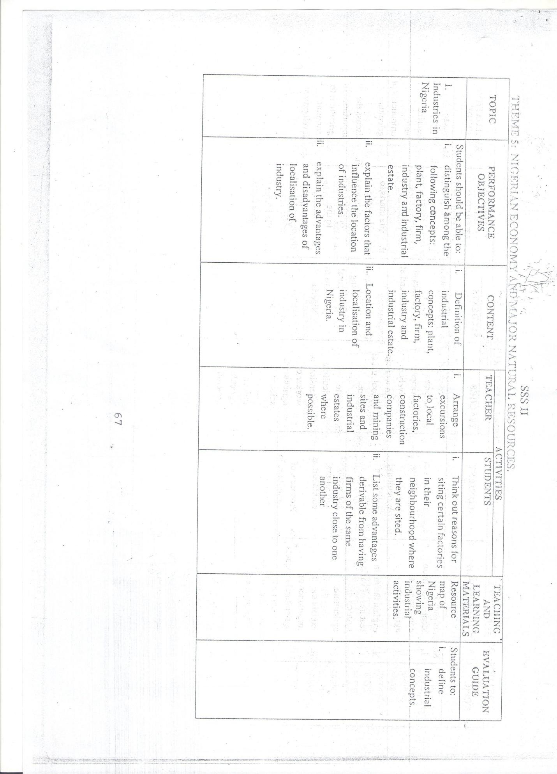

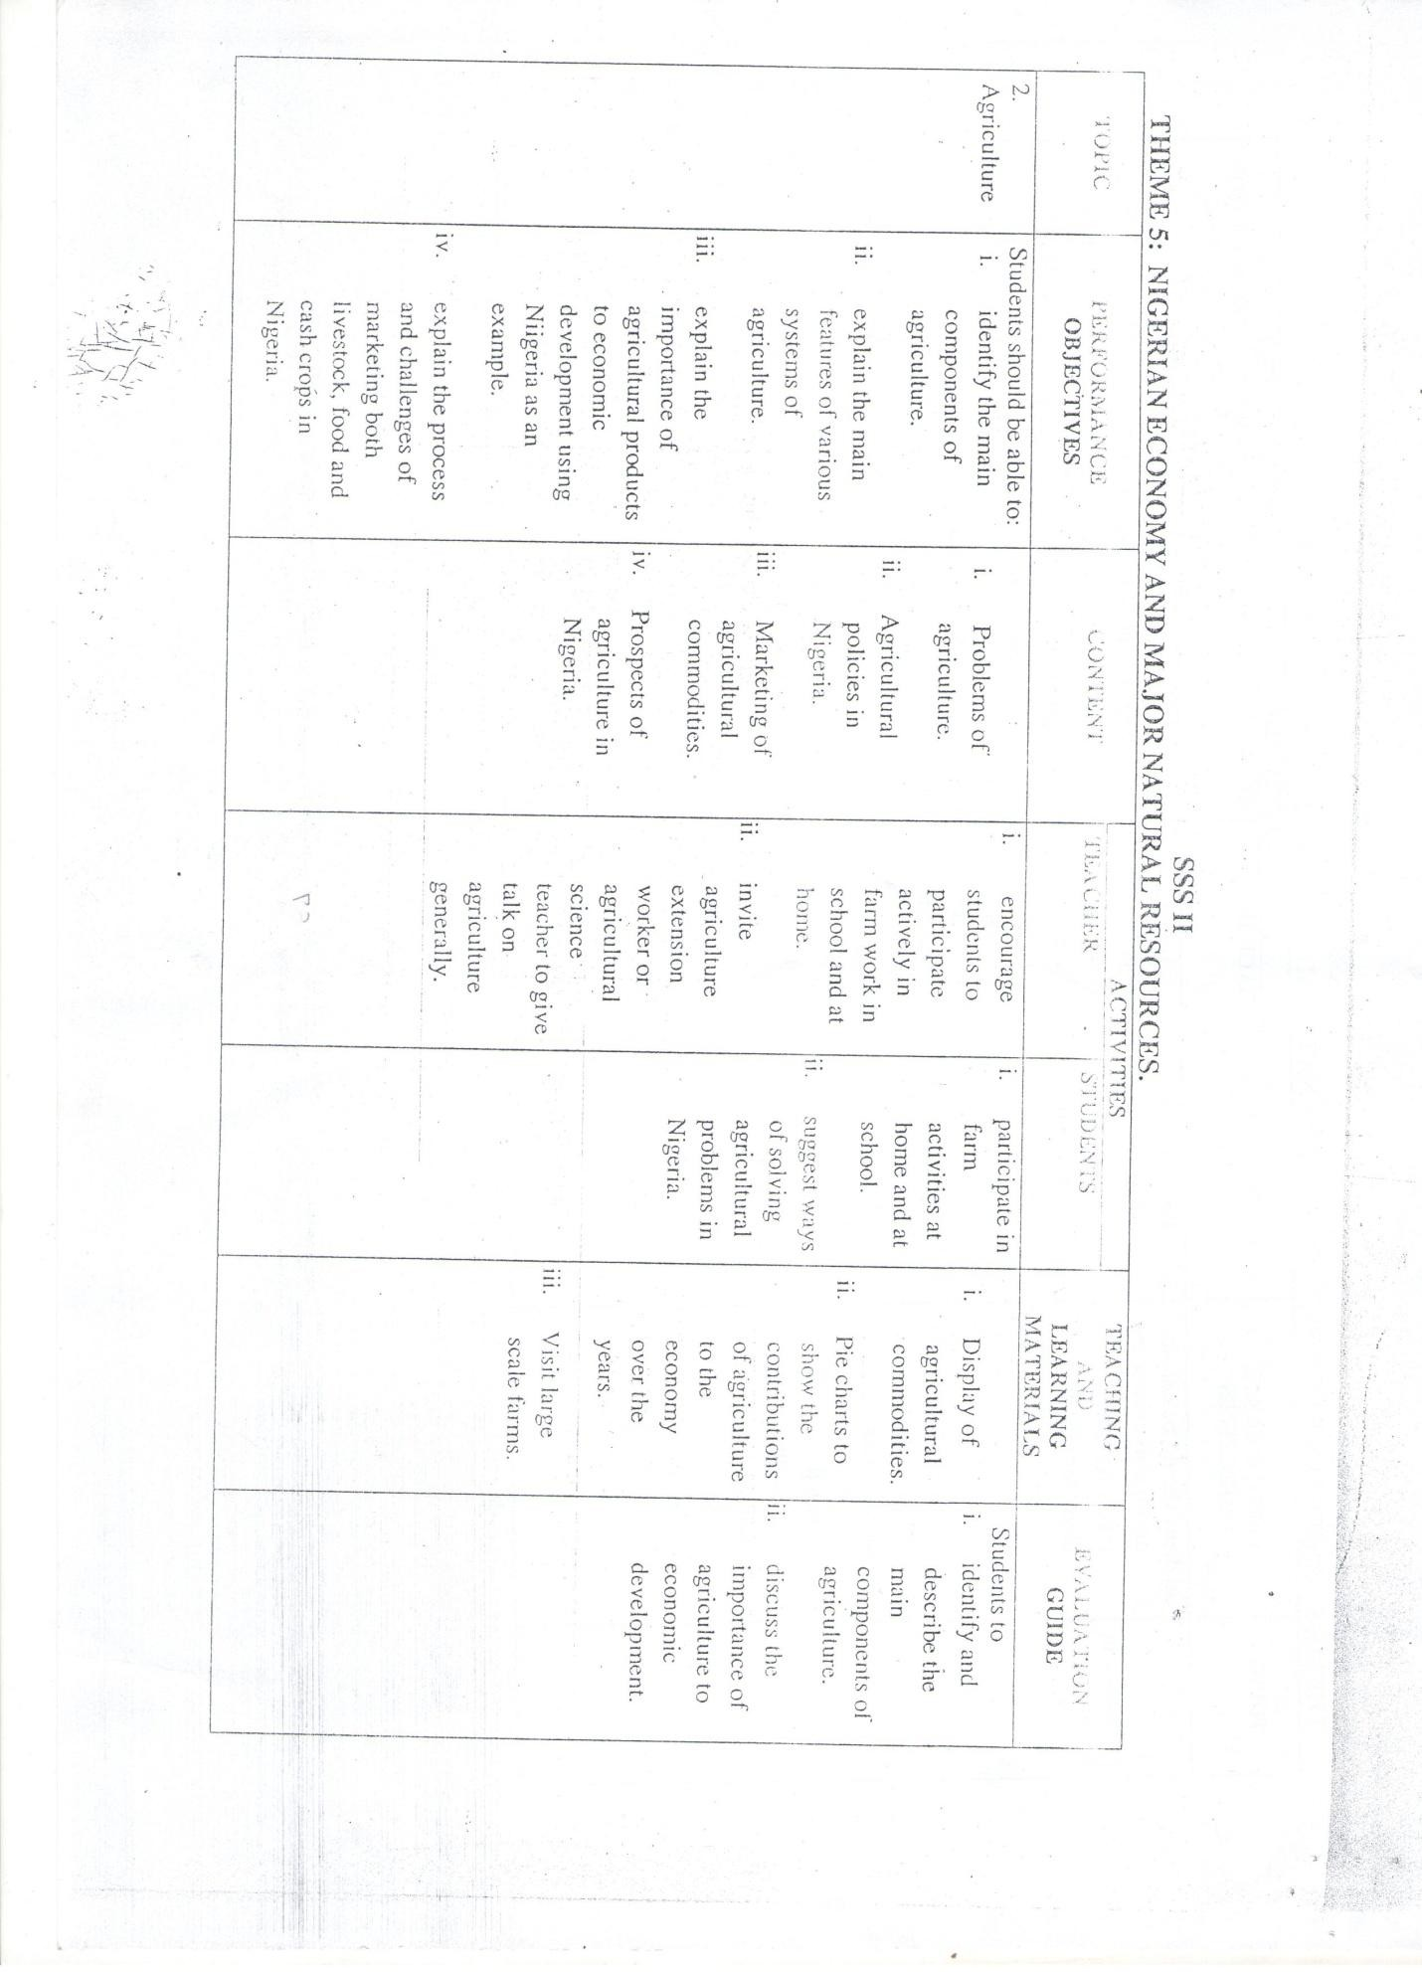

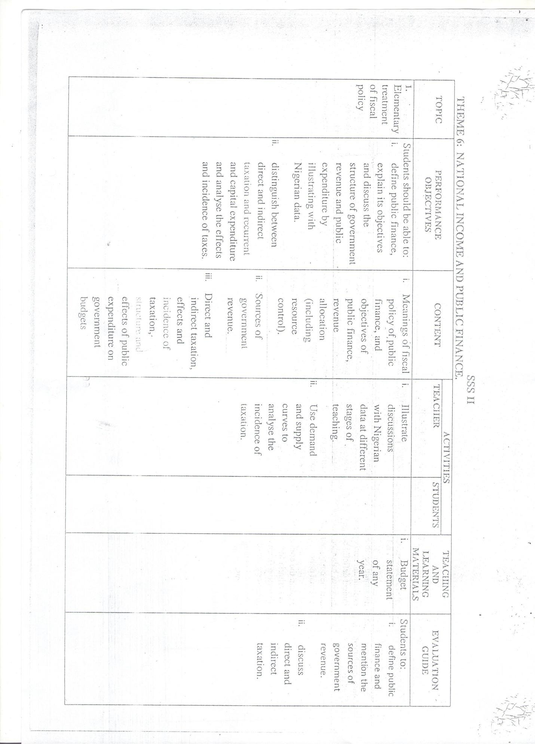

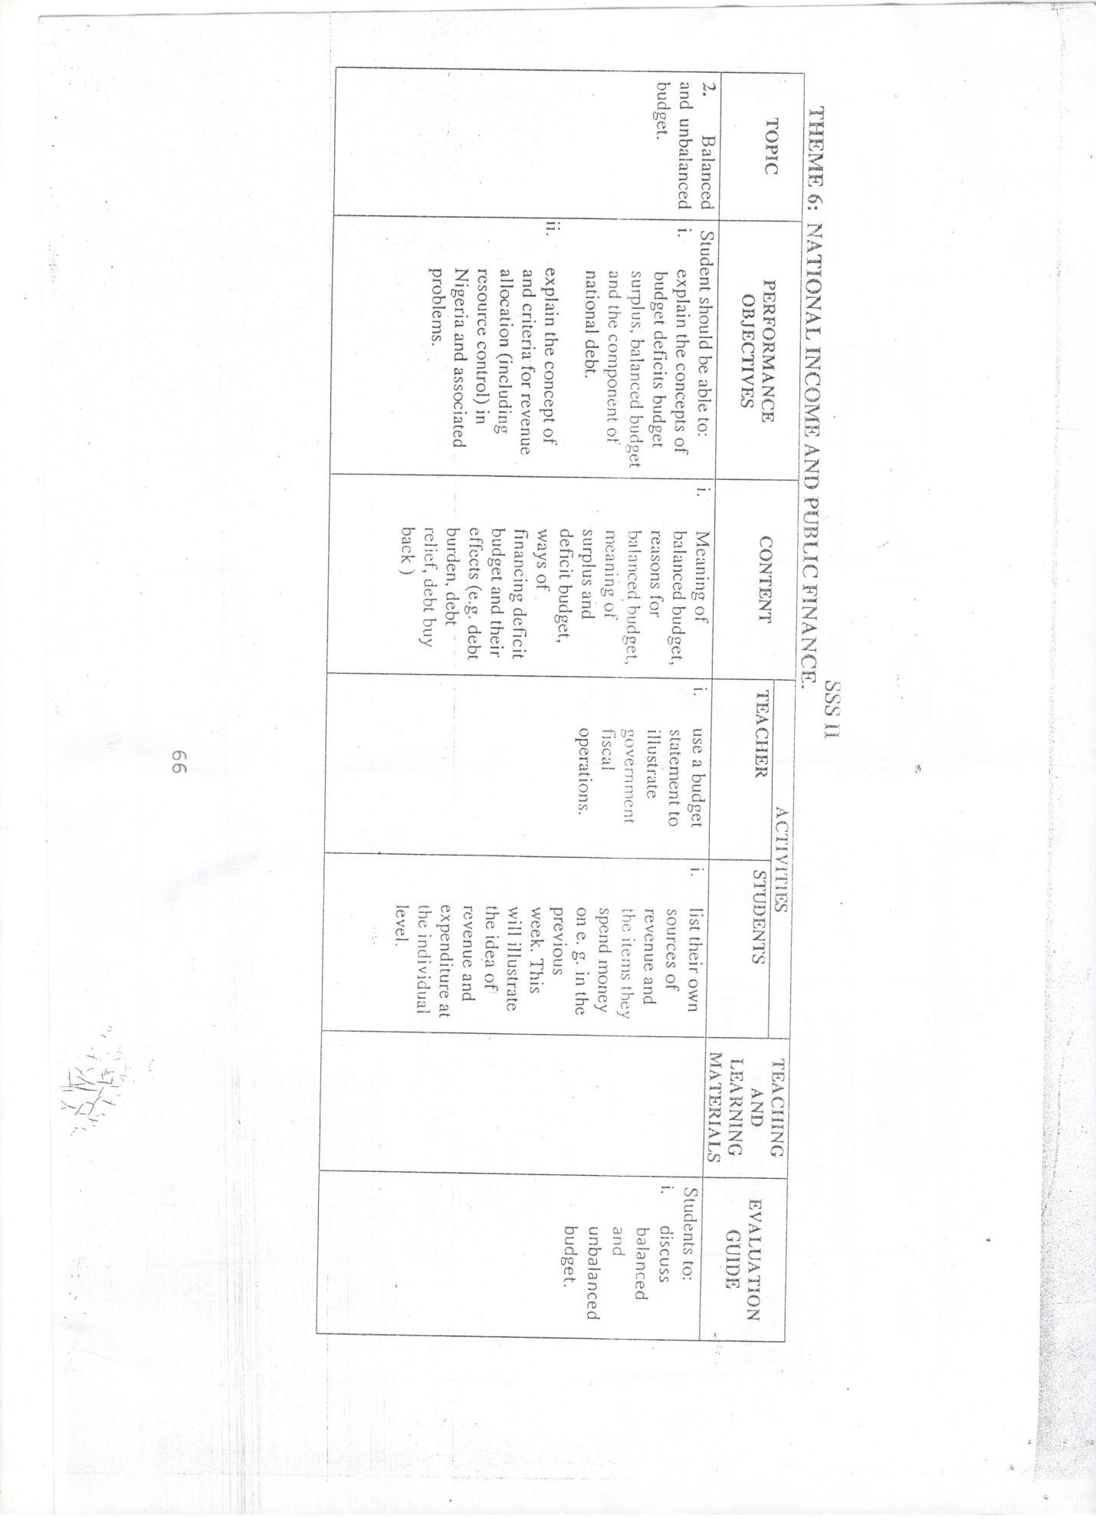

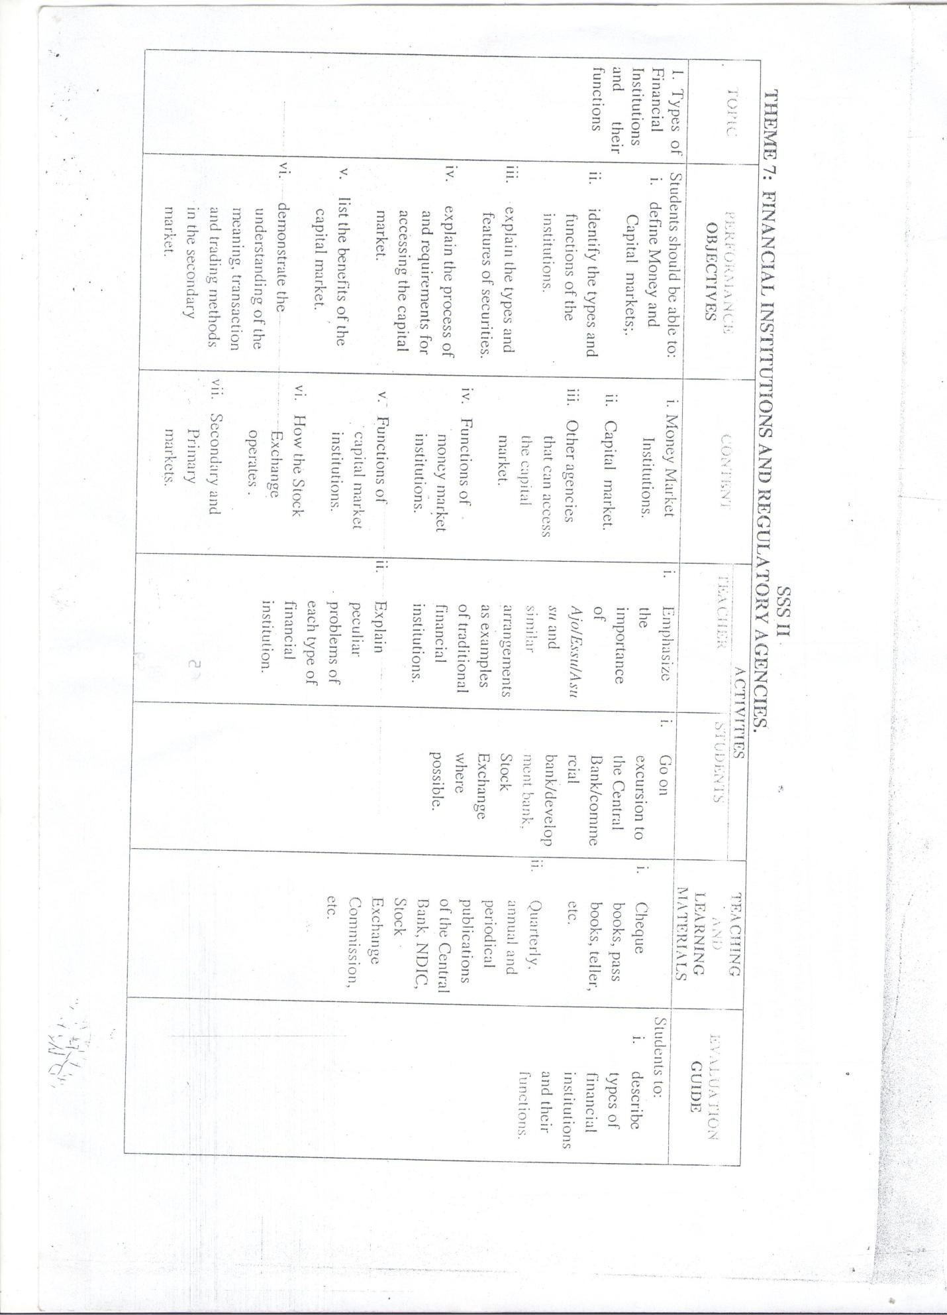

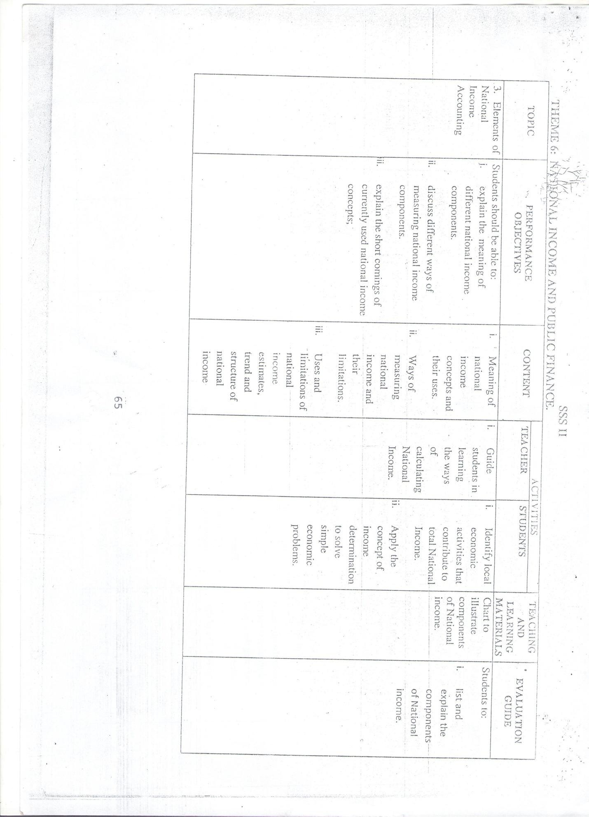

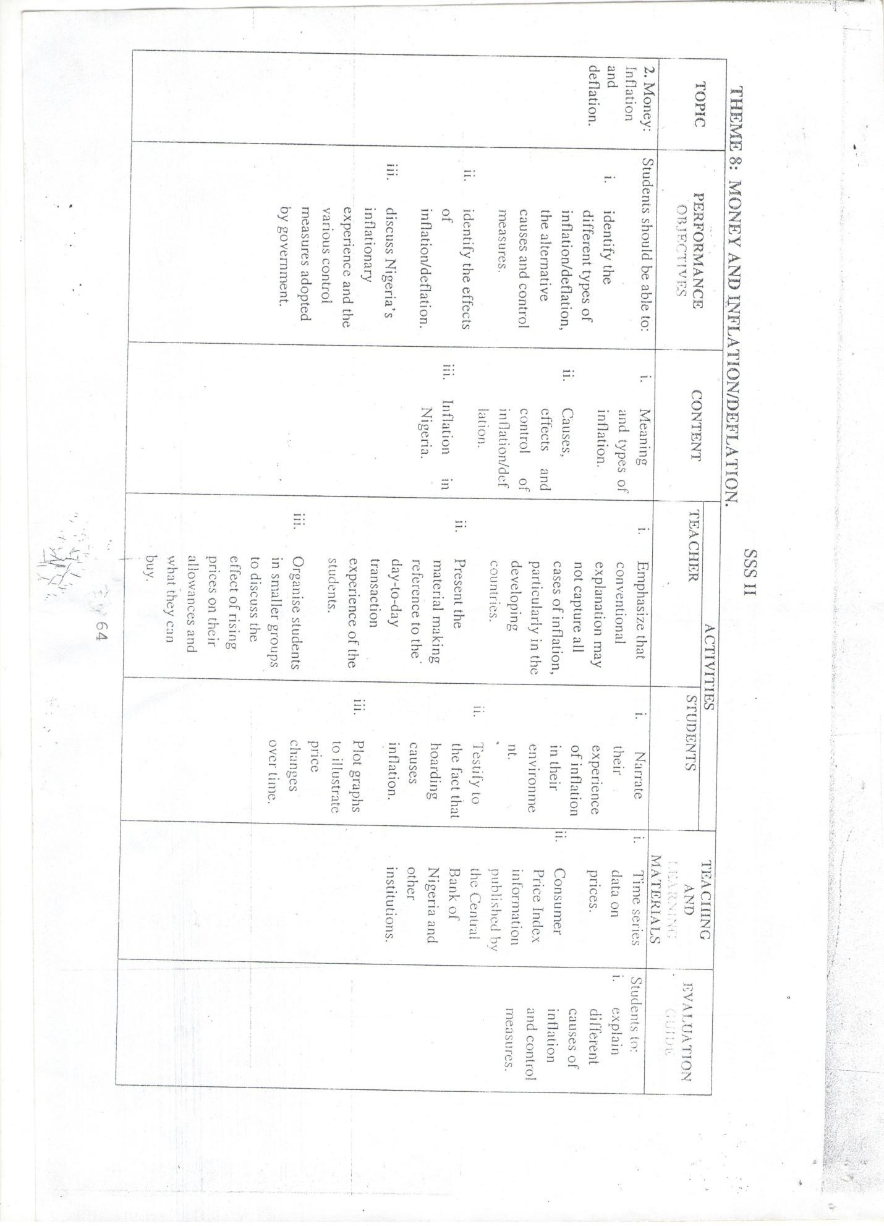

# APPENDIX III: ALLOCATION OF PERCENTAGE FOR THE CONTENTS COVERED (FIRST DRAFT)

|  |  |  |  |  |
| --- | --- | --- | --- | --- |
| **Content** | **Average Period** | **Percentage allocation** | **Percentage of each topic** | **Total items for each**  **topic** |
| Basic Tools for  Economics Analysis | 4 periods | 4 × 100  42 | 9.5 | 6 |
| Production | 4 periods | 4 × 100  42 | 9.5 | 6 |
| Labour Market | 3 periods | 3 × 100  42 | 7 | 4 |
| Money | 3 periods | 3 × 100  42 | 7 | 4 |
| Agriculture | 3 periods | 3 × 100  42 | 7 | 4 |
| Inflation | 3 periods | 3 × 100  42 | 7 | 4 |
| Industrialization | 3 periods | 3 × 100  42 | 7 | 4 |
| Alternative Economic  System | 3 periods | 3 × 100  42 | 7 | 4 |
| Theory of cost | 4 periods | 4 × 100  42 | 9.5 | 6 |
| Theory of Demand  And Supply | 4 periods | 4 × 100  42 | 9.5 | 6 |
| Public Finance | 4 periods | 4 × 100  42 | 9.5 | 6 |
| Financial Institution | 4 periods | 4 × 100  42 | 10 | 6 |
| **Total** | **42 periods** |  | **100** | **60** |

**Source school diary 2017**

# APPENDIX IV: SPECIFICATION FOR ECONOMICS ACHIEVEMENT TEST (EAT) FIRST DRAFT

|  |  |  |  |  |  |
| --- | --- | --- | --- | --- | --- |
| **CONTENTS** | **Know- Ledge**  **25%** | **Compr- hension**  **25%** | **Applica- tion**  **25%** | **Others**  **25%** | **Total Items** |
| 1.Basic tools for Economics Analysis 9.5% | (1.4 )  1 | (1.4 )  1 | (1.4 )  2 | (1.4 )  1 | 5 |
| 2.Production 10% | (1.5 )  2 | (1.5)  2 | (1.5 )  2 | (1.5 )  2 | 8 |
| 3.Labour of Market 7% | (1.1)  1 | (1.1)  1 | (1.1)  1 | (1.1)  1 | 4 |
| 4. Money 7% | (1.1)  1 | (1.1)  1 | (1.1)  1 | (1.1)  1 | 4 |
| 5. Agriculture 7% | (1.1)  1 | (1.1)  1 | (1.1)  1 | (1.1)  1 | 4 |
| 6. Inflation 7% | (1.1)  1 | (1.1)  1 | (1.1)  1 | (1.1)  1 | 4 |
| 7. Industrialization 7% | (1.1)  1 | (1.1)  1 | (1.1)  1 | (1.1)  1 | 4 |
| 8. Alternative Economics System 7% | (1.1)  1 | (1.1)  1 | (1.1)  1 | (1.1)  1 | 4 |
| 9. Theory of Demand and Supply 9.5% | (1.4)  2 | (1.4)  1 | (1.4)  1 | (1.4)  1 | 5 |
| 10. Theory of Cost 9.5% | (1.4 )  1 | (1.4 )  1 | (1.4 )  1 | (1.4 )  2 | 5 |
| 11. Public Finance 9.5% | (1.4 )  1 | (1.4 )  2 | (1.4 )  1 | (1.4 )  1 | 5 |
| 12. Financial Institution 10% | (1.5)  2 | (1.5)  2 | (1.5)  2 | (1.5)  2 | 8 |
| **Total** | **15** | **15** | **15** | **15** | **60** |

**Source: Field survey 2017**

# APPENDIX V: SPECIFICATION FOR ECONOMICS ACHIEVEMENT TEST (EAT) FINAL DRAFT

|  |  |  |  |  |  |
| --- | --- | --- | --- | --- | --- |
| **CONTENTS** | **Know- Ledge**  **25%** | **Compr- hension**  **25%** | **Applica- tion**  **25%** | **Others**  **25%** | **Total Items** |
| **1. Basic tools for Economics Analysis 9.5%** | (1.1)  1 | (1.1)  1 | (1.1)  1 | (1.1)  1 | 4 |
| **2. Production 9.5%** | (1.1)  1 | (1.1)  1 | (1.1)  1 | (1.1)  1 | 4 |
| **3. Labour of Market 7%** | (0.8)  1 | (0.8)  1 | (0.8)  1 | (0.8)  1 | 4 |
| **4. Money 7%** | (0.8)  1 | (0.8)  1 | (0.8)  1 | (0.8)  1 | 4 |
| **5. Agriculture 7%** | (0.8)  1 | (0.8)  1 | (0.8)  1 | (0.8)  1 | 4 |
| **6. Inflation 7%** | (0.8)  1 | (0.8)  1 | (0.8)  1 | (0.8)  1 | 4 |
| **7. Industrialization 7%** | (0.8)  1 | (0.8)  1 | (0.8)  1 | (0.8)  1 | 4 |
| **8. Alternative Economics system 7%** | (0.8)  1 | (0.8)  1 | (0.8)  1 | (0.8)  1 | 4 |
| **9. Theory of demand and supply 10%** | (1.1)  1 | (1.1)  1 | (1.1)  1 | (1.2)  2 | 5 |
| **10. Theory of cost 9.5%** | (1.1)  1 | (1.1)  1 | (1.1)  1 | (1.1)  1 | 4 |
| **11. Public finance 9.5%** | (1.1)  1 | (1.1)  1 | (1.1)  1 | (1.1)  1 | 4 |
| **12. Financial institution 10%** | (1.2)  1 | (1.2)  2 | (1.2)  1 | (1.2)  1 | 5 |
| **Total 100%** | 12 | 13 | 12 | 12 | 50 |

**Source: Field survey 2017**

# APPENDIX VI: Standardized Economics Achievement Test (SEAT)

**Introduction**

I am a postgraduate student in department of Educational Psychology and Counselling, Measurement and Evaluation Section, Faculty of Education Ahmadu Bello University Zaria, Nigeria. Conducting a research titled **“Assessment of Academic Achievement of Senior Secondary School Students on Standardized Economics Achievement in Bauchi, Bauchi State, Nigeria.”**

This research is purely for academic purpose, and all your responses will be treated with confidentiality. Please you are requested to respond to the questions with utmost sincerity and accuracy for the success of this study.

Thanks you for your anticipated cooperation.

# Standardized Economics Achievement Test (SEAT)

**Please fill the space below**

1. School Location: Urban [ ] Rural [ ]
2. School Type Co-education ( ) Single Sex School ( )

# Instruction: Attempt all questions, all questions carry equal marks Time allowed - 1 hour

Answer each question by ticking the letter containing the option that best suits your answer.

**Example:** Which of the following is a primary product?

A. Electronics

* B. Crude oil

C. Machineries

D. Furniture

The correct answer is B and letter B is therefore ticked. Now attempt the following

1. Mobility of labour is not affected by

A Optimum size of population B Marriage and Family

C Regulation Trade Union D Period of training

E Involvement Policies

1. Efficiency of labour is enhanced by

A Involvement of in one own Family B Mechanization processes

1. War against indiscipline
2. Improvement of working condition E Efficient remuneration
3. Which of the following is not a measure of central tendency?
   1. Mean
   2. Mode
   3. Median
   4. Weighted Average
   5. Standard Deviation
4. The migration of young people from rural to urban areas in Nigeria, should help to raise the

A Standard of living in the rural areas

B Total productivity of labour in the rural areas

C Marginal productivity of labour in the rural areas D Marginal productivity of labour in the urban areas E None of the Above

1. Nigerian Bank for commerce and industry is

A A commercial Bank B A Development Bank C A an Industrial Bank D A merchant Bank

E A and B

1. Commercial Bank Reserve at Central Bank have the effect of

A Controlling credit and money supply B Discouraging banking operation

C Advancing trade prospect D Reducing bank Fraud

E Strengthening of Asset

1. In a cookery competition 190 girls took part in the first round and the cumulative frequency distribution for the points awarded is as follows:

Scores less than 9.5 19.5 29.5 39.5 49.9 59.5 69.5 79.5 89.5 5

Cumulative freq. 0 5 27 64 117 149 170 182 190The number of girls who had a score in the range 40 - 49 points

51 Girls B. 52 girls C. 53 girls D. 54 girls E. 55 girls

1. A farmer‟s yield of cereals per hectare in 1999 was

|  |  |  |  |  |  |
| --- | --- | --- | --- | --- | --- |
| Ccereal | Beans | Cassava | Cocoa | Maize | Rice |
| Yield  (tone) | 2 | 1 | 3 | 0.5 | 5.5 |

If the information is represented in a circular diagram, what is the angle of the sector representing maize?

A. 72° B. 36° C. 18° D. 54° E. 180°

1. The basic purpose of imposing legal reserve requirement on Commercial Banks is to

A Assure the profitability of commercial Banks

B Provide a device through which credit creation by banks can be controlled C Provide proper ratio between earning and non-Bank Asset

D Provide the Central Bank with working condition

1. Which of the following is not a goal of modern budget? A The controlled of inflation
2. The reduction of income inequality
3. The shift of resources from private to public sector D Economics development

E Socio-economic development

1. In order to raise more revenue for a certain period, government should impose higher taxes on goods whose demand is

A Elastic B Inelastic

C Perfectly elastic D Unitary Elastic

E Imperfectly elastic

1. A group of 20 children was asked to state how many hours (to the nearest hour) each of them spent watching television during a particular weekend. The result was:

6 3 3 5 2 5 0 4

2 7 0 2 2 3 2 1

From the given table, the medium is A 40 B. 4.2 c. 4.2 d. 5.0 E. 5

13 A budget with a projected revenue in excess of its expenditure is said to be A Balanced

B Surplus C Deficit

D Inflationary

E Surplus density

1. Deficit Financing is mostly facilitated by the existence of A Stock exchange market

B Commercial Bank C Central Bank

D Capital Market E Labour Market

1. The system in which the means of production is held in trust for the people by government is known as a

A Socialist Economy B Capitalist Economy

C Subsistence Economy D Mixed Economy

E Commercialist Economy

1. Factors of production that has the highest degree of mobility is A Land

B Labour C Capital

D Entrepreneur E C and D

1. In recent times, Agriculture in Nigeria tends to increase its vital labor force as a result of A Effective agricultural policy

B Employment opportunity C Rural Urban drift

D Higher prices of agricultural product E Emigration

1. The most important attribute of money A Homogeneity

B Relative Scarcity C Divisibility

D General acceptability

1. Table of a firm's monthly wages

|  |  |  |  |  |
| --- | --- | --- | --- | --- |
|  | X |  | F | FX |
| N55.00 | 8 | N440.00 |
| N65.00 | 10 | NY |
| N75.00 | 16 | N1,200.00 |
| N85,00 | 14 | N1,190.00 |
| N95.00 | 10 | N950.00 |
| N105.00 | Z | N525,000 |
| NQ | 2 | N230.00 |

Use the above table to answer the question 47 and 48

1. What is the value of Z

A 2 B 3 C 4 D 5 E 75

21 Which of the following best describes production?

1. Creation of Utility
2. Production of tangible goods
3. Rendering of Services
4. Extraction of Mineral ores
5. Payment of services rendered

22. The following table represents the value of total production in a hypothetical economy in a particular period.

|  |  |  |
| --- | --- | --- |
| Production Stage | Value of Input | Sales Value of Output |
| Cattle farming Tonnery (Hides & Skins) Shoe Industry Shoe Shop | N500. N1,000 N1500 N2,250 | Nl,500.00 Nl.500.00 N2,500.00 N2,500.00 |

The value of total production in the economy using the value added approach is A. N2,800.00 B. N 3500.00.C. N3.700 D.N 4,200.00 E. N4800.00

23 The average product of a given period is obtained by dividing A Numbers of worker by total product

1. Total product by the number of hour actually worked
2. Change in total product by the change in the total number of workers D Total product by the number of workers

E Total number of product by price of the products

1. Given that fixed cost is #4500.00 variable cost is #1, 500.00 and output is 50 units, what will be the average cost of producing one unit?

A. #42000.00

B. #460.00

C. #445.00

D. #450.00

E. #430.00

If AC = Average cost of production, FC = Fixed cost of production, VC = Variable cost of production, and TC = Total cost of production then

* 1. VC = TC FC
  2. VC = FC + AC
  3. VC = TC - AC
  4. VC = TC - FC
  5. VC = TC - FC

VC

1. Which of the following is regarded as fixed cost?
   1. Cost of raw materials
   2. Cost of fuel
   3. Cost of light
   4. Rent on land
   5. Labour wages.
2. Which of the following is not regarded as fixed cost?
   1. Cost of raw materials
   2. Cost of fuel
   3. Cost of light
   4. Rent on land
   5. Labour wages
3. Which of the following is the time at the quantity of output, where average cost (AC) per unit has reached it maximum?

A AVC = FC B MC = FC C MC = AC D AC = AFC E FC=MC

1. Money becomes a very poor store of value in a period of
   1. Deflation
   2. Stable prices
   3. Recession
   4. Inflation
   5. Harvest.
2. All the following options are characteristics of money, except.
   1. Scarcity
   2. Durability
   3. Divisibility
   4. Homogeneity
   5. Mobility
3. The primary objective of the Agricultural credit Guarantee scheme is the provision of
   1. Guarantee for loansgranted by banks for agricultural purposes.
   2. Agricultural inputs to facilitate credit from banks.
   3. Loans for every farmer.
   4. Agricultural products for farmers. E Guarantee farm produce
4. Subsistence farming means producing food
   1. Mainly for the need of our immediate and extended family B Crops for sale mainly
5. Crops mainly for export.
6. To feed the community around
7. In order to satisfy the government directives
8. In a period where there is more money in the economy than the available goods and services, is known as
   1. Devaluation
   2. Inflation
   3. Deflation
   4. Demonstration
   5. Valuation
9. Inflation in any economy
10. Has no monetary connection
11. Impels a sustained decrease in the general price level
12. Always increases the value of the national currency
13. Tends to redistribute income arbitrarily.
14. Tends to bring down market prices
15. An inflation in which the price level rises steadily at an average rate of about 2% per annum is best described as
    1. Run-away
    2. Galloping
    3. Induced
    4. Creeping
    5. Suppress
16. Which of the following factors are more likely to influence the location of a steel industry?
    1. Availability of medical doctors
    2. Availability of iron ore.
    3. Proximity to a water fall.
    4. Proximity to and area of suitable climate
    5. Existence of a university of technology.
17. From the options below select the one that best describes the concentration of industries in one area
    1. Location of industries
    2. Multiplication of industries
    3. Pluralisation of industries
    4. Proliferation of industries
    5. Localization of industries
18. The rural areas of West African countries lack industries because
    1. Rural people are not meant to work in industries
    2. Rural people are uneducated
    3. Inadequate Infrastructure
    4. Low population density
    5. They are not suitable for industries
19. One of the following instruments is use for protection of infant industries from the following.
    1. Price control board
    2. Open market operation
    3. Tariff
    4. GDP deflator
    5. Multiplier
20. An economic system in which the state owns and controls the means of production is known as
    1. Free enterprise
    2. Socialist economy
    3. Mixed Economy
    4. Capitalist Economy
    5. Welfare Economy
21. What does the diagram above illustrates
    1. perfectly elastic demand
    2. inelastic demand
    3. perfectly inelastic demand
    4. elastic demand
    5. Unitary elasticity of demand
22. If the price of margarine rises substantially, what will be its effect on the equilibrium price of butter?

A Increase B Decrease

1. remain constant
2. fluctuate
3. inelastic

42. Use the diagram to answer Questions below

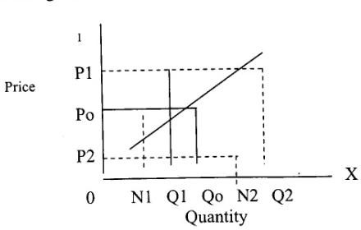

In the diagram above, the equilibrium price is

. A. OQ1 B. OQo C. PlPo D.PoP2 E. OPo

43 Use the following market schedule for semovita to answer question below

|  |  |  |
| --- | --- | --- |
| Price for  5kg bag | Quantity  Demanded | Quantity  Supplied |
| #43.00 | 15,000 | 1,500 |
| #44.00 | 13,000 | 3,000 |
| #45.00 | 10,000 | 6,000 |
| #46.00 | 7,000 | 7,000 |
| #47.00 | 5,000 | 9,000 |
| #48.00 | 4,000 | 12,000 |
| #49.00 | 2,000 | 14,000 |

. If the equilibrium price falls by N200, what will be the change in quantity demanded and supplied?

1. 7,000 and 6,000 bags respectively
2. 6,000 and 4,000 bags respectively
3. 5,000 and 4,500 bags respectively
4. 3,000 and 3,000 bags respectively
5. 2,000 and 2,000 bags respectively

44, when a country has a large labour force, it is beneficial to use a method of production what is that appropriate method?

* 1. Capital intensive
  2. Land intensive
  3. Labour intensive
  4. Mechanically intensive
  5. Technically Intensive

45. The productivity of labour does not depend only on its own effort and efficiency, but also on

A The level of technical knowledge B The quality of other factors

C Racial qualities which allow persons from certain D races of have good physique and be very active E The quality of other factors

1. The development banks are essentially different from commercial banks because they.
   1. Give medium and long term loans
   2. Open current accounts for their customers
   3. Discount bills of exchange D .Are lenders of last resort

E. Carry out open market operations

1. What is the name of a financial institution that specialized in accepting responsibilities for risk on persons or property
   1. a Trust Fund
   2. an Investment Bank
   3. a Development Bank
   4. an Insurance Company
   5. the Stock Exchange
2. From the following options point out the one the role of development banks in the economic development of West African Countries.
   1. They help to implement government policies
   2. They contribute to manpower development by making funds available to manpower training institutions.
   3. They monitor the flow of currency in the economy.
   4. They provide long term loans for capital projects.
   5. They help in the supervision of development Projects
3. Which of the following best describes the budget?
   1. A plan of government's needs & expenditure for a year
   2. Detailed estimate of government financial operation for a year. C.Satisfactory balance between income and service for one year.
4. Plan for importation of essential goods arid services for one year
5. Plan for control of government industries and corporations for One year
6. The group of people engaged in banking or insurance services by occupational distribution are classified as
7. Primary producers
8. Secondary producers
9. Tertiary producers
10. Technical Producers

E.A and B only

# APPENDIX VII: THE MARKING SCHEME SHEET

|  |  |  |  |
| --- | --- | --- | --- |
| QUESTIONS | ANSWERS | QUESTIONS | ANSWERS |
| 1 | D | 40 | D |
| 2 | D | 41 | A |
| 3 | E | 42 | A |
| 4 | D | 43 | E |
| 5 | A | 44 | C |
| 6 | E | 45 | A |
| 7 | B | 46 | A |
| 8 | B | 47 | D |
| 9 | B | 48 | A |
| 10 | B | 49 | A |
| 11 | C | 50 | A |
| 12 | E |  |  |
| 13 | B |  |  |
| 14 | E |  |  |
| 15 | A |  |  |
| 16 | B |  |  |
| 17 | A |  |  |
| 18 | C |  |  |
| 19 | D |  |  |
| 20 | A |  |  |
| 21 | B |  |  |
| 22 | B |  |  |
| 23 | B |  |  |
| 24 | C |  |  |
| 25 | D |  |  |
| 26 | D |  |  |
| 27 | E |  |  |
| 28 | D |  |  |
| 29 | D |  |  |
| 30 | C |  |  |
| 31 | A |  |  |
| 32 | B |  |  |
| 33 | A |  |  |
| 34 | E |  |  |
| 35 | B |  |  |

**APPENDIX IX: SUMMARY OF PSYCHOMETRIC ANALYSIS**

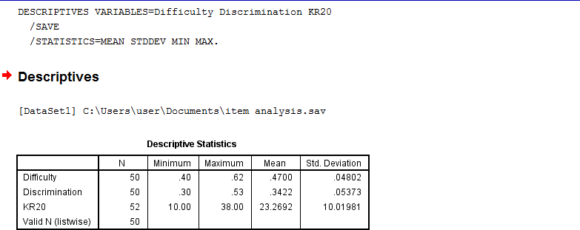

# APPENDIX X: PSYCHOMETRICS ANALYSES

|  |  |  |
| --- | --- | --- |
| **ITEMS NO** | **DIFFICULTY** | **DISCRIMINATION** |
| 1 | 0.52 | 0.53 |
| 2 | 0.48 | 0.34 |
| 3 | 0.50 | 0.38 |
| 4 | 0.50 | 0.30 |
| 5 | 0.48 | 0.34 |
| 6 | 0.56 | 0.34 |
| 7 | 0.46 | 0.30 |
| 8 | 0.53 | 0.30 |
| 9 | 0.44 | 0.30 |
| 10 | 0.48 | 0.38 |
| 11 | 0.48 | 0.30 |
| 12 | 0.52 | 0.42 |
| 13 | 0.44 | 0.34 |
| 14 | 0.42 | 0.30 |
| 15 | 0.44 | 0.30 |
| 16 | 0.44 | 0.30 |
| 17 | 0.42 | 0.34 |
| 18 | 0.46 | 0.30 |
| 19 | 0.50 | 0.30 |
| 20 | 0.48 | 0.34 |
| 21 | 0.44 | 0.34 |
| 22 | 0.40 | 0.34 |
| 23 | 0.54 | 0.38 |
| 24 | 0.42 | 0.42 |
| 25 | 0.44 | 0.42 |
| 26 | 0.52 | 0.34 |
| 27 | 0.46 | 0.30 |
| 28 | 0.42 | 0.46 |
| 29 | 0.44 | 0.38 |
| 30 | 0.54 | 0.38 |
| 31 | 0.46 | 0.30 |
| 32 | 0.40 | 0.30 |
| 33 | 0.44 | 0.42 |
| 34 | 0.46 | 0.30 |
| 35 | 0.46 | 0.34 |
| 36 | 0.42 | 0.34 |
| 37 | 0.40 | 0.38 |
| 38 | 0.51 | 0.30 |
| 39 | 0.50 | 0.30 |
| 40 | 0.44 | 0.34 |

|  |  |  |
| --- | --- | --- |
| 41 | 0.51 | 0.42 |
| 42 | 0.40 | 0.30 |
| 43 | 0.61 | 0.30 |
| 44 | 0.44 | 0.30 |
| 45 | 0.46 | 0.46 |
| 46 | 0.42 | 0.30 |
| 47 | 0.42 | 0.30 |
| 48 | 0.40 | 0.34 |
| 49 | 0.40 | 0.34 |
| 50 | 0.48 | 0.30 |

**Source: Field Survey 2017**

# APPENDIX XI: ANALYSIS OF HYPOTHESIS 1

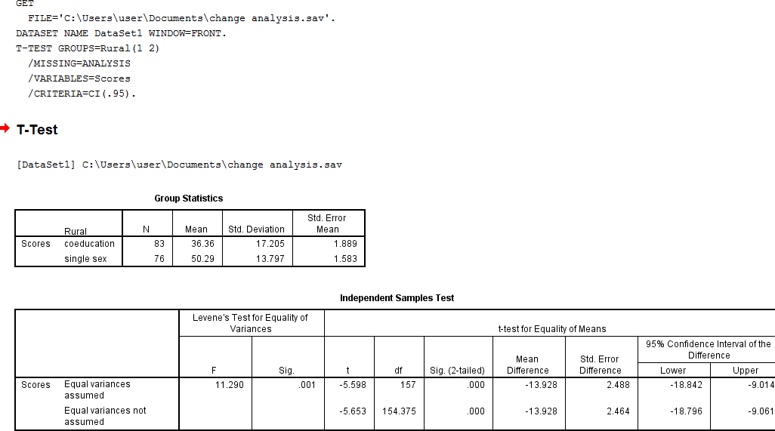

**APPENDIX XII:ANALYSIS OF HYPOTHESIS 2**

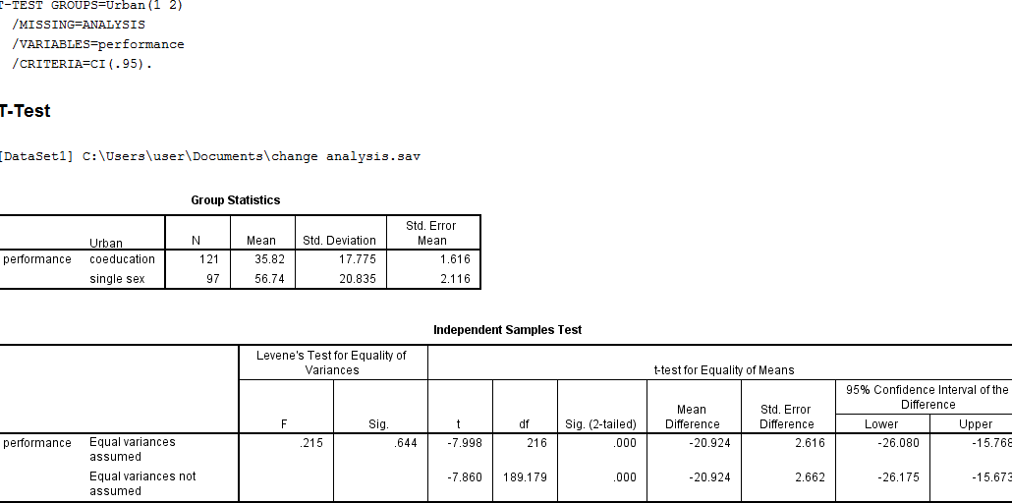

# APPENDIX XIII: ANALYSIS OF HYPOTHESIS 3

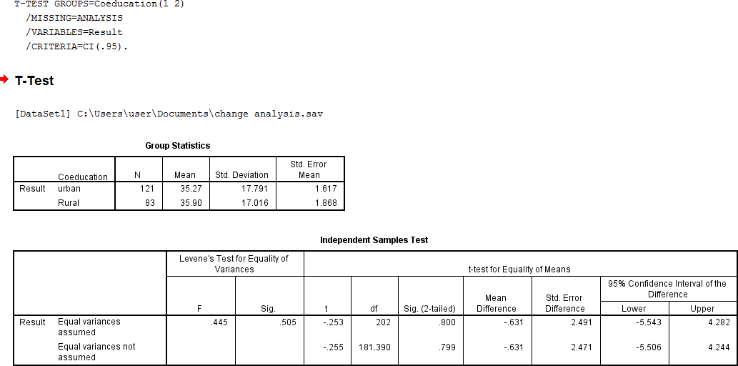

**APPENDIX XIV: ANALYSIS OF HYPOTHESIS 4**

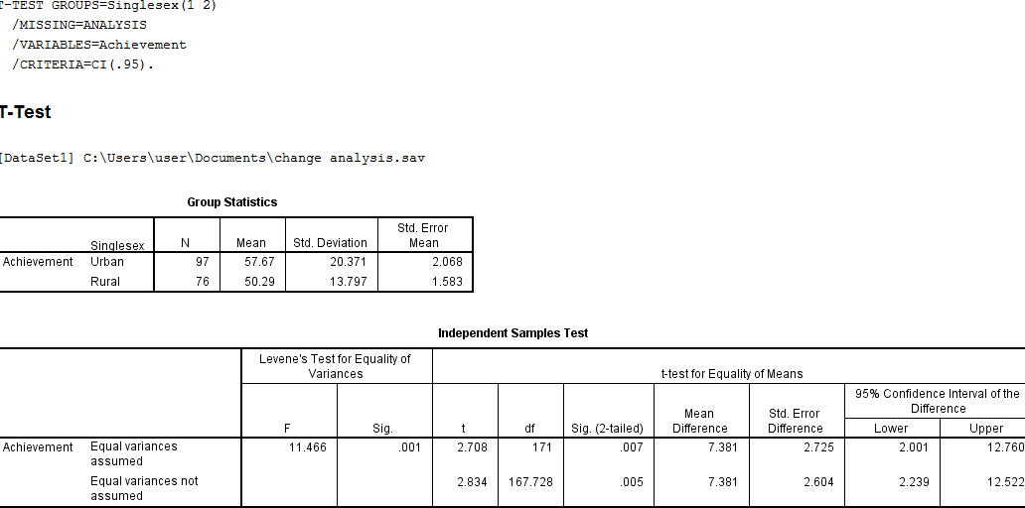

# APPENDIX XV: INVIGILATION GUIDELINE

Department of Educational Psychology and counselling Measurement and evaluation section,

Faculty of Education,

Ahmadu Bello University, Zaria

The Test Supervisor/Administrator/Proctor Dear Sir,

REQUEST FOR YOUR PARTICIPATION IN THE UPCOMING EXAMINATION IN SAMPLEPUBLIC SENIORSECONDARY SCHOOLS IN BAUCHI STATE.

I am postgraduate student in department of Educational Psychology and Counselling, Measurement and Evaluation Section, Conducting a research titled **“**Construction and Standardization of Achievement Test in Economics in Senior Secondary Schools in Bauchi State, Nigeria**.”**

The research is purely for academic purpose. I humbly need your full cooperation to make this research as valid as possible. I enclosed a Test Administration guide that may save as a helping hand.

Thanks for your cooperation. Yours Faithfully

Mohammed Yaya

The following guidelines are designed to help the test administrator and proctors before during and after examination

|  |  |  |
| --- | --- | --- |
| Before Testing | During Testing | After Testing |
| Arrive at the designated class well prior to commencement of examination | Let the respondents know that glancing at another‟s paper or exposing their papers to others, even if inadvertently, is a violation of examination and could lead to expel of the  respondent. | Control the collection of answer sheet s‟ in order to prevent students from leaving with copy. Count them again after collecting to assure to exams are uncounted for. |
| The Supervisor will be there to meet and provide additional instruction. | At the start let the respondent know the fire alarm and emergency procedure. | When time is up give a clear signal and inform the student to put down all writing  instrument. |
| The researcher/Supervisor will be contacted for supplies and signed of examination sheet  and emergencies during examination. | Count exam before handing them out. Make identification marks on the exams to prevent  student summiting prewritten pages. | Remain students to check all their personal items‟ |
| The respondents will enter the classroom 10-15 minute before the examination | Remind the respondent to keep away smart phones and turn off non smart phone  immediately. | Collect unused exam answer sheet returnto front of the room and exams materials  dispose of it accordingly. |
| Arrange the respondent one respondent par seat and interval of one seat to avoid  cheating during testing | Explain the entire rule governing the examination and their penalties. | Remain student to shade the correct answer neatly with precision. |
| Remain the respondent to use the washroom before the exam stated, if necessary during testing and only the first half hour. A proctor will recheck and follow the respondent to the washroom, before and  after. | Make sure all the students identify themselves on the exam paper in ink with name student number and signature. | Make a second signature on the answer sheet to avoid intrusion of another answer sheet. |
| Non material must bekept out of reach. | Use a tack or exam card to identify the respondents to avoid impersonation during testing. | Keeps a suspicious answer sheet separately fending to confirmation? And sign with a red ink pen |
| Coming with bags and non  essential materials material to | Where identification of a respondent is prevented by full | Ensure all the answer sheet are intact, |

|  |  |  |  |  |  |
| --- | --- | --- | --- | --- | --- |
| examination | class | is | not | or partial headdress, they |  |
| allowed. |  |  |  | should be given the |
|  |  |  |  | opportunity to unveil in a |
|  |  |  |  | private space in presence of |
|  |  |  |  | some one |
| Let know the what they can | | | | Circulate frequently and be | Report immediately if there is |
| keep with them. | | | | obviously present at all times. | any threat against ethic of the |
|  | | | | Make every effort to prevent | examination. |
|  | | | | cheating and collusion by |  |
|  | | | | immediately inspecting |  |
|  | | | | anything irregular or |  |
|  | | | | suspicious. |  |
| Confiscate the materials if the | | | | Control the movement of | Put down the entire answer |
| student will not show you | | | | student in and out of the class | sheet in the envelop provided |
| what information it contain. | | | | room | and sign against the passage |
|  | | | |  | by the supervisor. |

Carlsbad, (2012)

# Appendix XVI ANALYSIS OF SCORES

|  |  |  |  |  |  |  |  |  |  |  |  |  |  |  |  |
| --- | --- | --- | --- | --- | --- | --- | --- | --- | --- | --- | --- | --- | --- | --- | --- |
| **Rural Schools** | | | |  |  |  |  |  |  |  | **Urban Schools** | |  |  |  |
| **Coeducation** |  |  | **Single sex** | | |  |  | **Coeducation** | |  |  | **Single sex** |  |  |  |
| RAW SCORE | F | Z-SCORE | T-SCORE | RAW  SCORE | F | Z-SCORE | T-SCORE | RAW  SCORE | F | Z-  SCORE | T-SCORE | RAW  SCORE | F | Z-SCORE | T-SCORE |
| 58 | 3 | 0.636364 | 56.36364 | 74 | 1 | 1.363636 | 63.63636 | 68 | 4 | 1.090909 | 60.90909 | 92 | 3 | 2.181818 | 71.81818182 |
| 56 | 4 | 0.545455 | 55.45455 | 70 | 2 | 1.181818 | 61.81818 | 64 | 3 | 0.909091 | 59.09091 | 90 | 5 | 2.090909 | 70.90909091 |
| 54 | 6 | 0.454545 | 54.54545 | 68 | 2 | 1.090909 | 60.90909 | 60 | 4 | 0.727273 | 57.27273 | 88 | 7 | 2 | 70 |
| 52 | 7 | 0.363636 | 53.63636 | 66 | 4 | 1 | 60 | 58 | 8 | 0.636364 | 56.36364 | 84 | 2 | 1.818182 | 68.18181818 |
| 50 | 7 | 0.272727 | 52.72727 | 64 | 4 | 0.909091 | 59.09091 | 54 | 5 | 0.454545 | 54.54545 | 80 | 3 | 1.636364 | 66.36363636 |
| 48 | 4 | 0.181818 | 51.81818 | 62 | 5 | 0.818182 | 58.18182 | 52 | 9 | 0.363636 | 53.63636 | 72 | 3 | 1.272727 | 62.72727273 |
| 46 | 3 | 0.090909 | 50.90909 | 60 | 3 | 0.727273 | 57.27273 | 50 | 7 | 0.272727 | 52.72727 | 70 | 4 | 1.181818 | 61.81818182 |
| 44 | 8 | 0 | 50 | 58 | 5 | 0.636364 | 56.36364 | 48 | 6 | 0.181818 | 51.81818 | 68 | 3 | 1.090909 | 60.90909091 |
| 42 | 4 | -0.09091 | 49.09091 | 56 | 5 | 0.545455 | 55.45455 | 46 | 4 | 0.090909 | 50.90909 | 62 | 4 | 0.818182 | 58.18181818 |
| 38 | 5 | -0.27273 | 47.27273 | 54 | 6 | 0.454545 | 54.54545 | 36 | 4 | -0.36364 | 46.36364 | 60 | 3 | 0.727273 | 57.27272727 |
| 32 | 3 | -0.54545 | 44.54545 | 52 | 7 | 0.363636 | 53.63636 | 34 | 5 | -0.45455 | 45.45455 | 58 | 5 | 0.636364 | 56.36363636 |
| 28 | 3 | -0.72727 | 42.72727 | 50 | 5 | 0.272727 | 52.72727 | 32 | 7 | -0.54545 | 44.54545 | 56 | 5 | 0.545455 | 55.45454545 |
| 24 | 3 | -0.90909 | 40.90909 | 48 | 7 | 0.181818 | 51.81818 | 30 | 6 | -0.63636 | 43.63636 | 54 | 6 | 0.454545 | 54.54545455 |
| 22 | 4 | -1 | 40 | 46 | 4 | 0.090909 | 50.90909 | 28 | 4 | -0.72727 | 42.72727 | 52 | 7 | 0.363636 | 53.63636364 |
| 18 | 3 | -1.18182 | 38.18182 | 40 | 4 | -0.18182 | 48.18182 | 26 | 7 | -0.81818 | 41.81818 | 50 | 5 | 0.272727 | 52.72727273 |
| 12 | 3 | -1.45455 | 35.45455 | 38 | 6 | -0.27273 | 47.27273 | 22 | 8 | -1 | 40 | 46 | 5 | 0.090909 | 50.90909091 |
| 10 | 4 | -1.54545 | 34.54545 | 22 | 2 | -1 | 40 | 20 | 9 | -1.09091 | 39.09091 | 42 | 2 | -0.090909 | 49.09090909 |
| 6 | 4 | -1.72727 | 32.72727 | 20 | 3 | -1.09091 | 39.09091 | 18 | 3 | -1.18182 | 38.18182 | 40 | 3 | -0.181818 | 48.18181818 |
| 4 | 2 | -1.81818 | 31.81818 | 18 | 2 | -1.18182 | 38.18182 | 16 | 3 | -1.27273 | 37.27273 | 30 | 4 | -0.636364 | 43.63636364 |
| 2 | 2 | -1.90909 | 30.90909 |  |  |  |  | 14 | 5 | -1.36364 | 36.36364 | 28 | 4 | -0.727273 | 42.72727273 |
|  |  |  |  |  |  |  |  | 8 | 5 | -1.63636 | 33.63636 | 20 | 3 | -1.090909 | 39.09090909 |
|  |  |  |  |  |  |  |  | 6 | 4 | -1.72727 | 32.72727 | 18 | 2 | -1.181818 | 38.18181818 |
|  |  |  |  |  |  |  |  | 2 | 2 | -1.90909 | 30.90909 | 14 | 2 | -1.363636 | 36.36363636 |