ASSESSING THE USAGE OF SPACES IN ACADEMIC LIBRARIES IN- TRANSITION FROM TRADITIONAL TO DIGITAL LIBRARIES: PROPOSED ABU PHASE TWO LIBRARY

BY

SADIQ ABDULLAHI NASHE

DEPARTMENT OF ARCHITECTURE, FACULTY OF ENVIRONMENTAL DESIGN AHMADU BELLO UNIVERSITY,
ZARIA, NIGERIA

ASSESSING THE USAGE OF SPACES IN ACADEMIC LIBRARIES IN- TRANSITION FROM TRADITIONAL TO DIGITAL LIBRARIES: PROPOSED ABU PHASE TWO LIBRARY

BY

Sadiq Abdullahi NASHE, B.Sc (KUST WUDIL) 2012 M.Sc/ENV-DESIGN/30104/2012-2013

A THESIS SUBMITTED TO THE SCHOOL OF POSTGRADUATE STUDIES, AHMADU BELLO UNIVERSITY, ZARIA

IN PARTIAL FULFILLMENT OF THE REQUIREMENTS FOR THE AWARD OF MASTER OF SCIENCE DEGREE IN ARCHITECTURE

DEPARTMENT OF ARCHITECTURE, FACULTY OF ENVIRONMENTAL DESIGN AHMADU BELLO UNIVERSITY,
ZARIA, NIGERIA

Declaration

I declare that the work in this dissertation entitled “ASSESSING THE USAGE OF SPACES IN ACADEMIC LIBRARIES IN TRANSITION FROM TRADITIONAL TO
DIGITAL LIBRARIES” has been carried out by me in the Department of Architecture. The information derived from the literature has duly been acknowledged in the text and a list of references provided. No part of this dissertation was previously presented for another degree or diploma at this or any other institution.

Sadiq Abdullahi Nashe MARCH, 2017

Name of student Signature Date

Certification

This dissertation entitled “ASSESSING THE USAGE OF SPACES IN ACADEMIC LIBRARIES IN TRANSITION FROM TRADITIONAL TO DIGITAL LIBRARIES”
by Sadiq Abdullahi Nashe meets the regulations governing the award of the Master of Science Degree in Architecture of the Ahmadu Bello University, and is approved for its contribution to knowledge and literary presentation.

Dr. M.D Ahmed Chairman Supervisory Committee (Signature) (Date)

Dr. M.L Sagada

Member Supervisory Committee (Signature) (Date)

Dr. A.S Salisu

Head of Department (Signature) (Date)

Prof. K.Bala

Dean, School of Postgraduate Studies (Signature) (Date)

Acknowledgement

I thank almighty God for his infinite mercy and guidance throughout my school life and also for the health, strength he granted me to this moment.
From the formative stages of this thesis, to the final draft, I owe an immense debt of gratitude to my supervisor Dr. MD Ahmed. His sound advice and careful guidance were invaluable. My appreciation also goes to Dr M.L Sagada who is my second supervisor, I say thank you for putting your experience and efforts in the production of this thesis.
I would also like to thank those who agreed to be interviewed in the University libraries studied. My profound gratitude goes to the Bayero University Librarian, Prof. I.L Diso; the departmental heads for their efforts towards ensuring a successful study in the library. The departmental heads and staff of the Kashim Ibrahim Library and that of Kano University of Science and Technology, I say thank you for the assistance you provided to me in carrying out a successful study.
For their efforts and assistance, a special thanks to the family of Alhaji Abdullahi Nashe. Not forgotten my beloved friends and to my uncle Arc Imam Nashe for handful of encouragement throughout my M.Sc. program. My special appreciation also goes to my friend Saleem Sani who has always being a source of encouragement and support.
Finally, I want to specially mention my mother Dr. B.L Farouk whose extreme help and generosity will be remembered always.
To each of the above, I extend my deepest appreciation.

Dedication

This research thesis is dedicated to my entire family for their immense support and contribution to my educational pursuits.

Abstract

For over two decades technology has been affecting the way libraries operate. Academic libraries have witnessed various changes with the advent of information technology, which brought about adjustment in physical space of the traditional academic libraries. Some traditional library services and spaces have become obsolete while new ones have been introduced. This pose a challenge to designers and library administrators in integrating the newly introduced ones with the traditional services as well as spaces. The main aim of this research is to assess the usage of spaces in academic libraries that are shifting from traditional/analogue to digital academic libraries so as to come up with a flexible model that can accommodate rapid technological changes as well as integrating the needed traditional services with the new modern services. Case study method was employed as the research method of the study, unstructured interview was designed and used to collect data of the spaces currently available as well as the spaces that have been affected by information technology. Questionnaires were also administered in the study area mainly to find out the user needs and identification of the modern services within the libraries studied. Physical observation was also used to identify some new developments in terms of space requirement in the libraries studied. Transcription and interpretation of the unstructured interview was carried out to: - identify the current spaces in academic libraries provided in the north western zone of Nigeria; to identify all the traditional library spaces affected by technology and to examine the effect of technology on the overall pattern of physical spaces in the libraries studied. Pictures taken were used to indicate the new services as well as the new spaces that were provided in the libraries studied. Interpretation of the interviews was also used to identify these spaces. Statistical analysis was used to

analyse the questionnaire provided in order to determine the user needs with respect to the library environment.
The major research findings area: Nigerian libraries have undergone some reasonable changes over time most accompanied by information technology. This created some additional physical spaces to the existing traditional spaces. The study also reveals that only 15 functional spaces out of the 55 spaces provided which is 29% of the overall traditional academic library spaces have not been affected whereas 40 functional spaces out of 55 spaces which is 71% of the overall library spaces have undergone either additions, conversions or obsolescence in the libraries studied; Most of the modern trends such as the E-Classrooms, service desks, adjacent refreshment areas collaborative learning spaces and computer workstation clusters are yet to be incorporated within the traditional libraries,only E-library spaces and computer workstation clusters were introduced in the library departments studied. Several services such as the microfilms, Cardex and strip index are now phased out, but there are spaces that are still in use but need no or little modifications to meet the present and technological needs.
It wasconcluded from the study that Nigerian academic libraries are gradually shifting from the rigid traditional environment to modern academic libraries that goes beyond the provision of academic services but also social as well as informal services.

Table of Contents

Title Page Error! Bookmark not defined.

Declaration i
Certification ii
Acknowledgement iii
Dedication iv
Abstract v
Table of Contents vii
List of Tables xiii
List of Figures xiv
List of Plates xvi
List of Appendices xvii
Definition of Key Terms xviii
  - INTRODUCTION 1
  - Background of the Study 1
  - Problem Statement 2
  - Aim and Objectives 3
  - Research Questions 4
  - Significance of the Study 4
  - Scope of the Study 5
  - Thesis Organisation 5
  - LITERATURE REVIEW 6
  - Introduction 6
  - Library 6
    - General Functions of a Library 7
  - Types of Libraries 8
    - Public Libraries 8
    - Academic Libraries 9
    - Special Libraries 9
    - National Libraries 9
  - The Concept of an Academic library 10
    - Origin of Academic Library in Nigeria 11
  - Traditional academic Libraries 12
    - Traditional Academic Library Spaces/Departments 12
    - Traditional Academic library spaces 18
    - Traditional Academic Library Materials 19
  - Academic libraries today (Digital Academic Libraries) 20
    - The New Roles 21
    - Hybrid Library 23
  - Information Technology and Library Spaces 25
    - Monographs 25
    - Study Space 26
    - Reference Section/Services 27
    - Printing and photocopying 28
    - Periodical Section 28
    - Cataloguing Section 28
    - Circulation Space 29
  - The Spatial Impact of Technology on Library Functions 31
    - Instruction 31
    - Monographs 31
    - Periodicals 32
    - Processing 32
    - Study Space 32
  - Modern Concepts for Academic Library 33
    - Openness 33
    - Multifunctional 33
    - Flexibility 34
    - Artistry 35
    - Computer workstations clusters 36
    - A service desk 37
    - Collaborative learning spaces 38
    - Presentation Support Centers 39
    - Instructional technology centers for faculty development 39
  - Summary and Conclusion 40
  - RESEARCH METHODOLOGY 41
  - Introduction 41
  - Research Methods 41
  - Population of the Study 42
  - Sample and Sampling Techniques/Methods 43
  - Instruments for Data Collection. 44
  - Procedure for Administration of Instruments 45
  - Data analysis Procedure 45
  - Summary 46
  - RESULTS AND DISCUSSIONs 47
  - Introduction 47
  - Case Study one- Kashim Ibrahim Library 47
    - Technical Services 48
    - Customer Services Section 49
    - The Administrative Division. 50
    - The Information and Communication Technology Division 50
  - Case Study Two: Bayero University Kano Library 63
    - Technical Services 64
    - Reader-Services 64
    - Administrative Section 65
    - Automation Section 65
  - Case Study Three: Kano University of Science and Technology Library 74
    - Technical Services 75
    - Customer-Services 75
    - Administrative Section 76
    - E-Library 76
  - Discussion 85
  - Summary of findings 88
  - Implication of Findings to Design 90
  - Summary and Conclusion 92
  - ABU-Library 94
  - Introduction 94
  - Area of Study 94
  - Site Selection Criteria 95
    - Location 96
    - Accessibility 96
    - Physiography 96
    - Site Features and Image Quality 96
    - Topography 97
    - Site Capacity and Development Potentials 97
    - Site Infrastructure 97
    - Site A 97
    - Site B 101
  - Site Comparison 102
  - Site Analysis: Climate 104
    - Temperature 104
    - Rainfall 105
    - Wind Speed 105
    - Solar Radiation 106
  - Site Climatic Conditions 107
    - Site planning 107
    - Foundation 107
    - Roofing 107
    - Lighting 108
    - Ventilation 108
    - Finishing 108
  - Site Analysis: Topography and Development Potential 109
  - Site analysis: Accessibility and Noise 110
  - Design assumptions from site analysis 111
  - DESIGN REPORT 113
  - Introduction 113
  - Design Brief 113
  - Schedule of accommodation 113
  - Site Design 115
    - The Site Plan 118
  - Building Planning and Organisation 121
  - SUMMARY AND CONCLUSION 127
  - Introduction 127
  - Summary 127
  - Conclusion 128
  - Recommendations 129
    - Recommendations for implementation 129
    - Recommendations for further research 130
  - Contribution to Knowledge of the Study 130
REFERENCES 131
APPENDICES 134

List of Tables

Table 4. 1 A summary of the current spaces found in the library studied. 52

Table 4. 2 Summary of Affected Library Space 59

Table 4. 3 Emerging Development Checklist 60

Table 4. 4 Summary of the current spaces found in the library studied. 66

Table 4. 5 Summary of the Effect of Technology on Library Studied 70

Table 4. 6 Emerging Development Checklist 71

Table 4. 7 A summary of the current spaces found in the library studied. 77

Table 4. 8 Summary of the Effect of Technology on Library Studied 81

Table 4. 9 Emerging Developments Checklist 82

Table 5. 1 Site A Characteristics 100
Table 5. 2 Site B characteristics 102

Table 5. 3 Sites Comparison 103

List of Figures
Figure 2.1 Printed and ebooks Usage 26
Figure 2.2 Academic Libraries Circulation 29
Figure2.3Rate of Enrollment in Universites 30
Figure 2. 4 The multidimensional model of library space consists of physical, social,
and digital space 24
Figure 2. 5 Model of a Hybrid Library 25
Figure 4. 1 Initial Library Ground Floor 55
Figure 4. 2 Existing Library Ground Floor Plan 55
Figure 4. 3 Effect of technology on library spaces 58
Figure 4. 4 Effect of technology on library spaces 58
Figure 4. 5 Effects of Technology on Library Spaces 69
Figure 4. 6 Effects of Technology on Library Space 80
Figure 5. 1 Zaria Urban Area: Existing Land Use 95
Figure 5. 2 ABU Phase 2 map showing site A location 99
Figure 5. 3 ABU phase 2 map showing site B 101
Figure 5. 4 Average Temperature and Precipitation 104
Figure 5. 5Wind Speed 105
Figure 5. 6 Solar Radiation 106
Figure 5. 7 Site Analysis (Topography) 109
Figure 5. 8 Site Analysis (Accessibility) 110
Figure 5. 9 Site Analysis (Noise Zone) 111
Figure 5. 10 Informal Meeting Space 125
Figure 6. 1 Site Development Concept 116
Figure 6. 2 Site Zoning 117

Figure 6. 3 Site Plan 119
Figure 6. 6 Bubble Diagram 121
Figure 6. 7 Section of a Ground Floor 123
Figure 6. 8 Meeting Room 124

List of Plates

Plate I Library Catalogue Section at Keene University 14

Plate IILibrary Catalogue Section at Keene University 14

Plate III Circulation section at Dayananda Sagar College of Engineering 15

Plate IV Circulation section at Dayananda Sagar College of Engineering 16

Plate V General Reference Section 17

Plate VI Bridgewater state college Clover leaf work areas 37

Plate VII Bridgewater State College group Study Room 38

Plate VIII Student Instructional Technology Lab. Elon University 39

Plate IX Perspective View of Kashim Ibrahim Library 47

Plate X Obsolete Resource Development Catalogue 53

Plate XI Computer Desk for (OPAC) 54

Plate XII Perspective view of B.U.K main library 63

Plate XIII Obsolete Public access catalogue 67

Plate XIV Perspective view of KUST main library 74

Plate XV Obsolete Public access catalogue 78

Plate XVI KUST Library Archive 79

Plate XVII Digital Garden 120

Plate XVIII Reading Woods 120

List of Appendices
APPENDIX A: INTERVIEW GUIDE 134
APPENDIX B: QUESTIONNAIRE 137
APPENDIX C: KASHIM IBRAHIM LIBRARY LETTER OF INTRODUCTION 134
APPENDIX D: BUKL LETTER OF INTRODUCTION 143
APPENDIX E: NIGERIAN UNIVERSITY AND THEIR GENERATIONS 144

Definition of Key Terms

Some of the key terms used in this study are:

Library

A library is a place where books are kept; a room, building or institution where a collection of books or other research materials are kept.

Academic library

An academic library is a library which serves an institution of higher learning, such as a college or a university. (Murugan, 2012).

Technology

The application of science, especially to industrial or commercial objectives. Electronic or digital products or systems considered as a group.

Transition

A movement, development, or evolution from one form, stage or style to another

Traditional Library

Is a library that gave emphasis on storage and preservation of physical items, particularly books and periodicals; passivity; information is physically assembled in one place; users must travel to the library to learn what is there and make use of it.

Digital Library

A digital library is a special library with a focused collection of digital objects that can include text, visual material, audio material, video materials, stored as electronic media formats along with means for organizing, storing, and retrieving the files and media contained in the library collection.

Digitization

The conversion of text, pictures, or sound into a digital form that can be processed by a computer.

Physical Space

An area provided for a particular function or a delimited area

Space needs

These are physical spaces housing functions which are based on the needs of users in the library environment. While undertaking this research, questionnaire surveys were used to find out the space needs of users in the library.

Information and Communication Technology (ICT)

Information and communications technology or information and communication technology, usually abbreviated as ICT, is often used as an extended synonym
for information technology (IT), but is usually a more general term that stresses the role of unified communications and the integration of telecommunications(telephone lines and wireless signals), computers, middleware as well as necessary software, storage- and audio-visual systems, which enable users to create, access, store, transmit, and manipulate information. In other words, ICT consists of IT as well
as telecommunication, broadcast media, all types of audio and video processing and transmission and network based control and monitoring functions.

Social interaction

This is re-emphasizing the need for people to come, meet, learn and share ideas in the learning environment of the library. There is need for networking, sharing information and creative ideas and collaborative study in the digital age.

User/Patron

This refers to people who regularly use the library facilities

INTRODUCTION

Background of the Study

For centuries students as well as scholars have been visiting libraries to find information and the practical needs of housing collection and accommodating readers have typically evolved library building. In her report, (Krubu & Osawaru, 2011)opined that the impacts of new technologies are felt by libraries in every aspect. Computing technology, communication technology and mass storage technology are some of the areas of continuous development that reshape the way libraries give access, retrieved, store, manipulate and disseminate information to users.
As new technologies were created, traditional services were becoming obsolete changing the way libraries operates. Medias were changed for recording, preserving and disseminating information and knowledge. Libraries became multimedia centres of information resources leaving behind the dull and drab image of repositories of old books. (Tikekar, 2009)
In addition, technology is also affecting the physical space needs in major ways. Digitisation is beginning to replace microforms, audio/visual resources are evolving into multimedia/hypermedia formats and computer equipment is pervasive throughout the modern academic library. (Barney, The Impact of Technology on Library Space Requirement, 2004). In general, technology is causing increased demand for space in many areas of the library. Number of authors confirm that technology is increasing the requirements for study space in academic libraries. More space per student is required to accommodate the use of technology.
There are growing numbers of computer workstations for patrons and staff alike and other equipment such as network file server's needs specialized and additional space often not found in traditional academic libraries. The need to integrate such new spaces

into the traditional academic libraries poses a challenge not only to library administrators, but to planners and architects alike in integrating the digital libraries. Therefore this study aims at assessing the usage of spaces in digital academic libraries- in-transition and propose a design that addresses the change in space use in Nigerian academic libraries.

Problem Statement

For the past two decades, technology has been changing the way academic libraries operate. It affects the roles, services and even how libraries are been used by clientele. In addition to that it also affects the space requirements of all the functions in a traditional academic library changing the physical shape of the library.
Traditional academic library spaces have witnessed some reasonable changes in the era of technology. Services such cataloguing and microforms are becoming obsolete, flexible learning spaces equipped with network access capability for group study and project work are needed, which change the face of stack rooms and reading areas.
The need to integrate these changes pose a challenge to the library management, leading to conversion or creation of spaces for new use even though the spaces were not meant for such use.
This study therefore investigates the use of spaces in university libraries in Northwest zone of Nigeria with view to developing a framework that can be used to design "a library spaces that will meet the changing needs of academic libraries; a flexible new academic library spaces that will accommodate rapid change; come up with an integrated facility that will combine the new digital resources into the traditional academic library services.

Aim and Objectives

The aim of this study is to assess the usage of spaces in digital academic libraries-in- transition from traditional to digital libraries and propose a design that addresses the change in space use in Nigerian academic libraries.

Objectives

- To identify the current spaces in academic libraries provided in north-western zone of Nigeria.
- To identify the traditional library spaces affected by information technology.

- To examine the effects of technology on the overall pattern of physical spaces in the libraries under study
- To identify the new developments in the space requirements of academic libraries under study.
- To determine the need of the users with respect to the library environment.

- To develop a flexible design that will accommodate rapid technological changes which will accommodate the modern library services and the needed traditional services to serve the current needs of the users.

Research Questions

- What are the current spaces in traditional academic libraries provided in University libraries in North Western zone of Nigeria?
- Which of these traditional services were affected by the 21st century technological change.
- How does an advance in technology affect the overall pattern of the library spaces under study?
- What are the new developments in the space requirement of the academic libraries under study?
- What are the need of the users with respect to the library environment?

- How can therapid technological changes can be accommodated in a facility that combines both the traditional and modern library services?

Significance of the Study

The importance of this study is to:

- Provide a flexible learning space that will accommodate rapid technological changes.
- To enhance academic research through the provision of a one-stop-shop facility that will aid students and scholars in their research.
- Come up with an integrated facility that will combine the new digital resources into the traditional academic library services.
- To bridge the gap between campus life and academic culture by providing an academic social space.

Scope of the Study

Generally, Nigerian traditional libraries are now accommodating new services with the advent of information technology making the libraries to shift from traditional to digital libraries. This study will only be concerned with the usage of spaces in academic libraries in north western zone of Nigeria that are shifting from traditional librariesto digital libraries.

Thesis Organisation

This thesis is in seven (7) Chapters. Following this problem statement chapter is the literature review, which deals with concepts, theories and models of spatial adjustment due to technological change. Chapter three discusses on the research approach, methods of data collection, tools and analysis. Chapter four reports on the case studies from the libraries studied; analysis of the data collected from questionnaires and interviews and finally discussion of the findings of the research. Chapter Five discourse on the project location Site selection criteria, and the analysis of the selected site for the proposed library. Chapter six reports about architectural design of the proposed library building and how the research findings are incorporated into the design of the proposed Library. Chapter seven includes the summary, conclusion, recommendations and contribution to knowledge of the study.

2.0 LITERATURE REVIEW 2.1Introduction
The aim of this chapter is to review literature pertinent to the study. The review is organised and presented under the following subheadings: - 1) Library; 2) The Concept of Academic Library; 3) Traditional Academic Libraries; 4) Information Technology and Library Spaces; 5) Modern Concepts for Academic Libraries.

Library

Traditionally, a library is a collection of books used for reading or study, or the building or room in which such a collection is kept (Britanica, 2009).
A library as a place in which literary, musical, artistic, or reference materials (as books, manuscripts, recordings, or films) are kept for use but not for sale (Britanica, 2009).
According (David, 2011), a library is aCollection of information resources in print or in other forms that is organized and made accessible for reading or study. The word derives from the Latin liber (“book”).David, (2011) also defines a library as a place where books, magazines, and other materials (such as videos and musical recordings) are available for people to use or borrow.
Some of these definitions are in-exhaustive. A fundamental features of the library which are building (that is a place), books (recorded knowledge and information), staff (Professional) and users (patrons and clientele). (Ogbonna, 2009).In addition to that Adio( 2009) also defines a library as an instrument of self-education, a means of knowledge and factual information, a centre of intellectual recreation, and a beacon of enlightenment that provides accumulated preserved knowledge of civilization which consequently enriches one's mental vision, and dignifies his habit behaviour, character, taste, attitude, conduct, and outlook on life.A library is a place that is a repository of

information and gives every citizen equal access to it. It's a community space. It's a place of safety, a haven from the world. It's a place with librarians in it. What the libraries of the future will be like is something we should be imagining now.

General Functions of a Library

Ogbonna (2009) categorise the general functions of a library into four (4) broader functions through which the library will meet the needs of the clientele. These main functions are:
      - Acquisition of materials

      - Preservation of Knowledge

      - Organization of Materials

      - Dissemination of Information and Knowledge.

However, a library goes beyond the provision of these four functions. Libraries today no longer simply familiar repositories for books. They have changed and expanded, been rethought and redesigned. Libraries now provide an increasing range of different services, using a multitude of media, and reach a more diverse audience than ever before. These new facilities and services will be discussed later in the chapter.
Ogbonna (2009) also made an important statement about the functions as well as objective of a library:
"The objectives of any library are determined by the type of users and also the objectives of its parent organisation, if it had one. Beautiful library buildings with well trained staff members and modern information storage and retrieval systems can only be adequately valued and appreciated if excellent services are given to the library users. The overriding objective of all libraries therefore, is to acquire and build resources that will enable them to meet the need of their patrons efficiently and speedily. "

Types of Libraries

Technology has brought about a change in library needs, services and most importantly physical form of libraries. These changes occur in almost all the types of libraries. This chapter will discuss four main types of libraries.
        - Public Library

        - Academic Library: which can be categorise into three types-

          - School Library

          - College Library

          - University Library

        - Special Library

        - National Library

Public Libraries

According to Certified Public Library Administrators (2008) a public library is an entity that is established under state enabling laws or regulators to serve a community, district, or region, and that provides at least the following: 1) an organized collection of printed or other library materials, or a combination thereof; 2) paid staff; 3) an established schedule in which services of the staff are available to the public; 4) the facilities necessary to support such a collection, staff, and schedule; and 5) is supported in whole or in part with public funds.
Saliu (1998)as cited in Balarabe (2014),defines it as a library that offers services to the public free of charge and also provides educational, social and political information to people in a particular community.

Balarabe (2014) also added that Public libraries are being reinvented. They are increasingly seen as the shared ground in an increasingly diverse society, a place where the whole community can feel a connection.

Academic Libraries

An academic library is a library which serves an institution of higher learning, such as a college or a university. (Murugan, 2012).
However, Ogbonna (2009) defines academic library as the libraries in institutions of higher learning. These libraries are as varied and distinctive as the institutions which the serve.
Academic libraries include college and university libraries. Commonly referred to as research libraries, they are often used by students as a quiet place for study and research.

Special Libraries

Online Library Learning Center(2010) a special library is a library which is part of a company, organization, or other group. The special library meets the needs of the specialized group. Examples of special libraries are the libraries of Coca Cola and those found in hospitals.

National Libraries

A national library keeps all documents of and about a nation under some legal provision and thus represents publications of and about the whole nation.

The Concept of an Academic library

According to John (2013), an academic library is a library that is attached to academic institutions above the secondary level, serving the teaching and research needs of students and staff. These libraries serve two complementary purposes: to support the school's curriculum, and to support the research of the university faculty and students.
Academic libraries are information centers established in support of the mission of their parent institutions to generate knowledge, equip people with knowledge in order to serve the society and advance the well-being of mankind. (John, 2013)
As earlier defined in the chapter, academic libraries are the libraries in institutions of higher learning. Academic libraries are part of an educational process and have a mission. They
exist to support students, staff and academic faculty in their research and education by procuring and making the best print and electronic resources available.
Ogbonna (2009) said that academic library is the soul of an institution of higher learning. The library is indeed, the true university of today.
The primary responsibility of the academic library is to aid the parent institution in carrying out its academic programme. That is it functions to satisfy the institutional teaching, stud and research objective.
Although technology has had a tremendous impact on academic libraries over the past generation and few will disagree that this impact has been positive.
These changes impacted immensely in the ways our academic libraries are which raised a lot of argument over the need for academic libraries across the globe.
Hardesty (2001) said that academic libraries have evolved from card-based catalogues and print-based periodical indexes to online public access catalogue and online periodical

indexes. Increasingly, digital journals and books have supplemented the traditional print sources housed in physical library buildings.
However in Ogunsola(2011),libraries remain responsible for acquiring or providing access to books, periodicals, and other media that meet the educational, recreational, and informational needs of their users. They continue to keep the business, legal, historical, and religious record of a civilization. They are the place where a toddler can hear his or her first story and a scholar can carry out his or her research.
Yes, as the needs as well as services in academic libraries changes due to globalisation, the need for change in physical forms in academic libraries started.
For the purpose of this research, both the traditional as well as the digital academic libraries will be discussed.

Origin of Academic Library in Nigeria

According to history, library development in Nigeria dates back to pre-independence time when the University of Ibadan and its library were established in 1948. There has been an increase in the development of educational institution at all levels especially in university education.
Since independence Nigerian government have continued to invest strongly in education. It must be realized that university libraries, being integral academic parts of the universities, generally emerged simultaneously with their parent institutions. Hence there are as many university libraries as there are universities. The proliferation of universities, despite the economic recession in the country since the 1980s, has increased the problems of the universities and their libraries so much that now their future seems uncertain. Added to these problems are the problems of Information and Communication Technologies
(ICTs) in Nigerian universities as related to library development. Ever since the problem of

the literature explosion became noticeable in the 1970s, the developed world has created various systems to facilitate the flow of information both within and across the countries, and developing countries are invited to take advantage of these devices. (Ogunsola, L.A, 2004)
However, the likes of Nigeria and most of the developing countries find it difficult to accept this invitation because of these mitigating factors which are: human factors, fear, and the level of development-cum-infrastructure of the nation and so on. The case of application of modern technology in the library should start with the acceptance of the new technology as vital to the effective performance of the functions of the library.

Traditional academic Libraries

Traditionally, libraries were collections of books, manuscripts, journals, and other sources of recorded information. The traditional library has received some bad press over the past few years. It's been described as archaic, primitive, and outdated.Some futurists have even predicted its demise. But some scholars and researchers argue against its death. The physical library, along with its physical collection, is an essential and important component of any community, whether that community is a city, a school, or a corporation. (Remelts, 2005).Traditional academic libraries function mainly in the acquisition of materials; preservation of knowledge; organisation of materials and dissemination of information and knowledge.

Traditional Academic Library Spaces/Departments

An academic library is organized into departments or sections for resourceful service delivery. It is grouped into three departments which are listed below.

      - Technical services department/Division

        - Acquisition Section/Department

        - Cataloguing Section/Department

        - Binding Section/Department

      - Reader's Services Department/Division

        - Circulation Section/Department

        - Reference Section/Department

        - Reprographic Section/Department

      - Administration Department/Division

      - Acquisition Section/Department

The responsibility of this department is selection as well as acquiring of library materials. This can be through purchasing, lease, donation, exchange as well as through gifts from government, individuals, or other libraries.
      - Cataloguing section

This section deals with receiving acquired books from the acquisition department.

The cataloguing department receives the books already stamped of which are then catalogued and classified in the department.
Catalogue cards are assigned for each book for easy identification and locating of any book by the user.

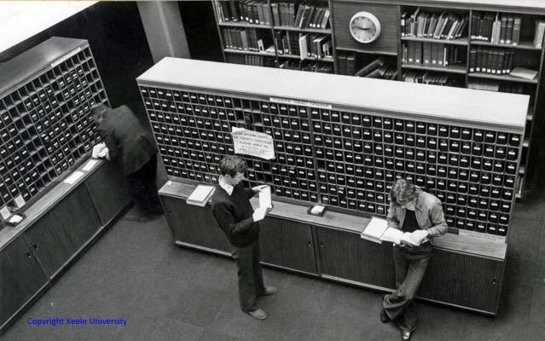

Plate ILibrary Catalogue Section at Keene University Source:(King, 2002)

      - Bindery Section/Department

The responsibility of this section is to repair damaged, torn or weakened materials.
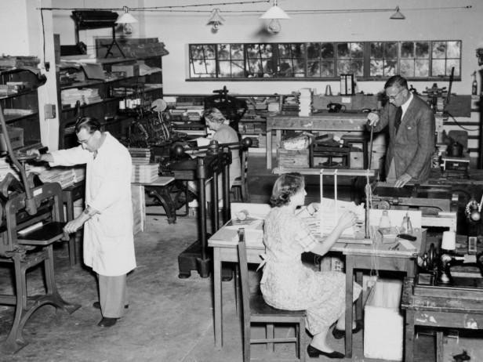
The section sometimes engaged in commercial bindery services if the work load, staff adequacy and other considerations permits it. (Ogbonna, 2009)

Plate IILibrary Catalogue Section at Keene University Source: (King, 2002)

      - Circulation Section/Department

This department receives processed books from the cataloguing department and makes them available for use. In some libraries, circulation desk is usually the first contact which readers have with the library.
Some of its functions are

        - Lending and Checkout of materials to library users

        - Checking- in materials returned

        - Monitoring materials for damage and routing them to the appropriate staff for repair or replacement
        - Collecting statistics on library use, i.e. patron transactions, material checkouts,

        - Charging and receipting overdue fines.

        - Process users‟ cards for authorized outside persons.

        - Registering validated users.

        - Writing and dispatching overdue notices
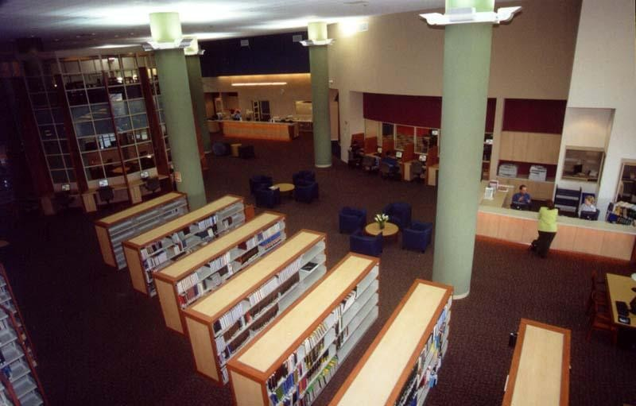

Plate IIICirculation section at Dayananda Sagar College of Engineering Source: (Troll, 2001)

      - Serials Section/Department

Like other library materials, serials are acquired by the acquisition departments. The serials department or section has the responsibility of organising, storing as well as displaying the serials or periodicals for use. The term serial is applied to materials in any medium issued under the same title in a succession of discrete parts, usually numbered or dated and appearing at regular or irregular intervals with no predetermined conclusion.
In contrast, a periodical has been defined as a serial publication with its own distinctive title, containing a mix of articles by more than one contributor, issued at regular stated intervals of less than a year, without prior decision as to when the final issue will appear. This includes magazines and journals, but not proceedings or newspapers.
Magazines are the most typical type of periodical, and therefore have their own entry and

category. Plate below shows a typical examples serials documents arrangement.
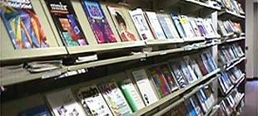

Plate IVCirculation section at Dayananda Sagar College of Engineering Source: (Troll, 2001)

      - Reference Section/Department

The department is concerned with providing the information and research needs of users. It is a department where extensive questions and answers take place. (Ogbonna, 2009).

Reference department provides personal assistance to the user. Materials in this department are not for borrowing or home use. They are meant to be consulted only in the library/department. They are usually materials to be consulted for specific information, not material to be read from cover to cover. Examples of reference materials are; encyclopaedia, dictionaries, handbooks, almanac, dictionaries, directories.
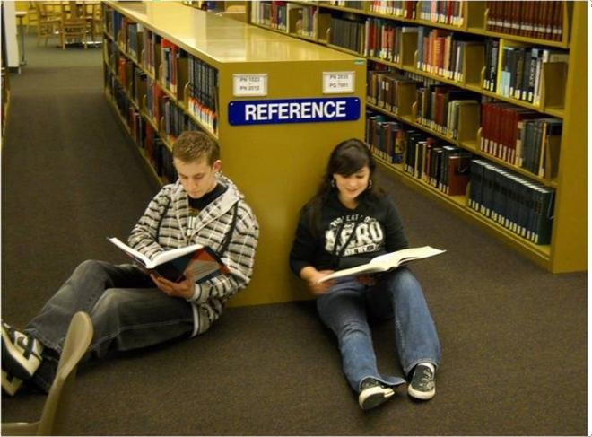

Plate V General Reference Section Source: (King, 2002)
      - Administration Department

This is the department that organizes the library into departments, organises the staff to function effectively, and generally perform the organisation tasks of the entire library. This department performs planning function by forecasting possible future developments and plan for adequate response to the future development.
Administration department provides leadership example and directs staff to accomplish a desired task. The department controls all the activities and services of the library.

Traditional Academic library spaces

Traditional academic library composed of the following space though the impact of technology change the way these spaces are been used while some are no longer useful.
The following spaces are:

      - Bibliographic rooms

      - Reading hall

      - Library staff offices

      - Reserved reading rooms

      - Audio-visual/maintenance rooms

      - Toilets

      - Relaxation rooms for clientele

      - Restaurant

      - Security check-points

      - Acquisition rooms

      - Cataloguing rooms

      - Serials rooms

      - Bindery rooms

      - Circulation hall

      - Reference room

      - Photocopying room

      - Administration rooms

      - Staff relaxation rooms

      - Store rooms

      - Microforms rooms

Traditional Academic Library Materials

Library materials are the items that make up a library. The need for physical space in any type of library is because the users as well as the materials need s to be housed, hence making up the library building.
Ogbonna(2009)defined the library materials as the recourses housed by a library which enables the library to meet its goal and objectives.
Academic library materials are broadly grouped into two  The print
And the non-print materials

The Print materials constitute of all prints on paper used as a source materials in a library. Examples of print material are:
- Books which constitute all the reference books (encyclopaedia, dictionaries, atlas, directories, almanac, calendar), other print materials are
- Periodicals (Serials)

- Thesis

- Special materials

- Documents

- Textbooks

- And other light reading material (novels).

The Non Print Materials

Ogbonna (2009)simply put these materials as the materials in library that are no in print.These include Audio-visual materials, microforms and other machine readable materials

  - Academic libraries today (Digital Academic Libraries) Accommodating readers and housing collection is one of the important functions of an academic library. Library design and construction of the past decades have responded to changes in information technology in a variety of ways, from incorporating e-classrooms for teaching information literacy to physically integrating the space where electronic and print material are kept. Libraries are becoming "Knowledge Navigator" rather than just cataloguers and shelf fillers. (Worpole, 2004)
Librarians, Architects, Planners both played a vital role in identifying the changes inemerging academic libraries.Tikekar (2009) highlighted these changes in the new academic libraries.
Medias were changed for recording, preserving and disseminating information and knowledge.
Libraries became multi media centres of information resources, leaving behind their dull and drab image of repositories of old dusty books, materials like microforms, audio and video cassettes.
Various electronic products for use both off line on line representing born digital and converted digitaldocuments are changing the faces of stack roomsand reading areas.
This ICT based phase of library development has resulted into not only extending the access of library users to the documents extensively but also quick retrieval of bibliographical and textual information. The erstwhile concepts of storage, various sections based on the types of the library material, technical processes and reader„s services, work

flow, and staffing pattern too are warranting a fresh look. The library management is becoming more integrated than before.

The New Roles

In a symposium titled"The Academic library 2012: A vision", these new emerging roles of academic libraries were fully identified
      - Provide welcoming space for intellectual discovery

By providing a centralized, interdisciplinary and fully configured learning commons among its spaces and resources, the library bridges the gap between campus life and academic culture. The library as place provides academic social space.
. Most obstacles to learning or to creating new knowledge are removed in the library; a widely known fact on campus. The library is branded as the place to go to fulfil course assignments, design an innovative syllabus or reach your informal learning goals. (American Universty Library, 2005)
      - Teach learners about information retrieval and integration

The instructional role of the library is widely recognized by learners. Library faculty work individually and in groups with learners, guiding them in navigating the information world and making effective and efficient use of information. The digital environment respects and affirms the value of the learner‟s time. Through intellectual exploration learners expand their curricula, integrate and contextualize information.
Students and faculty use library space for individual and group learning and see the library available at their fingertips, where ever they choose to be online. Reference service of all modalities – face to face, instant messaging, electronic research assistance, telephone assistance, one-on-one, one-to many – are all available, many of them on a 24-hour basis.
Librarians create interfaces, tutorials, web sites and online guides to facilitate asynchronous

and distributed access to information. Librarians provide consulting support for use of tools to access, assess and structure information.
      - Assemble information resources regardless of format and ownership

The longest tradition in libraries is collecting information packages – books, manuscripts, correspondence, journals, films and videos, sound recordings, maps, theses and dissertations. This tradition continues and the formats extend to include video games and other multimedia, interactive and simulation packages. The number of print packages decrease and proportionately more packages are digital, many born digital. The library provides improved access to collections through the digitization of materials it owns. It preserves information selectively, using contemporary standards whether preserving on paper, in microform or digitally
      - Create links to information, whether it is owned or accessed by the library

The second longest tradition in libraries is organizing information; i.e. classifying information packages and creating ways to describe them, thereby enabling their retrieval at the time of need. The catalog will continue to migrate in its format and content and libraries will continue to build finding aids that help people make sense of information organization. Highly intuitive web sites, search engines incorporating artificial intelligence, visual representations of library resources, thesaurus-based indexes and thumbnail images are created by the library and pushed out to searchers where ever they reside.
      - Promote ethical standards of information availability and use

The library, with its holistic and interdisciplinary commitments, promotes the ethical use of information whether it relates to fair use and copyright compliance, privacy issues, confidentiality of user records or promoting information as a public good. The library
maintains and communicates ethical standards regarding information policy and use.

Hybrid Library

The concept of the hybrid library, a fusion of the physical and digital dimensions of space and services, has offered one possible strategy for libraries to function as multifaceted social institutions, Library space should be understood as a complex and multidimensional concept. Modern academic libraries provides an intellectual and social space on campus. A place where people can meet, interact and discuss in groups both physical and virtual in aesthetically pleasing and well equipped surrounding. (Ugwuanyi, Roseline , & Emmanuel
, 2011). The design of libraries‟ physical spaces provides various opportunities for the renewal of the library as a societal institution. Figure 2.1 below shows model of library space consisting of three spheres: physical space, social space and digital space. In the diagram, the different spheres are defined to be partly independent and partly interconnected.
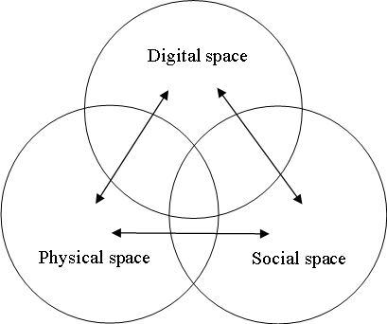

Figure 2. 1 The multidimensional model of library space consists of physical, social, and digital space.
Source: (Ugwuanyi, Roseline , & Emmanuel , 2011)

Traditional academic library spaces have witnessed some reasonable changes in the era of technology. Services such cataloguing and microforms are becoming obsolete, flexible learning spaces equipped with network access capability for group study and project work are needed, which change the face of stack rooms and reading areas. The libraries are now accommodating these new services within the traditional library wall which makes the library to exhibit two features for a traditional library and digital library. The facility is called a hybrid library. The figure below shows a model of a library in-transition from the traditional to modern or digital library.

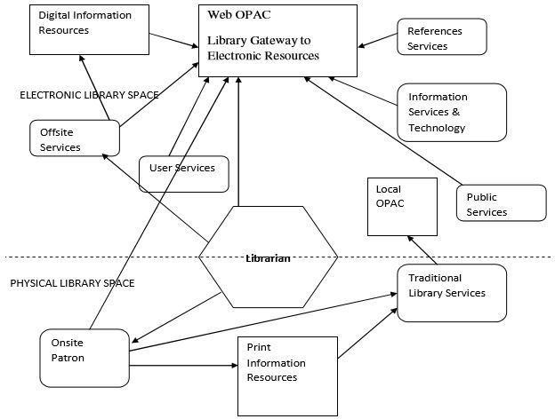

Figure 2. 2 Model of a Hybrid Library
Source: (Ugwuanyi, Roseline , & Emmanuel , 2011)

Information Technology and Library Spaces

Not only in academic libraries, the coming of technology has impacted almost every corners and buildings as well as services in higher education. Technology is causing important changes in how academic libraries look today. All the functions/spaces are been affected in one way or the other, some functions require less space while some require an increase. Many people believe that there will be no need for a physical place called a library in the future; giving that everything in the information realm will be accessible from the computer on their desktops. But Barney( 2004) reject this idea and he said even electronically stored infomation takes physical space somewhere and requires plenty of equipment and staff to accessio, index, retrieve and deliver it.
Mustapha (2012), also opined that Today‟s libraries must still preserve the core service values that traditional libraries were based on, but they cannot simply contain stacks and reading rooms. They must also address the vastly ways people access and process information.
Generally, technology itself is causing increased demand for space in many areas of the library. There are growing numbers of computer workstations for patrons and staff alike and other equipment such as network file server's needs specialized and additional space often not found in traditional academic libraries.
Barney( 2004) identifies the following spatial impact of technology on library functions.

Monographs

Monographic collections, especially for undergraduate libraries, are likely to continue to grow steadily. While digitization of some materials may result in some physical space savings, there are more formats that the library needs to collect; most of these require
additional space for equipment to access them, not to mention more specialized storage

facilities to house them. (Barney, The Impact of Technology on Library Space Requirement, 2004)
However, Troll (2001) said the use of video and other media appears to be increasing. Depending on the local context, circulation and in-house use of print resources may be increasing or decreasing.
E-Books are now replacing monographs; E-books have also been generating levels of excitement among the library community.
Fig 2.3 shows a statistics by National Center for Education Statistics that that eBooks will of course do have effects on the printed collections. However, the printed collection use will not hit zero not anytime soon. Though there will be decline in its use.
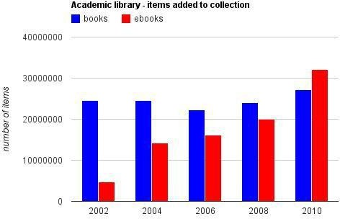

Figure 2.1 Printed and eBooks Usage

Source : (Association of College and Research Libraries, 2015)

Study Space

A number of authors confirm this one's experience that technology is increasing the requirements for study space in academic libraries. More space per student is required to accommodate the use of technology (for example laptops and workstations). Spaces for

group study are also needed. In his report, Freeman (2010) saidthe use of electronic databases, digitized formats, and interactive media has also fostered a major shift from the dominance of independent study to more collaborative and interactive learning. A student can go to this place called the "library" and see it as a logical extension of the classroom. It is a place to access and explore with fellow students information in a variety of formats, analyse the information in group discussion, and produce a publication or a presentation for the next day's seminar.
Barney (2004) added that, to address this need, libraries must provide numerous technology-infused group study rooms and project-development spaces. As "laboratories that learn," these spaces are designed to be easily reconfigured in response to new technologies and pedagogies.

Reference Section/Services

Concerns about general decline in library usage have proven unfounded. Instead, the impact of technology on libraries has been mixed.While the usage of some library services, such as reference section has declined. (American Library Association, 2007)
Traditionally, reference work depends on patrons approaching librarians. Students, faculty and other users must actively seek reference help. It is much more common now, however, for patrons to seek answers from the internet, rather than approaching a reference librarian. (Martin, 2009). However Troll (2001) added that the traditional face-to-face reference service with a librarian is being transformed by information technologies deployed to reach an increasingly remote audience, for example, electronic mail, web-based forms, and “chat” or “see you, see me” videoconferencing software.
But statistics by the American Library Association show that reference requests dropped an

average 4.5% per year, and book checkouts fell 1.2% per year though this varied depending

on the type of academic library. Master's level libraries saw an increase in research inquires during the same period. (ALA, 2007)

Printing and photocopying

The trend in many libraries is that the volume of printing is increasing and the volume of photocopying is decreasing. Librarians speculate that this is because of the increased availability and printing of full-text e-journals and e-reserves.

Periodical Section

However, use of print resources is decreasing. Use of video and other media appears to be increasing. Overall circulation is declining. In-house use of library materials is also declining(Troll, 2001). Serials in electronic format seem to be one of the best prospects for introducing space savings in academic libraries. Journals in electronic format will no doubt continue to increase, although those in scientific, technical, and medical disciplines are doing so at a more rapid rate. (Barney, The Impact of Technology on Library Space Requirement, 2004).
In this case the

Cataloguing Section

Cataloguing sections also witnessed reasonable changes in the era of I.C.T.

In the past, cataloguing and classification were done manually which made the work very difficult, boring and time consuming. Recently, most University libraries in Nigeria have joined their counterparts in advanced countries in the use of computers for processing library collections. (Adedibu, 2012)

Circulation Space

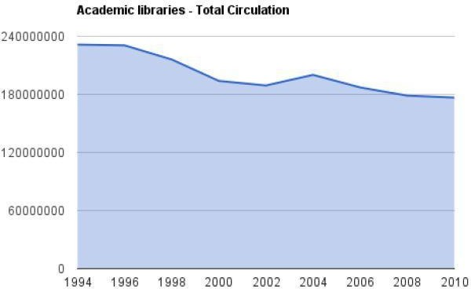

Figure 2.2 Academic Libraries Circulation Source:(Association of College and Research Libraries, 2015)

In the figure above, circulation will be in a decline but certainly doesn't look like it will hit zero anytime soon.

But in a statistics made by Academic and Research Library Association shows that academic enrolment has been rising rapidly. This means that more students will be enrolled which in turns more circulation activities and circulation space.
Fig 2.3 below shows the rate of enrollment in the academic institutions.

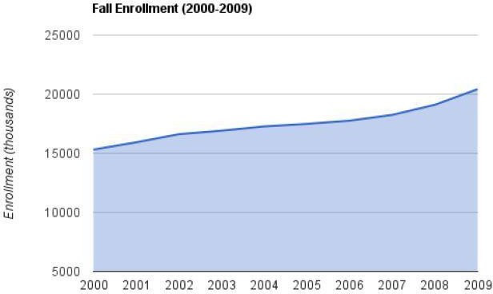

Figure2.3Rate of Enrolment in Universities
Source : (Association of College and Research Libraries, 2015)

The Spatial Impact of Technology on Library Functions

General: Technology itself is causing increased demand for space in many areas of the library. There are growing numbers of computer workstations for patrons and staff alike and other equipment such as network file servers needs specialized and additional space often not found in existing facilities. (Barney, The Impact of Technology on Library Space Requirements., 2006)

Instruction

A growing role of the library is helping students and others learn to use the new technology to access information. This is requiring libraries to supply more space for face- to-face consultation with information professionals and most often necessitating the provision of a large, well-equipped user instruction room Thus, as the instructional mission of the library is becoming more important, due in large part to introduction of technology, more square footage needs to be supplied for this function. (Barney, The Impact of Technology on Library Space Requirements., 2006)

Monographs

As discussed above, monographic collections, especially for undergraduate libraries, are likely to continue to grow steadily. While digitization of some materials may result in some physical space savings, there are more formats that the library needs to collect; most of these require additional space for equipment to access them, not to mention more specialized storage facilities to house them.

Periodicals

Serials in electronic format seem to be one of the best prospects for introducing space savings in academic libraries. Journals in electronic format will no doubt continue to increase, although those in scientific, technical, and medical disciplines are doing so at a more rapid rate (Lucker, 1996). Another factor also points in this direction, that being the extra-inflationary increases in pricing by many publishers.

Processing

In most "behind the scenes" areas of the library, technology is often causing the need for more rather than less space for equipment to handle incompatible systems. While this may be ameliorated in the future, the immediate space needs for areas like cataloging continue to grow
Reference: While technology is driving the need for more instructional space, it is impacting positively the need for space for reference materials themselves. A growing number of resources are available in electronic form, and often from resources housed outside the library. As in serials, however, collections more heavily reliant upon information in professional and scientific areas are experiencing space savings more dramatically (Lucker, 1996)

Study Space

A number of authors confirm this one's experience that technology is increasing the requirements for study space in academic libraries (Barney, The Impact of Technology on Library Space Requirements., 2006). Not only are more students relying on facilities like

libraries on college and university campuses for studying, more space per student is required to accommodate the use of technology (e.g., laptops and workstations)

Modern Concepts for Academic Library

According to (Ugwuanyi, Roseline , & Emmanuel , 2011), a modern library is expected to operate in these principles: - openness, multifunctional, flexibility and artistry. The principles of are also built upon these basic features enumerated five guiding principles to a successful information commons. These are open, free, comfortable, inspiring and practical.

Openness

A library should provide free, convenient and rapid services to the users. Therefore, the design of a library building should consider the efficiency of space and place. There is a shift from closed access to open access in this modern librarianship. Reading areas should be provided in positions that can easily be seen and reached with open stacks with large space. This abridges the gap between the reader and books, creating a convenient access to the books thereby encouraging serendipity and brows-ability. (Ugwuanyi, Roseline , & Emmanuel , 2011)

Multifunctional

A good library building must provide many functions in relations to recent developments in formats of documents, the ways of reading, the methods of document delivery and the diverse library activities. It must provide variety of informational materials such as books in print form, audio-visual materials, electronic products and internet services. It must provide enough spaces to accommodate these materials and at the same time provide a good study,

teaching, learning and research environment for various categories of library users will be accommodated and has to provide a good study, teaching, learning and research environment for various categories of library users. (Yunliang, 2001)pointed out that these developments have been motivating the building of new libraries in Shanghai-China. An example is the Shanghai library building with a floor space of 20,900 m2 which moved to a new building of floor space 83,000 m2 in 1997. It is four times larger than the old one. The new library building now has audiovisual rooms and electronic reading rooms installed with advanced equipment. The library often holds such activities as lectures, academic meetings, special seminars and information workshops.

Flexibility

Library building must be designed and built in such a way as to accommodate any change in library structure and services. The introduction of modern information technology into the library profession has caused reorganization of library services and structure. To satisfy this current development in the library information systems and reader services, new library buildings now follow the principles of flexibility. It uses unified module size, unified floor height and unified building load (Yunliang, 2001). Standards to apply this principle of flexibility. In the 3U standard, the unified module size of library building considers the size and arrangement of regular reading desk and the book shelves in the reading area. It supports the need of flexible separation of library area and save space at the same time. (Yunliang, 2001) stated that in Shanghai-China, in the mid-1980s the module size of library buildings constructed is about 6 to 7.5 m. For example, the size of the Shanghai library and the Bao Jiaotong library at the Shanghai University are both 7.5 x 7.5 m. The unified floor height is about 3.6 to 4.5 m. This height satisfies the natural light and ventilation needs of a

library building. Combining with air conditioned and artificial light, readers can be assured of good light and ventilation in all the activity area of the library. Unified building load meets the demand of future development of libraries for openness and for the open stack
layout of “combined storage and reading area”.

Artistry

Aesthetic is an important factor in the library building. New library buildings should pay attention to the expression of beauty as representing knowledge and culture. This idea is shown in the combination of such aspect as exterior look, interior layout, artistic design and natural environment. This makes the library environment attractive and inviting to users. (Yunliang, 2001)
A lot of researches have been written on the changing role and features of academic libraries. In her research on the "The need for physical space"King (2002) identifies these new featuresafter having a survey on existing academic libraries. From the results, the following features should be addressed:
      - 24 hour access to computer laboratories

      - Physical isolation of specific areas to allow longer hours of access e.g. open reserve collection and adjacent computer, photocopying and study facilities;
      - Flexible learning spaces equipped with network access capability for group study and project work;
      - Workstations equipped for electronic information access including multimedia resources, and applications software such as word processing. Specialist assistance close at hand;

      - Production facilities for use by clients to develop their own audiovisual and multimedia resources in a variety of formats;
      - Videoconferencing facilities for client use;

      - Facilities to support client participation in networked online discussion groups;

      - Laptop docking facilities, wireless laptops available for loan;

      - Specialised facilities for researchers such as fully equipped workstations supporting information access and retrieval with full word processing and printing facilities Adjacent to specialist assistance from reference librarians;
      - Special study domain for postgraduate students;

      - Open access compactus shelving

      - Provision of adjacent refreshment facilities or cafes including internet/cyber cafes;

      - Increased provision of self-help facilities such as open reserve;

      - Teleconferencing facilities for administrative purposes;

      - Co-location of service desks for increased staffing efficiencies; and

      - Increased physical integration with related units in the organisational structure such as Information technology, student support, and teaching and learning
In addition to these new features of academic libraries, (McMullen & Williams, 2008)also identifies these new spaces as part of digital/modern academic Library.

Computer workstations clusters

These are referred to as clusters or pods which allow ample space for students to spread out their materials. They are looking like computers of 1990's. Computer work areas are now being designed to functionally and spatially integrate into the library's overall design concept. Plate 3.6 shows a study area designed around building support of which the
columns offer plenty of space for individual or collaborative work.

A service desk

Support is an essential component of the computer workstation environment that includes a broad spectrum of productivity software. In using technology to complete a series of tasks, from identifying and locating information resources to producing a text-based or multimedia end product, students need both research and technological assistance. Librarians and information professionals are fulfilling these support needs by integrating service at a single desk or by staffing separate but co-located desks. In designing the service desk, careful consideration should be given to the types of activities that will be happening at this desk.

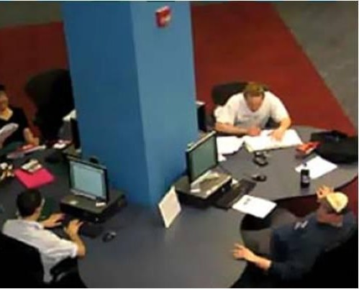

Plate VIBridgewater state college Clover leaf work area Source: (Worpole, 2004)

Collaborative learning spaces

Unlike the traditional libraries, the modern libraries facilitate collaborative learning spaces and satisfy the students' desire to mix social interaction with work. This enables the students to work together. Most libraries offer both small and large group study rooms that accommodate 4-12 users. Rooms are commonly equipped with computer projection technology and a white board. Plate 2.7 shows a large group study room with movable furniture, whiteboard and projection

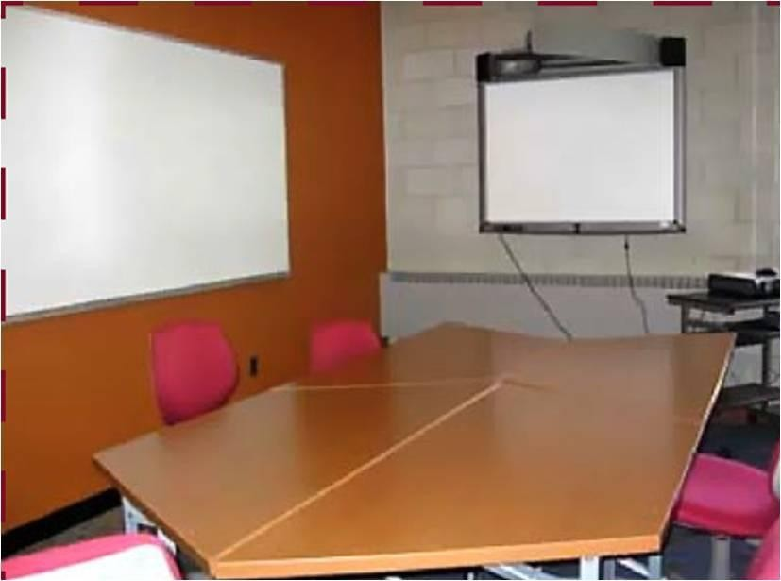

Plate VIIBridgewater State College group Study Room Source: (Worpole, 2004)

Presentation Support Centers
Plate 2.8 shows a student instructional technology laboratory with a student worker helping another student sharing a monitor. An important feature of the learning commons is an advanced technology facility to support students in developing multimedia projects. Presentation support centers go by many names: multimedia presentation centres, advanced technology labs, digital studios, media authoring labs, technology courtyards, special projects computer labs
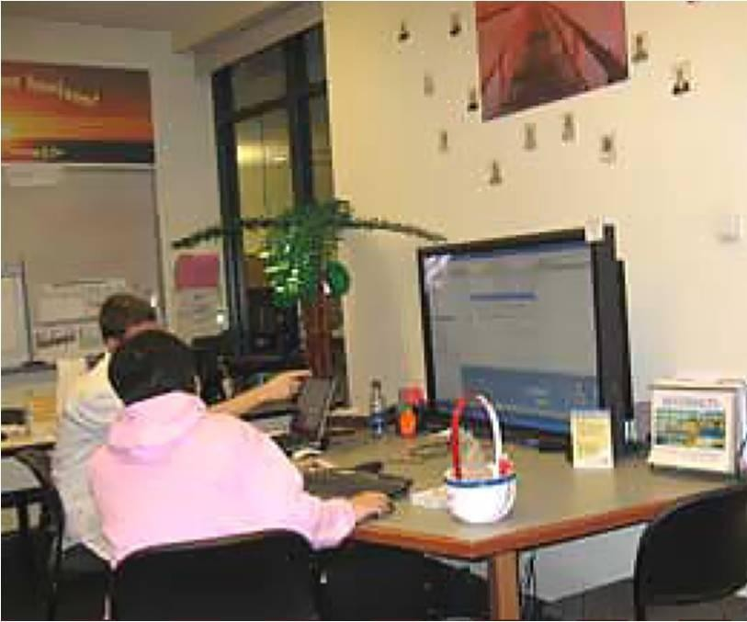

Plate VIIIStudent Instructional Technology Lab. Elon University Source: (Worpole, 2004)

Instructional technology centers for faculty development

The aim of this center is to give faculty with instructional strategies and assistance for teaching with technology. These centers are often called teaching learning centers and are often supported by instructional technology developments.
.Other spaces include:
Writing centres and other academic support unitsSpaces for meetings, Electronic classrooms, seminars, receptions, programs and cultural eventsCafés and lounge areas

Summary and Conclusion

This chapter reviews literature related to academic libraries. The concepts of traditional and modern systems of academic libraries of which different views of academic researchers were discussed. It also discourses about the spatial impact of information technology on traditional academic libraries as well as the modern concept of academic libraries in 21stcentury of which a multidimensional model of library space consists of physical, social, and digital space and a model of a hybrid library was been addressed.
In conclusion, traditional libraries in general are vastly affected by information technology. New services are now displacing the traditional ones. However, there are traditional services that are still in use in the traditional academic libraries making the libraries compose of traditional and digital services. Libraries have to be flexible enough to accommodate rapid technological changes.

RESEARCH METHODOLOGY

Introduction

This chapter deals with the research methodology, which outlines the philosophy behind the means of data collection and analysis and it is arranged under the following headings namely: - Introduction; Research methods; Population of the study; Sampling and Sampling Technique; Research Instruments; Procedure for administration of instruments and the Data analysis procedure.

Research Methods

According to Trochim (2006),a research design can be thought of as the structure of research, it is the glue that holds all the elements in research project together.There are different methods used by researchers in conducting research and there are no hard and just rules to be adopted in any given research situation. The appropriateness of a given research method is determined mainly by the kind of investigation being conducted. This research seeks to have an in depth investigation on the spaces as well as services and how are these are affected mainly by information technology over time. Indepth interview and opinions of the stakeholders mainly the librarians and the students respectively was carried out and this provided relevant information regarding the research.(Olanrewaju, 2004) stated that a method used to study a particular case in point with a view to examining in great depth and extent, the characteristics of that individual unit is case study. (Olanrewaju, 2004) also opined that this method is better adopted where emphasis is on pattern and sequences of
growth and or change as function of time. Similarly, this research seeks to explore and

examine the changes accompanied by information technology in the traditional libraries over time. Case study approach is applicable and is the appropriate for this research. To justify the selection of this method, (Kothari, 2004) also opined that a case study research is a method of research in depth rather than breadth. consequently, case studies focus on studying a small number of cases in detail rather than concentrating on large number of cases.Basically, a case study is an in depth study of a particular situation rather than a sweeping statistical survey. It is a method used to narrow down a very broad field of research into one easily researchable topic.

Population of the Study

The population of the study is made up of the following academic libraries in the North- Western zone of Nigeria. These are:
      - Kashim Ibrahim Library- Ahmadu Bello University Zaria

      - President Kennedy Library-Ahmadu Bello University Zaria.

      - Kaduna State University Library

      - Usman Danfodio University Library Sokoto

      - Bayero University Library (Old Campus) - Bayero University Kano.

      - Bayero University Library (New Campus)- Bayero University Kano

      - Kano University of Science and Technology Library, Kano

      - Umaru Musa Yar'aduwa University Library Katsina

      - Kebbi State University of Science and Technology Library, Kebbi

      - North West University Library Kano

      - Alkalam University Library Katsina

      - Federal University Birnin-Kebbi

      - Federal University Gusau

      - Federal University Dutse

      - Federal University Dutsinma

Sample and Sampling Techniques/Methods

According to (MacDonald, 1995) sampling is the process by which you reduce the total research population for a research project to a number which is practically feasible and theoretically acceptable (the sample). Issa (2004), explains it as a representation of a smaller group of the elements or members, drawn through some definite procedure from a specified population.
For the purpose of this study, a judgmental form of sampling known as purposive sampling was used to draw out the sample based on understanding of the population.Purposive sampling was used to enable the researcher to select the academic libraries based on universities generation. In order to examine the effect of information technology on the traditional libraries, three libraries were selected from first generation, second generation and fourth generation universities. The criteria for the selection was based on having 3 libraries from the first, second and fourth generationuniversities in Nigeria. (See APPENDIX E).
        - Kashim Ibrahim Library- Ahmadu Bello University Zaria

        - Kano University of Science and technology Library Wudil.

        - Bayero University Library (Old Campus) - Bayero University Kano.

Instruments for Data Collection.

Combinations of instruments were selected in the course of this study.

- Interview Schedule

Interview was structured that is the questions to be asked at the interview session have to be listed in what is called an Interview Schedule (see APPENDIX A). The respondents will be mainly academic libraries key staff
- Questionnaires

Questionnaire was designed to collect information mainly on the user need and identification of modern spaces/services in the library studied. Questionnaires were administered in the three libraries studied. The questionnaire is divided into 3 sections made up of personal/bio data in section A; User preferences in section B and interaction with the library in section C. (See APPENDIX B)
- Observation Checklist

Observation was used to compliment the use of interview in this study. It was used to cross validate certain responses from the interview. A combination of participant as well as non-participant observation was used to conduct this research.
- Documentary Sources

Data was collected from existing architectural plans of the academic libraries under study, recorded changes in terms of spaces was used to identify all the changes that occurred in the design of the libraries under study.

Procedure for Administration of Instruments

Introduction letters collected from the Department of Architecture Ahmadu Bello University (see APPENDIX C AND APPENDIX D)were submitted to Kashim Ibrahim library, Bayero University Library and Kano University of Science and Technology Library. After approval by the University Librarians from the listed libraries mentioned earlier, structured interviewswere conducted with the university librarians and head of departments of various sections of the libraries studied. Data was collected from the various departmental heads in each of the libraries studied. A tour round the libraries was made and sketches as well as photographs were taken which aid in the interpretation of the data collected from the interviews. In addition, 130 questionnaires (see APPENDIX B) were administered for each of the 3 libraries randomly for 6 days to the respondents which were there in the libraries during the study. The questionnaires were collected in each of the libraries by the researcher after they have been answered by the respondents.

Data analysis Procedure

In achieving the first objective which is to identify the current library spaces provided in the north western zone of Nigeria,transcription and interpretation of structured interview was carried it to find out the current spaces provided in the libraries studied.
In finding out the spaces which were affected by information technology and in examining the effect of technology on the overall pattern of the libraries studied, content analysis of some relevant documents was carried out to find out the level of usage of some services provided in the libraries studied. In addition to that, interpretation of structured interview was carried out.

To achieve the fourth objective which is to identify the new developments in terms of space requirement of the libraries under study, pictures taken were used to indicate the new services as well as the new spaces that were provided in the libraries studied. Interpretation of the interviews was also used to identify these spaces.
The fifth objective which is finding the user needs with respect to the library environment was achieved through statistical analysis of the questionnaire provided. Transcription of structured interview was also carried out to identify the user needs in terms of space requirement in the library environment.

Summary

The section started by brief introduction then followed by a clear description of the research methods, population of the study, sampling and sampling techniques. It also explain the instrument used for data collection and the procedure for administration of the instruments. Finally it discusses about the procedure used in analysing the data collected.

RESULTS AND DISCUSSIONS

Introduction

The study seeks to assess the dynamics in usage of spaces in academic libraries in transition.
In this chapter, the data that was collected from the two case studies was analysed and presented. The results were properly presented and discussed which was used to answer all the research questions.

Case Study one- Kashim Ibrahim Library

Location: Ahmadu Bello University, Zaria Date Established: 1964
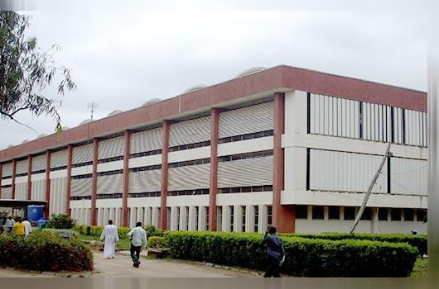

Plate IXPerspective View of Kashim Ibrahim Library Source: Researchers' field work (2015)

In answering the first research question that is to find out the current spaces in the library under study, an interview was taken and the following spaces were identified as the current spaces in library studied.
These spaces are categorised as follows:-

Technical Services

These are functions that provide technical support to the library services/functions. The following are the spaces/divisions found in this section.
      - Resource Development Division

This division deals with acquisition, organising as well as recording of library materials most specifically the prints materials. This department has 4 main units, these are: - ordering and invoice clearance unit; bibliographic checking and filing unit and receiving unit.
      - Resource Processing Division

This division deals with cataloguing and classification of library materials. It has 3 units which are, cataloguing and classification unit, catalogue maintenance unit, and bindery unit.
      - Quality Assurance Division

This division is responsible for ensuring high standards within the materials acquired by the library.

Customer Services Section

The following are the divisions/Sections that deal with providing the needs of the clientele:-

      - Circulation Section

This includes the circulation desk the study area which constitutes the study desk, the book shelves, and the circulation management offices, and the reserve section.
      - Reference Division

This division aims at providing user assistance in answering their reference queries.

It has five main units: - Query desk unit, catalogue/Online Public Access Catalogue Unit (OPAC), Industrial Training Unit, Shelve Maintenance unit, Online/Social Media Unit and Study Area and a Strong room.
      - Documents and Africana Division

This division provide materials aid to post graduate students and researchers in conducting their research. It is divided into four main units: - the Thesis Unit, The Africana Unit and the Native Authority Unit.
      - Serial Management Division

This division deals with the acquisition of serial resources as well as processing and administering it to the users. It includes Serials public service unit which includes the reading/study areas, the serials shelves; serials processing unit; gifts and exchange unit and serials records unit.

      - Media and Public Relations Division

This division aims in providing audio visual support to support the print Materials.

It has two main divisions: - the media unit and the public relations unit; the former deals with organising and maintenance of the microfilms, CD and DVD rooms, and disk and slide rooms, the later deals with maintenance of the viewing area as well as the bulleting and the E-adverts section.

The Administrative Division.

This division manages and supervise all the activities in the library. It administers all the divisions' in order to keep the library running so as to meet the need of the parent institution
This division constitute of the Librarian Office, Secretary's Office, administrative officer's office, accounting office, Services section, library's archives, cafeterias and libraries conveniences.

The Information and Communication Technology Division

This division was created after computing technology was introduced in Nigeria. The division centred in providing information to the academic library users in digital format. This was not in the initial design of the library. It has 5 main units. These are:-
      - Digitization Unit

This unit has the responsibility of converting the print materials to the digital materials. That is it aids in converting the library from analogue to digital.

      - Technical Unit

This houses the server room and maintenance unit which gives the division with technical support.
      - Training Unit

The aim of this centre is to give faculty with instructional strategies and assistance for teaching with technology.
      - MTN Net Library

This unit provides infrastructural services to the users for digital information retrieval. These division/sections constitute the Kashim Ibrahim Library. Table 4.1 below shows a summary of the divisions of the library studied.

Table 4. 1 A summary of the current spaces found in the library studied.

KASHIM IBRAHIM LIBRARY CURRENT SPACES
 | Main Divisions | Sub-Divisions | Units
1 | Technical Services | Resource Development | Ordering and Invoice Clearance Unit, Bibliographic Checking Unit
2 |  | Resource Processing | Catalogue and Classification unit, Bindery and  Catalogue Maintenance Unit
3 |  | Bindery
4 |  | Quality Assurance
5 | Customer Services | Customer Services
6 |  | Circulation Desk
7 |  | Study Area
8 |  | Reserve
9 |  | Reference | Query Desk Unit, Catalogue Unit, Shelve  Maintenance Unit, Industrial Training Unit
10 |  | Serials Management | Serials Public Service Unit. Serial Processing Unit  Serials Records and Gift and Exchange Unit
11 |  | Media and Public  Relations | Microfilm room, CD and DVD Rooms, Disk and  Slides Room, Viewing Area
12 |  | Documents and Africana Section
6 | Administrative Division | Librarian | Offices, Secretary
7 |  | Administrative Section | Administrative Office's Office, Secretary,  Accounting Office, deputy librarian‟s office, senior librarian‟s office.
8 |  | Archives
10 |  | Cafeteria
11 |  | Conveniences
12 | I.C.T Division | Digitization Unit
13 |  | Technical/Server Unit
14 |  | CD Rom Search Unit
16 |  | MTN Net Library
17 | Plant Room | Central Air-Condition Room.

Source: Researchers field work (2015)

In answering research question two which is the identification of the traditional spaces that are affected by technology. The study found out that various sections have been affected by the coming of technology, this indeed makes some spaces become obsolete, and some functions where displaced by some new introduced functions also some spaces were relocated to other places. The study found out that the following spaces are affected:-
53

Resource Development Section

Acquisition department has undergone some certain changes with the coming of technology.
A new space was been added which deals with ordering of e-resources such as e-books and e-journals.

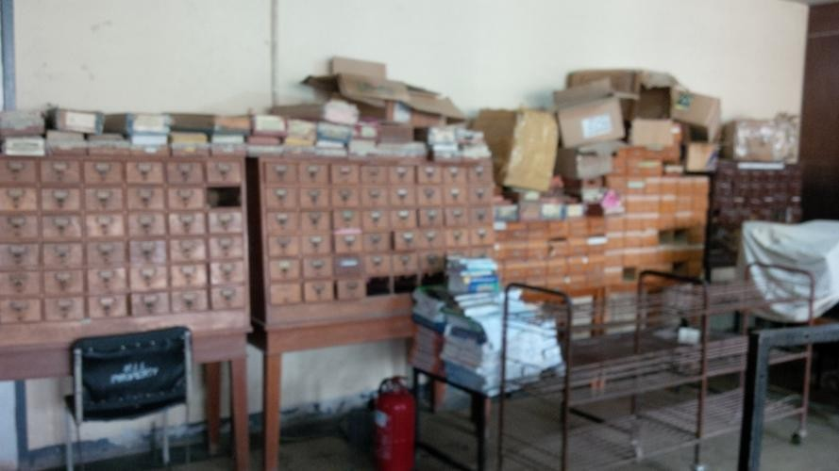Furthermore, as shown in plate 4.1 below catalogues kept in the department are no longer in use, because, the ordering and organisation in this section are done using computers.

Plate XObsolete Resource Development Catalogue Source: Researchers Field Work (2015)

Resource Processing Unit

The introduction of online public access catalogue (OPAC) serves as a substitute to the traditional catalogue though the OPAC is not widely being used by the users. A portion of space was added to provide a place for computers that will give an access to the OPAC.

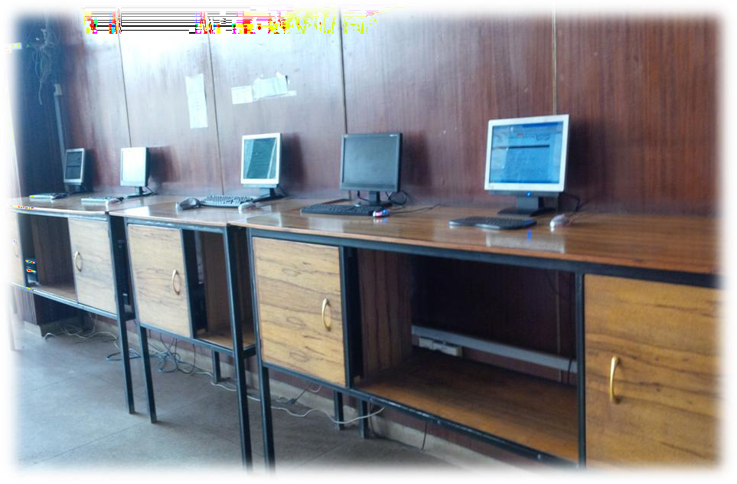

Plate XIComputer Desk for (OPAC) Source: Researchers field work (2015)

In addition, the reprographic section was converted to digitization room. The former was relocated to north western part in the ground floor as shown in plate 4.1

54

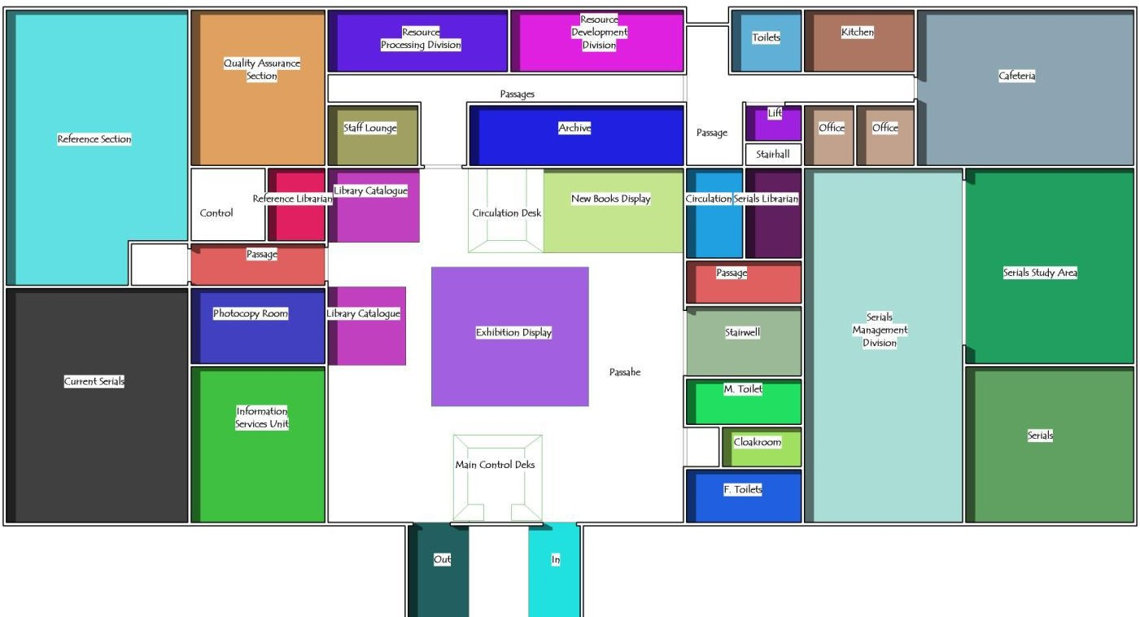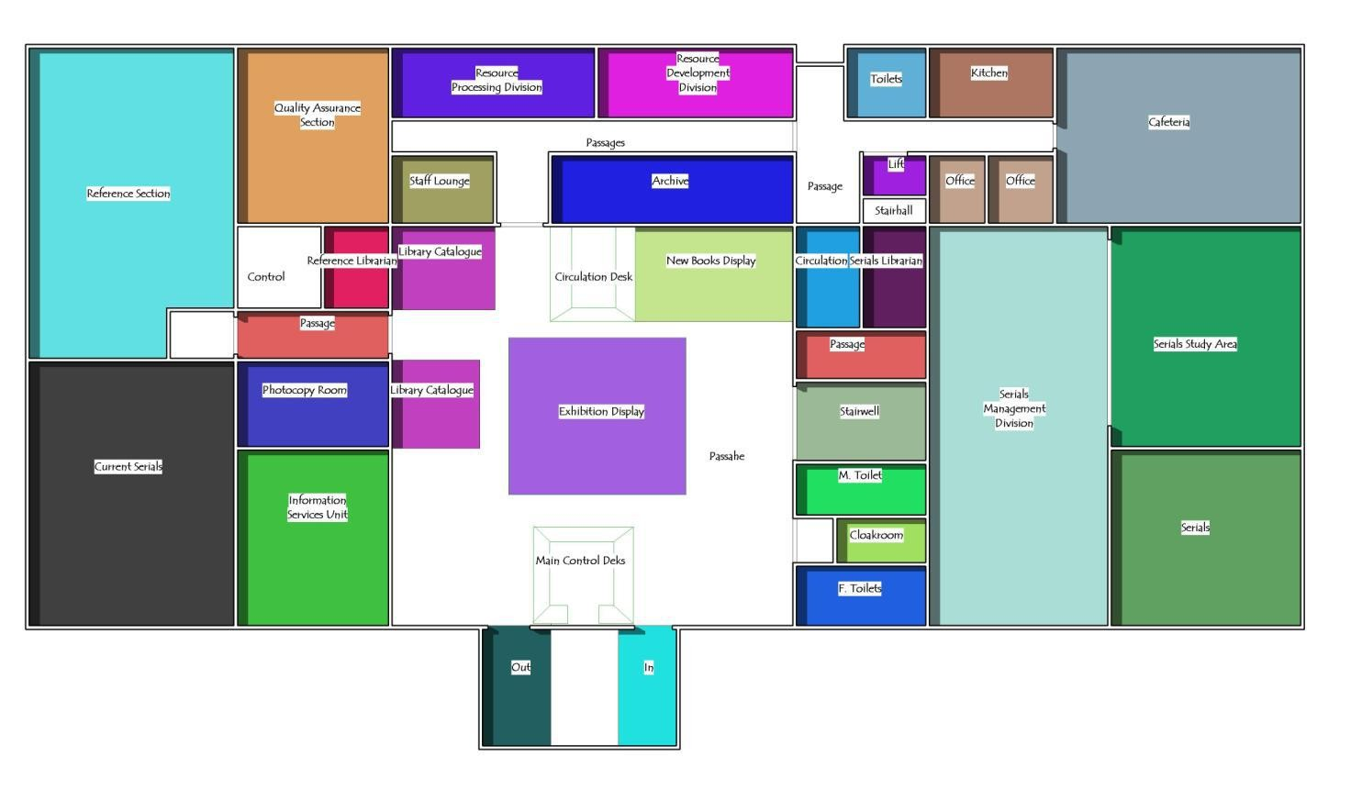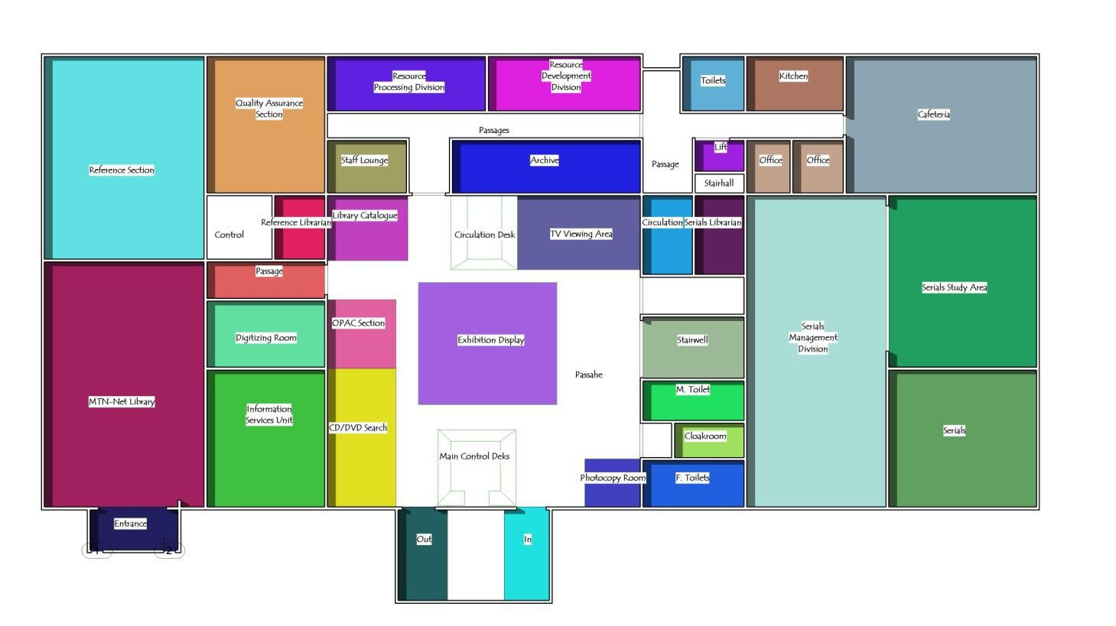

Figure 4. 1 Initial Library Ground Floor Source: Researchers'' field work (2015)

Figure 4. 2 Existing Library Ground Floor Plan Source: Researchers' field work (2015)
55

Study Areas and Circulation Desk.

In Study areas, the open shelves are not widely used most especially by the students due the introduction of e-resources and the provided books are out-dated found there in the shelves. The traditional method used in the circulation desk for clearance and registration of library users has been converted to computerized clearing and registration of users. Also the new books display area has been converted to TV-Viewing centre of students and staff. Plate 4.3 shows the initial plan with a new books display area, while plate 4.4 shows the area was converted to TV Viewing area for students and staff.
Reference Section

Some parts of the study area found in this department have been converted to computer spaces for online reference assistance for students and researcher. In addition, the newspaper reading area has been converted to reading area.
Serials Management Section

There are some certain changes caused by technology from the initial design of this section, Cardex and strip index areas which serves the same function as the public catalogue are no longer been used as a result of the introduction of the online cataloguing system. Computer workstations have been integrated to the serials study area as shown in plate 4. Plate 4.3 and 4.4 shows that the current serials section which was situated in the north eastern part of the ground floor plan was converted to MTN-net library.

Media and Public Relations

Microfilms are no longer used thus making the whole room obsolete. However, video tapes areas were also converted to CD and DVD rooms. Viewing Area was been created replacing the new books display areas as shown in plate 4.3 and 4.4 above
Plant Room

The central air conditioning plant room that was situated in the third floor was been converted to an Information and Communication Technology Server room.

In answering research question three, an assessment table was created in order to examine the effect of technology on the overall pattern of the library studied. Fig 4.1 and fig 4.2 illustrates the results on the technological effect on the overall pattern on the libraries under study. It can be observed that six out of twenty number of spaces have become obsolete and this makes up to 32% of the overall library space.Four spaces out twenty number of spaces have undergone conversions making up to 24% of the overall library space. Four out of twenty number of spaces have been added to the traditional library which is 16% of the total library space.Whereas two spaces out of twenty spaces have been removed from the existing library space. Only three spaces out of the overall twenty spaces have not been affected by information technology making up to 16% of the total library space.

Effect of Technology on Library Spaces
Effect of Technology on Library Spaces

Relocatio
n Not
4% Affected
16% Obsolesc
Subtracti ence
on 32%
8%

Addition Conversio 16% n
24%
Effect of Technology on Library Spaces
Relocation
4%
Not
Affected 16%
Obsolesce
nce 32%
Subtractio
n 8%
Addition
16%
Conversio
n 24%
Figure 4. 3 Effect of technology on library spaces


Not Affected 16%
Affected
84%

Source: Researchers' field work (2015)

Figure 4. 4 Effect of technology on library spaces Source: Researchers' field work (2015)

Table 4.2 assessed the library spaces based on these variables which are: - Obsolescence, additions, subtraction, and relocation. The result can be obtained from the table 4.2 showing the spaces that have been affected by technology.

Table 4. 2 Summary of Affected Library Space

Kashim Ibrahim Library
Division/Department  s |  | Changes
Obsolescence | Conversion | Additi  on | Subtraction | Relocation | Not  Affected
Technical Services
Acquisition/Collecti on Development
Cataloguing And
Classification
Quality Assurance
Bindery
Reader Services/Customer Services
Circulation/ Study Areas
Reference
Reserve
Documents and PG
Serials
Media and Public Relations
Administrative Division
Offices
Archives
Cafeteria
Stores
Conveniences

Source: Researchers' field work (2015)

In answering research question four which is the identification of new emerged developments found in libraries under study, a review of literature has shown that traditional libraries are now adding new functional spaces mainly derived by the coming of technology. Several researchers have identified these spaces as new development in academic libraries. These spaces are; service desk, collaborative learning areas, computer workstation clusters, presentation support centres, E-Classrooms, cafes, space for meetings and video conferencing areas. These have been used as a basis in finding out the new development in terms of space requirements in the library studied.
Table 4.3 helps the researcher to identify some of the new space/development in the library studied.
Table 4. 3 Emerging Development Checklist

 | New Developments | Present | Absent
1 | A Service Desk
2 | Collaborative Learning Space
3 | Computer Workstation Clusters
4 | Presentation Support Centres
5 | E-Classrooms
6 | Videoconferencing Area
7 | Cafes
8 | Lounge Areas
9 | Space for Meetings
10 | O.P.A.C
Source: Researchers' field work (2015)

In answering research question five that is identifying the need of the users with respect to the library environment. Responses were to identify the following:-
Responses shows that the library is mainly patronized by the students of which 70% of the respondents are male and 30% are females. Responses also indicates that 40% of the library users are having their postgraduate program and 60% of the respondents are undergraduate students. 60% of the respondents say they only go to the library during examination period while a modest amount of 20% say they go to the library on daily basis. This shows that the library is still being patronized by the students and staff. 79% of the respondents say they access information basically for their assignments and research work from the internet while 27% prefer to use library print materials for work. 62 % say they read e-books from their personal computers, smartphones and other electronic within the library, in their hostels and even outside the university campus.
In question 7 of the questionnaire administered, this shows the degree of usage of the library spaces by the users. 80% of the responded only go and read their course hand-outs in the reading area and also in the reserve, reference and serials section only few use the library materials.10% used the serials materials, 36% use the reference materials available in the library studied. 0nly 5% of the respondents use the public access catalogue provided in the library. While 10% use the online public access catalogue provided in K.I.L. the microfilm room in the audio-visual section is totally not been used by the respondents. 40% of the respondents say they mostly use the MTN net library that is the e-library provided within K.I.L. It can be deducted from the responses that E-Classrooms, Multimedia Rooms, Internet Café, Meeting rooms, Group Study/discussion areas, were not available in the library studied.

Question 8 shows 40% of respondents use the library for private/solitary reading, 36% say they go there to study with other people, 37.86% say they only go there to meet people, 45% say they only go there when they have research or homework to do, 38.86% say they go to study for exams and 40.17% say they visit the library regularly to improve their knowledge.
Question 9 shows 23% of library users require a very quiet for study, 37% say they prefer reading in groups with classmates and friends, 20% say they like reading outdoors, and 20% say that noise does not matter as long as they are comfortable. Interpreting this, results strongly indicate diverse needs of users hence the need to create an environment to cater for the diverse needs of users.

Case Study Two: Bayero University Kano Library

Date of establishment: 1987

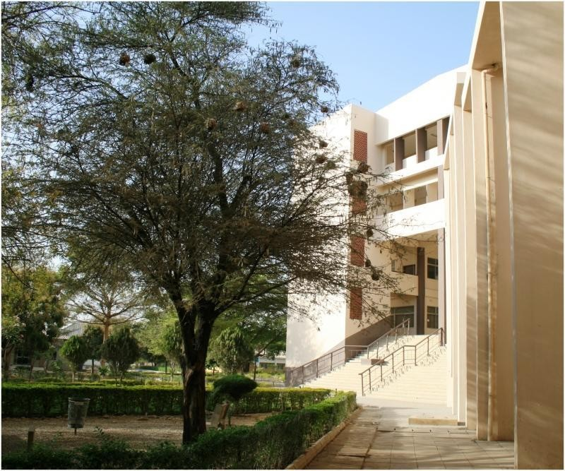
Location: Bayero University Kano

Plate XIIPerspective view of B.U.K main library Source Researchers' field work (2015)

In answering the first research question that is to find out the current spaces in the library under study, an interview was taken and the following spaces were identified as the current spaces in library studied. These spaces are categorised as follows:-

Technical Services

These are functions that provide technical support to the library services/functions. The following are the spaces/divisions found in this section.
      - Collection Development Division

Similar to the resource development section, this section has the responsibility of acquiring, organising as well as recording of library materials most specifically the prints materials. This department has 4 main units, these are: - ordering and invoice clearance unit; bibliographic checking and filing unit and receiving unit.
      - Cataloguing and Classification Division

This division deals with processing and organising of library materials. It has 3 units which are, cataloguing and classification unit, catalogue maintenance unit, and bindery unit.

Reader-Services

The following are the divisions/Sections that deal with providing the needs of the clientele:-

      - Circulation Unit:

This includes the circulation desk the study area which constitutes the study desk, the book shelves, and the circulation management offices, and the reserve section.
      - The Reference Unit:

This division aims at providing user assistance in answering their reference queries.

It has five main units: - Query desk unit, catalogue, industrial Training Unit, Shelve Maintenance unit, study Area and a Strong room.

      - Serials Unit:

This division deals with the acquisition of serial resources as well as processing and administering it to the users. It includes Serials public service unit which includes the reading/study areas, the serials shelves; serials processing unit; gifts and exchange unit and serials records unit.
      - Documents Section and Arabic:

This division provide materials aid to post graduate students and researchers in conducting their research. It is divided into four main units: - the Thesis Unit, The Arabic Unit and the Native Authority Unit.

Administrative Section

This division manages and supervise all the activities in the library. It administers all the divisions' in order to keep the library running so as to meet the need of the parent institution
This division constitute of the Librarian Office, Secretary's Office, administrative office, accounting office, Services section, library's archives, and library conveniences.

Automation Section

This section provides internet services to students and staff for academic and research work, and also managing electronic library software. The division is composed of student cafe, staff cafe and E-Learning centre.

Table 4. 4 Summary of the current spaces found in the library studied.

BAYERO UNIVERSITY MAIN LIBRARY SPACES
 | Services | Divisions | Units
1 | Technical Services | Collection Development
2 |  | Cataloguing and Classification | Catalogue and Classification unit, Bindery, unit Catalogue Maintenance Unit and photocopying room
3 | Reader Services | Circulation Unit | Circulation desk, Study areas, Shelves, study carrels
4 |  | Reference unit
5 |  | Serials Unit | Serials Public Service Unit. Serial Processing Unit Serials Records and Gift and Exchange Unit
6 |  | Documents and Arabic  Section
7 |  | Microfilm room
8 |  | Viewing Area
9 | Administrative Services | Librarian Office | Office, Secretary
10 |  | Administrative Unit | Office, typing office, filing office
11 |  | Stores and Archive
12 |  | Cafeteria
13 | Automation Services | Student Cafe
14 |  | Staff Cafe
15 |  | E-Learning Centre

In answering research question two which is the identification of the traditional spaces that are affected by technology. The study found out that various sections have been affected by the coming of technology, this indeed makes some spaces become obsolete, and some functions where displaced by some new introduced functions also some spaces were relocated to other places.
The study found out that the following spaces are affected:-

      - Cataloguing and Classification

Plate 4.4 shows a section of Public access catalogue which became not in use by both the students and staff. The space allocated to this item have become obsolete, photocopying area was converted to TV viewing area; thus the space allocated to the item was relocated to the northern part of the library studied.
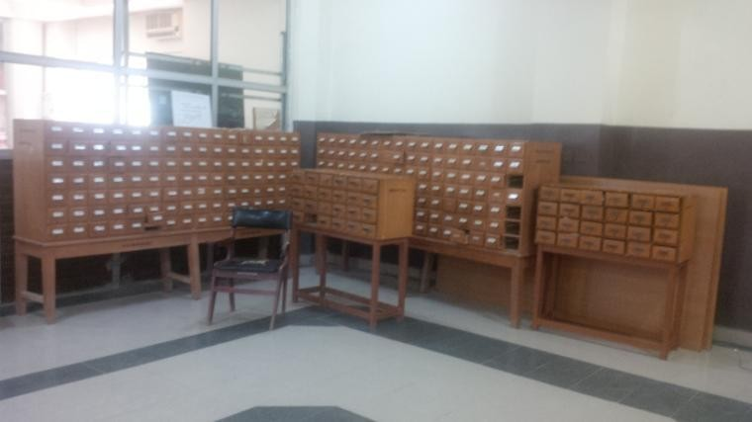Furthermore, new space for computer was added in the ordering and processing office used for recording of received and outgoing book. Plate 4.5 shows a section of the added space.

Plate XIIIObsolete Public access catalogue Source: Researchers' field work (2015)

      - Circulation Section

Study carrels found in circulation study area were converted to computer workstation clusters, shelves have become obsolete. With the expansion of the library later in 1987, the whole circulation area was been expanded as shown in figure below.
      - Reference Section

With the expansion of the whole library, this section was relocated to the new phase as shown in figure below. Computer station was created within the reference study area for reference use.
      - Serials Section

Computer workstation was created within the serials reading area. Cardex and strip index which serves the same function as the public catalogue are no longer been used as a result of the introduction of the online cataloguing system.
      - Microfilm Room

Microfilms are no longer used thus making the whole room obsolete. So the room was been converted to a store.

In answering research question 3, the study examined the effect of technology on the overall pattern on the library under study. Fig 4.5 was used to examine the technological effects. It can be shown that the library have undergone several changes such as additions and subtraction of functional spaces, relocation as well as conversion of some spaces while some spaces have become obsolete.

Effect of Technology on Library Spaces
[CATEGORY NAME] [PERCENTAGE
]

Obsolescent 24%

Relocation 9%

Subtraction 5%

Addition 19%
Conversion 19%

Obsolescent Conversion Addition Subtraction Relocation Not Affected

Figure 4. 5 Effects of Technology on Library Spaces Source: Researchers' field work (2015)

Similarly it can be observed that five out of twenty number of spaces have become obsolete and this makes up to 24% of the overall library space. Four out of twenty number of spaces have been converted to a different function which is 19% of the overall library space. Three out of twenty number of spaces have been added to the traditional library which is 19% of the total library space. Whereas 1 space out of twenty spaces have been removed from the existing library space which is 5% of the overall library space. Only five spaces out of the

overall twenty spaces have not been affected by information technology making up to 24% of the total library space.
Table 4. 5 Summary of the Effect of Technology on Library Studied

Divisions/Spaces |  | Changes
Obsolescence | Conversion | Addition | Subtraction | Relocation | Not Affected
Technical Services
Collection

Development
Cataloguing and Classification
Bindery
Reader Services
Circulation
Reference
Reserve
Documents and

Arabic
Serials
Microfilms room
Admin Services
Offices
Archives and Store
Conveniences

Source: Researchers' field work (2015)

In answering research question four which is the identification of new emerged developments found in libraries under study, a review of literature has shown that traditional libraries are now adding new functional spaces mainly derived by the coming of technology. Several researchers have identified these spaces as new development in academic libraries. These spaces are; service desk, collaborative learning areas, computer workstation clusters, presentation support centres, E-Classrooms, cafes, space for meetings and video conferencing areas. These have been used as a basis in finding out the new development in terms of space requirements in the library studied.
Table 4.3 helps the researcher to identify some of the new space/development in the library studied.
Table 4. 6 Emerging Development Checklist

 | New Developments | Present | Absent
1 | A Service Desk
2 | Collaborative Learning Space
3 | Computer Workstation Clusters
4 | Presentation Support Centres
5 | E-Classrooms
6 | Videoconferencing Area
7 | Cafes
8 | Lounge Areas
9 | Space for Meetings
10 | O.P.A.C
Source: Researchers' field work (2015)

In answering research question five that is identifying the need of the users with respect to the library environment. Responses were to identify the following:-
Responses shows that the library is mainly patronized by the students of which 68.5% of the respondents are male and 31.5% are females. Responses also indicates that 40% of the library users are having their postgraduate program and 60% of the respondents are undergraduate students. 69% of the respondents say they only go to the library during examination period while a modest amount of 16% say they go to the library on daily basis. This shows that the library is still being patronized by the students and staff. 79% of the respondents say they access information basically for their assignments and research work from the internet while 27% prefer to use library print materials for work. 62 % say they read e-books from their personal computers, smartphones and other electronic within the library, in their hostels and even outside the university campus.
In question 7 of the questionnaire administered, this shows the degree of usage of the library spaces by the users. 85% of the responded only go and read their course hand-outs in the reading area and also in the reserve, reference and serials section only few use the library materials.5% used the serials materials, 40% use the reference materials available in the library studied. 0nly 5% of the respondents use the public access catalogue provided in the library, the microfilm room in the audio-visual section is totally not been used by the respondents. 40% of the respondents say they mostly use the e-library provided. It can be deducted from the responses that O.P.A.C, E-Classrooms, Multimedia Rooms, Internet Café, Meeting rooms, Group Study/discussion areas, are not available in the library studied.

Question 8 shows 20% of respondents use the library for private/solitary reading, 15% say they go there to study with other people, 5% say they only go there to meet people, 10% say they only go there when they have research or homework to do, 30% say they go to study for exams and 10% say they visit the library regularly to improve their knowledge.
Question 9 shows 23% of library users require a very quiet for study, 37% say they prefer reading in groups with classmates and friends, 20% say they like reading outdoors, and 20% say that noise does not matter as long as they are comfortable. Interpreting this, results strongly indicate diverse needs of users hence the need to create an environment to cater for the diverse needs of users.

4.4 Case Study Three: Kano University of Science and Technology Library

Date of establishment: -

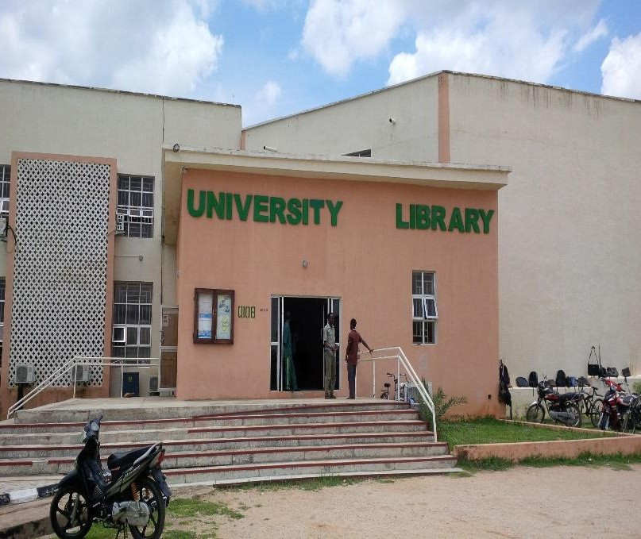
Location: Kano University of Science and Technology, Wudil

Plate XIVPerspective view of KUST main library Source Researchers' field work (2015)

In answering the first research question that is to find out the current spaces in the library under study, an interview was taken and the following spaces were identified as the current spaces in library studied. These spaces are categorised as follows:-

Technical Services

These are functions that provide technical support to the library services/functions. The following are the spaces/divisions found in this section.
      - Collection Development Division

Similar to the resource development section, this section has the responsibility of acquiring, organising as well as recording of library materials most specifically the prints materials. This department has 4 main units, these are: - ordering and invoice clearance unit; bibliographic checking and filing unit and receiving unit.
      - Cataloguing and Classification Division

This division deals with processing and organising of library materials. It has 3 units which are, cataloguing and classification unit, catalogue maintenance unit, and bindery unit.

Customer-Services

The following are the divisions/Sections that deal with providing the needs of the clientele:-

      - Circulation Unit:

This includes the circulation desk the study area which constitutes the study desk, the book shelves, and the circulation management offices, and the reserve section.
      - The Reference Unit:

This division aims at providing user assistance in answering their reference queries.

It has five main units: - Query desk unit, catalogue, Shelve Maintenance unit, study Area and a Strong room.

      - Serials Unit:

This division deals with the acquisition of serial resources as well as processing and administering it to the users. It includes Serials public service unit which includes the reading/study areas, the serials shelves; serials processing unit; gifts and exchange unit and serials records unit.
      - Documents Section and Africana:

This division provide materials aid to post graduate students and researchers in conducting their research. It is divided into four main units: - the Thesis Unit, The Arabic Unit and the Native Authority Unit.

Administrative Section

This division manages and supervise all the activities in the library. It administers all the divisions' in order to keep the library running so as to meet the need of the parent institution
This division constitute of the Librarian Office, Secretary's Office, administrative office, library's archives, and library conveniences.

E-Library

The division centred in providing information to the academic library users in digital format. It is equipped with computer workstations for 60 users.

Table 4. 7 A summary of the current spaces found in the library studied.

KANO UNIVERSITY MAIN LIBRARY SPACES
 | Services | Divisions | Units
1 | Technical Services | Collection Development
2 |  | Cataloguing and Classification | Catalogue and Classification unit, Bindery, unit Catalogue Maintenance  Unit and photocopying room
3 | Reader Services | Circulation Unit | Circulation desk, Study areas,  Shelves, study carrels
4 |  | Reference unit
5 |  | Serials Unit | Serials Public Service Unit. Serial  Processing Unit Serials
6 |  | Documents and Africana  Section
9 | Administrative  Services | Librarian Office | Office, Secretary
10 |  | Administrative Unit | Office, typing office, filing office
11 |  | Stores and Archive
13 | E-Library | Student Café
14 |  | Staff Café
Source: researchers' field work (2015)

In answering research question two which is the identification of the traditional spaces that are affected by technology. The study found out that various sections have been affected by the coming of technology, this indeed makes some spaces become obsolete, and some functions where displaced by some new introduced functions also some spaces were relocated to other places.
The study found out that the following spaces are affected:-

      - Cataloguing and Classification

The traditional public access catalogue is no longer in use by the staff and students. Figure

4.6 below shows the space allocated to the function has also been reduced in this library.

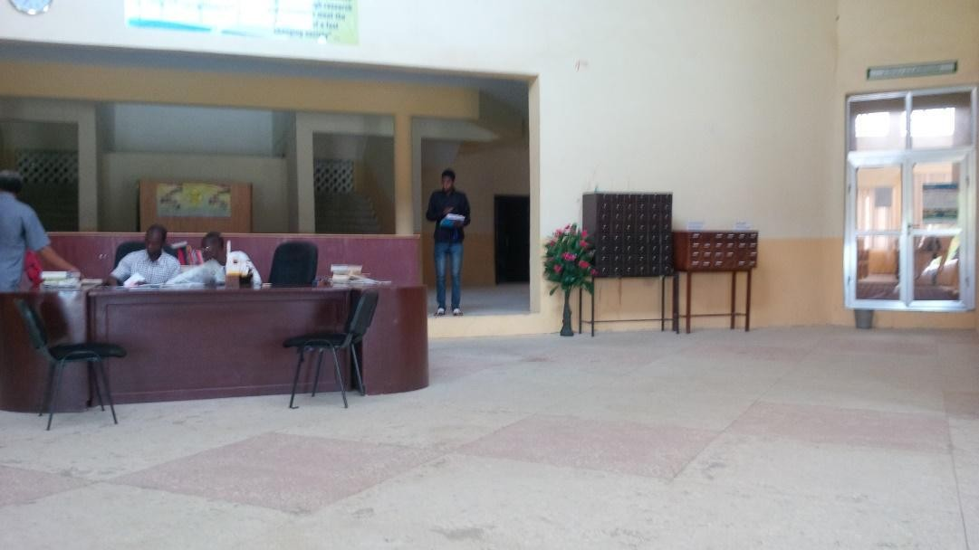

Plate XVObsolete Public access catalogue Source: Researchers' field work (2015)

The space for the public catalogues was converted to a new function and the remaining catalogues were moved to the library archive as shown in figure below.
      - Circulation Section

The shelves found in the reading areas are not widely used by the students making the whole space dusty and inaccessible.
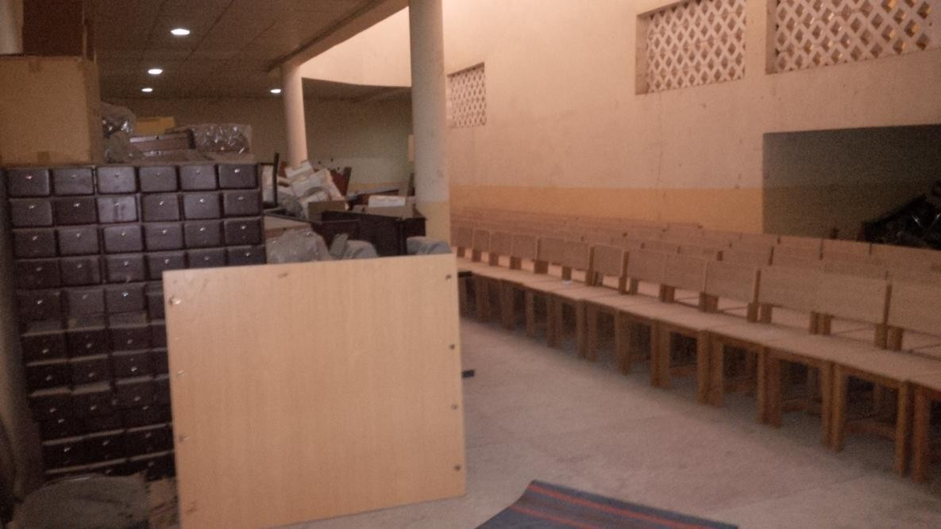

Plate XVIKUST Library Archive Source: Researchers‟ field work (2016)

      - Reference Section

Computer station were created within the reference study area for reference use.

      - Serials Section

Similar to the reading area in circulation section, the shelving area accommodates large area of the reading area. And this facility is not been used by the staff and students.

In answering research question 3, the study examined the effect of technology on the overall pattern on the library under study. Fig 4.5 was used to examine the technological effects. It can be shown that the library have undergone several changes such as additions and subtraction of functional spaces, relocation as well as conversion of some spaces while some spaces have become obsolete.

Obsolescence 20%

Not Affected 47%

Conversion 13%

Addition 20%

Figure 4. 6 Effects of Technology on Library Space Source: Researchers' field work (2015)

Unlike the other libraries studied, the number of spaces that are not affected in Kano University of Science and Technology library is high making up to seven out of fifteen number of spaces which makes up to 47% of the overall library space on the library. Three out of fifteen spaces have undergone conversion making up to 20% of the overall library space. Two out of fifteen number of spaces have undergone conversions which makes up to 13% of the overall library space. Three out of fifteen number of spaces have been added making up to 28% of the overall library space.

Table 4. 8 Summary of the Effect of Technology on Library Studied

Divisions/Spaces |  | Changes
Obsolescence | Conversion | Addition | Subtraction | Relocation | Not Affected
Technical Services
Collection

Development
Cataloguing and Classification
Bindery
Reader Services
Circulation
Reference
Reserve
Documents and Arabic
Serials
Admin Services
Offices
Archives and Store
Conveniences

Source: Researchers' field work (2015)

In answering research question four which is the identification of new emerged developments found in libraries under study, a review of literature has shown that traditional libraries are now adding new functional spaces mainly derived by the coming of technology. Several researchers have identified these spaces as new development in academic libraries. These spaces are; service desk, collaborative learning areas, computer workstation clusters, presentation support centres, E-Classrooms, cafes, space for meetings and video conferencing areas. These have been used as a basis in finding out the new development in terms of space requirements in the library studied. Table 4.3 helps the researcher to identify some of the new space/development in the library studied.
Table 4. 9 Emerging Developments Checklist

 | New Developments | Present | Absent
1 | A Service Desk
2 | Collaborative Learning Space
3 | Computer Workstation Clusters
4 | Presentation Support Centres
5 | E-Classrooms
6 | Videoconferencing Area
7 | Cafes
8 | Lounge Areas
9 | Space for Meetings
10 | Group Study Area
11 | O.P.A.C
Source: Researchers' field work (2015)

In answering research question five that is identifying the need of the users with respect to the library environment. Responses were to identify the following:-
Responses shows that the library is mainly patronized by the students of which 80% of the respondents are males and 20% are females. Responses also indicates that 10% of the library users are having their postgraduate program and 80% of the respondents are undergraduate students. 71% of the respondents say they only go to the library during examination period while a modest amount of 15% say they go to the library on daily basis. This shows that the library is still being patronized by the students and staff. 60% of the respondents say they access information basically for their assignments and research work from the internet while 20% prefer to use library print materials for work. 62 % say they read e-books from their personal computers, smartphones and other electronic within the library, in their hostels and even outside the university campus.
In question 7 of the questionnaire administered, this shows the degree of usage of the library spaces by the users. 90% of the responded only go and read their course hand-outs in the reading area and also in the reserve, reference and serials section only few use the library materials.5% used the serials materials, 40% use the reference materials available in the library studied. 0nly 5% of the respondents use the public access catalogue provided in the library, the microfilm room in the audio-visual section is totally not been used by the respondents. 40% of the respondents say they mostly use the e-library provided. It can be deducted from the responses that O.P.A.C, E-Classrooms, Multimedia Rooms, Internet Café, Meeting rooms, Group Study/discussion areas, are not available in the library studied.

Question 8 shows 20% of respondents use the library for private/solitary reading, 15% say they go there to study with other people, 5% say they only go there to meet people, 10% say they only go there when they have research or homework to do, 30% say they go to study for exams and 10% say they visit the library regularly to improve their knowledge.
Question 9 shows 35% of library users require a very quiet for study, 21% say they prefer reading in groups with classmates and friends, 19% say they like reading outdoors, and 25% say that noise does not matter as long as they are comfortable. Interpreting this, results strongly indicate diverse needs of users hence the need to create an environment to cater for the diverse needs of users.

Discussion

In the initial design of Kashim Ibrahim library (K.I.L), the library consists of only technical, customer and the administrative section. The advent of technology has brought some changes to these sections. A new section was added. This is the Information and technology section (I.C.T.) This section was fused into the library displacing other functions/services and making the whole environment less functional. However, in Bayero University Library, the whole library was expanded in order to accommodate the automation section which is serves the same function as the I.C.T. section of the K.I.L. These findings agree with what Barney (2004), opined. In his report (Barney, The Impact of Technology on Library Space Requirement, 2004) posits that technology is increasing the requirements of library in terms of space, and the need to integrate these changes pose a challenge leading to conversion or creation of spaces for new use even though the spaces were not meant for such use. The I.C.T. section has many services which require much space, hence the complete section was scattered around the library which hinder the function of the department and the organisational pattern of the library in general.

It can be observed from the three results, various computer workstations were available in almost all the spaces or functions of the two libraries studied. Recording and processing of library materials such as books in the acquision and cataloging divisioin were operated electronically using computers leaving the old manual handwrtten book records. In both
K.I.L and Bayero University Library, the Public access catalogue were being partly replaced with Online public access catalogue. This enables a user to access the library materials electronically using computer. Where as the OPAC is no available in the Kano
University of Science and Technology Library. These finding agrees with what Tikekar

(2009) that highlighted, several changes in new academic libraries such as change in meda form, addition of various electronic services like computers. He also added that digitization is begining to replace microforms, audio visuals resources and most monographic contents. In this study, it was found out that a new space type was been created which has the responsibiligy of digitizing these items. It can also be observed that microfilms rooms were converted to CD and DVD rooms in K.I.L library whereas in Bayero University libary it was replaced with a books store.
A number of authors confirm that technology is increasing the requirements of the overall library space in general. Based on the study of K.I.L, it is observed that four spaces out of twenty have been added in the library making up to 16% of the overall library space added as a result of advance in technology, making 32% of the traditional existing spaces obsolete (six out of twenty number of spaces provided).
Similarly, in Bayero University Kano Library, three spaces out of the twenty spaces provided spaces in the library were added making up to 19% of the overall library space added to accommodate new functions while 24% of the spaces had become obsolete (five spaces out of twenty spaces provided in the library). This goes in line with the opinion of Tikekar (2009). The ttraditional library services are becoming obsolete and new spaces are being added in new academic libraries. This also goes with Barney,(2004). He opined that technology itself is causing increased demand for space in many areas of the library. There are growing numbers of computer workstations for patrons and staff alike and other equipment such as network file server's needs specialized and additional space often not found in traditional academic libraries.
Furthermore, four out of twenty spaces provided that is 24% of the overall library space

have undergone conversions,two spaces that is 8% have been removed or subtracted. Only

three spaces out of the twenty spaces provided which is 16% of the total library space is not affected in the former library, in the later, three spaces that is 19% of the overall library space have undergone conversion, 5% that is only one space has been removed or subtracted. Only 24% of the total library space is not affected (five spaces out of twenty spaces provided in the library). However, researchers have identified certain new developments in new academic libraries. Susan (2008) identified several spaces as part of the new libraries. These have been used as a basis in finding out the new development in terms of space requirements in the library studied. A few of these spaces are found in Kashim Ibrahim library. Cafe and E-Library were the only spaces available there. Similar to the Bayero University Kano Library, Cafe, E-library and an addition of computer workstation clusters. A group study area, printing area and E-library were found in Kano University of Science and Technology library. Other spaces like the Collaborative learning space, a service desk, videoconferencing area and presentation support centres are not available due to space availability, flexibility of space and other non-architectural related reasons.

Summary of findings

- The introduction of online public access catalogue has made the traditional public catalogues and Cardex no longer in use available in all the library studied.
- The advent of new multimedia resources made the microfilms resources no longer useful. The microfilms rooms are not been used in all the libraries studied.
- Production spaces like the bindery is still in use in all the library studied. There is absence of printing and photocopying in the studied libraries.
- The management offices like the ordering and clearance; circulation, reference serials and the administrative offices were upgraded with specialized facilities such as fully equipped workstation and printing facilities.
- The digitizing rooms available in Kashim Ibrahim Library cannot accommodate new improved machines for conversions of print materials to digital resources. This facility is also not available in Bayero University and Kano University Library.
- In all the libraries studied, E-library was later introduced and it displaces spaces in some parts of serial and reserve section in Kashim Ibrahim Library and Bayero University Library respectively.
- Book shelves consume large space in especially the reading areas in all the libraries which make the areas not flexible enough to accommodate changes.

- Absence of adjacent refreshment facilities like cyber cafes, coffee shops and restaurant in all the libraries studied.
- Absence of group discussion area, computer workstation clusters and service desk in all the libraries studied.
- E-Classrooms, lecture rooms, meeting and project rooms are also absent in all the libraries studied.
- The study also reveals that only 15 functional spaces out of the 55 spaces provided which is 29% of the overall traditional academic library spaces have not been affected whereas 40 functional spaces out of 55 spaces which is 71% of the overall library spaces have undergone either additions, conversions or obsolescence in the libraries studied. The study further reveals that the modern functions are yet to be integrated within the Nigerian traditional libraries. Only E-library and computer workstation clusters were accommodated by the traditional libraries
- Most of the modern trends are yet to be incorporated within the traditional libraries.

Only the E-library spaces and computer workstation clusters were found in some of the library departments studied.

Implication of Findings to Design.

Technical Services

- The introduction of Online Public Access Catalogue (OPAC) serves as a substitute to the public access catalogue and acquisition section catalogues. Hence the spaces provided for this service has to be removed.
- Catalogue maintenance office, receiving section as well as bindery units are to be maintained.
- The study also found out that, ordering and invoice clearance section can be maintained but with some modification.
- Specialized facilities such as fully equipped workstations and printing facilities area needed in both acquisition and retrospective division respectively for working efficiency.
Customer/Reader Services

- The study found out that Cardex and strip index services are no longer useful as a result of online catalogue which can substitute these functions. Therefore, the space allocated to these services is no longer need.
- As new audio-visual services were available in the libraries studied, the microfilms and disk services are no longer useful. The space allocated for these services are not needed.

- The study also found that management offices, reserve section, query desks, shelve maintenance offices are still useful to the library services. Hence, the allocated spaces for these services are needed.
- Study areas are to be modified to flexible learning spaces that are equipped with network access capability for studies.
- Collaborative learning areas and computer workstation clusters equipped with network access are highly needed.
- Provision of adjacent refreshment facilities or cafes including internet/cyber cafes;

Administrative section

- The study found out that all the services/spaces are needed and therefore to be maintained but equipped with network access for working efficiency.
- Teleconferencing facility for administrative purposes is also needed.

Information and Communication Technology Section (I.C.T.)

- The study found out that digitization room is needed for conversion of print materials to digital contents.
- Training room, presentation support centres, cafe to student and staff as well as adequate E-Library are needed in every academic library.
- Co-location of service desk for increased staffing efficiency is also needed.

Table 4.7 Implications of Research findings

Library  Divisions | Spaces to be  Removed | Spaces to be  Maintained | Spaces to be  Modified | Spaces to be added
Acquisition  Department | Catalogues  Area | Receiving Office | Ordering and invoice  clearance unit | Store for purchased  books
Cataloguing and Classification | Public Access  Catalogue | Catalogue maintenance  office, bindery | nil | O.P.A.C service space
Reprographic  Section | nil | Photocopying  room, bindery | nil | Printing rooms
Circulation Section | nil | Management offices, Reserve section | Circulation desk to be computerized, shelves to be reduced, study area to  be networked | Collaborative learning space(group study), computer workstation clusters
Reference Section | Open shelves | Query desk, Maintenance offices, closed  shelves | Study area | Computer workstation spaces for online reference assistance.
Serials Section | Cardex and strip index | Serial  management offices | Open shelves, serials records unit | Collaborative reading  areas, computer workstation clusters
Documents and  P.G Section | Catalogues area | Nil | Study Areas, shelves | Collaborative reading  areas, computer workstation clusters
Administrative Section | Nil | Admin offices, Archives, conveniences,  cafeteria |  | Teleconferencing facilities
I.C.T. Section | nil | Technical service unit, server room, CD -Rom search | Digitization unit, Adequate E-Library space | Training room, presentation support centres, students and  staff cafe

Source: Researchers' field work (2015)

Summary and Conclusion

The chapter presented the results obtained in line with the research objectives and discussions were presented after each result. This is followed by a summary of findings and implication of study findings in Nigerian academic libraries.
It was concluded from the study that Nigerian academic libraries are gradually shifting from the rigid traditional environment to modern academic libraries that goes beyond the provision of academic services but also social as well as informal services. Nigerian libraries have undergone some reasonable changes over time most accompanied by information technology. This created some additional physical spaces to the existing traditional spaces. Most of the modern trends such as the E-Classrooms, service desks, adjacent refreshment areas collaborative learning spaces and computer workstation clusters are yet to be incorporated within the traditional libraries, only E-library spaces and computer workstation clusters were introduced in the library departments studied. Several services such as the microfilms, Cardex and strip index are now phased out, but there are spaces that are still in use but need no or little modifications to meet the present and technological needs.

ABU-LIBRARY

Introduction

The chapter is composed of five sections. Following the introduction section it is the background of the study area, site selection criteria, and site analysis and design assumptions from the site analysis that can be used in the design of the new proposed academic library.

Area of Study

The site is located in Ahmadu Bello University Zaria which is based in Zaria local government area. Zaria is a major city in northern Nigeria having an area of 300km² located on latitude 11°04′N and longitude 7°42′E. Zaria is a base for Ahmadu Bello University (ABU), the largest university in Nigeria and second largest in African continent.

ABU covers a land area of about 7000 hectares and encompasses two compasses, twelve faculties, a post graduate school and 82 departments. It also has five Institutes, six Specialized Centres, a Division of Agricultural Colleges, a School of Basic and Remedial Studies, a Demonstration Secondary School, a Primary School and a Consultancy Outfit which .provides a variety of services to the University and the wider society.
Recently, the university have commissioned the design of the university phase two generally known as the ABU Phase Two on the southern part of the university. The proposed site alongside the new proposed university clinic, staff school and other departments are located within the ABU phase two.

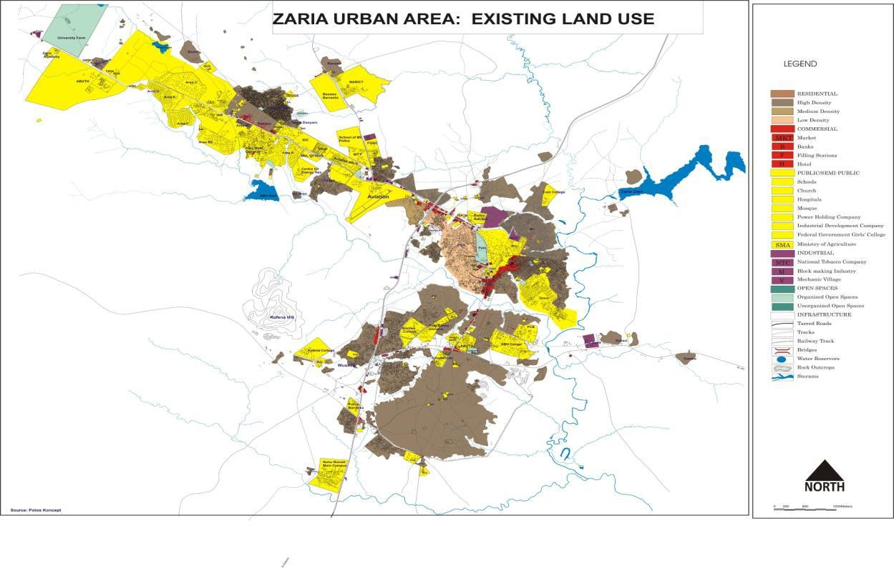

Figure 5. 1Zaria Urban Area: Existing Land Use Source: Field work (2016)

Site Selection Criteria

There are certain characteristics or attributes a site for developing a library must possess. In (Balarabe, 2014) the following are the recurring characteristic to be identified in selecting a suitable site for libraries: Access, Geography, Site Features, and Image Quality, Infrastructure and Site amenities. However in (Mustapha, 2012)the basic principles considered when planning for libraries are; locations to insure maximum accessibility, simplicity of design concept, ease of supervision by library staff and provision for future expansion recurring.

Location

The library should be located with relative proximity to major population centres. The library should be centrally located within the academic environment so that it can be reached out easily by the users. In addition to that, libraries should be located away from areas that generates noise and other forms of activities that will detracts the use of the library.
The site should be prominent. A noticeable site on a main street where the library can easily be seen is preferred. (Mustapha, 2012) Proximity

Accessibility

The selected site should be prominent and access to it has to be easy. The library should be located where it can be easily accessible to the largest number of information seekers and potential readers. According to (Balarabe, 2014), access to the library must cater for patrons need. Pure consideration must be given to convenience of users with respect to traffic flow, pedestrian crossing, bicycle path as well as emergency routes.

Physiography

The site should permit good orientation to avoid glare from the sun and also to avoid possible shadows from the adjacent building. Also, the soil bearing capacity of the site should be able to carry the building with little engineering done to the soil. (Balarabe, 2014)

Site Features and Image Quality

The surrounding environment of the selected site should enhance the main purpose of the library. The selected site should be enhance not lessen the activities. Trees, streams, ponds and rocks can enhance the library activities. The library should be a building that attracts large number people. Hence it should be visible from a major street. (Balarabe, 2014)

Topography

According to (Balarabe, 2014), the site selection of a library should be such that the site is able to drain naturally (if possible) with ease. He also added that the site should not be hilly to discourage the users.
The site should also permit street level entrance. Although a site that slopes to the rear has certain advantages a level should be acquired if possible.

Site Capacity and Development Potentials

In selecting a site for library building, consideration should be given to development potential. The site has to permit easy construction and without extra cost. The site should be large enough for expansion, accessibility for service vehicles and a generous amount of landscaping. In addition to that, the selected site should allow the development of building with ease and in a green sustainable manner.

Site Infrastructure

Special consideration should be given out to available infrastructure before selecting a site. These infrastructures refers to available structures and facilities within and surrounding the site. These includes roads, buildings, and power and water supplies among others. These should be given special considerations to avoid extra cost of construction. For the purpose of this study, two sites where selected and analyse based of location topography, development potential, accessibility, site infrastructure, site capacity, physiography site features and image quality.

Site A

Site A is located in ABU phase two surrounded by the university clinic its western side and the school for business studies at the southern boundary. Along its vicinity there is faculty of sciences, PG hostel and undergraduate hostels.

It has two possible accesses. It can be accessed through the main road located in its north and along the eastern boundary, another road can be proposed. The site is flexible enough to permit good orientation of the library building which can help to avoid glare from the sun; also help to aid in passive cooling of the building. In addition to that, the site is free on its east and having the school clinic on the west. This will lessen the possibility of buildings that can generate shadows within especially the reading areas of the library.

The site slopes towards its eastern part down to its southern part. This can aid in drainage and can be used for other outdoor activities. It also have a relatively flat terrain large enough to accommodate the library building and has space for expansion, accessibility for service vehicles and more space for landscaping.

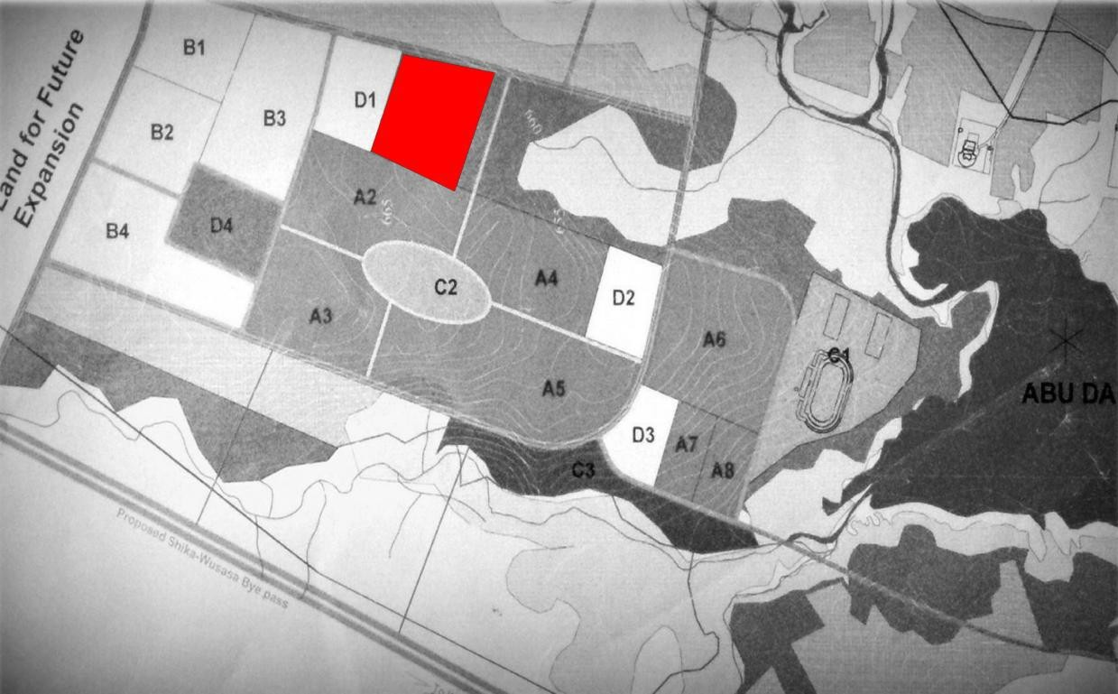
Site A

Figure 5. 2 ABU Phase 2 map showing site A location Source: Researchers field work (2016)

D1- Sick Bay

A2-School of Business Studies B3-Post Graduate Hostel
B1-Undergraduate Hostel

Table 5. 1 Site A Characteristics

SN | Criteria | Description | Remarks
1 | Location | Close to the student‟s hostel,  faculties. Centrally located | Very Suitable
2 | Accessibility | The site can be accessed through the main road. And a possible road can be created  along its western boundary | Suitable
3 | Physiography | The site can permit good  orientation | Suitable
4 | Site Features and Image Quality | Close to the ABU dam which will give room for outdoor functions and  beautiful scenery | Suitable
5 | Topography | The sites slopes down  towards the eastern part and to the south. | Very suitable
6 | Site Capacity and Development. Potential | It has a relatively flat terrain large enough to accommodate the library building and has space for expansion, accessibility for service vehicles and more space for landscaping. | Suitable
7 | Site Infrastructure | Having the site located in phase 2 of the department, the common services like water and power supplies  and roads will be provided. | Suitable

Source: Researchers fieldwork (2016)

Site B

Site B is also located in ABU phase two. The site is surrounded by fire services department alongside Biotech centre and technology incubation centre on its southern side. On its west, it‟s a proposed site for fire service department and a sport complex on the east.
The site has 3 possible accesses, it has a road on north, east and western boundaries as shown in fig below. In addition, the site is flexible enough to permit good orientation of the buildings to avoid unwanted glare for the east and western sun.
The site slopes towards the east to the ABU dam as shown in fig below. This can be used to drain especially storm water with ease. However, extra cutting and filling has to be done in order to provide a base for the main library buildings and this will incur additional cost.

Site B

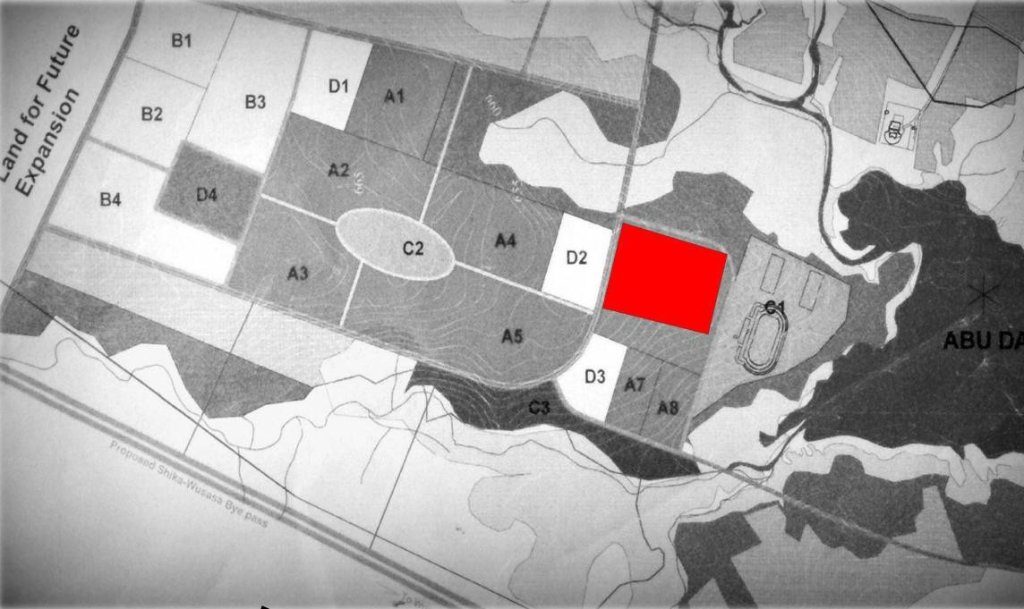

Figure 5. 3ABU phase 2 map showing site B
Source: Researchers field work
D2-Multi Level Car Park D3-Fire Service Department A7-Biotechnology Centre
A8-Technology Incubation Centre

Table 5. 2 Site B characteristics

SN | Criteria | Description | Remarks
1 | Location | Close to the multilevel car  park, sports complex, biotech centre | Not suitable
2 | Accessibility | It has three possible access  along its boundary | Very Suitable
3 | Physiography | The site can permit good  orientation | Suitable
4 | Site Features and Image Quality | Close to the ABU dam which will give room for outdoor functions and  beautiful scenery | Very Suitable
5 | Topography | It is sloppy towards the  ABU Dam | Suitable
6 | Site Capacity and Development. Potential | It has sloppy terrain hence extra cutting and filling has to be done in order to provide a base for the main library buildings and this will incur additional cost | Not Suitable
7 | Site Infrastructure | Having the site located in phase 2 of the department, the common services like water and power supplies  and roads will be provided. | Suitable

Source: Researchers fieldwork (2016)

Site Comparison

Here, the two sites will be compared based on the results obtained from tables 5.1 and 5.2 above. The 3 remarks; Very suitable, suitable and not suitable were scored based on the site characteristics. The remarks were scored as follows;
      - Very Suitable = 5

      - Suitable = 3

      - Not Suitable = 1

Table 5. 3 Sites Comparison

SN | Site Characteristics | Site A | Site B
1 | Location | 5 | 1
2 | Accessibility | 3 | 5
3 | Physiography | 3 | 3
4 | Site Features and Image Quality | 3 | 5
5 | Topography | 5 | 3
6 | Site Capacity and Development. Potential | 3 | 1
7 | Site Infrastructure | 3 | 3
 | Total Points | 25 | 22
Source: Researchers fieldwork (2016)

Using table 5.3 above it can be observed that the suitable site for the library development is site A which has 25 points while site B has 22 points.

Site Analysis: Climate

The site is located in a tropical climatic zone with abundant sunshine and dryness during the dry season and rain during the rainy period. The following climatic factors will be discussed:
- Temperature

- Rainfall

- Wind speed

- Solar Radiation

Temperature

The site experiences hot days usually around March to May and cold night usually around November to February. The highest temperature is recorded in April with average temperature of 38 °C. The minimum temperature on the other hand is recorded in January
with that average temperature of 16 °C as shown in fig 5.1 below
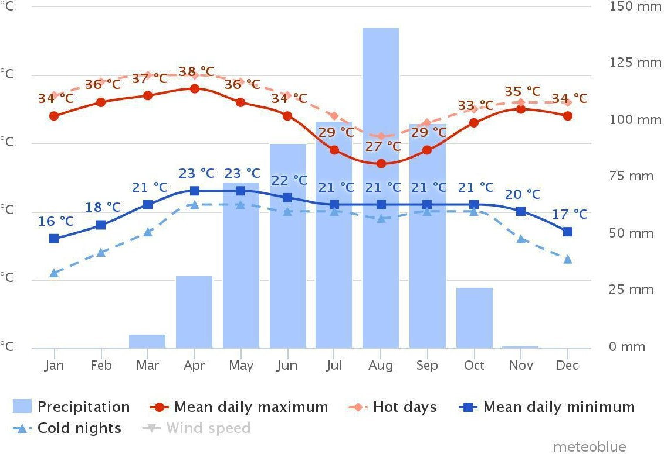

Figure 5. 4Average Temperature and Precipitation Source: (Climate Zaria, 2016)

Rainfall

In figure 5.1 above it can be observed that the site experience 8months of rainfall, with the highest in August with over 125mm and the lowest is recorded in November with below 5mm. 25days of rainfall is recorded in august while less than 5 days in November.

Wind Speed

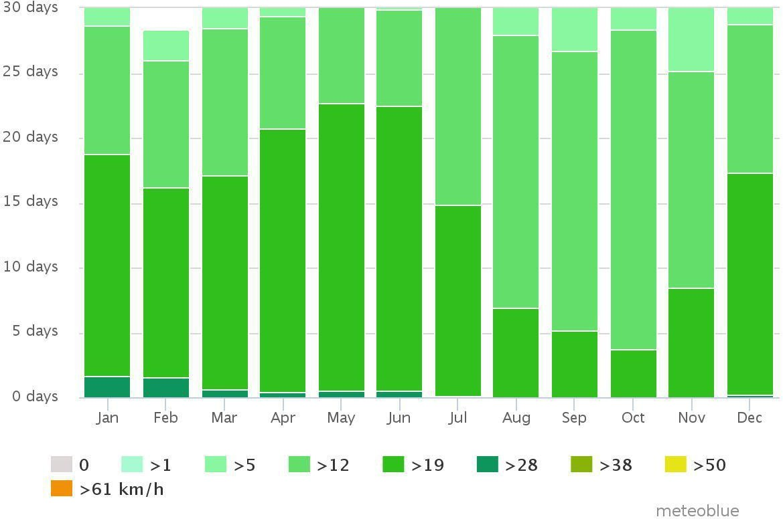
North east trade winds and south west trades are the two winds that blows from the Sahara desert and the Atlantic Ocean respectively. Fig 5.2 below shows that the site experience stronger winds from January to June which blows with the speed of 28km/h or more. In the other hand the site experience a calmer winds from July to October.

Figure 5. 5Wind Speed
Source:(Climate Zaria, 2016)

Solar Radiation

Months with least cloud cover are considered to be sunny. Figure 5.3 shows that the months of January, February, March, November and December are sunny. Sunny months are mostly characterized by intense solar radiation which results into intense heat on the site. Months will cloud cover tend to be less sunny? These months include April, May, June, July, August, September, and October. These months experience less solar radiation.

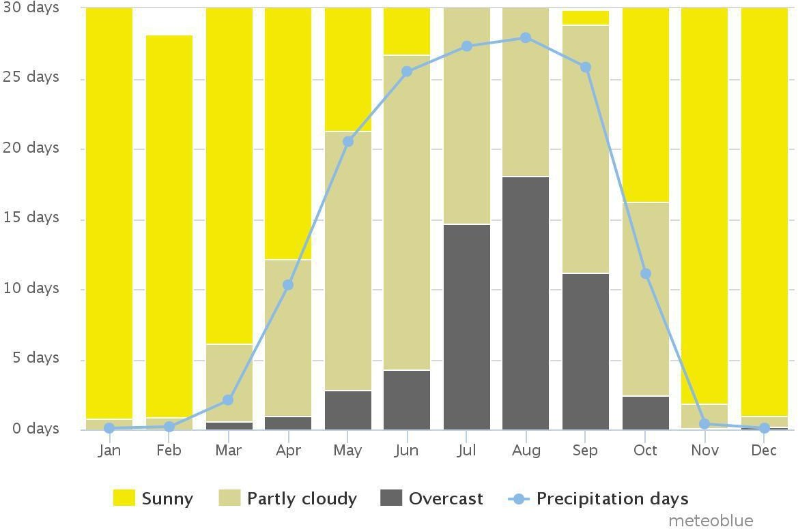

Figure 5. 6 Solar Radiation Source: (Climate Zaria, 2016)

Site Climatic Conditions

The above climatic analysis will the outcome of the design in achieving a good and sustainable design. This analysis will affect the outcome of the following:
      - Site Planning

      - Foundation

      - Roofing

      - Lighting

      - Ventilation

      - Finishing

Site planning

The library building has to be properly orientated to achieve passive cooling and to prevent glare especially within the reading area as well as other public areas. The longest side of the building should not be facing the east-west direction for proper orientation.

Foundation

Having the ABU dam close to the site, also the soil in the area is a mixture of loam and clay that has high water retention capacity. Special consideration has to be given the type of foundation to be used to achieve a stable and sound structure.

Roofing

The site is located in Ahmadu Bello University which is based in Zaria. The area is characterised with a very strong winds accompanied with a moderate amount of rainfall as seen in fig 5.1 above. Consideration has to be given the type of roof, its slope and materials to prevent any destruction that can be caused by the strong wind and rainfall.

Lighting

Adequate lighting has to be provided especially within the reading area. However the building has to be oriented properly to avoid glare. The buildings also has to be oriented to avoid adjacent buildings from generated unwanted shadows especially in the reading areas.

Ventilation

Having the site in a hot dry climate zone, the library building has to be convenient enough to permit longer reading hours. Shading devices has to be provided to prevent unnecessary heat gain into the buildings;the size of opening should be narrow such that it keep as much hot air away from the interior as possible.

Finishing

The finishing should be bright and glossy to reflect direct solar radiation from building and air spread of natural lighting within also taking into consideration the dusty nature of this climate region especially during hammatan period in avoiding white colours on the exterior surfaces.

Site Analysis: Topography and Development Potential

Fig 5.4 shows that the site slopes towards its north eastern part down to its southern part. This can aid in drainage and can be used for other outdoor activities.

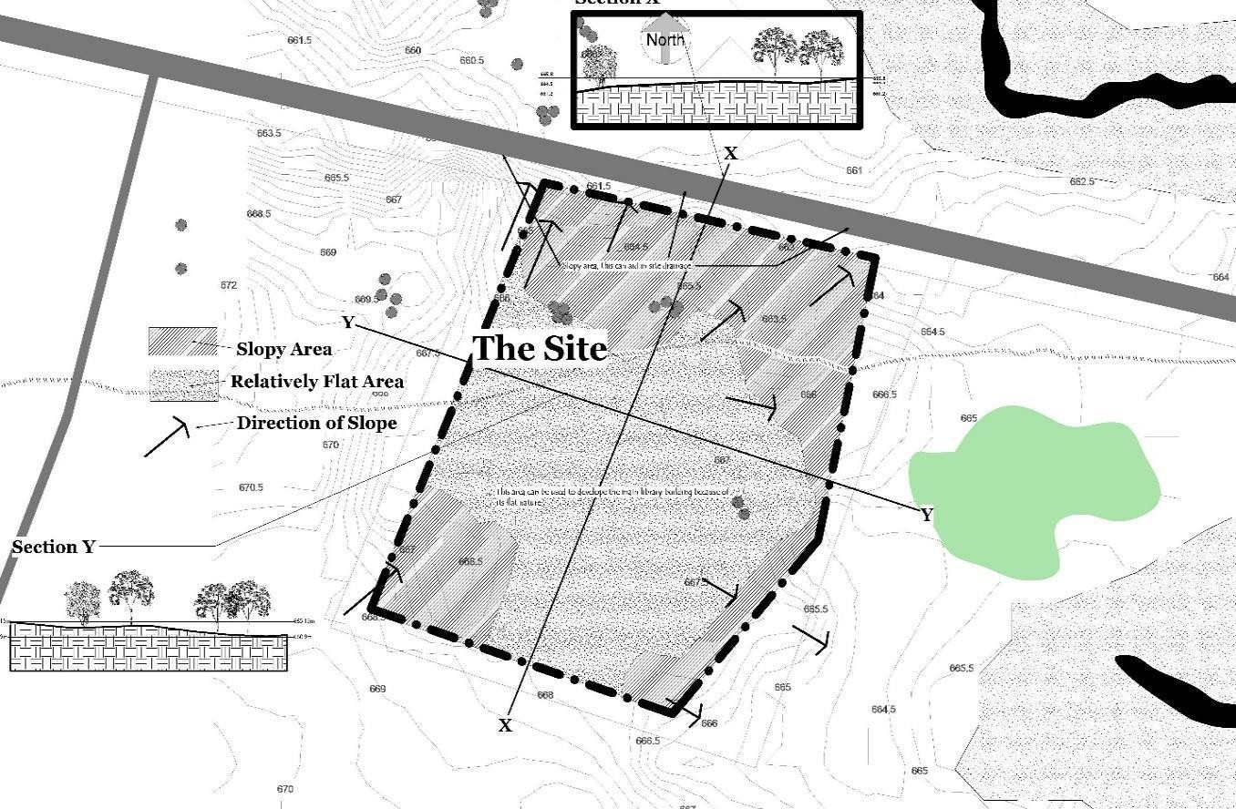

Figure 5. 7 Site Analysis (Topography) Source: Researchers fieldwork (2016)

It can be observed from fig 5.4 above the site has a relatively flat terrain large enough to accommodate the library building and has space for expansion, accessibility for service vehicles and more space for landscaping.

Site analysis: Accessibility and Noise

Fig 5.5 below shows that the site has two possible accesses. It can be accessed through the main road located in its north. The library can be viewed from the main road. It can also be accessed through its eastern boundary, this can serve as a service access for staff, and other non-customer related functions. The site is flexible enough to permit good orientation of the library building which can help to avoid glare from the sun; also help to aid in passive cooling of the building.
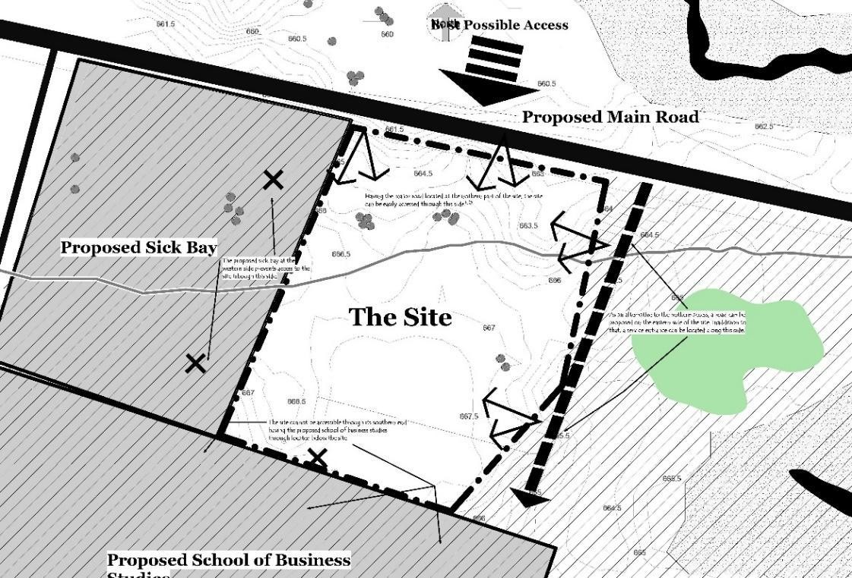

Figure 5. 8 Site Analysis (Accessibility) Source: Researchers fieldwork (2016)

Site Analysis: Noise

The site is surrounded by a sick bay and school of business studies from west and southern part respectively as shown in fig 5.6. The sick bay usually generates less noise unlike the school of business studies which generates noise. Noise can also come from the main road into the library. Trees are going to be planted to serve as a buffer to the noise coming from the

school of business studies. Proper spatial organisation can serve as a means to prevent noise into the reading area.
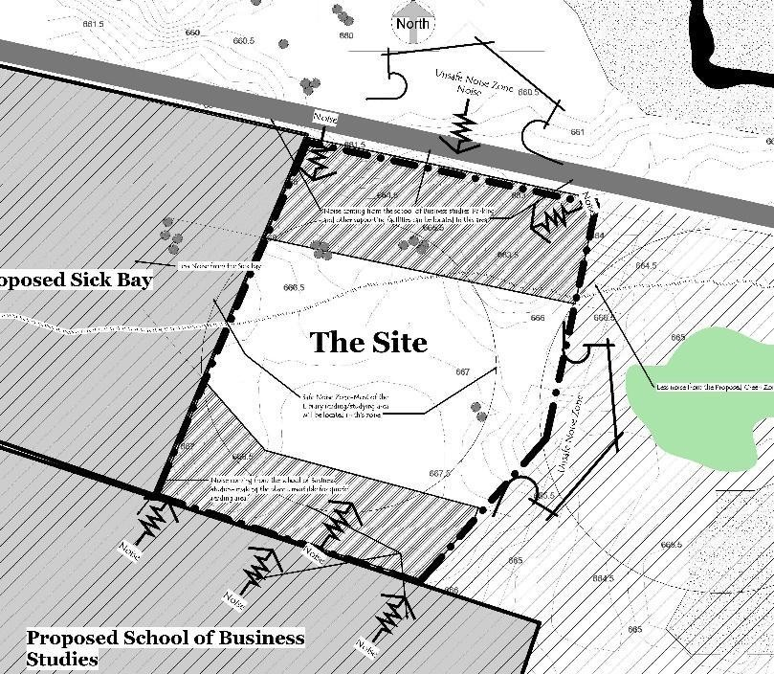

Figure 5. 9 Site Analysis (Noise Zone) Source: Researchers fieldwork (2016)

Design assumptions from site analysis

      - Placement longer side of new buildings will be on the North South direction so as to prevent solar heat gain and glare in the buildings
      - More trees to be planted at the rear to serves as buffers to noise coming from the neighbourhood.
      - The terrain can give room for excellent use of outdoor functions. This will give beautiful scenery and enhance learning activities.
      - The site is large enough to accommodate the library building and to provide a generous amount of landscape

This section started with a brief introduction about the chapter followed by a detailed discussion about the location and the features of the proposed site. It also analyses the climatic conditions, the topography, accessibility and the development potential of the selected site for the proposed design of the library.

6.0 DESIGN REPORT 6.1Introduction
Technology and time has brought some changes in the design of libraries in general. This research indicates that several new spaces are to be incorporated in the design of an academic library; some are to be maintained from the traditional libraries we have while some are to be discarded totally. This findings impact on the general design of academic libraries. This chapter provides information on the site planning, building organization as well as the general design of an academic libraries. The chapter also addresses design considerations for architectural character, function, circulation, and facility systems.

Design Brief

In its plan to decongest its main campus in Zaria, Ahmadu Bello University set to expand the university. A new master plan was developed in which many of its faculties and establishments will be moved to the new phase generally known as the ABU Phase 2.
Having the technological shift in terms of physical space in academic libraries. The university set to build a new academic libraries among other establishment. The new academic library design should provide all the current needs which will involve all the emerging trends in terms of space requirements that will boost research in the university and provide all the student and staff needs.

Schedule of accommodation

The space requirements in academic library has changed over time. Some physical spaces in the traditional library have become obsolete and new ones have emerged. The following spaces in table 6.1 indicates a shift in academic library space usage. These spaces are been categorised into the following headings:Administrative department, Technical services departmentCustomer services department and supporting facilities

Table 6. 1(a) Schedule of Accommodation

Space | Unit | Total Area (m²)
Technical Services
Delivery Bay | 1 | 50
Storage | 2 | 60
Acquisition Unit | 1 | 50
Processing Unit | 1 | 50
Printing | 3 | 13.8
Photocopying | 3 | 13.8
Bindery | 2 | 7.5
Server room | 1 | 18
Digitizing room | 1 | 30
Technical Office | 3 | 54
Conveniences | 4 | 8.4
Administrative Services
Librarian Office | 1 | 21.4
Secretary | 1 | 13
Kitchenette | 1 | 13
Board Room | 1 | 57
Deputy Librarian Office | 1 | 13
Administrative Office | 1 | 15
Secretary | 2 | 26
Office | 2 | 26
Storage | 2 | 18
Conveniences | 7 | 14.7
Supporting Services
Internet Café | 1 | 78
Restaurant | 1 | 60
Kitchen | 1 | 36
Garden/Relation Area | 1 | 900
Shop | 1 | 16
Coffee/Snack Bar | 2 | 26
News Lounge | 1 | 36
Convenience | 4 | 8.4
Parking Area | 150 | 1912.5
Source: Researchers fieldwork (2016)

Table 6.1 (b) Schedule of Accommodation

Customer Services
Entrance | 1 | 50
Control Point | 2 | 6.8
Space | Unit | Total Area (m²)
Hallway/Reception | 1 | 100
Circulation Desk | 1 | 14
O.P.A.C Area | 20 | 56
Exhibition Hall | 1 | 200
Lecture Rom | 2 | 360
E-Classroom | 1 | 75
E-Library | 1 | 250
Multimedia Rooms | 4 | 150
Meeting Rooms | 6 | 43.2
Flexible Learning Area | 4 | 115.2
Office | 6 | 84.5
Service Desk | 8 | 72
Mobile Compact Shelves | 35 | 605.5
Group Study Area | 28 | 582
Stand Alone Reading Area | 15 | 39
Main Reading Area | 3 | 780
Post Graduate Reading Area | 1 | 260
Periodicals Unit | 1 | 40
Reserve Unit | 1 | 40
Query Desk | 8 | 72
Reference Unit | 1 | 40
Africana and Special  Collections | 1 | 40
Documents | 1 | 40
Archives | 2 | 120
Conveniences | 20 | 42
Source: Researchers fieldwork (2016)

Site Design
116

The site planning was highly influenced by the research survey based on the shift in physical space usage. The site is composed of the main library building, the outdoor functions, the public and staff parking spaces and the entrance gate. The site is large enough to accommodate the building, the outdoor functions and also designed with a generous amount of landscape.
The main building is designed on the relatively flat terrain towards the south which is linked directly to the staff and public parking area. Figure 6.1 shows that outdoor functions were also integrated and designed on the sloppy terrain and that will provide a serene space for outdoor reading and meeting space.
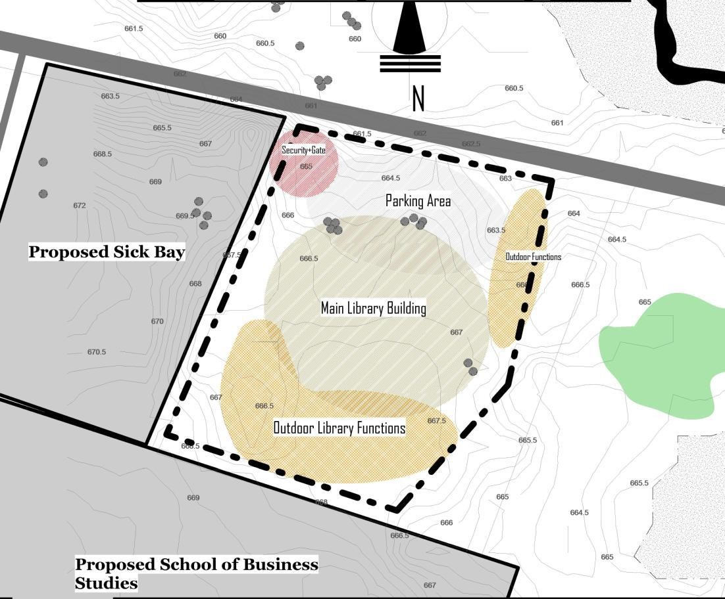

Figure 6. 1 Site Development Concept Source: Researchers fieldwork (2016)

The site is zoned based on the level of noise that will be generated within and outside the site. Places like that require absolute silence like the formal reading areas, formal project rooms, formal group study areas and study carrels are separated from less and noisy areas like the news lounge, exhibition halls, informal reading areas and outdoor functions.

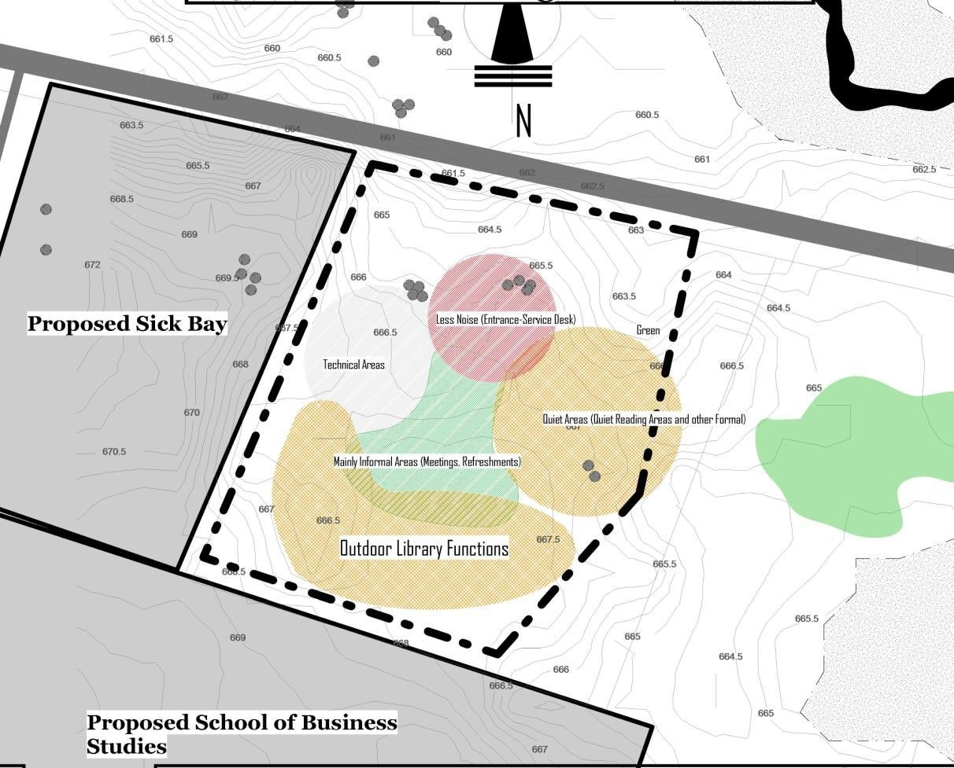

Figure 6. 2 Site Zoning
Source: Researchers fieldwork (2016)

6.4.1 The Site Plan

The site is large enough to contain the library building and its landscape. The building is placed to achieve proper orientation that will enhance passive cooling and avoid glare within the building. The building is well placed where it will be visible from the main street.
As shown in fig 6.3 the library is accessed from the main road which will provide an excellent view of the library. Adequate public parking space were designed in front of the library building and another parking areas for the staff close to the technical services as shown in fig
  - below.

The planning gave more emphasis to the outdoor functions and the site landscape. It can be seen from the fig 6.3 behind the main building it‟s a reading woods where the students can read alone or in group in a natural environment surrounded by natural trees and shrubs. Another reading area is designed outdoors on the eastern side of the library.
In addition to that a digital garden with internet connectivity is designed where students and staff can use their laptops or mobile phones in well-furnished shades with chairs and tables. This shade is powered by solar panel on top the pergola that provides the shades as shown in fig. below. Trees, shrubs will be planted to provide shades for outdoor reading and meeting in a natural environment. The building is linked adequate pedestrian walkways that links the outdoor functions with the main library building core.

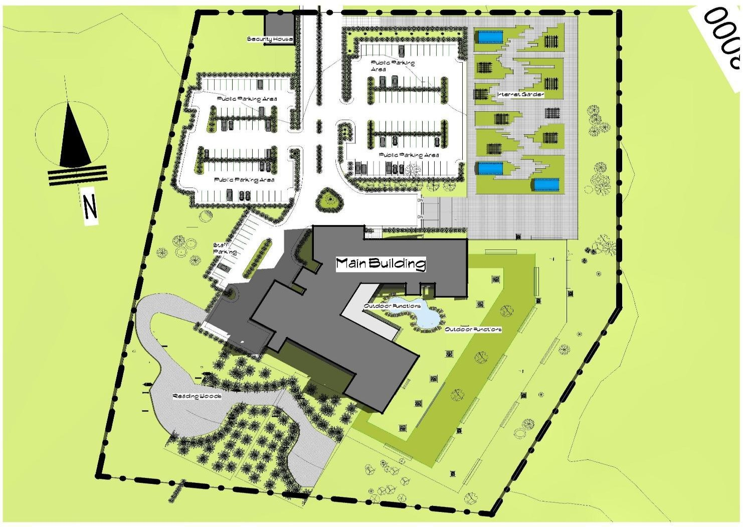

Figure 6. 3 Site Plan
Source: Researchers fieldwork (2016)

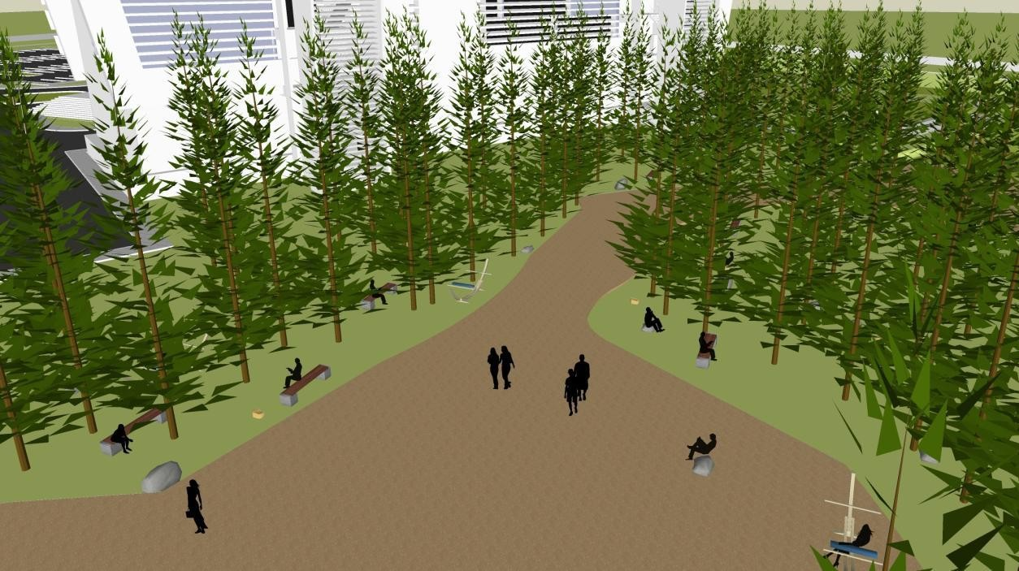

Plate XVII Reading Woods
Source: Researchers field work (2016)

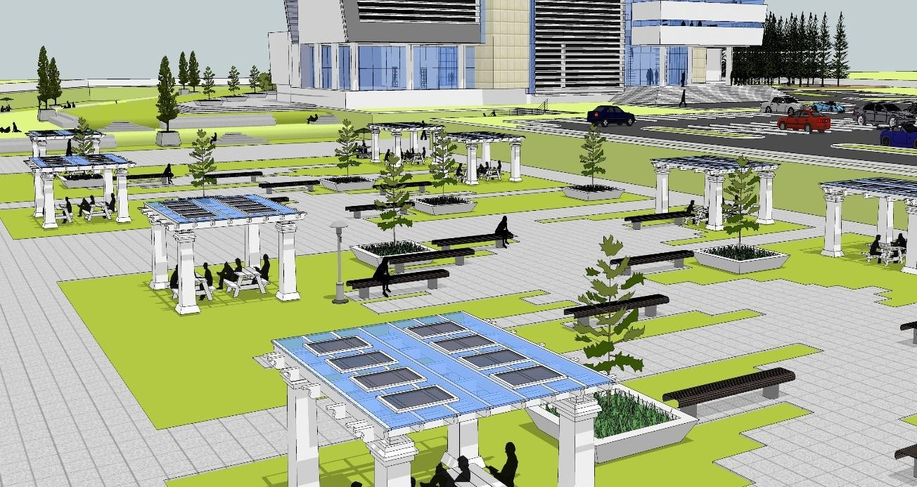

Plate XVIIIDigital Garden
Source: Researchers field work (2016)

6.5 Building Planning and Organisation

The building is divided into departments as shown in fig 6.6 below. This comprises of the technical services department, the customer services department, the supporting facilities and the administrative department. The above departments each have different spaces which are carefully designed to accommodate changes. Spaces that are prone to short term changes are designed in an open plan system. The building is flexible, and some spaces are physically isolated to enable longer hours of access.
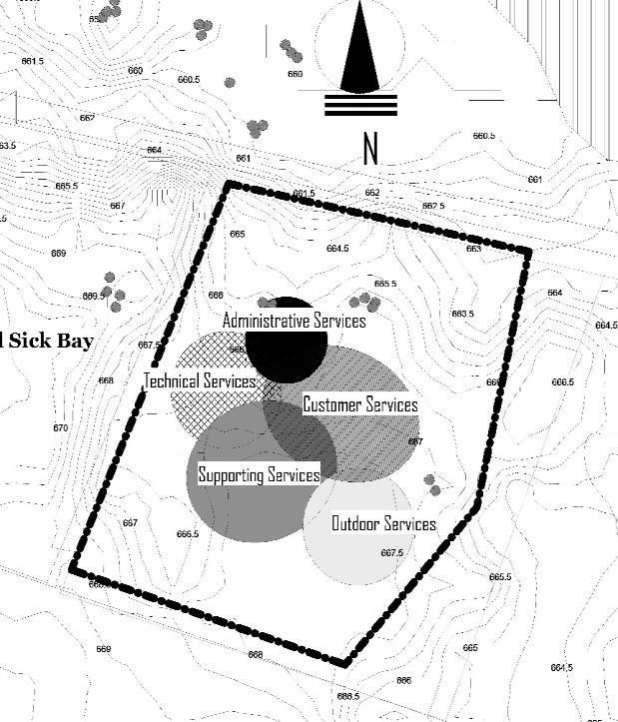

Figure 6. 4 Bubble Diagram
Source: Researchers fieldwork (2016)

The building is zoned into areas that generates noise, those that generates less and the places that require and generates no noise. The supporting services generates noise hence most of the facilities are on the ground floor. Spaces that require least noise especially the formal reading areas are designed on the higher floors.

Adequate means of escape through co-locating of escape staircases has been achieved in the design. Therefore the building can be evacuated swiftly, safely and efficiently. Toilets were provided for both staff and customers in each floor for user‟s conveniences. The administrative department deals with management of all the affairs of the library. This department is designed on the third floor.
The technical service unit facilitate access to information resources. The unit also deals with processing and maintenance activities of a library‟s collection. This department is designed on the ground floor. It has a separate entrance towards the rear side of the building with an adequate parking space for staff located directly opposite and close the entrance.
Digitizing room for converting print materials to digital resources is provided alongside a server room which will serve as a control unit for the I.C.T section is provided. Acquisition and catalogue and classification units have been provided but upgraded to a digitally enabled spaces. Production facility for printing and photocopying is also provided on the first floor.
The customer services departments on the other hand, includes circulation desk located very close to the library main entrance as shown in fig 6.7 below. A very wide staircase is designed to elevate the users to the upper floors where the main library formal activities are located. Service desks are provided on each floor to increase staffing efficiencies. Adjacent to the public staircase on the first floor, it‟s a corner/space for public access catalogue with a capacity of 10 computers for client use. This type of space is also available on the third floor where the formal reading areas are located. A flexible learning spaces equipped with tables and network access for group study and discussion is designed on the first floor as shown in fig 6.8 below. This type of area is located along the passages and areas on the second floor as well.

Workstations equipped for electronic information access is provided in the two E-classrooms

located in the first floor. The meeting rooms as shown in fig 6.9 below are also equipped with
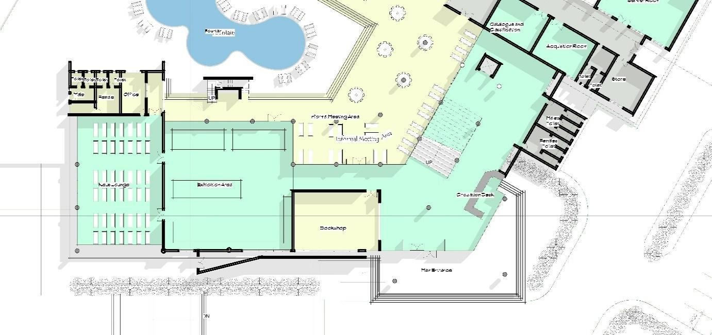

Figure 6. 5 Section of a Ground Floor Source: Researchers‟ field work (2016)

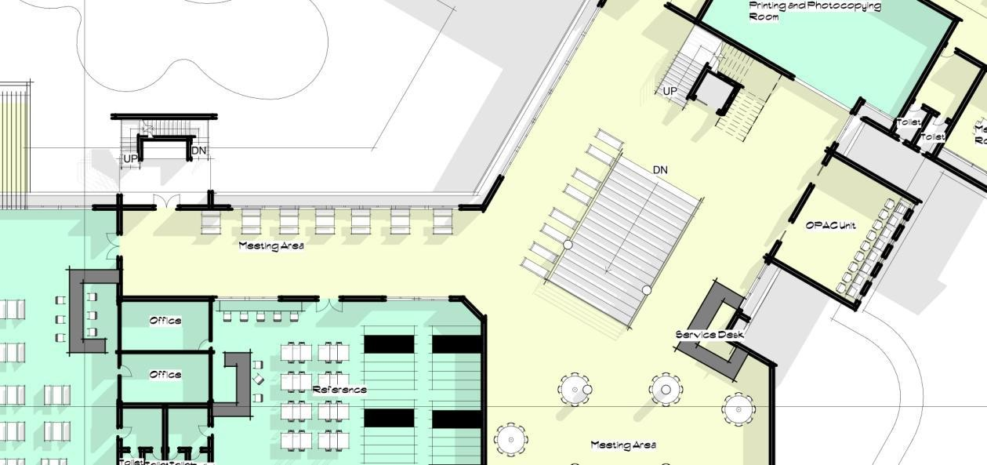

Figure 5. 7Section of a first floor plan Source: Researchers‟ fieldwork (2016)

computers, projection technology and a white board. This room can accommodate up to 4-12 users at a time.
The E-library designed on the second floor is equipped with workstations for electronic information access including multimedia resources and applications. Similar to the E-library, multimedia rooms are also provided with production facilities for the use of customers to develop their own audio visuals and multimedia resources in a variety of formats. A domain is provided for serials, documents and special collections is also provided on the second floor.

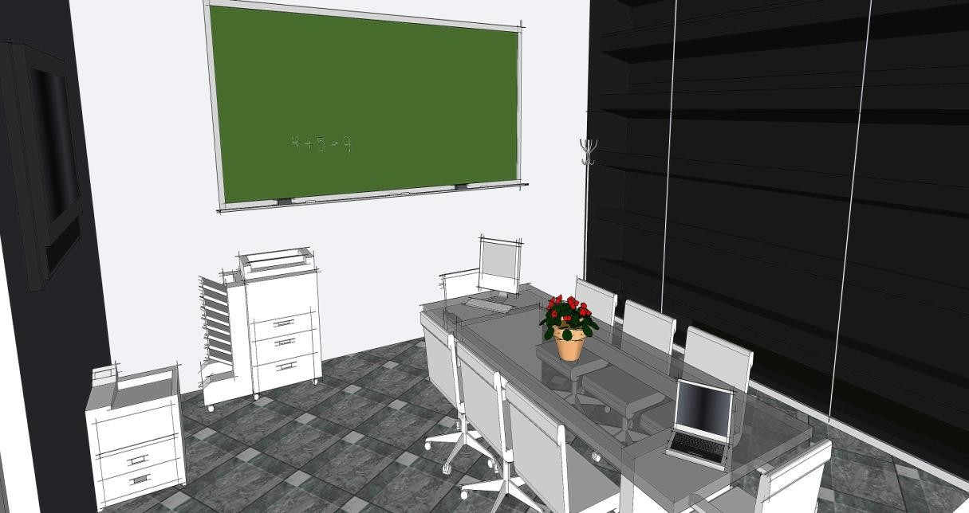

Figure 6. 6 Meeting Room
Researchers‟ Fieldwork (2016)

The third floor contains 2 reading areas, a special domain for post-graduate students and study carrels are provided. The reading rooms have reading tables with laptop docking facilities and the shelving spaces have been minimized by the use of mobile compactus shelves.
The supporting services are mainly designed/zoned on the ground floor because of the level of noise the activities generates. News lounge, exhibition lounge are designed on the ground floor. An adjacent refreshment facilities/restaurant and internet café is provided also on the floor. A cluster for individual and group seating is also provided for informal meetings and informal meetings is provided. These can accommodate 3-8 users. Figure below shows a cluster arrangement for the meetings.

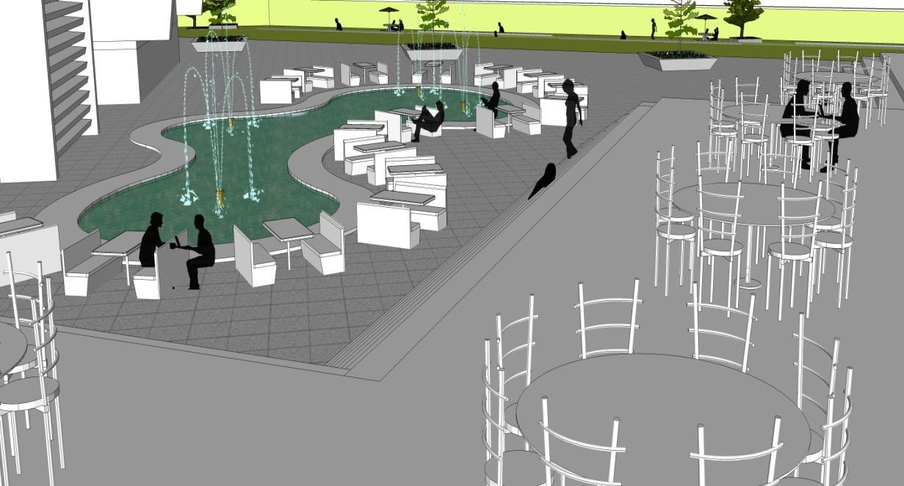

Figure 5. 10 Informal Meeting Space Source: Researchers‟ fieldwork (2016)

This section started by discussing about the design that is the design brief. It also discusses on the site planning, building organization and mainly how the study findings are applied in the proposed design of the academic library.The chapter also addresses design considerations for architectural character, function, circulation, and facility systems.

SUMMARY AND CONCLUSION

Introduction

In this chapter, a summary of findings was presented followed by conclusion, recommendations and contribution to knowledge of the study.

Summary

For the past two decades, technology has been changing the way academic libraries operate. It affects the roles, services and even how libraries are been used by clientele. In addition to that it also affects the space requirements of all the functions in a traditional academic library changing the physical shape of the library.
In terms of physical space, the traditional academic libraries have been affected in so many ways. Some spaces have been added while some are no longer useful. Many traditional academic library spaces have been displaced by the new emerged modern spaces. The need to house the computer workstation for information retrieval, the server room, and other new advanced multimedia facilities that is used by the patrons and staff increased the need for space with the introduction of computing technology.
Traditional libraries witnessed some reasonable changes over time. Various units or functions were affected with the coming of computing technology. Public access catalogue is converted to computerized/automated catalogue commonly known as Online Public Access Catalogue, strip index/Cardex is no were to be found in serials sections. Audio visuals such as the microfilms room are now an extension for the library archives. Book shelves is now an area for dusty and drab repositories of old books.
Changes in use from analogue to digital, from traditional to modern have necessitated new requirements in the spatial organizations and arrangements of the library learning environment. There are growing number of computer workstation for patrons and staff usage

in almost every part of the traditional libraries. These can be found in the management offices and in the public areas. E-libraries have been incorporated by traditional libraries for access and retrieval of information in digital formats.
The study reveals that only 29% of the overall academic library spaces have not been affected by technology, whereas 71% of the overall library space have undergone either addition, conversion, obsolescence and relocation of functions/spaces from one place to another within the traditional library. The study further reveals that the modern functions are yet to be integrated within the Nigerian traditional libraries. Only E-library and computer workstation clusters were accommodated by the traditional libraries

Conclusion

It can be deducted from the study that academic libraries are now a place where people enjoy coming to and a place where a range of specialist assistance is on hand to guide enquiries and aid the users to discover new information and create new knowledge through the use of different technological advanced resources.
However, modern academic libraries provides an intellectual and social space on campus. A place where people can meet, interact and discuss in groups both physical and virtual in aesthetically pleasing and well equipped surrounding.
From the study, traditional academic libraries are now in a shift from its old analogue library to an automated digital academic library in clearer terms, they are shifting from traditional to modern academic libraries. Several functions/spaces are now phased out not been used by the patrons and staff alike. However, there are spaces that are still in use but need no or little modification to meet the present and technological needs of the users.
The introduction of advanced facilities serves as a substitute to the existing traditional library

functions. Accommodating these new functions is now a big challenge to the designers and

library management. In trying to integrate the new functions with the left over traditional space, the library loses its organisational structure and functions.
As technology is always advancing, libraries should be planned in order to cater for future changes. Open plan can be achieved in order to accommodate changes especially to the spaces that are prone to short term changes. In addition to that, libraries should be planned to provide longer hours to some certain spaces for patrons.

Recommendations

Two recommendations were drawn by the researcher from the study. These include

    - Recommendations for implementation

    - Recommendation for further research

Recommendations for implementation

      - New facilities keeps evolving as technology is always advancing, effective planning should be given to spaces that are prone to short term change in order to meet the future needs of the academic libraries in Nigeria.
      - Compartmentalization of the library building will enable longer library hours for patrons.
      - Libraries are now turning into social space, adequate outdoor spaces have to be provided in order to accommodate informal meetings and other social functions.
      - There will be need to return to the general design standards for libraries in Nigeria and thoroughly review the existing model in order to create new models of library design that are responsive to present needs and capable of accommodating future demands of users and services.

Recommendations for further research

As technology is always advancing, there will be need for further researches in order to meet up the future needs of the library patrons and staff alike.

Contribution to Knowledge of the Study

      - The study disproves the idea that libraries in general are becoming obsolete. The study was able to point out the spaces that are still useful within the traditional library walls. The study was able to design a learning environment that integrates the traditional spaces that are useful but with modification to suit current needs of a modern library.
      - The study was able to provide a learning environment that goes away from the rigid learning environment that is only confined within the library walls to a social as well as informal environment which will help in learning process and increase library patronage.
      - The study was able to demonstrate that as technology keeps on changing, the library facilities or services change the architecture of academic libraries. The study was able to provide a learning environment that can accommodate rapid changes accompanied with the change in technology over time.

REFERENCES
Abdullahi, A. (2011). An Assessment of Architectual Curricula of Selected Nigerian University and its Relevance to the Building Industry.
Adedibu, L. O. (2012). Cataloguing and Classification of Library Resources in the 21st Century. Illorin.
Adio, G. (2009). The Role Of Library In Educational Development. Ogbomosho: LAUTECH Press.
American Universty Library. (2005). The Academic Library in 2010: A Vision. Washington, DC.
Association of College and Research Libraries. (2015, January 7). Advancing Learning; Transforming Scholarship. Retrieved from American Library Association: http:www.ala.org
Association, A. L. (2007). State of America's Library. Washington D.C.

Balarabe, M. K. (2014). Evaluating User Needs in the Design of Public Library in Kaduna.
Zaria: Ahmadu Bello Univerisyt Press.

Barney, A. (2004). The Impact of Technology on Library Space Requirement.

Barney, A. (2006). The Impact of Technology on Library Space Requirements. Library and Information Science Research .
Britanica, E. (2009). Library. Chicago.

Budd, J. M. (2005). The Changing Academic Library: Organisation, Culture, Environments.
Association of College and Research Libraries.

Certified Public Library Administrators. (2008). CPLA Certification Review Committee and Certification Program Committee meeting.
Climate Zaria. (2016). Retrieved from Meteoblue: https://www.meteoblue.com/en/weather/forecast/modelclimate/zaria_nigeria_2317765
David. (2011). Merriam Webstars Dictionary. Retrieved October 12, 2014, from Merriam Webstars.com: http://www.merriam-webster.com/dictionary/library
Freeman, G. T. (2010). The Library as Place: Changes in Learning Patterns, Collections, Technology, and Use.
Hardesty, L. (2001). Do We Need Academic Libraries. A Position Paper of the Association of College and Research Libraries .
John, O. (2013). History, Philosphy, Challenges, Nature, Roles of Academic Library in Nigeria. Nigeria.

King, H. (2002). The Academic Library of 21st Century: The Need for Physical Space. La- Trobe.
Kothari, C. R. (2004). Research Methods: Methods and Techniques. New Delhi, India: New Age International Journal.
Krubu, D. E., & Osawaru, K. E. (2011). The impact of information and Communication Technology (ICT) in Nigerian University Libraries. Ekpoma-Edo State.
Lucker, K. J. (1996). Library building: their current state and future development. New York: Haworth Press.
MacDonald, S. (1995). Introductory guide to research methods for social research.
Manchester: Association of College and Research Libraries.

Martin, P. N. (2009). Societal Transformation and Reference Services in the Academic Library.
McMullen, S., & Williams, R. (2008). US Academic Libraries:Today’s Learning Commons.
United States.

Murugan, S. (2012). User Education: Academic Library. International Journal of Information Technology and Library Science Research, 01-06.
Mustapha, H. (2012). Redefining the Learning Environment of the Public Library in Digital Age. Ahmadu Bello University, Zaria.
Ogbonna, I. M. (2009). Appreciating The Library. Enugu: His Glory Publishers.

Ogunsola, L. (2011). The Next Step in Librarianship: Is The Traditional Library Dead? Ile- Ife, Nigeria.
Ogunsola, L.A. (2004). Nigerian University Libraries and the Challenges of Globalization: The Way Forward. ELECTRONIC JOURNAL OF ACADEMIC AND SPECIAL LIBRARIANSHIP, 2-3.
Olanrewaju, I. A. (2004). Practical Guide to Project Writing. Department of Library and Information Science, Federal Polytechnic Offa.
Remelts, G. (2005). The Changing Nature of Information: The Digital Library. Retrieved October 19, 2014, from Calvin College: http://www.calvin.edu/academic/rit/webBook/chapter4/Sec1/tradlib/
Saliu, U. (1998). The Development and roles of public libraries in Nigeria. University of Ilorin Library Press.
Tikekar, A. (2009). VISION AND ROLES OF THE FUTURE ACADEMIC LIBRARIES.
Mumbai.

Trochim, W. M. (2006). Introduction to Design. Retrieved November 20, 2014, from Research Method (Knowledge Base): socialresearchmethods.net
Troll, D. (2001). How and Why Are Libraries Changing: What we Need to Know. Carnegie Mellon University: American Library Association.
Ugwuanyi, C. F., Roseline , N. O., & Emmanuel , C. E. (2011, May). Library space and place: Nature, use and impact on academic library. International Journal of Library and Information Science, 92-97.
Worpole, K. (2004). 21st Century Libraries: Changing Forms, Changing Futures. London.

Yunliang, M. (2001). The Development of Library Building in Shangai. Library buildings and Equipment. Shanghai.

APPENDICES APPENDIX A: INTERVIEW GUIDE
Interview Guide

Questions to the Departmental Heads

- To identify the spaces in traditional academic libraries provided in north-western zone of Nigeria.
  - What are the different spaces/functions that constitute this department before the coming of technology?

  - Is there any change of addition of function/space or services now?

If yes what are they?

  - What are the challenges that this department is facing in accommodating new additional spaces?

- To identify all the traditional library spaces those are affected by technology.
  - With the coming of technology,

    - What are the spaces that have become obsolete?

    - What are the spaces that have expanded?

    - What are the spaces that no longer in use?

    - Is there any space that is not affected?

- To examine the effects of technology on the overall pattern of physical spaces in the libraries under study.
  - How has technology affect rate of usage this department in general?

  - How has technology affect the organisation of this department in general?

APPENDIX B: QUESTIONNAIRE

INSTRUCTION: Please tick [ ] the appropriate option that best represents your opinion Key: (SA) Strongly Agree (A) Agree (U) Undecided (D) Disagree
(SD) Strongly Disagree

SECTION A: Personal Data

1. Sex
a) | Male | [ | ]
b) | Female | [ | ]

2. Occupation
a) Staff |  | [ | ]
b) Student | ` | [ | ]
c) Others

(specify)…………………………………………………………………………………

………………........

- If you are a student, what level are you in?

a) Undergraduate | [ | ]
b) Post Graduate | [ | ]
c) Others | [ | ]

SECTION B: User preferences

4. How often do you go to a library?
a) Daily | [ | ]
b) Once in a week | [ | ]
c) Once in a month | [ | ]
d) In my leisure time | [ | ]
e) During examination period | [ | ]

  - How often do you read e-books from the computer?

- Always [ ]

- Sometimes [ ]

- Rarely [ ]

  - How often do you access information from the internet?

- Always [ ]

- Sometimes [ ]

- Rarely [ ]

SECTION C: Interaction with the library

- Key: (SA) Strongly Agree (A) Agree (U) Undecided (D) Disagree
(SD) Strongly Disagree
e)
  - Tick if any of the following spaces are provided in your library and indicate the degree of usage. Do not respond if the facility is unavailable.

Facility | Availability (tick) | Degree of usage  Always Rarely Never

a) Circulation desk
b) Reading Rooms
c) Serials Unit
d) Reference Rooms
e) Reserve Rooms
f) Africana/Document Section
g) E-Library
h) Study Carrels
i) Public Access Catalogue
j) Online Public Access Catalogue
k) Outdoor spaces for reading
l) Group Study Area
m) Cafeteria
n) A bookshop
o) Multimedia Rooms
p) Internet Cafe
q) E-Classrooms
r) News Lounge

s) Microfilm Room

  - What is your main reason for visiting a library?

 | SA | A | U | D | SD
a) For private/solitary

reading
b) It‟s a place I go to study
with other people
c) I only go there to meet people
d) When I have
homework/research to do
e) To study for exams
f) I visit the library
regularly to improve my knowledge

  - What kind of reading spaces do you enjoy?

 | SA | A | U | D | SD
a) A very quiet environment
b) Reading in groups
with classmates/friends
c) Reading outdoors
d) Noise doesn‟t matter,
as long as I‟m comfortable

  - What additional spaces/facilities do you think should be provided in a library?

 | SA | A | U | D | SD
a) Individual study space for research?
b) A place to share
information and ideas? (group Study )
c) A flexible space for
reading

APPENDIX C:KASHIM IBRAHIM LIBRARY LETTER OF INTRODUCTION
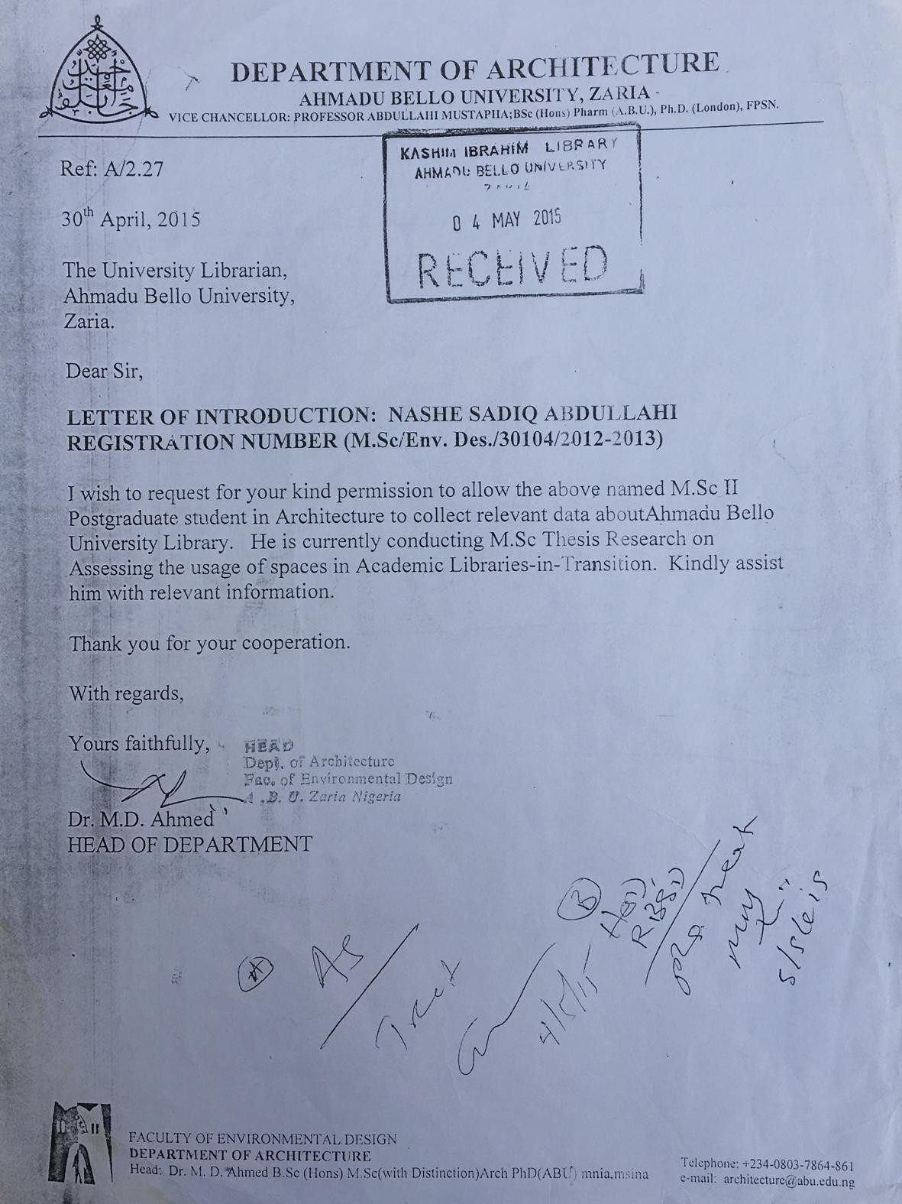

APPENDIX D: BUKL LETTER OF INTRODUCTION
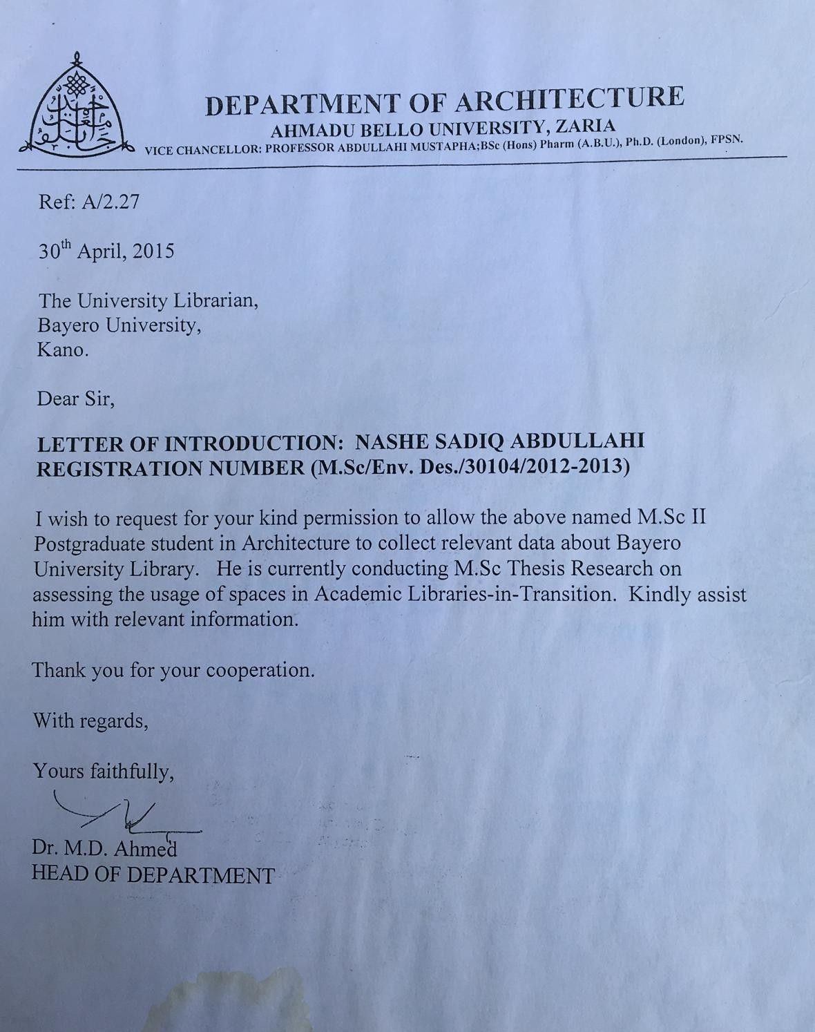

APPENDIX E:NIGERIAN UNIVERSITY AND THEIR GENERATIONS
