# APPRAISAL OF THE BIRNIN-KEBBI CITY MASTER PLAN FOR SUSTAINABLE DEVELOPMENT

**BY**

# SADIQ, Abubakar MTech/SPS/2017/7248

**THESIS SUBMITTED TO THE POSTGRADUATE SCHOOL FEDERAL UNIVERSITY OF TECHNOLOGY, MINNA, NIGERIA IN PARTIAL FULFILMENT OF THE REQUIREMENTS FOR THE AWARD OF THE DEGREE OF MASTER OF TECHNOLOGY IN REMOTE SENSING**

# APRIL 2021

**ABSTRACT**

The study is aimed at appraising the Birnin Kebbi city Master Plan with a view to providing information that can influence policy for sustainable urban development. The objectives of this study are to assess the land use and land cover change from 1991-2018 and simulate the 2027 land cover change; to appraise the level of implementation/mismatch of the 1980 Master Plan; to assess the level of compliance of the Birnin Kebbi city development with International best practices for sustainable cities and upgrade a neighbourhood and develop an improved Land Use Plan that is sustainable for the growing population in Birnin Kebbi. Geographic Information Systems, remote sensing and the administration of questionnaire through a stratified sampling technique were used for data collection and analysis. A supervised classification was applied to Landsat image of the study area from 1991, 2000, 2009 and 2018. The study revealed that urban/built-up area has increased from 1,687 hectares in 1991 to 7,725 hectares in 2018 and it is projected to increase by 2,034 hectares in 2027. Similarly, agricultural land increased from 9,270 to 43,921 hectares in 2018 and it is predicted to increase by 2,192 hectares in 2027, while vegetation has decreased from 73,030 to 54,992 hectares in 2018. It also revealed that the Master Plan was partially implemented, as the results indicated an increase in urban/built- up area, resulting from the conversion of other allotted land use into built-up/residential area. The assessment of the level of compliance to international best practices for sustainable development considered five major indicators and concluded that Birnin Kebbi is fairly sustainable in it development. Population growth and government policies are the major underlying cause for LULC change in the study area and the results indicated an increase in urban/built-up and agricultural land cover types, while vegetation and bare land cover decreased. This study recommend the deliberate measures to control natural increase in population through government partnering with NGOs such as Gate foundation, UNICEF and other aid organisation to invest more in the state in the area of family planning, education, poverty alleviation and green technology to improve child survival rate and ensure sustainable development.

|  |  |  |  |
| --- | --- | --- | --- |
|  | **TABLE OF CONTENTS** |  | |
| **Content**  Cover page Title Page |  | **Page** | i |
| Declaration |  |  | ii |
| Certification |  |  | iii |
| Dedication |  |  | iv |
| Acknowledgements |  |  | v |
| Abstract |  |  | vi |
| Table of Contents List of Tables List of Figures List of Plates  **CHAPTER ONE** |  | vii xiii xiv xv | 1 |

* 1. INTRODUCTIO 1
  2. Background to the Study 1
  3. Statement of the Research Problem 5
  4. Aim and Objectives 7
  5. Research Questions 8
  6. Justification 8
  7. Scope of the Study 9
  8. The Study Area 9
     1. Location 9
     2. Relief and drainage 12
     3. Climate 12
     4. Geology 13
     5. Soils and vegetation 13
     6. Population and people 14
     7. Economic activities of Birnin Kebbi 14
     8. Challenges associated with Birnin Kebbi 15

CHAPTER TWO 18

* 1. LITERATURE REVIEW 18
  2. Review of Concepts 18
     1. Land use and land cover change 18
     2. Challenges of land use and land cover change 20
     3. Concept of city and urban growth 22
     4. Population growth, urban expansion and climate change 25
     5. Sustainability, sustainable urban development and sustainable cities 28
     6. Urban sustainability assessment 33
     7. Master Planning 36
  3. Review of Relevant Literature 38

CHAPTER THREE 46

* 1. MATERIALS AND METHODS 46
  2. Data Type and Sources 46
     1. Primary data collection 46
     2. Secondary data 46
  3. Sampling Procedure 48
     1. Sampling size and procedure 49
  4. Instruments for Data Collection 50
     1. Questionnaire 50
     2. Hand held GPS 50
     3. Field observation and interviews 51
  5. Techniques of Data Analysis and Presentation 51
     1. Techniques of data analysis 51
        1. Assess the land use and land cover change in the study area from 1991 – 2018 and simulate the 2027 land cover change 52
        2. Appraise the level of implementation and mismatch of the existing

Master Plan 54

* + - 1. Assess the levelnternational best practices for sustainable cities. 54

3.4.1.4. Identify and pick a neighbourhood for upgrade and develop an improved

Land Use Plan that is sustainable for the growth of Birnin-Kebbi 55

CHAPTER FOUR 58

* 1. RESULTS AND DISCUSSION 58
  2. Land Use and Land Cover Change in the Study Area from 1991 – 2018 and

Simulate the 2027 Land Cover Change. 58

* + 1. Land use and land cover classification of 1991 58
    2. Land use and land cover classification of 2000 59
    3. Land use and land cover classification of 2009 61
    4. Land use and land cover classification of 2018 63
    5. Projected land use and land cover of 2027 66
    6. Simulated land use and land cover change of 2027 67
  1. Level of Implementation and Mismatch of the 1980 Master Plan 70
     1. Implementation and mismatch of the 1980 Land Use Plan 73

|  |  |  |
| --- | --- | --- |
| 4.3 The Level of Compliance of the Birnin-Kebbi City Master Plan with |  | |
| International Best Practices for Sustainable Cities |  | 78 |
| 4.3.1 Residents’ perception on land use and land cover change (LULC) |  | 79 |
| 4.3.2 Population and urban sustainability |  | 82 |
| 4.3.3 LULC compliance with international standard for sustainability |  | 84 |
| 4.3.3.1 Water supply | 86 |  |
| 4.3.3.2 Access to clean energy | 88 |  |
| 4.3.3.3 Urban transportation system | 90 |  |
| 4.3.3.4 Environmental pollution and management | 93 |  |
| 4.3.3.5 Disaster mitigation and resilience | 96 |  |
| 4.3.4 Residents’ perception on recommendation towards attaining sustainability |  | 98 |
| 4.3.5 Environmental sustainability of Birnin Kebbi |  | 99 |
| 4.4 Upgrade a Neighbourhood and Develop an Improved Land Use Plan that is |  |  |
| Sustainable for the Growing Population in Birnin-Kebbi. |  | 101 |
| 4.4.1 Implementation strategy for the redevelopment plan |  | 107 |
| 4.4.1.1 Phase 1 | 108 |  |
| 4.4.1.2 Phase 2 | 108 |  |
| 4.4.1.3 Phase 3 | 109 |  |
| 4.4.1.4 Phase 4 | 109 |  |
| 4.4.2 Modified Land Use Plan of Birnin Kebbi | 111 |  |
| 4.4.3 Implementation strategy for the modified Land Use Plan of Birnin Kebbi |  | 112 |
| 4.6 Summary of Findings |  | 114 |
| **CHAPTER FIVE** |  | 120 |
| 5.0 **CONCLUSION AND RECOMMENDATIONS** |  | 120 |

* 1. Conclusion 120
  2. Recommendations 122

**REFERENCES** 126

**APPENDICES** 137

|  |  |  |
| --- | --- | --- |
|  | **LIST OF TABLES** |  |
| **Table** |  | **Page** |
| 2.1 | Urban sustainability assessment methods from the literature | 36 |
| 3.1 | Description of Satellite Imagery Used | 48 |
| 3.2 | Categories of land cover classes | 53 |
| 3.3 | Summary of Research Observations and Methods of Data Collection | 56 |
| 4.1 | The land cover types of the different years and their percentage | 62 |
| 4.2  4.3: | Rate and percentage change of LULCs in Birnin-Kebbi  Projected LULC for 2027 and the predicted change between 2018 and 2027 | 65  68 |
| 4.4: | Land use budget for the 1980 Master Plan | 71 |
| 4.5: | Land use budget for the proposed land use map 2017 | 73 |
| 4.6: | Mismatch between the 1980 plan and the existing situation | 77 |
| 4.7 | Distribution of the questionnaire | 79 |
| 4.8 | Consequence of increased population growth on LULC in the area | 83 |
| 4.9 | Condition of Infrastructure and Services | 85 |
| 4.10 | Primary cooking energy used | 88 |
| 4.11 | Primary Means of Transportation | 91 |
| 4.12 | Frequency of solid waste collection | 93 |
| 4.13 | Methods of waste disposal | 95 |
| 4.14 | Level of compliance with building codes regulations | 97 |
| 4.15 | Possible Recommendations towards Attaining Sustainability | 99 |
| 4.16 | Effect of human interaction with the environment in Birnin Kebbi | 100 |

|  |  |  |
| --- | --- | --- |
|  | **LIST OF FIGURES** |  |
| **Figure** |  | **Page** |
| 1.1 | The Study Area (Birnin-Kebbi) | 11 |
| 3.1 | The schematic diagram of materials and methods to be use in the study | 57 |
| 4.1 | Land Use and Land Cover Classification Map of 1991 Satellite Imagery | 59 |
| 4.2 | Land Use and Land Cover Classification Map of 2000 Satellite Imagery | 61 |
| 4.3 | Land Use and Land Cover Classification Map of 2009 Satellite Imagery | 63 |
| 4.4 | Land Use and Land Cover Classification Map of 2018 Satellite Imagery | 64 |
| 4.5 | Trend analysis of LULC Classification of the Study Area | 66 |
| 4.6 | Simulated 2027 LULC classification | 67 |
| 4.7 | Birnin Kebbi Master Plan from 1980 – 2000 | 72 |
| 4.8 | Proposed 2017 Land Use Plan of Birnin Kebbi | 75 |
| 4.9 | Proposed Land Use Plan of Birnin Kebbi superimposed on satellite  image of 2018 | 76 |
| 4.10 | Land use type 10 years ago | 80 |
| 4.11 | Current LULC of Birnin Kebbi | 80 |
| 4.12 | Status of LULC in Birnin Kebbi | 81 |
| 4.13: | Proportion of respondents connected to public water supply | 87 |
| 4.14 | Primary cooking energy used | 90 |
| 4.15 | Most common means of transportation | 92 |
| 4.16 | Wastewater treatment | 96 |
| 4.17 | Proportion of development situated on hazard-prone environment | 98 |
| 4.18 | Redevelopment Plan for Nasarawa II ward (Alternative I) | 105 |
| 4.19 | Redevelopment Plan for Nasarawa II ward (Alternative II) | 106 |
| 4.20 | Modified land use map of Birnin Kebbi as proposed | 110 |
| 4.21 | Land use budget for the proposed modified land use | 112 |

|  |  |  |
| --- | --- | --- |
|  | **LIST OF PLATES** |  |
| **Plate**  I | The Reforestation Programme | **Page**  65 |
| II | Fuel wood depot at Nasarawa ward, Birnin-Kebbi | 68 |
| III | Solar-powered water system | 87 |
| IV | Neighbourhood road at Tudun wada community, Birnin Kebbi | 91 |
| V | Environmental condition at Ung-Dambo | 101 |
| VI | Housing condition at Rafin Atiku | 101 |
| VII | Pedestrian walkway | 107 |
| VIII | Solar roofing system | 107 |
| IX | Mixed-use housing | 107 |
| X | High-density building | 107 |

# CHAPTER ONE INTRODUCTION

# Background to the Study

The challenge of humanity in the 21st Century is clearly “to meet the needs of the people, within the means of this extraordinary unique living planet, so that humanity and the rest of nature can thrive” (Raworth, 2018). Humanity is faced with a complex situation, at the same time we are solving for climate change; we are going to be building new cities, towns and urban centres for 3 billion people, which is doubling the current urban environment (Calthorpe, 2017). If we fail to plan our cities right, then no climate solutions in the world might prevent humanity from the worst effects of carbon in the atmosphere.

The controversy over the reality causes and consequences of climate change had been fairly concluded in 2007, with the Fourth Assessment Report of the Intergovernmental Panel on Climate Change (IPCC), which made a categorical statement that it is real; it is human induced and predicting some very serious disaster scenarios (Tong, 2015). Cities or urban centres are the most extraordinary experiment in social engineering that we humans have ever created. Cities are one of the major contributors of greenhouse gasses in the world. They occupy just about 3% of the world surface area, account for more than 75% of the energy consumption and emit over 80% of greenhouse gasses (Muggah, 2017).

After the Industrial Revolution, the world human population gradually being to gather in urban areas, because of new job opportunities and improved living conditions. The 20th century witnessed the extreme and unprecedented growth of global urbanization. This has continue over the years in similar manner and has been driven by the continuous increase in global population growth; leading to a rise in total number of urban residents, from an

annual average of 57 million within 1990 and 2000, to over 77 million from 2010 - 2015 (MacLachlan *et al*, 2017).

Without any universal catastrophe, an additional growth in human population from the current 7 billion people to 10 billion by the middle of the century is inevitable. The expected growth is motivated by the high birth rate in the sub- Saharan Africa, whose human population is projected to increase in twofold within the next 40 years; Asia’s population is also expected to increase by 23% (Cleland, 2013). According to UN-Habitat (2016), the population in urban areas has increased from 14% in 1900 to 30% in 1950. With the world's population evenly split between urban and rural areas in 2008, it is predicted by the UN that by 2050 the urban population will increase again to 66% with nearly 90% of this increase being concentrated in Asian and African cities. Nigeria alone is projected to add 212 million urban dwellers between 2014 and 2050. In China, about 300,000,000 million people will move to urban areas over the next 15 years (Larson, 2012). All these should be of concern to us whether we live in a city or not.

Although cities are economic engines that create wealth, provide employment opportunities and drive human progress by harnessing the forces of agglomeration and industrialization (UN-Habitat, 2016), numerous towns and cities around the globe are largely not prepared for the complex and multifaceted challenges affiliated with urbanization and urban growth. This is because in most cases, urbanization or urban growth has depended on a prototype that is not sustainable in many considerations. Environmentally, the contemporary model of urbanisation encourages low-density urban development, mostly driven by private or individual need, rather than public interest.

This model is relatively made easier by the over reliance on individual cars and it energy demanding, thereby contributing dangerously to climate change.

Urban Planning involves objective or target based process adopted for urban development. It involves analysing and predicting the urban environment, quantitatively and qualitatively to identify and evaluate alternative policy options leading to a beautiful life (Musa, 2015). The Master Plan approach to urban planning is one of the earlier in the history of planning; it is aimed at guiding and managing urban development (Mishra, 2012). The Master Plan model is a type of spatial planning established on a comprehensive zoning system, land use maps and planning standards.

Due to its complicated and rigid nature, it has failed to solve numerous socio-economic problems arising from increased urbanisation and it is now been abandoned in many developed countries of the world. This model of planning is usually based on zoning and it encourages the centralisation of the various component of the society in different location and ultimately ends up in creating urban sprawls. For example, residential areas are separated from commercial areas, factories are moved to the outskirts of the city and administrative areas are located away from residential areas.

Sustainable urban development planning is a multidisciplinary approach to planning, which involves specialist from the diverse field of development planning, management, engineering, architecture, economics, accounting, history, sociology, geography, environment, policy formulation, public administration, statistics, demography, law, psychology, computer sciences, Information and communication technology. This is because if we are going to survive the 21st century, we have to work together to create a functional, liveable and resilient cities. Sustainable development is a common and

contemporary goal of many urban development policies in various countries (Abu-Bakar and Cheen, 2013).

The Agenda 21 is a blueprint for sustainable development in the 21st Century. It was held in Rio de Janeiro in June 1992 and was adopted by 179 nations (including Nigeria), and providing decent and environmentally friendly housing is one of the most important goals, and as such, it has significant potential to contribute to sustainability agenda. Similarly, the Goal 11 of the Sustainable Development Goals also emphasized on making cities and human settlements inclusive, safe, resilient and sustainable by 2030, thereby necessitating the need for urban planning.

Even though urban transition is a universal event that is witness in all countries, the causes or determinants, pattern, and outcomes do not necessarily follow a uniform process (Farrell, 2017). Africa’s rapid urbanization is driven mainly by natural increase, rural–urban migration, spatial expansion of urban settlements through the annexation, the reclassification of rural areas, and, in some countries, negative events such as conflicts and disasters (Bloch *et al*, 2015). As a result, urban planning or Master Plans are face with the problems of poor implementation at ground level. This has encouraged the development of slums and squatter settlements in many African cities such as Kibera in Nairobi, Makoko in Lagos and a host of others. In addition, given that African cities are among the poorest in the world, their growth rates signal a major challenge to their resources to build and sustain adequate infrastructure and public services for their growing population.

In Nigeria, the increase in urban population over the last 50 years has been extremely rapid and is expected to grow faster in the coming decades. The most dominant factor responsible for this rapid urban population growth and urban expansion is the declining mortality and

persistently high fertility (Bloch *et al,* 2015). While rural-urban migration also contributes to urban growth, it influence is not as significant as the natural urban increase and reclassification due to rural densification especially in northern Nigeria. The production of fancy, well-articulated documents such as the Master Plan is very common in Nigeria; the major challenge is usually in the implementation of such document. Virtually all major towns and cities in Nigeria have a documented Master Plan, despite this, most of the cities and towns are expanding with little or no control.

Birnin-Kebbi is situated in Kebbi state and it is the administrative headquarters of the state. The total population of the city in 2006 was 268,620 and an estimated population of 366,200 in the 2016 demographic statistics released by the National Bureau of statistics, (NBS, 2016). The rate of urbanisation in the state has being largely influence by the fast growing population. Despite having a Master Plan, the unchecked and uncontrolled urbanisation has led to the replacement of soil and vegetation with impervious urban materials and the creation of slums and squatter settlements. These may, directly or indirectly, affect the albedo and runoff characteristics of the land surface, thereby, significantly influencing the local climate.

# Statement of the Research Problem

Master Plans are generally prepared with a view to achieving decent and healthy environment for the purpose of growth and development. The urban design model of Master Plan where every component of the society such as residential, commercial and industrial areas are virtually segregated, are urban design of the 50’s and 60’s which encourage the development of sprawls, and are obsolete (Larson, 2012).

The new urbanism design concept, is to among others, promote walkability, mixed uses and diversity, connectivity, mixed housing, increased density, green transportation, sustainability, resilient, and improved quality of life. This is also known as the compact city or city of short distances concept. It is arguably a more sustainable urban settlement type than urban zonal system that promote sprawl because it is less dependent on the car, requiring less (and cheaper per capita) infrastructure provision, and has low carbon footprint (Zubairu, 2017).

Birnin-Kebbi has a Master Plan that was produced between 1980-1983, with the aim of guiding its urban growth and development from 1980-2000. This plan has been reviewed several times but uncontrolled urban expansion is still a major problem. The city has witness unprecedented increase in population, leading to the formation of sprawls, slums and squatter settlements. This is due to the development model adopted in the design and the poor implementation of the Master Plan. Woodland (vegetation) and agricultural lands are being converted, mostly illegally, into residential areas with little or no basic infrastructure. This has increased the surface run-off of rain water, eroding the loose soil particles and creating gully erosion in some places.

Ideally, cities of the 21st century are supposed to be planned with the aim of reducing their carbon footprint in the atmosphere, while anticipating increase in population. The implementation of the Birnin-Kebbi Master Plan so far, does not demonstrate any consideration for climate change, neither does the plan envisage the rapid increase in it urban population. This is not a sustainable plan, especially when Nigeria population is projected to reach 400 million; and estimated to add 212 million urban dwellers by 2050 (UN-Habitat, 2016). The model of urban growth in Birnin-Kebbi encourages the use of

unsustainable means of movement, leading to the increase use of dirty carbon-based fuel that is harmful to the environment.

The pattern of urban development in Birnin-Kebbi is everything but ideal. Therefore, limiting outward urban expansion can be combined with more efficient use of land resources and more effective protection of natural resources to begin a process of reengineering the urban space. The question of how to make the urban growth and development in Birnin-Kebbi sustainable must be researched upon, because this can provide a national template for planning and development of future cities.

# Aim and Objectives

The aim of this study is to appraise the implementation of the Birnin-Kebbi city Master Plan, with a view to providing information that can inform policy for sustainable urban development in the study area.

The objectives are to:-

* + 1. Assess the land use and land cover change in the study area from 1991 – 2018 and simulate the 2027 land cover change;
    2. Appraise the level of implementation and mismatch of the 1980 Master Plan;
    3. Assess the level of compliance of the Birnin-Kebbi city development with International best practices for sustainable cities**.**
    4. Identify and pick a neighbourhood for upgrade and develop an improved Land Use Plan that is sustainable for the growth of Birnin-Kebbi.

# Research Questions

This subsection is design to provide the specific research questions to guide the research process in data gathering and analysis necessary in achieving the research objectives. These questions are-

* + 1. What is the extent of changes in land cover since 1991 -2018 and how will it be in 2027?
    2. What is the extent of implementation of the Birnin-Kebbi city Master Plan?
    3. To what extent does this plan conform to international best practice for sustainable cities?
    4. What is the most sustainable development plan for the growing population of Birnin-Kebbi?

# Justification for the Study

The necessity of this study cannot be over stretch as the outcome would assist in policy and performance improvement, contribute to further research and add significantly to the existing body of knowledge; in the design and development of cities that can accommodate more people, ensure low emission level and reduce carbon footprint in the future.

Policy Improvement: The present study and its outcome will provide policy makers in the Ministry of Lands and Housing in the development, implementation and monitoring of policy on urban planning and maintenance for enhanced operational efficiency.

Performance Improvement: the study would also benefit all the staff members in the ministry of Lands and Housing, Kebbi state Urban Development Board, and urban managers in particular, with the requisite capacity, guide and strategies on best planning model to accommodate the expected increase in population. The current study would

definitely benefit the academic society and researchers willing to undertake further studies in the field. It will also serve are reference material to review for future research in the field.

Body of Knowledge: this study would add to the body of knowledge by documenting it findings on the subject matter. Though these findings might be unique to the study area, it is useful in extending the frontiers of knowledge and serve as a good reference material for individuals and organisation.

# Scope of the Study

The scope of the study is limited to the geographic boundary of Birnin-Kebbi. Birnin-Kebbi is the administrative headquarter of Kebbi state and the Master Plan is design to check urban growth and development in this area. The study will appraise the implementation of the Master Plan through urban growth from 1991 – 2018. However, the Master Plan was prepared for development from 1980 – 2000, by the Sokoto state government, major development started in 1991 when the local government became the capital of the newly created Kebbi state. The content scope of the study is on the physical and spatial elements of the Master Plan. These include the neighbourhood character and heritage; land uses (residential and commercial areas); open space and public realm; biodiversity, water management and utilities; and transport network. These are the major component of Master Plan that is mostly affected by population growth and urban expansion.

# The Study Area

# Location

Kebbi state is located in the north-western part of Nigeria. It was created from Sokoto state in 1991, during the Military government headed by Gen. Ibrahim Badamasi Babangida, the

state share boundary with Niger state to the south, Zamfara state to the east and Sokoto state to the north. The state also shares an international border with Niger Republic to the west. Birnin Kebbi lies between Longitudes 4º 011’E to 4º 381’ E and latitudes 12º 151’ N to 12º 351’ N. It is bounded to the north east by Argungu LGA, to the south by Kalgo LGA, to the east by Gwandu LGA, to the west by ArewaDandi LGA (see Figure 1.1)

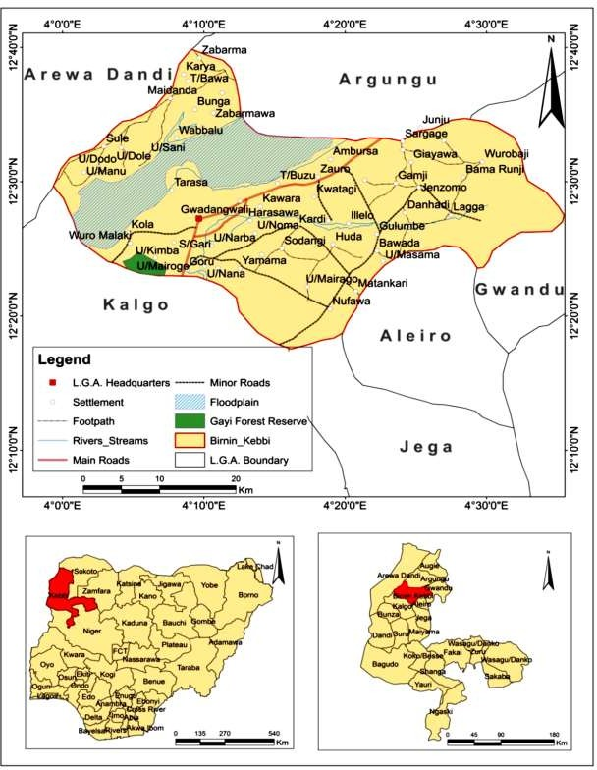

**Figure 1.1:** The Study Area (Birnin-Kebbi) Adopted from Abubakar (2015)

# Relief and drainage

Relief in the state is generally gently rolling to undulating. Further northwest of the study area, there are however, outcrops and steep cliffs of limestone, reaching 15m in height in the town and up to 30m just outside. In general, elevations throughout the state are mostly less than 300m (Birnin Kebbi Master Plan1980-2000).

The landscape of Birnin Kebbi is dominated by extensive flood plains. The Rima and the Shella rivers are located in the north and south east of the town respectively. Both rivers have broad flood plains. The Rima river system has major tributaries like Gawon, Zamfara and Gubinka. These tributaries rise in the Basement Complex region of Sokoto State and flow westward to join the Rima (Birnin Kebbi Master Plan1980-2000).

# Climate

Previously, there are no weather element recording stations that exist in Birnin Kebbi, but the building and operations of the Birnin-Kebbi airport has change this narrative. Kebbi State enjoys a Tropical Continental type of climate characterized by distinct wet and dry seasons.

In Birnin Kebbi and environs, the highest mean daily temperature are recorded at the peak of the dry season just before the onset of the rains in April while the lowest are recorded at the peak of the harmattan periods. The mean temperature during the hot season is 370C while it could be as low as 80C during the cold harmattan period (December-February).

Relative humidity is much higher in the southern areas than in the north where Birnin Kebbi is located. It is also higher during the wet season than the dry season all over the country. Whatever the season, relative humidity is generally lower in the afternoon than in

the morning. This is because the capacity of the air to hold moisture increases during the day with increase in the air temperature (Birnin Kebbi Master Plan 1980-2000).

# Geology

The geological characteristics of Birnin Kebbi include thick and vast sequences of sedimentary deposits of the Sokoto basin, which underlie about 50% of the area. The rest is being underlain by the Precambrian basement complex rocks. The Sokoto basin is part of an elongated sedimentary basin underlying most of north-western Nigeria and part of eastern Niger republic. The Kebbi basin constitutes approximately 10% of the regional geological basin with its focal point in Niger republic. The sequence ranges in age from cretaceous to quaternary and is composed mostly of interblended sand, clays some limestone; all laid on an uneven floor of basement complex. The beds dip gently towards the northwest. Alluvium of quaternary age underlies the lowlands of the river and its attributes (Birnin Kebbi Master Plan 1980-2000).

# Soils and vegetation

Wetland and savannah soils have developed throughout Kebbi state. The principal soils within the Birnin Kebbi region are the silt soils. These are heavy, cracking clayed soils with more than 35% clay have shrinking and swelling properties. The soils are high in minerals but have problems associated with spillage, poor drainage, flood and erosion. The entire Kebbi State falls within the northern Guinea savannah zone, characterized by heterogeneous mixture of vegetation, heavily disturbed by human influence and few trees of medium height which naturally provide habitat for a variety of wild life. Small holder and grazing agriculture activities are common in this zone.

The perennial grasses and herbs of the savannah provide a large and easily obtainable source of food for herbivore wild life (Birnin Kebbi Master Plan 1980-2000).Low acacia trees and shrubs with grasses, however, dominate the vegetative cover of Birnin Kebbi. Most of the trees have been felled to give way to agricultural and urban development although some species of neem trees could be indiscriminately found within the town.

# Population and people

The population of Birnin Kebbi has increased from 47,682 in 1984 to 63,147 in 1991 to 74,027 in 1996, to 268,620 in 2006 and 366,200 in 2016 (NPC, 2016). Different tribal groups, such as the Kabawas, Fulanis, Zabarmawas, and the Dakarkaris inhibit the state. However, the various distinct tribal groups within Birnin Kebbi have significantly increased due to its status of been a state capital. The major ethnic groups in the state capital include the Gungawas, Dandawas, Dakarkaris, Kambaris, and more recently Yorubas, Igbos, Urhobos, etc.

# Economic activities of Birnin Kebbi

The performance of the town’s economy since its creation (1991 to date) has exerted great influence on population growth, employment structure, physical expansion and development of the town. Birnin Kebbi is thus now serving triple functions as the state capital and Local Government Headquarters as well as the seat of Gwandu Emirate. Owing to these functions, it has now become centre of trade and commerce, serving the whole sub- region of far North West zone including the neighbouring Niger and Benin Republics. The local economy has attracted, and is still attracting migrants, from within and outside the country. This trend is manifested in the rapid population increase, physical growth and development of the town induced by the change in its status.

Birnin Kebbi is sandwiched between two fertile fadama lands; the Shella and Rima rivers fadama. Shella river fadama is situated approximately 3km southeast of the town and averages about 1.5km width. The area extends continuously in an easterly direction before turning due south into the permanent water of Shella river. The Rima river fadama situated North West of the town, which runs southerly and finally empties into the river Niger. The Rima river valley consists of the largest fadama land in Kebbi state made up of 525,000 hectares out of which about 142,000 hectares remain after the flood as dry season pools of stagnant water. The two expanse of Fadama lands (Rima and Shella) thus provide important area of high value agricultural soils for planting of floating rice as well as other crops in the retreating floodwaters (Birnin Kebbi Master Plan 1980-2000). Little wonder why the state is a major player in the Federal government rice farming programme. This has also increased the population of the state in general and Birnin-Kebbi in particular, as many companies and collaborations such as the Lake-Rice (with Lagos state) has led to more employment opportunities and increased standard of living.

# Challenges associated with Birnin Kebbi

Birnin-Kebbi is the capital of Kebbi state and the headquarters of the Gwandu Emirate. The state was created in 1991, out of Sokoto state with the aim of bring governance nearer to the people. The population of the city has increased over time from 47,682 in 1984 to 63,147 in 1991 to 74,027 in 1996, to 268,620 in 2006 and 366,200 in 2016 (NPC, 2016).

The steady increase in the city’s population had led to a rapid increase in urbanisation. This increase, though, driven by external, rural-urban and urban – urban migration, is also influenced by internal population growth. Some of the factors exacerbating this population movement include: economic advantage; Kebbi state is one of the major producers of rice

in Nigeria and the federal government policy aimed at promoting local rice production has led to the influx of people from within and outside the state to work in rice farms and rice milling company (rice production chain).

The number of these type companies, such as LABANA Rice mills, WACOT Rice and a host of others, have increase due to the significant increase in electricity supply to the city. The city enjoys virtually 24 hours power supply because the state derives its power supply from the electricity line supplying Niger republic from Nigeria. Another major pull factor to the city is because of the security to human lives and property experience in the state, with respect to its neighbouring states. Kebbi state and Birnin-Kebbi in particular has witness the influx of people from neighbouring states of Zamfara, Sokoto and Kastina states because of the activities of armed bandits, kidnappers and herdsmen, resulting in an increase need for residential accommodation in the urban areas. Similarly, the establishment of the Federal University, Birnin Kebbi in Kalgo L.G.A, has attracted the movement of people from various part of the country to Birnin Kebbi, as most of the people schooling and working at the University prefer to stay there.

Birnin-Kebbi Master Plan designed to control development from 1980 – 2000 had been hampered because of the unprecedented rate of urbanisation. The implementation of this Master Plan has being very poor, as studies have revealed that forest and agricultural farmland have being legally and illegally converted to low and high-density residential areas. For example, Abubakar (2015), revealed that the land consumption rate (LCR) increased from 0.022 to 0.089 between 1986 and 1999. This has aggravated the consequences of climate change in the study area, as the state now experience some severe and unpredictable weather conditions like rainfall, temperature and wind storms. In

addition, the associated effects of poor planning and poor agricultural practice in Kebbi state are evident in the number of gully erosions in the state. This is one of the major environmental problems in the state; others include drought, deforestation, seasonal flooding and overgrazing.

The present study will provide guide and strategies for the government or relevant agencies on best planning model to accommodate the expected increase in population and reduce the carbon footprint of the city. It will arm Kebbi State Urban Development Board and Town Planners with concrete facts about the compliance of the Master Plan with international standard for sustainable cities.

# CHAPTER TWO

# LITERATURE REVIEW

This chapter discusses the related literatures used to support this research work. It describes the concept of urbanisation and urban growth, Master Planning, sustainable urban development, and review relevant literatures on implementation of Master Plans.

# Review of Concepts

# Land use and land cover change

Land is natural resources and the main source of national wealth. It is use for different purposes, which include residential, industrial, agriculture, commercial, education etc. Land use/cover (LULC) is a composite term, which includes both categories of land cover and land use (Ioannis and Meliadis, 2011). They are two distinct but inter-related characteristics of the Earth’s surface. Land use describes the way and the purposes for which human beings employ the land and its resources such as grazing, agriculture, urban development, logging, and mining among many others (Alemayehu *et al*, 2018). While land cover refers to the ecological state and physical appearance of the land surface such as closed forests, woodlands or grasslands (Alemayehu, *et al.*, 2018).

The term land cover originally referred to the kind and state of vegetation, such as forest or grass cover but it has broadened in subsequent usage to include other things such as human structures, soil type, biodiversity, surface and ground water (Abubakar, 2015). Land use is the foundation of all forms of human activities, from it we obtain the food we eat, the shelter we need, the space to work and the room to relax (Abubakar, 2015). Human need of land resources gives rise to land use, which varies with the purposes it serves in terms of processing materials, provision of shelter, food production and recreation and so on.

The land use/cover pattern of a region is an outcome of natural and socioeconomic factors and their utilization by man in time and space (Alemayehu *et al.* 2018). Land use and land cover change has become a central component in current strategies in managing natural resources and monitoring environmental changes. Urban expansion has increased the exploitation of natural resources and has changed land use and land cover patterns. Rapid urbanization, therefore, brings opportunities for new urban developments; however, it also has brought serious losses of arable land, forestland and water bodies. Land cover change is a major concern of global environmental change.

Land use and Land cover change studies have become key components for managing natural resources and monitoring environmental changes. Musa (2015) opined that Land cover and Land use information should form part of the environmental data, which are kept in the form of inventories/infrastructure in many advanced and emerging economies. Most Land use change factors such as water flooding, air pollution, urban sprawl, soil erosion, deforestation, occur without clear and logical planning which results in serious environmental degradation with notable consequences globally.

Forces other than anthropogenic can alter Land cover, natural events such as weather, flooding, fire, climate fluctuations, and ecosystem dynamics may initiate modifications upon land cover (Abubakar, 2015). Globally, land cover today is alter principally by direct human use: by agriculture and livestock rising, forest harvesting management and urban and suburban construction and development. There are also incidental impacts on land cover from other human activities such as forest and lakes damaged by acid rain from fossil fuel combustion and crops near cities damaged by troposphere ozone resulting from automobile exhaust (Abubakar, 2015). Hence, in order to use land optimally, it is not only

necessary to have the information on existing land use land cover but also the capability to monitor the dynamics of land use resulting from both changing demands of increasing population and forces of nature acting to shape the landscape.

Land use and land cover in urbanisation involves the activities of lands associated with both natural and anthropogenic factors of the physical environment within the cover and uses (Isah, 2015). Tempering of land use and land cover activities is environmental problems usually causes by man against environmental biodiversity conservation. It is good to conserve the environmental resources and that is the best way for sustainability of land and land cover. The population growth and urban expansion with availability of resources mostly results in land pressure leading to unplanned settlement and tempering land use and land cover changes, (Olujide *et al.,* 2018).

Urban areas are highly dynamic and are continually undergoing rapid changes, one of which is changes observed in the pattern of land-use/land-cover (LULC). The knowledge of land use and land cover change is important to understanding certain occurrences in the earth’s biophysical composition. It entails a conversion of natural types of land to uses associated with growth of population and economy, transforming the landscape from its natural form to impervious urban lands termed cities and towns. These changes in the earths’ land use and land cover has resulted in unprecedented consequences that threaten man’s existence.

# Challenges of land use and land cover change

Land cover change occurring through the conversion and intensification of the earth surface by human intervention has led to altering of the earths’ ecosystem balance. For centuries,

humans have been altering the earth’s surface to produce food through agricultural activities (Nigussie, 2016). In the past few decades, conversion of grassland, woodland, and forest into cropland and pasture has risen dramatically, especially in developing countries where a large proportion of human population depends on natural resources for their livelihoods (FAO, 2005). The increasing demand for land and related resources often results in changes in land use/cover (Nigussie, 2016) and it has local, national, regional and global consequences (Olson *et al.* 2004).

Land use/cover dynamics are widespread, accelerating, and significant process driven by human actions and producing changes that impact humans (Leh *et al.,* 2011). Factors driving LULC change include an increase in human population and population response to economic opportunities. Population growth is a major driving force in land cover change and contributes to resource degradation (Woldamlak, 2002). Deforestation and forest degradation have been influenced by a combination of underlying driving forces, including unclear land tenure, poor economic conditions, population growth, market (wood extraction), and socio-political factors (Alemayehu *et al*., 2018).

LULC changes is affecting biodiversity, biogeochemical cycles, soil fertility, hydrological cycles, energy balance, land productivity, and the sustainability of environmental services (Alemayehu *et al.,* 2018). Therefore, the need for continuous monitoring of the changes and prediction of it consequences cannot be over stressed. It is so pervasive that when aggregated globally, it significantly affects the functioning of the earth's systems directly contributing to climate change (Lewis, 2006). LULC changes result in soil erosion and the formation of gullies, which are among the major cause of land degradation (Selamyihun, 2004). The highest average rates of soil loss are from previously cultivated lands, which are

presently unproductive because of degradation and improper land use (Alemayehu *et al.,*

2018).

The consequences of LULC are seen as one of the major environmental challenges facing human existence in the 21st century. Land cover change because of urbanisation is continuously altering the atmospheric components and energy exchange; modifying local and regional climate and adversely influencing city sustainability and liveability (MacLachlan *et al.,* 2017). When manmade urban materials such as concrete, asphalt, and buildings replace natural land cover, it often creates an urban heat island. This modifies the thermal bulk properties (heat capacity and thermal conductivity) and surface radioactive properties (albedo and emissivity) compared to that experienced by natural surfaces such as vegetation and bare soil (MacLachlan *et al*., 2017).

Yang *et al.* (2016) also concluded that “the spatiotemporal changes in thermal environment of any area will be consistent with the process of urbanization. The average Land Surface Temperature of any area will continuously increasing as many other land use types are transform to urban regions.

# Concept of city and urban growth

An urban area is an area with an increased density of human created structures in comparison to the areas surrounding it (Usman, 2014). These areas may be cities or towns, created and further developed by the process of urbanization. Cities are the most extraordinary experiment in social engineering that human has ever created (Muggah, 2017). The term “City” is fairly a complex concept that is often used interchangeably with urban area, by most authors within the built environment. Its definition and classification

varies within and between disciplines, cultures and countries (Brand, 2009). At the beginning of the twentieth century, the numbers of cities were just 16 in the world and are located in the most advanced industrial countries. Today, we have almost 4000 cities and nine out of the ten most populous cities are located in the developing world. The developing world now has majority of all the biggest cities in the world; they are developing three times faster than the developed countries and nine times bigger but qualitatively different (Brand, 2009).

A city can be define as a large human settlement with extensive system for housing, transportation, sanitation, utilities, land use and communication (Larson, 2012). The United Nation (2000) classified city as an administrative centre or political boundaries within the jurisdiction of a municipality or town with population density of 2,000 people. Cities are exciting, less gruelling, better paid, free, private, safe and upwardly mobile. They are based on a number of different systems such as infrastructure, networks and environments, people, business, transport, communication, water, and energy. This is why 1.3 billion people are projected to move to the cities every decade (Brand, 2009). The effectiveness and efficiency of these systems determine how a city works and how successful it is at delivering its goals (UN-Habitat, 2004). Most countries use single or a combination of characteristics such as administrative, population size or density, economic and urban size to define a city.

In Africa, making direct comparisons is quite a difficult task this is because the definition of city varies from country to country and within each country from time to time. For example, if India’s national authorities would classify populations of 5,000 or more as urban, the country would be considered predominantly urban and not rural. In Angola,

Argentina and Ethiopia, all settlements with 2,000 people or more are classified as urban. In Benin, only areas with 10,000 people or more are considered urban. In Botswana, an agglomeration of 5,000 people or more where 75 per cent of the economic activity is non- agricultural can be consider urban (Cohen, 2006). The lack of globally agreed and applicable definition of city is a major challenge in reporting on the progress on the Sustainable Development Goal 11 which calls for inclusive, safe, resilient and sustainable cities (UN-Habitat, 2019). The only form of data that is available in some African countries as far as city definition is concern is “Demographic” as a result, many scholar use demographically based definition and classification for urban area. Consequently, Alabi, (2009) note that in view of a wide variety of figures used by different countries most researchers use the

United Nations Economic Commission for African’s definition as:

1. Locality with 500 city
2. Locality with 200,000-499,999=medium city
3. Locality with 100,000-199,999=city
4. Locality with 20,000-99,999=urban locality
5. Locality with less than 20,000=rural locality

Apart from using demographic statistics for the definition and classification of city, Weeks (2008) argue that socio-economic characteristics have also been used to distinguish rural settlement from urban. However, the author defined a city as a place based on characteristics that incorporate elements of population density, social and economic organization and the transformation of natural environment to built environment. Jelili *et al.* (2008) defined Cities as focal points where people come together primarily carrying out

activities for livelihood in an organized environment. They are drivers of societal development, not simply bricks or mortar; they are usually places of dreams, nostalgia and imaginations. However, the alarming growth of urban population and poor response of government are a factor that partly contributes to high rate of physical development mishap in cities. Cities play increasing roles in infrastructural, economic change, poverty reduction and environmental development (Satterthwaite, 2010). The position of cities in the global economy varies as their window of opportunities for development. In developed countries, for example, there are cities offering good networks and benefits to the rest of the world. Infrastructural development however, remains the life wire of activity system of cities. Thus, adequate infrastructure and efficient city management helps to broaden the perspective of city dwellers and foreign investors; it enhances the quality of life of individual as well as the city as a whole. It is worth noting that, improved urban infrastructure as well as effective delivery of public services is a necessary element in alleviating poverty in developing world and developed countries. Improved accessibility to employment, education, health, and other public services are also important for the welfare of the people and the city itself (Bhattacharya *et al.*, 2004).

In line with the above concept, Birnin-Kebbi fits the description of a city. It has the demographic characteristic, the infrastructural capability and the socio-economic diversity of the place qualifies it to be regarded as a city. Birnin-Kebbi has a large number of human populations, which has continued to grow over the years since its assumption as state capital in 1991. It has an estimated human population of over 366,200 (NPC, 2016) occupying a vast area of land, which is put into several uses to meet human needs. It is economically considered a city because it provides opportunity for people and supports a

number of socio-economic activities apart from agricultural practices. However, Birnin- Kebbi accommodates a huge number of people from different cultural backgrounds and beliefs, which is requirement for city classification according to Olujimi (2009).

# Population growth, urban expansion and climate change

The world population was estimated at 3 billion in 1960, with the industrialised world having one billion people and the developing world having two billion people (Rosling, 2010). Over the years, human population has increased dramatically. Since 1960 to 2010, the world has changed and has added a staggering 4 billion people to its population with improved economic development. The world projection in 2050 shows that there will be continuous increase in population and it is expected to reach 9 billion people (Rosling, 2010). Similarly, Cleland (2013) explained that “barring a calamitous pandemic, a further increase in the world’s population from 7 to between 8.8 and 10 billion by mid-century is unavoidable. This increase is driven by high fertility in sub- Saharan Africa whose population is forecast to more than double in the next 40 years and by a modest rise of 23% in Asia’s huge population”.

Rosling (2010) also opined that, “as long as the aspiration of the average family in the developing world is to have food for the day, the poorest 2 billion population in the world will continue to grow and is projected to reach 4 billion by 2050, that nothing but a nuclear war of a kind we have not seen before can stop this from happening”. He concluded that, only if they get out of poverty, they get education, improved child survival then population growth can stop at 10 billion.

Regardless of which part of the world, a person generates an average of seven metric tonnes of carbon per year through his activities in the environment (El-Jisr, 2019). Whereas cities are hubs for positive social and economic transformation, urban centres are concentrations of industries, transportation, and other activities that release large quantities of greenhouse gases (Grafakos, 2017). These human activities has resulted in the emissions of four major gasses namely; carbon dioxide, methane, nitrous oxide, and hydro-fluorocarbons. These gases absorb infrared radiation or heat energy and often refer to as greenhouse gases. Grafakos (2017) explained that the major contributor to greenhouse gas emissions is the continuous use of dirty fossil fuel base energy resources, such as coal, oil, and natural gas; for power, industrial, residential and transport sectors, releasing tons of carbon dioxide in the atmosphere. Land use changes such as deforestation and urbanisation also contribute to carbon dioxide emissions through the burning of trees or vegetation to clear land for agricultural or residential use.

Methane and nitrous oxide are some of the other greenhouse gases that contributors majorly to global warming and climate change i.e., change in an average measurement of climate related parameters such as rainfall and temperature (Al-Gore, 2012). These gases are emitted from agriculture activities such as cattle rearing and fertilizer use; and waste management, using landfills. Additionally, refrigerators and air conditioning use hydro- fluorocarbons known as HFCs which are often considered as super greenhouse gases because for a given amount of mass they drop substantially more heat than carbon dioxide.

It should be mentioned that the greenhouse effect is the reason why we are able to live on Earth. Without this natural greenhouse effect the Earth would be 33 degrees Celsius cooler. Therefore, the greenhouse effect provides protection from the loss of heat, and has made

life on Earth possible (Grafakos, 2018). Greenhouse gases may work as temperature regulators, but in cases where more greenhouse gases are emitted, this layer of greenhouse gas becomes thicker, and more heat is trapped within the Earth's atmosphere, increasing the Earth's surface temperature.

Stern (2014) concludes that “we are in a remarkable moment in time; we face over the next 2 decades, two fundamental transformation that will determine the curse human. These transformations are basically the structural change in our economy and society”. He argued that cities that are going to be build, should be designed in a compact way to save travel time and energy; and existing cities requires renewed investment to enable people connect themselves much better within those cities and encourage people to live closer to the city centre.

# Sustainability, sustainable urban development and sustainable cities

Achieving global sustainability in cities, in a rapidly urbanising world, is quickly becoming a concern to the international community (Raworth, 2012). Indeed, 54% of the world population was urban in 2014, and the global urban population is projected to reach 66% by 2050 (United Nations, 2015). While cities can be centres of innovation and cross-cultural collaboration, the ecological footprint of the world’s cities extends far beyond these urban centres’ physical boundaries, and glaring socio-economic disparities exist within and between cities (Keivani, 2010). As such, scholars and practitioners are seeking and implementing strategies to shrink cities’ impacts on the planet while improving quality of life for all peoples, both today and in the future.

Meadows *et al.* first used the term “sustainability” in the study of global resources in 1972 (PBL Netherlands Environmental Assessment Agency, 2012) . It was believed that the

catastrophic collapse of global systems would occur midway through the twenty-first century, if current growth rates and resource consumption continued, and that the only alternative was to alter these growth trends and to establish a condition of ecological and economic stability that is sustainable far into the future (PBL Netherlands Environmental Assessment Agency, 2012). Sustainability can be seen in various dimensions such as environmental, social and economic sustainability.

Sustainability can also be defined in a number of ways but the idea is mostly framed from the concept of sustainable development (Joumard and Gudmundsson, 2010). Richard (2001) summarizes sustainability, by arguing that the core of this concept is “the redefining of wealth to include natural capital, clean air, fresh water, an effective ozone layer, a clean sea, fertile land, and the abundant diversity of specie.

The concept according to Kidd (1992) is perhaps best thought of as general concepts whose precise definitions have yet to be fully explicated. He argued that there are different historical intellectual strains of thought that underlie the contemporary concept of sustainability. He discussed the carrying capacity, natural resource and environment, biosphere, critique of technology as well as the eco development, which is related to sustainable biological resource use, sustainable agriculture, sustainable energy, sustainable society and economy, and sustainable development. These concepts and definitions of sustainability have been used to convey many different expressions of environmental priorities, each emphasizing some particular aspect or set of values concerning what should be sustained.

Sustainability is most frequently associated with maintaining the earth’s carrying capacity, usually through alteration of individual and collective human behaviour. Behaving in ways

that reduce the rate of population growth, and that find alternatives to depleting natural resources, is certainly consistent with the idea of sustainability. In terms of human behaviour, what may be required to maintain the earth’s carrying capacity is not well understood or agreed upon, and may be inconsistent with basic values that are prevalent in the industrialized and industrializing worlds (Robinson *et al.*, 1990).

Environmental sustainability is define as the condition that allows human society to meet their current needs without compromising the current and future health of natural ecosystems (Morelli, 2011). Similarly, Abu-Bakar and Cheen (2013) defined Sustainable development as the development that meets the needs of the present without compromising the ability of future generations to meet their own needs. The efforts of sustainability practices embrace the rigorous use of the scarce natural resources through a good implementation of economy but without neglecting the environment and social factors, in trying to maintain the earths’ carrying capacity.

However, maintaining the earth’s carrying capacity is in large part a function of the social and political values that define and prescribe human behaviours. Achieving sustainability, according to this line of reasoning, apparently requires some types of socio-political characteristics and values rather than others.

Musa (2015), proposed a model that divides sustainability into three sectors of different goals economic growth, environmental preservation, and social equity. These three aspects of sustainability are seen as the essence of sustainable development. The economic stakeholders are typically interested in cheap labour, industrial growth and the access of resources, while the environmental interests emphasize biodiversity, resilient ecosystems, and clean air and water. Social needs, on the other hand, may prioritize equity among

people, empowerment, and security in society. The author highlights that extensive conflicts arise between these different aspects, and as their needs and interests often oppose each other and challenging planners in evaluating and prioritize the many needs in the work of bringing the city towards a sustainable future

However, sustainable development is an elusive concept that has become wide spread across the world with a diversity of definitions and meaning (Koglin, 2008). The concept is aim at producing long-term global well-being through the wise use, management of economic, and natural resources, and through respect for people and other living things. It describes humanity’s ability to create a world for humans and a nonhuman that environmentally, socially, and economically provides the current development that should not harm the interests of future generations (Raworth, 2012).

Sustainable development is a much broader concept than environmental protection. It implies a concern for future generations and for the long-term health and integrity of the environment. It also implies that further development should only take place as long as it is within the carrying capacity of natural systems. However, the concept are obvious fact that sustainable development is not a fixed state of harmony, but rather a process of change in which the exploitation of resources, the direction of investments, the orientation of technological development and institutional change are all made consistent with future as well as present needs (Clement, 2001).

Weingaertner (2010), identified three basic principles of sustainable development namely, the principle are inter-generational equity, the principle of social justice, and the principle of trans-frontier responsibility. Each of these principles is seen as equally important in achieving sustainable development across the globe, especially when attempting to apply

the concept in a situation such as designing more sustainable cities. The principle of intergenerational equity is about considering the effects of human activities on future generations such as his aspirations and needs for satisfaction.

The principle of intra-generational equity and social justice means that poverty needs to be tackled in present generations, as it is a prime cause of environmental degradation. The principle of trans-frontier responsibility requires that the need for people to take stewardship of the global environment at a global level. This is necessary because many of the environmental problems such as climate change and global warming transcend national borders and as such also requires developed countries to refrain from the exploitation of resources in other areas, which can distort regional economies and ecosystems.

The notion of the sustainable city has emerged as a political initiative in response to the degradation that occurred in the urban environment throughout the twentieth century. The definitions of sustainable city are numerous and varied because of the pluralism of approaches and strategies (Fowke and Prasad 1996). Sustainable cities have its genetic roots from the general concept of sustainable development. Ever since the term “sustainable city” was first brought into the lexicon of environmentalism, scholars and practitioners have seized upon it to promote and facilitate various kinds of environmental change. The idea of sustainable city has evolved in such a way as to provide greater meaning than would initially appear. The concept of sustainable city was derived in an attempt to account for a large number and variety of environmental and inter-personal impacts of urban growth, which has the mechanisms that can be used to redress the often negative or deleterious environmental and social effects of adherence to mainstream approaches to economic development.

Sustainable city referred to as resource efficient city that is significantly decoupled from resource exploitation and ecological impacts and is socio-economically and ecologically sustainable in the long term (UNEP, 2012). The United Nation sustainable city program defined sustainable city as one that is able to retain the supply of natural resources while achieving economic, physical, and social progress, and remaining safe against the environmental risks that can undermine any development achievement. Burnett (2007) declared that the sustainable city is organized so as to enable all its citizens to meet their own needs and to enhance their well-being without damaging the natural world or endangering the living conditions of other people, now or in the future.

Wikipedia (2018) also defined sustainable city as a city designed with consideration for social, economic, environmental impact, and resilient habitat for existing populations, without compromising the ability of future generations to experience the same. A singular definition for the sustainable city does not exist. This becomes an obstacle to the creation of the sustainable city. The goals for sustainable cities are grounded on a similar understanding, urban development which strives to meet the essential needs of all, without overstepping the limitations of the natural environment. A sustainable city has to achieve a dynamic balance among economic, environmental and socio-cultural development goals, framed within a local governance system characterized by deep citizen involvement and inclusiveness (UN-Habitat, 2019).

Birnin-Kebbi is faced with numerous urban and environmental challenges; and cannot be considered as being an example of a sustainable city. The newly adopted 2030 Agenda for Sustainable Development, presents 17 Sustainable Development Goals that replace the previous Millennium Development Goals (MDGs). While cities were not specifically

represented in the MDGs, Goal 11 of the new Sustainable Development Agenda seeks to: Make cities and human settlements inclusive, safe, resilient and sustainable. Birnin-Kebbi fall short of this criteria for a sustainable city and as such cannot be considered as working to achieve sustainable development goals.

# Urban sustainability assessment

Sustainable cities would be urban areas whose surroundings are planned and managed to not drive environmental pressures beyond key thresholds while providing for livelihood and equity concerns of all inhabitants (Cohen, 2017). The assessment of urban sustainability is increasingly being seen as essential to mitigate the undesirable impacts of urbanisation in cities while improving communities’ resilience to environmental, social and economic changes. Several urban sustainability assessment methods have been developed to enable urban planners and decision-makers to make informed decision on city management (Ameen, 2017). To measure and assess progress towards sustainably city, there are multiple ways to frame indicators for understanding urban sustainability. Forman and Wu (2016) identify seven key areas of impact from urban expansion, these are; natural vegetation, agricultural land, clean water, jobs, housing, transport, and communities. Here, there is a balanced perspective on urban development’s impact on natural resources, natural services, basic human needs, and livelihoods.

There exist countless resources on sustainability assessment across sectors and scales, as well as a growing body of research on sustainability assessment for the urban context (Cohen, 2017). At the urban scale, sustainability assessment typically revolves around identifying and measuring indicators, and there are papers published that provide indicator

sets numbering in the hundreds (Xing *et al.*, 2009; Boyko *et al.*, 2012; Zhou *et al.,* 2012; Ameen, 2015)

Although there is an array of types of potential sustainability assessment frameworks, identifying and measuring indicators is often at the heart of sustainability assessment (Olalla-Tarraga, 2006). Indicator selection for urban sustainability assessment is not often guided by a theoretical framework because literature framing sustainability assessment has often targeted national and global scales instead (Sumner, 2004; Davidson, 2011; Chesson, 2013). This may be problematic, as key principles of sustainable development should be followed when selecting sustainability indicators (Ciegis *et al.,* 2009).

As cities are complex systems nested within and interconnected with unique ecological systems, with each city defined by its own cultural and historical context, it is quite challenging to adequately select from the hundreds, or possibly thousands, of indicators to apply a uniform assessment to all urban areas around the world (Gonzalez *et al*., 2011). Therefore, it may prove more beneficial, and possible, to instead align a generic urban sustainability assessment around a common set of guiding principles that frame criteria and indicators unique to each individual city (Cohen, 2017). There are a number of theoretical frameworks developed for un-contextualized or generic sustainability assessment (Gibson, 2006). In these cases, sustainability assessment is framed around guiding principles, for which scholars and practitioners can set goals and objectives as well as tangible indicators to measure progress.

Sustainability assessment may be conducted by employing a variety of methods. Cohen, 2017 conducted a systemic review of literatures (69 papers) on urban sustainability assessment, following the Preferred Reporting Items for Systematic Reviews and Meta-

Analyses (PRISMA) guidelines. Table 2.1 shows the lists research methods for organizing indicators used in the reviewed articles and shows the number of studies that applied each method.

# Table 2.1. Urban sustainability assessment methods from the literature.

|  |  |
| --- | --- |
| Method | Number of Instances in the Literature |
| Indicator or index-oriented frameworks | 25 |
| Sustainability rating systems | 16 |
| Principle-based frameworks | 6 |
| Spatial analysis and urban form | 6 |
| Multi-criteria decision making | 5 |
| Urban metabolism | 5 |
| Eco-efficiency assessment | 2 |
| Impact assessment | 2 |
| Asset-based framework | 1 |
| Urban carrying capacity | 1 |
| Adopted from Cohen, 2017 |  |

The assessment of urban sustainability in Birnin-Kebbi will adopt the indicator method and will select indicator that will adequately reflect the complex interaction between the city and its different components such as inhabitants’ needs, neighbourhoods, air quality, energy management, mobility and transportation, water management, open spaces, public services, infrastructure and waste management. The integration of these components as sustainability indicators would enable the production of a comprehensive sustainable urban development assessment report.

# Master Planning

Planning is the process of making choices among the options that appear open for the future, and then securing their implementation, which depends upon allocation of necessary resources (Hameed and Nadeem, 2008).According to the World Bank (2018), a Master Plan is a dynamic long-term planning document that provides a conceptual layout to guide

future growth and development. It is about making the connection between buildings, social settings and their surrounding environment. Master Planning is a process of allocating land to different uses in order to balance social, economic and environmental objectives (Phillips and João, 2017).

It focuses on the spatiality and geographies of socioeconomic and ecological factors to optimize the use of space while minimizing conflict (BMZ, 2012). Master Plan includes analysis, recommendations and proposals for a location population, economy, housing, transportation, community facilities and land use. It is based on public input, surveys, planning initiatives existing development, physical characteristics and social and economic conditions (World Bank, 2018).

Master Planning varies widely, but the general process includes preparation (defining the goal and objectives), data collection and analysis, plan formulation, negotiation and decision making, implementation, and monitoring and updating (BMZ, 2012). According to Metternicht (2017), Master Planning processes can be carried out at different scales e.g., urban, regional, national. Its origin lies in the English Town and Country Planning Act of 1947 (Hameed and Nadeem, 2008). While it has long been discarded in UK, the Master Planning approach is still being followed in many developing countries including Nigeria.

Unfortunately, Master Plans prepared for several major cities of Nigeria are not usually implemented to an appreciable level and Birnin-Kebbi is no exception. Hameed and Nadeem, (2008), identifies various reasons why, despite the several weaknesses associated with the Master Planning approach, it continues to dominate the urban planning systems in many developing countries. These include professional training and ideology of planners at the top of their profession emphasizing planning standards difficult to attain in real world

situation; stakes of donor agencies, consultants, professionals, administrators, city managers, and politicians; and inappropriate legislative basis for planning in terms of plan preparation and implementation.

# Review of Relevant Literature

This section focuses on previous researches done in relation to the topic of this work both locally and internationally. This is intended to expose the subject matter in relation to current trend in order to identify the gaps to be filled by the current study in the existing body of knowledge.

Land use and land cover (LULC) change mapping at either global, regional or National scales is very important for a wide range of purposes such as planning, urban growth, environmental hazards and risk assessment (Abubakar, 2015). Other studies where information from land use and land cover assessment has being useful includes global warming, earthquakes, landslide, erosion, flooding, etc. These rapid changes adversely affect the environment and have potential economic and social impacts. Thus, detailed accurate information about changes is urgently needed for updating LULC maps, to provide information for policymakers to support sustainable development, and the management of natural resources.

Alemayehu *et al.* (2018), in their study on “Land use land cover change trend and its drivers in Somodo watershed South Western Ethiopia” aimed at evaluating the historical and future trends as well as the driving forces of LULC, used satellite image of Landsat5 TM of 1985 and 1995, Landsat7 ETM+ of 1999, 2005 and Landsat8 OLI/TIROS 2017. They also conducted field observation, Key Informant Interview (KII) and Focus Group Discussion (FGD) to collect relevant data. They used ERDAS Imagine 9.1, QGIS 2.18 and

IDRISI Selva 17.00softwares for the LULC change detection and prediction. They concluded that LULC change in the study area is an outcome of several proximate and underlying drivers, chief among the proximate drivers are the expansion of settlements, plantation, agriculture and construction of infrastructure, while the underlying cause is population growth.

In another study by Enoguanbhor *et al*. (2019) on “Land cover change in the Abuja city- region, Nigeria: Integrating GIS and Remotely sensed data to support land use planning” used a supervised classification method on Landsat images of 1987, 2002 and 2017, and mapped land cover transition from 1987 to 2017, and computed the net land cover change during the time. They also analysed the mismatches between the past and the current urban land cover and Land Use Plans, and quantified the non-urban development area lost to urban/built-up area. The study concluded that there is a significant level of mismatch between the regional Land Use Plan and unregulated urban expansion, as there had been significant encroachment into areas that were originally designed as green areas, which are now urban/built-up areas.

In addition, studies have revealed the effect of uncontrolled land cover changes on the surface temperature. Olanrewaju (2018), in his study on “Urban land use land cover changes and their effect on urban thermal pattern: case study of Nigeria’s Federal Capital City” applied remote sensing, GIS and statistical methods to extract land use land cover change and Land Surface Temperature (LST). He revealed that increase in the built-up areas is inversely proportional to vegetation areas and directly proportional to the Land surface temperature. He concluded that there is a need for urban planners in the FCC to put in place temperature-mitigation strategies to ensure the sustainability of the city.

In Abuja, Nigeria, Mahmoud *et al.* (2016) report an increase in urban land cover to the detriment of bare land. They argue that the spatial pattern of urban expansion in Abuja is base on the Master Plan and exhibits sprawl towards surrounding satellite towns. Owoeye and Ibitoye(2016) show urban expansion at the expense of vegetation in Akure, Nigeria. They suggested that the Master Plan of the city is in dire need of revision and a comprehensive regional Land Use Plan should be prepared to address the problems of urban expansion but did not conduct a comparison between planned and actual land cover. Nkeki (2016) shows how urban expansion affected agricultural and forestland use/cover in Benin City, Nigeria, concluding that vital planning information for urban planners and public decision-making bodies can potentially be extracted from the findings.

Akintunde *et al.* (2016) show that urban land increased, while non-urban land decreased in Jos, Nigeria. They argue that urban development did not conform to the recent Master Plan in Jos. While comparing urban growth in three African cities (Bamako, Cairo, and Nairobi), Hou, *et al.* (2016) show an increase in urban expansion corresponding to a decrease in bare land, arguing that there is unplanned urban expansion in rapidly growing African cities. Similar results has been found in cities outside Africa. For example, Barrera and Henríquez (2017) observed an increase in urban growth and a decrease in urban vegetation in three cities in Chile, suggesting that the vegetation can and should be preserved using urban planning and design.

Similarly, Abubakar (2015), applied remote sensing and GIS to monitor land use and land cover dynamics in Birnin-Kebbi from 1986-2009, using Erdas imagine 9.2 software and employing a supervised classification method. The study discovered that there has been significant increase in the built-up area. The study revealed a dramatic increase in built-up

area from 1986 – 1999 and a drop in the rate of urbanisation from 1999 – 2009. The study also recorded an increase in grassland and a decrease in agricultural land. He recommended that residential buildings towards the outskirts of the city should be encouraged, especially in places like Zauro and Ambursa, to avoid the problem of overcrowding.

Isah (2015), used Landsat (ETM+ 1999 and 2003) and demographic data in monitoring change of urban growth in Kano city. A combination of supervised and unsupervised image classification techniques were adopted in the ERDAS imagines software. The study used Google map, historical maps and prior knowledge of the area as reference date for image classification. A Digital Elevation Model of the study area was analysed and discovered that there is a relationship between elevation and urbanisation. He also observed that the built-up area has increased by 25.36% between 1999 and 2003, while vegetation cover and bare land decreased by 25.47% and 3.64% respectively. He concluded that the expansion in the built-up area is majorly as a result of population increase.

The implementation of Master Plans has always been a problem especially in developing world. Usman (2014) appraised the Kano Comprehensive Tourism Master Plan (KCTMP), using the “process evaluation” method. The KCTMP prepared in 2005, was to be implemented from 2005 – 2020. Purposive sampling technique was adopted to collect data through interview and field survey, other secondary sources of information contributed to the appraisal. The study revealed that the level of implementation of KCTMP was low, because of some factors such as poor process of preparation, insufficient funding, duplication of responsibility, low stakeholders involvement, inadequate marketing and promotion, and poor publicity. He recommended that the phasing of the identified projects

should be reviewed and most important or viable sites should be prioritized to boost tourism activities and revenue generation.

In a similar vein, Mishra (2012) in his study titled “Urban Master Plans in Rajasthan, India: The case of Alwar” tries to identify the different causes and factors hindering the implementation of Master Plans in Rajasthan. He identifies some lacunas, the planning preparation reflects in nature and proposals of planning which affect the implementation process immensely. He concluded that even though the production and usage of Master Plans are obsolete, positive steps should be taken to strengthen the institutions and greater involvement of the public in planning process is essential for the preparation of a good Master Plan and its implementation on ground level.

Sustainability assessment frameworks are becoming increasingly important to assist in the transition towards a sustainable urban environment. Cohen (2017), conducted a systemic review of urban sustainability assessment studies with a view to identify the most commonly method for urban sustainability assessment, identify the most common framings for urban sustainability assessment and to identify the most common categories for organising indicators that measures urban sustainability. He discovered that urban sustainability assessment in general lacks a unifying framing and that it could be better aligned with common sustainability principles. He recommended that the employment of a mixed-method for urban sustainability assessment research, among other strategies would present better result.

Also, Elgadi *et al.* (2016) explained that the urban environment is an effective system and requires regular monitoring and evaluation through a set of relevant indicators. He proposes a set of key indicators to monitor urban environmental sustainability developments of

Libyan residential neighbourhoods. The proposed environmental indicator framework measures the sustainability performance of an urban environment through 13 sub- categories (i.e., water quantity, water quality, green space, air quality, marine environment, climate, agriculture, coastal zone, natural resource, fisheries, urbanization and ozone) and 21 indicators that need to put into neighbourhood development in order to achieve a sustainable urban environment. The environment indicators were identified as one aspect of liveability and contribute to the sustainable development of urban areas.

Similarly, Walsund (2013) argued that Remote Sensing, GIS and Decision Support Systems (DSS) can be used as tools to help achieve sustainable urban development especially on the environmental aspect of sustainability. In his paper where he reviewed former research within the subjects of GIS, RS, DSS and sustainable urban development, he explained that GIS and RS can be used to plan for water usage, actions to decrease air pollution and climate change adaption, and combined with a DSS; the software can help decision makers in the process of planning. He recommended that GIS and RS techniques should be implemented in the planning process of a sustainable city at its early stages, and to base action plan goals on what is realistic, in areas that are in greatest need of sustainability initiatives.

Most developed countries now pursue policies that implicitly or explicitly aim at promoting compact urban form. Ahlfeldt and Pietrostefani (2018) investigated compact urban growth by analysing more than 300 academic papers that study the effects of compact urban form, and finds that 69% of the papers reviewed find positive effects associated with compact urban design. Over 70% of studies find positive effects of economic density (the number of people living or working in an area). A smaller majority of studies attribute positive effects

to mixed land use (58%) and the density of the built environment (56%). Further benefits of compact urban design are generated through the preservation of urban green space, greater energy efficiency, pollution reduction, and safer urban environments. The major costs of higher economic density are related to congestion, health, and well-being. Increasing compactness can also contribute to higher land values and housing costs, which are borne disproportionately by renters and first-time buyers. They concluded that to increase economic density therefore, will require accompanying policy interventions to maximize the benefits and minimize the costs associated with compactness. In particular, policymakers need to facilitate large-scale investment in housing supply and public transport networks to ensure efficient and equitable access to housing, services, and jobs in compact cities.

Also, Mahesh *et al*. (2012) argued that urban planning requires a large volume of data both at the time of planning and at the time of implementation of the plan to determine the status of the available facilities. Thus, remote sensing techniques provide accurate, orderly and reliable information for planning and management of a town or a city. They recommended the use of Remote Sensing techniques for change detection analysis and selection of sites specific facilities such as hospitals, restaurants, solid waste disposal and industry.

Subsequently, the major findings from all the relevant papers reviewed include-

1. The world population is increasing and 90% of all future population growth will happen in Africa, Asian and Latin America continent.
2. About 54% of the world population is currently urban and it is projected to reach 70% by 2050.
3. A city emits over 80% of the greenhouse gasses, so a well-planned integrated land use can reduce the emission.
4. The concept of Master Plan as a city development strategy is obsolete often poorly implemented and encourages urban sprawl, slums and squatter settlements.
5. The adoption of polices by government, urban planners and other stakeholder is key to the realization of sustainable city development.

This study therefore, intends to transform Birnin-Kebbi into a sustainable city with the view of filling the following gaps|:

* 1. Available literatures on sustainability dwell mostly on the theoretical approach rather than attempting to practically transform a particular location to a sustainable city. This study intends to develop an improved land use Master Plan that is sustainable for the growing population of Birnin-Kebbi.
  2. Most studies assess the sustainability of cities that are located in the developed country. Very few attempt to compare existing cities in Africa to ensure their compliance with international standard for sustainable cities and Birnin-Kebbi city compliance level is yet to be assessed. Therefore, this study will add to knowledge, by critically examining the Birnin-Kebbi city and comparing it with international standard for sustainable city.

# CHAPTER THREE

# MATERIALS AND METHODS

This chapter explains the methods and relevant materials required in this project. The research has been categorized into three phases; i.e. the pre-field work, fieldwork and the post-field work phase. In addition, the technique and procedures for data analysis and mode of data presentation was discussed in this chapter.

# Data Type and Sources

The research was based on field information; so most data required for the successful completion of the research was collected during the fieldwork. The fieldwork involve the collection of primary and secondary data. Significant percentages of the data were collected through primary survey.

# Primary data collection

The primary data were collected at both household (community) level and the relevant MDAs involve in the delivery of public services. Primary data was gathered through the application of questionnaire that provides first-hand information about the actual situation of the study area. Other tools were used as complement and verification for the data collection; such as digital camera and hand held GPS. The GPS was use to collect points of various features (e.g. farmland, built-up areas, vegetation, bare land and water bodies) before image classification and after image classification for accuracy assessment.

# Secondary data

Secondary data are information about the study area that was collected from various offices in both hard and soft copy. MDAs such as the Ministry of Lands and Housing was contacted for the Master Plan of the study area and topographic map. Records on registered

houses, information on legal and illegal land use conversion and ascertaining the level of compliance with the Master Plan design was sourced from the Kebbi Urban Development Authority. Additional information on the study population and other relevant statistics was source from the National Population Commission (NPC) and Kebbi State Bureau of Statistics (KBS). In addition, classified documents and information on international standard for sustainable development was sourced from relevant United Nation Development Programme (UNDP) and United Nation Human Settlement Programmes (UN-Habitat) documents. This will give insight on the standard for universal guide on sustainable human settlement.

Most importantly, remotely sensed data necessary for the analysis was source from United State Geological Survey (USGS) Earth Explorer service. This is an online, openly accessible platform majorly for acquiring remotely sensed imagery. Remotely sensed data of 1991, 2000 and 2009 from Landsat 7 satellite (Enhanced Thematic Mapper plus), and 2018 from Landsat 8 satellite (Operational Land Image) was used. The spatial resolution for all the satellite images is 30 m (Table 3.1). Additionally, satellite imagery accessed via Google Earth was also be used in the development of an improved Land Use Plan for the study area.

# Table 3.1: Description of Satellite Imagery Used

|  |  |  |  |  |  |  |  |
| --- | --- | --- | --- | --- | --- | --- | --- |
| **Spacecraft** | **Sensor** | **Resolution** | **No. of bands** | **Acquisition date** | **Image details** | **Level of processing** | **Source** |
| LandSat 5 | TM | 30m | 1,2,3,4 | 17th, | Path-191, | Radiometric | USGS |
|  |  |  | & 5 | November | Row-51 | corrected |  |
|  |  |  |  | 1991 | & 52 |  |  |
| LandSat 7 | ETM+ | 30m | 1,2,3,& | 23rd, | Path-191, | Radiometric | USGS |
|  |  |  | 4 | November | Row-51 | corrected |  |
|  |  |  |  | 2000 | & 52 |  |  |
| LandSat 7 | ETM+ | 30m | 1,2,3,& | 29rd, | Path-191, | Radiometric | USGS |
|  |  |  | 4 | November | Row-51 | corrected |  |
|  |  |  |  | 2009 | & 52 |  |  |
| LandSat-OLI- | OLI | 30m |  | 30th, | Path-191, | Radiometric | USGS |
| 8 |  |  | 2,3,4,5  &6 | November 2018 | Row-51 & 52 | corrected |  |
| Google Earth |  |  | 1,2,& 3 | 1991, 2000, |  |  | Google |
|  |  |  |  | 2009,&2018 |  |  |  |

Source: Field survey, 2019.

# Sampling Procedure

This study adopted two sampling techniques; the Purposive Sampling Technique and stratified random sampling. The purposive sampling technique is a judgemental, non- probability sampling technique that is selected based on characteristics of a population and the objective of the study (Crossman, 2018). This technique was applied to interviews directed to the relevant MDAs that have the requisite knowledge required for collection of data relating to the subject matter, while the stratified random sampling techniques was used in the various neighbourhoods to be interviewed.

Based on the existing number of wards in Birnin Kebbi, which is 15 in number, 26.6% of the wards were selected for sampling (4 wards). These wards or neighbourhoods were further stratified into planned and unplanned neighbourhoods for the administration of questionnaire in this research. For example, Birnin-Kebbi has 15 wards so, four (4) wards

was sampled for this study, two (2) of the chosen wards are planned area while the other two (2) were unplanned neighbourhoods.

# Sampling size and procedure

This research will adopt the Survey Monkey sample size calculator to determine its sample size. This is online web application software to calculate sample size. This calculator usually allows the researcher to enter the target population size, confidence level and margin of error. In order to ensure a realistic, acceptable and manageable sample size, this research will adopt 95% confidence level and 5% margin of error.

In adopting the above sampling calculator for the 2018-projected population of Birnin Kebbi (352,050), by the Kebbi state bureau for statistics, a total of 384 questionnaire were administered in the four chosen wards in the study area. The wards are Nasarawa II and Godongaji for the planned areas and Nasarawa I and Makera for the unplanned areas. A total of 96 questionnaire were distributed in each of these wards and 89 was returned from Nasarawa II, 82 from Gwadangwaji, 78 from Makera area and 83 from Nasarawa 1 respectively. In total, 332 were return and analysed for this study while. 52 questionnaire were not returned as the respondents were either not around at the time of collection or did not fill it and refuse to return it.

The sampling procedure adopted was purposive and stratified sampling technique. Information about household population of the study area was gotten from the Kebbi state bureau for statistics and National Population Commission. Data collected was analysed using SSPS software and presentation were made on tables and graphs using Microsoft Excel tool.

# Instruments for Data Collection

As stated earlier, this research was base on data from both primary and secondary sources. The primary data was collected using questionnaire (structured and open-ended), cameras and GPS. Below is the detail of the instruments required and the type of information that collected from the field.

# Questionnaire

The use of questionnaire is an important element of this research, as it will provide the necessary information about the state of some basic infrastructure necessary for sustainable development. The questionnaire was administered at both community (household level) and to some relevant MDAs. The questionnaire was design to, among other things, collect information majorly, on the environmental sustainability index indicators. These indicators include water availability and accessibility in the study area, urban pollution, disaster prevention and resilience, urban transportation and urban space development.

# Hand held GPS

GERMIN GPS 12 was use in this research for reconnaissance and ground treating purposes. The GPS was use in collecting point at various features before the image classification and after the classification for accuracy assessment. The points were collected in longitude and latitude coordinate system. The GPS was also be used to collect details of important locations such as market, government house, the state secretariat etc. in the study area for planning purpose.

# Field observation and interviews

Even though the whole of Birnin-Kebbi would be observed and planned, an in-depth inventory was conducted on some selected community for planning purpose. The community inventory is sometimes called “closed sensing” is doing observation without taking interview Paul and Maiti, (2007). In the planning of a compact city design, community inventory was done to collect relevant information on the location of some essential service providers in the community, e.g. public health centres, schools, eateries, market/shopping malls, etc. these will enable the planning of a walkable city that is less dependent on cars. The inventory will also aid in the verification of the respondents’ answer on the questionnaire administered. Informal oral interview was done with contact persons on the field and questions which cannot be answered through questionnaire were asked such as: the historical background of the community.

# Techniques of Data Analysis and Presentation

# Techniques of data analysis

Simple analytical technique was use to analyse the data in this research work. These comprise the analysis of all the fundamental factors of sustainable planning, through a rational interpretation process with the aid of some analytical software. In addition, flow charts, diagrams, map sets were use to graphically show variation in the data analysis. Below are the specific analytical steps used for each objective.

# Assess the land use and land cover change in the study area from 1991 – 2018 and simulate the 2027 land cover change;

This involves land use and land cover change detection using satellite imagery from 1991 – 2018 with a nine (9) years interval i.e. 1991, 2000, 2009 and 2018. In addition, the simulation/prediction of the land cover of 2027 was done. According to Macleod and Congalton (1998), there are four major aspects to be considered when monitoring change detection in natural resources. These are detecting the changes that have occurred; identifying the nature of the change; measuring the area extent of the change; and assessing the spatial pattern of the change. These guidelines were use in detecting the changes that have occurred in the study area.

In addition, the spatial analysis was performed using ArcGIS (version 10.1) software. The study adopted the Classification Comparison Analysis of satellite imagery for its land use and land cover change detection, as utilized by Enoguanbhor et al (2019). A supervised classification method was applied to derive land cover types. Supervised classification is a process whereby samples of pixels from a satellite image are carefully selected in locations, where each pixel’s true land cover type is known following field observation (Enoguanbhor *et al.* 2019).

The spectral signatures of these known pixels was analysed to estimate and assign information classes to unknown pixels. This method enables the analyst to have control over the assignment of different pixel classes based on known information about the study area (Campbell and Wynne, 2011). The supervised classification algorithm that was used in this study is the maximum likelihood classifier, which relies on the probability that different pixels belong to different classes (Campbell and Wynne., 2011) and assigns pixels

to the class with the highest probability (Mather and Tso, 2009). This is because maximum likelihood algorithm has been demonstrated by Ganasri and Dwarakish, (2015) to produce high-accuracy results for land cover classification. The land cover classes were categorized into the most frequently occurring classes in the satellite imagery: urban/built-up, vegetation, bare land, and water (Table 3.2).

# Table 3.2: Categories of land cover classes.

**Land Cover Classes Description of Land Cover**

Urban/built-up Elements of urban/rural settlements such as buildings, roads, etc.

Vegetation (Forest and savannah vegetation): Tall trees that form canopy as healthy

vegetation, Isolated short trees mixed with grasses.

Farmland All type of cropland

Bare land All other surfaces such as open space with bare soil, rocks

Water bodies and wetland Seasonal and permanent wetlands, marshy lands, swamps, lakes and other water bodies

Modified from Enoguanbhor *et al.* (2019)

In assessing the LULC change detection, two different analytical methods were applied:

* + - * 1. Total LULC change in hectares was calculated as:

Total LULC = Area of a final year – Area of initial year

Positive value indicates an increase in the specific class, while negative value implies a decrease in extent.

* + - * 1. The percentage of LULC change was calculated based on the following equation:

Percentage LULC (%) = Area of final year – Area of initial year (3.1)

Area of initial year

# Appraise the level of implementation and mismatch of the existing Master Plan

This involves analysing the mismatches between the current urban land cover and the Master Plan i.e. comparing the classified land cover image of 2018 and the Master Plan of Birnin-Kebbi. This is to determine the level of distortion that has occurred to the original Master Plan, i.e. the percentage of the originally reserved green areas that been converted to urban/built-up areas, etc. this was done by scanning, geo-referencing, geo-processing, and digitizing the official Master Plan of the study area. An overlay analysis of the variables was performed to visualize the urban expansion trends on the Master Plan and urban planned area. Finally, the quantification of the non-urban development areas, which includes land use designated for nature conservation, intensive agriculture, and animal husbandry lost to urban/built-up in 2018 was done.

# Assess the level of compliance of the Birnin-Kebbi city Master Plan with international best practices for sustainable cities.

Questionnaire was used to collect information, majorly on the qualities of a sustainable city based on international best practice. The questions focused on access to improved water (demand and supply) and efficient electricity supply, availability of adequate transportation and communication route, access to improved sanitation and waste management, smart security for dweller, improved housing standard, sufficient living area (open space and green area) as well as socio-economic characteristics of the study area. Questions relating to infrastructural challenges in the study area were asked in order to provide background information needed for an improved Land Use Plan. The information gathered informally and through questionnaire was use in comparison with international standard for sustainable city.

# 3.4.1.4. Identify and pick a neighbourhood for upgrade and develop an improved Land Use Plan that is sustainable for the growth of Birnin-Kebbi. .

In addition to the existing Master Plan, a Google Earth image of the study area was required to design an improved Land Use Plan for sustainable development. The proposed plan was based on the new urbanism design concept that seeks to, among others, promote walkability, mixed uses and diversity, connectivity, mixed housing, increased density, green transportation (bicycle lanes), sustainability, resilient, and improved quality of life. This is also known as the compact city or city of short distances concept. It is arguably a more sustainable urban settlement type than urban zonal system that promote sprawl because it is less dependent on the car. During the field observation, identification of areas in need of utility development and infrastructural facilities was made and incorporated into the improved Land Use Plan. In an effort to encourage walkability, the plan will try to ensure that most of what people need are between 5 – 10 minutes’ walk, e.g. health care centres, schools, communication networks etc. In addition, a new mobility parkway, such as a super highway for joggers and bicyclers, is incorporated in the improved plan.

# Table 3.3: Summary of Research Observations and Methods of Data Collection Research Objectives Data Requirement Data Source

Assess the land use and

land cover change in the study area from 1991 – 2018 and simulate the 2027 land cover change

Landsat images of

1991, 2000, 2009 and

2018. GPS points during ground- treating

United State Geological

Survey (USGS) Earth Explorer service and field observation.

Appraise the level of implementation and mismatch of the existing Master Plan

Master Plan of the study area, classified Landsat image of 2018 and Google Earth image of the study area.

Ministry of Lands, Urban Development Board and United State Geological Survey

(USGS). Field observation.

Assess the level of compliance of the Birnin-Kebbi city Master Plan with International Best Practices for Sustainable Cities.

Information from the questionnaire and relevant documents.

Field observation and Interviews

Develop an improved Land Use Plan that is sustainable for the growing population in Birnin-Kebbi.

Existing Master Plan, Google Earth image of the study area and expert opinion

Field observation and Interviews

Source: Field survey, 2019.

# RESEARCH WORKFLOW

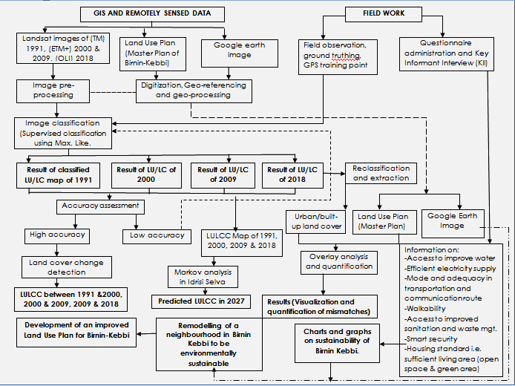

**Figure 3.1**: The schematic diagram of materials and methods to be use in the study Source: Field survey, 2019

58

# CHAPTER FOUR

# RESULTS AND DISCUSSION

Following the collection of primary and secondary data, which was analysed using the various methodology detailed in the previous chapter, this chapter shows the results and discuss the findings of the thesis as it relates to the various objectives.

# Land Use and Land Cover Change in the Study Area from 1991 – 2018 and Simulate the 2027 Land Cover Change.

Land use and land cover change is a constant but gradual process occurring in any geographic location on the earth surface. This process may sometimes occur unnoticed over time and space. However, studies have shown that spatio-temporal data analysis of a geographic location can visibly show the changes. Olujide *et al*. (2018) revealed that land use and land cover change is visible and well pronounced through a multi-data satellite imageries analysis. The Birnin-Kebbi land use and land cover analysis was done using multi-temporal Landsat images (Path 191 and Row 51 & 52) between 1991 and 2018. The land use and land cover analysis over a period of 27 years in the study area shows that the land has witnessed a significant change in it structure, pattern and extent.

# Land use and land cover classification of 1991

A supervised classification of Landsat images for 1991, 2000, 2009 and 2018 was done to visualise and quantify the spatial pattern of the land cover types. The results (Figure 4.1 and Table 4.1) show that in 1991, with a population of 119,000 inhabitants, the urban/built-up areas were concentrated in the north-western part of the local government, with some isolated settlements in other parts; development generally, was few and far between. The urban/built up class covered only 1.4% of the total land area. The low urban spread in 1991

may be attributed to the fact that Birnin-Kebbi at this period was just elevated to the capital of a newly created state (Kebbi State), from Sokoto State. In addition, vegetation covered 58.5%, water body covered 0.04%, 7.4% of the total land was used for agricultural purpose while bare land covered 32.7%.

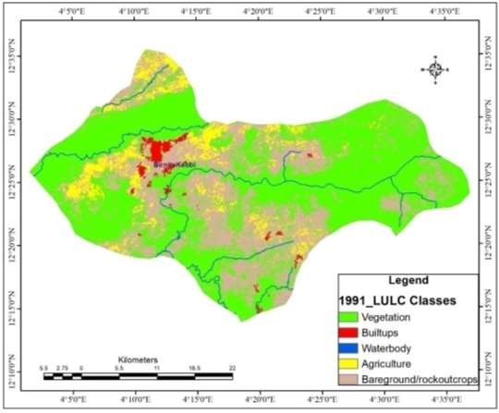

**Figure 4.1**: Land Use and Land Cover Classification Map of 1991 Satellite Imagery.

Source: Field survey, 2019

# Land use and land cover classification of 2000

In 2000, (Figure 4.2 and Table 4.1), the pattern of urban distribution indicates a gradual spread in the built up areas from the north-western part of the state capital, moving towards the western part in a linear pattern. The population increased from 119,000 to 160,000

(UN-WPP), leading to a rapid development of settlements in the southern part of the state capital. This led to the overall increase in the percentage of built up area in the year 2000 to 3.4% of the total land coverage. Similarly, vegetation covered 46.3%, water body covered 0.02%, and agricultural land covered 32.2% while bare ground covered 18.2%.

There was a significant increase and decrease in the different land cover types in the study area in the year 2000. This was credited to the increase in population due to natural growth and the influx of people into the study area; and the need to develop critical infrastructure to provide the necessary services to support the new status of the place. Built up area increased from 1,687 hectares (ha) in 1991 to 4,189 ha in 2000, vegetation reduced from 73,030 ha in 1991 to 57,790 ha in 2000 while, water body decreased from 51 to 29 ha. Similarly, agricultural land increased from 9,270 ha to 40,134 ha and bare ground decreased from 40,773 ha to 22,669 ha.

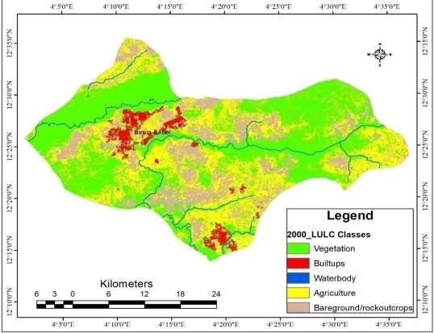

**Figure 4.2**: Land Use and Land Cover Classification Map of 2000 Satellite Imagery Source: Field survey, 2019

# Land use and land cover classification of 2009

The 2009 classified image (Figure 4.3 and Table 4.1) shows that with a population of 239,000 inhabitant (UN-WPP, 2019), the built up areas are becoming densely populated, as land previously used for farming or agricultural purposes close to settlements are gradually being converted to building or settlements. It also shows that there was not much increase or expansion in terms of the extent of built up area but densification of the existing urban space.

“According to the Director, *Town Planning, Ministry of Lands, Housing and Urban Development, Kebbi State, there was a deliberate effort in 2007/2008 from the ministry to monitor and control urban growth, enforce the existing Land Use Plan and encourage the reforestation programme in the state capital”*.

# Table 4.1 land cover types of the different years and their percentage

|  |  |  |  |  |  |  |  |  |
| --- | --- | --- | --- | --- | --- | --- | --- | --- |
| **Land cover type** | **1991(Ha)** | **%** | **2000(Ha)** | **%** | **2009(Ha)** | **%** | **2018(Ha)** | **%** |
| Built-up | 1,687 | 1.4 | 4,189 | 3.4 | 5,580 | 4.5 | 7,725 | 6.2 |
| Vegetation | 73,030 | 58.5 | 57,790 | 46.3 | 55,035 | 44.1 | 54,992 | 44.1 |
| Water body | 51 | 0.04 | 29 | 0.02 | 39 | 0.03 | 41 | 0.03 |
| Agriculture | 9,270 | 7.4 | 40,134 | 32.2 | 42,122 | 33.8 | 43,921 | 35.2 |
| Bare ground | 40,773 | 32.7 | 22,669 | 18.2 | 22,035 | 17.7 | 18,132 | 14.5 |
| **TOTAL** | **124,811** | **100** | **124,811** | **100** | **124,811** | **100** | **124,811** | **100** |

Source: Field survey, 2019.

Subsequently, built up area increased by 1,391 ha in 2009 (see Table 4.2), with a marginal increment of 33.2% from the 2000 classified image. Vegetation decreased by 2,755 ha and water body increased slightly by 10 ha. In addition, agriculture increased by 1,988 ha in 2009, while bare ground decreased by 634 ha.

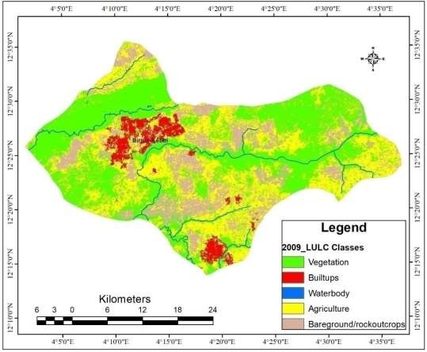

**Figure 4.3:** Land Use and Land Cover Classification Map of 2009 Satellite Imagery Source: Field survey, 2019

# Land use and land cover classification of 2018

In 2018, with a population of 339,000 inhabitant, the classified image of LULC shows significant expansion in the built up area in the north-west and the southern part of Birnin Kebbi, with some emerging settlements scattered around the study area. These settlements are isolated and located close to the river channels and surrounded by agriculture/farm lands. The Figure 4.4, Table 4.1 and Table 4.2 shows that built up area now covered 6.2% of the total land area, gaining about 2,145ha; vegetation decreased by 48 ha and water body increased by two (2) ha. Similarly, agricultural land now covered 35.2% of the total land surface, by adding 1,799 ha and bare ground decreased by 3,903ha.

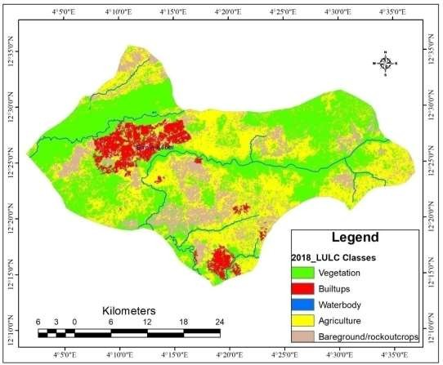

**Figure 4.4**: Land Use and Land Cover Classification Map of 2018 Satellite Imagery Source: Field survey, 2019

The Table 4.1 and 4.2 also revealed significant changes in the different land cover component. It shows that there was a rapid increase in the built up area when compared to 2009. The built up area increase from 5,580 ha in 2009 to 7,725 ha in 2018, indicating 38.4% increment. In addition, agricultural land increased from 42,122 ha to 43,921 ha.

“*According to the Director, Town Planning, The drastic increase in both built up area and agricultural land is a result of the federal government policy to encourage the production and consumption of local rice”. He further explained that “Kebbi is one of the major rice producing states in Nigeria, and the favourable condition in Birnin Kebbi, coupled with the incentive given to the farmers by the state government, more people have moved into the state to either start farming or work in the different rice processing companies in the state capital”.*

Subsequently, bare ground decreased from 22,035 ha to 18,132 ha.

# Table 4.2: Rate and percentage change of LULCs in Birnin-Kebbi

|  |  |  |  |  |  |  |
| --- | --- | --- | --- | --- | --- | --- |
| **LULC** | **1991 – 2000** | | **2000 – 2009** | **2009 – 2018** | | |
| **Category** | **Rate (Ha)** | **%** | **Rate (Ha)** | **%** | **Rate (Ha)** | **%** |
| Built ups | 2,502 | 148..3 | 1,391 | 33.2 | 2,145 | 38.4 |
| Vegetation | -1,524 | -20.9 | -2,755 | -4.8 | -43 | -0.09 |
| Water body | -22 | -43.1 | 10 | 34.5 | 2 | 5.1 |
| Agriculture | 30,864 | 332.9 | 1,988 | 4.9 | 1,799 | 4.3 |
| Bareground | -18,108 | -44.4 | -634 | -2.8 | -3,903 | -17.7 |

Source: Field survey, 2019.

Though, more vegetated land were converted to either farm land (agriculture) or built up area, the government effort to plant more trees has compensated for the loss of vegetative areas (see plate I). Therefore, vegetation recorded a “near-neutral” change when compared to 2009, i.e. only 43 ha of vegetation were lost between 2009 and 2018. Similarly, water body increased by 2 hectares over the same period.

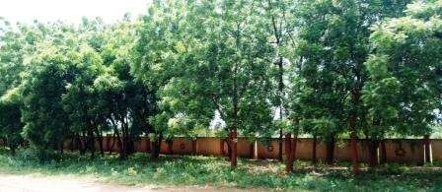

Plate I: The Reforestation Programme along Federal Polytechnic Birnin Kebbi Source: Field survey, 2019



80000

70000

60000

50000

40000

30000

20000

Vegetation

Built up areas Water bodies Agricultural land

Bare ground

10000

0

1991

2000

2009

2018

2027

**Figure 4.5:** Trend analysis of LULC Classification of the Study Area Source: Field survey, 2019

# Projected land use and land cover of 2027

The results (Figure 4.5 and Table 4.3) show the projected LULC for 2027 and the expected changes in the different classes of the land cover. The state of 2027 LULC depends majorly on the state of 2018. With a uniform time period or duration of 9 years interval, i.e, from 2009-2018 and 2018-2027, the projection agrees with Alemayehu et al (2019), where he said “trend of LULC change in future time can be detected when predicted LULC at time t2 compared to the base year at time t with reference to the class area metrics”. Therefore, when compared to the base year of 2018, in 2027, built up area and agricultural land are predicted to increase by 2,034 hectares and 2,192 hectares respectively, while vegetation, bare ground and water body are predicted to decrease by 920 hectares, 3,300 hectares and 4 hectares respectively.

# Simulated land use and land cover change of 2027

The growth in the built up area and agriculture is expected to come largely from bare ground and vegetation. This is because of the continuous increase in population due to migration and natural process, and the high demand on fuel wood for cooking energy (see plate II). Therefore, the over dependent on fuel wood will lead to the destruction of vegetation. Similarly, the drive to make Nigeria self-sufficient in rice production will have a direct impact on vegetation, water body and bare ground in the future, as Kebbi state and Birnin Kebbi, in particular, is the major contributor to the total rice production in Nigeria.

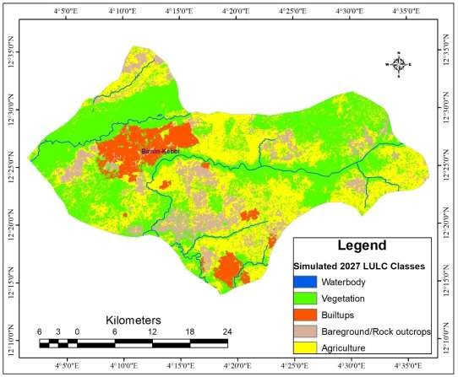

**Figure 4.6:** Simulated 2027 LULC classification Source: Field survey, 2019

# Table 4.3: Projected LULC for 2027 and the predicted change between 2018 and 2027

**Total**

**Bare**

**ground**

**Agriculture**

**Water body**

**Vegetation**

**Built ups**

**Classes**

**Years**

|  |  |  |  |  |  |  |  |
| --- | --- | --- | --- | --- | --- | --- | --- |
| **2027** | Area (Ha) | 9,759 | 54,070 | 37 | 46,113 | 14,832 | 124,811 |
|  | Area (%) | 7.8 | 43.3 | 0.03 | 36.9 | 11.9 | 100 |
| **2018–2027** | Area (Ha) | 2,034 | -920 | -4 | 2,192 | -3,300 |  |
| **change** | Area (%) | 26.6 | -1.7 | -9.8 | 4.9 | -18.2 |  |

Source: Field survey, 2019.

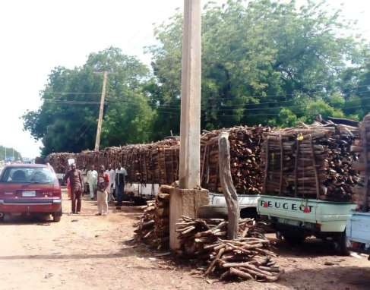

Plate II: Fuel wood depot at Nasarawa ward, Birnin-Kebbi Source: Field survey, 2019.

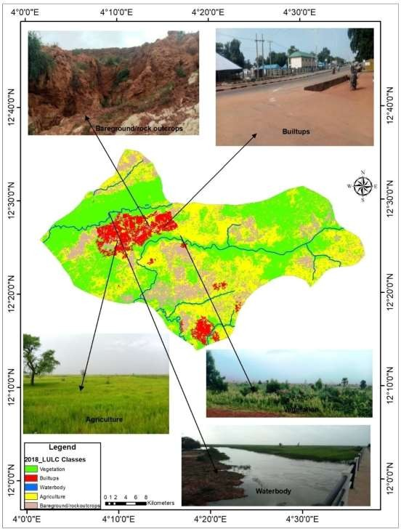

**Figure 4.6:** Classified image of 2018 with the picture of different classes.

Source: Field survey, 2019

# Level of Implementation and Mismatch of the 1980 Master Plan

The implementation of a proposed plan has direct and remote implications on urban growth and development in any society. The Birnin Kebbi Master Plan was designed with the anticipation that the population will increase over time. The population of Birnin Kebbi in 1980 was approximately 44,600 inhabitants (Birnin Kebbi Master Plan, 1983) and the conception was that by 2000, the population would reach between 107,600 and 133,300. Such population and its resultant economic changes are expected to simulate rapid urbanization and conflicting demand for various land use.

The proposed Master Plan in 1980 was aim at addressing these challenges and budgeted spaces for the various land use. The future land requirement of Birnin Kebbi was calculated in accordance with the planning methodology and design standard, with strong consideration to the projected population. As expected, residential land use was adjudged to require the largest single land use, as it was expected to accommodate a population increase of approximately 87,000 at a density of 60 persons per hectare (BKMP, 1983). The results (Table 4.4 and Figure 4.7) show that a total of 1450 hectares were allocated for residential purpose, which is about 38.6% of the total planned area. Business (light industry) was allotted 104 hectares, while Town centre and central market has 74 hectares. About 75 hectares was budgeted for government public community project institutions and Town parks were allotted 289 and 60 hectares respectively. Similarly, urban agriculture, water bodies and Green area were assigned 298, 16 and 1391 hectares respectively.

In appraising the level of implementation of the 1980 Land Use Plan (Master Plan), the digitized Land Use Plan of 1980 (1980 LUP), the Land Use Plan of 2017 (2017 LUP) and the google-earth image of 2018 (2018 GEI), in addition to physical observation done during

the field work was used. A set of indices or condition were made to appraise the implementation as modified from Tian and Shen (2007). These indices are-

* If the use of a portion of land in the 1980 LUP, 2017 LUP and 2018 GEI is consistent, it is adjudge to be in conformity with the plan.
* If the piece of land in 1980 LUP is different from the 2017 LUP and 2018 GEI, then it is said to have deviated from the plan.

# Table 4.4: Land use budget for the 1980 Master Plan

|  |  |  |
| --- | --- | --- |
| **Land Use Type** | **Area (Ha)** | **Percentage (%)** |
| Residential | 1450 | 38.6 |
| Business – light industry | 104 | 2.8 |
| Town centre and central market | 74 | 1.9 |
| Government public community project | 75 | 2.0 |
| Institutions | 289 | 7.8 |
| Town park | 60 | 1.6 |
| Urban agriculture | 298 | 7.9 |
| Water bodies | 16 | 0.4 |
| Green area | 1391 | 37.0 |
| **TOTAL** | **3757** | **100** |
| Source: Field survey, 2019. |  |  |

The 2017 proposed Land Use Plan result as shown in Table 4.5 and Figure 4.8 is a more detailed plan that considered many other components of the society. Unlike the 1980 plan that only planned for 3757 hectares of land for a projected population of 133,300 people, the 2017 Land Use Plan budgeted 56162 hectares of land and tried to incorporate more classes in the plan.

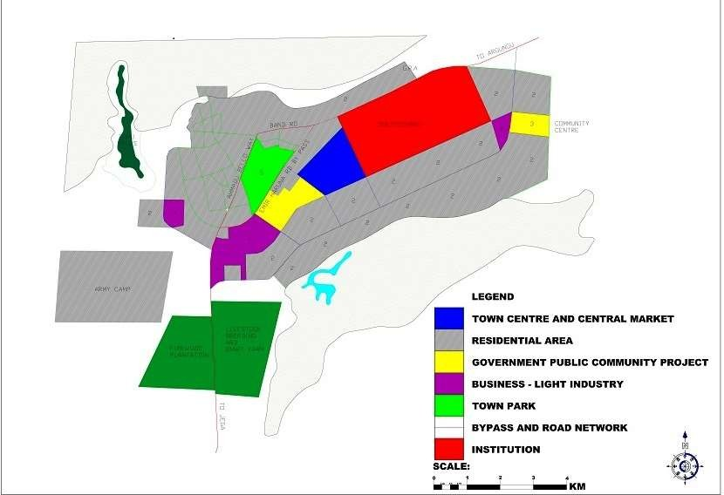

**Figure 4.7**: Birnin Kebbi Master Plan from 1980 - 2000 Source: Kebbi State Ministry of Land and Housing, 2019

74

A total of 7789 hectares was allocated for residential area while the plan also took into consideration the existing rural settlements and allotted 2659 for it. Similarly, industrial and employment area, public and semi-public space where allotted 0.3% and 3.4% of the total land area. In addition, water bodies, green open space and hills covers 1834, 21,547 and 237 hectares respectively, while, cemetery and Area reserved for future development was 0.09% and 31.8%.

# Table 4.5: Land use budget for the proposed land use map 2017

|  |  |  |
| --- | --- | --- |
| **Land Use Type** | **Area (Ha)** | **Percentage (%)** |
| Residential | 7798 | 13.9 |
| Settlements | 2659 | 4.7 |
| Industrial and employment area | 189 | 0.3 |
| Public and semi-public | 1911 | 3.4 |
| Institutions (Education) | 1931 | 3.4 |
| Recreational | 52 | 0.09 |
| Farm lands | 111 | 0.2 |
| Water bodies | 1834 | 3.3 |
| Green open space | 21547 | 38.4 |
| Hills | 237 | 0.4 |
| Cemetery | 8 | 0.01 |
| Area reserved for future development | 17885 | 31.8 |
| **TOTAL** | **56162** | **100** |
| Source: Field survey, 2019. |  |  |

# Implementation and mismatch of the 1980 Land Use Plan

The 1980 Master Plan of Birnin Kebbi was design when it was still under Sokoto state and just a local government headquarters. Novel as the idea may be, it did not envisage that the local government would become a state capital; a status the plan never took into consideration. Urban and infrastructural development proceeded as intended in the Master

Plan, residential buildings developed along the Birnin Kebbi – Argungu road as anticipated before 1991.

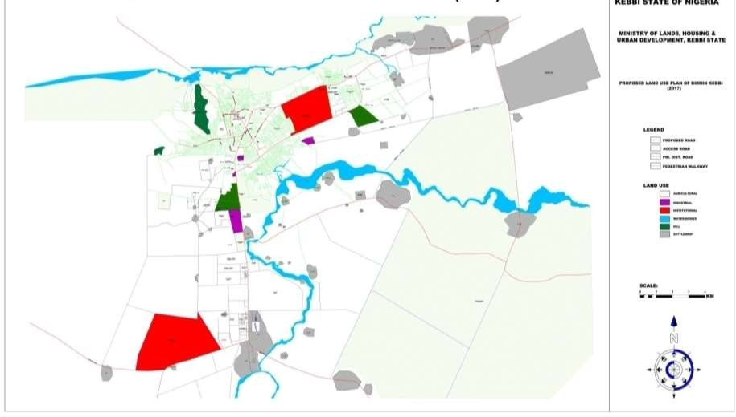

**Figure 4.8:** Proposed 2017 Land Use Plan of Birnin Kebbi. Source: Kebbi State Ministry of Land and Housing, 2019

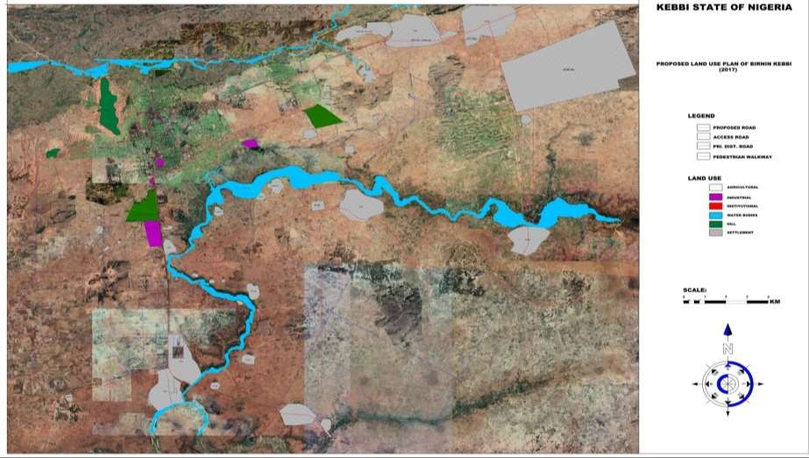**Figure 4.9:** Proposed Land Use Plan of Birnin Kebbi superimposed on satellite image of 2018.

Source: Field survey, 2019

# Table 4.6: Mismatch between the 1980 plan and the existing situation

|  |  |  |  |
| --- | --- | --- | --- |
| **Land uses** | **1980 (Ha)** | **2018 (Ha)** | **Deficit (Ha)** |
| Residential | **1450** | **7798** | 6348 |
| Industrial/ employment area | 104 | 189 | 85 |
| Institutions | **281** | **1931** | 1650 |
| Public and semi public | 75 | 1911 | 1836 |
| Water bodies | 16 | 1834 | 1802 |
| Urban Agriculture | 298 | 111 | -187 |
| Green area | 1391 | 21547 | 20156 |
| Town park and recreational land | 60 | 52 | -8 |
| Source: Field survey, 2019. |  |  |  |

By 1991, when the local government became the capital of the newly created state, the population had increased from 44,600 in 1980 to 150,520. So the Master Plan that was design with the population projection of 133,300 by 2000 became grossly ineffective. However, the new state capital developed in line with the 1980 plan, the increase in population led to the conversion of previously budgeted land for other purpose into urban areas. For example, 60 hectares budgeted for Town Park was converted into residential building while firewood plantation and livestock breeding and dairy farm, with a combine land mass of over 1600 hectares have been converted to institutional and residential areas.

The results (Figure 4.9 and Table 4.6) show that residential area has increased by 6348 hectares, industrial/employment area increased by 85 hectares while institution increased by 1650 hectares. Similarly, portion of the land reserved for urban agriculture decreased by 187 hectares while the new sites for Town Park and recreation are about 52 hectares. According to the Director, Town Planning Birnin Kebbi, the urban growth in Birnin Kebbi has largely being manage sustainably, as the government has put some mechanism to check

the activities of the native, and preventing them from just selling piece of land without proper layout and documentation. He further explained that even though land is vested in the hands of the Governor to hold in trust, the natives owned the right to use and they need to properly engage the Ministry for the design of layout and other necessary processes before they can sale any plot of land.

# The Level of Compliance of the Birnin-Kebbi City Master Plan with International Best Practices for Sustainable Cities

Urban sustainable assessment has emerged as one of the most significant areas of interest in urban development and management. As such, assessment needs to cover significant issues related to human life and the environment (Muggah, 2017). In the assessment of the level of compliance of Birnin Kebbi city with international best practices for sustainable development, a structured questionnaire was design and administered in some selected neighbourhoods in four (4) wards of the Birnin Kebbi. The neighbourhoods were selected based on pre-set conditions of either being planned or unplanned. Neighbourhoods with good accessibility/road network, planned layout, modern building materials and good structural condition are classify as planned, while those with poor conditions are unplanned. Table 4.7 shows the various neighbourhood and there condition.

The questions were centred on the environmental sustainability of the study area, and focused on the key indicators for environmental sustainability by international standard (UN-Habitat). The indicators adopted for this study majorly focused on the physical growth (urban growth), water supply, waste management and clean energy, transportation system and disaster prevention. This is in tandem with the evidence-based research on

sustainability assessment conducted in Lokoja, Nigeria by John in 2017. These works will contribute in understanding the sustainability level of some of our cities in Nigeria.

# Table 4.7: Distribution of the questionaire

|  |  |  |  |  |  |  |
| --- | --- | --- | --- | --- | --- | --- |
| **Physical condition** | **Wards** | **Neighbourhood** | **Number of questionniare distributed** | **Number returned** | **Total returned** | **% returned** |
| **Planned area** | Nasarawa I | G.R.A | 32 | 30 |  |  |
|  |  | Gesse phase I | 32 | 28 |  |  |
|  |  | Gesse Phase II | 32 | 31 | 89 | 92.7 |
| **Planned area** | Gadongaji | Busawa | 32 | 27 |  |  |
|  |  | Gwadan-Gaji | 32 | 30 |  |  |
|  |  | Kawara | 32 | 26 | 83 | 86.5 |
| **Unplanned** | Nasarawa II | Rafin Atiku | 32 | 24 |  |  |
| **area** |  | Ungwan-Dambo | 32 | 28 |  |  |
|  |  | Makera Gandu | 32 | 26 | 78 | 81.3 |
| **Unplanned** | Makera | Ungwan-Sani | 32 | 27 |  |  |
| **area** | | Ungwan-Dogo | 32 | 29 |  |  |
|  | | Makera Arewa | 32 | 26 | 82 | 85.4 |
| **Total** | |  | **384** | **332** |  | **86.5** |
| Source: Field survey, 2019. | |  |  |  |  |  |

* + 1. **Residents’ perception on land use and land cover change (LULC)**

In understanding the trend of change in land use and land cover, it is essential to know the history of the place from the actors responsible for the change. The result (Figure 4.10) shows how the residents of Birnin Kebbi perceived the land use and land cover ten years ago (2008). About 2.7% of the respondent believes that the study area was dominate by settlements, while 40% thinks it was dominate by farmland (agricultural practices).

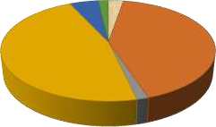

1.80%

5.10%

2.70%

**Land use types**

Settlements

42.20%

46.70%

Farm land Commercial LU Vegetation Water bodies

Bare land

1.50%

**Figure 4.10** Land use type in 2008 Source: Field survey, 2019.

Over 1% of the respondents were of the opinion that commercial land use dominates the place, while majority of the respondent (46.7%) concluded that vegetation is the most common land cover that dominated the study area ten (10) years ago. This is in agreement with the findings from Figure 4.3 and Table 4.1, which clearly reveal that vegetation occupied about 55,035 Ha of the total land cover in 2008.

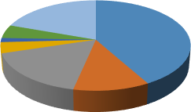

**Land use and land cover types**

4.80%

1.50%

19.60%

41.90%

3.90%

16.90%

11.50%

Settlements Farm land Commercial LU Vegetation Water bodies Bare land

Road construction/routes

**Figure 4.11:** Current LULC of Birnin Kebbi Source: Field survey, 2019.

The study also tries to engage the respondents’ and assess their sense of judgement of how land use and land cover has transformed over the years and what is it current state presently. The result (Figure 4.11) shows that over 11% believes that farming (agricultural practices) is the most dominant land cover, while 16.9% were of the opinion that commercial land use is more dominant land cover. About 3.9% still thinks vegetation is the dominant land cover now but 19.6% were of the view that road construction/access route are now the most dominant land cover. Similarly, 41.9%, which constitute the majority of the respondent believes that settlements are now the most common land use.

This view contradicts the reality on ground as indicated by the findings in Table 4.1 and Figure 4.4, i.e. the 2018 classified image, which shows that vegetation, still covers over 44% of the total land cover in the study area. The opinion of the respondents must have being form because of the rate of infrastructural development and urban expansion within their immediate neighbourhood. This finding proves the advantage of satellite remote sensing technology over the human eyes.

Road network Open/bare land Water bodies Forest/vegetation Commercial

Farmland

% of Increase

% of Neutral

% of Decrease

Settlement

0

20

40

60

80

100 120

**Percentage %**

**LULC types**

**Figure 4.12:** Status of LULC in Birnin Kebbi Source: Field survey, 2019

Analysis of the status of each LULC as at 2008 is presented in Figure 4.12. Analysis of three-point likert scaling revealed that most of the land use and cover across the study areas increased relatively. Settlement, road network, commercial and industrial land activities maintained a relative increase of over 60%. On the other hand, forest/vegetation, water bodies and bare land were perceived to be decreasing proportional to the increase in settlements and farmland.

During the field survey, oral interview was conducted to know the cost of land over the past few years. The feedback revealed that land, been a finite resource, has become very expensive due to the increase in population and demand for agricultural purpose. This has increased the demand for prime lands and putting enormous pressure on the value of a plot of land in Birnin Kebbi now, as a plot of land (15m*30m) goes for between ₦800,000 -

₦1,000,000. About 10 years ago, such plots were sold for between ₦50,000 - ₦150,000 and where readily available.

# Population and urban sustainability

Today, over four billion people around the world live in cities. This is more than 50% of the global population (World Bank, 2018). With the tremendous speed and scale of urbanisation, challenges are bound to be experienced. The consequences of increasing population and urbanisation in Birnin Kebbi is analysed in Table 4.8.

# Table 4.8: Consequence of increased population growth on LULC in the area

|  |  |  |  |  |  |  |  |  |
| --- | --- | --- | --- | --- | --- | --- | --- | --- |
| Consequence  Overcrowding is common | N  332 | Sum  1470.00 | Mean  4.43 | Std.  Deviation  1.04472 | Chi-sq  23.33 | p-value  0.000 | Rk  7 | Remark  Strongly |
|  |  |  |  |  |  | | | disagree |
| Poor planning | 332 | 1474.00 | 4.44 | 1.00421 | 4 | | | Disagree |
| Infrastructure such as electricity, |  |  |  |  |  | | | Strongly |
| health services, good roads etc. are | 332 | 1489.00 | 4.48 | 1.05573 | 5 | | | disagree |
| not properly managed |  |  |  |  |  | | |  |

There has been high rate of people moving into my area

332 1475.00 4.44 1.01337 2 Strongly agree

Source: Field Survey, 2019

ee

Strongly agree

|  |  |  |  |  |  |  |
| --- | --- | --- | --- | --- | --- | --- |
| Refuse are not properly dispose | 332 | 1422.00 | 4.28 | 1.12562 | 8 | Disagree |
| Standard of living is high | 332 | 1547.00 | 4.66 | .77057 | 6 | Agree |
| Destruction of trees | 332 | 1492.00 | 4.49 | 2.24550 | 3 | Strongly agr |
| Pressure on Pipe-borne water supply | 332 | 1489.00 | 4.48 | 1.00891 | 9 | Disagree |

|  |  |  |  |  |  |
| --- | --- | --- | --- | --- | --- |
| Unemployment is on the increase | 332 | 1445.00 | 4.35 | 1.17343 | 1 |
| Valid N (listwise) | 332 |  |  |  |  |

The result (Table 4.8) shows the consequence of increased population growth on LULC. The result of five-point likert scale revealed that increasing level of unemployment is strongly agreed to be the number one consequence of increase in population growth on LULC in the areas. The influx of people into Birnin Kebbi has been a major concern in the development of the city and it was rank second. Destruction of forest trees for fuel wood, agricultural purposes or construction of building is third consequence of the increase in population growth on LULC. The unplanned nature of some settlements within the state capital is rank fourth and pressure on some basic infrastructure such as electricity, health services, and good road were rank fifth.

High standard of living in the study area is the sixth consequence of increased population growth, while overcrowding is rank seventh consequence of increased population on LULC in Birnin Kebbi. Majority of the respondents’ believes that waste collection and disposal and water supply is the least of their problems, so they were ranked eighth and ninth respectively. The result of chi-square showed that the opinion of respondent on the consequence of increased population on LULC is statistically related, as p-value (0.000) of f-statistic (23.33) is less than 0.05 level of significant.

# LULC compliance with international standard for sustainability

Urban sustainability is the building of cities that can continue to function without running out of resources, thereby reducing their negative impact on the world (Keeler *et al.,* 2019). Cities are growing bigger and bigger every year, demanding more and more land, and requiring more and more buildings, infrastructure and services. The availability and conditions of these infrastructure and services would determine the level at which environmental resources are utilised. The analysis of the condition of infrastructure and services by the respondents in Birnin Kebbi are shown in Table 4.9.

# Table 4.9: Condition of Infrastructure and Services

|  |  |  |  |  |  |  |
| --- | --- | --- | --- | --- | --- | --- |
| Infrastructure & Services | N | Sum | Mean | Std.  Deviation | Sustainability Index | Remark |
| Health facilities | 332 | 1290.00 | 3.88 | 1.39664 | 0.776 | S |
| School(s) facilities | 332 | 1368.00 | 4.12 | 1.33869 | 0.824 | HS |
| Security service/Police Station | 332 | 1455.00 | 4.38 | .84870 | 0.876 | HS |
| Accessibility to market | 332 | 1370.00 | 4.13 | 1.14861 | 0.826 | HS |
| Access to potable water | 332 | 1553.00 | 4.68 | .50530 | 0.936 | HS |
| Access to electricity supply | 332 | 1500.00 | 4.51 | .84955 | 0.902 | HS |
| Refuse disposal/ collection facilities | 332 | 1487.00 | 4.48 | .91785 | 0.896 | HS |
| Drainage facilities | 332 | 1292.00 | 3.89 | 1.43552 | 0.778 | S |
| Road network | 332 | 1317.00 | 3.96 | 1.31300 | 0.792 | S |
| Availability of street light | 332 | 1379.00 | 4.15 | 1.26200 | 0.830 | HS |
| Area is safe or secure generally | 332 | 1450.00 | 4.36 | 1.07873 | 0.876 | HS |
| Access to fire station | 332 | 1502.00 | 4.52 | .82412 | 0.904 | HS |
| Access to open space/recreational | 332 | 1367.00 | 4.12 | 1.20224 | 0.824 | HS |
| Valid N (listwise) | 332 |  |  |  |  |  |

Source: Field Survey, 2019

The result of condition of infrastructure presented in table 4.7 showed the result of five point likert scale (VG = very good, G = good, F = fair, B = bad, VB = very bad). The sustainability index key was coded as 0-0.3 highly unsustainable (HUS), 0.31-0.5 Unsustainable (US), 0.51-0.8 Sustainable (S) and 0.81-1 highly sustainable (HS). The result revealed all the infrastructure and services are above the average sustainability index, which means that all the infrastructure, were above the ideal condition. The details based on wards/clusters are analysed further.

# Water supply

Availability of potable water supply has highest condition index at 93.6% (0.936) and classified as being highly sustainable. This is because regardless of the dam and the water treatment plant that distributes clean drinking water to most residents in Birnin Kebbi, the Kebbi State Water Board provide neighbourhood reticulation and water supply system that uses ground water to supply the specific neighbourhood. Birnin Kebbi is blessed with a high ground water table without basement rock, so drilling of boreholes is as cheap as

₦50,000.00 in the study area, individuals and government can afford to drill them and supply to their citizens. It is also less expensive, according to a Director in the Kebbi State Water Board Authority, when compared to the cost of laying pipes from the existing treatment plant to the different neighbourhood developing at an alarming rate, she also attest to the quality of the ground water to be good enough for human consumption (see plate III).

However, no evidence was presented to support the claim that the quality of the ground water is good enough for continuous human consumption, the lack of waste water treatment plant in the study area to purify the wastewater before infiltration process is a reason for concern, as many residents depend on the ground water for domestic use. The result in Figure 4.13 shows the proportion of respondents connected to public water supply system. Over 60% of the respondents in Nasarawa I are connected to public water supply while 39.3% have private boreholes. Similarly, 44.6% of the residents are connected while 55.4% depend on private boreholes in Gwadangwaji ward.

**Figure 4.13:** Proportion of respondents connected to public water supply

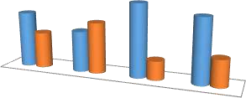

Connected (%)

60.7

39.3

44.6

Not connected (%)

79.5

55.4 70

20.5

29.3

Nasarawa I Gadongaji

Nasarawa II

Makera

**Wards**

**Percentage %**

Source: Field survey, 2019.

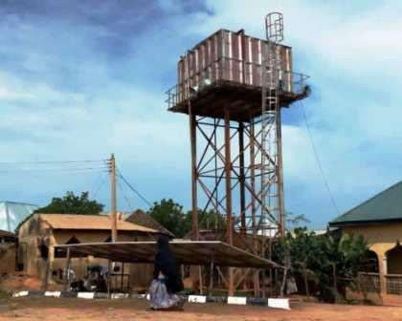

Plate III: Solar-powered water system Source: Field survey, 2019.

In Nasarawa II, the trend is the same, as 79.5% are connected while 20.5% are not connected to the public water supply system. Makera ward has 70% of its residents connected to the public water supply system while 29.3% are not connected. The result revealed that the unplanned settlements still have access to public water supply and are more willing to connect to them than the planned areas. Probably this is because of the low

cost in drilling a borehole in the study area, so most of the affluent respondents choose to own their water system.

# Access to clean energy

Compared to the erratic power supply usually experience in other part of the country, the government of Kebbi state has been able to negotiate with the Kaduna Electricity Distribution Company and are having about 18 hour of uninterrupted power supply daily, as electricity supply scored 0.902 (90.2%) in it sustainability index ranking and classified as highly sustainable. The challenge when it comes to energy is the type of cooking energy majorly used in Birnin Kebbi. According to one of the respondent, virtually every household in Birnin Kebbi uses firewood for cooking. That even the highly placed in the society still construct a “local kitchen” in their homes despite having cooking gas. This is a serious problem because it encourages the destruction of vegetation, as the market is readily available and ever increasing. Plate II depict the situation in the state area, as there is a whole market dedicated for the selling of pick-up load of firewood.

# Table 4.10: Primary cooking energy used Wards

**Remark**

**Index**

**Mean**

**w.sum**

**Total**

**Electric**

**LPG**

**Kerosene**

**Wood**

**Charcoal**

|  |  |  |  |  |  |  |  |  |  |  |
| --- | --- | --- | --- | --- | --- | --- | --- | --- | --- | --- |
| Nasarawa I | 5 | 24 | 13 | 47 | 0 | 89 | 280 | 3.15 | 0.63 | S |
| Gadongaji | 8 | 38 | 14 | 23 | 0 | 83 | 218 | 2.63 | 0.53 | S |
| Nasarawa II | 13 | 45 | 6 | 14 | 0 | 78 | 177 | 2.27 | 0.45 | US |
| Makera | 9 | 52 | 4 | 17 | 0 | 82 | 193 | 2.35 | 0.47 | US |
| Total | 35 | 159 | 37 | 101 | 0 | 332 | 865 | 2.61 | 0.52 | S |

Source: Field survey, (2019)

The result (Table 4.10) shows the different sources of cooking energy and their sustainability analysis. In assessing the sustainability index of clean cooking energy in Birnin Kebbi, ranking of the various cooking energy sources was necessary to enable the weighting of the different sources. Charcoal is the worst type of cooking energy in relation to the environment, therefore it is weighted 1, wood is ranked 2 and kerosene is rated 3. Liquefied petroleum gas is rated 4, though a relatively clean source of cooking energy, it produces carbon dioxide as a by-product when burning. Electricity as a source of cooking energy is rated 5, as it is valued as the most clean source of cooking energy, especially when it is generated through a renewable source such as hydro, wind or solar. The weighted sum (w.sum) was determined by multiplying each sources of cooking energy by it rating.

The result (Table 4.8) shows that Nasarawa I and Gadongoji wards has a sustainable index of (0.63) and (0.53) respectively, and therefore are classified as being sustainable, while Nasarawa II and Makera has (0.45) and (0.47) index and are classified as environmentally unsustainable in their sources of cooking energy. In general, Birnin Kebbi is sustainable as it scores an average of (0.52) in it sources of cooking energy. Figure 4.14 shows, graphically, the wards and their primary sources of cooking energy. The result shows that Makera ward uses more firewood in cooking than any other ward, while Nasarawa I uses more LPG. This shows where interventions on sustainable cooking energy need to be targeted for effective result.



Nasarawa I

80

60

40

Makera

20

0

Gadongaji

Charcoal Wood Kerosene LPG

electric

Nasarawa II

**Figure 4.14:** Primary cooking energy used Source: Field survey, 2019.

# Urban transportation system

According to Zhao *et al.* (2016), sustainable transport systems are crucial for underpinning the economic performance, prosperity of nations, tackling global climate change and reducing local air pollution. With the growth of urban economies, the living conditions and lifestyles of the city people are also changing. As income of the upper and middle class people in the city is increasing, the ownership of private vehicles is increasing rapidly. This has often led to the congestion of the urban area and the traditional solution to this problem is to increase the capacity of the road or construct new roads. Experience has shown that this solution is neither economically productive nor environmentally sustainable. So ensuring our cities have a sustainable transportation system is not just an option but a necessity, to meet the growing demand as well as to maintain the quality of living for the city residents.

The road network in Birnin Kebbi is highly commendable, this is because even the neighbourhood roads are all paved with asphalt and well drained (see Plate IV). The

challenges of urban transportation there is the lack of basic infrastructure to support other sustainable means of transportation such as walkways and Bus Rapid Transit system. The result (Table 4.11) shows that in general, the urban transportation system in Birnin Kebbi is environmentally unsustainable. Nasarawa I and Gadongaji has 0.23 and 0.27 sustainability index respectively and therefore classified as highly unsustainable, while Nasarawa II and Makera scored 0.37 each and are classified as unsustainable.

# Table 4.11: Primary Means of Transportation

**Remark**

**index**

**Mean**

**w.sum**

**Total**

**Bicycles**

**Mass**

**transit**

**Tricycle**

**Motorbike**

**Private**

**cars**

**Wards**

|  |  |  |  |  |  |  |  |  |  |  |
| --- | --- | --- | --- | --- | --- | --- | --- | --- | --- | --- |
| Nasarawa I | 79 | 7 | 3 | 0 | 0 | 89 | 102 | 1.14 | 0.23 | HUS |
| Gadongaji | 60 | 15 | 8 | 0 | 0 | 83 | 114 | 1.37 | 0.27 | HUS |
| Nasarawa II | 30 | 37 | 6 | 0 | 5 | 78 | 147 | 1.88 | 0.37 | US |
| Makera | 45 | 19 | 11 | 0 | 7 | 82 | 151 | 1.84 | 0.37 | US |

Source: Field survey, 2019.

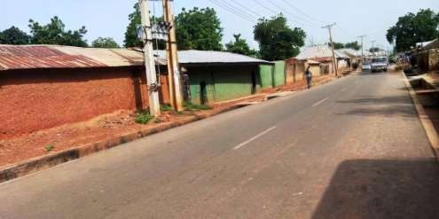

Plate IV: Neighbourhood road at Tudun Wada community, Birnin Kebbi Source: Field survey, 2019.

Even though the road network in Birnin Kebbi is good, their major means of transportation is not the most ideal for a sustainable environment. There is no mass transit bus system in Birnin Kebbi so majority of the residents (65.9%) uses private cars for their daily mobility (Figure 4.15). Cars are major contributors of greenhouse gases to the atmosphere and with the rate of urbanisation and growing population in the study area; this can lead to increase temperature in the study area, thereby leading to urban heat island. Similarly, motorbikes are another commonly used means of transportation, as over 23% have or engage their services for their daily movement. Only 8.1% of the respondent uses tricycle while, 2.4% uses bicycle for their daily mobility.

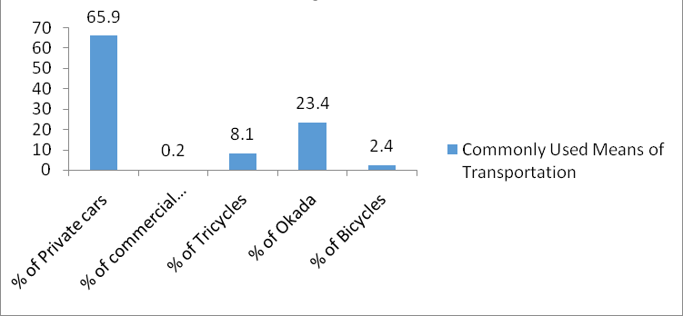

**Figure 4.15:** Most common means of transportation

Source: Field survey, 2019.

In order to encourage sustainable means of transportation, the roads should be design to accommodate walkways and Bus Rapid Transit system. This is a bus-based transport system designed to improve capacity and reliability of movement within the town. It is more effective and sustainable system. In addition, the incorporation of super-walkways and cycling lanes are necessary to promote sustainable environment as it was noticed to be lacking in the study area.

Similarly, the proximity to market place is another challenge being face by some of the respondent in the study area. However, this is subjective, as some areas are close to the market and do not have to move long distance to access it. This is a challenge for places like Gwadangwaji, Rafin-Atiku Busawa etc., as the study area has one central market.

# Environmental pollution and management

Pollution takes into account how cities dispose of the huge amounts of garbage and waste products that they produce, the smog that factories and businesses release into the air, and the chemicals that find their way into bodies of water (Keeler et al, 2019). Pollution is a major problem in every city, and generally the bigger the city the worse it is. It's in the economic interest of a city that it continues to be popular and grows, but as a city grows the issues of pollution grow with it and the need for effective and efficient waste collection system becomes imperative.

# Table 4.12: Frequency of solid waste collection

|  |  |  |  |  |
| --- | --- | --- | --- | --- |
| **Wards** | **Daily (%)** | **Fortnight (%)** | **Weekly (%)** | **Monthly (%)** |
| Nasarawa I | 0 | 70.8 | 29.2 | 0 |
| Gadongaji | 0 | 68.7 | 31.3 | 0 |
| Nasarawa II | 0 | 44.9 | 55.1 | 0 |
| Makera | 0 | 63.4 | 36.6 | 0 |

Source: Field survey, 2019.

The result (Table 4.12) shows the frequency of solid waste collection in Birnin Kebbi. The waste are collected either on a weekly or fortnightly bases, depending on the locations schedule. Over 70% of the respondents in Nasarawa I affirmed that waste is collected from the designated collection point every fortnight while 29.2% confirm that it is collected weekly. In Gwadangwaji, 68.7% are collected fortnightly while 31.3% are collected

weekly. Similarly, in Nasarawa II and Makera, 44.9% and 63.4% of the respondents believes solid waste is collected fortnightly in their wards while 55.1% and 36.6% respectively; agree that it is done on weekly bases. In general, solid waste is collected from some designated points in Birnin Kebbi. However, these points are not accessible to some residents, so some of them still dispose their waste indiscriminately.

Methods of household waste disposal: According to Larson (2012), waste management involves the activities and actions required to manage waste from its inception to its final disposal. Waste disposal methods can be classified into numerous categories, which include source reduction and reuse, animal feeding, recycling composting, fermentation, landfills, incineration and land application. In assessing the sustainability index of waste disposal methods in Birnin Kebbi, five (5) common disposal methods were adopted and ranked according to their effect on the environment from 1 – 5 i.e. uncontrolled incineration was ranked the lowest (1) while recycling was ranked highest (5).

The result (Table 4.13) shows that Nasarawa I scored 0.79 in the environmental sustainability index of waste disposal methods, thereby classified sustainable. Gadongaji and Makera scored 0.68 and 0.53 respectively, and are sustainable but Nasarawa II is unsustainable, as it scored 0.45 in the sustainability assessment index. In general, Birnin Kebbi in general is environmentally sustainable in terms of waste management. The residents’ of Nasarawa II attributes the unsustainable waste collection and disposal method in their area as due to the accessible nature of the area by waste collection trucks.

# Table 4.13: Methods of waste disposal

**Remark**

**index**

**Mean**

**w.sum**

**Total**

**Recycle**

**Designated**

**points**

**Land fill**

**Open dump**

**Incineration**

**(burning)**

**Wards**

|  |  |  |  |  |  |  |  |  |  |  |
| --- | --- | --- | --- | --- | --- | --- | --- | --- | --- | --- |
| Nasarawa I | 2 | 0 | 0 | 87 | 0 | 89 | 350 | 3.93 | 0.79 | S |
| Gadongaji | 5 | 6 | 23 | 49 | 0 | 83 | 282 | 3.39 | 0.68 | S |
| Nasarawa II | 20 | 29 | 16 | 13 | 0 | 78 | 178 | 2.28 | 0.45 | US |
| Makera | 15 | 11 | 44 | 12 | 0 | 82 | 217 | 2.65 | 0.53 | S |

Source: Authors’ field work (2019)

Household wastewater treatment: Wastewater treatment is a process used to remove contaminants from wastewater or sewage and convert into an effluent that can be returned to the water cycle with minimum impact on the environment, or directly reused (Pell and Worman, 2008). The treatment of wastewater is becoming imperative due to the effect of climate change on available sources of fresh water. The need for wastewater treatment plant in Birnin Kebbi cannot be over stressed because of the high dependant on ground water for domestic use. The water table level is constantly high and can be easily contaminated through indiscriminate discharge of wastewater to the environment.

The result (Figure 4.16) shows that there is virtually no household that conducts any form of treatment to their wastewater. In best cases, septic tanks are built to collect the wastewater on a household bases, while some households allow the wastewater to run on the surface and polluting the environment. All these methods directly or indirectly end up infiltrating into the ground water and may contaminate it.

**Percentage %**

**Figure 4.16:** Wastewater treatment Source: Field survey, 2019.

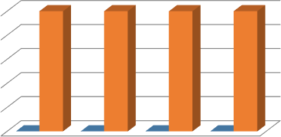

100

80

60

40

20

0

Nasarawa I

Gadongaji Nasarawa II

Makera

**Wards**

Yes No

# Disaster mitigation and resilience

Mitigation is the measures to eliminate or reduce the impact or risk of hazards through proactive measures taken before an emergency or disaster occurs (Public safety Canada, 2015). In ensuring that individuals, communities and states can adapt to and recover from hazard, if and when it occur, without compromising long-term prospects for development, disaster mitigation measure are necessary to be observed. There are many forms of environmental hazards that a community may be at risk from, depending on their geographic location and environmental conditions. Environmental hazards could range from earthquakes, tornadoes, volcanoes, blizzards, landslides, flood and droughts.

# Table 4.14: Level of compliance with building codes regulations

**R**

**In**

**M**

**W**

**T**

**H**

**F**

**L**

**N**

|  |  |  |  |  |  |  |  |  |  |
| --- | --- | --- | --- | --- | --- | --- | --- | --- | --- |
| **Wards** | **o** | **ow** | **air** | **igh** | **otal** | **.Sum** | **ean** | **dex** | **ank** |
| Nasarawa I | 6 | 21 | 19 | 43 | 89 | 277 | 3.11 | 0.78 | Fair |
| Gwadangwaji | 7 | 14 | 25 | 37 | 83 | 258 | 3.11 | 0.78 | Fair |
| Nasarawa II | 27 | 23 | 17 | 11 | 78 | 168 | 2.15 | 0.54 | Low |
| Makera | 36 | 17 | 16 | 13 | 82 | 170 | 2.07 | 0.52 | Low |

Source: Field survey, 2019.

The major type of hazards associated with Birnin Kebbi is flooding and soil erosion (gully), and the most vulnerable element in the communities after human lives is buildings. As part of the mitigation strategy assessment, the level of compliance with building codes regulation was assessed. The result (Table 4.14) revealed that the level of compliance with building regulation in Nasarawa I and Gadongaji is fair while Nasarawa II and Makera recorded low performance in their compliance with building codes and regulations.

The proportion of development situated on hazard-prone environment (Figure 4.17) shows that, in Nasarawa I, 7.9% of the developments are situated on hazard prone area, while 92.1% are not in hazardous environment. The proportion of properties situated on hazard prone area in Gadongaji is slightly higher (16.9%), while 83.1% are not in hazardous area. Similarly, 33.3% were located on hazardous area in Nasarawa II, while 66.6% are not situated on hazard prone environment. About 18.3% of the properties in Makera are located on hazard prone area, while 81.7% are not located on hazardous area.

**Percentage %**

**Figure 4.17:** Proportion of development situated on hazard-prone environment

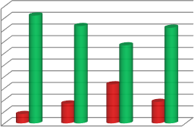

100

90

80

70

60

50

40

30

20

10

0

92.1

83.1

81.7

66.6

33.3

16.9

18.3

7.9

Hazardous (%)

Non-hazardous (%)

**Wards**

Source: Field survey, 2019.

# Residents’ perception on recommendation towards attaining sustainability

The possible recommendations toward attaining sustainability are presented in Table 4.15. The result of five-point scale (Strongly agree-SA, agree-A, indifferent-I disagree-D and strongly disagree-SD) showed that all the recommendations identified by the study were strongly agreed with by the respondents. In addition, the study identifies three the most important recommendations such as create economic zone to simulate local economy, improving transportation system and redevelopment of slum areas. The result of chi-square test revealed that the opinions of respondents on the identified recommendations were significantly related. Similarly, some of the respondents also advocate for the creation of mini markets in areas like Aleiro quarters, Gwadangwaji and Gesse phase I, II and III.

# Table 4.15: Possible Recommendations towards Attaining Sustainability

Recommendations N Sum Mean Rk Remark Chi-sq p-value

Planning of built up area (distinction of residential Settlement from industrial Centre)

settlements

|  |  |  |  |  |  |  |
| --- | --- | --- | --- | --- | --- | --- |
| 332 | 1268 | 3.82 | 7 | Agree | 20.22 | 0.000 |
| Demolition and redevelopment of slum  332 | 1298 | 3.91 | 6 | Strongly Agree |  |  |
| Provision of infrastructural services 332 | 1346 | 4.05 | 5 | Strongly Agree |  |  |
| Better Access to educational facilities 332 | 1390 | 4.19 | 3 | Strongly Agree |  |  |
| Use of energy efficient facilities 332 | 1343 | 4.05 | 5 | Strongly Agree |  |  |
| Create economic zone to simulate local economy 332 | 1469 | 4.42 | 1 | Strongly Agree |  |  |
| Creating green area and open space for  332 | 1354 | 4.08 | 4 | Strongly Agree |  |  |
| Improving transportation system 332 | 1414 | 4.26 | 2 | Strongly Agree |  |  |
| Others please mention below 332 | 1257 | 3.79 | 8 | Agree |  |  |
| Valid N (listwise) 332 |  |  |  |  |  |  |

recreational purpose

Source: Field Survey 2019

# Environmental sustainability of Birnin Kebbi

The environmental sustainability of Birnin Kebbi assessed the rates of renewable resource harvest, pollution creation and non-renewable resource depletion, and how these resources are affected by human interactions. In addition, the different elements at risk and the risk category in terms of global, national or local were also considered. Table 4.16 shows the element at risk from the consequences of the interaction and risk category.

The result (Table 4.16) shows the summary of the sustainability assessment of Birnin Kebbi and its influences on the environment. However, the ecological integrity of the

source of water was not examined; water supply in the study area is regular and meets the demand of the residents both in the planned and unplanned neighbourhoods.

The use of firewood as the major (primary) source of cooking energy, especially in the unplanned neighbourhoods is unsustainable. This source of energy encourage the destruction of vegetation and the release of carbon dioxide into the atmosphere, thereby increasing the earths’ heat trapping capacity and ultimately exacerbating climate change. More individual mobility, such as private cars and motorcycles are being used in the planned area than the unplanned areas. This also puts the environment at risk, as it leads to global warming.

# Table 4.16: Effect of human interaction with the environment in Birnin Kebbi

|  |  |  |  |  |
| --- | --- | --- | --- | --- |
| **Sustainability**  **criteria** | **Planned**  **neighbourhood** | **Unplanned**  **neighbourhood** | **Element at risk** | **Risk category** |
| **Water supply and** | Sustainable | Sustainable | None | None |
| **demand**  **Clean energy** | Sustainable | Unsustainable | Environment | Global |
| **Transportation system**  **Waste** | Highly unsustainable  Sustainable | Unsustainable  Unsustainable | Environment  Environment / | Global  Local |
| **management**  **Disaster prevention and** | Fair | Low | community Individual /  community | Local |
| **resilience** |  |  |  |  |

Source: Authors’ analysis (2019)

The method of waste collection and disposal in some part of the unplanned neighbourhoods is unsustainable, and the elements at risk are the residents of the communities and the environment. This can lead to the outbreak of diseases and blockage of drainage system leading to flash floods. This category of risk is local, as it will only affect the people of the

neighbourhood in particular. Disaster prevention and resilience measures in the planned area are fair compare to the unplanned area. The elements at risk are the individual households and the community at large.

# Upgrade a Neighbourhood and Develop an Improved Land Use Plan that is Sustainable for the Growing Population in Birnin-Kebbi

After the field observation and thorough assessment of the various neighbourhoods, Nasarawa II was selected for redevelopment plan. This is because of the poor state of the environmental condition and physical structures present in the neighbourhood, poorly planned road network/access ways; lack of any recreational areas, poorly designed buildings with substandard building materials and the neighbourhood is situated in some of the prime lands in Birnin Kebbi.

In a time of rapid climate change and environmental degradation, planning and building an ecologically sustainable environment have become imperative. In particular, urban settlements, as a densely populated built environment, are good for the environment.

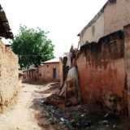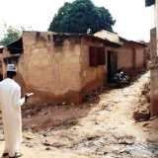

Plate V: Environmental condition at Ung-Dambo Plate VI: Housing condition at Rafin Atiku

Source: Field survey, 2019. Source: Field survey, 2019.

Neighbourhood redevelopment plan is aimed at responding to the issues facing a particular environment by visualising and communicating how it can change for the better. Most of the houses in this neighbourhood do not adhere to building code nor meets the average standard of building regulations and majority of them do not have any official document from the m

Ministry of Land, Housing and Urban Development.

The redevelopment plan (Figure 4.18) designed was influenced by the socioeconomic characteristics of the neighbourhood and the identified problem from the sustainability assessment conducted in the study area. The redevelopment plan proposed two (2) different, but alternative plans. Since a sustainable development plan is participatory in nature, the two alternative designs will provide options for the residents in the affected neighbourhood to choose which design best suit them.

The first alternative (Alternative A) is design to have 18-metre arterial road, 9-metre access road and pedestrian walkway (see plate vii). Subsequently, the residential area is divided into high-density residents with a plot size of 16*32 meters, medium density (26*32 meters), comprehensive development (high and medium density) and mixed-use housing (see plate IX). The High and medium density plots are areas for buildings like bungalows or duplex with single residential unit (see plate VIII). Comprehensive developments are more like block of flats or series of residential apartments built in a high-rise building, usually more than four floors but all individual units sharing common facilities like water,

light, playground etc. The high or medium comprehensive density will determine the number of flat per unit area or per residential block (see plate X).

Low-density residential area was not included in the “Alternative A” because looking at the Google earth image (see appendix II) and during the field data, it was observed that the area is highly populated and majorly occupied by low and medium income earners, therefore low-density design might consume more space for the high population. The mixed-use corridor is mainly for commercial and residential purposes. The proposed type of buildings here are design to be one or more floors, with the ground floor mainly for commercial purpose while the suspended floor(s) can be residential for the business owners downstairs or any other persons. This is the reason why these plots adjourn the arterial road that is 18 metres. Multi-functional plots are areas for wide range of uses such as light industries, hotels, office complexes, additional schools, estates, e.t.c. theses plots can also serve as areas for future development, as they can fit into different category of use, to prevent change in use or incompatible uses within the neighbourhood.

The “Alternative B” (Figure 4.19) was design to include low-density plots, additional space for schools and a mixed comprehensive development. This was influence by the idea that low-density plots will encourage the affluent people in the society to live in the neighbourhood, which is good for the local economy of the place. Similarly, the large population concentrated in this neighbourhood influence the decision to increase the number of schools.

In addition, a central sewer treatment plant was also included in this alternative. Over 60% of the residents of Birnin Kebbi depend (directly or indirectly) on ground water as their source of domestic water supply; and there is not a single wastewater treatment plant in the

study area to treat the wastewater that goes back into the ground apart from the natural soil filtration mechanism. This plan is designed to have a sewer treatment plant where all sewer and wastewater will be treated and reused for various purposes. The plant will also be used for power generation to power the streetlights and other public utilities.

Similarly, both plans also provides for neighbourhood clinic, police station, fire service station and worship centres (Mosque and church). Institutions are basic component of any strategic plan, so the plan proposed a crèche, nursery, primary and secondary school. Similarly, the plans were prepared with the concept of green development design, so no fuel station was proposed in the plan, instead, the built-up areas are to be fitted with solar roofing systems (see plate VIII). Tesla Company has been able to develop an affordable solar roofing system that would not cost much more than the roof that is on the average houses (Etherington, 2019). This roofing system is projected to be able to last up to 30 years and it is guaranteed to generate power for at least 25 years, at which point the electrical components may begin to need repairs. Provisions were also made for a neighbourhood market, park, public parking space, water board station and electric power station.

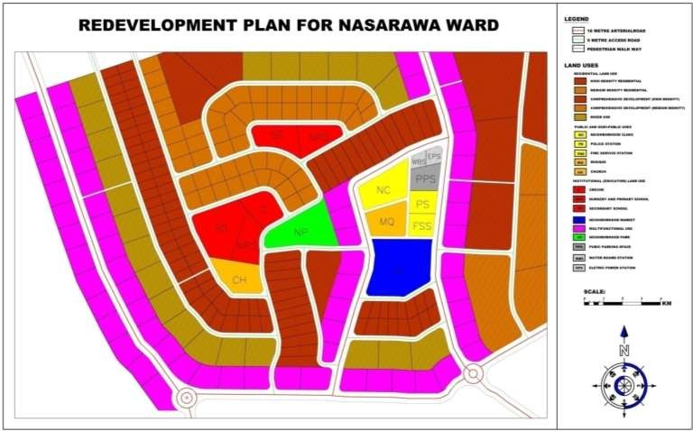

**Figure 4.18:** Redevelopment Plan for Nasarawa II ward (Alternative I)

Source: Field survey, 2019.

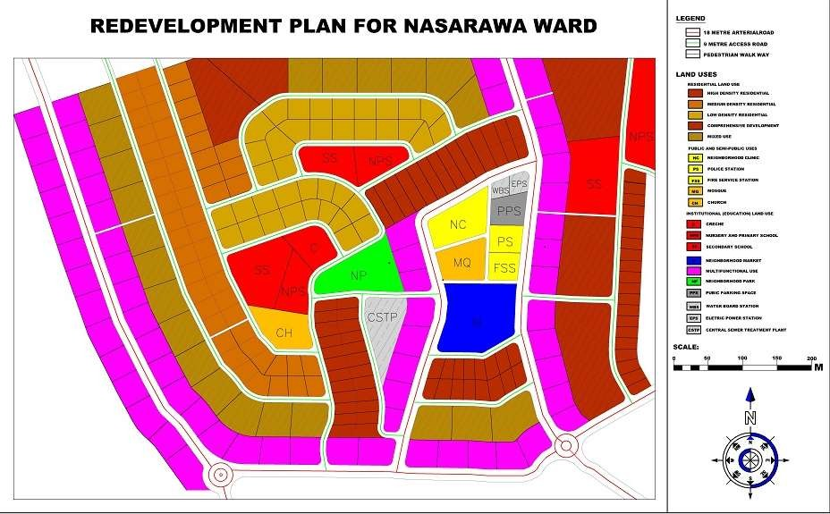

**Figure 4.19:** Redevelopment Plan for Nasarawa II ward (Alternative II)

Source: Field survey, 2019.

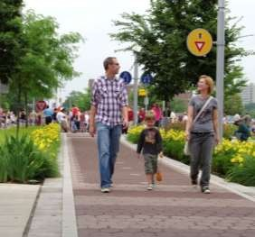 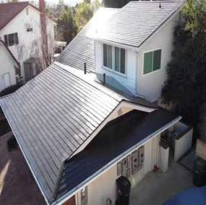

Plate VII: Pedestrian walkway (Zubairu, 2017). Plate VIII: Solar roofing system

(Etherington, 2019)

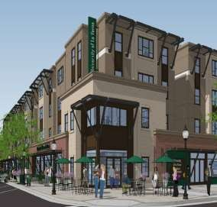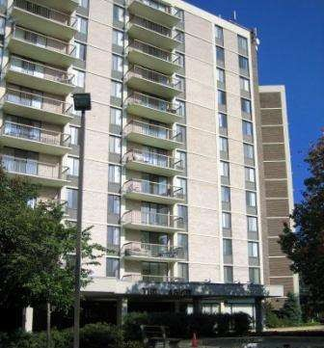

Plate IX: Mixed-use housing (Zubairu, 2017) Plate X: High-density building (Zubairu,

2017

# Implementation strategy for the redevelopment plan

The proposed redevelopment plan of Nasarawa I ward of Birnin Kebbi presented in Figure

4.16 and 4.17 is design with two (2) alternatives. Sustainable planning is a stakeholder- driven approach to planning that seeks to encourage communities to plan and design their neighbourhoods. The proposed redevelopment design was influenced by the

socioeconomics characteristics (poverty level), environmental conditions and the challenges identified by the respondents (stakeholders) during the fieldwork. This necessitated the need to produce two (2) alternative plans for flexibility. The implementation of this plan is proposed to last for three (3) years and will be in phases.

* + - 1. **Phase 1:** is schedule to last for three (3) months. This involves the setting up of the implementation team by the state government, identification and sensitizing the people (stakeholders) and development-partners (willing and viable investors). Similarly, the confirmation and authentication of ownership right will be conducted in this phase. This is to enable the team acquire attribute data of each plot of land and to recertify the landowners in the neighbourhood. Finally, the assessment and valuation of each individual property will end the activities of this phase. This will help the team to know the land value of each plot considering its present state, so that an equivalent value of plot can be given to the individuals after redevelopment. In addition, individuals plot owners will have the option of either being compensated (monetarily) in full for their properties or given a plot of land in the redeveloped neighbourhood. As redevelopment plan is accompanied by the provision of infrastructure, the value of the plots of land in the neighbourhood will generally increase. so the plots that will be return to individual may actually be smaller in size than their previously owned property but equal or greater in value.
      2. **Phase 2**: The second phase is schedule to last for 12 months and would start by reviewing phase one. This phase is proposed to commence mainly with emphases on the construction of new access roads, walkways and rehabilitation of arterial roads. This will enhance local economic development, promote healthy living and improve social network within the neighbourhood. Similarly, construction of new and rehabilitation of some exiting

public and semi-public uses such as schools, markets, police post etc will commence in this phase. In addition, the construction of comprehensive development (high-density) buildings will commence in this phase.

* + - 1. **Phase 3:** This phase is projected to last for 18 months and will commence with the review of phase two. This is to enable the committee assess their performance in the previous phase, adjust the strategy and plan if necessary, and learn from their mistakes. Construction of proposed Multifunctional corridor mixed with light industrial activities and other supporting land use type will commence alongside the rehabilitation of residential units. In this phase, individual landowners will be able to access financial assistance (interest-free loan) from the government by using their land documents as collateral, to ensure the upgrade of their residential buildings.

Similarly, regeneration of industrial areas and the mixed-use plots within the neighbourhood will commence in this phase. This will be achieved mainly by the public- private-partnership arrangement. The private sector is expected to bring the funds while the government will contributes land. Light industries within the neighbourhood will enhance the local economy of the area and provide job opportunities for the youths. In addition, construction of the proposed recreational centres as well as resettlement and allocation of property rights to individual plot owners.

* + - 1. **Phase 4:** This will commence with the review of phase 3. Conservation and maintenance of the project will be mainstreamed into the redevelopment plan to ensure it sustainability and finally, plan evaluation. This is to evaluate the entire project implementation for future redevelopment schemes. This phase is schedule to last for three

(3) months.

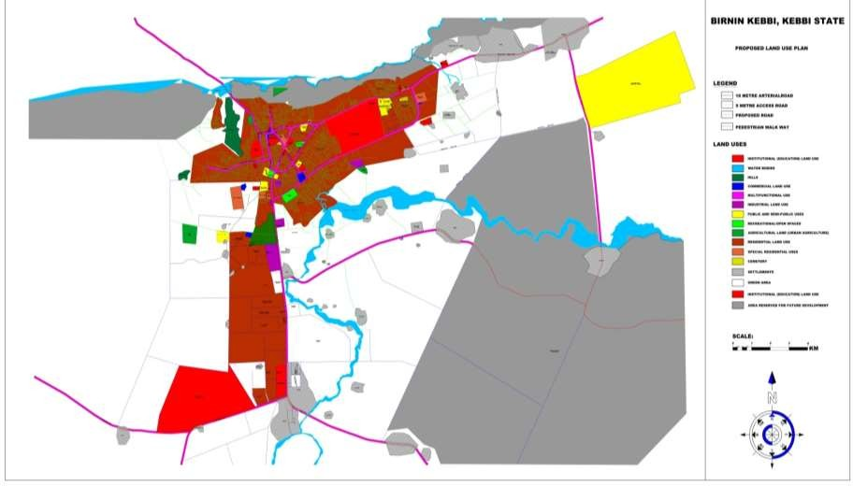

**Figure 4.20:** Modified land use map of Birnin Kebbi as proposed.

Source: Field survey, 2019.

112

# Modified Land Use Plan of Birnin Kebbi

The Land Use Plan of a city is identified as the foremost instrument in resource management and physical development of the city (Raworth, 2018). It is a model for future development of the city. It clarifies the class and quality of the land use to be maintained at specific space and time. The importance and utilization of public and private spaces are clarified well in advance. In order to ensure sustainable development with the increasing population, the study adjusted the proposed plan from the Ministry of Land, Housing and Urban Development. This adjustment was based on the findings from the field exercise.

It was observed that the proposed 2017 Land Use Plan from the ministry is still planning for horizontal growth pattern that is no longer encourage due to the increase in population and finite nature of land resources. However, being conscious of the culture and tradition of the people of Birnin Kebbi, the modified Land Use Plan results (Figure 4.20) proposed 138 hectares for special residential areas. These areas are reserve for high-density buildings to accommodate the increasing population in the study area. In addition, commercial area (mini markets) were proposed in the modified Land Use Plan (38 hectares), this is to reduce travel time to the general/central market, thereby, decrease the car usage and subsequently, carbon emission. Similarly, 1416 hectares were reserve for multi-functional land use. This include mixed-use housing, service stations plot etc.

The proposed land use map is design to have a multifunctional corridor all round the 18m arterial road. This is aimed at protecting the prime lands in the area for investors that will guarantee return on investment made on the road infrastructure. Similarly, a few roads were proposed and some old ones upgraded to have walkways to enhance walkability and

healthy living. Area for future development was intentionally proposed and clearly mapped out.

**Land Use Budget**

11.1

Residential

0.2

Special residential

4.7

0.3

0.07

Settlements

Industrial

38.4

3.4

0.09

Commercial

Public and semi-public

3.4

0.2

Institutions (Education)

3.3

Recreational/ open spaces

Urban agriculture

Water bodies Green area Hills Multifunctional

2.5

0.01

31.8

Cemetery

0.4

Area reserved for future development

**Figure 4.21:** Land use budget for the proposed modified land use

Source: Field survey, 2019.

# Implementation strategy for the modified Land Use Plan of Birnin Kebbi

As the world population continue to increase, more people are projected to move into new towns, cities and urban centres. Nigeria is projected to reach a population of 402 million people by 2050 (VOA, 2019) with an urban population of 226 million dwellers (United Nation, 2014). Going by this trend, Kebbi state and Birnin Kebbi population, in particular, is expected to increase in line with this projection. As the effect of climate change worsen

in the far north, couple with the high level of insecurity affecting the neighbouring states of Sokoto, Zamfara and Katsina, more people are destined to relocate there, given the good environmental condition for farming and animal husbandry, and the relatively peaceful environment in Birnin Kebbi.

In line with the global effort of avoiding a 20c warming above the pre-industrial level, scientist like Robert Muggah believes that the solution to this problem is planning our cities in a sustainable manner to reduce it carbon footprint. The modified Birnin Kebbi Land Use Plan is a 30 years plan, aimed at coping with the immense urban development growth anticipated in the area. The development is design to be implemented in four (4) phases over the 30 years period.

Phase one of the proposed development plan is to be dominated by the construction of the 18 metres arterial road network, the 9 metres access road and all the pedestrian walkways. Similarly, the special residential plots designed for high-density residential areas will also commence in this phase. This is to ensure the availability of houses for the growing population in Birnin Kebbi. This phase is proposed to last for 7 years (2020 – 2027). At the beginning of 2028, phase two is proposed to commence with emphasis on the development of residential land use (medium and low-density residents, and mixed-use complexes). Additionally, public and semi-public land use will be developed to provide the necessary services for the residential buildings. This phase is proposed to last for 8 years (2028 – 2035). Recreational/open spaces will also be developed under this phase.

Phase three (3) is schedule to commence at the end of 2035. This phase is proposed to focus on the commercial land use and the multifunctional corridors within the newly constructed carriage ways, alongside the development of neighbourhood settlements. Phase

three is proposed to last for 7 years (2036 – 2042). Phase four is proposed to start concurrently with phase three but expected to run until 2050. In this phase, the heavy industries such as the rice milling companies are expected to be fully operational. Agricultural land should be utilised, and more institution that is fully functional. This phase is projected to last for 15 years (2036 – 2050). At the end of 2050, Birnin Kebbi city is projected to have developed into a self-sustaining city with adequate housing and other social amenities to support the growing population in a liveable and harmonious manner.

# 4.6 Summary of Findings

Land use and land cover change is a constant but gradual process occurring in any geographical location on the earth surface. This process may sometimes occur unnoticed over time and space. The Birnin-Kebbi land use and land cover analysis was done using multi-temporal Landsat images between 1991 and 2018. The land use and land cover analysis shows that the land has witnessed a significant change in it structure, pattern and extent. In 1991, the urban/built-up class covered only 1.4% of the total land area and increased from 1,687ha in 1991 to 4,189 ha in 2000. Similarly, there was an upsurge in farming activities, as increase in population usually lead to the need for more food, so, agricultural land increased from 9,270 ha to 40,134 ha and bare ground decreased from 40,773 ha to 22,669 ha.

The 2009 classified image shows that the built up areas are becoming densely populated, as land previously used for farming or agricultural purposes close to settlements are gradually being converted to building or settlements, thereby increasing the built-up area by 1,391 ha in 2009. Vegetation decreased by 2,755 ha and agricultural land increased 1,988 ha in 2009, bare ground decreased by 634 ha.

In 2018, the LULC shows significant expansion in the built up area in the north-west and the southern part of Birnin Kebbi, with some emerging settlements scattered around the study area. Built up area now covered 6.2% of the total land area, gaining about 2,145 ha; vegetation decreased by 48 ha and agricultural land now covered 35.2% of the total land surface, by adding 1,799 ha and bare ground decreased by 3,903 ha.

The result shows that there was a rapid increase in the built up area when compared to 2009. The built up area increase from 5,580 ha in 2009 to 7,725 ha in 2018, indicating 38.4% increment. In addition, agricultural land increased from 42,122 ha to 43,921. According to the Director, Town Planning,

*“The drastic increase in both built up area and agricultural land is a result of the federal government policy to encourage the production and consumption of local rice”. He further explained that “Kebbi is one of the major rice producing states in Nigeria, and the favourable condition in Birnin Kebbi, coupled with the incentive given to the farmers by the state government, more people have moved into the state to either start farming or work in the different rice processing companies in the state capital”*.

Though, more vegetated land were converted to either farm land (agriculture) or built up area, the government effort to plant more trees has compensated for the loss of vegetative areas. Therefore, vegetation recorded a “near-neutral” change when compared to 2009, i.e. only 43 ha of vegetation was lost between 2009 and 2018. In 2027, it is projected that built up area and agricultural land will increase by 2,034 ha and 2,192 ha respectively, while vegetation, bare ground and water body are predicted to decrease by 920 ha, 3,300 ha and 4 ha respectively.

The 1980 Master Plan of Birnin Kebbi was design when it was still under Sokoto state and did not envisage that the local government would become a state capital. Urban and

infrastructural development proceeded as intended in the Master Plan, residential buildings developed along the Birnin Kebbi – Argungu road as anticipated before 1991. By 1991, when the local government became the capital of the newly created state, the population had increased from 44,600 in 1980 to 151,457 (NPC, 1991). So the Master Plan that was design with the population projection of 133,300 by 2000 became grossly ineffective. However, the new state capital developed in line with the 1980 plan, the increase in population led to the conversion of previously budgeted land for other purpose into urban areas. For example, 60 hectares budgeted for Town Park was converted into residential building while firewood plantation and livestock breeding and dairy farm, with a combine land mass of over 1,600 hectares have been converted to institutional and residential areas.

The results show that residential area has increased by 6348 hectares, industrial/employment area increased by 85 hectares while institution increased by 1650 hectares. Similarly, portion of the land reserved for urban agriculture decreased by 187 hectares while the new sites for Town Park and recreation are about 52 hectares. According to the Director, Town Planning Birnin Kebbi, the urban growth in Birnin Kebbi has largely being manage sustainably, as the government has put some mechanism to check the activities of the native, and preventing them from just selling piece of land without proper layout and documentation. He further explained that even though land is vested in the hands of the Governor to hold in trust, the natives owned the right to use and they need to properly engage the Ministry for the design of layout and other necessary processes before they can sale any plot of land.

The sustainability assessment considered some basic infrastructure and services available in Birnin Kebbi. Water in the study area is one of the most available resources in Birnin

Kebbi. Significant percentage of the residents depends solely on ground water as their source of domestic water supply. The government also adopted the strategy of supplying neighbourhood water through community borehole (motorized) system, due to the cheap cost of drilling, and it availability all year round. About 64% of the respondents are connected to the government water supply system while some individuals (36%) prefer to drill their own borehole. The concern about water in Birnin Kebbi is the sustainability of this resource for generations to come.

Clean energy is a very important component of environmental sustainability. Electricity supply is good in the study area as they enjoy about 18 hours of power supply, thereby reducing the need for carbon-based generator plants. The challenge of clean energy in the study area lies in their primary source of cooking energy. The high demand for firewood in Birnin Kebbi is alarming, even though most household have LPG system, they all have local kitchen for firewood. However, the use of firewood is worst in the unplanned area; it is generally used in every house in Birnin Kebbi. The sustainability index shows that the planned environment is just above the threshold of sustainability (0.53) while the unplanned environment is unsustainable (0.45).

Sustainable transport systems emphasized the use of public mass-transport, cycling and walking; and discourage the use of individual motorised means of movement such as cars and motorcycles. The sustainability index of the means of transportation in Birnin Kebbi is significantly low. This is because of the high rate in the use of private cars (65%) in the study area. This means that petroleum and other carbon-based energy sources are highly consumed in the state, thereby contributing to the global carbon emission. The study shows that within the planned and unplanned areas, the rate of un-sustainability varies, as more

cars are being used in the planned area with an average index of 0.25, and therefore rated “highly unsustainable” while the unplanned areas has an average index of 0.37 and rated unsustainable.

Solid waste is regularly collected fortnightly and weekly from the designated points depending on the location. However, some unsustainable methods of waste disposal such as open burning and indiscriminate dumping of waste in drainage still take place, especially in the unplanned area, due to their inaccessibility. Nasarawa II is most affected with this problem and it has a low index of 0.45, making it unsustainable. Liquid waste or wastewater is another poorly disposed waste in the study area, especially in the unplanned settlements where wastewater is channelled out of the house to flow on the environment without treatment. In the planned neighbourhood, most of the houses are fitted with sewer system to collect domestic wastewater, but there is need for treatment of this wastewater as majority of the respondents depend directly or indirectly on the ground water to avoid contamination.

The level of compliance of the neighbourhoods concerning building codes and regulations in the study area is fair in the planned areas and low in the unplanned neighbourhoods. Majority of the houses in the unplanned neighbourhood are constructed with substandard building materials and therefore prone to flash floods. Some settlements are constructed on hazard-prone area, with Nasarawa II having the highest number (33%) situated on hazardous area.

Nasarawa II was selected for redevelopment plan. This is because of the poor state of the environmental condition and physical structures present in the neighbourhood, poorly planned road network/access ways; lack of any recreational areas, poorly designed

buildings with substandard building materials and the neighbourhood is situated in some of the prime lands in Birnin Kebbi. Most of the houses in this neighbourhood do not adhere to building code nor meets the average standard of building regulations and majority of them do not have any official document from the Ministry of Land, Housing and Urban Development.

The redevelopment plan was designed with two (2) alternatives and they were designed to have main roads and access ways, cycling lane and pedestrian walkways. The major difference is that Alternative I argue that the area is highly populated with low and meddle income residents and therefore allot plots high and medium density buildings, while Alternative II argued that low-density plots are necessary for local economic development and therefore includes it in the design. Similarly, a central sewer system and water treatment plant were also allotted plot. Schools, Police station, fire station, recreational centres and other necessary facilities were allotted plots in both plans.

# CHAPTER FIVE

* 1. **CONCLUSION AND RECOMMENDATIONS**

# Conclusion

Heilbroner and Milberg, (2011) said, “Things takes longer to happen than you think they will, and then they happen much faster than you thought they could”. The rate of population explosion, urban expansion and the effect of technology have made the conversation on climate change unavoidable. Humanity is faced with risk whichever way it turns, a world changed by climate change or a world changed by climate change and our effort to counter climate change. This research is aimed at appraise the Birnin-Kebbi city Master Plan, with a view to providing information that can inform policy for sustainable urban development in the study area. The study is also design to assess the level of compliance of the Birnin-Kebbi city development with International best practices for sustainable cities. This chapter provides conclusion and recommend possible solutions that could be adopted to ensure sustainable urban development and increase the resilience of the study area.

The first objective of this study is to assess the land use and land cover change in the study area from 1991 – 2018 and simulate the 2027 land cover change. In this regard, it was discovered that there had been a steady increase in the rate of urbanisation and agricultural land (farmland) in the study area, with a corresponding decrease in vegetation cover and bare ground. The 2027 projection shows a similar trend and this is not environmentally sustainable.

The second objective is to appraise the level of implementation and mismatch of the 1980 Master Plan. The Master Plan was partially implemented from 1983-1991, but after the

change of status from a local government headquarters to a state capital, the plan could not be fully implemented due to increase in population, the need for more infrastructure and residential building. Therefore, various land formally assigned for other developmental purposes where converted to residential area.

Assessing the level of compliance of the Birnin-Kebbi city development with International best practices for sustainable cities was the third objective**.** The study area was stratified into planned and unplanned neighbourhoods and the assessment was conducted based on some sustainable development indicators. These indicators are water availability and supply, clean energy, waste management, transportation system and disaster resilience. The research discovers that water is available in the study area, especially ground water, and it is supplied regularly. The use of firewood as a primary source of cooking energy is predominant in the areas and is not sustainable. The prevalent use of individual (private) cars as there most preferred means of movement in the study area has increase the consumption of carbon-based energy and the release of CO2 in the atmosphere. Waste collection and disposal is done regularly in some neighbourhood, while some still engage in waste disposal methods that are not environmentally sustainable, especially in the unplanned neighbourhood, where refuse are dumped on open places, incinerated or disposed on drainage. Wastewater treatment is not practiced in the study area and majority of the household in the unplanned neighbourhood channel their wastewater pipe directly to the environment. The level of compliance of the neighbourhood about building codes and regulation is fair in the planned area and low in the unplanned area, with Nasarawa II being having the highest number of building situated in hazard-prone environment, this necessitates the need to redevelop Nasarawa II into a sustainable neighbourhood.

# Recommendations

In effort to reduce the various risk factors identified in this research, increase the communities’ resilience and make Birnin Kebbi environmentally sustainable, the following plan, projects and programmes are recommended to be adopted.

* + 1. There is a need to sensitise and re-orientate the people of Birnin Kebbi about the effect of using firewood as a source of cooking energy and its impact on climate change. The conscious reduction in the use of firewood for other sustainable alternatives like the LPG and electricity can lead to low patronage in the wood selling business and ultimately save the trees in the forest.
    2. Government should initiate material loans in terms of micro-credit schemes, through a coordinating Ministry or NGO to provide LPG cooking system for private individuals and commercial food vendors at an interest-free loan to enable them stop the use of firewood.
    3. Though, there is no constrain of land resources now, Kebbi State Ministry for Land, Housing and Urban Development should consider the construction of high-rise (vertical) buildings to accommodate the growing population in the future. As population increase, so does the need to provide houses increase too, but the conventional system of building estates with single unit houses (bungalows) are not sustainable. This is because land finite resources and population is constantly increasing, so if we continue to build in this manner, other component of the environment will be destroyed.
    4. The state government started a laudable project of planting trees within the urban areas in 2006-2007, this trees compensated for the loss in vegetation cover to farmland, leading to a small loss in vegetation between 2000 – 2009. The government should continue this project and encourage private organisations and individuals to plant trees. Primary and secondary school pupils can be motivated to plant a “Tree of Life” in their school environment.
    5. The relevant government agency task with the enforcement of building codes and standards should live up to their responsibilities of ensuring that all buildings are built in accordance with the standards and regulation prescribed for such environment. Similarly, risk and vulnerability assessment should be conducted on hazard-prone land and convert them into vegetation zones where economic trees can be planted to serve as source of revenue for the state and carbon-sink for the environment.
    6. Waste collection and disposal chain should be strengthened to promote and ensure environmental sustainability. Similarly, wastewater treatment plants should be developed around the urban area to prevent the contamination of ground water. Surface discharge of wastewater should be discouraged.
    7. The road network in Birnin Kebbi is good but the primary means of transportation are not environmentally sustainable. The incorporation of Mass-Transit Bus system (e.g. BRT), is necessary for a sustainable transportation system. This will help in reducing the amount of carbon that would have been generated by individual cars. In addition, walkways and cycling lanes should be developed to encourage more environmental friendly means of movement.
    8. Master Plans are rigid and usually difficult to implement, necessitating the need for strategic planning or neighbourhood planning and development. This involves the systemic collaboration between relevant MDA’s to ensure the development of a functional, liveable and sustainable neighbourhood.
    9. The rate of land conversion from vegetation to agricultural purposes needs to be controlled, and more sustainable system of farming introduced. Government, through the ministry of agriculture and rural development, need to task their extension worker to sensitizing farmers on high breed seeds and sustainable farming practice.
    10. Private organisation needs to collaborate with government and local communities, in exchange for tax holiday, to rehabilitate degraded lands e.g gully erosion prone areas, by planting trees and developing a sustainable forest management system which can lead to increase in standard of living of individuals.
    11. Deliberate measures to control natural increase in population: Urbanisation has often being attributed to increase in migration and little has being said about the impact of high birth rate to urbanisation. Rosling (2010) said “as long as people still struggle for daily food and shoe, the world population will keep increasing”. Meaning that if nothing is done to ensure a sustainable population size in the study area, all other effort to make Birnin Kebbi a sustainable city will be ineffective.

These recommendations are aimed toward ensuring that urbanisation in Birnin Kebbi grows in a sustainable manner that will contribute to the global effort of reducing carbon dioxide from the atmosphere, thereby solving the problem of climate change. Stern (2014) said,

“The depth of understanding of the enormous risks we might be facing from climate change are not known yet, the depth of the attractiveness of what we can do is not there yet”. We need political pressure to build, we need leaders to step-up, we can have a better urban growth, better climate and better world by managing our population and planning our cities right.

# REFERENCES

Abu-Bakar A and Cheen K.S. (2013). A Framework for Assessing the Sustainable Urban Development. ASEAN Conference on Environment-Behaviour Studies. Cultural Sustainability in the Built and Natural Environment"

[www.sciencedirect.com](http://www.sciencedirect.com/) Date sourced: 14-04-2019

Abubakar A.Z; (2015). Effects of Urbanization on Land Use / Land Cove Changes in Birnin Kebbi, Kebbi state, Nigeria.A thesis submitted to the school of Post- Graduate Studies, Ahmadu Bello University, Zaria.

Ahlfeldt G., and Pietrostefani E; (2018). Demystifying compact urban growth: Evidence from 300 studies from across the world. Coalition for urban transition: A new climate economy special initiative.

[www.coalitionforurbantransitions.org](http://www.coalitionforurbantransitions.org/) Date sourced: 19-10-2018

Akintunde, J.A.; Adzandeh, E.A.; Fabiyi, O.O. (2016).Spatio-temporal Pattern of Urban Growth in Jos Metropolis, Nigeria. *Remote Sensing Application Society Environment* (4), 44–54.

[www.researchgate.net.](http://www.researchgate.net/) Date sourced 23-04-2019

Alabi, M.O. (2009). “Urban Sprawl, Pattern and Measurement in Lokoja, Nigeria”.

*Theoretical and Empirical Researches in Urban Management*. (4), 158 – 164. [https://www.researchgate.net/publication/46567778_URBAN_SPRAWL_PATTER](https://www.researchgate.net/publication/46567778_URBAN_SPRAWL_PATTERN_AND_MEASUREMENT_IN_LOKOJA_NIGERIA/citation/download) [N_AND_MEASUREMENT_IN_LOKOJA_NIGERIA/citation/download](https://www.researchgate.net/publication/46567778_URBAN_SPRAWL_PATTERN_AND_MEASUREMENT_IN_LOKOJA_NIGERIA/citation/download). Date sourced 23-04-2019

Alemayehu F;Tolera M; and Tesfaye G; (2019). Land Use Land Cover Change Trend and its Drivers in Somodo Watershed South Western, Ethiopia. *African Journal of Agricultural Research* 14(2), 102-117,

<http://www.academicjournals.org/AJAR>. Date sourced 22-04-2019

Al-Gore (2016). The case for optimism on climate change. Recorded at TED Talk (Ideas worth spreading). Vancouver BC.

[www.ted.com](http://www.ted.com/) Date sourced 23-04-2019

Ameen R.F.M, (2017) A Framework for the Sustainability Assessment of Urban Design and Development in Iraqi Cities. A PhD Thesis submitted to the Department of Planning, Cardiff University, Wales, United Kingdom. [www.pdfs.semanticscholar.org](http://www.pdfs.semanticscholar.org/) Date sourced 23-04-2019

Ameen, R.F.M.; Mourshed, M.; Li, H; (2015). A critical review of environmental assessment tools for sustainable urban design. *Environmental Impact Assessment Review*. (55), 110–125.

<https://www.sciencedirect.com/science/article/abs/pii/S0195925515000736> Date sourced 23-04-2019

Barrera, F.D.L.; Henríquez, C. (2017). Vegetation Cover Change in Growing Urban Agglomerations in Chile. *Ecological Indicator*. (81), 265–273. <https://www.sciencedirect.com/science/article/abs/pii/S1470160X17303229> Date sourced 20-08-2019

Bhattacharya J, Currie J, Haider S, (2004). Poverty, Food Insecurity and Nutritional Outcomes in Children and Adults. *Journal of health economics* 23 (4), 839-62 [www.ncbi.nlm.nih.gov](http://www.ncbi.nlm.nih.gov/)>pub Date sourced: 18-07-2019

Birnin Kebbi Master Plan 1980 – 2000 final report. Survey and Analysis. Dar Al-Handasah consultants (Shair & Partners). Ministry of Housing and Environment, Sokoto State. 2 (2):

Bloch, R, Monroy J, Fox S, & Ojo A, (2015). Urbanisation and Urban Expansion in Nigeria. Urbanisation Research Nigeria. Research Report. <https://www.researchgate.net/publication/281677412>Date sourced 20-08-2019

BMZ (2012). Land Use Planning: Concept, Tools and Applications. Federal Ministry for Economic Cooperation. GIZ, Germany. [https://wocatpedia.net/images/3/3f/GIZ_%282012%29_Land_Use_Planning_Conce](https://wocatpedia.net/images/3/3f/GIZ_%282012%29_Land_Use_Planning_Concept%2C_Tools_and_Applications.pdf) [pt%2C_Tools_and_Applications.pdf](https://wocatpedia.net/images/3/3f/GIZ_%282012%29_Land_Use_Planning_Concept%2C_Tools_and_Applications.pdf) Date sourced 20-08-2019

Boyko, C.T.; Gaterell, M.R.; Barber, A.R.G.; Brown, J.; Bryson, J.R.; Butler, D.; *et al.* (2012). Benchmarking Sustainability in Cities: The Role of Indicators and Future Scenarios. *Global Environmental Change*. (22)1, 245 – 254 <https://www.sciencedirect.com/science/article/abs/pii/S0959378011001567> Date sourced 16-08-2019

Brand S, (2009). Four environmental ‘heresies’. Recorded at TED Talk (Ideas worth spreading). Washington DC.

[www.ted.com](http://www.ted.com/) Date sourced 16-08-2019

Buenett K.M, Reeves G.H, Miller D.J, Clarke S, Vance-Borland K, and Christiansen K, (2007). Distribution of Salmon-Habitat Potential relative to landscape Characteristics and Implications for Conservation. Ecological Applications, 17 (1), 66-80.

Calthorpe P, (2017). Seven principles for building better cities. Recorded at TED Talk (Ideas worth spreading). Vancouver BC.

[www.ted.com](http://www.ted.com/) Date sourced 16-08-2019

Campbell J.B and Wynne R.H, (2011). Introduction to Remote Sensing Fifth Edition. The Guilford press, 72 Spring Street, New York, NY 10012

[www.guilford.com](http://www.guilford.com/) Date sourced 16-08-2019

Chesson, J. (2013). Sustainable Development: Connecting Practice with Theory. *Journal of Environmental Assessment Policy and Management*. (15), 1, 1350002-1–1350002-

27.

www.worldscientifc,com Date sourced 15-10-2019

Ciegis, R.; Ramanauskiene, J.; Startiene, G. (2009). Theoretical Reasoning of the Use of Indicators and Indices for Sustainable Development Assessment. *Inzinerine Ekonomika-Engineering Economics* (3), 33–40.

[www.researchgate.net](http://www.researchgate.net/) Date sourced 15-10-2019

Cleland J, (2013). World Population Growth; Past, Present and Future. The Official *Journal of the European Association of Environmental and Resource Economists.* 55, (4) 543-554

https://link.springer.com>article Date sourced 15-10-2019

Clement K, (2001). Strategic Environmental Awakening: European progress in regional environmental integration. European Environment. 11 (2), 294-312 <https://doi.org/10.1002/eet.253>Date sourced: 18-07-2019

Cohen M, (2017). A Systematic Review of Urban Sustainability Assessment Literature.

*Sustainability Urban and Rural Development.* 9, (11) 1 – 16 [www.mdpi.com](http://www.mdpi.com/) Date sourced 15-10-2019

Crossman A, (2018). Understanding purposive sampling; an overview of the method and its application

[www.thoughtco.com](http://www.thoughtco.com/) Date sourced 15-10-2019

Davidson, K.M (2011). Reporting Systems for Sustainability: What are they Measuring?

*Social Indicators Research* 100, (2) 351–365. [www.jstor.org/stable/41476398 Date sourced 15-10-2019](http://www.jstor.org/stable/41476398%20Date%20sourced%2015-10-2019)

Devas N, and Rakodi C, (1993). *Managing Fast Growing Cities: New Approaches to Urban Planning and Management in the Developing World.* England: Longman Group UK Ltd, 1993.

Divisha H. (2017). Population projection: meaning, types and importance. Sociology discussion

[www.sociologydiscussion.com](http://www.sociologydiscussion.com/) Date sourced 15-10-2019

Elgadi A.A, Ismail L,H, Bargi W.A, and Ali, S. A, (2016). Selecting Indicators for the Sustainable Development of Residential Neighbourhoods in Tripoli, Libya. International Engineering Research and Innovation Symposium. [www.researchgate.net](http://www.researchgate.net/) Date sourced: 18-07-2019

El-Jisr K. (2019). Fully Charged. Director of the Sustainable City Innovation Centre. [www.youtube.com](http://www.youtube.com/) Date sourced 15-10-2019

Enoguanbhor E.C, Gollnow F, Nielson J.O, Lakes T, and Walker B.B (2019). Land Cover Change in the Abuja City-Region, Nigeria: Integrating GIS and Remotely Sensed Data to Support Land Use Planning. *Sustainable Urban and Rural Development* [www.mdpi.com](http://www.mdpi.com/) Date sourced 15-10-2019

Etherington D; (2019). Tesla’s new solar roofing system [www.techcrunch.com](http://www.techcrunch.com/) Date sourced 15-10-2019

FAO (2005). The state of food and agriculture 2005: Agricultural Trade and Poverty, Can Trade Work for the Poor? Food and Agriculture Organization of the United Nations, Rome

Farrell K. (2017). The Rapid Urban Growth Triad: A New Conceptual Framework for Examining the Urban Transition in Developing Countries. *Journal for Sustainability*.

[www.mdpi.com/journal/sustainability](http://www.mdpi.com/journal/sustainability) Date sourced 15-10-2019

Forman R.T.T and Wu J, (2016). Where to Put the Next Billion People. Call for Global and Regional Approaches to Urban Planning. *Nature*, 537, 608-611 [www.leml.asu.edu](http://www.leml.asu.edu/)>jingle>2016 Date sourced: 18-07-2019

Fowke R, and Prasad D.K, (1996). Sustainable Development, Cities and Local Government. *Journal Australian Planner*. 33 (2), 61-66.

[www.tandfonline.com](http://www.tandfonline.com/) Date sourced: 18-07-2019

Ganasri, B.P.; Dwarakish, G.S. (2015). Study of Land Use and Land Cover Dynamics through Classification Algorithms for Harangi Catchment Area, Karnataka State, INDIA. *Aquatic Procedia* 4, 1413–1420.

[www.sciencedirect.com](http://www.sciencedirect.com/) Date sourced 19-05-2019

Grafakos S, (2017). Planning for Climate Change in African Cities. Institute for Housing and Urban Development Studies (IHS), Netherlands.

Gibson, R.B (2006). Beyond the Pillars: Sustainability Assessment as a Framework for Effective

Integration of Social, Economic and Ecological Considerations in Significant Decision-Making. *Journal of Environmental Assessment Policy and Management*. 8, (3) 259–280.

[www.worldscientific.com](http://www.worldscientific.com/) Date sourced 05-11-2019

Gonzalez, A.; Donnelly, A.; Jones, M. (2011). Community of Practice Approach to Developing Urban Sustainability Indicators. *Journal of Environmental Assessment Policy and Management*. 13, (4) 591–617.

[www.worldscientific.com](http://www.worldscientific.com/) Date sourced 15-10-2019

Hameed R, and Nadeem O, (2008). Challenges of Implementing Urban Master Plans: The Lahore Experience. World Academy of Science, Engineering and Technology. *International Journal of Humanities and Social Sciences*: 2 (12), 1 – 8. [www.citeseerx.ist.psu.edu>](http://www.citeseerx.ist.psu.edu/)viewdoc Date sourced 15-10-2019

Hansen J. (2012). Why I Must Speak Out About Climate Change. Recorded at TED Talk (Ideas worth spreading). Long beach, California.

[www.ted.com](http://www.ted.com/) Date sourced 12-09-2019

Heilbroner L.R and Milberg W, (2011). *The Making of the Economic Society*. The Pearson series in Economics. 13th Edition.

Hou, H.; Estoque, R.C.; Murayama, Y. (2016). Spatiotemporal Analysis of Urban Growth in Three African Capital Cities: A grid-cell-based analysis using remote sensing data. *Journal of African Earth Sciences*. 123, 381–391.

[www.sciencedirect.com.pii](http://www.sciencedirect.com.pii/) Date sourced 15-10-2019

Ioannis M, Meliadis M (2011). Multi-Temporal Landsat Image Classification and Change Analysis of Land Cover/Use in the Prefecture of Thessaloniki, Greece. Department of Forest Management and Remote Sensing, School of Forestry and Natural Environment, Aristotle University of Thessaloniki: NAGREF-Forest Research Institute, GR570 06.

Isah T. (2015). Monitoring Change of Urban Growth Using Remote Sensing and GIS Techniques: A Case Study of Kano City, Northern Nigeria. A thesis submitted to the Faculty of Computing, Engineering and Science in partial fulfilment of the requirements for the degree of M.Sc. Geographical Information Systems, GIS

John N. (2017). Assessment of Lokoja Master Plan for urban sustainability. A thesis submitted to

The department of Geography, Federal University of Technology, Minna,

Jelili, M.O.; Adedibu, A.A.; Egunjobi, L, (2008). Regional Development Planning in Nigeria: The General and Particular. *Journal of Social Science*. 16, 135–140.

Keeler B.L., Hamel P., McPhearson T., Hamann M.H., Donahue M.L., Meza Prado K.A., Arkema

K.K., Bratman G.N., Brauman K.A., Finlay J.C., Guerry A.D., Hobbie S.E., Johnson J.A., MacDonald G.K., McDonald R.I., Neverisky N., Wood S.A, (2019). Social-ecologicaland technological factors moderate the value of urban nature.

Journal of Nature Sustainability. 2 (29-38).

Keivani, R (2010). A Review of the Main Challenges to Urban Sustainability. *International Journal Urban Sustainable Development*, 1, 5–16.

Koglin, T. (2008). Sustainable Development in General and Urban Context: Literature Review. Lund: Lund University.

Larson K, (2012). Brilliant Designs to Fit More People in Every City. Recorded at TED Talk (Ideas worth spreading). Boston, Massachusetts.

[www.ted.com](http://www.ted.com/) Date sourced: 11-06-2019

Leh M, Bajwa S, Chaubey I (2011). Impact of Land Use Change on Erosion Risk: An Integrated Remote Sensing, Geographic Information System, and Modelling Methodology. Department of Biological and Agricultural Engineering, University of Arkansas, Fayetteville, AR, USA.

[www.onlinelibrary.wiley.com](http://www.onlinelibrary.wiley.com/) Date sourced: 22-11-19

Lewis S.L, (2006). Tropical Forests and the Changing Earth System. Philosophical Transactions of the Royal Society. *Biological Sciences* 361(1465), 195-210. [www.ncbi.nlm.nih.gov](http://www.ncbi.nlm.nih.gov/)>publications Date sourced: 22-11-19

MacLachlan A, Biggs E, Roberts G, and Boruff B, (2017). Urbanisation-Induced Land Cover Temperature Dynamics for Sustainable Future Urban Heat Island Mitigation.

*Journal of Sustainability*. 1 (4), 38-50 [www.mdpi.com/journal/sustainability](http://www.mdpi.com/journal/sustainability) Date sourced: 17-11-2019

Macleod, R.D and Congalton, R.G. (1998). Quantitative Comparison of Change Detection Algorithms for Monitoring Eelgrass From Remotely Sensed Data. *Photogrammetric Engineering and Remote Sensing*. 64 (3), 207-216

[www.asprs.org](http://www.asprs.org/) Date sourced: 22-11-19

Mahesh J,Tyagi N., Dasgupta V. (2012). Urban Planning Using Remote Sensing. University of Petroleum and Energy, Dehradun, *India International Journal of Innovative Research in Science, Engineering and Technology*. 1, (1), 1-16 [www.ijirset.com](http://www.ijirset.com/) Date sourced: 17-11-2019

Mahmoud M.I, Duker A, Conrad C, and Thiel M, (2016). Analysis of Settlements Expansion and Urban Growth Modelling Using Geoinformation for Assessing Potential Impacts of Urbanization on Climate in Abuja City, Nigeria. Remote sensing, 8 (3), 220-281.

[www.researchgate.net](http://www.researchgate.net/) Date sourced: 18-07-2019

Mather P and Tso B; (2009). *Classification Methods for Remotely Sensed Data*. CRC press,

Boca Raton

[www.scirp.org](http://www.scirp.org/) Date sourced: 17-11-2019

Metternicht, G. (2017). Global Land Outlook Working Paper: Land Use Planning; UNCCD (United Nations Convention to Combat Desertification): Sydney, Australia.

Mishra A.K. (2012). Urban Master Plans in Rajasthan, India: The case of Alwar Management Research and Practice. 4, (1), 31-44

[www.semanticscholar.org](http://www.semanticscholar.org/) Date sourced: 22-11-19

Morelli, J. (2011). Environmental Sustainability: A Definition for Environmental Professionals. *Journal of Environmental Sustainability*. 1 (1), 1-10 [www.scholarworks.rit.edu](http://www.scholarworks.rit.edu/) Date sourced: 22-11-19

Muggah R., (2017). The biggest risk facing cities and some solutions. Recorded at TED Talk (Ideas worth spreading). New York, New York.

[www.ted.com](http://www.ted.com/) Date sourced: 17-11-2019

Musa I.G; (2015). Analysis of Land Use and Land Cover Change in Southern Part of Kaduna Metropolis, Kaduna State, Nigeria. A dissertation submitted to Post- Graduate School, Ahmadu Bello University, Zaria.

[www.researchgate.net](http://www.researchgate.net/) Date sourced: 22-11-19

National Bureau of Statistics (2016). Annual Abstract of Statistics. Federal Republic of Nigeria

[www.nigerianstat.gov.ng>](http://www.nigerianstat.gov.ng/)elibrary Date sourced: 22-11-19

National Population Commission of Nigeria, (1991). Population and housing census 1991.

International Housing Survey Network. [www.catalog.ihsn.org//catalog/3329](http://www.catalog.ihsn.org/catalog/3329) Date sourced: 21-10-19

National Population Commission of Nigeria, (2016). [www.nigerianstat.gov.ng>](http://www.nigerianstat.gov.ng/)doc Date sourced: 22-11-19

Nigussie A.M (2016). Land Use /Land Cover Change and Associated Driving Forces in Bale eco-region, Ethiopia. A Thesis submitted to Hawassa University, Wondo Genet College of forestry and natural resources, Wondo Genet, Ethiopia. [http://www.phethiopia.org/pdf/6.%20Land%20use%20land%20cover%20%20chan](http://www.phethiopia.org/pdf/6.%20Land%20use%20land%20cover%20%20change_Adane.pdf) [ge_Adane.pdf](http://www.phethiopia.org/pdf/6.%20Land%20use%20land%20cover%20%20change_Adane.pdf) Date sourced 23-04-2019

Nkeki, F.N. (2016). Spatio-Temporal Analysis of Land Use Transition and Urban Growth Characterization in Benin Metropolitan Region, Nigeria. *Remote Sensing Application Society Environment.* 4, 119–137.

[www.sciencedirect.com>](http://www.sciencedirect.com/)pii Date sourced: 22-11-19

Olalla-Tarraga, M.A; (2006). A Conceptual Framework to assess Sustainability in Urban Ecological Systems. *International Journal of Sustainable Development World Ecology*. 13 (1), 1-15.

[www.tandfonline.com>a](http://www.tandfonline.com/)bs Date sourced: 22-07-19

Olanrewaju A.V, (2018). Urban land use land cover changes and their effect on urban thermal

pattern: case study of Nigeria’s Federal Capital City. Journal of Environment and Earth Science. 8 (5).

Olujide, H.M., Amoo, N.B., Oguntayo, S.M., Aroge, S.K, Amoo, A.O. (2018). Geospatial Analysis of Land Use and Land Cover Dynamics in Akure, Nigeria. *Dutse Journal of Pure and Applied Science*s. 4, (1), 1-16.

[www.fud.edu.ng>](http://www.fud.edu.ng/)dujopas Date sourced: 22-01-19

OlujimiJ. (2009). Evolving a Planning Strategy for Managing Urban Sprawl in Nigeria.

*Journal of Human Ecology.* 25 (3), 201-208 [www.tandfonline.com>a](http://www.tandfonline.com/)bs Date sourced: 28-04-19

Olson J, Misana S, Campbell J, Mbonile M, Mugisha S (2004). The Spatial Patterns and Root Causes of Land Use Change in East Africa. LUCID Project Working Paper 47. [www.cgspace.cgiar.org>](http://www.cgspace.cgiar.org/)handle Date sourced: 28-04-19

Owoeye, J.O.; Ibitoye, O.A. (2016). Analysis of Akure Urban Land Use Change Detection from Remote Imagery Perspective. *Urban Studies Research*. 16, 1-10

[www.downloads.hindawi.com](http://www.downloads.hindawi.com/) Date sourced: 28-04-19

Paul P, and Maiti J, (2007). The Role of Behavioural Factors on Safety Management in Underground Mines. *Safety science,* 45 (4), 449-471.

[www.researchgate.net](http://www.researchgate.net/) Date sourced: 18-07-2019

PBL Netherlands Environmental Assessment Agency (2012). *Roads from Rio+20 Pathways to achieve Global Sustainability Goals by 2050*. Sustainable Development

[www.pbi.nl>dow](http://www.pbi.nl/)nloads Date sourced: 02-03-19

Pell M. and Worman A, (008). Biological Wastewater Treatment System. *Encyclopaedia of Ecology* 426 – 441.

<https://doi.org/10.1016/B978-008045405-4.00317-7> Date sourced: 24-05-2019

Phillips, P.M.; João, E. (2017). Land Use Planning and the Ecosystem Approach: An Evaluation

of Case Study Planning Frameworks Against the Malawi Principles. *Land Use Policy*. 4, 1-41.

[www.strathprints.strath.ac.uk](http://www.strathprints.strath.ac.uk/) Date sourced: 02-03-19

Public Safety Canada (2015). About disaster mitigation. [www.publicsafety.gc.ca](http://www.publicsafety.gc.ca/)>cnt Date sourced: 17-11-2019

Rosling H. (2010). Global Population Growth, Box by Box. Recorded at TED Talks (Ideas worth spreading). Gannes, France.

[www.ted.com](http://www.ted.com/) Date sourced: 17-11-2019

Raworth, K (2012). *A Safe and Just Space for Humanity: Can we live within the doughnut*?

Oxfam GB: Oxford, UK; pp. 1–26.

Raworth K. (2018). A healthy economy should be designed to thrive, not grow. Recorded at TED Talk (Ideas worth spreading). Vancouver BC.

[www.ted.com](http://www.ted.com/) Date sourced: 02-03-19.

Robinson L.A, Berman J.S, Neimeyer R.A (1990). Psychotherapy for the Treatment of Depression: A Comprehensive Review of Controlled outcome Research. Psycholt Bull. 108 (1), 30-49

[www.researchgate.net](http://www.researchgate.net/) Date sourced: 18-07-2019

Satterthwaite D, (2010). The Contribution of Cities to Global Warming and their Potential Contributions to Solutions. Environment and Urbanization ASIA 1 (1), 1-12. [www.journals.sagepub.com>doi](http://www.journals.sagepub.com/) Date sourced: 18-07-2019

Selamyihun K (2004). Using Eucalyptus for Soil and Water Conservation on the Highland. Vertisols of Ethiopia. A Ph.D. Thesis submitted to Wageningen University, the Netherlands.

Singh S.k., Pandey A.C., and Singh D., (2014). Land Use Fragmentation Analysis Using Remote Sensing and Fragstats. *Society of Earth Scientists Series*.

Stern L.N. (2014). The State of the Climate-and what we might do about it. Recorded at TED Talk (Ideas worth spreading). New York.

[www.ted.com](http://www.ted.com/) Date sourced: 02-03-19

Sumner, A. (2004). Measuring sustainable development in the era of globalisation: Can it be done and what way ahead? *World Review Science and Technology Sustainable Development*, 1, 116–127.

Tian L. and Shen T; (2007). Evaluation of plan implementation of the transitional China: A case of Guangzhou city Master Plan 43rd ISOCARP Congress 2007

Tong A, (2015). My country will be under water soon, unless we work together. Recorded at TED Talk (Ideas worth spreading). Solomon Islands.

[www.ted.com](http://www.ted.com/) Date sourced: 02-03-19

UNEP (2012). Annual Report [www.unep.org/annualreport](http://www.unep.org/annualreport)

UN-Habitat (2004). The challenges of slums. Global report on human settlements 2003.

Management of Environmental Quality. 15 (3) 337-338

UN-HABITAT. (2016). Urbanization and development: Emerging futures – World Cities Report 2016.Nairobi: UN Habitat.

UN-Habitat (2019). A new city classification method shows Southern African countries more urbanized than thought.

United States Geological Survey (2018). Landsat images.

Available online: https://earthexplorer.usgs.gov (accessed on10 June 2017).

United Nations, (2000). World urbanization prospect: the 2003 revision population database.

<http://esa.org/unup/index.asp?panel>Date sourced: 02-03-19

United Nations (2014). Department of economic and social affairs, population division. World urbanization prospects: The 2014 Revision, Highlights; United Nations: New York, NY, USA, 2015.

United Nations (2014). An inquiry into the nature and causes of Nigeria’s rapid urban transition. https://link.springer.com>article

United Nation (2019). World Population Prospect. Department of economic and social affairs. [www.population.un.org/wpp/](http://www.population.un.org/wpp/)

Usman I. J. (2014). An Evaluation of the Influence of Land-use/Land- cover Change on the Surface Temperature of Federal Capital City (Abuja) Using Remote Sensing and GIS. A thesis submitted to the School of Postgraduate Studies Ahmadu Bello University, Zaria.

VOA (2019). Nigeria’s Population Projection to double by 2050 [www.voanews.com](http://www.voanews.com/) Date sourced: 02-03-19

Walsund E, (2013). Geographical Information Systems as a Tool in Sustainable Urban Development. Master Thesis in Built Environment, Faculty of Culture and Society. Department of Urban Studies, Malmo University.

[www.semanticscholar.org](http://www.semanticscholar.org/) Date sourced: 18-07-2019

Weeks J.L (2008). Autocratic Audience Costs: Regime Type and Signalling Resolve. Published by: Cambridge University Press on behalf of the International Organization Foundation. 62, (1), 35-64.

[www.jstor.org](http://www.jstor.org/)>stable Date sourced: 18-07-2019

Weingaertner C. (2010). Identifying Strategic Initiatives to Promote Urban Sustainability.

Division of Environmental Strategies Research – fms [www.kth.se](http://www.kth.se/) Date sourced: 02-03-19

WIKIPEDIA (2018). Sustainable city [www.en.m.wikipedia.org](http://www.en.m.wikipedia.org/)

Woldamlak B (2002). Land cover dynamics since the 1950s inChemoga Watershed, Blue Nile Basin, Ethiopia.

World Bank (2018). Urban development. Understanding poverty [www.worldbank.org/en/topic/urbandevelopment/overview](http://www.worldbank.org/en/topic/urbandevelopment/overview)

World Bank (2019). Working for a world free of poverty. IBRD.IDA [https://urban-regeneration.worldbank.org](https://urban-regeneration.worldbank.org/)

Xing, Y.; Horner, R.M.W.; El-Haram, M.A.; Bebbington, J. (2009).A Framework Model for Assessing Sustainability Impacts of Urban Development. *Account. Forum,* 33, 209–224.

Yang H, Zhang Y, Khan, S. I, (2016). *Hydrologic Remote Sensing: Capacity Building for Sustainability and Resilience*. Boca Raton: Taylor & Francis, CRC Press, 2016. <https://lccn.loc.gov/2016009009>Date sourced 02-03-19

Yang, X. (2010). *Integration of Remote Sensing with GIS for Urban Growth Characterization. In Geospatial Analysis and Modelling of Urban Structure and Dynamics*, 1st ed.; Jiang, B., Yao, X., Eds.; Springer Science + Business Media B.V.: New York, NY, USA, 223–250.

Yulia S., Katalin S., Richard P., Peter M.G., and Gordon H. (2010). Effect of land use and vegetation cover on soil temperature in an urban ecology.

Soil science society of America journal. 74(2) [www.researchgate.net/publication/43798424](http://www.researchgate.net/publication/43798424)

Zhou, N.; He, G.; Williams, C; (2012). China’s development of low-carbon eco-cities and associated indicators systems; Ernest Orlanda Lawrence & Berkeley National Laboratory: Berkeley, CA, USA.

Zubairu M; (2017). Insurgency, Security and Urban Safety in Nigeria: The Potentials of Physical Planning in Addressing the Social, Economic and Environmental Consequences of the Boko-Haram Insurgency and Niger Delta Militancy. A Paper presented at the 2017 Mandatory Continuing Professional Planning Education (MCPPEP), Port Harcourt, Nigeria.

# APPENDIX A

**Demographic Information**

|  |  |  |  |  |  |  |  |  |
| --- | --- | --- | --- | --- | --- | --- | --- | --- |
| Demographic Information | Nasarawa I | | Gadongaji | | Nasarawa II | | Makera | |
| Gender | N | % | N | % | N | % | N | % |
| Male | 79 | 89 | 70 | 84 | 71 | 91 | 70 | 85 |
| Female | 10 | 11 | 13 | 16 | 7 | 9 | 12 | 15 |
| Total | 89 | 100 | 83 | 100 | 78 | 100 | 82 | 100 |
| Age of respondents |  |  |  |  |  |  |  |  |
| 20-30yrs |  |  |  |  |  |  |  |  |
| 31-40yrs | 20 | 22.5 | 18 | 21.7 | 19 | 24.4 |  |  |
| 41-50yrs | 60 | 67.4 | 65 | 78.3 | 52 | 66.6 | 61 | 74.4 |
| 51-60yrs | 9 | 10.1 |  |  | 7 | 9 | 21 | 25.6 |
| 61yrs and above |  |  |  |  |  |  |  |  |
| Total | 89 | 100 | 83 | 100 | 78 | 100 | 82 | 100 |
|  |  |  |  |  |  |  |  |  |
| Highest educational  qualification |  |  |  |  |  |  |  |  |
| Primary |  |  |  |  |  |  |  |  |
| Secondary |  |  |  |  |  |  |  |  |
| NCE/OND | 18 | 20 | 30 | 36 | 34 | 44 | 32 | 39 |
| HND/BSC | 71 | 80 | 53 | 64 | 44 | 56 | 50 | 61 |
| Post Graduate |  |  |  |  |  |  |  |  |
| Total | 89 | 100 | 83 | 100 | 78 | 100 | 82 | 100 |
|  |  |  |  |  |  |  |  |  |
| Occupation of respondent |  |  |  |  |  |  |  |  |
| Trading |  |  | 15 | 18 | 13 | 16.7 | 10 | 12 |
| Civil servant | 89 | 100 | 68 | 82 | 65 | 83.3 | 72 | 88 |
| Retired |  |  |  |  |  |  |  |  |
| Total | 89 | 100 | 83 | 100 | 78 | 100 | 82 | 100 |

Source: field survey, 2019

# APPENDIX B

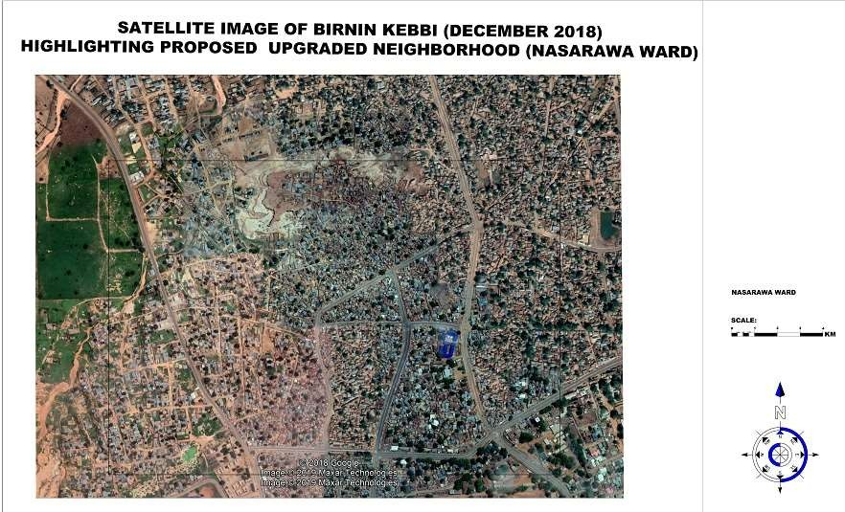

141

142