APPLICATION OF SATELLITE BASED REMOTE SENSING TO THE ESTIMATION AND MONITORING OF CROP HEALTH

The effect of loss in the availability of farm products has a lot of negative impact on the society. The decrease in crops production has created disparity between the food demand of world population and the global agricultural output. Crop production faces alot of challenges, some of which includes water scarcity, bad soils, unsuitable temperatures, pests, diseases and weeds which attacks the crops. Ground based or manual agricultural approach to detecting pest invasion and rapidly curbing it is not only time consuming and laborious, it is not also a real-time option especially for large scale farmlands. Remote sensing provides a rapid, intrusive and a more viable option for the collection and analysis of spectral properties of earth surfaces from various distances, ranging from satellites to ground-based policy. This study is aimed at assessing the applicability of remote sensing instrumentation and its techniques in evaluating and estimating crop health. This is to boycott the long process, time consuming and expensive biological laboratory tests always carried out by agricultural scientists to estimate the same attribute of crops. Sentinel-2A images and Landsat 8 images were acquired for use in this study. The total area covered for this research is101 Hectares. These images were preprocessed using ArcGIS software in order to remove effects of atmospheric conditions on the reflectance properties of the image channels. The images were processed to produce several representations of vegetation indices, soil indices and tasseled cap indices. Correlation, regression and analysis of variance (ANOVA) statistical tools were employed to assess the agreement of these vegetation and soil indices and their correlation with that of the tasseled cap indices. On the other hand, laboratory tests were performed to assess sampled crops and estimate their health status. A PCA model was developed to convert the laboratory test results to an equivalence of the remote sensing NDVI, a de-facto vegetation index for assessing crop health. Statistical analysis was performed to evaluate the relationship between the outputs from the remote sensing approach and the agricultural approach of crop health estimation, and the result shows a very weak correlation (0.16) between the two techniques. This implies that on general consideration of crop health estimation, there are just 1.6% (approximately negligible) chances that the result from the remote sensing technique will give equivalence to that of the laboratory result in agriculture. Statistical and graphical analysis performed based on each crop species reveal that cassava gave a 48.8% similarity with that of laboratory, 50.2% for groundnut and 63.8% for maize similarity respectively for two techniques, for rice health status, the study found out that the remote sensing technique could give 23.9% similar to that of laboratory. This makes it unreliable for such approach to be used in estimating maize health analysis. The result also found out that when satellite images are employed for estimating soya beans health, the output will be negatively correlated with that of the laboratory. For yam specie, the results show that there is no any correlation between the results from the laboratory and that of the remote sensing (0.021). Therefore, attention should be focused on the northern region of the study area for cultivation. Also, result obtained from this study should be further validated in order to establish a more valid PCA model for the study variables.

**CHAPTER ONE**

* 1. **INTRODUCTION**

# Background to the Study

The relevance of food production has been recognized by Sustainable Development Goals (SDGs) and this is as a result of the strong relationship that exists between food and insecurity. A lot of measures have been put in place to curb the challenges of low food production, especially in developing countries. Furthermore, despite the fact that agricultural production has been decreasing in most developing countries, most of these developing countries rely so much on agriculture for survival and as sources of income (Adesugba and Mavrotas, 2016). This underscores the importance of the development of automated technologies, such as satellite based remote sensing, for estimating and monitoring crops health and for the quick identification of pest invasion on plants, before they wreck and cause irreversible havoc on the plants thus, negatively influencing the rate of food production.

Standard means for estimating and monitoring crop health and identifying crops diseases are major issues in agricultural sectors (Savary *et al.,* 2015). Most farmers previously rely on manual checking of their crops for signs or symptoms that are detectable within human limitation, this process of disease identification leans on the variety of crop, size and area where the crops were planted, and in the case for most commercial farms, the farm land are habitually very large, this approach of checking crop condition is prolonged and very stressful (Oerke, 2006).Manual inspection strongly depends on the categories of infection or stress showing clearly detectable symptoms, which in the mid age regularly occurs to latter stages of infection. In order to determine the causal agent of such ailment in crop, it is achievable through either manual assessment or laboratory examination. Due to advancement

in the agricultural practice, which is a major cause why the largely manual process needs to be replaced with a more sophisticated, precise, and sensitive approaches (Mahlein, 2012).

Remote sensing is the science (with some approaches of art) of obtaining, without being in contact in the actual sense, Earth’s surface information. This is achieved through the sensing and recording of energy that is emitted or reflected and processing, analyzing, and applying that information. Remote sensing procedure encompasses interplay of interest target or object and radiation that are incident (Archana, 2015). The range of EMS commences from the shorter wavelengths (gamma and x-rays inclusive) to the longer wavelengths (radio waves for broadcasting and microwaves). Remote sensing solely depends on electromagnetic spectrum. The human eye is capable of detecting wavelength approximately ranging from

0.4 to 0.7μm. Chlorophyll is regarded as the most essential organic molecules present on Earth. Photosynthesis makes use of these molecules as its elemental pigments. Vicissitudes in the absolute consistency of foliar chlorophyll and the comparative proportions of chlorophyll ‘a’ and ‘b’ are effectuated by a multiplicity of biological stresses, leaf evolution and senescence. Such pigment adaptation interacts directly to the ratio of initial production. Furthermore, the chlorophylls proportionately contain a large measure of total leaf nitrogen. Consequently, chlorophyll concentration assessment may indirectly impart a definite result in the determination of plant nutrient. From a scientific view, the information pertaining to spatial and temporal changes of the chlorophyll properties of leaf is of a substantial relevance; especially carry out an investigative process of plant–environmental interactions, and from an applicable perception of agriculture, environmental management and forestry through the use of maps (George, 2008).

Application of mapping and satellite based remote sensing in crop production have a significant impact in modern practice agriculture also to combat the ecological problems traceable to climatic variation amongst other non-climatic factors. Classification of crops is a source of vital information required in making diverse decisions needed for agricultural resources management. Processing of satellite imageries is capable to render the users, propitious and precise knowledge on crop class and genuine evaluation of crop yield applying sophisticated classification methods. Decision on the satellite imagery for grouping and segmentation of crops is dependent on criteria such as economic constrain, availability, crop type variability, and size of the area of study.

Open source data like Moderate Resolution Imaging Spectrora diameter (MODIS), Sentinel and Landsat images have been used in some applications for mapping and analysis regarding vegetation or vegetative zones (Zheng *et al.,* 2015). Mix-pixel is a well-known challenge which is often encountered in MODIS due to poor coverage (250–500 m). Thus, land sat images (30m) when compared to MODIS especially for areas with small agricultural lands, provides better and more accurate results. The Sentinel-2 is a European Satellite which yields a multispectral image at average spatial resolution of 10m and good temporal resolution (five- days), and which can reduce the side-effects of its relatively rough spatial resolution *(*Drusch, 2012)*.* The Sentinel-2 satellite Multi-Spectral Instrument (MSI) has about thirteen (13) bands and three spatial resolutions. The newly launched Sentinel-2 images served several purposes in the remote sensing environment (Whyte, 2018). Such as, crop health estimation, mapping changes in land cover, forest monitoring and for providing information on pollution of lakes etc. The invention of unmanned aerial vehicles such as DJI Phantom which is simple to operate has immensely contributed to the affordability of precise agriculture. The system of

unmanned aerial vehicles (UAV) generally called drones, can be mounted with hyperspectral/visibility sensors to record countless images of an area that can be systematically processed adopting photogrammetric procedures to construct and orthophoto and NDVI maps (Chris, 2014).

NDVI can be described as a binary measure that makes use of the visible and near-infrared bands of the EMS, and it is often used to carry out analysis on remote sensing observations and detect whether the observed target contains green (living) vegetation or not (Gitelson *et al.,* 1996). NDVI has been applied to several studies on vegetation, been implemented to check crop fertility, performance level of pasture, and rangeland carrying capacities among others. NDVI values are associated with vegetation, NDVI values varies between -1 to +1. Values that exceeds +0.1 represent vegetation and values which are closer to 0 represent naked soil and rock while negative values represent water, clouds and snow. NDVI value positive increase means that there is vegetation. Vegetation indices are utilized as a surrogate to estimate vegetation activity. Hence, NDVI is a much reliable component that can be used to estimate crop health status.

The Tasseled Cap transformation was developed to map and evaluate urban and vegetation changes detected by different satellites; it converts the readings from group of frequencies into composed values. The weights are assigned to separate frequencies and the weighted sum of each frequency was taken. The light intensity of a single pixel in the scene is measured as the weighted sums. Distinct composed values are the linear combination of individual frequencies. Some of these weights are negative and some are positive. Three bands are commonly used in tasseled cap transformation-based analysis. Band one which is

correspondence with image “brightness” gives a measure of soil brightness that used to develop brightness index. Band two is correspondence with “greenness “or photo synthetically-active vegetation to derive greenness index. The third tasseled-cap band is usually construed as the wetness index in which describes the interdependence of soil and canopy moisture. (Riffi and Fizazi 2012).

# Statement of Research Problem

The reliability of detecting and identifying of the plant health and plant stress are a prevailing challenge in agriculture. Ideal approaches of detecting plant diseases or infections often rely on manual checking of crops for visible indicators of the presence of such diseases by agronomists.

According to the crop variability and the extent of the crop area, which for multitude of commercialized farms is tremendous in many cases, the standard methodology has proved to be time demanding, laborious and expensive. The manual process of disclosure is dependent upon the disease or stress clearly exhibit evident visible symptoms, that recurrently manifest from the middle stage to late stage of infection, which makes quick and adequate intervention difficult and sometimes, impossible. This is why there is a perceptive interest in the agricultural sector to provide alternative optimized approaches for real-time or near real time monitoring of crop growth and health. Also, it is needful today because of the trending precision agriculture which comprises mostly GPS and other geo-informatics techniques.

# Aim and Objectives of the Study

The aim of this research is to estimate crop health using Remote Sensing approach with a view to enhancing crop yield in Garatu village

In the interest of achieving the stated aim, the objectives of this research are to:

* + 1. Extract vegetative information from sentinel 2 images
    2. Evaluate crops health from the extracted vegetative information.
    3. Carry out tissue test for the validation of the extracted crop health information.
    4. Carry out (T.test and Pearson correlation) analysis for the results obtained from Objectives (2) and (3).

# Research Questions

* + 1. How best can vegetation indices be extracted from satellite image data
    2. How correlated are the result obtained from satellite images and crop health estimation
    3. How best can you validate result obtained on crops health from satellite images
    4. Is there any statistically significant relationship between vegetation index gotten from satellite images and tissue test result obtained from the lab relationship between.

# Justification of the Study

Nigeria being a fast-developing nation, having an approximate population of over 200 million citizens relies heavily on agriculture production, so as to avoid risk of food crisis. A lot of farmers in Nigeria face different challenges in monitoring their farm produce and have very limited chances of getting good farm yield; this is as a result of manually checking of crop disease and monitoring of crop health, which is both intensive and demanding. Identifying the causal agent is achieved by detecting manually or diagnostic tests. The implementation of remote sensing can be used to curtail the stress and challenges that farmers majorly face in the process of detecting diseases and stress of crops at early stage. These

precise procedures can engender a diminished rate of pesticide and herbicide utilization, as well as impacts that are subsequently beneficial for the grower finances, ecosystem services, for the environment, and the end consumer. The introduction of precision farming, using remote sensing approach will help farmers understand how to study their crop growth by providing real time monitoring approach, with very little understanding of the GIS approaches. Hence, this research will help resolving some of the challenges faced by farmers in monitoring their crop health.

# Study Area

The investigations were performed as a case study of Garatu village, located within geographical coordinate (214292mE, 1045668mN), (214781mE 1045819N), (214935mE 1045517mN) and(214579mE 1045259mN), under Bosso LGA area is situated at about

19.49km away from F.U.T Minna permanent site (Gidan Kwanu campus). Economically, agriculture plays a substantial role in the area, most people who reside in the area are farmers whom solely rely on agriculture for survival, several crops such as yam, maize, cassava, groundnut, soya beans, and rice, are being planted on the specified area of interest. Figure 1 shows the exact geographical representation of the study area. For this study area, Sentinel 2 images were obtained from European Space Agency (ESA) ([www.copernicus.datahub.com](http://www.copernicus.datahub.com/)). The total area covered for this research is101 Hectares.

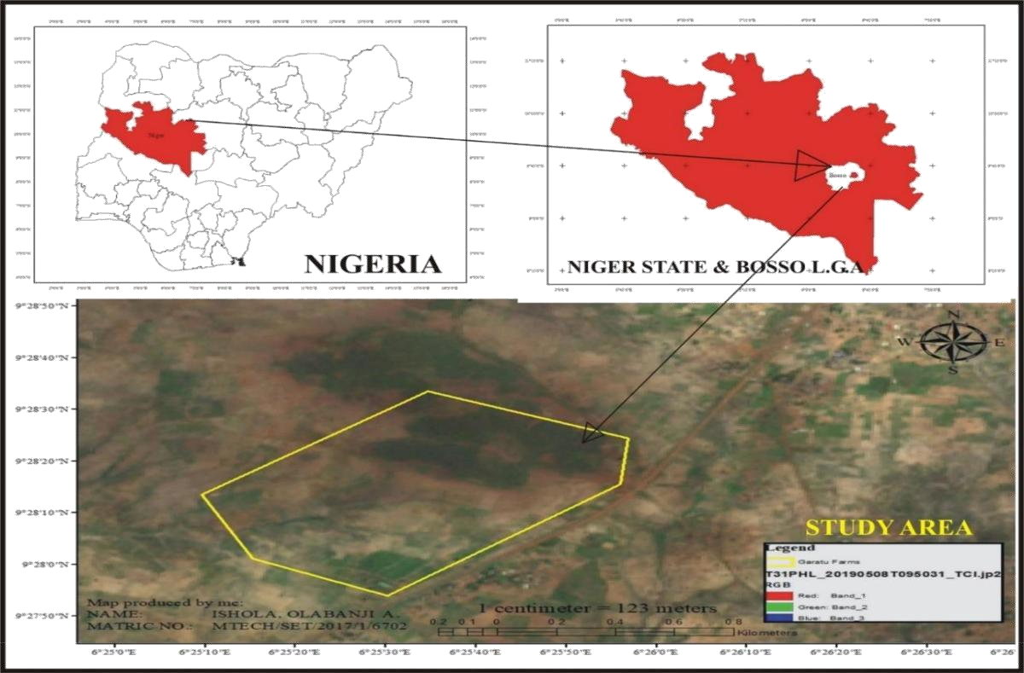

Figure 1: Map of the study

**CHAPTER TWO**

* 1. **LITERATURE REVIEW**

# Precision Agriculture

Precision Farming (PF), also referred to as Precision Agriculture (PA) or site-specific crop management (SSCM) is an integration of information- and production-based farming mechanism that is developed to amplify long term, site-specific and whole farm production adequacy, productivity and profitability while reducing to minimum unintended impacts on wildlife and the environment” (Earl *et al.,* 1996). The elemental rationale of PF is to optimize inputs adequacy as measured by outputs, which is for optimizing inputs in accordance to field inconsistency in order to maximize yields mitigating production costs and ecological impacts of agricultural practices, by giving the appropriate amount of input at the suitable place and the right time. Precision Agriculture firstly came from the application of imageries acquired from space borne satellites and aerial vehicles for the prediction of weather, fertilizer variability rate evaluation, and indicators for varieties of crop health. Secondly, the implementation brings about the collective use of machine data to ascertain the efficacy of mechanized planting, topography mapping, and soil data.

# Evolution and recent advances in precision farming

Precision farming is among the most recent agriculture modern inventions (Crookston, 2006). Precision farming is in general referred as engaging in proper practice at the right location and time at the appropriate potency. Since early 1980s when it began, precision farming has been endorsed for approximately millions of hectares of agricultural cropland across the globe. The specific focus of precision farming is on the use of Geographic Information Systems (GIS), farming by soil, variable rate fertilizer, site-specific farming,

management zones, Global Positioning System (GPS), yield monitoring, variable rate herbicides, variable rate irrigation, remote sensing, automatic tractor navigation and robotics, proximal sensing of soils and crops, and profitability. Consequently, it is definite to ascertain that agricultural labor activity would be tremendously minimized in the future. The era to efficiently integrate information technology and agricultural science for enhanced economic and ecological sustainability in crop production. This has birthed Precision Farming.

# Purposes of precision farming

1. Boosting efficiency of production
2. Optimizing quality
3. Minimizing environmental impact
4. Minimizing risk
5. Reduced production costs.
6. Overall yield increase.
7. Enhanced decision-making in agricultural management.
8. Reduced environmental impact.
9. Assemblage of farmers’ cognizance for improved management with time. (McBratney *et al.,* 2005).

# Tools for precision farming

Precision Farming is an integration of mutually interrelated diverse technologies that substantiate it developments. Precision farming (PF) has been conceptualized since the beginning of mechanized development in agriculture, which affirms that the implementation of precision farming was actively engaged by taking advantage of technology development that has led to quantifying and fields natural variability differential management.

Goddard *et al.,* (1995) said the invention of Global Navigation Satellite System such as GPS prompted the process. Production of maps about variation in geospatial objects and details (such as pH, crop yield, topography, moisture levels, potassium, magnesium, levels of nitrogen, moisture levels, etc.) is dependent on the Researcher’s and or farmer’s capability to locate precisely, position of points on the field. In addition, Whelan and McBratney (2003) said such maps produced can be compared by interpolating onto a common grid. Spatial and Temporal dynamics of crop types are the core part of PF, while the spatial and temporal performances of the dynamics are elemental to characterizing amendment approaches, or recipe maps.

# Remote Sensing

Remote sensing (RS) basically is referred to as the art of acquiring the observables concerning physical entities. Remote sensing is systematic process of using sensors mounted on space borne satellites or aircraft for actualizing the observation of the atmosphere and surface of the earth. Remote sensing accounts for the emitted or reflected electromagnetic energy from the target object under observation. The magnitude of the radiation (radiance) from the target objects is subjected to the both the characteristics of the objects and the radiation incidence on the objects (irradiance) (Campbell, 1996). The sensors in remote sensing measure information about objects by the process of recording the magnitude of electromagnetic energy transmission from the physical surface of the radiating and reflecting objects. The possibility of obtaining images of the earth in varying sections of wavelength of the (EMS) is achieved through remote sensing techniques. Amongst other essential attributes of remotely sensed images is the region of wavelength that they represent in the electromagnetic spectrum. The near infrared and visible light bands of the radiated energy

from the sun forms some images sensed by the sensors, while some are the measured energy remittance of the surface of the earth that lie thermal infrared wavelength region. The two categories of remote sensing procedures are the active and passive systems. The active systems are those systems with their inbuilt energy source (RADAR) and the passive systems rely on energy sourced from external entities for illumination of the features; commonly the sun.

# Principles of remote sensing

In remote sensing, the distinctive procedure of detecting and discriminating spatial features surmises recognizing and cataloging of surface materials or object’s reflected or radiated energy radiance. Surface materials revert distinguished magnitude of bands of energy in the electromagnetic spectrum that incident on it (Curran, 1985). The process is subjected to the physical, chemical and structural characteristics of the materials, surface anomaly, and angle of the incidence, magnitude and radiant energy wavelength. Remote sensing broadly compounds multi-disciplinary science that combines a wide range of field which includes optics, spectroscopy, photography, computer, electronics and telecommunication, satellite launching etc. Remote sensing is an integration of all these aforementioned technologies as a whole, known as Remote Sensing System (RSS).

# Stages in remote sensing

There are various stages involved in carrying out as successful remote sensing operation.

* Electromagnetic radiation emission (EMR), sun or self-emission
* Source-to-Earth absorption, scattering and transmission of energy
* Earth-EMR interaction; emission and reflection
* Energy transmit from Earth surface to the remote sensor
* Output of sensor data
* Transmission of data, its processing and analysis (Joseph, 1996).

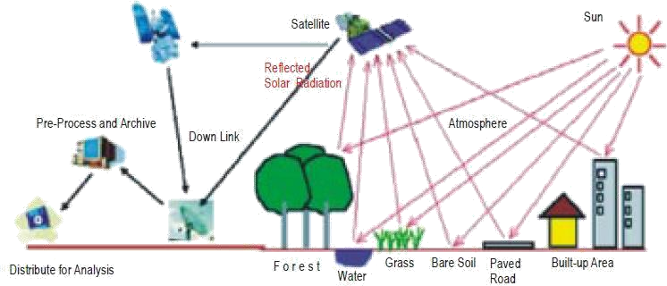

Figure 2.1 represents the process involved in remote sensing operation.

Figure 2.1: RS processing. Image source: (Sabins, 1997).

# Application of remote sensing data in agriculture

New RS multispectral and hyperspectral sensors are rapidly producing an immense expanse of information efficiently and at greater spectral and spatial resolutions. The interpretation of these images in the respective reflectance in the visible, near infrared and mid-infrared regions of the EMS as the physical properties namely; soil moisture, crop cover and crop health and are of significant usefulness for such tasks as mapping of the plant stress, application of pesticide and fertilizer application and management of irrigation system (Singh *et al*., 2007). The application of hyperspectral and multispectral remotely sensed data has enabled the assessment of varieties of crops nutrient contents, namely; paddy, sorghum, corn, broccoli, citrus, grapes and apple. Geostatistics, image classification and analysis, and artificial intelligence are the major techniques that expedite the interpretation of the remotely sensed data. Remote sensing technology in addition performs a significant function in the assessment of the condition of crops and the yield prognosis, specific crop acreage estimation, yield prognosis, detection of crops pest and diseases, mapping and location of

disastrous happenings, management of wild life, information management about water supply, climate assessment, management of range land, and survey of livestock. Remote sensing can be used as an efficient method to monitor some categories of crops diseases and insect pests (Reidell *et al*., 2004).described the techniques of remote sensing to be effectually an economical methodology for identifying pest and disease infested plants. With the application of the techniques of remote sensing, they achieved the detection of insect pests specifically and also categorically differentiated the damage caused by insects from the damage caused by diseases on oat. The agricultural applications of remote sensing have advanced to a level in which remotely sensed information (imageries) have been useful for several levels of strategic decisions that are relevant to the security of food, alleviation of poverty and development sustainability.

# Application of remote sensing to vegetation

In the 1980s, remote sensing and GIS implementation was adopted into agriculture alternatively for the estimation of growth and health of crop, ecological stress and crop output. Individual researchers have played extremely important role in establishing the thread that binds the spectral and agronomic traits of plant canopies and for determining the functional indices of vegetation on the basis of spectral reflection (Chang *et al.,* 2016). With the use of passive sensors, the acquisition of electromagnetic wave reflectance data from the canopies can only be achieved through remote sensing applications. The sensitivity of the sensing devices to some regions of light spectra such as visible spectral, ultraviolet region, near-infrared and mid-infrared band are the basis of remote sensing to vegetation index analysis (Bin *et al.,* 2016).

# Satellite Images

The existence of satellites for the past few decades has contributed tremendously in diverse applications such as in collection of earth’s surface related information which among many other aspects may include: its applicability in military to track patterns of the entire globe’s weather, Earth’s crust assessment, vegetation assessment, ocean temperature, ocean current, polar ice instability, pollution (Krisnah, 2007). The applicability of the analyzed satellite images in archaeology has emanated with the several other uses, however archaeologist have in resent time shown interest in the exploitation of further details of the expansive scope of the available analytical tools for the assessment of the earth’s surface and subsurface satellite image data. The declining cost, inclined resolution and satellites images greater availability for the civilians has effectively improved the use of satellites has contributed tremendously to many sectors of human endeavors such as in military intelligence, tracking and monitoring operations both on the surface and sub-surface of the earth together with temporal variation, and monitoring of spatial phenomena (Krisnah, 2007). Imaging technology with the use of satellite has brought about the growth of multispectral and hyperspectral sensors across the globe, it is a paramount means for mapping objects and phenomena by sensing unique material bonds and chemical from airborne and satellite sensors. From the definition of RS which is the science and art of observing and recording information about the environment or an object needless of physical contact with the object. Inverse problem is the principle on which satellite imaging technology is based; even if the target environment or object cannot be measured directly, there are some other variables existing that can be observed and recorded which have relationship with target object, making use of computer models that are data-derived (Victor, 2007). The emission’s frequency can then be related to the temperature

in that environment through various relations of thermodynamics. There are two major types of satellite imaging techniques, which are:

1. Multispectral imaging technique: in this technique, EMR of several wavelengths (multi-spectral) are usually taken. RS systems of multispectral imaging utilize arrays of sensor that are parallel and sense radiation in small number of broad wavelength bands. Many multispectral satellite systems observe 3 to 6 bands of spectrums within visible to middle infrared section of the EMS. However, there are some of these systems that use at least one of thermal infrared bands. Discrimination of various species of vegetation, Soils, rocks, turbid and clear water, man-made features, and so on is possible by multispectral remote sensing.
2. Hyperspectral imaging technique: This imaging approach is different from multi- spectal and regular imagery because it furnishes finer detail across the EMS. In place of gaining radiance data in only six bands which varies across locations from 100nm to 3000nm in width (such as MSS sensors and Landsat TM), hyperspectral sensor provides in hundreds of different bands spectral emissivity data, each of which is within 10-20nm in width.

# Differences between multispectral and hyperspectral images

1. Multispectral imaging produces two dimensional images of a few to hundred wavelength bands whereas Hyperspectral images obtains a large three- dimensional block of hundreds or thousands of images dimensionally denoted as (x, y, λ), where x, y and λ represent spatial and spectral dimensions respectively (Peg Shippert, 2009).
2. 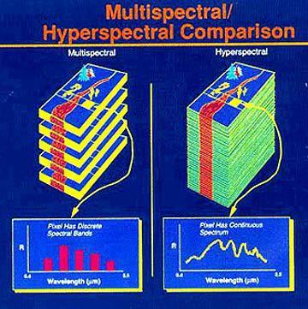Multispectral imaging processing is faster and easier with its smaller data set whereas Hyperspectral imaging having larger complexity of data, higher resolution spectra and it is more versatile having various emerging applications. Figure 2.2 shows the major differences between a hyperspectral and a multispectral image

Figure 2.2: Difference between multispectral and hyperspectral images Image source: (Peg Shippert, 2009).

# Application of satellite image technology

1. Satellite Imaging Corporation provides satellite imagery that is applicable in agricultural assessments and analysis (crop health & growth assessment, irrigation system charting, crop yield evaluation and assessment of soil vulnerability).
2. Remote Sensing provides imperative information for such evaluations as resources management and ecological vulnerability study.
3. Satellite imaging provides orthorectified imagery that is essential for the assessment and management of forest area and game reserves.
4. Satellite imaging provides vital data applicable to examine terrain dynamics, and military defensive operations.

# Sentinel Images

The Sentinel-2 mission is a land monitoring constellation of two satellites that provide high resolution optical imagery and provide continuity for the current (Satellite pour I’Observation de la Terre) SPOT and Landsat missions (Lillesand *et al.,* 2014). Sentinel-2 is a multispectral operational imaging mission within the (Global Monitoring for Environment and Security) GMES program, jointly implemented by the EC (European Commission) and ESA (European Space Agency) for global land observation (data on vegetation, soil and water cover for land, inland waterways and coastal areas, and also provide atmospheric absorption and distortion data corrections) at high resolution with high revisit capability to provide enhanced continuity of data so far provided by SPOT-5 and Landsat-7 (Martimort *et al.,* 2007). Sentinel-2 is the first satellite of a pair projected in the Sentinel-2 mission of the European program Copernicus and the European Space Agency (ESA). Different Sentinel missions are being deployed with satellites carrying various payloads designed for Earth Observation purposes (ESA, 2016). Sentinel-2 is equipped with multispectral instrument (MSI) for capturing spatial features and phenomena within 13 spectral bands of the EMS. Depending on the specific spectral band desired by the user, sentinel images spectral resolution ranges within 10m – 60m and currently, depending on the geographical latitude sentinel-2 has temporal resolution of 10 day. The launching of Sentinel-2A & 2B which were 2015 and 2017 respectively, boasted the temporal resolution to 5 days on the equatorial region and 2 to 3 days on mid-latitudes. The applicability of Sentinel-2 images in precision agriculture is a function of its improved resolutions (Spatial & Spectral) together with its non-commercialized access for the users.

# Application of sentinel_2 in precision agriculture

The use of Sentinel_2 imagery in agricultural applications requires an introduction period for users, which are less familiar with the unique properties of this sensor. The orbital constellation of Sentinel-2 satellite is configured to enable the acquisition of multispectral and higher resolution images with consistent global revisit period.

The Multi-Spectral Instrument (MSI) is the sensor carried as payload and has a push-broom configuration (Boschetti *et al.,* 2018). The MSI sensor acquires in 13 different spectral bands (Visible, NIR and SWIR) with a ground sample resolution (GSD) of 10 m. One of the objectives of sentinel -2 is to create a synergy with already existing land monitoring missions (e.g. USGS Landsat Thematic Mapper (TM) and Operational Land Imager (OLI) and the SPOT series). The use of sentinel images has helped in several ways to monitor crop growth, as a result of its resolution compared to other satellites images.

# Spectral Reflectance

* + 1. **Spectral reflectance properties of leaves**

Green plant leaves typically display very low reflectance and transmittance in visible regions of the spectrum (i.e., 400 to 700 nm) due to strong absorption by photosynthetic and accessory plant pigments (Chappelle *et al.,* 1992). By contrast, reflectance and transmittance are both usually high in the near-infrared regions (NIR, 700 to 1300 nm) because there is very little absorption by sub cellular particles or pigments and also because there is considerable scattering at mesophyll cell wall interfaces (Slaton *et al*., 2001). The disparity in reflectance properties between visible and NIR wavelengths substantiate a majority of remote procedures for monitoring and management of crop and natural vegetation. Plant stress typically results in lower chlorophyll concentrations that support expression of

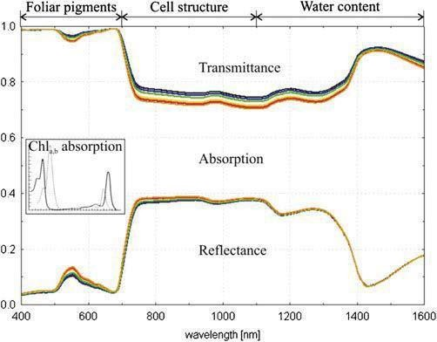accessory leaf pigments namely; carotenes and xanthophylls. This consequentially broadens the green reflectance peak (normally located near 550 nm) towards longer wavelengths, increasing visible reflectance and causing the tissues to appear chlorotic. Figure 2.3 shows Leaf reflectance, absorption and transmission.

Figure 2.3: Leaf reflectance, absorption and transmission. Image source: (Slaton *et al.,*

2001).

# Spectral reflectance properties of soil

The spectral signatures of most agricultural soils are relatively simple when compared with plants. They normally demonstrate monotonic proliferation in reflectance throughout visible and NIR regions (Prince, 1990). High soil water and high organic matter contents commonly cause lower reflectance while dry, smooth surfaced soils have a tendency to be brighter (Daughtry, 2001). The existence of specific minerals in soil has been linked with unique spectral features (e.g., higher red reflectance in the presence of iron oxides). Soil spectra in

SWIR display more features when compared with those observed in shorter wavelengths but are still controlled by water content, litter, and minerals (Henderson *et al.,* 1992).

# Vegetative indices for crop health estimation

Vegetation Indices (VIs) refers to mathematical compression of spectral bands that describes spectral features of green plants to differentiate them from other attributes. Some of these features can be achieved by summing up the red spectral band (chlorophyll absorbent) with the NIR bands (repellant), the shortwave infrared is another major feature to be considered (Njoku, 2013). This value is gotten by rationing their variations and summation by forming a single combination of band (Zhang and Ni-meister 2014).

(Solomon *et al.,* 2014), discovered that, vegetative indices in the red edge region are used as indicators of plant physiological stress, which implies the physical health of the plantations. One such parameter for the determination is the ratio of chlorophyll fluorescence (CF) emissions (red and far red light produced in photosynthetic tissue) between 690-740 nm which is inversely related to the amount of photosynthesis (Liew *et al.,* 2008) Plants growing under stressful conditions show leaf chlorosis which is a result of chlorophyll pigment disintegration in total chlorophyll concentration

(Adam et al 2014) stated that vegetation indices have been applied in several fields of Agriculture and forest management. For instance, (Weigand *et al.,* 1991) and (Zhang *et al.,* 2003) used NDVI and EVI respectively to monitor crop health. The illustration tells us that the highest NDVI value implies healthiness of the particular crop while the lower NDVI value suggests that the affected crops are weak or unhealthy (Dong *et al.,* 2016).also used vegetation indices to monitor different crops strength.

(Gunlu *et al.,* 2014).used the same indices to monitor the strength of forest plantations by employing several techniques such as k-nearest, neural network, multi-linear regression and nearest neighbor algorithm for the prediction of biomass. However, saturation was observed as a major challenge in implementing the VIs because it strongly affects the correctness of the estimation, which makes the final results unreliable (Lu *et al.,* 2014). Light reflectance from a vegetation surface depends on several factors among which is the amount and composition of the light that strikes the leaf surface, since solar irradiation varies with time and atmospheric conditions (moisture, clouds, dust particles and gases), which gives inconsistent results in repeated spectral data acquisition. To overcome such problems vegetation indices (VIs) are used for a more consistent interpretation of leaf properties using spectral data. Vegetation indices comprises of surface reflectance at two or more wavelengths or bands usually determined as ratios, differences or sums, at different wavelengths, or by using a linear combination of spectral data (Jackson and Huete, 1991). More related reviews are discussed in subsection 2.9

# Normalized Differential Vegetation Index (NDVI)

The Normalized Difference Vegetation Index (NDVI) is a numerical indicator that uses the visible and near-infrared bands of the electromagnetic spectrum, and is implemented to explore remote sensing measurements and evaluate whether the target being observed contains live green vegetation or not. The NDVI is a systematic procedure widely implemented for the measurement of crop health in agricultural applications, because of the variability in soil spatial properties, divers’ locations in a field may necessitate different aggregate of nitrogen to attain high yield (Ricotta *et al.,* 1999). Having ascertained the point information of NDVI, with the aid of Geo-statistics, the surface spatial continuity is produced

and the crop features are presented to remodel the precision agriculture. NDVI has been used in vegetation assessment since it has been found applicable for the estimation of crop yield, pasture efficiency, and rangeland capacity among others. It is often directly related to other ground parameters such as percent of ground cover, photosynthetic activity of the plant, surface water, leaf area index and the amount of biomass.

Healthy vegetation commonly absorbs significant portion of the visible light incident on it, and consequentially reflects a huge ratio of the near-infrared light while visible and less near- infrared light is reflected when the vegetation is unhealthy or sparsely distributed. The bare surface soil on the other hand fairly reflects both the red and infrared portion of the electromagnetic spectrum. NDVI focuses on the satellite bands that are most sensitive to vegetative information (near-infrared and red). The difference between the red and near- infrared reflectance is directly proportional to the vegetation distribution, which implies that; how vast the vegetation is depends on the hugeness of the difference.

This algorithm can be mathematically expressed as the subtraction of red reflectance from the near-infrared and dividing it by the summation of their bands respectively. Equation 2.1 represents the NDVI formula (Holme et al., 1987).

𝑁𝐷𝑉𝐼

(𝑁𝐼𝑅 − 𝑅𝐸𝐷)

= (𝑁𝐼𝑅 + 𝑅𝐸𝐷) (2.1)

This mathematical expression agrees that two indistinguishable patches of vegetation could exhibit distinct values if one were, for instance in bright sunbeams, and another under a cloudy sky. The bright pixels would all have larger values, and consequently a larger absolute variation between the bands. This is avoided by dividing by the sum of the reflectances.

Theoretically, NDVI values are represented as a ratio ranging in value from -1 to +1 but in reality, water is denoted by extreme negative values, bare soil represented by values near zero and green vegetation is symbolized by values that are beyond 6.

* + 1. **Plant reflectance and normalized difference vegetation index (NDVI)** Reflectance is referred to as the reflected energy proportion from an object to the energy incident on the object. Considerably, crops spectral reflectance varies in the near-infrared region and visible red denoted as λ within 700mm to 1300mm and 550mm to700mm of the electromagnetic spectrum respectively Kumar and Silva (1973). Generally, plants comparatively have low reflectance in the blue and red percentage of the EMS owing to the absorption of chlorophyll, with a little higher reflectance in the green; consequentially plants come into sight as green. The radiant energy off the near-infrared reflects keenly from the surface of plant leaf and the reflectance proportion is measured by the characteristics of the leaf tissue: their cellular structure and air-cell wall-protoplasm-chloroplast interfaces. These anatomy properties are impacted by environmental influences including soil humidity, nutritive status, soil salivation, and leaf phase (Ma *et al.,* 2001). The vegetation and soil variance are at optimum in the red and near infrared region. Therefore, spectral reflectance information is applicable to assess various indices of vegetation that are associated with agronomic and biophysical plant parameters related to photosynthesis process and productivity of plant (Ma *et al.,* 2001; Adamsen *et al.,* 1999). Since vegetative indices are sensitive to red and near infrared light, it has been found to be successfully applicable in plants photosynthesis process. The photosynthesis process of plant is a function of the chlorophyll activeness in the plant.

# Agricultural Diagnosis Test

* + 1. **Plant chlorophyll**

Chlorophyll is the green pigments in every green plant that aids the plant to source for energy from visible light. (Richardson *et al.,* 2002) described chlorophyll as the domineering factor that controls the optical properties of leaf for healthy green vegetation which is an indispensable component for photosynthesis. Hence, plants naturally absorb light energy from the sun to hoard it as their chemical energy. The plants use the energy to associate carbon dioxide and water into carbohydrate to support their life process. There may be many influences that affect the photosynthesis; the main factors are light intensity, carbon dioxide concentration, and temperature. The chlorophyll content could depend on seasonal and environmental changes. There are several methods to measure the content of chlorophyll. Figure 2.4 presents the corresponding absorption spectra of chlorophyll a and b pigments.

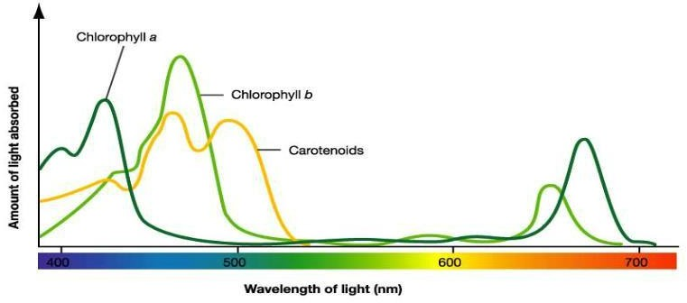

Figure 2.4: Absorption of spectra Chlorophyll a, b and carotenoids

Image source: (Richardson *et al.,* 2002)

The most important naturally occurring pigments essential for the oxygenic transformation of light energy are the chlorophyll a and b. The highest level at which chlorophyll a is absorbed transpires at 0.43 and 0.66 μm, while chlorophyll b is absorbed extremely from

0.45 to 0.65 μm. The comparative deficiency of the absorption of chlorophyll within the red and blue light region renders the leaves as green to sight.

# Application of leaf chlorophyll content

The adequate content of chlorophyll in leaves is unambiguously related to the capacity and efficacy of photosynthesis materials which makes available the helpful understanding regarding potential of photosynthesis and elemental production for land managers and eco- physiologist. Considering that nitrogen status is one of the substantial components of chlorophyll content, which implies that the nitrogen of leaf is entrenched in chlorophyll. In the light thereof, the assessment of the level of nitrogen in a plant can be achieved by taking measurement of the chlorophyll content so as to provide essential data foe adjusting the frequency of fertilization of nitrogen (Richardson *et al.,* 2002). In general, the process of shunting the destructive techniques of estimating vegetation chlorophyll content is attributed to considerable prominence to managing operations in agriculture, exceptionally to precision farming (Gitelson *et al.,* 2003). (Kaufman *et al.,* 2010) verified the scientific interest, that chlorophyll content is one of the criterions with ultimate prevalence to investigate hyperspectral studies in agriculture.

# Chlorophyll measurement

The level of concentration of chlorophyll in plants is normally measured with laboratory equipment called spectrophotometer. For several decades, discrete optically effectual techniques to carryout leaf chlorophyll content assessment efficiently without destructive process have been developed. Chlorophyll index is the output of the optical approach, having measured absorbance and reflectance of light in sample leaves (Gessner, 2014). The leaf

absorbance of chlorophyll distinctly within red and near-infrared regions of wavelength can be actualized with the use of chlorophyll-meter.

The measurement of the absorbance by the leaves of two different wavelengths in the spectral domain of red ad near-infrared can be actualized with the aid of chlorophyll-meters. Index- values are calculated as the output of the measured specific leaf chlorophyll content e.g. (SPAD-VALUE and CCI-value) SPAD value is the ratio between leaf reflectance in red- light at 650nm and in near-infrared light at 940mm. CCI-values is the variability red light and near-infrared light. The occurrence of strong chlorophyll absorption in the red-light domain and the evaluation of near-infrared light is achieved to register the leaf structural variability (Richardson *et al.,* 2002). It should be considered that the leaf chlorophyll content evaluation regresses with increasing chlorophyll content.

# Importance of chlorophyll measurement

Chlorophyll is the most profuse pigments in plants. This is responsible for the plant’s green leaves. Chlorophyll is profuse in plant leaves, through which the leaves absorbs light for the energy requirement for photosynthesis. The Chlorophyll’s absorbent of blue and red light in the absence of green light makes chlorophyll appears green. Photosynthesis which is the process whereby the plants green pigments (chlorophyll) utilizes sunlight to transform carbon dioxide and water into plants developing blocks. Considering nitrogen as a part of chlorophyll, the volume of nitrogen in the plant can be indirectly determined by measuring the chlorophyll in the plant. This possibility allows for extra resourceful inventorying of fertilizer applications. Photosynthesis is not only influential on plants; it is also significant to the sustenance of living things on earth, because plants through this process of photosynthesis consume carbon dioxide and gives out oxygen that we need to breathe.

# Tissue test

Tissue testing encompasses analyzing the foliar tissue (grass clippings) for nutrient content, Plant tissue testing contributes to the achievement of a significant level of fertilizer management precision. Carrijo and Hochmuth (2000). Regular tissue testing can help to make a diagnosis on the apparent nutrient or can aid the efficient management of fertilizer. Testing leaf tissues is functional for the assessment of the nutritive level of trees; hence it is specifically influential for macronutrients, primarily nitrogen (N) and potassium (K) that readily move with soil water.

# Importance of tissue test

* + - * 1. To confirm visual nutrient deficiency symptoms: It can be very hard to determine if a plant is experiencing nutrient deficiencies by just observing it in the field. Many individual nutrient symptoms look alike, and it can be hard to pinpoint exactly if a nutrient is deficient or other stress symptoms are present. A tissue test can confirm if a crop is suspected of being deficient of a specific nutrient.
        2. Monitor and adjust your crop fertility plan: Tissue testing can provide information to confirm if your fertility plan is working and help you evaluate new fertilizer placement or timing techniques. Tissue testing can also provide guidelines to farmers that are looking at applying a base level of nutrients with seeding and then topping up nutrient requirements in a foliar treatment.

1. Detect “hidden hunger”: Crops can experience minor nutrient deficiencies without showing any visual symptoms. A tissue test can point towards these minor nutrient needs that would otherwise go undetected. An application to address a small need can contribute to obtaining the crops top end yield potential.

# Pests and Diseases of Farm Crops

A pest is any living organism, which could be plant, animal or fungus, capable of invading another plant, animals or human. Pests can be insects, rodents, birds and other animals, weeds, fungi, or microorganisms such as bacteria and viruses that have a damaging influence on crops. It is a broad conception, that an organism can be a pest in some settings yet constructive, tamed or permissible in other settings. Animals are referred to as pests when they mutilates agricultural farm produce either livestock or crops by depending on them for their survival such as moth invading apples, weevils on cotton, rodents on groundnuts (Barrientos, 1998)., etc. Plate I show an example of farm pest

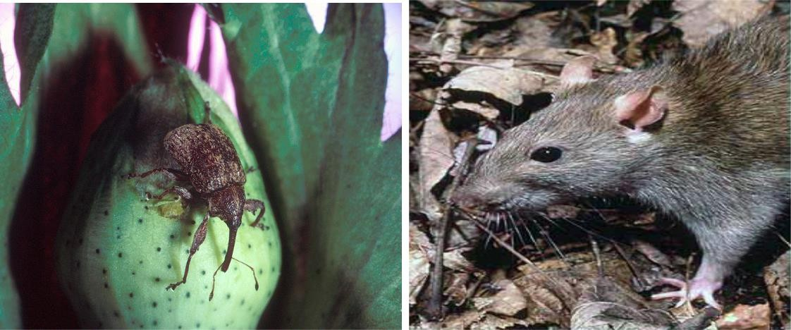

PlateI: Farm rodents (Barrientos, 1998)

# Ground nut

It is an herbaceous annual plant, cultivated for its oil and edible groundnuts. It is usually small, erect, has thin stem and leaves that are feather-like. Its leaves are in alternate pairs in arrangement and possess near the stalk, attachments that are leaf-like. This plant produces white, yellow, cream or orange flowers which yield pegs (Wright, 2012). Groundnut being an oil seed crop, it contains 40 to 49% oil. Apart from protein, groundnuts are resourceful for B, Zn, P, and Ca. The groundnuts also contain vitamin E and small amounts of vitamin B

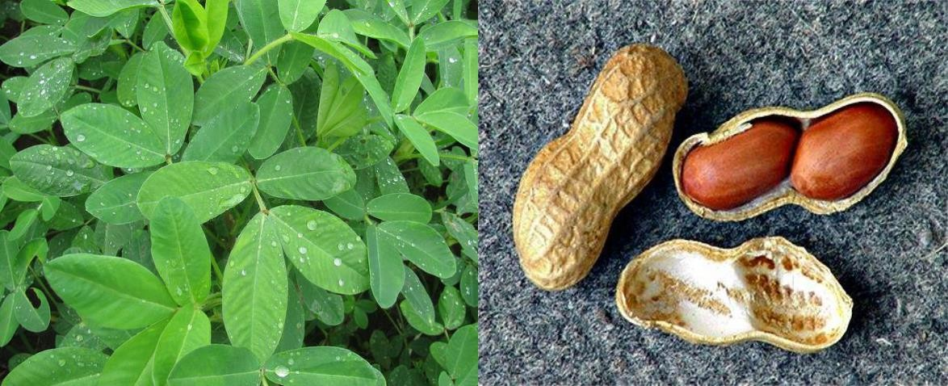complex. Below is an image of groundnut foliage and groundnut kernels. Groundnut is an annual plant, which survives only one growing season. Plate II shows an example of groundnut leaf and harvested seedlings

Plate II: Groundnut at germinating stage and after harvest Image source: (Wright, 2012)

Table 2.1 (a) Disease and symptoms of groundnut (Wright, 2012)

|  |  |
| --- | --- |
| **DISEASE** | **SYMPTOMS** |
| **Fungus** | * Numerous spots on upper surface of leaflets. * Entire plant or discrete parts may wilt and die. * Pods and stems become covered in fungal sclerotia. |
| **Charcoal rot** | * Water soaked lesion on stems of seedlings close to soil line * Lesions are initially water-soaked but turn brown, if lesions girdle the stem, plant wilts and branches die. * Infections beginning in the roots cause leave to turn yellow and wilt and cause stems to be   blighted. |

* + 1. **Soybeans (*Glycine max*)**

Soybean is a leguminous vegetable of the pea family that grows in tropical, subtropical, and temperate climates. Soybean was domesticated in the 11th century BC around northeast of China. It is believed that it might have been introduced to Africa in the 19th century by

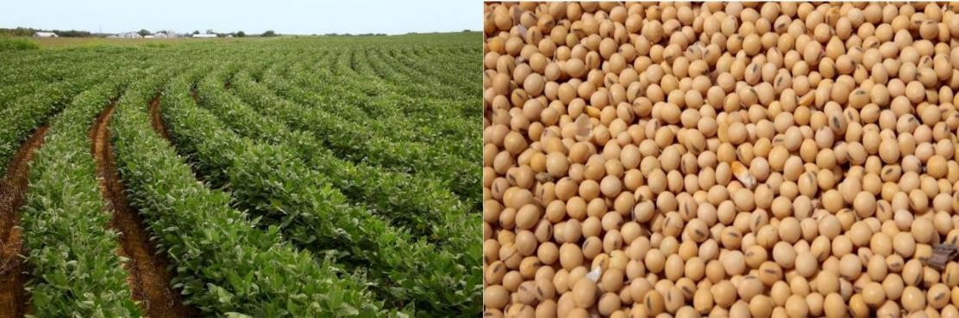Chinese traders along the east coast of Africa. (Earl, 2011). It contains a proportion of not less than 36% protein, 30% carbohydrates, and exceptional amount of dietary fiber, vitamins, and minerals. In addition, contains 20% of oil that makes it a significant crop for the production of consumable oil. Plate III shows an image of soyabean plantation and the harvested seedlings of the soyabeans. Table 2.3 shows a list of soyabeans diseases and their possible symptoms.

|  |  |
| --- | --- |
| **DISEASE** | **SYMPTOMS** |
| **Anthracnose** | * Foliar symptoms often occur at early reproductive growth stages with irregular shaped brown lesions that develop on stems, petioles and pods. * Premature defoliation may occur throughout the canopy on maturing plants when anthracnose lesion girdles the leaf petiole |
| **Bacterial blight** | * Leaf symptoms begin as small, angular, translucent, water soaked yellow to light brown spots. * As the spots age, their centers darken to a reddish brown become sunken and are surrounded by a water-soaked margin   bordered by a yellowish green |

Plate III: Soya beans farmland and seedlings (Earl, 2011) Table 2.2 shows diseases and symptoms of soya beans (Earl, 2011)

* + 1. **Cassava (*Manihotesculenta*)**

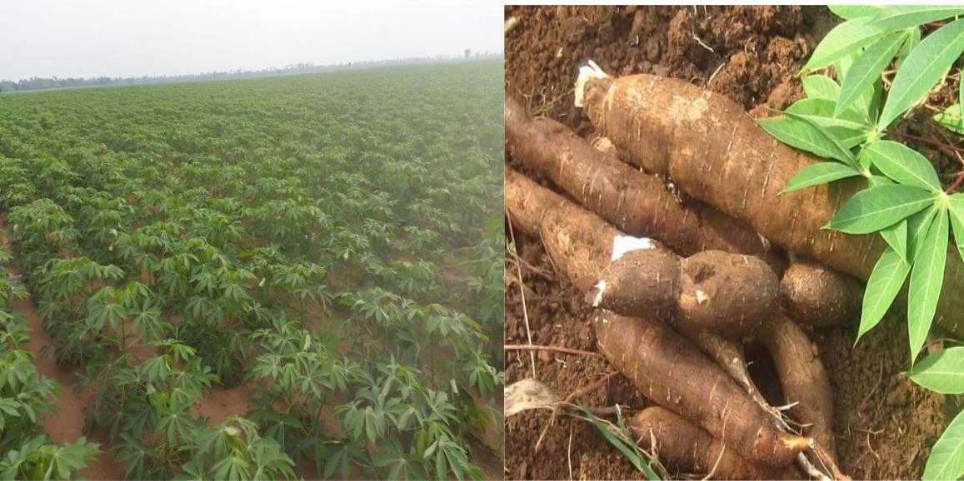Cassava has been proven to be one of the major indispensable foods in many sub-Saharan African countries (Hauser, 2006). The production and processing of Cassava persist to be predominantly habitual in most of the producing countries despite the high potentials for its commercial production and processing. Cassava roots are very rich in starch and contain small amounts of calcium (16 mg/100 g), phosphorus (27 mg/100 g), and vitamin C (20.6 mg/100 g). However, they are poor in protein and other nutrients. The cassava plant, grows exceptionally well in low fertility and drought prone environments (Howeler, 2012). Plate IV: shows cassava foliage and harvested cassava farm produce. Table 2.4 shows a list of cassava disease and symptoms.

Plate IV**:** cassava foliage and harvested cassava (Howeler, 2012)

Table 2.3: Shows diseases and symptoms of cassava

|  |  |
| --- | --- |
| DISEASES | SYMPTOMS |
| Witches broom | * Plants are stunted with an excessive proliferation of branches. * Shoots grows smaller leaves and shortened internodes; thus, no   chlorosis is present |
| Bud necrosis | * Patches of dark brown or gray fungal growth on stems * Necrotic areas covered by buds on   the stem. |

* + 1. **Rice (*Oryza Sativa*)**

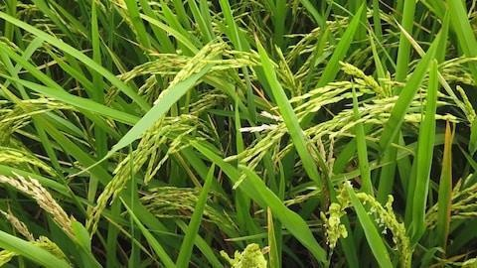Rice (Oryza sativa) is the major food crop in the world. Nearly 40% of the world population consumes rice as the major staple food. Most of the people, who depend on rice as primary food, live in the less developed countries. It is usually grown as an annual plant, but in the tropics, it can be grown as a perennial. (Roy *et al.,* 2011). Depending on the variability and soil, rice plants height ideally ranges from 1-1.8m. Rice is majorly cultivated on soils with great capacity to hold water though its growing and mature period (Siddiq *et al.,* 2005). Plate V illustrates rice plantation showing the growing grains. Table 2.5 shows a list of rice disease and symptoms.

Plate V: showing rice plantation: image source (Roy *et al.,* 2011)

Table 2.4: shows diseases and symptoms of rice (Siddiq *et al.,* 2005)

|  |  |
| --- | --- |
| **DISEASE** | **SYMPTOMS** |
| **Leaf streak** | * Water-soaked streaks between leaf veins which are initially dark green and then turn translucent. * Leaves turn brown and then gray-white in color before they die. * Streaks grow larger, coalesce and turn light brown in color. |
| **Rice bacterial blight** | * Water-soaked stripes on leaf blades. * Yellow or white stripes on leaf blades, leaves appear grayish in color.   • Plants wilting and rolling up, stunted growth. |

* + 1. **Yam *(Genus Dioscorea)***

Yams (Dioscorea species) are annual root tuber-bearing plants with more than 600 species out of which six are socially and economically important in terms of food, cash and medicine (IITA, 2009). There are different species of yam which include; water yam, Chinese yam, white yam, yellow yam etc. Ike and Inoni, (2006). They are cultivated in the tropical regions, and mostly cultivated in geographical areas where the dry and wet seasons of rainfall abound such as the savannah region of West Africa (FAO, 1997). Plate VI shows the leaf of a growing yam. Table 2.6 shows a list of yam disease and their symptoms.

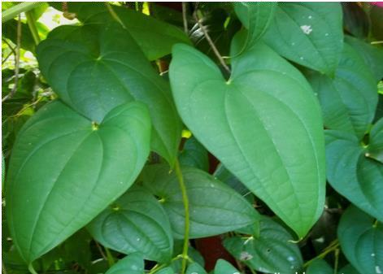

Plate VI: Foliage of a yam ([IITA, 2009)](http://www.growerjim.blogspot.com/)

Table 2.5: Disease and symptoms of yam ([IITA, 2009)](http://www.growerjim.blogspot.com/)

|  |  |
| --- | --- |
| **Disease** | **Symptoms** |
| **Anthracnose (Scorch)** | * Small, dark brown spots or black lesions on leaves which may be surrounded by a chlorotic halo * Leaf necrosis, dieback of stem, withered leaves and scorched appearance |
| **Yam mosaic disease** | * The common symptoms are infected leaves which show yellow and green patterns (called mosaics) between the veins or may show a narrow green strip bordering the veins (called vein banding). * If the disease is severe the leaves becomes long, thin and strap shape and whole plant become stunted. |

# Review of Related Literatures

Bunkei *et al,* (2007) studied a phenomenon, on the responsiveness of the EVI and NDVI on topographic effects: The both indices examined are global vegetation indices aimed at providing spatial and temporally consistent information about global vegetation. Several ecological factors that affect the accuracy of these indices were highlighted e.g. atmospheric

condition and soil background, these are potential error source and also the topographical factor is also non-negligible agent. The effect is likely to be greater at location of high mountain density; the soil adjustment factor “L” in the EVI makes it more responsive to topographic requirements compared with NDVI. Hence, the initial removal of the topographical effect from the reflectance data before the computation of EVI together with

other vegetation indices was recommended.

𝜌𝑛𝑖𝑟 − 𝜌𝑟𝑒𝑑

𝐸𝑉𝐼 = 𝐺 ×

𝜌𝑛𝑖𝑟 + (𝑐1 × 𝜌𝑟𝑒𝑑𝐶2 × 𝜌𝑏𝑙𝑢𝑒) + 𝐿

(2.2)

𝐸𝑁𝑉𝐼

= 𝐺 ×

𝜌𝑛𝑖𝑟⁄𝜌

𝑟𝑒𝑑−1

𝑟𝑒𝑑

(2.3)

𝜌𝑛𝑖𝑟

⁄𝜌

𝑟𝑒𝑑

+ 𝑐1 − 𝑐2 × 𝜌𝑏𝑙𝑢𝑒⁄𝜌

+ 𝐿⁄𝜌𝑟𝑒𝑑

𝑁𝐷𝑉𝐼

𝜌𝑛𝑖𝑟 − 𝜌𝑟𝑒𝑑

=

𝜌𝑛𝑖𝑟 + 𝜌𝑟𝑒𝑑

(2.4)

𝑁𝐷𝑉𝐼

𝜌𝑛𝑖𝑟⁄𝜌

= 𝜌𝑛𝑖𝑟⁄

𝑟𝑒𝑑−1

(2.5)

𝜌𝑟𝑒𝑑+1

Where G = Gain factor

𝜌𝑛𝑖𝑟 = 𝑅𝑒𝑓𝑙𝑒𝑐𝑡𝑎𝑛𝑐𝑒𝑎𝑡𝑛𝑒𝑎𝑟𝑖𝑛𝑓𝑟𝑎𝑟𝑒𝑑𝑤𝑎𝑣𝑒𝑙𝑒𝑛𝑔𝑡ℎ

𝜌𝑟𝑒𝑑 = 𝑅𝑒𝑓𝑙𝑒𝑐𝑡𝑎𝑛𝑐𝑒𝑎𝑡𝑡ℎ𝑒𝑟𝑒𝑑𝑤𝑎𝑣𝑒𝑙𝑒𝑛𝑔𝑡ℎ

𝜌𝑏𝑙𝑢𝑒 = 𝑅𝑒𝑓𝑙𝑒𝑐𝑡𝑎𝑛𝑐𝑒𝑎𝑡𝑡ℎ𝑒𝑏𝑙𝑢𝑒𝑤𝑎𝑣𝑒𝑙𝑒𝑛𝑔𝑡ℎ

𝐶1 𝑎𝑛𝑑𝐶2 = 𝐶𝑜𝑒𝑓𝑓𝑖𝑐𝑖𝑒𝑛𝑡𝑠𝑢𝑠𝑒𝑑𝑡𝑜𝑐𝑜𝑟𝑟𝑒𝑐𝑡𝑎𝑒𝑟𝑜𝑠𝑜𝑙𝑠𝑐𝑎𝑡𝑡𝑒𝑟𝑖𝑛𝑔

L = Canopy background

Owing to the fact that the topographic effect is in two categories, these are, direct and indirect topographic effect. A non-lambertian model for topographic effect model based was adopted

on the Bi-Directional Reflectance Function (BDRF) developed by (Mineart1941) which was one of the earliest surfaces statistical BDRF models. Equation 2.6 shows the lambertian model

cos 𝑒

𝐿𝑇 = 𝐿𝑜 (cos 𝑖 . cos 𝑒)𝑘 (2.6)

Where LT and LO are the radiance from an inclined surface and normalized radiance respectively and k is the Minnaert constant. The results of the study show that EVI is further responsive to topography in contrast with NDVI, thus, recommending EVI for addressing topographic and background soil noise simultaneously.

Meng and Wu-bing, (2007) also carried out an investigation on methods of monitoring crop condition using remote sensing approach and developing trend in china where emphasis was made on obtaining crop condition data at an early stage in crop growing season. The study enumerated five models for monitoring crop condition (health) which are thus;

1. Direct crop monitoring model
2. Classification models
3. Same-period comparing model
4. Crop growing process model
5. Diagnosis model

Emphasis was made on the universality of remote sensing using satellite images as the top and richest data source for monitoring a large-scale crop condition. Temporal sequence of NDVI within the crop period is utilized and profiles of crop growth are developed by acquiring statistics of NDVI at certain scale such as a province. Recommendation was made

that crop condition monitoring should be connected to crop yield assessment because the condition of a crop in particular has effect on the final yield of the crop.

Sabtu *et al.* (2013) examined the efficacy of geospatial technologies in tackling issues of crop pests and diseases distressing crop conditions and its impact on the overall yield rate of the entire population. Emphasis was made on the fact that remote sensing has not much been applied to a small area due to multiple land use and the limited size of the crops. Suggestion was made that GPS technology could be more applicable in such a situation.

Meera *et al.* (2015) carried out a temporal and spatial change examination over Vellore district of Tamil Nadu using multispectral images of landsat TM and INSAT, the landsat is a seven band images and the INSAT is a three-band remote sensing image. The reason for the INSAT is because it contains the major three bands necessary for the assessment of vegetation index. The images were downloaded from the National remote sensing of Vellore and the former from the USA NASA. The image processing and classification were carried out using ERDAS IMAGINE remote sensing software. The remote sensing technique adopted for this study is the Normalized Difference Vegetation Index (NDVI) and the span of the data used is 2001 and 2006. The NDVI analysis was repeated at different threshold of NDVI and the results yielded that, NDVI in 2006 is greater than that of 2001, this is as a result of high vegetation recovered during this period and more land recovered from barrenness, which implies that there is increasing vegetation activities on the Valore district and more land are reclaimed from barrenness or aridity.

Cristiano *et al.* (2016) also came up with a study on Agronomic characteristics associated with the normalized difference vegetation index (NDVI) in the peanut crop. The objective of this study was to evaluate the normalized difference vegetation index (NDVI) generated by

a terrestrial sensor and its relationship with agronomic variables of peanut crops grown at different densities The variables of vegetation cover yield and plant population strongly correlated with the NDVI obtained by the terrestrial sensor. The results indicated that the NDVI obtained through the Green Seeker sensor can be used to estimate productivity, vegetation cover and plant population on peanut crop. This may provide an additional tool for farmers to evaluate the potential of their culture; enabling even that agronomic measures can take effect so that this potential is improved A map showing the distribution of NDVI values across the study site was provided with the index value from 0.0 to 1.0 at an interval 0.2, and physical judgment also agreed with the findings.

Analysis of variance (ANOVA) was implemented in order to check the correspondence between the NDVI obtained from the Green seeker sensor and the satellite remote sensing The regression analysis revealed that there was a quadratic positive magnitude of the NDVI versus yield resulting in a correlation of determination of 0.60. In the phonological growth stage studied, when the crop is fully developed, there may be homogeneity of reflectance, saturating the NDVI In order to draw a viable conclusion, the variation in the yield over the field was verified using exploratory statistical analysis which involved derivation of mean, standard deviations, minimum and maximum values likewise normality test was performed. At the initial stage of planting the NDVI was negative and tends to zero which is sensitive to soil. It shows that there is larger portion of the soil exposed and at the later stage of germination, specifically stage five; the NDVI has a greater value which reflects a progressive growth and potential good yield.

Ashish *et al.* (2017) reviewed the concept of Precision agriculture (PA) which was tagged otherwise as satellite farming or Site-Specific Crop Management (SSCM) is a concept of

managing the farming on the basis of carrying out observation, measurement, and acknowledgement of inter and intra-field inconsistency in crops. The aim of precision agriculture is to develop a Decision Support System (DSS) development for overall farm administration with the for the purpose of ensuring optimum yields from inputs whereas conserving resources.

Ashishi *et al.* (2017) also traces the history of PA to the green revolution in 1960s and judged that in the very few years to come, the need for human power in farming will be less relevant due the advent of highly sophisticated machines equipped with the state-of-heart digital equipment for carrying out farming operation. The likes of these are: VRT, SSCM, GIS, and GPS. The tools require little contribution from man for their operation which strongly backs the earlier proposition that the need for man power in farming will be less relevant. So, technology will be highly dependable energy in farming.

Basic Steps in Precision Farming

The basic steps in precision farming are;

* 1. Variation Assessment
  2. Variation management and
  3. Estimation

Tiang *et al.* (2019) conducted a study about the prospective bands of sentinel 2 images for image classification in precision farming utilizing a five classes classification of land cover as the case study, The study explored classic index based classification methods and computer learning algorithm, Support Vector Machine (SVM) with four different approach for band selection in image classification; index based approach, index related band

approach, Mutual Information (MI) selected bands and full band approach. The result shows the learning algorithm (unsupervised) outperforms the classical approach and also an improved classification implementation may be accomplished by explicitly employing the bands selected subsequent to comparative MI rank order in accordance to utilizing empirical and specific bands that are indices related. This suggested methodology has been found to be applicable in effective monitoring process of vegetation, its physiology status detection as well as irrigation decision.

The work thus, recommended that prospective researches may be summed up in the following aspects:

1) Furthermore, exploring other information such as texture data may be added to the spectral band information.

2 Additionally, sophisticated classifying algorithms which include random forest and their variants can be explored.

**CHAPTER THREE**

* 1. **MATERIALS AND METHODS**

# Research Design

This chapter presents the method adopted in carrying out this research. It also describes the relevant details about the data and materials used for the research, their source, relevance, the processing operations carried out, and the work flow of the methodology employed to achieve the desired aim. Since one of the major issues encountered by farmers is basically on how to monitor their farm produce and prevent high loss, which is as a result of adopting classical and conventional ways by waiting for visible symptoms before applying preventive measures on such crops. Hence, this chapter provides detailed information on how to apply the use of GIS and remote sensing to address such issue.

Figure 3.1 shows the flow of the methods employed in this study, data acquired and processing while Table 3.1 presents the necessary software employed in this study and the purpose to which they were put.

Table 3.1: Software and tools used in this study

|  |  |
| --- | --- |
| Software | Purpose |
| ArcGIS 10.3 | Extracting vegetation indices pixel value |
| QGIS | Vegetation indices calculation |
| ENVI | For image classification |
| Microsoft excel | Descriptive statistics |
| SPSS | For performing statistical tests on results |
|  | Obtained |
| CorelDraw | For picture enhancement and merging |

Crop health data

from field

Crop location survey using DGPS

Hyperspectral R.S data (sendtinel -2 and landsat 8)

Crop location mappin

Image processing classification and analysis

Laboratory test and analysis



NDVI (Chlorophyll) analysis

Implementation of tasseled cap indices (greenness, wetness & brightness

Validation of NDVI values of sampled crops

Agricultural based crop health evaluation or assessment

Remote sensing approach of health evaluation or assessment

Statistical analysis

Suitability assessment of integrated approach of remote sensing for crop health assessment

Figure 3.1: Work flow of the methodology

# Data Acquisition

This study comparatively analyzed crop health status using agricultural-based approach and remote sensing (geomatics) approach. The data acquired were classified as remotely sensed data and field data, and their details are discussed in subsections 3.2.1 and 3.2.2.

# Acquisition of satellite image (Sentinel-2)

Remote sensing is daily evolving. Several types of data that are remotely sensed can be used in extraction of normalized difference vegetation index so far, the necessary channels were included in the satellite acquiring the images. LANDSAT, SPOT, Sentinel and so on are examples of satellites equipped with the channels (acquiring different bands) that can acquire data about earth features in varied spectral bands. One of the distinguishing differences among these satellites is the resolution of the image they are acquiring (due to the differences in the facilities they are equipped with, the altitude at which they are operating among others). Resolution of satellite images determines the accuracy of the product gotten from these images. This study employed sentinel image. Sentinel image is open source imagery from European Space Agency (ESA). ESA has continuously been launching satellites into space for the purpose of earth observation and global monitoring. Different sentinel missions in space which include: sentinel 1-5 and sentinel 5P. From multi-perspective view of various researchers in monitoring and estimation of crop health, Sentinel 2 is widely used because of its ability to penetrate into the soil. A sentinel-2 image was obtained from European Space Agency (ESA) (www.copernicusdata hub) for the month of August 2019. This was captured

in the growing season (rainy season). Spectral bands of Sentinel-2 have three different spatial

resolutions (10m, 20m, and 30m), so all the images were resampled at 20m spatial resolution.

Table 3.2 shows a list of data set acquired and there spectral, spatial and temporal resolutions. Table 3.2: spectral, spatial and temporal resolutions for dataset acquired

|  |  |  |  |
| --- | --- | --- | --- |
| **S/No** | **Sentinel-2 bands** | **Central wavelength(** μm**)** | **Resolutions (m)** |
| 1 | Band 1-Boastal  aerosol | 0.443 | 60 |
| 2 | Band 2- Blue | 0.490 | 10 |
| 3 | Band 3-Green | 0.560 | 10 |
| 4 | Band 4-Red | 0.665 | 10 |
| 5 | Band 5-Vegetation | 0.705 | 20 |
| 6 | Band 6-Vegetation | 0.740 | 20 |
| 7 | Band 7-Vegetation | 0.783 | 20 |
| 8 | Band 8-NIR | 0.842 | 10 |
| 9 | Band 8A-Vegetation | 0.865 | 20 |
| 10 | Band 9-Water  vapors | 0.945 | 60 |
| 11 | Band 10-SWIR | 1.375 | 60 |
| 12 | Band 11-SWIR | 1.61 | 20 |
| 13 | Band 12-SWIR | 2.190 | 20 |

# Acquisition of field data

Field data implies data captured about the sampled crops understudy. From the field, for the purpose of remote sensing analysis and agricultural laboratory analysis, crop samples and their coordinate positions were obtained from the field. The positioning satellite receiver (Garmin etrex – handheld GPS) was configured first to select the datum, unit. Clarke 1880 (Minna datum) was selected as the reference datum for the positioning while meter was selected as the unit of the coordinate values. Before recording the position of the sampled crops, enough satellites were ensured stabilized and observed by the receiver (to observe at 3m horizontal accuracy) then the coordinates were recorded in a projected universal transverse Mercator (UTM zone 32). The sampled crops include cassava, rice, soyabeans, yam, maize and groundnuts. Table 3.2 shows the sampled crops and their observed coordinate values.

Table 3.3: Sampled field crops and their position coordinates

|  |  |  |
| --- | --- | --- |
| **Point ID (crop)** | **Eastings (m)** | **Northings (m)** |
| **AGP1-334(Maize)** | 217321 | 1047389 |
| **AGP1-334(Groundnut)** | 217321 | 1047389 |
| **AGP2-335(Maize)** | 217360 | 1047446 |
| **AGP2-335(Groundnut)** | 217360 | 1047446 |
| **AGP3-336(Yam)** | 217352 | 1047528 |
| **AGP4-337(Yam)** | 217265 | 1047452 |
| **AGP5-338(Rice)** | 217352 | 1047565 |
| **AGP6-339(Rice)** | 217171 | 1047618 |
| **AGP8-341(Rice)** | 217145 | 1047675 |
| **AGP9-342(Rice)** | 217243 | 1047529 |
| **AGP10-343(Yam)** | 217174 | 1047476 |
| **AGP11-344(Yam)** | 217171 | 1047494 |
| **AGP12-345(Cassava)** | 217151 | 1047360 |
| **AGP13-346(Soyabeans)** | 217108 | 1047394 |
| **AGP14-347(Soyabeans)** | 217126 | 1047422 |
| **AGP15-348(Soyabeans)** | 217207 | 1047362 |
| **AGP16-349(Soyabeans)** | 217232 | 1047388 |
| **AGP17-350(Cassava)** | 217205 | 1047394 |
| **AGP18-351(Maize)** | 217201 | 1047360 |
| **AGP19-**  **352(Groundnut)** | 217174 | 1047385 |
| **AGP20-353(Soyabeans)** | 217249 | 1047348 |
| **AGP21-**  **354(Groundnut)** | 217271 | 1047337 |
| **AGP22-355(Maize)** | 217275 | 1047336 |
| **AGP23-356(Cassava)** | 217330 | 1047295 |
| **AGP24-357(Cassava)** | 217465 | 1047224 |
| **AGP11-344(Maize)** | 217171 | 1047494 |

# Data Processing

For the extraction of needful chlorophyll information and other crop related parameters, the sentinel-2 satellite imageries downloaded were processed using the required software. Also, for extraction of plant health information from the crops sampled from the field, tissue tests were carried out on the fetched field crops. This section contains the processes performed to achieve all these necessities. These processes include

1. Image classification
2. Implementation of NDVI
3. Verification and validation of NDVI (Tasseled cap indices)
4. Extraction of crop vegetation indices.

# Image classification

Classification in remote sensing implies grouping of picture elements on an image into different and similar spectral classes or groups. Classification in remote sensing is one of the approaches for identifying different features and segmenting them into various classes. We have supervised unsupervised and object-oriented technique of classifying images. The difference between these techniques is the degree of supervision by human users. Supervised classification which is always controlled by human expert is known to be the most accurate and reliable. Also, we have different type of classifiers (classifying algorithms) ranging from neural network approaches like SVM to software implemented approaches like maximum likelihood, minimum likelihood, mahanalobis, Supervised classification was performed in this study by making use of pre-installed SVM algorithm on ENVI software.

* + - 1. **Performing Supervised Classification using Support Vector Machine (SVM)** Import your satellite imagery “*Gara_july.tif*” files into the ENVI interface through the “file” button. After importing the file, then select the *“Region of Interest tool”* on the menu bar to create a training data for different feature classes to be classified.

When creating training data on the region of interest window, click on New ROI Change the Name and Color, of the feature class.

Start obtaining the sample training data by drawing polygon on the area of interest, and do the same for all the classes.

Save the training data by selecting file export export  to classic.

After creating the training data, then in the toolbox, select classification Classification  Support Vector Machine to select the SVM algorithm.

On the SVM pop up window, select the “Gara_july.tif” and then click next to select the trained data classes. *“Rock surface, Water bodies, Sandy soil, Clay soil, Vegetation”*. Change the location of the output file to the folder you desire.

Then click ok, for the classification to be done.

# Implementation of NDVI

Normalized Difference Vegetation Index is the most applicable of the many vegetation indices used in assessing plant health. This is as a result of the peculiarity of this study, this index was applied as a major remote sensing approach of assessing crops for their health status. As earlier introduced, NDVI ranges from -1 to +1 with negative ranges indicating water and built up areas while the positive region always indicating presence of crop and its health status. +1 indicates perfectly healthy crop which is many times not obtainable.

ArcGIS software was used to implement the algorithm. Raster calculator which allows arithmetic programming of raster images was the toolbox used in this study.

# Verification and validation of NDVI Using Tasseled Cap Indices (TCI)

Due to the sensitivity of this study, the vegetation index implemented in this study was verified and validated by using greenness index which is a part of tasseled cap indices (TCI).

# Tasseled Cap Indices

Tasseled Cap Transformation (TCT) algorithm was developed to map and assess vegetation changes as detected by different satellites. “Tasseled Cap” is a name that matches the shape developed from the graphical distribution of plotted data (Muhammad *et al.,* 2014). TCT converts the readings from set of bands into composite values. In this transformation, weights are assigned to individual bands as multiplicative constant and weighted sum of bands combined are taken for each of TC indices. Some of these weights are negative and some are positive. Three bands are commonly used in tasseled cap transformation-based analysis. Band one which is correspondence with image “brightness” gives a measure of soil brightness that used to develop brightness index. Band two is correspondence with “greenness “or photo synthetically-active vegetation to derive greenness index. The third tasseled-cap band is usually interpreted as an index of “wetness” in which describes the interconnection of soil and moisture.

TCI always provides a measure of Wetness, Brightness and Greenness of each picture elements. It makes use of linear combination of channels of satellite images (Landsat, SPOT, and Sentinel)

For the purpose of assessing the accuracy and effectiveness of the Sentinel-2A images for assessing vegetation indices, the tasseled cap indices (TCI) for the study area were

implemented on the acquired Landsat 8 image covering the same area, having 11 complete channels (11 bands) and captured within the same period of time just as the Sentinel images. These indices were programmed in the ArcGIS environment and served as a means to verify the correctness of the generated NDVI.

# Vegetation brightness index

The linear combination of satellite channels for tasseled brightness index is given as (Udaranga *et al.,* 2017; Muhammad *et al.,* 2014):

𝐵𝑟𝑖𝑔ℎ𝑡𝑛𝑒𝑠𝑠𝑖𝑛𝑑𝑒𝑥

= (0.3029 × 𝐵𝑎𝑛𝑑2) + (0.2786 × 𝐵𝑎𝑛𝑑3) + (0.4733 × 𝐵𝑎𝑛𝑑4)

+(0.5599 × 𝐵𝑎𝑛𝑑5) + (0.508 × 𝐵𝑎𝑛𝑑6)

+ (0.1872 × 𝐵𝑎𝑛𝑑7) (3.3)

Figure 3.2 shows the implementation of this algorithm in the ArcGIS environment.

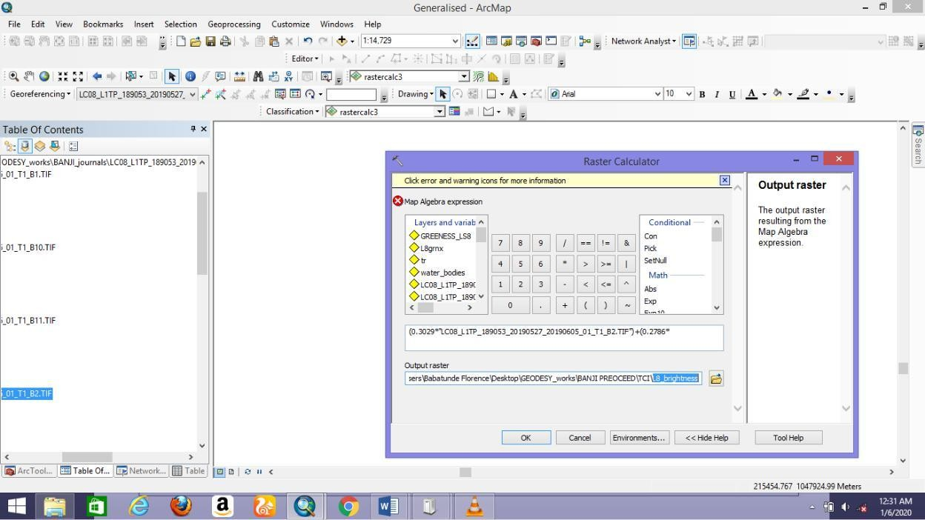

Figure 3.2: Implementation of brightness index

# Vegetation Greenness Index

The linear combination of satellite channels for tasseled greenness index is given as (Udaranga *et al.,* 2017; Muhammad *et al.,* 2014):

𝐺𝑟𝑒𝑒𝑛𝑒𝑠𝑠𝑖𝑛𝑑𝑒𝑥

= (−0.2941 × 𝐵𝑎𝑛𝑑2) + (−0.243 × 𝐵𝑎𝑛𝑑3) + (−0.5424 × 𝐵𝑎𝑛𝑑4)

+ (0.7276 × 𝐵𝑎𝑛𝑑5) + (0.0713 × 𝐵𝑎𝑛𝑑6) + (−0.1608 × 𝐵𝑎𝑛𝑑7)(3.4)

# Vegetation Wetness Index

The linear combination of satellite channels for tasseled wetness index is given as (Udaranga *et al.,* 2017; Muhammad *et al.,* 2014): Figure 3.5 shows the implementation of the algorithms in the ArcGIS environment

𝑊𝑒𝑡𝑛𝑒𝑠𝑠𝑖𝑛𝑑𝑒𝑥

= (0.1511 × 𝐵𝑎𝑛𝑑2) + (0.1973 × 𝐵𝑎𝑛𝑑3) + (0.3283 × 𝐵𝑎𝑛𝑑4)

+ (0.3407 × 𝐵𝑎𝑛𝑑5) + (−0.7117 × 𝐵𝑎𝑛𝑑6)

+ (−0.4559 × 𝐵𝑎𝑛𝑑7) (3.5)

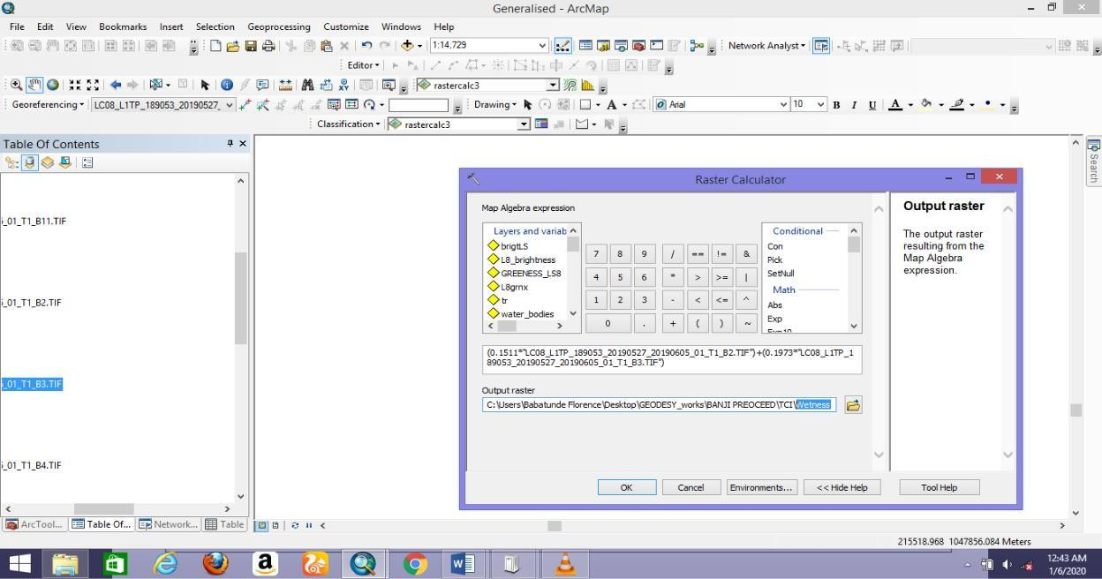

Figure 3.3: Implementation of wetness index

# Elimination of Soil brightness on the vegetation indices.

The spectral signatures of crop canopies (as seen from satellite images) in the field are more complex and often quite unrelated from those of single green leaves measured under carefully

controlled illumination conditions. (Huete, 1988) Even when leaf spectral properties remain relatively constant throughout the season, canopy spectra change vigorously as the proportions of soil and vegetation change and the architectural arrangement of plant components vary. Vegetation indices (VIs) provide a very simple yet elegant method for extracting the green plant quantity signal from complex canopy spectra. VIs exploits the basic differences between soil and plant spectra. Soil-adjusted VIs such as SAVI and modified SAVI has been developed to minimize effects of varying background soil reflectance properties on VI performance (Qi *et al.,* 1994).

This study further investigated the soil factor effect on the differences in the healthiness of the crops as seen from their spectral reflectance mapped from the vegetation indices. In this regard, the Soil-adjusted Vegetation Index (SAVI) was implemented to investigate the effect of the soil brightness on the computed NDVI and TCI.

NDVI products derived empirically have been noted for instability, varying in its form with soil color, soil moisture, and saturation effects from high density vegetation, in order to improve normalized vegetation index, postulated a vegetation index that corrected for the differential red and near-infrared extinction through the vegetation canopy. This is the Soil- adjusted Vegetation Index (SAVI) which is a transformation technique which minimizes soil brightness effect from spectral vegetation indices involving red and near-infrared bands. Equation 3.6 shows the equation for soil adjusted vegetation index (SAVI)

𝑆𝐴𝑉𝐼 =

(1 + 𝐿)(𝑁𝐼𝑅 − 𝑅𝐸𝐷)

(𝑁𝐼𝑅 + 𝑅𝐸𝐷 + 𝐿)

(3.6)

L Is a canopy background adjustment factor. (Huete, 1988) found out that a value of 0.5 in reflectance space minimizes soil brightness variations and eliminate the need for additional calibration for different soils. It really did eliminate soil-induced variations in vegetation

indices. Since the NDVI was produced with the sentinel images, the SAVI was also implemented with it in the ArcGIS environment. Figure 3.6 shows the programming for the implementation.

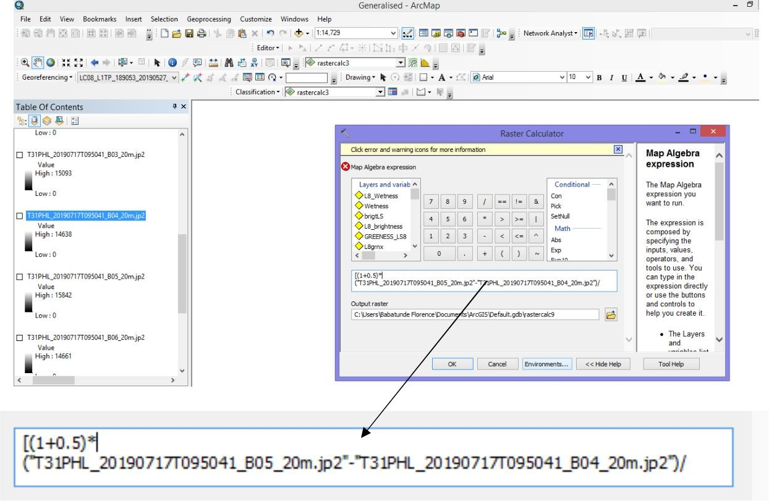

Figure 3.4: Implementation of SAVI algorithm

# Extraction of Crops Vegetation Indices

* + 1. **Extraction of crops NDVI**

Remote sensing techniques allow generalization of phenomenon. The NDVI map produced in this study covers the entire area. For the purpose of sampling and streamlining the vegetative analysis in the study area, the NDVI values of the sample crops were extracted from the map produced. To extract the unique NDVI values of the crops, the map was reclassified in form of digital number using the index distribution. Figure 3.7 shows the

NDVI unique values across the study area. Having done this transformation, each crop’s values were extracted

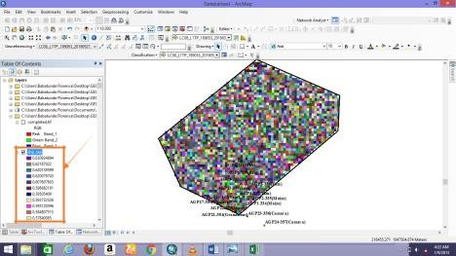

Figure 3.5: Extraction of crops NDVI

# Extraction of crops Greenness

The greenness index of the TCI is known to be an alternative for investigating vegetation healthiness. The map of the TCI bands (greenness, brightness and wetness) were produced as explained in section 3.3.4. Meanwhile, for proper assessment, the greenness of the sample crops was used as sample to assess and validate the NDVI map produced in this study. Greenness map produced in this study covers the entire area, for the purpose of sampling and streamlining the vegetative analysis in the study area. The greenness values of the sample crops were extracted from the map produced. To extract the unique greenness values of the crops, the map was reclassified in form of digital number using the index distribution. Figure

3.8 shows the greenness unique values across the study area. Having done this transformation, each crop’s values were extracted.

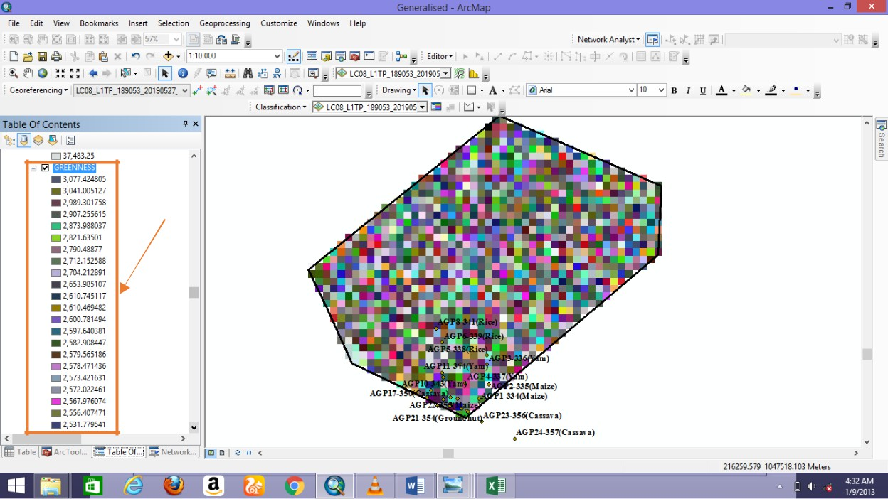

Figure 3.6: Extraction of crops greenness

Brightness and wetness values of the crops were also extracted and the analysis discussed in chapter four of this study.

# Sample Crop Tissue Test

* + 1. **Steps for carrying out tissue test**

Hand washing should be done by the person taking the sample at the time he/she takes the sample.

When the sample arrives at the laboratory, the following steps are typically taken.

# Step One: Be crop specific about crop sample

Different crops require different sampling times for optimal results.

# Step Two: Choose optimal leaves.

In general, the uppermost, recently mature leaves from a plant will provide the most ideal plant sample. Typically, young developing leaves and older mature leaves will not accurately reflect the nutrient status of the whole plant.

# Step Three: Use healthy tissue.

Plants should not come from areas of the field that have experienced long periods of stress. This stress includes, but is not limited to: drought, heat, standing water, nutritional stress, mechanical damage, disease damage and insect damage. If parts of the field are stressed, these areas should be sampled separately from the rest of the field so that a comparison can be done to determine the problem. Also, border rows and dead plants should not be included in the sample Mills and Jones (1996).

# Step Four: Collect a sufficient amount of plant material.

Be sure to follow instructions regarding the number of plants that should be sampled. In order for analysis to be accurate, the lab needs a sufficient amount of plant tissue. For example, when sampling pre-V5 corn plants, the sample should be about the same size as a softball when balled up. Before analysis can be performed, the sample must be dried, which will greatly decrease its weight and mass.

# Step Five: Randomize the plant selection process.

Randomly select plants, so that the sample is representative of the entire area. When the field being sampled is under stress, the number of plants sampled becomes even more important. These situations may require sampling more plants to accurately cover the variability in the field Mills and Jones (1996).

# Step Six: Avoid contamination.

If there is a chance that the plant sample could have fertilizer residue, soil, or other forms of contamination on the leaves or petioles, rinse the sample with bottled water. Tap water may contain ions such as iron, calcium and magnesium, which can affect analysis. After rinsing the plant tissue, it is critical to get samples to the lab quickly. The figure below presents tissue contents in plants and their physiological roles

# Analysis of tissue test

Tissue test results can be analyzed to give a chemical evaluation of nutritional status. Concentrations of essential elements found in indicator tissue reflect the nutritional status of plants. Accurate explanation of plant analysis results is paramount to effectively relate agricultural-based approach of estimating crop health to the remote sensing technique. Guidelines for interpretation of analytical results have been developed over years based on researchers’ findings, experience and studies. Plant analysis continues to advance as an imperative management tool as informative databases for various crops at different growth stage. Meanwhile authenticity of interpretive guidelines varies with the degree of research conducted on various crops. In the guidelines, sufficiency ranges are always stated which indicate the expectation of nutrients contents in an ideal crop, these values are always based on surveys and experience. In this study, sufficiency ratio of the crop nutrients from tissue test was obtained as shown in table 3.4 containing the growth stage of the crop species (synonymous to their field growth stage during laboratory test) and the author who propounded the standard.

Table 3.4: N-P-K expected standard ratio for sampled crops

|  |  |  |  |
| --- | --- | --- | --- |
| **S/No** | **Crop species** | **Growth stage at** | **Ideal crop N-P-** |
|  |  | **sampling period** | **K nutrient ratio** |
|  |  |  | **(%)** |
| **1** | Groundnut | All growth stage | 3.5:0.2:1.7 |
| **2** | Maize | Tasseling | 2.7:0.25:1.7 |
| **3** | Rice | Mid-tillering | 2.8:0.14:1.5 |
| **4** | Soyabeans | Flowering | 3.25:0.26:1.7 |
| **5** | Cassava | Actively growing | 4.0:0.3:1.5 |
|  |  | crops |  |
| **6** | Yam | Actively growing | 4.0:0.3:1.5 |
|  |  | crops |  |

Meanwhile, the N-P-K ratio which is an expected standard for an ideal healthy crop is spatio- dependent and also the soil content. Assumptions were made in this study that the standard is befitting for the study area since no work in this field has been done to deduce the standard expected nutrient contents.

# Best fit PCA Model for Transforming NPK into NDVI

The focus of this study is to evaluate the applicability of remote sensing technique for estimating crop health status and to investigate its effectiveness if sufficient enough to serve as an alternativeto the long-process and expensive approach of agriculture. This poses the need to relate the results of the two approaches. Because of the differences in the outputs of the two techniques; remote sensing estimating crop health in form of NDVI and agricultural- based in form of macro nutrients (Nitrogen, Phosphorus and Potassium) there is need to develop a best fit model that transforms one to the other.

PCA is an acronym for Principal Component Analysis which is a statistical or mathematical procedure that transforms the original coordinates or original state of a dataset into a new set of coordinates called principal components. Here, a model is developed to transform the NPK values to a scale synonymous to the NDVI scale. This will allow comparative analysis to be performed between the two approaches. Equation 3.7 shows the general transformation model (PCA model) from N-P-K to NDVI.

𝑇𝑇𝑁𝐷𝑉𝐼 =

[𝑁𝑖 + 𝑃𝑖 + 𝐾𝑖 ]

𝑁𝑠 𝑃𝑠 𝐾𝑠

3

(3.7)

Where= Nitrogen content of crop specie estimated from laboratory tissue test

= Standard Nitrogen content of an ideal crop specie as listed in table 3.4

= Phosphorus content of crop specie estimated from laboratory tissue test = Standard Phosphorus content of an ideal crop specie as listed in table 3.4

= Potassium content of crop specie estimated from laboratory tissue test = Standard Potassium content of an ideal crop specie as listed in table 3.4

= transformed NDVI value from laboratory estimated NPK content of crop species For instance, obtaining the transformed NDVI value of AGP1-334 (Maize) which has N:P: K ratio equivalent to 0.184:0.06:0.5,

[0.184 + 0.06 + 0.5

𝑇𝑇𝑁𝐷𝑉𝐼

𝑜𝑓𝐴𝐺𝑃1 − 334(𝑀𝑎𝑖𝑧𝑒) =

2.7

0.25

3

1.7]

[0.068 + 0.24 + 0.294]

=

3

[0.602]

=

3

= 0.201

Chapter four of this research contains the transformed results and other analysis.

**CHAPTER FOUR**

* 1. **RESULTS AND DISCUSSIONS**

# Land Cover Map of the Study Area

Figure 4.1 shows the spatial distribution of the existing land covers in the study area. This output was obtained from the classification performed using SVM algorithm (supervised classifier algorithm).

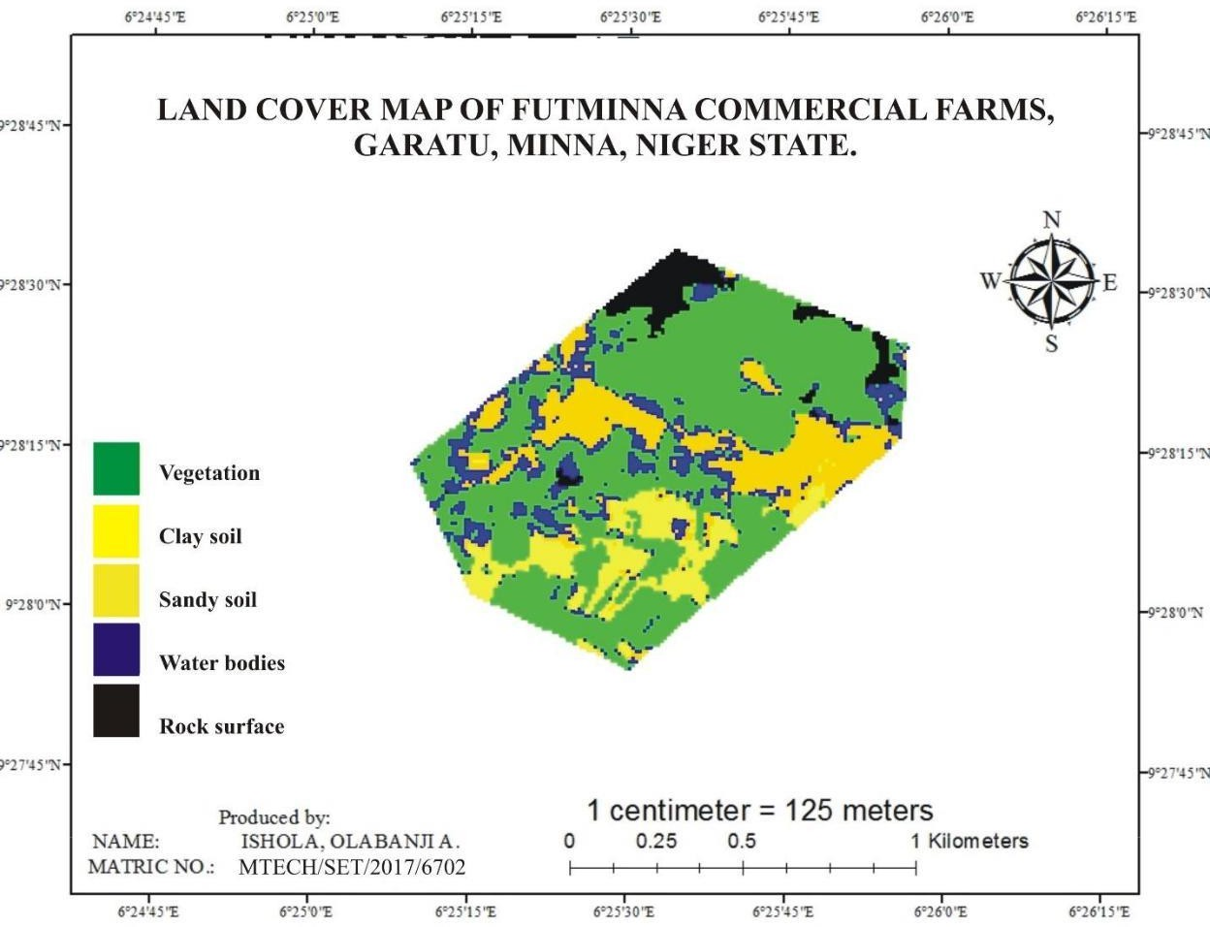

Figure 4.1: Land cover map of the study area.

Table 4.1 shows the area covered (in squares of metres) by each of the land covers in the study area.

Table 4.1: Land cover extents in the study area

|  |  |  |
| --- | --- | --- |
| **CLASSIFICATION** | **AREA** | **%** |
| **COVERAGE** | **(sq.m)** | **coverage** |
| **ROCKS** | 53246.442 | 5.138 |
| **CLAY SOIL** | 159432.769 | 15.383 |
| **VEGETATION** | 571254.779 | 55.119 |
| **WATER BODIES** | 73951.329 | 7.135 |
| **SANDY SOIL** | 178511.460 | 17.225 |
| **TOTAL** | 1036396.779 | 100 |

It is seen from table 4.1 that the study area is mostly covered by vegetation (55%) and is mostly found in the northern region of the study area. The water body in the study area is the least land cover type (7% of the entire extent). The non-vegetative areas in the study area are rocks, clay and sandy soil, these cover respectively 5.14%, 15.34% and 17.23% of the total extent of the mapped-out area of this study.

# Extraction of Vegetative Information (NDVI Map)

This map produced was to assess the health status of the crops in the study area measured by the chlorophyll content on the crops which can be mapped using the vegetation indices. Figure 4.2 shows the Normalized Difference Vegetation Index map of the study area. An NDVI value ranges from -1.0 - +1.0 with the negative regions indicating water areas or built up areas. Ideally, healthiest vegetation always has its NDVI value as +1.0.

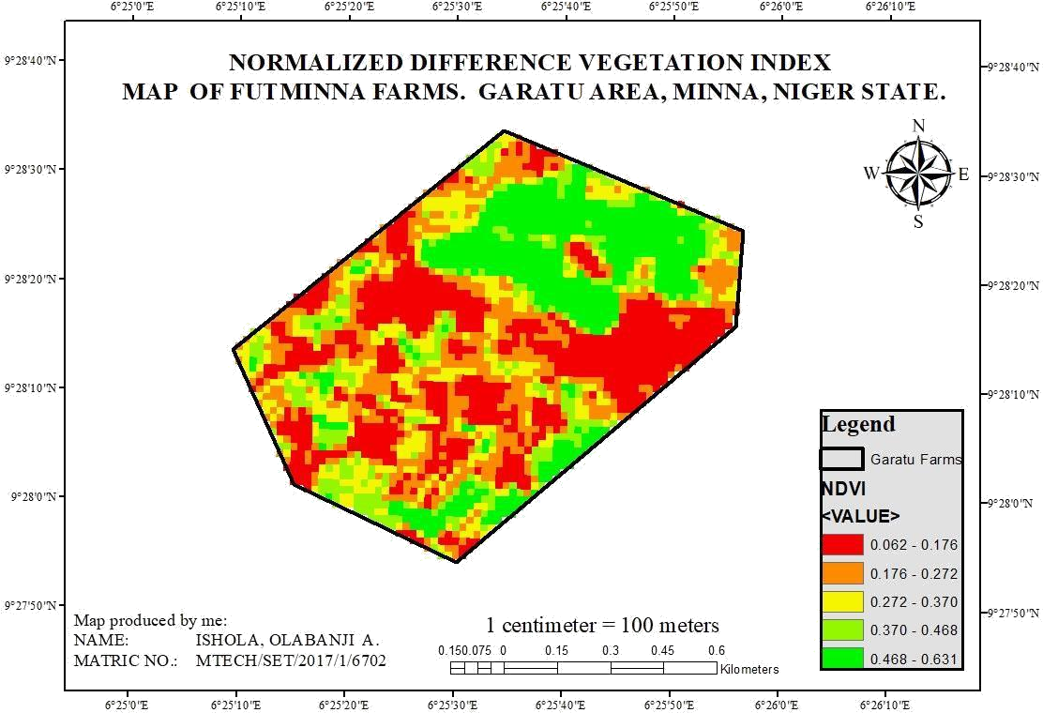

Figure 4.2: NDVI map of the study area

Figure 4.2 shows the vegetation index for the study area mapped using Sentinel-2 image with date of acquisition (from the download file metadata) as month of August. The vegetation index values range from 0.062-0.631. The Northern and far southern region of the study area shows the healthiest vegetation in the study area. Remote sensing as a technique for crop monitoring and any other applications require ground truthing. For this reason, crop sample data were collected from the field and figure 4.3 shows the spatial distribution of crop species collected from the field.

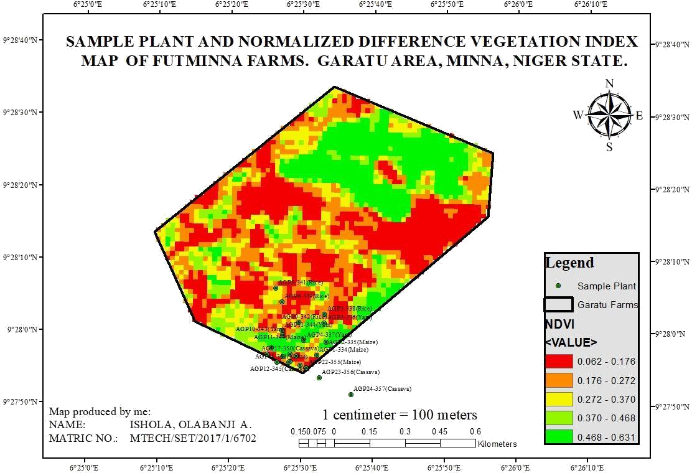

Figure 4.3: Sample plants overlaid on the NDVI for August

\In order to ascertain the applicability of remote sensing for monitoring crop health status, crop samples were collected from the field. Tubers and cereal crops in the study area were collected from the field and lab test carried out on them. The later section of this report shows the analysis of the agricultural lab test results carried out in the department of crop production, Federal University of Technology, Minna. The map shows that most of the cereal crops (including maize and groundnut) and some tuber crops are relatively the healthiest crops because their spatial locations on the NDVI map with indices value ranging from 0.468-

0.573. Out of the 24 sample crops fetched from the field, two sample cassava leaves (AGP 23-356 and AGP 24-357) were out of the boundary of the study, hence neglected in the further analysis. Table 4.2 shows the NDVI values of the sampled crops extracted as explained in section 3.3.6.1.

# Evaluating Crops Health

Table 4.2: Sample crops NDVI values

|  |  |  |  |
| --- | --- | --- | --- |
| **CROP SAMPLES** | **EASTINGS (m)** | **NORTHINGS (m)** | **NDVI** |
| **AGP1-334(Maize)** | 217321 | 1047389 | **0.263** |
| **AGP1-334(Groundniut)** | 217321 | 1047389 | **0.263** |
| **AGP2-335(Maize)** | 217360 | 1047446 | **0.573** |
| **AGP2-335(Groundnut)** | 217360 | 1047446 | **0.573** |
| **AGP3-336(Yam)** | 217352 | 1047528 | **0.363** |
| **AGP4-337(Yam)** | 217265 | 1047452 | **0.471** |
| **AGP5-338(Rice)** | 217352 | 1047565 | **0.185** |
| **AGP6-339(Rice)** | 217171 | 1047618 | **0.271** |
| **AGP8-341(Rice)** | 217145 | 1047675 | **0.300** |
| **AGP9-342(Rice)** | 217243 | 1047529 | **0.268** |
| **AGP10-343(Yam)** | 217174 | 1047476 | **0.154** |
| **AGP11-344(Yam)** | 217171 | 1047494 | **0.153** |
| **AGP12-345(Cassava)** | 217151 | 1047360 | **0.435** |
| **AGP13-346(Soyabeans)** | 217108 | 1047394 | **0.131** |
| **AGP14-347(Soyabeans)** | 217126 | 1047422 | **0.269** |
| **AGP15-348(Soyabeans)** | 217207 | 1047362 | **0.43** |
| **AGP16-349(Soyabeans)** | 217232 | 1047388 | **0.089** |
| **AGP17-350(Cassava)** | 217205 | 1047394 | **0.508** |
| **AGP18-351(Maize)** | 217201 | 1047360 | **0.43** |
| **AGP19-352(Groundnut)** | 217174 | 1047385 | **0.200** |
| **AGP20-353(Soyabeans)** | 217249 | 1047348 | **0.191** |
| **AGP21-354(Groundnut)** | 217271 | 1047337 | **0.103** |
| **AGP22-355(Maize)** | 217275 | 1047336 | **0.103** |
| **AGP11-344(Maize)** | 217171 | 1047494 | **0.153** |

Figure 4.4 shows a graphical representation of the sample crops and their NDVI values.

**NDVI**

Figure 4.4: Graph of sample crops NDVI

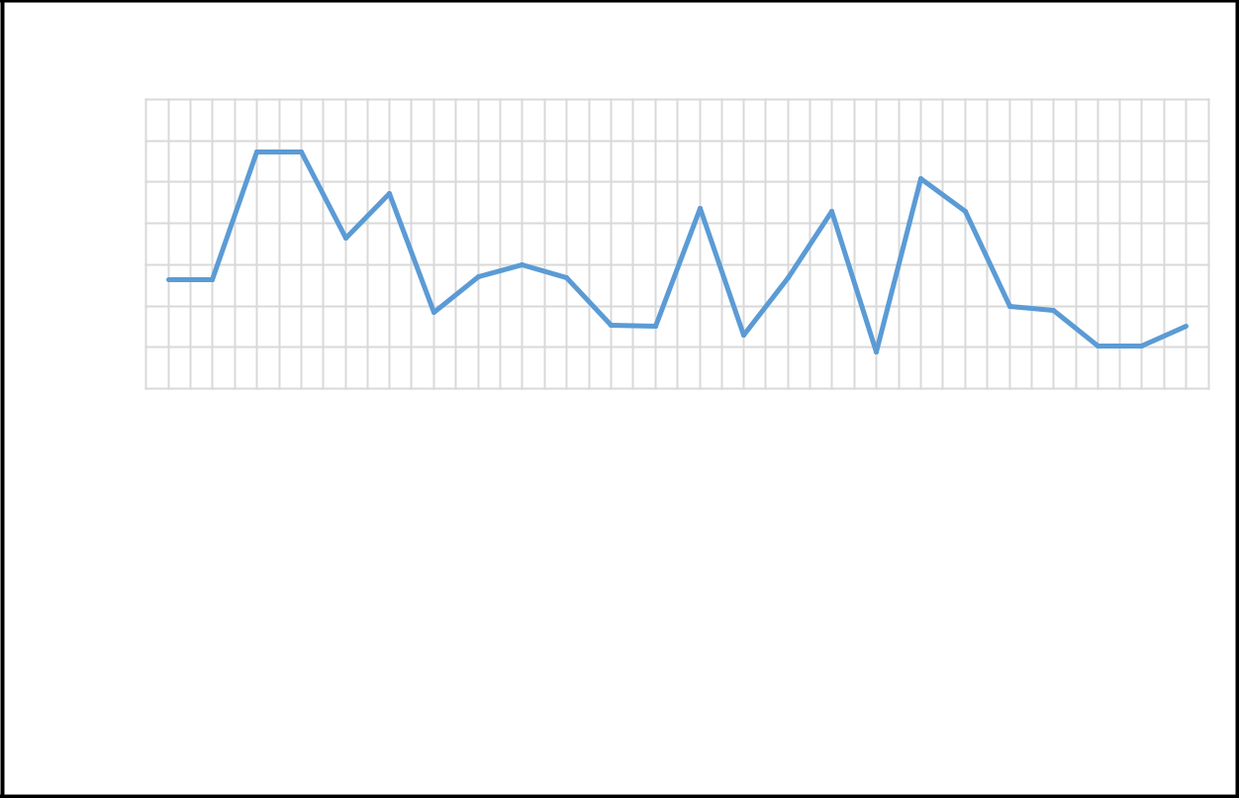

0.7

0.6

0.5

0.4

0.3

0.2

0.1

0

**Crop samples**

AGP1-334(Maize)

AGP1-334(Groundniut) AGP2-335(Maize)

AGP2-335(Groundnut) AGP3-336(Yam) AGP4-337(Yam) AGP5-338(Rice) AGP6-339(Rice) AGP8-341(Rice) AGP9-342(Rice) AGP10-343(Yam) AGP11-344(Yam)

AGP12-345(Cassava) AGP13-346(Soyabeans) AGP14-347(Soyabeans) AGP15-348(Soyabeans) AGP16-349(Soyabeans) AGP17-350(Cassava) AGP18-351(Maize)

AGP19-352(Groundnut) AGP20-353(Soyabeans) AGP21-354(Groundnut) AGP22-355(Maize)

AGP11-344(Maize)

The graph shows that AGP2-335, identity of maize and groundnut sample collected from the same spot from the field is recognized the healthiest crop samples as deduced from the NDVI map. Contrariwise, AGP16-349, identity for soyabean crop displays the least healthy sample crop collected from the study area. These indications can be clearly seen on the map tagged figure 4.2. Also, the greenness map explained in the later section of this chapter is a confirmation of the results gotten from the greenness map. From the crops NDVI values extracted, there is no specific pattern in the healthiness of crop species. It is clearly seen that crops in the far southern region of the study area (correlating with the analysis performed on the land cover map in section 4.1.1) are seen to be the healthiest. Crop species show different health status across the study area. This can be to effect of the soil type, the planting season

or the moisture content across the study area.Table 4.3 shows a categorization and summary of the NDVI values of crop species using regressioncorrelation.

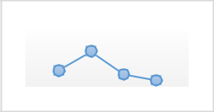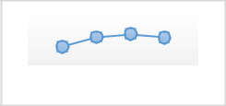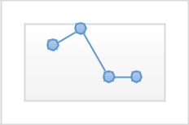Table 4.3: NDVI distribution and patters of species of crops

|  |  |  |  |
| --- | --- | --- | --- |
|  | **Crop identity** | **NDVI** | **Remark** |
| **Crop species** |  |  |  |
| **cassava** | AGP17-350(Cassava) & AGP12-345(Cassava) | 0.435-0.508 |  |
|  |  |  | Closely related |
| **Groundnut** | AGP1-334(Groundnut) AGP2-335(Groundnut) AGP19-  352(Groundnut)AGP21- 354(Groundnut) | 0.103-0.573 |  |
|  |  | Sparsely related |
| **Maize** | AGP1-334(Maize) AGP2-335(Maize) AGP22-355(Maize) AGP18-351(Maize) AGP11-344(Maize) AGP5-338(Rice) | 0.153-0.573 |  |
|  |  | Spaciously related |
| **Rice** | AGP6-339(Rice) AGP8-341(Rice) AGP9-342(Rice) AGP13-  346(Soyabeans)AGP14347( Soyabeans)  AGP15-348(Soyabeans) | 0.185-0.300 |  |
|  |  | Closely related |
| **Soyabeans** | AGP16-349(Soyabeans) bAGP20-353(Soyabeans) | 0.089-0.269 |  |
|  |  |  | Spaciously related |
| **Yam** | AGP3-336(Yam) AGP4-337(Yam) AGP10-343(Yam) AGP11-344(Yam) | 0.153-0.471 |  |
|  |  |  | Spaciously related |

# Greenness Map

Figure 4.5 is the greenness map of the study area in its general form. Greenness map depicts photo synthetically-active vegetation. It is an alternative means of measuring the presence of chlorophyll in vegetation, hence measure of health status of crops at their leave-shooting stages. This map is also an alternative for identifying vegetation covers in land covers. Unlike NDVI, there is no global range of values for “greenness” of vegetation an area of interest but it is established that there is a direct relationship between the greenness of a crop and the index values just like in the case of NDVI.

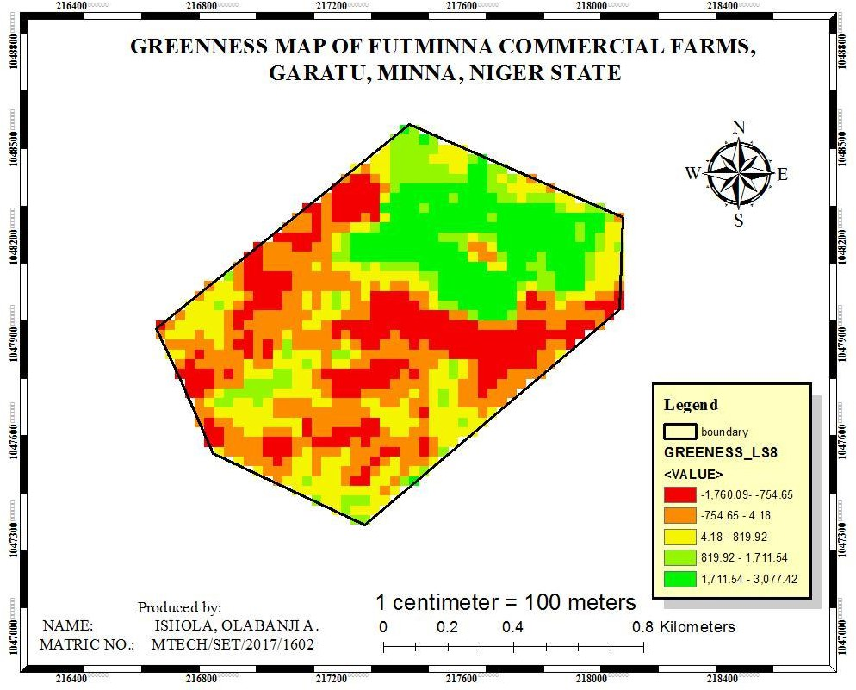

Figure 4.5: Greenness map of the study area.

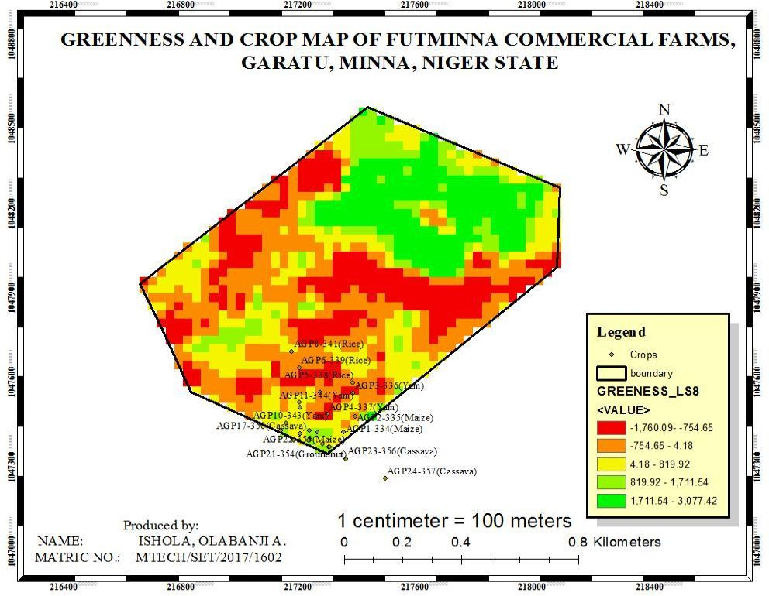The greenness values range from -1760.09 to +3077.42. This value is large due to the multiplicative constants and the band rationing leading to its production (combination of band 2 to band 7). With greenness index of the tasseled cap indices, negative greenness values could represent non-vegetative or brownish vegetation (indicating dying vegetation especially in the dry season). As earlier stated, the highest greenness value indicates the healthiest vegetation in the study area. Since they both measure the health status of vegetation, it is expected that the NDVI and greenness map should have a close correlation. Similar to the NDVI map, some part of the southern region and majorly the northern region of the study area has the healthiest vegetation in the study area with greenness value ranging from 1711.54-3077.42. To properly assess the relationship between the NDVI map and the greenness map, the greenness index values of the sampled crops were mapped and their values statistically assessed. Figure 4.5 and 4.6 shows the greenness and sampled crop maps. Figure 4.7 is a re-classified greenness map of the study area.

4.6: Greenness and sampled crop map of the study area.

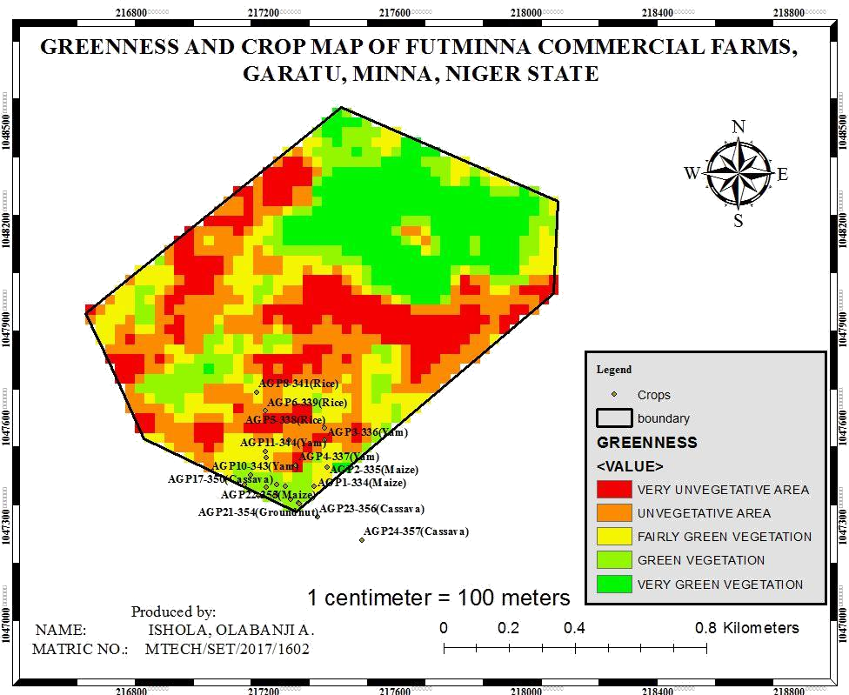

Figure 4.7: Reclassified greenness map of the study area.

For close examination, the greenness values of each of the sampled crops were extracted. Table 4.4 shows the extracted values for each of the sampled crops.

Table 4.4: Tasseled cap greenness index values of sampled crops

|  |  |  |  |
| --- | --- | --- | --- |
| **Point ID** | **POINT_X** | **POINT_Y** | **GREENESS** |
| **AGP1-334(Maize)** | 217321 | 1047389 | 433.289 |
| **AGP1-334(Groundnut)** | 217321 | 1047389 | 482.779 |
| **AGP2-335(Maize)** | 217360 | 1047446 | 1194.345 |
| **AGP2-335(Groundnut)** | 217360 | 1047446 | 1194.345 |
| **AGP3-336(Yam)** | 217352 | 1047528 | 467.432 |
| **AGP4-337(Yam)** | 217265 | 1047452 | 844.147 |
| **AGP5-338(Rice)** | 217352 | 1047565 | -443.132 |
| **AGP6-339(Rice)** | 217171 | 1047618 | -507.526 |
| **AGP8-341(Rice)** | 217145 | 1047675 | 433.289 |
| **AGP9-342(Rice)** | 217243 | 1047529 | -238.952 |
| **AGP10-343(Yam)** | 217174 | 1047476 | 87.193 |
| **AGP11-344(Yam)** | 217171 | 1047494 | 294.396 |
| **AGP12-345(Cassava)** | 217151 | 1047360 | 654.516 |
| **AGP13-346(Soyabeans)** | 217108 | 1047394 | 912.732 |
| **AGP14-347(Soyabeans)** | 217126 | 1047422 | 632.108 |
| **AGP15-348(Soyabeans)** | 217207 | 1047362 | 1167.972 |
| **AGP16-349(Soyabeans)** | 217232 | 1047388 | 1025.263 |
| **AGP17-350(Cassava)** | 217205 | 1047394 | 1161.671 |
| **AGP18-351(Maize)** | 217201 | 1047360 | 1167.972 |
| **AGP19-352(Groundnut)** | 217174 | 1047385 | 807.647 |
| **AGP20-353(Soyabeans)** | 217249 | 1047348 | 630.323 |
| **AGP21-354(Groundnut)** | 217271 | 1047337 | 1045.863 |
| **AGP22-355(Maize)** | 217275 | 1047336 | 1045.863 |

Figure 4.8 shows the graphical representation of the sampled crops and their greenness values.

- …

- …

- …

- …

- …

- …

- …

- …

- …

-

…

-

…

-

…

-

…

-

…

-

…

-

- …

- …

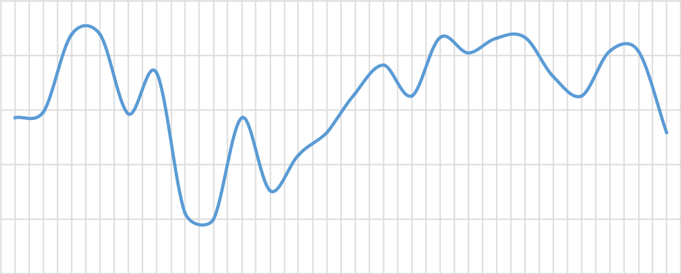Figure 4.8: Sampled crop greenness chart

1500

1000

500

0

-500

\ -1000

AGP11 AGP21 AGP19 AGP17 AGP15 AGP13 AGP11

AGP9-

AGP22 AGP20 AGP18 AGP16 AGP14 AGP12

AGP10

342(Rice)

AGP8-341(Rice) AGP6-339(Rice) AGP5-338(Rice) AGP4-337(Yam)

AGP3-336(Yam)

AGP2

AGP2

AGP1 AGP1

Table 4.4 shows some positive correlation with that of table 4.1 which signifies some positive strong correlation between the NDVI and Greenness maps of the study area. Meanwhile, some deviated away in their relationship. To assess the correlation between these vegetation indices, statistical regression analysis was performed using SPSS. Table 4.5-4.7 shows the summary of the analysis which was performed at 95% confidence interval. Table 4.5 shows the correlation and significant table for the parameters under analysis. A Pearson correlation output shown on this table signifies that the NDVI and GREENNESS indices values of the sampled crop is 57.7% positively correlated (0.577). This correlation reveals that there is a robust correlation between the two indices.

Table 4.5 Correlations

|  |  |  |  |
| --- | --- | --- | --- |
|  |  | GREENNESS | NDVI |
| Pearson Correlation | GREENNESS | 1.000 | .577 |
|  | NDVI | .577 | 1.000 |
| Sig. (1-tailed) | GREENNESS | . | .002 |
|  | NDVI | .002 | . |
| N | GREENNESS | 24 | 24 |
|  | NDVI | 24 | 24 |

The regression model summary is shown in table 4.6. The ‘R’ signifies multiple correlation value which in other words expresses the absolute correlation between the bivariate under analysis. The R-square is useful because it denotes the coefficient of determination of relationship between the variables.

Table 4.6: Model Summary

|  |  |  |  |  |  |  |  |  |  |
| --- | --- | --- | --- | --- | --- | --- | --- | --- | --- |
| Mode | R | R | Adjusted | Std. Error | Change Statistics | |  |  |  |
| L |  | Square | R Square | of the | R | F Change | df1 | df2 | Sig. F |
|  |  |  |  | Estimate | Square |  |  |  | Change |
|  |  |  |  |  | Change |  |  |  |  |
| 1 | .577a | .332 | .302 | 420.01484 | .332 | 10.956 | 1 | 22 | .003 |
| a. Predictors: (Constant), NDVI | | | |  |  |  |  |  |  |

Table 4.7 is the Analysis of Variance (ANOVA) analysis of the variables. It is not very useful to this purpose tells whether the regression equation is explaining significance in the relationship of the two variables. The table with the sig. value equal to 0.003 (less than 0.05, the p-value) signifies that there is significant difference in the distribution of values of the NDVI and the greenness indices which is obvious from their results.

Table 4.7: ANOVAb

|  |  |  |  |  |  |  |
| --- | --- | --- | --- | --- | --- | --- |
| Model |  | Sum of | df | Mean Square | F | Sig. |
| Squares | | | | | | |
| 1 | Regression | 1932862.702 | 1 | 1932862.702 | 10.956 | .003a |
|  | Residual | 3881074.262 | 22 | 176412.466 |  |  |
|  | Total | 5813936.964 | 23 |  |  |  |

* + - 1. Predictors: (Constant), NDVI
      2. Dependent Variable: GREENNESS

Figure 4.9 shows the scatter plot of the relationship between NDVI and Greenness values of the sampled crops in the study.

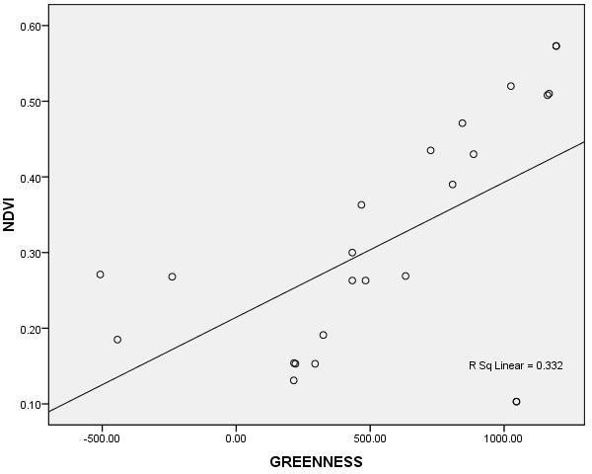

Figure 4.9: Scatter plot of the crop’s vegetation indices.

# Brightness map

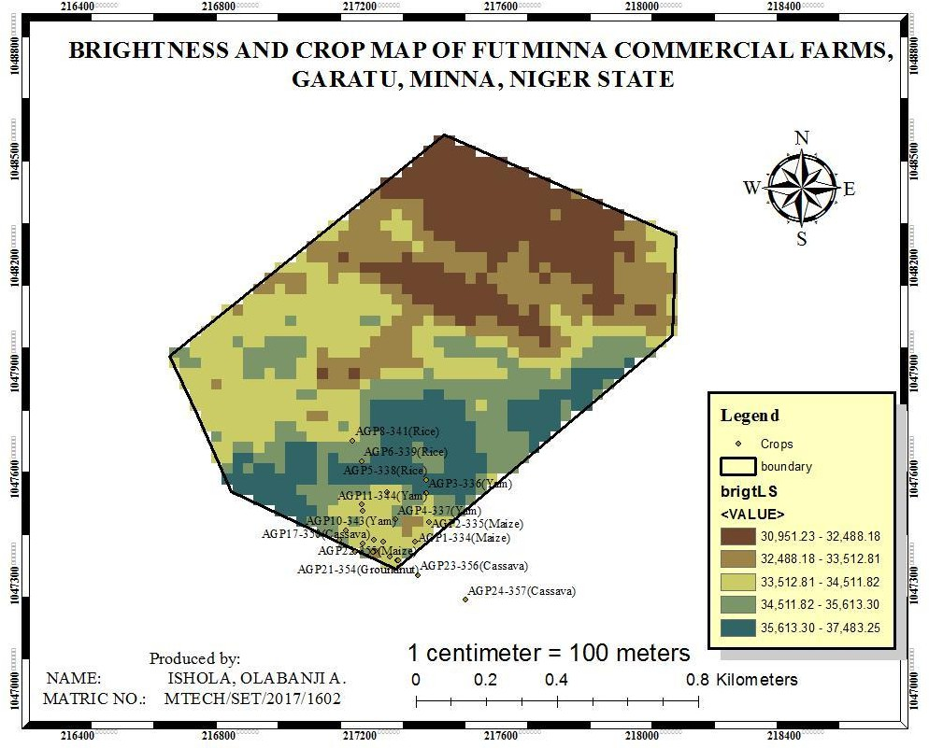Brightness of the tasseled cap indices (TCI) measures how bright-dark a given surface is. It does not necessarily measure the chlorophyll level of vegetation unlike the greenness index and its correspondence – NDVI but a measure of the brightness (texture reflectance) of all of the land covers in the study area. Figure 4.10 shows the brightness map produced from the TCI. The brightness values in the study area range from 30961.23 – 37483.25. These values only signify the level of brightness and are relative to one another. Just like the NDVI and greenness maps, the brightness map is rated in a direct proportion (Udaranga, 2017).

Figure 4.10: Brightness map of the study area

The deep-blue region of the study area signifies the brightest land covers in the study area and these are found mostly in the southern region of the study area. The region noted earlier for green vegetation (northern region) is here mapped, majorly, according to the TCI as the dullest land covers. This implies that the brightness index of the TCI has weak correlation with that of the NDVI or greenness and this is in synchrony with Udaranga *et al.* (2017) study. This hypothesis is statistically evaluated using the correlation statistical test to assess the relationship between the NDVI and brightness. Figure 4.11 shows the graphical representation of the sample crops brightness which was produced by making use of the extracted unique TCI values of each of the crops. It reveals that sample crops AGP3-336 (Yam) and AGP5-338 (Rice) has the highest brightness values (36,205.42 and 36,407.10 respectively).

|  |  |  |  |  |  |  |  |  |  |  |  |  |  |  |  |  |  |  |  |  |  |  |  |
| --- | --- | --- | --- | --- | --- | --- | --- | --- | --- | --- | --- | --- | --- | --- | --- | --- | --- | --- | --- | --- | --- | --- | --- |
| 37,000.00  36,500.00  36,000.00  35,500.00  35,000.00  34,500.00  34,000.00  33,500.00  33,000.00  32,500.00  32,000.00  31,500.00 | AGP1-334(Groundniut) | AGP2-335(Maize) | AGP2-335(Groundnut) | AGP3-336(Yam) | AGP4-337(Yam) | AGP5-338(Rice) | AGP6-339(Rice) | AGP8-341(Rice) | AGP9-342(Rice) | AGP10-343(Yam) | AGP11-344(Yam) | AGP12-345(Cassava) | AGP13-346(Soyabeans) | AGP14-347(Soyabeans) | AGP15-348(Soyabeans) | AGP16-349(Soyabeans) | AGP17-350(Cassava) | AGP18-351(Maize) | AGP19-352(Groundnut) | AGP20-353(Soyabeans) | AGP21-354(Groundnut) | AGP22-355(Maize) | AGP11-344(Maize) |

Figure 4.11: Crop sample brightness chart

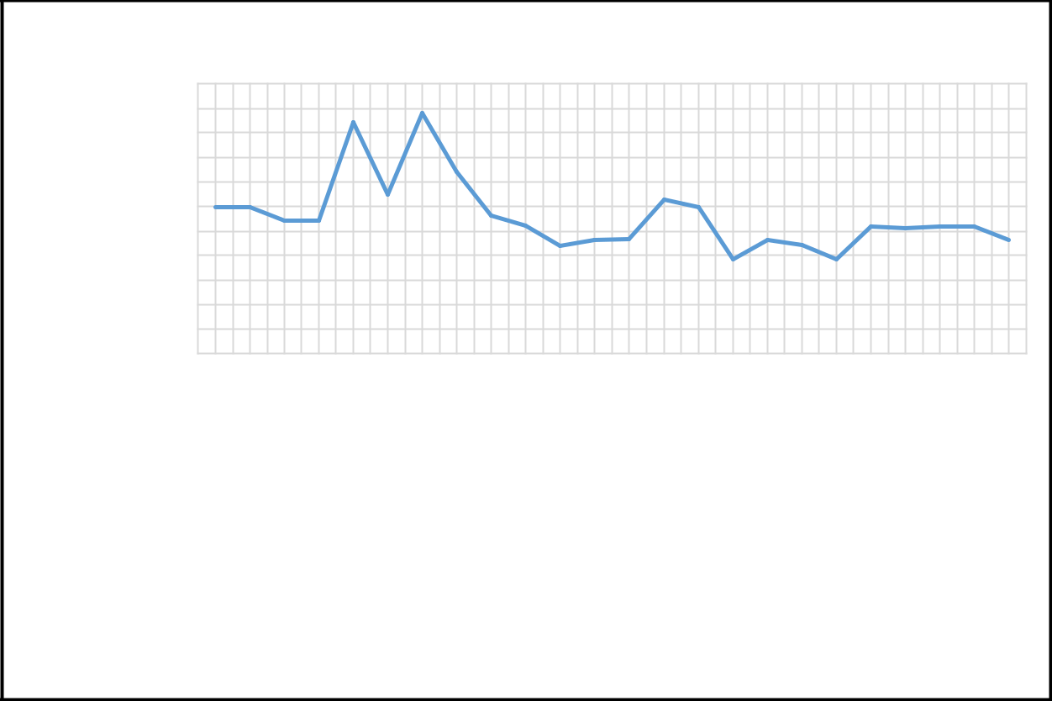

**Crop samples**

AGP1-334(Maize)

To assess the relationship and the applicability of the TCI brightness index for crop health estimation, the hypothesis that brightness index has weak correlation with the NDVI is statistically evaluated. Table 4.8 shows the correlation and significant table for the parameters under analysis. A Pearson correlation output shown on this table signifies that the NDVI and BRIGHTNESS indices values of the sampled crop are 17.5% negatively correlated (-0.175). This correlation reveals that there is a very weak correlation between the two indices.

Table 4.8: Correlations

|  |  |  |  |
| --- | --- | --- | --- |
|  |  | BRIGHTNES | NDVI |
|  |  | S |  |
| Pearson Correlation | BRIGHTNESS | 1.000 | -.175 |
|  | NDVI | -.175 | 1.000 |
| Sig. (1-tailed) | BRIGHTNESS . |  | .207 |
|  | NDVI | .207 |  |
| N | BRIGHTNESS | 24 | 24 |
|  | NDVI | 24 | 24 |

The regression model summary is shown in table 4.9. The ‘R’ signifies multiple correlation value which in other words expresses the absolute correlation between the bivariate under analysis. The R square is useful because it denotes the coefficient of determination of relationship between the variables. Also, with the R2 parameter, it is obvious that the brightness index is only a measure of the surface reflectance and does not relate to vegetation indices such as NDVI. This is to accept the hypothesis earlier stated and which is in total agreement to the study of Udaranga *et al.* (2017).

Table 4.9: Model Summary

|  |  |  |  |  |  |  |  |  |  |
| --- | --- | --- | --- | --- | --- | --- | --- | --- | --- |
| Mod | R | R | Adjusted | Std. Error | Change Statistics | |  |  |  |
| El |  | Square | R Square | of the | R | F | d | df | Sig. F |
|  |  |  |  | Estimate | Square | Chang | f | 2 | Change |
|  |  |  |  |  | Change | e | 1 |  |  |
| 1 | .175a | .030 | -.014 | 748.15721 | .030 | .692 | 1 | 2 | .414 |
|  | | | |  |  |  |  | 2 |  |
| a. Predictors: (Constant), NDVI | | | |  |  |  |  |  |  |

The analysis of Variance (ANOVA) analysis of the variables. It is not very useful to this purpose tells whether the regression equation is explaining significance in the relationship of the two variables. The table with the sig. value equal to 0.414 (greater than 0.05, the p-value).

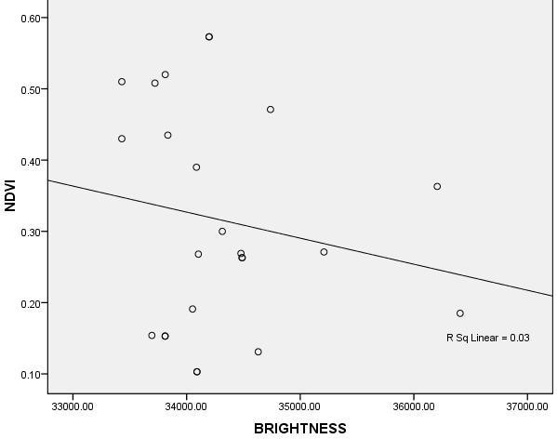Figure 4.12 shows the scatter plot of the relationship between NDVI and Brightness values of the sampled crops in the study.

Figure 4.12: Scatter plot with best-fit line of sample crops NDVI and BRIGHTNESS

# Wetness map

This is usually regarded as the third band of the TCI. This does not necessarily measure the greenness or healthiness of crops but provides information on the moisture content of soils and vegetation and its values are strongly influenced by the SWIR (Short wavelength Infrared) channels (bands). This map produced as the third component of the TCI is useful for evaluating the soil moisture effect on the variability in the healthiness of crops across the study. Figure 4.13 shows the wetness map of the study area.

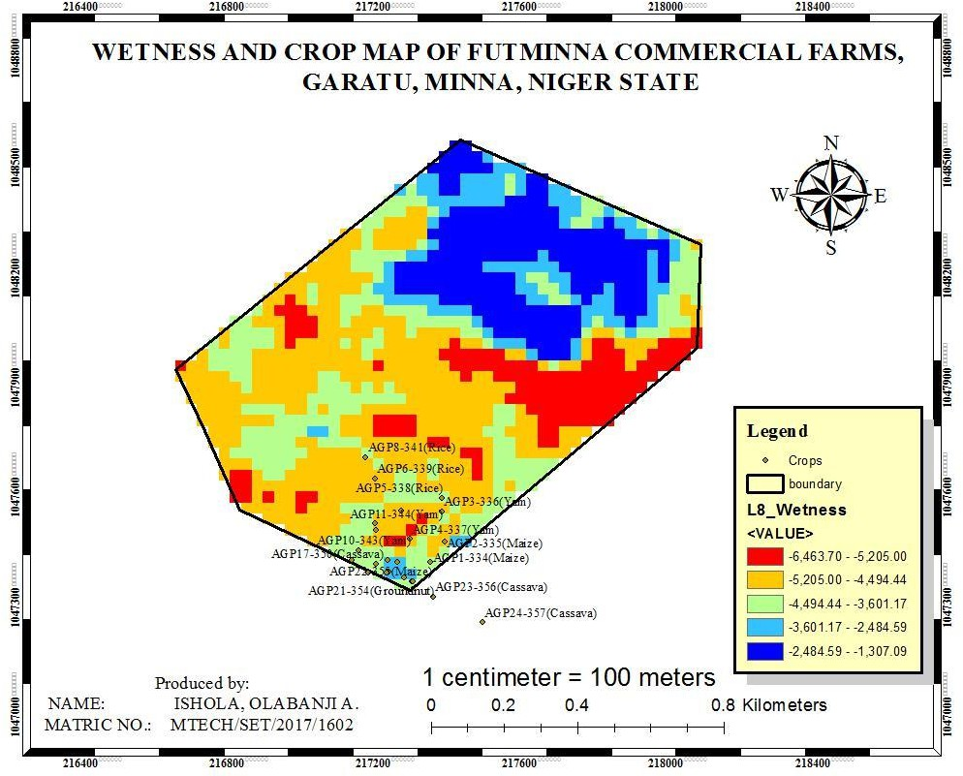

Figure 4.13: Wetness map of the study area

The wetness index values across the study area ranges from -6,463.70 to -1307.09. It can be clearly seen that the distribution of the soil moisture is directly proportional with the NDVI distribution. The northern region in figure 4.12 is seen to have the most moisturized soil which of course fosters crops growth. And this is also in agreement with the greenness and NDVI maps produced earlier that indicates that larger part of the northern region and some spots in the south region of the study area have the healthiest vegetation. The land cover map in figure 4.1 cab be referred back to in this effect; the northern region is largely surrounded by the larger portion of the water bodies present in the study area, the non-vegetative areas include sandy and clay soil and are here seen in figure 4.12 to have very little moisture.

# Agricultural-Based Crop Health Estimation

* + 1. **Laboratory tissue test result**

Table 4.11 shows the N-P-K (Nitrogen-Phosphorus-Potassium) content of each of the sampled crops estimated from series of laboratory test carried out. This is another lion part of this study which is geared towards assessing the applicability of remote sensing techniques for evaluating crop health. Explanation about tissue test has been largely done in chapter three of this report.

Table 4.10: Tissue test result

|  |  |  |  |  |  |  |
| --- | --- | --- | --- | --- | --- | --- |
| S/NO | Sample Description | Eastings | Northings | N% | P% | K+% |
|  |  | (m) | (m) |  |  |  |
| 1 | AGP1-334(Maize) | 217321 | 1047389 | 0.184 | 0.06 | 0.5 |
| 2 | AGP1-334(Groundniut) | 217321 | 1047389 | 0.181 | 0.06 | 0.65 |
| 3 | AGP2-335(Maize) | 217360 | 1047446 | 0.148 | 0.08 | 0.6 |
| 4 | AGP2-335(Groundnut) | 217360 | 1047446 | 0.146 | 0.02 | 0.9 |
| 5 | AGP3-336(Yam) | 217352 | 1047528 | 0.154 | 0.03 | 0.95 |
| 6 | AGP4-337(Yam) | 217265 | 1047452 | 0.14 | 0.03 | 0.7 |
| 7 | AGP5-338(Rice) | 217352 | 1047565 | 0.17 | 0.07 | 0.4 |
| 8 | AGP6-339(Rice) | 217171 | 1047618 | 0.158 | 0.08 | 0.3 |
| 9 | AGP8-341(Rice) | 217145 | 1047675 | 0.192 | 0.07 | 0.65 |
| 10 | AGP9-342(Rice) | 217243 | 1047529 | 0.129 | 0.02 | 0.5 |
| 11 | AGP10-343(Yam) | 217174 | 1047476 | 0.149 | 0.05 | 0.6 |
| 12 | AGP11-344(Yam) | 217171 | 1047494 | 0.187 | 0.08 | 0.55 |
| 13 | AGP12-345(Cassava) | 217151 | 1047360 | 0.175 | 0.02 | 0.45 |
| 14 | AGP13-346(Soyabeans) | 217108 | 1047394 | 0.218 | 0.11 | 0.6 |
| 15 | AGP14-347(Soyabeans) | 217126 | 1047422 | 0.123 | 0.03 | 0.7 |
| 16 | AGP15-348(Soyabeans) | 217207 | 1047362 | 0.138 | 0.05 | 0.6 |
| 17 | AGP16-349(Soyabeans) | 217232 | 1047388 | 0.177 | 0.03 | 0.6 |
| 18 | AGP17-350(Cassava) | 217205 | 1047394 | 0.18 | 0.05 | 0.75 |
| 19 | AGP18-351(Maize) | 217201 | 1047360 | 0.156 | 0.03 | 0.75 |
| 20 | AGP19-352(Groundnut) | 217174 | 1047385 | 0.172 | 0.03 | 0.7 |
| 21 | AGP20-353(Soyabeans) | 217249 | 1047348 | 0.166 | 0.04 | 0.45 |
| 22 | AGP21-354(Groundnut) | 217271 | 1047337 | 0.211 | 0.02 | 0.55 |
| 23 | AGP22-355(Maize) | 217275 | 1047336 | 0.196 | 0.06 | 0.6 |
| 26 | AGP11-344(Maize) | 217171 | 1047494 | 0.133 | 0.04 | 0.5 |

# Statistical Analysis for Objectives (2) and (3)

* + 1. **PCA implemented results**

In section 3.7.2.1 the PCA model was developed and an example of its implementation was done. Table 4.12 contains the transformed NPK contents of the sampled crops to its equivalent NDVI using equation (3.5).

Table 4.11: PCA obtained NDVI from NPK and remote sensing NDVI

|  |  |  |  |  |  |  |
| --- | --- | --- | --- | --- | --- | --- |
| S/NO | Sample Description | N% | P% | K+% | PCA obtained | Remote |
|  |  |  |  |  | NDVI | sensing NDVI |
| 1 | AGP1-334(Maize) | 0.184 | 0.06 | 0.5 | 0.201 | 0.263 |
| 2 | AGP1-334  (Groundniut) | 0.181 | 0.06 | 0.65 | 0.254 | 0.263 |
| 3 | AGP2-335(Maize) | 0.148 | 0.08 | 0.6 | 0.243 | 0.573 |
| 4 | AGP2-335  (Groundnut) | 0.146 | 0.02 | 0.9 | 0.224 | 0.573 |
| 5 | AGP3-336 (Yam) | 0.154 | 0.03 | 0.95 | 0.268 | 0.363 |
| 6 | AGP4-337(Yam) | 0.14 | 0.03 | 0.7 | 0.201 | 0.471 |
| 7 | AGP5-338 (Rice) | 0.17 | 0.07 | 0.4 | 0.237 | 0.185 |
| 8 | AGP6-339 (Rice) | 0.158 | 0.08 | 0.3 | 0.232 | 0.271 |
| 9 | AGP8-341(Rice) | 0.192 | 0.07 | 0.65 | 0.307 | 0.300 |
| 10 | AGP9-342 (Rice) | 0.129 | 0.02 | 0.5 | 0.162 | 0.268 |

Table 4.11: PCA obtained NDVI from NPK and remote sensing NDVI (CONTINUED)

To represent the relationship between the crop health status evaluated using the remote

|  |  |  |  |  |  |  |
| --- | --- | --- | --- | --- | --- | --- |
| 11 | AGP10-343(Yam) | 0.149 | 0.05 | 0.6 | 0.201 | 0.154 |
| 12 | AGP11-344(Yam) | 0.187 | 0.08 | 0.55 | 0.238 | 0.153 |
| 13 | AGP12-345(Cassava) | 0.175 | 0.02 | 0.45 | 0.148 | 0.435 |
| 14 | AGP13-346(Soyabeans) | 0.218 | 0.11 | 0.6 | 0.281 | 0.131 |
| 15 | AGP14-347(Soyabeans) | 0.123 | 0.03 | 0.7 | 0.188 | 0.269 |
| 16 | AGP15-348(Soyabeans) | 0.138 | 0.05 | 0.6 | 0.196 | 0.43 |
| 17 | AGP16-349(Soyabeans) | 0.177 | 0.03 | 0.6 | 0.174 | 0.089 |
| 18 | AGP17-350(Cassava) | 0.18 | 0.05 | 0.75 | 0.248 | 0.508 |
| 19 | AGP18-351(Maize) | 0.156 | 0.03 | 0.75 | 0.216 | 0.43 |
| 20 | AGP19-352(Groundnut) | 0.172 | 0.03 | 0.7 | 0.204 | 0.200 |
| 21 | AGP20-353(Soyabeans) | 0.166 | 0.04 | 0.45 | 0.166 | 0.191 |
| 22 | AGP21-354(Groundnut) | 0.211 | 0.02 | 0.55 | 0.171 | 0.103 |
| 23 | AGP22-355(Maize) | 0.196 | 0.06 | 0.6 | 0.222 | 0.103 |
| 26 | AGP11-344(Maize) | 0.133 | 0.04 | 0.5 | 0.168 | 0.153 |

sensing approach (from the obtained NDVI results using GIS) and that of the agricultural- based approach (from NPK transformed to NDVI using PCA), figure 4.14 shows the relationship between the estimated crop health.

|  |  |  |
| --- | --- | --- |
| 0.7 |  |  |
| 0.6 |  |  |
| 0.5 |  |  |
| 0.4 |  |  |
| 0.3 |  |  |
| 0.2 |  |  |
| 0.1 | ……  ……  ……  ……  ……  ……  ……  ……  ……  ……  ……  …… | |
| 0 |
| AGP11 | AGP12 | AGP22- AGP11- |
| AGRICULTURAL NDVI | REMOTE SENSING NDVI |  |

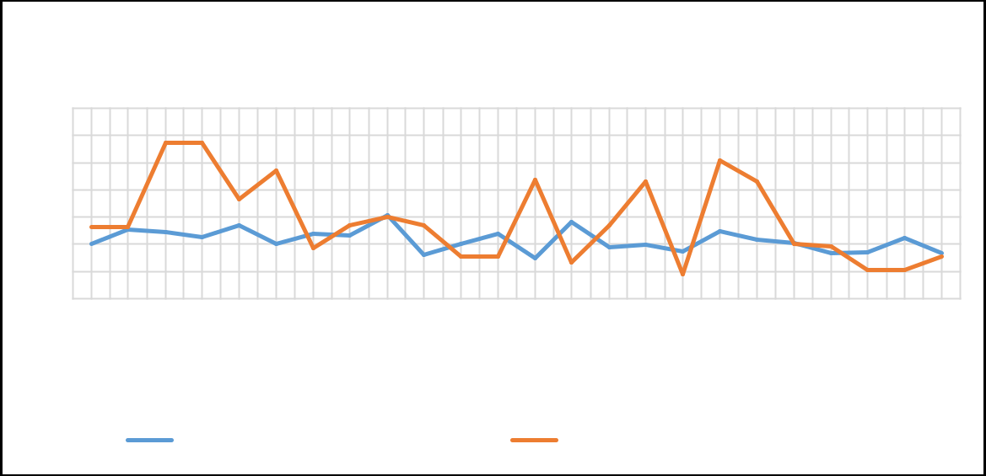Figure 4.14: Agricultural and Remote Sensing estimated NDVI

Figure 4.14 clearly shows that there are notable degrees of differences between the two techniques under consideration. Meanwhile to clearly investigate the relationship, a paired t- test analysis is performed using SPSS. This tool has been used to clearly see the deviations in the estimated crops health by the two techniques. Table 4.13 – 4.15 shows the output of the t-test analysis performed to investigate the differences between the two techniques

Table 4.12: Paired Samples Statistics

|  |  |  |  |  |
| --- | --- | --- | --- | --- |
|  |  |  |  | Std. Error |
|  | Mean | N | Std. Deviation | Mean |
| Pair 1 AGRIC_BASED_NDVI | .2146 | 24 | .04053 | .00827 |
| RS_BASED_NDVI | .3158 | 24 | .15557 | .03175 |

Table 4.13: Paired Samples Correlations

|  |  |  |  |
| --- | --- | --- | --- |
|  | N | Correlation | Sig. |
| Pair 1 AGRIC_BASED_NDVI  & RS_BASED_NDVI | 24 | 016. | . 939 |

Table 4.14 shows the correlations between the two techniques at 95% level of confidence. The‘sig.’ column reveals that there is a significant difference between the two techniques.

Also, specifically, ‘correlation’ column of table 4.14 shows that there is a weak positive similarity (0.016) between the two techniques implying 1.6% similarity.

Table 4.14: Paired Samples Test

|  |  |  |  |  |  |  |  |  |  |
| --- | --- | --- | --- | --- | --- | --- | --- | --- | --- |
|  |  | Paired Differences | | | | | t | df | Sig. (2-tailed) |
|  |  | Mean | Std. Deviat ion | Std. Error Mean | 95% Confidence Interval of the Difference | |
|  |  | Lower | Upper |
| Pair 1 | AGRIC_BAS ED_NDVI - RS_BASED_ NDVI | -.10125 | .16011 | .03268 | -.16886 | -.03364 | -3.098 | 23 | .005 |

For the purpose of investigating the responsiveness of the techniques to the crop species, Pearson correlation test between the NDVI outputs of each crop species as estimated by the two techniques were performed.

# Cassava

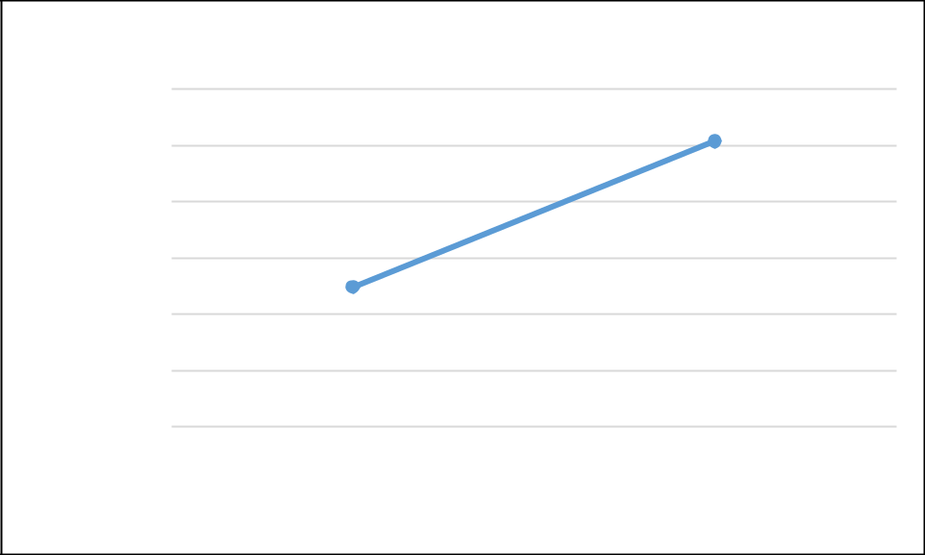Figure 4.15 shows the graphical representation of the NDVI outputs both from remote sensing and agricultural-based approach.

|  |  |  |
| --- | --- | --- |
|  | 0.600 |  |
|  | 0.500 |  |
| values | 0.400 |  |
|  | 0.300 |  |
| NDVI | 0.200 |  |
|  | 0.100 |  |
|  | 0.000 |  |
|  | NDVI_AGRIC Estimation | techniques NDVI_RS |

Figure 4.15: Comparison of the output for cassavaAGP17-350(Cassava)

Figure 4.15 shows that there is just 48.8% similarity between the outputs of cassava sample crop health estimate.

# Groundnut

Figure 4.16 shows the graphical representation of the NDVI outputs both from remote sensing and agricultural-based approach.

Table 4.16 shows the statistical Pearson correlation analysis performed.



0.700

0.600

0.500

0.400

0.300

0.200

0.100

0.000

AGP1-334(Groundniut) AGP2-335(Groundnut) AGP19-352(Groundnut) AGP21-354(Groundnut)

NDVI_AGRIC

NDVI_RS

Figure 4.16: Comparison of the output for groundnut

Table 4.15: Correlations between RS and AGRIC approach forgroundnut health status estimation

|  |  |  |  |
| --- | --- | --- | --- |
| **NDVI_AGRI** | | | |
|  |  | C | NDVI_RS |
| NDVI_AGRIC | Pearson Correlation | 1 | .502 |
|  | Sig. (2-tailed) |  | .498 |
|  | N | 4 | 4 |
| NDVI_RS | Pearson Correlation | .502 | 1 |
|  | Sig. (2-tailed) | .498 |  |
|  | N | 4 | 4 |

Table 4.16 shows that there is a moderate positive linear relationship between the agricultural-based and remote sensing approach of estimating maize health status. This implies that there is a 50-50 (50.2%) chance of obtaining agriculturally based approach result when using remote sensing approach for crop health estimation.

# Maize

Figure 4.17 shows the graphical representation of the NDVI outputs both from remote sensing and agricultural-based approach for estimating sampled maize health status. Table

4.17 shows the statistical Pearson correlation analysis performed.

|  |  |  |  |  |
| --- | --- | --- | --- | --- |
| Relationship between Maize NDVI estimated by AGRIC and RS approach | | | | |
|  | 0.700 |  |  |  |
|  | 0.600 |  |  |  |
| values | 0.500 |  |  |  |
| 0.400 |  |  |  |
| NDVI | 0.300 |  |  |  |
| 0.200 |  |  |  |
|  | 0.100 |  |  |  |
|  | 0.000 |  |  |  |
|  | AGP1-334(Maize) | AGP2-335(Maize) AGP18-351(Maize) AGP22-355(Maize) | | AGP11-344(Maize) |
|  |  | Sample crops | |  |
|  |  | NDVI_AGRIC | NDVI_RS |  |

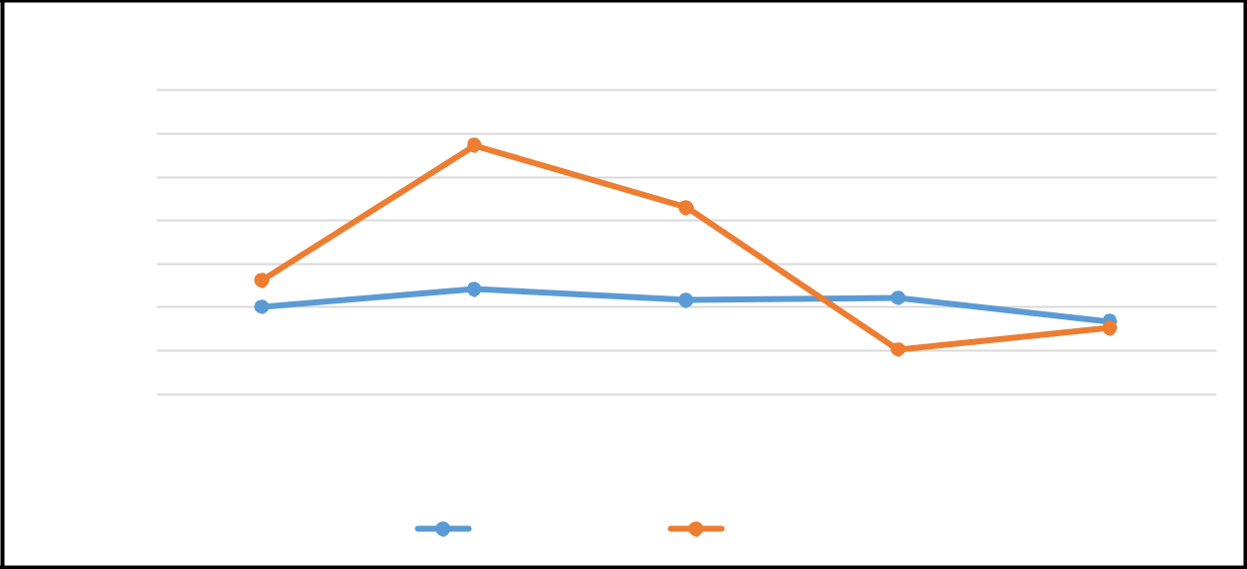Figure 4.17: Comparison of the output for maize

Table 4.16: Correlations between RS and AGRIC approach for maize health status estimation

|  |  |  |  |
| --- | --- | --- | --- |
|  |  | **NDVI_AGRIC** | **NDVI_RS** |
| NDVI_AGRI  C | Pearson Correlation | 1 | .638 |
| Sig. (2-tailed) |  | .247 |
|  | N | 5 | 5 |
| NDVI_RS | Pearson Correlation | .638 | 1 |
|  | Sig. (2-tailed) | .247 |  |
|  | N | 5 | 5 |

Table 4.17 shows that there is a moderate positive linear relationship between the agricultural-based and remote sensing approach of estimating maize health status. This implies that on a 63.8% reliability, remote sensing approach can be used to replace the long process agricultural-based technique of estimating maize health.

# Rice

Figure 4.18 shows the graphical representation of the NDVI outputs both from remote sensing and agricultural-based approach for estimating sampled rice health status. Table 4.18 shows the statistical Pearson correlation analysis performed.

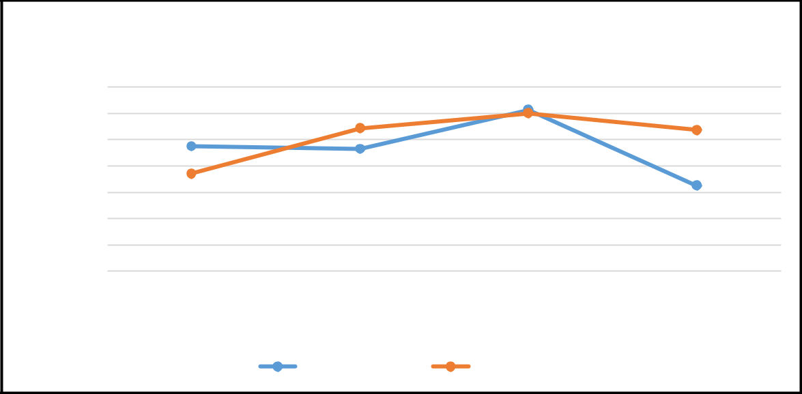0.350

0.300

NDV values

0.250

0.200

0.150

0.100

0.050

0.000

AGP5-338(Rice) AGP6-339(Rice)

AGP8-

341(Rice)

AGP9-

342(Rice)

Rice samples identity

NDVI_AGRIC NDVI_RS

Figure 4.18: Comparison of the output for Rice

Table 4.17: Correlations between RS and AGRIC approach for Rice health status estimation

|  |  |  |  |
| --- | --- | --- | --- |
|  |  | NDVI_AGRIC | NDVI_RS |
| NDVI_AGRIC | Pearson Correlation | 1 | .239 |
|  | Sig. (2-tailed) |  | .761 |
|  | N | 4 | 4 |
| NDVI_RS | Pearson Correlation | .239 | 1 |
|  | Sig. (2-tailed) | .761 |  |
|  | N | 4 | 4 |

Table 4.18 depicts that the linear relationship between agricultural-based and remote sensing approach of estimating rice health status is very weak. This implies that there is a very low probability (23.9%) of getting agricultural-based approach result when using remote sensing approach.

# Soya beans

Figure 4.19 shows the graphical representation of the NDVI outputs both from remote sensing and agricultural-based approach for estimating sampled soya beans health status. Table 4.19 shows the statistical Pearson correlation analysis performed.

**NDVI values**

Figure 4.19: Comparison of the output for Soya beans

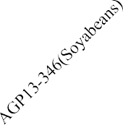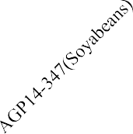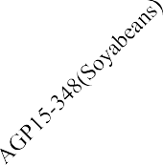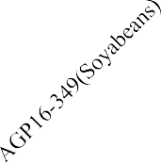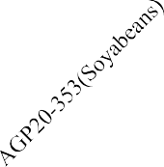

0.500

0.450

0.400

0.350

0.300

0.250

0.200

0.150

0.100

0.050

0.000

**Sampled soyabeans crops**

NDVI_AGRIC

NDVI_RS

Table 4.19 shows that there is a very weak and negative linear relationship between the agricultural-based and remote sensing approach of estimating soyabeans health status. This implies that the remote sensing approach totally contradicts and will give a contradictory result to whatsoever the laboratory output gives.

Table 4.18: Correlations between RS and AGRIC approach for soya beans health status Estimation

|  |  |  |  |
| --- | --- | --- | --- |
| NDVI_AGRI | | | |
|  |  | C | NDVI_RS |
| NDVI_AGRIC | Pearson Correlation | 1 | -.171 |
|  | Sig. (2-tailed) |  | .783 |
|  | N | 5 | 5 |
| NDVI_RS | Pearson Correlation | -.171 | 1 |
|  | Sig. (2-tailed) | .783 |  |
|  | N | 5 | 5 |

# Yam

Figure 4.20 shows the graphical representation of the NDVI outputs both from remote sensing and agricultural-based approach for estimating sampled yam health status. Table 4.20 shows the statistical Pearson correlation analysis performed.



0.500

0.450

0.400

0.350

0.300

0.250

0.200

0.150

0.100

0.050

0.000

AGP3-336(Yam)

AGP4-337(Yam)

AGP10-343(Yam)

AGP11-344(Yam)

**Yam samples**

NDVI_AGRIC

NDVI_RS

**NDVI values**

Figure 4.20: Comparison of the output for yam

Table 4.20 shows that there is a very weak and positive linear relationship between the agricultural-based and remote sensing approach of estimating yam health status. This implies that the remote sensing approach cannot replace the agricultural-based approach for yam health estimation due to weak correlation existing between them (0.021; 2.1%).

Table 4.19: Correlations between RS and AGRIC approach for yam health status estimation

|  |  |  |  |
| --- | --- | --- | --- |
| NDVI_AGRI | | | |
|  |  | C | NDVI_RS |
| NDVI_AGRI Pearson Correlation | | 1 | .021 |
| C | Sig. (2-tailed) |  | .979 |
|  | N | 4 | 4 |
| NDVI_RS | Pearson Correlation | .021 | 1 |
|  | Sig. (2-tailed) | .979 |  |
|  | N | 4 | 4 |

**CHAPTER FIVE**

* 1. **SUMMARY, CONCLUSION AND RECOMMENDATION**

# Summary

This study aimed at assessing the applicability of satellite remote sensing based technique in evaluating and estimating crop health as an alternative to the classical and conventional method, which is not only time consuming but also involves exclusive biological laboratory tests.

Vegetation and soil indices are the widely employed techniques and approaches for estimating crop health. Normalized Difference Vegetation Index, Soil-Adjusted Vegetation Index (SAVI), and so on is an example of the generally and widely employed indices in remote sensing. Tasseled Cap Indices is used in order to achieve the aim of this study, several data were collected which fall into two categories: primary and secondary data. The primary data obtained for the purpose of this study is basically GPS position of the study area’s boundary, the position of fetched sample crops. This was acquired by making use of a hand- held GPS receiver obtained from the department of surveying and geo-informatics, Federal University of Technology, Minna. Remote sensing largely depends on satellite-acquired information about the earth scene and phenomenon.

There are several remotely-sensed images applicable for estimating vegetation properties. The images are function of the satellite acquiring them and the launch parameters of the satellites determine the properties of the images. Sentinel-2A images and Landsat 8 images were acquired for use in this study. These images were preprocessed using ArcGIS software in order to remove effects of atmospheric conditions on the reflectance properties of the image channels. The images were processed to produce several representations of vegetation

indices, soil indices and tasseled cap indices. Correlation, regression and analysis of variance (ANOVA) statistical tools were employed to assess the agreement of these vegetation and soil indices and their correlation with that of the tasseled cap indices, as explained in subsection 3.4

On the other hand, the agricultural-based approach of crop health estimation was also performed. In doing this, six crop species (yam, cassava, rice, maize, soya bean and groundnut) were fetched as samples from the field (numbering up to twenty-four) for the purpose of carrying out laboratory test to investigate the crop health at the time of collection. Tissue test is one of the agricultural terms used for laboratory test performed on crops to assess their health status. This test estimates the NPK (nitrogen, phosphorus and potassium) content of the crop at the time of collection from the field and just like fertilizer that fosters crop growth through the nutrient passed from the soil, this parameter can be used to analyze and evaluate the crop health status. This test was performed on the sampled crops and their NPK contents at the time of collection (August) synonymous to the date of acquisition of satellite images used in this study. This parameter was transformed to a single value using PCA model propounded by this study and in term with their relationship with the vegetation status. To finally achieve the aim of this study, statistical analysis was performed to evaluate the relationship between the outputs from the remote sensing approach and the agricultural approach of crop health estimation. Sensitivity of remote sensing approach of estimating crop health status to crop species was also assessed by conducting relative analysis on the techniques under study based on each sampled crops species.

It is worth to note that this study identified series of challenges which one way or the other limited the results and hence become a knowledge gap which can be further investigated.

Majorly, the limitation in this study is the failure to make use of more than one-month data. Remote sensing just like any other surveying technique needs residual and continuous observation. Also, the tissue test conducted only gave an output of the macro nutrients of crops and ignored the micronutrients, further study can be made to contain this category of crop nutrients. This will help ascertain to the highest degree, the crop health from the laboratory.

# Conclusion

This study aimed at assessing the applicability of remote sensing techniques for crop health estimation in order to determine its relative advantage to the use of agricultural-based technique, as discussed by (Adesugba and Mavrotas 2016)*.* NDVI map produced using sentinel-2 image revealed that the vegetation in the area has NDVI values ranging from 0.062-0.631. The map shows that most of the cereal crops (including maize and groundnut) and some tuber crops are relatively the healthiest crops because of their spatial location on the NDVI map with indices value ranging from 0.468-0.573. AGP16-349, identity for soya bean crop displays the least healthy sample crop collected from the study area. From the NDVI map produced the northern region of the study area and some spots in the southern region reveal the healthiest vegetation in the study area.

The greenness map, an aspect of the TCI maps produced in the study area was evaluated to validate the NDVI results obtained in the study. A Pearson correlation statistical test was performed to investigate the correctness of the NDVI. The NDVI and GREENNESS indices values of the sampled crop is 57.7% positively correlated (0.577). This supports the postulation of (Cristiano *et al.,* 2016). This correlation reveals that there is a strong correlation between the two indices. Also, the brightness map which is known to be a

measurement of how bright-dark a surface was produced and it revealed that the brightness values of the study area ranges from 30961.23 – 37483.25. These values only signify the level of brightness and are relative to one another. Correlation test carried out on the brightness of the sample crops and their NDVI values shows that there is a weak and negative correlation between the indices (-0.175) which implies that brightness is not a measure of crop health. Also, the wetness index of TCI which is a measure of soil moisture was implemented. The map produced was used to investigate the effect of the soil on the crop health across the study area. The NDVI map and the wetness map shows that there is a perfect correlation between wetness and NDVI.

The NPK results of the sample crops converted using PCA model developed by this study. The model transformed the NPK outputs of each sampled crops from the laboratory to an equivalent of the NDVI (having values ranging between 0 and 1, since it is just vegetation). Paired t-test statistical analysis was conducted to assess the relationship (similarity) between the PCA induced NDVI and the Remote Sensing output NDVI for the crop samples. The result of the statistical analysis shows that there is generally a very weak correlation (0.16) between the two techniques under study implying that if considered generally for crop health estimation, there is just 1.6% (approximately negligible) chances that the result from the remote sensing technique will give an equivalence to that of the laboratory result in agriculture. Hence, further remote sensing approach shows that 48.8%, 50.2%, 63.8% similarity with that of laboratory test result for cassava, groundnut and maize health estimation respectively which is fairly acceptable. When employed in estimating rice health status, the study found out that the remote sensing technique yielded 23.9% similar to that of laboratory which is quite unreliable.

Finally, from the findings so far, it can be said that remote sensing approach cannot be relied on for crop health estimation, especially in a mixed far, this is as a result of low poor correlation that existed between NDVI and lab test result obtained.

# Recommendations

Based on the discovery and limitations of this study, the following are strongly recommended:

1. The Northern region of the study area is seen to be the healthiest; hence, farmer should concentrate on cultivating this portion for higher productivity.
2. Further study should be conducted to investigate the reliability of the Tasseled Cap Indices multiplicative constants for sentinel-2 image covering Nigeria as there is none available before now.
3. In furtherance and validation of results from this study, estimations of crop health should be carried out across the cultivation seasons if possible on a monthly basis to map the change in vegetation content with time.

**REFERENCES**

Adam, E. M., Mutanga, O., Rugege, D., & Ismail, R. (2014). Discriminating the Papyrus Vegetation (Cyperus papyrus L.) and Its Co-Existent Species Using Random Forest and Hyperspectral Data Resampled to HYMAP. *International Journal of Remote Sensing*, 33, 552-569

Adamsen, F.J., Pinter, P.J., Barnes, E.M., Lamorte, R.L., Wall, G.W., Leavitt, S.W. & Kimball. B.A. (1999). Measuring wheat senescence with a digital camera. *Crop Sci*. 39: 719-724.

Adesugba, M. A., & Mavrotas, G. (2016). Delving deeper into the agricultural transformation and youth employment nexus: The Nigerian case. *Intl Food Policy Res Inst*. April 19.

Archana N. (2015). Fundamentals of Remote Sensing-Introduction on Natural resources Canada site from government of Canada [http://www.mwri.gov.eg/PDF_files/Fundamentals-of-Remote Sensing.pdf](http://www.mwri.gov.eg/PDF_files/Fundamentals-of-Remote%20Sensing.pdf).

Ashish R. K., Naresh, R. K., Rajveer S. Y., & Rakesh K. (2017). Precision Agriculture.

Research gate. *Parmar publishers & distributors*, dhanbad, jharkhand

Barrientos, Z. (1998). Life history of the terrestrial snail Ovachlamysfulgens (Stylommatophora: Helicarionidae) *under laboratory conditions,* Califonia, 713-725

Bin, H. R., Abdulrahim, M. Q., Bin L. S. & Harun, W.R (2016) Applied light-side coupling with optimized spiral-patterned zinc oxide nanorod coatings for multiple optical channel alcohol vapor sensing, *Journal of Nanophotonics*, 10 (3); 69.

Boschetti, M., Busetto, L., Ranghetti, L., Garcia, F.J., Campos, M. & Confalonieri R., (2018). Testing Multi-Sensors Time series of Lai estimate to monitor Rice phenology: Premiliminaryresults, IGARSS 2018IEEE *Int. Geoscience and remote sensing symposium*, Valencia 2018, 8221-8224. Doi: 10.1109/IGARSS.2018.8518494

Bunkei, M., Wei, Y., Jin, C., Yuyichi, O., & Guoyu, Q. (2007). Sensitivity of the Enhanced Vegetation Index (EVI) and Normalized Difference Vegetation Index (NDVI) to Topographic Effects*: A Case Study in High-Density Cypress Forest*

Campbell, J.B., (1996). Introduction to Remote Sensing. Guilford Press, *New York*.

Carrijo, O. A., & Hochmuth, G., (2000). Tomato responses to preplant-incorporated or fertigated phosphorus on soils varying in Mehlich-1 *extractable phosphorus. HortScience* 35:67-72.

Chang, L. S., Peng,S., & Liu S.R. (2016.) A review of plant spectral reflectance response to water physiological changes, *Chinese Journal of Plant Ecology*, 40 (1), 80–91.

Chappelle. E.W., Kim, M.S., &. McMurtrey, J. E., (1992). Ratio analysis of reflectance spectra (RARS) – An algorithm for the remote estimation of the concentrations of chlorophyll-a, chlorophyll-b, and carotenoids in soybean leaves, *Remote Sensing of Environment*, 39(3), 239 247.

Chris, A. (2014). Agricultural Drones Relatively cheap drones with advanced sensors and imaging capabilities are giving farmers new ways to increase yields and reduce crop damage., *MIT Technology Review*,. Retrieved December 21.

Cristiano, Z.1., David L.R., Carlos, E.A., Juliano, D., & Murilo A.V (2016). Agronomic characteristics associated with the normalized difference vegetation index (NDVI) in the peanut crop.

Crookston, K. (2006). A top 10 list of developments and issues impacting crop management and ecology during the past 50 years. *Crop Sci*.46:2253–2262.

Curran, P.J. (1985). Principles of Remote Sensing. *Longman Group Limited,* London.

Daughtry, C. S. T., (2001). Agroclimatology: Discriminating crop residues from soil by shortwave infrared reflectance, *Agronomy Journal*, 93, (1), 125–131.

Dong, T., Liu, J., Qian, B., Zhao, T., Jiug, Q., Geng, X. & Sang, J. (2016). Estimating winter wheat biomass by assimilating leaf area index derived from fusion of landsat-8 and MODIS data *International journal of Applied Earth observation and Geoinformation*, 49, 63-74, doi.org/10.1016/j.jag 2012.02001

Drusch, M., Del B.U., Carlier, S., Colin, O., Fernandez, V. & Gason, F., (2012). Sentinel-2: ESA's optical high-resolution mission for GMES Operational services Remote Sens. Environ.120, 25-36.

Earl, V. (2011.) Extension Agricultural Engineer, Northeast Research and Extension Center,

*University of Arkansas*, Keiser.

Earl, R., Wheeler, P.N., Blackmore, B.S., Godwin, R.J., (1996). Precision farming – the management of variability. *The Journal of the Institution of Agricultural Engineers*, 51, 18-23.

ESA, (2016). Copernicus. Observing the Earth. <http://www.esa.int/Our_Activities/> Observing _ the Earth/Copernicus/Overview4 (retrieved 5/12/2016).

FAO. (1997). Report on the inter-center review of root and tuber crops research in the CGIAR. Rome: *Food and Agriculture Organization*.

George A. (2008). Retrieval of chlorophyll concentration from leaf reflectance spectra using wavelet analysis*, Remote Sensing of Environmen*t; 112: 1614–1632.

Gessner, V. (2014). Calibration of a SPAD-502 chlorophyll measuring instrument through laboratory measurements of chlorophyll concentration of agricultural crops. Unpublished bachelor thesis, Munich.

Gitelson, A. A., Gritz, Y., & Merzlyak, M. N., (2003). Relationship between leaf chlorophyll content and spectral reflectance and algorithms for non-destructive chlorophyll assessment in higher plant leaves. In: *Journal of Plant Physiology,* 160(3): 271-282.

Gitelson, A.A. and Merzlyak, M. N. (1996). Signature analysis of leaf reflectance spectra: Algorithm development for remote sensing of chlorophyll, *Journal of Plant Physiology*, 148 (3-4), 494–500.

Goddard, T.W., Lachapelle, G., Cannon, M.E., Penney, D.C & McKenzie, R.C., (1995). The potential of GPS and GIS in precision agriculture. Proc. Geomatique V: "La Route De L'Innovation". November 9-10, Canada

Gunlu, A., Ereanli, E. K., & Cakir, G., (2014). Estimating aboveground biomass using landsat TM imagery. A case study of Anatolian Crimean pine forests in Turkey. *Annals of Forest Research*, 57(2), 289-298. Retrieved from <http://afrjournal.org/index.php/afr/article/view/278>

Hauser, S., Nolte, C., & Carsky, R.J., (2006). What role can plant fallows play in the humid and sub-humid zone of West and Central Africa, 422 – 431.

Henderson, T.L., Baumgardner, M.F., Franzmeier, D.P., Stott, D. E. & Costar, D. C., (1992). High dimensional reflectance analysis of soil organic-matter, *Soil Science Society of America Journal*, 56 (3), 865–872.

Holme, A., Burnside, D.G., & Mitchell, A.A., (1987). The development of a system for monitoring trend in range condition in the arid shrub lands of Western Australia. *Australian Rangeland Journal* 9:14-20.

Howeler, R.H. (2012). Importance of my corrhiza for phosphorus absorption by cassava. In

R.H. Howeler, Ed. The Cassava Handbook – *A reference manual based on the Asian regional cassava training course, held in Thailand*. Cali, Colombia, CIAT. 497-523.

Huete, A. R. (1988). A soil-adjusted vegetation index (SAVI), *Remote Sensing of Environment*, 25 (3), 295–309,

Ike, P. C., & Inoni, O. E. (2006). Determinants of yam production and economic efficiency among small-holder farmers in South-eastern Nigeria. Journal of Central European Agriculture, 7(2): 337–342. *In agricultural crops. Biotechnology.* 10(1): 1-22.

IITA. (2009). Yam (Dioscorea species). Available at: [http://www.iita.org/yam.](http://www.iita.org/yam)

Jackson, R.D., & Huete, A.R., (1991). Interpreting vegetation indices. *Preventive Veterinary Medicine,* 11: 185-200.

Jensen, J. R., (2007). Remote sensing of the environment: an earth resource perspective. Prentice Hall series in Geographic Information Science. Edited 2. *Auflage. Pearson Prentice Hall. Upper Saddle River*, NJ.

Joseph, G. (1996). Imaging Sensors. Remote Sensing Reviews, 13: 257-342.

Kaufmann, H., Segl., K., Itzerott, S., Bach, H., Wagner, A., Hill, J., Heim, B., Oppermann, K., Heldens, W., Stein, E., Müller, A., van der Linden, S., Leitão, P. J., Rabe, A., & Hostert, P. (2010). Hyperspectral algorithms: report in the frame of EnMAP preparation activities, *(Scientific Technical Report*; 10/08), Potsdam: DeutschesGeoForschungsZentrum GFZ, 268.

Krishna Mohan, (2007). Satellite Image Processing and Analysis, CSRE, IIT Bombay. Kumar, R. & Silva, L. (1973). Light ray tracing through a leaf cross- section. *Apple Optics*

12: 2950-2954

Liew, O.W., Jenny, P.C, Chong, J., Li, B., & Asundi, A.K., (2008). Signature optical cues: emerging technologies for monitoring plant health. *Sensors* 8, 3205-3239; DOI: 10.3390/s8053205.

Lilles and, T., Kiefer, R.W. & Chipman, J., (2014). Remote Sensing and Image Interpretation, Wiley and Sons, 7th Edition.

Lu, D., Chenn Q., Wang G., Liu L., & Moran E., (2014). A survey of remote sensing-based aboveground biomass estimation methods in forest ecosystems. *International journal of Digital Earth*, 9(1), 63-105.doi.org/10.1080/17538947.2014.990526.

Ma, B.L., Dwyer, L.M., Costa, C., Cober, E.R., & Morrison, M.J., (2001). Early prediction of soybean yield from canopy reflectance measurements. *Agron. J.* 93: 1227-1234

Mahlein A.K., Rumpf, T., Welke, P., Dehne, H.W., Plümer, L., & Steiner, U. (2012). Development of spectral indices for detecting and identifying plant diseases. *Remote Sens Environ*. 128:21–30. doi: 10.1016/j.rse.09.019.

Martimort, P., Arino, O., Berger, M., Biasutti, R., Carnicero, B., Del Bello, U., Fernandez, V., Gascon, F., Greco, B., Silvestrin, P., & Spoto, F., (2007). Sentinel-2 Optical High- Resolution Mission for GMES Operational Services, Proceedings of IGARSS (*International Geoscience and Remote Sensing Symposium), Barcelona, Spain*.

McBratney, A., Whelan, B., & Ancev, T., (2005). Future Directions of Precision Agriculture*.*

*Precision Agriculture*, 6, 7-23.

Meerah, G., Parthiban, S., & Christy, A., (2015). NDVI: Vegetation change detection using remote sensing and gis – *A case study of Vellore District. 3rd International Conference on Recent Trends in Computing* (ICRTC-2015).

Meng, J., & Wu, B., (2007). An Operational Crop Growth Monitoring System by Remote Sensing. *High Technology Letters*, 17 (1) 94-99.

Mills, H.A., & Jones, J.B.,(1996). Plant Analysis Handbook 11. Micro-Macro Publishing, Athens, GA

Minnaert, M. (1941). The Reciprocity Principle in Lunar Photometry. Astrophys Journal.

Muhammad, H.A., Litu, Z., Tong, S., & Qingxi, T., (2014). Derivation of a ()taselled cap transformation based on Landsat 8 at-satellite reflectance. Journal of Remote Sensing Letters, 5 (5), 423-431.

Njoku, E G., (2013). Encyclopedia of Remote Sensing. Journal of chemical Information and Modelling, 53(9), 1689-1699. Retrieved from <http://staff.washington.edu/dushaw/epubs/Tomograpy_Ency_Remote_Sense_Spring> er_2014. Pdf.

Oerke, E C. (2006). Crop losses to pests. *J Agric Sci*.; 144:31–43. doi: 10.1017/S0021859605005708.

Peg, S. (2009). Introduction to Hyperspectral Image Analysis, Ph.D. Earth Science Applications Specialist, Research Systems, Inc.

Price, J.C., (1990). On the information-content of soil reflectance spectra, Remote Sensing of Environment, 33(2), 113–121.

Qi, J., Chehbouni, A., Huete,A. R., Kerr, Y. H. & Sorooshian, S., (1994). A modified soil adjusted vegetation index, *Remote Sensing of Environment*, 48 (2), 119 –126.

Reidell, W. E., Osborne, S. L. & Hesler, L. S., (2004). Insect pest and disease detection using remote sensing techniques. *Proceedings of 7th International Conference on Precision Agriculture.* Minneapolis, MN USA.

Richardson, A. D., Duigan, S. P., & Berlyn, G. P., (2002). An evaluation of noninvasive methods to estimate foliar chlorophyll content. *New Phytologist,* 153(1), 185-194.

Ricotta, C., Avena, G.C., Olsen, E.R., Ramsey, R.D., & Winn, D.S., (1999). Monitoring the landscape stability of Mediterranean vegetation relation to fire with a fractal algorithm. *International Journal of Remote Sensing* 19, 871–881

Riffi, M.A. & Fizazi, I.H., (2012). Channels of sentinel imageries. *Int. J. Computer. Sci.* 9, 172–177.

Roy B, Noren, S.K., Mandal, A.B., & Basu, A.K., (2011). Genetic engineering for abiotic stresses tolerance

Sabins, F.F., (1997). Remote Sensing and Principles and Image Interpretation. WH Freeman, New York

Sabtu, N.M., Idris N. H., & Ishak M. H., (2013). The role of geospatial in plant pests and diseases: an overview

Savary, S., Ficke, A., Aubertot, J.N., & Hollier, C., (2015). Crop losses due to diseases and their implications for global food production, losses and food security. *Food Secure*. 4:519–537. doi: 10.1007/s12571-012-0200

Siddiq, E. A., Saxena, S., & Malik, S.S., (2005). Plant Genetic Resources: Food Grain Crops. Dhillon BS, Saxena S, Agrawal A, Tyagi RK (eds*.), Indian Society of Plant Genetic Resources, New Delhi, Narosa Publishing House, New Delhi, India*. 27-57.

Singh, I., Srivastava, I.A., Chandna, P., & Gupta, R., (2007). Crop sensors for efficient nitrogen management in sugarcane. Potential and constraints,*Sugar Technol*., 8: 299-302.

Slaton, M.R., Hunt, E. R., & Smith, W.K. (2001). Estimating near-infrared leaf reflectance from leaf structural characteristics. *American journal of Botany.* 88. 278-284

Solomon, W., Newete, O.H., Barend, F.N., Erasmus, & Marcus, J. B. (2014). Hyperspectral Remote Sensing to detect Biotic and Abiotic stress in water Hyacinth, (Eichhorniacrassipes) (Pontederiaceae) *University of the Witwatersrand school of Animal, Plant and Environmental Sciences*. Report NO: 2037/1/13; ISBN 978-4312- 0497-7

Tiang, X. Z., Jin Y. S., Cun. L., Wen, H C. (2019). Potential Bands of Sentinel-2A Satellite for Classification Problems in Precision Agriculture: *International Journal of Automation and Computing.* 16-26. DOI: 10.1007/s11633-018- 1143

Udaranga, S., Dimuthu, P., & Manjula, R. (2017). Relationship between NDVI with Tasseled cap Indices: *A Remote Sensing based Analysis. International Journal of Innovative Research in Technology*, 3 (12), 13-19.

Victor, H. & Gardner, J. (2007). Hyperspectral Satellite Imaging: Planning a Mission, University of Maryland, College Park, MD, 20742

Whelan, B. &McBratney, A. (2003). Definition and interpretation of petential management zones in Australia. Solutions for a better environment, WEB: Australian Society of Agronomy.

Whyte, A., Ferentinos, K.P. & Petropoulos, G.P. (2018). A new synergistic approach for monitoring wetlands using Sentinels -1 and 2 data with object-based machine learning algorithms. *Environmental Modelling & Software.*104, 40–54.

Wiegand, CL., Richardson, A J., Escobar, D.E., & Gerbermann, A. H. (1991). Vegetation indices in crops assessment *Remote Sensing of Environment,* 35(2-3), 105-119. Retrieved from <http://www.sciencedirect.com/science/article/pii/0034425790004P>.

Wright, S. (2012). Peanuts. University of Kentucky College of Agriculture Cooperative Extension Service. Available at: [http://www.uky.edu/Ag/New Crops/introsheets/](http://www.uky.edu/Ag/New%20Crops/introsheets/%20peanuts.%20pdf) [peanuts. pdf.](http://www.uky.edu/Ag/New%20Crops/introsheets/%20peanuts.%20pdf)

Zhang, C. & Ni-meister, J. M. (2014). The application of small unmanned aerial systems for precision agriculture: a review. *Precision Agriculture,* 13, 693-712.

Zhang, M., Qin, Z., Liu, X., & Ustin, S.L., (2003). Detection of stress in tomatoes induced bylate blight disease in California, USA, using hyperspectral remote sensing. *Int. J.Appl. Earth Obs. Geoinf.* 4, 295–310

Zheng, B., Myint, S.W., Thenkabail, P.S., &Aggarwal, R.M., (2015). A support vector machine to identify irrigated crop types using time-series Landsat NDVI data. *Int. J. Appl. Earth Obs. Geoinf.* 34, 103–112.