APPLICATION OF GEOGRAPHIC INFORMATION SYSTEM TECHNOLOGY IN ANALYSING URBAN DENSIFICATION AND HOUSING MARKET IN BIDA, NIGERIA

ABSTRACT

Urban densification is as a result of increase in the level of urbanisation of a limited area which causes challenges in the housing affordability due to the increase in price of houses, high rental values, high demand and shortage in supply to meet the need of the urban residence. This study examines urban densification as an element of urban growth and how it can provide extra spatial information in explaining the variance of housing market of Bida with specific emphasis on its prevailing submarkets. Census sampling techniques was adopted in sampling all 31,410 buildings, 46,489 buildings and 47,394 buildings for the years 2008, 2013 and 2018 respectively and also 138 houses managed by the 3 registered estate firms in Bida. Data were collected using Google Earth to capture satellite imageries for the years 2008, 2013 and 2018 using maximum resolutions while handheld GPS was used to take coordinates of rental houses managed by registered estate surveyors and valuers. Onscreen digitization was conducted where Point Density spatial analysis and Ordinary Kriging (OK) was used to analyse residential density and rental prices respectively, while machine learning approach using Artificial Neural Network (ANN) was adopted to analyse and forecast residential density and housing prices with the aid of Map Algebra tool in ArcGIS. It was found out amongst others that the pattern of densification process is in line with urban economic theory for monocentric open cities and that OK model disconfirmed Alonso’s monocentric theory. The ANN model revealed that residential densities increase shall continue along the urban – rural gradient thereby causing a transition of open spaces and low density areas in to medium and high density areas in the coming years maintaining its monocentricity, while rental prices of housing apartments shall continue to decreases with decreasing distance to the city centre. It was therefore recommended amongst others that there is the need for rational densification for urban development in order check the increasing residential density that reduces green and open spaces.

CHAPTER ONE

  - INTRODUCTION

Background to the Study

Growing urban population pose a challenge to many cities around the world. The world’s urban population has soared from 2.6 billion (45 % of the whole) in 1995 to 3.9 billion (54 %) in 2014 (Asian Development Bank, 2012; Asian Development Bank, 2015). With over 50% of the world’s population residing in urban centres now, it is expected that future growth in the global population would be absorbed by the urban areas in four decades to come (UN-Habitat, 2013). There are rapid expansion of urban populations in West Africa. In the subregion, cities will accommodate an additional fifty-eight million and some other sixty-nine million at some stage in the 2020/30 decade. Despite the decline in the projected urbanisation growth rate after 2030 there is no hope for decline in the demographic increase of urban areas, there is need for cities in the subregion to accommodate additional seventy-nine million until 2040, and between 2040 and 2050 they will need to accommodate another eighty-four million (UN-Habitat, 2010).
With unprecedented rates of urban population expansion since 1996, it is perhaps not a surprise that the housing supply of many cities are falling (Asian Development Bank, 2012; Asian Development Bank, 2015). Estimate by UN-Habitat shows that there are eight hundred and eighty-one million people currently dwelling in slums in the cities of the developing world compared to seven hundred and ninety-two in the year 2000. By 2025, adequate and affordable housing will be likely be required by another 1.6 billion. This is, however, a wake-up call to authorities, advising them to take action resolutely to allow all urban residents to have access to housing (UN-Habitat, 2015). Nigeria's urban population was estimated to be 44% in the year 2005 with an annual growth rate of 3.7%

(United Nations, 2009) and increased to 48% in the year 2014 with a 4.7% annual growth rate (United Nations, 2014). As rapid urban agglomeration is experienced globally, building additional living apartments has to be complemented by urban gentrification and densification actions (Lin et al., 2015).
Urban densification is the increase in urbanisation level of a limited area, which could have an adverse effect on the biodiversity of its green spaces by destroying the habitats and soil temperature increase or pollutions (Vergnes et al., 2014). Urban densification causes a lot of challenges to cities ranging from decline in housing affordability, pressure on infrastructure and difficulties of city management. Urban densification has a consequential effect on affordable housing and may cause change in the housing market. As a result of change in the housing market the entire city or national economy would experience shift either negatively or positively (Gulyani et al., 2018).
The housing market is very imperative because of the place it holds in the economy (Seo, 2008). Housing construction easily contributes to gross domestic product and its market has a direct impact on the national economy (Hu et al., 2013). Housing is a special kind of commodity which is fixed (Renigier-Biłozor et al., 2017). Consequently, the location of the house is very imperative, since this feature is unchangeable (Cichociński & Dąbrowski, 2013). Housing has demonstrated its importance to the broader economy during the global financial crisis of 2007 – 2011, which has its roots in the United States housing market as its contribution to the national GDP fall during the period. Information on trends in housing prices is therefore essential to the governments, market participants and central banks (Hill & Scholz, 2017). Although, several factors determine housing prices (Xiao, 2017a).

The degree to which internal and external factors affect house prices varied over space. There are so many number of factors (internal & external) that inflate housing price in a particular location (Wang et al., 2017; Tupenaite et al., 2017; Liu & Li, 2018). It is important to talk about housing price changes issues. For instance, an increase in asset values (creates positive equity) can lead to the withdrawal of housing equity and confidence increase. In its place, decreasing house prices lowers the equity which could lead to equity downside risk, especially for new housing developers, which could give consumers a bad impression and likely reduce household spending. House price changes also have a direct impact on wealth distribution in the economy. When prices rise rapidly, property owners enjoy an increase in wealth relative to accommodation renting persons (Zmölnig et al., 2015).
Housing prices within an urban area are influenced by various housing characteristics or urban morphology such as location, environmental and neighbourhood characteristics (Saether, 2008) most especially urban densification. These housing characteristics and urban morphology together with the power of demand and supply further subdivide the housing market into a series of submarkets (Wu & Sharma, 2012). The housing submarket can be identified by its spatial requirements and non-spatial requirements (Xiao, 2017b). Spatial requirements stresses a predefined geographic area while non-spatial requirements emphasizes on housing types, estimations and socioeconomic structure of the housing occupants. Substantially, house prediction models accuracy have increase by submarket divisions, which provide better house price forecast. Useful insights are also provided on different aspects of housing which add value to the housing market (Wu & Sharma, 2012).
In Bida urban area, just like other urban areas of the developing world most especially Nigerian urban areas is characterised with rapid urban growth which is largely

uncontrolled and increased urban densification most especially in the central areas of the town. Urban densification in Bida is largely in terms of housing and population densities. As the population increases, the building development increases and causes conversion in the use of structure. For example, special structures are converted to residential units or industrial buildings converted to commercial uses; green spaces developed, low rise buildings converted to high rise structures and river banks and flood plains developed to increase housing stock. This increase in the housing and population densities may have a direct or indirect impact on the housing market structure, most especially, the housing submarket.

Statement of the Research Problem

Access to adequate, affordable and quality housing is among the current and growing problem in developing countries (UN-Habitat, 2011). Nigeria’s housing problems are muti-dimensional just like in many developing nations. The population explosion problem, shortage of basic infrastructure that can enhance living standard and urban drift have aggrevated problems of housing for many years (Mohammed & Aremu, 2017). Larger percentage of Nigeria’s urban dwellers do not have access to basic needs which requires critical attention to be addressed. One of the central issues in the housing sector of Nigeria is that there are distinctions in housing in terms of price and quantity on one hand and the people who have the ability to pay these prices on the other hand (Adedeji & Olotuah, 2012).
Housing affordability can be determine by the cost at which houses reach the market. Where the cost of housing unit is very high, few people would be able to afford it. In the Nigeria housing sector, there is a very wide gap between income and housing market. With this, the low-income earners are pushed out of the housing market (Adedeji &

Olotuah, 2012). However, one of the major challenges that hinder the progress is urban densification.
Urban densification is as a result of increasing urbanisation level of a limited area resulting to challenges in housing affordability due to the increase in the price of houses, high rental values, high demand and shortage in supply to meet the need of the urban residence.
Bida is experiencing urban densification which has attracted people from different parts of the country which has consequently led to an increase in housing demand. The intensity of housing demand in the city has also resulted in increased house rents.
However, there is a large body of literature on housing market (Leung, 2004; Wu et al., 2014; Muehlenbachs et al., 2015; Yang et al., 2017; Tupenaite et al., 2017; Zhou, 2018; Cameron, 2018; Cheung et al., 2018; Wang et al., 2018). For example, Xiao (2012) studied urban morphology and housing market with emphasis on street network pattern, where street pattern is a fundamental determinant of house prices and street network pattern influences accessibility. Wang et al. (2018) analyses the spatial patterns and driving forces of Chinese housing prices where various theoretical dimensions on housing supply, demand and market, are viewed as determinants of a housing price model to examine the effect of prices of land on hosing prices. These authors did not consider housing submarket in their respective studies.
Available literature on housing submarket (for example, Royuela & Vargas, 2007; Park, 2013; Manganelli et al., 2014), very little is written on delineation of housing market (for example, Wu & Sharma, 2012; Manganelli et al., 2014). Wu & Sharma (2012) classified housing submarket by developing a spatially constrained data-driven methodology to segment the housing market. Specifically, the model based on cluster analysis and

Principal Component Analysis (PCA) was developed for housing submarket delineation. The model constitutes a number of locational attributes which were used for PCA, and also the incorporation of spatial locations of the houses into the cluster analysis. Manganelli et al. (2014) adopted Geographically Weighted Regression in analysing housing market, in order to identify homogeneous areas and to define housing submarkets. The researchers focus on the spatial specification of housing submarket delineation and ignoring the non-spatial specifications. This has been criticised by Xiao (2012) for making scientific research complex and not simply replicable.
Studies of urban morphology (densification specifically) in relation to the housing market are not common because of the rare robust approach to measure the urban form accurately (Xiao, 2017b). In this context, this dissertation employs conventional methods such as Convolutional Neural Network, hedonic and spatial analysis methods to analyse urban density and housing market. By doing so, it attempts to contribute significantly to urban scholarship by exploring how measured residential density related to several issues in the housing market, particularly the housing submarket.
Much has not been done on how to delineate submarkets in housing markets of the developing world, most especially Nigeria urban areas, where typology of buildings in several fast-growing urban areas are simple structures and informal. This is the case in Bida town. It is on this basis this research intends to fill another gap in the literature by delineating the Bida housing submarket and demarcating it using both spatial and non- spatial specifications.

Research Questions

- What pattern revealed by the residential density of housing submarkets in the study area?
- How are the space and time variations in residential density of the study area between the years 2008 - 2018?
- What are the extents of spatial and temporal changes in the housing market of the study area between the years 2008 - 2018?
- To what extents does residential density have relationship with the rental value?

Aim and Objectives of the Study

This research shall seek to apply Geographic Information System (GIS) technology to analyse urban densification and housing market of Bida and as well, assess the pattern in urban densification and housing market of Bida for ten years.
The objectives set for the study are to:

- Examine residential density pattern of the housing submarkets in the study area.

- Examine spatiotemporal variations in residential density of the study area between the years 2008 - 2018.
- Examine the spatiotemporal dynamics in Bida housing market between the years 2008 – 2018.
- Develop a model to predict and analyse the relationship between residential density and rental value.

Justification of the Study

Location is emphasised by both the monocentric and polycentric economic models, suggesting that growing distance to the CBD causes a decrease in the housing prices, but studies in the recent times show that people do not prefer their housing location in accordance to the minimum travel cost or distance cover to reach their workplace and that work has significantly dispersed within urban areas, therefore, the CBD and distance to it becomes insignificant (Xiao, 2012; Xiao, 2017b). There are many literatures on housing market where few captured urban forms and housing market. However, little has been done on urban densification and the housing market.
Also, this study is of paramount importance because urban densification has either negative or positive impacts on the housing sector, most especially the housing market. The housing market, therefore, depends on the facilities, economy, beliefs, culture, demography, services and policies within the neighborhood to which it operates. It can, therefore, be stated that the outcome of this research work would be beneficial, which shall focus on developing a methodology aimed at ensuring a sustainable housing market aimed at providing affordable housing alongside proffering solutions to ailing consequences of urban densification in Bida.
The investigation will contribute to the existing body of knowledge in terms of:

- Bridging the gap in understanding the urban housing market and submarkets as it associates with both residential choices and spatial information
- Helping urban planners and urban managers differentiate between economic and social classes and they respond to affordable housing
- Helping urban planners and authorities to efficiently solve the problem of spatial growth and management and

- Assisting in the assessment of housing values to evaluate planning regulations and urban land-use policies.

Scope of the Study

This study shall identify and evaluate the nature of urban densification and housing market of Bida. It shall also compare the level of disparity in urban densification in terms of building density and housing market in order to assess housing affordability of residence in Bida. The study areas would be divided into various segments (submarket) according to their housing market structure. The pattern in urban densification and housing market shall be investigated within a decade range on an annual basis i.e. year 2008 – 2018.
The study area shall cover the entire Bida town to its extent as of 2018. This research shall also consider the positions of the traditional wall as the boundary for the core neighbourhoods of the town as the area is almost completely developed and homogenous in nature.
However, in terms of variable, the study will cover; satellite images of the study area between years 2008 to 2018, overall residential area between years 2008 to 2018, changes in the residential area between years 2008 to 2018, type of residential rented housing in major residential neighbourhoods of study area, number, and type of rental housing apartments managed by registered estate surveyors in the major residential neighbourhoods of the study area, rental value of different type of residential houses in the major residential neighbourhoods of study area, existing classification of residential neighbourhoods by registered estate firms, number and type of rental housing apartments managed by estate management firms in Bida, the annual rent of housing apartments in

Bida between years 2008 to 2018 and coordinates of sample rental housing apartments in Bida.

Limitations

This research work focused on urban densification of and housing market of Bida. However, data needed for the study is the rental values of residential apartments and location of buildings in the study area. This research work would have been more accurate if there is Spatial Data Infrastructure (SDI) where data related to houses and densities would have been kept and managed. This research, therefore, generates its data from satellite imageries of Bida.

Study Area

    - Location

Bida the area of study is a traditional, modern and heterogeneous society and a Local Government headquarters in Niger state, a north central town in Nigeria, as well as the traditional headquarters of Nupe Kingdom (Yahaya, 2002; Ononogbo, 2014). Bida is one of the largest settlements and it is next to Minna which is the largest settlement in Niger state and located in southern region of the state. It is also located on the A124 regional highway linking Minna to Ilorin and Abuja (Mahmud & Umaru, 2018). Bida Local Government Area has about 1.698 km² area and a population of 266,008 (National Population Commission, 2006). Bida town lies on latitude 9°5'30" - 9°2'07"N and longitude 5º58'30"- 6°3'0"E. As a traditional headquarters, Bida is led by Etsu Nupe whose leadership extends to other districts namely, Mokwa, Lemu, Enagi, Katcha, Kutigi, Baddeggi, and others. A major ethnic group in the town is Nupe with other tribes like Hausa, Fulani, Yoruba, Igbo, and others (Yahaya, 2002). Activities like traditional brass and copper goblets, crafts and other metal products, raffia and mats, glass beads and

bangles, silk cloth and locally dyed cotton is what the town is well known for (Alarima et al., 2012). Durbar festival is another feature that the town is also known for (Max Lock, 1980). There are two polytechnics in Bida (Federal Polytechnic Bida and a campus of Niger State Polytechnic), there are also one secondary and tertiary health institutions in the town (Umaru Sanda General Hospital and Federal Medical Centre). Others includes security and military institutions (police station and army barrack), primary and secondary schools both public and private, television house (Nigeria Television Authority - NTA), commercials banks, Nigeri Telecommunications (NITEL), Nigeria Postal Service (NIPOST), restaurants and eateries, hotels and two major markets (Ononogbo, 2014).

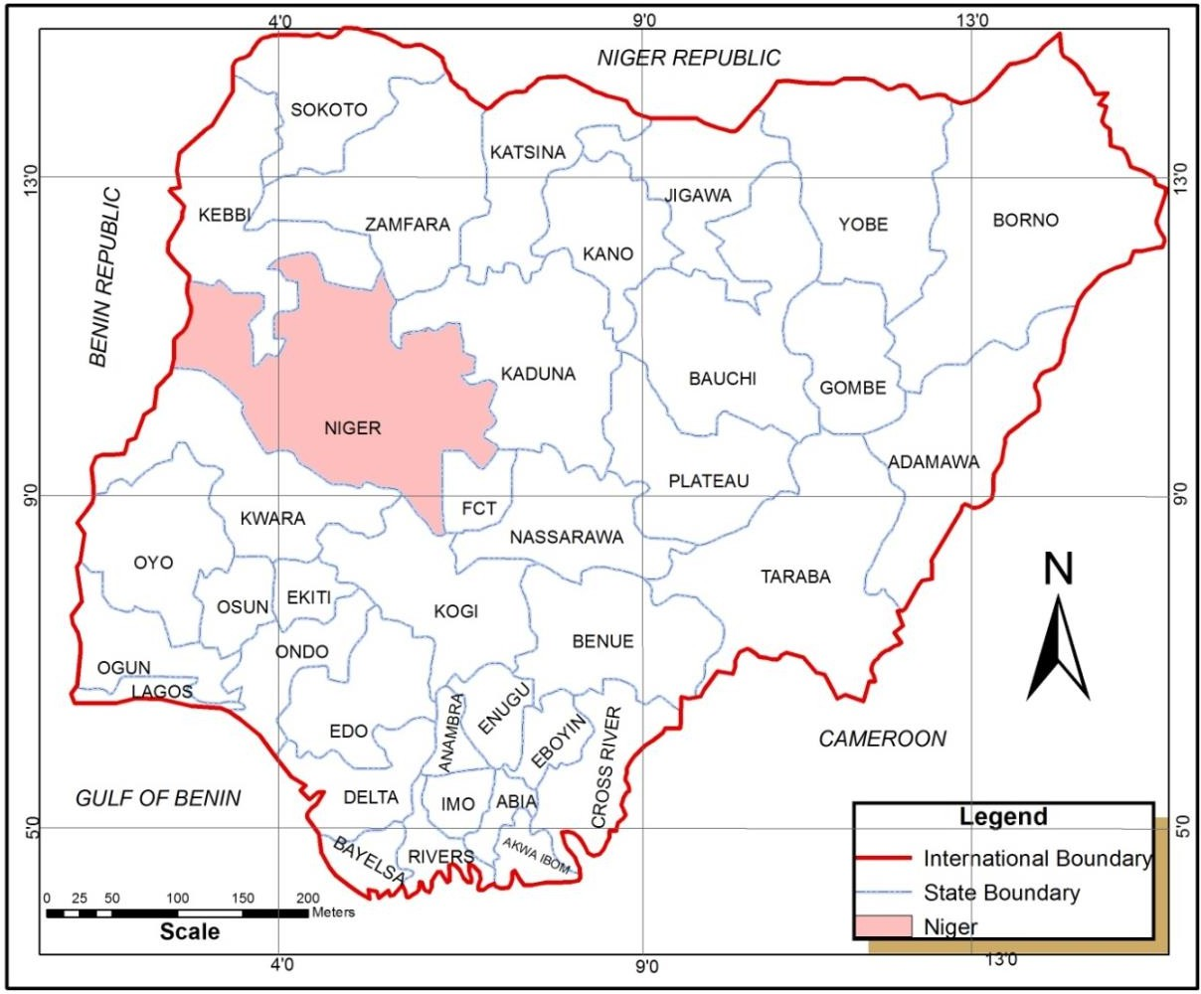

Figure 1.1: Niger State Location in Nigeria

Source: Federal Ministry of Works, Transport and Housing, 2015

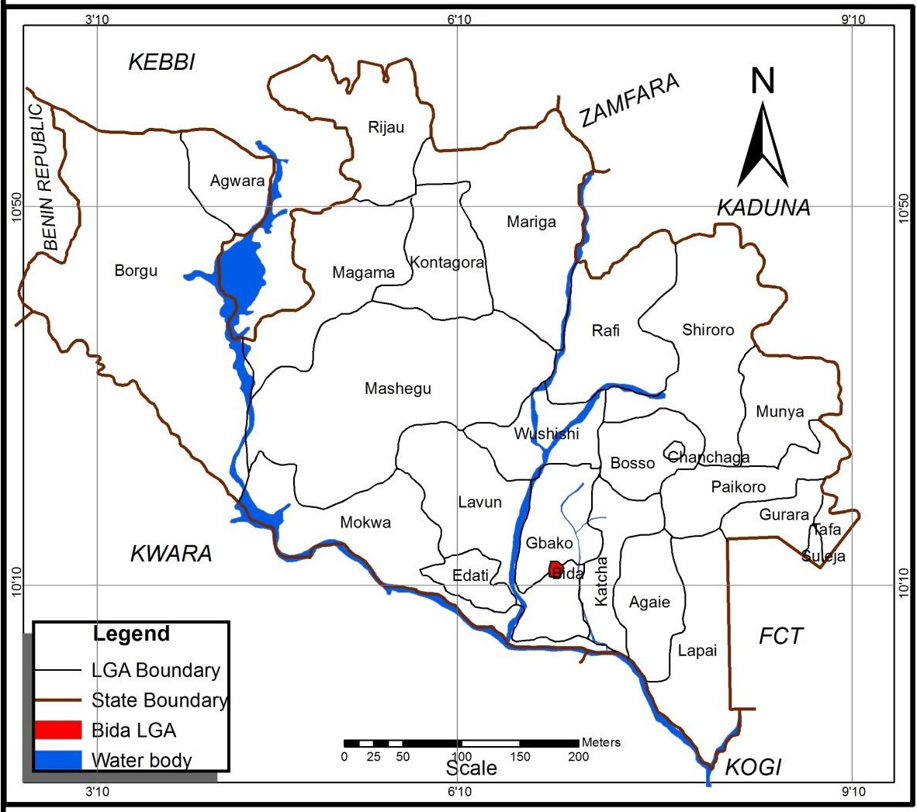
Figure 1.2: Bida Location in Niger State Source: Niger State Ministry of Lands and Housing, 2015

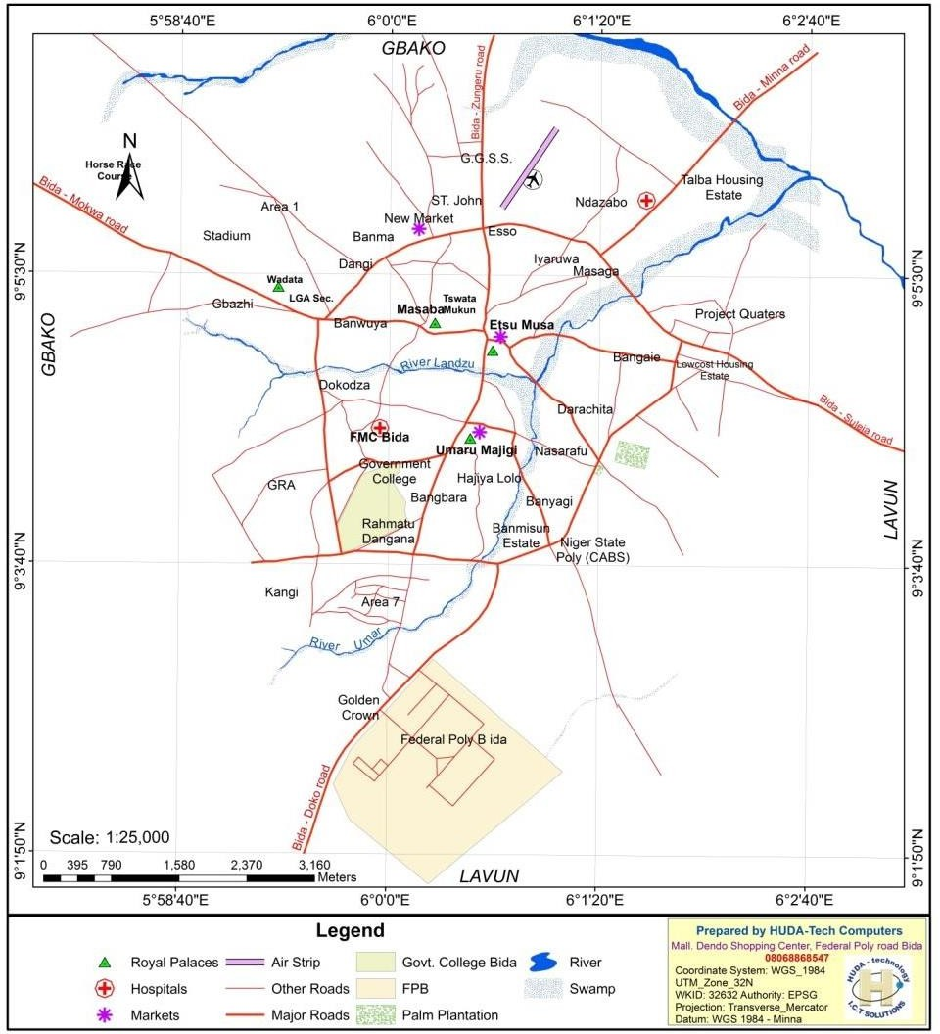

Figure 1.3: Street Map of Bida
Source: Niger State Ministry of Lands and Housing, 2015

Physical characteristics

There are two distinct climatic seasons in Bida in a year (dry and rainy seasons). Rainfall is experienced between April and November with peak in June/July. About 122.7mm annual average rainfall is recorded annually with highest of 226mm – 300mm recorded in July (Debaniyu, 2013). In the dry season, the town experience cold harmattan wind and

south west wind which is the hottest between month of March and April, prior to another rainy season. The town experience highest temperature in March with about 37.1ºc. Bida being a hot town but mainly have moderate climatic conditions in most part of the year. As a result of the climate being the tropical in nature, the sunshine duration ranges between eight-ten hours a day and ranging from about 30°c - 3 7.0°c yearly where in March temperature is at peak. However, the marked increase in cloud cover during July, August, and September makes the hours of sunshine per day, drop sharply to an average of about four hours (MaxLock, 1980). The beginning of rains starts from mid April and ends around mid October to early November. Consequently, there is variation in the rainy season duration which ranges from around 190 days to 240 days amounting to annual mean rainfall approximately 1,650mm per annum. The beginning and the end of the season, there is frequent incidences of rain storms. In this weather condition, there are cloud cover on daily basis for several weeks. It is accompanied by lightning and thunder, characterised with strong winds and high intensity rainfall (MaxLock, 1980).
Another feature of the rainfall is its mean monthly distribution. There is a very high concentration of rainfall in July, August and September during which about 57 percent of the annual rainfall of the town is experienced. The feature also shows a sharp drop in the rainfall received after these three months (MaxLock, 1980).
The humidity of the town rises everywhere during the rainy season and falls inseparably during the dry season within the town. In the afternoon relative humidity of the town, cloud rise above 60 percent during the rainy season and fall to as 30 percent during the dry season (MaxLock, 1980).
The Nupes live within the low basin formed by the two valleys of Rivers Niger and Kaduna. The area is surrounded by hills and and forms a valley, a few 3 to 4 kilometers

west of the prevailing built-up region. Occasional little steep hills rise between 20m to 25m above the sea level and the nicely-tired gutter slopping between the valley. The metropolis is drained with the aid of Landzu streams which go with the flow transversely the coronary centre of the city characterised with seasonal tributaries which can be gully routes today (Ononogbo, 2014).
Bida is located in the Nupe sandstone formation with a complicated basement. the previous is fabricated from surf stones, sandy cemented or clays coarse sands, and the soil supersede dense sandstone and the predominant components encompass the mild undulating plains and of a very deep soils (MaxLock, 1980).
The town lies in the vegetational region of Guinea savannah. The sector is characterised predominantly through grassland with bushes and shrubs scattered anywhere. Urbanization and expanded human activities and ecological foot prints have greatly altered the herbal nearby flora in a few components of Bida. The mostly timber plantation in Bida include Mangifera indica (mangoes, Azadirata indica (neem tree), shear butter tree and Parkia Filhu(Golden locust bean timber), among others (MaxLock, 1980).
The dominant soil types found in Bida include combisols and to some extent, lithosol in the upper slopes of the interfluves of Bida and luvisols are the major soil type found on the foot slope plains (American Public Health Association, 1916). The luvisols are made from downwash from the hills and that they develop on those foot plains, interfluves is associated with the soil which can be an aspect of the landscape which can be constantly been eroded by means of sheet-wash and streams from the hills. The individual of this soil kind varies as among top, middle and decrease slopes (MaxLock, 1980).
Though Bida lies near the northern boundary of Nigeria’s southern guinea savanna, the major types of vegetation are forest and savanna (Asaolu, 2002). Riparian vegetation

complex is the type of forest found in Bida and it consists of a complex of varying floristic composition and physiognomy. Consequently, there are units in the complex that can be characterized as high forest, while others are no more than woodland and thickets (MaxLock, 1980).
The Riparian high forest that is similar in physiognomy to the rain forest is sometimes continuous, has the following oil palm tree (Elaes guineesis), Afzelia Africana and Terminally laxiflora found within it. On the other hand, the Riparian complex that can be described as thickets and woodlands are relatively of lows stature. Furthermore, a few tall elements may be found as emergent, with high trees and contious vegetal cover form by the forest or woodlands. Examples of the more frequent species in this variant of the Riparian vegetation are Mitrgyna inermis, Alchnea cordifolia, Allophyllus Africana, Anogeissus leiocarpus and Borassue aethiopium (MaxLock, 1980).
Savanna woodlands are another type of vegetation found around Bida. They are the most luxuriant and are fire tolerant. They include ground vegetation dominated by grasses and also a continuous canopy, the trunk becomes more prominent and a large number of shrubs however exist between the trunks and also grasses are dominant on the floor in herb layer in which other herbs are important. (Bansal et al 1999). Common species in the savanna woodland include Afzelia Africana, Anogeissus leiocarpus, Bulyrospermum paradoxium, Danieiia Oliveri, Khyya senegalensis (Mohagany), Prosopis Africana etc. (MaxLock, 1980).

Land Use and Human Activities

Bida structure consist of various components such as traditional city wall, physical land use pattern, housing, and other human activities (Ndaguye, 1982). Majority of residential areas in the traditional core parts of the town are based on occupational, kinship, cultural

and ethnic structures to enhance either the continuity of a trade, be a protector or be protected (Ndaguye, 1982)
The built-up area of Bida as of 2014 was over 3.150 hectares (Niger State Ministry of Lands and Housing, 2018). Almost the entire traditional part of the town is high density in terms of human population and housing development. The annexing areas are also becoming excessive in density, where new layout are not strictly followed. The urban expansion (outside the city gate) which is usually a low development region is becoming highly developed with number people migrating to town and increase in human activities in the town.

CHAPTER TWO

  - LITERATURE REVIEW

Theoretical Framework

    - Monocentric model of Alonso

Monocentric model have it root from Von Thünen 's study on agricultural land use which became the centrepiece of Alonso's (1964) models of urban economics, particularly the residential location and the urban housing markets (Waddell, 2000). Transition from agriculture to urban environments, absolute and differential concepts received proper modifications. Alonso adapted and considered the Von Thünen model to an urban environment (Fujita, 1989). The input of Alonso in the model brought about specific urban application, disparaging the notion that limit it to transport costs as an expression of impedance of space and preference for more central locations which is known as Bid Rent (Fujita, 2010). Similarly, Alonso’s assumption include competition among various economic activities, which are spatially distributed in the urban area based on their availability to pay rent, as locational determinant and choices and consequential value distributions (Manganelli & Murgante, 2017).
Alonso took an exceptional position that is similar to preceding pioneers of urban economist and it is one of the fundamentals of his model (Ahlfeldt, 2011). Decreasing housing rent and density gradients are a feature of these monocentric models – i.e., rents and housing density fall as distance to the CBD increases (Magliocca et al., 2011). The model was later extended by Muth and Mills where housing was added to the model (Gwamna et al., 2015). In the extension, households’ utility is not directly derived from the land; rather, their utility is derived from housing, where housing is a product of both

land and capital. Although Muth and Mills had separates works, Monocentric city model of this version is referred to as the “Muth-Mills” model. In this version of the model, house prices, land rents, building heights, and population density all declined with distance from the CBD (Gwamna et al., 2015).
Combining Alonso’s model and ‘Muth-Mills’ extension, the monocentric model suggest that moving towards the CBD, land for housing is more expensive, this encourages housing developers to build more apartments per unit of land in order to economise the space used, that is by developing high rise buildings small apartments, as the building height increases the cost of additional meters (Kulish et al., 2012). Then the choice of households would be either to reside in better location, but more expensive and smaller apartment or in a far distant, but less expensive and bigger apartment towards the urban fringe (Kulish et al., 2012). According to the model, the urban form is characterised by taller buildings and higher density near the CBD and lower building height and lower density on the fringe and that total size of the urban area will simultaneously determine by the transportation cost, population size and the land value in different uses, such as agriculture (Kulish et al., 2012).
The limitations of the monocentric concept that predicts that land and house prices; population and employment densities diminish with distance to an exogenous urban core are well known and have attracted large criticism (Ahlfeldt, 2011; Kulish et al., 2012). The monocentric model excludes non-transportation elements, which include instances in which humans prefer a choice of residential location not primarily considering the commuting cost minimisation to their work place. Besides, as the central areas of the city is under restructuring, and employment centres exists in the suburb, several researches proved that the distance to the CBD will have less effect and will become insignificant or
and irrelevant (Xiao, 2017b). However, the model cannot be completely ruled out,

because it is still applicable to some extents in most urban studies such as housing density and population density. This is due the centralised structure of most urban forms of the developing countries.

Hedonic model

The word ‘hedonic’ comes from the Greek word for ‘pleasure-giving’, and was chosen because it suggests the idea that consumers value goods for the pleasure or utility that distinct attributes of the goods give them (Pirounakis, 2013). The theoretical foundation of hedonic price modelling can be traced far back as Waugh (1928), where he used it to analyse agricultural market (Baranzini et al., 2008). Lancaster (1966) further extend it to the theory of consumer’s demand (Xiao, 2017a). Although, Lancaster is consider by many researchers to be the founder of the hedonic model. He argued that individual characteristics of a good creates utility, not the good itself (Helbich et al., 2014). That is, number of features including the feature per unit cost, determines consumers’ purchasing decision (Xiao, 2017a). For instance, choice of a computer by people, depends on the processing speed, memory capacity, screen resolution, quality of casing and aesthetic look, and so on.
Although Waugh and Lancaster were the pioneers of the hedonic utility, they were silent about pricing models (Baranzini et al., 2008; Xiao, 2017a). It was Rosen (1974) in his seminal work that first present a theory of hedonic pricing (Baranzini et al., 2008; Xiao, 2017a). In his argument, Rosen opined that characteristics of an item determine its value. That is, the sum of price of each homogeneous attributes determines the total price an item, and unique implicit price is attached to each attribute in an equilibrium market (Xiao, 2017a). On this regard, each item’s composite unit price is determined by the characteristics uniquely contributed (Clauw, 2007). However, hedonic model require

well-functioning markets for goods or services, with buyers and sellers who are well informed about the attributes of the goods and service and willing pay (Clauw, 2007).
Recently, the hedonic price modelling has undergone substantial improvement in the direction of capturing spatial dependence and heterogeneity. The model then extends by allowing spatial analysis such as spatial autocorrelation (Kauko, 2003).

Theoretical basis of hedonic model

The hedonic technique is frequently applied to assess how housing prices have been affected by the housing and neighbourhood characteristics (Goodman & Thibodeau, 1995). House is regarded as an heterogeneous good in the hedonic price model (Seo, 2008). The equation of the hedonic model is in a way that housing expenditures can be disintegrated into measurable quantities and prices, in a way that rents for identical houses or different houses in different geographical locations can be forecast and compared. In other words, a hedonic equation is a regression rents or values on housing characteristics. The independent variables signifies the specific characteristics of the house, and the coefficients of the regression model may be transformed into the implicit price estimates of these characteristics (Malpezzi, 2002).
Helbich et al. (2014) argued that a hedonic price function 𝑓 describes the functional relationship between the housing price 𝑃 and associated physical characteristics
𝑥^{𝑝}, . .. , 𝑥^{𝑝} as well as neighborhood characteristics 𝑥^{𝑛}, … , 𝑥^{𝑛} . The former depicts the
1 𝑛 1 𝑚
fabric of the housing (e.g., type of roof); the latter defines the housing surroundings (e.g. accessibility). Where: 𝑓 = Hedonic price function, 𝑃 = Housing price, 𝑥 = Characteristic,
𝑝 = Physical and 𝑛 = Neighbourhood

Hedonic price model criticism

Hedonic house price models has traditionally been problematic an criticised by earlier studies (Hu et al., 2013; Limsombunc et al., 2004; Xiao et al., 2016). Hedonic price models have problem of estimation (Meese & Wallace, 1991). Hedonic house price criticism include its lack of specificity on the number of characteristic features (Oladunni et al., 2017). The model assumed observed equilibrium prices. However, in the housing market where adjustment cost can be large, the notion of observed prices being equilibrium becomes unrealistic (Sopranzetti, 2015).
Xiao (2017a) opined that hedonic function brought about a marginal price that does not measure individual household with willingness to pay for certain characteristics of a housing unit. Relatively, it can be said to be the valuation of an outcome of the demand and supply interactions in the whole housing market. Also, that the underlying demand factors for the specific household are revealed by the hedonic equation. For example, in a situation where households have similar homogenous socioeconomic and income characteristics and the supply differs, marginal willingness to pay will be the coefficient of the hedonic model (Xiao, 2012). Xiao continued with his argument that housing market can be referred to as a stock-flow model in which the function form is the flow, but the price is determine by housing stock only at all time, yet this is another problem with the hedonic model. Since the hedonic model is based on the regression model, it leads to the estimation bias, such as specification of function, spatial autocorrelation, spatial heterogeneity, multicollinearity, housing quality change, and heteroscedasticity (Xiao, 2017a).
Spatial autocorrelation is one of the important issues related to observed data in hedonic modelling. This is because housing prices are usually spatially autocorrelated, in such a

way that majority of the houses in some neighborhoods were constructed at the same time with the same structural characteristics such as apartment size, interior and exterior design features, year built, and so on. Also, prices of housing are spatially autocorrelated, this is because they share the same neighbourhood amenities like proximity to schools, markets, public transportation, and so on. Since the parameters for house price are commonly estimated using ordinary least squares procedure – where independent observations are assumed from residuals that are autocorrelated – the parameters estimates resulting from these usually produce confidence intervals that are incorrect for the parameters estimated and for the values predicted (Bajat et al., 2018).
Hedonic house price model completely ignored consumer’s passion and preference in terms of personal value attached type of house which popularly known as sentimental value in the field of property valuation. However, despite several criticism of hedonic house price model, it is among the reliable conventional methods that are largely applied in housing value estimation and analysis.

Spatial interpolation model

Spatial interpolation said to be a phenomenon in which an observed value in a location depends on the neighbouring locational values. Evidence have shown that values of property exhibit a systematic pattern in their spatial distribution (Diao, 2015). Spatial autocorrelation is seen as a cross-sectional dependence where covariation structure between different location observations is a function of spatial ordering. The relative positioning is what the ordering is related to, spatial observations in terms of distance and arrangement on the space, or in general, in social network space. Dependence in this form varies from dependence of time series and both are two-dimensional and also multidirectional. It can then be said it is an observations of a simultaneous feedback, with

specialized techniques application requirement that cannot be refer to time series extension methods to two dimensions (Mills, 2011).
In Kriging the spatial interpolation is based on spatial variables, considering that a variable vary continuously in space. Currently Kriging is often used in the implementation of Geographic Information Systems (GIS), where computer systems is able to produce, manage and analyze the spatial data associating one or more alphanumeric descriptions to each geographical element (Antoniucci & Marella, 2017a). In particular, the determination of interpolation areas can currently be done through the use of exponential, gaussian, linear, rational or spherical functions (De Paola et al., 2019).
Autocorrelation structure modelling has two common applied methods. Modelling the process itself is the first. Geographers work is what this approach relied on and the use of a weight matrix is required. In the housing market literature, this approach is perhaps the more common of the two. The second method directly model the error terms covariance matrix. The work of geologists is what this method is based on and wide application in the literature of housing market (Dubin, 1998).
Spatial autocorrelation model for housing market analysis is based on hedonic model (Chao Wu et al., 2018). Basu & Thibodeau (1998) developed spatial autocorrelation model in the residuals for housing market.

Machine learning

Machine Learning (ML) is a component of Artificial Intelligent (AI). The major aspect of ML is Deep Learning widely used in last decades Deep Learning (DL) or Deep Neural Network refers to Artificial Neural Networks (ANN) with multi layers (Albawi et al., 2017). In the recent decades, it is considered among the most powerful tools, and became

popular in the previous researches because of it capabilities of handling large amount of data. Deeper hidden layers interest recently becoming to outshine the classical methods performance in various endeavours; particularly in recognising pattern. One of the widely used deep neural networks is the Artificial Neural Network (Albawi et al., 2017).

Artificial neural network model

Artificial Neural Network (ANN) is an artificial intelligence model originally designed to replicate the human brain’s learning process (Limsombunc et al., 2004; Kauko, 2003; Khalafallah, 2008). The model consists of three main layers: input data layer, hidden layer(s) (commonly referred as “black box”), and output layer. Neural network is an interconnected network of artificial neurons with a rule to adjust the strength or weight of the connections between the units in response to externally supplied data (Limsombunc et al., 2004).
The basic structural elements of a neural network are called neurons or nodes, where weights determine the connections. Although, numerical signal coming from outside the network are process by the neurons in a way that the input and output information are connected. This form of connection is known as the ‘intelligence of the network’. The various types of networks can be classified according to their network architecture (feed forward, feedback, or competitive) and the nature of the learning process (supervised or unsupervised) (Kauko, 2003).
Fundamental to the practical application of ANN models is the concept of ‘universal approximation’ (Selim, 2009). ANNs are algorithms network based on mathematical principles designed to mimic human behaviour in the neural system in decision making that have ability of generalisation (Khalafallah, 2008). ANNs outputs are based on the training of the inputs given. ANNs are extensively used as powerful tools for predicting

and estimating a conventional research (Khalafallah, 2008). The most commonly applied ANN structure is the feed forward network (Selim, 2009). James and Carol (2000) provided a feed forward neural network model structure as presented in Figure 2.1.
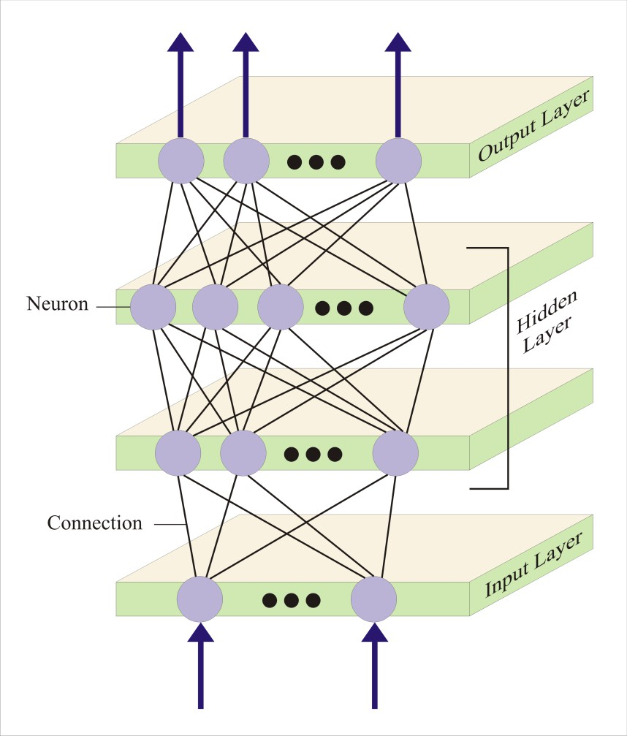
Figure 2.1: Feed Forward Neural Network Structure with Two Hidden Layers Source: James and Carol (2000) in Limsombunc et al. (2004)

There is a set of input connections from each artificial neuron (or computational unit) that receive signals from certain artificial neurons and a bias adjustment, weights attached to input connection and bias adjustment, and sum of the weighted inputs are transform through the transfer function and bias to decide the value of the output from computational unit (Limsombunc et al., 2004).
Kauko (2003) argued that ANN results are strongly dependent on the data – nearly all necessary guidance for the analyses is obtained from the sample we feed the network.

According to the author, ‘neural network theory’ is essentially not theory at all, unless we conceive of the theory in a highly context-sensitive and open sense, which means working from the empirical towards a generalisation. Thus, it is experience that gives ‘intelligence’ to the model (Kauko, 2003).

Neural network models for housing market

In housing market studies, ANNs are potentially seen as a replacement to the regression model (Selim, 2009). ANN application housing can be of different approach. For example, Li et al. (2014) developed a ANN model for identification of the real estate cycle which are in three steps: use the data value of representative indicators for real estate cycles as the input of the ANN model, encode the terms to identify the phases of the cycle as the output of the ANN, and the basic ANN framework is formed; summarize the development phases of the real estate market with reference to the past research, generate training samples to train the ANN; when the ANN model is well-trained, the network extracts the characteristic relationships implicit in the sample, and these characteristic information is stored in the weighted vectors of the network; process the data of representative indicators based on the trained ANN, output the codes of the identification results in the cycle, and the codes correspond to the descriptive term of the phases in the cycle.

Conceptual Clarification

    - Concept of housing market mechanism

The concept of market mechanism is first conceived by 13th-14th century Islamic theologian Ibn Taymiyyah (1962), where his notion was clear about what we now called the forces of demand and supply which determine the prices in a free market (Islahi, 1985). It was later in 14th century that another figure, African historiographer Ibn Khaldun in his Muqaddimah - An Introduction to History (Islahi, 1985). Although, Ibn Taymiyyah did not mention demand and supply categorically, but it is embedded in his writing which was argued by Islahi (1985) that it is clear that Ibn Taymiyyah meant demand and supply.
According to Islahi (1985), Ibn Taymiyyah is referring to what we now call shifts in demand and supply functions, though he did not state them as such. However, Ibn Khaldun (1958) mentioned both demand and supply as market mechanism (Ali, 2006). It was later in mid-18th century that western scholars like Jean Bodin, Pufendort, Barbon, Petty and Locke, who used the analysis of demand and supply to explain changes in market price before Adam Smith (Islahi, 1985).
Market mechanism is the forces of demand and supply that brings changes in price of goods and services in an ideal market (Kirman, 2011). That is to say, price of a commodity in every market is subjected to the forces of demand and supply considering market operating in a normal economic atmosphere.
Housing price is also determined by traditional economic market mechanism earlier explained (Saether, 2008). Housing market incorporates both the relationship between prices, demand and supply and the microeconomic and macroeconomic situation (Pirounakis, 2013). Housing market is a complex market where not only the supply and demand determines housing prices but other attribute features of the house as earlier

explained in the hedonic model. However, demand and supply for housing also has various determinants (Pirounakis, 2013) as in the market equilibrium thought.
In the neoclassical economic theory, equilibrium is the basic issue (Nanthakumaran et al., 2000). That is the where demand and supply mechanism ends and through time, interactive system that determines economic changes are suggested. In the housing market macroeconomic research stock-flow model widely adopted with business cycles and forecasting motivation. In the stock-flow model adjustment, perfectly inelastic is assumed for short-term supply of stock or services. Price per unit of housing services is determined by the inelastic supply and demand of housing services. There is interaction between this price and alternative asset yield operating cost, and a risk premium to determine housing stock capital value per unit (Gurran & Bramley, 2017).
As early as 13th and 14th century, Ibn Taymiyyah and Ibn Khaldun explain the determinants of rent (Ibn Taymiyyah, 1962; Ibn Khaldun, 1958). For example, Ibn Taymiyyah suggest that cities whose atmosphere is frequently unstable in terms of robbery and oppressors attacks, it rental value of land will differ from cities without such attacks (Islahi, 1985). In the same vein, Ibn Khaldun (1958) argued that When there is insecurity of life and property, and the city falls and is ruined. During that period, real estate possession is not encouraged and makes people unhappy, reason being that it has little benefit in this turmoil. There is fall in the value of real estate and with low prices it can be acquire. But when the city’s stability is regained and the dynasty flourishes, and it conditions are enhanced. The outcome is that real estate possession may make people happy, because real estate will be very useful. Values of real estate increases, and it becomes important. This is what is referred to as "fluctuation in the real estate market". The city’s wealthiest men now turns to be real estate owners. This was recently justified
by Aliyu (2012).

In many ways housing market is unique and different from other commodity market. The nature of housing and type of transaction usually involved substantially impact on the housing market mechanism. This is because housing transaction deals with not only physical nature of the product but also interest and right in it (Agbola & Adegoke, 2007).

Concentrated urbanisation

It is an undeniable reality that at present, the world is urbanizing at a quick pace. The unsettling component of this rate is that it doesn't uniformly spread everywhere throughout the world. Sooner than 1950, concentrated urbanization symbolize world urbanization picture as majority of urban growth occurred in developed countries but this have been shifted to the developing countries towards the 21st century (Saurav et al., 2015). This population is expected to increase in the next few decades (United Nations, 2014).
In West Africa, there is rapid expansion in the population of urban areas. Cities in West Africa subregion are expected to have an increase of additional 58 million in the 2010/20 decade, and in the 2020/30 decade additional 69 million is expected. Even by then, growth in the urban demography is not expected to subside, even if there is decline in the projected rates of urbanisation growth beyond 2030, the cities in the subregion are expected to accommodate an added 79 million by 2040, and by 2040 and 2050 another 84 million is expected (UN-Habitat, 2010).
Nigeria urban population is estimated at 44% in the year 2005 with annual growth rate of 3.7% (United Nations, 2009) and increases to 48% in the year 2014 with 4.7% annual growth rate (United Nations, 2014) . Due to the expansion in urban population at uncontrolled rates since 1996, the shortfall in the housing supply is not surprising in many cities (Asian Development Bank, 2012; Asian Development Bank, 2015). Estimates by

UN-Habitat show that slum dwellers in the cities of developing countries currently amount to 881 million people compared to 792 million in the year 2000. Another 1.6 billion are likely to need adequate, affordable housing by 2025. However, this is seen as a wake-up call governments, advising them urgently provide access to housing for all urban dwellers (UN-Habitat, 2015). As urban agglomerations are growing rapidly worldwide, building additional housing for citizen by the government is becoming unrealistic and the involvement of the private sector become necessary (UN-Habitat, 2015). Most of these agglomeration are concentrated urbanisation (Saurav et al., 2015).

Review of Empirical Studies

This section review literature related to urban densification and housing market, approaches to housing market analysis, housing submarket and approaches to housing submarket delineation. The purpose is to examine type and extents of previous researches related urban densification and housing market in order to establish basis for this research and identified what is left out in the literature so as to contribute to the literature in housing scholarship.

Conventional approaches and mechanism to housing market analysis

Housing market is an organised meeting place where there is buyers and sellers of housing goods and services, and are demanded and supplied (Sulyman, 2015). Price in the housing market is determined by many factors, ranging from structural attributes of the house (Debrezion et al., 2006; Wu et al., 2014a), environmental/neighbourhood factors (Antoniucci & Marella, 2017b; Liu & Li, 2018), urban forms (Xiao, 2012; Xiao, Orford, et al., 2016) and external factors such as the national economic performance (Gulyani et al., 2018; Killins et al., 2017). This has attracted a large body of literature on various determinants price in the housing market (Alkali et al., 2018).

Consequently, determinants of housing prices is reviewed from previous researches in order to highlight various determinants of housing prices in different scenarios and deduce whether they are within structural attributes, environmental/neighbourhood factors, urban forms or national economic performance.
From the past literature, set of authors focussed on the environmental/neighbourhood factors as determinants of housing prices (e.g. Aliyu, 2012; Bates, 2006; Bin et al., 2008; Chen et al., 2011; Debrezion et al., 2006; Latinopoulos, 2018; Lockwood et al., 2018; Wang & Wu, 2018; Yusuf & Resosudarmo, 2009). For example, Aliyu (2012) examine the impact of urban violence on the values of residential properties in Jos metropolis, Nigeria. The researcher established through the findings of his research that urban violence have great implication on the values of houses. The researcher also establishes relationship between urban violence and provision, availability and maintenance of neighbourhood facilities which are also linked with house prices.
Yusuf & Resosudarmo (2009) examine how clean air in developing countries determines housing prices using the combination of data on housing rental prices and their characteristics from the Indonesian Family Life Survey, and data of the ambient level of six different pollutants in Jakarta, Indonesia. The researchers found out that air pollutants have a negative association with housing rental price. That is, air pollution does not have anything to with the housing price in the location where their research was conducted. Similar result was recorded when Muehlenbachs et al. (2015) analyses property value impacts from nearby shale gas development that vary with water source, well productivity, and visibility. Their Results indicate large negative impacts on nearby groundwater dependent homes, while piped-water-dependent homes exhibit smaller positive impacts, suggesting benefits from lease payments.

Bin et al. (2008) examine the effects of flood hazard on coastal property values. Their analysis highlights that there is high degree of correlation between coastal hazard and amenity levels—an aspect of the market that can confound attempts to measure risk or amenity tradeoffs with housing sales data. Their results indicate that location within a flood zone lowers property value. The researchers conclude that flood zone designation and insurance premiums convey risk information to potential buyers in the coastal housing market. Debrezion et al. (2006) analyse the impact of railways on house prices in terms of distance to railway station, frequency of railway services and distance to the railway line. The researchers find a negative effect of distance to railways, probably due to noise effects – that is, railway have negative impact on the price of residential properties.
There are other group of authors who focuses on the relationship between macroeconomic indicators and housing market (Brounen & Kok, 2011; Cameron, 2018; Chu, 2018; Deng et al., 2011; Doszyń & Gnat, 2017; Gulyani et al., 2018; Killins et al., 2017). For example, Deng, et al. (2011) argue that the speed and efficacy of China's stimulus derives from state control over its banking system and corporate sector. The authors also assert that state-owned banks were ordered to lend, and they lent and that centrally-controlled state- owned enterprises (SOEs) were ordered to invest by Beijing, and they invested, however, their data revealed that much of this investments were highly motivated by real estate purchase. Auction prices of residential land in eight major cities under their findings increases by about 100% in 2009, quality variation control. Moreover, rises in prices occur as these SOEs are more active buyers. Their argument was that these centrally- controlled SOEs overbid significantly; driving bubble in the real estate market; and that Chinese effective macroeconomic stimulus package might have prompted inflated resource misallocation.

Chu (2018) develops a dynamic stochastic general equilibrium (DSGE) model that analyses real estate transfer tax transmission mechanisms and some other policies of macroeconomic on the housing market of Taiwan. Their model is in line with the Taiwanese housing prices volatility and transactions on housing since 2011 – 2015, after there is reduction in the loan-to-value ratio and successful collection of transfer tax along with a property tax. The findings indicate that residential property tax enforcement or increase in the interest rates efficiently limits housing transaction speculations and has long time impacts on housing price taming for some time. Imposition of transfer tax or a reduction in the loan-to-value ratio has short-lived impacts on housing market moderation.
Killins et al. (2017) examine the oil shocks impact on the housing market of Canada and United States. The authors argued that 2007-2009 economic recession necessitated the housing market regulators and market participants to closer monitor the global housing markets. Structural vector autoregressive model was employed where they found out that housing markets reaction to the shocks in the oil price differs considerably with a condition on whether oil market demand or supply shocks prompted the change in country’s status of oil trading. Their findings includes how oil shocks may determines housing price through different macroeconomic channels.
There are other authors who studied how other factors apart from environmental attributes and economic condition influences housing market (Antoniucci & Marella, 2017b; Chen et al., 2011; Gu, 2018; Gulyani et al., 2018; Hu et al., 2016; Hulse & Reynolds, 2018; Kuang & Wang, 2018; Li & Tang, 2018; Liu & Li, 2018; Musa & Yusoff, 2018; Troy, 2018; Tupenaite et al., 2017). For example, Zhang & Zhao (2018) studied the determinants of informal housing price in Beijing with focus on village power, informal
institutions, and property security. They argued that rural areas have the ability for

seeking political support and control the market transactions to stable the tenure of informal housing. This potential is authorised by numerous formalities: the dual land gadget and the regime of village autonomy. The developing powers of market organisations in local development help reinforce the village’s potential. The variances in capability among villages result in as heterogeneity of tenure security, hence creating rate differentials within the marketplace. They opined that higher tenure protection will increase the housing fee. In conclusion, the informal housing marketplace in China is “regulated” with the aid of a “semi-formal” device wherein both informality and formality paintings and intertwine.
In another perspective, Antoniucci & Marella (2017b) assess variations in the housing market polarisation in the cities of Italy since 2008 in economic recession period. Market polarization index was built and related with socio-economic factors and urban density, as factors that determines urban development of Southern European countries. Their findings revealed that there is increase in social polarization since 2008, the begining of crisis on economic and sovereign debt which correlated negatively with housing market patterns in the cities with more population densities than in those with sprawl development. Multivariate regression on price of housing dissimilarities from 2008, in addition to economic variables dataset of 112 Italian provincial capital cities, was applied test the hypothesis, and the findings established that there is an increase in the polarization of the housing market ever since 2008 and correlated statistically significantly with urban density, housing affordability, and socio-economic characteristics. Evidence from the empirical study also proves the close association amongst price patterns, urban density, and the urban populations socio–economic structure.
There are other authors who considered some other approaches to housing market analysis. Findings from the review of empirical studies reveals that determinants of

housing prices are based on structural attributes, environmental/neighbourhood attributes, location, socioeconomic characteristics, urban form, national economy or policy.

Structural attributes as determinants of housing prices

Numerous researches have been carried out on the relationship between structural attributes and housing price. For instance Archer et al. (2010) examined the influence of structural attributes on housing price using spatial variation method. The study found out that housing segementation is most significantly explained by the housing characteristics. Another study by Ajayi et al. (2015) assesses housing condition and rental value relationships. The study adopted spatial approach where it found out that building condition has weak relationship with rental values. Gulyani et al. (2018) studied the nexus between living conditions and housing value. The study adopted hedonic model in analysing its data. It found out that relative value of housing features with electricity, kitchen and number of rooms emerging as important drivers of rent. It was also found out by Abdullahi et al. (2018) who use multiple regression analysis that house type, availability of security post, location of the property, door type and availability of swimming pool significantly determines the housing price. Bolton (2018) also used hedonic model to find out that green-certified houses that are third-party verified will carry a higher price premium than green-certified houses without this verification.
Iliopoulou & Stratakis (2018) conducted housing prices spatial analysis in the region of Athens of Greece where Geographically Weighted Regression method was adopted and found out that structural attributes contribute immensely to the housing price determination. Also, in another separate studies by Lu (2018) and Saenko et al. (2018) considered building orientation (in China) and depreciation (in Russia) to have positive relationship with housing price. Lu (2018) adopted hedonic model while Saenko et al.

(2018) used correlation-regression analysis. Another study from China by Cui et al. (2018) suggest that houses with large numbers of rooms commands higher rental value using spatial approach, hedonic price model and quantile regression model.

Environmental/neighbourhood attributes as determinants of housing prices

The study found out from previous empirical studies that pollution, gas risk, flood hazard, neighbourhood facilities, conflicts, vices, crime among others have negative relationship with housing price. A study by Yusuf & Resosudarmo (2009) uses hedonic model to establish relationship between air pollutant and housing rental price. Their study found out that in the cases of lead, total hydro carbon (THC), and SO2, air pollutants have a negative association with property value. Bin et al. (2008), Jung & Yoon (2018) and Razali et al. (2018) observed that location within a flood zone lowers property value. The study also employed hedonic model. Muehlenbachs et al. (2015) found out using hedonic model that Shale gas development has large negative impacts nearby ground water which has negative effect on the housing value. Aliyu (2012) observed that there exists relationship between intangible location attributes and provision, availability and maintenance of neighbourhood facilities in the study area with the rental value. The study employed regression analysis. It was also observed by Chen & Li (2017) using 3-D spatial hedonic model, that homebuyers would like to pay an extra premium for an apartment located farther away from polluted streams.
Wu et al. (2017) and Xiao et al. (2016) found out, using hedonic model, that the effect of parks on the housing price is statistically significant. Gambo (2012) uses hedonic model to observe that conflict-free area is the most influential variable determining rent. Kemiki et al. (2014) also use hedonic model to establish that rental value decreases moving towards the Lafarge cement factory as a result of dust and noise severity. Using machine

learning methods, Aderibigbe & Chi (2018) observed that housing price is impacted by natural disasters factors such as hurricane. Paz & McGreal (2018) adopted Price index and Hedonic model to establish that improvements in neighbourhood quality affect house price. These improvements also include converting the abandoned railway into a greenway as observed by Noh (2019).

Location as determinants of housing Prices

Previous studies have shown that proximity to major employment centre, transit network, schools, parks and hospitals, major landmarks, major junctions and city centre among others, determines housing price at a given location. For instance, Wickramaarachchi (2016) and Oluwadamilola (2017) use multiple regression model to find out that distance to main junction is the most significant variable in the types of properties. Liang et al. (2018) uses regression analysis and geographic field model to analyse the effects of locational factors on the housing prices of residential communities. The study found out that proximity to externalities of parks, lakes, department stores, banks, secondary schools and rail transit have significance but spatially non-stationary effects on housing prices. This is also confirmed by Li et al. (2018) and Kim et al. (2019) using hedonic model. However, in line with monocentric model of Alonso (1964), D’Acci (2018) found out that housing value decreases with increasing distance from the city centre.

Socioeconomic characteristics as determinants of housing prices

Socioeconomic characteristics have been given much attention as housing price determinant. For instance, a study conducted in Singapore by Li & Tang (2018) using dynamic general equilibrium model and counter-factual experiments suggests that the native population growth can generate more of private housing price than growth of the foreign population. Oluwadamilola (2017) in his study using multivariate regression

found out that income have significant effect on rental value of accommodation. Using search-and-matching model, Gan et al. (2018) confirm unemployment influences on the housing market. Flage (2018) adopted meta-analysis method to found out that ethnic and gender discrimination have impact rental housing market. In South Korea, Kim & Lee (2018) use locally weighted non-parametric regression to found out that housing market respond to potential crime risk. In terms of fertility rate and housing price, Zhao (2018) uses cross weight coefficient and regression models to found out obvious positive correlation between housing price and fertility rate.

Urban form as determinants of housing prices

The impact of urban form on housing price has attracted many researches in recent decades. For instance, Xiao et al. (2016b) examine house price effects of changes in urban street configuration using spatial-network analysis. They found out that improved accessibility leads to higher property prices. In contrast, a study by Devaux et al. (2018) suggest that reorganization of the street had no significant impact on the closest properties’ prices, but had negative effects for properties located within 150 to 450 meters off the street. However, Xiao (2012) investigate relationship between urban morphology and housing market using space syntax method. The study captured two cities; Cardiff in UK and Nanjing in China where it was found out that there is a significant influence of urban morphology on the price of housing of both housing markets.

National economy (micro and macro) as determinants of housing prices

Scholars have considered national economic performance indicators in terms of both micro and macroeconomics to be determinants of housing market. For example, Killins et al. (2017) studied the oil shocks impact on the United States and Canada housing market. Structural vector autoregressive model was use to found out that housing market

reaction to the shocks in oil price significantly differs depending on whether the oil market demand or supply shocks prompted the change in the oil prices and status of country oil trading. Similar study was conducted by Cameron (2018) using local projection method and found out that house price in regions respond heterogeneously to oil price shocks. In another perspective, Antoniucci & Marella (2017b), Ge (2017) and White & Papastamos (2018) uses multivariate regression, agent–based model and LSDVC model respectively to found out that economic recession and financial crises have significant impact on housing price. Chen (2018) adopted Geographical Weighted Regression (GWR) in assessing the housing price spatial heterogeneity in Guangdong Province during 1995-2014 and its impact factors spatial heterogeneity. The study found out that GDP per capita have impact on housing prices. In terms of inflation rate and interest rate, Than-Thi et al. (2019) use autoregressive model to found out that in the United States, there is a negative impact of inflation rate on the housing market in the period of economic recession (global economic crises inclusive), but for other periods, there is a weak relationship, while in the United Kingdom, there is reverse influence of interest rates on the housing market during economic recession but it is insignificant in other periods.

Policy as determinants of housing prices

Government policies such as development control, energy control, urban renewal policy, tax, tenure security, government intervention on rent, housing supply policy, economic policy and bank credit have been considered as housing market determinants in the literature. For instance, Zhang & Zhao (2018) use ordinary least squares and multi-level hedonic models to found out that a higher tenure security increases the housing price. Zhou (2018) using Principal component and lagged sentiment proxies suggest that
government interventions have impact on housing market. Similar result was recorded by

Chung et al. (2018) using spatial approach and Hedonic Model. In a study by Huang et al. (2018) using regression model suggest that housing market is prosperous when economic policy is stable and there is a positive relationship between housing price variation and economic policy uncertainty, which means housing market risk grows under unstable economic policies. Bérard & Trannoy (2018) using month‑based model and hedonic model found out that increase in the real estate transfer tax sizable have short‑term effect – but no medium or long‑run effect on the housing price. In another perspective, He et al. (2018) studied relationship between housing prices and bank credit using vector autoregression (VAR) model with stochastic volatility found out that all kinds of bank credit influences of housing prices.

Housing market determinants variables

Variables for housing price determinants have been identified from the literature and group accordingly in Table 2.1.

Table 2.1: Housing Market Determinants Variables
S/N | Housing Price  Determinant | Variables
1. | Structural attributes | Housing type, building materials (type of roof etc.), obsolescence, age of building, building condition, building facilities (electricity, toilet, water, dining, size of rooms, type and size of doors and windows, security etc.),  building orientation, green certified housing,
2. | Environmental / Neighbourhood attributes | Pollution (water, air, noise and land), flood risk, gas development risk, parks, neighbourhood facilities (sewage, street light, road, drainage, public water, energy etc), conflict, vices, crime, densities, green space and greenway, natural disaster (hurricane, tsunami, typhoon,  etc.), spatial growth rate and environmental quality
3. | Location | Proximity to major employment centre, proximity to transit network, proximity to schools, parks and hospitals, proximity to major landmarks, proximity to major  junctions and proximity to city centre

4. | Socioeconomic characteristics | Household size, income, marriage entry, discrimination, native and tribe, household unemployment, crime offenders, fertility rate, gender and ethnic discrimination
5. | Urban form | Street pattern, land use pattern and density
6. | National economy (micro or and macro) | Land value, market spillovers, oil price, exchange rate, GDP, economic recession, financial crises, speculation, disposable income rate and inflation rate
7. | Policy | Development control, energy control, urban renewal policy, tax, tenure security, government intervention on rent, housing supply policy, economic policy and bank credit
Source: Authors’ compilation, 2019

Findings from various researches revealed that variables under structural attributes as housing price determinant includes housing type, building materials (type of roof etc.), obsolescence, age of building, building condition, building facilities (electricity, toilet, water, dining, size of rooms, type and size of doors and windows, security etc.), building orientation, green certified housing. For environmental/neighbourhood attributes as housing price determinant, the variables include pollution (water, air, noise and land), flood risk, gas development risk, parks, neighbourhood facilities (sewage, street light, road, drainage, public water, energy etc), conflict, vices, crime, densities, green space and greenway. natural disaster (hurricane, tsunami, typhoon, etc.), spatial growth rate and environmental quality. Variables for location as determinant of price include proximity to major employment centre, proximity to transit network, proximity to schools, parks and hospitals, proximity to major landmarks, proximity to major junctions and proximity to city centre.
Findings from various studies also revealed that variables for socioeconomic characteristics as determinant of housing price include household size, income, marriage entry, discrimination, native and tribe, household unemployment, crime offenders, fertility rate, gender and ethnic discrimination. Variables for urban form as determinant

of housing price include street pattern, land use pattern and density. National economy as determinant of housing price have land value, market spillovers, oil price, exchange rate, GDP, economic recession, financial crises, speculation, disposable income rate and inflation rate as variables. For policy as determinant of housing price, the variables are; development control, energy control, urban renewal policy, tax, tenure security, government intervention on rent, housing supply policy, economic policy and bank credit.

Conventional approaches to housing market analysis

      - Hedonic approach

Hedonic approach is one of the most used conventional approaches to housing market analysis (Sopranzetti, 2015). With hedonic approach expenditures on housing can be decomposed into measurable prices and quantities, so that rents for different dwellings or for identical dwellings in different places can be predicted and compared (Malpezzi, 2002; Meese & Wallace, 1991; Sopranzetti, 2015). This approach has been adopted by several authors in analysing housing market (Abdullahi et al., 2018; Anselin & Le Gallo, 2006; Goodman & Thibodeau, 1995; Helbich et al., 2014; Liao & Wang, 2012; Lu, 2018;
Oladunni et al., 2017; Sandmo, 2014).

For example, Lu (2018) adopted hedonic price model in examining the relationship between property orientation view and its value in Shanghai housing market context. The author use a unique dataset comprising attributes of building, indicators of the environment and urban spatial structure, where it shows that buildings that has south- facing orientation is associated with 14% property value premium. Property value increases by 6% with a view on Shanghai’s landmark and increases by 4% by south- facing orientation. Houses with south-facing orientation commands lower prices and value continue to reduce due to the presence of dust pollution, while the invisible PM2.5

has little or no influence. The author argued that elevators presence in tall buildings strongly influenced preference of such apartments. Also, internal accommodation characteristics shows signs of influence but the extents can mislead except with the control of the building features.
Abdullahi et al. (2018) applied Multiple Regression Analysis (MRA) in mass appraisal of house price estimation in Kaduna north, Nigeria. Structural characteristics and location were considered where the authors argued that they are the two basic house price micro determinants. They found out that amidst the variables considered in the MRA, location of property, availability of security post, house type, door type and availability of swimming pool were significant determinants of price of houses in Kaduna. However, those that were not significant in influencing house price include condition of the house, number of bedroom, type of ceiling and number of living room. Considering the variables that are significant, a model was developed for mass appraisal for the study area. In their recommendation, it was suggested this model be used in Kaduna north in case of any mass appraisal of residential properties, in order to improve accuracy, efficiency, objectivity and fairness of property taxation system, where government can generate more revenue and physical infrastructure development of Kaduna north can be encouraged.
Liao & Wang (2012) applied hedonic approach where open access sources was used to build a novel micro-dataset for a China emerging city, Changsha, by incorporating regression with modelling of spatial econometric to assess housing features implicit prices may diverge across house prices conditional distribution. Considerable disparities are found, and the implications and intuitions are discussed. Furthermore, a U-shape pattern was exhibited by the spatial dependence. A strong dependence is found in the lower and upper parts distribution responses, but in the medium range it is little.

Helbich et al. (2014) investigate single family home using by modelling Spatial Heterogeneity (SH). They argued that prices of Australian single family home are explored to appraise global and locally weighted hedonic models capabilities. They suggest that even if SH cannot be modelled fully with the regional indicators and with the need for technical amendments to account for unmodelled SH, significance of achieving a well-specified model was emphasises in the results. Locally weighted regressions are proposed because the SH is beyond regional indicators level. Limitations of fixed effects were prevented using mixed geographically weighted regression (MGWR) by exploring spatially stationary and non-stationary price effects. Apart from prediction errors reduction, they found out that complexity of SH of implicit prices is more than those modelled by purely local models or regional indicators.
Razali et al. (2018) examine response of house market price to flood‑hazard in the Langat River flood area in the State of Selangor, Malaysia. They suggest that environmental attributes are very subjective and relatively new in valuation theory. They argued that population growth has caused vulnerability of more areas, including flood prone areas. The investigation of new sites for development of housing also makes the areas more vulnerable to flood hazard. Determination of house price using valuation calculation needs flood hazard response as it will impact the housing market and investment in the housing market. It is expected that the impact from the flood to property price will be significant in future due to changes in property demand patterns as well as the increase in environmental issues.
Cajias et al. (2019) assess the housing market stock in respect to energy efficiency levels improvement, where the focus was on private rental market and unequal measure of landlords and tenants capital costs and utility cost savings. They argued that the German

housing market is characterised with the problem where rented accommodation dominate over owner occupancy. They argued that their research is so far the largest in terms of rating of the effect of energy efficiency investigation and how it impact rental values. Adopting a semiparametric hedonic model and empirically sampling about 760,000 observations covering about 403 Germany’s local markets considering complete hedonic feature, they observed that energy-efficient rental units are rented at a premium. Though, confirmation of this effect did not cover the largest metropolitan housing markets. Preceding this, the effect of energy ratings on time-on-market was estimated using survival hazard model. Their findings shows that energy inefficient dwelling have longer marketing periods and thereby less liquid than their more energy efficient counterparts.
Liebelt et al. (2018) examined how residential property prices are influenced by Urban Green Spaces (UGS) in Leipzig, Germany, adopting hedonic pricing analysis. Their findings contribute to the existing literature by considering both house rental and sale prices; UGS shape was considered; and argued that in Germany, their study is first of its kind to examine UGS using hedonic approach. Demonstration of their result shows that there is stronger impact of size of the nearest UGS on house prices. Considering the shape, they found that higher house prices are as a result of simple UGS shape. Valuation approach was proposed and results was obtained to inform urban planners concerning new UGS designs and public awareness of the social and economic impacts of the UGS.
Latinopoulos (2018) appraise the impact of sea view on the apartment rates together with other locational and structural characteristics. The research goals was to find out whether apartments in the Greek city of Halkidiki with a sea view commands higher price, by quantifying the associated costal area aesthetic values where key economic activity is tourism related development. Then, these data were integrated into a GIS environment to achieve spatial hedonic model. A semi-parametric geographically weighted regression

model was adopted in assessing the local impacts, also, to examine the spatial inconsistency of the selected features. Their finding revealed a substantial spatial inconsistency regarding the impact of sea view on apartment rates, signifying that local natural and/or tourism resources may substantially influenced the aesthetic value.

Spatial approach

One reason house prices may be spatially autocorrelated is that property values in the same neighbourhood capitalize shared location amenities. Location characteristics that influence house prices include neighbourhood characteristics, accessibility, and proximity externalities (Basu & Thibodeau, 1998). Spatial approach has been adopted by several authors in analysing housing market (Basu & Thibodeau, 1998; Delbari et al., 2013; Diao, 2015; Dubin, 1998; Dubin, 1992; McCluskey et al., 2000; Moral, 2008; Tu et al., 2007; Wang et al., 2017; Chao Wu et al., 2017; Zhang et al., 2018).
For example, Zhang & Tang (2016) Analyse Chinese cities’ housing prices to investigate public attention spatial pattern. They argued that detail data on housing price are not properly documented which also is not available for the public, which in turn poses a great challenge to the housing price studies in China. They argued that web search engines can records internet search activities by individuals, the web search activities analysis done on the cyber-space is capable of providing means of understanding public attention better and real geographic space concerns. The emphasis on investigating public attention spatial patterns on price of housing through Baidu Index based analysis which is done in form of web query, also the Chinese keyword finding medium from Baidu web search engine. A new index was proposed to source data from the Baidu search database based on the keyword query outcome to examine housing price attention spatial heterogeneous patterns which include nineteen medium and large-sized Chinese cities. They appraise

housing price attention spatial network structure, and develop a different index to assess the extent of interactions amongst interested cities. Their finding proved that using the new method and a gravity model, cities evaluated on housing price attention shows spatial interactions consistency. Meanwhile, existence of strong spatial association patterns was revealed by the indicators of the Baidu Index which form urban agglomerations. More so, their findings prove that cyber-space and geographic space based on the web search engine approach, provides strong backing for the housing price attention studies and spatially explicit patterns associated with it in China.
Kuntz & Helbich (2014) make comparative study on univariate kriging variants prediction accuracy, specifically universal kriging (UK) and detrended kriging (DK), and multivariate extensions, which include universal cokriging (UCK) and detrended cokriging (DCK). Structural and neighbourhood features are considered as auxiliary variables in both latter methods. Though the UK and DK price surfaces indicates closely identical cross-validated accuracies, the UCK and DCK cross-validation-based prediction accuracy vary in favour of the latter. They suggest that whenever there is challenge of univariate sample of property prices by real estate agencies, either UK or DK can be adopted, while in case of multivariate, UCK is recommended, however mathematically more complex.
Li et al. (2017) argued that in recent decades there is fast-paced development in the Chinese real estate industry. However, public attention was attracted by the spatial inequality that exists in urban and rural economic growth and house prices fluctuation and excessive growth in both areas. They also argued that urban and regional economic research focused focuses on these issues in recent times. Accurate and efficient housing price prediction remains an important and debatable issue. Currently, considering
financial market changes and trends, processes of urbanisation, migration of people,

several researches have been conducted to examine real estate price fluctuation mechanism. Sourcing data from sofang.com which is the Chinese real estate leading online platform, they examined the spatiotemporal trends of housing price fluctuations in big data context. Modelling techniques and spatial data analytics was used to identify housing prices spatial distribution at micro level, appraise the space and time dynamics of houses in the housing market, and detect housing prices geographic disparity if it exists. Their findings revealed space and time patterns of large metropolitan housing prices, establishing the importance of big data and how it can be analysed.
Iliopoulou & Stratakis (2018) analyses Greater Athens region housing prices considering locational and structural features of houses. They used 2017 total housing supply as sample which includes numerous thousand houses for sale online by the real estate specialists. A provision of detailed account of the houses in terms of characteristics of the structure, housing type, number of bedrooms, floor, size, parking and so on. More so, several related housing locational features, such as distance from the city center or closest metro station are measured in a GIS environment. As a result Ordinary Least Squares method residuals spatial dependency, Geographically Weighted Regression (a spatial regression model) is also presented in order to improve the prediction accuracy. They conclude that there is no significant locational characteristics contribution to the explanatory power of a regression model as compared to the structural features.
Chen (2018) examine urban housing prices spatial differentiation in Guangdong province in China and factors influencing housing prices. Spatial heterogeneity of housing prices and that of its impact factors were examined during 1995 – 2015 using ESDA and GWR models. The study found out that a certain circle structure was shown in the spatial structure of housing prices in the region. While relatively high housing price are found in the Pearl River Delta region, there is high disparity between housing prices of Zhongshan,

Huizhou and other cities. The price of housing in the cities of northern, western and eastern Guangdong is low, which shows a significant high variation from the housing prices of cities in Pearl River Delta, also Shantou and its surroundings has a high difference between the housing prices.

Artificial neural network approach

A review of previous research on the aspect of Artificial Neural Network approaches to housing market analysis is presented in this section. Several studies have been conducted on housing market using Artificial Neural Network (James & Carol, 2000; Kauko, 2003; Kauko et al., 2002; Khalafallah, 2008; Li et al., 2014; Limsombunc et al., 2004; Moulton & Preece, 2002; Selim, 2009). For example, Kauko et al. (2002) assesses the housing market of Helsinki in Finland using neural network modelling. Their study shows how various dimensions of housing submarket formation were identified by exploring patterns in the dataset, and also revealed that classification abilities of two neural network techniques: the Learning Vector Quantisation (LVQ) and Self-Organising Map (SOM). They argued that location and house type relatively determines housing submarket formation in Helsinki.
Selim (2009) assesses housing price determinants in Turkish housing market adopting the household budget survey data of the year 2004. He argued hedonic model mostly used in analysing locational value in the housing market research which mostly based on multiple regression techniques on a data set that is huge and formality is required on microeconomic theory in the analyses. He also argued that non-linearity in the hedonic functions potential makes necessary for ANN to employ the research as an alternative approach. He made comparison between artificial neural network and hedonic regression

models; he further proves that ANN is the best alternative for housing prices prediction in Turkey.
Limsombunc et al. (2004) conduct a comparative study on the artificial neural network model with hedonic model predictive power on prediction of house price. About 200 houses in the New Zealand’s Christchurch city were sampled randomly from the Harcourt website. Considered factors include size of house, age of house, type of house, number of bedrooms, number of bathrooms, number of garages, housing amenities and location respectively. They argue that their findings indicates artificial neural network potential in the predictions of house price.
Khalafallah (2008) developed an artificial neural network based models for the investors in real estate and housing developers in any difficult task. The design methodology, decision variables, and the model implementation were described. The data set of the historical market performance were utilised to train the artificial neural networks to forecast performances in the future. Example of the application was analysed to establish the capabilities of the model in the market performance analysis and prediction. A range of between –2% and +2% prediction errors were recorded for testing and validation the model.
Li (2014) adopted artificial neural networks in Chinese real estate cycles identification, and predicted the market development phases accurately with a well-trained artificial neural network built on historian training samples of 1993 – 2008. Their findings revealed that Chinese real estate market has oscillation features and high accuracy in obtained in the performance of the artificial neural networks. They argued that in a situation of serious continuous interventions by the government, the real estate cycles volatility has become apparent since 2008, in the year 2009 when the market reached its peak, but in 2010

recession came in, and lasted till 2011. They conclude that several macro-control governmental policies since 2008 have great influences on the Chinese real estate cycle’s duration and frequency, regulating the real estate business growth speed.
Del Giudice et al. (2017) argued that Neural Networks (NNs) have been widely adopted due successes recorded by studies from various fields of research. According the authors NNs models are extremely expressive where approximations from input/output of complex functions can be learn, with a specific ability in training huge data sets with stochastic optimization. They also argued that potential stochastic optimization problems can be avoided by the Bayesian approach to NNs and the problem of real estate appraisals is best suited by the use of Bayesian learning, and also that, inference techniques of the Bayesian approach are very exciting in dealing with noisy and small sample in the probabilistic inference field conducted using neural model. As such, they conducted experiment on a NNs model using Bayesian learning. They calculated the output distribution by numerical integration operation on the weights space with the help of Markov Chain Hybrid Monte Carlo Method which they concluded to be the best for housing market analysis.
However, Kauko (2003) adopted spatial approach to neural network analysis. He worked on current neural network applications involving spatial modelling of property prices. He evaluate the pros and cons of neural network models of property valuation (particularly the ‘self-organizing map’, SOM) in comparison with hedonic models, and to provide some examples of the application of the SOM method. His particular interest is how different locational, environmental, and social factors impact housing market segments and house price levels. He argued that these objectives are conveniently handled with a method based on the SOM.

Housing Submarket

Housing submarkets are typically defined as geographic areas where the price per unit of housing quantity (defined using some index of housing characteristics) is constant (Goodman & Thibodeau, 1998). Although as an urban economic, land use and residential location model – the residential location theory (Alonso, Muth, Mills) is also applicable to housing market segmentation. Even without certain factors, segmentation of an urban area can still be carried out, if there is disparity in households’ preferences and/or income with respect to accessibility and space (Kauko et al., 2002).
Although, there is agreement by several researchers on using locational and structure features to define a submarket, identifying a submarket and approach to be adopted have little consensus (Xiao, 2012). Usually, spatial and non-spatial specifications for housing submarket are the main two methods (Islam & Asami, 2009; Xiao, 2017b).

Spatial approach to housing submarket

Peopele’s housing choice of homogenous preferences based on geographic predefined areas are enphasised by spatial specifications which is the main index (e.g. political districts, north/south, inner/outer city, and postcode districts) (Xiao, 2012).
Hitherto, several studies has formed housing segmentation based on spatial specification For example, McCluskey & Borst (2011) uses utilises Geographically Weighted Regression (GWR), a geostatistical modeling methods to identify and demarcate the housing submarkets. The procedure effectiveness was established by improving the accuracy of the predictive model for housing market segmentation as compared to standard universal unsegmented model for the study areas. Measures of predictive accuracy provides optimal number of segments, the Akaike information criterion and

spatial autocorrelation in the residual errors. Their results demonstrate that housing submarket segmentation did not require an arbitrary process any more.
Goodman & Thibodeau (1998) describes housing submarkets as a geographical area where housing price per service unit is constant and characteristics of individual housing are available for purchase. They assess segmentation of housing market Dallas metropolitan area adopting hierarchical models and transaction of single family property between years 1995 to 1997. Performance of elementary school student information was supplemented by the transaction data. The technique demonstrate that using Carrollton– Farmers Branch Independent School District proposes that housing market of Dallas metropolitan area is segmented by the public education quality (standardized tests measuring the student performance). They argue that hierarchical models offer a suitable framework for housing submarkets delineation.
Wu & Sharma (2012) developed a methodology for submarket classification based on spatially constrained data-driven to achieve spatially integrated housing market segments. Precisely, a datadriven model on cluster analysis and principal component analysis was built for housing submarkets delineation. Inside the model, several location characteristics were adopted in the principal component analysis, and in the cluster analysis, houses geographic locations were equally incorporated. The method performance was compared with techniques of other unconstrained data-drivenand and a priori classifications using three measurements: spatial integrity, substitutability, and similarity. Their findings show that spatially contiguous submarkets can be obtained without compromising housing hedonic model accuracy and attribute homogeneity.
Park (2013) proposes spatial housing submarkets division basis in enhancing the housing market understanding. The division’s theoretical background is built upon the nexus

between the structure house prices and commuting patterns. An assessment of the process of 'expansion-overiap-merging' between residential spheres, defined as a unit containing of a centre of employment and the surrounding residential area, provides an overview of a probable form of merged residential spheres in big cities. An empirical study of the Seoul spatial housing submarkets were identified on the basis of the hierarchies between the local authorities from commuting patterns. According to the author, the division’s relevance was verified with three statistical processes: Chow tests, hedonic price models and weighted standard error tests. The empirical study recommended that the Seoul’s housing market can be alienated into three separate spatial submarkets, which supports the reasoning of the division technique recommended in their study.
Manganelli et al. (2014) adopted Geographically Weighted Regression (GWR) in housing market analysis, in homogeneous areas identification and defining a single location marginal contribution to the property’s value at the housing market. About 280 sample data was used to build the model, in relation to the residential real estate units trades that occurred between 2008 and 2010 Potenza city of Basilicata, southern Italy. Their results of territory zone the housing market into homogeneous market areas, they concludes that the findings has useful implications in terms of taxation, programming territorial transformations and checking ongoing or ex post planning decisions.

Non-spatial approach to housing submarket

Accuracy of estimation is emphasised by non-spatial submarket specifications, promoting a data driven method, without considering the pre-defined geographic area. Statistical hierarchical clustering techniques is the basis for these specifications to explore people’s homogeneous demand pattern such as socioeconomic status, income and household mobility (Goodman & Thibodeau, 1995; Xiao, 2012).

This techniques used in building the submarket emphasis on the house prices supply-side and uses housing stock characteristics (e.g., square feet of living area, dwelling type, dwelling age) to build the submarkets and/or neighbourhood characteristics (e.g., neighbourhood schools quality, local police quality). Other techniques in delineating submarket emphasis on demand-side of house prices determinants and form housing submarkets based on household incomes or other socioeconomic/demographic characteristics (Goodman & Thibodeau, 2007; Xiao et al., 2016a).
Day (2003) presents a hedonic housing price model for the city of Glasgow in Scotland. He use hierarchical clustering techniques to identify property submarkets defined by a combination of property types, locations and socioeconomic characteristics of inhabitants. Separate hedonic price functions were estimated for each submarket and these functions were presented to differ significantly across submarkets.
Royuela Mora & Vargas (2007) Use regional data from Catalonia, Spain, where they computed housing market areas with both commuting data and migration data. They looked at uniformity of prices within areas. Their main finding is that commuting algorithms present more homogeneous areas in terms of housing prices.

Criticisms of spatial and non-spatial approach

Both spatial and non-spatial approaches to housing market segmentation have received wide range criticism. Spatial-based determinations have been reprimanded for their error. Because of fast urbanization and the rise of polycentricity, the urban framework has turned out to be more intricate and thus the social spatial structure is changing and social spatial isolation has been upgraded. The main spatial models adopted to characterise the preferences spatial divisions appears to be less effective in peoples preference reflection and each characteristic choice in these type of cities. The traditional approaches risk is

that it underestimates the amount in the submarkets. More so, the spatial based specification often looks like an ad hoc reason be that the use of geographical boundaries that are pre-identified. The requirements also include a prior acknowledgement of the local context and consequently make scientific research complex and not simply replicated (Xiao, 2012).
As being arbitrary is the criticism of the spatial approach, the criticism of the non-spatial specification being unstable over time. For being a non-spatial nature is another criticism of the approach and its ambiguities in presentation for interventions of policy (Xiao, 2017b).
This indicates that both spatial and non-spatial approaches of housing submarket delineation cannot effectively represent true nature of the submarket. It is therefore better to combine both methods in delineating housing submarket. It is on this background that this study intends to adopt both spatial and non-spatial approaches to delineate housing submarket.

Urban Densification

The on-going debate over the environmental sustainability of different urban forms is both high profile and contentious. In the context of urban planning (of the Global North) the discussion however seems to be primarily focused around the issue of densification (Schmidt-Thomé et al., 2013). Several policies promotes urban densification (i.e. compact city forms creation or the densification of existing cities) in order to achieve reduction in urban sprawl. Urban densification denotes upsurge in the urbanisation level of a limited area, which could have negative impact on the urban green spaces biodiversity through habitats destruction, pollutions or increase of soil temperature, fragmentation and

alteration of sociospatial structure (Vergnes et al., 2014). Although, urban densification is also viewed as problem solving approach (Leffers & Ballamingie, 2013).
However, urban densification conceived as intensification of built-up area as a result of concentrated urbanisation. This has great impact on urban forms and has caused changes in the housing sector most especially the housing market. Density has wide range application of application, in urban form, population studies, transport studies, residential development, commercial development, in architecture and a varied range of professions (Medayese et al., 2015). According to Obateru (2005) density in urban forms can be measured in various ways; residential density, population density, housing density, occupancy rate, accommodation density, bedspace density and floor spare rate.
Residential density is the ratio of a population to residential land area. This measure can be further classified in terms of net and gross residential densities based on the definition of the reference area. However, there is no consensus on the definitions of net and gross areas; they vary across cities and countries (Medayese et al., 2015). Obateru (2005) conceived residential density to be the entire built-up area of human settlement. Broitman and Koomen (2015) see urban densification as the housing units added within the existing urban area. Therefore, this study conceived urban densification in form of residential density growth (i.e. growth in the built-up area).

Urban morphology, density and densification

There are three basic concepts used by urban planners to address the issue of how density affects people’s lives; density, perceived density and crowding (Alexander, 1993). Density described relationship between a given physical area and the number of objects in that area (Medayese et al., 2015). Density has an intrinsic relationship with urban morphology; it plays an important role in the shaping of urban forms. One of the pioneer

planners Ebenezer Howard pointed out that countryside have less density and greener environment compared to the growing industrial city (Medayese et al., 2015). Alonso suggest that moving closer to the city centre the density increases and distance away from the city centre causes decrease in density (Alonso, 1964). Density refers to by the two authors is both population density and housing density which result from rapid urbanisation.
More recently, studies shows that compact development provides solutions to many urban problems such as reducing urban sprawl and infrastructure provision (Broitman & Koomen, 2015; Chhipi-Shrestha et al., 2017; Vergnes et al., 2014). This results to many compact cities in Europe and Americas (Medayese et al., 2015). However, considering Howard’s and Alonso’s thought and the recent compact development that changes urban morphology, urban densification can be referred to as planned urban densification (deliberate) and unplanned urban densification (not deliberate). Therefore urban densification can be divided into two categories; planned urban densification and unplanned urban densification. This study is more inclined to unplanned urban densification.
Amer et al. (2017) examines urban densification through roof stacking where three consecutive levels (urban, social and engineering) systematic approach was considered. Identification f multiple criteria was carried out to map and assess the potential of roof stacking as regards number of added floors and location. Using ArcGIS software, maps were produced for roof stacking of Brussels at the city scale which signifies potential urban densification. Their findings revealed a realistic potential of about 30% increase in Brussels city population was expected by the year 2040 using roof stacking only, as long as the present urban regulations are adhered to. Chandrabose (2019) conducted a study
on urban densification and 12-year changes in cardiovascular risk markers where their

findings suggest that, at least in the context of Australia, urban densification may be protective against obesity risk but may have adverse effects on blood lipids and blood pressure.
In a different perspectives, Delmelle et al. (2014) assesses urban densification without growth management where it focused on local land development and housing trends in Charlotte, North Carolina, USA. The study relied on the current land and real estate property records and reconstitute the urban map of Charlotte using World War II as a starting point. Ghadami and Newman (2019) investigate the effect of the urban densification policies made after the Islamic Revolution on the urban spatial structure of Tehran as the most important metropolis in Iran. The Hot Spot approach based on the Getis Ord Local G statistical test and Arc GIS 10.2 software was employed where it was found out that the spatial structure of Tehran was affected by the non-spatial densification policies for 30 years.
Urban densification is conceived as urban regeneration method. For example, Treija et al. (2018) examines the existing approaches focused on densification in large housing estates in order to define the typical challenges of this process, the examples of infill developments in large housing area Imanta in Riga was analysed. Vuckovic et al. (2019) investigates urban densification potential in the effects of heat island mitigation and outdoor thermal conditions improvement in Vienna, Austria. Urban microclimate were simulated for both pre and post densification scenarios where the Rhinoceros 3D (parametric modelling environment) was considered and Grasshopper was used for built- in algorithms in the Rhino’s plug-in. Their findings revealed a well-known effect of solar shielding by the vertical extensions of existing buildings which is newly introduced, temperature reduction, thermal condition improvement within the urban area.

Measuring urban densification

Measuring urban density has been a problem of many researchers (Ståhle et al., 2008). Broitman and Koomen (2015) measured residential densification using a high level of detail spatial data that covers the whole of Netherland. They describe land use by employing 100 metre resolution rasterised data, residential density and local explanatory variables of wide range. Predominant land use is accessible for each cell for the years 2000 and 2010 which depend on an accumulated arrangement Netherland’s Statistics spatially explicit land use database. Wang et. al. (2019) generate a land use transition of 2001 to 2011 matrix using land use maps with the aid of ArcGIS and examines the spatial and temporal urban density changes. The study employed various metrics based on landscape to describe urban spatial pattern changes and to evaluate the model errors nature. Analysis based on rings were adopted which is primarily based on classical urban theory, was also employed to show transition of urban densification characteristics. The Land Transformation Model (LTM) which is a function of Artificial Neural Networks (ANNs) and GIS was applied in simulating the changes in land use, which also utilises a raster modelling environment in urban growth simulation which relied on several bio- physical and socioeconomic factors. Relying on changes in the historical land use data and predictor variables, the ANN learns urban densification patterns; this information is then kept and applied in predicting changes of future urban densification.
In contrast, Jiao (2015) acquired high quality Landsat TM/ETM+ images, where the images classified using the Maximum Likelihood Classification method in ENVI 4.5. The results from image classification processed using a non-linear least squares method to fit the pro-posed urban land density functions in order to fit a nonlinear function to the observed data by refining the parameters in successive iterations. They employed Trust- region algorithm in their study. They fit the urban land density functions with Matlab.

Urban densification was also measured using microclimate simulations with different models. The results are compared, and uncertainty ranges are documented by testing the impact of urban fabric on current climate (Loibl, 2019). Shahtahmassebi (2016) developed framework for measuring urban densification using time series of impervious surface fractions (ISFs) derived from remotely sensed imagery.

Summary of Literature Review

Theories for which this research forms its bases were reviewed. These theories include Monocentric model of Alonso which suggest that rental value increase with decreasing distance to the CBD and also residential density increases with a decreasing distance from the CBD. Despite various criticism, Alonso’s Monocentric model forms basic theoretical foundation of the study. Hedonic model is another model reviewed which suggest that housing prices are determined by utilities derived from the housing. Spatial interpolation model was also reviewed which forms the basis for spatial interpolation in the study. Neural Network models that are a machine learning models were also reviewed which the study adopted in forecasting urban densification and housing prices and also show their relationship. From the review of empirical studies, it was found out that determinants of housing price include structural attributes, environmental/neighbourhood attributes, location, socioeconomic characteristics, urban form, national economy and policy.

Research Gap

This dissertation adopted conventional methods such as Artificial Neural Network, hedonic and spatial analysis methods to analyse urban density and housing market. By doing so, it attempts to make a significant contribution to urban scholarship by exploring how measured residential density associated with a number of housing market issues, particularly the housing submarket.

There is little knowledge about how to delineate submarkets in housing markets of developing countries, most especially Nigeria urban areas, where the building type in many fast growing cities are simple structures and urban growth change quickly over time. This is the case in Bida town. It is on this basis that this research intends to fill another gap in the literature by delineating Bida housing submarket and demarcating it using both spatial and non-spatial specifications.
From the review of the empirical studies, knowledge gap established was that little have been done on urban form in relation to housing price determinant. More specifically, urban densification as a determinant of housing price is not given adequate attention. Also, hedonic model is the most used method in housing price analysis from the previous literature while Neural Network is given less preference. This establish basis for this research to develop a model using Artificial Neural Network to model residential densification and housing prices for the study area.

CHAPTER THREE

  - RESEARCH METHODOLOGY

Research Design

This study is designed in four phases vis-a-vis data collection stage, data processing stage, data analysis and model development. Data required for this research were collected from two different sources – satellite images from Google Earth for the years 2008, 2013 and 2018 respectively for each housing submarket and rental value of properties managed by professional estate surveyors and valuers for the period of study i.e. 2008, 2013 and 2018 respectively. The range of years was due to the fact that during this period there was high increase in population influx and spatial expansion.
The second phase of the research is the data processing where satellite imageries gotten from Google Earth were georeferenced and onscreen digitization was conducted to create point features for all buildings in the study area for the years under study. Point features created based on submarket were merged and aggregated to have three sets of point feature – i.e. 2008, 2013 and 2018. Data collected on rental value were sorted according to the type of housing apartments and different years under investigation. Geodatabase was built for rental values using point features and attribute tables representing rental apartments managed by professional estate surveyors.
Third phase of the research involves analysis of data on residential density in terms of number of building per area coverage by submarket for the years under study, number of buildings in each submarket for the same years and level of density for the years under review. Point features representing building were also analysed using Point density analysis for the years under review. Data on rental prices were analysed using spatial

interpolation techniques known as Ordinary Kriging (OK) for all type of housing apartments and years under consideration.
The last phase of the research involves developing a model that can analyse the relationship between rental prices and residential density of the study area. Point density results and spatial interpolation results were provided as data for the model where both data were normalised and inputs were refined before data processing. The model forecast both data where residential density and rental prices were predicted and relationships were shown (see Figure 3.1).
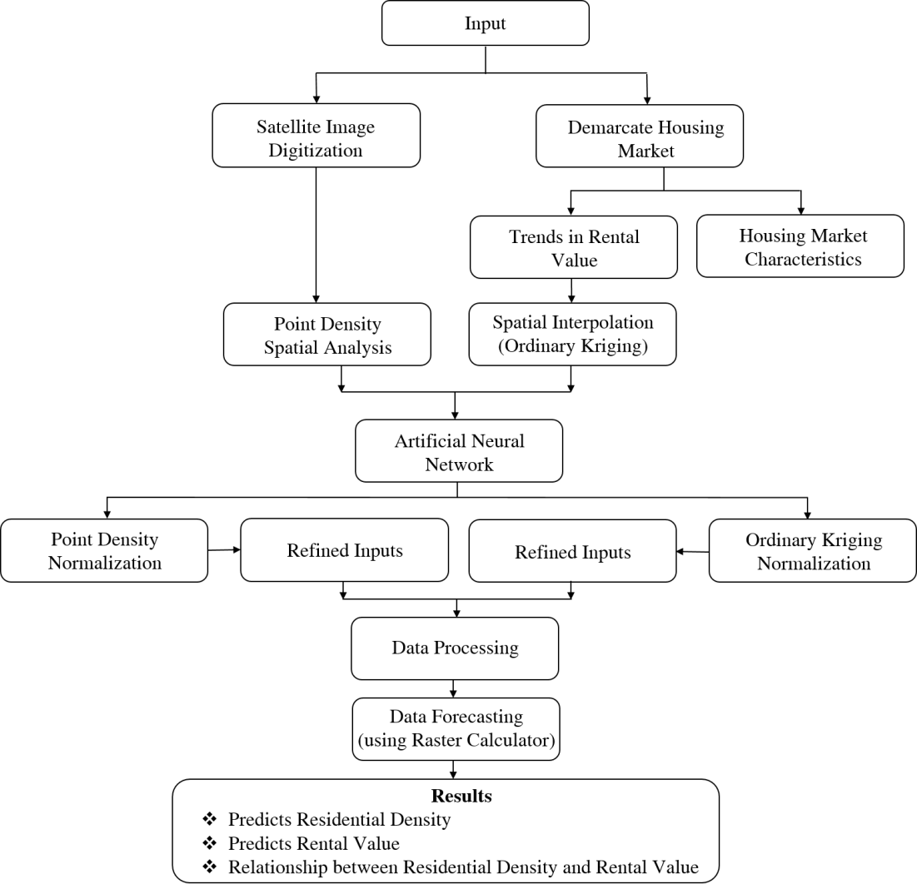

Figure 3.1: Research Design

  - Research Population

The population of this research work include all building in the study area between year 2008 and 2018, also rental housing apartments managed by professional estate surveyors and valuers - Usman Maishera & Associates, Okoh Okuoma & Co. and Pat Egbeduma & Partners.

Sampling Technique

Census sampling techniques was adopted for this research where the entire population is sampled. The census is alternately known as a complete enumeration survey method. However, in this study the entire buildings in the study area were sampled for the years 2008, 2013 and 2018. Also, all rental housing apartments managed by professional estate surveyors and valuers were sampled in the study area for the years 2008, 2013 and 2018.

Sampling Size

The required sample size for this research includes all building units in the entire study area which is 31,410 buildings, 46,489 buildings and 47,394 buildings for the years 2008, 2013 and 2018 respectively. Also total number of 138 houses managed by the 3 registered estate firms in Bida; Usman Maishera & Associates, Okoh Okuoma & Co. and Pat Egbeduma & Partners was sampled (see Appendix B). The sampled houses includes; 60 one bedroom, 54 two bedroom and 24 three bedroom (see Table 3.1).

Table 3.1: Number of Sample Houses Managed by Estate Firms in the Study Area
Estate Firms | 1 Bedroom | 2 Bedroom | 3 Bedroom
Okoh Okuoma & Co. | 9 | 3 | 2
Pat Egbeduma & Partners | 8 | 15 | 5
Usman Maishera & Associates | 43 | 36 | 17
Total | 60 | 54 | 24
Source: Authors’ Compilation, 2018

Nature of Data Required

Research variables were based on the nature of data required which are guided by the research questions and objectives. Data needed in respect of each objective are presented as follows:

Objective 1: Examine the pattern of residential density of housing submarkets in the study area
The data required for this objective will reveal the extent of density and how residential density changes based on different land uses between year 2008 and 2018. It will allow comparison of land use/land cover changes within a decade under the study. Therefore, data required are:
- Satellite imageries of the study area for the years 2008, 2013 and 2018

- Overall buildings in the study area for the years 2008, 2013 and 2018

- Changes in the residential area for the years 2008, 2013 and 2018

Objective 2: Examine spatiotemporal variations in residential density of the study area between years 2008 - 2018.
The data required on this objective will provide details about the residential density of the study area. The details provided would allow better understanding of the pattern of the residential density which will provide the basis on how to analyse the spatial autocorelation. Therefore, data required are:
- Area coverage of the housing submarkets.

- Number of buildings in the housing submarkets for the period under study.

- Building to area ratio for the housing submarkets for the period under study.

- Building units per hectares in the housing submarkets

Objective 3: Examine the spatiotemporal dynamics in the housing market of the study area between years 2008 – 2018.
In order to examine the spatiotemporal dynamics in the housing market of the study area, data would be required on the following:
- Type of residential rented housing in the study area
- Number and type of rental housing apartments managed by registered estate surveyors in the study area
- Annual rental value of residential houses in the study area between years 2008 to 2018
- Coordinates of sample rental housing apartments in the study area.

Objective 4: Develop a model to predict and analyse relationship between residential density and rental value
The relationship between residential density and rental value can be achieve by developing a predictive model using Artificial Neural Network to analyse the pattern of

residential density and rental value and also predict the future residential density and rental value. The model required the following data:
- Overall residential area between years 2008 - 2018

- Raster data of Kriging result of rental value of different types of residential houses for years 2008 – 2018.
- Raster data of Point density result for residential densities for years 2008 – 2018.

- Number of buildings for the years 2008 – 2018.

Area Demarcation

Spatial specification was adopted in demarcating the study area in to 11 submarkets as obtainable by the practicing professional Estate Surveyors and Valuers. The study area is divided in to 50 different area demarcations numbered using AD – i.e. from AD1 to AD50 across all the housing submarkets. This allowed better data handling and collection of data. Number of demarcated areas within submarkets depends on image clearity, and the size and position of the submarkets (see Table 3.2 and Figure 3.2).

Table 3.2: Area Demarcation by Housing Submarkets
S/N | Housing Submarkets | Area Demarcations (ADs)
1 | Kangi | AD1, AD2 and AD3
2 | Rahmatu Dangana | AD4
3 | Poly Area | AD5, AD6, AD7 and AD8
4 | GRA | AD9, AD10, AD11 and AD12
5 | Eyagi | AD13 and AD14
6 | Project Quarters | AD15 and AD16
7 | Ndazabo | AD17, AD18, AD19, AD20 and AD21
8 | Avenue | AD22 and AD23
9 | Wadata | AD24 and AD25
10 | Gbazhi | AD26 and AD27
11 | Town | AD28, AD29 AD30, AD31, AD32, AD33, AD34, AD35, AD36, AD37, AD38, AD39, AD40, AD41, AD42, AD43, AD44, AD45,  AD46, AD47, AD48, AD49 and AD50
Source: Author’s compilation, 2018

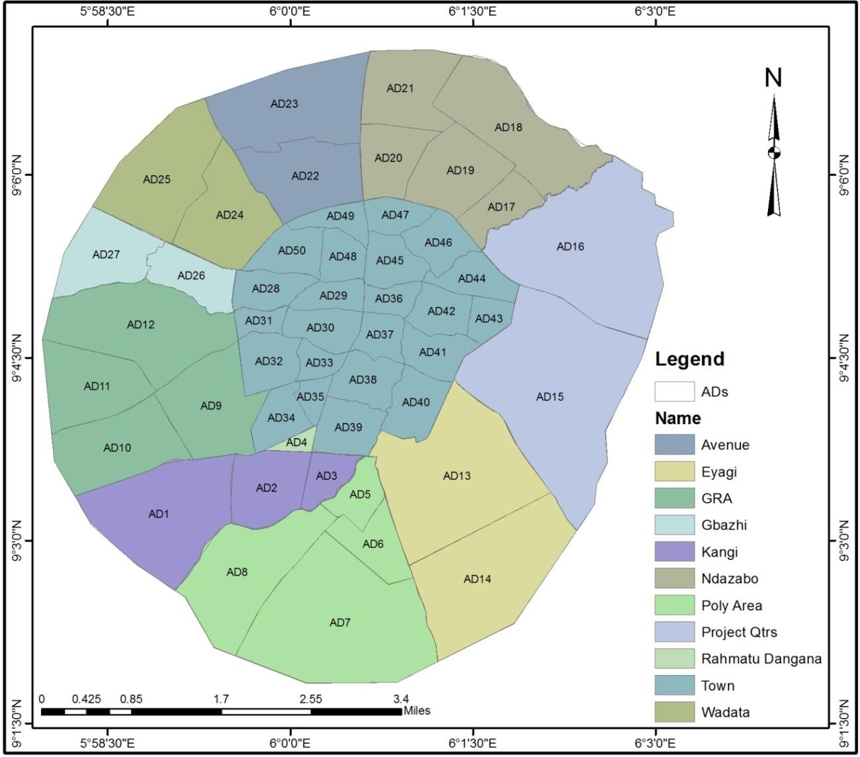
Figure 3.2: Area Demarcation by Housing Submarkets for the Study Source: Authors’ field survey

Sources of Data

Data for this research were sourced from both primary and secondary sources.

Primary data sources

The primary data were collected through field reconnaissance survey, physical observations and measurements, data generation on number of buildings, and housing submarkets. These data includes; data on number of buildings in each submarket, houses managed by the estate surveyors, type of housing, rental value, changes that occur in the rental years, location of houses and data on rate at which rent changes.

Secondary data

Other information needed for this research was sourced from journals, textbooks, maps. Satellite imageries captured from the Google Earth and records from resident Estate Surveyors and Valuers. Others include materials from the online sources, National Population Commission, National Bureau of Statistics, and past research reports. Topographical and street guide map which was collected from Niger State Ministry of Land and Housing, Minna, also form part of the secondary data sources used for this research.

Method of Data Collection

Data needed for this research were collected through interviews, physical observations, Satellite imageries and handheld GPS. Satellite imageries were captured to examine the residential density changes that occur within the study period. Handheld GPS was used in collecting coordinates of rental apartments managed by estate surveyors. Data on type of housing, rental value, changes that occur in the rental years, location of houses and data on rate at which rent changes in different submarkets were recorded from the estate surveyors.

Satellite image capturing

Satellite imageries were captured for the housing submarkets using the area demarcations. For each demarcated area, three satellite imageries were capture for three different periods, i.e. 2008, 2013 and 2018 using maximum resolutions on the Google Earth application. Images captured using area demarcation gives better resolution. The choice of Google Earth is due to its user friendly and historical images available.

Handheld Global Positioning System (GPS)

Coordinates of the sampled residential rental houses were captured using hand-held GPS. Data were collected separately for different types of rental residential apartments and from the three registered estate firms in Bida.

Data Analysis Techniques

The analytical techniques used for this study was based on the nature of the data collected. However, since the data collected were geographic in nature; both descriptive and spatial analytical methods were employed for analysis of the data. Descriptive statistical techniques used include percentages, building area ratio and cross tabulation to analyse the characteristics of residential densities in the study area while spatial analysis such as point density and spatial interpolation was used to achieve other objectives due to the nature of data collected.

Onscreen digitisation

Satellite images captured based on the demarcated areas were georeferenced where vector approach was adopted in digitising all the buildings using point features in ArcGIS environment. The entire buildings for each year under study were represented by points (see Figure 3.3, 3.4 and 3.5). Also, point features were created for rental residential apartments managed by estate surveyors and valuers linked with attribute data containing rental values of each apartment structured in the ArcGIS geodatabase (see Figure 3.6).

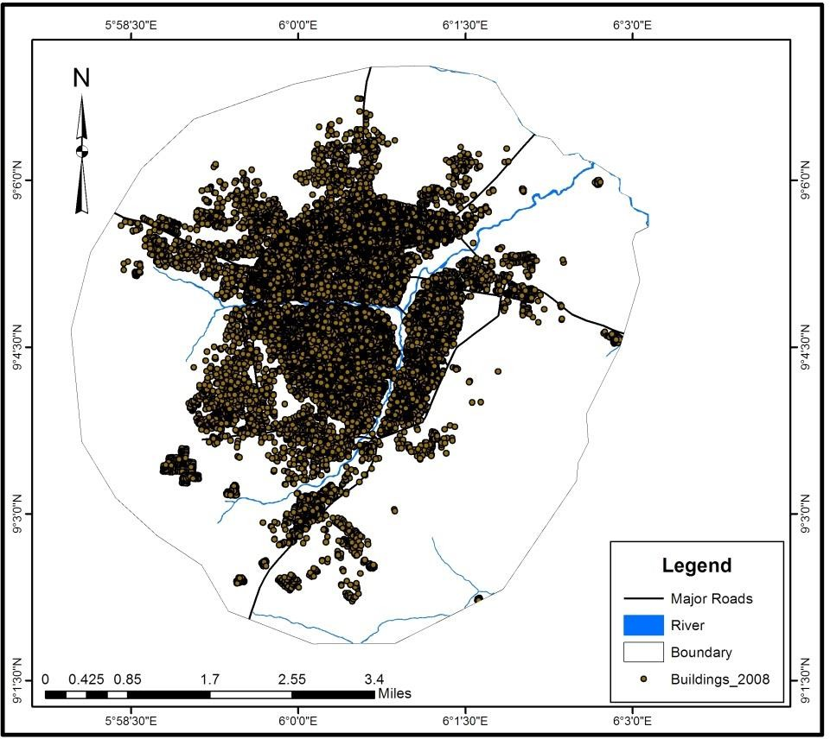
Figure 3.3: Location of Buildings in the Study Area for the Year 2008 Source: Authors’ field survey

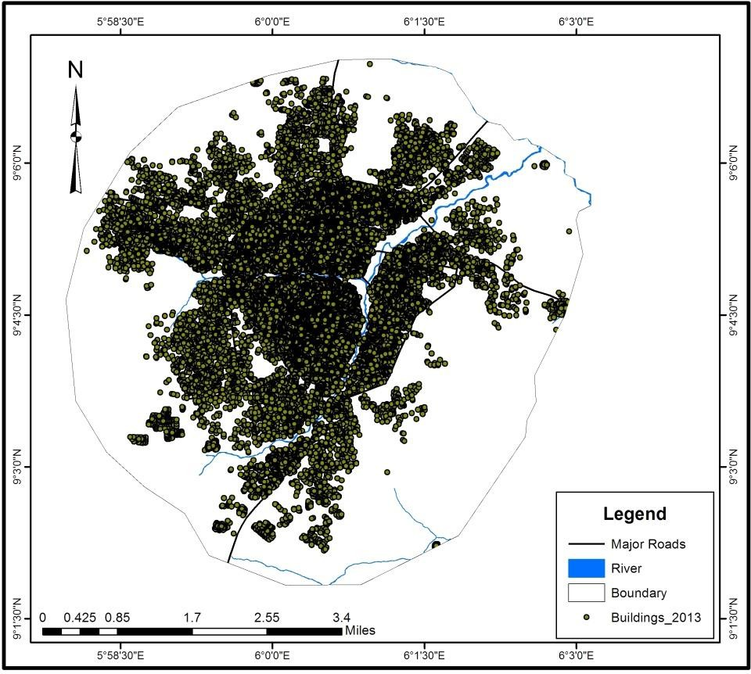
Figure 3.4: Location of Buildings in the Study Area for the Year 2013 Source: Authors’ field survey

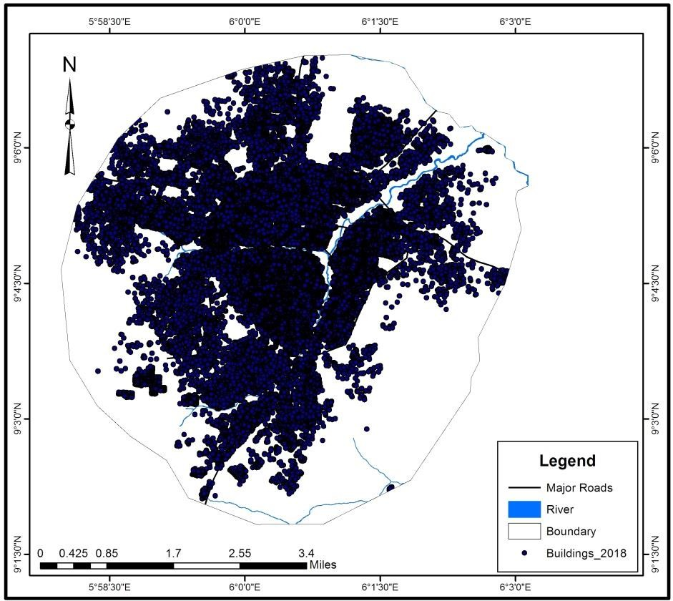
Figure 3.5: Location of Buildings in the Study Area for the Year 2018 Source: Authors’ field survey

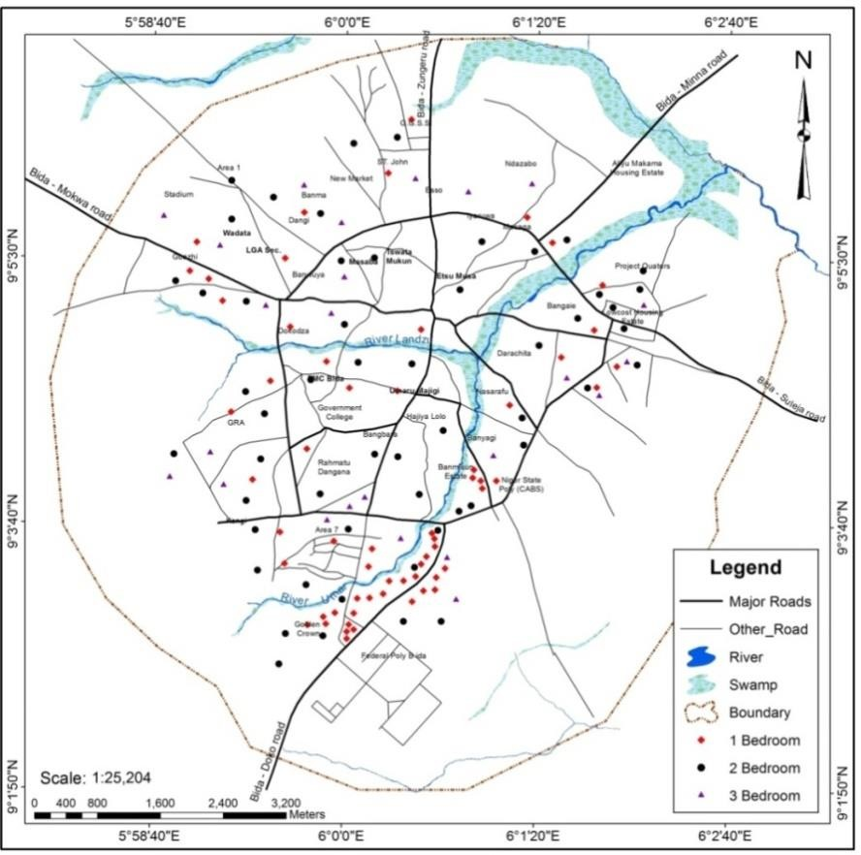

Figure 3.6: Sampled Houses Managed by Estate Surveyors and Valuers in the study area
Source: Authors’ field survey

Residential density level measurements

This research adopted residential density measurements by Niger State Urban Development Board (2015). Using this, residential density is measured using occupancy rates of building in a given location to give level of density. For example, low density is between 0 – 1.49 occupancy rate, medium density is between 1.5 – 1.99 occupancy rate while high density is 2.0 and above occupancy rate (see Table 3.3).

Table 3.3: Residential Density Level Measurement
Occupancy Rates | Residential Density Level
0 – 1.49 | Low
1.5 – 1.99 | Medium
2.0 and above | High
Source: Niger State Urban Development Board (2015).

Point density

Point density spatial analyst tool of ArcGIS 10.6 was used to analyse residential density of the study area for the years under study. Point density produces a raster showing a magnitude per unit area from point features that fall within a neighborhood around each cell. Only the points that fall within the neighborhood are considered when calculating the density. If no points fall within the neighborhood at a particular cell, that cell is assigned NoData. Points used in the spatial model represent the location of buildings in the study area. The spatial analyses were extended to reach the boundary. Geo-pressing procedure produces raster files for the densities for the year 2008, 2013 and 2018. This is adopted where ‘buildings within a fixed distance d from i’ is calculated in ArcGIS by using the ‘Point Density’ tool. This model was chosen for the benefit of better performance and visualization over land cover classification. The radius used for searching the neighbouring points d = 0.002672 m was chosen according to the content of data.

Spatial interpolation

Spatial interpolation methods were used to generate models for housing market. The interpolation methods used was Ordinary Kriging (OK). Most of the tools for performing interpolation require only one value subjected to interpolation, associated with a single point. Geostatistical Wizard, a part of the Geospatial Analyst extension of Esri’s ArcGIS

software was used to automatically select the interpolation parameters of the examined data. Rental value of residential rental apartment managed by estate surveyors firm which would form group of X variables and space forming Y variable was interpolated with filled contours to show areas with higher rental values for a particular year and this was applied to the year period in order to examine the spatiotemporal changes in the housing market within the time period.

The Predictive Model

    - Raster, raster clipping and raster reclass

The Ordinary Kriging results and Point density results were exported as raster files where each was saved using their unique identity. Density Raster files were saved as D2008, D2013 and D2018 for density of the years 2008, 2013 and 2018 respectively, while rental value raster files were saved as R1_2008, R1_2013 and R1_2018 for one bedrooms for the years 2008, 2013 and 2018 respectively; R2_2008, R2_2013 and R2_2018 for two bedrooms for the years 2008, 2013 and 2018 respectively; R3_2008, R3_2013 and R3_2018 for three bedrooms for the years 2008, 2013 and 2018 respectively.
The raster data files were clipped to the boundary of the study area using clip tool in the data Management Toolbox of ArcGIS 10.6. This allowed equal measurements in terms of number cells in the raster files. The raster files were reclassed into the same class intervals. The density raster files were reclassed into nine classes while rental raster files were recalssed into 10 classes. Thereafter, total cell count for each class was recorded.

Artificial neural network

Machine learning approach using ANN was adopted to analyse the changes that occur in the residential density and housing market within the 10 years period. Based on historical land use change data and changes in rental value, ANN predict the changes that is likely to happen in 10 years to come. The ANN learns patterns of urban densification (using density raster cell counts) and housing market (using rental value raster cell counts); this information is then saved and used to forecast change in urban densification and housing market. This allows the study to establish the relationship between urban densification and housing market.
The projected data from ANN was computed in a model built using Raster to polygon conversion of ArcGIS 10.6 Tookbox to produce maps for projected raster cell counts for both residential densities to 2023, 2028 and 2033 respectively. Also, the model was also used to project raster cell counts for rental values to one bedroom 2023, 2028 and 2023; two bedroom 2023, 2028 and 2033; three bedroom 2.23, 2028 and 2033 respectively (Appendix A).

Summary of Methodology

The summary of the research methodology is presented in Table 3.4.

Table 3.4: Objectives, Data Needed and Analysis Techniques
Objectives | Data Needed | Sources of  Data | Analysis  Techniques
- Examine the pattern of residential density of housing submarkets in the study area | - Satellite imageries of the study area between for the years 2008, 2013  and 2018  - Overall buildings in the study area for the years 2008, 2013 and  2018  - Changes in the residential area for the years 2008, 2013 and  2018 | Satellite imagery (Google Earth) | Tables and Maps
ii. Examine spatiotemporal variations in residential density of the study area between years 2008 – 2018 | - Area coverage of the housing submarkets.  - Number of buildings in the housing submarkets for the period under study.  - Building to area ratio for the housing submarkets for the period under study.  - Building units per hectares in the housing submarkets | Satellite imagery (Google Earth) | Point Density Analysis
iii. Examine the spatiotemporal dynamics in the housing market of the study area between years 2008 – 2018 | - Type of residential rented housing in the study area  - Number and type of rental housing apartments managed by registered estate surveyors in the study area  - Annual rental value of residential houses in the study area for the years 2008, 2013 and 2018  - Coordinates of sample rental housing  apartments. | Handheld GPS and rental value from professional estate surveyors and valuers | Kriging spatial interpolation

iv. Develop a model predictive and analyse relationship between residential density and rental value | - Raster data of Kriging result of rental value of different types of residential houses for the years 2008, 2013 and  2018.  - Raster data of Point density result for residential densities for the years 2008, 2013 and  2018.  - Number of buildings for the years 2008, 2013  and 2018. | Point density map and Kriging map | Artificial Neural Network

CHAPTER FOUR

  - RESULTS AND DISCUSSION

Pattern of Residential Density of Housing Submarkets in the Study Area

    - Residential density level and building units per hectares by housing submarkets
The pattern of urban densification dynamics in terms of level of residential density by housing submarkets and number of buildings and area coverage by housing submarkets is discussed in this section. This was achieved by measuring the total area of the housing submarkets, number of buildings in the housing submarkets and buildings per hectare (ha) in the housing submarket. It was found out that Town housing submarket have highest area coverage with 1,214.97ha. This is followed by Project Quarters with 984.31ha; Poly Area and GRA have area coverage of 823.13ha and 800.08ha respectively (see Table 4.1, 4.2 and 4.3).

Table 4.1: Residential Density Level and Building Units Per Hectares by Housing Submarkets 2008
Submarket | Area Coverage (Ha) | No. of Buildings | Ratio | Building Units/Ha | Density Level
Kangi | 457.52 | 661 | 1.44 | <2 | Low Density
Rahmatu Dangana | 14.5 | 83 | 5.72 | 5-6 | High Density
Town | 1214.97 | 25945 | 21.35 | >10 | High Density
Poly Area | 823.13 | 787 | 0.96 | <2 | Low Density
Eyagi | 725.34 | 165 | 0.23 | <2 | Low Density
Gbazhi | 215.81 | 489 | 2.27 | 2-4 | High Density
Wadata | 398.51 | 1020 | 2.56 | 2-4 | High Density
Avenue | 417.08 | 524 | 1.26 | <2 | Low Density
Ndazabo | 692.99 | 605 | 0.87 | <2 | Low Density
Project Qtrs | 984.31 | 358 | 0.36 | <2 | Low Density
GRA | 800.08 | 773 | 0.97 | <2 | Low Density

It was found out in Table 4.1 that in the year 2008, the Town housing submarket being the largest submarket had the highest number of buildings with a total of 25,945. This is followed by Wadata with 1,020 buildings, Poly area with 787 and GRA with 773. The study shows that Rahmatu Dangana being the smallest housing submarket also recorded lowest number of buildings in that year. The result also shows that the Town with largest area coverage and highest number of building units had the highest number of buildings to area ratio with 21.35 this is followed by Rahmatu Dangana with 5.72, Wadata 2.56 and Gbazhi 2.27. The lowest buildings to area ratio is recorded for Eyagi with 0.23.
This implies that people live in the Town housing submarket than any other submarkets in the study area. The Town housing submarket is also the traditional city centre where major commercial and cultural activities takes place. The result also implies that Rahmatu Dangana with smallest area coverage is highly developed.

Table 4.2: Residential Density Level and Building Units Per Hectares by Housing Submarkets 2013
Submarket | Area Coverage  (Ha) | No. of  Buildings | Ratio | Building  Units/Ha | Density  Level
Kangi | 457.52 | 1103 | 2.41 | 2-4 | High  Density
Rahmatu Dangana | 14.5 | 132 | 9.10 | 9-10 | High  Density
Town | 1214.97 | 34242 | 28.18 | >10 | High  Density
Poly Area | 823.13 | 1648 | 2.00 | 2-4 | High  Density
Eyagi | 725.34 | 304 | 0.42 | <2 | Low Density
Gbazhi | 215.81 | 2077 | 9.62 | 9-10 | High Density
Wadata | 398.51 | 1707 | 4.28 | 2-4 | High  Density
Avenue | 417.08 | 1283 | 3.08 | 2-4 | High  Density
Ndazabo | 692.99 | 1758 | 2.54 | 2-4 | High  Density
Project Qtrs | 984.31 | 793 | 0.81 | <2 | Low Density

GRA | 800.08 | 1442 | 1.80 | <2 | Medium  Density
The result in Table 4.2 shows that in the year 2013 Town housing submarket had highest number of building units with 34,242. This is followed by Gbazhi with 2,077, Ndazabo 1,758, Wadata 1,707 building units respectively. During this period, the study shows that Rahmatu Dangana had smallest number of building units. The result also shows that Town submarket recorded highest number of building to area ratio with 28.18, followed by Gbazhi with 9.62, Rahmatu Dangana 9.10 and Wadata 4.28 respectively. The lowest building to area ratio is recorded for Eyagi with 0.42.
Consequently, this result shows a tremendous transition in the housing submarket of the study area where all the housing submarkets had the number of their housing units increased at different rates. The results also implies that Gbazhi had very high residential development where the number housing units recorded for the year 2008 was 489 with building to area ratio of 2.27 and increases to 2,077 with building to area ratio of 9.62 in the year 2013.

Table 4.3: Residential Density Level and Building Units Per Hectares by Housing Submarkets 2018
Submarket | Area Coverage  (Ha) | No. of Building  s | Ratio | Building Units/Ha | Density Level
Kangi | 457.52 | 2134 | 4.66 | 2-4 | High Density
Rahmatu Dangana | 14.5 | 124 | 8.55 | 7-8 | High Density
Town | 1214.97 | 29985 | 24.68 | >10 | High Density
Poly Area | 823.13 | 2450 | 2.98 | 2-4 | High Density
Eyagi | 725.34 | 393 | 0.54 | <2 | Low Density
Gbazhi | 215.81 | 2331 | 10.80 | >10 | High Density
Wadata | 398.51 | 2300 | 5.77 | 5-6 | High Density
Avenue | 417.08 | 1976 | 4.74 | 2-4 | High Density
Ndazabo | 692.99 | 2346 | 3.39 | 2-4 | High Density
Project Qtrs | 984.31 | 1466 | 1.49 | <2 | Low Density
GRA | 800.08 | 1889 | 2.36 | 2-4 | High Density

The study revealed in Table 4.3 that in the year 2018 Town submarket had highest number of buildings with 29,985 followed by Poly Area with 2,450, Ndazabo 2,346, Gbazhi 2,331, Wadata 2,300 and Kangi 2,134 building units respectively. The lowest number of building units recorded was in Rahmatu Dangana with 124. The Table also revealed that Town submarket had highest building to area ratio with 24.68. This is followed by Gbazhi with 10.80 and Rahmatu Dangana 8.55. The lowest building to area ratio was recorded for Eyagi with 0.54.
The implication of this result is that transition in the urban morphology experienced tremendous changes where number of buildings in the Town submarket reduced from 34,242 in the year 2013 to 29,985 in the year 2018. The result also implies that there were high residential development in Poly Area, Ndazabo and Gbazhi submarkets during this period which may have occasioned the sudden reduction.

Level of residential density by housing submarkets

Residential density is measured based on the residential development within the housing submarkets. The study revealed in Figure 4.1 that in the year 2008 four housing submarkets i.e. Town, Rahmatu Dangana, Gbazhi and Wadata are of high residential density respectively, where the remaining seven submarkets are of low residential densities in that year. This means that two classes of residential density were existing (low and high residential densities) in the study area by the year 2008.

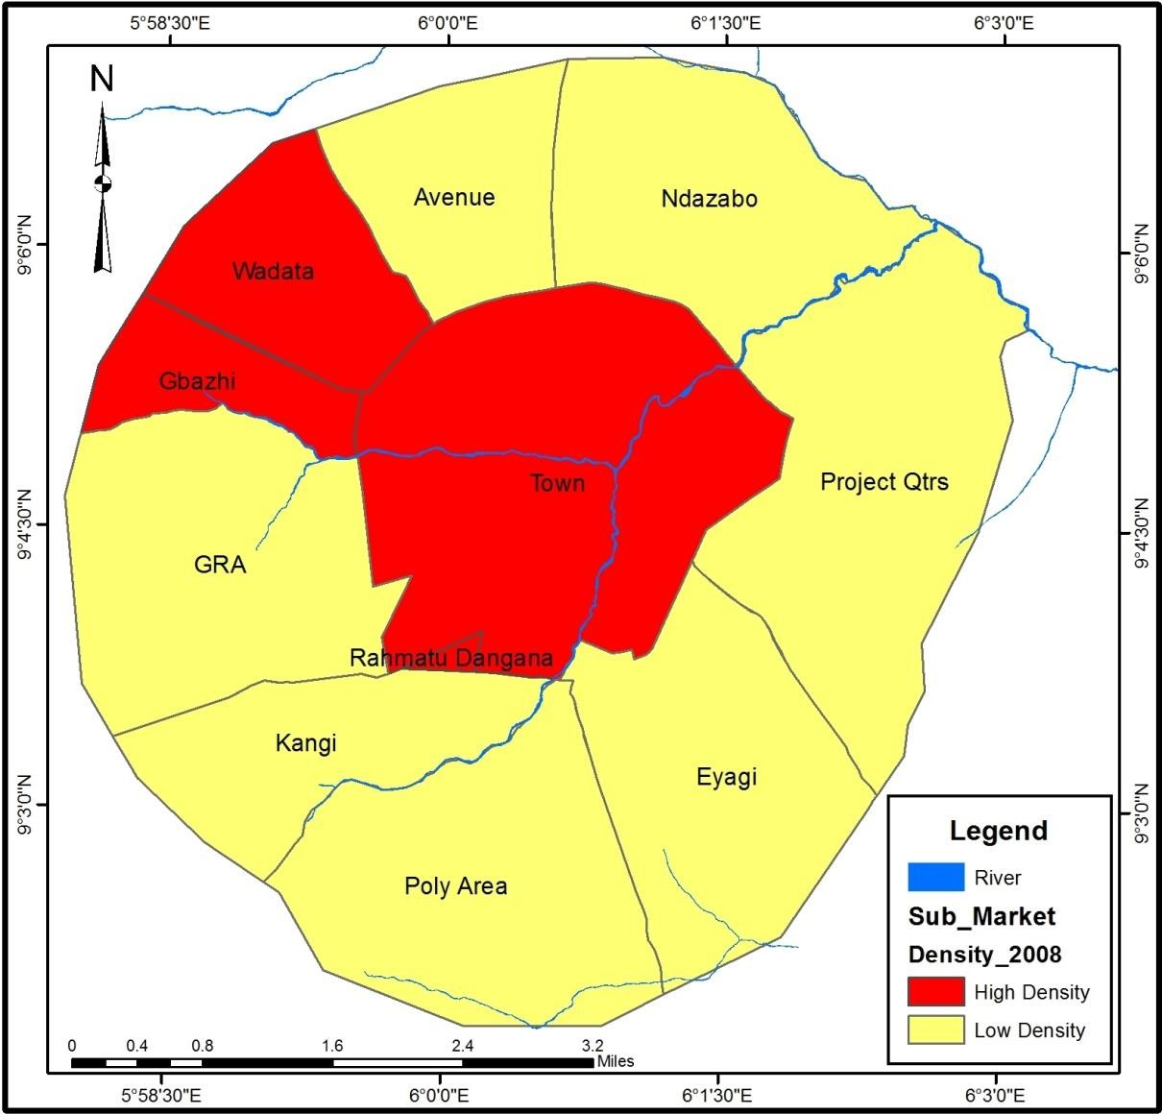
Figure 4.1: Level of Residential Density by Housing Submarkets in the Year 2008 Source: Authors’ field survey, 2019

The study showed in Figure 4.2 that in the year 2013 eight housing submarkets have their residential densities to be high while GRA had medium residential density and Eyagi and Project Quarters had low residential densities respectively. The pattern of the residential density implies that there is tremendous shift in the residential density changes in the study area in that year.

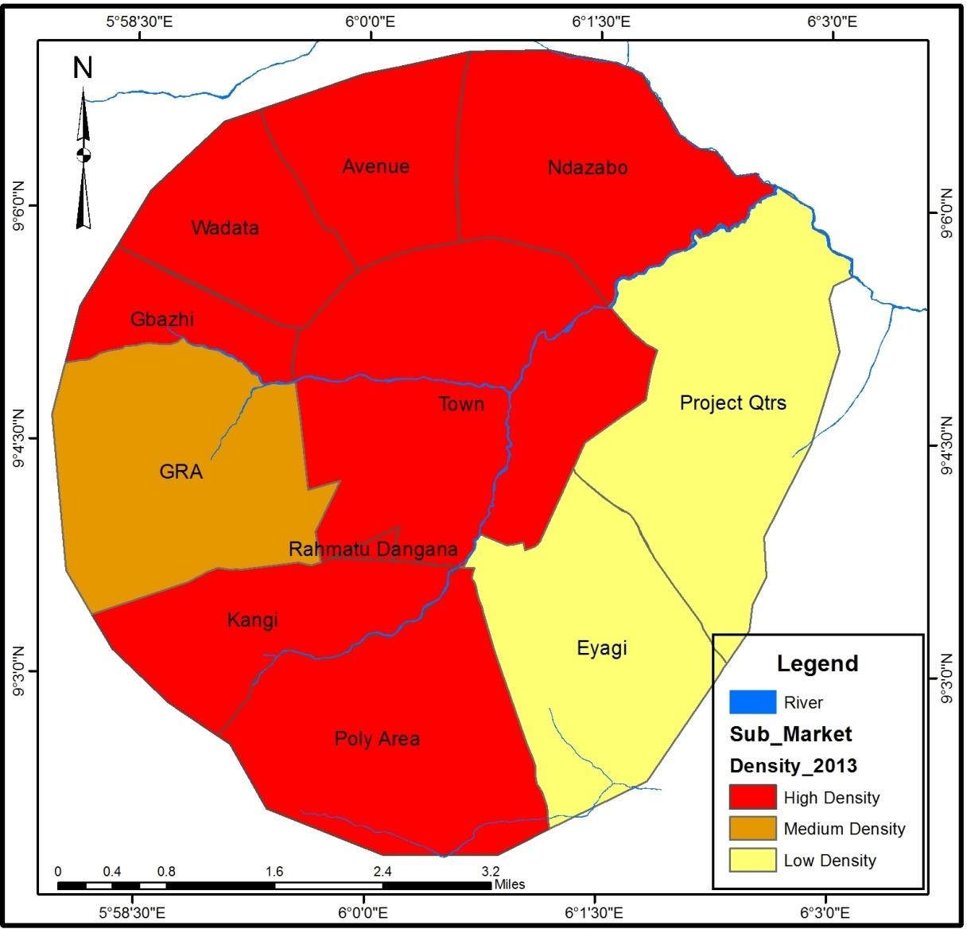
Figure 4.2: Level of Residential Density by Housing Submarkets in the Year 2013 Source: Authors’ field survey, 2019

In the year 2018, urbanisation effects have a great impact on the urban form. The study in Figure 4.3 shows that all the housing submarkets in the study area are of high residential densities except for Eyagi and Project Quarters who were of low residential densities respectively. This implies that there is transition from low residential density areas to high residential density areas in the study area. The entire housing market is becoming more developed as built-up areas increases in all dimensions.

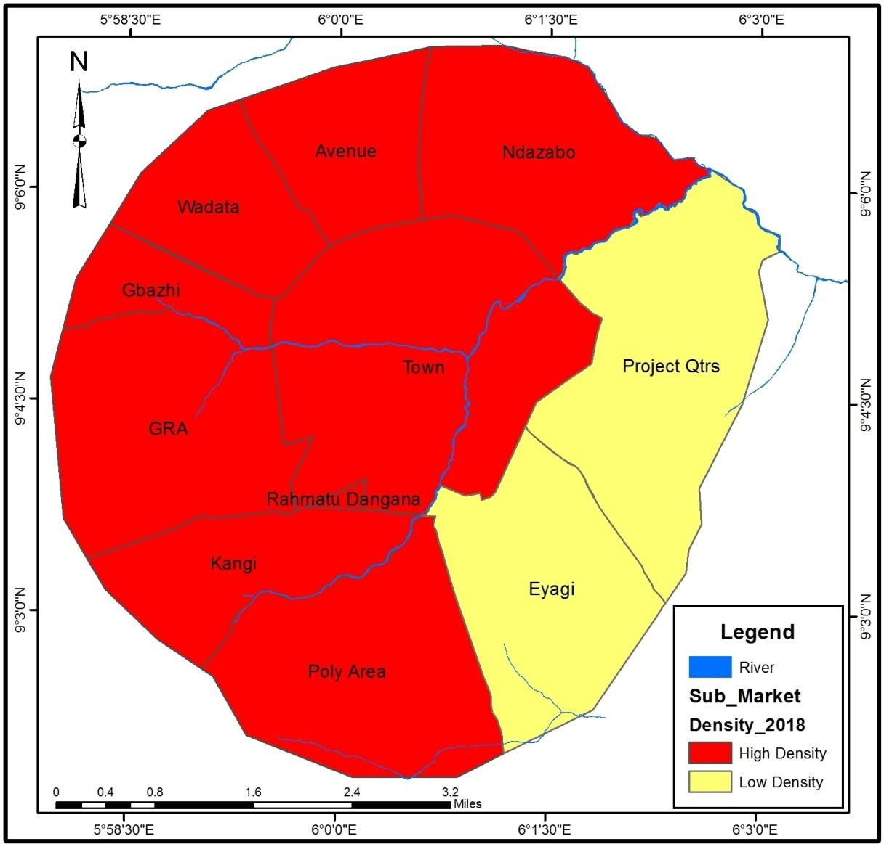
Figure 4.3: Level of Residential Density by Housing Submarkets in the Year 2018 Source: Authors’ field survey, 2019

Building density in Bida between years 2008 - 2018

In an attempt to explain variation in densification in housing submarkets of the study area in terms of number of buildings per hectares as presented in Figure 4.4, 4.5 and 4.6. The study attempts to explain densification based on number of buildings per hectares, but it does not directly highlight the factors responsible for the high or low number of buildings in the housing submarket.
The study shows in Figure 4.4 that in the year 2008, Town housing submarket had highest number of buildings per area coverage with >10 building units/ha. This is followed by Rahmatu Dangana with 5-6 number of building units/ha, Gbazhi and Wadata had 2-4

number of building units/ha each. All other submarkets had <2 building units/ha in that year. Figure 4.5 shows satellite image of AD48 demarcated area in town submarket for the year 2008.
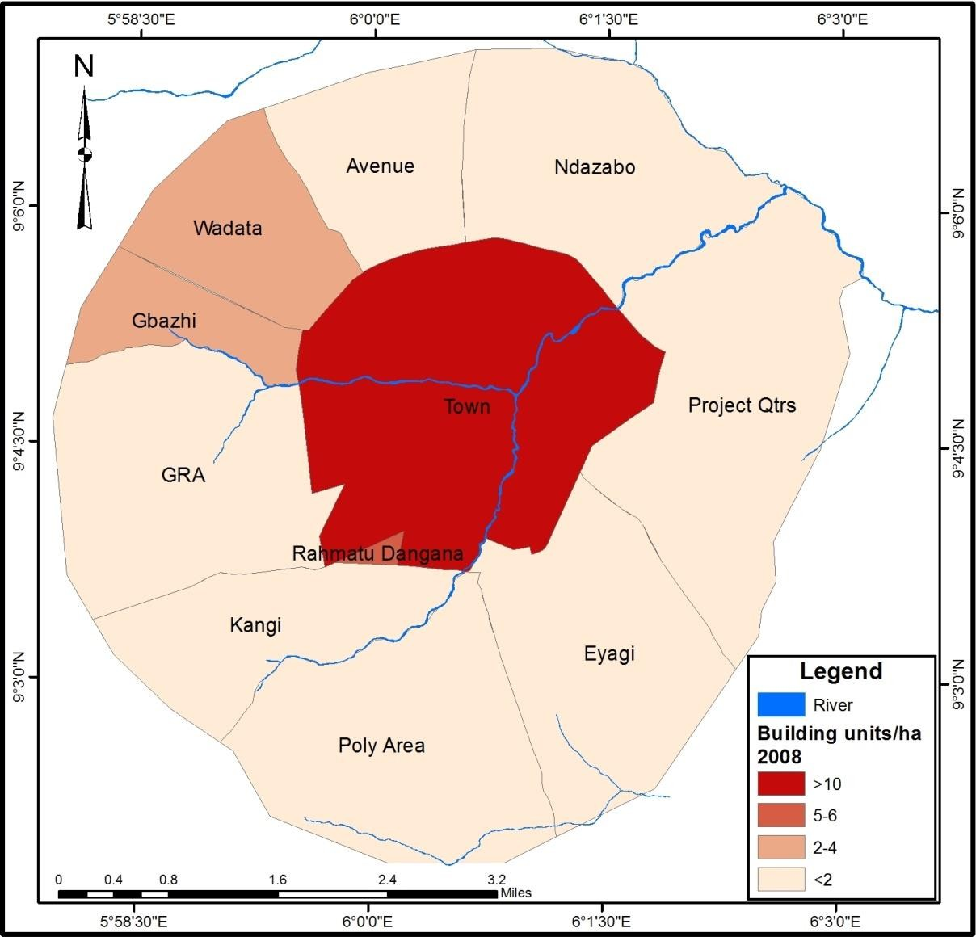
Figure 4.4: Number of Building Units/Ha by Housing Submarkets in the Year 2008 Source: Authors’ field survey, 2019

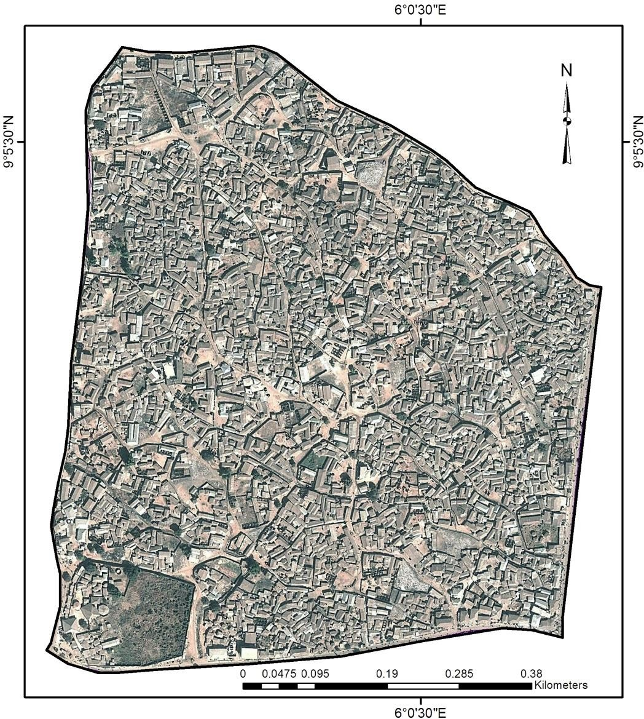

Figure 4.5: Satellite Image of AD48 in Town Submarket for the Year 2008 Source: Google Earth, 2019

The findings from Figure 4.4 and 4.5 implies that Town submarket with largest area coverage and highest number of buildings also had highest number of buildings per area coverage. The result also implies that during this years it is only Gbazhi and Wadata that had more than two number of building units/ha among submarkets in the urban fringe.
Residential density within the urban area of Bida considering the number of building units in the housing submarket is presented in Figure 4.6. Findings of the study in this section shows that Town housing submarket has the highest with >10 number of building units/ha in the year 2013. This is followed by Rahmatu Dangana and Gbazhi with 9-10 number of building units/ha, and Kangi, Poly Area, Wadata, Avenue and Ndazabo had 2-4 number

of building units/ha. Housing submarkets that recorded the lowest number of buildings per area coverage are Eyagi, Project Quarters and GRA with <2 number of building units/ha. Figure 4.7 shows a satellite image of AD9 in GRA submarket for the year 2013.
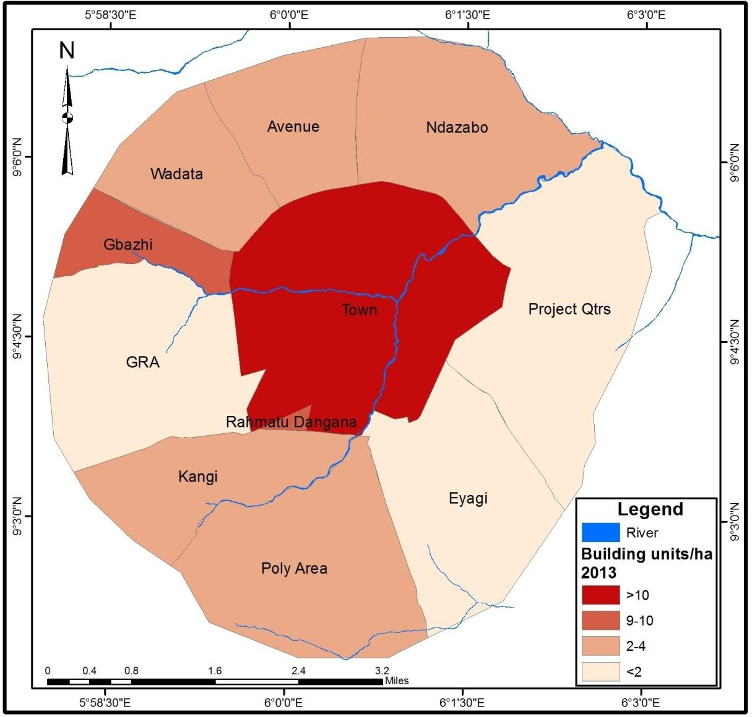
Figure 4.6: Number of Building Units/Ha by Housing Submarkets in the Year 2013 Source: Authors’ field survey, 2019

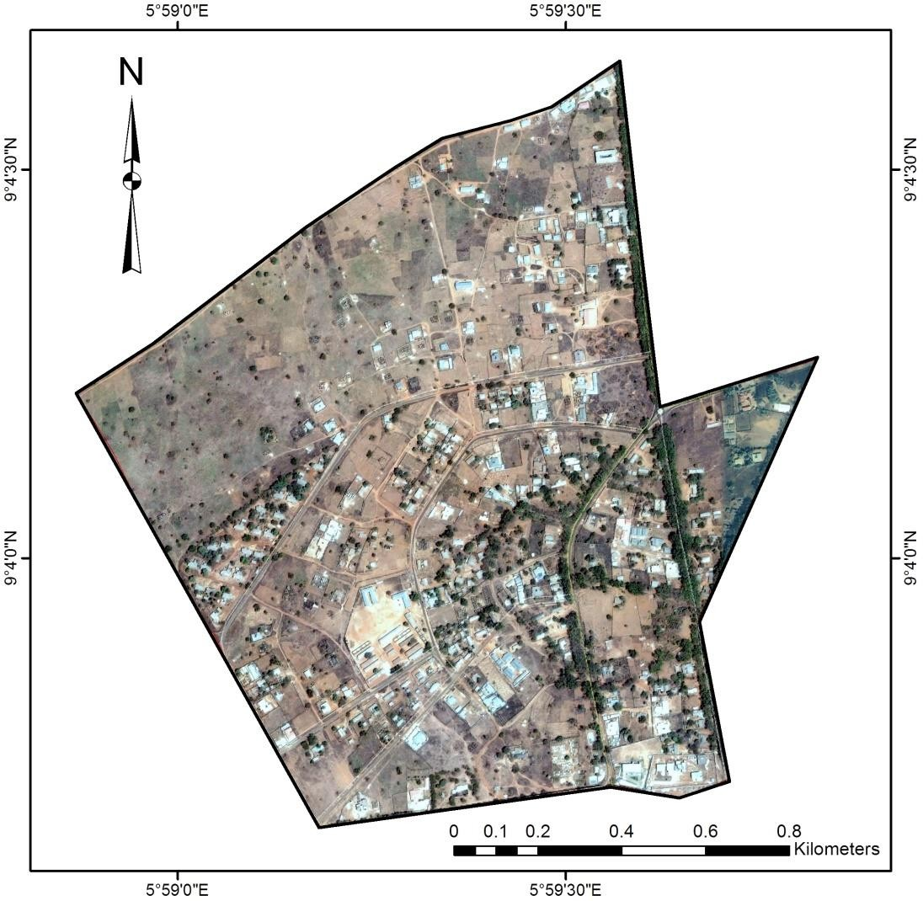

Figure 4.7: Satellite Image of AD9 in GRA Submarket for the Year 2013 Source: Google Earth, 2019

The implication of this result is that large amount of variation and tremendous transition in housing development in the housing submarket occurred during this period. The research therefore observed that there was high level of urban morphological transformation resulting from the increasing level of urbanisation that leads to high number of housing units in the housing market, which contributed to how the urban area looks like and shapes the future of urban development and the overall image of the town. This could one way or the other have impact on a number of housing economics such as housing affordability, housing supply, housing demand and the housing market which includes the rental value of residential apartments.

Urban densification in Bida proceeds in an unstructured manner in the year 2018. The study shows in Figure 4.8 that the Town and Gbazhi housing submarkets records highest number of buildings per area coverage with >10 building units/ha each. The study also reveals that Rahmatu Dangana and Wadata had 7-8 and 5-6 number of building units/ha each respectively in that year, and by implication made us to understand that Eyagi and Project Quarters had lowest number of buildings per area coverage with <2 building units/ha each. This has been further proven by Figure 4.9 showing satellite image of AD13 in Eyagi submarket for the year 2018.
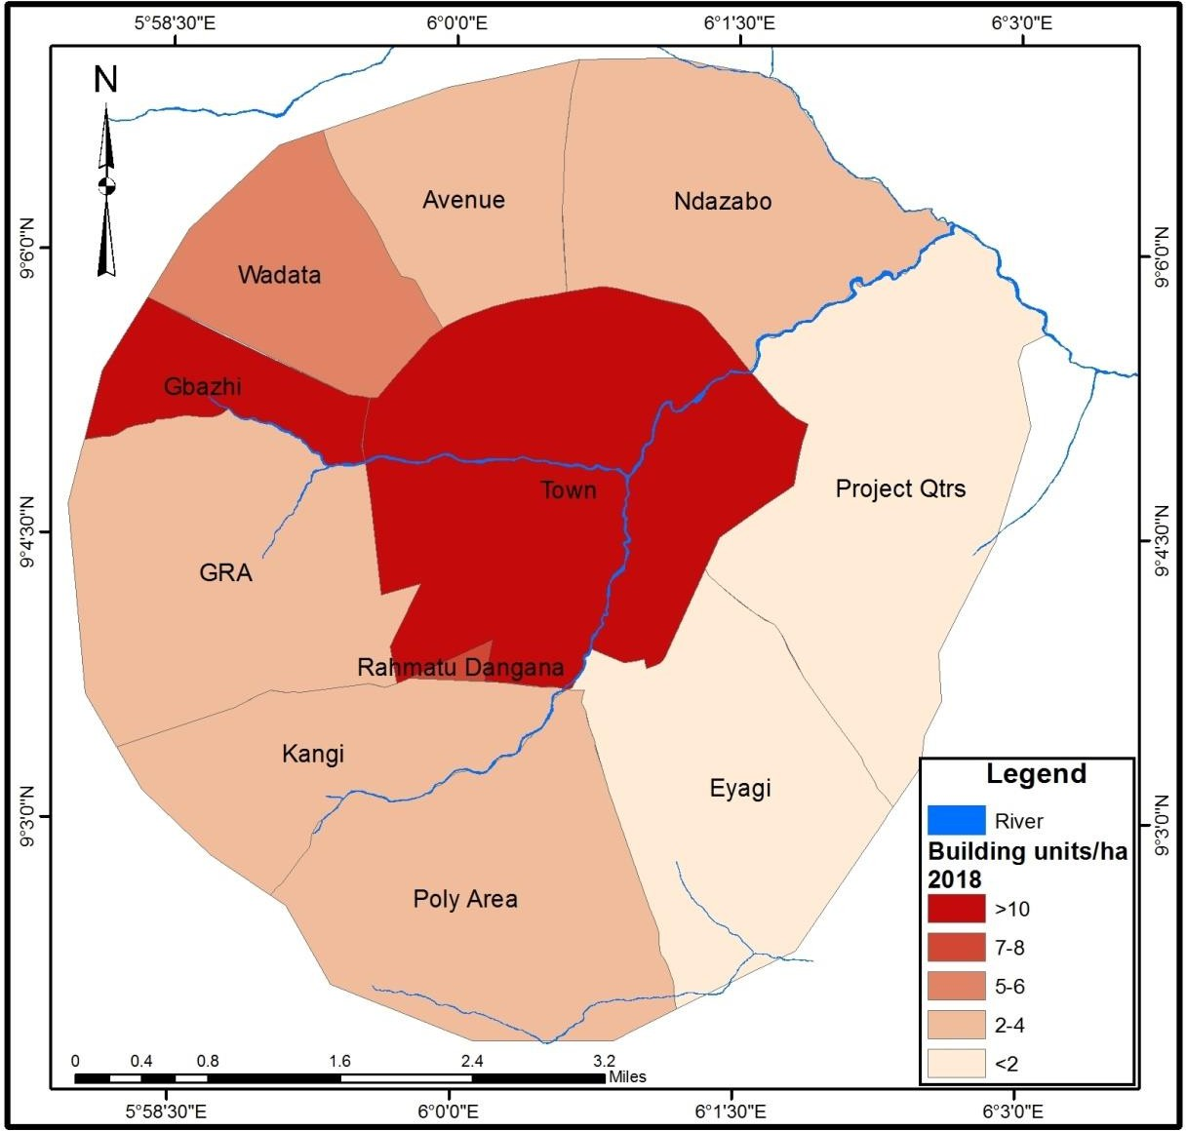
Figure 4.8: Number of Building Units/Ha by Housing Submarkets in the Year 2018 Source: Authors’ field survey, 2019

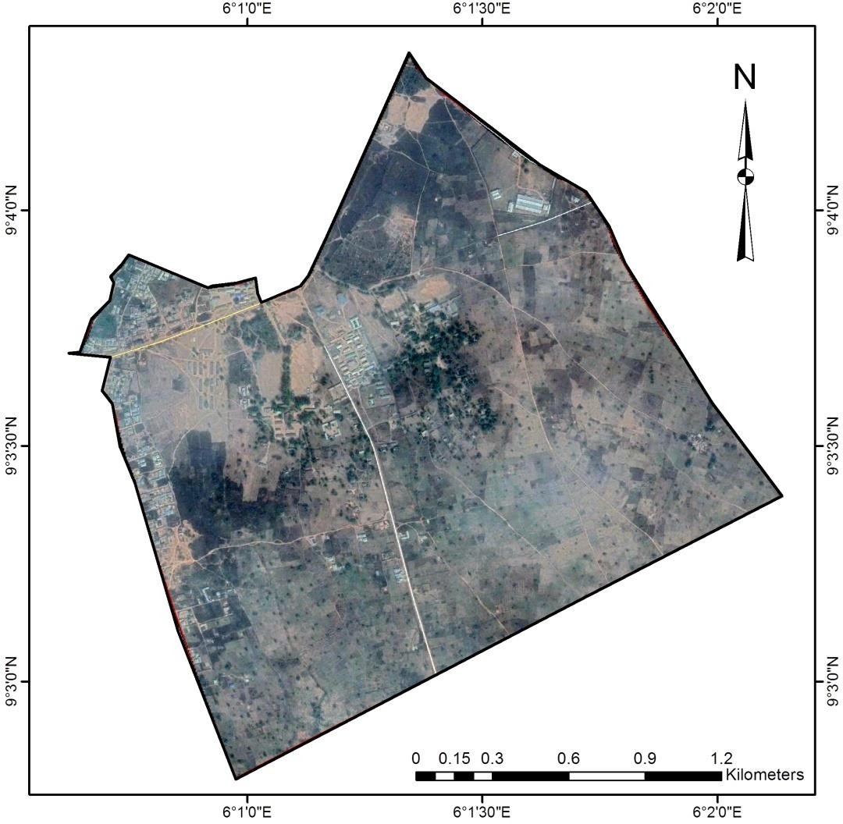

Figure 4.9: Satellite Image of AD13 in Eyagi Submarket for the Year 2018 Source: Google Earth, 2019

The pattern of residential development demonstrates urbanisation level that has almost reach it peak. This result indicates that the housing submarkets had high number of buildings in the total area coverage which indicates that larger parts of the area coverage of these submarkets have already been exhausted. This confirms Broitman and Koomen (2015) findings where wide variation in residential density among neighbourhoods was observed. The implication of the above is that this pattern would one way or the other has impacts on the rental value of residential apartments in the study area.

Spatiotemporal Variations in Residential Densities of the Study Area between Years 2008 – 2018
Spatial approach was adopted in analysing urban densification of the study area between the year 2008 and 2018. Spatial and temporal approach depicts the patterns of densification in a better morphological structure (see Figure 4.10, 4.11 and 4.12).
The result in Figure 4.10 shows spatiotemporal variations in residential densities in Bida in the year 2008. The result depicts the urban form in terms of residential density in that year. The structure of the town shows that areas around the Central Business District (CBD) are of high density while locations within the urban fringe tend to have lower residential densities. This is remarkable and relate to the fact that urban fringe locations during this period are outside the development zones. This result did not deviate from the traditional monocentric model of Alonso, which is consistent with many cities of developing world where density gradient decreases towards the urban fringe (Broitman & Koomen, 2015).

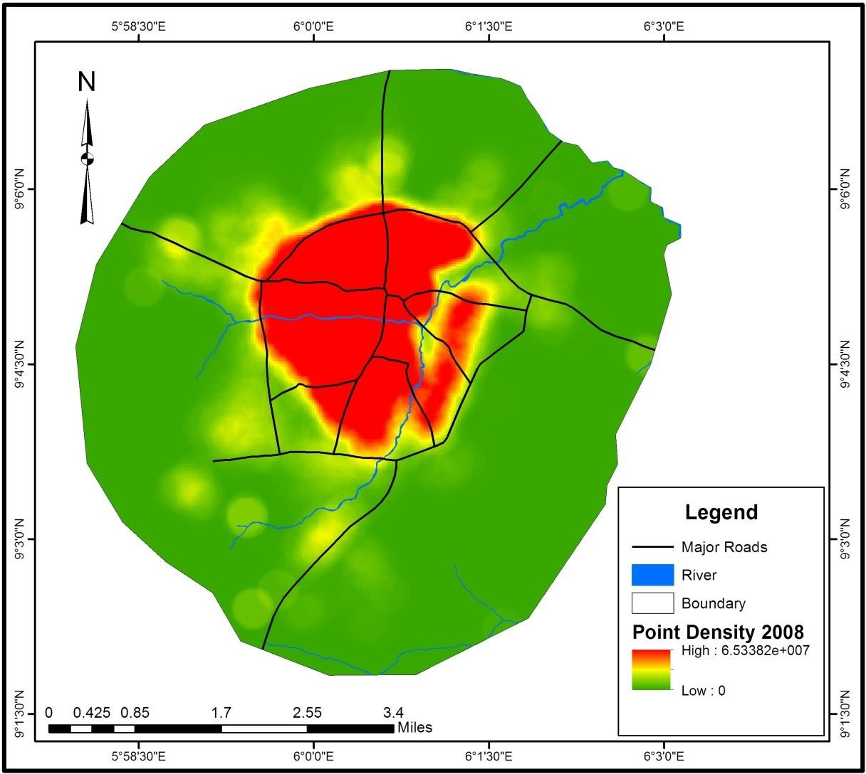
Figure 4.10: Spatial Pattern of Residential Density in the Study Area in 2008 Source: Authors’ field survey, 2019

As urban densification proceeds in an uncontrolled and unstructured manner, the spatial pattern of urban residential densities increase in an uneven manner in the year 2013 (see Figure 4.11). The result shows that residential density gradient increases towards the urban fringe without decreasing density in the CBD. The morphological structure of the town was retained in its traditional monocentric form, but towards the north and north western part of the town, the residential density increase was experienced more.

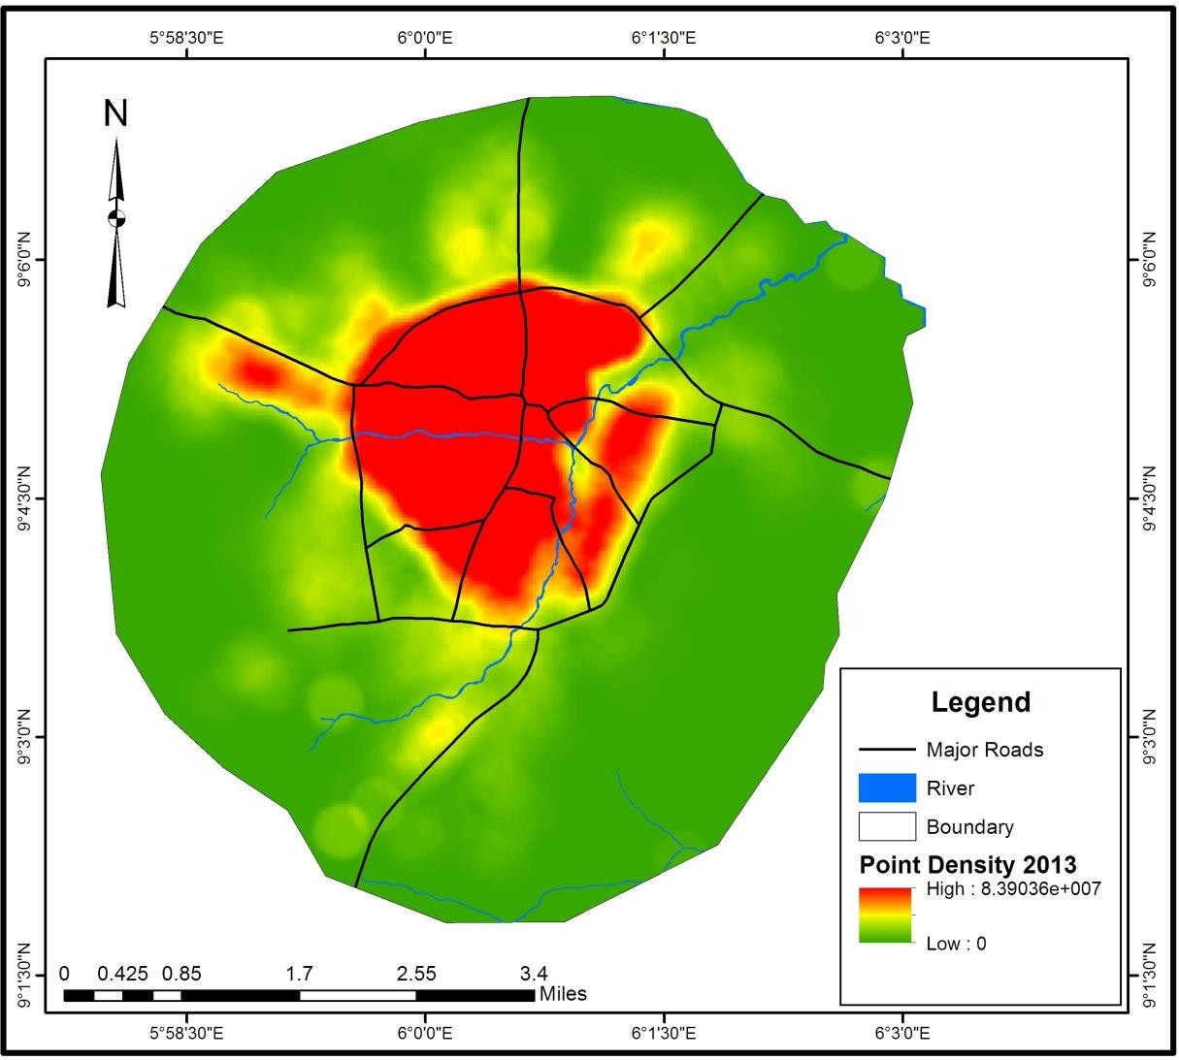
Figure 4.11: Spatial Pattern of Residential Density in the Study Area in 2013 Source: Authors’ field survey, 2019

The result in Figure 4.12 shows that there was consistent and fast increasing residential density in the study area in the year 2018. Residential density increases during this period towards the north, west and southern part of the town. However, the result implies that western part had low level of residential development.

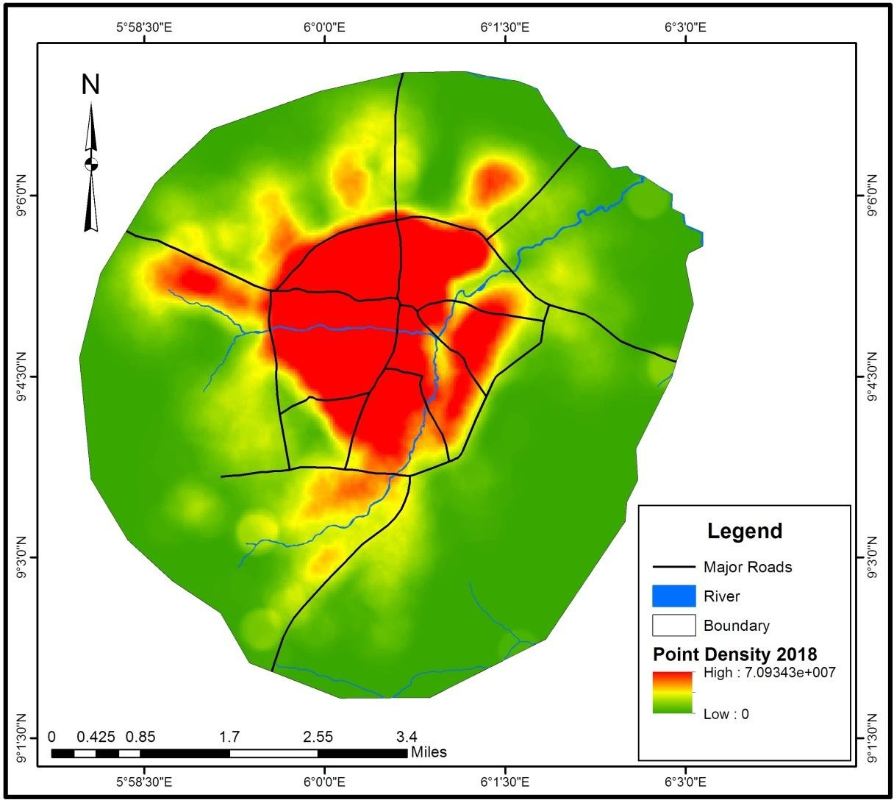
Figure 4.12: Spatial Pattern of Residential Density in the Study Area in 2018 Source: Authors’ field survey, 2019

This pattern of densification process, is in line with urban economic theory for monocentric open cities that experience population growth and decreasing commuting costs (Antoniucci & Marella, 2018). As a result of residential densities increase along the urban – rural gradient, the observed increase in residential densities associated with the presence of restrictive spatial planning is also in line with expectations from urban economic theory. However, in the study area the restrictive spatial planning is not in place. This analysis provides some empirical underpinning for city structures in line with the monocentric model. Similar pattern were observed by Broitman and Koomen (2015) who studied residential density change focussing on densification and urban expansion – that in urban development, increasing densities and number of housing units increases

towards the city centre. Wang et al. (2019) find a similar importance for the growth centres in their analysis of urban densification dynamics and future modes in south- eastern Wisconsin, USA. However, it can be inferred from the research findings that residential development occurs more in areas that are rich in amenities but in the study it occurs more in the areas with less or no physical planning regulations.

Spatiotemporal Dynamics in the Housing Market of the Study Area between Years 2008 – 2018
Using OK spatial interpolation method with combination of growing number of housing transaction database records from year 2008 to 2018 and three categories of housing (i.e. 1 bedroom, 2 bedroom and 3 bedroom), the spatiotemporal modelling of housing prices are presented as follow;

Spatiotemporal dynamics in 1 bedroom housing prices

The interpolation results in Figure 4.13, Figure 4.14 and Figure 4.15 revealed the pattern of space and time changes that occurred in the housing prices of one bedroom apartment in the study area. It can be observed that rental price for one bedroom apartment was lower in the Central Business District (CBD) and eastern part of the town and higher towards the south in the year 2008. Changes began to manifest in the year 2013 and became obvious in the year 2018. However, in the CBD, little changes were observed.
These results demonstrate complex urban structure of the housing market. The results showed spatial characteristics of the housing market contrary to the traditional characteristics of the monocentric model and similar linear models of urban morphology. The result corresponds with the polycentric pattern of urban morphology.

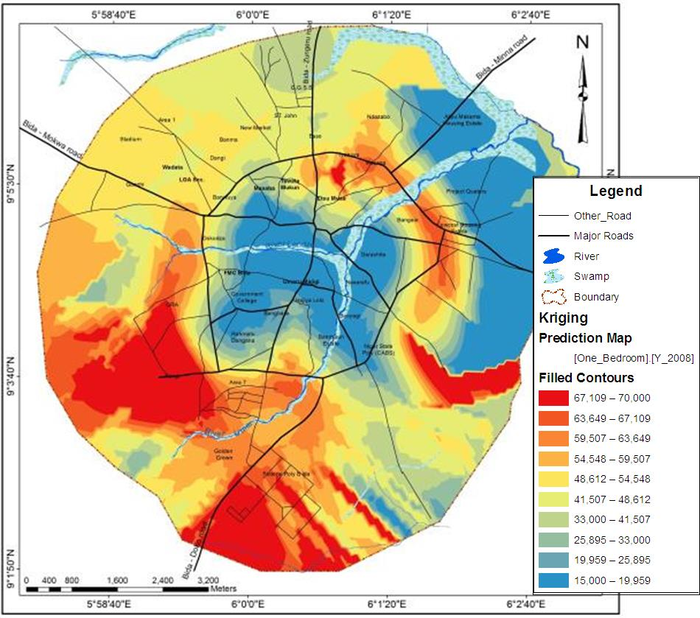

Figure 4.13: Spatial Interpolation of One Bedroom Housing Prices for 2008
Source: Field survey, 2019
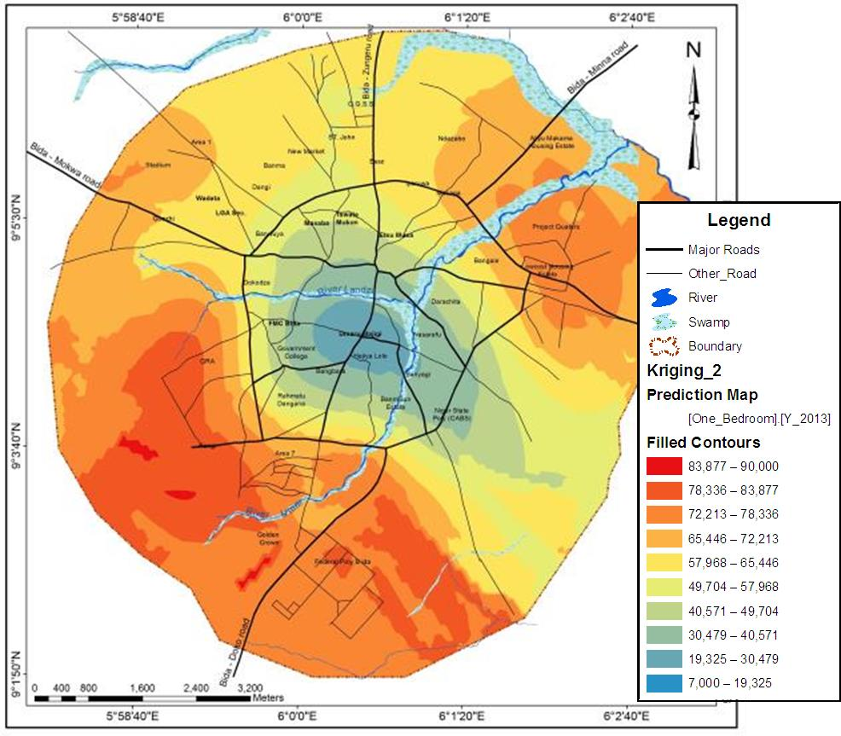

Figure 4.14: Spatial Interpolation of One Bedroom Housing Prices for 2013
Source: Field survey, 2019

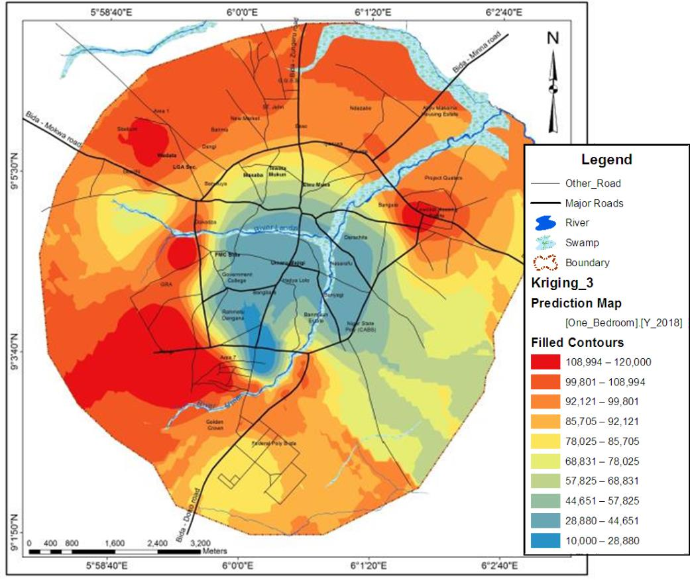

Figure 4.15: Spatial Interpolation of One Bedroom Housing Prices for 2018
Source: Field survey, 2019

Spatiotemporal dynamics in 2 bedroom housing prices

Spatial and temporal dynamics in the housing prices of two bedroom in the study area shows that CBD region have low rental value in the year 2008, and it increases in the area but still lower compare to other areas in the year 2018. However, to the west and southern parts, the rental value of two bedroom apartments was high throughout the study period. These are spatially represented in Figure 4.16, Figure 4.17 and Figure 4.18 respectively.
These results shows high housing prices in the GRA and Poly areas in the urban fringe while the CBD have lower housing prices for all type of houses. The spatial morphological structure of housing prices shows a pattern that is unique where changes occur from preceding years in the urban fringe without much change in the CBD. It also retains its polycentric model contrary to the Alonso urban economic theory.

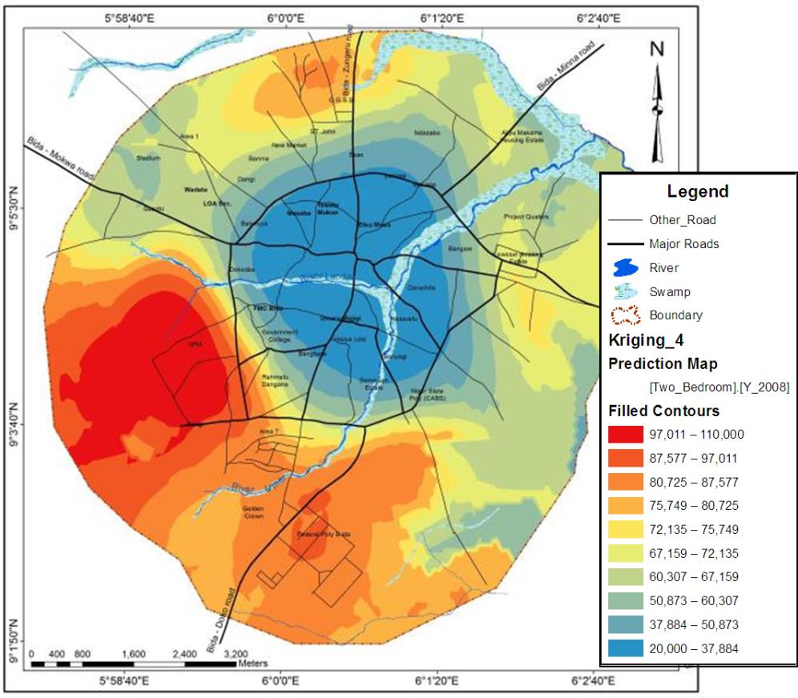

Figure 4.16: Spatial Interpolation of Two Bedroom Housing Prices for 2008
Source: Field survey, 2019
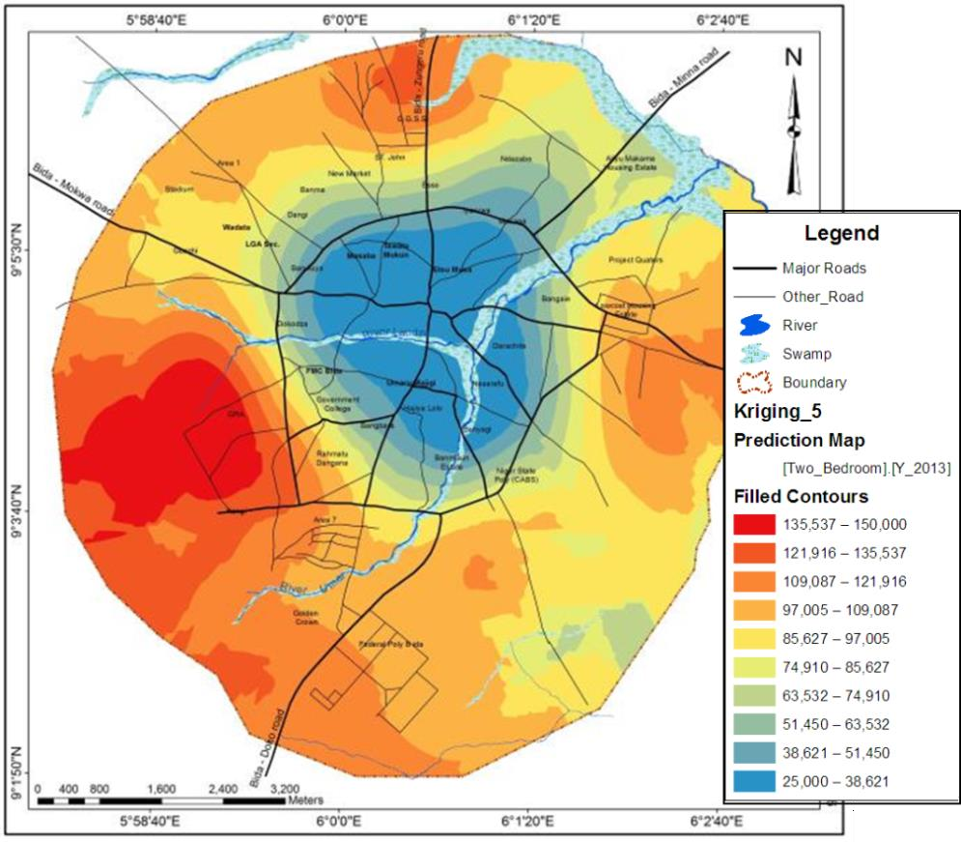

Figure 4.17: Spatial Interpolation of Two Bedroom Housing Prices for 2013
Source: Field survey, 2019

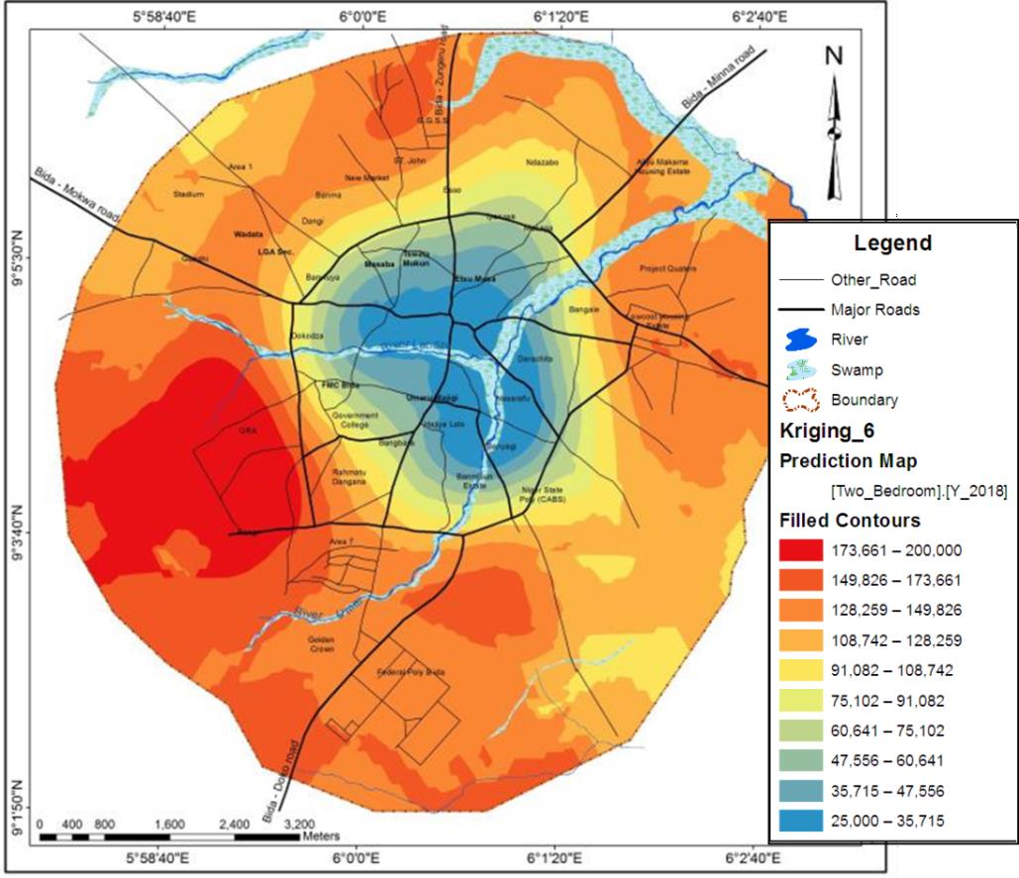

Figure 4.18: Spatial Interpolation of Two Bedroom Housing Prices for 2018
Source: Field survey, 2019

Spatiotemporal dynamics in 3 bedroom housing prices

For three bedroom apartments, space and time series analysis of rental prices records little changes between the year 2008 and 2013 while in 2018 significant changes have been observed. However, CBD and other areas surrounding it records lower rental value in 2018. This is graphically presented in Figure 4.19, Figure 4.20 and Figure 4.21 respectively.
The results continue to show the complex urban spatial pattern of the housing market. The spatial interpolations of the housing prices continue to increase in the entire urban fringe in the year 2018 and depicting more patterns in the polycentric urban morphology contrary to urban spatial structure of the monocentric housing market.

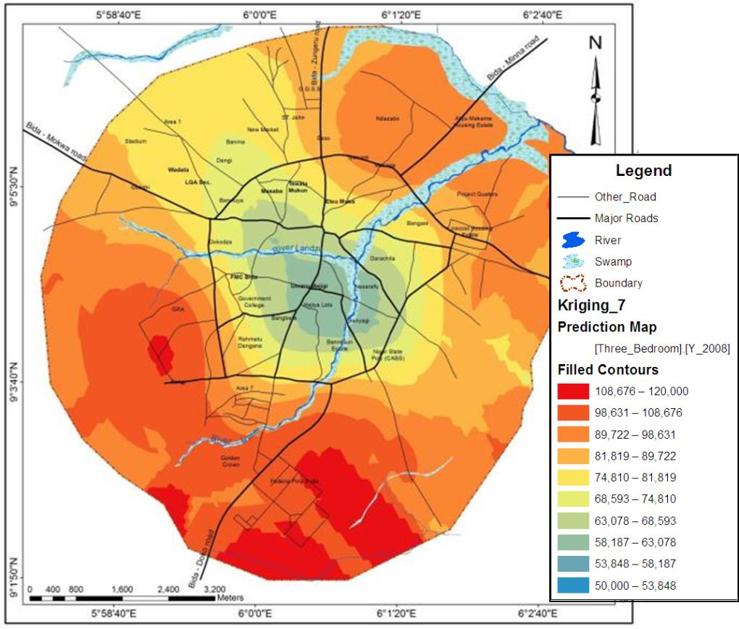

Figure 4.19: Spatial Interpolation of Three Bedroom Housing Prices for 2008
Source: Field survey, 2019
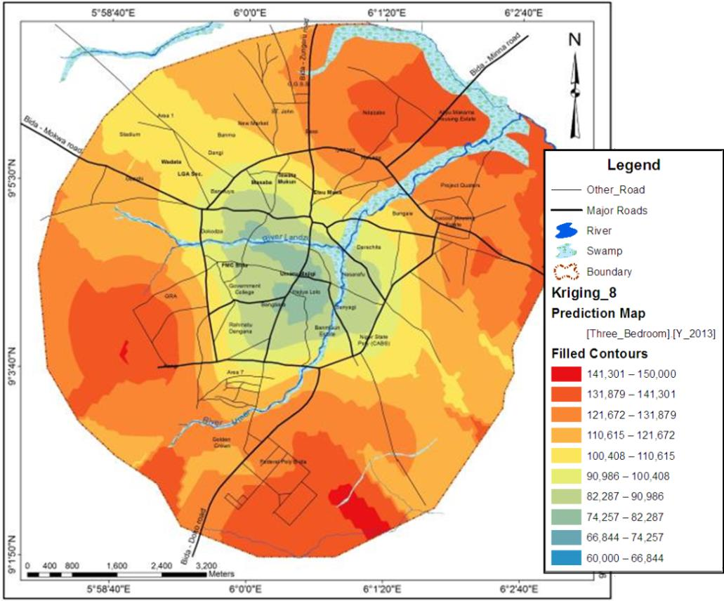

Figure 4.20: Spatial Interpolation of Three Bedroom Housing Prices for 2013
Source: Field survey, 2019

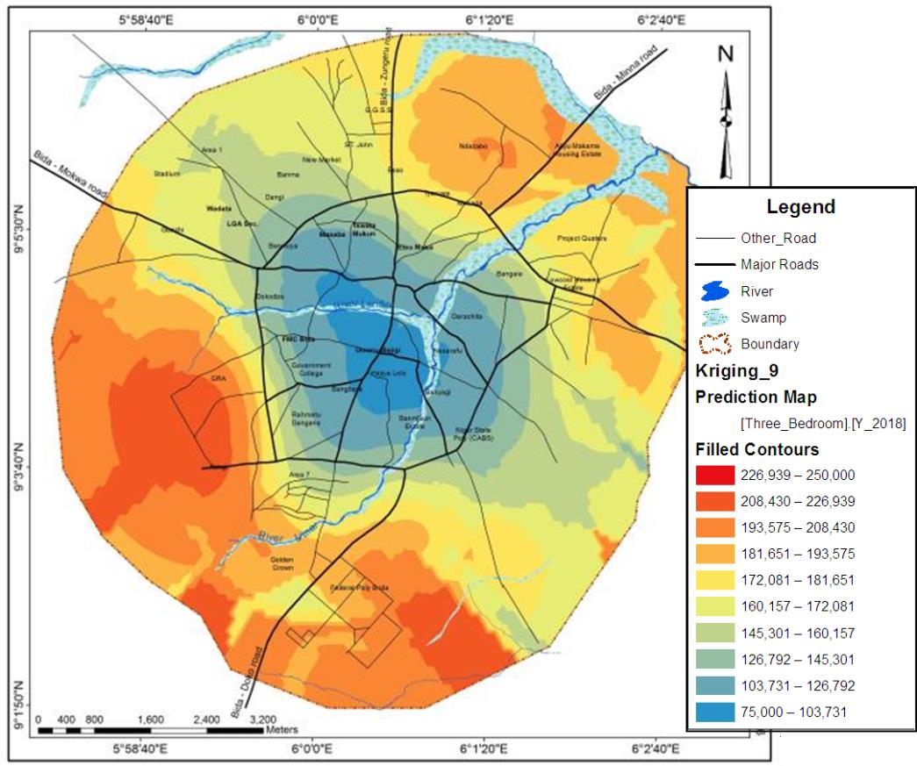

Figure 4.21: Spatial Interpolation of Three Bedroom Housing Prices for 2018
Source: Field survey, 2019

Findings of this study revealed that there is unique pattern of housing prices across the study period in most part of the town. The city centre which is referred to the CBD in this study has the lowest rental value through the study period. The study also shows the differences in rental value of apartments between the CBD and other neighbourhoods which continue to widen. For example, One bedroom apartments, in the year 2008 commands rental value of around N70,000 in GRA area and in the CBD it was around
N15,000 to N20,000. Ten years later, rental value for one bedroom apartment increases

to around N120,000 in GRA area and N28,000 around the CBD. This result is in

conformity with the result by Cichociński and Dąbrowski (2013) but contrary to findings by D'Acci (2018) whose findings shows that housing value decreases with the increasing distance from the city centre. D'Acci’ findings confirms Alonso’s monocentric model.
However, general pattern from the geospatial model of this study demonstrate a unique housing prices pattern for the CBD while a divergence pattern for other areas. The model

shows that housing prices in the Polytechnic area increases more than other regions for all types of houses under study and throughout the study period. Consequently, the model disconfirmed Alonso’s monocentric model which suggests that housing prices decreases with increasing distance to the city centre but it provides a new dimension and perspective for understanding the spatial urban structure.

Predictive Model

Geospatial data of residential density and housing rental prices were used in the data used for the Artificial Neural Network (ANN) model. The model focused on traditional urban economic model such as Alonso who states that densities and rental values increases with decreasing distance to the CBD. The model used techniques such as data augmentation, pre-training, and sparsity which allow training a relatively small dataset. The raster data sets were reclassed in equal specification as earlier explained in the methodology. The output of the model include was forecast data for raster class count values. However, ANN output data were used to forecast spatial morphology of residential density and housing prices. The projected output data are shown in Appendix I. The outcome of the ANN and spatial model shows in Figure 4.22 that residential density of the study area shall continue increasing in the nearest future and shall not deviate from the Alonso’s monocentric model. The study also revealed that densification may occur in the urban fringes but lower than that of the CBD.

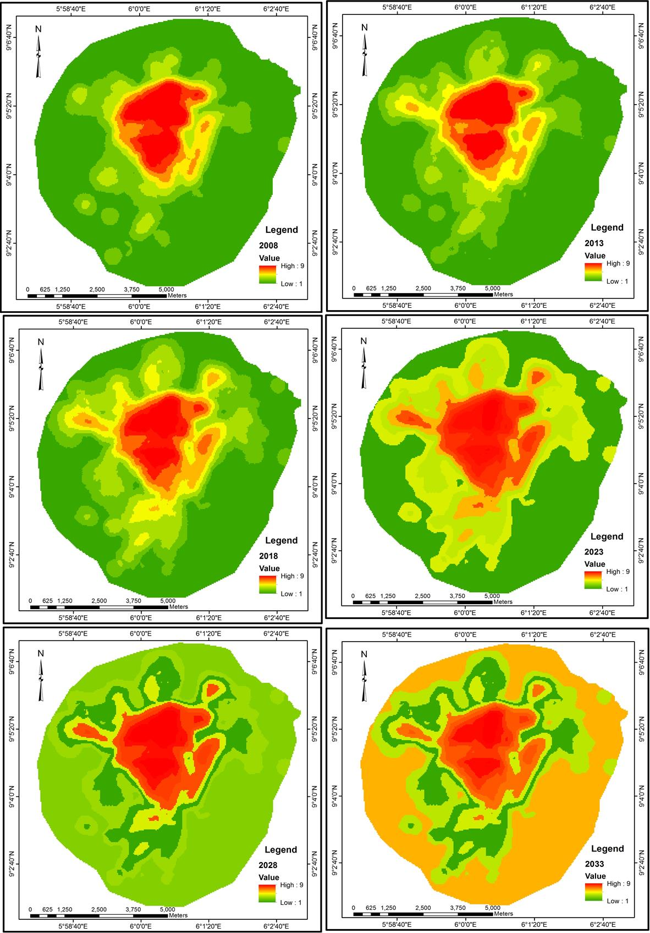

Figure 4.22: Forecast for Residential Density from the Year 2008 - 2033
Source: Field survey, 2019

The implication of this result is that residential densities increase shall continue along the urban – rural gradient thereby causing a transition of open spaces and low density areas in to medium and high density areas in the coming years maintaining its monocentricity. Therefore, it can be inferred that demand for housing shall increase along the urban fringes thereby attracting development of more housing apartments. But the consequential effects of this is that if there is no effective planning regulations that would check the uncontrolled development, the morphology of the town continue to grow in organic manner.
Also, the model suggests in Figures 4.23, 4.24 and 4.25 that rental prices of one bedroom, two bedroom and three bedroom apartments will maintain the pattern of rents recorded between years 2008 to 2018 in the future. The geospatial model of rental prices earlier explained shows deviation from the traditional urban economic theory such as monocentric model of Alonso. The model therefore suggests that the pattern shall continue in the nearest future against monocentricity.

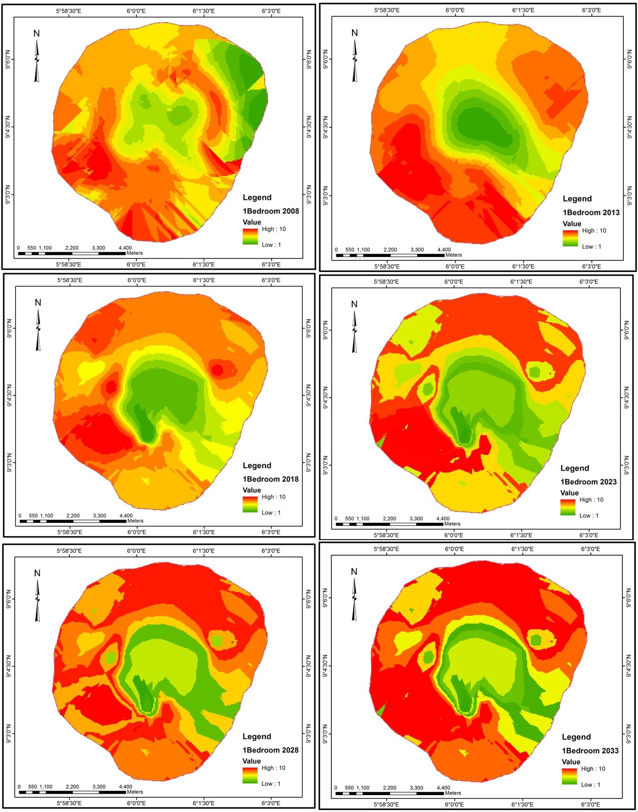

Figure 4.23: Forecast for One Bedroom Rental Prices
Source: Field survey, 2019

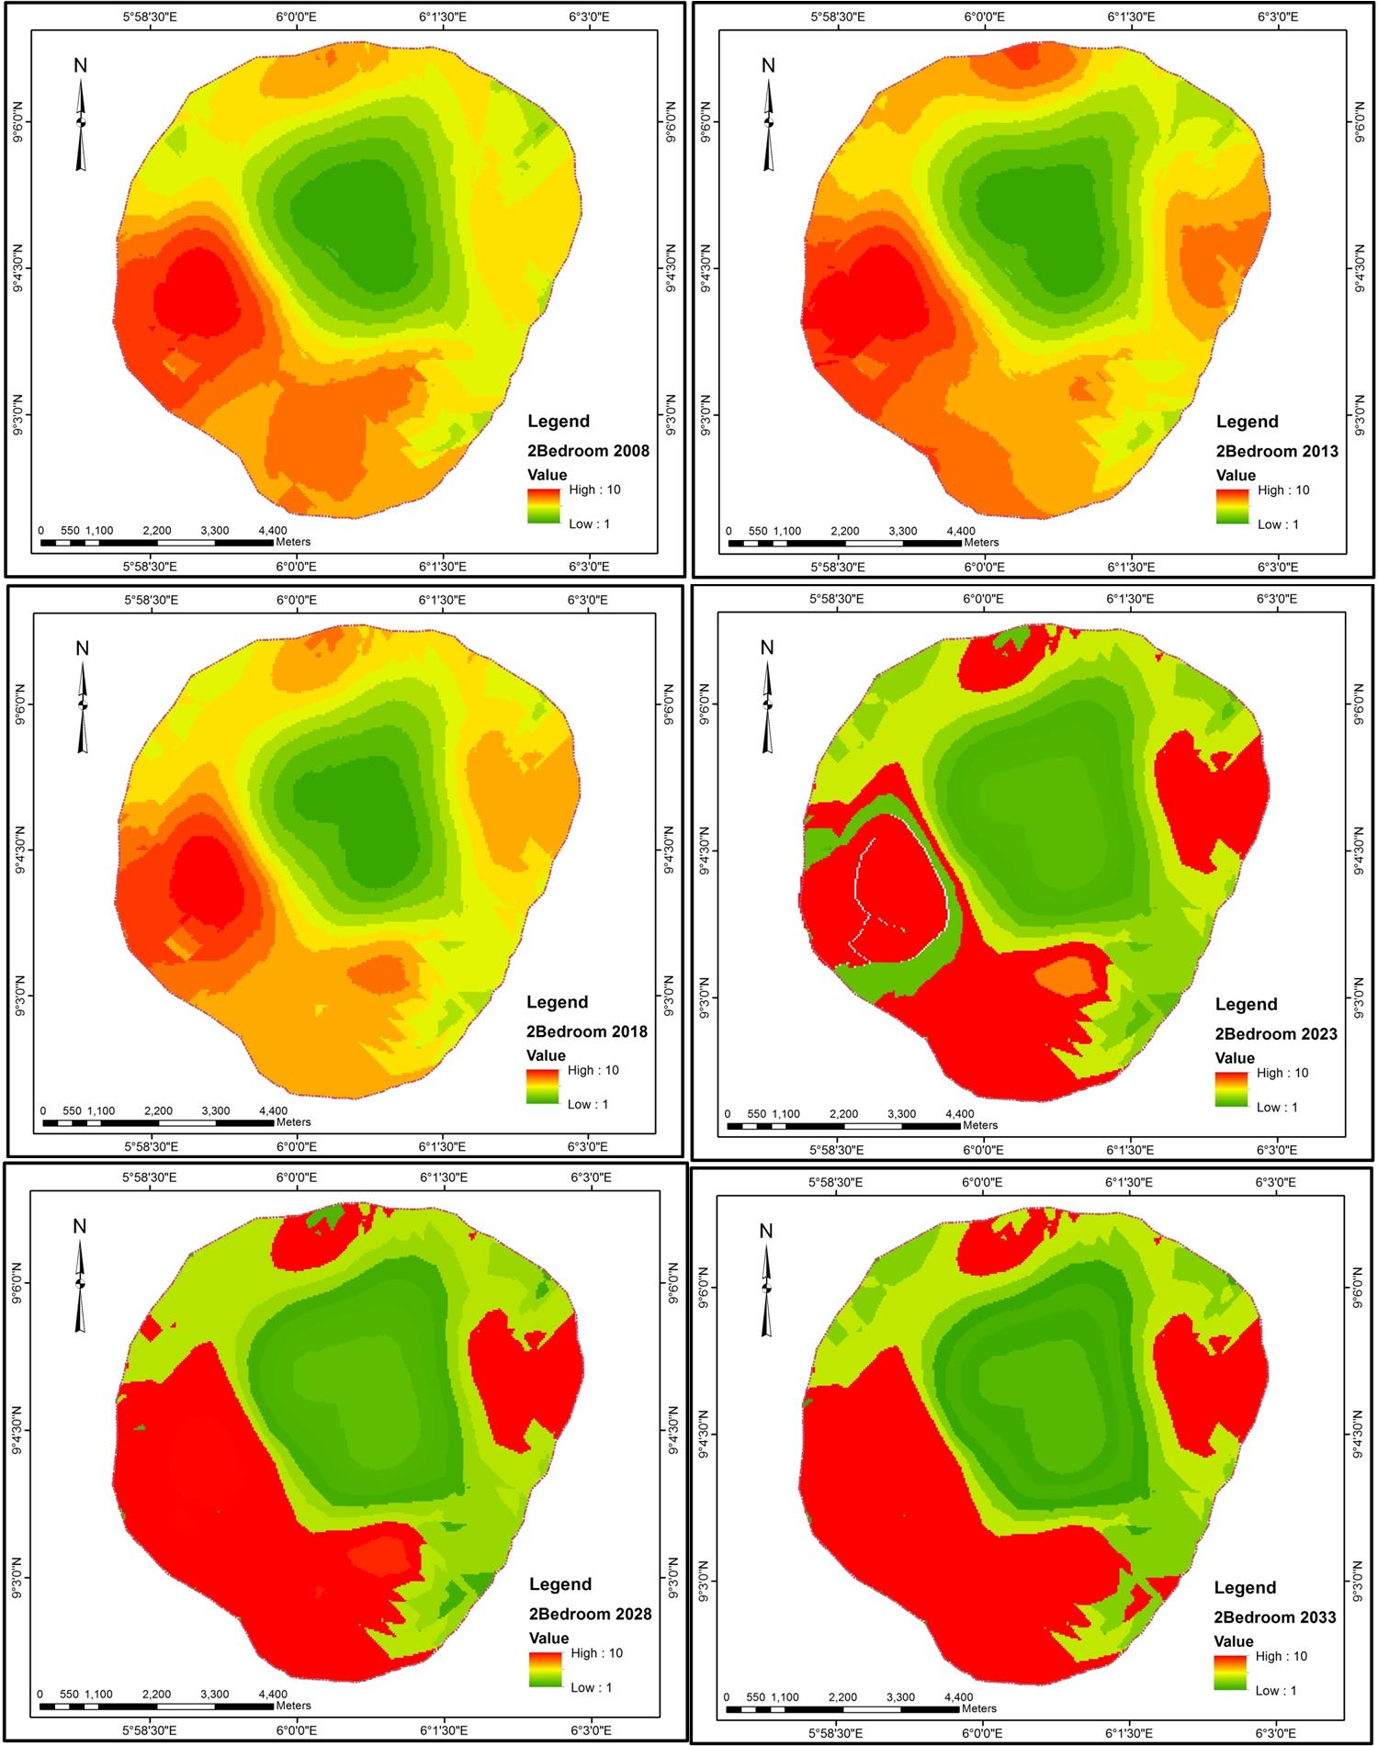

Figure 4.24: Forecast for Two Bedroom Rental Prices
Source: Field survey, 2019

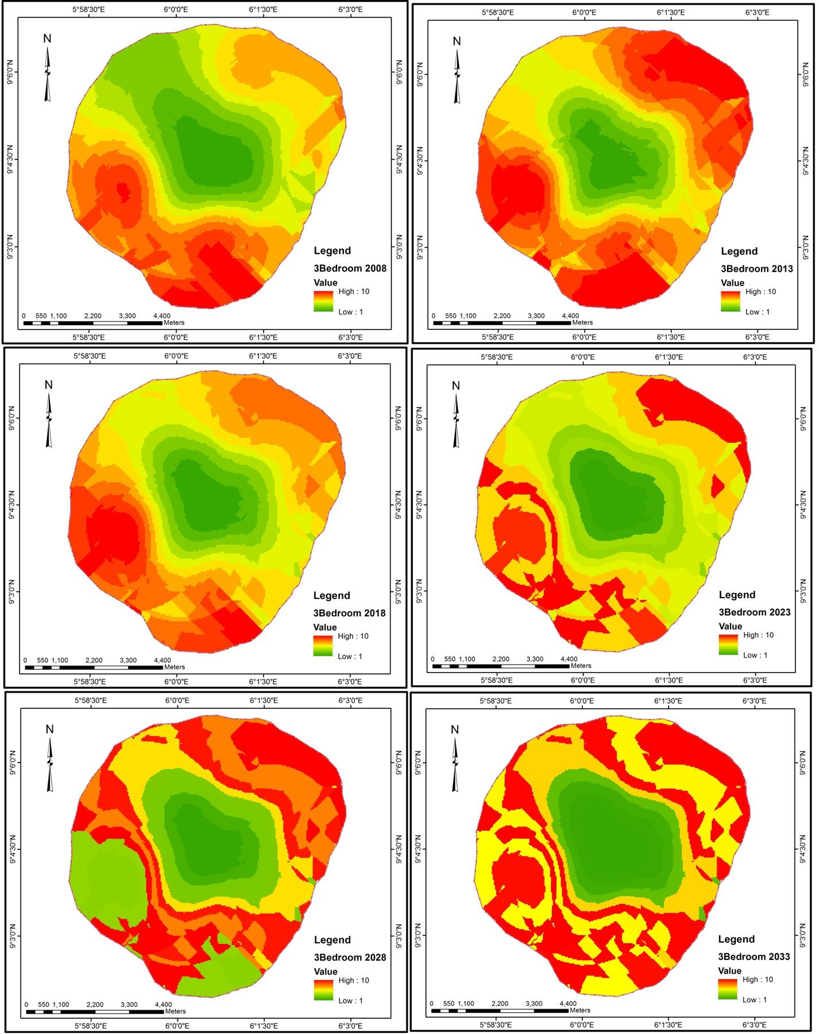

Figure 4.25: Forecast for Three Bedroom Rental Prices
Source: Field survey, 2019

This result implies that the Alonso’s monocentric model as earlier disconfirmed in terms of rental prices shall continue in the future. Therefore rental prices of housing apartments

shall continue to decreases with decreasing distance to the city centre. This also implies that this new dimension and perspective for understanding the spatial urban structure is how the study area would look like in the coming years. Therefore this pattern can only be altered only when there is rational densification, zoning regulations, site and services and adoption of new town concept.

Summary of Findings

It was found out that in the year 2008, Town housing submarket have highest area coverage with 1,214.97ha. This is followed by Project Quarters with 984.31ha; Poly Area and GRA have area coverage of 823.13ha and 800.08ha respectively, also that people live in the Town housing submarket than any other submarkets in the study area in all years under review. The Town housing submarket is also the traditional city centre where major commercial and cultural activities takes place. The result revealed that Rahmatu Dangana with smallest area coverage is highly developed in the year 2013. The implication of this result is that transition in the urban morphology experienced tremendous changes where number of buildings in the Town submarket reduced from 34,242 in the year 2013 to 29,985 in the year 2018. This could be attributed to Bida old market razed by fire in early 2018. The result also implies that there were high residential development in Poly Area, Ndazabo and Gbazhi submarkets during this period which may have occasioned the sudden reduction.
The study revealed that in the year 2008 four housing submarkets i.e. Town, Rahmatu Dangana, Gbazhi and Wadata are of high residential density respectively, where the remaining seven submarkets are of low residential densities in that year. Findings of this study also showed that in the year 2013 eight housing submarkets have their residential densities to be high while GRA had medium residential density and Eyagi and Project

Quarters had low residential densities respectively. The study also revealed that all the housing submarkets in the study area are of high residential densities except for Eyagi and Project Quarters who were of low residential densities respectively.
The study shows that in the year 2008, Town housing submarket had highest number of buildings per area coverage with >10 building units/ha. This is followed by Rahmatu Dangana with 5-6 number of building units/ha, Gbazhi and Wadata had 2-4 number of building units/ha each. Findings of the study in this section shows that Town housing submarket has the highest with >10 number of building units/ha in the year 2013. The study also shows that the Town and Gbazhi housing submarkets records highest number of buildings per area coverage with >10 building units/ha each in the year 2018.
The result shows spatiotemporal dynamics in residential densities in Bida in the year 2008. The result depicts the urban form in terms of residential density in that year. The structure of the town shows that areas around the Central Business District (CBD) are of high density while locations within the urban fringe tend to have lower residential densities. As urban densification proceeds in an uncontrolled and unstructured manner, the spatial pattern of urban residential densities increase in an uneven manner in the year 2013. The result shows that residential density gradient increases towards the urban fringe without decreasing density in the CBD. The study also shows that there was consistent and fast increasing residential density in the study area in the year 2018. Residential density increases during this period towards the north, west and southern part of the town.
Findings of this study revealed that there is unique pattern of housing prices across the study period in most part of the town. The city centre which is referred to the CBD in this study has the lowest rental value through the study period. The study also shows the differences in rental value of apartments between the CBD and other neighbourhoods

which continue to widen. For example, One bedroom apartments, in the year 2008 commands rental value of around N70,000 in GRA area and in the CBD it was around
N15,000 to N20,000. Ten years later, rental value for one bedroom apartment increases

to around N120,000 in GRA area and N28,000 around the CBD.

The outcome of the ANN and raster model shows that residential density of the study area shall continue increasing in the nearest future (year 2033) and shall not deviate from the Alonso’s monocentric model. Also that rental prices of one bedroom, two bedroom and 3 bedroom apartments will maintain the pattern of rents recorded between years 2008 to 2018 into the year 2033.

CHAPTER FIVE

  - CONCLUSION AND RECOMMENDATIONS

Conclusion

From the study, the residential densities increase along the urban core areas moving outward to the urban fringe was observed which is in line with urban economic theory, though restrictive spatial planning is not in place. The study area depicted patterns in the polycentric urban morphology contrary to urban spatial structure of the monocentric housing market. However, general pattern from the geospatial model of this study demonstrate a unique housing prices for the CBD while a divergence pattern for other areas. This study further demonstrate the benefits associated with the use of GIS technology in housing research and the benefits obtained by modelling the spatial as well as the temporal dependence of housing price data. The residential densities increase shall continue along the urban – rural gradient thereby causing a transition of open spaces and low density areas in to medium and high density areas in the coming years maintaining its monocentricity. Therefore, demand for housing shall increase along the urban fringes thereby attracting development of more housing apartments. Also, the rental prices of housing apartments shall continue to decrease with decreasing distance to the city centre, and may continue to maintain its unique spatial pattern of housing prices in the coming years.

Recommendations

In line with the implication of findings of this research, recommendations are as follow:

- The study recommends the use of Artificial Neural Network (ANN), Ordinary Kriging and Point Density in examining housing related issues such as density, housing prices and other related issues.
- It also recommends that relevant authorities need to develop Spatial Data Infrastructure (SDI) in order to enhance housing management and urban density related issues.
- The study suggests rational densification (planned densification) in urban development which could curb the increasing residential density that continue to grow organically, which could increase the standard of urban environment. In conducting this form of densification, urban managers should propose new development plan for the affected areas by converting certain areas from low density to medium density and medium density to high density.
- There is need to create specific requirements for a spatial policy regulating not only the design and implementation of new cities and settlements, but also the management of already urbanised areas, which are also undergoing development and transformation processes affecting on the way they are used on.
- There is also need for policy formulation for urban development particularly urban fringes of a traditional settlement where development is yet to reach in order to control the unplanned densification process.

REFERENCES

Abdullahi, A., Usman, H., & Ibrahim, I. (2018). Determining house price for mass appraisal using multiple regression analysis modeling in Kaduna North, Nigeria. ATBU Journal of Environmental Technology, 11(1), 26–40.
Adedeji, Y. D., & Olotuah, A. O. (2012). An evaluation of accessibility of low-income earners to housing finance in Nigeria. European Scientific Journal, ESJ, 8(12). Retrieved from http://eujournal.org/index.php/esj/article/view/181
Adegoke, O. J. (2014). Critical factors determining rental value of residential property in Ibadan metropolis, Nigeria. Property Management, 32(3), 224–240. https://doi.org/10.1108/PM-05-2013-0033
Aderibigbe, T., & Chi, H. (2018). Investigation of florida housing prices using predictive time series model. Proceedings of the Practice and Experience on Advanced Research Computing - PEARC ’18, 4, 1–4. https://doi.org/10.1145/3219104.3229253
Agbola, T., & Adegoke, S. A. (2007). Economics of housing. In T. Agbola, L. Egunjobi, & C. O. Olatubara (Eds.), Housing Development and Management. A book of readings (pp. 107–149). Ibadan: Department of Urban and Regional Planning, Faculty of Social sciences, University of Ibadan, Nigeria.
Ahlfeldt, G. (2011). If Alonso was right: Modeling accessibility and explaining the residential land gradient. Journal of Regional Science, 51(2), 318–338. https://doi.org/10.1111/j.1467-9787.2010.00694.x
Ajayi, M. T. A., Nuhu, M. B., Bello, M. Z., Shuaib, S. I., Owoyele, G., Onuigbo, I., … Alias, A. (2015). A GIS based assessment of the relationship between housing conditions and rental value in government built housing estates in Minna. Journal of Building Performance, 6(1), 50–62.
Alarima, C. I., Fabusoro, E., Kolawole, A., Uzoma, K. C., Aromolaran, A. K., Masunaga, T., & Wakatsuki, T. (2012). Land rights and rental systems: implications for management of conflicts related to land in sawah- based rice production systems in Nigeria. African Study Monographs, 33(3), 189–208.
Albawi, S., Mohammed, T. A., & Al-Zawi, S. (2017). Understanding of a convolutional neural network. 2017 International Conference on Engineering and Technology (ICET), 1–6. https://doi.org/10.1109/ICEngTechnol.2017.8308186
Alexander, E. R. (1993). Density measures: A review and analysis. Journal of Architectural and Planning Research, 10(3), 181–202.
Ali, S. S. (2006). Economic thought of Ibn Khaldun (1332—1406 A. D.) [IRTI]. Islamic Development Bank.
Aliyu, A. A. (2012). Impact of intangible location attributes on residential property value in Nigeria (PhD Thesis, Universiti Tun Hussein Onn Malaysia). Retrieved from http://eprints.uthm.edu.my/2913/

Alkali, M. A., Sipan, I., & Razali, M. N. (2018). An overview of macro-economic determinants of real estate price in Nigeria. International Journal of Engineering & Technology, 7(3), 484–488.
Alonso, W. (1964). Location and land use: Toward a general theory of land rent. Publication of the Joint Center for Urban Studies. Cambridge: Harvard University Press.
Amer, M., Mustafa, A., Teller, J., Attia, S., & Reiter, S. (2017). A methodology to determine the potential of urban densification through roof stacking. Sustainable Cities and Society, 35, 677–691. https://doi.org/10.1016/j.scs.2017.09.021
Anselin, L., & Le Gallo, J. (2006). Interpolation of air quality measures in hedonic house price models: Spatial aspects. Spatial Economic Analysis, 1(1), 31–52. https://doi.org/10.1080/17421770600661337
Antoniucci, V., & Marella, G. (2017a). Immigrants and the city: The relevance of immigration on housing price gradient. Buildings, 7(4), 2–14. https://doi.org/10.3390/buildings7040091
Antoniucci, V., & Marella, G. (2017b). Is social polarization related to urban density? Evidence from the Italian housing market. Landscape and Urban Planning. https://doi.org/10.1016/j.landurbplan.2017.08.012
Antoniucci, V., & Marella, G. (2018). Is social polarization related to urban density? Evidence from the Italian housing market. Landscape and Urban Planning, 177, 340–349. https://doi.org/10.1016/j.landurbplan.2017.08.012
Archer, W. R., Ling, D. C., & Smith, B. C. (2010). Ownership duration in the residential housing market: The influence of structure, tenure, household and neighborhood factors. The Journal of Real Estate Finance and Economics, 40(1), 41–61. https://doi.org/10.1007/s11146-008-9126-2
Asian Development Bank. (2012). The State of Pacific Towns and Cities: Urbanization in ADB’s Pacific Development Member Countries. Manila: Asian Development Bank.
Asian Development Bank. (2015). ‘Revisiting the GMS Economic Corridor Strategies and Action Plans’, Discussion Paper Prepared for the 7th Economic Corridors Forum Kunming. Retrieved from http://www.adb.org/sites/default/files/related/33507/revisiting-the-gms- strategies-andaction-plans.pdf
Bajat, B., Kilibarda, M., Pejović, M., & Petrović, M. S. (2018). Spatial hedonic modeling of housing prices using auxiliary maps. In J.-C. Thill (Ed.), Spatial Analysis and Location Modeling in Urban and Regional Systems (pp. 97–122). https://doi.org/10.1007/978-3-642-37896-6_5
Baranzini, A., Ramirez, J., Schaerer, C., & Thalmann, P. (Eds.). (2008). Hedonic methods in housing markets. https://doi.org/10.1007/978-0-387-76815-1
Basu, S., & Thibodeau, T. G. (1998). Analysis of spatial autocorrelation in house prices.
Journal of Real Estate Finance and Economics, 17(1), 61–85.

Bates, L. K. (2006). Does neighborhood really matter?: Comparing historically defined neighborhood boundaries with housing submarkets. Journal of Planning Education and Research, 26(1), 5–17. https://doi.org/10.1177/0739456X05283254
Bérard, G., & Trannoy, A. (2018). The impact of the 2014 increase in the real estate transfer taxes on the French housing market. Economie et Statistique / Economics and Statistics, (500t), 179–200. https://doi.org/10.24187/ecostat.2018.500t.1951
Bin, O., Kruse, J. B., & Landry, C. E. (2008). Flood hazards, insurance rates, and amenities: Evidence from the coastal housing market. Journal of Risk & Insurance, 75(1), 63–82. https://doi.org/10.1111/j.1539-6975.2007.00248.x
Bolton, R. (2018). The value of third-party verified green residential housing in the Chicagoland area. The Park Place Economist, 26(1), 1–12.
Broitman, D., & Koomen, E. (2015). Residential density change: Densification and urban expansion. Computers, Environment and Urban Systems, 54, 32–46. https://doi.org/10.1016/j.compenvurbsys.2015.05.006
Brounen, D., & Kok, N. (2011). On the economics of energy labels in the housing market.
Journal of Environmental Economics and Management, 62(2), 166–179.
Cajias, M., Fuerst, F., & Bienert, S. (2019). Tearing down the information barrier: The price impacts of energy efficiency ratings for buildings in the German rental market. Energy Research & Social Science, 47, 177–191. https://doi.org/10.1016/j.erss.2018.08.014
Cameron, T. (2018). The house rules: Housing market responses to oil price shocks in Canada (Masters Dissertation). University of Ottawa, Ottawa, Canada.
Chandrabose, M., Owen, N., Giles‐Corti, B., Turrell, G., Carver, A., & Sugiyama, T. (2019). Urban densification and 12‐year changes in cardiovascular risk markers. Journal of the American Heart Association, 8(15). https://doi.org/10.1161/JAHA.119.013199
Chen, F. (2018). Spatial differentiation of urban housing prices in Guangdong province and its influencing factors. Modern Economy, 09(04), 664–681. https://doi.org/10.4236/me.2018.94043
Chen, J., Guo, F., & Wu, Y. (2011). One decade of urban housing reform in China: Urban housing price dynamics and the role of migration and urbanization, 1995-2005. Habitat International, 35(1), 1–8.
Chen, W. Y., & Li, X. (2017). Cumulative impacts of polluted urban streams on property values: A 3-D spatial hedonic model at the micro-neighborhood level. Landscape and Urban Planning, 162, 1–12. https://doi.org/10.1016/j.landurbplan.2017.01.012
Chen, Y., Pryce, G., & Mackay, D. (2011). Flood Risk, Climate Change and Housing Economics.

Cheung, R., Wetherell, D., & Whitaker, S. (2018). Induced earthquakes and housing markets: Evidence from Oklahoma. Regional Science and Urban Economics, 69, 153–166. https://doi.org/10.1016/j.regsciurbeco.2018.01.004
Chhipi-Shrestha, G., Hewage, K., & Sadiq, R. (2017). Impacts of neighborhood densification on water-energy-carbon nexus: Investigating water distribution and residential landscaping system. Journal of Cleaner Production, 156, 786–795. https://doi.org/10.1016/j.jclepro.2017.04.113
Chu, S.-Y. (2018). Macroeconomic policies and housing market in Taiwan. International Review of Economics & Finance. https://doi.org/10.1016/j.iref.2018.05.002
Chung, Y., Seo, D., & Kim, J. (2018). Price determinants and GIS analysis of the housing market in Vietnam: The cases of Ho Chi Minh city and Hanoi. Sustainability, 10(12), 1–18. https://doi.org/10.3390/su10124720
Cichociński, P., & Dąbrowski, J. (2013). Spatio-temporal analysis of the real estate market using geographic information systems. Real Estate Management and Valuation, 21(2), 73–82. https://doi.org/10.2478/remav-2013-0019
Clauw, F. (2007). The effect of soil contamination on real estate value: A hedonic pricing approach based on different risk measures (UHasselt Diepenbeek). Retrieved from https://doclib.uhasselt.be/dspace/handle/1942/8973
Cui, N., Gu, H., Shen, T., & Feng, C. (2018). The impact of micro-level influencing factors on home value: A housing price-rent comparison. Sustainability, 10(12), 1–23. https://doi.org/10.3390/su10124343
D’Acci, L. (2018). Quality of urban area, distance from city centre, and housing value. Case study on real estate values in Turin. Cities, xxx(xx), xxx. https://doi.org/10.1016/j.cities.2018.11.008
Day, B. (2003). Submarket identification in property markets: A hedonic housing price model for Glasgow [Working paper]. Norwich: University of East Anglia.
De Paola, P., Del Giudice, V., Massimo, D. E., Forte, F., Musolino, M., & Malerba, A. (2019). Isovalore maps for the spatial analysis of real estate market: A case study for a central urban area of Reggio Calabria, Italy. In F. Calabrò, L. Della Spina, & C. Bevilacqua (Eds.), New Metropolitan Perspectives (Vol. 100, pp. 402–410). https://doi.org/10.1007/978-3-319-92099-3_46
Debaniyu, I. F. (2013). Price integration of cowpea retail markets in Niger State, Nigeria.
Academic Research International, 4(3), 264–277.
Debrezion, G., Pels, E. A., & Rietveld, P. (2006). The impact of rail transport on real estate prices: An empirical analysis of the Dutch housing market. Retrieved from https://papers.ssrn.com/sol3/papers.cfm?abstract_id=895270
Del Giudice, V., De Paola, P., & Forte, F. (2017). Bayesian neural network models in the appraisal of real estate properties. International Conference on Computational Science and Its Applications, 478–489. Cham: Springer.
Delbari, M., Afrasiab, P., & Jahani, S. (2013). Spatial interpolation of monthly and annual rainfall in northeast of Iran. 122(1–2), 103–113.

Delmelle, E., Zhou, Y., & Thill, J.-C. (2014). Densification without Growth Management? Evidence from local land development and housing trends in Charlotte, North Carolina, USA. Sustainability, 6(6), 3975–3990. https://doi.org/10.3390/su6063975
Deng, Y., Morck, R. K., Wu, J., & Yeung, B. Y. (2011). Monetary and fiscal stimuli, ownership structure, and China’s housing market. SSRN Electronic Journal. https://doi.org/10.2139/ssrn.1775363
Devaux, N., Berthold, E., & Dubé, J. (2018). Economic impact of a heritage policy on residential property values in a historic district context: The Case of the old city of Quebec. The Review of Regional Studies, 48, 279–297.
Diao, M. (2015). Selectivity, spatial autocorrelation and the valuation of transit accessibility. Urban Studies, 52(1), 159–177. https://doi.org/10.1177/0042098014523686
Díaz-Fernández, M., Llorente-Marrón, M., & Méndez-Rodríguez, P. (2018). Interrelation between births and the housing market: A cointegration analysis for the Spanish case: Does fertility affect dynamics of housing market? Population, Space and Place, 1–10. https://doi.org/10.1002/psp.2172
Doszyń, M., & Gnat, S. (2017). Econometric identification of the impact of real estate characteristics based on predictive and studentized residuals. Real Estate Management and Valuation, 25(1). https://doi.org/10.1515/remav-2017-0005
Dubin, R A. (1998). Spatial autocorrelation: A primer. Journal of Housing Economics, 7, 304–327.
Dubin, Robin A. (1992). Spatial autocorrelation and neighborhood quality. Regional Science and Urban Economics, 22(3), 433–452. https://doi.org/10.1016/0166- 0462(92)90038-3
Flage, A. (2018). Ethnic and gender discrimination in the rental housing market: Evidence from a meta-analysis of correspondence tests, 2006–2017. Journal of Housing Economics, 41, 251–273. https://doi.org/10.1016/j.jhe.2018.07.003
Fujita, M. (1989). Urban economic theory: Land use and city size. Cambridge [Cambridgeshire] ; New York: Cambridge University Press.
Fujita, M. (2010). The evolution of spatial economics: From Thünen to the new economic geography. Japanese Economic Review, 61(1), 1–32. https://doi.org/10.1111/j.1468-5876.2009.00504.x
Gambo, Y. L. (2012). Hedonic price modeling of the influence of violent ethno-religious conflict on residential property values in Bauchi metropolis, Nigeria. Journal of Sustainable Development, 5(9), 85–97. https://doi.org/10.5539/jsd.v5n9p85
Gan, L., Wang, P., & Zhang, Q. (2018). Market thickness and the impact of unemployment on housing market outcomes. Journal of Monetary Economics. https://doi.org/10.1016/j.jmoneco.2018.04.007

Ge, J. (2017). Endogenous rise and collapse of housing price. Computers, Environment and Urban Systems, 62, 182–198. https://doi.org/10.1016/j.compenvurbsys.2016.11.005
Ghadami, M., & Newman, P. (2019). Spatial consequences of urban densification policy: Floor-to-area ratio policy in Tehran, Iran. Environment and Planning B: Urban Analytics and City Science, 46(4), 626–647. https://doi.org/10.1177/2399808317722168
Goodman, A. C., & Thibodeau, T. G. (1995). Age-related heteroskedasticity in hedonic house price equations. Journal of Housing Research, 6(1), 25–42.
Goodman, A. C., & Thibodeau, T. G. (1998). Housing market segmentation. Journal of Housing Economics, 7(2), 121–143.
Goodman, A. C., & Thibodeau, T. G. (2007). The spatial proximity of metropolitan area housing submarkets. Real Estate Economics, 35(2), 209–232. https://doi.org/10.1111/j.1540-6229.2007.00188.x
Gu, Y. (2018). What are the most important factors that influence the changes in London real estate prices? How to quantify them? ArXiv Preprint ArXiv:1802.08238.
Guan, J., & Gao, J. (2018). Time and space analysis of house price in mainland China in the last 10 years. Modern Economy, 09(09), 1520–1532. https://doi.org/10.4236/me.2018.99096
Gulyani, S., Talukdar, D., & Bassett, E. M. (2018). A sharing economy? Unpacking demand and living conditions in the urban housing market in Kenya. World Development, 109, 57–72. https://doi.org/10.1016/j.worlddev.2018.04.007
Gurran, N., & Bramley, G. (2017). Urban Planning and the Housing Market. https://doi.org/10.1057/978-1-137-46403-3
Gwamna, E. S., Wan Yusoff, W. Z., & Ismail, M. F. (2015). Determinants of land use and property value. Advanced Science Letters, 21(5), 1150–1153. https://doi.org/10.1166/asl.2015.6065
Hanson, A., & Hawley, Z. (2011). Do landlords discriminate in the rental housing market? Evidence from an internet field experiment in US cities. Journal of Urban Economics, 70(2–3), 99–114. https://doi.org/10.1016/j.jue.2011.02.003
He, X., Cai, X.-J., & Hamori, S. (2018). Bank credit and housing prices in China: Evidence from a TVP-VAR model with stochastic volatility. Journal of Risk and Financial Management, 11(90), 1–16. https://doi.org/10.3390/jrfm11040090
Helbich, M., Brunauer, W., Vaz, E., & Nijkamp, P. (2014). Spatial heterogeneity in hedonic house price models: The case of Austria. Urban Studies, 51(2), 390–411. https://doi.org/10.1177/0042098013492234
Hill, R. J., & Scholz, M. (2017). Can geospatial data improve house price indexes? A hedonic imputation approach with splines. Review of Income and Wealth. https://doi.org/10.1111/roiw.12303

Hu, S., Cheng, Q., Wang, L., & Xu, D. (2013). Modeling land price distribution using multifractal IDW interpolation and fractal filtering method. Landscape and Urban Planning, 110, 25–35. https://doi.org/10.1016/j.landurbplan.2012.09.008
Hu, S., Yang, S., Li, W., Zhang, C., & Xu, F. (2016). Spatially non-stationary relationships between urban residential land price and impact factors in Wuhan city, China. Applied Geography, 68, 48–56. https://doi.org/10.1016/j.apgeog.2016.01.006
Huang, W.-L., Lin, W.-Y., & Ning, S.-L. (2018). The effect of economic policy uncertainty on China’s housing market. The North American Journal of Economics and Finance, xxx(xx), xxx. https://doi.org/10.1016/j.najef.2018.09.008
Hulse, K., & Reynolds, M. (2018). Investification: Financialisation of housing markets and persistence of suburban socio-economic disadvantage. Urban Studies, 55(8), 1655–1671. https://doi.org/10.1177/0042098017734995
Ibn Khaldun, A. (1958). The Muqaddimah; An Introduction to History (Translated by Franz Rosenthal). New York: Pantheon Books Inc.
Ibn Taymiyyah, A. (1962). Majmu’ Fatawa Shaikh al Islam Ahmad b. Taimiyah (Vol. 8 & 28). Riyadh: al Riyadh Press.
Iliopoulou, P., & Stratakis, P. (2018). Spatial analysis of housing prices in the Athens Region, Greece. 10.
Islahi, A. A. (1985). Ibn Taimiyah’s concept of market mechanism. J. Res. Islamic Econ., 2(2), 51–60.
Islam, K. S., & Asami, Y. (2009). Housing market segmentation: A review. Review of Urban & Regional Development Studies, 21(2–3), 93–109. https://doi.org/10.1111/j.1467-940X.2009.00161.x
James, R. C., & Carol, E. B. (2000). Artificial neural networks in accounting and finance: Modeling issues. International Journal of Intelligent Systems in Accounting, Finance & Management, 9, 119 – 144.
Jiao, L. (2015). Urban land density function: A new method to characterize urban expansion. Landscape and Urban Planning, 139, 26–39. http://dx.doi.org/10.1016/j.landurbplan.2015.02.017
Jung, E., & Yoon, H. (2018). Is flood risk capitalized into real estate market value? A Mahalanobis-Metric matching approach to the housing market in Gyeonggi, South Korea. Sustainability, 10(11), 1–17. https://doi.org/10.3390/su10114008
Kauko, T. (2003). On current neural network applications involving spatial modelling of property prices. Journal of Housing and the Built Environment, 18, 159–181.
Kauko, T., Hooimeijer, P., & Hakfoort, J. (2002). Capturing housing market segmentation: An alternative approach based on neural network modelling. Housing Studies, 17(6), 875–894. https://doi.org/10.1080/02673030215999

Kemiki, O., Ojetunde, I., & Ayoola, A. (2014). The impact of noise and dust level on rental price of residential tenements around Lafarge cement factory in Ewekoro Town, Nigeria. Ethiopian Journal of Environmental Studies and Management, 7(2), 108–116. https://doi.org/10.4314/ejesm.v7i2.1
Khalafallah, A. (2008). Neural network based model for predicting housing market performance. Tsinghua Science and Technology, 13(S1), 325–328. https://doi.org/10.1016/S1007-0214(08)70169-X
Killins, R. N., Egly, P. V., & Escobari, D. (2017). The impact of oil shocks on the housing market: Evidence from Canada and U.S. Journal of Economics and Business, 93, 15–28. https://doi.org/10.1016/j.jeconbus.2017.07.002
Kim, H.-S., Lee, G.-E., Lee, J.-S., & Choi, Y. (2019). Understanding the local impact of urban park plans and park typology on housing price: A case study of the Busan metropolitan region, Korea. Landscape and Urban Planning, 184, 1–11. https://doi.org/10.1016/j.landurbplan.2018.12.007
Kim, S., & Lee, K. O. (2018). Potential crime risk and housing market responses. Journal of Urban Economics, 108, 1–17. https://doi.org/10.1016/j.jue.2018.09.001
Kirman, A. (2011). Market Mechanisms in Real Markets: Why did markets disappear from Economic Analysis? 93.
Kuang, W., & Wang, Q. (2018). Cultural similarities and housing market linkage: Evidence from OECD countries. Frontiers of Business Research in China, 12(1). https://doi.org/10.1186/s11782-018-0030-1
Kulish, M., Richards, A., & Gillitzer, C. (2012). Urban structure and housing prices: Some evidence from Australian cities*: Urban structure and housing prices. Economic Record, 88(282), 303–322. https://doi.org/10.1111/j.1475- 4932.2012.00829.x
Kuntz, M., & Helbich, M. (2014). Geostatistical mapping of real estate prices: An empirical comparison of kriging and cokriging. International Journal of Geographical Information Science, 28(9), 1904–1921. https://doi.org/10.1080/13658816.2014.906041
Lancaster, K. J. (1966). A new approach to consumer theory. The Journal of Political Economy, 74(2), 132–157.
Latinopoulos, D. (2018). Using a spatial hedonic analysis to evaluate the effect of sea view on hotel prices. Tourism Management, 65, 87–99. https://doi.org/10.1016/j.tourman.2017.09.019
Leffers, D., & Ballamingie, P. (2013). Governmentality, environmental subjectivity, and urban intensification. Local Environment, 18(2), 134–151. https://doi.org/10.1080/13549839.2012.719016
Leung, C. (2004). Macroeconomics and housing: A review of the literature. Journal of Housing Economics, 13(4), 249–267. https://doi.org/10.1016/j.jhe.2004.09.002

Li, H., Wei, Y. D., Wu, Y., & Tian, G. (2018). Analyzing housing prices in Shanghai with open data: Amenity, accessibility and urban structure. Cities, xxx(xx), xxx. https://doi.org/10.1016/j.cities.2018.11.016
Li, S., Ye, X., Lee, J., Gong, J., & Qin, C. (2017). Spatiotemporal analysis of housing prices in China: A big data perspective. Applied Spatial Analysis and Policy, 10(3), 421–433. https://doi.org/10.1007/s12061-016-9185-3
Li, X., & Tang, Y. (2018). When natives meet immigrants in public and private housing markets. Journal of Housing Economics, 41, 30–44. https://doi.org/10.1016/j.jhe.2017.08.003
Li, Y., Zhang, H., Yang, F., & Wang, Y. (2014). Applications of artificial neural networks in the identification of real estate cycles: Evidence from China. In D Yang & Y. Qian (Eds.), Proceedings of the 18th International Symposium on Advancement of Construction Management and Real Estate (pp. 185–195). https://doi.org/10.1007/978-3-642-44916-1_19
Liang, X., Liu, Y., Qiu, T., Jing, Y., & Fang, F. (2018). The effects of locational factors on the housing prices of residential communities: The case of Ningbo, China. Habitat International, 81, 1–11. https://doi.org/10.1016/j.habitatint.2018.09.004
Liao, W.-C., & Wang, X. (2012). Hedonic house prices and spatial quantile regression. Journal of Housing Economics, 21(1), 16–27. https://doi.org/10.1016/j.jhe.2011.11.001
Liebelt, V., Bartke, S., & Schwarz, N. (2018). Hedonic pricing analysis of the influence of urban green spaces onto residential prices: The case of Leipzig, Germany. European Planning Studies, 26(1), 133–157. https://doi.org/10.1080/09654313.2017.1376314
Limsombunc, V., Gan, C., & Lee, M. (2004). House price prediction: Hedonic price model vs. artificial neural network. American Journal of Applied Sciences, 1(3), 193–201. https://doi.org/10.3844/ajassp.2004.193.201
Lin, B., Meyers, J., & Barnett, G. (2015). Understanding the potential loss and inequities of green space distribution with urban densification. Urban Forestry & Urban Greening, 14(4), 952–958. https://doi.org/10.1016/j.ufug.2015.09.003
Liu, Y., & Li, Z. (2018). Determinants of housing purchase decision: An empirical study of the high education cohort in urban China. Journal of Asian Architecture and Building Engineering, 17(2), 299–305. https://doi.org/10.3130/jaabe.17.299
Lockwood, T., Coffee, N. T., Rossini, P., Niyonsenga, T., & McGreal, S. (2018). Does where you live influence your socio-economic status? Land Use Policy, 72, 152–
160. https://doi.org/10.1016/j.landusepol.2017.12.045
Lu, J. (2018). The value of a south-facing orientation: A hedonic pricing analysis of the Shanghai housing market. Habitat International, 81, 24–32. https://doi.org/10.1016/j.habitatint.2018.09.002
Magliocca, N., Safirova, E., McConnell, V., & Walls, M. (2011). An economic agent- based model of coupled housing and land markets (CHALMS). Computers,

Environment and Urban Systems, 35(3), 183–191. https://doi.org/10.1016/j.compenvurbsys.2011.01.002
Mahmud, H. L., & Umaru, E. T. (2018). Impact of gully erosion on landuse/land cover in Bida town Niger State, Nigeria. International Journal of Geography and Environmental Management 4(2), 7-15.
Malpezzi, S. (2002). Hedonic pricing models: A selective and applied review. In T. O’Sullivan & K. Gibb (Eds.), Housing Economics and Public Policy (pp. 67–89). https://doi.org/10.1002/9780470690680.ch5
Manganelli, B., & Murgante, B. (2017). The dynamics of urban land rent in Italian regional capital cities. Land, 6(3), 54. https://doi.org/10.3390/land6030054
Manganelli, B., Pontrandolfi, P., Azzato, A., & Murgante, B. (2014). Using geographically weighted regression for housing market segmentation. International Journal of Business Intelligence and Data Mining 13, 9(2), 161– 177.
MaxLock. (1980). Bida Master Plan Final Edition. Max Lock Group of Company Limited.
McCluskey, W. J., & Borst, R. A. (2011). Detecting and validating residential housing submarkets: A geostatistical approach for use in mass appraisal. International Journal of Housing Markets and Analysis, 4(3), 290–318. https://doi.org/10.1108/17538271111153040
McCluskey, W. J., Deddis, W. G., Lamont, I. G., & Borst, R. A. (2000). The application of surface generated interpolation models for the prediction of residential property values. Journal of Property Investment & Finance, 18(2), 162–176.
Medayese, M., Martins, V. E., & Abdrazack, N. T. (2015). Density. In L. Egunjobi (Ed.), Contemporary Concepts in Physical Planning (First Edition, Vol. 1, pp. 263– 290). Ibadan: University of Ibadan.
Meese, R., & Wallace, N. (1991). Nonparametric estimation of dynamic hedonic price models and the construction of residential housing prices indeces. Fisher Center Working Papers.
Mills, T. C. (Ed.). (2011). Palgrave handbook of econometrics. Vol. 2: Applied econometrics. Basingstoke,: Palgrave Macmillan.
Mohammed, J. K., & Aremu, S. C. (2017). Geospatial relationship between conditions of facilities and users’ satisfaction of residential housing in Bida. Environmental Watch, 10(2), 26–33.
Moral, F. J. (2008). Comparison of different geostatistical approaches to map climate variables: Application to precipitation. International Journal of Climatology 30(4), 620–631.
Moulton, M., & Preece, A. (2002). Applications and Innovations in Intelligent Systems
IX. International Teledemocracy Centre, Napier University, Edinburgh, UK.
Proceedings of ES2001.

Muehlenbachs, L., Spiller, E., & Timmins, C. (2015). The housing market impacts of shale gas development. The American Economic Review, 105(12), 3633–3659.
Musa, U., & Yusoff, W. Z. W. (2015). Impact of location and dwelling characteristics on residential property prices/values: A critical review of literature. International Journal of Advances in Management and Economics, 4(2), 5–11.
Nanthakumaran, N., Watkins, C., & Orr, A. (2000). Understanding property market dynamics: Insights from modelling the supply-side adjustment mechanism. Environment and Planning A, 32(4), 655–671. https://doi.org/10.1068/a31176
National Population Commission. (2006). Population and housing census of the federal republic of Nigeria: National and state population and housing priority tables. National Population Commission.
Ndaguye, M. (1982). Forms and structures of Nupe settlements (M.Sc. Thesis). Ahmadu Bello University, Zaria, Zaria Nigeria.
Noh, Y. (2019). Does converting abandoned railways to greenways impact neighboring housing prices? Landscape and Urban Planning, 183, 157–166. https://doi.org/10.1016/j.landurbplan.2018.11.002
Oladunni, T., Sharma, S., & Tiwang, R. (2017). A spatio – temporal hedonic house regression model. IEEE International Conference on Machine Learning and Applications. Presented at the IEEE International Conference on Machine Learning and Applications. https://doi.org/10.1109/ICMLA.2017.00-94
Oluwadamilola, I. (2017). Effect of socioeconomic factors on the rental values of accommodation in Lagos metropolis. Equatorial Journal of Social Sciences and Human Behaviour, 2(3), 106–120.
Ononogbo, K. U. (2014). Assessment of Residents’ Attitudes Towards Recreation in Bida- Nigeria (M.Sc. Thesis). Ahmadu Bello University, Zaria, Zaria Nigeria.
Park, J. (2013). The division of spatial housing submarkets: A theory and the case of Seoul. Environment and Planning A, 45(3), 668–690. https://doi.org/10.1068/a45337
Paz, P. T. de la, & McGreal, S. (2018). A re-assessment of house price indices: Evidence from the Spanish market. International Journal of Strategic Property Management, 23(1), 23–35. https://doi.org/10.3846/ijspm.2019.6366
Pirounakis, N. G. (2013). Real estate economics: A point to point handbook. London ; New York: Routledge.
Razali, M. N., Zulkarnain, S. H., Tarmidi, Z., Maimun, N. H. A., Adnan, Y. Mohd., & Yuzir, M. A. (2018). Property market price response to flood-hazard. Natural Hazards, 1–16. https://doi.org/10.1007/s11069-018-3495-5
Renigier-Biłozor, M., Biłozor, A., & Wisniewski, R. (2017). Rating engineering of real estate markets as the condition of urban areas assessment. Land Use Policy, 61, 511–525. https://doi.org/10.1016/j.landusepol.2016.11.040

Royuela, V., & Vargas, M. (2007). Defining housing market areas using commuting and migration algorithms. Catalonia (Spain) as an applied case study. IREA–Working Papers, 2007, IR07/07.
Saenko, I., Kushina, E., & Pukhova, V. (2018). Verification of the dependence of factors determining the market value of residential real estate at the stages of the life cycle. MATEC Web of Conferences, 212, 1–6. https://doi.org/10.1051/matecconf/201821203002
Saether, J. P. (2008). Fluctuations in housing markets, causes and consequences
(Master’s Thesis). The University of Bergen.
Sandmo, A. (2014). The market in economics: Behavioural assumptions and value judgments. SSRN Electronic Journal. https://doi.org/10.2139/ssrn.2432934
Saurav, C., Kakoli, D., & Utpal, R. (2015). Concentrated or dispersed urbanization: A critical analysis of newly emerged census towns of west Bengal, India in 2011. Journal of Geography and Regional Planning, 8(9), 218–227. https://doi.org/10.5897/JGRP2015.0503
Schmidt-Thomé, K., Haybatollahi, M., Kyttä, M., & Korpi, J. (2013). The prospects for urban densification: A place-based study. Environmental Research Letters, 8(2), 025020. https://doi.org/10.1088/1748-9326/8/2/025020
Selim, H. (2009). Determinants of house prices in Turkey: Hedonic regression versus artificial neural network. Expert Systems with Applications, 36(2), 2843–2852. https://doi.org/10.1016/j.eswa.2008.01.044
Seo, W. (2008). Spatial impacts of micro neighborhood environments on residential real estate resale values: The importance of physical disorder (The Ohio State University). Retrieved from http://rave.ohiolink.edu/etdc/view?acc_num=osu1228281862
Sopranzetti, B. J. (2015). Hedonic regression models. In C. F. Lee & J. Lee (Eds.), Handbook of Financial Econometrics and Statistics (pp. 2119–2134). New York: Springer Science+Business Media.
Ståhle, A., Kungliga Tekniska högskolan, & Arkitekturskolan. (2008). Compact sprawl: Exploring public open space and contradictions in urban density. School of Architecture, KTH, Stockholm.
Sulyman, A. O. (2015). Introduction to housing (Basic concepts and applications)
(Revised Edition). Minna: King James Publishing House.
Than-Thi, H., Dong, M. C., & Chen, C. W. S. (2019). Bayesian modelling structural changes on housing price dynamics. In V. Kreinovich & S. Sriboonchitta (Eds.), Structural Changes and their Econometric Modeling (Vol. 808, pp. 83–104). https://doi.org/10.1007/978-3-030-04263-9_6
Treija, S., Bratuškins, U., & Koroļova, A. (2018). Urban densification of large housing estates in the context of privatisation of public open space: The case of Imanta, Riga. Architecture and Urban Planning, 14(1), 105–110. https://doi.org/10.2478/aup-2018-0014

Troy, L. (2018). The politics of urban renewal in Sydney’s residential apartment market.
Urban Studies, 55(6), 1329–1345. https://doi.org/10.1177/0042098017695459
Tu, Y., Sun, H., & Yu, S.-M. (2007). Spatial autocorrelations and urban housing market segmentation. The Journal of Real Estate Finance and Economics, 34(3), 385–
406. https://doi.org/10.1007/s11146-007-9015-0
Tupenaite, L., Kanapeckiene, L., & Naimaviciene, J. (2017). Determinants of housing market fluctuations: Case study of Lithuania. Procedia Engineering, 172, 1169– 1175. https://doi.org/10.1016/j.proeng.2017.02.136
UN-Habitat. (2010). Governance, Inequality and Urban Land Markets. Nairobi: UNON/Publishing Services Section.
UN-Habitat. (2011). Affordable Land and Housing in Africa. Retrieved from United Nations Human Settlements Programme website: www.unhabitat.org
UN-Habitat (Ed.). (2013). Planning and design for sustainable urban mobility: Global report on human settlements 2013. Abingdon, Oxon: Routledge.
UN-Habitat. (2015). Housing at the Centre of the New Urban Agenda. Nairobi: UN- Habitat.
United Nations. (2009). Challenges to Sustainable Development. Retrieved from United Nations, Department of Economic and Social Affairs, Population Division website: http://www.un.org/en/development/desa/financialcrisis/challenges.shtml.
United Nations. (2014). World Urbanization Prospects: The 2014 Revision. United Nations, Department of Economic and Social Affairs, Population Division.
Vergnes, A., Pellissier, V., Lemperiere, G., Rollard, C., & Clergeau, P. (2014). Urban densification causes the decline of ground-dwelling arthropods. Biodiversity and Conservation, 23(8), 1859–1877. https://doi.org/10.1007/s10531-014-0689-3
Vuckovic, Loibl, Tötzer, & Stollnberger. (2019). Potential of urban densification to mitigate the effects of heat island in Vienna, Austria. Environments, 6(7), 82. https://doi.org/10.3390/environments6070082
Waddell, P. (2000). A behavioral simulation model for metropolitan policy analysis and planning: Residential location and housing market components of Urbansim. Environment and Planning B: Planning and Design, 27(2), 247–263. https://doi.org/10.1068/b2627
Wang, F., & Wu, Y. (2018). Spatial-temporal effects of housing price caused by metro construction: A perspective of price-to-rent ratio. In K. W. Chau, I. Y. S. Chan,
W. Lu, & C. Webster (Eds.), Proceedings of the 21st International Symposium on Advancement of Construction Management and Real Estate (pp. 1317–1333). https://doi.org/10.1007/978-981-10-6190-5_116
Wang, L., Omrani, H., Zhao, Z., Francomano, D., Li, K., & Pijanowski, B. (2019). Analysis on urban densification dynamics and future modes in southeastern Wisconsin, USA. PLOS ONE, 14(3), 1–22.
https://doi.org/10.1371/journal.pone.0211964

Wang, S., Wang, J., & Wang, Y. (2018). Effect of land prices on the spatial differentiation of housing prices: Evidence from cross-county analyses in China. Journal of Geographical Sciences, 28(6), 725–740. https://doi.org/10.1007/s11442-018-
1501-1
Wang, Y., Wang, S., Li, G., Zhang, H., Jin, L., Su, Y., & Wu, K. (2017). Identifying the determinants of housing prices in China using spatial regression and the geographical detector technique. Applied Geography, 79, 26–36. https://doi.org/10.1016/j.apgeog.2016.12.003
Waugh, F. V. (1928). Quality factors influencing vegetable prices. Journal of Farm Economics, 10, 185–196.
White, M., & Papastamos, D. (2018). An analysis of regional house prices in Greece. Journal of European Real Estate Research, 11(3), 335–352. https://doi.org/10.1108/JERER-07-2018-0033
Wickramaarachchi, N. (2016). Determinants of rental value for residential properties: A land owner’s perspective for boarding homes. Built-Environment Sri Lanka, 12(1), 10–22. https://doi.org/10.4038/besl.v12i1.7612
Wu, C., & Sharma, R. (2012). Housing submarket classification: The role of spatial contiguity. Applied Geography, 32(2), 746–756. https://doi.org/10.1016/j.apgeog.2011.08.011
Wu, C., Ye, X., Du, Q., & Luo, P. (2017). Spatial effects of accessibility to parks on housing prices in Shenzhen, China. Habitat International, 63, 45–54. https://doi.org/10.1016/j.habitatint.2017.03.010
Wu, Chao, Ye, X., Ren, F., & Du, Q. (2018). Check-in behaviour and spatio-temporal vibrancy: An exploratory analysis in Shenzhen, China. Cities, 77, 104–116. https://doi.org/10.1016/j.cities.2018.01.017
Wu, J., Deng, Y., & Liu, H. (2014a). House price index construction in the nascent housing market: The case of China. The Journal of Real Estate Finance and Economics, 48(3), 522–545.
Wu, J., Deng, Y., & Liu, H. (2014b). House price index construction in the nascent housing market: The case of China. The Journal of Real Estate Finance and Economics, 48(3), 522–545.
Xiao, Y. (2012). Urban morphology and housing market (PhD Thesis). Cardiff University.
Xiao, Y. (2017a). Hedonic housing price theory review. In Y. Xiao, Urban Morphology and Housing Market (pp. 11–40). https://doi.org/10.1007/978-981-10-2762-8_2
Xiao, Y. (2017b). Urban Morphology and Housing Market. https://doi.org/10.1007/978- 981-10-2762-8
Xiao, Y., Li, Z., & Webster, C. (2016). Estimating the mediating effect of privately- supplied green space on the relationship between urban public green space and property value: Evidence from Shanghai, China. Land Use Policy, 54, 439–447. https://doi.org/10.1016/j.landusepol.2016.03.001

Xiao, Y., Orford, S., & Webster, C. J. (2016). Urban configuration, accessibility and property prices: A case study of Cardiff, Wales. Environment and Planning B: Planning and Design, 43(1), 108–129.
Xiao, Y., Webster, C., & Orford, S. (2016a). Can street segments indexed for accessibility form the basis for housing submarket delineation? Housing Studies, 31(7), 829– 851. https://doi.org/10.1080/02673037.2016.1150433
Xiao, Y., Webster, C., & Orford, S. (2016b). Identifying house price effects of changes in urban street configuration: An empirical study in Nanjing, China. Urban Studies, 53(1), 112–131. https://doi.org/10.1177/0042098014560500
Yahaya, M. K. (2002). Analysis of women’s reproductive health situation in Bida emirate of Niger State, Nigeria. African Journal of Reproductive Health, 6(1), 50. https://doi.org/10.2307/3583146
Yang, S., Hu, S., Li, W., Zhang, C., & Torres, J. (2017). Spatiotemporal effects of main impact factors on residential land price in major cities of China. Sustainability, 9(11), 2050. https://doi.org/10.3390/su9112050
Yusuf, A. A., & Resosudarmo, B. P. (2009). Does clean air matter in developing countries’ megacities? A hedonic price analysis of the Jakarta housing market, Indonesia. Ecological Economics, 68(5), 1398–1407. https://doi.org/10.1016/j.ecolecon.2008.09.011
Zhang, M., & Zhao, P. (2018). The determinants of informal housing price in Beijing: Village power, informal institutions, and property security. Cities, 77, 117–129. https://doi.org/10.1016/j.cities.2018.01.018
Zhang, Y., Sun, Y., & Stengos, T. (2018). Spatial dependence in the residential Canadian housing market. The Journal of Real Estate Finance and Economics. https://doi.org/10.1007/s11146-017-9623-2
Zhang, Z., & Tang, W. (2016). Analysis of spatial patterns of public attention on housing prices in Chinese cities: A web search engine approach. Applied Geography, 70, 68–81. https://doi.org/10.1016/j.apgeog.2016.03.004
Zhao, X. (2018). A study of the spatio-temporal correlation of housing prices and fertility rate in China. Proceedings of the 2018 2nd International Conference on Management, Education and Social Science (ICMESS 2018). Presented at the 2018 2nd International Conference on Management, Education and Social Science (ICMESS 2018), Qingdao, China. https://doi.org/10.2991/icmess- 18.2018.173
Zhou, Z. (2018). Housing market sentiment and intervention effectiveness: Evidence from China. Emerging Markets Review. https://doi.org/10.1016/j.ememar.2017.12.005
Zmölnig, J., Tomintz, M. N., & Fotheringham, S. A. (2014). A Spatial Analysis of House Prices in the Kingdom of Fife, Scotland. In R. Vogler, A. Car, J. Strobl, & G. Griesebner (Eds.), Geospatial Innovation for Society (pp. 125–134). Austrian Academy of Sciences Press. https://doi.org/10.1553/giscience2014s125

APPENDICES

Appendix A

ANN Projected Data for Density
Value | 2008  Count | 2013  Count | 2018  Count | 2023  Count | 2028  Count | 2033  Count
1 | 28993 | 25086 | 20490 | 14020 | 8942 | 5098
2 | 6872 | 8200 | 8131 | 8502 | 8411 | 8504
3 | 3058 | 4475 | 6788 | 9101 | 11068 | 12550
4 | 1790 | 2327 | 3486 | 5574 | 7120 | 7901
5 | 1380 | 1761 | 2316 | 2831 | 3107 | 3697
6 | 1259 | 1541 | 1732 | 2123 | 2715 | 3114
7 | 1000 | 989 | 1310 | 1517 | 1921 | 2322
8 | 825 | 965 | 1091 | 1215 | 1303 | 1401
9 | 524 | 357 | 357 | 818 | 1114 | 1114

ANN Projected Data One Bedroom Rental Prices
Value | 2008  Count | 2013  Count | 2018  Count | 2023  Count | 2028  Count | 2033  Count
1 | 867 | 1097 | 91 | 102 | 1004 | 902
2 | 769 | 1046 | 245 | 411 | 721 | 1121
3 | 1148 | 1225 | 2325 | 2409 | 2731 | 3011
4 | 2383 | 1637 | 1414 | 1135 | 1412 | 1747
5 | 2471 | 2010 | 1967 | 1711 | 1412 | 1182
6 | 4244 | 4419 | 2889 | 3294 | 3901 | 3371
7 | 6843 | 4438 | 6488 | 5201 | 4801 | 5124
8 | 5735 | 5358 | 8072 | 8104 | 5828 | 6152
9 | 2812 | 4214 | 3358 | 3931 | 4312 | 4001
10 | 1050 | 3088 | 1473 | 2024 | 2200 | 1711

ANN Projected Data Two Bedroom Rental Prices
Value | 2008  Count | 2013  Count | 2018  Count | 2023  Count | 2028  Count | 2033  Count
1 | 2019 | 2046 | 1887 | 1880 | 2054 | 2011
2 | 1549 | 1569 | 1649 | 1662 | 1770 | 1400
3 | 1744 | 1707 | 1623 | 1510 | 1624 | 1699
4 | 2270 | 2310 | 1971 | 1961 | 1410 | 1212
5 | 4879 | 2992 | 4230 | 3102 | 3411 | 3211
6 | 5437 | 4431 | 5328 | 4212 | 4022 | 4523
7 | 3838 | 5725 | 7192 | 9201 | 9623 | 10085
8 | 3528 | 4044 | 1747 | 2104 | 1782 | 1200
9 | 2053 | 1929 | 1808 | 1703 | 1611 | 1596
10 | 1005 | 1569 | 887 | 987 | 1015 | 1385

ANN Projected Data Three Bedroom Rental Prices
Value | 2008  Count | 2013  Count | 2018  Count | 2023  Count | 2028  Count | 2033  Count
1 | 1806 | 1229 | 1575 | 1024 | 1041 | 1129
2 | 2066 | 1556 | 1583 | 1177 | 1267 | 1169
3 | 3505 | 1416 | 1685 | 2201 | 1862 | 1244
4 | 2745 | 1528 | 1953 | 2104 | 1900 | 1596
5 | 3343 | 2740 | 3927 | 2619 | 3404 | 3229
6 | 3321 | 3472 | 4299 | 2811 | 5100 | 4663
7 | 4344 | 3423 | 4581 | 3415 | 4212 | 3001
8 | 3176 | 3839 | 4392 | 5015 | 5312 | 4733
9 | 2597 | 4407 | 2444 | 3312 | 2119 | 2929
10 | 1419 | 4712 | 1883 | 4644 | 2105 | 4629

Appendix B

Sampled Houses and Estate Firms One Bedroom Apartments
S/N | Estate Firm | Year 2008 | Year 2013 | Year 2018 | X | Y
1 | Usman Maishera & Associates | 50000 | 60000 | 90000 | 829039.38 | 1006344.26
2 | Usman Maishera & Associates | 50000 | 75000 | 110000 | 827912.37 | 1006534.4
3 | Usman Maishera & Associates | 50000 | 55000 | 70000 | 828250.17 | 1005790.76
4 | Usman Maishera & Associates | 50000 | 60000 | 100000 | 829275.31 | 1006931.6
5 | Usman Maishera & Associates | 15000 | 35000 | 40000 | 830784.06 | 1005462.71
6 | Usman Maishera & Associates | 15000 | 30000 | 40000 | 830497 | 1004675.2
7 | Usman Maishera & Associates | 60000 | 70000 | 100000 | 832112.8 | 1006913.7
8 | Usman Maishera & Associates | 55000 | 70000 | 100000 | 833085.87 | 1006066.06
9 | Usman Maishera & Associates | 15000 | 30000 | 35000 | 831930.2 | 1004516.31
10 | Usman Maishera & Associates | 15000 | 30000 | 40000 | 831774.68 | 1003550.28
11 | Usman Maishera & Associates | 15000 | 35000 | 40000 | 831577.85 | 1003547.03
12 | Usman Maishera & Associates | 15000 | 35000 | 40000 | 831486.65 | 1003685.24
13 | Usman Maishera & Associates | 15000 | 35000 | 40000 | 831598.47 | 1003452.1
14 | Usman Maishera & Associates | 60000 | 70000 | 100000 | 830999.53 | 1002800.76
15 | Usman Maishera & Associates | 60000 | 75000 | 100000 | 831007.55 | 1002699.27
16 | Usman Maishera & Associates | 65000 | 75000 | 90000 | 830833.44 | 1002474.12
17 | Usman Maishera & Associates | 60000 | 80000 | 100000 | 831139.1 | 1002425.17
18 | Usman Maishera & Associates | 60000 | 80000 | 90000 | 831016.62 | 1002150.06
19 | Usman Maishera & Associates | 65000 | 75000 | 95000 | 830870.79 | 1002134.95
20 | Usman Maishera & Associates | 60000 | 80000 | 100000 | 829986.62 | 1001834.58
21 | Usman Maishera & Associates | 60000 | 80000 | 100000 | 830186.54 | 1002034.75
22 | Usman Maishera & Associates | 55000 | 70000 | 90000 | 830357.13 | 1002088.38
23 | Usman Maishera & Associates | 60000 | 80000 | 100000 | 830727.06 | 1001992.86
24 | Usman Maishera & Associates | 55000 | 7000 | 90000 | 830027.92 | 1002025.79
25 | Usman Maishera & Associates | 60000 | 75000 | 100000 | 830614.73 | 1002257.75
26 | Usman Maishera & Associates | 60000 | 75000 | 90000 | 829745.24 | 1001836.95
27 | Usman Maishera & Associates | 65000 | 80000 | 100000 | 829600.05 | 1001783.75
28 | Usman Maishera & Associates | 60000 | 80000 | 100000 | 829633.26 | 1001695.38
29 | Usman Maishera & Associates | 60000 | 75000 | 95000 | 829398.55 | 1001678.81
30 | Usman Maishera & Associates | 65000 | 80000 | 10000 | 830208.02 | 1002657.5
31 | Usman Maishera & Associates | 60000 | 80000 | 100000 | 829717.46 | 1002751.02
32 | Usman Maishera & Associates | 70000 | 80000 | 120000 | 829029.87 | 1002853.98
33 | Usman Maishera & Associates | 70000 | 80000 | 120000 | 829093.61 | 1002454.93
34 | Usman Maishera & Associates | 70000 | 80000 | 120000 | 828669.61 | 1003518.04
35 | Usman Maishera & Associates | 65000 | 80000 | 100000 | 828382.34 | 1004376.99
36 | Usman Maishera & Associates | 60000 | 85000 | 100000 | 830901.7 | 1002571.14
37 | Usman Maishera & Associates | 60000 | 80000 | 100000 | 830766.21 | 1002314.87
38 | Usman Maishera & Associates | 50000 | 70000 | 85000 | 830430.64 | 1002252.17

39 | Usman Maishera & Associates | 60000 | 80000 | 100000 | 830167.33 | 1002429.46
40 | Usman Maishera & Associates | 60000 | 75000 | 95000 | 829990.05 | 1001626.33
41 | Usman Maishera & Associates | 60000 | 80000 | 100000 | 829901.58 | 1001599.46
42 | Usman Maishera & Associates | 65000 | 75000 | 90000 | 829903.04 | 1001510.58
43 | Usman Maishera & Associates | 65000 | 80000 | 100000 | 829925.51 | 1001688.77
44 | Okoh Okuoma & Co. | 50000 | 60000 | 100000 | 828069.87 | 1006066.83
45 | Okoh Okuoma & Co. | 50000 | 60000 | 90000 | 827826.92 | 1006164.42
46 | Okoh Okuoma & Co. | 60000 | 90000 | 120000 | 828877.32 | 1004778.73
47 | Okoh Okuoma & Co. | 60000 | 80000 | 100000 | 830965.87 | 1002871.47
48 | Okoh Okuoma & Co. | 15000 | 35000 | 45000 | 831472.35 | 1003585.12
49 | Okoh Okuoma & Co. | 40000 | 55000 | 100000 | 830619.32 | 1008136.73
50 | Okoh Okuoma & Co. | 45000 | 60000 | 100000 | 830335.2 | 1007449.6
51 | Okoh Okuoma & Co. | 60000 | 75000 | 100000 | 832438.53 | 1006597.05
52 | Okoh Okuoma & Co. | 70000 | 80000 | 120000 | 832989.78 | 1005491.64
53 | Pat Egbeduma & Partners | 20000 | 25000 | 40000 | 829885.13 | 1004703.66
54 | Pat Egbeduma & Partners | 15000 | 30000 | 40000 | 829588.55 | 1005036.15
55 | Pat Egbeduma & Partners | 50000 | 60000 | 100000 | 829118.26 | 1005471.6
56 | Pat Egbeduma & Partners | 30000 | 45000 | 60000 | 832577.12 | 1005138.51
57 | Pat Egbeduma & Partners | 15000 | 35000 | 45000 | 829355.6 | 1003920.9
58 | Pat Egbeduma & Partners | 60000 | 70000 | 95000 | 833286.81 | 1005029.85
59 | Pat Egbeduma & Partners | 65000 | 70000 | 90000 | 833033.24 | 1004761.02
60 | Pat Egbeduma & Partners | 60000 | 80000 | 100000 | 831029.52 | 1002306.56

Two Bedroom Apartments
S/N | Firm | Year 2008 | Year 2013 | Year 2018 | X | Y
1 | Usman Maishera & Associates | 70000 | 100000 | 150000 | 828352.8134 | 1006829.902
2 | Usman Maishera & Associates | 70000 | 90000 | 120000 | 828878.2339 | 1007118.607
3 | Usman Maishera & Associates | 60000 | 60000 | 130000 | 829483.2231 | 1006920.124
4 | Okoh Okuoma & Co. | 60000 | 90000 | 120000 | 827651.1559 | 1006031.915
5 | Pat Egbeduma & Partners | 70000 | 100000 | 150000 | 827999.1477 | 1005882.787
6 | Pat Egbeduma & Partners | 70000 | 90000 | 130000 | 828554.8023 | 1005784.754
7 | Usman Maishera & Associates | 80000 | 120000 | 150000 | 830443.887 | 1007907.125
8 | Usman Maishera & Associates | 75000 | 100000 | 150000 | 829891.2746 | 1007820.511
9 | Okoh Okuoma & Co. | 65000 | 100000 | 120000 | 828344.6196 | 1007324.225
10 | Usman Maishera & Associates | 25000 | 30000 | 50000 | 829755.2459 | 1006322.928
11 | Usman Maishera & Associates | 20000 | 30000 | 40000 | 831274.1632 | 1005978.714
12 | Pat Egbeduma & Partners | 25000 | 30000 | 50000 | 830177.5201 | 1006365.667
13 | Usman Maishera & Associates | 25000 | 25000 | 40000 | 829810.4068 | 1005510.05
14 | Usman Maishera & Associates | 25000 | 35000 | 45000 | 829393.2144 | 1004800.168
15 | Usman Maishera & Associates | 25000 | 30000 | 40000 | 830676.3326 | 1005023.946
16 | Usman Maishera & Associates | 25000 | 40000 | 50000 | 829991.1088 | 1005030.483
17 | Usman Maishera & Associates | 70000 | 95000 | 130000 | 832779.9732 | 1005636.648
18 | Usman Maishera & Associates | 25000 | 30000 | 50000 | 832291.3329 | 1005283.012

19 | Usman Maishera & Associates | 25000 | 40000 | 40000 | 832092.1823 | 1004356.274
20 | Pat Egbeduma & Partners | 25000 | 40000 | 45000 | 832115.7602 | 1004011.117
21 | Usman Maishera & Associates | 70000 | 90000 | 120000 | 832919.7349 | 1004751.252
22 | Usman Maishera & Associates | 70000 | 85000 | 135000 | 833371.8021 | 1005515.372
23 | Pat Egbeduma & Partners | 70000 | 120000 | 150000 | 833546.2627 | 1005053.547
24 | Usman Maishera & Associates | 60000 | 100000 | 150000 | 833224.4173 | 1005781.034
25 | Usman Maishera & Associates | 70000 | 100000 | 150000 | 833048.9274 | 1005944.947
26 | Usman Maishera & Associates | 70000 | 100000 | 150000 | 833566.0308 | 1006019.045
27 | Usman Maishera & Associates | 60000 | 90000 | 140000 | 833603.7789 | 1006257.984
28 | Pat Egbeduma & Partners | 70000 | 70000 | 120000 | 832626.412 | 1006635.009
29 | Usman Maishera & Associates | 25000 | 30000 | 50000 | 832217.908 | 1006479.298
30 | Usman Maishera & Associates | 25000 | 30000 | 50000 | 831542.8027 | 1006593.225
31 | Pat Egbeduma & Partners | 70000 | 85000 | 100000 | 831461.4347 | 1003228.195
32 | Pat Egbeduma & Partners | 70000 | 85000 | 100000 | 831307.7588 | 1003154.166
33 | Usman Maishera & Associates | 80000 | 100000 | 150000 | 831043.7712 | 1002905.546
34 | Pat Egbeduma & Partners | 80000 | 100000 | 150000 | 830753.7388 | 1002430.111
35 | Usman Maishera & Associates | 90000 | 100000 | 140000 | 829837.2559 | 1002009.881
36 | Usman Maishera & Associates | 80000 | 120000 | 150000 | 829899.9411 | 1002904.537
37 | Usman Maishera & Associates | 75000 | 100000 | 120000 | 829535.2154 | 1003345.325
38 | Usman Maishera & Associates | 75000 | 100000 | 120000 | 830223.6877 | 1003863.083
39 | Pat Egbeduma & Partners | 25000 | 30000 | 50000 | 830516.0189 | 1003838.126
40 | Usman Maishera & Associates | 25000 | 25000 | 25000 | 831088.2337 | 1004181.206
41 | Usman Maishera & Associates | 25000 | 30000 | 35000 | 830797.9609 | 1003360.221
42 | Usman Maishera & Associates | 100000 | 130000 | 200000 | 828595.5799 | 1003246.404
43 | Pat Egbeduma & Partners | 100000 | 130000 | 200000 | 828771.4524 | 1003779.514
44 | Okoh Okuoma & Co. | 110000 | 150000 | 200000 | 827664.1991 | 1003827.033
45 | Pat Egbeduma & Partners | 110000 | 140000 | 190000 | 828566.6932 | 1004633.99
46 | Usman Maishera & Associates | 100000 | 130000 | 180000 | 828809.5508 | 1004358.009
47 | Usman Maishera & Associates | 100000 | 140000 | 190000 | 828714.8354 | 1002879.017
48 | Usman Maishera & Associates | 80000 | 100000 | 150000 | 828753.1651 | 1002361.358
49 | Usman Maishera & Associates | 75000 | 100000 | 150000 | 829375.6117 | 1002186.948
50 | Pat Egbeduma & Partners | 80000 | 120000 | 150000 | 829123.8203 | 1001560.246
51 | Pat Egbeduma & Partners | 80000 | 120000 | 150000 | 829046.8202 | 1001171.746
52 | Usman Maishera & Associates | 90000 | 100000 | 140000 | 830622.1428 | 1001739.843
53 | Pat Egbeduma & Partners | 80000 | 100000 | 150000 | 831104.5748 | 1001747.798
54 | Usman Maishera & Associates | 85000 | 110000 | 150000 | 829600.7757 | 1001538.322

Three Bedroom Apartments
S/N | Firm | Year 2008 | Year 2013 | Year 2018 | X | Y
1 | Usman Maishera & Associates | 80000 | 100000 | 170000 | 828804.2286 | 1005732.753
2 | Usman Maishera & Associates | 60000 | 75000 | 80000 | 829639.1111 | 1005644.521
3 | Usman Maishera & Associates | 60000 | 75000 | 80000 | 829795.789 | 1006112.021
4 | Okoh Okuoma & Co. | 80000 | 110000 | 160000 | 829750.3258 | 1006802.958

5 | Usman Maishera & Associates | 100000 | 140000 | 200000 | 831359.2539 | 1007220.832
6 | Pat Egbeduma & Partners | 100000 | 140000 | 200000 | 832168.1176 | 1007336.298
7 | Usman Maishera & Associates | 80000 | 120000 | 170000 | 830681.9249 | 1007379.693
8 | Usman Maishera & Associates | 70000 | 110000 | 160000 | 829266.3214 | 1007271.179
9 | Pat Egbeduma & Partners | 80000 | 120000 | 160000 | 828207.7618 | 1006488.254
10 | Usman Maishera & Associates | 80000 | 100000 | 170000 | 827487.3198 | 1006856.168
11 | Usman Maishera & Associates | 90000 | 130000 | 180000 | 833617.6652 | 1005810.734
12 | Okoh Okuoma & Co. | 90000 | 130000 | 190000 | 833414.1797 | 1005087.285
13 | Usman Maishera & Associates | 55000 | 75000 | 75000 | 832652.3295 | 1004870.568
14 | Usman Maishera & Associates | 100000 | 140000 | 200000 | 833069.8666 | 1004650.678
15 | Usman Maishera & Associates | 50000 | 70000 | 80000 | 831733.4645 | 1003863.161
16 | Usman Maishera & Associates | 120000 | 150000 | 250000 | 828303.5076 | 1003441.944
17 | Pat Egbeduma & Partners | 100000 | 140000 | 210000 | 827616.0103 | 1003532.637
18 | Pat Egbeduma & Partners | 120000 | 150000 | 250000 | 828126.6356 | 1003852.891
19 | Usman Maishera & Associates | 100000 | 120000 | 200000 | 829625.9624 | 1003010.221
20 | Usman Maishera & Associates | 60000 | 75000 | 80000 | 830102.9732 | 1003307.246
21 | Usman Maishera & Associates | 60000 | 60000 | 80000 | 829912.2248 | 1003185.034
22 | Pat Egbeduma & Partners | 100000 | 130000 | 200000 | 831164.2534 | 1002556.526
23 | Usman Maishera & Associates | 120000 | 140000 | 200000 | 831286.4068 | 1002025.588
24 | Usman Maishera & Associates | 100000 | 130000 | 180000 | 830570.7446 | 1002790.528

