## APPLICATION OF BAT ALGORITHM-BASED METHOD FOR MULTI-OBJECTIVE OPTIMAL NETWORK RECONFIGURATION AND DISTRIBUTED

**GENERATION PLACEMENT IN RADIAL DISTRIBUTION NETWORK**

## BY MUHAMMAD MAGAJI

**P13EGEE8011**

[**mmagaji@abu.edu.ng**](mailto:mmagaji@abu.edu.ng)

**A DISSERTATION SUBMITTEDTO THE DEPARTMENT OF ELECTRICAL AND**

## COMPUTER ENGINEERING, AHMADUBELLOUNIVERSITYZARIA, IN PARTIAL FULFILLMENT OF THE REQUIREMENTS FOR THE AWARD OF MASTER OF SCIENCE (M.Sc.) IN ELECTRICAL POWER SYSTEM ENGINEERING

**FEBRUARY, 2018**

## DECLARATION

I Muhammad Magaji declare that this dissertation entitled **³APPLICATION OF BAT ALGORITHM-BASED METHOD FOR MULIT-OBJECTIVEOPTIMAL NETWORK RECONFIGURATION AND DISTRIBUTED GENERATION PLACEMENTIN**

**RADIALDISTRIBUTION NETWORK´**has been carried out by me in the Department of Electrical Engineering, Ahmadu Bello University Zaria. The information derived from the literature has been duly acknowledged in the text and a list of references provided. No part of this dissertation was previously presented for another degree or diploma atAhmadu Bello University, Zaria or any other Institution.

Signature Date

## Muhammad MAGAJI

## CERTIFICATION

## This dissertation entitled ³APPLICATION OF BAT ALGORITHM-BASED METHOD FOR MULTI-OBJECTIVE OPTIMAL NETWORK RECONFIGURATION AND DISTRIBUTED GENERATION PLACEMENT IN RADIAL DISTRIBUTION

**NETWORK´**by Muhammad MAGAJImeets the regulations governing the award of degree of Master of Science (M.Sc.) in Electrical Power System of the Ahmadu Bello University, Zara and is approved for its contribution to knowledge and literary presentation.

Dr. A. A. Mati (Chairman Supervisory Committee) (Signature) Date

|  |  |  |
| --- | --- | --- |
| Prof. B. Jimoh |  |  |
| (Member Supervisory Committee) | (Signature) | Date |

|  |  |  |
| --- | --- | --- |
| Dr. Y. Jibril |  |  |
| (Head of Department) | (Signature) | Date |

Prof. S. Z. Abubakar _ (Dean. School of Postgraduate Studies) (Signature) Date

## DEDICATION

I Muhammad MAGAJI dedicate this work to Prophet Muhammad Bn Abdullah (S.A.W) and his Companions, thentomyparentsfor their support and prayers.

## ACKNOWLEDGEMENTS

First and Foremost, I wish to thank Almighty Allah for sparing my life, keeping me physically, emotionally and rationally stable and for giving me this opportunity to undergo MasterV¶e gre'e program in Electrical Power Systems Engineering in this famous University; Ahmadu Bello University, Zaria.

My Special gratitude goes to my late parents for bringing me up to be a better person in the society, May Allah bless them and grant them Jannatul-Firdaus, Ameen. My sincere gratitude also goes to my spouse; Ummu-Abdur-Rahman, my little Children; Abdur-Rahman, Farida, Maryam, Khadijah, Abdullah, Abubakarand all of my relatives for their encouragement, love and support.

I also wish to extend my sincere thanks to my able supervisors; Dr. A. A. Mati and Prof. B. Jimoh for their guidance, encouragement and patience toward the completion of this research work. I also wish to sincerely thank Dr. Y. Jibril (H.O.D), Professor M.B 0X¶DrD. A].DX.

Usman, Dr. A.M.S. Tekanyi, Dr. G. A. Olarinoye,Dr. E. AAdedokun, Dr. H. Musa (BUK), Engr.

A. B. Kunya, A. O. Ansari, A.S. Abubakar, J. O. Haruna, Salawudeen A. Tijjani and I. Yusuf for their useful advice and guidance towards the successful completion of the research work.I also wish to acknowledge the useful contributions of Prof. B. Bajoga, Prof. U. O.Aliyu,Dr. S.M. Sani, Dr. K.A. Abubilal, and the entire members of staff of Electrical and Computer Engineering Department, A.B.U. Zaria.Finally, I appreciate and thank all my colleagues during the course as well as all those who in one way or the other assisted in trying to see the successful completion of this research work.

## Muhammad MAGAJI FEBRUARY, 2018

## ABSTRACT

This dissertation presents an Application of Bat Algorithm-Based Method (BA) forMulti- Objective Optimal Network Reconfiguration andDistributed Generation placement in Radial Distribution Network. The BA approach presented in this work enables the reconfiguration of the network as well as the optimal distributed generation(DG) placement in one seamless algorithm. This would minimize errors encountered in using analytical approaches and also improve on the accuracy of the results obtained. In the developed method, the base case active and reactive power losses for the standard IEEE 33-bus were first determined using forward-backward algorithm as 208.46kW and 111.67kW respectively. Then, the developed BA method was applied on the IEEE-33 to determine the optimal DG sizes and the location as well as the optimal reconfiguration of the network.The DGssizes and locations were determined as 957kW, 870kW, 822kW as well as 593kVar, 539kVar, 509kVar at buses 29, 31 and 12 respectively. The total active and reactive power loss obtained after the DG placement as well as network reconfiguration were 15.2353kW and 12.0593kVAr respectively.Thus, the developed method recorded a loss reduction of 92.6915% and 53.56% for active and reactive power loss respectively over the base case, while the voltage profile of 0.91075*pu* for base casewas improved to 0.9918*pu*.Furthermore, the results were compared with the work of Syahputra*et al*., wherethe developed method recorded an improvement of 6.32% on active power loss reduction and 1.04% on voltage profile improvement over the results of Syahputra. The developed method was also implemented on a simulated feeder of Sabon-Gari at Zaria distribution network with the view to optimize the synchronous DG placement as well as network reconfiguration. The results indicated that active and reactive power losses were reduced by 88.77% and 88.18% respectively, while the voltage profile has beenimproved to 4.1% over the base case.All simulations were implemented on MAT LAB 2013b environment.

## TABLE OF CONTENTS

TITLE PAGE««««««««««««««««««««««««««««««««i DECLARATION ii

CERTIFICATION iii

DEDICATION iv

ACKNOWLEDGEMENTS v

ABSTRACT vi

7$%/( 2) &217(1«7«6« ««««.« ««« «««««««««««««««YLL

$33(1',&(6«« « ««««« ««««««««««««««««««««««..viii

LIS7 2) ),*85(6« ««««««« ««««««««««««««««««« i x

/,67 2) 7$%/«(«6««««««««««««««««««««««« x

LIST OF ABBREVIAT,21«««««««««««««««««««««««««xi CHAPTER ONE: GENERAL INTRODUCTION

* 1. : General Background 1
  2. : Motivation 3
  3. : Statement of Problem 4

$LP DQG 2EMHFWLYHV«««««««««««««««««««««««

0HWKRGRORJ\« . .... .... .... .... .... .... .... .... .... .... .... .... .... .... .. 6

1.6: Dissertation Organization««««««««««««««««««««««««««

CHAPTER TWO: LITERATURE REVIEW

* 1. Introduction 9
  2. Review of Foundamental Concepts **9**
     1. Electrical Power System 9

2.2.2Electrical Power GenerDWLRQ««««««««««««««««««««««««

2.2.2.1Central Grid Power Generation 10

* + 1. Distributed Generation 11
       1. Application of Distributed Generation 12
       2. Distributed Generation 15
       3. Main Components of Distributed Generation 15
       4. Excitation of Distributed Generation 15
       5. Different Models of Distributed Generation 16
       6. Synchronous Distributed Generation Model 16
    2. Electrical Power Distribution Networks 17
       1. Ring Main Distribution Network 18
       2. Merits of Ring Main Distribution Network 18
       3. Demerits of Ring Main Distribution Network 18

5DGLDO 'LVWULEXWLRQ 1HWZRUN«««..1«9««««««

* + - 1. Merits of Radial DistribuWLRQ 1HWZR«U«N«««««««««««««««««..19
      2. Demerit of Radial DistributLRQ 1HWZRUN«««««««««««««.2«0 ««««
      3. Placement and Sizing of DG in Radial 'LVWULEXWLRQ 1HWZRUN««««««

'LVWULEXWLRQ 1HWZRUN 5HFRQILJ«X«U«D W L RQ RI

* + - 1. Determination of Radial Configuration in thH 'LVWULEXWLRQ 1HWZRUN««
      2. Reconfiguration of Standard IEEE-33 NeWZRUN ZLWK '* 'HSOR\PHQW«
      3. Reconfiguration of Zaria (Sabo) 29 bus Network with DG 'HSOR\PHQW««««««

2.2.6 The Standard IEEE-33 and Zaria EXV 1HWZRUNV««««««««««««««

2.2.6.1 Standard IEEE-bus 1HWZRUN«««««««««««««««««««««««

2.2.6.2 Sabo-29 Distribution 1HWZRUN««««««««««««««««««««««

* + - 1. Load Flow Analysis of DistribuWLRQ 1HWZRUN««««««««««««««««
      2. Optimal Network Reconfiguration, PlDFHPHQW DQG 6L]LQJ«««««««««

2.2.7 Bat Algorithm«««««««««««««««««««««««««««««

2.2.7.1 Population of BDWV«««««««««««««««««««««««««««

2.2.7.2 Movement of %DWV«««««««««««««««««««««««««««

2.2.7.3 Loudness and Pulse EPLVVL«R«Q««««««««««««««««««««

5HYLHZ RI 6LPLODU :RUNV««««««««««««41««««««

2.3.1 Summary of LiterDWXUH««««««««««««««««««««««««..4«2 «

## CHAPTER THREE: MATERIALS AND METHODS

**3.0 Introduction 44**

0DWHULDOV«««««««««««««««««««««««««..4«4 ««««««

3HUVRQDO &RPSXWHU ««««««««««««««4«4 ««««««

0$7/$% E 6RIWZDUH ««««««««««4«4 ««««««

'LVWULEXWLRQ 1HWZRUN 3DUDPHWHUV 4«5 «««««« 3.2 MethodRORJ\«««««««««««««««««««««««««««««««45

* + 1. Acquisition of IEEE-33 Bus Data and Zaria Distribution Network Data **45**
    2. Determination of Base Case Network Parameters Using FBS Algorithm **46**
       1. Formulation of the Objective Functions 47
       2. Backward-Forward Technique 50
    3. Application of BA for the Developed Method 51
       1. BA Implementation for the Developed Method 53
       2. The Pseudo Codes for w1, w2 and w3 of the Developed Method 55
       3. Summary of the Research Work Algorithms Processes 58
    4. Validation of the Developed Method 59
    5. Implementation of the Developed Method on Sabo-Feeder in Zaria Distribution 1HWZRUN«««««««««««««««««««««««««««««««5«9 ««
    6. Placement and Sizing of DGs in the Radial Distribution Network 59

## CHAPTER FOUR: RESULTS AND DISCUSSIONS

* 1. : Introduction **60**
  2. : IEEE 33-Bus Radial Distribution Test System **60**
     1. : Without Network Rec. and DG Deployment (Base Case) **61**
     2. : With Network Reconfiguration Only 63
     3. : With DG Deployment Only 65
     4. : Simultaneous DG Deployment with Reconfiguration 67
     5. : With Four Case Scenarios 69
  3. : 29-Bus Sabo Radial Distribution )HHGHU««««««««««««««««««««

4.3.1: Base Case ScenarLR«««««««««««««««««««««««««««

4.3.2: With Network ReconfigurDWLRQ 2QO\««««««««««««««««««««

4.3.3: With DG DeploymeQW 2QO\««««««««««««««««««««««««

4.3.4: Simultaneous DG Deployment with 5HFRQILJXUDWLRQ«««««««««««««

4.3.5: With Four Case ScenaULRV««««««««««««««««««««««««

* 1. : Validation of the DevelopHG 0HWKRG«««««««««««««««««««««

## CHAPTER FIVE: CONCLUSION AND RECOMMENDATIONS

* 1. Introduction **83**
  2. Conclusion **84**

## Significant Contributions 84

* 1. Limitation of the Work **85**
  2. Recommendation for Further Work **85**

## 5.65HIHUH«Q«F«H«V««««««««««««««««««««««««««« 8 7

$SSHGL[ $ «««««« «««««««««««««««««

$SSHQGL[ % «««««««««««««««««««««««« « ««««««

$SSHQGL[ & «««««««««««««««««««««««« « ««««««

## APPENDICES

APPENDIX A

## StandardIEEE-33BusNetworkData 92

APPENDIX B

Sabo-Gari 29-Bus Network Data «««««««««««««««««««««««« 94

APPENDIX C

BA Codes for the Developed Method«««««««««««««««««««««««96

## LIST OF FIGURES

**Figure 2.1 Components of Electric Power System with DG integration 10**

## Figure 2.2 Economic, Technical and Environmental DGs Benefits 13

**Figure** 2.3 Ring Main Distribution Network **18**

**Figure**  5DGLDO 'LVWULEXWLRQ**...** **....**1**....**H**...**W**....**Z**....**R**....**U**....**N**....** **....**Z**...**L**....**W**...1**K**9** '* ,Q

**Figure** 2.5 Radial Network Power Flow Equations with DG integration **«**

**Figure** 2.6 Distribution Network Reconfiguration Diagram **22**

**Figure** 2.7 Reconfiguration of Std IEEE-33 Bus with DGs Deployment **24**

## Figure 2.8 Reconfiguration of Sabo 29 Bus Diagram 25

Figure 2.9 Single Line Diagram of IEEE- %XV 6\VWHP «««««««.«.26« ««««

## Figure 2.10 Sabo-Gari 29 Bus Network 27

**Figure** 2.11 Backward-Forward Technique Flow Chart **28**

**Figure** 2.12 Single Line Diagram of Radial Network **««**

**Figure** 2.13 Electrical Equivalent of Single Line Network **««**

**Figure** 2.14 Bat Algorithm Flow Chart **«**

## Figure 3.1 Radial Network Power Flow Equations 46

## Figure 3.2 The Proposed Bat Algorithm Flow Chart 55

## Figure 3.3 The MATLAB Snippet of the Developed Bat Algorithm ««

## Figure 3.4 The Snap-Shot of the Developed Method Flow Chart 58

## Figure 3.5 The IEEE-33 Bus System 59

## Figure 3.6 The Sabo-Gari 29 Bus System ««

## Figure 4.1: Active Power Loss Before and After Rec. for 33-Bus System 64

## Figure 4.2: Voltage Profile of 33-Bus Before and After Rec 64

## Figure 4.3: Active Power Loss Before and After DG Deployment 66

## Figure 4.4: Voltage Profile Before and DG for 33-Bus System 66

## Figure 4.5: Active Power Loss Before and After DG with Rec 68

)LJXUH 9ROWDJH 3URILOH %HIRUH DQG..6 8 $IWHU

## Figure 4.7: Acive Power Loss of Four Scenarios for 33-Bus System«««««« . .. 69

Figure 4.8: Voltage Profile of Four Scenarios for 33-%XV 6\VWHP«««««««««7«0 ««

Figure 4.9: Active Power Loss Before and After Reconfiguration for 29-%XV 6\VWHP«««« Figure 4.10: Voltage Profile Before and After 5HFRQILJXUDWLRQ««««««««««« Figure 4.11: Active Power Loss Before and AftHU '* 'HSOR\PHQW«««««««««« Figure 4.12: Voltage Profile Before and AftHU '* 'HSOR\PHQW««««««««««« **Figure 4.13: Active Power Loss Before and After DG with Rec«««««««««« 7 7**

Figure 4.14: Voltage Profile Before and After DG with ReconfiguratLRQ«««««««««

Figure 4.15: Active Power Loss of Four 6FHQDULRV«««««««««««««««««

Figure 4.16: Voltage Profile of Four 6FHQDULRV«««««««««««««««««««

)LJXUH 3RZHU /RVV RI WKH 'HYHOR«S 8H 1G 0HWK

Figure 4.18: Voltage ProILOH RI WKH 'HYHORSHG 0HWKR«G 8 1DQG 6\

## LIST OF TABLES

TabOH &ODVVLILFDWLRQ RI 'LIIHUHQW '.14*V ZLW

Table 3.1: Data Acquired for IEEE-33 Bus and Zaria Distribution Network«««««««

Table3.2: Bat Algorithm (BA) Parameter Notation, Definition and 9DOXH««««««««

Table 4.1: Base Case Power Loss, Reactive Power Loss and Voltage Profile of IEEE 33-Buss 6\VWHP«««««««««««««««««««««««««««««««...62

Table 4.2: Base Case Power Loss, Reactive Power Loss and Voltage Profile of Sabo 29-Bus 6\VWHP«««««««««««««««««««««««««««««««

Table 4.3: Summary Results of Syahputra et al (2015) and WKH 'HYHORSH«G« «0 H WKRG«

## LIST OF ABBREVIATIONS

**Abbreviations Definition**

A Loudness

AC Alternating Current

CB Circuit Breaker

DC Direct Current

DN Distribution Network

DNR Distribution Network Reconfiguration

DG Distributed Generation

DSTATCOM Distribution Synchronous Static Compensator ri. Emission rate

fiFrequency

IEA International Energy Association IEEE Institute of Electrical Electronics Engineers

IDGLossSaving Current of DG

kW Kilo-Watt

kVarKilo-Reactive Volt-Ampere

BA Bat Algorithm

MW Mega-Watt

MATLAB Matrix Laboratory NPF Number of Pareto Fronts

1. Active Power

PDGActive Power of DG

PLR Power Loss Ratio

1. Reactive Power

QDGReactive Power of DG

Syn DG Synchronous DG

VSC Voltage Source Converter

ViVelocity of Bats XiPosition of Bats

ȜL Wavelength

## CHAPTER ONE INTRODUCTION

* 1. Background Information

Distribution network (DN) is the final stage of electric power delivery. The system conveys electrical energy from transmission system to electrical energy consumers. Generally, distribution networks are configured in a radial pattern against meshed configuration used in transmission networks, which makes power flow unidirectional. This often results in power and voltage reduction delivered at the consumer load points where the demand is high. Distribution networks normally have much power loss and poor voltage regulation due to high load current and low voltage in the distribution network (Nguyen *et al*.,2016)

Thus, the performance improvement of the radial distribution network is usually premised on minimization of power loss and voltage deviation. Many efforts have been put in place to mitigate power losses and improve voltage stability in distribution network such as distribution synchronous static compensator (DSTATCOM), voltage source converter (VSC) such DC link Capacitors placement, network reconfiguration, DG placement and many others (Shamsuddin *et al*., 2014)

However, excessive power loss and voltage deviation in the distribution network may further require combination of network reconfiguration and placement of distributed generation, so as to reduce high power losses, poor voltage regulation and improve loading capacity margin (Ali *et al*., 2015)

Distribution Network Reconfiguration (DRN) is the process of varying the topology of distribution network by changing the closed/open condition of sectionalizing and tie switches while abiding by distribution system constraints (Rao *et al*., 2013).

On the other hand, Distributed Generation (DG) as defined by the International Energy Association (IEA), as a generating plant serving customers on-site or providing support to distribution network connected to the grid at distribution voltage level (Kansal *et al*., 2011)

The current drive towards power loss reduction, voltage deviation minimization and load balance enhancement tend to favor the introduction of distributed generations (DGs) at distribution load centers, in view of the advantages of the DGs over the expansion of large central power generation plants. Some of these advantages include reduction in line losses, reduction in overall operation costs due to improved efficiency, peaking shaving, improvement of voltage profile, system reliability, ease of finding sites for smaller generators, availability of modular generating plant, proximity to heavy loads and security (Prakash & Khatod, 2016)

There are several types of DG technologies in modern power system generation. These include, solar PV, wind power, small hydro, pumped hydro and synchronous diesel or gas generators. Because solar PV and wind generate power intermittently and require expensive energy storage systems, they are often employed as off-grid DGs, since their unit cost of electricity generation is much higher than the central grid system. The hydro and diesel/gas synchronous generators on the other hand, have been preferred as grid connected DGs due to their ability to generate fairly constant power as well as their ability to provide both active and reactive power at relatively comparative cost with the central grid system. In addition, the synchronous DGs ensure local generation of reactive power and reduces the import of reactive power from the feeder, thus

reduces the associated losses and improves the voltage profile. As a result, voltage security is improved (Prakash & Sujatha, 2016)

The placement of the DG in the distribution network, however, is often constrained by the size and location of the DG on the distribution network, which if not optimally located and sized, their deployment in distribution network could pose serious technical challenges that may affect the stability of the power system as well as its quality (Buaklee & Hongesombut, 2014).

Similarly, the distribution network reconfiguration requires some optimization schemes to help fashion out the optimal network topology that would ensure minimum power loss and voltage deviation in the network. The recent approaches to network reconfiguration involved numerical methods as in (Merlin & Back, 1975), analytical methods as in (Baran & Wu, 1989) and heuristics methods as in (Li *et al*., 2016).

On the other hand, the recent approaches to network reconfiguration and DG placement in the distribution network have been mostly meta-heuristics approaches as in (Syahputra *et al*., 2015) where extended particle swarm optimization (PSO) was employed +LY]L*e*H*t a*I*l*.,H2Q01G6) Lü

In this research work, an application of Bat Algorithm (BA) based method is presented for multi- objective optimal network reconfiguration and distributed generation placement in radial distribution network considering Sabo-Feeder in Zaria distribution network as a case study.

## Motivation

The incessant power loss and poor voltage level due to varying loads in the distribution network has prompted the power utility to search a quicker and relatively less expensive approach for reducing power loss, improve voltage profile as well as relieving the load among the distribution feeders. This has brought about the choice of distribution network reconfiguration with DG deployment technique to solve the stated problem, hence a motivation for this research work

## PROBLEM DEFINITION

Minimum power loss and voltage deviation in conventional radial distribution network could not achieved for a fixed network configuration due to varying loads, which increases load current drawn from the network .This effect makes the network inefficient, owing to voltage magnitude reduction and increase in network losses. Hence, there is a need for reconfiguration of the network from time to time for optimal network performance. In addition, the total load is more than the system generation capacity due to dynamic nature of the load as such eliminating the load on the feeder could not be possible, hence DG units could be further installed to meet the required level of voltage profile improvement and power loss minimization for overall distribution network performance improvement. The recent approaches to network reconfiguration involved heuristics as in Li *et ±al, (2016)* and Meta heuristics methods as in Kunya *et ±al (2016)*, On the other hand, the recent approaches to DG placement in the distribution network have been mostly Meta heuristics approaches as in Prakash & Sujatha.

In most of the past research efforts, the framework for optimal network reconfiguration of the distribution network and DG placement considered the two optimization problems independently. However, attempts were made recently to consider the two optimization problems simultaneously by employing multi-objective modeling framework using extended particle swarm optimization (PSO) algorithm as in Syahputra*et al* and a multi-objective approach using a harmony search algorithm as in Rao *et al*. However, in view of the need to further improve accuracy and speed of computation, other meta-heuristic approaches, such as bat algorithm could be explored to achieve better DNR and DG deployment.

Hence, this research work, presented an application of multi-objective bat algorithm-based method for optimal network reconfiguration and DG placement in a radial distribution network. The results obtained from this work have been compared with works of Syahputra 2015 to validate the research work.

## Aim and Objectives

The aim of this dissertation is the application of Bat algorithm-based method for multi-objective optimal network reconfiguration and distributed generation placement in radial distribution network to minimize total power loss, voltage deviation and enhance load balancing in distribution feeders, considering Zaria (Sabo-Feeder) distribution network as a case study.

To attain the aim, the set objectives are given as follows,

1. Determination of Base Case Network Parameters Using Backward-Forward Algorithm
2. Application of Bat Algorithm (BA) Method for Multi-Objective Optimal Network Reconfiguration and DG Placement
3. Validation of the developed method on standard IEEE-33 bus system by comparing with the Work of Syahputra*et al.,* 2015 on MATLAB Platform.
4. Implementation of the developed method on Sabo feeder in Zaria distribution network

## Methodology

The following approach was adopted in order to achieve the stated aim and objectives.

1. Adoption of IEEE-33 bus data and Zaria distribution network data The following data have been obtained and analyzed:
2. Line data; impedance data (resistance and reactance) of each line
3. Bus data ; active and reactive power demand at each bus with the exception of slack bus
4. Network base voltage
5. Sending and receiving end buses data
6. Determination of Base Case Network Parameters using backward-forward algorithm The following steps could be followed;
7. Formulation of forward-backward sweep equations
8. Loading of the line and bus data for base case
9. Computation of the load current and bus voltages at each bus
10. Application of BA for optimal reconfiguration and DGs placement The following steps were followed for optimal DNR and DG Deployment
11. Initialization of the Bat algorithm
12. Initialization of the population
13. Selecting the appropriate tuning parameters
14. Validation of the Bat algorithm on IEEE-33 Bus System
15. Loading of line and bus data of IEEE-33 bus
16. Analysis of base power flow
17. Initialization the Bat parameters
18. Application of bat algorithm with the formulated objective functions
19. Analysis of final power flow for reconfiguration and DGs at critical buses
20. Validation of the developed Method by comparing with the work of Syahputra*et al*., (2015)
21. Implementation of the Developed Method on Zaria (Sabo-feeder) Distribution Network
22. Load the line and bus data of Zaria distribution network
23. Analysis of base power flow for Zaria distribution network
24. Initialization of the Bat parameters for Zaria distribution network
25. Application of the BA with the formulated objective functions
26. Simulation of final power flow analysis for reconfiguration and DGs incorporated at the optimum buses of Zaria distribution network.

## Dissertation Organization

In chapter one, a general background introduction of distribution network reconfiguration and DG placement concepts were presented accordingly. Chapter two provides a concise review of the fundamental concepts and review of similar works on distribution network reconfiguration and DG placement. The research methods and materials, which include determination of radial network reconfiguration, placement and sizing of DGs were presented in chapter three. In chapter four, the results and discussions based on network reconfiguration and DG deployment were presented, while chapter five discussed on the significance contribution of the research work, conclusion, limitations of the research work and recommendation for further work.

## CHAPTER TWO

**LITERATURE REVIEW**

## Introduction

This chapter consists of two parts; the review of fundamental concepts relevant to the research work and the review of similar works. In the review of fundamental work, some of the existing research works and fundamental theories relevant to this research work were reviewed for the success of the work

## Review of the fundamental concepts

In this section, fundamental concepts of the research work such as electrical power system, distribution networks, network reconfiguration, synchronous distributed generator, different DGs and many others were reviewed.

## Electrical power system

The electrical power systems are classified as large technical systems due to their complex nature characterized by large number of technical components and area coverage. It consists of three major components; generation, transmission and distribution systems as presented in Figure: 2.1. The production, transmission as well as distribution of electrical energy is usually efficient, though unlike other forms of energy production, electrical energy could not be stored easily as such electrical energy must be consumed as it is being generated (Ackermann *et al*., 2001)

The hierarchical order of power transfer starts from generation via transmission and terminated at various load centers through the DN as shown in Figure 2.1

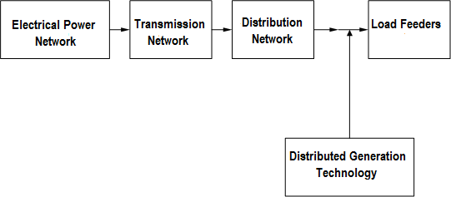

Figure: 2.1 Components of Electric Power Sys. With DG Integration (Ackermann *et al.,* 2001)

## Electrical Power Generation

Power generation in modern power system consists of central grid generation systems and the distributed generation systems which can be as follows;

* + - 1. *Central Grid Generation (Smart Grid)*

This is the modern method of power generation which transformed electricity transmission as well as distribution network by allowing robust two-ways communication, advanced sensors and distributed computers in order to improve the efficiency, reliability and safety of power delivery and use (Bari *et al*., 2014)

Central grid generation brings all elements of the electricity system production, delivery, and consumption closer together to improve overall system operation for the benefit of consumers and the environment. Smart grid can also augment the present electric grid

system by including renewable energy resources like solar, wind biomass, synchronous distributed generators that are environmentally cleaned as compared to non-renewable energy resources like fossil fuels technologies that include sterling engine, reciprocating engine, for power generation.

* + - * 1. Benefits of Smart Grid Application

1. It enable informed participation in buying and selling of electricity by consumers
2. It optimizes asset utilization and efficient power system operation
3. It accommodates all generation and storage option
4. It operates resiliently against all hazards
   * + - 1. Limitation of Smart Grid Application
5. Energy generators protection is challenging in smart grid
6. (QHUJ\ FRQVXPHUV¶ SULYDF\ SURWHFWLRQ LQ V
7. Power houses can be attractive to terrorists targets
8. Smart grid devices protection in the buildings (Bari *et al*., 2014)
   * 1. **Distributed Generation (DG):**According to International Energy Association (IEA), is a generating plant serving customers on-site or providing support to distribution network connected to the grid at distribution voltage level (Kansal *et al*., 2011)

Generally, distributed generation refers to small-scale electric power generators (typically 1kW- 50MW) that produce electricity at a site close to customer or that are tied to an electric distribution system.

Distributed generation include but not limited to synchronous generators, induction generators, reciprocating engines, micro turbines, combustion gas turbines, fuel cells, solar photovoltaic, wind turbines etc. (Lai & Chan, 2008)

* + - 1. *Application of Distributed Generation*

'LVWULEXWHG JHQHUDWLRQ FDQ EH XVHG WR JHQHUD

for standby or emergency generation, for green power source, or for increased reliability. In some remote locations, distributed generation can be less costly, as it eliminates the need for expensive construction of generation system (Kansal *et al*., 2011)

The benefits of distributed generation can be considered in three fold: economic, technical and environmental as expressed in Figure 2.2

a. Economic Benefits of distributed generations (DGs)

1. DGs provide power generation, transmission, distribution investment deferment
2. DGs have low operation and maintenance costs to peak shaving
3. DGs reduce power losses in the distribution network
4. DGs increase generation diversity on the grid
5. Technical Benefits of distributed generations
6. DGs provide voltage profile improvement
7. DGs relieve transmission and distribution congestion
8. DGs increase security for critical loads
9. DGs lessen physical and cyber-attacks impact
10. Environmental Benefits of distributed generation
11. DGs help in removal of refuse through the use of biomass
12. '*V KHOS LQ UHGXFWLRQ RI SROOXWDQW¶V HPLV
13. DGs help to reduce land use for power generation
14. 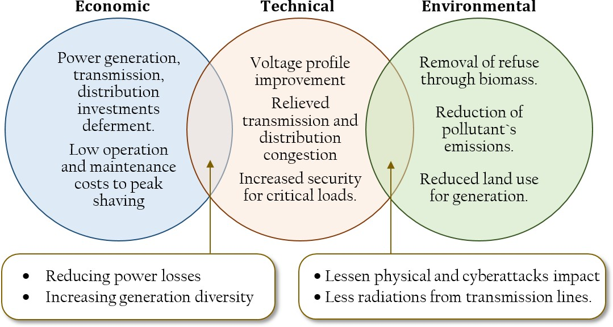DGs help to lessen radiation from transmission lines (Kansal *et al*., 2011) s

Figure: 2.2 Economic, Technical and Environmental DGs Benefits (Kunya *et al*., 2016)

Distributed generations can be classified based on the reactive power and active power injection or absorption into electrical distribution network as given in Table 2.1:

1. **Type 1 DG:** This type of DG is having the ability in delivering the real power only in the distribution network and the DG operates at unity power factor. These types of DGs are photovoltaic cells, fuel cells and many others
2. **Type 2 DG:** This type of DG is having the ability in delivering both active and reactive power in the distribution network. This type of DG includes synchronous generators
3. **Type 3 DG:** This is the type of DG capable of injecting active power (P), but consumes reactive power (Q) from the grid. This type of DG includes induction generators used as in wind turbine.

**iii. Type 4 DG:** This is the type of DG capable of injecting reactive power (Q) only into distribution network. This type of DG includes synchronous compensator such as in gas turbine (Mehta *et al*., 2015)

The Table 2.1 shows the summary of DG classification in tabular form Table 2.1: Classification of DGs

## Type of

**Model of**

## Real power of

**Reactive power of DG**

## Example

**DG**

## Type I

**Type II**

**DG**

Constant Real Power

Constant

**DG**

*PDGi*

# P

*PDG*

 *S*

cos

*QDG*

0

*QDGi*  *SDGi* sin

Solar photovoltaic cells

Sync.

Power Factor

*DGi DGi*

generators

## Type III

**Type IV**

Variable Reactive Power

Constant Reactive Power

*PDGi*

0

*QDGi*    (0.5 0 .04(*PDGi*

*QDGi*

)2 )

Induction generators

Synchronous compensators

* + - 1. *Synchronous Distributed Generator (DG)*

This is the DG that generates a three-phase AC voltage output from its stator windings. Synchronous generators consist of a magnetic field on the rotor that rotates and a stationary stator containing multiple windings that supply the generated power to the loads

7KH URWRU¶V PDJQHWLF ILHOG V\VWHP LV FUHDWHG

onto the rotor or energized electro-magnetically by an external DC current flowing in the rotor field windings. Synchronous Generators are capable of generating both active and reactive power. Therefore, the use of DGs utilizing overexcited synchronous generators will allow on-site production of reactive power. The local generation of reactive power reduces its import from the feeder, thus reduces the associated losses and improves the voltage profile. As a result, the voltage security is also improved (Hedayati *et al*., 2008)

* + - 1. *Main Components of a Synchronous Generator (DG)*

1. **The Stator:** The stator carries the three separate phases, electrically displaced from each other by 120 degrees producing an AC voltage output
2. **The Rotor:** The rotor carries the magnetic field either permanent magnets or wound field coils connected to an external DC power source via slip rings and carbon brushes
   * + 1. *Excitation of Synchronous DGs*

The excitation of synchronous DGs have a power impact on synchronous DGs dynamic performance and availability, as it ensures quality of synchronous DGs voltage and reactive power which means quality of delivered power to energy consumers (Prakash & Khatod, 2016)

* + - 1. *Synchronous Distributed Generator Model (DG)*

This DG model is modelled as PQ+ type, the DG is usually small in size and normally 2MW with 085*p.f.* Synchronous distributed generator based model has the capability to maintain its terminal voltage constant by varying the reactive power it generates. Given that *Psg* is real power of the DG and the minimum power factor at which the DG is to operates is *Cos*min , then the reactive power Qsg with an upper bound Qmax can be determined as maximum and lower reactive power bound; Qmin as follows (Sheng *et al* 2015)

*QMax*  *PSG* tan*Max*

*(2.1)*

*QMin*    *PSG* tan*Min*

*(2.2)*

Where: ; The real power of DG, *Q* ; The reactive power of DG

*P SGSG*

*Q* ; The upper limit of reactive power, *Q* ; The lower limit of reactive power

*Max Min*

*Cos**Max* ; The maximum power factor, *Cos**Min* ; The minimum power factor

In view of the above, it shows that the synchronous distributed generator operates between the upper and lower limit of the reactive power that is

   

*Q Q*

*Q*

*Min SG Max*

(2.3)

Synchronous distributed generators are classified as type 2 DGs for having the capability of delivering both real and reactive power as stated earlier. The power factor of DGs are fixed at a specified value +LY]L*e*H*t a*I*l*.,H20Q16G) Lü

Considering, the reactive power output of DGs,  (sign) tan(cos 1(*PF* ))

*DG*

is expressed as

*Qi*  *PDGi*

*In this type, Q*  *Q*  *Q*

*i DGi Di*

*(2.4)*

*(2.5)*

Where;

= net reactive power of node i

*i*

*Q*

Sign= +1; DG supplying reactive power Sign =-1; DG absorbing reactive power

*PF DG* = power factor of DG (Sheng *et al* 2015)

## Electrical Power Distribution Networks

Distribution network system is the final point in the delivery of electrical power system. The distribution network carries electricity from the transmission system to different consumers. There are two different distribution stages: Primary distribution and secondary distribution stage, the primary distribution lines carry the medium voltage to distribution transformers which are

ORFDWHG QHDU WKH FRQVXPHU¶V DUHDV 7KH 6HFRQ

voltage further to the consumption voltage of household electrical appliances such as electric pressing iron, electric blending machines and many others. Distribution network systems are divided into two types namely ring and radial networks;

* + - 1. *Ring Main Distribution Network*

7KH 5LQJ PDLQ GLVWULEXWLRQan sfoQrmHerWs fZormRUa lNoo¶p. VTh e lSooUp LPDULH

circuit starts from the sub-station bus bars, makes a loop through the area to be served and returns to the sub-station (Sunisith & Meena, 2014)

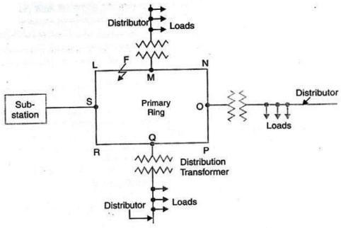The distributors are tapped from different points of the feeder through distribution transformers. The schematic diagram of the ring main distribution network is as shown in Figure 2.3

Figure: 2.3 Ring Main Distribution Network (Sunisith & Meena, 2014)

* + - 1. *Merit of Ring Distribution Network*

1. The feeder can be fed at one or more feeding points
2. The fault cannot interrupt the supply of electricity to consumers
   * + 1. *Demerit of Ring Main Distribution Network*
3. The ring main is more expensive than the radial distribution network
4. The ring main is not good when the generation is at low voltage
5. The ring main has a high construction costs (Mehta *et al*., 2015)
   * + 1. *Radial Distribution Network*

The radial distribution network has separate feeders that radiate from a single sub-station and feed the radial distributors. The power is delivered from the main branch to the sub-branches and then radiate out from the main branches again. In summary the radial distribution network leaves the station and passes through the network area with no connection to any other supply. The schematic diagram of the radial distribution network is shown in Figure 2.4, while the schematic diagram showing the power flow equations is as shown in Figure 2.5

* + - 1. *Merit of Radial Distribution Network*

1. The radial distribution network is simple in term of construction
2. The radial distribution network has low initial cost
3. The radial distribution network is useful when the generation is at low voltage
4. The radial distribution network is important when the station is located at the center of the load.

The Figure 2.4 below shows the radial distribution network with the DG connection

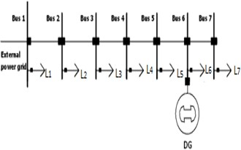

Figure: 2.4 Radial Distribution Network with the DG Connection (Nadhir *et al*., 2013)

* + - 1. *Demerit of Radial Distribution Network*

1. The end of the radial distributor nearest to the feeding point will be heavily loaded
2. The consumers are dependent on a single feeder and single distributor. If there is fault no voltage supply to the consumers of that feeder until the fault is rectified.
3. The consumers at the distant end of the distributor would be subjected to serious voltage fluctuations when the load on the distributor changes, but with the present distributed generation penetration in the distribution network near the consumer premises, the problem of voltage fluctuations has been adequately addressed (Rupa & Ganesh, 2014)

In view of the above mentioned factors, the radial distribution network is usually used in the distribution network system than the ring main distribution network system.

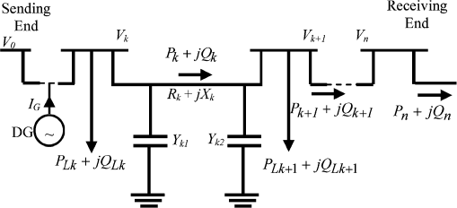

Figure: 2.5 Radial Distribution Network Power Flow Equations with DG (Nadhir *et al.*, 2013)

* + - 1. *Placement and Sizing of Distributed Generation in the Radial Network*

The power flows in the radial network can be calculated by the following number of simplified recursive equations derived from Figure: 2.5 (Nadhir *et al.*, 2013)

2

*i*

       

*R* *i* ( 2 (*Q*  

*V* ) )

*(2.5)*

*Pi* 1

*Pi PLoss*,*i PLi*  1 *Pi*

*V* 2 *Pi*

*i*

*i Y i*

*PLi* 1

*Q*  *Q*

 *Q Q* 

*Q*  *R* *i* (*P*2

(*Q*  *Y V* ) ) *Y V Y V Q*

*(2.6)*

*i* 1

*i Loss*,*i Li*  1

*i V* 2

*i*

*i i i*1 *i*

 

*i*1 *i i* 2

2

2

2

 

*i* 1

*Li* 1 

2 2 *R*2  *X* 2 '2

*i i*

2

2 *R*2  *X* 2 2

*i i*

2

2 *(2.7)*

*V*  *V*

    2

(*Pi*

*Q* ) 2(*R* *i Pi*

*X iQ*  )

*V*    2

(*Pi* (*Q*

*Y* *i V* )  ) 2(*Ri Pi*  *X i*(*Q*

*Y* *i V* ))

*i* 1 *i V*

*i*

*i i i V i i i i i*

The loss in the line section connecting buses, i and i+1can be calculated as (Nadhir*et al.*, 2013)

 *P*2  *Q*2  

*PLoss*(i,i 1)

 *Ri*

  *i i*

*V* 2

*(2.8)*

*i*

The total power loss of the network, PT, Loss can be determined by summing up the losses of all line sections of the network is given by (Nadhir *et al.*, 2013)

*n*

*P*T,Loss  *PLOSS* (i,i 1) *(2.9)*

*i* 1

The DG location can be determined by considering the difference of the power loss before and after the installation of DG in the network as given below

*PowerLoss* Re *ductionValue*  *P*

*Loss* (i,i  1)

'

*Loss* (i,i  1)

 *P*

*(2.10)*

Where;

PLR: The power loss reduction value

PLOSS: The power loss before DG installation in the network

¶

P

LOSS:

The power loss after DG installation in the network

Therefore, the network bus that gives the highest value of PLR will be considered as the optimal DG location in the network.

The DG size can be computed by considering equation (2.11) which means calculating the product of maximum loss saving DG current and voltage magnitude of the network bus as

indicated by (Nadhir *et al*., 2013)

*PDG*  *I DGV i*

Where; PDG: The active power of the DG

IDG: The maximum loss saving current of DG

Vi: The voltage magnitude of bus i where the DG is to be installed.

## Distribution Network Reconfiguration of Radial Network

*(2.11)*

Distribution networks are usually operated as radial network but the topology of the network is changed during operation by altering the state of some sectionalizing switches hence called network reconfiguration. For instance in Figure: 2.6, the switches CB7 (circuit breaker7) and CB8 can be closed and CB3 and CB6 can be opened to transfer load from one feeder to another (Li *et al*., 2016).

There are two type of switches in distribution networks: normally closed switches connecting the line sections (CB1 to CB6), and normally open switches on the tie lines

connecting either two distribution feeders (CB7) or two sub-stations (CB8), or loop-type laterals (Baran & Wu, 1989) as shown in Figure 2.6

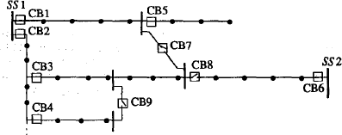

Figure:2.6 Network Reconfiguration Schematic Diagram (Baran & Wu, 1989)

* + - 1. *Determination of Radial Configuration in the distribution network*

The distribution network can be regarded as a function of G (N, B) where G represents a graph that contains a set of N nodes and a set of B branches. The node represents either a source node or a sink node while a branch represents a feeder section that can either be energized or de- energized. The distribution network reconfiguration is to find a radial structure that minimizes the network power loss and relieve the load among feeders while satisfying distribution network operating constraints.

The possible number of radial structure for a distribution network could be obtained for a given configuration. The number of branches needed to maintain a radial network with redundant

connections is fixed and could be obtained using &RUR*et* D*al*.P, ă20 13)

*D*  *B*  *N S* *(2.12)*

Where; B is the number of branches N is the number of nodes

S is the number of supplies

D is the number of redundant connections (Abubakar, 2014)

* + - 1. *Reconfiguration of Standard IEEE-33 Distribution Network with DG Deployment*

The standard IEEE-33 distribution network has a total active and reactive load demand of 3.72MW and 2.30 Mvar respectively. The system also has 37 branches, 32 sectionalizing switches and 5 tie switches respectively.

The Figure: 2.7 shows the reconfiguration of the standard IEEE-33 distribution network,

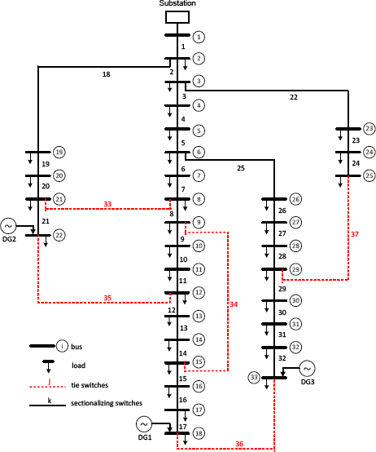

Figure:2.7 Shows the Reconfiguration of Std IEEE-33 System and DGs (Syahputra *et al*., 2015)

* + - 1. *Reconfiguration of Zaria (Sabo) Distribution Network with DGs Deployment*

The Zaria distribution network has total active and reactive load demand of 1.84MW, 0.82 Mvar and 11kV base voltage respectively. The system also has 31 branches, 29 nodes, 3 tie switches and 28 sectionalizing switches in Figure 2.8. The network data is shown in Appendix B. The three loops were formed by closing the three tie switches and also the number of branches form the possible switches to be opened in the system

The Figure: 2.8 shows the network reconfiguration of Zaria distribution network

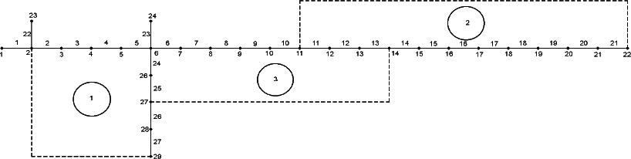

Figure:2.8 Reconfiguration of Zaria Distribution Network Schematic Diagram(Abubakar, 2014)

## The Standard IEEE Radial Distribution Network

Different standard IEEE distribution tests networks have been considered and also used by different researchers to verify the effectiveness of their research works. Most of the literatures so far reviewed have employed one or more standard IEEE distribution networks for analysis and validation of research works. The line and bus data for 33-bus standard IEEE radial distribution networks was used in this research work

* + - 1. *Standard IEEE 33-Bus Distribution Network*

This is a medium voltage radial distribution network with 33-buses and 32-branches, line data and bus data as shown in Appendix A. The line and bus data for 33-bus standard IEEE radial distribution networks was used in this research work. The line voltage, base MVA, real and reactive power demands of the radial distribution network are 12.66kV, 10MVA, 3.72MW and 2.30MVAr, respectively (Yuvaraj *et al*., 2015)

Figure 2.9 shows the single line diagram of the distribution network.

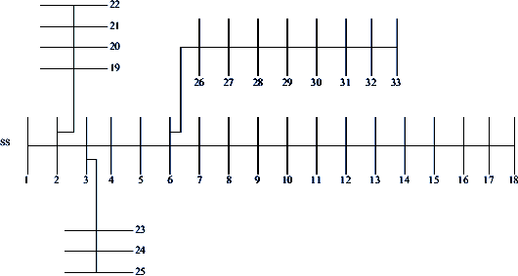

Figure: 2.9 Single Line Diagram of IEEE 33-Bus System (Yuvaraj *et al*., 2015)

* + - 1. *Zaria Distribution Network*

The Zaria distribution network is a real distribution network interconnected with 8 (eight) distribution feeders that include; Gaskiya feeder, Canteen feeder, Zaria-city feeder, RLY/NTC feeder, Sabon- Gari feeder, G.R.A. feeder, Kofar-Kibo as well as Zaria Teaching hospital feeder. All the above mentioned feeders have 11kV as their base voltage.

This research work opted for Sabon-Gari feeder to be considered as a case study for the implementation of the presented research work.

The line and bus data are shown in appendix B. The line voltage, base MVA, real as well as reactive power demands of Sabon-Gari radial distribution network are 11kV, 10MVA, 1.84MW and 0.82MVar respectively.

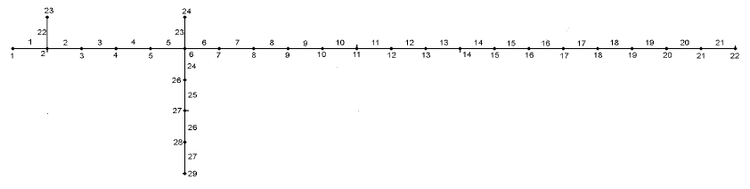The Figure 2.10 shows the single line diagram of the Sabo feeder of Zaria distribution network

Figure: 2.10 Sabon-Gari Distribution Network (Abubakar, 2014)

* + - 1. *Load Flow Analysis in Distribution Network*

Conventional load flow methods such as Newton-Raphson, Gauss-Seidal or fast Decoupled which are typically designed for electrical transmission networks are not suitable for power distribution networks load flow analysis. Distribution networks are typically radial in nature and the feeders have high R/X ratio, hence ill-conditioned for such load flow

The backward forward sweep (FBS) technique assumed the network to be balanced so that the distribution network could be represented in a single line diagram. The analysis follows from one branch to another in a logical approach until all the branches in the network have been considered (Nadhir *et al*., 2013)

First, the voltage at all the buses is assumed to be one pu at angle zero except the slack bus. Therefore, based on the above information, the voltage, the specified active power, the reactive

power and the branch currents are computed and saved simultaneously, from the end buses to the source buses (Backward Sweep) (Sunisith & Meena, 2014)

Then, the branch currents are calculated in order to find the active and reactive power losses in the distribution network. The current at the source end is now computed iteratively. The calculation starts from source to the end of the distribution network feeders to find the voltage drop, current, real and reactive power losses respectively (Forward Sweep) (Kumar *et al*., 2011)

The flow chart of backward-forward sweep algorithm for determining the base case of the stated objective functions in the distribution network is shown in Figure: 2.11



Calculate branch power loss, total power loss, voltage

deviation and line loading.

Calculate maximum real and reactive power

flows of all branches

Calculate node voltages forward sweep

Is load flow converged?

No

Calculate branch currents.

Backward sweep

Yes

Start

Read the line data and load data

Set flat voltage (1 p.u) for all nodes

Number branches

Stop

Print the result

Figure: 2.11 Backward-forward Algorithm of the DN (Rupa & Ganesh, 2014)

The equations for forward/backward sweep technique used for the work were given in Figure:

2.13 and Figure: 2.19

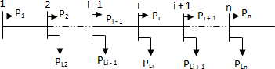

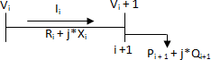Figure: 2.12 Single Line Diagram of Radial Distribution Network (Nadhir *et al*., 2013) Consider Figure 2.13 with bus i. as sending bus and bus i+1 as receiving bus

Figure: 2.13 Electrical Equivalent of Single Radial Network (Nadhir *et al*., 2013)

*P*  *P*

 *P R* 

 *P*2

*i* 1

 *Q*2

*i*  1

*(2.13)*

*i i* 1 *Li*

*i*  1

*V i* 1

2

The equations (2.13) and (2.14) were used to determine base case results

*P*  *P*  *P R* 

*i i*

*V*

 *P*2  *Q*2  

*(2.14)*

*i i* 1 *Li*

*i*  1 2

*i*

The equation (2.15) is used for the computation of branches currents

*I*

|  |  |  |  |
| --- | --- | --- | --- |
| *Vi* | *i*   | *Vi* 1 | *i*  1 |

*(2.15)*

*i*  

*Ri*  *jXi*

The equation (2.16) is used to determine the capacities of the DGs used

*Pi* 1

 *jQ*

*i* 1

 

*i* 1

 *V*

*I**i (2.16)*

The equation (2.17) is used for the determination of voltage deviation

2 2 1

1 2 2

 *P*2  *Q*2  

*i i*

*(2.17)*

*V*  *V*

*i* 1 *i*

 2 *Ri* 1,*i* * *Pi*

*X*  *i*  1,*i* \**Qi*    *R* *i* 1 ,*i*

*X* *i* 1,*i*  * 2

*i*

*V*

The power loss of any line connecting the buses i and i+1 can be calculated as;

*PLoss*(i,i 1)

 *Ri*,*i*  1

2 2

*i i*

 *Q*

 *P*

*V* 2

*(2.18)*

*i*

The total power loss in all the buses

*PT* ,*Loss*

can be determined by summing up the losses of all line

sections of the power feeders (Nadhir *et al*., 2013) which is given by;

*n* 1



*PT* ,*Loss*   *PLoss*(i,i  1)

*i* 1

*(2.19)*

Where; n is the number of buses in the distribution network i.is the number of branches in the distribution network

PTLOSS is the total active power loss in the distribution network The objective function of minimizing power loss is given by

*line*



*Fobj*  *Min PLoss*

*i* 1

*(2.20)*

The reactive power loss QT LOSS is given by

*n* 1

*Q*

*Q*

 

*T* ,*Loss Loss*(i,i 1)

*i* 1

(2.21)

Where; n is the number of buses in the distribution network i.is the number of branches in the distribution network

QTLOSS is the total reactive power loss in the distribution network

* + - 1. *Optimal Network Reconfiguration, Placement and Sizing of Distributed Generation*

Distribution network reconfiguration and DGs deployment are the good option to improve distribution network performance, but due to complex combinatorial, non-differential nature of the problem, the conventional or classical optimization techniques such as Linear Programming, Gradient Search are not suitable for this optimization problems (Rao *et al*., 2013)

Many methods from different researchers have been introduced for optimal network reconfiguration and DGs deployment in a radial distribution system. Previous methods presented include the analytical approach as proposed by (Merlin and Back, 1975), (Baran & Wu, 1989), (Li *et al*., 2016) and (Hung *et al., 2013)*, the numerical method as presented by (Atwa *et al*., 2010) and (Hung *et al*., 2014). Other methods used were the heuristic approach as proposed in the Work of (Kunya *et al*.), (Abubakar, 2014). The choice is mostly based on the general problem statement, objectives and constraints considered. Generally, some methods used for optimal network reconfiguration and DGs deployment are as follows;

1. Numerical method: This method involves the use of numerical analysis in searching for an optimal solution. Its main advantage lies in the ability to guarantee finding global optimum; however, it is mostly not suitable for large scale systems. The different types of numerical methods that have been used for optimal network reconfiguration and DGs deployment include Gradient search, linear programming, Non-linear programming, Sequential quadratic programming, Exhaustive search and many others (Syahputra *et al*., 2014)
2. Analytical method: This method originated from the 2/3 rule and is mostly executed based on the exact power loss formula for active power loss in the system. Analytical methods are easy to implement and execute, but their results are only indicative, since they make simplified

assumptions including the consideration of only one power system loading snapshot (Hung *et al*., 2013)

1. Heuristic and Meta-heuristic method: This method involves creating a minimization or maximization objective function in finding the optimal DG placement and size. It could either be an experienced-based technique i.e. heuristic or higher±level i.e. meta-heuristic method that does not require training in searching for the iterative optimal solution. Generally, meta-heuristic methods require high computational effort that is why they can be trapped into local minima. Some types of heuristic and meta-heuristic solution methods used in optimal network reconfiguration and DGs deployment include Genetic Algorithm (GA), Taboo search, particle swarm optimization (PSO), Ant colony Optimization (ACO), Artificial Fish Swarm Algorithm (AFSA), Harmony Search, Fuzz- logic, Firefly Algorithm (FA), Cuckoo search algorithm (CSA) and many others(Nguyen *et al*., 2016)

Hence, application of meta-heuristic techniques known as Bat algorithm (BA) is considered as impetus for distribution network performance improvement through multi-objective optimal network reconfiguration and DG technology placement to achieve the defined objectives of the research work.

## Bat Algorithm

Bat Algorithm (BA) is a nature inspired Meta heuristic algorithm developed by Xing-She Yang in 2010. Bat algorithm is based on echolocation that is important feature of the bat behavior. Bats are fascinating group of mammals that rely on echolocation to detect obstacles in flight, finding their way into roosts and forage for food/prey (Buaklee & Hongesombut, 2014)

The principle of operation of this algorithm is as follows; Bats emit a very loud sound pulse and listen for the echo that bounces back from surrounding objects, thus the loud pulse can determine the distance between bats and also can distinguish obstacles and prey(Heraguemi*et al*., 2016)

Based on that behavior of bats; the ability to compute the distance between them and object echolocation can be used in such a way that it can be associated with the objective function to be optimized (Prakash & Sujatha, 2016)

To model bat algorithm Yang has set some rules as follows;

All bats use echolocation to sense distance and they also guess the difference between food/prey and background barriers in some magical way

Bats fly randomly with velocity *vi*

at position

*xi* with a fixed frequency

min

*f*

and varying

ZDYHOHQJWK Ȝ*A0* toDseQarcGh forOpRreyX(YGaQngH&VHVe, 2 013)

They can automatically adjust the wavelength or frequency of their emitted pulses and adjust the rate of pulse emission r א[0, 1], depending on the proximity of their target.

Although the loudness can vary in many ways, we assume that the loudness varies from a large

positive *AO*

to a minimum constant value *A*min . For each bat *bi* , the position *xi* , the velocity *vi* and

the frequency

*f*

*i*

are initialize. For each step t, the maximum number of iterations, the

movement of the virtual bats is given by updating their velocity and position (Prakash & Sujatha, 2016).

* + - 1. *Po*pu*lation of Bats*

The initial population i.e. the virtual number of bats for BA (n) is generated randomly. The number of bats can be between 20 and 40. After finding the initial fitness of the population for the given objective function, the values are updated based on movement, loudness and pulse rate (Yang, 2011)

* + - 1. *Movement of Bats*

The movement of bats can be demonstrated by the preceding equations as indicated below. All the Bats parameters are updated based on the following equations (Injeti *et al*., 2015)

 

*f f*

*i* min

 (

max

*f*

  ) *(2.22)*

min

*f*

*vt*  *vt*  1

 (*xt*

*x* ) *f*

*(2.23)*

*i i i*   *i*

:KHUH ȕ LV D UDQGRP *f*

QisXusPedEtoHcUon troEl tHhe WpaZceHanHd Qra nge>o f t he @

*i*

EDW¶V PR*x*\*YisHa PcuHrreQntWbe st location. Then the new solution or position for the bat can be generated by the equation given below

*vt*  *xt*  1

*i i i*

 *vt (2.24)*

One solution is selected among the current best solutions and then the random walk is used to obtain a new solution.

*i*

*xnew*  *xold*

 *At*

*(2.25)*

 LV WKH DYHUDJH ORXGQHVV RI DOO EDWV D UDQG

depending on the pulse rate *r i* , it should be noted that when bat finds prey the rate of pulse

emission *r i*

increases and the loudness

*Ai* decreases (Behera *et al*., 2015)

* + - 1. *Loudness and* Pu*lse Emission*

For each iteration the loudness

*At* 1  *At (2.26)*

*i i*

*Ai* and the emission pulse rate *r i*

are updated as follows

*rt*  *ro* 1

*i*

 exp(

☺ t)

*(2.27)*

Where ןDQG Ȗ DUH FRQVWDthQe WalgVor ith m$thWe v aluWesKoHf th esIe tLwoUpVaraWm eteVrsWHS RI

are chosen randomly, generally loudness and pulse rate are chosen within the ranges as indicated in equation (2.28)

*Ai* 01, 2*andri* 00,1 *(2.28)*

Based on the above approximations and idealization, the pseudo- code of the Bat algorithm can be summarized as follows:

Step 1: Initialize the bat population or their position *r i*

and their velocity *vi* , define pulse

frequency

*f*

*i*

at *xi* . Initialize pulse rate r and loudness A

Step 2: Generate new solutions by adjusting frequency and updating velocities and location

/solutions.

Step: 3 If (rand > r) select a solution among the best solutions. Generate a local solution; the selected best solution

Step: 4 Else generate a new solution by flying randomly

Step 5: If (rand > *Ai*

) and *f* (*x* ) *At*

accept the new solutions, increase r and reduce A.

*i*

*i*

Step 6: Rank the bats and find the current best *x*\*

Step 7: while (iteration < max number of iterations), post process results and visualization. The algorithm stops with the total best solution. (Yang, 2011)

The flow chart of basic bat algorithm showing the steps involved for DNR and DG deployment

NO



Start

Update tuning parameters of BATA with the given eqns

Constraints exists

Update tuning parameters using the given equations

K=max. iterations

Stop

Find the DN performance with optimum DRN and

DGs incorporated

If PL=PL(k-1), find the objective functions

Perform load flow for updated values for DN performance

Perform load flow to determine power loss

Generate population randomly

Find search space each DGs

Initialize BA parameters update veloc. & position

NO

Figure: 2.14 Bat Algorithm Flow Chart (Buaklee*et al.,* 2014)

## Review of Similar Work

In this section, a review of some literatures relevant to this developed method was consulted accordingly.

**Kumar *et al*., (2011)** proposed a new optimization technique that employed a heuristic based Fuzzy algorithm for optimal network reconfiguration on IEEE-33, 69 and 70adistribution network with the objectives of real power loss minimization, bus voltage deviation minimization and branch current violation for load balancing among feeders, subject to a radial network structure in which all loads were kept energized. The heuristic algorithm was also applied to minimize the number of tie- switch operations in the proposed distribution network.

However, the proposed technique was easy to implement in smaller networks but would take longer time to converge for complex distribution networks. So also the criteria for choosing the operational switches for optimal switching were not clearly elaborated in the work. More, so the improved Fast Decoupled load flow algorithm was not suitable for distribution networks, as the technique was suitable for transmission system where R/X ratio was very minimal.

**Dahalan & Mokhlis, (2012)**presented a particle swarm optimization (PSO) algorithm for network reconfiguration with distributed generation in order to reduce the real power loss and improve bus voltage profile in the system. The technique considered IEEE33-Bus System for simultaneous reconfiguration with DG placement in the system to achieve the stated objectives. However, in the proposed technique there was no specification of the types of DG considered. More so, the proposed technique considered has low exploration capacity.

**Rao *et al*., (2013)** extended a new optimization technique that employed Harmony Search Algorithm (HSA) for network reconfiguration with distributed generation placement in order to

minimize real power loss and improve voltage profile in the distribution network. The technique had been tested on IEEE-33 and IEEE-69 buses at different load levels to demonstrate the performance and effectiveness of the technique. However, in the proposed technique the use of sensitivity analysis to obtain the optimal location of DGs was complex and time consuming.

**Shamsudin*et al*., (2014)** proposed a new optimization technique that employed a heuristic algorithm known as Selection Improvement in Genetic Algorithm (SIGA) in consideration of genetic operator probabilities that include cross-over and mutation parameters that would be adjusted in order to determine the objective functions of power loss reduction and voltage profile improvement using optimal network reconfiguration in the distribution network.

The proposed research work applied on IEEE-33 bus system, considered eight cases of the optimization processes, where four cases for cross-over occurrence probabilities and four cases for mutation occurrence probabilities to determine the stated objective functions. The highest percentage of total power loss reduction was 23.65% produced by case 6 with possible tie switches of 14, 28, 11, 7 and 16 using SIGA. The result was the best when compared with other cases and GA as well. However, the proposed method was simple and faster but cannot be suitable for population based solution technique where large iterations were required.

**Syahputra*et al*., (2014)** presented a new optimization technique that employed an extended fuzzy-objective approach for optimal network reconfiguration with integration of distributed energy resources (DERs) for achieving minimum active power loss, improve voltage profile and enhancing load balancing among feeders of a radial distribution network on standard IEEE 77- Bus distribution network and 60-Bus real distribution network of Yogyakarta province of Indonesia. The proposed work considered solar photovoltaic and wind farms DERs. However, the considered DERs output power was usually affected by weather condition; likewise, the DERs occupy large space, especially wind farms generators. More so the determination of weighting factors combination in the extended fuzzy logic was not clearly stated in the proposed work.

**Ali *et al*., (2015)** extended a new optimization technique that employed a Meta-heuristic algorithm known as Harmony Search Algorithm for optimal network reconfiguration and DG installation with the objectives of real power loss minimization and voltage profile improvement in the distribution network systems. The proposed work was tested on standard IEEE-33 bus and standard IEEE-69 bus systems respectively. In the analysis of the work three different loads levels were considered i.e heavy load level, nominal load level and light load level respectively. The result obtained indicated that better result was at the nominal load level.

However, the proposed work did not give the details of the DGs types used in the work, likewise the proposed algorithm had a tendency of being trapped in local minima during the optimization process as the algorithm usually converged quickly.

**Abdur-Rahman *et al*., (2015)** proposed hybridization of analytical-firefly algorithm for optimal DG placement and sizing of non-conventional distributed generations in order to minimizes total power loss and improve voltage profile in distribution network. The proposed work was tested on IEEE-30 bus of radial distribution network and the results obtained showed a better location and sizing. However, the proposed work takes longer time for convergence due to low exploration capacity of the proposed method.

**Syahputra*et al*., (2015)** suggested a new optimization technique that employed an Extended Particle Swarm Optimization (EPSO) technique for optimal network reconfiguration and distributed generation integration simultaneously, in order to reduce power loss and improve voltage profile in the distribution network. The proposed research work was tested on IEEE-33 and 71 bus system respectively. However, the proposed work did not consider load balance as an objective function rather a constraint. More so, the proposed technique will have the capability of being trapped in local minima.

**Nguyen *et al*., (2016)** presented a new optimization technique that employed Cuckoo Search Algorithm for network reconfiguration and distributed generation on the IEEE-33, 69 and 119 bus system in the distribution network in order to reduce real power loss and enhance voltage stability in the system. The graph theory was used to determine search space which reduced configuration and reconfiguration processes. However, the proposed graph theory will not yield better result as the approach was computationally complex and time demanding

**Kunya *et al*., (2016)** extended an optimization technique that employed Binary Particle Swarm Optimization (BPSO) for optimal network reconfiguration using IEEE-16, 33 and 69 test beds, in order to minimize the total active power loss and voltage deviation in the distribution network.

However, the proposed technique might not guarantee optimal location for closed or normally opened switches as the searching space will be dissimilar for different dimensions. More so, the technique may not be suitable for complex distribution networks.

**Hivziefendic*et al*., (2016)** proposed an optimization technique that employed NSGAII for optimal network reconfiguration with distributed generation installation on the IEEE-213 bus system, in order to minimize real power loss and energy not supplied function in the distribution network. However, the technique was complex for operational improvement conditions of the distribution network. More so, the test bed system was complex and only suitable for planning purpose.

**Sudabattula and Kowsalya, (2016)** proposed a new optimization technique that employed the Bat algorithm for optimal placement and sizing of DGs on IEEE-33 bus system, in order to maximize annual energy loss reduction and maintain better node voltage profile under a piece- wise linear variable load pattern using a penalty factor. However, the DG was a weather dependent as the output of the DGs depends on temperature and weather conditions, therefore the optimization will not be efficient and reliable.

**Prakash and Sujatha, (2016)** presented an optimization technique that employed bat algorithm to exploit the DG benefits by choosing optimal location and capacity of DGs in the radial distribution network simultaneously. The technique was applied on the IEEE-69 bus system for multi-objective function of total real power losses minimization and maximum voltage stability index within the range of voltage constraint. However, the technique did not elaborate the criteria for weighting factor selection for optimal DG placement and sizing in the stated objectives of the proposed network.

## Summary of Literature

It is apparent that from the literature review, an analytical technique is not suitable for optimal network reconfiguration and DGs deployment in complex distribution networks as it is being impaired due to large computations and time consumption. It is usually applied to simple electrical network problems. Meta-heuristic methods on the other hand are characterized by high computational speed, high handling capacity of complex solutions as well as exploration ability. However, some meta-heuristic algorithms have the possibility of being trapped in local minima, which is considered as a limitation. From the reviewed literatures, it could be said that the optimal network reconfiguration and DG deployment of different types of DGs had been adequately addressed using the PSO, HS, SIGA and Fuzzy approaches. However, optimal network reconfiguration and distributed generation placement using Bat Algorithm-Based method has not been addressed.

## CHAPTER THREE MATRIALS AND METHODS

**Introduction**

This chapter discussed the detailed materials and methods employed in achieving the aim and objectives of this researched work. This includes application of Bat algorithm based- method for multi-objective optimal network reconfiguration and DG installation in a radial distribution network.

## Materials

The materials employed for the realization of this research work are as follows;

## Personal Computer

All simulation analyses were carried out using Compact/HP Presario CQ61 with the following specifications:

* + - 1. AMD Athlon (tm) 2Duo CPU M320;
      2. 2.10 GHz 64-based processor;
      3. 320GB installed memory (RAM) and;
      4. 64-bit Operating system (OS)
      5. 4.1 Windows Experience Index

## MATLAB 2013b Software

Simulations were performed under virtual platform using MATLAB 2013b for analysis of the research work. The details of the programs developed are provided in the appendices.

## Distribution Network Parameters

The standard IEEE-33 and a dedicated 29-bus Sabo-Feeder in Zaria distribution network with the following network parameters: slack bus, active and reactive powers and bus voltages have been adopted for this research work

## Methodology

The following approach was adopted in order to achieve the stated aim and objectives.

## Acquisition of IEEE-33 Bus Data and Zaria distribution Network Data

This is a medium voltage radial distribution network with 33-buses and 32-branches, line data and bus data as shown in Appendix A. The Zaria distribution network is the simulated distribution network interconnected with 8 (eight) distribution feeders that include; Gaskiya feeder, Canteen feeder, Zaria-city feeder, RLY/NTC feeder, Sabon- Gari feeder, G.R.A. feeder, Kofar-Kibo as well as Zaria Teaching hospital feeder. The line and bus data are shown in appendix B. The data acquired for IEEE 33 and Zaria distribution network was shown in Table 3.1.The data was obtained from Kaduna Distribution Company at injection sub-station, Zaria main office. The Figure 2.10 in chapter 2 section (2.2.6.2) shows the single line diagram of the given network. Table 3.1 shows the network parameters of IEEE-33 Bus and Zaria Distribution network.

Table 3.1: Data Acquired for IEEE 33 and Zaria distribution network

|  |  |  |  |
| --- | --- | --- | --- |
| S/N | Parameter | IEEE 33 | Zaria Distribution network |
| 1 | line voltage | 12.66kV | 11kV |
| 2 | base MVA | 100MVA | 10MVA |
| 3 | Real power | 3.72MW | 1.84MW |
| 4 | reactive power | 2.3MVAr | 0.82MVar |

## Determination of Base Case Network Parameters Using Backward-Forward Algorithm

* + - 1. *Formulation of Objective Functions*

The main objectives of DNR and DG deployment in distribution system are minimization of real power loss, voltage deviation and load balancing among feeders while satisfying network operating constraints that include voltage profile, current capacity and radial structure of the distribution network. Network reconfiguration means changing the topological structure of a network by altering the OFF/ON states of tie and sectionalizing switches of the distribution network.

The process can be achieved by considering the possible number of radial structure for a given configuration of the distribution network with the following expression as given in equation (2.12). The possible DG location can be determined by considering the difference of the power loss before and after the installation of DG in the network as given in equation (2.10)

Therefore, the network bus that gives the highest value of PLR will be considered as the optimal DG location in the network.

The possible DG size was computed by considering equation (2.11) which means calculating the product of maximum loss saving DG current and voltage magnitude of the network bus

The objective function was mathematically formulated as multi-objective function that include reduction of power loss, voltage deviation and load balance among feeders as follows;

A. The weighting technique was used in this research work to convert multi-objective function (MOF) into a single objective function. The objective function can be represented mathematically as indicated in equation (3.1)

Min F= w1f1 + w2f2 + w3f3 (3.1)

Where;

f1; represent the total real power loss in distribution network f2; represent voltage deviation index of the network buses

f3; represent load balance enhancement of the distribution network

While w1, w2 and w3 are the weighing factors. For simplicity, the weighting factors are usually considered within the range of 0 as minimum and 1 as maximum value which can be represented mathematically as;

and; 0 < Wi < 1 (3.2)

But the distribution utility usually gives higher weighting factor to an objective function depending upon its overall importance in the research work. In this research work the weighting functions were determined in the given pseud code of BA in page 56. The weighing factors values are w1; 0.4, w2; 0.36 and w3; 0.24 respectively, and the values were determined after possible Pareto fronts combination process situated in BA.

**f1: Power Losses:** The total real power losses at all nodes cause by circulating current in the network with the DG installation in the distribution network was determined as part of the objective function formulated as follows;

 *P*2  *Q*2  

*i*

*i*

*f* 1*a*  *Ri*,*i*  1 2

*V*

*i*

(3.3)

The minimum losses were computed by considering the difference between equation (3.3) and equation (3.4) respectively

▪

' ' ◻*P*

'2   '2

*i i*

*Q*

f1b =

*P Loss* (i,)

 *R i*,*i*  1



*V* ' 2

(3.4)

*i*

Where; P LOSS (i), Ri, Pi2 and Qi2 are the total power losses, resistance of the branch, active and UHDFWLYH SRZHU EHIRUH '15 DQG '* LQ2VDWQDGO 2 O4D¶W**L**RQ

is the total power losses, resistance of the branch, active and reactive power after DNR and DG installation in the distribution network.

**f2: Voltage Deviation:** The voltage deviation can be determined by normalizing the reconfigured network with DG and non-reconfigured network with the following expression as follows;

f2 = Voltage deviation minimization, *V*

*dev*

*recong*  *DG Total*

*initial Total*

*V*

*V*

(3.5)

Where; *V initial* , Represents the initial voltage deviation before reconfiguration of the distribution network

*dev*

*V recong*  *DG* , Represents voltage deviation after DNR and DG placement in the distribution network

*dev*

*V dev* , Represents the total voltage deviation of the distribution network

**f3: Load balance:** The load balance usually measures how much a particular branch can be loaded without exceeding the rated capacity of the branch in the distribution network, and load balance can be determined by minimizing the branch current of the distribution network as follows;

# I

*f*   *i*,*n* (3.6)

3 *I c*,*n*

For i= 1, 2, 3--------------Ni & for n= 1, 2, 3 NB-1

Where: Ni; The total number of branches of the distribution network NB-1; The total number of buses of the distribution network

*I* ; The branch, n electric current magnitude when the i-th branch in the loop is opened

*i*,n

*I C* ,*i* ; The maximum capacity of the line branch of the network

*LBI* ; The load balancing index of the distribution network

## B Constraints

DNR and DG deployment might upset voltage level in the distribution network due to inrush current in the network. Hence, voltage magnitude must be maintained within minimum and maximum limits at each bus as indicated below

min

*V*

*V*



*i i*

max



*V*

*i*

*(3.7)*

Where: Vi represent voltage magnitude at ith node. V minand Vimax are considered as 0.95pu and 1.05pu respectively, as power system equipment is designed to operate within the allowable

i

variation of ±5 to 10% of the rated voltage. The system must not exceed the current carrying capacity of the of its conductors as indicated below

max

*I* *I*

* $ (3. 8)*

*i*,*i*  1

Where,

*i*,*i*  1,max

*I* : The circulating current in the distribution network

*i*,*i*  1

max

*I*

*i*,*i*  1,max

: The maximum circulation current capacity of the network

Radial distribution networks are configured in radial structure that makes R/X higher. This usually results in power loss in the network, as such the constraint is as indicated below

Det (A) = 1 or -1 (radial structure) Det (A) = 0 (not radial)

* + - 1. *Backward-Forward Sweep Technique*

The backward- forward sweep technique was suitable for distribution network load flows analysis. The technique assumed the network to be balanced so that the distribution network could be represented in a single line diagram. In this technique, the voltage at all the buses was also assumed to be one pu at angle zero except the slack bus. Therefore, based on the above information, the voltage, the specified active power, the reactive power and the branch currents were computed and saved simultaneously, from the end buses to the source buses.

Then, the branch currents were also calculated in order to find the active and reactive power losses in the distribution network. The current at the source end was computed iteratively. The calculation starts from source to the end of the distribution network feeders to find the voltage drop, current, real and reactive power losses respectively using equation *(2.18)* and *(2.19)* respectively.

The backward-forward sweep equation for voltages, current, active and reactive power was determined for the base case scenario. Furthermore, the flow chart for the backward-forward sweep technique of the radial distribution system using the topological characteristics of the distribution network was shown in Figure. 2.11of chapter two.

## Application of BA for Optimal Reconfiguration and DGs Deployment

Bat Algorithm (BA) is a nature inspired Meta heuristic algorithm developed by Xing-She Yang in 2010. Bat algorithm is based on echolocation that is important feature of the bat behavior. Bats are fascinating group of mammals that rely on echolocation to detect obstacles in flight, finding their way into roosts and forage for food/prey.

The principle of operation of this algorithm is as follows; Bats emit a very loud sound pulse and listen for the echo that bounces back from surrounding objects, thus the loud pulse can determine the distance between bats and also can distinguish obstacles and prey. Based on that behavior of bats; the ability to compute the distance between them and object, echolocation can be used in such a way that it can be associated with the objective function to be optimized.

For each iteration the loudness

*Ai* and the emission pulse rate *r i*

were updated as given in

equation *(2.26)* and *(2.27),* where ןDQG Ȗ DUH FRQVWDQWV $W WKH I values of these two parameters were chosen randomly, generally as in equation *(2.28).*

From Table 3.2 The explanation of the BA results parameters were observed as follows; NPF is 10 which was the best combination for weighing factor selection, (A)& (r) were 0.9 obtained from parametric results, Fmin & Fmax were set fequency ranges which were 0 and 2, i. was 60

as set number of iterations, N were 33 & 29 as the number of bats population and dimension size of the virtual bats. The summary of the parameters used for BA are indicated in Table 3.2

Table 3.2: BA Parameter notation, definition and value

|  |  |  |
| --- | --- | --- |
| Parameter | Notation | Value |
| NPF | Number of Pareto Fronts | 10 |
| (A) | Loudness | 0.9 |
| (r) | Pulse Rate | 0.9 |
| Fmin | Minimum Frequency | 0 |

Fmax Maximum Frequency 2

Number of generation *i* Iterations 60

Number of Bats *N* Populations 33 & 29

* + - 1. *BA implementation for Network Reconfiguration and DG Deployment*

The following viable equations showed the steps involved in solving optimal network reconfiguration with DG deployment in the radial distribution network for the DGs sizing as well as DGs and switches optimal placement in the distribution network based on the equations were derived from equation (2.23) and (2.24)

SWLocvt  vt  1

i i i

 (sw loct

b estloc,)f

*(3.8)*

The equation *(3.8)* was used to determine the best positions of the optimal network switches, where SW means Switches and Loc. means Location

i

i

DGLocvt  vt  1

i i i

 (DG loct

b estloc,)f

*(3.9)*

The equation *(3.9)* was used to determine the best positions for optimal DGs locations, where t- 1i. means best Location of the DGs and fi ,means initial position of the DGs

V

 

i

DGSIZEvt  vt  1

i i i

 (DGsizet

b est size )f

*(3.10)*

The equation *(3.10)* was used to determine the optimal DGs capacities in the network, where Vt-1i.

means best Size of the DGs

SWloct  swloct  1

i i i

 loc vt)

*(3.11)*

The equation *(3.11)* was used to determine the new solution of the optimal network switches

DGloct  DGloct  1

i i i

 loc vt)

*(3.12)*

The equation *(3.12)* was used to determine the new solution for optimal DGs locations

DGsizet  DGsizet

i i i

 sizevt)

*(3.13)*

The equation *(3.13)* was used to determine the new solution for optimal DGs capacities

BA flow chart for DNR and DG considering the stated objective functions



Start

No

Is load flow analysis converged?

No

Is optimal solution found?

Yes

No

Is optimal solution found?

Yes

Stop

Print the result

Compare the optimal solution with the base case solution and infer

Run the optimization problem using bat algorithm (BA)

Set up the equality and inequality constraints of the network

reconfiguration and DG installation

Set up the objective functions which is weighted summation of

voltage deviation, power loss and line loading with weighting factor

Perform load flow analysis to obtain the bus voltages, branch currents, line flows and power losses using backward forward sweep technique

Set up a convergence criteria for the load flow

Input the line and load data of the networks

Output the optimal solution that is optimal size, location and network switches of the respective distribution networks

Yes

Figure: 3.1TheFlow Chart of the Research Work Algorithm

* + - 1. *The Pseudo Codes for w1, w2and w3of the Developed Method*

The following pseudo codes were developed using equation (2.23) and (2.24) for w1, w2 and w3 of DG deployment with reconfiguration

Objective functions *f*1(*x*)*, ...,fk*(*x*). Initialize the bat population *xi* and *vi*; Initialize pulse rates *ri*and the loudness *Ai*; **for** *j* = 1 to *N* (points on Pareto fronts) **do**

*\*HQHUDWH .* 0 *ZsoHthLat J**K\**; *WV ZN  Form a single objective \*\*\**

**while** (*t < Max number of iterations*) **do**

*Generate new solutions (DG Sizes, Locations and Reconfiguration) by adjusting*

*Frequency fi;and updating velocities and locations/solutions*

*Generate a new solution (DG Sizes, Locations and Reconfiguration) xi*

**if** (*rand >ri*) **then**

*Generate a local solution (DG Sizes, Locations and Reconfiguration) around the Selected best solution by changing onlyone item in the rule;*

## end if

**if**(*f*(*xi* *f*(ޒ*xiכ* )) **then**

*Accept the new solutions; xiכ*= *xi*;

*Increase ri and reduce Ai*

## end if

*Rank the bats according to the best solution;*

## end while

Record *xiכ*as non-dominate solution;

## end for

Post-process results and visualize the best detected rules.

The snippet of the MATLAB program of Bat Algorithm-based method for multi-objective optimal network reconfiguration and DG deployment is shown in Figure 3.2

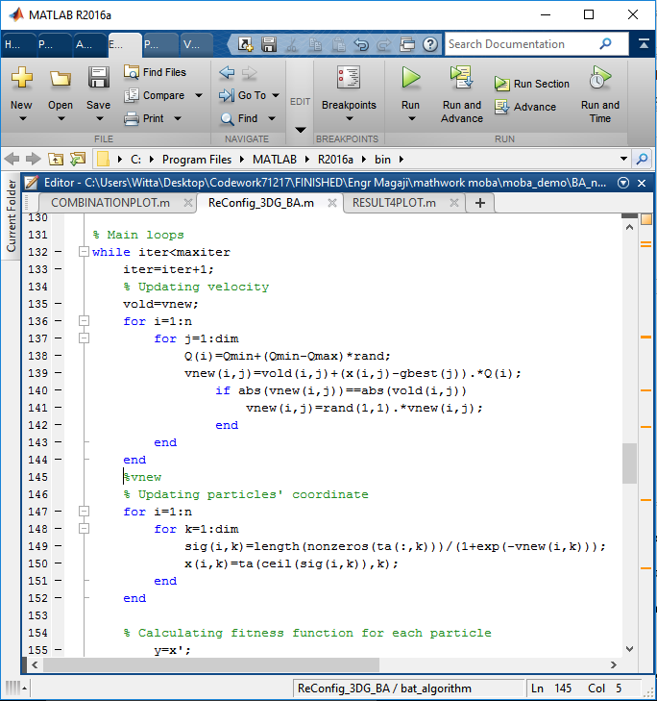

Figure: 3.2 MATLAB Snapshot of BAT Algorithm for Reconfiguration and DG Deployment

* + - 1. *Summary of the Research work Algorithms Processes*

Convegence criteria

BA

Formulate the objective function

Yes

The summary of the BA algorithms are indicated in the Figure 3.4 flow chart

Load flow Backward Forward sweep technique

Pi Vi Ii

Start

No

Stop

Optimal solution

Figure: 3.3The Summary of the Developed Method Algorithms Flow Charts

## Validation of the Developed Method

The Parameters used for comparison on IEEE-33 bus distribution network with the work of Syahputra at el., 2015 were active power loss, power loss reduction, reactive power loss, voltage profile, DGs locations, DGs capacities as well as network operational switches.

## Implementation of the Developed Method on Sabo Feeder in Zaria Distribution Network

The Bat Algorithm-based method for multi-objective optimal network reconfiguration and DG deployment was implemented on a simulated feeder of Sabon-Gari at Zaria distribution network with the view to optimize the synchronous DG placement as well as network reconfiguration where the significant metric parameters improvements were observed.

## Placement and Sizing of DG in the Radial Network

The power flows in the radial network were calculated by the following number of simplified recursive equations derived from Figure: 2.5

The power loss in the line section connecting buses, i and i+1 could be calculated as in equation*(2.8)* .The total power loss of the network, PT, Loss could be determined by summing up the losses of all line sections of the network as given in equation *(2.9)*

The DG location could be determined by considering the difference of the power loss before and after the installation of DG in the network as given in equation *(2.10).*

Therefore, the network bus that gives the highest value of PLR has been considered as the optimal DG location in the network. The DG size could be computed by considering the product of maximum loss saving DG current and voltage magnitude of the network bus as indicated in equation *(2.11)*

## CHAPTER FOUR

**RESULTS ANALYSIS AND DISCUSSIONS**

## Introduction

This chapter presents the results obtained as well as the discussions of the obtained results. The results obtained include the base case (without network reconfiguration and DG placement), then case with network reconfiguration only then also the case with DG placement only and finally the case with simultaneous DG placement and network reconfiguration as the presented research work. Then the developed method implementation on a standard IEEE-33 bus and 29-bus of Sabo feeder networks were evaluated respectively. The comparison between the developed methods with the work of Syahputra*et al.,* (2015) was also presented in this chapter**.**

## The IEEE 33-Bus Radial Distribution Test System

The test was carried out on the IEEE 33-Bus network based on the base case (without network reconfiguration and DG placement) and evaluating the network parameters on base case scenario using FBS technique discussed in subsection (2.2.6.3), the IEEE 33-bus test system detail was discussed in chapter two and the single line diagram was shown in Figure 2.9.The line and bus data are given in appendix A

## Case I: Base Case

For the base case, power flow analysis was carried out without DG and reconfiguration on the network. The power flow analyses were performed using power flow analysis based on BFS technique by considering equations (2.18), (2.19)and (2.21) on a Mat Lab R2013b environment where the steady state of the network was determined. The results of power analysis (P loss, Q loss and voltage magnitude) of the developed method were presented in Table 4.1.

From Table 4.1, it is observed that base case total active power loss of the distribution network is 208.4592kW, the base total reactive power loss is 111.6726kVar, the minimum base voltage is 0.91075p.u at bus 18. The OFF-switches before reconfiguration were 33,34,35,36 and 37 respectively while the ON-switches for 33-bus system before reconfiguration were 1-32 switches at the base case. From the base case result, it shows that 18-bus was the critical bus. The bus that has higher voltage drop is the bus that is far away from sub-station.

The result of the analysis (power loss, voltage magnitude, OFF-switches and ON-switches) of the 33-bus network was presented in tabular form in Table 4.1

**Table 4.1: IEEE-33 Bus Base Case Power Flows Results**

**SERIAL NUMBER PREREC.&DG**

## PLOSS PRE

**QLOSS PRE**

|  |  |  |  |
| --- | --- | --- | --- |
|  | **BUS VOLT *(*pu)** | **REC.& DG (kW)** | **REC.& DG (kW)** |
| 1 | 1.0000 | 12.2025 | 6.3130 |
| 2 | 0.9970 | 51.6024 | 26.2827 |
| 3 | 0.9829 | 19.7843 | 9.9462 |
| 4 | 0.9755 | 18.5835 | 9.4649 |
| 5 | 0.9681 | 38.0041 | 3.2482 |
| 6 | 0.9561 | 1.9178 | 6.3395 |
| 7 | 0.9526 | 11.6983 | 8.4425 |
| 8 | 0.9390 | 4.2022 | 3.0190 |
| 9 | 0.9328 | 3.5657 | 2.5371 |
| 10 | 0.9270 | 0.5566 | 0.1840 |
| 11 | 0.9261 | 0.8857 | 0.2929 |
| 12 | 0.9246 | 2.6802 | 2.1087 |
| 13 | 0.9185 | 0.7330 | 0.9648 |
| 14 | 0.9162 | 0.3588 | 0.3194 |
| 15 | 0.9148 | 0.2829 | 0.2066 |
| 16 | 0.9134 | 0.2530 | 0.3377 |
| 17 | 0.9114 | 0.0534 | 0.0419 |
| 18 | 0.9108 | 0.1610 | 0.1536 |
| 19 | 0.9965 | 0.8323 | 0.7500 |
| 20 | 0.9929 | 0.1008 | 0.1177 |
| 21 | 0.9922 | 0.0436 | 0.0577 |
| 22 | 0.9916 | 3.1820 | 2.1742 |
| 23 | 0.9794 | 5.1442 | 4.0621 |
| 24 | 0.9727 | 1.2876 | 1.0075 |
| 25 | 0.9694 | 2.5642 | 1.3061 |
| 26 | 0.9542 | 3.2819 | 1.6710 |
| 27 | 0.9516 | 11.1407 | 9.8225 |
| 28 | 0.9403 | 7.7222 | 6.7274 |
| 29 | 0.9321 | 3.8403 | 1.9561 |
| 30 | 0.9286 | 1.5709 | 1.5525 |
| 31 | 0.9245 | 0.2101 | 0.2449 |
| 32 | 0.9236 | 0.0130 | 0.0202 |
| 33 | 0.9233 | 0 | 0 |
|  |  | 0 | 0 |
|  |  | 0 | 0 |
|  |  | 0 | 0 |
|  |  | 0 | 0 |

## Case II: Network Reconfiguration Only

In this case, the forward-backward sweep technique using equations *(2.13)* and *(2.19)* in sub- section (2.2.6.3) was employed to obtain the base case result. The BA was run using sub-section (3.2.3.1) for network reconfiguration to obtain optimal switches to reduce power loss and relieve loading condition of the network. The result of the active power loss obtained before and after reconfiguration is as shown in Figure 4.9, from the Figure, it is observed that, the active power loss before and after reconfiguration was 208.4592kW and 140.5803kW respectively, which represents the active power loss reduction of 32.5622%.The reactive power loss before and after reconfiguration was 111.6726kVar and 93.0210kVar respectively, which represents the reactive power loss reduction of 16.7020%. Similarly, from Figure 4.2 it shows that, the magnitude of voltage before reconfiguration was 0.91075p.u after reconfiguration was 0.94234p.u respectively. It could also be observed from Figure 4.2 that, bus 18 has higher voltage profile improvement due to network reconfiguration.

The OFF-switches before reconfiguration were 33, 34, 35, 36 and 37 while after reconfiguration

they were optimally found to be 7, 11, 14, 32 and 37 respectively.

The plot of the active power loss before and after reconfiguration is shown in Figure: 4.1

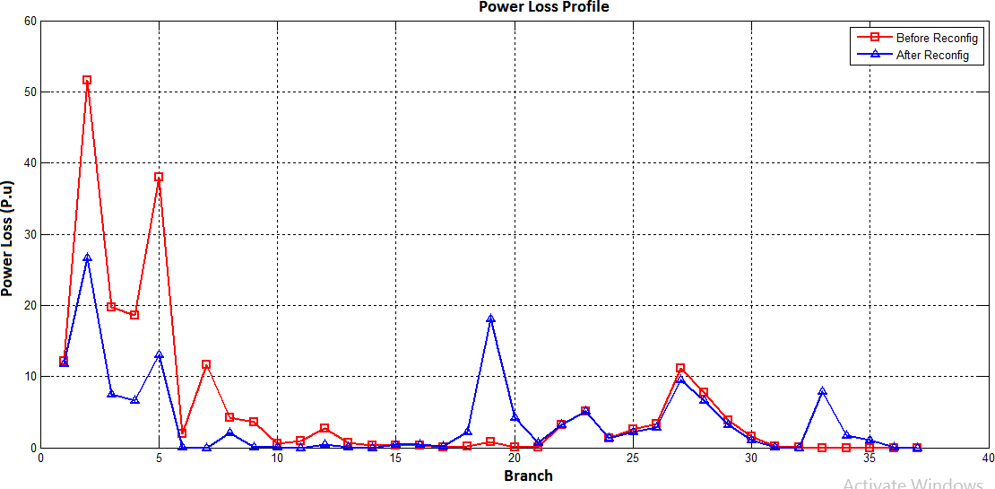

Figure: 4.1 Active Power Loss Before and After Reconfiguration of 33-Bus System

The voltage profile plot of 33-bus system before and after reconfiguration is shown in Figure 4.2

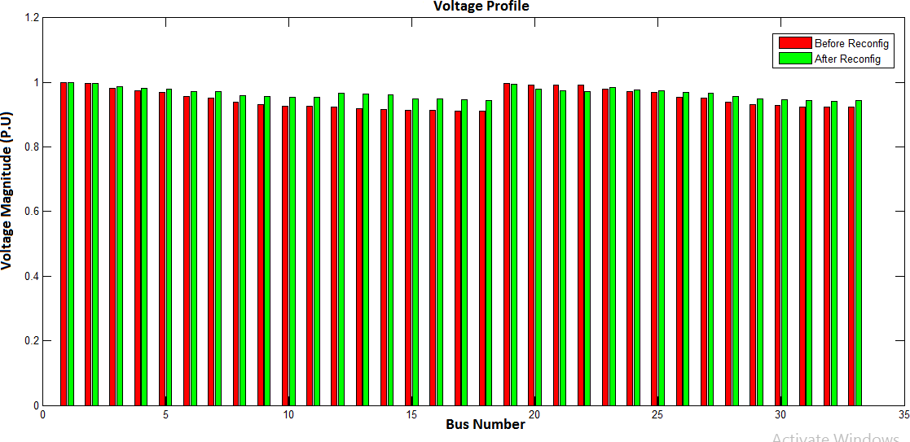

Figure:4.2 Voltage Profile Plot of 33-Bus System Before and After Reconfiguration

## Case III: DG Placement Only

In this case, the forward-backward sweep technique using equations *(2.13)* and *(2.19)* in sub- section (2.2.6.3) was employed to obtain the base case result. The BA was run using sub-section (3.2.3.1) for DG placement and sizing to reduce power loss and improve voltage profile of the network. Three synchronous DGs were installed to improve the network performance, the DGs sizes and locations were957kW, 870kW, 822kW as well as 593kVar, 539kVar, 509kVar at buses 29, 31 and 12 respectively. The result of active power loss obtained before and after reconfiguration is shown in Figure 4.3. From the Figure it is observed that, the active power loss before and after DG placement and sizing was 208.4592kW and 39.5823kW respectively, which represents the power loss reduction of 81.012%. The reactive power loss before and after DG location and sizing was 111.6726kVar and29.7789kVarrespectively, which represents the reactive power loss reduction of 73.3337%.Similarly, it is observed that from Figure 4.4, the magnitude of voltage before DG deployment was 0.91075p.u after DG deployment was 0.98305p.u respectively. It could also be observed from Figure 4.4 that, buses 6, 7, 8, 9, 10, 11, 12 to 18 show highest voltage profile improvement due to DG installation in the distribution network

The plot of the active power loss before DG location and sizing after DG is shown in Figure: 4.3

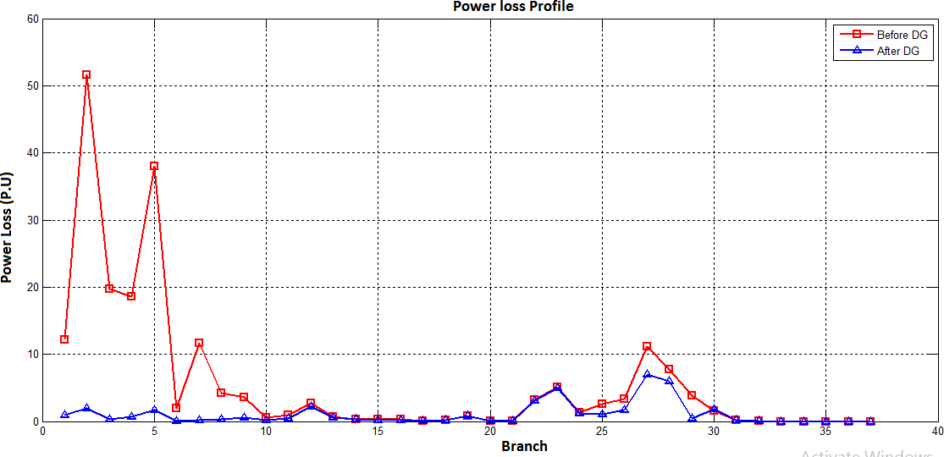

Figure: 4.3 Active Power Loss Before and After DG of 33-Bus System

The voltage profile plot of 33-bus system before and after DG is shown in Figure 4.4

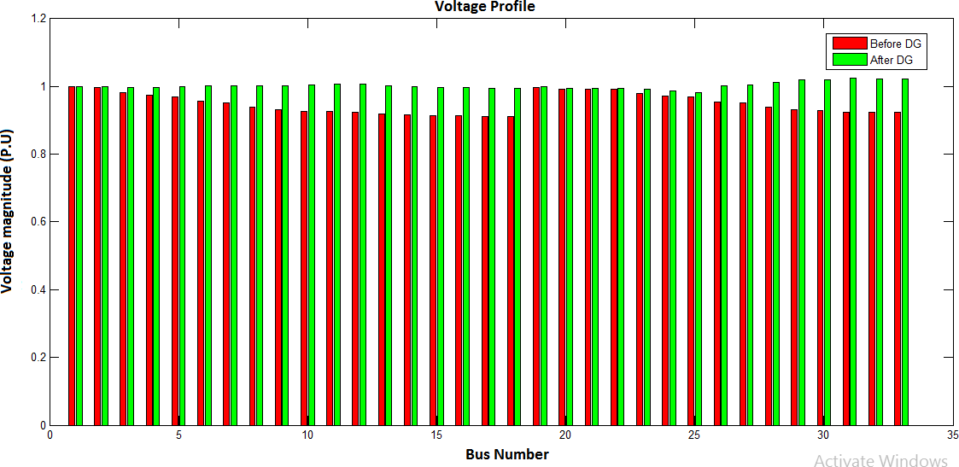

Figure:4.4 Voltage Profile Plot Before and After of DG for 33-Bus System

## Case IV: Simultaneous DG and Reconfiguration

Once again for 33-bus system, the forward-backward sweep using equations *(2.13)* and *(2.19)* in sub-section (2.2.6.3) was employed to obtain the base case result. The BA was run using sub- section (3.2.3.1) for simultaneous DG placement, sizing and reconfiguration to reduce power loss and enhance load balancing of the network., after simultaneous DG placement with reconfiguration of the network, the DGs sizes and locations were957kW, 870kW, 822kW as well as 593kVar, 539kVar, 509kVar at buses 29, 31 and 12 respectively. The optimal OFF-switches were 7, 8, 14, 16 and 25 respectively. The result of the active power loss obtained before and after reconfiguration is as shown in Figure 4.5. It is observed that from the Figure, the active power loss before and after DG with reconfiguration was 208.4592kW and 15.2353kW respectively, which represents the power loss reduction of 92.6915%. The reactive power loss before and after DG with reconfiguration was 111.6726kVar and12.0593kVar respectively which represents the reactive power loss reduction of 89.2012%. Similarly, it is observed that from 4.6, the magnitude of voltage before DG with reconfiguration was 0.91075p.u after DG with reconfiguration was 0.99179p.urespectively.It could also be observed from Figure 4.6 that, buses 9, 10, 11, 12 to 18 show highest voltage profile improvement due to DG installation with reconfiguration in the distribution network

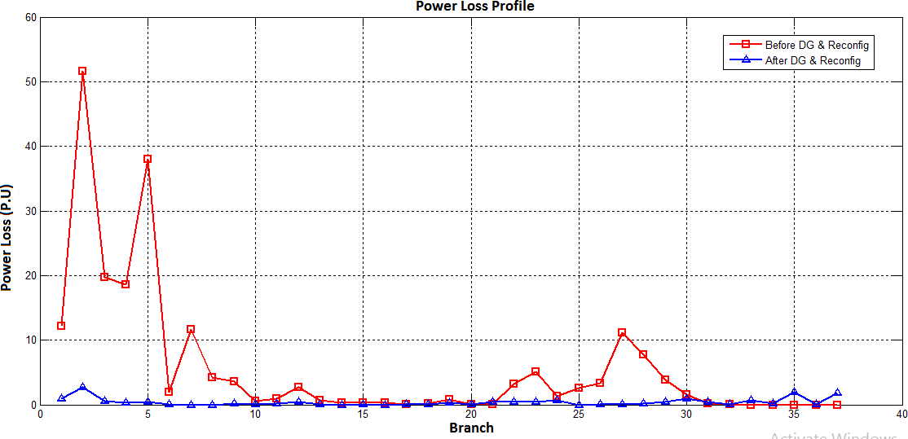The plot of the active power loss before DG with reconfiguration and after DG with reconfiguration is shown in Figure: 4.5

Figure: 4.5 Active Power Loss Before and After DG with Reconfiguration of 33-Bus System

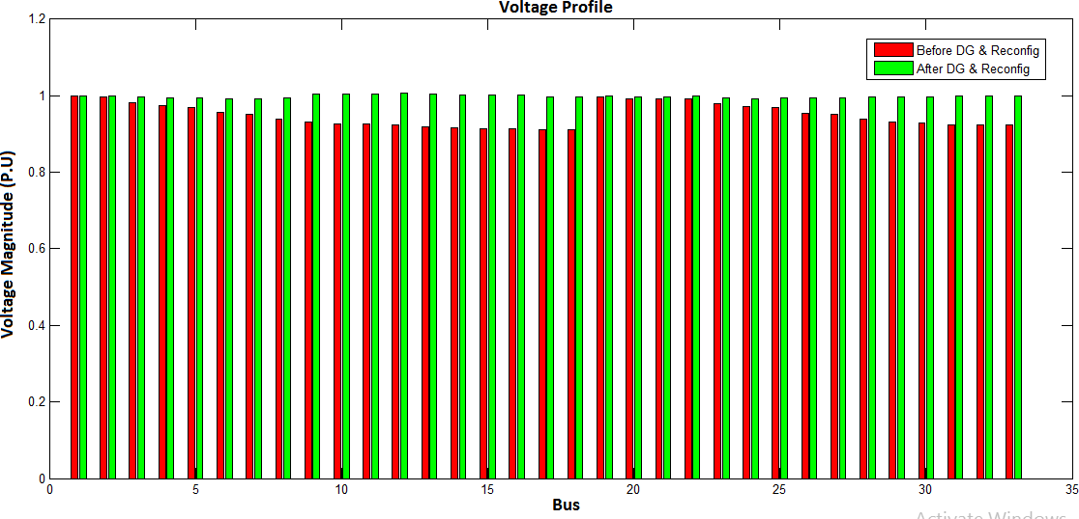The voltage profile plot of 33-bus system before and after DG with reconfiguration is shown in Figure 4.6

Figure:4.6 Voltage Profile Plot of DG with Reconfigurationfor 33-Bus System

## Case V: Combination of Four Case Scenarios

Finally, in this case four different conditions were considered which include, the base case result only, reconfiguration result only, DG result only and simultaneous DG with reconfiguration results were combined together, it is observed that from Figure 4.7, the result of simultaneous DG with reconfiguration was better as the active power loss was 15.2353kW which represents the active power loss reduction of 92.6915% compared with the other results. The reactive power loss was 12.0593kVar which represent the reactive power loss reduction of 89.2012% compared with the other results. It is also observed that from Figure 4.8, the voltage profile has been enhanced from 0.91075*p.u* to 0.99179*p.u* after DG deployment with reconfiguration. This shows that the simultaneous DG deployment with reconfiguration method has better improvement.

The plot of the combined active power loss of four scenarios is shown in Figure: 4.7

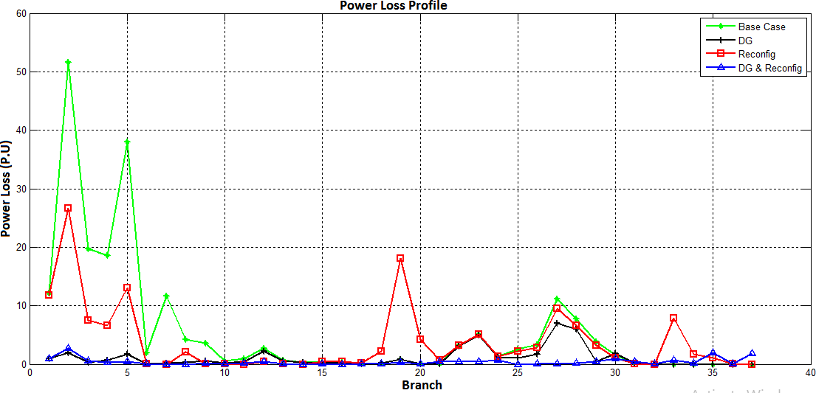

Figure: 4.7 Active Power Loss of Four Scenarios of 33-Bus System

The voltage profile plot for four scenario of 33-bus system is shown in Figure 4.8

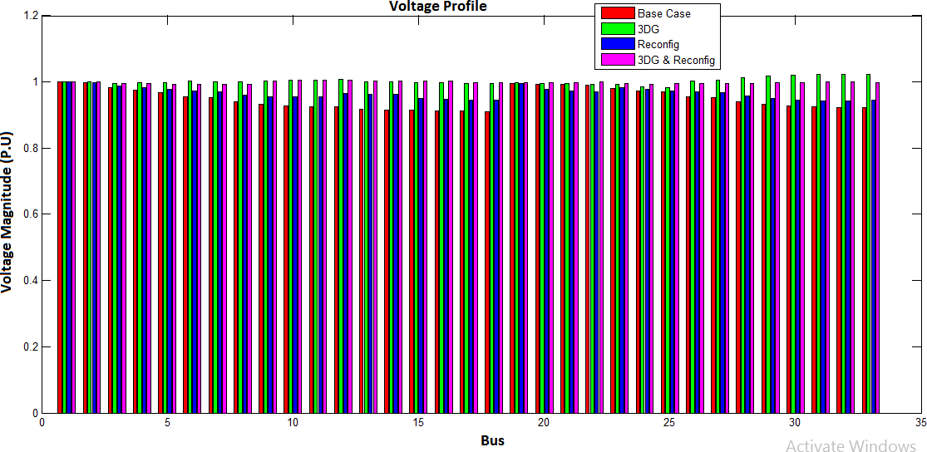

Figure:4.8 Voltage Profile Plot of Four Scenarios for 33-Bus System

## 29-Bus Sabo Radial Distribution Feeder

The 29-Bus Sabo feeder is discussed in chapter two and chapter three, the line and bus parameters are given in appendix B.

## Case I: Base Case

For the base case of 29-bus, power flow analysis was carried out without DG and reconfiguration on the network. The power flow analyses were performed using power flow analysis based on forward-backward sweep technique by considering equations (2.18), (2.19)and (2.21) on a MATLAB R2013b environment where the steady state of the network was determined. The results of power analysis (P loss, Q loss and voltage magnitude) of the developed method were presented in Table 4.2.

From Table 4.2, it is observed that, the base case total active power loss of the distribution network is 4.7864kW, the base total reactive power loss is 3.5675kW, and from Table 4.2, it is shown that the minimum base voltage is 0.95695p.u at bus 22 respectively. The OFF-switches before reconfiguration were 29, 30 and 31 respectively while the ON-switches for 29-bus system before reconfiguration were 1-28 switches at the base case. From the base case result, it shows that 22-bus was the critical bus. The bus has higher voltage drop as the bus is far away from the sub-station.

The result of the analysis (power loss, voltage magnitude, OFF-switches and ON-switches) of the 29-bus network was presented in tabular form in Table 4.2

**Table 4.2: 29-BusBase Case Power Flows Results**

|  |  |  |  |
| --- | --- | --- | --- |
| **SERIAL NUMBER** | **PRE REC.& DG**  **BUS VOLT(PU)** | **PLOSS PRE**  **REC.& DG(kW)** | **QLOSS PRE**  **REC.& DG (KW)** |
| 1 | 1.0000 | 0.3946 | 0.2946 |
| 2 | 0.9980 | 0.4313 | 0.3219 |
| 3 | 0.9956 | 0.4044 | 0.3019 |
| 4 | 0.9933 | 0.6285 | 0.4691 |
| 5 | 0.9897 | 0.3814 | 0.2847 |
| 6 | 0.9874 | 0.2498 | 0.1863 |
| 7 | 0.9853 | 0.2576 | 0.1924 |
| 8 | 0.9830 | 0.2025 | 0.1510 |
| 9 | 0.9811 | 0.2580 | 0.1925 |
| 10 | 0.9785 | 0.0915 | 0.0682 |
| 11 | 0.9775 | 0.3060 | 0.2284 |
| 12 | 0.9740 | 0.3076 | 0.2295 |
| 13 | 0.9704 | 0.2829 | 0.2111 |
| 14 | 0.9668 | 0.1908 | 0.1424 |
| 15 | 0.9642 | 0.0493 | 0.0368 |
| 16 | 0.9635 | 0.0964 | 0.1019 |
| 17 | 0.9615 | 0.1240 | 0.0544 |
| 18 | 0.9595 | 0.0409 | 0.0305 |
| 19 | 0.9585 | 0.0325 | 0.0243 |
| 20 | 0.9573 | 0.0013 | 0.0009 |
| 21 | 0.9571 | 0.0010 | 0.0008 |
| 22 | 0.9569 | 0.0017 | 0.0013 |
| 23 | 0.9978 | 0.0017 | 0.0013 |
| 24 | 0.9873 | 0.0262 | 0.0195 |
| 25 | 0.9867 | 0.0171 | 0.0128 |
| 26 | 0.9859 | 0.0046 | 0.0034 |
| 27 | 0.9857 | 0.0022 | 0.0016 |
| 28 | 0.9855 | 0.0005 | 0.0004 |
| 29 | 0.9854 | 0 | 0 |
|  |  | 0 | 0 |
|  |  | 0 | 0 |
|  |  | 0 | 0 |

* + 1. **Case II: Network Reconfiguration Only**

In this case, the forward-backward sweep technique using equations *(2.13)* and *(2.19)* in sub- section (2.2.6.3) was employed to obtain the base case result. The BA was run using sub-section (3.2.3.1) for network reconfiguration to obtain optimal switches to reduce power loss and relieve loading condition of the network. The result of the active power loss obtained before and after reconfiguration is shown in Figure 4.9. From the Figure it is observed that, the active power loss before and after reconfiguration was 4.7864kW and 2.0558kW respectively, which represents the active power loss reduction of 57.0492%. The reactive power loss before and after reconfiguration was 3.5675kVar and 1.4247kVar respectively, which represents the reactive power loss reduction of 60.0241%. Similarly it is observed that from Figure 4.10, the magnitude of voltage before reconfiguration was 0.95695p.u after reconfiguration was 0.98217p.u respectively. It could also be observed from Figure 4.10 that, buses 13, 12, 14 to 21 have highest voltage profile due to network reconfiguration.

The OFF-switches before reconfiguration were 29, 30 and 31 while after reconfiguration they were optimally found to be 7, 19 and 26 respectively.

The plot of the active power loss before and after reconfiguration is shown in Figure: 4.9

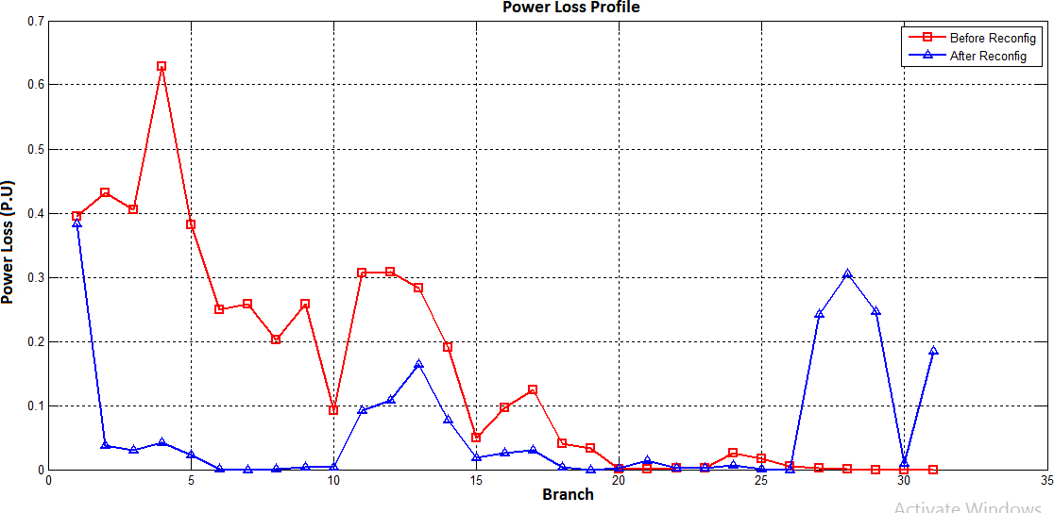

Figure 4.9: The Active Power Loss Plot of 29-Bus System Before and After Reconfiguration

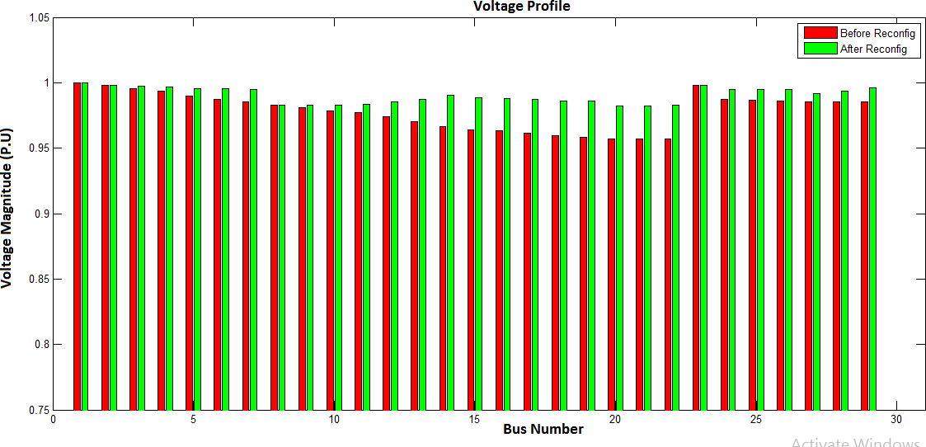The voltage profile plot of 29-bus system before and after reconfiguration is shown in Figure 4.10

Figure:4.10 Voltage Profile Plot of 29-Bus System Before and After Reconfiguration

## Case III: DG Placement Only

In this case, the forward-backward sweep technique using equations *(2.13)* and *(2.19)* in sub- section (2.2.6.3) was employed to obtain the power flow results. The BA was run using sub- section (3.2.3.1) for DG placement and sizing to reduce power loss and improve voltage profile of the network. Three synchronous DGs were installed to improve the network performance, DGs sizes and locations were95kW, 83kW, 54kW as well as 59kVar, 52kVar, 34kVar at buses 17, 3 and 12 respectively. The result of the active power loss obtained before and after reconfiguration is shown in Figure 4.11.It can be seen that from the Figure, the active power loss before and after DG placement and sizing was 4.7864kW and 0.65703kW respectively, which represents the power loss reduction of 86.2729%. The reactive power loss before and after DG location and sizing was 3.5675kWand 0.4687kVar which represents the reactive power loss reduction of86.8487%. Similarly, it is observed that from Figure 4.12, the magnitude of voltage before DG placement and sizing was 0.95695p.u after DG placement and sizing was 0.99743p.u respectively. It could also be observed from Figure 4.12 that, buses 7, 8, 9, 10, 11, 12, 13 15, 16 to 22 have highest voltage profile due to network reconfiguration.

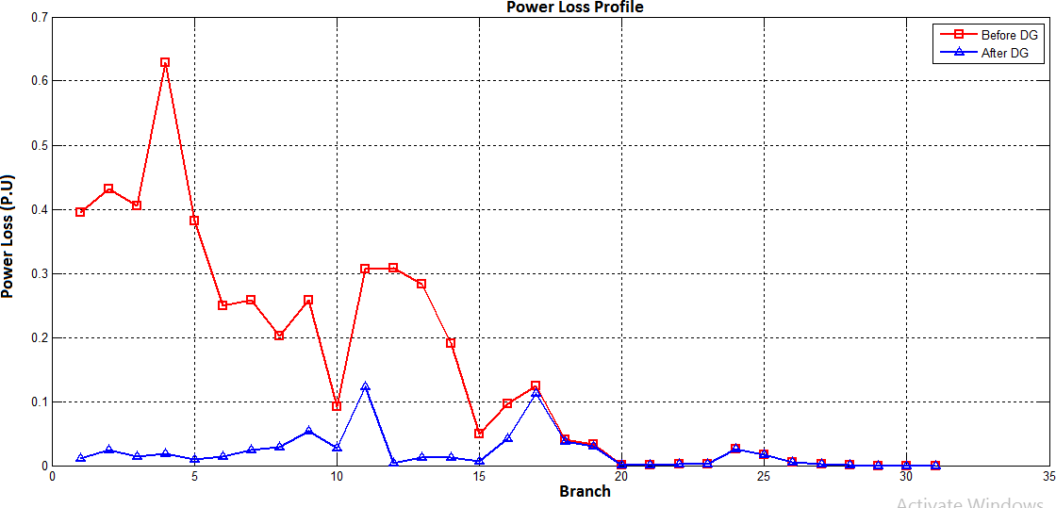The plot of the active power loss before DG location and sizing and after DG placement and sizing is shown in Figure: 4.11 while the voltage profile plot was shown in Figure 4.12

Figure: 4.11The Plot of the Active Power Loss Before and After DG Placement and Sizing

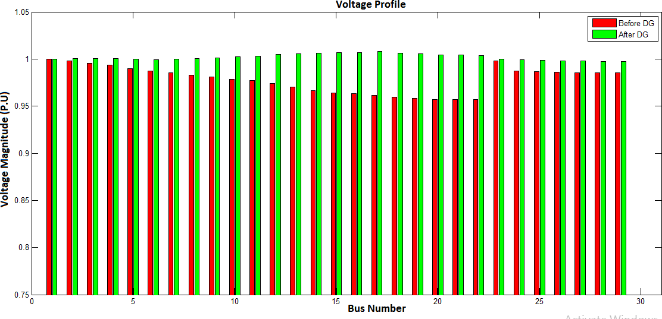

Figure: 4.12 The Voltage Profile Plot of 29-Bus System Before and After DG Placement

## Case IV: Simultaneous DG Placement with Reconfiguration

Once again for 29-bus system, the forward-backward sweep technique using equations *(2.13)* and *(2.19)* in sub-section (2.2.6.3) was employed to obtain the power flow results. The BA was run using sub-section (3.2.3.1) for simultaneous DG placement, sizing and reconfiguration to reduce power loss and enhance load balancing of the network. It is observed that after simultaneous DG with reconfiguration of the network, the DGs sizes and locations were95kW, 83kW, 54kW as well as 59kVar, 52kVar, 34kVar at buses 17, 3 and 12 respectively. The optimal OFF-switches were 7, 17 and 26 respectively. The result of the active power loss obtained before and after reconfiguration is as shown in Figure 4.13.It is shown that from the Figure, the active power loss before and after DG with reconfiguration was 4.7864kW and 0.53735kW respectively, which represent the power loss reduction of 88.7734%. The reactive power loss before and after DG with reconfiguration was 3.5675kWand 0.4210kVarrespectively, which represents the reactive power loss reduction of 88.1871%. Similarly, it is observed from Figure 4.14that, the magnitude of voltage before DG with reconfiguration was 0.95695p.u after DG with reconfiguration was 0.99796p.u respectively. It could also be observed from Figure 4.14 that, buses 4, 5, 6, 7, 8, 9, 10, 11, 12, 13 15, 16 to 22 have highest voltage profile due to DG with reconfiguration.

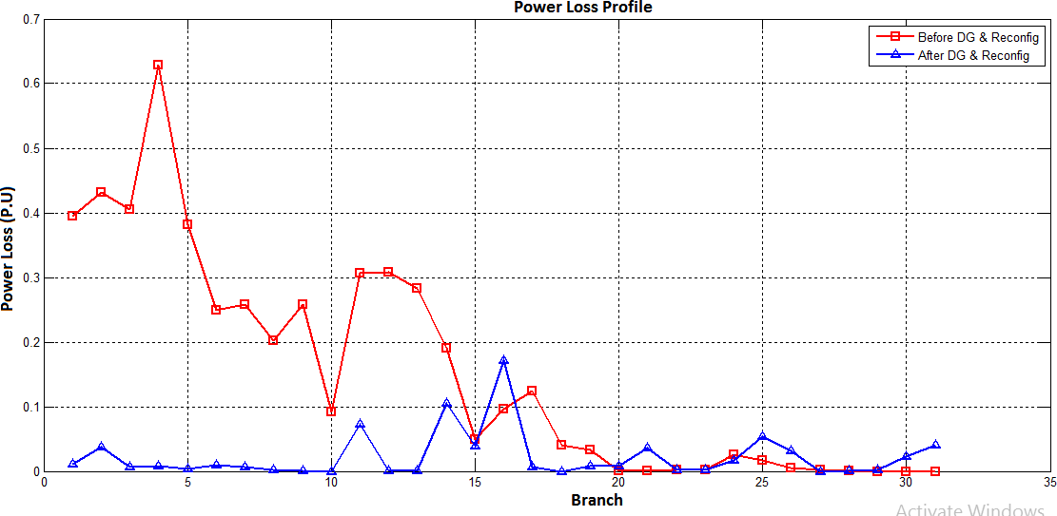The plot of the active power loss before DG with reconfiguration and after DG with reconfiguration is shown in Figure: 4.13

Figure: 4.13The Active Power Loss Before and After DG with Reconfiguration

The voltage profile plot of 29-bus system before and after DG with reconfiguration is show in Figure 4.14

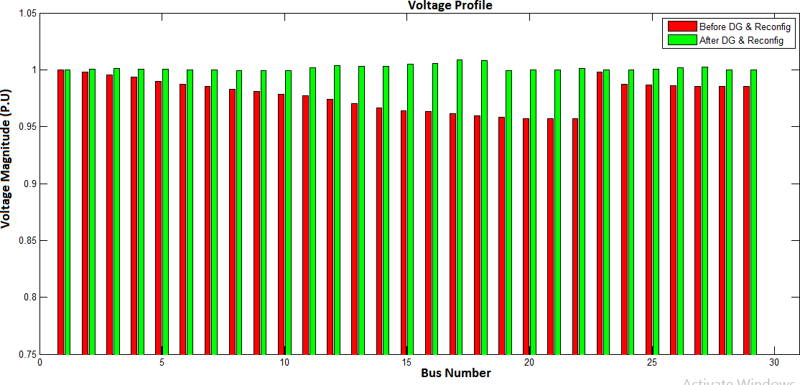

Figure: 4.14The Voltage Profile Plot of 29-Bus System Before and After DG with Reconfiguration

## Case V: Combination of Four Case Scenarios

Finally, in this case four conditions were considered such as; the base case result only, reconfiguration result only, DG result only and simultaneous DG and reconfiguration results were combined together. From Figure 4.15, it is observed that the result of simultaneous DG with reconfiguration was better as the active power loss was 0.53735kW, which represents the active power loss reduction of 88.7734% compared with the other results. The reactive power loss was 0.4210kVar which represent the reactive power loss reduction of 88.1871% compared with the other results. Likewise from Figure 4.16 shows that the voltage profile has been enhanced from 0.95695p.u to 0.99796p.u. This shows that the developed method is better than the other three case scenarios.

The plot of the combined active power loss of four scenarios is shown in Figure: 4.7

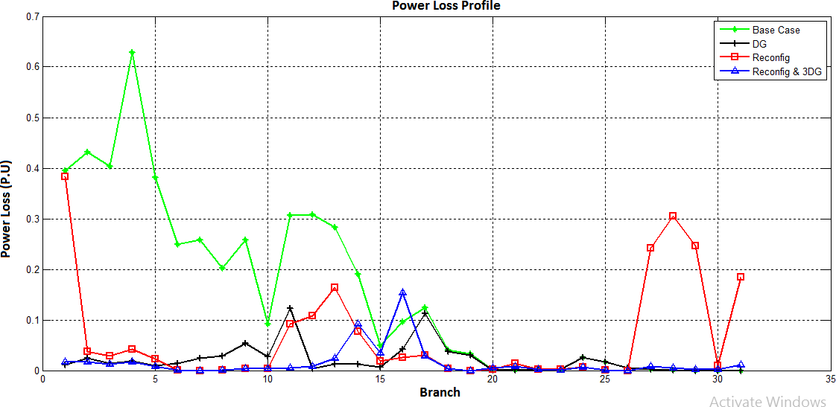

Figure: 4.15 Active Power Loss of four Scenarios of 29-Bus System

The voltage profile plot for four scenario of 29-bus system is shown in Figure 4.16

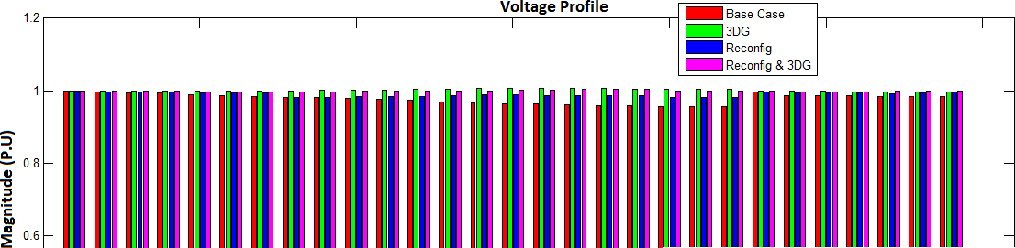

Figure: 4.16The Voltage Profile Plot for Four Scenario of 29-Bus System