**ANXIOLYTIC PROPERTIES OF *MITRACARPUS VILLOSUS* (SW) DC.LEAF EXTRACTS IN MICE AND RATS**

**BY**

**LUCY BINDA JOHN-AFRICA**

**DEPARTMENT OF PHARMACOLOGY AND THERAPEUTICS, FACULTY OF PHARMACEUTICAL SCIENCES,**

**AHMADU BELLO UNIVERSITY, ZARIA, NIGERIA**

**MAY, 2017**

**ANXIOLYTIC PROPERTIES OF *MITRACARPUS VILLOSUS*(SW) DC.LEAF EXTRACTS IN MICE AND RATS**

**BY**

**Lucy Binda JOHN-AFRICA B.Pharm (Jos ) 1996, M.Pharm (Nsukka) 2006**

**DEPARTMENT OF PHARMACOLOGY AND THERAPEUTICS, FACULTY OF PHARMACEUTICAL SCIENCES,**

**AHMADU BELLO UNIVERSITY, ZARIA, NIGERIA**

**MAY, 2017**

**ANXIOLYTIC PROPERTIES OF*MITRACARPUS VILLOSUS*(SW) DC.LEAF EXTRACTS IN MICE AND RATS**

**BY**

**LucyBindaJOHN-AFRICA B.Pharm (Jos ) 1996, M.Pharm (Nsukka) 2006**

**PhD/PharmSci/2111/11-12**

**A THESIS SUBMITTED TO THE SCHOOL OF POSTGRADUATE STUDIES, AHMADU BELLO UNIVERSITY, ZARIA**

**IN PARTIAL FULFILLMENT OF THE REQUIREMENTS FOR THE AWARD OF DOCTOR OF PHILOSOPHY IN PHARMACOLOGY,**

**DEPARTMENT OF PHARMACOLOGY AND THERAPEUTICS, FACULTY OF PHARMACEUTICAL SCIENCES,**

**AHMADU BELLO UNIVERSITY, ZARIA, NIGERIA**

**May, 2017**

**DECLARATION**

I hereby declare that the work in this thesis titled ―ANXIOLYTIC PROPERTIES OF

*MITRACARPUS VILLOSUS* LEAFEXTRACTS IN MICE AND RATS‖ was

performed by me in the Department of Pharmacology and Therapeutics, Faculty of Pharmaceutical Sciences under the supervision of Professors N. M Danjuma, J. A. Anuka and B. A. Chindo. The information derived from the literature has been duly acknowledged in the text and a list of references provided. No part of this work has been presented for another degree or diploma at this or any other institution.

Lucy Binda John-Africa (Signature) (Date)

**CERTIFICATION**

This thesis titled ―ANXIOLYTIC PROPERTIES OF *MITRACARPUS VILLOSUS*

LEAFEXTRACTS IN MICE AND RATS‖ meets the regulations governing the award of the degree of Doctor of Philosophy in Pharmacology of the Ahmadu Bello University, and is approved for its contribution to knowledge and literary presentation.

Prof. N. M. Danjuma (Signature) (Date)

(Chairman, Supervisory Committee)

Prof. J. A. Anuka (Signature) (Date)

(Member, Supervisory Committee)

Prof. B. A. Chindo (Signature) (Date)

(Member, Supervisory Committee)

Prof. N. M Danjuma (Signature) (Date) (Head of Department)

Prof S. Z. Abubakar (Signature) (Date)

(Dean, School of Post Graduate Studies)

**DEDICATION**

To Dimiari, Elioenai and Cecil,

May this inspire you to reach beyond the stars.

**ACKNOWLEDGEMENTS**

I am grateful to my supervisors for guiding and directing this project and giving me all the room to ―flex my brain muscles‖. I thank the management of the National Institute for Pharmaceutical Research and Development (NIPRD) Idu, for granting approval and sponsorship for this programme. My gratitude also goes to staff of the department of Pharmacology and Toxicology, Dr (Mrs) Jemilat Ibrahim and Dr (Mrs) O.F. Kunle and staff of the Department of Medicinal Plant Research and Traditional Medicine, NIPRD, Chief Technologist and other Laboratory Staff of the Department of Pharmacology and Therapeutics AhmaduBello University, Zaria.

I am grateful to my course mates whose contributions have made it possible to meet with datelines and for the motivating cerebral group discussions.

I am appreciative of my parents for their prayers and siblings for the numerous errandsthey had to undertake on my behalf which facilitated this work.

I am heavily indebted tomy children. Thank you for your benevolence and enduring the evenings that mommy was not around to supervise your homework.

I would like to express my sincere gratitude to my Dear husband without your invaluable consent this journey would not have begun.

Most importantly …… **PRAISE THE LORD!**

**TO HIM BE ALL THE GLORY!**

**ABSTRACT**

The leaf of *Mitracarpusvillosus* (Sw.) DC. (Rubiaceae) is used in West African folk medicine for the management of a plethora of stress-related diseases including headaches and toothaches. In this study, preliminary phytochemical analysis of the ethylacetateleaf extract of *Mitracarpusvillosus* and its fractions were conducted. Vacuum liquid chromatography (VLC), column chromatography (CC) and thin layer chromatography (TLC) using solvents of varying polarities were employed to separate the constituents of the plant extract. The intraperitoneal and oral lethal doses (LD50) of the extracts were determined by Lorke‘s method in mice and rats. The sub-chronic toxicity studies were carried out on male and female Wistar albino rats by daily administration of ethylacetateleaf extract of *Mitracarpusvillosus* (312 – 1250 mg/kg) for 28 days during which body weight, feed and water consumption were monitored. After 28 days, effects of the extract on biochemical and haematological parameters were evaluated and the histological changes of the vital organs were also examined. The effect of the ethylacetateleaf extract of *Mitracarpusvillosus* on mouse behaviour was examined using various in-vivo models whichinclude the hole-board (exploratory behaviour), open field test (OFT), staircase test (SCT), light/dark box (LDB), elevated plus maze (EPM), diazepam-induced sleep and rota rod tests. The anti-nociceptive effects of the ethylacetate extract were tested on acetic acid-induced abdominal writhing, oro-facial formalin-induced pain as well as carageenaan–induced hyperalgesia in mice and rats. The effects of the extract on inflammation and body temperature were determined using formalin induced paw oedema and Baker‘s yeast induced pyrexia respectively in mice. The ethylacetateleaf extract of *Mitracarpusvillosus*tested positive for alkaloids,steroids, terpenes, flavonoids, cardiac glycosides, resins and tannins while the biologically active fraction tested positive for terpenes and steroids. The intraperitoneal LD50 of the extract was calculated to be 1264.91 mg/kg and the oral LD50 was estimated to be greater than 5000 mg/kg in mice and rats, respectively. Ethylacetateleaf extract of *Mitracarpusvillosus* at doses of 312, 625 and 1250 mg/kg did not cause changes of food and water intake or body weight, but significant (p<0.001) increase of the weight of the liver and levels of the mean corpuscular volume (MCV) were recorded at 1250 mg/kg. Similarly, significant (p<0.05) changes in the levels of the hepatic enzyme alkaline phosphatase (ALP) and the renal index creatinine were recorded. There was no significant difference in levels of electrolytes (Na, K, Cl, HCO3) and urea. Histological evaluation of the organs presented with distortion of the structures of kidney and liver tissues at high doses of up to 1250 mg/kg. Graded doses of the extract (6.25 – 25 mg/kg) exhibited significant (p<0.001) anxiolytic effects by causing increase in locomotion and central square crossings in the open field test. Staircase test produced increase in locomotion and rearing. The percentage of time spent in the light compartment was prolonged both in the LDB and EPM tests when compared to control. At higher doses, the extract (100 – 400 mg/kg) significantly (p<0.01) and dose-dependently prolonged the duration of diazepam-induced sleep (p<0.05), decreased the number of both peripheral and central squares crossed in the OFT, decreased (p<0.001) number of head-dips in the hole-board test and reduced steps climbing in SCT (p<0.05) in mice. The most active fraction E2, exhibited a similar pattern of behavioural actions comparable to the crude extract. The ethylacetateleaf extract of *Mitracarpusvillosus*at the doses tested had no effect on motor co-ordination as observed in the rota-rod assay in mice. The extract at 100 – 400 mg/kg significantly (p< 0.05) and dose-dependently inhibited acetic acid- induced writhing, decreased the time of face rubbing induced by formalin in mice and

increased the paw withdrawal threshold of carageenan induced hyperalgesia in rats. Paw thickness induced by formalin was also significantly (p<0.001) reduced. Hyperthermia induced by baker‘s yeast was significantly (p< 0.05) reversed by the extract. The actions exhibited by the ethylacetateleaf extract of *Mitracarpusvillosus* are probably mediated via the benzodiazepine-GABA-ergic (BDZ-GABA) pathways. The results from this study provide scientific evidence that the ethylacetate extract of *Mitracarpusvillosus* leaf may contain psychoactive principles that are sedative in nature with potential anxiolytic effects attributable to the presence of terpenoidal and steroidal compounds. The sedative and anxiolytic effects may be mediated through the benzodiazepine site of the GABAA receptor channel complex as the effect of the extract on diazepam induced sleep was reversed by flumazenil. The extract exhibited anti-nociceptive effects against neurogenic and inflammatory mediated pain with anti- inflammatory and hypothermic effects. These findings support the further appraisal of the biologically active principles of the plant as analgesic, anxiolytic and anti- inflammatory agents.

**TABLE OF CONTENTS**

|  |  |
| --- | --- |
| Title page - - | - - - - - - - - i |
| Fly page- - | - - - - - - - - ii |
| Cover page- - | - - - - - - - - iii |
| Declaration- - | - - - - - - - - iv |
| Certification- - | - - - - - - - - v |
| Dedication- - | - - - - - - - - vi |
| Acknowledgement- | - - - - - - - - vii |
| Abstract- - | - - - - - - - - viii |
| Table of contents- | - - - - - - - - x |
| List of Figures- | - - - - - - - - xix |
| List of Tables-- | - - - - - - - - xxiii |
| List of Plates- - | - - - - - - - - xxiv |
| Appendices- - | - - - - - - - - xxv |

Abbreviations, Definitions, Glossary and Symbols- - - - - xxvi

CHAPTER ONE

1.0 Introduction - - - - - - - 1

* 1. Epidemiology of Neurological Diseases- - - - - 1
  2. Traditional and Herbal medicine - - - - - - 3
  3. Statement of Research Problem- - - - - - 7
  4. Justification for the Study- - - - - - - 8
  5. Theoretical framework- -- - - - - 9
     1. Phytochemistry- - - - - - - - 9
     2. Toxicity studies - - - - - - - - 10
     3. General behavioural studies - - - - - - - 10
        1. Irwin primary behavioural studies- - - - - - 10
        2. Anxiety studies- - - - - - - - 11
        3. Motor co-ordination studies- - - - - - - 12

1.5.3.4. Diazepam induced sleep- - - - - - - 12

1.5.4. Pain Studies - - - - - - - - - 12

1.5.5. Anti-convulsantstudies- - - - - - - 13

* 1. Aim and objectives- - - - - - - - 13
     1. Specific objectives-- - - - - - - - 13

1.7 Research Hypothesis- - - - - - - - 14

CHAPTER TWO

|  |  |  |  |  |  |  |  |  |  |  |
| --- | --- | --- | --- | --- | --- | --- | --- | --- | --- | --- |
| 2.0 | Literature review- | | - | - | - | - | - | - | - | 15 |
| 2.1 | Anxiety- | - | - | - | - | - | - | - | - | 15 |
| 2.2 | Neurobiological basis of anxiety- | | | | - | - | - | - | - | 16 |
| 2.3 | Animal models of anxiety | | | - - - - - - | | | | | | 21 |
| 2.4 | Types of Anxiety- | | - | - | - | - | - | - | - | 27 |
| 2.4.1 | Generalized anxiety disorder- - | | | | - | - | - | - | - | 28 |
| 2.4.2 | Panic disorders- | | - | - | - | - | - | - | - | 28 |
| 2.4.3 | Social anxiety disorder- | | | - - - - - - | | | | | | 29 |
| 2.4.4 | Specific phobias- | | - | - | - | - | - | - | - | 29 |
| 2.4.5 | Post-traumatic stress disorder-- | | | | - | - | - | - | - | 30 |
| 2.5 | Treatment of Anxiety-- | | | - - - - - - | | | | | | 30 |

* + 1. [Treatment objective- - - - - - - - 30](#_TOC_250014)
    2. [Non-drug measures – psychological treatment- - - - 31](#_TOC_250013)
    3. [Drug treatments- - - - - - - - 31](#_TOC_250012)
       1. Orthodox medicine- - - - - - - - 31
       2. Complementary and Alternative medicines- - - - - 34
  1. [Anxiety and Pain- - - - - - - - 35](#_TOC_250011)
  2. [Anxiety and Inflammation- - - - - - - 35](#_TOC_250010)
  3. [Anxiety and Hyperthermia- - - - - - - 36](#_TOC_250009)
  4. The role of medicinal plants in the management of anxiety disorders- 37
  5. [Plants with anxiolytic properties- - - - - - 39](#_TOC_250008)
  6. [Herbal toxicity- - - - - - - - 40](#_TOC_250007)
  7. [Safe administration of herbal medicines- - - - - 42](#_TOC_250006)
  8. [Standardization of herbal medicine- - - - - - 45](#_TOC_250005)
  9. The Plant -Mitracarpusvillosus - - - - - - 47

CHAPTER THREE

[3.0 Materials and methods- - - - - - 49](#_TOC_250004)

[3.1 Materials- - - - - - - - - 49](#_TOC_250003)

[3.1.1 Drugs- - - - - - - - - - 49](#_TOC_250002)

[3.1.2 Important equipment- - - - - - - - 49](#_TOC_250001)

[3.2 Methods- - - - - - - - - 49](#_TOC_250000)

* + 1. Collection of plant material - - - - - - - 49
    2. Plant preparation and extraction- - - - - - 50
  1. Vacuum liquid chromatography (VLC) - - - - - 50
  2. Column chromatography (CC) - - - - - - 51
  3. Preliminary phytochemical screening- - - - - 54

|  |  |
| --- | --- |
| 3.5.1 Test for Alkaloids - - - - - - - - | 54 |
| 3.5.2 Test for Phenols- - - - - - - - | 54 |
| 3.5.3 Test for Resins- - - - - - - - | 55 |
| 3.5.4 Test for Flavonoids- - - - - - - - | 55 |
| 3.5.5 Test for Tannins (Ferric Chloride Test) - - - - - | 55 |
| 3.5.6 Test for saponins- - - - - - - - | 55 |
| 3.5.7 Test for Terpenes- - - - - - - - | 55 |
| 3.5.8 Test for steroids (Salkowski‘s Test) - - - - - - | 56 |
| 3.5.9 Test for Carbohydrates - - - - - - - | 56 |
| 3.5.10 Test for Phlobatannins - - - - - - | 56 |
| 3.5.11 Test for cardiac glycosides - - - - - - | 56 |
| 3.6 Animals- - - - - - - - | 57 |
| 3.7 Toxicity Studies- - - - - - - - | 57 |
| 3.7.1 Acute toxicity studies - - - - - - - | 57 |
| 3.7.2 Sub-chronic toxicity studies- - - - - - - | 58 |

* + - 1. Effect of ethylacetate leaf extract of *Mitracarpusvillosus* (MVEA)

on haematological indices- - - - - - - 58

* + - 1. Effect ethylacetate leaf extract of *Mitracarpusvillosus* (MVEA)

on serum biochemical indices- - - - - - 59

* + - 1. Histological studies - - - - - - - 59
  1. Pharmacological studies- - - - - - - 59
     1. Pilot studies carried out with hexane extract (MVX), ethylacetate extract (MVEA) and methanol extract (MVM) of *Mitracarpusvillosus* leaf- 60
        1. Studies on diazepam induced sleep in mice- - - - - 60

|  |  |  |
| --- | --- | --- |
| 3.8.1.2 Studies on hole-board test in mice- | - - - - - | 60 |
| 3.8.1.3 Studies onstaircase test in mice- | - - - - - | 61 |

* + 1. Experiment carried out using ethylacetate leaf extract of *Mitracarpusvillosus*

(MVEA) - - - - - - - - - - 61

* + - 1. Functional Observational Battery (FOB) screening studies in mice- - 61
      2. Hole-board (exploratory behaviour) test in mice- - - - 62
      3. Staircase assay in mice- - - - - - -- 62
      4. Open Field Test in mice- - - - - - - 62
      5. Light/dark Box transition test in mice- - - - - 63
      6. Elevated plus maze (EPM) test in mice- - - - - 63
      7. Diazepam induced sleep in mice- - - - - - 64
      8. Rota rod test in mice - - - - - - - 64
      9. Acetic acid-induced writhing test in mice- - - - - 65
      10. Orofacial formalin test in mice- - - - - - 65
      11. Carageenaan induced hyperalgesia in rats- - - - - 66
      12. Formalin induced anti-inflammation test in mice- - - - 67
      13. Baker‘s yeast induced pyrexia test in mice- - - - - 67
      14. Pentylenetetrazol-induced seizures in mice- - - - - 68
    1. Studies carried out with primary fraction obtained from ethylacetate leaf extract of *Mitracarpusvillosus* (fraction E).- - - - 68
    2. Studies carried out with secondary fraction obtained from ethylacetate leaf extract of *Mitracarpusvillosus*.- - - - - - 69
  1. Statistical analysis- - - - - - - - 69

CHAPTER FOUR

4.0 Results- - - - - - - - - 70

* 1. Plant extraction- - - - - - - - 70
  2. Phytochemical analysis- - - - - - - 72
  3. Vacuum liquid and column chromatography(VLC/CC)of- - - 73
  4. Acute toxicity studies ethylacetateleaf extract of *Mitracarpusvillosus* and E2 in mice and rats- - - - - - - - 75
     1. Effect of orally administered ethylacetateleaf extract of *Mitracarpusvillosus*on behavioural responses in mice - - - - - - 75
     2. Effect of intraperitoneally administered ethylacetateleaf extract of

*Mitracarpusvillosus* in mice and rats-- - - - 78

* 1. Effect of the ethylacetate leaf extract of *Mitracarpusvillosus* on food consumption in rats - - - - - - - 82
  2. Effect of the ethylacetate leaf extract of *Mitracarpusvillosus* on water intake in rats- - - - - - - - - - 84
  3. Effect of the ethylacetate leaf extract of *Mitracarpusvillosus* on body weight of rats - - - - - - - - - 86
  4. Effect of the ethylacetate leaf extract of *Mitracarpusvillosus* on organ weight of rats - - - - - - - - - 88
  5. Effect of the ethylacetate leaf extract of *Mitracarpusvillosus* on haematological parameters of rats - - - - - 91
  6. Effect of the ethylacetate leaf extract of *Mitracarpusvillosus*on renal indices of Wistar rats- - - - - - - - - 94
  7. Effect of the ethylacetate leaf extract of *Mitracarpusvillosus* on hepatic indices of Wistar rats- - - - - - - - 97
  8. Effect of the ethylacetate leaf extract of *Mitracarpusvillosus* on histology of the organs following 28 days daily oral administration in rats - 100
  9. Effect of hexane, ethylacetate and methanol extracts of *Mitracarpus villosus*leaf on diazepam-induced sleeping time in mice- - - 103
  10. Effect of hexane, ethylacetate and methanol extracts of *Mitracarpus villosus* leaf on hole-board test in mice- - - - - 105
  11. Effect of hexane, ethylacetate and methanol extracts of *Mitracarpus villosus* leaf on staircase test in mice-- - - - - 107
  12. Functional observational Battery (FOB) screening studies in mice- 109
  13. Effect of the ethylacetate leaf extract of *Mitracarpusvillosus* on hole-board (exploratory behaviour) studies in mice - - - - 111
  14. Effect of the ethylacetate leaf extract of *Mitracarpusvillosus* on Staircase assay in mice - - - - - - - - 113
  15. Effects of the ethylacetate leaf extract of *Mitracarpusvillosus* on the Open Field Test in mice - - - - - - - 115
  16. Effect of ethylacetate leaf extract of *Mitracarpusvillosus* on Light Dark box test in mice - - - - - - - - 119
  17. Effect of ethylacetate leaf extract of *Mitracarpusvillosus* on Elevated Plus Maze (EPM) in mice - - - - - - - 122
  18. Effect of ethylacetate leaf extract of *Mitracarpusvillosus* on diazepam-induced sleeping time in mice - - - - - - 125
  19. Effect of flumazenil on the actions of the ethylacetate extract of *M. villosus*

leaves (MVEA) on diazepam induced sleeping time in mice- - 127

* 1. Effect of flumazenil, pentylenetetrazole, cyproheptidine and atropine on the actions of the ethylacetate leaf extract of *Mitracarpusvillosus* using the hole board test in mice - - - - - - - - 129
  2. Effect of the ethylacetate leaf extract of*Mitracarpusvillosus* on motor co- ordination (Rota Rod) test in mice - - - - - 131
  3. Effect of the ethyl acetate extract of *Mitracarpusvillosus* leaves on acetic acid induced abdominal writhing in mice - - - - - 133
  4. Effects of the ethylacetate leaf extract of *Mitracarpusvillosus* on oro- facial formalin test in mice - - - - - - 135
  5. Effects of the ethylacetate leaf extract of *Mitracarpusvillosus* on carageenan induced hyperalgesia in rats - - - - - - 137
  6. Effects of the ethylacetate leaf extract of *Mitracarpusvillosus* on formalin induced paw oedema in mice - - - - - - 139
  7. Effect of the ethylacetate leaf extract of *Mitracarpusvillosus* on core body temperature of mice - - - - - - - - 141
  8. Effect of the ethylacetate leaf extract of *Mitracarpusvillosus* on pentylenetetrazole induced convulsion in mice - - - 143
  9. Effect of fractions of the ethylacetate leaf extract of *Mitracarpusvillosus* obtained by vacuum liquid chromatography (VLC) on diazepam induced sleeping time in mice - - - - - - - 145
  10. Effect of fractions of the ethylacetate leaf extract of *Mitracarpusvillosus*

obtained by vacuum liquid chromatography (VLC) on staircase test in mice

- - - - - - - - - 147

* 1. Effect of fractions of the ethylacetate leaf extract of *Mitracarpusvillosus*

obtained by vacuum liquid chromatography (VLC) on open field test in mice-

- - - - - - - - - 149

* 1. Effect of the secondary fractions obtained from the ethylacetate leaf extract of

*Mitracarpusvillosus* on diazepam induced sleeping time in mice- 151

* 1. Effect of fraction of ethylacetate leaf extract of *Mitracarpusvillosus* (E2) on hole-board exploratory test in mice- - - - - - 153
  2. Effect of fraction of ethylacetate extract of *Mitracarpusvillosus* leaf (E2) on staircase test in mice- - - - - - - - 155
  3. Effect of ethylacetate leaf extract of *Mitracarpusvillosus* (E2) on the open field Test in mice - - - - - - - - 157
  4. Effect of fraction of ethylacetate leaf extract of *Mitracarpusvillosus* (E2) on light dark box transition test in mice - - - - - 161
  5. Effect of ethylacetate leaf extract of *Mitracarpusvillosus* (E2) on Elevated plus maze in mice- - - - - - - - 164

CHAPTER FIVE

5.0 Discussion- - - - - - - - - 167

CHAPTER SIX

6.1 Summary- - - - - - - - - 185

6.2 Conclusion- - - - - - - - - 187

* 1. Recommendation - - - - - - - - 187

References- - - - - - - - - 188

**LIST OF FIGURES**

Figure 3.1 Flow chart for the bioassay-guided extraction and fractionation procedure for*Mitracarpus villosus* leaf- - - - 53

Figure 4.1 Effect of ethylacetate leaf extract of*Mitracarpusvillosus*on food consumption in (A) male and (B) female rats- - - 83

Figure 4.2 Effect of ethylacetate leaf extract of*Mitracarpusvillosus* on water intake in (A) male and (B) female rats- - - - 85

Figure 4.3 Effect of ethylacetate leaf extract of*Mitracarpusvillosus* on body weight of (A) male and (B) female rats. - - - 87

Figure 4.4 Effect of hexane extract (MVX), ethylacetate extract (MVEA) and methanol extract (MVM) of *Mitracarpusvillosus* leaf on diazepam induced sleeping time in mice- - - - 104

Figure 4.5 Effects of hexane (MVX), ethylacetate (MVEA) and methanolic (MVM) extracts of *Mitracarpusvillosus* on exploratory behaviour in mice - - - - - - - - - 106

Figure 4.6 Effects of hexane (MVX), ethylacetate (MVEA) and methanolic (MVM) extracts of *Mitracarpusvillosus* on climbing and rearing actions in mice- - - - - - - 108

Figure 4.7 Effect of ethylacetate leaf extract of *Mitracarpusvillosus* on Hole- board (exploratory behaviour) in mice- - - - 112

Figure 4.8 Effect of ethylacetate leaf extract of *Mitracarpusvillosus* on step climbing (A) and rearing (B) activity using Staircase assay in mice-114

Figure 4.9 Effect ofethylacetateleaf extract of *Mitracarpusvillosus*onlocomotion using the open field test in mice- - - - 116

Figure 4.10 Effect ofethylacetate leaf extract of *Mitracarpusvillosus*oncentral square crossings using the open field test in mice- - - 117

Figure 4.11 Effect ofethylacetateleaf extract of *Mitracarpusvillosus* leaves on rearing activity using the open field test in mice- - - 118

Figure 4.12 Effect of ethylacetate leaf extract of *Mitracarpusvillosus*(MVEA) on time spent in lit/dark area in the light/dark box transition test in mice-

- - - - - - - - 120

Figure 4.13 Effect of ethylacetate leaf extract of *Mitracarpusvillosus*(MVEA) on number of transition between compartments in the light/dark box transition test in mice-- - - - - - 121

Figure 4.14 Effect of ethylacetate leaf extract of *Mitracarpusvillosus*(MVEA) on time spent in arms in the elevated plus maze- - - 123

- -

Figure 4.15 Effect of ethylacetate leaf extract of *Mitracarpusvillosus*(MVEA) on number of entries into arms by mice in the elevated plus maze- 124

Figure4.16 Effect of ethylacetate leaf extract of *Mitracarpusvillosus* on onset of sleep (A) and duration of sleep (B) of diazepam-induced sleeping time in mice- - - - - - - - 126

Figure 4.17 Effect of Flumazenil on the actions of the ethylacetate leaf extract of

*M. villosus* (MVEA) on diazepam induced sleeping time in mice-

- - - - - - - - 128

Figure 4.18 Effect of Flumazenil, pentylenetetrazole, cyproheptidine andatropine on the actions of the ethylacetate extract of *M. villosus* in mice using the hole-board test. - - - - - - - 130

Figure 4.19 Effect of ethylacetate leaf extract of *Mitracarpusvillosus*on acetic acid induced abdominal writhing in mice- - - - 134

Figure 4.20 Effect of ethylacetate leaf extract of*Mitracarpusvillosus*on oro-facial formalin induced pain in mice; A represents early phase; B represents late phase- - - - - - - - 136

Figure 4.21 Effect of ethylacetate leaf extract of *Mitracarpusvillosus* on carageenan induced hyperalgesia in rats. -- - - - - 138

Figure 4.22 Effect ethylacetate leaf extract of*Mitracarpusvillosus* on formalin induced paw oedema in mice - - - - - 140

Figure 4.23 Effect of ethylacetate leaf extract of *Mitracarpusvillosus*on (A) normal body temperature and (B) effect on Yeast induced pyrexia in mice -

- - - - - - - - 142

Figure 4.24 Comparative effects of fractions (A – F) obtained by vacuum liquid chromatography from ethylacetate leaf extract of *Mitracarpusvillosus* on diazepam induced sleeping time in mice- - - - 146

Figure 4.25 Effect of fraction of ethylacetate leaf extract of *Mitracarpusvillosus*(A- F) obtained using vacuum liquid chromatography (VLC) on climbing and rearing activities in mice on staircase test- - 148

Figure 4.26 Effect of fractions of ethylacetateleaf extract of *Mitracarpusvillosus*(A-F) obtained using vacuum liquid chromatography (VLC) on Open field test (locomotion) in mice - -

- - - 150

Figure 4.27 Comparative effect of fractions of ethylacetate extract of

*Mitracarpusvillosus*obtained using column chromatography (CC) on

diazepam induced sleeping time in mice - - - -

- 152

Figure 4.28 Effect of fraction E2 obtained from ethylacetate leaf extract of*Mitracarpus villosus* using column chromatography (CC) on hole- board (exploratory) test in mice- - - - - 154

Figure 4.29 Effect offraction E2 obtained from ethylacetate leaf extract of *Mitracarpus villosus* using column chromatography (CC) on climbing and rearing activities on the staircase test in mice- - - 156

Figure4.30 Effect of fraction E2 obtained from ethylacetate leaf extract of *Mitracarpusvillosus* using column chromatography (CC) on peripheral squares crossings of the open field test in mice - - - 158

Figure4.31 Effect of fraction E2 obtained from ethylacetate leaf extract of *Mitracarpusvillosus* using column chromatography (CC) on central squares crossings of the open field test in mice- - - 159

Figure4.32 Effect of fraction E2 obtained from ethylacetate leaf extract of *Mitracarpusvillosus* using column chromatography (CC) on rearing activities in mice of the open field test- - - - 160

Figure 4.33 Effect offraction E2 obtained from ethylacetate leaf extract of *Mitracarpusvillosus* using column chromatography (CC) on time spent in the compartments of the Light/dark Box transition test in mice- -

- - - - - - - 162

Figure 4.34 Effect of fraction E2 obtained from ethylacetate leaf extract of *Mitracarpusvillosus* using column chromatography (CC) on number of transitions between the compartments of the Light/dark Box transition test in mice. - - - - - - 163

Figure 4.35 Effect of fraction E2 obtained from ethylacetate leaf extract of *Mitracarpusvillosus* using column chromatography (CC) on time spent in arms of the elevated plus maze test in mice- - - 165

Figure 4.36 Effect offraction E2 obtained from ethylacetate leaf extract of *Mitracarpusvillosus* using column chromatography (CC) on number of entries into arms of the elevated plus maze test in mice - 166

**LIST OF TABLES**

Table 4.1 Percentage yield of extracts / fractions following extraction and fractionation of *Mitracarpusvillosus* leaf- - - - 71

Table 4.2 Phytochemical constituents of *Mitracarpusvillosus* leaf- - 72

Table 4.3 Behavioural responses obtained followingacute oral administration of ethylacetate extract of *Mitracarpusvillosus* in mice- - - 76

Table 4.4 Behavioural responses obtained following acute oral administration of ethylacetateleaf extract of *Mitracarpusvillosus* in rats**- -** 77

Table 4.5 Behavioural responses obtained following intraperitonealadministration of ethylacetateleaf extract of *Mitracarpusvillosus* in mice- - - - - - -

- - 79

Table 4.6 Behavioural responses obtained following intraperitonealadministration of ethylacetateleaf extract of *Mitracarpusvillosus*following in rats-- - - - -

- 80

Table 4.7 Acute toxicity studies of E2 fraction of ethylacetate leaf extract of *Mitracarpusvillosus* (E2) following intraperitoneal administration in mice - - - - - - - - 81

Table 4.8 Effect of ethylacetate leaf extract of *Mitracarpusvillosus* on organ weight of male rats following 28 days of oral administration 89

Table 4.9 Effect of ethylacetate leaf extract of *Mitracarpusvillosus* on organ weight of female rats following 28 days of oral administration 90

Table 4.10 Effect of ethylacetate leaf extract of *Mitracarpusvillosus* on haematological parameters of male rats - - - - 92

Table 4.11 Effect of ethylacetate leaf extract of *Mitracarpusvillosus* on haematological parameters of female rats- - - - 93

Table 4.12 Effect of ethylacetate leaf extract of *Mitracarpusvillosus* on renal parameters of male rats - - - - - 95

Table 4.13 Effect of ethylacetate leaf extract of *Mitracarpusvillosus*on renal indices of female rats-- - - - - - 96

Table 4.14 Effect of orally administered vehicle, ethylacetate leaf extract of

*Mitracarpusvillosus* on hepatic indices of male rats- - 98

Table 4.15 Effect of orally administered vehicle, ethylacetate leaf extract of

*Mitracarpusvillosus* on hepatic indices of female rats- - 99

Table 4.15 Effect of the ethylacetate leaf extract of *Mitracarpusvillosus* on behavioural responses and mortality in mice using modified Functional Observation Battery (FOB) test in mice - - - 110

Table 4.17 Effect of ethylacetate extract of *Mitracarpusvillosus* leaves on motor co-ordination (Rota-rod) test in mice - - - - 132

Table 4.18 Effect of ethylacetate leaf extract of *Mitracarpusvillosus* on pentylenetetrazole induced convulsion in mice- - - 144

**LIST OF PLATES**

Plate I Thin layer chromatographic plates of aliquots obtained from Vacuum liquid chromatography of ethylacetateleaf extract of*Mitracarpusvillosus*, column chromatography of fraction E and E2 in hexane, ethylacetate and methanol - - - - - -

74

Plate II Pictomicrographs of kidney sections after 28 days daily treatment with ethylacetateleaf extract of *Mitracarpusvillosus*- - - 101

Plate III Pictomicrograph of the liver sections after 28 days daily treatment with ethylacetateleaf extract of *Mitracarpusvillosus*- - - 102

Plate IV Pictomicrograph of the cerebral cortex after 28 daysdailytreatment with ethylacetateleaf extract of *Mitracarpusvillosus*in rats- 213

Plate V Pictomicrograph of the stomachafter 28 days daily treatment with ethylacetateleaf extract of *Mitracarpusvillosus* - - 214

Plate VI Pictomicrograph of the intestine after 28 days daily treatment with ethylacetateleaf extract of *Mitracarpusvillosus* - - 215

Plate VII Pictomicrograph of the lungs after 28 days daily treatment with ethylacetateleaf extract of *Mitracarpusvillosus* - - 216

Plate VIII Pictomicrograph of the spleen after 28 days daily treatment with ethylacetateleaf extract of *Mitracarpusvillosus* - - 217

Plate IX Pictomicrograph of the heart after 28 days daily treatment with ethylacetateleaf extract of *Mitracarpusvillosus* - - 218

Plate X Pictomicrograph of the ovaries after 28 days daily treatment with ethylacetateleaf extract of *Mitracarpusvillosus* - - 219

Plate XI Pictomicrograph of the testis after 28 days daily treatmentwith ethylacetateleaf extract of *Mitracarpusvillosus* - - 220

**APPENDICES**

Appendix I Calculation of LD50 values- - - - - - 210

Appendix II Calculation of percentage yieldsfrom extraction procedures - 212

Appendix III Effect of the *Mitracarpusvillosus* on histology of major organs of the rats showing normal architecture following 28 days daily oral administration- - - - - - - 213

Appendix IV John-Africa, L.B.Danjuma, N.M.Anuka J.A and Chindo B.A(2014).Sedative properties of *Mitracarpusvillosus* leaves in mice. *International Journal of Biological and Chemical Sciences,* 8(5): 2132

– 2142

Appendix V John-Africa,L.B.Danjuma, N.M.Anuka J.A.and Chindo B.A. (2016).Analgesic properties of *Mitracarpusvillosus* leavesin mice. *European Journal of Medicinal Plants,* 15(3): 1 – 10

Appendix VI John-Africa,L.B.Danjuma N.M, Anuka, J.A and Chindo, B.A. (2016) Anxiolytic effects of ethylacetate extract of *Mitracarpusvillosus* leaves in mice.NSN Conference Ahmadu Bello University, Zaria.

**LIST OF ABBREVIATIONS**

**Abbreviations, Definitions, Glossary and Symbols**

5HT - 5-Hydroxytryptamine

AIHW - Australian Institute of Health and Welfare ALP - Alkaline phosphatase

BDZ - Benzodiazepines

CC - Column Chromatography

CIHI – Canadian Institute of Health Information Cl- - Chloride ion

CNS - Central Nervous System DALYs - Disability-Adjusted Life Years

e.g. – for example

EPM - Elevated plus maze

FDA - Food and Drug Administration GABA - Gamma Amino Butyric Acid HCO- – Bicarbonate ion

3

i.e. – that is

INA – International Neuropsychiatry Association ISAP – International Association for the Study of Pain K - Potassium

LDB - Light /dark box

MV - *Mitracarpusvillosus*

Na - Sodium

NA- Noradrenaline

NIH – National Institute of Health

OECD - Organisation for Economic Co-operation and Development OFT- Open Field Test

SCT - Staircase Test

TLC - Thin Layer Chromatography VLC - Vacuum Liquid Chromatography WHO - World Health Organisation

YLD - Years Living with Disability

**CHAPTER ONE**

**1.0 INTRODUCTION**

**The rising burden of neurological disorders in developing countries has been ascribed to increasing life expectancy and urbanization of population;the availability of better diagnostic facilitiesimplies that hitherto unknown casesbecome diagnosed and recorded(Wasay and Ali, 2010). Furthermore,**the complexity and challenges of everyday life in modern society in addition to the rising spate of insecurity along with natural disasters has led to various degrees of anxiety, insomnia and depression (WHO, 2012). Psychosocial and other neurological disorders have been found to be associated with pains, headaches, stress and related debilitating psychiatric disorders among people in both developed and developing countries (Sinanovic, 2012).

**Neurological conditions produce a range of symptoms and functional limitations that greatly limit the ability of individuals to perform normal daily activities thereby posing serious challenges to the individuals and the family members that support them. In addition, neurological conditions pose an economic burden to society from both direct (health care expenditures) and indirect costs i.e. monetary value due to loss of productive years as a result of premature death or loss of activity because of long term disability (CIHI, 2007, Ojagbemi *et al.*, 2013).**

* 1. **Epidemiology of Neurological Diseases**

The **burden of neurological,mental and substance use disorders in the world has been estimated to account for 10.4% of global Disability Adjusted Life Years (DALYs) and 28.5% of global years living with disability (YLDs) (Whiteford, 2015). The World Health Organisation (WHO, 2006) reported that neurological conditions contribute to** an **estimated 92 million DALYs in 2005 and it is projected to increase to 103 million in 2030.**

**Neurological conditions contributed to the global burden of disease in the African region, an estimated 2.9 % in 2005.** Some reports have suggested that neurological diseases account for more than 20% of the world's disease burden with a greater majority of people affected living in Africa(Tegueu *et al*, 2013). The life expectancy of persons with psychiatric disorders tend to be shorter compared with non-sufferers due to associated factors that include health risky behaviours like obesity, smoking, substance use (Markkula *et al.,* 2012)with anxiety and depression being the most common psychiatric disorders presenting in behavioural neurology (Sinanovic, 2012).

The International Neuropsychiatry Association (INA) defined Neuropsychiatry as a field of medicine with interest in the complex relationship between human behaviour and brain function and attempts to understand behavioural disorders on the basis of an interaction of neurobiological and psychosocial factors. Neuropsychiatric conditions include dementias, cognitive impairment, sleep and movement disorders, psychiatric disorders such as anxiety, depression (Sachdev, 2005; Beletsky and Mirsattari, 2012); while psychiatric/mental disorders are chronic, malfunctioning conditions that present primarily as abnormalities of thought, feeling or behaviour, producing either distress or impairment of function(WHO, 2006).

Neurological and neuropsychiatric conditions are closely related with a common background in neuroscience. The advancement of the field of behavioural neurology has made it possible to study morphological links to personality traits and neuro-psychiatric symptoms and connect this to genetic, biochemical and neuro-receptor characteristics of these conditions (Aarli, 2005).

Literature review of scientific reports for current epidemiological data on neurological and psychiatric disorders in Nigeria is inadequate, but inferences on the prevalence of neurological conditions can be made from studies conducted in different regions of the country. Although hospital medical statistics do not reflect the true prevalence of a particular disease in developing countries where people tend to seek help from traditional medicine practitioners before doing so at the hospitals (Osemene *et al.,* 2011), thedatathat can be derived from the hospitals however will provide some information on the rate of prevalence on neurological and neuropsychiatric conditions.Abiodun and Ogunremi(1990) and Mohammed *et al.,*(2014) reported that about one third of in-patients with physical illnesses at general hospitals had comorbid psychiatric conditions and in many of these cases, the psychiatric disorders were unrecognised by attending physicians.Additionally, certain types of neurological disorders could have been under-represented because of inadequate facilities for detailed neurological diagnosis (Wammanda *et al*., 2007). Thus, there is need to address neurological conditions including psychiatric and pain disorders with a view to finding effective treatment for the management of these diseases.

* 1. **Traditional and Herbal Medicines**

**Traditional medicine is defined as the sum total of the knowledge, skills and practices based on the theories, beliefs and experiences indigenous to different cultures, whether explicable or not, used in the maintenance of health as well as in the prevention, diagnosis, improvement or treatment of physical and mental illness and herbal medicines include herbs, herbal materials, herbal preparations and finished herbal products that contain as active ingredients parts of plants or other plant materials or combinations (WHO, 2005). The use of plants as sources of medicines is as old as the history of man. Man has used plants as food and medicines and acquired the knowledge of medicinal plants with healing properties by probably learning through trial and error, spiritual**

**inspiration, observing primates and other animals repeatedly consume certain plant species and then passed on this knowledge from one generation to the next through** myths, traditions, writings and symbols used to categorize those plants that can treat diseases **(Halberstein, 2005; Mamedov, 2012).** The evolution and preservation of traditional plant based systems of treating illnesses within local communities gave birth to medical systems such as Ayurverda, Unani, Siddha, Amchi, aromatherapy medical systems;these systems are unique to each local area because they are deeply embedded into the cultures and traditional belief systems of the people (Nagori *et al.,* 2011).

**In present day, traditional medicine is progressively gaining popularity in both developed and developing countries.** An increasing number of the population in many industrialized countries now regularly use some form of traditional medical system (United States - 42%, Australia - 48%, France - 49%, Canada - 70%); and factors such as variety, flexibility, accessibility, broad acceptance, relative low cost, relative low side effects, rising economic importance, limitations of conventional orthodox treatment for chronic ailments, the desire for holistic or natural treatments, embedding of cultural belief systems, increased advertising and media coverage of traditional medicine practices are some of the elements advancing the course of traditional medicine (Coss *et al*., 1998, Hussain and Malik, 2013). In countries such asChina, Korea, and Vietnam, insurance fully covers traditional treatment services (Hussain and Malik, 2013), and increasing number of insurers in theUnited States of America and managed care organizations also offer alternative medicine programs (Shirwaikar *et al.,* 2013).

In Africa, traditional medicine plays a key role in the health of the people and this system of alternative medicine has been described as one of the effective measures that can be utilized to attain total healthcare coverage of the world population as it is more accessible to

the rural and urban poor communities and also gaining wide acceptability in the industrialized worlds (Shirwaikar*et al,* 2013). The scepticism that has trailed this practice due to the secrecy surrounding the methods used by the traditional medicine healers is beginning to wane largely due to improved education of the operators of these systems; this education has made the custodians of traditional medicine practices to employ series of strategies like trainings to ensure the integration of their practices into national health care systems and they are responsive to subjecting their recipes to scientific validation (Awodele *et al*., 2011). Besides, progress in the fields of pharmaceutical sciences such as pharmacology and pharmacognosy which provide scientific basis for the methods employed by traditional medicine practitioners (Bologa *et al.,* 2013; Dhami, 2013) have led researchers and other practitioners of orthodox medicine to appreciate that herbal medicine may possibly play a vital role in patient care and could be effective in treating chronic illnesses and should be recognised by governments (Awodele *et al.,* 2012).

**Nigeria is a multicultural society with its indigenous traditional medical systems which were developed from the use of available resources to meet the health care requirement of the people. In Nigeria, both the traditional and orthodox medical systems enjoy large patronage and** a study on the comparative assessment of herbal and orthodox medicines in Nigeria revealed that about 41% of the respondents took herbal medicines as first drug of choice (Osememe *et al*., 2011), while about 95% use it concurrently with western medicine either as dietary supplements, health food/ drinks or drugs; thus there is a need to formulate a national health policy to integrate traditional medicine practices with the orthodox medical practice that hinges on a collaboration, rather than competition (Adefolaju, 2014). Regulation of herbal medicines was introduced in Nigeria in 1993 in Decree No. 15, and revised in 1999 (WHO, 2005). The Federal Government of Nigeria had approved a policy frame work that would regulate the practice of traditional medicine in

Nigeria and also endorsed a bill for the establishment of Traditional Medical Council of Nigeria (TMPA, 2004). The use of traditional medicine alongside or even in place of conventional medicine **has been advocated for treatment/management of long term illnesses where conventional drugs have resulted in intolerable side effects or in cases which have not been effectively managed with orthodox medicine based therapy (Siddiqui *et al.,* 2014).**

**Herbal medicines are regarded as natural rather than synthetic therefore are considered to be safer with fewer side effects and have often been promoted as food supplements; therefore they are seen as part of a healthy life style.**However, ingredients once used for symptomatic management in traditional healing are now used in developed countries as part of health promotion or disease prevention strategies; thus, acute treatments have been replaced by chronic exposure thus the potential of developing toxicity effects as a result of exposure to very high doses with an example of herbal products used for weight loss (Allison *et al.,* 2001). Indiscriminate applications of these products have been associated with deleterious effects (Ekor, 2013). Moreover, several herbal drugs produced and sold currently in the developing countries do not meet the required quality standard and therefore have no consistency in quality in batch to batch products and do not have well defined and characterized composition (Shirwaikar*et al,* 2013).

* 1. **Statement of Research Problem**

According to WHO, about 70 - 90 % of the world’s population relies on plants for their primary health care of which 35,000 to 70,000 species have been used as medicaments, a figure corresponding to 14 – 28% of the 250,000 plant species estimated to occur around the world and thus far only about 17% have been investigated for medical potential.The chemical and biological diversity of plants represent a potentially limitless renewable source

for use in the development of new pharmaceuticals (Mamedov, 2012) and serve as a reservoir for identification of novel lead compounds for drug development (Melva, 2013) because in today’s global market, several drugs were derived from tropical plants (De Padua *et al.,* 1999).

Mental and substance use disorders were the fifth leading cause of DALYs in the year 2010 (Whiteford *et al.,* 2015). In Nigeria, studies in a Lagos primary health care setting reporteda 4 – 15% prevalence of generalized anxiety disorder (Lasebikan *et al*., 2012). Co-morbidityof ailments is prevalent in neurological disorders (Hesdorffer, 2016) and neuropsychiatric conditions are incurable illnesses with the conditions of many patients deteriorating over time thereforethe patients present with several debilitating symptoms and functional limitations.

Many agents used in the management of neurological conditions are expensive, limited in availability, have incapacitating side effects and adverse drug reactions and could be highly subjected to dependence (Von Moltke and Green blatt, 2003, Lakhan and Vieira, 2010).

* 1. **Justification of the Study**

Neuropsychiatric disorders produce a range of symptoms and operational restrictions that greatly limit the ability of individuals to perform normal daily activities thereby posing serious challenges to the individuals and the family members that support those contending with these maladies (Ojagbemi *et al.*, 2013). These disease conditions are lifelong necessitating prolonged treatment which may cause non-compliance with drug administration, thereby adversely affecting health care outcomes and resulting in treatment failure (Jimmy and Jose 2011).

One of the important areas in which herbal medicines enjoy a high patronage worldwide is in the treatment of neurological and psychiatric disorders (Etkin, 1988, Magaji *et al*, 2008). Medicinal plants are used to modify moods, feelings, and behaviour in tribal ceremonies;many ethnic cultures also frequently maintain within their collections of herbal medicines substances valued as analgesics, tonics and stimulants, and these constitute potentially valuable but unexploited sources of psychotropic drugs (Cragg and Newman, 2013, Danjuma *et al*., 2014). Traditional medical practitioners make claims of successful treatments of diseases using a variety of herbal medicines often with insufficient supporting evidence. A proper scientific evaluation of these herbal medicines with pertinent emphasis on established pharmacological and toxicological paradigms is imperative in order to determine their efficacy and safety.

*Mitracarpus villosus* is a plant of varied medicinal applications. The use of the plant for the treatment of headaches in traditional medicine has been reported in literature and co- morbidity of headaches and psychiatric conditions have been reported (Shoib *et al*., 2014). Literature search revealed that a triterpenoid compound, ursolic acid had been isolated from this plant (Ekpendu *et al.,* 1993). This compound has been reported to have sedative, antitumour, anti-diabetic, anti-inflammatory, vasorelaxant and antioxidant properties (Wozniak *et al.,* 2015). Further search showed inadequate scientific documentation in literature of the effect of *Mitracarpus villosus* on the central nervous system (CNS). This finding motivated the interest to investigate the anxiolytic properties and safety of this plant as a step towards the identification and isolation of the biologically active components and to complement earlier studies on this important medicinal plant that is already in common use in order to document the pharmacological profile of the plant.

**1.5 Theoretical Framework**

* + 1. **Phytochemistry**

The pharmacological activities exhibited by plants have been attributed to their various phyto-constituents, therefore, extraction, separation and phytochemical tests are conducted to identify the pharmacologically active principles present in plants (Sheikh *et al.*, 2013).

* + 1. **Toxicity studies**

The objective of these studies is to determine the toxicity profile of a plant substance. This can be determined using acute, sub-acute and chronic toxicity studies. The acute toxicity studies aims at elucidating the dose that causes major adverse effects and an estimation of the minimum dose causing lethality. This is expressed as LD50 – dose that produces lethality to 50% of the test subjects (Sathya et al, 2012). The results allow a substance to be ranked and classified according to their intrinsic toxicity following the Globally Harmonised System for the classification of chemicals which cause acute toxicity (OECD, 2001); whereas the main objective of repeated toxicity studies is to characterize the toxicological profile of the test compound after repeated administration with a duration of exposure of up to 28 days. The information that can be obtained from these studies include identification of target organs of toxicity, dose dependence, exposure-response relationship and the potential reversibility of toxic effects (CPMP, 2000). This information can be used to estimate an initial safe starting dose and dose range for human trials and to identify parameters for clinical monitoring for potential adverse effects (FDA, 2010), and the possible health hazards likely to arise from repeated exposure over a relatively limited period of time (OECD, 2008).

* + 1. **General behavioural studies**
       1. *Irwin primary observation tests* - This method described by Irwin (1962, 1968) can be employed to detect potential adverse effects of drugs on the central nervous system (CNS). When applied at an early stage of drug development, is particularly suitable to screen and select compounds against unwanted CNS effects, understand the

mechanisms underlying these effects and possibly, discover novel therapeutic effects. By using an appropriate dose range for each test molecule, it is possible to obtain information on its pharmacological profile, on the intensity and the duration of its effects, and on the specificity of these effects (De Ron *et al*., 2008; Moser, 2011). Assessment of general behavioural and locomotor activity of rodents can be achieved using the open field test (OFT) and mouse staircase. The open field examines an animal’s response to a new environment and consequently its locomotion activity as the animal will tend to explore the new environment. Conversely, a novel wide open space may induce fear and anxiety in the animal resulting in changes in locomotion, exploration, rearing and grooming behaviours (Kharade *et al*., 2011; Kishore *et al*., 2012). The parameters monitored in the OFT have been used to determine sedative or stimulant effects of a pharmacological agent (Steru *et al*., 1987; Martinez-Vazquez *et al*., 2012). The hole-board experiment measures exploratory behaviour in animals. A decrease in number of head dips reveals sedative behaviour (File and Pellow, 1985) and is thus a measure of CNS depressant activity, while an increase in the number is an indication of CNS excitement (Ezekiel *et al*., 2010).

* + - 1. *Anxiety studies* - The mouse staircase evaluates anxiety and sedation. Increase in the number of rearing denotes anxiety while a reduction in the number of steps climbed is a suggestion of sedative activity (Gahlot *et al*., 2011). Natural aversion of rodents from brightly lit places will be evaluated in the light/dark transition model. (Akindele *et al.*, 2012). This test is sensitive to the detection of anxiolytic/anxiogenic agents. Anxiolytic drugs increase the number of transitions between the light/dark compartments and/or increase the time spent in the light area. (Crawley *et al.*, 1981). The Elevated plus maze (EPM) is sensitive to the anxiolytic/ anxiogenic effects

of drugs. The percentage of time spent on the open arms is the parameter used to measure anxiety. These are increased by anxiolytics and decreased by anxiogenic agents (Pellow and File, 1986; File, 1991).

* + - 1. *Motor co-ordination (Rota rod) test* **-** This method provides a quantitative measure of motor co-ordination and offers some estimation of CNS related side effects (Mortari *et al.,* 2007). The rotarod test provides an index of skeletal muscle relaxation (Woode*et al*., 2011)*.*
      2. *Diazepam induced sleep* - A large number of substances are able to either stimulate the CNS and cause excitation or cause a decrease in activity thereby producing drowsiness, thus indicating sedation and CNS depression. Standard drugs such as diazepam act selectively on GABAA receptor, which mediates fast inhibitory synaptic transmission throughout the central nervous system (Ngo Bum *et al*., 2012). The sedative property of a plant can be confirmed by its ability to potentiate the duration of diazepam induced sleep (Ngoupaye *et al*., 2013)*.*
    1. **Pain Studies**

Orofacial formalin test *-* This method assesses visceral pain response and is considered an acceptable representation of clinical pain in comparison to methods which elicit thermal pain e.g. hot plate (Besra *et al*., 1996, Morrow *et al*., 1998). The orofacial region is one of the most densely innervated areas of the body by the trigeminal nerve which focuses some of the most acute pain. It is the site of frequent chronic and referred pains such as migraine (Munoz *et al*., 2010). Increased pain in response to noxious stimulation following peripheral tissue injury depends on an increase in the sensitivity of primary afferent nociceptors at the site of injury i.e peripheral sensitization and on an increase in the excitability of neurons in the CNS i.e central sensitization (Coderrre and Melzack, 1992). The acetic acid induced abdominal writhing assesses peripheral anti-nociceptive activity (Wani *et al*., 2012).

Carageenan induced hyperalgesia which exhibits a biphasic response is a method that assess inflammatory pain without any injury to the inflamed tissue (Gill *et al*., 2013).

* + 1. **Anti-Convulsant studies**

An evaluation of the potential pro and anti convulsant potential of a test compound is often included in the CNS safety pharmacology of drugs. These tests can identify the convulsant/anticonvulsant effects of novel compounds. The pentylenetetrazole test is a primary test that identifies compounds that prevent and/ raise seizures threshold (White, 1999).

**1.6.Aim/Objective**

The aim of the sudy is to investigate the anxiolytic effects of the leaf extracts of *Mitracarpus villosus* (MV) and its active fractions(s) in rodents.

**1.6.1. Specific Objectives**

The specific objectives of this study are to:

1. Determine the constituents of the leaf extract of *Mitracarpus villosus* and its fraction using phytochemical analysis.
2. Carry out preliminary/pilot tests to determine the effect of the hexane, methanol and ethylacetate leaf extracts of *Mitracarpus villosus* on diazepam induced sleep, hole- board and staircase test in mice.
3. Evaluate the safety profile of the most active fraction of *Mitracarpus villosus* leaf by means of acute toxicity (LD50) and sub-chronic toxicity testing of the extract.
4. Examine the anxiolytic effects of the ethylacetate extract of *Mitracarpus villosus* and its active fraction using Hole-board, Open Field Test, Staircase test, Light/dark Box and Elevated PlusMaze.
5. Elucidate the possible mechanism(s) underlying the anxiolytic actions of the ethylacetate leaf extract of *Mitracarpus villosus*if any by interaction with antagonists.
6. Test the effects of theethylacetate leaf extract of *Mitracarpus villosus* on pain, inflammation and pyrexia.

**1.7 Research Hypothesis**

The plant *Mitracarpus villosus* contains pharmacologically active principles with anxiolytic effects and it is non-toxic.

**CHAPTER TWO**

* 1. **LITERATURE REVIEW**
  2. **Anxiety**

Anxiety is a discomforting feeling of dread from a known or unknown threat to the person experiencing it.This condition may be accompanied by a feeling of apprehension or anticipation that enables a person to prepare to cope with an impending dangerous situation implying that this is an adaptive response.However, when this condition is disproportionately intense or irreversible, it develops into a disorder.Anxiety is the most common core symptom of all stress-induced disorders (Gilhotra and Dhingra 2010, Gautam *et al.,* 2012).

The aetiology of anxiety disorder is still largely unclear but various diverse factors that include biological (genetics, nutritional, medication, illnesses), psychological (personality traits, negative emotions, conflicts, developmental crisis) and social elements (stress, traumatic experiences, impaired social skills, natural disasters, insecurity) have been implicated as causative or precipitating factors (Shri, 2010) which have led to various degrees of anxiety, insomnia and other stress disorders.

These neurological/psychiatric disorders are the resulting conditions that emanate when susceptible individuals are continuously exposed to the stress factors over a period of time. Neuropsychiatric disorders are frequently accompanied by involvement of the autonomic and somatic systems thereby resulting in various degrees of performance impairments associated with high incidences of protracted, medically non-specific, unexplained physical and emotional symptoms that may

negatively affect the quality of life and the conditions tend to be chronic in nature causing considerable suffering (Cline *et al.*, 2008).

Anxiety and depressive disorders are psychiatric conditions identified as the most common stress-related mood disorders causing disability and premature death, affecting about one eighth of the total population worldwide with much earlier age onset than most other commonly occurring chronic conditions and a lifetime prevalence of 20% (Foyet *et al*., 2012; Mesfin *et al.,* 2014). Anxiety is a chronic mood disorder frequently leading to secondary co-morbid conditions and it is characterized by repeated hospital visits by individuals usually with complain about non-specific physical illness, stress and emotional exhaustion.

* 1. **Neurobiological Basis of Anxiety Disorders**

**The pathophysiology of anxiety disorders is not fully understood but several neurochemicals have been implicated in the neurobiology of this multi-faceted disorder but three major neurotransmitters have been identified to be involved in the mediation of anxiety processes: gamma-aminobutyric acid, serotonin and norepinephrine.Many effectivetherapies for anxiety disorders modulate the activity of one or several of them. Other neurochemicals implicated in the mediation of anxiety condition include dopamine, cholecystokinin (CKC), neuropeptides, melatonin, galanin and acetylcholine.** These neurochemical systems serve important adaptive functions in preparing the organism for responding to threat or stress, by increasing vigilance, modulating memory, mobilizing energy stores and elevating cardiovascular function. However, if these processes are

chronically or inappropriately activated thebiological responses to threat and stress can become maladaptive (Charney and Drevets, 2002)

***Gamma-aminobutyric acid (GABA)***

**Gamma-aminobutyric acid is the main inhibitory neurotransmitter in the central nervous system. GABA-benzodiazepine receptors are widely distributed in the brain and spinal cord and occur in abundance in regions of the brain thought to be involved in anxiety, which include the medial PFC, amygdala, and hippocampus.** GABA-ergic pathway is one of the fundamental systems involved in anxiety disorders. There are 2 subtypes of GABA receptors GABAA and GABAB. Reduced GABA levels and GABAA-benzodiazepine receptor binding have been detected in patients with anxiety disorders **(Shivani and Arya, 2015).** It has been proposed that changes in the GABAA-BZD macromolecular complex conformation or changes in the concentration or properties of an endogenous ligand account for the pathologic anxiety symptoms seen in anxiety disorders (Charney and Drevets, 2002). Increases in GABA neurotransmission mediate the anxiolytic effect of barbiturates and benzodiazepines. These classes of drugs do not bind directly to the GABA receptor; instead, they promote the open configuration of an associated chloride channeland prolong the synaptic actions of GABA by either increasing the frequency or duration of opening of GABA-mediated chloride channel (Bystritsky, 2013).Other anxiolytic agents act by enhancement of GABA function via receptor (inverse) agonism (e.g β-carboline), inhibition of enzymatic degradation of GABA (e.g valproate) and inhibition of GABA reuptake (e.g tiagabine) (Nemeroff,2003) .

*Serotonin (5-HT)*

Serotonergic pathways arising from the raphé nuclei in the brainstem innervate a wide range of structures thought to be involved in anxiety. Increased or decreased innervations of key brain structures (the frontal cortex, amygdala, hypothalamus, and hippocampus) and/or cellular mechanisms (such as abnormal regulation of 5-HT release and/or reuptake or abnormal responsiveness to 5-HT signalling) may contribute to the development of anxiety disorders. The 5-HT1A receptor serves as both a mediator and an inhibitor of serotonergic neurotransmission, depending on whether it is located on the presynaptic or the postsynaptic neuron (Bystritsky, 2013). 5-HT1A receptors are localized as inhibitory autoreceptors on the dendrites of serotonergic cell bodies in the raphé nuclei. The effect of stress in activating 5-HT turnover may stimulate both anxiogenic and anxiolytic pathways within the forebrain, depending on the region involved and the 5-HT–receptor subtype that is predominantly stimulated. It has been hypothesized that the serotonergic innervation of the amygdala and the hippocampus mediates anxiogenic effects by 5-HT2A– receptor stimulation, whereas serotonergic innervation of hippocampal 5-HT1A receptors suppress formation of new conditioned stimulus unconditioned-stimulus associations (SU-SA) and provides resilience to aversive anxiety-inducing events (Charney and Drevets, 2002).

Despite this complexity, it is recognized that medications that inhibit the reuptake of serotonin, presumably increasing serotonergic neurotransmission, result in a reduction in symptoms of anxiety for many patients. Increased serotonergic tone appears to be correlated with a reduction in anxiety. Fear and stress activate serotonergic pathways. Long-term stress desensitizes presynaptic 5-HT1A receptors, an action that potentiates

serotonergic neurotransmission. Activation of 5-HT1A receptors is also involved in the inductionof adrenocortical trophic hormone and corticosteroid secretion in response to stress (Bystritsky, 2013).

*Norepinephrine (NE)*

Noradrenergic neurons originate primarily in the locuscoeruleus in the pons and project widely throughout the CNS. Sustained stimulation of the locus ceruleus results in manifestation of anxietysymptoms.Norepinephrine is up-regulated in anxiety states, but it has a complex dual role in mediating normal and pathological anxiety. Altered noradrenergic signaling islinked to anxiety disorders. Many of the physiological symptoms of anxiety are mediated bynorepinephrine, and antagonists of various norepinephrine receptorsubtypes are used to combat particular aspects of anxiety.Blockers of adrenergicβ receptors have been utilized clinically fortreatment of performance anxiety; for example, propranolol, used to reduce the rapid heart rate, handtremor, and quivering voice that might accompany activities associated with performance anxiety (Gilhotra and Dhingra 2010;Bystritsky, 2013).

*Dopamine*

The principal dopaminergic pathways originate from themidbrain in the ventral tegmental area and substantia nigra,with projections to the cortex, striatum, limbic nuclei andinfundibulum. The regional sensitivity to stress appears to followa pattern in which dopaminergic projections to the PFC are more sensitive to stress than the mesoaccumbensand nigrostriatal projections, and the mesoaccumbens dopaminergicprojections are more sensitive to stress than thenigrostriatal projections. Dopamine‘s role in normal and pathologicalanxiety states is complex, and

dopaminergic pathways mayaffect anxiety states in several ways.Dopamine isup- regulated with norepinephrine in anxiety states and acute stress increases DA release and turnover in multiplebrain areas.Blockade of dopamine D2 is associated with anxiolytic effectswhereasincreases in dopaminergic signaling also appear to mediate feelings of self-efficacy and confidence—which can act to reduce anxiety this results is a variation of responses to medications that increase dopamine (Bystritsky, 2013; Charney and Drevets, 2002).

*Glutamate*

Glutamate is involved in the neuroanatomic circuits that support fear and anxiety behaviour. It is the primary excitatory neurotransmitter inthe CNS and is involved in virtually every neuronal pathway, including those underlying normal and pathological anxietystates. Glutamate levels are profoundly increased upon exposure to aversive stimuli and stress.The *N*-methyl-d-aspartate (NMDA) receptor subtypemay be relevant in anxiety disorders, as itis believed to play a role in learning and memory. Activation of theNMDA receptor triggers protein synthesis, which strengthens the connection between neurons when they fireconcurrently. Thus, glutamatergic pathways are probablyinvolved in both conditioning and extinction, the processesassociated with the development and treatment of anxietydisorders, respectively.Preliminary evidence suggests that both augmentation andantagonism of NMDA-mediated pathways are effective in the treatment of anxiety disorders (Bystritsky, 2013; Shivani and Arya, 2015).

Other neurochemicals that may be involved in the mechanism of anxiety include cholecystokinin that produces anxiety via the CCK-2 receptors. Galanin and

Glucagon‐like peptide–1 act directly on the amygdala resulting in anxiolysis. Melatonin and Neuroactive steroids also produce anxiolytic actions by stimulation of GABAA receptors but acetylcholine has a dual effect as it produces anxiogenesis through M2 receptors while exhibiting anxiolysis by enhancement of the effects of GABA (Gilhotra and Dhingra 2010).

* 1. **Animal Models of Anxiety**

Anxiety studies – The manifestation of anxiety is complex and there is also huge cognitive differences between man and laboratory animals therefore animal models of anxiety are not intended to replicate all the characteristics and symptoms of a specific anxiety disorder but produce a state of anxiety that could be applicable to these disorders. This can be achieved either by creation of opposite motivational states induced by approach-avoidance situations referred to as ethological (unconditioned) behavioural based models or punishment infliction in conditioned based models (Campos *et al*., 2013)

*Unconditioned based models*

*Hole-board*: Hole-board method allows for simultaneous assessment of anxiolytic and sedative properties of a test agent were an anxiolytic increases the number and duration of head dipping at doses that do not cause sedation. Sedatives would typically produce reduction in the number of head dips (Landerverde *et al.,* 2009).

*Mazes* - The Elevated plus maze (EPM) is sensitive to the anxiolytic/ anxiogenic effects of drugs. Anxiety is induced by exposure of the animal to novel, open and elevated platform. The percentage of time spent on the open arms is the parameter

used to measure anxiety. These are increased by anxiolytics and decreased by anxiogenic agents (Pellow and File, 1986; File, 1991). The elevated zero maze is a modification for EPM that incorporates traditional and novel ethological measures for the analysis of drug effects. The uninterrupted nature of the open versus enclosed segments of the circular arena eliminates the ambiguous interpretation of animal location in the centre area of the EPM. Other versions of the mazes are the T-maze, X-maze and the unstable elevated exposed plus maze (Campos *et al*., 2013).

*Mouse staircase:* The mouse staircase evaluates both anxiety and sedation. Increase in the number of rearing denotes anxiety while a reduction in the number of steps climbed is a suggestion of sedative activity (Gahlot *et al*., 2011). Natural aversion of rodents from brightly lit places will be evaluated in the light/dark transition model (Akindele *et al.,* 2012). This test is sensitive to the detection of anxiolytic/anxiogenic agents. Anxiolytic drugs increase the number of transitions between the light/dark compartments and/or increase the time spent in the light area (Crawley *et al.*, 1981).

*Open field Test*: In the open field test, anxiolytic property of a drug is evaluated by placing an animal in an enclosed unknown environment so as to observe a number of behaviour patterns, including the tendency to stay on the periphery of the field without entering the centre (anxious behaviour), levels of defecation and urination.Anxiety behaviour in the open field is triggered by individual testing and exposure to a wide open space. An anxiolytic agent should increase the number of visits to the central square while decreasing entry number of into squares on the periphery (Bourin *et al*., 2007).

*Social Interaction test*: Anxiety is assessed whensingly housed rats are matched in pairs unfamiliar to each other and then placed in bright white light, with white noise in the background. Active social interactions noted as sniffing, following the other, grooming, biting, boxing, crawling over or under each other are scored. An anxiolytic would increase the duration of social interaction which may not affect locomotion **(**Kennett *et al*., 1996**).**

*Conditioned based models*

*Defensive burying*; Rodents spray materials towards an oncoming threat stimulus with rapid alternating movements of the forepaws while avoiding direct contact. Burying can be induced in the laboratory by electric shock probe. The amount of time spent burying the shock probe and the numbers of contacts with the probe are used as indices of anxiety and typical anxiolytics would decrease the duration of burying while increasing the number of contact with the probe (Stein and Steckler, 2010). Rodents havebeen shown to bury non-aversive unconditioned objects such as food pellets and glass marble. Total number of marbles buried under the saw dust, latency to bury the first marble, number of digging events and duration of digging are recorded as parameters to measure anxiolytic effects of a test agent (Thomas *et al*., 2009).

*The Geller-Seifter conflict test*: Animals on a restricted food regimen are trained to associate pressing a lever with reward of food. Animals are exposed to multiple varying schedule of foodreinforcement. Presentation of an auditory cue indicates a change in the reinforcement contingencies. In the first segmen of the schedule (signalled by an auditory or visual cue), response is reinforced at irregular intervals.

In the second segment (the conflict component), every response is simultaneously reinforced (signalled by a different signal); and punished (by the delivery of a brief, inescapable electro-shock). An anxiolytic agent would increase the number of punished response (Kennett, *et al*., 1996; Safi *et al.,* 2006).

*Vogel conflict tests*; Thirsty animals gain water reward through a water spout, but at the expense of receiving a mild electric shock delivered to the tongue. Punishedlicking is increased by anxiolytics while non-specific effects are assessed on non-punished water drinking (Bourin et al., 2007).

*Four plate test*; the principle of the four plate method is based on innate exploration of new surroundings by the animal. Every time an animal crosses from one plate to another, the metal plate electrifies the whole floor to deliver foot shocks thereby evoking flight response in the animal. An anxiolytic drug increases the frequencies of crossings (Singh et al., 2016).

*Fear conditioning*; Animals are initially trained to associate a neutral stimulus, such as a light, with an aversive stimulus like an electric foot-shock. After training, animals are subjected to an intense sound. The startle response to this unconditioned stimulus (sound) is potentiated by simultaneous presentation of the previously conditioned light stimulus. Anxiolytics produce reduction of the startle amplitude with no change in the baseline level of the startle (observed in the absence of the conditioned stimulus). A decrease in the baseline would reveal a non-specific locomotor impairment (Bourin *et al*., 2007).

*Issuessurrounding animal anxiety models.*

In biomedical research, a model is usually described as an experimental setup or protocol developed in a non-human species with the aim of replicating humans physiological, pathophysiological, or behavioural features. Anxiety is multifaceted therefore the animal model cannot truly reflect the real nature of the human disease. However, the only variables that can be observed and measured in animals are the behavioural and physiological responses elicited when they are exposed to more or less naturalistic, potentially anxiogenic situations (e.g. novelty, illumination, wide open spaces, height, punishment- electric shock, food deprivation) under controlled laboratory conditions (Steimer, 2011).

Many animal models are also based on behaviours that depend on body activity and locomotion which partially explains why a pure measure of emotionality devoid of non- emotional confounding factors (e.g. motor activity) is unavailable as reflected in some of the popularly used models highlighted. The models mentioned are not without debates surrounding their use and interpretation of the results derived from the application of these models. The open field activity test in some laboratories is used for its locomotor component, comparable with an actimeter test, while other laboratories use this model as a test of anxiety. This model is lacking in standardization between the different laboratories because the shape, sizes, brightness, recording time varies from one laboratory to another (Bourin *et al.,* 2007).

The EPM offers a number of advantages over other paradigms used to assess anxiety that involve food or water deprivation or shock administration. But the plus maze behaviour patterns may be influenced by variability in test conditions that contribute

to discrepancies among results, including a wide range of experimental animals used (age, gender, strain) and procedures adopted (housing conditions, handling, time of testing, prior exposure to other behavioural tests, illumination, method of scoring, routes of drug administration, maze construction there are also lab-to-lab variations Ramos, 2008). Issues regarding the specificity of marble burying as an indicator of anxiety alone have been raised in part due to studies illustrating a decrease in marble burying in response to drugs such as typical antipsychotics. It is commonly assumed that mice bury marbles because the noveltyof the object elicits the burying response. Yet, studies have shown that marble burying is genetically regulated, not correlated with other anxiety-like traits, not stimulated by novelty, and is a repetitive behaviour that persists with little change across multiple exposures. Marble burying is related to digging behaviour and may in fact be more appropriately considered as an indicative measure of repetitive digging reflecting a more obsessive/compulsive-like behaviour (Thomas *et al*., 2009).

Studies have demonstrated that there is no correlation of anxiety factors obtained from the various models e.g variables from EPM do not correlate with OFT but there is correlationof anxiety-related factors between open field, light dark box and elevated zero maze. The EPM, vogel and social interaction test did not reveal any single factor that could be regarded as general anxiety factor; instead each test produced its own anxiety related axis, indicating that these tests do not access the same psychobiological phenomenon (Ramos, 2008).

Efforts are being made towards the generation of novel models of anxiety (i.e. an effort to induce in animals a hyper-anxious state), equivalent to the state seen in

anxiety disorder patients, which can be detected by increased sensitivity to the anxiety-provoking nature of behavioural tests. Development of genetic animal models has proven invaluable not only in this regard, but in the dissection of neurobiological basis of anxiety behaviour and in providing potential therapeutic leads for treatment of anxiety disorders. The Combination of these genetic techniques with other valid animal anxiety models is fundamental to overcoming the challenges inherent in developing novel treatment strategies for anxiety; however, caution is needed for the assessment of genetically modified animals in tests of anxiety, as it is vital in avoiding erroneous interpretations of behavioural data because genetic models of anxiety also present with some limitations (Cyran and Sweeney, 2011).

Although the multiple tests assess different aspect of anxiety, they should however be seen as partially over lapping rather than viewing the test as reflecting independent emotional axes therefore use of a battery of tests encompassing multiple anxiety tests exploring different aspects of anxiety behaviour has thus been suggested as an approach to detect genuine behavioural effects (Ramos 2008: Cryan and Sweeney, 2011).

* 1. **Types of Anxiety**

Anxiety disorders according to *Diagnostic and statistical Manual of mental disorders*

(DSM IV) have generally been classified into:

* 1. Generalized anxiety disorder (GAD)
  2. Panic disorder (PD)
  3. Social anxiety disorder (SAD)
  4. Specific Phobias (SP)
  5. Post-traumatic stress disorder
     1. **Generalized Anxiety Disorder (GAD)**

Persons with anxiety disorders present with excessive anxiety and uncontrollable worry occurring for most of the days within a period of at least six months, about performance on regular activities such as work or school performance. The anxiety and worry in adults are associated with three or more of the following symptoms: autonomic symptoms: palpitations, sweating, trembling and dry mouth. Others include difficulty in breathing, feeling of choking, chest pain or discomfort and abdominal distress; psychological symptoms: dizziness, de-realisation (feeling that objects are unreal), depersonalization, a feeling of losing control and fear of dying; general symptoms: hot flushes or cold chills; numbness or tingling sensations, muscle tension or aches and pains; restlessness, mentally tense; a sensation of a lump in the throat and other non-specific symptoms may include exaggerated response to minor issues, difficulty in concentrating, persistent irritability, sleep disturbance and fatigue (Gale and Davidson, 2007).

* + 1. **Panic Disorders (PD)**

These conditions have been stated as disabling, recurrent unexpected panic attacks characterized by a period of intense fear or discomfort which may include palpitation, sweating, trembling, shortness of breath, abdominal discomfort dizziness and fear of dying. In addition, at least one of the attacks would have been followed by at least one month of one or more of the following: Persistent concern about having additional attacks; worry about the implication or consequence of the attack and substantial change in behaviors related to the attack. The panic attacks are usually not due to the

direct physiological effects of a substance or a medical condition and are not due to another mental condition (Marchesi, 2008).

* + 1. **Social anxiety disorder (SAD)**

Thisis a condition of excessive fear resulting in the avoidance of social or performance events where there is the probability of assessment by others with the possibility of embarrassment or humiliation. The individuals have persistent fear over social situations where there is exposure to unfamiliar faces. Persons with SAD tend to over-estimate the anxiety and underestimate themselves and rate their performance as poor (Raphee and Lim, 1992). SAD is characterized by stage fright, avoidance of public speaking or interaction with strangers, avoidance of eating in public places and poor communication skills. The anxiety centers on fear of behaving in a manner that would be regarded as embarrassing and presents with physical symptoms including blushing, sweating, trembling, quivering voice, parauresis; exposure to phobic situations resulting in anxiety responses; prominent avoidance of performance; occupational functional impairment and worry over having the phobia. The anxiety episodes are not better accounted for by another comorbid mental disorder and should have persisted longer than 6 months. This anxiety situation manifests only in socially interactive environment and tend to completely disappear in private settings (Betzer *et al*., 2005).

* + 1. **Specific Phobias (SP)**

These are anxiety disorders that present as unreasonable, irrational fear related to a specific object or situation. The fear may be triggered by animals or insects (e.g spiders), natural environment (heights, dark places), objects (e.g needle), situations

(e.g flying) or other stimuli e.g loud noises. The anxiety symptoms that present in phobic situations include palpitations, chest pain, perspiration, trembling or fear of dying. Comorbidity of phobias is common such that individuals may have more than one anxiety disorders at a particular time e.g SP being comorbid with panic disorder. Several individuals with phobia associated its onset with a conditioning traumatic experience or observation of another person reacting with anxiety to a traumatizing situation (Le Beau *et al*., 2010).

* + 1. **Post-traumatic stress disorder (PTSD)**

Thisis a type of anxiety disorder that may cause impaired functional ability and psychological trauma in individuals that develop characteristic symptoms after traumatic exposure (single or repetitive incidences) and are constantly avoiding triggers that could revive the traumatizing event(s). Although most people experience trauma in the course of a lifetime, about 8% develop PTSD. The disorder manifests as uncontrollable flashbacks and nightmares, avoidance of triggers associated with the trauma, increased arousal levels (palpitations, sweating, trembling and dry mouth, difficulty in breathing, feeling of choking, chest pain) sleep disorders, anger, agitation and substance abuse which should have persisted longer than one to six months (Vitzthum *et al*., 2009).

* 1. **Treatment of Anxiety**
     1. **Treatment objective**

Many treatment strategies are being implemented but the overall underlying objective is for patients to achieved marked symptom reduction for at least 6 months period (Bystritsky *et al*, 2013) therefore treatment options should have rapid onset of actions,

limited potential for dependence and abuse with reduced adverse effects (Connor, 2004). Side effects and cost may lead to noncompliance and impede recovery thus preferably; a therapeutic agent should be effective, easy to use, safe with minimum side effects, available with low cost (Wang *et al*., 2011).

* + 1. **Non-drug measures – Psychological treatment**

Psychological treatment has been promoted for management of anxiety disorders. These consist of anxiety management and cognitive behavior therapy. Anxiety management therapy is a structured training involving education, relaxation by performing techniques that lead to bodily relaxation and exposure to graded, repeated confrontation with a stimulus that causes anxiety, while cognitive behaviour therapy encompasses cognitive restructuring that involves challenging the dysfunctional thought processes and the underlying assumptions often through exposure exercises that may be related to the anxiety-precipitating symptoms with the aim of changing irrational and dysfunctional beliefs then developing adaptive coping mechanisms (Gale and Davidson, 2007, Bystritsky *et al*, 2013).

* + 1. **Drug treatments**
       1. *Orthodox medicine*

The general approach to treatment of anxiety is therapy in combination with medication. Advances in research has made available an array of medicaments that that have been proven to be efficacious in treatment of these conditions.

*Barbiturates* (thiopental, pentobarbital, mephobarbital): Barbiturates mediate their anxiolytic effects by increasing GABA neurotransmission. Their use is associated

with tolerance, addiction and fatal withdrawals. These have largely been replaced by benzodiazepines (Mehdi, 2012).

*Benzodiazepines* (diazepam, chlordiazepoxide, clonazepam, lorazepam alprazolam and oxazepam): this group of drugs used in anxiety management mediates their actions by occupying benzodiazepine receptors located on Gamma-Amino butyric acid (GABA) receptor to potentiate the inhibitory actions of GABA. The subtypes of receptor benzodiazepine, alpha 1 is responsible for sedation, while alpha 2 exerts anxiolysis (Mehdi, 2012). Benzodiazepines may not be used as first line drugs but when used in combination with antidepressants, they speed up recovery from anxiety related symptoms and are effective for use on short term crisis for uncontrolled anxiety. They are not recommended for long term use because of tendency of dependence and tolerance however; benzodiazepines with intermediate to long onset of action (e.g clonazepam) may have less potential for abuse (Locke *et al*., 2015).

*Selective serotonin reuptake inhibitors (SSRIs) and Selective norepinephrine reuptake inhibitors (SNRIs*

SSRIs (fluoxetine, fluvoxamine, setraline) act selectively on serotonin reuptake pump causing an initial increase in serotonin only at the cell body and the dendrites, not at axonal terminals resulting in immediate inhibition of release of serotonin by 5HT autoreceptors. Longer exposure to serotonin eventually causes down regulation of 5HT receptors and dis-inhibition of serotonin release at the axonal terminal. In the presence of blockade, more serotonin is available to act post synaptically (Norman, 1999). SSRIs are the first line therapy for pharmacological management of anxiety disorders (GAD, PD, SAD) which have been shown to be beneficial even though

therapeutic response is delayed requiring longer period of treatments. One drug does not appear to have an advantage over another in terms of efficacy or speed of onset of action however side effects that include drowsiness, sleep disturbances, headaches weight gain, suicide ideation, worsened mood limit their use ( Kodish *et al*., 2011).

SNRIs (venlafaxine) bind to 5-hydroxytryptamine also known as serotonin (5HT) and norepinephrine (NA) transporters to selectively inhibit the reuptake of these neurotransmitters from the synaptic cleft. They are applied in the management of anxiety disorders that include GAD, SAD, PD. Common side effects include weight gain, bizarre dreams/night mares, muscle pain, genital anesthesia (Celikyurt *et al*., 2012). Selection of a drug with tolerable side effects is relevant in clinical therapy therefore pretreatment counseling is advocated for anxiety management using these drugs to increase compliance. Most patients respond to initial minimum dose however the onset of action for anxiety is slower (4 – 6 weeks) than in depression (Lampe, 2013).

*Tricyclic antidepressants TCADs*

TCADs (imipramine, desipramine, amitriptyline) these act as norepinephrine reuptake inhibitors. TCADS are as effective as SSRIs and SNRIs for GAD and PD but have more limiting side effects and are potentially lethal in over dose, therefore their use is limited in treatment of anxiety (Bystritsky *et al*., 2013).

*Anti-convulsants*

Pregabalin is a structural analogue to the neurotransmitter GABA but does not interact with GABA receptors, but binds with calcium channels and reducing the flow of calcium through the ion channel thereby reducing release of excitatory transmitters eg

glutamate and norepinephrine into the synapse. Pregabalin is effectively used in treatment of GAD in comparison to SSRIs with faster onset of anxiolytic action and it slows down or prevents relapse (Boschen, 2011).

* + - 1. *Complementary and Alternative medicines*

Inspite of the limited scientific evidence of the efficacy of complementary and alternative medicines (CAM), in developing countries CAM practitioners are often the primary care givers for mental health problems. Herbs such as passionflower (*Passiflora incarnata*), kava (*Piper methysticum*.), St. John‘s, wort (*Hypericum perforatum*) and valerian root, have been used for centuries in folk and traditional medicine to calm the mind and positively enhance mood. Kava, ginkgo biloba and matricaria have shown efficacy similar to those of antidepressants and benzodiazepines (Kodish *et al.*, 2011). Other plants including *Crataegus oxyacantha*, *Ballota foetida*, *Valeriana officinalis*, *Cola nitida* and *Paullinia cupana* have been evaluated for anxiolytic efficacy (Bourin *et al*., 1997), while other studies have reviewed data associated with treatments using lavender, skullcap, hops, lemon balm, black cohosh, extracts of Magnolia and Phellondendron bark (Lakhan and Vieira, 2010) and these serve as a pool of potential anxiolytic agents. However CAM recipes, have demonstrated potential interactions with prescription medications - St. John‘s wort is known to interact with many medications because of the induction of cytochrome P450 (CYP) isoenzymes 3A4 and 2C9. Combining St. John‘s wort with SSRIs for instance could increase the risk of serotonin Syndrome and Kava has been linked with inhibition of several CYP isoenzymes, including 1A2, 2D6, 2C9, and 3A4 (Bystritsky *et al*., 2013).

* 1. **Anxiety and Pain**

The International Association for the study of pain (ISAP) defines pain as an unpleasant sensory and emotional experience associated with actual or potential tissue damage. Pain could play an adaptive role in the survival of an organism by protecting it from injury, or maladaptive role which is an expression of the pathologic operation of the nervous system (Morovic-Vergles, 2007). Several neurological diseases have been associated with chronic pain (Borsook, 2014) and the correlation between pain and anxiety has been well established; these ascertain that anxiety disorders increase the likelihood of co-existing chronic pain conditions and since anxiety and pain are mediated via the same pathophysiological pathway, anxiety conditions expedite the modulation of the pain response in the CNS pain centres thereby exacerbating the feeling of pain (De Heer *et al*., 2014). Anxiety, pain, inflammation and hyperthermia are associated conditions.

* 1. **Anxiety and Inflammation**

Inflammation as defined by Costantini *et al*., (2015) is a physiological process in response to acute tissue damage resulting from physical and ischaemic injury, infection, exposure to toxins, chemical irritation and other types of trauma. Although it is a natural defence mechanism, if the effect is prolonged it may lead to tissue damage and other deleterious effects in the body systems.

Inflammation is the response of living tissue to injury which involves complex processes of enzyme activation, mediator release,extravasation of fluid, cell migration, tissue breakdown and repair. Pyrexia may result as a secondary impact of tissue injury, inflammation, infection or other conditions.

Inflammation is of key concern as it has been linked to many acute and chronic disease conditions as a predisposing factor to the development of many ailments and inflammation plays a significant role in neurological and psychiatric diseases that include dementias, depression and anxiety conditions (Khansari and Sperlagh, 2012). Most inflammatory mediators are expressed at very low levels and have relatively few actions in healthy CNS tissues but they contribute to normal physiological functions of the CNS, also cytokine receptors are expressed throughout the CNS. These mediators can however be quickly generated in response to tissue injury or infection. Pro-inflammatory cytokines cross the blood brain barrier when it is compromised in pathological conditions, thus the CNS can be affected by actions of inflammatory mediators produced within the brain and also mediators generated from the periphery. The inflammatory mediators may be neuro-protective in acute response to injury but have also been demonstrated to be neurotoxic when their effects become chronic thus contributing to the development and/or progression of neurological diseases (Lucas *et al.,* 2006).

Experimentally induced stress has been shown to produce inflammatory reaction thereby causing high levels of inflammation in anxiety and increased levels of inflammatory markers (e.g. pro-inflammatory cytokines - C-reactive protein) have been detected in several common anxiety disorder patients especially those presenting with late onset of anxiety disorder (Vogelzangs *et al.,* 2013) thereby indicating a correlation of inflammation with anxiety disorders.

* 1. **Anxiety and Hyperthermia**

Pyrexia is the body‘s defence mechanism which creates an environment where infections agents or damaged tissue cells cannot survive (Bhowmick *et al*., 2014).

Damaged tissues initiate the enhanced formation, activation or release of chemical mediators such as protons, kinins, prostanoids, histamine, and serotonin which activate sensory neurones in pain, produce swelling by vasodilatation in inflammatory conditions and increase the synthesis of prostaglandin E2 (PGE2) near hypothalamic area thereby triggering the hypothalamus to elevate body temperature (Spacer and breeder, 1994). NSAIDs which act by inhibition of cyclooxygenase enzymes with subsequent inhibition of prostaglandin synthesis are frequently administered in the management of inflammation and pain (Das *et al.,* 2013).

It has been proposed that anxiety induces hyperthermia; the increase in body temperature causes disabling discomfort which may affect an individual‘s normal day-to-day activities. Studies have shown that exposure to psychological stress causes an increase in body temperature via a mechanism that is independent of the PGE2 and proinflammatory cytokines pathway thus NSAIDs do not attenuate the fever, however anxiolytic agents like benzodiazepines have been demonstrated to ameliorate stress- induced hyperthermia (Oka, 2015).

* 1. **The Role of Medicinal Plants in the Management of Anxiety Disorders** The world Health Organization (WHO) estimated that about 80% of the people that are living in developing countries use exclusively traditional medicines to treat their health problems (Coopoosamy and Naidoo, 2012). There has been increasing interest in research in the value of plants as sources of new drug candidates and more recently in herbal products as nutraceuticals (Pandey *et al.,* 2011).

Several plants have been in use for many decades as food and medicines, and the claim that they present with less harmful side effects has made their use very popular

in the communities where these plants occur (Street and Prinsloo, 2013). Numerous herbal products are recognized as active in the central nervous system and they have at least a hypothetical potential to affect chronic conditions such as anxiety, depression, headaches or epilepsy that do not respond well to conventional treatments (Mirshafa *et al.,* 2013).

Research in medicinal plants is continuously advancing such that several biochemical constituents such as flavonoids, terpenoids, steroids, saponins, alkaloids, volatile oils have been isolated and identified from plants and these demonstrate analgesic, anxiolytic, antipsychotic, antidepressant and other activities with beneficial properties for management of neuro-behavioural conditions (Edewor-Kuponiyi, 2013); the chemical and biological diversity of plants represent inexhaustible replenishable source for use in the development of new therapeutic pharmaceuticals and serve as a reservoir for exploration, detection and identification of novel lead compounds for drug development (Mamedov, 2012; Melva, 2013).

The uses of traditional medicine alongside or even in place of conventional medicine have been advocated for treatment and management of long term illnesses where conventional drugs have resulted in intolerable side effects or cases which have not been effectively managed with orthodox medicine based therapy (Siddiqui *et al.,* 2014). One of the important areas in which herbal medicines enjoy a high patronage worldwide is in the treatment of chronic medical conditions that include neurological and psychiatric disorders (Magaji *et al.,* 2008, Shri, 2010).

The aim of therapy in the management of anxiety disorders is to reduce anxiety symptoms, ameliorate physical symptoms and achieve remission so that normal day to

day activities of suffers are not hampered; this can be achieved by psychotherapy and drug treatment (Connor, 2004), however available drugs in the market although effective do not have good safety profile, presenting with side effects such as sedation, muscle relaxation, physical dependence,extrapyramidal symptoms, oxidative stress thereby leading to compliance issues. In these conditions, the efficacy of such drugs is very limited and prescribed for relativelyshort term use but treatment of anxiety requires long term medication thus, the need for newer, better-tolerated, and equally or more efficacious treatments remains high. The continuing search for efficacious medicines with limited debilitating adverse reactions and higher safety profile puts medicinal plants as sources of medicines or lead compounds for the discovery and development of more efficacious and safer drugs (De Sousa, 2011).

* 1. **Plants with Anxiolytic Properties**

**A considerable number of plants have been investigated for anxiolytic activities in rodents. The promising results further buttress the need for investigation of plants as they have been acclaimed to be the best source for diversity in chemotherapy for the discovery of novel therapeutic agents for the management of such neuro-psyhiatric conditions (Garg, *et al.,* 2012). Some of such plants include** B*rysocarpus coccineus* (Akindele and Adeyemi 2010), *Allium ascalonicum* (Akindele *et al*., 2012), *Spondias mombin* (Ayoka *et al*., 2005), *Citus limon* (De Oliveira *et al.*, 2013), *Urena sinuta* (Emran and Rahman 2014), *Alafia multiflora* (Foyet *et al.*, 2012), *Flacourtia indica* (Gnanasekar *et al.,* 2014), *Carum copticum (*Kharade 2011), *Foeniculum vulgare (*Kishore 2012), *Bellis perennis* (Marques *et al*., 2012),*Ipomoea Carnea* (Rout *et al.,* (2013), *Passiflora actinia* (Santos *et al.,* 2006), *Tapinanthus dodoneifolius* (Simplice *et al.*, 2014). A review carried out by Preeti *et*

*al.,*(2015)revealed that plants that include *Abies pindrow, Aegle marmelos, Angelica sinensis, Azadirachta indica, cinnamomum cassia, Crinum giganteum, Euphobia hirta, Garcinia indica, Magnolia officinalis, Morinda citrifolia and Ocimun sanctum* possess anxiolytic properties.

* 1. **Herbal Toxicity**

Herbal medicines originated from nature and the wide acceptability and use of these products is because it is widely believed that herbal medicines have no toxins or unwanted side effects therefore are generally safe and will not produce adverse effects (Zheng et al., 2015). Many supporters of herbal medicine argue that products with long history of popular use are generally safe when used properly at common therapeutic doses. But there is no scientific rationale to assume that plants and/or their derivatives, including those of long standing popular use are intrinsically safe and or beneficial or that compared to orthodox medicines they would not cause any harm to those who use them (Moreira et al., 2014).Any substance with a healing influence can induce unwanted reactions because while they are capableof curing ailments, they also have the capacity to cause damage to the human body (Kamsu-Foguem and Foguem, 2014).

The use of herbal medicines has been associated with carcinogenicity, hepatotoxic, renal toxicity and deleterious pharmacokinetic interactions. Hepatotoxicities have been reported with administration of high doses of *Magnifera indica* to Wistar rats (Oaikhena *et al*., 2014) and *Melissa officinalis*produced hepatotoxicity in treated rats (Namjoo *et al*., 2013). Green tea extract (*Camellia sinensis*) a common herbal product classified as a supplement and promoted as aid for weightloss has been reported to

cause liver toxicity characterized by elevated levels of liver enzymes (Patel *et al*., 2013). *Aframomum melegueta* (grains of paradise) is used in Nigerian herbal medicine and is attributed with therapeutic properties against stomach disorders, cough and rheumatism.It is also used as an antidote for snake bite. This plant caused liver injury at high doses in treated rats (Nwaehujor *et al*., 2014). *Achyrocline satureoides Lam* D. C (anti-spasmodic, analgesic, anti-inflammatory), *Baccharis anomala* D. C. (diuretic) and *Luehea divacata* Mart.(diuretic) used in brazillian popular medicines demonstrated genotoxicity in Ames test (salmonella /microsome). This effect was linked to the phytoconstituents (Vargas *et al*., 1991). The kidneys play a major role in excretion of drugs as well as their metabolites therefore they are prone to injury when exposed to toxic materials. Asif, (2012) reported that Aloe vera (aloe), *Chamaemelumnobile* (chamomile), *Trigonella foenum-graecum* (fenugreek), *Capsicum minimum* (cayenne) and *Eucalypus spps* cause nephrotoxicities leading to acute renal failure. Several medicinal herbs have been reported to cause pharmacokinetic interferences by modulation of the actions of the metabolising enzyme CYP P450 or the drug transporter P-glycoprotein. *Ginkgo biloba, Alliumsativum, Allium cepa, Camillia sinensis, Zingiber officinalum, Piper nigrum, Rosmarinus officinalis, curcuma longa and Panax ginseng* popularly used for culinary or medicinal purposes have been shown to interact with various metabolising enzymes and transporter proteins with clinical implications (Cho and Yoon, 2015). Therefore, all herbal medicines should be subjected to rigouous safety and efficacy standardization processess before being made available for public use.

* 1. **Safe Administration of Herbal Medicines**

Traditional medical practitioners make claims of successful treatments of diseases using a variety of herbal medicines often with little supporting evidence. A proper scientific evaluation of these herbal medicines with pertinent emphasis on established pharmacological and toxicological paradigms is imperative in order to determine their efficacy and safety.

Acute toxicity is the adverse changes produced by a substance immediately or within a short period when it is administered in a single or more doses during a period not exceeding 24h (CDER, 1996) and animals are monitored for a period of 14 days (Lorke, 1983). The objectives of this test are to obtain information on the biologic activity or toxic nature including delayed toxicity of the test agent, determine the dose–dependent adverse effect that may occur and determine the lethal dose (LD50).The information serves as guide in dose(s) selection for repeated dose studies. Furthermore, theinformation on acute systemic toxicity generated by the test provides information relating to symptoms of acute dosing in human as well as in hazard identification and risk management in the context of handling and use (Walum, 1998, OECD, 2001).

The sub-acute toxicity comprises of repeated dose toxicity study and provides information on the possible health hazard that may occur due to repeated exposure over a relatively limited period of time, potential neurotoxicity, immunological and endocrine effects with the aim of providing information on hazard identification and risk assessments. The test may provide information on substances that may affect reproductive organs in young adult animals and the results should provide information

for hazard identification and risk assessment. Toxicity studies aid in identification of potential target organs of toxicity and occasionally revealing delayed toxicity (OECD, 2008).

Chronic toxicity studies provide information on the possible health hazard likely tooccur from repeated exposure over a considerable part of the life span of the species used as well as the possibility of toxic effects due to accumulation of the test substance. The aim is to identify target organs of toxicity, characterize dose-response relationship, identify no-observered-adverse-effect level (NOAEL) or end-point of departure for establishment of a bench mark dose (BMD), predict chronic toxicity effects at human exposure levels and provide data to test hypothesis regarding mode of action. This is used in risk assessement and risk management by limiting the acceptable exposure of humans to a fraction of the NOAEL(NCB, 2005; OECD, 2009).

Specialized toxicity testing which involve carcinogenicity, genotoxicity and reproductive toxicity may also be conducted. Carcinogenicity studies examine the risk of cancer induction by the agent on exposure to humans. This test is often combined with repeated dose toxicity studies to reduce the number of animals used. Genotoxicity studies investigate intractions with DNA and chromosomes to evaluate the test material for the potential to alter genetic material and cause cancers or inheritable mutations in offsprings of exposed humans. Most of these studies are conducted *in vitro* in bacterial or isolated mammalian cells. Animals are used only if one or more *invitro* studies give positive results. Tests on reproduction and development evaluate the effects of compounds on various aspect of reproductive

capacity of the adult and on development of the offspring.Studies on developmental toxicity provide information of probability to cause hazard to the unborn that may result from exposure of the mother to a particular substance during pregnancy. An evaluation is made of maternal toxicity in comparison to non-pregnant females, embryo or foetal death.Altered growth and structural changes in the foetus are also examined. These results are used in hazard classification and risk assessement (NCB, 2005).

The government agency in Nigeria charged with the responsibility to regulate and control production, advertisement, and sale of medicines, food and other similar pharmaceutical consumables as well as ensure the quality and safety of herbal medicinal products has included in its protocol for listing of herbal medicine the acute toxicity tests as a safety parameter for simple herbal preparations (Iwu and Wooton, 2002). Although the use of plants as medications dates back in time past,constantly evolving technology has resulted in enhancement in quality of food, medicine and hygiene with consequent global rise in life expectancy within the older population thereby increasing the number of people at very old age; this development has led to the emergence of chronic diseases such as cardiovascular diseases, cancers, diabetes, dementias and other degenerative diseases which exerts great economic burden on global health (WHO/NIH 2011).Persons with chronic conditions that may not have responded well to conventional medicine seek alternative medicines services of which herbal medicines are a key component thus paving way for the increase in popularity of use of herbs in its natural form either as medicines or dietary supplements which may be used alone or concurrently with orthodox medicines (Metalfe *et al*., 2010). However, herbal medicines are not without side effects or adverse reactions thus

presenting a situation that calls for caution in the administration of herbs as inappropriate use of this group of medicines can cause serious consequences (Oreagba *et al*., 2011). Besides many medicinal plant treatments are available, largely obtainable without restrictions and are frequently self-prescribed, moreover the proliferation of substandard herbal medicines in the trade of traditional medicine possess a threat to an uninformed consumer (Azila-Gbettor *et al*., 2014) hence the need to determine the safety/toxicity profile of medicinal plants is fundamental.

* 1. **Standardization of Herbal Medicine**

Standardization of herbal medicines is a quality control measure that involves the confirmation of the identity of a drug substance and determination of its quality and purity as well as detection of the nature of its adulteration and adulterants. Herbal preparations are the basis for finished herbal products produced by extraction, fractionation, purification, concentration or other physical or biological processes (Kurami and Kotecha, 2016).

The increasing acceptability of alternative traditional medicine of which herbal preparations are a significant part, necessitates the need to gain public trust and promote the integration of herbal medicine and bring herbal product into mainstream present day healthcare systems. Therefore, researchers, manufacturers and regulatory agencies must apply acceptable rigorous scientific methodologies to ensure the quality and batch to batch consistency of the traditional herbal products (Wani, 2007).

The need for quality control and standardization of herbal products has been dictated by constantly changing climatic conditions which affect plants. Besides, when

traditional medicines were developed technology and the concept of standardization were not at the advanced level at which they are today. Additionally, the nature of plants and the properties of botanicals may have undergone change due to time and environmental factors; also, because of commercialization the supply of genuine raw material has become a challenge (Patwardhan, 2000; Kurami and Kotecha, 2016).

The process of standardization leads to the recommendation of a set of characteristic indices exhibited by a particular material necessary to produce medicines of reasonable consistency considering that plant constituents are influenced by multiple factors such as environmental and ecological conditions as well as harvesting and manufacturing processes (Kurami and Kotecha, 2016).

Standardization of herbal raw drug involves compilation of complete data of raw plant components. This includes medico- botanical survey, botanical authentification - macroscopic and microscopic examination, phytochemical evaluation, assessment of purity, strength, safety and efficacy. Likewise, the WHO guidelines for standardization of herbal/ polyherbal formulation encompass quality control of crude drugs material, plant and finished products preparations, stability and shelf life evaluation, safety and efficacy assessment.

Standardization of herbal products can either be by means of an active constituent extract, where biochemical principles are known and have therapeutic values, or a marker extract, where the active principle is not known but a characteristic compound is used as marker to assess the presence of other therapeutic biochemical compounds along with the chromatographic fingerprints (TLC, HPTLC, HPLC, and GC). Finger

printing should be based on five or more marker constituents (Hussain et al., 2009; Garg et al 2012).

* 1. **The Plant - *Mitracarpus villosus***

*Mitracarpus villosus* (Sw.)DC. is a medicinal plant belonging to the family Rubiaceae locally known in Nigeria as ‗Irawo Ile‘-Yoruba, ‗Obuobwa‘ – Ibo, ‗Gogamasu‘ - Hausa and‗Gududal‘ - Fulani (Jegede *et al.,* 2005). It is an annual herb of about 30 cm high that grows as weeds in old and abandoned farmlands in tropical countries like Senegal, Gambia, Mali, Nigeria and Liberia. The extracted juice from the aerial parts of *Mitracarpus villosus* are widely used in West African traditional medicine for the management of toothaches, amenorrhoea, dyspepsia, hepatic diseases, venereal diseases, sore throat, skin disease, wound dressing, leprosy as well as conditions such as headaches. It is also taken as an antidote for arrow poison, diarrhoea and dysentery (Jegede *et al*., 2005; Abere *et al*., 2007).

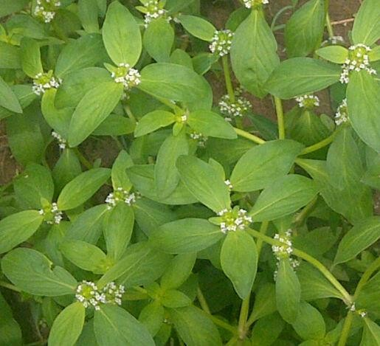

*Mitracarpus villosus* (Sw.) DC. –Family - Rubiaceae; Order – Rubiales

Previous studies revealed that the plant contains biologically active substances such as fatty acids, terpenes, flavonoids and other phenolic compounds with potential hepatoprotective, larvicidal, antifungal, antimicrobial, antinociceptive and anti- inflammatory activities (Ekpendu *et al.,* 1994; Germano *et al.,* 1999; Bisignano *et al.,* 2000; Kprou *et al.,* 2010; Makambila-Koebemba *et al*., 2011; Abdullahi *et al*., 2011). Furthermore, the pharmacognostic properties of the plant have been studied (Jegede *et al.,* 2005; Abere *et al.,* 2007) and some constituents of the volatile oil isolated and characterized (Ekpendu *et al.,* 1993). The parameters for the standardization of *Mitracarpus villosus* have been reported by Ameh *et al*, 2014.

**CHAPTERTHREE**

* 1. **MATERIALS AND METHODS**
  2. **Materials**
     1. **Drugs**

Diazepam (Valium®Roche France), Diclofenac (Norvatis India), Pentazocine

(Fortwin®Ranbaxy, India), Paracetamol (Avipol, Fidson Healthcare, Nigeria),

Flumazenil (Hameln Pharma plus gmbh, UK), Cyproheptidine(Periactin® MerkSharp

and Domme Pakistan), Atropine suphate(Martindale Pharmaceuticals, UK), Pentylenetetrazole (Sigma,USA).

* + 1. **Important equipment**

Automatic Sysmex haematology analyser (KX-21N, Sysmex) Japan, Automatic Biochemical analyser (VITROS), Dynamic Plantar aesthesiometer (base platform 37000-003, touch stimulator 37400-002)Ugo Basile S.R.L Italy, Letica hole Board (6652, Ugo Basile,No. 62294, Italy), Rotary vacuum evaporator (BiBBy RE 100, BiBBy Sterlin LTD, England), Rota rod threadmill (UgoBasile, Italy), Digital thermometer, Mouse stair case (Fabricated), Open Field arena (Fabricated), Elevated plus maze (Fabricated), Light/dark box (Fabricated).

* 1. **Methods**
     1. **Collection and preparation of plant meterials**

The aerial parts of *Mitracarpus villosus* were collected byMal. Ibrahim Muazzam and Mal Tanko Garba in the month of September 2013, around Idu in Abuja, Nigeria. The plant was

identified and authenticated by a botanist Dr. Grace Ugbabe of the Department of Medicinal Plant Research and Traditional Medicine, National Institute for Pharmaceutical Research and Development (NIPRD) Idu, Abuja. A voucher specimen (NIPRD/H/6606) was prepared and deposited for future reference.

* + 1. **Plant preparation and extraction**

The leaves were cleaned, air-dried to constant weight in an open shade away from sunlight, and then pulverized to obtain a coarse powder using a pestle and mortar. Two hundred and fifty grammes(250 g) of powdered leaf was subjected to successive soxhlet extraction using

2 litres each of hexane, ethylacetate and methanol.The solvents were removed under reduced pressure at 65oC using a rotary vacuum evaporator and the concentrates evaporated to dryness on a water bath set at 40 oC. This procedure was repeated and the extracts pooled.

* 1. **Vacuum Liquid Chromatography (VLC)**

The vacuum liquid chromatography was used to separate the ethylacetate extract of *Mitracarpus villosus* into its various fractions. Silica gel (230 - 400 mesh) was used as the stationary phase while varying solvent combinations of increasing polarity were used as the mobile phase. The dry packing method was used to pack the silica gel into the unit. The sample was prepared by dissolving 127 g of the extract in ethylacetate andadsorbedonto 150 g of silica gel in a ceramic mortar. This was allowed to dry under a slow rotating fan with continuous stirring using a glass rod, the adsorbed extract was then carefully transferred and evenly placed on the silica gel in the packed funnel and cotton wool placed on top to prevent solvent drops from distortion of the topmost layer and prevent non-uniformed drainage of the fractions. Elution of the extract was done with solvent systems of gradually increasing polarity using hexane, ethylacetate and methanol. Four hundred millilitres of each

solvent combination was used each time in the following ratios and sequence of the elution process; Hexane: ethyl acetate 100:0, 80:20, 60:40, 40:60, 20:80, 0:100; ethylacetate:

methanol 100:0, 80:20, 60:40, 40:60, 20:80, 0:100. The eluents were collected in aliquots of 50 ml in glass bottles andanalysed using thin layer chromatography (TLC). These were pooled based on their TLC profile to obtain six fractions labelled A - F.They were referred to as the primary fractions.These were subjected to biological assay (diazepam induced sleep) and the most active fraction selected for further separation by column chromatography.

* 1. **Column Chromatography (CC)**

The pooled fraction(E) obtained from the VLC process was subjected to silica gel column chromatography (CC). Silica gel (70 – 230 mesh) was used as the stationary phase while varying solvent combinations of increasing polarity were used as the mobile phase. The wet packing method was used in preparing the silica gel column. Briefly, the lower end of the glass column was packed with cotton wool using a glass rod. Slurry was made by adding one hundred grammes of silica gel to 300 ml of hexane while swirling. This was poured down carefully into the column. The tap of the glass column was left open to allow free flow of solvent into a beaker placed beneath the tap of the column. After packing the column with the silica gel, the tap was then closed and the column was left to stand overnight in order to allow proper settlement of the silica. After this period, the clear solvent on top of the silica gel was drained down to the silica gel meniscus. The sample was prepared in a ceramic mortar by adsorbing 13.74 g of fraction E to 20 g of silica gel. This was allowed to dry under a slow rotating fan with continuous stirring using a glass rod. The dry mixture was then carefully placed as a layer on top of the column and a thin layer of wool placed on top. This was done to prevent falling solvent drops from distortion of the topmost layer and prevent non-uniform drainage of the fractions. The column tap was opened to allow the eluent to flow at the rate of 40 drops per minute. Elution of the extract was done with solvent systems

of gradually increasing polarity using hexane, ethylacetate and methanol. The following ratios of solvent combinations were sequentially used in the elution process; Hexane: ethyl acetate 100:0, 90:10, 80:20, 70:30, 60:40, 50:50, 40:60, 30:70, 20:80, 10:90, 0:100 then

ethylacetate: methanol 90:10, 80:20, 70:30, 60:40, 50:50, 40:60, 30:70, 20:80, 10:90, 0:100.

Two hundred millilitres of each solvent combination was used each time. The eluents were collected in aliquots of 20 ml in glass bottles. The collected fractions were concentrated on a rotary evaporator and progress of separation monitored using thin layer chromatography (Ode *et al.,* 2011).The eluents were then pooled based on their TLC profile.They were labelled E1 – E6 and referred to as the secondary fractions. These were subjected to biological test (diazepam induced sleep) and the most active fraction was selected for further *in-vivo*pharmacological test.

Biological assay

Biological assay

Coarse powdered leaf

TLC

**Figure 3.1 Flow chart for the bioassay-guided extraction and fractionation procedure for *Mitracarpus villosus* leaf.**

E6

F

E5

**E**

E4

CC

D

E3

C

B

**E2**

A

E1

Methanolic

extract

Marc 3

Methanol

Marc 2

**Ethylacetate fraction**

VLC

Ethylacetate

Marc 1

Hexane fraction

Hexane

**Bold arrows showing steps for obtaining the active fraction (E2) of *Mitracarpus villosus*;VLC=vacuum liquid chromatography, CC = column chromatography, TLC = Thin layer chromatography**

* 1. **Preliminary Phytochemical Screening**

Theethylacetate leaf extract of *Mitracarpus villosus*, fractions E and E2 were subjected to phytochemical analysis for the presence of various constituents. They were screened for the presence of tannins, saponins, alkaloids, glycosides, flavonoids, carbohydrates, terpenes according to standard qualitative procedures as described by Trease and Evans (1989), Harbourne, (1998) and Sofowora(1993).

* + 1. **Test for Alkaloids**

The sample was prepared by adding10 ml of 1 % aqueous HCl to1 g of ethylacetate leaf exract of *Mitracarpus villosus*.This was shaken and filtered. 1 ml of each filtrate was treated with the following reagents.

Mayer’s reagent -A few drops of reagent was ml of reagent was added to 1 ml of filtrate appearance of whitish precipitate indicates presence of alkaloids.

Dragendoff’s reagent –Dragendoff’s reagent was added to 1 ml of filtrate. Formation of brick red precipitate indicates presence of alkaloids.

Wagner’s reagent – The reagent was added to 1 ml of filtrate and the colour reactions recorded. Appearance of reddish-brown precipitate indicates presence of alkaloids.

* + 1. **Test for Phenols**

Five hundred milligrammes (500 mg) of *Mitracarpus villosus*ethylacetate leaf extract was mixed with 2ml 5% ferric chloride solution. Formation of dark green colour indicates presence of phenols.

* + 1. **Test for Resins**

One hundred milligrammes of *Mitracarpus villosus*ethylacetate leaf extract was suspended in 2 ml acetic anhydride and 2 drops of concentrated tetraoxosulphate (IV) acid (H2SO4) were added. A purple colour indicates the presence of resins.

* + 1. **Test for Flavonoids (Shinoida test)**

To 0.5 gof *Mitracarpus villosus*ethylacetate leaf extract, 5 ml of ethanol was added, followed by 5 drops of concentrated hydrochloric acid and0.5 g of magnesium chips.Formation of pink colourindicated presence of flavonoids.

* + 1. **Test for Tannins (Ferric Chloride Test)**

To 100 mg of *Mitracarpus villosus*ethylacetate leaf extract, was added 4 ml of distilled water and 3 drops of 5% ferric chloride. Dirty green precipitate indicated the presence of tannins.

* + 1. **Test for saponins**

Froth test:0.5g of *Mitracarpus villosus*ethylacetate leaf extract was vigorously shaken for two minutes with 10 ml of water in a test tube. Frothing which persisted on warming for a period of 15 min was taken as an evidence for the presence of Saponins.

* + 1. **Test for Terpenes**

100 mg of*Mitracarpus villosus*ethylacetate leaf extractwasdissolved in chloroform and then 1ml of acetic anhydride was added, followed by 1 ml of concentrated sulphuric acid down the wall of the test tube to form a lower layer. The formation of a reddish – violet colouredring indicates the presence of terpenes.

* + 1. **Test for steroids(Salkowski’s test)**

100 mg of *Mitracarpus villosus*ethylacetate leaf extract was mixed in 2 ml of chloroform. Concentrated sulphuric acid was carefully added to form a lower layer. A reddish brown colouration at the interphase indicated presence of steroids in the extract whilesulphuric acid layer showed yellow.

* + 1. **Test for Carbohydrates**

2 ml of Molisch’s reagent was added to*Mitracarpus villosus*ethylacetate leaf extract and the mixture shaken. 2ml of concentrated sulphuric acid was then added and allowed to form a lower layer. A purple ring at the interface of the liquid indicated the presence of carbohydrates.

* + 1. **Test for Phlobatanins**

0.5g of extract was mixed into 2 ml of distilled water then added into 1% dilute hydrochloric acid and boiled. Formation of red precipitate indicated the presence of phlobatannins.

* + 1. **Test for cardiac glycosides**

0.5g of extract is treated with 2 ml glacial acetic acid and a drop of 5% ferric chloride added along with a few drops of concentrated sulphuric acid. Appearance of greenish-blue within 4 minutes indicates the presence of cardiac glycosides.

All the proceedures for phytochemical screening were repeated for the primary fraction E (using 0.1g for each test), and in a separate experiment, the secondary fraction E2(0.1 g) was tested forflavonoids, steroids and terpenes only.

* 1. **Animals**

Swiss albino mice (20 – 28 g) and Wistar rats (90 – 130 g) bred and maintained at the Animal Facility Centre of NIPRD were used in these studies. They were housed in standard polypropylene cages with saw dust as beddings, under ambient conditions and fed on standard feed (Capsfeed Limited, Ibadan) with access to water *ad libitum*. The mice were carried to the test room in home cages and were handled by the base of their tails at all times.

* 1. **Toxicity Studies**
     1. **Acute toxicity studies**

Mice and rats were used for this test as described by Lorke (1983) with modification by inclusion of a control group.The ethylacetate leaf extract of *Mitracarpus villosus*(MVEA) was administered orally or intraperitoneally in a single dose to healthy fasted animals in two phases. In the first phase, animals were randomly placed in four groups of 3 animals each. Group 1 was administered 10 ml/kg of 0.5 % Tween 80, group 2 received 10 mg/kg of MVEA, group 3 was given 100 mg/kg MVEAwhile group 4 was administered 1000 mg/kg of extract. The animals were observed for signs of intoxication for a period of 24h and monitored for mortality for a period of 14 days. In the second phase of the test, animals (three animals

/group) received 1600, 2900 and 5000 mg/kg of MVEA. The median lethal dose (LD50) was calculated using the following formular:

LD50= √ (D1 X D2)

Where D1 = highest dose that produced no mortality D2 = lowest dose that produced mortality

This procedure was repeated for the secondary fraction E2.

* + 1. **Subchronic toxicity studies**

Rats of both sexes were randomly assigned into four groups of control and three treatment groups (n = 10; 5 males, 5 females). The extract was freshly prepared each day and orally administered at a single daily dose of 312 mg/kg, 625 mg/kg and 1250 mg/kg of extract while the control was given the vehicle. The ethylacetate leaf extract of *Mitracarpus villosus* (MVEA) was suspended in a vehicle consisting 5 % Tween 80 in normal saline. The animals were observed on a daily basis, daily feed consumption and water intake were assessed and rats were weighed once a week for aduration of 28 days. At the end of the experiment, all animals were anaesthetized by diethyl ether inhalation and blood samples were collected by cardiac puncture in a 5 ml syringe using a 21G needle into non heparinized and EDTA– containing tubes for biochemical and haematological analysis, respectively.

* + - 1. *Effect of ethylacetate leaf extract ofMitracarpusvillosus (MVEA) on haematological indices*

The blood samples transferred into EDTA-containing tubes were evaluated for haematological parameters such as white blood cells, red blood cells (RBC), haemoglobin concentration (Hb), platelet count using the Automated Sysmex haematology analyzer (KX- 21N, Sysmex, Japan).

* + - 1. *Effect of ethylacetate leaf extractofMitracarpusvillosus (MVEA) on serum biochemical indices*

The serum was separated from non-heparinized blood and the serum biochemical parameters which include alanine amino transferase (ALT), aspartate amino transferase (AST), alkaline phosphatase (ALP), creatinine, urea, albumin, bilirubin, total protein, sodium, potassium, chloride and bicarbonate were analysed using automated biochemical analyser (VITROS DT 60 II chemistry systems).

* + - 1. *Histological studies*

All the animals were euthanized for gross pathological examination of all major internal organs. Organs such as liver, kidney, brain, lungs, spleen, stomach, small intestine, gonads were excised, blotted of blood, weighed and observed macroscopically. The relative organ weights were calculated. The organs were preserved in 10 % neutral buffered formalin. The tissues were embedded in paraffin, sectioned at approximately 5 µm, stained with hematoxylin and eosin and examined with an optical microscope (Titford, 2009).

* 1. **Pharmacological Studies**

The effect of ethylacetate leaf extract of*Mitracarpus villosus* (MVEA)was suspended in a vehicle consisting of 0.5 % Tween 80 in normal saline. All drugs and extract were freshly prepared and administered via the peritoneal route 30 min before tests were carried out.

* + 1. **Pilot studies carried out with MVX (hexane extract), MVEA (ethylacetate extract) and MVM (methanol extract) of *Mitracarpus villosus* leaf.**
       1. *Studies on diazepam induced sleeping time in mice*

In this study male mice were randomly placed into groups of 7 miceeach. The first group received vehicle (0.5 % Tween 80 in Normal Saline) and served as negative control while the other groups of mice received400 mg/kg of methanol leaf extract of *Mitracarpus villosus* (MVM), 400 mg/kg of ethylacetate leaf extract of *Mitracarpus villosus* (MVEA) and 400 mg/kg of hexane leaf extract of *Mitracarpus villosus* (MVX)respectively. Thirty minutes later, diazepam 25 mg/kg was administered through intraperitoneal route to each animal. The time of onset and duration of sleep were recorded for each mouse. The time taken to loose a righting reflex indicated the onset of sleep, while the time between the loss and recovery

of the righting reflex for each mouse was taken as the duration of sleep (Rakotonirina *et al*., 2001).

* + - 1. *Studies on hole- board (exploratory behaviour) in mice*

The apparatus used is the Letica hole board instrument with 16 equi-distant holes (1 cm diameter x 2 cm depth). Five groups consisting of 6 mice per group were given vehicle,200 mg/kg of hexane extract (MVX), 200 mg/kg of ethylacetate extract (MVEA) and 200 mg/kg of methanol extract (MVM)of *Mitracarpus villosus* leaf, and diazepam 1mg/kg*i.p*.respectively. After 30 minutes, the animalswere individually placed at the middle of the board and the number of head dips over a period of 5 min was recorded (Perez, 1998).After the 5 minute test, each mouse was returned into its home cage and the apparatus was cleaned with 70% ethyl alcohol and allowed to dry to eliminate olfactory clues before the next animal was introduced.

* + - 1. *Studies on staircase test in mice*

This method consists of placing a mouse in an enclosed staircase with five steps (2.5 cm × 10 cm × 7.5 cm). The apparatus of 45 cm in length, with the other end 12 cm and 25 cm in height was used. Mice (n=6) received vehicle which served as control, 200 mg/kg of hexane extract (MVX), 200 mg/kg of ethylacetate extract (MVEA) and 200 mg/kg of methanol extract (MVM)*Mitracarpus villosus* leaf, and diazepam 1 mg/kg*i.p*.respectively. After 30 min of treatment, each mouse was placed on the floor of the box with its back to the staircase and observed for climbing and rearing activites. The numbers of steps climbed and rearing were recorded for duration of 5 min. A step was considered to be climbed only if the mouse had placed all four paws on the step. Rearing was noted as when the mouse rose on its hind legs either on the step or against the wall to sniff the air. The number of steps descended was not counted. After each test the box and staircase were cleaned with 70 % ethanol in

order to eliminate any olfactory clues that may modify the behaviour of the next animal (Siminaid *et al*, 1984).

* + 1. *Experiment carried out using ethylacetate leaf extract of Mitracarpus villosus (MVEA)*
       1. *Functional observational Battery (FOB) screening test in mice*

Mice (n=3) were treated with single doses of vehicle (control) and ethylacetate leaf extract of *Mitracarpus villosus* at 10, 100 and 1000 mg/kg i.p. The animals were assessed forparameters that include sedation, excitement, abnormal gait, jumps, motor incoordination, loss of balance, writhes, piloerection, sniffing, scratching, respiration, aggressiveness, reaction to touch (evaluated by the animal’s flight reaction to downwards finger pressure on the hindquarters), catalepsy, analgesia(measured by pinching the tail of the animal), defeacation, salivation, lacrimation, tremors, convulsion and death were assessed at 30, 60, 120, 180 and 240 min after treatment.

* + - 1. *Hole-board (exploratory behaviour) test in mice*

Mice (n=6) were treated with the vehicle, graded doses of the extract MVEA (6.25, 12.5, 25, 50, 100, 200 and 400 mg/kg) and diazepam (0.2 and 1 mg/kg)were administered were administered*i.p*.30 minutes later, each mouse was placed at the middle of the board and the number of head dips over a period of 5 min was recorded (Perez, 1998). The apparatus was cleaned with 70% ethyl alcohol and allowed to dry to eliminate olfactory clues before the next animal was introduced.In another experiment, the effect of MVEA on head dips using the hole-board was examined in the presence of flumazenil (3 mg/kg), pentylenetrtrazole (10 mg/kg), cyproheptidine (10 mg/kg) and atropine (0.2 mg/kg).

* + - 1. *Staircase Assay in mice*

Ten groups of six mice per group were treated intraperitoneally with vehicle, MVEA at doses of 6.25, 12.5, 25, 50, 100, 200 and 400 mg/kg mg/kg, and diazepam (0.2 and 1 mg/kg) respectively. After 30 min of treatment, each mouse was placed individually on the floor of the box with its back to the staircase and then its behaviour observed. The numbers of steps climbed and rearing were recorded for 5 min (Siminaid *et al*, 1984).

* + - 1. *Open Field Test in mice*

This test was conducted using an open field apparatus which consists of a clear glass box with floor dimensions of 45 cm × 45 cm. The floor was divided by lines into 9 equal-sized squares. Mice (n=6) were treated intraperitoneally with vehicle, the extract (MVEA 6.25, 12.5, 25, 50, 100, 200 and 400 mg/kg), and diazepam (0.2 and 1 mg/kg). After 30 min of treatment, each mouse was placed in the proximal right-hand corner of the maze and allowed to explore the apparatus unobstructed for five minutes. The total numbers of horizontal line crossed were counted for 5 min which was recorded as the total locomotive activity. After each five minute test, the maze was cleaned with 70 % ethanol and allowed to dry before introduction of the next animal (Bailey and Crawley, 2009).

* + - 1. *Light/Dark Box transition test in mice*

The light/dark box used was a rectangular box of 50 × 25 × 25 cm, which was divided into 2 compartments (light and dark). Vehicle, standard (diazepam), and extract (MVEA) were administered *i.p.* (n=6). 30 min after administration, each mouse was placed individually in the illuminated part of the light/dark box with its back to the dark compartment. During the test session of 5 min, total time spent and numbers of enteries in each of the compartments were recorded (Bourin and Hascoet, 2003).

* + - 1. *Elevated Plus Maze (EPM) test in mice*

The EPM apparatus consisted of two open arms (35 × 5 cm) and two closed arms (30 × 5 cm) that extend from a common central platform (5 × 5 cm). The floor and walls of each arm were made of wood. The entire maze is elevated to a height of 50 cm above floor level as described by Lister (1987). Testing was conducted in a quiet room illuminated only by a dim light. Mice were placed in the center of the maze facing an open arm. An entry into an arm was regarded as the placement of all four paws over the line marking that area. The number of entries into and time spent on the open and closed arms were recorded during a 5 min test session 30 min post-drug/extract treatment. The maze was wiped clean with a 70 % alcohol solution and allowed to dry between trials (Lister, 1987).

* + - 1. *Diazepam induced sleep in mice*

In this study male mice were randomly placed into groups of 7 each. The first group received vehicle (0.5 % Tween 80 in Normal saline) which served as negative control while the other groups of mice received graded doses of the extract (MVEA 6.25, 12.5, 25, 50, 100, 200 and

400 mg/kg). Thirty minutes later, diazepam 25 mg/kg was administered through intraperitoneal route to each animal. The time of onset and duration of sleep were recorded for each mouse. The time of loss and regain of righting reflex for each mouse was recorded (Rakotonirina *et al*., 2001).In separateexperiment, the effect of MVEA (100, 200 and 400 mg/kg) on duration of sleep was examined in the presence of flumazenil (3 mg/kg).

* + - 1. *Rota rod Test in mice*

A rota-rod treadmill device (Ugo Basile, Italy) was used for this study. Mice were tested on slowly-moving (16 revolutions/min) rods of 5 cm diameter for 180 seconds. Only the animals that demonstrated their ability to remain on the revolving rod for 3 min were used for the test. Subsequently the animals were grouped into four (n = 6) and treated with vehicle,

extract (MVEA 100, 200 and 400 mg/kg). 30 minutes post-treatment, animals were placed on the rod at intervals of 30 minutes, up to 2 hours. If an animal failed more than once to remain on the rod for 3 minutes, it was considered to lack motor coordination (Amos *et al*., 2005).

* + - 1. *Acetic Acid-induced writhing test in mice*

In this method, the number of abdominal constriction, induced by intraperitoneal administration of dilute acetic acid (10 ml/kg of 0.6 %) was counted according to the method of Koster et al, (1959). The animals were weighed and randomised into 5 groups of 6 animals each and treated as follows: group 1 served as negative control with the animals receiving the vehicle (0.5 % Tween 80 in Normal saline), group 2 animals were administered diclofenac 25 mg/kg as reference (positive control) while groups 3 – 5 received 100, 200 and 400 mg/kg of extract MVEA respectively. A reduction in the number of abdominal writhes between control (vehicle) animals and extract treated groups was regarded as analgesic activity.

* + - 1. *Orofacial Formalin Test in mice*

In this study, 30 min after intraperitoneal administration of drugs or extract (group 1 – vehicle, group 2 - Pentazocine 40 mg/kg, group 3 – paracetamol 100 mg/kg and groups 4 to 6 (100, 200 and 400 mg/kg of extract respectively), 20 µl of 2.5 % formalin was injected into the upper lip of the mice with a 27-guage needle. The animals were placed in a plexiglass observation chamber with a mirror placed at an angle of 45o underneath the floor in order to allow an unobstructed view of the formalin injected site by the observer. All animals were brought to the test chamber 1 h prior to the experiments to adapt to the environment. The mice were observed in the

box and the time spent face-rubbing the injected area with the fore or hind paws was recorded by a chronometer. The behavioural responses were observed immediately after formalin injection for a period of 5 min and at 15 min up until 30min after injection. Two distinct nociception time are shown to be induced following formalin injection, the first 5 min represents phasic/neurogenic pain (early phase) while the second period 15 and 30 min represents tonic/inflammatory pain (late phase) (Hugo *et al*., 2013). The time spent by the animal face rubbing in the injected area with fore/hind paws was regarded as nociception (Luccarini *et al*., 2006) and a reduction in the time was considered as anti-nociception.

* + - 1. *Carageenan induced hyperalgesia in rats*

The method described by Lannitti *et al*., (2012), was followed with modification because only the mechanical response threshold was measured. This was assessed using the rat hind paw withdrawal threshold in response to mechanical stimulation using a Dynamic Plantar Aesthesiometer (Ugo Basile, Italy). Animals in group 1 received the vehicle (0.5 % Tween 80 in Normal saline), group 2 animals were administered Pentazocine 40 mg/kg and groups 3 - 5 received 100, 200 and 400 mg/kg of ethylacetate leaf extract of *Mitracarpus villosus* respectively. Each rat was placed in a clear acrylic cubicle with a metal grid floor which allows access to the underside of their paws, and animals were allowed to acclimate for 30 min before the tests were conducted. A mechanical stimulus was applied to the plantar surface of one hind paw by a stainless steel filament (0.5 mm in diameter) exerting a linearly increasing pressure. A cut-off force of 50g was pre-set to prevent tissue damage. The force (g)at which paw withdrawal occurred was automatically recorded. Each rat paw withdrawal threshold was calculated as the average of three consecutive tests

performed at 5-min intervals. This was regarded as the nociception threshold. Testing was carried out before (0 mins) and after(30, 60, 120 and 180 min) intraplanter injection of 50µl of 1% carageenan (Wani *et al*., 2012).

* + - 1. *Formalin induced inflammation test in mice*

In this study, 20 μl of freshly prepared 2 % formalin was injected into the sub-plantar region of the right hind paw of each mouse to induce oedema. The paw thickness of each animal was measured using Vernier calliper 30 min before and 30 min after drug/extract administration. Theethylacetate leaf extract of *Mitracarpus villosus* (100

- 400 mg/kg), vehicle (10 ml/kg) and standard (diclofenac 10 mg/kg) were administered 30 min before sub plantar administration of formalin; 6 animals per group were tested. The drug treatments were continued for 3 consecutive days and paw oedema measured 30 min after drug treatment on each day. Measurement of paw oedema was continued up to 6 days following formalin injection. The percentage inhibition of the oedema was calculated for each treatment group relative to control (Turner, 1965).

* + - 1. *Baker’s yeast induced pyrexia test in mice*

Basal rectal temperature of mice was measured by insertion of lubricated digital thermometer into the rectum of the animals 30 min prior and 30 min after treatment. The temperature was monitored hourly over a period of 4 h.

In another set of animals, the effect of the extract on Baker‘s yeast induced hyperthermia was investigated. This test followed the method described by Tomazetti *et al*., (2005) with modification. Rectal temperature was measured after which

animals were injected with a pyrogenic dose (0.135 g/kg, *i.p.*) of Baker‘s yeast in normal saline. Rectal temperature was recorded after 4 h and the animals that showed an increase of > 0.5 oC of rectal temperature were selected and treated intraperitoneallywith vehicle, extract (MVEA100, 200 and 400 mg/kg) andparacetamol 100 mg/kg. The temperature was measured hourly up to 4 h post treatment.

* + - 1. *Pentylenetetrazol-induced seizures in mice*

In this study, mice were divided into 4 groups (n=7) of treatment (100, 200 and 400 mg/kg extract), and 1 group of control (Tween 80 in normal saline). In the 4 treatment groups, the mice were treated (MVEA 100- 4—mg/kg *i.p.*)30 min before the administration of pentylenetetrazole PTZ (90 mg/kg i.p). The animals were observed for hind limb extension for up to 30 mins. Latency of onset to hind limb extension was recorded. The durationof seizure and number of deaths after showing tonic hind limb extension were noted. Hind-limb tonic extensions of the mice were regarded as manifestations of seizures (Swinyard *et al.,* 1989).

* + 1. **Studies carried out withprimary fraction obtained from ethylacetate leaf extract of**

***Mitracarpus villosus* (fraction E).**

Determination of effects offraction E (200 mg/kg *i.p.*) was evaluated in mice as earlier described for MVEA using;

1. Diazepam induced sleeping timein mice.
2. Staircase assay in mice.
3. Open field test.
   * 1. **Studies carried out with secondary fraction obtained from ethylacetate leaf extract of *Mitracarpus villosus*.**

Evaluationof the anxiolytic effects of E2 was carried out following the proceedures described for the extract MVEA.

1. Diazepam induced sleeping time in mice.
2. Hole-board (exploratory) test in mice.
3. Staircase assay in mice.
4. Open field test (OFT) in mice.
5. Light/dark box test in mice.
6. Elevated plus maze test in mice.
   1. **Statistical Analysis**

Results were expressed as mean ± SEM. Data were analysed using ANOVA followed by Dunnet‘s or Bonferroni‘s *post hoc* test. Repeated measures data were analysed using Split ANOVA, p<0.05 was considered as significant.

**CHAPTER FOUR**

**4.0 RESULTS**

**4.1. Plant Extraction**

*Mitracarpus villosus* leaves were successively extracted following the procedure as illustrated (Fig 3.1). The obtained extracts MVX (hexane extract), MVEA (ethylacetate extract) and MVM (methanol extract) of *Mitracarpus villosus* leaf were tested for biological activity by diazepam induced sleeping time, hole-board test and staircase test with sedation as a marker. MVEA produced more sedation compared to MVX and MVM thus was selected for further separation. Fractionation of MVEA by vacuum liquid chromatography yielded six primaryfractions (A – F). When these fractions were tested for biological activity using diazepam induced sleep fraction E was the most active fraction, therefore it was selected and additional separation by column chromatography toproduce secondary fractions E1 – E6. The percentage yields of the various extracts are reflected inTable4.1.

**Table 4.1 Percentage yield of extracts / fractions following extraction and fractionation of *Mitracarpus villosus* leaf.**

|  |  |  |  |
| --- | --- | --- | --- |
| **Name of extract** | **Colour** | **Physical Nature** | **% yield (w/w)** |
| Hexane extract (MVX) | Green | Solid | 2.10 |
| Ethylacetate fraction  (MVEA) | Green | Sticky semi-solid | 4.75 |
| Methanol fraction (MVM) | Greenish-brown | Solid | 9.56 |
| **Fractions obtained from VLC of the ethylacetate fraction (MVEA)** | | | |
| Primary fraction A | Orange | Oil | 1.9 |
| Primary fraction B | Dark green | Solid | 13.2 |
| Primary fraction C | Dark green | Solid | 4.4 |
| Primary fraction D | Black | Solid | 5.7 |
| Primary fraction E | Dark green | Semi solid | 8.2 |
| Primary fraction F | Brownish green | Solid | 1.3 |
| **Fractions obtained from CC of primary fraction E** | | | |
| Secondary fraction E1 | Pale green | Oily semi-solid | 0.51 |
| Secondary fraction E2 | Creamish-green | Solid | 12.37 |
| Secondary fraction E3 | Greenish brown | Solid | 19.94 |
| Secondary fraction E4 | Black | Semo solid | 30.93 |
| Secondary fraction E5 | Brown | Solid | 11.71 |
| Secondary fraction E6 | Brown | Solid | 1.82 |

Primary fractions obtained from vacuum liquid chromatography (VLC), secondary fraction obtained by column chromatography(CC)

* 1. **Phytochemical Analysis**

The ethylacetate leaf extract of *Mitracarpus villosus* (MVEA)tested positive for the presence of tannins, terpenes, flavonoids, phenols, resins, and carbohydrates. Steroids, Terpenes and flavonoids were detected in Fraction E, while E2 tested positive for streroids and terpenes (Table4.2).

Table4.2 Phytochemical constituents of *Mitracarpus villosus* leaf.

|  |  |  |  |  |
| --- | --- | --- | --- | --- |
|  | **Compounds tested** | **Ethylacetate extract** | **E** | **E2** |
| 1 | Steroids | + | + | + |
| 2 | Terpenes | + | + | + |
| 3 | Carbohydrate | + | − | nt |
| 4 | Saponins | − | − | nt |
| 5 | Tannins | + | − | nt |
| 6 | Flavonoid | + | + | − |
| 7 | Alkaloid | + | − | nt |
| 8 | Phlobatannins | − | − | nt |
| 9 | Cardiac glycosides | + | − | nt |
| 10 | Resins | + | − | nt |

+ = Present − = Absent nt = not tested

* 1. **Vacuum Liquid and Column Chromatography (VLC/CC)** Fractions obtained by vacuum chromatography and column chromatography were subjected to thin layer chromatography todetect the compounds present in the eluents obtained from both VLC ( A) and column chromatography (B). The ascending eluting solvent hexane:ethylacetate (3:2) was used. Aspraying reagent of methanol:sulphuric acid wasused . Visibility of the bands was aided by placingthe plate on a hot plate a 100oC heated for 5 mins. VCL provided fast elution with capacity to carry large quantity of the extract at once (127 g). Column chromatography provided additional separation. E2, a fraction derived from CC was subjected to TLC (C) to aid visualising and detection of the compouds present.

1. TLC plate of eluents obtained by Vacuum Liquid Chromatography(VLC):

H:E; 3:2

E:M; 4:1

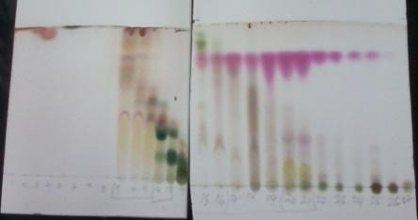

1. TLC plate of eluents (H:E 3:2) obtained byColumn Chromatography(CC):



1. TLC plate of E2 obtained byColumn Chromatography

|  |  |  |  |
| --- | --- | --- | --- |
| **Solvent system** | H:E 3:2 | H:E:M 3:2:1 | E:M 3:2 |
|  | C:\Users\Lucy\AppData\Local\Microsoft\Windows\Temporary Internet Files\Content.Word\20150625_140410.jpg | C:\Users\Lucy\AppData\Local\Microsoft\Windows\Temporary Internet Files\Content.Word\20150625_140410.jpg | C:\Users\Lucy\AppData\Local\Microsoft\Windows\Temporary Internet Files\Content.Word\20150625_140410.jpg |
| **Rf value** | 3.3 | 5.3 | 6.3 |

Plate I: Thin layer Chromatographic plates (TLC) of aliquots obtained from Vacuum liquid chromatography of ethylacetate leaf extract of *Mitracarpus villosus*(H = hexane, E = ethylacetate, M = Methanol).

* 1. **Acute toxicity studiesof ethylacetate extract of*Mitracarpus villosus* and E2 in mice and rats**
     1. **Effect of orally administered ethylacetate leaf extract of *Mitracarpus villosus*(MVEA) on behavioural responses in mice and rats.**

The animals treated with extract showed decreased activity during the first 4 h post treatment. However no adverse effects were observed during the 14 day observation period. No death was observed on oral administration (Table 4.3 andTable 4.4). Therefore, the oral LD50 in mice was estimated to be greater than 5000 mg/kg and oral LD50 in rats was also estimated to be greater than 5000 mg/kg.

**Table 4.3 Behavioural responses observed following acute oral administration of ethylacetate leaf extract of *Mitracarpus villosus* in mice**

|  |  |  |  |  |  |  |  |
| --- | --- | --- | --- | --- | --- | --- | --- |
| Behavioural response |  |  | Treatment (mg/kg) | | |  |  |
|  | Vehicle | 10 | 100 | 1000 | 1600 | 2900 | 5000 |
| Abdominal writhes | 0/3 | 0/3 | 0/3 | 0/3 | 0/3 | 0/3 | 0/3 |
| Diarrhoea | 0/3 | 0/3 | 0/3 | 0/3 | 0/3 | 0/3 | 0/3 |
| Salivation | 0/3 | 0/3 | 0/3 | 0/3 | 0/3 | 0/3 | 0/3 |
| Hyperactivity | 0/3 | 0/3 | 0/3 | 0/3 | 0/3 | 0/3 | 0/3 |
| Sedation | 0/3 | 0/3 | 1/3 | 3/3 | 3/3 | 3/3 | 3/3 |
| Lethargy | 0/3 | 0/3 | 0/3 | 3/3 | 3/3 | 3/3 | 3/3 |
| Aggression | 0/3 | 0/3 | 0/3 | 0/3 | 0/3 | 0/3 | 0/3 |
| Skin/fur changes | 0/3 | 0/3 | 0/3 | 0/3 | 0/3 | 0/3 | 0/3 |
| Respiratory changes | 0/3 | 0/3 | 0/3 | 0/3 | 0/3 | 0/3 | 0/3 |
| Tremors | 0/3 | 0/3 | 0/3 | 0/3 | 0/3 | 0/3 | 0/3 |
| Convulsion | 0/3 | 0/3 | 0/3 | 0/3 | 0/3 | 0/3 | 0/3 |
| Coma | 0/3 | 0/3 | 0/3 | 0/3 | 0/3 | 0/3 | 0/3 |
| Mortality | 0/3 | 0/3 | 0/3 | 0/3 | 0/3 | 0/3 | 0/3 |

**Table 4.4 Behavioural responses observed following acute oral administration of ethylacetate leaf extract of *Mitracarpus villosus* in rats**

|  |  |  |  |  |  |  |  |
| --- | --- | --- | --- | --- | --- | --- | --- |
| Behavioural response |  |  | Treatment (mg/kg) | | |  |  |
|  | Vehicle | 10 | 100 | 1000 | 1600 | 2900 | 5000 |
| Abdominal writhes | 0/3 | 0/3 | 0/3 | 0/3 | 0/1 | 0/1 | 0/1 |
| Diarrhoea | 0/3 | 0/3 | 0/3 | 0/3 | 0/1 | 0/1 | 0/1 |
| Salivation | 0/3 | 0/3 | 0/3 | 0/3 | 0/1 | 0/1 | 0/1 |
| Hyperactivity | 0/3 | 0/3 | 0/3 | 0/3 | 0/1 | 0/1 | 0/1 |
| Sedation | 0/3 | 0/3 | 0/3 | 3/3 | 1/1 | 1/1 | 1/1 |
| Lethargy | 0/3 | 0/3 | 0/3 | 3/3 | 1/1 | 1/1 | 1/1 |
| Aggression | 0/3 | 0/3 | 0/3 | 0/3 | 0/1 | 0/1 | 0/1 |
| Skin/fur changes | 0/3 | 0/3 | 0/3 | 0/3 | 0/1 | 0/1 | 0/1 |
| Respiratory changes | 0/3 | 0/3 | 0/3 | 0/3 | 0/1 | 0/1 | 0/1 |
| Tremors | 0/3 | 0/3 | 0/3 | 0/3 | 0/1 | 0/1 | 0/1 |
| Convulsion | 0/3 | 0/3 | 0/3 | 0/3 | 0/1 | 0/1 | 0/1 |
| Coma | 0/3 | 0/3 | 0/3 | 0/3 | 0/1 | 0/1 | 0/1 |
| Mortality | 0/3 | 0/3 | 0/3 | 0/3 | 0/1 | 0/1 | 0/1 |

* + 1. **Effect of intraperitoneal administration ofethylacetate leaf extract of**

***Mitracarpus villosus*(MVEA) and E2 in mice and rats**

Intraperitoneal administration of the extract resulted in mortalityat 1600 mg/kg. General decrease in activity was observed in treated animals.Other observations recorded during the 14days observation period are recorded (Table 4.5andTable 4.6).The intraperitoneal LD50 was calculated to be 1264.91 mg/kg for ethylacetate leaf extract of *Mitracarpus villosus* (MVEA) in both mice and ratsand the calculated LD50for the isolated fraction E2 to be was 1264.91 mg/kg (Table 4.7).

**Table 4.5 Behavioural responses observed following acute intraperitoneal administration of ethylacetate leaf extract of *Mitracarpus villosus* in mice**

|  |  |  |  |  |  |
| --- | --- | --- | --- | --- | --- |
| Behavioural response |  | Treatment (mg/kg) | | |  |
|  | Vehicle | 10 | 100 | 1000 | 1600 |
| Abdominal writhes | 0/3 | 0/3 | 0/3 | 0/3 | 0/3 |
| Diarrhoea | 0/3 | 0/3 | 0/3 | 0/3 | 0/3 |
| Salivation | 0/3 | 0/3 | 0/3 | 0/3 | 0/3 |
| Hyperactivity | 0/3 | 0/3 | 0/3 | 0/3 | 0/3 |
| Sedation | 0/3 | 0/3 | 1/3 | 3/3 | 3/3 |
| Lethargy | 0/3 | 0/3 | 0/3 | 3/3 | 3/3 |
| Aggression | 0/3 | 0/3 | 0/3 | 0/3 | 0/3 |
| Skin/fur changes | 0/3 | 0/3 | 0/3 | 0/3 | 0/3 |
| Respiratory changes | 0/3 | 0/3 | 0/3 | 0/3 | 0/3 |
| Tremors | 0/3 | 0/3 | 0/3 | 0/3 | 0/3 |
| Convulsion | 0/3 | 0/3 | 0/3 | 0/3 | 0/3 |
| Coma | 0/3 | 0/3 | 0/3 | 0/3 | 0/3 |
| Mortality | 0/3 | 0/3 | 0/3 | 0/3 | 2/3 |

**Table 4.6 Behavioural responses observed following acute intraperitoneal administration of ethylacetate leaf extract of *Mitracarpus villosus* in rats**

|  |  |  |  |  |  |
| --- | --- | --- | --- | --- | --- |
| Behavioural response |  | Treatment (mg/kg) | | |  |
|  | Vehicle | 10 | 100 | 1000 | 1600 |
| Abdominal writhes | 0/3 | 0/3 | 0/3 | 0/3 | 0/1 |
| Diarrhoea | 0/3 | 0/3 | 0/3 | 0/3 | 0/1 |
| Salivation | 0/3 | 0/3 | 0/3 | 0/3 | 0/1 |
| Hyperactivity | 0/3 | 0/3 | 0/3 | 0/3 | 0/1 |
| Sedation | 0/3 | 0/3 | 2/3 | 3/3 | 1/1 |
| Lethargy | 0/3 | 0/3 | 1/3 | 3/3 | 1/1 |
| Aggression | 0/3 | 0/3 | 0/3 | 0/3 | 0/1 |
| Skin/fur changes | 0/3 | 0/3 | 0/3 | 0/3 | − |
| Respiratory changes | 0/3 | 0/3 | 0/3 | 0/3 | 0/1 |
| Tremors | 0/3 | 0/3 | 0/3 | 0/3 | 0/1 |
| Convulsion | 0/3 | 0/3 | 0/3 | 0/3 | 0/1 |
| Coma | 0/3 | 0/3 | 0/3 | 0/3 | 0/1 |
| Mortality | 0/3 | 0/3 | 0/3 | 0/3 | 1/1 |

**Table 4.7 Acute toxicity studies of E2 fraction ofethylacetate leaf extract of *Mitracarpus villosus*following intraperitoneal administration in mice**.

|  |  |  |  |  |  |
| --- | --- | --- | --- | --- | --- |
| Behavioural response |  | Treatment (mg/kg) | | |  |
|  | Vehicle | 10 | 100 | 1000 | 1600 |
| Abdominal writhes | 0/3 | 0/3 | 0/3 | 0/3 | 0/1 |
| Diarrhoea | 0/3 | 0/3 | 0/3 | 0/3 | 0/1 |
| Salivation | 0/3 | 0/3 | 0/3 | 0/3 | 0/1 |
| Hyperactivity | 0/3 | 0/3 | 0/3 | 0/3 | 0/1 |
| Sedation | 0/3 | 0/3 | 1/3 | 3/3 | 1/1 |
| Lethargy | 0/3 | 0/3 | 1/3 | 3/3 | 1/1 |
| Aggression | 0/3 | 0/3 | 0/3 | 0/3 | 0/1 |
| Skin/fur changes | 0/3 | 0/3 | 0/3 | 0/3 | − |
| Respiratory changes | 0/3 | 0/3 | 0/3 | 0/3 | 0/1 |
| Tremors | 0/3 | 0/3 | 0/3 | 0/3 | 0/1 |
| Convulsion | 0/3 | 0/3 | 0/3 | 0/3 | 0/1 |
| Coma | 0/3 | 0/3 | 0/3 | 0/3 | 0/1 |
| Mortality | 0/3 | 0/3 | 0/3 | 0/3 | 1/1 |

* 1. **Effect of the ethylacetate leaf extract of*Mitracarpus villosus* on food consumption inrats**

In the 28 day toxicity studies, there were no significant differences between control and treated groups in the quantity of food consumed (Fig 4.1).

##### A

130

Amount of food consumed (g)

120

110

100

90

80

B

110

Amount of food consumed (g)

100

90

80

70

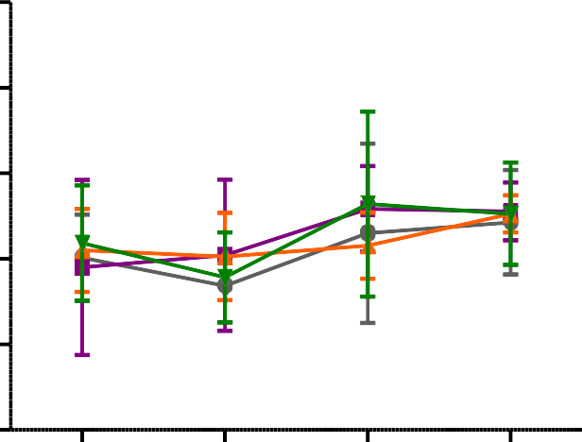

Week 1 Week 2 Week 3 Week 4

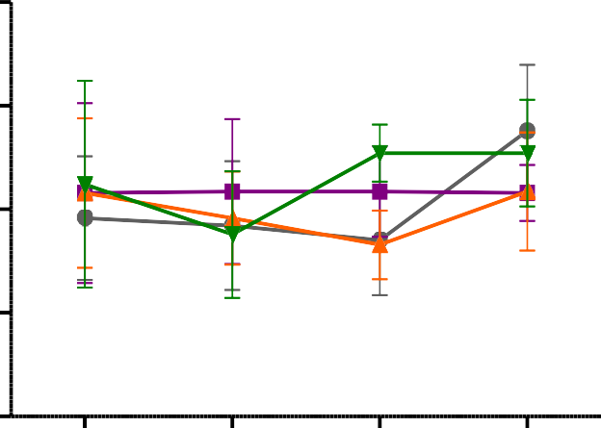

Week 1 Week 2 Week 3 Week 4

Vehicle

MVEA 312 mg/kg

MVEA 625 mg/kg

MVEA 1250 mg/kg

**Figure 4.1 Effect ofethylacetate leaf extract of *Mitracarpus villosus* on food consumption in (A)male and (B) female rats.**

Values are presented as mean ± SEM (n = 5), No significant difference between control and treated groups (Two way ANOVA followed by Bonferroni‘s *post hoc* test).

**4.6 Effect of the ethylacetate leaf extract of*Mitracarpus villosus*on water intake in rats**

After 28 days of daily administration of the extract, there was no significant change in the quantity of water taken by the animals in the treated groups when compared to control group (Fig 4.2).

A 220



Quantity of water taken (mls)

200

180

Vehicle

MVEA 312 mg/kg

MVEA 625 mg/kg

MVEA 1250 mg/kg

160

140

Week 1 Week 2 Week 3 Week 4

A 170



160

Quantity of water taken (mls)

150

140

130

week 1 Week 2 Week 3 Week 4

**Figure 4.2 Effect ofethylacetate leaf extract of *Mitracarpus villosus* on water intake in (A) male and (B) female rats.**

Values are presented as mean ± SEM (n = 5), No significant difference between control and treated groups (Two way ANOVA followed by Bonferroni‘s *post hoc* test).

**4.7 Effect of the ethylacetate leaf extract of*Mitracarpus villosus*on body weight of rats**

After 28 days of daily administration of the extract, there was no significant change in the body weight of the animals in the treated groups compared to the control group (Fig 4.3).

A240



220

Weight of Rat (g)

200

Control

MVEA 312 mg/kg

MVEA 625 mg/kg

MVEA 1250 mg/kg

180

160

140

Day 0 Day 7 Day 14 Day 21

B 200



180

Weight of Rat (g)

160

140

120

Day 0 Day 7 Day 14 Day 21

**Figure 4.3 Effect ofethylacetate leaf extract of *Mitracarpus villosus* on body weight of (A) male and (B) female rats.**

Values are presented as mean ± SEM (n = 5), No significant difference between control and treated groups (Two way ANOVA followed by Bonferroni‘s *post hoc* test).

* 1. **Effect of the ethylacetate leaf extract of *Mitracarpus villosus* on organ weight of rats**

Oral administration of the extract for 28 days caused an increase in the relative weight of the liver of rats in both maleand female rats at 1250 mg/kg. The increase however was significant (p<0.001) only in female rats (Table 4.8 andTable 4.9)

**Table 4.8 Effect of ethylacetate leaf extract of *Mitracarpus villosus* on organ weight of male rats following 28 days of oral administration**

|  |  |  |  |  |
| --- | --- | --- | --- | --- |
| **Organ** |  | **Treatment (mg/kg)** | |  |
|  | **Vehicle** | **MVEA 312** | **MVEA 625** | **MVEA 1250** |
| Stomach | 1.36 ± 0.095 | 1.50 ± 0.08 | 1.40 ± 0.18 | 1.38 ± 0.04 |
| Brain | 0.79 ± 0.13 | 0.76 ± 0.08 | 0.89 ± 0.04 | 0.90 ± 0.04 |
| Liver | 2.98 ± 0.10 | 3.13 ± 0.08 | 3.23 ± 0.17 | 3.32 ± 0.05 |
| Spleen | 0.58 ± 0.10 | 0.47 ± 0.03 | 0.43 ± 0.04 | 0.46 ± 0.04 |
| Lung | 0.83 ± 0.05 | 0.74 ± 0.54 | 0.77 ± 0.51 | 0.73 ± 0.03 |
| Small Intestine | 3.56 ± 0.05 | 0.32 ± 0.02 | 0.41 ± 0.07 | 0.31 ± 0.04 |
| Kidneys | 0.70 ± 0.04 | 0.70 ± 0.03 | 0.71 ± 0.03 | 0.76 ± 0.03 |
| Testis | 1.49 ± 0.07 | 1.58 ± 0.08 | 0.16 ± 0.02 | 1.54 ± 0.09 |
| Heart | 0.35 ± 0.01 | 0.33 ± 0.03 | 0.33 ± 0.01 | 0.36 ± 0.02 |

Values are presented as mean ± SEM (n = 5), No significant difference between control and treated groups.

**Table 4.9 Effect of ethylacetate leaf extract of *Mitracarpus villosus* on organ weight of female rats following 28 days of oral administration**

|  |  |  |  |  |
| --- | --- | --- | --- | --- |
| **Organ** |  | **Treatment (mg/kg)** | |  |
|  | **Vehicle** | **MVEA 312** | **MVEA 625** | **MVEA 1250** |
| Stomach | 1.44 ± 0.10 | 1.53 ± 0.06 | 1.46 ± 0.06 | 1.46 ± 0.05 |
| Brain | 0.84 ± 0.06 | 0.83 ± 0.06 | 0.99 ± 0.45 | 1.00 ± 0.06 |
| Liver | 2.83 ± 0.08 | 3.29± 0.04 | 3.51 ± 0.14 | 3.85 ± 0.17\* |
| Spleen | 0.42 ± 0.04 | 0.48 ± 0.06 | 0.47 ± 0.01 | 0.49 ± 0.05 |
| Lung | 0.77 ± 0.04 | 0.95 ± 0.09 | 0.84 ± 0.08 | 0.93 ± 0.08 |
| Small Intestine | 0.46 ± 0.04 | 0.40 ± 0.04 | 0.50 ± 0.05 | 0.42 ± 0.06 |
| Kidneys | 0.71 ± 0.03 | 0.72 ± 0.03 | 0.75 ± 0.07 | 0.68 ± 0.01 |
| Ovaries | 0.60 ± 0.08 | 0.62 ± 0.15 | 0.67 ± 0.13 | 0.64 ± 0.17 |
| Heart | 0.37 ± 0.03 | 0.32 ± 0.01 | 0.43 ± 0.07 | 0.36 ± 0.01 |

Values are presented as mean ± SEM (n = 5), \*P<0.05 significant when compared to control (Two way ANOVA followed by Bonferroni‘s *post hoc* test).

* 1. **Effect of the ethylacetate leaf extract of*Mitracarpus villosus* on haematological parameters of rats**

The ethylacetate extract of *Mitracarpus villosus* produced a significant (p<0.001) increase in the levels of MCV in both maleand female rats at 1250 mg/kg. The extract however did not produce any significant difference in the values of the other parameters evaluated such as red blood cells (RBC), white blood cells (WBC), haemoglobin concentration (Hb), platelet count (Plts) andpacked cellvolume (PCV) (Table 4.10 and Table 4.11).

**Table 4.10 Effect of ethylacetate leaf extract of *Mitracarpus villosus*on haematological parameters of male rats**

|  |  |  |  |  |
| --- | --- | --- | --- | --- |
| **Index** |  | **Treatment (mg/kg)** | |  |
|  | Vehicle | 312 | 625 | 1250 |
| **RBC (x 10/L)** | 5.39 ± 0.10 | 5.04 ± 0.39 | 5.36 ± 0.30 | 5.32 ± 0.46 |
| **HB (g/dL)** | 14.18 ± 0.73 | 12.80 ± 0.61 | 12.82 ± 0.75 | 14.60 ± 0.98 |
| **PCV (%)** | 37.86 ± 0.43 | 40.34 ± 1.76 | 39.26 ± 1.04 | 38.20 ± 0.64 |
| **MCV(fl)** | 58.82 ± 0.67 | 59.24 ± 0.86 | 63.00 ± 1.32 | 69.24 ± 1.99b |
| **MCH (Pg)** | 18.02 ± 0.17 | 17.10 ± 0.19 | 17 24 ± 0.30 | 17.05 ± 0.13 |
| **MCHC(g/dL)** | 28.44 ± 0.24 | 28.86 ± 0.15 | 28.50 ± 0.26 | 28 63 ± 0.27 |
| **Pllts (x100/L)** | 54.12 ± 4.85 | 58.24 ± 2.52 | 57.92 ± 1.86 | 59.13 ± 4.09 |
| **WBC (x10/L)** | 6.28 ± 0.72 | 6.46 ± 1.13 | 6.78 ± 0.31 | 7.25 ± 0.28 |
| **Neutrophils (%)** | 7.74 ± 1.44 | 9.14 ± 1.19 | 7.78 ± 1.39 | 7.13 ± 0.10 |
| **Lymphocytes (%)** | 80.90 ± 2.88 | 79.60 ± 2.53 | 80.58 ± 2.75 | 83 40 ± 1.07 |
| **Monocytes (%)** | 6.36 ± 1.15 | 5.70 ± 0.75 | 6.46 ± 0.66 | 5.05 ± 0.47 |
| **Eosinophiles (%)** | 0.32 ± 0.16 | 0.22 ± 0.07 | 0.22 ± 0.10 | 0.10 ± 0.04 |
| **Basophiles (%)** | 4.38 ± 0.89 | 5.34 ± 0.81 | 4.86 ± 1.08 | 3.98 ± 0.25 |

Values are presented as mean ± SEM (n = 5), bp<0.001 significant when compared to control. (Two way ANOVA followed by Bonferroni‘s *post hoc* test).

**Table 4.11 Effect of ethylacetate leaf extract of *Mitracarpus villosus*on haematological parameters of female rats.**

|  |  |  |  |  |
| --- | --- | --- | --- | --- |
| **Index** |  | **Treatment (mg/kg)** | |  |
|  | Vehicle | 312 | 625 | 1250 |
| **RBC (x 10/L)** | 6.16 ± 0.32 | 5.60 ± 0.19 | 5.87 ± 0.07 | 5.73 ± 0.09 |
| **HB (g/dL)** | 10.88 ± 0.45 | 10.60 ± 0.08 | 10.40 ± 0.07 | 10.48 ± 0.05 |
| **PCV (%)** | 37.50 ± 1.41 | 37.55 ± 0.71 | 37.20 ± 0.49 | 37.96 ± 0.24 |
| **MCV(fl)** | 59 03 ± 1.55 | 63.65 ± 2.30 | 64.5 ± 4.02 | 69.50 ± 1.85b |
| **MCH(Pg)** | 17.60 ± 0.21 | 18.78 ± 0.51 | 17.68 ± 0.27 | 17.52 ± 0.18 |
| **MCHC(g/dL)** | 29.78 ± 0.11 | 28.25 ± 0.34 | 28.68 ± 0.29 | 28.60 ± 0.24 |
| **Plts (x100/L)** | 50.67 ± 2.74 | 54.48 ± 3.64 | 55.40 ± 0.58 | 53.30 ± 3.29 |
| **WBC (x10/L)** | 8.10 ± 2.89 | 9.43 ± 2.23 | 7.63 ± 1.24 | 9.76 ± 0.94 |
| **Neutrophils (%)** | 9.28 ± 3.04 | 8.34 ± 1.44 | 7.70 ± 0.97 | 7.62 ± 1.10 |
| **Lymphocytes (%)** | 78.73 ± 4.16 | 79.75 ± 4.64 | 80.75 ± 3.84 | 82.66 ± 1.98 |
| **Monocytes (%)** | 6.20 ± 1.01 | 7.10 ± 2.31 | 3.40 ± 0.07 | 4.84 ± 0.55 |
| **Eosinophiles (%)** | 0.40 ± 0.15 | 0.18 ± 0.04 | 0.20 ± 0.04 | 0.16 ± 0.04 |
| **Basophiles (%)** | 5.40 ± 0.93 | 4.63 ± 1.20 | 2.95 ± 0.35 | 4.62 ± 0.76 |

Values are presented as mean ± SEM (n = 5), bp<0.001 significant when compared to control. Two way ANOVA followed by Bonferroni‘s *post hoc* test)

* 1. **Effect of the ethylacetate leaf extract of *Mitracarpus* on renal indices of wistar rats.**

The result obtained showed that the ethylacetate extract of *Mitracarpus villosus* caused no significant change in renal indices of male rats.However a significant (p<0.01) increase in the levels of serum creatinine was observed in female animals. The levels of urea, creatinine and electrolytes were comparable to the control group (Table 4.12 and 4.13).

**Table 4.12 Effect of ethylacetate leaf extract of *Mitracarpus villosus* on renal parameters of male rats.**

|  |  |  |  |  |
| --- | --- | --- | --- | --- |
| **Parameter**  **(mmol/L)** |  | **Treatment (mg/kg)** | |  |
|  | Vehicle | 312 | 625 | 1250 |
| **Sodium** | 137.60 ± 1.40 | 137.80 ± 1.62 | 138.40 ± 1.21 | 136.40 ± 0.51 |
| **Pottassium** | 10.52 ± 0.76 | 9.82 ± 0.49 | 10.38 ± 0.52 | 9.95 ± 0.51 |
| **Chloride** | 100.40 ± 0.51 | 101.20 ± 1.36 | 99.00 ± 0.63 | 100.60 ± 1.08 |
| **Bicarbonate** | 25.50 ± 1.81 | 27.00 ± 2.07 | 25.40 ± 2.11 | 26.2 ± 2.01 |
| **Urea** | 8.04 ± 0.65 | 7.20 ± 0.54 | 7.02 ± 0.42 | 7.40 ± 0.55 |
| **Creatinine** | 64.40 ± 3.31 | 69.00 ± 2.45 | 67.80 ± 3.35 | 67.75 ± 1.54 |

Values are presented as mean ± SEM (n = 5); No significant difference between control and treated groups; (Two way ANOVA followed by Bonferroni‘s *post hoc* test).

**Table 4.13 Effect ofethylacetate leaf extract of *Mitracarpus villosus* on renal indices of female rats.**

|  |  |  |  |  |
| --- | --- | --- | --- | --- |
| **Parameter**  **(mmol/L)** |  | **Treatment (mg/kg)** | |  |
|  | Vehicle | 312 | 625 | 1250 |
| **Sodium** | 139.20 ± 1.32 | 136.20 ± 1.16 | 138.20 ± 132 | 137.20 ± 2.51 |
| **Pottassium** | 6.85 ± 0.54 | 7.33 ± 0.58 | 7.00 ± 0.63 | 9.26 ± 0.35 |
| **Chloride** | 101.00 ± 1.26 | 99.40 ± 0.68 | 101.20 ± 0.20 | 100.00 ± 0.71 |
| **Bicarbonate** | 28.60 ± 1.40 | 28.00 ± 1.45 | 30.20 ± 0.20 | 30.00 ± 0.63 |
| **Urea** | 7.26 ± 0.59 | 7.60 ± 0.35 | 7.80 ± 0.61 | 8.32 ± 0.65 |
| **Creatinine** | 50.50 ± 6.59 | 62.25 ± 2.87 | 71.75 ± 8.74 | 83.60 ± 13.70a |

Values are presented as mean ± SEM (n = 5);ap<0.05 significant when compared to control. Two way ANOVA followed by Bonferroni‘s *post hoc* test)

* 1. **Effect of the ethylacetate leaf extract of *Mitracarpus villosus* on hepatic indices of wistar rats**

The results of the serum hepatic indices showed that the extract did not cause any significant change in the values of hepatic parameters when compared to the control group in male rats. However, in the female rats, an increase in the serum level of alkaline phosphatase (ALP) was observed which was significant (p<0.05) at 1250 mg/kg. Again, the level of alanine amino transferase (ALT) and aspartate amino transferase (AST) did not change significantly. Likewise the levels of the total serum proteins, albumin, direct and total bilirubin measured were not significantly affected when compared to the control (Table 4.14 andTable 4.15).

**Table 4.14 Effect of orally administered vehicle, ethylacetate leaf extract of *Mitracarpus villosus* on hepatic indices of male rats.**

|  |  |  |  |  |
| --- | --- | --- | --- | --- |
| **Parameter** |  | **Treatment (mg/kg)** | |  |
|  | Vehicle | 312 | 625 | 1250 |
| **Total Bilirubin (μmol/L)** | 28.96 ± 2.99 | 28 90 ± 1.24 | 31.16 ± 0.85 | 32.20 ± 0.46 |
| **Direct Bilirubin (μmol/L)** | 14.12 ± 0.10 | 11.40 ± 0.73 | 12.38 ± 0.80 | 13.68 ± 1.63 |
| **ALP(u/c)** | 119.88 ± 4.36 | 113.00± 1.73 | 113.00 ± 1.76 | 114.60 ± 1.96 |
| **AST (u/c)** | 9.60 ± 1.21 | 9.60 ± 0.60 | 9.20 ± 0.58 | 8.80 ± 0.58 |
| **ALT (u/c)** | 9.00 ± 0.71 | 11.20 ± 1.01 | 11.40 ± 0.87 | 11.40 ± 0.60 |
| **Total proteins (g/dl)** | 66.00 ± 2.84 | 69.60 ± 2.77 | 70.20 ± 1.96 | 67.80 ± 2.54 |
| **Albumin (g/dl)** | 42.8 ± 3.12 | 47.4 ± 2.64 | 41.6 ± 2.29 | 49.8 ± 2.58 |

Alkaline phosphatase (ALP), Aspartate aminotranferases (AST), Alanine aminotransferaces (ALT)

Values are mean ± SEM; n = 5,No significant value when compared to control (Two way ANOVA followed by Bonferroni‘s *post hoc* test).

**Table 4.15 Effect of orally administered vehicle, ethylacetate leaf extract of *Mitracarpus villosus* on hepatic indices of female rats.**

|  |  |  |  |  |
| --- | --- | --- | --- | --- |
| **Treatment (mg/kg)** | | | | |
| **Parameter** |  |  |  |  |
|  | Vehicle | 312 | 625 | 1250 |
| **Total Bilirubin (μmol/L)** | 32.35 ± 1.86 | 32.80 ± 0.53 | 31.83 ± 1.66 | 31.30 ± 1.33 |
| **Direct Bilirubin (μmol/L)** | 14.35 ± 1.37 | 13.86 ± 1.56 | 12.85 ± 1.36 | 15.12 ± 1.49 |
| **ALP(u/c)** | 115.80 ± 4.92 | 117.00 ± 4.68 | 123.20 ± 4.77 | 127.40 ± 3.26a |
| **AST (u/c)** | 13.40 ± 1.54 | 12.00 ± 2.61 | 14.80 ± 2.24 | 15.80 ± 2.97 |
| **ALT (u/c)** | 7.60 ± 0.51 | 8.60 ± 1.60 | 8.00 ± 2.07 | 8.60 ± 1.50 |
| **Total proteins (g/dl)** | 64.20 ± 2.80 | 61.00 ± 1.48 | 59.40 ± 1.74 | 61.60 ± 2.94 |
| **Albumin (g/dl)** | 41.20 ± 3.65 | 40.40 ± 3.30 | 41.00 ± 3.37 | 39.80 ± 3.09 |

Alkaline phosphatase (ALP), Aspartate aminotranferases (AST), Alanine aminotransferaces (ALT).

Values are mean ± SEM; n = 5,ap<0.05 significant when compared to control (Two way ANOVA followed by Bonferroni‘s *post hoc* test).

* 1. **Effect of the ethylacetate leaf extract of *Mitracarpus villosus* on organs of the rat following 28 days daily oral administration in rats**

Kidneys showed normal glumerulei but without epithelial lining and mild distortion of the arrangement of nuclei within the collecting duct in the 1250 mg/kg and interstitial inflammation. Repeated administration of extract caused distortion of radial arrangement of hepatocytes and enlargement of nuclei in the 1250 mg/kg treated group. However, no remarkable changes were observed in the tissues of the stomach, small intestine, spleen, lungs, heart, gonads (Plate II and Plate III).

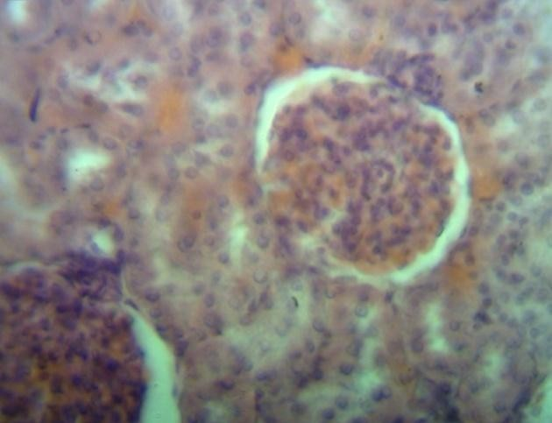 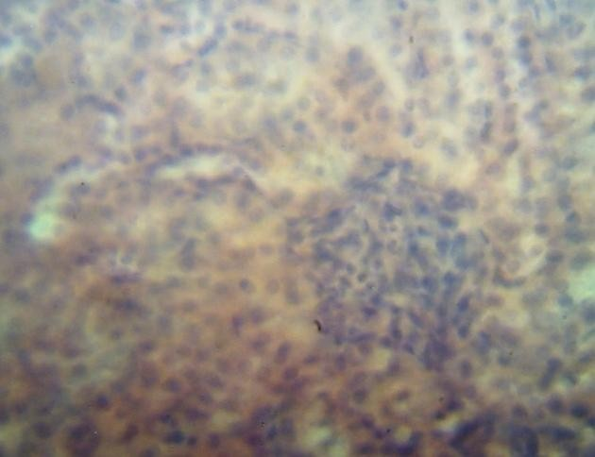

|  |  |
| --- | --- |
| A Control | B MVEA 1250 mg/kg |

Plate II Pictomicrographs of kidney sections showing A (Control) normal glumerulei and nuclei within collecting duct and B (1250 mg/kg) normal glumerulei, with absence of the epithelial lining down arrow shows distortion of the arrangement of nuclei within the collecting duct (H&E; X400).

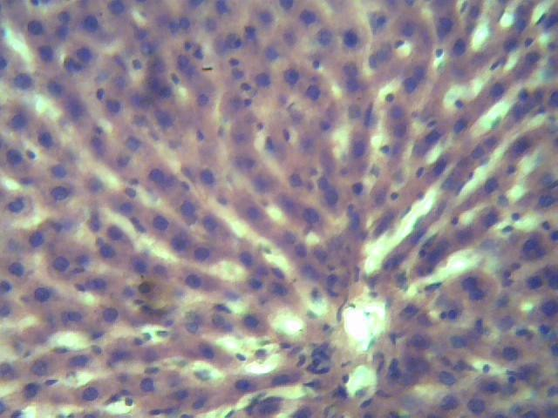 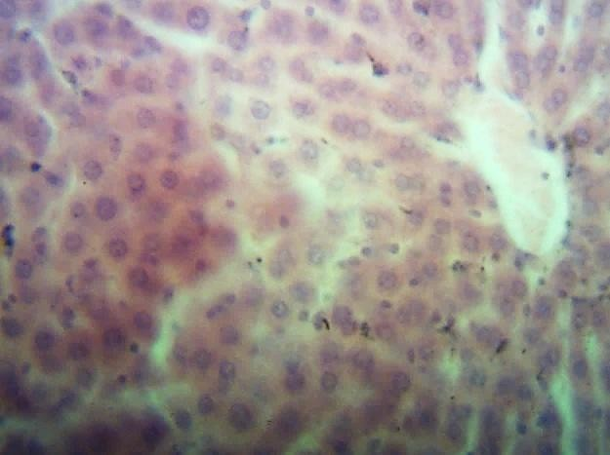

|  |  |
| --- | --- |
| A Control | B MVEA 1250 mg/kg |

Plate III Pictomicrographs of sections of the liver showing A (Control) Normal radial arrangement of hepatocyte and normal nuclei B (1250 mg/kg) revealing enlarge nuclei and distortion of the radial arrangement of hepertocyte (H&E; X400).

* 1. **Effect of hexane, ethylacetate and methanol leaf extracts of *Mitracarpus villosus* on diazepam-induced sleeping time in mice.**

The methanol (MVM) and ethylacetate (MVEA) extracts obtained from the leaf of *Mitracarpus villosus* prolonged sleeping time induced by diazepam. The effect produced by the ethylacetate extract was significantly (p<0.05) different from the control. The hexane (MVX) extract produced an effect similar to that of the vehicle which was 0.5 % Tween 80 in normal saline (Fig 4.4).

**200**

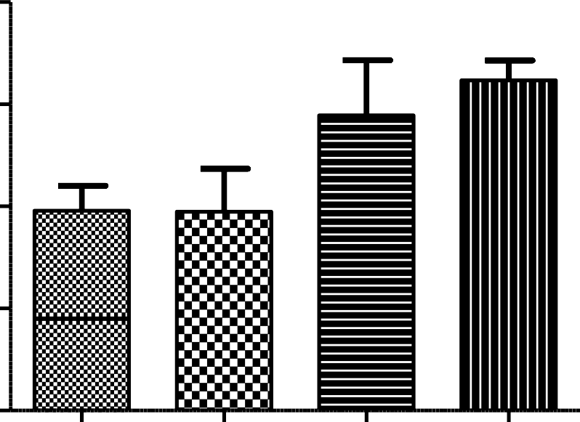

\*

**150**

Duration of Sleep (min)

###### 100

**50**

###### 0

Treatment (400 mg/kg)

**Figure 4.4 Effects of hexane (MVX), ethylacetate (MVEA) and methanolic (MVM) extracts of *Mitracarpus villosus* on diazepam induced sleep in mice.**

Values are presented as mean ± SEM (n = 7) p<0.05 significant when compared to control (One-way ANOVA followed by Dunnet‘s *post hoc*test).

* 1. **Effect of hexane, ethylacetate and methanol leaf extracts of *Mitracarpus villosus* on hole-board test inmice**

Administration of hexane (MVX),ethylacetate (MVEA) and methanol (MVM) extracts of *Mitracarpus villosus*caused decrease in the number of head dips.Ethylacetate (MVEA) and methanol (MVM) extractsproduced significant dose- dependent reduction in the number of head-dips on comparison with control. However, MVEA exhibited more reduction compared to MVM(Fig 4.5).

###### 40



b

c

c

**30**

No of head dips

###### 20

**10**

###### 0

Treatment (mg/kg)

**Figure 4.5 Effects of hexane (MVX), ethylacetate (MVEA) and methanolic (MVM) extracts of *Mitracarpus villosus* on exploratory behaviour in mice.**

Values are presented as mean ± SEM (n = 6) Values are presented as mean ± SEM (n = 6); p<0.05 vs control (One way ANOVA Dunnet‘s *post-hoc* test).

* 1. **Effect of hexane, ethylacetate and methanol leaf extracts of *Mitracarpus villosus* on staircase test in mice.**

Extracts of *Mitracarpus villosus*leaf hexane (MVX), ethylacetate (MVEA) and methanol (MVM)caused decrease in the number of steps climbed and similarly reduced rearing action in treated animals. However,ethylacetate (MVEA) produced significant reduction in both climbing and rearing effects on mice. This effect was similar to diazepam (Fig. 4.6).

30

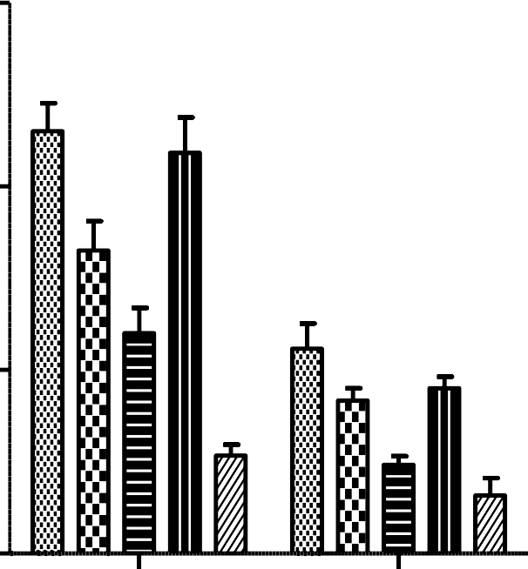

b

c

c

b

c

 Vehicle

 MVM 200 mg/kg

20 MVEA 200 mg/kg

 MVX 200 mg/kg

 Diazepam 1 mg/kg

10

0

Climbing

Rearing

**Figure 4.6 Effects of hexane (MVX), ethylacetate (MVEA) and methanolic (MVM) extracts of *Mitracarpus villosus* on climbing and rearing actions in mice.**

Values are presented as mean ± SEM (n = 6Values are presented as mean ± SEM (n = 6); p<0.05vs control (Two way ANOVA Dunnet‘s *post-hoc* test).

* 1. **Functional Observational Battery (FOB) screening studies in mice** Following administration of the extract, increased activity was noted at 10 mg/kg but generalized reduction of activity was observed in mice treated with 100 and 1000 mg/kg up to 4 h after treatment. There was no loss of balance, change of gait or catalepsy. Tremors, convulsion and death were not recorded. However analgesia was observed in animals given 1000 mg/kg. Jumps, defeacation and abdominal writhing were observed. All animals were reactive to touch (Table4.16).

**Table 4.16 Effect ofethylacetate leaf extract of *Mitracarpus villosus* on behavioural responses and mortality in mice using modified functional observation battery (FOB) test.**

|  |  |  |  |  |  |  |  |  |  |  |  |  |  |  |  |  |  |  |  |  |
| --- | --- | --- | --- | --- | --- | --- | --- | --- | --- | --- | --- | --- | --- | --- | --- | --- | --- | --- | --- | --- |
| **Dose (mg/kg)** | **Vehicle** | | | | | **MVEA 10** | | | | | **MVEA 100** | | | | | **MVEA 1000** | | | | |
| Time (min) | 30 | 60 | 2h | 3h | 4h | 30 | 60 | 2h | 3h | 4h | 30 | 60 | 2h | 3h | 4h | 30 | 60 | 2h | 3h | 4h |
| Lethality | - | - | - | - | - | - | - | - | - | - | - | - | - | - | - | - | - | - | - | - |
| Convulsion | - | - | - | - | - | - | - | - | - | - | - | - | - | - | - | - | - | - | - | - |
| Tremors | - | - | - | - | - | - | - | - | - | - | - | - | - | - | - | - | - | - | - | - |
| Sedation | - | - | - | - | - | - | - | - | - | - | 3/3 | 3/3 | 3/3 | 3/3 | - | - | 3/3 | 3/3 | 3/3 | 3/3 |
| Excitement | - | - | - | - | - | 3/3 | 2/3 | 2/3 | 1/3 | - | - | - | - | - | - | - | - | - | - | - |
| Abnormal gait | - | - | - | - | - | - | - | - | - | - | - | - | - | - | - | - | - | - | - | - |
| Jumps | - | - | - | - | - | 1/3 | 1/3 | - | - | - | - | - | - | - | - | - | - | - | - | - |
| Motor incoordination | - | - | - | - | - | - | - | - | - | - | - | - | - | - | - | - | - | - | - | - |
| Loss of balance | - | - | - | - | - | - | - | - | - | - | - | - | - | - | - | - | - | - | - | - |
| Writhes | - | - | - | - | - | - | - | - | - | - | - | - | - | - | - | 1/3 | - | - | - | - |
| Piloerection | - | - | - | - | - | - | - | - | - | - | - | - | - | - | - | - | - | - | - | - |
| Stereotypy | - | - | - | - | - | - | - | - | - | - | - | - | - | - | - | - | - | - | - | - |
| Respiration | - | - | - | - | - | - | - | - | - | - | - | - | - | - | - | - | - | - | - | - |
| Aggression | - | - | - | - | - | - | - | - | - | - | - | - | - | - | - | - | - | - | - | - |
| Reaction to touch | 3/3 | 3/3 | 3/3 | 3/3 | 3/3 | 3/3 | 3/3 | 3/3 | 3/3 | 3/3 | 3/3 | 3/3 | 3/3 | 3/3 | 3/3 | 3/3 | 1/3 | 1/3 | 2/3 | 2/3 |
| Catalepsy | - | - | - | - | - | - | - | - | - | - | - | - | - | - | - | - | - | - | - | - |
| Analgesia | - | - | - | - | - | - | - | - | - | - | - | 2/3 | 3/3 | 1/3 | - | 3/3 | 3/3 | 3/3 | 2/3 | 1/3 |
| Defeacation | 1/3 | - | 1/3 | - | - | 1/3 | - | - | 1/3 | - | - | - | - | - | 1/3 | - | - | - | - | 1/3 |
| Salivation | - | - | - | - | - | - | - | - | - | - | - | - | - | - | - | - | - | - | - | - |

* 1. **Effect of theethylacetate leaf extract of *Mitracarpus villosus* on hole-board (exploratory behaviour) studies in mice**

Graded doses (6.25 – 25 mg/kg) of the ethylacetate extract of *Mitracarpus villosus*producedan increase in the number of exploratory head dips and doses of 100

– 400 mg/kg produced a dose-dependent reduction in the number of head-dips, which was significant(p<0.001) at 200 – 400 mg/kgwhen compared to the control. Diazepam at 0.2 mg/kg produced an increase in the frequency of head-dips while 1 mg/kg exhibited reduction in the number of head dips(Fig 4.7).

4 0



b

b

a

b

c

3 0

N o o f h e a d d ip s

2 0

1 0

0

##### \_ \_ \_ \_ \_ \_ \_ \_ \_ \_ \_ \_ \_ \_ \_ \_ \_

M V E A

T r e a tm e n t ( m g / k g )

**Figure 4.7 Effect of ethylacetate leaf extract of *Mitracarpus villosus* on Hole- board (exploratory behaviour) in mice.**

Values are presented as mean ± SEM (n = 6); ap<0.05, bp<0.001, cp<0.0001 vs control (One way ANOVA Dunnet‘s *post-hoc* test).

* 1. **Effect of the ethylacetate leaf extract of *Mitracarpus villosus* on staircase assay in mice**

Graded doses (6.25 – 12.5 mg/kg) of the ethylacetate extract produced an increase in number of stepsand rearing activities of mice while decrease of both steps climbed and rearing on the hind legs was observed at 200 – 400 mg/kg. These were dose- dependent and significant (p<0.05) when compared to the control group. Diazepam (1 mg/kg) reduced both the number of steps climbed and rearing but at 0.2 mg/kg an increase in climbing was observed while rearing activities were decreased significantly(p<0.001) (Fig 4.8; A and B).

**5 0**

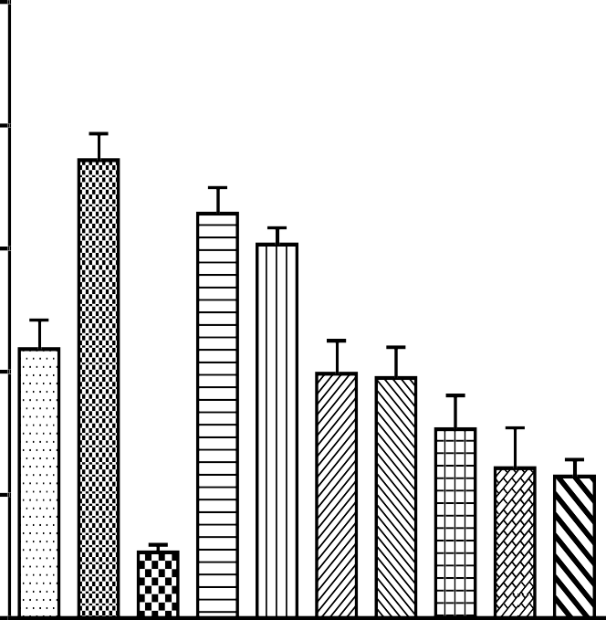

c

b

a

a

c

A

**4 0**

C o n tr o l 1 0 m l/k g

N o o f s te p s c lim b e d

**3 0**

D ia z e p a m 0 . 2 m g / k g D ia z e p a m 0 . 2 m g / k g

**2 0**

**1 0**

**0**

T r e a tm e n t ( m g / k g )

M V E A 6 . 2 5 m g / k g M V E A 1 2 . 5 m g / k g M V E A 2 5 m g / k g

M V E A 5 0 m g / k g M V E A 1 0 0 m g / k g M V E A 2 0 0 m g /k g M V E A 4 0 0 m g /k g

3 0

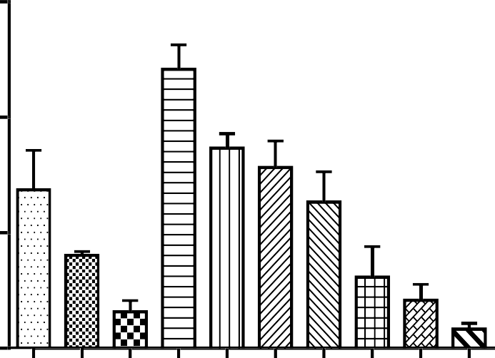

b

a

a

b

c

B

2 0

N o o f r e a r in g

1 0

0

T re a tm e n t ( m g / k g )

**Figure 4.8 Effect ofethylacetate leaf extract of *Mitracarpus villosus* on stepclimbing (A) and rearing (B) activity usingStaircase assay in mice.**

Values are presented as mean ± SEM (n = 6); p< 0.05 vs control (One- way ANOVA Dunnett‘s *post hoc* test).

* 1. **Effects of the ethylacetate leaf extract of *Mitracarpus villosus* on the Open Field Test in mice**

Mice treated acutely with *M. villosus*leaf extract showed increased activity. The number of squares crossed at the periphery was increased at 6.25 – 12 mg/kg, number of central squares was increased at 6.25 – 25 mg/kg and likewise increased rearing activities were recorded at 6.25 – 12.5 mg/kg. However general decreases of these parameters were shown at 100 – 400 mg/kg. Effects on peripheral squares crossed were significant (P<0.0001) and dose-dependent compared with the control, whereas increased number of central squares crossed were dose-independent(Fig 4.9, 4.10 and 4.11).

A 1 5 0

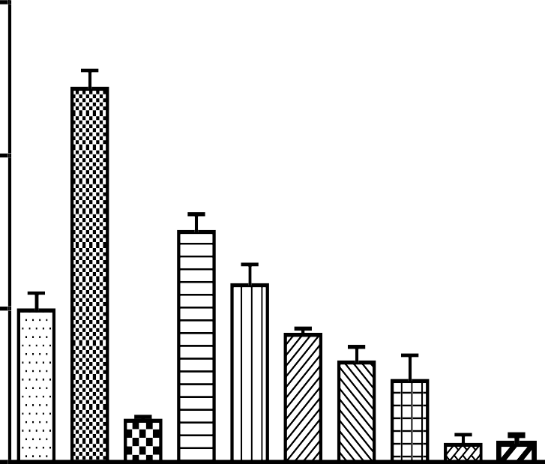

c

a

a

c

c

c

N o o f p e r ip h e r a l s q u a r e s c r o s s e d

1 0 0

5 0

0

\_ \_ \_ \_ \_ \_ \_ \_ \_ \_ \_ \_ \_ \_ \_ \_ \_ \_ \_

M V E A

T r e a tm e n t ( m g / k g )

**Figure 4.9 Effect ofethylacetate leaf extract of *Mitracarpus villosus* on locomotion using the Open Field Test in mice.**

Values are presented as mean ± SEM (n = 6); p< 0.05 vs control (One- way ANOVA Dunnett‘s *post hoc* test).

1 0

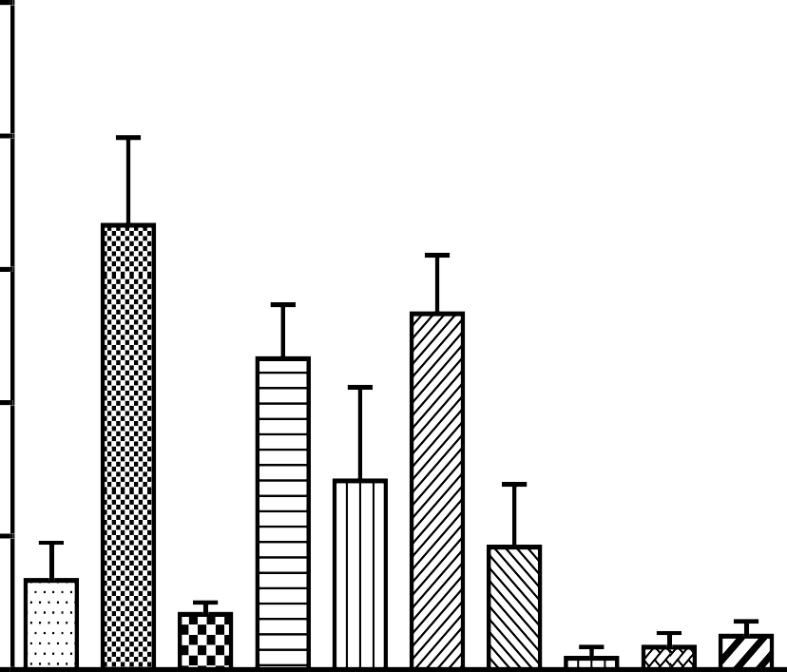

c

c

a

a

B

8

N o o f c e n tr a l s q u a r e s c r o s s e d

6

4

2

0

T r e a tm e n t ( m g / k g )

**Figure 4.10 Effect ofethylacetate leaf extract of *Mitracarpus villosus*on central square crossings using theOpen Field Test in mice**

Values are presented as mean ± SEM (n = 6); p< 0.05 vs control (One- way ANOVA Dunnett‘s *post hoc* test).

C 2 5



a

b

c

c

2 0

1 5

N o o f r e a r in g

1 0

5

0

#### \_ \_ \_ \_ \_ \_ \_ \_ \_ \_ \_ \_ \_ \_ \_ \_ \_ \_ \_

M V E A

T r e a tm e n t ( m g / k g )

**Figure4.11 Effect of ethylacetate leaf extract of *Mitracarpus villosus*, diazepam (Dz), control (ctrl) on rearing activity using Open Field.**

Values are presented as mean ± SEM (n = 6); p< 0.05 vs control (One- way ANOVA Dunnett‘s *post hoc* test).

* 1. **Effect ofethylacetate leaf extract of *Mitracarpus villosus* on light dark box test in mice**

MVEA produced dose dependent increase in the cumulative time spent in the lit areaand similarly increased the number of transitions between the light and dark compartments. The effect on time spent in the light area is significant (p<0.001) on comparison with control. However, the effect on number of transitions was not significantly different from control. Diazepam (0.2 mg/kg) produced a significant (p<0.001) effect of both increased duration in the lit area and increased transition times (Fig 4.12 and4.13).

## 400

A

## 300

T i m e s p e n t ( s e c )

Control

Diazepam 0.2 m g/kg M VEA 6.25 m g/kg



c c c b

a

a a

b a b

## 200

M VEA 12.5 m g/kg M VEA 25 m g/kg

## 100

M VEA 50 m g/kg M VEA100 m g/kg

## 0

Light A rea

## Dark A rea

M VEA 200 m g/kg M VEA 400 m g/kg

## T rea tm e nt (m g/kg )

**Figure 4.12 Effect ofethylacetate leaf extract of *Mitracarpus villosus*(MVEA) on timespent in lit/dark area in the light/dark box transition test in mice.**

Values are presented as mean ± SEM (n = 6); p< 0.05 vs control (Two-way ANOVA followed by Bonferroni *post-hoc* test).

**8**

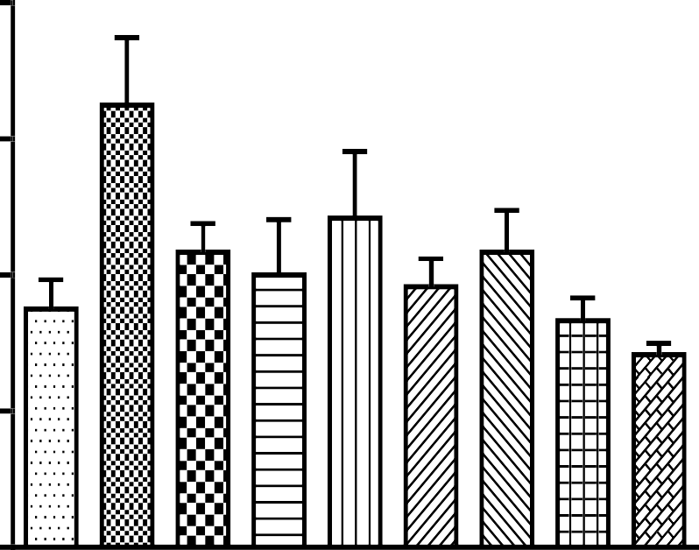

a

**6**

**4**

N o o f e n te r ie s

**2**

**0**

\_ \_ \_ \_ \_ \_ \_ \_ \_ \_ \_ \_ \_ \_ \_ \_ \_ \_ \_ \_

M V E A

T r e a tm e n t ( m g / k g )

**Figure 4.13 Effect of ethylacetate leaf extract of *Mitracarpus villosus* (MVEA) on number of transition between compartments in the light/dark box transition test in mice.**

Values are presented as mean ± SEM (n = 6); ap<0.05, vs control (Two-wayANOVA followed by Bonferroni *post-hoc* test).

* 1. **Effect ofethylacetate leaf extract of *Mitracarpus villosus* on elevated plus maze (EPM) in mice**

MVEA significantly (p<0.001)and dose dependently increased the cumulative period spent in the open arm relative to control. Diazepam (0.2 mg/kg) significantly(p<0.05) increased time spent in open arm. The total numbers of entries into the open arms were increased in similar manner in extract and diazepam treated groups (Fig 4.14 and4.15).

# A

**300**

**200**

T i m e s p e n t ( s )

**100**

**0**

**O p e n C lo se**

 C o n tro l

 D ia z e p a m 0 .2 m g /k g  M V E A 6 .2 5 m g /k g  M V E A 1 2 .5 m g /k g  M V E A 2 5 m g /k g

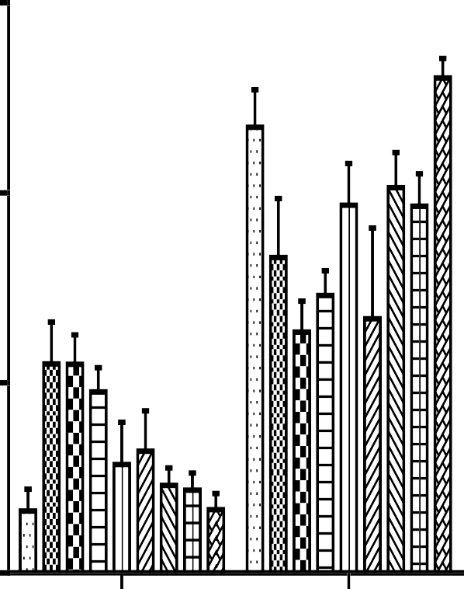

a

b

a

c

b a

 M V E A 5 0 m g /k g  M V E A 1 0 0 m g /k g

 M V E A 2 0 0 m g /k g  M V E A 4 0 0 m g /k g

**Figure 4.14 Effect ofethylacetate leaf extract of *Mitracarpus villosus*(MVEA) on time spent in arms in the elevated plus maze.**

Values are presented as mean ± SEM (n = 6);p<0.05vs control (two- way ANOVA Bonferroni post-hoc test

B

20



b

a a

a

a

a

a

C o n tro l

D ia z e p a m 1

15

D ia z e p a m 0 .2

N o o f e n t e r i e s

M V E A 6 .2 5

10 M V E A 1 2 .5

M V E A 5 0

5 M V E A 1 0 0

0

O pen

A rm

C los ed A rm

M V E A 2 0 0

M V E A 4 0 0

T re a tm e n t (m g /k g )

**Figure 4.15 Effect of ethylacetate leaf extract of *Mitracarpus villosus* (MVEA) on number of enteries into armsby mice in the elevated plus maze.**

Values are presented as mean ± SEM (n = 6); p< 0.05 vs control (Two-way ANOVA, Bonferroni *posthoc* test).

* 1. **Effect of ethylacetate leaf extract of *Mitracarpus villosus*on diazepam- induced sleeping time in mice**

Ethylacetate extractproduced no significant difference in the time of onset of sleep in animals treated with the extract. However, graded doses (100 – 400 mg/kg) prolonged the duration of diazepam-induced sleep in mice dose-dependently. The duration of sleep was increased from 110.43 ± 21.93 in the control group to 274.86 ± 28.49 at 400 mg/kg of extract. The effect of the extract on duration of sleep was significant (*P* < 0.001) at 400mg/kg when compared to that of control(Fig 4.16).

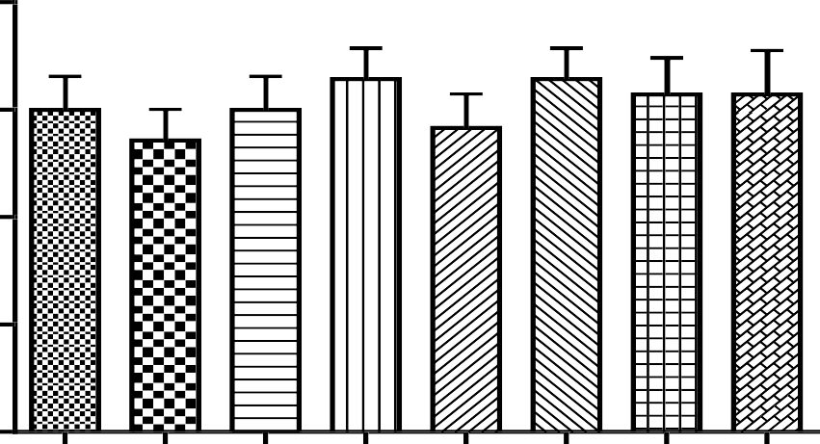4

A

3

O n s e t o f s le e p ( m in s )

2

1

0

T r e a tm e n t ( M V E A m g /k g )

4 0 0

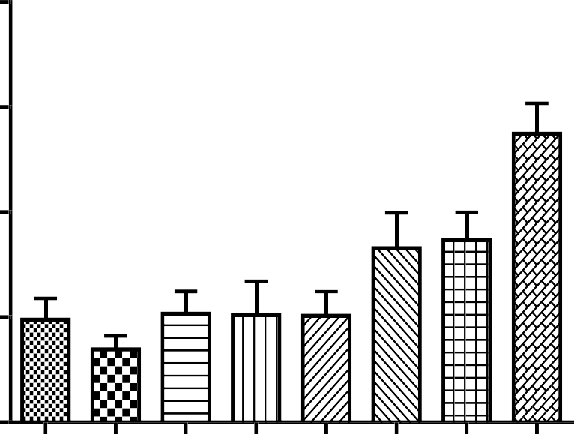

c

B

3 0 0

D u ra tio n o f S le e p ( m in )

2 0 0

1 0 0

0

T re a tm e n t (M V E A m g /k g )

**Figure 4.16 Effect ofethylacetate leaf extract of *Mitracarpus villosus* on onset of sleep (A) and duration of sleep (B) of diazepam-inducedsleeping time in mice.**

Values are presented as mean ± SEM (n = 7); p<0.01 vs control (one- way ANOVA followed by Dunnett‘s *post-hoc* test).

* 1. **Effect of flumazenil on the actions of the ethylacetate leaf extract of *M. villosus* (MVEA) on diazepam induced sleeping time in mice**

Treatment of mice with MVEA caused a dose related increase in sleeping time induced by the extract; however pre-treatment with flumazenil reversed this effect (Fig 4.17).

250

b

c

c

c

200

Duration of sleep (mins)

150

100

50

0

\_\_\_\_\_\_\_\_\_\_\_\_\_\_\_\_\_\_\_\_\_\_\_\_\_\_\_\_\_\_\_\_\_\_\_\_\_\_\_\_\_\_

Diazepam 25

Treatment (mg/kg)

**Figure 4.17 Effect of Flumazenil (flum 3 mg/kg) on the actions of the ethylacetate leaf extract of *M. villosus* (MVEA) on diazepam induced sleeping time in mice.**

Data are expressed as values ± SEM n=7; bp< 0.01 vz vehicle;

cp<0.001 vs flumazenil (One way ANOVA Bonferroni‘s *post hoc*).

* 1. **Effect of flumazenil, pentylenetetrazole, cyproheptidine and atropine on the actions of theethylacetate leaf extract of *Mitracarpus villosus* using the hole-board test in mice**

Administration of cyproheptidine and atropine revealed that the effect of the extract was not affected by these agents. However flumazenil and pentylenetetrazole caused a significant decrease in exploratory head-dips (Fig 4.18).

30

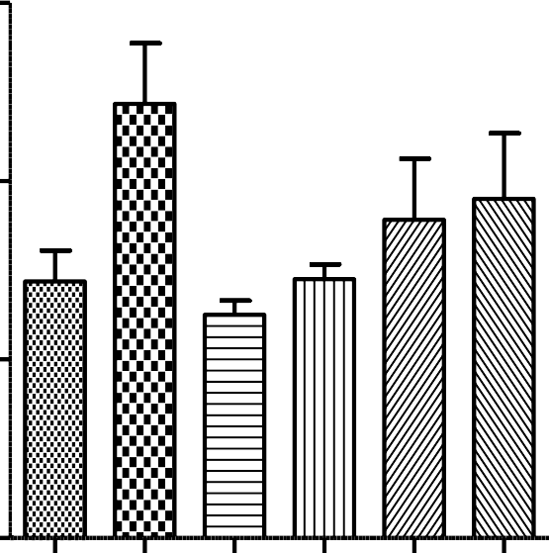

a

Vehicle 10 ml/kg

MVEA 6.25 mg/kg

20 Flumazenil 3 mg/kg

No of head dips

Pentylenetetrazole 10 mg/kg

Cyproheptidine 10 mg/kg

10 Atropine 0.2 mg/kg

0

\_\_\_\_\_\_\_\_\_\_\_\_\_\_\_\_\_\_\_\_\_\_\_\_\_\_\_\_\_ MVEA 6.25 mg/kg

**Figure 4.18 Effect of Flumazenil (FLUM 3 mg/kg), pentylenetetrazole (PTZ 10 mg/kg), cyproheptidine (Cypro 10 mg/kg) and atropine (ATR 0.2 mg/kg) on the actions of the ethylacetate extract of *M. villosus* in mice using the hole-board test.**

Data expressed as values ± SEM n=6; p< 0.05 significant to control(One way ANOVA followed by Dunnet‘s *post hoc* test).

* 1. **Effect of the ethylacetate leaf extract of*Mitracarpus villosus* onmotor co- ordination (rota rod) test in mice**

The extract (100 – 400 mg/kg *i.p*.) did not reveal significant effect on the rota-rod performance of the mice as all the animals stayed on the rod for 180 sec without falling off the rods (Table 4.17).

**Table4.17 Effect ofethylacetate leaf extract of *Mitracarpus villosus* on motor co-ordination (Rota-rod) test in mice.**

|  |  |  |  |  |  |  |  |  |
| --- | --- | --- | --- | --- | --- | --- | --- | --- |
| **Treatment** |  |  | **Post Treatment (min)** | | |  |  |  |
|  | **30** |  | **60** |  | **90** |  | **120** |  |
|  | Time on rod | Fail.  % | Time on rod | Fail.  % | Time on rod | Fail.  % | Time on rod | Fail. % |
| Vehicle | >180.0±0.0 | 0.0 | >180.0±0.0 | 0.0 | >180.0±0.0 | 0.0 | >180.0±0.0 | 0.0  0.0 |
| 100 mg/kg | >180.0±0.0 | 0.0 | >180.0±0.0 | 0.0 | >180.0±0.0 | 0.0 | >180.0±0.0 |
| 200 mg/kg | >180.0±0.0 | 0.0 | >180.0±0.0 | 0.0 | >180.0±0.0 | 0.0 | >180.0±0.0 | 0.0 |
| 400 mg/kg | >180.0±0.0 | 0.0 | >180.0±0.0 | 0.0 | >180.0±0.0 | 0.0 | >180.0±0.0 | 0.0 |

Results were presented as mean ± SEM (n=6). No significant difference between control and treated groups.

* 1. **Effect of the ethyl acetate leaf extract of *Mitracarpus villosus*on acetic acid induced abdominal writhing in mice**

Graded doses (100 - 400 mg/kg; i.p.) of the ethyl acetate extract of *Mitracarpus villosus* showed a significant (p<0.05) and dose dependent decrease in the number of abdominal writhes induced by acetic acid. Diclofenacalso significantly decreased the number of abdominal writhes (Fig 4.19).

# 50

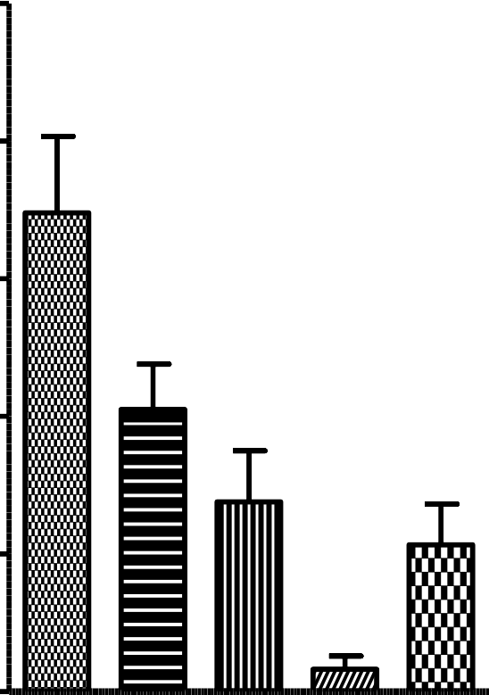

a

b

c

c

Vehicle 10 ml/kg

40 MVEA 100 mg/kg

 MVEA 200 mg/kg

No of wriths

30 MVEA 400 mg/kg

# Diclofenac 25 mg/kg

20

# 10

0

# Treatment (mg/kg)

**Figure 4.19 Effect of ethylacetate leaf extract of *Mitracarpus villosus* on acetic acid induced abdominal writhing in mice.**

Values are presented as mean ± SEM (n = 6);p<0.05 significant when compared to control (One-way ANOVA followed by Dunnet‘s *post hoc* test).

* 1. **Effects of the ethylacetate leaf extract of*Mitracarpus villosus* on oro-facial formalin test in mice**

The administration of extract of *Mitracarpus villosus* produced a decrease in the face rubbing behavioural response induced by formalin.The graded doses (100 – 400 mg/kg) produced a significant (p< 0.01), dose dependent reduction in time in both early (phase 1) and late (phase 2) phases of pain when compared to control (vehicle). Pentazocine reduced the face rubbing time significantly (p<0.01) in both phases. Paracetamol however produced significant decrease in the face rubbing period in phase one (Fig 4.20; A andB).

A

150

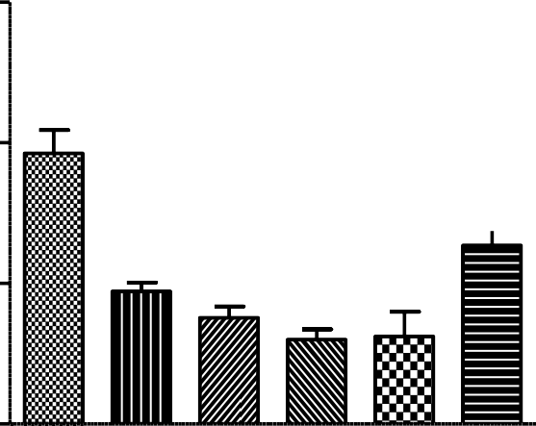

b

c

c

c

c

Face rubbing time (secs)

100

50

Phase 1

 Vehicle 10 ml/kg  MVEA100 mg/kg  MVEA 200 mg/kg

 MVEA 400 mg/kg

 Pentazocine 40 mg/kg

 Paracetamol 100 mg/kg

0

Treatment (mg/kg)

B 500

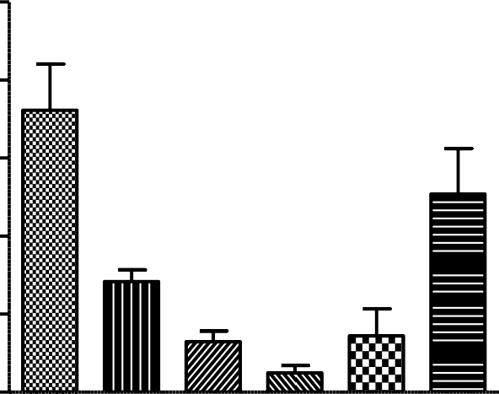

b

c

c

c

400

Face rubbing time (secs)

300

200

100

Phase 2

 Vehicle 10 ml/kg

 MVEA 100 mg/kg

 MVEA 200 mg/kg

 MVEA 400 mg/kg

 Pentazocine 40 mg/kg

 Paracetamol 100 mg/kg

0

Treatment (mg/kg)

**Figure 4.20 Effect of ethylacetate leaf extract of *Mitracarpus villosus* on oro- facial formalin induced pain in mice; A represents early phase; B represents late phase.**

Values are presented as mean ± SEM (n = 6) bp<0.001, cp<0.01 significant when compared to control (Oneway ANOVA followed by Dunnet‘s *post hoc* test).

* 1. **Effects of the ethylacetate leaf extract of *Mitracarpus villosus***

**oncarageenaninduced hyperalgesia in rats**

Administration of extract of *Mitracarpus villosus* significantly (p<0.05) increased the mechanical withdrawal threshold of the hind paws compared to control. No statistical significant difference was detected between the groups treated with 100 mg/kg. At 400mg/kg the withdrawal threshold was increased by 54.52 % compared to the vehicle at 180 min (Fig 4.21).

8



c

a

b

b

b

a

Vehicle 10 ml/kg

Pentazocine 40 mg/kg

Withdrawal Threshold (g)

6 MVEA 100 mg/kg

MVEA 200 mg/kg

4 MVEA 400 mg/kg

2

0

0 50 100 150 200

Time (mins)

**Figure 4.21 Effect ofethylacetate leaf extract of *Mitracarpus villosus* on Carageenan induced hyperalgesia in rats.**

Values are presented as mean ± SEM (n = 6);p<0.05, significant when compared to control (Two way ANOVE followed by Bonferroni‘s *post hoc* test).

* 1. **Effects of ethylacetate leaf extract of *Mitracarpus villosus*on formalin inducedpaw oedema in mice**

The ethylacetate leaf extract of *Mitracarpus villosus* produced a reduction of paw thickness which was significant (p<0.001) at 400mg/kg on day 3 of treatment. The standard diclofenac show significant (0.001) reduction in paw oedema when compared to control values (Fig 4.22).

0.5



a

b

c

c

c

c

c

c

b

c c

c

Mean Paw Thickness (cm)

0.4

0.3

0.2

#### Vehicle 10 ml/kg

MVEA 100 mg/kg

#### MVEA 200 mg/kg

 MVEA 400 mg/kg

Diclofenac 10 mg/kg

0.1

0.0

0. 1. 2. 3. 4. 5. 6.

Time (Days)

**Figure 4.22 Effect ethylacetate leaf extract of *Mitracarpus villosus* on formalin induced paw oedema in mice.**

Values are presented as mean ± SEM (n = 6); ap<0.05, bp<0.01, cp<0.001 significant when compared to control (Two way ANOVA followed by Bonferroni‘s *post hoc* test).

* 1. **Effect of ethylacetate leaf extract of*Mitracarpus villosus* on core body temperature of mice**

The extract caused a reduction in normal rectal body temperature. Yeast caused an increase in body temperature 4 h after its administration, however this effect was significantly (p<0.05) reduced by the extract from 38.13 ± 0.24 to 36.21 ± 0.26 oC at 400 mg/kg (Fig 4.23 A, B).

A

**40**

Vehicle 10 ml/kg

MVEA 100 mg/kg

Body temperature oC

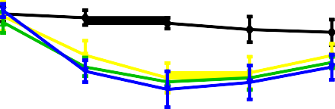**38** MVEA 200 mg/kg

MVEA 400 mg/kg

**36**



**0 1 2 3 4**

Time (h)

B

42

Vehicle 10 ml/kg

Body temperature oC

40 Paracetamol 100 mgkg

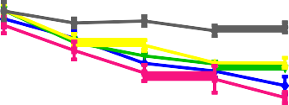MVEA100 mg/kg

38 MVEA 200 mg/kg

36 MVEA 400 mg/kg

34

32



0 1 2 3 4

Time post - treatment (h)

**Figure 4.23 Effect ofethylacetate leaf extract of *Mitracarpus villosus* on**

1. **normal bodytemperature and (B) effect on Yeast induced pyrexia in mice**

Values are presented as mean ± SEM (n = 6);p<0.05 significant when compared to control; (Two way ANOVA, followed by Bonferroni‘s *post hoc* test)

* 1. **Effect of the ethylacetate leaf extract of*Mitracarpus villosus* on pentylenetetrazole induced convulsion in mice**

The results obtained showed that ethylacetate extract of *Mitracarpus villosus* did not provide protection against pentylenetetrazole induced convulsion. There was no significant difference in the duration of seizure between the control and treated groups. There was 100 % mortality in extract treated animals, however no mortality was recorded in the diazepam treated group (Table 4.18).

**Table 4.18 Effect ofethylacetate leaf extract of *Mitracarpus villosus*on pentylenetetrazole induced convulsion in mice.**

|  |  |  |  |
| --- | --- | --- | --- |
| Treatment (mg/kg) | Latency to seizure(s) | Duration of seizure (s) | Mortality |
| Vehicle | 218.29 ± 33 28 | 413.00 ± 23.08 | 7/7 |
| MVEA 100 | 222.86 ± 31.30 | 408.14 ± 37.64 | 7/7 |
| MVEA 200 | 200.00 ± 25.91 | 418.14 ± 51.47 | 7/7 |
| MVEA 400 | 212.71 ± 28.31 | 414.71 ± 59.31 | 7/7 |
| Diazepam 5 | 586.71 ± 24.40c | 37.00 ± 5.08c | 0/7 |

MVEA = ethylacetate leaf extract *of Mitracarpus villosus.*

Values are presented as mean ± SEM (n = 7). c P<0.01 significant when compared to control; (One way ANOVA, followed by Dunnet‘s *post hoc* test)

* 1. **Effect of fractions of ethylacetate leaf extract of *Mitracarpus villosus* obtained by vacuum liquid chromatography (vlc) on diazepam induced sleeping time in mice**

The fractions prolonged sleeping time induced by diazepam, fraction E prolonged the sleeping time longer than the other fractions with sleeping time of 122.6 min at 200 mg/kg while fraction D was the shortest with an average sleeping time of 78.4 min at the same dose compared to control group with sleeping time of 68.8mins (Fig 4.24).

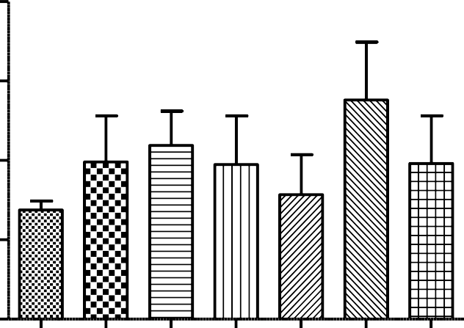200

Duration of sleep (mins)

150

100

50

0

Vehicle 10 ml/kg

A 200 mg/kg

B 200 mg/kg

C 200 mg/kg

D 200 mg/kg

E 200 mg/kg

F 200 mg/kg

**Figure 4.24 Comparative effects of fractions (A – F) obtained by vacuum liquid chromatography from ethylacetate leaf extract of*Mitracarpus villosus* on diazepam induced sleeping time in mice.**

Values expressed as mean ± SEM (n = 6).

No significance vs control (One way ANOVA followed by Dunnet‘s *post hoc* test).

* 1. **Effect of fractions of the ethylacetate leaf extract of*Mitracarpus villosus* obtainedby vacuum liquid chromatography (VLC) on staircase test in mice**

Fractions A-F of MVEA caused decrease in both the number of steps climbed and rearing action of mice. However Fraction E produced the most decrease in number of steps climbed, while fractions E and F exhibited similar effects on rearing actions of mice on the staircase test (Fig 4.25).

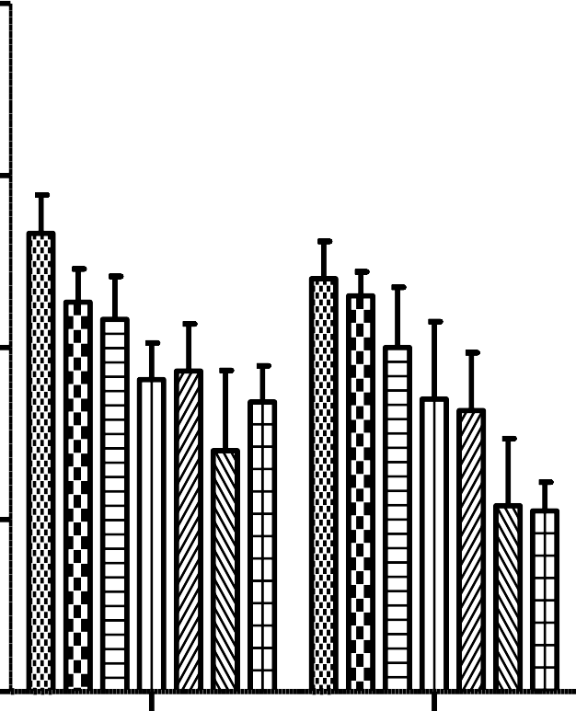40

Control 10 ml/kg

A 200 mg/kg

30 B 200 mg/kg

C 200 mg/kg

20 D 200 mg/kg

E 200 mg/kg

10 F 200 mg/kg

0

Climbing

Rearing

**Figure 4.25 Effect of fraction of ethylacetate leaf extract of *Mitracarpus villosus* (A-F)obtained using vacuum liquid chromatography (VLC) on climbing and rearing activities in mice on staircase test.**

Values expressed as mean ± SEM (n = 6). No significance when compared to control (One way ANOVA followed by Dunnet‘s *post hoc* test).

* 1. **Effect of fractions of the ethylacetate leaf extract of *mitracarpus villosus***

**obtainedby vacuum liquid chromatography (vlc) on open field test in mice**

No difference in locomotive behaviour of animals was observed for fractions A, B, C,

D. Fractions E and F at the dose tested exhibited a decrease of locomotor action.

Fraction E produced greater degree of reduction of locomotion (Fig 4.26).

30

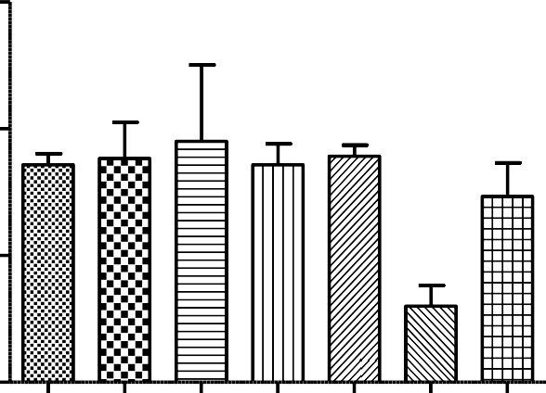

a

Control 10 ml/kg

A 200 mg/kg

No of squares crossed

20 B 200 mg/kg

C 200 mg/kg

D 200 mg/kg

10 E 200 mg/kg

F 200 mg/kg

0

Treament (mg/kg)

**Figure 4.26 Effect of fractions of ethylacetate leaf extract of *Mitracarpus villosus* (A-F) obtained using vacuum liquid chromatography (VLC) on Open field test (locomotion) in mice.**

Values expressed as mean ± SEM (n = 6).ap<0.05 significant vs control (One way ANOVA followed by Bonferroni‘s *post hoc* test).

* 1. **Effect of the secondary fractions obtained from the ethylacetate leaf extract of *Mitracarpus villosus* on diazepam induced sleeping time in mice**

The fractions E2, E3 and E4 potentiated the sleeping effects of diazepam at 214.25 ± 17.75, 187.0 ± 16.66 and 181.2 ± 21.39 min respectively), with E2 producing the longest sleeping time of the treatment groups (Fig 4.27).

300

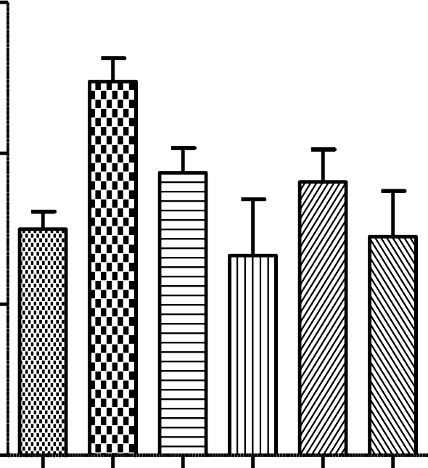

a

Duration of Sleep (min)

200

100

Control 10 ml/kg

E2 200 mg/kg

E3 200 mg/kg

E5 200 mg/kg

E4 200 m/kg

E6 200 mg/kg

0

Control

E2 E3

Treament

E5 E4 E6

(mg/kg)

**Figure 4.27 Comparative effect of fractions of ethylacetateextract of *Mitracarpus villosus* obtained using column chromatography (CC) on diazepam induced sleeping time in mice.**

Values are presented as mean ± SEM (n = 6); ap<0.05, significant vs control (One way ANOVA followed by Dunnet‘s *post hoc* test).

* 1. **Effect of fraction of ethylacetate leaf extract of *Mitracarpus villosus* (e2) on hole-board exploratory test in mice**

Treatment of mice with the E2 resulted in significant (p<0.001) increased number of head dips at 6.25 – 12.5 mg/kg, whereas a reduction in head dipping activity was observed at higher doses 100 – 200 mg/kg which was significant (p<0.05) at 200 mg/kg (Fig 4.28).

4 0



b

b

a

a

3 0

N o o f h e a d d ip s

2 0

1 0

0

T r e a tm e n t ( m g / k g )

**Figure 4.28 Effect offraction E2 obtained from ethylacetate leaf extract of *Mitracarpus villosus* using column chromatography (CC) on hole- board (exploratory) test in mice.**

Values are presented as mean ± SEM (n = 6)

ap< 0.05, bp< 0.001 vs control (One-way ANOVA Dunnett‘s post-hoc test).

* 1. **Effect of fraction of ethylacetate extract of *Mitracarpus villosus* leaf (E2) on Staircase test in mice**

E2 administered at doses of 6.25 - 25 mg/kg caused a significant (p<0.01) increase in number of steps climbed. Similarly, increase in rearing activity was recorded but this was not significant, meanwhile a marked reduction was observed at the dose of 200 mg/kg of both the number of steps climbed and rearing actions in the treated mice. Diazepam (0.2 mg/kg) increased the climbing activity while reducing rearing effects (Fig 4.29).

60



c

a

a

\*

c

\* b

c

40

20

0

C lim b in g R e a rin g

 C o n tro l

 D ia z e p a m 0 .2 m g /k g D ia z e p a m 1 .0 m g /k g

 E 2 6 .2 6 m g /k g

 E 2 1 2 .5 m g /k g

 E 2 2 5 m g /k g

 E 2 5 0 m g /k g

 E 2 1 0 0 m g /k g

E 2 2 0 0 m g /k g

**Figure 4.29 Effect offraction E2 obtained from ethylacetate leaf extract of *Mitracarpus villosus* using column chromatography (CC) on (A)climbing and (B) rearing activities on the staircase test in mice.** Values expressed as mean ± SEMap< 0.05, bp< 0.001, cp<0.0001 vs control (Two-way ANOVA Bonferroni‘s *post-hoc* test).

* 1. **Effect of ethylacetate leaf extract of *Mitracarpus villosus* (E2) on the Open Field test in mice**

The number of squares crossed at the periphery was increased at 6.25 – 12.5 mg/kg, by E2 which was significant (p<0.05) at 6.25 mg/kg and likewise increased rearing activities were recorded at 6.25mg/kg. However there was no significant change of the number of central square crossings. Meanwhile, the standard diazepam showed significant (p<0.001) increase in the number of peripheral and central squares crossed as well as increased the number of rearings (Fig 4.30, 4.31 and 4.32).

AII



c

a

**2 0 0**

**1 5 0**

N o o f s q u a r e s c ro s s e d

**1 0 0**

**5 0**

**0**

C o n t ro l D z 0 . 2 E 2 6 . 2 5 E 2 1 2 . 5 E 2 2 5

T r e a tm e n t (m g /k g )

**Figure 4.30 Effect offraction E2 obtained from ethylacetate leaf extract of *Mitracarpus villosus* using column chromatography (CC) on peripheral squares crossings of the open field test in mice.**

Values are repressed as mean ± SEM (n = 6); p<0.05, vs control (One– way ANOVA followed by Dunnett‘s *post-hoc* test)

**15**

#### BII

C o n tro l 1 0 m l/k g

D ia z e p a m 0 .2 m g /k g



c

E 2 6 .2 5 m g /k g

N o o f s q u a r e s c r o s s e d

### 10

E 2 1 2 .5 m g /k g

E 2 2 5 m g /k g

### 5

**0**

C entre s quare

T reatm ent (m g/kg)

**Figure 4.31 Effect offraction E2 obtained from ethylacetate leaf extract of *Mitracarpus villosus* using column chromatography (CC) on central squares crossings of the open field test in mice.**

Values are repressed as mean ± SEM (n = 6); p<0.05, vs control (One– way ANOVA followed by Dunnett‘s *post-hoc* test)

**5 0**

CII

4 0

N o o f r e a r i n g

**3 0**

2 0

C o n tro l 1 0 m l/k g

D ia z e p a m 0 .2 m g /k g E 2 6 .2 5 m g /k g



c

E 2 1 2 .5 m g /k g

E 2 2 5 m g /k g

1 0

**0**

R earing

T re a tm e n t (m g /kg )

**Figure 4.32 Effect offraction E2 obtained from ethylacetate leaf extract of *Mitracarpus villosus* using column chromatography (CC) on rearing activities in mice of the open field test.**

Values are repressed as mean ± SEM (n = 6); p<0.05, vscontrol One– way ANOVA. Dunnett‘s *post-hoc* test)

* 1. **Effect of fraction of ethylacetate leaf extract of *Mitracarpus villosus*(E2) on Light Dark Box transition test in mice**

Treatment of mice with E2 resulted in increased cumulative time spent in the light compartment and a corresponding reduction in the cumulative time spent in the dark compartment which is in a significant (p<0.05) manner at 6.25 mg/kg. This effect is similar to the standard diazepam at 0.2 (p<0.001) mg/kg. No significant change was observed between treated and the control groups on number of transition between compartments (Fig 4.33 and 4.34)

300

c

a

a

c

* + 1. Control

Diazepam 0.2 mg/kg

200

Time spent (sec)

100

E2 6.25 mg/kg

E2 12.5 mg/kg

E2 25 mg/kg

0

Light

Compartment

Dark

**FIGURE 4.33 Effect offraction E2 obtained from ethylacetate leaf extract of *Mitracarpus villosus* using column chromatography (cc) on time spent in the compartments of the Light/Dark box transition test in mice.**

Values expressed as mean ± SEM.cp< 0.05, vs control (Two-way ANOVABonferroni‘s *post-hoc* test).

1 5



 C o n tro l 1 0 m l/k g  D ia z e p a m 0 .2 m g /k g

N o o f c r o s s i n g s

E 2 6 .2 5 m g /k g

1 0

 E 2 1 2 .5 m g /k g

 E 2 2 5 m g /k g

5

0

C o m p a rtm e n t

**FIGURE 4.34 Effect offraction E2 obtained from ethylacetate leaf extract of *Mitracarpus villosus* using column chromatography (cc) on number of transitions between the compartments of the Light/Dark box transition test in mice.**

Values are presented as mean ± SEM (n = 6); no significant difference p< 0.05 vs control (One-way ANOVADunnett‘s *post hoc* test).

**4.40 Effect of ethylacetate leaf extract of *Mitracarpus villosus*(E2) on Elevated PlusMaze in mice**

Administration of E2 (6.25 – 25 mg/kg) resulted in increased cumulative time spent in the open arm which is significant (p<0.05) at 6.25 mg/kg in a manner similar to diazepam. The number of transitions between the arms and central compartment was similarly increased but this effect was not significant when compared to the control group. Diazepam produced significant (p<0.05) increase in transitions into the arms(Fig 4.35 andFig 4.36).

300



c

a

a

A

200

Time spent (sec)

100

Control

Diazepam 0.2 mg/kg

E2 6.25 mg/kg

E2 12.5 mg/kg

E2 25 mg/kg

0 Open Arm Closed Arm

**Figure 4.35 Effect offraction E2 obtained from ethylacetate leaf extract of *Mitracarpus villosus* using column chromatography (CC) on time spent in arms of the elevated plus maze test in mice.**

Values expressed as mean ± SEM. p< 0.001, vs control (Two-way ANOVA Bonferroni‘s *post-hoc* test).

20

a

a

* + 1. Control

#### Diazepam 0.2 mg/kg

15 E2 6.25 mg/kg

No of enteries

#### E2 12.5 mg/kg

10 E2 25 mg/kg

#### 5

0

#### Open Arm

Closed Arm

**Figure 4.36 Effect offraction E2 obtained from ethylacetate leaf extract of *Mitracarpus villosus* using column chromatography (CC) on number of entries into arms of the elevated plus maze test in mice.** Values expressed as mean ± SEM.ap< 0.05vs control (Two-way ANOVA Bonferroni‘s *post-hoc* test).

**CHAPTER FIVE**

**5.0 DISCUSSION**

The plant *Mitracarpus villosus* is used in folkloric medicine for themanagement of toothaches, amenorrhoea, dyspepsia, hepatic diseases, venereal diseases,sore throat, skin disease, wound dressing,leprosy as well as neurological disorders suchas headaches (Abere *et al.,* 2007). It is also administered as an antidote for arrow poison, diarrhoea, and dysentery (Jegede *et al.,* 2005).

Preliminary phytochemical analysis of the ethylacetate leaf extract of *M.villosus*revealed the presence of flavonoids, tannins, steroids, terpenoids, phenols, resins and carbohydrates in the extract. These secondary metabolites may be responsible for the observed pharmacological effects (Jiang et al., 2007; Akindele and Adeyemi, 2010; Ajao and Akindele, 2013). Bioassay guided fractionation yielded a fraction containing steroids and terpeniod compounds.

The intraperitoneal and oral LD50 of the extract were estimated to be1264.91 mg/kg and greater than 5000 mg/kg respectively in mice and rats. In the acute toxicity study, no immediate sign of toxicity was detected, however reduced activity was observed in the animals which may be due to the presence of CNS depressant constituents in the plant extract (Meenakshi *et al*., 2013). The intraperitoneal and oral LD50suggest that the ethylacetate extract of *Mitracarpus villosus* plant could be consideredof relatively low-toxicity when given acutely via the intraperitonealroute and non-toxic when given orally (Hosseinzadeh *et al*., 2013). According to Lorke (1983), substances with LD50 values greater than 5 g/kg havepractically no toxicity, thus, the ethylacetate leaf extract of *Mitracarpus villosus* may be considered as having low potential to cause

toxic effects on acute administration but the toxicity profile of the extract may be better assessed when animals are subjected to repeated administration of different doses for a longer period in which case the sub-acute toxicity study was conducted.

Neurological and behavioural diseases are chronic conditions thus requiring long term treatment and prolonged exposure to the medicines used for therapy. In addition, records have shown that a high percentage of the population of persons suffering from neuropsychiatric disorders use alternative medicine as an integral part of therapy (Marques, 2012). It was therefore pertinent to determine the safety profile of *Mitracarpus villosus* after repeated oral administration in adult male and female rats.

In the sub-chronic toxicity test, the observed piloerection and hunched posture may be due to dopamine-induced localized cutaneous vasoconstriction or involvement of sympathetic stimulation (Parasuraman *et al*, 2014). The reason piloerection and hunched posture were observed only in females is not clear but may be because females are generally more sensitive and tend to exhibit toxicological effects slightly more than males as has been earlier reported (OECD, 2001). An abnormal change in body weight of an animal has been used as indicator of adverse effect of an agent (Diallo *et al*., 2010). The weight changes in the rats were similar to control.This therefore connotes that the extract did not probably cause deleterious effects that would lead to loss of appetite and decreased food intake and the extractmay not contain principles that could adversely affect food nutrients uptake and utilization nor altered efficiency of food conversion (Oularbi, 2014).

Change in organ weight indicates whether an organ has been exposed to chemical induced change with potential injury(Oaikhena *et al*, 2014). The results obtained also showed that the extract did not produce any significant change in the weights of the brain, kidney, small intestine, spleen, lungs and gonads relative to the weight of the body. However there was increase in the relative organ weight of the liver in male and female rats. An increase in the weight of the liver after administration of a substance has been associated with toxicity effect of that agent (Imafidon and Okunrobo, 2012).Exposure of liver cells to hepatotoxic agents result in an initial insult followed by a phase of regenerative hyperplasia, the cycle of necrosis and regeneration can occur following repeated administration, resulting in liver enlargement associated with histopathological and clinical chemistry findings (Andrew, 2005).Nevertheless, it is adviced that organ weight data should be assessed in context of the entire study which includes consideration of body weight changes and the overall pharmacological action of the test agent. Also consideration should be given to residual blood that may have remained in the liver at the time of sacrifice which may differ from one animal to another (Nirogi *et al*, 2014).

Haematopoiesis is the formation of blood, that is the process by which elements of the blood derived from the pluripotent haematopoietic stem cell are formed in the red bone marrow through the process of proliferation and differentiation; haematological evaluations are carried out in toxicological studies to investigate the effects of an agent on cellular elements of the blood thereby revealing the propensity of the agent to alter haematopoetic factors or cause dyscrasias (Jagannathan-Bodgan *et al*, 2012).

The haematological indices such as mean corpuscular volume (MCV) is an indication of the size of the red blood cells; the mean corpuscular haemoglobin (MCH) is a measure of the amount of haemoglobin per red blood cell and the mean corpuscular haemoglobin concentration (MCHC) is a measure of the amount of haemoglobin per litre of fluid in each cell; these parameters give a valuable indication of haemoglobin deficiency thus may be used for the categorization of different types of anaemias (Zheng *et al*., 2015). In this experiment the extract produced a significant increase of the mean corpuscular volume (MCV). Alteration of the red blood cell structure is caused by liver dysfunction which affects heam synthesis and an increase in MCV levels occur in impaired liver conditions and in anaemic disorders(Kateregga *et al*., 2014). Increased MCV may not be sufficient to reach a diagnosis as it is not usually considered as a single factor; it is frequently considered along with the values of other haematological indices e.g MCHC and in this study, there is no significant change of MCHC values. Large circulating erythrocytes are not always associated with apathologic process or condtion. Macrocytosis without anaemia may be a normal occurance in some indviduals which has been linked to their genetic states (Aslinia *et al*.,2006).

The liver performs major roles related to metabolism, digestion, immunity and storage of food nutrients. Liver function may be determined by assessing the concentrations of hepatic enzymes that include alkaline phosphatase (ALP), aspartate aminotranferases (AST) and alanine aminotransferaces (ALT) (Namjoo *et al.*, 2013). Liver enzymes are released into the blood when liver cells are injured therefore, alteration in the levels of these enzymes reveal compromise in the functional integrity of the hepatic cells and can thus be used in detection of liver diseases such as liver

inflammation (Adebiyi and Abatan, 2013). In this study the extract produced an increase in the level of ALP in treated female rats. No significant change was observed in males or in levels of AST and ALT in both male and female rats. AST and ALT levels are increased to some level in almost all liver diseases and are specific indicators of hepatocellular necrosis and hepatitis; therefore, serum levels of AST and ALT are the most frequently used indicators for determination of liver injury (Thapa and Walia, 2007). An isolated elevation of one of the value of the parameters of the liver function tests is suggestive of a source other than the liver (Murali and Carey, 2014). In the study, only ALP levels were significantly increased implying the enzyme may have been released from non-hepatic sources such as bone, bile, kidneys or intestines; the observed increase may therefore not be due to liver injury.

Serum proteins such as albumin can also be used to assess liver function and decrease in the concentration of serum proteins from normal serum levels is indicative of impairment of normal liver functions or tissue injury and increase in liver enzymes connotes liver toxicity (Imafidon and Okunrobo, 2012).In this study, administration of the extract of *Mitracarpus villosus* did not significantly change the total protein and albumin levels. Bilirubin is considered as an index of hepatic function; an irregular elevation in serum bilirubin is an important indicator of liver damage or could be a sign of biliary duct obstruction (Hor *et al*., 2012). Degeneration of hepatocytes and blockade of the bile ducts could lead to significant increase in the serum levels of total and direct bilirubin (Adebiyi and Abatan, 2013). Treatment with ethylacetate extract of *M. villosus* did not show any significant change in the level of total or direct bilirubin, thus indicating that biliary function may not be adversely affected by the extract. Likewise, the extract did not produce significant change in the serum levels of

total protein and albumin which suggests that treatment with *M. villosus* extract may not have affected protein synthesis of endoplasmic reticulum which is the cellular site of protein synthesis (Nasir *et al*., 2013).

Histological analysis of the liver revealeddistortion of radial arrangement of hepatocytes and enlargement of nuclei. In the liver, there are a limitednumber of morphologic changes that canbe discerned using conventional light microscopy. These morphologic alterations are often characterzed as either adaptive consisting of exaggerated normal physiological response, pharmacologic consisting of an expected alteration in response to the desired actions of the test article or adverse consisting of morphologic alterations that are generally undesired, progressive and deleterious to the normal function of the cells involved. Often the difference between the different responses is the magnitude of change rather than a completely different mechanism or pathway (Hardisty and Brix, 2005). Since the morphological alterations observed in the liver are mild, it may be possible that the liver cells are in a phase of adaptation to the presence of the extract or its metabolites considering that Ekpendu *et al*., (1994) reported the presence of active principles with hepatoprotective potentials.It has also been suggested that the significance of histopathological changes should be considered in the context of other study results as well as other information known about the plant or extract (Hayes, 2007).

The kidneys are the main organs involved in the excretion of metabolic wastes, elimination of exogenous substances and regulation of electrolytes and thus are exposed to toxic effects (Bidhe and Ghosh, 2004). Maintenance of steady electrolyte levels in the blood is essential for normal healthy function of cells

therefore;electrolyte tests are frequently carried out to evaluate the level of toxicity in disease conditions such as diabetes, heart, liver or kidney disorders. Kidney function was evaluated by means of creatinine, urea, potassium, sodium, chloride and bicarbonate levels in serum. These biomarkers used for routine assessment of kidney function are determined as indicators of normal biologic, pathologic processes or pharmacologic responses to a therapeutic intervention in management of renal, endocrine, acid-base, water balance conditions (Gowda *et al*., 2010). In this study, oral administration of the ethylacetate leaf extract of *Mitracarpus villosus*did not produce any observable changes in the levels of serum electrolytes. Histological analysis revealed the alteration of some cellular structures of the kidney such asdistortion of the arrangement of nuclei within the collecting duct and mild interstitial inflammation, there was also significant increase in creatinine levels recorded in this study indicating that extract may have caused an alteration in the filtration processes in the kidney (Iimie *et al*., 2015).Serum creatinine levels do not increase significantly until kidney function is considerably compromised (Castro *et al*., 2014).Changes in the levels of serum creatinine has been attributed to kidney dysfunction such as in glomerulonephritis, acute tubular necrosis and polycystic kidney disease (Gowda *et al*., 2010); conditions which may cause changes in the homeostasis or excretory functions of the kidneys (Tende *et al*., 2014).

The kidneys are some of the major organs of excretion, the observed changes from histological examination of the kidney sections, may have occurred due to tissue reaction to the extract or its constituents or it may have resulted from the processes of metabolism and excretion of the extract or metabolites by the organs which are the primary sites for these processes thus corresponding with the theory of target organ

toxicity (Aderonke *et al*., 2014) as there were no changes observed in the structural integrity of the other organs of the animals.

This study was designed to evaluate the neuro-behavioural activities of the ethylacetate extract of *Mitracarpus villosus* using acknowledged*in-vivo* gross behavioural, pain and inflammatory models and to determine its toxicity/safety in mice and rats.

The Irwin (FOB) test, whichassesses the effects of drugs on the behavioural and physiological state of rodents, provides information on the pharmacological profile of a test compound (De Ron *et al*., 2008).Abdominal writhing was observed in an animal treated with 1000 mg/kg of the extract; this may be attributable to drug administration. Generalized reduction of activity was observed in mice treated with 100 and 1000 mg/kg up to 4 h after treatment. Agents that reduce activity and exhibit sedative actions may possess anxiolytic, antipsychotic or anticonvulsant effects (Roux *et al*., 2004).

Assessment of general behavioural and locomotor activity of rodents can be achieved using the open field and mouse staircasetests. These activities have been used to determine sedative or stimulant effects of a pharmacological agent (Steru *et al*., 1987; Martinez-Vazquez *et al*., 2012). The numbers of squares crossed and rear counts are indicative of locomotor activity (Asuquo *et al*., 2013). Locomotion connotes alertness and decreased locomotor activity is suggestive of sedation; increase in the number of rearing signifies anxiety while a reduction in the number of steps climbed is a

suggestion of sedative activity (Gahlot *et al*., 2011; Yau *et al*., 2011; Rout and Kar, 2013).

Two forms of activity were observed for the lower doses and the higher doses of ethylacetate leaf extract of *Mitracarpus villosus*. Increase in locomotion was observed on administration of the extract and its fraction at lower doses signifying anxiolytic effects, whereasdecreased locomotion at the higher dosesindicated by reduction of the number of steps climbed and number of rearing observed in the staircase test is indicative of possession of sedative effects by the extract. This pattern was also observed in the open field test (OFT);at lower doses the ethylacetate leaf extract of *Mitracarpus villosus* caused an increase in the number of rearing and demonstrated increase in the number of central square crossings, suggesting anxiolytic property of the plant (Ramos, 2008).

Anxiolytic-like activity has been shown to be associated with increased activity in the number of steps climbed while sedative activity is connected to decreased frequency of rears. Meanwhile, other studies have suggested that increased rearing incidence can be attributed to an anxiety-like behaviour and a decrease in number of steps climbed to be a sedative effect (Aman et al, 2006). However, rearing is to some extent an exploration behaviour that correlates with locomotor activity (Lister, 1991), thus rearing is an index of locomotion.An increase in the number of squares (central and peripheral) crossed and rearings counts show anxiolytic-like activity in the open field test. This therefore suggests that the extract possesses anxiolytic and sedative actions (Aslam, 2016).

Diazepam, an anxiolytic agent in the benzodiazepine group typically increases climbing activities in staircase test(SCT) while decreasing rearing in test subjects as demonstrated in other studies (Foyet*et al*., 2012, Gnanasekar*et al*., 2014), thoughit has been reported that increased climbing and rearing effects produced by a treatment agent is representation of hyperactivity and anxiolytic effects (Ali *et al*., 2007). Therefore, in this study where the ethylacetate leaf extract of *M. villosus* has exhibited increase in both parameters i.e. climbing and rearing in staircase test, as well as produced increased locomotion, increased rearing and increased squares (central and peripheral) crossed at lower doses, when assessed generally, the actions of the plant extract may be viewed as anxiolytic at lower doses and sedative at higher doses because sedative actions has been related to higher doses, while anxiolytic effects have been related to lower doses of plant extracts or reference drugs (Santos et al, 2006).

The light dark box is a model that has been used for investigation of anxiolysis in a test agent. This model is not affected by feeding and does not require prior training; it operates on the rationale that rodents have a natural aversion to bright open spaces and show tendency to spend more time in closed dark areas. The time spent in the open /dark compartment is a reflection of aversion (Gnanasekar *et al*., 2014). In this test, aversion to light was diminished by the extract which was reflected as increase in the time spent in the light compartment at 6.25 – 25 mg/kg. This activity is suggestive of anxiolytic effects (Bailey and Crawley, 2009).

The elevated plus maze is a valuable tool for the detection of anxiolytic agents that may be mediating their effects via the benzodiazepine/gamma amino butyric acid

(BDZ/GABA) receptor complex in a manner similar to benzodiazepines (Mesfin *et al*., 2014). The test is also sensitive to anxiogenic agents (Woode *et al*., 2011b). Compounds with anxiolytic properties reverse aversion by increasing the proportion of time spent in open spaces with corresponding increased locomotor activity.Conversely, anxiogenic substances and sedatives produce the opposite effects of higher percentage of time in closed arm with decreased activity. Typical anxiolytic agents like benzodiazepines exhibit their effects of anxiolysis at low dose while showing sedative action at higher dose (Santos*et al*., 2006). The extract and its active fraction E2 have shown anxiolytic actions at low doses and sedative effects at higher dosesin a manner that is similar to diazepam. At the higher doses (100 – 400 mg/kg) in the EPM the extract decreased the entries and time spent in the open arms, although this may be an anxiety-like effect, administration of the extract also decreased the number of head dips in the hole board, decreased climbing and rearing in SCT, as well as the number of crossings and rearings incidences in OFT, thus suggesting a sedative effect instead of anxiogenic effect (Woode et al, 2011b). The possible activity of the extract on BDZ receptors was further substantiated by its ability to potentiate the duration of diazepam induced sleeping time (Ngoupaye *et al*., 2013).

The hole-board experiment is a measure of exploratory behaviour. Agents that decrease this parameter are generally regarded as possessing sedative properties (File and Fernandez, 1994; Amos *et al*., 2003) while anxiolytics increase the head-dip counts. In this test, the extract increased the counts of head dips at low doses while reduction in the number of head dips was shown by the extract at higher doses. This observation is therefore an indication of the presence of psychoactive constituents that are anxiolytic and sedative in nature.

The cause of decreased spontaneous activities may be due to sedation, motor impairment or muscle relaxation (Simplice *et al*., 2014), thus effects of the extract on induced sleep and skeletal muscle activity were tested to evaluate the effect on motor coordination.Increase in duration of diazepam induced sleeping time is suggestive of sedative property of the plant.

Hypnotic/sedative agents like the benzodiazepines act by enhancing the action of Gamma Amino Butyric Acid (GABA) on GABA receptor channel complex by binding on specific allosteric sites on GABA receptor type-A (Ritcher *et al*., 2012) to enhance GABA binding to the GABA receptor resulting to the potentiation of GABA responses (Mellor and Randall, 1997, Ezekiel *et al*., 2010). In this experiment, the ethylacetate extract of *Mitracarpus villosus*(MVEA) prolonged the duration of diazepam-induced sleep possibly by modulating the action of GABA at the BDZ binding site of GABAA receptors as indicated by decreased duration of sleeping time of the extract on diazepam induced sleep after pre-treatment with flumazenil, a benzodiazepine antagonist (Whitman and Amrein, 1995).

The rota-rod test provides an index of skeletal muscle relaxation. The ability of mice to stay on the rotating rod during the study suggests that although the extract may possesse sedative effects, the sedation at the doses tested did not interfere with skeletal muscle activity on the rotating rod indicating that the extract may be devoid of skeletal muscle relaxant effect (Woode *et al*., 2011a).

Several neurotransmitters have been implicated in the aetiology of anxiety disorders and previous reports show that numerous herbal medicines employed in the

management of anxiety disorders may directly or indirectly affect the central nervous system by modulating the actions of neurotransmitters such as serotonin, dopamine, GABA, noradrenalin at receptor sites (Ayoka, *et al*., 2005). Interaction studies were carried out with antagonists of various neurotransmitters to elucidate their probable involvement in the actions mediated by the plant extract. The treatment dose of the extract at 6.25 mg/kg showed significant anxiolytic effects while 400 mg/kg exhibited significant sedative actions, therefore these doses were selected for interaction studies to determine a possible mechanism of action. Results obtained on interaction with flumazenil, an antagonist at the BDZ receptor revealed a reversal of the anxiolytic and sedative effects of the extract in a manner similar to the effects of flumazenil on diazepam thus suggesting the extract maybe mediating its effect via the BDZ-GABA receptor sites.

Although, the mechanism of action of pentylenetetrazole is not well understood, it has been proposed to be antagonism of GABA at receptors of GABAAchloride ionophore complex(Ergul Erkec and Arihan, 2015) pre-treatment with pentylenetetrazole produced a decrease in the anxiolytic actions of the extract, thereby suggesting some interaction at these sites by components of the extract and implying that the extract may be mediating its effect via the GABA-ergic systems (Aviles-Montes *et al*., 2015). Cyproheptidine and atropine (5-HT and cholinergic antagonists respectively) had no effect on the actions of MVEA, thus indicating that the serotonergic or cholinergic pathways may not be involved in the mechanism of anxiolysis of the plant (Ishola *et al*., 2015).

Several plants that demonstrated anxiolytic-sedative activities have produced analgesic effects (Emran and Rahman, 2014; Habib *et al.*, 2016) and its use for the treatment of headaches influenced investigation of the anti-nociceptive effect of the ethylacetate leaf extract of *Mitracarpus villosus* using various *in-vivo* models for both neurogenic and inflammatory pain. The extract significantly and dose dependently decreased the number of abdominal writhes induced by dilute acetic acid, reduced the time of face rubbing in the oro-facial formalin test and increased the withdrawal threshold in carageenan induced hyperalgesia.

The acetic acid induced abdominal writhing is a visceral pain model that assesses peripheral and central anti-nociceptive activity (Wani *et al*, 2012, Pavao-de-Souza *et al*., 2012). Acetic acid causes inflammatory pain as a result of capillary permeability due to increase in level of endogenous substances in the peritoneum caused by the administration of an irritant (Santos *et al*., 2011). The rising levels of these endogenous substances such as prostanoids, bradykinin, serotonin and histamine (Swati and Saha, 2012) produce localized inflammatory responses and stimulate pain nerve endings resulting in painful episodes. In this study, the extract decreased the number of abdominal writhes induced by dilute acetic acid. This result agrees with the study carried out by Makambila-Koubemba *et al*., (2011). This effect is similar to the action of the standard diclofenac, an analgesic agent with anti-inflammatory properties (Ortiz *et al*, 2001). Pre-treatment with the extract decreased the pain sensation produced by acetic acid thereby suggesting anti-inflammatory mechanisms being involved in the analgesic action of *Mitracarpus villosus* given that the acetic acid method is a useful screening tool for anti-inflammatory analgesic agents (Sah *et al*., 2010).

Formalin test is a valid and reliable model of persistent clinical pain (Morrow *et al*, 1998). The orofacial region is innervated by the trigeminal nerve (Romero-Reyes *et al*., 2013). This densely innervated area is the site frequently associated with headaches and pains relating to the teeth and related structures of the head, face and neck regions (Siqueira *et al.*, 2010, Romero-Reyes and Uyanik, 2014). The orofacial formalin test exhibits two characteristic phases of pain (the early which denotes the neurogenic phase is due to direct activation of nociceptors and primary afferent fibres by formalin leading to release of bradykinin and tachykinins; this phase is inhibited by opioid analgesics (Bhutia *et al*., 2010.) The second phase/late phase is the inflammatory phase accompanied by the release of inflammatory mediators due to inflammatory reaction caused by tissue injury leading to release of histamine, serotonin, prostaglandin and excitatory amino acids (Henry *et al*, 1999). This phase is associated with the activation of central sensitized neurons due to peripheral inflammation as well as increase in sensitivity/activity of primary afferent nociceptors at the injury site (Zhao *et al.*, 2003). This phase is inhibited by NSAIDs and opioid analgesics (Saba *et al*., 2011). Pentazocine a centrally acting analgesic (Bradley and Nicholson, 1987) inhibited both phases of pain. Paracetamol in this study reduced face rubbing time in phase one and not in the second phase of pain even though it has been postulated that paracetamol affects both peripheral and central anti-nociception processes (Jozwiak-Bebenista and Nowak, 2014). This observation may have been as a result of paracetamol possessing mild analgesic effect (Blondell *et al*., 2013). The significant reduction in the period of face rubbing by the extract in both early and late phases of the formalin test suggests that the extract of *Mitracarpus villosus* has activity in both central and peripherally mediated pain.

Carageenan induced paw oedema which exhibits a biphasic response is a method that assess inflammatory pain without any injury to the inflamed tissue; the first stage (0 - 2 h) is associated with the release of inflammatory mediators such as histamine, serotonin and kinins while the second phase (3h onward) is primarily due to the enhancement of inducible cyclo-oxygenase iso-enzyme, COX 2 and subsequently prostaglandins (Gill *et al*., 2013). In this experiment the extract increased the withdrawal threshold of the paw of treated animals suggesting its anti-nociceptive activity. It is possible that the anti-nociceptive effect demonstrated by the extract might have been as a result of the extract suppressing/reversing inflammatory processes by the inhibition of the inflammatory mediator substances (Santos *et al*., 2011) which have been implicated in the model of pain.

The formalin induced paw oedema is a model of sub-acute inflammation resulting from cell damage which provokes the production of endogenous mediators that include histamine, serotonin, prostaglandins and bradykinin (Sachan and Singh, 2013). The data obtained in this study shows that the extract decreased the paw thickness of the mice. This result agrees with an earlier study carried out by Ekpendu *et al*., (1994). It is also possible that this effect produced by the ethylacetate extract of *Mitracarpus villosus*could also have been due to inhibition of COX-2. Prostaglandins play a significant role in the generation of the inflammatory response where they contribute to the development of the signs of acute inflammation (Ricciotti and Fitzgerald, 2011). Prostaglandins mediate various manifestations of the inflammatory response that include fever, hyperalgesia, increase in vascular permeability and oedema (Morteau, 2000) and previous studies have demonstrated that COX-2 inhibitors are effective in supressing hyperalgesia under inflammatory conditions (Fujikawa et al., 2012).The interaction of the leaf extract of *Mitracarpus villosus* with

opioid receptors in the formalin test is another possible mechanism of its anti- nociceptive action. This test is used to investigate both peripheral and central mechanisms; centrally acting drugs such as opioids, inhibit both phases of pain equally.

Hyperthermia is associated with increased production of the endogenous substances that include the potent pyretic agents PGF2α, PGE2 in the hypothalamus; antipyretic activity is characteristic of compounds which have inhibitory effect on prostaglandin synthesis, it is therefore suggested that the anti-pyrectic activity exhibited by the extract which is similar to paracetamol may be by inhibition of cyclooxygenase and consequently prostaglandins (Zampronio *et al*., 2015).

Phytochemicals such as flavonoids, terpenoids and tannins detected in *Mitracarpus villosus* have been reported to possess CNS activating properties in other plants (Kumar and Khanum, 2012). They are able to inhibit the inducible isoforms of cyclo- oxygenase (COX-2) as well as other mediators of the inflammatory process (Paiva *et al.*, 2013). The terpenoid compound, ursolic acid which was isolated from another specie of *Mitracarpus* (Fabri *et al*., 2014) and other plants has been shown to possess analgesic and anti-inflammatory effects (Taviano *et al*., 2007; Nsonde Ntandou *et al*., 2010). The presence of this compoundin *Mitracarpus villosus* (Ekpendu *et al*., 2001) may be contributing to the observed analgesic effect. Flavoniods and terpenes have also been reported to possess anti-pyretic activity. This property may contribute to the observed hypothermic effect (Bafor *et al*., 2014). In addition, systemic administration of GABA agonist cause decrease in core body temperature elicited by possible action by the agonist substance on the GABA-ergic system (Yakimova *et al*, 2014).

In this study administration of the plant extract had no effect on the onset of convulsion neither was the duration of convulsion altered, suggesting that although the extract may possess sedative effects, it probably does not have anticonvulsant properties. Other studies have demonstrated that plants reduce activity and exhibit sedative actions may possess anxiolytic and anticonvulsant effects (Adeyemi *et al.,* 2010, Mahendran *et al*., 2014).

**CHAPTER SIX**

* 1. **SUMMARY**

Thisthesisaimed at evaluation of the anxiolytic effects of the ethylacetate leaf extract of *Mitracarpus villosus*a plant with diverse medicinal claims. Its ethnomedical application for the management of headaches motivated the interest to investigate the effects of this plant on the central nervous system (CNS) and determination of its safety profile. Earlier study isolated ursolic acid from this plant, a triterpeniod compoundshowing sedative actions.

Extraction, phytochemical and chromatographic techniques were employed to identify the pharmacologically active compounds present in *Mitracarpus villosus* leaves. The safety profile of the ethylacetate leaf extract of *Mitracarpus villosus*(MVEA)and its active fraction E2 were evaluated using acute (LD50) and sub-chronictoxicity tests in mice and rats. The anxiolytic effects of the ethylacetate extract of *Mitracarpus villosus* and its active fraction E2 were investigated using hole-board (exploratory behavior), staircase test (SCT), open field test (OFT), light dark box (LDB) and elevated plus maze (EPM) tests in Swiss albino mice. Effects on diazepam induced sleeping time were tested. Interaction studies with various antagonists were conducted in order to elucidate the possible mechanism(s) of actions of the ethylacetate leaf extract of *Mitracarpus villosus*. Effect of MVEAwas tested on motor co-ordination, pain, inflammation and pyrexia.

Preliminary phytochemical analysis revealed the presence of flavonoids, tannins, steroids, terpenoids, phenols, resins and carbohydrates in the extract. Bioassay guided fractionation yielded a steroid and terpeniod containing fraction (E2). On administration of low dosesof MVEA and E2 (6.25 – 12.5 mg/kg),significant

p<0.05increased locomotion was observedwith hole-board, SCT and OFT whereas decreased locomotion was recorded at higher dosesof MVEA (100 – 400 mg/kg). In the LDB and EPM tests, the extract and its fraction caused increasedinpercentage of time spent in the illuminated area in contrast to decreased time spent in enclosed areas thus signifying anxiolytic and sedative actions Diazepam induced sleeping time was significantly (p<0.05) increased by the extract an activity reversed by flumazenil, Flumazenil also reversed exploratory activity suggesting involvement of BDZ-GABA pathways. Anti-nociceptive effects were observed as significant (p<0.05) reduction in abdominal writhing in acetic acid induced pain, decreased face rubbing time in orofacial induced pain, increased and paw withdrawal threshold.Significant (p<0.05) hypothermic effects was observed. MVEAdid not cause changes in haematological and serum biochemical induces nor adversely distort morphological structures of animal organs.

It can be concluded that the ethylacetate leaf extract of *Mitracarpus villosus* may contain psychoactive principles that possess anxiolytic/sedative effects probably due to the presence of steroid and terpenoid compounds. The sedative and anxiolytic effects may be mediated via the benzodiazepine site of the GABAA receptor channel complex. The extract may possess anti-nociceptive effects against neurogenic and inflammatory mediated pain with anti-inflammatory andhypothermic effects.

* 1. **CONCLUSION**

The results from this study provide scientific evidence that the ethylacetate leaf extract of *Mitracarpus villosus* may contain psychoactive principles that are sedative in nature with potential anxiolytic effects attributable to the presence of steroid and terpenoid compounds. The sedative and anxiolytic effects maybe mediated via the benzodiazepine site of the GABAAreceptor channel complex. The extract possesses anti-nociceptive effects against neurogenic and inflammatory mediated pain with anti- inflammatory and hypothermic effects. These findings support the further appraisal of the biologically active principles of the plant as anxiolytic, analgesic and anti- inflammatory agents. However, the plant is relatively safe and could be used as a standardized phytomedicine but with caution in susceptible individuals.

* 1. **RECOMMENDATION**

1. Isolate and elucidate the molecular mechanisms underlying the action of the phytoconstituents of the medicinal plant for the management of pain, inflammation, pyrexia and anxiety.
2. Structural elucidation of the pharmacologically active compound(s).
3. Study the toxicity of the fractions using invitro models.

**REFERENCES**

Aarli, A.A. (2005). Neurology and psychiatry ―Oh east is east and west is west…‖

*Neuropsychiatric Disease and treatment* 1(4): 285 – 286.

American psychiatric association. (1994). *Diagnostic and statistical Manual of mental disorders.* 4th Edn, Revised. Washington, DC. American Psychiatric Association.23.

Abdullahi, K., Abubakar, M.G., Umar R.A., Gwarzo, M.S., Muhammad, M. and Ibrahim H.M. (2011). Studies on the larvicidal efficacy of aqueous extracts of *Strigaher monthica* (Delile) Benth and *Mitracarpus scaber* (Zucc) on *Culexquinque fasciatus* (culicidae) mosquito larvae. *Journal of Medicinal Plants Research*, 5(21): 5321-5323.

Abere, T.A., Onwukaeme, D.N. and Eboka, C.J. (2007). Pharmacognostic evaluation of the leaves of *Mitracarpus scaber* Zucc (Rubiaceae). *Tropical Journal of Pharmacetuical Research* 6(4): 849 - 853.

Abiodun, O.A. and Ogunremi, O.O. (1990). Psychiatric mobidity in medical and surgical wards of a Nigerian general Hospital. J*ournal of psychosomatic Research.* 34(4): 409 – 414.

Adebiyi, O.E. and Abatan, M.O. (2013). Protective effects of *Enantia chlorantha* stem bark extract on acetaminophen induced liver damage in rats. *Jordan Journal of Biological Sciences* 6(4):284 – 290.

Adefolaju, T. (2014). Traditional and orthodox medical systems in Nigeria: The imperative of a synthesis. *American Journal of Health Research* 2(4): 118- 124.

Aderonke, S.O. Oluranti, E.O. Wolfe, O.A and Minakiri, S.I. (2014). The effect of acetone extracts of *Crinuim jagus* bulbs on the histology of the kidney, liver and testis of albino rats. *Peak Journal of Medicinal Plants Research*. 2(4): 38

– 44.

Adeyemi, O.O., Akindele, A.J., Yemitan, O.K.,Aigbe,F.R. and Fagbo, F.I (2010). Anticonvulsant, anxiolytic and sedative activities of the aquoes root extract of *Securidaca longepedunculata* fresen. *Journal of Ethnopharmacology* 130(2):191 195. Doi:10.1016/j.jep.2010.04.028

Ajao, M.Y.and Akindele, A.J. (2013). Anxiolytic and sedative properties of hydroethanolic extract of *Telfairia occidentalis* leaves in mice. *Revista Brasileira de Farmacognosia.,* 23(2): 301 – 309.

Akindele, A.J. and Adeyemi, O.O. (2010). Anxiolytic and sedative effects of B*rysocarpus coccineus* Schum. and Thonn. (Connaraceae) extract. *International Journal of Applied Research in. Natural Products.,* 3(1): 28 – 36.

Akindele, A.J., Sanni, H.A. and Edeh, P.C. (2012). Anxiolytic activity of aerial part hydroethanolic extract of *Allium ascalonicum* Linn. (Liliaceae) in mice. *Functional Foods in Health and Disease*, 2(11):448-459

Ali, A., Venkat Rao, N., Shalam, M.,Shivaraj Gouda, T., Babu, J. and Shantakumar,

S.A (2007). Anxiolytic actions of seed extract *Caesalpinea bonducella* (Roxb) in laboratory rats. *The Internet Journal of Pharmacology,* 5:2 ispub.com/IJPHARM/5/2/12298#.

Allison, D.B., Fontaine, K.R., Heshka, S.,Mentore, J.L. and Heymsfield, S.B. (2001). Alternative treatments for weight loss: A critical review. *Critical Reviews in Food Science and Nutrition*, 41: 1–28.

Aman, U., Subhan, Z., Shahid, M.,Akbar, S., Ahmad, N., Ali, G., Fawad, K.and Sewell R.D.E. (2016).*Passiflora incarnata* attenuation of neuropathic allodynia and vulvodunia apropos GABA-ergic and opioidergic antinociceptive and behavioural mechanisms. *BMC Complementary andAlternative Medicine*, Doi: 10.1186/s12906-016- 10486.PMCID:PMC4765057.

Ameh. S.J., Ibekwe, N., Ambi, A., Obodozie, O., Abubakar, M.,Garba, M., Cocker, H.and Gamaniel, K.S. (2014). Standardization of *Andrographis paniculata*, *Mitracarpus scaber* and *Nauclea latifolia* herbal preparations as per European and Nigerian Drug Regulations. *European Journal of Medicinal Plants*, 4(4): 413-443.

Amos, S.,Abbah, J., Chindo, B., Edmond, I., Binda, L., Adzu, B., Buhari, S.,Odutola, A.A., Wambebe, C. and Gamaniel K.(2005).Neuropharmacological effects of the aqueous extract of *Nauclea latifolia* root bark in rats and mice. *Journal of Ethnopharmacology,* 97: 53–57.

Amos, S. Chindo, B.A., Abbah, J., Vongtau, H.O., Edmond, I., Binda, L., Akah, P.A., Wambebe, C. and Gamaniel, K.S. (2003). Postsynaptic dopamine (D2)- mediated behavioural effects of high acute doses of artemisinin in rodents. *Brain Research. Bulletin,* 62: 255–260.

Andrew D (2005), Interpretation of Liver Enlargement in Regulatory Toxicity Studies. *PSD Guidance Document*: York England, Pesticide safety directorate.htt[p:www.pe](http://www.pesticide.gov.uk/uploadedfiles/liver%20paper%20post)s[ti](http://www.pesticide.gov.uk/uploadedfiles/liver%20paper%20post)c[ide.gov.uk/uploadedfiles/liver%20paper%20post](http://www.pesticide.gov.uk/uploadedfiles/liver%20paper%20post)

%20ACP.

Aslam, M. and Sultana, N. (2016). Evaluation of anxiolytic-like activity of *Vitis vinifera* juice in mice. *Avicenna Journal of Phytomedicine*, 6(3):344 -350

Aslinia, F., Mazza J. and Yale,S.H. (2006).Megaloblastic anemia and other causes of macrocytosis. *Clinical Medicine and Research*, 4(3):236 – 241.

Asuquo, O.R., Ottoh, M.O., Eluwa, M.A., Oko, O.K. and Ekanem, T.B. (2013). Locomotive activity of ethanolic extract of *Spondias mombin* leaf. *International Journal of PharmaceuticaScience Invention,*2(10): 31 – 35.

Australian Institute of Health and Welfare (AIHW) 2013.Burden of disease Australian government AIHW data base. <http://www.aihw.gov.au/burden-of-disease/>

Aviles-Montes, D. Herrera-Ruiz, M. Roman-Ramos, R. Jimenez-Ferrer, E. Gonzalez- Cortazar, M. Zamilpa, A. and Tortoriello, J. (2015). Pharmacological interaction between galphmine-A, a natural anxiolytic compound and gabaergic drugs. *International Journal of Pharmacology*. 11(8):944 – 955.

Awodele, O. Agbaje, E.O., Abiola, O.O., Awodele, D.F. and Dolapo, D.C. (2012). Doctors‘ attitudes towards the use of herbal medicines in Lagos Nigeria. *Journal of Herbal Medicine,* 2(1):16 – 22.

Awodele, O., Agbaje, E.O., Ogunkeye, F.A., Kolapo, A.G. and Awodele, D.F. (2011). Towards integrating traditional medicine (TM) into National Health Care Scheme (NHSC): Assessment of TM practitioners‘ disposition in Lagos Nigeria*. Journal of Herbal Medicine.* 1(3): 90 – 94.

Ayoka, A.O., Akomolafe, R.O., Iwalewa, E.O. and Ukponmwan, O.E. (2005). Studies on the anxiolytic effect of *Spondias mombin* L. (anacardiaceae) extracts. *African Journal of Traditional Complementary and Alternative Medicines,* 2(2): 153 – 165.

Azila-Gbettor, E.M, Atatsi, E.A. and Adigbo, E.D. Hawking of medicinal drugs: The perspective of the Ghanaian consumer. *Research on Humanities and Social Sciences*, 4(11): 37 – 43.

Bafor, E.E., Uwumarongie, O.H. and Omoegbe, A. (2014). Antipyretic activity of orallyadministered extracts of *Newbouldia laevis* (Bignonaceae) in mice. *Journal of Science and Practice of Pharmacy,* 1(1): 7 – 10.

Bailey, K.R. and Crawley, J.N. (2009). Anxiety-related behaviours in mice. In Buccafusco J.J. Ed Methods of Behavior analysis inneuroscience. 2nd Edition. CRC Press/Taylor and Francis group. Available at https:/[/www](http://www/). ncbi.nlm.nih.gov/books/nBK5221/

Beletsky, V. and Mirsattari, S.M. (2012). Epilepsy, mental health disorder, or both?

*Epilepsy Research and Treatment*, 2012:163731

Betzer, K.D.,Mckee, M. B. and Liebowitz, M.R. (2005). Social anxiety disorder: Current perspectives on diagnosisand treatment. *Primary Psychiatry*, 12(11):35 – 48.

Bhowmick, R., Sarwar, M.S., Dewan, S.M.R., Das, A., Das, B., Uddin, M.M.N.U., Islam, M.S. and Islam, M.S. (2014). *In-vivo* analgesic, antipyretic and anti- inflammatory potential in Swiss albino mice in invitro thrombolytic activity of hydroalcoholic extract from *Litsea glutinosa* leaves. *Biological Research,* 47(1): 56. Doi:10 1186/0717-6287-47-56.

Bhutia, Y.D., Vijayaraghavan, R. and Pathak, U. (2010). Analgesic and anti- inflammatory activity of amifostine, DRDE-07, and their analogues in mice. *Indian Journal of Pharmacology.* 42(1): 17 – 20.

Bidhe, R.M. and Ghosh, S. (2004). Acute and subchronic (28-day) oral toxicity study in rats fed with novel surfactants. *American Association of Pharmaceutical scientists Journal*, 6(2):7-16.

Bisignano, G., Sanogo, R., Marino, A., Aquino, R. D, Angelo, V., Germano, M.P., De Pasquale, R. and Pizza, C. (2000). Antimicrobial activity of *Mitracarpus scaber* extract and isolated constituents. *Letters in Appied Microbiology*,30: 105–108.

Blondell, R.D., Azadfard, M. and Wisniewski, A. M. (2013). Pharmacologic therapy for acute pain. *American Family Physician,* 87(11): 766 - 772.

Bologa, C., Ursu, O., Oprea, T.I., Melancon III,, C.E. and Tegos, G.P. (2013). Emerging trends in the discovery of natural product antibacterials. *Current Opinions in Pharmacology,* 13(5): 678 – 687.

Borsook, D. (2014) Neurological diseases and pain. *Brain* 135:320 – 344.

Boschen, M. J. (2011). Generalized anxiety disorder in Adults: focus on pregabalin.

Clinical medicines insights: *Psychiatry*4: 17 – 35.

Bourin, M., Bougerol, T., Guitton, B. and Broutin, E. (1997): A combination of plant extracts in the treatment of outpatients with adjustment disorder with anxious mood: controlled study versus placebo. *Fundamental,* 11:127-132.

Bourin, M. and Hascoet, M. (2003). The mouse light/dark box test. *European Journal of Pharmacology*, 463(1-3):55 – 65.

Bourin, M. Petit-Demoulie`re, P., Dhonnchadha, B.N.and Hasco¨et, M. (2007). Animal models of anxiety in mice. *Fundamental and Clinical Pharmacology,* 21: 567–574doi: 10.1111/j.1472-8206.2007.00526.x

Bradley, C. M. and Nicholson, A.N. (1987). Studies on performance with aspirin and paracetamol and with the centrally acting analgesics meptazinol and pentazocine. *European Journal of Clinical Pharmacology*, 32 (2): 135 – 139.

Bystritsky, A.,Khalsa, S.S., Cameron M.E. and Schiffman, L. (2013). Current diagnosis and treatment of Anxiety disorders. *Pharmacy and Therapeutics*, 38(1): 30 – 57.

Campos, A.C.,Fogaca, M.V., Aguiar, D.C and Guimaraes. (2013). Animal models of anxiety disorders and stress.*Revista Brasileira de Psiquiatria* 35(2): S101 – S111) Doi.org/10.1590/1516-444-2013-1139).

Canadian Institute of Health Information CIHI (2007). The burden of Neurological diseases, disorders and injuries in Canada. Ottawa CIHI, 1- 7.

Castro, B.B.A.D, Colugnati, F.A.B., Cenedeze M.P.G. D.A. and Pinheiro H.S. (2014). Syandardization of renal function evaluation in wistar rats (*Rattus norvegicus*) from the Federal University of Juiz de Fora‘s colony. *Jornal Brasileiro de Nefrologia*36(2)[:http://](http://dx.doi.org.10.5935/0101-)d[x.doi.org.10.5935/0101-](http://dx.doi.org.10.5935/0101-) 2800.20140023.

Celikyurt, I.K., Mutlu O., and Ulak G (2012). Serotonin noradrenalin reuptake inhibitors(SNRIs). Effects of antidepressants Lu R-B (Ed) Intech: available from [http://www.intechopen.com/books/effects-of-antidepressants/serotonin-](http://www.intechopen.com/books/effects-of-antidepressants/serotonin-norepinephrine-reuptake-inhibitors) [norepinephrine-reuptake-inhibitors](http://www.intechopen.com/books/effects-of-antidepressants/serotonin-norepinephrine-reuptake-inhibitors).

Centre for drug evaluation and research (CDER) (1996). Guidance for Industry Single dose acute toxicity testing for pharmaceuticals: available from [*http://www.fda.gov/downloads/Drugs/.../Guidance/umc09270.pdf*](http://www.fda.gov/downloads/Drugs/.../Guidance/umc09270.pdf)

Charney, D.S.and Drevets, W.C (2002). Neurobiological Basis of Anxiety Disorders In: Davis, K., Charney D. S., Coyle J., Nemeroff, C. B., eds Psychopharmacology: The Fifth Generation of Progress. NewYork.Lippincott. Williams and Wilkins pp 911 – 920

Cline, M. Taylor, E.J.,Flores, J.,Bracken, S., McCall, S.and Ceremuga,T E. (2008). Investigation of the anxiolytic effects of linalool,a lavender extract in the male Sprague-dawley rats *AANA Journal* 76 (1) 1 – 6.

Coderre ,T.J. and Melzack R. (1992). The Contribution of Excitatory Amino Acids to Central Sensitization and Persistent Nociception after Formalin-induced Tissue Injury. *The Journal of Neuroscience.* 12(9): 3665 – 3670.

Connor, K. M. (2004) Treatment of generalized anxiety disorder: current options and future developments. In: Culpepper L, Chair. Effective recognition and treatment of generalized anxiety disorder in primary care (Academic highlights). *Primary Care companion to The Journal of Clinical Psychiatry* 6:35 – 41.

Coopoosamy, R.M. and Naidoo, K.K. (2012). Evaluation of traditional plant extraction methods used by traditional healers in KwaZulu-Natal, *South Africa Journal of Medicinal Plants Research* 6(17): 3396-3398.

Coss, R.A., McGrath, P. and Caggiano, V. (1998). Alternative care: patient choices for adjunct therapies within a cancer center. *Cancer Practice*, 6(3): 176–181.

Costantini, S., Romano, G., Rusolo, F., Capone, F.,Guerriero, E., Ianora, A., Ciliberto,

G. and Costantini M (2015). Anti-inflammatory effects of a methanol extract from the marine sponge *Geodia cydonium* on the human breast cancer MCF-

7 cell line. *Mediators of Inflammation,* 2015, Article ID 204975. <http://dx.doi.org/10.1155/2015/204975>.

Cragg, G.M. and Newman, J. (2013). Natural products: a continuing source of novel drug leads. *Biochimica et Biophysica Acta*, 1830(6): 3670 – [3695.htt](http://doi.org/10.1016/j.bbagen.2013.02.008)p:/[/doi.org/10.1016/j.bbag](http://doi.org/10.1016/j.bbagen.2013.02.008)e[n.2013.02.008.](http://doi.org/10.1016/j.bbagen.2013.02.008)

Crawley. J.N. (1981). Neuropharmaologic specificity of a simple animal model for the behavioural actions of benzodiazepines. *Pharmacology Biochemistry and Behaviour,*15:695 -699.

Cyran, J F. and Sweeney, F.F. (2011). The age of anxiety: role of animal models of anxiolytic action in drug discovery. Bristish Journal of pharmacology 164:1129–1161. DOI:10.1111/j.1476-5381.2011.01362.x

Danjuma, N.M., Chindo, B.A., Abdu-Aguye, I., Anuka, J.A. and Hussaini, M.I. (2014). Psychpoharmacological properties of saponins from Randia nilotica stem bark. *Pharmaceutical Biology,* http://doi:103109/13880209.2013/784343.

Das, B. Ferdous, T., Mahmood, Q.A., Hannan, J. M.A., Bhattacharjee, R. and Das

B.K. (2013). Aninociceptive and anti-inflammatory activity of the bark extract of *Plumeria rubra* on laboratory animals. *European Journal of Medicinal Plants*. 3(1): 114 – 126.

De Heer E.W., Gerrits, M.M.J.G., Beekman, A.T.F., Dekker, J.,Van Marwijk, H.W.J.,De Waal, M.W.M., Spinhoven, P., Penninx, B.W.J.H. and Van Der Feltz-Cornelis, C.M. (2014). The association of depression and anxiety with pain:a study from NESDA *PLOS ONE* 9(10):e 106907 doi: 10.1371/journal.pone.0106907

De Oliveira, F.R.M., Cerqueira, G.S., De Freitas, R.L.M., Júnior, J.S.C., Feitosa,

C.M. and De Freitas R.M. (2013) Anxiolytic- and antidepressant-like effects of the ethanolic extract from *Citrus limon* plant widely used in Northeastern Brazil *African Journal of Pharmacy and Pharmacology,* 7(30):2173 – 2179

De Padua, L.S., Bunyapraphatsara,N. and Lemmens, R.H.M.J. (Eds) (1999). *Plant Resources of South-East Asia. Medicinal and poisonous plants 1*. Backhuy publishers leiden, The nethelands.12.1

De Ron, P., Delaunois, A.,Hanon, E., Lambetry, Y. and Guyaux, M. (2008). *An original method to interpret neurobehavioral data generated by the Irwin test in the mouse.*Proceedings of Measuring Behavior. Maastricht, The Netherlands, Eds. A.J. Spink, M.R. Ballintijn, N.D. Bogers, F. Grieco,

L.W.S. Loijens, L.P.J.J. Noldus, G. Smit, and P.H. Zimmerman pp 326.

De Sousa, D.P. (2011).Analgesic-like Activity of Essential Oils Constituents.

*Molecules*. 16: 2233-2252.

Dhami N. (2013). Trends in Pharmacognosy: A modern science of natural medicines.

*Journal of Herbal Medicine* 3(4): 123 – 131.

Diallo A., Eklu-Gadegkeku K.,Agbonon A.,Aklikokou k., Creppy E.E. and Gbeassor

M. (2010). Acute and Subchronic (28 day) oral toxicity studies of

hdroalcoholic extract of *Lannea kerstingii* Engl and K. Krause (Anacardiaceae) stem bark. *Journal of Pharmacology and Toxicology* 5:343

– 349.

Edewor-Kuponiyi T. I., (2013). Plant derived compounds with potential sedative and anxiolytic activities. *International Journal of Basic and Applied Sciences*. 2(1):63 – 78.

Ekor M. (2013). The growing use of herbal medicines: issues relating to adverse reactions and challenges in monitoring safety. *Frontiers in Pharmacology.* 4:177. Doi:10.3389/fphar.013.00177

Ekpendu TOE, Adesomoju AA, Ekundayo O, Okogun JI, Laakso I. (1993). Constituents of the volatile oil of *Mitracarpus scaber* Zucc. *The Flavour and Fragrance Journal,*8(5): 269-271.

Ekpendu TOE., Adesomoju AA. and Okogun JI. (2001). Chemical studies of *Mitracarpus villosus* (Sw.) DC – a medicinal rubiaceaeous weed. J*ournal of the Chemical Society*. Nigeria 26: 69 – 74.

Ekpendu, T.O., Akah, P.A., Adesumoju, A.A. and Okogun, J.I. (1994). Antiinflammatory and Antimicrobial Activities of *Mitracarpus scaber* extracts, *Pharmaceutical Biology.* 32(2): 191-196.

Emran T.B. and Rahman M. A. (2014). Sedative, anxiolytic andanalgesic effects of *Urena sinuta* L. leaf extract in animal models. International food research journal 21(5): 2069 – 2075.

Ergul Rekec O. and Arihan O. (2015). Pentylenetetrazole kindling epilepsy model.

Epilepsi. 21(1):6-12 doi:10.5505/epilepsi.2015.08108.

Etkin N.L. (1988). Ethnopharmacology: Behavioural approaches in the anthropological study of indigenous medicines. *Annual review anthropology*. 17:23 – 42

Ezekiel I., Mabrouk M. A., Ayo J.O., Goji A.D.T., Okpanachi A.O., Mohammed A. AndTanko Y. 2010. Study of the effect of hydroethanolic extract of *Commiphora Africana* (stem-bark) on sleeping time and convulsion in Mice. *Asian Journal of Medical Sciences.*2(3): 85-88.

Fabri, R. L., Garcia, R. A., Florencio, J. R., Pinto, N. C. C., Oliveira, L. G., Aguiar,

J.A. K., Ribeiro, A. and Scio E. (2014). Anti-inflammatory and antioxidative effects of the methanolic extract of the aeriel parts of *Mitracarpus frigidus* in established animal models. *Journal of Pharmacy and Pharmacology* 66(5): 722 – 732.

File S and Pellow S. (1985). The effect of triazolobenzodiazepines in two animal tests of anxiety and on the hole–board. Br. J. Pharmacol., 86: 729-735. Akindele,

A. J., Sanni, H. A., and Edeh P. C. (2012) Anxiolytic activity of aerial part hydroethanolic extract of Allium ascalonicum Linn. (Liliaceae) in mice. *Functional Foods in Health and Disease*, 2(11):448-459

File S.E and Fernandez C. (1994). Dizocilipine prevents the development of tolerance to the sedative effects of diazepam in rats. *Pharmacology Biochemistry and Behavior*, 47: 823– 826.

File, S. E. (1991). Animal models of anxiety. In Biological Psychiatry (G. Racagni, N. Brunello, and T. Fukuda, eds.) Elsevier NewYork.596 -599.

Food and Drug Administration (1996). USA. Federal Register, Single dose acute toxicity testing for pharmaceuticals; Revised guidance; 61 (166): 43934 – 35.

Foyet H.S., Tsala D.E., Bouba A.A. and Hritcu L. (2012). Anxiolytic and antidepressant-like effects of the aqueous extract of *Alafia multiflora* stem bark in rodents. *Advances in Pharmacological Science*. 2012:912041.

Fujikawa, M., Ibuki T., Matsumura K. and Sawa T. (2012). Inflammatory hyperalgesia: The role of the prostaglandin system in the spinal cord. Advances in Neuroimmune Biology 3: 197 – 207. Doi:10.3233/NIB-2012-

012041

Gahlot K., Abid M.and Sharma A. (2011). Pharmacological evaluation of *Gelsemium sempevirens* for CNS depressant activity. *International Journal of PharmTech Research,* 3(2): 693 – 697.

Gainok. J., Daniels, R., Golembiowski, D., Kindred, P., Post, L., Strickland, R. and Garrett. N. (2011). Investigation of the anti-inflammatory, antinociceptive effect of Ellagic acid as measured by digital paw pressure via the Randall- Selitto meter in male Sprague- Dawley rats. *American Association of Nurse Anesthetists Journal*79(4): S28 – S33.

Gale C. and Davidson O. (2007). Generalised anxiety disorder. *The British Medical Journal,* 334: 579 – 581.

Garg V., Dhar V. J., Sharma A. and Dutt R (2012). Facts about standardization of herbal medicine: a review. Journal of Chinese Integrative Medicine 10(10):1077 – 1083.

Gautam M., Agrawal M., Gautam M., Sharma P., Gautam A. S. and Gautam S. (2012) Role of antioxidants in generalised anxiety disorder and depression. *Indian Journal of Psychiatry* 54(3):244 – 247.

Germano M. P., Sanogo R., Costa C., Fulco R, D'angelo V., Torre E. A., Viscomi M.G.and De Pasquale R. (1999). Hepatoprotective properties in the rat of *Mitracarpus scaber* (Rubiaceae). *Journal of Pharmacy and Pharmacology,* **51**(6): 729–734.

Gilhotra N. and Dhingra D. (2010). Neurochemical modulation of anxiety disorders.

International *Journal of Pharmacy and Pharmaceutical Sciences* 2(1):1- 6.

Gill, N., Bijjem, K.R.V. and Sharma, P.L. (2013). Anti-inflammatory and anti- hyperalgesic effect of all-trans retinoic acid in carrageenan-induced paw edema in Wistar rats: Involvement of peroxisome proliferator-activated receptor-β/δ receptors. *Indian Journal of Pharmacology* 45:278-282.

Gnanasekar N., Uma Maheswara Reddy C., Narayanan N., Chamundeeswari C. and Gopal T.K. (2014) Anxiolytic activity of *flacourtia indica* using stair case and light dark exploration methods in mice. *Journal of Chemical and Pharmaceutical Sciences,* 7: (1) 29 -33.

Gowda S., Desai P.B., Kulkarni S.S., Hull V.V., Math A.A.K. and Vernekar S. N. (2010).Markers of renal function tests. *North American Journal of Medical sciences* 2(4):170 – 173.

Habib M. R., Billah M.M., Nawrin K., Hasan M.R., Khalil M.I. and Rahman M.M. (2016). Assessement of analgesic and neuropharmacological activity of different extracts of Euphorbia hirta (Linn.) leaf. *British Journal of Pharmaceutical Research*. 9(2): 1 – 7.

Halberstein R.A. (2005). Medicinal Plants: Historical and Cross-Cultural Usage Patterns. *Annals of Epidemiology.* 15 (9):686–699.

Harbourne J.B. (1998). Phytochemical methods: A guide to modern techniques of analysis. 3rd Ed. Chapma and Hall, London: 182 – 190.

Hardisty F. J. and Brix A. E (2005). Comparatve hepatic toxicity: Prechronic/chronic liver toxicity on rodents. Toxicologic pathology 33:35 – 40.

Henry, J.L., Yaspal, K., Picher, G.M., Chabot, J.G. and Coderre, T.J. (1999). Evidence for tonic activation of NK-1 receptors during the second phase of the formalin test in the Rat. *Journal of Neuroscience* 19: 6588-6598.

Hesdorffer D.C. (2016). Comorbidity between neurological illness and psychiatric disorders. *Neuropsychiatry.* 21(3): 230 – 238.

Doi.org/10.1017/S1092852915000929.

Hor S.Y., Ahmad M., Farsi E., Yam M.F., Hashim M.A., Lim C.P., Sadikun A. and Asmawi M.Z. (2012). Safety assessment of velsmethanol extract of red dragon fruit (Hylocereus polyrhizus): Acute and subchronic toxicity studies. *Regulatory Toxicology and Pharmacology* 63: 106–114.

Hosseinzadeh H., Shakib S.S., Sameni A.K.and Taghiabadi E. (2013). Acute and sub- acute toxicity of Safranal, a constituent of Saffron in mice and rats. *Iranian Journal of Pharmaceutical Research,* 12(1): 93 - 99.

Hugo, F., Miranda, H.F., Noriega, V., Zepeda, R.J., Sierralta, F. and Prieto, J.C. (2013). Systemic synergism between codeine and morphine in three pain models in mice. *Pharmacological Reports*. 65, 80 – 88.

Hussain K., Majeed M.T., Ismail Z., Sadikun A. and Ibrahim P. (2009).Traditional and complementary medicines: Quality assessment strategies and safe usage. *Southern Med Review* 2 (1): 19-23.

Hussain S. and Malik F. (2013). Integration of complementary and traditional medicines in public health care systems: Challenges and methodology*. Journal of Medicinal Plant Research* 7(40): 2952-2959.

Iimie M.U., JaafarH., Mansor S.M. and Abdullah J.M. (2014). Subchronic toxicoy studies of standardized methanolic extract of *Mitragyna speciosa* Korth in Sprague-Dawley rats. *Frontiers in Neuroscience* 9:198. Doi:10.3398/fnins.2015.00189.

Imafidon K.E. and Okunrobo L.O. 2012 Study on Biochemical Indices of Liver Function Tests of Albino Rats Supplemented with Three Sources of Vegetable Oils). *Nigerian Journal of Basic and Applied Science* 19 (2): 105- 110.

Irwin S. (1962). Drug screening and evaluative proceedures. *Science* 136: 123 – 128. Irwin S. (1968). Comprehensive observational assessement: Ia. A systematic,

quantitative procedure for assessing the behaviour and physiologic state of the mouse. Psychopharmacologia (Berl) 13: 222 – 257.

Ishola I.O., Olayemi S.O., Yemitan O.K. and Akinseye K. (2015). Role of monoaminergic systems and anxiolytic properties of the hydroethanolic leaf extract from *Adenia cissampeloides*. *Journal of Basic Clinical Physiology and Pharmacology* 26(3): 301 – 312.

Iwu M.M and Wootton J. (2002) Ethnomedicine and Drug discovery, Elsevier, pp 251.

Jagannathan-Bogdan M. and Zon L.I. (2013). Hematopoiesis. *Development* 140(12): 2463 – 2467.

Jegede I.A., Kunle O.F., Ibrahim J.A., Ugbabe G.and Okogun J.I. (2005). Pharmacognostic investigation of leaves of *Mitracarpus vilosus* (S.W.) D.C. *African Journal of Biotechnology*, 4(9): 957-959.

Jiang J.G. Huang K.J., Cheng J.and Lin Q.S. (2007). Comparison of the sedative and hypnotic effects of flavonoids, saponins and polysaccharides extracted from semen *Zizipus jujube*. *Natural Product Research,* 21(4): 310 – 320.

Jimmy B. and Jose J. (2011). Patient medication adherence: measures in daily practise. *Oman medical Journal*. 26(3):155-159. Available at <http://doi.org.10.5001/omj.2011.38>

Jozwiak-Bebenista M.and Nowak J.Z. (2014) Paracetamol: mechanism of action, applications and safety concern. *Acta poloniae Pharmaceutica* 71(1):11-23.

Kateregga JN., Babu M., Abuine R. and Ndukui J.G. (2014). Hematological and Histopathological effects of Cyanobacteria (Blue-Green algae) from Lake Victoria Shores of Uganda in Swiss Mice. *International Journal of Applied Science and Technology* 4(4): 128-133.

Kennett G. A., Bright F., Trail B.S. andBlackburn T.P. (1996).Effects of the 5-HT2B receptor agonist, BW 723C86, on three rat models of anxiety. British Journal of pharmacology 117: 1443 – 1448.

Khansari P.S. and Splerlagh B. (2012). Inflammation in neurological and psychiatric diseases. *Inflammopharmacology*, 20(3): 103 – 7. Doi: 10.1007/s10787- 0124-x

Kharade S.M., Khetmar S.S., Desai P.S., Lokhande R.S., Patil S.S. (2011). Evaluation of anxiolytic activity of *Carum copticum* by using elevated plus maze and open field method*. International Research Journal of Pharmacy* 2(4): 165 – 168.

Kishore R.G., Anjaneyulu N., Ganesh N. and Sravya N. (2012). Evaluation of anxiolytic activity of ethanolic extract of *Foeniculum vulgare* in mice model. *International Journal of Pharmacy and Pharmaceutical sciences* 4(3):584 – 586.

Kodish I., Rockhill C. and Varley C. (2011). Pharmacoltherapy of anxiety disorders in children and adolescents. *Dialogues in clinical neuroscience.* 13(4):439 – 452.

Koster, R., Anderson, M. and Beer, E. (1959). Acetic acid for analgesic screening.

*Federation Procedings.* 18: 412 – 416.

Kporou E.K., KoffiAdouKra M., Ouattara S., Guede-Guina F. (2010). Evaluation of antifungal activity of *Mitracarpus scaber* a Rubiaceae MISCA codified on *Candida glabrata*. *Therapie,* 65(3): 271 - 274.

Kumar G.P. and Khanum F. (2012). Neuroprotective potentials of phytochemicals.

*Pharmacognosy reviews* 6(12): 81 – 90.

Kurami R. and Kotecha M. (2016). A review on the Standardization of herbal medicines. *International Journal of Pharma Sciences and Research.* 7(2):97

– 106.

Lakhan S.E. and Vieira K.F. (2010). Nutritional and herbal supplements for anxiety and anxiety-related disorders: systematic review. *Nutrition Journal*.9:42;<http://www.utritionj.com/content/9/1/42>

Lampe L. (2013). Drug treatment of anxiety. *Australian Prescriber* 36: 186 – 9 Doi:10.18773austprescr.2013.076

Landerverde N.A., Juarez-Flores B.I., Jimenez-Capdeville M.E. and Ortiz-Perez D.

M. Anxiolytic and sedative effects of essential oil from Casimiroa pringlei on Wistar rats. Journal of Medicinal plants research 3(10):797 – 798.

Lannitti, T., Graham, A., and Dolan, S. (2012). Increased central and peripheral inflammation and inflammatory hyperalgesia in Zucker rat model of leptin

receptor deficiency and genetic obesity. *Experimental Physiology* 97: 1236 - 1245.

Lasebikan, V.O., Ejidokun, A. and Coker O.A. (2012). Prevalece of mental disorders and profile of disablement among primary health care service users in Lagos Island. *Epidemiology Research International*. <http://doi.org/10.1155/2012/357348>.

Le Beau R.T., Glenn D., Liao B., Wittchen H.U., Beesdo-Baum K., Ollendick T. and Craske M.G (2010). Specific phobia: A review of DSM-IV specific phobia and preliminary recommendations for DSM-V. *Depression and anxiety*, 27: 148 – 167.

Lister R.G. (1987). The use of a plus-maze to measure anxiety in a mouse.

*Psychopharmacology (Berl)* 92(2):180- 185. Doi:10.1007/bF00177912.

Lister R.G. (1991).Ethologically based animal models of anxiety disorders. In Psychopharmacology of anxiolytics and antidepressants. Ed. File S. E. Pergamon Press Inc. New York USA. Pp 167 - 168WHO/NIH (2011) Global Health and Aging. National Institute of Health 11-7737.

Locke A.B., Kirst N. and Shultz C.G (2015). Diagnosis and management of generalized anxiety disorder and panic disorder in adults. *American Family Physician.* 91(1): 617 – 624.

Lorke, D. (1983). A new approach to practical acute toxicity testing. *Archives of Toxicology.*54: 275 – 287.

Lucas S.M., Rothwell J. and Gibson R.M. (2006). The role of inflammation in CNS injury and disease. *British Journal of Pharmacology*. 147(1):S232 – 40.

Luccarini, P., Childeric, C., Guydier, A.M., Voisin, D. and Dallel, R. (2006). The Orofacial formalin test in the mouse: A behavioral model for studying physiology and modulation of trigeminal nociception. *Pain* 7: 908 – 914.

Magaji, M.G., Anuka, J.A., Abdu-Aguye I., Yaro A.H. and Hussaini I. M. (2008). Behavioural Effects of the Methanolic Root Bark Extract of *Securinega virosa* in Rodents *African Journal of Traditional, Complementary and Alternative Medicines*, 5(2) 147-153.

Mahendran G., Thamatharan G., Sengottuvelu S. and Narmatha Bai V (2014). Evaluation of anticonvulsant, sedative, anxiolytic and phytochemical profile of the methanol extract from the aerial parts of Swertia corymbosa (Griseb.) wight ex C.B. Clarke. *Biomed Research International*. Doi:org/10.1155/2014/542385.

Makambila-koubemba M., Mbatchi B., Ardid B., Gelot A., Henroin C., Janisson R., Abena A. and Banzouzi J. (2011) Pharmacological studies of Ten medicinal plants used for analgesic purposes in Congo Brazaville. *International Journal of Pharmacology* 7(5): 608-615.

Mamedov N. (2012). Medicinal Plants Studies: History, Challenges and Prospective.

*Medicinal Aromatic Plants* 1:e133. Doi:10.4172/2167- 0412.1000e133.

Marchesi C. (2008). Pharmacological management of panic disorders.

*Neuropsychiatry Diseases and Treatment*, 4 (1): 93 – 106.

Markkula N., Harkanen T., Perala J., Partti K., Pena S., Koskinen S., Lonnqvist J., Suvisaari J.and Saami S.I. (2012). Mortality in people with depressive, anxiety and alcohol use disorders in Finland. *The British Journal of Psychiatry* 200(2): 143 – 149; Doi10.1192/bjp.bp.111.094904.

Marques T.H.C, Melo C.H.S.D. and Freitas R. M. D (2012).*In vitro* evaluation of antioxidant, anxiolytic and antidepressant-like effects of the *Bellis perennis* extract Revista Brasileira de Farmacognosia 22(5): 1044-1052.

[Doihtt](http://dx.org/10.1590/S0102)p:/[/dx.org/10.1590/S0102.](http://dx.org/10.1590/S0102)

Martinez-Vazquez M., Estrada-Reyes R., Martinez-Laurrabaquio A., Lopez- Rubalcava C.and Heinz G. (2012). Neuropharmacological study of *Dracocephalum moldavica* L. (Lamiaceae) in mice: sedative effect and chemical analysis of an aqueous extract. *Journal of Ethnopharmacology,* 141(3): 908 – 917.

Meenakshi V.K., Delighta Mano Joyce M. I., Paripooranaselvi M. and Gomathy S. (2013). CNS depressant activity of the simple ascidian *Microcosmus exasperates* Heller, 1878. *International Journal of Current Microbiology and Applied Sciences* 2 (10): 16 – 25.

Mehdi T. (2012). Benzodiazepines revisited. *British Journal of Medical Practitioners*.

5(1):a501

Mellor J.R. and Randall A.D. (1997). Frequency dependent actions of benzodiazepines on GABAA receptors in murines cerebellar granules cells. *The Journal of Physiology.* 503(2): 353 – 369.

Melva L. (2013). Medicinal plants: source of new lead compounds in therapeutics

*Medical Journal of Indonesia* 2:.3 127 – 128.

Mesfin M., Asres K. and Shibeshi W. (2014). Evaluation of anxiolytic activity of the essential oil of the aerial part of *Foeniculum vulgare* Miller in mice. *BMC Complementary and Alternative Medicine* 14: 310.

<http://www.biomedcentral.com/1472-6882/14/310>.

Metalfe A., Williams J., McChesney J., Patten S.B. and Jette N. (2010). Use of complimentary and alternative medicine by those with a chronic disease and the general population – results of a national polulation based survey. *BMC Complementary and alternative medicine* 10:58. Doi: 10.1185/1472-6882- 10-58.

Mirshafa SA., Azadbakht M. and Ahangar N. (2013). Study of antidepressant and sedative-hypnotic activity of hydroalcoholic extract of *Asperugo procumbens*

L. aerial parts in mice.*Iranian Journal of Pharmaceutical Research* 12 (3): 529-535.

Mohammed A., Said J.M., Wakil M.A., Rabbabebe I.B., Sheik T.L. and Agunbiade S. (2014). Unrecognised psychiatric disorders among adult patients admitted into a general hospital in Maiduguri, North-Eastern Nigeria. *Pan African Medical Journal* 2014:19:197. Doi 10.11604/pamj.2014.19.197.4531.

Morovic-Vergles, J. (2007). The pathophysiology of chronic pain. *Reumatizam.* 54(2): 28 – 31.

Morrow, T.J., Paulson, P.E., Danneman, P.J. and Casey, K.L. (1998). Regional changes in forebrain activation during the early and late phase of formalin nociception: analysis using cerebral blood flow in the rat. *Pain* 75: 355–365.

Mortari M. R., Cunha A.O.S., De Oliveira L., Vieira E.B., Gelfuso E.A., Coutinho- Netto J. and Dos Santos W.F. (2007). Anticonvulsant and behavioural effects of the denatured venom of the social wasp *Polybia occidentalis* (Polistinae Vespidae). *Basic and Clinical Pharmacology and Toxicology* 97: 289 – 295.

Morteau O. (2000) Prostaglandins and Inflammation: the cyclooxygenase controversy. Archivum Immunologiae etTherapiae Experimentalis 48(473 – 480.

Moser V.C. (2011)Functional Assays for Neurotoxicity Testing. *Toxicologic Pathology* 39: 36-45.

Murali A.R. and Carey W.D. (2014). Livet test interpretation approach to the patient with liver disease: A guide to commonly used liver tests. Available at [http://www.](http://www/) clevelandclinicmeded.com/medicalpubs/diseasemanagement/hepatology/gui de-to-common-liver-tests/#evaluation.Thapa B.R. and Walia A (2007). Liver function tests and their interpretation. Indian Journal of Pediatrics. 74: 633 - 671

Nagori K., Sharma M., Agrawal A., Agarwal A.K., Sharma A., Verma H.and Tripathi

D.K (2011). General awareness on allopathic, ayurvedic and homeopathic system of medicine in Chhattisgarh, India*. International Journal of Pharmacy and Pharmaceutical Sciences* 3(4):159- 162.

Namjoo A., MirVakili M., Shirzad H. and Faghani M. (2013). Biochemical liver and renal toxicities of *Melissa officinals* hydroalcoholic extract on balb/C mice. *Journal of Herbmed Pharmacology*, 2(2):35 – 40.

Nasir A., Abubakar M.G., Shehu R.A., Aliyu U. and Toge B.K. (2013). Hepatoprotective effect of the aqueous leaf extract of Andrographis paniculata Nees against carbon tetrachloride – induced hepatotoxicity in Rats. *Nigerian Journal of Basic and Applied Science* 21(1): 45-54.

National policy on Traditional medicine and regulation of herbal medicine - Report of a WHO Global survey 2005.

Nemeroff C. (2003). GABA in the pathophysiology and treatment of anxiety disorders. Psychopharmacology bulletin 37(4): Available at <https://www.researchgate.net/publication/8573327>.

Ngoupaye G.T., Ngo Bum E., Ngah E., Talla E., Moto F.C., Taiwe G.S., Rakotonirira A.and Rakotonirira SV. (2013). The anticonvulsant and sedative effects of *Gladiolus dalenii* extracts in mice. *Epilepsy Behaviour*, 28(3): 450 – 456.

Nigori R., Goyal V.K. Jana S., Pandey S.K. and Gothi A (2014). What suits best for organ weight analysis: review of relationship between organ weight and body/brain weigh for rodent toxicity studies. International Journal of Pharmaceutical science and Research.5(4): 1525 -1532.

Norman T.R. (1999). The new antidepressants-mechanism of action . Experimental and clinical pharmacology 22:106 – 108. Doi: 10.18773/austprescr.1999.094.

Nsonde Ntandou, G.F., Banzouzi, J.T., Mbatchi, B., Elion-Itou, R.D.G., Etou-Ossibi, A.W., Ramos, S., Benoit-Vical, F., Abena, A.A. and Ouamba, J. B. (2010). Analgesic and Anti-inflammatory effects of Cassia siamea Lam. Stem bark extracts. *Journal of Ethnopharmacology* 127(1):108 – 111.

Nuffield Council on Bioethics (2005). Animal use in toxicity studies. Ch 9. In :*The ethics of research involving animals*. London pp 158 – 161. Available at:https://nuffieldbioethics.org/wp-content/uploads/ The ethics of researchinvolving animals full report-pdf.

Oaikhena G.A., Izunya AM., Olugbenga M.A. and Ujaddughe M.O (2014). Liver weight changes in Wistar rats treated with crude aqueous extract of *Magnifera Indica* stem bark*. International Journal of Basic, Applied and Innovative Research* 3(1): 80 – 85.

Ode O.J., Asuzu I.U. and Ajayi I.E (2011) Bioassay-Guided Fractionation of the Crude Methanol Extract of *Cassia singueana* Leaves. *Journal of Advanced Scientific Research*, 2(4): 81-86.

OECD (2001). Guidelines for the testing of chemicals/section 4: Health effects test No. 423. Acute oral toxicity - Acute toxic class method. Organization for Economic Co-operation and development.

OECD. (2008). Test 407. Guidelines for the testing of chemicals (407) - Repeated dose 28-Day oral toxicity study in Rodents.

OECD. (2009). Test 452. Chronic toxicity studies. OECD Publishing Paris. Doi: <http://dx.doi.org/10.1787/9789264071209-en>

Ojagbemi, A.A., Akinyemi R.O. and Baiyewu O. (2013). Neuropsychiatric symptoms in Nigerian patients with pakinson‘s disease. *Acta neurologica Scandinavica* 128(1): 9 – 16.

Oka T. (2015). Psychogenic fever: how psychological stress affects body temperature in the clinical population. *Temperature* 2(3): 368-378.

Oreagba I.A., Oshikoya K.A. and Amachree M. (2011). Herbal medicine use among urban residents in Lagos Nigeria. *BMC Complementary and Alternative Medicine* 11:117. DOI: 10.1186/1472-6882-11-117.

Ortiz, M.I., Castaneda-Hernandez, G., Rosas, R., Vidal-Cantu, G.C. and Granados- Soto, V. (2001). Evidence for new mechanism of Action of diclofenac: activation of K+ channels. *Proceedings of the Western Pharmacology Society*. 44:19 – 21*.*

Osemene K.P., Elujoba A.A. and Ilotr M.O. (2011). A comparative assessment of Herbal and orthodox medicines in Nigeria. *Research Journal of Medical Sciences* 5 (5): 280 – 285.

Oularbi H.K. (2014). Biochemical an histopathological changes in the kidney and gland of rats following repeated exposure to lambda-cyhaloyhrin. *Journal of Xenobiotics* 9:2240.

Paiva, D.C.C., Santos, C.A., Diniz, J.C., Viana, F.A., Thomazzi, S.M., and Falcão,

D.A. (2013). Anti-inflammatory and antinociceptive effects of hydroalcoholic extract from *Pseudobombax marginatum* inner bark from *Caatinga potiguar*. *Journal of Ethnopharmacology*. 149: 416–421.

Pandey M., Debnath M., Gupta S. and Chikara S.K. (2011). Phytomedicine: An ancient aproach turning into future potential source of therapeutics. *Journal of Pharmacognosy and Phytotherapy*. 3(3): 27 – 37.

Parasuraman S.,Sujithra J., Syamittra B., Yeng W.Y., Ping W.Y., Muralidharan S., Raj P.V. and Dhanaraj S.A. (2014). Evaluation of sub-chronic toxic effects of petroleum ether, a laboratory solvent in Sprague-Dawley rats. *Journal of Basic and Clinical Pharmacy* 5(4): 89 – 97.

Pavao-de-Souza G.F., Zarpelon A.C., Tedeschi G.C., Mizakami S.S., Sanson J.S., Cunha T.M., Ferreira S.H., Cunha F.Q., Casagrande R. and Verri W.A. (2012). Acetic acid- and phenyl-p-benzoquinono-induced overt pain-like behaviour depends on spinal activation of MAP kinases, PI3K and microglia in mice. *Pharmacology Biochemistry and Behaviour* 101(3): 320 – 328, Doi:10.1016/j.pbb.2012.01.018.

Pellow, S. and File S.E. (1986). Anxiolytic and anxiogenic drug effects in exploratory activity in an elevated maze plus: A novel test of anxiety in the rat.*Pharmacology Biochemistry and Behaviour* 24:525 - 529.

Perez G.R.M, Perez L., Garcia D.L.M.and Sossa M.H. (1998). Neuropharmacological activity of *Solanum nigrum* fruit. *Journal of Ethnopharmacology*62: 43- 48.

Preeti, Parle M., Monu and Sharma K. (2015). Medicinal plants possessing anxiolytic activity: A brief review. Der Pharmacia Sinica 6(5): 1 – 7.

Rakotonirina A.H., Ngo Bum E., Rakotonirina A.and Bopelet M. (2001). Sedative properties of the decoction of the rhizome of *Cyperus articularis*. *Fitoterapia*. 72: 22 – 29.

Ramos A. (2008). Aminal models of anxiety: do I need multiple tests? *Trends in Pharmacological Sciences* 10: 493 – 498.Doi:10.1016/j.tips.2008.07.005.Epub2008Aug26.

Raphee R.M. and Lim L. (1992). Discrepancy between self- and observer rating of performance in social phobics. *Journal of abnormal psychology*, 101(4):728

– 731.

Ricciotti, E. and Fitzgerald, G.A. (2011). Prostaglandins and inflammation.

*Arteriosclerosis, Thrombosis and Vascular Biology*. 31: 986 – 1000.

Ritcher L., de Graaf C., Sieghart W., Varagic Z., Morzinger M., de Esch I.J., Ecker

G.F. and Ernst M. (2012). Diazepam bound GABAA receptor models identify new benzodiazepine binding site ligands. *Nature Chemical Biology.* 8(5): 455 – 464.

Romero-Reyes, M. and Uyanik J. (2014). Orofacial pain management: current perspectives. *Journal of Pain Research.* 7: 99–115.

Romero-Reyes, M., Akerman, S., Nguyen, E., Vijjeswarapu, A., Hom, B., Dong, H-

W. and Charles, A. C. (2013). Spontaneous behavioral responses in the Orofacial Region: A Model of Trigeminal Pain in Mouse. *Headache*. 53:137- 151.

Rout S.K, and Kar D.M. (2013). Sedative, anxiolytic and anticonvulsant effects of different extracts from the leaves of *Ipomoea Carnea* in experimental animals. *International Journal of Drug Development and Research*. 5(2): 232-243.

Roux S., Sable E. and Porsolt R.D (2004). Primary observation (Irwin) test in rodents for assessing acute toxicity of a test agent and its effects on behaviour and physiological function. Safety pharmacology/toxicology. In: *Current protocols in pharmacology*. Supplement 27.10.10.1-10.10.23.

Saba A.B., Oguntoke, P.C. and Oridupa, O.A. (2011). Anti-inflammatory and analgesic activities of ethanol leaf extract of *Calotropis procera*. *African Journal of Biomedical Research.* 14: 203 – 208.

Sachan S. and Singh M.P.(2013). Antiinflammatory activityof quercertin in acute, sub-acute and chronic phases of inflammation in aminal models, *Journal of Chemical and Pharmaceutical Research* 5(7): 152 – 155.

Sachdev P. (2005). International Neuropsychiatric Association. *Neuropsychiatry Disease and Treatment.* 1(3): 191 – 192.

Safi K., Neuhausser-Wespy F., Welzl H. and Lipp H-P( 2006). Mouse anxiety models andan example of an experimental seup using unconditioned

avoidance in an automated system iltellicage. *Cognition, Brain and Behaviour* (4);475 – 488.

Sah, S.P., Methela, C.S. and Chopra K. (2010). Elucidation of possible mechanism of action of *Valeriana waliichii* DC chemotype (patchouli alcohol) in experimental animal models. *Indian Journal of Experimental Biology* 48: 289 – 293.

Santos K.C.D., Kurtz S.M.T.F., Muller S.D., Biavatti M.W., De Oliviera R.M.M.W. and Santos C.A.M. (2006). Sedative and anxiolytic effects of methanolic extract from the leaves of *Passiflora actinia*. *Brazillian Archives of Biology and Technology* 49(4):565 – 573.

Santos, E.N., Lima. J.C.S., Noldin, V.F., Cechinel-filho, V., Rao, V.S.N., Lima, E.F., Schmeda-Hirschmann, G., Sousa Jr, P.T. and Martinez, D.T.O. (2011). Anti- inflammatory, antinociceptive and antipyretic effects of methanol extract of *Cariniana rubra* stem bark in animal model. *Anais da Academia Brasileira de Ciencias.* 83(2): 557 – 566.

Sathya M, Kokilavani R, and Ananta Teepa K.S. (2012).Acute and subacute toxicity studies of ethanolic extract of *Acalypha indica* Linn in male wistar albino rats. *Asian journal of pharmaceutical and clinical research* 5(1): 97 – 100.

Sheikh N., Kumar Y. and Pfoze L. (2013). Phytochemical screening to validate the ethnobotanical importance of root tubers of *Dioscorea* species of Meghalaya, North East, India*. Journal of Medicinal Plant Studies* 1(6): 62 – 69).

Shirwaikar A., Govindarajan R. and Rawat A.K.S. (2013). Integrating Complementary and Alternative Medicine with Primary Health Care. *Evidence-Based Complementary and Alternative Medicine.* Vol 2013 Article ID 948308,<http://dx.doi.org/10.1155/2013/948308>

Shivani S. and Arya A.(2015).Understanding the Pathophysiology and Management of the Anxiety Disorders. *Internation Journal of Pharmacy and Pharmaceutical Research. Human* 4(3): 251-278.

Shoib S., Mushtaq R., Ahmed S.R. and Arif T. (2014). Recognising risk ofpsychiatric comorbidity in headache: looking for symptoms of anxiety and depression in headache: a study from general hospital in Kashmir (India). *Journal of depression and anxiety* SI:006. Doi 10.4172/2167-1044.SI-006.

Shri R. (2010). Anxiety: causes and management. *Journal of Behavioural Sciences*, 5 100 – 118.

Siddiqui M.J., Min C.S., Verma R.K. and Jamshed S.Q. (2014). Role of complementary and alternative medicine in geriatric care: A mini review. *Pharmacognosy Reviews*. 8(16):81 – 87.

Siminaid J., Keane P.E. and Morre M. (1984). The Staircase test in mice: a simple and efficient procedure for primary screening of anxiolytic agents. Psychopharmacology (Berl). 84(1): 48 – 53.

Simplice E.H., Emery T.D.and Herve N.A.H, (2014) Enhancing spatial memory:anxiolytic and antidepressant effects of *Tapinanthus dodoneifolius* (DC) Danser in mice. *Neurology Research Internationa*l. Doi: org/ 10.1155/2014/974308.

Sinanovic O. (2012). Psychiatric disorders in neurology. *Psychiatria Danubina* 24 (30):331 – 335.

Singh B., Jalwal., Dahiya and Khokhara (2016). Research methods for animal studies of the anxiolytic drugs. *The Pharma Innovation*. 5(1):19 – 22.

Siqueira, R.S., Bonjardim, L.R., Araújo, A.A.S., Araújo, B.E.S., Melo, M.G.D., Oliveira, M.G.B., Gelain, D. P., Silva, F. A., DeSantana, J. M., Albuquerque- Júnior, R.L.C., Rocha, R.F., Moreira, J.C.F., Antoniolli, A.R. and Quintans- Júnior, L.J. (2010). Antinociceptive activity of Atranorin in mice orofacial nociception tests. *Zeitschrift fur Naturforschung C.* 65 c, 551 – 561.

Sofowora E. A.(1993).Screening plants for bioactive agents, In: Medicinal plants and Traditional medicine in Africa. 2nd Ed. Spectrum Books Ltd. Sunshine house Ibadan, Nigeria. pp 134 – 156.

Spacer C. B. and Breder, C.D. (1994). The neurogenic basis of fever. *New England Journal of Medicine* 330:1880 – 1886

Steimer T. (2011). Animal models of anxiety disorders in rats and mice: some conceptional issues. Dialogues Clinical neuroscience 13: 495 – 506.

Stein M. and Steckler T. Eds (2010). Animal models of anxiety and anxiolytic action Ed in. Behavioural neurobiolgy of anxiety and its treatment. Springer Science and business media pp 130.

Steru L., Thierry B., Chermat R., Millet B., Simon P. and Porsolt R.D. (1987). Comparing benzodiazepines using the stair case test in mice. *Psychopharmacology (Berl)* 92(1): 106 – 109..

Street R.A. and Prinsloo G. (2013). Commercially Important Medicinal Plants of South Africa: A Review, *Journal ofChemistry,* Article ID 205048, 16 pages, 2013. doi:10.1155/2013/205048.

Swati P. and Saha, D. (2012). Analgesic activity of methanol extract of *Plumbago indica* (L.) by acetic acid induced writhing method. *Asian Journal of Pharmaceutical Technology* 2 (2): 74 – 76.

Swinyard E.A. Woodhead J. H. White H. S. and Franklin M. R. (1989). General principles: experimental selection, quantification and evaluation of anticonvulsant. In Antiepileptic drugs, Third edition, R H. Levy R. H. Mattson, B. Melrum, J. K. and Dreifuss, F. E. eds New York; raven Press pp 85 – 102.

Taviano M.F., Miceli N., Monforte M.T., Tzakou O. and Galati E.M. (2007). Ursolic acid plays a role in *Nepeta sibthorpii* Bentham CNS depressing effects. *Phythotherapy Research* 21: 382 – 385.

Tegueu C.K., Nguefack S., Doumbe J., Fogang Y.F., Mbonda P.C. and Mbonda E. (2013). The spectrum of neurological disorders presenting at a neurology clinic in Yaounde, Cameroon. *Pan African Medical Journal* 14:148 doi:10.11604/pamj.2013.14.148.23300.

Tende J.A., Ayo J.O., Mohammed A. and Zezi A.U. (2014). Effect of garlic (*Allium sativum*) and ginger (*Zingiber officinale*) extracts on haemato-biochemical parameters and liver enzymes activities in Wistar rats. *International Journal of Nutrition and Food Sciences* 3(5): 380 – 386.

The Committee for Propriety medicinal Products (CPMP) 2000. The European Agency for the evaluation of Medicinal products London 1 – 9.

Thomas A.,Burant A., Bui N., Graham D., Yuva-Paylor L.A and Paylor R (2009). Marble burying reflects a repetitive and perseverative behaviour more than novelty-induced anxiety. Psychopharmacology(berl). 204(2):361 – 373. Doi:10.1007/s00213-009-1466-y.

Titford M. (2009). Progress in the development of microscopical techniques for diagnostic pathology. Journal of Histotechnology 32:9 – 19.

Tomazetti J., Avila D.S., Ferreira A. P., Martins J. S. and Souza F.R Royer C., Rubin M.A., Oliviera M. R., Bonacorso H. G., Martins M. A, Zanatta N and Mello

C. F.2005. Baker yeast-induced fever in young rats: characterization and validation of an animal model for antipyretics screening. *Journal of Neuroscience methods,* 147: 29 – 35.

Traditional Medicine Practice Act, (2004). Federal Government of Nigeria Traditional Medicine Practice Bill. http:// nass.gov.ng

Trease G.E.and Evans W.C. (1989). A textbook of *Pharmacognosy* (13th Ed). ELBS Baillere Tindall, Oxford. London, UK; 245 – 265.

Turner R. A. (1965). Screening Methods in Pharmacology. *Anti-inflammatory agents*.

Academic Press New York, London. 13: 154.

U.S. Department of Health and Human Services. Food and Drug Administration (FDA). (2010). Guidance for Industry M3(R2) Nonclinical Safety Studies for the Conduct of Human Clinical Trials and Marketing Authorization for Pharmaceuticals ICH. pp 3

Vitzthum K., Mache S., Joachim R, Quarcoo D. and Groneberg D.A. (2009). Psychotrauma and effective treatment of post-traumatic stress disorder in soldiers and peacekeepers. *Journal of Occupational Medicine and Toxicology* 4:21 doi: 10.1186/1745-6673-4-21

Vogelzangs V., Beekman ATF., de Jonge P., and Penninx B.W.J.H. (2013) Anxiety disorders and inflammation in a large adult cohort. *Translational Psychiatry* e249 Doi:1038/tp.2013.27

Von Moltke L.L. and GreenblattD. J. (2003). Medication dependence and anxiety.

*Dialogues in clinical neuroscience*, 5(3):237 – 245.

Wallace Hayes A. and Kruger C.L (2014). Prnciples of pathology for toxicology studies. In *Hayes’Principles and methods of toxicology* 6th Edition CRC Press pp584

Walum E. (1998). Acute oral toxicity. *Environmental Health Perspectives* 106(2): 497 – 503.

Wammanda RD, Onalo R. and Adama S.J. (2007). Pattern of neurological disorder presenting at a paediatric neurology clinic in Nigeria. *Annals of African Medicine* 6:73-5

Wang B., Sui J., Yu Z.and Zhu L. (2011).Screening the hemostatic active fraction of *Artemisia annua* L. *In-vitro*. *Iranian Journal of Pharmaceutical Research*. 10(1):57-62.

Wani M.S (2007). Herbal Medicine and its Standarization.*Pharma Info*, 5(6): 1-6 Wani, T.A., Kumar, D., Prasad, R., Verma, P.K. Sardar, K.K., Tandan, S.K. and

Kumar, D. (2012). Analgesic activity of the ethanolic extract of *Shorea*

*robusta* resin in experimental animals. *Indian Journal of Pharmacology*

44(4): 493 – 499.

Wasay M. and Ali S.(2010). Growing burden of neurological diseases in Pakistan: need for a national Health survey*. Journal of Pakistan Medical Association* 60(93): 249 – 250.

Whiteford H.A., Ferrari A.J., Degenhrtdt L., FeiginV. and Vos T. (2015). The global burden of mental, neurological and substance use disorder: An analysis from the global burden of disease study 2010. *PLoS ONE* 10(2): e0116820. Doi:10.1371/journal.pone.0116820.

Whitman J.G. and Amrein R. (1995). Pharmacology of flumazenil. *Acta Anaesthesiologica Scandinavica* 108:3 – 14

WHO (2005). National policy on traditional medicine and regulation of a WHO global survey.

WHO (2006). Neurological disorder: Public health challenges, WHO, Geneva Switzeland.

WHO (2012). Risks to mental health: An overview of vulnerabilities and risk factors.

Woode E., Amoateng P. and Abotsi W.K.M (2011a). Ethopharmacologycal analysis of the effects of the whole plant extract of *Synedrella nodiflora* (L.) Gaertn (Asteraceae) in murine models. *Der Pharmacia Sinica* 2(2):54 – 67.

Woode E., Poku R.A. and Abotsi W.K.M. (2011b). Anticonvulsant effects of a leaf extract of *Ficus exasperate* Vahl (Moraceae) in mice. *International. Journal of Pharmacology* 7(3):405 – 409.

Wozniak L., Skapska S. and Marszalek K, (2015). Ursolic acid-a pentacyclic triterpenoid with a wide spectrum of pharmacological activities. *Molecules*.20:20614 – 20641. Doi: 10.3390/molecules201119721.

Ya‘u J., Abdulmalik U.N., Yaro A.H., Chindo B.A., Anuka J.A.and Hussaini I.M. (2011). Behavioral properties of *Balanites aegyptiaca* in rodents. *Journal of Ethnopharmacology,* 135: 725–729.

Yakimova K.S., Nikolov R.P., Todorov I.G. and Hristov M.H. (2014) Leptin and GABA interactions on thermoregulations in rats. *Journal of Biomedical and Clinical Research.* 7(1): 20 – 24.

Zampronio R., Soares D.M. and Souza G.E.P (2015) Central mediators involved in the febrile response: effects of antipyretic drugs. *Temperature* 2(4): 506 – 521.

Zhao, C.S., Tao, Y.X., Tall, J.M., Donovan, D.M., Meyer, R.A. and Raja, S.N. (2003). Role of A-opioid receptors in formalin-induced pain behavior in mice *Experimental Neurolology.* 184: 839– 845.

Zheng Y., Castro D., Gay D. and Cai D. (2015). Mean corpuscular hemoglobin concentration in hemoglobin CC, SC and AC. *The North American Journal of Medicine and Sciences* 8(1): 1 – 4.

**APPENDIX I**

Calculation of LD50

LD50 of ethylacetate leaf extract of *Mitracarpus villosus* (MVEA) administered orally: No death was observed at 5000 mg/kg therefore LD50 was estimatedto be greater than 5000 mg/kg in mice.

LD50 of ethylacetate leaf extract of *Mitracarpus villosus* (MVEA) administered orally: No death was observed at 5000 mg/kg therefore LD50 was estimatedto be greater than 5000 mg/kg in rats.

The median lethal dose (LD50) was calculated using the following formula:

LD50= √ (D1 X D2)

Where D1 = highest dose that produced no mortality D2 = lowest dose that produced mortality

LD50 of ethylacetate leaf extract of *Mitracarpus villosus* (MVEA) administered intraperitoneally in mice.

LD50= √ (D1 X D2) LD50= √ (1000 X 1600)

= √ (1600000)

= 1264.91

LD50 of ethylacetate leaf extract of *Mitracarpus villosus* (MVEA) administered intraperitoneally in rats.

LD50= √ (D1 X D2) LD50= √ (1000 X 1600)

= √ (1600000)

= 1264.91

LD50 for E2administered intraperitoneally in mice:

LD50= √ (D1 X D2) LD50= √ (1000 X 1600)

= √ (1600000)

=1264.91

**APPENDIX II**

Calculation of percentages of yieldfrom extraction proceedures

The percentage yield was calculated using the formula:

X 100



Yield of MVX:



X 100 = 2.10 %

Yield of MVEA:



X 100 =4.75 %

Yield of MVM:



X 100 = 9.56%

Yield of E



X 100 = 10.23 %

Yield of E2:

X 100 = 14.63 %



**APPENDIX III**

**Effect of the *Mitracarpus villosus* on histology of major organs of the rats showing normal architecture following 28 days daily oral administration**

1. Cerebral cortex

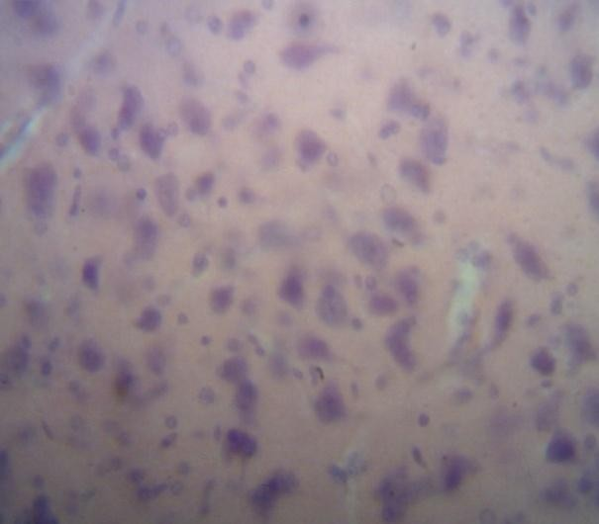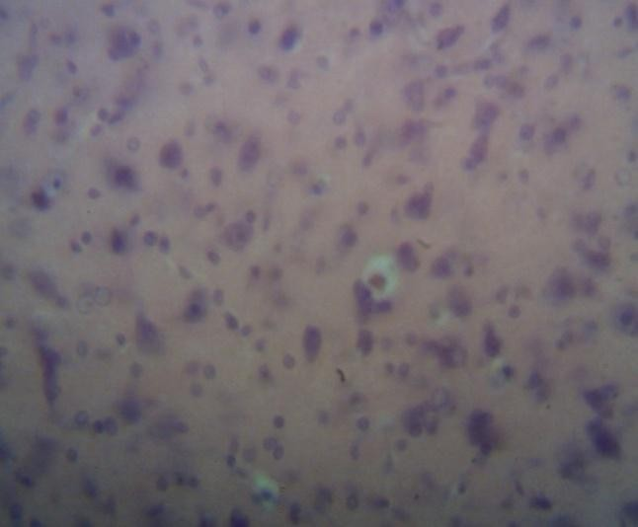

|  |  |
| --- | --- |
| A Control | B MVEA 1250 mg/kg |

Plate IV Pictomicrograph of the brain showing A (Control) Right arrow showing normal astrocytes, (1250 mg/kg) down arrow shows presence of oligodendrocyte after 28 days treatment with ethylacetate leaf extract of *M villosus*(H&E X 400).

1. Stomach

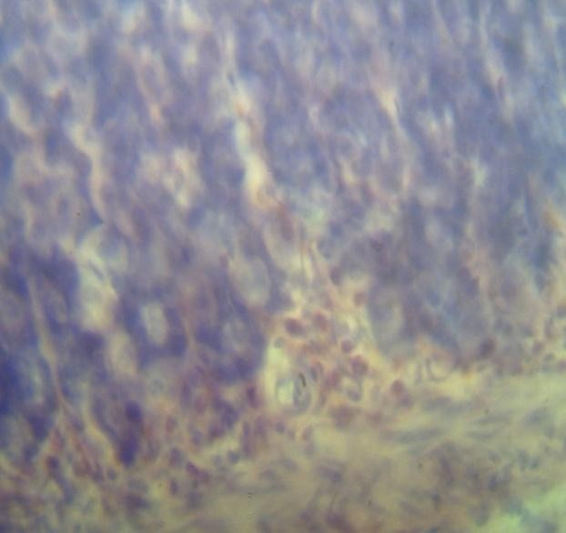

|  |  |
| --- | --- |
| A Control | B MVES 1250 mg/kg |

Plate V Pictomicrograph of the stomach showing A (Control) left arrow presence of normal chief cell and right arrow presence of oxyntic cells, B (1250 mg/kg) right arrow shows presence of chief cell while left arrow shows oxyntic cells within the gastric pit after 28 days treatment with ethylacetate leaf extract of *M villosus*(H&E X 400).

1. Small intestine

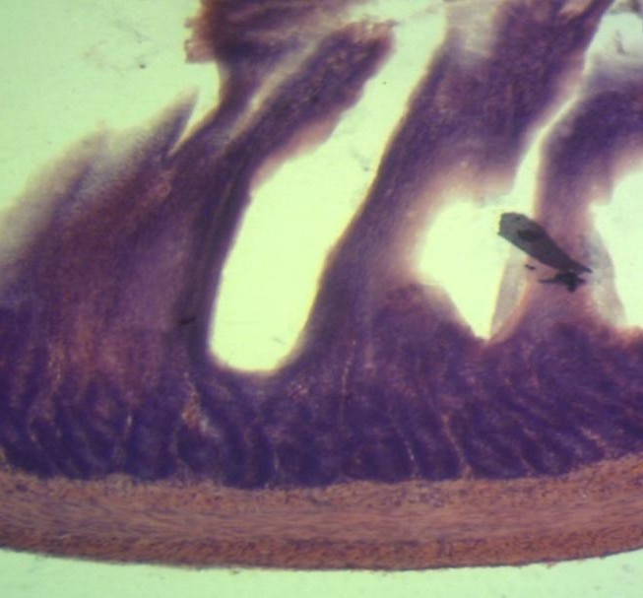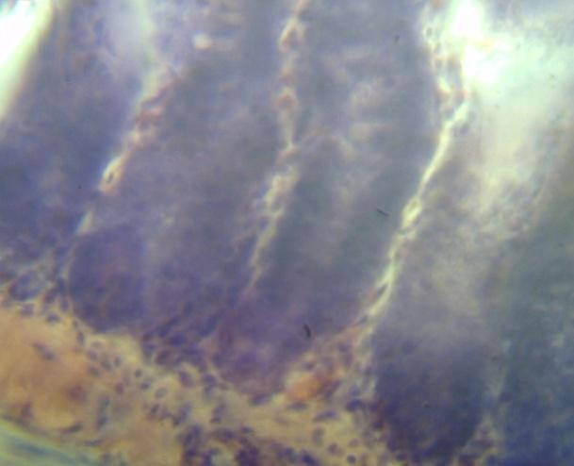

|  |  |
| --- | --- |
| A Control | B MVEA 1250 mg/kg |

Plate VI Representative section of the intestine showing the effect of the ethylacetate leaf extract of *Mitracarpus villosus* on treated rats. A (Control) Left arrow shows normal villi, down arrow shows agenterffin cell and up arrow shows smooth muscle of intestine, B (1250 mg/kg) right arrow shows presence of normal argentaffin cell within the crypst and down arrow shows a normal crypst of lieberkuhm (X200).

1. Lungs

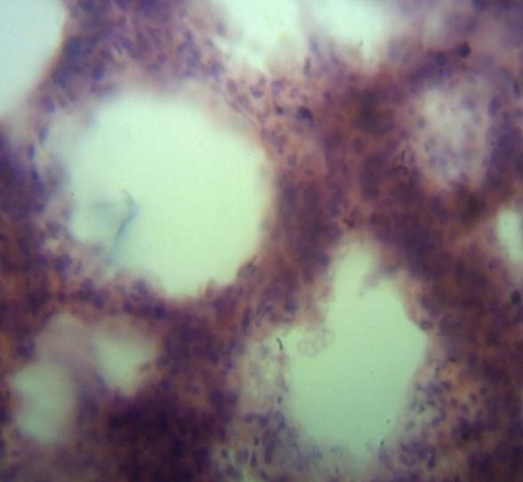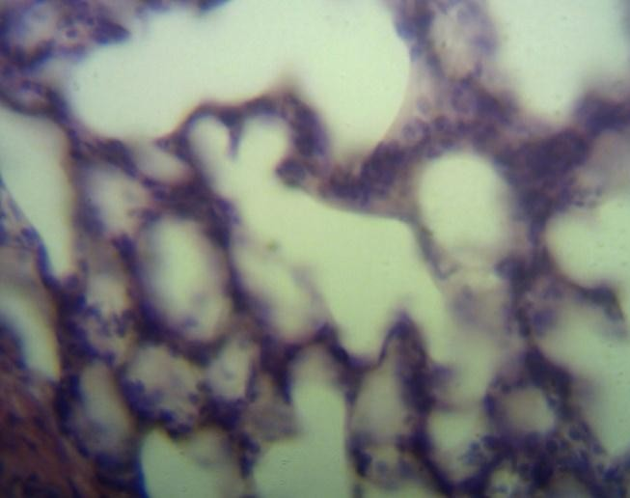

|  |  |
| --- | --- |
| A Control | B MVEA 1250 mg/kg |

Plate VII Pictomicrographs sections of the lungs showing the effect of the ethylacetate extract of *Mitracarpus villosus* on treated rats presenting with A (Control) left arrow indicating normal nuclei within the alveolar sac and down arrow shows a clear alveolar sac, B (1250 mg/kg) up arrow shows a normal nuclei within the alveolar sac while left arrow shows a clear alveolar sac (H&E X400).

1. Spleen

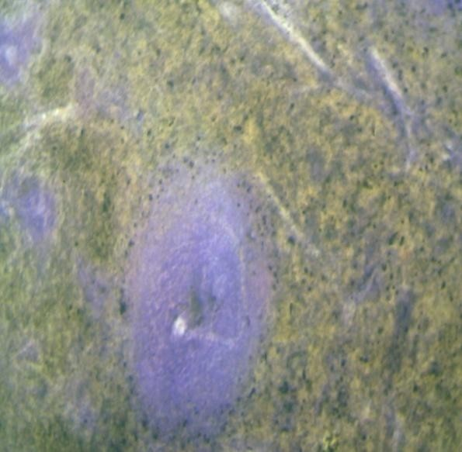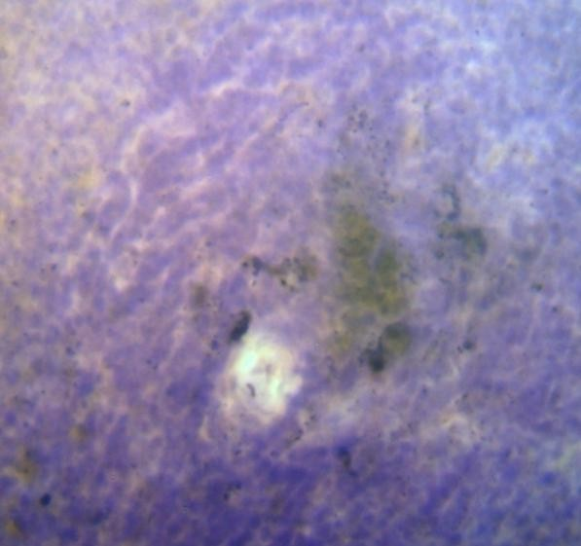

|  |  |
| --- | --- |
| A Control | B MVEA 1250 mg/kg |

Plate VIII Pictomicrographs of H&E stained sections of the liver showing A (Control) a normal white pulp, B (1250 mg/kg) a normal spleenic artery within the white pulp (X400).

1. Heart

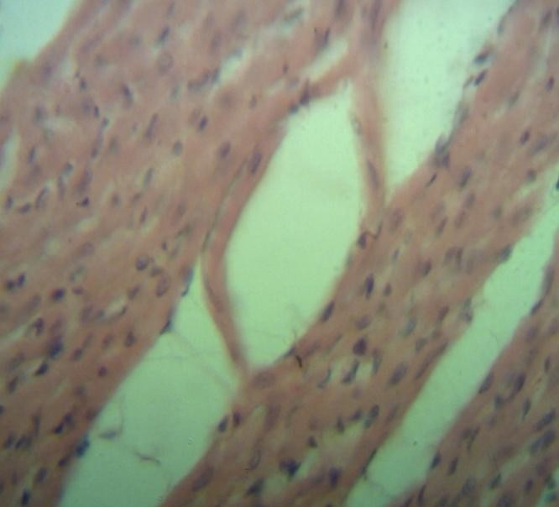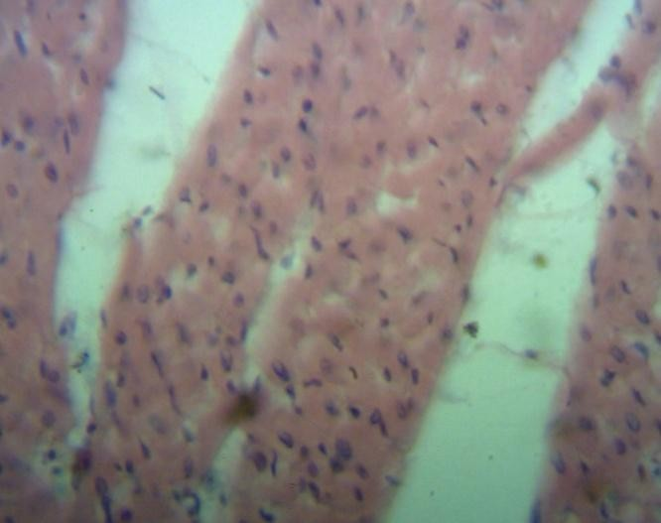

|  |  |
| --- | --- |
| A Control | B MVEA 1250 mg/kg |

Plate IX Microscopic representations of sections of the heart A (Control) a normal nuclei within the muscle cell, B (1250 mg/kg) normal nuclei within the muscle cell (H&E X400).

1. Ovary

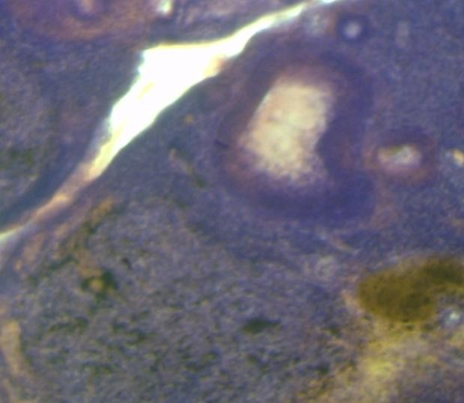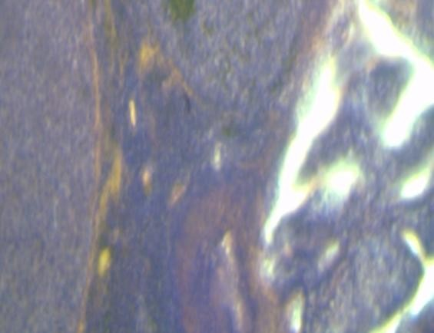

|  |  |
| --- | --- |
| A | B |

Plate X Pictomicrographs of the ovaries showing A (Control) developing ovarian follicle, B (1250 mg/kg) developing ovarian follicle (H&E X400).

1. Testis

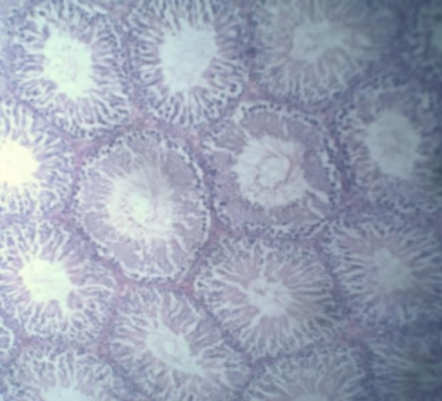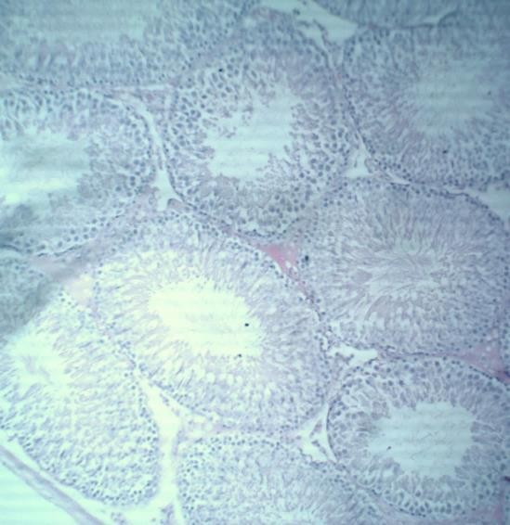

|  |  |
| --- | --- |
| A | B |

Plate XI Pictomicrographs of H &E stained sections of the testes A (control), B (1250 mg/kg) presenting with spermiogenesis and spermatogenesis and spermatozoans (X200)