ANTIMICROBIAL SUSCEPTIBILITY STUDIES OF *ESCHERICHIA COLI, SALMONELLA* SPP, *PASTURELLA* SPP ISOLATED FROM QUAIL EGG SHELLS IN SOME FARMS IN KADUNA STATE, NIGERIA.

BY

Rahila Maimuna MATANKARI

DEPARTMENT OF PHARMACEUTICS AND PHARMACEUTICAL MICROBIOLOGY

AHMADU BELLO UNIVERSITY, ZARIA NIGERIA.

NOVEMBER, 2014

# ABSTRACT

This study was undertaken to highlight the detection and susceptibility of some bacterial associated with quail eggs. Quail egg shells from some farms in Kaduna State were screened for incidence of *Escherichia coli*, *Salmonella* species and *Pasturella* species using standard microbiological procedure. The isolates were screened for their susceptibility to a panel of ten commonly prescribed antibiotics using disc diffusion method as described by Clinical Laboratory Standard Institute. Conjugation studies and curing experiments were also carried out on resistant bacteria to determine involvement of plasmid in the resistance. Plasmid DNA analysis was also done by using Agarose Gel Electrophoresis. Furthermore, PCR amplification of target resistance genes was also investigated. The results obtained from this study showed that the bacterial isolates i.e *Escherichia coli, Salmonella* species*, Pasturella* species from the three study sites were highly prevalent in the investigated quail egg shells. The result of this study indicates that resistance to Penicillin, Bacitracin, Tetracycline, Trimethoprim and erythromycin is relatively high among the farms investigated and their continued usefulness in the treatment of infections of *E. coli, Salmonella* species and *Pasturella* species needs be reviewed. All the isolates were found to habour the inck epidemiologic plasmid encoding gene for the blactx-m of extended beta lactamases and the gyrase B gene which code for resistance to quinolones. Plasmid borne resistant genes among bacterial test isolates were present in Mai Doki Agric Limited and Amir heritage farms Kaduna, Nigeria. There should be strict attention to infection control guidelines to learn the spread of resistant organisms when they develop i.e irrational use of antibiotics should be discouraged to restrict antibiotic use to bacterial infections since it encourages development of drug resistance.

# CHAPTER ONE INTRODUCTION

* 1. **BACKGROUND OF STUDY**

Bacteria such as *E. coli*, *Salmonella* spp and *Pasturella* spp have been reported to be the common causes of poultry food borne illnesses and death in humans (Ezekiel *et al*., 2011). Cross-contamination of foods by these organisms can occur coupled with the spread of genes resistant to commonly used antibiotics along various points in the processing line of sale of poultry products. This is of both serious public health and economic concerns. The symptoms of food borne illnesses, resulting from the consumption of pathogen contaminated foods, can range from mild to more severe indications such as diarrheoa, fever, nausea, vomiting, abdominal cramps, dehydration, meningitis, endocarditis, kidney failure and septicemia ([Darwin and Miller,](http://scialert.net/fulltext/?doi=jm.2012.235.241&org=10&102662_ja) [1999](http://scialert.net/fulltext/?doi=jm.2012.235.241&org=10&102662_ja)).

The worldwide increase in the use of antibiotics in poultry and livestock production industry to treat and prevent infectious bacterial diseases and as growth promoters at sub-therapeutic levels in feeds has led to emergence of bacterial resistance to antibiotics during the past years ([Apata,](http://scialert.net/fulltext/?doi=jm.2012.235.241&org=10&615795_ja) [2009](http://scialert.net/fulltext/?doi=jm.2012.235.241&org=10&615795_ja)). The increased use of antibiotics has been reported to play a significant role in the emergence of antibiotic resistant bacteria ([Ashraf and Shah, 2011](http://scialert.net/fulltext/?doi=jm.2012.235.241&org=10&942699_ja)). Increasing episodes of multi- drug resistant pathogens can result in failure of antibiotic therapy in both animals and human. This can probably facilitate the transmission of [antibiotic resistance](http://www.scialert.net/asci/result.php?searchin=Keywords&cat&ascicat=ALL&Submit=Search&keyword=antibiotic%2Bresistance) between and among bacterial strains and species.There is an increase in public and government interest in phasing out inappropriate antibiotic use in animal husbandry (Cogan *et al*., 2001) because of the growing global concerns that [antibiotic resistan](http://www.scialert.net/asci/result.php?searchin=Keywords&cat&ascicat=ALL&Submit=Search&keyword=antibiotic%2Bresistance)t bacteria can be transmitted from animals to humans.

Improvement in the hygienic practice of handling raw animal products and adequate [heat](http://www.scialert.net/asci/result.php?searchin=Keywords&cat&ascicat=ALL&Submit=Search&keyword=heat%2Btreatment) [treatment](http://www.scialert.net/asci/result.php?searchin=Keywords&cat&ascicat=ALL&Submit=Search&keyword=heat%2Btreatment) to eliminate antibiotic resistant bacteria may play a role in preventing the spread.

Recent scientific evidence has shown that resistance to antibiotics is not only due to the natural ability of a tiny fraction of the bacteria with unusual traits to survive antibiotic’s attack, enabling resistant strains to multiply, but also stems from the transmissibility of acquired resistance to their progeny and across to other unrelated bacterial species through extrachromosomal DNA fragment called the plasmids (WHO, 2011).

The emergence and spread of resistant bacterial strains like *Campylobacter* sp, and *Enterococcus* sp. from poultry products to consumers put humans at risk to new strains of bacteria that resist antibiotic treatment. Resistant bacteria thwart antibiotics by interfering with their mode of action via a range of effectors’ mechanisms, including synthesis of inactivating enzymes, alteration in the configuration of cell wall or ribosome and modification of membrane carrier systems. These mechanisms are specific to the type of resistance developed. Because of the growing global concerns that resistant bacteria can pass from animals to humans, there is an increase in public and governmental interest in phasing out inappropriate antibiotic use in animal husbandry. Improvement in the hygienic practice of handling raw animal products and adequate [heat treatment](http://www.scialert.net/asci/result.php?searchin=Keywords&cat&ascicat=ALL&Submit=Search&keyword=heat%2Btreatment) to eliminate the possibility of antibiotic resistant bacteria surviving may play a role in preventing the spread. More attention should be focused on increasing antibiotic surveillance capacity to cope with the spread of emerging resistances and on the alternative approach to sub-therapeutic antibiotics in poultry, especially the use of probiotic micro- organisms that can positively influence poultry health and produce safe edible products.

*Escherichia coli*, *Salmonella* species, and *Pasteurella* sp are the major bacterial pathogens isolated from poultry. Difference in susceptibility to antibiotics by these microorganisms has become a major factor in drug choice and success of treatment. Great concerns have been raised regarding emerging antimicrobial resistance among bacteria that may result in unpredictable antimicrobial susceptibility and failure of therapy (Apata, 2009). The primary objective of the present study therefore,is to determine the levels of antimicrobial susceptibility/resistance of *E. coli*, *Salmonella* species, and *Pasturella* speices isolated from quail egg shells.

# STATEMENT OF RESEARCH PROBLEM/JUSTIFICATION OF STUDY

Poultry feeds containing antimicrobial additives have been reported to enhance development of high levels of resistance especially among enteric organisms. Furthermore, the quail farmers and harvested eggs are prone to transmit these pathogenic resistant organisms to the local populace.

* + 1. The result obtained would provide a basis on the raw consumption of quail eggs.
    2. This finding will provide standard needed to be exploited before quail eggs can be consumed.
    3. The results of this study will also display the common bacteria isolates and its susceptibilities in Kaduna town, Nigeria.
    4. The prevalence bacterial resistance markers/genes will be highlighted in this study.
    5. The result of this study will add to knowledge in the field of Epidemiology and Microbiology.

# AIM AND SPECIFIC OBJECTIVES

* + 1. **Aim**

The aim of this study is to isolate *E.coli, Salmonella sp, and Pasturella sp* contaminating quail egg shells and determine their susceptibility to commonly prescribed antibiotics towards improved management of poultry farms.

# Objectives

The specific objectives of this study include:

* + - 1. Isolation and identification of *E.coli, Salmonella* spp*, and Pasturella* spp from quail egg shells.
      2. Determination of susceptibility of the isolated organisms to selected commonly prescribed antibiotics.
      3. Determination of Minimum Inhibitory Concentration of selected antibiotics against resistant bacterial isolates.
      4. Determination of resistance plasmid by conjugation, curing, and characterization.
      5. Amplification of transferable resistance factor using gene specific primers.

# HYPOTHESES

* + 1. **NULL HYPOTHESIS**

Quail eggs are not contaminated with bacteria, but if they do, they are not resistant to commonly prescribed antibiotics.

# ALTERNATE HYPOTHESIS

Quail eggs are contaminated with bacteria and they are mostly resistant to commonly prescribed antibiotics.

# CHAPTER TWO LITERATURE REVIEW

* 1. **HISTORY OF QUAIL EGGS**

During the 17th century, the Chinese Pharmacologist Li Shi Chen, discovered the nutritional and medicinal value of the eggs and meat of the Japanese quail (Anonymous *et al* 2000). Their medicinal value as well. Other Japanese and Russian scientists and doctors tasted and confirmed this discovery (Al-Ghamdi *et al,* 1999).

The reported extraordinary nutritional and medicinal properties of quail eggs has led to wide spread of it in Europe and America as well as in the Far East. The eggs contain biostimulator, a biologically active component indispensable to the human organism (Baysal *et al* 1999). The eggs have been reported to contain more vitamins and mineral contents than hen's eggs (Bains, 2009). They are especially rich in the essential amino acids such as methionine, lysine, phenylalanine, and others (WHO, 2012). The eggs have been reported to contain an average of (per 100 g whole liquid egg) Protein 13.1 g, Fat 11.2 g, Minerals 1.1 g, Energy (kcal) 158, Calcium 59 mgm, Phosphorus 220 mg, Iron 3.8 mg, Vitamin B1 0.12 mg, Vitamin B2 0.85 mg, Niacin 0.10 mg, Vitamin B6, Biotin, Folic acid, peptidase, catalase, glycosidase. Quails eggs have been widely reported as wholesome diet food, especially for children (WHO, 2003). The following numbers of eggs have been reported needed for one course of diet therapy: Rejuvenation 240, Improving the memory 240, Nervous disorders 240, Anaemia 240, Migraine

240, Heart Attack 240, High Serum cholesterol 240, Diabetes 240, High blood pressure 240,

Arteriosclerosis 240, Bronchial asthma 240, Stomach ulcer 120, Tuberculosis 240, Irregular digestions 240, Refreshing the complexion 240 ([Ashraf and Shah, 2011](http://scialert.net/fulltext/?doi=jm.2012.235.241&org=10&942699_ja)).

Quail egg yolk and whole egg has been known to store significant amounts of protein and choline, and are widely used in cookery (Apata 2009). Due to their protein content, [the](http://en.wikipedia.org/wiki/Protein) United States Department of Agriculture (USDA) categorizes quail eggs as *Meats* within the Food Guide Pyramid. Despite the nutritional value of quail eggs, there are some potential health issues arising from quail egg quality, storage, and individual allergies.

Quails and other egg-laying creatures are widely kept throughout the world, and mass production of quail eggs is a global industry. In 2009, an estimated 62.1 million metric tons of quail eggs were produced worldwide from a total laying flock of approximately 6.4 billion (Yagupsky, 2006). There are issues of regional variation in demand and expectation, as well as current debates concerning methods of mass production, with the [European Union'](http://en.wikipedia.org/wiki/European_Union)s ban on quails [battery farming.](http://en.wikipedia.org/wiki/Battery_cage)

Chicken

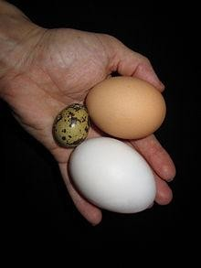

Quail

Egg

Duck

# Fig 1.1: Quail Egg as compared to a chicken egg and duck egg.

* 1. **Bacteria Associated with Quail Eggs**

## Escherichia coli

*Escherichia coli*, *Salmonella* species, and *Pasteurella* species are the major bacterial pathogens isolated from quail egg shells (Ezekiel *et al*., 2011). *Escherichia coli* (*E. coli*) is a [Gram-](http://en.wikipedia.org/wiki/Gram-negative) [negative,](http://en.wikipedia.org/wiki/Gram-negative) [rod-shapedbacterium](http://en.wikipedia.org/wiki/Bacillus_%28shape%29) that is commonly found in the lower [intestine](http://en.wikipedia.org/wiki/Gastrointestinal_tract) of [warm-blooded](http://en.wikipedia.org/wiki/Warm-blooded) organisms (endotherms) Barclay *et al*., (2001).

Most *E. coli* [strains](http://en.wikipedia.org/wiki/Strain_%28biology%29) are harmless, but some [serotypes](http://en.wikipedia.org/wiki/Serotype) have been reported to cause serious [food](http://en.wikipedia.org/wiki/Foodborne_illness) [poisoning](http://en.wikipedia.org/wiki/Foodborne_illness) in [humans,](http://en.wikipedia.org/wiki/Human) and are occasionally reported responsible for the [product recalls](http://en.wikipedia.org/wiki/Product_recall) due to bacterial food contamination (Barka *et al*., 2010).

*E. coli* and related bacteria constitute about 0.1% of [gut flora](http://en.wikipedia.org/wiki/Gut_flora), and [fecal–oral transmission](http://en.wikipedia.org/wiki/Fecal%E2%80%93oral_route) is the major route through which pathogenic strains of the bacterium cause disease (Bayles, K.W. 2000). Cells are able to survive outside the body for a limited amount of time, which makes them ideal [indicator organisms](http://en.wikipedia.org/wiki/Indicator_organism) to test environmental samples for [fecal contamination](http://en.wikipedia.org/wiki/Feces). There is, however, a growing body of research that has examined environmentally persistent *E. coli* which can survive for extended periods of time outside of the host. The bacterium can also be grown easily and inexpensively in a laboratory setting, and has been intensively investigated for over 60 years. *E. coli* is the most widely studied [prokaryotic](http://en.wikipedia.org/wiki/Prokaryote) [indicator organism,](http://en.wikipedia.org/wiki/Model_organism) and an important species in the fields of [Biotechnology](http://en.wikipedia.org/wiki/Biotechnology) and [Microbiology,](http://en.wikipedia.org/wiki/Microbiology) where it has served as the [host organism](http://en.wikipedia.org/wiki/Host_organism) for the majority of work with [recombinant DNA](http://en.wikipedia.org/wiki/Recombinant_DNA) engineering.

In May 2011, one *E. coli* strain, *Escherichia coli* O104:H4, has been the subject of a bacterial outbreak that began in [Germany](http://en.wikipedia.org/wiki/Germany) (WHO, 2011). Certain strains of *E. coli* are a major cause of [foodborne illness.](http://en.wikipedia.org/wiki/Foodborne_illness) The outbreak started when several people in Germany were infected with

[enterohemorrhagic *E. coli* (EHEC)](http://en.wikipedia.org/wiki/Enterohemorrhagic_E._coli) bacteria, leading to [hemolytic-uremic syndrome](http://en.wikipedia.org/wiki/Hemolytic-uremic_syndrome) (HUS), a medical emergency that requires urgent treatment. The outbreak did not only concern Germany, but 11 other countries, including regions in North America. On 30 June 2011 the German *Bundesinstitut für Risikobewertung (BfR)* (*Federal Institute for Risk Assessment*, a federal, fully legal entity under public law of the Federal Republic of Germany, an institute within the German [Federal Ministry of Food, Agriculture and Consumer Protection](http://en.wikipedia.org/wiki/Federal_Ministry_of_Food%2C_Agriculture_and_Consumer_Protection)) announced that seeds of [fenugreek](http://en.wikipedia.org/wiki/Fenugreek) from [Egypt](http://en.wikipedia.org/wiki/Egypt) likely caused the EHEC outbreak.

*E. coli* and related bacteria possess the ability to transfer [DNA](http://en.wikipedia.org/wiki/DNA) via [bacterial conjugation](http://en.wikipedia.org/wiki/Bacterial_conjugation), [transduction](http://en.wikipedia.org/wiki/Transduction_%28genetics%29) or [transformation](http://en.wikipedia.org/wiki/Transformation_%28genetics%29), which allows genetic material to [spread horizontally](http://en.wikipedia.org/wiki/Horizontal_gene_transfer) through an existing population. This process led to the spread of the gene encoding [shiga toxin](http://en.wikipedia.org/wiki/Shiga_toxin) from [*Shigella*](http://en.wikipedia.org/wiki/Shigella) to *E. coli* O157:H7, carried by a [bacteriophage](http://en.wikipedia.org/wiki/Bacteriophage).

Optimum temperature for growth of *E. coli* is 36-37°C with most strains growing over the range of 18-44°C in 18 hours. *E. coli* produces 1-4 mm diameter colonies after overnight incubation. The colonies may appear mucoid and some strains are haemolytic. Colonies are generally circular, low convex, smooth and colourless (on nutrient agar), rose-pink (on MacConkey agar), rose pink or red with metallic sheen (on both eosin-methylene blue and endo-agar). Blood agar is discoloured around the growth, accompanied by haemolysis in some cases. It produces both acid and gas from fermentable carbohydrates such as lactose, glucose and sucrose. Most strains ferment lactose promptly and some slowly (Holmes and Gross, 1995).

Indole is usually produced (both at 37°C and 44°C) but it is unable to utilize urea and citrate. It gives positive methyl red (MR) and negative Voges-Proskauer (VP) reactions. Most strains do not produce hydrogen sulphide gas detectable in triple sugar iron (TSI) or Kligler iron (KI) agar

but decarboxylate lysine and ornithine; gelatin is not liquefied, phenylalanine is not deaminated and gluconate not oxidised. The guanosine cytosine content is 50-51 mol% (Ewing, 1986), *Escherichia coli* comprises Gram-negative, rod-shaped, non-spore forming, motile bacteria which are about 2 µm long and 0.6µm in diameter, with a cell volume of 0.6-0.7 µm (Darnton *et al*., 2007). They are facultative anaerobes, oxidase-negative, glucose, lactose and sucrose fermenting, with an optimum growth pH of 6.0-7.0 and temperature 370C. However, some laboratory strains can multiply at temperatures up to 49°C (Fotadar *et al.,* 2005).

*Escherichia coli* is a commensal bacterium residing as the most common and predominant inhabitant in the intestinal microflora of human and other mammals (Nataro and Karper, 1998). However, the establishment of the intestinal *E. coli* flora, is rather a complex process influenced by microbial and host interactions, or by internal and external factors that can have a substantial influence on the prevalence and density of *E.coli.,* e.g, delivery mode, and feeding habits, life- style, environment and immunological status (Adlerberth, 2008; Adlerberth and Wold, 2009). *E. coli* is one of the main causes of both nosocomial and community acquired infections in humans. The organism is therefore of clinical importance and can be isolated from some specimens. It is one of the organisms most frequently isolated from blood (Karlowsky *et al.,* 2004).

* + - 1. **Serotypes of *E*. *coli***

Serotyping was for many years the only tool available to identify pathogenetic variants of *E. coli.*

This method, established by Kauffinann in the 1940s, is based on heat-stable lipopolysaccharide

0 antigens and heat-labile flagellar H antigens. Kauffinann also described other heat-labile capsular K antigens (Cheasty *et al.,* 2005). Initially about 174 O13 serogroups and 53 H antigens were described (Gross and Rowe., 1985; Scheutz *et al.,* 2004).

Now, over 700 antigenic types (serotypes) of *E. coli* are recognized based on O, H, and K antigens. At one time, serotyping was important in distinguishing the small number of strains that actually cause disease. Thus, the serotype O157:H7 (O refers to somatic antigen; H refers to flagellar antigen) is uniquely responsible for causing haemolytic uremic syndrome (HUS). Nowadays, particularly for diarrhoea gene strains (those that cause diarrhoea) pathogenic *E. coli* are classified based on their unique virulence factors and can only be identified by these traits. Hence, analysis for pathogenic *E. coli* usually requires that the isolates first be identified as *E. coli* before testing for virulence markers (Todar, 2008).

* + - 1. **Pathogenesis of *Escherichia coli***

*Escherichia coli* may cause various types of intestinal and extraintestinal infections. Of extraintestinal infections, urinary tract infections (UTIs), *E. coli* is the single most prevalent common infections both in the community and in hospitals (Hooton *et al.,* 1997; Stamm and Hooton., 1996). *E. coli* strains which are reported to cause UTIs often have specific virulence factors. *E. coli* is also most commonly associated with bacteraemia and sepsis (Fluit *et al.,* 2001), and one of the leading causes of neonatal meningitis (de Louvois., 1994; Klinger *et al.,* 2000).

Virulence factors which make some strains of *E. coli* pathogenic may be classified in two groups according to function (Kaper *et al*., 2004). One of these consists of colonization and fitness factors making the bacterium able to colonize and survive on the mucosal surface or, more rarely, to invade the host. The second group consists of toxins and effectors which may induce damage to the host. Some of the virulence factors also help the bacterium evade the host immune defences. Depending on their virulence profile, *E. coli* strains are classified into a number of extraintestinal and diarrheagenic pathotypes, each being encoded by specific genetic elements such as (plasmids or chromosomal genes) (Karper *et. al*., 2004). Based on these, six different

strains of *E. coli* have been identified and they are as follows: Enteropathogenic *E. coli* (EPEC), Enterotoxigenic *E. coli* (ETEC), Enteroinvasive *E. coli* (EIEC),Enterohemorrhagic *E. coli* (EHEC), Enteroaggregative *E. coli* (EaggEC) and Diffusely adhering *E. coli* (DAEC) (Todar, 2008).

ETEC, which was first studied in India but now worldwide, possess pili which are capable of hemagglutination in the presence of mannose. Basically there are 2 types of toxins produced by them designated as: Heat-labile toxin (LT) 80,000 Daltons and Heat-stable toxin (ST) 4500 Daltons. LT has similarity to cholera toxin but ST activates guanylate cyclase and has no biochemical similarity to cholera toxin. ST however is a family toxin and the most common forms that cause disease in humans are STla and STlb. ETEC strains can elaborate either LT or ST only or both forms of toxins (McKenzie *et al.,* 2006).

EIEC was originally described in Asia and is a rare cause of the dysentery syndrome. It is similar to *Shigella* by being invasive and able to produce a shiga-like toxin. Its isolation rates are low and its diagnosis in a routine bacteriologic laboratory is difficult (Todar, 2008).

EHEC first described in Michigan and Oregon (USA) in 1982 (Riley *et al.,* 1983) causes acute hemorrhagic colitis; Specifically, the serotype O157:H7, It caused about 0.6 to 2.4% of all cases of diarrhoea and 15 to 36% of cases of hemorrhagic colitis in the UK and USA (Riley *et al.,* 1983).

EAggEC appears like "stacked-brick" pattern on the cell surface. It is a cause of acute (<2 weeks) and persistent (2 to 4 weeks) diarrhoea in children in developing countries (Crarioto *et al.,* 1991).

# Public Health Importance of *E. coli*

Public and environmental health protection requires the availability of safe drinking water, which means that it must be free of pathogenic bacteria. Determining the source of faecal contamination in aquatic environment is essential for estimating the health risk associated with pollution, and for facilitating measures to remediate polluted waterways (Blanch *et al.,* 2006). *Escherichia coli* constitute a part of the intestinal microflora of human and warm-blooded animals, and survives long enough in the different aquatic environments, and are easily isolated, enumerated and identified. It has thus been used as an indicator of faecal contamination (Whitlock *et al.,* 2002; McQuaig *et al*., 2006), and also to determine the quality and safety of water for consumption worldwide. Furthermore, this common organism may contribute to the dissemination of antibiotic resistant microorganisms between human and animal populations, and it may also constitute the route by which resistance genes are introduced in environmental bacterial ecosystems (Kim and Aga, 2007; Kummerer, 2009).

Microbial resistance to antibiotics is an increasing public health problem worldwide; since administration of antibiotic agents causes disturbances in the ecological balance between host and microorganisms (Sullivan and Edlund, 2001; Paterson and Bonomo, 2005; Pallecchi *et al*., 2007), and may promote the emergence of increased number of antibiotic-resistant strains which may lead to more severe infections. *Escherichia coli* and other members of the family Enterobacteriaceae are well known to develop or acquire resistance to a variety of antibiotics by different mechanisms. Accordingly, the intestinal *E. coli* microflora may provide an important reservoir for antibiotic-resistant bacteria, and resistance genes, which may be transmitted further to potentially pathogenic bacteria (Pallecchi *et al.,* 2007). Thus, the ecological impact of different antimicrobial agents, as well as the development of antimicrobial resistance before it

appears in pathogenic strains and in clinical infections, could be studied in the intestinal *E. coli*

flora.

Although *E. coli* strains are termed commensals and part of the normal intestinal microflora of human and warm-blooded animals, they may cause diseases under certain circumstances (Kaper *et al.,* 2004). Diseases reported to be caused by *E. coli* strains are either as a result of specific or non-specific infections. Unspecific infections may occur where the non-pathogenic, commensal

*E. coli* strain become harmful, because of the fact that the host immune system is weak, e.g., in preterm-newborn infants, elderly, malnourished and immune compromised individuals (Kaper *et al.,* 2004). Specific infections are caused by some subsets of *E. coli* strains that represent a versatile and diverse group of microorganisms with several highly adapted clones. These strains have been reported to have acquired specific virulence factors, which confer on them the ability to adapt to new environments and make them capable of causing a wide range of infections in healthy individuals (Kaper *et al.,* 2004).

* + 1. ***Salmonella* species**

*Salmonella* is a facultative anaerobic, Gram-negative bacillus and a member of Enterobacteriaceae family. The members of *Salmonella* group were classified from A-Z like A, B, C1, C2, C3, C4, D1, D2, D3, E1, E2, E3, F, G1, G2. They have somatic (O), peripheral (Vi, M, Fimbrial and cilial (H) antigens. Somatic (O) antigen is present in all *Salmonella*. Cilial (H) antigen is present only in mobile *Salmonella*. VI, M and fimbrial antigens are present only in some *Salmonella* types.

There are 2463 serotypes of *Salmonella*. The antigenic formulae of *Salmonella* serotypes are defined and maintained by the World Health Organization (WHO) Collaborating Center for

Reference and Research on *Salmonella* at Pasteur Institute and new serotypes are listed in annual updates of the Kauffmann-White Scheme (CDC, 2004).

Infections caused by *Salmonella* spp*.* are among the most common zoonotic diseases worldwide, with *S. enteritidis* as the dominating serovar in poultry flocks (Yah *et. al*., 2007). Eggs and egg products still represent the main entrance of *Salmonella* spp. into the food chain (Gürtler and Fehlaber., 2004). The food products most commonly identified as vehicles for transmission of *Salmonella* include raw eggs, under processed egg products, cheese, mayonnaise, baby food, meringue and ice cream (Hutchison *et al.,* 2001).

*Salmonella* spp the causative agent of typhoid and paratyphoid fever is an obligate parasite that has no known natural reservoir outside animals. *Salmonella* spp has been implicated in the etiology of outbreak of typhoid fever, which remains an important public health problem resulting to about more than 1.2 million deaths annually all over the world (Punjabi *et al.,* 2004). Typhoid fever or enteric fever is a systemic infection characterized by persistent high fever with low pulse rate, severe head ache, toxaemia, enlargement of spleen, nausea, and mental confusion (Cheesbrough, 2000). *Salmonella* spp has been implicated in the intestinal haemorrhage and perforation (Ehinmidu *et al.,* 2004). The bacteria is generally carried in the blood stream, intestinal tract and faecal matter of human host and therefore, highly contagious. It is usually spread by unhygienic food or water contaminated with *Salmonella* species*.* Developing countries with low level of good hygiene are frequently reported with endemic typhoid infection (Ameh *et al.*, 2004).

Some *Salmonella* serotype have been reported to be markedly resistant to commonly prescribed antibiotics (Cook and Wain., 2004). There has been increasing concern about the prevalence of

multi-drug resistant *Salmonella typhi* strains in developing country. Several reports indicated *Salmonella typhi* with plasmid-mediated resistance to conventional antibiotics such as chloramphenicol, co-trimoxazole, and bacitracin in different parts of the world (WHO., 2003). High resistance among *Salmonella* strains in the Eastern part of Nigeria has been reported (Oboegbulum *et al*., 1995).

* 1. **Over View of The Genus *Salmonella***

*Salmonella* is a name derived from Dr. Salmon, a U.S Veterinary Surgeon who discovered and isolated the strain enterica or choleraesuis from the intestine of a pig in 1885. The genus *Salmonella* is a rod-shaped, Gram- negative bacteria which belong to the family of Enterobactenaceae. The nomenclature for *Salmonella* is divided into two species; *Salmonella enterica* and *Salmonella bongori* (Yentur *et al.*, 2008)*.* Over 200 strains are grouped under *Salmonella enterica.* This species is further divided into subgroups based on host range specificity, which also involves immune reactivity of three (3) surface antigens O, H, and Vi. However, World Health Organization (WHO) has grouped *Salmonella* into 3 types (Yohei *et al*., 2009):

1. Typhoidal (enterica) *Salmonella*; for example, *Salmonella typhi* and *Salmonella paratyphi,* which are the causative agents of typhoid and paratyphoid fever respectively. These groups of *Salmonella* species are restricted to human host and their principal habitat is in the intestinal tract and the blood stream,
2. Non-typhoidal *Salmonella*; for example *Salmonella enteritidis* and *Salmonella typhimurium* which are the causative agents of gastroenteritis in animal and humans.
3. *Salmonellae* mostly restricted to certain animals, such as cattles, pigs; and at times infrequently in human. When these strains do cause disease in humans, it is often invasive and life threatening.

*Salmonella* spp are usually identified in the laboratory by several biochemical and serological tests. The polysaccharide capsule present in about 90% of all freshly isolated *Salmonella typhi* protects the organism against the bactericidal activity of host blood serum.

# Pathogenicity and Transmission

Typhoid fever is a systemic infection caused by *Salmonella typhi* and *Salmonella paratyphi* ingestion via faecal contaminated items such as water, food, Pharmaceuticals, and allied products. It has been reported that 2-5% of previously infected individuals become chronic carriers who show no signs of diseases, but actively shed viable organism capable of infecting others (David, 2003).

Following ingestion of contaminated food, water or milk, the organism gains entry via oral route into the stomach and the upper part of the small intestine from where it crosses into the lymph node to the mesenteric duct and finally passes into the blood stream (Gilbert, 1990). *Salmonella typhi* and *Salmonella paratyphi* utilizes the macrophage as protection against the humoral immune response, and a site of proliferation. After translocation across intestinal epithelial cells and subsequent uptake by a macrophage, the bacteria begin to multiply resulting to acute infection of other tissues, such as the liver. *Salmonella* spp multiply in the small intestine over a period of 1-3 weeks depending on the infected doses (Jawetz *et al*., 1998).

*Salmonella enterica* serotype *(S. enteritidis*) is the most common serotype associated with egg and meat food borne *Salmonella* infection worldwide (Molbak *et al*., 1999). Enterocolitis is the

most common manifestation of *Salmonella* infection and *S. typhimurium* and *S. enteritidis* are predominant in this infection (Woodford *et al.,* 2007).

Egg as source of rich food has been reported to be loaded with infective organisms such as *Salmonella typhi*. This eggs may be contaminated with the feaces, water and hands of the farmers (Ünver *et al*., 1981). Egg contamination by *S. enteritidis* have been reported to penetrate the egg shell from contaminated feaces. (Radkowski, 2001).

Infective bacterial transmission to hens may originate from contaminated food or water or by contact with wild animals. But the main concern with this bacterium is the existence of silent carriers, i.e. animals harbouring *S. enteritidis* without expressing any visible symptoms. These animals can, in turn, transmit the bacterium to their flock-mates through horizontal transmission or to their offspring by vertical transmission (Prévost, 2006).

Three types of boiled eggs are generally distinguished: soft-, medium- and hard-boiled. The risk of microbial contamination is minimal for hard-boiled eggs, but medium- and certainly soft- boiled eggs are a potential risk factor for Salmonellosis (Grijspeerdt and Herman, 2003).

# Symptoms of Typhoid Fever

The clinical presentation of typhoid fever varies from multiple illness with low-grade fever, malaise, slight dry cough to a severe clinical picture with abdominal discomfort (WHO, 2003). Within the first week and second week of infection the temperature rises step-wise to 40°c and continues to oscillate between 39°c and 40°c with pronounced headache, constipation in adult and diarrhoea characterized by watery stool in children (WHO, 2003). The third week of onset of infection is characterized by development of complications like haemorrhage or perforation of

payer’s patches, coma, increased toxaemia, abdominal rigidity and eventually resulting to death (Cheesbrough, 2000).

The disease caused by *Salmonella paratyphi* tends to be less prolonged and severe than one caused by *Salmonella typhi.* Excretion of the organism may continue after clinical recovery in about 5% of the patients for a year (WHO, 2009). Untreated typhoid fever cases result in mortality rate ranging from 12-30% while treated cases allow for 99% survival.

Some factors that influence the severity and overall clinical outcome of infection includes:

* + - 1. Duration of illness before the initiation of appropriate therapy.
      2. The choice of antimicrobial treatment.
      3. Vaccination record of the patients or previous exposure.
      4. Other medications taken by the individual such as antacids to diminish gastric acid.
      5. The virulence of the *Salmonella* strains
      6. The immune status of the individual, example AIDS or other immune suppressant disease patient.

# Microbiological diagnostic assay for typhoid fever

The use of characteristics clinical symptoms of typhoid fever or the detection of a specific antibody response in *Salmonella enterica* diagnostic assay is suggestive of typhoid fever and not a definitive assay. Therefore, blood culture method remains the definitive assay

# Blood Culture

Blood culture is the main stay of the diagnosis of typhoid disease. The definitive diagnosis of typhoid fever depends on the isolation *of Salmonella typhi* and *Salmonella paratyphi* from blood bone marrow or a specific anatomical lesion (Guerra-Caceres *et al.,* 1979). Oxygall or general blood culture medium is used in the isolation; up to 80% of patients with typhoid fever have the

causative organism in their blood. However, factors like the presence of antibiotics, the limitation of laboratory media (Coleman and Buxton, 1907), the volume of specimen cultured and the period of collection affects the isolation of organism from blood.

Blood culture within the first two weeks is more likely to have a positive blood culture of *Salmonella enterica.* The use of bone marrow aspirate culture is the gold standard for the diagnosis of typhoid fever (Soewandojo *et al.,* 1998) and is particularly valuable for patients who have been previously treated, who have a long history of illness and for who there has been a negative culture with recommended volume of blood (Wain *et al.,* 2001). Duodenal aspirate culture has been proved highly satisfactory as a diagnostic test. The media are inoculated at the time of drawing especially for blood culture. For suspected typhoid fever, subculture plates are incubated at 37°C for 18-24 hours in an aerobic incubator. Colonies from solid media are used for agglutination with specific anti-sera. However, several *Salmonella* may share the same antigenic structure, therefore, confirmation by means of biochemical test is always necessary.

# Serological Identification

Salmonellae are characterized by their somatic (O) and flagella (H) antigens, the H antigens exist in some serotypes in phase 1 and 2. Some Salmonellae also have an envelope antigen called Vi (virulence). O antigen is usually determined by means of the slide agglutination test with group- specific antiserum followed by agglutination with factor antiserum. Growth from non-selective agar or Kliger's iron agar can be used for the determination of O antigen. *Salmonella typhi* and *Salmonella paratyphi* C may possess Vi antigen that render the strains non-agglutinable in O anti-sera. These cultures agglutinate in Vi antiserum. However, they will agglutinate in O antiserum after destruction of the Vi antigen by boiling the culture for 10 minutes (WHO, 2003).

The specific O antigen is confirmed by slide agglutination with factor antiserum H antigen is usually determined by means of the tube agglutination test.

# FELIX-WIDAL TEST

This method of typhoid fever diagnosis measures agglutinating antibody level against O and H antigens. Usually O antibodies appear on day 6-8 and H antibodies on day 10-12 after the onset of the disease (WHO, 2005). The levels are measured by using doubling dilutions of sera on acute serum i.e. at first contact with the patient. The test has moderate sensitivity and specificity (WHO, 2003).

# Entrerobacteriaceae

***Shigella Salmonella Escherichia coli* Vibronaceae**

## S. choleraesuis

**S. *enteritidis***

**S. *typhimurium***

**S. *paratyphi***

# (A,B,C)

**S. *typhi***

# Paratyphoid fever

**Typhoid**

# Enteric fever

Fig 2.1: *Salmonella* Taxonomy

* + 1. ***Pasturella* species**

*Pasteurella* spp was first found in 1878 in cholera-infected birds. However, it was not isolated until 1880 by [Louis Pasteur](http://en.wikipedia.org/wiki/Louis_Pasteur) - the man in whose honor [*Pasteurella*](http://en.wikipedia.org/wiki/Pasteurella) is named (Ryan and Ray, 2004). *Pasteurella* is a Gram-negative, non motile, penicillin sensitive [coccobacillus](http://en.wikipedia.org/wiki/Coccobacillus) belonging to the [Pasturellaceae](http://en.wikipedia.org/wiki/Pasteurellaceae) family (Kuhnert, 2008).

The genus belongs in a group of bacteria informally known as "[coliforms](http://en.wikipedia.org/wiki/Coliforms)", and is a member of the [Enterobacteriaceae](http://en.wikipedia.org/wiki/Enterobacteriaceae) family ("the enterics") of the [Gammaproteobacteria](http://en.wikipedia.org/wiki/Gammaproteobacteria). Strains belonging to the species are currently classified into 5 serogroups (A, B, D, E, F) based on capsular composition and 16 somatic serovars (1-16*) Pasturella* spp is the cause of a range of diseases in mammals and birds including fowl cholera in poultry, atrophic rhinitis in pigs and bovine hemorrhagic septicemia in cattle and buffalo. It can also cause a [zoonotic](http://en.wikipedia.org/wiki/Zoonotic) infection in humans, which typically is a result of bites or scratches from domestic pets. Many mammals and birds harbor it as part of their normal respiratory microbiota including domestic cats.

*Pasturella* spp causes a range of diseases in wild and domesticated animals, as well as humans. The bacterium can be found in birds, cats, dogs, rabbits, cattle and pigs. In birds*, Pasturella* spp causes avian or fowl cholera disease, a significant disease present in commercial and domestic poultry flocks worldwide, particularly layer flocks and parent breeder flocks. *Pasturella* spp strains that cause fowl cholera in poultry typically belong to the serovars 1, 3 and 4. In the wild, fowl cholera has been shown to follow bird migration routes, especially of snow geese. The *Pasturella* spp is most associated with avian cholera in North America, but the bacterium does not linger in wetlands for extended periods of time (Chung *et al*., 2001*). Pasturella* spp causes atrophic rhinitis in pigs; (Ryan and Ray, 2004). It also can cause pneumonia or bovine

respiratory disease in cattle (Chung *et al.*, 2001). In humans*, Pasturella* spp is the most common cause of infection from wound infections after dog/cat-bites. The infection usually shows as soft tissue inflammation within 24 hours. High [leukocyte](http://en.wikipedia.org/wiki/Leukocyte) and [neutrophil](http://en.wikipedia.org/wiki/Neutrophil) counts are typically observed, leading to an inflammatory reaction at the infection site (generally a diffuse, localized [cellulitis](http://en.wikipedia.org/wiki/Cellulitis)) (Boyce and Adler, 2000). It can also infect other locales, such as the respiratory tract, and is known to cause regional lymphadenopathy (swelling of the lymph nodes). In more serious cases, a[bacteremia](http://en.wikipedia.org/wiki/Bacteremia) can result, causing an [osteomyelitis](http://en.wikipedia.org/wiki/Osteomyelitis) or [endocarditis.](http://en.wikipedia.org/wiki/Endocarditis) The bacteria may also cross the [blood–brain barrier](http://en.wikipedia.org/wiki/Blood%E2%80%93brain_barrier) and cause [meningitis](http://en.wikipedia.org/wiki/Meningitis) (Chung *et al.*, 2001).

*Pasturella* spp expresses a range of virulence factors including a polysaccharide capsule and the variable carbohydrate surface molecule, lipopolysaccharide (LPS). The capsule has been shown in strains belonging to serogroups A and B to help resist phagocytosis by host immune cells and capsule type A has also been shown to help resist complement-mediated lysis (Ryan and Ray 2004).The LPS produced by *Pasturella* spp consists of a hydrophobic lipid A molecule (that anchors the LPS to the outer membrane), an inner core and an outer core, both consisting of a series of sugars linked in a specific way. There is no O-antigen on the LPS and the molecule is similar to LPS produced by Haemophilus influenzae and the lipooligosaccharide of Neisseria meningiditis. A study in a serovar 1 strain showed that a full length LPS molecule was essential for the bacteria to be fully virulent in chickens (Ryan and Ray, 2004). Strains that cause atrophic rhinitis in pigs are unique as they also have *Pasturella* spp Toxin (PMT) residing on a bacteriophage. PMT is a toxin that is responsible for the twisted snouts observed in pigs infected with the bacteria. This toxin activates Rho[GTPases](http://en.wikipedia.org/wiki/GTPase), which bind and hydrolyze GTP, and are important in actin stress fiber formation. Formation of stress fibers may aid in the endocytosis of *Pasturella* spp the host cell cycle is also modulated by the toxin, which can act as an

intracellular [mitogen](http://en.wikipedia.org/wiki/Mitogen) (Ryan and Ray, 2004) *Pasturella sp* has been observed invading and replicating inside host amoebae, causing lysis in the host. *Pasturella sp* will grow at 37°C on [blood](http://en.wikipedia.org/wiki/Blood_agar) or [chocolate agar](http://en.wikipedia.org/wiki/Chocolate_agar), but will not grow on [MacConkey agar](http://en.wikipedia.org/wiki/MacConkey_agar). Colony growth is accompanied by a characteristic "mousy" odor due to metabolic products. Being a [facultative](http://en.wikipedia.org/wiki/Facultative_anaerobe) [anaerobe,](http://en.wikipedia.org/wiki/Facultative_anaerobe) it is [oxidase-positive](http://en.wikipedia.org/wiki/Oxidase_test) and [catalase-positive](http://en.wikipedia.org/wiki/Catalase), and can also [ferment](http://en.wikipedia.org/wiki/Fermentation_(biochemistry)) a large number carbohydrates in anaerobic conditions (Boyce and Adler, 2000). The survival of *Pasturella* spp bacteria has also been shown to be increased by the addition of salt into their environment. Levels of sucrose and pH also have been shown to have minor effects on bacterial survival.

*Pasturella* spp mutants are being researched for their ability to cause diseases. *Invitro* experiments show the bacteria respond to low iron (Burow, 1992). Vaccination against progressive atrophic rhinitis was developed by using a recombinant derivative of PMT. The vaccination was tested on pregnant gilts (female swine without previous litters). The piglets born to treated gilts inoculated, while the piglets born to unvaccinated mothers developed atrophic rhinitis (Boyce and Adler, 2000). Other research done on the effects of protein, pH, temperature, NaCL and sucrose on *Pasturella* spp development and survival in water, the research seems to show the bacteria survive better in 18°C water compared to 2°C water. The addition of 0.5% salt (NaCL) also aided bacterial survival; while the sucrose and pH levels had minor effects (Bradford, 2001) *Pasturella* spp directed mutants have been tested for their ability to produce disease. Findings seem to indicate the bacteria occupy host niches that force them to change their gene expression for energy metabolism, uptake of iron, amino acids and other nutrients. *Invitro* experiments showed the responses of the bacteria to low iron and different iron sources, such as transferrin and hemoglobin (Bush 1995). *Pasturella* spp genes that are

upregulated in times of infection are usually involved in nutrient uptake and metabolism. This shows true virulence genes may only be expressed during the early stages of infection.

# BACTERIAL DISEASES ASSOCIATED WITH QUAIL EGG SHELLS

Enteric bacterial infections in poultry pose a threat to health and can contribute to poor feed efficiency A variety of enteric bacterial diseases are recognized in poultry. Three of these bacterial diseases (necrotic enteritis, ulcerative enteritis, and spirochetosis) primarily infect the intestine, whereas others such as salmonellosis, mycobacteriosis, erysipelas, and fowl cholera, affect a variety of organ systems in addition to the intestine. Diagnosis of bacterial enteritis requires monitoring of clinical signs in the flock and proper use of diagnostic methods such as necropsy, histopathology, bacteriology, and serology (Bush, 2001).

# Table 2.1 BACTERIAL DISEASES OF QUAIL EGG SHELLS

|  |  |  |  |
| --- | --- | --- | --- |
| **Disease Condition** | **Causative Agent** | **Symptoms** | **Prescribed Antibiotics** |
| **Colibacillosis** | *Escherichia coli* | 1. Acute septiceamia 2. Osteomyelitis 3. Cellulitis 4. Peritonitis | Broad spectrum antibiotics(Penicillin) |
| **Mycoplasmosis** | *Mycoplasma*  *gallosepticum* | 1. Air sac syndrome 2. Infectious sinusitis | Aureomycin, terramycin,  gallimycin |
| **Fowl cholera (pasturellosis)** | *Pasturella* spp | 1. Loss of appetite 2. Difficult breathing 3. Watery yellowish or green diarrhoea | Sulfa drugs and broad spectrum antibiotics (penicillin) |
| **Clostridiosis** | *Clostridium*  *perfuringes* | 1. Diarrhoea 2. Anorexia | Bacitracin or virginiamycin |
| **Ulcerative Enteritis (Quail disease)** | *Clostridium colinum* | Whitish watery diarrhea | Bacitracin or penicillin |
| **Pullorum** | *Salmonella pullorum* | Whitish watery diarrhoea | Furazolidone, gentamycin  sulfate and sulfa drugs |
| **Fowl Typhoid (salmonellosis)** | *Salmonella gallinarum* | 1. Loss of appetite 2. Green or yellow diarrhoea 3. Sudden or sporadic mortality | Furazolidone, gentamycin sulfate and sulfa drugs |
| **Botulism** | *Clostridium botulinum* | 1. Weakness 2. Flaccid paralysis of legs | Antitoxin therapy |
| **Infections coryza** | *Haemophilus gallinarum* | Swelling of face around  the eyes and swollen sinuses | Erythromycin or sulfathiazole |
| **Erysipelas** | *Escherichia husiopathiae* | 1. Inflammation of intestinal tract or enteritis 2. General weakness 3. Loss of appetite 4. Yellowish or greenish diarrhoea | Penicillin injections |

**Source: (Broussard *et al*., 1992)**

# COMMONLY PRESCRIBED ANTIBIOTICS FOR BACTERIAL DISEASES

* + 1. **Penicillin**

Is a group of [antibiotics](http://en.wikipedia.org/wiki/Antibiotic) derived from [*Penicillium*](http://en.wikipedia.org/wiki/Penicillium)fungi. They include [penicillin G](http://en.wikipedia.org/wiki/Benzylpenicillin), [procaine](http://en.wikipedia.org/wiki/Procaine_benzylpenicillin) [penicillin](http://en.wikipedia.org/wiki/Procaine_benzylpenicillin), [benzathine penicillin](http://en.wikipedia.org/wiki/Benzathine_benzylpenicillin), and [penicillin V](http://en.wikipedia.org/wiki/Phenoxymethylpenicillin). Penicillin antibiotics are historically significant because they are the first drugs that effective against many previously serious diseases, such as [syphilis](http://en.wikipedia.org/wiki/Syphilis), and infections caused by [staphylococci](http://en.wikipedia.org/wiki/Staphylococcus) and streptococci.

The β-lactam antibiotics are frequently prescribed antimicrobial agents with similar structure and mechanism of action (Petri, 2006).

# Structure

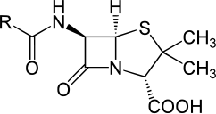

1. **Mechanism of Action**

[β-Lactam antibiotics](http://en.wikipedia.org/wiki/Beta-lactam_antibiotic) inhibit the formation of peptidoglycan [cross-links](http://en.wikipedia.org/wiki/Cross-link) in the bacterial [cell wall](http://en.wikipedia.org/wiki/Cell_wall) through binding of the four-membered β-lactam [ring](http://en.wikipedia.org/wiki/Cycloalkane) of penicillin to the [enzymeDD-](http://en.wikipedia.org/wiki/Enzyme) transpeptidase. Therefore, DD-transpeptidase cannot catalyze formation of these cross-links, and an imbalance between cell wall production and degradation develops, causing the cell to rapidly die. This weakens the cell wall of the bacterium, and osmotic pressure continues to rise eventually causing cell death called [cytolysis.](http://en.wikipedia.org/wiki/Cytolysis) The build-up of peptidoglycan precursors triggers the activation of bacterial cell wall hydrolases and autolysins, which further digest the cell wall's

peptidoglycan. The small size of the penicillins increases their potency, by allowing them to penetrate the entire depth of the cell wall. Penicillin shows a synergistic effect with [aminoglycosides](http://en.wikipedia.org/wiki/Aminoglycosides) (Alabi *et. al.,* 1998), since the inhibition of peptidoglycan synthesis allows aminoglycosides to penetrate the bacterial cell wall more easily, allowing their disruption of bacterial protein synthesis within the cell. This results in a low [Minimal Bactericidal](http://en.wikipedia.org/wiki/Minimum_Bactericidal_Concentration) [Concentration](http://en.wikipedia.org/wiki/Minimum_Bactericidal_Concentration) (MBC) for susceptible organisms.

Penicillins, like other β-lactam antibiotics, block not only the division of bacteria, but also the division of organelles, the [photosyntheticorganelles](http://en.wikipedia.org/wiki/Photosynthesis) of the [glaucophytes,](http://en.wikipedia.org/wiki/Glaucophyte) and the division of [chloroplasts](http://en.wikipedia.org/wiki/Chloroplast) of [bryophytes](http://en.wikipedia.org/wiki/Bryophyte).

# Spectrum of Activity

Penicillin is a bactericidal, broad spectrum antibiotic. It shows activity against *Haemophilus influenzae*, and Enterobacteriaceae such as *E.coli* and *Salmonella* species*.* Synergy has also been demonstrated between aminoglycosides such as gentamicin (Ehinmidu and Ibrahim, 2004).

# Development of Resistance

Resistance to Penicillin may be due to beta-lactamase mediated chromosomally or by plasmid (Al-Gallas *et. al.,* 2007) Resistance in *E.coli, Salmonella* species and *Pasturella* species has been reported to be due to changes in their outer membrane resulting in the failure of beta-lactam to reach their target penicillin-binding proteins (Martindale, 2005).

# Gentamicin

Gentamicin sulfate was first isolated from *Micromonospora purpurea* in 1963.It is an aminoglycoside antibiotic used often with other antibacterials to treat severe infections due to sensitive Gram negative organisms and other organisms. Gentamicin is a white hygroscopic powder, freely soluble in water, insoluble in alcohol, in acetone, in chloroformand in benzene. pH of 4% solution in water is between 3.5 and 5.5.

# Structure

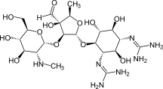

1. **Administration**

Gentamicin is not absorbed from the gut and therefore should be administered [intravenously](http://en.wikipedia.org/wiki/Intravenously) and [intramuscularly.](http://en.wikipedia.org/wiki/Intramuscularly) Some are used in topical preparations for wounds. Oral administration can be used for gut decontamination (e.g., in hepatic encephalopathy). Tobramycin may be administered in a nebulized form.

# Mechanism of action

Gentamicin binds to the bacterial [30S](http://en.wikipedia.org/wiki/30S) [ribosomal](http://en.wikipedia.org/wiki/Ribosome) subunit and interfere with the [proof](http://en.wikipedia.org/wiki/Proofreading_(biology)) [reading](http://en.wikipedia.org/wiki/Proofreading_(biology)) process, causing increased rate of error in synthesis with premature termination (Luzzatto *et al*., 1969).Aminoglycosides have also shown evidence of inhibition of [ribosomal](http://en.wikipedia.org/wiki/Ribosomal_translocation) [translocation](http://en.wikipedia.org/wiki/Ribosomal_translocation) where the peptidyl-tRNA moves from the A-site to the P-site

(Chambers,2006).They can also disrupt the integrity of bacterial cell membrane (Alam *et al.,*

2003).

The protein synthesis inhibition by aminoglycosides does not usually produce a bactericidal effect, but competitively displace cell biofilm-associated Mg2+ and Ca2+ that link the polysaccharides of adjacent lipopolysaccharide molecules. "The result is shedding of cell membrane blebs, with formation of transient holes in the cell wall and disruption of the normal permeability of the cell wall (Abinu, 2007). This action alone is sufficient to kill most susceptible Gram-negative bacteria before the aminoglycoside has a chance to reach the 30S ribosome.

# Development of Resistance

Bacterial resistance to gentamicin has been reported to be due to inactivation by enzymatic modification (Akinyemi, 1998). Three main classes of enzymatic inactivations confer resistance to gentamicin such as phosphorylation, acetylation, or addition of a nucleotide group. These enzymes are usually plasmid determined and the observed resistance in *E.coli*, *Salmonella* species and *Pasturella* species can therefore be transferred between bacteria (Ryan and Ray, 2004).

# Fluoroquinolones

The relative importance of 4-quinolones has increased with the discovery that such structures that also bear a [carboxylic acid](http://en.wikipedia.org/wiki/Carboxylic_acid) have very potent [bactericidal](http://en.wikipedia.org/wiki/Bacteriocidal) activities, inhibition of a [broad](http://en.wikipedia.org/wiki/Broad_spectrum) [spectrum](http://en.wikipedia.org/wiki/Broad_spectrum) of [Gram negative](http://en.wikipedia.org/wiki/Gram_negative) and [Gram positive](http://en.wikipedia.org/wiki/Gram_positive) [DNA gyrase](http://en.wikipedia.org/wiki/DNA_gyrase) and [topoisomerase](http://en.wikipedia.org/wiki/Topoisomerase) enzymes (Albert *et. al.,* 1999). They are very useful in [antibacterial](http://en.wikipedia.org/wiki/Antibacterial) therapy. An example of such a 4-quinolone is [ciprofloxacin](http://en.wikipedia.org/wiki/Ciprofloxacin), Ciprofloxacin is a "second-generation" fluoroquinolone antibacterial antibiotic.

These second generation quinolones have increased potency and spectrum of activity compared with nalidixic acid. Examples of fluoroquinolones include norfloxacin, ciprofloxacin and nalidixic acid. Fluoroquinolones are regarded as effective antibiotics for the treatment of fowl typhoid fever in poultry (Chinh *et al*., 2000) Majority of isolates havebeen reported sensitive to fluoroquinolones. They are relatively and reliably effective than former first-line drugs viz ampicillin and co-trimoxazole. They produce a rapid therapeutic response and low rates of post treatment carriage (Laudico *et al*., 1995)

# Structure

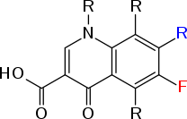

* + - 1. **Administration**

Ciprofloxacin is a second-generation [fluoroquinolone](http://en.wikipedia.org/wiki/Fluoroquinolone) [antibiotic](http://en.wikipedia.org/wiki/Antibiotic). Ciprofloxacin and other fluoroquinolones are valued for this broad spectrum of activity, excellent tissue penetration, and for their availability in both oral and intravenous formulations because many antibacterials used in serious infections must be dosed intravenously.

# Antimicrobial Activity

Ciprofloxacin are valued for their broad spectrum activity against Gram negative [*Escherichia*](http://en.wikipedia.org/wiki/Escherichia_coli)[*coli*](http://en.wikipedia.org/wiki/Escherichia_coli)*,* [*Haemophilus influenzae*](http://en.wikipedia.org/wiki/Haemophilus_influenzae)*,* [*Klebsiella pneumoniae*](http://en.wikipedia.org/wiki/Klebsiella_pneumoniae)*,* [*Legionella pneumophila*](http://en.wikipedia.org/wiki/Legionella_pneumophila)*,* [*Moraxella*](http://en.wikipedia.org/wiki/Moraxella_catarrhalis)[*catarrhalis*](http://en.wikipedia.org/wiki/Moraxella_catarrhalis)*,* [*Proteus mirabilis*](http://en.wikipedia.org/wiki/Proteus_mirabilis)*,* and [*Pseudomonas aeruginosa*](http://en.wikipedia.org/wiki/Pseudomonas_aeruginosa)*),* and *Gram* positvie *(*methicillin*-* sensitive but not methicillin-resistant [*Staphylococcus aureus*](http://en.wikipedia.org/wiki/Staphylococcus_aureus)*,* [*Streptococcus*](http://en.wikipedia.org/wiki/Streptococcus_pneumoniae)

*pneumoniae,* [*Staphylococcus epidermidis*](http://en.wikipedia.org/wiki/Staphylococcus_epidermidis)*,* [*Enterococcus faecalis*](http://en.wikipedia.org/wiki/Enterococcus_faecalis)*, and* [*Streptococcus pyogenes*](http://en.wikipedia.org/wiki/Streptococcus_pyogenes)*)*

bacterial pathogens.

Ciprofloxacin is used alone or in combination with other antibacterial drugs in the empiric treatment of infections for which the bacterial pathogen has not been identified, including urinary tract infections and abdominal infections, among others (Solomkin *et. al.,* 2010) among others. It is also used for the treatment of infections caused by specific pathogens known to be sensitive. In 2004 over 20 million outpatient prescriptions were written for ciprofloxacin, making it the 35th most commonly prescribed drug, and the 5th most commonly prescribed antibacterial, in the USA (Schaeffer, 2004).

# Mechanism of Action

Ciprofloxacin is a second-generation [fluoroquinolone](http://en.wikipedia.org/wiki/Quinolone) antibacterial. It kills bacteria by interfering with the enzymes (DNA gyrase) that cause the DNA to unwind after being copied, which stops synthesis of DNA and of protein. Fluoroquinolones inhibit the [Topoisomerase II](http://en.wikipedia.org/wiki/Topoisomerase_II) ligase domain, leaving the two nuclease domains intact. This modification, coupled with the constant action of the [Topoisomerase II](http://en.wikipedia.org/wiki/Topoisomerase_II) in the bacterial cell, leads to DNA fragmentation via the nucleasic activity of the intact enzyme domains (Schaeffer, 2004)

# Mechanism of Resistance

In recent years, there have been many reports of reduced susceptibility and treatment failure for ciprofloxacin (Solomkin *et. al.,* 2010), due to emergence of multi-drug resistant strains. *E. coli, Salmonella* species and *Pasturella* species acquire resistance to quinolones due to chromosomal mutations in the gene coding for DNA gyrase (Laudico *et al*., 1995).

# Co- trimoxazole

Co-trimoxazole is mixture of five part of sulphamethoxazole and one part of trimethoprim. This combination is synergistic and bactericidal and is used in chemotherapy of fowl typhoid fever because of it’s ability to cause rapid improvement in the host’s body and relief of toxicity (Bains, 2009).

# Structure

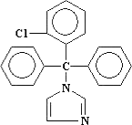

**Cotrimazole C22H17CIN2**

# Antimicrobial Activity

Co-trimoxazole is a broad spectrum antibiotic and is the agent of choice in treating pneumonia caused by *Pneumoncytis carinii*. It is also among the first line drug used in treating typhoid fever.

# Mechanism of action

Co-trimoxazole has combined effects of its components. While sulphamethoxazole inhibits the conversion of para-aminobenzoic acid to the co-enzyme dihydrofolic acid, trimethoprim inhibits the conversion of bacteria dihydrofolic acid to tetrahydrofolic acid which is necessary for the synthesis of DNA precursors (Akgun 19997).

# Mechanism of Resistance

*Salmonella, Pasturella* species and *E. coli* resistance is due to plasmid-mediated dihydrofolate reductase and dihydropterate synthetase target site of the drug (Bolon *et al*., 2004).

# Tetracycline

Tetracyclines are group of antibiotics obtained as a by**-**product from metabolism of various species of *Streptomyces,* for example *Streptomyces aureofaciens.* They are relatively hydrophilic (Hugo and Russel, 2000)

# Structure

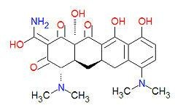

**Tetracycline C22H24N2O8**

# Mechanism of action

Tetracyclines are bacteriostatic and they bind to 30s ribosomal subunit to inhibit protein synthesis by preventing the binding of amino aceyltransferase RNA to the ribosomal site (Bonnet *et al*., 2004). It also chelates magnesium ion to form tetracycline or magnesium complex preventing protein synthesis (Boschi-Pinto *et al.,* 2008).

# Mechanism of Resistance

*E.coli, Salmonella* species and *Pasturella* species resistance to tetracyclines is usually plasmid mediated and trasferable (Boue *et al.,* 2002). It appears to be associated with the ability to prevent accumulation of the antibiotic within the bacteria cell, both by decreasing active transport of the drug into the cell and by decreasing tetracycline efflux (Black *et al.,* 2010).

# Erythromycin

Erythromycin is a [macrolide](http://en.wikipedia.org/wiki/Macrolide) [antibiotic](http://en.wikipedia.org/wiki/Antibiotic) that has an antimicrobial spectrum similar to or slightly wider than that of [penicillin](http://en.wikipedia.org/wiki/Penicillin), and is often [prescribed](http://en.wikipedia.org/wiki/Prescription_drug) for people who have an [allergy](http://en.wikipedia.org/wiki/Allergy) to penicillins. Erythromycin is produced from a strain of the actinomycete [*Saccharopolyspora*](http://en.wikipedia.org/wiki/Saccharopolyspora_erythraea)[*erythraea*.](http://en.wikipedia.org/wiki/Saccharopolyspora_erythraea)

# http://upload.wikimedia.org/wikipedia/commons/thumb/6/65/Erythromycin_A.svg/200px-Erythromycin_A.svg.pngStructure

**Erythromycin** [**C**](http://en.wikipedia.org/wiki/Carbon)**37**[**H**](http://en.wikipedia.org/wiki/Hydrogen)**67**[**NO**](http://en.wikipedia.org/wiki/Nitrogen)**13**

# Mechanism of action

Erythromycin displays [bacteriostatic](http://en.wikipedia.org/wiki/Bacteriostatic) activity or inhibits growth of bacteria, especially at higher concentrations (Pal, 2006) by binding to the 50s subunit of the bacterial 70s [rRNA](http://en.wikipedia.org/wiki/RRNA) complex. Protein synthesis and subsequent structure and functional processes critical for life or replication are inhibited. Erythromycin interferes with [aminoacyl translocation](http://en.wikipedia.org/w/index.php?title=Aminoacyl_translocation&action=edit&redlink=1), preventing the transfer of the [tRNA](http://en.wikipedia.org/wiki/TRNA) bound at the [A site](http://en.wikipedia.org/wiki/A_site) of the rRNA complex to the [P site](http://en.wikipedia.org/wiki/P_site) of the rRNA complex (Bhutta et. al., 1999). This interferes with the production of functionally useful proteins, which is the basis of this antimicrobial action.

# Nalidixic Acid

Nalidixic acid is first of the synthetic [quinolone](http://en.wikipedia.org/wiki/Quinolone) [antibiotics](http://en.wikipedia.org/wiki/Antibiotic). Nalidixic acid is effective against both [Gram-positive](http://en.wikipedia.org/wiki/Gram-positive) and [Gram-negative](http://en.wikipedia.org/wiki/Gram-negative) [bacteria.](http://en.wikipedia.org/wiki/Bacterium) In lower concentrations, it acts in a [bacteriostatic](http://en.wikipedia.org/wiki/Bacteriostatic) manner; that is, it inhibits growth and reproduction. In higher concentrations, it is bactericidal, meaning that it kills bacteria instead of merely inhibiting their growth. It has

historically been used for treating [infections](http://en.wikipedia.org/wiki/Urinary_tract_infections), caused by [*E. coli*](http://en.wikipedia.org/wiki/Escherichia_coli), [*Proteus*](http://en.wikipedia.org/wiki/Proteus_(bacterium)), [*Shigella*](http://en.wikipedia.org/wiki/Shigella), [*Enterobacter*](http://en.wikipedia.org/wiki/Enterobacter)

and [*Klebsiella*](http://en.wikipedia.org/wiki/Klebsiella).

# Structure

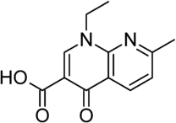

**C12H12N203**

# Mechanism of Action

It kills bacteria by interfering with the enzyme DNA gyrase to unwind after being copied, which stops synthesis of DNA and of protein. Like fluoroquinolones, it inhibit the [Topoisomerase](http://en.wikipedia.org/wiki/Topoisomerase_II) [II](http://en.wikipedia.org/wiki/Topoisomerase_II) ligase domain, leaving the two nuclease domains intact. This modification, coupled with the constant action of the [Topoisomerase II](http://en.wikipedia.org/wiki/Topoisomerase_II) in the bacterial cell, leads to DNA fragmentation via the nucleasic activity of the intact enzyme domain (Schaeffer, 2004).

# Mechanism of Resistance

In recent years, there have been many reports of reduced susceptibility and treatment failure for nalidixic acid (Solomkin *et al.,* 2010), due to emergence of multi-drug resistant strains. *E.coli*, *Salmonella* species and *Pasturella* species acquire resistance to quinolones due to chromosomal mutations in the gene coding for DNA gyrase (Laudico *et al*.,1995).

# Bacitracin

Bacitracin is a mixture of related cyclic [polypeptides](http://en.wikipedia.org/wiki/Peptide) produced by [organisms](http://en.wikipedia.org/wiki/Organism) of the licheniformis group of [*Bacillus subtilis*](http://en.wikipedia.org/wiki/Bacillus_subtilis) var Tracy, isolation of which was first reported in 1945. These peptides disrupt both [gram positive](http://en.wikipedia.org/wiki/Gram_positive) and [gram negative](http://en.wikipedia.org/wiki/Gram_negative) bacteria, by interfering [cell wall](http://en.wikipedia.org/wiki/Cell_wall) and [phospholipid](http://en.wikipedia.org/wiki/Phospholipid) synthesis (Boyce *et al.,* 2000).

# Structure

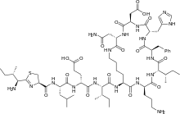

C66H103N17016S

# Mechanism of action

Bacitracin interferes with the dephosphorylation of the [C](http://en.wikipedia.org/wiki/Carbon)55-isoprenyl pyrophosphate, a molecule that carries the building-blocks of the [peptidoglycan](http://en.wikipedia.org/wiki/Peptidoglycan) bacterial [cell wall](http://en.wikipedia.org/wiki/Cell_wall) outside of the inner membrane (British Pharmacoepia, 2000). Bacitracin has been claimed to be a [protein disulfide](http://en.wikipedia.org/wiki/Protein_disulfide_isomerase) [isomerase](http://en.wikipedia.org/wiki/Protein_disulfide_isomerase) inhibitor in cells, but this is disputed by *invitro* studies. (Solomkin *et al.,* 2010)

# Imipenem

Imipenem is an [intravenous](http://en.wikipedia.org/wiki/Intravenous) [β-lactam](http://en.wikipedia.org/wiki/Beta-lactam) [antibiotic](http://en.wikipedia.org/wiki/Antibiotic) developed in 1980 (British Pharmacoepia, 2000). Imipenem belongs to the subgroup of [carbapenems.](http://en.wikipedia.org/wiki/Carbapenem) It is derived from a compound called [thienamycin,](http://en.wikipedia.org/wiki/Thienamycin) which is produced by the bacterium *Streptomyces cattleya*. Imipenem has a broad spectrum of activity against [aerobic](http://en.wikipedia.org/wiki/Aerobic_organism) and [anaerobic](http://en.wikipedia.org/wiki/Anaerobic_organism), [Gram-positive](http://en.wikipedia.org/wiki/Gram-positive) and [Gram-](http://en.wikipedia.org/wiki/Gram-negative) [negative](http://en.wikipedia.org/wiki/Gram-negative) [bacteria.](http://en.wikipedia.org/wiki/Bacteria)

It is particularly important for its activity against [*Pseudomonas aeruginosa*](http://en.wikipedia.org/wiki/Pseudomonas_aeruginosa) and the [*Enterococcus*](http://en.wikipedia.org/wiki/Enterococcus) species. It is not active against [MRSA](http://en.wikipedia.org/wiki/Methicillin-resistant_Staphylococcus_aureus), however. Imipenem and other drugs in the [carbapenem](http://en.wikipedia.org/wiki/Carbapenem) class are typically restricted in use, to avoid widespread [bacterial resistanc](http://en.wikipedia.org/wiki/Antibiotic_resistance)e.

# Structure

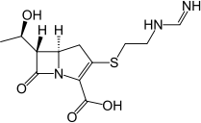

C12H17N304S

# Mechanism of Action

Imipenem acts as an antimicrobial through inhibiting cell wall synthesis of various Gram- positive and Gram-negative bacteria (Ensor *et al.,* 2006). It remains very stable in the presence of beta-lactamase (both penicillinase and cephalosporinase) produced by some bacteria, and is a strong inhibitor of beta-lactamases from some Gram-negative bacteria that are resistant to most beta-lactam antibiotics (Brooks *et al.,* 2004)

# Mechanism of resistance

*Acinetobacter anitratus,* [*Acinetobacter calcoaceticus*](http://en.wikipedia.org/wiki/Acinetobacter_calcoaceticus)*, Actinomyces odontolyticus,* [*Aeromonas*](http://en.wikipedia.org/wiki/Aeromonas_hydrophila)[*hydrophila*](http://en.wikipedia.org/wiki/Aeromonas_hydrophila)*, Bacteroides distasonis, Bacteroides uniformis, and* [*Clostridium perfringens*](http://en.wikipedia.org/wiki/Clostridium_perfringens) species are generally susceptible to Imipenem, while some [*Acinetobacter baumannii*](http://en.wikipedia.org/wiki/Acinetobacter_baumannii)*,* [*Acinetobacter*](http://en.wikipedia.org/wiki/Acinetobacter) *spp.,* [*Bacteroides fragilis*](http://en.wikipedia.org/wiki/Bacteroides_fragilis) *and* [*Enterococcus faecalis*](http://en.wikipedia.org/wiki/Enterococcus_faecalis) *have* developed resistance to Imipenem to varying degrees (Choe *et al.,* 1999). Not many species are resistant to Imipenem except [*Pseudomonas aeruginosa*](http://en.wikipedia.org/wiki/Pseudomonas_aeruginosa) (Oman) and [*Xanthomonas maltophilia*](http://en.wikipedia.org/wiki/Xanthomonas_maltophilia). (Yoshinari, 1980).

# Nitrofurantoin

Nitrofurantoin is an [antibiotic](http://en.wikipedia.org/wiki/Antibiotic) usually used in treating infections against [*E. coli*](http://en.wikipedia.org/wiki/Escherichia_coli)(Chigor *et al.,* 2010)*.* Resistance to other antibiotics has led to increased interest in this agent. This is in contrast to agents such as [trimethoprim](http://en.wikipedia.org/wiki/Trimethoprim) and [ciprofloxacin](http://en.wikipedia.org/wiki/Ciprofloxacin) (Goodman, 2002).

# Structure

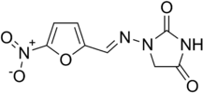

C12H17N304S

# Mechanism of Action

The mechanism of action of nitrofurantoin is unique and complex. The drug works by damaging bacterial [DNA,](http://en.wikipedia.org/wiki/DNA) since its reduced form is highly reactive (Elmali *et al.,* 2007). This is made possible by the rapid reduction of nitrofurantoin inside the bacterial cell by [flavoproteins](http://en.wikipedia.org/wiki/Flavoprotein) ([nitrofuran reductase](http://en.wikipedia.org/w/index.php?title=Nitrofuran_reductase&action=edit&redlink=1)) to multiple reactive intermediates that

attack [ribosomal](http://en.wikipedia.org/wiki/Ribosome) proteins, DNA respiration, [pyruvate](http://en.wikipedia.org/wiki/Pyruvate) metabolism and other macromolecules within the cell (Goodman, 2002). Nitrofurantoin exerts greater effects on bacterial cells than mammalian cells because bacterial cells activate the drug more rapidly. It is not known which of the actions of nitrofurantoin is primarily responsible for its [bactericidal](http://en.wikipedia.org/wiki/Bactericide) activity (Solomkin *et al.,* 2010).

# Antibiotic Resistance

Antibiotic resistance is a global public health issue that is impacted by both human and non- human antimicrobial usage. The continuing emergence, development and spread of pathogenic organisms that are resistant to antimicrobials are a cause of increasing concern (WHO, 2012). Antimicrobial resistance (AMR) is defined as changes in microbial biology that occur in response to antimicrobials (AM) and that reduces or blocks the effectiveness of drugs, chemicals, or other agents to cure or prevent infections. Antimicrobial resistance is determined by *in*-*vitro* tests of strain-specific cultures in which survival of the bacterial isolates is tested under conditions of increasing antimicrobial concentrations. The *in-vitro* concentration at which bacterial survival is significantly affected is then compared to benchmarks that signify impacts on clinical efficacy; thus the MIC (minimum inhibitory concentrations) values are set by the CLSI (Clinical and Laboratory Standards Institute) to reflect a level of resistance that is likely to compromise the efficacy of antimicrobial treatment in an infected patient (Ginocchio, 2002; CLSI, 2006).

Sir Alexander Fleming, the father of antibiotics, described the phenomena of antibiotic resistance and suggested in the 1940s that extensive use of antibiotics would cause bacteria to develop resistance, and further pointed that new antibiotics would be necessary to combat this on a regular basis (Todar, 2009). It can be assumed that the wider use of antibiotics, the greater the

chance for the development of antibiotic resistance. The discovery of antimicrobials and the application to clinical medicine are among the triumphs of 20th century pharmacology and medicine. This triumph has been eroded with the rise and spread of antimicrobial resistance, it has been suggested that we are entering the post antibiotic age of medicine (Falagas and Bliziotis, 2007*).* Antimicrobial resistance bacteria infections now account for much of the problem of emerging infectious disease worldwide (Okeke *et al.,* 2005; Velge *et al.,* 2005; Seybold *et al.,* 2006*;* Erb *et al.,* 2007; Laximinarayan, 2007).

In some cases, selection for resistance also results in more virulent strains, as in the case of *E. coli* and *S aureus* (Ohlsen *et al.,* 1998; Johnson *et al.,* 2005*;* Mora *et al.,* 2005; Stevens *et al.,* 2007).

# Origin of Antimicrobial Resistance

Bacteria acquired the genetic and physiological tools to resist antimicrobials long before scientists isolated and identified these natural agents in the early 20th century (Wright, 2007). Because many antimicrobials are natural products of fungi and other organisms, bacteria have evolved these mechanisms over millions of years, and thus it is possible to detect antimicrobial resistance in bacteria that have not been exposed to our uses of antimicrobials in medicine (Levy, 1998). Antimicrobial resistance was evident from the early history of penicillin. The isolation of the first naturally occurring antimicrobial (penicillin) in the 1930s ushered in a major change in clinical and veterinary medicine (Todar, 2009). With the discovery of natural antimicrobial compounds, the balance seemed at last to be tipped against the pathogens, but victory was short- lived. Even in the laboratory, Fleming observed that his bacterial cultures quickly demonstrated resistance to penicillin, and in 1945, he warned that the misuse of penicillin could lead to selection of resistant forms of bacteria (Levy, 1998).

Fleming suggested that resistance to penicillin could be conferred in two ways either through changes in the bacterial cell wall, which was the target of penicillin action, or through the selection of bacteria expressing mutant proteins capable of degrading penicillin. Unfortunately, in the early period of its use, penicillin was available orally to the public without prescription until the mid 1950s (Silbergeld *et al.,* 2007). By 1946, one hospital reported that 14% of the strains of staphylococci isolated from sick patients were penicillin resistant (Barber and Hayhoe, 1949). By the 1950s, this same hospital reported that 59% of the strains of staphylococci penicillin resistant (Levy, 1998). There are major cost impacts on the health care system to monitor and prevent spread of resistant infections, which have not been fully calculated (Laxminarayan, 2007). From time immemorial, animals have been the source of some of the pathogens that can cause diseases in human populations (Orriss, 1997; Bengis *et al*., 2004; Fevre *et al.,* 2006).

Microbes have evolved highly effective mechanisms to respond to environmental pressures, such as temperature change, oxygen concentrations, nutrient availability, and toxin exposure, including antimicrobial agents. Thus, exposure of bacteria to sub-lethal concentrations of antimicrobial inevitably results in the selection of resistant strains, and under conditions of continued antimicrobial pressure, resistant strains will propagate and spread (Silbergeld *et al.,* 2007). Because most antimicrobials are derived from natural products, bacteria have acquired through evolution, biochemical responses to resist antimicrobial attack; and antibiotic resistance can be observed in the absence of any deliberate human use of antibiotics. Because of the speed of bacterial reproduction, these changes can be expressed with great efficiency. Thus, through an evolutionary process of microbial response to the pressure of antimicrobial agents, resistance is an inevitable consequence of antimicrobial use, and it is not surprising that observations of

resistance came soon after the identification and isolation of the first natural antimicrobial substance (Silbergeld *et al.,* 2007).

Genetic changes typically involve enhanced activity or regulation of physiological processes such as membrane transport pumps that extrude harmful agents, including antimicrobials. However, the capacity of these response mechanisms is limited, and usually bacteria express only low-level resistance as a consequence (Wright, 2007; Todar, 2009). Genetically encoded changes are more serious because these can usually confer higher-level resistance to specific agents and they can be transferred among bacteria. Since most antimicrobials are derived from microorganisms and other natural sources, bacteria resistance have evolved in the presence of these toxins (Wright, 2007), and it is therefore not surprising that, even in the absence of antimicrobial pressure, there are sources of resistance encoded by specific genes within the community repertoire of bacterial genomes (Silbergeld, 2007). In the presence of selection pressure by an antimicrobial, bacterial populations quickly evolve to a resistant phenotype (Smith and Harris 2002; Tenover, 2006). The speed of this evasion process is hastened by two factors: the rapid rate of bacterial reproduction and the ability of bacteria to transfer genetic information among organisms even across broad phylogenetic categories (Silbergeld *et al.,* 2007).

# Development of Antibiotic Resistance

Historically, bacterial resistance to antimicrobials has been a common phenomenon. Soon after their discovery, Alexander reported Staphylococci resistant to the first "wonder drug" (Iruka *et al.,* 1999). He correctly predicted that imprudent use of antibiotics could lead to clinical failure with these drugs in the future. Penicillin and its derivatives that were erstwhile considered potent

to many Gram-negative organisms have been reported to be ineffective due to intrinsic bacterial resistance.

It has been reported to result to dreaded chemotherapeutic failure worldwide (Iruka *et al*., 1999). Bacterial strains that are resistant to antibiotics can produce enzyme that inactivate the drug, cell membrane that are impermeable to the antibiotics, actively export drug from the cell or by-pass the cellular target the antibiotics interferes with (Enabulele *et al.,* 2013).

Bacteria acquire the ability to resist antibiotics by altering their own genes through mutation or, more commonly, by horizontally acquiring readymade resistance gene from other organism (Freeman *et al.,* 2008). Horizontally acquired resistance genes are often carried on transmissible plasmid, (small ring of DNA) that is efficiently transferred from one cell to another by mating or conjugation. However, some antibiotic resistance genes are held within mobile elements called

―transposons‖ or ―integrons‖. These elements not only capture and organize the expression of resistant genes but are also capable of moving from plasmid to the chromosome, through conjugation or transposome, a characteristic way of stabilizing their inheritance. The acquisition of foreign DNA or mutation provides little advantage for a bacterial cell unless there is express need for phenotype encoded by the new genes (Prescott *et al*., 2000). Hence, bacteria habouring resistant genes are given selective advantage over those that are not in the presence of the antibiotic.

When a population of bacteria predominantly of susceptible strains, with a few resistant one is exposed to an antibiotic therapy, the sensitive strains are killed leaving those strain resistant to the antibiotics to flourish (Iruka *et al.,* 1999). This observation has been attributed for the success of resistant bacteria in a world where substandard antibiotics are used worldwide.

# Spread of resistence

Resistance is a trait expressed by specific bacteria and can result from new mutations that occur spontaneously in bacteria due to their rapid rate of cell division or from the selection of resistance genes already present within a bacterial colony (Silbergeld *et al.,* 2007).

The emergence and spread of resistant bacterial strains like *Campylobacter* species, and *Enterococcus* sp. from poultry products to consumers put humans at risk to new strains of bacteria that resist antibiotic treatment. Resistant bacteria thwart antibiotics by interfering with theirmode of action via a range of effectors’ mechanisms, including synthesis of inactivating enzymes, alteration in the configuration of cell wall or ribosome and modification of membrane carrier systems. These mechanisms are specific to the type of resistance developed.

In the presence of antimicrobial pressure, strains that express resistance traits through spontaneous mutation are favored in terms of survival, and they will rapidly supplant susceptible strains in microbial populations (Nwosu, 2001).

In addition, and potentially of greatest significance for public health, bacteria have a third mechanism of rapid evolution towards a resistant phenotype through the sharing of genes that encode resistance (Frota *et al.,* 2002). By this process, resistance can be propagated within and among bacterial strains, species, and genera, including commensals (nonpathogenic) and pathogens, by mobile genetic elements including plasmids, transposons, integrons, gene cassettes, and bacteriophages. In contrast to chromosomal based resistance determinants, these transfers account for more than 95% of antibiotic resistance (Nwosu, 2001).

These events have been detected in resistant *E. coli* isolated from consumer meat products (Sunde and Norstrom 2006). This finding is of particular concern because integrons can transfer multiple resistance genes at a time (Zhang *et al.,* 2003; Zhang *et al.,* 2006).

Bacteria operate at the community level in terms of responding to stress, and therefore they have developed mechanisms to share genetic information, often across broad species divisions. Because it is the community response that is crucial (Summers, 2002; Heuer *et al.,* 2006), genetic change in response to antimicrobial pressure is not dependent upon reproduction or cell division, as is the case for most higher organisms. Bacteria can exchange genetic information across broad classes by several mechanisms which in many cases, are enhanced by stressors such as pressures that can enhance the rates and efficiency of genetic recombination (Summers, 2002; Heuer *et al.,* 2006). Microbiologists now refer to "reservoirs of resistance" in recognition of the fact that it is the community of genetic resources that determines the rate and propagation of resistance (Salyers and Shoemaker, 2006).

# Persistence of Resistance

The microbial community can serves as a resource, or reservoir, of resistance genes. Earlier theories of microbial genetics assumed that this was unlikely to be a long term phenomenon since the expression of resistance was thought to cost the organism (in terms of increased energy requirements, susceptibility to other stressors, or decreased reproductive rates) such that in the absence of antimicrobial pressure, its occurrence was rare. Current research has cast doubt on the concept of a ―cost of resistance‖ (Salyers and Amabile-Cuevas, 1997). While the prevalence of resistant strains markedly decreases when antimicrobials are no longer present, this is not always the case for several reasons. Resistance may persist due to the clustering of resistance genes on the same transposable elements such that eliminating only one antimicrobial may not reduce the

prevalence of the cluster (Aarestrup *et al.,* 2000). Also it may in some cases be ―cheaper‖ for a resistant bacterial strain to acquire an additional genetic change that reduces the biological cost of resistance rather than to revert genetically and phenotypically to the ―wild‖ or susceptible state (Levin *et al.,* 2000; Wright, 2007)

# Factors that influence development of antibiotic resistance.

Several scientific reports have shown that resistance to antibiotics is not only due to the natural ability of a tiny fraction of the bacteria with unusual traits to survive antibiotic’s attack, but the transmission of acquired resistance to their progeny and across to other unrelated bacteria species through extrachromosomal DNA fragment called the plasmid (Marian *et al*, 2007).

Acquired bacterial resistance to antibiotics is a common phenomenon. This may due to some complex socioeconomic and behavioral factors. Among these factors is inappropriate prescription of antibiotics by physicians in clinical practice, due to lack of proper information (Ginnochio, 2002). Misuse of antibiotics by patients with low economic status increase the risk for selection and dissemination of antibiotic-resistance bacteria (Goldstein, 1995). It has been reported that unqualified drug sellers offer alternative antibiotics when the prescribed antibiotics are out of stock or refill prescription without consulting the prescriber (Dua *et al.,* l994). High proportions of patients are treated by untrained practitioners (Iruka *et al*., 1999). Besides, the risk of therapeutic failure due to use of substandard products or fake antibiotics increased the selection and dissemination of resistant strains. In Nigeria substandard ampicillin, tetracycline, and oxytetracycline capsules have been reported in open market and buses (Taylor *et al.,* 1995). In tropical countries, the conditions of transport and storage during distribution are poorly controlled and the antibiotics may be degraded since many antibiotics are heat-and moisture- liable. Example, the reported affected degradation of chloroquine and amoxicillin (Shakoor *et*

*al.,* 1997). Another factor that predispose to emergence of bacterial resistance is the bioavailability of antibiotic in formulation such as combinations of chloroquine and ampicillin which lower the bioavailability of ampicillin to sub-inhibitory concentration level (Ali, 1985). Apparently, healthy people in developing countries carry potentially pathogenic, antibiotic- resistant organisms asymptomatically (Iruka *et al*., 1999). Factors such as urban migration with crowding and improper sewage disposal encouraged the exchange of antibiotic-resistant gene among bacteria, thereby increasing the prevalence of resistant strains (Goldstein, 2000).

Absence of susceptibility testing which provide information on resistance trends, including emerging antibiotic resistance have been reported as a major factors of antibiotics resistance in developing countries (Rosas *et al.*, 1997).

# Plasmid Resistance

Plasmids are circular, double-stranded DNA molecules that can exist and replicate independently of the chromosome or may be integrated with it (Prescott *et al*., 2000). They are inherited and passed on to the progeny. Plasmids have relatively few genes generally less than 30 (Prescott *et al*., 2000). It has been reported that plasmids are not required for host growth or reproduction, although they may carry genes that give their bacterial host a selective advantage. Therefore, their genetic information is not essential to the host because bacteria that lack plasmid them usually function normally. Single copy plasmids produce only one copy per host cells. However, multi-copy plasmid may be present at concentrations of 40 or more per cell.

Plasmid may be classified in terms of their mode of existence or spread. An epitome is a plasmid that can exist either within or without being integrated into the host's chromosome. Conjugative

plasmids have genes for pili and copies can be transferred to other bacteria during conjugation (Prescott *et al*., 2000).

R-plasmid often confers antibiotic resistance on the bacteria that contain them. R-plasmid typically has gene that code for enzyme capable of destroying or modifying antibiotics. They are not usually integrated into the host chromosome. Some R-plasmid have only one single resistance gene whereas others can have as many as eight. Often the resistance genes are located within a transposon (jumping genetic material), and thus making it possible for bacterial strains to acquire plasmid encoding for multiple resistance (Hugo and Russel, 2004). It has been reported that many R-factors are conjugative plasmids, hence posses the conjugative ability through which it can spread within a population of people. Besides, non-conjugative R-plasmid also moves between bacteria during plasmid promoted conjugation. Thus, a whole population can become resistant to antibiotics; the fact that some of these plasmids are readily transferred between species further promotes the spread of resistance, when the host abuse antibiotics the selective pressure encourages the acquisition of the R-factor which can be transferred to more pathogenic genera such as *E. coli, Salmonella* species *and Pasturella* spp*.*

# Materials

* + 1. Culture Media

# CHAPTER THREE MATERIALS AND METHODS

 Nutrient Agar(NA) - (Fluka, Spain)

 Nutrient Broth(NB) - (Fluka, Spain)

 MacConkey Agar(MCA) - (Biotech Laboratory Ltd, UK)  Triple Sugar Iron Agar (TSIA) - (Biotech Laboratory Ltd, UK)  Brilliant Green Bile Broth (2%) - (Biotech Laboratory Ltd, UK)  Horse Blood Agar (HBA) - (Vet Public Health Lab, Nig.)  Eosin Methylene Blue Agar (EMB) - (Biotech Laboratory Ltd, UK)  Muller-Hinton Agar (MHA) - (Biotech Laboratory Ltd, UK)

 Urea Agar Base - (Oxoid Ltd, England)

 Urea Broth - (Oxoid Ltd, England)

 Luria-Bertani broth (LB) - (Oxoid Ltd, England)

All the media were prepared according to the manufacturers’ specifications, sterilized at 1210C for 15 minutes and stored at 40C until required.

# 3.1.1.2 Susceptibiity Disc (ABTEK Biological Ltd)

Susceptibility discs used in the study were made by Oxiod Ltd England and includes:

 Ciprofloxacin (5µg) - (Oxoid Ltd, England)

 Bacitracin (10µg) - (Oxoid Ltd, England)

 Nitrofurantoin (30µg) - (Oxoid Ltd, England)

 Gentamicin (10µg) - (Oxoid Ltd, England)

 Penicillin G (25µg) - (Oxoid Ltd, England)  Trimethoprim Sulfamethoxazole (10µg) - (Oxoid Ltd, England)  Imipenem (30µg) - (Oxoid Ltd, England)

 Tetracycline (30µg) - (Oxoid Ltd, England)

 Nalidixic Acid (30µg) - (Oxoid Ltd, England)

 Erythromycin (15µg) - (Oxoid Ltd, England)

# Reagents, Chemicals and Antibiotics

Acridine Orange - Sigma Chemical Ltd, England

Acetone-Alcohol - BDH Chemical Ltd, England

Agarose gel - Schwarzl Mann Biotech, England

Chloroform - BDH Chemical Ltd, England

Dettol - Reckit Benckiser Ltd, Nigeria Ethylene Diamine Tetraacetic acid (EDTA) - Sigma Chemical Ltd, England Ethanol - BDH Chemical Ltd, England

Crystal violet - BDH Chemical Ltd, England

Iso propanol - BDH Chemical Ltd, England

Lugos-Iodine - Sigma Chemical Ltd, England

Sodium hydroxide - BDH Chemical Ltd, England

Tris Buffer - Iquaba Biotech, South Africa

Ethiduim Bromide - Iquaba Biotech, South Africa

Imipenem - Rex Pharmaceuticals, Nigeria

Gentamicin - Rex Pharmaceuticals, Nigeria

Nalidixic Acid - Rex Pharmaceuticals, Nigeria

Ciprofloxacin - Rex Pharmaceuticals, Nigeria

Nitrofurantoin - Rex Pharmaceuticals, Nigeria

# Reference Strain

*Proteus mirabilis* (R-)

# Glasswares

Conical flasks, Test tubes, Petri dishes, Cover slips, McCartney Bottles, Eppendoff pipette (1ml and 0.1ml)

# METHODS

* + 1. **Study Population**

Egg shells samples of quails were collected from three farms along Zaria-Kaduna road that gave expressed permission for this study. These farms include;

* + - 1. Mai Doki Inter Agric Farm Limited (Gonar Salwa), Dinki Village Kaduna State.
      2. Amir Heritage Farms, Kwanan Farakwai, Kaduna State.
      3. Skypet Farms and Agric Limited, Birnin Yero, Kaduna State.

# Sample Collection

Egg shell samples were collected for a period of four weeks. They were collected into sterile wide containers and then transported to the Pharmaceutical Microbiology Laboratory at an ambient temperature (150C to 300C).

# Isolation and Identification Test

In the laboratory, quail egg shells samples were rinsed in sterile distilled water and the rinsed samples were inoculated into sterile nutrient broth and incubated at 370C overnight for 24 hours. The nutrient broth sample were subcultured on Triple Sugar (TSIA) iron agar*,* Eosin Methylene Blue (EMB) Agar, Horse Blood Agar (HBA) plates and further incubated at 370C for 24-48 hrs for isolation.

The test bacteria isolates were grown in their appropriate selective media, those that showed the presence of glucose, citrate utilization, indole, H2S, lactose fermenting colonies were subjected to microscopic examination to determine the cell morphology and Gram stain reactions as described (Cheesbrough, 2000).

# 3.2.3.1 Biochemical Tests

The isolated *E.coli*, *Salmonella* spp, and *Pasturella* spp were biochemically identified using various tests: citrate and non citrate utilization, catalase production, indole formation, methyl red and Voges Proskauer tests, sugar fermentation, urease production, oxidase and hydrogen sulphite production (Cheesbrough, 2000). Triple sugar iron agar was used to further differentiate *Salmonella* species using a straight wire, the butt was first stabbed and the slope was streaked in a zig-zag pattern. Pink-red (alkaline) slope and yellow (acid) butt, indicates fermentation of

glucose, lactose and cracks in the medium depicts gas production from the serotype fermenting glucose. Blacking in the medium has been reported to be due to hydrogen sulphide (H2S) production while grey and viscous colour with mucinous odour has been reported to be due to the presence of *Pasturella* spp (Cheesbrough, 2000).

# Antimicrobial Susceptibility Testing

The susceptibility of *E.coli*, *Salmonella* spp, and *Pasturella* spp isolates to the ten (10) commonly prescribed panel of antibiotics were determined as modified by CLSI(2008);

An overnight culture of each isolate was prepared on nutrient broth and incubated at 370C for 18 hours. standardized innoculum was in 1:5000 serial dilusions to reduce the microbial load. Dry sterile plates of prepared Mueller Hinton’s agar (MHA) were flooded with the standardized innoculum (105CFU/ml) of 18hrs culture of the isolates. After inoculation, the plates were allowed to dry for 10minutes in properly disinfected incubator, before placing the susceptibility disc of the various antibiotics aseptically on the dried Mueller-Hinton agar plates. After incubation for 18 hours at 370C, the plates were examined for zones of inhibition and measured appropriately. The results were interpreted according to the interpretation criteria published by CLSI (2008). Isolates were reported as susceptible (S), moderately susceptible or intermediate (I) and Resistant (R) to the various antibiotics, depending on the sizes of the zones of inhibition.

# Determination of Minimum Inhibitory Concentrations (MIC)

The MIC determination were carried out using agar dilution method as described by Lennette *et al.,*(1990) with modifications viz:

A freshly prepared stock solution of the each antibiotic was filtered, and sterilized through milipore membrane filter (0.22µ). Graded concentrations of the various antibiotics in 5ml melted volume was prepared in triplicates using sterile distilled water, and then aseptically mixed with 5ml melted volume of double strength sterile Mueller- Hinton agar poured into a plate and allowed to set.Furthermore, 5ml of sterile distilled water mixed with 5ml double strength Mueller- Hinton agar was set up as positive control. Eighteen hours broth culture of the test isolates were standardized to an inoculum density of 105cfu/ml (Wood and Washington, 1995). The dried Mueller Hinton agar surfaces were aseptically inoculated with ten micro litre of the test organisms per plate in triplicates at equidistant spacing.

Similarly, positive control Mueller- Hinton agar inoculated with 10µl of the standardized overnight culture of standardized test isolates (105cfu/ml). The plates were allowed to stay for one hour (1 hour) and then incubated at 37oC for 18 hours. After the incubation the plates were examined for the presence or absence of growth. The lowest antibiotic concentration at which there were no visible growths was taken as the minimum inhibitory concentration (MIC).

# Conjugation Studies

The transfer of resistant traits by ciprofloxacin resistant isolates of *E. coli, Salmonella* species*, Pasturella* species was investigated using the methods described by Onaolapo (1986) with some modifications.

The minimum inhibitory concentrations (MIC) of the test antibiotics against the sensitive *Proteus* recipient was determined as described under section 3.2.4 above. The ciprofloxacin resistant isolates of the three (3) test organisms were each grown in sterile nutrient broth (5ml) each at 370C for 18hours. The ciprofloxacin sensitive *Proteus mirabilis* was sub-cultured into a

sterile nutrient broth and incubated at 370C for 18 hours. The overnight cultures of the potential donor (R+) of the *E*. *coli, Salmonella* spp*, Pasturella* spp isolates and the recipient (R-) i.e sensitive *Proteus mirabilis* was grown in a ratio 10:1 respectively in 5ml of sterile nutrient broth and incubated in a static incubator at 370C for 18 hours. One loopful of transconjugants from the admixtures (*E. coli, Salmonella* spp*, Pasturella* spp and *Proteus mirabilis*) bottles were subcultured in triplicates on MacConkey agar plates incorporated with the antibiotics of MIC strength (4µg/ml) of ciprofloxacin in double strength MacConkey agar against sensitive *Proteus mirabilis* and incubated at 370C for 24 hours. The plates were examined for the presence or absence of cultural characteristics of *Proteus mirabilis* and lactose fermenting properties. Origianl culture of *Proteus* mirabilis and *Escherichia coli, Salmonella* species*, Pasturella* spp seperately was diluted in 1:100 ratio and a drop was spread on MacConkey agar containing ciprofloxacin (4µg/ml) for positive control. The colonies of *Proteus mirabilis* observed were aseptically picked and transferred to nutrient agar slant and sub-cultured after which the MIC of transconjugants were determined as previously described by (Lannette, *et al.*, 1990).

# Curing of Transconjugants

The curing of transconjugants *Proteus mirabilis* (R-plasmid) was carried out by treating the

*Proteus mirabilis* transconjugants with acridine orange dye as described by Onaolapo (1986).

Each of the transconjugants (ER) was grown overnight in sterile nutrient broth and incubated at 370C for 18 hours in a static incubator. The overnight culture of the *Proteus mirabilis* transconjugants was standardized (105CFU/ml). A stock solution of acridine orange in sterile distilled water (10,000µg/ml), was prepared and 1.0ml of the solution dispensed into test tubes containing sterile nutrient broth (2ml). The content of each tube was vortexed and mixed

properly, mixture were properly labeled and allowed to settle. Twenty microlitre (20µl) of standardized *Proteus mirabilis* transconjugants (105CFU/ml) was inoculated into the mixed solution of acridine orange and sterile nutrient broth and incubated at 370C for 18 hours. The growths from the overnight culture of the *Proteus mirabilis* transconjugants was sub-cultured on sterile MacConkey Agar plates. The colonies obtained from curing of transconjugants transfer experiment was further assessed for their antibiotic susceptibility using the MIC method. This was an attempt to determine whether the resistant pattern had changed or not.

# Extraction of Plasmid DNA

The transconjugant strains and resistant bacterial isolates were subjected to plasmid DNA extraction usimg Gene JetTM Plasmid Miniprep kit:- Inqaba Biotechnical Industries (Pty) Ltd South Africa in accordance with manufacturers instruction.

One loopful of the resistant bacterial isolates and transconjugants were inoculated into 10ml Luria Bertani medium for purification of low copy plasmid and incubated for 18 hours at 370C. The culture was centrifuge at 10,000 rpm for 2 minutes. The pelleted cells from the overnight culture were resuspended in 250µl of the resuspension solution and transferred to a micro- centerifuge tube. Bacteria suspension were then completely resuspended by vortexing or pipetting up and down until no cell clumps remained. 250 µl of the lysis solution was added and mixed thoroughly by inverting the tube 4-6 times until the solution became viscous and slightly clear. Furthermore, 350µl of the neutralization solution was added and mixed immediately and thoroughly by inverting the tube 4-6 times, and centrifuged for 5 minutes to pellet cell debris and chromosomal DNA. The Supernatants were transfrede to the gene JetTM spin column by decanting and the supernatant was then centrifuge at 10,000rpm for 1 minute and flow-through

were discarded and the columns were placed in the same collection tube. Subsequently 500µl of the wash solution (diluted with ethanol prior to fit use) was added to the Gene JetTM spin column and centrifuged for 30 seconds and flow-through was then discarded and column placed back into collection tube. Wash procedure above was repeated using 500µl of wash solution. Flow through was discarded and column was centrifuged for at 10,00rpm for 1 minute to remove residual was solution. Gene JetTM spin column were transferred into fresh 1.5ml microcentrifuged tube and 50µl of Elution Buffer was added to the center of Gene JetTM spin column membrane to elute the plasmid DNA then incubated for 2 minutes at room temperature and centrifuged for 2 minutes. The step above was repeated to recover residual DNA from membrane. Column was discarded and purified plasmid DNA were stored at – 200C.

# Agarose Gel Electorphoresis

A 0.8% agarose gel was used to resolve DNA fragment, and it was prepared by combining 0.8g agarose in ten times concentration of Tris acetate ethylene diamine tetraacetate (10ml 10XTAE) buffer and ninety (90)ml sterilized distilled water in a two hundred and fifty (250)ml beaker flask and heating in a microwave for 2 minutes until the agarose dissolved. 2.5µl ethidium bromide (5.0mg/ml) was added to the dissolved agarose solution with swirling to mix. The gel was then poured onto a mini horizontal gel electrophoresis tank (BioRad) and the casting combs inserted and then allowed to gel for 30 minutes.

The gel casting comb was carefully removed after the gel had completely solidified and one times concentration (1X) TAE electrophoresis buffer was then added to the reservoir until the buffer just covered the agarose gel.

# POLYMERASE CHAIN REACTION AMPLICATION OF TARGET GENES

Polymerase chain reaction (PCR) amplification of target genes from isolated plasmid DNA was carried out. Primers were used in PCR (Clever Scientific, Ltd) to amplify specific fragments from genes coding for resistance of fluoroquinolones and blaCTX-M ESBL as described by the manufacturer (Inqaba Biotec). Consequently, 0.5µl of gel tracking dye (bromo phenol blue) was then added to 20µl of each sample and marker standard with gentle mixing and 20µl of the sample was then loaded on to the wells of the gel, the mini horizontal electroporesis gel set up was then covered and the electrodes connected.

Dream Taq TM PCR master mix (2x) was vortexed and centrifuged for 30 seconds at 10,000rpm after thawing. A thin-walled PCR tube was placed on the ice and the following components were added for each 50µl reaction viz:

 25µl of Dream TaqTM PCR master mix (2x) was added in the PCR tube.  1.0µl of the forward primer’s was added.

 1.0µl of the reverse primer’s was added.

 10.0µl of template DNA (plasmid DNA) was added.

 The nuclease-free water (13 µl) was added in the PCR tube to make up a total volume of 50µl.

Electrophoresis was carried out at 120V for one hour. At the completion of the electrophoresis, the gel was removed from the buffer and the gel was viewed under a long wave UV-light box i.e Transilluminator (302nm) (Clever Scientifc, Ltd) the band pattern of the DNA fragments were then photographed with a polariod camera and documented using an electrophoresis gel documentation system.

# Table 3.1: Primer Names and Sequences

|  |  |  |  |  |
| --- | --- | --- | --- | --- |
| **Primer name** | **Targeted**  **Gene** | **Sequence** | **Gene to be detected** | **Reference** |
| **CTX-M2-** | *blactx-m* | 51 - ATGATGACTCAGAGCATTCG -  31  51 - GAAACCGTGGGTTACGATTT -  31 | Β-lactams | Park YJ, et al, (2006) |
| **CMY - 2 -** | *blacmy-2* | 51 -  GCACTTAGCCACCTATACGGCAG  - 31  51 -  GCTTTTCAAGAATGCGCCAGG - 31 | Β-lactams | Hasman H, Mevius D, *et. al*, (2006) |
| **aac(3) - IV -** | *aac(3)iv gene* | 51 - AGTTGACCCAGGGCTGTCGC  – 31  51 - GTGTGCTGCTGGTTCCACAGC  – 31 | Aminoglycosides | Brau B, Pilz U, Piepersberg W (1984) |
| **ant(2) – 1** | *ant2gene* | 51 – GGGCCGTCATGGAGGAGTT –  31  51 – TAT CGCGACCTGAAAGCGGC  - 31 | Aminoglycosides | Cameron F. H. Groot Obbink, DJ, Hall RM. (1986) |
| **gyrA**  ***Salmonella -*** | *qrdrs* | 51 – TACCGTCATAGTTATCCACG -  31  51 – GTACTTTTACGCCATGAACGT  - 31 | Quinolones | Wiuff C, Madsen M, Baggesen DL, Aarestrup FM (2000) |
| **gyrA *E. coli*** | *qrdrs* | 51 – ACGTACTAGGCAATGACTGG  - 31  51 –  AGAAGTCGCCGTCGATAGAAC - 31 | Quinolones | Everelt MJ, Jin YF, Ricci V, Piddock LJ (1996) |

Source: DTU food. Technical University of Denmark National food Institute (EU Reference Laboratory for Antimicrobial Resistance, 2008)

# Table 3.2: PCR conditions for primers

|  |  |  |  |
| --- | --- | --- | --- |
| Step | Temperature 0C | Time | Number of Cycle |
| **Initial denaturation** | 950C | 5 minutes | 1 |
| **Denaturation** | 950C | 30 minutes |  |
| **Annealing** | 550C (Primer 1)  (Primer 5)  (Primer 6)  600C (Primer 2)  (Primer 3)  (Primer 4) |  | 35 |
| **Extension** | 720C | 7 minutes |  |
| **Final Extension** | 720C | 15 minutes | 1 |

* 1. **Results**

# Isolation and Identification

**CHAPTER FOUR RESULTS**

A total of 191 test bacteria were isolated from the 150 samples of quail egg shells. Of the bacteria isolated, 48 (32.00%) were *E.coli*, 91 (60.67%) were *Salmonella* spp and 52 (34.67%) were *Pasturella* species.

Biochemical reaction were performed showed that the colonies of *E.coli* appear mucoid, generally circular low convex, smooth and colourless on nutrient agar, rose-pink on MacConkey agar, green metallic sheen on EMB agar. It produced both acid and gas from fermentable carbohydrate such as lactose, glucose and sucrose. It gave positive result for methyl red (MR) and negative Voges-Proskauer (VP) reactions.

Furthermore, samples showing red slope (lactose fermentation), yellow butt (glucose fermentation) small black spot (hydrogen sulphide production) and no gas production on triple sugar iron agar was considered as *Salmonella* spp*.*

Samples showing colony growth accompany by characteristics ―mousy‖ colour and odour, oxidase positive, catalase positive, fermenting large number of carbohydrates was considered as *Pasturella* spp in Table 4.1.

**Table 4.1: Biochemical reaction schemes of *E coli*, *Salmonella* and *Pasturella* species**

|  |  |  |  |  |  |  |  |  |  |  |  |  |
| --- | --- | --- | --- | --- | --- | --- | --- | --- | --- | --- | --- | --- |
| Species | urea | lact | man | glu | suc | ox | cit | ind | Slop | Butt | H2S | Gas |
| ***E.coli*** | **-** | **+** | **-** | **+** | **-** | **-** | **-** | **+** | **-** | **-** | **-** | **-** |
| ***Salmonella* spp** | **-** | **-** | **+** | **+** | **-** | **-** | **+** | **-** | R | Y | **+** | **-** |
| ***Pasturella* spp** | **+** | **+** | **-** | **+** | **-** | **-** | **+** | **+** | **-** | **-** | **-** | **-** |

Key: Urea = Urease, glu = glucose, cit = citrate, lact = lactose, suc = sucrose, ind = indole test, man = mannitol, ox = oxidase, H2S=hydrogen sulphide, R = Red pink (alkaline reaction), yellow (acid reaction)

**+** = Production

- = No production

# Table 4.2: Percentage of Isolation Bacterial Isolates from the three Farms in Kaduna State Nigeria.

|  |  |  |  |  |
| --- | --- | --- | --- | --- |
| **Farms** | **No. of samples collected** | **No. (%) of Bacteria isolated** | | |
|  | *E.coli* | *Salmonella* spp | *Pasturella* spp |
| Mai Doki Inter Agric Limited (Gonar Salwa) Dinki Village Kaduna State | 50 | 20(40.00) | 40(80.00) | 30(60.00) |
| Amir Heritage Farms, Kwanar Farakwai, Kaduna State. | 50 | 21(42.00) | 26(52.00) | 15(30.00) |
| Skypet Farms and Agric. Limited, Birnin Yero, Kaduna State | 50 | 7(2.00) | 25(50.00) | 7(14.00) |
| **Total** | 150 | 48(32.00) | 91(60.67) | 52(34.67) |
|  |  | 32.0% | 60.6% | 34.6% |

* 1. **Antibiotic susceptibility profiles**

The susceptibility of the isolates is shown in table 4.3. Bacitracin, Penicillin G, and Tetracycline were the least active with 0% susceptibility, while Nitrofuratoin and Erythromycin were active against 2% Sulphadoxine -Trimethoprim of test *E*. *coli*. However, Nalidixic Acid yielded 4% activity, Ciprofloxacin, Gentamicin and Imipenem displayed high level of antibacterial activities of 14.0%, 39.0% and 93% respectively against the test *E. coli* isolates.

Furthermore, the antibacterial acitivity against the test *Salmonella* isolates for Erythromycin had the least activity with 0% susceptibility, while Penicillin G showed 5.5%, Bacitracin 15.4%, Nalidixic acid 29.7%, tetracycline 30.8%, Trimethoprim 31.8%, Ciprofloxacin 48.4%, Gentamicin 45.1%Nitrofuratoin 58.2%, against the test *Salmonella* isolates, whereas imipenem showed the highest level of antibacterial activity with 93.4% against the test *Salmonella* isolates.

The obsereved results of antibacterial activity against the test *Pasturella* spp isolates showed that Erythromycin Penicillin G and Bacitracin had the least activity with 0%, 0% and 1.9% respectively, while Tetracycline, Nalidixic acid had 3.9%, activity, Trimethoprim 5.9%, Ciprofloxacin 29.4 %, Gentamicin 45%, Nitrofurantoin showed 52.9%. Imipenem however, showed the highest level of antibacterial activity with 96% against the test *Pasturella sp* isolate.

All of the 191 isolates were consistently sensitive to imipenem but constantly resistant to erythromycin, Tetracycline, Trimethoprim, Penicillin and Bacitracin.

**Table 4.3: Antibiotic Resistance of *Escehrichia coli, Salmonella* spp*, Pasturella* spp to antibiotics.**

|  |  |  |  |  |
| --- | --- | --- | --- | --- |
| **Susceptibility (%)** | | | | |
| **S/N** | **Antibiotics** | ***E.coli***  ***n=48*** | ***Salmonella* spp**  ***n=91*** | ***Paturella* spp**  ***n=52*** |
| **1** | Ciprofloxacin | 86.0 | 51.6 | 70.6 |
| **2** | Bacitracin | 100.0 | 84.6 | 98.1 |
| **3** | Nitrofuratoin | 98.0 | 41.8 | 47.1 |
| **4** | Gentamicin | 61.0 | 54.9 | 55.0 |
| **5** | Penicillin G | 100.0 | 94.5 | 100.0 |
| **6** | Trimethoprim | 96.0 | 68.2 | 94.1 |
| **7** | Imipenem | 7.0 | 6.6 | 4.0 |
| **8** | Tetracycline | 100.0 | 69.2 | 96.1 |
| **9** | Nalidixic acid | 96.0 | 70.3 | 96.1 |
| **10** | Erythromycin | 98.0 | 100.0 | 100.0 |

# Conjugation Studies

Conjugation studies was carried out to determine the existence of transferable antibiotic resistance determinant using ciprofloxacin resistant *E. coli* (3) *Salmonella* spp (9) and *Pasturella* spp (7) isolates respectively as donor. The studies showed that out of 19 donor isolates only three

(3) were observed to transfer their resistance factor. The increase in the minimum inhibitory concentration of ciprofloxacin against the recipient *Proteus mirabilis* from (3µg/ml) to a (6µg/ml) after conjugation, showed that the phenotypic resistant factor of the donor bacterium had been transferred to it.

# Table 4.4: Conjugation Studies Using Sensitive *Proteus Mirabilis* (106 Cfu/Ml) as Recipient

|  |  |  |  |  |
| --- | --- | --- | --- | --- |
| S/No | Isolates | MIC of Ciprofloxacin  against Donor test bacteria (µg/ml) | MIC of Ciprofloxacin against Recipient *Proteus mirabilis*  before conjugation (µg/ml) | MIC of Ciprofloxacin  against transconjugant (µg/ml) |
| 1 | S10 | 24 | 3 | 48.00 |
| 2 | P22 | 24 | 3 | 96.00 |
| 3 | S11 | 24 | 3 | 6.00 |
| 4 | E23 | 24 | 3 | 3 |
| 5 | S30 | 24 | 3 | 3 |
| 6 | P12 | 24 | 3 | 3 |
| 7 | P35 | 24 | 3 | 3 |
| 8 | S79 | 24 | 3 | 3 |
| 9 | P4 | 24 | 3 | 3 |
| 10 | P33 | 24 | 3 | 3 |
| 11 | P34 | 24 | 3 | 3 |
| 12 | S20 | 24 | 3 | 3 |
| 13 | P10 | 24 | 3 | 3 |
| 14 | P40 | 24 | 3 | 3 |
| 15 | S3 | 24 | 3 | 3 |
| 16 | S25 | 24 | 3 | 3 |
| 17 | S22 | 24 | 3 | 3 |
| 18 | S18 | 24 | 3 | 3 |
| 19 | E10 | 24 | 3 | 3 |

**Key:** E = *E. coli,* S = *Salmonella* spp*,* P = *Pasturella* spp

# Plasmid Curing

Curing of the transconjugant with acridine orange showed changes in the antibiotics susceptibility of all the tested transconjugants. The minimum inhibitory concentration values of the tested transconjugants decreased significantly when compared with those obtained with the untreated transconjugants shown in table 4.6.

# Table 4.5: MIC of Ciprofloxacin against transconjugants

|  |  |  |  |
| --- | --- | --- | --- |
| **MIC of Ciprofloxacin (µg/ml)** | | | |
| **S/No** | **Isolates No.** | **Before curing transconjugant(µg/ml)** | **After curing transconjugant (µg/ml)** |
| **1** | S10 | 48 | 3 |
| **2** | S11 | 6 | 3 |
| **3** | P22 | 96 | 3 |

**Key:** E = *E. coli,* S = *Salmonella* spp*,* P = *Pasturella* spp

# MULTIPLE ANTIBIOTICS RESISTANCE INDEX

Multiple antibiotics resistance index is defined as the number of antibiotics to which the isolates were resistance to over total number of antibiotics tested. Multiple antibiotics restance (MAR) is defined here as resistance to atleast two antibiotics simultaneously.

The result shows that most (186; 97.38%) of isolates tested exhibited MAR of this number, 46(24.73%) were *E. coli* 89(47.85%) were *Salmonella* species and 51(27.42%) were *Pasturella* species.

The MAR indices are as shown in table 4.6. Isolates with MARI >0.2 indicate that they have had prior exposure to antibiotics that is, they originate from an environment where antibiotics are frequently used/unused (Krupermenn, 1983). For *E.coli* MARI of 0.9 was most frequent (52.17%); for *Salmonella* MARI of 0.9 was also most frequent (31.40%); and for *Pasturella* species MARI of 0.8 was most frequent (39.22%).

# Table 4.6: Multiple antibiotics resistance indices of the test bacterial isolates

|  |  |  |  |
| --- | --- | --- | --- |
| **Percentage of Isolates with MAR-Index** | | | |
| **MAR**  **Index** | ***E.coli***  **(n=46)** | ***Salmonella* spp**  ***(n=86)*** | ***Pasturella***  **spp *(n=51)*** |
| 0.20 | 0(0) | 6(6.98) | 0(0) |
| 0.30 | 0(0) | 13(15.12) | 0(0) |
| 0.40 | 0(0) | 7(8.14) | 0(0) |
| 0.50 | 0(0) | 2(2.33) | 3(5.88) |
| 0.60 | 2(4.35) | 6(6.98) | 3(5.88) |
| 0.70 | 5(10.87) | 11(12.79) | 13(25.49) |
| 0.80 | 15(32.61) | 17(19.77) | 20(39.22) |
| 0.90 | 24(52.17) | 27(31.40) | 10(19.61) |
| 1.00 | 2(4.35) | 0(0) | 3(5.88) |

MAR index = Ratio of no. of antibiotics to which isolates were resistant to over total of 10 antibiotics tested.

# PLASMID DNA ANALYSIS

Plasmid DNA analysis of the multiple antiobiotics resistants test bacterial isolates and transconjugants revealed different plasmid of size 100 – 1000bp. It was also observed that the different transconjugant *Proteus mirabilis* displayed more than two plasmid bands in them which probably carry reisistant genes.

# PCR Amplification of Target resistance genes.

Amplification of target resistance genes by PCR is shown in plate 1-13. Results shows presence in test organisms of genes for floroquinolones, gyrase B, blactx-m.

Gel well Plasmid bands

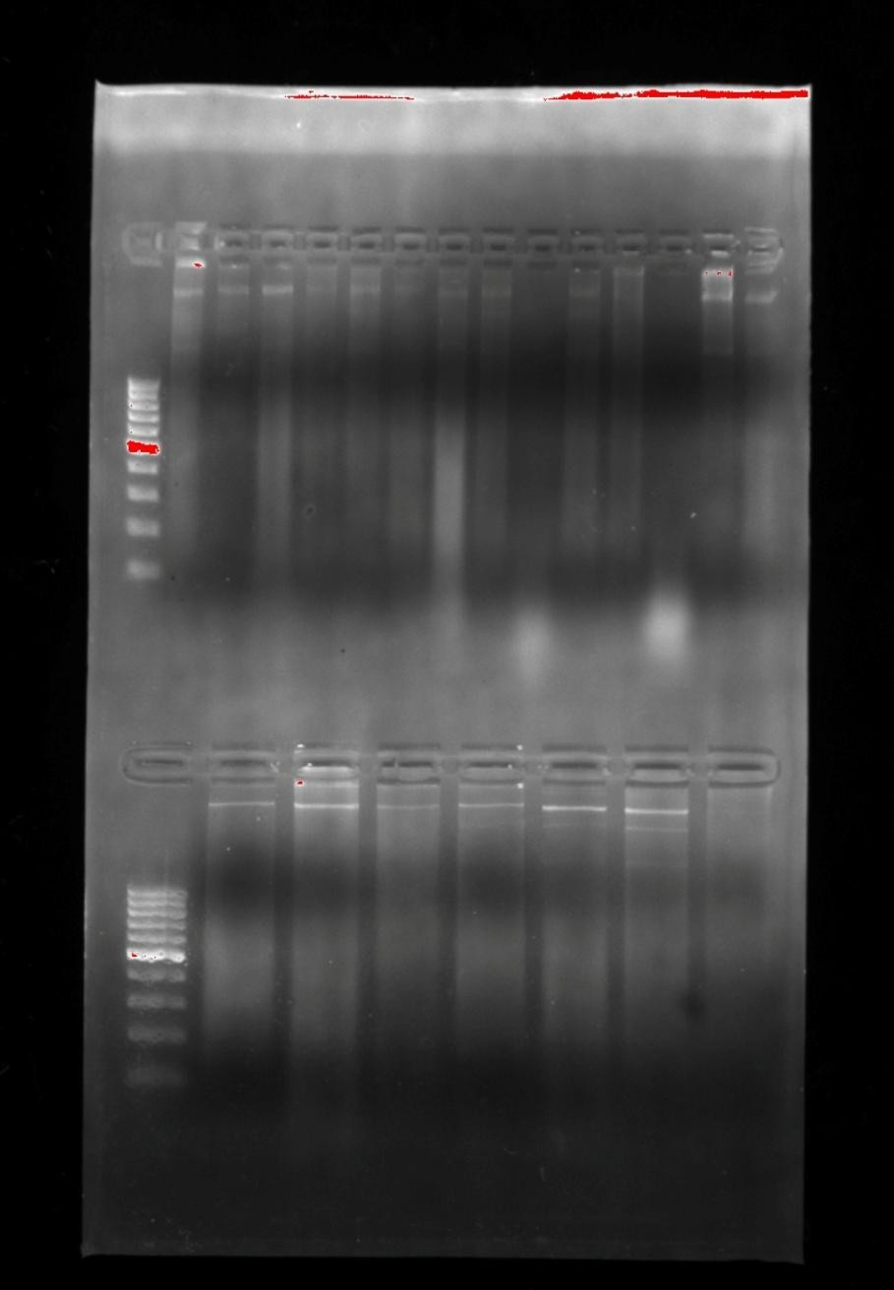

**1 2 3 4 5 6 7 8 9 10 11 12 13 14 15**

**16 17 18 19 20 21 22 23**

1000

500

100

Gel well

Plasmid bands

1000

500

100

Plate 1: Plasmid Extraction on Agarose Gel Electrophoresis

Lane 1: Molecular weight standard marker 100bp DNA ladder, Lane 2: *Salmonella* isolate number 10, Lane 3: *E.coli*

isolate number 23, Lane 4: *Salmonella* isolate number 30, Lane 5: *Pasturella* isolate number 12, Lane 6: *Pasturella*

isolate number 22, Lane 7: *Salmonella* isolate number 11, Lane 8: *Pasturella* isolate number 35, Lane 9: *Salmonella* isolate number 79, Lane 10: S10 transconjugant, Lane 11: P22 transconjugant, Lane 12: *Pasturella* isolate number 4, Lane 13: *Pasturella* isolate number 33, Lane 14: *Pasturella* isolate number 34, Lane 15: *Salmonella* isolate number 20,

Lane 16: S11 transconjugant, Lane 17: *Pasturella* isolate number 10, Lane 18: *Pasturella* isolate number 40, Lane 19:

*E.coli* isolate number 10, Lane 20: *Salmonella* isolate number 3, Lane 21: *Salmonella* isolate number 25, Lane 22:

*Salmonella* isolate number 22, Lane 23: *Salmonella* isolate number 18.

Plate 2: PCR analysis using Primer CTX-M2 on Agarose Gel Electrophoresis

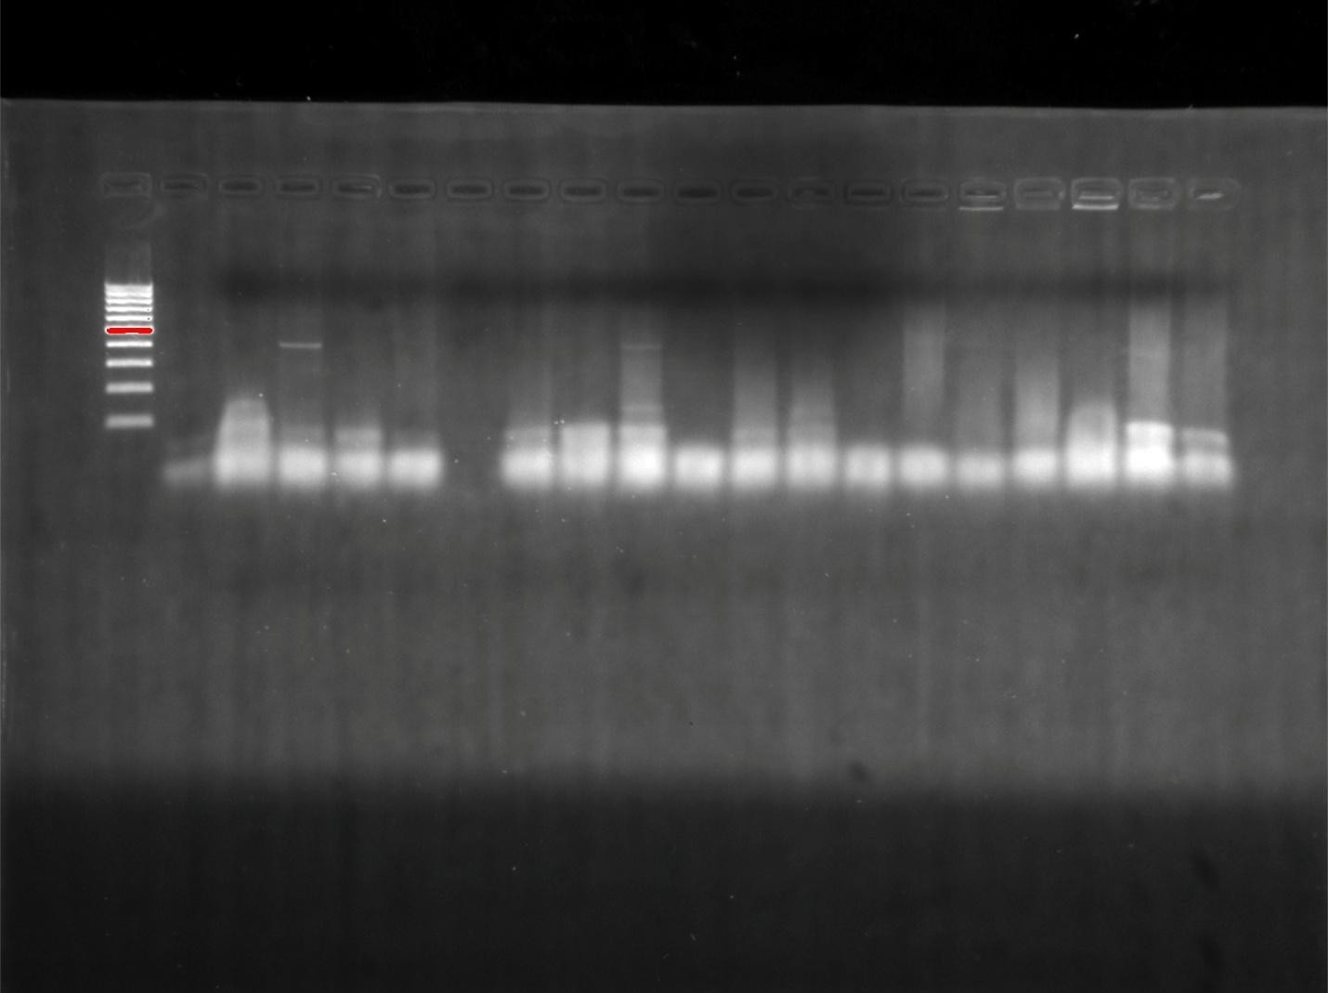

**1 2 3 4 5 6**

**7 8 9 10 11 12 13 14 15 16 17 18 19**

1000

865bp

100

**Primer front**

Lane 1: Molecular weight standard marker 100bp DNA ladder, Lane 2: *Salmonella* isolate number 10, Lane 3:

*E.coli* isolate number 23, Lane 4: *Salmonella* isolate number 30, Lane 5: *Pasturella* isolate number 12, Lane 6:

*Pasturella* isolate number 22, Lane 7: *Salmonella* isolate number 11, Lane 8: *Pasturella* isolate number 35,

Lane 9: *Salmonella* isolate number 79, Lane 10: S10 transconjugant, Lane 11: P22 transconjugant, Lane 12:

*Pasturella* isolate number 4, Lane 13: *Pasturella* isolate number 33, Lane 14: *Pasturella* isolate number 34,

Lane 15: *Salmonella* isolate number 20, Lane 16: S11 transconjugant, Lane 17: *Pasturella* isolate number 10,

Lane 18: *Pasturella* isolate number 40, Lane 19: *E.coli* isolate number 10.

**Gel well**

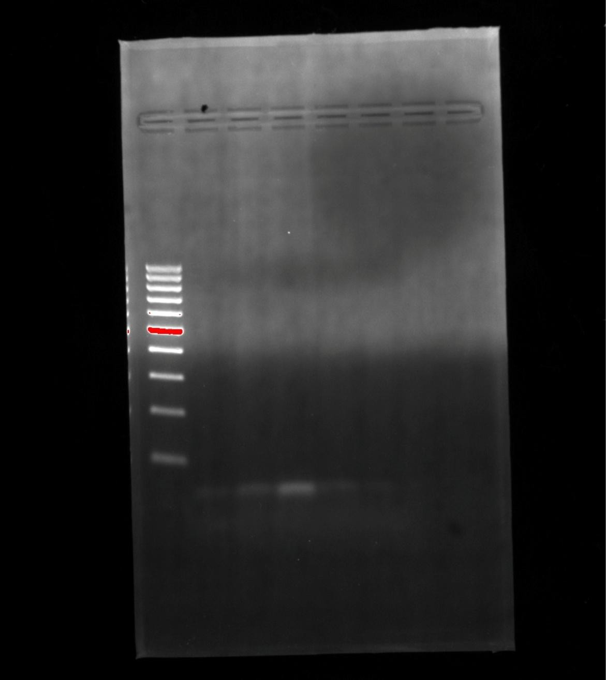

**20 21 22 23**

**DNA Marker**

Plate 3: PCR Analysis using Primer CTX-M2 on Agarose Gel Electrophoresis

Lane 20: *Salmonella* isolate number 3, Lane 21: *Salmonella* isolate number 25, Lane 22:

*Salmonella* isolate number 22, Lane 23: *Salmonella* isolate number 18.

1000

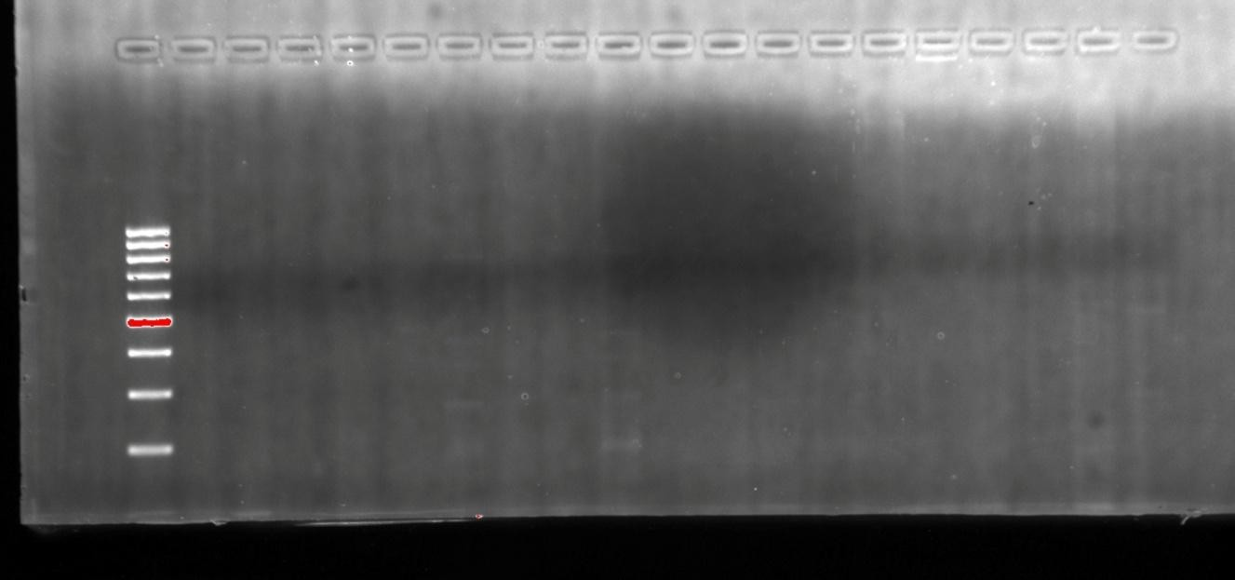

**1 2 3 4 5 6 7 8 9 10 11 12 13 14 15 16 17 18**

100

Plate 4: PCR analysis using CMY-2 on Agarose Gel Electrophoresis

Lane 1: Molecular weight standard marker 100bp DNA ladder, Lane 2: *Salmonella* isolate number 10, Lane 3: *E.coli* isolate number 23, Lane 4: *Salmonella* isolate number 30, Lane 5: *Pasturella* isolate number 12, Lane 6: *Pasturella* isolate number 22, Lane 7: *Salmonella* isolate number 11, Lane 8: *Pasturella* isolate number 35, Lane 9: *Salmonella* isolate number 79, Lane 10: S10 transconjugant, Lane 11: P22 transconjugant, Lane 12: *Pasturella*

isolate number 4, Lane 13: *Pasturella* isolate number 33, Lane 14: *Pasturella* isolate number 34, Lane 15:

*Salmonella* isolate number 20, Lane 16: S11 transconjugant, Lane 17: *Pasturella* isolate number 10, Lane 18:

*Pasturella* isolate number 40.

ll

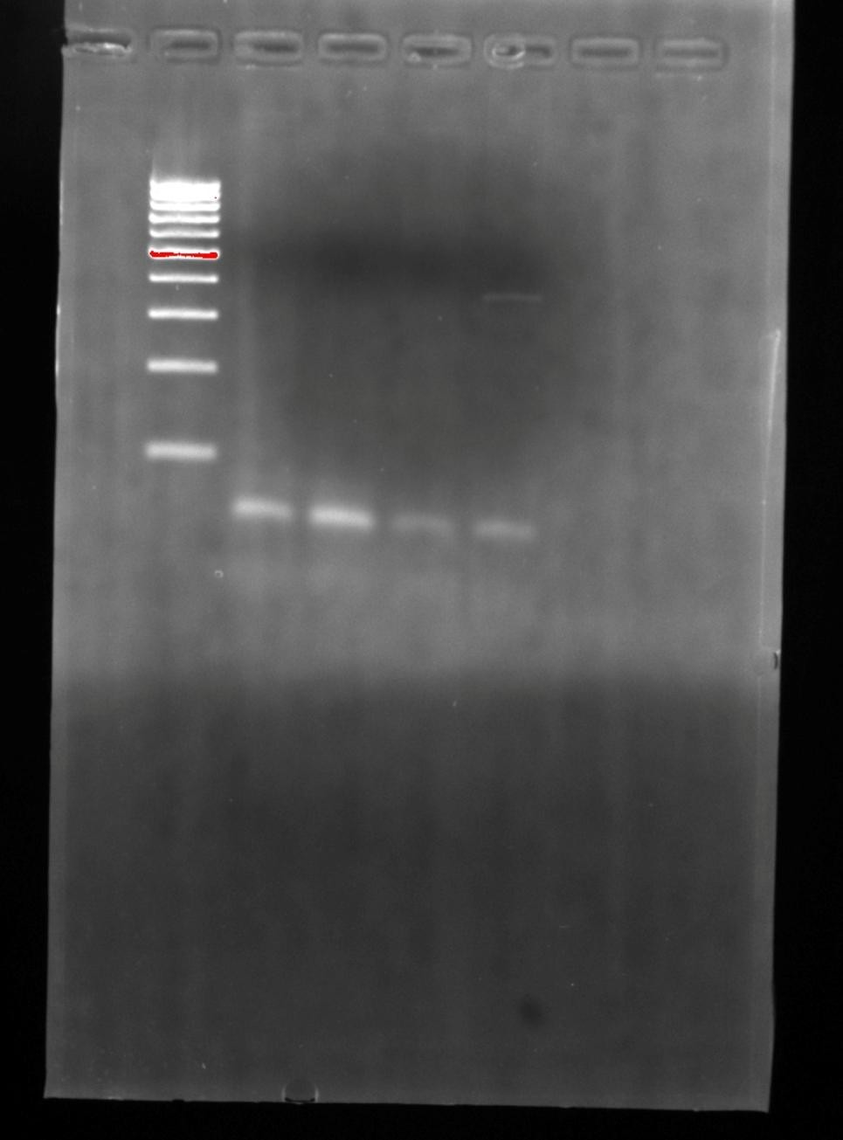

**19 20**

**21 22 23**

We

97bp

1000

100

Plate 5: PCR analysis using CMY-2 on Agarose Gel Electrophoresis

Lane 19: *E.coli* isolate number 10, Lane 20: *Salmonella* isolate number 3, Lane 21:

*Salmonella* isolate number 25, Lane 22: *Salmonella* isolate number 22, Lane 23:

*Salmonella* isolate number 18.

1000

500

100

900bp

232bp 99bp

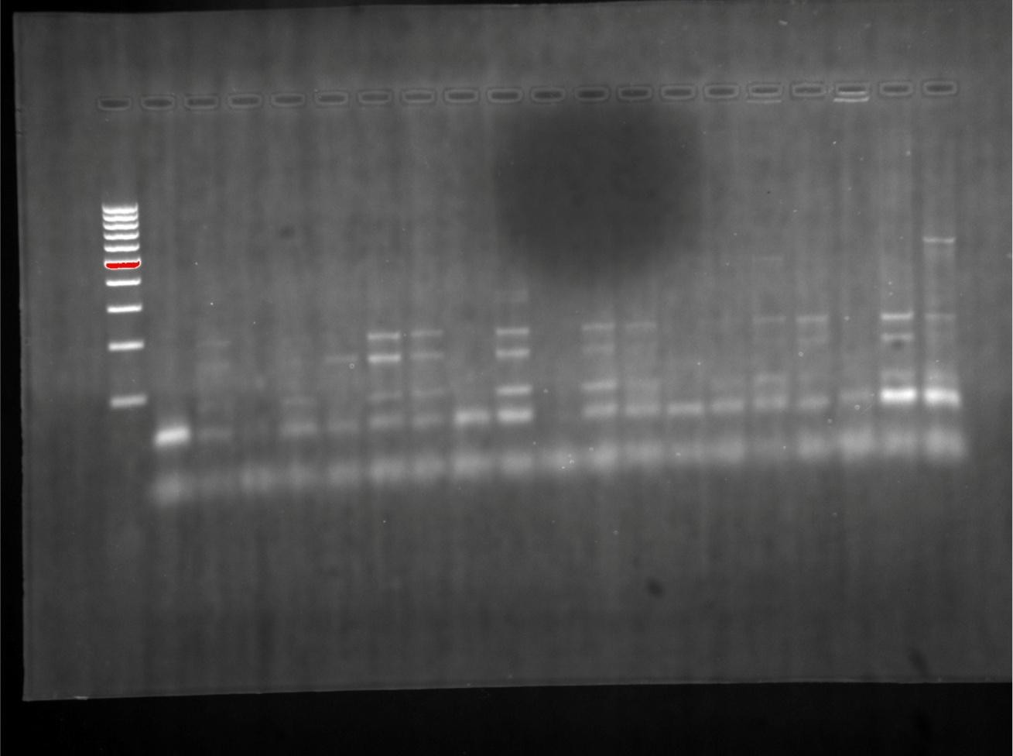

**1 2 3 4 5 6 7 8 9 10 11 12 13 14 15 16 17 18 19 20**

Plate 6: PCR Analysis using primer aac(3) – IV on Agarose gel Electrophoresis

Lane 1: Molecular weight standard marker 100bp DNA ladder, Lane 2: *Salmonella* isolate number 10, Lane 3: *E.coli* isolate number 23, Lane 4: *Salmonella* isolate number 30, Lane 5: *Pasturella* isolate number 12,

Lane 6: *Pasturella* isolate number 22, Lane 7: *Salmonella* isolate number 11, Lane 8: *Pasturella* isolate

number 35, Lane 9: *Salmonella* isolate number 79, Lane 10: S10 transconjugant, Lane 11: P22 transconjugant,

Lane 12: *Pasturella* isolate number 4, Lane 13: *Pasturella* isolate number 33, Lane 14: *Pasturella* isolate

number 34, Lane 15: *Salmonella* isolate number 20, Lane 16: S11 transconjugant, Lane 17: *Pasturella*

isolate number 10, Lane 18: *Pasturella* isolate number 40, Lane 19: *E.coli* isolate number 10, Lane 20:

*Salmonella* isolate number 3.

**Well**

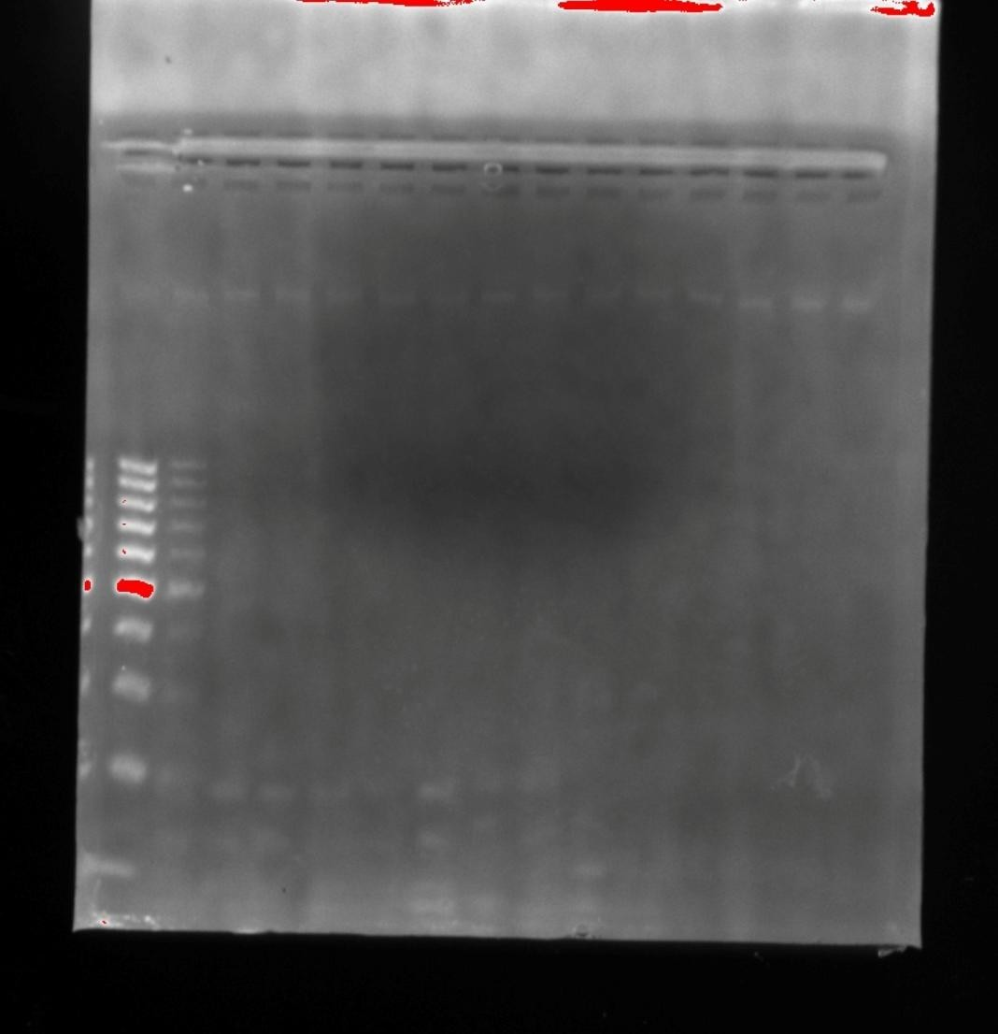

**21 22 23**

**Marker**

Plate 7: PCR Analysis using primer aac(3) – IV on Agarose gel Electrophoresis

Lane 21: *Salmonella* isolate number 25, Lane 22: *Salmonella* isolate number 22, Lane 23:

*Salmonella* isolate number 18.

1000

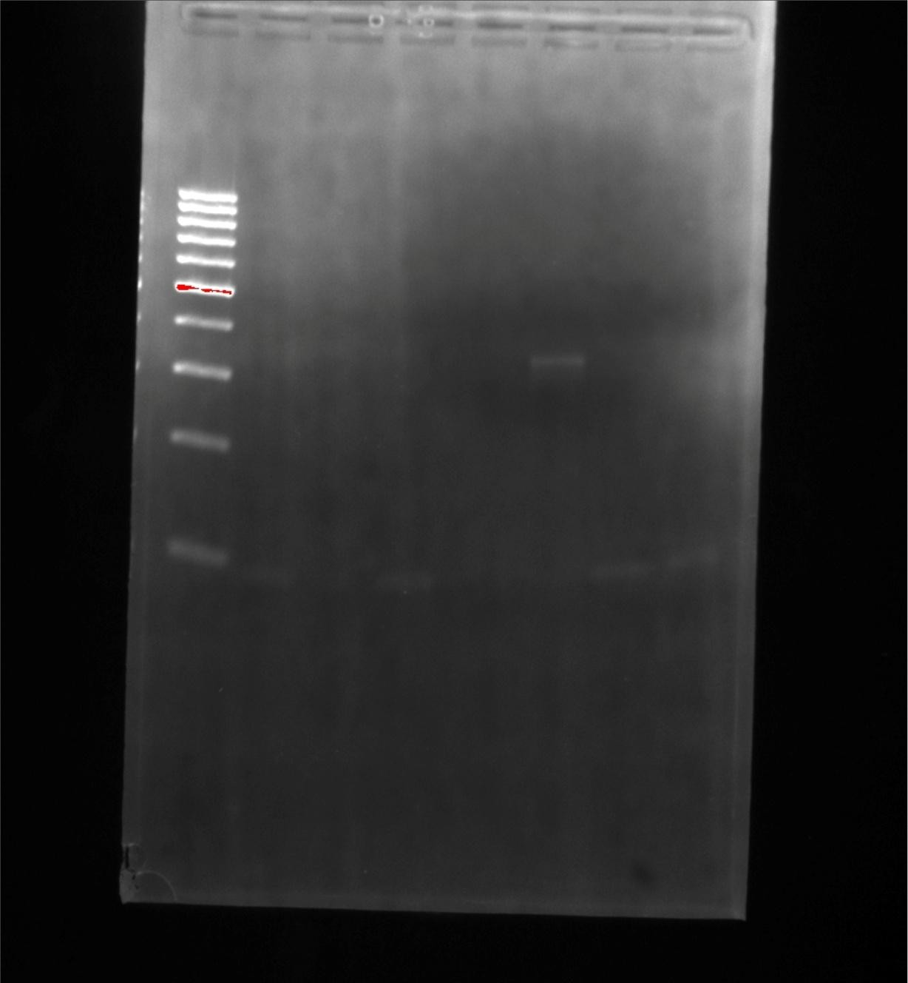

**1**

**2**

**3**

**4**

**5**

**6**

**7**

**8**

500

330bp

100

Plate 8: PCR analysis using primer ant(2)-1 on Agarose Gel Electrophoresis

Lane 1: Molecular weight standard marker 100bp DNA ladder, Lane 2: *Salmonella* isolate number 10, Lane 3: *E.coli* isolate number 23, Lane 4: *Salmonella* isolate number 30, Lane 5: *Pasturella* isolate number 12, Lane 6: *Pasturella* isolate number 22, Lane 7: *Salmonella* isolate number 11, Lane 8: *Pasturella* isolate number 35.

Well

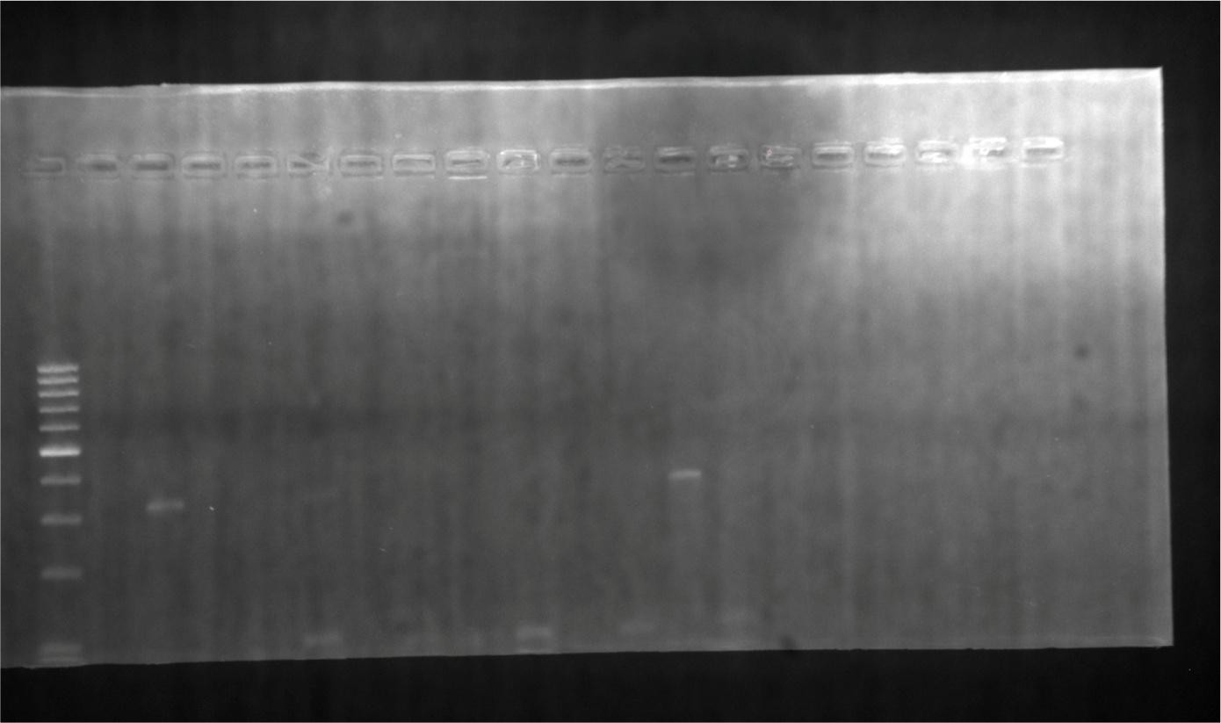

**9 10 11 12 13 14 15 16 17 18 19 20 21 22 23**

Marker

356bp

Plate 9: PCR analysis using primer ant(2)-1 on Agarose Gel Electrophoresis

Lane 9: *Salmonella* isolate number 79, Lane 10: S10 transconjugant, Lane 11: P22 transconjugant, Lane 12: *Pasturella* isolate number 4, Lane 13: *Pasturella* isolate number 33, Lane 14: *Pasturella* isolate number 34, Lane 15: *Salmonella* isolate number 20, Lane

16: S11 transconjugant, Lane 17: *Pasturella* isolate number 10, Lane 18: *Pasturella* isolate

number 40, Lane 19: *E.coli* isolate number 10, Lane 20: *Salmonella* isolate number 3.

Lane 21: *Salmonella* isolate number 25, Lane 22: *Salmonella* isolate number 22, Lane 23:

*Salmonella* isolate number 18.

**1 2 3 4 5 6 7 8**

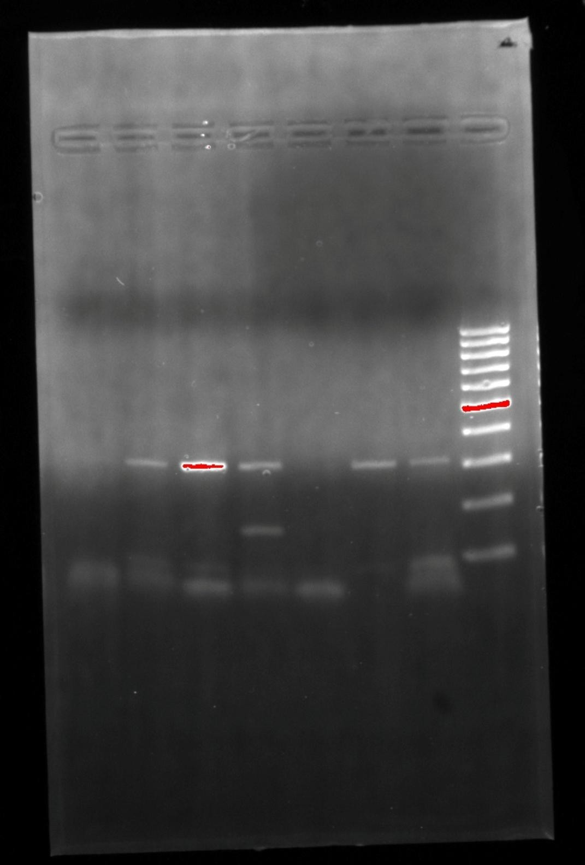

Gel well

1000

500

350bp

250bp

200

Marker

Plate 10: PCR analysis using primer gyrA on Agarose Gel Electrophoresis

Lane 1: Molecular weight standard marker 100bp DNA ladder, Lane 2: *Salmonella* isolate number 10, Lane 3: *E.coli* isolate number 23, Lane 4: *Salmonella* isolate number 30, Lane

5: *Pasturella* isolate number 12, Lane 6: *Pasturella* isolate number 22, Lane 7:

*Salmonella* isolate number 11, Lane 8: *Pasturella* isolate number 35.

Well

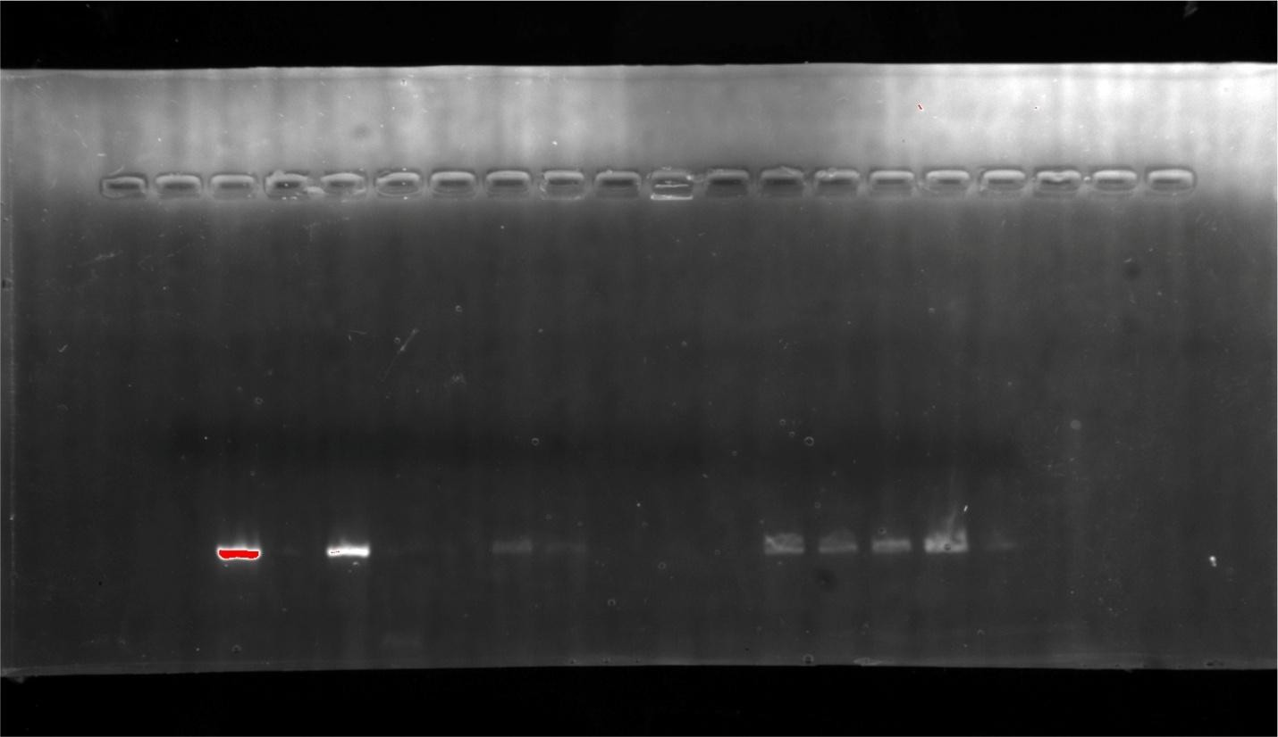

**9 10 11 12 13 14 15 16 17 18 19 20 21 22 23**

150bp

Plate 11: PCR analysis using primer gyrA on Agarose Gel Electrophoresis

Lane 9: *Salmonella* isolate number 79, Lane 10: S10 transconjugant, Lane 11: P22 transconjugant, Lane 12: *Pasturella* isolate number 4, Lane 13: *Pasturella* isolate number 33, Lane 14: *Pasturella* isolate number 34, Lane 15: *Salmonella* isolate number 20, Lane

16: S11 transconjugant, Lane 17: *Pasturella* isolate number 10, Lane 18: *Pasturella* isolate

number 40. Lane 19: *E.coli* isolate number 10, Lane 20: *Salmonella* isolate number 3.

Lane 21: *Salmonella* isolate number 25, Lane 22: *Salmonella* isolate number 22, Lane 23:

*Salmonella* isolate number 18.

Well

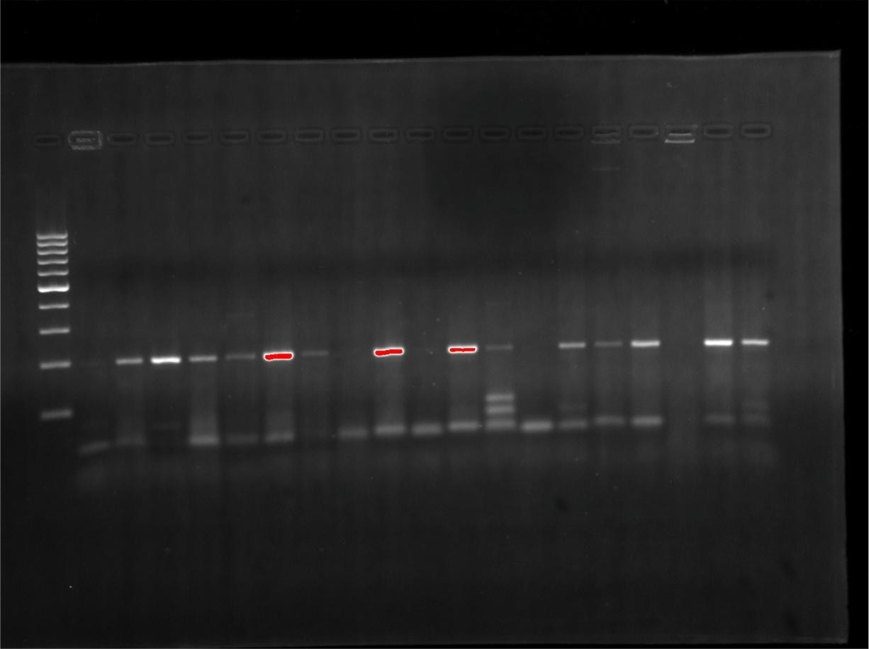

1 2 3 4 5 6 7 8 9 10 11 12 13 14 15 16 17 18 19 20

Marker 1000

500

320bp

100

Plate 12: PCR analysis using primer gyrA *E.coli* on Agarose Gel Electrophoresis

Lane 1: Molecular weight standard marker 100bp DNA ladder, Lane 2: *Salmonella* isolate number 10, Lane 3: *E.coli* isolate number 23, Lane 4: *Salmonella* isolate number 30, Lane 5: *Pasturella*

isolate number 12, Lane 6: *Pasturella* isolate number 22, Lane 7: *Salmonella* isolate number 11,

Lane 8: *Pasturella* isolate number 35. Lane 9: *Salmonella* isolate number 79, Lane 10: S10

transconjugant, Lane 11: P22 transconjugant, Lane 12: *Pasturella* isolate number 4, Lane 13: *Pasturella* isolate number 33, Lane 14: *Pasturella* isolate number 34, Lane 15: *Salmonella* isolate number 20, Lane 16: S11 transconjugant, Lane 17: *Pasturella* isolate number 10, Lane 18: *Pasturella*

isolate number 40. Lane 19: *E.coli* isolate number 10, Lane 20: *Salmonella* isolate number 3.

Marker

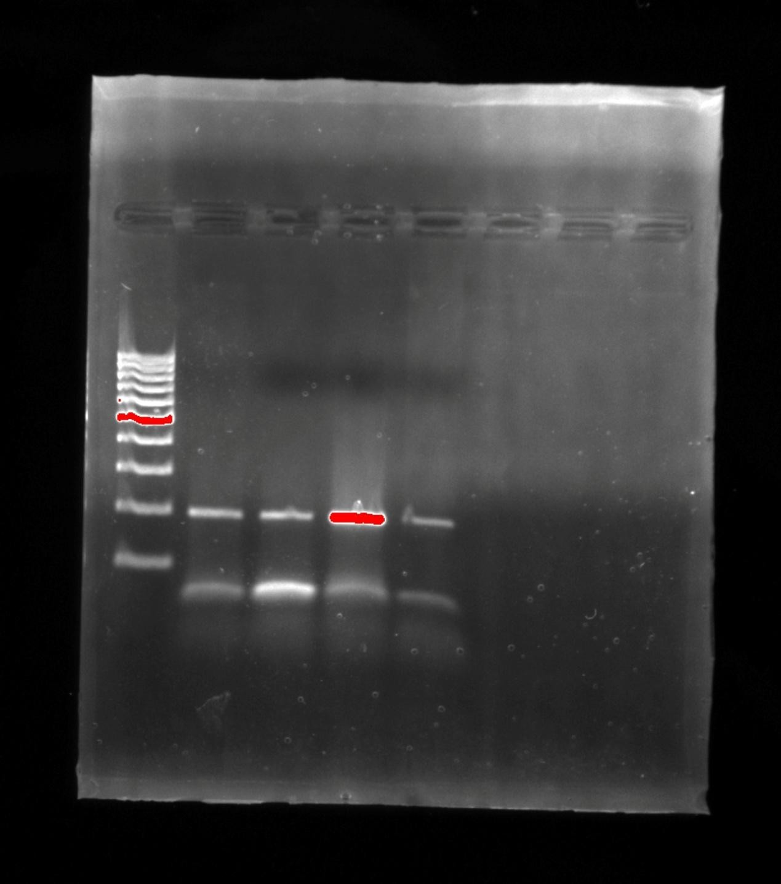

21

22

23

Well

20

9

1000

500

0bp

100

5bp

Plate 13: PCR analysis using primer gyrA *E.coli* on Agarose Gel Electrophoresis

Lane 21: *Salmonella* isolate number 25, Lane 22: *Salmonella* isolate number 22, Lane 23:

*Salmonella* isolate number 18.

# CHAPTER FIVE

**5.0 Discussion**

Quail eggs have been widely reported to contain extraordinary, nutritional and medicinal properties needed for diet therapy (Apata, 2009). Quail eggs have been reported to have high therapeutic activity in nervous disorders, anaemia, high serum, diabeties, heart attack etc. The results from this study showed that *E. coli, Salmonella* spp*, Pasturella* spp were highly prevalent in the investigated quail egg shells which correlates with works documented by previous workers Bryce *et al.,* (2005), Afste, 2007, and Ifeanyi *et al.,* (2010).

The result of antibiotics susceptibility in this study also correlates with the reports of previous studies that document high resistant to Erythromycin, Tetracycline, Trimethoprim – sulfamethoxazole (Nwanze *et al*., 2010, Ngwai *et al.*, 2005). The reason for high level resistance to multiple antibiotics was common in this study. This situation is made worse as a result of ignorance or poor hygiene by quail eggs consumers and perhaps the poultry handlers. This study is in contrast to the work carried out by Nkang and co-workers (2009), who also observed that these test bacterial isolates were resistants to Ciprofloxacin, Nitrofuratoin. All of the isolates had 90% susceptibility percentage to Imipenem.

Furthermore, observations from the results obtained showed that there were substantial decrease in antibiotic activity of ciprofloxacin, Gentamicin, Nitrofuratoin and Cotrimoxazole against the bacterial isolates. This observation was similar to earlier reported cases of multidrug resistant *E. coli, Salmonella* spp (Ibrahim *et al.,* 1998, Threefall *et al.,* 2003). It showed increased bacteria resistance to test antibiotics by isolates from the quail farms. The high level of isolation of beta- lactam resistant *E. coli, Salmonella* spp and *Pasturella* spp 70% 80% 90% suggest frequent

usage of beta lactam antibiotics, bacitracin and others such as tetracycline, nitofuratoin nalidixic acid, erythromycin in its environment (Ehinmidu and Ibrahim, 2004). Bacteria resistance to nalidixic acid predicts reduced susceptibility to flouroquinolones treatment (WHO, 2003) was observed in this study.

This observation could suggest that the resistant isolates may probably originate from the environment where antibiotics are often used (Ngwai *et al.,* 2005) or resistance in the study could possibly be innate.

The conjugation studies in this report showed that acquisition of R-plasmid by sensitive *Proteus mirabilis* from multiple antibiotic resistant *E. coli*, *Salmonella* spp *and Pasturella* species test bacterial isolates was obtained from the three quail farms. The antibiotic susceptibility testing result of the test transconjugants exhibited resistant pattern of donor cells before conjugation. This is because most of these isolates showed a common resistant pattern representing it’s environment and coupled with the fact that their resistant factor were transferable. Furthermore, the resistance isolates and their corresponding transconjugants co-migrated in the electro phoresis tank with some having the same band patterns.

Thirty (30) resistant bacterial test isolates were used for conjugation studies. The result of conjugation studies showed that some of the antibiotics resistance genes were likely plasmid encoded and transmissible. The MIC of ciprofloxacin was done before and after conjugation in order to ascertain if there was plasmid transfer between the donor and recipient organisms. The increase in the MIC value of ciprofloxacin after conjugation shows that the recipient had taken the characteristics of the donor resistant *E. coli, Salmonella* spp *and Pasturella* spp donors.

The curing of transcojugants showed a reduced value for ciprofloxacin against the same transconjugants. The MIC of ciprofloxacin against the cured transconjugants decreased as compared to the values obtained before the curing.

This shows that the curing of the plasmid from the transconjugants with the acridine orange dye affected the change in MIC values observed.

The result obtained from this study also showed similarities of corresponding transconjugants harbouring similar plasmids. The similar plasmid patterns of multi antibiotics resistance bacterial test isolates from the three investigated quail farms suggests the wide spread migration of similar plasmids. This showed the existence of plasmid pool carrying multiple antibiotic resistance in the bacteria population in Kaduna town, Nigeria.

In this study, there was coexistence of antibiotic-sensitive and multi-antibiotic resistance strains of the organisms, unlike multi-antibiotic resistant strains, the sensitive strains did not contain any plasmid. The pressure exerted by antibiotics treatment of salmonellosis and pasturellosis has been reported to enhance the prevalence of R-plasmid (Datta *et al.,* 1981).

Epidemiological result based on the plasmid analysis showed that the plasmid isolated in this study belongs to different clonal population of organism though with some similarities. The *invitro* susceptibility of the predominant plasmid profile in Primer 1 and 3 respectively was identified with majority of the isolates showing sensitivity to Imipenem, gentamicin, Ciprofloxacin, Nalidixic acid and resistant to the macrolide, beta-lactam antibiotics and some of the aminoglycosides.

Through the acquisition of a plasmid conferring multi antibiotics resistance, the strain under goes the necessary and appropriate adaptation for survival in the changing antibiotic environment.

This result therefore appears that the already existing sensitive strain by the acquisition of R- plasmid has emerged as a resistant strain with the species bacterial population in Kaduna.

# CHAPTER SIX

**SUMMARY, CONCLUSION AND RECOMMENDATIONS**

# Summary and Conclusion

Based on these research findings we conclude as follows:

* + 1. *Escherichia coli, Salmonella* spp and *Pasturella* spp were detected in quail egg shells from farm investigated in Kaduna state Nigeria.
    2. The studied *E coli*, *Salmonella* spp and *Pasturella* spp isolates were generally resistants to the antibiotic tested.
    3. The studied *E coli, Salmonella* spp and *Pasturella* spp isolates were highly susceptible to Imipenem.
    4. The bacterial isolates were found in behavior resistant plasmids encoding inck epidermologic gene of blacTX – M for ESBL genes with molecular weight of 200bp. All the isolates carrying this gene were from farm 1.
    5. Some of the resistant genes were of *E coli*, Salmonella *spp* and *Pasturella* spp isolates were observed to be plasmid-mediated.

# Recommendation

In the light of these research finding, it is imperative that preventive and corrective measures enumerated below need to be considered.

 It is clear that bacteria will continue to develop resistance to currently available antibacterial drugs by either new mutations or the exchange of genetic information that is, the transfer of old resistance gene into new hosts. Therefore use of appropriate antibiotics

at the appropriate dosage and for the appropriate duration through appropriate route of administration is one important means of reducing selective pressure that helps resistant organisms emerge.

 There is need for constant antimicrobial susceptibility surveillance since antimicrobial resistant patterns are constantly evolving and presenting global public health problems.

 There is also need for serotyping of *E coli*, *Salmonella* spp and *Pasturella* spp, organism so as to be sure of the strains isolated and the need for more molecular studies for the characterization of resistant genes for further guide in therapy.

 There is need for antibacterial agents with different mechanisms of action since it is difficult to outsmart organisms that have had several billion years to learn how to adapt to hostile environments such as those containing antimicrobial agents.

 There should be strict attention to infection control guidelines to learn the spread of resistant organisms when they develop i.e irrational use of antibiotics should be discouraged to restrict antibiotic use to bacterial infections since it encourages development of drug resistance.

 Poor personal hygiene and inadequate food handling is the predisposing factor that potentiate transmission of bacteria infections.

 The poultry farmers and handlers should be educated on the need for proper hygiene and its relationship to food health; therefore, there is also the need for enlightment campaign to educate the people on quality of water, maintenance, importance of good hygienic practice, such as washing hands with soap and washing the eggs properly after purchase before consumption and other hygienic measures should be stressed.

 The use of modified gel electrophoresis such as pulse field gel electrophoresis of bacteria DNA, ribotyping of the resistant isolates, polymerase chain reactions should be implored in the surveillance of multiple drug resistant clone of the bacteria isolates in order to adequately establish the epidemiological links between the emerging resistant strains.

# CONTRIBUTION TO KNOWLEDGE

It was identified that *Escherichia coli, Salmonella* spp and *Pasturella* spp are present in quail egg shells, and this work has not been carried out in the North Western part of Nigeria. This is a step forward in further research finding to reducing the spread of antibiotic resistance through misuse of antibiotics among poultry handlers working on poultry farms. It was also identified that Imipenem was the most effective antibiotic used in this study because it is not administered orally therefore the spread of resistance to this drug is very minimal.

# REFERENCES

Aarestrup, F.M, Agerso, Y., Gemer-Smidt, P, Madsen, M and Jensen, L.B, (2000)."Comparison of antimicrobial resistance phenotypes and resistance genes in *Enterococcus faecalis* and *Enterococcus faecium* from humans in the community, broilers, and pigs in Denmark."*Diagnostic Microbiology of Infectious Diseases* 37(2):127-37.

Adlerberth, I. (2008). Factors influencing the establishment of the intestinal microbiota in *infancy. Nestle Nutritional Workshop Service Pediatric Program* 62, 13-29; discussion 29-33.

Adlerberth, I. and Wold, A. E. (2009).Establishment of the gut microbiota in Western infants.

*Acta Paediatrica* 98, 229-238.

Afset, J.E.(2007). Role of enteropathogenic *Escherichia coli* in childhood diarrhoea in Norway.

Norwegian University of Science and Technology.(Full thesis) pp 8-16.

Aibinu, I.E., R.F. Peters, K.O. Amisu, S.A. Adesida, M.O. Ojo and T. Odugbemi, (2007). Multidrug resistance in *E. coli* O157 strains and the public health implication. Journal America Science, 3: 22-33.

Akgün, S., Soyutemiz, E., Anar, S., Çıbık, R. ―Tüketime sunulan kremalı pastalarn mikrobiyolojik niteliklerinin saptanması‖, Gıda, 22(6), 433-438, 1997.

Akinyemi, K.O., Oyefolu, A.O., Opere, B., Otunba-Payne, V.A. and Oworu, A.O,(1998). *Escherichia coli* in patients with acute gastroenteritis. *East African Medical Journal.*75, 512-515.

Alabi, S.A., Audu, R.A and Onedeji, K.S (1998). Viral, Bacterial and Parasitic agents associated with infantile diarrhoea in Lagos. *Nigerian Journal of Medical Research, 2:* 29-32.

Alam, N. H. and H. Ashraf. 2003. Treatment of infectious diarrhea in children. *Paediatrica.*

*Drugs* 5:151-165.

Albert, M. J., Faruque, A. S., Faruque, S. M., Sack, R. B. and Mahalanabis, D. (1999).Case- control study of enteropathogens associated with childhood diarrhoea in Dhaka, Bangladesh. *Journal of clinical microbiology* 37, 3458-3464.

Al-Gallas, N., Bahri, O., Bouratbeen, A., Ben Haasen, A. and Ben Aissa, R. (2007).Etiology of acute diarrhoea in children and adults in Tunis, Tunisia, with emphasis on 40diarrhoeagenic *Escherichia coli:* prevalence, phenotyping, and molecular epidemiology. *American Journal of Tropical Medicine & Hygiene.*571-582.

Al-Ghamdi, M.S., F. El-Morsey, Z.H. Al-Mustafa, M. Al-Ramadhan and M. Hanif, 1999.Antibiotic resistance of *Escherichia coli* isolated from poultry workers, patients and chicken in the eastern province of Saudi Arabia. Tropical MedicalInternational. Health, 4: 278-283.

Ali, H. M. (1985). Reduced Ampicillin Bioavailability Following Oral Co-administration with Chloroquine. *J Antimicrob Chentotherapy;* 15:781-4.

Ameh, 1.G., and Opara, W.E. K. (2004).Typhoid : A Record of Cases in Sokoto, Nigeria.

*Pakistan Journal of Biological Sciences.*7(7): 1177-1180, 2004 ISSN 1028-8880

Anonymous, ―Türk gıda kodeksi yumurta ve yumurta ürünleri hakkında 2000/11 no’lu tebliğ‖, Resmi Gazette 2000.

Apata, D.F., 2009. Antibiotic resistance in poultry.*International Journalof Poultry Science*, 8: 404-408.

Ashraf, R. and N.P. Shah, (2011).Antibiotic resistance of probiotic organisms and safety of probiotic dairy products*. International Food Research Journal*, 18: 837-853.

Bains (2009). Oral rehydration of children with diarrhoea in Nigeria, A 12 year review of impact on morbidity and mortality from diarrhoea disease and diarrhoea treatment practices. *Journal of Tropic Paediat;* 37: 16-66.

Barber, M., Hayhoe, F.G (1949). "Penicillin-resistant staphylococcal infection in a maternity hospital."*Lancet* 2(25): 1120-5.

Barclay, M.L., Begg, E. J. (2001). Aminoglycoside Adaptive Resistance: Importance for Effective Dosage Regimens. *Drugs* ; 61: 713-21

Barka, M.S. and M. Kihal, 2010.Prevalence of *Escherichia coli* enterohemorragic 0157: h7 in frozen bovine meat in Algeria. *World Journal of Dairy Food Science*, 5: 183-187.

Barrett, S.P., Savage, M.A., Rebec, M.P., Guyot, A., Andrews, N and Shrimpton, S. B. (1999). Antibiotic sensitivity of bacteria associated with community acquired urinary tract infection in Britain. *Journal of Antimicrobial Chemotherapy.*44:359-365.

Barrow, C.I. and R.K.A. Feltham, 1993.Cowan and Steel's Manual for Identification of Medical Bacteria. 3rd Edn., Cambridge University Press, London, pp: 214-218.

Bauer, A.W., Kirbu, W M.M., Sheriss, J.C., and Turck, M. (1966). Antibiotics Susceptibility Testing by a Standardized Single Disc Method *America Journal of Clinical Pathology* 45:493-496.

Bayles, K.W. (2000). The bactericidal action of penicillin: New clues to an unsolved mystery.

*Trends Microbiology.,*2000, 8:81274-81278.

Bengis, RG, FA Leighton, *et al.,* (2004)."The role of wildlife in emerging and re-emerging zoonoses."*Revised Science Technology.*23(2): 497-511.

Bhutta, Z. A. (1996). Impact of Age and Drug Resistance on Mortality in Typhoid Fever.

*Archives of Disease in Childhood; 75:* 214-7.

Bhutta, Z. A., Mansurali, N. (1999). Rapid Serologic Diagnosis of Pediatric Typhoid Fever in an Endemic Area: A Prospective Comparative Evaluation of Two Dot-enzyme Immunoassays and the Widal Test. *The American Journal of Tropical Medicine and Hygiene;* 61(4): 654-7.

Black, R. E., Cousens, S., Johnson, H. L., Lawn, J. E., Rudan, I., Bassani, D. G., Jha, P., Campbell, H., Walker, C. F., Cibulskis, R., Eisele, T., Liu, L. and Mathers, C. (2010). Global, regional, and national causes of child mortality in 2008: a systematic analysis. *Lancet* 375,1969-1987.

Blanch, A. R., Belanche-Munoz, L., Bonjoch, X., Ebdon, J., Gantzer, C., Lucena, F., Ottoson, J., Kourtis, C., Iversen, A., Kiihn, I., Moce, L., Muniesa, M., Schwartzbrod, J., Skraber, S.,Papageorgiou, G. T., Taylor, H., Wallis, J. and Jofre, J. (2006). Integrated analysis of established and novel microbial and chemical methods for microbial source tracking. *Applied Environmental Microbiology 72,* pp 5915-5926.

Bolon, M.K., Wright S.B., Gold, H.S. and Cermeli, Y. (2004). The magnitude of the association between fluoroquinolone use and quinolone-resistant *E.coli* and *Klebsiella pneumonia* may be lower than previously reported. *Antimicrobial Agents Chemotherapy.*48:1934- 1940.

Bonnet, R (2004). Growing group of ESBLs: The CTX-M enzymes .*Antimicrobial agents chemotherapy.* Vol 48(l).ppl-14.

Boschi-Pinto, C., Velebit, L. and Shibuya, K. (2008).Estimating child mortality due to diarrhoea in developing countries.*Bull World Health Organisation* 86, 710-717.

Bou, G., Cartella, M., Tomas, M., Canle, D., Molina, F., Moure, R., Eiros, J. M., and Guerrero,

A. (2002). Identification and broad dissemination of the CTX-M-14 β-lactamase in different *Escherichia coli* strains in the northwest area of Spain. *Journal of Clinical Microbiology* 40:4030-6.

Boyce JD, Adler B: (2000) The capsule is a virulence determinant in the pathogenesis of Pasteurella multocida M1404 (B:2). Infectious Immunology 2000, 68(6):3463-3468.

Bradford, P. A. 2001. Extended-spectrum β -lactamases in the 21st century: characterization, epidemiology, and detection of this important resistance threat. *Clinical Microbiology Review* 14:933-51.

British pharmacopiea (2000). Volume 1 pp 678

Brooks, G.F., Butel, J.S., Morse, S.A, ―Medical Microbiology‖, 23th Edition, McGraw Hill, Singapore, 258, 2004.

Bryce, J., Boschi-pinto, C., Shibuya, K., and Black, R.E.(2005). WHO estimates of the causes of death in *children. Lancet* 365:1147-52.

Broussard (1992). Mechanism of Bacterial Resistance. *Pediatr din of North America* 43(3); 479- 507.

Burow, H., ―Dominanz von Salmonella Enteritidis bei isolierungen aus lebensmittel tierischer herkunft in Nordbayern―, Fleischwirt, 72, 1045-1050, 1992.

Bush, K., Jacoby, G. A., and Medeiros, A. A. (1995). A functional Classification Scheme for Beta-lactamases and its Correlation with Molecular Structure. *Antimicmb. Agents Chemother.*59:1211-1233.

Bush, K.,(2001). New beta-lactamases in gram negative bacteria: diversity and impact on the selection of antimicrobial therapy. *Clinical Infectious Diseases,* 32:1085-1089.

Çakıroğlu, H.S., Gümüşsoy, K.S. ―Ankara Garnizonunda tüketime sunulan tavuk yumurtalarnın Salmonella spp. yönünden analizi‖, *Journal of Health Sciences*, 14(3), 158-162, 2005.

Camilleri, F., ―Incidence of Salmonellosis in local hens’ eggs‖, The Journal of the Royal Society for the Promotion of Health, 112(5), 212-213, 1992.

Cardosso, M.O., A.R. Ribeiro, L.R. dos Santos, H.L.S. de Moraes and C.T.P. Salle *et al*., 2006. Antibiotic resistance in *Salmonella* enteritidis isolated from broiler carcasses. *Brazilian Journal of Microbiology*, 37: 368-371.

Cattoir, V (2009). A quinolone surprise: A plasmid mediated resistance. In: Solutions to manage antimicrobial resistance. *International Newsletter* Dec 2009.

Cattoir, V., Poirel, L., Nordmann, P., Rotimi, P., Soussy, CJ (2007). Multiplex PCR for detection of plasmid-mediated quinolone resistance qnr genes in ESBL-producing enterobacterial isolates. *Journal of Antimicrobial Chemotherapy.*60:394-7.

Cattoir, V.,Nordmann,P.(2009). Plasmid-mediated quinolone resistance in Gram-negative bacterial species: an update. *Current Medicinal Chemistry* 16:1028-46.

CDC, (2004) ―Salmonella, MMWR‖, Atlanta-Georgia, 1–15, 2004.

Centers for Disease Control and Prevention.Decreased susceptibility of *Neisseria gonorrhoeae* to fluoroquinolones. Ohio and Hawaii, 1992-1994.*Morbidity Mortality Weekly Report.,*1994, 43:325-327.

Chambers, H.F (2006). Aminoglycosides and Protein inhibitors. In Goodman and Oilman (eds).

*The Pharmacological Basis of Therapeutics.*11th edition. McGraw-Hill companies, Inc.

Charpentier, E. and P. Courvalin, (1999). Antibiotic resistance in *Listeria* spp. Antimicrobial Agents Chemotherapy, 43: 2103-2108.

Charpentier, E., G. Gerbaud, C. Jacquet, J. Rocourt and P. Courvalin, (1995).Incidence of antibiotic resistance in *Listeria* species. *Journal of Infectious Disease*, 172: 277-281.

Cheasty, T. and Smith H.R. (2005).*Escherichia*., p. 1360-1385. In S. P. Borrellio, Murray P.R., and G. Funke (eds.), *Topley & Wilson's Microbiology & Microbial Infections.*

Cheesbrough, M. (2000). District Laboratory Practice in Tropical Counties Part 2 Cambridge Low- Price Editions, University Press Cambridge, pp 134-143.

Chinh, V.N., Umoh, V.J., Smith, I.S., Igbinosa, E.O and Okoh, A.I (2000). Multidrug Resistance and Plasmid Patterns of *E.coli* 0157 and other *E.coli* isolated from diarrhoeal stools and surface waters from selected sources in Zaria, Nigeria. *International Journal of Environmental Research and Public Health.*7: 3831-3841.

Chung JY, Wilkie I, Boyce JD, Townsend KM, Frost AJ, Ghoddusi M, Adler B (2001): Role of capsule in the pathogenesis of fowl cholera caused by Pasteurella multocida serogroup A. Infectious Immunology, 69(4):2487-2492.

Clegg, A., Passey, M., Omena, M. K., Karigifa, K., Sueve, N. (1994). Re-evaluation of the Widal Agglutination Test in Response to the Changing Pattern of Typhoid Fever in the Highlands of Papua New Guinea. *Acta Tropica* 57(4):255-63

Clinical and Laboratory Standard Institute,(CLSI) (2002). Performance standard for antimicrobial susceptibility testing. Approved standard M31-A3. 3rd edition.vol 26(3):32- 35.

Clinical and Laboratory Standards Institute (2006).Performance Standards for Antimicrobial Disk Susceptibility Tests. Approved Standard. 9th Edn., Clinical and Laboratory Standards Institute, Wayne, Pennsylvania.

Clinical Laboratory Standard Institute (2000). Performance Standards for Anti-Microbial Susceptibility Testing 12th Information Supplement. M100 S 12, Vol. 0 No. O. Wayne PA CLSI.

CLSI (1990).Approved Performance Standard for Antimicrobial Susceptibility Testing for Bacteria. Clinical Laboratory Standard Institute. Villanora, PA, USA. Pp 19-85.

Cogan, T.A., Domingue, G., Lappin-Scott, H.M., Benson, C.E., Woodward, M.J., Humphrey,

T.J. ―Growth of Salmonella Enteritidis in artificially contaminated eggs: the effects of inoculum size and suspending media‖, *International Journal of Food Microbiology*, 70, 131-141, 2001.

Coleman, W., Buxton, B. H. (1907).The Bacteriology of the Blood in Typhoid Fever. *The American Journal of the Medical Sciences* 133: 896-903.

Cook, F.J., Wain, J. (2004). The Emergence of Antibiotics Resistance in Typhoid Fever. *Travel Medicine and Infectious Disease. 2: 61-14.*

Cooke, M.L (2010). Causes and Management of diarrhoea in children in a clinical setting. *South African Journal of Clinical Nutrition,* 23(1): suppl: 42-46.

Coque, T. M., Novais, A., Carattoli, A., Poirel, L., Pitout J., Peixe, L and Baquero, F (2008). Dissemination of clonally related *Escherichia coli* strains expressing extendedspectrum B- lactamase CTX-M-15. *Emerging Infectious Diseases* 14:195-200.

Cormican, M., Morris, D., Corbett-Feney, G and Flynn, J. ( 1998). Extended spectrum β - lactamase production and fluorquinolone resistance in pathogens associated with community acquired urinary tract infection. *Diagnostic Microbiology Infectious Diseases* 32:317-9.

Cottell, L., Webber, M.A., Coldham, N.G., Taylor, D.L., Cerdeno-Tarraga, A. M., Hauser, H., Thomson, N. R., Woodward, M. J and Piddock, J. V.(2011). Complete sequence and

Molecular Epidermiology of IncK Epidermic Plasmid Encoding blactx.m*.Emerging Infectious Diseases.vol* 17(4).pp645-652.

Crarioto, A., Tello A., Navarro, A., Ruiz, J., Villafan, H., Uribe, F and Eslava (1991). Association of *Escherichia coli* Hep-2 adherence patterns with type and duration of diarrhoea. *Lancet* 337:262-264.

Darnton, N. C., Turner, L., Rojevsky, S. and Berg, H. C. (2007). On torque and tumbling in Swimming *Escherichia coli. Journal of bacteriology* 189**,** 1756-1764.

Darwin, K.H. and V.L. Miller, (1999).Molecular basis of the interaction of Salmonella with the intestinal mucosa.*Clinical Microbiology Revolution*, 12: 405-428.

Datta, N., Richards, H., Datta, C. (1981). *Salmonella typhi* in vivo Acquires Resistance to Both Chloramphenicol and Cotrimoxazole. *Lancet*; *i*:1181-1183.

David, L. P. and Robert, A. B.(2005). Extended-Spectrum Beta-lactamases: A Clinical Update Clinical Microbiology Reviews, p. 657-686 Vol. 18, No. 4 Copyright © 2005, American Society for Microbiology.

David, V. (2003). Student Presentation on *Salmonella enteric* typhi Copyright Dennis Kunkel Microscopy, Inc

Davies, J. (1994). Inactivation of antibiotics and the dissemination of resistance genes. *Science,*

264:375-382.

Davis, B. J. (1964). Disc Electrophoresis. Methods and Application to Human Serum Proteins.

Ann N. Y. Acad. Sci. 121. 404-427.

De Buck, J., Van Immersed, F., Haesebrouck, F., Ducatelle, R. ―Colonization of the chicken reproductive tract and egg contamination by Salmonella‖, *Journal of Applied Microbiology*, 97, 233-245, 2004.

de Louvois, J. (1994). Acute bacterial meningitis in the newborn. *Journal of AntimicrobialChemotherapy.*34 Suppl A:61-73.

Dobrindt, U., Agerer, F., Michaelis, K., Janka, A., Buchrieser, C., Samuelson, M., Svanborg, C., Gottschalk, G., Karch, H. and Hacker, J. (2003).Analysis of genome plasticity inpathogenic and commensal *Escherichia coli* isolates by use of DNA arrays. *Journal of bacteriology IKS,* 1831-1840.

Dobrindt, U., Hentschel, U., Kaper, J. B. and Hacker, J. (2002).Genome plasticity in pathogenicand nonpathogenic enterobacteria. *Tropical Microbiology& Immunology.* 264, 157-175.

Doughari, J.H., A.M. Elmahmood and H.P. Nggada, 2007.Retrospective study on the antibiotic resistant pattern of *Salmonella typhi* from some clinical samples. *Africa Journal Microbiology* Res., 1: 33-36.

Doyle J. Evans, Jr and Dolores G. Evans, (1996).*E. coli* in Diarrhoeal disease. In *Medical Microbiology* 4th Edition Edited by Baron S, Galveston (Texas); University of Texas. Medical Branch at Galveston; 1996.

Dua, V., Kunin, C. M., White, L. V. (1994).The Use of Antimicrobial Drugs in Nagpur, India. A Window on medical Care in a Developing Country *Soc Sci Med;* 3:717-24

DuPont, H. L. (2009). Clinical practice. Bacterial diarrhoea. *New England Journal of Medicine*361, 1560-1569.

DuPont, H. L., Formal, S. B., Hornick, R. B., Snyder, M. J., Libonati, J. P., Sheahan, D.G., LaBrec, E. H. and Kalas, J. P. (1971).Pathogenesis *of Escherichia coli* diarrhoea. *New England Journal of Medicine.*285, 1-9.

DTU food:Technical University of Denmark National food Institute (EU Reference Laboratory for Antimicrobial Resistance, 2008)

Edelman, R., Levine, M. M. (1986). Summary of An International Workshop on Typhoid Fever. Rev of Infect Disease 8: 329-349. Evans, M. R., Tromans, J. P., Dexter, E. I., Ribeiro, G. D., (1996). Consecutive Salmonella Outbreaks Traced to the same Bakery. *Journal EpidermiologicalInfection.*116(2): 161-167.

Ehinmidu, J.O., and Ibrahim, Y.K.E (2004). Antibacterial Activity of Low Concentration of Antibiotics Combinations against Resistant *Salmonella typhi* Isolates in Zaria, Nigeria. *Nigeria Journal of Experimental and Applied Biology*. Vol. 5, No. 2, pp. 133-139.

Elmali, M., U. Zeynep, Y. Hilmi, T. Mehmet, G. Kenan and C. Perihan, 2005.A seven-month survey for the detection of *E. coli* O157:H7 from ground beef samples in the markets of Turkey. *PakistanJournal on Nutrition*, 4: 158-161.

Elmalı, M., Ulukanh, Z., Yaman, H., Gençtav, K. ―Hygienic quality of cream pastries in Turkey‖, Archiv Fur Lebensmittelhygine, 58(1), 14, 2007.

Enabulele, S.A., P.O. Amune and W.T. Aborisade, 2010.Antibiograms of *Salmonella* isolates from poultry farms in Ovia North East local government area, Edo State, Nigeria. *Agricultural Biological Journal of North America*, 1: 1287-1290.

Ensor, V. M., Shahid, M., Evans, J.T., and Hawkey, P.M.( 2006). Occurrence, prevalence and genetic environment of CTX-M 6-lactamases in Enterobacteriaceae from Indian hospitals. *Journal of Antimicrobial Chemotherapy.*58:1260-3.

Erb, A., Sturmer, T., Marre, R., and Brenner, H. (2007). "Prevalence of antibiotic resistance in *Escherichia coli:* overview of geographical, temporal, and methodological variations." *European Journal of Clinical Microbiology & Infectious Diseases* 26(2): 83-90.

Evan (1996) ―Food Hygene, Microbiology and HACCP‖, Third edition, An Aspen Publication, Maryland, 118-119.

Ewing W. H. (1986). Edwards and Ewing' s Identification of Enterobacteriacoae 4th edition; pp 27-45,Elsevier Science Publishing Co. inc. New York.

Ezekiel, C.N., A.O. Olarinmoye, J.M.A. Oyinloye, O.B. Olaoye and A.O. Edun, 2011.Distribution, antibiogram and multidrug resistance in *Enterobacteriaceae* from commercial poultry feeds in Nigeria. *Africa Journal Microbiology* Res., 5: 294-301.

Falagas, ME and IA Bliziotis (2007). "Pandrug-resistant Gram-negative bacteria: the dawn of the post-antibiotic era?" *International Journal of Antimicrobial Agents* 29(6): 630-6.

Fevre, EM, Bronsvoort, B.M., Hamilton, K.A., Cleaveland, S. (2006). "Animal movements and the spread of infectious diseases. "*Trends Microbiology* 14(3): 125-31.

Fluit, A. C., F. J. Schmitz, and J. Verhoef. 2001. Frequency of isolation of pathogens from bloodstream, nosocomial pneumonia, skin and soft tissue, and urinary tract infections occurring in European patients. *European Journal of Clinical Microbiology & Infectious Diseases.20:* 188-191.

Fotodar, U., Zaveloff, P., Terracio, L.(2005). Growth *of Escherichia coli* at elevated temperatures. *Journal of Basic Microbiology.*.Vol 45:403-404.

Freeman, J. T., McBride, S. J., Heffernan, H., (2008). Community-onset genitourinary tract infection due to CTX-M-15-producing *Escherichia coli* among travelers to the Indian subcontinent in New Zealand. *Clinical Infectious Diseases.*47:689-92.

Frota, C. A. Solari, E. L. Amorim, G. Carvalho Mda, L. M. Teixeira, and Jarvis, W. R. (2002). Infection Due to Extended-spectrum Beta-lactamase-Producing *Salmonella enterica* subsp. Enterica Serotype Infantis in a Neona-tal Unit. *J. Pediatr.* 141:381-387.

Gilbert., P. (1990) Principle of Microbial Pathogenicity and Epidemiology. In: Pharmaceutical Microbiology (Editors Hugo W.B and Russel, A.D.) *5th*Edition. Blackwell Scientific Publications, London.250-265.

Ginocchio, C.C (2002). "Role of NCCLS in antimicrobial susceptibility testing and monitoring."*American Journal of Health-System.Pharmacy.*59(8 Suppl 3): S7-11.

Glisson (1996).Antimicrobial-drug resistance. *New England Journal of Medicine.335:1445- 1453.*

Goldstein, F. W. 2000. Antibiotic susceptibility of bacterial strains isolated from patients with community-acquired urinary tract infections in France. Multicentre Study Group. *European Journal of Clinical Microbiology & Infectious Diseases.*19:112-7.

Goldstein, F. W., Pean, Y., Gertner, J.(1995). Resistance to ceftriaxone and other b-lactams in bacteria isolated in the community. The Vigil'Roc Study Group. *Antimicrobial Agents Chemotherapy* 39:2516-9.

Goodman (2002) ―Modelling the penetration and growth of bacteria in eggs‖, Food Control 12, 7-11.

Grijspeerdt, K., Herman, L. (2003) ―Inactivation of Salmonella Enteritidis during boiling of eggs‖, *International Journal of Food Microbiology*, 82, 13-24.

Gross, R. J. and B. Rowe. 1985. Serotyping of *Escherichia coli,* In M. Sussmann (ed.), The virulence *of Escherichia coli.* Cambridge University Press, Cambridge, UK.345-360.

Gross, R. J. and Rowe, B. (1985). *Escherichia coli* diarrhoea. *Journal of Hygiene (Land)* **95,**

531-550.

Guerra-Caceres, J. G., Gotuzzo-Herencia, E., Crosby-Dagnino, E., Miro-Quesada, M., Carillo- Parodi, C. (1979).Diagnostic Value of Bone Marrow Culture in Typhoid Fever. *Transactions of the Royal Society of Tropical Medicine and Hygiene 73:* 680-3.

Heuer, O.E., Hammerum, A.M., Collignon, P., Wegener, H.C. (2006). "Human health hazard from antimicrobial-resistant enterococci in animals and food." *Clinical Infectious Diseases* 43(7): 911-6.

Hill, D.R., and Pearson, R.D. (1988).Health advice for international travel. *Annual InternationalMedicine.,*705:839-852. Hill, M. J. and Drasar, B. S. (1975).The normal colonic bacterial flora. *Gut* **16,** 318-323.

Holmes, B and Gross, R. J.(1995). Coliform bacteria: various other members of the Enterobacteriaceae. In: Tpoley and Wilson's Principles of Bacteriology, Virology and Immunity. Parker, M. T and Duerden B.I(eds). 8thedition., vol. 2 pp 416-421.

Hooton, T. M. and W. E. Stamm (1997). Diagnosis and treatment of uncomplicated urinary tract infection. *Infectious Diseases in Clinical Northern America* 11:551-581.

Hugo, W. B., Russell, A. D. (2000). Pharmaceutical Microbiology 7th Edition Blackwell Scientific Publications, London. Pp 163 - 187.

Ibrahim, Y.K.E., Adedare, AT. and EhinmiduJ.O. (1998). Antibiotic Sensitivity Profiles of *Salmonella* Organism isolated from Typhoid Fever Treatment Prevention and Diagnosis Scientific Workshop of Nigeria Association of Academic Pharmacists (NAAP), Royal Tropicana Hotels, Kano, Nigeria. Nov. 1-3.

Ifeanyi, C., Ifeanyichukwu C., Isu, R.N., Akpa, A.L and Ikeneche, N.F (2010). Enteric bacteria pathogens associated with diarrhoea of children in the FCT, Abuja, Nigeria. *New York Science Journal,* 3(1).

Iruka, O. R., Lamikanra, A. and Edelman, R. (1999).Socioeconomic and Behavioral Factors Leading to Acquired Bacterial Resistance to Antibiotics in Developing Countries *Journal of 'emerging infectious diseases volume 5.*number 1; 2-12.

Jawetz, E., Melnick, J. L., Adelberg, E. A., Brooks, G. F., Butel, J.S. and Ornston, L.N. (1998).Medical Microbiology. Twenty-first editions. Prentice Hall international Inc.,

U.S.A. pp.75-92.

Kaper, J. B., J. P. Nataro, and H. L. Mobley (2004).Pathogenic *Escherichia coli. National Revision of Microbiology.*2:123-140.

Karlowsky, J.A., Jones, M.E., Draghi, B.C., Thornsbery, C., Sahm, D.F and Volturo, G.A (2004).Prevalence of antimicrobial susceptibilities of bacteria isolated from blood cultures of hospitalized patients in the United States in 2002. *Annual Clinical Microbiology ofAntimicrobials.,*3: 7.

Kim, S. and Aga, D. S. (2007).Potential ecological and human health impacts of antibiotics and antibiotic-resistant bacteria from wastewater treatment plants. *Journal of Toxicology and Environmental Health B Critical Review* 10, 559-573.

Krumperman, P. H. (1983). Multiple Antibiotic Indexing *Escheriahia coli* to Identifying Risk Sources of Faecal Contamination of Foods. *Applied and Environmental Microbiology* 46: 165-170.

Kuhnert P; Christensen H (editors). (2008).[*Pasteurellaceae: Biology, Genomics and Molecular*](http://www.horizonpress.com/past)[*Aspects*](http://www.horizonpress.com/past). Caister Academic Press. [ISBN 978-1-904455-34-9](http://www.horizonpress.com/past) .

Kuhnert, P., Boerlin, P. and Frey, J. (2000).Target genes for virulence assessment *of Escherichia coli* isolates from water, food and the environment. FEMS' *Microbiology Revision* 24, 107-117.

Kummerer, K. (2009). Antibiotics in the aquatic environment—a review--part II. *Chemosphere*

75,435-441.

Laudico, A. V., Cortez, E. R., Quebral, J. D., Crisosomo, A. C. and Pena, A. C. (1995): Complicate Typhoid Ileitis. *Phil. J. Surg. Spec.,* 50, 13-15

Laxminarayan, R (2007). Extending the cure: policy responses to the growing threat of antibiotic resistance. Washington, DC, Resources for the Future. *Infectious Diseases.*55:1736-41.

Lennette, E.H., Balones, P., Hausa, W.J., Shadonmu, H.J(1990). *Manual of clinical microbiology,* Washington DC. pp. 10-20.

Levine M.M, C. Ferreccio, V. Prado M. Cayazzo, P. Abrego J. Martinez, L. Maggi, M.M Baldini, W Martin D. Maneval. (1993). Epidermiologic studies of *E. coli* diarrhoeal infections in low socio economic level peri-urban community in Santiago, Chile. *American Journal of Epidermiology* 138:849-869.

Levine, M.M and Edelman R. (1984). Enteropathogenic *E. coli* of classic serotype associated with infant diarrhoea: Epidemiology and Pathogenesis. *Immunology Revision.*6:31. Levy,

S.B (1998). "The challenge of antibiotic resistance."*Science.*278(3): 46-53.

Luzzatto, L., Apirion, D., and Schlessinger, D. (1969).Polyribosome depletion and blockage of the ribosome cycle by streptomycin in *Escherichia coli. Journal of MolecularBiology.,*42:315-335.

MacKenzie, F, M., Miller, C. A. and Gould, I. M. (2002). Comparison of Screening Methods for TEM- and SHV-Derived Extended-Spectrum Beta-Lactamase Detection. *Clin. Microbial. Infect.* 8:715-724.

Marian (2007). Antibiotic Resistance Pattern of *Salmonella typhi* Isolates in Kolkata, India During 1991-2001: A Retrospective Study. Japan *Journal of Infectious Diseases.* ; 55:58- 59.

Martindale, Sweetman S (Ed)., (2005). The Complete Drug Reference. London: Pharmaceutical Press. Electronic version, (2005).

McKenzie, R., Bourgeois A.L., Enstrom, F., Hall, E., Chang, H.S.J Gomes, J.G., Kyle, J.L., Cassels, F., Turner, A.K., Randall, R., Darsley, M., Lee, C., Bedford, P., Shimko, J and Sack D.A.(2006).Comparative safety and immunogenicity of two attenuated ETEC in healthy adults. *Infection and immunity.*74 (2):994-1000.

McQuaig, S. M., Scott, T. M., Harwood, V. J., Farrah, S. R. and Lukasik, J. O. (2006).Detection of human-derived faecal pollution in environmental waters by use of a PCR based human polyomavirus *assay Applied and Environmental Microbiology* 72, 7567-7574.

Mora, A, Blanco J.E., Blanco, M., Alonso, M.D., Dhabi, G., Echeita, A., Gonzalez, E.A., Bernadez, M.I and Blanco, J. (2005). "Antimicrobial resistance of Shiga toxin (verotoxin)- producing *Escherichia coli* O157:H7 and non-0157 strains isolated from humans, cattle, sheep and food in Spain." *Research Microbiology* 156(7): 793-806.

Nataro, J. and Karper, J. (1998).Diarrhoeagenic *Escherichia coli. Clinical Microbiology Revision*

11**,** 142-201.

Ngwai, Y. B., Onaolapo, J.A., Ehinmidu, J. O., Ibrahim, Y.K.E and Olutimayin, G.O.(2005). Frequency of ampicillin resistance in Uroputhogunic strains of *Escherichia coli* isolated from patients with suspected Urinary Tract Infection in Zaria. *Nigerian Journal of Pharmaceutical Sciences. pp* 26-32.

Nkang, A.O., Okonko, I.O., Mejeha, O.K., Adewale, O.G., Udeze, A.O., Fowotade,A., Fajobi,E.A., Adedeji, A.O., Babalola, E.T.(2009). Assessment of antibiotics susceptibility profiles of some selected clinical isolates from laboratories in Nigeria. Journal *of Microbiology and Antimicrobials.*Voll2 pp019-026.

Nwanze, P.I., Odun, D.C., Ezeji, P.M., Chuekweke, B.O and Ononogbo, C (2010). Antibiotic susceptibility patterns of *E. coli* obtained from diarrhoea stools from Federal Medical Centre, Owerri.

Nwosu, V.C (2001). "Antibiotic resistance with particular reference to soil microorganisms."*Research Microbiology* 152(5): 421-30.

Oboegbulam, S.I., Ogukea, J.U. and Gugani, H. L. (1995). Microbiological Studies and cases Diagnosed as typhoid (enteric fever) in South -East Nigeria *J. Commim. Dis 21(2):* 97- 100.

Ohlsen, K., Ziebuhr, W., Koller, K. P., Hell, W., Wichelhaus, T. A., and Hacker, J. (1998). "Effects of sub inhibitory concentrations of antibiotics on alphatoxin (hla) gene expression of methicillin-sensitive and methicillin-resistant Staphylococcus aureus isolates."*Antimicrobial Agents Chemotherapy* 42(11): 2817-23.

Okeke, I.N., Laxminarayan, R., Bhutta, Z.A., Duse, A.G., Jenkins, P and O'Brien, T.F (2005)."Antimicrobial resistance in developing countries. Part 1: recent trends and current stains." *Lancet Infections Diseases* (8): 481-93.

Onaolapo, J.A. and Klemperer, R.M.M.(1986). Effect of R-plasmid RP1 on surfacehydrophobicity of *Proteus mirabilis. Journal of General Microbiology,* 132:3303- 3307.

Orriss, GD (1997). "Animal diseases of public health importance."*Emerging Infectious Diseases* 3(4): 497-502.

Pallecchi, L., Bartoloni, A., Fiorelli, C., Mantella, A., Di Maggio, T., Gamboa, H., Gotuzzo, E., Kronvall, G., Paradisi, F. and Rossolini, G. M. (2007). Rapid dissemination and diversity of CTX-M extended-spectrum beta-lactamase genes in commensal *Escherichia coli* isolates from healthy children from low-resource settings in Latin America. *Antimicrobial Agents Chemotherapy* 51, 2720-2725.

Paterson, D.L., Bonomo, R.A (2005). "Extended-spectrum beta-lactamases: a clinical update".

*Clinical Microbiology* Review 18 (4): 657-86.

Pal (2006). Multiple antibiotic Resistance (MAR) Index and its Reversion in *Pseudomona aeritginosa. Letters in Applied Microbiology* 24; 169-171

Petri, Jr. W.A (2006). Penicillins, Cephalosporins and other β-lactam antibiotics. In. Goodman and Oilman (eds). *The Pharmacological Basis of Therapeutics.*11th edition. McGraw-Hill companies. Inc.

Punjabi, N.H. ET AL.,(2004).Burden of Disease of Typhoid Fever, a Passive Surveillance Study in Slum Areas of 2 Sub-districts of North Jakarta, Indonesia. *Online Journal of Health and Allied Sciences* Vol.3

Riley, L.W., Remis R.S., Helgerson S.D., McGee, H.B., Wells, J.G., Davis, B.R.(1983). Hemorrhagic colitis with a rare *Escherichia coli* serotype. *New England Journal of Medicine.308:681.*

Rosas, I., Salinas, E., Yela, A., Calva, E., Eslava, C, Cravioto, A. (1997). *Escherichia coli* in Settled-Dust and Air Samples Collected in Residential Environments in Mexico City *Appi Environ Microbiol; 63:4093.*

Ryan KJ; Ray CG (editors) (2004). *Sherris Medical Microbiology* (4th ed. ed.). McGraw Hill. [ISBN](http://en.wikipedia.org/wiki/International_Standard_Book_Number) 0-8385-8529-9.

Salyers, A and Shoemaker, N.B. (2006)."Reservoirs of antibiotic resistance genes."*Animal Biotechnology* 17(2): 137-46.

Salyers, A.A and Amabile-Cuevas, C.F. (1997). "Why are antibiotic resistance genes so resistant to elimination?" *Antimicrobial Agents Chemotherapy. 41(11):* 2321-5.

Schaeffer (2004).differential Bacteria Surviving Replication, and Apoptosis Inducing Ability of Salmonella Serova Within Human and Murine Macrophages. *Infection and Immunity Vol. 3*:1005-1013.

Scheutz, F., T. Cheasty, D. Woodward, and H. R. Smith. (2004). Designation of 0174 and 0175 to temporary O groups OX3 and OX7, and six new *E. coli* O groups that include Verocytotoxin-producing *E. coli* (VTEC): O176, O177, O178, O179, O180 and O181. *APMIS* 112:569-584.

Seybold, U., Kourbatova, E.V., Johnson, J.Q., Halvosa, SJ., Wang, Y.F., King, M.D., Ray, S.M., Blumberg, H.M. (2006). "Emergence of community-associated methicillin-resistant Staphylococcus aureus use 300 genotype as a major cause of health care-associated blood stream infections."*Clinical Infectious Diseases* 42(5): 647-56.

Shakoor, O., Taylor, R. B., Behrens, R. H. (1997). Assessment of the Incidence of Substandard Drugs in Developing Countries. *Trop MedInt Health* ;2:839-45.

Smith, D.L and Harris, A.D (2002). "Animal antibiotic use has an early but important impact on the emergence of antibiotic resistance in human commensal bacteria." Proceedings of National Academy of Science. USA. 99(9): 6434-9.

Soewandojo, E., Suharto, U., Hadi, U., Frans, P., Prihartini, E. (1998). Comparative Results Between Bone Marrow Culture and Blood Culture in the Diagnosis of Typhoid fever. *Medical Journal of Indonesia* 7(S1): 209.

Solanki, A.H., M. Khaskheli, M.B. Bhutto, G. Shah, A. Memon and P. Dewani, (2010).Prevalence and antimicrobial resistance of *Salmonella* serovars isolated from poultry meat in Hyderabad, Pakistan. *Turkey Journal of Veterinary Animal Science*, 34: 455-460.

Stamm, W. E. and T. M. Hooton.(1993). Management of urinary tract infections in adults. *New England Journal of Medicine.*329:1328-1334.

Steele, A. D. and Ivanoff. (2007). 6th International Conference on Typhoid everand Other Salmonelloses, uilin, hina, 12-14 *J Health Popid nutr* 122-124

Stevens, D.L., Ma, Y., Salmi, D.B., McIndoo, E., Wallace, R.J., and Bryant, A.E. (2007)."Impact of antibiotics on expression of virulence-associated exotoxin genes in methicillin-sensitive and methicillin-resistant Staphylococcus aureus."*Journal of Infectious Diseases.*195(2): 202-11.

Sullivan, A., Edlund, C.(2001).Effect of antimicrobial agents on the ecological balance of human microflora. *Lancet Infectious Diseases.1(2):101-14.*

Summers, AO (2002)."Generally overlooked fundamentals of bacterial genetics and ecology."*Clinical Infectious Diseases 34* Suppl 3: S85-92.

Sunde, M and M Norstrom (2006)."The prevalence of, associations between and conjugal transfer of antibiotic resistance genes in *Escherichia coli* isolated from Norwegian meat and meat products."*Journal of Antimicrobial Chemotherapy* 58(4): 741 - 7.

Tardelli,T.A., Rossi,V., MacDonald, K.L., SilvaRamo, S.R.T., Trabulsi, L.R., Vieira, M.A.M.,

Guth, B.E.C., Candias, J.A.N., Ivey, C., Toledo, M.R.F., and Blake, P.A.(1991). Enteropathogenes associated with acute diarrhoeal disease in urban infants in Sao Paulo, Brazil. *Journal of Infectious Diseases* 164:331, 1991.

Taylor, R. B., Shakoor, O., Behrens, R. H. (199). Drug Quality, a contributor to Drug Resistance? *Lancet,* 346:122.

Tenover, FC (2006). "Mechanisms of antimicrobial resistance in bacteria."*American Journal of Medicine* 119(6 Suppl 1): S3-10; discussion S62-70.

Terutaka (1980).Surveillance of antimicrobial resistance in *Streptococcus pneumoniae, Haemophilus influenzae,* and *Moraxella 5catarrhalis* in the United States in 1996-1997 respiratory season. The Laboratory Investigator *Group diagnostic Microbiology of Infectious Diseases., 29:249-257.*

Threlfall, E. J., Et AI. (2003). Trends in antimicrobial drug resistance in *Salmonella enterica* serotypes *typhi* and *Paratyphi* A isolated in Europe, 1999-2001. *Int*. *J. Antimicrob. Agents* 22, 487-491.

Todar, K (2008). Pathogenic *E. coli* in; Todar's online Text book on bacteriology. University of Wisconsin, Madison, Dept of bacteriology.

Todar, K (2009). Bacterial Resistance to Antibiotics. Textbook of bacteriology. University of Wisconsin, Madison, Dept of Bacteriology.

Tran TH, Nguyen MD, Huynh DH, Nguyen TT, To SD, Le TP, Arnold K, (1994).A randomized comparative study of flerox-acin and ceftriaxone in enteric fever. Trans R Soc *Trap Med Hyg* 88: 464-465.

Velge, P, A Cloeckaert, *et al.* (2005). "Emergence of Salmonella epidemics: the problems related to Salmonella enterica serotype Enteritidis and multiple antibiotic resistance in other major serotypes." Veterinary Research 36(3): 267-88.

Wain, J., Bay, P. V., Vinh, II., Duong, N. M., Diep, T. S, Walsh, A. L., Parry, C. M, Hasserjian,

R. P., Ho, V. A., Hien, T. T , Farrar, J., White, N. J., Day, N. P. (2001). Quantitation of Bacteria in Bone Marrow from Patients with Typhoid Fever; Relationship Between Counts and Clinical Features. *Vaccine, 39:* 1571-6.

Whitlock, J. E., Jones, D. T. & Harwood, V. J. (2002).Identification of the sources of fecal coliforms in an urban watershed using antibiotic resistance analysis. *Water Research* 36, 4273-4282.

WHO (2003).Guidelines for safe recreational-water environments. In: *Coastal and Fresh- Waters,* 1. *World Health Organization, Geneva, Switzerland.*

WHO (2005).*Child Health Epidemiology Reference Group.* WHO estimates of the causes of death in children.*Lancet.365,* 1147-1152.

WHO (2009). Diarrhoeal Disease. W.H.O; Geneva. Switzerland, 2009. WHO (2011).*Antimicrobial Resistance;* WHO; Geneva. Switzerland, 2011.

WHO (2012).*Antimicrobial Resistance in Food Borne Disease Surveillance.* World Health Organization, Geneva, Switzerland.

Wong, C.S., Jelacic, S., Habeeb, R.L., Watkins, S.L., and Tarr, P.L. (2000).The risk of the hemolytic-uremic syndrome after antibiotic treatment *of Escherichia coli* 0157:H7. *New England Journal of Medicine.*542:1930-1936.

Wood, G.H., and Washington, J.A. (1995).Antimicrobial Susceptibility Test, Dilution and Disc Suffusion Methods. In Manual of Clinical Microbiology. Murray PR(ed) 6th ed. American society for Microbiology, Washington D.C pp 1327-1341.

Woodford, N., Kaufmann, M. E., Karisik, E. and Hartley, J. W. (2007).Molecular epidemiology of multi-resistant *Escherichia coli* isolates from community-onset urinary tract infections in Cornwall, England. *The Journal of antimicrobial chemotherapy* 59, 106-109.

World Health Organization (2003) Department of Vaccines and Biologicals. Health Technology and Pharmaceuticals CH-1211 Geneva 27 Switzerland WHO/V&B/03.07

Wright, G.D (2007). "The antibiotic resistome: the nexus of chemical and genetic diversity."

*National Revision of Microbiology* 5(3): 175-86.

Yagupsky, P. (2006). Selection of antibiotic-resistant pathogens in the community. *Pediatric Infective Disease Journal.*25: 974-976.

Yah, C.S. and N.O. Eghafona, 2007.Plasmids: A vehicle for rapid transfer of antibiotic resistance markers of *Salmonella* species in animals. J. Am. Sci., 3: 86-92.

Yentür, G., Büyükgüçlü Kocaman, N., Er, B., Bayhan Öktem, A. ―Occurrence of Yersinia enterocolitica in Turkish white cheese consumed in Karabük Region-Turkey‖, Turkish Journal of Pharmaceutical Sciences, 34, 227-233, 2008.

Yohei, D., Nordman P.(2009). ESBL producing *E. coli* in the community. An emerging public health problem. In: Solutions to manage the antimicrobial resistance threat. *International Newsletter,* 1-4.

Yoshinari (1980) ―Prevalence of Salmonella spp. in poultry broilers and shell eggs in Korea‖,

*Journal of Food Protection*, 63(5), 655-658.

Zhang, Q., Lin, J., and Pereira, S. (2003). "Fluoroquinolone resistant Campylobacter in animal reservoirs: dynamics of development, resistance mechanisms and ecological fitness." *Animal Health Research Revision* 4(2): 63-71.

Zhang, Q., Sahin, O., McDermott, P.F., and Payot, S. (2006). "Fitness of antimicrobial-resistant Campylobacter and Salmonella."*Microbes & Infection* 8(7): 1972-8

# APPENDIX 1

**RESULT OF ANTIBIOTIC SUSCEPTIBILITY FOR *Escherichia coli***

|  |  |  |  |  |  |  |  |  |  |  |
| --- | --- | --- | --- | --- | --- | --- | --- | --- | --- | --- |
| **S/No** | **CIP** | **B** | **N** | **G** | **PenG** | **Tmx** | **Imp** | **Tet** | **Na** | **Ery** |
| **1** | R | R | R | S | R | R | S | R | R | R |
| **2** | S | R | R | S | R | R | S | R | R | R |
| **3** | R | R | R | S | R | R | S | R | R | R |
| **4** | R | R | R | R | R | R | R | R | R | R |
| **5** | S | R | R | R | R | R | S | R | R | R |
| **6** | R | R | R | R | R | R | S | R | R | R |
| **7** | R | R | R | S | R | R | S | R | R | R |
| **8** | R | R | R | R | R | R | S | R | S | R |
| **9** | R | R | R | R | R | R | S | R | R | R |
| **10** | R | R | R | R | R | R | S | R | R | R |
| **11** | R | R | R | R | R | R | S | R | R | R |
| **12** | R | R | R | R | R | R | R | R | R | R |
| **13** | R | R | S | R | R | R | S | R | R | R |
| **14** | R | R | R | R | R | R | S | R | R | R |
| **15** | R | R | R | R | R | R | S | R | R | R |
| **16** | R | R | R | S | R | R | S | R | R | S |
| **17** | R | R | R | S | R | R | R | R | S | R |
| **18** | R | R | R | R | R | R | S | R | R | R |
| **19** | S | R | R | S | R | S | S | R | R | R |
| **20** | R | R | R | S | R | R | S | R | R | R |
| **21** | R | R | R | R | R | R | S | R | R | R |
| **22** | R | R | R | S | R | R | S | R | R | R |
| **23** | R | R | R | R | R | R | S | R | R | R |
| **24** | R | R | R | R | R | R | S | R | R | R |
| **25** | R | R | R | R | R | R | S | R | R | R |
| **26** | R | R | R | R | R | R | S | R | R | R |
| **27** | R | R | R | R | R | R | S | R | R | R |
| **28** | R | R | R | R | R | R | S | R | R | R |
| **29** | R | R | R | R | R | R | S | R | R | R |
| **30** | R | R | R | S | R | R | S | R | R | R |
| **31** | R | R | R | S | R | R | S | R | R | R |
| **32** | R | R | R | R | R | R | S | R | R | R |
| **33** | R | R | R | R | R | R | S | R | R | R |
| **34** | R | R | R | S | R | R | S | R | R | R |
| **35** | S | R | R | R | R | R | S | R | R | R |
| **36** | R | R | R | R | R | R | S | R | R | R |
| **37** | S | R | R | S | R | R | S | R | R | R |
| **38** | S | R | R | S | R | R | S | R | R | R |
| **39** | R | R | R | R | R | R | S | R | R | R |
| **40** | R | R | R | S | R | R | S | R | R | R |
| **41** | R | R | R | R | R | R | S | R | R | R |

|  |  |  |  |  |  |  |  |  |  |  |
| --- | --- | --- | --- | --- | --- | --- | --- | --- | --- | --- |
| **42** | R | R | R | R | R | R | S | R | R | R |
| **43** | R | R | R | S | R | R | S | R | R | R |
| **44** | R | R | R | S | R | R | S | R | R | R |
| **45** | R | R | R | R | R | R | S | R | R | R |
| **46** | S | R | R | S | R | R | S | R | R | R |

# Key: R = Resistant, S = Susceptible

**APPENDIX II**

# RESULT OF ANTIBIOTIC SUSCEPTIBILITY FOR *Salmonella* species

|  |  |  |  |  |  |  |  |  |  |  |
| --- | --- | --- | --- | --- | --- | --- | --- | --- | --- | --- |
| **S/No** | **CIP** | **B** | **N** | **G** | **PenG** | **Tmx** | **Imp** | **Tet** | **Na** | **Ery** |
| **1** | S | R | R | R | R | R | S | R | R | R |
| **2** | R | R | S | R | R | R | S | R | R | R |
| **3** | R | R | R | R | R | R | S | R | R | R |
| **4** | R | R | S | R | R | R | S | R | R | R |
| **5** | R | R | R | R | R | R | S | R | R | R |
| **6** | S | R | R | R | R | R | S | R | R | R |
| **7** | R | R | S | R | R | R | S | R | R | R |
| **8** | R | R | R | R | R | R | S | R | R | R |
| **9** | R | R | R | R | R | R | S | R | R | R |
| **10** | R | R | R | R | R | R | S | R | R | R |
| **11** | R | R | S | R | R | R | S | R | R | R |
| **12** | R | R | R | R | R | R | S | R | R | R |
| **13** | R | R | R | R | R | R | S | R | R | R |
| **14** | S | R | R | R | R | R | S | R | R | R |
| **15** | S | R | R | R | R | R | S | R | R | R |
| **16** | R | R | R | R | R | R | S | R | R | R |
| **17** | R | R | R | R | R | R | S | R | R | R |
| **18** | R | R | R | S | R | R | S | R | R | R |
| **19** | S | R | R | S | R | R | S | R | R | R |
| **20** | R | R | R | R | R | R | S | R | R | R |
| **21** | R | R | R | S | R | R | S | R | R | R |
| **22** | R | R | R | R | R | R | S | R | R | R |
| **23** | R | R | R | R | R | R | S | R | R | R |
| **24** | R | R | R | R | R | R | S | R | R | R |
| **25** | R | R | R | R | R | R | S | R | R | R |
| **26** | R | R | S | R | R | R | S | R | R | R |
| **27** | R | R | S | R | R | R | S | R | R | R |
| **28** | R | R | S | R | R | R | S | R | R | R |
| **29** | S | R | S | S | R | S | S | R | R | R |
| **30** | R | R | R | R | R | R | S | R | R | R |
| **31** | R | R | R | R | R | R | S | R | R | R |
| **32** | R | R | S | R | R | R | S | R | R | R |
| **33** | R | R | R | R | R | R | S | R | R | R |
| **34** | R | R | R | R | R | R | S | R | S | R |
| **35** | S | R | S | S | R | R | S | S | R | R |
| **36** | R | R | S | R | R | R | S | R | R | R |
| **37** | S | R | S | S | R | R | S | R | R | R |
| **38** | R | R | R | R | R | R | S | R | R | R |
| **39** | R | R | R | R | R | R | S | R | R | R |
| **40** | R | R | R | R | R | R | S | S | R | R |
| **41** | R | R | R | R | R | R | R | S | R | R |

|  |  |  |  |  |  |  |  |  |  |  |
| --- | --- | --- | --- | --- | --- | --- | --- | --- | --- | --- |
| **42** | R | R | R | S | R | R | R | S | R | R |
| **43** | S | R | S | R | R | R | S | R | R | R |
| **44** | S | S | S | R | R | R | R | R | R | R |
| **45** | R | R | R | R | R | R | R | S | R | R |
| **46** | R | R | R | R | R | R | S | R | R | R |
| **47** | R | R | R | S | R | R | S | R | R | R |
| **48** | R | R | R | R | R | R | S | R | R | R |
| **49** | R | R | R | R | R | R | S | R | R | R |
| **50** | R | R | S | S | R | R | S | R | R | R |
| **51** | R | R | S | S | R | R | S | R | R | R |
| **52** | S | R | S | R | R | S | S | S | S | R |
| **53** | S | S | S | S | R | S | S | S | S | R |
| **54** | R | R | S | S | R | R | S | R | R | R |
| **55** | S | R | S | S | R | R | S | R | R | R |
| **56** | S | R | S | S | R | S | S | S | S | R |
| **57** | S | S | S | R | S | S | S | S | S | R |
| **58** | S | R | R | S | R | R | S | S | R | R |
| **59** | R | R | S | S | R | S | S | S | S | R |
| **60** | S | R | S | S | R | S | S | S | S | R |
| **61** | S | R | S | S | R | S | S | S | S | R |
| **62** | S | R | R | R | R | R | R | S | S | R |
| **63** | S | S | S | S | S | S | S | S | S | R |
| **64** | S | R | S | S | R | S | S | R | S | R |
| **65** | S | R | S | S | R | S | S | S | S | R |
| **66** | S | S | S | R | R | S | S | R | S | R |
| **67** | S | R | S | S | R | S | S | S | S | R |
| **68** | R | S | S | S | R | R | R | S | S | R |
| **69** | S | S | S | S | S | R | R | S | R | R |
| **70** | S | R | S | S | R | S | S | S | S | R |
| **71** | S | S | S | S | S | S | S | S | R | R |
| **72** | S | S | S | S | R | S | S | S | R | R |
| **73** | S | S | S | R | R | R | S | S | R | R |
| **74** | S | R | S | S | R | S | S | R | S | R |
| **75** | S | S | S | S | S | S | S | S | S | R |
| **76** | R | R | S | S | R | R | S | R | R | R |
| **77** | S | R | S | S | R | S | S | S | S | R |
| **78** | S | R | S | S | R | S | S | S | S | R |
| **79** | R | R | S | R | R | R | R | R | R | R |
| **80** | S | S | S | S | S | R | S | S | S | R |
| **81** | S | R | S | S | R | S | S | R | S | R |
| **82** | S | R | S | S | R | S | S | S | S | R |
| **83** | S | S | S | S | R | S | S | S | S | R |
| **84** | S | R | S | S | R | S | S | S | S | R |
| **85** | S | R | S | S | R | S | S | R | S | R |
| **86** | S | S | S | S | R | S | S | S | S | R |

**Key: R = Resistant, S = Susceptible**

# APPENDIX III

**RESULT OF ANTIBIOTIC SUSCEPTIBILITY FOR *Pasturella* species**

|  |  |  |  |  |  |  |  |  |  |  |
| --- | --- | --- | --- | --- | --- | --- | --- | --- | --- | --- |
| **S/No** | **CIP** | **B** | **N** | **G** | **PenG** | **Tmx** | **Imp** | **Tet** | **Na** | **Ery** |
| **1** | R | R | R | S | R | R | S | R | R | R |
| **2** | S | R | R | S | R | R | S | R | R | R |
| **3** | S | R | S | S | R | R | S | R | R | R |
| **4** | R | R | R | R | R | R | S | R | R | R |
| **5** | R | R | S | S | R | R | S | R | R | R |
| **6** | R | R | S | S | R | R | S | R | R | R |
| **7** | R | R | R | S | R | R | S | R | R | R |
| **8** | R | S | R | R | R | R | S | R | S | R |
| **9** | R | R | S | R | R | R | S | R | R | R |
| **10** | R | R | S | R | R | S | S | R | R | R |
| **11** | R | R | R | S | R | R | S | R | R | R |
| **12** | R | R | R | R | R | R | S | R | R | R |
| **13** | R | R | S | S | R | R | S | R | R | R |
| **14** | R | R | S | S | R | R | S | R | R | R |
| **15** | S | R | S | R | R | R | S | R | R | R |
| **16** | R | R | S | R | R | R | S | R | R | S |
| **17** | R | R | R | R | R | R | R | R | S | R |
| **18** | R | R | S | R | R | R | S | R | R | R |
| **19** | S | R | S | S | R | R | S | R | R | R |
| **20** | R | R | S | R | R | R | S | R | R | R |
| **21** | R | R | S | R | R | R | S | R | R | R |
| **22** | R | R | R | R | R | R | S | R | R | R |
| **23** | R | R | S | R | R | R | S | R | R | R |
| **24** | S | R | R | R | R | R | S | R | R | R |
| **25** | R | R | R | R | R | R | S | R | R | R |
| **26** | R | R | S | S | R | R | S | R | R | R |
| **27** | R | R | S | R | R | R | S | R | R | R |
| **28** | S | R | S | S | R | R | S | R | R | R |
| **29** | R | R | R | S | R | R | S | R | R | R |
| **30** | S | R | S | S | R | R | S | R | R | R |
| **31** | S | R | S | S | R | S | S | R | R | R |
| **32** | S | R | R | S | R | R | S | R | R | R |
| **33** | R | R | R | R | R | R | S | R | R | R |
| **34** | R | R | R | R | R | R | S | R | R | R |
| **35** | R | R | R | R | R | R | S | R | R | R |
| **36** | R | R | R | R | R | R | S | R | R | R |
| **37** | R | R | S | R | R | R | S | R | R | R |
| **38** | R | R | R | S | R | R | S | R | R | R |
| **39** | R | R | R | R | R | R | S | R | R | R |
| **40** | R | R | R | R | R | R | S | R | R | R |
| **41** | R | R | S | S | R | R | S | R | R | R |

|  |  |  |  |  |  |  |  |  |  |  |
| --- | --- | --- | --- | --- | --- | --- | --- | --- | --- | --- |
| **42** | R | R | R | S | R | R | S | R | R | R |
| **43** | R | R | S | R | R | R | S | R | R | R |
| **44** | R | R | R | R | R | R | R | R | R | R |
| **45** | R | R | S | R | R | R | S | S | R | R |
| **46** | R | R | S | R | R | R | S | R | R | R |
| **47** | R | R | S | R | R | R | S | R | R | R |
| **48** | S | R | R | R | R | R | S | R | R | R |
| **49** | R | R | S | S | R | R | S | R | R | R |
| **50** | S | R | R | R | R | R | S | R | R | R |
| **51** | S | R | S | R | R | R | S | R | R | R |

# Key: R = Resistant, S = Susceptible

**APPENDIX IV**

# MINIMUM INHIBITORY CONCENTRATION (MIC) IN ug/ml OF SELECTED ANTIBIOTICS AGAINST TEST ISOLATES

|  |  |  |  |  |  |  |
| --- | --- | --- | --- | --- | --- | --- |
| Minimum Inhibitory Concentration | | | | | | |
| S/N | Isolate No. | CIP | Cn | Nitro | Nalidixic  Acid | Imipenem |
| 1 | E6 | 0.375 | 20 | 16 | 20 | 58.0 |
| 2 | E10 | 6 | 20 | 8 | 80 | 3.625 |
| 3 | E11 | 0.375 | 20 | 8 | 20 | 0.453 |
| 4 | E14 | 0.375 | 20 | 16 | 80 | 0.453 |
| 5 | E15 | 1.5 | 2.5 | 8 | 80 | 0.453 |
| 6 | E18 | 6 | 20 | 4 | 40 | 0.453 |
| 7 | E21 | 12 | 10 | 4 | 80 | 0.453 |
| 8 | E23 | 1.5 | 5 | 4 | 160 | 0.453 |
| 9 | E24 | 1.5 | 5 | 4 | 160 | 0.453 |
| 10 | E25 | 1.5 | 5 | 4 | 160 | 0.453 |
| 11 | S3 | 24 | 20 | 8 | 160 | 7.25 |
| 12 | S12 | 24 | 20 | 8 | 80 | 7.25 |
| 13 | S22 | 24 | 20 | 8 | 80 | 3.625 |
| 14 | S25 | 3 | 40 | 8 | 160 | 3.625 |
| 15 | S33 | 3 | 40 | 8 | 80 | 3.625 |
| 16 | S34 | 24 | 40 | 8 | 80 | 3.625 |
| 17 | S35 | 24 | 40 | 8 | 80 | 3.625 |
| 18 | S36 | 24 | 20 | 8 | 40 | 3.625 |
| 19 | S39 | 24 | 20 | 8 | 40 | 3.625 |
| 20 | S40 | 24 | 20 | 8 | 160 | 3.625 |
| 21 | P 4 | 12 | 20 | 8 | 160 | 14.5 |
| 22 | P 12 | 12 | 20 | 8 | 160 | 7.25 |
| 23 | P22 | 12 | 20 | 2 | 160 | 3.625 |
| 24 | P 25 | 12 | 20 | 0.5 | 160 | 1.813 |
| 25 | P33 | 12 | 20 | 2 | 160 | 3.625 |
| 26 | P 34 | 12 | 20 | 4 | 160 | 3.625 |
| 27 | P 35 | 12 | 20 | 4 | 160 | 1.813 |
| 28 | P 36 | 1.5 | 20 | 4 | 160 | 1.813 |
| 29 | P 39 | 3 | 20 | 4 | 160 | 1.813 |
| 30 | P 40 | 6 | 20 | 4 | 160 | 1.813 |

|  |  |  |  |
| --- | --- | --- | --- |
| Key: | Cip = Ciprofloxacin, | Nitro = Nitrofurantoin, | Cn = Gentamicin |
|  | Na = Nalidixic acid | Im = Imipenem |  |

**APPENDIX V PREPARATION OF REAGENTS.**

# AGAROSE GEL ELECTROPHORESIS PREPARATION OF REAGENTS

Stock solution 20times concentration (20X) of Tris Acetate Ethylenediamine tetraacetate (TAE) buffer: 0.8 M Tris (hydroxymethyl) aminomethane, 0.4 M sodium acetate, and 0.04 M disodium ethylenediamine tetraacetate (Na2EDT A), and glacial acetic acid to pH 8.3 in distilled water.

96.9g Tris base

32.8g NaOAc-3H20

14.9g Na2EDTA

96.9g Tris base, 32.8g Sodium Acetate and 14.9g disodium ethylenediamine tetraacetate were dissolved in 700 ml of double distilled water, and the pH was adjusted to 8.3 with glacial acetic acid, and the volume was made up to I Litre with sterile distilled water. One times concentration of Tris Acetate Ethylenediamine tetraacetate (T AE) buffer was used for electrophoresis.

*0.5* M Na2EDTA, (disodium ethylenediamine tetraacetate'), pH 8.0:

I8.6g Na2EDTA was dissolved in 60 ml distilled H20, and the pH adjusted to 8.0 with IN NaOH, the total volume was then made up to 100ml with distilled water.

Ethidium Bromide

5 ug/ml ethidium bromide (EtBr):

500mg ethidium bromide (Sigma E-8751) Sterile-Distilled water to 100 ml