ANTIMICROBIAL PROPERTIES OF CHLORINE AND ALCOHOL DISINFECTANTS

ABSTRACT
This study was carried out on the antimicrobial properties of chlorine and alcohol disinfectants. Disinfectant solutions were pre-pared according to manufacturers’ instructions and tested against Staphylococcus aureus ATCC 29213, Pseudomonas aeruginosa ATCC 27853, Streptococcus mutans NCTC1044, Candida albicans ATCC 90028, Bacillus subtilis ATCC15244 spores, Mycobacterium tuberculosis ATCC 25177, My-cobacterium avium subsp. avium ATCC 25291 and HepatitisB virus using the Standard quantitative suspension test. The shelf-lives of the disinfectants were also determined. The results showed that both disinfectants killed all the test organisms within 30 seconds. B. subtilis spores were killed in 2 and2.5 minutes by chlorine dioxide and sodium dichloroisocya-nurate respectively. When diluted solutions of these disinfectants were stored in screw cap bottles, they retained their activity for at least 30 days. The study concluded that Chlorine dioxide and sodium dichloroiso-cyanurate containing disinfectants can be used in the dental settings for surfaces and heat sensitive instruments. However, chlorine dioxide is advantageous because it is non-corrosive and the effective concentration is lower than that recommended for sodium dichloroisocyanurate.
TABLE OF CONTENTS
ABSTRACT
CHAPTER ONE: INTRODUCTION
1.1 Background of the study
1.2 Statement of the problem
1.3 Objectives of the study
1.4 Significance/ Justifications of the study
CHAPTER TWO:LITERATURE REVIEW
2.1 Concept of Chlorine
2.2 Properties of Chlorine
2.3 Chlorine as Sanitation, disinfection and antisepsis agent
2.3.1 Combating putrefaction
2.3.2 Disinfection
2.3.3 Semmelweis and experiments with antisepsis
2.3.4 Public sanitation
2.4 Concept of disinfectants
2.5 Alcohol as a disinfectant
2.6 Mechanisms of action
CHAPTER THREE: RESEARCH METHODOLOGY
3.1 Disinfectants
3.2 Test organisms and inocula
3.3 Test procedures for percentage kill
3.4 Hepatitis b virus
3.5 Shelf-life test
CHAPTER FOUR: RESULTS AND DISCUSSION
4.1 Results
4.2 Discussion
CHAPTER FIVE
CONCLUSIONS
REFERENCES

CHAPTER ONE
INTRODUCTION
1.1 Background of the study
Antiseptics and disinfectants are used extensively in hospitals and other health care settings for a variety of topical and hard-surface applications. In particular, they are an essential part of infection control practices and aid in the prevention of nosocomial infections. Mounting concerns over the potential for microbial contamination and infection risks in the food and general consumer markets have also led to increased use of antiseptics and disinfectants by the general public. A wide variety of active chemical agents (or “biocides”) are found in these products, many of which have been used for hundreds of years for antisepsis, disinfection, and preservation. Despite this, less is known about the mode of action of these active agents than about antibiotics. In general, biocides have a broader spectrum of activity than antibiotics, and, while antibiotics tend to have specific intracellular targets, biocides may have multiple targets. The widespread use of antiseptic and disinfectant products has prompted some speculation on the development of microbial resistance, in particular crossresistance to antibiotics.
Chlorinated compounds are often used in dental clinics and laboratory environment due to their broad spectrum of antimicrobial activity, low toxicity, low cost and efficacy in biofilms.1 However, they corrode metals and are inactivated by organic matter at high concentrations. A slow-release chlorine compound, sodium dichloroisocyanurate is used in healthcare settings; however, it too is corrosive. Slow-release chlorine dioxide disinfectants have been developed containing corrosion inhibitors which are extensively used in the industrial settings.
The use of chlorine dioxide containing products in dentistry has been explored. Studies have shown that in mouthrinses it is effective for the management of chronic atrophic candidiasis, denture stomatitis, and the control of plaque accumulation, periodontal pathogens and oral malodor.2-5 The efficacy of sodium dichloroisocyanurate for disinfection of radiographic films and irreversible hydrocolloid impression material has also been established.6,7 none of the above studies have tested the efficacy of these disinfectants against Mycobacteria and Hepatitis B virus. In addition, anti hepatitis B virus activity of chlorine dioxide has not been established.

1.2 Statement of the problem
Chlorination of bacteria by active chlorine compounds with the aim of killing them occurs both in a variety of disinfection processes and, in vivo, in the myeloperoxidase-hypochlorite system that operates within phagolysosomes of human leuco-cytes.8–10 Investigations on the main long-lived oxidant produced by granulocytes and monocytes, N-chlorotaurine (NCT),11,12 revealed new insights in the consequences of the chlorination of pathogens. Incubation for a sublethal time of 1min in 1% NCT solution caused a lag of regrowth (postantibiotic effect) of bacteria and a loss of virulence of highly encapsulated staphylococci and streptococci, demonstrated in the mouse peritonitis model.13,14 In addition, bacteria chlorinated by the myeloperoxidase system lost their ability to induce nitric oxide and tumour necrosis factor-a in macrophages.
These findings prompted us to establish methods of detection and quantification of chlorination of bacterial surfaces and to perform the first systematic examination of chlorine covers on Gram-positive and -negative bacteria and Candida albicans.
1.3 Objectives of the study
The main objective of the study is to assess the antimicrobial properties of chlorine and alcohol disinfectants.
This study compares the antimicrobial effect of a chlorine dioxide and a chlorine generating disinfectant on the contaminants commonly present on dental instruments and in the dental surgery.
Specifically, the study will;
- Determine the time duration of healing using animal models.
- Determine the efficacy of the chosen disinfectants.
- Identify the organism isolated from the wounds.
1.4 Significance/ Justifications of the study
This study will help to add to the existing knowledge in this area of research. It will be of significance in the health sector as it will reduce the effects and spread of bacteria on man. It will provide insightful information on individuals in order to educate them on the properties of chlorine and alcohol disinfectants.
This study will also help the educational sector, as it could be used as a source material to carryout further research related to this study.
1.5 Scope Of The Study
This study examines assess the antimicrobial properties of chlorine and alcohol disinfectants. The study will further assess by comparison the antimicrobial effect of a chlorine dioxide and a chlorine generating disinfectant on the contaminants commonly present on dental instruments and in the dental surgery. More so, the study will determine the time duration of healing using animal models, determine the efficacy of the chosen disinfectants, and identify the organism isolated from the wounds.

CHAPTER TWO
LITERATURE REVIEW
2.1 Concept of Chlorine
Chlorine is a chemical element with the symbol Cl and atomic number 17. The second-lightest of the halogens, it appears between fluorine and bromine in the periodic table and its properties are mostly intermediate between them. Chlorine is a yellow-green gas at room temperature. It is an extremely reactive element and a strong oxidising agent: among the elements, it has the highest electron affinity and the third-highest electronegativity on the Pauling scale, behind only oxygen and fluorine.
The most common compound of chlorine, sodium chloride (common salt), has been known since ancient times. Around 1630, chlorine gas was first synthesised in a chemical reaction, but not recognised as a fundamentally important substance. Carl Wilhelm Scheele wrote a description of chlorine gas in 1774, supposing it to be an oxide of a new element. In 1809, chemists suggested that the gas might be a pure element, and this was confirmed by Sir Humphry Davy in 1810, who named it from Ancient Greek: χλωρός, romanized: khlôros, lit. 'pale green' based on its colour.
Because of its great reactivity, all chlorine in the Earth's crust is in the form of ionic chloride compounds, which includes table salt. It is the second-most abundant halogen (after fluorine) and twenty-first most abundant chemical element in Earth's crust. These crustal deposits are nevertheless dwarfed by the huge reserves of chloride in seawater.
Elemental chlorine is commercially produced from brine by electrolysis. The high oxidising potential of elemental chlorine led to the development of commercial bleaches and disinfectants, and a reagent for many processes in the chemical industry. Chlorine is used in the manufacture of a wide range of consumer products, about two-thirds of them organic chemicals such as polyvinyl chloride, and many intermediates for the production of plastics and other end products which do not contain the element. As a common disinfectant, elemental chlorine and chlorine-generating compounds are used more directly in swimming pools to keep them clean and sanitary. Elemental chlorine at high concentrations is extremely dangerous and poisonous for all living organisms, and was used in World War I as the first gaseous chemical warfare agent.
In the form of chloride ions, chlorine is necessary to all known species of life. Other types of chlorine compounds are rare in living organisms, and artificially produced chlorinated organics range from inert to toxic. In the upper atmosphere, chlorine-containing organic molecules such as chlorofluorocarbons have been implicated in ozone depletion. Small quantities of elemental chlorine are generated by oxidation of chloride to hypochlorite in neutrophils as part of the immune response against bacteria.
2.2 Properties of Chlorine
Chlorine is the second halogen, being a nonmetal in group 17 of the periodic table. Its properties are thus similar to fluorine, bromine, and iodine, and are largely intermediate between those of the first two. Chlorine has the electron configuration [Ne]3s23p5, with the seven electrons in the third and outermost shell acting as its valence electrons. Like all halogens, it is thus one electron short of a full octet, and is hence a strong oxidising agent, reacting with many elements in order to complete its outer shell. Corresponding to periodic trends, it is intermediate in electronegativity between fluorine and bromine (F: 3.98, Cl: 3.16, Br: 2.96, I: 2.66), and is less reactive than fluorine and more reactive than bromine. It is also a weaker oxidising agent than fluorine, but a stronger one than bromine. Conversely, the chloride ion is a weaker reducing agent than bromide, but a stronger one than fluoride. It is intermediate in atomic radius between fluorine and bromine, and this leads to many of its atomic properties similarly continuing the trend from iodine to bromine upward, such as first ionisation energy, electron affinity, enthalpy of dissociation of the X2 molecule (X = Cl, Br, I), ionic radius, and X–X bond length. (Fluorine is anomalous due to its small size.)
All four stable halogens experience intermolecular van der Waals forces of attraction, and their strength increases together with the number of electrons among all homonuclear diatomic halogen molecules. Thus, the melting and boiling points of chlorine are intermediate between those of fluorine and bromine: chlorine melts at −101.0 °C and boils at −34.0 °C. As a result of the increasing molecular weight of the halogens down the group, the density and heats of fusion and vaporisation of chlorine are again intermediate between those of bromine and fluorine, although all their heats of vaporisation are fairly low (leading to high volatility) thanks to their diatomic molecular structure. The halogens darken in colour as the group is descended: thus, while fluorine is a pale yellow gas, chlorine is distinctly yellow-green. This trend occurs because the wavelengths of visible light absorbed by the halogens increase down the group. Specifically, the colour of a halogen, such as chlorine, results from the electron transition between the highest occupied antibonding πg molecular orbital and the lowest vacant antibonding σu molecular orbital.[30] The colour fades at low temperatures, so that solid chlorine at −195 °C is almost colourless.
Like solid bromine and iodine, solid chlorine crystallises in the orthorhombic crystal system, in a layered lattice of Cl2 molecules. The Cl–Cl distance is 198 pm (close to the gaseous Cl–Cl distance of 199 pm) and the Cl···Cl distance between molecules is 332 pm within a layer and 382 pm between layers (compare the van der Waals radius of chlorine, 180 pm). This structure means that chlorine is a very poor conductor of electricity, and indeed its conductivity is so low as to be practically unmeasurable.

2.3 Chlorine as Sanitation, disinfection and antisepsis agent
2.3.1 Combating putrefaction
In France (as elsewhere), animal intestines were processed to make musical instrument strings, Goldbeater's skin and other products. This was done in "gut factories" (boyauderies), and it was an odiferous and unhealthy process. In or about 1820, the Société d'encouragement pour l'industrie nationale offered a prize for the discovery of a method, chemical or mechanical, for separating the peritoneal membrane of animal intestines without putrefaction. The prize was won by Antoine-Germain Labarraque, a 44-year-old French chemist and pharmacist who had discovered that Berthollet's chlorinated bleaching solutions ("Eau de Javel") not only destroyed the smell of putrefaction of animal tissue decomposition, but also actually retarded the decomposition.
Labarraque's research resulted in the use of chlorides and hypochlorites of lime (calcium hypochlorite) and of sodium (sodium hypochlorite) in the boyauderies. The same chemicals were found to be useful in the routine disinfection and deodorization of latrines, sewers, markets, abattoirs, anatomical theatres, and morgues. They were successful in hospitals, lazarets, prisons, infirmaries (both on land and at sea), magnaneries, stables, cattle-sheds, etc.; and they were beneficial during exhumations, embalming, outbreaks of epidemic disease, fever, and blackleg in cattle.
2.3.2 Disinfection
Labarraque's chlorinated lime and soda solutions have been advocated since 1828 to prevent infection (called "contagious infection", presumed to be transmitted by "miasmas"), and to treat putrefaction of existing wounds, including septic wounds. In his 1828 work, Labarraque recommended that doctors breathe chlorine, wash their hands in chlorinated lime, and even sprinkle chlorinated lime about the patients' beds in cases of "contagious infection". In 1828, the contagion of infections was well known, even though the agency of the microbe was not discovered until more than half a century later.
During the Paris cholera outbreak of 1832, large quantities of so-called chloride of lime were used to disinfect the capital. This was not simply modern calcium chloride, but chlorine gas dissolved in lime-water (dilute calcium hydroxide) to form calcium hypochlorite (chlorinated lime). Labarraque's discovery helped to remove the terrible stench of decay from hospitals and dissecting rooms, and by doing so, effectively deodorised the Latin Quarter of Paris. These "putrid miasmas" were thought by many to cause the spread of "contagion" and "infection" – both words used before the germ theory of infection. Chloride of lime was used for destroying odors and "putrid matter". One source claims chloride of lime was used by Dr. John Snow to disinfect water from the cholera-contaminated well that was feeding the Broad Street pump in 1854 London, though three other reputable sources that describe that famous cholera epidemic do not mention the incident. One reference makes it clear that chloride of lime was used to disinfect the offal and filth in the streets surrounding the Broad Street pump—a common practice in mid-nineteenth century England.
2.3.3 Semmelweis and experiments with antisepsis
Ignaz Semmelweis, Perhaps the most famous application of Labarraque's chlorine and chemical base solutions was in 1847, when Ignaz Semmelweis used chlorine-water (chlorine dissolved in pure water, which was cheaper than chlorinated lime solutions) to disinfect the hands of Austrian doctors, which Semmelweis noticed still carried the stench of decomposition from the dissection rooms to the patient examination rooms. Long before the germ theory of disease, Semmelweis theorized that "cadaveric particles" were transmitting decay from fresh medical cadavers to living patients, and he used the well-known "Labarraque's solutions" as the only known method to remove the smell of decay and tissue decomposition (which he found that soap did not). The solutions proved to be far more effective antiseptics than soap (Semmelweis was also aware of their greater efficacy, but not the reason), and this resulted in Semmelweis's celebrated success in stopping the transmission of childbed fever ("puerperal fever") in the maternity wards of Vienna General Hospital in Austria in 1847.
Much later, during World War I in 1916, a standardized and diluted modification of Labarraque's solution containing hypochlorite (0.5%) and boric acid as an acidic stabilizer, was developed by Henry Drysdale Dakin (who gave full credit to Labarraque's prior work in this area). Called Dakin's solution, the method of wound irrigation with chlorinated solutions allowed antiseptic treatment of a wide variety of open wounds, long before the modern antibiotic era. A modified version of this solution continues to be employed in wound irrigation in modern times, where it remains effective against bacteria that are resistant to multiple antibiotics (see Century Pharmaceuticals).
2.3.4 Public sanitation
Liquid Pool Chlorine
The first continuous application of chlorination to drinking U.S. water was installed in Jersey City, New Jersey in 1908. By 1918, the US Department of Treasury called for all drinking water to be disinfected with chlorine. Chlorine is presently an important chemical for water purification (such as in water treatment plants), in disinfectants, and in bleach. Even small water supplies are now routinely chlorinated.
Chlorine is usually used (in the form of hypochlorous acid) to kill bacteria and other microbes in drinking water supplies and public swimming pools. In most private swimming pools, chlorine itself is not used, but rather sodium hypochlorite, formed from chlorine and sodium hydroxide, or solid tablets of chlorinated isocyanurates. The drawback of using chlorine in swimming pools is that the chlorine reacts with the proteins in human hair and skin. The distinctive 'chlorine aroma' associated with swimming pools is not the result of chlorine itself, but of chloramine, a chemical compound produced by the reaction of free dissolved chlorine with amines in organic substances. As a disinfectant in water, chlorine is more than three times as effective against Escherichia coli as bromine, and more than six times as effective as iodine. Increasingly, monochloramine itself is being directly added to drinking water for purposes of disinfection, a process known as chloramination.
It is often impractical to store and use poisonous chlorine gas for water treatment, so alternative methods of adding chlorine are used. These include hypochlorite solutions, which gradually release chlorine into the water, and compounds like sodium dichloro-s-triazinetrione (dihydrate or anhydrous), sometimes referred to as "dichlor", and trichloro-s-triazinetrione, sometimes referred to as "trichlor". These compounds are stable while solid and may be used in powdered, granular, or tablet form. When added in small amounts to pool water or industrial water systems, the chlorine atoms hydrolyze from the rest of the molecule forming hypochlorous acid (HOCl), which acts as a general biocide, killing germs, micro-organisms, algae, and so on.
2.4 Concept of disinfectants
Disinfectants are antimicrobial agents designed to inactivate or destroy microorganisms on inert surfaces. Disinfection does not necessarily kill all microorganisms, especially resistant bacterial spores; it is less effective than sterilization, which is an extreme physical and/or chemical process that kills all types of life.[1] Disinfectants are different from other antimicrobial agents such as antibiotics, which destroy microorganisms within the body, and antiseptics, which destroy microorganisms on living tissue. Disinfectants are also different from biocides — the latter are intended to destroy all forms of life, not just microorganisms. Disinfectants work by destroying the cell wall of microbes or interfering with their metabolism.
Sanitizers are substances that simultaneously clean and disinfect. Disinfectants kill more germs than sanitizers. Disinfectants are frequently used in hospitals, dental surgeries, kitchens, and bathrooms to kill infectious organisms.
Bacterial endospores are most resistant to disinfectants, but some fungi, viruses and bacteria also possess some resistance.
Disinfectants are used to rapidly kill bacteria. They kill off the bacteria by causing the proteins to become damaged and outer layers of the bacteria cell to rupture. The DNA material subsequently leaks out.
In wastewater treatment, a disinfection step with chlorine, ultra-violet (UV) radiation or ozonation can be included as tertiary treatment to remove pathogens from wastewater, for example if it is to be discharged to a river or the sea where there body contact immersion recreations is practiced (Europe) or reused to irrigate golf courses (US). An alternative term used in the sanitation sector for disinfection of waste streams, sewage sludge or fecal sludge is sanitisation or sanitization.
2.5 Alcohol as a disinfectant
Alcohol and alcohol plus Quaternary ammonium cation based compounds comprise a class of proven surface sanitizers and disinfectants approved by the EPA and the Centers for Disease Control for use as a hospital grade disinfectant. Alcohols are most effective when combined with distilled water to facilitate diffusion through the cell membrane; 100% alcohol typically denatures only external membrane proteins. A mixture of 70% ethanol or isopropanol diluted in water is effective against a wide spectrum of bacteria, though higher concentrations are often needed to disinfect wet surfaces. Additionally, high-concentration mixtures (such as 80% ethanol + 5% isopropanol) are required to effectively inactivate lipid-enveloped viruses (such as HIV, hepatitis B, and hepatitis C).
The efficacy of alcohol is enhanced when in solution with the wetting agent dodecanoic acid (coconut soap). The synergistic effect of 29.4% ethanol with dodecanoic acid is effective against a broad spectrum of bacteria, fungi, and viruses. Further testing is being performed against Clostridium difficile (C.Diff) spores with higher concentrations of ethanol and dodecanoic acid, which proved effective with a contact time of ten minutes.
2.6 Mechanisms of action
A battery of techniques are available for studying the mechanisms of action of antiseptics and disinfectants on microorganisms, especially bacteria. These include examination of uptake, lysis and leakage of intracellular constituents, perturbation of cell homeostasis, effects on model membranes, inhibition of enzymes, electron transport, and oxidative phosphorylation, interaction with macromolecules, effects on macromolecular biosynthetic processes, and microscopic examination of biocide-exposed cells. Additional and useful information can be obtained by calculating concentration exponents and relating these to membrane activity. Many of these procedures are valuable for detecting and evaluating antiseptics or disinfectants used in combination.
Similar techniques have been used to study the activity of antiseptics and disinfectants against fungi, in particular yeasts. Additionally, studies on cell wall porosity may provide useful information about intracellular entry of disinfectants and antiseptics.
Mechanisms of antiprotozoal action have not been widely investigated. One reason for this is the difficulty in culturing some protozoa (e.g., Cryptosporidium) under laboratory conditions. However, the different life stages (trophozoites and cysts) do provide a fascinating example of the problem
TABLE 1. Chemical structures and uses of biocides in antiseptics and disinfectants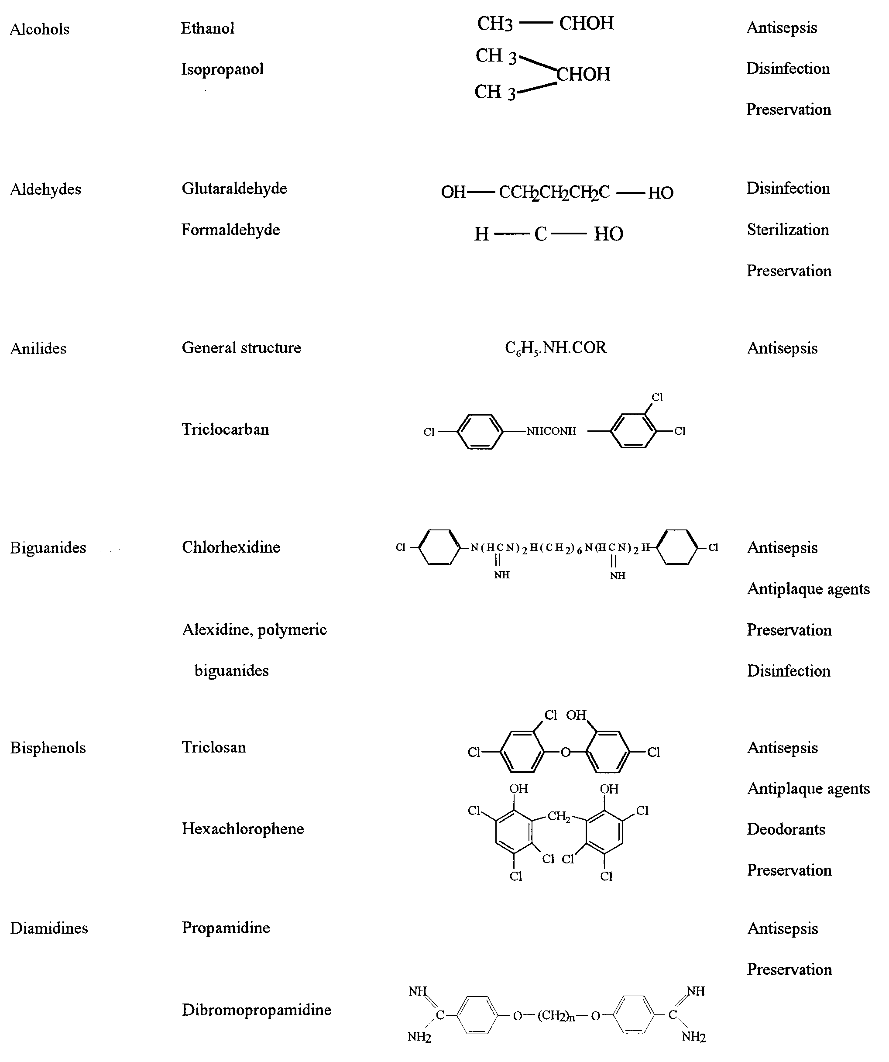
Continued on following page
of how changes in cytology and physiology can modify re- Some of these procedures can also be modified for studysponses to antiseptics and disinfectants. Khunkitti et al. (251– ing effects on viruses and phages (e.g., uptake to whole cells 255) have explored this aspect by using indices of viability, and viral or phage components, effects on nucleic acids and leakage, uptake, and electron microscopy as experimental tools. proteins, and electron microscopy) (401). Viral targets are
TABLE 1—Continued

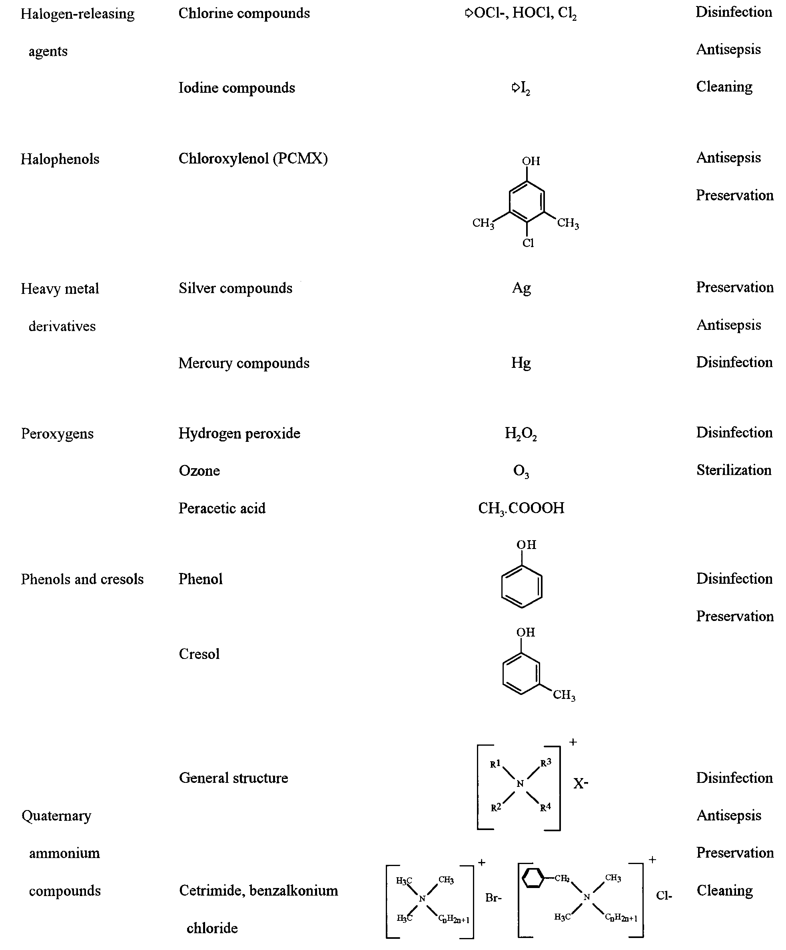
predominantly the viral envelope (if present), derived from the host cell cytoplasmic or nuclear membrane; the capsid, which is responsible for the shape of virus particles and for the protection of viral nucleic acid; and the viral genome. Release of an intact viral nucleic acid into the environment
CHAPTER THREE
RESEARCH METHODOLOGY
3.1 Disinfectants
Chlorine dioxide (Aseptrol®) tablets manufactured by engelhard Aseptrol technology, USA and supplied by Waylor Trading and Logistics cc, South Africa were used in the study. A 48ppm solution of ClO2 was prepared by dissolving one 1.5g tablet of Aseptrol® in 2.5 litres of tap water according to the manufacturer’s instructions. The mixture was allowed to stand for 20 minutes. A further two- fold dilution of the disinfectant was prepared in tap water to give a final concentration of 24ppm solution.
Sodium dichloroisocyanurate (PreSept®, Johnson and Johnson, South Africa) solution was prepared by dissolving seven 2.5g tablets in one litre of tap water, according to the manufacturer’s instruction. This concentration is generally used for blood spillage and gave a final solution of 10 000ppm available chlorine. Both disinfectant solutions were prepared shortly before each experiment.
3.2 Test organisms and inocula
The antimicrobial properties of both disinfectants were tested against Staphylococcus aureus ATCC 29213, Pseudomonas aeruginosa ATCC 27853, Streptococcus mutans nCTC 1044, Candida albicans ATCC 90028, Bacillus subtilis (ATCC 6633) spores, Mycobacterium tuberculosis (ATCC 25177), Mycobacterium avium subsp. avium (ATCC 25291) and Hepatitis B virus (HBV). Stock cultures of S. aureus, P. aeruginosa, S. mutans, C. albicans and B. subtilis were stored in semisolid agar and subcultures were prepared as required. M. tuberculosis and M. avium subsp. avium were stored at -70oC in aliquots. Hepatitis B virus was obtained from the immunology laboratory, national Health Laboratory Services, Johannesburg, South Africa.
The test organisms were cultured on the selective media to obtain a primary culture for preparation of inoculum suspensions. S. aureus and P. aeruginosa were grown on Tryptone Soy agar and incubated at 37oC for 24 hours and S. mutans on Blood agar and incubated at 37oC for 48 hours under carbon dioxide. C. albicans was grown on Sabouraud Dextrose agar and incubated at 37oC for 48 hours. The resultant growth was harvested using a sterile wire loop, which was then suspended in 20ml sterile distilled water and the optical density was adjusted to 0.2 McFarland standards. M. tuberculosis and M. avium subsp. avium were grown in BACTeC MGIT 960 (7ml of modified Middlebrook 7H9 Broth base with supplements) incubated at 37oC until it became positive. The number of organisms in the inoculum was determined for each experiment using serial dilutions.
B. subtilis was plated on Tryptone Soy agar which contained 2mg/l MnSO4.4H2O to enhance sporulation and was incubated at 37oC for 7 days.8 The Schaefer and Fulton’s method for staining spores was used to confirm >90% spore production.9 The sporulating culture was suspended in 20mL of sterile distilled water and placed in a water-bath at 70oC for 20 minutes in order to kill the vegetative cells. The optical density of the resultant spore suspension was adjusted to 0.2 McFarland standards (approximately 106 test organisms per ml) and used as the inoculum.
3.3 Test procedures for percentage kill
S. aureus, P. aeruginosa, S. mutans, C. albicans and B. subtilis
Standard quantitative suspension tests or exposure tests were performed.10 Two millilitres of 48 and 24ppm noncorrosive chlorine dioxide and 10000 ppm sodium dichloroisocyanurate solutions were inoculated with 20μl of inoculum, containing approximately 106 test organism per milliliter, and with 10μl of skim milk, used to simulate organic material. After inoculation, 20μl of the inoculated test compound was removed every 30 seconds for 5 minutes, neutralised with a universal neutraliser (quarter strength Ringer’s solution, 0.5% Tween 80 and 0.5% sodium thiosulphate), diluted and spread on an appropriate medium to determine the number of surviving microorganisms. The culture plates were incubated at 37oC for 24 or 48 hours depending on the type of organisms. The colony count for each plate was determined and log reduction was calculated using the inoculum count. The time taken to kill the challenged organisms was recorded against the log reduction. each test was repeated five times.
M. tuberculosis and M. avium subsp. avium The quantitative suspension test described by Hernández et al. was modified and used in this study.11 Cultures were grown on Mycobacteria Growth Indicator Tube 960 medium at 37oC until it became positive. A viable bacterial count was obtained using a serial dilution technique. 20µl of this prepared suspension and 10μl of skim milk was added to 2ml of disinfectant. After inoculation, 20μl of inoculated test compound was removed every 30 seconds for five minutes, neutralised with a universal neutraliser, and spread on Middlebrook agar plate and incubated at 37oC for four to six weeks. The colony count for each plate was determined and the log reduction was calculated for each contact time period. each experiment was repeated five times.
3.4 Hepatitis b virus
Viral particles (1.0 x 105 IU/ml) were obtained from the immunology laboratory of the national Health Laboratory Services, Johannesburg and used as an inoculum. Two millilitre of the test disinfectant solutions were inoculated with 20μl of inoculum and 20μl of disinfectant was removed every 30 seconds for five minutes, neutralised and transferred into 2ml HBV-negative human eDTA-plasma. Skim milk was not added because human plasma contains organic material. The samples were processed on a COBAS® AmpliPrep/COBAS® Taqman® system (Roche Molecular Systems, Inc, Branchburg, nJ) using the Roche COBOS TaqMan HBV Test for quantitation of hepatitis B virus. COBAS AmpliPrep-COBAS Taqman HBV Test is an in vitro real-time PCR amplification and detection test used for the quantitation of Hepatitis B virus (HBV) DnA in human plasma.12 This test is FDA approved and can detect a HBV DnA range from 12 to 110 000 000 IU/ml. In each test the intact HBV was determined and the number of degraded HBV DnA was calculated. A quantitation standard was run for each sample to compensate for inhibition and to control the preparation and amplification processes.
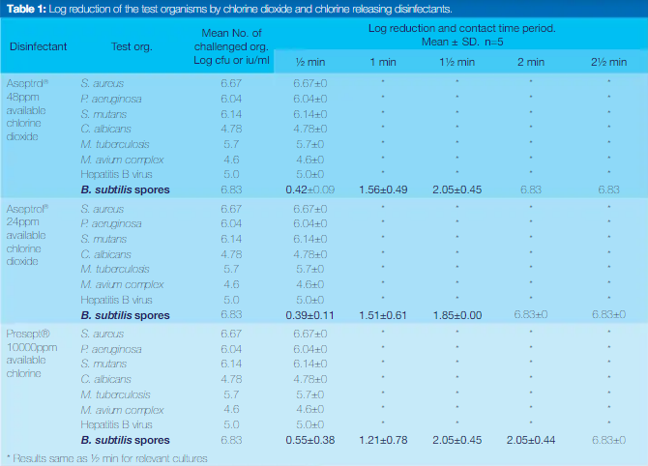
3.5 Shelf-life test
Chlorine dioxide and sodium dichloroisocyanurate solutions were prepared and stored in screw cap bottles. Approxi-mately 10 6 cfu/ml of S. aureus, P. aeruginosa, S. mutans, C. albicans, M. tuberculosis and M. avium subsp. avium wereexposed to disinfectant for 30 and 60 seconds to determinethe survival of these organisms. This procedure was repeatedevery five days for two weeks and thereafter every day for 37days, using the same disinfectant solutions.

CHAPTER FOUR
RESULTS AND DISCUSSION
Seconds of exposure (Table 1) and B. subtilis spores in two to 2.5 minutes. The shelf-life test showed that chlorine dioxide killed all the test microorganisms within 30 seconds for up to 27 days whereas sodium dichloroisocyanurate was still effective after 37 days (Table 2).

DISCUSSION
The efficacies of a chlorine dioxide and a chlorine generating disinfectant were tested against common microorganisms including HBV and mycobacterium that exist in the dental settings. Both the disinfectants proved to be effective on all the vegetative form of test organisms and HBV within 30 seconds and B. subtilis spores after 2.5 minutes which suggests that both these compounds can be considered intermediate to high-level disinfectants which can be used in the dental setting
Table 2: Antimicrobial shelf-life of chlorine dioxide and chlorine releasing disinfectants.
Organisms Disinfectant | Effectiveness (days)
Organisms Disinfectant | Time taken to kill
Organisms Disinfectant | 30 seconds 60 seconds
Aseptrol 27 27
S. aureus
Presept >37 >37
Aseptrol 35 >37
P. aeruginosa
Presept >37 >37
Aseptrol 35 >37
S. mutans
Presept >37 >37
Aseptrol 30 >37
C. albicans
Presept >37 >37
Aseptrol >28 >28
M. tuberculosis
Presept >28 >28
Aseptrol >28 >28
M. avium complex
Presept >28 >28

Although chlorinated disinfectants are known to have a low sporicidal activity, this study showed good sporicidal property. Similar results were found by Coates¹³ who suggested the use of 140 ppm chlorine dioxide in the semi-critical conditions such as endoscope decontamination. Although isolates of M. avium (environmental contaminants) are known to be resistant
to chlorine dioxide, in our study the solution effectively killed M. avium within 30 seconds.
Results obtained by Hernández
368 ReSeARCH
>
et al.(2016) also showed that chlorine dioxide wipes at 200 ppm can kill M. avium within 30 seconds. However, our effective test concentrations were much lower concentration (24 and 48ppm). The present study also established an in vitro antiHBV activity of chlorine dioxide. Glutaraldehyde is known to have similar efficacy against a broad spectrum of organisms but the use of chlorine dioxide has been suggested over glutaraldehyde due to the chemical health hazards posed by the latter such as skin and mucosal sensitivity.
Although chlorinated compounds are generally known to have antimicrobial activity against a wide range of organisms,18-19 they are considered an intermediate level disinfectant because they have low sporicidal activity, are relatively unstable and their activity is dependent on pH. Demandrelease chlorine compounds, such as the chlorine dioxide tested in this study, were developed because chorine is then retained longer, exerting a more prolonged bactericidal effect and the compound is stable. Chlorine dioxide is also more rapidly effective against microorganisms than is chlorine. In this study both disinfectants were shown to exhibit good sporicidal properties and could therefore be used as for intermediate to high level disinfection of semi-critical and non-critical instruments such as dental mouth mirrors, amalgam condenser, reusable impression trays, dental handpieces, radiographic head cone and radiographic films and as a sterilant for semi-critical heat sensitive instruments. Chlorine dioxide has an additional advantage because it is non-corrosive as claimed by the manufacturer and effective disinfection is achieved at low concentrations. Products containing chlorine dioxide concentrations of 150 to 1100ppm have shown antimicrobial and sporicidal activity. However our results showed that even at 24ppm chlorine dioxide exerts an antimicrobial effect including activity against spores, HBV and mycobacteria.
In the dental surgery chlorine dioxide can be used as a pre-soaking solution for dirty instruments and for the decontamination of radiographic films before processing. Quantitative carrier tests were not performed on these compounds because similar tests were performed by Rweyendela et al. (2017) who tested the efficacy on contaminated impression material blocks and found similar results. However, they did not test the efficacy of chlorine dioxide on HBV and Mycobacteria.
Housekeeping surfaces such as hospital and surgery floors, bedside units, dental chairs and light handles are often contaminated and generally require ePA registered hospital disinfectant/detergent depending on the nature of the surface and the type and degree of contamination. Sodium dichloroisocyanurate has been recommended for this type of surface25 at 1000 ppm. Our results show that even at 24ppm chlorine dioxide will eliminate most of the contaminants including mycobacteria and HBV within 30 seconds which suggests that lower concentrations could be used for housekeeping surfaces. Furthermore, in our study, organic material (skim milk) did not compromise the efficacy of disinfectants which suggests that body fluids will not interfere with the disinfection process. However, the pre-cleaning of heavily contaminated instruments is advantageous as suggested by Isomoto et al.(2014)
Although the manufacturers of chlorinated compounds recommend the daily preparation of solutions, our results showed that both disinfectant solutions can be effective for up to 27 days. Although the recommended concentration of chlorine dioxide is 48ppm, our results showed that 24ppm was just as effective. These results have financial as well as time implications because the daily preparation of disinfectant solution can be avoided. Similar results were found by Rutala et al. who showed that brown screw cap bottles were ideal for the storage of chlorinated disinfectants.

CHAPTER FIVE
5.1 CONCLUSIONS
In conclusion this study has shown that a non-corrosive slow release chlorine dioxide and chlorine releasing sodium dichloroisocyanurate disinfectants are microbiocidal after 30 seconds exposure and sporicidal after two to three minutes in the presence of organic material. Both the disinfectant solutions were effective for 27 to 37 days if stored in screw cap bottles. They have the potential to be used in the dental setting as a surface disinfectant and a sterilant for semicritical heat sensitive instruments. Chlorine dioxide has an additional advantage because it is non-corrosive and the effective concentration is much lower than that required for sodium dichloroisocyanurate.
clinical significance
Chlorine dioxide has a broad-spectrum antimicrobial property and therefore it can be used in the dental settings for surfaces and heat sensitive instruments as a sterilant.

REFERENCES
Awodele O, Emeka PM, Agbamuche HC,Akintowa A. The antimicrobial activities of somecommonly used disinfectants on Bacillus subtilis,Pseudomonas aeruginosa and Candida albicans.African J. of Biotechnology 2007; 6(8):987-990.
Bloomfield S F. Chlorine and iodine formulations.In: Ascenzi J M, editor. Handbook of disinfectantsand antiseptics. New York, N. Y: Marcel Dekker,Inc., 1996; 33-158
Chioma C. Okore, Ogechukwu N. Mbanefo,Bright C. Onyekwere, Simon C. Onyewenjo,Agaptus U. Ozurumba, Chinyere A.M. Abba-Father. Antimicrobial Efficacy of Selected Disinfectants, American Journal of Biology andLife Sciences, 2014, 2(2): 53-57.
Coogan MM, Patel M, Mladenova D. efficacy of three surface disinfectants for dental radiographic films and gloves. J Dent 2006;32:385-9.
Drake D, Villhauer AL. An in vitro comparative study determining bactericidal activity of stabilizing chlorine dioxide and other oral rinses. J Clin Dent 2011;22:1-5.
Dychdala, G. R. (2001). Chlorine and chlorine compounds. In Disinfection, Sterilization and Preservation, 5th edn (Block, S. S., Ed.), pp. 135–58. Lippincott Williams & Wilkins, Philadelphia, PA, USA.
Gottardi, W. & Karl, A. (1990). Chlorine covers on skin surfaces. I. Determination of the cover strength by the DPDcuvette-method. Zentralblatt fu¨r Hygiene und Umweltmedizin 190, 511–22.
Gottardi, W. & Karl, A. (1991). Chlorine covers on skin surfaces. II. Parameters influencing the cover strength. Zentralblatt fu¨r Hygiene und Umweltmedizin 191, 478–93.
Gottardi, W. & Karl, A. (1991). The bactericidal effect of chlorine covers: a new model for the remanent skin disinfection. Hygiene und Medizin 16, 51–4.
Gottardi, W. (1988). Residual effects on the skin after application of disinfectants containing active halogen. Hygiene und Medizin 13, 157–61.
Hammond SA, Morgan JR, Russell AD.Comparative susceptibility of Gram; negative bacteria to antiseptics and disinfectants. Journal of Hospital Infection, 1987; 9: 255-264
Hussong, D; W.D Burger, N.K. Enkiri. 1985.Occurrence, growth, and suppression of Salmonellae in composted sewage sludge. Appl Environ Microbiol. 50:887–893.2013.
K. Saha, M. F. Haque, S. Karmaker and M. K.Mohanta Genetics and Molecular BiologyLaboratory, Department of Zoology, University of Rajshahi, Rajshahi 6205,Bangladesh Vols. 3-4: 19-21, 2009
Karabit MS, Juneskans OT, Ludngren P. Studieson the evaluation of preservative efficacy. Thedetermination of antimicrobial characteristics ofphenol. Acta pharm Suec, 1985; 22:281-290
Merritt K, Hitchins VM, Brown SA. Safety and cleaning of medical materials and devices. J Biomed Mater Res 2000;53:131-6.
Miche, L. & Balandreau, J. (2001). Effects of rice seed surface sterilization with hypochlorite on inoculated Burkholderia vietnamiensis. Applied and Environmental Microbiology 67, 3046–52.
Mohammad AR, Giannini PJ, Preshaw PM, Alliger H. Clinical and microbiological efficacy of chlorine dioxide in the management of chronic atrophic candidiasis: an open study. Int Dent J 2004;54:154-8.
Nagl, M. & Gottardi, W. (1996). Enhancement of the bactericidal efficacy of N-chlorotaurine by inflammation samples and selected N–H compounds. Hygiene und Medizin 21, 597–605.
Perez J, Springthorpe VS, Sattar SA. Activity of selected oxidizing microbiocides against the spores of Clostridium difficile: relevance to environmental control. Am J Infect Control 2005;33:320-5.
Rweyendela IH, Patel M, Owen CP. Disinfection of irreversible hydrocolloid impression material with chlorinated compounds. SADJ 2008;64:208-12.
Semmelweis, I. P. (1861). Die A¨ tiologie, der Begriff und die Prophylaxe des Kindbettfiebers, 1st edn. C.A. Hartlebens, Verlag, Wien and Leipzig, Germany.
Shinada K, Ueno M, Konishi C, Takehara S, Yokoyama S, Zaitsu T, et al. effects of a mouthwash with chlorine dioxide on oral malodor and salivary bacteria: a randomized placebo-controlled 7-day trial. Trials 2010;11:14.
Stelmaszynska, T. & Zgliczynski, J. M. (1974). Myeloperoxidase of human neutrophilic granulocytes as chlorinating enzyme. European Journal of Biochemistry 45, 305–12.
Thomas, E. L. (1979). Myeloperoxidase, hydrogen peroxide, chloride antimicrobial system: nitrogen-chlorine derivatives of bacterial components in bactericidal action against Escherichia coli. Infection and Immunity 23, 522–31.
Uludamar A, Gökhan Özyesil A, Ozkan YK. Clinical and microbiological efficacy of three different treatment methods in the management of denture stomatitis. Gerodontology 2011;28:104-10.
Weiss, S. J., Klein, R., Slivka, A. et al. (1982). Chlorination of taurine by human neutrophils. Journal of Clinical Investigation 70, 598–607.

