ANTIHYPERGLYCAEMIC AND ANTIBACTERIAL EVALUATION OF METHANOL TUBER EXTRACT OF *CHLOROPHYTUM ALISMIFOLIUM* BAKER (LILIACEAE)

BY

Abdulhakim ABUBAKAR

B. PHARM (A.B.U.), 2011 P13PHPG8004

A DISSERTATION SUBMITTED TO THE SCHOOL OF POSTGRADUATE STUDIES, AHMADU BELLO UNIVERSITY, ZARIA

IN PARTIAL FULFILLMENT OF THE REQUIREMENTS FOR THE AWARD OF MASTERS OF SCIENCE DEGREE IN PHARMACOLOGY

DEPARTMENT OF PHARMACOLOGY AND THERAPEUTICS, FACULTY OF PHARMACEUTICAL SCIENCES,

AHMADU BELLO UNIVERSITY, ZARIA,NIGERIA

JUNE, 2016

# DECLARATION

I declare that the work in this dissertation entitled “Antihyperglycaemicand antibacterial evaluation ofmethanol tuber extract ofC*hlorophytum alismifolium* Baker (Liliaceae)” has been performed by me in the Department of Pharmacology and Therapeutics. The information derived from the literature has been duly acknowledged in the text and a list of references provided. No part of this dissertation was previously presented for another degree or diploma at this or any other Institution.

Abdulhakim ABUBAKAR

Name of Student Signature Date

# CERTIFICATION

This dissertationentitled ANTIHYPERGLYCAEMIC AND ANTIBACTERIAL EVALUATION OF METHANOL TUBER EXTRACT OF*CHLOROPHYTUMALISMIFOLIUM* BAKER (LILIACEAE) by Abdulhakim

ABUBAKAR meets the regulations governing the award of the degree of Master of Science of the Ahmadu Bello University, and is approved for its contribution to knowledge and literary presentation.

Prof. N.M. Danjuma

Chairman, Supervisory Committee Signature Date

Prof. B.A. Chindo

Member, Supervisory Committee Signature Date

Dr. B.O. Olayinka

Member, Supervisory Committee Signature Date

Prof. N.M. Danjuma

Head of Department Signature Date

Prof. K. Bala

Dean, School of Postgraduate Studies Signature Date

# DEDICATION

This project is dedicated to my Father, Teacher and Mentor- Alhaji (Engr.) M.A Evuti (Dan MadaminEvuti), my Principal- Alhaji M.K.Tsadu both of blessed memory and my beloved family.

# ACKNOWLEDGEMENT

I want to start by reaffirming the existence and supremacy of Allah; the Omnipotent, omnipresent and the Lord of possibilities who gave me the strength and inspiration to study pharmacy.

I am profoundly and sincerely grateful to my supervisors; Prof. N.M.Danjuma, Prof. B.A.Chindo and Dr. B.O.Olayinkafor their time, efforts and contributions to this research work. I lack words to thank you for everything. May Allah reward you all abundantly.

I wish to acknowledge the Head of Department, Prof. N.M.Danjuma and my lecturers; Dr. A. U. Zezi, and Dr. M. G. Magaji for their various contributions in making this work a success. My gratitude also goes to the other members of Academic staffof theDepartment of Pharmacology and Therapeutics. I also appreciate the immense contributions of Pharm. A.B.Nazifiof Department of Pharmacology and Therapeutics, Bayero University, Kano to the success of this work.The contribution of the Technical staff of the Department,particularly MallamAliyu Ahmed of the Animal House, is also appreciated.

I am forever indebted to my parents Alhaji (Engr.) M.A.Evuti of blessed memory- May Allah grant him eternal bliss in JannatulFirdaus. My mother HajiyaRamatuAbubakar and my step mother Late HajiyaHadizaAbubakar who had supported me in the hustles and bustles of life. Thank you for everything.

I am also grateful to my family particularly my beloved wife Halima SalihuEvuti and my Children-Abubakar (Khalifa) and Umaru (Farouk) for their prayers, understanding and moral support. I want to also acknowledge the support and encouragement from my Uncle- AlhajiSalihuEvuti (LafarmanEvuti) and my sibblings especially Hamza and Amina (Mimi).

I want to acknowledge the financial support of Pharm. Usman Musa of Azmu Pharm. Ltd., Arc. AbubakarBukar and Arc.Mukhtar Saiki Akobe. I am also grateful to Pharm. LekeBoluwajoko for his contributions to this research work.

# ABSTRACT

Diabetes mellitus is a metabolic disorder which affects about 346 million people globally. Synthetic antidiabetic agents are expensive and also associated with side effects. In a bid to develop cheaper and safer antidiabetic agents, this study was carried out to determine the effect of the methanol tuber extract of *Chlorophytumalismifolium*.It is used in folkloric medicine for the treatment of diabetes and bacterial infections. The dried powdered tubers was extracted using soxhletextraction method while acute toxicity study was carried out in rats using Lorke‟s method. Antidiabetic study was carried out using streptozotocin-induced hyperglycemia in Wistar rats and *in-vitro* antibacterial susceptibility testing was carried out using Agar-well diffusion method. Adult male Wistar rats weighing 150-200 g were injected with a single dose of 50 mg/kg streptozotocinintraperitoneally and the rats with fasting blood glucose between 200 and 450 mg/dL were considered hyperglycemic and selected for the study. Experimental groups were set up using control rats in group Iand hyperglycemic rats in five groups of six rats each. Group II was the diabetic control that received normal saline (1 ml/kg) while groups III, IV and V received graded doses of the extract (150, 300 and 600 mg/kg) respectively. Group VI received glimepiride (10 mg/kg). All treatments were given daily by oral route which lasted for 28 days. Blood glucose levels and weights were noted on days 0,7, 14,21 and 28 after which therats were sacrificed and blood samples collected for hematology, changes in lipid profile, liver and kidney function tests, relative organ body weights and histopathology (kidneys, liver, pancreas and heart). The LD50 in Wistar rats was determined to be >5,000 mg/kg using the oral route. The extract of *C. alismifolium* at all the doses tested showed blood glucose lowering effect.Statistical significant (p<0.01) blood glucose lowering effectoccurred at a dose of 150 mg/kg on day 21, at a dose of 300 mg/kg on days 21 and 28 (p<0.001 and p< 0.01 respectively) and 600

mg/kg on days 7, 14, 21 and 28 (p<0.05, p< 0.01, p<0.001 and p<0.01respectively) was produced by the extract. The extract didnot alter significantly (p > 0.05) liver enzymes, kidney and hematological parameters and relative organbody weights. The histopathological studies showed no changes in the cardiac cells of the Wistar rats.However, degenerative effects were seen in the liver and kidneys. There was regeneration of islet cells at the doses of 300 and 600 mg/kg of the extract. The antibacterial screening showed that the extract at all the concentrations tested possesses a concentration dependent inhibition of*Escherichia coli.Staphylococcusaureus, Beta-hemolytic streptococcus*and *Pseudomonasaeruginosa*.Phytochemical screening of the methanol tuber extract of *C.alismifolium* revealed the presence of carbohydrates, glycosides, cardiac glycosides, saponins, flavonoids, triterpenes and alkaloids, some of which may be responsible for the observed antihyperglycemic and antibacterialproperties. In conclusion, the methanol tuber extract of *C. alismifolium* has antihyperglycemic activity in streptozotocin-induced hyperglycemic rats and inhibitory effect against *Staphylococcusaureus, Beta-hemolytic streptococcus, Escherichia coli* and *Pseudomonasaeruginosa*.

# CONTENTS

Title Page i

Declaration ii Certification iii Dedication iv Acknowledgement v Abstract vi Contents viii List of Tables xiv List of Figures xv List of Plates xvi Appendix xvii List of Abbreviations xviii **CHAPTER ONE** 1

* 1. INTRODUCTION 1
  2. TraditionalMedicine 1
  3. StatementofResearchProblem 2
  4. Justification 3
  5. TheoreticalFrameWork 4 1.5AimandObjectivesoftheStudy 5
     1. Aim 5
     2. Specific Objectives 5

1.6 Research Hypothesis 6

# CHAPTER TWO 7

* 1. LITERATURE REVIEW 7
  2. DiabetesMellitus 7
     1. Epidemiology and etiology of type 1 diabetes mellitus 8
     2. Pathophysiology of type 1 diabetes mellitus 10
     3. Epidemiology and etiology of type 2 diabetes mellitus---------------------------- 11
     4. Pathophysiology of type 2 diabetes mellitus 11
     5. Diagnosis of diabetes mellitus 12
     6. Glycatedhaemoglobin 13
  3. Diabetes and Hyperlipidemia 14
  4. Diabetic Foot Ulcer and Urinary Tract Infections 14
  5. Characteristics of Bacterial Species Used in the Study 16
     1. Staphylococcusaureus - 16
     2. Beta- streptococci - 17
     3. pseudomonasaeruginosa 18
     4. Escherichia coli 19
  6. Non-pharmacological Management of Diabetes Mellitus 20
  7. Drug Management of Diabetes Mellitus 21
     1. Insulin 21
     2. Sulphonylureas 22
     3. Biguanides 22
     4. Thiazolidinediones 23
     5. Meglitinides 24
     6. Alpha-glucosidase Inhibitors 24
     7. Other Oral Antidiabetic Agents 25
     8. Potential New Antidiabetic Agents 25
  8. Medicinal Plants Used in in the Management of Diabetes Mellitus 25
  9. The Family Liliaceae 26
     1. The genus Chlorophytum 26
     2. The plant *Chlorophytumalismifolium* 27
  10. Models for Experimental Diabetes 30

2.9.1 Alloxan**-**inducedhyperglycemicmodel------------------------------------------------ 30

* + 1. Streptozotocin-induced hyperglycemic model 31
    2. Pancreatectomy in dogs 32
    3. Growth hormone induced diabetes 32
    4. Virus induced diabetes 32
    5. Corticosteroids induced diabetes 33
    6. Ferric nitrilotriaceticinduction of diabetes 33
    7. Genetic models 33

**CHAPTER THREE**  34

* 1. MATERIALS 34
     1. Drugs and chemicals 34
     2. Equipment and other materials 34
     3. Experimental animals 35
  2. METHODS 35
     1. Collection and Extraction of Plant 35
     2. Acute toxicity study 35
     3. Pharmacological studies 36
        1. Streptozotocin-induced hyperglycaemia 36

3.2 3.2 Experimental design 37

3.2.3.3 Streptozotocin –induced hyperglycaemia(28 day studies) 37

* + 1. Antibacterial studies 38
       1. Cultivation and standardizationof test bacteria 38
       2. Antibacterialassay of *Chlorophytumalismifolium* 39
       3. Minimum Inhibitory Concentration*Chlorophytum alismifolium* Extract 39
       4. Minimum Bactericidal Concentration of *Chlorophytum alismifolium* Extract 40
    2. Preliminary Phytochemical Screening of *Chlorophytumalismifolium* 40

3.2 5.1 Test for carbohydrates 40

3.2.5.2 Test for free Anthracene/Anthraquinone Derivatives 41

3.2 5.3 Test for Glycosides 41

3.2 5.4 Test for Cardiac Glycosides 41

* + - 1. Test for Saponins 42
      2. Test for Tannins 42
      3. Test for Flavonoid 42
      4. Test for Alkaloids 43
      5. Test for Unsaturated Steroids and Triterpenes 43
    1. Statistical Analysis 43

**CHAPTER FOUR**  44

* 1. RESULTS 44
  2. PercentageYield of the Extract 44
  3. Result of Acute Toxicity Studyon*C. alismifolium* extract 45
  4. Pharmacological Studies 46
     1. Effect of 28-day daily administration of methanol extract of *C*. *alismifolium*

on blood glucose level of hyperglycemic rats 46

* + 1. Effect of 28- day daily administration of methanol extract of *C. alismifolium*

on lipid profile of hypergly 48

* + 1. Effect of 28-days oral daily administration of methanol extract of *C.alismifolium*

onHaematological parameters of hyperglycemic rats 49

* + 1. Effect of 28-days oral daily administration of the methanol extract of

*C.alismifolium* on liver function of hyperglycemic rats 50

* + 1. Effect of 28-day oraldaily administration of the methanol extract of

*C.alismifolium* on renal indices of hyperglycemic rats 51

* + 1. Effect of 28-days oral daily administration of the methanol extract of

*C.alismifolium*on body weight of hyperglycemic rats 53

* + 1. Effect of 28-days oral dailyadministration of the methanol extract of

*C.alismifolium*on relative organ weights 54

* + 1. Effects of 28-days oral dailyadministration of *C.alismifolium* on histopathology

of the kidney, liver, pancreas and heart ofSTZ-induced hyperglycemic rats 55

* 1. Results of Antibacterial Studies 60
     1. Diameter of Zone of Inhibition 60
     2. Minimum Inhibitory and Bactericidal Concentrations of *C.alismifolium* Extract 62
  2. Phytochemical Constituents 64

# CHAPTER FIVE 65

5.0 DISCUSSIONS 65

# CHAPTER SIX 70

6.0 CONCLUSION, SUMMARYANDRECOMMENDATIONS 70

**REFERENCES**  71

# APPENDIX 91

**LIST OF TABLES**

Table 4.1: Effect of 28- day daily administration of crude methanol extract of

*Chlorophytum alismifolium* on lipid profile of hyperglycemic rats-------------- 48

Table 4.2: Effect of 28-day daily administration of crude methanol extract of *Chlorophytum alismifolium* on hematological parameters of hyperglycemic rats---------------- 49

Table 4.3: Effect of 28- day daily administration of the methanol extract of

*Chlorophytumalismifolium* on liver function of hyperglycemic rats-------------- 50

Table 4.4: Effect of 28- day daily administration of the methanol extract of

*Chlorophytumalismifolium* on renal indices of hyperglycemic rats--------------- 52

Table 4.5: Effect of 28-day daily administration of the methanol extract of *Chlorophytum alismifolium* on body weight of hyperglycemic rats 53

Table 4.6: Effect of 28 day daily administration of the methanol extract of *Chlorophytum alismifolium* on relative organ weights 54

Table 4.7: Diameter of Zone of Inhibition of *Chlorophytum alismifolium* 61

Table 4.8: MIC and MBC of *Chlorophytum alismifolium* 63

Table 4.9: Phytochemical Constituents of *Chlorophytum alismifolium* 64

# LIST OF FIGURES

Figure 4.1: Effect of daily administration of *Chlorophytumalismifolium* extract on Fastingblood glucose of STZ-induced hyperglycemic Rats 47

# LIST OF PLATES

Plate I: *Chlorophytum alismifolium* plant in its natural habitat 28

Plate II: *Chlorophytum alismifolium* tubers after harvest 29

Plate III:Histopathology of the kidney 56 Plate IV: Histopathology of the liver 57 Plate V: Histopathology of thepancreas 58

Plate VI:Histopathology of theheart 59

# APPENDIX

APPENDIX A: The Effect of 28 days Daily Administration of *Chlorophytumalismifolium*

Extract on Fasting Blood Glucose ofHyperglycemic rats----------------- 91

# ABBREVIATIONS

% Percent

< Less than

> Greater than

± Plus or Minus

°C Degree Celsius

A.B.U. Ahmadu Bello University

ADA American Diabetes Association

ALP Alkaline Phosphatase

ALT Alanine Aminotransferase ANOVA Analysis of Variance

AST Aspartate Aminotransferase

CAE *Chlorophytumalismifolium* Extract

DM Diabetes Mellitus

e.g. For example

e.t.c. *Etcetera*

FBG Fasting Blood Glucose

g Gram

GAD Glutamic Acid Decarboxylase

GDM Gestational Diabetes Mellitus H and E Haematoxylin and Eosin HDL High Density Lipoprotein

Hrs Hours

i.e that is

*i.p*. Intraperitoneal

|  |  |
| --- | --- |
| ICCA | Islet Cells Cytoplasmic Antibodies |
| ICSA | Islet Cells Surface Antibodies |
| IDDM | Insulin Dependent Diabetes mellitus |
| IDF | International Diabetes Federation |
| IGT | Impaired Glucose Tolerance |
| K+ | Potassium ion |
| Kg | Kilogram |
| LD50 | Median Lethal Dose |
| LDL | Low Density Lipoprotein |
| mg | Milligram |
| min | Minutes |
| ml | Millilitres |
| NIDDM | Non Insulin Dependent Diabetes Mellitus |
| PPAR | Peroxisome Proliferator-Activated Receptor |
| PPG | Post Prandial Glucose |
| SEM | Standard Error of the Mean |
| STZ | Streptozotocin |
| TB | Total Bilirubin |
| TC | Total Cholesterol |
| TGs | Triglycerides |
| TM | Traditional Medicine |
| WHO | World Health Organization |
| β | Beta |

# CHAPTERONE

* 1. **INTRODUCTION**

# Traditional Medicine

Traditional medicine is defined as the knowledge, skills and practices based on the theories, beliefs and experiences indigenous to different cultures whether explicable or not, used in the maintenance of health and in prevention, diagnosis, improvement or treatment of physical and mental illness (WHO, 2000).In some Asian and African countries,80% of the population depends on traditional medicine for primary health care needs (WHO,2008). This is attributed to the fact that traditional medicine is more affordable and accessible compared to orthodox medicine (Bhushan,2005).Traditional medicine that has been adopted by other population (outside its indigenous culture) is often termed alternative or complementary medicine (WHO,2000). Traditional medicine practice utilizes plants, animals, minerals and other methods (WHO,2008).

Herbal medicine is the use of medicinal plants for the prevention and treatment of diseases and it has become a popular healthcare remedy (Fabio and Luigi, 2007). According to World Health Organization,medicinal plant is defined as „any plant in which one or more of its part contains substance that can be used for therapeutic purposes or as precursors for the synthesis of useful drugs‟ (WHO, 2003).

Traditional medicines have provided us with lead compounds some of which are very useful synthetic class of modern drugs (Gregory*etal.*,2009) that were originally discovered through herbal cures and folk knowledge (Gilani*etal.*,2011). Many known therapeutic agents used in orthodox medicine were derived from medicinal plants, some of these include digoxin from *Digitalis purpurea*(cardiac activity),quinine (an

antimalarial) from cinchona bark, vincristine and vinblastine alkaloids (antileukemic agents) from *Catharantusroseus* (Hardman,1991).Studies have shown that increasing daily intake of green leafy vegetables (such as *Moringa oleifera, Vernonia amygdalina* e.t.c.)could significantly reduce the risk of type 2 diabetes (Carter *etal.*,2010).

# Statement of Research Problem

The World Health Organization (WHO) estimated the number of Diabetic patients to be 346 million worldwide and this number is likely tobe more than double by the year 2030 (WHO,2012). Almost 80% of the Diabetic deaths occur in low and middle income countries (WHO,2012). Diabetes mellitus is ranked seventh among the leading causes of death globally and it is considered third when its complications are taken into account (Trivedi*etal.*,2004). In 2012 diabetes was the direct cause of 1.5 million deaths and hyperglycaemia was the cause of another 2.2 million deaths(WHO,2016). Diabetes related mortality is on the increase and every six seconds a person dies from diabetes (Diabetes Atlas,2013). Nigeria has the highest number of people with diabetes in the African region with approximately 1.22 million people affected and 3.85 million people with impaired glucose tolerance (IDF,2011).

Numerous hospital-based studies in Nigeria demonstrated that the prevalence of diabetic limb ulcerations was between 11.7 % and 19.1 % among individuals with diabetes in Nigeria (Ogbera*et al.*,2006; Unachukwu,2007) and diabetic foot ulcer is the second leading cause of diabetes-related deaths in Nigeria, accounting for 24 % of all diabetes related mortalities (Ogbera*etal.*,2005). Diabetic patients are also susceptible to many other infections and of particular interest urinary tract infection such as acute

pyelonephritis which is a more common disease in patients with diabetes than in non- diabetic patients (Patterson and Andriou, 1997).

Currently available antidiabetic agents do not provide cure and their usage is accompanied by debilitating adverse reactions. Thus, there is an increasing demand by patients to use natural products which are documented to possess antidiabetic activity (Ivorra*etal.*,1989).Available literature indicates that there are more than 800 plant species with antidiabetic activity (Rajagopal and Sasikala,2008).

To our knowledge, no scientific data on the antidiabetic property of *Chlorophytum alismifolium*is available in literature. This study is designed to explore the folkloric claim that *Chlorophytum alismifolium* possesses antihyperglycaemicand antibacterial activities (Personal Communication,2014).

# Justification

The number of people with DM is growing worldwide and this necessitates immediate action by introducing cost-effective strategies to reverse this trend (WHO, 2013). Diabetes mellitus caused 5.1 million deaths in 2013 taking up about USD 548 billion in health spending which accounts for 11% of total money spent worldwide (Diabetes Atlas, 2013).Insulin and oral antidiabetic agents are not only expensive but are also known to produce serious side effects, therefore the search for cheaper, safer and effective antidiabetic agents has continued to be an important area of investigation (Klein*et al*., 2007).In addition, traditional medicine is a more affordable and accessible healthcare system available when compared to orthodox medicine (Bhushan,2005). Although insulin is the main therapyfor type 1 diabetes mellitus there are several

drawbacks like insulin resistance (Piedrola*etal.*,1999), anorexia nervosa, brain atrophy and fatty liver (Yaryura*etal.*, 2001) following chronic treatment. Biguanides and sulphonylureas are valuable in the management of type 2 diabetes mellitus but their use is limited by side effects such as lactic acidosis, gastrointestinal tract disturbances and hypoglycaemia (Satoskar *et al*., 1999). Moreover, these therapies only partially compensate for metabolic derangements seen in diabetics and do not necessarily cure diabetes (Expert Commmittee on Classification and Diagnosis of Diabetes Mellitus, 1997).

There has been a focus on the search for new chemically active compounds from medicinal plants that will be suitable for use in diabetes mellitus (Mariangeli*etal.*,2006). The genus chlorophytum (Liliaceae), owing to the presence of pharmacologically important saponins has attracted the interest of the scientific community (Nutan,2005).This project seeks to investigate the antihyperglycaemic and antibacterial activities of the methanol tuber extract of *Chlorophytum alismifolium* plant to justify (or otherwise) the folkloric claim of its uses. This therefore forms the basis for evaluating its purported antihyperglycaemic and antibacterial properties.

# Theoretical Framework

The focus on plant research has increased all over the world and more than 13,000 plants have been studied between 1996 and 2000 (Dahanukar et *al.*,2000). Over the years, several animal models have been developed for studying diabetes mellitus. These models include chemical, surgical (pancreatectomy) and genetic manipulations in several animal species. The diabetogenic agents mostly used include Alloxan monohydrate and streptozotocin (with or without nicotinamide).

The selection of these models for investigation of the antidiabetic properties of a new compound may be a difficult task (Etuk,2010). Streptozotocin which is selected for this study is a glucosamine-nitrosourea compound derived from *Streptomyces achromogenes* that is used clinically as a chemotherapeutic agent in the treatment of pancreatic β cell carcinoma. It damages the β cells and result in hypoinsulinemia and hyperglycemia (Lenzen, 2008). Streptozotocin is a more suitable model for non-insulin dependent diabetes mellitus or type II diabetes (Pellegrino, 1998) but there are some disadvantages to its use in chronic experiments, especially by the development of functioning insulinoma (Steiner *etal.*, 1970) and high incidence of kidney and liver tumors which are attributed to its oncogenic action (Antia*et al.*, 2005).

# Aim and Objectives of the study

* + 1. **Aim**

The aim of this study isto validate the folkloric claim for the use of *Chlorophytum alismifolium* in the treatment of diabetes and some of its complications.

# Specific objectives

1. To extract and conduct phytochemical analysis on the methanol extract of *C. alismifolium*tuber so as to identify the various chemical constituents present.
2. To carry out acute toxicity studies on the methanol extract of *C. alismifolium*tuber*.*
3. To investigate the effect of methanol extract of *C. alismifolium*tuber in streptozotocin-induced hyperglycaemic rats.
4. To investigate the effect of methanol extract of *C. alismifolium* on lipid profile in streptozotocin-induced hyperglycaemic rats.
5. To carry out the *invitro* antibacterial studies of the methanol extract of *C. alismifolium*
6. To determine the effect of the methanol extract of *C.alismifolium*tuber on haematological indices (RBC, WBC, PCV, LYM and PLT), renal indices (EL, U and CR) and liver enzymes (AST, ALT, ALP and TB) in hyperglycaemic rats.
7. To carry out histopathological studies on the pancreas, liver, kidney and heart ofhyperglycaemic rats.

# Research Hypothesis

The methanol crude extract of *C. alismifolium* does not possess antidiabetic activity.

# CHAPTER TWO

* 1. **LITERATURE REVIEW**

# Diabetes Mellitus

Diabetes mellitus (DM) is a chronic progressive metabolic disorder characterized by hyperglycemia mainly due to absolute (Type 1) or relative (Type 2) deficiency of insulin (WHO, 1999). It is mainly characterized by disruptions in carbohydrates, proteins and fats metabolism caused by complete or relative insufficiency of insulin secretion and /or insulin action (ADA,2007).

DM was believed to be a disease occurring mainly in the developed countries, but findings revealedarise in number of new cases with earlier onset and complicationsin developing countries (Kinra*etal.*, 2010).According to American Diabetes Association (ADA, 2013) DM is associated with complications such as retinopathy, nephropathy, peripheral neuropathy, ketoacidosis, non-ketotic coma, cardiovascular diseases and genitourinary complications. Poor healing of wounds, particularly of the feet, can lead to gangrene which may require amputation. Adequate treatment of DM, as well as increased emphasis on blood pressure control and lifestyle modifications may improve the aforementioned complications (ADA,2001). Symptoms of DM include polyuria, polydipsia, weight loss sometimes with polyphagia and blurred vision (ADA,2013). The first widely accepted classification of DM was published by WHO in 1980 and, in modified form, in 1985. The 1980 and 1985 classifications of DM and allied categories of glucose intolerance included clinical classes and two statistical risk classes. The 1980 Expert Committee proposed two major classes of diabetes mellitus and named them;

* 1. Type 1 diabetes, also called insulin dependent diabetes mellitus (IDDM) which is caused by lack of insulin secretion by beta cells of the pancreas.
  2. Type 2 diabetes, also called non-insulin dependent diabetes mellitus (NIDDM) which is caused by decreased sensitivity of target tissues to insulin. The basic effect of lack of insulin or insulin resistance on glucose metabolism is to prevent the efficient uptake and utilization of glucose by most cells of the body except those of the brain.In both the 1980 and 1985 reports, other classes of diabetes were included: “Other Types” and “Impaired Glucose Tolerance” (IGT) as well as “Gestational Diabetes Mellitus” (GDM) (WHO, 1999). The 1985 classification was widely accepted and is used internationally. It represented a compromise between clinical and etiological classification and allowed classification of individual subjects and patients in a clinically useful manner even when the specific cause or etiology was unknown. The recommended classification includes both staging of diabetes mellitus based on clinical descriptive criteria and a complimentary etiological classification (Expert Committee, 1997). The classification encompasses both clinical stages and etiological types of diabetes mellitus and other categories of hyperglycemia, as suggested by Kuzuya and Matsuda, (1997). The clinical staging reflects that diabetes,regardless of its etiology, progresses through several clinical stages during its natural history (WHO,1999). Moreover, individual subjects may move from stage to stage in either direction. Persons who have diabetes mellitus can be categorized by stage according to the clinical characteristics, even in the absence of information concerning the underlying etiology (WHO,1999).

# Epidemiology and Etiology of Type 1 diabetes (IDDM)

DM is one of the most common endocrine disorders affecting almost 6% of the world‟s population (Diabetes Fact sheet,2011). The continent of Africa has about 13.6 million people with diabetes (IDF, 2011). Type I DM represent about 10% of all cases of

diabetes (ADA,2001). Although, Type I DM affects all age groups, the majority of individuals are diagnosed either at around age of 4-5 years or in their teens and early adulthood (Blood*etal.*,1975). Type I DM is as a result of autoimmune reaction to proteins of the islet cells of the pancreas (Holt,2004). The incidence of type 1 diabetes ranged from 1.9 to 7.0/100,000/yr in Africa, 0.13 to 10/100,000/yr in Asia, 3.4 to 36/100,000/yr in Europe, 2.62 to 2018./100,000/yr in Middle East, 7.61 to 25.7/100,000/yr in North America, 1.27 to 18/100,000/yr in South America and approximately 4.4/100,000/yr in Australia (WHO,2006).

There is a strong association between IDDM and other endocrine autoimmune diseases. The three types of autoantibodies known are:

1. Islet cell cytoplasmic antibodies (ICCA): The primary antibodies found in 90% of type 1 diabetics are against islets cell cytoplasmic proteins.The presence of ICCA is a highly accurate predictor of future development of IDDM.
2. Islet cell surface antibodies (ICSA): They are autoantibodies directed against islet cells surface antigens and have also been found in as many as 80% of type 1 diabetics.
3. Specific antigenic targets of islet cells antibodies to glutamic acid decarboxylase (GAD) have been identified in over 80% of patients newly diagnosed with IDDM
4. The presence of anti-GAD antibodies is a strong predictor of the future development of IDDM in high risk populations. Anti-insulin antibodies have been identified in IDDM patients and even detectable in 40% of young children with IDDM (Raju and Raju, 2010).

# Pathophysiology of Type I Diabetes Mellitus (IDDM)

The autoimmune destruction of pancreatic β-cells leads to a deficiency of insulin secretion which results in the metabolic derangements associated with IDDM. In addition to the loss of insulin secretion, the function of pancreatic α-cells is also abnormal and there is an excessive secretion of glucagon in IDDM patients. Normally, hyperglycemia leads to reduced glucagon secretions; however, in patients with IDDM, glucagon secretion is not suppressed by hyperglycemia (Raju and Raju,2010). The onset of IDDM is usually abrupt. It generally occurs before the age of 30 years but may be diagnosed at any age. Most type 1 diabetics are of normal weight or are thin in stature.The resultant inappropriately elevated levels of glucagon exacerbate the metabolic defects due to insulin deficiency. The most pronounced example of this metabolic disruption is that patients with IDDM rapidly develop diabetic ketoacidosis (DKA) in the absence of insulin. There are multiple biochemical mechanisms that account for impairment of tissues response to insulin. Deficiency in insulin leads to uncontrolled lipolysis and elevated levels of free fatty acids in the plasma which suppresses glucose metabolism in the peripheral tissue such as skeletal muscle (Raju and Raju,2010). Glycerol is converted to glucose for cellular use. Fatty acids are converted to ketones, resulting in increased ketone levels in body fluids which are excreted in the urine with large volume of water. This results in dehydration from excessive urination and electrolyte loss and alterations in bicarbonate buffer system. Untreated DKA can result in coma or death (Sirek,1986).

# Epidemiology and Etiology of Type 2 Diabetes Mellitus (NIDDM)

Type 2 diabetes is the predominant form of diabetes and account for at least 90% of all cases of diabetes mellitus (Gonzalez*etal.*,2009). The prevalence of type 2 diabetes ranged from 0.3 to 17.9 % in Africa, 1.2 to 14.6 %in Asia, 0.7 to 11.6 % in Europe, 4.6 to 40 % in Middle East, 6.69 to 28.2 % in North America and 2.01 to 17.4 % in South America (WHO,2006). The rise in prevalence is predicted to be much greater in developing than in developed countries (Shaw,2010). The increase in NIDDM islinked to changes towards a western lifestyle and arises in the prevalence of obesity (Chan*etal.*,2009; Colagiuri, 2010). The incidence of NIDDM increases with age, with most cases being diagnosed after the age of 40 (Neil*etal.*,1987). Type II diabetes is a heterogeneous disorder caused by a combination of genetic factors related to impaired insulin secretion, insulin resistance and environmental factors such as obesity, over eating, lack of exercise, stress and aging (Kaku,2010). It is typically a multifactorial disease involving multiple genes and environmental factors to varying extents (Holt, 2004). Type II diabetes is the common form of idiopathic diabetes and it is not an auto immune disorder.

# Pathophysiology of Type 2 Diabetes (NIDDM)

The underlying pathophysiologic defect in type 2 DM does not involve autoimmune beta- cell destruction. Rather, type 2 DM is characterized by the following three disorders: (1) Peripheral resistance to insulin, especially in the muscles; (2) Altered pancreatic insulin secretion; and (3) Increased production of glucose by the liver. Increased tissue resistance to insulin generally occurs first and is eventually followed by impaired insulin secretion (ADA,2001). Obesity contributes greatly to insulin resistance, even in the absence of diabetes. In fact, weight loss is a cornerstone of therapy for obese

type 2 diabetic patients. Insulin resistance generally decreases with weight loss. Obesity also may explain the dramatic increase in the incidence of type 2 diabetes among young individuals in the United States in the past 10 to 20 years (Cook*etal.*,2008).

The individuals with impaired glucose tolerance have hyperglycemia despite having highest levels of plasma insulin indicating that they are resistant to the action of insulin (Holt,2004). Insulin resistance is the primary cause of NIDDM and evidence has demonstrated arole for a number of the nuclear hormone receptor super family of proteins in the etiology of Type II diabetes.There is a class of antidiabetic agents used to increase the sensitivity of the body to insulin are the thiazolidinediones. These compounds bind to alter the function of the peroxisome proliferator-activated receptors g (PPARg)which is a transcription factor (Raju and Raju,2010).

# Diagnosis of Diabetes Mellitus

The oral glucose tolerance test previously recommended by the National Diabetes Data Group has been replaced with the recommendation that the diagnosis of DM be based on two fasting plasma glucose levels of 126mg/dl (7.0 mmol per L) or higher.Other options for diagnosis include two-hour post prandial plasma glucose (2 h) readings of 200mg/dl (11.1 mmol) or higher after glucose load of 75g essentially, the criterion recommended by WHO; or two casual glucose readings of 200mg/dl (11.1 mmol per L). Measurement of the fasting plasma glucose level is the preferred diagnostic test, but any combination of two abnormal testresults can be used. Fasting plasma glucose was selected as the primary diagnostic test because it predicts adverse outcomes (e.g retinopathy) as well as the 2hour post prandial glucose (2 h PPG) test but it is much more reproducible than the oral glucose tolerance test or the 2h PPG test and easier to perform in a clinical setting

(WHO,1999).A normal fasting plasma glucose level is less than 110 mg/dl (6.1 mmol per L), however, blood glucose levels above the normal level but below the criterion established for diabetes mellitus indicate impaired glucose homeostasis. Persons with fasting plasma glucose levels ranging from 110-126mg per L (6.10-7.0 mmol per L) are said to have impaired glucose tolerance. Both impaired fasting glucose level and impaired glucose tolerance are associated with an increased risk of developing type II diabetes mellitus. Lifestyle changes such as weight loss and exercise are warranted in these patients (WHO,1999).

# Glycated Haemoglobin

Measurement of glycated haemoglobin has commonly been used to monitor the glycemic control of persons already diagnosed with DM. Measurements of this haemoglobin also called glycosylated haemoglobin, glycohaemoglobin, haemoglobin A1C or haemoglobin A. There is currently no agreement on standardization, so a variety of measurement methods and normal ranges are being used. Some experts argue that glycated haemoglobin test could be used for the diagnosis of DM. Glycated haemoglobin levels are as highly correlated to adverse clinical outcomes (e.g retinopathy) as are fasting plasma glucose or post prandial plasma glucose levels and are as reproducible as fasting plasma glucose levels.

The expert committee however did not include glycated haemoglobin measurement in the recommendations ofInternational Standards for the diagnosis of DM. They noted lack of standardization and normal ranges among the various glycated haemoglobin tests, making it difficult to dictate a standard cut-off point. There is also an overlap in the

levels glycated haemoglobin in patients with DM and those without it (Expert committee, 1997).

# Diabetes and Hyperlipidemia

The degree of hypercholesterolemia is directly proportional to the severity of diabetes. The increase in blood glucose level is accompanied by arise in total cholesterol (TC), triglycerides (TGs) and a fall in high density lipoprotein (HDL) (Chen*etal.*, 2011). In diabetes mellitus, blood glucose is not utilized by tissues, the fatty acids from adipose tissues and excess fatty acids are accumulated in the liver and converted to TGs and cholesterol (Kim*et al*., 2008). Rising evidence also indicates that the activity of HMG- COA reductase is increased in diabetic rats (Tobias and Stellan, 2009) and deficiency of insulin is associated with increased HMG-COA reductase activity (Catanzaro and Suen, 1996). Elevated blood glucose level and hypercholesterolemia have been implicated in diabetic retinopathy (Diabetic Atlas, 2013). Patients with NIDDM have increased lipid abnormalities that contribute to higher rates of cardiovascular disease. Treatment of diabetic hyperlipidemia includes glycemic control, exercise, lipid lowering diet and drugs (Margaritis*etal.*, 2012).

# Diabetic Foot Ulcer and Urinary Tract Infection

Many complications are associated with DM and some arise chiefly from the disruption of the vascular system which can result in inadequate circulation to the peripheral body and consequently, the foot is placed at a higher risk of ulceration and infection (Alvin,2005). Several infectious diseases are strongly associated with diabetes and others are more complicated or severe in the presence of diabetes (Douglas, 2000). The most common cause of hospitalization for diabetic patients is foot infections and the

susceptibility of the diabetic host to the infection is multifactorial (Rich and Lee, 2005). Diabetic foot ulcer is defined as non-traumatic lesions of the skin on the foot of a person who has DM(Bedilu*etal.*,2014). The diabetic foot is characterized by the triad of neuropathy, ischaemia and infection (Pendsey,2010). Diabetic foot infections are associated with high morbidity and lower extremity amputation (Mazen, 2008) and they are the second leading cause of diabetes-related deaths in Nigeria (Ogbera*etal.*,2005).

Although limb-threatening infections in diabetic individuals are frequently polymicrobial, *Staphylococcus aureus* is the major pathogen, others are beta-hemolytic *streptococci*(Mazen,2008) and *pseudomonas aeruginosa* (Martinez*etal.*, 2004). Methicilin resistant strains of *S.aureus* have become increasingly prevalent among both nosocomial and community acquired infections including diabetic foot (Tentolouris*etal.*, 2006).

Diabetic patients are also susceptible to many other infections and of particular interest is urinary tract infection such as acute pyelonephritis which is a more common disease in patients with diabetes than in non-diabetic patients (Patterson and Andriou, 1997). *Escherishia coli* is the most common organism in both groups (Stamm and Hooton, 1993).Patients with diabetes are more likely to have bacteuria, and recurrent urinary tract infections are more common in these patients (Forland and Thomas, 1985).

# Characteristics of the Bacterial Species Used in the Study

The bacterial species to be used in the study are two Gram-positive microorganisms (*Staphylococcus aureus* and β-hemolytic *streptococcus)* and two Gram-negative microorganisms (*Pseudomonas aeruginosa* and *Escherichia coli*).

## Staphylococcus aureus

Taxonomically, the genus *Staphylococcus* is in the bacterial family *Staphylococcaceae,* which include three lesser known genera, Gamella, Macrococcus and Salinicoccus. The best-known of its nearby phylogenetic relatives are the members of the genus Bacillus in the family Bacillaceae, which is on the same level as the family Staphylococcaceae (Brooks et *al.*, 2001).

*Staphylococcusaureus* is Gram-positive, cluster-forming coccus, nonmotile, non-spore forming bacteria which forms a fairly large yellow colony on enriched medium and is often hemolytic on blood agar (Ryan and Ray, 2004). Staphylococci are facultative anaerobes that grow by aerobic respiration or by fermentation, which yields principally lactic acid. The bacteria are catalase-positive and oxidase-negative. *S. aureus* can grow at a temperature range of 15 to 45 degree and at sodium chloride concentration as high as 15 percent. Nearly all strains of *S. aureus* produce the enzyme coagulase (Ryan and Ray, 2004). *S. aureus* should always be considered a potential pathogen (Todar, 2011). Each year, some 500,000 patients in American hospitals contract a staphylococcal infection (Bowersox, 1999). *S. aureus* causes a variety of suppurative (pus-forming infections and toxins in human) infections. It was estimated that 20% of the human population are long-term carrier of *S. aureus* (Kluytmans *etal*., 1997).It causes superficial skin lesions such as boils, styes and furuncles; more serious infections such as pneumonia, mastitis, phlebitis, meningitis and urinary tract infections; and deep- seated infections, such as osteomyelitis and endocarditis (Korzeniowski and Sande, 1982; Bayer*et al*., 1998).*S.aureus* is a major cause of hospital acquired (nosocomial) infection of surgical wound and infections associated with indwelling medical devices.

*S. aureus* causes food poisoning by releasing enterotoxins into food, and toxic shock syndrome by release of super antigens into the blood stream (Todar, 2011).

The reasons why *S. aureus* is successful pathogen are a combination of host and bacterial immune-evasive strategies. One of these strategies is the production of carotenoid pigment staphyloxanthin, which is responsible for the characteristic golden colour of *S. aureus* colonies. The golden pigment impairs neutrophil killing and promotes virulence through its antioxidant activity (Clauditz *etal.*, 2006; Liu *etal.*, 2005).

## Beta-haemolyticstreptococci

*Streptococcus* cells are spherical or ovoid, rarely elongated into rods, occurring in pairs of short or long chains. They are non-motile and Gram-positive. Capsules are not regularly formed but may become conspicuous with some species under certain conditions. Growth on artificial media is slight. Agar colonies are very small, and bile insoluble (Sallie, 1973).*Streptococci* are among the most difficult groups of bacteria to classify. One of the earliest classifications divided the organisms into three groups according to their effect on blood agar. They include alpha *Streptococci*, beta *streptococci* and gamma *Streptococci* (Sallie, 1973).

Beta-hemolytic *streptococci* produce soluble hemolysins that can be recognized readily on culture, although individual strains may fail to be recognized (Ernest *etal.*, 1982). Generally, Streptococcus are found to be associated with a variety of pathological conditions including septicemia, peritonitis and various skin and wound infections (Sallie, 1973).

## Pseudomonas aeruginosa

*Pseudomonas aeruginosa* is a member of the Gamma Proteobacteria class of bacteria. It is a Gram-negative, aerobic rod belonging to the bacterial family Pseudomonadaceae (Brooks et *al.*, 2001).*Pseudomonas aeruginosa* is a common bacterium that can cause disease in animals, including humans. Itis known as a hydrocarbon-using microorganism (or HUM bug), causing microbial corrosion (Mahajan-Miklos *et al.*, 1999).Like other members of the genus, *pseudomonas aeruginosa* is a free-living bacterium, commonly found in soil and water (Ryan and Ray, 2004). However, it occurs regularly on the surface of plants and occasionally on the surface of animals. Members of the genus are well known to plant microbiologists because they are one of the few groups of bacteria that are true pathogens of plants.

*Pseudomonas aeruginosa* has been recognized as an emerging opportunistic pathogen of clinical relevance; several different epidemiological studies track its occurrence as a nosocomial pathogen and indicate that antibiotic resistance is increasing in clinical isolates (Balcht and Smith,1994). *Pseudomonas aeruginosa* is an opportunistic pathogen, meaning that it exploits some break in the host defenses to initiate an infection. It causes urinary tract infections, respiratory tract infections, dermatitis, soft tissue infections, bacteremia, bone and joint infections, gastrointestinal infections and a variety of systematic infections, particularly in patients with severe burns and in cancer and AIDS patients who are immunosuppressed (Todar, 2011).

## Escherichia coli

Theodor Escherich first described *Escherichia coli* in 1885, as Bacterium coli commune, which he isolated from the faeces of newborns. It was later renamed *Escherichia coli,* and for many years, the bacterium was simply considered to be commensal organism of the large intestine. It was not until 1935 that the strain of *E. coli* was shown to be the cause of an outbreak of diarrhea among infants (Wakimoto*etal.*, 2004). *Escherichia coli* colonize the gastrointestinal tract of most warm-blooded animals within hours or a few days after birth. The bacterium is ingested in food or water or obtained directly from other individuals handling the infant. The human bowel is usually colonized within 24 hours of birth.

*Escherichia coli* can adhere to the mucus overlying the large intestine. Once established, an *E. coli* strain may persist for months or years. Resident strains shift over a long period (weeks to months), and more rapidly after enteric infection or antimicrobial chemotherapy that perturbs the normal flora. The basis for these shifts and the ecology of *E. coli* in the intestine of humans are poorly understood, despite the vast amount of information on almost every other aspect of the organism‟s existence. The entire DNA base sequence of the *E. coli* genome has been known since 1997 (Thomas*etal.*, 1990). Pathogenic strains of *E. coli* are responsible for three types of infections in humans: urinary tract infections (UTI), neonatal meningitis, and intestinal diseases (gastroenteritis). The disease caused (or not caused) by a particular strain of *E. coli* depend on distribution and expression of an array of virulence determinants, including adhesins, invasins, toxins, and abilities to withstand host defenses (Todar, 2011).

# Non-pharmacological Management of Diabetes Mellitus

A good number of people with type II diabetes are overweight or obese which is a major factor in insulin resistance. Consequently, reduction of excess weight is a primary component in the management of type II diabetes (Tripathi and Srivastava, 2006).Regular exercise improves insulin sensitivity and as a consequence may improve glucose tolerance(ADA, 1990). Today, the beneficial role of exercise should be incorporated systematically in the treatment of patients with diabetes (Sato*etal.*, 2007). Exercise has a significant role in the regulation of blood glucose, improves insulin action, metabolism of protein and fats, prevent complication of diabetes, beneficial on cardiovascular system and increases life expectancy of diabetic patients (Colberg, 2007). Based on literature, if completely sedentary and under active individuals participate in moderate physical activity 30 minutes a day, they will attain at least 30% reduction in risk not only for type II diabetes but also for other chronic diseases such as coronary artery disease, stroke and colon cancer (Lamonte*etal.*, 2005).It is widely accepted that healthy nutrition is the basis for the treatment of type II diabetes. Researchers have suggested that Mediterranean diet is the best for diabetics. It is characterized by olive oil as the main source of fats, consumption of fruits, vegetables, cereals, fish,and legumesin combination with small portion of meat (Willett, 2006).

Furthermore, the western diet has been implicated in the etiology of DM and it is the main risk factor for increased morbidity and mortality (Steyn*etal.*, 2004).Patients with diabetes need to be informed about the benefits of appropriate nutritional habits which is the major key in the regulation of blood glucose (Swift and Boucher, 2006).

# Drug Management of Diabetes Mellitus

Diet is the cornerstone of the management of diabetes, regardless of the severity of the symptoms or the type of diabetes. Exercise also is an important component in managing diabetes particularly in obese individuals with NIDDM. Treatment regimens that have proved effective include a calorie restricted diet in combination with exogenous insulin or oral hypoglycemic drugs. Howeversince diet, exercise and oral hypoglycemic drugs often because of non- compliance by diabetic patients,will not always achieve the clinical objectives of controlling the symptoms of diabetes. Insulin remains the most universally important agent in the therapeutic management of diabetes. The administration of insulin is required for the treatment of type I (IDDM) and in some cases of type II (NIDDM) that are refractory to the management with oral hypoglycemic drugs (ADA, 2001).

# Insulin

Insulin is the hormone secreted by the β cells of the islets of Langerhans and derived its name from the Latin word „Insula‟ which means an island. It was extracted from the pancreas by Banting and Best in 1921 and was isolated in crystalline form by Abel, 1930 (Satoskar*etal.*, 1999). Insulin is a polypeptide with a molecular weight of about 600, consisting of two amino acid chains, A and B linked by two disulphide bridges. The chains contain 21 and 30 amino acids respectively. The disulphide bridges are essential for its biological activity (Satoskar*etal.*, 1999).Insulin is the mainstay for treatment of virtually all type I DM and also used in many type II DM patients. When necessary, insulin may be administered intravenously or intramuscularly, however, long term treatment relies predominantly on subcutaneous injection of the hormone. Subcutaneous injection of the hormone differs from physiological secretion of insulin in two major

ways: the kinetic do not reproduce the normal rapid rise and decline of insulin secretion in response to injection of nutrients and the insulin diffuses into the peripheral circulation instead of being released into the portal circulation, the direct effect of secreted insulin on hepatic metabolic processes thus is eliminated (Bailey, 1992).Insulin is also necessary in the treatment of diabetic ketoacidosis and in the treatment of hyperosmolar,hyperglycaemic non-ketotic coma, patients with gestational diabetes may also need insulin therapy (Satoskar *etal.*, 1999).

# Sulphonylureas

Sulphonylureas are compounds that are chemically related to sulfonamides (Satoskar*etal.*, 1999) and they are the most widely prescribed drugs in the treatment of NIDDM (Bailey, 1992). They are only effective in the presence of functioning pancreas. They stimulate the release of insulin by the β cells of the islets of Langerhans. They appear to act by increasing the β cells sensitivity to glucose so that more insulin is released. They act on sulphonylureareceptors on the surface of β cells. These receptors are linked to ATP dependent K channels in cell membrane of beta cells. Activation of the receptors causes the K channels to close and the cell membrane to depolarize. There then occurs a calcium influx into the cell, with exocytosis of insulin granules (Satoskar*etal.*, 1999). Examples are Tolbutamide, Glimepiride, Glibenclamide and Acetohexamide. Side effects of sulphonylureas include; hypoglycemia, allergic reaction, bone marrow depression among others (Satoskar *et al*., 1999).

# Biguanides

Biguanides are a group of oral antidiabetic agents that are chemically and pharmacologically distinct from the sulphonylureas. A free guanidine radical is thought

to be essential for the antidiabetic effect of biguanides. The biguanides do not lower the blood sugar in normal subjects but they do so in all type of diabetes mellitus. The exact mechanism by which they act is not known, but the presence of either endogenous or exogenous insulin is necessary for their action. They do not stimulate insulin release from the pancreas. They may act by inhibition of hepatic gluconeogenesis, increase in peripheral glucose utilization, due to enhancement of glycolysis, delay in glucose absorption from the intestine and increase the sensitivity of the peripheral tissues to insulin. They reduce plasma total and LDL cholesterol and TGs (Satoskar*etal.*, 1999). Examples are phenfornin and metformin and common side effects include metallic taste, anorexia, abdominal discomfort, lactic acidosis and so on and so forth (Satoskar *etal.*, 1999).

# Thiazolidinediones

They are also known as glitazones. Thiazolidinediones activate the nuclear peroxisome proliferator activated receptor (PPAR), a receptor that is predominantly expressed in adipose tissues and to a lesser extent in the muscles, liver and other tissues (Bailey, 1999). In laboratory animals, thiazolidinediones at high doses are associated with histopathology changes in cardiac tissues; therefore,thiazolidinediones are contraindicated in patients with heart failure (Nesto*etal.*, 2003). They enhance the sensitivity to the suppressing effect of insulin on hepatic glucose output. They improve insulin sensitivity in the muscles, reduce hyperinsulinaemia and increase the peripheral disposal of glucose. They also lower serum lipids, FFA and triglycerides and increases HDL cholesterol. They have no effect on insulin secretion and do not cause hypoglycemia (Satoskar*etal.*,1999). Examples are Rosiglitazone and

Troglitazone.Adverse reactions include reduction in haematocrit and haemoglobin, elevation of liver enzymes and hepatotoxicity (Satoskar *etal.*, 1999).

# Meglitinides

Though structurally unrelated to sulphonylureas, the meglitinides bind to the same potassium ATP channels as the sulphonylureas. As a class, the meglitinides are incapable of stimulating insulin secretion in nutrient starved beta cells, but in the presence of glucose, they demonstrate hypoglycemic effects by augmenting the release of insulin. Insulin levels transiently rise post-prandially after the administration of repaglinide (a member of the class of meglitinides) but generally return to base line by next meal (Bailey, 1992). They do not offer any advantage over the sulphonylureas, they may be helpful in patients with known allergy to sulpha drugs. Hypoglycemia is the most common side effect.

# *α*-Glucosidase inhibitors

The α-glucosidase inhibitors primarily act by decreasing post prandial hyperglycemia by slowing the rates at which carbohydrates are absorbed from the gastro intestinal tract (Bailey, 1992). They inhibit the intestinal absorption of carbohydrates but not of glucose because they don‟t interact with the sodium dependent glucose transfer from the small intestine. They don‟t affect insulin sensitivity (Satoskar*etal.*, 1999). They are beneficial in patients with mild to moderate diabetes whose diet is more than 50% carbohydrates and not approved for use in type I diabetes. Examples are Acarbose and miglitol (Bailey, 1992).

# Otheroral antidiabetic agents

Other agents used in the management of diabetes include;Incretin mimetics- (Exanatide and Liraglutide), Dipeptidyl peptidase 4(DPP4) inhibitors (Sitagliptin, Saxagliptin and Linagliptin), Amylin analogues (Pramlintide) and Dopamine agonist (Bromocryptine) (ADA, 2012).

# Potential new antidiabetics

Several agents are currently being studied, including alpha2-adrenoceptor antagonists and inhibitors of fatty acid oxidation.Lipolysis in fat cells is controlled by adrenoceptors of the β3 subtype. The possibility of using selective β3 agonists (currently in development) for the treatment of obese patients with NIDDM is being investigated.There is interest in inhibitors of protein kinase c, for example ruboxistaurin (LY333531), an inhibitor specific for the βform of protein kinase because of evidence implicating the activity of this pathway in the development of vascular diabetic complications (Aiello, 2010).

* 1. **Medicinal Plants Used in the Management of Diabetes Mellitus** Herbal medicines have been used as alternative therapy for the management of diabetes and their efficacies are widely acclaimed among communities where the practice of traditional medicine is deeply rooted (Ivorra*et al*., 1989). There is an increasing demand by patients to use natural products with antidiabetic activity and available literature indicates that there are more than 800 plant species showing antidiabetic activity (Rajagopal and Sasikala, 2008).

Some of these plants include; *Tamarindus indica* (Maiti et *al.*, 2004), *Hyptis suaveolens* (Danmalam*etal.*, 2009), *Graptophyllum pictum* (Olagbende-Dada*etal.*, 2011), *Nigella sativa* (Benhaddou- Andalousi*etal.*, 2011), *Chlorophytum borivilianum* (Neli*etal.*, 2014) and *Chlorophytum nimmoni* (Kunal and Prashat, 2013).

# The family Liliaceae

Liliaceae is a widely distributed family of about 250 genera and 3700 species; mostly perennial herbs with a rhizome or bulb. Some members of the family are cultivated for their flowers. Vegetables include asparagus, onion,garlic,shallot,leek and chives. Drugs obtained from this family include squill,veratrum, colchicum seed, and aloes. Garlic, an age-old remedy frequently used for the treatment of colds, bronchitis, and so forth has received much attention as a preventive agent in heart disease, as an antimicrobial and as an anticancer drug. Many members of the liliaceae family contain alkaloids, which are of the steroidal, isoquinoline or purine types. Other steroidal substances include sterols, cardenolides, bufadienolides and steroidal saponins. Other constituents include quinones, flavonoids, carbohydrates and cyanogenetic substances. Some volatile oils from the family have antimicrobial properties (Evans,2000).

# The genus Chlorophytum

The genus chlorophytum (Liliaceae) contains 198 species which are valuable medicinal plants widely distributed in the tropical regions of the world especially in Africa and India (Devendra*etal.*,2012). The tuberous roots of these species are the medicinally useful parts (Sardesei*etal.*,2006). The genus chlorophytum owing to the presence of pharmacologically important saponins have attracted the interest of the scientific community (Nutan,2005). In the Indian system of medicine, Chlorophytum species form

an integral part of more than 100 Ayurvedic formulations. Theyhave been used for their antidiabetic,hypolipidemic,antioxidant,immunomodulatory,anti- inflammatory,anticancer,antimicrobial,antiarthritic and aphrodisiac properties (Singh*et al*.,2007; Deore and Khadabadi,2008; Hague*etal.*,2011; Mishra,2012; Neli*etal.*,2014).

*Chlorophytum blepharophyllum* is edible and has roots that resemble peanuts and also used as a vermifuge (Burkil,1995),*Chlorophytum inornatum* is made into a decoction to treat draught and as an enema to stimulate lactation (Burkil,1995), *Chlorophytum macrophyllum* is used to treat stomach pains (Burkil,1995). *Chlorophytum laxum* is ornamental and it is grown in Gabon where it is considered to bring good luck (Burkil,1995), *Chlorophytum tuberosum* is crushed to produce lotion used to treat Guinea-worm infestations (Burkil,1995), *Chlorophytum spp.indet* which are not identified as to species are used by Tivs on the Benue-Plateau of Nigeria as fish poison and leaves are boiled and the liquid is drunk for snake-bite (Burkil, 1995), *Chlorophytum borivilianum* has been reported to possess antidiabetic,hypolipidemic and antimicrobial properties ( Sundaparam,2011; Neli,2014) and *Chlorophytum nimmoni* possesses antidiabetic and hypolipidemic properties (Kunal and Prashat,2013).

* + 1. **The plant *Chlorophytum alismifolium***

*Chlorophytum alismifolium* (Baker), a member of Liliaceae family is a short stem herb with tuberous root stocks and white flowers found around stony sites in forest streams (Burkil,1995).

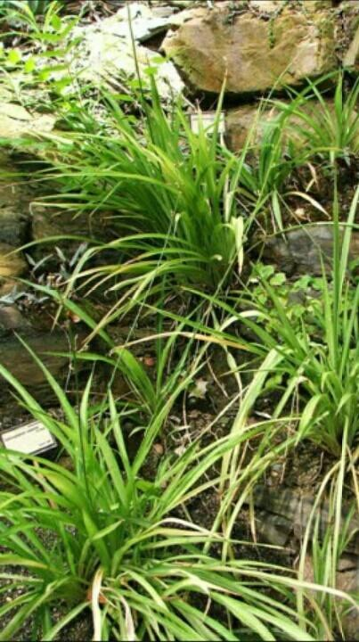

Plate I: *Chlorophytum alismifolium* plant in its natural habitat

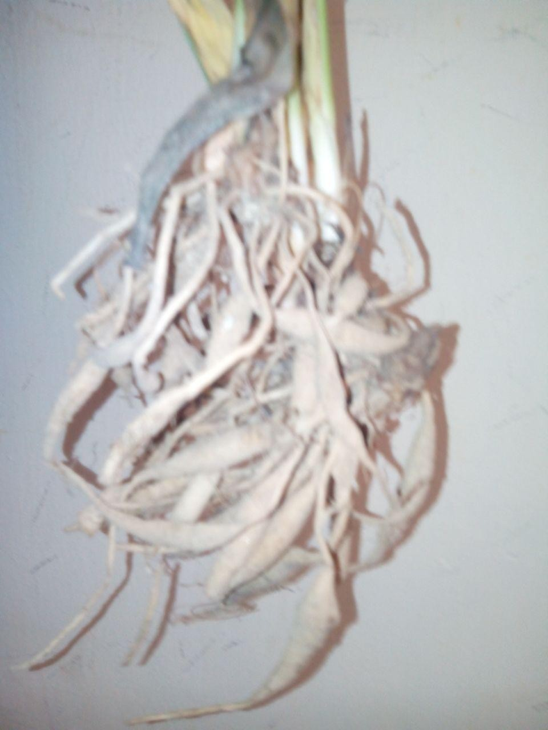

Plate II: *Chlorophytum alismifolium* tubers after harvest

**Taxonomy of*Chlorophytumalismifolium***

Kingdom -Plantae Phyllum- Magnoliophyta Class- Liliopsida Order- Asparagales Family- Asparagaceae Genus- Chlorophytum Species- Alismifolium **Plant Description**

English Name: Alimsa-leaved ground lily (Morton) CommonNames:

Hausa- Rogon makwarwa Fulfulde-cigorodi **Ethnomedical Uses**

The tubers are used in the management of diabetes, erectile dysfunction and in the treatment of wounds (Personal Communication,2014).

# Models for experimental diabetes

Experimental DMhas been induced in laboratory animals by several methods which include chemical, surgical and genetic manipulations (ReesandAlcolado*.* 2005).

# Alloxan-induced hyperglycaemic model

Alloxan is a urea derivative which causes selective necrosis of the pancreatic β-cell.it is used to produce experimental diabetes in animals such as rabbits, rats, mice and dogs. It is possible to produce different grades of the severity of the disease by varying the dose

of alloxan used in the induction, e.g. in rabbits, moderate diabetes can be induced with FBS level of 180-250mg/dl and severe diabetes with a FBS level above 250mg/dl (Hurali-kuppi, 1991).

Alloxan is a toxic glucose analogue which selectively destroys insulin producing β-cells in the pancreas of rodents and many animal species (Etuk, 2010). The cytotoxic action of alloxan is mediated by reactive oxygen species with a simultaneous massive increase in cytosolic calcium concentration, leading to a rapid destruction of β-cells (Szkudelski, 2001). Sulphonylureas are effective in a state where the pancreas β-cells are not completely destroyed (Rajkumar and Govindarajulu, 1991).

Rodents‟ models are commonly used to study metabolic functions in diabetes (VanBelle *etal.*, 2009). Alloxan-induced model is suitable for both IDDM and NIDDM (Etuk and Muhammed, 2010) but it is associated with high incidence of ketosis, mortality and reversal of hyperglycemia (Srinavasan and Romarao, 2007; Etuk, 2010).

# Streptozotocin-induced Hyperglycaemic Model

Streptozotocin (STZ) is a glucosamine nitrosourea compound derived from *Streptomyces achromogenes* that is used clinically in the treatment of pancreatic β-cells carcinoma. It damages β-cells and results in hypoinsulinaemia and hyperglycemia (Lenzen, 2008). STZ enters β-cells via a glucose transporter (GLUT-2) and causes alkylation of DNA and formation of super oxide radicals. Consequently, hydrogen peroxide and hydroxyl radicals are generated.Furthermore, streptozotocin liberates toxic amount of nitric oxide that inhibits aconitase activity and participate in DNA damage, as a result, the β-cells undergo destruction by necrosis (Szkudelski, 2001). STZ is a more suitable model for

NIDDM. It can be used alone or in combination with nicotinamide (Pellegrino *etal.*, 1998). STZ has a limitation when used in chronic experiments, especially by the development of functioning insulinoma (Steiner, 1970) and high incident of kidney and liver tumors which are attributed to its oncogenic action (Antia*etal.*, 2005).

# Pancreatectomy in dogs

Von Mohring and Minkowski (1890) noted polyuria, polydipsia, polyphagia and severe glucosuria following removal of the pancrease in dogs. The technique of complete pancreatectomy in the dogis described in detail by Foa (1971) and Sirek (1986)and has been used by many scientists as a relevant animal model for diabetes mellitus.

# Growth hormone induced diabetes

Cotes *et al*., (1949) described the diabetogenic action of pure anterior pituitary growth hormone in cats. In intact adult dogs and cats, the repeated administration of growth hormone causes an intensively diabetic condition including severe ketonuria and ketonemia. Rats of any age subjected to a similar treatment do not become diabetic but grow faster and show striking hypertrophy of the pancreatic islets (Young, 1945).

# Virus induced diabetes

Juvenile-onset (IDDM) may be due to viral infections and β-cells specific auto immunity (Craighead, 1978) .The D-variant of encephalomyocarditis virus (Emc-D) selectively infects and destroys pancreatic β-cells in susceptible mouse strains similar to human insulin-dependent diabetes (Yoon*etal.*, 1980; Gironand Patterson*.*, 1982).

# Corticosteroids induced diabetes

Ingle*etal.,* (1941) described hyperglycaemia and glucosuria in forced fed rats treated with cortisone. In the guinea pigs and rabbits, experimental corticosteroid-induced diabetes could be obtained without forced feeding (Abelove and Paschkis, 1954). In rats, the adrenal cortex, stimulated by corticotrophin, has the capacity to secrete amounts of steroids which include steroid diabetes (Ingle*etal.*, 1946).

# Ferric nitrilotriacetate induction of diabetes mellitus

This is rarely used procedure. Rats and rabbits parenterally treated with a largedaily dose of ferric nitrilotriacetate manifested diabetic symptoms such as hyperglycemia, glycosuria, ketonemia and ketonuria after 60 days of treatment (Awai, 1979)

# Genetic models of diabetes

They are spontaneously developed diabetic rats which permit the evaluation of the effect of a natural product in an animal without interference of the side effects induced by chemical drugs like alloxan and STZ (Masiello, 2006). Example is the spontaneously developed diabetic Goto-kakizaki rat which is a genetic model of type II diabetes (Chen and Wang, 2005). Genetic models are employed to study diabetic complications and this is a great advantage (Wu and Huan, 2007).

# CHAPTER THREE

* 1. **MATERIALS AND METHODS**

# Materials

* + 1. **Drugs and chemicals**

Distilled water

Streptozotocin (MP Biomedicals M 3219k, France) Chloroform (Sigma Chemical Co. St. Louis, USA) Concentrated HCl (BDH LTD, Poole, England)

10% Dextrose (Dana pharm. Minna, Niger State, Nigeria) Dragendoff reagent (BDH LTD, Poole, England)

Ferric chloride (BDH LTD, Poole, England)

Glimepiride (Sanofi Aventis, D-65926 Frankfurt, Germany) Normal saline (Dana pharmaceuticals. Minna, Niger State, Nigeria)

Meyer‟s reagent, methanol, sulphuric acid, wagner‟s reagent, Naphthol (Sigma Chemical Co. St. Louis, USA)

Acetic acid anhydride, Lead sub-acetate,Picric acid and Sodium hydroxide (BDH LTD. Poole, England)

# Equipment and other materials

Photo electric colorimeter model AE 11D (Erma Inc. Japan), Hematology analyzer (Sysmex USA), haematocrit centrifuge, spectrophotometer, Glucometer (Accu-check Active), Roche, Germany. Test strips (Accu-check Active), weighing balance, cotton wool, scissors, syringes (1ml, 2ml, 5ml and 5ml), spatula, animal cages, pestle, mortar, plastic containers, plain and heparinized 5ml plastic bottles.

# Experimental animals

Male Wistar rats (150-200g) obtained from the Animal House, Department of Pharmacology and Therapeutics, Ahmadu Bello University Zaria were used for this study. The animals were maintained in a well-ventilatedroom, fed on standard feed (vital feed) and granted access to water *adlibitium*.

# Method

* + 1. **Collection and extraction ofplant material**

The whole plant of *chlorophytum alismifolium* was collected from Tudun Fulani River in Toro Local Government Area of Bauchi state. It was identified and authenticated by Mallam Musa Muhammed of the Herbarium unit of Department of Biological Sciences, Ahmadu Bello University Zaria, Nigeria. The plant was issued a voucher specimen number (No. 6785) for future reference.

The roots (tubers) were washed and chopped into smaller sizes and then air-dried under shade for three weeks until constant weight was attained. The dried plant was then crushed into fine powder using pestle and mortar. About 1 kgof the powdered plant was extracted with 90% v/v methanol (2.5L) for 72 hours using the soxhlet apparatus.The extract was concentrated to dryness on a water bath set at 50oC and stored in a desiccator until further use.

# Acute toxicity study

The median lethal dose (LD50) of the extract was determined using he method described by Lorke (1983). The study was carried out in two phases. In the initial phase, three groups of three rats each were orally administered the methanol extract of *Chlorophytum*

*alismifolium* in widely differing dosesof 10, 100 and 1000mg/kg body weight and observed for signs of toxicity and mortality for 24 hours. In the second phase,four rats were orally administered the extract at the doses of 1600,2900 and 5000 mg/kg body weight respectively and then observed for signs of toxicity post-administration and mortality after 24 hours. The median lethal dose was then determined by evaluating the geometric mean of the lowest lethal dose and the highest non-lethal dose.

# Pharmacological studies

* + - 1. *Streptozotocin-induced hyperglycemia*

Experimental diabetes was induced using the method of Virendra*etal*.,(2011). Streptozotocin (50mg/kg) was dissolved in cold citrate buffer (pH 4.5) immediately before use. The solution was injected intraperitoneally at the dose of 50mg/kg body weight in rats fasted for 12 hours. The rats were given 10% glucose solution for 24 hours to prevent mortality due to initial hypoglycemia induced by STZ. The animals were given food and water then observed over a period of 72 hours for signs of hyperglycemia. The determination of glucose concentration was done using test strips which follows the glucose oxidase principle (Beach and Turner, 1958). Glucose is converted to glucoronic acid by oxidation which is then read by the glucometer. The rats with fasting glucose level between 200- 450mg/dl were consideredhyperglycaemic and selected for the study.

* + - 1. *Experimental design*

Normal (non-diabetic) andstreptozotocin-induced hyperglycaemic rats were then assigned accordingly into six groups with each group containing six rats (n = 6).

Group I Normal control group (Non diabetic) administered normal saline (1ml/kg) Group II Diabetic control group administered Normal saline, 1ml/kg

Group III Diabetic rats administered *C. alismifolium* extract (CAE),150mg/kg Group IV Diabetic rats administered CAE,300mg/kg

Group V Diabetic rats administered CAE, 600 mg/kg Group VI Diabetic rats administered Glimepiride, 10 mg/kg

## Streptozotocin-induced hyperglycaemia (28 days study)

The rats used in the study as grouped in 3.6.3, were administered their respective doses of normal saline, CAE and glimepiride daily for 28 days while their weight and glucose level were noted on the first day and then monitored on days 7, 14, 21 and 28. On the last day, the rats were anaesthetized under chloroform vapour and then sacrificed. Blood samples and harvested organs were collected for further experiments (Haematological, lipid profile, liver function, renal indices and electrolytes, and histopathological evaluation).

# Haematological evaluation

The blood samples collected at the end of the 28 days treatment were analyzed to determine changes in haematologic parameters which include; packed cell volume, red blood cell count, total white blood cell count, platelets and lymphocytes using Swep LabHaematology Analyser.

# Lipid profile evaluation

The plasma Total Cholesterol (TC), triglycerides(TGs), low-density lipoprotein (LDL) and high density lipoprotein (HDL) were analyzed using a photoelectric colorimeter.

# Evaluation of liver enzymes,renal indices and electrolytes

The collected blood samples were investigated to determine the effect of the extract on liver enzymes: Alanine amino transferase (ALT), Alkaline phosphatase (ALP) and Total bilirubin (TB) using a photoelectric colorimeter (Model WGZ-2000). The effect of the extract on renal indices like urea and creatinine, and electrolytes were also determined using Hitachi 902 analyzer.

# Histological evaluation

The organs (pancreas, heart, liver and kidney) were fixed in 10% formaldehyde for 10 days, they were then processed to dehydrate, clear and infiltrate the tissues. This was done using paraffin wax. It was then embedded which allows orientation of the specimen in a „block‟ that can be sectioned. It was then sectioned using a microtome to produce very thin sections that are placed on a microscope slide and stained using haematoxylin and eosin and then viewed for morphological features (Rolls, 2011).

# Antibacterial studies

* + - 1. *Cultivation and standardization of test bacteria*

An Eighteen-hour nutrient broth culture was prepared from the organisms stored on nutrient agar slants. A 1:1000 solution was prepared by serial dilution using (3x9 ml) sterile normal saline which produced about 105-106 CFU/ml for the Gram-positive

organisms. A 1:5000 solution was prepared by serial dilution using 3x9 ml and 1x4 ml sterile normal saline for the Gram negative organisms (Anderson, 1970).

* + - 1. *Antibacterial assay of extract of Chlorophytum alismifolium*

Agar well diffusion method was used as described by Adeniyi*etal*.,(1996) to determine the antibacterial activity of the extract. Molten sterile nutrient agar (20 ml) was poured into sterile petri dishes and allowed to set. The sterile nutrient agar plates were flooded with 1.0 ml of the standardized inoculum (equivalent to 105-106 CFU/ml) and the excess was drained off. A sterile cork borer (No. 4) was used to bore equidistant cups into the agar plate. One drop of the molten agar was used to seal the bottom of the bored hole, so that the test agent will not sip beneath the agar. About 0.1 ml of the different concentrations (200-0.38 mg/ml) of the extract was added to fill the bored holes. Negative control was prepared by putting 0.2 ml of pure solvent in one of the bored holes.

One hour pre-diffusion time was allowed, after which the plates were incubated at 37oC for 18 h. The zones of inhibition were then measured in millimeter. The procedure was repeated and the meandiameter of the zones of inhibition was taken.

* + - 1. *Minimum inhibitory concentration (MIC) of the extract*

Two fold serial dilution of the stock solution of *C. alismifolium* extract was made to obtain concentration between 200-0.38 mg/ml. A 2 ml portion of each dilution was incorporated into 18.0 ml double strength Mueller Hinton Agar and poured into the petri dishes. Sterile 6mm filter paper discs were aseptically placed on Mueller Hinton Agar surfaces. Standardizedinocula of the isolates were immediately added to the discs in

volumes of about 20µl sterile distilled water was added to the sterile paper disc as a negative control. The plates were left at ambient temperature for 15 minutes to allow excess pre-diffusion of organism prior to incubation at 37oC for 24 hrs. The lowest concentration that did not show any visible growth around the paper disc when compared to the control was considered as the Minimum Inhibitory Concentration (Ogbonnia*et al*.*,* 2008).

* + - 1. *Minimum bactericidal concentration (MBC)of the extract*

This was determined by using sterile forceps to place the filter paper discs that did not show any growth from the MIC plates into sterile Nutrient broth containing inactivating agent 5% v/v Tween 80 (Ehinmidu, 2003). This was incubated at 37oC for 24 hrs. The MBC was considered as the first tube that did not show any turbidity (Aboaba*etal.,* 2006). The procedure was carried out in duplicates with the reference antibiotics (gentamicin,amoxcilicin and ciprofloxacin).

* + 1. **Preliminary phytochemical screening of *Chlorophytumalismifolium***

The preliminary phytochemical screening of C.*alismifolium* was carried out on the methanol extract according to methods of Evans, (2002).

* + - 1. *Test for carbohydrates*

Molisch Test:- To a small portion of the extract in a test tube, few drops of molisch reagent was added down the side of the test tube to form a lower layer, a reddish coloured ring at the interphase indicates presence of carbohydrates (Evans, 2002).

* + - 1. *Test for free anthracene/anthraquinone derivatives*

Bontrager‟s Test:- To a portion of the extract in a dry test tube, 5ml of chloroform was added and was shaken for at least 5 minutes. This was filtered and the filtrate shaken with equal volume of 10% ammonia solution; bright pink colour in the aqueous (upper) layer indicates the presence of free anthraquinones.

* + - 1. *Test for glycosides*

To a portion of the extract, 5ml of dilute sulphuric acid was added and boiled on a water bath for 10-15 minutes.This was then cooled and neutralized with 20% KOH. It was then divided into two portions;

 To the first potion, 5ml of a mixture of Fehling‟s solution A and B was added and boiled; a brick red precipitate shows the release of reducing sugar as a result of hydrolysis of glycoside.

 To the second portion, about 3ml of ferric chloride solution was added; a green to blue colour will be produced because of the release of phenolic aglycones due to hydrolysis.

* + - 1. *Test for cardiac glycosides*

Keller-killianiTest: - A portion of the extract was dissolved in 1ml of glacialacetic acid containing traces of ferric chloride solution. This was then transferred into a dry test tube to form a lower layer at the bottom. The test tube was observed carefully at the interphase for purple brown ring. The presence of deoxy sugars and a pale green colour in the upper acetic acid layer indicates the presence of cardiac glycosides.

* + - 1. *Test for saponins*

 Frothing Test: - About 10ml of distilled water was added to a portion of the extract and was shaken vigorously for about 30 seconds. The tube was allowed to stand in a vertical position and was observed for 30 minutes. A honey comb froth that persists for 10-15 minutes indicates the presence of saponins.

 Hemolysis Test:- The extract was dissolved in water and filtered, 2ml of 1.8% aqueous sodium chloride solution was separated into two test tubes, to one of the tubes; 2ml of filtrate was added and to the other tube, 2ml distilled water was added, 5 drops of animal blood was added to each of the tube using a syringe. The test tubes were observed for 10-15 minutes for hemolysis in the tube containing the extract and its absence in the tube containing distilled water indicating the presence of saponins.

* + - 1. *Test for tannins*

Ferric-chloride test: - To a portion of the extract, 3-5 drops of ferric-chloride was added. A greenish black precipitate indicates the presence of condensed tannins while hydrolysable tannins give a blue or brownish-blue precipitate.

* + - 1. *Test for flavonoid*

 Shinoda Test: - A portion of the extract was dissolved in 1-2 ml of 50% methanol in the heat. Metallic magnesium chipsand few drops of concentrated hydrochloric acid were added. Appearance of red colour indicates the presence of flavonoids.

 Sodium hydroxide Test: - Few drops of 10% sodium hydroxide were added to the extract. Yellow coloration indicates the presence of flavonoid.

 Ferric chloride Test: - Few drops of ferric chloride solution were added to a portion of the extract, a green precipitate indicates the presence of phenolic nucleus.

* + - 1. *Test for alkaloids*

 Mayer‟s Test: - To 0.5 ml of the extract, few drops of Mayer‟s reagent were added.

A green precipitate indicates the presence of alkaloids.

 Dragendoff‟s Test: -To 0.5 mlof the extract, few drops of Dragendoff reagent were added. A reddish-brown precipitate indicates the presence of alkaloids.

 Wagner‟s Test: - Few drops of wagner‟s reagent were added to a portion of the extract, whitish precipitate indicates the presence of alkaloids

* + - 1. *Test for unsaturated steroids and triterpenes*

Lieberman Bucchard‟s Test: - To 0.5 ml of the extract, equal volume of acetic acid anhydride was added and mixed gently. 1ml of concentrated sulphuric acid was added down the side of the test tube to form a lower layer, colour changes were observed immediately and over a period of one hour. Blue to blue-green colour in the upper layer and a reddish pink or purple colour indicate the presence of triterpenes.

# Statistical analysis

Results were presented in tables and charts. Data were expressed as Mean ± Standard Error of the Mean (S.E.M.) and the differences between means were analyzed by One Way and Repeated Measure Analysis of Variance (ANOVA) were appropriate followed by Bonferroni post hoc test using a computer software application package (SPSS) Version 20. Values of p<0.05 were considered statistically significant.

# CHAPTER FOUR

* 1. **RESULTS**
  2. **P**ercentage Yield

The methanol tuber extract of *Chlorophytumalismifolium* obtained was dark brown, sticky semi solid substance with honey-like smell. Thepercentage yield of the extract was calculated to be 5.16 % w/w.

* 1. **Acute Toxicity Study on*Chlorophytumalismifolium*Extract**

Oral administration of the methanol tuber extract of *C*.*alismifolium* (10-5,000mg/kg) did not produce any visible sign of toxicity or mortality in the animals over a period of 24hrs. The oral LD50in rats was estimated to be above 5,000mg/kg.

# Pharmacological Studies

* + 1. **Effect of 28-day Daily Administration ofMethanol Extract of *C*. *alismifolium*on Blood Glucose Level of STZ-induced Hyperglycaemic Rats**

A significant (p< 0.05) and (p< 0.01) blood glucose lowering effect was observed at a dose of 600 mg/kg on days 7 and 14 respectively when compared to diabetic control. On day 21,there was a significant (p< 0.01)decrease in blood glucose level at 150 mg/kg (p< 0.001) at 300 and 600 mg/kg compared to the hyperglycaemic control. Similarly, on day 28, the extractat a dose of 300 and 600 mg/kg significantly (p<0.01) also lowered the blood glucose level when compared to hyperglycaemic control.The results were also compared over time by comparing day 0 with days 7, 14, 21 and 28. The extract at 600 mg/kg significantly (p< 0.001) reduced the blood glucose levelthroughout the experiment when compared to day 0; while at 300 mg/kg, the reduction was significant (p< 0.001) only on days 14, 21 and 28 compared to day 0 (Figure 4.1; Appendix A).

**500**



a

b

c

* c

** c

** c

** c

a**

**c*

c***

* b

*

**450**

**400**

**Fasting blood glucose (mg/dl)**

**350**

**300**

**250**

**200**

**150**

**100**

**NS 1ml/kg H/Control**

**H + CAE 150 H + CAE 300 H + CAE 600 GPD 10**

**50**

**0**

**Day 0 Day 7 Day 14 Day 21 Day 28**

# Treatment days

**Fig. 4.1:Effect of Daily Administration of *Chlorophytumalismifolium*Methanol Extract on Fasting Blood Glucose in Streptozotocin-Induced HyperglycaemicRats.**Values are presented as Mean ± S.E.M; *= p˂ 0.05, **=p˂ 0.01,

*** = p< 0.001 compared to hyperglycaemic control group; a, b and c represent p<0.05, p<0.01 and p<0.001 compared to day 0 – repeated measure ANOVA followed by Bonferronipost hoc test. CAE-*Chlorophytumalismifolium* extract, H = Hyperglycaemic, N/S = Normal saline, GPD=Glimepiride,n=6

# Effect of 28-Day Daily Oral Administration of Methanol Extract of *C. alismifolium* on Lipid Profile of Streptozotocin-inducedHyperglycaemic Rats

There was no statistical significant difference (p> 0.05) in the lipid profile of STZ- induced hyperglycaemicrats when compared to thehyperglycaemic control group(Table 4.1).

# Table 4.1: The Effect of 28-Day Daily OralAdministration of *C.alismifolium* on Lipid Profile of Streptozotocin-Induced HyperglycaemicRats

|  |  |  |  |  |
| --- | --- | --- | --- | --- |
| **Treatment**  **(mg/kg)** | **CH**  **(mg/dL)** | **HDL**  **(mg/dL)** | **LDL**  **(mg/dL)** | **TG**  **(mg/dL)** |
| NS (1ml/kg) | 2.33 ± 0.25 | 0.40 ± 0.08 | 1.03 ± 0.14 | 1.22 ± 0.13 |
| H/Control | 2.48 ± 0.21 | 0.50 ± 0.58 | 1.45 ± 0.24 | 1.93 ± 0.15 |
| H + CAE (150) | 2.03 ± 0.13 | 0.40 ± 0.08 | 1.15 ± 0.06 | 1.00 ± o.14 |
| H + CAE (300) | 2.13 ± 0.50 | 0.50 ± 0.13 | 1.10 ± 0.31 | 1.03 ± 0.10 |
| H + CAE (600) | 1.92 ± 0.21 | 0.45 ± 0.10 | 0.90 ± 0.08 | 0.98 ± 0.28 |
| GPD(10) | 1.55 ± 0.31 | 0.30 ± 0.58 | 0.63 ± 0.21 | 1.30 ± 0.30 |

Values are presented as Mean ± S.E.M, No statistical significant difference compared to diabetic control - one way ANOVA followed by Bonferroni test,CH = cholesterol, HDL

= High Density lipoprotein, LDL = Low Density lipoprotein, TG = Triglycerides, n=6, CAE= *Chlorophytumalismifolium* Extract, GPD = Glimepiride, H=Hyperglycaemic

# Effect of 28-day daily OralAdministration of Methanol Extract of *Chlorophytumalismifolium* on Haematological Parameters in Streptozotocin- induced Hyperglycaemic Rats

There was no statistical significant difference (p> 0.05) in the hematological parameters observed of all the groups irrespective of the treatment they received except that the lymphocytes counts of the hyperglycaemic control was elevated (Table 4.2).

# Table 4.2: Effect of 28-day Oral Daily Administration of Methanol Extract of *Chlorophytumalismifolium* on Haematological Parameters of Streptozotocin-induced Hyperglycaemic Rats

|  |  |  |  |  |  |
| --- | --- | --- | --- | --- | --- |
| **Treatment**  **(mg/kg)** | **RBC**  **(×109/L)** | **WBC**  **(×109/L)** | **PCV**  **(%)** | **LYMP**  **(%)** | **PLT**  **(×109)** |
| NS (1 ml/kg) | 6.40±0.45 | 7.55±3.60 | 37.75±2.49 | 5.53±2.64 | 424.50±49.12 |
| H/Control | 6.45±0.74 | 12.23±3.10 | 24.73±9.81 | 19.78±5.39 | 167.25±9.26 |
| H+CAE (150) | 5.63±0.72 | 9.00±1.06 | 31.55±4.15 | 6.40±0.88* | 483.50±59.02 |
| H+CAE (300) | 4.06±2.03 | 2.28±0.50 | 26.13±11.05 | 1.40±0.21** | 305.50±53.22 |
| H+CAE (600) | 8.25±0.44 | 9.10±1.57 | 44.98±2.90 | 6.50±1.19* | 455.75±117.23 |
| GPD(10) | 4.92±0.76 | 7.85±2.22 | 28.15±4.54 | 5.68±1.14* | 310.00±80.47 |

Values are presented as mean ± S.E.M *= p ˂ 0.05,**= p< 0.01compared to diabetic control- one way ANOVA followed by Bonferroni post hoc test, CAE = *Chlorophytumalismifolium* extract, RBC –Red blood Cell, WBC = White blood Cell, PCV = Packed Cell volume, LYMP = Lymphocytes, PLT = Platelets, n = 6; GPD = Glimepiride, H = Hyperglycaemic

# Effect of 28-day daily OralAdministration of the Methanol Tuber Extract of *Chlorophytumalismifolium* on Liver Function of Streptozotocin-induced Hyperglycaemic Rats

There was no statistical significant difference (p> 0.05) in levels of the liver enzymes of all the animals administered graded doses of the extract but there was elevation of alkaline phosphatase in the group that received glimepiride which was significant (p<0.01) compared to hyperglycaemic control (Table 4.3).

# Table 4.3:Effect of 28- day Daily Administration of the Methanol Tuber

**Extract of *Chlorophytumalismifolium* on Liver Function of Streptozotocin-induced Hyperglycaemic Rats**

|  |  |  |  |  |
| --- | --- | --- | --- | --- |
| **Treatment**  **(mg/kg)** | **AST**  **(I.U/L)** | **ALT**  **(I.U/L)** | **ALP**  **(I.U/L)** | **TB**  **(mg/dL)** |
| NS (1 ml/kg) | 148.00±6.48 | 66.50±8.97 | 525.50± 25.44 | 16.00±0.00 |
| H/control | 174.75±38.88 | 70.50±2.72 | 546.50±108.90 | 24.50±8.50 |
| H + CAE (150) | 155.25±12.74 | 53.75±5.68 | 392.75±37.69 | 20.25±4.25 |
| H + CAE (300) | 144.75±34.82 | 78.25±7.89 | 466.75±63.65 | 16.00±0.00 |
| H + CAE (600) | 215.00±34.33 | 106.25±7.87 | 938.00±137.63 | 21.67±5.67 |
| GPD(10) | 149.00±15.42 | 76.75±7.8 | 1317.00±256.37** | 27.33±5.67 |

Values are presented as Mean ±S.E.M **= p˂ 0.01 compared to diabetic control- one way ANOVA followed by Bonferroni post hoc test. AST= Aspartate amino transferase, ALT= Alanine amino transferase, ALP= Alkaline Phosphatase, TB= Total bilirubin,CAE=*Chlorophytumalismifolium* extract,n=6, GPD = Glimepiride, NS

=Normal saline, I.U=International unit, H = Hyperglycaemic

# Effect of 28- day Oral Daily Administration of the Methanol Tuber Extract of *Chlorophytumalismifolium*on Renal Indices inStreptozotocin-induced hyperglycaemic rats

The extract at all the doses tested significantly(p< 0.001) reduced the sodium ion levels. The urea level at 300 mg/kg was significantly significantly (p< 0.001) reduced compared to diabetic control. However, the levels of potassium, chloride, bicarbonate and creatinine were not significantly different (p> 0.05) when compared to hyperglycaemic control**(**Table 4.4**)**.

# Table 4.4: Effect of 28-Day Oral Daily Administration of the Methanol Tuber Extract of *Chlorophytumalismifolium* on Renal Indices and electrolytes in Streptozotocin-induced Hyperglycaemic Rats

|  |  |  |  |  |  |  |
| --- | --- | --- | --- | --- | --- | --- |
| **Treatment**  **(mg/kg)** | **Urea** | **Creatinine** | **Sodium** | **Potassium** | **Chloride** | **Bicarbonate** |
| Normal control | 2.13± 0.13 | 70.75±4.70 | 131.00±1.08 | 4.35±0.29 | 93.00±1.91 | 22.00±1.58 |
| H/control | 6.63±0.85 | 67.75±5.53 | 131.25±2.14 | 4.68±0.27 | 95.00±2.38 | 23.25±1.49 |
| H+CAE (150) | 4.58±0.22 | 67.75±5.53 | 100.25±1.31*** | 4.52±0.26 | 100.25±1.31 | 24.75±1.25 |
| H+CAE (300) | 1.88±0.13*** | 68.00±3.00 | 101.50±0.50*** | 6.50±1.35 | 101.50±0.50 | 20.25±1.44 |
| H+CAE (600) | 3.75±0.85 | 85.50±8.72 | 99.50±3.10*** | 6.50±0.39 | 99.50±3.10 | 19.25±1.31 |
| GPD(10) | 3.91±0.24 | 67.75±7.39 | 125.25±1.80** | 5.48±0.24 | 104.00±1.96 | 25.00±2.04 |

Values are presented as Mean ± S.E.M; **= p˂ 0.01, ***= p<0.001 compared to diabetic control - one way ANOVA followedby Bonferroni post hoc test. CAE= *Chlorophytumalismifolium* Extract, n=6, GPD = Glimepiride, H=Hypreglycaemic

# Effect of 28-day Oral Daily Administration of the Methanol Extract of *Chlorophytumalismifolium* onBody Weight of Steptozotocin-induced Hyperglycaemic Rats

A significant (p<0.001) reduction in body weight of the diabetic control rats was observed when compared to the initial body weight. There was also a significant (p<

0.05 and p<0.01) reduction in body weight when compared with initial weight 150 and 300mg/kgrespectively when compared to initial body weight. However, a significant (p< 0.05) increase in body weight was observed at 600 mg/kg (Table 4.5).

# Table 4.5:Effect of 28-day Oral Daily Administration of the Methanol Extract of *Chlorophytumalismifolium* on Body Weight of Streptozotocin-induced Hyperglycaemic Rats

|  |  |  |
| --- | --- | --- |
| **Treatment groups** | **Initial body weight (g)** | **Final body weight (g)** |
| Normal saline 1ml/kg | 197.83±19.82 | 207.33±19.11 |
| H/ control | 197.00±18.65 | 155.00±25.45 *** |
| H+CAE (150) | 193.33±14.56 | 167.00±2.28* |
| H+CAE (300) | 192.00±13.42 | 165.50±11.72** |
| H+CAE (600) | 191.17±12.54 | 215.80±15.27 * |
| Glimepiride (10) | 193.75±12.90 | 166.00±20.69** |

Values are presented as Mean ±S.E.M; *= p˂ 0.05, **=p˂ 0.01, ***= p< 0.001 compared to initial body weight – repeated measure ANOVA followed by Bonferroni post hoc test, CAE= *Chlorophytumalismifolium* extract, D=Diabetic, GDP=Glimepiride, n=6, H = Hyperglycaemic

# Effect of 28-day Oral Daily Administration of the Methanol Extract of

***Chlorophytumalismifolium* on Relative Organ Weights**

There was no significant difference (p>0.05) in the relative organ weights of the liver, kidney, pancreas and heart at all the doses of the extract tested (150, 300 and 600 mg/kg) when compared to hyperglycaemic control (Table 4.6.).

# Table 4.6: Effect of Methanol Extract of *Chlorophytumalismifolium* on relative organ weights of Streptozotocin-Induced Hyperglycaemic Rats following 28-days Oral Daily Administration

|  |  |  |  |  |
| --- | --- | --- | --- | --- |
| **Treatment**  **(mg/kg)** | **% Mean weight (g)**  **Liver Kidney Pancreas Heart** | | | |
| N/S 1 ml/kg | 4.32 ± 0.25 | 0.79± 0.10 | 0.54 ± 0.04 | 0.48 ± 0.03 |
| H/ control | 4.91 ± 0.69 | 1.05 ± 0.17 | 0.37 ± 0.09 | 0.60 ± 0.09 |
| H+CAE (150) | 4.63 ± 0.36 | 0.96 ± 0.04 | 0.31 ± 0.03 | 0.50 ± 0.02 |
| H+CAE (300) | 2.89 ± 0.17 | 0.83 ± 0.10 | 0.37 ± 0.03 | 0.40 ± 0.04 |
| H+CAE (600) | 3.00 ± 0.13 | 0.58 ± 0.07 | 0.42 ± 0.04 | 0.38 ± 0.02 |
| GPD (10) | 4.52 ± 0.65 | 0.96 ± 0.12 | 0.34 ± 0.05 | 0.45 ± 0.05 |

Data are presented as Mean ± S.E.M; No significant difference compared to diabetic control – one way ANOVA followed by Bonferroni post hoc test; n = 3, CAE = *Chlorophytumalismifolium* extract, D = Diabetic, GPD = Glimepiride, H = Hyperglycaemic

# Effects of 28days Oral Daily Administration of *C.alismifolium*on Histopathology of the Kidney, Liver, Pancreas and Heart of Streptozotocin- Induced Hyperglycaemic Rats

Histopathology of the kidney showed glomerular tubular necrosis, tubular destruction, lymphocyte hyperplasia and tubular damage(Plates III b, c, d, e and f).Histopathology of the liver showed vascular congestion, hepatocellular necrosis and vacoulations (Plates IV b, c, d, e and f). In the pancreas, islets destruction was observed in the diabetic group and the extract at 150 mg/kg. However, at 300 and 600 mg/kg, regeneration of the islets was observed(Plates V b, c, d and e). Histopathology of the heart showed intact cardiac cellsin all the groups (Plates VI a, b, c, d, e and f).

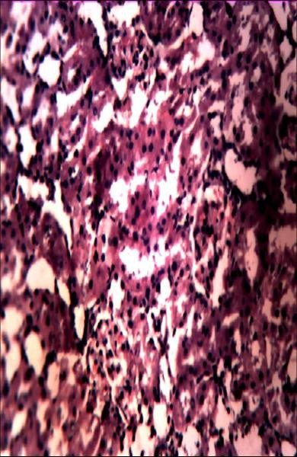**a b c**

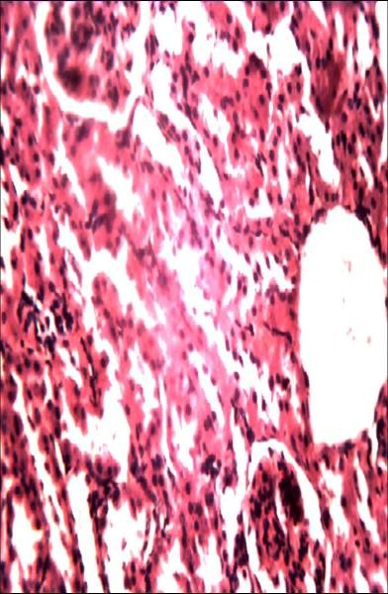

**GN**

**LH**

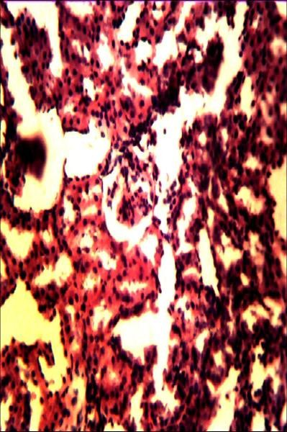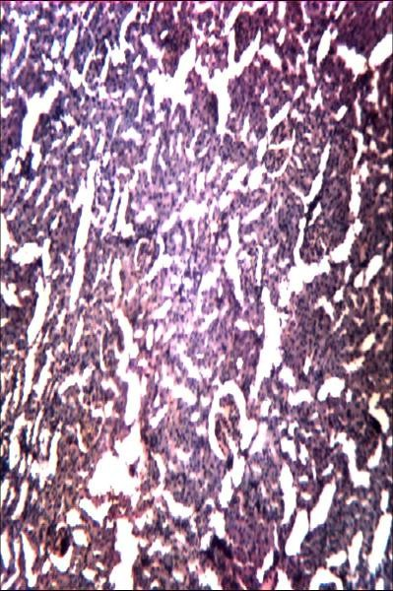

**TN**

**LH**

**TN**

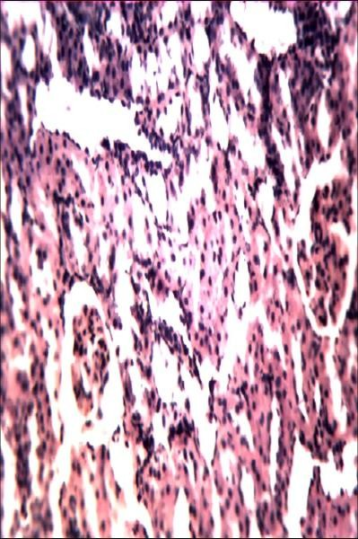

**LH**

**TD**

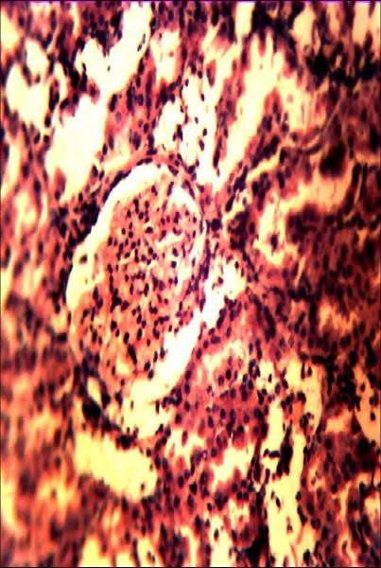

**LH**

**d e f**

**Plate III:**Photomicrogramof the Kidney showing glomerular necrosis (GN), tubular necrosis (TN), tubular destruction (TD) and lymphocyte hyperplasia (LH) in streptozotocin-induced diabetic rats(H and E x 250).a= normal rats, b=streptozotocin- induced diabetic rats, c=diabetic rats treated with CAE (150mg/kg), d= diabetic rats treated with CAE (300mg/kg),e= diabetic rats treated with CAE (600mg/kg), f= diabetic rats treated with Glimepiride (10 mg/kg), CAE = *Chlorophytumalismifolium*extract

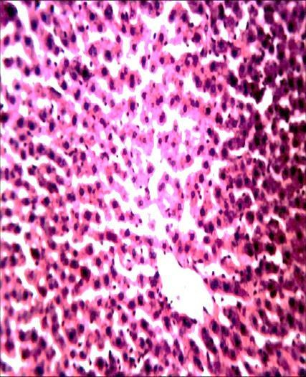

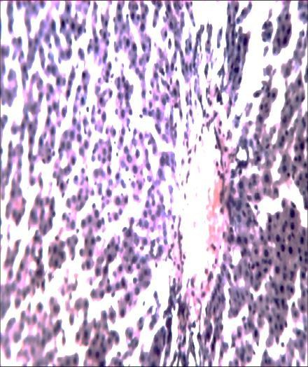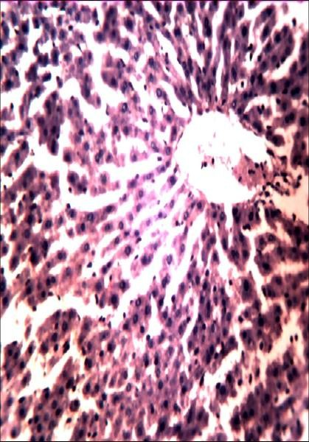

**VC**

**VC**

**HN**

**a b c**

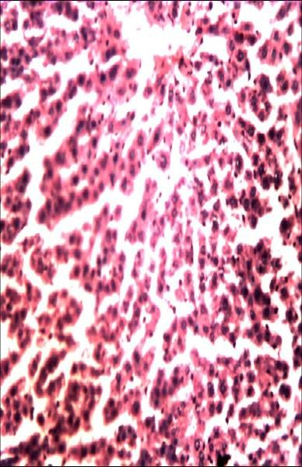

**HN**

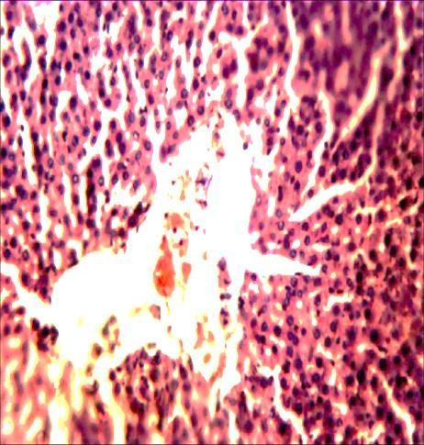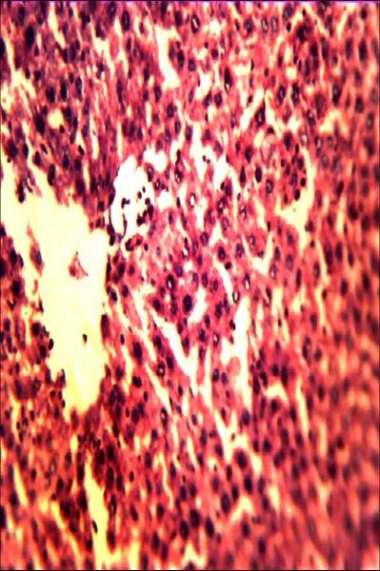

**VC**

**VC**

**HN**

**d e f**

**Plate IV:** Photomicrogram of the livershowing Hepatocellular necrosis (HN), Vacoulations (V) and Vascular congestion(VC), in streptozotocin-induced diabetic rats (H and E x 250).a= normal rats, b= streptozotocin-induced diabetic rats, c= diabetic rats treated with CAE (150 mg/kg), d= diabetic rats treated with CAE (300mg/kg), e= diabetic rats treated with CAE (600mg/kg), f= diabetic rats treated with Glimepiride (10 mg/kg), CAE = *Chlorophytumalismifolium*extract

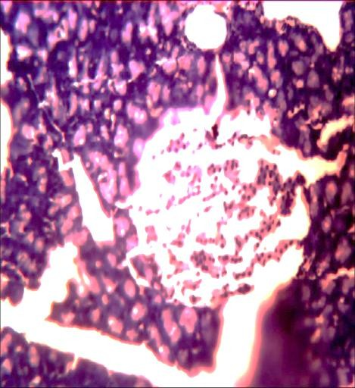**a b c**

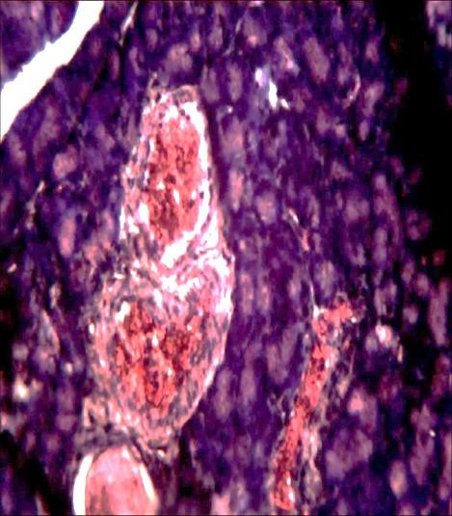

**RI**

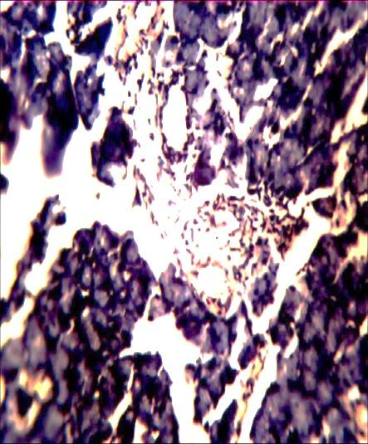

**RI**

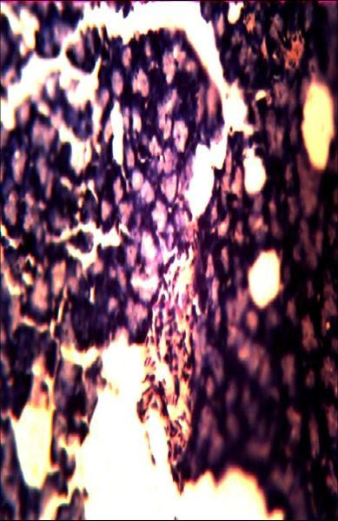

**RI**

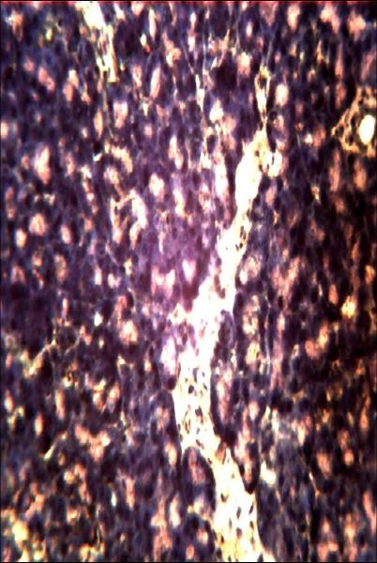

**DI**

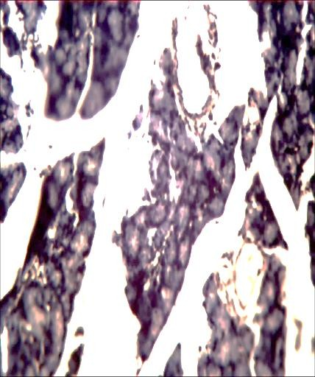

**DI**

**d e f**

**Plate V:**Photomicrogram of the pancreas showing Destroyed Islets (DI) and regenerated islets (RI) in streptozotocin-induced diabetic rats (H and E x 250).a= normal rats, b= diabetic control, c= diabetic rats treated with CAE (150 mg/kg), d= diabetic rats treated with CAE (300mg/kg), e= diabetic rats treated with CAE (600mg/kg), f= diabetic rats treated with Glimepiride (10 mg/kg) CAE = *Chlorophytumalismifolium*extract

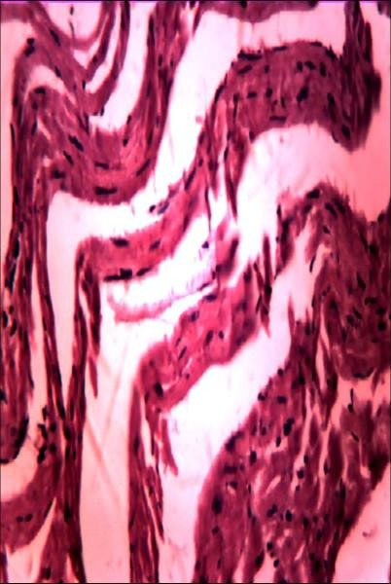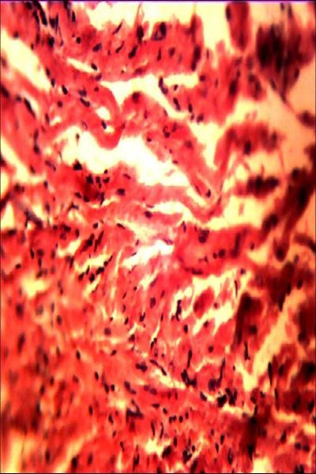

**NC**

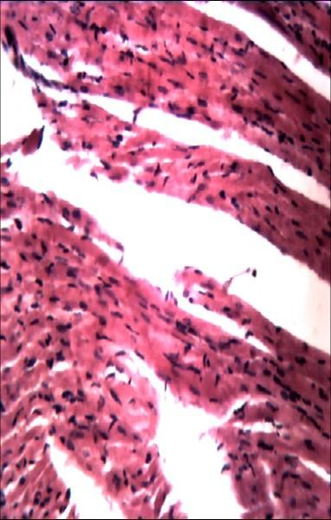

**NC**

**a b c**

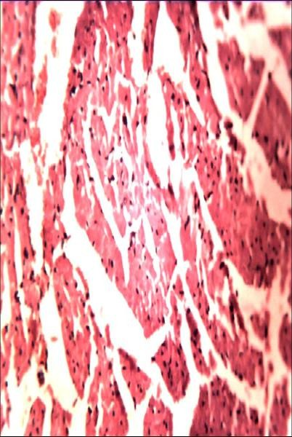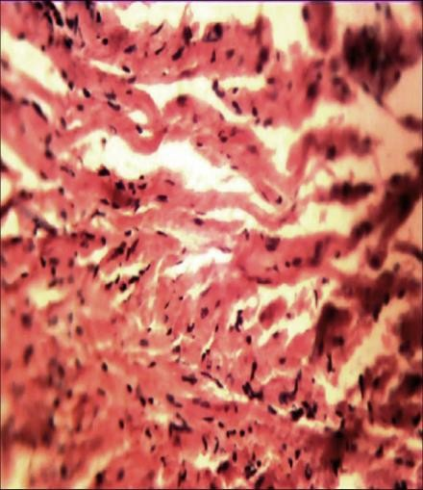

**NC**

**NC**

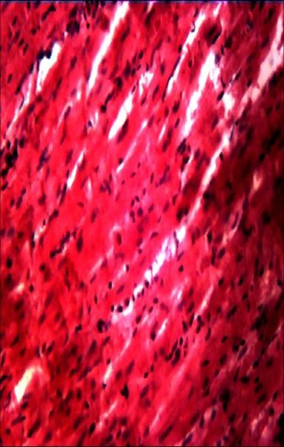

**NC**

**d e f**

**Plate VI:**Photomicrogram of the heart showing intact cardiac cells (NC) in streptozotocin-induced diabetic rats (H and E x 250). a= normal rats, b=diabetic control, c= diabetic rats treated with CAE (150 mg/kg), d= diabetic rats treated with CAE (300mg/kg), e= diabetic rats treated with CAE (600mg/kg), f= diabetic rats treated with Glimepiride (10 mg/kg), CAE = *Chlorophytumalismifolium*extract

# Antibacterial Studies

* + 1. **Diameter of zone of inhibition of *Chlorophytum alismifolium* extract**

The methanol extract of *Chlorophytumalismifolium* was observed to possess antibacterial activity against the four bacterial isolates that were selected for the study. The extract has activity against *E*. *coli* at all concentrations tested which was concentration dependent. The highest concentration (200mg/ml) had the zone of inhibition (21.50mm) while 100mg/ml and 50mg/ml have the zones of inhibition of 18.50mm and 14.50 mm respectively. Widest zone of inhibition was exhibited by gentamicin (29.00 mm). The extract at 200mg/ml produced the zone of inhibition of

18.50 mm while 15.50 mm inhibition was observed at 100mg/ml. There was no activity at 50mg/ml against *S*.*aureus*. Ciprofloxacin had highest zone of inhibition against *S*. *aureus* (25.00 mm). The extract produced the same zone of inhibition as gentamicin against Beta Hemolytic *streptococcus*at 200mg/ml which was 20.00mm. The zone of inhibition of 16.50 mm was produced at 100 mg/ml of the extract. Amoxicillin gave the highest zone of inhibition (24.50 mm).However, the extract showed little activity against *P.aeruginosa* with the highest dose 200mg/ml exhibiting the zone of inhibition of 16.50mm. There was no activity at the other doses tested while ciprofloxacin gave the highest zone of inhibition (23.50 mm) against *P. aeruginosa*(Table 4.7).

**Table 4.7: Diameter of Zone of Inhibition of Methanol Extract of *Chlorophytum alismifolium***

|  |  |  |  |  |
| --- | --- | --- | --- | --- |
| **Treatment**  **(mg/ml)** | **Zone of Inhibition (mm)**  ***S. aureus BHStrept. P. aeruginosa E. coli*** | | | |
| CIP 5µg/ml | 25.00 ± 0.00 |  | 23.50 ± 0.50 | 25.00 ± 0.00 |
| GEN 10µg/ml |  | 20.00 ± 0.00 | 20.00 ± 0.00 | 29.00 ± 1.00 |
| AMX 25µg/ml | 20.00 ± 0.00 | 24.50 ± 0.50 | 21.50 ± 0.50 |  |
| CAE (200) | - | 20.00 ± 0.00 | 16.50 ± 0.50 | 21.50 ± 0.50 |
| CAE (100) | 15.50 ± 0.50 | 16.50 ± 0.50 |  | 18.50 ± 0.50 |
| CAE (50) |  |  |  | 14.50 ± 0.50 |

Values are presented as mean ± S.E.M, CAE- *Chlorophytumalismifolium* extract. CIP = Ciprofloxacin, GEN = Gentamicin, AMX = Amoxycillin, BH *Strept*= Beta haemolytic *Streptococcus, E. coli =Escherichia coli, S. aureus* ***=*** *Staphylococcus aureus*

* + 1. **Minimum Inhibitory Concentration (MIC) and Minimum Bactericidal Concentration (MBC) of *Chlorophytumalismifolium* Extract**

The MIC values were the same for the two Gram-positive organisms used for the study and same values were also obtained for the two Gram-negative organisms tested. The MIC against Gram-negative organisms tested (*E.coli* and *P. aeruginosa*) were the same (100mg) while the MIC of the extract against Gram-positive organisms tested (*S. aureus* and betahemolytic*streptococcus*)was 50 mg(Table 4.8).

The MBC values were the same for the two gram-positive organisms used for the study and same values were also obtained for the two gram-negative organisms. The MBC against Gram-negative organisms tested (*E .coli* and *P. aeruginosa)* was the same (>100mg) while the MBC of the extract against Gram-positive organisms tested(S*. aureus* and betahemolytic*streptococcus*)was 100 mg (Table 4.8).

**Table 4.8: Minimum Inhibitory and Minimum Bactericidal Concentrations of Methanol Extract of *Chlorophytum alismifolium***

|  |  |  |
| --- | --- | --- |
| **Test organisms** | **MIC and MBC of CAE (mg/ml)**  **MIC MBC** | |
| *Staph. aureus* | 50 | 100 |
| *Streptococcus spp* | 50 | 100 |
| *P. aeruginosa* | 100 | NA |
| *Escherichia coli* | 100 | NA |

NA = No activity

# 4.5 Phytochemical Constituents

Preliminary phytochemical screening of the methanol tuber extract of *C.alismifolium* revealed the presence of flavonoids, glycosides, cardiac glycosides, saponins, alkaloids and triterpenes (Table 4.10).

**Table 4.9: Phytochemical constituents of *Chlorophytum alismifolium* extract**

|  |  |
| --- | --- |
| Constituents | Inference |
| Anthraquinones |  |
| Glycosides | + |
| Cardiac glycosides | + |
| Saponins | + |
| Tannins |  |
| Flavonoids | + |
| Alkaloids | + |
| Triterpenes | + |
| Steroids |  |

Key: Absent – Present +

# CHAPTER FIVE

**5.0 DISCUSSION**

Determination of the median lethal dose value of plants used in Traditional medicine using acute toxicity study is of paramount importance because it provides information regarding the margin of safety of the plant (Matsumura, 1985).The acute toxicity study indicated that the extract at a dose of 5000 mg/kg caused neither visible signs of toxicity nor mortality, suggesting that it is non-toxic when used orally.

Several studies have reported that STZ-induced diabetes mellitus and insulin deficiency lead to increased blood glucose level (Saeed *etal*., 2008). In the present study, *C. alismifolium* extract showed significant blood glucose lowering activity. The group that received glimepiride also showed a decline in blood glucose level which was significant on day 28th in STZ-induced hyperglycaemic rats. This suggests that the damage done by streptozotocin to the pancreatic β cells is not complete as sulphonylureasare established insulin secretagogues which stimulate insulin secretion by inhibition of ATP-dependent potassium channel, which sets the β cells resting membrane potential. A reduction of potassium outflowcauses β cell depolarization and the activation of calcium channels. The resulting calcium influx triggers exocytosis and release of insulin (Aguilar-Bryan *et al*., 1995). In the present study, it is not possible to pinpoint the mechanism of antihyperglycaemic action of the extract of *C. alismifolium.* Therefore, the blood glucose lowering effect of *C. alismifolium* extract could also be attributed to enhanced peripheral glucose utilization (Sharma *et al*.,2006).

The antihyperlipidemic effect of the extract at the doses tested was not significant when compared to the diabetic control.

The methanol extract of *C. alismifolium* produced relative activity against the four bacterial species used for the study. The zones of inhibition produced by the methanol extract of *C. alismifolium* against Gram-positive organisms (*S. aureus* and betahemolytic*Streptococcus*) and Gram-negative organisms tested (*E .coli* and *P. aeruginosa*) indicates that the methanol extract of the plant has activity against the susceptible bacteria implicated in wound and urinary tract infections in diabetic patients.

The extract had no effect on RBC, WBC, PCV and PLT at all the doses tested when compared to hyperglycaemic control. However, the lymphocyte count of the rats in the diabetic group was elevated.High lymphocyte level (lymphocytosis) in some cases indicates certain types of diseases such as cancer, autoimmune disorder and infections (Kraine and Tisch, 1999).

ALT is an enzyme that is found in the liver in high concentration. ALT level increases after significant hepatic injury by toxicants or disease conditions which make the enzyme a valuable monitoring parameter of hepatic injury (Singh *etal.*, 2011).The extract does not have any effect on ALT and other liver enzymes which indicate its relative safety at the doses tested but ALP was significantly (p < 0.01) elevated in the glimepiride group. This is expected because sulphonylureas like glimepiride cause elevation of liver enzymes including ALP in diabetics (Omar *etal.*, 2009).

The significant reductionin sodium ion levelsproduced by *C. alismifolium*could benefit diabetics because most of them are hypertensive and higher sodium level is associated with higher blood pressure (Mackay and Mensah, 2004) and low sodium diets maximize albumin decreasing effect (George and Amy, 1996).Creatinine is a marker for assessing

the function of the kidney by comparing the amount of creatinine, a product of body metabolism which is normally excreted by the kidneys, in the blood with the amount appearing in the urine (Singh *et al*., 2011). The extract at all doses tested does not have any effect on the creatinine level when compared to the diabetic control which indicates that it does not have any adverse effect on the kidneys.

The extract had effect on body weight of the animals with a significant reduction in body weight of the diabetic group compared to the initial weight. The extract at doses of 150 and 300mg/kg also produced a significant reduction in body weight of the animals.However, there was an increase in body weight of the animals in the group that received 600mg/kg of the extract which was statistically significant. Streptozotocin produces a diabetic state which is characterized by weight loss (Hakim *etal*., 1997), but the increase in body weight of animals in the group that received 600 mg/kg of the extract could be attributed to the better regeneration of islet cells function and enhanced insulin activity which will promote glucose utilization.

The extract at the doses of 150, 300 and 600mg/kg had no significant effect on the weights of the heart, kidney and liver and pancreas in relation to body weight. A decrease in the weight of pancreas in relation to body weight is due to destruction of pancreatic islet cells (Kim*etal*., 2006). The extract at 600 mg/kg showed an appreciable effect on the pancreas which could be due to regeneration of the islet cells.

The histological examination showed intact cardiac cells in the heart (plate VI) while the kidneys and liver (plates III and IV) showed abnormal features which were expected because streptozotocin as a diabetogenic agent is hepatotoxic and nephrotoxic

(Piyachaturawat,1988). The pancreas (plate V) showed slight regeneration of islet cells at 300 mg /kg and a better regeneration was observed at 600 mg/kg which further justifies the blood glucose lowering activity of the methanol extract of *C. alismifolium*

The efficacy of medicinal plants as antidiabetic agents may involve one or more active components responsible for blood glucose reduction (Marles and Fansworth, 1995; Grover *etal.*, 2002). There are reports implicating some phytochemical compounds as hypoglycemic agents.Phytochemicals like polypeptides (Khanna and Jain, 1981), alkaloids (Karawya and Wahab, 1984), steroids (Ivorra *etal.*, 1989) terpenoids (Reher *etal.*, 1991) have been shown to have blood glucose lowering activity. Saponins have a wide range of pharmacological activities which include hypoglycemic, hypocholesterolemic and antiparasitic (Sparge *etal.*, 2004 and Sahu *etal.*, 2008),while flavonoids have been reported to possess an insulin-like effect (Marles and Fansworth, 1995).

The antibacterial efficiency of any plant may be due to the actions of one or more phytochemical constituents such as flavonoids, terpenoids, saponins and other secondary metabolites (Poovendron *etal.*, 2011). Similarly, phenolic compounds have been reported to possess antimicrobial activities against microorganisms (Ismail and Abdulsamad, 2010; Nyananyo and Akada, 2011; Hussein, 2012).Glycosides and flavonoids are known to be useful in gastrointestinal infections (El-Mahmud, 2009) and flavonoids have also been reported to be synthesized by plants in response to microbial infections and have been shown to possess antibacterial activities (Kujumgiere *etal.*, 1999).

Different species of Chlorophytum have been used in traditional medicine for the treatment of variety of illnesses which include diabetes mellitus, hyperlipidemia and some bacterial infections. *Chlorophytumborivilianum* possesses antidiabetic, antihyperlipidemic and antimicrobial properties (Sundaparam, 2011; Neli *etal.*, 2014).Phytochemical screening of the methanol tuber extract of *Chlorophytumalismifolium* revealed the presence of bioactive compounds.The observed antihyperglycaemic and antibacterial activities of the extractcould have been as a result of one or more of the bioactive compounds.

# CHAPTER SIX

**6.0 CONCLUSION AND RECOMMENDATIONS**

The results of this study suggest that the methanol tuber extract of *Chlorophytum alismifolium* contains bioactive compounds that could be useful in the management ofhyperglycaemia. Thus, providing a scientific justification for the ethnomedicinal use of the plant in the management of diabetes mellitus. The antibacterial activity of the extract is an added value in the management of DM, given that diabetics are prone to infections due to the presence of unutilized glucose, which is a good medium for microbial growth.

Further studies should be carried out to characterize the active constituent(s) that is/are responsible for the observed pharmacological activities*.*Sub-chronic and chronic toxicity studies should also be carried out on the crude extract to ascertain its long term toxicity profile.

# REFERENCES

Abelove, W.A. and Peschkis, K.E. (1954). Comparison of the diabetogenic action of cortisone and growth hormone in different species. *Endocrinology*, 55:637-654.

Aboaba O.O, Smith S.I and Olude F.O (2006). Antibacterial effect of Edible Plant on

*Escherichia coli* 015:H. *Pakistan Journal of Nutrition* 5 (4):325-327.

Adeniyi, B.A., Odelola, H.A. and Oso, B.A. (1996). Antimicrobial potentials of *Diospyrosmespiliformis* (Ebenaceae). *African Journal of Medical Sciences*, 25: 179-184.

Aguilar-Bryan, L., Nichols, C., Wechsler, S., Body, a.E., Gonzalez, G. and Herreraspa,

H. (1995). Cloning of beta cell high affinity sulphonylurea receptor: A regulator of insulin secretion. *Science*, 268:423-426.

Aiello, L.P. (2010). The effect of ruboxistaurin on visual loss in patients with moderately severe to very severe nonproliferative diabetic retinopathy initial results of the Protein Kinase C Beta Inhibitor Diabetic Retinopathy Study (PKC-DRS) multicenter randomized clinical trial. *Diabetes*, 54: 2188-2197.

Alvin, C. (2005). Diabetes mellitus; Harrison T (ed.) *Principles of internal medicine*

(SixteenthEdition). New York McGraw-Hill Companies. 830-835.

American Diabetes Association(ADA) (1990). Diabetes mellitus and exercise.

*DiabetesCare*, 13: 804-805.

American Diabetes Association (ADA) (2001). Clinical Practice Recommendation.

*DiabetesCare*, 24: SI-S32.

American Diabetes Association (ADA) (2007). Diabetes Mellitus.*Diabetescare*, 542- 546.

American Diabetes Association (ADA) (2012).Diagnosis and classification ofDiabetes Mellitus. *Diabetescare*, 13.

American Diabetes Association (ADA) (2013).Diagnosis and classification of Diabetes Mellitus. *Diabetescare*, Vol.36, 67-74.

Anderson, G.T. (1970). Testing for susceptibility of Antimicrobial Agents and Assay of Antimicrobial Agents in Body Fluids.Manual of Clinical Microbiology by *American Society of Microbiology*. 1st Edition, pp. 299-310.

Antia, B.S., Okokon, J.E. and Okon, P.A. (2005). Hypoglycemic effect of aqueous leaf extract of *Perseaamericana*Mill in Alloxan-induced diabetic rats. *Indian Journal of Pharmacology,* 37:325-326.

Awai, M., Nasaraki, M., Yamanoi, Y. and Seno, S. (1979). Induction of diabetes in animals by parenteral administration of ferric nitriloacetate. A model of experimental hemochromamatosis. *American Journal of Pathology.*95,(3):663- 673.

Bailey, C.J. (1992). Biguanides and NIDDM. *DiabetesCare*. 15:755-772.

Balamurugan, A.N., Miyamoto, M., Wang, W., Inoue,K. and Tabata, Y. (2003).

Streptozotocin used to induce diabetes in animal models 26:102-103.

Balcht, A. and Smith, R.(1994). *Pseudomonas aeruginosa*: Infections and Treatment.*Information on Health Care*, 83-84.

Bayer, A.S., Bolger, A.F., and Taubert, K.A. (1998). Diagnosis and Management of Infective endocarditis and its complications. *Circulation*, 98(25): 2936-48.

Beach, E.F. and Turner J.J. (1958). An enzymatic method for glucose determination uptake in body fluids. *ClinicalChemistry*. 4:462-468.

Bedilu, D., Kifle, W. and Gugsa N. (2014). Prevalence and factors influencing diabetic foot ulcer among diabetic patients attending Arbaminch Hospital,South Ethiopia. *JournalofDiabetesmetabolism*, (5):1.

Benhaddou-Andalousi, A., Martineau, L., Vuong, T., Meddah, B. and Madiraju, P. (2011). The in Vivo Antidiabetic Activity of *Nigellasativa* is Mediated through activation of the AMPK pathway and increased muscle Glut4 Content. *Evidence Based Complementary and Alternative Medicine*, 538-671.

Bhushan, P. (2005). Traditional Medicine: Modern Approach for Affordable Global Health. WHO-CIPIH *study on Traditional Medicine, Draft Report*, pp. 135-137.

Blood, A., Hayes, T.M. and Gamble, D.R.(1975). Registration of newly diagnosed diabetic children. *British Medical Journal,* 3:580-583.

Bowersox, J. (1999). Experimental Staph Vaccine Broadly Protective in Animal Studies <http://www3.niaid.nih.gov/news/newsreleases/1999/staph.htm>.

Brooks, G.F., Butel, S.J. and Morse, S.A. (2001). Hawets, Melnick, and Adelberg‟s Medical Microbiology *vibrioCamplybacters*, *Helicobacters* and Associated Bacteria. (22nd edition) Editors: Folton, J., Ramson, J., Lebowitz, H. and Holton,

B. Mc-Graw-Hill Coy, Ins: pp. 240-241.

Burkill, H.M. (1995). *The useful plant of West Tropical Africa.* Vol. 3. PP. 494.

Carter, P., Gray, L.J., Troughton, J., Khunti, K. and Davies, M.J. (2010). Fruit and vegetable intake and incidence of type two diabetes mellitus: systematic review and meta-analysis. *British Medical Journal*, 341: c4229.

Catanzaro, N.D.J.A. and Suen, M.T.R. (1996). Clinical laboratory indicators of cardiovascular disease risk. *Alternative Medicine Review,* 1, 185-194.

Chan, J.C., Malik, V., Jia, W., Kadowaki, T, Tajnik, C.S., Yoon, K.H., and Hu, F.B. (2009). Diabetes in Asia: epidemiology, risk factors, and pathophysiology. *The Journal of the American Medical Association*, 301:2129-2140.

Chen, D. and Wang, M.W.(2005). Development and application of rodent models for type II diabetes. *Diabetes, Obesity and Metabolism.* 7:307-317.

Chen, Q., Reis, S.E., Kammerer, C., Craig, W., Mcnamara, D.M., Holubkhor, R.,Sharaf, B.L., Sobkho, G.,Pauly, D,F.,Merz, C.N. and Kamboh, M.I. (2011). Association of antioxidized LDL and candidate genes with severity of coronary stenosis in the women‟s ischaemia syndrome evaluation study. *The Journal of Lipid Research*, 52, 801-807.

Clauditz, A., Reseh, A., Wieland, K.P., Peschel, A. and Gotz, F. (2006). Staphyloxanthin plays a role in the fitness of *Staphylococcusaureus* and its ability to cope with oxidative stress”. *Infection and Immunity*, 74(8): 4950-3.

Colagiuri, S. (2010). Diabesity; Therapeutic Options. *Diabetes Obesity Metabolism*, 12:463-473.

Colberg, S,R. (2007). Physical activity, insulin action, and diabetes prevention and control. *CurrentDiabetesReview,* 3(3):176-84.

Cook, J.T., Hattersley, A.T., Levy, J.C., Patel, P., Wainscoat, J.S., Hockaday, T.D. and Turner, R.C. (1993). Distribution of Type II diabetes in nuclear families. *Diabetes*, 42:106-12.

Cook, L.C., Johnson, T.J. and Wade, E.W. (2008). Endocrinologic Disorder: Diabetes mellitus. In: Chisholm-Burns, M.E. and Wells, B.G. (Eds). *Pharmacotherapyprinciplesandpractice*. McGraw-Hill Company, Inc. USA. pp.643-644.

Cotes, P.M., Reid, E. and Young, F.G. (1949). Diabetogenic action of pure anterior pituitary growth hormone. *Nature*, 164: 209-211.

Craighead, J. (1978). Current views on the etiology of insulin-dependent diabetes mellitus. *New England Journal of Medicine,* 299: 1439-1445.

Dahanukar, S.A., Kulkarni, R.A. and Rege, N.N. (2000). Pharmacology of medicinal plants and natural products. *IndianJournalofPharmacology*, 32: 81-118.

Danmalam, U.H., Abdullahi, L.M., Agunu, A. and Musa, K.Y. (2009). Acute toxicity studies and hypoglycemic activity of the methanol extract of the leaves of *Hyptissuaveolens*Poit. (Lamiaceae). *NigerianJournalofPharmaceuticalSciences*, 8: 87-92.

Deore, S.L. and Khadabadi S.S. (2008). Standardisation and pharmaceutical Evaluation of *Chlorophytumborivilianum* mucilage.*RasayanJournalofChemistry*, 1(4): 887-

897.

Devendra, S., Bhagirath P., Joshi Y.M. and Vilasra O. (2012). Pharmacological aspect of *Chlorophytumborivilianum* (safed musli). A review; *InternationalJournalofResearchinPharmacyandChemistry*, 2231-2781.

Diabetes Atlas 6th ed. (2013). International Diabetes Federation. pp. 10-24. Diabetes fact sheet, January, 2011. No. 312.

Douglas S, Paauw M.D (2000); Infectious emergencies in patients with diabetes.

*Clinical Diabetes*, vol 18.3.

Ehinmidu, J.O. (2003). Antibiotics susceptibility patterns of urine bacterial isolates in Zaria, Nigeria. *Journal of Tropical PharmaceuticalResearch,* 2(1):223-228.

El-Mahmood, A.M. (2009). Antibacterial activity of crude extracts *Euphorbiahirta* against some bacteria associated with enteric infections. *Journal of Medical Plant Resources.* 3 (7): 498-505.

Ernest, J., Joseph, L.M. and Edward, A.A. (1982). *Review of medical Microbiology* (15th ed.) Lange Medical Publishers, Los Angeles. 195-196.

Etuk, E.U. (2010). Animal models for studying diabetes mellitus.

*AgricultureandBiologyJournalofNorthAmerica*, 1(2): 130-134.

Etuk, E.U. and Muhammed B.J. (2010). Evidence based analysis of chemical method of induction of diabetes mellitus in experimental animals. *Asian Journal of Experimental Biological Sciences*. 2, 331-336.

Expert Committee on Diagnosis and Classification of Diabetes Mellitus, (1997). Report of the Expert Committee on the Diagnosis and Classification of Diabetes Mellitus. *DiabetesCare*, 20: 1183-1197.

Evans, W.C (2000). Trease and Evans Pharmacognosy, (FifteenthEdition) Saunders Company Limited, London.36-37.

Evans, W.C (2002). Trease and Evans Pharmacognosy, (Fifteenth Edition) Saunders Company Limited, London. 191-193.

Fabio, F. and Luigi G (2007). Evidence-Based Complimentary and Alternative medicine,Volume 4 ,37-40.

Foa, P.P. (1971). Pankreatektomie. In: Dorzbach, E. (ed). *Handbook* of *ExperimentalPharmacology* Vol 32/1, Insulin, Springer-Verlag, Berlin Heidelberg, New York, pp. 146-158.

Forland, M. and Thomas, V.L. (1985). The treatment of UTIs in women with diabetes.

*Diabetes care*, 8:499-506.

George, L.B. and Amy S. (1996).*Annals ofInternalMedicine,* 125(3): 201-204.

Gilani, A.H., Aziz, N., Ali, S. and Saeed, M., (2011). A molecular phylogeny of selected species of Genus Prunus L (Rosaceae) from Pakistan using the TRN-L and TRN-F Spacer DNA. *AfricanJournalofBiotechnology*, 10(22): 4550-4554.

Giron, D.J. and Patterson, R.R. (1982). Effect of steroid hormones on virus-induced diabetes mellitus. *InfectiveImmunology*, 37: 820-822.

Gonzalez, E.L., Johansson, S., Wallander M.A. and Rodriguez L.A. (2009). Trends in the prevalence and incidence of diabetes in the UK: 1996-2005. *JournalofEpidemiologyandCommunityHealth*, 63: 332:336.

Gregory, M., Vithalrao, K.P., Franklin, G. and Kalai, C.V. (2009). Anti ulcer activity of *Ficusamoftiana* Miq (Moraceae) Leaf Methanolic Extract. *AmericanJournalofPharmacologyandToxicology*, 4(3): 89-93.

Grover, J.K.,Yadav, S. and Vats, V. (2002).Medicinal plants of India with hypoglycemic potentials. *Journal of Ethnopharmacology*,81:81-100.

Hague, R., Saha, S. and Bera T. (2011). A peer reviewed Literature on Medical Activity of *Chlorophytumborivilianum*, commercial medicinal plant; *IndianJournalofPharmaceuticalSciences*, 3(1): 116-1130.

Hakim., Z.S., Patel, B.K. and Goyal, R.K. (1997). Effect of chronic ramipril treatment in streptozoto-induced diabetic rats. *Indian Journal of Physiology and Pharmacology.* 41, 353-360.

Hardman, D.J. (1991). Biotransformation of halogenated compounds,

*CriticalReviewinBiotechnology*, 11:1-4.

Holt, G.I. (2004). Diagnosis, epidemiology and pathogenesis of diabetes mellitus an update for psychiatrists. *BritishJournalofPsychiatry*, 184:55-63.

Hou, Z.M., Zhang, Z. and Wu, H. (2005). Effect of *Sanguisdratonis* (a Chinese traditional herb) in the formation of Insulin resistance in Rats. *DiabetesResearchandclinicalpractice*, 68: 3-11.

Huralikuppi, J.C. (1991). Antidiabetic effect of *Nelumbonucifera* extract.

*PhytotherapyResearch,* 5:217-223.

Hussein, N.J. (2012). Investigation and analysis of extracts of some medicinal plants over some enteric bacteria. *Journal of Biomedical Bioengineering,* 3(1): 79-82.

<http://www.who.int/mediacentre/factsheets/fs312/en/index.html>

Ingle, D.J. (1941). The Production of glycosuria in the normal rat by means of 17 hydroxy-11-dehydrocorticosterone. *Endocrinology*, 39:32-39.

Ingle, D.J., Li, C.H. and Evans, H.M. (1946). The effect of adrenocorticotropic hormone on the urinary excretion of sodium, chloride, potassium, nitrogen and glucose in normal rats, *Endocrinology*, 39:32-39.

International Diabetic Federation (2011). *DiabetesAtlas*: Global Estimates of the Prevalence of Diabetes for 2011 and 2030, *Diabetes Research and Clinical Practice*. 311-321.

Ismail, C.A.N. and Abdulsamad, O. (2010). Antimicrobial and Antioxidant Studies Of *Acaciamangium* Leaf Extract. In 3rd International Conference on Advancement in Science and Technology (ICAST). Nistara Hotel,Kolantan pp. 27-29.

Ivorra, M.D., Paya, M. and Villar, A. (1989). A review of natural products and plants as potential antidiabetic agents. *JournalofEthnopharmacology*, 27:243-275.

Juan, J., Ramirez E., Maria Y., Sugey, L.M., Fabian, L.V., Jose, L., Medina, F., Paolo, P., Guido, C., Gabriel, N., Rolffy, O. and Samuel, E. (2011). Antidiabetic

activity of some pentacyclic acid triterpenoids, role of PTPIB: invitro, in silico and in vivo approaches: *EuropeanJournalofMedicinalChemistry*, 46: 2243-2251.

Kaku, K. (2010). Pathophysiology of type 2 diabetes and its treatment policy.

*JapanMedicalAssociationJournal*, 53(1): 41-46.

Karawya, M.S. and Wahab, S.A. (1984).Diphenylamine, an antihyperglycaemic agent from onion and tea. *Journal of Natural Product*,47:775-780.

Khanna, P. and Jain, S. (1981). Hypoglycemic activity of polypeptide-p-from a plant source. *Journal of Natural Product,* 44:648-655.

Kim, J.D., Kay, S.M., Seo, B.I., Choi, H.Y., Choi, H.S. and Ku, S.K (2006). Antidiabetic activity of SMK001,a polyherbal formulation in streptozotocin-induced diabetic rats. *Biological and Pharmaceutical Bulletin,* 29(3): 477-82.

Kim, H. ,Jeong, D., Jun, H., Yokozawa, T. and Choi, J. (2008). Hypolipidemic effect of sophora flavescens and its constituents in polaxamer induced hyperlipidemic and cholesterol-fed rats. *Biological and Pharmaceutical Bulletin,* 31: 73-78.

Kinra, S., Bowen, L.J., Lyngdoh, T., Prabhakaran, D., Reddy, K.S. and Ramakrishnan,

L. (2010). Socio-demographic pattering of non-communicable disease risk factors in rural India: Across sectional study. *British Medical Journal*, 341:49- 74.

Klein, G., Kim, J., Himmeldirk, K.,Cao, Y. and Chen, X. (2007). Antidiabetic and anti- obesity activity of *Lagerstroemia speclosa* . *eCAM* . 4:401-407.

Kluytmans, J., Van Belkum, A. and Verbrugh, H. (1997). *Clinical Microbiology.* 10(3): 505-520.

Korzeniowski, O. and Sande, M.A. (1982). Combination antimicrobial therapy for

*Staphylococcusaureus* endocarditis in patients addicted to parenteral drugs and

in non addicts: a prospective study. *Annual International Medicine*. 97(4): 496- 503.

Kraine, M.R. and Tisch, R.M. (1999). The role of environmental factors in insulin dependent diabetes mellitus: an unresolved issue. *EnvironmentalHealthPerspectives,*107:777-781.

Kujumgiere, A., Tseveikoval, T.S.,Serkedjivay, D.E., Bankora, V.,Christo, R. and Popov, S. (1999). Antibacterial, Antifungal and Antiviral Activity of *Propolis geographica*Origin.*Journal of Ethnopharmacology,* 44:35-40.

Kunal, K. and Prashat T. (2013). Genus Chlorophytum Ker Gaul, Medicinally Important Plant from Ancient India Literature (Ayurveda), *InternationalJournal of Ayurvedic and Herbal Medicine,* 3:3, 1201-1211.

Kuzuya, T. and Mastuda, A. (1997). Classification of Diabetes on the Basis of Etiologies versus Degree of Insulin Deficiency. *DiabetesCare*, 20: 219-220.

Lamonte, M.J., Church T.S.,Barlon, C.E. and Blair S.N.(2005). Cardiorespiratory fitness and body mass index as predictors of cardiovascular disease mortality among men with diabetes. *Archives ofInternalMedicine,* 165(18):2114-2120.

Lenzen, S. (2008). The mechanisms of alloxan and streptozotocin induced diabetes.

*Diabetologia*.51,216-226.

Liu, G.Y., Essex, A., Buchanam, J.T., Datta, V., Hoffman, H. M., Bastian, J.F., Fierer,

J. and Nizet, V. (2005). *Staphylococcus aureus* golden pigment impairs neutrophil killing and promotes virulence through its antioxidant activity. *Journal of Experimental Medicine,* 202(2): 209-215.

Lorke, D. (1983). A new approach to practical acute toxicity testing.*ArchivesofToxicology*, 54:275-287.

Lukic, M.L., Stosic-Grujicic, S., Ostojic, N., Chan, W.L. and Liew, F.Y. (1991). Inhibition of nitric oxide generation affects the induction of diabetes by streptozotocin in mice. *BiochemicalandBiophysicalResearchCommunications*, 178:913-920.

Mackay, J. and Mensah, G. (2004). *Atlas of heart disease and stroke*. Geneva, World Health organization.

Mahajan-Miklos, S., Tan, W.W., Rahme, L.G., and Ausubel, F.M. (1999). Molecular mechanisms of bacterial virulence elucidated using a *Pseudomonas aeruginosa-* Caenorhabditis elegans pathogenesis model*Cell*, 96(1): 47-56.

Maiti, R., Jana, D., Das, U.K., and Ghosh, D. (2004). Antidiabetic effect of aqueous extract of seed of *TamarindusIndica* in streptozotocin induced diabetic rats. *JournalofEthnopharmacology*, 92: 85-91.

Margaritis, M., Channon, K,M. and Antoniades, C. (2012). Statins and vein graft failure in coronary bypass surgery. *Current Opinion in Pharmacology,* 12, 172-180.

Mariangeli, C.P.F., Barady, K. and Jones, P.J.H. (2006). Plant sterols combined with exercise for the treatment of hypercholesterolemia: Overview of independent and synergistic mechanisms of action. *The Journal of Nutritional Biochemistry,* 17: 217-224.

Marles, R. and Fansworth, N. (1995). Antidiabetic plants and their active constituents.

*Phytomedicine,* 2:137-165.

Martinez, C., Pans, E., Prat, G. and Leon, J. (2004). Salicylic acid regulates flowering time and links defense responses and reproductive development.*Plant Journal*. 37: 209-217.

Masiello, P. (2006). Animal models of type II diabetes with reduced pancreatic beta-cell mass. *The International Journal of Biochemistry and Cell Biology*. 38: 873-893.

Matsumura, F.(1985).*Toxicology of Insecticides*.2nd Ed. Plenum Press, New York.p. 588.

Mazen, S.B. (2008).Diabetic foot infection. *American Family Physician.* 78(1): 71-79. Mishra, R.N. (2012). The Ayurvedic Antiaging Drugs*. Indian Journal of Research in*

*Pharmaceutical and Biomedical Science*, 3(1): 234-239.

Neil, H.A., Gatling, W., Mather, H.M., Thompson, A.V., Thorgood, M., Fowler, G.H., Hill, R.D. and Mann, J.L. (1987). The Oxford community Diabetes study; evidence for an increase in the prevalence of known diabetes in Great Brittain. *DiabeticMedicine*, 4:539-543.

Neli, G., Kilari, E.K., Somesula, S.R., Sekavan, M. and Naguib, S. (2014).*Chlorophytumborivilianum* root extract maintains normal blood glucose, insulin and lipid profile levels and prevents oxidative stress in the pancreas of streptozocin-induced Adult male diabetic Rats. *International Journal of Medical Sciences,*11(11): 1172-1184*.*

Nesto, R.W., Bell, D., Bonow, O.R., Fonseea, V., Grundy, S.V., Horton, S.E. and Kahn,

R. (2003). Thiazolidinedione Use, Fluid Retention and Congestive Heart Failure: A. Consensus Statement from the American Heart Association and American Diabetes Association, *Circulation*, 108:2941-2948.

Nnayanyo, B.L. and Akada, P. (2011). Ethnomedicinal and Phytochemical Screening of some plants in Sagbama Area of Bayelsa State, Nigeria. *ScienticaAfricana,* 10 (1): 41-45.

Nutan, K. (2005). Saponins of Chlorophytum species, *SpringerPhytochemistryReview*, 4(2-3): 191-196.

Ogbera, A.O., Adedokun, A., Fasanmade, O.A. and Ajani, M. (2005). The foot at risk in Nigerians with Diabetes Mellitus: The Nigerian scenario. *InternationalJournalofEndocrinologyandMetabolism*, 4:165-173.

Ogbera, A. O., Fasanmade, O.A., Ohwovoriole, A.E. and Adeniran, O. (2006). An assessment of the disease burden of foot ulcers in patients with diabetes mellitus attending a Teaching Hospital in Lagos Nigeria. *The international Journal Of Lower Extremity Wounds*, 5:244-249.

Ogbonnia, S.O., Enwuru, N.V.,Onyemenem, G.A. and Enwuru, C.A. (2008). Phytochemical evaluation and antibacterial profile of *TreculiaAfricana* bark extract on gastrointestinal bacterial pathogen. *African journal of Biotechnology*. 7:(10)1383-1389.

Olagbende-Dada, S.A., Ogbonnia, S.O., Coker, H.A.B. and Ukpo, G.E. (2011). Blood glucose lowering effect of aqueous extract of *Graptophyllumpictum* (Linn) Griff, on alloxan-induced diabetic rats and its acute toxicity in mice. *AfricanJournalofBiotechnology*, 10(6): 1039-1043.

Omar, H., Jaya, K. and Daranard, M. (2009). Glimepiride induced cholestasis in man with diabetes mellitus: a case report. *Journal* of *MedicalCaseReports,* (3) 9257.

Patterson, J.E. and Andriou, V.T. (1997). Bacterial urinary tract infections in diabetes

*inf. Diseaseand Clin. North America,*161: 735-750.

Pellegrino, M., Christopher, B., Michelle, M. and Gerrad, R. (1998). Development of a new Model of type II diabetes in Adult rats administered streptozotocin and nicotinamide. *Diabetes,* 47: 224-230.

Pendsey, S.P. (2010). *Understanding diabetic foot. International Journal Of Diabetes in Developing Countries,*30:75-79.

Piedrola, G., Novo, E. and Serrano-Gotarredona, J. (1999). Evolution of insulin resistance in coronary artery disease patient on four different pharmacological therapies. *PostgraduateMedicineJournal,* 75:27-31.

Piyachaturawat, P., Poprasit, J.,Glinsukon, T. and Warichanon, C. (1988). Gastric Mucosal lessions in streptozotocin-induced diabetic rats. *Cell Biology international Report*, 12(1):53-63.

Poovendron, P., Kalaigandhi, V. and Poogunron, M. (2011). Agrofest data Base, a Tree reference and selection guide verse 4.0, PP.1-5‟.

Rajagopal, K, and Sasikala, S. (2008).Antihyperglycaemic and Antihyperlipidemic effects of *Nymphatastellate* in Alloxan-induced Diabetic Rats. *SingaporeMedicalJournal*, 49:137-141.

Rajkumar, L. and Govindarajulu, P. (1991). Increased degradation of dermal collagen in diabetic rats. *IndianJournal* of *ExperimentalBiology*, 29:1081-1083.

Raju, S.M. and Raju. B. (2010). *Illustrated Medical Biochemistry*. (Second Edition).

213-395.

Rees, D.A. and Alcolado, J.C. (2005). Animal Models of Diabetes Mellitus,

*DiabeticMedicine,* 22: 259-370.

Reher,G., Slijepeevic, M. and Krans, L.(1991). Hypoglycemic activity of triterpenes and tannins from *Sarcopoteriumspinosum* and two *sanguirsorba* species. *Plantamedica,* 57:57-58.

Rich. J. and Lee, J.C. (2005). The pathogenesis of *staphylococcusaureus* infection in the diabetic NOD mouse. *Diabetes . 54 (10)*: 2904-10.

Rolls, G. (2011). Leica Biosystem, Wetzlar, Germany.

Ryan, K.J. and Ray, C.G. (2004). *Sherris Medical Microbiology* (Forth Edition).

McGraw Hill. pp. 100-123.

Saeed, M.K., Deng,Y. and Dai, I.(2008). Attenuation of biochemical parameters in streptozotocin-induced diabetic rats by oral administration of extracts and fractions of *Cephalotaxussinensis*.*Journal of Clinical Biochemistry and Nutrition*, 42:21-28.

Sahu, N.P., Banerjee, S.,Mondal, N.B. and Mandal, D. (2008). Steroidal saponins.in:*fortschritte der Chemie Organischer Natursoffe/progress* in the *chemistry of organic natural products,*vol*.*89*.Springer*, 45-141.

Sallie, A.J. (1973). *Fundamental Principles of Bacteriology* (7th ed.) Mc Graw Hill Book Company, New York. 950-951.

Sardesei, M.M., Gakwad S.P. and Yadav S.P. (2006). A new specie of Chlorophytum (Anthericaceae) from Western Ghats, *IndiaKewBulletin*, 61: 269-271.

Satoskar, R.S., Bhandarkar, S.D and Ainapure, S.S. (1999). *Pharmacology And pharmacotherapeutics*.Rev.16th ed.Popular Prakashan,Mumbai.879-904.

Sato, Y.,Nagasaki, M., Kubota, M. and Uno, T. (2007). Clinical aspect of physical exercise for diabetes/metabolic syndrome. *DiabetesResearch* and *ClinicalPractice,* 77(3):87-91.

Schimizu, M., Ito, T., Rshima, S., Mayashi,T.,Arisawa, M., Morita, K.S. and Hashimato,Y. (1984). Inhibition of lens aldose reductase by flavonoids. *Phytochemistry*, 23:1885-1888.

Shabbir, M.,Muhammed, R,k. and Naima, S.(2013). Assessment of phytochemicals,antioxidants,anti-lipid peroxidation and antihemolytic activity of

the extract and various fractions of *Mytenusroyleanus*.*Complementary* and

*AlternativeMedicine,* (13) 143.

Sharma, S.B., Nasir, A., Prabhu, K.M. and Murthy, P.S. (2006). Antihyperglycaemiceffect of the fruit pulp of *Eugeniajambolana* in experimental diabetes mellitus. *Journal* of *Ethnopharmacology,* 104:367-373.

Shaw, J.E., Sicree, R.A. and Zimmet, P.Z. (2010). Global estimates of the prevalence of diabetes for 2010 and 2030. *Diabetes Research and Clinical Practice*. 87:4-14.

Singh, S.N., vats, P., Suri, S.,Shyam, R.,Kumria,M.M.L.,Ranganathan, S. and Sridharan, K.(2007).Effect of antidiabetic extract of *Catharantusroseus* on enzymatic activities in streptozotocin induced diabetic rats. *Journal* of *Ethnopharmacology,*76:269-277.

Sirek, A. (1986). Pancreatectomy and diabetes. In: Pfeiffer, B.F. (Ed). *Handbook of Diabetes mellitus, Pathophysiology and Clinical Consideration*. Vol 1, Lehmanns Verlag, Munchen. Pp. 727-743.

Sparge,S.G., Light,M.E. and Staden, J. (2004).Biological activities and distribution of plant saponins. *Journal* of *Ethnopharmacology*,94:219-243.

Srinivasan, K. and Ramarao, P. (2007). Animal models in type 2 diabetes research: An overview. *Indian Journal of Medical Research*, 125:451-72.

Stamm W.E and Hooton T.M (1993); Management of urinary tract infections in adults.

*New England Journal of Medicine,*329: 1328-1334.

Staneley, M. Prince, P. and Kannan, N.K., (2006). Protective effect of rutin on lipids, lipoproteins lipids metabolizing enzymes and glycoproteins in streptozotocin- induced diabetic rats. *JournalofPharmacyandPharmacology,* 58, 1373-1383.

Steiner, H., Velz, O., Zahn, G. and Froesch, E.R. (1970). Studies on islet cells regeneration, hyperplasia and intraminsular cellular interrelations in long lasting streptozotocin diabetes in rats. *Diabetologia,* 6:558-564.

Steyn N.P., Mann, J., Bennett, P.H., Zimmet, P.,Tuomilehto, J. and Louheranta, A. (2004). Diet, Nutrition and prevention of type 2 diabetes. *PublicHealthNutrition,* 7(1A):147-65.

Suleiman, I.A., Fadake, O.F. and Okubanjo, O.O. (2006). Pharmacoeconomic Evaluation of Antidiabetic Therapy in a Nigerian Tertiary Health Institution. *AnnalsofAfricanMedicine*, 5 (3): 135-137.

Sundaparam, E., Dwivedi, P. and Purwar, S. (2011). Antibacterial activity of crude extract of *Chlorophytumborivilianum* to bacterial pathogens. *Research journal of Medicinal Plants*.5, 343-347.

Swift, C.S. and Boucher, J.L. (2006). Nutrition Therapy For Hospitalized patients with diabetes. *EndocrinePractice,* (3):61-7.

Szkudelski, T. (2001). The mechanism of Alloxan and Streptozotocin action in beta cells of the rat‟s pancreas. *PhysiologyResearch*. 50:537-546.

Tentolouris, N., Patrikkos. G. and Vallianou, N. (2006). Prevalence of methicillin- resistant *Staphylococcus aureus* in infected and non-infected diabetic foot ulcers. *Clinical microbial infection.* 12(2): 186-189.

Thomas, A., Tocher, J. and Edwards, D.I.A. (1990). Electrochemical characteristics of five quinolone drugs and their effect on DNA damage and repair in *Escherichia coli. Journal of Antimicrobial Chemotherapy.* 25(5): 733-44.

Tobias, R. and Stellan, S.(2009) . The Protective effect of simvastatin against low dose streptozotocin induced type 1 diabetes in mice is independent of inhibition of

HMG-CoA reductase. *BiochemicalandBiophysicalResearchCommunications*, 379, 1076-1079.

Todar, K. (2011). Todar‟s online textbook of Bacteriology. [www.textbookofbacteriology.net.](http://www.textbookofbacteriology.net/)

Tripathi, K.D. (2003).*Essentials of Medical Pharmacology*. 3rd Edition New Delhi, Jaypee Brothers Medical Publishers Ltd. pp. 532-42.

Tripathi, B.K. and Srivastava, A.K. (2006). Diabetes mellitus: Complications and therapeutics. *MedicalScienceMonitor*, 12(7): 130-147.

Trivedi, N.A., Myumber, B., Bhart, J.B. and Hermavathik K.G. (2004). Effect of Shilagit on blood glucose and lipid profilein alloxan-induced diabetic rats. Indian Journal of Pharmacology, 36: 373-376.

Unachukwu, C., Babatunde, S. and Ihekwaba, A.E., (2007). Diabetic hand and/or foot ulcers: A cross-sectational hospital-based study in Port Harcourt,Nigeria. *Diabetes Research and clinical Practice*, 75:148-152.

Van Belle, T.L., Taylor P. and Von Herrath M.G. (2009). Mouse models for type 1 diabetes. *Drug Discovery Today Disease Models – Journal* 6:41-45.

Vinayagam, R., Ramalingam, S, and Poomalav S. (2014). Antidiabetic and Antihyperlipidemic Activity of Asiatic Acid in Diabetic Rats, Role of HMG- COA: In vivo and Silico Approaches. *Journalofphytomedicine*, 21:225-232.

Virendra, S., Mahendra, S., Smitha, S., Sunil, S., Mohammed, H.M. and Kori, M.L (2011). Antidiabetic Effect Of *Flacourtiaindica* Merr in streptozotocin-induced diabetic rats. *GlobalJournal* of *Pharmacology,* 5(3): 147-152.

Von Mohring, J. and Minkowski, O. (1890). Diabetes mellitus nach Pankreasextripation.

*ArchivesofExperimentalPathologyandPharmacology*, 26:371-387.

Wakimoto, N., Nishi, J. and Sheikh, J. (2004). Quantitative biofilm assay using a microtiter plate to screen for enteroaggregative *Escherichia coli. American Journal of Tropical Medicine and Hygiene.* 71(5): 687-690.

World Health Organisation (2006). Health Report, Who Regional Office, Brazaville.

World Health Organisation (1980). Expert committee on diabetes mellitus. Second report. Geneva: Technical Report Series 306.

World Health Organisation(1999). Definition, diagnosis and classification of diabetes mellitus and its complication. First report of a WHO Consultation, Department of Non Communicable Diseases Surveillance, Geneva, pp. 8-11.

World Health Organisation(2000). General guidelines for methodologies on research and evaluation of traditional medicine, pp. 1-20.

World Health Organisation(2003). Traditional Medicine. Fact Sheet No. 134. World Health Organisation(2008). Traditional Medicine. Fact Sheet No. 134.

World Health Organisation (2012). Fact Sheet. http[:www.who.int/](http://www.who.int/ediacentrefactsheets)e[diacentrefactsheets.](http://www.who.int/ediacentrefactsheets) World Health Organisation (2016). Global report on diabetes. Fact Sheet, Geneva.

Willet, W.C. (2006). The Mediterranean Diet: Science and Practice.

*PublicHealthNutrition*, 9(1A):105-10.

Witek, B., Krol, T., Kolataj, A., Ochwanowska, E., Stanislawska, I. and Slewa, A. (2001). The Insulin, glucose and cholesterol level and activity of lysosomal enzymes in the course of the model alloxan diabetes. *NeuroendocrinologyLetters*, 22: 238-242.

Wu, K.K. and Huan, Y. (2007). Diabetic atherosclerosis mouse models. *Atherosclerosis,*

191:241-249.

Yaryura-Tobias, J.A., Neziroglu, F.A. and Kaplan, S. (2001). Self Mutilation, anorexia and dysmenorrhhoea in obsessive compulsive disorder. *InternationalJournalofEatingDisorders*, 17:33-38.

Yoon, J.W., McClintock, P.R., Onodera, T. and Notkins, A.L. (1980). Virus induced diabetes mellitus XVII. Inhibition by a nondiabetogenic variant of encephalomyocarditis virus. *JournalofExperimentalMedicine*, 152:878-892.

Young, F.G. (1945). Growth and diabetes in normal animals treated with pituitary (anterior lobe) diabetogenic extracts. *BiochemistryJournal* 39:515-536.

# APPENDIX

**Appendix A: The Effect of 28-days Oral Daily Administration of *Chlorophytumalismifolium* Extract on FBG of STZ-Induced Hyperglycaemic Rats**

|  |  |  |  |  |  |
| --- | --- | --- | --- | --- | --- |
| **Treatment** | **Fasting blood glucose (mg/dl)**  **Day 0Day 7Day 14Day 21Day 28** | | | |  |
| N/S 1ml/kg | 95.83±5.09 | 84.33±5.97 | 91.33 ± 4.29 | 91.00 ± 4.97 | 87.67 ± 3.73 |
| H/Control | 316.50±21.69 | 296.00±7.99 | 330.00±44**.**95 | 407.50± 9.67 | 399.75±31.77 |
| H + CAE (150) | 359.20±22.49 | 371.20±34.96 | 246.60±37.93b | 182.00±80.00**a | 336.50±89.90 a |
| H + CAE (300) | 396.50±20.17 | 303.60±58.73 | 195.20±49.56c | 149.40±21.44***c | 166.20±26.85**c |
| H + CAE (600) | 419.00±25.97 | 124.67±22.83*c | 93.00±23.30**c | 109.00±11.03***c | 170.40±39.77**c |
| GPD(10) | 348.75±23.98 | 298.83±45.70 | 275.50±34.45 | 253.75±55.07* | 199.50±4.59*b |

Values are presented as Mean ± S.E.M; *= p˂ 0.05, **=p˂ 0.01, *** = p< 0.001 compared to diabetic control group; a, b and c represent p< 0.05, p< 0.01 and p<0.001 compared to day 0 – repeated measure ANOVA followed Bonferronipost hoc test. CAE-*Chlorophytumalismifolium* extract, H = Hyperglycaemic, N/S = Normal saline, GPD=Glimepiride n=6