**ANTIDIABETIC PROPERTIES OF *MUCUNA PRURIENS* L. (D.C.) SEED EXTRACT AND ITS TABLET FORMULATIONS**

**BY**

**MAJEKODUNMI, STEPHEN OLARIBIGBE**

**B. Pharm. (Ife); M.Sc. Pharmaceutics & Industrial Pharmacy (Ibadan)**

**A thesis in the Department of**

# PHARMACEUTICS AND INDUSTRIAL PHARMACY

**Submitted to the Faculty of Pharmacy**

**in partial fulfillment of the requirements for the Degree of**

# DOCTOR OF PHILOSOPHY

**of the UNIVERSITY OF IBADAN**

# SEPTEMBER, 2012

# CERTIFICATION

I certify that this work was carried out by Mr. Stephen Olaribigbe Majekodunmi in the Department of Pharmaceutics and Industrial Pharmacy, Faculty of Pharmacy, University of Ibadan, Ibadan, Nigeria.

**-------------------------------------------------------------------**

**(Supervisor)**

**Prof. Oluwatoyin A. Odeku B.Pharm. (Ife); M.Sc., PhD. (Ibadan)**

**Department of Pharmaceutics and Industrial Pharmacy, Faculty of Pharmacy, University of Ibadan,**

**Ibadan, Nigeria**

## DEDICATION

This piece of work is dedicated to my redeemer God Almighty for giving me the will, strength and courage to attain this height, renewing my days; and in remembrance of my late parents, Chief James Olawale Majekodunmi, Sakotun of Ikopa and Chief (Mrs.) Marian Omotayo Majekodunmi, Lika of Ikopa, Abeokuta, Ogun State, Nigeria, who bequeathed in me an enduring legacy vital for the realization and completion of this project. To God be the glory.

## ACKNOWLEDGEMENT

I am what I am today by the will of God who in His infinite mercies chose to renew my days. I express my heart felt appreciation to God Almighty for the grace to complete this work.

My wholehearted, sincere and profound gratitude goes to my supervisor Professor Oluwatoyin A. Odeku for her holistic support, guidance, encouragement and particularly for her consolidated mentoring right from my M.Sc. programme.

I acknowledge the invaluable contributions of Prof. A.O. Itiola and Prof. Olusegun Ekundayo (Department of Chemistry) towards my seeing light at the end of the tunnel. My appreciation also goes to Dr. A.O. Adegoke for his frequent advice.

I am grateful to Prof. Moody, the dean of Faculty of Pharmacy and the entire staff of the Department of Pharmaceutics and Industrial Pharmacy, Faculty of Pharmacy, University of Ibadan. In particular, the contributions of the technical and administrative staff of the department are highly appreciated.

My sincere gratitude and appreciation also go to Dr. S. Umukoro and Dr Ademola Oyagbemi of the Departments of Pharmacology and Therapeutics, College of Medicine and Veterinary Physiology, Biochemistry and Pharmacology, University of Ibadan respectively for their advice in carrying out the acute toxicity tests and anti-diabetic investigations, respectively.

I recognize the kind assistance of Mr. Ahmed and all the staff of the Technical Development and Chemical Laboratories of May and Baker PLC, Lagos, Chemical Pathology Department of the University College Hospital (UCH), Ibadan and the International institute of Tropical Agriculture (I.I.T.A), Ibadan for affording me unrestricted accesses to their facilities.

Special mention must be made of the continuous prayers, love, support and encouragement from my old uncle and Papa Prof. Olajide Shonekan and my siblings, in- laws and friends. This appreciation is also extended to Prof. E.E. Essien for his genuine concern over my early completion of this programme.

I am indebted to my understanding wife, Vivienne, and to my daughters, Temil’Oluwa (Who will say,” Daddy you are going again”), and Oluwatunmise who were born as I was rounding up my M.Sc and Ph.D programmes respectively.

And to everyone that has contributed to the success of this work I say may God bless you all.

## ABSTRACT

Diabetes mellitus and its complications continue to be one of the highest causes of morbidity and mortality in recent times. Although many drugs are commercially available for use in the management of diabetes, their side effects and high costs underscore the need for new drugs. *Mucuna pruriens* (L.) DC. (Fabaceae) is among the plants used in the management of diabetes in the tropics. The antidiabetic and ameliorative effects of the seed ethanolic extract of *M. pruriens* on alloxan-induced diabetes in Wistar rats were evaluated. Antidiabetic activity of the formulated *M. pruriens* tablets was also investigated in rabbits.

Preliminary phytochemical screening of *M. pruriens* was done using standard methods. The effects of oral administration of the extract at doses 5.0-100.0 mg/kg body weight (bw) and glibenclamide (5.0 mg/kg bw) as standard drug were studied in alloxan- induced (120 mg/kg, i.p) diabetic rats (eight groups of six rats each, plasma glucose>450.0 mg/dL). Biochemical parameters were evaluated by spectroscopy and acute toxicity tests carried out based on mortality rate of Swiss albino mice. Tablets were formulated using direct compression and wet granulation methods. Mechanical properties of the tablets were assessed using crushing strength, friability and the crushing strength- friability ratio while drug release properties were evaluated by determining disintegration and dissolution times. The *in vivo* release properties of selected tablet formulations in diabetic rabbits were assessed. Data were analyzed using descriptive statistics, linear regression and ANOVA.

The seed of *M. pruriens* contained alkaloids, saponins, steroids and phenols. The administration of 5.0, 10.0, 20.0, 30.0, 40, 50.0, and 100.0 mg/kg of the crude ethanol

extract of MP led to 18.6%, 24.9%, 30.8%, 41.4%, 49.7%, 53.1% and 55.4% reduction, respectively in blood glucose level eight hours after administration, while glibenclamide resulted in 59.7% reduction. Chronic administration of the extract also resulted in significant (p<0.001) dose-dependent reduction in the blood glucose level and the alleviation of body weight loss associated with diabetes. Acute toxicity tests showed that no death was recorded after administration of the extract (0.5 – 32.0 g/kg). Significantly

(p<0.05) elevated levels of plasma cholesterol, triglycerides, urea, creatinine, aspartate aminotransferase and alanine aminotransferase with concomitant decrease in total protein level were observed in diabetic rats when compared with control rats. The values of these biochemical parameters were restored to normal levels by *M. pruriens* extract or glibenclamide after 12 weeks of treatment. *Mucuna pruriens* tablets prepared by wet granulation exhibited higher mechanical and drug release properties than tablets prepared by direct compression (p<0.05). The tablet properties depended on the type and concentration of binders and excipients employed in the formulations. Tablets prepared by direct compression showed better reduction in the blood glucose level, compared to those prepared by wet granulation. There was a direct correlation between drug released from the tablets *in vitro* and its antidiabetic activity *in vivo* in rabbits (r2 = 0.995).

The ethanolic extract of the seed of *Mucuna pruriens* and its tablet formulations showed significant antidiabetic activity. In addition, *M. pruriens* displayed both hepatoprotective and cholesterol reducing properties in diabetic rats.

Keywords: *Mucuna pruriens*, Alloxan-induced diabetes mellitus, Tablet formulations, Drug release properties.

Word count: 498

## TABLE OF CONTENTS PAGE

TITLE PAGE i

CERTIFICATION ii

DEDICATION iii

ACKNOWLEDGEMENT iv

ABSTRACT vi

TABLE OF CONTENTS viii

LIST OF TABLES xvi

LIST OF FIGURES xviii

CHAPTER ONE: INTRODUCTION AND LITERATURE REVIEW

* 1. General introduction 1
  2. From “the plants” to “the medicine” 1
  3. Back to nature 2
  4. Diabetes mellitus 3
     1. Types of diabetes mellitus 3
        1. Type 1 diabetes mellitus 4
        2. Type 2 diabetes mellitus 4
        3. “Other specific types’ and gestational diabetes 4
  5. Complications of diabetic mellitus 5
     1. Renal complications (Nephropathy) 5
     2. Ocular complications (Retinopathy) 6
     3. Neuropathy 6
     4. Cardiovascular disease 7
     5. Atherosclerosis 8
     6. Mucormycosis 8
  6. Antidiabetic drugs 8
     1. Insulin replacement therapy 8
        1. Intermediate-acting insulin 9
        2. Long-acting insulin 9
     2. Oral antihyperglycemic drugs 9
        1. Sulfonylureas 9
        2. Biguanides 11
        3. Meglitinides 11
        4. Thiazolidinediones 12
        5. Glucosidase inhibitors 13
        6. Dipeptidylpeptidase inhibitors 13
  7. Use of medicinal plants for the treatment of diabetes mellitus 14
     1. *Momordica charantia* L. (Karela); Balsam pear 14
     2. *Caesalpinia bonducella* 15
     3. *Bauhinia divaricata* 16
     4. *Trigonella faenum graecum* L. (fenugreek) 16
     5. *Allium sativum* 17
     6. *Allium cepa* L (Onion) 18
     7. *Aloe barbadense* Mill (Barbados) 19
     8. *Azadirachta indica* L. 20
     9. *Ficus carica* L 20
     10. *Ficus bengalensis* L (Banyan) 21
     11. *Eugenia jambolana* Lam. (Gambol) = *Syzgium cumini*

Skeels (jamum) 22

* + 1. *Musa sapientum* Kuntze (Banana) 22
  1. *Mucuna pruriens* (Linn) 23
     1. Medicinal importance of *Mucuna pruriens* 23
     2. Experimental evidence of the potency of *Mucuna pruriens* 28
        1. L. dopa constituent 29
        2. Antioxidant properties of *Mucuna pruriens* 29
        3. Antitumor activity 30
        4. Antibacterial activity 30
        5. Use of *Mucuna pruriens* in Parkinson’s disease 30
        6. Antispasmodic, anti-inflammatory, fever-reducing and antivenin Properties of *Mucuna pruriens* 30
        7. Use of *Mucuna pruriens* as aphrodisiac 31
        8. Use of *Mucuna pruriens* for its anabolic and fertility agent 31
  2. Antidiabetic screening methods 31
     1. Animals used for screening of anti-diabetic drugs 32
     2. Chemical agents used for screening of anti-diabetic drugs 32
     3. Models used for insulin dependent diabetes mellitus 32
        1. Alloxan induced diabetes 32
           1. Mechanism of alloxan action 34
        2. Streptozotocin induced diabetes 37
           1. Single dose streptozotocin diabetes 37
           2. Multiple low dose streptozotocin diabetes 37
           3. Procedure for injecting streptozotocin 38
        3. Virus - induced diabetes 38
        4. Insulin antibodies – induced diabetes 38
        5. Hormone induced diabetes 39
        6. Genetic models 39
           1. Non obese diabetic mouse (NOD mouse) 39
           2. Bio breeding (BB) rats 39
           3. Adrenaline induced acute hyperglycemia 40
           4. Dithizone induced diabetes 40
  3. Tablets 40
     1. Advantages of tablet as a dosage form 41
     2. Disadvantages of tablet as a dosage form 41
     3. Tablet excipients 42
        1. Binders 42
        2. Diluents 42
        3. Disintegrants 44
        4. Lubricants 44
        5. Glidants or flow promoters 44
        6. Colouring agents 44
        7. Flavours and sweeteners 45
     4. Methods of tablet production 45
        1. Direct compression 46
        2. Compression granulation 47
        3. Wet granulation 49
           1. Stages in the development of moist granules 49

Pendular state 49

Furnicular state 51

Capillary state 51

Droplet state 51

* + 1. Tablet compression 52
       1. Compression sequence 52
    2. Tablet compression machinery 52
       1. Single punch or eccentric press 55
       2. Multi-station or rotary press 55
       3. Advanced high speed 55
    3. Evaluation of tablets 56
       1. Crushing strength and friability 56
       2. Factors affecting mechanical strength of tablets 57
    4. Evaluation of drug content and release 57
       1. Disintegration 57
  1. Dissolution 58
     1. Dissolution as parameter affecting drug absorption 58
     2. Methods used for dissolution rate studies 59
  2. Pharmacokinetic evaluation of medicinal plants 59
  3. Aims and objectives of the study 60

CHAPTER TWO: MATERIALS AND METHODS

* 1. Materials 62
  2. Methods 62
     1. Collection, selection and treatment of Mucuna seeds 62
  3. Determination of total ash value of the seed 62
     1. Determination of acid-insoluble ash-value of the seed 63
     2. Determination of water soluble ash 63
  4. Determination of soluble extractives 64
     1. Water soluble extractives 64
     2. Alcohol-soluble extractives 65
  5. Determination of moisture and volatile matter content 65
  6. Phytochemical screening of the extract 66
     1. Test for alkaloids 66
     2. Test for cardenolides 66
     3. Test for anthraquinones 67
     4. Test for saponins 67
     5. Test for tannins 68
     6. Test for steroids 68
     7. Test for flavonoids 68
  7. Antidiabetic tests 69
     1. Animals 69
     2. Induction of diabetes 69
     3. Acute hypoglyaemic activity 69

2.7.5 Chronic hypoglycaemic activity 69

* + 1. Effects of fraction of *Mucuna pruriens* on diabetic rats 70
    2. Acute toxicity studies 70
  1. Biochemical and hematological studies 70
  2. Histopathological studies 71
  3. Powders characterization 71
     1. Bulk density 72
     2. Tapped density 72
     3. Percentage compressibility 72
     4. Determination of moisture content 72
     5. Particle size 73
     6. Determination of particle density 73
     7. Determination of powder flowability 73

Angle of repose 73

* 1. Preparation of powder mixtures for direct compression 74
  2. Preparation of tablets by direct compression 74
  3. Preparation of granules for wet granulation 74
     1. Granule size distribution 74
     2. Compression of tablets 75
  4. Evaluation of tablet properties 75
     1. Test for uniformity of weight 75
     2. Determination of tablet crushing strength and friability 75
     3. Determination of disintegration time 75
     4. Dissolution profile of *Mucuna pruriens* tablets 76
        1. Determination of absorption maxima for *Mucuna prurien6*

seed extracts 76

* + - 1. Beer Lambert plot (calibration curve) for *Mucuna pruriens* 76
         1. Dissolution profile study 76
  1. Preparation of animal for *in vivo* test 77
     1. *In vivo* release of *Mucuna pruriens* tablets prepared by direct compression and wet granulation methods in rabbits 77
  2. Statistical analysis 78

RESULTS AND DISCUSSION 79

CHAPTER THREE: ANTIDIABETIC PROPERTIES OF *MUCUNA PRURIENS*

* 1. Yields of successive extraction in n-hexane, chloroform

ethylacetate, ethanol and methanol 80`

* 1. Proximate analysis of *Mucuna pruriens* seed 80
  2. Phytochemical screening of the ethanol extract of the

seed of *Mucuna pruriens* 82

* 1. Effects of fractions of ethanolic extract of *Mucuna pruriens* on diabetic rats 84
  2. Anti-diabetic properties of ethanolic extract of *Mucuna pruriens*

seed 84

* + 1. Acute anti-diabetic effects on alloxan – induced diabetic rats 84
    2. Chronic anti-diabetic effects on alloxan – induced diabetic rats 88
  1. Changes in body weight 92

Acute toxicity determination in mice 92

* 1. Determination of ameliorative potentials of *Mucuna pruriens*

on the complication of diabetes mellitus 95

* + 1. Biochemical and hematological studies 95
    2. Histopathological studies 106

CHAPTER FOUR: FORMULATION STUDIES

* 1. Material properties of the *Mucuna pruriens* ethanol extract 120
  2. Particle size and size distribution of formulations for direct Compression 122
  3. Binding properties of *Mucuna pruriens* granules 122
     1. Granule size distribution 122
  4. Evaluation of tablet properties 122
     1. Test for uniformity of weight 122
     2. Mechanical properties of *Mucuna pruriens* tablets 130
        1. Crushing strength 130
        2. Friability 132
        3. Crushing strength – friability ratio 134
     3. Release properties of *Mucuna pruriens* tablets prepared by

direct compression 134

* + - 1. Disintegration time 134
      2. Dissolution profile of *Mucuna pruriens* tablets 136
      3. Kitazawa plots 145

CHAPTER FIVE-IN VIVO STUDIES

* 1. Anti- diabetic investigation of *Mucuna pruriens* tablets and glucose kinetics 148

CHAPTER SIX – GENERAL DISCUSSION 153

CHAPTER SEVEN – CONCLUSION 163

REFERENCES 165

APPENDICES 189

## LIST OF TABLES

* 1. Some common tablet excipients by Banker and Anderson, 1986 43
  2. Proximate analysis of the seed of *Mucuna pruriens* 81
  3. Phyto-chemical screening of *Mucuna pruriens* ethanol extract 83
  4. Biological screening-effect of crude fractions of n-hexane, chloroform, ethylacetate, methanol and ethanol on alloxan-induced diabetic rats 85
  5. Acute anti-diabetic effect on alloxan-induced diabetic rats

(mean ± SD, n=6) 86

* 1. Chronic anti-diabetic effect on alloxan-induced diabetic rats 89
  2. Changes in the body weight in normal control, non-diabetic and diabetic rats after treatment with different doses of *Mucuna pruriens*

ethanol extract 93

* 1. Effect of ethanolic seed extract of *Mucuna pruriens* on plasma

lipid profiles and metabolites 96

* 1. Effect of ethanolic seed extract of *Mucuna pruriens* on liver

function tests (LFTs) 97

* 1. Effect of ethanolic seed extract of *Mucuna pruriens* on plasma

electrolytes 98

* 1. Material properties of tablets prepared by direct compression

and wet granulation from ethanolic seed extract *Mucuna pruriens* 120

* 1. Particle size distribution of formulations by direct compression 123
  2. Size distribution of *Mucuna pruriens* seed ethanolic extract containing

PVP and corn starch as binders 124

* 1. Values of mean granule size (G) of *Mucuna pruriens* containing

no binder, PVP, corn starch as binders. 127

* 1. Uniformity of weight of *Mucuna pruriens* tablets prepared by

direct compression 128

* 1. Uniformity of weight of *Mucuna pruriens* tablets prepared by

wet granulation 129

* 1. Mechanical properties of tablets prepared by direct

compression 131

* 1. Mechanical properties of *Mucuna pruriens* tablets prepared by

wet granulation 133

* 1. Disintegration and dissolution characteristics of *Mucuna pruriens*

tablets prepared by direct compression and wet granulation methods 135

* 1. Concentrations and corresponding absorbance for ethanolic extract of

*Mucuna pruriens* 137

* 1. Effects of the *Mucuna pruriens* tablets on alloxan-induced diabetic

rabbits and glucose kinetics 150

* 1. Glucose kinetics: different rate constants and correlation coefficients

for tablets prepared by direct compression and wet granulation 152

## LIST OF FIGURES

* 1. *Mucuna pruriens* growing on trees at Tosa village near Moniya, Ibadan, Nigeria 25
  2. *Mucuna pruriens* climber in natural habitat with hanging

bunch of pods in Abeokuta, Nigeria. 26

* 1. Schematic diagram of the oxidative reactions of alloxan 36
  2. Stages in the development of moist granules 50
  3. Change in toque of mixer shaft during addition of granulating

fluid 53

* 1. Stages involved in compression (I-IV) and decompression 54
  2. Plots of the effects of various doses of ethanol extract and Glibenclamide on diabetic rats with time in the assessment of

the acute anti-diabetic investigation. 87

* 1. Plots of the effects of various doses of extract, and glibenclamide on diabetic rats with time in the assessment

of the chronic anti-diabetic investigation 90

3.2 Plots of the weight variations with time on the diabetic rats at

the administration of drug and glibenclamide 94

3.2 a Plots of the effects of doses of ethanolic seed extract of

*Mucuna pruriens* and glibenclamide on liver function

test [(TotalBilirubin (TB) and Direct Bilirubin (DB)]. 99

3.4b Plots of the effects of doses of ethanolic seed extract of

*Mucuna pruriens* and glibenclamide on liver function tests [(Alkaline phosphatase (ALP), Aspartame aminotransferase (AST),

Alanine aminotransferase (ALT) and Gammagluttamyltransferase (GGT). 100

3.4c Plots of the effects of doses of ethanolic seed extract of

*Mucuna pruriens* and glibenclamide on liver function tests

|  |  |  |
| --- | --- | --- |
|  | [(Total protein (TP) and Albumin (ALB)] | 101 |
| 3.3 | Effects of different doses of ethanol seed extract of |  |
|  | *Mucuna pruriens* on the plasma total cholesterol, (TC) |  |
|  | triglycerides, (TRI), high density lipoprotein (DL), low |  |
|  | density lipoprotein (LDL), BUN and creatinine | 102 |
| 3.4 | Plots of the effects of MP ethanol seed extract on plasma |  |
|  | electrolytes of Sodium ion (Na+), Potassium ion (K+), |  |
|  | Chloride ion and Bicarbonate. |  |
| 3.7a | Photomicrographs of the kidney on normal rats | 107 |
| 3.7b | Photomicrographs of the liver of normal rat | 108 |
| 3.7c | Photomicrographs of the pancreas of normal rat | 109 |
| 3.8a | Interlobular connective tissue of pancreas of normal rat | 110 |
| 3.8b | Kupfller cell of the liver | 111 |
| 3.8c | Photomicrograph of the liver showing no visible lesion | 112 |
| 3.9a | Photomicrograph of the pancreas showing no visible lesion | 113 |
| 3.9b | Photomicrograph of the kidney showing no visible lesion |  |
|  | in the treated rats | 114 |
| 3.9c | Photomicrograph of the pancreas showing the destruction |  |
|  | of the pancreatic cells in the diabetic rat | 115 |
| 3.10a | Photomicrograph of the pancreas showing quasi-amelioration |  |
|  | of the pancreatic cells upon the administration of ethanolic |  |
|  | extract of *Mucuna pruriens* to the diabetic rat | 116 |
| 3.10b | Hyperplasia of the Kupfller cells of the liver | 117 |
| 3.10c | Photomicrograph of the liver cells of rats administered with |  |
|  | ethanol extract of *Mucuna pruriens* showing the amelioration of |  |
|  | the damaged caused by diabetes mellitus | 118 |
| 4.1 | Plots of particle size distribution of *Mucuna pruriens* |  |
|  | formulations by direct compression | 125 |
| 4.2 | Plots of the granule size distribution of *Mucuna pruriens* |  |
|  | formulations containing 0%, 1% and 4% of binder | 126 |
| 4.3 | Plots of the dissolution profile of *Mucuna pruriens* tablets |  |

prepared by direct compression without diluents 138

* 1. Plots of cumulative percentage (%) drug release Vs Time for

Tablets containing Avicel 139

* 1. Plots of cumulative percentage (%) drug release Vs Time for

tablets containing Cellactose 140

* 1. Plots of cumulative percentage (%) drug release Vs Time for

tablets containing lactose 141

* 1. Plots of the cumulative % drug released versus time for tablets containing PVP 1% 142
  2. Plots of the cumulative % drug released versus time for tablets containing PVP 4% 143
  3. Plots of the cumulative % drug released versus time for tablets containing corn starch 1% 144
  4. Representatative plots of Ln [Cs/(Cs-C] versus time plots for

*Mucuna pruriens* tablets containing corn starch and PVP

as binders 146

* 1. Plots of log blood glucose levels in rabbits against time (hour) 151

## CHAPTER ONE

## General introduction

Medicinal herbs were used over many centuries before the advent of modern medicine (Bannerman *et al*., 1983; Wills *et al*., 2000). Their usage had, however, been in decline in most developed western countries from about the beginning of the 20th century up to the 1970s. This decline in popularity coincided with industrialization and urbanization and the associated rejection of traditional values and systems. It is of interest that a similar decline in the use of medicinal herbs did not occur in the more developed Asian countries such as Japan, despite considerable industrialization. It was estimated by the World Health Organization that about 80% of the world population currently use plants for medicinal purposes, with high usage mainly in Asia, South America and Africa (Bannerman *et al.,* 1983*).*

## From “the plants” to “the medicine”

Plants have been used by man as food and medicine from ages past. They are a biologically and chemically diverse resource with estimates of 250,000-500,000 species occurring on our planet (Cox and Balick, 1994).

According to Rogers-Pamplona in the Encyclopedia of Medicinal Plants (1999), the use of a medicinal herb for the treatment of diseases can be traced back to the work in a six-volume book known as ‗De materia medica‘ in the first century A.D by Dioscorides, a Greek botanist and physician, which was the basic pharmacopeia for all western physicians for more than 1700 years. De material medica served as Vademecum or manual in which useful plants and remedies could be looked up. With the development in chemical science and the birth of pharmacology, from the 18th century onwards, physicians began to substitute their plant-based recipes according to Dioscorides for prescription based on chemical products extracted from plants.

In 1785, the British physician, William Withering, reported that ingestion of dried leaves of the foxglove *(Digitalis purpurea*) eased dropsy, now known to be caused by heart failure (Cox and Balick, 1994). Friedrich Serturner, a young German pharmacist, in 1803, isolated an alkaloid from the opium poppy, which he named morphine, after Morpheus, the Greek god of dreams. In doing so, he became the first chemist ever to isolate and identify the active ingredient associated with a medicinal herb or plant (Klockgether-Radke, 2002). Furthermore, Serturner's discovery enabled physicians to prescribe morphine in regulated dosages. It was a powerful new method for easing pain and eliminated the dangers of [overdose](http://www.answers.com/topic/overdose) associated with raw [poppy](http://www.answers.com/topic/poppy) juice, which varied unpredictably in its concentration of morphine from one batch to another. In 1817, the active principle of ipecac, emetine, was isolated (Klockgether-Radke, 2002).

The German chemist, Hoffman in the nineteen century obtained aspirin from the bark of the willow. Pelletier and Caventou, two French pharmacists, isolated quinine from cinchona in 1920 (Rogers-Pamplona, 1999).

Following the isolation of digitalis, morphine and quinine, many important substances like codeine, vinblastine and vincristine have been discovered through scientific investigation of folklore claims (Cox and Balick, 1994; Taiwo, 1998).

## Back to nature

Around the 1950s, interest in medicinal plant consumption and research waned after storming advances in synthetic chemistry and molecular biology promised to supply new means for designing drugs in the laboratory. Consequently most pharmaceutical firms abandoned the search for therapeutic compounds in higher plants (Cox and Balick, 1994; Taiwo, 1998). But now scientists have woken up to renewed research into medicinal plants derived products. Ecological awareness and an increased demand for non-classical therapies have been advanced as reasons for the revival of interest (Hamburger and Hostettmann, 1991). An example of renewed research into medicinal plants derived products is artemisinin, derived from a Chinese medicinal plant, *Artemisia annua* L (Qinghao) in severe malaria for which chloroquine may not be helpful (WHO, 1998).

## Diabetic mellitus

Diabetic mellitus is a disorder in which the blood sugar (glucose) levels are abnormally high (hyperglycemia) because either the body does not produce enough insulin or the insulin so produced can not be used by the body (Mayfield, 1998).

Insulin, a hormone produced and released from the pancrease by the beta cells of the islets of Langerhans controls the amount of sugar in the blood (Rother, 2007). When a person eats or drinks, food is broken into smaller molecules, including sugar that the body needs to function. Sugar is absorbed into the bloodstream and stimulates the pancrease to produce insulin. Insulin allows sugar to move from the blood into the cells. Once inside the cells sugar is converted to energy, which is either used immediately or stored until it is needed. The levels of sugar in the blood vary normally throughout the day. They rise after a meal and return to normal within about 2 hours after eating. Once the levels of sugar in the blood returns to normal, insulin production decreases. The variation in blood sugar levels is usually within a narrow range, about 70 to 110 milligrams per deciliter (mg/dL) of blood. If a person has eaten a large amount of carbohydrates, the levels may increase. People older than 65 years tend to have slightly higher levels, especially after eating. If the body does not produce enough insulin to move the sugar into the cells, the resulting high levels of sugar in the blood and the inadequate amount of sugar in the cells together produce the symptoms and complications of diabetes (Lindstrom *et al*., 2006). The full name diabetes mellitus is often used rather than diabetes alone, to distinguish this disorder from diabetes insipidus, a relatively rare disease that does not affect blood sugar levels (Lamb, 2006).

## Types of diabetes mellitus

There are two major types of diabetes mellitus. The first is Type 1 or Insulin- dependent diabetes mellitus (IDDM) or juvenile-onset diabetes mellitus) and second, Type 2 or Non-insulin-dependent diabetes mellitus (NIDDM) or type 2 adult onset. However, as treatment recommendations evolve, correct classification of the type of diabetes mellitus complicates epidemiological evaluation and clinical management (Mayfield, 1998). The new classification system identifies four types of diabetes mellitus: type 1; type 2 as previously mentioned; other specific types and gestational diabetes. Each of the types of

diabetes mellitus identified extends across a clinical requirement (Dubois and Bankauskaite, 2005).

## Type 1 diabetes mellitus

Type 1 diabetes mellitus is characterized by beta cell destruction caused by an autoimmune process, usually leading to absolute insulin deficiency (Rother, 2007). The onset is usually acute, developing over a period of a few days to weeks. Over 95% of persons with type 1 diabetes mellitus develop the disease before the age of 25, with an equal incidence in both sexes and increased prevalence in the white population (Razavi *et al*., 2006). Most of these patients have the ―immune-mediated form‖ of type 1 diabetes mellitus with islet cell antibodies and often have other autoimmune disorders such as Hachimoto‘s thyroiditis, Addison‘s disease and pernicious anemia (Razavi *et al*., 2006). A few patients, usually those of African or Asian origin, have no antibodies but have a similar clinical presentation; consequently, they are included in this classification and their disease is called the ―idiopathic form‖ of type 1 diabetes mellitus (Eberhart *et al*., 2004).

## Type 2 diabetes mellitus

Type 2 diabetes mellitus is characterized by insulin resistance in peripheral tissue and an insulin secretory defect of the beta cell (Eberhart *et al*., 2004). This is the most common form of diabetes mellitus and is highly associated with a family history of diabetes, old age, obesity and lack of exercise. It is more common in women, especially women with a history of gestational diabetes, and in blacks, Hispanics and native Americans. Insulin resistance and hyperinsulinemia eventually lead to impaired glucose tolerance. Defective beta cells become exhausted, further fueling the cycle of glucose intolerance and hyperglycemia. The etiology of type 2 diabetes mellitus is multifactorial and probably genetically based, but it also has strong behavioral components (Harris *et al*., 1998).

## “Other specific types” and gestational diabetes

Types of diabetes mellitus of various known etiologies are grouped together to form the classification called ―other specific types‖. This group includes persons with

genetic defects of beta–cell function (this type of diabetes mellitus was formerly called MODY or maturity-onset diabetes in youth) or with defects of insulin action; persons with diseases of the exocrine pancrease such as pancreatitis or cystis fibrosis; persons with dysfunction associated with other endocrinopathies (e.g. acromegaly); and persons with pancreatic dysfunction caused by drugs, chemicals or infections (Rother, 2007).

Gestational diabetes mellitus is an operational classification (rather than a pathophysiologic condition) identifying women who develop diabetes mellitus during gestation.

## Complications of diabetes mellitus

People with diabetes mellitus may experience many serious, long-term complications. Some of these complications begin within months of the onset of diabetes, although most tend to develop years later. Most of the complications are progressive (Nathan *et al*., 2005).

## Renal complications (nephropathy)

Nephropathy which develops in only 35 to 45 percent of patients with IDDM and less than 20 percent of those with NIDDM (Deckert *et al*, 1978; Andersen *et al*., 1983, Ballard *et al*., 1988) is a complication associated with the greatest mortality. Diabetic nephropathy in IDDM begins with the development of micro albuminuria (30 to 300 mg of albumin per 24 hours), which may occur as early as five years after the onset of diabetes (Selby *et al*., 1990; Viberti and Keen, 1984; Viberti *et al*. 1982; Mathiesen *et al*., 1984; Mogensen and Christensen, 1984). This stage of incipient nephropathy may be more likely in patients with glomerular hyperfiltration (i.e., a glomerular filtration rate > 150 ml per minute) (Mogensen, 1984). After another 5 to 10 years of diabetes, overt proteinuria (> 500 mg of protein per liter, equivalent to > 300 mg of albumin per 24 hours) develops in patients destined to have end-stage renal disease. Hypertension invariably develops during this period. In the next 5 to 10 years, the nephrotic syndrome develops and the glomerular filtration rate falls, resulting in end-stage renal disease. The mean durations of IDDM before the development of overt proteinuria and end-stage renal disease are 17 and 23 years, respectively (Kussman *et*

*al*., 1976). Although a small fraction of patients with IDDM who have nephropathy may die of uremia, the majority die of concurrent cardiovascular disease, the risk of which is 30 to 40 times that in patients with IDDM who do not have nephropathy (Nathan, 1993).

Microalbuminuria appears to precede nephropathy in patients with NIDDM, as it does in those with IDDM (Mogensen, 1984). End-stage renal disease is characterized by small, atrophic kidneys with diffuse glomerulosclerosis (Bilous *et al*., 1989).

## Ocular complications (retinopathy)

The eyes can be affected in several ways by diabetes mellitus. Diabetes retinopathy is one of the leading causes for irreversible blindness in the United States. This retinopathy can occur with either Type 1 or Type 2 diabetes mellitus, and the development depends on the duration of the disease (Pirart, 1978; Krowlewski *et al*., 1986). Most persons with type 1 diabetes and many of those with type 2 diabetes develop some background (non proliferative) retinopathy. Proliferative retinopathy is more ominous and is more likely to occur when diabetes mellitus is poorly controlled.

## Neuropathy

A peripheral, symmetric sensorimotor neuropathy is the most common form of diabetic neuropathy, whose other forms include cranial and peripheral motor neuropathies and autonomic neuropathy. Although neuropathy is also more common with a longer duration of diabetes, Said *et al*., (1992) described a relatively severe, early-onset polyneuropathy. Electrophysiologic studies demonstrate subclinical abnormalities, including slowed motor- and sensory-nerve conduction in most patients, after 5 to 10 years of diabetes.

Because loss of sensation in the feet and altered foot architecture make foot care problematic, the principal risk posed by peripheral neuropathy is of foot trauma and diabetic ulcers. A minority of patients have painful peripheral neuropathy with lancinating or burning dysesthesia, severe enough in some to be associated with depression and anorexia (Ellenberg, 1974). Autonomic neuropathy can affect gastric or intestinal motility, erectile function, bladder function, cardiac function, and vascular tone. Impotence is the most common clinical manifestation of autonomic neuropathy, affecting more than 50

percent of men with diabetes. Cardiac autonomic neuropathy may result in resting tachycardia and postural hypotension.

## Cardiovascular disease

Cardiovascular disease is generally similar in patients with IDDM or NIDDM and patients without diabetes. The chief difference in cardiovascular disease in diabetic as compared with nondiabetic patients (especially women) is its increased frequency (Kanne and McGee, 1979). In addition, coronary disease develops at a younger age in diabetic patients than nondiabetic patients, especially if renal disease supervenes. Although asymptomatic coronary artery disease and myocardial infarction are probably not much more common in diabetic patients than in nondiabetic patients (Singer *et al*., 1989; Margolis *et al*., 1973), atypical anginal symptoms, including symptoms of congestive heart failure, are more common clinical presentation of coronary artery disease in those with diabetes (Singer *et al*., 1989). Mortality from first or subsequent myocardial infarctions is higher in diabetic than nondiabetic patients (Singer *et al*., 1989; Rytter *et al*., 1985).

The increased prevalence of coronary artery disease in diabetes is preceded by a constellation of risk factors **(**Wingard *et al*., 1983; Jarret *et al*., 1982). Patients with NIDDM (and patients with impaired glucose tolerance) are commonly obese and have hypertension and dyslipidemia (increased serum triglyceride and decreased high-density lipoprotein cholesterol concentrations). Independently of these variables, diabetes remains a major risk factor for coronary artery disease (Gordon *et al*, 1977); its effect may be mediated in part through the occurrence of renal disease. The level of chronic glycemia, as determined by measurements of glycosylated hemoglobin, may also be an independent risk factor for coronary artery disease, particularly in women (Singer *et al*., 1989).

Other long-term complications, including a predilection for certain infections (e.g., pseudomonas "malignant" external otitis, monilial skin infections, and rhinocerebral mucormycosis) and cognitive impairment, have been identified (Wheat, 1980; Perlmuter *et al*., 1984). Dupuytren's contractures and periarticular thickening of the skin leading to decreased mobility of the fingers are also more common in patients with diabetes.

## Atherosclerosis

Persons with diabetes mellitus, either type 1 or type 2, have early and accelerated atherosclerosis. The most serious complications of this are atherosclerotic heart disease, cerebrovascular disease, and renal disease. The most common cause of death with diabetes mellitus is myocardial infarction. Peripheral vascular disease is a particular problem with diabetes mellitus and is made worse through the development of diabetic neuropathy leading to propensity for injury.

## Mucormycosis

This is a feared complication of diabetes mellitus. Diabetic ketoacidosis helps to potentiate the growth of mucor. This site of involvement is typically the nasophryngeal region, but the infection can spread to involve soft tissue and bone of the, orbit, skull, and brain.

## Anti-diabetic drugs

## Insulin replacement therapy

People with type 1 diabetes almost require insulin therapy, and many people with other diabetes require it as well. Insulin is usually injected. It currently can not be taken by mouth as insulin is destroyed in the stomach.

Insulin is injected under the skin into the fat layer, usually in the arm, thigh, or abdominal wall. Small syringes with very thin needles make the injections nearly painless. An air pump device that blows the insulin under the skin can be used for people who cannot tolerate needles. An insulin pen, which, contain a cartridge that holds the insulin, is a convenient way for many people to carry insulin, especially for those who take several injections a day outside the home. Another device is an insulin pump, which pumps insulin continuously from a reservoir through a small needle left in the skin.

Insulin is available in three basic forms, each with a different speed of onset and duration. Rapid-acting insulin such as Insulin Lispro (Humalog) has the fastest onset and shortest duration of action. Rapid-acting insulin is often used by people taking several daily injections and is injected 15 to 20 minutes before meals or just after, activity is between 1-2 h in the body, and duration of action is 2-4 h.

## Intermediate-acting insulin

Such as Insulin zinc suspension, lente, or isophane insulin (ultralente) starts to work in 1 to 3 hours, reaches its maximum activity in 6-10 hours. This type of insulin may be used in the morning for the first part of the day and evening during the night.

## Long acting insulin

Long acting (such as extended insulin suspension, ultra-lente, or glargine (Lantus) has very little effect for about 6 hours but the duration of action lasts for 36 hours.

Insulin preparations are stable at room temperature for months, allowing them to be carried to work, or taken on a trip. Insulin should not, however, be exposed to extreme temperatures.

The following factors are considered before deciding which insulin preparation is most suitable for the patient:,

* how willing and able the person is to monitor the blood sugar levels and adjust to dosage.
* how varied the person‘s daily activity is.
* how adept the person is at learning about and understanding the disease.

•how stable the person‘s blood sugar levels are during the day and from day to day.

## Oral antihyperglycemic drugs

Oral antihyperglycaemic drugs are used for the treatment of hyperglycaemia and can often lower blood sugar or glucose levels adequately in people with type 2 diabetes or non-insulin-dependent diabetics. Classes of drugs used include:

## Sulfonylureas

The main action of sulphonylureas is to stimulate insulin secretion from pancreatic beta-cells, but in addition they have two other extrapancreatic actions. In the liver, they decrease hepatic gluconeogenesis and reduce hepatic insulin degradation, and in peripheral tissues such as muscle and fat cells, they enhance the peripheral utilization of glucose by increasing insulin receptor binding sites. Examples are acetohexamide, glyburide, chlorpropamide, glimepriride, glipzide, tolazamide and tolbutamide.

The sulphonylureas are rapidly absorbed from the gastrointestinal tract (GIT) and

are metabolised in the liver and excreted in the urine. They are classified into two groups:

1. First generation- e.g. tolbutamide, chlorpropamide
2. Second generation- e.g. glibenclamide, glipizide, gliclazide.

The second-generation drugs are more expensive and are of higher potency.

Sulphonylureas are transported in the blood, bound to plasma proteins and they become active when released from these protein complexes. Hence, drugs that bind to plasma proteins will displace the sulphonylureas from the protein-binding sites causing increased bioavailability and hypoglycaemic effects. Such drugs include salicylates (high dose), barbiturates, monoamine oxidase inhibitors (MAOls), phenylbutazone, sulphonamides, co-trimoxazole, phenytoin, clofibrate and warfarin. The non-selective beta adrenoceptor antagonists may mask the symptoms and signs of hypoglycaemia and in addition delay the recovery from hypoglycaemia by inhibiting gluconeogenesis and glycogenolysis. Drugs that cause hyperglycaemia like thiazide diuretics, frusemide, corticosteroids, contraceptive pills and diazoxide may require an increase to be made in the dosage of sulphonylurea.

Elderly patients are particularly prone to the dangers of hypoglycaemia when long- acting sulphonylurea are used. Chlorpropamide and glibenclamide should be avoided in these patients and replaced by others, such as gliclazide or tolbutamide. The sulphonylureas tend to encourage weight gain. Metformin should be considered for patients who are obese. They should not be used during lactation while the short-acting tolbutamide may be used in renal impairment but careful monitoring of blood-glucose concentration is essential. Care is required in choosing smallest possible dose that produces adequate control of blood glucose. They should be avoided in porphyria and ketoacidosis. Side effects are generally mild and infrequent and include gastro-intestinal disturbances and headache.

Side-effects of sulphonylureas are generally mild and infrequent and include gastro-intestinal disturbances such as nausea, vomiting, diarrhoea and constipation.

Chlorpropamide has appreciably more side-effects, mainly because of its very prolonged duration of action and the consequent hazard of hypoglyceamia and it should no longer be used. Chlorpropamide may also enhance antidiuretic hormone secretion and very rarely cause hyponatraemia (hyponatreamia is also reported with glimepiride and glipizide).

Sulphonylureas can occasionally cause a disturbance in liver function, which may rarely lead to cholestatic jaundice, hepatitis, and hepatic failure. Hypersensitivity reactions can occur, usually in the first 6-8 weeks of therapy. They consist mainly of allergic skin reactions which progress rarely to erythema multiforme and exfoliative dermatitis, fever, and jaundice. Photosensitivity has rarely been reported with chlorpropamide and glipizide. Blood disorders are also rare but may include leucopenia, thrombocytopenia, agranulocytosis, pancytopenia, haemolytic anaemia, and aplastic anaemia.

## Biguanides

Metformin is a biguanide which acts by (a) direct stimulation of glycolysis in peripheral tissues, with increased glucose removal from blood; (b) reduced hepatic gluconeogenesis; (c) slowing of glucose absorption from the GIT; (d) reduction of plasma glucagon levels; and (e) increased insulin binding to insulin receptors. Their blood glucose-lowering action does not depend on the presence of functioning pancreatic B cells.

Metformin is the drug of choice in grossly obese patients in whom strict dieting has failed to control diabetes. It is also used when diabetes is inadequately controlled with sulphonylureas. Hypoglycaemia is not a problem with metformin. Other advantages are the lower incidence of weight gain and lower plasma insulin concentration. It does not exert a hypoglycaemic action in non-diabetic subjects unless in overdose.

Metformin is rapidly absorbed from the gut but it is not protein-bound in the plasma nor metabolised to any degree by the liver. It is excreted unchanged by the kidney within 24 hours. Its mean plasma half-life is about 2-3 hours. It often induces anorexia, and diarrhoea. It is suited for obese diabetic.

## Meglitinides

Meglitinides stimulate the pancrease to produce more insulin and have a rapid onset of action and short duration of activity, and should be administered shortly before each main meal. Examples are nateglinide and repaglinide. Repaglinide may be given as monotherapy to patients who are not overweight or those in whom metformin is contra-

indicated or not tolerated, or otherwise it may be given in combination with metformin. Nateglinide is licensed only for use with metformin.

## Thiazolidinediones

Thiazolidinediones reduce peripheral insulin resistance, leading to a reduction of blood-glucose concentration. Examples are pioglitazone and rosiglitazone. Either drug can be used alone or in combination with metformin or with the sulphonylurea (if metformin is inappropriate). The combination of a thiazolidinedione with metformin is preferred to a thiazolidinedione – sulphonylurea combination particularly for obese patients. Inadequate response to a combination of metformin and sulphonylurea may indicate failing insulin release. The introduction of pioglitazone or rosiglitazone has a limited role in these circumstances and the initiation of insulin is often more appropriate. Blood-glucose control may deteriorate temporarily when a thiazolidinedione is substituted for an oral antidiabetic drug that is being used in combination with another. Long-term benefits of the thiazolidinediones have not yet been demonstrated. The National Institute for Health and Clinical Excellence (NICE) in May, 2009 annual review published online has recommended that, when glycaemic control is inadequate with existing treatment, a thiazolidinedione can be added to:

* a sulphonylurea, if metformin is contra-indicated or not tolerated;
* metformin, if risks of hypoglycaemia with sulphonylurea are unacceptable or a sulphonylurea is contra-indicated or not tolerated;
* combination of metformin and a sulphonylurea, if insulin is unacceptable because of lifestyle or other personal issues, or the patient is obese.

The Scottish Medicines Consortium accepted use of thiazolidinedione (rosiglitazone (June 2006), pioglipazone (February 2007) with metformin and a sulphonylurea, for patients (especially if overweight) whose glycaemic control is inadequate despite the use of 2 oral hypoglycaemic drugs and who are unable or unwilling to take insulin. In this instance, treatment should be initiated and monitored by an experienced diabetes physician.

## Glucosidase inhibitors

Another class of drug is glucosidase inhibitors such as acarbose and miglitol, which work by delaying the digestion and absorption of starch and glucose in the intestines. The drugs are sometimes taken only in the morning, although some people need two or three doses. It has a small but significant effect in lowering blood glucose. Postprandial hyperglycaemia in type 1 diabetes can be reduced by acarbose. Flatulence deters some from using acarbose although this side-effect tends to decrease with time.

## Dipeptidylpeptidase inhibitors

Dipeptidylpeptidase inhibitors increase insulin secretion and lower glucagon secretion. Examples are sitagliptin and vildagliptin. Both drugs are licensed for use in type

2 diabetes in combination with metformin or a sulphonylurea (if metformin is inappropriate). Sitagliptin is also licensed for use in combination with both metformin and a sulphonylurea when dual therapy with these drugs fails to achieve adequate glycaemic control.

The National Institute for Health and Clinical Excellence (NICE, May 2009) has recommended that, when glycaemic control is inadequate with existing treatment:

* sitagliptin or vildagliptin (instead of a sulphonylurea) can be added to metformin, if there is a significant risk of hypoglycaemia or if a sulphonylurea is contra- indicated or not tolerated;
* sitagliptin or vildagliptin can be added to a sulphonylurea, if metformin is contra- indicated or not tolerated;
* sitagliptin can be added to both metformin and a sulphonylurea, if insulin is unacceptable because of lifestyle or other personal issues.

The National Institute for Health and Clinical Excellence (NICE, May 2009) also recommended that when glycaemic control is inadequate with metformin and sulphonylurea treatment, the addition of exenatide might be considered if the patient has:

* a body mass index of 35 kg/m2 or over and is of European descent (with appropriate adjustment for other ethnic groups) and weight-related psychological or medical problems or
* a body mass index less than 35 kg/m2, and insulin would be unacceptable for occupational reasons or weight loss would benefit other significant obesity-related morbidities.

## Use of medicinal plants for the treatment of diabetes mellitus

The importance of anti-diabetic plants in the development of economic and effective treatment for diabetes, currently estimated to affect over 30 million people worldwide, has been recognized by the World Health Organization (WHO, 1985).

Anti-diabetic plants have often been used by practitioners of herbal medicine in treating individuals with non-insulin-dependent (type 2) diabetes. However, the use of such herbs by type 1 (insulin- dependent) diabetics can be hazardous and requires that such patients carefully monitor their blood sugar to prevent hypoglycemic and hyperglycemic episodes (Brinker, 1998).

Some of the plants that have shown varying degree of hypoglycemic activity

include:

* + 1. ***Momordica charantia* L (Karela) or (Balsam pear)**

*Momordica charantia* known as Bitter melon is used primarily as an alternative therapy for diabetes. Bitter melon has a long history of use as a hypoglycemic agent in Asia, Africa, and Latin America, where the plant extract has been referred to as vegetable insulin. Data from *in vitro*, animal and designed human studies do suggest that bitter melon and some of its crude extracts have a moderate hypoglycemic effect (Basch *et al*., 2003). In healthy mice, an aqueous extract obtained from *Momordica charantia L.* attenuated the glycaemic response to both oral and intraperitoneal glucose, without altering the insulin response. This aqueous extract and the residue after alkaline chloroform extraction reduced hyperglycaemia in diabetic mice after 1 hour. It was concluded that the hypoglycaemia activity of orally administered *M. charantia* extracts was independent of intestinal glucose absorption and involved an extrapancreatic effect (Day *et al*., 1990). A 50 % methanolic extract (30 mg/kg) caused a decrease in blood glucose level (BGL) 3 hours after oral administration to streptozotocin-induced diabetic rats. Other fractions, such as the n-butanol soluble fraction from *M. charantia* extract,

were most effective in lowering BGL. The n-butanol fraction of *M. charantia* inhibited the increase of BGL prominently after intraperitoneal glucose load. Like the action of sulfonylureas (Higashino *et al*., 1992), the *M. charantia* extract seems to act like insulin or via insulin secretion from the pancreas. The aqueous fruit extract decreased the fasting glucose level in normoglycaemic and cyproheptadine-induced hyperglycaemic mice. The alcoholic extract of the pulp (500 mg/kg), administered to healthy glucose-primed rats depressed plasma glucose levels at 1 hour. Tolbutamide (100 mg/kg), under similar conditions, produced the same effect. This reduction in plasma glucose levels was not accompanied by increased insulin secretion. In streptozotocin-induced diabetic rats, it improved the oral glucose tolerance causing significant reduction in plasma glucose. These data suggest that the mechanism of action of this plant could partly be attributed to increased glucose utilization by the liver rather than an insulin secretion effect (Sarka *et al*., 1996).

### Caesalpinia bonducella

*Caesalpinia bonducella* F., (Leguminosae) commonly known as Nata Karanja in Spanish, is a prickly shrub found throughout the hotter parts of India, Myanmar, Sri Lanka, Bangladesh. It is reported to have antipyretic, antidiuretic, anthelmintic and antibacterial ([Neogi and Nayak, 1958](http://hinari-gw.who.int/whalecomwww.sciencedirect.com/whalecom0/science/article/pii/S0378874104005392#bib15)), antianaphylactic and antidiarrhoeal ([Iyengar and](http://hinari-gw.who.int/whalecomwww.sciencedirect.com/whalecom0/science/article/pii/S0378874104005392#bib9) [Pendse, 1965](http://hinari-gw.who.int/whalecomwww.sciencedirect.com/whalecom0/science/article/pii/S0378874104005392#bib9)), antiviral ([Dhar *et al*., 1968](http://hinari-gw.who.int/whalecomwww.sciencedirect.com/whalecom0/science/article/pii/S0378874104005392#bib4)), antiasthmatic ([Gayaraja *et al*., 1978](http://hinari-gw.who.int/whalecomwww.sciencedirect.com/whalecom0/science/article/pii/S0378874104005392#bib6)), antiemetic and antiestrogenic properties ([Raghunathan and Mitra, 1982](http://hinari-gw.who.int/whalecomwww.sciencedirect.com/whalecom0/science/article/pii/S0378874104005392#bib16)).

Traditionally, the tribes of Andaman and Nicober Island in the Bay of Bengal and a union Territory of India used the aqueous decoction of the seeds of this plant, simply by rubbing on a stone, to eliminate the symptoms of diabetes mellitus. This ethnic lead necessitated the exploration of *Caesalpinia bonducella* seeds for their antidiabetic activity. Blood sugar lowering activity of *Caesalpinia bonducella* has been primarily evaluated with significant results in rabbit ([Rao *et al*., 1994](http://hinari-gw.who.int/whalecomwww.sciencedirect.com/whalecom0/science/article/pii/S0378874104005392#bib17)). Hypoglycemic activity of different extracts of *Caesalpinia bonducella* seed shell has been reported in physiological hyperglycemic and type 1 and type 2 diabetic model rats ([Biswas *et al*., 1997](http://hinari-gw.who.int/whalecomwww.sciencedirect.com/whalecom0/science/article/pii/S0378874104005392#bib1), [Chakrabarti](http://hinari-gw.who.int/whalecomwww.sciencedirect.com/whalecom0/science/article/pii/S0378874104005392#bib3) [*et al*., 2003](http://hinari-gw.who.int/whalecomwww.sciencedirect.com/whalecom0/science/article/pii/S0378874104005392#bib3)).

In healthy rats, both the aqueous and 50% ethanolic extracts of *Caesalpinia bonducella Fleming* seeds exhibited hypoglycaemic activity as early as 4 h after administration at a dose of 100 mg/kg. The hypoglycaemia produced by the aqueous extract was of prolonged duration as compared to the ethanolic extract. In diabetic rats, both extracts produced marked antihyperglycaemic effects from day 5 onwards (Sharma *et al*, 1997).

### Bauhinia divaricata

*Bauhinia divaricata* is an ornamental nice looking small tree that bear small white flower that turns pink with time. In laboratory experiment *Bauhinia divericata* revealed hypoglycemic (antidiabetic) effect (Roman Ramos *et al*., 1992, Lemus *et al*., 1999). A study was performed using healthy rabbits with intragastric administration of water, tolbutamide or decoction of the tested plant before the induction of hyperglycaemia by subcutaneous injection of 50 % dextrose solution (4 ml/kg) at 0 and 60 min. Tolbutamide and *Bauhinia divaricata* significantly decreased hyperglycaemia compared with control. (Roman-Ramos *et al*., 1992). The hypoglycaemic activity of a 20% dried leaf infusion of *Bauhinia candicans* Benth. did not modify the glycaemia in healthy rats, but in alloxan- induced diabetic rats it produced a decrease in glycaemia (39 %) (Lemus *et al*., 1999).

* + 1. ***Trigonella foenum graecum* L. (fenugreek)**

*Trigonella foenum graecum*, commonly called fenugreek, is a leguminous plant native to many Asian, Middle Eastern, and European countries (Milner *et al*., 2001) where its seeds and leaves are edible and used as condiments and in Ayurvedic medicine in the Indian subcontinent to treat diabetes, high cholesterol, wounds, inflammation, and gastrointestinal ailments (Milner *et al*., 2000). Fenugreek seeds have been successfully tested in laboratory animals and in humans with type 1 and type 2 diabetes as a hypoglycemic agent (Basch *et al*., 2003; Sharma *et al*., 1990; Madar *et al*., 1988). The potential of fenugreek seeds to modulate several enzymes, including those associated with glucose and lipid metabolism, has been documented (Raju *et al*., 2001). Among bioactive compounds isolated from fenugreek seeds are protodioscin, trigoneoside, diosgenin, yamogenin, and others (Murakami *et al*., 2000; Yoshikawa *et al*., 1997). Fenugreek is

among twelve herbs mostly used to treat diabetes in Saudi Arabia (Al-Rowais, 2002). In insulin-dependent diabetic patients, the fenugreek diet significantly reduced fasting blood glucose and improved the glucose tolerance test. There was a 54% reduction in the 24 hours urinary glucose excretion. The results showed the usefulness of fenugreek seeds in the management of diabetes (Sharma *et al*., 1990). Oral administration of *T. foenum graecum* to healthy and alloxan induced diabetic rats (2 and 8 g/kg) produced a significant fall in blood glucose level (BGL) both in the normal as well as in diabetic rats. The hypoglycaemic effect was dose related (Khosla *et al*., 1995). On the other hand, the aqueous extract of fenugreek leaf when given to both healthy and alloxan-diabetic rats, produced a significant reduction in BGL. However, an ethanolic extract of fenugreek leaf produced no reduction in BGL in healthy rats but (intraperitoneal) i.p. administration of

0.8 g/kg of the ethanolic leaf extract to diabetic rats produced a significant reduction of BGL. The Soluble Dietary Fibers (SDF) fraction of fenugreek seeds showed no effect on fasting blood glucose levels of non-diabetic or NIDDM (type II) rats. However, when fed simultaneously with glucose, it showed a hypoglycaemic effect in type II diabetic rats. The major constituent of the SDF is galactomannan (Ali *et al.*, 1995). When steroid and saponins extracted from the seed of fenugreek were administered chronically mixed with food (12.5 mg/day per 300 g body weight) to healthy and streptozotocin-induced diabetic rats, food intake and the motivation to eat in healthy rats were significantly increased and the food consumption in diabetic rats was also stabilized. In both healthy and diabetic rats, steroid and saponins decreased total plasma cholesterol without any change in triglycerides (Petit *et al*., 1995). More recently, it has been shown that the disrupted free radical metabolism in diabetic animals may be normalized by fenugreek seed supplementation in the diet (Ravikurma and Anuradha, 1999). Moreover, fenugreek significantly decreased the hyperglycaemic peak and the area under the glucose tolerance curve in hyperglycaemic rabbits (Alarcon-Aguilar *et al*., 1998).

* + 1. ***Allium sativum* (Garlic)**

Garlic has a very long folk history of use in a wide range of ailments, particularly ailments such as ringworm, candida and vaginitis where its fungicidal, antiseptic, tonic and parasiticidal properties have proved of benefit. The plant produces inhibitory effects

on gram-negative germs of the typhoid-paratyphoid-enteritis group, indeed it possesses outstanding germicidal properties and can keep amoebic dysentery at bay. It is also said to have anticancer activity. It has also been shown that garlic aids detoxification of chronic lead poisoning. Daily use of garlic in the diet has been shown to have a very beneficial effect on the body, especially the blood system and the heart. For example, demographic studies suggest that garlic is responsible for the low incidence of arteriosclerosis in areas of Italy and Spain where consumption of the bulb is heavy.

S-allyl cysteine sulphoxide (SACS), a sulphur-containing amino acid of *Allium sativum* L. (Garlic) that is the precursor of allicin and garlic oil, has been found to show significant antidiabetic effects in alloxan diabetic rats. Administration of a dose of 200 mg/kg significantly decreased the concentration of serum lipids, blood glucose and activities of serum enzymes like alkaline phosphatase, acid phosphatase and lactate dehydrogenase and liver glucose-6-phosphatase. It significantly increased liver and intestinal HMG CoA reductase activity and liver hexokinase activity (Sheela and Augusti, 1995). Oral administration of SACS to alloxan diabetic rats for a month ameliorated the diabetic conditions of treated rats comparable with rats treated with glibenclamide and insulin (Sheela *et al*., 1992). Treatment of alloxan diabetic rats with SACS ameliorated the diabetic condition almost to the same extent as glibenclamide and insulin. Furthermore, SACS significantly stimulated *in vitro* insulin secretion from beta cells isolated from healthy rats. Hence it can be surmised that the beneficial effects of SACS could be due to both its antioxidant and its secretagogue actions. The former effect is predominant and the latter is only secondary (Augusti and Sheela, 1996).

* + 1. ***Allium cepa L* (Onion)**

Although rarely used specifically as a medicinal herb, the onion has a wide range of beneficial actions on the body and when eaten (especially raw) on a regular basis will promote the general health of the body and offsets tendencies towards angina, arteriosclerosis and heart attack. The bulb is anthelmintic, anti-inflammatory, antiseptic, antispasmodic, carminative, diuretic, expectorant, febrifuge, hypoglycaemic, hypotensive, lithontripic, stomachic and tonic. It is also useful in preventing oral infection and tooth decay. Baked onions can be used as a poultice to remove pus from sores. Fresh onion juice

is a very useful first aid treatment for bee and wasp stings, bites, grazes or fungal skin complaints. When warmed, the juice can be dropped into the ear to treat earache. It also aids the formation of scar tissue on wounds, thus speeding up the healing process, and has been used as a cosmetic to remove freckles. Bulbs of red cultivars are harvested when mature in the summer and used to make a homeopathic remedy. This is used particularly in the treatment of people whose symptoms include running eyes and nose. Oral administration of *Allium cepa* L. (Onion), S-methyl cysteine sulphoxide (SMCS) daily at a dose of 200 mg/kg body weight for a period of 45 days to alloxan diabetic rats controlled the blood glucose and lipids in serum and tissues and altered the activities of liver hexokinase, glucose 6- phosphatase and HMG CoA reductase towards normal values. These effects of SMCS were comparable to those of glibenclamide and insulin (Kumari *et al*., 1995). Oral administration of onion SMCS to alloxan diabetic rats for a month, ameliorated the diabetic condition similar to rats treated with glibenclamide and insulin. The effect of feeding a 15 % capsaicin diet or 3 % freeze-dried onion powder containing diet produced a significant reduction in the hyperglycaemic status of diabetic animals. This study revealed that onion feeding improves the metabolic status in diabetes probably because of its hypocholesterolemic as well as its hypoglycaemic effect (Babu and Srinivasan, 1997).

* + 1. ***Aloe barbadense* Mill (Barbados)**

*Aloe barbadensis* Mill fresh juice obtained from the cut bases of the Aloe leaves is cathartic and cooling. The juice is often used to treat eye diseases, liver and spleen ailments, muscular pain, dermatitis, burns, cutaneous leishmaniasis and other skin problems. To relieve burns, insect and fish bites, skin ailments, arthritis, myopathies, *Aloe babadensis* Mill is used as external application. The plant is also used for manufacturing beauty products as hair conditioners and skin creams. The rural inhabitants of Gujarat in India use the pulp of the leaf to cure piles, boils, burns and swellings. It is considered effective to reduce excessive body fats.

Acute oral administration of an exudate of *Aloe barbadensis* Mill. (Barbados) leaves (500 mg/kg) produced no reduction in blood glucose level whereas its bitter principle (5 mg/kg) administered intraperitoneally produced a significant hypoglycaemic

effect that extended over a period of 24 hours with maximum hypoglycaemia observed after 8 hours. In chronic studies, *A. barbadensis* and its bitter principle produced a maximum effect after 5 days. It seems that the hypoglycaemic effect of this plant and its bitter principle may be mediated through stimulating synthesis and/or release of insulin from the beta-cells of the islets of Langerhans (Ajabnoor, 1990). Moreover, this plant slightly decreased the area under glucose tolerance curve compared to control (1.4 %) or tolbutamide (14.3 %) in healthy rabbits (Roman-Ramos *et al*., 1992).

### Azadirachta indica L

All parts of *Azadirachta indica* have been used medicinally for centuries. It is widely used in toothpastes, soaps and lotion today, as well as being a biological insecticide.

An *Azadirachta indica* leaf extract was found to have no action on peripheral utilization of glucose or on hepatic glycogen in healthy and streptozotocin-induced diabetic rabbits. The reduction in peripheral utilization of glucose and glycogenolytic effect due to epinephrine was blocked by the *A. indica* leaf extract, almost completely in diabetic rabbits and to a certain extent in healthy animals (Chattopadhyay, 1996) More recently, it has been demonstrated that in an *in vitro* rat pancreas preparation, *A. indica* leaf extract significantly blocked the inhibitory effect of serotonin on insulin secretion mediated by glucose (Chattopadhyay, 1999). Furthermore, *A. indica* leaf extract was found to have the most potent blood sugar-lowering followed by *Catharantus roseus, Gymnema sylvestre* and *Ocimum sanctum* (Chattopadhyay, 1999).

* + 1. ***Ficus carica* L (Common fig)**

The [sap](http://en.wikipedia.org/wiki/Sap) of the Fig's green parts is an irritant to human skin. The Common Fig is widely known for its edible [fruit.](http://en.wikipedia.org/wiki/Fruit) The effect of a decoction of leaves of *Ficus carica* L. (Common Fig) as a supplement to breakfast was studied in insulin-dependent diabetes mellitus (IDDM) patients. Postprandial glycaemia was lower during supplementation with

*F. carica* [156.6 ± 75.9 mg/dl vs commercial tea 293.7 ± 45.0 mg/dl (p < 0.001)] without pre-prandial differences (145.0 ± 41.5 and 196.6 ± 43.2 mg/dl, respectively). It was concluded that the addition of *F. carica* to diet in IDDM could help to control postprandial

glycaemia (Serraclara, 1998). Moreover, from the aqueous decoction of fig leaves, after treatment with HCl, centrifuging, treatment with NaOH and extraction with chloroform, the administration of the organic phase to diabetic rats produced a decrease in hyperglycaemia and a decline in the level of total cholesterol and reduction in the total cholesterol/HDL cholesterol ratio (Canal *et al*., 2000).

* + 1. ***Ficus bengalensis* L. (Banyan)**

The oral administration of the extract obtained from *Ficus bengalensis* L. (Banyan) resulted in enhancement of serum insulin levels in normoglycaemic and diabetic rats. The incubation of isolated islets of Langerhans from healthy as well as from diabetic animals with this plant extracts resulted in increased insulin secretion. This extract inhibited insulinase activity from liver and kidney (Achrekar, 1991). The antidiabetic effect of a dimethoxy derivative of perlargonidin 3-O-alpha- L rhamnoside (250 mg/kg, single dose study and 100 mg/kg/day, long term study) isolated from the bark of *F*. *bengalensis* has been compared with that of glibenclamide (2 mg/kg and 0.5 mg/kg/day respectively) in moderately diabetic rats. The single dose glycoside treatment decreased fasting blood glucose by 19% and improved glucose tolerance by 29%. After one-month treatment with the plant, the fasting blood glucose level went down to almost half of the pre-treatment levels in both the groups and their glucose tolerance improved by 41% in the glibenclamide group and by 15% in the glycoside treated group. Urine sugar decreased to trace amounts in both groups. *In vitro* studies showed that insulin secretion by beta-cells was greater in the presence of the pelargonidin derivative than in the presence of a leucocyanidin derivative, reported to be a good antidiabetic agent (Cherian, *et al*., 1992). Glycoside of leucopelargonidin isolated from the bark of *F. bengalensis* demonstrated significant hypoglycaemic, hypolipidemic and serum insulin raising effects in moderately diabetic rats with close similarities to the effects of a minimal dose of glibenclamide (Cherian and Augusti, 1993). Dimethoxy ether of Leucopelargonidin-3- O-alpha-L rhamnoside isolated from the bark of *F. bengalensis* was used at a dose of 100 mg/kg on oral administration. The compound showed significant hypoglycaemic and serum insulin raising actions in healthy and alloxan induced-diabetic dogs during a period of 2 hours. This compound appears to stimulate insulin secretion (Augusti *et al*., 1994). A

leucodelphinidin derivative isolated from the bark of *F. bengalensis* L. showed hypoglycaemic action at a dosage of 250 mg/kg when given to both healthy and alloxan diabetic rats. Its action was similar to that of an effective dose of glibenclamide (2 mg/kg) tested under the same conditions. However, after a glucose load, the plant product was only just significantly active and not as effective as the sulphonylureas. The efficacy of the plant product as an hypoglycaemic agent adds to the other therapeutic effects associated with this class of flavonoids (Geetha *et al*., 1994).

* + 1. ***Eugenia jambolana* Lam. (Gambol) =Syzigium cumini Skeels (Jamum)**

Both the fruit pulp and seed extracts of the Jamun berry have a long history of medicinal use and they have been extensively studied for their anti-diabetic properties (Helmstoadter, 2008).The hypoglycaemic activity of the extract of jamum pulp from the fruit of *Eugenia jambolana* Lam. (Gambol), also called *Syzigium cumini* Skeels (Jamum) was seen after 30 min, while the seeds of the same fruit required 24 h to produce the same effect. These results were confirmed in streptozotocin-induced diabetic animals. The oral administration of the extract resulted in the enhancement of insulinemia in normoglycaemic and diabetic rats. The incubation of isolated pancreatic islet cells of normal and diabetic animals with this plant extracts resulted in increased insulin secretion. This extract inhibited insulinase activity in the liver and kidney (Achrekar *et al*., 1991). Oral administration of 2.5 and 5.0 g/kg body weight of the aqueous extract of the seeds of

*S. cumini* for six weeks in alloxan-diabetic rats resulted in a significant reduction in blood glucose concentration and an increase in total haemoglobin, but in the case of 7.5 g/kg body weight, the effect was not significant. It also resulted in decreased free radical formation in tissues (Prince *et al*., 1998).

* + 1. ***Musa sapientum* Kuntze (Banana)**

Among the plants most used in the treatment of diabetes mellitus *Musa sapientum* Kuntze (Banana) significantly decreased the hyperglycaemic peak and the area under the glucose tolerance curve in hyperglycaemic rabbits (Alarcon-Aguilar *et al*., 1999). Oral administration of 1.5, 0.2 and 0.25 g/kg body weight of the chloroform extract of the flowers of *M. sapientum* during a 30-day period caused a decrease in blood glucose and

glycosylated haemoglobin levels and an increase in total haemoglobin. The extract showed antihyperglycaemic action and an antioxidant effect. Banana flower was more effective than glibenclamide (Pari and Umamaheswari, 2000).

* 1. ***Mucuna pruriens* (Linn)**

*Mucuna pruriens* belongs to the Kingdom: Plants, Sub Kingdom: Vascular Plants; Division: Angiosperm; Class Dicotyledon; Sub class: Rosidae; Order: Fabales; Family: Leguminoseae; Sub Family: Papilionoideae/Fabaceae; Genus: Mucuna; Species: pruriens. Duke (1981) recognized five species, namely, *Mucuna pruriens* (L.) DC, *Mucuna nivea* (syn. *Mucuna yonii* Merr.) (Lyon velvetbean), *Mucuna hassjoo* (Yokohama velvetbean), *Mucuna aterrima* Holi. (Mauritius or Bourbon velvetbean), *Mucuna utilis* Wall. (Bengal velvetbean), and *Mucuna deeringiana* Merr. (Florida or Georgia velvetbean). However, it is now well accepted in the taxonomic community that most cultivars of Mucuna belong to the species *M. pruriens* (Kay, 1979; Wilmot-Dear, 1984 and 1991). Two main varieties are encountered, *Mucuna pruriens* var. *pruriem* known for its particularly itching hairs on the pods, and *Mucuna pruriens* var. *utiiis,* similar in shape, but possessing velvety pods, hence the frequently used English common name, velvet bean or cowhage. In Nigeria, *Mucuna pruriens*‘ local names are: Agbala (Igbo), Karara (Hausa) and Werepe or Yerepe (Yoruba).

Mucuna is an annual climbing and twinning plant that grows 3-18 m in height. It is indigenous to tropical regions, especially Africa, India, and the West Indies. Its flowers are white to dark purple and hang in long clusters. The plant also produces clusters of pods, which contain seeds known as Mucuna beans. The seed pods are covered with reddish-orange hairs that are readily dislodged and can cause intense irritation to the skin. The species name "pruriens" comes from the Latin which means "itching sensation." These hairs contain mucunian and serotonine causing blisters and dermatitis. The hairs have been used in itching powder and mixed with honey and used as vermifuge.

* + 1. **Medicinal importance of *Mucuna pruriens***

All parts of *Mucuna* plant are known to possess high medicinal value (Caius,

1989, Warrier *et al.,* 1996). *Mucuna pruriens* has been reported to contain several useful phytochemicals (Morris, 1999).

The roots contain alkaloids such as 5-methoxytryptamine, bufotenine, choline, N,N-dimethyltryptamine, 5-oxyindole-3-alkylamines, indole-3-alkylamine and B- carboline (Ghosal *et al.,* 1971). Gupta *et al* (1997) reported the antiepileptic and antineoplastic activity of methanol extract of *Mucuna pruriens* roots. Roots of *Mucuna* are used in Ayurveda and in indigenous medicines to relieve constipation, nephropathy, strangury, dysmenorrhoea, amenorrhoea, elephantiasis, dropsy, neuropathy, consumption, ulcers, helminthiasis, fever and delirium (Sastry and Kavathekar, 1990).

Mucuna leaves also contain 5-methoxytryptamine, bufotenine, choline, N,N- dimethyltryptamine, 5-oxyindole-3-alkylamines, indole-3-alkylamine and B-carboline (Ghosal *et al.,* 1971). The leaves are aphrodisiac, anthelmintic and useful in treating ulcers, inflammation, helminthiasis, cephalalgia and general debility. The seeds also contain 5-methoxytryptamine, bufotenine, choline, N,N-dimethyltryptamine, 5-oxyindole- 3-alkylamines, indole-3-alkylamine and B-carboline (Ghosal *et al.,* 1971). Seeds of *Mucuna* are prescribed as powder to treat leucorrhoea, spermatorrhoea and wherever aphrodisiac action is required (Nadkarni, 1982). Seeds possess anabolic, androgenic, analgesic (pain-relieving), anti-inflammatory, anti-Parkinson's, antispasmodic, antivenin, aphrodisiac, febrifuge (fever reducing), hormonal, hypocholesterolemic (cholesterol lowering), hypoglycemic, immunomodulator, nervine (nerve balancing), neurasthenic (nerve pain relieving), antilithic (kidney stones preventing or eliminating), antiparasitic, cough suppressant, blood cleanser, carminative (gas expelling), central nervous system stimulant, diuretic, hypotensive (blood pressure lowering), menstrual stimulant, uterine stimulant and vermifuge properties (Sridhar and Bhat, 2007). There are a number of value- added phytochemicals of *Mucuna* seeds of medicinal importance (e.g. alkaloids, alkylamines, arachidic acid, behenic acid, betacarboline, beta-sitosterol, bufotenine, cystine, dopamine, fatty acids, flavones, galactose, gallic acid, genistein, glutamic acid, glutathione, glycine, histidine, hydroxygenistein, 5-hydroxytryptamine, methionine, 6- methoxyharman, mucunadine, mucunain, mucunine, myristic acid, niacin, nicotine,

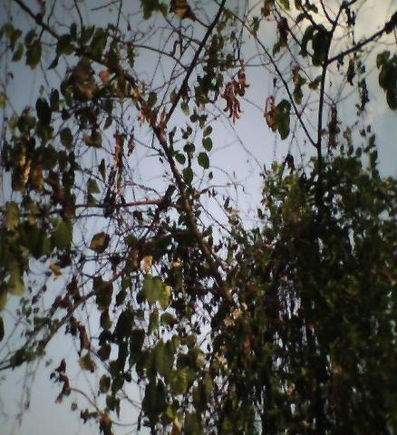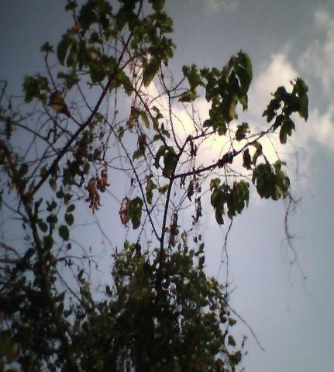

**Fig. 1.1 *Mucuna pruriens* growing on trees at Tosa village near Moniya, Ibadan.**

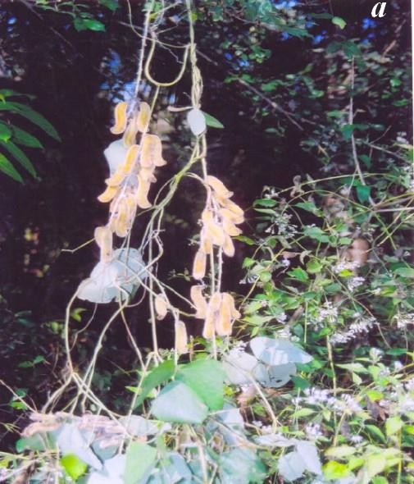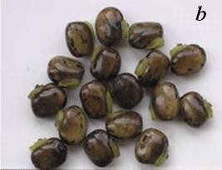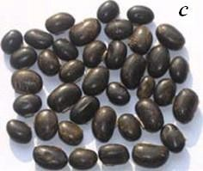

**Fig. 1.2** *Mucuna pruriens* climber in natural habitat with hanging bunch of pods in Abeokuta, Nigeria (a), ripened beans (b) and dried seeds (c)

prurienidine, prurienine, riboflavin, saponins, serine, serotonin, stearic acid, stizolamine, threonine, trypsin, tryptamine, tyrosine, valine, vernolic acid) (Sridhar and Bhat, 2007).

*Mucuna* seeds are in high demand in international market after the discovery of L- dopa, which serves as a potential drug for Parkinson's disease (Farooqi *et al*., 1999) and provides symptomatic relief against Parkinson disease (Nagashayana *et al*., 2000). *Mucuna* seeds produce hypoglycemic effect and the fruits possess a weak neuromuscular blocking effect in rats but not in alloxan-treated rats (Joshi and Pant, 1970). Presence of bioactive alkaloids such as nicotine, physostigmine and serotonin in the *Mucuna* seeds has been reported by Duke (1981). Mucunine, mucunadine, prurienine and prurieninine are the additional four important alkaloids isolated from seed extracts (Mehta and Majumdar, 1994). The seeds of *Mucuna pruriens* revealed high potassium (806-2790 mg/100g) (Janardhanan and Lakshmanan, 1985), while low potassium (356-433 mg/100g) was reported by Adebowale *et al.,* (2005a). Mineral composition of seed legumes is dependent on the soil edaphic factors including the genetic origin and geographical source (Vadivel and Janardhanan, 2000). It is known that iron, selenium, zinc and manganese strengthen the immune system as antioxidants (Talwar *et al.,* 1989). Similarly, magnesium, zinc and selenium are also known to prevent cardiomyopathy, muscle degeneration, growth retardation, alopecia, dermatitis, immunologic dysfunction, gonadal atrophy, impaired spermatogenesis, congenital malformations and bleeding disorders (Chaturvedi *et al.,* 2004).

The stem contains 5-methoxytryptamine, serotonine and trichomes of pods are used for de-worming.

Besides typical medicinal properties of *Mucuna pruriens* mentioned earlier, certain toxic compounds which can be responsible for the antioxidant activities and potential health benefits are known. The high phenolics may be responsible for the reduction of cardio-vascular diseases and cancer mortality (Hertog *et al*., 1997). Polyphenols are important phytochemicals due to their free radical scavenging and *in vivo* biological activities as reported by many investigators (Rice-Evans *et al.,* 1996; Bravo, 1998). Tannins are also known to possess health benefits, wherein they are 15-30 times more efficient in free radical quenching activity than Trolox and other simple phenolics (Hagerman *et al.,* 1998). The phytic acid of *Mucuna* possesses antioxidant,

anticarcinogenic and hypoglycemic activities (Graf and Eaton, 1990; Rickard and Thompson, 1997; Shamsuddin *et al.,* 1997) and is effective at low concentrations. Saponins are recently shown to have hypocholesterolemic as well as anticarcinogenic effects (Koratkar and Rao, 1997). Cholesterol lowering effect in animals and humans through the formation of mixed micelles and bile acids into miceller bile acid molecules by saponins have been reported by Okenfull *et al* (1984).

* + 1. **Experimental evidence of the potency of *Mucuna pruriens***

## L-dopa constituents

Cell suspension cultures of seeds of *Mucuna pruriens* accumulate L-dopa (Pras *et al.,* 1993). Paul and Joseph (2001) studied the effects of ethanolic seed extract of *Mucuna pruriens* on the gonads and sex accessory glands of male guinea-pigs and showed the presence of potential male antifertility agent. Due to the presence of L-dopa, *Mucuna pruriens* serve as a precursor of neurotransmitter and thus used as aphrodisiac and prophylactic agent in patients suffering from oligospermia to elevate the sperm count and improve the ovulation in women. As L-dopa acts as a nervine tonic, it prevents male and female sterility. The effectiveness of using *Mucuna* seed powder over synthetic L-dopa has been established by clinical trials (Hussain and Manyam, 1997). However, some reports reveal that administration of L- dopa have some serious side effects in patients suffering Parkinson's disease (e.g. confusion state, hallucination, nausea, vomiting, anorexia) (Infante, 1990, Reynolds, 1989). *Mucuna* plants are known to resist most of the pest-causing diseases due to high amount of L-dopa (Takahashi and Riperton, 1949).

* + - 1. **Antioxidant properties of *Mucuna pruriens***

Both *in vitro* and *in vivo* methods have been used in the study of the antioxidant properties of *Mucuna pruriens* by Tripathi and Upadhyay (2002) and Rajeshwar *et al* (2005a). The *in vitro* evaluation of ethanolic extract of *M. pruriens* in rat liver revealed no changes in the rate of aerial oxidation of glutathione S-transferase (GST), reduced form of glutathione, but it significantly inhibited ferrous sulphate-induced lipid peroxidation with inhibition of superoxides and hydroxyl radicals. The *in vivo* tests using albino rats up to 30 days revealed no toxic effect after oral administration up to a dose of 600 mg/kg body

weight. Similarly, no impact was seen on the level of thiobarbituric acid (TBA) reactive substances, reduction in glutathione level and superoxide dismutase (SOD) activity in the liver. The activity of serum GOT, GPT and alkaline phosphatase was also unaltered. With these observations, Tripathi and Upadhyay (2002) concluded that the alcohol extract of the seeds of *Mucuna pruriens* has an anti-lipid peroxidation property, which is mediated through the removal of superoxides and hydroxyl radicals. Rajeshwar and coworkers (2005a) investigated the antioxidant activities of methanol extract of seeds of *Mucuna pruriens* in various *in vitro* models by measuring the hydrogen donating ability in the presence of a scavenger, 2,2-diphenyl-1-picrylhydrazyl **(**DPPH) radical. Methanol extract at 100 µg/ml revealed an inhibition of up to 90.16% and the IC50 was 38.5 µg/ml. The reducing power effect of methanolic extract of *Mucuna pruriens* was studied based on the reaction of ferric (Fe+3) to ferrous (Fe+2) revealed that the reducing power of the extract increases with the elevated concentration. Rajeshwar and coworkers (2005a) concluded that the methanol extract of seeds of *Mucuna pruriens* showed strong antioxidant activity by inhibiting DPPH and hydroxyl radical, nitric oxide and superoxide anion scavenging, hydrogen peroxide scavenging and reducing activities compared with different standards such as L-ascorbic acid, curcumin, quercetin and α- tocopherol.

## Antitumor activity

Rajeshwar *et al* (2005b) also evaluated the antitumor activity of the methanol extract of *M. pruriens* seed in Ehrlich Ascites Carcinoma (EAC) tumor bearing mice. The animals treated 125 and 250 mg/kg of the methanol extract showed significant reduction of tumor volume, packed cell volume (PCV) and tumor (viable) cell count. The extract was also successful in restoring to near normal levels of hepatic lipid peroxidation, free radical scavenging enzyme (GSH) and antioxidant enzymes (SOD and CAT) in tumor- bearing mice.

## Antibacterial activity

The extracts of the leaf, stem, seed, fruit of Mucuna monosperma showed antibacterial activity against *Bacillus cereus, Escherichia coli, Proteus vulgaris* and *Staphylococcus* (Manjunatha *et al.,* 2006). The wound-healing potency of methanolic extracts of stem bark, seed kernel and leaves of *Mucuna monosperma* have been reported

by Manjunatha *et al.,* (2005). The extract of the stem bark and seed kernel extracts showed significant wound-healing potential in Swiss Wistar rats, which was evident by decrease in the epithelialisation, increase in wound-contraction, skin-breaking strength, dry weight of granulation tissue and the quantity of hydroxyproline. Wound-healing potential of Mucuna seeds has been attributed to the presence of several phytochemicals such as flavonoids, triterpenoids, tannins and sterols (Manjunatha *et al.,* 2005).

* + - 1. **Use of *Mucuna pruriens* in Parkinson's disease**

Traditionally, mucuna bean has been used as nerve tonic for nervous system disorder. Due to the high concentration of L-dopa in the seeds, it has been studied for possible use in Parkinson's disease (Vaidya *et al*., 1978). Parkinson's disease is a common age - related neuro-degeneration disorder affecting more than a million people worldwide. It is associated with progressive degeneration of dopaminergic neurons in specific areas in the brain. Dopamine does not cross the blood-brain barrier and therefore cannot be used directly as a treatment. However, L-dopa (levodopa) gains access to the brain where it is converted to dopamine. Mucuna bean is now being considered as an alternative to pharmaceutical medication. It was found to slow the progression of Parkinson's symptoms (such as tremors, rigidity, slurring, drooling) and to have none of the side effects of L- dopa. Numerous *in vivo* studies have also been conducted in rats and in humans. In one human study, the bean powder was given to 60 patients (26 previously treated with L- dopa and 34 had never taken L-dopa). There were statistically significant reductions of Parkinson's symptoms in all the subjects (Katzenschlager *et al.,* 2004). Its clinical use for several free radical diseases, especially the age related male infertility has been reported (Tripathi and Upadyhay, 2002).

## Antispasmodic, anti-inflammatory, fever reducing and antivenin properties of

### Mucuna pruriens

The root, fruit, leaf, and seed have shown significant *in vivo* antispasmodic, anti inflammatory, pain relieving, and fever reducing activities in various clinical researches with animals (Vermal *et al*., 1993). Traditionally, the seed has been used by indigenous peoples throughout the world for snake bite and several *in vivo* studies validate this

traditional use. In rats, a water extract of the seed inhibited venom-induced blood and coagulation alterations, and reduced lethality of the venom. The antivenin effect of mucuna bean is thought to be due to an immune mechanism, as proteins in the seed were documented to raise antibodies against the venom (Verma *et al.,* 1993).

* + - 1. **Use of *Mucuna pruriens* as aphrodisiac**

Mucuna has a long history of traditional use in Brazil and India as an aphrodisiac. Clinical studies in India have validated that the plant does indeed have aphrodisiac activity (Rastogi and Mehrotra, 1979).

* + - 1. **Use of *Mucuna pruriens* as anabolic and fertility agent**

The anabolic effect of the seed is due to its ability to increase testosterone (Katzenschlager, 2004). In 2002, a U.S. patent was filed on the use of mucuna bean to stimulate the release of growth hormone in humans. Research cited in the patent indicated that the high levels of L-dopa in mucuna seed were converted to dopamine, which stimulated the release of growth hormone, by the pituitary gland. L-dopa and dopamine are also effective inhibitors of prolactin. Prolactin is a hormone released by the pituitary gland. Increased levels of prolactin are considered to cause erection failure in males. In one study, oral intake of the seeds in 56 human males was able to improve erection, improve sperm count and motility (Katzenschlager, 2004). Mucuna has demonstrated little toxicity; however it has been documented in animal studies to cause birth defects and should not be used during pregnancy (Oudhia, 2001). This could suggest its use as an abortificant by some people in South-Western part of Nigeria.

## Antidiabetic screening methods

Appropriate experimental models are essential tools for understanding the pathogenesis, complications, and genetic or environmental influences that increase the risks of type 2 diabetes and testing of various therapeutic agents. The animal models of type 2 diabetes can be obtained either spontaneously or induced by chemicals or dietary or surgical manipulations and/or by combination thereof (Pederson, 1999).

## Animals used for screening of anti-diabetic drugs

Various animals are used for screening of anti – diabetic drug or plant. These include: Obese mouse, Diabetic mouse, Sand mouse (*Psammomys obesus*), Spiny mouse (*Acomys cahirinus*) Bio breeding (BB rats), KK mouse ,Yellow mouse, Yellow KK mouse, New Zealand obese mouse, Tuco-tuco (*Clenomys talarum*)- these are burrowing rodents from Argentina. Chinese hamster (Cricetulus griseus), Non obese diabetic (NOD) mouse. Japanese wistar rat (Goto rat) etc. (Kumar, 1997; Shafrir, 1992 and Pederson, 1999).

## Chemical agents capable of inducing diabetes

Different chemicals are used to induce diabetes in an animal model and these include (i) irreversible beta cytotoxic agents, examples of which are alloxan, streptozocin, diphenyl thiocarbazine, Onine – 9 – hydroxyquinolone and vacor (ii) reversible beta cytotoxic agents such as, 6 – aminonicotinamide, l – asparginase, azide, cyanide, cyproheptadine, phenytoin, Thiazides, Malonates (iii) other agents such as insulin antibodies, somatostatins, catecholamines, glucocorticoids and glucagon (Parmar, 2006; Shafrir, 1992; Pederson, 1999).

## Models for insulin dependent diabetes mellitus (IDDM)

## Alloxan induced diabetes

Alloxan is a cyclic urea compound, which induces permanent diabetes. It is a highly reactive molecule, which produces free radical damage to beta islet cells & causes cell death (Barker, C. F., 1982). When islets are exposed *in vitro* to alloxan, it exhibits exceptional beta cell specificity, the other islets cells remaining largely unaffected by both its inhibitory and cytotoxic effects (Turner, 1965). Several studies have shown that alloxan alters the properties of beta cell plasma membrane. In rodents islets treated *in vitro* with alloxan displays abnormal membrane morphology & altered the ion flux, both effects being prevented by high glucose concentrations. Although alloxan has an effect at plasma membrane, these changes may be secondary to actions of drugs on the cellular and molecular components of the beta cells (Winzell, 2004; Yoshikawa, 1997; Gelati, 1979). Following its uptake by the beta cells, alloxan interacts with sulphydrl- containing cellular

components, particularly sulphydryl enzymes known to be essential for beta cell function. Glucokinase, an enzyme which has signal-recognition function in coupling the glucose concentration to insulin release is particularly sensitive to inhibition by alloxan. Findings have led to hypothesis that the sulphydryl groups of glucokinase may be primarily the intracellular target for alloxan and responsible ultimately for its cytotoxicity. Enzymes like hexokinase, protein kinase are also inhibited by alloxan at higher concentrations (Reed, 1999). Other proposed mechanism for alloxan cytotoxicity include direct induction of mitochondrial abnormalities, extreme sensitivity of beta cells to the cytotoxic effects of free radicals (generated during the reduction/ re-oxidation cycle of alloxan) & damage to DNA within the beta cell nucleus. Alloxan induces fragmentation of DNA both *in-vivo* & *in-vitro*, which stimulates DNA repair by nuclear poly (ADP-ribose) synthetase, leading to delpletion of cellular NAD and impaired beta cell function. Alloxan may exert its effect at several sites including the plasma membrane, mitochondria and nucleus of the beta cell. In rats, alloxan at dose of 120 mg/kg produces diabetes. In rabbits, dose of 150 mg/kg infused through marginal ear vein produces diabetes in 70% of the animals (Bell, 1983; Gupta, 2006).

Albino rats of either sex (150 - 200 g) are injected with a single dose of alloxan monohydrate (120 mg/kg body weight) dissolved in normal saline by i.p. route. Animals are kept for 48 hours during which food and water is allowed *ad libitum*. Blood glucose levels show triphasic response with hyperglycemia for one hour followed by hypoglycemia that lasts for six hours & stable hyperglycemia after 48 hours. Animals showing fasting blood glucose level above 140 mg/dl after 48 hour of alloxan administration are considered diabetic (ADA, 1985). For a period of six weeks, drug samples to be screened are administered orally. After six weeks of treatment, blood samples are collected from 8 hour fasting animals through a caudal vein. Serum is separated by centrifuge (3000 rpm) under cooling (2-4 °C) for ten minutes. The serum glucose level is estimated by glucose oxidase-peroxidase method [GOD-POD kit] using autoanalyser.

## Mechanism of alloxan action

Alloxan (2,4,5,6-tetraoxypyrimidine; 5,6-dioxyuracil) was first described by Brugnatelli in 1818. Wöhler and Liebig used the name ―alloxan‖ and described its synthesis by uric acid oxidation (Lenzen and Panten, 1988). Alloxan exerts its diabetogenic action when it is administered parenterally: intravenously, intraperitoneally or subcutaneously. The dose of alloxan required for inducing diabetes depends on the animal species, route of administration and nutritional status (Szkudelski, 2001). Human islets are considerably more resistant to alloxan than those of the rat and mouse (Eizirik *et al*., 1994). The most frequently used intravenous dose of this drug to induce diabetes in rats is 65 mg/kg b.w. (Gruppuso *et al*., 1990, Boylan *et al*., 1992). When alloxan is given intraperitonealy or subcutaneously its effective dose must be 2-3 times higher. Fasted animals are more susceptible to alloxan (Katsumata *et al.,* 1992, Szkudelski *et al.,* 1998), whereas increased blood glucose provides partial protection (Bansal *et al*., 1980, Szkudelski *et al*., 1998).

The mechanism of alloxan action has been intensively studied, predominantly *in vitro*, and has been well characterized. Two separate experiments by Weaver *et al*., (1978) and Kliber *et al*., (1996) using isolated islets and perfused rat pancreas respectively, demonstrated that alloxan caused a sudden rise in insulin secretion in the presence or absence of glucose. Weaver *et al.* (1978) discovered that the sudden rise in insulin secretion appeared just after alloxan treatment and was not observed after repetitive exposure of islets to alloxan. Szkudelski *et al*., (1998) also observed *in vivo* the sudden rise in blood insulin concentration just after alloxan injection to rats. This alloxan-induced insulin released is of short duration. This, however, is followed by complete suppression of the islet even when high concentrations of glucose were used (Kliber *et al*., 1996). The diabetogenicity of alloxan in the pancreas is as a result of a rapid uptake of alloxan by the B cells (Weaver *et al*., 1978, Boquist *et al*., 1983). Another factor is the formation of reactive oxygen species (Heikkila *et al*., 1976). Even though another uptake of alloxan takes place in the liver, the liver and other tissues are more resistant to reactive oxygen species in comparison to pancreatic B cells and this resistance protects them against alloxan toxicity (Malaisse *et al*., 1982, Tiedge *et al*., 1997). Different reducing agents account for the reduction of B cells of the pancrease. Those SH-containing cellular

compounds that have high affinity to alloxan such as reduced glutathione (GSH), cysteine and protein-bound sulfhydryl groups (including SH-containing enzymes) are susceptible to alloxan action (Lenzen and Munday, 1991). Lenzen *et al.,* (1987) proposed that one of the SH-containing compounds essential for proper glucose-induced insulin secretion is glucokinase, being very vulnerable to alloxan. Alloxan reacts with two -SH groups in the sugar-binding site of glucokinase resulting in the formation of the disulfide bond and inactivation of the enzyme.

Glucose can protect glucokinase against the inactivation hindering the access of alloxan to the -SH groups of the enzyme (Lenzen *et al*., 1987, 1988, Lenzen and Mirzaie- Petri, 1991). Dialuric acid is formed as a result of alloxan reduction. It is then re-oxidized back to alloxan establishing a redox cycle for the generation of superoxide radicals (Munday, 1988). The reaction between alloxan and dialuric acid is a process in which intermediate alloxan radicals (HAO) and an unidentified "compound 305" (maximum absorption at 305 nm) is formed. The latter appears when alloxan is reduced by GSH (Sakurai and Ogiso, 1991). Superoxide radicals are able to liberate ferric ions from ferritin and reduce them to ferrous ions. Fe3+ can also be reduced by alloxan radicals (Sakurai and Ogiso, 1995). Moreover, superoxide radicals undergo dismutation to hydrogen peroxide as shown in equation (1):

O2 + O2 +2 H+ → H2O2 + O2 (1)

This reaction may occur spontaneously or may be catalyzed by superoxide dismutaseas shown in Fig. 1.3.

-SH HS-

*GK*

*GK*

-S-S

### Allaxan HA



O2

O2

O2-2 O2-2

+

+ 2Hc

***Dialuric acid***

H2O2 + O2

Fe2

Fe2 

OH

augmented Ca2 influx from extracellular fluid augmented Ca2 mobilisation from intracellular stores limited Ca2 climination from the cyroplasm

[Ca2+],

## Fig. 1.3: Schematic diagram of the oxidative reactions of alloxan

## Streptozotocin induced diabetes

Streptozotocin is a broad-spectrum antibiotic, which causes beta islet cell damage by free radical generation. It induces diabetes in almost all species of animals excluding rabbits and guinea pigs. Diabetes can be induced by streptozotocin when it is given either as single large (as with alloxan) or as multiple sub diabetogenic injections.

## Single dose streptozotocin diabetes

Streptozocin may share several common beta cytotoxic mechanisms with alloxan and damage the beta cell membrane, producing changes similar to those induced by the alloxan (Barker, 1982). It is also thought to act intracellularly, where it may deplete the islet content of NAD. Streptozotocin shares with alloxan the ability to induce strand breaks in beta cell DNA. Moreover the induction of these lesions by streptozotocin is followed by a cascade of intracellular events similar to those provoked by exposure to alloxan i.e. stimulation of DNA repair (via poly- ADP- ribose synthetase), reduction of islet NAD content and subsequent inhibition of the islet functions. Despite some evidence that streptozotocin and alloxan exert their beta cytotoxic effects via a common mechanism, other work (Barker, 1982) suggests that this may not be the case.

## Multiple low dose streptozotocin diabetes

Diabetes can be induced in mice by repeated injections of sub diabetogenic doses of streptozotocin and was associated with marked pancreatic insulitis, which suggested pathogenic involvement of cell mediated immunity and similarity to human IDDM. A further similarity of this model to human IDDM is that the susceptibility to develop diabetes is influenced by genetic factors, as the disease occurs only in certain inbred strains of mice (Gupta, 2006). Low dose streptozotocin induced diabetes is a useful tool to study the ways in which the immune processes may augment the effects of beta cytotoxic agent but not the spontaneous development of IDDM. The dose for diabetogenic dose in mice is 200 mg/kg i.p. For Beagle dogs the dose is 15 mg/kg i.v. for three days.

## Procedure for injecting streptozotocin

Streptozotocin (60 mg/kg body weight) is prepared in citrated buffer (pH 4.5). Albino rats of either sex weighing 150-200 g are injected i.p with above solution. Animals showing fasting blood glucose levels > 140 mg/dl after 48 hours of streptozotocin administration are considered diabetic. After six weeks of treatment blood samples are collected from 6 hr fasted animals through caudal vein. Serum is separated by centrifuge (3000 rpm) under cooling (2-4 °C) for ten minutes. Serum glucose level is estimated by glucose- peroxidase method (GOD-POD kit) using autoanalyser.

## Virus induced diabetes

Viruses are one of the etiological agents for IDDM. They produce diabetes mellitus by infecting and destroying beta cells of pancreas. Various human viruses used for inducing diabetes include RNA picornovirus, encephalomyocarditis (EMC-D), coxsackie B4 (CB-4). 6-8 week old mice are inoculated by 0.1 ml of 1:50 dilutions of D- variant encephalomyocarditis (EMC) through i.p. 0.1 ml of above dilution contains 50 PFU (plaque forming units) of EMC virus.(mortality due to this concentration of virus is approximately 10-20%). A less infecting variant produces a comparable damage by eliciting autoimmune reactivity to the beta cells. Infected animals are considered hyperglycemic if there non fasting levels exceed by 250 mg/dl the levels of uninfected animals of the same strain. Drug samples to be screened are administered orally for a period of 6 weeks. After 6 weeks of drug treatment, blood glucose estimation is done to determine the anti diabetic activity.

## Insulin antibodies induced diabetes

A transient diabetic syndrome can be induced by injecting guinea pigs with anti insulin serum. Diabetes persists as long as antibodies are capable of reacting with insulin remaining in the circulation. Bovine insulin, dissolved in acidified water (pH 3.0) at a dose of 1mg is injected to guinea pigs weighing 300-400 gm. Anti insulin sera is collected after two weeks of antigenic challenge. Adult albino rats are injected with 0.25-1.0 ml of guinea pig anti- insulin serum. Insulin antibodies induce a dose dependent increase of

blood glucose level up to 300 mg/ dl. The drug sample to be screened is administered by a suitable root and blood glucose level is analysed to determine the activity.

## Hormone induced diabetes

Dexamethasone is a steroid possessing immunesuppresion action, which causes an autoimmune reaction in the islets and produces type 1 diabetes. Adult rats weighing 150- 200 gm are injected with dexamethasone at a dose level of 2-5 mg/kg body weight i.p. twice a day. Repeated injection of same dose level is carried out for a period of 20-30 days resulting in IDDM. The sample to be screened is administered through a suitable root. Blood glucose is analyzed to determine the activity.

## Genetic models

## Non obese diabetic mouse (NOD mouse)

This is a model for IDDM. Hypoinsulinemia is developed which is caused by autoimmune destruction of pancreatic beta cells in association with autoantibody production. Mice are bred at laboratory by sib mating over 20 generations. After 20 generations of sib mating, spontaneous development of IDDM in mice is obtained. Diabetes develops abruptly between 100-200 days of age. Characterized by weight loss, poly urea, severe glucosurea). Animals are treated with the drug sample to be screened. Blood sample is analysed for glucose level to determine activity.

## Bio breeding rats (BB) rats

The BB rats were discovered in 1974 by Drs Reignald and Clifford Chappel in a commercial rodent breeding company (Biobreeding laboratories Ltd.) in Ottawa. The diabetogenic syndromes of BB rat shares many characteristics with human IDDM. There is genetic predisposition to develop the disease and long prediabetic period followed by abrupt onset of symptoms at around three months of age. Rats are bred at the laboratory by sib mating over 20 generations. After 20 generations of sib mating spontaneous development of IDDM in rats is obtained. The onset of clinical diabetes is sudden and occurs at 60- 120 days of age. (Clinical presentation is similar to that of humans with marked hyperglycemia, glycosurea and weight loss and decrease plasma insulin, and these

results in ketoacidosis if untreated). Animals are treated with drug samples to be screened for a required period of time. Blood sample is determined for glucose level to determine activity.

## Adrenaline induced acute hyperglycemia

Adrenaline is a counter regulatory hormone to insulin. It increases the rate of glyconeolysis and the glucose levels in blood causing hyperglycemia. Adult albino rats are injected at a dose level of 0.1 mg / kg through subcutaneous (s.c.) route. The dose produces peak hyperglycemic effect after one hour and lasts up to four hours. The drug sample to be analyzed is administered through a suitable route. Blood glucose is determined. (The oral hypoglycemic agents can be screened by this method).

## Dithizone induced diabetes

Organic agents react with zinc in islets of langerhans causing destruction of islet cells and producing diabetes. Compounds such as dithizone, EDTA, 8-hydroxy quinoline are used to induce spontaneous type 2 diabetes in experimental animals. Dithizone at dose levels of 40-100 mg/ kg (i.v) produces type two diabetes in mice, cats, rabbits and golden hamsters. Adult rabbits weighing 1.8-2 kg are divided into two groups of six animals each. An exactly weighed amount of Dithizone is dissolved in dilute ammonia solution (0.2- 0.5%). The solution is warmed to 60-70 oC for 10 minutes to aid solubility of dithizone. Dithizone injection at a dose level of 50-200 mg/ kg will produce triphasic glycemic reaction. Initial hyperglycemia will be observed after 2 h & normoglycemia after 8 h, which persist for up to 24 h. permanent hyperglycemia, is observed after 24-72 h. The drug sample to be analysed is administered through a suitable route and blood glucose determined.

## Tablets

Tablets are solid pharmaceutical dosage forms containing drug substance with suitable diluents and prepared either by compression or molding methods (King, 1980). The drug with or without excipients is first converted into free flowing granules by dry moist granulation or by preliminary compression into large tablets, which are broken

down into granules. These granules are then compressed in suitable dies by means of punches.

Excipients used in tablet formulations include diluents (give the powder bulk), binders (impart cohesion), disintegrating agents (cause tablet to disintegrate), glidants (to enhance flow of granules), lubricants (to facilitate the release of tablets from the dies), colours (improve aesthetic value), and flavours and sweetening agents (mask offensive taste of components). Substances may also be added to modify the release and absorption of the drug.

The main features that have led to their dominant position as a dosage form in therapeutics are their convenience and ease of administration, the precision with which their drug content can be controlled, their durability and biological degradation and their smaller bulk. Advances in the field of tableting technology have led to these various types of tablets: chewable, sublingual, effervescent, coated, soluble, molded and sustained– release, each of which was developed to deal with a particular biopharmaceutical necessity.

## Advantages of tablet as a dosage form

1. They make it possible to administer an accurate dose of medicament safely.
2. Their transportation in bulk is easier and cheap.
3. They are light and compact thus making them convenient to carry and use.
4. They are the most stable of all oral dosage forms.
5. Their drug release can be controlled to the desired pharmacological effect.
6. Their production on large scale is quite simple and quick.
7. They are generally cheaper than other dosage forms.

## Disadvantages of tablet as a dosage form

1. They are most often given in repeated daily doses to maintain therapeutic plasma drug concentration. This, however, makes patient compliance difficult. Though, in the alternative, sustained release tablets make daily dose possible.
2. Not all of them can be swallowed and still give the desired therapeutic effect e.g. nitroglycerin is placed under the tongue and allowed to slowly dissolve to yield its effect.
3. When a rapid onset of action is desired they are not a first line choice.
4. Drugs requiring large dose to be given or requiring optimum absorption in the gastrointestinal tract may be difficult to tablet.

## Tablet excipients

Some excipients mentioned above can now be explained in details as shown in Table 1.1. The excipients help to impact satisfactory compression characteristics to the formulation, while others help to give additional desirable physical characteristics to the finished tablet

e.g. colour, flavour and sweeteners in chewable tablets (King and Osoe 1975). These excipients include:

## Binders

Binders function primarily by imparting cohesion to the powder in the formulation during the granulation process and ultimately improve the strength of the granules and tablets formed during compression. Binders may be incorporated dry (as powder e.g. acacia and tragacanth) or wet (as mucilage or syrups) depending on the method of granulation. They have been found, however, to be more efficient when incorporated as liquid. Some of the properties desired of a good binder are, high cohesive tendency with low viscosity, inert physiologically and non-toxic, free of microbiological contamination and high solubility in cold solvent thus requiring minimal amount of solvent for dissolution. Other examples of binders are alginate, polyvinylpyrolidone (PVP), starch, sorbitol, gelatin, glucose.

## Diluents

Diluents are fillers used to give the powder bulk so that an acceptable size tablet is produced. Most commercial tablets weigh from 100 to 500 mg so it is obvious that for many potent drugs the diluent comprises a large portion of the tablet. Binding of drug to

## Tables 1.1 Some common tablet excipients

**Diluents**

Lactose USP Mannitol USP

Lactose USP, anhydrous Sorbitol

Lactose USP, spray-dried Sucrose USP powder

Directly compressible starches Sucrose-based materials Calcium sulphate

Hydrolyzed starches Dextrose

dehydrate NF Microcrystalline cellulose NF Other cellulose derivatives

Dibasic calcium phosphate dehydrate NF

## Binders and Adhesives

|  |  |  |  |  |
| --- | --- | --- | --- | --- |
|  | Acacia  Cellulose derivatives Gelatin  Glucose Polyvinylpyrrolidone (PVP)  Starch, paste |  | Starch, pregelatinized Sodium alginate and alginate derivatives  Sorbitol Tragacanth |  |
|  |  | **Disintegrants** |  |
|  | Starch  Starch derivatives Clays  Cellulose |  | Cellulose  Alginates  PVP, cross-linked |
|  |  | **Lubricants** |  |  |
|  | Stearic acid Stearic acid salts  Stearic acid derivatives |  | Polyethylene glycols Surfactants  Waxes |  |

**Glidants and Flow Promoters**

Silica derivatives Talc

Cornstarch

## Colors, Flavours and Sweeteners

FD & C and D & C dyes and lakes Spray-dried and other flavours Natural sweeteners

Artificial sweeteners

the filler may occur and affect bioavailability. Examples are lactose, sucrose, sorbitol, calcium sulphate, dextrose, microcrystalline cellulose, etc.

## Disintegrants

A disintegrant is used to cause the tablet to disintegrate when exposed to an aqueous environment. Too much will produce tablet which may disintegrate in the container due to atmospheric pressure. Too little may be insufficient for disintegration to occur and may thus alter the rate and extent of release of the drug from the dosage form. Examples of disintegrants are starch, PVP, cellulose, clays, etc.

## Lubricants

Lubricants are used to enhance the flow of the powder to the tablet machine and to prevent sticking of the tablet in the die of the machine after the tablet is compressed. Lubricants are usually hydrophobic materials such as stearic acid or magnesium or calcium stearate. Too little lubricant will not permit satisfactory tablet to be made and too much may produce a tablet with a water impervious hydrophobic coat. This impervious coat can inhibit disintegration of the tablet and dissolution of the drug. An ideal lubricant should be white or colourless, odourless, tasteless, soluble in water, non-toxic and efficient at low concentrations. Other examples of lubricants are polyethylene glycols, surfactants and waxes.

## Glidants or flow promoters

A glidant reduces friction between particles thus enhancing the flow of powder or granules from the feed mill to the die leading to uniformity and consistency in the weight of tablets produced. Examples are talc and corn starch.

## Colouring agents

A colouring agent improves the aesthetic value hence the appeal and acceptance of the product as well as making identification of the product and maintaining color uniformity among batches possible. An ideal colorant should have the following qualities:,

stablility to light, heat and pH changes, resistance to action of oxidizing and reducing agents and should be non-toxic.

Examples of colouring agents are FD & C, D & C dyes.

## Flavours and sweeteners

Sweeteners are only of limited importance and their use is restricted to chewable tablets. Sweeteners are used to mask the taste of the components which are offensive and thereby improve compliance and acceptability. Examples are sucrose, dextran and mannitol. Natural sweeteners such as thaumatin and glycyrrhizin have now been introduced in pharmaceuticals.

## Methods of tablet production

There are three main methods of tablet production; direct compression, compression granulation and wet granulation (Banker & Anderson, 1986). The last one being spheronization.

## Direct compression

This is the simplest of the three preparative techniques. The material to be tableted is screened through a sieve, if necessary, mixed with additional adjuvant and is then ready for compression. Tablets made in this way are said to have been prepared by direct compression.

There are a few crystalline materials such as sodium and potassium chloride, potassium iodide, sodium bromide and ammonium chloride that may be compressed directly. However, the vast majority of medicinal agents are rarely so easy to tablet. In addition, the compression of a single substance may produce tablets that do not disintegrate. This will necessitate the inclusion in the tablet formulation of additives like disintegrants. This disintegrant may interfere with the compressibility of the active ingredients in the powder. In addition, most materials possess relatively weak molecular attraction or are covered with films of absorbed gases that tend to hinder compaction.

The use of directly compressible fillers and diluents with the drug may produce good quality tablets without prior manipulation. The direct compression diluents in addition to possessing good flow and compressibility, must be physiologically inert, tasteless, able to disintegrate and inexpensive.

The particle size should be such as to minimize segregation of the powder bed during compression. It should have a high bulk density and considerable capacity for dilution with drug substance. In event of defective tablets, the tablets being produced should be capable of being broken down and re-compressed. Examples of directly compressible diluents are microcrystalline cellulose (Avicel®), spray-dried lactose, calcium phosphate and micro fine cellulose.

The advantages of direct compression are:

1. It is a dry process and drugs susceptible to moisture degradation are good candidates for this mode of compression.
2. Low labour input.
3. There are few processing steps as the technique is streamlined. The limitations of the use of direct compression are:
   1. Poor content uniformity of the drug in the compressed tablet may occur. This problem is invariably caused by stratification within the powder bed due to differences in particle size and bulk density between the drug and the diluent. This problem is of special concern with low-dose drugs.
   2. A large-dose drug may present problems with direct compression if it is not easily compressible by itself. To facilitate compression, non-compressible large-dose drugs could require an amount of diluent so large that the resultant tablet is costly and difficult to swallow.
   3. In some instances, interaction may occur between the compressible diluent and the drug. A typical example is the Maillard reaction between amine compounds and spray-dried lactose, which results in a yellow discoloration (Banker & Anderson, 1986).
   4. Because of the dry nature of direct compression, static charges may develop on the drug during mixing which may prevent uniform distribution and result in inadequate mixing.

## Compression granulation

Compression granulation is a valuable technique in situations where the effective dose of a drug is too high for direct compression, and the drug is sensitive to heat, moisture or both, which precludes wet granulation, and where granules yielded from other granulation techniques are of poor compression properties. Many aspirin and vitamins preparations are prepared for tableting by compression granulation.

Compression granulation involves the compaction of the components of a tablet formulation by means of a tablet press or specially designed machinery, followed by milling and screening, prior to final compression into a tablet. When the initial blend of powders is compacted by means of flat faced punches, the compacted masses are called slugs, and the process is referred to as slugging. The slugs are then screened (or milled) to produce a granular form of the material for tableting. When a single slugging process is insufficient to confer the desired granular properties to the material, the slugs are sometimes screened, slugged again, and screened once more. Slugging is just an elaborate method of subjecting a material to increased compression time (i.e. increased dwell time during compression). The slugging process effectively converts the poor flowing initial blend of powder into granules, which flow more freely and uniformly. To aid the flow of the initial blend of powder into the dies of the heavy-duty tablet press utilized for the preliminary compression, the following techniques and/or additions may be made:

1. Vibratory feed devices may be attached to the hopper.
2. Large punches (2.5 cm) are used (to aid die filling).
3. The press is operated at slow speed.

It is noteworthy that flat-faced punches are necessary, as the high compaction pressures employed for slugging would widen the edges of a concave punch.

However, the use of heavy-duty tablet press with these innovations would expectedly have the following limitations:, (i) the use of the vibratory feed devices may cause de-mixing within the hopper, (ii) the slow operation of the tablet press would result in slow production rate, (iii) excessive lubrication of powder may be needed to induce good flow and this may weaken granule strength.

Hence on a large scale, compression granulation is performed on a specially designed machine called roller compactor. Roller compactors are capable of producing as

much as 500 kg per hour or more of compacted material, which can be screened or milled into a granulation suitable for compression into tablets. In addition, there is greater control of compaction pressure and dwell time, and also there is no need for excessive lubrication of the powder (Banker & Anderson, 1986).

## Wet granulation

Wet granulation is the most widely used method of granulation. The unique portions of wet granulation process involve the wet massing of the powders, wet sizing or milling, and drying. Wet granulation forms the granules by binding the powders together with an adhesive instead of by compaction. The wet granulation process employs a solution, suspension, or slurry containing a binder, which is usually added to the powder mixture. However, the method of introducing the binder depends on its solubility and on the components of the mixture. Liquid bridges are developed between particles, and the tensile strength of these bonds increases as the amount of liquid added is increased. In cases where only a small amount of liquid is to be added, the binder is blended dry with the powder mixture. If, however, the amount of the solvent permissible is large, the binder is dissolved in the solvent. Once the granulating fluid has been added, mixing continues until a uniform dispersion is attained and all the binder has been activated. During granulation, particles and agglomerates are subjected to consolidating forces by the action of machine parts and inter-particulate forces. Granulation in large blenders requires 15 minutes to an hour. The length of time depends on the wetting properties of the powder mixture and on the granulating fluid, and on the efficiency of the mixer.

A rough way of determining the end point is to press a portion of the mass in the palm of the hand; if the ball crumbles under moderate pressure then the mixture is ready for screening.

Wet screening involves converting the moist mass into coarse, granular aggregates. On a large scale, this is achieved by passing the mass through a hammer mill or oscillating granulator, while in the laboratory, it is forced through a sieve. The screening process further consolidates the particles; increases particles contact point as well as surface area to facilitate drying. Overly wet material dries slowly and forms hard aggregates, which tend to turn to powder during subsequent, dry screening.

Drying serves a dual purpose of removing the solvent of the granulating fluid and also reducing the moisture content to an optimum level (usually 2-4%). The conditions and equipment used in the drying process are selected according to the nature of the substances in the tablet formulation. In general, most thermal resistant substances are dried at 60°C while lower temperatures are employed for thermo labile materials. The fluid-bed dryer is suitable for most granules and has superceded tray drying in the tableting industry. This is accounted for by the shorter drying time of the fluid-bed dryer over tray dryer and with a consequent greater output of dried material per unit time. If a tray dryer must be used, adequate provision must be made for air exchange to prevent saturation of the oven atmosphere with solvent vapour.

In the dry screening stage, the dried granules are broken down and reduced to a size compatible with the tablet diameter. Too vigorous dry screening causes granule structure to be lost with the production of excessive quantities of fines. Although a proportion of these is required to fill voids between the large granules, so giving a smooth tablet surface, an excess causes difficulty at the compression stage (Banker & Anderson, 1986).

## Stages in the development of moist granules

Newitt and Conway-Jones (1958) were the first to describe stages of development of moist granules. They observed that on addition of a granulating fluid to a mass of powder a series of events characterized by 4 stages would occur, which are:

Stage A — Pendular state Stage B — Funicular state Stage C — Capillary state Stage D — Droplet state

## Pendular state

With the wetting of powder particles at the initial stage (A), liquid films would be formed on the surface and these may combine to produce discrete liquid bridges; in Fig. 1.4A. At the point of contact, the surface tension and negative capillary pressure in

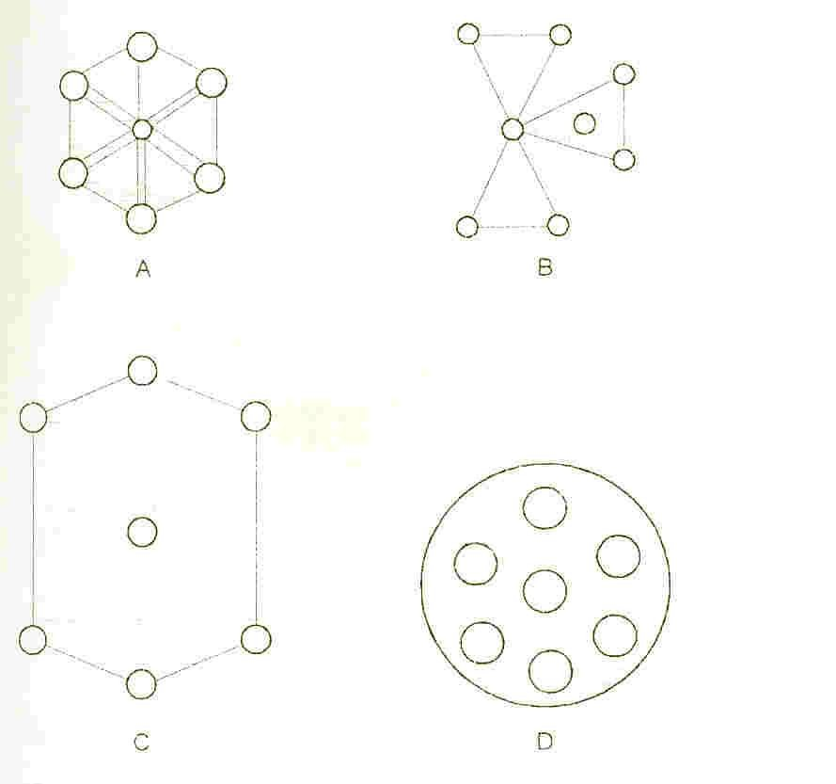Key

A-Pendular state B-Funicular state C-Capillary state D-Droplet state

## Fig. 1.4: Stages in the development of moist granules

such bridges provide a cohesive force that results in the condition called the pendular state. This state has a comparatively low mechanical strength.

## Funicular state

Here, several bridges coalesce to give rise to the funicular state (Fig. 1 .4B) as the liquid content increases. There is also a further modest increase in the strength of the moist granule.

## Capillary state

As more liquid is added and the mass is kneaded to bring particles into closer proximity, the void spaces within the granules are entirely eliminated. At this point bonding is effected by interfacial forces at the granule surface and by negative capillary pressure throughout the interior liquid filled space - a condition referred to as the capillary stage as shown in Fig. I.4C. The capillary state coincides with the maximum strength of the wet granules and optimization of many granulation processes involves ensuring that this state has been achieved. Granulation equipment can now be instrumented with torque measuring devices, which sense the change in agitator power requirement at the capillary stage as shown in Fig. 1.5.

## Droplet state

A further addition of liquid after the capillary state has been attained results in droplet formation as shown in Fig. 1.4D, in which the particles are still held together by surface tension but without intra-granular forces. Such structures are the weakest.

The concentration of binder and the quantity of granulating fluid used are the factors contributing to an increase in granule strength. For any given material, smaller initial particle sizes lead to granules of greater strength, presumably because of the increased occurrence of interparticulate contacts (Shotton and Ganderton, 1960).

Granule strength is sometimes optimized by small residual moisture, though this is more desirable for its lubricant potential during compaction at higher applied loads. The migration of soluble components to the surface of the granules during drying, may lead to a surface layer that is typical of the bulk, thus assisting or hindering the consolidate

performance of the granules when they are subsequently compressed. Optimum moisture levels are peculiar to formulations (York and Pilpel, 1973), hence moisture level should be determined routinely during formulation development.

## Tablet compression

Tablets are prepared by compressing particulate solids in a die by the application of forces through two punches. The lower punch moves up and down within the die but never eventually leaves it, while the upper punch descends to penetrate the die and apply the compressive force and then withdraws to allow ejection of the tablet from the die. In some machines, only the upper punch moves and these are called stamping press.

## Compression sequence

The compaction process can be divided into three distinct stages (Fig. 1.6):

1. The lower punch falls within the die, leaving a cavity into which particulate material can flow under the influence of gravity.
2. The upper punch descends and the punch tip enters the die, confining the particles. Further punch movement applies the compressive force to the particles which aggregate to form a coherent tablet.
3. The upper punch withdraws from the die and simultaneously the lower punch rises until its tip becomes level with the top of the die. The tablet is thus ejected from the die and removed from the tablet press.

## 1.10.6.2 Tablet compression machinery

There are two types of tableting machines in common use:

1. The single punch or eccentric press.
2. The multi-station or rotary press.

0000

**START OF FLUID ADDITION**

**F**

0000

**TORQUE**

## AMPL

**FLUID ADDITION**

Key

Arrows (→) - Start of fluid addition

F-Direction of Interfacial forces

## Fig. 1.5: Change in torque of mixer shaft during addition of granulating fluid

I



oooo**o**ooooo

oooooooooo

oo oooo

oooooooo

II



ooooo

III



ooooo

If Elastic If Plastic



ooooo



ooooo

y

1. The lower punch falls
2. Upper punch descends
3. Upper punch withdraws

ON DECOMPRESSION iv

## Fig. 1.6: Stages involved in compression (I-IV) and decompression (Banker and Anderson, 1986).

* + - 1. **The single punch or eccentric press**

This tablet machine has only one compression station. Die filling is by aid of feed shoe, which oscillates over the die. It has a low maximum output of 150-200 tablets per minute which makes it unsuitable for large-scale production.

## Multi-station or rotary press

This type has several compression stations. The essential feature being the central circular rotating head, which carries the dies with the punches, set in tracks above and below the central position.

Compression is effected by the upper and lower punches pressing the granules between them. Output here is large, usually up to 1,500 tablets per minute. Thus, it has found wide use in pharmaceutical manufacturing.

## Advanced high speed presses

The development of devices for promoting granule flow, die-filling and the removal of air during compression has permitted the introduction of ultra-high speed presses (Talman, 1977; King and Schwartz, 1985), the double and triple-rotary machines. Granule flow from the hopper onto the feed frame of the conventional tableting machine is governed by the height of the hopper outlet above the die table (i.e gravity controlled). This process of die filling is grossly inadequate for the high speed presses which may require the die filling, compression and ejection operations to be completed in a fraction of a second (Armstrong, 1989). In order to provide granule flow that is commensurate with the speed of rotation of the turrets of rotary presses, vibratory devices are attached to this hopper. However, the flow rate desired for the ultra-high speed presses require more efficient feeding devices such as the Stokes metering hoppe (Talman, 1977; King and Schwartz, 1985). Another technique that has been employed is the induced feeding of the die cavity. The Manesty rotaflow feeder employs contrarotating vane rotors in an enclosed feed frame to direct granules into the dies (Talman, 1977). The very short compression cycle operational in the ultra-high speed presses would not permit a complete removal of air from the granule bed under compression. This may inhibit inter-granular bonding that may, in turn, promote caping and lamination of tablets. In order to eliminate this problem,

precompression rollers have been designed into some rotary presses to exert a slight compaction on granules prior to the main compression process.

Some additional features designed into the ultra-high speed presses have contributed significantly to the attainment of some standard requirements of Good Manufacturing Practice (GMP) as defined by the US Food and Drug Administration. Such features include computerization and programming of production sequence, continuous in- process control and facilities for full data storage (King and Schwartz, 1985).

Ultra-high speed presses include the Excelapress, Novapress, Rotapress and Unpress (Manesty Machines, Liverpool, U.K.) and the Perfecta series (Wilheim Fette GmbH, Germany). The Fette PT 2080 models are available as 22-, 29-, 36- and 43 station presses with capacity in excess of 290,000 tablets per hour and facilities for handling tablets with diameter up to 25 mm and compression presses up to 80,000 N (King and Schwartz, 1985).

## Evaluation of tablets

The aim of drug development is to move toward an ideal tablet, that is, one, which will provide a perfectly selective biological drug action with no side effects and no toxicity. However, there is no such tablet formulation. The desired effect must be well defined and a procedure must be outlined that can determine whether or not a particular tablet has the specified effect.

To design tablets and later monitor tablet production quality, quantitative evaluation and assessment of a tablet‘s chemical, physical and bioavailability properties must be made. The in-process tests routinely needed to monitor and evaluate tablet production quality include:

## Crushing strength and friability

The crushing strength is the measurement of tablet hardness. Tablets require a certain amount of strength and resistance to friability, to withstand mechanical shocks of handling in manufacture, packaging, and shipping. In addition, tablets should be able to withstand reasonable abuse when in the hands of the consumer.

The crushing strength is defined as the force required to breaking a tablet in a diametric compression test and like its thickness, is a function of the die fill and compression force. At a constant die fill, the crushing strength values increase and thickness decreases as additional compression force is applied. At a constant compression force (fixed distance between upper and lower punches) crushing strength increases with increasing die fills and decreases with lower die fills.

In general, tablets are harder several hours after compression than they are immediately after compression. Tablet hardness is not an absolute indicator of strength since some formulations, when compressed into very hard tablets, tend to ―cap‖ on attrition, losing their crown portions. Therefore, another measure of tablet strength, its friability, is often measured. This involves measuring the propensity of tablets to break into crumbs or pieces when subjected to disruptive forces.

## Factors affecting mechanical strength of tablets

The factors affecting mechanical strength of tablets are binding agents (Itiola and Pilpel, 1986; Esezobo & Pilpel, 1976; Kurup & Pilpel, 1977; Esezobo and Pilpel, 1977), compression pressure (Pitt *et al*., 1991; Itiola and Pilpel, 1986) and granule size (Pilpel, 1969; Esezobo and Pilpel, 1977; Shotton and Ganderton, 1960; Rumpf, 1962; Itiola and Pilpel 1991; Esezobo and Pilpel, 1976; Itiola and Pilpel, 1986; Itiola, 1983; Esezobo and Pilpel, 1977; Itiola and Fell, 1983; Esezobo and Pilpel, 1976), temperature (Hanus and King, 1968, Rankell and Higushi, 1968; York and Pilpel, 1972; Britten and Pilpel, 1978; Esezobo and Pilpel, 1986), moisture content (Ahlneck and Alderborn, 1989; Sehbatu *et al*., 1997), coating (York and Pilpel, 1973; Irono and Pilpel, 1982a, b; Malamaturis and Pilpel, 1982a).

## Evaluation of drug content and release (disintegration and dissolution)

## Disintegration

It is generally recognized that *in vitro* tablet disintegration test does not necessarily bear a relationship to the *in vivo* action of a solid dosage form. To be absorbed, a drug substance must be in solution and the disintegration test is a measure only of the time required under a given set of conditions for a group of tablets to disintegrate into particles.

The bioavailabilities of drugs that are administered orally in solid form depend on their rates of disintegration and dissolution (Banker and Anderson, 1986). Factors affecting disintegration of tablets include binding agents (Kurup and Pilpel, 1979), disintegrants, compression pressure (Khan and Rhodes, 1976), lubricant, granule size, surfactants, granular mixing time and method of granulation and the apparatus used in the determination of disintegration time. Some postulated mechanisms of the theories of disintegration include evolution of gas, heat of wetting (Matsumaru, 1959), effect of water absorption (Lowenthal, 1973), swelling (Ringard and Guyot-Hermann, 1981; Kanig and Rudnic, 1984), porosity of tablets (Singh *et al*., 1968; Kurup and Pilpel, 1977; Kanig and Rudnic, 1984; Shangraw *et al*., 1980).

## Dissolution

Like disintegration test, dissolution test measures the amount of time required for a given percentage of the drug substance in a tablet to go into solution under a specified set of conditions. It is an *in vitro* test. It is intended to provide a step towards the evaluation of the physiological availability of the drug substance. Like the disintegration test, it does provide a means of control in assuring that a given tablet formulation is the same with regard to dissolution as other batches of the tablets in term of clinical effectiveness.

Thus, drug absorption requires the molecules be in solution at their absorption site. Dissolution of solid dosage form (tablet) in the gastro intestinal tract (G.I.T) fluid is a prerequisite to the delivery of a drug to the systemic circulations.

## Dissolution as parameter affecting drug absorption

The absorption of drugs administered orally as solids consists of two consecutive processes: the process of dissolution, followed by the transport of the dissolved material across gastrointestinal membrane into systemic circulation (Lieberman *et al*., 1989).

For relatively insoluble compounds, the rate-determining step in the overall absorption process is generally the rate of dissolution. On the other hand, for relatively soluble compounds, the rate of permeation across biological membrane is the rate- determining step.

The rate of dissolution can be altered via physical intervention (crushing strength, nature and concentration of binding agents and compression pressure). The rate of permeation, on the other hand, is dependent on size, relative aqueous and lipid solubility, and ionic charge of the solute molecules. These properties can be altered, in the majority of cases, only through molecular modification (Lieberman *et al.,* 1989).

## Methods used for dissolution rate studies

There are three main elements usually require for the design of apparatus for dissolution rate tests: means for agitating the dissolution medium; means for supporting the sample without impeding the flow of liquid and the means for estimating the quantity of drug that has been dissolved (Talman, 1977).

The attainment of the right degree of agitation that would adequately mimic peristaltic motion of the gastro-intestinal tract appears to be the most difficult task in the design and standardization of dissolution test apparatus (Talman, 1977). To ensure that the stirring elements of the apparatus rotate smoothly without significant wobble during its operation, the official methods adopted the forced convection stream lined flow procedure (BP, 1998).

The BP apparatus I (basket) and Apparatus II (Paddle) have been commonly used for dissolution rate studies. The ―flow through cell‖ (Apparatus III) has more recently been introduced by the BP (1998).

## Pharmacokinetic evaluation of medicinal plants

Pharmacokinetics is the action of body on the drug and includes absorption, distribution, metabolism and excretion (Hussain *et al*., 2009). Therapeutic outcome depends on the rate and extent at which drug reaches the site of action and its bioavailability. Pharmacokinetic parameters help to establish bioequivalence in-between formulations and to understand toxicology and drug exposure. Pharmacokinetic studies of herbs may also assist physicians in prescribing drugs safely and effectively to those patients who are consuming herbal products, because herbs may synergise or antagonise the drugs and herb-drug interactions (Esinome *et al*, 2002). Natural product scientists have been studying pharmacodynamics, the action of herbs on the body but less attention has

been paid to study the effect of body on herbs (De Smet and Brauwers, 1997). Unlike pharmaceuticals, pharmacokinetics of herbal products, mixture of known and unknown components, is always challenging due to their complexity and unavailability or inadequacy of standards and methods. Moreover, lack of pharmacokinetic studies is the biggest hindrance in the modernization of herbal products because there is no way to establish bioequivalence between products prepared by modified method and the original method (Handa, 1996). Pharmacokinetic studies are of prime importance prior to clinical trials of herbal products to make these remedies evidence-based drugs (Mills and Bone, 2000). Two approaches, compartment and non-compartment model are commomnly used to evaluate pharmacokinetics of antidiabetic medicinal plants which may follow a first order glucose kinetics (Hussain *et al*., 2009).

## Aims and objectives

One of the chronic, worldwide heterogeneous, life threatening disease is diabetes. International Diabetic Federation quoted 6% of the world‘s population (230 million people) as sufferers, (Gbolade, 2006). It was predicted that the prevalence of it will be 5.4% by the year 2025 with the global diabetic population reaching to 300 million (Khan and Khanum, 2005). In Nigeria, diabetes mellitus is among the ten leading causes of death. According to the Diabetic Association of Nigeria, the number of people suffering from diabetes is about 10 million and half of this number are in Lagos (Gbolade, 2009). The number is increasing in both rural and urban areas and the fact is that access to orthodox therapies are difficult or even non-exist and in some cases costly to be accessible for rural dwellers which form the larger population. So most of the rural dwellers use one plant or the other to control or treat diabetes mellitus. In spite of their efficacy, herbal medicinal products have been widely criticized due to lack of standardization and poor- quality presentation (Majekodunmi *et al*., 2008). Hence, there is a need to formulate a herbal antidiabetic that is convenient, cheap, safe and effective for the treatment of diabetes mellitus.

*Mucuna pruriens* (Fam. Fabaceae) is grown wildly in bushes, gardens, bush parts and large plantations in Nigeria. In traditional medicine, the seeds of *M. pruriens* are ground and soaked in water or alcohol and unspecified quantities of the decoction are

ingested without regard to toxicological and other adverse effects. Formulation of *M. pruriens* into tablet dosage form might ensure dosage precision and confer on it many of the good properties of tablets, which include ease of administration, patient acceptance due to better presentation, prolonged shelf life, and quality assurance in dispensing and reduction in cost arising from transportation of bulky dosage forms (Gunsel and Kanig, 1986).

Thus, in the present work the the antidiabetic properties of the extract of the seeds of *M. pruriens* was evaluated and the extract formulated into tablet dosage form using direct compression and wet granulation methods to determine the most suitable method of the preparation of the tablets.

The specific objectives of the work are to:

1. Investigate the antidiabetic and toxicological potentials of the extract of the seed of *M. pruriens*.
2. Evaluate the ameliorative effects of *M. pruriens* seed extract on complications resulting from alloxan-induced biochemical alteration in experimental animal model.
3. Formulate the extract of the seeds of *M. pruriens* into tablet dosage form using direct compression and wet granulation methods in order to determine the most suitable method of the preparation of tablets.
4. Assess the mechanical properties of tablets on *M. pruriens* tablets using crushing strength, friability and crushing strength - friability ratio as assessment parameters.
5. Study the effects of the release properties of tablets on *M. pruriens* tablets using disintegration time and dissolution times (t50, t80) as assessment parameters.
6. Examine the kinetics of glucose elimination after administration of different formulations of *M. pruriens* tablets to alloxan-induced diabetic rabbits.

**CHAPTER TWO MATERIALS AND METHODS**

## Materials

The materials used in this study were alloxan monohydrate (Sigma Chemical Co., St. Louis, M.O., USA); lactose (DMV, Veghel, Netherlands); magnesium stearate (Hopkins and Williams, Chadwell, Health, Essex, UK); microcrystalline cellulose co- processed with α-lactose monohydrate, (Cellactose®) (Meggle Group, Wasserburg, Megglestrasse, Germany), corn starch B.P, absolute alcohol 96% (BDH Chemicals, Poole, BHI, London, UK), microcrystaline cellulose, (Avicel® RH 102) (FMC International Co. Cork, Ireland). All other chemicals and reagents used are of analytical grade.

## Methods

* + 1. **Collection of plant materials and extracts preparation**

Seeds of *M. pruriens* were collected at Tose village, Ibadan, Nigeria and

authenticated by the Herbarium Unit of the Department of Botany and Microbiology, University of Ibadan, Ibadan, Nigeria. A voucher specimen has been kept in the herbarium of the Department (Voucher No. UITH 22305). Seeds of *M. pruriens* were dried under shade, powdered with a milling machine and then screened through sieve 180 µm. To prepare the fractions, 10 g of ground seed was successively extracted in n-hexane, chloroform, ethylacetate, methanol and ethanol. The fractions were dried, powdered and sieved (particle size ≤ 180 µm).

To prepare the crude ethanolic extract, 100 g of the ground seed was extracted with 500 mL of ethanol at room temperature. The extract (44 g) was dried as described for the crude fractions giving a weight of 44 g to obtain a yield of 44%.

## Determination of total ash of the seed

The seeds of *M. pruriens* were dehulled (seed coat removed) and reduced to a moderately coarse powder. Ten different porcelain crucibles were thoroughly washed and rinsed before drying in hot air oven preheated to 105oC for 30 minutes. On drying, each

crucible was allowed to cool in a dessicator before weighing. To each crucible 2.5 g of *M*. *pruriens* powder was added and transferred into the electric furnace fitted with a thermostat to regulate the rate of increase in the ignition temperature. The ignition temperature was maintained at 500oC to 600°C for eight (8) hour. On ashing, the crucibles were transferred with the aid of tongs into a desiccant for cooling. After cooling, each crucible was re-weighed until a constant weight was obtained. The weight of total ash was determined by difference and using the following formula (BP, 1998):

% of Total ash = 100 (weight of total ash/weight)/weight of air-dried seed…….Eqn. 2.1 The mean of the 10 determinations gave the value of the total ash.

## Determination of acid – insoluble ash

The total ash obtained as described above was dissolved in 25 mL of dilute hydrochloric acid and the crucible covered before boiling gently over a water bath for 30 minutes. The mixture was well mixed with a glass rod and left to cool before filtering using ashless filter papers. Fresh distilled water was used to wash the residual ash in the filter paper until the filtrate was neutral to litmus. The wet residual acid-insoluble ash was returned to the crucible and dried at 105 oC for 30 minutes after which it was ignited in an electric furnace at a temperature between 500oC and 600oC. After ashing, cooling was done in a dessicator and each crucible was reweighed until a constant weight was obtained. The weight of the acid-insoluble ash was obtained from the difference between the weight of the crucible containing the ash and the crucible and the calculation was as follows (BP 1998):

% Acid-insoluble ash = Weight of acid – insoluble / Weight of air- dried powdered seeds x 100 Eqn. 2.2

The mean of six determinations was taken.

## Determination of water-soluble ash

The total ash obtained previously was dissolved in 25 mL of freshly boiled

and cooled distilled water. After covering each crucible, the ash-water mixture was gently boiled for 30 minutes over a water bath. The crucibles were removed and left to cool before filtering through an ashless filter paper. The residual ash retained by the filter was returned to the crucible and dried at 105oC for 1 hour in a hot air oven. Then the crucible and its contents were ignited at a temperature between 500oC and 600oC in an electric furnace. After complete ashing, the crucible was weighed and the process repeated until a constant weight was obtained. The difference between the total ash and the water insoluble ash gave the weight of the water-soluble ash. Percentage water-soluble ash was calculated as follows (BP, 1998):

% Water-soluble ash = Weight of water-soluble ash / Weight of air-dried powdered seeds x 100 Eqn. 2.3

The mean of six determinations was taken.

## Determination of soluble extractives

## Water-soluble extractives

Into a clean conical flask was accurately weighed 2.5 g of powdered seeds and 100 mL of 0.5% chloroform water B.P was added. Each flask was stoppered and shaken intermittently over a period of 6 hours after which the flask and its contents were allowed to stand for 18 hours. The mixture was filtered under suction through a Buchner funnel and the filtrate was measured out in 20mL portions into clean, dried and pre-weighed porcelain crucibles. The crucibles and their contents were arranged on a porcelain tile, which was transferred into an electric hot-air oven and dried at a temperature of 60oC for 90 minutes. Each crucible (together with its contents) was allowed to cool in a dessicator and weighed. Then the process was repeated until a constant weight was obtained. The value of the water-soluble extractive was obtained from the following equation

(BP, 1998):

% Water-soluble extractives = 100 × Wt. of Extract (g) × Vol. of solvent / Vol. of Ext. (20mL) × Wt. of dried seed Eqn. 2.4

The mean of six determinations was taken.

## Alcohol-soluble extractives

Six conical flasks were washed, dried and weighed. A 100 mL volume portion of 80% of ethanol was added into each flask before 2.5 g of powdered seed was added into each of the flask. The flask was stoppered and shaken intermittently over a period of 6 hours after which the contents were allowed to stand for 18 hours. The mixture was filtered. Then the filtrate was measured out in 2 mL portions into six clean, dried and pre-weighed beakers. The contents of the beakers were evaporated in a hot air oven at a temperature of 60oC for 1 hour. The beakers were cooled in a dessicator and weighed. Percentage alcohol-soluble extractive was calculated as follows (AOAC, 1980):

% of Alcohol-soluble extractives = 100 × Wt. of extract × Vol. of solvent / Vol. of extract (20mL) × Wt. of seeds………………………………………….Eqn. 2.5

The mean of six determinations was taken.

## Determination of moisture content

Volatile matter content: Six evaporating dishes were thoroughly washed and dried in the hot air oven at 105oC for 1 hour, then cooled in a dessicator before weighing. Two grams of the powdered seeds was then added to each evaporating dish and dried in the hot air oven at 105oC for 6 hours. Then the evaporating dish were cooled in a dessicator and weighed immediately. The dishes were dried again for another 1 hour and cooled, then re- weighed. This was continued until the difference in the weights was less than 0.5 mg. The difference between the weight of the dish and seeds before drying and the weight of the

dish and seeds after drying to constant weight gave the loss on weight on drying. Percentage loss on drying was calculated as follows (BP, 1998).

% Loss on drying = 100 x (Wt. of seed before drying – Wt. of seed after drying) / Wt. of seed before drying Eqn. 2.6

* 1. **Phytochemical screening of *Mucuna pruriens***

The ethanol extract, found to be the most active extract biologically, was screened for the presence of secondary metabolites using conventional chemical test procedures (Yen and Yung, 1971, BP 1998 and Trease and Evans 1989).

## Test for alkaloids

*Mucuna pruriens* ethanol extract (1 g) was dissolved in 1 mL of 10% of HCl on a water bath. The extract was filtered and the pH of the filtrate adjusted to about 6. To about

0.5 mL of filtrate small quantity of Meyer‘s reagent (potassium mercuric iodide solution) and Wagner‘s reagent (iodine in potassium iodide solution) were each added drop wise in a test-tube and mixed and observed for the formation of a precipitate.

## Test for cardenolides

*M. pruriens* ethanol extract (1 g) was mixed with 80 mL of 80% alcohol for 5 minutes on a steam bath. The extract was filtered and diluted with an equal volume of distilled water. A few drops of lead acetate solution was added, shaken and filtered after standing for a few minutes. The filtrate was extracted with aliquots of methylene chloride (dichloromethane) (2 volumes). The methylene chloride extracts were combined. The combined methylene chloride was divided into two portions in a clean Petri dish. Each portion was evaporated on a steam bath to dryness.

The following tests were performed as described below:

1. Keller-Killiani test

The cooled residue was dissolved in 3 mL of ferric chloride reagent (0.3 mL of 10% ferric chloride (FeCl3) in 50 mL glacial acetic acid in a clean test-tube. On the side of the test tube was carefully poured 2 mL of conc. H2SO4. A purple or reddish-brown ring

at the interface and green colour in the acetic acid layer indicates the presence of 2-deoxy sugars.

1. Kedde test

The dry residue was mixed with 1 mL of 2% 3,5- dinitrobenzoic acid in ethanol. The solution was then made alkaline with 5% NaOH after mixing. A brown-purple colour indicates the presence of unsaturated lactones in cardenolides.

## Test for anthraquinones

Extract (1 g) was boiled with 2 mL of 10% HCl for 5 min. The extract was filtered while still hot and the filtrate allowed to cool. The cooled filtrate was partitioned against equal volumes of chloroform (2 volumes) avoiding vigorous shaking. The lower part of the chloroform layer was transferred to a clean test tube using a clean pipette. Care was taken not to include the aqueous (upper, highly coloured layer) phase. To the chloroform layer an equal volume of 10% ammonia solution was added and shaken. The layers were allowed to separate. The absence of delicate rose – pink colour indicates the absence of combined anthraquinones.

## Test for saponins

1. Frothing test

Extract (2 g) was boiled with water. A persistent frothing suggested saponins. Extract (0.2 g) was mixed with 10 mL of warm water and filtered. About 2 mL of 1.8% NaCl solution was added to two test tubes. To one of them, nothing was added while 2 mL distilled water was added to the other. The concentration of sodium chloride in tube was then isotonic with blood serum by the addition of five drops of blood to each tube and the tubes inverted gently to mix the contents. Haemolysis in the tube containing the extract but not in the control tube indicated the presence of saponin. A little of the extract was shaken vigorously in a tube. Copious froth formed indicated the presence of saponins.

1. Haemolytic test

About 2 mL of 1.8% sodium chloride solution was added to two test tubes. To one of the test tubes 2 mL of the distilled water was added. Then to the other test tubes, 2

mL of the extract was added. Five drops of blood was added to each test tube and inverted gently to ensure mixing of the contents of the test tubes. The colour of the test tubes were observed and compared. Change of colour of the blood in the test tube indicates the presence of haemolysis.

## Test for tannins

*Mucuna pruriens* extract (5 g) was stirred with 10 mL of distilled water and filtered and the filtrate was treated with ferric chloride. Blue-black precipitate formed indicated the presence of phenolic compounds.

## Test for steroids

1. Lieberman‘s test

The test for steroids was done by the Lieberman acid test. A portion of the extract (0.5 g) was treated with drops of acetic anhydride. Concentrated sulphuric acid (H2SO4) was carefully added to the side of the test tube. The presence of a brown ring at the boundary of the mixture was taken as positive result (Trease and Evans, 1983).

1. Salkowski‘s test

Extract (0.5 g) was dissolved in 2 mL of chloroform, and then 1 mL of concentrated sulphuric acid added. A faint reddish brown colour at the interphase indicates a positive result for the presence of steroids.

## Test for flavonoids

To a small amount of the extract, methylated spirit was added and heated for a few minutes. Magnesium ribbons and concentrated hydrochloric acid were added. This was observed for the presence or absence red colouration.

## Antidiabetic tests

## Animals

Wistar rats (180-240 g) and albino mice (16-20 g) of both sexes were bred in the animal house of the Department of veterinary pharmacology, Faculty of Veterinary Medicine, University of Ibadan, Ibadan, Nigeria. After ramdomization into various groups, animals were acclimatized for a period of 2-3 days before the start of experiments. Animals described as fasting had been deprived of food for at least 16 hours but had been allowed free access to water.

## Induction of diabetes

Diabetes was induced by single intravenous injection of 120 mg/kg body weight of alloxan monohydrate (dissolved just before use in 0.9% normal saline) to overnight fasted rats (Verspohl, 2008). Animals in which the development of hyperglycaemia was confirmed 72 hour after the administration of alloxan monohydrate injection (blood glucose level range of 450-500 mg/dL) were used for experiments.

## Acute hypoglycaemic activity

Sixty Wistar rats were randomly divided into ten groups (A-J) with six rats in each group. Group A consisted of non-treated rats (control), Group B consisted of diabetic control rats (alloxan induced diabetic rats), Group C, D, E, F, G, H and I were diabetic rats and 5, 10, 20, 30, 40, 50 and 100 mg/kg body weight, respectively of the crude ethanolic seed extract were administered orally while diabetic rats in group J received glibenclamide (5 mg/kg) as standard reference drug. Blood glucose levels were measured at zero time (before receiving the extract) followed by hourly, up to 8 hours, and 24 hours.

## Chronic hypoglycaemic activity

For the chronic study, sixty Wistar rats were randomly grouped into ten groups (A- J) with six rats in each group. Animals in each group were administered with the same dose of extract and standard drug daily as described for acute studies. The blood glucose

level was measured and weights of rats taken weekly for 12 weeks. The animals were carefully monitored.

* + 1. **Effects of fractions of *M. pruriens* on diabetic rats**

Thirty Wistar rats of average weight 200 mg ere randomly divided into five groups with six rats in each group. After about a week of acclimatization all the rats were administered with 120 mg/kg body weight of alloxan monohydrate (dissolved just before use in 0.9% normal saline). Administration was done after an overnight fast of the rats. After the confirmation of hyperglycaemia (430-450 mg/dL of blood) each group received 10 mg/kg of the n-hexane, chloroform, ethylacetate, methanol and ethanol fractions, respectively and the blood glucose level was measured at different time intervals using a glucometer (LifeScan inc. California, USA).

## Acute toxicity studies

In the acute toxicity study, thirty-six albino mice were distributed into six groups consisting of 6 rats each. Mice were given 2, 4, 6, 8, 16 and 32 g/kg body weight, respectively of the ethanol extract of *M. pruriens*. Doses for the extract were selected based on constant logarithm ratio of 2. Mice were deprived of food overnight prior to the oral administration of the extract and were observed for toxic signs, symptoms and mortality for two weeks.

## Biochemical and hemological studies

After the anti-diabetic investigations, 3-5 mL of blood was collected from the inner canthus of the eye from each rat under light ether anesthesia (to make blood collection easier) using capillary tube. Blood was collected into sterilized dry centrifuge tubes and coagulated for 30 min at 37oC. All the rats were sacrificed by cervical dislocation. The clear serum was separated by centrifugation at 2500 rpm for 10 min. Serum was subjected to standard biochemical estimations for different parameters such as total bilirubin (T.Bil), direct bilirubin (D.Bil), alkaline phosphatase (ALP), asphatase transaminase (AST or SGOT), total protein (TP), albumin (ALB), cholesterol (CHOH),

gamma glutamyl transferase (GGT), triglyceride (TG), high density lipoprotein (HDL), low density lipoprotein (LDL), sodium ion (Na+), potassium ion (K+), chloride ion (Cl-), bicarbonate ion (HCO3-), urea (Ur) and creatinine (Crt). Total protein was determined in the serum by the method of Keller (1984). Plasm cholesterol was measured by the Allain *et al.* (1974) enzymatic method, total plasma triglycerides were assayed by the peroxidase- coupled method of Esders and Michrina (1979). Urea was measured by the method of Searcy *et al.* (1967). Serum creatinine was estimated by the method of Bartels and Boehmer (1971). Serum aspartate aminotransferase (AST) and alanine aminotransferase were assayed by methods of Henry *et al*. (1960) and IFCC (1986). Total and direct bilirubin were assayed by the method of Walters and Gerarde (1970). Albumin was assayed by the method of Doumas *et al*. (1971). High density lipoprotein (HDL) was determined after precipitation of LDL, very low-density lipoproteins, and chylomicrons using MgCl2 and dextran sulphate by the method of Lopez-Virella *et al* (1977). LDL- cholestrol concentrate was calculated from the above data using the formula of Friedewald (1972). Plasma Sodium (Na+) and Potassium (K+) were determined by flame photometry. The concentration of K+ was calculated using the standard calibration method of Kolthoff and Elving (1976). Bicarbonate (HCO3) and Chloride (Cl-) anions were measured as described by Van Slyke and Aulle (1977) and Schales and Schales (1971).

## Histopathological study

The liver, pancreas, kidney and spleen were collected and portion of tissue was fixed in 10% formal saline (formalin diluted to 10% with normal saline) and the histopathology examinations conducted. After paraffin embedding and block making, serial sections of 5 µm thickness were made, stained with hematoxylin and eosin and examined under microscope. The biochemical evaluation of the serum and histopathology evaluation of the tissues were carried out at the Chemical Pathology Laboratory of the University College Hospital, Ibadan and Histology Laboratory of the Department of Veterinary Pathology, of the University of Ibadan, Ibadan respectively.

## Powders characterization

The following parameters were determined for all the formulations

## Bulk density

Powder (30 g) was poured gently and slowly through a short stemmed glass funnel and allowed to settle freely into a dry 250 mL measuring cylinder and the volume (VB) occupied by the granules was read by visual observation. The bulk density was calculated in g/mL as follows (Lachman & Lieberman, 1989).

Bulk density (BD) = Weight of sample / Volume of sample (mL) = 30 / VB Eqn.2.7

The average of six determinations was taken.

## Tapped density

Powder (30 g) was poured into a 250 mL measuring cylinder. This was then tapped until a constant volume was obtained (VT). The height and frequency of tapping was maintained as much as possible. (Lachman & Lieberman, 1989).

Tapped density (TD) = Weight of powder (g) / Volume of tapped powder (mL) = 30 g / (VT)…………………………………………………………………Eqn. 2.8

An average of six determinations was taken.

## Percentage compressibility

This was calculated from the values of bulk and tapped densities (Carr, 1965).

% Compressibility = 100 (TD - BD) / TD……………………………Eqn. 2.9

## Determination of moisture content

The moisture content of the granule formulations was determined with an Ohaus moisture balance (Ohaus Scale Corporation, USA).

## Particle size

The particle size distribution of each powder mix for direct compression was determined by optical microscopy (Leitz, laborlux, Germany) on 300 particles. This was used to determine the projected diameter (d).

## Determination of particle density

The particle density of the powders was determined by the liquid pycnometer method using xylene as the displacement fluid. A 50 mL capacity pycnometer was weighed empty (W), filled with the non-solvent (xylene) and the excess wiped off. The weight of the pcynometer with the non-solvent was determined (W1). The difference in weight was calculated as W2. A 2 g quantity of the sample was weighed (W3) and qualitatively transferred into the pycnometer bottle. The excess non-solvent was wiped off and the pycnometer was weighed again (W4). The particle density was calculated from the equation:

W2-W3 / 50 (W3 – W4+W2+W) gcm-3 Eqn. 2.10

## Determination of powder flowability

The flowability of the powders was assessed using the Hausner ratio and the Carr index. The Hausner‘s ratio was determined as the ratio of the initial bulk volume to the tapped volume.

## Angle of repose

An open ended cylinder of diameter 2.8 cm was placed on a base of similar diameter. Powder (30 mg) was allowed to flow through a funnel, under the force of gravity, to form a conical heap. The angle of repose which is the minimum angle at which any piled-up bulky or loose material will stand without falling downhill was calculated by calculating between the peak of the pile and the horizontal ground using:

tan-1(2h/d).

The angle of repose was calculated from a mean of four determinations.

## Preparation of powder mixtures for direct compression

Batches (100 mg) of ethanolic extract of *M. pruriens* and 400 mg of Avicel, Cellactose and lactose, 350 mg of Avicel, Cellactose and lactose with 50 mg of corn starch to aid disintegration, were thoroughly mixed until homogenous in a mortar and then compressed.

## Preparation of tablets by direct compression

Tablets (500 mg) were prepared by direct compression, compressing them at predetermined loads of 5 and 10 kN using a Carver hydraulic hand press (Model C, Carver Inc, Menomonee Falls, WI, USA) for a dwell time of 30 sec. Before each compression, the die (10.5 mm diameter) and the flat-faced punches were lubricated with a 2%w/w dispersion of magnesium stearate in ethanol: ether (1:1) solution. After ejection, the tablets were stored over silica gel for 24 hours to allow for hardening and elastic recovery.

## Preparation of granules for wet granulation

Batches (100 g) of a basic formula of drug (20% w/w), lactose (70%w/w) and corn starch (10%w/w) were dry-mixed for 5 min in a Kenwood planetary mixer and then moistened with the prepared 1%w/w or 4%w/w concentration of binder solution, (PVP or corn starch) mucilage to produce granules. Massing was continued for 5 min and the wet masses were granulated by passing them manually through a No12 mesh sieve (1,400

m), dried in hot air oven for 18 hour at 50oC, and then resieved through a No16 mesh size (1,000 m) to break aggregates and then dried again in a hot air oven for 24 hours. The moisture content of the granule formulations was determined with an Ohaus moisture balance (Ohaus Scale Corporation, USA). The granules were stored in airtight containers.

## Granule size distribution

The size distribution of the granules were determined in triplicate by sieve analysis method (British Standard 410, 1962) using standard sieves of sizes 12 mesh (1400 µm), 16

mesh (1000 µm), 22 mesh (710 µm), 30 mesh (500 µm), 44 mesh (355µm), 60 mesh (250 µm) and the receiver.

## Compression of tablets

Tablets (500 mg) were prepared from 500-1000 m size fractions of granule formulation by compressing at predetermined loads 5 and 10 kN using a Carver hydraulic hand press (Model C, Carver Inc, Menomonee Falls, WI, USA) at dwell time of 30 sec. Before each compression, the die (10.5 mm diameter) and the flat-faced punches were lubricated with a 2%w/w dispersion of magnesium stearate in ethanol: ether (1:1) solution. After ejection, the tablets were stored over silica solution gel for 24 hours to allow hardening and elastic recovery as was done for tablets prepared by direct compression.

## Evaluation of tablet properties

## Test for uniformity of weight

Ten tablets were weighed individually and collectively using Ohaus laboratory balance (Model: TP 2005, Serial No 1673: 200 g, Ohaus Corporation, Florham Park, New Jersey, USA) and the average weight determined for each batch. The percentage deviation was then calculated from the average weight.

## Determination of tablet crushing strength and friability

The load (N) required to diametrically break the tablet was determined at room temperature using a PTB 301 crushing strength tester (Pharmatest, Switzerland). Four tablets randomly selected from each batch were used for the test. The average reading for four tablets was taken as the crushing strength of each batch.

The percentage friability of the tablets also was determined using a scientific friabilator (Model TF 2D, Scientific Equipment Ltd., Bombay, India) operated at 25 rpm for 4 min. Ten tablets were used for each sample.

## Determination of disintegration time

The disintegration time of the tablets was determined in distilled water at 37 

0.50C using an Erweka disintegration time apparatus (Model: Copley ZT2, Erweka

Apparatebau GMBH, Heusenstamm, Germany). Six tablets randomly selected from each batch were used for the test.

* + 1. **Dissolution profiles of *Mucuna pruriens* tablets**
       1. **Determination of absorption maxima for *Mucuna pruriens* ethanol seed extract**

Ethanol extract (1 g) was weighed and placed in 100 mL flask. 0.1M HCl was added to make a 100 mL mixture. This was agitated in a shaker for about 1 hour and filtered through a Whatman filter paper No1. The filtrate was scanned in a UV spectrophotometer (Model Cintra 6, Type GBC UV –Visible, GBC, Scientific Equipment Limited, Victoria, Australia) and the maximum absorption appeared at 281nm.

* + - 1. **Beer Lambert plot (calibration curve) for *Mucuna pruriens***

Various concentrations of pure sample of ethanol extract of *Mucuna pruriens* were prepared by dilution to contain between 0.02 to 0.1 mg/mL. The absorbance was measured spectrophotometrically at 281 nm. The absorbances obtained were plotted against the various concentrations to obtain a straight-line graph with a correlation coefficient of R2 = 0.999). The regression equation was found to be y = 9.2795x – 0.0244 (Appendix 2).

## Dissolution profile study

The dissolution time of the tablets was determined at 370.5oC in 900 mL of 0.1 M HCl using a dissolution test apparatus (Model: DA-6D, Veego Scientific Devices Mumbai, India) with the rotating basket positioned 25 mm above the bottom of the round- bottomed flask and operating at 50 rpm. Samples were withdrawn at various time intervals for up to 150 mins and the amount of drug released was determined spectrophotometrically at 281 nm using the UV visible spectrophotometer. The volume withdrawn was replced with an equal volume of 0.1 M HCl at the same temperature to keep the volume of the dissolution medium constant during the course of the test. The amount released at each time was obtained from the Beer Lambert plot and the % release calculated. All the determinations were made in quadruplicate.

* + 1. **Preparation of animal for *in vivo* test**
    2. ***In vivo* release of *Mucuna pruriens* tablets (produced by direct compression and wet granulation methods) in rabbits**

Rabbits (20), of both sexes, weighing (1.00 - 1.65) kg bred in the Animal house of the Department of Veterinary Pharmacology, Faculty of Veterinary Medicine, University of Ibadan, Ibadan were used for the *in vivo* release profile. After randomization into 5 groups (A, B, C, D and E) with four rabbits in each group the animals were kept at room temperature with good ventilation, allowed free access to water and food. The animals were acclimatized for one week before the commencement of the experiment.

The animals were fasted for about 16 hours but given free access to water *ad libitum* during fasting and throughout the experiment. Diabetes was induced by a single intraperitoneal injection of 120 mg/kg of alloxan monohydrate (dissolved just before use in 0.9% normal saline) to the rabbits in groups B, C, D and E while the first group A consisted of non-treated rabbits (normal control). A glucometer was used to monitor the blood glucose level. Animals with a serum glucose range of 450-485 mg/dL were used for the experiment.

Hyperglycemia was confirmed in the animals about 72 hour after the alloxan injection. Group B consisted of diabetic control rabbits. Groups C and D were given one tablet each (containing 100 mg *M. pruriens* seed extract) produced by direct compression and wet granulation respectively while Group E contained rabbits that were given one tablet each (5 mg/kg body weight) of glibenclamide as standard reference drug. The normal control group received no medication. The tablets were inserted direct into the animals‘ guts through a special pointed forceps. Blood samples were collected from marginal ear vein of all the animals onto glucometer strips and measured at 0 min (pre dose) and subsequently at 1, 2, 3, 4, 5, 6, 7, 8, 9, 10, 18, 24, 36, 48, 54, 60, 72, 84, 96, 108,

120, 132, 144, 156, 168, 180 and 192 hours. The corresponding blood glucose elimination levels were obtained at the various times. Log blood glucose level was plotted against time. The slopes of the regression analysis (-k/2.303) were used to calculate the various rate constants according to the first order kinetic reaction: k = 2.303/t log Co/C where k is the elimination glucose kinetics rate constant, Co is the initial glucose level, C is the final blood glucose level and t is the time it takes Co to reduce to C. The parameters computed

were glucose elimination rate constants k and t which is the time at the point of change between two different k when the glucose elimination was going from one compartment to the order.

## 2.16 Statistical analysis

Statistical analysis was done using ANOVA followed by Dunnett‘s multiple comparison tests. The other data were evaluated using Graph Pad Prism software. Data were expressed as mean ± SD and p-value ≤ 0.05 was considered significant.

# RESULTS AND DISCUSSION

## CHAPTER THREE ANTIDIABETIC PROPERTIES OF THE PLANT

* 1. **Yields of extracts**

The yields of the successive extractions in n-hexane, chloroform, ethylacetate, ethanol and methanol were 0.827 g, 0.540 g, 0.679 g, 1.006 g and 1.009 g respectively. Methanol and ethanol are polar substances. Ethylacetate is not as polar as methanol and ethanol while and n-hexane and chloroform are non-polar. There was a good yield in methanol and ethanol. Ethanol extract was used for this investigation because of its safe handling and environment friendly nature unlike methanol which is very volatile and toxic. The cold extraction method used in our investigation produced a yield of 44%.

* 1. **Proximate analysis of *M. pruriens* seed**

The results of the proximate analysis and moisture content of *M. pruriens* seed powder are presented in Table 3.1. Ash values, which are a measure of mineral matter present in the incinerated (seeds) residue, provide a means of standardizing the seeds. Our value of 4.1% is in range of values (3.60 - 4.69%) obtained by Amoo *et al*. (2009). Ash values are frequently used to standardize crude drug material. Total ash, which is designed to measure the amount of material remaining after ignition, contains both ‗physiological ash‘ and ‗non-physiological ash‘. That is why the value of total ash is usually larger than other ash values. Acid-insoluble ash is used to measure the presence of silica, especially sand and siliceous earth in the plant material. Often, these proximate analysis values are used for crude drugs as a measure of quality and give an indication of incorrect collection and bad preparation of the drug samples. The value obtained for acid – insoluble ash was 2.5%. Values obtained for these parameters suggest that our sample is of good quality.

**Table: 3.1 Proximate analysis of the seed of *M. pruiriens***

|  |  |
| --- | --- |
| **Parameter** | **Value (%)** |
| Ash value | 4.1±0.0 |
| Acid insoluble ash | 2.5±0.8 |
| Water soluble ash | 0.9±0.2 |
| Water soluble extractives | 12.2±0.1 |
| Alcohol soluble extractives | 55.0±0.9 |
| Moisture content | 5.1±0.0 |

## Phytochemical screening of the ethanol extract of the seeds of *M. pruriens.*

The results of the phytochemical screening of ethanol extract of the seeds are presented in Table 3.2. The phytochemical studies carried out revealed the presence of various phytochemicals like alkaloids, tannins, saponins, steroids, carbohydrates, proteins, lipids and phenols. This is consistent with the works of Ashok *et al*., (2009); Rajaram and Janardhanan, (1991) and Siddhuraju and Becker (2005) which stated that alkaloids, terpenes, glycosides, saponins, terpenoids,phenols, steroids and reducing sugars were found in mucuna plants.

Saponins in *Mucuna* seeds ranged between 1.2 and 1.3% (Siddhuraju and Becker, 2005). Saponins possess a carbohydrate moiety attached to a triterpenoid or a steroidal aglycone. They form a group of compounds, which on consumption causes deleterious effects such as hemolysis and permeabilization of the intestine (Cheeke, 1996, Price *et al*., 1987). Saponins are recently shown to have hypocholesterolemic as well as anticarcinogenic effects (Koratkar and Rao, 1997). Cholesterol lowering effect in animals and humans through the formation of mixed micelles and bile acids into micelle bile acid molecules by saponins have been reported (Okenfull *et al*., 1984). Thus, the presence of saponins could be responsible for the hypocholesterolemic property of *M. pruriens.*

The total phenolics of *Mucuna* seeds varies between 3.1 and 4.9% (Vadivel and Janardhanan 2000, Mohan and Janardhanan, 1995). Siddhuraju *et al* (2000) studied the total phenolics and tannins of different germplasm of *Mucuna* and found high concentration in the black seed accessions (6.1 and 0.55% respectively) than white seed accessions (5.5 and 0.37 % respectively). Tannin content of *Mucuna* seeds generally range from 0.03 and 0.06% (Mohan and Janardhanan 1995, Vadivel and Janardhanan 2000), but higher amount of tannin (0.24%) was reported by Gurumoorthi *et al* (2003b). Tannin is known to possess health benefits. It is 15 - 30 times more efficient in free radical quenching activity than Trolox and other simple phenolics (Hagerman *et al*., 1998). Tannin could be one of the substances responsible for the antioxidant properties of *M. pruriens.*

**Table 3.2: Phyto-chemical screening of *Mucuna pruriens* ethanol extract**

|  |  |  |
| --- | --- | --- |
| **Parameter** | **Test** | **Result** |
| Alkaloids | Dragendorf Meyer‘s  Wagner | ****  ****  **** |
| Tannins | Ferric Chloride | * |
| Cardenolide | Keller-Killiani  Kedde | -  - |
| Saponin | Frothing | **** |
| Steroid |  | **** |
| Flavonoid |  | - |
| Terpenoid |  | - |
| Carbohydrate |  | **** |
| Protein |  | **** |
| Glycoside |  | - |
| Lipid |  | *** |
| Phenol |  | * |

## *Present, - Not present, multiple pluses indicate degree of abundance

Carbohydrate, protein and lipid contents are in abundance from the phytochemical analysis result as shown in Table 3.2. This is in tandem with the findings of Adeboye and Phillips (2006) and their results revealed that *Mucuna pruriens* seed is good source of crude protein (19.97 - 20.57%), carbohydrate (73.29 - 75.49%), fat (1.84 - 5.05%) and vitamins (11.24 - 17.10%). Adebowale and Lawal (2003a) reported the presence of five polypptide seed protein subunits (200, 116, 82, 63, and 59 kDa) in *Mucuna pruriens*. Ezeagu *et al* (2003) also studied the proximate composition of 12 *Mucuna* accessions from Nigeria and found high protein (24.50 - 29.79%), fat (4.72 - 7.28%), carbohydrate (59.20 - 64.88%), crude fibre (3.65 - 4.43%), starch (39.22 - 41.17%) and gross energy

(16.64 - 17.17 kJ/g).

* 1. **Effects of fractions of *Mucuna pruriens* on diabetic rats**

The hypoglycaemic effects of n-hexane, chloroform, ethylacetate, methanol and ethanol extracts are presented in Table 3.3. The results showed that n-hexane, chloroform and ethylacetate fractions possessed no hypoglycaemic activity at the dose employed. Methanol and ethanol fractions showed 39.1% and 38.9% reduction in the blood glucose level, respectively, 24 hour after the administration of extracts. The yield was 44o/o. The high yield of extracts shows that optimal extraction of the constituents requires the use of polar solvents such as water or alcohol which is in consonant with folkloric use.

* 1. **Anti-diabetic properties of ethanolic extract of *Mucuna pruriens***

## Acute anti-diabetic effects on alloxan-induced diabetic rats

The results of the acute administration of the crude ethanolic extract of *M*. *pruriens* on the blood glucose level in alloxan-induced diabetic rats are presented in Table 3.4 while the plots of % reduction in the blood glucose level versus time (hour) after acute administration of different concentrations of the extract and glibenclamide are presented in Figure 3.1. There was a significant dose-dependent reduction in the blood glucose level of the rats compared with the diabetic standard (P < 0.0001). However, there were no significant differences in the reduction of the blood glucose level when the extract was administered at a dose ≥ 50mg/kg/day and glibenclamide (P > 0.05).

## Table 3.3: Biological screening: Effect of crude fractions of n-hexane, chloroform, ethylacetate, methanol and ethanol on alloxan-induced diabetic rats.

|  |  |  |  |  |  |
| --- | --- | --- | --- | --- | --- |
| **Time**  **(hour)** | **n-Hexane**  **(mg/dL)** | **Chloroform**  **(mg/dL)** | **Ethylacetate**  **(mg/dL)** | **Methanol**  **(mg/dL)** | **Ethanol**  **(mg/dL)** |
| 0 | 455.5 ± 0.4 | 456.2 ± 0.7 | 456.8 ± 0.5 | 466.7 ± 0.3 | 460.1± 0.2 |
| 1 | 455.5 ± 1.2 | 457.1 ± 1.4 | 457.2 ± 0.9 | 447.7 ± 0.2 | 451.5 ± 2.3 |
| 2 | 456.6 ± 2.4 | 457.6 ± 1.3 | 457.7 ± 0.3 | 438.3 ± 2.7 | 440.2 ± 1.0 |
| 3 | 456.4 ± 0.8 | 456.4 ± 1.3 | 458.7 ± 2.1 | 430.4 ± 0.3 | 433.9 ± 3.4 |
| 4 | 457.2 ± 0.4 | 457.2 ± 1.3 | 458.6 ± 1.6 | 387.2 ± 0.7 | 382.1 ± 0.5 |
| 5 | 457.3 ± 1.4 | 457.3 ± 0.5 | 459.6 ± 4.6 | 387.5 ± 2.4 | 382.6 ± 2.6 |
| 6 | 456.1 ± 0.7 | 458.6 ± 3.7 | 460.3 ± 7.8 | 362.7 ± 1.5 | 337.7 ± 5.7 |
| 7 | 458.8 ± 0.4 | 458.4 ± 2.7 | 460.4 ± 6.3 | 324.6 ± 4.2 | 337.7 ± 3.5 |
| 8 | 458.5 ± 0.3 | 459.2 ± 1.3 | 459.6 ± 7.3 | 300.6 ± 3.6 | 305.2 ± 3.8 |
| 24 | 464.5 ± 1.6 | 463.7 ± 0.6 | 460.5 ± 1.2 | 284.3 ± 4.3 | 281.3 ± 2.6 |

LANDSCAPE

Table 3.4

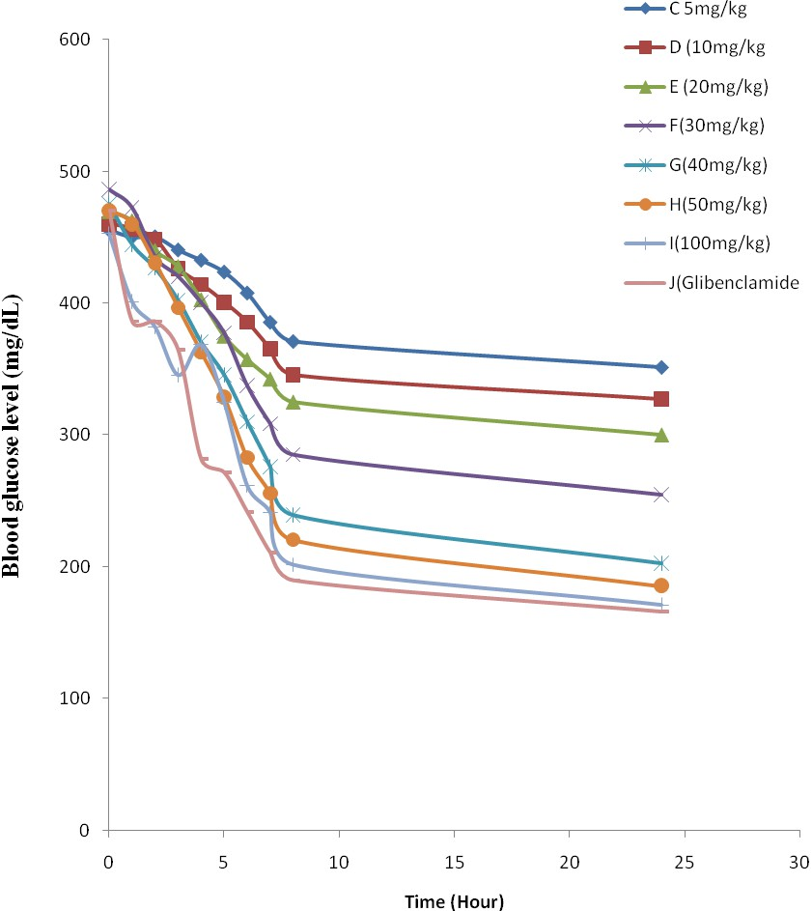

## Fig: 3.1: Effects of various doses of extract and glibenclamide on diabetic rats.

The administration of 5, 10, 20, 30, 40, 50 and 100mg/kg of the crude ethanolic extract of

*M. pruriens* resulted in 18.6%, 24.9%, 30.8%, 41.4%, 49.7%, 53.1%, 55.4% reduction, respectively in blood glucose of the diabetic rats after 8 hours of treatment while the administration of glibenclamide (5 mg/kg body weight) resulted in 59.7% reduction.

## Chronic anti-diabetic effects on alloxan-induced diabetic rats

Results of the chronic administration of *Mucuna pruriens* extracts on the blood glucose level are presented in Table 3.5 while the plots of % reduction in the blood glucose level versus time (weeks) after chronic administration of different doses of the extract and standard drug (glibenclamide) on diabetic rats are presented in Figure 3.2. This indicates that daily administration of the extract of *Mucuna pruriens* seed extract for 12 weeks resulted in a dose dependent reduction in the blood glucose level. Daily administration of 5, 10, 20, 30, 40, 50, and 100 mg/kg/body weight of the extract resulted

in 55.5 o/o, 59.5 o/o, 68.4 o/o, 74.7 o/o, 78.4%, 80.9 o/o and 83.2o/o reduction ion blood glucose level, respectively after 12 weeks. On the other hand, the standard drug, glibenclamide (5 mg/kg), resulted in 57.8o/o reduction in blood glucose level of the diabetic rats. This dose-dependent antihyperglycemic effect of *Mucuna pruriens* is in agreement with the reports of Rathi *et al*., 2002, who observed that the ethanol extract of *Mucuna pruriens* at varying doses showed different degrees of antihyperglycemic activity in alloxan-induced dia Other workers (Bhaskar *et al*., 2008) have reported that administration of *Mucuna pruriens* to diabetic rats treated with 100 and 200 mg/kg of the

*M. pruriens* seed extract showed a significant reduction in blood glucose of about 12 and 19% respectively after 6 hour of treatment; and after 3 weeks of daily treatment with the *Mucuna pruriens* seed aqueous (100 and 200mg/kg), there was significant fall in blood sugar level (55% and 62% respectively). At the same time, Tolbutamide caused a significant (60%) reduction in blood glucose level (Bhaskar *et al*., 2008).

Though pathophysiology of diabetes remains to be fully understood (Madak *et al.*, 2007), experimental evidences suggest the involvement of free radicals in the pathogenesis of diabetes (Matteucci and Giampietro, 2000) and more importantly in the

Table 3.5

**Fig. 3.2**

development of diabetic complications (Oberly, 1988; Baynes and Thorpe, 1997; Lipinski, 2001). Free radicals are capable of damaging cellular molecules, DNA, proteins and lipids leading to altered cellular functions. Many recent studies reveal that antioxidants capable of neutralizing free radicals are effective in preventing experimentally induced diabetes in animal models (Kubish *et al*., 1997; Naziroglu and Cay, 2001), as well as reducing the severity of diabetic complications (Lipinski, 2001). For the development of diabetic complications, the abnormalities produced in lipids and proteins are the major etiologic factors. In diabetic patients, extra-cellular and long lived proteins, such as elastin, laminin, collagen are the major targets of free radicals. These proteins are modified to form glycol- proteins due to hyperglycemia. The modification of these proteins present in tissues such as lens, vascular wall and basement membranes are associated with the development of complications of diabetes such as cataracts, microangiopathy, atherosclerosis and nephropathy (Glugliano *et al*., 1996). During diabetes, lipoproteins are oxidised by free radicals. There are also multiple abnormalities of lipoprotein metabolism in very low density lipoprotein (VLDL), low density lipoprotein (LDL), and high density (HDL) in diabetes. Lipid peroxidation is enhanced due to increased oxidative stress in diabetic condition. Also, it is well known that *Mucuna pruriens* is a rich source of dietary fibre (8.7-10.5%) (Vadivel and Janaradhanan, 2000). It is also known that it reduces plasma glucose in diabetic subjects. Soluble dietary fibre with high viscosity is more effective in delaying glucose absorption than insoluble fibre.

The ethanol extract might be producing its hypoglycaemic effect by an extra- pancreatic action (Dabis *et al*., 1984) as well as mimicking the function of insulin as mentioned earlier.

The extract of *Mucuna pruriens* has both organic and inorganic constituents. It is important to note that the inorganic part of the medicinal plant containing mainly mineral elements, sometimes play a contributing role in enhancing medicinal properties (including hypoglycaemic activity) of the plant (Kar and Choudhary, 1994; Kar *et al*., 1999). A number of essential minerals like Na, K, Ca, Zn, Mg, P, Fe, Cu, Mn and Cr have been found to be present in *M. pruriens* (Scheffe, 1953). These mineral elements may be associated with the mechanism of insulin release and its activity or glucose tolerance

factor as described in different laboratory animals (Mertz, 1981; Niewoehner *et al*., 1986; Chen *et al*., 1995; Schroeder, 1996 and Castro, 1998).

## Changes in body weight

Changes in body weights of diabetic rats after daily administration of the crude ethanolic extract of *Mucuna pruriens* seed are shown in Table 3.6 while the plots of weight variations with time on the diabetic rats after the administration of drug and glibenclamide are presented in Fig. 3.3.

The result indicates that the normal control showed 27% weight gain while diabetic control rats exhibited 27% weight loss over the 12 weeks period. Rats that were administered with the extracts exhibited 16% - 40% weight gain while those administered with glibenclamide (5 mg/kg body weight) showed 18% weight gain. The weight gain observed with the extract depended on the dose administered. This indicates that treatment with *Mucuna pruriens* seed extract significantly alleviated the weight loss in diabetic rats in a similar manner to glibenclamide (p < 0.001). In the diabetic control rats there could have been a decrease in the production of total protein and albumen as well as the production of insulin. So, in this case fats might have been mobilized and this could result in hyperlipidemia and weight loss as shown in Table 3.6.

## Acute toxicity determination in mice

Acute toxicity studies showed that the administration of the crude ethanolic extract of *Mucuna pruriens* seed was well tolerated by animals as no death was recorded 14 days after the administration of the extract. However, adverse effects such as hyperventilation, clonic seizures, pico erection and reduced spontaneous motor activity were observed about I hour after the administration of high doses (8-32g/kg/day).

**TABLE 3.6**

**Fig. 3.3**

## Determination of ameliorative potentials of *Mucuna pruriens* on the complications of diabetes mellitus

## Biochemical and hematological studies

The results of the biochemical and haematological studies are presented in Tables

3.7 - 3.9 while their various representative plots are presented in Figures 3.4 - 3.6. The diabetic rats showed significant (p < 0.05) elevated levels of plasma cholesterol, triglycerides, urea, creatinine (Table 3.7), AST, total bilirubin and ALT with concomitant decrease in total plasma protein (Table 3.8) when compared with normal rats. Plasma cholesterol, triglycerides, LDL, creatinine, urea and alkaline phosphatase levels decreased significantly (p < 0.05) by glibenclamide and *Mucuna pruriens* extract after 12 weeks of administration compared with diabetic rats as shown in Table 3.7. High density lipoproteins (HDL) levels also increased (p < 0.05) significantly following the administration of glibenclamide and *Mucuna pruriens* extract compared with diabetic control (Table 3.7). Following the administration of *Mucuna pruriens* seed extract or glibenclamide (5 mg/kg), cholesterol, triglycerides (Table 3.7) and total plasma protein levels (Table 3.8) were restored to near normal. The present results show that plasma urea and creatinine levels (Table 3.7) increased in diabetic rats when compared with normal rats.

The administration of *Mucuna pruriens* seeds extracts significantly (p < 0.05) decreased plasma urea and creatinine when compared with diabetic rats (Table 3.7). Administration of *Mucuna pruriens* extract and glibenclamide restored the above biochemical parameters to almost normal values. There was significant (p < 0.05) decrease in plasma Na+, K+, Cl- and HC03- in alloxan treated group (Table 3.9). Administration of *Mucuna pruriens* seeds extracts or glibenclamide ameliorated depletion of Na+, Cl- and HC03- but not K+ ion. The graphical representations of the various effects of ethanol seed extract of *Mucuna pruriens* on the liver function tests are shown in Figures 3.4a, b and c, while the graphical representations of the effects of different doses of the seed extract of *Mucuna pruriens* on the plasma total cholesterol, triglycerides, high density lipoprotein, low density lipoprotein, blood urea nitrogen and creatinine are shown in Figure. 3.5.

TABLE 3.7

TABLE 3.8

TABLE 3.9

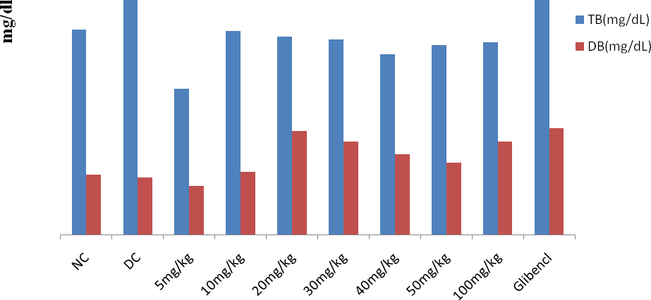

**Fig. 3.4a: Effects of doses of ethanolic seed extract of *M.pruriens* and glibenclamide on liver function test [(Total Bilirubin (TB) and Direct Bilirubin (DB)].**

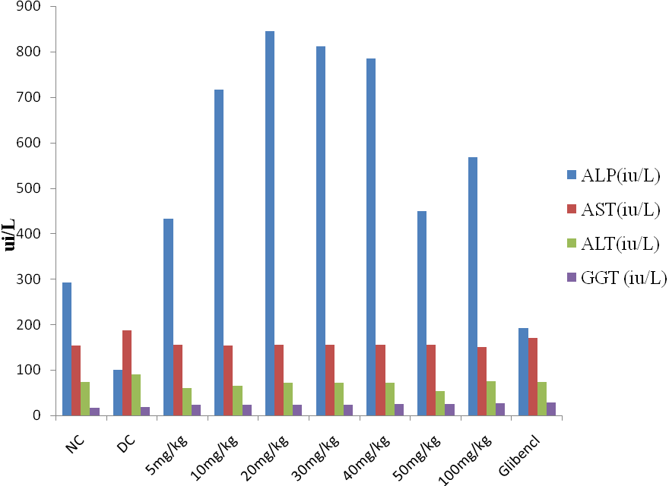

**Fig. 3.4b: Effects of doses of ethanolic seed extract of *M. pruriens* and glibenclamide on liver function tests [(Alkaline phosphatase (ALP) , Aspartame aminotransferase(AST) , Alanine aminotransferase (ALT) and Gamma glutt amyltransferase (GGT).**

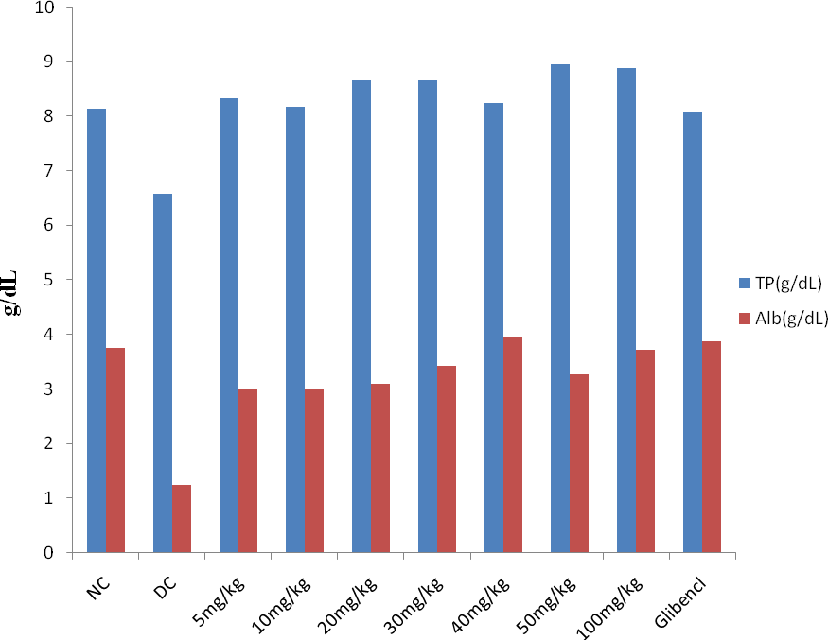

**Fig. 3.4c: Effects of doses of ethanolic seed extract of *M. pruriens* and glibenclamide on liver function tests [(Total protein (TP) and Albumin (ALB)]**

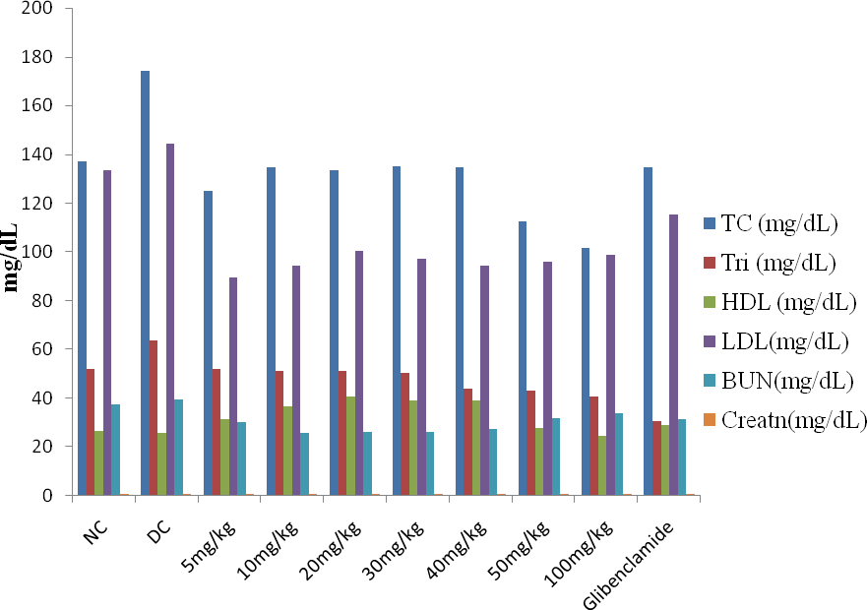

**Fig. 3.5: Effects of different doses of ethanol seed extract of *M.pruriens* on the plasma total cholestrol, (TC), triglycerides, (TRI), high density lipoprotein (HDL), low density lipoprotein (LDL), BUN and creatinine. Values are means ± SEM (n=6).**

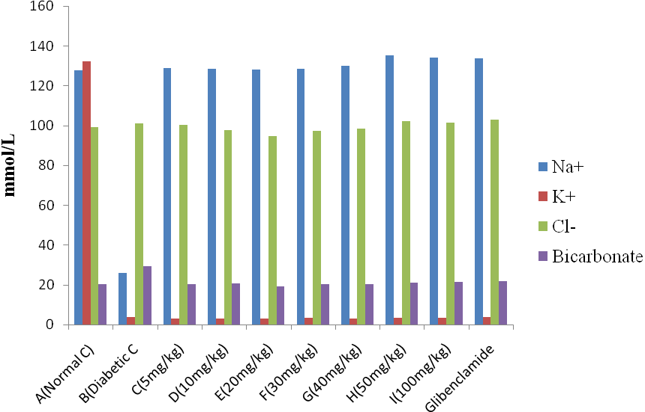

**Fig. 3.6: Effects of MP ethanol seed extract on plasma electrolytes of Sodium ion (Na+), Potasium ion (K+), Chloride ion and Bicarbonate. Values are means ± SEM (n=6).**

Diabetes mellitus is known to cause hyperlipidemia through various metabolic derangements (Hardman and Limberd, 2001). Among several metabolic derangements, insulin deficiency has been known to stimulate lipolysis in the adipose tissue and give rise to hyperlipidemia and fatty liver. Thus, in diabetes, hypercholesterolemia and hyper triglyceridaemia often occur (Hardman and Limberd, 2001). Many traditional medicines in use are derived from medicinal plants, minerals and organic matter (Grover *et al.,* 2002). In recent years, there has been a renewed interest to screen such plants by examining toxicity associated with their long term use, identify the active principle, and understand the mechanism of action (Sridhar and Bhat, 2007). The plasma aminotransferases (ALT and AST) and phosphatase (ALP), LDL-cholesterol, total bilirubin, were significantly (p < 0.05) increased in diabetic alloxan treated group. On the other hand, animals which were administered with *M. pruriens* extract, the plasma activity and the levels of ALT, AST and ALP, LDL, TB decreased significantly. The fall in plasma enzymes suggests a protective effect of *Mucuna pruriens* on the liver against alloxan-induced hepato-toxicity. Elevated activities of AST and ALT in plasma are indicative of cellular leakage and loss of functional integrity of cell membrane in the liver (Rajesh and Latha, 2004). Their estimations are useful quantitative marker for the extent of hepatocellular damage (Kumar *et al*., 2004).

The increase in the levels of plasma bilirubin reflected the depth of jaundice and the increase in transaminases and alkaline phosphatase have been reported as clear indication of cellular leakage and loss of functional integrity of the cell membrane (Saraswat *et al.*, 1993). Yamini and Anil (2001) reported that *M. pruriens* possessed antioxidant property and the alloxan initiated the process of lipid peroxidation through the production of superoxide radicals. Effects of *M. pruriens* extract on alloxan-treated groups could be due to the property of *M. pruriens* in trapping the superoxide radicals. Although free radicals are considered to be important for normal physiology but, when produced in excess, they cause cellular damage. The radicals initiate a chain reaction of lipid and protein peroxidation by attacking the double bonds of these molecules. The medicinal properties of *M. pruriens* against diseases associated with free radical, especially the age- related male-infertility and Parkingson‘s disease is well documented (Vaidya *et al*., 1978). Hence, it is possible that the mechanism of hepato-protection of *M. pruriens* is due to its

antioxidant effect. Also in the present study, animals treated with alloxan had significant increase in the activities of AST and ALT double-fold respectively. Alkaline phosphatase mainly arises from the lining of canaliculi in hepatocytes and also brush border of the renal tubule. It is excreted normally via bile through liver and involves active transport across the capillary wall. Increased activity of alkaline phosphatase, which occurs due to *de novo* synthesis by liver cells, is a reliable marker of hepato-biliary dysfunction due to damage in liver and kidney. *Mucuna pruriens* enhanced the synthesis of total protein and albumin which accelerated the regeneration process and the protection of liver cells. The increased level of total protein in plasma indicates the hepatoprotective activity of *M. pruriens.*

The administration of *Mucuna pruriens* seed extract increased the activity of GTT in dose dependent manner. This, therefore, shows that prolonged administration of *M. pruriens* seed extract precipitated liver injury in animal models. Gamma- glutamyltransferase (GGT) is the enzyme activity responsible for the extracellular catabolism of glutathione, the main thiol antioxidant in mammalian cells (Meister, 1983). The determination of serum GGT activity is a well-established diagnostic test for hepatobiliary disease, and is used as a sensitive marker of alcohol consumption and abuse (Rollason *et al*., 1972).

Diabetes mellitus is a condition characterized by hyperglycemia and a markedly increased risk of cardiovascular disease, a major cause of death and disability in our society. The presence of diabetes mellitus also markedly increases the risk of retinopathy and blindness, nephropathy and renal failure, and neuropathy. Patients with diabetes often have elevations in plasma triglycerides, remnant lipoprotein cholesterol, and small dense LDL, as well as decreased HDL as compared to control subjects (Siegel *et al.,* 1996 and Schaefer *et al*., 2002a). The direct LDL-cholesterol offers the physician the option of assessing LDL-C in the non-fasting state, as well as when the patient has significant hypertriglyceridemia (Schaefer *et al*., 2001; Schaefer *et al*., 2002b and Schaefer *et al*., 2004). Data obtained in this study showed that the *M. pruriens* seed extract produced significant reduction in LDL-cholesterol, total cholesterol and triglyceride with appreciable increase in HDL-cholesterol as shown in Table 3.7. *Mucuna. pruriens* extract could therefore be used to ameliorate complications associated with diabetes mellitus.

Epidemiological evidence shows that the plasma concentration of high-density lipoproteins (HDL) has been reported to be inversely related to the risk of cardiovascular disease (Nicholls *et al.*, 2005). The best known anti-atherogenic function of HDL particles is attributable to their ability to promote the efflux of cholesterol from cells. However, there is mounting evidence that HDL has other effects that are independent of the cholesterol transporting functions, including antioxidant, anti-inflammatory and anti- thrombotic properties (Barter *et al*., 2004; Nicholls *et al.*, 2005 and Negre-Salvayre *et al*., 2006). Also, the observable decrease in plasma blood urea nitrogen (BUN) and creatinine following administration of *Mucuna pruriens* extract confirmed that *M. pruriens* could ameliorate kidney damage which is one of the complications of diabetic mellitus.

## Histopathological studies

After 12 weeks of daily administration of *M. pruriens* extract no changes were detected in the kidney (Fig. 3.7 a), liver (Fig. 3.7b), adrenal glands, pancreas (Fig.3.7c), epidydimis of the normal rats (group A). The diabetic rats (group B) were observed to possess individual cell necrosis in the pancreas (Fig. 3.8a), very mild tubular degeneration in the kidneys (Fig. 3.8b) but diffuse, extensive hepatic degeneration, peripheral hepatic necrosis and cytoplasmic fatty vacuolation of the centrilobular hepatocytes (Fig.3.8c). In the adrenal gland and epidydimis no visible lesion was observed.

In the diabetic rats treated with 5 mg/kg body weight of *Mucuna pruriens* (group C), no visible lesion was observed in the kidney, adrenal glands, pancreas (Fig. 3.9a) and epidydimis, but in the liver, hyperplasia of the kupfiller and central venous congestion were observed (Fig. 3.9b).

In the rats treated with 10 mg/kg, 20 mg/kg, 30 mg/kg, 40 mg/kg, 50 mg/kg, 100 mg/kg body weight of *M. pruriens* and glibenclamide (5 mg/kg) no significant lesions were observed in the kidneys (Fig. 3.9c), liver (Fig 3.9a) and pancreas (Fig. 3.8c). In the normal control, the islets are normal. The architecture of islet was preserved. The acini are lined by round to oval cells with moderate cytoplasm and small round to oval nuclei. No fibrosis or any inflammation was seen.

Microscopically, the pancreas Section of diabetic control shows pancreas with engorged and congested blood vessels. The islets were damaged. The acini were lined by round to oval cells with moderate cytoplasm and small round to oval nuclei.

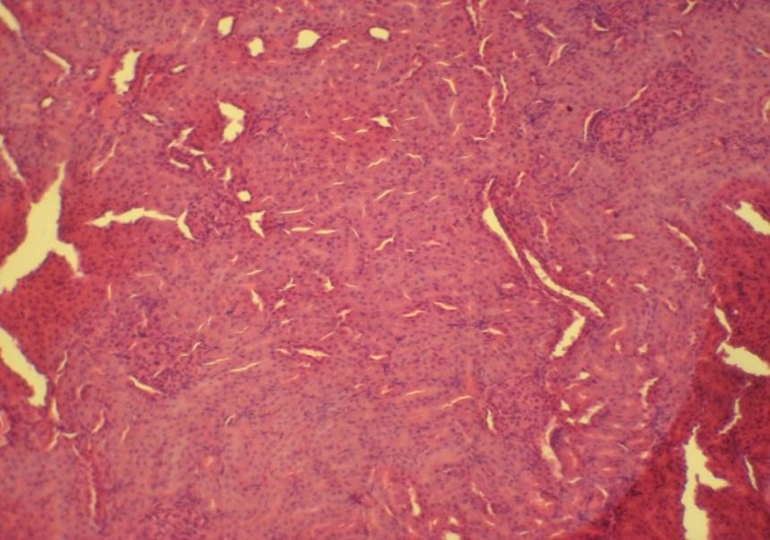

**Fig. 3.7a: Photomicrograph of the kidney showing no visible lesion in group A normal rats**

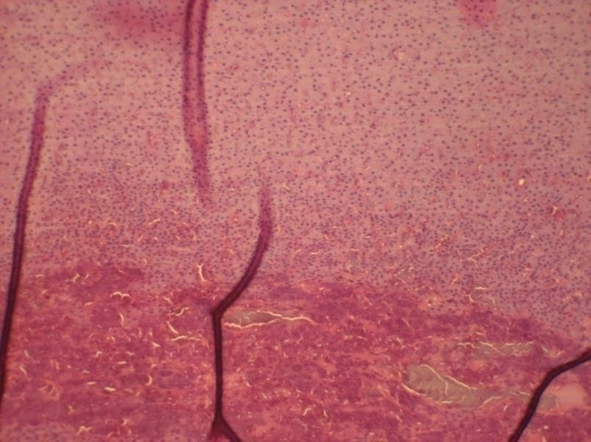

**Fig. 3.7b: Photomicrograph of the liver of rat in group A normal rat where no visible lesion was observed**

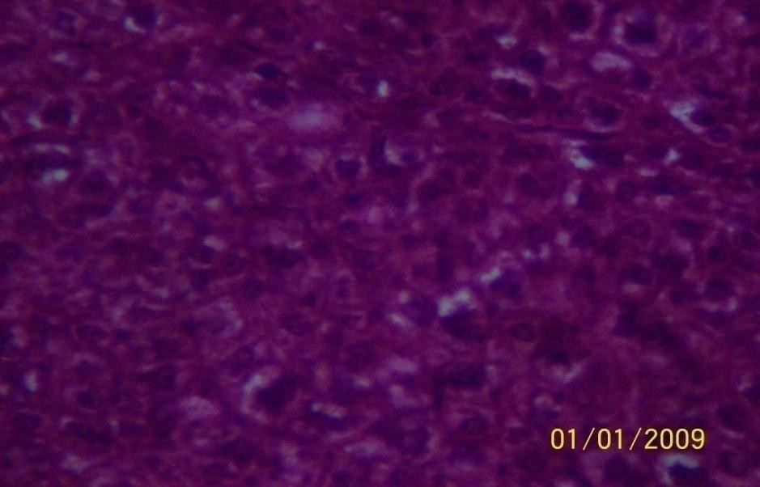

**Fig. 3.7c: Photomicrograph of the pancrease showing no visible lesion in the normal rat.**



**Fig. 3.8a Group B =Prominent interlobular connective tissue**

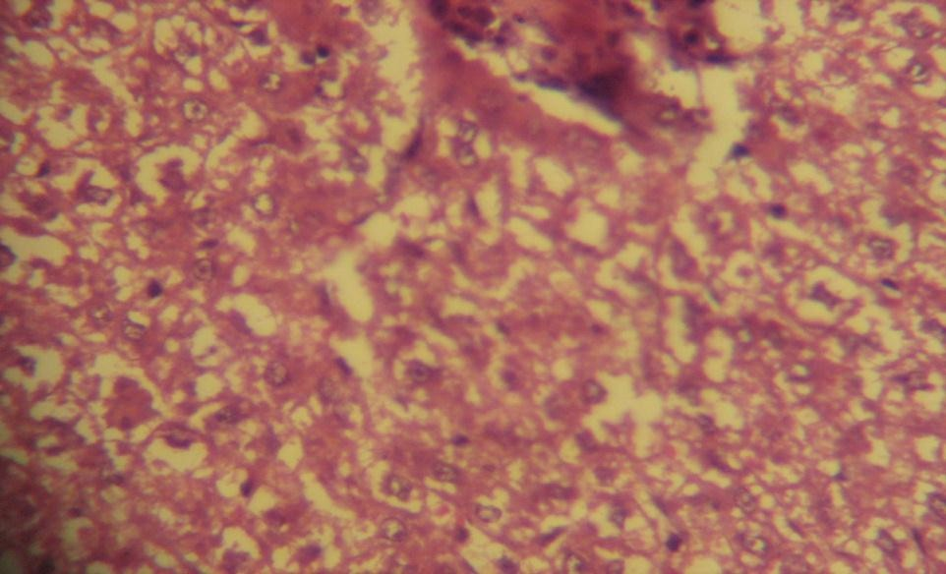

**Fig. 3.8b: Photomicrogragh of the liver showing Kupfller cell hyperplasia**

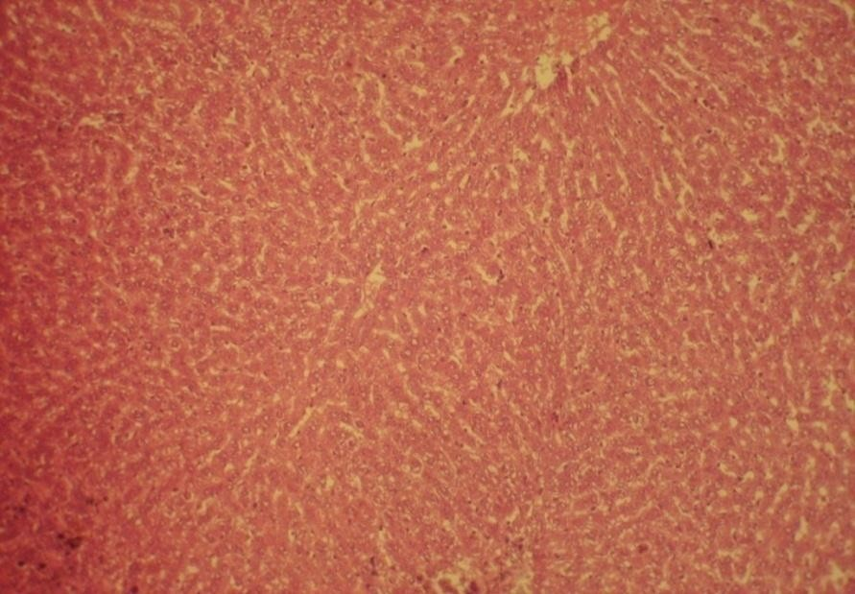

**Fig. 3.8c: Photomicrogragh of the liver showing no visible lesion**

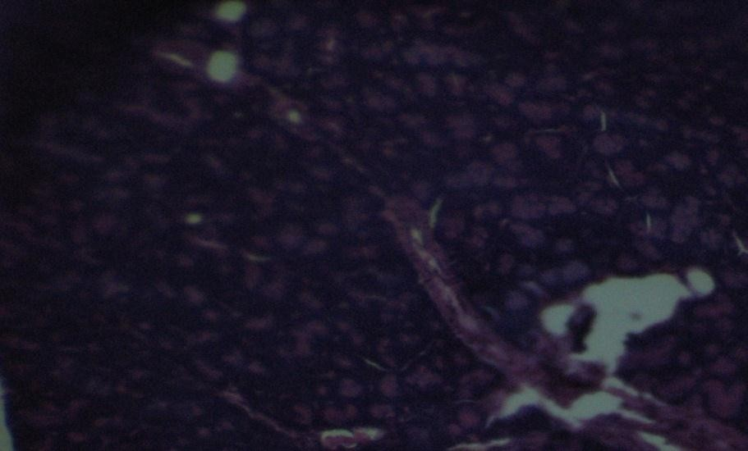

**Fig. 3.9a: Photomicrogragh of the pancreas showing no visible lesion**

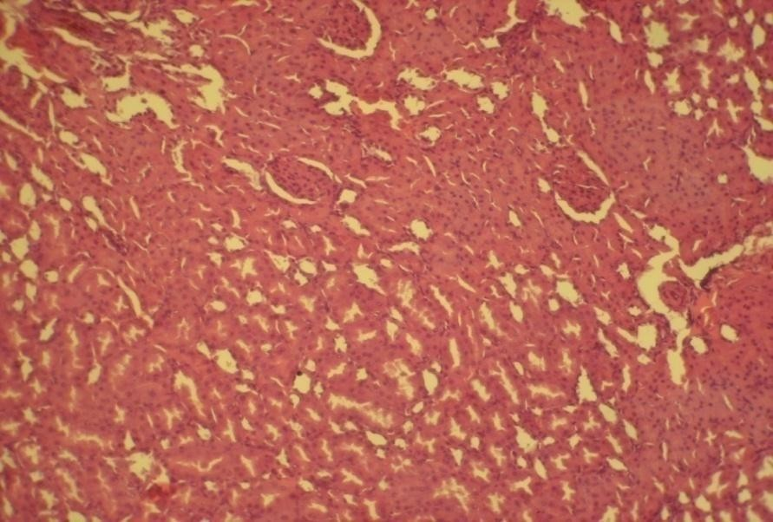

**Fig. 3.9b: Photomicrograph of the kidney showing a very mild tubular degeneration in diabetic rats**

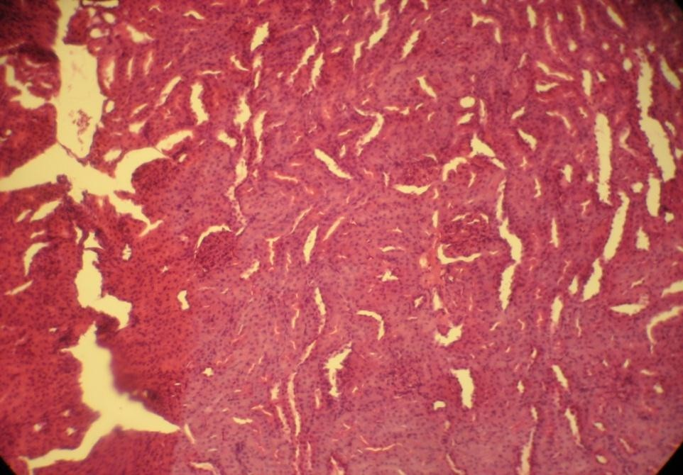

**Fig. 3.9c: Photomicrograph of the kidney showing the amelioration of the kidney cells upon the administration of ethanolic extract of *M. pruriens***



**Fig. 3.10a: Photomicrograph of the pancrease showing quasi-amelioration of the pancreatic cells upon the administration of ethanolic extract of *M. pruriens* to the diabetic rat.**



**Fig. 3.10b: Photomicrograph of the liver cells of rats in group B showing hyperplasia of the Kupfller cell**

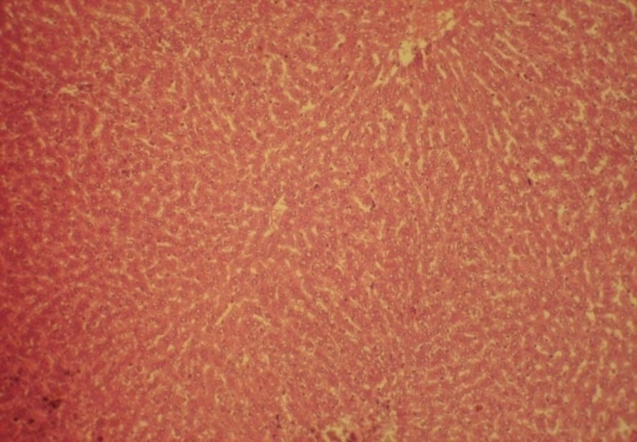

**Fig. 3.10c: Photomicrograph of the liver cells of rats administered with the ethanolic extract of *M. pruriens* showing amelioration of the damage caused by diabetes mellitus.**

Microscopically, the pancreas section of standard glibenclamide and *M. pruriens* treated rats section shows pancreas with normal architecture and acini. The islet cells show moderate cytoplasm and round to oval nuclei. There is no evidence of inflammation.

*M. pruriens* has restored the damaged organs due to the effects of alloxan to normalcy.

## CHAPTER FOUR: FORMULATION STUDIES

* 1. **Material properties of the *M. pruriens* ethanol extract**

The bulk density, tap density and Hausner ratio of the ethanol seed extract of the various powder mixes for direct compression are presented in Table 4.1. The bulk density of a powder describes its packing behavior during the various unit operations of tableting such as die filling, mixing, granulation and compression. Higher bulk density is advantageous in tableting because of reduction in the fill volume of the die. The ranking of the bulk density was Extract > Avicel > Cellulose > Lactose. The tap density indicates the rate and extent of packing that would be experienced by a material during the various unit operations of tableting (Wray, 1992). The ranking of the tap density was Avicel > Extract > Cellactose > Lactose. The difference observed in the tap density values could be due to the difference in particle shape and particle size distribution, both of which affect the packing arrangement of particles.

The Hausner ratio (tap to bulk density ratio) provides an indication of the degree of densification which could result from vibration of the feed hopper during tableting. Higher values of Hausner ratio predict significant densification of powders. The ranking of Hausner ratio was Avicel > Extract > Cellactose > Lactose. Thus, Avicel exhibited highest degree of densification with tapping while lactose had the lowest values. The angle of repose **(**θ) has been used as a qualitative measure of the cohesiveness or the tendency of powdered or granulated materials to flow, for instance, from hoppers through the feed frame into tableting machine. Such uniformity of flow will minimize weight variations in tablets produced (Varthalis and Pilpel, 1976). Angle of repose of 30o or below usually indicate that the powder is free flowing. Angle of repose of 40o or above indicates poor flow. The angle of repose is affected by the particle size distribution and usually increases with a decrease in particle size. The ranking of angle of repose was Lactose > Extract > Cellactose > Avicel.

## Table 4.1: Material properties of *M. pruriens* ethanol extract (Mean ± SD, n = 4

|  |  |  |  |  |
| --- | --- | --- | --- | --- |
| **Diluent** | **Bulk Density (BD)** | **Tap Density (TD)** | **Hausner Ratio (HR)** | **Angle of**  **Repose (o)** |
| Extract | 0.65±0.0 | 0.70±0.0 | 1.08±0.0 | 30.40±0.1 |
| Avicel | 0.64±0.0 | 0.71±0.0 | 0.90±0.0 | 22.32±0.3 |
| Cellactose | 0.77±0.0 | 0.79±0.0 | 0.97±0.0 | 26.12±0.2 |
| Lactose | 0.36±0.0 | 0.51±0.0 | 1.43±0.0 | 40.64±0.5 |

## Particle size and size distribution of formulations for direct compression

The size distributions of the formulations in the direct compression are presented in Table 4.2. Particle size has significant effect on the densification of the powder mix during die filling, particle rearrangement, fragmentation propensity and elastic/plastic deformation (Wray, 1992; Munoz – Ruiz and Paronen, 1996). It has been shown that cohesiveness is usually inversely related to the particle diameter of materials (Shotton and Obiorah, 1973).

* 1. **Binding properties of *M. pruriens* granules**

## Granule size distribution

The size distributions of the granules of ethanol extract of *M. pruriens* containing PVP and Corn starch as binders obtained by sieve analysis are presented in Tables 4.3. Representative plots of cumulative weight percent oversize versus mean diameter for the *Mucuna pruriens* formulations containing PVP and corn starch as binders are shown in Fig. 4.1. Values of mean granule size for the formulations are shown in Table 4.4. The mean granule size of the samples increased with increase in binder concentration. This can be attributed to the strengthening of bonds between particles as there would be more binder per bond as the concentration is increased (Luangtanan – Anan and Fell, 1990). The mean granule size of PVP was greater than that of corn starch. .

## Evaluation of tablet properties

## Test for uniformity of weight

The results of the average weight and their corresponding percentage deviation for tablets prepared by direct compression (DC) with or without diluents using Avicel®, Cellactose, lactose and by wet granulation (WG) using PVP and corn starch are presented in Tables 4.5 and 4.6 respectively. Weight uniformity refers to the average weight of tablets in each sample. The tablets showed some slight variations in weight.

**Table 4.2: Particle size distribution of formulations by direct compression**

|  |  |  |  |
| --- | --- | --- | --- |
| **Diluent** | **Particle diameter (µm)** | **Number of particles (%)** | **Cumulative % size** |
| Extract only | 0.9 | 7 | 100 |
|  | 1.3 | 25 | 93 |
|  | 3.2 | 21 | 48 |
|  | 3.7 | 42 | 43 |
|  | 4.5 | 5 | 5 |
| Avicel | 1.9 | 4 | 100 |
|  | 4.5 | 30 | 95 |
|  | 6.0 | 4 | 70 |
|  | 7.4 | 56 | 64 |
|  | 8 | 6 | 6 |
| Cellactose | 1.5 | 22 | 100 |
|  | 3.3 | 8 | 90 |
|  | 4.8 | 53 | 76 |
|  | 5.2 | 8 | 70 |
|  | 5.9 | 9 | 9 |
| Lactose | 0.7 | 25 | 100 |
|  | 1.5 | 6 | 80 |
|  | 2.5 | 38 | 70 |
|  | 4.0 | 20 | 30 |
|  | 5.0 | 11 | 11 |

**Table 4.3: Size distribution of *M. pruriens* seed ethanolic extract containing PVP and corn starch as binders**

|  |  |  |  |
| --- | --- | --- | --- |
| **Binder** | **Mean sieve size (µm)** | **Cumulative weight % oversize**  **1% 4%** | |
| PVP | 1100 | 0.04 | 0.08 |
|  | 855 | 5.67 | 4.86 |
|  | 605 | 30.41 | 40.52 |
|  | 428 | 37.86 | 48.21 |
|  | 303 | 74.42 | 77.51 |
|  | 125 | 100.00 | 100.00 |
| Corn starch | 1100 | 0.10 | 0.87 |
|  | 855 | 4.34 | 5.41 |
|  | 605 | 25.72 | 37.51 |
|  | 428 | 34.68 | 49.72 |
|  | 303 | 69.94 | 74.51 |
|  | 125 | 100.00 | 100.00 |

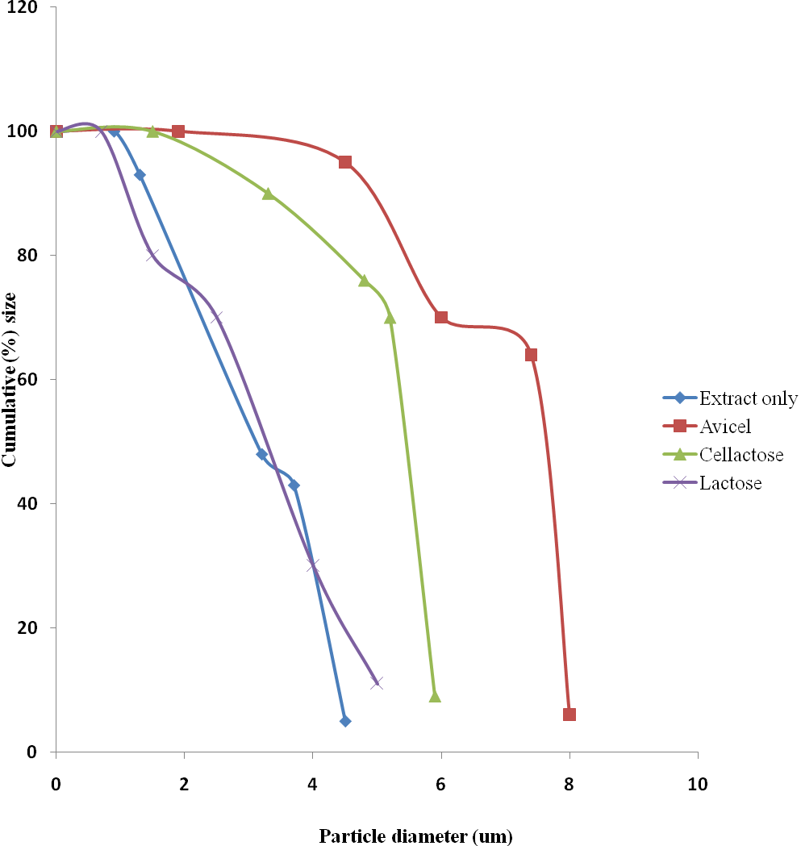

**Fig. 4.1: Particle size distribution of *Mucuna pruriens* formulations by direct compression**

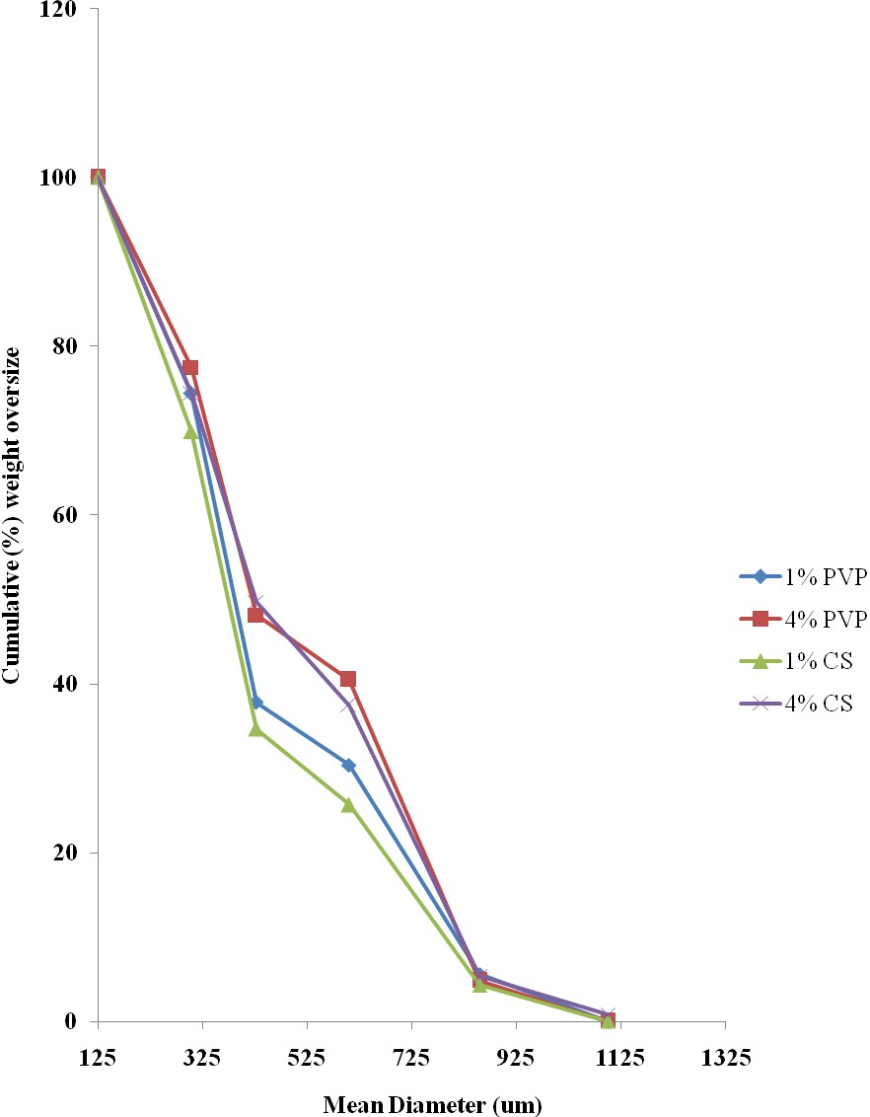

**Fig. 4.2: Granule size distribution of *Mucuna pruriens* formulations containing 0%, 1% and 4% of binder**

**Table 4.4: Values of mean granule size (G) of *Mucuna pruriens* granules containing no binder, PVP, corn starch as binders.**

|  |  |  |
| --- | --- | --- |
| **Binder** | **Concentration (%w/w)** | **Mean granule size (µm)** |
| - | 0.00 | 390 |
| PVP | 1 | 410 |
|  | 4 | 520 |
| Corn starch | 1 | 400 |
|  | 4 | 510 |

**Table 4.5: Uniformity of weight of the tablets prepared by direct compression (DC)**

|  |  |  |  |  |
| --- | --- | --- | --- | --- |
| **Method of preparation** | **Diluent/binder** | **Compression pressure**  **(CP) kN** | **Average weight (mg)** | **% deviation** |
| DC | Extract without  diluents | 5  10 | 498.0  499.0 | 0.1  0.1 |
| DC | Avicel | 5  10 | 498.0  497.0 | 0.2  0.1 |
| DC | Cellactose | 5  10 | 499.0  499.0 | 0.2  0.1 |
| DC | Lactose | 5  10 | 499.0  499.0 | 0.3  0.1 |

**(n – 10)**

**Table 4.6: Uniformity of weight of the tablets prepared by wet granulation**

|  |  |  |  |  |  |
| --- | --- | --- | --- | --- | --- |
| **Method of preparation** | **Binder** | **Binder con- centration**  **(%)** | **CP (kN)** | **Average weight (mg)** | **%**  **Deviation** |
| WG | PVP | 1 | 5 | 499.0 | 0.1 |
|  |  |  | 10 | 497.0 | 0.2 |
| WG | PVP | 4 | 5 | 498.0 | 0.3 |
|  |  |  | 10 | 498.0 | 0.2 |
| WG | Corn starch | 1 | 5 | 498.0 | 0.1 |
|  |  |  | 10 | 497.0 | 0.1 |
| WG | Corn starch | 4 | 5 | 498.0 | 0.1 |
|  |  |  | 10 | 497.0 | 0.2 |

**CP = compression pressure**

This shows conformity with the British Pharmacopoeia (B.P) requirement. The

B.P (1998) standard for uniformity of weight for tablets states that the preparation complies with the test if not more than two of the individual weights deviate from the average weight by more than 5% deviation if the average weight is or greater than 250mg (in this study, the weight of each tablet was 500mg). All the *M. pruriens* tablets prepared by both direct compression and wet granulation passed the weight uniformity test.

* + 1. **Mechanical properties of *M. pruriens* tablets**

## Crushing strength

The values of the crushing strength, friability and crushing strength-friability ratio for *M. pruriens* tablets prepared by direct compression are presented in Tables 4.7. The crushing strength and friability are important tests for pharmaceutical tablets that often form part of a manufacturer‘s own specification. Friability is especially important because the tablet is likely to be subjected to various abrasive motions during production and subsequent use (Odeku and Itiola, 2003). The values of crushing strength and friability provide measures of tablet strength and weakness, respectively. Thus, the crushing strength-friability ratio (CSFR) can be used as a measure of the mechanical strength of the

*M. pruriens* tablets. The higher the (CSFR), the stronger the tablet.

The nature of diluent and compression pressure were shown to affect the tablet crushing strength (CS) considerably. Generally, increased compression pressure resulted in harder tablets. This might be as a result of the provision of greater compressibility to the powder mass under high compression pressure resulting in more plastic deformation (Itiola and Pilpel, 1986, 1996). Tablets containing lactose showed the least CS values while those containing Cellactose had the highest CS values. Avicel and Cellactose are directly compressible diluents thus possessing high compressibility. The ranking of crushing strength values for tablets prepared by direct compression was Cellactose > Avicel® > lactose.

## Table 4.7: Mechanical properties of *Mucuna pruriens* tablets prepared by direct compression

|  |  |  |  |  |  |
| --- | --- | --- | --- | --- | --- |
| **Diluent** | **Concentration**  **of binder** | **CP**  **(kN)** | **CS (N)** | **F (%)** | **CSFR** |
| No diluents | -  - | 5  10 | 33.4±0.0  36.5±0.0 | 0.6±0.0  0.5±0.0 | 52.2±0.0  71.4±0.0 |
| Avicel | - | 5 | 33.7±0.1 | 0.5±0.1 | 67.4±0.0 |
|  | - | 10 | 36.2±0.0 | 0.4±0.0 | 90.5±0.1 |
|  | - | 10 | 36.6±0.0 | 0.4±0.1 | 89.0±0.2 |
| Cellactose | - | 5 | 35.1±0.0 | 0.7±0.0 | 47.5±0.0 |
|  | - | 10 | 39.1±0.0 | 0.5±0.0 | 78.2±0.0 |
| Lactose | - | 5 | 22.9±0.1 | 0.9±0.0 | 22.0±0.1 |
|  | - | 10 | 24.6±0.0 | 0.8±0.0 | 29.3±0.1 |

**CP = compression pressure, CS = Crushing strength, F = Friability, CSFR = Crushing strength – friability ratio**

The values of the crushing strength, friability and crushing strength-friability ratio for *M. pruriens* tablets prepared by wet granulation are presented in Tables 4.8. Generally, binder type, concentration and compression pressure in wet granulation affected the crushing strength of the tablets produced. The values of crushing strength increased with increasing binder concentration and compression pressure. It is well known that increasing the concentration of a plastoelastic binding agent leads to an increase in plastic deformation during compression and consequently to the formation of more solid bonds in the resulting tablets. Tablets containing PVP had the highest CS compared with corn starch. *M. pruriens* tablets containing PVP as binders were stronger than tablets prepared by corn starch.

Generally, tablets prepared by direct compression were stronger than tablets prepared by wet granulation for possessing higher crushing strength.

## Friability

There was a general decrease in friability with increase in compression pressure as shown in Table 4.7. As the compression pressure was increased there was a general increase in CS and decrease in the friability. The result also indicated that *Mucuna pruriens* tablets containing lactose had the highest F value while those containing Avicel® had the least F value. All the tablets prepared by direct compression passed the friability test as they had F value < 1%. This demonstrated the influence of compression pressure on the mechanical properties of tablets. The ranking of friability values for tablets prepared by direct compression was Avicel® < Cellactose < lactose.

The values of friability of MP tablets prepared by wet granulation decreased with increasing binder concentration and compression pressure. As compression pressure is elevated there is a general decrease in friability (Itiola and Pilpel, 1986, 1996). The decreased friability due to increasing binder concentration is attributed to increased degree and strength of inter-particular bonding (Esezobo and Ambujam, 1982; Iwuagwu *et al*., 1986). All the tablets prepared by wet granulation using PVP and corn starch as binding agents had F values < 1%. Tablets containing corn starch were generally more friable than tablets containing PVP.

## Table 4.8: Mechanical properties of tablets produced by wet granulation

|  |  |  |  |  |  |
| --- | --- | --- | --- | --- | --- |
| **Binder** | **Binder Conc.**  **%w/v** | **Compression Pressure (kN)** | **Crushing Strength**  **(N)** | **Friability**  **%** | **CS-FR**  **Ratio** |
|  | 1 | 5 | 31.0 | 0.7 | 43.7 |
| PVP |  | 10 | 32.6 | 0.7 | 49.4 |
|  | 4 | 5 | 33.5 | 0.5 | 64.4 |
|  |  | 10 | 34.5 | 0.4 | 86.3 |
|  | 1 | 5 | 30.5 | 0.9 | 33.9 |
| Corn  starch |  | 10 | 32.0 | 0.7 | 45.7 |
| 4 | 5 | 32.9 | 0.6 | 54.8 |
|  |  | 10 | 33.6 | 0.5 | 67.2 |

**CP = Compression pressure, CS = Crushing strength, F = Friability, CSFR = Crushing strength – friability ratio**

The relationship between crushing strength and friability is such of an inverse proportionality. Thus, tablets prepared by direct compression were less friable than tablets prepared by wet granulation.

## Crushing strength – friability ratio

For a particular diluent, the CSFR values increased with increasing compression pressure in tablets prepared by direct compression. Tablets containing Avicel® had higher CSFR values than tablets containing Cellactose® or lactose. The ranking of CSFR values for tablets prepared by direct compression was Avicel® > Cellactose® > lactose.

For a particular binder the CSFR values increased with increasing concentration and compression pressure. Tablets containing PVP had the highest CSFR compared to tablets containing cornstarch.

CSFR, being a measure of the tablet hardness, was higher in the tablets prepared by direct compression than in tablets prepared by wet granulation.

## Release properties of *M. pruriens* tablets prepared by direct compression

## Disintegration time

Values of disintegration time and the dissolution characteristics (t50, t80, t1, k1 and k2) of *M. pruriens* tablets prepared by direct compression and wet granulation are presented in Table 4.9.

The disintegration time of tablets prepared by direct compression increased with increase in compression pressure as shown in Table 4.9. Similar observations have been made by other investigators and have been explained in terms of the effect of compression pressure on the specific surface area of the particles and the rate of penetration of liquid into the interior of the tablets (Itiola & Pilpel, 1986, 1996; Odeku & Itiola, 2003). Khan and Rhodes (1976) stated that porosity and permeability of tablets reduced as compression pressure was increased leading to increase in disintegration time.

# TABLE 4.9 LANDSCAPE

This can be ascribed to the decrease in size of capillary spaces between the particles due to bond formation, which prevent the easy penetration of water into the tablets. All the tablets prepared by direct compression disintegrated within 15 minutes - the pharmacopoeial acceptable standard. Lactose had the least disintegration time while tablets prepared without diluents had the longest disintegration time. Avicel, though insoluble, allows fluid into a tablet by capillary action, swells on contact and acts as a disintegrant. For this reason, the relatively hard tablets containing Avicel still disintegrated within 15 minutes.

The disintegration time test of tablets is very important because it plays a vital role in the dissolution process since it determines, to a large extent, the area of contact between solid and liquid (Pilpel *et al*., 1978; Itiola and Pilpel, 1986; Itiola and Pilpel, 1991). Disintegration of tablets had been described as the net outcome of adhesive and disintegrative forces (Wan and Prasad, 1989; Adebayo and Itiola, 1998). Depending on the solubility of the drug and excipients within the tablet and on the mechanism of disintegration, the disintegration of tablets may not precede the dissolution of drug.

The disintegration times of tablets prepared by wet granulation increased with increase in binder concentration and compression pressure.

* + - 1. **Dissolution profile of *M*. *pruriens* tablets**

The peak absorbance for the extract of *M. pruriens* when subjected to a UV scan with peak adsorbance occurring at 281 nm is shown in Appendix 1. The various dilutions (0.01- 0.1) mg/mL and their corresponding absorbance (used to construct the Beer Lambert plots in Appendix 2) is shown in Table 4.10. The values of the percentage (%) release obtained for each time interval for tablets prepared by direct compression using Avicel, Cellactose and lactose are presented in Appendices 3, 4, and 5 respectively while the plots of % released versus time (min) for extract without diluents, Avicel, Cellactose and lactose are presented in Figures 4.2, 4.3, 4.4 and 4.5 respectively Plots of percentage (%) release versus time (min) of *Mucuna pruriens* tablets containing PVP and corn starch as binders are presented in Figures 4.6 - 4.8. From Table 4.9 differences in binders used in wet granulation resulted in different dissolution profiles. Generally for each binder used an

**Table 4.10: Concentrations and corresponding absorbance for *M. pruriens***

|  |  |
| --- | --- |
| **Concentration (mg/mL)** | **Absorbance (at 281.8nm)** |
| 0.01 | 0.07±0.00 |
| 0.02 | 0.17±0.01 |
| 0.04 | 0.33±0.00 |
| 0.06 | 0.53±0.00 |
| 0.08 | 0.73±0.04 |
| 0.1 | 0.90±0.02 |

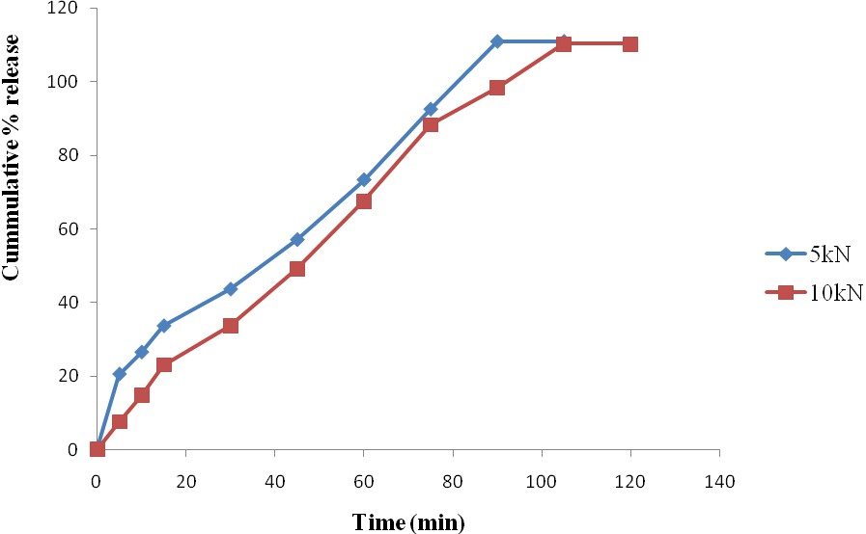

**Fig 4.3: Plots of dissolution profile of *M. pruriens* tablets prepared by direct compression (without diluents)**

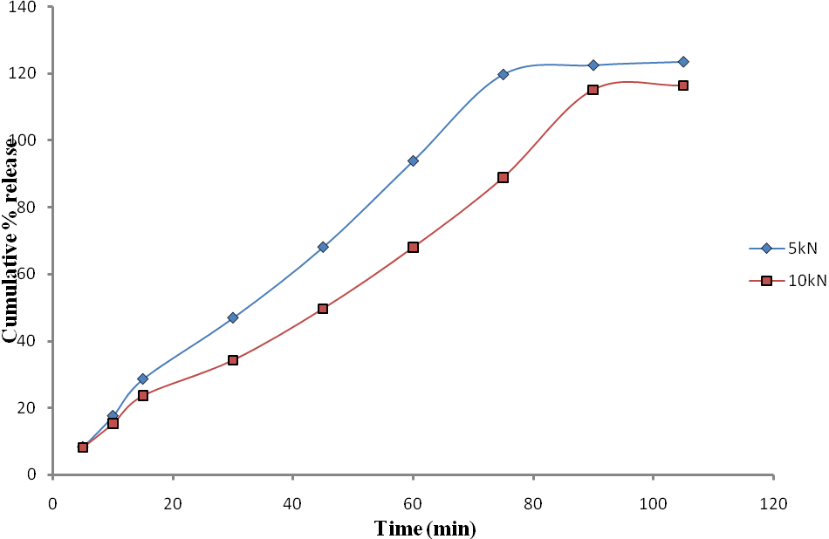

**Fig. 4.4: Plots of cumulative percentage (%) drug release versus Time for Avicel**

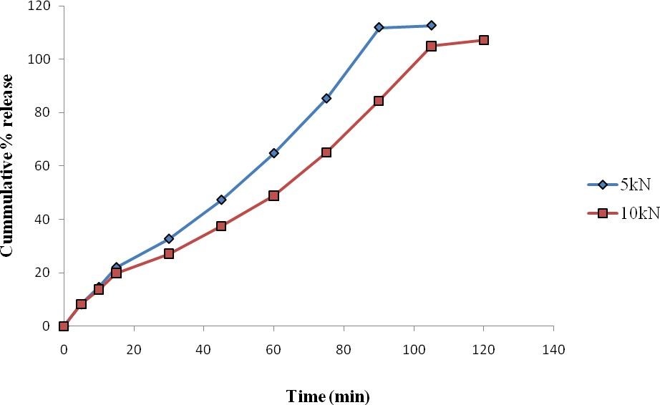

**Fig. 4.5: Plots of cumulative percentage (%) release versus Time for Cellactose**

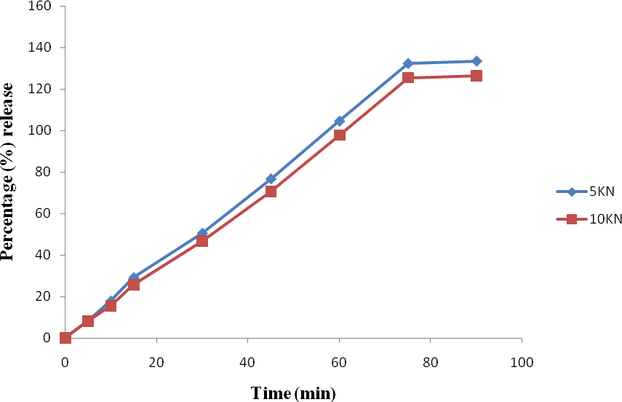

**Fig. 4.6: Plots of cumulative percentage (%) release versus Time for lactose**

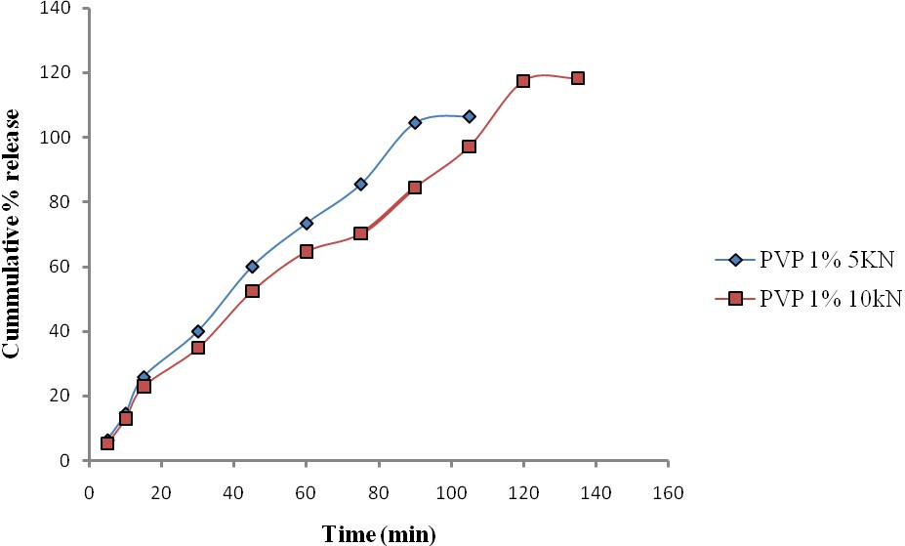

**Fig 4.7: Plot of cumulative % drug release versus Time for PVP 1% in wet granulation**

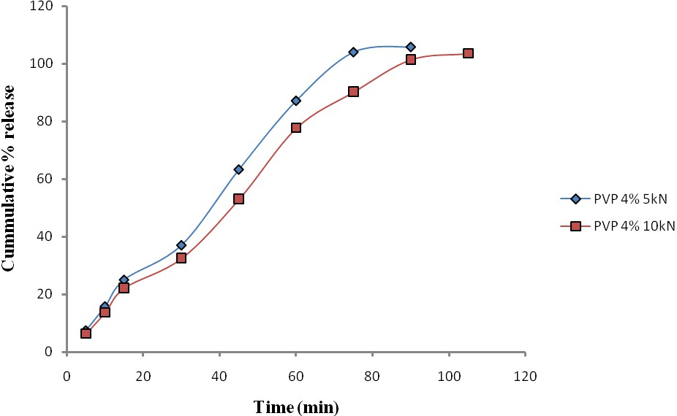

**Fig. 4.8: Cummulative % release versus Time for PVP 4% in wet granulation**

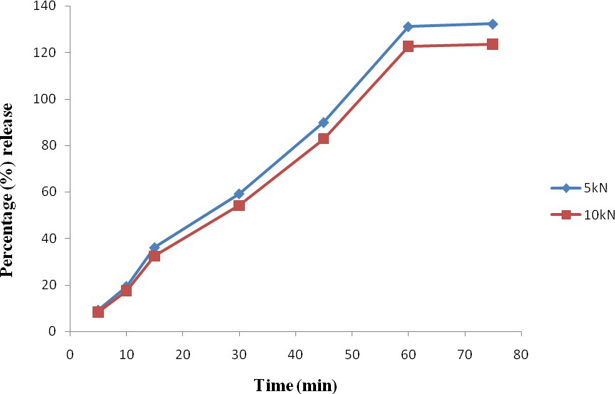

**Fig. 4.9: Plot of cumulative % drug release versus Time for Corn starch 1% in wet granulation**

increase in the concentration of the binding agent and compression pressure resulted in increase in dissolution time of the compressed drug.

Within 61 and 76 minutes all the formulations containing PVP and corn starch respectively had released 70% and 80% of their contents. The impressing dissolution profile of tablets containing PVP as binder could be due to the disintegration times exhibited by PVP.

As shown in Table 4.9, differences in diluents used and compression pressure resulted in different dissolution profiles (t50, t80- the times required for 50% and 80% of the drug to be dissolved). Generally for each diluent type used, an increase in the compression pressure resulted in increase in dissolution time of the compressed tablets.

The highest t50 values were obtained for tablets containing Avicel as diluent while tablets containing lactose had the least t50 values. Tablets compressed without diluents had the highest t80 while tablets containing lactose had the least.

## Kitazawa plots

The plots of different dissolution profiles of tablets prepared by direct compression and compressed at two different compression pressures are shown in Figures 4.3-4.6. From these, the values of t50 and t80 (the time required for 50% and 80% of *Mucuna pruriens* tablets to be dissolved) were calculated using the integrated form of the equation of Noyes and Whitney (1897):

ln[Cs/(Cs – C)] = kt

where Cs is the concentration of the solute at saturation. C is the concentration at time t1 and k is a dissolution rate constant. Representative plots of ln[Cs/(Cs – C)] versus t (Kitazawa *et al*., 1975) are presented in Figure 4.9. In all cases, two straight regression lines of slopes k1 and k2 were obtained. The time at which the lines intersect is denoted t1. From Figure 4.9**,** the higher the compression pressure the lower the dissolution rate

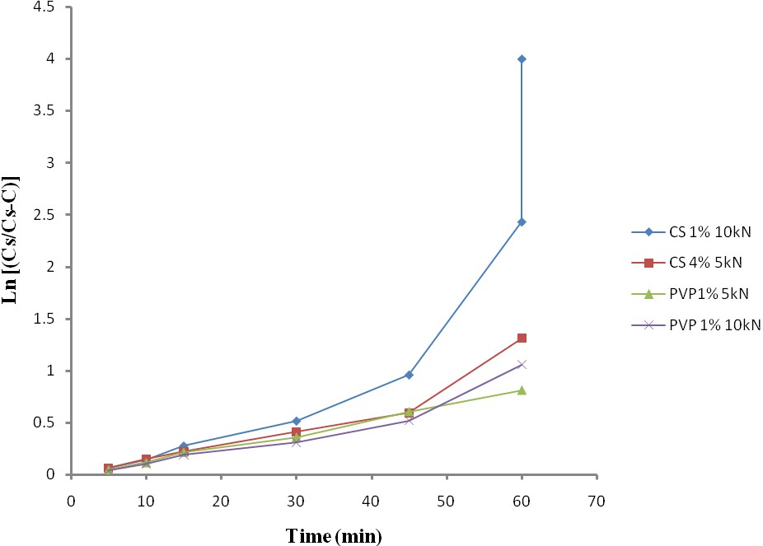

## Fig. 4.10: Ln [Cs/ (Cs-C) ] versus time plots for *Mucuna pruiens* tablets containing corn starch and PVP as binders

constants for all the tablets prepared by both the direct compression and wet granulation. It can be observed that the values of t50, t80 and t1 all increased with binder concentration while the values of k1 and k2 decreased.

The values of k1 were lower than the values of k2, implying a faster dissolution rate of the drug after t1. The change from k1 to k2 at time t1 is attributable to a change in the surface area due to the break up of the tablets into fragments (Itiola and Pilpel, 1986b). It was also observed that t1 values were generally higher than the disintegration time values, probably resulting from the greater agitation employed in the disintegration test than in dissolution tests (Kitazawa *et al*, 1977; Itiola and Pilpel, 1986b). The linear relationships between various measured parameters of disintegration and dissolution proved to be significant (p < 0.05) using two ways ANOVA. The disintegration time, DT, generally gave linear relationships with t50 and t80. The correlation between DT and the dissolution parameters t50 and t80 are probably due to the fact that disintegration of tablets plays a vital role in the dissolution process since disintegration determines to a large extent, the area of contact between the solid and liquid (Itiola and Pilpel, 1986).

Furthermore, there were generally no significant (p < 0.05) relationships between dissolution rate constant, k1 and k2, and most of the other dissolution parameters. The dissolution rate constant, k2, did not show significant (p < 0.05) correlation with all the parameters. A similar observation was made by Odeku and Itiola (2003) and is due to the fact that k2 represents essentially the period of time during dissolution when the tablet has broken up.

Production of *M. pruriens* tablets by direct compression with or without diluents using Avicel produced satisfactory tablets which possessed good mechanical and release properties. Generally, the crushing strength of tablets prepared by direct compression using Avicel as directly compressible diluent were higher than those prepared by wet granulation using PVP and corn starch.

## CHAPTER FIVE: IN VIVO STUDIES

**5.0 Antidiabetic properties of *Mucuna pruriens* tablets and glucose kinetics in rabbits**

**5.1 Results and discussion**

The effects of *Mucuna pruriens* tablets prepared by direct compression and wet granulation methods of tablet production and glibenclamide (Daonil®) tablet as standard drug on glucose levels in alloxan-induced diabetic rabbits after the administration of the tablets were evaluated and assessed hourly and the results presented in Table 5.1 while the representative plots of the log blood glucose levels against time (hour) are presented in Figures 5.1-5.4. The blood glucose level reduction versus time profiles depicted an intravenous bolus administration under going a glucose elimination first order reaction in a two-compartment model. The various rate constants which denote the rate at which the blood is cleared from the body and their corresponding t that is the time (hour) at which the glucose elimination moved from one compartment to the other, and half lives are presented in Table 5.2.

After a single dose of the orally administered tablets in rabbits there was a significant (p < 0.05) reduction in blood glucose level of the rabbits from 0hr up to 10 hour when compared with the diabetic standard. The profile which is similar for direct compression and wet granulation which means that the drug release is similar. In this investigation reduction in blood glucose levels correlates with drug release.

Between time 0 and time 10 hour, k1, the rate at which blood glucose was being eliminated, was significantly higher (p < 0.05) than k2, the rate at which the blood glucose was being eliminated between 10 hour and 72 hour. According to the law of mass action, the velocity of a chemical reaction is proportional to the product of the active masses (concentrations) of the reactants. In a monomolecular reaction, that is, one in which only a single molecular species reacts, as in this investigation, the velocity of the reaction is proportional to the concentration of the un-reacted substance, that is, glucose that is not

yet eliminated. Hence, the high velocity recorded at the onset of the course of the elimination. As time went on more of the glucose was being eliminated thus a lower velocity of reaction ensued starting from 10 hour to 72 hour. The rate at which *M.*

*pruriens* tablet prepared by direct compression was eliminating glucose was higher than that of tablet produced by wet granulation. The rate at which glibenclamide (Daonil®) was eliminating glucose was significantly (P < 0 .05) higher than those of M. pruriens tablets prepared by DC and WG. At 72hr there was a rebound as the blood glucose started going up as a result of non-bioavailability of more *M. pruriens* tablet to elicit pharmacological activity, that is, to cause more glucose elimination. The blood glucose level went up until 192 hour which necessitated the stoppage of the experiment. The rebound effect was going at a different rate constant (k3). The line made a detour at t which corresponds to the time the blood glucose elimination was moving from one compartment to the other. The resident time in the first compartment was the same for all the *M. pruriens* prepared by direct compression and wet granulation and glibenclamide while the second compartment (k2) was almost the same too except for glibenclamide that was much lower than *M. pruriens* tablets prepared by direct compression and wet granulation.

The corresponding elimination half- lives (t1*/*2) of the rate constants are presented in Table 5.2. Half life is the time required for the concentration to be halved. The elimination half-life of glibenclamide was significantly (p < 0.05) lower than *M. pruriens* tablets prepared by direct compression and wet granulation at the initial stage of the glucose elimination kinetics. Between 10 hour and 72 hour all the tablet had the same half

-life.

**Table 5.1: Effects of the *Mucuna pruriens* tablets on alloxan-diabetic rabbits and elimination of glucose kinetics (Mean ± SD)**

|  |  |  |  |  |  |
| --- | --- | --- | --- | --- | --- |
| **Time (hour)** | **Normal control**  **(mg/dL)** | **Diabetic control**  **(mg/dL)** | **DC**  **(mg/dL)** | **WG**  **(mg/dL)** | **GLI**  **(mg/dL)** |
| 0 | 82.3 ±3.3 | 468.3±8.5 | 458.8 ±3.5 | 468.0 ±8.6 | 463.5 ±5.2 |
| 1 | 80.5 ±2.4 | 468.5 ±8.4 | 453.3 ±4.9 | 464.3 ±6.9 | 457.0 ±4.7 |
| 2 | 81.9 ±2.5 | 469.0 ±8.8 | 447.3 ±6.9 | 458.8 ±7.9 | 447.0 ±8.9 |
| 3 | 81.5 ±2.4 | 470.0 ±8.0 | 438.3 ±5.2 | 451.8 ±7.7 | 437.5 ±7.7 |
| 4 | 81.3 ±2.6 | 470.0 ±8.7 | 420.0 ±10.6 | 440.3 ±11.8 | 417.5 ±6.4 |
| 5 | 81.5 ±1.5 | 473.5 ±6.7 | 408.0 ±14.5 | 431.5 ±11.3 | 410.3 ±6.9 |
| 6 | 80.8 ±3.4 | 474.8 ±6.7 | 401.0 ±10.1 | 423.3 ±11.5 | 389.8 ±9.3 |
| 7 | 81.3 ±2.4 | 476.0 ±6.6 | 388.5 ±6.5 | 411.3 ±15.5 | 370.8 ±8.2 |
| 8 | 82.0 ±2.1 | 477.8 ±6.2 | 377.8 ±4.9 | 397.8 ±16.3 | 357.3±6.8 |
| 9 | 82.3 ±2.9 | 478.3 ±5.9 | 361.5 ±8.5 | 386.5 ±14.9 | 341.5 ±6.0 |
| 10 | 82.3 ±2.1 | 480.5 ±5.8 | 332.0 ±11.7 | 365.8 ±11.7 | 323.0 ±6.8 |
| 18 | 81.3 ±1.9 | 484.5 ±4.2 | 317.5 ±7.1 | 359.0 ±10.0 | 270.8 ±10.8 |
| 24 | 81.3 ±2.6 | 487.0 ±3.5 | 299.5 ±10.1 | 332.5 ±11.8 | 258.8 ±5.4 |
| 36 | 80.8 ±2.2 | 489.0 ±3.9 | 287.5 8.3 | 314.8 ±7.2 | 248.8 ±5.4 |
| 48 | 80.5 ±2.4 | 494.3 ±1.9 | 273.8 ±5.1 | 294.3 ±7.6 | 229.5 ±7.9 |
| 54 | 81.8 ±2.8 | 496.3 ±1.5 | 257.0 ±6.2 | 281.8 ±5.5 | 220.0 ±7.7 |
| 60 | 81.5 ±1.9 | 497.0 ±1.6 | 244.3 ±6.0 | 266.8 ±6.7 | 221.3 ±7.0 |
| 72 | 81.3 ±2.2 | - | 222.3 ±9.3 | 246.3 ±8.7 | 228.0 ±2.3 |
| 84 | 82.5 ±1.9 | - | 245.3 ±10.7 | 260.8 ±9.9 | 239.0 ±1.8 |
| 96 | 82.0 ±1.8 | - | 295.0 ±1.9 | 281.8 v6.6 | 253.5 ±4.7 |
| 108 | 80.8 ±2.9 | - | 351.8 ±12.3 | 310.0 ±14.1 | 271.0 ±3.2 |
| 120 | 81.3 ±2.6 | - | 403.5 ±4.5 | 355.5 ±8.3 | 300.0 ±3.7 |
| 132 | 82.5 ±2.4 | - | 443.0 ±5.3 | 391.3 ±10.5 | 340.5 ±6.6 |
| 144 | 82.8 ±3.8 | - | 464.3 ±3.6 | 427.5 ±11.1 | 361.8 ±4.4 |
| 156 | 81.3 ±2.5 | - | 483.3 ±2.2 | 452.8 ±12.8 | 381.3 ±8.5 |
| 168 | 81.5 ±3.1 | - | 493.3 ±2.4 | 471.3 ±11.7 | 409.5 ±8.4 |
| 180 | 82.0 ±3.2 | - | 496.5 ±1.7 | 487.8 ±8.4 | 433.5 ±6.9 |
| 192 | 80.0 ±2.4 | - | 497.5 ±1.1 | 495.0 ±1.4 | 455.0 ±5.0 |

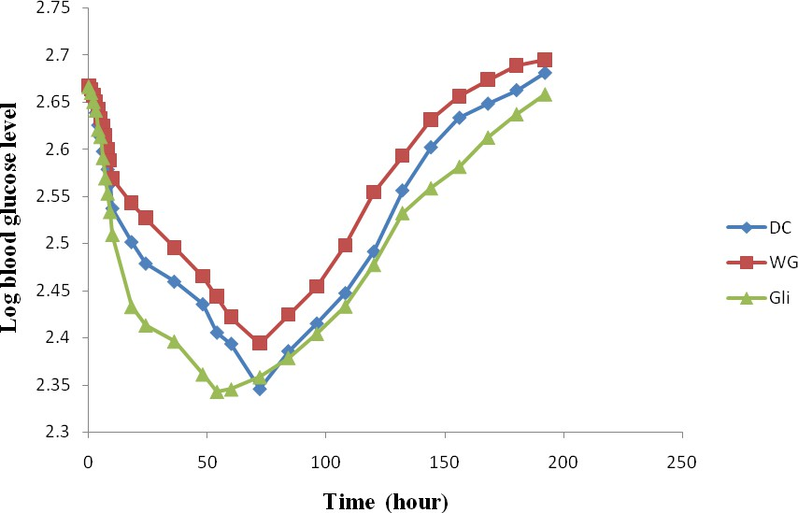

**Fig. 5.1: Plots of log blood glucose level in rabbits against time**

**Table 5.2: Glucose kinetics: Different rate constants (k) and corresponding points of change from one component to the other (t) and half-lives (t1/2) for tablets prepared by direct compression and wet granulation.**

|  |  |  |  |  |  |  |
| --- | --- | --- | --- | --- | --- | --- |
| **Drug** | **Method of**  **preparation** | **k1**  **(hr-1)** | **t1**  **(h)** | **k2**  **(hr-1)** | **t2**  **(hr)** | **k3**  **(hr-1)** |
| *M. pruriens* | DC | 0.028 | 10.0 | 0.005 | 71.0 | 0.007 |
|  | WG | 0.021 | 10.5 | 0.005 | 71.0 | 0.005 |
| Glibenclamide  (Daonil®) | **-** | 0.035 | 10.0 | 0.005 | 52.0 | 0.005 |

## CHAPTER SIX GENERAL DISCUSSION

Diabetes mellitus is the most common disease associated with carbohydrate metabolism and is a major cause of disability, morbidity and mortality associated due to its complications, and hospitalization resulting in a significant financial burden (Foster, 1996). While some NIDDM patients can be managed by diet alone, others require oral hypoglycaemic therapy and/or insulin. Although insulin therapy affords a tight and effective glycaemic control, certain drawbacks such as oral ineffectiveness, short shelf life, requirement of constant refrigeration, parenteral therapy and fatal hypoglycaemia in the event of excess dosage limit its use. On the other hand, pharmacotherapy with sulphonylureas and biguanides is also associated with side effects such as nausea and vomiting, cholestatic jaundice, agranulocytosis, aplastic and hemolytic anemias, generalized hypersensitivity reactions, dermatological reaction and lactic acidosis. (Rang and Dale, 1991). Therefore, there is an urgent need to find safe and effective pharmacological interventions for diabetic mellitus.

Many drugs commonly used today are of herbal origin. Indeed, about 25 percent of the prescription drugs dispensed in the United States contain at least one active ingredient derived from plant material. Some are made from plant extracts; others are synthesized to mimic a natural plant compound. Herbal medicinal products are defined as any medicinal product, exclusively containing one or more active substances (Chandra and Jayakar, 2010).

In the present study, the suitability of the seed of *Mucuna pruriens,* reported to be useful in diabetes ( as a possible antidiabetic agent in the management and treatment of the complications arising from diabetes mellitus and the standardization of its extract into a tablet dosage form have been investigated.

The attainment of dry plant extract from *Mucuna pruriens* was done by first determining which was the most efficient solvent system. Thus, we evaluated the

extractive capacity of chloroform, n-hexane, ethylacetate, ethanol and methanol. The solvent ethanol proved to be the most efficient and effective and was subsequently used to design and formulate the tablets, which was in tandem with folkloric use. The ground seed usually is dipped in a local gin, left for some days before using mucuna seed as an antidiabetic. The percent yield of the extraction process was 44%. The yield can be said to be satisfactory when compared with the outcome of the work of Dhanasekaran *et al*., (2010) which obtained a percentage yield extract of 18.7%w/w.

Results of phytochemical screening revealed that the plant extract contains appreciable amount of carbohydrates, alkaloids, saponoin, steroid, proteins and lipids; trace amounts of tannins and phenols. Any of these secondary metabolites, singly or in combination with others could be responsible for antidiabetic effect of the seed of *M. pruriens*. Using a combination of chromatographic and NMR techniques, Donati *et al*, 2005 revealed the presence of D-chiro-inositol (an oligosaccharide) and its two galacto- derivatives in *Mucuna pruriens* seeds. The quantities detected explained the well established antiglycaemic effect of *Mucuna pruriens* seeds (Horbowicz and Oberdorf, 1994). Although usually ignored in phytochemical analysis for dietary purposes, the presence of these cyclitols is of interest because of the insulin-mimetic effect of D-*chiro*- inositol which constitutes a novel signalling system for the control of glucose metabolism (Larner *et al.*, 1998; Asplin *et al.*, 1993; Ostlund *et al.*, 1993; Ortmeyer *et al.*, 1995; Donati *et al*., 2005). Similarly, several phenolic compounds possess marked anti-diabetic activity (Hsu *et al*., 2000). Moreover, tannin-containing drug demonstrated antidiabetic activity (Iwu, 1983, 1980; Klein *et al*, 2007). Although, only a small number of alkaloids have shown anti-diabetic activity, it is possible that alkaloid content of *Mucuna pruriens* may contribute to its overall antidiabetic activity of the plant. Possibly the insulin-like activity of these bioactive compounds inherent in *Mucuna pruriens* is responsible for its hypoglycaemic effects. It is interesting to know that a carbohydrate is being used to remove same carbohydrate (sugar) responsible for diabetes from the blood just as bacteria produce toxins (antibiotics) that eliminate them.

An acute toxicity study is always performed to establish the therapeutic index of a particular drug and to ensure the safety *in-vivo*. Acute toxicity study is generally carried out for the determination of LD50 value in experimental animals. LD stands for "Lethal

Dose". LD50 is the amount of a material, given all at once, which causes the death of 50% (one half) of a group of test animals. The LD50 is one way to measure the short-term poisoning potential (acute toxicity) of a material. The selection of doses in our study was made based on constant logarithm ratio of 2. The doses selected were very high (0.5 – 32g/kg body weight). As no death of mice was recorded at the doses administered it can be said that *Mucuna pruriens* ethanol seed extract is safe at doses selected.

Alloxan monohydrate is a toxic glucose analogue that preferentially accumulates in pancreatic beta cells via the GLUT2 glucose transporters. In the presence of intracellular thiols, especially glutathione, alloxan generates reactive oxygen species (ROS) in a cyclic redox reaction with its reduction product, dialuric acid. Autoxidation of dialuric acid generates superoxide radicals, hydrogen peroxide and, in a final iron- catalysed reaction step, hydroxyl radicals. These hydroxyl radicals are ultimately responsible for the death of the pancreatic beta cells, which have a particularly low antioxidative defence capacity, and the ensuing state of insulin-dependent ‗alloxan diabetes‘. As a thiol reagent, alloxan also selectively inhibits glucose-induced insulin secretion through its ability to inhibit the beta cell glucose sensor glucokinase.

Different doses of alloxan can produce varying intensities of hyperglycaemia ranging from 120 to 500 mg/dL (Ahmed *et al*., 1991; Dubey *et al*., 1994; Subramanium *et al*., 1996). In the present study, an injection of alloxan (120 mg/kg body weight) raised the blood glucose level 72 hours later by 295%. This is comparable to that reported earlier by (Tasaka *et al*., 1988). Thus, the antihyperglycemic effect of can be dependent upon the dose of diabetogenic agent and therefore on the degree of destruction of the beta cells (Pabrai and Sehra, 1962). This clearly indicates that part of the antihyperglycemic activity of these plants is through the release of insulin from the pancreas, thus when the degree of destruction is more their efficacy is less. In our own study, a hyperglycemia of about 450 mg/dL in rats, (an indication of high diabetic state) extract of *M. pruriens*, continued to exert an antihyperglycemic effect even when the major part of the beta cells in the pancreas were destroyed, indicating a direct insulinomimetic effect.

Even in the event of severe diabetes (> 450mg/dL) and an administration of low doses, *Mucuna pruriens* continued to exert an antihyperglycaemic effect even when the

major part of the beta cells have been destroyed and treatment with extract discontinued, as evidenced from our results, thus, indicating a direct insulinomimetic effect.

The present data indicated that the *M. pruriens* ethanol seed extract significantly exhibited dose dependent reduction of serum glucose in treated normal and diabetic rats as compared with control rats.

Diabetic rats treated with 5, 10, 20, 30, 40, 50 and 100mg/kg of the seed extract and glibenclamide, (5 mg/kg) as standard drug, showed a significant reduction in blood glucose of about 18.6%, 24.9%, 30.8%, 41.4%, 49.7%, 53.1% and 55.4% and 59.7% respectively after 8 hours of treatment.

After twelve weeks of daily treatment with the seed extracts (5, 10, 20, 30, 40, 50 and 100mg/kg) there was significant fall in blood sugar level of 55.3%, 59.5%, 68.4%, 74.7%, 80.89% and 83.2% and 83.6% respectively. At the same time, glibenclamide caused a significant reduction of plasma glucose level of 57.8%.

After 8 hours of treatment, there was a reduction in blood glucose (58%). But after about twelve weeks of treatment the reduction in blood glucose was 83% in blood glucose. This means that the effect of *Mucuna pruriens* was better if they were given for a longer duration. Thus, to derive maximum therapeutic advantage from these plants in diabetic patients, treatment should be continued for a long duration.

The results of the antihyperglycaemic investigations show that *M. pruriens* can be even more effective as an antidiabetic agent than an orthodox medicine like glibenclamide. This is in consistent with the works of Bhaskar *et al*., (2008); Warrier *et al*., (1996); Grover *et al*., (2001); Grover *et al*., (2002) and Akhtar *et al*., (1990). Furthermore, during the past few years some of the new bioactive drugs isolated from hypoglycaemic plants showed antidiabetic activity with more efficacy than oral hypoglycaemic agents used in clinical therapy (Shabana *et al*., 1990; Ramon – Ramos *et al*., 1991; Skim *et al*., 1999 and Jaouhari *et al*., 2000).

It is clearly evident that alloxan administration caused the significant increase in the blood glucose level in 72 hour from 77.5 to 461.9 mg/dL in chronic investigation and from 74.4 to 455.3 mg/dL in acute investigation, (p < 0.05) in rats. The extract of the seeds of showed significant effect compared with respective diabetic control group,

decreased the blood glucose level at all the doses administered. Decrease in blood glucose level indicates antidiabetic effect of the ethanol extract of *M. pruriens.*

Alloxan exerts its diabetic action when it administered parenterally. The action of Alloxan in pancreas is preceded by its rapid uptake by the β-cells. Rapid uptake by insulinsecreting cells has been proposed to be one of the important features determining alloxan diabetogenicity. Another aspect concerns the formation of reactive oxygen species. The studies show that the oral administration of ethanol extract of the seeds of *M. pruriens* decreased blood glucose level in diabetic rats. It is known that diabetes could be one of the non-communicable diseases as a result of the free radical scavengers destroying vital organs of which the pancreas is included. It can be said, however that any plants that possess antioxidant properties could be investigated for a possible anti-diabetic properties (Majekodunmi and Odeku, 2011).

To gain an understanding of the mechanism(s) by which *M. pruriens* elicits its hypoglycemic activity, various biochemical parameters were evaluated following (chronic (72 day) treatment in rats. It has been demonstrated that insulin deficiency in diabetes mellitus leads to a variety of derangement in metabolic and regulatory process, which in turn leads to accumulation of lipid such as cholesterol and triglycerides and LDL and decrease the level of HDL in diabetic patients (Al Rowais, 2002; Grover *et al*., 2001; Leiweng Xiang *et al*., 2007; Nathan *et al*., 2005; Baynes & Thorpe, 1997; Rathi *et al*., 2002; Yamini & Anil, 2001). The abnormal high concentration of serum lipids in the diabetic rats is due mainly to increase in the mobilization of free fatty acids from the peripheral fats depots for breakdown so as to nourish the various cells. In the present study the effect of ethanol extract of *M. pruriens* on the hyperlipedimic level of the rats is dose related.

It is clearly evident from our results that alloxan caused significant elevation of serum markers, Cholestrol (174.0 mg/dL), Triglyceride (63.83 mg/dL), LDL (144.5 mg/dL), BUN (39.33 mg/dL) and Creatinine (mg/dL). This is in agreement with the with the findings of Sharma *et al.,* 1996 who reported that hypercholesterolemia and hypertriglyceridemia occur in alloxan diabetic rats. The marked hyperlipidemia that characterizes the diabetic state may therefore be regarded as a consequence of the uninhibited actions of lipolytic hormones on the fat depots ((Hardman and Limberd,

2001). In contrast ,the groups treated with ethanol extract of *M. pruriens* at the doses of once daily for 12 week reduced all the lipid components such as cholesterol, triglyceride, LDL, and BUN, creatinine and increased the level of HDL in the serum of rat in a dose - related manner. The more prominent effect being reduction in LDL which is a known triggering factor for coronary occlusion. HDL is a protective cholesterol. Considering *M. prurien*‘s effect on the lipid components, it can be assumed to be potential hypolipidemic agent, which will be a great advantage both in diabetic condition as well as the associated atherosclerosis or hyperlipidemic conditions.

This study also evaluated the toxicological effects of the extract of *Mucuna pruriens* seeds using its effect on liver enzymes and serum bilirubin (total and direct) of white albino Wistar rats in the laboratory. The tests conducted were Total Bilirubin (TB), Direct Bilirubin (DB), Serum Aspartate Amino Transaminase (AST), Alanine Amino Transaminase (ALT), and Alkaline Phosphatase (ALP). The liver function tests revealed that the serum AST, ALT, ALP as well as the total and direct bilirubin were significantly (P < 0.05) increased in the rats that were administered the doses in a dose depended fashion when compared to the diabetic control. ALT, AST and ALP levels are mainly indicators of reduced protein synthesis. Also the liver enzymes and serum bilirubin (total and direct) of the rats that received different amount of the dose of *M. pruriens* seed extract were significantly (P < 0.05) increased when compared to the negative control group. In all the experiments, the level of the liver enzymes and serum bilirubin decreased with increase in the dose of drug administered. The increase in serum insulin levels suggested that *M. pruriens* like glibenclamide enhances the secretion of insulin from the beta cells of the islets of Langerhans. Further, *M. prurien* has the ability to restore the protein breakdown and enhance the glycogenesis process in the liver of diabetic rats.

Histopathological studies revealed that *M. prurien* and glibenclamide significantly improved the histological architecture of the islets of Langerhans, the liver and the kidney. The groups treated with *M. pruriens* and glibenclamide showed greater persistence of the islets of Langerhans and lesser degree of necrotic changes as compared to the untreated alloxan diabetic rats. Hence, it may be tentatively summarized that the possible mechanism (s) by which *M. pruriens* brings about the antihyperglycaemic action may be through potentiation of pancreatic secretion of insulin from the intact β-cells of islets

(which may be evidenced by the perceived increased level of insulin in diabetic rats treated with *M. pruriens* and glibenclamide) coupled with extra-pancreatic mechanisms like decreased glycogenolysis and enhanced glycogenesis by the liver and/or enhanced transport of blood glucose to peripheral tissues. *M. pruriens*‘s direct effect on the regeneration of the islet of pancreas was also evidenced by the restoration of the architecture of the islets of Langerhans in histopathological studies. With such an evidence, it is possible to assume that MP might stimulate the secretion of insulin from the beta cells by a mechanism similar to that of oral hypoglycaemic agents (like sulphonylureas) i.e. by depolarisation of islet membrane which consequently alters the change in ion flux (Grodsky *et al*., 1977) or affecting receptors responsible for the recognition of insulin secretagogues (Hellman *et al*., 1973). These mechanism(s) have been accepted as a paradigm for the action of all insulin releasing agents (Nafisa *et al*., 2007).

When a plant extract has been found to be safe, efficacious and non toxic the next thing is how it can be standardized into an adequate dosage form and which method of production or nature of excipient will be most ideal since the ultimate goal of our investigation is to produce an alternative, safe, efficacious and cheap anti-diabetic drug. In spite of their efficacy herbal medicinal products have been widely criticized due to lack of standardization and good presentation (Majekodunmi *et al*., 2007). It is well known that tablet manufacture through direct compression offers many advantages over other methods (Shangraw, 1990). However, when a dry plant extract is incorporated as an active component, it is necessary to bear in mind some considerations: the quality of the plant material should be guaranteed from a botanical, chemical and sanitary point of view. The components of the formulation, like excipients and the active compounds, have to possess some characteristics referred mainly as flowability, compactability and compressibility, and the design of the formulation must satisfy predetermined biopharmaceutical standards. Dry powdered extracts may not exhibit the appropriate rheology and compressibility required to be processed by direct compression. Numerous reports have addressed techniques to solve this kind of problems, such as wet greanulation with non- aqueous solvents, direct compression of spray dried extracts, and selection of suitable excipients for the formulation of dry plant extract in direct compression tablets (Plazier-

Vercamen and Bruwier, 1986: Diaz *et al*., 1996: Renoux *et al*., 1996). However, few studies such as our own have aimed at eliciting dry plant extracts of good flowability and compactibility.

The rheological properties of dry plant extract of *Mucuna pruriens* is important to determine the extract‘s flowability and compressibility and these were assayed considering density, angle of repose and Hausner ratio. These results are similar to those obtained from other species (Palma *et al*., 1999). The dry extract of *M. pruriens* possesses suitable rheological properties and compressibility, permitting its use in direct compression technology. The relatively low values of Hausner ratio and normal angles of repose observed for extract; Avicel, Cellactose and lactose denote their ability to flow. The excipients selected, microcrystalline cellulose (Avicel), Cellactose (Wade and Weller, 1994), α-lactose monohydrate (Wade and Weller, 1994) possess defined physical- mechanical properties (Alderborn and Nystron, 1996) which may be transferred to the formulation according to the rates in which they occur. Cellulose and its combination with lactose (Cellactose) has the highest density. But when this excipient is replaced by lactose, a significant reduction of density (BD and TD) in the powder mixture is observed. The use of directly compressible fillers and diluents such as Avicel and Cellactose produced good quality tablets without prior manipulation.

The tablets were compressed at the specified weight (500mg). The maximum weight variation of the tablets was ± 1.71%, which falls within the acceptable weight variation range of ± 5%, hence the tablets of all the batches passed the weight variation test.

With respect to compression behaviour, the influence of compression forces (CF) on the crushing strength, friability and disintegration time of the tablets was shown. When the compression force is increased from 5kN to 10 kN, an increase in the crushing strength of the tablet was observed. This increase in crushing strength was more remarkable with formulations containing Avicel and Cellactose because these excipients are very compressible materials. Crushing strength for tablets produced by drug without diluents, Avicel and Cellactose was in the range of 3.3 to 4.1kg/cm², which falls above the limit of not less than 3.0 kg/cm², while MP tablets containing lactose did not.

The ranking of crushing strength values for tablets prepared by direct compression using Avicel, Cellactose and lactose are: Cellactose > Avicel > Lactose. None of the tablets had friability value more than 0.90%.

There seemed to be not much difference in properties of tablets produced by direct compression and wet granulation methods. Tablets formed from granules generally had a lower crushing strength than tablets produced by direct compression. The crushing strength data suggests that the increase in the compaction force (i.e. densification) during the granulation reduces the strength of the compacted material. This reduction can be attributed to the material‘s ability to undergo plastic deformation, which ability was dissipitated during the granulation process (Freitag and Kleinebude, 2003; Bultmann, 2002; Mitrevej, 1996; Kochhar *et al*., 1995). *M. pruriens* tablets containing PVP as binder was less friable than tablets containing corn starch. For tablets produced by wet granulation, crushing strength of the tablets of all batches was in the range of 3.1 to 3.5kg/cm², which falls above the limit of not less than 3.0 kg/cm². The tablets produced by wet granulation disintegrated within 11 minutes 17 seconds. PVP is a binder with high cohesive tendency but of low viscosity. It can as well acts as a disintegrant and this may alter the rate and extent of the drug release.

The various tablets exhibited varying dissolution profiles due in part to differences in the compression pressures and binder concentration. *M. pruriens* tablets containing PVP dissolved faster than *M. pruriens* tablets containing corn starch. Concerning the disintegration times of the tablets, much difference was observed between direct compression and wet granulation. For all the cases, the disintegration times increased significantly when the compression force was increased. In addition, as the binder concentration increased, the disintegration time increased as well.

Generally, the values of k1 and k2 for tablets prepared by direct compression were lower than their corresponding values for tablets prepared by wet granulation implying a faster dissolution rate of the drug after t1. This could be expected as tablets prepared by direct compression disintegrated fater than tablets prepared by wet granulation.

The results of the elimination of glucose kinetics are in good agreement with the hypothesis that the elimination of glucose from the blood takes place at the rate of a first-

order reaction (Jokipii and Turpeinen, 1954). One quantity of physiological significance is k, the elimination kinetic rate constant which is the best single index of the capacity of the organism to eliminate glucose from the blood. The elimination rate constant, k, indicates the fraction of glucose which is eliminated per unit time. The effects of *Mucuna pruriens* extract tablets were evaluated on glucose level in rabbits after induction of diabetics. Thus, at the time of commencement and during treatment, the glucose kinetics was analogous to those following the intravenous bolus drugs. `

There was a significant (p < 0.05) increase on the rate constant of tablets prepared by direct compression compared to tablets prepared by wet granulation *in vivo* which implied a faster dissolution as obtained in the *in vitro* dissolution profile meaning that the bioavailability of the drug in wet granulation was not as high as tablet prepared by direct compression. In other words, tablets prepared by direct compression had more bioavailability than tablets prepared by wet granulation.

## CHAPTER SEVEN CONCLUSION

The studies of the antidiabetic potential of the ethanolic extract of *Mucuna pruriens* seed and its tablet formulation have led to the following conclusions:

1. The administration of the various doses of ethanolic seed extract of *Mucuna pruriens* led to the dose-dependent reduction in the blood glucose level in both acute and chronic administrations more effectively than that observed for glibenclamide as a standard drug. Acute toxicity studies showed that the extract was relatively safe except at high doses when some adverse effects were observed although no death was recorded. Oral administration of *M. pruriens* ethanolic seed extract also reduced the weight loss associated with diabetes.
2. The biochemical and haematological investigations of the blood and histopathological examinations of the liver, pancreas and kidney of the rats carried out after the antidiabetic investigations showed that *M. pruriens* ethanol seed extract has both hepato-protective and cholesterol reducing activities comparable to glibenclamide in diabetic rats and could be useful for the treatment of hepatic and kidney damage arising from diabetes mellitus. These studies clearly support the traditional use of the plant for the treatment of diabetes.
3. The mechanical properties of *M. pruriens* tablets prepared by direct compression were found to depend on the diluent type and compression pressure applied for compaction.
4. Generally, binder type, concentration and compression pressure affected the mechanical properties of the tablets produced by wet granulation.
5. Generally, tablets prepared by direct compression possessed better mechanical and release properties than tablets prepared by wet granulation as they possessed acceptable bond strengths and faster disintegration times. The disintegration time and dissolution rates of the tablets prepared by direct compression increased with increase in binder concentration and compression pressure. Tablets prepared by

direct compression using Avicel and Cellactose produced better tablets with adequate bond strength to withstand the rigours of handling during manufacture, packaging and use and at the same time released the active compound(s) for bilologic action.

1. The elimination of glucose in rabbits was found to undergo a first order rate kinetics and the elimination of *Mucuna pruriens* tablets was comparable to that of glibenclamide tablets.

## REFERENCES

A.O.A.C. (1980): Official methods of analysis, 13th ed. Association of official Analytical Chemist, Washington D.C. 376 - 384

Achrekar, S., Kaklij, G.S., Pote, M.S., Kelkar, S.M. (1991): Hypoglycaemic activity of *Eugenia jambolana* and *Ficus bengalensis*: Mechanism of action*.* J. *In vivo*, **5**: 143-147.

ADA (American Diabetes Association). (1985): Responsible use of animals in research.

*Diabetes* **34**:714.

Adebayo, A.S. and Itiola, O.A. (1998): Evaluation of breadfruit and cocoyam starches as exodisintegrants in a paracetamol tablet formulation. *Pharm. Pharmacol. Commun.* **4**: 385 - 389.

Adebowale, K. O. and Lawal, O. S. (2003a): Foaming, gelation and electrophoretic characteristics of *Mucuna* bean (*Mucuna pruriens*) protein concentrates. *Food Chemistry* **83**: 237-246.

Ahmed, T., Adeghate, E., Sharma, A. K., Pallot, D. J., Singh, J. (1991): Effect of *Momordica charantia* fruit juice on islet of morphology in the pancreas of the streptozotocin diabetic rat. *Diabetes Res. Clin. Pract.* **40**: 145 – 151.

Akhtar, M. S, Qureshi, A. O., Igbai, J (1990): Antidiabetic evaluation of *Mucuna pruriens*

Linn seed. *Journal of Pak. Med. Associ.* **40**: 147-150.

Alarcon-Aguilar, F. J., Roman-Ramos, R., Perez-Gutierrez, S., *et al*. (1998): Study of the antihyperglycaemic effect of plants used as antidiabetics. *J Ethnopharmacol*. **61**: 101-110.

Alderborn, G., Nystro¨ n, C., 1996. Pharmaceutical Powder Compaction Technology.

Marcel Dekker, New York and Basel.

Ali, L., Azad-Khan, A.K., Hassan, Z., *et al.* (1995): Characterization of the hypoglycemic effects of *Trigonella foecum graecum* seed. *Planta Med*., **61**: 101-110.

Allain, C.C., Poon, L.S., Chanm, C.S., Richmound, W., Fu, P.C. (1974): Enzymatic determination of total serum cholesterol. *Clin Chem*. **20**: 470-475.

Al-Rowais, N.A. (2002): Herbal medicine in the treatment of diabetes mellitus; *Saudi Med J*., **23**: 1327-1331.

Andersen, A.R, Christiansen, J.S Andersen, J.K, Kreine,r S, Deckert, T. (1983): Diabetic nephropathy in Type 1 (insulin dependent) diabetes: an epidemiological study. *Diabetologia*, **25**: 496-501

Armstrong, N.A. (1989): Time-dependent factors involved in powder compression and tablet manufacture. *Int. J. Pharm*. **49**, 1–13.

Ashok, K, Gaurav, R, Vinod, K, Dhatwalia, G, Gaurav, S. (2009): Phytochemical screening of Mucuna seeds and exploit in opposition to pathogenic microbes. *J. Biol. Environ*. *Sci*., **3**(9): 71-76.

Asplin, I, Galasko, G, Larner, J. (1993): Chiro-inositol deficiency and insulin resistance: a comparison of the chiro-inositoland myo-inositol-containing insulin mediators isolated from urine, hemodialysate and muscle of control and type II diabetic subjects. *Proc Natl Acad Sci* USA **90**: 5924–5928.

Augusti, K.T., Rajisuan, Cherian, D.S., Sheeta, C.G. and Nair, C.R. (1994): Effect of leucopelargonin derived from *Ficus bengalensis* (Linn.) on diabetic dogs. *Ind. J*. *Med. Res*., 99: 82-86

Augusti, K. T., Sheela, C. G. (1996): Antiperoxide effect of Sallyl - cystein sulfoxide, an insulin secretagogue in diabetic rats. *Experientia*; **52**: 115-120.

Babu, P.S. and Srinivasan, K. (1997): Influence of dietary capsaicin and onion on the metabolic abnormalities associated with streptozotocin induced diabetes mellitus. *Mol Cell Biochem.,* **175**: 49-57.

Babu, V. (2002): Anti-hyperglycemic activity of Cassia kleinii leaf extract in glucose fed normal rats and alloxan-induced diabetic rats. *Indian J Pharmacol*; **34**:409-15.

Ballard, D. J., Humphrey, L.L, Melton, L.J. *et al*. (1998): Epidemiology of persistent proteinuria in type 11 diabetes mellitus: population-based study in Rochester, Minnesota, *Diabetes*; **25**: 496-412.

Banker, G.S and Anderson, N.R, (1986): Tablets: In: The Theory and Practice of Industrial Pharmacy, Lachman, L., Lieberman, H.A. and Kanig, J.L. (Eds) 3rd edition, Lea & Febiger, Philadelphia, pp. 301-323.

Bannerman, R, Burton J and Wen-Chieh, C (1983): Traditional Medicine and Health Care Coverage, A Reader for Health Administrator and Practitioners, Geneva: World Health organization.

Bansal, R., Ahmad, N., Kidwai. J.R. (1980): Alloxan-glucose interaction: effect of incorporation of 14C-leucine into pancreatic islets of rats. *Acta Diabetol Lat* **17**: 135-143.

Barker, C. F. (1982): Animal models of diabetes and immunological problems with islet allografts. Trans. Am. Soc. Artif. Intern. Organs 28: 691-699.

Bartels, H. and Boehmer, M. (1971): Microdetermination of creatinine. *Clin. Chim. Acta*;

**32**: 81-85.

Barter, P. J., Nicholls, S., Rye, K. A., Anantharamaiah, G. M., Navab, M., Fogelman, A.

M. (2004): Antiinflammatory properties of HDL. *Circulatory Res*.; **95**: 764 - 772

Basch, W.E, Gabardi, S and Ulbricht, C. (2003): Musa sapientum, *Am J Health-Syst Pharm*. Vol. **60**.

Baynes, J.W. and Thorpe, S.R. (1997): The role of oxidative in diabetic complications. *J. Curr. Opin. Endocrinol*., **3**: 277-284

Bell, R. H. (1983): Animal models of diabetes mellitus: physiology and pathology. *J Surg.*

*Res*,*35*, 433-60.

Bhaskar Anusha, Vidhya V.G. and Ramya M. (2008): Hypoglycaemic effect of Mucuna pruriens seed extract on normal and streptozotocin-diabetic rats. *J. of Phytoteraphy* **79**: p. 539-543.

Bilous, R..W, Mauer, S. M, Sutherland, D. E. R., Steffes, M.W. (1989): Mean glomerular volume and rate of development of diabetic nephropathy. *Diabetes*; **38**:1142- 1147.

Biswas, T.K, Bandyopadhyay,S, Mukherjee,B, Mukherjee, B and Sengupta, B. R. (1997): Oral hypoglycemic effect of *Caesalpinia bonducella*, Int. *J. of Pharmacognosy* **35**: pp. 261–264.

Boquist, L., Nelson, L., Lorentzon, R. (1983): Uptake of labelled alloxan in mouse organs and mitochondria *in vivo* and *in vitro*. *Endocrinology* **113**: 943-948.

Bravo, L. (1998): Polyphenols: chemistry, dietary sources, metabolism and nutritional significance. *Nutrition Review* **56**: 317-333.

Brinker, F.J., (1998): Herb Contraindictions and Drug Interactions: With Appendices Addressing Specific Conditions and Medicines. 2nd Edn., Eclectic Medical British Pharmacopoeia (1980): Ash value, Acid Insoluble Water Soluble, Extractive and Alcohol Extractive, Vol. II, Appendix XII, Majesty‘s Stationery Office, London, pp. 1276 - 1277.Publications, Oregon, USA.

British Pharmacopoeia (1998): Friability of Uncoated Tablets. Her Majesty Stationery Office, London, A262.

British Pharmacopoeia (1998): Resistance to Crushing of Tablets. Her Majesty Stationery Office, London, A 262.

British Standard 1460, British Standard Institution, London, 1970.

Bultmann, J.M. (2002): Multiple compaction of microcrystalline cellulose in a roller compactor. *Eur J Pharm Biopharm*. 54, p 59-64.

Caius, J. F. (1989): The Medicinal and Poisonous Legumes of India. Scientific Publishers, Jodhpur, India, 70-71.

Canal, J. R., Torres, M. D., Romero, A., Perez, C. A. (2000): Chloroform extract obtained from a decoction of *Ficus carica* leaves improves the cholesterolaemic status of rats with streptozotocin-induced diabetes. *Acta Physiol Hung*, **87**: 71-76.

Castro, V.R., (1998): Chromium in a series of *Portuguese* plants used in the herbal treatment of diabetes. *Biol. Trace Element Res*., **62**: 101-106.

Chakrabarti, S., Biswas, T.K., Rokeya, B., Mosihuzzaman, M., Ali, L., Nahar, N. and Mukherjee, B. (2003): Advanced studies on hypoglycemic effect of *Caesalpinia bonducella* F. in type 1 and 2 diabetes in Long-Evans rats, *J. of Ethnopharmacology* **84**: pp. 41–46.

Chandra, M and Jayakar, B. (2010): Formulation and evaluation of herbal tablets containing *Ipomea digitata* Linn. Extract. *Int. J. Pharm. Sci. Rev & Res*. **21**: 343 – 346.

Chattopadhyay, R. R. (1996): Possible mechanism of antihyperglycaemic effect of

*Azadirachta indica* leaf extract, part IV. *Gen Pharmacol*., **27**: 431-434.

Chattopadhyay, R. R. (1999): Possible mechanism of antihyperglycaemic effect of

*Azadirachta indica* leaf extract, part V. *J. Ethnopharmacol.,* **67**: 373-376.

Chaturvedi, V. C., Shrivastava, R. and Upreti, R. K. (2004): Viral infections and trace elements: A complex interaction. Current Science **87**: 1536-1554.

Cheeke, P. R. (1996): Biological effects of feed and forage saponins and their impacts on animal production. In: Saponins Used in Food and Agriculture (Editors, Waller G. and Yamasaki K.), Plenum Press, New York, 377-385.

Chen, M. D., Lin, P. Y, Tsou, C. T., Wang, J. J., Lin, W. H. (1995): Effects of Valsartan, mycophenolate mofetil trail and nuclear factor-kB expression in the kidneys of diabetic rats. *J. of Biol Trace Elements Res*. **50**: p.119.

Cherian, S. and Augusti, K.T. (1993): Antidiabetic effects of glycoside of Leucopelargonidin isolated from *Ficus bengalensis* Linn. *Indian J Exp Biol.* **31**: 26-29.

Cherian, S., Kumar, R.V., Augusti, K.T., Kidwai, J.R. (1992): Antidiabetic effects of glycoside of pelargonidin isolated from the bark of *Ficus bengalensis* Linn*. Indian J. Exp Biol*. **29**: 380-382.

Cox, P. A. and Balick, M. J. (1994): The Ethnobotanical approach to drug discovery.

Scientific American, **270**: 60

Dabis, G, Michon, D, Gazenav, J., Ruffie A. (1984): Hypoglycemic effect of Sueda fruticosa in streptozotocin- induced diabetic rats. *La vie medicale* **8**: p.277

Day, C., Cartwright, T., Provost, J., Bailey, C. J. (1990): Hypoglycaemic effect of

*Momordica charantia* extracts. *Planta Med*., **56**: 426-429.

De Smet, P. A. and Brauwers, J. R. (1997): Pharmacokinetic evaluation of herbal remedies: basic introduction, applicability, current status and regulatory needs; *Clinical Pharmacokinetics*, Vol. **32**: pp. 427-436.

Deckert, T., Poulsen, J. E., and Larsen, M. (1978): Late diabetic manifestation s in pancreatogenic diabetes mellitus. *Act Diabetol Lat* 15: 201 – 204.

Dhar, M.L., Dhar, M.M., Dhawan, B.N., Mehrotra, B.N. and Ray, C. (1968): Screening of Indian plants for biological activity, *Indian J. of Exp Biol*. **6:** p. 232.

Diaz, L., Souto, C., Concheiro, A., Gomez-Amozy, L.M., Martinez-Pacheco, R.,(1986): . Evaluation of Eudragit E as excipient in tablets of dry plant extract. *STP Pharma Sci*. 2: p105-109.

Donati D., Lampariello, L. R., Pagani, R., Guerranti, R., Cinci, G., Marinello, E. (2005): *J. of Phyto Res.* **19**: p.1057-1060

Doumas, B. T., Watson, W. A., and Biggs, H. G (1971): Albumin standards and the measurement of serum albumin with bromocresol green. *Clin. Chin. Acta* **31**: 87-89.

Dubey, G. P., Dixit, S. P., Singh, A. (1954): Alloxan – induced diabetes in rabbits and effect of an herbal formation D – 400, *Indian J. Pharm*. 26: 225 – 226.

Dubois, H. F. W. and Bankauskaite, V. (2005): Type 2 diabetes programme in Europe. *J*. *Euro Observer,* **7**(2) 5-6.

Duke, J. A. (1981): Handbook of legumes of world economic importance. New York, Plenum press.

Ebelt, H., Peschke, D., Bromme, H.j., Morke, W., Blume, R., Peschke, E. (2000): Influence of melatonin on free radical-induced changes in rat pancreatic beta- cells in vitro. *J Pineal Res* **28**: 65-72.

Eberhart, M. S., Ogden, C., Engelgau, M., Cadwell, B., Hedley, A. A, Saydah, S. H. (2004): Prevalence of Overweight and Obesity Among Adults with Diagnosed Diabetes-United States, 1988-1994 and 1999-2002. Morbidity Mortality Weekly Rep. **53**(45): 1066-1068.

Ellenberg, M. (1974): Diabetic neuropathic cachexia. *Diabetes* **23**: 418-423.

Esders, T. W. and Michrina, C. A. (1979): Purification and properties of L – alpha- glycerophosphate oxidase from *Streptococcus faecium* AJCC 12755. JBC, Vol. 254, issue 8, 2710 – 2715.

Esezobo, S. and Ambujam, V. (1982): An evaluation of starch obtained from plantain *Musa parasidisiaca* as binder and disintegrant for compressed tablets. *J. Pharm. Pharmacol*., **34**: 761 - 765.

Esezobo, S. and Pilpel, N. (1976): Some formulations factors affecting tensile strength, disintegration and dissolution of uncoated oxytetracycline tablets. *J. Pharm*. *Pharmacol*., **28**: 8 - 16.

Esezobo, S. and Pilpel, N. (1977): Moisture and gelatin effects on the interparticle attractive forces and the compression behaviour of oxytetracycline formulations.

*J. Pharm. Pharmacol*., **29**: 75 - 81.

Esimone, C.O., Nwafor, S.V., Okoli, C.O*. et al*., (2002): ―*In vivo* evaluation of interaction between aqueous seed extract of *Garcinia kola* Heckel and ciprofloxacin hydrochloride‖., *American Journal of Therapeutics*, Vol. 9: no 4, pp. 275-280.

Evolution of wetting heat and its relation to compressional force. *Yakugaku*

Foster, D.W. (1996): Diabetes mellitus. In Harrison‘s principles of Internal Medicine, Isselbacher K. J, Brawnwald, E, Wilson, J.D., Martin, J.B., Fauci, A.S. Kasper,

D.L (eds.) McGraw Hill: New York 1798-1981.

Freitag, F., Kleinebude, P. (2003): How do roll compaction/dry granulation affect the tablet behavior of inorganic materials? Comparison of four magnesium carbonates. *Eur J Pharm Sci*. 19, p 281-289.

Friedewald, W .T., Levy, R. I., Fredrickson, D. S. (1972): Estimation of the concentration of low-density lipoprotein cholesterol in plasma, without use of the preparative

Gayaraja, S., Shinde, S. and Agarwal, S.L. (1978): Antiasthmatic properties of

*Caesalpinia bonducella* leaves, *Indian J. of Pharmacy* **10**: p. 86.

Gbolade, A.A. (2006): Inventory of antidiabetic plants in selected districts of Lagos State, Nigeria. *J Ethnopharmacol.,* **121:** 135-139.

Geetha, B. S., Mathew, B. C., Augusti, K. T. (1994): Hypoglycaemic effects of leucodelphinidin derivative isolated from *Ficus bengalensis* (Linn.). *Indian J Physiol Pharmacol.,* **38**: 220-222.

Gelati, K. N. (1979): Diabetic relinopathy in Spontaneous Animal Models of Human

*Diseases*, vol. **I**, New York: Academic Press. Pp. 177-178

Gelati, K. N. (1979): Diabetic relinopathy in Spontaneous Animal Models of Human Diseases, vol. **I**, New York: Academic Press. Pp. 177-178

Ghosal, S., Singh, S. and Bhattacharya, S. K. (1971): Alkaloids of *Mucuna pruriens*: Chemistry and pharmacology. *Planta Medica* **19**: 279-284.

Glugliano, D., Ceriello, A., and Paolisso, G. (1996); Oxidative stree and diabetic vascular complications. *J. Diabet. Care*, **19**: 257-267

Gordon, T., Castelli, W. P., Hjjortland, M. C. (1977): High density lipoproteins as a protective factor against coronary heart disease: the Framingham study. *Am J Med*, **62**: 707.

Graf, E. and Eaton, J. (1990): Antioxidant functions of phytic acid. Free Radica; *Biol. and Med*. **8**: 61-69

Grodsky, G. M.,, Fanska, R., Lundquist, I. (1975): Interrelationships between alpha and beta-anomers of glucose affecting both insulin and glucagon secretion in the perfused rat pancreas. II. *Endocrinology*. **97**(3): 573–580.

Grover, J. K., Vats, V., Rathi, S. S., Dawar, R. (2001): Traditional Indian anti-diabetic plants attenuate progression of renal damage in streptozotocin induced diabetic mice .*J Ethnopharmacol.* **76**(3):233-238.

Grover, J. K., Yadav, S., Vats, V. (2002): Medicinal plants of India with antidiabetic potential. *J. of Ethnopharmacology* **81**: 100.

Gruppuso, P.A., Boylan, J.M., Posner, B.I., Faure, R., Brautigan, D.l. (1990): Hepatic protein phosphotyrosine phosphatase. Dephosphorylation of insulin receptor and epidermal growth factor receptors in normal and alloxan diabetic rats. *J Clin Invest* **85**: 1754-1760.

Gunsel, N and Kanig, J. F. (1986): Tablets. In: The Theory and Practice of Industrial Pharmacy, Ed. by Lachman, L., Lieberman, H.A. and Kanig, J.L. (Eds) 3rd Edition, Lea and Ferbiger, and Philadelphia. pp. 297 – 303.

Gupta, M., Mazunder, U. K., Chakrabort, S., Rath, N., Bhawal, S. R. (1997): Antiepileptic and anticancer activity of some indigenous plants. Indian *J. Physiol. Allied Sci.* **51**(2): 53-56.

Gupta, S. K. (2006): Drug Screening Methods, Anshan publication, New Delhi .pp.254.

Gurumoorthi, P., Pugalenthi, M. and Janardhanan, K. (2003b): Nutritional potential of five accessions of a South Indian tribal pulse, *Mucuna pruriens* var. *utilis*. II. Investigation on the total free phenolics, tannins, trypsin and chymotrypsin

inhibitors, phytohaemagglutinins and *in vitro* protein digestibility. *Tropical and Subtropical Agroecosystems* **1**: 153-158.

Hagerman, A. E., Riedl, K. M., Jones, G. A., Sovik, K. N., Ritchard, N. T., Hartfield, P.

W. and Riechel, T. L. (1998): High molecular weight plant polyphenolics (tannins) as biological antioxidants. *J. Agricultural Food Chemistry* **46**: 1887- 1892.

Hamburger, M. and Hostettmann, K. (1991): Bioactivity in Plants: The Link between phytochemistry and medicine. *Phytochemistry*, **30**: 3864 - 3874.

Handa, S.S. (1996); Medicinal plant- priorities in India medicines diverse studies and implications, ―Supplement to Cultivation and Utilization of medicinal plants,

S.S. Handa and M. A. Kakul, Eds., pp. 33-51, Regional Research Laboratories, Jammu Tawi, India.

Hardman, J. G. Limbard, L. E. (2001): Insulin, Oral Hypoglycemic Agents and and The Pharmacology of the Endocrine Pancrease. In Goodman and Gilman‘s: The Pharmacological basis of Therepeuticsa. Tenth edition. Mcgraw-Hill Company Limited, USA; 1383-1399.

Harris, M. I., Flegal, K. M., Cowie, C. C., Eberhardt, M. S., Goldstein, D. E., Little, R. R., et al. (1998): Prevalence of diabetes, impaired fasting glucose, and impaired glucose tolerance in U.S. adults: The Third National Health and Nutrition Examination Survey. *Diabetes Care*; **21**: 18-24.

Heikkila, R. E., Winston, B., Cohen, G. and Barden, H. (1976): Alloxan induced diabetes, evidence for hydroxyl radicals as a cytotoxic intermediate. *Biochem Pharmacol* **25**: 1085-1092.

Hellman, B. O., Lars-Ake, I., Lernmark, A., Sehlin, J. and Taljedal, I. (1973): The pancreatic p-cell recognition of insulin secretagogues: Effects of calcium and sodium on glucose metabolism and insulin release. *Biochem. J*. **138**: 33-45

Helmstoädter, A. (2008): *Syzygium cumini* (L.) Skeels (Myrtaceae) against diabetes-125 years of research. *Pharmazie.* 63:91–101.

Henry, R. J., Chiamori, N., Golub, O. J., and Berkman, S. (1960): Revised spectrophotometric methods for the determination of glutamic-axoloaacetic transaminase, glutamic-pyruvic transaminase, and lactic acid dehydrogenase. *Am. J. Clin. Pathol*. **34** (4): p. 381-385.

Hertog, M. G. L., Sweetnam, P. M., Fehily, A. M., Elwood, P. C. and Kromhout, D. (1997): Antioxidant flavonols and ischaemic heart disease in a Welsh population of men - the caerphilly study. *American Journal of Clinical Nutrition* **65**: 1489-1494.

Higashino, H., Suzuki, A., Tanaka Pootakham, K. (1992): Hypoglycaemic effects of Siamese *Momordica Charantia* and *Phyllantus urinaria* extracts instreptozotocin-induced diabetic rats. Nippon Yakurigaku Zasshi, **100**: 515- 521.

Horbowicz, M, Obendorf, R. L. (1994): Seed desiccation tolerance and storability: dependence on flatulence-producing oligosaccharides and cyclitols. Review and survey. *Seed Sci Res* **4**: 385.

Hsu, F.L., Chen, Y.C., Cheng, J.T. (2000): Caffeic acid as active principle from the fruit of *Xanthium strumarium* to lower plasma glucose in diabetic rats. *Plant Med*., **66**, 228-230.

Hussain and Manyam, B. V. (1997): *Mucuna pruriens* proves more effective than L. Dopa in Parkinson‘s Disease animal model. *Phytother. Res*. 11: 419-423.

Hussain, K., Ismail, Z., Sadikun, A., Ibrahim, P. (2009): Bioactive markers based pharmacokinetic evaluation of extracts of a traditional medicinal plant, *Piper sarmentosum* J*.* Evidence-based Complementary and alternative Medicine, Vol. **2011.**

IFCC (1986): Method for L-Aspartate aminotransferase. *J. Clin. Chem. Clin*. *Biochem.*

**24:** 497-510.

Infante, M. E., Perez, A. M., Simao, M. R., Manda, F., Baquete, E. F. and Fernandez, A.

M. (1990): Outbreak of acute psychosis attributed to *Mucuna pruriens*. Lancet 336: 1129.

Itiola, O. A. and Pilpel, N. (1986): Studies on Metronidazole tablet formulations. *J. Pharm. Pharmacol*., **68**: 81

Itiola, O. A. and Pilpel, N. (1991): Formulation effects on the mechanical properties of metronidazole tablets. *J. Pharm. Pharmacol*., **43**: 145 - 147. (Editorial) Lancet **343**: pp. 1513.

Itiola, O. A. and Pilpel, N. (1996): Effects of interacting variables on the disintegration and dissolution of metronidazole tablets. *Pharmazie,* **31**: 987 - 989.

Iwu, M. M. (1983): Traditional Igbo medicine. Institute of African studies, University of Nigeria, Nsukka, pp 122–144.

Iwuagwu, M. A., Nwaoshai, C.A. and Iseghobi, F. E. (1986): Investigation into the binding and disintegrant property of starches from selected Discoreaceae plants. *Nig. J. Pharm. Sci*., **2**: 10 - 22.

Iyengar, M. A., Pendse, G. S. (1965): Anti-diarrhoeal activity of the nut of

*Caesalpinia bonducella* Flem. *Indian J. Pharmacol*. **27**, 307-308

Janardhanan, K. and Lakshmanan, K. K. (1985): Studies on the pulse, *Mucuna utilis*: Chemical composition and antinutritional factors. *Journal of Food Science and Technology* **22**:369-371.

Jaouhari, J.T., Lazrek, H.B., Jana, M. (2000): The hypoglycaemic activity of *Zygophyllum gaetulum* extracts in alloxan-induced hyperglycaemic rats*. J Ethnopharmacol,* **69**:17-20.

Jarrett, R. j., McCartney, P., Keen, H. (1982): The Bedford Survey: ten year mortality rates in newly diagnosed diabetics and normoglycaemic controls and risk indices for coronary heart disease in borderline diabetics. *Diabetologia*; **22**: 79-84

Jokippi, S.G. and Turpeinen, O. (1954): Kinetics of elimination of glucose from the blood during and after a continous intraveneous injection, **33**(3): pp 452-458.

Joshi, L. D. and Pant, M. C. (1970): Hypoglycaemic effect of *Glycine soja, Dolichos biflorus* and *Mucuna pruriens* - seeds diets in albinorats. *Indian Journal* of *Pharmacology* 2: 29-35.

Kabele – Toge, B. B., Igwilo, C. I., Adeoye, A. O. (1996): Characterization and standardization of the seeds of *Ricinus communis* Linn var. minor used as contraceptive. *West Afr. J. Biol. Sc.* **5**(2): 160 – 165.

Kanig, J. L. and Rudnic, C**.** (1984): The mechanisms of disintegrant action.

*Pharm.Technol*., **8**: 50 - 62.

Kanne, W.B, McGee D.L, (1979): Diabetes and Cardiovascular Disease: the Framingham study. JAMA 1979; 241:2035-2038.

Kar A, Choudhary B. K, Bandyopadhyay N. G. (1999): Comparative evaluation of hypoglycaemic activity of some Indian medicinal plants in alloxan diabetic rats.

*J. Ethnopharmacol*., 64: 179-184.

Kar A, Choudhary B.K (1994): Herbal and traditional medicine for the treatment of Diabetic mellitus. *J. of Indian Drugs* 1994; **31,** p.127

Katsumata, K., Katsumata, K., Jr., Katsumata, Y. (1992): Protective effect of diltiazem hydrochloride on the occurrence of alloxan- or streptozotocin-induced diabetes in rats. *Horm Metab Res* **24**: 508-510.

Katzenschlager, R., Evans, A., Manson, A., Patsalos, P.N., Ratnaraj, N., Watt, H., Timmermann, L., Van der Goessel, R and Lees, A. J. (2004): *Mucuna pruriens* in Parkinson‘s disease: a double blind clinical and pharmacological study. *Journal of Neurosurgery and Psychiatry*, **75**, p.1672-1677.

Kay, D. (1979): Food legumes. Tropical Products Institute, London, *UK. Crop and Product Digest* No 3. pp. 435.

Keller, A., (1984); Total Serum Protein. In: Clinical Chemistry, Theory, Analysis and Correlation, Kaplan, L.A. and A.J. Pesce (Eds.). St. Lious: Mosby Company, USA, pp: 1400-1402.

Khan, K. A. and Rhodes, C, T. (1976): Effect of variables in compaction force on properties of six direct compression tablet formulations. *J. Pharm. Sci*., **65**: 1835 - 1837.

Khosla, P, Gupta, D. D., Nagpal, R. K. (1995): Effect of *Trigonella foenum graecum* (Fenugreek) on blood glucose in normal and diabetic rats*. Indian J Physiol Pharmacol.,* **39**: 173-174.

King, R.E. (1980): Tablets, Capsules and Pills In: Remington‘s Pharmaceutical Sciences (Eds) 16th edition, Mack Publishing Company, Pennsylvania, pp. 1563 - 1564.

King, R.E. and Schwarz, J.B. (1985): Oral solid dosage forms. In: Remington‘s Pharmaeutical Sciences. Gennaro, R (Ed) 17th ed. (1985). Mack, Pennsyslavania, pp. 1603-1622.

King, R.E.M., Osoe, A. (1975): Tablets, Capsules and Pills In: Remington‘s Pharmaceutical Sciences, Mack Publishing Company, Philadelphia, fifteenth Edition, pp. 1576 – 1586.

Kitazawa, S., Johno, I., Minouchi, T., Ito, Y. and Okada, J. (1977a): A comparison of the dissolution rates of caffeine tablets in a rotating-basket with those in a Sartorius dissolution tester. *Journal of Pharm and Pharmacol* **29**: 585-588.

Klein, G. Kim, J., Himmeldirk, K., Cao, Y., Chen, X. (2007): Antidiabetes and Anti- obesity Activity of Lagerstroemia speciosa. Evidence-based Complementary and Alternative Medicine (eCAM); **4**(4):401–407.

Kliber, A., Szkudelski, T., Chichlowska, J. (1996): Alloxan stimulation and subsequent inhibition of insulin release from in situ perfused rat pancreas. *J Physiol Pharmacol* **47**: 321-328.

Klockgether-Radke, A.P. (2002): F.W. Serturner and the discovery of morphine. 200 years of pain therapy with opiods. *J. Anasthesiol intensivmed notfallmed schmarzther;* **37** (5) 244-249.

Kochhar, S.K., Rubinstein, M.H., Barnes, D. (1995): The effects of slugging and recompression on pharmaceutical excipients. International Journal of Pharmaceutics **115**, 35-43.

Kolthoff, I. M. and Elving, P. J. (1976): Treatise on Analytical Chemistry: Part I and II Vol. 15 John Wiley and Sons. Pg. 15 – 100.

Koratkar, R. and Rao, A. V. (1997): Effect of soya bean saponins on azoxymethane- induced preneoplastic lesions in the colon of mice. *Nutrition and Cancer* **27**: 206-209.

Krolewski, A. S., Warram, J. H, R. and L. I, (1986): Christlieb, A. R,. Busick, E. J., Kahn,

C. R. Risk of proliferative diabetic retinopathy in juvenile-onset type 1 diabetes: a 40-year follow-up study. *Diabetes Care*; **9**: 443-452.

Kubish, H. M., Vang J., Bray, T. M., and Phillips, J. P. (1997): Targeted over expression of Cu/Zn superoxide dismutase protects pancreatic beta cells against oxidative stress. *Diabetes*, **46**: 1563-1566.

Kumar G, Sharmila B. G., Vanita P. P, Sundararajan M, Rajsekara P. M (2004): Hepatoprotective activity of Trianthema portuacastrum L against paracetamol and thioacetamide intoxication in albino rats. *J. Ethnopharmacol*. **92**: 37-40.

Kumar, S. (1997): Animal models in diabetes mellitus, Indian *J. Exp. Biol*., **35**, 1141-5.

Kumari, K., Mathew, B. C., Augusti, K. T. (1995): Antidiabetic and hypolipidemic effects of S-methyl cysteine sulfoxide isolated from *Allium cepa* Linn. *Indian J. Biochem Biophys*., **32**: 49-54.

Kurup, T. R. R. and Pilpel, N. (1977): The tensile strength and disintegration of griseofulvin tablets. *Powder Technol*., **16**: 843 - 847.

Kurup, T. R. R. and Pilpel, N. (1979): The effect of binding agents on the tensile strength of powders and tablets*. Asian J. Pharm. Sci.,* **1**: 75 - 90.

Kussman, M. J., Goldsten, H. H., Gleason, R. E. (1976): The clinical course of diabetic nephropathy. JAMA; **236**: 1861-1863.

Lamb, R. E. (2006): review of therapeutic groups for type 1 diabetes mellitus patients. *J. Diab. And Endocr*. Vol **3(**2): pp. 11 – 12.

Lara-Lemus, R., Liu, M., Turner, M., Scherer, P., Stenbeck, G., Iyengar, P., Arvan, P. (2006): Lumenal protein sorting to the constitutive secretion pathway of a regulated secretory cell. *J. Cell Sci.;* **119**:1833-1842.

Larner J, Allan G, Kessler C, Reamer P, Gunn R, Huang LC. (1998): Phosphoinositol glycan derived mediators and insulin resistance. Prospects for diagnosis and therapy*. J Basic Clin Physiol Pharmacol* **9**: 127–137.

Leiweng Xiang, Xiaonan Huang, Liumei Chen, Pingfan Rao and Lijing Ke (2007): The reparative effects of *Momordica charantia* Linn extract on HiT-T15 pancreatic beta cells. *Asia pacific Journal of Clinical. Nutrition,* **16**: 249-522.

Lemus, I., Garcia, R., Delvillar, E., Knop, G. (1999): Hypoglycaemic activity of four plants used in Chilean popular medicine. *Phytother Res.,* **13**: 91-94.

Lenzen, S. and Mirzaie-Petri, M. (1991): Inhibition of glucokinase and hexokinase from pancreatic B-cells and liver by alloxan, alloxantin, dialuric acid, and *t*- butylhydroperoxide. *Biomed Res* **12**: 297-307.

Lenzen, S. and Munday, R. (1991): Thiol-group reactivity, hydrophilicity and stability of alloxan, its reduction products and its *N*-methyl derivatives and a comparison with ninhydrin. *Biochem Pharmacol* **42**: 1385-1391.

Lenzen, S. and Panten, U. (1988): Alloxan: history and mechanism of action.

*Diabetologia* **31**: 337-342, 1988.

Lenzen, S., Tiedge, M., Panten, U. (1987): Glucokinase in pancreatic B-cells and its inhibition by alloxan. *Acta Endocrinol (Copenh)* **115**: 21-29.

Lieberman, H. A., Schwartz, J. B and Lachman, L. (1989): Tablets In**:** Pharmaceutical Dosage Forms. 2nd edition, Mariel Dekker, Vol. **1**, pp. 18 - 24.

Limpinski, B (2001): Pathophysiology of oxidative stress in diabetes mellitus. *J. Diabet*.

*Complications*, **15**: 203-210.

Lindstrom, J., Peltonen, M., Eriksson, J. G., Louheranta, A., Fogelholm, M., Uusitupa, M., Tuomilehto, J. (2006): High – fibre diet predicts long – term weight loss and decreased type 2 diabetes risk; the Finnish Diabetes Prevention Study. *Diabetologia* **49**: 912 – 920.

Lopez-Virella, M. F., Stone, P., Ellis, S and Colwell, J. A. (1977): Cholesterol determination in high-density lipoproteins separated by three different methods. *Clin. Chem.,* **23**: 882-884.

Lowenthal, W. (1973): Mechanism of action of tablet disintegrants. *Pharm. Acta. Helv*.

**48**: 589-609.

Luangtanan – Anan, M. & Fell, J. T. (1990): Bonding mechanism in tableting.

*International Journal of Pharmaceutics*. **60**: 197 – 202.

Madak, M., Priyanjali, D., Jayant, L., Saroj, G. and Devasagayam, T. P. A. (2007): Indian Herbs and Herbal Drugs Used for the Treatment of Diabetes. *J. Clin.Biochem. Nutr.,* **40**: 163-173.

Majekodunmi, S. O. and Odeku, o. A. (2011): Formulation studies on *Mucuna pruriens* seed extract into tablet dosage form for the treatment of diabetes mellitus, seminar presentation, Department of Pharmaceutics and Industrial Pharmacy, Faculty of Pharmacy, University of Ibadan, Ibadan, Nigeria.

Majekodunmi, S. O., Odeku, O. A., Adegoke, O. A. (2008): Formulation of the extract of the stem bark of *Alstonia boonei* as tablet dosage form. *Tropical Journal of Pharmaceutical Research*, **7** (1): 870-880

Malaisse, W. J. (1982): Alloxan toxicity to the pancreatic B-cell. *Biochem Pharmacol* **31**: 3527-3534.

Manjunatha, B. K., Krishna, V., Jagadeesh, S. S. D., Vidya, S. M., Mankani, K. L., Ramya

P. K. R., Shruthi, P. R. and Bairy, S. (2005): Wound healing potency of

*Mucuna monosperma*. *J. of Tropi Med. Plants* **6**: 7-13.

Manjunatha, B. K., Patil, H. S. R., Vidya, S. M., Kekuda, T. R. P., Mukunda, S. and Divakar, R. (2006): Studies on the antibacterial activity of *Mucuna monosperma* DC. *Indian Drugs* **43**: 150-152.

Margolis, J. R., Kannel, W. S., Feinleib, M., Dawber, T. R., McNamara, P. M. (1973): Clinical features of unrecognized myocardial infarction **--** silent and symptomatic eighteen year follow-up: the Framingham study. *Am J Cardiol.* **32**:1-7.

Mathiesen, E. R., Oxenboll, B., Johansen, K., Svendsen, P. A., Deckert, T. (1984): Incipient nephropathy in type 1 (insulin-dependent) diabetes. *Diabetologia* **26**: 406-410.

Matsumaru, H. (1959): Mechanism of tablet compression and disintegration, IV**.** Evolution of wetting heat and its relation to compressional force. Yakugaku Zasshi, 79; 63 – 64.

Matteucci, E. and Giampietro, O. (2000): Oxidative stress in families of type 1 diabetic patients. *J. Diabetes Care*, **23**: 1182-1186.

Mayfield, J. (1998): Diagnosis and classification of Diabetes mellitus- New Criteria. *J*. *American academy of family physician*. Vol. **58:** No8 p.11-15.

Mehta, J. C. and Majumdar, D. N. (1994): Indian Medicinal Plants V - *Mucuna pruriens*

bark (Papilionaceae). *Indian Journal of Pharmacology* 6: 92-94.

Meister, A. (1983). Metabolism and transport of glutathione and other γ-glutamyl compounds. In: Larsson A, Orrenius S, Holmgren A, Mannervik B, editors. control subjects. *Am. J. Cardiol.* **90:** 689–96.

Mertz, W. (1981): The essential trace elements. *Journal of Science.* **213**, p.1332

Mills, S. and Bone, K. (2000): Principle and practice of phytotherapy, Churchill Livingstone, Edinburgh, UK.

Milner, J.A., McDonald, S.S., Anderson, D.E., and Greenwald, P. (2001): Molecular targets for nutrients involved with cancer prevention*. Nutr Cancer;* **41**: 1*-*16*.*

Mitrevej, A, Faroongsarng, D., Sinchaipanid, N. (1996): Compression behaviour of spray dried starch. *Int J Pharm*. **140**, p 61-68.

Mogensen, C. E. (1984): Microalbuminuria predicts clinical proteinuria and early mortality in maturity-onset diabetes. *N. Engl. J. Med*. **310**: 356-360.

Mohan, V. R. and Janardhanan, K. (1995): Chemical analysis and nutritional assessment of lesser known pulses of the genus *Mucuna*. *Food Chemistry* 52: 275-280.

Mojab, F., Kamalinejad, M., Ghaderi, N., Vahidipour, H. (2003): Phytochemical Screening of Some Iranian Plants. *Iranian Journal of Pharmaceutical Research.* pp 77-82.

Morris, J. B. (1999): Legume genetic resources with novel "value added" industrial and pharmacy eutical use. In: Perspectives on new crops and new uses (Editor, Janick J), ASHS Press, Alexandria, VA, 196–201.

Mukherjee, P.K. (1997): Hypoglycaemic activity of Cassia fistula Linn (Leguminosae) Leaf in Alloxan induced Diabetic Rats, *Ethanobotany India*, **9**, 35-38.

Munday, R. (1988): Dialuric acid autooxidation: Effects of transition metals on the reation rate and on the generation of ‗active oxygen s;pecies. *J. Biochemical Pharmacology* **37**: 409 – 413.

Munoz – Ruiz, A. and Paronen, P. (1996): Time dependent densification behavior of cyclodextrins. *Journal of Pharmacy and pharmacology* **48**: 790 – 797.

Murakami, T., Kishi, A., Matsuda, H., Yoshikawa, M. (2000): Medicinal foodstuffs.

XVII. Fenugreek seed (3): structures of new furostanol-type steroid saponins, trigoneosides Xa, Xb, XIb, XIIa, XIIb, and XIIIa, from the seeds of Egyptian *Trigonella foenum graecum* L. *Chem Pharm Bull* (Tokyo); **48**: 994-1000.

Nadkarni, A. K. (19820; The Indian Materia Medica. Vol 1 Popular Prakashan Privtte Limited, Bombay, India.

Nafisa, P.C.F., Chakradhar, V. L., Vandana, S.P., Suresh, R. N. (2007): An experimental evaluation of the antidiabetic and antilipidemic properties of a standardized *Momordica charantia* fruit extract. Compl. And Alt. Med. 7:29

Nagashyana, N., Sankarankutty, P., Nampoothiri, M. R., Mohan, P. K. and Mohan, K. K. (2000): Association of L-DOPA with recovery following Ayurveda medication in Parkinson's disease. *J. Neurological Science* **176**: 124-127.

Nathan, D. M. (1993): Long-term complications of diabetes mellitus. *N Engl J Med*. **10**: 328(23):1676–1685.

Nathan, D. M., Cleary, P. A., Backlund, J. Y. (2005): Intensive diabetic treatment and cardiovascular disease in patients with type 1 diabetes. *N. Engl. J. Med*. 353, 2643.

Naziroglu, M. and Cay, M. (2001): Protective role of intraperitoneally administered vitamin E and selenium on the oxidative defense mechanisms in rats with diabetes induced by streptozotocin*. J. Biol. Stress Elem. Res,* **47:** 475-488.

Negre-Salvayre, A., Dousset, N., Ferretti, G., Bacchetti, T., Curatola, G., Salvayre, R. (2006): Antioxidant and cytoprotective properties of high-density lipoproteins in vascular cells. *Free Radic Biol Med* **41**: 1031 – 1040.

Neogi, N.C. and Nayak, K.P. (1958): Biological investigation of *Caesalpinia bonducella*

Flem, *Indian Journal of Pharmacy* **20**: pp. 95–100.

Nicholls, S.J., Rye, K.A., Barter, P.J. (2005): High-density lipoproteins as therapeutic targets. *Curr Opin Lipidol*. **16**:345-349.

Niewoehner, C.B., Lin, P.Y., Tsou, C.T., Wang, J.J., Lin, W.H. (1986): Hypoglycaemic effect of Mucuna pruriens seed extract. *Journal of Biological Trace Elements Research* **50**, p.119.

Noyes, A.A and Whitney, W.R. (1897): The rate of dissolution of solid substances in their own solutions. *Journal of American Chemist Society* **19:** 930-934.

Oberly, L.W.(1988): Free radicals and diabetes, *J. Free Radical. Biol. Med*, **5:** 113-124**.** Odeku, O. A. and Itiola, O. A. (2003): Evaluation of the Effects of Khaya Gum on the

Mechanical and Release Properties of Paracetamol Tablets. *Drug Dev. and Ind. Pharmacy*, **29**: 311 - 320.

Okenfull, D. G. Topping, D. L. Illuman, R. J. and Fenwick D. E. (1984): Prevention of dietary hypercholesterolaemia in the art by soya and quillaja saponins. *Nutrition Research International* **29**: 1039-1041.

Ortmeyer, H. K, Larner, J, Hansen, B. C. (1995): Effect of D-chiroinositol added to a meal on plasma glucose and insulin in hyperinsulinemic rhesus monkeys. *Obesity Research* **3**: 605S–608S.

Ostlund, R.E, McGill, J. B, Herskowitz I, Kipnis DM, Santiago J, Sherman WR. (1993): D-chiro-inositol metabolism in diabetes mellitus. *Proc Natl Acad Sci* **90**: 9988–9992.

Pabrai, P. R. and Sehra, K. B. (1962): Effect of Momordica charantia opn blood sugar in rabbits. *Indian J. of Pharm* **24**: 209-213.

Palma, S. D., Manzo, R. H., (1999): Allemandi D. A. Dry plant extract loaded on fumed silica for direct compression: preparation and preformulation. *Pharm. Dev.*

*Technol*. **4**(4):523–530.

Paul, U. and Joseph, E. (2001): Effect of *Mucuna urens* (horse eye bean) on the gonads of male guinea-pigs. *Phytotherapy Research* **15**: 99-102.

Pederson, R. A. (1999): Non insulin dependent animal models of diabetes mellitus, Experimental models of diabetes. Florida, USA: CRC Press LLC; p. 337-98.

Perlmuter, L. C, Hakami, M. K, and Hodgson-Harrington, C. (1984): Decreased cognitive function in aging non-insulin-dependent diabetic patients. *Am. J. Med*., **77**: 1043-1048

Petit, P. R., Sauvaire, Y. D., Hillaire-Buys, D. M., *et al.* (1995): Steroid saponins from fenugreek seeds: extraction, purification, and pharmacological investigation on feeding behavior and plasma cholesterol. *Steroids.* **60**: 674-80.

Pharmaceutical Sciences. Mack Publishing Co. Philadelphia, Fifteenth Edition,

*Pharmacol*., **43** : 219 – 225.

Pilpel, N., Otuyemi, S. O. and Kurup, T. R. R. (1978): Factors affecting the disintegration and dissolution of chloroquine phosphate/starch tablets. *J. Pharm. Pharmacol*., **30**: 214 - 219.

Pirart, J. (1978): Diabetes mellitus and it`s degenerative complications: A prospective study of 4,400 patients observed between 1947 and 1973. *Diabetes Care*, **1**:168-87.

Pitt, K.G., Newton, J.M. and Stanley, P. (1991): Effect of compaction variables on porosity and material tensile strength of convex – faced aspirin tablets. *J. Pharm. Pharmacol.*, 43: 219 – 225.

Plazier-Vercamen, J. A., Bruwier, C. (1986): Evaluation of excipients for direct compression of the spray-dried extract of *Harpagophytum procumbens*. STP Pharma. **12**: 525–530.

Prakash, D. and Tewari, S. K. (1999): Variation on L-DOPA content in *Mucuna* species.

*Journal of Medicinal and Aromatic Plant Science* **21**: 343-346.

Pras, N., Woerdenbag, H. J., Batterman, S., Visser, J. F. and Vanuden, W. (1993): *Mucuna pruriens*: Improvement of the biotechnological production of the anti-parkinson drug L-dopa by plant cell selection. *Pharmacy World and Science* **15**: 263-268.

Price, K. R., Johnson, I. T. and Fenwick, G. R. (1987): The chemistry and biological significance of saponins in food and feedingstuffs. *CRC Critical Reviews in Food Science and Nutrition* **26**: 27-135.

Qureshi, S.A. (2010): *In vitro-in vivo* correlation (IVIVC) and determining drug concentrations in blood from dissolution testing- A simple and practical approach.. *The Open Drug Delivery Journal*, **4**: 38-47.

Raghunathan, K. and Mitra, K. M. (1982): In: K. Raghunathan and R. Mitra, Editors, Pharmacognosy of Indigenous drugs. Part I, Central Council for Research in Ayurveda and Siddha, New Delhi, pp. 484–510.

Rajaram, N., Janardhanan, K. (1991): The biochemical composition and nutritional potential of the tribal pulse, *Mucuna gigantea* (Willd.) DC. *Plant Foods for Human Nutrition*, **44**: 45–51.

Rajesh, M. G, Latha, M. S. (2004): Preliminary evaluation of the antihepatotoxic effect of Kamilari, a polyherbal formulation. *J. Ethnopharmacol.* 91: 99-104.

Rajeshwar, Y., Gupta, M. and Mazumder, U. K. (2005b): Antitumor Activity and *in vivo* Antioxidant Status of *Mucuna pruriens* (Fabaceae) seeds against Ehrlich Ascites Carcinoma in Swiss Albino Mice. *Iranian Journal of Pharmacological Therapy* **4**: 46-53.

Rajeshwar, Y., Senthil, K. G. P., Gupta, M. and Mazumder, U. K. ( 2005a): Studies on *in vitro* antioxidant activities of methanol extract of *Mucuna pruriens* (fabaceae) seeds. *European Bulletin of Drug Research* **13**: 31-35.

Raju, J., Gupta, D., Rao, A.R., Yadava, P.K., and Baquer, N.Z. (2001): Trigonella foenum graecum (fenugreek) seed powder improves glucose homeostasis in alloxan diabetic rat tissues by reversing the altered glycolytic, gluconeogenic and lipogenic enzymes. *Mol Cell Biochem*; **224**: 45-51.

Rang, H. P. Dale, M.M (1991): In: The endocrine system Pharmacology 2nd edn.

Longman Group: London, 504-508.

Rao, V.V., Dwivedi, S.K. and Swarup, D. (1994): Hypoglycemic effect of *Caesalpinia bonducella* in rabbits, *Fitoterapia* **LXV**: pp. 245–247.

Rastogi, P. P. and Mehrotra, B. N. (1979): Compendium of Indian medicinal plants, vol.

5*. Indian Journal. Expt. Biol*. **18** (9): 594-606.

Rathi, S. S., Grover, J. K. and Vats, V. (2002): The effect of Momordica charantia and *Mucuna pruriens* in experimental diabetes and their effect on key metabolic enzymes involved in carbohydrate metabolism. *Phytotherapy Research* **16**: 236-243.

Ravikumar, P. and Anuradha, C. V. (1999): Effect of fenugreek seeds on blood lipid peroxidation and antioxidants in diabetic rats. *Phytother. Res*.**13**: 197-201.

Ravindran, V. and Ravindran, G. (1988): Nutritional and antinutritional characteristics of

*Mucuna* bean seeds. *Journal of Science of Food and Agriculture* **46**: 71-79.

[Razavi, R](http://www.ncbi.nlm.nih.gov/pubmed?term=Razavi%20R%5BAuthor%5D&cauthor=true&cauthor_uid=17174891), [Chan, Y](http://www.ncbi.nlm.nih.gov/pubmed?term=Chan%20Y%5BAuthor%5D&cauthor=true&cauthor_uid=17174891)., [Afifiyan, F. N.](http://www.ncbi.nlm.nih.gov/pubmed?term=Afifiyan%20FN%5BAuthor%5D&cauthor=true&cauthor_uid=17174891), [Liu, X. J](http://www.ncbi.nlm.nih.gov/pubmed?term=Liu%20XJ%5BAuthor%5D&cauthor=true&cauthor_uid=17174891)., [Wan, X](http://www.ncbi.nlm.nih.gov/pubmed?term=Wan%20X%5BAuthor%5D&cauthor=true&cauthor_uid=17174891)., [Yantha, J](http://www.ncbi.nlm.nih.gov/pubmed?term=Yantha%20J%5BAuthor%5D&cauthor=true&cauthor_uid=17174891)., [Tsui, H](http://www.ncbi.nlm.nih.gov/pubmed?term=Tsui%20H%5BAuthor%5D&cauthor=true&cauthor_uid=17174891)., [Tang, L](http://www.ncbi.nlm.nih.gov/pubmed?term=Tang%20L%5BAuthor%5D&cauthor=true&cauthor_uid=17174891)., [Tsai, S](http://www.ncbi.nlm.nih.gov/pubmed?term=Tsai%20S%5BAuthor%5D&cauthor=true&cauthor_uid=17174891)., [Santamaria, P](http://www.ncbi.nlm.nih.gov/pubmed?term=Santamaria%20P%5BAuthor%5D&cauthor=true&cauthor_uid=17174891)., [Driver, J. P](http://www.ncbi.nlm.nih.gov/pubmed?term=Driver%20JP%5BAuthor%5D&cauthor=true&cauthor_uid=17174891)., [Serreze, D](http://www.ncbi.nlm.nih.gov/pubmed?term=Serreze%20D%5BAuthor%5D&cauthor=true&cauthor_uid=17174891)., [Salter, M. W](http://www.ncbi.nlm.nih.gov/pubmed?term=Salter%20MW%5BAuthor%5D&cauthor=true&cauthor_uid=17174891)., [Dosch, H.](http://www.ncbi.nlm.nih.gov/pubmed?term=Dosch%20HM%5BAuthor%5D&cauthor=true&cauthor_uid=17174891)

[M](http://www.ncbi.nlm.nih.gov/pubmed?term=Dosch%20HM%5BAuthor%5D&cauthor=true&cauthor_uid=17174891). (2006): [*Cell.*](http://www.ncbi.nlm.nih.gov/pubmed/17174891)15: **127**(6):1123-35.

Reed, M. J. (1999): *In vivo* and *in vitro* models of type 2 diabetes in pharmaceutical drug discovery. *Diabetes Obes Metab*; **1**: 75-86.

Renoux, R., Demazieres, J.A., Cardot, J.M., Aiache, J.M., 1996. Experimentally designed optimisation of direct compression tablets. *Drug Dev. Ind. Pharm*. **22** (2), 103–105.

Reynolds, J. E. (1989): The Extra Pharmacopoeia. Pharmaceutical Press, London.

Rice-Evans, C. A., Miller, N. J. A. and Paganga, G. (1996): Structure antioxidant activity relationships of flavonoids and phenolic acids. Free Radica; *Biology and Medicine* **20**: 933-956.

Rickard, S. W. and Thompson, L. U. (1997): Interactions and biological effects of phytic acid. In: Antinutrients and Phytochemicals in Food (Editor, Shahidi F), ACS Symposium Series # 662, American Chemical Society, Washington DC, 294-312.

Ringard, J. and Guyot-Hermann, A. (1981): Disintegration mechanism of tablet containing starches: hypothesis about the particle-particle repulsive forces. *Drug Dev. Ind. Pharm*., **7**: 15 - 177.

Rogers-Pamplona (1999): The Medicinal Plants. In**:** Encyclopedia of Medicinal Plants (1). (Ed) Safeliz, Madrid, pp. 5.

Rollason, J. G., Pincherle, G., Robinson, D. (1972): Serum gammaglutamyltranspeptidase Roman-Ramos R, Alarcon-Aguilar F. Lara-Lemus A, Flores-Saenz J. L., Hypoglycaemic effect of plants used in Mexico as antidiabetics. *Arc. Med. Res*. **23**: 59-64.

Roman-Ramos, R, Alarcon-Aguilar, F, Lara-Lemus, A. Flores-Saenz, J. L. (1992): Hypoglycaemic effect of plants used in Mexico as antidiabetics*. Arch Med Res*; **23**: 59-64

Rother, K. I. (2007): Diabetes treatment: Bridging the Divide. *New England Journal of Medicine* **356** (15): 1499-1501.

Rumpf, H. (1962): The strength of granules and agglomerates. In: Agglomeration. (Ed) Knepper, W. A., Interscience, New York. **5**: 379.

Said, G, Gordon-Goeau C, Slama G, Tchobroutsky G. (1992): Severe early- onset polyneuropathy in insulin-dependent diabetes mellitus: a clinical and pathological study. *N. Engl. J. Med*. 1992; 326: 1257-1263.

Sakurai, K. and Ogiso, T. (1991): Inhibitory effect of glutathione on the generation of hydroxyl radicals in the reaction system of glutathione-alloxan. *Chem Pharm Bull* **39**: 737-742.

Sakurai, K. and Ogiso, T. (1995): Effect of ferritin on DNA strand breaks in the reaction system of alloxan plus NADPHcytochrome P450 reductase: ferritin's role in diabetogenic action of alloxan. *Biol Pharm Bull* **18**: 262-266.

Sandler, S. and Swenne, I. (1983): Streptozotocin, but not alloxan, induces DNA repair synthesis in mouse pancreatic islets *in vitro*. *Diabetologia* **25**: 444-447.

Saraswat, B., Visen, P. K., Patnaik, G. K., Dhawan, B. N. (1993): Anticholestic effect of picroliv, active hepatoprotective principle of Picrorhiza kuvroog against carbon tetrachloride induced cholestatis. *Indian J. Exp. Biol*. **31**: 316-318.

Sarkar, S., Pranava, M., Marita, R. (1996): Demonstration of the hypoglycaemic action of

*Momordica Charantia* in a validated model of diabetes. *Pharmacol Res* **33**: 1-4.

Sarr, M. (1988): Pancreas in Experimental Surgery and Physiology: Induced Animal Models of Human Disease,Baltimore, Md.: Williams & Wilkins. Pp. 204-21

Schaefer, E. J., Audelin, M. C., McNamara, J. R., *et al.* (2001): Comparison of fasting and postprandial plasma lipoproteins in subjects with and without coronary heart disease. *Am J Cardiol*. **88**: 1129 – 1133.

Schaefer, E. J., McNamara, J. R., Shah, P. K. *et al.* (2002a): Elevated remnant-like particle cholesterol and triglyceride levels in diabetic men and women in the Framingham Offspring Study. *Diabetes Care.* **25:** 989–994.

Schaefer, E. J., McNamara, J. R., Tayler, T, *et al.* (2002b): Effects of atorvastatin on fasting and postprandial lipoprotein subclasses in coronary heart disease patients versus control subjects. *Am J Cardiol*. **93**: 31 – 39.

Schaefer, E. J., McNamara, J. R., Tayler, T. *et al.* (2004): Comparisons of effects of statins (atorvastatin, fluvastatin, lovastatin, pravastatin, and simvastatin) on fasting and postprandial lipoproteins in patients with coronary heart disease versus control subjects. *Am J cardiol*. **93**; 31 – 39.

Schales, O and Schales S. S. (1971): Determination of chloride in laboratory. *J. Biol.*

*Chem.* **140**: 879

Scheffe H.A. (1953): A method of judging all contracts in the analysis of variance.

*Journal of Biometrika* **40**: p.87

Schroeder, H. A. (1996): Chromium deficiency in rats: a syndrome simulating diabetes mellitus with retarded growth, *J. Nutri.,* **88**: 439-445.

Searcy, R. L., Reardon, J. E. and Foreman, J. A. (1967): Urea determination. *Am. J. Med.*

*Technol*., **33**: 15-20.

Selby, J. V., FitzSimmons, S. C., Newman, J. M., Katz, P. P., Sepe, S., Showstack, J. (1990): The natural history and epidemiology of diabetic nephropathy: implications for prevention and control. JAMA **263**: 1954-1960.

Serturner **(**1803): From the Plant to the Medicine. In: Encyclopedia of Medicinal Plants

(**1**): Ed. Safeliz, Spain, pp. 5.

Shabana, M.M., Mirhom, Y.W., Genenah, A.A. *et al*. (1990): Study into wild Egyptian plants of potential medicinal activity. Ninth communication: Hypoglycaemic activity of some selected plants in normal fasting and alloxanised rats. Archiv Fur Exp Veterinarmedizin, **44**: 389-394.

Shafrir, E., (1992): Animal models of non-insulin dependent diabetes. *Diabetes Metab Rev*; **8**, 179-208.

Shamsuddin, A. M., Vucenik, I. and Cole, K. E. (1997): A novel anticancer agent. *Life Science* **61**: 343-354.

Shangraw, R., Mitrevej, A. and Shah, M. (1980): New era of tablet disintegrants. *Powder Technol.,* **4**: 49-57.

Sharma, R. D., Raghuran, and T. C., Raos, N. S. (1990): Effect of fenugreek seeds on blood glucose and serum lipids in type I diabetes. *Eur. J. Clin. Nutr*., **44**: 301-306.

Sharma, S. R., Dwivedi, S K., Swarup, D. (1997): Hypoglycaemic, antihyperglycaemic and hypolipidemic activities of *Caesalpinia bonducella* seeds in rats. *J Ethnopharmacol* **58**: 39-44.

Sheela, C. G. and Augusti, K. T. (1992): Antidiabetic effects of S-allyl cysteine sulphoxide isolated from garlic *Allium sativum* Linn. Indian J Exp Biol., **30**: 523- 526.

Sheela, C. G., Kumud, K., Augusti, K. T. (1995): Antidiabetic effects of onion and garlic sulfoxide amino acids in rats*. Planta Med*., **61**: 356-357.

Shotton, E. and Ganderton, D. (1960): The strength of compressed tablet II. The bonding of granules during compression. *J. Pharm. Pharmacol*., **12**: 93-96.

Shotton, E. and Obiorah, B. A. (1973): The effect of particle shape and crystal habit on properties of sodium chloride. *Journal of Pharmacy and Pharmacology* **25**: 37 – 43.

Siddhuraju, P. and Becker, K. (2005): Nutritional and antinutritional composition *in vitro*

amino acid digestibility, starch digestibility and predicted glycemic index of

differentially processed *Mucuna* beans (*Mucuna pruriens* var. *utilis*): An under- utilized legume. *Food Chemistry* **91**:275-286.

Siddhuraju, P., Becker, K. and Makkar, H. P. S. (2000): Studies on the nutritional composition and antinutritional factors of three different germplasm seed materials of an underutilized tropical legume. *Mucuna pruriens* var. *utilis*. *Journal of Agricultural Food Chemistry* **48**: 6048-6060.

Siegel, R.D., Cupples, A., Schaefer, E.J., Wilson, P.W.F. (1996). Lipoproteins, apoliproteins, and low density lipoprotein size among diabetics in the Framingham Offspring study. *Metabolism*. **45**: 1267-72

Singer, D. E, Moulton A. W., Nathan, D. M. (1989): Diabetic myocardial infarction: interaction of diabetes with other pre infarction risk factors. *Diabetes* **38**:350-357.

Singh, P., Desai, S. J., Simonelli, A. P. and Higuichi, W. I. (1968): Role of wetting on the rate of drug release from inert matrices*. J. Pharm. Sci.,* **57**: 217 - 226.

Skim F., Lazrek, H.B., Kaaya, A. *et al*. (1999): Pharmacological studies of two antidiabetic plants: *Globularia alypum* and *Zygophyllum gaetulum*. *Therapie,* **54**: pp 711 - 715.

Sridhar, K. R. and Bhat, R. (2007): Agrobotanical, nutritional and bioactive potential of unconventional legume – *Mucuna. J. Livestock Research for Rural Development* **19** (9).

Subramoniam, A., Pushpangadan, P., Rajasekharan, S. (1996): Effect of *Artemisia pallen* Wall. on blood glucose levels in normal and alloxan-induced diabetic rats*. J. Ethnopharmacol* 1996; **50**: 13-17.

Szkudelski, T (2001): The mechanism of alloxan and streptozotocin action in B cells of the rat pancrease, *Physiol. Res.* **50**: 536-546.

Szkudelski, T., Kandulska, K., Okulicz, M. (1998): Alloxan *in vivo* does not only exert deleterious effects on pancreatic B cells. *Physiol Res* **47**: 343-346.

Taiwo, O.B. (1998): Antimalarial, immunomodulatory and contractile activities of

*Alstonia boonei* (Apocyneceae). Ph.D Thesis. University of Ibadan.

Takahashi, M. and Riperton, J. C. (1949): Koa haole (*Leucaena glauca*): Its establishment, culture and utilization as a forage crop. Hawaii Agricultural Station Bulletin **100**: 1-56.

Talman, F.A.J. (1977): Tablets, In: Bently‘s Textbook of Pharmaceutics. Rawlings. E.A (Ed.) 8th ed. Bailliere Tindall, Sussex, pp. 269-316.

Talwar, G. P., Srivastava, L M. and Mudgil, K. D. (1989): Text Book of Biochemistry and Human Biology. Prentice Hall of India Private Limited, India.

Tasaka, y., Inoue, Y., Matsumoto, h., Hirata, Y. (1988): Changes in plasma glucagon, pancreatic polypeptide and insulin during development of alloxan diabetes mellitus in dog. *Endocrinol. JPN*. 35: 399 – 404.

Tiedge, M., Lortz, S., Drinkgern, J., Lenzen, S. (1997): Relation between antioxidant enzyme gene expression and antioxidative defense status of insulin-producing cells. *Diabetes* **46**: 1733-1742.

Trease, G. E. and Evans, W. C. (1983): Textbook of Pharmacognosy, Tindall, London, UK, 12th edition.

Trease, G. E. and Evans, W. C. (1989): Carbohydrate, volatile oils, resins, acids, alcohols, esters and alkaloids. In: textbook of Pharmacognosy. 13th ed. pp. 333 – 335, 504 – 594, 612 – 638.

Tripathi, Y. B. and Upadhyay, A. K. (2002): Effect of the alcohol extract of the seeds of *Mucuna pruriens* on free radicals and oxidative stress in albino rats. *Phytotherapy Research* **16**: 534-538.

Turner, R. (1965): Screening Method in Pharmacology. Anti-diabetic agent, Academic Press New York , London, 13, 158.

Vadivel, V. and Janaradhanan, K. (2000): Nutritional and anti-nutritional composition of

*Mucuna pruriens*. International Journal of Food Science Nutrition. **51**: p.279

Vaidya, R. A., Allorkar, S. D., Seth, A. R. and Panday, S. K. (1978): Clinical investigation of *Mucuna pruriens*. *Neurology*, **26**: p. 179-186**.**

Varthalis, S. and Pilpel, N. (1976): Anomalies in some properties of powder mixtures. *J*. *of Pharmacy and Pharmacology*. **28**: 415-419.

Verma, D. M., Balakrishnan and Dixit, R. D. (1993): Flora of Madhya Pradesh. (Botanical Survey of India). Lucknow page 190-191.

Viberti, G. C., Hill, R. D., Jarrett, R. J., Argyropoulos, A., Mahmud, U., Keen, H. (1982): Microalbuminuria as a predictor of clinical nephropathy in insulin-dependent diabetes mellitus. Lancet. **26**:1(8287):1430–1432.

Viberti, G, Keen, H. (1984): The patterns of proteinuria in diabetes mellitus. Relevance to pathogenesis and prevention of diabetic nephropathy. *Diabetes J*. **33**(7): 686– 692.

W.H.O. (1998): World Malaria Situation Wld. Hlth. Stat. Quart., **43**: 68 - 78.

Wade A., Weller P.J. (Eds), (1994): Handbook of Pharmaceutical Excipients, 2nd Ed., American Pharmaceutical Association, Washington, (a) pp: 252, (b) pp: 56, c) pp: 84.

Walters, M. I and Gerarde, H. W. (1970): An ultramicromethod for the determination of conjugated and total bilirubin in serum or plasma. *J. Microchem* **15**: 231-243

Wan, L. S. C. and Prasad, K. P. P. (1989): Uptake of water into tablets with low substitute carboxymethylcellulose sodium as disintegrant. *Int. J. Pharm*. **55**: 115 - 121.

Warrier, P. K, Nambiar, N. P, and Ramakutty, C. (1996): Indian medicinal plants- a compendium of 500 species, Vol. 4 Orient Longman Ltd., Madras p. 68-72.

Weaver, D.C., McDaniel, M.l., Naber, S.P., Barray, C.D., Lacy, P.E. (1978): Alloxan stimulation and inhibition of insulin release from isolated rat islets of Langerhans. *Diabetes* **27**: 1205-1214..

Wheat, L. J. (1980): Infection and diabetes mellitus. *Diabetes Care*, **3:** 187-197

WHO study group report on diabetes mellitus. (1985): WHO technical report series 727, WHO Geneva

Wills, R. B. H, Bone, K. and Morgan, M. (2000): Herbal products: active constituents, modes of action and quality control. *J. Nutrition Research Review* **13**: 47-77.

Wilmot-Dear, C. M. (1984): A revision of Mucuna (Leguminosae-Phaseolae) in China and Japan, Kew Bulletin 39(1): 23-65.

Wilmot-Dear, C. M. (1991): A revision of Mucuna (Leguminosea-Phaseolae) in the Philippines, Kew Bulletin 46(2): 213-251.

Winzell, M. S. (2004): The high-fat diet-fed mouse: a model for studying mechanisms and treatment of impaired glucose tolerance and type 2 diabetes*. Diabetes*; **53** (Suppl 3): S215-9.

World Health Organization, (1980): Second report of the WHO Expert Committee on Diabetes Mellitus. Technical report series. 646-666.

Wray, P. E. (1992): The physics of tablet compression revisited. *Drug Development and Industrial Pharmacy* **18**: 627 – 658.

Yamini, B.T., Anil, K.U. (2001). Antioxidant property of *Mucuna pruriens* Linn. *Current Science*, **80**: 1377-1378.

Yen, P.M., and Yung, W.W. (1971): New advances in understanding the molecular- mechanisms of thyroid hormone action. *Trends Endocrinol Metab* **5**: 65-72.

York, P. and Pilpel, N. (1973): The tensile strength and compression behaviour of lactose, four fatty acids and their mixtures in relation to tableting. *J. Pharm. Pharmacol*., **25**: 1 - 11.

Yoshikawa, M. (1997): A novel locus, Mody4, distal to D7 Mit189 on chromosome 7 determines early-onset NIDDM in nonobese C57BL/6 (Akita) mutant mice. *Diabetes*; 46: 887-94.

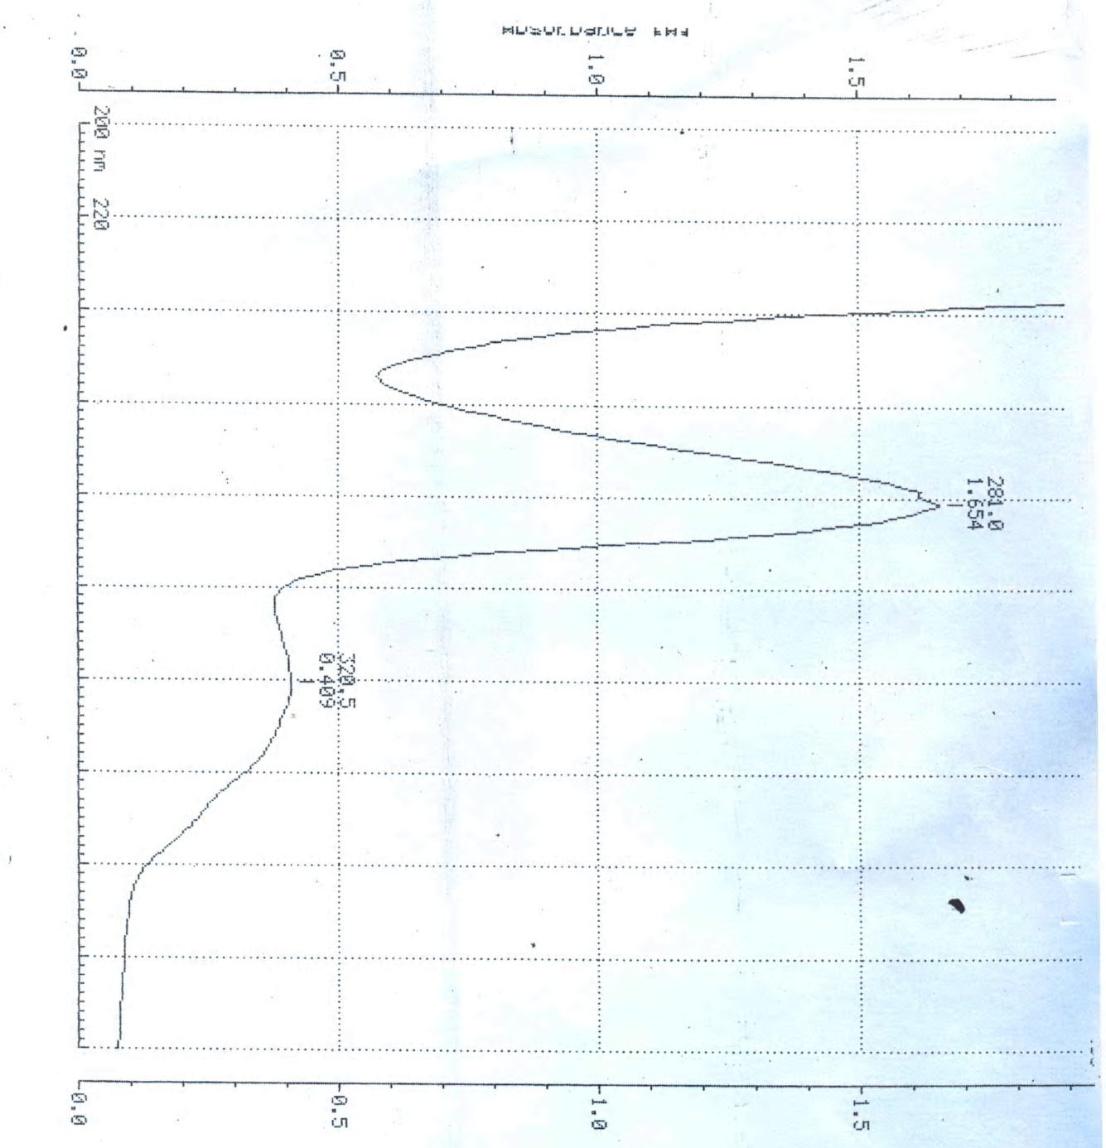**Appendix 1: Absorbance maxima for *M pruriens* ethanol seed extract**

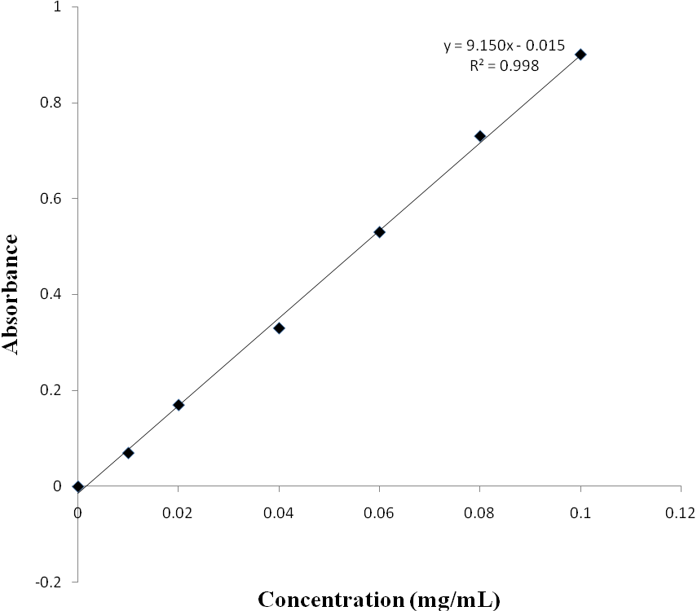**Appendix 2: Beer Lambert plot (calibration plot) for *M. pruriens***

**Appendix 3: Dissolution profiles of *M. pruriens* tablets prepared by direct compression using Avicel® as directly compressible diluent.**

|  |  |  |  |  |
| --- | --- | --- | --- | --- |
| **Diluents** | **Weight (mg) of**  **diluents/combination** | **Compression**  **Pressure (KN)** | **Time (min)** | **Cumulative %**  **Drug Release** |
| Avicel® | 400 | 5 | 5 | 20.54 |
|  |  |  | 10 | 26.51 |
|  |  |  | 15 | 33.65 |
|  |  |  | 30 | 43.62 |
|  |  |  | 45 | 57.07 |
|  |  |  | 60 | 73.32 |
|  |  |  | 75 | 92.57 |
|  |  |  | 90 | 100.00 |
|  |  | 10 | 5 | 7.56 |
|  |  |  | 10 | 14.71 |
|  |  |  | 15 | 23.03 |
|  |  |  | 30 | 33.68 |
|  |  |  | 45 | 49.08 |
|  |  |  | 60 | 67.40 |
|  |  |  | 75 | 88.28 |
|  |  |  | 90 | 98.34 |
|  |  |  | 105 | 100.00 |

**Appendix 4: Dissolution profiles of *M. pruriens* tablets prepared by direct compression using Cellactose as diluent.**

|  |  |  |  |  |
| --- | --- | --- | --- | --- |
| **Diluents** | **Weight (mg) of**  **diluents/combination** | **Compression**  **Pressure (KN)** | **Time (min)** | **Cumulative %**  **Drug Release** |
| Cellactose | 400 | 5 | 5 | 8.23 |
|  |  |  | 10 | 14.66 |
|  |  |  | 15 | 22.08 |
|  |  |  | 30 | 32.74 |
|  |  |  | 45 | 47.34 |
|  |  |  | 60 | 64.78 |
|  |  |  | 75 | 85.30 |
|  |  |  | 90 | 100.00 |
|  |  | 10 | 5 | 8.23 |
|  |  |  | 10 | 13.70 |
|  |  |  | 15 | 19.90 |
|  |  |  | 30 | 27.17 |
|  |  |  | 45 | 37.45 |
|  |  |  | 60 | 48.97 |
|  |  |  | 75 | 65.13 |
|  |  |  | 90 | 84.42 |
|  |  |  | 105 | 100.00 |

**Appendix 5: Dissolution profiles of *M. pruriens* tablets prepared by direct compression using lactose as diluent.**

|  |  |  |  |  |
| --- | --- | --- | --- | --- |
| **Diluents** | **Weight (mg) of**  **diluents/combination** | **Compression**  **Pressure (KN)** | **Time (min)** | **Cumulative %**  **Drug Release** |
| Lactose | 400 | 5 | 5 | 7.23 |
|  |  |  | 10 | 17.86 |
|  |  |  | 15 | 29.12 |
|  |  |  | 30 | 50.47 |
|  |  |  | 45 | 76.67 |
|  |  |  | 60 | 64.78 |
|  |  |  | 75 | 100.00 |
|  |  |  | 90 | 100.00 |
|  |  | 10 | 5 | 9.32 |
|  |  |  | 10 | 15.40 |
|  |  |  | 15 | 25.63 |
|  |  |  | 30 | 46.68 |
|  |  |  | 45 | 70.59 |
|  |  |  | 60 | 97.62 |
|  |  |  | 75 | 100.00 |
|  |  |  | 90 | 100.00 |

**Appendix 6: Dissolution profiles of *M. pruriens* tablets prepared by using PVP as binding agent.**

|  |  |  |  |  |
| --- | --- | --- | --- | --- |
| **Binding**  **Agent** | **Concentration**  **(%w/w)** | **Compression**  **Pressure (kN)** | **Time Interval**  **(min)** | **Cumulative**  **% Release** |
| PVP | 1 | 5 | 5 | 6.36 |
|  |  |  | 10 | 14.60 |
|  |  |  | 15 | 25.87 |
|  |  |  | 30 | 40.01 |
|  |  |  | 45 | 60.02 |
|  |  |  | 60 | 73.40 |
|  |  |  | 75 | 95.64 |
|  |  |  | 90 | 100.01 |
|  |  |  | 105 | 100.01 |
|  |  | 10 | 5 | 5.29 |
|  |  |  | 10 | 12.97 |
|  |  |  | 15 | 22.94 |
|  |  |  | 30 | 34.80 |
|  |  |  | 45 | 52.44 |
|  |  |  | 60 | 74.30 |
|  |  |  | 75 | 87.94 |
|  |  |  | 90 | 94.0 |
|  |  |  | 105 | 100.41 |
|  |  |  | 120 | 100.83 |
|  | 4 | 5 | 5 | 7.56 |
|  |  |  | 10 | 15.89 |
|  |  |  | 15 | 25.09 |
|  |  |  | 30 | 37.08 |
|  |  |  | 45 | 53.31 |

**Appendix 6 contd.: Dissolution profiles of *M. pruriens* tablets prepared by using PVP as binding agent.**

|  |  |  |  |  |
| --- | --- | --- | --- | --- |
| **Binding**  **Agent** | **Concentration**  **(%w/w)** | **Compression**  **Pressure (KN)** | **Time Interval**  **(min)** | **Cumulative**  **% Release** |

|  |  |
| --- | --- |
| 60 | 70.21 |
| 75 | 87.11 |
| 90 | 101.25 |
| 105 | 101.28 |

|  |  |  |
| --- | --- | --- |
| 10 | 5 | 6.45 |
|  | 10 | 13.79 |
|  | 15 | 22.26 |
|  | 30 | 32.54 |
|  | 45 | 53.07 |
|  | 60 | 77.76 |
|  | 75 | 96.65 |
|  | 90 | 101.31 |
|  | 105 | 101.23 |

**Appendix 7: Dissolution profiles of *M. pruriens* tablets prepared by using Corn starch as binding agent.**

|  |  |  |  |  |
| --- | --- | --- | --- | --- |
| **Binding**  **Agent** | **Concentration**  **(%w/w)** | **Compression**  **Pressure (kN)** | **Time Interval**  **(min)** | **Cumulative %**  **Release** |
| Corn starch | 1 | 5 | 5 | 9.3 |
|  |  |  | 10 | 19.50 |
|  |  |  | 15 | 36.16 |
|  |  |  | 30 | 59.31 |
|  |  |  | 45 | 70.43 |
|  |  |  | 60 | 89.93 |
|  |  |  | 75 | 100.54 |
|  |  |  | 90 | 100.68 |
|  |  |  | 135 | 101.27 |
|  |  | 10 | 5 | 8.22 |
|  |  |  | 10 | 17.50 |
|  |  |  | 15 | 32.30 |
|  |  |  | 30 | 54.08 |
|  |  |  | 45 | 65.93 |
|  |  |  | 60 | 82.81 |
|  |  |  | 75 | 91.62 |
|  |  |  | 90 | 100.00 |
|  |  |  | 105 | 102.00 |
|  | 4 | 5 | 5 | 7.56 |
|  |  |  | 10 | 15.89 |
|  |  |  | 15 | 25.09 |
|  |  |  | 30 | 37.08 |

**Appendix 7 contd.: Dissolution profiles of *M. pruriens* tablets prepared by using Corn starch as binding agent.**

|  |  |  |  |  |
| --- | --- | --- | --- | --- |
| **Binding**  **Agent** | **Concentration**  **(%w/w)** | **Compression**  **Pressure (kN)** | **Time Interval**  **(min)** | **Cumulative %**  **Release** |
|  |  |  | 45 | 53.30 |
|  |  |  | 60 | 65.27 |
|  |  |  | 75 | 74.14 |
|  |  |  | 90 | 80.01 |
|  |  |  | 105 | 94.17 |
|  |  |  | 120 | 100.00 |
|  |  |  | 135 | 100.00 |
|  |  | 10 | 5 | 6.45 |
|  |  |  | 10 | 13.06 |
|  |  |  | 15 | 20.40 |
|  |  |  | 30 | 28.80 |
|  |  |  | 45 | 38.16 |
|  |  |  | 60 | 59.21 |
|  |  |  | 75 | 75.46 |
|  |  |  | 90 | 75.18 |
|  |  |  | 105 | 98.45 |
|  |  |  | 120 | 100.01 |
|  |  |  | 135 | 100.01 |

**Appendix II continued: Cummulative % drug release Vs Time for PVP 1% in wet granulation**

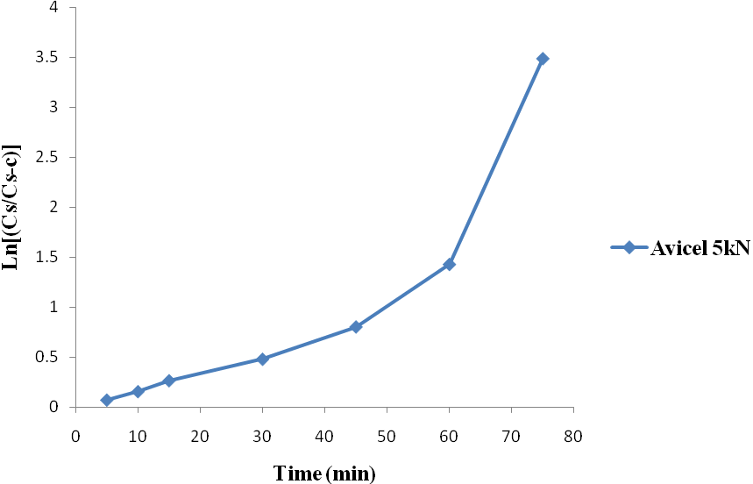**Appendix II continued: Ln [Cs/ (Cs-C) ] versus time plots for *Mucuna pruriens***

**tablets prepared by direct compression using Avicel at 5kN compression pressure**

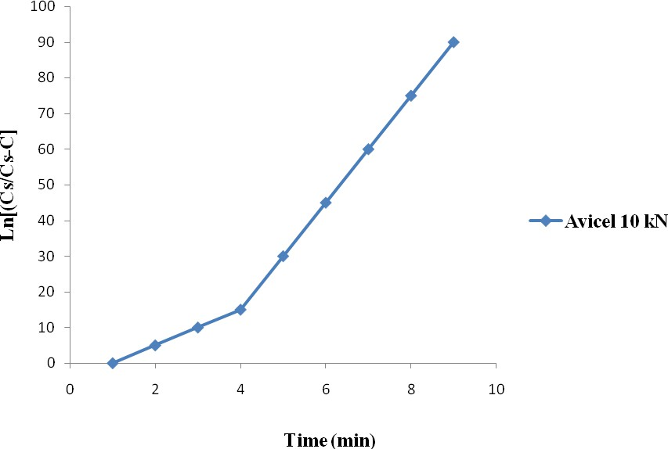**Appendix II continued: Ln [Cs/ (Cs-C) ] versus time plots for *Mucuna pruiens* tablet prepared by direct compression Avicel using at 10kN compression pressure**

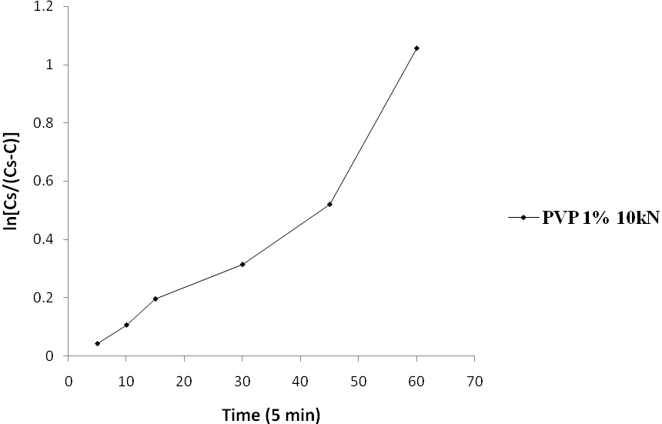**Appendix II continued Ln [Cs/ (Cs-C) ] versus time plots for *Mucuna pruiens* tablet prepared by wet granulation using PVP 1% concentration at 10kN compression pressure**