## ANTIBACTERIAL ACTIVITY OF THE LEAF EXTRACTS OF *ALCHORNEA CORDIFOLIA* (Euphorbiaceae) AGAINST ISOLATES FROM PATIENTS WITH RESPIRATORY TRACT INFECTION IN AHMADU BELLO UNIVERSITY TEACHING HOSPITAL ZARIA, NIGERIA

**BY**

## Isaiah YUSUF

**DEPARTMENT OF PHARMACEUTICS AND PHARMACEUTICAL MICROBIOLOGY,**

## FACULTY OF PHARMACEUTICAL SCIENCES, AHMADU BELLO UNIVERSITY,

**ZARIA**

## DECEMBER, 2016

**ANTIBACTERIAL ACTIVITY OF THE LEAF EXTRACTS OF *ALCHORNEA CORDIFOLIA* (Euphorbiaceae) AGAINST ISOLATES FROM PATIENTS WITH RESPIRATORY TRACT INFECTIONIN AHMADU BELLO UNIVERSITY TEACHING HOSPITAL ZARIA, NIGERIA**

## BY

**Isaiah YUSUF M.SC/PHARM-SCI/40805/12-13**

## A DISSERTATION SUBMITTED TO THE SCHOOL OF POSTGRADUATE STUDIES AHMADU BELLO UNIVERSITY

**ZARIA, NIGERIA**

## IN PARTIAL FULFILLMENT OF THE REQUIREMENTS FOR THE AWARD OF

**MASTERS OF SCIENCE (M. SC) DEGREE IN PHARMACEUTICAL MICROBIOLOGY**

## DEPARTMENT OF PHARMACEUTICS AND PHARMACEUTICAL MICROBIOLOGY,

**FACULTY OF PHARMACEUTICAL SCIENCES, AHMADU BELLO UNIVERSITY,**

## ZARIA

**DECEMBER, 2016**

## DECLARATION

I declare that the work in this dissertation titled ―**Antibacterial activity of the leaf extracts of *Alchornea cordifolia*(Euphorbiaceae) against isolates from patients with respiratory tract infections in Ahmadu Bello University Teaching Hospital Zaria, Nigeria**‖ was carried out by me in the Department of Pharmaceutics and Pharmaceutical Microbiology, Faculty of Pharmaceutical Sciences. Ahmadu Bello University, Zaria, Nigeria. The information derived from the literatures has been duly acknowledged in the text and alist of references provided. No part of this dissertation has been previously presented for another degree or diploma at this or any Institution.

Isaiah YUSUF

Signature Date

## CERTIFICATION

This dissertation titled ―**Antibacterial activityof the leaf extracts of *Alchornea cordifolia*(Euphorbiaceae) against isolates from patients with respiratory tract infections in Ahmadu Bello University Teaching Hospital, Zaria, Nigeria”** by Isaiah YUSUF meets the regulations governing the award of the degree of Master of Science (Pharmaceutical Microbiology) of Ahmadu Bello University Zaria, Nigeria.

|  |  |  |
| --- | --- | --- |
| Prof. G. O. Adeshina |  |  |
| Chairman, Supervisory Committee | Signature | Date |
| Department of Pharmaceutics and |  | |
| Pharmaceutical Microbiology, |
| Ahmadu Bello University, Zaria. |

Dr. B. A. Tytler Member, Supervisory Committee Signature Date Department of Pharmaceutics and

Pharmaceutical Microbiology, Ahmadu Bello University, Zaria.

Prof. B. O. Olayinka

Head of Department, Signature Date Pharmaceutics and Pharmaceutical

Microbiology,

Ahmadu Bello University, Zaria.

Prof. K. Bala

Dean, School of Postgraduate Studies, Signature Date Ahmadu Bello University, Zaria.

## DEDICATION

This work is dedicated to God Almighty for His uncommon grace, mercy, unmerited favor and boundless love over my life. To Him alone I give all praise, thanks and adoration. To my loving family for believing in me.

## ACKNOWLEDGEMENT

I wish to expressmy sincere appreciation to my major supervisor Prof. G. O. Adeshina who initiated the idea of starting thisresearch work, and for her encouragement, suggestions and helpful criticism.In addition, my appreciation goes to my Co-supervisors Dr. B. A. Tytler and Prof. A. T. Olayinka for their advice, care and dedication throughout the process of this research work.

I highly appreciate the prayers, understanding and untiring financial support of my entire family especially, Mr. Jonathan Yusuf, Wg. Cdr. F. Yusuf, DSI. Johnson Yusuf, Engr. Aaron Yusuf, Miss Sarah Yusuf, Dr. Musa Idris Maiyamba and my loving mother Mrs. Jummai Yusuf.

Also to be acknowledged is the support and contributions of the staff in the Department of Pharmaceutical Microbiology A. B. U, Zaria especially Mr. Ezekiel Dangana and Mr. Ainoje Michael. I also acknowledge the management of the National Institute for Pharmaceutical Research and Development (NIPRD) Idu, Abuja for the permission given to me to carry out part of the study in the Institute. My special appreciation goes to Mr. Andrew and Mrs Mercy Aboh for helping me carry out my analysis during my time in the Institute.

Not to be forgotten are my postgraduate colleagues and my friends who have in one way or the other contributed to the success of this work: Mr. Ikene Istifanus, Orji Loveday, Dr. Igwe James, Alhaji Kachalla M, Pharm. Hussein Ungo, Pharm Ahmed Oluwookere, Dr. Abdullahi A. Mohammed, Pharm. Nuhu Tanko, Miss Rashida Umar, Mr. Kamba Bayo and Mr. Kaseem Abubakar (Obama).

May the Almighty God reward and bless you all in Jesus Name.

## ABTRACT

Many bacterial species have been reported to develop resistance to antibiotics commonly prescribed for respiratory tract infections. Therefore, the need to search for natural products for remedy of this problem cannot be overemphasized.

One hundred and eighty (180) specimens were collected from throat (68) and ear swabs (57) as well as sputum (55) from patients with respiratory tract infection in Ahmadu Bello University Teaching Hospital Zaria, Nigeria. Isolation and identification of the bacterial isolates were carried out using standard microbiological methods. MicroGen identification kit was used for confirmatory identification of the isolates. The ethanol and aqueous extracts of *Alchornea cordifolia* was carried out using cold maceration extraction method. Agar well diffusion, agar dilution and spread plate methods were employed to determine the zone of inhibition, minimum inhibitory concentration, minimum bactericidal concentration and rate of kill respectively.The aqueous extracts was fractionated using column chromatography. Thin layer Chromatography method was used to identify the phytochemical constituents of the active fraction F2.

The bacterial isolates identified were *Staphylococcus aureus* (7), *Pseudomonas aeruginosa* (2), *Klebsiella pneumoniae* (2), *Escherichia coli* (1) and *Streptococcus* spps (5). The two extracts showed broad spectrum of activity but the aqueous extract had larger zones of inhibition ranging from 32. 5 mm – 11. 5 mm and lower M.I.C and M.B.C values ranging from 5 mg/ml – 20 mg/ml.

The fractionation of the aqueous extract gave thirty five (35) fractions but after pooling together of similar ones, Seven (7) different fractions were obtained. The M.I.C of the fractions showed that F2 had the lowest M.I.C values against all the isolates and better antibacterial activity. The

F2 fraction had M.I.C values that ranged between 2.5 – 5 mg/ml against *S. aureus* and 5 – 10 mg/ml against *Strep*. spp.

The death/survival rate showed that at 1440 minutes, M.I.C concentration of 2.5 mg/ml of F2 had 100 % kill; there was reduction in surviving cells with both the Sub-M.I.C concentration of

1.25 mg/ml and amoxicillin clavulanic acid 30 µg/ml against *S. aureus* (T38) isolate. A total kill was observed at 240 minutes, with M.I.C concentration of 5 mg/ml and at 1440 minutes, with Sub-M.I.C concentration of 2.5 mg/ml against *Klebsiella pneumoniae* (S16). There was a decrease in the number of surviving cells in the positive control and increase in the number of surviving cells with time in the negative control. The TLC based phytochemical screening of F2 fraction revealed the presence of phenolic compound and flavonoid as secondary metabolites. This study has justified the traditional use of *Alchornea cordifolia* leaf extracts in the treatment of respiratory tract infection caused by bacteria.

## TABLE OF CONTENTS

Title Page …………………………………………………………………………… i Declaration……….…………………………………………………………………… ii

Certification… iii

Dedication… iv

Acknowledgement v

Abstract… vi

Table of contents… viii

List of Figures… xiii

List of Tables xiv

List of Plate… xvi

List of Appendices… xvii

Abbreviation Page xviii

**CHAPTER ONE**

1.0 INTRODUCTION ……………………………………………………………… 1

* 1. Background… 1
  2. Statement of Research Problem… 3
  3. Justification 4
  4. Research Aim 4
  5. Specific Objectives 4
  6. Research Hypothesis 5
  7. Research Limitations… 5

CHAPTER TWO

* 1. LITERATURE REVIEW 6
  2. Herbal Medicine in Nigeria 6
     1. Safety and Standardization of Herbal Medicines 7
     2. Status of Herbal Medicine in Nigeria 8
  3. Alchornea cordifolia(Euphorbiaceae)… 9
     1. Ethno-medicinal Properties of Alchornea cordifolia 12
     2. Phytochemical Constituents of Alchorneacordifolia 13
  4. Upper Respiratory Tract Infections and treatment… 14
     1. Rhinosinusitis 14
     2. Otitis Media… 16
     3. Pharyngitis and Tonsillitis… 17
     4. Laryngitis 18
     5. Epiglottitis 19
     6. Bronchitis and Tracheitis 19
  5. Lower Respiratory Tract Infections and treatment… 21
     1. Acute exacerbations of chronic bronchitis 21
     2. Pneumonia 22
  6. Mode of resistance by respiratory tract pathogens to some antibiotics 25
     1. Pneumococcal Resistance to Beta-Lactams 25
     2. Haemophilus influenzae resistance to Beta-lactams 28
     3. Moraxella catarrhalis resistance to Beta-lactams 28
     4. Streptococcus pneumoniae resistance to Macrolides 29
     5. Haemophilus influenzaeresistance to Macrolide 30
     6. Streptococcus pneumoniae resistance to Fluoroquinolones 31
     7. H. influenzae resistance in Fluoroquinolones and other agents 32
     8. Pneumococcal resistance in Tetracyclines and other agents 32
     9. Mycoplasma pneumoniae resistance to other agents 32
     10. Staphylococcus aureus resistance 33

CHAPTER THREE

* 1. MATERIALS AND METHODS 35
  2. Materials 35
     1. Equipment… 35
     2. Glass wares 35

3.1.3Culture Media …………………………………………...……………………… 35

3.1.4 Reagents 35

* 1. Methods 36
     1. Collection, Identification and Preparation of Plant leaf 36
     2. Ethical approval 36
     3. Collection of Clinical Specimens… 36
     4. Isolation and Characterization of Bacteria Species 36
        1. Catalase Test… 37
        2. Oxidase Test… 37
        3. Coagulase Test… 38
        4. Identification of testorganisms using Rapid test kits. 38
     5. Aqueous and Ethanol extraction of plant material 39
     6. Fractionation of Aqueous extract using Column Chromatography 39
     7. Thin Layer Chromatography (TLC) of fractions… 40
     8. Susceptibility Testing 40
     9. Determination of Minimum Inhibitory Concentration (M.I.C) 41
     10. Determination of Minimum Bactericidal Concentration (M.B.C) 41
     11. Determination of the Rate of Kill 42
     12. TLC based Phytochemical screening 42
  2. Statistical Analysis 43

CHAPTER FOUR

* 1. RESULTS 44
  2. Sample collection, Isolation and Identification 44
  3. Antibacterial activity of plant extracts… 44
     1. Extraction of powdered leaves of Alchornea cordifolia 44
     2. Zone of inhibition values of the extracts of Alchornea cordifolia 44
     3. M.I.C and M.B.C values ofextracts Aqueous and Ethanol… 45
     4. Fractionation of aqueous extract and Phytochemical analysis of Fraction F2… 46
  4. Antibacterial activity of Fractions… 46
     1. MIC and MBC of fraction F2… 46
     2. Death/Survival Rate of most active fraction (F2)… 47

CHAPTER FIVE

5.0 DISCUSSION 72

CHAPTER SIX

* 1. SUMMARY, CONCLUSION AND RECOMMENDATION 77
  2. Summary 77
  3. Conclusion… 77
  4. Recommendation 78

6.3 Contribution to Knowledge 78

REFERENCES 79

APPENDICES 96

## LIST OF FIGURES

Figure 4.1. Flow-chart of isolation and identification of bacterial species… 48

Figure 4.2. Distribution of bacterial isolates by source 50

Figure 4.3. M.I.C and M.B.C of fraction (F2) against isolates from throat swab specimens 67 Figure 4.4. M.I.C and M.B.C of fraction (F2) against Isolates from ear swab specimens… 68 Figure 4.5.M.I.C and M.B.C of fraction (F2) against Isolates from sputum specimens. 69

Figure 4.6. Death/Survival rate of *S. aureus* (T38) on exposure to M.I.C and Sub-M.I.C ofF2……………………………………………………………………………………….…

70

Figure 4.7. Death/Survival rate of *K. pneumoniae* (S16) on exposure to M.I.C and Sub-M.I.C of F2 71

## LIST OF TABLES

Table 4.1. Distribution of bacterial isolates from clinical specimens 49

Table 4.2. Zone of inhibition values of the aqueous extract of *A.cordifolia* againstisolates from throat swabs 51

Table 4.3. Zone of inhibition values of the ethanol extract of *A.cordifolia* against isolates from throat swabs 52

Table 4.4. Zone of inhibition values of aqueous extract of *A.cordifolia* against isolates from ear swabs 53

Table 4.5. Zone of inhibition values of ethanol extract of *A.cordifolia* against isolates from ear swabs 54

Table 4.6. Zone of inhibition values of aqueous extract of *A.cordifolia* against isolates from sputum specimens 55

Table 4.7. Zone of inhibition values of ethanol extract of *A.cordifolia* against isolates from sputum specimens 56

Table 4.8. M.I.C and M.B.C of aqueous and ethanol extracts against isolates from throat swab specimens 57

Table 4.9. The M.I.C and M.B.C values of aqueous and ethanol extracts against isolates from ear swab specimens 58

Table 4.10. M.I.C and M.B.C values of aqueous and ethanol extracts against isolates from sputum specimens 59

Table 4.11. Fractionation of aqueous extract of *A. cordifolia* 60

Table 4.12.Number of fractions after TLC and the combination of pooled fractions… 61

Table 4.13.Weight of pooled fractions 62

Table 4.14. TLC Based Phytochemical screening of Fraction (F2) 63

Table 4.15. M.I.C of Fractions against Isolates from throat swab specimens 64

Table 4.16. M.I.C of Fractions against Isolates from ear swab specimens 65

Table 4.17. M.I.C of Fractions against Isolates from sputum specimens 66

**LIST OF PLATES**

Plate 1. *A. cordifolia* in its natural habitat… 11

Plate 2. *A. cordifolia* leaves… 11

## LIST OF APPENDICES

Appendix I. Ethical Clearance 96

Appendix II. Departmental Approval 97

Appendix III. Consent Form… 98

Appendix IV. Thin layer Chromatography (TLC) of different fractions 99

Appendix V. Different fractions collected 100

Appendix VI. Column chromatography 101

Appendix VII.TLC of pooled fractions… 102

Appendix VIII.TLC phytochemicals of F2 fraction using different specific spray reagents.103 Appendix IX. Zone of inhibition of aqueous and ethanol extracts of *A. cordifolia* 104

Appendix X. Death/Survival Rate of *K. pneumoniae* at 240 minutes growth 105

**ABBREVIATION PAGE**

ABUTH = Ahmadu Bello University Teaching Hospital

*A. cordifolia* = *Alchornea cordifolia* AMC = Amoxicillin Clavulanic acid ANOVA = Analysis of Variance AOM = Acute Otitis Media

ARI = Acute Respiratory Infection BL = Beta - Lactamase

BLNAR = Beta-lactamase negative ampicillin resistant

BLPACR = Beta-lactamase-positive amoxicillin/clavulanate-resistant

CA-MRSA = Community Acquired – Methicillin Resistant *Staphylococcus aureus*

CAP = Community Acquired Pneumonia CDC = Centers for Disease Control

CLSI = Clinical and Laboratory Standards Institute COPD = Chronic Obstructive Pulmonary Disease

*E. coli* = *Escherichia coli*

HA-MRSA = Healthcare Acquired – Methicillin Resistant*Staphylococcus aureus*

*H. influenza* = *Haemophilus influenzae*

ICSI = Institute for Clinical System Improvement

*K. pneumoniae* = *Klebsiella pneumoniae* LRTI = Lower Respiratory Tract Infection MBC = Minimum Bactericidal Concentration MDR = Multidrug – resistant

MIC = Minimum Inhibitory Concentration

NCCLS = National Committee for Clinical Laboratory Standards NIHCE = National Institute for Health and Clinical Excellence ONPG = Ortho – nitrophenyl – β – galactosidase

*P. aeruginosa* = *Pseudomonas aeruginosa*

PBP = Penicillin Binding Protein

PROTEKT = Prospective Resistant Organism Tracking and Epidemiology for the Ketolide Telithromycin

PRSP = Penicillin – resistant *Streptococcus pneumoniae*

PVL = Panton Valentine Leukocidin

QRDR = Quinolone Resistance Determining Region RCTs = Randomized Clinical Trials

RTI = Respiratory Tract Infection

*S. aureus* = *Staphylococcus aureus*

TB = Tuberculosis

TDA = Tryptophan Deaminase TLC = Thin Layer Chromatography

URTI = Upper Respiratory Tract Infection VP = Voges – Proskauer

WHO = World Health Organization

## CHAPTER ONE

## INTRODUCTION

## Background

Respiratory tract infections continue to be the most frequent and important cause of short term illnesses that compel an individual to seek medical attention not only in the developing world, but also in the developed world (Zafar *et al*., 2008). It is typically the first infection to occur after birth. Respiratory tract infections are caused by a handful of bacteria, fungi and viruses and account for more than 40% of disability days, secondary to acute illnesses; pneumonia and influenza accounting to 80 - 90% of death in the elderly (Hugonnet *et al.,* 2000).

Respiratory tract infection can be divided into two major types; the Upper Respiratory Tract Infection (URTI) and Lower Respiratory Tract Infection (LRTI).Upper respiratory tract infection is a nonspecific term used to describe acute infections involving the nose, paranasal sinuses, pharynx, larynx, trachea and bronchi (Mossad, 2008). URTIs such as sore throat, ear ache, laryngitis, common cold, otitis media and sinusitis are the most frequently reported infections of all human diseases (Hueston *et al.,* 1999; Brunton, 2005, Ndip *etal.*, 2008; Mossad, 2008; Mungrue *et al.,* 2009). Recurrent URTIs in children constitute a serious problem worldwide (Ndip *et al*., 2008). Adults develop an average of two to four colds cycles annually (Mossad, 2008). It has been reported that the majority of URTIs are of viral origin with rhinovirus, parainfluenza virus, coronavirus, adenovirus, respiratory syncytial virus and influenza virus accounting for most cases (Clark *et al.,* 2004; Lykova *et al*., 2003).Apart from viruses, bacteria pathogens have been reported to cause RTI; the organisms identified include *Haemophilusinfluenzae, Staphylococcus aureus, Streptococcus pneumoniae,*

*Klebsiellapneumoniae, Pseudomonasaeruginosa* and some Enterobacteriaceae (Isenberg and D- Amato, 1985; Ndip *et al.,* 2003).

Lower Respiratory Tract Infections (LRTI‘s) may be defined as those infections presenting with symptoms including cough, expectoration, dyspnoea, wheeze and or chest pain/discomfort usually for a period ranging from 1-3 weeks. Acute manifestations of LRTIs which may or may not involve lungs include acute bronchitis, bronchiolitis, influenza, community–acquired pneumonia either with or without radiological evidence, acute exacerbation of Chronic obstructive pulmonary disease (COPD) and acute exacerbation of broncheictasis(Woodhead *etal.,*2005).Lower Respiratory Tract Infections are among the most common infectious diseasesaffecting humans worldwide (Carroll, 2002). They are important causes of morbidity and mortality for all age groups, and each year approximately 7 million people die as a directconsequence of acute and chronic respiratory infections (Ozyilmaz *et al.,* 2005). Acute Respiratory Infections (ARI) and tuberculosis were two of the six leading causes of deathacross all ages (WHO, 2003). Out of the total acute respiratory diseases, 20–24% of all deaths are accounted for by LRTI(Gauchen *et al.,* 2006).

RTIs impose a serious economic burden on society, ranging from reduced output in workplaces to frequent prescription by physicians of antibiotics, even when the causative agent of infection is not bacteria (Jafari *et al.,* 2009).Due to resistance to antibiotics by pathogens, recent research has been directed towards the use of traditional medicine/natural products for treatment and control of infections.

The history of the use of herbs in the management of diseases dates back to the time ofthe early man (Sofowora, 1992; Kafaru, 1994). In herbal medicine, herbs/plants are used in their unaltered form for the treatment of disease. A variety of plants or materialsderived from plants have been

used for the preventionand treatment of diseases virtually in all cultures(Adedapo *et al.,*2005). It is also reported thatherbshave been used as sources of food and medicinalpurposes for centuries and this knowledge has beenpassed from one generation to another(Adedapo *et al.,*2005). Medicinal plants also represent a rich source fromwhich antimicrobial agents can be obtained (Kubmarawa*et al.,*2007). Many pharmaceuticals currently available tophysicians have a long history of use as herbal remedies (Elumalai and Eswariah, 2012). Pravin, (2006) reported that about 70% of thehuman population is dependent (wholly or partially) onplant-based medicines and the World HealthOrganisation (WHO) estimates that 80% of the population in some Asian and African countries depends on herbal medicine for someaspect of primary health care (WHO, 2008). A majority of Nigerian population still rely on herbal medicine (Eliakim-Ikechukwu and Riman, 2009). Available evidence suggests that some herbal remedies and traditional therapeutic regimes are efficacious and affordable (TMP,2007).

## STATEMENT OF RESEARCH PROBLEM

Antimicrobial drug resistance is a global challenge for the 21st century with the emergence of resistant bacteria strains worldwide (Furin*et al.,* 2011).Respiratory tract infections impose a serious economic burden on society, ranging from reduced output in workplaces to frequent prescription by physicians of antibiotics, even when the causative agents of infection is not bacteria (Jafari *et al.,* 2009). Respiratory tract infections are amongst the most wide spread and serious infection, accounting for over 50 million deaths globally each year (Zafar *et al*., 2008)). In 2012, lower respiratory infections such as pneumonia and bronchitis were the second causes of mortality and morbidity in Sub-Saharan Africa, accounting for over 1 million or 11.5% of deaths in the region, while tuberculosis accounted for 2.4% (Siikamaki, 2015).Acute respiratory tract infection is a common cause of hospital admission in Nigeria, it was estimated that

pneumonia accounted for 20% of deaths in children under age of 5 years (Akanbi *et al*., 2009). The increasing prevalence of multi-drug resistant strains of bacteria and the recent appearance of strains with reduced susceptibility to antibiotics raised the specter of ‗untreatable‘ bacterial infections and adds urgency to the search for new infection-fighting strategies (Zy *et al.,*2005; Rojas *et al.*, 2006).

## JUSTIFICATION

Medicinal properties of plants are hinged on the presence of bioactive principles such as alkaloids, phenols, tannins, glycosides and essential oils among others. This necessitates the continued screening of medicinal plants, not only to determine the scientific basis for their usage, but also to discover possible new active principles (Karou *et al.*, 2006). The primary benefits of using plantderived medicines are that they are relatively cheaper than synthetic alternatives, offering profound therapeutic benefits and more affordable treatments.

Many of the plant materials used in traditional medicine are readily available in rural areas and this has made traditional system of medicine relatively cheaper than modern medicine. Many works have been carried out with the aim of knowing the different antimicrobial and phytochemical constituents of medicinal plants and using them for the treatment of microbial infections as possible alternatives to antibiotics and other chemotherapeutic agents to which many infectious microorganisms have become resistant.

## RESEARCH AIM

To evaluate the antibacterial activity of ethanol and aqueous extracts of *Alchornea cordifolia* leaf against some bacterial isolates associated with respiratory tract infections.

## SPECIFIC OBJECTIVES

The specific objectives of this study are to:

* + - Isolate and identify bacteria species associated with respiratory tract infection from sputum,throat and ear swabs from clinical settings.
    - Prepare ethanol and water extractsfrom dried powdered leaves of *A. cordifolia*.
    - Determine the antibacterial activity(zone of inhibition, MIC and MBC) of the twoextracts against the identified bacterial isolates.
    - Fractionate the more active extract using Column Chromatography method.
    - Determine the antibacterial activity of the fractions against the identified bacterial isolates.
    - Determine the rate of kill of the most active fraction against some of the bacterial isolates.
    - Carry out the phytochemical screening of the most active fraction using TLC.

## RESEARCH HYPOTHESIS

* NULL HYPOTHESIS: HO

The leaf extracts of *Alchornea cordifolia* has no inhibitory activity against some bacterial isolates from sputum, throat and ear swab samples.

* ALTERNATE HYPOTHESIS: HA

The leaf extracts of *Alchornea cordifolia* has inhibitory activity against some bacterial isolates from sputum,throat and ear swab samples.

## LIMITATIONS OF THE STUDY

* Only bacterial isolates from clinical specimens of patients with respiratory tract infections were included in this study.

## CHAPTER TWO

## LITERATURE REVIEW

## Herbal medicine in Nigeria

The traditional medicine program of WHO recognizes traditional medicines as the sum total of all the knowledge and practices whether explicable or inexplicable used in diagnosis, prevention and elimination of physical, mental or social imbalance and relying exclusively on practical experience and observation handed down from generation to generation whether verbally or written (Rukangira, 2001). According toAnsari and Inamdar, (2010), traditional (or herbal) medicine is in an evolutionary process as communities and individuals continue to discover new techniques that can transform practice in the field of medicinal sciences. Traditional medicine and drug discovery using natural products is still an important issue in the current target-rich lead poor scenario (Patwardhan *et al*., 2004).

World Health Organisation (WHO, 2008), reported that about three quarter of Asian and sub- Saharan African population depends upon traditional remedies (mainly herbs) for the health care of its people. In fact, herbs are the oldest friends of human being. They not only provide food and shelter but also served the humanity to cure different dysfunctions. Traditional medicine is popular. They are extensively used in the developing world where in many places, they offer a more widely available and more affordable alternative to pharmaceutical drugs. In Africa, for example, up to 80% of the population depends on them, according WHO estimates in the last 10 years, there has been aresurgence of interest and attention in the use andstudy of traditional medicine globally (EssentialDrugs, 2003). Hillenbrand (2006) stated thatsupport for traditional medicine has dramaticallyincreased worldwide and that as far backas 1978 during the Alma-Ata

Primary HealthCare Delivery Declaration, the World HealthOrganisation (WHO) acknowledged the importanceof traditional medicine in providing primaryhealth care and urged nations to developofficial policies on it. Though there was minimalfollow through, the African Union indeedmoved traditional medicine to the front burnerwhen it declared years 2001 to 2010 as the Decadefor African Traditional Medicine (Davy, 2001). The new health agenda in Nigeria and Africa focuses on the institutionalization of traditional medicine in parallel with orthodox medicine into the natural health care scheme in order to move the health agenda forward since, effective health cannot be achieved in Africa by orthodox medicine alone unless it has been complemented with traditional medicine as recorded by (Elujoba *et al*., 2005).

Historians from all around the world have produced evidence to show that apparently all primitive people used plants often in a sophisticated way. Quinine from Cinchona bark was used to manage the symptoms of malaria long before the disease was identified and the raw ingredients of a common or garden aspirin tablet have been a popular painkiller for longer than we have had access to tablet making machinery (Ekeanyanwu, 2011).

## Safety and Standardization of Herbal Medicine

The growing popularity of herbal remedies is fuelled by increasing scientific interest in herbal medicine (Ansari and Inamdar, 2010). WHO estimated that of the 35,000-70,000 species of plants that are used for medicinal purposes around the world some 5,000 have been submitted for biomedical scrutiny. Scientific evidence of efficacy is beginning to emerge from randomized controlled trials. Osborne, (2007), noted that thepractitioners inflated the claims attached toadvertisement and its products as well as nothaving scientific data about its effectiveness, thus making it difficult to ascertain legitimate and effective therapy.

Another reason for the growing popularity of herbal medicines is that many people believe they are safer more natural than pharmaceuticals. However, studies have shown that not all natural products are safe, some poisons are also natural (Ansari and Inamdar, 2010). WHO, (2001) reported that herbal medicine however natural can cause serious illnesses from allergy to liver or kidney malfunction to cancer and even death. In terms of carcinogenicity for example, the toxicological potential of natural plant chemicals could be roughly the same as that of synthetic chemicals. Most herbal products on the market today have not been subjected to drug approval process to demonstrate their safety and effectiveness. Hepatic failure and even death following ingestion of herbal medicine have been reported (Chattopathyay, 1996). A prospective study showed that 25% of the childhood blindness in Nigeria and India were associated with the use of traditional eye medicines (Harries and Cullinan,1994). A review of side effects of some medicinal plants have been been carried (Gupta and Raina, 1998).

Perhaps, the biggest problems in Nigeria with herbal medicine are lack of standardization and safety regulation. Standardization of a herbal medicine that may contain hundreds of chemical constituents with little or no proven therapeutic effect is particularly a problem (WHO, 2001).

## Status of Herbal Medicine in Nigeria

Nigeria has a rich tradition of herbal medicine with its diverse cultures and traditions. Traditional medicine practices are a main source of livelihood for a significant number of herbalist who depend on it as their source of income. High population growth rate and poverty coupled with dwindling economic reserves in the country make Nigerians resort to more affordable sources for their immediate health needs (Ekeanyanwu, 2011). As the population increases, demand for herbal medicine will increase. Nigeria has established national and state traditional medicine

boards for regulation of herbal medicine practice and to promote cooperation and research. In order to provide affordable health care services especially, to those who cannot afford orthodox medicine, several state governments through their traditional medicine boards have tried to institutionalize the use of traditional medicine. The Federal Government has also set up and financed the Federal College of Complementary and Alternative Medicine, Lagos under the Federal Ministry of Health to train herbalist on its use and practices. Herbalists are also being encouraged to register their proven and efficacious standardized herbal preparations with the National Agency for Food and Drug Administration and Control (NAFDAC) (Ekeanyanwu,2011).

* 1. ***Alchornea cordifolia* (Euphorbiaceae).**

*Alchornea cordifolia* (Euphorbiaceae) (Plate 1) is amedium-sized shrubby treefound along the coastal regions of West Africa. Widespread in secondary forest and riverine forest, especially in marshy areas but sometimes in drier sites.It belongs to the subfamily Acalypholdeae and family Euphorbiaceae or Spurge family.The plant is an important crude drug in the indigenous system of medicine for the management of pain, rheumatism, and arthritis, pile, toothache and some other inflammatory disease states (Osadebe and Okoye, 2003). The leaves are mostly used, but the stem bark, stem pith, leafy stems, root bark, roots and fruits are also used in local medicine.

In Nigeria the local names are ‗Bambami‘ in Hausa, ‗Ubebe‘ in Igbo, ‗epa‘ in Yoruba, ‗Mbom‘ in Efik and commonly ‗Christmas bush‘ in English. It is widely distributed throughout Africa where it is used extensively in traditional medicine. *Alchornea cordifolia* is an important crude drug in indigenous system of medicine in the coastal regions of West Africa (Adeshina *et al*., 2012).

It is a straggling, laxly branched, evergreen dioecious shrub or small tree up to 8 m tall; young shoots erect, later becoming horizontal, hollow, glabrous. Leaves (Plate 2) are alternate, simple; stipules triangular, 1.5 mm long, acute, soon falling; petiole 5–15 cm long; blade ovate to elliptical-ovate, 10–25 cm × 7–15 cm, base cordate, with basal lobes slightly auriculate and overlapping, apex acute to acuminate, margins toothed, shortly hairy when young, later almost glabrous, 3–5- veined at the base with 4 glandular patches in the angles of the veins. Male inflorescence an axillary panicle up to 30–45 cm long, sparingly hairy, bracts minute; female inflorescence an axillary spike or lax panicle up to 30–45 cm long, bracts broadly triangularovate. 1 mm long, acuminate. Flowers unisexual, sessile; male flowers with 2 cup- shaped sepals, petals absent, stamens 8, the united filaments forming a basal plate; female flowers with 2–4-lobed calyx, lobes obtuse, hairy, petals absent, ovary superior, conical. 2 mm × 2 mm, smooth, densely silky hairy, styles 2–3, 1–2 cm long, free or fused at base, dark red. Fruit a 2-lobed capsule . 1.5 cm × 1.5 cm, lobes somewhat compressed, smooth, shortly hairy, green to red, 2-seeded. Seeds ovoidellipsoid,. 6 mm long, smooth, bright red (Ake-Assi *et al.,* 1991).

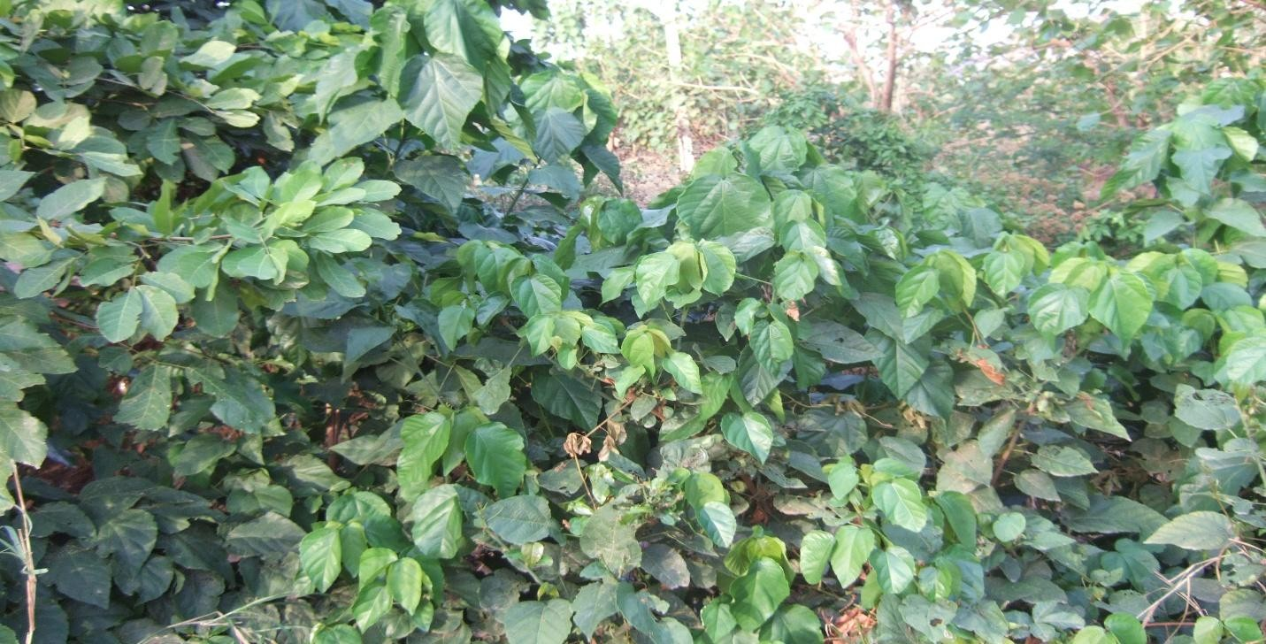

**Plate 1:*Alchornea cordifolia*in its natural habitat.**

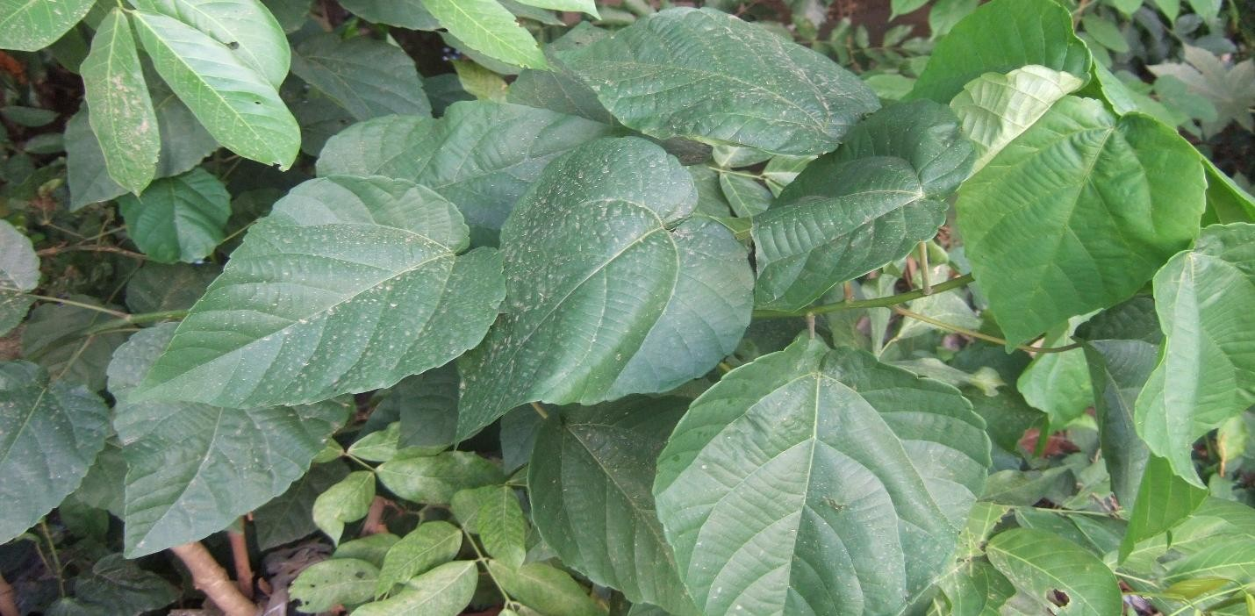

**Plate 2: *Alchornea cordifolia* leaves**

* + 1. **Ethno-medicinal Properties of *Alchornea cordifolia***

Much research has been carried out into the antibacterial, antifungal and antiprotozoal properties of *Alchornea cordifolia* as well as its anti-inflammatory activities, with significant positive results.

In West Africa pulped root is widely taken to treat venereal diseases. Dried leaves or roots, alone or with tobacco, are smoked to cure cough, they are also taken as a blood purifier, as a tonic and to treat anaemia and epilepsy (Burkhil, 1994). Leaf and root decoctions are widely used as mouth wash to treat ulcers of the mouth, toothache and caries, and twigs are chewed for the same purposes. The root and stem bark are used in the treatment of jaundice (Agbor *et al*., 2004).

Ogungbamila and Samuelsson, (1990) reported the use of the decoction of the plant leaf against gonorrhea in Nigeria and the infusion of the leaf has also been reportedly taken orally for urinary tract infection in Zaire (Muanza *et al.,* 1994). The decoction of the leaf as reported by Le Grand, (1989) isused for conjunctivitis in Senegal. For ringworm, the juice of the leaves and fruit is rubbed on the skin (Okeke *et al.*, 1999). The plant leaf is used for treating infected wound in Zaire (Muanza *et al*, 1994). The infusion of the dried leaf of *A. cordifolia* is used for diarrhea in Zaire (Kambu *et al*, 1990; Muanza *et al*, 1994). The fresh chewed leaf juice of the plant is used for pneumonia in Sierra Leone (Macfoy and Sama, 1990). It has been reported to have anti- inflammatory, antibacterial and analgesic properties (Cesario, 1993).

The ethanol extract of the root significantly delayed the effect of histamine-induced broncho- constriction characterized by shortness of breath in guinea pig (Boampong, 1992). The cytotoxicity of the crude extract as reported by Banzouzi *et al*., (2002) and Ayisi *et al*., (2003),

was very low. Alcohol extracts from root-bark, stem-bark, leaves, fruits and seeds disrupted mitotic cell division in onion (*Allium cepa* L.) (Ayisi *et al*., 2003).

Adeshina *et al*., (2010) reported that ethyl acetate extract of *Alchornea cordifolia* leaves possesses antimicrobial activity against the clinical and typed isolates of *Pseudomonasaeruginosa, Staphylococcus aureus, Escherichia coli* and *Candida albicans*.

* + 1. **Phytochemical Constituents of *Alchornea cordifolia***

Some constituents of the plant, *Alchornea cordifolia*, have been identified which include; terpenes, sterols, flavonoids, glycoside and saponins (Osadebe and Okoye, 2003). The leaves, roots and stem bark contain terpenoids, steroid glycosides, flavonoids ( 2–3%), tannins (about10%), saponins, carbohydrates and the imidazopyrimidine alkaloids alchorneine, alchornidine and several guanidine alkaloids (Mavar-Manga *et al* ., 2004).Duke and Vasquez, (1994) reported the presence of alchorneine, anthranilic acid, gentisinic acid, iso alchorneine, yohimbinein the plant.

## Upper Respiratory Tract Infections and treatment

Although viruses cause most URTIs, antibiotics continue to be inappropriately widely prescribed for these illnesses (Grijalva *et al.,* 2009). Unnecessary adverse effects of antibiotics and the development of antimicrobial resistance can be reduced by judicious use of these drugs. Healthcare providers should educate their patients about the self-limited nature of most URIs and the hazards of inappropriate use of antibiotics for the individual and the community.

Antibiotics are currently prescribed to 41% of patients with suspected viral pharyngitis; ranking third among activities thought to be in common practice, but of little benefit, with additional annual cost of $116.3 million (Kale *et al.,* 2011). Grijalva *et al.,* (2009) reported thatprescriptions for penicillins, cephalosporins, trimethoprim-sulfamethoxazole, and tetracyclines has decreased, but there was increase in those for macrolides and fluoroquinolones. Antibiotics account for 20% of all drug-related emergency department visits in the US; 80% of which are for allergic reactions. Antibiotics are the second most common cause of adverse drug events in the elderly, with a risk comparable to insulin, warfarin, and digoxin (Grijalva *et al.,* 2009). Moreover, concurrent use of warfarin and any antibiotic is associated with an increased risk of bleeding (Baillargeon *et al.,* 2012).

* + 1. **Rhinosinusitis**

Acute rhinosinusitis is a common diagnosis in the outpatient setting, with an annual incidence of approximately 13 percent in adults(CDC, 2009).It is defined as inflammation of the nasal mucosa and sinuses. Symptoms include nasal obstruction, anterior or posterior purulent nasal discharge, facial pain, decrease in sense of smell, and cough (Thomas *et al.,*2008).Rhinosinusitis

is classified as acute when symptoms are present for less than four weeks, sub-acute for four to 12 weeks, and chronic for more than 12 weeks (Thomas *et al.,*2008).

To differentiate between viral and bacterial rhinosinusitis is very important in order to avoid overprescribing of antibiotics (Thomas *et al.,*2008).The diagnosis of acute bacterial rhinosinusitis should not be made until symptoms have persisted for at least 10 days or after initial improvement followed by worsening of symptoms (Rosenfeld *et al.,* 2007).Four symptoms are more predictive of bacterial rather than viral rhinosinusitis: purulent nasal discharge, maxillary tooth or facial pain, unilateral maxillary sinus tenderness, and worsening symptoms after initial improvement (Gonzales *et al.,* 2001; Chow *et al.,* 2012).

Mild cases of acute bacterial rhinosinusitis can be managed with watchful waiting if appropriate follow-up can be ensured (Rosenfeld *et al.,* 2007). Worsening symptoms within seven days warrant the initiation of antibiotics in these patients. Antibiotic treatment is acceptable in patients with severe or complicated acute bacterial rhinosinusitis (Chow *et al.,* 2012).

A Cochrane review of five studies in the primary care setting (n = 631 patients) found that antibiotic therapy for acute maxillary sinusitis has a slight statistical advantage over placebo (William *et al.,* 2008). However, the clinical significance was equivocal because the clinical cure rate was high in both groups (90 percent in the treatment group compared with 80 percent in the placebo group). The antibiotic chosen should provide coverage for *Streptococcus pneumonia*, *Haemophilus influenzae,* and *Moraxella catarrhalis*, (Poole, 2004) with amoxicillin as the first choice or trimethoprim/sulfamethoxazole for patients allergic to penicillin (Rosenfeld *et al.,* 2007).A different antibiotic is justified if symptoms worsen within seven days (Rosenfeld *et al.,* 2007). Falagas *et al.,* (2009)reported thata meta-analysis of 12 RCTs (Randomize Control Trials)

(10 double-blinded, n = 4,430 patients) found no statistically significant difference between long- and short-course antibiotics for cure or improvement of symptoms. The study showed that short- course antibiotic therapy (median of five days‘ duration) was as effective as longer-course treatment (median of 10 days‘ duration) in patients with acute, uncomplicated bacterial rhinosinusitis.

## Otitis Media

The diagnosis of acute otitis media (AOM) requires an acute onset of symptoms, the presence of middle ear effusion, and signs and symptoms of middle ear inflammation.The most common pathogens are nontypeable *H. influenza,S. pneumonia*, and *M. catarrhalis* (Klein, 1994).Viruses have been found in the respiratory secretions of patients with AOM and may account for many cases of antibiotic failure(Heikkinen *et al.,* 1999; Pitkäranta *et al.,* 1998; Chonmaitree, 2000)Group B streptococcus, Gram-negative enteric bacteria, and *Chlamydia trachomatis* are common middle ear pathogens in infants up to eight weeks of age.

Cohort studies and RCTs have shown that AOM typically resolves without antibiotic therapy in children (Rosenfeld and Kay, 2003). In 2004, the American Academy of Pediatrics and the American Academy of Family Physicians developed guidelines for the treatment of AOM. These guidelines list observation as an option for children older than six months; observation involves deferring antibiotic treatment for 48 to 72 hours and initiating therapy only if symptoms persist or worsen. However, two RCTs conducted in 2011 showed that immediate antibiotic use in children six to 35 months of age was more effective than observation (Tähtinen *et al.,* 2011; Hoberman *et al.,* 2011).These studies used strict criteria, tympanometry, or otoscopy for diagnosis and follow-up. Febrile infants (up to eight weeks of age) with AOM should have a full sepsis workup. These infants should undergo an otolaryngology consultation, if available, for

tympanocentesis. Immediate initiation of antibiotics is recommended in children younger than two years with bilateral AOM and in those with AOM and otorrhea (Rovers *et al.,* 2006; Glasziou *et al.,* 2004).Amoxicillin (80 to 90 mg per kg per day, in two divided doses) is recommended as first-line treatment for AOM (Coker *et al.,* 2010).

If there is no response to initial antibiotic therapy within 48 to 72 hours, the patient should be reexamined to confirm the diagnosis, and amoxicillin/clavulanate (Augmentin) should be initiated.Ceftriaxone can be used as a second-line agent or in children with vomiting.Trimethoprim/sulfamethoxazole and erythromycin/sulfisoxazole are not effective for the treatment of AOM.Longer courses of antibiotics (more than seven days) have lower failure rates than shorter courses (Kozyrskyj *et al.,* 2010).

Children with AOM should be reevaluated in three months to document clearance of middle ear effusion. Long-term antibiotic therapy has been shown to reduce the number of recurrent AOM episodes, (Leach and Morris, 2006), but is not recommended because of the risk of antibiotic resistance.

## Pharyngitis and Tonsillitis

Approximately 90 percent of adults and 70 percent of children with pharyngitis have viral infections(ICSI, 2012; Bisno *et al.,* 2002; Bisno, 1996).In those with bacterial cases of pharyngitis, the leading pathogen is group A beta-hemolytic streptococcus. Appropriate antibiotic treatment in these cases has been shown to decrease the risk of rheumatic fever, alleviate symptoms, and decrease communicability (Centor *et al.,* 2007; Bisno *et al.,* 2002; Cooper *et al.,* 2001). Antibiotic treatment does not prevent glomerulonephritis and has inconsistent results in the prevention of peritonsillar abscess(Centor *et al.,* 2007;ICSI, 2012).

The Infectious Diseases Society of America recommends diagnostic testing to confirm group A beta-hemolytic streptococcal infection before initiating antibiotics to avoid overuse (Bisno *et al.,* 2002). However, the American Academy of Family Physicians and the American College of Physicians recommend using the modified Centor criteria, which are based on age and the presence or absence of fever, tonsillar erythema or exudates, anterior cervical lymphadenopathy, and cough (Ebell, 2003; Choby, 2009; McIsaac 1998; McIsaac *et al.,* 2000)*.*In patients with a score of 1 or less, no further diagnostic testing or treatment is indicated because the likelihood of streptococcal infection is low. However, in patients with a score of 1, other factors should be considered, such as contact with a person who has documented streptococcal infection; rapid antigen detection testing should be performed in these patients. In those with a score of 2 or 3, streptococcal rapid antigen detection testing should also be performed. If test results are positive, antibiotic treatment is indicated. Antibiotic therapy is recommended for patients with a score of 4 or 5 (Choby, 2009).

The recommended first-line treatment is a 10-day course of Penicillin (Bisno *et al.,* 2002; Choby, 2009; Lan *et al.,* 2000).Erythromycin can be used in patients who are allergic to penicillin.(Choby, 2009; Snow *et al.,* 2001).Amoxicillin, azithromycin (Zithromax), and first- generation cephalosporins are appropriate alternatives (Bisno *et al.,* 2002; Choby, 2009).

## Laryngitis

Acute laryngitis is inflammation of the vocal cords and larynx lasting less than three weeks (Reveiz *et al.,* 2007). Symptoms include loss or muffling of the voice, sore throat, and other clas- sic URTI symptoms such as cough, fever, runny nose, and headache. A Cochrane review of antibiotic therapy in patients with laryngitis found two studies (n = 206 patients) showing that antibiotic use does not reduce the duration of symptoms or lead to voice improvement(Reveiz *et*

*al.,* 2007). Although these studies are older, there are no recent studies to indicate that these conclusions have changed. Laryngitis is a self-limited, viral disease that does not respond to antibiotic therapy (Schwartz *et al.,* 2009)

## Epiglottitis

Epiglottitis is an inflammatory condition of the epiglottis and adjacent supraglottic structures that can rapidly progress to airway compromise and, potentially, death (Rafei and Lichenstein, 2006;Guldfred*et al.,* 2008).The incidence of epiglottitis in children has decreased with the use of

*H. influenza* type b (Hib) conjugate vaccines in early infancy (Shah *et al.,* 2004; González*et al.,* 1995). A combination of an intravenous anti-staphylococcal agent that is active against methicillin-resistant *Staphylococcus aureus* and a third-generation cephalosporin may be effective(Ward, 2002).Intravenous monotherapy with ceftriaxone, cefotaxime, or ampicillin/sulbactam is also recommended (Shah *et al.,* 2004; Tanner *et al.,* 2002; Fairbanks, 2012).

## Bronchitis and Tracheitis

Acute bronchitis is a self-limited inflammation of the large airways (including the trachea) that presents with cough and possibly phlegm production. The predominant etiology of acute bronchitis is viral; therefore, antibiotics are not indicated in most patients(Smucny *et al.,* 2004; Gonzales *et al.,* 2001; NIHCE, 2012; Irwin *et al.,* 2006).Many studies have evaluated the use of antibiotics in the treatment of acute bronchitis and found no significant benefit from their use. Guidelines from the National Institute for Health and Clinical Excellence and the Centers for Disease Control and Prevention do not recommend antibiotics for the treatment of adults with acute bronchitis(Gonzales *et al.,* 2001; NIHCE, 2012).A 2004 Cochrane review found a small decrease in cough and days of feeling ill in patients who received antibiotics; however, the

authors do not recommend their use because of adverse reactions, antibiotic resistance, and cost (Smucny *et al.,* 2004).Individualized care focusing on symptom relief, as well as explaining to patients why antibiotics are not indicated, is appropriate in managing acute bronchitis in the outpatient setting.

It is important to differentiate pneumonia and influenza from bronchitis because antibiotics are recommended for patients with pneumonia, and antivirals may be indicated for those with influenza. Few cases of acute bronchitis are caused by *Bordetella pertussis* or atypical bacteria, such as *Chlamydia pneumoniae*and *Mycoplasma pneumoniae*. However, these infections are self-limited and do not warrant antibiotic use except in rare cases in which pneumonia develops or the patient is immunocompromised(NIHCE, 2012).The British Thoracic Society does not recommend using antibiotics to treat cough or head colds in children except when pertussis is suspected, and then macrolides should be administered early in the course of the disease (Shields *et al.,* 2008). In patients with suspected pertussis, antibiotics are prescribed to curb the spread of disease rather than to change patient outcomes(Gonzales *et al.,* 2001).

## Lower Respiratory Tract Infections and treatment

Antibiotics do not help the many lower respiratory infections which are caused by viruses. While acute bronchitis often does not require antibiotic therapy, antibiotics can be given to patients with acute exacerbations of chronic bronchitis. The indications for treatment are increased dyspnoea, and an increase in the volume or purulence of the sputum.

An important consideration in the treatment of a patient with a lower respiratory tract infection is to decide if an antibiotic is required at all. If an antibiotic is required, the choice of drug will depend on the site of infection, the severity of illness, the age of the patient, the presence of any other underlying diseases, history of drug reactions and the likely compliance of the patient (Christainsen, 1996).

## Acute exacerbations of chronic bronchitis

Early trials did not show any significant benefit from antibiotics, although there was a trend in their favour. More recent trials which have addressed some of the problems of the previous trials have shown a significantly better outcome in the treatment group. The largest study showed that antibiotic treatment was associated with a significantly higher success rate than the placebo group, with an overall failure rate of 29% in the treatment group and 42% in the placebo group (Anthonisen *et al.,* 1987). This response was further analysed according to the number of symptoms present. Significant improvement was obtained with antibiotics if the patient had two of the following:

 increased dyspnoea

 increased sputum volume

 increased purulence

A meta-analysis (Saint *et al.,* 1995) also found a small, but statistically significant, improved outcome in the patients given antibiotics. In many infections, a culture provides useful information for choosing an antibiotic, but this can be misleading in patients with acute on chronic bronchitis. The respiratory tract of these patients is usually colonised with one or more of the recognised respiratory tract pathogens, *Streptococcus pneumoniae*, *Haemophilus influenzae* , and *Moraxella catarrhalis*.The ninth edition of the Antibiotic Guidelines (1996) recommends either amoxycillin or doxycycline as initial therapy. Either of these will be effective against most of the causative bacteria. Approximately 20% of *Haemophilus influenzae* and almost 100% of *Moraxella catarrhalis* produce a beta lactamase. If one of these organisms has colonised the respiratory tract, if the clinical response is slow or the patient has a severe exacerbation, an alternative drug should be chosen. The alternatives that have the required spectrum of activity and that are not affected by beta lactamases are roxithromycin, cefaclor and amoxycillin/potassium clavulanate (Christainsen, 1996).

## Pneumonia

Although the diagnosis of community-acquired pneumonia is made on clinical and radiographic grounds, the same information cannot be used to establish the identity of the causative agent. For many years, the empirical choice of antibiotic for the initial treatment of pneumonia has been 'organism based'. This assumed that the clinical and radiographic appearances of disease caused by the different pathogens were sufficiently distinct as to be easily recognized (Farr *et al.,* 1989).

An acute illness characterised by fever, productive cough with blood-stained sputum, signs of lobar consolidation and a neutrophilia has been considered diagnostic for *Streptococcus pneumoniae* infection. A dry cough, low grade fever, extra pulmonary symptoms and diffuse infiltrates on chest X-ray were considered indicative of an infection due to *Mycoplasma pneumoniae, Chlamydia pneumoniae* or *Legionella spp*. While this may be true for many patients, there is unfortunately much overlap. Well-controlled studies in which clinical or radiographic parameters have been used to predict the microbial aetiology show a correct prediction in less than 50% of cases (Farr *et al.,* 1989).

A different approach to selecting the initial empirical therapy is necessary. The most useful approach is to identify the risk factors contributing to morbidity and mortality and then select empirical therapy accordingly (Niederman *et al.,* 1993).The most important predictors of patient morbidity and mortality are;

 Age

 The presence of underlying disease

 Severity of illness.

## Age

This is important for two reasons.

 Patients over 60 years of age have a significantly higher mortality and should be treated more vigorously, with hospitalization being considered at an earlier stage than for a younger patient.

 There is an association of particular pathogens with different age groups. *Streptococcus pneumoniae* is more common in the elderly, although it does occur in all age groups, while *Mycoplasma pneumoniae* is much more common in the 20-40 age group.

## Presence of Underlying Disease

The most common underlying condition of significance is chronic obstructive pulmonary disease. The airways are colonised with organisms such as *Streptococcus pneumoniae, Haemophilus influenzae* and *Moraxella catarrhalis* making infection with these organisms more likely. Similarly, patients with diabetes mellitus, alcoholism, renal disease, altered mental state, congestive cardiac failure, post-spleenectomy state and a history of smoking are more predisposed to these pathogens.

## Severity of Illness

This can be defined as mild, moderate or severe. The patient with severe pneumonia can usually be recognized and sent rapidly to hospital for specialist care. The patient with mild or moderate pneumonia requiring hospitalization is perhaps harder to identify. Attempts have been made to identify risk factors which predispose to a complicated course. The presence of two or more risk factors should lead to hospitalization, while those patients with one or less risk factors could be given a trial of therapy at home (Fine *et al.,* 1991).

The initial route of therapy will depend on the severity of illness, the ability of the patient to tolerate oral medication and the likely patient compliance. If the initial treatment is parenteral, transfer to oral therapy can be considered once the clinical condition has stabilized and the patient can tolerate oral fluids and has a temperature of <380C for at least 48 hours. The choice

of drug should be made on known susceptibilities if the causative organism has been identified. For those initially treated for severe pneumonia, a combination of an oral macrolide together with either amoxycillin/potassium clavulanate or cefaclor would be suitable.

## Mode of Resistance by Respiratory Tract Pathogens to some Antibiotics

## Pneumococcal resistance to Beta-lactams

The prevalence ofresistance to penicillin and other drugs among pneumococcihas considerably been complicated in the empirical treatment ofrespiratory tract infections. Worryingly, the majority ofresistant isolates are resistant to multiple classes of antimicrobials,which has a serious impact on many first-line antimicrobialtherapies.The mechanism of resistance to penicillin and other b-lactamsis due to alterations of penicillin-binding proteins (PBP).PBPs interact with b- lactams enzymatically by forming acovalent complex via the active-site serine. The loss of affinityfor the PBPs affects all b-lactams, although this may varysubstantially depending on the drug. The affinity for a givenb-lactam is different for different PBPs, and conversely, onePBP has distinct affinities for different b-lactams. Thereforepoint mutations reducing the affinity for one b-lactam do notnecessarily affect the affinity for another compound.However, National Committee for Clinical Laboratory Standards(NCCLS) guidelines states that a pneumococcal isolatethat is susceptible to penicillin can be considered susceptibleto other b-lactams. It is generally accepted that the MICs of amoxicillin and extended-spectrum cephalosporins are usuallyequal to or two to four times lower than the MIC of benzylpenicillin (Spratt *et al*., 1975). However, pneumococci resistant to amoxicillin and/or extended-spectrum cephalosporins with the MICs ofthese agents equal to or 1 dilution higher than the MIC ofpenicillin have been identified (Doit *et al*., 1999).Pneumococci with decreased susceptibility to penicillinhave a much higher rate of resistance to other classes ofantibiotics, as has been mentioned.

Carbapenems,imipenem, meropenem and ertapenem, are the most active b-lactams available. Among parenteral cephalosporins,those with good activity are cefotaxime, ceftriaxone,cefepime and cefpirome. Although otherparenteral third-generation cephalosporins are considerablyless active, for example ceftizoxime and ceftazidime; thelatter has been linked to a poor clinical response (Carratala *et al.,* 1997).

Amoxicillin remains the most active of all oral b-lactams,and among cephalosporins, cefditoren and cefpodoxime aremost active, a cefuroxime and cefprozil. The use of cefuroximein cases of bacteraemic pneumococcal pneumoniacaused by penicillin non-susceptible strains has been linked to an increased mortality (Yu *et al.,* 2003).

The prevalence of penicillin-resistant *Streptococcus pneumonia* (PRSP) and multidrug-resistant SP varies between regions.Data on the prevalence of antibiotic resistance among *Streptococcus pneumoniae* has been regularly produced by the EARSSproject, a European-wide network of national surveillance systems,providing reference data on antimicrobial resistance forpublic health purposes. In Belgium,the proportions of PNSP as well as PRSP continued todecrease significantly in 2008. In Croatia, Hungary, Irelandand Turkey a significant increase was also observed, but onlyfor the percentage of fully resistant isolates .The changes in the distribution of serotypes compared with2007 were small. Serogroups 1 and 19 were still the mostprevalent ones, whereas serogroup 7 and serogroup 3 becameslightly more prevalent, and serogroup 14 became less prevalentin the population. The highest resistance proportionswere identified in serogroups 1, 6, 9, 14, 19F and 33, of whichall but 1 and 33 are included in the seven-conjugate vaccine (Woodhead *et al*., 2011)

Another recent survey of interest was performed in easternand southern Mediterranean countries. Over a 36-monthperiod, from 2003 to 2005, the ARMed project collected1298 susceptibility test

results of invasive isolates of *S. pneumonia*from blood and spinal fluid cultures routinely processed within 59 participating laboratories situated in Algeria,Cyprus, Egypt, Jordan, Lebanon, Malta, Morocco, Tunisia andTurkey. Overall, 26% (335) of isolates were reported asnon-susceptible to penicillin, with the highest proportionsbeing reported from Algeria (44%) and Lebanon (40%) (Borg *et al.,* 2009).In the US, the incidence of invasive pneumococcal diseasedue to penicillin-resistant increased from 6.7%to 35% between 1998 and 2005 (p

<0.0001). Of 151 penicillin- resistant isolates, 111 (73.5%) belonged to the rapidly emerging clonal complex 320, which is related tomultidrug-resistant Taiwan (Moore *et al.*, 2008). Of special concern, is the increase in some Europeancountries of MDR strains of serotype 19A, particularly in Spain and France (Ardanuy *et al.,* 2009).

The new susceptibility breakpoints for *S. pneumoniae*, publishedby the Clinical and Laboratory Standards Institute(CLSI) in January 2008, were the result of a re-evaluation thatshowed clinical response to penicillin was being preserved inclinical studies of pneumococcal infection, despite reducedsusceptibility response in vitro. Antimicrobial susceptibilitybreakpoints are currently established based on (i) the pharmacokineticand pharmacodynamic properties of an agent and (ii) data correlating individual MIC results withpatient outcomes. Those breakpoints remain unchanged forpatients without meningitis who can be treated with oral penicillin(e.g. for outpatient pneumonia). The changes in penicillin breakpoints for *S. pneumonia*have the potential to allow clinicians to increase use of penicillinto treat penicillin-susceptible non-meningitis pneumococcalinfections, instead of using broader-spectrumantimicrobials. Its use is encouraged to prevent the spread ofantimicrobial-resistant *S. pneumoniae* and also the spread ofmethicillin- resistant *Staphylococcus aureus* and *Clostridium difficile*,which can result from use of broader- spectrum antimicrobials (CLSI, 2008). The new formulation of amoxicillin-clavulanic acid now

available in some countries, is able to eradicateamoxicillin-resistant strains, as shownin two recent randomized clinical trials (RCTs) (File *et al.,* 2005).

* + 1. ***Haemophilus influenza* resistance to Beta-lactams**

Beta-Lactamase productionis the primary mechanism of resistance among *H. influenza*and is a well-known predictor of treatment failure incommunity-acquired respiratory tract infections. This can beovercome with the use of b-lactamase-stable cephalosporinsor b-lactam plus b- lactamase-inhibitor combinations. In addition,*H. influenzae* isolates carrying amino acid substitutionsin the ftsI gene (encoding PBP 3) are phenotypically recognizedas b-lactamase negative ampicillin resistant (BLNAR),which leads to the loss of susceptibility to aminopenicillinand some cephalosporins.In Europe, resistance rates of *Haemophilus influenza*against b-lactams, in spite of large inter-regional differences, seem to decline due to a decreasing number of BL-producingstrains. In a recent surveillance study of antibiotic resistancein *H. influenzae*, the mean prevalence of b-lactamase producerswas 7.6%, with a range of 0.7–17.6% (Jansen *et al.,* 2006). Although rare, b-lactamase-negative ampicillin-resistant (BLNAR) and b-lactamase-positive amoxicillin/clavulanate-resistant (BLPACR)*H. influenzae*are of concern where they exist (Woodhead *et al*., 2011)

* + 1. ***Moraxella catarrhalis* resistance to Beta-lactams**.

The susceptibility of *M. catarrhalis* haschanged little since 1999. It is interesting to note that,despite almost universal b-lactamase prevalence, resistanceto other antibacterial agents has not developed in *M. catarrhalis*.Clinicians should assume that all isolates of *M. catarrhalis*are resistant to amoxicillin, ampicillin, piperacillin and penicillin.Two types of b-lactamases can be found that are phenotypicallyidentical: the BRO-1 and BRO-2 types. Bothenzymes are readily inactivated by b-lactamase inhibitors,and all isolates are still susceptible to amoxicillin in

combinationwith clavulanic acid. Other enzyme-stable b-lactams,macrolides and tetracyclines are still very active against *M. catarrhalis*,but rates of TMP-SMX resistance as high as 50%have been occasionally reported.

* + 1. ***Streptococcus pneumoniae* resistance to Macrolides.**

Macrolide resistance in *S. pneumoniae* occurs by two mainmechanisms: target-site modification or efflux of the drugout of the cell. The most common form of target-site modificationis a specific adenine residue on the 23S rRNA (A2058) that is dimethylated by an rRNA methylase. Thepredominant methylase responsible for macrolide resistancein *S. pneumoniae* is encoded by erm (B). This methylation isthought to lead to conformational changes in the ribosome,resulting in decreased binding of all macrolide, lincosamideand streptogramin antibacterials (the so-called MLSB phenotype).The pneumococci harbouring erm (B) gene exhibitsslight to very high levels of resistance to all macrolides, with both clarithromycin and azithromycin or more (Weisblum, 1995;Syrogiannopoulos *et al*., 2001). Macrolide efflux is mediated by the product of the mefA) gene, which usually causes MICs lower than the erm (B)isolates (MICs of 1–32 mg/L) and retains susceptibility toclindamycin (the so-called M-phenotype) (Johnston *et al.,* 1998). Much morerarely, mutations at different positions in domains V and II of23S rRNA and in genes that encode the ribosomal proteinsL4 and L22 have been identified as a cause of macrolide resistance (Farrell *et al.,* 2003). A matched case-control studyof patients with bacteraemic pneumococcal infections showedthat breakthrough bacteraemia with an erythromycin-resistantisolate occurred in 18 (24%) of 76 patients taking a macrolidecompared with none of the 136 matched patients withbacteraemia with an erythromycin-susceptible isolate (Lonks *et al.,* 2002)

These results established that macrolide resistance amongpneumococci, including low level erythromycin-resistant isolates(M phenotype), is a cause of failure of outpatient pneumonia

therapy. A more recent population-based case-control study from Toronto has confirmed these results (Daneman *et al.,* 2006).Macrolide resistance contributes to an increased risk ofmacrolide failure, irrespective of the underlying resistancemechanism or the degree of elevation in erythromycin MIC. Clinical parameters associated with macrolide resistanceamong pneumococci include macrolide exposure within theprevious 3 months, recent use of a penicillin or trimethroprim–sulphamethoxazole, extremes of age, HIV infection andexposure to siblings colonized with resistant isolates (Doern, 2006).

Macrolides, at sub-MICs, but not other classes of antibiotic,subvert the production of pneumolysin, even in the presenceof (and irrespective of the mechanism of) macrolide resistancein *S. pneumonia* (Anderson *et al.,* 2007).

* + 1. ***Haemophilus influenzae*resistance to Macrolide**

Azithromycin is the most active of theseagents against *H. influenzae*, with a MIC four- to eightfoldlower than erythromycin (azithromycin MICs, <0.25–4 mg/L).On the other hand, the existence of efflux pumps leads toloss of susceptibility to macrolides in more than 98% of *H. influenza* strains (Peric *et al.,* 2003). It appears that the vast majority(>98%) of *H. influenzae* strains have a macrolide efflux mechanism,with a few of these being hyper-resistant (1.3%; azithromycinMICs >4 mg/L) due to one or several ribosomalmutations. Occasional hypersusceptible strains (1.8%; azithromycinMICs <0.25 mg/L) are found without any underlyingmechanism of resistance and appear to be the only truly macrolide-susceptible variants of *H. influenza*e (Peric *et al.,* 2003).

**2.5.6. *Streptococcus pneumoniae* resistance to Fluoroquinolones**

Resistance to quinolones occurs in a stepwise fashion, with mutations observed first in either parC or gyrA leading to decreased fluoroquinolonesusceptibility. Strains usually become fully resistant with theaddition of a mutation in the other target gene (either gyrAor parC) (Pan *et al.,* 1996). Mutations in parE and gyrB and efflux pumpare less important mechanisms of resistance.Emergence of resistance during the course of antimicrobialtherapy is most likely to develop from strains that alreadycarry one quinolone resistance determining region (QRDR)as they require only one additional mutation in one of theother target genes to become resistant. The concept ofmutant prevention concentration reflects the concentrationthat prevents the growth of first-step mutants. Based ontheir potential for restricting the selection of resistantmutants, not all fluoroquinolones are equal and can be classifiedaccordingly; their ability to prevent the selection ofmutants is in descending order: moxifloxacin, trovafloxacin,gatifloxacin, grepafloxacin and levofloxacin (Blondeau *et al.,* 2001).Fluoroquinolone resistance among *S. pneumoniae* remainsrare in Europe. The use of older agents and incorrect dosingare the main drivers of resistance. The Alexander Project reported fluoroquinolone resistance among pneumococci of<1% in 2001 in northern and southern Europe (http://www.alexandernetwork.com). The PROTEKT study identifiedno quinolone-resistant isolates in northern Europe andonly 1.3% of *S. pneumoniae* from southern Europe wereresistant to levofloxacin (http://www.protekt.org.). However,the prevalence of first-step mutants is largely unknown.

More recent surveys suggest that the prevalence of resistanceto levofloxacin and 8-methoxi fluoroquinolones (moxifloxacin,gatifloxacin) in southern Europe, specifically in Italyand Spain, appears to be around 2–3% (De La *et al.,* 2009)

* + 1. ***H. influenzae* resistance inFluoroquinolones and other agents**

Fluoroquinolone resistanceremains rare with *H. Influenzae*.Prevalence of tetracycline resistance: few recent data areavailable. A survey in the UK and Ireland showed a significantthough slow downward trend (p <0.00008) in tetracyclinenon-susceptibility, which reduced from 3.5% in 1999/2000 to1.2% in 2006/2007 and dipped as low as 0.9% in 2004/2005 (Morrissey *et al.,* 2008). In Greece, resistance to tetracycline increased from 1.6% in 1996 to 38% in 2005 (Kofteridis *et al.,* 2008).Resistance to other orally administered agents, such as trimethoprim- sulphamethoxazole (TMP-SMX) and chloramphenicol,is well known. The overall frequencies of resistance toTMP-SMX remain around 18% in a recent survey in the US (Critchley *et al.,* 2007)

## Pneumococcal resistance in Tetracyclinesand other agents

In many countries of theworld chloramphenicol, co-trimoxazole and tetracyclineshave reached such a level and prevalence of resistance thatthey are no longer a good option for empirical therapy inRTI of pneumococcal aetiology. Thus, resistance to trimethoprim-sulphamethoxazole is reported in approximately 35% ofisolates. Tetracycline resistance in pneumococi remains relativelyhigh in some European countries. However, no recentcomprehensive surveillance data on tetracycline resistanceare available. Early this decade, among invasive isolates, up to11.5% were reported to be resistant to tetracycline, andamong non-invasive isolates, the prevalence of tetracyclineresistance can be as high as 42% in southern Europe.

* + 1. ***Mycoplasma pneumoniae* resistance to other agents**

*M. pneumoniae* is inhibited by tetracyclines,macrolides, ketolides and fluoroquinolones, with littlevariation in MICs among clinical isolates (Waites *et al.,* 2003). Otheragents that are active at the bacterial ribosome, such as streptogramins,chloramphenicol and aminoglycosides, may alsoshow in vitro inhibitory activity against *M. pneumoniae* but arenot normally used for therapeutic purposes against this organism.Clindamycin is active in vitro but it in vivo activity

hasnever been demonstrated. Due to the lack of a cell wall, mycoplasmasare resistant to all b- lactams and glycopeptides. Sulphonamides,trimethoprim, polymixins, nalidixic acid and rifampin are also inactive (Waites and Talkington, 2004). As tetracyclines and fluoroquinolonesare not approved for use in children, macrolides aregenerally considered the treatment of choice for *M. pneumonia*infections in both adults and children.Since 2000, the emergence of macrolide resistance hasbeen reported mainly in Asia. In Japan, several recent studiesreported that macrolide-resistant *M. pneumoniae* isolateshave been spreading since 2000, with prevalence increasingup to 30.6% according to these studies (Matsuoka *et al.,* 2004; Morozumi *et al.,* 2005; Morozumi *et al.,* 2008). TheA2058G mutation in domain V of 23S rRNA is the most frequentsubstitution associated with macrolide resistance inclinical isolates.

* + 1. ***Staphylococcus aureus*resistance.**

In the European setting, *S. aureus*remains an unusual primary cause of CAP (Stralin and Soderquist, 2006) although itis an important cause of pneumonia and death following influenza (Morens *et al.,* 2008). The role of CA-MRSA is even more poorlydefined, although emergent in Europe (Nathwani *et al.,* 2008). Infections dueto CA-MRSA have symptom onset before or within 48 h ofadmission to hospital and patients have no significant previoushealthcare contact with CAP, which is due to CA-MRSA, classically presents in a young, previously healthy, individualwith rapidly progressive, severe respiratory disease. Theaggressive nature of CA- MRSA, due to toxin production,causes massive destruction in previously normal lungs.CA- MRSA is usually only resistant to the b-lactams andsusceptible to most other antibiotic classes. This differencein the laboratory findings may indicate that the patient has aCA-MRSA isolate as opposed to an HA-MRSA isolate. However,with time, CA-MRSA is likely to acquire the

resistancegenes that will make it more difficult to differentiate fromHA-MRSA by routine antimicrobial susceptibility testing (Woodhead *et al*., 2011).

Because *S. aureus* is an uncommon cause of CAP, it doesnot need to be covered routinely by the empirical CAPtreatment. However, the severity associated with *S. aureus*pneumonia reinforces the importance of performing routineblood and respiratory cultures in pneumonia patients.Clindamycin and linezolid markedly suppress the formationof PVL, a-haemolysin and toxic shock syndrome toxin 1by suppressing translation but not transcription. Nafcillin, onthe other hand, stimulates toxin production, whereas toxinlevels with use of vancomycin are comparable to those incontrol samples not exposed to antibiotics.As suppression of toxin production may correlate withimproved outcome, vancomycin alone may not be the optimaltreatment for pneumonia caused by toxin-producingCA-MRSA. Although it has not been established that the

Combination of a bactericidal agent with a toxin-suppressingagent, such as clindamycin or linezolid, is associated withimproved outcome, it is the general feeling that vancomycinshould not be used as a single agent in the treatment ofCA-MRSA CAP.In severe infections there are limited trial data to supportthe use of one regimen over another and recommendations (Woodhead *et al*., 2011).

## CHAPTER THREE

## MATERIALS AND METHODS

## Materials

## Equipment

Autoclave (Portable 230V and 1850W Adelphi MFG Co. Ltd, England), Cork borer, Water bath, Incubator (National Appliance Co. Ltd, USA: model 1630, 240Vand 2340W),Hot air oven (Baird and Tatlock (London) Ltd, Chad Well Health Essex, England), Refrigerator (Haier Thermocool: Model No. HRF-688-FF/A), Microscope (Wild Heerbrugg M11,Swizerland), Micro-pipette, Forcep, Electronic weighing balance (QT 600), Bunsen burner, Wire loop, Rotary evaporator, Colony counter (Stuart scientific. UK), TLC Aluminium plates.

## Glass wares

Beakers, Petri dishes, Conical flasks, Bent glass rod, Bijou bottles, Column.

## Culture Media

MacConkey agar (Oxoid Ltd. England), Chocolate agar, Blood agar, Nutrient agar (Oxoid Ltd. England), Mueller Hinton agar (Oxoid Ltd. England), Cetrimide agar (Oxoid Ltd. England), Eosin Methylene Blue agar (Oxoid Ltd. England), Nutrient broth (Oxoid Ltd. England)

## Reagents

Distilled water,Amoxiclav 30µg disc(Oxoid Ltd. England), Tween 80, n-Hexane, 0.5 McFarland Standard, Ethyl acetate, Methanol, Ethanol, MicroGen Identification kits A and B, Staph MicroGen Identification kits, Gram staining reagents, P – Anisaldehyde, Ferric chloride, Aluminium chloride, Libermann Burchard spray reagent, Bontrager‘s spray reagent, Dragendorff spray reagent, Normal saline.

## METHODS

## Collection,Identification and Preparation of Plant leaf.

*Alchornea cordifolia* leaves werecollected from Chaza area of Suleja in Niger State,Nigeria. The plant was authenticated in the herbarium of the Department of Biological Sciences,Ahmadu Bello University, Zaria. A voucher specimen number of 1868 was kept for future reference. The leaves were air-dried at room temperature and reduced to powder using mortar and pestle.

## Ethical Approval

Ethical clearance with the number ABUTH/HREC/CL/05 was obtained from the ethical committee of Ahamdu Bello University Teaching Hospital for all the sample collection (Appendix I and II)

## Collection ofClinical Specimen.

Specimen collection commenced immediately the Ethical Committee approved the research proposal. The consent of patients that presented with upper and lower respiratory tract infections were sought before taking the specimens (Appendix III).One hundred and eighty (180) consecutive,non-duplicate specimens made up of Throat swabs (68), Ear swabs (57) and Sputum

(55) were collectedin theGeneral out Patient (GOP) clinic of theDepartment of Family Medicine, Ahmadu Bello University Teaching Hospital Zaria, over a period of six months.

## Isolation and Characterization of Bacteria Species

The specimens were cultured on Blood agar, Chocolate agar andMac-Conkey agar platesat 37°C for 24 h. Discrete colonies were picked based on their morphologyand further sub-cultured to

obtain pure strains. The isolated colonies wereGram stained and based on their Gram reactions were inoculated on different selective media; Mannitol Salt agar, Cetrimide agar, Eosin Methylene blue agar. Different biochemical tests were conducted(Catalase test, Coagulase test, Oxidase test), after which MicroGen Identification Kits were used to identify different species with Staph. ID kits for S*. aureus,* MicroGen A for enterobacteracea and MicroGen A+B for oxidase positive organisms.All the isolates were then placed on nutrient agar and chocolate agar slants and maintained in a refrigerator at 4°C.

## Catalase Test

This was used to detect the presence of enzyme catalase which hydrolyses hydrogen peroxide to oxygen and water. This test was performed as described by Cheesbrough (2006). Few drops of 3% H2O2 were added to the suspension of test bacteria on a microscope slide. The results were considered positive if bubbling and frothing occurs (signifying O2 gas liberation from the H2O2) within 10 seconds and negative if no bubbling occurs.

## Oxidase Test

This test was used for differentiation of *Pseudomonas aeruginosa* which is oxidase positive from members of Enterobacteriaceae family which are also Gram negative bacilli but oxidase negative. It was performed as described by Cheesbrough (2006) by smearing with the aid of a glass rod, test organisms on 2 drops of 1% freshly prepared oxidase reagent (Phenylenediamine) placed on a filter paper. A positive result was indicated by appearance of deep purple colour within 5-30 seconds.

## Coagulase Test

This test was used to identify *S. aureus* which produces the enzyme, Coagulase. This causes plasma to clot by converting fibrinogen to fibrin. The test was performed as described by Cheesbrough (2006).

The slide method which detects bound coagulase was used in this study. To a drop of physiological saline on two separate spots on a clean glass slide, a loopful of the test organism were picked and emulsified in both spots. To one spot, a drop of plasma was added and to the other a drop of saline. Both mixtures were then mixed thoroughly by rocking. Coagulation in the emulsion in the spot to which plasma was added indicates positive test.

## Identification of Test Organism using Rapid Test Kits

The Microgen ID system is a simple, commercial standardised microsystem for the rapid identification of common clinical isolates. It consists of dehydrated substrates for different biochemical tests placed in the wells of a microtitre tray.

The test was performed according to the manufacturer‘s specifications. It was performed by adding saline suspension of the test organisms to each of the wells and appropriate wells (1, 2, 3 and 9) were overlaid with sterile paraffin oil. After overnight (18-24 hours) incubation at 37°C, suitable reagents (such as Nitrate A and B, Kovacs, Typtophan deaminase (TDA), Voges- proskauer (VPI and II) were added to wells 8, 10 and 12 for additional tests and colour changes of the different tests recorded. The results were converted into four to eight digits codes depending on the organisms being tested and interpreted using the Microgen Identification Software Package.

## Aqueous and EthanolExtraction of Plant Material

Seven hundred grams (700g) each of powdered leaf extract were weighed. To one portion 2.5litres of ethanol was added, covered to prevent evaporation and allowed to macerate for 2hrs; it was filtered and excess ethanol evaporated to dryness using a rotary evaporator at 35o The dried extract was then stored in a desiccator till required. The second portion was extracted in water at 60oC for one hour and filtered. The filtered extract was then concentrated on a water bath at 70oC (Evans, 2002).

C.

## Fractionation of Aqueous extractusing Column Chromatography

Forty grams (40g) of the aqueous extract was mixed with 40grams of silica gel and 20mls of Methanol and allowed to dry in open air. A column was mounted by first placing a cotton inside the column, then 150grams of silica gel was introduced into the column, after which the extract was introduced. A cotton was finally placed. Two hundred (200)mls of different solvents with varying percentage were used to elute the column starting from the least polar solvent to the most polar solvents. 100% n-Hexane was first eluted twice and the fractions collected, then 90% n- Hexane and 10% Ethyl acetate three times, followed by 80% n-Hexane and 20% Ethyl acetate twice, then 70% n- Hexane and 30% Ethyl acetate, 60% n-Hexane and 40% Ethyl acetate, 50% n-Hexane and 50% Ethyl acetate, 40% n-Hexane and 60% Ethyl acetate, 30% n-Hexane and 70% Ethyl acetate, 20% n-Hexane and 80% Ethyl acetate, 10% n-Hexane and 90% Ethyl acetate, 100% Ethyl acetate. Same was carried out forpercentages of Ethyl acetate and Methanol. After elution, various fractions were collected.

## Thin Layer Chromatography (TLC) of fractions

The Thin Layer Chromatography was carried out by cutting equal sizes of silica gel plates, different fractions starting from the first fraction were spotted on the plate using a capillary at an interval of 0.5cm. A mobile phase mixture of n-Hexane and Ethyl acetate at ratio of 4:1 was placed in a chromatographic tank for fractions 1-15 and the silica plate was placed in the tank vertically with the spotted portion facing down. The solvent move vertically upward by capillary movement. It was removed and allowed to dry before it was sprayed with 10% sulphuric acid in methanol and heated in an oven at 110oC to bring out the bands clearly. This was carried out using mobile phase solvent system mixture of Ethyl acetate and Methanol at ratio of 3:2 for fractions 16-23. Similar bands of fractions were pooled together. The pooled fractions were evaporated to yield dry residues using rotary evaporator and water bath. The weight of the pooled fractions were determined using a weighing balance (Evans, 2002).

## Susceptibility Testing

Each of the overnight cultures of organism was standardized to a 0.5 MacFarland density. Sterile molten Mueller Hinton agar(20 ml) was poured into sterile Petri dishes and allowed to set. The sterile Mueller Hinton agar plateswere flooded with 1.0 ml each of the standardized test organism and the excess is drained off and dried. A sterile cork-borer was used to bore equidistant cups into the agar plate. One drop of the molten agar was used to seal the bottom of the bored hole so that the extract will not seep beneath the agar. Serial dilutions of the stock solution of the extracts were made to obtain concentration between 20 – 1.25 mg/ml.One hundred microlitres of the extracts of different concentrations (1.25 – 20.0 mg/ml) was added to fill the bored holes. Negative control was prepared by putting 0.1 ml of sterile distilled water

inone of the bored holes for each plate andamoxicillin-clavulanicacid antibioticdisc (30µg) served as a positive control. The plates were left to stand for one hour to allow for diffusion, after which the plateswere incubated at 37°C for 18 h. The zones of inhibition weremeasured in millimetres.The above method was carried out in duplicates and the mean of the duplicate results wastaken. For all isolates and both extracts (CLSI, 2009).

## Determination ofMinimum Inhibitory Concentration (M.I.C)

The MIC was determined by agar-dilution method according to CLSI, (2006) with some modifications (Aboaba *et al*., 2006). Serial dilution of the stock solution of the extracts/fractions was made to obtain concentration between 20 – 1.25 mg/ml. A 10ml portion of each dilution containing double concentration of extract/fraction was incorporated into 10mls double strength Mueller Hinton Agar and poured into sterile Petri dishes. Sterilepunctured filterpaper discs (6mm) were aseptically placed on the solidified leaf extract-agar admixture plates. Using a micro pipette standardized innoculum ofthe isolates was immediately added to the discs in volumes of about 20μl. A 20 μl sterile distilledwater was added to the sterile paper disc as a negative control. The plates were left at ambient temperature for 30 minutes for pre-diffusion prior to incubation at 37°C for 24 hrs. Thelowest concentration of the extract/fraction in each of the test agar plates that showed no growth when compared to the control wasconsidered as the M.I.C. of the extract against the test organism.

## Determination of Minimum Bactericidal Concentration (M.B.C)

The filter paper discs that did not show any visiblegrowth from the M.I.C plates were asepticallytransferred into 5ml sterile Nutrient broth using a pair of sterile forceps. This was incubated at 37°Cfor 24hrs. The Minimum BactericidalConcentration was considered as the

minimum concentration of those nutrient broth bottles in which no turbidity was observed (CLSI, 2006) as modified by (Aboaba et al., 2006).

## Determination of the Rate of Kill

The rate at which the most active fraction kills the bacterial isolates was determined using the methoddescribed by Adeshina *et al*., (2012).The M.I.C (5mg/ml and 2.5mg/ml) and sub- M.I.C (2.5mg/ml and 1.25mg/ml) of the fraction were prepared in 9mls of single strength sterile nutrient broth in bottles, after which 1.0ml of standardized overnight culture of *K. pneumoniae* (S16) and *S. aureus* (T38) were added to the bottles respectively.The reaction mixtures were shaken at 37oCand at various time intervals that is; 0,30,60, 120, 240, 360 and 1440 minutes,1.0mlof each mixture was taken using a micropipette,serially diluted in sterile normal saline containing 3% Tween 80,from this a 0.1ml aliquot was then plated on the surface of solidified sterile Mueller-hinton agar containing 3% Tween 80. It was allowed to stand and plates wereincubated at 37oC for 18 hours and the number of colonies was counted using a colony counter, and recorded. A negative control was set containing nutrient broth and the test organism but without fraction (F2). The positive control was a mixture of the organism with amoxicillin-clavulanicacid (30ug/ml).

## TLC Based Phytochemical screening

Phytochemical screening was carried out using the method of (Evans, 2002) as modified by Wahab *et al.,*(2010).Thin layer chromatography was carried out on the fractions (F1-F7) by reconstituting the fractions and spotting them on a TLC plate 0.5cm apart using a capillary tube. Three solvent system were used as the mobile phase in the chromatographic tank. They are; n- hexane and ethyl acetate 7:3, chloroform and methanol 8:2 and Butanol, acetic acid and water 10:1:1. The plates were removed and dried after placing them in the tank vertically, they were

sprayed with p-anisaldehyde and sulphuric acid. It was heated in an oven at temperature of 105oC. The bands were read. The TLC offraction (F2) was further conducted using a mix of 7:3 n-hexane and ethyl acetate assolvent system. The fraction was spotted on six plates. After removing it from the tank it was dried and cut into six parts each part for a spot. For each part a specific phytochemical reagent was used to spray the plate. The first was sprayed with (P- anisaldehyde), the second with ferric chloride, third with aluminium chloride and viewed under long wave length u.v light of 360nm, the fourth with Liberman-Burchard spray reagent, fifth plate with Bontrager‘s spray and the sixth with Dragendorff spray reagent.They were heated in an oven at 105oC (where applicable).The colour changes were observed and recorded.

## Statistical Analysis

The data was analyzed using SPSS version 20.Results were expressed as meansstandard deviations. The data was analyzed using Analysis of Variance (ANOVA) at P< 0.05 level of significance. Duncan multiple range test was used to separate differences in means.

## CHAPTER FOUR

## RESULTS

## Sample Collection, Isolation and Identification

Out of the 180 specimens collected, 208 bacteria were isolated.Seventeen (17) isolates were identified and confirmed using MicroGen identification kits. (Fig 4.1) is aflow-chart that shows the isolation and identification of bacterial species from clinical specimens.(Table 4.1) shows the distribution of bacterial isolates from clinical specimens.*S.aureus* has the highest number with seven isolates while *E.coli* has just one isolate.

## Distribution of bacterial isolates by source

*S.aureus* was isolated in throat swabs, ear swabs and sputum specimens, with isolates from throat swab having the highest number. While *K.pneumoniae* was only isolated from sputum specimens and *E.coli* from throat swab samples (Figure 4.2).

## Antibacterial Activity of the Plant Extracts. 4.2.1Extraction of the powdered leaves of *Alchornea cordifolia*

Aqueous has higher percentage yield ofextract than that of Ethanol. The ethanol extract yielded

7.0 % while the aqueous yielded 8.5 %.

## Zone of Inhibition values of the aqueous and ethanol extracts of *A.cordifolia.*

The aqueous extract of *A. cordifolia* showed activity against isolates from throat swab specimens with highest activity recorded against *E.coli*(T13) and least zone of inhibition against *Strep. spp* (T67) (Table 4.2).

The ethanol extract showed activity against the isolates from throat swab specimens but with smaller zones of inhibition compared to the aqueous extract. The larger zone of inhibition is seen in *E. coli* (T13) and the lowest in *Strep.* spp (T67) (Table 4.3).

The aqueous extract showed higher activity against isolates from ear swab specimens with the highest diameter zones of inhibition recorded against *P. aeruginosa*. (Table 4.4.).

Smaller zones of inhibition have been recorded in ethanol extract against isolates from ear swab specimens compared to the aqueous extract. At 1.25mg/ml concentration there was no zone of inhibition recorded. (Table 4.5).

The aqueous extract had clear activity against isolates from sputum specimens with *S. aureus* (S44) having the least zone of inhibition values. At the concentration of 1.25mg/ml only *K. pneumoniae* (S16) had a zone of inhibition value of 12.5 mm. (Table 4.6).

The ethanol extract showed smaller zones of inhibition against isolates from sputum specimens. With *K. pneumonia* (S20), *S. aureus* (S44) and *S. aureus* (S10) having no zones of inhibition at

2.5 mg/ml concentration. (Table 4.7).

## Minimum Inhibitory Concentration (M.I.C) and Minimum Bactericidal Concentration (M.B.C) values of aqueous and ethanol extracts.

The aqueous extract showed lower values of M.I.C and M.B.C with *S. aureus* (T31) having the lowest values. While *Strep*. spp (T67) having the highest values. (Table 4.8).

The Ethanol extract has higher M.I.C and M.B.C values than the aqueous extract with *P. aeruginosa* (E27) and (E6) having lower M.I.C values. (Table 4.9).

Both the ethanol and aqueous extract M.I.C values against isolates from sputum specimens were higher and the same in the two *K. pneumonia* isolates and *S. aureus* (S44). *S. aureus* (S10) had lower M.I.C and M.B.C. (Table 4.10).

## Fractionation of the aqueous extract and TLC based phytochemicals of fraction F2

Fractionation of the aqueous extract gave a total of 35 fractions (Table 4.11).

Similar bands after TLC were pooled together and seven fractions were obtained. (Table 4.12) shows the combinations of fractions.

Fraction (F3) has the lowest weight of 0.69g while (F6) has the highest weight of 13.18g (Table 4.13). The fractions contains Phenolic compound and Flavonoid (Table 4. 14).

## Antibacterial Activity of Fractions

Fraction F1 had the highest M.I.C values against isolates from throat swabs specimens and fraction F2 had the lowest (Table 4. 15).

As shown in (Table 4.16) F2 fraction had the lowest M.I.C values followed by F3 fraction against isolates from ear swab specimens.

The M.I.C values of most of the fractions against isolates from sputum samples were high all having values >20. Only fraction F2 had the lowest M.I.C values followed by F3 (Table 4. 17).

## M.I.C and M.B.C of fraction F2

The values of the M.I.C and M.B.C of the fraction F2 against *Strep*. spp isolated from throat swab were higher than those against *S. aureus* (Fig 4.3).

The values of the M.I.C and M.B.C of the fraction F2 against *Strep*. spp and *P. aeruginosa*

isolated from ear swab were higher than that against *S. aureus* (Fig 4.4).

Fraction F2 M.I.C and M.B.C values against *S. aureus* (S10) isolated from sputum sample was the lowest. While the M.I.C and M.B.C values of fraction F2 against *K. pneumoniae* isolates and

*S. aureus* (S44) were higher (Fig 4.5).

## Death/Survival Rate of most active Fraction (F2).

The Death/Survival Rate of *S. aureus* (T38) in Fig 4.5 showed that as contact time increases the number of surviving cells decreases with no cells recovered at 1440 minutes at M.I.C concentration (Fig 4.5).The Death/Survival Rate of *K. pneumoniae* (S16) is concentration dependent with no cells recovered at 240 minutes of the M.I.C concentration and 1440 minutes at Sub-M.I.C concentration (Fig 4.6).

180 samples

Throat swabs 68 Sputum 55

Ear swabs 57

MacConkey agar, Blood agar MacConkey agar, Blood agar MacConkey agar, Blood agarChocolate agar Chocolate agar Chocolate agar

Isolates 80 Isolates 68 Isolates 60

Gram stain Gram stain Gram stain G +ve G –ve G +ve G –ve G +ve G -ve

60 20 41 27 45 16

M.S.A M.A/E.M.B/C.A M.S.A M.A/E.M.B/C.A M.S.A M.A/E.M.B/C.A 11 5 3 8 3 4

Cat.test Oxid.test Cat.test Oxid.test Cat.test Oxid.test

+ve -ve +ve -ve +ve -ve Coag.test Coag.test Coag.test

3 *Strep.*spp 2 *Strep.*spp

MicroGenstaph MicroGenA+B MicroGenstaph MicroGenA+B MicroGenstaph MicroGenA+B 4 *S. aureus*1 *E.coli*1 *S. aureus* 2 *P. aeruginosa*2 *S. aureus* 2 *K. pneumoniae*

1 *S. lentus*2 *H. alvei*2 *P. putida*1 *S. hyicus* 2 *K. ozaenae*

3 *S. chromogenes*3 *B. pseudomallei*

Key: M.S.A (Mannitol salt agar), E.M.B (Eosin Methylene Blue agar)

M.A (MacConkey agar), C.A (Cetrimide agar), Cat (Catalase), Coag (Coagulase), Oxid (Oxidase).

## A flow-chart of the isolation and identification of bacterial species from clinical specimens Fig 4.1

**Table 4.1Distribution of bacterial isolates from clinical specimens**

## Organisms Number of Isolates

|  |  |  |
| --- | --- | --- |
| *Staphylococcus aureus* |  | 7 |
| *Streptococcus spp.* |  | 5 |
| *Klebsiella pneumoniae* |  | 2 |
| *Pseudomonas aeruginosa* |  | 2 |
| *Escherichia coli* | 1 |  |
| Total |  | 17 |

4

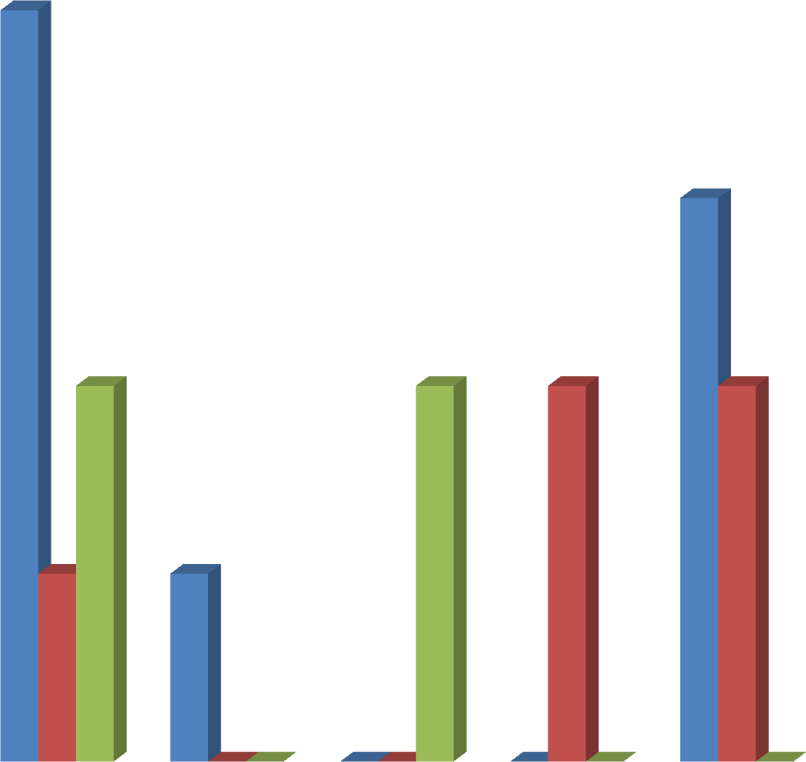

3

2

2

2

2

1

1

0 0

0 0

0

0

0

4

3.5

3

2.5

**Number of Isolates**

2

1.5

1

0.5

0

*S.aureus E.coli K.pneumoniae P.aeruginosa Strep.spp*

**Test Organism**

Throat swab Ear swab Sputum

## Fig 4.2Distribution of the bacterial isolates by source

**Table 4.2.Zone of inhibition values of the aqueous extract of *A.cordifolia* againstisolates from throat swabs.**

Isolates Zone of Inhibition (mm) for aqueous extract

20mg/ml 10mg/ml 5 mg/ml 2.5mg/ml 1.25mg/ml Amc (30µg) C

|  |  |  |  |  |  |
| --- | --- | --- | --- | --- | --- |
| *E.coli*25.5±0.7 | 22.5±1.4 17.0±1.4 | 15.5±0.7 | 14.5±0.7 | 27.5±0.7 | NI |
| (T13) |  |  |  |  |  |

|  |  |  |  |  |  |  |  |  |  |  |  |
| --- | --- | --- | --- | --- | --- | --- | --- | --- | --- | --- | --- |
| *S.aureus* | 20.0 ±0.0 | 18.5±0.7 | | 16.5±0.7 | | 12.5±0.7 | | 11.5±0.7 | | 26.5±0.7 | NI |
| (T20) |  |  | |  | |  | |  | |  |  |
| *S.aureus*22.5±0.7 | | 19.0±0.0 | | 17.5±0.7 | | 11.5±0.7 | | NI | | 25.0±1.4 | NI |
| (T31) | |  | |  | |  | |  | |  |  |
| *S.aureus* 20.5±0.7 | | 17.5±0.7 | | 14.0±0.0 | | 12.5±0.7 | | NI | | 26.5±0.7 | NI |
| (T44) | |  | |  | |  | |  | |  |  |
| *S.aureus*20.0 ±0.0 | | 17.5±0.7 | | 16.0±0.0 | | 14.5±0.7 | | 11.5±0.7 | | 28.5±0.7 | NI |
| (T38) | |  | |  | |  | |  | |  |  |
| *Strep.*spp | 22.5±0.7 | | 20.5±0.7 | | 17.5± 0.7 | | 12.5±0.7 | | NI | 27.0±1.4 | NI |
| (T12) |  | |  | |  | |  | |  |  |  |
| *Strep.*spp | 20.5±0.7 | | 19.5±0.7 | | 15.5±0.7 | | 12.0±0.0 | | NI | 25.0±1.4 | NI |
| (T8) |  | |  | |  | |  | |  |  |  |
| *Strep.*spp | 16.5±0.7 | | 13.0±0.0 | | 11.5±0.7 | | NI | | NI | 24.5±0.7 | NI |
| (T67) |  | |  | |  | |  | |  |  |  |

KEY:

± Standard deviation NI = No Inhibition

AMC= amoxicillin /clavulanic acid C =Control (Sterile distilled water)

## Table 4.3. Zone of inhibition values of the ethanol extract of *A.cordifolia* against isolates from throat swabs.

Isolates Zone of inhibition (mm) for ethanol extract.

20mg/ml 10 mg/ml 5mg/ml 2.5mg/ml 1.25mg/ml Amc (30µg) C

|  |  |  |  |  |  |  |
| --- | --- | --- | --- | --- | --- | --- |
| *E.coli*23.5±0.7 | 20.5±0.7 | 17.5±0.7 | 12.5±0.7 | NI | 29.5±0.7 | NI |
| (T13) |  |  |  |  |  |  |

|  |  |  |  |  |  |  |  |  |
| --- | --- | --- | --- | --- | --- | --- | --- | --- |
| *S. aureus* | 18.0±0.0 | 16.5±0.7 | 14.0±1.4 | 11.5 ±0.7 | NI | | 24.0±0.0 | NI |
| (T20) |  |  |  |  |  | |  |  |
| *S. aureus* | 18.5±0.7 | 14.5±0.7 | 12.0±0.0 | NI | NI | | 24.5± 2.1 | NI |
| (T31) |  |  |  |  |  | |  |  |
| *S.aureus*17.5±0.7 | | 15.5±0.7 | 12.5±0.7 | NI | NI | 25.5±0.7 | | NI |
| (T44) | |  |  |  |  |  | |  |
| *S.aureus* | 18.5±0.7 | 16.0±0.0 | 12.5±0.7 | 11.0±0.0 | NI | | 24.5±0.7 | NI |
| (T38) |  |  |  |  |  | |  |  |
| *Strep.* spp 19.5±0.7 | | 17.0±0.0 | 12.5±0.7 | NI | NI | | 25.5±0.7 | NI |
| (T12) | |  |  |  |  | |  |  |
| *Strep*. spp19.5±0.7 | | 16.5±0.7 | 13.5±0.7 | NI | NI | | 23.5±0.7 | NI |
| (T8) | |  |  |  |  | |  |  |
| *Strep.* spp 16.0±0.0 | | 12.5±0.7 | NI | NI | NI | | 23.0±1.4 | NI |
| (T67) | |  |  |  |  | |  |  |

KEY:

± Standard Deviation NI = No Inhibition

AMC=Amoxicillin Clavulanic acid C =Control (Sterile distilled water)

## Table 4.4. Zone of inhibition values of aqueous extract of *A.cordifolia* against isolates from ear swabs.

Isolates Zone of inhibition (mm) for aqueous extract

20 mg/ml 10 mg/ml 5 mg/ml 2.5 mg/ml 1.25 mg/ml Amc (30µg) C

|  |  |  |  |  |  |  |
| --- | --- | --- | --- | --- | --- | --- |
| *P. aeruginosa* 32.5±0.7 30.0±1.4 (E6) | 27.5±0.7 24.5±0.7 | 20.0±1.4 | | 29.0±1.4 | NI | |
| *P.aeruginosa* 30.5±0.7 26.0±1.4 | 23.5±0.7 21.5±0.7 | 18.0±1.4 | | 26.0±0.7 | NI | |
| (E24) |  |  | |  |  | |
| *S. aureus*23.5±0.7 21.5±0.7 19.0±0.0 15.5±0.7 | | NI | 25.5±0.7 | | NI | |
| (E27) | |  |  | |  | |
| *Strep.* spp18.5±0.7 16.0±0.0 14.5±0.7 12.0±0.0 | | NI | 24.0±0.0 | | NI | |
| (E20) |  |  |  |  |  |  |

*Strep .*spp 20.5±0.7 16.5±0.7 14.5±0.7 11.5±0.7 NI 25.0±0.0 NI (E22)

KEY:

± Standard deviation NI = No Inhibition

AMC= amoxicillin/clavulanic acid C =Control (Sterile distilled water)

## Table 4.5. Zone of inhibition values of ethanol extract of *A.cordifolia* against isolates from ear swabs.

Isolates Zone of inhibition (mm) for ethanol extract.

20 mg/ml 10 mg/ml 5 mg/ml 2.5 mg/ml 1.25 mg/ml Amc (30µg) C

*P. aeruginosa*21.0±1.4 17.5±0.7 15.5±0.7 12.5±0.7 NI 26.5±2.1 NI (E6)

*P.aeruginosa*19.0±0.0 15.5±0.7 13.5±0.7 NI NI 26.5±2.1 NI (E24)

*S. aureus*20.5±0.7 18.5±0.7 15.0±0.0 12.5±0.7 NI 24.5±0.7 NI (E27)

*Strep.* spp 17.5±0.7 15.5±0.7 12.5±0.7 NI NI 24.0±1.4 NI (E20)

*Strep.* spp 16.5±0.7 14.5±0.7 11.5±0.7 NI NI 24.0±0.0 NI

(E22)

KEY:

± Standard deviation NI = No Inhibition

AMC= amoxicillin/clavulanic acid C =Control (Sterile distilled water)

## Table 4.6. Zone of inhibition values of aqueous extract of *A.cordifolia* against isolates from sputum specimens.

Isolates Zone of Inhibition (mm) for aqueous extract

|  |  |  |  |  |  |  |  |
| --- | --- | --- | --- | --- | --- | --- | --- |
| 20 mg/ml | 10 mg/ml | 5 mg/ml | 2.5 mg/ml | 1.25 mg/ml | Amc (30µg) | C | |
| *K.pneumoniae*27.5±0.7 | | 24.5±0.7 | 22.0±1.4 | 16.5±0.7 | 12.5±0.7 | 27.5±2.1 | NI |
| (S16) | |  |  |  |  |  |  |
| *K.pneumoniae* | 25.5±0.7 | 19.5±0.7 | 17.0±0.0 | 12.5±0.7 | NI | 27.0±2.1 | NI |
| (S20) |  |  |  |  |  |  |  |
| *S. aureus* | 20.5±0.7 | 18.5±0.7 | 16.0±0.0 | 13.5±0.7 | NI | 26.0±0.7 | NI |
| (S44) |  |  |  |  |  |  |  |
| *S. aureus* | 25.5±0.7 | 20.5±0.7 | 17.5±0.7 | 12.5±0.7 | NI | 23.5± 0.7 | NI |
| (S10) |  |  |  |  |  |  |  |

KEY:

± Standard deviation NI = No Inhibition

AMC= amoxicillin/clavulanic acid C =Control (Sterile distilled water)

## Table 4.7. Zone of inhibition values of ethanol extract of *A.cordifolia* against isolates from sputum specimens.

Isolates Zone of inhibition (mm) for ethanol extract.

|  |  |  |  |  |  |  |  |  |  |
| --- | --- | --- | --- | --- | --- | --- | --- | --- | --- |
| 20 mg/ml | 10 mg/ml | | 5 mg/ml | 2.5 mg/ml | 1.25 mg/ml | Amc (30µg) | C | |  |
| *K.pneumoniae*19.5±0.7 | | | 17.5±0.7 | 15.5±0.7 | 14.0±0.7 | 11.5±0.7 | 26.5±0.7 | NI | |
| (S16) | | |  |  |  |  |  |  | |
| *K.pneumoniae* | | 19.0±1.4 | 15.5±0.7 | 12.5±0.7 | NI | NI | 29.5±0.7 | NI | |
| (S20) | |  |  |  |  |  |  |  | |
| *S. aureus* | | 18.5±0.7 | 16.0±0.0 | 12.5±0.7 | NI | NI | 26.5±0.7 | NI | |
| (S44) | |  |  |  |  |  |  |  | |
| *S. aureus* | | 20.5±0.7 | 18.0 ±0.0 | 14.5±0.7 | NI | NI | 25.0±1.4 | NI | |
| (S10) | |  |  |  |  |  |  |  | |

KEY:

± Standard deviation NI = No Inhibition

AMC= amoxicillin/clavulanic acids C =Control (Sterile distilled water)

## Table 4.8. M.I.C and M.B.C of aqueous and ethanol extracts against isolates from throat swab specimens.

Aqueous Extract Ethanol Extract

|  |  |  |  |  |  |
| --- | --- | --- | --- | --- | --- |
| Isolates |  | M.I.C (mg/ml) | M.B.C (mg/ml) | M.I.C (mg/ml) | M.B.C (mg/ml) |
| *E.coli* | (T13) | 20 | >20 | 20 | >20 |
| *S. aureus* | (T38) | 5 | 5 | 10 | 20 |
| *S. aureus* | (T44) | 5 | 20 | 10 | 20 |
| *S. aureus* | (T31) | 5 | 5 | 10 | 10 |
| *S. aureus* | (T20) | 5 | 10 | 10 | 20 |
| *Strep.*spp (T12) | | 10 | 20 | 20 | 20 |

*Strep.*spp (T8) 20 >20 20 >20

*Strep.*spp (T67) 20 >20 20 >20

## Table 4.9.The M.I.C and M.B.C values of aqueous and ethanol extracts against isolates from ear swab specimens.

Aqueous Extract Ethanol Extract

Isolates M.I.C (mg/ml) M.B.C (mg/ml) M.I.C (mg/ml) M.B.C (mg/ml)

*P.aeruginosa*(E6) 5 10 10 20

*P.aeruginosa*(E24) 5 20 10 20

*S. aureus* (E27) 5 10 5 20

*Strep.*spp (E20) 10 20 20 >20

*Strep*. spp (E22) 20 >20 20 >20

## Table 4.10. The M.I.C and M.B.C values of aqueous and ethanol extracts against isolates from sputum specimens.

Aqueous Extract Ethanol Extract

|  |  |  |  |  |  |  |
| --- | --- | --- | --- | --- | --- | --- |
| Isolates |  | M.I.C (mg/ml) | M.B.C (mg/ml) | M.I.C (mg/ml) | M.B.C (mg/ml) |  |
| *K.pneumoniae* | (S16) | 20 | >20 | 20 | >20 |  |
| *K.pneumoniae* | (S20) | 20 | >20 | 20 | >20 |  |
| *S. aureus* | (S10) | 5 | 10 | 10 | 20 |  |
| *S. aureus* | (S44) | 20 | >20 | 20 | >20 |  |

**Table 4.11: Fractionation of aqueous extract of *A. cordifolia***

|  |  |  |  |
| --- | --- | --- | --- |
| **Fraction No.** | **Ratio of Eluting Solvents** | | |
|  | **N-hexane** | **Ethyl acetate** | **Methanol** |
| 1 | 10 | 0 | 0 |
| 2 | 10 | 0 | 0 |
| 3 | 9 | 1 | 0 |
| 4 | 9 | 1 | 0 |
| 5 | 9 | 1 | 0 |
| 6 | 8 | 2 | 0 |
| 7 | 8 | 2 | 0 |
| 8 | 7 | 3 | 0 |
| 9 | 6 | 4 | 0 |
| 10 | 5 | 5 | 0 |
| 11 | 4 | 6 | 0 |
| 12 | 3 | 7 | 0 |
| 13 | 2 | 8 | 0 |
| 14 | 1 | 9 | 0 |
| 15 | 0 | 10 | 0 |
| 16 | 0 | 10 | 0 |
| 17 | 0 | 9 | 1 |
| 18 | 0 | 8 | 2 |
| 19 | 0 | 8 | 2 |
| 20 | 0 | 7 | 3 |
| 21 | 0 | 7 | 3 |
| 22 | 0 | 7 | 3 |
| 23 | 0 | 6 | 4 |
| 24 | 0 | 6 | 4 |
| 25 | 0 | 5 | 5 |
| 26 | 0 | 5 | 5 |
| 27 | 0 | 5 | 5 |
| 28 | 0 | 4 | 6 |
| 29 | 0 | 3 | 7 |
| 30 | 0 | 2 | 8 |
| 31 | 0 | 1 | 9 |
| 32 | 0 | 10 | 10 |
| 33 | 0 | 10 | 10 |
| 34 | 0 | 10 | 10 |
| 35 | 0 | 10 | 10 |

## Table 4.12. Number of fractions after TLC and the combination of pooled fractions.

|  |  |  |
| --- | --- | --- |
| Number of pooled Fractions | Combination of Fractions pooled |  |
| F1 | Combination of fractions 1-9 |  |
| F2 | Combination of fractions 10-14 |  |
| F3 | Combination of fractions 15-17 |  |
| F4 | Combination of fractions 18-20 |  |
| F5 | Combination of fractions 21-24 |  |
| F6 | Combination of fractions 25-27 |  |
| F7 | Combination of fractions 28-35 |  |

**Table 4.13. Weight of pooled fractions**

## Weight of Fractions

Number of Fractions Weight (g)

|  |  |  |  |
| --- | --- | --- | --- |
| F1 |  | 0.88 |  |
|  | F2 |  | 1.36 |
|  | F3 |  | 0.69 |
|  | F4 |  | 3.79 |
|  | F5 |  | 7.28 |
|  | F6 |  | 13.18 |
|  | F7 |  | 6.20 |
|  | Total | 33.38 |  |

## Table 4.14. TLC Based Phytochemical screening of F2

**Spray Reagents used Secondary Metabolites Inferences**

|  |  |  |
| --- | --- | --- |
| P-Anisaldehyde | General | Present |
| Ferric Chloride | Phenolic compounds | Present |
| Aluminium chloride | Flavonoids | Present |
| + u.v light 360nm |  |  |
| Liberman Burchard | Steroids/Tertepenoids | Absent |
| Bontragers spray | Anthraquinones | Absent |
| Dragendorff | Alkaloids | Absent |

## Table 4.15. The M.I.C of Fractions against Isolates from Throat swab specimens.

|  |  |  |  |  |  |  |  |  |  |  |  |  |  |  |
| --- | --- | --- | --- | --- | --- | --- | --- | --- | --- | --- | --- | --- | --- | --- |
| **M.I.C (mg/ml)** |  | | | | | | | | | | | | | |
| Isolates | F1 |  | F2 |  | F3 |  | F4 |  | F5 |  | F6 |  | F7 |  |
| *E.coli*(T13)>20 |  | 5 |  | 10 |  | 10 |  | 10 |  | >20 |  | 10 |  |  |
| *S.aureus* (T38) | >20 |  | 2.5 |  | 5 |  | 20 |  | 10 |  | 10 |  | 20 |  |
| *S.aureus* (T44) | >20 |  | 2.5 |  | 10 |  | >20 |  | >20 |  | >20 |  | >20 |  |
| *S.aureus* (T31) | >20 |  | 5 |  | 5 |  | 20 |  | 10 |  | 10 |  | 10 |  |
| *S.aureus* (T20) | >20 |  | 2.5 |  | 5 |  | 10 |  | 20 |  | >20 |  | 10 |  |
| *Strep.* spp (T12)>20 | | 5 | | 10 | | 20 | | 10 | | 20 | | >20 | | |
| *Strep.* spp (T8) >20 | | 10 | | 20 | | >20 | | >20 | | >20 | | >20 | | |
| *Strep.* spp (T67) >20 | | 5 | | 20 | | >20 | | >20 | | >20 | | >20 | | |

**Table 4.16. The M.I.C of Fractions against Isolates from Ear swab specimens.**

|  |  |  |  |  |  |  |  |  |  |  |  |  |  |  |  |
| --- | --- | --- | --- | --- | --- | --- | --- | --- | --- | --- | --- | --- | --- | --- | --- |
|  | **M.I.C (mg/ml)**  Isolates | F1 |  | F2 |  | F3 |  | F4 |  | F5 |  | F6 |  | F7 |  |
|  | *P.aeruginosa* (E6) | >20 |  | 5 |  | 20 |  | >20 |  | >20 |  | >20 |  | >20 |  |
|  | *P.aeruginosa* (E24) | >20 |  | 5 |  | 10 |  | >20 |  | >20 |  | >20 |  | >20 |  |
|  | *S.aureus* (E27) | >20 |  | 2.5 |  | 5 |  | >20 |  | 20 |  | 10 |  | 20 |  |
|  | *Strep.* spp (E20) | >20 |  | 5 |  | >20 |  | >20 |  | >20 |  | >20 |  | >20 |  |
|  | *Strep.* spp (E22)>20 |  | 10 |  | >20 |  | >20 |  | >20 |  | >20 |  | >20 |  |  |

## Table 4.17. The M.I.C of Fractions against Isolates from Sputum specimens

|  |  |  |  |  |  |  |  |
| --- | --- | --- | --- | --- | --- | --- | --- |
| **M.I.C (mg/ml)**  Isolates F1 | F2 | F3 | F4 | F5 | F6 | F7 |  |
| *K. pneumoniae (S16)* >20 | 5 | 20 | >20 | >20 | >20 | >20 |  |
| *K.pneumoniae* (S20) >20 | 5 | 20 | >20 | >20 | >20 | >20 |  |
| *S.aureus* (S10) >20 | 2.5 | 20 | >20 | >20 | >20 | >20 |  |
| *S.aureus* (S44) >20 | 5 | >20 | >20 | >20 | >20 | >20 |  |

25

20 20

20



10

10

10 10

5

5

5

5

5

5

2.5

2.5 2.5

2.5

15

**Concentration mg/ml**

10

5

0

*E. coli (T13)*

*S. aureus (T38)*

*S. aureus (T44)*

*S. aureus (T31)*

*S. aureus (T20)*

*Strep. spp (T12)*

*Strep. spp (T8)*

*Strep. spp (T67)*

**Test Organism**

M.I.C M.B.C

## Fig 4.3. M.I.C and M.B.C of the most active fraction (F2) against isolates from throat swab specimens

25

20 20 20

20



10

10

5

5

5

5

2.5

15

**Concentration mg/ml**

10

5

0

*P. aeruginosa (E6)*

*P. aeruginosa (E24)*

*S. aureus (E27) Strep.spp (E20) Strep.spp (E22)*

**Test Organisms**

M.I.C M.B.C

## Fig 4.4. M.I.C and M.B.C of the most active fraction (F2) against isolates from ear swab specimens.

12

10 10 10

10

5

5

5

5

2.5

8

**Concentration mg/ml**

6

4

2

0

*K. pneumoniae (S16)*

*K. pneumoniae (S20)*

*S. aureus (S10) S. aureus (S44)*

**Test Organisms**

M.I.C M.B.C

## Fig 4.5. M.I.C and M.B.C of the most active fraction (F2) against isolates from Sputum specimens.

8



7

6

LOG OF SURVIVAL CELL/ML

5

4 M.I.C 2.5mg/ml

Sub-M.I.C 1.25mg/ml

3 AMC 30µg/ml

Control

2

1

0

0 30 60 120 240 360 1440

TIME (MINUTES)

## Fig 4.6. Death/Survival rate of *S. aureus* (T38) on exposure to M.I.C and Sub-M.I.C of F2.

8



7

6

**Log of survival cells/ml**

5

4 M.I.C 5mg/ml

Sub-M.I.C 2.5mg/ml

3 AMC 30µg/ml

2 Control

1

0

0 30 60 120 240 360 1440

**Time (minutes**)

## Fig 4.7. Death/Survival rate of *K. pneumoniae* (S16) on exposure to M.I.C and Sub-M.I.C of F2.

## CHAPTER FIVE

## 5.0 DISCUSSIONS

A total of 180 specimens were collected from patients having RTIs.The bacteria isolated from the specimens collected included; *S. aureus, K. pneumoniae, E. coli, P. aeruginosa* and *Strep.* spp. These isolates clearly represented clinically significant pathogens and are known to cause majority of community and hospital acquired infections and are capable of elaborating severe virulence factors. This result is similar with the work of Kumari *et al*., (2007) in India, EL – Mahmood *et al*., (2010) and Okesola and Oni, (2009) in Nigeria who isolated similar pathogens from patients with respiratory tract infection. It is also in line with the work of Taura *et al*., (2013) that isolated *Klebsiella pneumoniae* and *Staphylococccus aureus* from sputum samples in Aminu Kano Teaching Hospital in Kano State, Nigeria.

*S. aureus* was isolated in all the specimens with throat swabs (4), ear swabs, (1) and sputum (2).

While *K. pneumoniae* was isolated in only sputum specimens (2), *P. aeruginosa* was isolated in only ear specimens (2) and *Strep*. spp in throat swab (3) and ear swab (2) specimens. This is in line with the work of Adedeji *et al*., (2007) in Osun State, Nigeria and the work of Somia *et al*., (2014) in Pakistan who showed that *P. aeruginosa* was the commonest organism isolated from ear infections followed by *S. aureus*. *P. aeruginosa* infections such as Otitis media and externa are often chronic infections. It was also similar with the result obtained in the work by Anitha *et al.,* (2016) in India who isolated *Strep. pyogenes*, *S. aureus* and *E. coli* from throat swab specimens with *Strep. pyogene* having the highest percentage and *E. coli* having the least. Also in the study,*S. aureus* has the highest number of isolates and is also isolated in all the three specimen sources, this could be as a result of the availability of *Staphylococcus aureus* as a normal flora of the nares, mouth and some non-sterile sites. The presence of *K. pneumoniae* from

sputum could be as a result of *K. pneumoniae* being one of the causes of broncho-pneumonia. It colonize the lower respiratory tract and common in hospital patients receiving antibiotics, it sometimes causes chronic destructive lesions and multiple abscess formation in the lungs (Friedländer‘s pneumonia), (Greenwood *et al*., 2007).

The polarity of the solvent (water) used in extracting the aqueous extract which allowed it to draw more constituents than ethanol extract, could have been the reason why the former had more yield than the latter. The choice of the method of extraction (Cold maceration) was due to the fact that it is similar with the extraction method by the traditional herbalist.

The diameter zones of inhibition, showed that the aqueous extract had more activity than the ethanol extract. The degree of activity varied with the isolates and the extracts. This variation of activity could be due to the differences in the solubility of the secondary metabolite in the different solvents used and also the structural or morphological variability of the tested isolates thus, larger zones of inhibition were produced by the susceptible organisms than the resistant ones. It could also be due to the polarity of the solvents, water been more polar dissolvemore of the secondary metabolites. This result is different from the work of Adeshina *et al*., (2012) which showed that the ethyl acetate fraction (non-polar solvent) of methanol extract of *A. cordifolia*leaf was relatively more active than the aqueous fraction (polar solvent) against type isolates of*E. coli*, *S. aureus*, *P. aeruginosa* and *Candida albican*. The observed differences may be as a result of variation of plants location and method of extraction. The result is similar to the findings of Mohammed *et al.,* (2012) who reported that water extract of *Alchornea cordifolia* exerted highest activity against *S. aureus* isolated from wound samples in Aminu Kano Teaching Hospital in Kano, Nigeria more than the ethanol extract. The work OFGatsing *et al.,* (2010) in Cameroon who showed that the aqueous leaf extract of *A. cordifolia* was more active than the

methanol and ethanol extracts against *E. coli*, *P. aeruginosa*, *K. pneumoniae* and *S. aureus.* The result is also in line with the work of Osumah *et al*., (2012) that showed that the aqueous root extract of *A. cordifolia* had more activity than the ethanol extract against *E. coli*, *P. aeruginosa*,

*S. aureus* and *S. typhi* isolates from fecal material and wounds

The diameters zone of inhibition showed a concentration dependent result and the result also showed that the zone of inhibition values of the extracts was far lesser than that of the positive control amoxicillin/clavulanic acid. This may be attributed to the fact that conventional antibiotics are usually prepared from synthetic materials by means of reproducible manufacturing techniques and procedures, while herbal medicinal plants products are still crude, prepared from plant and animal origins and are subjected to contamination and deterioration most of the time (EL – Mahmood and Ameh, 2007).

The M.I.C and M.B.C values were generally lower for the aqueous extract against the test isolates compared to those of the ethanol extract. *S. aureus* was more susceptible to the extracts especially the aqueous extract which showed lowest M.I.C and M.B.C values of 5 mg/ml – 10 mg/ml. This is of great importance as it has been reported that this organism has developed resistance to many antibiotics, which sometimes makes its clinical management difficult (Adewunmi *et al*., 2001). This result agrees with the work ofOsumah *et al.,*(2012) who showed that the root and stem bark extracts and fractions of *A. cordifolia* had more activity against *S. aureus*isolated from fecal and wound samples in Ahmadu Bello University Teaching Hospital Zaria. The differences in the susceptibilities of the isolates to the plant extracts can be related to the cell wall composition of the organisms. Gram – positive bacteria have cell wall composed of peptidoglycan with techoic acid in between, therefore they are more susceptible than Gram – negative bacteria that have their cell wall surrounded by bi-lipid layers of Gram-negative

lipopolysaccharides and lipoproteins, which prevent ready penetration of antibiotics through their cell wall.

The lower M.I.C confirm the high activity of the fraction (F2) at low concentration. High activity of antibacterial agent at low concentration is very essential for chemotherapeutic purposes because of their toxicity to patient system. The observed low M.I.C values from fraction F2 could be due to the fact that F2 contains the secondary metabolites responsible for the antibacterial activity of the aqueous extract. The M.I.C and M.B.C values of F2 against the isolates was lower compared to the crude extract, this could be due to the fact that the crude extract contained a lot of constituent that play little or no role in the antibacterial activity of the extract ( Adewunmi *et al.*, 2001).

There was increase in the number of surviving cells in all the negative controls. The general bactericidal activity of F2 was rapid from onset and generally concentration dependent. Garret and Brown (1964) reported that there was no single concentration of an antibacterial agent at which cells in a suspension will be killed spontaneously. Killing of cells occur chiefly as a function of time within a range of concentrations and these possibly explain the increase lethal activity of the F2 with increase concentration above the Sub – M.I.C.

Many researchers have reported the presence of secondary metabolites in *A. cordifolia*, these secondary metabolites are generally found as components of plants (Ogungbamila and Samuelsson, 1990). The secondary metabolitesreported by several researchers possessed appreciable inhibitory activities against various organisms (Cushine and Lamd, 2005). In this study, the TLC based phytochemical screening of fraction F2 revealed the presence of phenolic compounds and flavonoids. These secondary metabolites might be responsible for the

antibacterial activity of F2 and they exert their antimicrobial activities through different mechanisms. Phenols are generally protoplasmic poisons toxic to all types of cells. Precipitation of proteins occurs with high concentration of phenol, while at low concentrations it denatures proteins without coagulating them. It freely to penetrates the tissue because of its denaturing activity (Adeshina *et al*., 2012). Flavonoids on the other hand have been reported to be synthesized by plants in response to microbial infection, hence they exhibitantibacterial activities (Kujumgiev *et al*., 1999). The presence of flavonoids suggest that it can be used as anti– spasmodic and antioxidant, and confirms the reason for the use of the plant in the treatment of spasmodic bronchitis and other microbial infections.

## CHAPTER SIX

* 1. **SUMMARY,CONCLUSION AND RECOMMENDATIONS**

## SUMMARY

The leafextracts of *A. cordifolia* have shown broad spectrum of activity and a consistent and concentration dependent inhibition of bacterial isolates. The aqueous extract had more yield than the ethanol extract, and have shown to have higher antibacterial activity than the ethanol extractwith zones of inhibition ranging from 32. 5 mm – 11. 5 mm and lower M.I.C and M.B.C values ranging from 5 mg/ml – 20 mg/ml

Fraction F2 obtained from the column chromatography of the aqueous extract was found to be the most active fraction with superior antibacterial activity than the extracts.

The TLC based phytochemical showed that F2 contains Phenolic compound and flavonoids secondary metabolites.

## CONCLUSION

The aqueous and ethanol leaf extracts of *Alchornea cordifolia* obtained from Chaza, Niger State, Nigeria was found to possess antibacterial activity against *S. aureus*, *E. coli*, *P. aeruginosa*, *K. pneumoniae* and *Strep*. spp isolated from throat swabs, ear swabs and sputum specimens of patients with respiratory tract infection in Ahmadu Bello University Teaching Hospital Zaria, Nigeria.

This study has justifiedthe use of *Alchornea cordifolia* in the treatment of some bacterial diseases in folkloric herbal medicine.

## RECOMMENDATIONS

1. Isolating the secondary metabolites will be important to explore the full potential of *Alchornea cordifolia* plant.
2. Test for safety is required with further purification for economical purposes.
3. Mechanism of action of the *Alchornea cordifolia* should be determined.
4. The findings in this study have shown the need for further investigation to establish the economic viability of exploiting *Alchornea cordifolia*plant to address health problems.

## CONTRIBUTIONS TO KNOWLEDGE

1. This study has contributed to other studies on the antibacterial activity of the leaf extracts of *Alchornea cordifolia.*It further substantiated other findings that *Alchornea cordifolia* has antibacterial activity.
2. It was observed in this study that aqueous and ethanol leaf extracts of *Alchornea cordifolia*were active against respiratory tract pathogens and can be used in the treatment of respiratory tract infection caused by *S. aureus*, *K. pneumoniae*, *E. coli*, *Strep*. spp and *P. aeruginosa*.

## REFERENCES

Aboaba, O. O., Smith, S. I., Olude, F.O.(2006). Antibacterial effect of Edible Plant on

*Escherichia coli*015:H.*Pakistan Journal of Nutrition* 5 (4):325-327.

Adedeji, G. B., Fagade, O. E., Oyelade, A. A. (2007). The prevalence of *Pseudomonas aeruginosa* in clinical samples and its sensitivity to citrus extract. *African Journal of Biomedical Research*. 10: 183-187.

Adedapo, A. A., Shabi, O. O., Adedokun, O. A. (2005). Antihelminthic efficacy of the aqueous extract of Euphorbia hirta (Linn) in Nigerian dogs. *Vet. Arch*. 75 (1): 39 – 47.

Adeshina, G.O., Kunle, O. F.,Onaolapo, J.A., Ehinmidu J.O., Odama L.E. (2012) Antibacterial Activity of Aqueous and Ethyl Acetate sub-fractions of *Alchornea cordifolia* leaf.

*European Journal of Medicinal plants*. 2 (1): 31-41.

Adeshina, G.O., Onaolapo, J.A., Ehinmidu J.O., Odama L.E. (2010). Phytochemical and antimicrobial studies of the ethyl acetate extract of *Alchornea cordifolia* leaf found

in Abuja.*Nigeria Journal of Medicinal Plants* Res, 4, 649-658.

Adewunmi, C. O., Agbedahunsi, J. M., Adebajo, A. C., Aladesanmi, A. J., Murphy, N. and Wando, J. (2001). Ethno-veterinary medicine: Screening of Nigerian medicinal plants for trypanocidal properties. *Journal of Ethnopharmacology*. 77: 19-14.

Agbor, G.A., Leopold, T., Jeanne, N.Y., (2004). The antidiarrhoeal activity of *Alchornea cordifolia*leaf extract. *Phytotherapy Research Journal*. 18 (11): 873–876.

Akanbi, M. O., Ukoli, C. O., Erhabor, G. E., Akanbi, F. O., Gordon, S. B. (2009). The burden of respiratory disease in Nigeria. *The African Journal of Respiratory Medicine*. 17.

Ake-Assi, L., Guinko, S., Aya-Lazare, A. (1991). Plants used in Traditional Medicine in West Africa. Rock Edition, Basel, Switzerland. Pp 151.

American Academy of Family Physicians; American Academy of Otolaryngology-Head and Neck Surgery; American Academy of Pediatrics Subcommittee on Otitis Media

With Effusion. Otitis media with effusion. *Pediatrics*. 2004;113(5):1412-1429.

American Academy of Pediatrics Subcommittee on management of acute Otitis Media. Diagnosis and management of acute otitis media. (2004).

*Pediatrics*.113(5):1451-1465.

Anderson, R., Steel, H. C., Cockeran, R.(2007). Comparison of theeffects of macrolides, amoxicillin, ceftriaxone, doxycycline, tobramycin and fluoroquinolones on the production of pneumolysin by*Streptococcus pneumoniae* in vitro. *Journal of*

*Antimicrobial Chemotherapy.* 60:1155–1158.

Ansari, J. A., Inamdar, N. N. (2010). The promise of traditional medicines. *International Journal of Pharmacology*. 6: 808 – 812.

Anthonisen, N., Manfreda, J., Warren, C. P., Hershfield, E. S., Harding, G. K, Nelson, N. A. (1987). Antibiotic therapy in exacerbations of chronic obstructive pulmonary disease.

*Annual International journal of Medicine.* 106:196-204.

Antibiotic Guidelines Sub-Committee, Victorian Drug Usage Advisory Committee. Antibiotic guidelines. 9th ed. (1996). Melbourne: Victorian Medical Postgraduate Foundation.

Arroll, B., Kenealy, T. (2005). Antibiotics for the common cold and acute purulent rhinitis.

*Cochrane Database Syst Rev*. (3):CD000247.

Ayisi, N.K., Nyadedzor, C.(2003). Comparative in vitro effects of AZT and extracts of *Ocimum gratissimum, Ficus polita, Clausena anisata, Alchornea cordifolia,* and *Elaeophorbia drupifera* against HIV-1 and HIV-2 infections. *Antiviral Research Journal.* 58: 25–33.

Banzouzi, J.T., Prado, R., Menan, H., Valentin, A., Roumestan, C., Mallie, M., Pelissier, Y.

Blache, Y. (2002). In vitro antiplasmodial activity of extracts of *Alchornea cordifolia* and identification of an active constituent: ellagic acid. *Journal of Ethnopharmacology*81: 399–401.

Bisno, A. L., Gerber, M. A., Gwaltney, J. M. Jr., Kaplan, E. L., Schwartz, R. H. (2002). Infectious Diseases Society of America. Practice guidelines for the diagnosis and management of group A streptococcal pharyngitis. *Clinical Infectious Diseases*.

35(2):113-125.

Bisno, A. L. (1996). Acute pharyngitis: etiology and diagnosis. *Pediatrics*. 97(6 pt 2):949-954.

Blondeau, J. M., Zhao, X., Hansen, G., Drlica, K. (2001). Mutant prevention concentrations of fluoroquinolones for clinical isolates of *Streptococcus pneumoniae.Antimicrobial*

*Agents Chemotherapy*. 45: 433–438.

Boampong, J.N., (1992). A preliminary investigation of the anti-asthmatic properties of ethanolic root extracts of *Alchornea cordifolia* and *Cassia alata*. B.Pharm. degree thesis,

Department of Pharmacognosy, Faculty of Pharmacy, Kwame Nkrumah University of Science and Technology, Kumasi, Ghana. p.32.

Borg, M. A., Tiemersma, E., Scicluna, E. (2009). Prevalence of penicillin anderythromycin resistance among invasive *Streptococcus pneumoniae* isolates reported by

laboratories in the southern and easternMediterranean region. *Clinical Microbiology and Infection Journal*. 15: 232–237.

Brunton, S. (2005). Treating community acquired bacterial respiratory tract infections on etiology, diagnosis and antimicrobiology therapy*. Journal of Family Practice.* 54 (4) 1 – 10.

Burkill, H.M., (1994). The useful plants of West Tropical Africa. 2nd Edition. Volume 2, Mavar- Families E–I. Royal Botanic Gardens, Kew, Richmond, United Kingdom. pp. 636

Carratala, J., Marron, A., Fernandez-Sevilla, A., Linares, J., Gudiol, F. (1997). Treatment of penicillin-resistant pneumococcal bacteremia in neutropeniacpatients with cancer.

*Clinical Infectious Diseases.*24: 148–152.

Carroll, K.C. ( 2002). Laboratory diagnosis of lower respiratory tract infections: Controversy and conundrums. *Journal of Clinical Microbiology* 40(9):3115–3120

Centers for Disease Control and Prevention. Summary health statistics for U.S. adults: National HealthInterviewSurvey,(2009).http://www.cdc. gov/nchs/data/series/sr_10/sr10_249.pdf.

Centor, R. M., Allison, J. J., Cohen, S. J. (2007). Pharyngitis management: defining the controversy. *Journal of General Internal Medicine*. 22(1):127-130.

Cesario, A. (1993). Screening of plants used in Argentine folk medicine for antimicrobial activity. *Journal of Ethnopharmacology* 13

Chattopadhyay, M. K. (1996). Herbal medicines. *Current Science*. 71: 5 - 5

Cheesbrough, M. (2006). Biochemical Test to Idenify Bacteria in Laboratory Practice in Tropical Countries. Cheesbrough M. (ed). Cambridge Edition 2: 63-87.

Choby, B. A. (2009). Diagnosis and treatment of streptococcal pharyngitis. *American Family*

. *Physician*. 79(5):383-390

Chonmaitree, T. (2000). Viral and bacterial interaction in acute otitis media. *Pediatric Infectious Disease Journal*. 19(5 suppl):S24-S30.

Chow, A. W., Benninger, M. S., Brook, I. (2012). Infectious Diseases Society of America. IDSA clinical practice guideline for acute bacterial rhinosinusitis in children and

adults. *Clinical Infectious Diseases Journal.* 54(8):e72-e112.

Christainsen, K. (1996). Treatment of common lower respiratory tract infections. *Australian Prescriber.* 19: 48-51.

Clark, M., Kumar, P., Ballinger, A., Patchett, S. (2004). Saunder‘s Pocket Essentials of Clinical Medicine (3ed.) Elservier, London.

CLSI, (2006). Method for dilution antimicrobial susceptibility test for bacteria that grow aerobically. Wayne, Pa, USA. Approved standard M7-A7.

CLSI, (2009). Performance Standard for Antimicrobial disk Susceptibility Test, Approved StandardM02-A10.10th Edition. CLSI, Wayne, PA, 29: 1.

Coker, T. R., Chan, L. S., Newberry, S. J. (2010). Diagnosis, microbial epidemiology, and antibiotic treatment of acute otitis media in children: a systematic review. *Journal of American Medical Association*. 304(19):2161-2169.

Cooper, R. J., Hoffman, J. R., Bartlett, J. G. (2001). American Academy of Family Physicians;

American College of Physicians-American Society of Internal Medicine; Centers for Disease Control. Principles of appropriate antibiotic use for acute pharyngitis in adults: background. *Annals of Internal Medicine*.134(6):509-517.

Critchley, I. A., Brown, S. D., Traczewski, M. M, Tillotson, G. S, Janjic, N. (2007). National and regional assessment of antimicrobial resistance amongcommunity-acquired

respiratory tract pathogens identified in a2005–2006 U.S. Faropenem surveillance study. *Antimicrobial AgentsChemotherapy.* 51: 4382–4389.

Cushine, T. P. T and Lamb, A. J. (2005). Antimicrobial activity of flavonoids. *International Journal of Antimicrobial Agents*. 26(5): 343-356.

Daneman, N., McGeer, A., Green, K., Low, D. E. (2006). Macrolide resistance inbacteremic pneumococcal disease: implications for patient management.*Clinical Infectious*

*Diseases.* 43: 432–438.

Davy, B.(2001). Canada to Participate in the Decade for African Traditional Medicine. From< InternationalDevelopment Research, Canada. From [<http://www.idr](http://www.idrc.ca/en/er-)c[.ca/en/er-...>](http://www.idrc.ca/en/er-)

(Retrieved on December 4, 2007).

Doern, G. V. (2006). Macrolide and ketolide resistance with *Streptococcus pneumoniae*. *Medical Clinics of North America.* 90: 1109–1124.

Doit, C., Loukil, C., Fitoussi, F., Geslin, P., Bingen, E. (1999). Emergence in Franceof multiple clones of clinical *Streptococcus pneumoniae* isolates withhigh-level resistance to

amoxicillin. *Antimicrobial Agents Chemotherapy*. 43: 1480–1483.

Duke, J. and Vasquez, R. (1994). *Amazonian Ethnobotanical Dictionary*, Florda, CRC Press Incorporated. 122:101-102.

Ebell, M. H. (2003). Making decisions at the point of care: sore throat. *Family Practice Management Journal*.10(8):68-69.

Ekeanyanwu, C. R. (2011). Traditional medicine in Nigeria: Current status and the future.

*Research Journal of Pharmacology*. 5 (6): 90- 94.

Ekpo, M. A., Akinjogunla, O. J., Iiong, D.F. (2009) Microorganisms associated with acute otitis media diagnosed in Uyo City, Nigeria. *Scientific Research and Essay*. 4(6):550-564

Eliakim-Ikechukwu, C. F., Riman, E. B. (2009). The effect of aqueous ethanolic extract of El-

*Alchornea cordifolia*leaf on the histology of the aorta of wistar rats. *Nigerian Journal of Physiological Sciences*. 24(2): 149-151.

Mahmood, A., Ameh, J. M. (2007). In-vitro antibacterial activity of *Parkia biglobosa*

(Jacq) root, bark extract against some microorganisms associated with Urinary tract infections. *African Journal of Biotechnology.* 6, 195-200.

EL-Mahmood, A., Doughari, J., Ladan, N. (2008). Antimicrobial Screening of Stem bark extracts of *Vitellaria paradixa* against some enteric pathogenic microorganisms, Available online http://www.academic jourmals.org/ajpp. *African Journal of Pharmacognosy.* 2(5): 89-94.

El-Mahmood A. M., Isa. A., Tirmidhi, S.B. (2010). Antimicrobial susceptibility of some respiratory tract pathogens to commonly used antibiotics at the Specialist Hospital, Yola, Adamawa State, Nigeria. *Journal of Clinical Medicine and Research.*2(8),

pp. 135-142.

EL- Sheikh, S. M. (1998). Respiratory tract infections during the pilgrimage season in Saudi Arabia. *Tropical Medicine and International Health Journal*. 3: 205 – 209.

Elujoba, A. A., Odeleye, O. M., Ogunyemi, C. M. (2005). Traditional medicine development for medical and dental primary health care delivery system in Africa. *African Journal*

*of Traditional, Complementary and Alternative Medicines*. 2 (1): 46 – 61.

Elumalai, A., Eswariah, M. C. (2012). Herbalism- a review. *International Journal of Phytotherapy*. 2: 96-105.

Essential Drugs,(2003). (e-drug) - WHO Report on Traditional Medicines. From <[http://.www](http://.www/) essentialdrugs.org/ e drug/archive.

Evans, W. C. (2002). Trease and Evans Pharmacognosy, (Fifteenth Edition), Saunders, W. B. Company limited. Pp: (137-139, 230-240).

Fairbanks, D. N. (2012). Pocket guide to antimicrobial therapy in otolaryngology—head and neck surgery. 13 ed. <http://www.entnet.org/Education> AndResearch/upload/AAO-

PGS-9-4-2.pdf.

Falagas, M. E., Karageorgopoulos, D .E., Grammatikos, A. P., Matthaiou, D. K. (2009). Effectiveness and safety of short vs. long duration of antibiotic therapy for acute bacterial sinusitis: a meta-analysis of randomized trials. *British Journal of Clinical Pharmacol*ogy. 67(2):161-171.

Farr, B. M., Kaiser, D. L., Harrison, B. D, Connolly, C. K. (1989). Prediction of microbial aetiology at admission to hospital for pneumonia from the presenting clinical

features. British Thoracic Society Pneumonia Research Subcommittee. *Thorax*

144:1031-5.

Farrell, D. J., Douthwaite, S., Morrissey, I. (2003). Macrolide resistance byribosomal mutation in clinical isolates of Streptococcus pneumonia from the PROTEKT 1999-2000

study. *Antimicrobial Agents Chemotherapy.* 47: 1777–1783.

Fine, M. J., Smith, D. N., Singer, D. E. (1991). Hospitalization decision in patients with community-acquired pneumonia: a prospective cohort study [see comments]. Am J Med 1990;89:713-21. Comment in: *American Journal of Medicine*. 91:207-8.

File, T. M., Garau, J., Jacobs, M. R., Wynne, B., Twynholm, M., Berkowitz, E. (2005). Efficacy of a new pharmacokinetically enhanced formulation ofamoxicillin/clavulanate

(2000/125 mg) in adults with communityacquiredpneumonia caused by

*Streptococcus pneumoniae*, includingpenicillin-resistant strains. *International Journal of Antimicrobial Agents*. 25:110–119.

Fiore, A. E., Fry, A., Shay, D., Gubareva, L., Bresee, J. S., Uyeki, T. M. (2011). Centers for Disease Control and Prevention (CDC). Antiviral agents for the treatment and chemoprophylaxis of influenza—recommendations of the Advisory Committee on Immunization Practices (ACIP). *MMWR Recomm Rep*.60(1):1-24.

Furin, J., Gegia, M., Mitnick, C. (2011). Eliminating the category II retreatment regime from National tuberculosis progamme: *The Georgian experience Bulletin of the World Health Organiztion.* Article ID: BLT.11.092320.

Gatsing, D., Nkeugouap, F. N. C., Nji-Nkah, F. B., Kuiate, J. R., Tchouanguep, M. F. (2010).

Antibacterial activity, bioavailability and acute toxicity evaluation of the leaf extracts of *Alchornea cordifolia* (Euphorbiaceae). *International Journal of Pharmacology*.

1811 – 7775.

Gauchan, P., Lekhak, B., Sherchand, J.B. (2006). The Prevalence of lower respiratory tract infection in adults visiting Tribhuvan University Teaching Hospital*. Journal of*

*Institute of Medicine,* 28(2):10-14.

George, N. J., Obot, I. B., Ikot, A. N., Akpan, A. E., Obi-Egbedi, N. O. (2010). Phytochemical and antimicrobial properties of leaves of *Alchornea cordifolia*. *European Journal of Chemistry*. 7(30): 1071 – 1079.

Gill, J. M., Fleischut, P., Haas, S., Pellini, B., Crawford, A., Nash, D. B. (2006). Use of antibiotics for adult upper respiratory infections in outpatient settings: a national ambulatory network study. *Family Medicine*. 38(5):349-354.

Glasziou, P. P., DelMar, C. B., Sanders, S. L., Hayem, M. (2004). Antibiotics for acute otitis media in children. *Conchrane Database system Review*. (1) : CD 000219.

Gonzales, R., Bartlett, J. G., Besser, R. E. (2001). American Academy of Family Physicians; American College of Physicians-American Society of Internal Medicine;

Centers for Disease Control; Infectious Diseases Society of America. Principles of appropriate antibiotic use for treatment of uncomplicated acute bronchitis: background. *Annal of Internal Medicine Journal*. 134(6):521-529.

Gonzales, R., Bartlett, J. G., Besser, R .E, Hickner, J. M., Hoffman, J. R., Sande, M. A. (2001). American Academy of Family Physicians; Infectious Diseases Society of America;

Centers for Disease Control; American College of Physicians- American Society of Internal Medicine. Principles of appropriate antibiotic use for treatment of nonspecific upper respiratory tract infections in adults: background. *Annal of Internal Medicine Journal*. 134(6):490-494.

Gonzales, R., Malone, D. C., Maselli, J. H., Sande, M. A. (2001). Excessive antibiotic use for acute respiratory infections in the United States. *Clinical Infectious Diseases*.

33(6):757-762.

González Valdepeña, H., Wald, E. R., Rose, E., Ungkanont, K., Casselbrant, M. L. (1995).

Epiglottitis and *Haemophilus influenzae* immunization: the Pittsburgh experience—a five-year review. *Pediatrics*. 96(3 pt 1):424-427.

Greenwood, D., Slack, R., Peutherer, J. and Barer, M. (2007). A guide to microbial infections: Pathogenesis, Immunity, Laboratory diagnosis and control. Medical microbiology, 17th Edition. Elsevier limited. Pp: 286-287.

Guldfred, L. A., Lyhne, D., Becker, B. C. (2008). Acute epiglottitis: epidemiology, clinical presentation, management and outcome. *Journal of Laryngology Otology*. 122(8):818- 823.

Gupta, L. M., Raina, R. (1998). Side effects of some medicinal plants. *Current Science Journal.*

75: 897 – 900.11670-11675.

Harper, S. A., Bradley, J. S., Englund, J. A. (2009). Expert Panel of the Infectious Diseases Society of America. Seasonal influenza in adults and children—diagnosis,

treatment, chemoprophylaxis, and institutional outbreak management: clinical practice guidelines of the Infectious Diseases Society of America. *Clinical Infectious Dis*eases.48(8):1003-1032.

Harries, A. D., Culliman, T. (1994). Herbis et Orbis: The dangers of traditional medicines.

*Lancet*. 344: 1588.

Heikkinen, T., Järvinen, A. (2003). The common cold. *Lancet*. 361(9351): 51-59.

Heikkinen, T., Thint, M., Chonmaitree, T. (1999). Prevalence of various respiratory viruses in the middle ear during acute otitis media. *New England Journal of Medicine*. 340(4):260-

264.

Hellinger, W.C. (2000). Confronting the problem of increasing antibiotic resistance. *South Medical Journal.* 93(9): 842-848.

Hillenbrand, E.(2006). Improving Traditional Conventional Medicine Collaboration: Perspectives fromCameroonian Traditional Practitioners. *Nordic Journal of African Studies.* 15 (1): 1 - 15.

Hoberman, A., Paradise, J. L., Rockette, H. E. (2011). Treatment of acute otitis media in children under 2 years of age. *New England Journal of Medicine*. 364(2):105-115.

Hueston, W. J. (1997). "Antibiotics: neither cost effective nor 'cough' effective". *The Journal of Family Practice.***44**(3): 261–5.

Hueston, W. J., Mainous, A. G., Omstein, S., Pan, Q., Jenkins, R. (1999). Antibiotics for upper respiratory tract infections. Follow up utilization and antibiotics use. *Archives of*

*Family Medicine.* 8(5): 426 – 436.

Hugonnet, S., Sax, H., Eggimann, P., Chevrolet, J.C., Pitlet, D. (2000). Nosocomial blood stream infection and clinical sepsis*. Emerging Infectious Diseases.* 10(1): 76-81

Institute for Clinical Systems Improvement. Diagnosis and treatment of respiratory illness in children and adults: percentage of patients with strep pharyngitis who had rapid

group.A strep test or strep culture.

[http://quality measures.ahrq.gov/content.aspx?id=32415.](http://qualitymeasures.ahrq.gov/content.aspx?id=32415) Accessed September, 2012.

Irwin, R. S., Baumann, M. H., Bolser, D. C. (2006). American College of Chest Physicians (ACCP). Diagnosis and management of cough executive summary: ACCP

evidence-based clinical practice guidelines. *Chest*. 129(1 suppl):1S-23S.

Isenberg, H.D., D-Amato, R.F. (1985). Endogenous and pathogenic microorganisms of humans. In: *Manuals of Clinical Microbiology* ASM, Washington DC. 3: 293- 297

Jafari, N. J., Ranjbar, R., Haghi-Ashtiani, M. T., Abedini, M., Izadi, M. (2009). The study of prevalence and antimicrobial susceptibility of tracheal bacterial strains isolated from paediatric patients. *Pakistan Journal of Biomedical sciences.* 12(5): 455-458.

Jansen, W. T., Verel, A., Beitsma, M., Verhoef, J., Milatovic, D. (2006). LongitudinalEuropean surveillance study of antibiotic resistance of *Haemophilus influenzae*. *Journal of*

*Antimicrobial Chemotherapy.* 58: 873–877

Jefferson, T., Demicheli, V., Rivetti, D., Jones, M., Di Pietrantonj, C., Rivetti, A. (2006). Antivirals for influenza in healthy adults: systematic review. *Lancet*.

367(9507):303-313.

Johnston, N. J., De Azavedo, J. C., Kellner, J. D., Low, D. E. (1998). Prevalence and characterization of the mechanisms of macrolide, lincosamide, andstreptogramin resistance in isolates of *Streptococcus pneumoniae*. *Antimicrobial Agents Chemotherapy*. 42: 2425–2426.

Kafaru, E. (1994). Immense help from nature‘s workshop. Nigeria, Elikaf*Health Services*

Limited. p. 32.

Kambu, K., Tona, L., Kaba, S., Cimanga, K., Mukala, N. (1990). Antispasmodic activity of extracts proceeding of plant, antidiarrhoeic traditional preparations used in Kinshasa, Zaire. *Annales Pharmaceutiques Francaises.* 48 (4): 200 – 208.

Karou, D., Savadogo, A., Canini, A., Yameogo, S., Montesano, C., Simoire, L., Colizzi, V., Traore, A.S. (2006). Antibacterial activity of alkaloids from *Sida acuta. African Journal of Biotechnology*. 5(2): 195-200.

Klein, J. O. (1994). Otitis media. *Clinical Infectious Diseases*. 19(5):823-833. Kofteridis, D. P., Notas, G., Maraki, S.(2008). Antimicrobial susceptibilitiesof 930

*Haemophilus influenzae* clinical strains isolated from the islandof Crete, Greece.

*Chemotherapy*. 54: 492–498.

Kollef, M. H., Leeper, K. (2005). Prevention of infections due to antibiotic resistant bacteria

[.www.medsc](http://www.medscape.com/)a[pe.com.](http://www.medscape.com/)

Kozyrskyj, A., Klassen, T. P., Moffatt, M., Harvey, K. (2010). Short-course antibiotics for acute otitis media. *Cochrane Database System Review*. (9):CD001095.

Kubmarawa, D., Ajoku, G. A., Enwerem, N. M., Okorie, D. A. (2007). Preliminary phytochemical and antimicrobial screening of 50 medicinal plants from Nigeria.

*African Journal of Biotechnology*. 6 (14): 1690 – 1696.

Kujumgiev, A., Tsvetkoval, S., Bankova, V., Christo, R. and Popov, S. (1999). Antibacterial, antifungal and antiviral activity of Propolis geography origin. *Journal of Ethnopharmacology.* 4(4): 35-40.

Kumari, H.B.V., Nagarathna. S., Chandramuki, A. (2007). Antimicrobial resistance pattern among aerobic gram negative bacilli of lower respiratory tract specimens of intensive

care unit patients in a neurocentre. *Indian Journal of Chest. Diseases Allied. Science*. 49: 19-22.Org. 86, 408-416.

Lan, A. J., Colford, J. M., Colford, J. M. Jr. (2000). The impact of dosing frequency on the efficacy of 10-day penicillin or amoxicillin therapy for streptococcal

tonsillopharyngitis: a meta-analysis. *Pediatrics*. 105(2):E19.

Latham, P., (2004). Useful plants of Bas-Congo province, Democratic Republic of the Congo. DFID, London, United Kingdom. 320 pp.

Leach, A. J., Morris, P. S. (2006). Antibiotics for the prevention of acute and chronic suppurative otitis media in children. *Cochrane Database System Review*. (4):CD004401.

Le Grand, A. (1989). Anti-infectious phytotherapy of the Tree-Savannah, Senegal (West

Africa) III; A review of the phytochemical substances and anti- microbial activity of 43 species*. Journal of Ethnopharmacology*, 25: 315-338.

Lichenstein, K. R. (2006). Airway infectious disease emergencies. *Pediatric Clinics of North America.*53(2):215-242.

Little, P., Gould, C., Williamson, I., Warner, G., Gantley, M., Kinmonth, A. L. (1997). ["Re-](http://bmj.com/cgi/pmidlookup?view=long&pmid=9270458) [attendance and complications in a randomised trial of prescribing strategies for sore](http://bmj.com/cgi/pmidlookup?view=long&pmid=9270458) [throat: the medicalising effect of prescribing antibiotics"](http://bmj.com/cgi/pmidlookup?view=long&pmid=9270458). *British Medical Journal.***315**(7104): 350–352.

Lonks, J. R., Garau, J., Gomez, L.(2002). Failure of macrolide antibiotictreatment in patients with bacteremia due to erythromycin-resistant*Streptococcus pneumoniae*. *Clinical*

*Infectious Diseases.* 35: 556–564.

Lykova, E. A., Vorob‘ev, A. A. B., okorol, A. G., Karazhas, N. V., Evseeva, L. F. (2003). Associated infections in acute bronchopulmonary infections in children. *Vestnik*

*Rossii Akademiia Meditsinskikh Nauk.* 6: 9 – 12.

Macfoy, C. A., Sama, A. M. (1990). Medicinal plants in Puyehun district of Sierra Leone.

*Journal of Ethnopharmacology*. 30 (3): 610 – 632.

Manga, H.M., Brkic, D., Marie, D.E.P., Leclercq, Q. (2004). *In vivo* anti-inflammatory activity of*Alchornea cordifolia* (Schumach. and Thonn.) Mull. Arg. (Euphorbiaceae).

*Journal of Ethnopharmacology.* 94: 209-214

Mann, A., Banso, A., Clifford, L.C. (2008). An antifungal property of crude plant extracts from

*Anogeissus leiocarpus* and *Terminalia Avicennioides* .*Tanzania Journal of Health*

Research. 10(1): 34-38.

Matsuoka, M., Narita, M., Okazaki, N.(2004). Characterization andmolecular analysis of macrolide-resistant*Mycoplasma pneumoniae*clinical isolates obtained in Japan.

*Antimicrobial Agents Chemotherapy.* 48: 4624–4630.

McIsaac, W. J., Goel, V., To, T., Low, D. E. (2000). The validity of a sore throat score in family practice. *Canadian Medical Association Journal*. 163(7):811-815.

McIsaac, W. J., White, D., Tannenbaum, D., Low, D. E. (1998). A clinical score to reduce unnecessary antibiotic use in patients with sore throat. *Canadian Medical Association*

*Journal*. 158(1):75-83.

Mohammed, A., Adeshina, G. O., Ibrahim, Y. K. E. (2012). Incidence of wound infections in a teaching hospital in Kano and susceptibility of the bacteria isolates to *Alchornea*

*cordifolia* leaf extracts. M.sc Research Dissertation (Unpublished).Department of Pharmaceutics/ Pharmaceutical Microbiology Library. Ahmadu Bello University, Zaria.

Morens, D. M., Taubenberger, J. K., Fauci, A. S. (2008). Predominant role of bacterial pneumonia as a cause of death in pandemic influenza: implicationsfor pandemic influenza preparedness. *Journal of Infectious Diseases*. 198:962–970.

Morozumi, M., Hasegawa, K., Kobayashi, R.(2005). Emergence of macrolide-resistant *Mycoplasma pneumoniae* with a 23S rRNA gene mutation.*Antimicrobial Agents Chemotherapy.*49: 2302–2306.

Morozumi, M., Iwata, S., Hasegawa, K.(2008). Increased macrolide resistanceof *Mycoplasma pneumoniae* in pediatric patients with community-acquired pneumonia.

*Antimicrobial Agents Chemotherapy*. 52:348–350.

Morrissey, I., Maher, K., Williams, L., Shackcloth, J., Felmingham, D.,Reynolds, R. (2008).

Non-susceptibility trends among *Haemophilus influenza*and *Moraxellacatarrhalis* from community-acquired respiratory tractinfections in the UK and Ireland, 1999– 2007. *Journal of Antimicrobial Chemotherapy*. 62 (suppl 2): ii97–ii103.

Mossad, S.B. (2008). Upper respiratory tract infections Cleveland clinic [www.](http://www/) Cleveland dinicmeded. Com/medicalpubs.

Muanza, D.N., Kim, B.W., Euter, K.L., Williams, L. (1994). Antibacterial and antifungal activities of nine medicinal plants from Zaire. *International Journal of Pharmacognosy*,

32: 337-345.

Mungrue, K., Brown, T., Hayes, I., Ramroop, S., Thurston, P., Pinto Pereira, L. (2009). Drugs in upper respiratory tract infections in paediatric patients in North Trinidad. *Pharmacy*

*Practice*. 7(1) : 29 – 33.

National Institute for Health and Clinical Excellence. (2012). Respiratory tract infections—

Antibioticprescribing.<http://www.nice.org.uk/nicemedia/> live/12015/41323/41323.pdf.

Niederman, M. S., Bass, J. B. Jr., Campbell, G. D, Fein, A. M, Grossman, R. F., Mandell, L. A. (1993). Guidelines for the initial management of adults with community-acquired

pneumonia: diagnosis, assessment of severity, and initial antimicrobial therapy. American Thoracic Society. Medical Section of the American Lung Association. *American Review of Respiratory Diseases.*148:1418-26.

Ndip, R. N., Akoachere, J. F., Mokosso, D. I. G., Ndip, L. M., Anyangwe, I. A. N. (2002). Antibiogram carriage of Vibro species by shrimps harvested from coastal water of South West Cameroon. *East African Medical Journal*. 19: 146 – 149.

Ndip, R.N., Arock, G., Mbacham, W., Ndip, L.M., Titanji, V.P. (2003). Antibiogram and plasmid profiles of *Neisseria gronorrhoeae* isolates from Cameroon. Useful tools for epidemiological survey. *African Journal of Reproductive Health.* 7: 100-105.

Ndip, R. N., Ntiege, E. A., Ndip, L. M., Nkwelang, G., Aoachere, T. K., Nkuo, A. T. (2008).

Antimicrobial resistance of bacterial agents of the upper respiratory tract of school children in Buea, Cameroon. *Journal of Health Population and Nutrition.* 26: 397

– 404.

Nwanze, P., Nwaru, L. M., Oranusi, S., Dimkpa, U., Okwu, M. U., Babatunde, B. B., Anke, T. A., Jatta, W., Asagwara, C. E. (2007). Urinary Tract Infection in Okada village: prevalence and antimicrobial susceptibility pattern. *Science Research Essays,* 2(4): 112-116.

Ogungbamila, F.O. and Samuelsson, G. (1990): Smooth Muscle Relaxing Flavonoids from

*Alchornea cordifolia*. *Acta, Pharma Nordica 2 (6)***:** 421-422

Okeke, I.N., Ogundaini, A.O., Ogungbamila, F.O., Lamikanra, A. (1999). Antimicrobial spectrum of *Alchornea cordifolia* leaf extract. *Phytotherapy Research Journal*.13, 67– 69.

Okesola, A. O., Oni. A. A. (2009). Antimicrobial resistance among common bacterial pathogens in South Western Nigeria. *Journal of Environmental Sciences*. 5(3): 327-330.

Osadebe, P., Okoye, F. B. C. (2003). Anti inflammatory effects of crude methanolic extract and fractions of *Alchornea cordifolia* leaves. *Journal ofEthnopharmacology.*89:19-

24.

Osborne, O. (2007). Healthcare System in Post-colonial Africa. *Microsoft Student 2007 Dvd.* Osumah, R. O., Adeshina, G. O., Ehinmidu, J. O. (2012). Phytochemical and antibacterial studies of the stem bark and root of *Alchornea cordifolia* (Euphorbiaceae). M.sc

Research Dissertation (Unpublished).Department of Pharmaceutics/ Pharmaceutical Microbiology Library. Ahmadu Bello University, Zaria. Pp: 58-66.

Ozyilmaz, E., Akan, O.A., Gulhan, M., Ahmed, K., Nagatake, T. (2005). Major bacteria of community-acquired respiratory tract infections in Turkey. *Journal of Infecious Diseases*.58(1): 50–52.

Pan, X. S, Ambler, J., Mehtar, S., Fisher, L. M. (1996). Involvement of topoisomeraseIV and DNA gyrase as ciprofloxacin targets in *Streptococcus pneumoniae. Antimicrobial*

*Agents Chemotherapy.* 40: 2321–2326.

Patwardhan, B., Vaidiya, A. D. B., Chorghede, M. (2004). Ayurveda and natural products drug discovery*. Current Journal of Science*. 86: 789 – 799.

Peric, M., Bozdogan, B., Jacobs, M. R., Appelbaum, P. C. (2003). Effects of an efflux mechanism and ribosomal mutations on macrolide susceptibility of*Haemophilus*

*influenza* clinical isolates. *Antimicrobial Agents Chemotherapy*. 47: 1017–1022.

Pitkäranta, A., Virolainen, A., Jero, J., Arruda, E., Hayden, F. G. (1998).Detection of rhinovirus,. respiratory syncytial virus, and coronavirus infections in acute otitis media by

reverse transcriptase polymerase chain reaction. *Pediatrics*. 102(2 pt 1):291-295

Poole, M. D.(2004). Acute bacterial rhinosinusitis: clinical impact of resistance and susceptibility. *American Journal of Medicine*. 117(suppl 3A):29S-38S.

Pravin, C. T. (2006). Medicinal plants: Traditional knowledge. I. K. International Private Limited New Delhi. Pp. 216.

Reveiz, L., Cardona, A. F., Ospina, E. G. (2007). Antibiotics for acute laryngitis in adults. Rafei,

*Cochrane Database Syst Rev*. (2):CD004783.

Rojas, J.J., Ochoa, V.J., Ocampo, S.A., Munoz, J.F. (2006). Screening for antimicrobial activity of ten medicinal plants used in Colombian folkloric medicine: A possible

alternative in the treatment of non-nosocomial infections. BMC Complement.

*Alternative Medicine*. 6:2.

Rosenfeld, R.M., Andes, D., Bhattacharyya, N. (2007). Clinical practice guideline: adult sinusitis. *Otolaryngology, Head Neck Surgery*.137(3 suppl): S1-S31.

Rosenfeld, R.M., Kay, D. (2003). Natural history of untreated otitis media. *Laryngoscope*. 113(10):1645-1657.

Rovers, M. M., Glasziou, P., Appelman, C. L. (2006). Antibiotics for acute otitis media: a meta- analysis with individual patient data. *Lancet*. 368 (9545):1429-1435.

Rukangira, E. (2001). The African herbal industry, Constrainsts and challenges. Proceedings of the Natural products and Cosmeceutical Conference, August 2001, Erboisteria

Domani. Pp: 1 – 23.

Saint, S., Bent, S., Vittinghoff, E., Grady, D. (1995). Antibiotics in chronic obstructive pulmonary disease exacerbations. A meta-analysis. *Journal of American Medical Association*.

273:957-60. Saunders Comprehensive Veterinary Dictionary (2007). 3rd edition. Elsevier, Inc.

Schwartz, S. R., Cohen, S. M., Dailey, S. H. (2009). Clinical practice guideline: hoarseness (dysphonia). *Otolaryngology, Head Neck Surgery*. 141 (3 suppl 2):S1-S31.

Shah, R. K., Roberson, D. W., Jones, D. T. (2004). Epiglottitis in the *Hemophilus influenzae* type b vaccine era: changing trends. *Laryngoscope*. 114(3): 557-560.

Sheikh, S.M. (1998). Respiratory tract infections during the pilgrimage season in Saudi Arabia.

*Tropical Medicine and International Health Journal.*3: 205-209.

Shields, M. D., Bush, A., Everard, M. L., McKenzie, S., Primhak, R. (2008). British Thoracic SocietyCough Guideline Group. BTS guidelines: recommendations for the

assessment and management of cough in children. *Thorax*. 63(suppl 3):iii1-iii15. Siikamaki, H. (2015). Health problems of finish travelers focus on infections.

Smucny, J., Fahey, T., Becker, L., Glazier, R. (2004). Antibiotics for acute bronchitis. *Cochrane*

33(6):757-762.

Snow, V., Mottur-Pilson, C., Cooper, R. J., Hoffman, J. R. (2001). American Academy of Family Physicians; American College of Physicians-American Society of Internal Medicine; Centers for Disease Control. Principles of appropriate antibiotic use for

acute pharyngitis in adults. *Annals of Internal Medicine.* 134(6):506-508.

Sofowora, A. (1992). Medicinal Plants and Traditional Medicine in Africa, Spectrum Books Limited pp. 4-289.

Somia, G., Asma, E., Zehre, A. (2014). Pseudomonas: A common causative agent of Ear infections in South Asian Children. *International Journal of Current Microbiology and Applied Sciences.* 3(6): 156-160.

Spratt, B. G., Pardee, A. B. (1975). Penicillin-binding proteins and cell shape in *E. coli. Nature*. 254: 516-517.

Steinman, M. A., Gonzales, R., Linder, J. A., Landefeld, C. S. (2003). Changing use of antibiotics in community-based outpatient practice, 1991-1999. *Annals of Internal*

*Medicine*.138(7):525-533.

Stille, C.J., Andrad, S.E., Huang, S.S., Nordin, S., Raebel, M.A., Go, A.S., Chan, K.A.,

Finkelstein, J.A. (2004). Increased use of second generation macrolide antibiotics for children in nine health plans in the United States. *Pediatrics*. 114(5): 1206-1211.

Stralin, K., Soderquist, B. (2006).*Staphylococcus aureus* in community-acquiredpneumonia. Chest. 130: 623.

Sweetman, S. (2005). Sweetman S (Ed), Martindale: The complete drug reference.

Pharmaceutical Press. Electronic version.

Syrogiannopoulos, G. A., Grivea, I. N., Tait-Kamradt, A.(2001). Identificationof an erm(A) erythromycin resistance methylase gene in *Streptococcus pneumoniae* isolated in

Greece. *Antimicrobial Agents Chemotherapy.*45: 342–344.

Tähtinen, P. A., Laine, M. K., Huovinen, P., Jalava, J., Ruuskanen, O., Ruohola, A. A. (2011). placebo-controlled trial of antimicrobial treatment for acute otitis media. *New*

*England Journal of Medicine*. 364(2):116-126.

Tanner, K., Fitzsimmons, G., Carrol, E. D., Flood, T. J., Clark, J. E. (2002). *Haemophilus Influenza* type b epiglottitis as a cause of acute upper airways obstruction in children.

*British Medical Journal.*325(7372):1099-1100.

Taura, D. W., Adamu, S., Koki, Y. A., Musa, M. A., and Muhammed, B. B. (2013). Mycotic infections associated with pulmonary symptoms in patients attending infectious diseases hospital, Kano. *Greener Journal of Microbiology and Antimicrobials*. 2(1): 015-020.

Thomas, M., Yawn, B. P., Price, D., Lund, V., Mullol, J., Fokkens, W. (2008). European Position Paper on Rhinosinusitis and Nasal Polyps Group. EPOS primary care guidelines: European position paper on the primary care diagnosis and

management of rhinosinusitis and nasal polyps —a summary. *Primary health Care Respiratory Journal*. 17(2):79-89.

TMP (2007). Traditional Medicine Policy for Nigeria. Pp: 66-70.

Treanor, J. J., Hayden, F. G., Vrooman, P. S. (2000). US Oral Neuraminidase Study Group. Efficacy and safety of the oral neuraminidase inhibitor oseltamivir in treating acute influenza: a randomized controlled trial. *Journal of American Medical Association*.

283(8):1016-1024.

Trease, G. E., Evans, W. C. (2002). Pharmacognosy. 15th Edition. Saunder. Pp. 214 – 393.

University of Michigan Health System. Guidelines for clinical care: otitis media. <http://www.med.umich.edu/1info/fhp/practiceguides/om/>OM.pdf. Accessed August 14, 2012.

Wahab, O. M., Ayodele, A. E., Moody, J. O. (2010). TLC Phytochemical Screening in some Nigerian Loranthaceae. *Journal of Pharmacognosy and Phytotherapy.* 2(5). Pp. 64-70.

Waites, K. B., Crabb, D. M., Bing, X., Duffy, L. B. (2003). In vitro susceptibilities toand bactericidal activities of garenoxacin (BMS-284756) and otherantimicrobial agents against human mycoplasmas and ureaplasmas.*Antimicrobial Agents Chemotherapy*.

47: 161–165.

Waites, K. B., Talkington, D. F. (2004). *Mycoplasma pneumoniae* and its role as ahuman pathogen. *Clinical Microbiology Review*. 17: 697–728, table.

Ward, M. A. (2002). Emergency department management of acute respiratory infections.

*Seminars in Respiratory Infections*. 17(1):65-71.

Weisblum, B. (1995). Erythromycin resistance by ribosome modification.*Antimicrobial Agents Chemotherapy.* 39: 577–585.

Williams, J. W Jr, Aguilar, C., Cornell, J. (2008). Antibiotics for acute maxillary sinusitis.

*Cochrane Database Syst Rev*. (2):CD000243.

Winther, B. (2011). Rhinovirus infections in the upper airway. *Proceedings of American Thoracic Society Journal*. 8(1): 79-89.

Woodhead, M., Blasi, F., Ewig, S., Garau, J., Huchon, G., Leven, M., Ortqvist, A., Schaberg, T. (2005). Guidelines for the management of adult lower respiratory tract infections.

*European Respiratory Journal*. 26 (6): 1138 – 80.

WHO. (2011). Antibiotic resistance: No action today, no cure tomorrow. World Health Day 2011.

WHO. (2003). Disease Burden and Economics. *Practical Approach to LungHealth* (PAL). WHO.

WHO. (2001). Legal status of traditional medicine and

Complementary / alternative medicine. A worldwide review. World Health Organization, http : // apps. Who. Int/ medicine docs/ en/ d/ dh 2943e/.

World Health Organization. (2008). Traditional Medicine. Fact sheet number 134.

Yu, V. L, Chiou, C. C., Feldman, C.(2003). An international prospectivestudy of pneumococcal bacteremia: correlation with in vitro resistanceantibiotics administered, and clinical

outcome. *Clinical Infectious Diseases*. 37: 230–237.

Zafar, A., Hussain, Z., Lomama, E., Sibliie, S., Irfan, S., Khan, E. (2008). Antibiotic susceptibility of pathogens isolated from patients with community-acquired respiratory tract infections in Pakistan- the active study. *Journal of Ayub Medical College, Abbottabad*. 20: 7-9.

Zy, E.A., Area, A., Aam, K. (2005). Antimicobial activity of some medicinal plant extracts in Palestine. *Pakistan Journal of Medical Science*. 21: 187-193.

## APPENDICES

**Appendix I. Ethical Clearance**

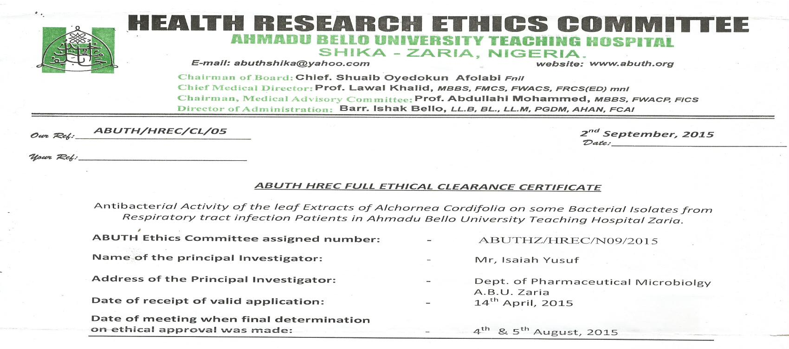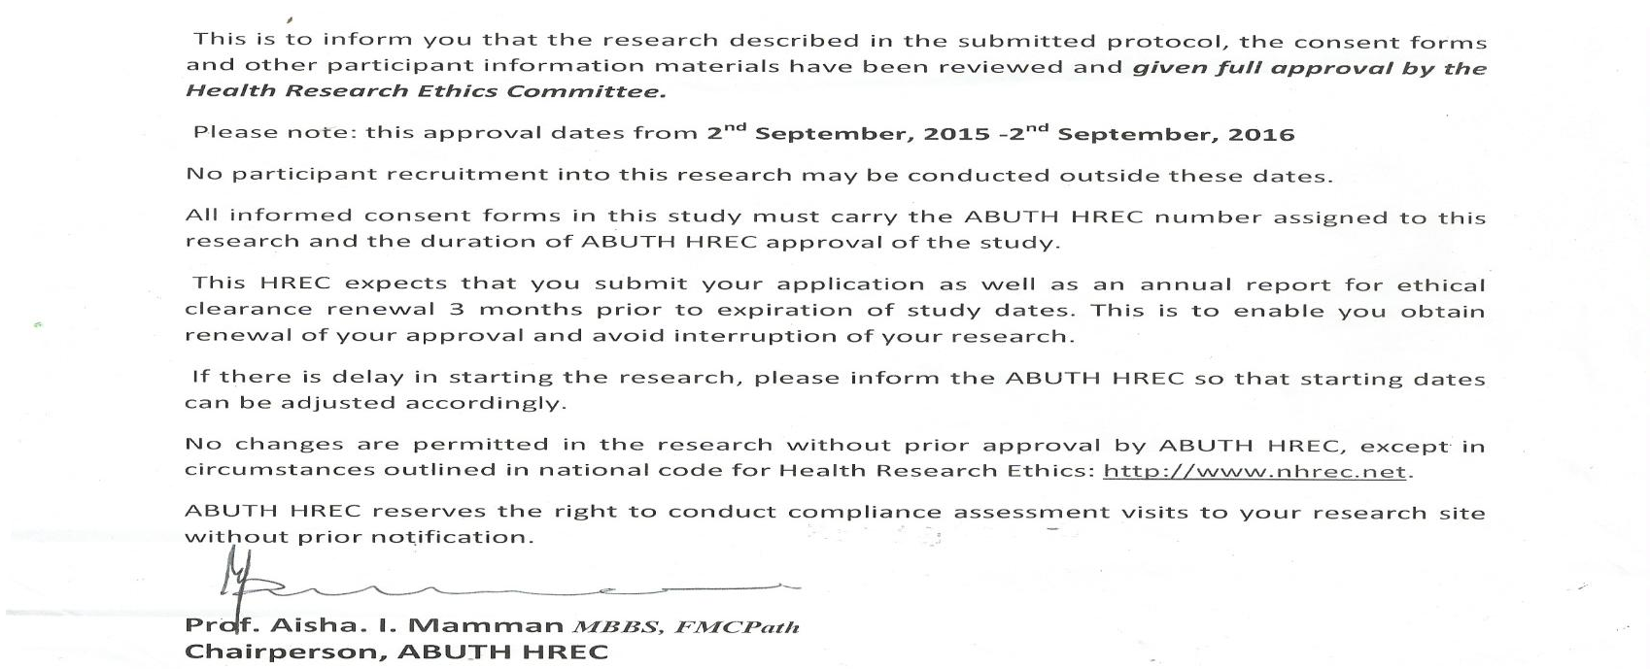

## Appendix II. Departmental Approval

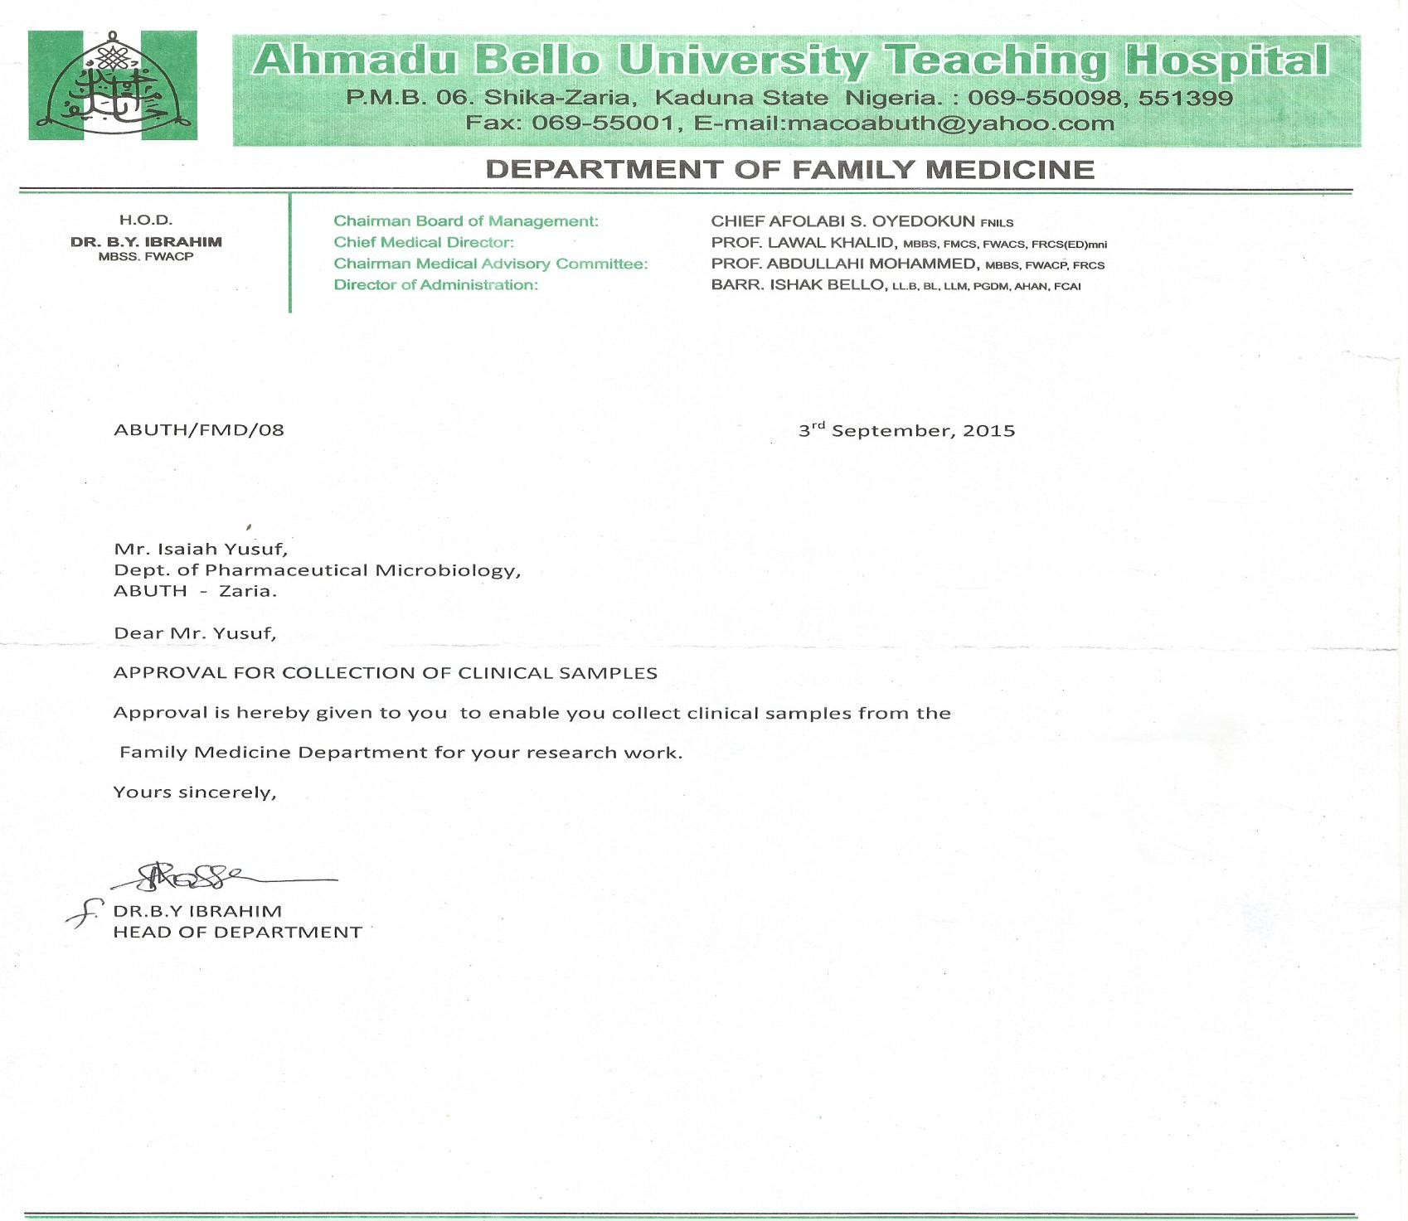

**Appendix III. CONSENT FORM**

**DEPARTMENT OF PHARMACEUTICS AND PHARM. MICROBIOLOGY, FACULTY OF PHARMACEUTICAL SCIENCES AHMADU BELLO UNIVERSITY, ZARIA, NIGERIA**

# INFORMED CONSENT FORM (ICF)

Serial No.: ………… Age………………… Phone No.: ……………

We are inviting you to participate in this research work titled ―**Antibacterial activity of the leaf extracts of *Alchornea cordifolia*against some bacterial isolates from respiratory tract infection patients in Ahmadu Bello University Teaching Hospital, Zaria, Nigeria**.‖ The research will involve the collection of ear swabs, throat swabs and sputum samples.

# CERTIFICATE OF CONSENT

I ………………………………………….of hereby

consent to participate in this study. The full procedures of the test/study have been explained to me by the investigator. I therefore give this consent voluntarily without being subjected to any pressure.

Signature of participant/thumb print…………………………. Date………………..

## Risk

From the best of my knowledge within the context of this research there will be no health hazard or whatsoever that would be detrimental to the volunteer and all information will be confidential.

Name of witness………………………………………………

Signature of witness/thumb print…………………………….. Date………………..

## Statement by the Researcher/Person Taking Consent

I confirmed that sufficient information, including risk and benefits to make an informed decision have been fully explained to the participant. The participant was given an opportunity to ask questions about the study, and all questions have been answered correctly to the best of my ability. I confirmed that the individual has not been coerced into giving consent, and the consent has been given freely and voluntarily.

Name of Researcher……………………………………….

Signature…………………………………………………. Date………………...

## Appendix IV. Thin layer Chromatography (TLC) of different fractions

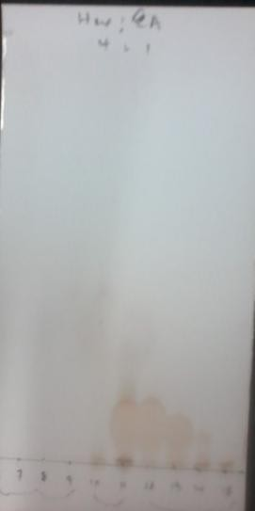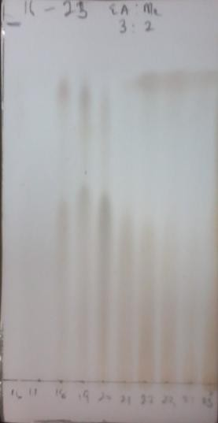

**Appendix V**

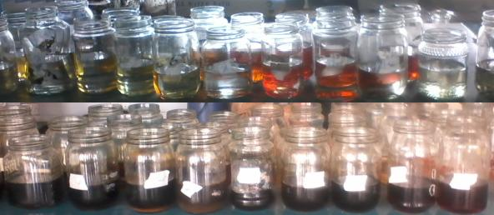

## Thirty five (35) different fractions collected.

**Appendix VI**

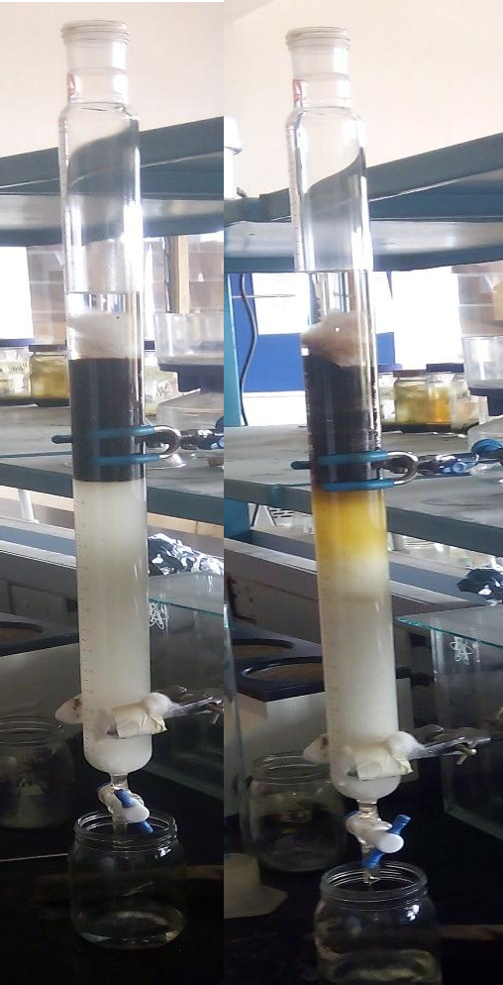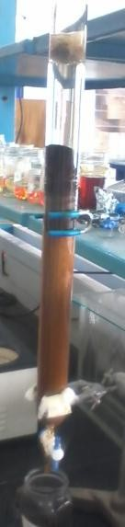

A

C

B

## Column used in Column chromatography

A= Column before eluding B= Column during eluding C= Column after eluding

## Appendix VII

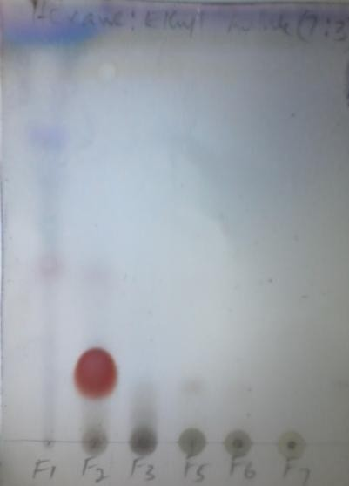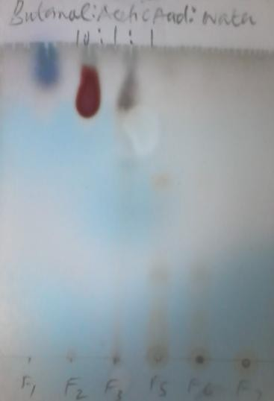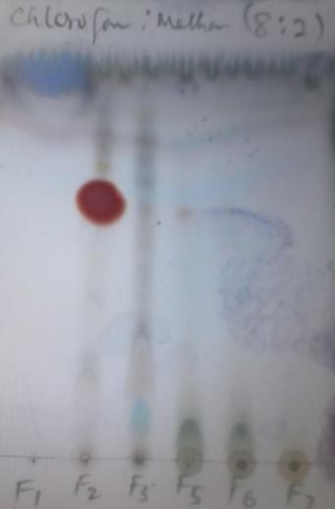

1

2

3

**TLC of pooled fractions in three solvent system**

# n - hexane and ethyl acetate 7:3

1. Butanol, acetic acid and water 10:1:1

# Chloroform and methanol 8:2

**Appendix VIII**

* 1. P – Anisaldehyde



* 1. Ferric Chloride
  2. Aliminium chloride + uv light
  3. Liberman Burchard reagent
  4. Bontrager‘s reagent
  5. Dragendorff reagent

## TLC phytochemicals of F2 fraction using different specific spray reagents

**Appendix IX**

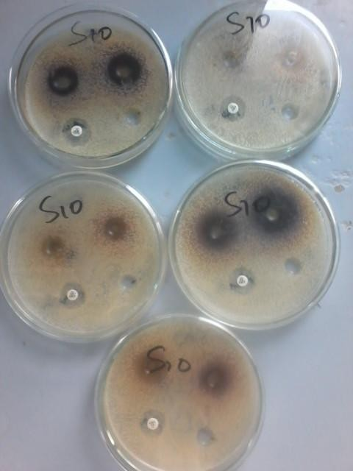

**Zone of inhibition of Aqueous and Ethanol extracts of *A. cordifolia* against *S. aureus*(S10)**

## Appendix X

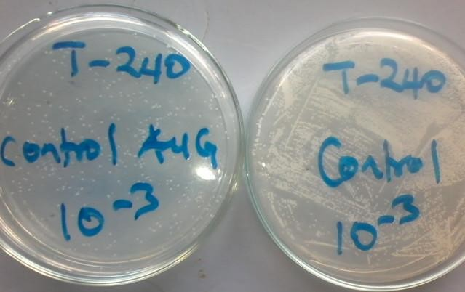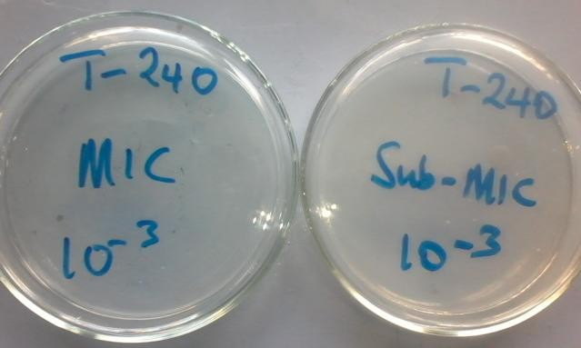

C

D

B

A

**Death/Survival Rate of *K. pneumoniae* at 240 minutes growth.**

A= Organism with Amoxicillin clavulanic acid (Positive control) B= Organism without fraction or antibiotic (Negative control) C= Organism with Sub-M.I.C of fraction (F2)

D= Organism with M.I.C of fraction (F2)