**ANTI-DIARRHOEAL AND SUBCHRONIC TOXICITY STUDIES ON METHANOLSTEM BARK EXTRACT OF *IRIVINGIA WOMBOLU* VERMOESEN (IRVINGIACEAE) IN LABORATORY ANIMALS**

**BY**

**LUCIA ONOSELUMHEN UHOMOIBHI**

**DEPARTMENT OF PHARMACOLOGY AND THERAPEUTICS FACULTY OF PHARMACEUTICAL SCIENCES,**

**AHMADU BELLO UNIVERSITY, ZARIA, NIGERIA**

**OCTOBER, 2018**

1

**ANTI-DIARRHOEAL AND SUBCHRONIC TOXICITY STUDIES ON METHANOLSTEM BARK EXTRACT OF *IRIVINGIA WOMBOLU* VERMOESEN (IRVINGIACEAE) IN LABORATORY ANIMALS**

**BY**

**Lucia Onoselumhen UHOMOIBHI,**

**B. Sc. BIOCHEMISTRY (KSU) 2014 MSc/PHARMACOLOGY/P15PHCP8019**

**A THESIS SUBMITTED TO THE SCHOOL OF POSTGRADUATE STUDIES, AHMADU BELLO UNIVERSITY ZARIA,**

**IN PARTIAL FULFILLMENT OF THE REQUIREMENTS FOR THE AWARD OF MASTER DEGREE IN PHARMACOLOGY**

**DEPARTMENT OF PHARMACOLOGY AND THERAPEUTICS, FACULTY OF PHARMACEUTICAL SCIENCES,**

**AHMADU BELLO UNIVERSITY, ZARIA, NIGERIA**

**OCTOBER, 2018**

## Declaration

I declare that the work in this Dissertation entitled “Anti-diarrhoeal and Subchronic Toxicity Studies on MethanolStem Bark Extract of *Irivingia wombolu* Vermoesen (Irvingiaceae) in Laboratory Animals‟‟ has been performed by me in the Department of Pharmacology and Therapeutics, Ahmadu Bello University, Zaria. The information derived from the literature has been duly acknowledged in the text and a list of references provided. No part of this dissertation was previously presented for another degree or diploma at this or any other Institution.

Lucia Onoselumhen UHOMOIBHI

## Signature Date

## Certification

This dissertation entitled “ANTI-DIARRHOEAL AND SUBCHRONIC TOXICITY STUDIES ON METHANOLSTEM BARK EXTRACT OF *IRIVINGIA WOMBOLU* VERMOESEN (IRVINGIACEAE) IN LABORATORY ANIMALS‟‟ by Lucia Onoselumhen UHOMOIBHI,

meets the regulations governing the award of the degree of Masters of Science in Pharmacology of the Ahmadu Bello University, and is approved for its‟ contribution to knowledge and literary presentation.

Prof. A.U. Zezi

Chairman, Supervisory Committee Signature Date

Dr. M. Yerima

Member, Supervisory Committee Signature Date

Dr. M. G. Magaji

Head of Department Signature Date

Prof. S. Z. Abubakar

Dean, School of Postgraduate Studies Signature Date

## Dedication

This dissertation is dedicated to the Blessed Trinity and to the family of Felix and Margaret Uhomoibhi.

## Acknowledgement

Firstly, I thank the Lord God of host who is the author and finisher of this research work. His abundant graces, blessings and human resources made my M.Sc. program a success.

My heartily appreciation goes to my able supervisors; Prof. A. U. Zezi and Dr. M. Yerima for their constant encouragement, patience, constructive criticisms and suggestion that helped in perfecting this work.

I appreciate the Head of Department, Dr. M.G. Magaji, the Dean of Faculty, Prof. N.M. Danjuma and the P.G. Coordinator Dr. Maje for all their great assistance. I am grateful to all the lecturers of the Department of Pharmacology and Therapeutics who have taught me throughout the course of my study, your impacts have helped to put up and sharpen me both in character and learning.

I also acknowledge the timely assistance and ready to help attitudes of the entire administrative, technical and Animal House staff of the Department of Pharmacology especially the Chief Technologist J.T. Ose, Mal. Adamu and Mal. Mua‟zu for providing a conducive and friendly environment and facilities that enhanced the smooth conduct of this research work. Not forgetting the assistance of Mr. Monday of Department of Pharm. Chemistry Laboratory and Mr. Bamidele (Histotechnologist) of the Department of Anatomy laboratory, A.B.U. I am grateful.

I am grateful to Prof. H.O. Kwanashie, Prof. Anuka and Mrs. Medina Abbas for their immense contributions, God bless you richly.

I will not forget to thank Mrs. A. Okhah (a.k.a grandmother) who provided me with information on plants used traditionally for treating diarrhoea in Edo state.

I show my deepest love and gratitude to my beloved families. I am highly indebted to my dear parents and my lovely brothers and sisters for their undaunted financial support, love, prayers and for believing in me. May the good Lord preserve you.

I am indebted to my big sister Dr. Joyce Agofure and the family, may God continue to bless your kind and generous husband and wonderful children for their immeasurable and timely encouragement, moral and financial support all through my M.Sc. program. I love you all.

To my all beloved friends; Engr. Franklin (Osemen), Pharm. Asibi (Asa babe), Isah Abraham and Emmanuel Ayodeji Ayeni who assisted during the study. God bless our amity.

## Abstract

*Irvingia wombolu* is one of the herbal plants used as food for its nutritional values. It is also used as medicinal plant in the south-south and south-eastern part of Nigeria for the management of diarrhoea and other ailments. Although these medicinal plants are believed to be harmless with their utilization, scarcity of scientific evidence on the claimed pharmacological activities of this plant is an issue of concern. This study was aimed at evaluating the antidiarrhoeal and subchronic toxicity studies of methanol stem bark extract of *I. wombolu* (MEIW) in laboratory animals. Preliminary phytochemical screening, acute and sub-chronic toxicity, *in vivo* antidiarrhoeal and isolated tissuestudies were carried out according to standard methods. Doses of 500mg/kg, 1000mg/kg and I500mg/kg were used for the *in vivo* antidiarrhoeal studies. Preliminary phytochemical screening revealed the presence of saponins, steroids/triterpenes, flavonoids, tannins, alkaloids, cardiac glycosides, terpenoids and carbohydrates whereas anthraquinones was absent. The oral median lethal dose (LD50) of the extract in mice was estimated to be greater than 5000 mg/kg. In the subchronic toxicity study, the extract did not produce significant changes on body weights and the relative organ weights of treated rats when compared with control. The extract significantly (*p*≤0.05) decreased only the white blood cell (WBC) and neutrophils count among the haematological parameters assessed. The extract also significantly (*p*≤0.05) increased ALP and sodium while AST, ALT, TP, bilirubin, potassium, bicarbonate, chloride, urea, creatinine and albumin showed no significant difference when compared with the control. Histopathological findings indicated that there were some levels of liver injury characterized by centrilobular necrosis and mild hepatocytes vacoulation. The kidney exhibited mild distortion of tubular epithelial cell and widening of the bowman capsule within the glomerular at doses of 500 and 1000 mg/kg with the adhesion of intestinal villi. Results

obtained from the castor oil and magnesium sulphate-induced diarrhoea models indicated that MEIW produced statistically significant inhibition of diarrhoea in both models with reduction of wet faeces (*p*≤0.05). In the castor oil-induced enteropooling model, MEIW demonstrated an anti- enteropooling effect by reducing significantly (*p*≤0.05) the volume of intestinal content in a dose-dependent way. In the gastrointestinal transit of charcoal meal model, the movement (transit) of charcoal meal along the intestinal tract of mice treated with the extract of *I. wombolu* (MEIW) was delayed. With increasing doses of the extract, the peristaltic index decreased significantly (*p*≤0.05) in all as compared to the negative control. In the guinea pig ileum, the extract produced a marked relaxatory effect on the tissue. Graded concentrations of the extract, produced a reduction in the tone and rate of the spontaneous contraction of rabbit jejunum. Also atropine in synergy with the extract blocked completely the stimulant effect of the rabbit jejunum, this indicates that the extract possess some anticholinergic-like properties. It can be concluded that, the extract is relatively safe with minor histopathological changes in vital organs with significant antidiarrhoeal effect.

## Table of Contents

Declaration ii

Certification iii

Dedication iv

Acknowledgement v

Abstract vi

Table of Contents viii

List of Figures xii

List of Tables xiii

List of Plates xiv

Abbreviations and Symbols xv

CHAPTER 1… 1

* 1. INTRODUCTION… 1
  2. Background of Study… 1
  3. Research Problem 5
  4. Justification of the study… 5
  5. Aim and Objectives of the study… 7
     1. Aim of the study 7
     2. Specific objectives 7
  6. Research Hypothesis 7

CHAPTER 2… 8

* 1. LITERATURE REVIEW… 8
  2. Diarrhoea… 8
     1. Prevalence 10
     2. Etiology of diarrhoea 14
  3. Diarrhoea Management 19
     1. Orthodox system 19
     2. The use of medicinal plants for the treatment of diarrhoea 22
  4. Irvingia wombolu Ver. (Irvingiaceae) Bitter Bush Mango 24
     1. Description of Irvingia wombolu 25
     2. Botanic and geographical distribution 25
     3. Nutritional composition 31
     4. The uses of Irvingia species parts 31
     5. Ethnomedicinal uses and traditional claims 33
     6. Scientific studies 33

CHAPTER 3 35

* 1. MATERIALS AND METHODS… 35
  2. Materials 35
     1. Laboratory materials 35
     2. Collection of plant material 35
     3. Experimental animals 36
  3. Methods 36
     1. Botanical authentication of Irvingia wombolu plant 36
     2. Preparation and extraction of plant material 36
     3. Preliminary phytochemical screening… 37
     4. Acute toxicity study 39
     5. Subchronic toxicity study 40
     6. Histopathological effects of the methanol stem bark of *I.wombolu* (MEIW) 41
     7. Antidiarrhoeal studies 41
        1. In vivo antidiarrhoeal studies 41
        2. In vitro (isolated tissue) studies 44
  4. Statistical analysis 45

CHAPTER 4 46

* 1. RESULT 46
  2. Percentage Yield of Methanol Stem Bark Extract of *I. wombolu* 46
  3. Preliminary Phytochemical Constituents of Methanol Stem Bark Extract of *Irvingia wombolu* 46
  4. Acute Toxicity of Methanol Stem Bark Extract of *I. wombolu* 46
  5. Subchronic Toxicity of Methanol Stem Bark of *I. wombolu* 48
     1. Effect of methanol stem bark extract of *I. wombolu* on the bodyweight of Wistar rats after oral administration for 28 days 48
     2. Effect of methanol stem bark extract of *I. wombolu* on the relative organ weight in Wistar rats after oral administration for 28 days 48
     3. Effect of methanol stem bark extract of *I. wombolu* on the haematological parameters of Wistar rats after oral administration for 28 days 48
     4. Effect of methanol stem bark extract of *I. wombolu* on the serum electrolytes and kidney function parameters of Wistar rats after oral administration for 28 days 52
     5. Effect of methanol stem bark extract of *I. wombolu* on the liver function parameters of Wistar rats after oral administration for 28 days 52
     6. Histopathological effect of methanol stem bark extract of *I. wombolu* on the kidneys of Wistar rats 55
     7. Histopathological effect of methanol stem bark extract of *I. wombolu* on the liver of Wistar rats 55
     8. Histopathological effect of methanol stem bark extract of *I. wombolu* on the stomach of Wistar rats 58
     9. Histopathological effect of methanol stem bark extract of *I. wombolu* on the intestine of Wistar rats 58
  6. In vivo Antidiarrhoeal Studies 61
     1. Castor oil-induced diarrhoea in mice 61
     2. Magnesium-sulphate induced diarrhoea in mice 61
     3. Castor oil-induced enteropooling in mice 64
     4. Gastrointestinal transit of charcoal meal model in mice 64
  7. In vitro (isolated tissue) studies 67
     1. Effect of methanol stem bark extract of *I. wombolu* on isolated rabbit jejunum 67
     2. Effect of methanol stem bark extract of *I. wombolu* onisolated guinea pig ileum 70

CHAPTER 5… 72

1. DISCUSSION… 72

CHAPTER 6 83

1. SUMMARY, CONCLUSION AND RECOMMENDATION… 83
   1. Summary… 83
   2. Conclusion 84
   3. Recommendation 84

REFERENCES 85

APPENDICES 97

## List of Figures

Figure 2.1: Trends in diarrhoea deaths and diarrhoea mortality rates by region, around 2000 and 2015 Global burden of diarrhoea 11

Figure 2.2 Diarrhoea and Pneumonia: causes of child‟s death in developing countries 12

Figure 2.3 Distribution maps of both species (*I. wombolu* and *I. gabonensis*) 27

Figure 4.1: Effects of graded acetylcholine (ACH 20 – 60ng/ml) final organ bath concentrations and methanol stem bark extract of *I. wombolu* (MEIW 0.4 x 10-6 – 3.2 x 10-6g/ml) on isolated rabbit jejunum 68

Figure 4.2: Interactive studies: Using methanol stem bark extract of *I. wombolu* (MEIW) and standard drugs (Acetylcholine and Atropine respectively) on isolated rabbit jejunum 69

Figure 4.3: Effect of graded histamine (20 – 60ng/ml) final organ bath concentrations and methanol stem bark extract of *I.* wombolu (0.4 x 10-6 – 3.2 x 10-6 g/ml) on isolated guinea pig ileum 71

## List of Tables

Table 2.1: Top 15 countries with highest number of diarrhoea deaths in children under 5 in 2015 13

Table 4.1: Phytochemical constituents of methanol stem bark extract of *I. wombolu* 47

Table 4.2: Effect of methanol stem bark extract of *I. wombolu* on the body weight of Wistar rats after oral administration for 28days 49

Table 4.3: Effect of methanol stem bark extract of *I. wombolu*on the relative organ weight of Wistar rats after oral administration for 28 day 50

Table 4.4: Effect of methanol stem bark extract of *I. wombolu* on the haematological parameters of Wistar rats after oral administration for 28 days 51

Table 4.5:Effect of methanol stem bark extract of *I. wombolu*on serum electrolytes and kidney function parameters of Wistar rats after oral administration for 28 days 53

Table 4.6: Effect ofmethanol stem bark extract of *I. wombolu*on liver function parameters of Wistar rats after oral administration for 28 days 54

Table 4.7: Inhibitory effect ofmethanol stem bark extract of *I. wombolu* on castor oil induced diarrhea in Mice 62

Table 4.8: Inhibitory effect of methanol stem bark extract of *I. wombolu* on magnesium sulphate induced diarrhoea in Mice 63

Table 4.9: Effect of methanol stem bark extract of *I. wombolu* on castor oil induced enter- pooling in Mice 65

Table 4.10: Effect of methanol stem bark extract of *I. wombolu* on gastrointestinal transit of charcoal meal in Mice 66

## List of Plates

Plate 1: *Irvingia wombolu* tree in its natural habitat in Esan south east L.G.A., Ubiaja, Edo State 29

Plate II: Parts of the*Irvingia wombolu*fruits 30

Plate III: Photomicrographs of sections of the kidney tissues of control and treated rats (Mag.: x400), H/E 56

Plate IV: Photomicrographs of sections of the liver tissues of control and treated rats (Mag.: x400), H/E 57

Plate V: Photomicrographs of sections of the stomach tissues of control and treated rats (Mag.: x100),H/E 59

Plate VI: Photomicrographs of sections of the small intestine of control and treated rats (Mag.: x400, H/E 60

Plate VII: Effects of graded acetylcholine (20 _ 160ng/ml) final organ bath concentrations on isolated rabbit jejunum 97

Plate VIII: Effects of graded concentrations of methanol stem bark extract of *I. wombolu*(0.4 x 10-6 – 3.2 x 10-6 g/ml) on isolated rabbit jejunum… 98

Plate IX: Antagonistic effect of graded concentrations (0.04 _ 3.2µg/ml) of methanol stem bark extract of *I. wombolu*with Acetylcholine (40 ng/ml) on isolated rabbit jejunum 99

Plate X: Potentiating effects of graded concentrations (0.04_ 3.2µg/ml) of methanol stem bark extract of *I. wombolu* with atropine (Atrp 40 ng/ml) on isolated rabbit jejunum 100

Plate XI: Effect of graded concentrations of Histamine (Hist. 20 – 160 ng/ml) on isolated guinea pig ileum 101

Plate XII: Effect of graded concentrations of Histamine (Hist. 20 – 160 ng/ml) on isolated guinea pig ileum 101

## Abbreviations and Symbols

ORS Oral Rehydration Solution

CAM Complementary/Alternative medicine ECF Extracellular fluid

cAMP cyclic adenosine monophosphate cGMP cyclic guanosine monophosphate

IAP India academy of pediatrics committee WGO World gastroenterology organization AAD Antibiotic associated diarrhoea

DNA Deoxyribonucleic acid

MEIW Methanol stem bark extract of *Irvingia wombolu*

PGE2 Prostaglandin E2 LD50 Media lethal dose

OECD Organization for Economic Cooperation Development AOAC Association of Official Analyst Chemist

# CHAPTER 1

# INTRODUCTION

## Background of Study

The normal intestinal tract regulates the absorption and secretion of electrolytes and water to meet the body's physiological needs. More than 98% of the 10 liters per day of fluid entering the adult intestines are reabsorbed (Keusch, 2001). The remaining stool water related primarily to the indigestible fiber content, determines the consistency of feces, varying from person to person, day to day, and stool to stool. This variation complicates the definition of diarrhoea, which by convention is present when three or more stools are passed in 24 hours that are sufficiently liquid (Black and Lanata, 2002; Nigro *et al.,* 2000).

However, most patients base their diarrhoea on the consistency of the stool rather than the frequency of bowel movements. Since the consistency of the stool is difficult to quantify, diarrhoea is often defined based on stool frequency or the stool weight alone (Black and Lanata, 2002).

Diarrhoea may be further classified as acute if the duration is less than 2 weeks, persistent if the duration varies from 2 to 4 weeks, and chronic if it lasts more than 4 weeks in duration (Pawlowski *et al.,* 2009). Acute diarrhoea isthe most common, involves the passage of frequent loose or watery stools without visible blood, lasts less than 14 days (most episodes last less than 7 days) and contributes to significant morbidity and mortality worldwide with close to 70% of diarrhoea being food borne (Giannella and Navaneethan, 2010; Käfferstein, 2003).

The main cause of death from acute diarrhoea is dehydration, which results from the loss of fluid and electrolytes in diarrhoea stools. Vomiting and fever may also be seen in patient with

diarrhoea. Other important causes of death in patient with diarrhoea are dysentery and malnutrition (Petri *et al.,* 2008). In developing countries, infectious agents such as rotavirus, enterotoxigenic *Escherichia coli*, *Shigella,Campylobacter jejuni*, and Cryptosporidium are also important causes of acute diarrhoea (Nataro *et al.,* 2006).

The etiologies of chronic diarrhoea vary depending on the region and the socio-economic status. In developed countries for example United State of America (USA), irritable bowel syndrome, inflammatory bowel disease, mal-absorption syndrome, and chronic infections predominate and are underlying factors, whereas in developing countries, chronic bacterial, microbacterial and parasitic infections are the most common causes of chronic diarrhoea (Nighot *et al.,* 2010). These contribute to malnutrition by causing decreased food intake, impaired absorption, increased losses of fluid, electrolytes, protein, and iron, and by altering the normal metabolism (Njume and Goduka, 2012; Field, 2003).

The pathophysiology of drug-associated diarrhoea is even more complex, and mechanisms include disruption of normal enteric flora by antimicrobial agents and overgrowth of pathogens, disturbance of intestinal carbohydrate and bile acid metabolism, allergic effects, toxic effects, and direct effects on motility (Njume and Goduka, 2012).

Worldwide, about nine million children, most of them younger than 5 years of age die annually as a result of diarrhoea than malaria, acquired immunodeficiency syndrome (AIDS) and tuberculosis combined (WHO, 2009). The majority of deaths occur in rural African communities where health care facilities are inadequate and the majority of the people lack access to clean and safe water, a major vehicle for transmission of diarrhoea diseases (Forsberg *et al.,* 2009).

In some rural parts of the developing world, about 80% of deaths due to diarrhoea occur in the first two years of life, reason being that mother‟s knowledge on the predisposing factors of diarrhoea are poor and at times the re-occurrence of childhood diarrhoea is wrongly perceived as a developmental stage of the child and this virtually results in mortality (Mwanbete and Joseph, 2010). Diarrhoea continues to be a challenge despite developments in science and remains a considerable source of morbidity and mortality (Liu *et al.,* 2012).

Infectious agents that cause diarrhoea are usually spread by the fecal-oral route, on ingestion of fecal contaminated water or food, through person-to-person transmission or direct contact with infected faeces (Aremu *et al.,* 2011). Therefore, hygiene encouragement and proper hand washing is one of the effective intervention of public health against diarrhoeal diseases (Jebunnessa *et al.,* 2009). Seeing that poor sanitation and hygiene due to poverty continue to endure in developing countries, the use of antidiarrhoeal drugs becomes central.

Antidiarrhoeal agents aim at reducing the discomfort and inconvenience of frequent bowel movements (Brunton, 1996) by inhibiting gastrointestinal motility and secretion. Existing drugs include metronidazole (flagyl), loperamide (Imodium®), bismuth subsalicylate (Pepto-Bismol®) and racecadotril. In most cases, the basic treatment of diarrhoea is replacing lost fluids and electrolytes to prevent further dehydration, thus Oral Hydration Therapy (ORT) such as pedialyate® or Gastrolyte®, with continued feeding and zinc supplements are used (WHO/MCEE, 2015; Atia and Buchman, 2009).

Availability and accessibility of these drugs to the poor and remote populations is inadequate as people in urban areas are more likely to receive this recommended treatment than people in rural area. Nevertheless, the disparity, inaccessibility and high cost of antidiarrhoeal drugscause

themajority to rely on the traditional healing practices and medicinal plants for their daily health care (UNICEF global databases 2012).

In African traditional medicine, mixture of medicinal plants are cooked, macerated or made into tincture to treat various ailments such as diarrhoea, as they are effective in reducing gastrointestinal motility and gastric secretion. Essential bioactive constituents contained in medicinal plants are responsible for their pharmacological activities (Edeoga *et al.,* 2005). To surmount the danger of diarrhoea diseases in developing countries, the World Health Organization has integrated a program (Diarrhoea Disease Control Program) for the control of diarrhoea relating the use of traditional herbal medicine (Suleiman *et al.,* 2008). Thus, it is important to evaluate commonly available medicinal plants as alternative to used antidiarrhoeal drugs which are not completely free from adverse effects.

Medicinal plants such as *Gmelina arborea* Roxb (Verbenaceae), *Irvingia wombolu* Verm. (Irvingiaceae), *Sercuringa virosa* (Euphorbiaceae),*Cochlosperum tintorium* and others are widely used by traditional healers for the treatment of diarrhoea (Magaji *et al.,* 2007; 2010). Many traditional preparations have been used for years and claimed to be the most potent and effective but very few scientific studies are carried out on these products to evaluate their effectiveness and possible toxicity. This present study is aimed at investigating the potential anti- diarrhoeal effect and toxicity of the stem bark of *Irvingia wombolu* Verm. (Irvingiaceae) commonly called wild mango and locally called „‟ogbono‟‟, used traditionally in treating diarrhoea in the South and Eastern parts of Nigeria.

## Research Problem

Diarrhoea is considered as one of the leading causes of death especially in infants (Petri *et al.,* 2008), accountings for 9% of all deaths among children under age 5 worldwide in 2015. This translates into over 1,400 young children dying each day, or about 530,000 children a year (WHO, 2015).

The death caused by diarrhoea is highly visible in tropical and subtropical countries (Heinrich *et al.,* 2005). As such, around 88% of diarrhoea-related deaths are caused due to inadequate sanitation and poor hygiene (Kosek *et al.,* 2003). In Nigeria, it kills about 194,000 children under the age five, every year (UNICEF, 2012).

There are simple effective treatments in the management of diarrhoea. Example of such drugs that has been used are, opioid drugs (loperamide, diphenoxylate), diloxanide furoate for protozoa infections, racecadotril and muscarinic receptor blockers like atropine sulfate among others. Loperamide, for example, acts through the opioid-like µ- receptors of the enteric nervous system, (Sibylle and Stephanie, 2009). Despite their efficacy, these drugs are not recommended for use in infants due to their side effects like, intestinal obstruction and constipation caused by loperamide and racecadotril causes induction of bronchospasm and vomiting (Hardman and Limberd, 2001).

## Justification of the Study

It is a known fact that since ancient times, medicinal plants have been used for the treatment of range of diseases and have played a key role in the world health care system. In spite of the great advances observed in modern medicine in recent decades, plants still make important contribution to health care delivery (Green *et al.,* 2010). Although medicinal plants are distributed worldwide, they are most abundant in tropical countries and over time, interest in

drugs derived from higher plants, especially the therapeutic ones, has increased expressively (Elujoba*et al.,* 2005). It is estimated that about 45% of all modern medicines are directly or indirectly derived from plants. In some particular cases, such as anti-tumor, antimicrobial and anti-malaria drugs, about 60% of the medicine currently available in the market and most of those in the late stages of clinical trials are derived from natural products, mainly from plants (Njume *et al.,* 2011).

According to World Health Organization (WHO, 2009), poverty, lack of access to modern medicine and high cost of treatment has resulted to about 80% of the African population using traditional medicine for primary health care. However, in industrialized countries, traditional medicine is adopted using the term as complementary medicine or alternative medicine (CAM).

In terms of drugs used, cost of treatment, inaccessibility of hospital in rural communities, distressing resistance of pathogens to drugs resulting to increase pill burden with the fact that some of the major treatments of diarrhoea (oral rehydration solution, ORS) may not reduce the volume of stool or duration of disease (Bardhan, 2007). WHO has encouraged studies for treatment and prevention of diarrhoea diseases using traditional medical practices. Thus, it has become important to identify and evaluate commonly available natural plants such as *Irvingia wombolu* Ver. as alternative drug to currently used anti-diarrhoeal drug.

Medicinal plants have been recognized as natural sources of various bioactive compounds which are contained in their phytoconstituents (Gonz´alez-Aguilar*et al*., 2008). One of such medicinal plant is *Irivingia wombolu,* traditionally found to be beneficial in treatment of various forms of diarrhoea. Although several of its uses in traditional medicine have been documented, many of these claims are yet to be validated by scientific researchers. This study is carried out to

authenticate the use of *I. wombolu* stem barkscientifically as having anti-diarrhoea activity along with toxicological profile.

## Aim and Objectives of the study

## Aim of the study

To evaluate the methanol stem bark extract of *I. wombolu* for anti-diarrhoeal activity and its toxicity profile in laboratory animals.

## Specific objectives

The specific objectives of this study are to determine the:

* + - * oral acute toxicity (LD50) and sub chronic toxicity studies of methanol stem bark extract of *I. wombolu*
      * preliminary phytochemical constituents of the extract
      * *in vivo* anti-diarrhoeal effect of the extract on some laboratory animals
      * effects of the extract on isolated rabbit jejunum and guinea pig ileum

## Research Hypothesis

*Irvingia wombolu* stem bark extract possesses a significant anti-diarrhoeal activity, and it is safe for use.

# CHAPTER 2

# LITERATURE REVIEW

## Diarrhoea

Diarrhoea is the frequent passage of unformed, loose or watery stools, usually three or more times in 24 hours. Diarrhoea results when the normal balance in electrolyte and water transport is upset in favour of net secretion because of decreased absorption from the intestinal lumen or increased secretion or water loss into the lumen. Both mechanisms can coexist, exemplified in rotaviral diarrhoea where the virus targets mature absorptive enterocytes while in an effort at regeneration, immature cryptal secretory cells become prominent, driving increased secretion. Loss of brush border enzymes exacerbates mal-absorption. The increased volume of luminal contents stimulates peristaltic activity, further contributing to fluid loss (Mandomando *et al.,* 2007).

Diarrhoea is a common disease accounting for up to 85% of childhood illnesses in Africa with a severity that seems to depend to some extent on etiology and age (Boadi and Kuitunen 2005). The causes of diarrhoea are wide and varied; the majority of them are related to poor sanitary conditions and low socio-economic status (Aremu *et al.,* 2011). The onset of the disease may be sudden and self-limiting in immune-competent individuals, but chronic diarrhoea may be persistent even with therapy, especially in people with an underlying debilitating clinical condition such as HIV/AIDS and diabetes mellitus or individuals with an aging immunity (Nigro *et al.,* 2000).

Diarrhoea is an important cause of malnutrition. This is because patients with diarrhoea eat less and their ability to absorb nutrients is reduced; moreover, their nutrient requirements are

increased as a result of the infection. With repeated attacks, protein energy malnutrition results and if not controlled, complications such as renal failure and subsequently death will occur. Malnutrition on the other hand is a predisposing factor to the increased incidence and severity of diarrhoea. This ailment is closely related to protein energy malnutrition (Farthing, 2000); this is known as the „‟vicious cycle‟‟. As the episodes are prolonged, their impact on growth and development is increased (Guerrants *et al.,* 2002).

Other causes of concern are loss of body water and electrolyte imbalances. Children are at greater risk than adults of acute dehydration since water constitutes a greater proportion of their bodyweight. Fluid losses resulting from diarrhoea and vomiting can be as high as three times the circulating blood volume. In order to keep intravascular volume steady, water is lost from intracellular compartment leading to dehydration (Sibylle and Stephanie, 2009). Signs of dehydration often begin with loss of the normal stretchiness of the skin and changes in personality. This can advance to decreased urination, loss of skin colour, a fast heart rate and a decrease in responsiveness as it becomes severe (WHO, 2013). In many countries, more than one-third of hospital beds for children are occupied by patients with diarrhoea. These patients are often treated with expensive intravenous fluids and ineffective drugs. Studies on the long term- effects of diarrhoea in children has it that decreased physical fitness, declined cognitive function, delayed school commencement and poor school performance have all been shown to be repercussions of early childhood diarrhoea (Guerrants *et al.,* 2002; WHO, 2013). This makes the disease far more costly, both economically and in community health and therefore far more important to control than previously thought.

## Prevalence

Diarrhoea is a leading cause of illness and death among children in developing countries, where an estimated 1.3 million episodes and 3.2 million deaths occur each year in those under five years of age. Where episodes are frequent, young children may spend more than 15% of their days with diarrhoea. About 80% of deaths due to diarrhoea occur in the first 2 years of life (UNICEF, 2012).

Diarrhoea kills more children than malaria, measles, and AIDS combined with a proportional distribution of cause-specific deaths among children under five years of age, excluding neonatal deaths (Lui *et al.,* 2012) as shown in (Figure 2.1). The vast majority of deaths due to diarrhoea occur in the poorest regions, nearly 90 per cent of them in sub-Saharan Africa and South Asia (Lakshminarayana *et al.,* 2011; UNICEF, 2012) as shown in (Figure 2.2).This staggering toll, however, is not evenly felt across the world, approximately 60% instead is highly concentrated in the poorest settings. Each year, almost 2 million children are dying from diarrhea and pneumoniaglobally despite the availability of simple, affordable, and life-saving treatments; of these deaths are occurring in just 10 priority countries: India, Nigeria, Democratic Republic of Congo, Pakistan, Ethiopia, Afghanistan, China, Mali and Angola (Table 2.1).

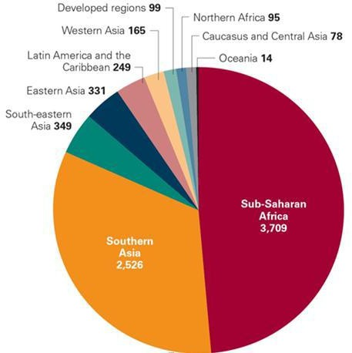

Figure 2.1: Trends in diarrhoea deaths and diarrhoea mortality rates by region, around 2000 and 2015 Global burden of diarrhoea: A UNICEF Survey of the number of Child‟s deaths by region (UNICEF, 2012).

Source: UNICEF analysis based on cause of death estimates from WHO and Maternal and Child Epidemiology Estimation Group (MCEE) estimates 2015; Liu *et al.,* 2012; (UNICEF 2012)

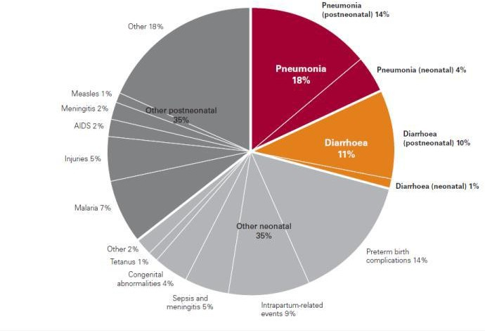

Figure 2.2 Diarrhoea and Pneumonia: causes of child‟s death in developing countries

Source: Adapted from Liu *et al.,* 2012; UNICEF global databases, 2012, based on Multiple Indicator Cluster Surveys, Demographic and Health Surveys and other national surveys.

Table 2.1: Top 15 countries with highest number of diarrhoea deaths in children under 5 in 2010

|  |  |  |
| --- | --- | --- |
| **Rank** | **Country** | **Deaths among children under age 5 due to**  **diarrhoea, 2010** |
| **1**  **2**  **3**  **4**  **5**  **6**  **7**  **8**  **9**  **10**  **11**  **12**  **13**  **14**  **15**  **16** | India Nigeria Pakistan  Democratic republic of Congo Angola  Ethiopia Afghanistan Chad  Niger Sudan Somali Indonesia Cameroon  United Republic of Tanzania Mali  Rest of the world | 117,300  77,000  39,500  32,000  24,900  15,500  11,700  11,400  9,900  9,500  8,800  8,600  8,000  8,000  7,800  31,000 |

Source: Adapted from Liu *et al.,* 2012: Estimates refer to pre-cession Sudan; UNICEF, 2012

## Etiology of diarrhoea

Toxins, poisons, drugs, food allergens, prolonged use of antibiotics resulting in the disruption of gut microflora may cause diarrhoea and at times pseudo membranous colitis resulting from *Clostridium difficile* infection (Mandomando *et al.*, 2007). Intestinal infection is the most common cause of diarrhoea, caused by infectious agents such as viruses (rotavirus, norovirus, herpes simplex virus), parasites (*Giardia lamblia, Entamoeba histolytica, and Cryptosporidium parvum*), bacteria (*campylobacter, Salmonella, Vibrio cholerae, Shigella* and enterotoxigenic *Escherichia coli*), acquired from food or water that has been contaminated. Irrespective of etiology, diarrhoea most of the time will occur, when there is an imbalance between absorption and secretion, when the absorptive capacity of the intestine is exceeded and net secretion is greater than absorption (Nigro *et al.,* 2000). Worthy of note is the fact that even minimal changes in normal intestinal fluid and electrolyte balance may result in diarrhoea. Such changes may be caused by infectious agents, toxins, and other noxious agents present in the gut causing disruption of normal fluid secretion and stimulating the gut to expel its contents. This response is protective for acute irritations of the gut but becomes an issue when chronically present and no longer serving a physiological role (Thaparand Sanderson, 2004). Failures in the regulation of ionic balance, differences in fluid absorption and secretion may result in very large changes in stool consistency and volume. Excessive loss of fluids, electrolytes and nutrients due to diarrhoea may result in dehydration, acidosis, malnutrition and hemolytic uremic syndrome (Payne *et al.,* 2006).

The occurrence of diarrhoea may at times be indicative of clinical conditions that are located out of the gastrointestinal tract such as hyperthyroidism, lactose intolerance, inflammatory bowel disease amongst others (DuPont, 2014). Reactions to certain medications such as antibiotics,

anticancer and some magnesium-containing drugs (e.g., antacids), may cause mal-digestion or mal-absorption sometimes stimulating the expulsion of gut contents. Mucositis or inflammation of the mucous membrane lining the alimentary tract is a potential adverse effect of chemotherapeutic agents, and diarrhoea is a symptomatic result of mucositis of the large bowel (Wisinki and Benson, 2007). Due to some chemotherapy regimens like 5-fluorouracil (5-FU) and IFL [Irinotecan (CPT-11; camptosor), 5-FU and Leucovorin], diarrhoea has been linked to excess hospitalizations and death (Saltz *et al.,* 2000). Drug-related diarrhoea is the most common form of diarrhoea in the elderly probably due to prolong effects of the drugs in the body owing to the fact that major organs of drug clearance such as the kidneys and liver are affected by age (Nigro *et al.,* 2000). Thus, causes of diarrhoea could be of the non-infectious and infectious forms.

*Osmotic diarrhoea*

Osmotic diarrhoea occur either when non absorbable or poorly absorbable solutes are ingested or enterocytes or colonocytes cannot absorb them. Non-absorbable solutes include sugar alcohols such as mannitol or sorbitol. Poorly absorbable solutes include magnesium, sulfates, and phosphates.The osmotic force of the unabsorbed solutes results in driving water and secondarily ions into the gut lumen resulting in diarrhoea (Field, 2003; Giannella and Navaneethan, 2010). Patients with mal-absorption may also have osmotic diarrhoea, with the mal-absorbed nutrients acting as poorly absorbed solutes. Ingested disaccharides require disaccharidase digestion to their constituent monosaccharides to permit absorption, as monosaccharides are the only sugars that can be absorbed. Absence of disaccharidase as in lactase deficiency results in osmotic diarrhea (Casburn-Jones and Farthing, 2004).

The small bowel mucosa is a porous epithelium, across which water and electrolytes move rapidly to maintain osmotic balance between the bowel contents and the extra cellular fluid (ECF). Under these conditions, diarrhoea can occur when a poorly absorbed, osmotically active substance is ingested. If the substance is taken as an isotonic solution, the water and solute will simply pass through the gut unabsorbed, causing diarrhoea (Cooke, 2010). Purgatives, such as magnesium sulfate, work by this principle.

The same process may occur when the solute is lactose (in children with lactase deficiency) or glucose (in children with glucose mal absorption); both conditions are occasional complications of enteric infections. If the poorly absorbed substance is taken as a *hypertonic* solution, water (and some electrolytes) will move from the ECF into the gut lumen, until the osmolarity of the intestinal contents equals that of the ECF and blood. This increases the volume of the stool and, more importantly, causes dehydration owing to the loss of body water, sodium chloride, base- deficit acidosis (due to the loss of bicarbonate), and potassium depletion. Because the loss of body water is greater than the loss of sodium chloride, hypernatraemia also develops. Among these, dehydration is the most dangerous because it can cause decreased blood volume (hypovolaemia), cardiovascular collapse, and death if not treated promptly (Giannella and Navaneethan, 2010; WHO, 2013).

*Secretory*

Secretory diarrhoea is caused by the increased secretion of water and electrolytes into the small bowel. This occurs when the absorption of sodium by the villi is impaired while the secretion of chloride in the crypt cells continues or is increased. The net result is fluid secretion, which leads to the loss of water and salts from the body as watery stools; this causes dehydration. In infectious diarrhoea, these changes may result from the action on the bowel mucosa of bacterial

toxins, such as those of *Escherichia coli* and *Vibrio choleraeO1*, or of viruses, such as rotavirus; other mechanisms may also be involved (Nighot *et al.,* 2010).

The driving force for intestinal ion secretion can arise from the gut lumen as with infectious diarrhoea (enterotoxins), from the sub-epithelial space (inflammatory mediators), or from the systemic circulation (peptide hormones produced from endocrine tumors). Most causes of secretory diarrhoea alter the second messenger systems through alteration in cyclic adenosine mono-phosphate (cAMP), cyclic guanosine mono-phosphate (cGMP), or intracellular calcium- regulated ion transport pathways (Binder *et al.,* 2005).

Peptide hormones produced by endocrine tumors can also cause secretory diarrhoea by stimulating intestinal secretion (Giannella and Navaneethan, 2010). Some of these include pancreatic islet tumors which secrete vasoactive intestinal peptide, medullar carcinoma of thyroid-secreting calcitonin, carcinoid tumors which elaborate serotonin, bradykinin, and prostaglandins. Neurotransmitters, such as acetylcholine and serotonin, and other modulators, such as histamine in systemic mastocytosis and inflammatory cytokines, are also potent secretory stimuli (Cooke, 2000). Mal-absorbed bile salts and fatty acids can also induce secretory diarrhoea. Under normal conditions, re-absorption of conjugated bile acids occurs in the distal ileum via sodium–bile acid co-transport. However with severe ileal colon disease or after ileal resection, some of the bile acids are not absorbed and spill into the colon and stimulate colonic secretion. This involves both intracellular calcium ion Ca2+ (probably secondary to membrane phospholipase activation) and cAMP (Field, 2003).

*Exudative diarrhoea*

When the intestinal epithelium‟s barrier function is compromised by loss of epithelial cells or disruption of tight junctions, hydrostatic pressure in blood vessels and lymphatic, this will cause

water and electrolytes, mucus, protein, and sometimes even red and white cells to accumulate in the lumen leading to watery stools (Nighot *et al.,* 2010). This kind of diarrhoea can also be caused by bacterial infection, but not all infectious diarrhoea is exudative. Other organisms associated with exudative diarrhoea include *Salmonella*, *Yersinia*, *Campylobacter*, *Aeromonas*, Entero-invasive *E*. *coli* and *Rotavirus* infection). These organisms invade the epithelium and multiply, damaging the surface epithelium and causing inflammation. Diarrhoea is due both to the epithelial damage which causes exudation, decreased absorptive capacity and to the action of inflammatory mediators (Field, 2003).

*Iatrogenic-/Drug-induced diarrhea*

Diarrhea can also result following certain surgical procedures and usage of certain drugs. Diarrhea can follow cholecystectomy in 5–10% of patients; the pathophysiology depends on the extent of resection. That is, with resections less than 100 cm, it is predominantly secretory with mal-absorbed dihydroxy bile acids spilling into the colon and stimulating colonic secretion through increase in cAMP (Nigro*et al.,* 2004). However with resections exceeding 100 cm, there is depletion of the bile acid pool resulting in chronic diarrhea due to fat mal-absorption. A number of drugs can cause diarrhea. The pathophysiology of drug-induced diarrhea may involve one or more of the above-mentioned mechanisms. Antibiotic use may alter the bacterial flora in the colon resulting in impaired colonic salvage of mal-absorbed carbohydrates resulting in diarrhea. Theophylline may increase intracellular cAMP and fluid secretion, while erythromycin interacts with the motilin receptors increasing the motility to cause diarrhea. Similarly chemotherapeutic drugs may cause diarrhea because of decreased rate of proliferation of the enterocytes (Schiller*et al.,* 2006; Mandomando*et al.,* 2007).

*Infectious diarrhoea*

This is most common form of diarrhoea worldwide and may be caused by viruses, bacteria or protozoa. Examples of viral causes of diarrhoea include rotavirus, enteric adenovirus, norovirus, enteroviruses, caliciviruses and astroviruses. Worldwide, rotavirus infection is responsible for the most severe forms of diarrhoea, especially in children and may account for up to 25% of cases in the developed countries and 40% in the developing world (Cooke, 2010). Infections with bacteria such as, enterotoxigenic *Escherichia coli* (ETEC) and *Campylobacter jejuni,* account for 25% and 18% of diarrhoea cases in the developing world, respectively. Diarrhoeagenic *E*. *coli* (DEC) which include enteroinvasive *E*. *coli* (EIEC), enteroaggregative *E*. *coli* (EAEC), enterohaemorrhagic *E*. *coli* (EHEC), enteropathogenic *E*. *coli* (EPEC) and ETEC are among the major bacterial causes of diarrhoea in the world. Other bacterial causal agents include *Vibrio cholerae*, non-typhoidal *Salmonella*, *Shigella* species and *Salmonella typhi*. Protozoan such as *Cryptosporidium parvum*, *Giardia lamblia* and *Entamoeba histolytica* have also been incriminated as serious causes of diarrhoea in Africa and other parts of the developing world (Nkrumah and Nguah, 2011).

## Diarrhoea Management

There are two major health care systems used in the treatment of diarrhoea in the developing world, orthodox and indigenous systems (Singh and Sharma, 2011).

## Orthodox system

The objective of any anti-diarrhoeal treatment is to replace or minimize fluid and electrolyte loss, reduce stool frequency and any other symptoms such as abdominal pain, reduce fecal losses and ultimately reduce duration and severity of illness.

*Fluid replacement therapy:* The administration of oral rehydration solutions (ORS) to replace fluid and electrolyte loss in patients with diarrhoea is sine qua non to effective treatment (Casburn-Jones and Farthing, 2004). Different formulations of these solutions exist but the basic ingredients are water, electrolytes (e.g., sodium) and glucose. Their mechanism of action lies in the fact that sodium/glucose co-transport proteins on the brush boarder cells of the intestinal lumen pull sodium and glucose from the gut into the cells. As the cellular osmotic pressure increases, water is reabsorbed out of the gut into the body. This action reverses electrolyte imbalances and re-hydrates the patient. This treatment is being encouraged because it may be a way to avoid unnecessary use of antibiotics, especially in children.

Since the 1970s, ORS has been the basis of management, to prevent life threatening dehydration associated with diarrhoea. The WHO task force of 2001 and the India Academy of Pediatrics Committee (IAP) national task force of 2003 both recommended that every doctor globally should prescribe ORS for all types of diarrhoea in all ages groups (Bhatnagar *et al.,* 2004). In severe cases that may include shock, intravenous administration will prevent the progression of kidney failure and death.

Despite the relief obtained with ORS, lack of parental knowledge concerning their application is among the major factors that limit their usage in rural and semi-urban areas of the developing world (UNICEF global databases 2012). It is also difficult to administer the therapy successfully to patients whose purging episodes are accompanied by vomiting. In this case, intravenous fluid replacement by a professional medical staff may be required. Such staffs are difficult to find in African rural communities (Casburn-Jones and Farthing, 2004).

*Antidiarrhoeal drugs*

Anti-motility and anti-secretory agents such as loperamide (Imodium®) and diphenoxylate- atropine combinations act by increasing intestinal transit-time and enhancing the potential for re- absorption of fluids and electrolytes (Sibylle and Stephanie, 2009). However, these groups of drugs are usually not recommended for children and young infants due to the potential for central nervous system side-effects. The anti-secretory properties of bismuth salicylate (Pepto-Bismol®) have been shown to be effective in reducing the number of unformed stools by approximately 50% in patients with travelers‟ diarrhoea. Apart from its anti-secretory properties, bismuth salicylate also has antibacterial and anti-inflammatory properties which make it a good candidate for the treatment of diarrhoea. However, this drug is not a very popular choice because of its high pill burden, delayed onset of action and the presence of unpleasant side-effects such as tinnitus and black tongue (Manyi-Loh *et al.,* 2010).

*Antibiotics*

They are used in cases of infection with *Salmonella, Vibrio cholera, Entamoeba histolytica* and infant diarrhoea specifically dysentery. Cotrimoxazole is the first line drug and in the event of resistance, nalidixic acid is recommended (Bhatnagar *et al.,* 2004). Antimicrobial therapy shortens the duration of the illness, prevents development of complications and reduces the severity of associated symptoms such as fever and abdominal pain. It also decreases secondary cases by halting person-to-person spread of diarrhoeic pathogens. However, the use of antibiotics in the treatment of diarrhoea is being approached with caution due to potential problems of drug- resistance, side-effects and cost of treatment. There is also the fear that antibiotic therapy may worsen the clinical state of the patients because of their effect on gut micro-flora. In most cases,

antibiotic treatment is only recommended in the treatment of acute bloody diarrhoea in children (Cooke, 2010).

*Probiotics*

Probiotics are defined by the World Health Organization (WHO) as “living micro-organisms that provide a health benefit to the host when ingested in adequate amounts” (Food and Agriculture Organization of the United Nations/WHO, 2001). In relation to the impact of the gut micro-biota (gut flora) on immune function, clinical benefits have been demonstrated by modulating the composition of the gut micro-biota through the use of Probiotics. The World Gastroenterology Organization WGO advises that certain Probiotics have been shown to be useful in reducing the severity and duration of acute and infectious diarrhoea in children and, in certain settings, the incidence in adults and children (WGO, 2011). Probiotics can be found in different formats, such as foods or supplements. Furthermore, studies have shown strong evidence of efficacy of Probiotics (*S. boulardii* or *L. rhamnosus* GG) in adults or children who received antibiotic therapy, in reducing antibiotic associated diarrhoea (AAD) and *C. difficile* associated diarrhoea (CDAD) from 42 to 47 per cent and 66 to 71 per cent respectively (Avadhani and Miley, 2011; Johnston, 2012). Several *Lactobacillus* species and *Bifido bacterium* genera have been evaluated as chemo-prophylactic agents for use in travelers. However, it must be remembered that results can vary and may be geographically inconsistent (DuPont*et al.,* 2009).

## The use of medicinal plants for the treatment of diarrhoea

Medicinal remedies prepared from indigenous plants are mostly the only readily accessible and affordable therapies for the control of diarrhoea in many rural communities in the developing world (Green *et al.,* 2011). In these communities, extracts decoctions/concoctions or ashes of

various plant parts (roots, rhizomes, tubers, aerial parts, stem barks and leaves) and informal methods of treatment, some of which are considered remote and inefficient are used as remedies for diarrhoea and other illnesses. The literature is rich with information on the anti-diarrhoea activities of most of these plants and some have been scientifically validated, with active components isolated, such as tannins, alkaloids, saponins, flavonoids, steroids and/or terpenoids (Teke *et al.,* 2010; Ojewole *et al.,* 2008). Some of these plants are *Moringa oleifera* (Saralaya *et al.,* 2010), *Ceratonia siliqua* commonly called locust beans (Lahssini *et al.,* 2015), *Psidium guajava* commonly called guava (Kamath *et al.,* 2014), *catharanthus roseus* (Njume and Goduka, 2012) and *Securinega verosa* (Magaji *et al.,* 2007). Medicinal plants possessing antidiarrhoeal activity, act by reducing the gastrointestinal motility and/or secretions (Chinenyi *et al.,* 2013).

Many researchers have associated the high incidence of diarrhoea in Sub Sahara Africa to poverty, a fact that is supported by its high morbidity and mortality in rural low-income communities (Aremu *et al.,* 2011). Living in socio-economic deprived neighborhood is reported to be associated with likelihood of seeking less medical care.

Traditional and Modern (Orthodox) medicine often exist side by side, but seldom cooperate, probably due to the fact that certain aspects of indigenous medicine often rely on mysticism and intangible forces such as witchcraft and some other aspects are based on spiritual and moral principles. While these may be valid psychologically, they are difficult to rationalize scientifically. In any case, more than 80% of people in rural African communities still rely on indigenous medicine as a primary source of health care (Tchachondo *et al.,* 2011). This is an indication that an overflow of people to the indigenous health system is almost always inevitable. This is partly due to the fact that the majority of the people are not able to meet the high cost

associated with the western health care system and also the benevolent attachment to their culture and tradition. The W.H.O has therefore encouraged interaction between western-based and indigenous-based medicines with a view to exploit and identifies compounds that could provide safe and effective remedies for all ailments (WHO, 1977). This study examines a useful medicinal plant *Irvingia wombolu* employed in the control of diarrhoea in the south-south and south-eastern parts of Nigeria and to justify it claims and safety.

* 1. ***Irvingia wombolu* Ver. (Irvingiaceae) Bitter Bush mango**

Medicines of plant origin contain various bioactive constituents which play vital roles in metabolic functions such as growth, digestion and immunity against physiological threats all in a bid to improve human health through distinct pathways.

Irvingia is a genus of African and South East Asian trees of the family *Irvingiaceae*. It has 7 (Seven) species; *Irvingia excels,Irvingia gabonensis* (Aubry-Lecomte ex O‟Rorke) Baill, *Irvingia malayana*, *Irvingia grandifolia*, *Irvingia robur*, *Irvingia Smithii andIrvingia wombolu* Vermoesen.

Six (6) of these species are found in tropical Africa and 1 (one) in South-East Asia. The highly and extremely utilized tropical African trees among these species are: *Irvingia wombolu and Irvingia gabonensis.Irvingia gabonensis* and *I. wombolu* were once considered varieties of the same species. However, DNA (genetic) data analyses indicate that the two are genetically distinct, supporting conclusion that the taxonomy commemorates e.g. Irving, 1816-1855, a Scottish botanist (Harris, 1996).

Both species are found growing wild in the humid low land forest of tropical Africa in Angola, Cameroon, Central African Republic, Congo, Equatorial Guinea, Gabon and Zaire (Harris,1996),

with *Irvingia wombolu* additionally extending to Senegal. In Nigeria, planting is common in the wild farms than on compound farms (Ndoye *et al.,* 1997).

* + 1. **Description of *Irvingia wombolu***

Family:*Irvingiaceae*

Local/common names: *Irvingia wombolu* Ver. is commonly known as African mango, bitter bush mango, wild mango dika nut and maguire sauvage, Chocolatier (French). There are local names for *Irvingia* species kernel in Nigeria. The Ibos call it “Ogbono”, “Oroapon” in Yoruba (Ladipo *et al.*, 1996), “Ogwi” in Edo, “Mangoron kurmi” in Hausa, “Oro” or “Agili in Igala (Kogi state). Also Dudu (1998) reported that Nigerians distinguish kernels of *Irvingia gabonensis* and *Irvingiawombolu* as “Ugiri” and “Ogbono” respectively.

## Botanic and geographic distribution

*Irvingia wombolu* is a tree that grows to about 25-30m tall, buttressed up to 2m. The stem is often leaning and glabrous. The first branches are usually at a height of 7-10m. Foliage is regular, not as dense as the *Irvingia gabonensis*. Leafs are simple, alternate, entire, obovate and less leathery, length10.5-14cm, width 4-8.5cm, leaf apex rounded, often with a barely distinct blunt acumen, and base obtuse to acute. Leaf stipules leave an annular scar around the stem when they fall off (Ladipo *et al.*, 1996).

The fruits with green skin turn yellow on ripening; flesh of fruit is yellow, soft, juicy and fibrous, extremely bitter and inedible. When the flesh rots away, the fruits, the shell may have some curly fiber attached to it. The shell wall is less than 7mm thick and is easy to break open using a wooden club or a stone. The tree closely resembles *Irvingiagabonensis*, genetic data indicates

significant differences between the two (2), supporting (Harris, 1996) conclusion that the taxonomy commemorates e.g. Irving, 1816-1855, a Scottish botanist.

*I. wombolu* is well known and has been utilized for a long time in Nigeria and parts of Cameroon. *I. wombolu* occurs in the forest zone from the Cassamance in Senegal east to Southern Sudan and Uganda and South to South-western Democratic Republic of Congo and Northern Angola. The distributions of both species are shown in figure 2.3

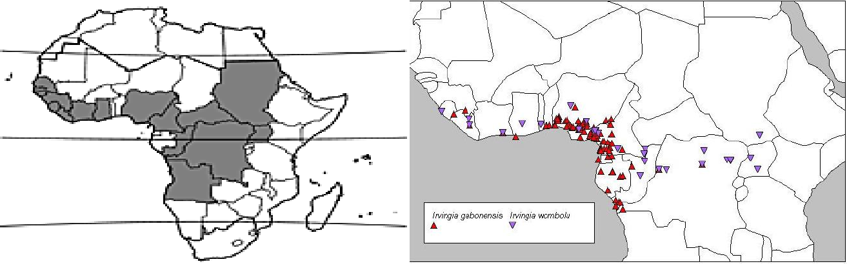

Figure 2.3: Distribution maps of both species (*I. wombolu* and *I. gabonensis*), (Harris 1996).

*Ecology, growth and development*

*Irvingia wombolu* is mostly propagated by seed, but methods of vegetative propagation have been developed. Seed loses its viability within one month and has to be planted soon after collection*. I. wombolu* occurs in dry-land forest with more than 1500mm annual rainfall. In some locations, it grows on seasonally flooded forest on river banks. It is adapted to a wider rainfall range than other *Irvingia* species. It starts flowering when 6-10 years old. It does not have a clearly demarcated flowering season, but flowering peaks at the end of the rainy season or beginning of the dry season, fruiting peaks at the end of the dry season flowers are pollinated by insects (Asaah *et al*., 2003). The diagram of *Irvingia wombolu* and the fruit‟s parts are shown in plate 1 and 11 respectively.

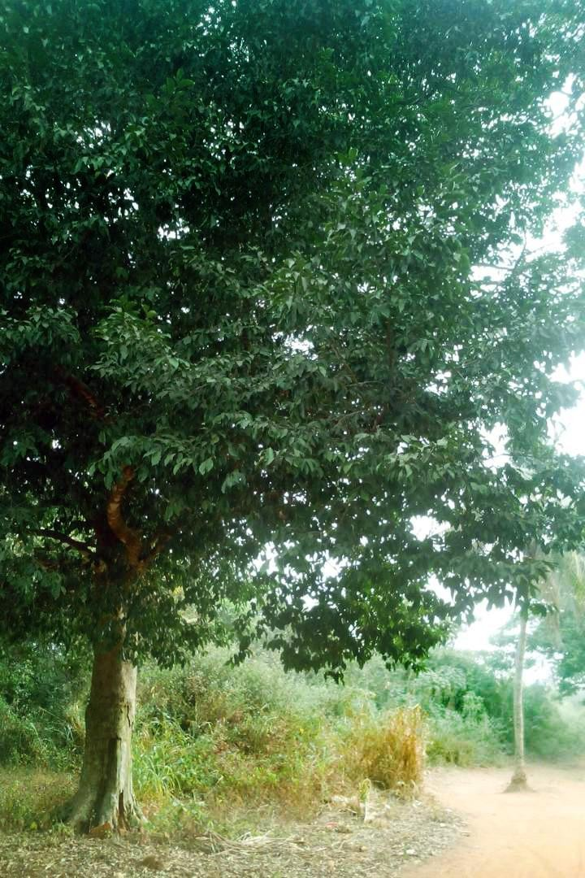

**Plate 1**: *Irvingia wombolu* tree (Bitter bush mango) in its natural habitat in Ubiaja, Esan South East L.G.A., Edo State

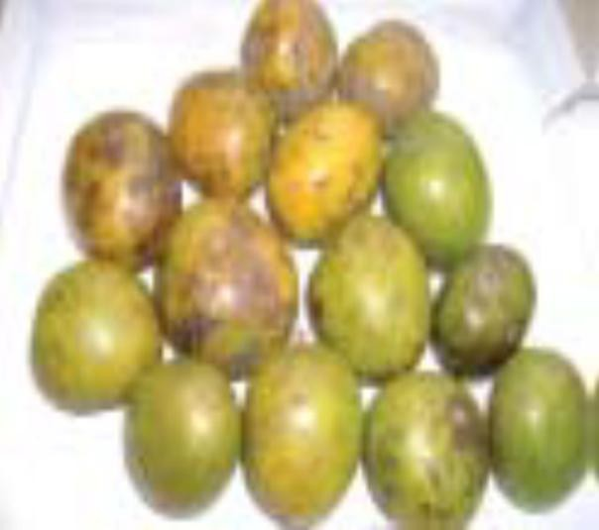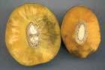

A B

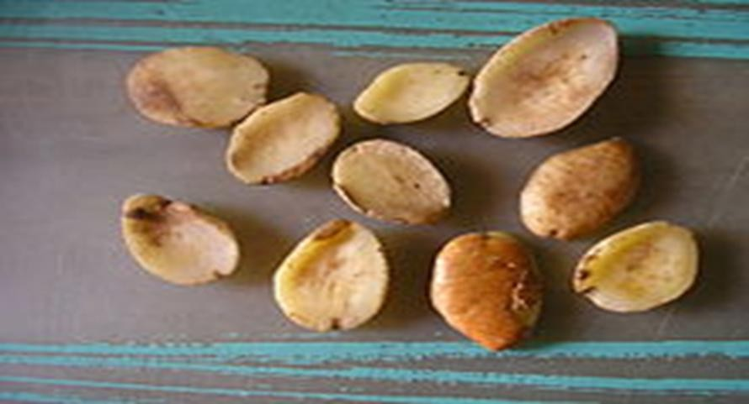

(C)

**Plate II**: Parts of the *I. wombolu* fruit

A: *Irvingia wombolu* fruits

B: Mesocarp of *I. wombolu* fruit C: Kernels of *I. wombolu*

## Nutritional composition

The nutritive value of the kernel of *Irvingia wombolu,* per 100g edible portion include, water 4g, protein 8.5g, fat67g, carbohydrate 15g, calcium 120g, iron 3.4mg, thiamine 0.22mg, riboflavin 0.08mg, niacin 0.5mg and energy 2918kg (697 kcal). Drawability (sliminess‟) and viscosity of soups imparted by the kernels varies between kernels from different trees. The fat content of kernels also varies between trees and it‟s about 37.5-75g/100g (Agbor, 1994).

The approximate fatty acid composition include; lauric acid 20-59%, myristic acid 33-70%, palmitic acid 2%, stearic acid 1% and oleic acid 1-11%.Aroma extract dilution analysis revealed 32 odor active volatile compounds that contribute to the overall nutty aroma of roasted seeds or kernels. Myristic, lauric, and palmitic acids compose nearly 95% of the total fatty acids in African mango seeds (Matos *et al.,* 2009). Margarine-based African mango oil may provide an alternative to trans-fatty acids obtained during hydrogenation used in oil technological applications (Dudu, 1998).

Heartwood of *I. wombolu* is pale greenish brown or orange-yellow fading to grayish brown; Sapwood is lighter but not always clearly differentiated. The wood is fairly heavy. The density is 930-100.2kg/kg3 at 12% moisture content (Lowe *et al.,* 2000).

* + 1. **The uses of *Irvingia* species parts**

*The tree, timber and wood*

Bush mango wood is used locally for construction (Leakey and Izac, 1996). It is fine grained, hard heavy timber, conferring strength durability and fairly resistant to termite; these characteristics are recognized and utilized (Agbor, 1994). The wood is also used for making

poles and stakes, while live branches are made into walking sticks or thatched roof supports and dead branches are used as fire woods (Ayuk*et al*., 1999).

*The fruits:*

The fruit pulp of *I. wombolu* is bitter and tastes of turpentine, so it is not edible (Ejiofor, 1994). In Nigeria, wine made from the fruit‟s pulp juice had attributes comparable to those of a German reference wine. Bush mango fruit pulp is a major source of vitamin C and beta-carotene. Fresh bark can be used to confer a bitter taste to palm wine if pieces are kept in the wine containers during tapping.

The juicy fruit calp of *I. gabonensis* is sweet, and is widely reported to be consumed as a dessert fruit or snack; throughout Western and Central African (Leaky and Newton, 1994). *Irvingia gabonensis* pulp can be used for making jam, jelly and Juice (Okolo *et al*., 1995).

*The seeds:*

*Irvingia* kernels (that is*, I. gabonensis* and *I. wombolu)* are classed as oil seeds. They are grinded with a pestle and mortar or a stone into a paste or cake called “Dika bread”, which is used as “ogbono” soup, stew or sauce additive, for flavoring and thickening (Agbor, 1994; Vivien and Faure, 1996). The kernels are highly valued for the slimy consistency they produce.

*Food application:*

Fat extracted from the kernels (Dika fat) can be used in food applications, such as in margarine or cooking oil, and is also suitable for soap, cosmetics and pharmaceuticals (Ejiofor, 1994).Flour can be produced from the kernels but degrades between 6-9 months unless defatted. Defatted flour is still acceptable in terms of its colour, taste, texture and drawability after nine months storage in ambient conditions and in more viscous, with greater emulsifying properties than un-

defatted flour (Vivien and Faure, 1996). Improvements in drawability and possible storage time have enabled the flour to be considered for a range of processed products, particularly “Ogbono” cubes; thus giving them a longer shelf life and are sold as a convenient cooking ingredient.

Dika fat may serve a role in pharmaceutical drug-release systems. Documented studies show that mucilage extracted from African mango seeds performed better than acacia and tragacanth in emulsion and suspension formulations. Dika fat out-performed magnesium stearate, Stearic acid, and hydrogenated vegetable oil when tested in tablet equipment and imparted no adverse effect on the creation and integrity of hydrochlorothiazide tablets (Odeku and Patani, 2005).

## Ethno medicinal uses and traditional claims.

*Irvingia wombolu* Ver. is one of the medicinal trees used traditionally in Africa for the management of diarrhoea and other ailments especially in the south-south and southeastern parts of Nigeria. Agbor (1994) reported that the roots, leaves and bark of *Irvingia* species are used medicinally to treat variety of illnesses and to relieve pain. However, others mentioned that only the bark mixed with palm oil was used in the treatment of diarrhoea and is also taken by women to shorten their breast feeding period (Ndoye and Tchamou 1994). It is also administered for colic and dysentery, hernia, yellow fever and as anti-poison. Preparations from the bark are rubbed unto the body to relieve pains and are applied to wounds and against toothache. It is reported that the bark has antibiotic properties for healing scabies (Ayuk*et al.,* 1999).

## Scientific studies

Scientific researches on African mango (Irvingiaceae) revealed beneficial effects on diabetes and obesity as well as antimicrobial, antioxidant, and Gastro intestinal activities of *Irvingia gabonensis*, one of the species of the Irvingia family (Kuete *et al.,* 2007; Ngondi *et al.,* 2009;

George and Zhao, 2007; Okolo *et al.,* 1995). But the specie in study *Irvingia wombolu* has few scientific findings.

Measurement of antioxidant activity of African mango (*I. wombolu*) kernel peels; antioxidant and anti-hyperglycemic potential of pulp extract of *I. wombolu* fruit (Matsinkou *et al.,* 2017; 2012). Preventive effect of *Irvingia wombolu* pulp and peel extracts against high fat-high fructose diet induced insulin resistance in rats (Ngondi *et al.,* 2014).

Onyishi and Chime (2013) also reported in his studies on the physiochemical characterization of

*I. wombolu* gum in Tramadol encapsulated granules that natural gum from *I. wombolu* seedhas good potential to be used in formulating normal release tramadol capsules. The results of phytochemical analysis of *I. wombolu* gumshowed that the gum contains alkaloids, flavonoids, saponins, tannins and glycosides (Onyishi and Chime 2013).

# CHAPTER 3

# MATERIALS AND METHODS

## Materials

## Laboratory materials

Animal cages, Weighing balance (Lab. Tech. BL 20001 and Mittler P162, USA), Porcelain pestle and mortar, Syringes, Plain paper, Distilled water, Ugo Basile micro-dynamometer (Ugo Basile, Italy), Stop watch, Filter papers (Whattman filter papers 25cm), Pipette, Test tubes (Pyrex, France), Water bath ( HH-S Digital Thermostatic water bath), Laboratory microwave oven, Isolated tissue apparatus and Dissecting kit ( Gold cross, Malaysia).

The drugs and reagents include;

Castor oil (Bell, Sons and Co (DRUGGIST) Ltd, Southport PR9 9 AL, England) Loperamide (Imodium® - Janssen Pharmaceutical, Beerse, Belgium) Magnesium sulphate (BDH Chemical ltd, Poole, England)

Atropine sulphate ((Sigma-Aldrich Life Science, St. Louis U.S.A)) Acetylcholine and Adrenaline (Sigma-Aldrich Inc., St. Louis, USA)

Medicinal charcoal (Ultra carbon® tablets- Merck KGaA, Darmstadt, Germany) Histamine (Sigma-Aldrich Inc., St. Louis, USA)

Methanol (AR JHD UN1230; Guangdong Guanghua Sci-Tech. Co., Ltd. China).

## Collection of plant material

Fresh stem bark of *Irvingia wombolu*tree along with its fruits and leaves were obtained from a farm land in Esan South East, Ubiaja, Edo State in the month of April 2017.

## Experimental animals

Apparently 112 healthy Swiss albino mice of both sexes weighing 19-30g, 20 Wistar rats weighing 80-120g, 3 New Zealand male rabbits (800-1200g) and 3 Guinea pigs (300-400g) were used for the study. They were obtained from the Animal House of the Department of Pharmacology and Therapeutics, Ahmadu Bello University, Zaria. Animals were fed with rat feed and provided with water*ad libitum*.

Protocols approved by the Institutional Animal Ethical Committee according to Ahmadu Bello University‟s Academic Guidelines for the use and care of experimental animals with approval no **ABUCAUC/2018/016**were followed. All experiments were conducted during the daytime.

## Methods

* + 1. **Botanical authentication of *Irvingia wombolu* plant**

Botanical authentication was done by Mal. Namadi Sanusi of Herbarium Unit of the Department of Biological Sciences, Ahmadu Bello University, Zaria. The plant was given a voucher number of **6926** for future reference.

## Preparation and extraction of plant material.

Fresh *I. wombolu* stem bark collected was air-dried for 14days. The air-dried stem bark was pounded to a coarse powder form with mortar and pestle. Two kilograms of the powder was weighed and extracted using maceration method with 70% methanol solvent for 7 days with occasional shaking. The extract obtained after concentration using evaporator was subjected to drying over a water bath in a controlled temperature (45oC). The extract obtained (a sticky brown mass residue) was then stored in an air-tight container and kept in a desiccator until used.

The percentage extract yield was calculated as:

Weight of extract Weight of dried powder

x 100

## Preliminary phytochemical screening

The methanol stem bark extract of *Irvingia wombolu* (MEIW) was screened for the presence of saponins, tannins, triterpenes, cardiac glycosides, flavonoids, alkaloids, carbohydrates, terpenoids using methods of Sofowora(1993) and Trease and Evans (2002).

*Test for saponins*

Frothing test: About 10 ml of distilled water was added to one ml of the extract solution. It was subjected to vigorous shaking for 30 seconds and was allowed to stand for 30 minutes in a vertical position. A honeycomb froth that persists for 15 minutes indicated presence of saponins (Trease and Evans 2002; Sofowora, 1993).

*Test for steroids and triterpenes*

Leiberman-Burchard‟s test: One ml of the chloroform solution of the extract with equal volume of acetic acid anhydride was added and mixed gently. One ml of sulphuric acid was added down the side of the test tube to form lower layer. Changes were observed immediately and over a period of one hour. Blue to blue-green colour in the upper layer indicated the presence of steroids while reddish brown colour indicated the presence of triterpenes (Trease and Evans 2002).

*Test for cardiac glycosides*

Killer-killiani test: One ml of aqueous solution of the extract was mixed with one ml of glacial acetic acid containing one drop of ferric chloride solution. This was transferred into a dry test

tube and one ml of concentrated sulphuric acid was added with a pipette down the side of the test tube to form a lower layer at the bottom. The interface was observed carefully for a brown ring. The ring indicated the presence of deoxy sugars while presence of pale green colour in the upper acetic acid layer indicated the presence of glycosides (Trease and Evans 2002).

*Test for flavonoids*

Shinoda test: One hundred milligram of the extract was dissolved in 2 ml of 50% methanol and warmed on a steam bath. Few pieces of metallic magnesium chips and a few drops of concentrated hydrochloric acid were added. Appearance of a red colour indicated the presence of flavonoid (Trease and Evans 2002).

Sodium hydroxide test: Few drops of 10% of sodium hydroxide were added to aqueous solution of the extract. Yellow colouration indicated the presence of flavonoid (Trease and Evans 2002).

*Test for tannins*

Ferric chloride test: Three drops of ferric chloride solution was added to one ml of aqueous extract solution. A greenish-black precipitate indicated the presence of condensed tannins while a blue or brownish-blue precipitate indicated the presence of hydrolysable tannins (Trease and Evans 2002).

Lead acetate test: Three drops of lead acetate solution was added to one ml aqueous solution of the extract. A cream-coloured precipitate indicated the presence of tannins (Trease and Evans 2002).

*Test for alkaloids*

About 0.5 g of the extract was stirred with 5 ml of 1% aqueous hydrochloric acid on a water bath and filtered. Ammonia solution was added to the filtrate followed with chloroform; this was

gently shaken to allow separation. The chloroform layer was collected and dilute hydrochloric acid was added gently shaken to allow separation and the aqueous layer was divided into three portions. To the first portion, few drops of freshly prepared Dragendorff reagent was added and observed for formation of orange to brownish precipitates. To the second, one drop of Mayer‟s reagent was added and observed for formation of white to yellowish or cream color precipitates. To the third portion, 1ml of Wagner‟s reagent was added to give a brown or reddish or reddish- brown precipitates, which indicated the presence of alkaloids (Trease and Evans 2002).

*Test for carbohydrates*

Molisch test: One ml aqueous solution of the extract was put in a test tube, 5 drops of Molisch reagent was added and the concentrated sulphuric acid was added down the side of the test tube to form a lower layer, a reddish colored ring at the interphase indicated presence of carbohydrate (Trease and Evans 2002).

Fehling‟s test: One ml aqueous solution of the extract was put in a test tube; 5 ml of an equal mixture of Fehling‟s solutions A and B was added. This was boiled on a water bath and a brick red precipitate indicated presence of reducing sugar (Trease and Evans 2002).

## Acute toxicity study

The median lethal dose (LD50)was carried out using Lorkes‟ method (1983) with little modification. In the **firstphase**, nine mice randomly divided into three groups of three mice per group and were given 10, 100 and 1000 mg extract/kg body weight orally (via cannula), respectively. The mice were observed for signs and symptoms of toxicity for the first 4 hours and mortality for 24 hours.

The**second phase** was initiated following the result obtained from the first phase and three mice were orally administered three graded doses of the extract respectively. They were observed for signs and symptoms of toxicity for the first 4 hours and mortality after 24 hours.

## Sub chronic toxicity study

The 28 days study to determine possible toxicity and establish a toxicological profile of the extract was carried out using the method of OECD 407, (2008). Thirty percent of the safe acute toxicity reference dose of MEIW was employed on Wistar rats.

Twenty rats of both sexes were randomly distributed into four groups of 5 rats each. Group I, received normal saline (10 ml/kg), groups II-IV received MEIW (500, 1000 and 1500 mg/kg) respectively. The extract and normal saline were administered orally, once daily at every morning time for twenty eight days during the study. The rats were observed twice daily for toxicity signs and mortality, behavioral abnormalities and other clinical signs as prescribed by OECD method (OECD, 2008). The body weight of all the experimental animals were measured at regular intervals and recorded weekly. On the 28th day of the dosing period, the animals were starved for 12 hours and on the 29th day all animals were euthanized under chloroform anesthesia. Blood samples were drawn from the jugular vein of each sacrificed animal into sterilized plain plastic test tubes and EDTA bottles for biochemical and hematological studies respectively. The kidney, liver, stomach, and intestine were carefully fetched out and weighed in grams to get the relative organ weight of each animal before they were preserved in 10% formalin for gross pathological examinations.

The relative organ weight for each animal was calculated using the formulae:

Absolute organ weight

Body weight of rats on sacrifice day (g) X 100

* + 1. **Histopathological effects of the methanol stem bark extract of** *I. wombolu* **(MEIW)** Three Wistar rats were randomly selected in each treatment group of MEIW and observed for similar histopathological effects The Organs (kidney, liver, Intestine and stomach) of the Wistar rats were sliced in 3 to 4 cm thick and fixed in labeled containers containing 10% formalin. They were then dehydrated for 2 hours in each of the following ascending grades of alcohol: 30%, 50%, 70%, and 95% with a final bath 100% v/v to ensure total elimination of moisture. The dehydrated tissues were then cleared in toluene for 2 hours, after which the tissue slices were embedded in paraffin wax and left to cool. The blocks were trimmed on the microtome at 5 microns. The ribbon of sections was dehydrated in xylene and rehydrated in the following grades of alcohol: 100%, 90% and 70% v/v and subsequently infiltrated with molten paraffin wax. They were then stained in hematoxylin for about 5 minutes, differentiated in 1% acid alcohol, blued in Scotch‟s tap water and stained with Eosin for 3 minutes. They were later rinsed, dehydrated in ascending grades of alcohol: 70%, 90% and 100% v/v, and finally cleared in a pox. The slides were then examined microscopically for pathological lesions (Parasuraman, 2011; Liu *et al*., 2011; Jaijoy *et al*., 2011). Photomicrographs of the lesions were taken at the magnification of

×400 with the assistance of consultant histopathologist.

## Anti diarrhoeal studies

* + - 1. *In-vivo antidiarrhoeal studies*

*Castor oil induced diarrhoea:*Method described by Diurno *et al*(1996) and Agunu *et al*(2005) were used for the study. Twenty-five mice fasted for 12 hours (overnight) were randomly

divided into 5 groups of 5 animals each. Group 1 received normal saline (10 ml/kg), groups II-IV received MEIW (500, 1000, 1500 mg/kg) respectively. Group 5 received loperamide (3mg/kg) in suspension. All drugs were administered through oral route and solutions were dissolved in normal saline according to drug concentration. After 60 minutes, 0.2 ml of castor oil was administered orally to each mouse to induce diarrhoea. After 30minutes of its administration, animals were placed in individual cages with the floor lined with blotting paper that was changed every hour, for observation period of 4 hours. The number of dry faeces and wet diarrhoea droppings were counted every hour. A numeric score based on the stool consistency was assigned as follows: normal stool = 0, semisolid stool = 1 and watery stool = 2.

The total score of diarrhoea faeces of negative control was considered as 100%. The percentage protection against diarrhoea was calculated with respect to the number of wet faeces excreted using the formula:

% Inhibition =

Number of WFC − Number of WFT Number of WFC x 100

Where; WFC= wet faeces in negative control WFT= wet faeces in test group

*Magnesium sulphate induced diarrhoea:* Using the method described by Afroz *et al* (2006) in which 25 mice fasted for 12 hours were divided into 5 groups of 5 animals each; Group 1 (Negative control) received normal saline (10 ml/kg), groups I-IV received (500, 1000 and 1500 mg/kg) of MEIW stem bark respectively. Group 5 (positive control), were given loperamide (3mg/kg). After 60 minutes, 0.5 ml of magnesium sulphate (200 mg/ml) was administered to all mice to induce diarrhoea. All drugs were administered through the oral route. After 30 minutes of magnesium sulphate post-treatment, animals were placed in cages with the floor lined with

blotting paper that was changed every hour for observation period of 4hours. The number of dry faeces and wet diarrhoea droppings were counted every hour during the observation period.

The percentage protection against diarrhoea was calculated with respect to the total number of wet faeces excreted using the formula:

% Inhibition =

Number of WFC − Number of WFT Number of WFC x 100

Where; WFC= wet feaces in negative control WFT= wet feaces in test group

*Castor oil-induced enterpooling (fluid accumulation test):* This is used to assay for intestinal fluid accumulation (osmotic diarrhoea), as described by Robert *et* al (1976). Twenty-five mice were randomly divided into 5groups of 5 mice each. Group 1 (negative control) was given normal saline , groups II-IV received 500, 1000 and 1500 mg/kg of MEIW stem bark respectively and group 5 (positive control) received loperamide (3 mg/kg). Castor oil (0.5 ml) was administered to the mice 60 minutes after the pretreatment with the extract doses and loperamide. All drugs were administered through oral route. After 30 minutes of administration, the mice were euthanized and the small intestines (pylorus to caecum) were removed and the intestinal contents for each of the intestines was collected with a graduated syringe and volume measured and recorded.

The volume obtained from group 1 (the negative control) was used to compare with the rest of the groups, were values lesser than the negative control was recorded as protection from diarrhoea.

*Gastrointestinal motility test:* Using castor oil-induced intestinal motility model, effect of the extract on gastrointestinal motility was determined (Mascolo *et al*., 1994). Mice fasted for 12

hours were randomly divided into 5 groups of 5 mice each. Group 1 (negative control) was given

10 ml/kg of normal saline, groups II-IV received (500, 1000 and 1500 mg/kg) of MEIW respectively and group 5 (positive control) received atropine sulphate (0.2mg). Charcoal meal (5% activated charcoal suspended in 3% gum acacia) of 0.3 was administered to the animals 30 minutes after the pretreatment with extract and atropine. After 60minutes, 0.2ml of castor oil was administered to the mice to induce motility. All drugs were administered through oral route. After 30 minutes of its administration, animals were euthanized by placing them in an enclosed bowl for 3-5 minutes containing chloroform. The intestines were removed without stretching and placed lengthwise on moist paper horizontally on a table. The distance in centimeters travelled by the charcoal meal (an adsorbent, serving as a marker) down the length of the intestine was measured. The whole length of the intestine, from the pylorus to caecum was also measured.

Peristaltic index (PI) /Intestinal transit was calculated as a percentage of distance travelled by charcoal meal relative to the length of the intestine.

PI of charcoal meal = Distance travelled by charcoal meal

Total length of intestine

x 100

* + - 1. *In-vitro (isolated tissue) studies*

An apparently healthy rabbit fasted of food for 12 hours was sacrificed by a blow on the head. Segments of the jejunum, about 3cm long, was removed and dissected free of adhering mesentery and suspended in 25ml organ bath containing Tyrode solution(NaCl: 136.8; KCl: 2.7; CaCl2: 1.3; NaHCO- :12.0; MgCl -: 0.5; NaPO- : 0.14; glucose:5.5 mmol). The tissue was allowed to equilibrate for 60 minutes during which the physiological solution was changed every 15minutes. At the end of the equilibration period, effects of acetylcholine, the methanol extract

3

2

4

of *I. wombolu*, and atropine were then tested on the jejunum. Responses were recorded using a micro-dynamometer (Amos *et al.,* 1998).

The effect of methanol stem bark extract of *I. wombolu* on isolated guinea pig ileum: A similar protocol as for the previous study on rabbit jejunum was followed, using guinea pig. The effects of histamine and the methanol extract of *I. wombolu* were tested on the ileum. Equilibration period of 60 minutes was allowed, during which the physiological solution was changed every 15minutes. At the end of the equilibration period, the effects of histamine (at 5 x 10¯6g/ml concentration)and the methanol extract of *I. wombolu*(at 1mg/ml, 10mg/ml and 100 mg/ml concentrations) were determined. Contact time for each concentration was 5 minutes, followed by washing three times. Tissue was allowed a resting period of 15 minutes before the next drug administration (Amos *et al.,* 1998).

## Statistical analysis

Data was analyzed using Statistical Package for Social Sciences (SPSS), IBM version 20 and Microsoft Excel 2010. The results were expressed as mean ± standard error mean (SEM) and percentages except where otherwise stated. The data was analyzed with one way analysis of variance (ANOVA), split-plot ANOVA, Bonferroni andDunnett‟s *post* hoc test were necessary**.** The differences between the various animal groups were compared by Dunnett‟s post hoc test for multiple comparisons. P values (*p*≤0.05) were taken as significant (Duncan, 1955). All results were presented in tables, figures and plates.

# CHAPTER 4

# RESULT

## Percentage Yield of Methanol Stem Bark Extract of *I. wombolu*

Two kilogram of the powdered stem bark of *I. wombolu*yielded 218.84g of methanol crude extract, giving a percentage yield of 10.94%w/w.

* 1. **Preliminary Phytochemical Constituents of Methanol Stem Bark Extract of *I. wombolu***

The preliminary phytochemical screening of the methanol extract showed the presence of alkaloids, cardiac glycosides, saponins, tannins, flavonoid, steroids/triterpenes, terpenoids and carbohydrates. However, anthraquinones was absent (Table 4.1).

## Acute Toxicity of Methanol Stem Bark Extract of *I. wombolu*

The acute toxicity studies carried out as described by Lorkes‟ (1983), showed no lethality or toxic reactions at any of the oral administered doses of the methanol stem bark extract of *I. wombolu*, even at the highest dose of 5000 mg/kg on observation for 48hours in mice. The LD50 is then greater than 5000mg/kg.

## Table 4.1: Phytochemical constituents of methanol stem bark extract of*I. wombolu*

|  |  |  |
| --- | --- | --- |
| **Phytochemical constituents** | **Test** | **Inference** |
| Alkaloids  Cardiac glycoside Saponins  Tannins Flavonoids  Triterpenes/Steroids Terpenoids Carbohydrates  Anthraquinones | Dragendorff Mayer  Killer-killiani Frothing Lead acetate  Shinoda  Ferric chloride Sodium hydroxide  Lieberman-Burchard Salkwoski  Molish  Bontragers | Present Present  Present Present Present  Present Present Present  Present Present Present  Absent |

* 1. **Sub chronic Toxicity of Methanol Stem Bark Extract of *I. wombolu***

The oral administration of methanol extract of *I. wombolu*at the doses of500, 1000 and 1500mg/kg produced no observable overt signs and symptoms of toxicity throughout the 28 days study period. All the animals survived throughout the period of the experiment.

## Effect of methanol stem bark extract of *I. wombolu* on the body weight of Wistar rats after oral administration for 28 days

There was a steady increase in the mean weight of rats in all the groups over the 28 days period. However, a decrease in weight that was not significant (*p*˃0.05) was observed in the group treated with 1500mg/kg body weight when compared with the control group in the 2nd week of the study period (Table 4.2).

## Effect of methanol stem bark extract of *I. wombolu* on the relative organ weights of Wistar rats after oral administration for 28 days

The relative organ weights of the Liver, Kidneys, Intestine and Stomach in treated groups were not significantly (*p*˃0.05) different from the control group (Table 4.3).

## Effect of methanol stem bark extract of *I. wombolu*on the haematological parameters of Wistar rats after oral administration for 28 days

The oral administration of the extract showed statistical significant difference (*p*≤ 0.05) in white blood cell (WBC) at doses of 1000mg/kg and 1500mg/kg and in neutrophils at dose 1500mg/kg. The platelet, haemoglobin, red blood cells and its counts showed no significance in the treated groups when compared with the control group (Table 4.4).

## Table 4:2: Effect of methanol stem bark extract of *Irvingia wombolu*on the bodyweight of Wistar rats after oral administration for 28 days

|  |  |  |  |  |  |
| --- | --- | --- | --- | --- | --- |
| **Treatment groupMean Body Weight** ± 𝐒𝐄𝐌 (𝐠)  **(mg/kg)** | | | | | |
|  | **Week 0** | **Week 1** | **Week 2** | **Week 3** | **Week 4** |
| NS (10 ml/kg) | 83.20±11.05 | 91.20±10.55 | 97.00±13.04 | 108.00±17.99 | 117.20±19.28 |
| 500 (MEIW) | 87.00±5.79 | 95.40±5.63 | 103.60±4.50 | 108.00±6.60 | 114.40±11.41 |
| 1000 (MEIW) | 87.60±12.14 | 96.00±14.16 | 103.20±12.46 | 109.00±8.77 | 114.00±10.07 |
| 1500 (MEIW) | 88.20±12.26 | 92.80±11.32 | 95.40±9.56 | 105.40±10.83 | 112.40±10.45 |

Results were presented as mean ± SEM;Data were analyzed using Split plot ANOVA, (n=5). NS = Normal saline, MEIW= methanol stem bark extract of *I. wombolu*

## Table 4.3 Effect of methanol stem bark extract of *Irvingia wombolu*on the relative organ weight of Wistar rats after oral administration for 28 days

|  |
| --- |
| **Treatment group (mg/kg)Mean Organ Weight± SEM** |
| **Liver Kidney Intestine Stomach** |
| NS (10ml/Kg) 7.47±1.15 0.55±0.05 1.17±0.14 3.34±0.04  500 (MEIW) 5.74±0.80 0.45±0.02 1.60±0.42 3.34±0.37  1000 (MEIW) 6.22±0.53 0.49±0.011.15±0.24 3.45±0.26  1500 (MEIW) 7.10±0.38 0.51±0.021.52±0.113.14±0.63 |

Results were presented as mean ± SEM;Data were analyzed using one way ANOVA, (n=5). NS = Normal saline, MEIW= methanol stem barkextract of *I. wombolu*

## Table 4.4: Effect of methanol stem bark extract of *I. wombolu*on the haematological parameters of Wistar rats after oral administration for 28 days

|  |  |  |  |  |
| --- | --- | --- | --- | --- |
| **Haematological parameters/Mean Doses ± SEM** | | | | |
| **Haematological parameters** | **NS**  **(10 ml/kg)** | **MEIW**  **(500 mg/kg)** | **MEIW**  **(1000 mg/kg)** | **MEIW**  **(1500 mg/kg)** |
| WBC (×109/L) | 9.96±1.12 | 7.52±0.55 | 6.82±0.57* | 5.24±0.27* |
| HGB (g/dL) | 11.88±1.12 | 11.14±0.56 | 11.18±0.46 | 11.22±0.69 |
| RBC (×109/L) | 4.68±0.39 | 4.38±0.26 | 4.44±0.30 | 4.51±0.30 |
| PLT (×109/L) | 302±37.31 | 260.40±33.76 | 251.80±22.59 | 239.80±41.94 |
| PCV (%) | 39.72±3.32 | 36.18±1.98 | 36.02±0.88 | 37.28±2.35 |
| MCV(fL) | 82.82±2.40 | 82.78±2.40 | 82.06±4.38 | 81.16±2.38 |
| LYMPH(×109/L) | 2.76±0.55 | 2.54±0.22 | 2.32±0.25 | 2.40±0.21 |
| NEUTRO (×109/L) | 6.12±1.00 | 4.58±0.38 | 4.74±0.60 | 3.48±0.33* |

Results were presented as mean ± SEM; Data were analyzed using one way ANOVA followed by Dunnett post hoc.

*= *P* ≤ 0.05, (n = 5). MEIW= methanol stem bark extract of *Irvingia wombolu*. MCV=Mean cell Volume, WBC = white blood cell, RBC=Red Blood cell, Neutro = Neutrophil, HGB=Hemoglobin, Lymph = Lymphocytes, PCV= Pack Cell Volume, PLT= Platelet

## Effect of methanol stem bark extract of *I. wombolu* on serum electrolyte and kidney function parameters of Wistar rats after oral administration for 28 days

There were slight changes in the serum electrolytes of rats in the treatment groups when compared with the control group. However, these changes were not statistically significant (*p*˃0.05), except serum sodium with a statistical significant increase (*p≤*0.05) in the treated group with 500mg/kg when compared with the control group (Table 4.5).

## Effect of methanol stem bark extract of *I. wombolu* on liver function parameters of Wistar rats after oral administration for 28 days

The effect of oral daily administration of methanol extract of *I. wombolu* on the liver function parameters showed statistically significant difference (*p*≤0.05) on ALP (IU/L) at 500 mg/kg and 1000 mg/kg respectively compared with the control group while the ALT (IU/L), AST (IU/L), TP (IU/L) and ALB (G/DL) showed no significant difference when compared with the control (Table 4.6).

## Table 4.5: Effect ofmethanol stem bark extract of *I. wombolu*on serum electrolytes and kidney function parameters of Wistar rats after oral administration for 28 days study

|  |  |  |  |  |
| --- | --- | --- | --- | --- |
| **Kidney function parameter/Mean Doses ± SEM** | | | | |
| **Kidney function Parameters** | **NS**  **(10ml/kg)** | **MEIW**  **(500 mg/kg)** | **MEIW**  **(1000 mg/kg)** | **MEIW**  **(1500 mg/kg)** |
| Urea (μmol/l) | 87.10±19.07 | 80.20±8.76 | 76.79±11.93 | 75.49±7.55 |
| Sodium (mmol/I) | 151.47±5.46 | 181.79±9.15* | 154.44±3.98 | 151.90±2.75 |
| Potassium (mmol/I) | 9.54±0.68 | 9.70±0.51 | 11.66±0.91 | 11.75±0.28 |
| Creatinine (μmol/l) | 0.96±0.09 | 1.10±0.11 | 0.84±0.09 | 0.92±0.07 |
| Chloride(mmol/I) | 25.80±1.98 | 28.20±1.28 | 26.00±0.55 | 23.80±2.27 |
| Bicarbonate(mmol/I) | 94.80±5.00 | 90.40±4.83 | 88.60±.4.79 | 84.48±2.71 |

Results were presented as mean ± SEM;Data were analyzed using one way ANOVA followed by Dunnett post hoc,

*= *p*≤0.05, n= 5.

## Table 4.6:Effect of methanol stem bark extract of *I. wombolu*on Liver function parameters of Wistar rats after oral administration for 28 days

|  |  |  |  |  |
| --- | --- | --- | --- | --- |
| **Liver parameters /Mean Doses ± SEM** | | | | |
| **Liver Biomarkers** | **NS**  **(10ml/kg)** | **MEIW**  **(500 mg/kg)** | **MEIW**  **(1000mg/kg)** | **MEIW**  **(1500 mg/kg)** |
| ALT (IU/L) | 37.40± 3.48 | 41.00±2.77 | 40.60±2.64 | 37.00±5.44 |
| AST (IU/L) | 36.20±3.48 | 40.00±4.69 | 44.60±3.71 | 35.60±6.18 |
| ALP (IU/L) | I9.53±1.72 | 40.82±3.88* | 31.11±3.91* | 15.05±2.24 |
| TP (G/DL) | 9.43±0.37 | 8.61±0.48 | 7.82±0.52 | 9.93±0.43 |
| ALB (G/DL)  TB (G/DL) | 3.08±0.08  6.32±0.28 | 3.22±0.15  5.63±0.30 | 3.53±0.17  6.98±0.47 | 3.13±0.15  6.23±0.44 |

Results were presented as mean ± SEM;Data were analyzed using one way ANOVA followed by Dunnett post hoc,

*= *p*≤0.05), (n = 5). AST = Aspartate Aminotransferase, ALT = Alanine Aminotransferase, TP = Total Protein, ALB = Albumin, ALP = Alkaline Phosphatase, TB = Total Bilirubin

## Histopathological effects of the methanol stem bark extract of *I. wombolu* on the kidneys of Wistar rats

The histopathological effects of the control groupshowed normal tubules (T) and glomerulus (G) in the kidney (plate IIIA). In the treatment groups with MEIW at 500 mg/kg, distorted interstitial tubular cell (DIT) was observed (plate IIIB), at 1000 mg/kg widened bowman‟s space (WBS) with distorted tubular cells (plate IIIC) and at 1500 mg/kg, normal glomerular with slight lymphocyte hyperplasia (LH) was observed in the kidney (plate IIID).

## Histopathological effects of themethanol stem bark extract of*I. wombolu* on the liver of Wistar rats

The histopathological effects of the control group showed normal hepatocytes (H) in the liver (plate IVA). In the treatment groups with MEIW at 500 mg/kg, the liver showed moderate necrosis (plate IVB), at 1000mg/kg and 1500mg/kg moderate and mild vacoulation was observed in the liver respectively (plate IVC and plate IVD).

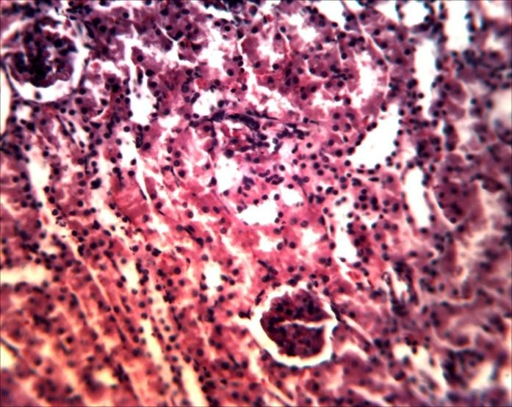

**G**

**T**

Plate IIIA: 10 ml/kg Normal salinePlate IIIB: 500mg/kg MEIW

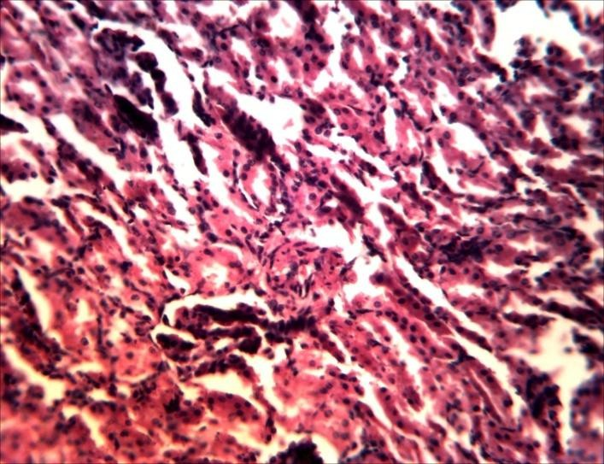

**DIT**

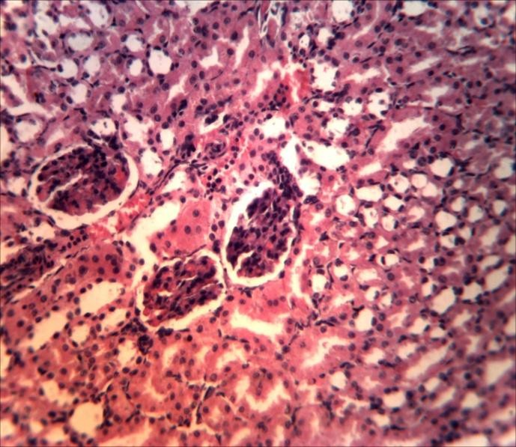

**G**

**H**

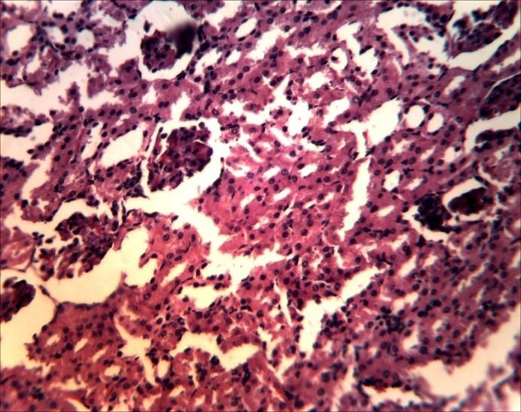

**WBS**

Plate IIIC: 1000mg/kg MEIW Plate IIID: 1500mg/kg MEIW

## Plate III: Photomicrographs of sections of the kidney tissues of control and treated rats (×400), Stain H/E

IIIA: Section showing normal histological appearance of kidney with normal glomerulus (G) and normal renal tubules (T)

IIIB: Section showing distorted interstitial tubular cells (DIT)

IIIC: Section showing widened bowman‟s space (WBS) with distorted tubular cell IIID: Section showing normal glomerular (G) with slight lymphocyte hyperplasia (LH)

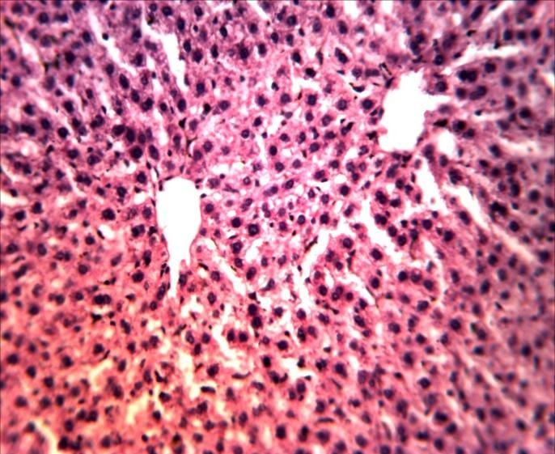

**H**

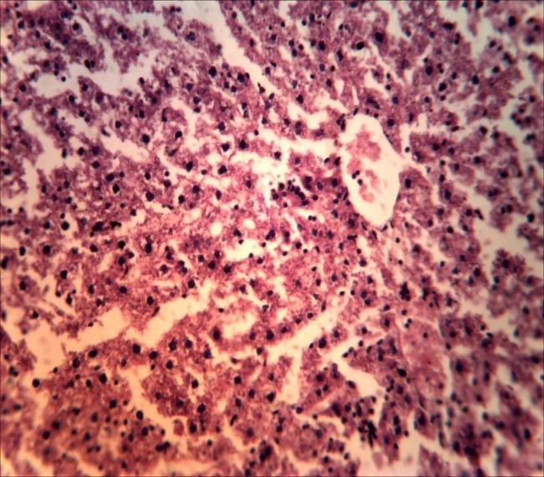

**N**

Plate IVA: 10 ml/kg Normal saline Plate IVB: 500mg/kg MEIW

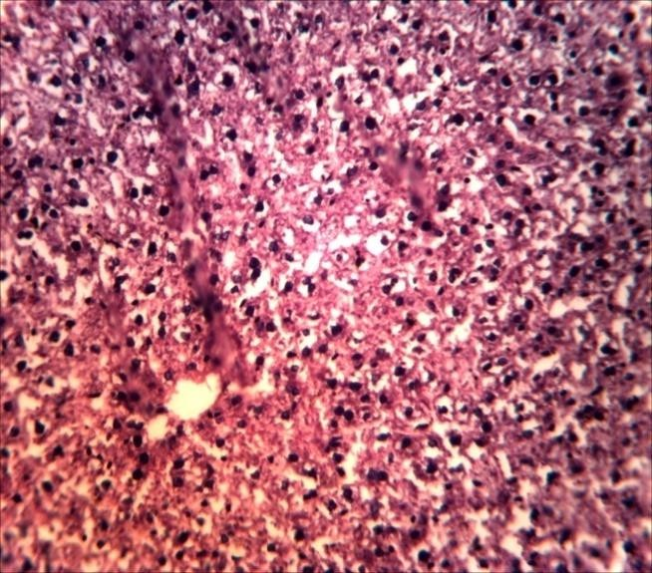

**VC**

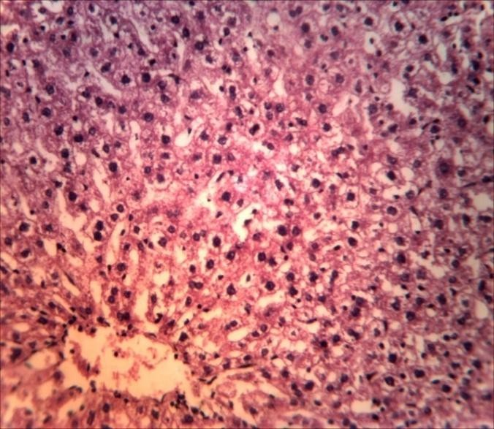

**VC**

Plate IVC: 1000mg/kg MEIW Plate IVD: 1500mg/kg MEIW

## Plate IV: Photomicrographs of sections of the liver tissues of control and treatedrats (×400),Stain H/E

IVA: Section showing normal histological appearance of liver with normal hepatocytes (H) IVB: Section showing mild necrosis (N)

IVC: Section showing moderate vacoulation (VC) IVD: Section showing slight vacoulation (VC)

## Histopathological effects of themethanol stem bark extract of*I. wombolu* on the stomach

The histopathological effects of the control group showed normal mucosa epithelium (ME) of the stomach (Plate VA).In the treated groups of MEIW at 500 mg/kg a normal mucosa epithelium was observed (plate VB), at doses 1000mg/kg (plate VC)and 1500mg/kg (plate VD)distortion of the mucosaland normal mucosal was seen respectively.

## Histopathological effects of themethanol stem bark extractof*I. wombolu* on the small intestine

The histopathological effects of the control group showed normal intestinal villi (plate VIA) and those that received 500 mg/kg of MEIW (plate VIB). Also, at 1000mg/kg and 1500mg/kg, mild villi adhesion (VA) in the intestine was observed respectively (Plate VIC and plate VID).

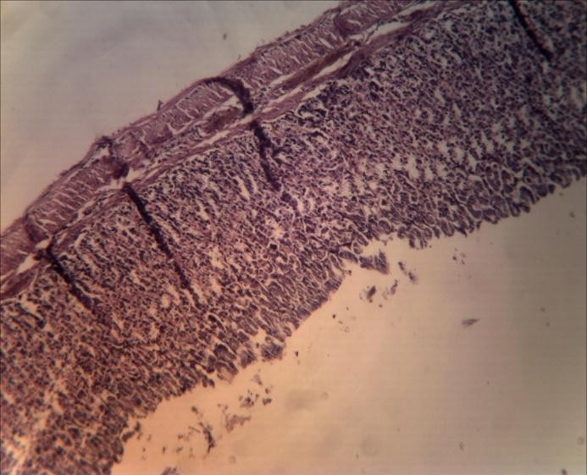

**M**

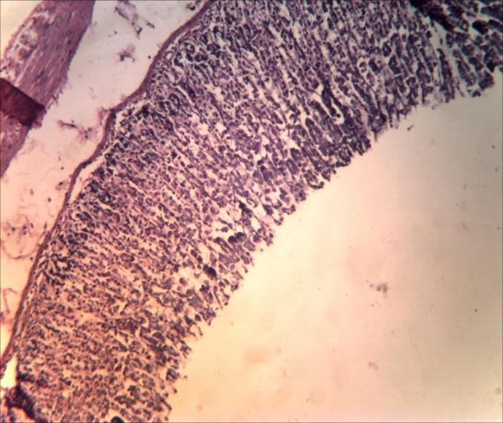

**M**

Plate VA: 10 ml/kg Normal saline Plate VB: 500 mg/kg MEIW

**M**

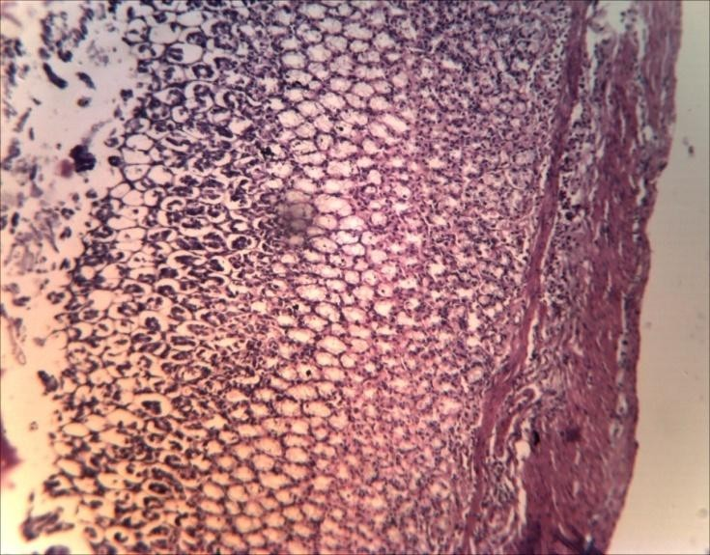

**DM**

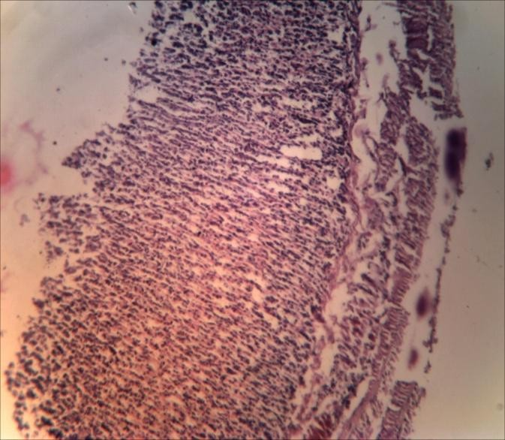

**M**

Plate VC: 1000mg/kg MEIWPlate VD: 1500mg/kg MEIW

## Plate V: Photomicrographs of sections of stomach tissues of control and treated rats (×400),Stain H/E

VA: Section showing normal mucosa epithelium of the stomach (M) VB: Section showing normal epithelium of the stomach (M)

VC: Section showing distortion of the mucosa (DM)

VD: Section showing normal mucosa epithelium of the stomach (M)

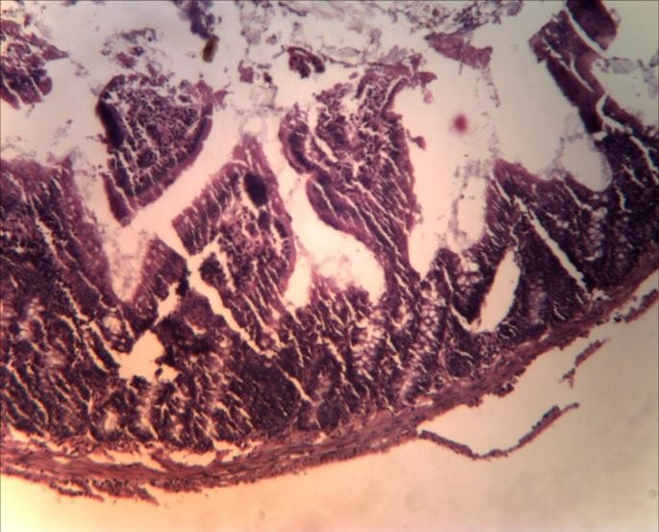

**V**

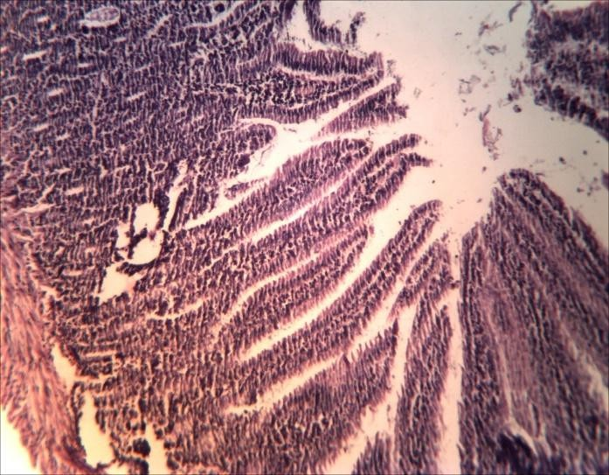

**V**

Plate VIA: 10 ml/kg Normal saline Plate VIB: 500 mg/kgMEIW

**VA**

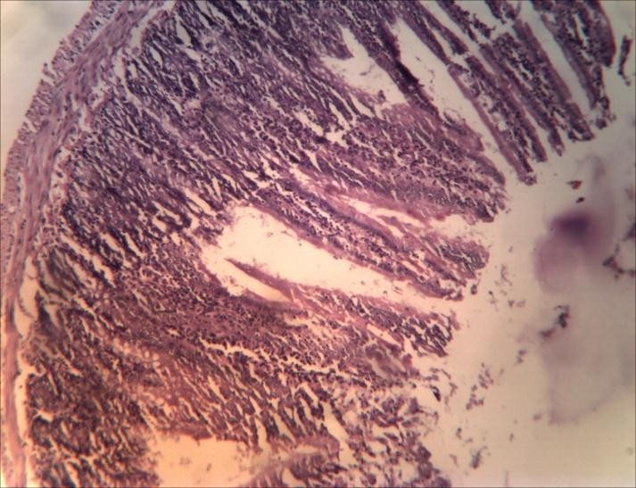

**VA**

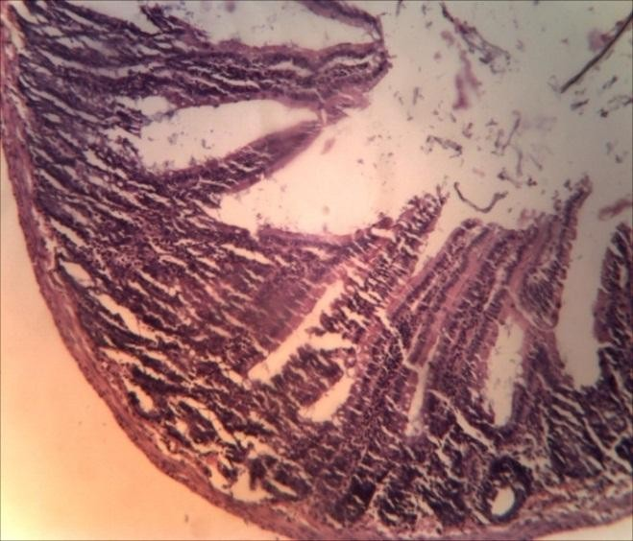

**VA**

Plate VIC: 1000mg/kg MEIWPlate VID: 1500mg/kg MEIW

## Plate VI: Photomicrographs of sections of the small intestine of control and treated rats (×400),Stain H/E

VA: Section showing normal intestinal villi of the small intestine (V) VB: Section showing normal intestinal villi of the intestine (V)

VC: Section showing mild villi adhesion (VA) VD: Section showing mild villi adhesion (VA)

* 1. ***In vivo* Antidiarrhoeal Studies**

## Castor oil-induced diarrhoea in mice

On administration of castor oil to mice after 60minutes to induce diarrhoea, mice in the negative control group produced significant amount of wet feaces (diarrhoeal droppings). Mice treated with methanol stem bark extract of *I. wombolu* (MEIW) at the tested doses (500, 1000 and 1500mg/kg) decreased the amount of wet feaces. Statistical significant decrease (*p*≤0.05) was observed at doses of 1000mg/kg and 1500 mg/kg and the positive control group (loperamide 3 mg/kg) having a percentage inhibition of 61.39%, 75.56% and 93.33% respectively when compared to the negative control group (Table 4.7).

## Magnesium sulphate induced diarrhoea in mice

Diarrhoeal droppings produced after treatment with methanol stem bark extract of *I. wombolu* (MEIW) in mice were reduced with all the doses of the extract, However, statistical significant (*p*≤0.05) reduction was observed at doses of 1000mg/kg and 1500 mg/kg producing a percentage inhibition of 59.33% and 73.33% respectively as compared to negative control. The standard drug (loperamide 3 mg/kg) produced the least amount of wet feaces (0.02) with a 93.30% inhibition of diarrhoea (Table 4.8).

## Table 4.7: Inhibitory effect of methanol stem bark extract of *I. wombolu*on castor oil- induced diarrhoea in mice

|  |  |  |
| --- | --- | --- |
| **Treatment Group (mg/kg)** | **Mean no of wet feaces** | **Mean % Inhibition ± SEM** |
| NS (10 ml/kg) MEIW(500) MEIW(1000) MEIW(1500)  Loperamide (3) | 12.40± 0.92  8.40±0.68  3.00±0.41  2.00±0.23  0.20± 0.04 | 0.00±0.00  9.72±0.22  61.39±0.17*  75.56±0.13*  93.33±0.17* |

Results were presented as mean ± SEM; Data were analyzed using one way ANOVA followed by Dunnett post hoc,

*= *p*≤0.05, n= 5, NS= normal saline, MEIW= methanol stem bark extract of *Irvingia wombolu*

## Table 4.8: Inhibitory effect of methanol stem bark extract of *I. wombolu*on magnesium sulphate induced diarrhoea in mice

|  |  |  |
| --- | --- | --- |
| **Treatment Group (mg/kg)** | **Mean no of wet feaces** | **Mean %Inhibition ±SEM** |
| NS (10 ml/kg)  MEIW (500)  MEIW (1000)  MEIW (1500)  Loperamide (3) | 8.00±0.76  5.80±0. 39  1.00±0.21*  0.40±0.11*  0.20±0.10* | 0.00±0.00  35.33±0.15  59.33±0.15*  73.33±0.18*  93.30±0.19* |

Results were presented as mean ± SEM; Data were analyzed using one way ANOVA followed by Dunnett post hoc,

*= *p*≤0.05, n =5, NS= normal saline, MEIW= methanol stem bark extract of *Irvingia wombolu*

## Castor oil induced enter-pooling in mice

Fluid accumulation caused by castor oil-induced diarrhoea in the intestinal lumen of mice treated with methanol extract of *I.* wombolu, was reduced significantly (*p*≤0.05) in all the tested doses (500, 1000 and 1500mg/kg) producing little fluid accumulation in a dose-dependent manner as compared to the negative control group. The positive control group was also statistically significant (*p*≤0.05), having the least accumulation of fluid (Table 4.9).

## Gastrointestinal transit of charcoal meal model in mice

The movement (transit) of charcoal meal along the intestinal tract of mice treated with methanol stem bark extract of *I. wombolu* was delayed. With increasing doses of the extract, the peristaltic index was statistically significance (*p*≤0.05) with a decrease in charcoal meal transit in the test groups as compared to the negative control. The positive control group (atropine sulphate) was also statistically significant (Table 4.10).

## Table 4.9: Effect of methanol stem bark extract of *I. wombolu*on castor oil induced- enteropooling in mice

|  |  |
| --- | --- |
| **Treatment groups (mg/kg)** | **Vol. of fluid (ml) ± SEM** |
| NS (10 ml/kg) | 0.21±0.03 |
| MEIW (500) | 0.09±0.03* |
| MEIW (1000) | 0.05±0.02* |
| MEIW (1500) | 0.02±0.01* |
| Loperamide (3) | 0.01±0.00* |

Results were presented as mean ± SEM;Data were analyzed using one way ANOVA followed by Dunnett post hoc.

*= *p*≤0.05), (n= 5), NS= normal saline, MEIW= methanol stem bark extract of *Irvingia wombolu*

## Table 4.10: Effect of methanol stem bark extract of *I. wombolu* on gastrointestinal transit of charcoal meal in mice

|  |  |  |  |
| --- | --- | --- | --- |
| **Treatment Group (mg/kg)** | **Mean dist.trav.by charcoal(cm)** | **Mean total intestinal length** | **%Peristaltic Index**  **± SEM** |
| NS (10 ml/kg) | 44.40 | 44.80 | 99.10±0.55 |
| IWME (500) | 41.82 | 46.38 | 90.17±1.93 |
| IWME (1000) | 32.60 | 45.45 | 71.73±2.86* |
| IWME (1500)  Atrp. S (0.2) | 21.70  18.88 | 46.49  46.76 | 46.68±0.50*  40.38±0.67* |

Results were presented as mean ± SEM;Data were analyzed using one way ANOVA followed by Dunnett post hoc,

*= *p*≤0.05, n= 5, MEIW= methanol stem bark extract of *Irvingia wombolu,* NS= normal saline, Atrp. S= Atropine sulphate

* 1. ***In vitro* (Isolated tissue) Studies**

## Effect of methanol stem bark extract of *I. wombolu* on isolated rabbit jejunum

Graded concentrations of Acetylcholine (20–160 ng/ml) produced an increasing concentration dependent contractile effect on the tone of contraction of rabbit jejunum (Plate VII of appendix I). From figure 4.3, it can be seen that the curve of the response (black line) increased with increasing log concentration of acetylcholine. Progressive administration of the extract alone at graded concentrations (0.4 x 10-6 – 3.2 x 10-6 g/ml) at first produced a reduction in the tone and rate of spontaneous contraction of the tissue and subsequently blocked the spontaneous contraction, causing the relaxation of the tissue (Plate VIII). This is clearly seen in figure 4.3, were the curve of the response (red line) of the extract lie below to the right, indicating antagonism. The extract (0.4 x 10-6 – 3.2 x 10-6 g/ml) when interacted with acetylcholine (40 ng/ml) blocked the contractile effect of acetylcholine (Plate IX). It can be observed in figure 4.4, that the curve of the interactive response (dark blue line) of the extract with acetylcholine lie below and to the right of the curve of the extract alone, indicating antagonism . A potentiating effect was noticed on interaction of the extract with atropine on rabbit jejunum, when compared with extract alone (Plate X). From figure 4.4, it was noticed that interactions of the extract with atropine elicited reduced amplitude and the curve of the interactions (red line) lie below and to the right of the extract alone on the log concentration-amplitude curve, indicating potentiation of the activity of the extract by atropine.

**60**

 ACH Responses (mm)

 MEIW Responses(mm)

**Response (mm)**

**40**

**20**

**0**

**1.0 1.5 2.0 2.5**

**Log concentration ng/ml)**

Figure 4.1: Effects of graded acetylcholine (ACH 20 – 60ng/ml) final organ bath concentrations and methanol stem bark extract of *I. wombolu* (MEIW 0.4 x 10-6 – 3.2 x 10-6 g/ml) on isolated rabbit jejunum

**60**

 ACH Responses (mm)

 MEIW Responses(mm)

**40 ** MEIW + ACH Responses(

**Response (mm)**

 MEIW + ATRP Responses

**20**

**0**

**1.0 1.5 2.0 2.5**

**Log concentration ng/ml)**

Fig 4.2: Interactive studies: Using methanol stem bark extract of *I. wombolu* (MEIW) and standard drugs (Acetylcholine and Atropine respectively) on isolated rabbit jejunum

Black : Effects of graded acetylcholine (ACH 20 – 60 ng/ml) final organ bath concentrations Green : Effects of graded concentrations of MEIW (0.4 x 10-6- 3.2 x 10-6µg/ml)

Blue  : Antagonist effects of graded concentrations of MEIW on interaction with ACH Red  : Potentiating effects of graded concentrations of MEIW with Atropine (ATRP)

* + 1. **Effect of methanol stem bark extract of** *I. wombolu* **on isolated guinea pig ileum** Graded concentrations of histamine produced a concentration dependent contractile response at concentrations of 20 – 160 ng/ml (figure 4.5 and appendix V). Methanol stem bark extract of *I. wombolu* at graded concentrations of (0.4 x 10-6 – 3.2 x 10-6 g/ml) produced a concentration dependent relaxatory effect on the tissue (figure 4.5 and appendix V).

**50**

 Histamine Responses(mm

**40 ** MEIW Responses(mm)

**30**

**Response (mm)**

**20**

**10**

**0**

**1.0 1.5 2.0 2.5**

**Log concentration ng/ml)**

Figure 4.3: Effect of graded histamine (20 – 60ng/ml) final organ bath concentrations and methanol stem bark extract of *I. wombolu* (0.4 x 10-6 – 3.2 x 10-6 g/ml) on isolated guinea pig ileum

# CHAPTER 5

# DISCUSSION

*Irvingia wombolu* is one of the herbal plants used as food for its nutritional values. It is also used as medicinal plant in the south-south and south-eastern part of Nigeria for the management of diarrhoea and other ailments (Agbor, 1994). Although these medicinal plants are believed to be harmless with their utilization, scarcities of scientific evidence on the claimed pharmacological activities of this plant are issues of concern (Chindo *et al.,* 2012).

The phytochemical screening of methanol stem bark extract of *Irvingia wombolu* (MEIW) that revealed the presence of several phytochemical constituents agrees with the report of Onyishi and Chime (2013) and Matsinkou *et al*(2012; 2017) who reported the phytochemical test carried out on *I. wombolu* powdered gum to contain alkaloids, saponins, tannins, flavonoids and glycosides in substantial quantities. These phytochemical compounds may be responsible for the observed biological activities of the plant.

The acute toxicity of MEIW was investigated to determine the median lethal dose (LD50) as well as any adverse effects that might haverisen as a result of a short time animal exposure to the extract within 24 hours, considering the route of administration and animal species used. Using the Lorke‟s method (1983), there was no mortality and observable adverse effects in the oral treatment up to 5000mg/kg body weight of MEIWin mice. This result suggests that the extract is relatively safe on acute administration at the doses used, since LD50 was greater than 5000mg/kg (Lorke‟s, 1983). This result is in line with Parasuraman *et al* (2014) and Adesegun *et al* (2016) who reported that acute toxicity of nontoxic plants could be considered practically nontoxic and safe above oral administration of 5000mg/kg body weight. However, Obidike and Salawu (2013)

recommended further toxicity assay to be carried out in turn to discover possible long term effects on the physiology and organs of animals for proper recommendation on its utilization.

Generally, reduction in body weight and relative organ weight changes serve as indicators of adverse effects, as they are indices often used in toxicological evaluations (Nandy and Datta, 2012). In this study, there was a steady increase in the body weight of the rats in all the groups during the 1st, 3rd and 4th weeks. However, a decrease that was not significant (*p*>0.05) was observed in the group treated with 1500mg/kg when compared with the control group in the 2nd week. In the relative organs weight of the rats, there were no substantial mean difference with significant changes (*p*>0.05) in the treated groups with their corresponding control. The liver and kidneys being key organs in the metabolism of xenobiotic are vulnerable to damage induced by a wide variety of chemicals (Jothy *et al.,* 2009). Thus, from the histopathological changes observed, it is possible that the injuries elicited by MEIW on some of the essential organs may have not gotten to the stage of causing growth retardation in the treated animals. Suggestively, these indices were not significantly altered by sub-chronic treatment.

The hematological parameters between control and treated groups showed that the extract was neither toxic to circulating red blood cells, nor interfered with the production and that of platelets. The hematopoietic system is one of the most sensitive targets of toxic compounds and is an important index of physiological and pathological status in man and animals (Nahari*et al.,* 2015; Odeyemi *et al.,* 2009).The RBC indices, MCV and PCV showed marginal decrease in the extract treated groups when compared to the control. The non-significant difference on the RBC indices suggested that the extract did not affect a change in the average size of RBCs.

There was a notable change with a significant decrease in WBC and neutrophil count which is known to rise as body defense in response to toxic substances in plant. On the other hand, lymphocyte, the main effector's cell of the immune system (Odeghe *et al.,* 2012)recorded no significant variation (*p*>0.05) suggesting that the extract may not have exerted a toxic effect on the immune system.

On the other hand, the liver participates in a variety of metabolic activities such as detoxification and excretion of chemicals or drugs. Hence, any abnormal concentrations or constituents of these substances given to subjects will affect the liver‟s architecture and be presented in the serum or plasma as abnormal levels of its enzymes (Alemnji *et al.,* 2010). Liver function tests involve evaluating serum alanine aminotransferase (ALT), aspartate aminotransferase (AST), alkaline phosphatase (ALP), total protein, bilirubin and albumin levels. The most commonly used indicators of liver damage are the ALT and AST. These are enzymes normally found in liver cells that leak out of these cells into the blood stream following injury to the liver cells. Due to its distinctive abundance in the cytoplasm of liver cells, ALT has been commonly used as a marker to quantify suspected liver cell damage. Besides making up 80% and 20% of the total intracellular enzymes in hepatic mitochondria and cytoplasm, respectively, it is found in the heart, skeletal muscle, kidneys, brain, pancreas and blood cells (Asmawi *et al.,* 2016) These liver enzymes become elevated in the blood in liver cirrhosis, hepatitis and hepato-biliary obstruction; they can provide a quantitative assessment of the degree of damage sustained by the liver (Ramaiah, 2011).

The result of the liver function test in this study, revealed mean variations in ALT, AST and ALP levels between the treated groups and their corresponding control groups. Statistically, these variations were insignificant except in ALP at doses of 500 and 1000mg/kg where a significant

increase was observed. This might have been due to the prolonged administration of the extract, since liver enzyme activities normally increase at the early stage of liver injury as a result of its exposure to chemicals. Owing to the fact that the liver has a reputation for its unparalleled ability to regenerate or re-form itself, similarly, the liver that has undergone injury may subsequently recover (Dhillon and Steadman, 2012). This might explain the mean reduction of the liver enzymes at 1500mg/kg dose and suggesting physiological protection of the extract, as evident in the histopathological studies where the observed liver injury at doses 500 and 1000mg/kg was not sustained at 1500mg/kg dose.

ALP exist in the intestine, bone, placental, canalicular hepatocyte membrane and bile duct epithelial cells. Increased production or elevated ALP levels is seen in cholestatic liver disease, although not specific for biliary disease alone because states of increased metabolic activity (such as rapid bone growth and in placental production) are associated with increased ALP activity in the affected tissue. To this effect, elevation can be attributed to many factors. Slight ALP elevations within 1.5 times the normal do not necessarily indicate liver disease rather, ALP levels as high as three times the normal control value, as seen in many liver disease (Lawrentschuck*et al.,* 2015).

The elevations observed in the serum ALP activities of MEIWtreated normal rats were typically less than 1.5 times that of control. This suggests that possible cholestasis may have not occurred at the dose levels tested though toxic response was seen by the mean increase in liver enzymes. This finding correlates with the studies of Omonkhua and Onoagbe(2012).

Serum total protein and albumin reflects the synthetic function of the liver (Braunwald *et al.,*

2001).The serum total protein, albumin levels of the medicinal plant (MEIW) treated rats in this

study, were generally similar to their respective controls, by implication the extract did not diminish the protein synthetic capacity of the liver. Also conjugating ability of the liver was intact as revealed by the total and conjugated bilirubin levels.

Urea and Creatinine are considered as good predictive indicators of renal dysfunction and kidney failure for any toxic compound, as the kidneys become impaired, creatinine level in the blood rises due to damage to the functional nephrons and consequently poor clearance by the kidneys (Gnamani *et al.,* 2008). Thus, abnormally high levels of serum creatinine and urea are biomarkers of possible malfunction of the kidneys (Asmawi *et al.,* 2016). In this study both urea and creatinine levels were normal in the treated groups when compared to the controls. Bicarbonate, potassium, chloride and sodium were marginally altered compared with their respective controls with a significant increase (*p*≤0.05) of sodium at a dose level of 500mg/kg. This might have caused the slight changes observed in the histology examination of the kidney, although they were not severe and sustained, because the alterations were not dose-dependent. Nevertheless, the values were within the normal in the treated groups when compared to the controls, which ruled out the possibility of precipitated abnormalities.

Histological examination of essential organs is the ideal standard for evaluating treatment related pathological changes in tissues and organs (OECD, 1995). The histopathological examination of MEIW on the liver indicated centrilobular necrosis which is a common pattern in which injury surrounds the central vein. This is a characteristic effect of chemicals or toxins on the liver. Although most biotransformations are detoxification reactions, many oxidative reactions produce reactive metabolites that can induce lesions within the liver. Often areas of damage are in the centrilobular region, as seen in this study and this localized effect has been attributed, in part, to the higher concentration of cytochrome P450 in that area of the liver involved in high metabolic

activity and biotransformation (Dhillon and Steadman, 2012); also biochemical events that may lead to shifts in Na+ and K+ balance as was observed in the serum electrolyte and renal indices assay in this study can also affect the liver. Due to the regenerating capability of the liver, necrotic lesions are not necessarily critical (Ernest and Patricia, 2004).

The glomerulus in the kidney is the site of removal of several chemicals and it may be injured by any toxic metabolic and immunologic mechanism (Uzama *et al.,* 2012). The toxic irritant substances brought to the kidney by circulating blood could have been responsible for the mild distortion of tubular cells with widening of the bowman capsule within the glomerular as observed in the kidney.

Most xenobiotics enter the body through the gastrointestinal (GI) tract and after absorption, are transported by the hepatic portal vein to the liver. Thus, villi adhesion seen in the histopathology of the intestine, maybe due to alterations in microcirculation resulting from disarrangement of cytoskeleton in host cell (Krause, 2005). To this end, the results obtained in this study clearly shows that the medicinal plant (MEIW) examined exerted an initial undesirable effect which was a temporal event that was not sustained.

In the pharmacological evaluation of a potential antidiarrhoeal agent, a substance that causes reduction in faecal output and inhibition of experimental diarrhoea is a potential antidiarrhoeal agent (Akah *et al.,* 1999). In the investigation of antidiarrhoeal activity of MEIW in mice, results obtained from the castor oil-induced diarrhoea model indicated that MEIW produced statistically significant inhibition of diarrhoea with reduction of wet faeces induced by castor oil. Castor oil is a triglyceride characterized with its active metabolite ricinoleic acid- a hydroxylated and unsaturated fatty acid (Sharkey and Wallace 2011). The mechanisms underlying the

pharmacological effects of castor oil on oral ingestion is the release of its metabolite (ricinoleic acid) through hydrolysis reaction by lipases in the intestine. This induces a strong laxative effect by activating intestinal smooth muscle cells via prostaglandin EP3 receptors, resulting to irritation, inflammation and alterations in the villous tips of the intestinal mucosa. Prostaglandins and histamine released in the process stimulate vasodilation, smooth muscles contraction and hyper-secretory response due to changes in the transport of water and electrolytes in the intestine (Tunaru *et al.,* 2012). Other studies have shown that adenylate cyclase activation or mucosal cyclic adenosine mononucleotide phosphate (cAMP) mediated active secretion and inhibition of Na+, K+-ATPAase activity have been postulated as other mechanisms to explain the diarrhoeal effect of castor oil (Capasso *et al.* 1994; Singh *et al.,* 2013).

Diarrhoea in mice was also induced by administration of oral magnesium sulphate, which increases the accumulation of fluid in the intestinal lumen and enhances flow from the proximal to distal intestine. This mechanism also involves release of nitric oxide (NO), probably through stimulation of the constitutive form of NO synthase (Izzo *et al.* 1994). Magnesium sulphate has also been reported to liberate cholecystokinin from duodenal mucosa resulting in increase of small intestine secretions and motility and thereby preventing the reabsorption of water and sodium chloride (Magaji *et al.,* 2007; 2010). MEIW significantly inhibited the magnesium sulphate-induced diarrhoea, which may be due to reduction in secretion as it was marked from the reduction of total number of faeces. The antidiarrhoeal effect of MEIW in both models was found to be comparable to loperamide; a widely used antidiarrhoeal drug which antagonizes diarrhoea induced by castor oil, prostaglandin and cholera toxin (Awouters *et al.,* 1975). This pharmacological effect of loperamide is due to its anti-motility and anti-secretory properties (Sibylle and Stephanie 2009).

Fluid accumulation caused by castor oil-induced diarrhoea in the intestinal lumen of mice was well reinforced by prostaglandin (PGE2) induced entero-pooling. In this study, MEIW demonstrated an anti-enteropooling effect by reducing significantly the volume of intestinal content in a dose-dependent way. Mascolo *et al* (1994) reported that castor oil induces the release of NO which in turn provokes the generation of PGE2 by the colonic cells and hyper- secretory response results due to nitrosative and oxidative stress-induced mucosal damage. Flavonoids have been reported to inhibit prostaglandins and autacoids release, resulting in reduction of motility and secretion induced by castor oil (Veiga *et al.,*2001). Phenol and polyphenol compound (flavonoids)-constituents of herbal plant possess antioxidant properties mainly due to their redox properties, which allow them to act as reducing agents, hydrogen donors and singlet oxygen quenchers. In addition, they have a metal chelation potential (Ngondi *et al.,* 2014; Sarowa *et al.,*2011).Therefore the flavonoid constituent in MEIW as revealed by the phytochemical screening in this study and in previous work done by Matsinkou *et al* (2017), might have to some extent contributed to the antisecretory or anti-enteropooling effects seen in MEIW either through the nitric oxide pathway- by scavenging the free radical species to prevent nitrosative and oxidative stress induced mucosal damage or inhibiting the production of prostaglandin by modifying the production of cyclooxygenase 1 and 2 and lipo-oxygenase (Otimeyin *et al.,* 2008).

The gastrointestinal transit of charcoal meal model in mice was also investigated as diarrhoea is also characterized by hypermotility (Choudhary, 2012). Brown and Taylor (2005) stated that castor oil-induced gastro-intestinal (GI) hypermotility has been postulated to be secondarily mediated by the cholinergic system since it is antagonized by atropine (an anticholinergic agent).

In this study, the movement (transit) of charcoal meal along the intestinal tract of mice treated with methanol stem bark extract of *I. wombolu* (MEIW) was delayed. With increasing doses of the extract, the peristaltic index was statistically significant (*p*≤0.05) in all as compared to the negative control. The positive control group (atropine sulphate) also produced statistically significant delay probably due to its anti-cholinergic (antimuscarinic) effect. This result supports that of Brown and Taylor‟s findings (2005).

The significant reduction in propulsive movement of charcoal meal observed in mice treated with MEIW is comparable to that of the standard drug (atropine sulphate). Thus, it can be said that MEIW possesses an antispasmodic properties and may be through the blockage of cholinergic (muscarinic) receptors, since gastro-intestinal motility is indirectly mediated by the cholinergic system. This spasmolytic effect of MEIW was also seen in the *in vitro* tissue study, were the effect of Acetylcholine (a cholinergic agonist) on the spontaneous contractility of the rabbit jejunum was completely blocked by the extract (MEIW) and atropine.

Kumar *et al* (2010) in his report stated that, phytochemical like tannins present in extract act locally in the GI walls to inhibit intestinal motility, reduce secretion and make the intestinal mucus resistant by forming protein tannate. This mechanism of action has been proposed that tannins and flavonoids present in various plants extract are responsible for the antidiarrhoeal action. Therefore the observed antidiarrhoeal activity in MEIW may be as a result of these phytoconstituents present and acting through the possible physiological receptors implicated in diarrhoeic conditions to bring about decreased intestinal motility of GI muscle as observed by the decrease in intestinal transit of charcoal meal. As intestinal contents are prolonged, GI hyper secretion and entero-pooling is inhibited thereby enhancing electrolytes, solutes and water absorption from the intestinal lumen. Thus, the repression of the propulsive movement of

charcoal meal through the GI tract suggests that MEIW may be capable of reducing the frequency of diarrhoea condition.

The study of gastrointestinal (GI) motility by *in vitro* techniques may be helpful in determining the therapeuticpotential of newer drugs in motility disorders, thealterations in motility secondary to physiological orpharmacological stimuli and the effect of pathologicalcondition on GI motility as increased motility interferes with thedigestion and absorption processes and can lead to diarrhoeaand the mal-absorption syndrome (Hennig *et al.,* 1999; Peddireddy, 2011).

The effects of methanol stem bark extract of *I. wombolu* on isolated tissues of rabbit jejunum and guinea pig ileum preparations produced a marked relaxatory response. In guinea pig ileum, a quiescent gut preparation, graded concentrations of histamine produced a concentration dependent contractile response. Methanol stem bark extract of *I. wombolu* produced a concentration dependent relaxatory effect on the guinea pig tissue. The rabbit jejunum exhibits a spontaneous rhythmic contraction under an experimental condition, at graded concentrations of the extract (MEIW) a reduction in the tone and rate of spontaneous contraction of the tissue was produced and at a higher concentration of the extract, the spontaneous contraction of the tissue was completely blocked causing the relaxation of the tissue. The extract when interacted with acetylcholine blocked the contractile effect of acetylcholine and a synergistic effect of relaxation was produced on interaction of the extract with atropine.

In smooth muscle contractions and GI secretory system, the role of multiple types of physiological mediators such as acetylcholine, histamine, prostaglandin, cholecystokinin is well established (Ali *et al.,* 2015; Pasricha, 2006). Similarly the activation of muscarinic receptors by acetylcholine on release by the nerve endings of parasympathetic enteric nerve endings in the gut

is also known for their gut accelerating properties (Brown and Taylor, 2005). The spasmolytic activity elicited on the isolated tissues confirmed the extract antidiarrhoeal activity in delaying intestinal motility and reducing the severity of diarrhoeal droppings through inhibition of GI hyper-secretion. Also atropine in synergy with the extract blocked completely the stimulant effect, this indicates that the extract possesses some anticholinergic-like properties which counterbalance an excessive gut stimulant effect, and nevertheless, further investigation is required to ascertain this speculation.

# CHAPTER 6

* 1. **SUMMARY, CONCLUSION AND RECOMMENDATIONS**

## Summary

The results from these studies have shown that methanol stem bark extract of *I. wombolu*has a wide range of phytochemical constituents which could be responsible for its various pharmacological activities observed in this study. The acute toxicity study revealed that the extract is relatively safe orally since the LD50 was greater than 5000 mg/kg. However the continuous oral daily dosing for 28 days showed variations on the biochemical parameters; owing to the toxic response observed in the histopathological examination of the organs, although it was a temporary event that was not sustained.

No significant effects was observed in the body weight and organ weight; hematological parameters between treated groups and their respective controls showed that the extract was neither toxic to circulating red blood cells, nor interfered with the production of red blood cells and that of platelets. There was a notable change with a significant decrease in WBC and neutrophil count which is known to rise as body defense in response to toxic environment. On the other hand, lymphocyte the main effector's cell of the immune system recorded no fluctuation significantly.

Investigation of antidiarrhoeal activity of MEIW produced a marked relaxatory response. The spasmolytic activity elicited on the isolated tissues confirmed the extract antidiarrhoeal activity in delaying intestinal motility and reducing the severity of diarrhoeal droppings through inhibition of GI hyper-secretion.

## Conclusion

From the results of this study, we concluded that oral administration of methanol stem bark extract of *I.* wombolu has relative acute safety with the lower dose of the extract but mild toxic response at doses used on long term administration. A desirable effect resulting to antidiarrhoeal activity elicited by the extract was seen, hence, justifying the folkloric claim of its antidiarrhoeal activity in the management of diarrhoea. However, caution should be taken in long term administration of the extract especially in liver and kidney impaired condition owing to the mild alterations in the liver and kidney architecture recorded in this study.

## Recommendations

Based on the findings of this work, we therefore recommend the followings;

* + - 1. Further studies are needed to quantify, isolate, purify and characterize the specific active compound(s) responsible for the activities observed in methanol stem bark extract of *I. wombolu* through bioassay guided fractionations.
      2. Chronic toxicity studies should be carried out in order to ascertain the toxic effect (safety profile) of the extract on long term treatment.
      3. There is need to investigate the actual mechanisms/mode of actions through which the extract possibly elicited the antidiarrhoeal effect.

# REFERENCES

Adesegun, S. A., Celestina, I. O. & Coker, H. A.(2016). Analgesic and Antioxidant Activities of stem bark extract and fractions of *Petersianthusmacrocarpus. Pharmacognosy Research.* 8(3): 181–185.

Afroz, S., Alamgir M., Khan M.T.H., Jabbar S., Nahar N., &Choudhuri M.S.K. (2006). Antidiarrhoeal activity of ethanol extract of *Paederiafoetida* Linn.(Rubiaceae). *Journal of Ethnopharmacology,* 105(1):125-130.

Agbor, L.O.N., (1994). Marketing trends and potentials of *Irvingia gabonesis* products in Nigeria: ICRAF-IITA Conference on *Irvingia gabonensis,* Ibadan, Nigerian.

Agunu, A., Yusuf S., Andrew G.O., Zezi A.U., &Abdulrahman E.M., (2005). Evaluation of five medicinal plants used in diarrhoea treatment in Nigeria. *Journal of Ethnopharmacology,* 100: 27-30.

Akah, PA., Aguwa, CN., &Agu, RU., (1999). Studies on the Antidiarrhoeal properties of

*Pentaclethramacrophylla* leaf extracts. *Phytotherapy Research Journal,* 13: 292-295.

Alemnji, G.A., Mbuagbaw, J., Teto, G., Nkengafac, S., Atems, S., *et al,*. (2010). Physiochemical ranges of serum biochemical parameters among healthy Cameroonians to support HIV vaccine and related clinical trials. *African Journal of Health Science.* 17: 75-822.

Ali, M.Z., Janbaz, K.H., Mehood, M.H., &Gilani, H.A. (2015). Antidiarrhoea and antispasmodic activities of *Polygonumbistorta* rhizomes are mediated predominantly through k+ channels activation. *Bangladesh journal Pharmacology*. 10:627-634.

Amos, S., Okwosaba F.K., Gamanial K., Akah P., &Wembebe C., (1998). Inhibitory effects of the aqueous extract of *Pavettacrassipes* leaves of gastrointestinal and uterine smooth muscle preparation isolated from rabbit, guinea-pig and rats. *Journal of Ethnopharmacology,* 60:209-212.

Aremu, O., Lawoko, S., Moradi, T., &Dalal, K., (2011). Socio-economic determinants in selecting childhood diarrhoeal treatment options in Sub-Saharan Africa: A multilevel model. *Italian Journal Paediatric.*37:1–8.

Asaah, E.K., Tchoundjeu Z., &Atangana, A.R., (2003). Cultivation and conservation status of Irvingia wombolu in humid lowland forest of Cameroon. *Journal of Food, Agriculture and Environment,* 1(3-4): 251–256.

Asmawi, M.Z., Bakkouri, A.S., Idris, B., Tabana, Y.M., Al-hindi. B., Al-mansoub, M.A., &Mahmmud, R. (2016). Acute and subacute toxicity of evaluation of the methanolic extract of *Alstoniascholaris* stem bark. *Medical Science.* 4:4; dio:10- 3390/medsci/40100004.

Atia, A.N., & Buchman A.L. (2009). Oral rehydration solutions in non-cholera diarrhoea: *A review. America Journal of Gastroenterology*, 104: 2596–2604.

Avadhan, A. & Miley, H.(2011). Probiotics for prevention of antibiotic-associated diarrhea and *Clostridium difficile*associated disease in hospitalized adults – a meta-analysis. *Journal of the American Academy of Nurse Practitioners*. 23(6):269-274.

Awouters, F., Neimegeers, C.J.E., Kuyps, J, & Janssen, P.A.J. (1975). Loperamide antagonism of castor oil induced diarrhoea in rats: a quantitative study. *Archive International PharmacodynamicTherapuetics,*217: 29-37.

Ayuk, E.T., Duguma, B., Franzel, S., &Kengue, J. (1999). Uses, Management and Economic potential of *Irvingia gabonesis* in the humid lowlands of Cameroon: *Forest ecology and Management.* 113 (1):1-9.

Bardhan, P.K. (2007). Improving the ORS: Does glutamine have a role? *Journal of Health Population & Nutrition,* 25: 263-266.

Bhatnagar S., Bhandari N., Mouli U.C., &Bhan M.K. (2004). Consensus statement of IAP National Task Force: Stauts Report on Management of Acute Diarrhoea. *Indian Pediatrics,* 41: 335-348.

Binder, H.J., Boron, W.F., &Boulpaep, E.I. (2005). Intestinal fluid and electrolyte movement.

*Medical physiology. Philadelphia, PA: Elsevier*;. pp. 931–946.

Black, R.E., &Lanata, C.F. (2002). "Epidemiology of Diarrheal Diseases in Developing Countries." In *Infections of the Gastrointestinal Tract,* 2nd ed. 11-29.

Boadi, K.O., &Kuitunen, M. (2005). Childhood diarrhoeal morbidity in the Accra metropolitan area, Ghana: Socio-economic, environmental and behavioural risks determinants*. Journalof Health Populationin Developing Countries*.7:1–13.

Braunwald, E, Fauci, A.S., Kasper, D.L., Hauser, S.L., Longo, D.L., & Jameson J.L. (2001). Harrison's Principles of Internal Medicine. 15th Edition. New York. McGraw-Hill, 123- 136.

Brown, J.H., & Taylor, P. (2005). Muscarinic receptor Agonist and Antagonist. In: Brunton L., Lazo JS., Parker, KL., Goodman and Gilman‟s the Pharmacological Basis of Therapeutics. 11th Ed. McGraw Hill, New York. Pp: 183.

Brown, J.H, &Taylo,r P. (2006). Muscarinic receptor agonists and antagonists. In: Goodman & Gilman‟s the pharmacological basis of therapeutics. Brunton LL, Lazo JS, Parker KL (eds). 11th eds. New York, McGraw-Hill., pp 183–200.

Brunton, L.L., (1996). Agents for control of gastric acidity and treatment of peptic ulcers. In: Goodman and Gilmans‟s „The Pharmacological Basis of Therapeutics‟, 9th ed., McGaw- Hill, Newyork, pp. 901-915.

Capasso, F., Mascolo, N., Izzo, A. A. &Gaginella, T. S. (1994) Dissociation of castor oil-induced diarrhoea and intestinal mucosal injury in rat: Effect of NG-nitro-L-arginine methyl ester, *British Journal of Pharmacology*, 113: 1127–1130.

Casburn-Jones, A.C., &Farthing, M.J.G., (2004). Management of infectious diarrhoeal Gut,53:296–305.

Chindo, B.A., Anuka, J.A., &Gamaniel, K.S. (2012). Toxicity screenings of

*Ficusplatyphylla*stem bark in rats. *Pharmacologia*, *10*(3), 499

Chinenye, J., Oguejiofor, U., Alkali, Y.I., Ugwah, O.M., & Abubakar, K. (2013). Antidiarrhoeal potential of the aqueous root extract of *Ziziphusabyssinica.* A Rich *School Journal of Pharmacy*, 2(5):419-423.

Choudhary, G. P. (2012). Antidiarrhoeal activity of ethanolic extract of *Onosmabracteatum*wall.

*International Journal of Advances in Pharmacy, Biology and Chemistry*, 1: 402–405.

Cooke, M.L. (2010). Causes and management of diarrhoeal in children in a clinical setting*.*

*South African Journal Clinical Nutrition*; 23:S42–S46.

Dhillon, A. & Steadman, R.H. (2012). Anaesthesia and Uncommon disease. 6: 162-214; Retrieved [*https://wwwwSciencedirect.com.*ISBN](https://wwwwsciencedirect.com.isbn/): 978-1-4377-27876

Diurno, M.V., Izzo A.A., Mazzoni B., Bologgnese, A.,& Capasso, F. (1996). Antidiarrhoeal activity of new Thiazolidinones related to Loperamide. *Journal of Pharmacy and Pharmacology,* 48: 760-762

Dudu, P.O., (1998). Attractancy of diethyl ether extract of *A.hypogaea, C. lanatus, I. gabonensis*

to *O.mercator*. *Journal of stored products research*. 34 (4): 237-241.

Duncan, D.B. (1955). Multiple ranges and multiple F- test. *Biometrics,* 11, 1–42.

Dupont, H.L., Ericson C.D., & Farthing M.J. (2009). “ Expert view of the evidence base for self- therapy of traveler‟s diarrhea”. *Journal of travel medicine.* 16(3): 161-71

Dupont, H.L. (2014). “Acute infectious diarrhoea in immuno-competent adults”. *The England Journal of Medicine,* 370(16): 1532-40.

Edeoga, H.O., Okwo D.E. &Mbaebie B.O. (2005). Phytochemical constituents of some Nigerian medicinal plants. *African Jornal of Biotechnology*, 4:685-688.

Ejiofor, M.A.N. (1994). Nutritional values of Ogbono (*Irvingia gabonensis var.excelsa*).ICRAF- IITA Conference on *Irvingia gabonensis,*Ibidan, Nigeria.

Elujoba, A.A., Odeleye O.M. &Ogunyemi C.M., (2005). Traditional Medicine Development for medical and dental primary healthcare delivery system in Africa. *African Journal of Traditional, Complementary and Alternative Medicine,* 2(1): 46-61.

Ernest, H.& Patricia E.L., (2004). Hepatotoxicity: In *Textbook of Modern Toxicology, Third Edition.* New Jersey: John Wiley & Sons, Inc., 14: 263-273

Farthing M.J.(2000). Diarrhoea: a significant worldwide problem. *International Journal of Antimicrobial Agent,* 14(1):65-9.

Field, M. (2003). Intestinal ion transport and the pathophysiology of diarrhoeal. *Journal of Clinical Investigation*,111:931–943.

Forsberg, B.C., Gwatkin, D., Tomson, G., Allebeck, P., Petzold, M.G. (2009). Socioeconomic inequalities in the prevalence and management of childhood diarrhoeal: Potential health gains to be achieved. *Open Infectious Disease Journal,*3:44–49.

George, I.N., & Zhao, Y.(2007). Pharmacological activity of 2,3,8-tri-O-methyl ellagic acid isolated from the stem bark of Irvingia gabonensis . *African Journal of Biotechnology* 6(16):1910-1912.

Giannella, R, & Navaneethan, U., (2010). Definition, Epidemiology, Pathophysiology, Clinical Classification, and Differential Diagnosis of Diarrhea: *Diarrhea, Clinical Gastroenterology*, 16-28. DOI 10.1007/978-1-60761-183-7-1

Gnamani, A., Sudha, M., Deepa, G. and Sadulla, S. (2008). Haematological and

Biochemical effects of polyphenolics in animal models. *Chemosphere*, 72: 1321-1326

Gonz´alez-Aguilar, G., Robles-S´anchez, R.M., Mart´inez-T´eller, M.A., Olivas, G.I., Alvarez- Parrilla, E. & De La Rosa, L.A., (2008). “Bioactive compounds in fruits: health benefits and effect of storage conditions,” *Stewart Postharvest Review*, Vol.4 (3)8: 1-10.

Green, E., Samie, A., Obi C.L.,Bessong P.O., &Ndip R.N. (2010). Inhibitory properties of some selected South African medicinal plants against *Mycobacterium tuberculosis. Journal of Ethnopharmacology,* 130: 151-157

Green, E., Obi C.L., Samie A., Bessong P.O., &Ndip R.N. (2011). Characterization of n-hexane sub-fraction of *Brideliamicrantha* (Berth) and its antimycobaterium activity. *BMC Complementary/AlternativeMedicine,* 11:1–5

Guerrant, R.L., Kosek, M., Moore, S., Lorntz, B., Brantly, R., & Lima A. (2002). Magnitude and impact of Diarrhoeal Diseases. *Archives of Medical Research*, 33-39.

Hardman, J.G, &Limberd L.E. (2001). The pharmacological basis of therapeutics. In: Goodman and Gilman‟s (Eds), 10th edition. MacGraw Hill, New York. Pp. 914-931.

Harris, D.J. (1996). A Revision of the Irvingiacea in Africa. *Bulletin du JardinBotanique National de Belgique.* 65: 143-196.

Heinrich, M., Heneka, B., Ankli, A., Rimpler, H., Sticher, O., &Kostiza, T. (2005). Spasmolytic and antidiarrhoeal properties of the Yucatecmayan medicinal plant *Casimiroatetrameria. Journal of Pharmaceutical Pharmacology,* 57: 1081-1085.

Hennig, GW, Costa M, Chen BN, & Brookes SJ. (1999). Quantitative analysis of peristalsis in the guinea-pig small intestine using spatio-temporal maps. *Journal of Physiology*, 517:575-90.

Izzo, A. A., Gaginella, T. S., Mascolo, N. & Capasso, F. (1994). Nitric oxide as a mediator of the laxative action of magnesium sulphate, *British Journal of Pharmacology*, 113: 228–232.

Jaijoy, K, Soonthornchareonnon, N., Lertprasertsuk,e N., Panthong, A., &Sireeratawong, S. (2011). Acute and chronic oral toxicity of standardized water extract from the fruit of*Phyllanthusemblica* Linn. *InternationalJournal of Applied Research on Natural. Product, 3:48–58.*

Jebunnessa, Uddin S.B., Mahbub-Uz-Zaman, M., Akhtar, R., Ahmed, & N.U. (2009). Antidiarrhoeal activity of ethanolic bark extract of *Mitragynadiversifolia. Bangladesh Journal of Pharmacology,* 4: 144-46.

Johnston, B.C, et al. (2012) Probiotics for the prevention of *Clostridium difficile*-associated diarrhea: a systematic review and meta-analysis. *Annals of Internal Medicine*, 157(12): 878-888.

Jothy, S.L., Zakaria, Z., Chen, Y., Lau, Y.L., Ltha, L.Y. &Sasidharan, S. (2009). Acute oral toxicity of methanol seed extract of *Cassia fistula* in mice. *Molecules.*16:5268-5286.

Käfferstein, F.K. (2003). Food safety as a public health issue for developing countries. In: Unnevehr LJ, ed. Food safety in food security and food trade. Brief 2 of 17. Washington DC: *International Food Policy Research Institute.*

Kamath, J. V., Rahul, N., Kumar, C. K. A. & Lakshmi, S. M. (2014). Psidium guajava L: A review, *International Journal of Green Pharmacy*, pp. 9-11.

Keusch, G. T. (2001). "Toxin-Associated Gastrointestinal Disease: A Clinical Overview." In *Molecular Medical Microbiology*, ed. M. Sussman, 1083–88. New York: Academic Press.

Kosek, M., Bern C., &Guerrant R.L. (2003). The global burden of diarrhoeal disease, as estimated from studies published between 1992 and 2000, *Bullentin of the* WHO. 81 (3): 197-204

Kruase, J.W., (2005). Kruase‟s Essential Human Histology for Medical Students. Universal Publisher. Pp37- ISBN 978-1.58112-468-2

Kuete, V, Wabo GF, Ngameni B, et al. (2007). Antimicrobial activity of the methanolic extract, fractions and compounds from the stem bark of Irvingia gabonensis (Ixonanthaceae). *Journal of Ethnopharmacology*, 114(1):54-60.

Kumar, R., Sharma, R., Bairwa, K., Roy, R. & Kumar, A. (2010). Pharmacological review on natural antidiarrhoeal agents, *Der PharmaChemica*, 2: 66–93.

Ladipo, D. O., Fondoun, J.-M., & Ganga, N. (1996). Domestication of the bush mango (Irvingia spp.): some exploitable intraspeci® variations in west and central Africa. In R. R. B. Leakey, A. B. Temu, M. Melnyk, & P. Vantomme (Eds.), Domestication and commercialization of non-timber forest products in agroforestry

Lahssini, S., Hajib, S., Lahlaoi, H., Alaoui, H. M. &Khattabi, A. (2015). Modelling Spatial Distribution of the Carob Tree (Ceratonia siliqua L.) in Azilal Province, Morocco.*Journal of Geography and Geology,* 7(4): pp.33-34.

Lakshiminarayana, M., Shivkumar, H., Rimaben, P., &Bhargava V.K. (2011). *International Journal of Phytomedicine* 3(1):68-74.

Lawrentchuck, N.S., Rajarubendra, N., & Bolton, D. (2015). Diagnosis of Bone metastases in Urological maglignancies: Bone cancer. *Academic press.* 2: 537-556.

Leakey, R. & Newton, A. (1994). Domestication of tropical trees for timber and non-timber products. MAB Digest. 17:67-68.

Leakey, R.R.B., &Izac, A.M.N. (1996). Linkages between domestication and commercialization of non-timber forest products: implications for agroforestry. In R. R. B. Leakey, A. B. Temu, M.Melnyk, & P. Vantomme (Eds.), Domestication and commercialization of non- timber forest products in agroforestry systems, non-wood forest products No. 9 (pp. 1-7). Rome, Italy

Liu, L., Hope, L.J, Simon, C., Jamie, P., Susana, S., Joy, E.L… & Robert, E. (2012). Black [global, regional, and national causes of child mortality:](http://dx.doi.org/10.1016/S0140-6736(12)60560-1)an updated systematic analysis for 2010 with time trends since 2000. *Child Health Epidemiology Reference Group of WHO and UNICEF.* [Vol 379(9832](http://www.sciencedirect.com/science/journal/01406736/379/9832)) 2151-2161

Liu, T., Li, L., Teng, X., Huang, X, Liu, H. & Chen, D. (2011). Single and repeated dose toxicity of mesoporous hollow silica nanoparticles in intravenously exposed mice. *Biomaterials; 32:1657-68.*

Lorke, D. (1983). A new approach to practical acute toxicity testing; *Archives of Toxicology.* 54:

pp. 275–287.

Lowe, A.J., Gilles, A.C.M., Wilson, J., & Dawson, I.K. (2000). Conservation genetics of bush mango from central/west Africa, implications from RAPD analysis. *Molecular Ecology.*9: 831-841

Magaji, M.G., Yaro, A.H., Mohammed, A., Zezi, A.U., Tanko, Y., &Bala, T.Y. (2007). Preliminary antidiarrhoeal activity of methanol extract of *Securinega virosa* (Euphorbiaceae). *African Journal of Biotechnology,* 6:2752-2757.

Magaji, M.G., Shehu, A., Musa, A.M., Sani, M.B., &Yaro, A.H. (2010). Pharmacology evidence on the folkloric use of *Cochlosperum tintorium* in the management of diarrhoea. *International Journal of Pure and Applied Sciences*, 4(1):14-20.

Mandomando, I.M., Macete, E.V., Ruiz, J., Sanz, S., Abacassamo, F., Valles, X…&Gascon, J. (2007). Aetiology of diarrhoea in children younger than 5 years of age admitted in a rural hospital Southern Mozambique. *America Journal of Tropical Medicine Hygiene*. 76:522– 527.

Manyi-Loh, C.E., Clarke, A.M., Mkwetshana, N.F., &Ndip, R.N., (2010). Treatment of *Helicobacter pylori* infections: Mitigating factors and prospective natural remedies. *African Journal of Biotechnology*,9:2032–2042.

Mascolo, A., Izzo A., Autore G., Barbato F., & Capasso F., (1994). Nitric oxide and castor oil- induced diarrhoea. *Journal of pharmacology and Experimental Therapeutics,* 268: 291- 292.

Matos, L., Nzikou., J.M., Matouba, E., Pandzou-Yembe, V.N., Mapepoulou, T.G., Linder, M., &Desobry, S. (2009). Studies of Irvingia gabonensis seed kernels: Oil technological applications. *Pakistan Journal of Nutrition*, 8(2):151-157.

Matsinkou R.S., Ngondi, J.L., Kaute, D., Mbofune, C.&Oben, J.E. (2017). Antioxidant and antihyperglycemic potential of pulp extract of *I. wombolu* fruits.*Biology and Medicine.* 4(1): 10-19

MatsinkouR.S., Dakam, W., Azantsa, B.G.K., Ngondi, J.L., &Oben, J., (2017). Measurement of antioxidant activity of African mango (*I. wombolu*) kernel peels.*World Journal of Pharmaceutical Research.* 6(4): 148-162

Mwambete, K.D., & Joseph, R. (2010). Knowledge and perception of mothers and caregivers on childhood diarrhoea and its management in Temeke municipality, Tanzania. Tanz. *Journal of HealthReources*,12:1–9.

Nahari, D., Goshwami, D., Hassan, M.S., &Raihan, S.Z. (2015). Evaluation of acute and sub- acute toxicity induced by methanol extract of *Terminalia citrine* leaves SpragheDowley rats. *Journal of Acute Disaease*, 4(4):316-321.

Nandy, S., & Datta, R. (2012). Acute and Sub-acute toxicity studies of methanol leaves of*Pterospermiumacerifolium*L.Willd in rodents. *International Journal of Pharmaceutical Life Science.*3(3): 1519-1529.

Nataro, J.P., Mai, V., Johnson, J., et al. (2006). Diarrheagenic*Escherichia coli* infection in Baltimore, Maryland, and New Haven, Connecticut. *Clinical Infectious Disease*, 43:402– 407.

Ndoye, O., & Tchamou, N. (1994). Utilization and marketing trends for *I. gabonensis* products in Cameroon. ICRAF-IITA Conference on *I. gabonensis*; Ibadan, Nigeria.

Ndoye, O., Pérez, M. R., &Eyebe, A. (1997). The markets of non-timber forest products in the humid zone of Cameroon. Network No, 22 Rural Development Forest Network, Overseas Development Institute, London.

Nighot, P.K., Moeser, A., Ali, A.A., Blikslager, A.T., &Koci, M.D. (2010). Astrovirus infection induces sodium mal-absorption and redistributes sodium hydrogen exchanger expression; *Virology*. 401:146–154.

Nigro, O., Milton, A.G., &Ratnaike, R.N. (2000). Drug-associated diarrhoea and constipation in older people. *Australia Journal of Hospital Pharmacy.*30:165–169.

Ngondi, J.L., Djiotsa, E.J., Fossouo, Z., &Oben, J. (2009). Hypoglycaemic effect of the methanol extract of Irvingia gabonensis seeds on streptozotocin diabetic rats. *African Journal of Traditional Complement /Alternative Medicine,* 3(4):74-77

Ngondi, J.L., Matsinkou, S.R., Mbong, A.M.A., Takussi, N.G., &Oben, J.E. (2014). Preventive Effect of *Irvingia Wombolu* Pulp and Peel Extracts against High Fat-High Fructose Diet Induced Insulin Resistance in Rats. *America Journal of Pharmaceutical Health Research*; 2:2321-3647.

Njume, C., Afolayan, A.J., &Ndip, R.N. (2011). Diversity of plants used in the treatment of *Helicobacter pylori*-associated morbidities in the Nkonkobe municipality of the Eastern Cape province of South Africa. *Journal of Medicinal Plants Research*, 5:3146–3151.

Njume, C & Goduka N.I., (2012). Treatment of Diarrhoea in Rural African Communities: An Overview of Measures to Maximise the Medicinal Potentials of Indigenous. *International Journal of Environmental Research Public Health;* 9(11): 3911–3933.

Nkrumah, B., &Nguah, S.B. (2011). *Giardia lamblia*: A major parasitic cause of childhood diarrhoea in patients attending a district hospital in Ghana. Parasites Vec. 4:1–7.

Obidike, I & Salawu, O. (2013). *Screening of herbal medicines for potential toxicities;* Pharmacology, Toxicology and Pharmaceutical Science; New insight in Toxicity and Drug testing. PubulicIntech; Pp. 63-67.

Odeghe, O.B., Uwakwe, A.A., &Monago, C.C. (2012). Some biochemical and haematological studies on the methanolic extract of *Anthocleistagrandiflora* stem bark. *International Journal of Applied Science & Technology*; 2(5): 58-65.

Odeku, O.A., &Patani, B.O. (2005). Evaluation of dika nut mucilage (*Irvingia gabonensis* ) as binding agent in metronidazole tablet formulations. *Pharmaceutical Development & Technology*. 10(3):439-446.

Odeyemi, O.O., Yakubu, M.T., Masika, P.J., &Afolayan, A.J. (2009) Toxicological evaluation of the essential oil from *Menthalongifolia* L. *subsp. capensis* leaves in rats. *Journal of Medicinal Food*; 12(3): 669-74.

Ojewole, J.A.O., Awe, E.O., &Chiwororo, W.D.H. (2008). Antidiarrhoeal activity of *Psidium guajava* Linn. (Myrtaceae) leaf aqueous extract in rodents. *Journal of Smooth Muscle Research.*44:195–207.

Okolo, C.O., Johnson, P.B., Abdurahman, E..M, Abdu-Aguye, I., &Hussaini,. I.M.(1995). Analgesic effect of *Irvingia gabonensis* stem bark extract. *Journal of Ethnopharmacology,* 45(2):125-129.

Omonkhua, A.A. & Onoagbe I.O. (2012). Effects of long term oral administration of aqueous extract of *I. gabonensis* bark on blood glucose and liver profile of normal rabbits. *Journal of Medicinal plants Research*. 6(13): 2581-2589.

Onyishi, V.I. & Chime, A.S. (2013). Physiochemical characterization of *I. wombolu* gum in tramadol encapsulated granules. *African Journal of Pharmacy and Pharmacology.* 7 (42): 2788-2793.

Otimeyin, O.S., Uguru. O.M., &Akanbi, B.E. (2008). Antidiarrhoea effect of aqueous extract of *Momordicabalsamina*and *Strachytarphetaindica* in rats. *Journal of National Production,* 1: 36-45.

Organization for Economic Co-operation and Development (OECD), (1995). Repeated dose 28- day oral toxicity study in rodents: Test guideline 407. In: OECD Guidelines for Testing of Chemicals (pp. 1-8). Retrieved from http//[www.oecd.org/dataoecd/17/52/1948377.](http://www.oecd.org/dataoecd/17/52/1948377)

OECD (2008). Repeated Dose 28-day Oral Toxicity Study in Rodents. OECD guideline for testing chemicals 407. Pp. 1-8

Parasuraman, S., (2011). Toxicological Screening. *Journal of Pharmacology &Pharmacotherapeutics*, 2:74-95.

Parasuraman, S., Raveendran, R., Rajesh, N.G. &Nandhakumar, S. (2014). Sub-chronic toxicological evaluation of cleistanthin A and cleistanthin B from the leaves of *Cleistanthus collinus* (Roxb.). *Toxicol. Rep*. [In press] (DOI: 10.1016/j.toxrep.2014.08.6).

Park, J.H., Choi, K., H., &Kwak, H.S. (2011). Single and 14-day repeat-dose toxicity of cross- linked ß-cyclodextrin in Rats. *International Journal of Toxicology,*30:700-6. 6.

Pasricha, P.J. (2006). Treatment of disorders of bowel motility and water flux In: Goodman & Gilman‟s the pharmacological basis of therapeutics. Brunton LL, Lazo JS, Parker KL (eds). 11th ed. New York, McGraw-Hill. pp 983-1008.

Payne, C.M., Fass, R., Bernstein, H., Giron, J., Bernstein, C., Dvorak, K., &Garewal, H., (2006). Pathogenesis of diarrhoea in the adult: Diagnostic challenges and life-threatening conditions. *European Journal of Gastroenterology Hepatology,*18:1047–1051.

Peddireddy, M.K.R., (2011). *In vitro* evaluation techniques for GI motility. *Indian Journal of Pharmaceutical Education and Research*. 45(2).

Petri, W.A., Miller, M., Binder, H.J., Levine, M.M., Dillingham, R., &Guerant R.L. (2008). Enteric infections, diarrhoea and their impact on function and development. *Journal of Clinical Investigation,* 118: 1277-1290.

Pawlowski, S.W., Warren, C.A., &Guerrant R. (2009). “Diagnosis and treatment of acute or persistent diarrhoea”. *Gastroenterology,* 136(6): 1874-86.

Ramaiah, S.K. (2011). Preclinical safety assessment: Current gaps, challenges and approaches in identifying translable biomarkers of drug-induced liver. *Clinical Laboratory Medicine*. 31: 161-172.

Robert, A., Nezamis, J.E., Lancaster, C., Hanchar, A.J., &Klepper, M.S. (1976). Enteropooling assay; a test for diarrhea produced by prostaglandins. *Prostaglandins,* 11: 809-828

Saltz, L.B., et al (2000). Irinotecan plus fluorouracil and leucovorin for metastatic colorectal cancer. Irinotecan Study Group. *New England Journal of Medical Research*, 343:905- 915.

Saralaya, M.G., Patel, P., Patel, M., Roy, S.P., & Patel A.N. (2010). Antidiarrhoeal activity of methanol extract of *Moringa oleifera* Lam roots in experimental animal models. *International Journal of Pharmaceutical Research*, 2(2): 35-39

Sarowa, M.H., Alam, M.B., Asadujjama, M., Zahan, R., Islam, M.M., Muzumder, M.E.H. &Haque, M.E. (2011). Anti-diarrhoea, antioxidant and antimicrobial activities of *Musasapientum* seed. *Avicenna journal of medical Biotechnology*, 3(2):95-105.

Schiller, LR, Sellin, J.H., Feldman, M., Friedman, L.S., Brandt, L.J., Sleisenger, &Fordtran (2006). Gastrointestinal and liver disease: pathophysiology, diagnosis, management, 8th edn (Ed. Feldman M) Philadelphia: WB Saunders; pp. 159–186.

Sharkey, K.A., & Wallace, J.L. (2011). Treatment of disorders of bowel motility and water flux; anti-emetics; agents used in biliary and pancreatic disease. In: Brunton LL, editor. Goodman & Gilman's The Pharmacological Basis of Therapeutics. 12 Ed. New York: McGraw Hill; pp. 1323–1349.

Sibylle Koletzko & Stephanie (2009). Acute Infectious Diarrhoea in Children.

*DeutschesArzteblatt International,* 106(33):539-48.

Singh, A., Shaharan, A.V., Ram, V &Bhandari, A. (2013). Evaluation of antidiarrhoeal activity of *Elytratiaacaulis* extracts on magnesium sulphate and castor oil-induced diarrhoea in wistar rats. *Malayasia Journal of Pharmaceutical Science,* 11(2):31-39.

Singh, R., & Sharma, A. (2011). Medicinal plants used for diarrhoeal by tribes from Majhgawan block of district Satna, Mathya Pradesh, India. *Ethno Medicine*,5:205–208.

Sofowora, A., (1993). Medicinal plants and traditional medicine in Africa. 2nd Edition., Spectrum Books Ltd., Ibadan, Nigeria, ISBN-13: 9782462195, Pages: 289.

Suleiman, M.M., Dzenda T., &Sani T.A. (2008). Antidiarrhoeal activity of methanol stem bark of *Annonasenegalensis* Pers. (Annonaceae). *Journal of Ethnopharmacology*, 116:125-130

Tchachondo, T., Karou, S.D., Batawila, K., Agban, A., Ouro-Bang‟na K., Anani, K.T., Gbeasso, M., & De Souza C. (2011). Herbal remedies and their adverse effects in Tem tribe traditional medicine in Togo. *African Journal of TraditionalComplementary/Alternative Medicine,*8:45–60.

Teke, G.N., Kuiate, J.R., Kwete, V., Teponno, R.B., Tapondjou, L.A., &Vilarem, G. (2010) Antidiarrhoeal activity of extracts and compound from *Trilepisiummadagascariense* stem bark. *Indian Journal of Pharmacology*,42:157–163.

Thapar, N., & Sanderson, I.R. (2004). Diarrhoea in children: An interface between developing and developed countries. *Lancet.*363:641–653.

Trease G.E., & Evans W.C. (2002). *Trease and Evans Pharmacology*. 15thedn. W.R. Saunders, London.

Tunarus, S., Althoff, T.F., Nusing, R.M., Diener, M., &Offermanns, S., (2012). Castor oil induces laxation and uterus contraction via ricinoleic acid activating Prostaglandin Ep3 receptors. *Proc. Natural Academic Science U.S.A.* 109(23): 9179-84

United Nation International Children Emergency Fund. (2012). Strategies to Control Pneumonia and Diarrhoea:UNICEF *Tackling the deadliest diseases for the world’s poorest children*.

Uzama D., Bwai, M.D. & Sunday, A.T. (2012). Phytochemicals, proximate and elemental analyses of *Securinega virosa* leaf extracts. *Research Journal in Engineering and applied sciences.* 1(6): 351-354

Veiga, V.F., Zunino, L., Calixto, J.O.B., Patitucci, M.L. & Pinto, Ã.N.C. (2001) Phytochemical and antioedematogenic studies of commercial copaiba oils available in Brazil, *Phytotherapy Research*, 15: 476–480.

Vilchez S., Reyes, D., Paniagua, M., Bucardo, F., Mollby, R., &Weintraub, A. (2009). Prevalence of diarrhoeagenic*Escherichia coli* in children from Leon, Nicaragua. *Journal of Medical Microbiology*. 58:630–637.

Vivien, J., & Faure, J.J. (1996). Fruitierssauvages d‟ Afrique Min. des Relations Exterieures, cooperation et development-agence de cooperation culturelle et Techniques, Paris.

Wisinki K., & Benson A.L. (2007). Chemotherapy induced mucositis; Focusing on diarrhoea.

*Journal of Supplementary Continuity,*5: 270-271.

World Gastroenterology Organisation (2011). *Practice Guideline. Probiotics and Prebiotics*.

Munich, Germany:WGO. Available online at: [www.worldgastroenterology.org](http://www.worldgastroenterology.org/)

World Health Organisation, (1977). Resolution, promotion and development of training and research in traditional medicine. WHO Document No., 30: 49-49.

World Health Organisation; Geneva, Switzerland (2009). Diarrhoea: Why children are still dying and what can be done.

World Health Organisation, (2013). “Diarrhoeal disease Fact sheet No330”

World Health Organisation, (2015). “Traditional Medicine: Modern Approach for Affordable Globalhealth.”WHO.Availablefrom:<http://www.who.int/intellectualproperty/studies/tradit> ional_medicine/en/.

World Health Organisation; Maternal and Child Epidemiology Estimation Group (MCEE) estimates (2015). Distribution of causes of death among children under 5 in 2015.

# APPENDICES

## Appendix 1

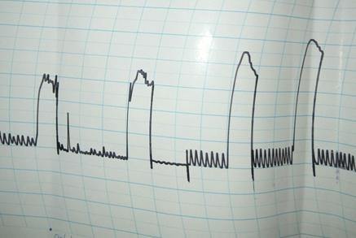

0.02 x 10-3

g/ml Ach

0.04 x 10-3

g/ml Ach

0.08 x 10-3

g/ml Ach

0.16 x 10-3

g/ml Ach

Plate VII: Effects of graded acetylcholine (20 _ 160ng/ml) final organ bath concentrations on isolated rabbit jejunum

## Appendix 11

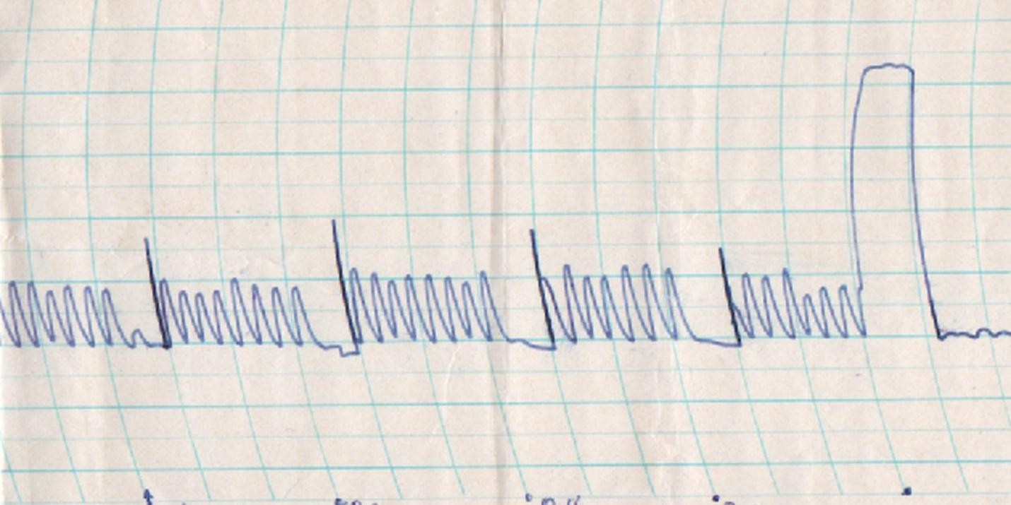

0.4 x 10-6

g/ml MEIW

0.8 x 10-6

g/ml MEIW

1.8 x 10-6

g/ml MEIW

3.2 x 10-6

g/ml MEIW

0.16 x 10-6

g/ml Ach

Plate VIII: Effects of graded concentrations of MEIW (0.4 x 10-6 – 3.2 x 10-6 g/ml) on isolated rabbit jejunum

## Appendix III

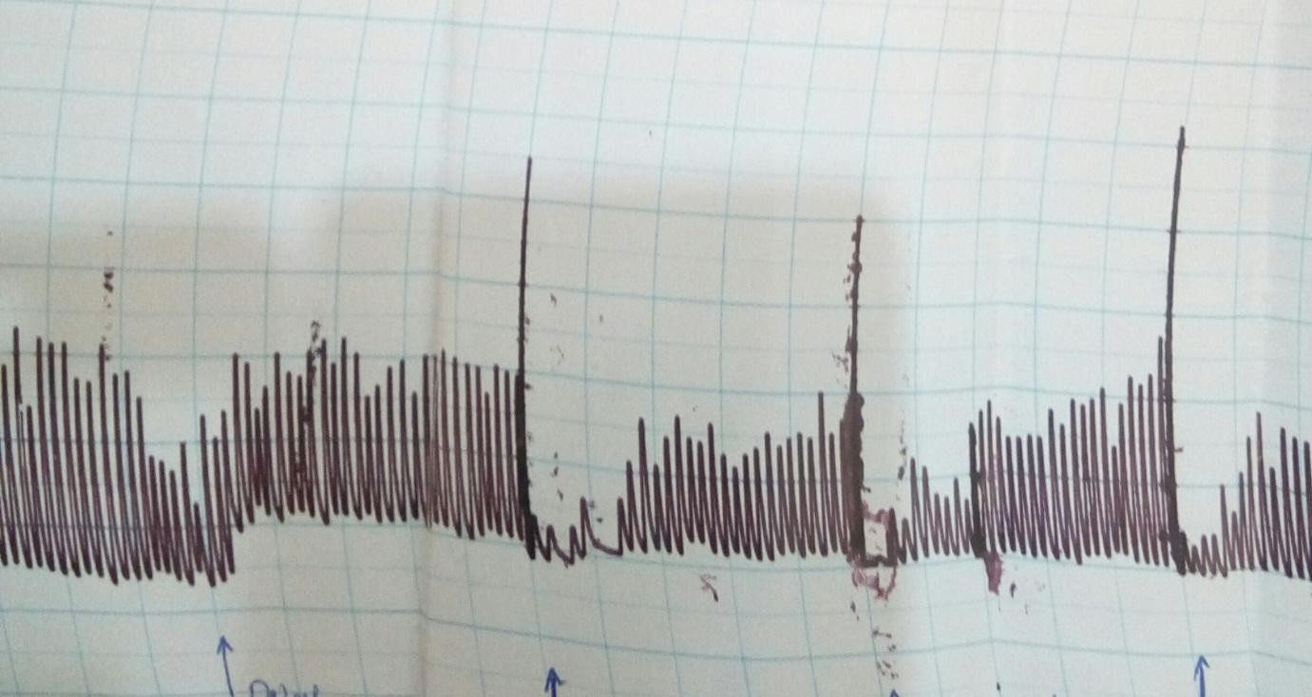

**0.04 x 10-60.04 x 10-6g/ml Ach 0.04 x 10-6g/ml Ach 0.04 x 10-6 Ach g/ml Ach 0.8 x 10-6g/ml MEIW 1.6 x 10-6g/ml MEIW**

**3.2 x 10-6 MEIW**

Plate IX: Antagonistic effect of graded concentrations (0.04 _ 3.2µg/ml) of Methanol stem bark extract of *I. wombolu* with Acetylcholine (40 ng/ml) on isolated rabbit jejunum

## Appendix IV



**0.04 x 10-6g/ml Atrp0.04 x 10-6g/ml Atrp**

**0.04 x 10-6g/ml Atrp**

**0.04 x 10-6 Atrp**

**0.4 x 10-6g/mlMEIW 0.8 x 10-6g/ml MEIW 1.6 x 10-6g/ml MEIW 3.2 x 10-6 MEIW**

Plate X: Synergistic effects of graded concentrations (0.04_ 3.2µg/ml) of methanol stem bark extract of *I. wombolu* with atropine (Atrp 40 ng/ml) on isolated rabbit jejunum

## Appendix V

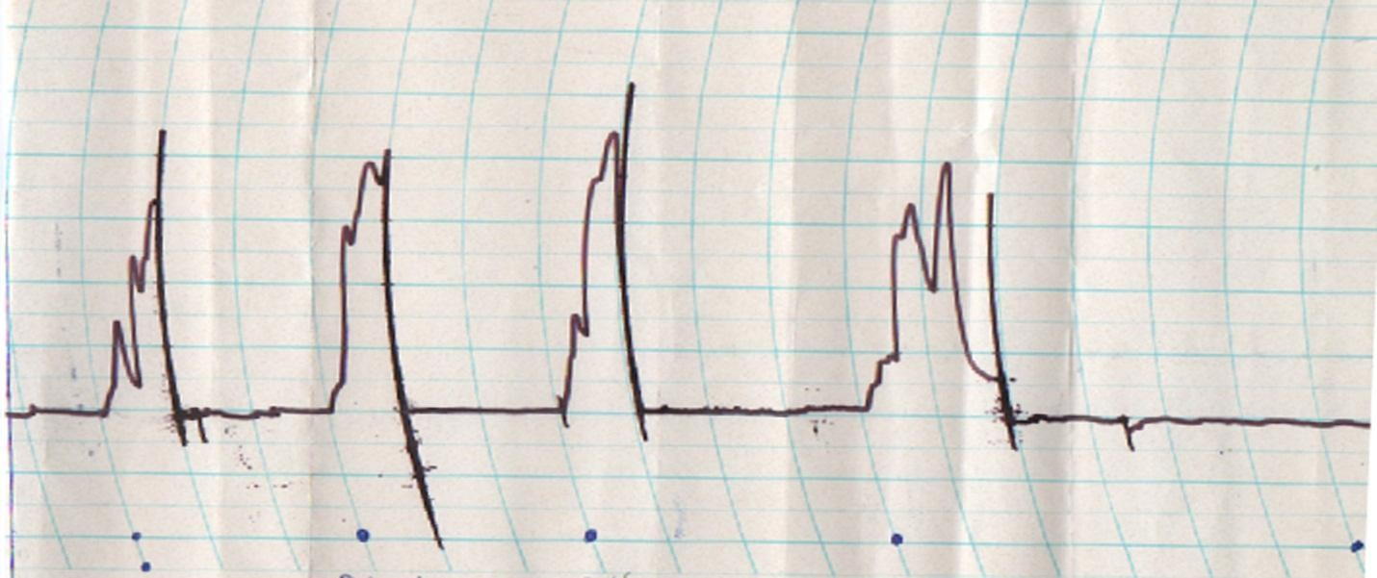

**0.02 x 10-3**

**g/ml Hist.**

**0.04 x 10-3**

**g/ml Hist.**

**0.08 x 10-3**

**g/ml Hist.**

**0.16 x 10-3**

**g/ml Hist.**

Plate XI: Effect of graded concentrations of Histamine (Hist. 20 – 160 ng/ml) on isolated guinea pig ileum



**0.4 x 10-6**

**g/ml MEIW**

**0.8 x 10-6**

**g/ml MEIW**

**1.6 x 10-6**

**g/ml MEIW**

**3.2 x 10-6**

**g/ml MEIW**

**3.2 x 10-6**

**g/ml MEIW**

Plate XII: Effect of graded concentrations of methanol stem bark extract of *I.* wombolu (0.4 x 10- 6 – 3.2 x 10-6 g/ml) on isolated guinea pig ileum

## Appendix VI

**Calculations**

The percentage extract yield of methanol stem bark extract of *I. wombolu* was calculated as:

Weight of extract Weight of dried powder

x 100 = 218 .84

2000

𝑋 100 = 10.94%

## Median lethal dose (LD50) determination

First phase:

|  |  |  |  |
| --- | --- | --- | --- |
| Doses  Stock concentration No of animals | **10 mg/kg**  **1 mg/ml**  25 g= 0.25 mg/kg  19 g= 0.19 mg/kg  21 g= 0.21 mg/kg | **100 mg/kg**  **10 mg/ml**  27 g= 0.27 mg/kg  30 g= 0.3 mg/kg  28 g= 0.25 mg/kg | **1000 mg/kg**  **100 mg/ml**  28 g= 0.28 mg/kg  22 g= 0.22 mg/kg  26 g= 0.26 mg/kg |

Calculation: 0.3 g of the extract was weighed= 300mg and then dissolved into 3 ml of water 300 mg/ 3 ml= **100 mg/ml (Stock concentration)**

Using the formula: Dose x weight/ Stock, doses administered to animals were calculated

Second phase:

|  |  |  |  |
| --- | --- | --- | --- |
| Doses Stock  No of animals | **1600 mg/kg**  **160 mg/ml**  25 g= 0.14 | **2900 mg/kg**  **290 mg/ml**  22 g= 0.22 mg/ml | **5000 mg/kg**  **500 mg/ml**  28 g= 0.48 mg/ml |

Calculation: 0.58 g of the extract was weighed= 580 mg and dissolved into 2 ml of water 580 mg/ 2 ml= 290 mg/ml

Using the formula: Dose x weight/ Stock, doses administered to animals were calculated