# AMERICAN UNIVERSITY OF NIGERIA DEPARTMENT OF NATURAL AND ENVIRONMENTAL SCIENCES

Senior Research Project

# ANALYTICAL STUDY OF PROSTATE CANCER IN MEN LIVING IN ADAMAWA STATE; CASE STUDIES IN FEDERAL MEDICAL CENTER YOLA, DAAMA CLINIC AND ZENITHCARE

by

# FUNOM RESTORATION HASSAN A00015063

Submitted in partial fulfillment of the Requirements for the degree of Bachelor of Science

2015

# AMERICAN UNIVERSITY OF NIGERIA DEPARTMENT OF NATURAL AND ENVIRONMENTAL SCIENCES

**ANALYTICAL STUDY OF PROSTATE CANCER IN MEN LIVING IN ADAMAWA STATE; CASE STUDIES IN FEDERAL MEDICAL CENTER YOLA, DAAMA CLINIC AND ZENITHCARE**

This thesis represents my original work in accordance with the American University of Nigeria regulations. I am solely responsible for its content.

# FUNOM RESTORATION HASSAN

**Signature Date**

I further authorize the American University of Nigeria to reproduce this thesis by photocopying or by any other means, in total or in part, at the request of other institutions or individuals for the purpose of scholarly research.

# FUNOM RESTORATION HASSAN

**Signature Date**

# ANALYTICAL STUDY OF PROSTATE CANCER IN MEN LIVING IN ADAMAWA STATE; CASE STUDIES IN FMC YOLA, DAAMA CLINIC AND ZENITHCARE

**FUNOM RESTORATION HASSAN**

Approved by

Research Supervisor: **Dr Jennifer Tyndall, Ph.D**. Professor of Natural and Environmental Sciences

Signature Date

Second Reader: **Dr Regina Mousa, Ph.D**. Professor of Natural and Environmental Sciences

Signature Date

# DEDICATION

I dedicate this research project to God almighty, for his sustenance, his guidance and for overall well-being to carry out the research successfully. I also dedicate the project to my wonderful parents Pastor and Dr Mrs Hassan for their sacrifice in seeing me this far in life and their constant encouragement. I love you both.

# ACKNOWLEDGEMENT

First and foremost I appreciate God for granting me resilience and the capability to carry this research in good health. I thank my supervisor Dr Jennifer Tyndall for her ample support and guidance; I also thank Dr Boyd for being the best project co- ordinator I ever did see, for her patience and advice and for soothingly pushing me towards my goal. I appreciate Dr Regina Moussa for taking out the time from her rigorous schedule to go through my work and correct me. I want to appreciate my friends who stood by me, went to class with me and kept me company as we struggled to meet deadlines and meet demands from our supervisors. I appreciate my roommate Susan for bringing me food when in my zeal I forgot to eat. Generally, I appreciate everyone that made this research a success. God bless you all and I love you all.

# ANALYTICAL STUDY OF PROSTATE CANCER IN MEN LIVING IN ADAMAWA STATE; CASE STUDIES IN FEDERAL MEDICAL CENTER YOLA, DAAMA CLINIC AND ZENITHCARE

**FUNOM RESTORATION HASSAN A00015063**

American University of Nigeria, 2015

Major Professor: Dr Jennifer Tyndall Ph.D.., Professor of Natural Environmental Sciences

**ABSTRACT:** The research is on the analysis of prostate cancer in men living in

Adamawa state, this topic is essential to determining certain degenerative factors that make individuals more at risk of being diagnosed with the condition. Some of these factors include age, genes, lifestyle etc. The sample size afforded an opportunity for data collection with the aid of questionnaires and interview techniques which enhanced the knowledge of prostate cancer epidemiology, screening methods and biomarkers (such as the prostate specific antigen test) of the condition. The data thus derived were then analyzed with SPSS software which yielded the feasible output that led to the results obtained. From the results obtained it could be seen that the age group ranging from 60 to 64 had the highest occurrence and men who were members of a younger age group like 50 to 54 were usually men with family history of prostate cancer. This research was conducted with the help of Urologists, histologists and specializing surgeons who were very learned and conversant in the field of cancerous ailments as well as medical interventions.

# Key terms: biomarkers, Epidemiology, Urologist, Histologist, Screening methods

**Table of Content**

Certification Statement ii

Approvals iii

Dedication iv

Acknowledgement v

Abstract vi

1.0 Introduction 1

Aims and objectives 1

* 1. Background and literature review 3
  2. About the prostate gland/Overview of cancer 4
  3. Benign prostatic hyperplasia 5
  4. Pathology of prostate cancer 9
  5. Anatomical pathology 10
  6. Chemical pathology 10
  7. Cytogenetic pathology 11
  8. Prostate cancer and race 12
  9. Impact of prostate cancer 15
  10. Side effects of prostate cancer 15
  11. Prostate cancer and impotence 15
  12. Prostate cancer and incontinence 16
  13. Prostate cancer and infertility 17
  14. Epidemiology 18
      1. Global incidence of prostate cancer 18
  15. Prostate cancer and diet 20
  16. Prevalence of prostate cancer in Nigeria 21
  17. Risk factors of Prostate cancer 24
      1. Age 24
      2. Genetics 24
      3. Geographical location 25
      4. Obesity 25
  18. Detection, diagnosis, treatment of prostate cancer 25
  19. Detection 25
  20. Diagnosis 26
      1. Clinical assessment 26
      2. Clinical symptoms 27
  21. Digital Rectal exam 28
  22. TURP (trans-urethral resection of the prostate) 28
      1. Pros and cons of TURP 29
      2. Pros of TURP 29
      3. Cons of TURP 29
  23. Treatment 29
  24. Materials and methods 31
  25. The focus of the study 31
  26. Description of the study site 32
  27. Materials used for data collection 33

6.0 Results 35

7.0 Discussion 41

8.0 Conclusion/Recommendation 47

Reference 50

# List of Figures

Figure 1: Showing the prostate gland 6

Figure 1a: Showing an extensive view of the male reproductive system 7

Figure 2: Showing bar-chart of age against percent for incidence of prostate cancer.

................................................................................................................................13

Figure 3: Graph showing the probability of cancer 14

Figure 4: Showing the age distribution of men >40 years of age who were screened

................................................................................................................................23

Figure 5: Showing the trends of PSA in men >40 years of age by year screening 23 Figure 6: Showing proportion of abnormal DREs to total DREs 24

Figure 7: Showing a graph of age against severity of prostate cancer 35

Figure 8: Graph of frequency 36

# List of Tables

Table 1: Showing sensitivity and specificity of different PSA thresholds 14

Table 2: Showing information on a variety of treatment options and their effect on sexual morbidity 18

Table 3: Attendance of men at outreach events 22

Table 4: Relationship between education and frequency of check-up 37

Table 5: Showing the ethnicity of patients in percent 38

Table 7: Showing table of response of participants regarding history of prostate cancer in the family 39

Table 8: Showing the symptoms experienced by participants 40

**List of abbreviations**

FMC –Federal Medical Center Pca – Prostate cancer

DRE – Digital Rectal Exam

PSA – Prostate serum antigen test Mm Hg – Millimetres of mercury Bpm – Beats per minute

BPH – Benign Prostatic Hyperplasia

TURP – Transurethral resection of the prostate

# 1.0 BRIEF INTRODUCTION:

The topic of this research is one that is of keen interest and hence the reason for the study. The topic delves into an area of the male anatomy that is of enormous importance and one that is seemingly neglected by many academicians; especially students. It is common knowledge that cancer is a malignant growth and replication of cells that leads to several health complications which are mostly fatal. However, when talking about cancer the popular ones are cervical, breast and in some cases testicular cancer. The study of the prostate cancer and relation of it to its applications and importance to life is one that is neglected by young academicians even though it is a popular topic. This piqued the interest and desire to explore and research more on this topic, in order to understand better the male anatomy and the condition itself.

# AIMS AND OBJECTIVES OF RESEARCH TOPIC:

The research had specific aims and objectives that were to be accomplished in the course of the research. These aims and objectives were the bedrock on which the research and data collection was done. They helped to direct the format in which the research was undergone and based on the topic the aims and objectives were as follows:

**To determine how common prostate cancer is in men living in Adamawa state:** This aspect was the main part of the research topic. It was mainly to see how many men were living with the incidence of prostate cancer in Adamawa state. This was done by distribution of questionnaires which made the inquiry easier. This was done for men of ages 50 and above and majority of them had conditions relating to the research interest. Those who did not have the cancer of the prostate had benign

prostatic hyperplasia and others just had mild inflammation. This aspect helped in the identification of just how prevalent the condition was in men of Adamawa state.

Some particular age groups had fewer incidences than others and the age group with the highest incidence was the age group ranging from 60-64.

**To determine the connection between prostate cancer and genetic:** This part of the research was to determine the link if any between the prevalence of the condition prostate cancer and genetics. The patients that were interviewed in the course of this research shed more light on that. Prevalence of prostate cancer has been shown to be due to several reasons and factors including genetics. The overall belief is that a man is at a higher risk of being diagnosed with this condition if any member of his family had had the condition prior to him. In some cases the men who had this condition had fathers or uncles or other relatives who had had the same issue before then. However, most of the men who were analysed did not have any such criteria or they were not entirely sure about it. This was helpful in determining that while genetics plays a role in the prevalence of the condition it does not play an overall role. It makes more sense to imply that men whose family members have had the condition were in more risk than those whose family members did not have the condition.

The impact of prostate cancer is also one of the aims of the research. This is to see how the condition affects the patient in terms of impotency, inconsistency and infertility. These areas are of major concern to many men and this was one of the areas that was concentrated on to enable a vast understanding of these impacts, how they impair the lives of the patients and how to tackle them.

The research went further to determine the risk factors related with prostate cancer. This is because the exact cause of the condition is not known and to be able to limit

its prevalence the risk factors have to be understood. These risk factors were studied based on race and ethnicity as well as lifestyle and other such factors.

Furthermore, the research was aimed at determining the effectiveness of medical interventions and how much degree of normalcy is regained by the patient after each procedure. This was done with the help of case studies which progressively followed the patient from diagnoses to post-surgical conditions.

# LITERATURE REVIEW ON PROSTATE CANCER 2.0 ABOUT THE PROSTATE GLAND:

The human body is one that has so many complexities. There are various aspects of it that scientists have studied and been able to understand fully. The part of the human anatomy under discourse in this paper is that of the male anatomy known as the prostate gland. This is a part of the male accessory organ and is the size of a kiwi fruit. Its importance to male body functions and even to females cannot be overemphasized and that is why the issue of prostate cancer is one of severe concern (rishma, 2007).

This organ among many things helps the process of excretion of urine. It is an intermediary of sorts between the bladder and the urethra and functions in passing waste fluids through these two organs and subsequently out of the body (Gleave, 2005). This particular function that it performs is one of many that make it very delicate and important to the physiology of any male. It is also very crucial in the passage of semen during sexual excitement. The prostate gland functions in this regards by secreting a fluid that is known as the seminal fluid. This fluid helps in

keeping the sperm protected and viable (ajape et al, 2010). The fluid helps to reduce the acidity of the semen and gives it a form of cushioning. The reduction of acidity goes further in aiding reproduction in females as a highly acidic sperm would not be viable for fertilisation. This fluid forms a large part of the total semen that is let out by the male penis during ejaculation (Gleave, 2005). This fluid has its own very important functions; it secretes an antigen known as the prostate specific antigen which helps to keep the semen in its liquid form. Based on the issue of fertility and acidity of the sperm, the seminal fluid is important due to the fact that the female vagina is acidic and could destroy the viability of the semen. The fluid secreted from the prostate keeps the semen at a regulated pH that protects it from the acidic environment of the vagina. It could also help in keeping urine out of the semen and aiding pleasurable sensations during coitus (ajape et al, 2010).

* 1. **OVERVIEW OF CANCER:** The word cancer refers to a malignant growth in

the body. It occurs from an uncontrollable growth and replication of cells in a particular region. This uncontrollable cell division may start at an origin and then spread to separate regions and into various tissues in the body causing varying effects ranging from benign to malignant (Zatzkin, 2010). The division of cells continuously could lead to lumps or an aggregation of tissues known as tumours. The particular site initially affected determines the form the cancer takes, for instance in the breast it occurs as lumps but in the prostate it is a build-up of tissues that results in tumours (ukoli et al, 2003). Research has shown that the reason behind cancer cells spreading has to do with the sticky properties of cells.

When a cell becomes cancerous, molecular interactions otherwise known as the extracellular matrix causes it to become unstuck. This cell becomes dislodged and

moves to another site where it binds and replicates and this process is repeated continuously (Walz, 2010). This causes an obstruction to body systems such as circulatory systems and other systems of the body. There are various kinds of cancer all of which are extensively talked about in various articles including journal by ajape et al; but for the sake of this paper, the focus would be on prostate cancer (Walz, 2010).

Prostate cancer is often benign this is because it does not spread to other sites very fast like malignant tumours do. Tumours that are not benign are more agile in that they can move through small gaps and bind to sites that benign cancer cells may not be able to reach, they can also move with more force giving them more speedy time for replication (zatzkin, 2010). DNA mutation is the real brain behind these uncontrollable replications. This is due to the fact that when DNA is mutated the process of cell division is affected and in most cancerous cases, the cells replicate and do not die (ajape et al, 2010).

# BENIGN PROSTATIC HYPERPLASIA AND PROSTATE CANCER:

Benign prostatic hyperplasia is a condition that is not the same as prostate cancer. They are two very different conditions (pettaway et al, 2011). Benign prostatic hyperplasia is a condition in older men that occurs when cells begin to replicate within the prostate at a zone known as the transition zone. It does not grow outward but inward and wraps around the urethra hence causing urinary difficulties (Badawi, 2003).

Prostate cancer on the other hand is a condition that affects the prostate gland but in this case it affects the peripheral zone of the gland. This means that it grows outwards and affects surrounding tissue. It is an enlargement of the prostate that is

not detected until years after initial growth because it is a slow progress (Badawi, 2003). The prostate is an organ that continues to grow from the age of 25 and because it grows very slowly it poses not serious problems till about the ages of 50 or 60 (rishma, 2007). The condition is called benign because it is not a malignant form of cancer; it is not life threatening in most cases but it impairs normal living and could make the patient very uncomfortable. The cancer is as a result of cells that replicate out of control either within the prostate gland itself or outside it to other parts; this is known as metastasis (pettaway et al, 2011).

(Figure 1: **Showing the prostate gland**)

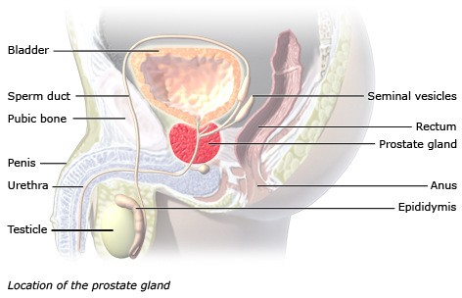

(Badawi, 2003)

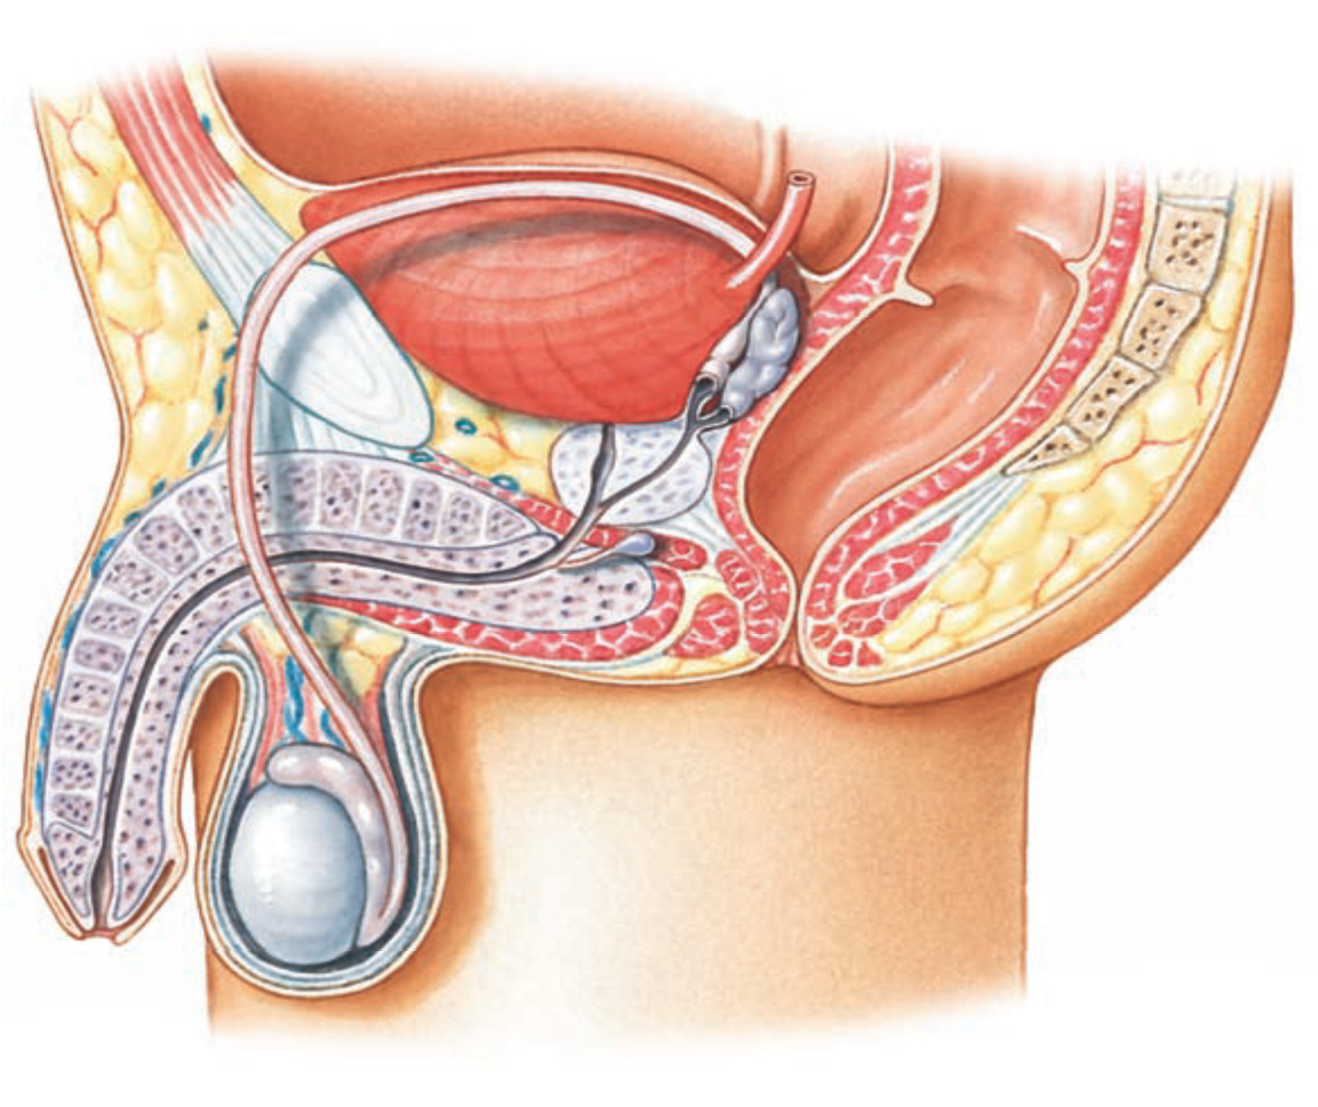Figure 1b:

Showing an extensive view of the male reproductive system (martini, 2012).

Prostate cancer is the type of cancer that does not spread quickly and is not as life threatening as the other forms of cancer that spread more quickly. The major reason why the prostate cancer poses any form of issue is because of it disadvantageous position between the bladder and the penis (pettaway et al, 2011).

This position results in discomfort in urinary process which might range from mild to severe as the prostate continues to grow. A prostate cancer detected early has a higher chance at being treated successfully. While it may not always be fatal, it destabilizes the life of the patients, making normal processes such as passing out urine a thing of pain and discomfort and so this leads to patients eventually seeking medical help (pettaway et al, 2011).

# RELATIONSHIP BETWEEN PROSTATE CANCER AND

**PROSTAGLANDINS:**

Prostaglandins are popularly known Eicosanoids. These are molecules that are highly important in many clinical and medical processes. Prostaglandins are involved in carcinogenic processes as well as in malignant processes and cases of heightened aggressiveness in malignant conditions (Badawi, 2003). The relationship between prostaglandins (which are commonly annotated as PGs) and prostate cancer is one that is of enormous importance. This is based on research as well as studies that have shown that the advent of prostate cancer and other carcinogenic conditions is directly related or linked to the levels of PG in the body. This characteristic or feature is similar for both humans and some animals as well (Badawi, 2003).

PGs also affect the aggressiveness of carcinogenic conditions as well as the degree of metastasis in these conditions. The link of these Eicosanoids is to a large degree due to the possible growth enhancing factors or growth promoting factors that they possess. This has been proposed to be a possible method that could be used in implementing prevention techniques for prostate cancer (Badawi, 2003).

# PROSTAGLANDINS AND REPRODUCTION:

The role of the prostaglandins is such that expands to processes of reproduction in females. The prostate functions in stimulating the pituitary gonadotropins secretion. This is crucial for the stimulation of the uterus and it also aids in rupturing the follicle which then leads to the formation of the corpus luteum in ovarian events. It also functions in constricting blood vessels which opens the door for pregnancy; it is

also helpful in stimulating contractions of the uterine during both menstruation and parturition (Behrman, 1974).

* 1. **PATHOLOGY OF PROSTATE CANCER:** Pathology is a branch of science

involved in the study of diseases. Diseases such as infections and cancers; this goes through from the levels of genetics, cellular, molecular and into the organs levels. It delves deep into the anatomy and physiology of living organisms to try and understand the causal agents behind diseases and the effects they have on the body (Walz. J et al, 2010). This aspect of science also focuses on the diagnostic phase of diseases. These diagnoses do not stop at just blood tests; there are other criteria to it (Patel et al, 2013). These criteria includes examining how the diseases progress and how it affects the body. The effects, complications, symptoms and others are crucial parts that are also studied as a part of the pathology of diseases.

Pathology is mostly about research; about understanding the pathogens, bacteria and other foreign causal agents of diseases. This is a huge stepping stone to making effective and accurate diagnoses (George et al, 2014).

During pathology several components of the body are brought into consideration and under examinations. The body tissues are studied for patterns and trends that could help in identifying what disease or pathogen is being sought after. Blood tests as well as fluids tests are also done for this same purpose (Patel et al, 2013). This is important and helps in the monitoring phase and disease progression from one level to another to aid in detecting changes in severity and the effects of those changes. Pathology is a branch done by medical practitioners known as pathologist. These are people who have been trained for the purpose of detecting diseases, their causes and their effects. They are people who are mainly into research

and consultation. According to journal by George et al, 2014 pathology has different areas known as specialty areas and they comprise of the following;

# Anatomical pathology:

This studies the organs and tissues of the body to describe or get a better feel of the problem on ground. It also helps medical practitioners to decide the best approach to treatment (Huyghe et al, 2013).

This branch of pathology deals specially with the morphology of diseases. It could be related to special areas such as the gynaecological pathology (Patel et al, 2013). This is the branch of anatomical pathology that focuses on the diseases that affect the female genital tract. Another branch of anatomical pathology is dermato- pathology and it deals with diseases affecting the skin. Other branches include cardio-vascular pathology, neurological pathology, gastro-intestinal pathology, endocrine pathology etc (George et al, 2014).

# Chemical pathology:

This deals with the chemical and biochemical aspect of the body that relates to diseases. It also aids in the treatments that involves drugs and other chemical remedies (Huyghe et al, 2013).

According to George et al, 2014 chemical pathology which can also be referred to as clinical biochemistry deals with investigating as well as studying the biochemical background of diseases i.e. the way the diseases progress and the reason behind that. It studies diseases with emphasis on metabolic diseases. These diseases include diabetes, lipid disorders, bone diseases as well as inborn error (genetic disorders).

Chemical pathology is diverse in that it does not just bring science and medicine together; it is also linked to all medical specialties. It uses biochemistry tests for diagnosis and disease management (George et al, 2014).

# Cytogenetic:

This is based on the chromosomal study. It helps in providing an understanding of disease pathogens as it relates to genetics (Huyghe et al, 2013). This involves diseases that could have been passed down through genetics and inheritance of chromosomal material. This aspect of pathology is done with high powered microscopes for viewing of chromosomal structures and models of genetic material. Other forms of pathology include haematology, microbiology, immunology and molecular pathology (George et al, 2014).

Prostate cancer being the second most diagnosed cancer has about approximately 240,000 deaths annually (Patel et al, 2013). According to Patel et al, 2013 research it has been observed that the incidence and mortality of the disease varies based on race and region. In the United States, African American men are at the highest risk of developing prostate cancer with an annual incidence of about 178 out o 100,000. This number is in total contrast to that of south Asians who have an incidence of 88.3 out of 100,000. Research done with parameters that includes clinical and pathological data, level of the prostate serum antigen (PSA) as at the time of diagnosis, the biopsy score, the Gleason score, the clinical and pathological score and other such parameters showed compelling results that connected south Asians and African Americans.

Asians have been known to have a low risk of being diagnosed with prostate cancer. Speculations have proposed genetics as well as eating habits as the source of the low incidence with Asian men (Akinremi et al, 2014). The diet as well as the readily available medical attention and screening play a critical role in keeping Asian men at a minimal level of prostate cancer exposure. This however does not reduce the pathological characteristics seen with Asian men that were diagnosed with prostate cancer. A comparison with high risk African Americans show that south Asian men who have been diagnosed show similar in characteristic and mortality risks as do African American men (Akinremi et al, 2014).

Their stages of disease were higher during the research conducted and the research also showed Asians had worse pathological features than did African American men. These features were also worse than those of white Caucasians. In addition, Asian men who were born and thus treated in the U.S had less aggressive conditions than Asian men living in Asia. This was summed up to quick screening and publicity of the disease in the states (Patel et al, 2013).

# PROSTATE CANCER AND RACE

Prostate cancer seems to be a discriminatory disease. This is based on the differential way in which it affects individuals based on their race, ethnicity and region. Caucasian men have an incidence rate of 144.9 out of 100,000 and in comparison to the figures for African Americans and Asians there is an obvious disparity (Akinremi et al, 2014).

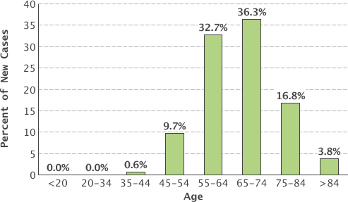

Figure 2: Showing bar chart of age against percent for incidence of prostate cancer (Patel et al, 2013)

The discriminatory nature of the disease goes past the incidence rates and into the response individuals have to treatments. A difference is seen in the response Asians and pacific islanders have to treatments of PSA and PSAD (Prostate specific Antigen Density) (Akinremi et al, 2014). There was a general adherence to treatment

i.e. they performed better or responded better to treatments than their white counterparts. The static PSA test has been the common test used for prostate cancer for several decades. This test is however only beneficial for a few because several others would find it unnecessary. This is due to the fact that majority of those with the condition do not have aggressive cases of metastases (Patel et al, 2013).

An analysis of the effects of these tests has been done and a variation in effectiveness was noted for the PSA and the PSAV (prostate specific antigen velocity) tests. The PSA test was seen to have slightly more effect than the PSAV. The difference is however quite negligible as it is not a huge difference in the detection of high-grade prostate cancer for the two tests (ajape et al, 2010).























Table 1: A table showing the sensitivity and specificity of different PSA thresholds (ajape et al, 2010)

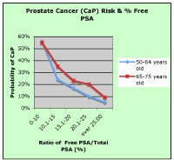

Figure 3: Graph showing the probability of cancer of the prostate against the ratio of free-to-total PSA test (Patel et al, 2013)

* 1. **IMPACT OF PROSTATE CANCER:** Many men who have been diagnosed

with this condition have been found to have varying concerns. These concerns are about the impact prostate cancer has on their normal living before and after treatment (ajape et al, 2010). There are various side effects attached to this condition and they are enumerated below:

# SIDE EFFECTS OF PROSTATE CANCER

# PROSTATE CANCER AND IMPOTENCE:

There has been a great deal of concern as regards the issue of impotence as a result of prostate cancer. Many men are worried about the danger of them becoming impotent as a result of this condition (Huyghe et al, 2013). Impotence could be as a result of the treatments used to slow the spread of the cancer or in some extreme cases t could be as a result of the disease itself. The understanding of these side effects prepares a patient to know what to expect and how best to cope with these effects. One of the major impacts prostate cancer has in regards to impact is the case of impotence. This is the inability to achieve and/or maintain erection in the penis (Gleave et al, 2005). Treatments in men with advanced prostate cancer such as the removal of the testicles which is known as Orchidectomy most likely results in impotency in men. Drugs used in the treatment of the condition to reduce testosterone levels could also lead to impotency. In some instances men can recover all by themselves after a while but others may need to seek medical assistance (Huyghe et al, 2013).

* 1. **PROSTATE CANCER AND INCONTINENCE:** Another major impact o

prostate cancer is incontinence. This is a condition in which the male cannot control the flow of urine. This could be as a result of surgical processes mostly and can be corrected medically through exercises and other options. Exercises that strengthen the sphincter and the pelvic muscles help in the control of urine flow. The sphincter is a cylindrical muscle that normally maintains constriction of a body passage. This muscle when strengthened helps the patient to pass urine out more effectively (Gleave et al, 2005).

Urinary incontinence (UI) is a problem that has to do with the leakage of urine involuntarily and it is associated with certain factors which include age, benign prostatic hyperplasia, over-weight and even prostate cancer (gat et al, 2012). These factors are risk factors that could elevate the probability of having this condition.

This condition poses clinical challenge because it has varying frequency and severity (chen et al, 2014). It is directly as a result of an over-reactive bladder also known as known urge incontinence or it could be due to urethral sphincter malfunction which is known as stress incontinence. Similar to the problem of infertility the issue of incontinence can also be directly related to the form or forms of treatments that are used on patients; especially in cases of Pca. In the article by Chen et al, 2014 it is said that the condition seems to be worse off with radiation therapy as it develops years after the procedure and seemingly has little or no chance of recovery. It is a little less severe in radical prostatectomy which leaves a patient still needing to wear pads for about a year after operation (chen et al, 2014).

# PROSTATE CANCER AND INFERTILITY:

Perhaps one of the most serious issues associated with prostate cancer and post treatment effects is the issue of infertility. Infertility is simply the inability to fertilise a woman’s egg and get her pregnant. This is due to the medical procedure called prostatectomy (gat et al, 2012). This is the removal of the prostate and the seminal vesicles and it affects the flow of semen which results in an inability to fertilise the egg. Radiation therapy could also impair the ability for semen to transport the sperm properly and this hinders the process of fertility (Gleave et al, 2005).

Furthermore on the issue of infertility as a result of prostate cancer treatments is that several treatment options hold differential risks pertaining to the dangers of infertility. Whether the treatment is prostate brachytherapy, radical prostatectomy or any of the others listed in figure 3 there are risks associated (chen et al, 2014).

According to Huyghe et al, 2013 series of research has shown that while some treatments are have less propensity for sexual morbidity others have more (Huyghe et al, 2013). According to this research the brachytherapy (treatment using ionization radiation to treat cancer) has the lowest morbidity on sexuality while the radical prostatectomy has the highest. Figure 3 provides more information on these treatments and the effects they pose on infertility (gat et al, 2012). The effect of these treatments are not however restricted to just infertility. Several other factors are involved such as issues with sexual intimacy, sexual fantasy or imaging and as severe as issues with everyday relations with women (Huyghe et al, 2013)

# TABLE SHOWING DIFFERENT MEDICAL INTERVENTIONS AND THEIR EFFECT

|  |  |
| --- | --- |
| Treatment options | Morbidity rate on sexuality |
| Prostate brachytherapy (PB) | 0.76 |
| External beam radiotherapy (EBR) | 0.55 |
| Nerve-spanning radical prostatectomy | 0.34 |
| Radical prostatectomy | 0.25 |

Table 2: Showing information on a variety of treatment options and their effect on sexual morbidity (Huyghe et al, 2013).

Furthermore, research has shown that prostatic fluid plays a vital role in instigating uterine contractions and fertility (chen et al, 2014). Uterine contractions are the process by which the walls of the uterus contract to enable the spermatozoa to reach the site of fertilization in the oviduct. Studies have shown that infusing semen into the uterus with prostatic fluid is a more effective way of inciting pregnancy than using saline solution (england et al, 2012). These studies have been done on both animals and humans with similar results and this alludes even more to the importance of the prostate to fertility especially in artificial insemination. It is an increasingly important application to medical science because fertilisation cannot occur without these contractions (england et al, 2012).

# EPIDEMIOLOGY

* + 1. **GLOBAL INCIDENCE OF PROSTATE CANCER:** Global incidence of

prostate cancer across the globe has differing trends as observed with various races. For instance, the trend in men of African descent is somewhat different from men of

other races. Based on Kamanger et al research men with African descent seem to have a higher mortality rate and a more aggressive case of the condition. This result is inconclusive due to the small sample size of men of African descent that have been used for the studies (kamanger et al, 2006). Continues clinical tests and research are being conducted to determine proper diagnostic tests, treatment and prevention of recurrence of the condition. A major diagnostic test that is used for screening of prostate cancer is the PSA (prostate serum antigen) (George et al, 2014). This screening is not acceptable in every country especially developing countries and some developed countries such as the Great Britain. Challenges have been posed as to the suitability of the test for diagnosis of prostate cancer (George et al, 2014).

The higher risk of men with African descent could also be juxtaposed with the counter beliefs associated with this test. Men with African descent might not be as frequent with health care specialists and so early detection of the condition might not be possible; this would lead to a more aggressive or severe case of the condition and so might increase the rate of mortality for men of this region (kamanger et al, 2006).

The cultural belief could also be a prominent factor. It is common acceptance that prostate cancer is a disease of aging and that if anyone lives long enough it would catch up with him. This has led people to see the PSA and other forms of treatment as unnecessary and a large number of men with African descent have been associated with a lack of interest in getting regular medical attention (kamanger et al, 2006).

According to Kamanger et al, in cases where men with African descent seek health care services regularly, there is a better chance of early detection and in such situations the rate of mortality and that of survival is not different from other races such as Hispanic races (George et al, 2014). The same could be said for British men

of Caribbean or African descent. They also showed no much difference in survival rates even though the PSA is not an accepted diagnostic test in Britain (kamanger et al, 2006).

A study of 335 African American and Bohemian men who are all of African descent revealed that a huge factor in the refusal of these males to get medical attention on the regular was culture (kamanger et al, 2006). The need to portray the attitude of alpha males, and the relationship of getting medical attention as unmanly or cowardly ensured that most of these men refused medical care and by so doing early detection of prostate cancer was evasive (kamanger et al, 2006).

# PROSTATE CANCER AND DIET:

Food is something whose importance cannot be undermined. When eaten right it can be a booster of health and well-being but when not eaten right then it can turn around to be a harmful thing. This double edged behaviour of food can affect one's health when it is eaten wrongly; this is because it could lead to fat related issues. Over-weight could be as a result of not eating right, although it can also be as a result of other things (kamanger et al, 2006).

When diet becomes an issue obesity can result and then several diseases can ensue. In the condition where obesity does not cause the problem like in Pca, it enhances its malignancy and makes the case more severe than it naturally should have been (George et al, 2014).

# PREVALENCE OF PROSTATE CANCER IN NIGERIA

The prevalence of prostate cancer among males of Nigerian population has become a common place thing. The disease has been noted to be more severe in males of black descent than in males of other ethnicity (Patel et al, 2013). In recent times, statistics have shown that more and more men are consensually getting screened. Males ranging from the ages of 40-85 years old are getting screened; this age group has about 85.4% of adherence as opposed to other such research and statistics obtained (Akinremi et al, 2014). Prostate cancer (Pca) according to this research by Akinremi et al alludes to the high risk of prostate cancer in Nigerian men as being due to the lack of screening and health care checks.

The black race shows some aggressive response to the disease but as yet many parameters related to the risk factors and the causes especially in men of black descent are still unknown. This research does not mean that all men of black descent have total similarities in their cases (Akinremi et al, 2014). There are disparities seen in men of native Africa and African Americans (AA). Pca is considered to be more prevalent in AA men than in native African men says Akinremi et al. However, this information cannot be conclusively stated as native African men have not received much research and screening and other health care attention that would bring about that conclusion (Patel et al, 2013).

There are several reasons why this condition has high rates of prevalence in Nigerian men and among these reasons is the fact that there is poor education about the condition and how it affects people (Patel et al, 2013). Misinformation often is worse than no information because in this case it brings about a nonchalance in Nigerian men which results in lack of screening and other health care consultations. This is

why screening is crucial because it serves as a means for educating the population on the condition. The advantage of this form of education is that some of the risk factors which may increase severity or recurrence can be avoided (Akinremi et al, 2014).

Studies have been done to understand the reaction and response to treatment of men to Pca and also the progression of the disease in various factors have been checked (ukoli et al, 2003). The impact of health care tests have been analysed as seen in Tables 3 and figures 4, 5, and 6. The concern of the prevalence of Pca in men of AA has led to hypothesis based on race and environmental factors. This is heightened by the transatlantic migration of slaves and the aggressive nature of Pca observed in AA men. The figures and table show the rate of PSA and DREs done and how this impacts the studies (Patel et al, 2013).

TABLE 3:- Attendance of men at outreach events (Akinremi et al, 2014)

|  |  |  |  |  |  |
| --- | --- | --- | --- | --- | --- |
|  | Year 1 | Year 2 | Year 3 | Year 4 | Total |
| No of males | 267 | 271 | 356 | 394 | 1288 |
| No >40  years | 222 | 233 | 315 | 354 | 1124 |
| No of PSA  done | 210 | 187 | 239 | 324 | 960 |
| No of PSA  >4ng/ml | 24 | 19 | 22 | 42 | 107 |
| DRE done |  | 173 | 275 | 312 | 760 |
| Abnormal  DRE |  | 40 | 97 | 102 | 239 |

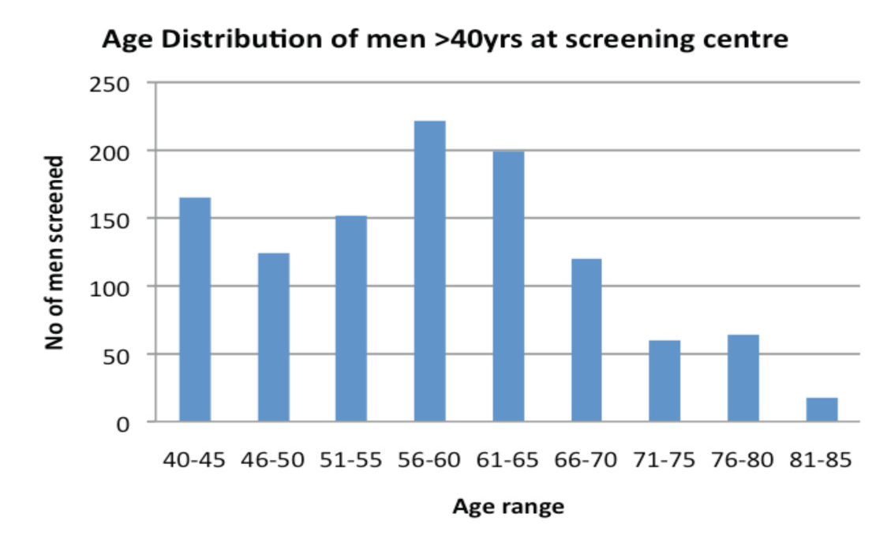

Figure 4: showing the age distribution of men >40 years of age who were screened (Akinremi et al, 2014)

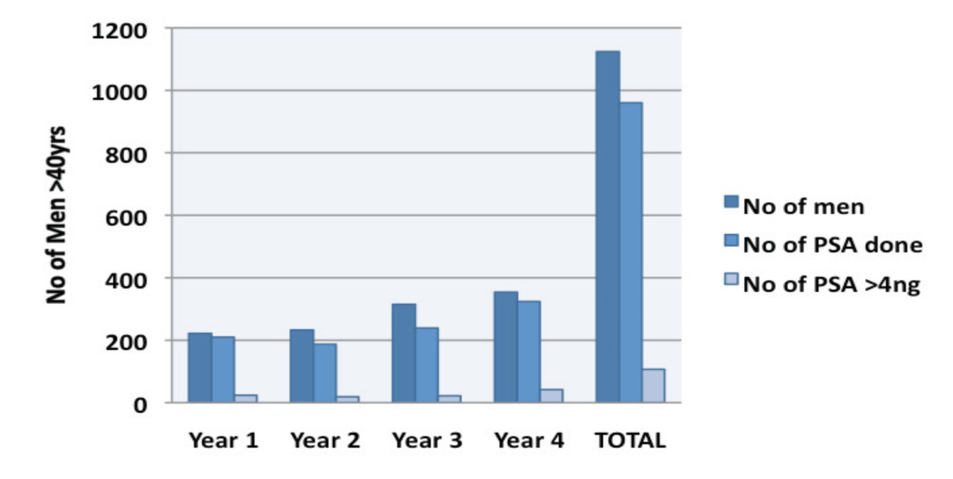

Figure 5: Showing the trends of PSA in men >40 years of age by year of screening (Akinremi et al, 2014)

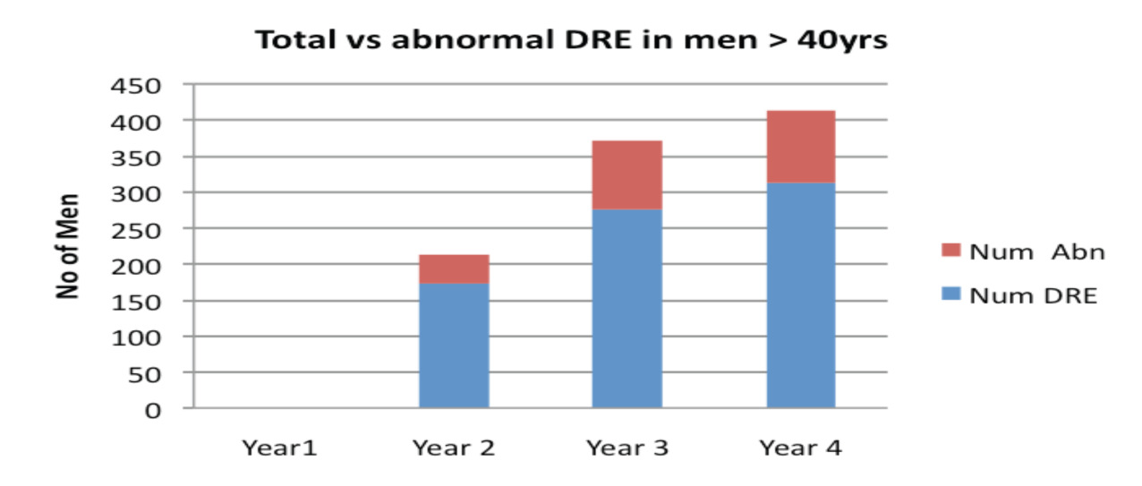

Figure 6: Showing proportion of abnormal DREs to total DREs (Akinremi et al, 2014)

# RISK FACTORS OF PROSTATE CANCER:

Prostate cancer is a medical condition that affects the male species and the cause of this condition is as yet not known and speculations are all there are to it. However, the condition has several risk factors associated with it and some of these risk factors have been listed below (Walz et al, 2010).

* + 1. **Age:** It is common knowledge that the more a human ages the more prone to

diseases that human becomes. The same is the case for Pca and BPH, although this is strictly in men. The cause is as yet not determined but something probably in the hormonal change triggers the enlargement of the prostate at the later age of a man’s life (zatzkin, 2013).

* + 1. **Genetics:** This is based on the prior members of one’s family or currently

existing members. When a member of a family has had the condition or is currently battling such a condition then the risk of an individual getting the condition in the future is higher than an individual whose family members have never the condition (zatzkin, 2013).

* + 1. **Geographical location:** The location of one’s dwelling is a factor that could

increase the risk of having Pca or BPH (Walz et al, 2010). Some individuals who genetically might not be at risk could have a heightened risk by where they live. Some countries are least prevalent when it comes to Pca, however when men from that country move to a region of higher prevalence then their risk also increases (zatzkin, 2013).

* + 1. **Obesity:** Lifestyle is also something that could be talked about. Diet and what

one eats may not necessarily increase the risk for Pca however diet related issues such as over-weight always heightens the seriousness of medical conditions (Walz et al, 2010). In relation to this if an individual has Pca or BPH then the issue of being over-weight could play a role in heightening the seriousness of the condition (zatzkin, 2013).

# 4.0 DETECTION, DIAGNOSIS AND TREATMENT OF PROSTATE

**CANCER**

# 4.1). DETECTION:

The condition in question is one that might not be detected on time due to the nature and behaviour of African men to medical care. Nigerian men are no exception to this especially men from the rural north. Regular check-ups are not normal for them and they rarely ever visit medical facilities except in dire conditions. As a result, many of

the men that were seen were in their late ages and had never come for any prostate examination till they started experiencing severe symptoms and were too miserable to stay put anymore.

Most of these men came with complaints that were unrelated to prostate cancer or BPH but during questioning and counselling the doctors sensed that some of the symptoms they were experiencing were akin to that of the condition in question. This led to the doctors undergoing a quick examination of the patients. This is an examination used to detect an enlarged prostate, whether benign or otherwise.

The medical personnel then gloves his hands and inserts a finger up the anus of the patient and with the expertise of training feels around for the prostate until it is felt. This is how to tell if the prostate is enlarged or not.

# 4.2). DIAGNOSIS:

In the situation that the doctor’s intuition has been proven, diagnosis is then made and drugs are administered for a period of time. If the prostate is cancerous there would be a need for a surgical procedure usually the prostatectomy. This would however not be done immediately except in extreme and severe conditions and this is due to the fact that the medical personnel’s would want to observe the patient in a controlled situation. Drugs and IV’s would be administered and the patient would be observed. Usually drugs such as augmentin are used and then when the medical doctors are satisfied a date is fixed for surgery (darby, 2005).

* + 1. **Clinical assessment:** Clinical assessment refers to methods and

procedures that are undertaken to determine the medical condition of a patient. These procedures tell whether there are abnormalities and hence it

generally is crucial for making diagnoses (loeb, 2011). In the case of prostate cancer there are several such processes and techniques used to cross check and then make diagnoses and among the numerous processes there is one named the Nomogram (rishma et al, 2007). This is a technique used to graph and check charts; it also called the nomograph. It graphs the frequency of a function and generally computes graphical measures and approximates it to yield results that are used in making diagnoses and determinations (darby, 2005).

Assessment can also be to confirm certain things like probability of recurrence, optional treatment available. It also seeks to examine past conditions that could be similar to the present condition and how best to ensure treatment is effective.

* + 1. **Clinical symptoms:** This is the symptoms and associated reactions or

behaviours associated with a particular ailment. Every medical condition is such that it can be detected from the symptoms that manifest after infection or contraction of whatever condition it may be (rishma et al, 2007). In the case of prostate cancer, like earlier discussed, the symptoms are distinct and a tell-tale for doctors and medical personnel’s to be able to notice (darby, 2005). They include Dysuria, Haematuria, poor stream, hesitancy, back-pain, incontinence. These symptoms that have been the major primary form of detecting prostate cancer. Dysuria refers to the painful flow of urine; whereby the penis goes through pain that ranges from mild to excruciatingly severe when the male tries to pass urine out (loeb, 2011). Haematuria refers to witnessing blood in the urine due to pressure that is exerted and hence burst some blood cells. Incontinence is

a laxity that affects the bladder muscles and sphincter muscles that causes the male to be unable to control the passage of urine. Some of the Pca patients also experience back-pain that ranges also from mild to severe; poor stream and hesitancy are also part of the symptoms (rishma et al, 2007). Hesitancy is the interrupted flow of urine and poor stream is when there is not a full flow of urine i.e. there is a high rate of retention after urinating.

All these symptoms aid in the diagnoses process as well as other tests that are carried out by medical personnel’s.

* 1. **Digital Rectal exam:** This is an exam that is done to check for enlargement of

prostate. The exam is called a digital rectal examination. It is done with a gloved and lubricated finger which probes the rectum to the area of the prostate and feels for abnormal enlargements (loeb, 2011). This test can also be in women to check for irregularities with the ovaries and the uterus.

* 1. **TURP:** The transurethral resection of the prostate is an exam that is done to

remove the tissue or mass of cell that is blocking the flow of urine from the urethra. This is done with a needle-like device inserted into the urethra (rishma et al, 2007). This is done with either the general anaesthesia or the spinal anaesthesia. The spinal anaesthesia is usually the one likely to be done because it is less complicated and easier to recover from than the general anaesthesia. In addition to this, the TURP has an instrument that is called a resectroscope which has a mechanical camera attached to it which guides the instrument through the urethra during the procedure. It also has a loop which conducts heat and seals off the blood vessels during the procedure. It also has a mechanic for inducing fluid flow to flush out unwanted tissues.

# PROS AND CONS OF TURP:

The transurethral resection of the prostate has its pros and cons which contribute largely to its effectiveness and use in the medical world.

* + 1. **Pros of TURP:** The pros of this medical intervention are that it can be

performed without necessarily using the general anaesthesia (GA). This is very important because the general anaesthesia is quite risky and very expensive; it is also inconvenient as the patient needs more than usual attendance and monitoring. However, with the TURP it can be performed with the spinal anaesthesia and thus it is a better option of treatment.

* + 1. **Cons of TURP:** TURP has its side effects and consequences which

affect the effectiveness of the treatment and one of these consequences is the incidence of dry orgasm. This is technically known as retrograde ejaculation. This could be as a result of damage to the muscles that surround the bladder during the TURP procedure. This inadvertently reduces the probability of fertility (elshal et al, 2013). The lack of qualified and skilled surgeons to carry out this procedure is also a big issue with this treatment option.

# 4.5. TREATMENT:

Radical prostatectomy is rather common treatment option for Pca; however there are others such as trans-urethral resection, bilateral orchidectomy etc. These forms of surgical procedures are determined by the doctors; they access the patient’s situation and ascertain the best form of treatment procedure to undertake (rishma et al, 2007). Bilateral orchidectomy is done when the testicles are affected and usually this is known as testicular cancer. This reduces the production of testosterone hormones that are said to enhance prostate cancer malignancy (rishma et al, 2007). The

procedure does not completely cure one of Pca but it is easier to control in a condition where the hormones are no longer produced or the production is limited. The procedure also can be effective in shrinking the size of the cancer cells or limiting their spread and growth. Trans-urethral resection is done when the inner tissues of prostate gland is affected. This procedure also does not cure prostate cancer but goes a long way in improving ones condition (rishma et al, 2007).

# MATERIALS AND METHODS

This section provides detailed explanation of the procedures used in carrying out this research. It show-cases how the data was assembled, the location and site of data collection and the way the data is to be analyzed. The section is primarily to provide a validation of how the research was undertaken and the validity of obtained results.

* 1. **THE FOCUS OF STUDY:** This research was focused on the prevalence of

prostate cancer in yola men. This topic was one of interest because of the high incidence of the condition among men in general. It has since been stated to be the second leading cause of mortality and morbidity in men of elderly age. The range of age group was from ages 50 upwards. The research is focused on discovering just how prevalent prostate cancer is in men of Adamawa state so every man within that age group with even a slight symptom of benign prostatic hyperplasia or prostate cancer was interviewed. Some of these men had a recurring case and some just had an inflammation but there was always a link to the main objective. As a result the topic was found as one that should be investigated in close quarters and hence the sample size was chosen to be restricted to men residing in Adamawa state.

The sample size was focused on medical facilities in Adamawa state and these include the Federal medical center which is located at the Lamido Zubairu way off-yola by pass just a stone throw from the American University of Nigeria. Another facility was the specialist hospital which is situated in Jimeta, yola south, Adamawa state. There was also the Daama specialist clinic which is situated at the Atiku Abubakar road, Jimeta Adamawa state. These facilities were the bedrock of the research and the

data obtained for the analysis were obtained from these facilities. This was for efficiency and effectiveness, as the state is well within reach, neither so big nor inaccessible to a student. A liaison with several doctors procured data from a wide range of patients which aided in the research objectives being met.

* 1. **DESCRIPTION OF THE STUDY SITE:** The study site as aforementioned

consisted of the Federal Medical Center (FMC) yola, the specialist hospital, DAMA clinic and zenith care hospital. These medical facilities are located within the Adamawa environs. Some are found in yola north along Lamido Zubairu road such as FMC and others in Jimeta and neighbouring environs. There were processes involved in getting the required data. The FMC has an out-patient clinic that holds every Mondays and this was a perfect avenue to sit with the doctors in consulting rooms and whenever any case relating to Prostate cancer, benign prostatic hyperplasia or inflammation came along, data could be gotten. In addition to this, the doctors afforded the opportunity of making their rounds with them to see patients and to acquire data. Several surgical procedures were witnessed to better understand the condition and the most common of these procedures is the prostatectomy.

There are wards in all these facilities that are specified for handling the cases that involve that of the prostate cancer and these wards are called the male surgical wards. The wards house men that are awaiting surgery and those that are undergoing treatment; it also houses men that have undergone surgery and are recuperating or in convalescence.

# MATERIALS USED FOR DATA COLLECTION:

In order to collect data easily from these patients a questionnaire on prevalence of prostate cancer was drafted. This was for the sole purpose of making the task of inquiries more private and faster. Questions were put together with options available and tick boxes so the patients could just tick whichever applied to them. In addition to this another questionnaire based on pre and post surgical treatment was drafted to be able to make a case study which follows the progressive developments of patients about two of them whose prostatectomy was witnessed. This afforded an avenue for comparison of the cases and the outcomes of treatment on the physiological and anatomical aspect of the patients. In extreme cases were the patients were too weak and thus incoherent to speak, a brief interview was done and the questionnaires filled out for them. Based on the region and state of the sample size not every patient was fluent in the English language and so in various instances the Hausa language was reverted to in order to acquire data. Once there happened to be a case in which Fulfulde had to be spoken because the patient could neither understand English nor Hausa, this was done with the aid of the supervising doctor who himself could speak the language fluent enough and so helped in translating during the interview.

The questionnaire afore-mentioned were handed out to patients and their specific age range fell within 50 to 85 years of age. This provided ample data for results and analysis and helped with achieving the specific aims and objectives.

For the other medical facilities questionnaires were dropped with nurses in wards and after a stipulated number of days they were retrieved as the nurses had helped in giving them out to be filled. This procedure was necessary because some of the facilities had patients that were in and out and so questionnaires had to be dropped

for patients that could possible come in at a later time of absence. Medical records were also made accessible in these facilities for more information of the background of the patients as regards their medical history.

The data was to be analysed using the Statistical Package for the Social sciences (SPSS) software was obtained and licensed in several computers. This was to make data analysis more apt and professional as opposed to the sub-standard results that might be gotten from other analytical machines including excel; although excel did prove very useful in addition to the SPSS software.

# RESULTS:

* 1. **DATA ANALYSIS:**

The data was analyzed using SPSS software which categorized various sections by their variables and provided frequencies, percentages and other analysis that explained the results obtained in better light.

Excel was also used for more analysis and grouping of variables together to enable a conjoined analysis and coalition of results.

8

7

6

5

4

3

Mild

Severe

2

1

0

50-54

55-59

60-64

65-59

70-74

Fig 7: Showing a graph of age against severity of prostate cancer (SPSS analysis).

Figure 7 shows the rate at which age affects severity of prostate cancer. From the graph obtained it can be seen that the age group of 60 to 64 had the highest prevalence of prostate cancer and in addition to that it also explains that that particular age group had a high percentage of severe cases as compared to mild cases. This was the case for the age group of 65 to 69; however the two variables were of equal percent for the age group of 50 to 54 while for the age group of 55 to

59 there were more mild cases than severe cases. Further look at the graph shows that in the lesser incidence of prostate cancer in men with age range of 70 to 74, the cases were entirely severe.

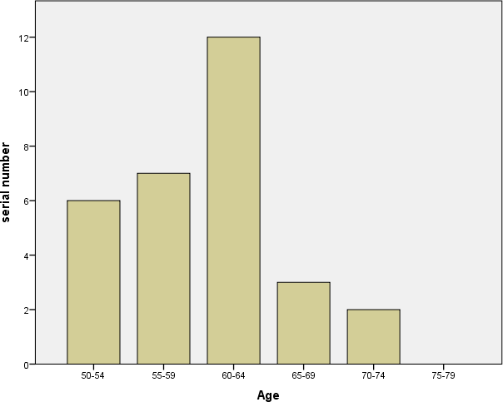

Figure 8: Showing the graph of age against frequency (SPSS analysis)

|  |  |  |  |  |
| --- | --- | --- | --- | --- |
| **How regular do participant's go for check-up** | **Un-educated** | **Primary count** | **Secondary count** | **Tertiary count** |
| Annually | 0 | 1 | 2 | 3 |
| Every 6 months | 0 | 1 | 0 | 2 |
| Quarterly | 0 | 0 | 0 | 0 |
| Monthly | 0 | 0 | 0 | 0 |
| Not regular | 9 | 6 | 4 | 2 |
| Summation | 9 | 8 | 6 | 7 |

Table 4 explains how each parameter such as level of education would affect the rate or the frequency with which men go for medical check-ups in Adamawa state. From the table distribution it can be seen that men of only primary education had very low hospital visits for check-ups while those who had as high as tertiary were more frequent in going for check-ups. Those who are entirely uneducated had close to no hospital visits at all. This shows just how much education and enlightenment affects the rate at which men seek medical help in Adamawa state.

**TABLE 5 SHOWING THE ETHNICITY OF PATIENTS IN PERCENT AS ANALYSED BY SPSS**

**Ethnicity**

|  |  |  |  |  |
| --- | --- | --- | --- | --- |
|  | Frequency | Percent | Valid Percent | Cumulative Percent |
| Benue | 1 | 3.3 | 3.3 | 3.3 |
| Borno state | 1 | 3.3 | 3.3 | 6.7 |
| Bwatiye | 3 | 10.0 | 10.0 | 16.7 |
| Gombi | 1 | 3.3 | 3.3 | 20.0 |
| Hong | 10 | 33.3 | 33.3 | 53.3 |
| Jada | 1 | 3.3 | 3.3 | 56.7 |
| Jigawa | 1 | 3.3 | 3.3 | 60.0 |
| jos | 2 | 6.7 | 6.7 | 66.7 |
| kaduna | 1 | 3.3 | 3.3 | 70.0 |
| kanu | 1 | 3.3 | 3.3 | 73.3 |
| Laka | 2 | 6.7 | 6.7 | 80.0 |
| Sagari | 4 | 13.3 | 13.3 | 93.3 |
| Song | 1 | 3.3 | 3.3 | 96.7 |
| Taraba state | 1 | 3.3 | 3.3 | 100.0 |
| Total | 30 | 100.0 | 100.0 |  |

Table 5 is showing the ethnicity of each participant in the study and the frequency with which a particular ethnic group appeared in the study. Being that it was a small sample size there were quite a few ethnic groups that were more frequent, especially those indigenous to Adamawa state and only few belonging to other states.

|  |  |  |
| --- | --- | --- |
| **Participants response** | **Frequency** | **Percent** |
| No history of condition | 12 | 40 |
| No idea what is being asked? | 7 | 23.3 |
| Not sure if there was/is the condition | 1 | 3.3 |
| Yes | 10 | 33.3 |
| Total | 30 | 100 |
|  |  |  |

Table 7 is analysing the response of the participants based on their knowledge of any prior condition of prostate cancer in their family. This was explained through percentages of those who responded that they had history of prostate cancer in their families and those who responded that they were not sure and those who were sure that there was no such history in their family.

Table 8: Showing the symptoms experienced by participants

|  |  |  |
| --- | --- | --- |
| **Symptoms** | **Frequency** | **Percent** |
| Dysuria | 10 | 33.3 |
| Nocturia | 9 | 30.1 |
| Urgency | 6 | 20.0 |
| Hesitancy | 2 | 6.67 |
| Haematuria | 2 | 6.67 |
| Black-pain | 1 | 3.26 |
| Total | 30 | 100 |

# DISCUSSION:

* 1. **SUMMARY OF RESULTS**

# Is prostate cancer prevalent in Adamawa?

The issue of the prevalence of prostate cancer in Nigeria is one that has been researched on during the course of this particular researched. From rough statistical inference it could be said that 7 in all men over 50 have symptoms related to benign prostatic hyperplasia or prostate cancer. Most men do not really realise the condition they have because they do not go for regular medical check-ups. Those who are aware of their situation are those whose symptoms have escalated to the point of severe discomfort. They have as a result sought medical intervention and through questioning and examinations the real condition was discovered.

# Do men always have a genetic link from other family members?

Through questioning and observation it was noted that some of these men had past links of the condition through family members. Some could not be entirely certain but they could affirm that a father or grand father had died based on something related with the male penis. This however does not go to say that every man with the condition has a family member who must have had it. Some men were positive that no family member had ever had anything of the sort and that his condition was the first he was hearing of any condition.

# Is there a particular age that has a more prevalent case of the condition etc?

Based on the research conducted there was no particular age group that had a more prevalent case of the condition. There were men in their 50s; others were in their 60s

and above. The distribution was very random. However for men in the later ages they had a more severe case of the condition. The prostate in their case was more enlarged and the symptoms more urgent.

Another major concern that has to be brought to light is that of recurrence. Recurrence refers to the condition whereby a disease or an illness which has been treated recurs and causes even more discomfort or harm than it had initially. The issue with Pca or prostate related diseases is that in some cases and depending on the form of treatment used, it could recur. It has been noted that the treatment option of Transurethral incision of the prostate (TUIP) has a higher incidence of recurrence.

This is a major set-back in terms of medical interventions that are in place to combat this particular condition.

# LIMITATIONS TO OBTAINING RESULTS

**Strike:** The course of obtaining data for this particular research topic was a cumbersome one. This is because there were several contributing factors that put a loll on the progress. For one, there was strike in FMC after initial data collection began and this caused a set-back for a while. The specialist hospital was then turned to for assistance and just as data collection began, a strike also commenced in the hospital which left one no choice but to tackle other problems and hope that the strike did not strike.

**Inconsistency with doctors:** Due to the busy nature of doctors and the fact that they had more pressing things to attend to than a final year student on research, there was a set-back in obtaining data. This was due to the fact that the doctors were hardly ever around even when they had given out appointments. At some point they would

leave the country without prior notice and there would be no option but to wait for them. In addition to this doctors were giving conflicting information which was confusing to the data progression. This in the sense that one would inform on a particular thing and the other would counteract that particular thing leaving one in a confused state as to whose approach to accept.

**Wrong audience:** Another issue encountered during data collection was that of incoherence and discouragement. Being that the sample for the research was Adamawa state, the men were very traditional and mostly northerners and so there was a bit of stiffness on their part in participating in the survey and questioning. This could be because of cultural background or religious background because there was a reluctance to divulge information and even a severe displeasure at being questioned by a young female. The topic in question being a sensitive one only made these men more sensitive to being probed and questioned by a young female student. More discouraging of all was there reluctance to be watched by a young female while they were being examined or otherwise.

**Small sample size:** Yet another disturbance to the results was the problem of sample size. The research is one that requires a number of men for accurate analysis of results based on the fact that the prevalence of the condition was being discussed.

The small nature of the town was not very helpful as there were limited care centers who dealt with issues like this. The medical facilities were limited to FMC, specialist hospital, Daama specialist clinic and Zenithcare clinic. These four were the main centers and only two out of these were not private. The data that could be gotten from the private clinics were minute at best and the two major medical facilities kept going on and off strike.

# EFFECT OF LIMITATIONS TO RESULTS

There is no research that is without its limitations or room for some measure of inaccuracy and this was one of them. The various limitations that were encountered are proof that the research was not totally smooth sailing. This goes to show that some or all of these limitations could have impaired the results that were gotten. For one if the hospitals had not kept going on strike there would have been ample time to collect more data and make a better analysis of the results. This is not to say that the results derived are in anyway second class or that strenuous effort was not put into the research because effort was indeed put in and while the data gotten was not as bogus as would have been loved, they were very okay for the inference and results obtained.

Furthermore, if the research was conducted in a bigger state such as Abuja or Lagos etc there would have been a larger sample size. There also would have been several readily available medical facilities with patients who were not bound so tightly to their cultural background that they did not recognise the advancement of science in progress. These are the main issues that crept up that could have impaired the results gotten but as stated earlier the previously mentioned limitations did not impair the quality of the research, it simply made it more difficult to achieve great accuracy.

# POSSIBLE SOURCES OF ERRORS

**Reluctance of patients to divulge personal information:** As earlier stated the reluctance of patients to divulge information about them was quite an issue. The supervising doctor had to intervene by insisting that it was part of their clinical processes and that they should indulge the questioning phase. In this situation most

of them reluctantly agreed to be questioned and gave hasty answers so they could be done and gone. This could have led any of them to give inaccurate information about them especially about previous cases of the condition in their families. Few patients however were very accommodating and they gave really lengthy speeches about their lives and detailed responses that helped propel the data collection phase forward.

**Reluctance of patients to interact with a young female:** There was an incidence were an 80 year old Fulani man bluntly refused to talk to a young female. He staunchly claimed that he would not be questioned by a female who was probably the age of his great-grandchild. In this situation, the doctor had to do the questioning instead. Others adhered and agreed to be questioned albeit reluctantly.

**Language barrier:** There was an issue of language barrier; although both the English and Hausa language was understood there was still the issue of individuals who could only speak in the Fulfulde language. A good example of this situation was the man afore-mentioned; he spoke total Fulani and as such could not be understood. The situation was neutralised however by the doctor who could speak fluently enough in the language and played an intermediary at that point.

# STRONG POINTS OF RESULTS

**Having case studies and being able to follow progressive developments of the patients:** With all the limitations that have been enumerated, the research had a very bright beam to it and this was the case study that was done. The case study focused on a couple of patients and their progression was observed keenly. They were questioned early on when they came in for diagnoses and their progress through

treatments, surgical procedures and post surgical well-being were all monitored. These were then compared to determine if the treatment patterns used on both was favourable of if one patient responded to treatments better than others.

Some of the points that were noted while monitoring these case studies were the moment of diagnoses, their symptoms and how severe these symptoms were. The degree of enlargement of the prostate and whether it was benign or cancerous were all taken into consideration. When diagnoses were made, the drugs given were noted as well as the reaction/s each patient had to these drugs and the intervention if necessary that was made. The surgical procedure was then monitored closely and witnessed and then the size and weight of the prostatic tissue that was sent for histology was also monitored and compared. Then the overall outcome of the treatments and surgical procedure were observed i.e. if all the symptoms disappeared or if they got worse. They were monitored for new symptoms if any and any allergic reactions that could have ensued. Finally, there total health after a while was checked and then compared.

This was done to decide how effective the treatments were and how save the surgical procedures were overall. It was also to help an analysis of differential reactions to drugs and other such medical interventions by different individuals.

# POSSIBLE IMPACT THAT MORE TIME FOR DATA COLLECTION

**WOULD HAVE HAD**

**Data collection with the time allocated provided reasonable data:** The time that was available to data collection was used judiciously even with all the challenges and

stumbling block. The topic of research was well understood with the data obtained. This leads to the point of how much more authentic the results gotten would have been if there was more time left for data collection. Every researcher is always keen about the impact more research time would have had and how much more professional the research would have been. This is just common perspective and does not in any way undermine the work already done. In this respect there is a desire and a wish that more time was available for the research and with that being said it is crucial to still say that the aims and objectives were still attained.

**What would a longer period of time have contributed to the research**: With more time, there probably would have been a more complex and deeper research done and the topic would have been broadened. The sample size would have also surpassed the region it had to focus on in this paper. More medical facilities would have been used and more perspectives from other medical personnel would have been achieved. This however was not the case for this research but subsequently there can be a further research done. For the time being though, the most has been done and the particular research topic for this research has been satisfied.

**Keywords:** Prostate cancer, incontinency, limitations to result, strike, sources of error.

# 8.0 CONCLUSION/RECOMMENDATION:

The research carried out on the subject matter of prostate cancer led to the result analysis that men of ages 50 and above are at a higher risk of being diagnosed with the condition than anyone of younger age range. Asides this, it also brings to light how genetic factors increase severity of prostate cancer as well as late diagnosis.

Another point that was discovered was that education plays a role in early or late detection because the majority of those who were not very educated formally had late detection due to the fact that they were not regular at check-ups and other medical counselling centres.

In addition to the afore-mentioned point; it is also crucial that men not only go for the regular clinical visits and check-ups but also carry their family members along. It is also important that these men even after surgeries and medical intervention still go for check-ups to ascertain that there is no recurrence or consequential damage done to the inner anatomy and physiology of the prostate gland and surrounding accessory organs.

The constant check-ups with medical practitioners and health care centers is of utmost magnitude and weight because it would be the bedrock that leads to early discovery, detection and diagnoses of prostate cancer in patients which would simultaneously lead to a better chance of treatment with less severity attached. This would also contribute in making the diagnoses more effective and precise. This would be done through testing and other observational detecting mechanic and techniques done by urologists and other related medical personnel.

It is highly common for individuals to look at medical conditions especially malignant ones on the peripheral bases. This is most especially true for those who are not of the science field; however medical conditions such as the one researched upon in this paper is one that needs some digging deep to afford valuable understanding.

To understand how a problem works it is necessary to get a broad knowledge on how the condition generates, what heightens it and how it can best be handled.

Furthermore, it is crucial to know not just the anatomical aspect of it but also the

physiological aspect of it; this is how scientists come up with designs and solutions to nerve wrecking problems. In this research the aims and research questions were put forth and then pursued with a gusto that enabled the researcher to accomplish all the given aims and objectives which yielded the results that afforded better knowledge of the subject.

**Keywords:** Diagnoses, Medical check-ups, Physiology of the prostate.

# REFERENCES

Ajape, A. A., Ibrahim, K. O., Fakeye, J. A., & Abiola, O. O. (2010). An overview of cancer of the prostate diagnosis and management in Nigeria: The experience in a Nigerian tertiary hospital. *Annals Of African Medicine,* 9(3), 113-117. doi:10.4103/1596-3519.68353

Akinremi, T. O., Adeniyi, A., Olutunde, A., Oduniyi, A., & Ogo, C. N. (2014). Need for and relevance of prostate cancer screening in

Nigeria. *Ecancermedicalscience,* 8(447-473), 1-6. doi:10.3332/ecancer.2014.457

Badawi, A. (2003). The role of prostaglandins synthesis in prostate cancer. BJU International,85(4), 451-462.

Behrman, H., & Anderson, G. (1974). Prostaglandins in Reproduction. JAMA Internal Medicine, 133(1), 77-84.

Chen, L. N., Simeng, S., Hongkun, W., Bhagat, A., Woo, J. A., Moures, R. A., & ...

Collins, S. P. (2014). Patient-reported urinary incontinence following stereotactic body radiation therapy (SBRT) for clinically localized prostate cancer. Radiation Oncology, 9(1), 1-21. doi:10.1186/1748-717X-9-148

Darby, E., & Anawalt, B. D. (2005). Male Hypogonadism: An Update on Diagnosis and Treatment. Treatments In Endocrinology,4(5), 293-309.

Elshal, A., El-Nahas, A., Barakat, T., Elsaadany, M., & Elhafnawy, A. (2013).

Transvesical open prostatectomy for benign prostatic hyperplasia in the era of

minimally invasive surgery: Perioperative outcomes of a contemporary series. Arab Journal of Urology, 11(4), 362-368.

England, G., Moxon, R., & Freeman, S. (2012). Stimulation of Mating-Induced Uterine Contractions in the Bitch and Their Modification and Enhancement of Fertility by Prostatic Fluid. Reproduction In Domestic Animals, 471-5. doi:10.1111/rda.12019

Gat, Y., Gornish, M., & Joshua, S. (2012). Erect posture of humans leads to male infertility, BPH and prostate cancer. Andrologia,44(3), 145-146. doi:10.1111/j.1439-0272.2011.01233.x

George J, Walker, M. Musser, J. & Ward, D. (2014). Impact of Race in Using PSA Velocity to Predict for Prostate Cancer. *Military Medicine,* 179(3), 329-333.

Gleave M, Kelly WK. High-risk localized prostate cancer: a case for early chemotherapy. J Clin Oncol 2005; 23:8186–91

Hoy, N. Y., & Rourke, K. F. (2014). Stemming the tide of mild to moderate post- prostatectomy incontinence: A retrospective comparison of transobturator male slings and the artificial urinary sphincter. Canadian Urological Association Journal, 8(7/8), 273-237. doi:10.5489/cuaj.2108

Huyghe, E., Delaunay, B., Njomnang Soh, P., Delannes, M., Walschaerts, M., Delavierre, D., & ... Bachaud, J. M. (2013). Proposal for a predictive model of erectile function after permanent 125I prostate brachytherapy for localized prostate cancer. International Journal Of Impotence Research, 25(4), 121-126. doi:10.1038/ijir.2013.3

Kamanger F, Dores, G, & Anderson, W. (2006). Patterns of Cancer Incidence, Mortality, and Prevalence across Five Continents: Defining Priorities to Reduce Cancer Disparities in Different Geographic Regions of the World. *Journal of Clinical Oncology,* 25(4), 458-459. Retrieved February 26, 2015

Loeb S, Carter HB. Early detection, diagnosis, and staging of prostate cancer. In: Wein AJ, ed. Campbell-Walsh Urology. 10th ed. Philadelphia, Pa: Saunders Elsevier; 2011:chap 99.

Martini, F., Ober, W., & Batholomew, E. (2012). The coiled seminiferous tubules of the testes are connected to the male reproductive tract. Visual Essentials of Anatomy and Physiology,633-669.

Patel, T., Wambi, C., Berg, W., & Inusa, M. (2013). Prostate cancer disease characteristics for foreign-born South Asian men living in the United States. *Indian Journal of Cancer,* 30(3), 159-163.

Pettaway, C. A., Lamerato, L. E., Eaddy, M. T., Edwards, J. K., Hogue, S. L., & Crane, M. M. (2011). Benign prostatic hyperplasia: racial differences in treatment patterns and prostate cancer prevalence. *BJU International,* 108(8), 1302-1308. doi:10.1111/j.1464-410X.2010.09991.x

Rishma, W., Heather, B., Emma, G., Doreen, O., & Jawaid, Y. (2007). Black cohosh ( Cimicifuga racemosa [L.] Nutt.): safety and efficacy for cancer

patients. Supportive Care In Cancer, 15(8), 913-921.

UKOLI, F., OSIME, U., AKEREYENI, F., OKUNZUWA, O., KITTLES, R., &

ADAMS-CAMPBELL, L. (2003). Prevalence of elevated serum prostate-

specific antigen in rural Nigeria. *International Journal Of Urology,* 10(6), 315- 322. doi:10.1046/j.1442-2042.2003.00633.x

Walz, J., Joniau, S., Chun, F., & Isbarn, H. (2010). Pathological results and rates of treatment failure in high-risk prostate cancer patients after radical prostatectomy. *BJU International,* 107, 765-770.

Zatzkin, J. (2013). Prostate Cancer Risk Factors. Prostate Cancer Health Center, 6(2), 1-3. Retrieved March 22, 2015, from <http://www.webmd.com/prostate-> cancer/guide/prostate-cancer-risk-factors