# ANALYSIS OF URBAN LAND USE PLANNING IN MINNA, NIGERIA

Housing is a basic need of every human being just as food and clothing. Density simply refers to how much of a particular object or thing there is in a particular unit of space. The aim of this research work is to analyze urban land use planning, with the view to knowing the major density type and the area exhibiting the highest residential land use in Minna metropolis. This research analyses housing densitie, social services and infrastructure and the environment surrounding the selected neighbourhoods. The sample frame for the research work consist of ten neighbourgoods which are GRA, Barikinsale, Shango, Dusen-Kura, Tudunwada-South, Fadipe, Kpakungun, Maitunbi, Sabongari and Bosso. The sample size of 5 percent was used for the research work and purposive sampling technique was used to administer the questionnaire for this research work. Primary and secondary data were collected and analyzed using descriptive statistics, quantitative method was also employed to analyze housing densities in the selected ten neighbourhoods. The result from the field survey revealed that the highest density that is dominant in Minna metropolis is the high density out of the three types of densities existing in planning, the research also revealed that neighbourhoods with high density are more prone to environmental hazards such as erosion, noise pollution, infrastructural degradation. Areas characterized with high density have more negative challenges in terms of infrastructure, facilities and social services, some of the available infrastructure are no more functioning the ones that are still functioning are over stress. The obscene are principally due to limited intervention by the urban authorities to augment local initiatives. In conclusion, the highest housing density in Minna is high density, most of the infrastructure in the sampled neighbourhoods are in poor conditions and also environmental condition of most of the neighbourhoods are very bad. It was recommended that government and stake holders should re-think high density planning and consider how this can be of great help in urban centers in Minna, government should also work with the local neighbourhood associations available within the neighbourhoods to know the needs of the people and how best to plan for the people.

# CHAPTER ONE

* 1. **INTRODUCTION**

## Background to the Study

Housing is the most important needs of every human just as food and clothing. Housing is very essential to the welfare, survival and health of human. Housing can be seen as the best indicators of measuring a man’s standard of living and position in the society which is very important to the existence of man. The Procedure to own a land in this part of developing country involves access to land, financial resources, good building plans and man power with the necessary social amenities to make the shelter functional, convenient, aesthetically pleasing, safe and hygienic to the environment while unsanitary, unhygienic, unsafe and inadequate housing can affect the security, physical health and privacy of man.

Urban planning is concerned with the design and regulation of urban spaces, such as cities and towns. One of the many factors that urban planners considers is the issue of density which is referred to how much of a particular object or things there is in particular unit of space. In urban planning and design, housing density is concerned with how many dwelling units exist in a given area of land, such as city block or a residential neighborhood (Keeble, 1972). Density has numerous definitions and methods of measurement. For example, when density is seen as how many housing units are in a development designated for housing, or dwelling units per acre, it is the parcels that comprise the subdivision. And when it is the area included in development projects or neighborhood blocks, then housing density can be seen as the provision of an established method that can be used to quantify the intensity of development and a strong indicator of amenity and environmental quality (Tibaijuka, 2009; Ndayako & Kawu, 2012).

Studies revealed that high residential densities can increase physical activities of the residents. For example, in the USA, those states with strong urban containment policies display high rates of relaxation time for physical activities and good transportation system such as cycling, walking, jogging and other form of exercises for recreation purposes than those without such policies (Aytur *et al.,* 2008). Healthy development and good physical activities can be associated to good neighbourhood built environment which can also have great influence in on the behavioral mechanism of those within the neighbourhood.

The neighbourhood environment can assist the adoption and maintenance of an active life style and affect the physical and mental well-being and produce good quality of life and good standard of living for those living the neighbourhood. The physical and the behavioral mechanism at which the environment may affect the physical and mental well- being of those living in the neighbourhood is not really understood by planners. The major cause of environmental pollution in most of the developing countries can be seen as the increase in population, most of the activities of man have both negative and harmful effects on the environment within the neighbourhood (Ester *et al.,* 2016).

Infrastructure is an important aspect of a nation and it should be managed and taken seriously. The type of infrastructure varies from road, health, portable water, electricity, national assets all focused at the comfort and development of the nation at large. Sustainable infrastructure can help to promote strong economic development, job opportunities, and the transaction of local goods and services with the neighbourhoods, but most of the available infrastructure in the developing countries such as Nigeria are under stress and in very bad position because of the increase in population and lack of maintenance. Also, infrastructure decay in Nigeria can be linked to issues of rapid development crises in Nigeria (Uchechi et al., 2014). This study will not only enlighten

the populace on the importance of density and infrastructures alone, but it will also bring

to the notice of the populace about the effect of density on the environment, it will provide insight on the need and factors that influence density selection and preference in selected neighborhoods in Minna and how denser these neighborhood are in Minna.

## Statement of the Research Problem

Density is an essential part of planning, without density the neighbourhood design might not be functional and the whole city at large. The study of density, environment and infrastructure can help neighbourhoods to be lot more effective and viable beyond a certain threshold and boost the economy for effective productivity.

Density, environment and infrastructure are therefore essential to sustain development and this is demonstrated using Minna as a case study. This research work accessed housing densities in Minna, its environment as well as the infrastructural decay which has not been given much attention by the researchers. It also looked at the major density type in Minna and the neighbourhood that has the highest residential land use, while this was done by Obateru in Lagos to know the neighbourhood that exhibited the highest residential land use and it was discovered that Lagos Island exhibited the highest residential land use in 2005 (Obateru 2005). This has been looked into in Minna in this research work. A total number of ten neighbourhoods in Minna were considered in order to identify the neighbourhood with the highest residential land use and the highest density type in Minna.

The growth of counties mostly depends on the proper provision of infrastructure which is the ability necessary to enhance business growth, development of science and technology and the improvement of the nation’s research. Quality and standard infrastructure allows the citizens to express themselves creatively, innovatively, fully employed, independent, creators of wealth and availability of sustainable security. But in Minna, little attention

has been given to infrastructural related studies and other environmental and housing density issues. Most of the available social facilities and infrastructure are in a state of degradation and some are no more functioning at all creating developmental crisis (Atuaya 2012).

## Research Questions

To clearly provide direction to this study, the following research questions were framed:

1. What is the main housing density type in Minna?
2. What are the Housing conditions in the study area?
3. What are the conditions of social services and infrastructure provision available in the study areas?
4. What are the environmental conditions and problems in the study areas?

## Aim and Objectives of the study

The aim of this research work is to analyze urban land use planning in the area of housing densities, environment and infrastructure, with the view to knowing the major density type and the area exhibiting the highest residential land use in Minna metropolis.

The objectives of the study were to:

* + 1. Assess housing densities in Minna
    2. Assess housing conditions in the study area
    3. Examine social services, facilities and infrastructure provision in residential neighbourhoods of the study areas.
    4. Assess environmental conditions and problems in the selected neighbourhoods of Minna.

## Scope of the Research

This research is focused on housing density, environments and infrastructure in Minna. The research employed qualitative approach to assess housing densities in Minna. This research focused on ten neighbourhoods in Minna which are Bosso, Maitumbi, Dutsen Kura, Fadipe, Barikin Sale, Shango, Tudun wada South and Kpakungu and Sabon gari. These ten (10) neighbourhoods were selected due to the similarity of the characteristics with others they represent including their near centrality in terms of locations.

## Justification of the Research

Since density is the most important part of sustainable development, it is important to know that the contribution of this research works cannot be overemphasized. This research provided the awareness, understanding and guidance on importance housing densities and the highest density in Minna, the environmental aspect of the neighbourhoods selected and the infrastructure available to serve the selected neighbourhood and also the conditions of the infrastructure available in these neighbourhoods. The research work made use of qualitative method of data analysis with the use of purpose sampling technique for the sampling size.

This study will go a long way in assisting efforts towards housing provision and infrastructure in Minna and also provision of suitable environmental conditions.

## Study Area

Minna, the administrative capital of Niger State is located on Latitude 9˚ 37’N and Longitude 6033/E (Longman, 2003). It is made up two Local Government Areas of Bosso and Chanchaga, Minna is 135km away from Abuja the Capital of Nigeria (Figures 1.1

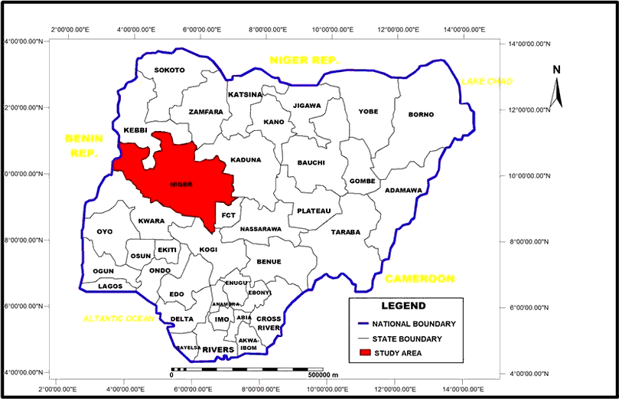and 1.2) and it is common to find significant number of people who live in Minna but work in Abuja thereby commuting on a daily basis (Sanusi, 2006).

**Figure 1.1: Niger State in Nigeria**

**Source: Niger State Ministry of Land and Housing, Minna (2012)**

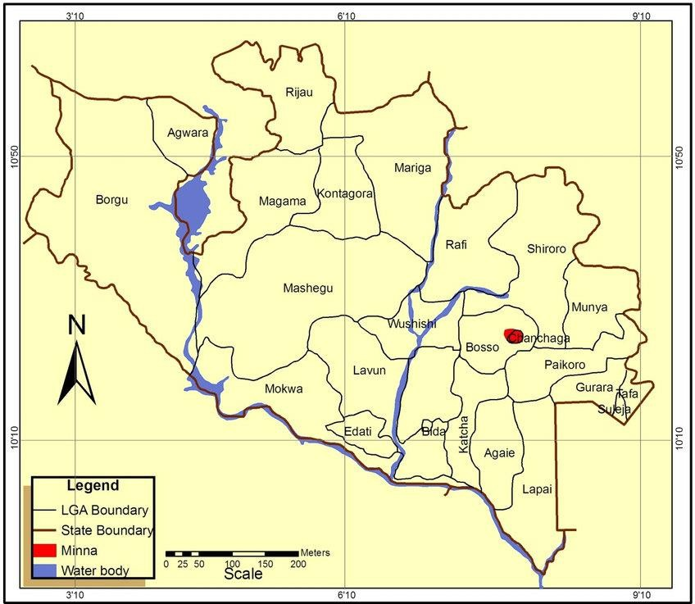

**Figure 1.2: Minna in Niger State**

**Source: Niger State Ministry of Land and Housing, Minna (2012)**

The map of Minna shows the road network and the smaller towns and communities that make up the city. In terms of topography the city lies on a relatively high land between

240m – 270m above sea level which greatly determines the climate of the region. The climate of Minna is such that the average annual rainfall is about 1334mm with the highest rainfall experienced in the month of September, the average temperature is about 30.50C which explains the need for environmentally friendly building designs to ensure sustainability (Popoola, 2015). Minna, is believed to be surrounded by continuous stretch of sometimes steep line of hills with varying heights which has encouraged quarry business in the fast expanding metropolis.

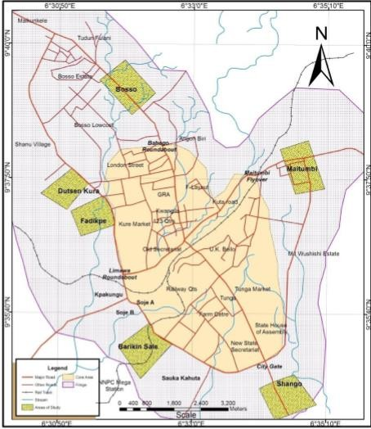

## Figure 1.3: Main neighborhoods and road network of Minna Source: Adapted from Popoola (2015)

The population of Niger State is put at 3,950,249 in 2006 based on data from the National Population Commission (2008). Minna is often referred to as a civil servant city with large proportion of the dwellers working with either the State or Federal Governments. Commercial activities are often limited small scale shops within residential areas to the shop owners along the major roads within the city. There is only one major market in

Minna which is located along the Western bye-pass of the city which is called Engr. A.

A. Kure Modern Market.

# CHAPTER TWO

* 1. **LITERATURE REVIEW**

## Review of Relevant Literatures

Housing is one of the most important need of a man just as food and clothing. It is essential to the health, survival and welfare of a man (Fadamiro *et al*., 2004). Housing is one of the most important indicators of measuring a man’s standard of living and position in the society (Jinadu, 2007). Housing can likewise be defined as the whole residential neighborhood including the environment, including the physical structure and necessary services and the facilities for the whole well-being of the individual and family (Salau, 1992). Housing can also be seen as the physical environment that family and society at large can develop from. Economically, housing takes a major part of the family income or expenses, yet it is the most essential part of human life which also represents a man’s most tangible asset (Kinyungu, 2004). Housing density gives a well-known methods of measuring development and is a strong pointer which shows the availability of good infrastructure and environmental quality. Urban density can be refers to the number of people living in a specific urbanized area, and it is one of the most important factors in understanding how cities works (Leemans & Solecki, 2013). The need to know about housing density is essential for sustainable development planning. Every day, mankind is becoming more conscious about reducing carbon dioxide emission, and hence, the need to put density into consideration in planning ( Mwangi & Ostrom, 2009).

According to Adebayo & Iweka (2013), housing can be seen as the most important part of human needs and also the essential right of every individual regardless of age, sex, economic status, race or religion. Housing can also be defined as habitable place where human safety is guaranteed, as well as adequate spacing, protection from harsh weather

and other threat to human health or natural hazards (UN-Habitat, 2009). In developed countries, affordable housing is very accessible to all include the poor and the rich, especially due to subsidies from the government. Many studies revealed that the problem facing housing is worldwide, it is however more severe in under developed countries (Ogundahunsi & Adejuwon, 2014).

The desired for housing is not only because it is one of the most important needs of man, but it is also the indicator of standard of living of the population in a particular geographical area. It is the most important topic today that housing has to be comfortable, affordable and cost of maintenance is less, as well as compliant with the environment (Henilane, 2015). The major problem facing Nigeria today is the lack and scarcity of affordable, livable and comfortable housing for people to live in. The efforts of those past government and the present government to tackle the problems facing housing in Nigeria, through various housing programs, proper funding, easy access to loan, creation of mortgage banks and the presence of Nation Housing Fund in Nigeria, housing problems still persist in Nigeria and oddly, all the schemes and housing programs have not really solved housing problems or give satisfying solutions in Nigeria (Adedipe, 2009).

Ibimilua & Ibitoye (2015) examined housing policy in Nigeria and concluded that housing is a general problem that is facing both the developed and the developing countries. There are some problems associated to housing generally which are shortage of housing, homelessness, lack of forethought by the government about what people really need, access to land for construction, construction cost in relation to building specifications and standards and as well as high interest rate of access to loans. Also there are other causes of housing shortage in developing countries such as Nigeria which can be poverty, high rate of urbanization which is high rate of rural-urban migration, high cost

of building materials, and availability of fundamental technology of building. Ogundiran

& Enisan (2013) also concluded that challenges of housing delivery will be more in metropolitan areas such as Lagos; hence it is essential for any good government to make available livable and affordable housing to its citizens.

Many works of (Keeble, 1972; Chapin, 1972; Mabogunje, 2005; Jinadu, 2007; Tibaijuka, 2009; Mitlin & Satterthwaite, 2013) have shown that factors that influence housing density include characteristics like location, proximity to place of work, school and amenities. In addition, size of house and change in marital status can further influence housing density, i.e, the need for sufficient space for all family members to live comfortably. Other factors include change in taste and increase in income influencing change in location and accommodation from high density area to a low density area particularly with the availability of better social amenities and infrastructure. However, in areas lacking basic amenities coupled with the availability of local materials, cheap and affordable building materials can influence the development of shanty towns to form slums where majority of the urban poor are found of (Keeble, 1972; Chapin, 1972; Mabogunje, 2005; Jinadu, 2007; Tibaijuka, 2009; Satterthwaite &Mitlin, 2013).

## The Neighbourhood

Experts often referred to a neighborhood as a place designated as the part of a city that can be defined by its characteristics, location, history, housing type and design and its architectural design or can also be identify by its residential characteristics, environmental, industrial, commercial and administrative activities (Muir, 2010; Sohn, 2016). By its main characteristics, a neighborhood can be a unit that is totally and socially more smaller than a city, that shows an entire unity of life; space of relationships and a particular social practices, connected by nearness; or a space of life which is defined by the behavior of the inhabitants (Chapin, 1972; Keeble, 1972).

## Population and Density

The term population is the number of people living in a specified geographical area such as a country, a town, or a territorial ethnic group. Similarly, population can similarly be said to be the count of number of residents within a geographical boundary. Population density is the entire number of people in a specific square kilometer in a given political or geographical area, and can also be seen as the measurement of population per unit land area (Boyko & Cooper, 2013; Co-operation & States, 2012).

## Housing Density and Types

Housing density may be defined as the measurement of the built up area or the built residential accommodation, and the number of people or houses located on a particular site or district (Persons, 2017). According to Borukhov (1978) who also define housing density to simply means the total housing units located in an area.

Housing density can also describe the relationship between the physical environment and the number of people living in that particular area. It can also be explained as the ratio of the population or number of dwelling units in particular area (Forsyth, 2003; Forsyth *et al.,* 2008). Due to its impact, density has been sub-divided into three categories such as high, medium and low. High density is any development that has more houses on a property that the other density types. Medium density housing is also a development that is not as denser as high density but higher densities than standard low-density while low density housing are large homes on a very low residential block. These types of houses are often associated with rural residential areas where the housing density is very low. Low density housing can also be terms used to describe the large blocks of residential area where different large houses are constructed on properties of about 600-700 square meters. Another component of housing is urban density and this is also a term that is

popularly used in urban planning and urban designs which can be referred to as the number of people living in a particular urbanized area. Urban density is crucial factor in understanding how cities work (Okafor 2016).

## Physical density

Physical density is the measurement of the concentration of people or structures within a specific geographical unit area. It is a quantitative and numerical spatial indicator (Rodriguez & Bonilla, 2007; Simon, 2014). However, physical density can have a better meaning if it is associated to a defined scale of reference.

## Residential density

Residential density is the ratio of a population to total residential land area. This can be classified into net and gross residential densities based on the definition of the reference area (Tower, 2000).

## Net residential density

This density measures the total area of the residential site which includes the surroundings, roads and some facilities supporting the houses such as open space, community centers, corner shops etc (Tower, 2000).

## Gross residential density

Gross density measures the residential area includes housing parks, schools, road transport network and other mixed uses within then area, while most times it does not include large commercial areas and industrial areas (Tower, 2000).

## Occupancy density

Occupancy density can be said to be the ratio of the number of occupants to the floor area of an individual habitable unit area. This habitable unit area can be any kind either private or public space, such as houses, offices, theatre and other places. However, the reference area usually refers to as the only enclosed area. Occupancy density is an important measure in the building services design as it gives an indicator for estimating the services required and such services can be electricity demand, space cooling and heating load, provision of fire safety facilities, and other spaces required are estimated based on the occupancy density (AlertNet, 2014; Kawu & Shuaibu, 2007)**.**

## High density

High density associated with overcrowding, but the idea of high density expressed in terms of building density does not really have anything to do with overcrowding. High building density can be measured in plot ratio, for example, it can be refers to as high proportion of built-up floor area. In the case of large dwelling size and small household size, higher plot ratio can lead to lower occupancy density, therefore, there can be more habitable area for people, and in turn affecting the condition of the crowd (Campbell, 1996; Kenworthy, 2006).

Study of density can reveal peculiar attributes associated with the increasingly populated neighbourhood in a particular area. Detailed study is needed to establish reasons for the preference of neighbourhood associated with certain densities with the social, economic and environmental attributes that sustain such characteristics (Ajanlekoko, 2001).

## Medium density

Medium density housing is a residential density development higher than the standard low housing densities, but not as higher as high density housing though in planning they

might be regarded as high density housing. Medium density can be planned to meet most density requirements, it increase density flexibility in housing density and are usually affordable (Baker et al., 2019).

## Low density

Low density residential areas have lots of open spaces and are mostly in large blocks. These areas are specially designed for small number of residential houses with large industries, apartments, complexes, and other large structures, sometimes, businesses, community organizations, commercial agricultural activities and so on can be allowed if they meet some design standards (Novinson, 2017).

## Mixed density

Mixed density is a residential development that has mixture of housing types such as single dwellings and different units with different varieties of development forms with different sizes and heights. Mixed density is encouraged for new residential developments because it provides different housing types that can encourage more diverse community which can help to serve various stages of life and to maximize infrastructure and land use, and encourage the provision of public mass transit (Babalola, 2009).

Mixed land use describes variety of land uses existing together side by side in a street or one above the other, for example shops can be at the ground floor while residential development will be above (Akinmoladun & Oluwoye, 2007).

Mixed density, can be design as compact development pattern that involves a multi-storey building with a ground floor that is made up of commercial units and other floors designed for residential uses and it is also a development that encompasses three or more significant

revenue generation and related land uses whose closeness or proximity reduce trips and

limit the use of automobiles and encourages other modes of transportation such as walking, cycling and the use of public transportation system (Cope & Lee, 2016; Karlson & Mörtberg, 2015).

## Determinants of Housing Density

* + 1. **Environmental factors**

Environmental issues such as climate, surrounding areas and the conditions of the environment, material used the safety of the house and occupants of the house can contribute to the determinants of housing density and the choice of an area. Also regulation planning permission can affect the style and choice of an area which can also be a determinant factor of housing density (Robert 2007).

## Social factors

Location, proximity to work and school and amenities can be the determinant factors and increase in status, increase in family size and increase in income and personal choice can be part of determinant factors for choice of a particular area (Robert 2007).

## Economic factors

Economic factors such as income level cost of land and building materials, household bills, location and types of house can be the determinant factor in the area of housing density (Robert 2007).

## Advantages and the Disadvantages of Housing Density

* + 1. **Advantages of housing density**

Housing density is a method of quantifying the intensity of development and it is an important way of knowing social facility and environmental quality. Compatibility of density is one of the numerous criteria that can be used to assess the livability of housing and other factors that will often have override the importance in determining an application. Higher density accommodation has district advantages of land conservation by reducing the loss of open space, farm land and can also reduce the consumption of energy through the providing more effective transportation system and easier way of infrastructural provision (Tower, 2000).

Density can also increase the use of public transport and reduces the use of automobile and the negative effects that come with the use of automobiles. Density becomes more necessary and viable in planning design especially high densities which becomes reliable and encourages public transport system become fully effective with dramatic reductions in energy cost. Movements can also be made through the use of foot and bicycle thereby reducing fuel consumption and air pollution while in a low density design, people depend more on private cars for personal transport thereby increasing the consumption of energy and also increase in air pollution. He concluded by saying low density residence travel more than twice as far each week than people in more compact cities or area (Tower, 2000).

## Advantages and disadvantages of housing density

The knowledge of density can help us to understand how the new development and the existing surrounding areas can work together, and how they can be considered to determine appropriate density in planning. Housing densities are often categorized as low,

medium and high densities. These separate densities are often used to reach different goals

for the city growth plan (Baker, 2019). Low density can fulfills demand for the single- detached family housing, sustainable space for family growth and parking available drive way while the disadvantages of low density can be low population density and growth, high land consumption, unsustainable green field development, the need for more infrastructure such as sewer, electricity, water supply, storm water management and usually more expensive for the low income earners (Baker, 2019). Residential houses can be described as the important elements in a city because they form most of the built environment Asfour (2015), Borukhov (1978) also highlighted that the type of density can affects the quality of life and standard of living in urban environments in many ways, directly or indirectly.

Medium density housing are developments that are higher densities than the standard low housing densities, but not as high as to be seen as the main high density housing. The disadvantages can be accessibility due to the provision of stairs, parking space could also be an issue and the same apartment design for everyone (Baker, 2019). Advantages of high density can be the increase in property or city density significantly, easier to serve with transit, encourages transit use and walk ability due to proximity to necessities, promotes development around high density building in order to make use of the population influx, discourage car dependency and affordable to low income earners while there are disadvantages associated with the density such as same design of apartment for all, accessibility issues because of the provision of stair case and elevators, high crime rate in some cases. There are many advantages and disadvantages to all housing density types which are different from with location and goals trying to be reached in different towns and cities of the world (Baker, 2019).

## Conceptual Framework

Britain was characterized by rapid industrialization and urbanization in the nineteenth century, with industrial cities attracting great numbers of people living poorly in partially reformed existing houses. Large numbers of these houses were leaking, and had no ventilation with poor environmental sanitation. This problem caused diseases and the high level of over population, made these diseases highly contagious. Diseases like cholera and typhoid were spreading in cities, housing then became linked to health and the environment. Poor health and bad environment became the result of poor standards of living and large population (Leishman 2008).

Since rapid growth was associated with overcrowding in large cities, housing density also becoming an issue and two solutions were provided which were, either to clear the affected areas and rebuild which brought about Slum clearance in Liverpool and Glasgow in the year1860s and was encouraged nation-wide by the legislation in 1875.The second option was to leave the overpopulated, polluted and unhealthy cities to another safe place. The rich became scared and started acquiring space to build in the new place and the cleaner air at the countryside. With the creation of the railways, developers started building new suburbs. In the process of rebuilding in the new area, social activists encouraged lower densities to be the solution to urban problems for all classes that were facing them in Britain (Leishman 2008).

Different types of model of towns were employed for rebuilding and by the end of the nineteenth century such ideals became a law in the new place they tagged as Garden City which was Garden City Movement. These principles were written in the Tudor Walters report for the design of new housing (1918), that brought about the acceptable design for social housing development after the First World War (Brooks, 2003; Daily & Ehrlich,

2008). This also brought about a relief in urban problems and decentralization was also introduced to the new development of housing estates outside urban areas which only allowed densities to be as low as 12 houses on an acre (30 per ha.). In the inter-war period, more than a million houses for were constructed to be rented out in line with this pattern of design, and about 3 million houses were constructed in low-density suburbs for sale.

So many development plans were produced for the large cities. Patrick Abercrombie’s plan for London was one of those plans. His plan was the hierarchy of densities for new housing development which was 200 Persons Per Acre (PPA) at the centre, 136 in the inner areas descending through 100 and 75 ppa to 50 ppa at the periphery. The results of these post-war plans brought about the traditional hostility to high density. Most redevelopment in the inner areas were multi-storey housing in which low-income families with children were housed. This resulted in the growth of social problems which had caused so many multi-storey estates to be left empty and became a place of crime and deprivation. This negative development stre5 the negative image of high-density housing design (Towers, 2000).

## Concept of density

The concept of density started with the Garden City movement which was also adopted in England and the early modernist’s movement in Germany (Pont & Haupt, 2007). Density means different thing to different profession and professionals in different disciplines such as planners, economists, community organizations, psychologists and ecologists.it can be said that a psychologist or a sociologist will only check the effects of perceived density on mental well-being on his or her patient or client. Obateru (2005) defined density as the number of persons or object per unit of space such as the number of persons or houses on an acre or hectare of land. Residential density can be described

as numerical measures of the extent to which land is occupied by buildings or people in a simplest form (Evans, 1973).

Residential densities can be described as dwelling units per hectare or bed spaces per unit, in terms of the population expected to live in a particular place. Densities are likely to be higher in the central areas of the city than in the suburbs. For example, example of this can be seen in Lagos Island which exhibited a higher residential land use density than other residential areas of the metropolis.

Elaf’s (2017) worked on the Impact of High Population Density on the Built Environment and the Behavior of Individuals revealed that high density can bring about great impact on the human environment. However, it was discovered that high density can encourage mass transportation through the greater number of users in high density housing, thus improving its efficiency and feasibility and this also gives more opportunities for walking and cycling, and therefore reduces the number of car trips, as well as the travel distance per trip on the road.

## Impact of density on sustainable design

In the work “Density Design and Sustainable Residential Development” by Sadasivam (2009), described density and how it can bring about sustainability in neighborhood design. It also explained that density is very vital in shaping how cities look and function, with the advantages of efficient use in terms of infrastructure, affordable housing, conservation of energy and lively activities within the neighborhood to improve social lives and activities and also high density housing design is very efficient and sustainable.

Different concepts of planning were introduced to support high density housing, especially in US, UK, Australia and New Zealand. Nevertheless, high density

neighborhood can be undesirable and bring about unpleasant interferences such as encroachment of population and activities into private places, high crime rates, overcrowding, over stretched of the public facilities available etc. On the other hand, it can also be very positive and bring about rise in social cohesion such as reduction in the use of energy, effective mass transportation system, availability of affordable housing and provision of job opportunities for the less privilege etc. Another alarming aspect of high- density neighborhood is the overcrowding issue, believed that there are too many people.

It is not possible to know if a specific area of density will turn out positively or negatively. It is possible to have a design with high densities and voluminous rooms without been overcrowded; on the other hand, it is likely that an isolated ranch is overcrowded with several people in a single room (Sadasivam 2009).

Not much detailed research has been done on housing densities, the environment and infrastructure in Minna neighbourhood metropolis. Detailed study is needed to be carried out on housing densities and the environment surrounding the available densities in Minna and to know the higher density and the neighbourhoods exhibiting the highest residential density.

To achieve sustainability in high density housing design, improvement in standard of living, sustainable future well-being, reduction in social inequalities and improvement in quality of life must be put into consideration, to achieve these, there must be interaction with the people living within the community. Intensity of interaction within a neighborhood is so much connected to design features and layout outline. Sadasivam (2009) further explained that residential areas with row housing density and low density housing have a tendency to reduce the interaction within the neighborhood, whereas high density and medium density increase interaction.

In order to ensure sustainability in density planning, number of housing designs should be put into consideration when preparing residential density which means when introducing high density design, people should be encouraged to walk or ride bicycle and thus help to reduce the emissions and pollutions of gas within the neighborhood (Sadasivam 2009).

Studies revealed that density and design must be well thought-out before social, economic and environmental sustainability of densities in housing can be achieved. The way in which we develop our neighborhood must change through the incorporation of density and design factors. To examine the possibility of density design, factors that can provide sustainable solutions for neighborhood development must be an agreement among different planners with the potentials for sustainable result to correlates with the diversity of the urban environment. Density design should be one concept instead of treating design and density separately in the area of social, economic and environmental development of neighborhoods (Sadasivam 2009).

## Effects of high population density

A study in Federal Capital Territory by Maria *et al*., (2014), on the effect of high population density on rural land use in Abuja, Nigeria revealed that a greater amount of the land in FCT is taken up by residential area and other human activities because of the population pressure in the area which is causing reduction in food and crop production leading to high increase of starvation and hunger among the subsistence farmers in FCT. The research work concluded that government should make available low cost housing in the area to cut down the loss of farmland to settlement development and other human activities in the area because of the high population density. There is also a connection between high density and crime rates which

could be indirect consequences of high density housing (Bah, Faye, & Geh, 2018; Peterman, 2000).

City assessors and managers have worked on housing density in Nigeria and beyond.

* 1. **Relationship between Neighbourhoods, the Environment and Infrastructure**

The word infrastructure was first used in the late 1880s, it was coined from a French word which is *infra-*meaning “below” and *structure* meaning “building”. Infrastructure can be said to be the fundamental foundation in which the economy of a city is formed (Michael, 2020).

Infrastructure can also be seen as the fundamental social services and amenities that support the functionality of houses and firms, these are services provided to serve a country, a city, or any other area, including those services and necessary for the growth of the economy to function. Infrastructure has private and public aspects such as roads, water supply, bridges, tunnels, sewer, railways, telecommunication and electricity. Infrastructure can also be seen as physical components of inter related structures that provide goods and essential services for sustaining the living conditions and maintenance of the surrounding environment (Cervero, 2014).

## Infrastructural development

Infrastructural development is the creation and maintenance of fundamental services such as transportation, communication, energy, water, digital, social and green infrastructure to encourage economic growth and improvement of lives (John, 2018).

## Types of infrastructure

There are so many types of infrastructure which includes soft infrastructure, hard infrastructure, I.T and critical infrastructure and so on (Michael, 2020).

## Soft infrastructure

These are the institutional infrastructure that help to maintain economy which are human capital, these human capital are mostly institutional services that sustain the population. The example of these are health care system, financial institutions, law enforcement agencies, educational systems and others (Michael, 2020).

## Hard infrastructure

These infrastructures are transportation systems that allow the flow of modern industrialization these include road, bridges, highways and capital needed to keep them functioning (Michael, 2020).

## Critical infrastructure

These are infrastructure that are very essential for the growth of the economy that government must provide for the functioning and the development of a neighbouhood and the city at large such as facilities made for shelter, telecommunication, Public health, agriculture (Michael, 2020).

## I.T infrastructure

These include network equipment and server, without the information technology I.T many businesses may not grow or many businesses will struggle to grow, if I. T infrastructure fails, many business functions cannot be carried out (Michael, 2020).

## Economic Benefits of Good Infrastructure

Infrastructure improves the quality of lives, efficiency and productivity, make a neighbourhood more competitive and bring about increase in neighbourhood preference. Good infrastructure can also be used to improve strong resilience of a neighbourhood to

stresses for example water infrastructure can be put in place to reduce the risk of floods in some neighbourhood (John 2018).

Proper maintenance system must be put in place before Investing in infrastructure because infrastructure needs a lot of maintenance, also construction of infrastructure will bring about increases in the number of job creation. Infrastructure also have a positive impact on education and contribute to good health and a high level of education which will lead to economic growth in a city (Tatyana, 2014).

## Impact of population on environment and infrastructure

The population of the world in 1800 was about 1 billion, only two centuries later, the population rose up to 6 billion, and half of these population live in cities. The effects of this explosive population has on the environment has been clearly obvious in the changes this has brought to greenhouse gas emissions, rates of soil erosion, and the extinction of special species of animals and plants. The available Natural reserves has about 10% of land area globally, the available ones are small, detached from other reserves, and are under serious human pressures. The size of the population is an important factor in assessing environmental impact, other factors that can be used in assessing population increase can be the level of consumption per person and unit of consumption per person, reflected in the technologies used in supplying energy, food, water and other resources. The total effects of population increase, consumption, overuse of the earth resources, wastage and misuse of resources has put the earth under tremendous stress to sustain life (World Population Data Sheet, 2005).

## Effects of Population Growth on the Physical Environment

Physical environment can be seen as the land, air, water, soil and minerals and other natural earth resources. The use, overuse and misuse of these physical resources increase

the environmental degeneration due to the increase in human population, it was explained earlier that increase in population means more mouths to feed which means more agricultural production will be needed. This leads to cultivation of more land for agricultural activities through clearing of forests and reclaiming wet lands, ponds and green belts. Modern agricultural activities need more utilization of water, more fertilizers and more pesticides. The use of fertilizers and pesticides makes the soil infertile and good for farming but this action can contribute to the degradation of the soil and extinction of some special species in the soil. Clearing of forests for farming and other development has its own damaging effects on the environment and the environment as a whole gets imbalanced.

Increase in population requires increase in space for construction of houses and development and production of more consumable goods and services, this also means there will be increase in transportation, consumption of fossil fuels and increase in air pollution, land pollution and water pollution. All these human activities creating different types of pollution are causing serious damages on the physical environmental and environmental degradation which are further affecting the biological environment and climate change.

## Air and water pollution

The more the population increases, the more the needs for the clearing of forests. The main reasons for deforestation are for housing construction to house the available population and other urban developments and to make use of wood, and coal as fuel in some industries. This action leads to the cutting of trees to make fire woods and coal while reducing the activities of the trees that help in reduction of air pollution through the process of photosynthesis. The main problem facing the world at large in recent time is

the issues of global warming which is affecting the environment and climate change and this issues of global warming is bothering the environmentalist. Air pollution is not the only environmental damage being done by the increasing population, water pollution is now one of the major reason for increasing environmental problems due to over population in the world. Water is the most important factor for sustaining life. The increase in population calls for increase in the numbers of factories and industries thereby leading to air pollution. Increase in factories and different types of industries bring about various kinds of pollution, which include water, environmental and air pollution, also water pollution sometimes comes from advanced farming through the use of pesticides and other chemicals for farming. India which is an agrarian country experience water pollution through the use of pesticides for agricultural practices. It is now obvious that the growth in population size is the cause of the increase in pollution of the environment and climate change, which in turn is leading to a more hostile environment for human beings to live.

## Social and physical environment of the neighbourhood

The environment can be the physical, chemical and biological external factors to human host and all other living things. The environment can also be defined as the surroundings or conditions in which a person, animal or plant lives (King, 2013). There are three types of environment which consist of physical, natural and human environment. The natural environment is made up of living and non-living things created by nature such as vegetation, mountains, lakes, rivers, soil and disaster of different forms. The physical environment includes all the natural available resources that provide humans the necessary need for survival and development such as land, air, soil, water etc., while human environment consists of man-made environment such as the buildings, road,

infrastructure, electronics, vehicle etc. (King 2013).

Exposure to environmental influences occurs in many contexts, of which the direct environment of the residential neighbourhood is the most important. It is common knowledge that different dimension of the neighbourhood environment have an influence on health of the neighbourhood residents (Groenewegen *et al*., 2018).

The neighbourhood environment can contribute to the adoption and maintenance of an active life style and affect the physical and mental well-being of those within the neighbourhood (Ester *et al.,* 2016), and also the same neighbourhood environment can contribute negatively through sicknesses and medically unexplained diseases as a result of physical and environmental degradation effects that are highly rampant in the neighbourhood and have high impact on quality of life and associated high cost (Murray *et al.,* 2016). The psychosocial and behavioral mechanism through which the environment may affect physical and social well-being are not properly understood. It is said that involving in regular moderate to vigorous physical activities in a very good environment can reduce the risk of mortality, a range of deadly diseases, mental illness, depression, and dementia and can contribute to independence and social well-being of the residents within a neighbourhood (Ester *et al.,* 2016). Traditionally, the emphasis has been on individual determinants. However, during the past decades the focus shifted towards environmental characteristics and their interaction with the individual characteristics to neighbourhood densities (Macintyre and Ellaway, 2002). However, it is also acceptable to assume that some of the observed effect of the environment on metal well-being in particular might be attributable to greater levels of neighbourhood satisfaction and opportunities to engage in social activities independent of physical activities.

The major cause of pollution and other environmental damage is said to be the increase

in population in the world and it is clear that all human activities have effects including negative and harmful effects on the environment (Guild, 2000).

* 1. **Gaps in Knowledge**

Much as not been done on housing density and the highest density type in Minna metropolis, it was also revealed by Obateru (2005) that Lagos Island has a higher residential land use density compared to any other residential areas in Lagos metropolis but this has not been given a consideration or done in Minna to check among the neighbourhoods in Minna if there is any neighbourhood in Minna metropolis exhibiting residential land use that is higher than any other residential area in the metropolis and also the study will reveal the state and the condition of the environment and the infrastructure available to the selected neighborgood which has not been considered much in any of the research work that has been done in Minna Niger State.

# CHAPTER THREE

* 1. **METHODOLOGY**

## Research Design

This chapter consists of step by step procedure used to achieve the aim and objectives of this research work and also the collection of important data for analysis. This chapter also discussed the types of data, sources of data, sampling techniques, sample size, sample procedure, questionnaire administration, and data analysis on housing density in residential neighbourhoods of Minna, Nigeria.

Research design is a systematic approach that a researcher uses to conduct a scientific study (Campos et al., 2015; Mccandless et al., 2007). It is also the overall synchronization of identified components and data resulting in a plausible outcome.

# RESEARCH DESIGN DIAGAM

**3**

**Methodology**

**7**

**conclusion**

**8**

**Reccommen dation**

**1**

**Problem Identification**

**2**

**Review of Literature**

RESEARCH DESIGN

**6**

**Processing & Data Analysis**

**5**

**Quantitative & Qualitative Data**

**4**

**Data Collection method**

## Research Methodology

Research methodology can be said to be the methods used in carrying out a particular research or a study which involves steps to follow in achieving the aim and objective of a research.

**Table 3.1 Research methodology**

|  |  |  |
| --- | --- | --- |
| S/N | Procedure | Activity |
| 1 | Problem identification | A problem was identified to be researched on to provide solutions on |
| 2 | Review of relevant literatures | Relevant and past literatures were reviewed on issues related to densities, environment and infrastructure |
| 4 | Methodology | Method of data collection was through questionnaire, physical observation, interview of the respondents one on one, and through the use of camera |
|  |  | Method of data analysis  The result of the questionnaires will be analyzed carefully with the aid of computer software Statistical Package for Social Science (SPSS) |
| 5 | Data presentation, interpretation, evaluation of findings | Data presentation and interpretation will be represented through the use of percentages, chats, tables etc. |
| 6 | Conclusion and recommendations | Summary and conclusion will be drawn, recommendations and possible areas for further studies shall be highlighted in this research work for future endeavours. |

* 1. **Operational Table Table 3.2: Operational table**

|  |  |  |  |  |  |
| --- | --- | --- | --- | --- | --- |
| S/N | Objectives | Data required | Sources of data | Method of data collection | Method of data analysis |
| 1 | Assess housing densities in Minna | Data on density of the selected neighbourhoods were collected | Primary and secondary data | Field survey, Satellite image and questionnaires | Descriptive analysis and calculation |
| 2 | Assess housing conditions in the study areas | Data on the housing conditions in the study areas were collected | Primary data | Field survey, questionnaire and personal observation with a digital camera. | Descriptive and Analytical analysis |
| 3 | Examine social services and infrastructure provision in residential housing in the study area. | Data on the available and functional infrastructure supporting the residential housing in the study areas were collected | Primary data | Field survey, Personal observation and the use of digital cameral | Descriptive and Analytical analysis |
| 4 | Assess environmental conditions and problems in the selected neighbourhood. | Data about the condition of the neighbourhood environmental problems will  be collected | Primary source of data | Field survey and personal observation with the use of digital cameral | Descriptive and Analytical analysis |

* 1. **Data Required for the Study**
     1. **Data types and sources**

The data needed for this research work were gathered through primary and secondary sources.

## Sources of Data Collection

* + 1. **Primary sources of data required**

Primary sources of data were collected from the field work through questionnaires which consist of section A-C, see appendix iv for more details. These questionnaires were answered by the household heads or older adult available in the house at the time in which the field work was carried out, also participatory observation and cameras were used to collect data on environmental and infrastructural conditions of the ten selected neighbourhoods, also one on one interview was used to collect data on neighbourhood density from the respondents and the residents in the selected neighbourhoods. GPS was used by the researcher to collect data on the location of each neighbourhod and the location of the available infrastructure in the selected neighbourhoods.

## Secondary sources of data required

Secondary sources of data for this research work were collected from Google maps, population maps of 1991 census and 2006 census in Nigeria, maps were extracted with the aid Arc GIS software, Other secondary data sources were collected from the Ministry of Town Planning in Minna also some relevant information were gotten from the internet both published and unpublished documents, magazines and journals.

## Instruments for Data Collection

* + 1. **A structured questionnaire**

This is a set of typed and printed questions with options of answers created for the purpose of carrying out a research or a survey. It was designed by the researcher to collect relevant information about the research and the questionnaires were distributed and answered by the household heads or the older adults available at the time of the survey within the neigbourhoods.

## Personal observation

The researcher was the primary instrument and data was collected on housing conditions, environmental problems and the condition of infrastructure through participatory observation with the aid of hand-held digital camera by the researcher during the field survey within the selected neighbourhoods.

## Interview

The researcher met the residence within the ten selected neighbourhoods one on one to interview them on the reasons behind their neighbourhood preference for the purpose of data collection.

## GPS machine

This is a hand-held machine - Global Positioning System (GPS) that the researcher went with to the filed for the purpose of collecting data to determine location of objects, neighbourhoods, infrastructure in the study areas.

## Hand-held digital cameras

This is an optical electronic instrument that was used to captured images and the present condition of the environment and infrastructure in the selected neighbourhoods by the

researcher to know the present condition of the available infrastructure and the environmental conditions as at the time the survey was carried out.

## Google maps

This is a web-based service that gives detailed information about geographical regions and site around the world and it was used by the researcher to collect data on the locations of the ten selected neighbourhoods for the research work.

## Sampling Procedure

Different stages of sampling were used. The first stage was the collection of data on environmental conditions of each neighbourhood, followed by the physical survey of available facilities and amenities guided by a checklist designed for physical observations of the sample neighbourhoods (Appendix II and III). Physical observations will be followed by questionnaire administration to the household head or any adult member of the household present at the time of carrying out the survey. The household units will be randomly selected in order to eliminate as much as possible and to also give equal chance to all the households in the sample area.

## Study population and sample size

The population of Niger State as at 2006 census was 3,954,772. With an average household size of between 8-12, Minna with a population of about 360,000 people– using Geometric Progression Population Projection Formula (Lock, 1980; NPC, 2008; Dukiya, 2008; Kawu, 2016), will have between 45,000 and 30,000 households (Appendix I).

These households form the sample population of 5 percent which was sampled through

the field surveys. The number of questionnaires to be distributed in each neighbourhood for this sample size for this research work was determined through Taro Yamane’s sample size formula (1967), in other to obtain the number of questionnaires that were distributed in each neighbourhood (Taro, 1967). The total number of the questionnaires was given as 396 as in line with Taro Yamane’s formula for calculating sample size, but were rounded up to 400. Forty (40) questionnaires were distributed in each neighbourhood which means

10 percent of the total population within the neighbourhood were administered questionnaire to. See appendix 1.

## Sampling technique

Purposive sampling technique was used to administer the questionnaire within the selected neighbourhoods. This sampling technique has the characteristics and advantages that warrants their adoption for this particular field activities.

Purposive sampling techniques provide non-probability samples which receive selection based on the characteristics which are present within a specific population group and the overall study. It is a process that is sometimes referred to as selective, subjective, or judgmental sampling, but the actual structure involved remains the same (Ames, 2019). The advantages of this technique is that it can take advantage of numerous quantitative research designs, it also involves multiple phases, help to save time and resources while collecting data, it can also be used to target niche demographic to obtain specific data point, in addition to been possible to achieve maximum level of variation. Information collected through purposive sampling has a low margin of error, it produces result that are available in real-time (Parija & Kate, 2018; Ames, 2019).

## Sampling area

Kawu (2016) have shown that Minna metropolis consists of about 36 neighbourhoods (Table 3.2) that are further subdivided into low, medium and high residential densities. In order to achieve adequate and desired representative sample population, ten (10) sample areas of Bosso, Maitumbi, Dusentkura, Fadipe, Shango, Sabo gari, Tudunwada South, Barikin sale, Kpakungun and G.R.A were selected (Table 3.2 and Figure 3.1). This is done in order to ensure even spatial spread and equal representation of the entire population of the Study area which further corresponds to the main income level groupings of residents in the fast growing urban enclaves (Bussu & Kawu, 2008; Kawu & Owoyele, 2008; Kawu & Shuaibu, 2007).

**Table 3.3: Main residential areas in Minna**

|  |  |  |
| --- | --- | --- |
| S/N | Wards | Density type |
| 1 | Barikin Saleh | High |
| 2 | Bosso Town | High |
| 3 | Chanchaga | High |
| 4 | Dutsen Kura Gwari | High |
| 5 | Dutsen Kura Hausa | High |
| 6 | Fadikpe | High |
| 7 | Jikpan | High |
| 8 | Kpakungu | High |
| 9 | Limawa | High |
| 10 | Maitumbi | High |
| 11 | Makera | High |
| 12 | Minna Central | High |
| 13 | Nassarawa | High |
| 14 | Sabon Gari | High |
| 15 | SaukaKahuta | High |
| 16 | Tayi Village | High |
| 17 | Tungan Goro | High |

|  |  |  |
| --- | --- | --- |
| 18 | Soje I | High |
| 19 | Soje II | High |
| 20 | Nyikamkpe or Gurara | High |
| 21 | AnguwanBiri | High |
| 22 | AnguwanDaji | High |
| 23 | Saiko | High |
| 24 | F-Layout | Low |
| 25 | GRA | Low |
| 26 | Type B Quarters | Low |
| 27 | Hill-Top GRA | Low |
| 28 | Bosso Estate | Medium |
| 29 | Bosso Low-cost | Medium |
| 30 | Maikunkele | Medium |
| 31 | Shango | Medium |
| 32 | Tudun Fulani | Medium |
| 33 | Tutungo | Medium |
| 34 | Tudun Wada North | Medium |
| 35 | Tudun Wada South | Medium |
| 36 | Tunga | Medium |

**Source: Kawu (2016)**

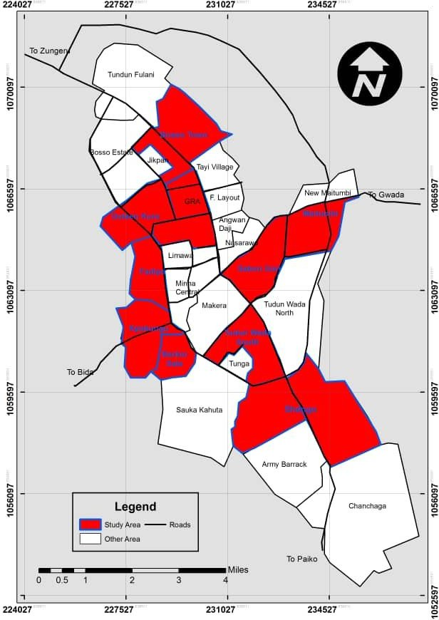

**Fig. 3.1: Sample areas selected for the project work**

* 1. **Methods of Data Analysis and Presentation**

The result of the field questionnaires was analyzed with the aid of computer software Statistical Package for Social Science (SPSS) in order to eliminate errors usually encountered in manual data analysis, and to also aid data manipulation besides easy storage and retrieval of large volume of information and data. Percentage and frequency

distribution were used to generate descriptive statistics result for the research. Results from the primary data were shown in chats, plates, figures, tables and maps.

# CHAPTER FOUR

* 1. **RESULTS AND DISCUSSION**

## Data Analysis

The research findings from field survey and data analysis from the selected neighbourhoods are represented in this chapter. Analysis of data and data representation is carried out on the socio-economic characteristics, gender, educational qualification, monthly income of the respondents including neighbourhood and housing conditions and environmental and infrastructure conditions of the neighbourhoods.

## Socio-Economic Characteristics of Respondents

The socio-economic characteristic involves the economic and social factor of the respondents. The analysis of the socio-economic characteristics of respondents determines the attitude of respondents towards the choice of choosing residential neighbourhood. The variable considered include: gender, highest level of education, monthly income, occupation among others.

## Gender of respondents

It shows from the findings that male respondents were more than the female respondents because the questionnaires were distributed mostly to the household heads except the situations where households’ heads were represented by their wives or the absence of the household heads were met at the time of questionnaire distribution. The table revealed that male respondents are 58.2% while female respondents are 41.8%.

## Occupation of respondents

Figure 4.1 shows that the highest or commonest is civil servant with over 39% of the population followed by the self-employed which is 21.2%, artisans has 17.7%, students 11.3% while unemployed is 10.4%. This shows that more than half of the population

sampled are employed which about 89.2% while only10.8% of the sampled population sampled are unemployed.

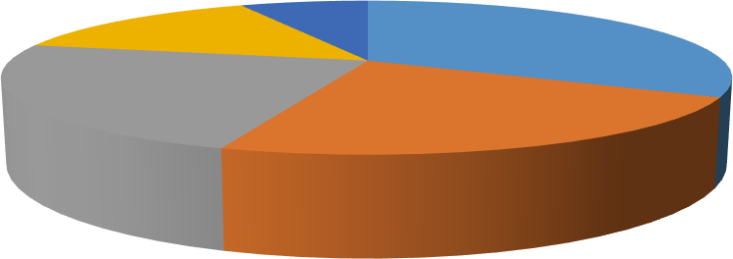

Student

15%

Unemployed

7%

Civil servant

32%

Self-employed Artisan

23% 23%

## Figure 4.1: Occupation of the respondents

* + 1. **Monthly income of the respondents**

Majority of the sampled population (53.2%) earn within the range of 5,000 naira to 15,000 naira per which is less than 18,000-naira minimum wage per month, while 36.5% of the sampled population earn within the range of 20,000 naira to 50,000 naira and above which is more than the standard minimum wage per month.

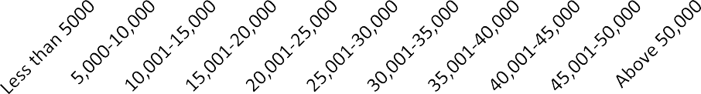

1.2% 1.5%

5.5%

2.8%

0

4%

5.2%

10.8%

9.8%

5

20.2%

19.2%

19 %

25

20

15

10

## Figure 4.2: Monthly income of the respondents

* + 1. **Respondents level of education**

Analysis of the field survey revealed that high percentages of the sampled population are educated. About 90.5% of the sampled populations are educated while 8.4% are less educated or not educated at all.

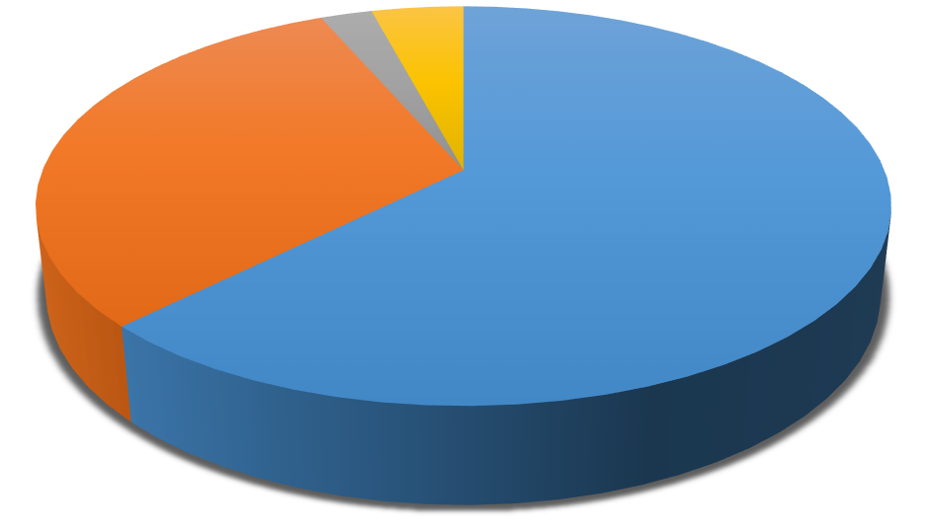

Quranic school

4%

Primary

2%

Secondary

31%

Tertiary

63%

**Figure 4.3: Respondent’s highest Level of Education**

* 1. **Neigbourhoods and Housing Density Assessment**
     1. **Types of density**

From the field survey, it was analyzed from the data collected in figure 4.3 that the highest density that is dominant in Minna metropolis is the high density out of the three types of densities existing in planning.



14%medium density

57%high density

29% low density

## Figure 4.4: Highest density of the respondents

* + 1. **Household size**

From the field survey that was carried out, figure 4.4 shows that majority of the houses have highest number of people in a household to be 5 which is 19% which mean the number of people within an household in Minna still fall below the planning standard compared to the number of bedrooms available within these households.

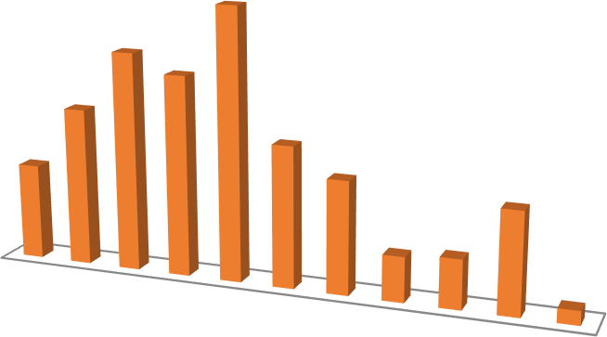

11

10

9

8

7

6

5

4

3

1%

2

1

3.2% 3.5%

7.2%

8%

19.2%

15.5%

14.2%

11.2%

10%

6.8%

## Figure 4.5: Household size

* + 1. **Number of bedrooms per households**

Most of the houses that were survey are below the average standard which is 2 persons per room. 53.2% households are below the average standard while 24.5% are above the standard and about 21.5% are neither below nor above the ideal standard.

The number of bedrooms available within the house hold against the highest number of people per house hold is below the standard which is 5 people per house hold. See figure 4.4.

The ideal density is high density where planners can plan to go higher in terms of constructions of accommodation thereby reducing space by giving room for other development, enhance mass transportation, exercise through wall and cycling, reduction of greenhouse gas emission and also to enhance housing affordability for all Nigerians. **Table 4.3: Number of bedrooms per household**

|  |  |  |
| --- | --- | --- |
| Numbers of Rooms | Frequency | Percentage |
| 1 | 101 | 25.2 |
| 2 | 112 | 28.0 |
| 3 | 86 | 21.5 |
| 4 | 50 | 12.5 |
| 5 | 30 | 7.5 |
| Above 5 | 18 | 4.5 |
| Total | **379** | **99.2** |

## Assessment of Housing Condition

* + 1. **Housing type**

From the survey that was carried out, Bungalow has the highest percentage which is 28.5%, while semidetached is about 20.8%, self contains, roll housing, duplex,

compound housing have and storey buildings are 50.7%. This mean more bungalows and semi-detached housing were built in the study areas and with two or one bedroom in the core high density neighbourhoods areas of Minna. See figure 4.5.

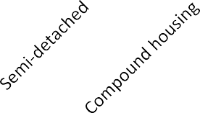

30

25

20

15

10

5

0

28.5%

20.8%

13.2%

15%

9.2%

8.5%

4.8%

## Figure 4.6: Housing type resided by the respondents

* + 1. **Housing construction materials**

Table 4.4 revealed that concrete material has the highest percentage which is about 92.0%, bricks, mud and straw, zinc, wood and aluminium are 7.9%. Most of these houses within the selected neighbourhoods are constructed with concrete materials.

## Table 4.4: Housing construction materials

|  |  |  |  |
| --- | --- | --- | --- |
|  | **Material** | **Frequency** | **Percent** |
|  | Bricks | 17 | 4.2 |
|  | Concrete | 368 | 92.0 |
|  | Wood | 4 | 1.0 |
|  | Aluminum | 4 | 1.0 |
|  | Zinc | 1 | .2 |
|  | Mud and straw | 6 | 1.5 |
|  | **Total** | **400** | **100.0** |

* + 1. **Housing condition in the neighbourhoods**

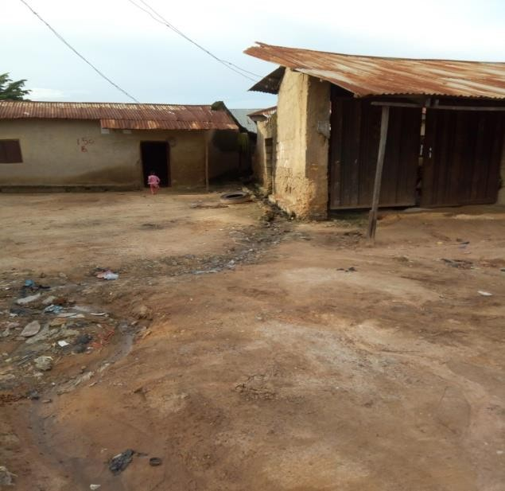The field survey shows that higher percentage of the population in the the sampled neighbourhoods are very dissatisfied with the conditions of their houses and locations of these houses. Plate l shows dilapidated building and housing condition in the sampled area.

**Plate l: Housing condition in Kpakungu**

* 1. **Assessment of Social Services, Housing Facilities and Infrastructure**
     1. **Source of water in the respondent’s neighbourhood**

As shown in figure 4.7, the study revealed that 33.5% of the household that were sampled are using well water, about 28.2% of the sampled household are making use of water vendor (Mai Ruwa and tanks) while private boreholes are 19.2%, Minna water board 10.8%, public boreholes and public taps are about 8.2%. From the survey, it can be said that most of the neighbourhoods in Minna get their source of water through well which usually dry up during the dry season thereby making the alternative source of water to be water vendors through tanks or Mai Ruwa during these period while these water vendors

got their own sources of water through private and mostly commercial boreholes in Minna (Figure 4.6).

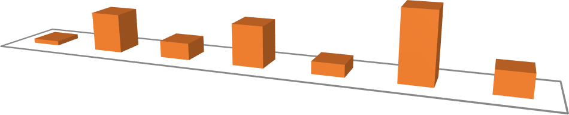

19.2%

33.5%

20%

2.2%

8.2%

6%

10.8%

Public tap Private

borehole

Water

vendor through tanks

Water

vendor through mai ruwa

Public

borehole

Well

Minna

water board

## Figure 4.7: Source of water in the sampled neighbourhood

* + 1. **Sources of electricity**

As shown in Table 4.5 which explained that most of the sampled households in Minna make use of AEDC as the source of their electricity which has about 95.2%, generator has about 3.2%, while those that are not using AEDC or generator is about 1.5%. Most of the sampled households have AEDC light 12 hours in a day which through rationing such as 8am to 2pm during the day and 8pm to 2am at night while some neighbourhoods will have the AEDC light from 6am to 12pm during the day and 6pm to 12am during the night. The cost of the electricity is on the high side, this was revealed during the field survey, while most of the respondents lamented that they have to pay #5,000 naira per month with the irregularity of light, others especially those in low density such as GRA said it is normal for them because of some of their household utensil which sometimes consume more electricity.

## Table 4.5: Source of electricity

|  |  |  |
| --- | --- | --- |
| Source of Electricity | Frequency | Percent |
| AEDC | 381 | 95.2 |

|  |  |  |
| --- | --- | --- |
| Generator | 13 | 3.2 |
| None | 6 | 1.5 |
| Total | **400** | **100.0** |

* + 1. **Waste disposal method by sampled households**

Table 4.6 shows the commonest waste disposal method of the respondents which is regular collection by Minna waste management which is about 44.0%, open dump site is about 37.2%, informal waste collectors has 17.2%. Minna has a very strong waste management system with their largest landfill dump site located in Maikunkele which was discovered during one on one interview with some of the workers in Minna waste management system.

## Table 4.6: Waste disposal method

|  |  |  |
| --- | --- | --- |
| Waste Disposal Method | Frequency | Percent |
| Open dump site | 149 | 37.2 |
| Regular collection by Minna waste management | 176 | 44.0 |
| Give to informal waste collectors | 69 | 17.2 |
| Total | **394** | **98.4** |

* + 1. **Drainage system in the sampled neighbourhood**

The type of drainage system in the neighbourhoods is shown in the figure 4.7. About 3% of the drainage system in the neighbourhoods that were sampled are not constructed, 9% are water lodge, about 40% are constructed and 48% are free drain which means lots of the existing access roads within the neighbourhoods are lacking proper drainage system thereby causing erosion and also causing the existing access road to wash away and

degenerate.

3%not constructed

40%

constructed

48%free drain

9%water lodge

## Figure 4.8: Drainage systems in the sampled neighbourhoods

* + 1. **Community association in the sampled neighbourhood**

Figure 4.8 shows that most of the neighbourhoods have no community association except the individuals who are willing to come together to carry out community work with funds coming from their personal pocket.

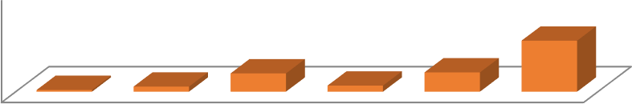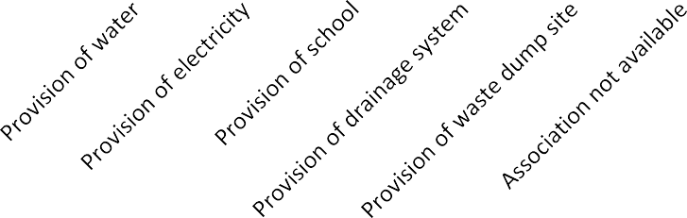

100

50.2%

1.7%

5%

18%

6%

19%

0

**Figure 4.9: Community association in the sampled neighbourhood**

## Infrastructure provided by the government

About 57.5% of the sampled neigbourhood have received various kinds of government interventions in forms of provision of transformers, provisions of dump sites, provisions of health care centers and schools including drainage systems while the reimaging 42.5% has not received any intervention from the government This shows that government is

working on providing more of the necessary infrastructure and enhancing the existing

ones. In Bosso Estate government is working currently on the degenerated road that leads to the Estate. See table 4.8.

**Table 4.8: Infrastructure provided by the government**

|  |  |  |
| --- | --- | --- |
| Type of Assistance | Frequency | Percentage |
| Access road | 20 | **5.0** |
| Provision of water | 2 | 0.5 |
| Provision of transformer | 132 | 33.0 |
| Provision of waste dump site | 57 | 14.2 |
| Provision of health care center | 2 | 0.5 |
| Provision of school | 3 | 0.8 |
| Provision of drainages | 14 | 3.5 |
| No government intervention yet | 170 | 42.5 |
| Total | **400** | **100.0** |

* 1. **Environmental Conditions and Problems within the Neighbourhoods**
     1. **Infrastructural conditions within the neighbourhoods**

Table 4.9 shows the rating of infrastructure condition in the selected neighbourhoods such as access road, drainage system, dump sites, availability of portable water, source electricity, health care services, schools etc. The survey revealed that 1.5% of the respondents are very dissatisfied with the state of infrastructure within their neighbourhoods, 10.8% are dissatisfied, 34.2% are not satisfied, 21.5% are satisfied and 30.8% are very satisfied. Other necessary social services are lacking in some of the

sampled neighbourhoods. The plates below show the states and conditions of the road in Barikin Sale, state and the condition of a bridge in Dutsen Kura.

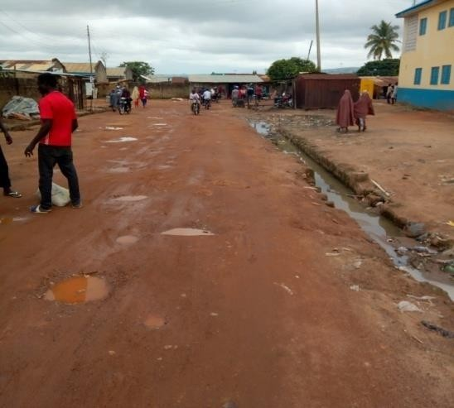

## Plate l1: Access road in Barikin Sale neighborhood

* + 1. **Overcrowding in the sampled neighbourhood**

It was observed that most there is the issues of overcrowding in most of the high density neighbourhoods such as Barikin Sale, Kpakungu, Maitumbi, Dusen Kura, Sabon Gari is crowded because of the existing market in the neighbourhood. Most of the available infrastructure are over stretched and some of them are no more functioning.

## Environmental degradation

From the field survey that was carried out, it was observed that most of the environment in the selected sampled neighbourhoods are degenerating, the available infrastructure are over stretched because of the population in these neighbourhoods leaving most of the people interviewed not satisfied with the conditions of their environment.

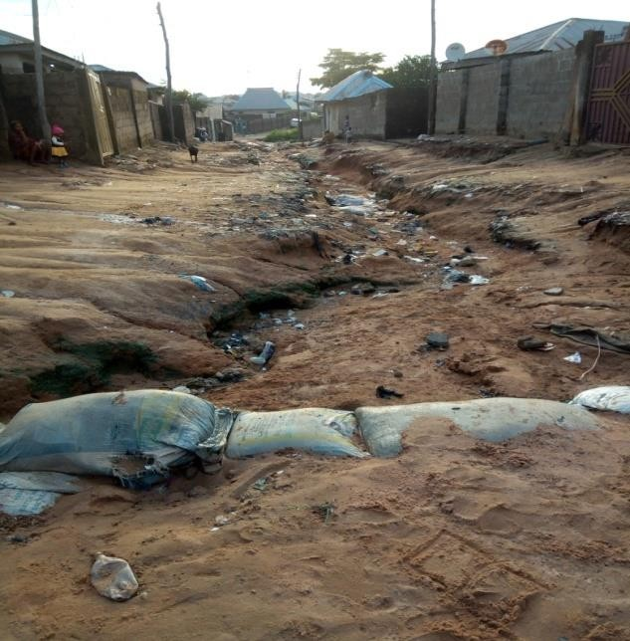

## Plate III: Situation of the road in Kpakungu neighbourhood

* + 1. **Erosion**

It was also observed that most of the access roads are not in good conditions because most of them are already washed away because of the erosion activities caused by lack of drainages and blocked drains through the actions of pouring dirt in the drainages and drains by some people in the sampled neighbourhoods.

## Noise pollution

The level of noise pollution is examined in the neighbourhoods and the highest numbers of the population are not satisfied with the level of noise pollution in their neighbourhoods.

## Crime rate

Figure 4.9 revealed that 4% of the respondents are very satisfied with the level of crime in their neighbourhood, 6.8% are satisfied, 9.8% are not satisfied, 26.5% are dissatisfied, while 52.8% are very dissatisfied. From the figure 4.9 it shows that crime rate is high in most of the neighbourhoods and crime is synonymous with high density since the highest

density in Minna has been discovered to be high density, most of the respondents are not satisfied with the crime rate of their neighbourhoods.

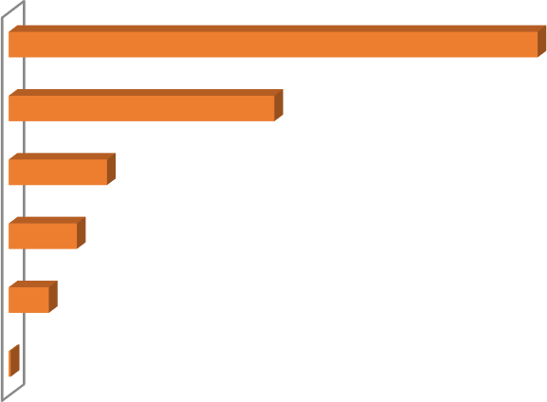

|  |  |  |  |
| --- | --- | --- | --- |
| Very dissatisfied |  |  | 52.8% |
| Dissatisfied |  | 26.5% |  |
| Not satisfied | 9.8% |  |  |
| Satisfied | 6.8% |  |  |
| Very satisfied | 4% |  |  |
| unattempted | 0.2% |  |  |

## Figure 4.9: Crime rate in the sampled neighbourhoods

* + 1. **General rating of the sampled neighbourhood and environment by the respondents**

Most of the respondents in the selected neighbourhoods responded with very satisfied and satisfied because the nighbourhood is either their source or sources of livelihood, the neighbourhood is close to their work place, for security purposes and so most of them accepted the neighbourhood they are as it is but they still wish for a better and improve condition of the neighbourhood by the government or community association within the neighbourhoods.

## Summary of Findings

1. From the findings, it shows that most of the respondents are male since the questionnaire is directly meant for the household heads to be answered and the highest occupation is civil service which means most of the household heads interviewed are government workers and also from the findings, it was shown that

the respondents earning above 50,000 as their monthly income accounted for the highest percentage which is 20.2%.

1. The main housing density type in Minna is high density. From the findings it was revealed that out of the three types of housing densities existing among the ten selected neighbourhoods, high density is the highest within Minna metropolis.
2. From the findings, the highest number of bedrooms available within the household is 2 bedrooms which is 28.0% against the highest number of people per household. This means the peope within the households are more compared to the number of bedrooms available within these households.
3. Most of the social facilities and infrastructure that are available in the high density sampled neighbourhoods are over stressed especially neigbourhoods like Barikin Sale, Dusen Kura, Maitumbi and Kpakungun. Some of these facilities and infrastructure are out of services; the few that are available are over used. Neighbourhood such as G.R.A has few good infrastructure and some social facilities that are available in the neighbourhood are privately owned. Sabon Gari is more of a market setting; the residential area in the neighbourhood makes use of the few facilities and infrastructure in the area.
4. From the findings, most of the neighbourhoods have means of providing water for themselves through digging of wells which means most of the neigbhourhoods make use of well water but complained that during the dry season these wells dry up and the available means of water supply will be from water vendors such as (Mai ruwa) or water tanks suppliers.
5. Most of the sampled households use AEDC which means Abuja Electricity Distribution Company and they have light 12 hours in a day which through

rationing such as 8am to 2pm during the day and 8pm to 2am at night while some neighbourhoods will have the AEDC light from 6am to 12pm during the day and 6pm to 12am during the night. The cost of the electricity is on the high side, this was revealed during the field survey, while most of the respondents lamented that they have to pay #5,000 naira per month with the irregularity of light, others especially those in low density such as GRA said it is normal for them because of some of their household utensils which sometimes consume more electricity.

1. From the findings, most of the neighbourhoods in Minna lack good social infrastructure and facilities. Most of the facilities and services supporting each neighbourhoods are in a state of degradation thereby making life difficult for the people living in these neigbourhoods
2. From the survey, it was discovered that Minna waste management system come to each neighbourhood on a fixed or scheduled time to pick up accumulated waste to a general landfill site. Minna landfill site is located in Maikunkele for proper sorting of the waste for example, waste that can be recycle will be separated, packed by companies and converted into useful material for other purposes while bio degradable waste will be separated and refined to be used for farm nutrients.
3. The general environmental conditions of most of the neighbourhoods are not good because these neighbourhoods lack proper planning and infrastructure such as good access roads, portable water, efficient drainage system, electricity, dump sites etc thereby endangering the lives of those living in these neighbourhoods and exposing them to environmental hazard and health problems.
4. From the findings, the neighbourhood that demonstrated higher residential land use in Minna is Barikin Sale the reason is that it has more population with a lot of

shanty houses built haphazardly and a small mass of land not enough to accommodate the whole population in the neighbourhood conveniently.

1. Most of the people living in high density residential neighbourhoods prefer the neighbourhoods because of the proximity to work, school and source of livelihood while others in low and medium densities prefer the neighbourhoods for security, availability of some facilities in the neighbourhoods.

# CHAPTER FIVE

* 1. **CONCLUSION AND RECOMMENDATIONS**

## Conclusion

The Highest housing density in Minna is high density according to the research work.

Most of the infrastructure in the neighbourhood are in poor state, some are no more functioning and the available ones are under stress.

The environmental condition of most neighbourhoods are also very bad with high crime rates in most of these neigbourhhood.

Neighbourhood preference shows that most respondents especially in the high density neighbourghoods prefer the neighbourhoods because of proximity to work and business places and the neighbourhoods serve as source or sources of livelihood but those in the low and medium neighbourhoods prefer the neighbourhoods for security reasons.

## Recommendations

There is the need for government at state and local level to formulate policies that will aid and help to solve issues in high density planning. The number of high density neighbourhoods in Minna is more than the low or medium density. It is time for the planners and stakeholders in planning to re-think housing densities in Nigeria.

Security will be fortified to prevent crimes and other evil vises, standard materials will be used for constructions and there will be enlightenment about the positive effects of high density development so as to change people’s orientation about the way they view high density development.

There is the need for strong creation of community associations within every neighbourhood to make and take good decisions about the neighbourhood improvement and provision and maintenance of some social facilities and provision of some infrastructure within these neighbourhoods and to give those living in these neighbourhoods a sense of belonging, identification, proper planning and report.

If standard infrastructure are in place, people will definitely use less of private cars and use more of public transport to save energy, time and fuel so therefore government should do the right thing by putting the right infrastructure in place and also community association should be encouraged to come together to work out how some infrastructure and social facilities can be put in place in their community to ease and enhance their standard of living, promote good security, creation of job opportunities to reduce crime rate within these nighbourhoods.

When re-thinking housing densities, planning authorities should put strict laws in place to guide the high density sustainability and maintenance high densities to reduce the fear and negative thoughts that some people have about living in high density neighbourhoods.

# REFERENCES

Adebayo, A. K., & Iweka, A. C. (2013). Households background and crowding in public housing multifamily apartments in Lagos. *ABTU Journal of Environmental Technology.* 2(1), 19-71.

Adedipe, A. (2009). Challenges of sustainable physical planning and development in Lagos,

*Journal of Sustainable Development*, 2(1), 159-171.

Ajanlekoko, J. O. (2001). Sustainable housing development in Nigeria : The financial and infrastructural implication, federal university of technology Akure, Ondo State. *Journal of Sustainable Development*, 2(1), 59-75.

Akinmoladun I. O., & Oluwoye, J. O. (2007). An assessment of why the problem of housing shortages persist in developing countries: a case study of Lagos metropolis, Nigeria. *Pakinstan Journal of Social Sciences*, 4: 589-598 http//medwelljournals.com.

AlertNet, R. (2014). Climate action needs to be part of city planning. Retrieved April 9, 2014, from <http://www.eco-business.com/news/climate-action-needs-be-part-city-> planning-urban-leaders/

Ames, H. (2019). Purposive sampling in a quantitave evidence synthesis; A worked example, BMC Med Res Methodol. *Journal of regional and city planning*, 19(26).

Asfour, O. S. (2015). Towards an effective strategy with housing land scarcity as a sustainable

development priority, *Journal of regional and city planning*, 36(2).

Atuaya, P. (2012). Insecurity, Infrastructure Deficit Mask Nigeria’s Progress. [www.businessdayonline.com](http://www.businessdayonline.com/). Retrieved on the 8th of July 2013.

Aytur, S. A., Daniel, A. R., Kelly, R. E., & Diane, J. C. (2008). Urban containment policy and physical attribues: A time series analysis of metropolitant area. *journal of regional and city planning*, 67(3).

Babalola, M. (2009), Cities and urban planning in Africa: Where did we go wrong, a paper presented at montly meet of Nigerian Institiute of Town Planning (NITP), Ikeja, Lagos. *Journal of regional and city planning,* 34, 23-56

Bah, E. M., Faye, I. O., & Geh, Z. F. (2018). Housing Finance in Africa. Housing Market Dynamics in Africa, *Journal of regional and city planning,* 57–108. https://doi.org/10.1057/978-1-137-59792-2_3

Baker, M. A. (2019). Advantages of density to infrastructure as an asset class.

*International Journal of Housing Policy,* 23(2), 674-698.

Baker, A., Brenneman, E., Change, H., McPhillip, L., & Matsler, M. (2019). Spartial analysis of landscape and socio-demographic: Factor associated with green storm water infrastructure distribution in Baltimore, Marryland and Portland. *Journal*

*of Environment and Earth Science,* 3(9), 72-83.

Borukhov, E. (1978). The trade-off between density and other objectives: a re- examination of planning norms. *GeoJournal,* 2, 71-80.

Boyko, C., & Cooper, R. (2013). Density and decision-making: Findings from an online survey. *Sustainability*, *5*(10), 4502–4522. https://doi.org/10.3390/su5104502

Brooks, N. (2003). Vulnerability, risk and adaptation: A conceptual framework (Tyndall Centre Working Paper No. 38 No. 38). Norwch. *Journal of Environment and Earth Science,* 1(2), 272-383.

Bussu, B. B., & Kawu, A. M. (2008). Establishing Sanitation Profile of Settlements in Minna Urban Divide - Niger State, Nigeria. *ETS Journal - Environmental Technology & Science Journal, Fed. Univ. of Tech. Minna, Nigeria.*, *2*(2), 1–12.

Campbell, S. (1996). Green Cities, Growing Cities, Just Cities?: Urban Planning and the Contradictions of Sustainable Development. *Journal of the American Planning Association*, *62*(3), 296–312. https://doi.org/10.1080/01944369608975696

Campos, L. C., Ross, P., Nasir, Z. A., Taylor, H., & Parkinson, J. (2015). Development and application of a methodology to assess sanitary risks in Maputo, Mozambique. *Journal of regional and city planning,* 27(2), 371–388. <https://doi.org/10.1177/0956247815595784>

Cervero, R. (2014). Transportation, infrastructure and the environment in the global south: Sustainable mobility and urbanism, *journal of regional and city planning*. 25(3): 174-191. ISSN 25026429

Chapin, F. S. (1972). Urban Land Use Planning. University of Illinois Press, Urbana, USA. *Journal of Sustainable Development*, 2(1), 59-75.

Co-operation, E., & States, U. (2012). With Disability, *Sustainablity* 1–9 https://doi.org/10.1017/idm.

Cope, M., & Lee, B. (2016). Mobility, Communication, and Place: Navigating the Landscapes of Suburban U.S. Teens, *International Research Journal of Finance and Economics,* 4452(June). https://doi.org/10.1080/24694452.2015.1124017

Daily, G. C., & Ehrlich, P. R. (2008). Impacts of development and global change on the epidemiological environment. *Environment and Development Economics*, 1(3). https://doi.org/10.1017/S1355770X00000656

Dukiya, J. J. (2008). Solid waste collection and disposal in Nigerian urban centres. A case study of Minna, Niger State. *Preserving the Environmental.* Second Annual National Conference of the School of Environmental Technology (SET), Federal University of Technology, Minna, Nigeria, 28 – 29th of February.

Elaf, D. (2017). The Impact of High Population Density on The Built Environment and The Behaviour of Individual in Amman, USA. *Global Journal of Research in*

*Engineering*: *J General Engineering,* 65(17).

Ester, C., Cindy, H. P., Casper, J. P., Anthoney, B., Martin, M. C., Poh-Chin, L., Janice,

M. J., & Ruby, S. Y. (2016). Neighbourhood Environment, Physical Activities, Quality of Life and Depressive Symptoms in Hong Kong Older Adult: A protocol for an Observational Study. *Mass Communication & Society*, 4(3), 225-244.

Evans, P. (1973). Housing Layout and Density. University of Cambridge, Department of Architecture, Landuse and Builtform Studies. *Journal of regional and city planning,* 12(2).

Fadamiro, J. A., Taiwo, A. A., & Ajayi, M. O. (2004). Sustainable Housing Development and Public Sector Intervention in a Developing Country: Nigeria. *Journal of regional and city planning,* 23(8), 324-378.

Forsyth, A. (2003). Measuring Density: Working Definition for Residential Density and Building. *International Journal of Housing Policy,* 12, 49–45.

Forsyth, A., Hearst, M. J., Oakes, M., & Schmitz, H. (2008). Design Destination: Factors Influencing Walking and Total Physical Activities in Urban Studies. *International Journal of Housing Policy,* 31, 44–45.

Groenewegen, P., Zock, .J.P., Spreecuwenberg, P., Hlbich, M., Hoek, G., Ruijsbroek. A., Strak, M., Verheij, R., Volker, B., Waverijn, G., & Dijst, M. (2018). Neighbourhood Social and Physical Environment and General Practitioner Assessed Morbidity: *Health and Place Journal, NIVEL, Netherlands Geosciences UU, Netherlands*, 34(12), 67-92.

Guild, R. L. (2000). Infrastructure investment and interregional development: Theory evidence and implication of planning, Public works management and policy. *Journal of regional and city planning,* 4(4), 274-285.

Henilane, I. (2015). The Evolution of Housing Situation in Latvia. In XVI Turiba University Future International Conference "Towards Smart, Sustainable and Inclusive Europe: Challenges for Future Development. Riga, Latvia. ISSN 1691- 6069.

Ibimiluwa, A. F., & Ibitoye, O. A. (2015). Housing Policy in Nigeria, Department Geography and Planning Science, Ekiti State University, Ado Ekiti, Ekiti, Nigeria. *Journal of Environmental Technology,* 22, 67-87.

Jinadu, A. M. (2007). Understanding the Basics of Housing: A Book of Notes for Students in

Tertiary Institutions. Revised Edition. Jos University Press Ltd, Jos, Nigeria.

John, S. (2018). What is Infrastructure Development, Asian-Pacific Economic Literature for the 21st Century: Framework for a Research Agenda. *Journal of Environmental Technology,* 20, 156-234.

Karlson, M., & Mörtberg, U. (2015). Landscape and Urban Planning A spatial ecological

assessment of fragmentation and disturbance effects of the Swedish road network. *Landscape and Urban Planning,* 134, 53–65. https://doi.org/10.1016/j.landurbplan.2014.10.009

Kawu, A. M., & Owoyele, G. S. (2008). Slums: Hubs of Opportunities and Sustainable Development. Environ. Ahmadu Bello University, Zaria, Nigeria. *Journal of Environmental Studies,* 2(9), 51–61.

Kawu, A. M., & Shuaibu, S. (2007). Physical Planning and Sustainable Urbanization in Nigeria. *Humanities and Education Research Journal (NASHER Journal ),* 5(1), 78– 86.

Kawu, A. M. (2016). Assessment of Urban Development Activities of Community Based Organizations in Minna, Nigeria. Unpublished PhD (URP) Thesis, Ahmadu Bello University, Zaria.

Keeble, L. (1972). Principles and Practice of Town and Country Planning.The Estates Gazette Limited, London, UK. *Centre on Urban and Metropolitan Policy*, 1-9.

Kenworthy, J. R. (2006). The eco-city: ten key transport and planning dimensions for sustainable city development. Environment and Urbanization. *Centre on Urban and Metropolitan Policy*, 18(1), 67–85. https://doi.org/10.1177/0956247806063947

King, K. (2013). Neighbourhood Walkable Urban Form and C - reactive protein. *Cities*, 52.

Kinyungu, A. N. (2004). Public-Private sector pertnership in serving of the land and provision of housing in low-income groups in Harare, Kenya: Experiences and lesson learnt . *Kenya Foundation for Rural and Urban Development,* 5(2).

Leemans, R., & Solecki, W. (2013). Redefining environmental sustainability. Current Opinion in Environmental Sustainability. *Centre on Urban and Metropolitan Policy*, 5(3–4), 272–277. https://doi.org/10.1016/j.cosust.2013.07.006

Leishman, C. (2008). Scottish Mode of Housing Supply and Affordability: Final Report, The Scottish Government (Hrsg.) Edinburgh. *Journal of the Scottish Regional Science Association*, 34(2), 35-47.

Lock, M. (1980). The Master Plan for Minna 1979 – 2000, Capital of Niger State, Nigeria. Max Lock Group Nigeria Limited, Kaduna, Nigeria. *Journal of Sustainable Growth,* 36, 1-12.

Longman, (2003). Senior Secondary Atlas, 2nd Edition. Ikeja: Longman Plc. *Centre on Urban and Metropolitan Policy*, 1(2), 19-39.

Mabogunje, A. L. (2005). Global Urban Poverty Reseach Agenda: The African Case. In Global Urban Poverty: Setting the Research Agenda. Washington, D. C. C*omparative Urban Studies Project of the Woodrow Wilson International Center for Scholars*, 28.

Macintyre, S., & Anne, E. (2002). Place Effect on Health: How can we conceptualize and operationalize and measure them? *Social Science*, 55(1), 125.

Maria, A., Esther, E., & Agnes, P. (2014). Effects of High Population Density on Rural Land Use in Federal Capital Territory. *Journal of Engineering Trend in Education Research and Policy Studies (JETERAPS),* 5(4), 392-395.

Mccandless, E., Bangura, A. K., King, M. E., & Sall, E. (2007). Peace Research for Africa: Critical Essays on Methodology. (E. Mccandless, A. K. Bangura, M. E. King, & E. Sall, Eds.). Addis Ababa: University for Peace, Africa Programme, Addis Ababa, Ethiopia. Retrieved from [www.africa.upeace.org](http://www.africa.upeace.org/)

Michael, J. B. (2020). COVID-19 Status Report. ASCEs, *Infrastructure Report Card Retrieved,* 6(2), 1-6.

Mitlin, D., & Satterthwaite, D. (2013). Urban Poverty in the Global South: Scale and nature. Routledge, Abingdon, Oxon, UK. *The Annual International Conference on Geographic Information Science,* 165-183.

Muir, J. (2010). Renewing Neighbourhoods: Work, Enterprise and Governance. Planning Theory & Practice, *Journal of regional and city planning,* 11(4), 626–628. https://doi.org/10.1080/14649357.2010.525377.

Murray, S. B., Griffinths, S., & Mond, J. M. (2016). Anabolic Steroid Use and Body Image Psychothology in Men. *Journal of regional and city planning,* 2(3), 10.

Mwangi, E., & Ostrom, E. (2009). Top-Down Solutions: Looking Up from East Africa’s Rangelands. Environment: *Science and Policy for Sustainable Development,* 51(1), 34–45. https://doi.org/10.3200/ENVT.51.1.34-45

Ndayako, F. M., & Kawu, A. M. (2012). Beneficiaries’ Assessment of Public Private Partnership in Housing Delivery in Minna, Nigeria. *CHSUD Journal - Centre for Human Settlements and Urban Development, Fed. Univ. of Tech, Minna, Nigeria*, 2, 41–54.

National Population Commission, (2008). National and State Population and Housing Table. Housing Characteristics and Amenities Table. Www.population.gov.ng/index/censuses.

Novinson, M. (2017). The Limit to Growth; Holt, Rinchat and Winston. *Journal of regional and city planning,* 23.

Obateru, O. I. (2005). Controling Residential Densities. Penthouse publications, Ibadan, Nigeria. *Journal of regional and city planning,* 57(7), 23-31.

Ogundahunsi, D. S., & Adejuwon S. A. (2014). Housing Condition and Health Relationship in Ijeda-Ijesa and Iloko-Ijesa Osun State, Nigeria. *Global Journal of Human-Social Science: B Geography, Geo-Sciences, Environmental Disaster Management*, 14(7): 1-8.

Ogundiran, A., & Enisan, O. (2013). Challenges of Housing Delivery in Metropolitan,

Lagos. Department of Urban and Regional Planning, Federal University of Technology, Ondo, Ondo State. Nigeria. *Journal of regional and city planning,* 109– 178.

Okafor, S. O. (2016). Population Growth and Distribution in Nigeria Issues and Trendsin Social Science. *Journal of Engineering Trend in Education Research and Policy Studies (JETERAPS),* 136-152.

Parija, S. C., & Kate, V. (2018). Thesis Writing for Master ’s and PhD Program. (S. C. Parija & V. Kate, Eds.). Singapore: Springer Nature Singapore. https://doi.org/https://doi.org/10.1007/978-981-13-0890-1

Persons, G. (2017), City Density and Public Transport; Australia Planner. *Journal of Environmental Technology,* 38(2), 74-79.

Peterman, W. (2000). Neighborhood Planning and Community-Based Development: The Potential and Limits of Grassroots Action. 2455 Teller Road, Thousand Oaks California 91320 United States: *SAGE Publications, Inc*. 28. https://doi.org/10.4135/9781452232508

Pont, M. B., & Haupt, P., (2007). The Spacement: Density and the Typomophology of Urban Fabric

Popoola, N. I. (2015). Analysis of Poor Urban Development and Real Property Value in Minna, Nigeria. Unpublished Phd Thesis, Urban and Regional Planning Department, Federal University of Technology Minna.

Robert B. H. (2007), Changes in Urban Density; Its implications on the sustainable development of Australian Cities. Paper presented at the State of Australia Cities National Conference.

Rodriguez, R. S., & Bonilla, A. (2007). Urbanization , Global Environmental Change , and Sustainable Development in Latin America Global Environmental Change, Sao Jose: *Inter American Institute for Global Change Research - IAI, Instituto Nacional de Ecología - INE, and United Nations Environment Programme - UNEP.* Retrieved from [www.iai.int,](http://www.iai.int/) [www.ine.gob.mx,](http://www.ine.gob.mx/) and [www.unep.org](http://www.unep.org/)

Sadasivam, K. (2009). Density Design and Sustainable Residential Development, *Habitat International*; Univrsity of South Australia, 25, 99-113.

Salau, A. T. (1992). Urbanization Housing and Social Services in Nigeria: The challenges of meeting basic needs, *Cities and Development in the Third World, England: Magnet Publishers,* 56, 123-214.

Sanusi A. Y. (2006). The Assessment of the Spatial Relationship between Poverty and Environmental Quality in Minna Metropolis Niger State, Nigeria. Unpublished PhD Project Geography Department Federal University of Tecnology Minna, Niger State.

Satterthwaite, D., & Mitlin, D. (2013). A future that low-income urban dwellers want and can help secure (Human Settlements Working Paper Series No. Poverty Reduction In Urban Areas – 38). *London: International Institute for Environment and*

*Development,* https://doi.org[/http://pubs.iied.or](http://pubs.iied.org/10626IIED.html)g[/10626IIED.html](http://pubs.iied.org/10626IIED.html)

Simon, D. (2014). New evidence and thinking on urban environmental change challenges. *International Development Planning Review,* 36(2). v–xi. https://doi.org/10.3828/idpr.2014.9

Sohn, D. W. (2016). Residential crimes and neighbourhood built environment: Assessing the effectiveness of crime prevention through environmental design (CPTED). *Cities*, *52*, 86–93. https://doi.org/10.1016/j.cities.2015.11.023

Taro Yamane, (1967). Sample Size Formular, *The Annual International Conference on Geographic Information Science,* 16-83.

Tatyana, P. (2014). Assessing The Impact of Infrastructure on Economic Growth and Global Competitiveness, 2nd Global Conference On Business, Economic, Management and Tourism, Parague, Czech Republic. *The Annual International Conference on Geographic Information Science,* 101-112.

Tibaijuka, A. K. (2009). Building Prosperity: Housing and Economic Development.

Leicester: *Earthscan.* Retrieved from [www.earthscan.co.uk](http://www.earthscan.co.uk/)

Tower, G. (2000). Implication of Housing Density. *The policy press Bristol*, 23, 56-89. Uchechi, O., Peter, U., Lionel, E. (2014). Corruption and Infrastucture Decay: Perceptible

Evidence from Nigeria, Department of Economics, University of Calabal, Calaba, Nigeria.

UN-Habitat, (2009). Sustainable Urban Energy Planning: A handbook for cities and towns in developing countries. *ICLEI – Local Governments for Sustainability ICLEI,* 27-67.

World Population Data Sheet, (2005). Population by Year-World meter. *The Annual International Conference on Geographic Information Science,* 105-143.

# APPENDIX I

## Geometric Progression Population Projection Formula

Po = (1 − 𝑅 )𝑛

100

While;

Po = Expected population P1 = Existing population R = Growth rate

n = Number of years

# APPENDIX II

## Structured questionnaire

For demographic and socioeconomic survey of sample households in the selected neighbourhoods.

# APPENDIX III

**CHECK LIST**

For physical survey of sample households in the selected neighbourhoods.

|  |  |  |  |  |  |  |  |
| --- | --- | --- | --- | --- | --- | --- | --- |
| **S/N** | **Facilities available** | **Very good** | **Good** | **Fair** | **Poor** | **Bad** | **Condition rating** |
| 1 |  |  |  |  |  |  |  |
| 2 |  |  |  |  |  |  |  |
| 3 |  |  |  |  |  |  |  |
| 4 |  |  |  |  |  |  |  |
| 5 |  |  |  |  |  |  |  |
| 6 |  |  |  |  |  |  |  |
| 7 |  |  |  |  |  |  |  |
| 8 |  |  |  |  |  |  |  |
| 9 |  |  |  |  |  |  |  |
| 10 |  |  |  |  |  |  |  |

# APPENDIX IV

DEPAETMENT OF URBAN AND REGIONAL PLANNING SCHOOL OF ENVIRONMENTAL TECHNOLOLGY FEDERAL UNIVERSITY OF TECHNOLOGY, MINNA

*QUESTIONNAIRE ON ANALYSIS OF HOUSING DENSITIES, ENVIRONMENT AND INRASTRUCTURE IN MINNA*

## Dear Respondent,

This research work is part of the requirements for the award of Master Degree (M.Tech) Urban and Regional Planning (Housing and Urban Renewal Option). The information provided will be used mainly for the purpose of the research work and shall be treated with utmost confidentiality.

# SECTION A (PERSONAL DATA)

* + 1. **Gender**(a) Male….. (b) Female…
    2. **Occupation** (a) Civil Servant… (b) Artisan… (c) Self-employed… (d) Student…(e) Unemployed…
    3. **Monthly income** (a) Less than 5,000… (b) 5,000-10,000… (c) 10,001-15,000

(d) 15,001-20,000… (e) 20,001-25,000…(f) 25,001-30,000… (g) 30,001- 35,000… (h) 35,001-40,000… (i) 40,001-45,000… (j) 45,001-50,000… (k)

Above 50,000…

* + 1. **Level of education** (a)None… (b) Tertiary… (c) Secondary… (d) Primary…(e) Quranicschool….

# SECTION B (NEIGHBOURHOOD AND HOUSING CONDITION)

* + 1. **Neighbourhood location**(a)Bosso… (b)Sabongari… (c)Fadipe… (d)Dutsenkura… (e) GRA… (f) Tudunwada South…(g)Maitunbi….(h)Kpakungu…(i) Shango… (j) Barikin sale…
    2. **Type of density** (a) Low density area… (b) Medium density area… (c) High density area…
    3. **Number of people per family(household)** (a)1… (b) 2… (c) 3… (d) 4… (e) 5… (f) 6… (g) 7… (h) 8… (i) 9… (j) 10…
    4. **Number of bedroom per household** (a) 1… (b) 2... (c) 3… (d) 4… (e) 5…

(f) Above 5…

* + 1. **Housing type** (a) Duplex… (b) Bungalow… (c) Semi-detached… (d) Compound housing… (e) Roll housing… (f) Self contain… (g) Storey building…
    2. **Construction materials** (a) Bricks… (b) Concrete… (c) Wood… (d) Aluminum…(e) Zinc…(f) Mud and straw…
    3. ​**Main source of water** (a) Public tap… (b) Private borehole… (c) Water vendor through tanks…(d) Water vendor through (Mai Ruwa)…. (e) Public borehole… (f) Well… (g) Minna water boad…
    4. **Main source of electricity** (a) PHCN… (b) Generator… (c) Solar… (d) None…
    5. **Waste disposal method** (a) Open dump site (b) Regular collection by Minna waste management… (c) Give to informal waste collectors…
    6. **Type of drainage system** (a) constructed… (b) Water lodge… (c) Free drain…

(d) Not constructed….

* + 1. **What is the activity of community association in your neighbourhood** (a) provision of water… (b) Provision of electricity… (c) Provision of School…

(d) Provision of drainages… (e) Provision of waste dump site… (f) Association not available…

* + 1. **Help from the government to the neighbourhood**(a) Access road… (b)Provision of water… (c) Provision of transformer…. (d) Provision of waste dump site… (e) Provision of health care… (f) Provision of schools… (g) Provision of drainages…. (h) No government intervention yet…

# SECTION C (ENVIRONMENTAL CONDITION)

**Rate the challenges you face in your neighbourhood by ticking in the appropriateTable below**

|  |  |  |  |  |  |  |
| --- | --- | --- | --- | --- | --- | --- |
|  |  | Verysatisfied **5** | Satisfied **4** | Notsatisfied **3** | Dissatisfied **2** | Very dissatisfied **1** |
| 17 | High crime rate |  |  |  |  |  |
| 18 | Lack of social infrastructure |  |  |  |  |  |
| 19 | Overcrowding |  |  |  |  |  |
| 20 | Environmental degradation |  |  |  |  |  |
| 21 | Poor housing condition |  |  |  |  |  |
| 22 | Erosion |  |  |  |  |  |
| 23 | Noise pollution |  |  |  |  |  |

**Rate the opportunity associated to your neighbourhood by ticking in the appropriate box below**

|  |  |  |  |  |  |  |
| --- | --- | --- | --- | --- | --- | --- |
|  |  | Very satisfied **5** | Satisfied **4** | Not satisfied **3** | Dissatisfied **2** | Very dissatisfied **1** |
| 24 | Proximity to work |  |  |  |  |  |
| 25 | Proximity to school |  |  |  |  |  |
| 26 | Availability of necessary infrastructure |  |  |  |  |  |
| 27 | Serve as source of livelihood |  |  |  |  |  |
| 28 | Proximity to CBD(or Mobil) |  |  |  |  |  |
| 29 | For security purpose |  |  |  |  |  |

**How satisfied are you with the environmental condition of your neighbourhood?**

|  |  |  |  |  |  |  |
| --- | --- | --- | --- | --- | --- | --- |
|  |  | Verysatisfied **5** | Satisfied **4** | Not satisfied  **3** | Dissatisfied **2** | Very dissatisfied **1** |
| 30 | Very good |  |  |  |  |  |
| 31 | Good |  |  |  |  |  |
| 32 | Fair |  |  |  |  |  |
| 33 | Bad |  |  |  |  |  |
| 34 | Very bad |  |  |  |  |  |

**Check list for Bosso**

|  |  |  |  |  |  |  |
| --- | --- | --- | --- | --- | --- | --- |
| Category of | Available | Not | Numbers | Source | Functioning | Not |
| facilities, |  | available | of the |  |  | functioning |
| amenities and |  |  | available |  |  |  |
| infrastructure |  |  | on |  |  |  |
|  |  |  | ground |  |  |  |
| Water Supply |  |  |  |  |  |  |
| Electricity |  |  |  |  |  |  |
| Access Road |  |  |  |  |  |  |
| Drainage System |  |  |  |  |  |  |
| Phone Facilities |  |  |  |  |  |  |
| Waste Disposal system |  |  |  |  |  |  |

|  |  |  |  |  |  |  |
| --- | --- | --- | --- | --- | --- | --- |
| Health care center |  |  |  |  |  |  |
| Primary school |  |  |  |  |  |  |
| Secondary school |  |  |  |  |  |  |
| Church |  |  |  |  |  |  |
| Mosque |  |  |  |  |  |  |