## AMERICAN UNIVERSITY OF NIGERIA DEPARTMENT OF NATURAL AND ENVIRONMENTAL SCIENCES

Senior Research Project

## ANALYSIS OF THE KNOWLEDGE AND PERCEPTION TOWARDS DOWN SYNDROME IN ADAMAWA STATE

by

## IMAIMA ROBERT

Submitted in partial fulfillment of the requirements for the degree of Bachelor of Science

2016

## AMERICAN UNIVERSITY OF NIGERIA DEPARTMENT OF NATURAL AND ENVIRONMENTAL SCIENCES

## ANALYSIS OF THE KNOWLEDGE AND PERCEPTION TOWARDS DOWN SYNDROME IN ADAMAWA STATE

This thesis represents my original work in accordance with the American University of Nigeria regulations. I am solely responsible for its content.

## IMAIMA ROBERT

### Signature Date

I further authorize the American University of Nigeria to reproduce this thesis by photocopying or by any other means, in total or in part, at the request of other institutions or individuals for the purpose of scholarly research.

## IMAIMA ROBERT

### Signature Date

## ANALYSIS OF THE KNOWLEDGE AND PERCEPTION TOWARDS DOWN SYNDROME IN ADAMAWA STATE

## IMAIMA ROBERT

Approved by

Research Supervisor: **Dr. Jennifer Tyndall, Ph.D**. Associate Professor of Natural and Environmental Sciences

Signature Date

Second Reader: **Dr. Jessica Boyd, Ph.D**.

Assistant Professor of Natural and Environmental Sciences

Signature Date

## ANALYSIS OF THE KNOWLEDGE AND PERCEPTION TOWARDS DOWN SYNDROME IN ADAMAWA STATE

## IMAIMA ROBERT

American University of Nigeria, 2015

Major Professor: Dr. Jennifer Tyndall, Ph.D, Professor of Natural and Environmental Science*.*

ABSTRACT

This study was undertaken in order to gain an insight on the knowledge and attitudes of the AUN community towards Down syndrome, further research was conducted with number [3] families in both Adamawa and Rivers States in order to assess how parents cope with the care of a child with Down syndrome. The research also tried to ascertain the knowledge of these parents about the disorder before and after the birth of their children. If they had more than one child with Down syndrome was also a factor studied in the research. All three families involved in the study had male children with Down syndrome. Their ages ranged from 6 to 10. Questionnaires with close ended and open ended questions were used for the study carried out in the AUN community. All parents involved were unaware of their child’s disorder before birth and the mothers were in denial for a while. The research investigates how these parents cope and how the children are being cared for.

### Keywords: Down syndrome, coping, awareness, knowledge

.

Table of Contents

BRIEF INTRODUCTION 1

AIMS AND OBJECTIVES 1

* 1. DEFINITION OF DISABILITY 2
  2. TYPES OF DISABILITIES 3
  3. WHAT IS DOWN SYNDROME? 4
  4. TRAITS AND CHARACTERISTICS COMMON TO DOWN SYNDROME 5
  5. CAUSES OF DOWN SYNDROME 6
  6. TYPES OF DOWN SYNDROME 7
  7. RISK FACTORS 12
  8. COMPLICATIONS ASSOCIATED WITH DOWN SYNDROME 13
  9. DISABILITY ACT 18
  10. RESEARCH METHODOLOGY 19
  11. RESEARCH METHOD 19
  12. STUDY AREA 19
  13. TARGETED POPULATION AND DATA COLLECTION 20
  14. METHOD OF DATA ANALYSIS 20

RESULT 21

DATA ANALYSIS 28

DISCUSSION 36

CONCLUSION 44

APPENDIX 45

REFERENCES 48

**LIST OF FIGURES**

Figure 1: Physical Traits of Down syndrome 6

Figure 2: Inheritance of Familial Down syndrome 8

Figure 3: Karyotype of Down syndrome 10

Figure 4: Risk of having a child with Down syndrome against age 12

Figure 5: Percentage of Males and Females that participated (Excel) 29

Figure 6 Relationship between gender and Knowledge of Down syndrome 30

Figure 7 Relationship between Gender and willingness to share a meal or touch someone with Down syndrome 31

Figure 8 Relationship between gender and knowledge of inheritance of the disorder

. 31

Figure 9 Relationship between Educational Status and Knowledge about Down syndrome 32

Figure 10 Educational Level against Knowledge of Inheritance Mechanisms 32

Figure 11 Relationship between age of respondent and their knowledge about Down syndrome 33

**LIST OF TABLES**

Table 1: Disabilities, Types and Examples 3

Table 2: Table showing the compilation of questionnaire outcome (SPSS analysis) 21

Table 3: Table showing the compilation of questionnaire outcome (SPSS analysis) 25

**LIST OF ABBREVIATIONS**

|  |  |
| --- | --- |
| SFSV | Student, Faculty, Staff or Visitor |
| HYHADS | Have you heard about Down syndrome |
| HDYHADS | How did you hear about Down syndrome |
| Cntg | Do you think it is Contagious |
| Contact | Have you come in contact with a person with Down syndrome |
| SAMT | Would you share a meal with someone with Down syndrome |
| CGTS | Would you let your children go to school with someone with Down syndrome |
| FFWD | Friend or Family with Down syndrome |

Chapter 1

# Brief Introduction

Down syndrome is a common genetic disorder; this research is geared towards finding out how many people in the area of focus (American University of Nigeria, Yola) know about the disorder and how much knowledge they have and it will also in turn attempt to raise awareness about the disorder. The paper is aimed at increasing the understanding of Down syndrome, its causes, how it is being diagnosed, the traits common to the disorder and its risk factors. It will also discuss the complications associated with Down syndrome, the life expectancy of people with Down syndrome, treatment and prevention. Coping mechanics adopted by the parents will also be discussed.

# Aims and Objectives

**To know how many people are aware of Down syndrome:** This aspect of the project will explore how many people are aware of the disorder and how they gained awareness, through the media, articles, television, school or newspapers. This will also study the knowledge and attitudes of people who know about Down syndrome because of a family member or relative with Down syndrome.

**To figure out how parents cope with the disorder**: Many parents who have children with trisomy 21, are prone to being stressed which can affect them both emotionally and psychologically. This study will attempt to determine how they deal

with stress. This will also touch on the healthcare they provide for their child and if they have a regular checkup dates scheduled with the doctor.

**To know if parents have more than one kid with Down syndrome:** This will try to understand if mothers can give birth to another child with Down syndrome after they have already had one.

# Definition of Disability

A disability is a state or condition that is perceived to be considerably dysfunctional with regards to the typical standard of an individual or a collection of individuals. (Definition of Disabilities) The word disability is a canopy that encompasses, impairments, activity restraint and constraint in involvement (Disabilities, 2015).

Impairments are often translated as the inability to do things as a result of being physically or mentally unsound. Activity restraint is the trouble a person experiences while trying to achieve a goal or an action and constraint in involvement is the difficulty an individual encounters in life circumstances. There are various types of disabilities, they include mobility and physical impairments, spinal cord disability, head injuries – brain disability, vision disability, hearing disability, cognitive or learning disabilities, psychological disorders and invisible disabilities (Definition of Disabilities). Table 1.0 shows a list of disabilities, types and examples.

*Table 4: Disabilities, Types and Examples.*

|  |  |  |
| --- | --- | --- |
| **Disabilities** | **Types of Disabilities** | **Example** |
| **Physical:** The partial or total loss of bodily functions or a body part | Mobility and Physical Impairment, Spinal Cord Disability, Visual Disability, Hearing Disability | Stroke, Muscular Dystrophy, Poliomyelitis, Deformity of limbs, Osteogensis Imperfecta |
| **Mental/Psychological:** Anomalies that cause inability to function effectively in daily life | Head Injuries – Brain Disability, Psychological Disorders | Schizophrenia, Major Depression, Bipolar Disorder, Panic Disorder |
| **Genetic/Congenital:** Disabilities that are present before birth | Cognitive or Learning Disabilities, | Down syndrome, Autism, Fragile X syndrome, Cystic Disease |

*The contents of the table have disabilities that overlap.*

# Types of Disabilities

There are different disabilities associated with Mobility and Physical Impairment, they include upper and lower limb disability, manual dexterity and disability in co-ordination with organs of the body. Spinal Cord Disability that is caused mostly by accident but it can sometimes be a birth defect; There are two kinds of spinal injuries: incomplete and compete injuries (Definition of Disabilities). Brain disabilities consist of two major types: acquired and traumatic brain injury. They both can range from mild to severe injuries; Acquired Brain Injuries happen after birth and they occur in brains cells while Traumatic Brain Injury are commonly a result of applied force to the head and also occurs after birth. (Brain Damage: Learn About Trauma from Brain Injuries, 2015) Vision Disabilities are impairment that cannot be rectified with the use of glasses or contact lens. Vision Disabilities range from age-related macular degeneration (AMD) to glaucoma (Visual impairment ).

Hearing disability is an impairment that hinders an individual’s reception of sound

through the ear. There are three types of hearing impairment, they include Conductive, Sensorineural and Auditory Processing Disorder. (Shemesh, 2010) Cognitive or Learning Disabilities affects several mental tasks, examples include dyslexia, autism, down syndrome and various others. Lastly, psychological disorders also known as mental disorders are impairments that inhibits one’s ability to function in daily activities. (Definition of Disabilities)

# What is Down syndrome?

Down syndrome was first described by a late nineteenth century physician named John Langdon Down (Asa, 2009). Though Down syndrome was easily identifiable, especially by the physical features, John Down was the one who gave Down syndrome a definitive description and a detailed and scientific definition. With the developments in science, technology and medicine Down syndrome was researched in-depth and it was identified and recognized as a chromosomal disorder in 1959 by Jerome Lejeune, a French Physician.

Humans have 46 chromosomes each in pairs. Down syndrome is caused by an extra chromosome 21; this adds up to a total of 47 chromosomes as opposed to the normal 46 chromosomes. This is why the condition is also known as Trisomy 21. It is one of the most common chromosomal disorders that is a cause of cognitive and learning impairment and it does not have a cure. According to Alan H. Bittles 1 in every 650-100 newborns is diagnosed with Down syndrome (Bittles, Bower, Hussain, & Glasson, 2006).

# Traits and Characteristics Common to Down syndrome

People born with this condition often have a distinctive phenotype. The traits common to people with Down syndrome include, short neck, flat and round face, relatively large tongue, eyes that slant upwards, small nose, poor muscle tone and short fingers as seen in Figure 1.3. People with this condition are also likely to develop other medical complications including but not restricted to heart defects, leukemia, respiratory infections, ear infections, eye defects and hypothyroidism.

Most people with Down syndrome have an intelligence quotient (IQ) that falls between ranges that are mildly to moderately low. They take more time to develop compared to their peers; their intellectual disability makes it harder for them to speak properly, learn quickly and take care of themselves. According to Diana Hernandez (1996), people with this condition have an IQ that declines with an increase in age and close to all of them develop Alzheimer when they get to 35 years (Hernandez & Fisher, 1996)

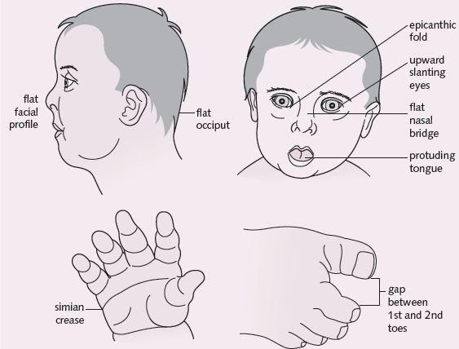

*Figure 1: Physical Traits of Down syndrome.*

# Causes of Down syndrome

Down syndrome is caused by an error in cell division known as nondisjunction. Nondisjunction occurs when homologous chromosomes are not properly separated or correctly distributed during the formation of egg or sperm. This causes the embryo to have three copies of chromosome 21, after the egg fuses with the sperm. As the baby grows this third chromosome is copied into each cell. There is an increase in the occurrence of nondisjunction in women with advanced ages; women above the ages of 35 are more likely to have children with Down syndrome.

Down syndrome can also be caused by Robertsonian translocation (Down Syndrome, 2015). Robertsonian translocation is a chromosomal rearrangement that

occurs when two chromosomes join together. People with balanced translocation are carriers, they lead a normal life; most carriers are not aware of their chromosomal arrangement but can have children with Down syndrome. Unbalanced Robertsonian translocation more often than not lead to chromosomal disorders like Down syndrome, Patau Syndrome, Prader-Willi syndrome and Angelman syndrome. Down syndrome caused by Robertsonian translocation is rare (Robertsonian Translocations

, 2005).

# Types of Down syndrome

There are three types of Down syndrome, they include Trisomy 21 (Nondisjunction), Translocation and Mosaic (Percy & Schrormans, 2005).

**Trisomy 21:** This is the most common type of Down syndrome accounting for 95% of all cases. It is also known as nondisjunction. It occurs when a child has an extra copy of chromosome 21 as opposed to the usual 2 copies. It is caused by errors in cell division during the formation of the egg and sperm cell. These three chromosomes are then replicated in all cells (Facts About Down Syndrome , 2014).

**Mosaic:** Mosaic pattern affect 2% of the people with Down syndrome. This happens when nondisjunction does not occur in all of the initial cell division after fertilization. This causes them to have a mixture of two kinds of cells, some having the typical 46 chromosome and others having 47 chromosome (cells with extra chromosome 21). When this happens, babies born have fewer typical traits of Down syndrome as many have the correct number of 46 chromosomes (National Down Syndrome Society ).

**Translocation:** This happens when part or all of the extra chromosome 21 is attached to another chromosome and as the cells undergo division the chromosome it

gets attached to, is transmitted into other cells; this happens before or during conception (Facts about Down Syndrome , 2014). The effect of translocation does not necessarily change the effect of Down syndrome. This type of Down syndrome can be hereditary, and usually the father or mother is a carrier of translocation but is not aware because the symptoms are not apparent (Translocation Down Syndrome, 2013).

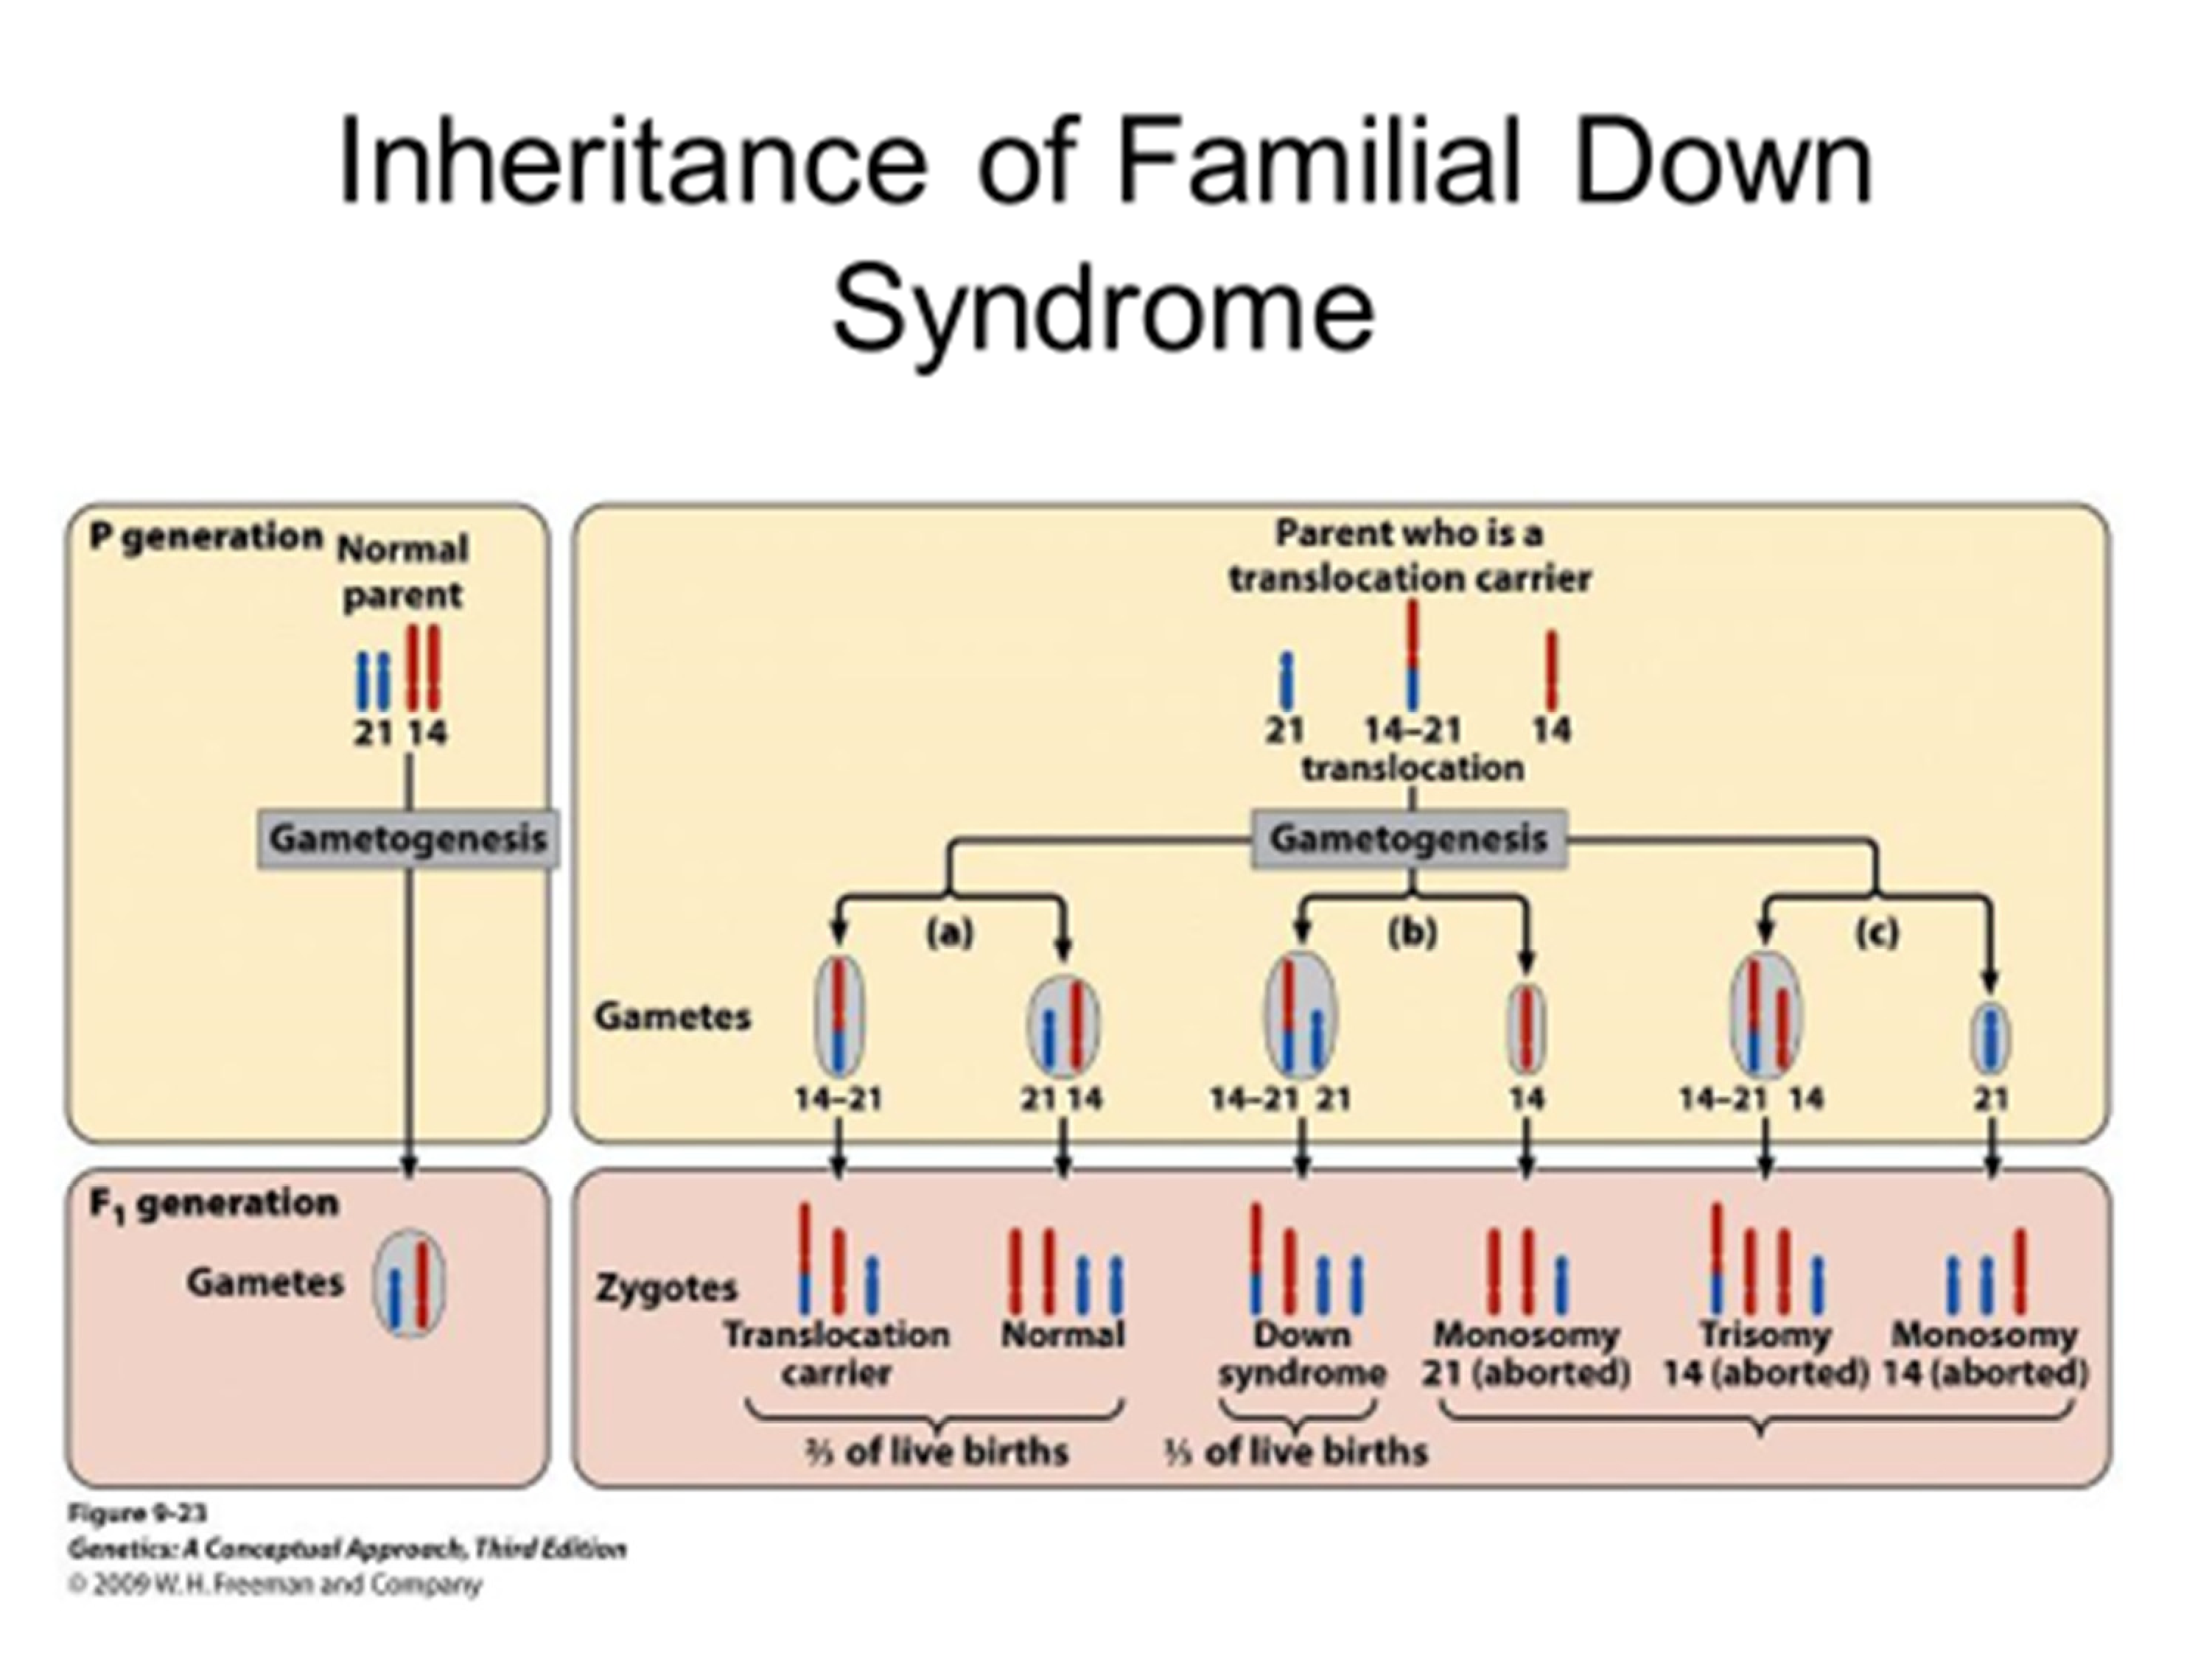

*Figure 2: Inheritance of Familial Down syndrome*

### Diagnosis of Down syndrome

Two kinds of prenatal testing can be performed to know if a baby has Down syndrome, they are the screening tests and diagnostic tests (Understanding a Diagnosis of Down Syndrome, 2012). Screening tests are typically done for mothers who are more likely to have a child with Down syndrome but are highly recommended for mothers of all ages. Diagnosis from this kind of test is not 100% accurate but is safe for the mother and baby. Diagnostic tests are more invasive, somewhat unsafe for both mother and baby but overall more accurate for diagnosis (Mayo Clinic, 2015).

**Screening Tests:** This comprises blood tests and sonograms, the blood test measures the amount of different substances in the mother’s blood, this aids in knowing if the mother has high or low chances of having a baby with Down syndrome and the sonograms (ultrasound) take pictures of the baby that can be examined carefully.

Certain markers are looked for during sonograms like excess fluid behind a baby’s neck, which often means a baby has a genetic disorder (Understanding a Diagnosis of Down Syndrome, 2012). Screenings are not completely reliable because sometimes, though rarely, the results indicates problem when there is no problem and other times it gives a normal result when indeed there is a problem. A new type of screening is now available that checks the mother’s blood for chromosomal materials (DNA) from the fetus.

**Diagnostic Tests:** These kinds of tests are more invasive and poses a greater risk to the fetus because it involves extracting samples surrounding the developing fetus that can lead to spontaneous termination. It is typically done after screening tests that are uncertain or positive to confirm that the child has Down syndrome. The types of

Diagnostic tests carried out include: amniocentesis, which involves taking samples of the amniotic fluid and examining it for an extra chromosome. It is done in the second trimester 14-18weeks into the pregnancy. Chorionic villus sampling (CVS) is a test that is carried out within the 9th to 11th week of pregnancy (Mayo Clinic, 2015), it involves the extraction and examination of the genetic material from the placenta (an organ that attaches/connects the fetus to the mother). Lastly, percutaneous umbilical blood sampling (PUBS) examines extracted blood from the umbilical cord through the uterus, out of all three diagnostic tests it is regarded as the most precise but it cannot be performed until the 18th to 22nd week of pregnancy.

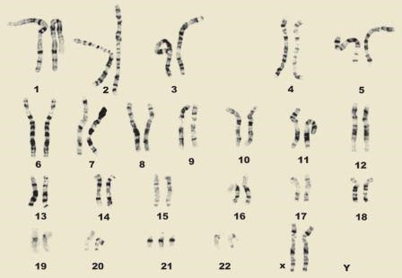

*Figure 3: Karyotype of Down syndrome*

Diagnosis can also be carried out after birth by examining the baby using the traits common to people with Down syndrome. Since this method is not 100% effective as a baby without Down syndrome can possess some of these qualities and a baby with Down syndrome might not have the obvious traits, a blood test is usually carried out. A sample of the baby’s blood is usually taken for chromosomal analysis known a Karyotype (Figure 1.5). A special equipment is used to take pictures of the chromosome and then these chromosomes are arranged and grouped according to number, size and shape; when this is done the karyotype will tell accurately if the baby has Down syndrome (Understanding a Diagnosis of Down Syndrome, 2012).

This tests are critical and important as they ready parents mentally and psychologically and also aid them in taking care of the baby. Babies with Down syndrome require extra care and their quality of life can be better if it is detected on time and their health need met.

# Risk Factors

Studies have shown that mothers over the age of 35 are likely to have children with Down syndrome but mothers under the age of 30 account for 75% of the mothers that have children with Down syndrome. As the mothers age increases the chances of her having a child with the disorder increase significantly this is because the older the woman’s eggs the higher the probability of correct chromosomal division (Malini & Ramachandra, 2007).

People with a child that has Down syndrome have higher risk of having another child with Down syndrome. Also parents that are translocation carrier are more likely to have a child with Down syndrome and women with this genetic disorder have a 50% chance of having a child with the same disorder (WebMD, 2013).

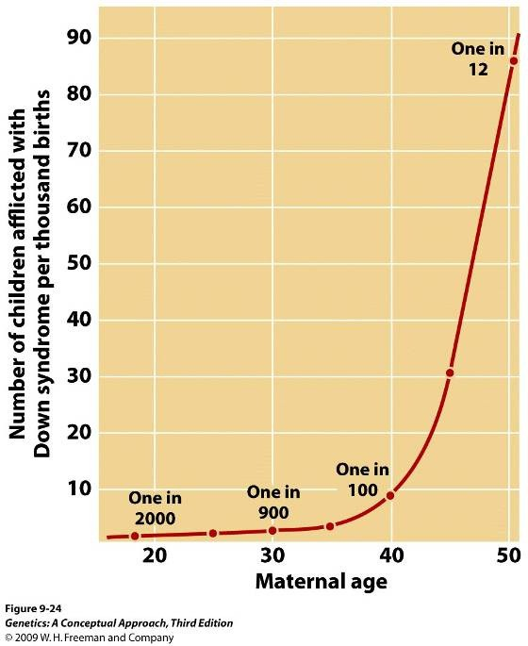

*Figure 4: Risk of having a child with Down syndrome against age*

# Complications associated with Down syndrome

There are several complications associated with Down syndrome, they include attention deficit hyperactivity (ADHD), Alzheimer’s, ear, nose and throat issues, Endocrine conditions, heart condition, mental health issues, sleep apnea and vision impairment. Children with Down syndrome are more vulnerable to viral and bacterial infections because their T lymphocytes are lower than normal (Murphy, Esptein, & Lempert, 1990).

**Attention Deficit Hyperactivity Disorder (ADHD):** Is a disorder that is commonly diagnosed at childhood, it sometime transcends into adolescence and adulthood.

Some of the traits common to attention deficit hyperactivity disorder includes a decline in attention span, hyperactivity as the name suggests and impulsive behavior (Insel, 2010). Many children exhibit these traits but children with Down syndrome are more likely to display these traits than her/his peers.

**Alzheimer’s disease:** It is a neurological disorder that is considered a type of dementia. It involves the death of brain cells that in turn leads to loss of memory and other problems in thinking and behavior (MacGill, 2015). People with Down syndrome around 65years and above are 75 percent more likely to have Down syndrome. Alzheimer’s shares a genetic connection with Down syndrome that leads to greater risk of dementia at a young age (Alzheimer's Disease & Down Syndrome, 2012). Alzheimer’s that occur before the age of 65 is known as younger-onset Alzheimer’s. On average the life expectancy of people with Down syndrome is between 55 and 60 years, this explain why they are more probable to have younger- onset Alzheimer’s than older onset Alzheimer’s disease that typically develops at in people that are 65years or older (Alzheimer's Association , 2015).

**Ear, nose and throat issues (ENT):** As the name implies, ENT are the problem that are commonly associated with the ear nose and throat. Some of the ear, nose and throat problems that are considered typical include, sleep apnea, sore throat, hearing loss, nosebleeds, tonsils and adenoid problems (Common ENT Problems , 2015).

40-50 percent of children with Down syndrome have stenotic ear canals, this makes it hard for their middle ear and ear drum to be examined. The mildest loss in a child’s hearing can make it hard for the child to articulate and learn. This is why it is advised that children with Down syndrome have an otolaryngologist (specialist in ear nose and throat infection). An otolaryngologist plays a vital role in the health of people with Down syndrome. The facial anatomy of people with trisomy 21 makes increases their chances of inflammation of the sinus (sinusitis) and chronic rhinitis. These inflammations can be treated with the use of prescribed nasal spray and the problems usually improve and are easily managed as they grow older. Speech delay and disorders are common with people with Down syndrome, this is why their voice may sound brusque or harsh.

**Endocrine Conditions:** The incidence of endocrine conditions are higher in people with Down syndrome. Glands that secrete hormones that control growth, metabolism, tissue function and other bodily functions they include the pituitary, thyroid and adrenal glands. The endocrine condition particularly common to those with Down syndrome is hypothyroidism. Hypothyroidism is a result of a malfunctioning thyroid gland, this condition occurs when the thyroid gland does not secrete sufficient thyroid hormones. The thyroid glands controls metabolism, it controls how fast the body spends energy and produces protein (Badiu, Verzea, & Picu, 2010). For children with Down syndrome hypothyroidism is a common

endocrine condition. Studies have shown that 10% of kids with Down syndrome have either acquired thyroid disease or congenital thyroid disease. Hypothyroidism is easily treated by replacing thyroxin through the use of medication. Symptoms of hypothyroidism includes confusion, poor circulation, constipation, weight fluctuation and mental sluggishness. This is why some of the people with Down syndrome are weight more than they should when compared to their age.

**Heart Condition:** This is the most common health condition related to Down syndrome. In fact half of the children born with Down syndrome have congenital heart diseases. Atrioventricular Septal Defect is one of the heart defect common to down syndrome, when the tissue in the heart does not come together during the fetus embryonic stage atrioventricular septal defect occurs. This leads to a hole in the middle of the heart; this in turn can cause Atrial Septal Defect and Ventricular Septal defects. Persistent Ductus Arteriosus is another common defect in children with Down syndrome, it occurs when blood flows into the lungs because the ductus arteriosus (channel between the aorta and pulmonary artery) does not close after the child is born. It is recommended that children born with Down syndrome should have an echocardiogram. An echocardiogram is a test that is done with a device that records that echoes of sound waves that bounces of the heart. An echocardiogram creates pictures of the heart with the use of the high-pitched sound waves generated by the heart. The echocardiogram should be done within the first two months of a child life whether or not the child shows symptoms of heart disease. The process is safe because it does not expose the child to radiation (Ruben, Magana, Hach , & Jimenez, 2003). Symptoms of heart defects includes a child’s difficulty in breathing

and heart failure. Children diagnosed with heart defects are required to undergo heart surgery that is done before the child is five months to reduce the risk of lung damage.

**Mental Health Issues:** There are several mental health conditions that occur with Down syndrome. Adults with Down syndrome are most vulnerable to mental health issues. The most common mental illness include obsessive compulsive disorders, depression, impulsive behaviors, psychosis and anxiety.

* **Obsessive disorder**: This is sometimes beneficial because people with Down syndrome often follow a strict routine, this helps them with things like their jobs, taking care of their belongings and waking up on time to take a particular bus to school and back. Other times the obsessive disorder can be a problem, an example is when they rearrange stacks of books, or count the number of soaps in the bathroom before they shower or stick to a very strict routine that cannot be altered even if it is at the expense of other activities. Symptoms of this often includes restlessness, this restlessness sometimes leads the person with Down syndrome to act in a particular manner that might be considered inflexible and rigid. Another symptom includes engaging ritualistic acts and repetitive behaviors and example is wiping the table thoroughly for a certain amount of time before eating. Sometime when they are anger or scared the repeat a routine that is obsessive and they are “stuck” in this routine until they are calm or fall asleep. Obsessive Compulsive Disorders can be treated by the use of serotonin reuptake inhibitors and the used of behavioral therapy
* **Depression:** Is medical illness that leads to low mood and loss of interest in

usual activities. Depression can last for day, weeks, months and even years.

Symptoms of depression often include weight loss or weight gain, difficulty in sleeping for long or oversleep, negative thoughts, loss of interest in interacting or communicating with others, lowered concentration and self- neglect. For people with Down syndrome the depression is usually associated with triggers from the environment. The common stressors are death of a pet, a sibling moving out of the house or sudden absence of caregiver. These kinds of event may seem normal to typical people but for those with Down syndrome it is considered an extraordinary effect and it leads to depression. People with Down syndrome are extra sensitive to change and it is often advised that when known changes that may have a negative effect is about to occur a therapist or counselor is around to help them cope. Treatment of depression includes the use of antidepressant and a therapist. Severe depression is not common to people with Down syndrome however when it does occur doctors often recommend the use of electroconvulsive therapy (ECT). Electroconvulsive therapy has laws governing its use; it is usually done under general anesthetic and muscle relaxant and some adults with severe Down syndrome have been successfully treated with the use of electroconvulsive therapy (Jennifer, 2008).

* **Psychosis:** This is another mental health condition associated with Down syndrome. Psychosis is a psychiatric problem that occurs and results in people thinking and perceiving things in a different way from others around them. Their emotions and interpretation of things are impaired. Symptoms of psychosis includes hallucinations and delusions (Maatta, Taanila, & Kaski, 2006).

# Disability Act

The Disability Act is aimed at stopping discrimination against people with disabilities. It is aimed at giving the disabled rights to be employed, acquire standard education and giving the disabled access to services and goods (The Disability Discrimination Act (DDA), 2014). Many countries have adopted this act, they include America, Australia, Hong Kong, Canada, United Kingdom and South Africa

Chapter 2

# Research Methodology

This chapter covers my hypothesis, method of data collection, and area of study. I will also discuss the sample size, a copy of the questionnaire and the objective of the research.

# Research Method

The research methodology used in this research was Descriptive-Qualitative and Descriptive Quantitative. Descriptive-Qualitative is the detailed description of situations with the aid of questionnaires, interviews and reviews it is basically a description of things while Descriptive-Quantitative deals with numbers, it is the measurement of things with the use of numerical descriptions like sum, average and frequency

# Study Area

The area of focus was the American University of Nigeria located in Adamawa State. Adamawa is a state in Nigeria located in the northeastern region with Yola as its capital. The state was established in August 1991. American University of Nigeria is a private university that was founded in 2005 by Atiku Abubakar a former vice president of Nigeria. The American University of Nigeria fosters intellectuals from around the county and abroad.

# Targeted Population and Data Collection

The population of focus are the students, faculty and staff of the university, their age groups varied from 16 years to above 60 years, they were from different parts of the world some from Nigeria, Rwanda, South Africa, America and some from Europe. The parents of children with Down syndrome were also focused on for the research. Information was acquired from this population with the use of questionnaires.

Interviews were also carried out on the parents of people with the chromosomal disorder. Over 100 questionnaires were distributed around the school. These questionnaire and interview templates have structured questions that are relevant to the research.

# Method of Data Analysis

After the data collection process was completed the data was analyzed using the Statistical Package for the Social Science (SPSS) software.

Chapter 3

# Result

*Table 5: Table showing the compilation of questionnaire outcome (SPSS analysis)*

|  |  |  |  |  |  |
| --- | --- | --- | --- | --- | --- |
| **Gender** | **SFSV** | **Age** | **Educational Status** | **HYHADS** | **HDYHADS** |
| Male | Student | 16-19 | Secondary | Yes | TV |
| Female | Student | 20-23 | Secondary | No |  |
| Female | Student | 20-23 | 1st Degree | No |  |
| Female | Student | 16-19 | Secondary | No |  |
| Male | Student | 20-23 | 1st Degree | Yes | TV, Article |
| Male | Staff | 28-31 | 1st Degree | Yes | High School |
| Male | Student | 16-19 | Secondary | No |  |
| Male | Student | 24-27 | Secondary | Yes | Family |
| Male | Student | 16-19 | Secondary | Yes | Family |
| Male | Student | 20-23 | Secondary | Yes | TV |
| Male | Student | 16-19 | Secondary | No |  |
| Male | Student | 32-35 | Secondary | No |  |
| Male | Student | 16-19 | 1st Degree | Yes | TV |
| Male | Student | 16-19 | Secondary | Yes |  |
| Male | Student | 20-23 | Secondary | Yes | High School |
| Male | Student | 20-23 | Secondary | Yes | TV, Family, Friends |
| Male | Student | 20-23 | Secondary | No |  |
| Male | Student | 20-23 | Secondary | No |  |
| Male | Student | 20-23 | 1st Degree | Yes | Internet |
| Male | Student | 16-19 | Secondary | Yes | Friends |
| Male | Student | 20-23 | Secondary | No |  |
| Male | Student | 20-23 | Secondary | No |  |
| Male | Student | 20-23 | 1st Degree | Yes | High School |
| Male | Student | 20-23 | Secondary | No |  |
| Male | Student | 16-19 | Secondary | Yes | TV, Radio, Meeting, High  School, Post Secondary School |
| Male | Student | 16-19 | Secondary | No |  |
| Male | Student | 20-23 | 1st Degree | Yes | University |

|  |  |  |  |  |  |
| --- | --- | --- | --- | --- | --- |
| Male | Student | 20-23 | 1st Degree | Yes | University |
| Male | Student | 16-19 | Secondary | No |  |
| Male | Student | 16-19 | Secondary | No |  |
| Female | Student | 20-23 | 1st Degree | Yes | Family, Friends, Post -  Secondary School |
| Female | Student | 20-23 |  | Yes | Family, Friends, High  school |
| Female | Student | 20-23 | 1st Degree | Yes | Friends |
| Female | Student | 24-27 | 1st Degree | Yes | Newspaper |
| Female | Student | 16-19 | Secondary | Yes | Web |
| Female | Student | 20-23 | Secondary | Yes | Web |
| Female | Student | 16-19 | Secondary | Yes | TV |
| Female | Student | 20-23 | Secondary | No |  |
| Female | Student | 20-23 | Secondary | No |  |
| Female | Student | 16-19 | Secondary | No |  |
| Female | Student | 16-19 | 1st Degree | No |  |
| Female | Student | 16-19 | 1st Degree | No |  |
| Female | Student | 16-19 | Secondary | Yes | TV, High School, Post-  Secondary School |
| Female | Student | 20-23 | 1st Degree | No |  |
| Female | Student | 16-19 | Secondary | No |  |
| Female | Student | 20-23 | Secondary | No |  |
| Female | Student | 20-23 | 1st Degree | No |  |
| Female | Student | 20-23 | 1st Degree | Yes | Family |
| Female | Student | 20-23 | 1st Degree | No |  |
| Female | Student | 20-23 | Secondary | Yes | Post-Secondary School,  University |
| Female | Student | 16-19 | Secondary | No |  |
| Female | Student | 16-19 | Secondary | Yes | TV, High School, Post-  Secondary School |
| Female | Student | 16-19 | 1st Degree | Yes | Family, Friends |
| Male | Student | 20-23 | Secondary | Yes | TV, Family, Friends,  Article, High School |
| Female | Student | 20-23 | Secondary | Yes | TV, High School |
| Female | Student | 20-23 | Secondary | Yes | TV, High School |
| Female | Student | 16-19 | Secondary | Yes | Post-secondary |
| Female | Student | 16-19 | Secondary | Yes | TV |
| Female | Student | 16-19 | Secondary | No |  |
| Female | Student | 20-23 | Secondary | No |  |
| Female | Student | 16-19 | 1st Degree | Yes |  |
| Male | Student | 20-23 | Secondary | Yes | Post-secondary School,  University |
| Female | Student | 16-19 | Secondary | Yes | TV, Article |
| Female | Student | 16-19 | Secondary | Yes | High School, Movies |
| Female | Student | 20-23 | 1st Degree | No |  |

|  |  |  |  |  |  |
| --- | --- | --- | --- | --- | --- |
| Female | Student | 16-19 | Secondary | Yes | TV |
| Female | Student | 16-19 | Secondary | Yes | TV |
| Female | Student | 16-19 | Secondary | No |  |
| Female | Student | 20-23 | Post-Graduate  Certificate | No |  |
| Female | Student | 16-19 | Secondary | No |  |
| Female | Student | 20-23 | Secondary | No |  |
| Female | Student | 16-19 | Secondary | Yes | TV |
| Female | Student | 20-23 | 1st Degree | Yes | High School, University |
| Female | Student | 16-19 | Secondary | Yes | TV |
| Male | Student | 16-19 | Secondary | No |  |
| Female | Student | 16-19 | Secondary | Yes | University |
| Female | Student | 16-19 | 1st Degree | Yes | Family, Friends |
| Female | Student | 16-19 |  | Yes | University |
| Female | Student | 20-23 |  | No |  |
| Male | Student | 20-23 | 1st Degree | No |  |
| Female | Student | 16-19 | Secondary | No |  |
| Male | Student | 20-23 | Secondary | No |  |
| Female | Student | 16-19 | Secondary | No |  |
| Female | Student | 16-19 | Secondary | No |  |
| Male | Student | 16-19 | Secondary | No |  |
| Female | Student | 20-23 | Secondary | Yes | TV, Movies, Books |
| Male | Faculty | 44-47 | Post Graduate | No |  |
| Male | Staff | 32-35 | 1st Degree | Yes |  |
| Male | Visitor | 24-27 | 1st Degree | Yes | Conference, University |
| Male | Staff | 32-35 | 1st Degree | Yes | University |
| Male | Staff | 32-35 | 1st Degree | Yes | Article |
| Female | Staff | 32-35 | 1st Degree | Yes | TV, Friends, Newspaper |
| Female | Faculty | 44-47 | Post-Graduate | Yes | Article |
| Male | Visitor | 24-27 | 1st Degree | Yes | Radio |
| Male | Staff | 48-51 | Primary | Yes | TV, Friends |
| Female | Staff | 24-27 | 1st Degree | No |  |
| Male | Visitor | 24-27 | Post-Graduate | No |  |
| Female | Student | 16-19 | Secondary | Yes | High School |
| Female | Staff | 40-43 | 1st Degree | Yes | University |
| Male | Staff | 36-39 | 1st Degree | Yes | University |
| Male | Student | 16-19 | Secondary | Yes |  |
| Male | Staff | 32-35 | Post-Graduate | Yes | Friends, Articles, Workshop, TV,High  School, University, Newspaper |
| Male | Staff | 24-27 | 1st Degree | Yes | TV |
| Female | Student | 20-23 | Secondary | Yes | TV |
| Male | Student | 36-39 | Post-Graduate | Yes | Friends |

|  |  |  |  |  |  |
| --- | --- | --- | --- | --- | --- |
| Male | Faculty | 60 &  above | Post-Graduate | Yes | Radio, TV, Family, Friends,  University, High School |
| Male | Staff | 28-31 | 1st Degree | Yes | Article |
| Male | Staff | 40-43 | 1st Degree | Yes | Radio, TV, Article |
| Female | Staff | 36-39 | Post-Graduate | Yes | TV |
| Male | Faculty | 40-43 | Tertiary | Yes | TV, Conference, Article |
| Female | Student | 20-23 | 1st Degree | Yes | TV |
| Female | Student | 16-19 | Secondary | Yes | University |
| Male | Faculty | 40-43 | Post-Graduate | Yes | Radio,TV, Article |
| Female | Faculty | 52-55 | Post-Graduate | Yes | University |
| Male | Faculty | 48-51 | Post-Graduate | No |  |
| Female | Student | 16-19 | Secondary | No |  |
| Female | Student | 16-19 | Secondary | Yes | Article |
| Female | Student | 24-27 | Secondary | Yes | TV, Article |
| Female | Student | 20-23 | 1st Degree | No |  |
| Female | Student | 20-23 | Secondary | Yes | TV, High School |
| Male | Student | 20-23 | Secondary | Yes | TV |
| Male | Student | 16-19 | 1st Degree | Yes | University |
| Male | Faculty | 36-39 | Post-Graduate | Yes | Radio, TV |
| Female | Student | 16-19 | 1st Degree | Yes |  |
| Male | Student | 24-27 | 1st Degree | Yes | Friends, University |
| Female | Student | 20-23 | 1st Degree | Yes | TV, Friends |
| Female | Staff | 32-35 | 1st Degree | No |  |
| Female | Staff | 24-27 | 1st Degree | Yes | Radio |
| Male | Staff | 28-31 | 1st Degree | Yes | TV, Article, Conference,  Newspaper |
| Male | Staff | 40-43 | Post-Graduate | Yes | High School |
| Male | Student | 16-19 | Secondary | No |  |
| Male | Student | 16-19 | Secondary | No |  |
| Male | Staff | 32-35 | 1st Degree | No |  |
| Male | Student | 20-23 | Secondary | No |  |
| Male | Student | 20-23 | Secondary | No |  |
| Male | Staff | 32-35 | 1st Degree | No |  |
| Male | Student | 16-19 | Secondary | No |  |
| Male | Student | 16-19 | Secondary | No |  |
| Male | Staff | 32-35 | 1st Degree | No |  |
| Male | Staff | 32-35 | 1st Degree | No |  |
| Male | Staff | 32-35 | 1st Degree | No |  |
| Male | Student | 20-23 | Secondary | No |  |
| Male | Student | 16-19 | Secondary | No |  |
| Male | Student | 20-23 | Secondary | No |  |
| Male | Student | 20-23 | Secondary | No |  |
| Male | Student | 16-19 | Secondary | No |  |
| Male | Student | 16-19 | Secondary | No |  |

|  |  |  |  |  |  |
| --- | --- | --- | --- | --- | --- |
| Male | Student | 20-23 | Secondary | No |  |
| Male | Student | 20-23 | Secondary | No |  |
| Male | Student | 16-19 | Secondary | No |  |

## CONTINUATION OF SPREADSHEET SHOWING COMPILATION OF QUESTIONNAIRE OUTCOME

*Table 6: Table showing the compilation of questionnaire outcome (SPSS analysis) (Cont.)*

|  |  |  |  |  |  |  |
| --- | --- | --- | --- | --- | --- | --- |
| **Causes** | **Whom it is Gotten From** | **Cntgs** | **Contact** | **SAMT** | **CGTS** | **FFWDS** |
| Genes | Either Mother or Father | No | No | Yes | Yes | No |
|  |  |  |  |  |  |  |
|  |  |  |  |  |  |  |
|  |  |  |  |  |  |  |
| Genes | Either Mother or Father |  |  |  |  |  |
| Genes |  |  | Yes | Yes | Yes | No |
|  |  |  |  |  |  |  |
| Genes | No | Yes | Yes | Yes | Yes | Yes |
| Genes | Either Mother or Father | No | Yes | Yes | Yes | No |
| Genes | Either Mother or Father | No | No | No | No | No |
|  |  |  |  |  |  |  |
|  |  |  |  |  |  |  |
| Genes | Mother |  |  |  |  |  |
| Genes | Either mother or father |  |  |  |  |  |
| Mother's Age | Mother | No | Yes | Yes | Yes | No |
| Mother's Age | Mother | No | Yes | Yes | Yes | Yes |
|  |  |  |  |  |  |  |
|  |  |  |  |  |  |  |
| Genes | Either mother or father | No | No | Yes | No | No |
| Genes | Mother |  |  |  |  |  |
|  |  |  |  |  |  |  |
|  |  |  |  |  |  |  |
| Mother's Age | Mother | No | yes | No | Yes | No |

|  |  |  |  |  |  |  |
| --- | --- | --- | --- | --- | --- | --- |
|  |  |  |  |  |  |  |
| Genes | Either Mother or Father | No | No | No | No |  |
|  |  |  |  |  |  |  |
| Genes | Either mother or father | No | Yes | No | No | No |
| Genes | Either mother or father | No | Yes | No | No | No |
|  | Either mother or father | No | No | No | No | No |
|  |  |  |  |  |  |  |
| Genes,  Mother's Age | Either mother or father | No | Yes | No | Yes | Yes |
| Genes | Either mother or father | No | Yes | Yes | Yes | Yes |
| Genes | Either mother or father | No | Yes | Yes | Yes | No |
| Genes | Either mother or father | Yes | No | Yes | Yes | No |
| Genes | Either mother or father | Yes | No | Yes | Yes | No |
| Genes | Either mother or father | Yes | No | Yes | Yes | No |
| Genes | Either mother or father | No | No | Yes | Yes | No |
|  |  |  |  |  |  |  |
|  |  |  |  |  |  |  |
|  |  |  |  |  |  |  |
|  |  |  |  |  |  |  |
|  |  |  |  |  |  |  |
| Genes | Either mother or father | No | No | Yes | Yes | No |
|  |  |  |  |  |  |  |
|  |  |  |  |  |  |  |
|  |  |  |  |  |  |  |
|  |  |  |  |  |  |  |
| Genes | Either mother or father | No | Yes | Yes | Yes | Yes |
|  |  |  |  |  |  |  |
| Genes,  Mother's Age | Either mother or father | No | No | Yes | Yes | No |
|  |  |  |  |  |  |  |
| Genes | Either mother or father | No | Yes | Yes | Yes | Yes |
| Genes, Environmental  Influences | Either mother or father | No | No | Yes | Yes | No |
| Genes | Either mother or father | No | No | Yes | Yes | No |
| Genes |  | No | No | Yes | Yes | No |
| Genes |  | No | No | Yes | Yes | No |
| Genes | Either mother or father | No | Yes | Yes | Yes | No |
| Genes | Either mother or father | No | No | Yes | Yes | No |
|  |  |  |  |  |  |  |
|  |  |  |  |  |  |  |
| Lifestyle | Mother | No | No | Yes | Yes | No |
| Genes | Either mother or father | No | No | Yes | Yes | No |
| Genes,  Environmental | Either mother or father | No | Yes | Yes | Yes | No |

|  |  |  |  |  |  |  |
| --- | --- | --- | --- | --- | --- | --- |
| Influences, Mother's Age, Food,  Lifestyle |  |  |  |  |  |  |
| Lifestyle | Mother | No | Yes | Yes | Yes | No |
|  |  |  |  |  |  |  |
| Genes | Either mother or father | No | No | Yes | Yes | No |
| Genes | Father | No | Yes | Yes | Yes | No |
|  |  |  |  |  |  |  |
|  |  |  |  |  |  |  |
|  |  |  |  |  |  |  |
|  |  |  |  |  |  |  |
| Genes | Either mother or father | No | No | Yes | Yes | No |
| Genes | Either mother or father | No | Yes | Yes | Yes | Yes |
| Genes | Either mother or father | No | No | Yes | Yes | No |
|  |  |  |  |  |  |  |
| Genes | Mother | No | No | Yes | Yes | No |
| Genes | Mother | No | Yes | Yes | No | No |
| Mother's Age | Mother | No | No | No | No | No |
|  |  |  |  |  |  |  |
|  |  |  |  |  |  |  |
|  |  |  |  |  |  |  |
|  |  |  |  |  |  |  |
|  |  |  |  |  |  |  |
|  |  |  |  |  |  |  |
|  |  |  |  |  |  |  |
| Lifestyle | Either mother or father | No | Yes | Yes | Yes | No |
|  |  |  |  |  |  |  |
| Mother's Age | Mother | No | No | No | No | No |
| Genes,  Mother's Age | Either mother or father | No | Yes | No | No | No |
| Genes | Either mother or father | No | Yes | Yes | Yes | No |
| Genes | Either mother or father | Yes | Yes | Yes | Yes | No |
| Genes | Either mother or father | No | Yes | Yes | Yes | Yes |
| Genes,  Mother's Age | Either mother or father | No | Yes | Yes | Yes | No |
| Genes | Either mother or father | No | Yes | No | Yes | No |
| Genes | Either mother or father | No | Yes | Yes | Yes | Yes |
|  |  |  |  |  |  |  |
|  |  |  |  |  |  |  |
| Genes | Either mother or father | No | No | Yes | Yes | No |
| Genes | Either mother or father | No | Yes | Yes | Yes | No |
| Genes | Either mother or father | No | No | Yes | Yes | No |
| Genes | Either mother or father | No | Yes | Yes | Yes | No |
| Genes | Either mother or father | No | Yes | Yes | Yes | No |

|  |  |  |  |  |  |  |
| --- | --- | --- | --- | --- | --- | --- |
| Genes | Mother | No | No | Yes | Yes | No |
| Genes | Either mother or father | No | Yes | Yes | Yes | No |
| Genes | Either mother or father | No | Yes | Yes | Yes | Yes |
| Genes,  Mother's Age | Mother | No | No | No | Yes | No |
| Genes | Either mother or father | No | No | Yes | Yes | No |
| Mother's Age | Either mother or father | No | Yes | Yes | Yes | No |
| Genes | Either mother or father | No | Yes | Yes | Yes | No |
| Genes | Either mother or father | No | Yes | Yes | Yes | No |
| Genes, Lifestyle | | No | Yes | Yes | No | No |
| Genes | Either mother or father | No | No | Yes | Yes | No |
| Genes | Either mother or father | No | No | Yes | Yes | No |
| Genes | Either mother or father | No | Yes | Yes | Yes | No |
|  |  |  |  |  |  |  |
|  |  |  |  |  |  |  |
| Genes | Either mother or father | No | No | Yes | Yes | No |
| Genes | Either mother or father | No | Yes | Yes | Yes | Yes |
|  |  |  |  |  |  |  |
|  | Mother | No | Yes | Yes | Yes | No |
| Genes | Either mother or father | No | No | Yes | Yes | No |
| Environmental  Influences | Either mother or father | No | No | Yes | Yes | No |
| Genes | Either mother or father | No | Yes | Yes | Yes | No |
| Genes | Either mother or father | No | Yes | No | No | No |
| Genes | Either mother or father | No | Yes | Yes | Yes | Yes |
| Genes | Either mother or father | No | No | Yes | Yes | No |
|  |  |  |  |  |  |  |
| Genes | Either mother or father | No | No | Yes | Yes | No |
| Genes | Either mother or father | No | No | Yes | Yes | No |
|  | Mother | No | Yes | Yes | Yes | Yes |

# Data Analysis

SPSS software and Excel were used in the analysis of the data.

Number of Male and Female that

participated in the AUN community

Male Female

*Figure 5: Percentage of Males and Females that participated (Excel)*

48%

52%

The total number of respondents interviewed was 150, approximately half of which were male (52%) and half were female (48%) (See Figure 5). When asked if they had heard of Down syndrome before, more than half of the respondents said they had (55.3%). Of the respondents that had heard of Down syndrome, slightly more of them were female. Figure 10 shows the relationship of the respondent’s age to their knowledge of the disorder. Since the survey was conducted on a University campus, it is not surprising that the largest age groups were 16 to 19 and 20 to 23.

The data indicates that this youngest group were about evenly divided in their knowledge of Down syndrome, while in the older group’s knowledge of the disorder was more common.

Most of the respondents had secondary school education or a 1st degree. The data (Figure 9) shows that respondents with higher education levels (1st degree or post-graduate degree) were more likely than not to know about Down syndrome,

whereas respondents with secondary education were less likely to have heard of the disorder.

When asked about their knowledge of Down syndrome and how it is acquired, again those with higher education were more likely to know that both parents have an equal probability of contributing to the genetics of the child.

When asked about their willingness to share a meal with a person with DS (an indicator of their comfort level and understanding) a large majority of respondents said they would (Figure 7) (67 out of 80). Affirmative responses to this question were strongly female-biased (40 females).

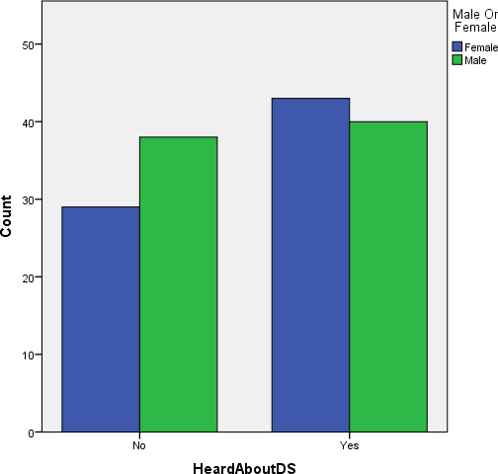

*Figure 6 Relationship between gender and Knowledge of Down syndrome*

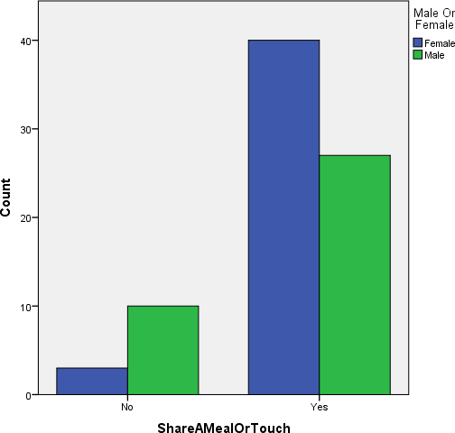

Figure 7 Relationship between Gender and willingness to share a meal or touch someone with Down syndrome

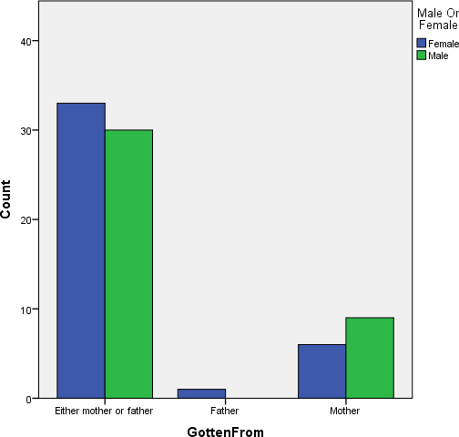

Figure 8 Relationship between gender and knowledge of inheritance of the disorder

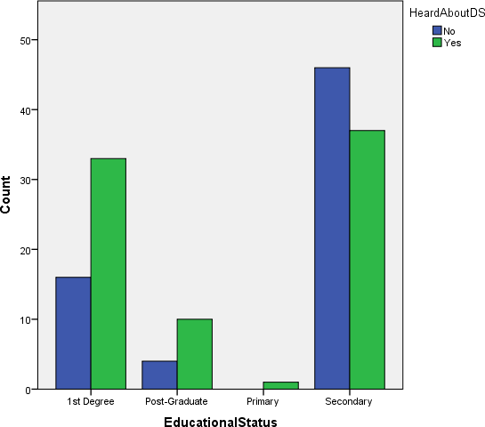

Figure 9 Relationship between Educational Status and Knowledge about Down syndrome

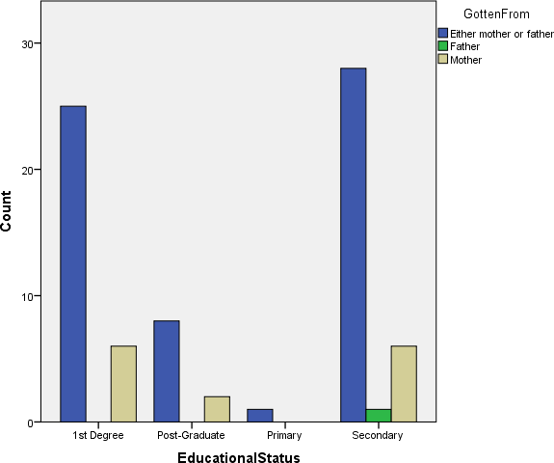

Figure 10 Educational Level against Knowledge of Inheritance Mechanisms

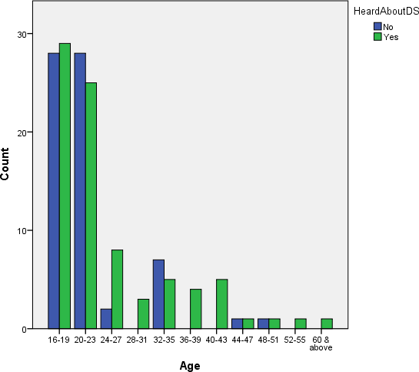

Figure 11 Relationship between age of respondent and their knowledge about Down syndrome

**Case Description:** The following three cases were chosen to represent the general phenotype and conditions associated with Down syndrome

**Case 1 (Self-harming behavior):** Peter is a 6 year old boy with Down syndrome, he is the fifth child of 50 year old woman and the first child of a 52 year old man. He started walking at the age of 4, and has a speech impairment. He understands when spoken to and is an integral part of the family. Peter’s parent did not know he had Down syndrome until he was admitted to a hospital for a totally unrelated illness. He is enrolled in school and can read A to Z but his speech is slurred. Peter ate a bag of polyethylene when he was 2 which affected him and resulted in gastrointestinal infection; he also inserted broomstick in his penis when he was around the same age. He underwent a minor surgery to take it out but did not heal properly as part of the opening in his penis is sealed. Peter also has reoccurring sinus infection that results in snoring and restless sleep pattern. His parent’s reported him to hyperactive.

**Case 2 (Attention Deficit Hyperactivity Disorder):** Joe is a 7 year old boy, he is the only son to a mother of 29 years and a father of 54 years. He also started walking around the age of 4 but still cannot speak, read or write. Joe is not enrolled in any school. His parents found out that he had Down syndrome a few days after he was born though his mother was screened while she was pregnant with him but the screening did not show Down syndrome. Joe is understands when he is being spoken to and is also reported to be hyperactive.

**Case 3 (Attention Deficit Hyperactivity Disorder):** Simon is a 10 year old boy that is the second son to a father of 56 and mother of 45. Simon is enrolled in school and can write and identify letters and numbers but cannot speak clearly. Simon is a

hyperactive child but is reported by his parents to love school. He has reoccurring sinus infection but no gastrointestinal infections.

Chapter 4

# Discussion

**Summary of Result:** Down syndrome is a common genetic disorder and one out of 600 children have Down syndrome. The research was aimed to know how many people are aware of Down syndrome, I tried to ensure that the gender dispersion was at least approximately equal as seen in Figure 5. From the result more than half of the respondent (55.3%) had knowledge about Down syndrome, while 44.7% did not know anything about Down syndrome. Most of the people who are aware of Down syndrome are female as seen in Figure 6, the reason for this is unknown.

### Sharing a meal or touching?

When they were asked if they would share a meal or touch someone with Down syndrome, most of them affirmed they would. However, most of those who ticked that they wouldn’t share a meal with people with the chromosomal disorder were men. The reason for this is unclear but can be attributed to the fact that women are known to be nurturing beings thus making it more likely and easier for them to share a meal with or touch a person with Down syndrome. The number of men and women willing to share a meal with or touch people with Down syndrome could be increase by incorporating the disability act into the legislation. This might reduce

discrimination and stigmatization and sensitize people to others with disabilities like Down syndrome.

### Which parent contributes most towards the disorder?

The results showed that the majority of the participants correctly thought that Down syndrome was acquired from either mother or father.

### Educational Status

From the result it is safe to say that the level of education achieved affects the knowledge of Down syndrome. The result shows that 16 people with first degree and 3 or 4 people with post graduate degrees did not know about the disorder. Most of those who completed only secondary school have no knowledge of Down syndrome. This indicates that those who have achieved higher statuses educationally are more likely to have heard about Down syndrome. The number of people who know about Down syndrome with only secondary school certificates can be improved by creating awareness in secondary schools. The number can also be increased by updating the curriculum of secondary schools, there should be health classes that cover the most common disorders and occasional field trips to health centers.

### Age Versus Knowledge of the disorder

From Figure, it is clear that a bulk of the respondents are between the age range of 16-19 years and 20-23 years, this is because the survey was carried out in a

university and bulk of students in a typical university fall into these age groups. It is also noticed that most people in all age ranges know about Down syndrome, excluding those in the bracket 20-23 years and 32-35years. Everyone above the age of 52 know about Down syndrome. When studied, the graph shows that those who know about Down syndrome in all age range excluding those between 32-35years are either equal to those do not know about it or two times greater than those who do not know about it. This support the earlier result that those who have achieved high educational status are more knowledgeable on Down syndrome assuming that the older one gets the more they achieve educationally. Although, ideally, following the obtained results it would be expected that people within the ages of 16-19years and 20-23years would be less knowledgeable groups and not between 20-23 years and 32-35years.

### Case Studies

Though the children that were studied for the case study were individually unique, a few symptoms and traits were common to them. They include sinus infections, gastrointestinal infection, speech impairment, inability to read and attention deficit hyperactivity disorder. In all cases excluding Joe’s, the children had reoccurring sinus infections that caused them to snore at night; it also sometimes caused sleep inhibition. All three children had the traits common to Down syndrome, palmar crease, slant eyes, small fingers, short neck and reoccurring medical conditions. The mothers of the children that participated also reported that they went for screenings while they were pregnant.

Peter and Simon’s parents reported that they ate a lot and weighed more than they should, the both of them also stated that their children were always excited

about school and were both eager to learn. The mothers of Peter and Simon were above the age of 35 when they has their kids, this might explain why the children have Down syndrome. This assumption is based on the studies that have shown that mothers above the age of 35 are more likely to have children with Down syndrome.

Joe’s speech impairment is more severe than Peter and Simon, this is probably due to the fact that he is not enrolled in school. Out of all three mother’s, his mother was the youngest, she was 29 years old when she had him. The fact that he is being raised in a rural area compared to the other children might be a reason for his speech impairment and the severity in his down syndrome.

Simon has undergone eye surgery and has stentoic ears according to his doctors but currently can hear more clearly with the use of his hearing aids. Since his enrollment in school his parents have noticed improvement in his overall behavior but they complain that he forgets what he learns easily if he is not reminded. An instance was when he was learning numbers, during the summer break when he was not in school he forgot some of the numbers he learned.

### Coping mechanics

Peter’s mother and Simon’s mother were in denial when they found out that their son had Down syndrome. They thought it was a curse and with prayers their children will be healed. Also, every improvement the children had or every milestone the children reached was attributed to a supreme religious figure. The parents also reported that their biggest challenge was that their children were being made fun off

by their peers. The parents ensured that their children were an integral part of the family, by sending them on household errands and showering them with unconditional love. They also claim that their child has taught them tolerance in their day to day activities. Another challenge they faced was that there were no schools set up in place for children with similar disorder. Simon’s parent reported that Simon was not admitted into certain schools he was taken to because they did not have adequate facilities and resources set up for children with Down syndrome. This challenge can be solved if the government and other companies in the private sector come together an aid in the development and expansion of the few facilities that cater to children with Down syndrome. An example of such facility is the Children Development Centre that was founded by Dr. Yinka Akindayomi which has a main branch in Lagos and another in Port Harcourt. Children Development Centre uses the United State African Development Foundation grant to expand and they have helped over 600 children and young adults in Lagos (A Rose Grows in Lagos ). Dr.

Akindayomi has an autistic son that is an integral part of the society. He is proof that one can lead a productive and meaningful life with early learning and stimulation. If centers like this are expanded throughout the country, it would go a long way in helping children with this disorder and other disabilities. Parents that have children with Down syndrome can cope by communicating with each other. Networking through phone, video calls and email these parents can share their worries and help each other.

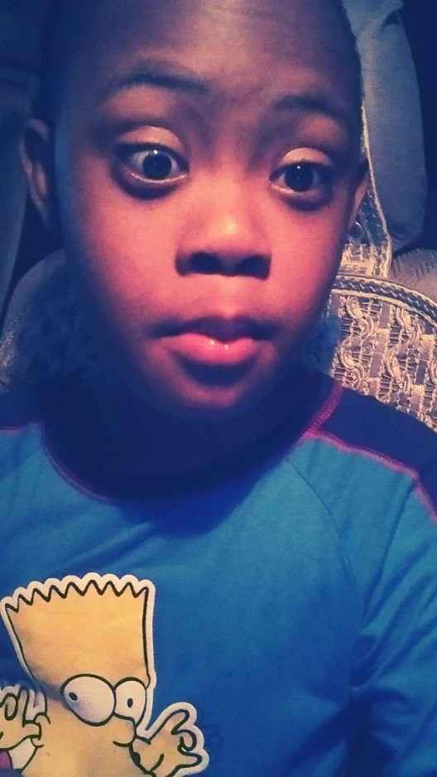 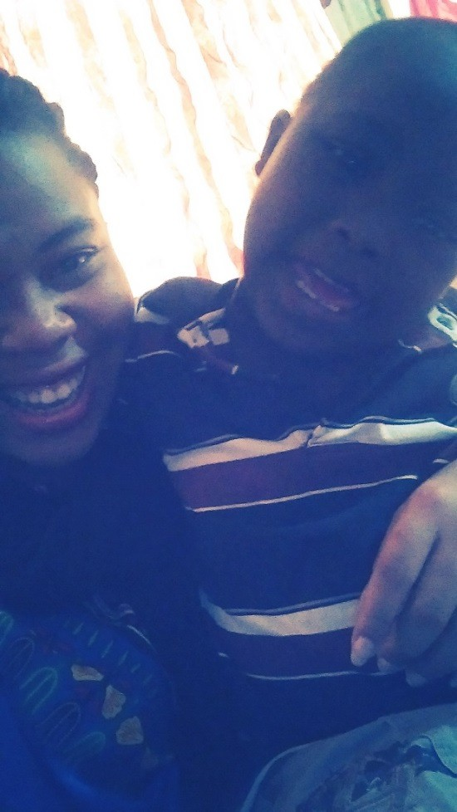

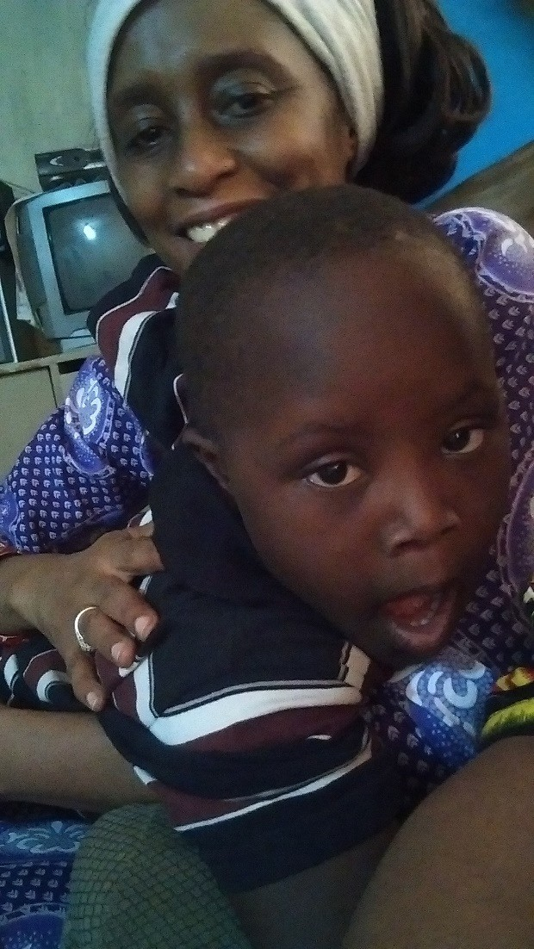 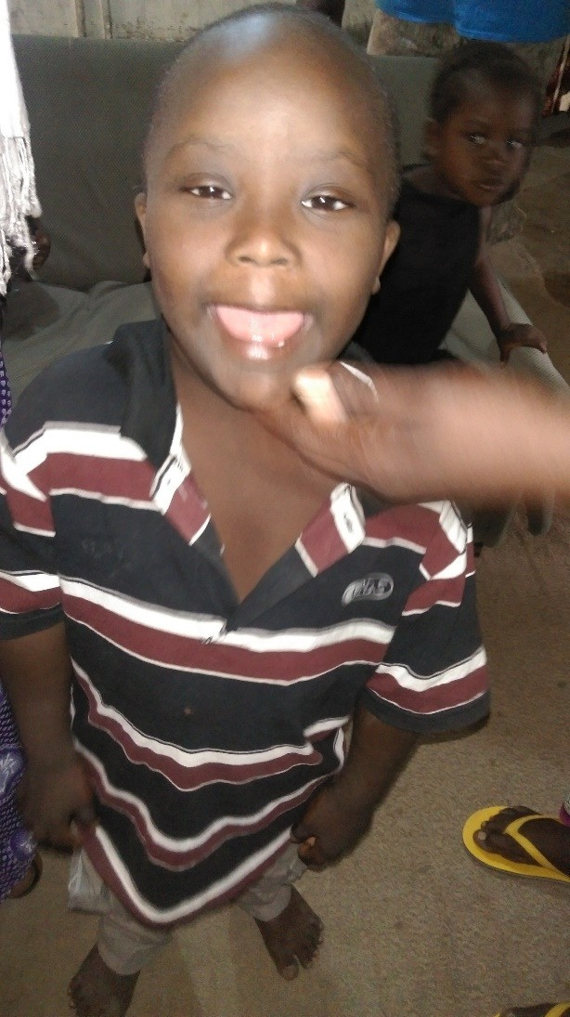

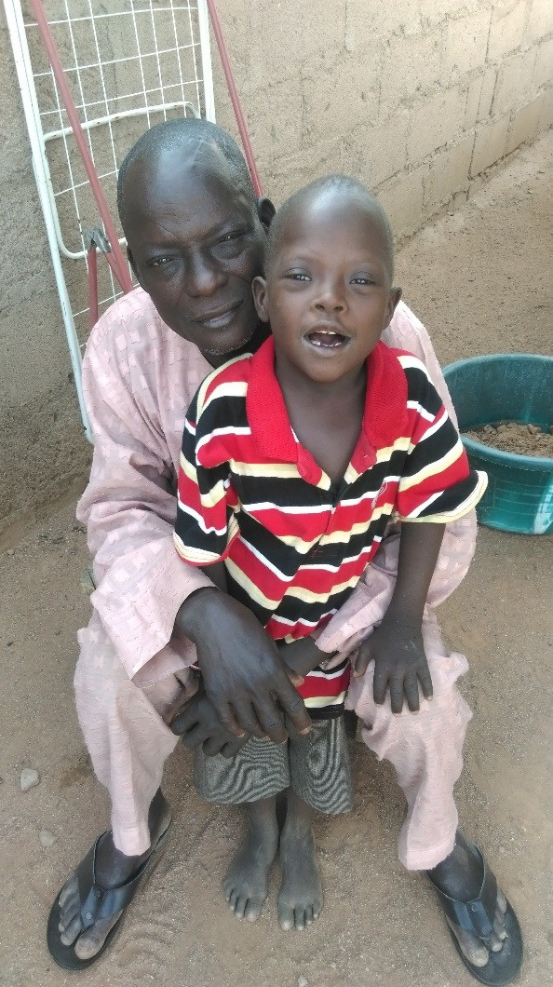 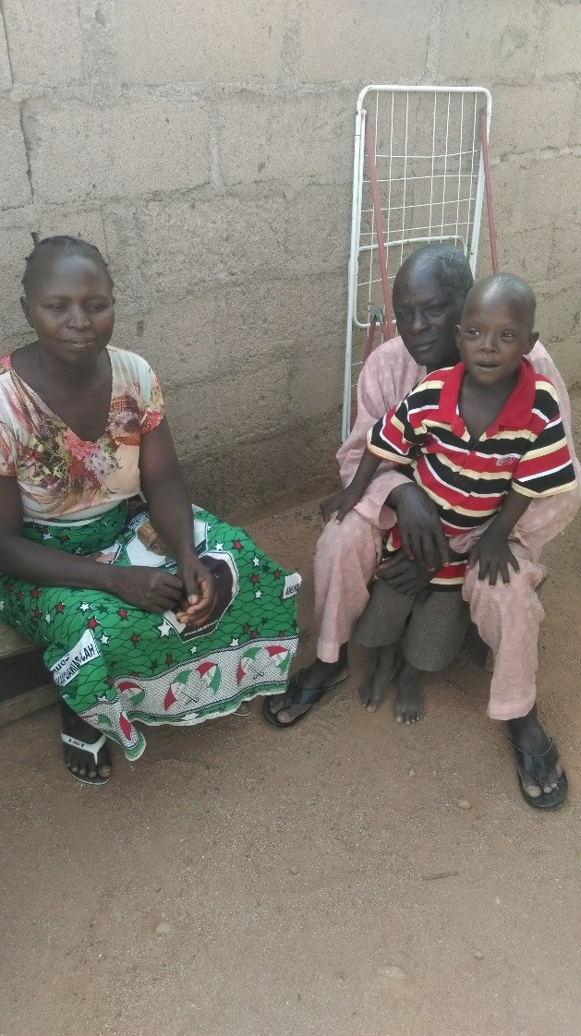

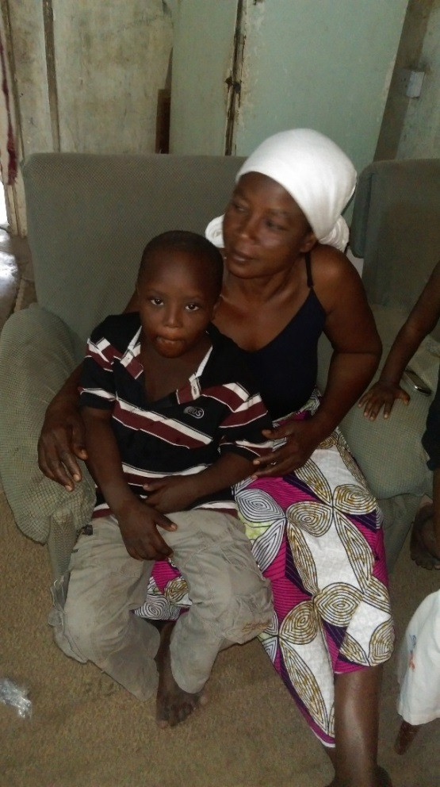

# Conclusion

From this study, more than half of the respondents know about Down syndrome but more awareness needs to be raised especially in secondary schools as they are the least knowledgeable about the disorder.

More facilities and infrastructures need to be set up for people with disorders because many typical schools do not have the necessary resources and materials to take care of children with this chromosomal disorder.

Mothers who are more likely to have children with Down syndrome should be screened while they are pregnant and prepared for the birth of their child.

# APPENDIX

Below is a copy of the questionnaire:

### Down syndrome is a genetic disorder, it is caused by an extra chromosome 21. This questionnaire seeks to know the degree of awareness with regards to the disorder.

1. Are you male or female? ………………..
2. Tick what applies to you
   * Student ☐Faculty ☐Staff ☐Visitor
3. How old are you?

|  |  |  |  |  |  |
| --- | --- | --- | --- | --- | --- |
| * 16 – 19 | * 20 – 23 | * 24 – 27 | * 28 – 31 | * 32 – 35 | * ​ |
| 36 – 39 | * 40 – 43 | * 44 – 47 | * 48 – 51 | * 52 – 55 |  |
| * 56 – 59 | * 60 & above |  |  |  |  |

1. What is the highest educational status you have achieved?

Degree

* Primary School ☐Secondary ☐University (1st Degree) ☐Post-Grad

1. Have you heard about Down syndrome?
   * Yes ☐ No
2. How did you hear about it?

☐Radio ☐TV ☐Meeting ☐Conference ☐Family ☐ Friends ☐Article ☐Workshop ☐High School ☐Post- Secondary School ☐University ☐Newspaper ☐Other……………….

1. What do you think are the causes of Down syndrome?

☐Genes ☐Environmental Influences ☐Mother’s Age ☐

Food ☐Lifestyle ☐Cultural Practices (what type?)……………..

* + Other………………….

1. From whom do you think it is gotten ☐Mother ☐Father ☐Either mother or father.
2. Why do you think so?

…………………………………………………………………………………

…………………………………………………………………………………

……..Do you think it is contagious?

* + Yes ☐No

1. Have you come in contact with someone who has Down syndrome?
   * Yes ☐No
2. If yes, what was your reaction?

…………………………………..……………………………………………

…………………………………………………………………………………

… Would you share a meal with them or touch them?

* + Yes ☐No

1. Would you let your children go to school with someone that has Down syndrome?
   * Yes ☐No
2. If No, why?

…………………………………..……………………………………………

…………………………………………………………………………………

… Do you have any family/friends with Down syndrome?

* + Yes ☐No

1. If yes, how are they related to you and how do you interact/socialize with them?

……………………………………………..…………………………………

…………………………………………………………………………………

………Tell me what you know about Down syndrome. (Traits, treatment, education, quality of life, etc.)

…………………………………………………………………………………

…………………………………………………………………………………

……..…………………………………………………………………………

…………

Thank you for taking time out to fill this questionnaire.

# References

Alzheimer's Association . (2015). *Down Syndrome and Alzheimer's Disease*.

Retrieved from Alz.org: <http://www.alz.org/dementia/down-syndrome-> alzheimers-symptoms.asp

*Alzheimer's Disease & Down Syndrome*. (2012). Retrieved from National Down Syndrome Society : <http://www.ndss.org/Resources/Health-Care/Associated-> Conditions/Alzheimers-Disease--Down-Syndrome/

Asa, M. (2009). Down Syndrome . *Digital Comprehensive Summaries of Uppsala Dissertations from the Faculty of Medicine 465* , 11.

Badiu, C., Verzea, S., & Picu, M. (2010). Autoimmunity puzzle in Down syndrome.

*Down Syndrome Research and Practice* , 1-4.

Bittles, A. H., Bower, C., Hussain, R., & Glasson, E. J. (2006). The four ages of Down syndrome. *European Journal of Public Health* , 221-225.

*Brain Damage: Learn About Trauma from Brain Injuries.* (2015). Retrieved March 5, 2015, from MedicineNet: <http://www.medicinenet.com/brain_damage_symptoms_causes_treatment/arti> cle.htm

*Common ENT Problems* . (2015). Retrieved from North Carolina Eye, Ear, Nose & Throat : <http://www.nceent.com/ear-nose-throat/common-ent-problems/>

*Definition of Disabilities.* (n.d.). Retrieved February 25, 2015, from Disabled World: <http://www.disabled-world.com/disability/types/>

*Disabilities.* (2015). Retrieved February 2, 2015, from WHO: <http://www.who.int/topics/disabilities/en/>

*Down Syndrome.* (2015). Retrieved from Genetic Science Learning Center: <http://learn.genetics.utah.edu/content/disorders/chromosomal/down/>

(2013). *Down Syndrome Ireland: Student Information Booklet .* Dublin: Down Syndrome Ireland.

*Facts about Down Syndrome .* (2014, October 20). Retrieved from Centers For Disease Control and Prevention: <http://www.cdc.gov/ncbddd/birthdefects/DownSyndrome.html>

*Facts About Down Syndrome .* (2014, October 20). Retrieved from Center for Disease Control : <http://www.cdc.gov/ncbddd/birthdefects/downsyndrome.html>

*Genes and Human Diseases .* (2015). Retrieved from WHO: <http://www.who.int/genomics/public/geneticdiseases/en/index1.html>

Hernandez, D., & Fisher, E. M. (1996). Down syndrome genetics: unravelling a multifactorial disorder. *Human Molecular Genetics* , 1411-1416.

*Impairment.* (n.d.). Retrieved February 25, 2015, from The Free Dictionary : <http://www.thefreedictionary.com/impairment>

Insel, T. (2010, September 15). *Attention on ADHD* . Retrieved from National Institute of Mental Health : <http://www.nimh.nih.gov/about/director/2010/attention-on-adhd-awareness-> week.shtml

Jennifer, T. (2008). Mental Health for Adults with Down syndrome. *Voice*, 4-7. Maatta, T., Taanila, A., & Kaski, M. (2006). Mental health Behavoiur and

Intellectual abilities of people with Down syndrome. *Down syndrome research and practice*, 37-43.

MacGill, M. (2015, February 23). *What is Alzheimer's Disease? Causes, symptoms and treatment.* . Retrieved from Medical News Today : <http://www.medicalnewstoday.com/articles/159442.php>

Malini, S., & Ramachandra, N. (2007). Possible risk factors for Down syndrome and sex chromosomal aneuploidy in Mysore, South India. *Indian Journal of Human Genetics* , 102-108.

Mayo Clinic. (2015). *Down Syndrome: Tests and Diagnosis* . Retrieved from Mayo Clinic: <http://www.mayoclinic.org/diseases-conditions/down-> syndrome/basics/tests-diagnosis/con-20020948

National Down Syndrome Society . (n.d.). *Down Syndrome .* New York : National Down Syndrome Society .

Percy , M., & Schrormans, A. F. (2005). Down Syndrome . *Journal on Developmental Disabilities* .

(2005). *Robertsonian Translocations .* Surrey: Unique.

Ruben, J., Magana, B., Hach , J., & Jimenez, C. (2003). Heart Malformation in Children With Down Syndrome. *Revista Espanola De Cardiologia*, 894-899.

Shemesh, R. (2010). *Hearing Impairment: Definitions, Assessment and Management.*

Retrieved March 10, 2015, from International Encyclopedia of Rehabilitation: <http://cirrie.buffalo.edu/encyclopedia/en/article/272/>

The Disability Discrimination Act (DDA). (2014). *The Disability Discrimination Act (DDA)*. Retrieved from NiDirect : <http://www.nidirect.gov.uk/the-disability-> discrimination-act-dda

(2013). *Translocation Down Syndrome.* MassGeneral Hospital for Children .

*Understanding a Diagnosis of Down Syndrome*. (2012). Retrieved from National Down Syndrome Society: <http://www.ndss.org/Resources/New-Expectant-> Parents/Understanding-a-Diagnosis-of-Down-Syndrome/

*Visual impairment .* (n.d.). Retrieved March 5, 2015, from Visual impairment : <http://www.nhs.uk/conditions/Visual-impairment/Pages/Introduction.aspx>

WebMD. (2013, July 01). *Down Syndrome - What Increases Your Risk .* Retrieved from WebMD: <http://www.webmd.com/children/tc/down-syndrome-what-> increases-your-risk

*What is Down Syndrome?* (2012). Retrieved from National Down Syndrome Society

: <http://www.ndss.org/Down-Syndrome/What-Is-Down-Syndrome/>