ANALYSIS OF THE IMPACT OF FLOODS ON LIVELIHOODS AND ADAPTATION MEASURES OF CROP FARMERS
ABSTRACT
This study aimed to assess the impact of flooding on agricultural households in Delta State. The study focused on providing a detailed analysis of the socioeconomic characteristics of smallholder crop farmers in the designated area. It aimed to identify the underlying causes of floods in the study area and assess the economic impact of flood hazards on smallholder crop farmers. Additionally, the study examined the vulnerability of smallholder crop farmers' families to floods and proposed adaptive strategies to mitigate the adverse effects of floods on smallholder farm households. A total of 395 smallholder farmers were selected at random from the Oleh and Isoko South local government areas. Data were gathered from a combination of primary and secondary sources and subsequently analysed using a range of descriptive and inferential statistical methods. The findings indicate that a significant proportion of the participants, specifically 51%, identified as females. Additionally, the majority of respondents, accounting for 57.78%, fell within the age range of 20 to 59 years. Furthermore, a substantial 70.56% of the participants reported being married.A significant majority of the respondents, accounting for over 87%, reported having received some form of formal education. The average household size was 8 persons, and the majority of farmers, specifically 76.66%, possessed farm sizes of 1.0 hectare or less. The factors contributing to flooding in the area are as follows: prolonged periods of rainfall, land use patterns, improper disposal of waste into water channels, inadequate and substandard drainage systems, topography, characteristics of urban land surfaces and buildings, and stream basin parameters. The absence of a proper drainage network for the disposal of flood water is considered a significant contributing factor that significantly exacerbates flooding in the study area. During the 2012 flood in the study area, a significant proportion of sampled respondents experienced adverse effects. Specifically, over 27% of the houses belonging to the respondents collapsed, while approximately 43% reported experiencing health problems. The findings from the regression analysis examining the impact of socioeconomic variables on vulnerability to flood hazards indicate that savings, membership in ROSCAS, farm output, and income all have a statistically significant negative effect on vulnerability. Conversely, the Dependency Ratio exhibits a statistically significant positive relationship with vulnerability at a 5% significance level. Therefore, the susceptibility to flood events is significantly diminished as there is an increase in savings, membership of ROSCAS, farm output, and the level of income among smallholder farmers. Conversely, the opposite effect occurs when the dependency ratio increases. Various measures to mitigate the risks of flooding in the area have been identified. These include river re-channelisation, elevating the foundation of houses to withstand flood water levels, and employing sand bags as levees to prevent the ingress of flood water. It is advisable that timely notification of potential flooding, derived from analysis of climatic variability, can assist individuals residing in flood-prone regions in making proactive preparations. Furthermore, the implementation of construction and enhancement measures for drainage networks to efficiently manage the disposal of floodwater will significantly contribute to mitigating the potential risks associated with flooding.

CHAPTER ONE
INTRODUCTION
1.1 Background Information
Today, global climate change is one of humanity’s greatest challenges. According to the International Resource Group (2008) global warming will increase within the next fifty (50) years to the detriment of the world’s population. Weather extremities such as droughts, floods and cyclones will occur more frequently and forcefully, causing insecure living conditions, food shortage and forced migration. The current cycle of rising temperatures is unique. For the first time, the actions of human beings are responsible for decisively changing a cycle that is typically a natural phenomenon.
Apart from mitigation, adaption represents the second insurance strategy to first, protect vulnerable populations already experiencing adverse effects of climate change and secondly, protect all people in the future. Therefore, adaptation to existing climate change is essential for all countries. Political scientists and the policy-making community have begun to explore potential consequences of climate change, especially for developing countries, describing it as a stress factor with the potential to add to existing development, security and health problems (International Resource Group, 2008).
Inequality in capacity to adapt to climate change is emerging as a potential force widening disparities in wealth, security and opportunities for human development. While developed countries with adequate resources are in the process of adapting to climate change, it is the countries in the developing world that are facing extreme and more immediate burdens and adverse impacts of changes in global climate. According to research, developing countries in tropical and subtropical regions will face some of the strongest negative consequences of climate change, thus primarily and adversely impacting the most vulnerable people globally (International Resource Group, 2008).
Flood is unusual accumulation of water. A disaster might be caused by a natural or man-made phenomenon resulting in a significant physical damage or destruction, loss of life or drastic change to the environment. It is a terrible occurrence that is capable of being harmful to life, property, economic and social welfare of people (Cherdpong and Thiengkamol, 2013). The coastal plains or flood belt are often more vulnerable to flood disaster in Delta State. With the advent of climate change phenomenon, the effect of floods has been devastating in the flood belt of Delta State, Nigeria. The 2012 flood disaster in some parts of Nigeria, including Delta State is a case worthy of reference.
The dimensions of the effect of flood can broadly be grouped into direct and indirect. Social effect of flood may manifest in the forms of loss of homes, loss of social status, education of children/wards and psychological trauma of the victims. Other direct effects are loss of farm income, social infrastructures (schools, markets, roads, and health facilities), loss of means of livelihood, loss of farm lands and crops/livestock’s. Indirect effects of flood may reflect in the form of burden on safe communities in the hinterland and food shortages, increase in prices of food stuff. Other dimensions of effects of flood disaster include: food insecurity, poverty, psychological trauma, loss of human capital, political unrest and a drain on government budget (Cherdpong and Thiengkamol, 2013).
The overall effect of flood disaster is that it retards and reverses development. It may hinder productive investment. A key issue for developing countries including Nigeria is the lack of capacity of farming households to mitigate flood disaster (Abaje and Giwa, 2007).
The smallholder farmers that dominate the population of Delta State, produce small output, with scanty resources, earn low income and low purchasing power. About 70% of the whole population depends on their aggregate output. According to Cruz (2010) majority (more than 80%) of the small holder farmers in the world depend on farming as their primary source of livelihoods. Three out of every four poor people leave in rural areas and depend on agriculture, either directly or indirectly for their livelihood (World Bank, 2008). Consequently, flood hazards on farming households will have spillover effect on those that depend on them.
In most parts of the world, and particularly in the developing countries such as Nigeria, food security and its related issues are vital welfare issues that occupy central focus in global economic debates. Attainment of food security is core problem confronting rural farming households due to low productivity. The changing climate pattern and its effect on agriculture pose a serious food security and livelihood challenges to the rural farm families in Delta State, Nigeria. The United Nations estimate has projected that over the next 20 years the demand for food will increase astronomically. Ash, et al. (2007) reported that yields from Africa’s rain-fed farm production may decrease by 50% due to climate change hazards such as flood, by 2020.
Previous studies demonstrating correlations between flood hazards and poverty status among vulnerable rural farm families have generated considerable interest (Meza et al, 2008). The body of literature has accordingly pursued three main directions with respect to climate hazards and livelihood status of vulnerable rural farm families:
* close link between flood and farm output (Meinke and Stone, 2005)
* vulnerability of rural communities, which lack economic resources and capacity to mitigate flood hazards, and
* the need for agronomic
and economic models that can capture relevant variables for adaptation policies and practices (Maza, et al, 2008).
Agronomic and economic models of flood hazards indicate that, over time, adaptive use of seasonal climate forecast could provide some benefits (Ash, et al. 2007), especially with respect to vulnerable farmers (Letson et al, 2005). Hansen et al. (2009) demonstrated that high value could be attained from accurate predictability of flood hazards.
The main purpose of estimating flood response model is to integrate the relevant variables in flood hazards management decision making. It is important to investigate how vulnerable rural farm families and others in the flood belt make use of flood hazards forecast information in their livelihood decision making (Roncoli, 2006).
Flooding and its impacts have been a major concern to farmers, engineers, economists, among others thus, forming headlines in the world and Nigerian dailies. Flooding has a wide range of influence on the interactions between man and his social, economic environment. Similarly, the Nile River was regarded due to its annual cycle of flooding, and farming was of great significance to many early farming cultures in Egypt. Flooding, which deposits rich fertile alluvium on agricultural areas, also replenish irrigation channels.
The growing increase in population, human activities, coupled with flooding in the Niger Delta region have increased the need to evaluate the impacts of flooding on socio-economic activities in Oleh community.
1.2 STATEMENT OF THE RESEARCH PROBLEM
Flooding is a wide spread phenomenon on the earth surface, which has been defined by many scholars and organizations. Flooding has caused a great setback to mankind, although these setbacks are only restricted to those areas or places of low terrain especially in the coastal regions of the world (Chorley, 1977).
Doocy, Daniels, Murray and Kirsch (2013) stated that, the causes of flooding are not only by natural processes but also by human activities. Natural processes include excessive moisture through heavy rainfall, snow melt in the spring combined with rain while human activities refers to the way mankind alters the hydrological cycle of the river and drainage system, the altering of dams, deforestation, land reclamation, improper soil management and so forth.
Several years back, farmers in Nigeria were experiencing seasonal flooding problems which resulted to low crop yield and low income. For example, in Oleh, 54 percent of the total maize cultivated was lost to flooding, while more than half of the yield from plantain was also lost to flooding in 2011 and 2012 (Ojeh and Orivoh, 2014). Flooding, which has been a perennial problem in Oleh, has caused much havocs and difficulties to the inhabitants of Oleh community, such as destruction of farmlands, destruction of buildings, lives and properties. Roads are flooded thereby making them unmotorable and so restricting the movement of people in the area; also, drastic reduction of human activities such as farming, fishing which are the major activities of the people.
Flooding affects numerous aspects of man’s environment. These include his economic activities; settlements and lifestyle. Several threats to livelihoods ranging from the physical threats to social and economic threats exists, while affected persons suffer some psychological effects. Flooding also causes land pollution which leads to epidemics and infections. Flooding has been seriously affecting Oleh community. A lot of social and emotional costs were involved in flooded areas. These costs include: displacement from homes, the loss of personal valuables and the ongoing fear and insecurity caused by the experience. Portable water supplies were contaminated and lost during periods of flood. Furthermore, flooding in Oleh made people to suffer untold hardships in the process of trying to make new buildings to withstand flooding.
Also, the school system was disrupted as communication and personal mobility proved difficult. Although, most people complained of the adverse impact caused by flooding, some people rejoiced during flooding and prayed because of the gains usually made from the affected persons. For instance, marketers sold items such as oil palm, meat double of its normal price. Transporters also make more income by increasing transport fare.
Perennial flooding in Oleh has forced the inhabitants to make canals, raise foundation of houses, sand fill compounds, cultivate water tolerant crops and prematurely harvest their crops. Pre-mature harvesting is seen as the people’s commonest and most assured way in which they can locally reduce the effects of flooding in their production and food supplies.
Over the years, governments and non-governmental organizations have attempted to provide drainage system, fund, and policy with a view to reducing flood damage. Notwithstanding all coping strategies, most people in Oleh cannot cope at all and were forced to relocate their dwelling units during flooding to the camp provided by the government. Regrettably, on November 24, 2012, flood victims in Nigeria and Oleh in particular were forced out of camps, which exposed government’s inadequacy in handling flood situations.
Although there are a lot of published works on flooding, unfortunately, until now, adequate work has not been done on the impacts of flooding on socio-economic activities in Oleh. For example, Ojeh and Orivoh (2014) who worked on flooding in Oleh only focused on the impacts of flooding on crop yields, neglecting other socio- economic activities. Furthermore, researchers such as Odermerho (1988), Sada and Odermerho (1988), Efe (2007), Aderogba (2012c), and others, at various times have written on the devastating nature of flooding but not in Oleh. Despite the frequency and magnitude of flooding in Oleh, no comprehensive study on impacts of flooding on socio-economic activities of the people has been undertaken. Based on the aforementioned problem and research gap, the researcher was motivated to carry out this study. Filling this gap in knowledge is the main purpose of this research.
1.3 AIM AND OBJECTIVES OF THE RESEARCH
The aim of this study is Analysis Of Effect Of Flood On Livelihoods And Adaptation Measures Of Smallholder Crop Farmers. The specific objectives are set to:
i) identify the impacts of flooding in Oleh community.
ii) evaluate the adverse and beneficial impacts of flooding on socio-economic activities of the people in Oleh community.
iii) know the number of fish lost in ponds per household in Oleh community.
HYPOTHESIS
HO: There is no significant relationship between flooding and socio-economic activities in Oleh.
1.5 Significance of the study
The importance of this research cannot be overemphasized because of its immense significance to different groups of people who are in need of information that it will provide. Its significance includes the following:
The study will enable the management of flooding and provide an in-depth understanding and knowledge of the flood prevention strategies available so that they can adopt them adequately.
The study will also serve as a source of secondary data for students and scholars who intend to carry out similar studies in the future.
THE STUDY AREA
1.1 LOCATION
Oleh lies roughly to the South-East of Delta State. It is located between latitudes 50 14’N and 50 33’ N, and longitudes 60 07’ E and 60 25’ E. Oleh is bounded on the North by Ozoro and Owhe town respectively, on the South by Olomoro/Emede town, and on the East by Irri town while on the West by Emevor town (see figures 1.1)
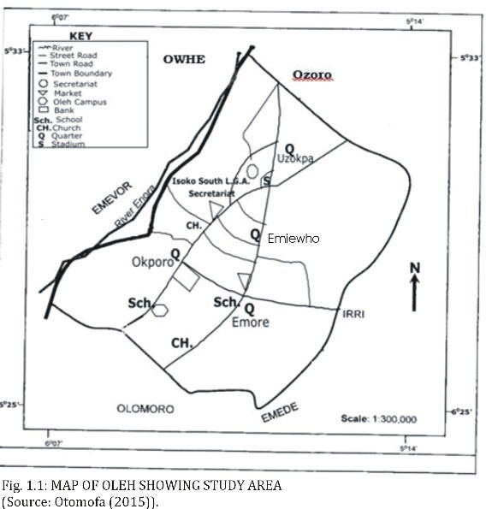

CHAPTER TWO
LITERATURE REVIEW
Considering the global picture of disaster, particularly in the flood event, the various rolling Vulnerability Assessments conducted in different countries indicate that the last two decades have seen an increase in the frequency and occurrence of climateinduced hazards such as floods and drought in the countries (Concept Note on the Vulnerability Assessment and Analysis Survey for Zambia, 2006). According to Nott (2006), the causes of floods can be broadly divided into physical, such as climatologically forces, and human influences such as vegetation clearing and urban development.
The most common causes of floods are climate related, most especially rainfall. Prolonged rainfall events are the most common cause of flooding worldwide. These events are usually associated with several days, weeks or months long of continuous rainfall. Human impacts on river catchments influence flood behaviour. Land use changes in particular have a direct impact on the magnitude and behaviour of floods all over the world. Deforestation results in increased run-off and often a decrease in channel capacity due to increased sedimentation rates.
Borrows and De Bruin (2006) indicated that among natural catastrophes, flooding has claimed more lives than any other single natural hazard. In the decade 1986 to 1995, flooding accounted for 31% of the global economic loss from natural catastrophes and 55% of the casualties. The damaging effects of flooding are likely to become more frequent, more prevalent and more serious in the future. Carey (2005) argues that human populations worldwide are vulnerable to natural disasters. Certain conditions such as geographical location or people’s income level can affect the degree to which natural disasters impact people’s homes and livelihoods. A study of Nott (2006) correctly points out that a normal level of flood event is not considered to be a natural hazard unless there is a threat to human life or property. The most vulnerable landscapes for floods are low-lying parts of floodplains, lowlying coasts and deltas, small basins subject to flash floods. Rivers offer human respondents populations transport links, a water source, recreational amenities, fertile plains and are an attractive place for settlements. Floods then become a major natural hazard because of the high human population densities that inhabit these lands.
He indicated that the direct impacts of a flood are closely related to the extent of affected area and depth of floods water. The extent of a flood has a direct relationship with the recovery times of crops, pastures and the social and economical dislocation impact to populations of a country. Floods are the most costly and wide reaching of all natural hazards. They are responsible for up to 50,000 deaths and adversely affect some 75 million people on average worldwide in every year. Disease occurrence is common especially in less developed countries. Malaria and Typhoid outbreaks after floods in tropical countries are also common. It has been estimated that in India and Kwale and its environ 300 million people live in areas that are affected by floods (Nott, 2006). Physical damage to property is one of the major causes for tangible loss in floods. This includes the cost of damage to goods and possessions, loss of income or services in the floods aftermath and clean-up costs. Some impacts of floods are intangible and are hard to place a monetary figure on. Intangible losses also include increased levels of physical, emotional and psychological health problems suffered by flood affected people.
In a study of Know Risk (2005), it is observed that the economic impact of natural disasters shows a marked upward trend over the last several decades worldwide. The hazards tend to hit communities in developing countries, increasing their vulnerability and setting back their economic and social growth, sometimes by decades. The floods have led to loss of human life, destruction of social and economic infrastructure and degradation of already fragile ecosystems and social structures. The study indicates that social impacts include changes in people’s way of life, their culture, community, political systems, environment, health and wellbeing, their personal and property rights and their fears and aspirations. In this study it was suggested in the results that, social impacts are linked to the level of well being of individuals, communities and society. It includes aspects related to the level of literacy and education, the existence of peace and security, access to basic human rights, systems of good governance, social equity, positive traditional values, knowledge structure, customs and ideological beliefs and overall collective organizational systems. Some groups are more vulnerable than others, mainly those less privileged in society (Living with Risk, 2002).
In UK, flood risk represents a significant threat to many communities. Around 1.8 million households and 140,000 commercial properties in England and Wales are located in floodplain areas, affecting at least 4-5 million people. The researcher further points out that a range of flood risk management activities are undertaken by operating authorities. These include emergency planning, awareness raising, provision of flood warning and creation of flood storage areas as well as the construction and maintenance of both conventional and innovative flood defences. Crossman, M. et al. (2006) suggests that in the face of such increases in risk, the provision of reliable information and public awareness is essential.
A study by the International Flood Initiative (2003) suggests that floods are the most taxing of water related natural disasters to humans, material assets as well as to cultural and ecological resources affecting people and their livelihoods and claiming thousands of agricultural product annually worldwide. According to a study experience, the emotional behaviour of many flood victims was shocking. Follow-up studies of the same experience found that the flood and the secondary effect of the flood have a serious emotional trauma. Factors that contributed to the non-recovery included the severity of the flooding, the degree of the resulting financial hardship, age and socioeconomic status. Poor people on low income houses are mostly flooded in maximum years (Flood Management in Australia, 1998). Thus, a severe flood can impose a range of economic costs on flood victims and many of them are quite severe. Moreover the economic effects may linger for years after the event. Flood aware communities can be expected to suffer less social and financial disruption than communities with a low level of flood awareness (Flood Management in Australia, 1998). Lindsell and Prater (2003) argue that social impacts can cause significant problems for the long term functioning of specific types of households and businesses in an affected community. A proper contingency plan is needed in order to readies the impact of the flood and to protect the livelihood.
Ariyabandu and Wickramasinghe (2005) observed that some groups are more vulnerable to floods than others are especially in the developing countries. Vulnerability is not increased for poverty, but also the poor tend to be the most vulnerable due to their lack of choices. The influences of both poverty and development process on people’s vulnerability to disaster are now well established. Class, ethnicity, gender, disability and age are some of the factors increase the affecting people’s vulnerability. It is estimated that, poverty does not equal vulnerability but being poor makes people more vulnerable to disasters because poor people have lack of resources (physical, social and knowledge based) to prepare them for and respond to such threats and shocks as natural hazards. Poor people often get locked in a cycle of vulnerability. As they are vulnerable; they are at great risk in the face of a natural hazard, leading to disaster. Close analysis of disaster impact shows that the vulnerability of men and women to disaster, their capacities, and the options available to them differ in character and scale to their gender which may have a close link with the level or severity of disaster event (Ariyabandu and Wickramasinghe 2005). In this same study Ariyabandu and Wickramasighe (2005) suggest that, although women are often more vulnerable to disasters than men they are not just helpless victims as often represented. The impact of disasters is usually measured in quantifiable ways, such as adding up the number of the dead and injured, and estimating the physical damage to housing, land, livestock, agriculture, stores and infrastructure. However attention is not necessarily paid to how disasters impact on different categories of people, men, women, children, aged people, etc in socially and economically. Disasters affect men and women differently because of the different roles they occupy and the different responsibilities given to them in life and because of differences in their capacities, needs and vulnerabilities (Ariyabandu and Wickramasighe 2005).
Sinclair and Pegram (2003) stated that floods cannot be prevented but their devastating effects can be minimized if advance warning of the event is available. With large increase in population and increasing urbanization there are more people living in informal settlements, which are often on flood plains as this is the only underdeveloped land available near cities. The people living in these settlements are those who are most at risk, not only due to their geographical location in the flood plain but also because they do not have the financial resources to recover from the damage caused by flooding. According to Smith and Ward (1998), there is more evidence that the flood problem is getting worse in terms of the damage caused by flooding. Despite massive expenditure on flood defence, flood damage losses continue to rise in many countries. Although most floods are more or less natural phenomena, the flood hazard is largely of human origin. Most floods results from moderate to large events, occurring within the expected range of stream flow. Floods constitute a “hazard” only where human encroachment into flood prone areas has occurred. African Wildlife (2000) also points out that the cumulative impact of human activities without regard for nature has turned the recent floods from a natural phenomenon into a man-made disaster of epic proportions. When severe floods occur in areas occupied by humans, they can create natural disasters which involve the loss of human life and property plus serious disruption to the on-going activities of large urban and rural communities. Flood losses are therefore essentially human interpretations of the negative economic and social consequences of natural events. The impact of the flood hazard will, in part be determined by the magnitude of the events and the duration of the event. However the true significance of the flood disaster will depend primarily on the vulnerability for the local community. The relationship between physical exposure and human vulnerability is highly dynamic and can change through time (Smith and Ward, 1998). Smith and Ward (1998) also argued that direct losses to floods occur immediately after the event as a result of the physical contract of the flood waters with humans and with damageable property. However, indirect losses which are less easily connected to the flood disaster and often operate on-long time scales, may be equally, or even more important. Depending on whether or not losses are capable of assessment in monetary values, they are termed tangible and intangible.
Some of the most important direct consequences of flooding such as loss of human life or the consequent ill health of the survivors and also the economic losses are intangible. Indirect and intangible consequences of flooding are probably greatest in Least Developed Countries (LDCs), especially where frequent and devastating floods create special impacts for the survivors. Primarily losses of any disaster like flood can be high in rural areas where most of the damage is sustained by crops, livestock and the agriculture infrastructure, such as irrigation system, levees, walls and fences. In other words, primary losses relate mainly to the disruption of economic and social activities, especially in urban areas, immediately after a flood (Smith and Ward 1998).
According to Lind, et al. (2008:143), the loss in case of flooding has many dimensions. In addition to economic loss and loss of life and injury, there may be irreversible loss of land, of historical for cultural valuables and loss of nature or ecological valuables Kundzewicz, et al. (2002) argues that floods are natural phenomenon for which the risks of occurrence are likely to continue to grow, increasing levels of exposure and insufficient capacity among the factors responsible for the rising vulnerability. Water related events such as floods have been a major concern since the dawn of human civilization. They continue to hit every generation of human beings, bringing suffering and death as well as immense and still growing, material losses.
Economic development of flood prone areas in developing country is a factor that increases flood risk. Population pressure and shortages of land cause encroachment into flood plains. Mushrooming informal settlements often form enlargement zones around mega cities in developed countries (Kundzewicz, et al. 2002). In a study of south Asian region Bank off (2003) states that, in Philippines, flooding is not a recent hazard but one that has occurred throughout the recorded history. On the one hand, it is related to a wider global ecological crisis to do with climate change and rising sea levels but on the other hand, it is also the effect of more-localized human activities. A whole range of socio-economic factors such as land use practices, living standards and policy responses are increasingly influencing the frequency of natural hazards such as floods and the corresponding occurrence of disasters. He also mentioned in his study that, Municipality has its basis in a complex risk of inter-relating factors that emphasize how the nature of vulnerability is constructed through the lack of mutuality between environment and human activity over time. Statistical trends suggest that floods have become more numerous and more devastating in recent years. Certainly the frequency of events and the number of people affected have increased steadily as human related activities such as deforestation; overgrazing and urbanization aggravate environmental conditions, making communities more vulnerable (Bank off, 2003).
Hanson, et al. (2007) state that, reduce poverty is one of the great challenges faced all over the world. Over half of the world’s poor live in rural areas. Poverty worsens when natural hazards destroy vital rural infrastructure. Asia is struck by 70% of all floods in the world and the average annual cost of floods over the past decade is approximately 15 Billion USD. Economic losses and impacts have remained high and constitute a large developmental burden. It was suggested from this study that there is a need for new types of strategies in order to cope with the financial burden from hazardous events. One of the largest deltas in Vietnam is seriously threatened by floods. Lives and property are threatened by annual flood events which impose a substantial burden on the community. The area has experienced increased flooding due to its dense ad increasing population and its location in a low land.
A study conducted on poverty, Vulnerability and the Impact of flooding in the Limpopo province in South Africa argues that while disasters may affect everyone and play an important role in increasing vulnerability, poor people are made more vulnerable from a web of circumstances that make them prone to the effects of disasters (Khandlhela and May, 2006). In this study, they established that the varying impact of floods on households and the community showed that vulnerability to the effects of a flood disaster is indeed an outcome of the interaction between socio, economic and political process. Douben (2006) states that since early times, people have settled in flood prone areas due to favourable geographic conditions which facilitate economic growth, such as accessibility (transportation) and food production (fertile land). This fact forces societies all over the world to protect vulnerable assets against flooding. Nevertheless, flooding is still the most damaging of all natural disasters and more than half of all victims are flood related. Flood mitigation policies and measures should therefore be implemented in order to enable societies to increase their resilience to flood hazards. According to Mustafa (2002), despite Pakistan’s massive investment in its water sector, it still remains vulnerable to the flood hazard. Pakistan suffered major floods in 1950, 1956, 1973, 1976, 1988 and 1992, each affecting more than 10 thousand lives. The 1992 floods cost the country more than 3 percent of its total GDP. According to the study undertaken in four villages in Central Pakistan, the people attributed their vulnerability to floods to poverty, God’s will, socio-economic powerlessness and Government (Mustafa 2002). Gao, et al. (2007) states that although water shortages often grab the headlines, floods continue to be the most serious natural disaster in China. This is despite enormous efforts to construct structural engineering projects for flood control. Dixit (2003) stated that in Southern Nepal, flooding leads to large scale disruption of social and economic lives. The rivers bring large sediments whose deposition on agricultural lands harms productivity. The poor mostly live in these floodplains (vulnerable zones) because they have no opportunity to live in less hazardous areas. In Nepal, every year floods cause death, cultivated fields and irrigation, bridges and rural infrastructure. He argues that policy makers, donors and relief and development agencies treat flood disaster as isolated events that break the continuity of the normal way of life. According to Dixit (2003), research shows that disasters are the outcome not only of natural hazards but also of socio-economic structures and political process that make individuals and families vulnerable. Dixit further points out that vulnerability is the condition of a person or group in terms of their capacity to anticipate, cope with, resist and recover from the impact of a natural hazard. Even in normal times people live in vulnerable conditions. Vulnerable conditions and families find it hardest to reconstruct their livelihood following a disaster. Families live in conditions that are vulnerable to disasters out of ignorance about the hazards or their erroneous perceptions of risk. Also, most have little freedom to choose how and where they live. Vulnerability, therefore, is not static but a dynamic process that depends upon the social, economic and political contexts that change overtime, which will consequently affect the probability of loss. On the other hand, he suggests that strengthening social resilience capacity would reduce vulnerability. These social, political and economic conditions and their interrelationships during normal “times” determine why certain sections of the societies are more vulnerable to disasters than others.
According to Mohapatra and Singh (2003), among all natural disasters, floods are the most frequent to be faced in India. On an average, floods have affected about 33 million people between 1953 and 2000. This figure may have risen due to population growth. From the global level outlined above, it is clear that floods have had adverse impact on people’s lives and livelihoods. The number of reported homeless persons following floods is particularly high because of the vulnerability of dwelling on rain and flood. Floods frequently cause major infrastructure damage including damage of roads, railway lines, airports, electricity supply systems, water supply and sewage disposal systems. Bridges over rivers are particularly exposed to damage and disruption of transportation systems follows. The economic effects of flood are often much greater than the flood itself (Parker, 2000).
Floods had several socio-economic and political implications which caused a wide range of complex issues. Some of the immediate consequences included the displacement of people, the destruction of infrastructure such as houses and roads, damage to farms and crops and loss of cattle and livestock. The destruction of roads and other infrastructure delayed on-going development initiatives and political processes (Theron, 2007). Floods also caused loss of soil fertility which lessened future harvests. In the long-term, affected areas had to deal with the spread of infections and water borne diseases, cholera, dysentery and diarrhoea which increased the need for safe drinking water and the provision of water purification tablets.
Flood is more or less a recurring phenomenon in Kwale and its environ, and often within tolerable limits. Kwale and its environ is a land of many rivers, and heavy monsoon rains. Therefore, the country is subject to inundation by overflow due to drainage congestion, rainfall run-off, and storm-tidal surges. Some 30 to 35 percent of the total land surface is flooded every year during the wet monsoon (Milliman et. al., 1989). These normal floods are considered a blessing for Kwale and its environ-providing vital moisture and fertility to the soil through the alluvial silt deposition. Only abnormal floods are considered disastrous at the peak flow season (July, August and September). Most of the rivers overflow their banks, and deposit silt on the flood plains - providing vital moisture and fertility to the soil. Extensive studies by various authors have shown that the area of flooding at different times at Kwale and its environ varied from 31 percent to 85 percent of the total area of the country (Choudhury and Hossain 1981, Matin and Hussain, 1988, Pramanik 1988 and Rashid and Pramanik, 1990). Occasionally, it becomes devastating. In 1997, 1988, 1998, and 2000, Kwale and its environ faced unprecedented floods, causing massive loss of life and property. During 1987 an area of 57,270 sq. km was inundated, whereas in 1988 an area of 81,831 sq. km was inundated.
Brouwer, et al. (2007) states that, Kwale and its environ is a highly flood prone country. Eighty (80) percent of the country consists of floodplains and several other minor rivers. These floodplains sustain a predominantly poor rural population. Once every ten (10) years roughly one-third of the country gets severely affected by floods while in catastrophic years such as 1988, 1998 and 2004, more than 60% of the country was inundated. Floods caused social disruptions and resulted in scarcity of drinking water as surface water got contaminated.
A study carried out in 2005 in Southeast Kwale and its environ confirms the positive relationship between environmental risk, poverty and vulnerability. Poorer segments of society live closer to the river and therefore face a higher risk of flooding and are thus more vulnerable. Environmental risk exposure also goes hand in hand with income inequality and access to natural resources (Brouwer, et al.2007). Families living nearer to the river seem to have fewer opportunities to engage in multiple economic activities which make them more vulnerable to natural disasters and may keep them trapped in a poverty cycle (Brouwer, et al.2007). Despite the overwhelming nature of disasters, there is growing evidence to suggest that coping may significantly affect the outcome for those involved (Smith 2008). Rashid (2000) described the 1998 floods that hit Kwale and its environ as the worst in the last century. Almost two-thirds of the country was submerged under water and millions were affected. A total of 33 million people were marooned of whom 18 million needed emergency food and health services in 52 districts. The floods continued for more than 65 days. Those floods destroyed basic infrastructure like roads and bridges as well as houses, crops, animals and cattle. The most damaging aspect of the flood was the destruction of people’s means of livelihood. The response to the floods included distribution of food, medicine and clothing for the poor.
According to Rashid (2000), women and children are the most vulnerable during the disasters. During the 1998 floods, the women shared stories about the difficulties they faced in gaining access to basic sanitation as most of the latrines were submerged by the floodwaters. They resorted to a number of desperate measures to cope with the predicament. Some of the women admitted walking long distances with female relatives or planned trips together by boat to other less flooded areas to use the latrines. Ninno, et al. (2003) stated that the 1998 floods in Kwale and its environ caused severe damage to the rice crop and threatened the food security of tens of millions of households. Government food transfers to the affected people helped limit the impact of the flood on household access to food. The flood led to major crop losses, losses of other assets and lower employment opportunities and thus affected household income as well as market prices.
From the literature reviewed, it is clear that the increasing population of our planet is leading to the increasing exposure of people and property to hazards of flooding. This declaration is in line with the findings of the research which has confirmed that the population living along the river banks in the study area has increased over the years and has made them susceptible to the flooding and consequent increasing the vulnerability. With the increased population on our planet, it may be expected that the effects of climate change will further aggravate this. At present, there are no sufficient and effective measures globally to limit the growing chance and consequence of flooding. The evidence is that flood risk is increasing and continuing alertness is needed to ensure that existing systems are maintained and improvements are introduced. It is imperative that human society adopts a risk management approach if there is to be harmonious coexistence with floods. In practical terms, the chance of flooding can never be eliminated entirely. However, the consequences of flooding can be mitigated by appropriate behaviours and actions. Successful flood risk management is dependent upon the active support of all on whom the effects of flooding may impact.
The literature suggests that socially vulnerable or disadvantaged households have lower levels of disaster preparedness. Flood risk is expected to increase substantially in coming years as a result of both climate change and continued socio-economic development. Further, it is clear that most flood studies acknowledge that floods have had negative impact on people. However, the studies have tended to address the subject matter depending on the objective of the study. This literature review suggests that the documentation of longer-term flood impacts on communities vary markedly specially on socio-economic sector.
2.2 SOCIO-ECONOMIC IMPACTS OF FLOODING
Globally, and in Nigeria in particular, wide spread flooding progressively cause devastating ecological havocs by destroying lives, properties, agricultural lands and social infrastructures (Fubara, 1987).Generally, the impacts of flooding are of two types-positive and negative effects. The negative impacts are categorized into two broad categories: these are the primary impacts and the secondary impacts and they are also known as tangible and intangible losses respectively (Garg, 2010).
2.2.1 Primary Impacts of Flooding
He noted that tangible losses caused by flooding are damages which can be quantified in monetary terms, and include: loss of cattle and livestock, destruction of personal property, loss of earnings and services, loss of growing and pre-harvest crops in agricultural fields, reduction in property values, collapsing of bridges, buildings, roads, communication, infrastructures, destruction of schools, hospitals, loss incurred in flood-fighting measures, relief, evacuation and rehabilitation of flood victims and other social amenities in the area affected that were destroyed.
In Nigeria, some major tangible effects of flooding were recorded by Johnson (2001) for the International Committee of the Fourth International (ICFI). He reported that over 500 homes and 100 vehicles were damaged. In North West Nigeria, up to 13 villages were destroyed in Sokoto State. More than 100 houses were destroyed by flooding from an opened barrage in neighbouring Zamfara State. Around 114 families were reportedly affected by flooding in Yobe state. In the previously serene city of Calabar in the South of Nigeria, properties worth millions of naira were destroyed by flooding in the month of June 2001, (Johnson, 2001). In Lagos, the situation were complicated by the fact that mean sea level were higher during the months of September and October (based on historical analysis of tidal data from 1992 – 1996). Furthermore, storm surges are experienced during the months of April to May and August to September, when surge heights exceed 4 metres above low water levels, also resulted to flooding that destroyed properties worth billions of naira (Johnson, 2001).
Lawal and Nagya (1999) revealed the effect of the Kainji flooding at Mokwa, Rabba and its environs between 1994 and 1998 destroyed properties worth over five hundred million naira and submerged several houses, farmlands and disrupted social services. In addition, Askew (1999) reiterated that flooding caused about one third of all deaths, one third of all injuries and one third of all damages from natural disasters in the world. In Eli’s (2002) studied, he identified specific social, economic and cultural effects of the Kolo Creek floods in Bayelsa State. He stated that 99.4 percent respondents suffered loss of livelihood during flooding months. Losses suffered include farm produce, collapse of buildings, bridges and no access road. He further stressed that school system were disrupted as communication and personal mobility proved difficult.
In a study conducted by Efe (2007), he stated that the abundance of rainwater often thrown most towns and rural settlements in Delta South and Central Senatorial District into flooding soon after every rain events. Whenever that occurred, socio-economic activities are almost brought to a haut or paralyzed in the area. He expressed further that heavy rain that occurred between July and September 2000 and 2002 rendered many people homeless and properties worth billion of naira were destroyed in Warri, Burutu, Bomadi, Agbaro, Sapele, Effurun, Patani, Ughelli, etc.
Keller (2005) revealed that 70 houses were destroyed by flooding which resulted from two tributaries of Ohio River, Wegee and Pipe Creeks. Furthermore, Efe (2007b) stated that torrential down pour and associated heavy flooding caused automobile accidents, vehicular traffic jam, delays and frustration. He stressed further that all these cripple the daily socio-economic activities of a city or a village, business thus comes to a standstill. He also claimed that flooding reduces the amenity value and aesthetic quality of residential areas, thereby forcing rents to drop in areas affected; consequently, loss of income to landlords. In line with Pere (2013), who stated that many rental occupants were sent away by flooding in Nigeria, 2012. Also, many farms were covered by flooding, a total of N30 million damage of crops resulted due to flooding in Bayelsa state in 2012 (Pere, 2013). Moreso, many communities in the Niger Delta region, several houses were abandoned by the owners due to
flooding resulted from heavy rainfall. In addition, top soils were removed, roads were destroyed and fresh water resources were also affected (Uyigue, 2007).
Etuonovbe (2011) revealed that flooding affected 4000 people in Awka-Ibom. The same disaster affected Edo State, 560 houses were destroyed and 820 people affected. While in Bayelsa State, houses, schools and farmlands were submerged during 1999 and 2001 flooding. Also, two third of the population were affected by flooding. Similarly, flooding displaced 200,000 people in 1999 and 2000 in Niger State. Furthermore, in Taraba, Zamfara and Kogi State, flooding submerged buildings, farmlands were extensively destroyed. In Zamfara State, 12,398 persons were affected, while in Taraba State, 50,000 people were displaced and 80 houses were swept off. In addition, Delta State was seriously affected by flooding in 1999 and 2001. Houses, schools, markets and farmlands were affected; half of the population in Delta State 1999 and 2001 were affected by flooding (Etuonovbe, 2011).
Moreso, flooding caused damages to infrastructure at the University of Ibadan 2011. The university lost properties estimated at N10 billion to flooding. These included many large buildings, laboratories, and expensive equipments destroyed by flooding (Agbola, Ajayi, Taiwo and Wahab, 2012). In Nigeria thousands of houses, 20 health clinics and 5 hospitals, as well as dozens of schools, churches and government buildings were destroyed in Delta State by flooding (Integrated Regional Information Networks, 2012)
2.2.2 Secondary Impacts or Intangible Losses of Flooding
Garg, (2010) regarded these losses as most important, and cannot be evaluated in monetary values, and include: losses of human life, anxiety and general social distress, snake bites and physical ailments and economic hardship, insecurity, and so on.
Casualties
Flooding is the leading cause of natural disaster deaths worldwide and were responsible for 6.8 million deaths in 20th century (Doocy, Daniels, Murray & Kirsch, 2013). Spectacular and devastating examples of widespread flooding in 2012, affected 3 million people in West and Central Africa, especially in Nigeria, Niger, Chad and Senegal (UN Office for the Coordination of Humanitarian Affairs, 2012a).
Ujah (2007) revealed that about 5,650 people in Nigeria were displaced by flooding, with 34 deaths reported. Also, in Ibadan (1995, 1987, 1990), Oshogbo (1992, 1996, 2003), Yobe (2000), Akure (1996, 2000, 2002, 2004,
2006) and the coastal cities of Lagos, Port Harcourt, Calabar, Uyo and Warri, flooding claimed many lives (Eludoyin, Akinbode and Okuko, 2007). Flooding also claimed 14 lives between 1999 and 2010 in Benin City (Odjugo, 2012). Moreso, in Nigeria, flooding affected 7.7 million people, damaged 600,000 houses and claimed 363 lives in 2012 (UN Office for the Coordination of Humanitarian Affairs, 2012).
Ill-Health and General Social Distress
There are also long term impacts which are generally not seen immediately after flooding. Studies such as Ahern et al., (2005) and Few and Matthies (2006) revealed that flooding have long-term, “hidden” effects, in the form of stress and trauma during and after the flooding event. Increased flooding activities and challenges during disasters have aggravated the epidemiological effects and increased psychological and physical stress (Reacher, 2004). Also, mental health issues have been known to increase in populations that have experienced flooding, most commonly anxiety, depression and stress (Torti, 2012). Similarly, during flooding waters are contaminated and clean drinking water becomes scarce. Unhygienic conditions and spread of water-borne diseases resulted (Adeloye and Rustum, 2011).
Olajuyigbe, Rotowa and Durojaye (2012) observed that flooding events are usually not limited to destruction of physical structures but are also accompanied with prevalence of diarrhea and other water-borne diseases as most sources of water are polluted. In addition, Odufuwa, Adedeji, Oladesu and Bongwa (2012) stated in their work, “Floods of Fury in Nigerian Cities” that flooding in cities contaminates water supplies and intensify the spread of epidemics diseases, such as diarrhea, typhoid, scabies, cholera, malaria, dysentery and other water-borne diseases.
Moreso, Eli (2002) revealed that flooding has impact on health which include high incidence of water borne diseases such as cholera and dysentery. He stressed further that as the people affected by flooding get their main water supply from polluted river; fever, malaria, pneumonia and stress resulted. Also, Ujah (2007) revealed that flooding contaminated unprotected water sources, exposing people to the risk of water-borne diseases.
Economic
Economic hardship due to: temporary decline in tourism, food shortage leading to price increase, rebuilding costs, and so on, results during and after flooding.
Moreso, at Bacita sugar cane fields downstream of Jebba dam in Nigeria, the cost of rehabilitation in 1994, 1998 and 1999 due to the effect of flooding at Bacita sugar irrigation field was about $10.8 million (Sule et al., 2009).Also, in Nigeria, the estimated amount to fix culverts and bridges damaged by flooding in 2011 totaled N2.1 billion (Oyo State Government, 2011).
Iroaganachi and Ufere (2012), in their study, “Flooding in Nigeria and Sustainable Land Development: Case of Delta State,” concluded that aside loss of lives, properties, flooding affects crops, which generally unfit for agriculture leading to shortage of foodstuff and price increase. More so, some of the study areas form part of tourist attraction has experienced a remarkable decline in tourism.
In Nigeria, Yenagoa residents in Bayelsa State were cut off from all land routes by flooding in 2012, the situation caused food crisis and prices of essential food items skyrocketed followed reduced supply (Pere, 2013). His study revealed that N170 million were costs incurred by flood victims who moved from Bayelsa to other cities during flooding. The costs were attributed to packing and high transportation charges. Moreso, in Yenagoa 2012, flooding covered roads which paved way for high price of fuel sold at N150 and above per litre (Pere, 2013).
2.2.3 Positive Impacts of Flooding
Although flooding generally is a bane to most people, flooding is quite beneficial. Actually, nature benefits more from natural floods than not having them at all (Abowei and Sikoki, 2005). What makes natural flooding a disaster is when flood waters occur in areas populated by humans and in areas of significant human development. Otherwise, when left in its natural state, the benefits of flooding outweigh the adverse effects (Bradshaw et al., 2007) For instance; deposited alluvium material during flooding nourished the soil. Moreso, farmers generate more income from farm during flooding.
David et al., (1981) noted that people lived and worked by the water to seek sustenance and capitalize on the gains of cheap and easy travel and commerce by being near water. Indeed, the fact that humans continue to inhabit areas threatened by flood damage is evidence that perceived value of living near the water exceeds the cost of repeated periodic flooding.
Hill (1976) revealed that, farmers that cultivate crops along rivers should not feel threatened by yearly flooding, because flooding gives farm lands better soil consistencies and keep land more fertile resulting in better harvests each year. He added that instead of preventing the natural flow of river flooding, it is beneficial in the long run to allow the flood waters to encroach into farmlands. In addition, great example of how river flooding benefits humans was observed in the Nile River and the Mississippi Delta. It has been noted that farmers in Egypt have long equated river flooding to high harvest rates. Conversely, the higher the flood waters from the river, the better the harvest for that year (O’Connor and John, 2004; Bariweni, Tawari and Abowei, 2012).
Similarly, periodic flooding was essential to the well-being of ancient communities along the Tigris-Euphrates Rivers in Mesopotamia, Nile River in Egypt, and Yellow Rivers in China, among others. The communities around these rivers relied on annual flooding for their cultivation because floods make the soil more fertile and by providing nutrients to the soil. For example, before the construction of dams on the Nile, particularly the Aswan High Dam, the fertility of the Nile Valley was sustained by the water flow and the silt deposited by the annual flooding (Bariweni et al., 2012). Also, flood waters were used to grow rice, so natural flooding replaced the requirement of artificial irrigation which is time consuming and costly to build. Furthermore, salt deposited on fields through liming were removed during flooding, preventing the land from becoming infertile. In addition, Egyptian agriculturalists enjoyed not only a productive system, but also a sustainable one (Postel, 2000).
Montgomery (2008) has observed that farmers have settled in floodplains since ancient times because flooding streams deposit fine sediment over the lands flooded, replenishing nutrients in the soil and thus making the soil especially fertile. He added that some countries with lateritic soil achieve agricultural success only because frequent floods deposit fresh, nutrient-rich soil over the depleted laterite.
Imogie, Udosen, Airede and Enonuya (2012), in their work, “Utilization of Niger Delta Basin Coastal Fresh Water Swamps for Meaning Agricultural Production” stated that flooding revives ground water, and flood waters absorb into the ground, infiltrates down through the rock to recharge the underground aquifers that supply natural springs, wells, rivers and lakes with fresh water. They further stated that, healthy wetlands promote healthy water supplies and improve the surrounding air quality. According to them, flooding contributes fresh water and waste to the wetlands, carries and deposits nutrient-rich sediments that support both plant and animal life of the wetlands. Similarly, flooding helps to recover natural fish stock, provide fresh water, waste, nutrients, and larva to the wetlands. As a result, the wetlands get chance to renew its environment. This in turn helps to recover the natural fish stock and increase the population of fishes. Niger Delta region is suitable for agricultural work due to flooding that nourished the soil. Also, Queensland Government (2014) report has noted some environmental benefits of flooding, such as, increased fish production, recharge of groundwater resources and maintenance of recreational environments.
Eli (2002), in his study, “Community response to flooding of the kolo creek in the Niger Delta” noted that, timber logging is the only economic activity not severely affected by flooding. He further observed that flooding actually ease transportation of timber from the forests. Furthermore, the good thing about river overflows is the fact that as flood waters flow into the banks, sand, silt and debris are deposited into the surrounding land. After the river water subsided and returned to its normal flow, the deposited materials make the land richer or more fertile. In addition, the organic materials and minerals deposited by the river water keep the soil fertile and productive (Abowei and Sikoki, 2005).

CHAPTER THREE
RESEARCH METHODOLOGY
3.1 Introduction
In this chapter, we would describe how the study was carried out.
3.2 Research design
Research design is a detailed outline of how an investigation took place. It entails how data is collected, the data collection tools used and the mode of analyzing data collected (Cooper & Schindler (2006). This study used a descriptive research design. Gill and Johnson (2002) state that a descriptive design looks at particular characteristics of a specific population of subjects, at a particular point in time or at different times for comparative purposes. The choice of a survey design for this study was deemed appropriate as Mugenda and Mugenda (2003) attest that it enables the researcher to determine the nature of prevailing conditions without manipulating the subjects.
Further, the survey method was useful in describing the characteristics of a large population and no other method of observation can provide this general capability. On the other hand, since the time duration to complete the research project was limited, the survey method was a cost effective way to gather information from a large group of people within a short time. The survey design made feasible very large samples and thus making the results statistically significant even when analyzing multiple variables. It allowed for many questions to be asked about a given topic giving considerable flexibility to the analysis. Usually, high reliability is easy to obtain by presenting all subjects with a standardized stimulus; observer subjectivity is greatly eliminated. Cooper and Schindler (2006) assert that the results of a survey can be easily generalized to the entire population..
3.3 Research settings
This study was carried out in Delta state Nigeria.
3.4 Sources of Data
The data for this study were generated from two main sources; Primary sources and secondary sources. The primary sources include questionnaire, interviews and observation. The secondary sources include journals, bulletins, textbooks and the internet.
3.5 Population of the study
A study population is a group of elements or individuals as the case may be, who share similar characteristics. These similar features can include location, gender, age, sex or specific interest. The emphasis on study population is that it constitute of individuals or elements that are homogeneous in description (Udoyen, 2019). The population of the study were all resident of Oleh community in Delta state Nigeria.
3.6 SAMPLE/SAMPLING FRAMEWORK
To have proper coverage, samples for the study were collected in a systematic random sampling form from the four quarters in Oleh which have statistical population of 30,438 persons.
To get a true representative sample of the target population, the Yamane (1964) formula for sample size determination was used thus;
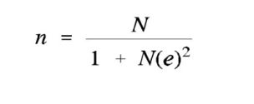
n= 30438/1+30438(0.05)²
n= 30438/1+30438(0.0025)
n= 30438/1+0.25
n=395
Therefore, the sample size is 395. However, for the purpose of convenience, 400 questionnaires were designed and 100 questionnaires were administered in each of the identified quarters. Also, one questionnaire was administered to each of the selected household heads. A situation where more than one household heads resides in a particular housing unit, only one household was given.
3.7 Instrumentation
This is a tool or method used in getting data from respondents. In this study, questionnaires and interview are research instruments used. Questionnaire is the main research instrument used for the study to gather necessary data from the sample respondents. The questionnaire is structured type and provides answers to the research questions and hypotheses therein.
This instrument is divided and limited into two sections; Section A and B. Section A deals with the personal data of the respondents while Section B contains research statement postulated in line with the research question and hypothesis in chapter one. Options or alternatives are provided for each respondent to pick or tick one of the options.
3.9 Reliability
The researcher initially used peers to check for consistence of results. The researcher also approached senior researchers in the field. The research supervisor played a pivotal role in ensuring that consistency of the results was enhanced. The instrument was also pilot tested.
3.10 Validity
Validity here refers to the degree of measurement to which an adopted research instrument or method represents in a reasonable and logical manner the reality of the study (Prince Udoyen: 2019). Questionnaire items were developed from the reviewed literature. The researcher designed a questionnaire with items that were clear and used the language that was understood by all the participants. The questionnaires were given to the supervisor to check for errors and vagueness.
3.11 Method of Data Collection
The data for this study was obtained through the use of questionnaires administered to the study participants. Observation was another method through which data was also collected as well as interview. Oral questioning and clarification was made.
3.12 Method of Data Analysis
The study employed the simple percentage model in analyzing and interpreting the responses from the study participants while the hypothesis was tested using chi-square.
3.13 Ethical consideration
The study was approved by the Project Committee of the Department. Informed consent was obtained from all study participants before they were enrolled in the study. Permission was sought from the relevant authorities to carry out the study. Date to visit the place of study for questionnaire distribution was put in place in advance.

CHAPTER FOUR
ANALYSIS AND DISCUSSION OF RESULT
The study identifies and evaluates the impacts of flooding on socio-economic activities in Oleh community.
This section outlines the impacts of flooding on livelihood of farmers, school system, Transportation of farm produce, food prices, and loss of portable water supply and so forth.
The impact of flooding on farmers livelihood was analyzed in table 3.1.
Table 3.1: Analysis of Flooding on livelihood
Options | Number of respondents | Percentage
Strongly Agreed | 213 | 57.4
Agreed | 153 | 41.3
Strongly Disagreed | 0 | 0
Disagreed | 5 | 1.3
Others Specified | 0 | 0
Total | 371 | 100

The study revealed that high percentage of respondents strongly agreed on the ground that flooding affects farmers livelihood in the study area. It is evident that the percentage of respondents that strongly agreed and agreed that flooding affects farmers livelihood are 57.4 percent and 41.3 percent respectively. While no respondent strongly disagreed rather 1.3 percent of the respondents disagreed that flooding affects farmers livelihood. Also, at community level, interview revealed that most people in the study area could not go to their places of work some days since access roads were blocked and submerged for days by flooding. Similarly, the school system was not spared (see figure 3.1).
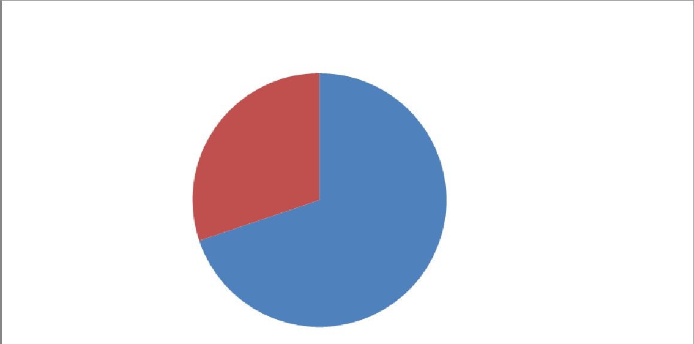
Effect of Flooding on School System based on Sampled Households
15.6
84.4
Strongly Agreed

Agreed
Figure 3.1: Pie Chart of the Effect of Flooding on School System based on Sampled Households
It is clearly seen that high percentage of the sampled households responded that flooding obstructed school system in the study area. That is, 84.4 percent and 15.6 percent of the sampled households strongly agreed and agreed respectively that flooding obstructed the school system (see figure 3.1). It indicated that during flooding school system was halt. At community level, during discussion, the study indicated that school infrastructure was damaged due to flooding in one way or another. Study also revealed that flooding impacts prevented school children from going to school. The disruption was attributed to various reasons such as road being impassible and school being submerged. This study is in agreement with study conducted by Eli (2002), on “kolo creek floods in Bayelsa State”, which revealed that flooding disrupted school system as communication and personal mobility proved difficult.
Table 3.2: Perception of Flooding Impact on Transportation of farm produce
Options | Number of respondents | Percentage
Strongly Agreed | 216 | 58.2
Agreed | 133 | 35.9
Strongly Disagreed | 9 | 2.4
Disagreed | 13 | 3.5
Total | 371 | 100

From table 3.2, it is obvious that high percentage of sampled households strongly agreed that flooding affected Transportation of farm produce. This was revealed with 58.2 percent. Furthermore, 35.9 percent of sampled households also agreed that flooding affected Transportation of farm produce. Little percent of the respondents strongly disagreed and disagreed that flooding affected Transportation of farm produce representing 2.4 percent and 3.5 percent respectively (see table 3.2). The minimal percentage that strongly disagreed and disagreed is an indication that in the study area, there are those who do not travel, therefore, they have no connection with Transportation of farm produce, whereas the high percentage of the sampled households strongly agreed and agreed indicated that flooding affected transportation charges. The study is out of agreement with David et al., (1981), who noted that people lived and worked by the water (flooding) to seek sustenance and capitalize on the gains of cheap and easy travel. While the study is in
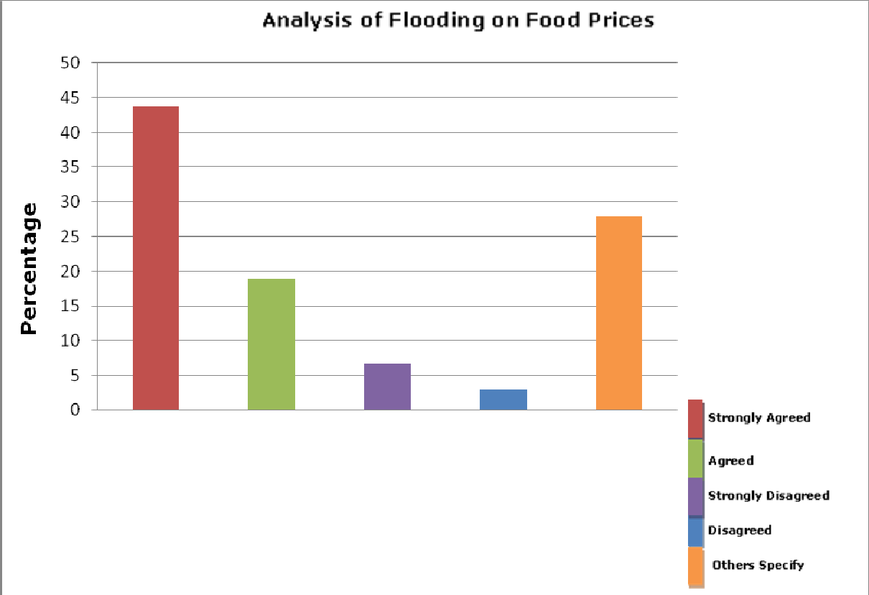
conformity with Pere (2013), who revealed that flooding caused high transportation charges. Similarly, impact of flooding on food prices was analyzed (see figure 3.2).
Figure 3.2: Bar Graph of the Effect of Flooding on Food Prices
It is clearly seen that high percentage of the respondents strongly agreed that flooding caused increase in food prices. The percentage of respondents that strongly agreed and agreed that flooding caused increase in food prices are 43.7 and 18.9 respectively. While few percentages of respondents strongly disagreed and disagreed that flooding caused increase in food prices representing 6.7 percent and 2.9 percent respectively (see figure 3.2). On the other hand, 27.8 percent of the respondents specified that although flooding caused increase in food prices, not all items were affected. This revealed the fact that some food items were produced by the people during flooding. Therefore, supply of such items was high, that is the reason why prices of all food items were not affected.
Moreso, increase in food prices by the respondents that strongly agreed and agreed revealed that flooding caused residents in the study area to be cut off from other neighbouring towns and villages. The situation caused reduced supply, therefore, food crisis and prices of essential food items increased. While few percentage of the respondents strongly disagreed and disagreed that flooding caused increase in food prices, representing 6.7 percent and 2.9 percent respectively. Also showed that some respondents during flooding they did not involve in buying or selling of any food item, therefore, they were not aware of increase of food prices.
The study also revealed at community level during interview that, there was increase of some food items which was attributed to the impacts of flooding on farming. Items such as oil palm, garri, plantain and others increased double during flooding. This is in line with study conducted by Pere (2013) in Bayelsa State which revealed that, flooding caused food crisis and prices of essential items increase rapidly.Furthermore, the impact of flooding on economic trees was revealed by households in figure 3.3.
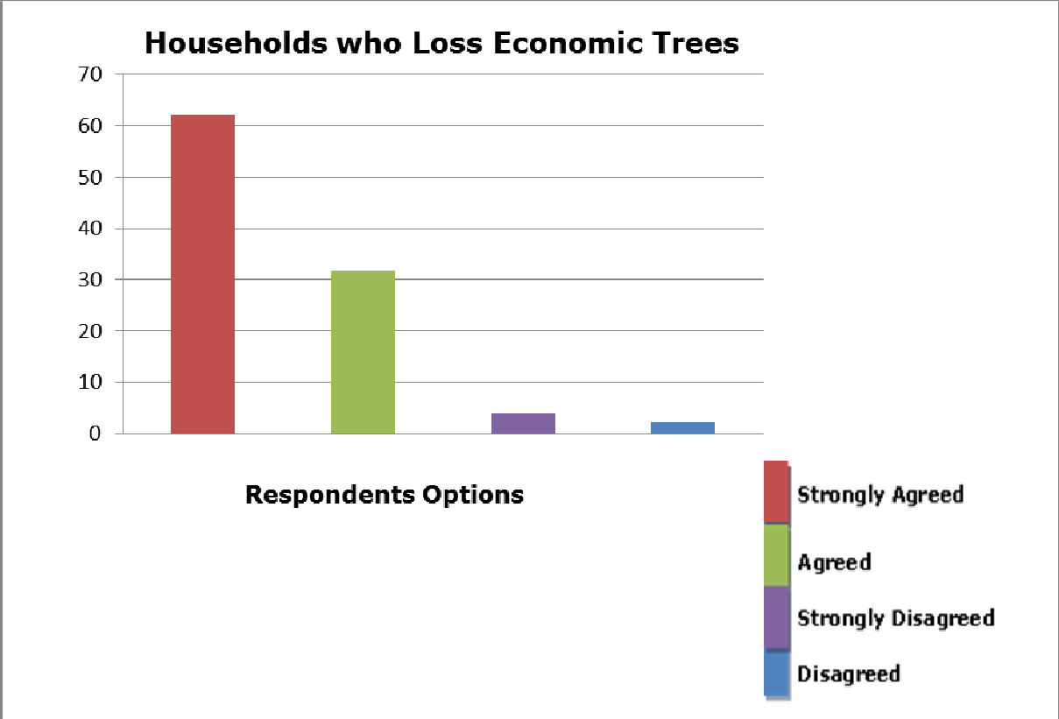

Figure 3.3: Bar Graph of Households Who Loss Economic Trees.
Among the three hundred and seventy one (371) sampled households, 62 percent and 31.8 percent strongly agreed and agreed respectively that there was loss of economic trees due to flooding in the study area. While very little percentage of the sampled households representing 4 percent and 2.2 percent, strongly disagreed and disagreed respectively that flooding does not cause loss of economic trees (see figure 3.3). Also, at community level, interview conducted revealed that due to the impacts of flooding in the past and recent years especially 2012, there was high loss of extensive cola plantation, pear and other valuable crops that resulted to shortage in supply, therefore, increased in prices of those fruits and crops. This finding revealed the negative impacts of flooding on socio-economic activities in the study area.Similarly, impact of flooding on fish stock in ponds loss by respondents was analyzed in table 3.3.
Table 3.3: Perception of the Impact of Flooding on Fish Stock in Ponds
Options | Number of respondents | Percentage
Strongly Agreed | 247 | 66.6
Agreed | 101 | 27.2
Strongly Disagreed | 19 | 5.1
Disagreed | 4 | 1.1
Total | 371 | 100
More than 66 percent of the total respondents in the study area strongly agreed that flooding caused loss of fish stock in ponds. In addition, 27.2 percent of respondents also agreed while few respondents representing 5.1 percent and 1.1 percent strongly disagreed and disagreed respectively (see table 3.3). The high percentage of respondents strongly agreed indicated that there was high loss of fish stock in ponds due to flooding in the study area. Furthermore, table 3.4 also revealed the average number of fish stock loss per household in the study area.
Table 3.4: Average Fish Stock in Ponds lost per Household in Oleh
Species | African Catfish (Claris gariepenus) | Hetro (heterobronchus longifiles)
Total number of fish lost among households in the past and recent years  i.e. from 2012-2014 | 63,000 | 22,500
Total number of households who lost fish stock in ponds | 18 | 10
Average number of fish lost per household | 3,500 | 2,250
(Source: Author’s Fieldwork, 2014)
The study revealed 3,500 African catfish (Claris geriepenus) as average number of fish lost per household while 2,250 Hetro (heterobronchus longifiles) was indicated as average number of fish lost per household due to flooding in the past years. The lost of fish stock in ponds was attributed to overflow of fish ponds which resulted from river flooding due to heavy rainfall in the study area.
Similarly, impact of flooding on portable water was analyzed based on sampled households (see figure 3.3).
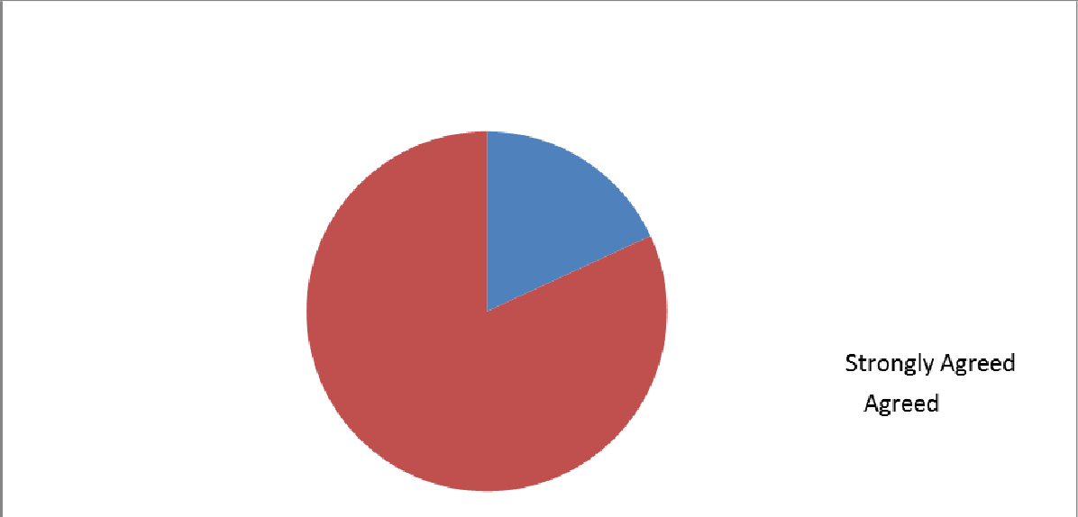


Effect of Flooding on Loss of Portable Water Based on Sampled Households
18.1
81.9
Figure 3.4: Pie Chart on the Effect of Flooding on Loss of Portable Water based on Sampled Households
The sampled households showed that flooding in the study area caused loss of portable water. Of the sampled households, 81.9 percent strongly agreed and 18.1 percent agreed (see figure 3.4). Whereas no household was able to identify that flooding cause no loss of portable water. This revealed that there was a total loss of portable water in the study area. This is a result of increased contamination that occurs during flooding. Despite borehole being the safest water source for drinking, analysis also revealed by NAFDAC that all the analyzed water samples in flooded areas came short of the standard for safe water.Similarly, analysis of impact of flooding on volume of fish catch was done.
Two hundred and thirty one (62.2%) and eighty seven (23.5%) of sampled households strongly agreed and agreed respectively that the volume of fish catch during flooding was high. While few sampled households, that is, thirty nine (10.5%) and fourteen (3.8%) strongly disagreed and disagreed that the volume of fish catch during flooding was high (see figure 3.5). Furthermore, interview conducted revealed that during flooding, natural fish stock were recovered and population of fishes increased, this led to fish catch. The study indicated environmental benefit of flooding because high percentage of the respondents strongly agreed that the volume of fish catch was high during flooding.
Testing Hypothesis
In order to verify whether flooding and socio-economic activities has no significant relationship in Oleh, Pearson Product Moment Correlation is applied.
Thus:
Ho: There is no significant relationship between flooding and socio-economic activities in Oleh.
H1: There is significant relationship between flooding and socio-economic activities in Oleh.
Table 3.5: Summary of Correlation of Area Covered by Flooding with Impacts on Socio-Economic Activities.
Location | X | Y | X2 | Y2 | XY
1 | 336 | 199 | 112896 | 39601 | 66864
2 | 534.6 | 208 | 285797.16 | 43264 | 111196.8
3 | 387.6 | 124 | 150233.76 | 15376 | 48062.4
4 | 395.2 | 289 | 156183.04 | 83521 | 114212.8
5 | 469 | 284 | 219961 | 80656 | 133196
6 | 341 | 179 | 116281 | 32041 | 61039
7 | 520 | 213 | 270400 | 45369 | 110760
8 | 324 | 313 | 104976 | 97969 | 101412
9 | 330 | 216 | 108900 | 46656 | 71280
10 | 667.8 | 162 | 445956.84 | 26244 | 108183.6
11 | 421.6 | 247 | 177746.56 | 61009 | 104135.2
12 | 598 | 304 | 357604 | 92416 | 181792
13 | 581 | 258 | 337561 | 66564 | 149898
14 | 838.2 | 109 | 702579.24 | 11881 | 91363.8
Total | ∑X = 6744 | ∑Y = 3105 | ∑X²= 3547075.6 | ∑y²= 742567 | ∑XY = 1453395.6

Solution:

r = n∑XY – (∑X)( ∑Y)
√[n(∑X²) – (∑X)² [(n[∑Y²) – (∑Y)²
The dependent variable is Area Covered by Flooding = X
The independent variable is Impact on Socio-economic activities =Y Where:
r = -0.33368
The coefficient of determination is calculated by simply multiplying the calculated r value by 100. That is - 0.33368 x 100 =- 33.36.
This shows that there is a high negative correlation between impacts of flooding and socio-economic activities in the study area.
t cal = 1.23
Decision Rules
Using degree of freedom (N–2) which is 14–2 = 12 under level of significance .05, (two tailed test), the table value is 0.53. Since t calculated is greater than the table value (1.23 > 0.53), the null hypothesis (H0) is rejected and the alternative hypothesis (H1) is accepted.
This means that there is significant relationship between impacts of flooding and socio-economic activities in Oleh.

CHAPTER FIVE
Summary of Findings
From the results of the analysis of effect of flood on livelihoods and adaptation measures of smallholder crop farmers activities and critical aspects namely: Agriculture, Education, Transportation, Water of people in Oleh, Isoko South Local Government Area of Delta State.
1. Flooding caused loss of economic trees and agricultural products in the study area which resulted to shortage in supply and led to high price of some food items.
2. The education sector was equally not spared. Learning was disrupted due to submerged schools and damaged infrastructure. Roads were submerged and damaged due to flooding, this affected transportation system that led to increase in fare. Also, travelling was delayed during flooding.
3. Regarding water, there was high loss of portable water. This happened as a result of increased contamination of water during flooding.
4. The study revealed that there was high loss of fish stock in ponds due to flooding in Oleh. In addition, 63000 African catfish (Claris gariepenus) and 22500 Hetro (Heterobronchus longifiles) were the total number of fishes lost among households between 2012 and 2014.
5. High volume of fish caught was revealed as positive impact of flooding in the study area.
RECOMMENDATIONS
1. Community based floods early warning system should be developed. Moreso, children should be educated regarding the risks involved in playing in flood water. This will go a long way in creating awareness and preparedness of the inhabitant of Oleh. Thus, the negative impacts such as loss of human lives, animals, plants and properties would be reduced.
2. Individuals and non-governmental organizations should provide improved varieties of crops that are highly water-resistant to farmers in the study area. This will help to minimize unnecessary premature harvesting of crops during flooding.
3. Individuals, corporate bodies and governments should provide adequate funding for disaster management bodies and agencies; this will go a long way in reducing dreadful experience from the study area.

REFERENCES
Abowei, J.F.N. and Sikoki, F.D. (2005). Water Pollution Management and Control. Port Harcourt: Double Trust Publications Co.
Adeloye, A. and Rustum, R. (2011). Flooding and Influence of Urban Planning in Nigeria. Journal of Urban Design and Planning. 164 (3): 173-187.
Aderogba, K.A. (2012). Qualitative Studies of Recent Flood and Sustainable Growth and Development of Cities and Towns in Nigeria. International Journal of Academic Research in Economics and Management Sciences. 1 (3): 1-25.
Agbola, B.S.; Ajayi, O.; Taiwo, O.J. & Wahab, B.W. (2012). The August 2011 Flood in Ibadan, Nigeria: Anthropogenic Causes and Consequences. International Journal of Disaster Risk Science. 3 (4): 207-217.
Askew, A.J. (1999). Water in the International Decade for Natural Disaster Reduction. In Leavesley et al. (eds) Destructive Water: Water-caused Natural Disaster, their Abatement and Control. IAHS Publication.
Bariweni, P.A.; Tawari, C.C. and Abowei, J.F.N. (2012). Some Environmental Effects of Flooding in the Niger Delta Region of Nigeria. International Journal of Fisheries and Aquatic Sciences. 1 (1): 35-46.
Bradshaw, C.J.; Sodln, N. S.; Peh, S. H. and Brook, B. W. (2007). Global Evidence that Deforestation Amplifies Flood Risk and Severity in the Developing. Global Change Biol. 13: 2379-2395.
Chorley, R.J. (1977). Introduction to Geographical Hydrology: Spatial Aspects of the Interacting between Water Occurrence and Human Activity (6th ed.) Methuen: Associated Book Publishers Ltd.
Climate Institute (2010). Human Health and Climate Change. Available at http://www.climate.org/topics/health.html.
David, R.L.; David, L. P. and Kenneth, W. E. (1981). Variable Effects of Sediment Addition on Stream Benthos. Hydrobiologia 79: 182-184.
Doocy, S.; Daniels, A.; Murray, S. and Kirsch, T.D. (2013). The Human Impact of Floods: a Historical Review of Events 1980-2009 and Systematic Literature Review. Available at http://currents.plos.org/disasters/article/the- human-impact-of-floods-a-historical-review-of-events-1980-2009-and -systematic-literature-review/
Efe, S.I. (2007). Urban Flooding in Abraka, Delta State, Nigeria. Journal of Environmental Conservation and Research 1(1): 96-103.
Eludoyin, A.O.; Akinbode, M.O. and Okuko, E. (2007). Combating Flood Crisis with Geographical Information System: An Example from Akure Southwest, Nigeria. Proceeding of International Symposium on New Direction in Urban Water Management. Paris: UNESCO.
Etuonovbe, A.K. (2011). The Devastating Effect of Flooding in Nigeria. FIG Working Week, 2011.
Few, R.; Kovats, S.; Matthies, F. and Ahern, M. (2004). Floods, health and climate change: A Strategic review from http://www.tynadall.ac.uk/content/floods-health-and-climate-change-strategic-review.
Fubara, D.M.J. (1987). The Menace of Flood and Erosion and Enviromental Disaster. Combat Plan in Sagua, V.O.; Enabor, E.E.; Ofomata, G.E.K.; Ologe, K.O. (eds.). Ecological Disaster in Nigeria-Soil Erosion. Lagos: Federal Ministry of Science and Technoloogy.
Garg, S.K. (2010). Hydrology and Water Resources Engineering. Delhi: Khanna Publishers.
Hill, A.R. (1976). The Environmental Impacts of Agricultural Land Drainage. Journal of Environmental Management. 4 (4): 251-274.
Imogie, A.E.; Udosen, C.V.; Airede, C.I. and Enonuya, D.O.M. (2012). Utilization of Niger Delta Basin Coastal Fresh Water Swamps for Meaning Agricultural Production. Greener Journal of Agricultural Sciences. 2 (5): 180- 187.
Integrated Regional Information Networks (IRIN) (2012). NIGERIA: Worst Flooding in decades from http://www.irinnews.org/report/96504/NIGERIA-Worst-flooding-in-decades.
Iroaganchi, N. & Ufere, K. (2013). Flooding in Nigeria and Sustainable Land Development: Case of Delta State, Journal of Environment and Earth Science. 3 (5): 38-42.
Johnson, T. (2001). Northern Nigeria hit by Floods. Published by the International Committee of the Fourth International (ICFI).
Keller, E.A. (2005). Introduction to Environmental Geology. New Jersey: Pearson Prentice-Hall.
Lawal, A.F. and Nagya, M.T. (1999). Socio-Economic Effects of Flood Disaster on Farmers in Mokwa Local Government Area, Niger State, Nigeria. A Paper Presented at the 33rd Annual Conference of Agricultural Society of Nigeria held at National Cereal Research Institute, Badeggi, Niger State. Pp. 1-10.
Macmillan (2009). Flooding-definition of flooding by Macmillan Dictionary. Available at http://www.macmillandictionary.com/dictionary/british/flooding
Montgomery, C.W. (2008). Environmental Geology (8th ed.) New York: McGraw-Hill Companies Inc. National Erosion and Flood Control Action Plan Committee (2005). The Federal Government Official Gazette, Abuja.
O’Connor, J.E. and John, E.E. (2004). The World’s Largest Floods, Past and Present: Their Causes and Magnitude. Washington DC: US Department of the Interior.
Odemerho, F.O. (1988). “Urban Flood Problems” in Sada, P.O. and Odemerho, F.O. (ed). Environmental Issues and Management in Nigeria Development. Ibadan: Evans Brothers Limited.
Odjugo, P.A.O. (2012). Valuing the Cost of Environmental Degradation in the face of Changing Climate: Emphasis on Flood and Erosion in Benin City, Nigeria. African Journal of Environmental Science and Technology. 6 (1): 17-27.
Odufuwa, B.O.; Adedeji, O.H.; Oladesu, J.O. and Bongwa, A. (2012). “Floods of Fury in Nigerian Cities”. Canadian Center of Science and Education. 5 (7): 2.
Ojeh, V.N. & Orivoh, A. F. (2014). Natural Hazard and Crop Yield in Oleh, South-South Nigeria: Flooding in Perspective. Journal of Earth Science and Climate Change. 5 (2): 2 - 7.
Olajuyigbe, A.E.; Rotowa, O.O. and Durojaye, E. (2012). An Assessment of Flood Hazard in Nigeria. The Case of Mile 12, Lagos. Mediterranean Journal of Social Sciences. 3(2): 367-377.
Ologunorisa, T. E. (2004). An Assessment of Flood Vulnerability Zones in the Niger Delta, Nigeria. International Journal of Environment Studies. 61(1):31-38.
Oyo State Government (2011). Government of Oyo State Report on the Assessment of the 26th August 2011 Flood Disaster in Ibadan Metropolis. Ibadan: Oyo State Task Force on Flood Prevention and Management.
Pere, A. (2013). Accounting Experience of Flood Disaster in Niger Delta Region, Nigeria. Retrieved April 8th, from http://ayaperescholar.blogspot.in/2013/03/accounting-experience-of-flood-diasater.html?m=1.
Postel, S. (2000). Egypt’s Nile Valley Basin Irrigation. Available at http://www.waterhistory.org/histories/rule/t1.html.
Queensland Government (2014). What are the consequences of floods? Office of the Queensland Chief Scientist. Available at http://www.chiefscientist.qld.gov.au/publications/understanding-floods/consequences.aspx.
Reacher, M., Mckenzie, K. and Lane, C. (2004). Health Impacts of Flooding in Lewes: a Comparison of Reported Gastrointestinal and other Illness and Mental Health in Flooded and non-flooded households. Journal of Communicable Diseases Public Health 7(1): 56-63
Sada, P. O. & Odemerho, F. O. (1988). Environmental Issues and Management in Nigeria Development. Ibadan: Evans Brothers Limited.
Sule, B.F., Salami, A. W. and Okeola, O. G. (2009). Operational Impact of Hydropower Generation and Highlights on Preventive Measures in Lowland Areas of River Niger, Nigeria. Journal of Engineering Mathematics. 7 (2): 109-126.
Torti, J. (2012). Floods in Southeast Asia: A Health Priority. Journal of global health. 2 (2): 020304. Ujah, O.C. (2007). Internal Displacement in Nigeria. Enugu: The African Institute for Applied Economics (AIAE).
UN Office for the Coordination of Humanitarian Affairs (2012) Nigeria: Floods as of November 15. ReliefWeb Accessed December 2012.
Uyigue, E. (2007). Climate Change in the Niger Delta. A Publication of the Community Research and Development Centre (CREDC), Nigeria.
Williams, L. (1998). The effect of wildfire or runoff and erosion in native Eucalyptus forest. Journal of Hydrological Processes. 12 (4): 251-268.
Yamane, T. (1964). Prove formula of Taro Yamane-Math Help Forum available at http://mathhelpforum.com/advanced-statistics/181149-prove-formula-taro-yamane.html.
QUESTIONNAIRE
PLEASE TICK [√] YOUR MOST PREFERRED CHOICE AND AVOID TICKING TWICE ON A QUESTION
SECTION A
PERSONAL INFORMATION
Gender
Male [ ]
Female [ ]
Age
18-25 [ ]
20-30 [ ]
31-40 [ ]
41 and above [ ]
Educational level
WAEC [ ]
BSC/HND [ ]
MSC/PGDE [ ]
PHD [ ]
Others……………………………………………….. (please indicate)
Marital Status
Single [ ]
Married [ ]
Separated [ ]
Widowed [ ]
Duration of Service
0-2 years [ ]
2-5 years [ ]
5 and above [ ]
Section B
- There is impact of flooding on farmers livelihood.
- Strongly agreed [ ]
- Agreed [ ]
- Disagreed [ ]
- Strongly Disagreed [ ]
- Uncertain [ ]
- Effect of Flooding on School System
a. Strongly agreed [ ]
b. Agreed [ ]
c. Disagreed [ ]
d. Strongly Disagreed [ ]
e. Uncertain [ ]
3. Flooding Impact on Transportation of farm produce
a. Strongly agreed [ ]
b. Agreed [ ]
c. Disagreed [ ]
d. Strongly Disagreed [ ]
e. Uncertain [ ]
4. impact of flooding on food prices?
a. Strongly agreed [ ]
b. Agreed [ ]
c. Disagreed [ ]
d. Strongly Disagreed [ ]
e. Uncertain [ ]
5. impact of flooding on economic trees of the households?
a. Strongly agreed [ ]
b. Agreed [ ]
c. Disagreed [ ]
d. Strongly Disagreed [ ]
e. Uncertain [ ]
6. the Impact of Flooding on Fish Stock in Ponds?
a. Strongly agreed [ ]
b. Agreed [ ]
c. Disagreed [ ]
d. Strongly Disagreed [ ]
e. Uncertain [ ]
7. the Effect of Flooding on Loss of Portable Water on Sampled Households ?
a. Strongly agreed [ ]
b. Agreed [ ]
c. Disagreed [ ]
d. Strongly Disagreed [ ]
e. Uncertain [ ]
8. impact of flooding on volume of fish catch?
a. Strongly agreed [ ]
b. Agreed [ ]
c. Disagreed [ ]
d. Strongly Disagreed [ ]
e. Uncertain [ ]

