**ANALYSIS OF SPATIAL DISTRIBUTION OF SELECTED SOCIAL INFRASTRUCTURE IN ZURU LOCAL GOVERNMENT, KEBBI STATE**

Social infrastructure includes public primary schools (PPSs) and primary health care facilities (PHCs) which are essential in fostering community wellbeing, cohesion and development. For efficiency in the distribution of social infrastructure, population or travel distance can be used as a criterion for allocating social infrastructures. This study assessed the inadequacy and spatial inequality in the distribution of social infrastructure in Zuru local government of Kebbi State using both primary and secondary data. Six wards were sampled during this study namely; Bedi, Tadurga, Dabai, Rikoto, Rafin Zuru, Manga Ushe wards. Graphical analysis and spatial analysis were adopted for this research using ArcGIS 10.1 and Qgis. Firstly, PHCs and PPSs were identified and their locations were established using geographical positioning system (GPS). This study identified 14 primary health centres and 26 public primary schools existing within the sampled area. Nearest neighbour analysis revealed that both PPSs and PHCs exhibited a dispersed spatial distribution pattern with a neighbour ratio of 1.199216 and 1.284260 respectively. Hence, suggesting the likelihood of each facility being allocated far away from another not necessarily by a predetermined distance. Furthermore, service areas for each facility were established using both Euclidean and road network methods in

G.I.S to determine areas that were adequately and also not adequately serviced by these facilities. Some households within Bedi, Tadurga and Manga Ushe are outside the catchment areas of PHCs and/or PPSs. More so, non-spatial data such as ward population, land area and count of PPSs and PHCs were also used to determine the spatial inequality and inadequacy using the Local Quotient. Result showed that Tadurga ward has an L.Q less than 1.0 and it is the most deprived ward in the allocated existing social infrastructures. Multiple model regression showed that there is no statically significant relationship between the population of wards and the number of existing social infrastructure. Thus, suggesting that a spatial criterion is used to allocate social infrastructure in the area. There is the need provide new facilities in deprived wards at strategic positions in other to ensure the adequacy of social infrastructure within Zuru local government.

**CHAPTER ONE**

* 1. **INTRODUCTION**

# Background to the Study

Infrastructure plays an important role in Africa’s growth and development, the interaction of social and economic infrastructure facilitates the growth process as stated in the Office of the Special Adviser on Africa report (United Nations, 2015). Social infrastructure is complex in nature because it encompasses different institutions united by similar goal of developing the city and fulfilling the essential needs of the society (Frolova *et al.*, 2016). These institutions are relevant sectors or offices responsible for rendering social services such as; facility for health, education and sanitation which are provided to improve human lives.

United Nations (2015) pointed out that the development of social infrastructure in Africa was driven by her economic specialisation as a resource base during the colonial era. The presence of natural resources led to the development of transportation and intensified Foreign Direct Investment (FDI). The aim of infrastructural development during the colonial era was solely to facilitate communication with the western powers. Salisu (2016) attest that firms use infrastructure as delicate intermediate goods. In other words, they are means to an end while household utilized infrastructure as final consumables. Historically, the development of social infrastructure in Africa is supported by several aid programmes; but they were generally disadvantaged due to poor location with large proportion of infrastructure is concentrated in urban areas than rural areas (United Nations, 2015).

Accessibility to infrastructure cannot be over emphasized and it has been a form of right in both developed and less developed countries (Akpan and Atser, 2010). Hasssan and Nor (2017) noted that in militating against poverty, the accessibility to social

infrastructure by the poor is paramount. This perspective hence emphasizes the vitality of social infrastructure as an essential element in the development process of communities. However, the demand for social infrastructure is high and factors that affect its adequacy include insufficient resource base and competing political agenda (Oyedele, 2012).

Oyedele (2012) argued that infrastructure is the benchmark for measuring democratic performance and the bedrock of good governance. Hence, government is responsible for providing the basic infrastructure for her populace. Akpan and Atser (2010) attributed issues such as product diversification, poverty reduction, human welfare, population growth and expanding trade in developing economies to rely on social infrastructure. Both producers and consumers are also burdened with high cost of social and economic infrastructure (United Nations, 2015). This increase in cost arose from the very nature of infrastructure as a linkage in itself on one hand and as an element that connects or link other sectors, including housing to the resource sector. The concentration of social infrastructure and the spatial distribution pattern determines the level of growth and development of any region and also reveal government autonomy (Akpan and Atser, 2010; Frolova *et al.,* 2016).

The Millennium Development Goals (MDGs) initially facilitated the global concern towards social infrastructure through the development of strategies. The MDGs Strategies addressed the special needs of the less developed countries including Nigeria (Akpan and Atser, 2010). When the MDGs programme ended the global concern of social infrastructure was embedded into the Sustainable Development Goals (SDGs) programme which succeeded the MDGs (United Nations, 2018). Salisu (2016) suggested that poor infrastructure in Nigeria hinders the possibility of achieving a sustainable socio-economic development as such there is need to prioritize

infrastructure in the national budget. Oyedele (2012) blamed the military era for widening the infrastructural gap and deficit in Nigeria. Infrastructural deficit in Africa however as indicated by United Nations (2015) is caused by neglecting social infrastructure due to too much focus on economic infrastructure thereby resulting to massive rate of exclusion. Bello *et al.* (2014) suggested that Zuru would experience overcrowding due to the centralized forces of attractions (infrastructure) except if remote areas are provided with such infrastructure. It therefore draws attention towards the relevance of social infrastructure as a pull factor and also the potential cause of overpopulation if adequate measures are not taken.

Zuru is experiencing a gradual change in land use-land cover and population growth. Bello *et al.* (2014) estimated land use-land cover trend to be at 5% per annum between the years 1999 to 2008 in Zuru local government. This showed that, urban growth is much anticipated in Zuru local government and as such it is indeed a pertinent issue to adequately plan for it. This would ensure sustainability and efficiency. However, such decisions must be influenced by careful observation of some underlying factors. Mapping the spatial distribution pattern of social infrastructure is a tool for decision making in balancing spatial distribution and enhancing access to social infrastructure (Akpan and Atser, 2010). With the advent of Geographical Information System (GIS) geospatial analysis has become a lot easier and precise and several studies on spatial distribution had tested the reliability of GIS software (Liu *et al.,* 2008; Dejene *et al.,* 2018; Dejen *et al.,* 2019). Hence, this study presents an analysis of spatial distribution of social infrastructure and their accessibility in Zuru local government of Kebbi state.

# Statement of the Research Problem

Adequate accessibility to social infrastructure is a critical element of a good neighbourhood. Housing as defined by the 2012 National Housing Policy places social infrastructure as one basic component in the composite that makes the proper setting of the neighbourhood. Adequate housing as proclaimed in the policy (Chapter 1, sub section 3.1) is a form of right that is anchored on the ability of individuals to access health, education and social service facilities amongst other household needs to improve quality of life (Federal Republic of Nigeria, 2012). Abraha (2019) lamented that third world countries are not only victims of overpopulation, unemployment and inadequate housing but they also lack social services. Davern *et al.* (2017) have established that there is a relationship between healthy communities and the availability of social infrastructure and more importantly the spatial accessibility to the infrastructure. Brown and Barber (2012) also noted the relevance of equity in the spatial distribution of social infrastructure for efficient delivery and optimal utility of its social benefits in neighbourhoods.

In Nigeria few studies on spatial analysis and distribution pattern of social infrastructure used several methodologies to analyse the phenomenon. The major focus was on spatial distribution rather than spatial accessibility. Akpan and Atser (2010) determined accessibility using social index to take inventory of the social infrastructure stock in Akwa Ibom State. Osumgborogwu (2016) used income to justify accessibility and Ogunyemi *et al*. (2014) stated that accessibility to social infrastructure is influenced by socio economic status of residents and local politics. However, Spatial accessibility relies on measurable travel distance to the infrastructure while spatial distribution had been standardized into various patterns or form (random, dispersed and cluster).

Therefore, there is still need to explain spatial distribution and accessibility of social infrastructure in Nigeria especially Kebbi state.

Spatial analysis has been a tool for spatial planning and management (Akpan and Atser, 2010; Frolova *et al*, 2016; Davern *et al.,* 2017). Since, location of social infrastructure is fixed and as such users need to travel to that location to fulfil their need, the spatial distribution and also accessibility of these facilities can be examined. In this regard, this study will examine the spatial distribution pattern, spatial inequality and accessibility to social infrastructure.

# Research Questions

In the course of this research some relevant questions are thus presented;

1. Is the social infrastructure evenly distributed within Zuru local government?
2. Which households are within and outside the service area of this social infrastructure?
3. What is the level of spatial inequality infrastructural facilities?

# Aim of the Study

The aim of this study is to analyse the spatial distribution of selected social infrastructure with a view to determining the level of inequality in the study area.

# Objectives of the Study

In order to attain the aim of the study, the objectives are to;

1. Examine the spatial distribution pattern of existing social infrastructure.
2. Analyse accessibility of existing social infrastructure.
3. Determine the level of spatial inequality in the distribution of social infrastructure in the study area.

# Hypothesis

In other to answer the research question a hypothesis was formulated that;

Ho: There is no statistical significant relationship between the distribution of social infrastructure and population in Zuru local government.

# Scope of the Study

Social infrastructure includes schools, hospitals or health facilities, recreational and sanitation facilities, water supply, museums, courts and other social-cultural centres like women empowerment centres. This study however is focused on public primary schools and primary health care centres. It aims at identifying existing Primary Health Centres (PHCs) and Public Primary Schools (PPSs); determining their catchment area or service radius, evaluating their threshold population, assessing the spatial distribution pattern and accessibility of the existing social infrastructure. The study adopts spatial graphical analysis which includes spatial distribution and location in the GIS environment.

The spatial extent of this study is Zuru local government area which comprises of ten political wards namely; Bedi, Isgogo-Dago, Manga-Ushe, Rafin Zuru, Rikoto, Rumu- Daben Dabai Seme, Senchi, Tadurga and Zodi wards. This therefore means every PHC and PPS found within the borders of Zuru local government area would be represented and as well analysed.

# Justification for the Study

Social Infrastructure in Nigeria is part of the public sector responsibility. Akpan and Atser (2010) had stressed the relevance of social infrastructure in society and how accessibility to them is a form of right. Teriman *et al.,* (2011) recognised social infrastructure as an essential element in neighbourhood land use planning and development schemes. Davern *et al.* (2017) echoed the relevance of defining a measurable and reliable tool that would show the importance of social infrastructure to community well-being. Social infrastructure as a determinant of community wellbeing and development should be considered a critical component of community planning (Davern *et al*. 2017). A recent phenomenon of determining accessibility to primary health centres in the neighbourhood is to consider travel time as a determinant of accessibility of health centre using GIS as a reliable too for geospatial analysis (Dejen *et al.,* 2019).

Hence, adequate spatial distribution patterns and accessibility of social infrastructure is a necessity for planning and managing healthy neighbourhoods and also in optimizing social service delivery. This study would serve as a reliable tool for policy formation and also emphasize the need to provide educational and health facilities to deprived and underserved wards and/or households within Zuru local government area.

# Study Area

* + 1. **Geographical location and characteristics**

Zuru is a local government in Kebbi state in which the state is located in the north western part of Nigeria as shown in Figure 1.1. Zuru local government within the context of the sate however, is located in the south eastern region of the state as shown in Figure 1.2. It lies between latitude 10.840N to 11.840N and longitude 4.450E to 6.00E

and has a total land mass of 653km². It is characterized with an undulating topography, ranging between 350mm to 1,000m above the mean sea level.

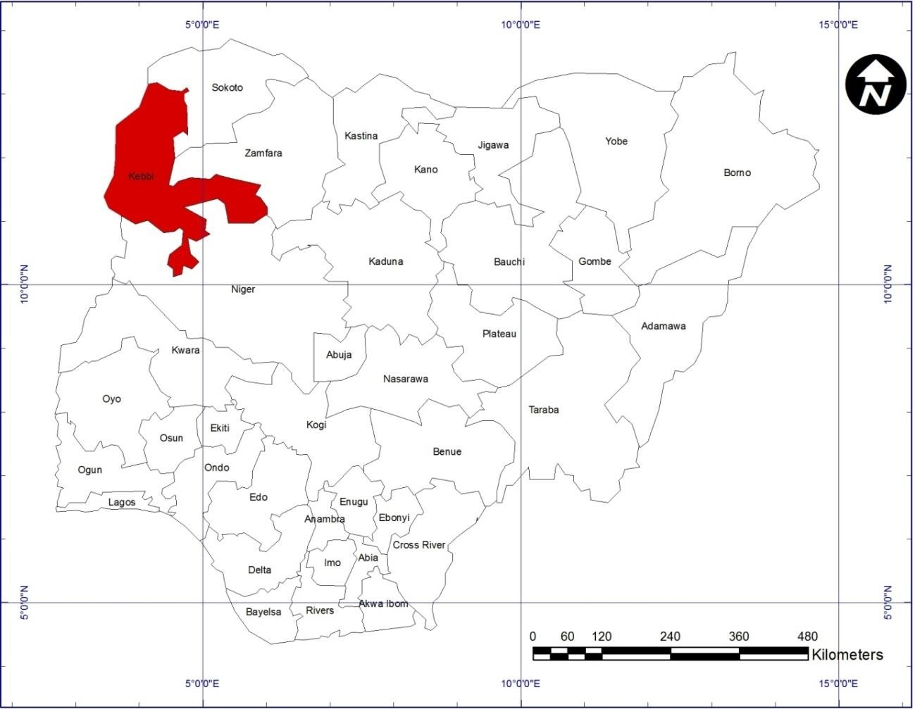

Figure 1.1: Kebbi State in Context of Nigeria Source: Adopted from Google Earth, 2020

There is 1,825 mm as average rainfall and also an average temperature of 27°C. The rainy season begins from April to October and harmattan starts from December to February. Zuru is bounded by Wasagu Danko local government by the north east and north west. At the south it is bounded by Rijau local government of Niger state and by the south eastern by Sakaba local government and in the west by Fakai local government respectively as shown in Figure 1.2.

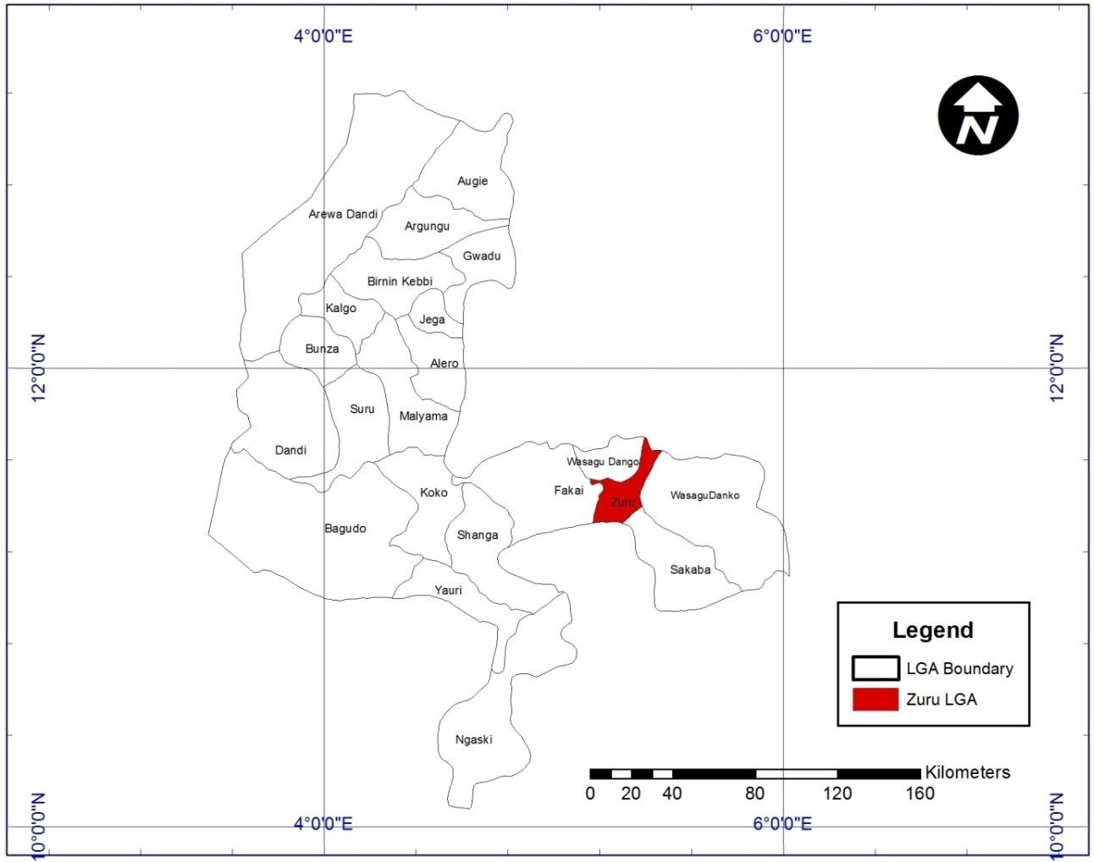

Figure 1.2: Zuru Local Government in Context of Kebbi State Source: Adopted from Google Earth, 2020

# Socio - economic attributes

The predominant ethnic group are the K’lela and they are the indigenous inhabitant of the local government. Zuru has a population of about 165,547 recorded in 2006 census (National Population Commission, 2010). The major primary activities in Zuru local government are; farming and rearing of animals other primary activities include fishing.

Tertiary socio-economic activities in Zuru local government are influenced by the existence of institutions such as; Military base, The Federal University of Agriculture Zuru, the local government secretariat.

# Transportation and settlement pattern

Zuru town can be described as a transit town also as indicated in Figure 1.3. With a major arterial road from Zamfara state through Zuru to Rijau, Niger state. The Zuru- Rijau Road and Zuru-Riba road are the two routes that connect the local government to other bordering local government areas. As shown in Figure 1.3, a large percentage of the household population reside at a central place and as such that area is occupied by a large proportion of the local government population.

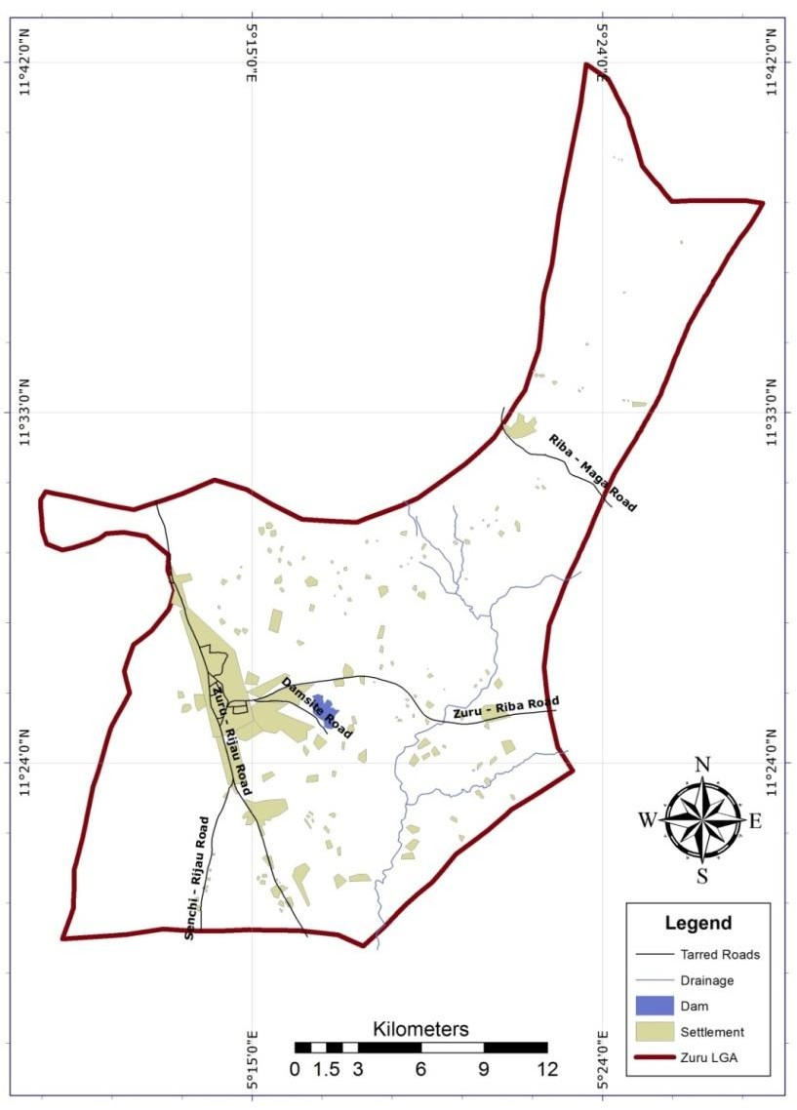

Figure 1.3: Transportation in Zuru Local Government Area Source: Adopted from Google Earth, 2020

**CHAPTER TWO**

* 1. **LITERATURE REVIEW**

# Concept of Social Infrastructure

The term ‘infrastructure’ has no universally accepted definition and classification. The taxonomy of the term varies among authors. The existing varying classification of infrastructure includes; economic and social, hard and soft, material and immaterial, core and peripheral, network, nucleus and territorial infrastructure (Gianpiero, 2009). Oguzor (2011) presented social infrastructure as a tool used in third world countries to facilitate development. In this regard, it has more effect on the socio-economic aspect of life because of its so many advantages which includes; creation of employment, reducing migration, generate income and help spread development. Social infrastructure consists of built structures and public facilities that are necessary for human development (Osumgborogwu, 2016). Frolova *et al.* (2016) describes social infrastructure as the essential facilities that are meant to satisfy the basic needs of society, and also improve living standard.

It is also a form of right for citizenry which becomes an obligation of the state to provide. In other words, it is the responsibility of the governing body of a nation to provide social infrastructural facilities (Akpan and Atser, 2010). The policy provision for social infrastructure and the role of the Federal Government of Nigeria is enshrined in the 2015 National Integrated Infrastructural Master Plan of Nigeria. According to the report, the sub sector of social infrastructure are as follows; health, education, women affairs, labour, information, environment, tourism, youth and sports, social development and productivity. However, all these subsectors are basically subsets of four broad themes under national social infrastructure from which they were derived (National Planning Commission, 2015).

Biktemirova *et al.* (2015) suggested that social infrastructure is an independent economic activity which is understudied but it also has influence on the Gross National Product (GDP) and Gross National Income (GNI). Just like every other market commodity, social infrastructure is a public good which is subjected to forces of demand and supply. Though the impact is understudied but its relevance cannot be neglected. Similarly, Frolova *et al. (*2016) has emphasised that the idea of social service and market economy is also critical in the provision of social infrastructure to meet the basic social demands of the community. Where the market economy is broad based focusing on social status improvement of individuals and communities, social service becomes a neo-liberal concept calling on partnership in social infrastructural delivery.

Teriman *et al.* (2011) has enumerated the function of social infrastructure within the context of urban planning as the provision and availability of facilities that promotes spiritual and social connection, health, education and recreation. Salisu (2016) listed elements or facilities that constitute social infrastructure as, Libraries, Universities, Clinics, Hospitals, Courts, Museums, Theatres, Playgrounds, Parks, Fountains and statues, however the social infrastructure mostly studied are, transportation, health, energy and education.

# 2.1.2 Sustainable neighbourhood and social infrastructure

Teriman *et al.* (2011) pointed out that sustainable development and social infrastructure are two distinct concepts yet connected by spatial location. On one hand, social infrastructure is perceived as facilities that enhances social capital and quality of life. Sustainable development on the other hand, involves the process of preserving and improving the quality of life over a long period of time. Social infrastructure allocation in both developing and developed nations is carried out using local planning standard which is sometimes based on population. However, the physical and psychological

barriers could deprive neighbourhoods from gaining access to facilities when demographic profiles are used as a benchmark for providing social infrastructure. Hence, it is important to realize the impact of social infrastructure to residents’ quality of life. A more pragmatic study of social infrastructure and community sustainability is presented in Brown and Baber (2012) study of Luneside East, Lancaster UK. The study has not only shown that community sustainability relies on access to proper social infrastructure but also makes recommendations that policy makers could also utilize mixed use regulations to provide accessible infrastructure at minimal distance. In siting facilities however, it is important to consider the demographic and social demands of the community, because this would determine the scale, scope, local context, building flexibility, and long term bureaucratic arrangements. Emphasis should dwell on equity as a medium to discourage spatial inequality in the allocation of infrastructure and the best toolkit for ensuring long term bureaucratic arrangements is through mapping.

As advocated by Davern *et al.* (2017), accessibility is vital to the residents if quality life must be achieved. In this regard, the notion of developing neighbourhoods without social infrastructure should be discouraged. For the sustenance of community wellbeing, there must be a standard and strict regulation to ensure that housing is developed in a proper setting with necessary facilities that meets basic social demands. Shroyer *et al.* (2019) revealed that individuals tend to commune in places with sound social infrastructure. It is from sustained conversation and/or interaction especially in forums of shared values that strong relationships are formed. In other words, when people meet in public spaces and interact frequently, a community is built. The role of social infrastructure could be seen as an avenue or facility that strengthens social ties within the neighbourhood. This indicates that social infrastructure is a tool for fostering social cohesion and wellbeing of residents.

A more recent study presented by Latham and Layton (2019) noted that the public character of a good city is exhibited in the fabric of their social network. Although, promoting social cohesion cannot be the primary or the ultimate function of social infrastructure but an added benefit. Hence, promoting a sense of togetherness in a community is one of the added advantages of existing social infrastructure. Latham and Layton (2019) citing Putman (2000) also illustrated that the informal social network sustains the infrastructure. That is, when people successfully build a community of trust and neighbourliness, infrastructure are equally guarded, maintained and cared for by the community. Understanding the importance of social network in public life would enable city planners to allocate strategic outlet that would promote social mix by recommending central places for social infrastructure.

# Public Primary Schools

Public primary schools are solely managed and controlled by a public agency, council, ministry and committee (Dronkers and Robert, 2003). Haggins and Knight (2011) presented an argument that two schools of thoughts exist in defining public school. The argument is between the formalist and the functionalist, where the former agrees that the three attributes that defines public schools are; financing through tax funding, offering admission to candidates within the districts, overseen by appointed or elected officials. However, the latter concept dwells on the expected performance level of public school in fulfilling its essential goal. Avinash (2017) indicated that, the nature of education even in its elementary form is one of the most essential components that constitute human capital. Dronkers and Robert (2003) in a much earlier study also viewed public primary school as a public provider which has legal and political constraint in the overall management framework. The public primary school also commands the attention of other public institutions like Fire Service, Police and

communal socio-cultural activities. Avinash (2017) echoed the importance of public school as a unique political instrument used to combat issues of unemployment and poverty in developing countries.

Barret *et al.* (2019) acknowledge the efforts of government and societies towards improving the educational systems of the world. Schools have set of aspirations and that include; accessibility, safety and health, optimal space for learning, fitting into context and effective implementation of objectives and vision. Obi and Ezemba (2019) stated that the objective of primary education includes instilling knowledge, skills and morals, encouraging reflective thinking, good character and adaptability in pupils.

# Planning standards for public primary schools

Schools are fixed infrastructural investments and its location influences trip patterns. The earliest size and location guideline for school development was developed by Cooper in 1925 cited by Noreen (2010) and it suggested that schools should be adequate in size to accommodate classroom and outdoor activities. The location of schools should be far from noise and air polluted areas. This guideline was first adopted in USA during the industrial revolution until when the standards were advanced into measureable guidelines between 1929 and 1974 by the works of Strayer and Engelhardt and Clarence Perry (Noreen, 2010). Minimum land area for primary school (elementary school) was first recommended by Strayer and Engelhard. The guideline stipulated that elementary school grade pupils should not travel more than one and a half kilometres and the minimum size of the school should be two hectares. It was these guidelines that influence Clearance Perry (1929) neighbourhood unit concept. The location of primary school is at the neighbourhood centres which allow fair access from all side. The proposed maximum service radius in the neighbourhood concept is 800metres. These

guidelines were the first measurable guidelines for siting primary schools in the USA and it has influence on subsequent planning guidelines (Noreen, 2010).

Accessibility by Egbosi and Offor (2016) refers to the ability of primary education to be within the reach of the masses, which is the responsibility of the society. However, the standard about space for learning is debatable. Conant (1959) arguments cited in Barret *et al.* (2019) which influenced the public school design in USA was that “the larger the school, the lower the cost per student.” Later study by Bingler *et al.* (2002) showed that schools can be small in size and still remain operational and cost effective. More so, small schools can take advantage of its size by creating a friendlier learning environment and more inclusive environment. Garnham (2015) declared the availability of land, the desire for public schools to incorporate community facilities into design and the cost of land acquisition as the factors that influence the siting of schools. One of the implications is that, it becomes challenging for policy makers to adopt service radius and land use standards as criteria for allocating space for school. This would in turn influence the trip pattern and average distance travelled by pupils to reach their respective schools. Opoh *et al*. (2014) and Egbosi and Offor (2016) agreed that the Universal Basic Education (UBE) Standard Action Plan is the most adopted guideline in public primary school management of Nigeria. The following Criteria are contained the UBE Standard Action Plan;

* + - 1. Accessibility to the central school must be good and schools must be established within maximum radius of 3-4km of cluster settlements.
      2. Schools should have an architecturally aesthetic and well landscaped (soft scape) environment that should encourage student attendance.
      3. Schools should have recreational facilities
      4. Improve transportation methods that would ensure safety, reduce cost and travel time of pupils to school.

# Factors affecting the utility of primary schools

Yusuff (2011) indicated that the Nigeria Child Act 2003; section 15 dictates that a child has right to basic education. Therefore, it is a legal right given to every Nigeria child to obtain free, compulsory and universal basic education. This section also made it mandatory for parents to ensure their children obtain both primary and junior secondary school education. Egbosi and Offor (2016) also emphasized that primary education is the foundation for any other level of education. This is to explain the crucial nature and importance of primary education. If there is poor quality of primary education, it would affect the pupil’s assimilation in other levels.

Abraha (2019) categorized the factors that influenced the quality of education into two categories namely; the spatial and non-spatial factors. The non-spatial factors are revealed by perceptions and reflections of every stakeholder in the institution. That is, the parent, pupil, teacher and principals. They include; pupil- teacher ratio (PTR) Indicator, pupil - section ratio (PSR) Indicator, physical conditions and school facilities. While spatial factors that affect the utilisation of primary school are, spatial distribution, accessibility and service area coverage. They are generic considerations in the siting of facilities in spatial planning. Owoeye and Yara (2011) examined the correlation between school location and academic performance of students in Ekiti state, Nigeria. Using a Student Location Questionnaire (SLQ), results revealed that there is indeed a statistical relationship. The analysis was based on an ex-post facto type of descriptive survey that used existing data of West African School Certificate Examinations (WASCE) between 1990 and 1997. However, the study aimed at making comparison between urban and rural settings. It was observed that rural schools perform lower than

urban schools. Barret *et al.* (2019) mentioned low density of classroom occupancy and school site to maintain acceptable walking distances has attributes that should improve pupil’s academic performance.

# Primary Health Centres

World Health Organisation (2017) noted that Nigeria is positioned as the 187th country among 191 WHO countries in providing efficient health care system in respect to health expenditure per capita. White (2015) acknowledges that, in building a sustainable health system, the Primary Health Centres are considered as essential cornerstone. Primary health centres are seen as grassroots health service providers in rural communities. Egbewale and Odu (2013) defined Primary Health Care as; “an essential health care made available to all people where they live, work and play, which needs substantial community involvement for its success.” By this definition, the nature of PHCs is one that would care for people at a community, just as secondary and tertiary health facilities are found in urban centres. WHO (2017) also added that the role of PHCs is to provide preventive, curative and rehabilitative services. Primary health care system is not an independent system but a subset of the entire national health system which is meant to carryout specialized objectives. These basic functions of primary health care are as follows; education, promotion of nutrition, sanitation, maternal and child care, immunization, treatment of common diseases, provision of essential drugs for treatment of injuries and prevention of endemic diseases (Emeka and Masemote, 2011).

The primary health centres were established due to the shortcomings and challenges associated with western medicine. The program was introduced by the colonial masters but one of the current challenges in its service delivery is caused by poor leadership and political stability (Idemudia and Victor, 2010). Abdulraheem *et al.* (2012) claimed that despite the uniformly distributed PHCs throughout Nigeria, the health facility is not

utilized in rural communities. More so Egbewale and Odu (2013) in their opinion stressed that, the provision of health facilities in Nigeria does not necessarily command its utility. This is because, there are some underlying factors that influence the utility of health facilities across the country. They are; distance, service cost, cultural beliefs, educational status, and quality of health services and nature of illness.

According to white (2015), the PHC is a component of the National health system whose primary objective is to promote and improve health. The system comprises of public, private and informal sectors. The informal health care system includes; self- help, family and community care and traditional practitioners. WHO (2017) attested that a large part of the Nigeria health care system is driven by the public sector. White (2015) also claimed that inability to improve health conditions is complicated by inadequate resource allocation that address issues of affordability, universality and accessibility. The WHO (2017) identified that government factors and client related factors are responsible for the inaccessibility of PHCs to communities in Nigeria. Government factors includes lack of political will and commitment, weak partnership between government agencies and embezzlement of funds while; client related factors are community perception on quality, underutilization of PHC and low level of community participation.

The Nigeria Primary Health Care Development Agency (NPHCDA) has laid down guidelines and condition for developing PHCs across the country. The PHC also known as Ward Health Centre is meant to service 10,000 – 20,000 populations and designated to political wards (Nigeria Primary Health Care Development Agency, 2010). Otu (2018) described accessibility as a network of physical, social and financial links between the populace and the service provider. In other words, accessibility would distinguish between who is eligible to get served first and who would be served later or

who would incur greater travel time to access services provided. The study suggested that, a strategic siting of PHCs could achieve more in terms of geographical accessibility. The geographical accessibility mentioned by Otu (2018) takes cognisance of distance, cost and travel time as an important factor in the health system. This is because when a health facility is provided, it becomes immobile and as such it becomes challenging to change the location of the infrastructure without incurring a huge financial commitment.

# Primary health centre (PHC) catchment area

In 2006, Dos Anjos - Luis and Cabral identified the use of Euclidean Distance (Straight line Distance) also known as service radius and Network Distance (Road distance) as the two conventional methods of determining accessibility. Phiri and Munthali (2019) argued that the policy on accessibility to PHC in Malawi may not be pragmatic in real life scenarios. In Malawi, eight kilometres (8km) radius is recognized as the service radius of a PHC by the Ministry of Health. The study showed that the actual distances travelled by household within the service radius can be greater than 8km due to road distance and topographical constraints. Dos Anjos - Luis and Cabral (2016) also stated that, Euclidean distance underestimates the travelled distance because of its lack of consideration for natural barriers and transport routes. Accessibility becomes greater in areas with good road network leading to PHCs when road network distance is used.

As a solution the World Health Organisation (WHO) recommended the use of travel time instead of distances in measuring accessibility to health care. Despite this recommendation there is still no universally accepted time range to define adequate access to health care (dos Anjos - Luis and Cabral, 2016). Adopting the use of travel time as criteria for determining the service radius, Phiri and Munthali (2019) and dos Anjos - Luis and Cabral (2016) adopted five kilometres per hour (5km/hr) as the

average distance a person should walk within the recommended time. This however does not include actual road distance because it might be greater than 5km to the nearest PHC. However, it suggests an empirical and logical distance to define access to PHCs using Ambulance Recommended travel time.

# Theoretical Framework

In 1933, a German geographer named Walter Chistaller propounded the central place theory which is an attempt to clarify spatial distribution, size and number of settlements. The theory in many ways suggests the creation of central functions in different settlements in hierarchical order. The model exhibits economic ideology in space, by presenting the issues of range and threshold in provision of goods and services. Range is the maximum distance an individual would travel to benefit or procure goods and services while threshold is the minimum population required to command or demand the provision of a particular goods or service. Vionis and Papantoniou (2019) have noted that central place theory has undergone rigorous recycling, modification, critics, rejection, and revision many times in the past. This has in one way or another lead to several application of the concept in spatial analysis. The researchers further describe the theory as one that considers travel time (distance and cost) in its framework. Robert and Aniruddha (2019) explained that distance describes how things are far apart in numerals and it explains how geographical features are related with each other in Waldo Tobler’s First Law of Geography. It is also a basic concept in spatial dependence (spatial relationship of locations) and spatial autocorrelation (a measure of similarity between near features).

Knitter and Nakoinz (2018) had emphasized that central place distinguishes settlements into three ranks which is determined using market principle, administrative and transportation principle. Hierarchically the settlements are differentiated between higher

and lower order which would enforce a central siting of political power. Knitter *et al.* (2013) had equally opined that the theory in application is not limited to settlements but can as well be extended to mean a group of institution at a neighbourhood or regional level that offer goods and services. Hence, social infrastructure as presented by Teriman *et al.* (2011) can be regarded as an institution that seeks to deliver range of proper facilities that promotes spiritual and social connection, health, education and recreation. Since settlements exists in hierarchies so also would the scale and scope of their social demands which determines the location and type of facility to be provided in both spatial and population based approach of infrastructure planning.

# Spatial Distribution and Accessibility

Gianpiero (2009) has established that infrastructure is measured either by quantifying the existing stock or analysing its effects in regional development. However, the quantification of infrastructure can either be in spatial or monetary terms. This validates the claims of Liu *et al.* (2008) that spatial analysis is common in geosciences especially with the technological advancement of spatial information technology. Accessibility in spatial context is analysed using Geographical Information System (GIS) as an analytical tool (Fabiyi and Ogunyemi, 2015). There are several approaches to spatial analysis depending on academic discipline. However, from a geographic point of view, spatial analysis can be categorized into spatial-graphical analysis, spatial-data analysis, and spatial model (Liu *et al.,* 2008). Spatial graphical analysis includes location and spatial distributions, spatial data analysis deals with measurements of attributes while spatial model analyses spatial mechanisms.

Akpan and Atser (2010) adopted a twenty-one (21) social indicator variable that were derived from indices of water, health, and education to examine the levels of social infrastructure stock and spatial distribution of fifty (50) rural communities in Akwa

Ibom state. The communities were grouped using a single cluster analysis to show the level of performance of social infrastructure using Statistical Package for Social Sciences (SPSS). The study revealed the vulnerable or underserved rural communities and also determined the level of accessibility a community has to basic social infrastructure. The study however, did not examine the factors that are responsible for the unequal siting of social infrastructure in Nigeria. Biktemirova *et al.* (2015) drawing from Marxian ideologies indicated that socio-economic and demographic attributes of communities are what influences the distribution pattern of social infrastructure in Russia. The existing settlement system and a balanced social overhead development is what determine the location of social infrastructure. Specifically, economic development and population are responsible for influencing what social infrastructure goes to where in Russian communities. Osumgborogwu, (2016) on the other hand, investigated the correlation between accessibility to social infrastructure and the income level of the rural community. He argued that income level affects affordability and in turn determines accessibility to social infrastructure. The study showed a strong correlation between the three social infrastructure variables (education, health and leisure facilities) and the income level of the rural community. This confirmed a much earlier observation by Ogunyemi *et al.* (2014) that both the issue of location and accessibility of educational facilities in the country are influenced by the ruling power and socio-economic status of residents.

Davern *et al.* (2017) has specifically mentioned the demerits of adopting a population based approach in social infrastructure planning. Firstly, new suburban regions are deprived of social services until the minimum threshold is available. Secondly, the peri- urban areas suffer an amplified deprivation effect due to the socio-political characteristics of the lower income residents. However, an alternative approach to

planning neighbourhoods is an accessibility based approach. This requires the use of walking or vehicular distances to plan for social infrastructure. For example, in the city of Vancouver a service radius of 0.8km to primary schools and playgrounds was the standard for high density developments. This emphasis affirmed the opinion of Salisu (2016) that Infrastructure is meant to be the final consumable of households and in this case accessibility to education and health facility is very important. As such an accessibility criterion in social infrastructure allocation is more suitable than a population based approach in neighbourhood planning.

Dejene *et al.* (2018) study on spatial distribution and accessibility in Bishoftu town, Ethopia used local quotient method and spatial concentration analysis to examine unequal distribution of primary school. The nearest neighbour analysis was used to display the spatial distribution pattern of primary schools. Spatial accessibility on the other hand was analysed using road network based service area analysis. The result of both the spatial distribution and accessibility were mapped in the Geographical Information System (G.I.S) environment. Recent study of Dejen *et al.* (2019) also adopted the service area analysis of health care centres, using 30 and 60 minutes’ travel time on both foot and vehicle respectively as a parameter to analyse accessibility in

G.I.S. The study validates the use of geospatial technology in analysing spatial distribution and accessibility to social infrastructural facilities. The travel speed in each land cover used in the study was determined by assigning travel speed values adopted from Ebner *et al.* (2004). However, the author agrees that the collection of travel time information is challenging and with a tendency of variations in accuracy. These studies have shown the reliability of geospatial technology in carrying out spatial analysis.

# GIS approach to spatial analysis

Several proposals on geospatial analysis in the GIS environment have been published and this is applicable to so many disciplines including physics, economics, social sciences and geography. The output of analysis is as a result of the attribute of the dataset. Each data set is independent and has the property of distance decay. That is, the effect of the spatial data would decline as the distance between the focal point (spatial field source) and the object increases. This property of a data set can be used to measure the range of impact emitting from the dataset to the surrounding object. This therefore is significant in measuring the range of social infrastructural delivery in urban and regional planning. Another property of spatial data fields is in their interaction and overlapping function when they meet. They tend to exert the same forces when they meet at any point thus, the data field would overlap. The service radius of social infrastructure could also overlap given if the distances in service radius between two features meet at the same point (Liu *et al.,* 2008). Techniques used for spatial analysis covers areas such as;

# Spatial distribution

Adrain (2008) presented spatial distributions as a graphical representation of phenomenon on the surface of the earth through geo-referenced datasets. The dataset could be manipulated in complicated data analysis. There are three types of spatial distribution representation across the surface of the earth. And they are as follows;

* 1. Uniform: in the graphical outcome of spatial distribution, the uniform pattern is always distinguished form other patterns by a relatively farther distance that exists between geographic features or phenomenon. As shown in Figure 2.1.



Figure 2.1: Uniform Spatial Distribution

Source: Adrain (2008)

* 1. Clustered: there is a concentration of geographic features or phenomenon within a region while other areas contain few. As such the outcome of the graphical representation is shown in form of patches of varying concentrations as illustrated in Figure 2.2.

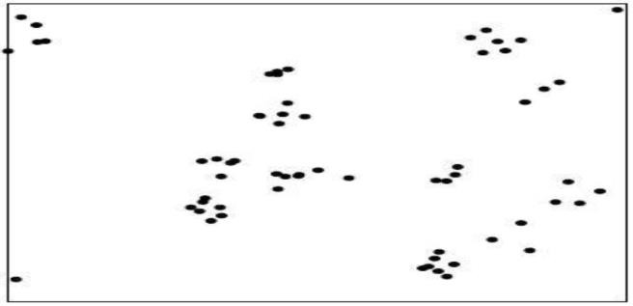

Figure 2.2: Clustered Spatial Distribution Source: Adrain (2008)

* 1. Random: as shown in Figure 2.3, geographic features or phenomenon have less influenced on the location of another. There are chances of them to exist in any location and as such the result would show a representation that is not likely to occur at defined intervals or clusters.

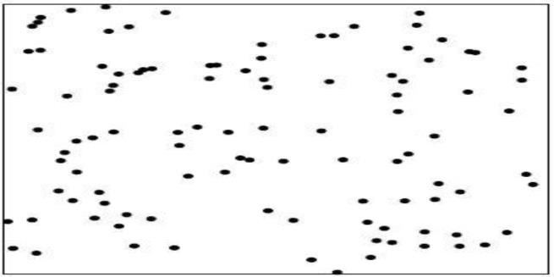

Figure 2.3: Random Spatial Distribution Source: Adrain (2008)

Kosfeld *et al.* (2019) mentioned that nearest neighbour analysis is an explorative tool for spatial point analysis. Point analysis is used to determine the spatial distribution pattern aforementioned by Adrain (2008). Nearest neighbour analysis is a method of testing spatial randomness hypothesis and it takes cognisance of distance between adjacent spatial features. This method of analysis is obtainable in the GIS environment. The range value in the result of the analysis ranges from 0 to 10. It is represented as (Rn) and the formula is;

𝐑𝐧 =

(𝑑√𝑛)

𝑎

Where;

Rn= the average nearest neighbour index

n= number of geographical features (social infrastructure) a= the size of the study area

d= the mean distance between geographical features (social infrastructure)

When the value is 2.15 it shows that there is uniform pattern of distribution. 10 signifies a perfect random distribution, 1.0 however shows a probable spacing of features while clustering values are usually below 1.0. Many studies have employed the use of GIS for spatial distribution pattern analysis (Dejene *et al.,* 2018).

# Accessibility

Efiong (2019) described accessibility as the distance travelled between origin and destination. That means that accessibility is characterised by origin, destination and the interaction between them. The interaction which is expressed as distance has the potential to either limit or enhance peoples’ ability to access their destinations. In social infrastructure discourse, there exist a demand (origin) and supply (destination) point or

centre where consumers’ travel to satisfy their social needs. Accessibility is also a function of distance decay. That is, the shorter the distance between the origin and destination, the greater the accessibility. However, analysing accessibility requires developing and selecting a technique according to the purpose of the study and the nature of the problem. This would command specific method of measuring distance and method of data presentation. The spatial unit of accessibility can be zoned into individuals, household and building blocks or socio-economic groups (Liu and Zhu 2004).

Shanmathi *et al.* (2017) summarized accessibility models into four namely; provider to population ratio, distance to nearest provider, average distance to a set of providers and gravitational models of provider influence. Provider to population ratio is significant in communities where population based criteria is used in the provision of social infrastructure. The constraint however, is that smaller communities are deprived from essential facilities. The average distance to a set of providers is measured either by using Euclidean (Straight line) distance, network distance or estimated travel time. Efiong (2019) also emphasized that buffering and network analysis are GIS techniques used in determining accessibility. Buffering is used to answer questions that relates to linear network. Network analysis on the other hand assesses the demand and supply of goods and services. It is used to analyse facilities that are optimized more from a demand centre. This way the policy maker can decide which facility to close down and which to rehabilitate to ensure efficiency. This technique incorporates the use of socio- economic data of the sampled population.

The ability to measure straight line distances, travel time and cost, three-part network distances and shortest path distances is an advantage of using GIS Accessibility Analyst. Where different modes of transport are involved, the distances can be grouped

into three part network distances and the cumulative sum of the distances would yield the total calculated travel distance. The constraint of analysing accessibility using GIS is that, personal preferences in travel pattern, space time limitation and individual time budgeted are usually ignored. Hence, the result presents an analysis of spatial or place accessibility and not individual accessibility (Liu and Zhu 2004).

Tao *et al*. (2018) noted that the Two Step Floating Catchment Area (2SFCA) method is one of the most conventional method used in measuring accessibility to PHC. The 2SFCA is described as the interaction between demanders and suppliers (facilities) as a way of measuring accessibility. The accuracy of this method can be influenced by demands emanating beyond the administrative boundary. To neglect this factor will lead to a biased result. Phiri and Munthali (2019) noted the relevance of spatial and non- spatial data in analysing accessibility using the 2SFCA method. The non-spatial data involved the administration of questionnaires to collect relevant data on mode of transportation, factors affecting access to PHCs, The Household suppliers and the capacity of the PHC. There must be an efficient mechanism to determine the accuracy of each variable in the 2SFCA method to ensure an unbiased result.

Spatial factors include the geo points of households (demanders), PHCs (suppliers) and a Digital Elevation Model (DEM) of the study area. Both the spatial and non-spatial variables represent either the suppliers or the demanders. In the study, the Malawi districts were mapped into enumeration areas with an average of 233 households in each enumerated area by the National Statistical Office. This ensures a spatial referenced data ready for the 2SFCA method and also policy making (Phiri and Munthali 2019). This kind of spatial referenced data can be difficult to obtain in some developing countries. In summary spatial analysis is used to determine areas that have access to infrastructure and those that do not have adequate access to the infrastructure.

# Spatial Inequality

Scholars have used different concepts to explain spatial inequalities; some are based on geography while others are based on social, economic or political features or a combination of variables from two or more features aforementioned. In a general sense, measuring spatial inequality entails examining the quality of infrastructure existing in a place with a view of identifying the level of spatial equity and determining the underserved communities in that place (Adefila and Bulus, 2014). According to Somik and Sanjoy (2005), spatial inequality exists in all levels of settlements, in neighbourhoods, districts, towns, cities, metropolis and country levels.

Grant (2010) attributed matters of spatial inequalities to poverty rather than access to infrastructure and services. The proposition suggested that spatial inequalities exist due to the relationship between social and political processes and not a factor of geography alone. Adefila and Bulus (2014) confirmed that, the core and the peripheral areas exhibit inequalities in varying degrees which only the state and national politics could address. However, in Nigeria policies are not fully implemented and resources are meant to favour social groups with political affiliation. Oyedele (2012) has highlighted that existing infrastructure in the community represent the performance of government and it also serves as criteria for measuring good governance. It suffices to say that despite spatial inequality is influenced by socio-political factors; the severity is proved by the existence and non-existence of physical infrastructure. As such it is easier to measure and investigate social inequality.

Somik and Sanjoy (2005) stressed that, spatial units for measuring spatial inequalities must contain a significant amount of data for the variable measured, or must be responsible for creating policies that affects the variables substantially. According to Adefila and Bulus (2014) models for measuring spatial inequalities include; total factor

productivity, Z score, regression analysis model (Least cost, linear regression etc.) and location quotient (LQ). The determinant of spatial inequality varies with available data and method of data analysis. The difference between the LQ and other models is that, the LQ dwells on infrastructural index inventory while regression, Z score, total productivity factor and regression models used a more complex set of variables. These variables may include endogenous and exogenous variables, social and ecological variables (Ngeleza *et al.* 2011).

# Location quotient (LQ)

According to Chobotová and Palová (2015), location quotient (LQ) was first introduced by Florence in 1939 as a tool for comparing the characteristics of a smaller region to the characteristics of a larger region. It is mostly used to quantify the concentration of industries in a region. LQ is significant in establishing a benchmark that is used to compare smaller regions with larger ones in exploratory research (Gokan, 2010). In exploratory research, LQ will provide more understanding and description of the phenomenon.

Abu *et al.* (2015) in an attempt to explain ‘region’ as a concept re-echoed John (1974) that, a region is either viewed subjectively or objectively. These schools of thoughts have opposing views about the term. Subjectively, regions exist as a mere idea, a paradigm used to study, classify and segregate the world. On the other hand, the objective thinkers viewed regions as an organism, an end in itself that can be defined and as well mapped.

Gokan (2010) noted that spatial inequalities can be measured between an industry and population using LQ, which can be presented also in a locational curve. Abu *et al.* (2015) opined that, LQ is also a tool used in understanding the growth pattern of smaller

regions within the context of a larger region. However, Gokan (2010) cautioned that, despite the tendencies of LQ measuring spatial inequalities, it is not a viable tool for measuring export and import industries. Thus, LQ is primarily used in measuring industrial concentrations (Somik and Sanjoy, 2005). The formula is given as;

𝐋𝐐 =

𝑒𝑖𝑟

𝑒𝑟

𝐸𝑖𝑛

𝐸𝑛

Where;

eir= industy employment, i in sub region r er= overall employment in sub region r Ein= industry employment i region n

En= overall employment in region n

Chobotová and Palová (2015) revealed that social inequality determines the level of cohesion and also helps the populace become informed of their regional position in relation to other regions. This can extend beyond measuring physical facilities and structures to activities, performance, income and other variables. The method of loose- coupling of GIS module using both GIS and other non-spatial analytical software made it possible to analyse both spatial and temporal regional economic development and industrial clusters datasets. This included the use of LQ and Moran’s *I* statistics. One of the advantages in using GIS for spatial inequality studies model is that, one can use the count of existing infrastructure to measure the level and pattern of spatial concentration and also carryout spatial regression (Boasson and Boasson, 2011).

As illustrated by Abu *et al.* (2015), LQ of sub regions or smaller regions can be grouped according to range. The result can be interpreted where regions with LQ less than 0.4

are regarded as very poor, 0.4 to less than 0.8 means poor while, 0.8 to less than 1.0 means moderate share compared to the larger regional share. When the LQ ranges between 1.0 to less than 1.5, it shows that a sub region as equal share of the industry or features as the larger region. Any LQ above 1.0 will mean that the sub region has a higher proportion of the industry, characteristics or feature than the larger region. Classification of LQ can also be done in GIS using these ranges.

**CHAPTER THREE**

* 1. **RESEARCH METHODOLOGY**

# Research Design

This research adopts a cross-sectional study design; this is because the phenomena are subject to change and the data are not necessarily consistent overtime. The existing geographical location of primary health centres and public primary schools in Zuru local government area is essential to the study. The methodology of this study depends on quantitative data collected and sourced in other to achieve both the research broad aim and its objectives as shown in Figure 3.1. It will include issues such as; instruments for gathering of spatial and non-spatial data along with methods of sampling, data analysis and presentation.

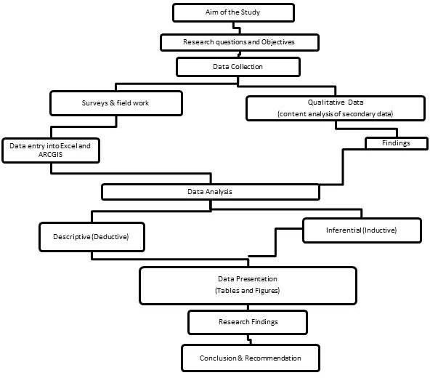

Figure 3.1: Research Design Flowchart Source: Reseacher, 2020

# Sources and Method of Data Collection

In achieving the objectives of this research, both primary and secondary data are employed in the study. Table 3.1 presents the type of data required for each objective in this study and also a summary description of methods of analysis. The highlighted details showed how every objective was analysed and presented uniquely for better

interpretations and deductions. For instance, the location of social infrastructure will require primary and secondary data and analysed descriptively, which the result will be presented using tables and/or figures.

# Table 3.1: Summary of the Research Data Requirements and Objectives

|  |  |  |  |  |  |
| --- | --- | --- | --- | --- | --- |
| **S/N** | **Objectives** | **Type of Data**  **Required** | **Source of Data** | **Type of**  **Analysis** | **Analytical**  **Tool** |
| **1** | Spatial distribution pattern of existing social infrastructure. | Inventory and location of existing PPSs and PHCs in selected wards | Secondary (records of PHCs and PPSs) | Descriptive Analysis | ArcGIS  Microsoft Excel 2010 |
|  |  | Coordinates of each PPSs and PHCs | Primary (Coordinates) | Nearest Neighbour Analysis |  |
| **2** | Analyse accessibility to existing social infrastructure. | Space standards and coordinates | Secondary (Planning Standards) | Buffering  Network Analysis | ArcGIS 10.1 |
| **3** | Spatial inequality in the distribution of social infrastructure. | Number of existing PHCs and PPSs in various wards  The estimated population of each ward Land area of  each ward | Secondary (population data and number of PHCs and PPSs)  Primary (ground trothing of PHCs and ) | Descriptive and Inferential Statistics | JASP 0.10 |

Source: Author 2021

# Primary data

The geographical coordinates of the public primary schools and primary health care facilities were among the primary data for this study. Satellite images were also used and verified by ground trothing. This ensures the accuracy of spatial distribution and accessibility analysis of Primary Health Centres and Public Primary Schools in Zuru local government.

# Secondary data

For the purpose of this research, data were sourced from local and international journal publications, text books and other published materials. The data were used to develop a sound literature relevant to this study, and also in providing necessary background on spatial distribution and accessibility, nature of primary health centres and public schools and spatial inequality. Data on household population, wards, names and location of primary health centres were obtained from the Zuru Primary Health Centre Local Government head office. Equally the names and location of public primary schools were collected from the Zuru Local Government Primary Board. This data informed and aided the researcher in spatial distribution and accessibility analysis. An Open Street Map (OSM) of the study area was obtained as a dataset for network analysis in the GIS environment.

# Instrument for data collection

A handheld GPS, field survey checklist, remote sensing and G.I.S Software were the instruments used as instrument for data collection for this study. The GPS device was used to acquire the coordinates of public primary schools and primary health care centres respectively. Terraincognita software was used as a remote sensing software to acquire a five metre resolution satellite imagery of the study area which was digitize into a vector data in ArcMap 10.1 software. The field survey checklist was used to take record of distances and coordinates during the study.

# Procedure for Sampling

A census of the existing PHCs and PPSs in Zuru local government area were carried out. The population of each respective ward was also used to assess impact of population in the siting of the social infrastructure.

# Population of the study

The population of wards is relevant in this study especially in determining the level of spatial inequality. As shown in Table 3.2 the household population was obtained from records of house to house immunization program carried out in 2019. The estimated population in each ward were derived by multiplying the respective household population (Hh) with the average National Household Size of 5.0. (National Population Commission, 2019). This resulted to a total of two hundred and eighteen thousand, three hundred and eighty-five people in Zuru local government as shown in Table 3.2.

# Table 3.2: Wards, Household Population and Estimated Population

|  |  |  |  |  |
| --- | --- | --- | --- | --- |
| **S/N** | **Ward** | **Household Population** | **Average Household Size** | **Estimated Population** |
| 1 | Bedi | 3928 | 5.0 | 19,640 |
| 2 | Dabai | 6211 | 5.0 | 31,055 |
| 3 | Dabai Sema | 2841 | 5.0 | 14,205 |
| 4 | Isgogo/Dago | 2639 | 5.0 | 13.195 |
| 5 | Manga Ushe | 5657 | 5.0 | 28,285 |
| 6 | Rafin Zuru | 5310 | 5.0 | 26,550 |
| 7 | Rikoto | 6582 | 5.0 | 32,910 |
| 8 | Senchi | 5301 | 5.0 | 26,505 |
| 9 | Tadurga | 2762 | 5.0 | 13,810 |
| 10 | Zodi | 2446 | 5.0 | 12,230 |
| **Total** |  | 43,677 |  | 218,385 |

Source: Zuru LGA Primary Health Centre Head Office (2019), and Researcher’s Computation (2020)

# Sampling size

Efiong (2019) stated that, in spatial data analysis it is a general principle to treat the entire population as the sample, since the research is GIS based. Thus, it is imperative to examine the entire public primary schools and public primary health centres of the local government and the population of the respective wards. Thus, every facility within the study area was accounted for. As shown in Table 3.2, the estimated population of each respective ward was used in subsequent sub themes and chapter for analysis. Hence, the total facilities within the local government and the estimated ward population of each ward where these facilities were located were adopted as the sample size.

# Sampling frame

This contains the list of members of the study population from which a sample can be obtained. In this study, Zuru local government area is regarded as the sampling frame. This is because the local government area will contain both the wards spatial and non-spatial attributes of elements to be sampled.

# Sampling units

This referred to the location or physical area where the target population can be found from which the sampling was performed. In the case of this study the wards are the sampling unit and each respective ward contains the sampled elements. The wards are, Bedi, Tadurga, Senchi, Dabai Seme, Dabai, Manga Ushe, Zodi, Rikoto, Rafin Zuru and Isgogo Dago.

# Sampling elements

This is a more precise description of who will be eligible in the sampling exercise and from whom the required information will be obtained. The existing public primary schools and primary health centres within the local government area are the sampling unit. Therefore, the

coordinates for each of them were obtained along with relevant data required for this study. The estimated household population of the sample frame is also relevant to this study.

# Sampling technique

Efiong (2019) has stressed the importance of treating the entire facilities as sample for spatial analysis. This is necessary to ensure accuracy in assessing spatial distribution patterns and examining the accessibilities of infrastructure. This means that it is of paramount importance that the study must account for one hundred per cent of the sample namely; the existing public primary schools, primary health centres within the local government area and the estimated population of each ward. Therefore, this study adopted a census technique that accounted for every social infrastructure and population within the spatial extent or boundary of the local government.

# Method of Data Analysis and Presentation

Both descriptive and inferential methods were used during data analysis and results were presented in tables and figures. Since this study is based on spatial data and do not require the administration of questionnaire, it was analysed using ArcGIS 10.1. A 5m resolution imagery of Google Earth imagery of the local government was digitized to produce necessary Shapefiles for analysis. Shapefiles and layers which includes; polygons and polylines were developed using Google Earth imagery which also functioned as a data used during this study. More importantly, the coordinates (longitude and latitude) was a key element for this study. Coordinates were used as a Geodatabase file. In the ArcGIS interface, the researcher utilized the system toolboxes in the analysis which included but not restricted to; data management tools, analysis tools, spatial statistics tool and conversion tools. The data was presented using figures. Point mapping was done by processing X and Y data, where X is the Longitude and Y is the Latitude.

ArcGIS 10.1 was also integrated with some other application including OSM toolbox and QGIS for the network analyst. The procedure firstly required a download of the study area street map form the OSM (Open Street Map) server. This data was imported into the ArcGIS

10.1 environment and also edited using the OpenStreetMap tool box. The network analysis was carried out using both QGIS and ArcGIS 10.1.

Notwithstanding, testing the research hypothesis required some form of analysis outside the ArcGIS 10.1 interface. The researcher ought to use the population of each respective ward as a variable in the analysis. The research hypothesis was tested using multiple regression model. According to Morenikeji (2006), the multiple regression model is a statistical model that enable two independent variables to predict the likely occurrence of a dependent variable. The research hypothesis was tested in JASP 0.10 software while spatial inequality was examined using the location quotient (LQ) and the results were presented in tables.

**CHAPTER FOUR**

* 1. **RESULTS AND DISCUSSION**

# Existing Social Infrastructure within Zuru L.G.A

This section presents the result of analysed data which explains the nature and locationss of wards within Zuru local government and how they relate to one another. It also identified the existing social infrastructure within the local government area. The inventory and location of existing PPSs and PHCs, and also their spatial distribution pattern and accessibility analysis were all detailed in this chapter.

# The nature and location of wards within Zuru L.G.A

Zuru local government consist of ten electoral wards namely; Bedi, Tadurga, Senchi, Dabia Seme, Dabai, Manga Ushe, Zodi, Rikoto, Rafin Zuru and Isgogo Dago wards as illustrated in Figure 4.1. However, the spatial extent of some of these wards extends beyond the borders of the local government area. Typical examples are the Isogo Dago, Dabai Seme and Zodi wards. The locations of households in those wards as well as social infrastructure (PPSs and PHCs) were not found within the boundary of the Zuru local government area as shown in Figure 4.1. Despite being under the jurisdiction of the Zuru local government administration, including data collected from the aforementioned wards alters the defined nature and spatial scope of this study. Exempting these wards (Isogo Dago, Dabai Seme, Senchi and Zodi) from this study justifies the spatial nature, scope and boundary of this study.

Rikoto and Rafin Zuru ward are regarded as the urban part of Zuru local government due to administrative functions of the wards. Figure 4.1 also illustrates how the urban area is distinct due to the nature of circulation (road network), because the road intersects at the central part of the local government area. More so, the rural areas as defined by the circulation system are areas that are far away from the road and also from the urban centre as shown in Figure 4.1. These wards include, Tadurga, Dabai, Zodi, Isgogo Dago, Senchi, and Dabai Seme ward.

However, Bedi and Manga Ushe ward are the Suburban areas, which are characterised by new residential development and emerging neighbourhoods.

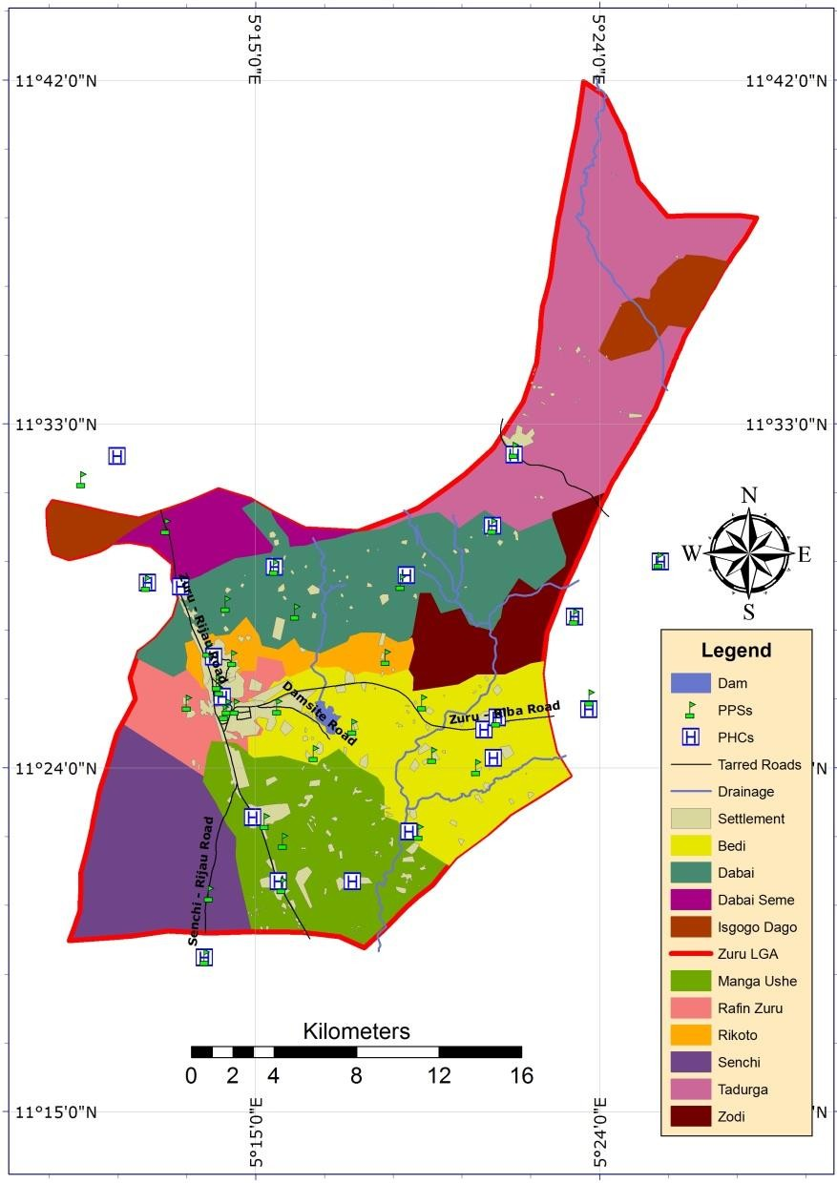

Figure 4.1: Existing Social Infrastructure of Wards in Zuru Local Government Area Source: Researcher’s 2020

Since Figure 4.1 showed a graphical evidence of social infrastructure (PPSs and PHCs) sited outside the local government borders, it thus presented the need to select wards with social

infrastructure and households that falls within the spatial scope of the study. Hence, using the findings in Figure 4.1, six wards were selected as sampling units for spatial analysis. They include; Rikoto, Rafin Zuru, Dabai, Bedi, Manga Ushe and Tadurga wards as shown in Figure 4.2. The wards used for analysis comprises of two urban, suburban and rural wards respectively.

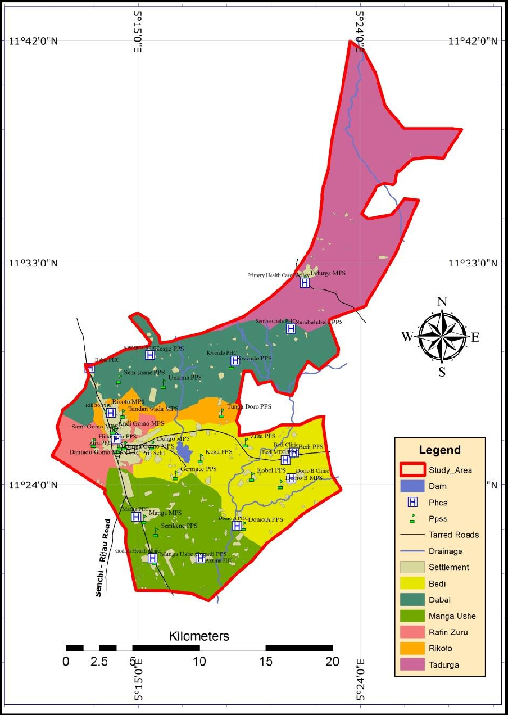

Figure 4.2: Existing Social Infrastructure within Zuru Local Government Area Source: Researcher’s 2020

# Existing primary health facilities within the selected wards

There are fourteen existing provisions made for public primary health care facilities within the selected wards. Dabai, and Manga Ushe wards have four PHCs each while, Tadurga, Rikoto and Rafin Zuru ward have only one PHC each and Bedi have three. Each PHC (Primary health centre) also have its own unique name as shown in Table 4.1. The names given to these PHCs were also the names of the settlement where they were found. For instance; the PHC in Kwendo is sited in Kwendo community and as such ‘Kwendo’ is use adjectively to identify and/or differentiate that particular PHC from others.

# Table 4.1: Existing Primary Health Facilities within Zuru L.G.A

|  |  |  |  |  |
| --- | --- | --- | --- | --- |
| **Index** | **Infrastructure Name** | **Ward** | **Latitude** | **Longitude** |
| 1 | Dabai PHC | Dabai | 11.47892667 | 5.21746 |
| 2 | Kwesge Clinic | Dabai | 11.48746667 | 5.258278333 |
| 3 | Kwendo PHC | Dabai | 11.483875 | 5.315813333 |
| 4 | Sembelubelu PHC | Dabai | 11.50534167 | 5.353406667 |
| 5 | Bedi MDG/PHC | Bedi | 11.41650333 | 5.349665 |
| 6 | Domo B Clinic | Bedi | 11.404185 | 5.353763333 |
| 7 | Bedi Clinic | Bedi | 11.42178667 | 5.3555 |
| 8 | Manga PHC | Manga Ushe | 11.37817333 | 5.24878 |
| 9 | Godadi Health clinic | Manga Ushe | 11.35025333 | 5.25998 |
| 10 | Akumu PHC | Manga Ushe | 11.35029333 | 5.292303333 |
| 11 | Domo A PHC | Manga Ushe | 11.37199 | 5.316958333 |
| 12 | Zuru PHC | Rafin Zuru | 11.430855 | 5.235495 |
| 13 | Rikoto PHC | Rikoto | 11.448345 | 5.231681667 |
| 14 | Primary Health Care Facility | Tadurga | 11.53640167 | 5.362778333 |

Source: Researcher’s Field Work, 2020

Figure 4.3 presented the existing PHCs in the study area as listed in Table 4.1 on a map. This shows the actual position of each facility graphically on a map. The Figure 4.3 was plotted using the coordinates (longitude and latitudes) in Table 4.1. Each facility is labelled accordingly in Figure 4.3 to show the relative positions where they are located on the surface of the earth in their respective wards.

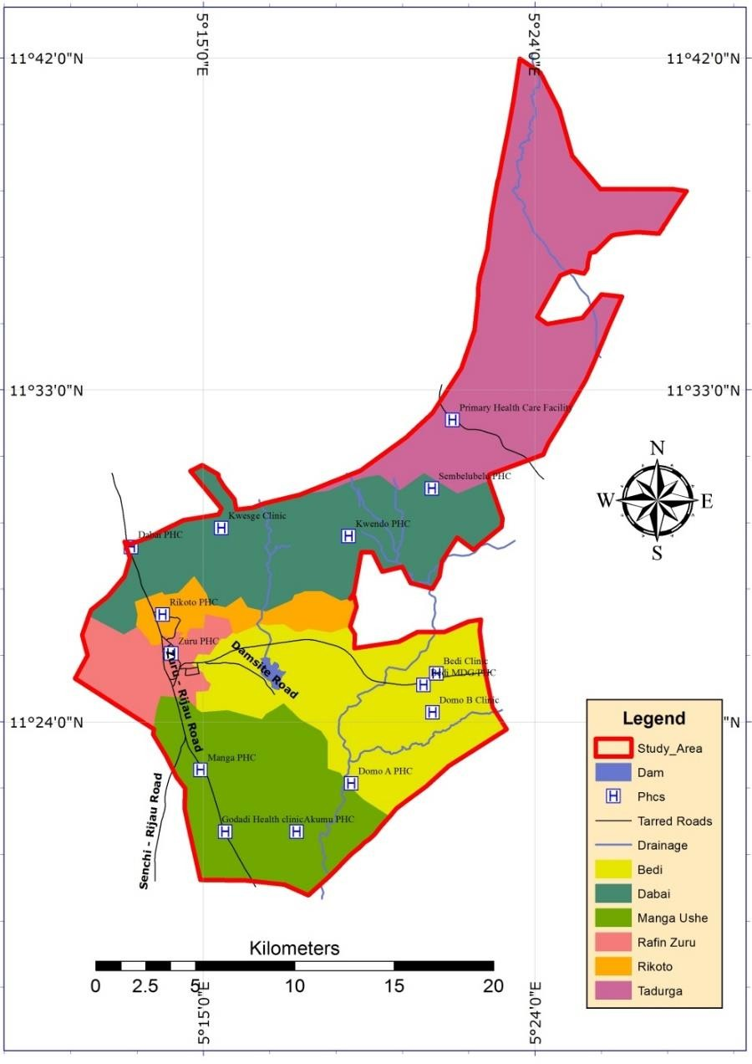

Figure 4.3: Existing Primary Health Centres within Zuru Local Government Area

Source: Researcher’s Field Work, 2020

This implies that, the identified existing primary health centres were provided at the precise location presented in Figure 4.3 and Table 4.1 respectively to serve the households around it. Figure 4.3 also shows how close the PHCs are to the arterial road and this describes the relative distance between a PHC, the arterial road and other PHCs.

# Existing public primary schools within the selected wards

There are 26 existing public primary schools (PPSs) identified within the selected wards as shown in Table 4.2. Each school has a unique name and coordinate that differentiated one from the other as stated in Table 4.2. Although some schools are regarded as Model Primary School (MPS) because they are larger in terms of space allocation and number of pupils than the regular public primary school (PPS). The National Youth Service Corps (NYSC) Primary School is also a public primary school sited in Rafin Zuru ward. Majority of the schools were given the name of the settlement they are servicing with the exception of Danga Gomo MPS, Sami Gomo MPS, Andi Gomo MPS, Dantudu Gomo MPS that were named after prominent Chieftains and Emirs and also the NYSC primary school.

In Table 4.2, a clear observation and inventory can be deduced to account for the number of public primary schools found within each ward. For instance, the Table 4.2 shows that, Rafin Zuru ward has six schools, Bedi has seven public primary schools within the local government borders, Dabai has five PPSs, Manga Ushe has four PPSs, Rikoto has three and Tadurga has one public school located within the boundaries of the local government.

# Table 4.2: Existing Public Primary Schools within Zuru L.G.AS

|  |  |  |  |  |
| --- | --- | --- | --- | --- |
| **Index** | **Infrastructure Name** | **Ward** | **Latitude** | **Longitude** |
| 1 | Sem Saune PPS | Dabai | 11.471345 | 5.23725 |
| 2 | Kesge PPS | Dabai | 11.4874 | 5.258306667 |
| 3 | Umama PPS | Dabai | 11.46796833 | 5.26743 |
| 4 | Kwendo PPS | Dabai | 11.48097 | 5.31348 |
| 5 | Sembelubelu PPS | Dabai | 11.50534167 | 5.353406667 |
| 6 | Domo B MPS | Bedi | 11.40006667 | 5.346415 |
| 7 | Bedi PPS | Bedi | 11.42125667 | 5.355133333 |
| 8 | Kobol PPS | Bedi | 11.40534667 | 5.3272 |
| 9 | Zutu PPS | Bedi | 11.428395 | 5.322811667 |
| 10 | Koga PPS | Bedi | 11.41765 | 5.29248 |
| 11 | Germace PPS | Bedi | 11.40619667 | 5.275615 |
| 12 | Dongo MPS | Bedi | 11.42661 | 5.259638333 |
| 13 | Domo A PPS | Manga Ushe | 11.37193 | 5.32128 |
| 14 | Manga MPS | Manga Ushe | 11.37654167 | 5.254181667 |
| 15 | Manga Ushe Gogadi PPS | Manga Ushe | 11.34867333 | 5.26149 |
| 16 | Semkene PPS | Manga Ushe | 11.36788 | 5.262158333 |
| 17 | NYSC Pri. Schl | Rafin Zuru | 11.42408333 | 5.236433333 |
| 18 | Danga Gomo MPS | Rafin Zuru | 11.42643167 | 5.2377 |
| 19 | Sami Gomo MPS | Rafin Zuru | 11.4349 | 5.234336667 |
| 20 | Andi Gomo MPS | Rafin Zuru | 11.43703333 | 5.233318333 |
| 21 | Dantudu Gomo PPS | Rafin Zuru | 11.426425 | 5.241083333 |
| 22 | Hidangen PPS | Rafin Zuru | 11.42809667 | 5.220158333 |
| 23 | Tundun wada MPS | Rikoto | 11.44772667 | 5.239943333 |
| 24 | Rikoto MPS | Rikoto | 11.451675 | 5.229286667 |
| 25 | Tunga Doro PPS | Rikoto | 11.448205 | 5.306871667 |
| 26 | Tadurga MPS | Tadurga | 11.53845167 | 5.362746667 |

Source: Researcher’s Field Work, 2020

Figure 4.4 showed a map of the public primary schools listed in Table 4.2 by using their respective longitude and latitude to determine their actual location on the local government map using ArcGIS 10.1. This also presented the geographical reality in terms of how the identified features relate to one another. For instance, a graphical deduction can be made in Figure 4.3 that Manga MPS is along Zuru-Rijau road, the relative distance from Koga PPS to Germace PPS is nearer compared Koga PPS to to Kobol PPS.

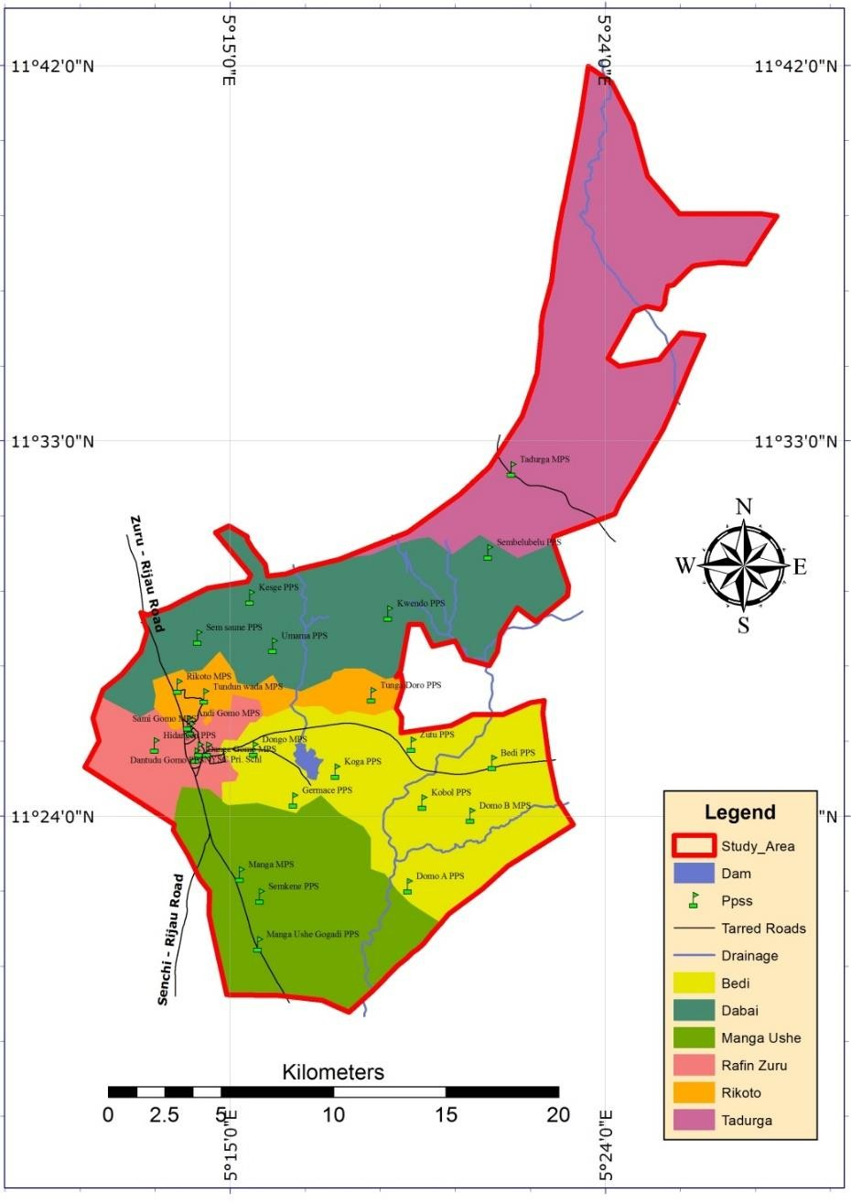

Figure 4.4: Existing Public Primary Schools within Zuru Local Government Area

Source: Researcher’s Field Work, 2020

# Spatial Distribution Pattern of Social Infrastructure within Zuru L.G.A

This section presents an analysis of spatial distribution patterns using the spatial statistics tool in ArcMap 10.1. The results presented were generated using the Average Nearest Neighbour tool. This showed the type of spatial pattern each facility (either PPSs or PHCs) exhibits using the locations and average distances between them. The data used for this analysis are point data (coordinates) of social infrastructure as shown in Table 4.1 and 4.2 respectively.

# Spatial distribution pattern of primary health centres

The Average Nearest Neighbour of PHCs indicates a p-value of 0.041876, z-score of 2.034746 and a Nearest Neighbour Ratio of 1.284260. The observed mean distance is 0.026676 degrees while the expected mean distance is 0.020771 degrees. The breakdown of the result illustrated that, the distribution of existing PHCs in the sampled area exhibited a dispersed spatial pattern as shown in Figure 4.5.

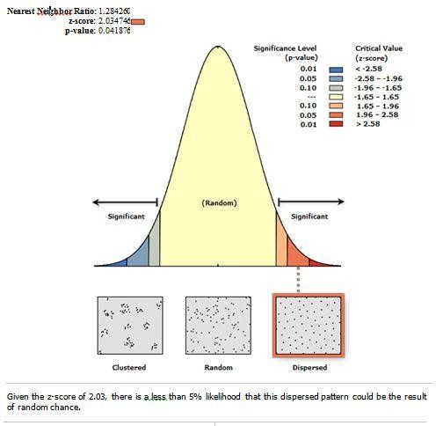

Figure 4.5: Spatial Distribution Pattern of PHCs within Zuru L.G.A Source: Researcher’s Field Work, 2020

A dispersed pattern means that, the locations of Primary Health Centres do not form consistent clusters nor were they scattered randomly. This also meant that, the location and spatial relationship between PHCs are not characterised by equal distances between them but by a pattern that tends to place them away from each other.

# Spatial distribution pattern of public primary schools

The spatial distribution of PPSs as indicated in Figure 4.6 showed that, the Average Nearest Neighbour p-value is 0.047666, z-score is 1.980331 and the Nearest Neighbour Ratio is 1.199216. Furthermore, the observed mean distance is 0.018846 degrees while the expected mean distance is 0.015716 degrees. This breakdown explains that, the distribution of existing PPSs in the sample area exhibits a dispersed spatial pattern as shown in Figure 4.6.

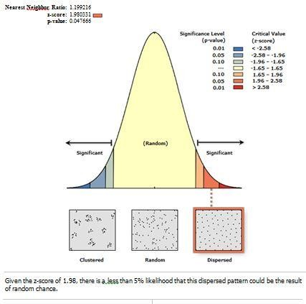

Figure 4.6: Spatial Distribution Pattern of Public Primary School within Zuru L.G.A Source: Researcher’s Field Work, 2020

A dispersed pattern as shown in Figure 4.6 implied that, public primary schools spread out as much as they can from each other and neither form clusters nor are random distribution pattern. Both PHCs and PPSs exhibit similar spatial distribution characteristics or patterns. It is thus clear, to say that social infrastructure within Zuru local government were neither allocated to maintain a specific uniform distance between them, nor were they provided randomly without having locational influence on one another.

# Accessibility to Social Infrastructure within Zuru L.G.A

This section presents an analysis of spatial accessibility to social infrastructure within the study area. Distance was used as a parameter to measure the accessibility of both the primary health centres (PHCs) and public primary schools (PPSs). This section also presented results using both Euclidean (linear) distances and network (actual road) distance.

# Accessibility to primary health centres within Zuru L.G.A

Figure 4.7 showed a result of the Euclidean (straight line) distance analysis of PHCs. Rings like service area known as ‘buffer’ were established to show the catchment areas around the PHCs. The analysis adopted the World Health Organisation standard time of one-hour travel time which is estimated as 5km walking distance, where 12 minutes is equal to 1km (Phiri and Munthali, 2019). 5 buffers were established at 1km interval to show the effect of distance decay and how the PHCs relate to each other in Figure 4.7. The service radii were established within the six sampled wards which are, Bedi, Manga Ushe, Dabai, Rafin Zuru, Rikoto and Tadurga. Each distance is represented by a colour in Figure 4.7 for instance; darker red circles showed areas that are within 1km radius away from the facility and a lighter red showed areas that are within 2km away from each other.

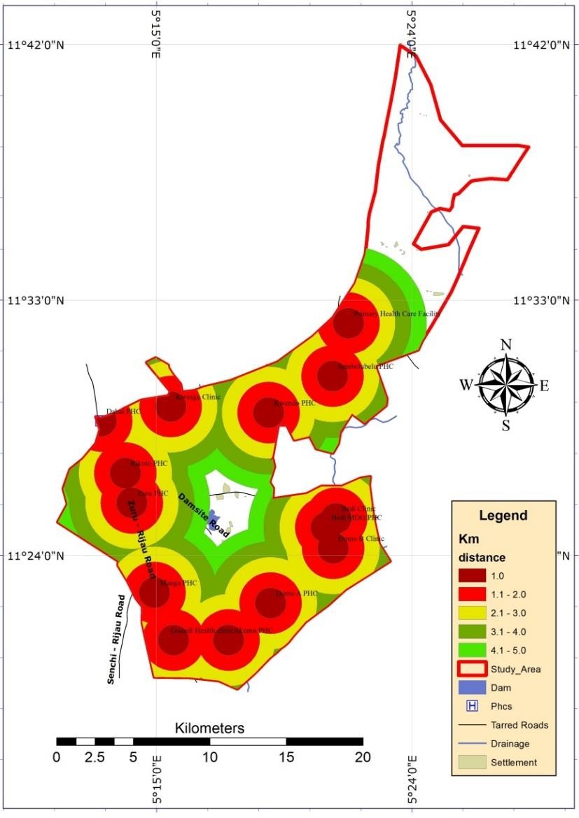

Figure 4.7: 5km service radius of PHCs within Zuru L.G.A

Source: Researcher’s Field Work, 2020

From the Figure 4.7 it can be deduced that some PHCs tend to cluster within 1km radius. This showed PHCs that are located very close to one another. Example includes Bedi clinic, Domo B clinic and Bedi MDG/PHC. The Figure 4.7 also revealed households that were outside the catchment area, which were also outside the accessibility range defined by the World Health Organisation. They include households close to the dam and other areas in Tadurga ward as shown in Figure 4.7 as households outside the buffer. This implied that, any household outside the catchment area must walk more than 5km or more than an hour to get

to the nearest primary health centre. The underserved households were located within Tadurga ward and also area close to the dam in Bedi ward.

However, due to the identified inadequacies of using linear network or Euclidean distance as a method to analyse accessibility by dos Anjos - Luis and Cabral (2016), the researcher also used network distances to analyse accessibility. The premise for this analysis was based on the assumption that physical barriers may influence the route used to reach social infrastructure (dos Anjos - Luis and Cabral, 2016). It does become more pragmatic to predict the catchment area of PHCs using the existing transport route within the study area. The road network data was sourced from Open Street Map (OSM) database as shown in Figure 4.8 and validated by ground trothing. This served as a base map or dataset for network analysis in Qgis.

Using the data in Figure 4.8 and the location of PHCs (coordinates) the researcher established catchment areas along the road network lines. The service areas were predicted using a one- hour travel time (3600 seconds) for the fastest route as a parameter to determine the travelled distance. The road network analysis in Figure 4.9 showed households that are having access to health care facilities and the ones that do not. It also showed the geographic features (such as the drainage) limiting linear distances and also suggests possible fastest routes to access the nearest service provider.

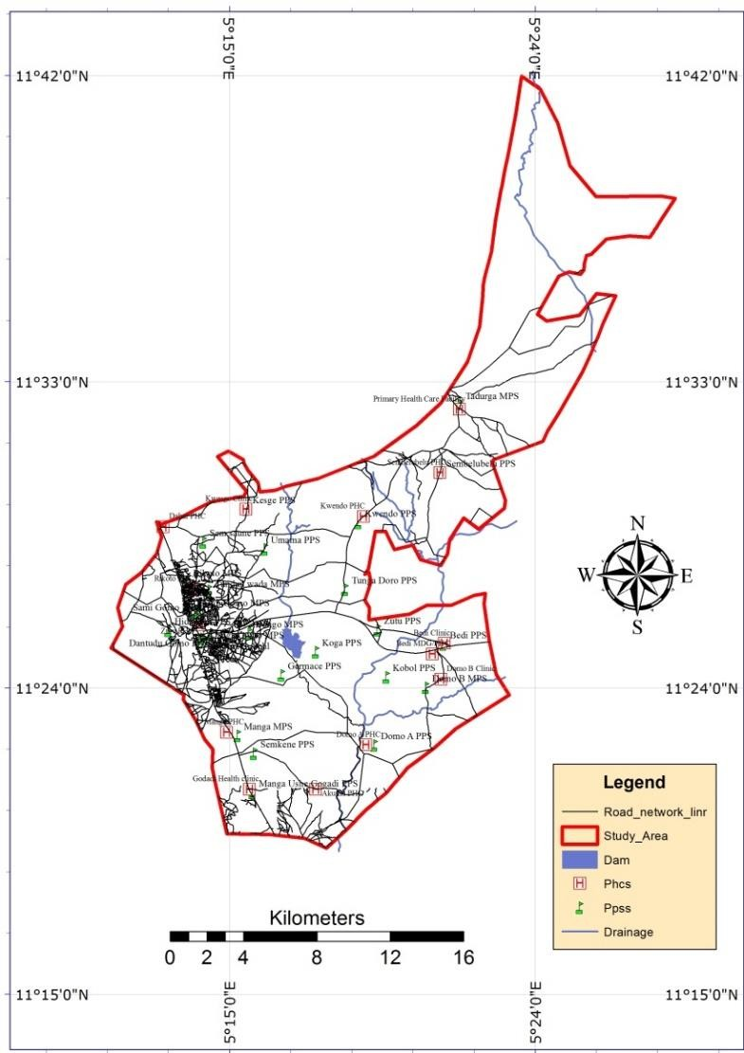

Figure 4.8: Open Street Map (OSM) of road network within the study area

Source: OSM (2020) and Researcher’s Field Work, 2020

A typical network analysis is Qgis will erase any transport route that does not fall within (5km or 3600 seconds) the specified travelled distance or time. Hence, the network analysis results illustrated the extent to which the acceptable standard of accessibility could be defined in the study area. Thus identifying and classifying households without linkages to the road network as underserved or inaccessible households as shown in Figure 4.9. The areas that are outside the catchment areas were marked with a brown polygon as shown in Figure 4.9. These underserved and inaccessible areas or households were located within Tadurga and Bedi ward.

The inadequacies of the linear method of measuring accessibility are spot on by the road network analysis. Figure 4.9 illustrates that, while Domo A PHC and Domo B clinic have overlapping buffers at 5km in Figure 4.7, it is not so in actual road distance in Figure 4.9 because of the drainage serving as a barrier between the settlements. Hence it takes a longer road distance to reach the next settlement.

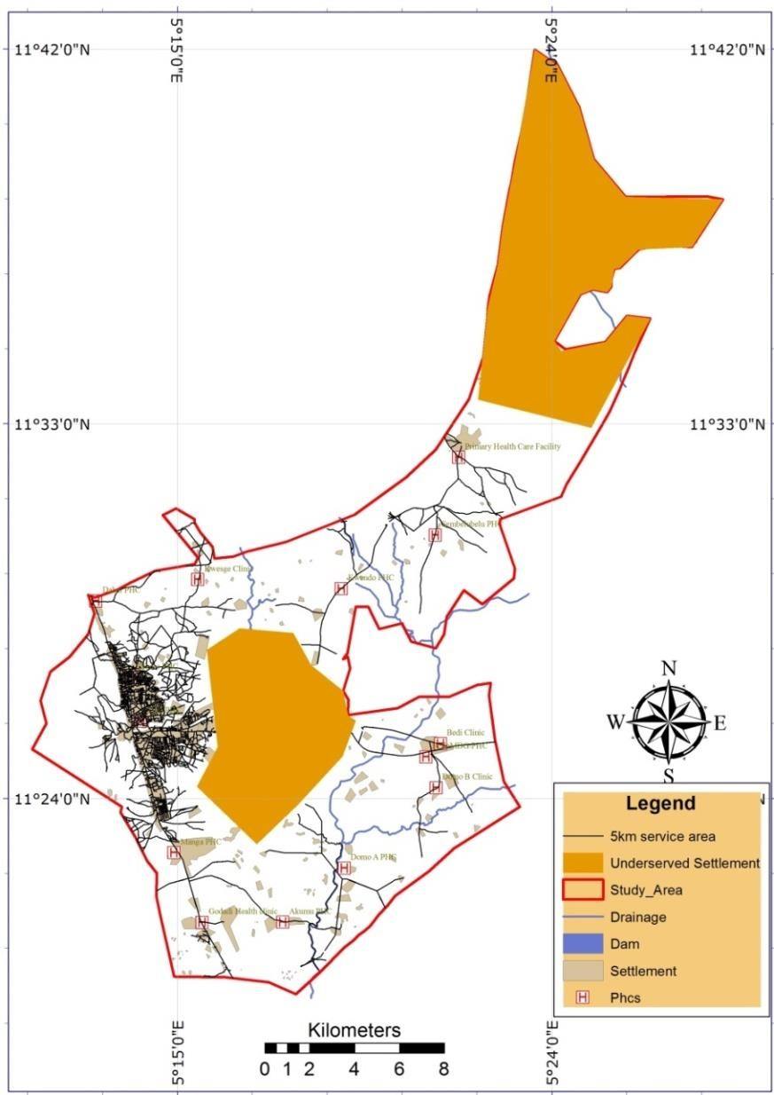

Figure 4.9: 5km Road Network Service Area of PHCs within Zuru L.G.A Source: Researcher’s Field Work, 2020

The expanse of the area delineated as the underserved or inaccessible households, areas, settlements or region are basically what differentiate the Euclidean method from the Network method of measuring accessibility. Figure 4.7 and 4.9 respectively identified the accessible

and inaccessible areas to the nearest PHCs in varying amount. Figure 4.10 drew a distinction to ascertain the level of difference in the results of both the linear and the network analysis by measuring the identified underserved areas in both methods.

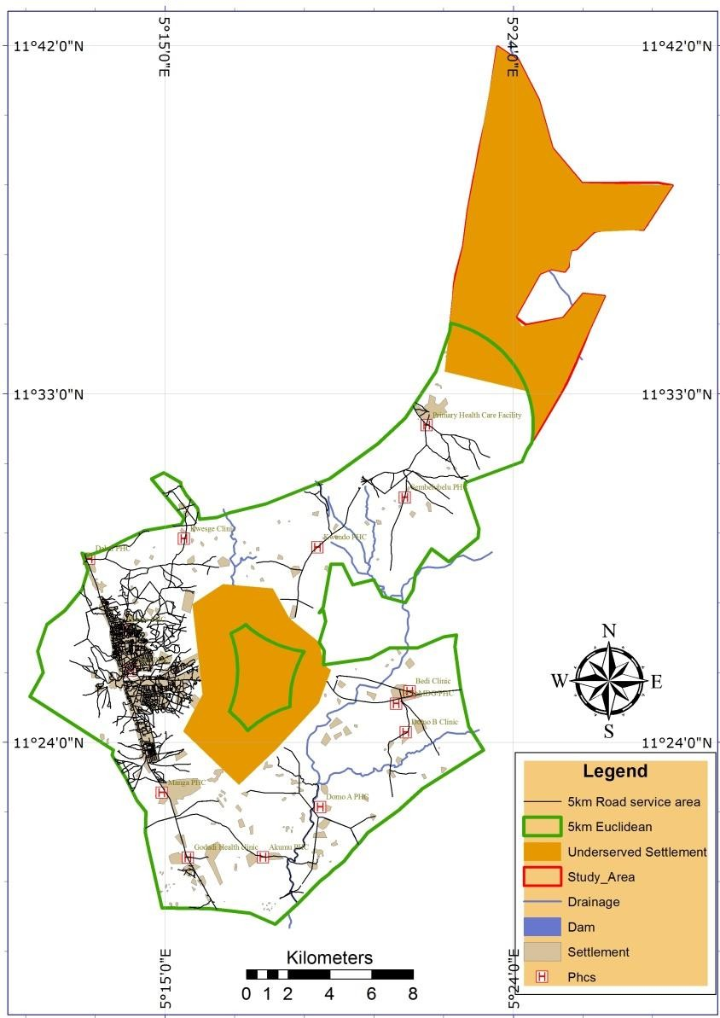

Figure 4.10: Comparison between the Euclidean and Road Network Analysis for the Accessibility of PHCs within Zuru L.G.A

Source: Researcher’s Field Work, 2020

Figure 4.10 has verified that both methods have identified underserved households or areas within Tadurga and Bedi ward. The linear (Euclidean) method revealed 10.64km2 within Bedi ward and 42.228km2 within Tardurga ward. On the contrary, the Network analysis revealed that the land area of the underserved region is 71.632km2 within Bedi ward and

78.466km2 within Tardurga ward. The resulting difference is 60.992km2 and 36.238km2 in Bedi and Tardurga ward respectively. This implied that, even though the service radius of a PHC is 5km, some household within that radius actually travelled more than 5km to the nearest PHC.

# Accessibility to public primary schools within Zuru L.G.A

The Euclidean method determines the households that are adequately serviced by the public primary schools (PPSs) by establishing service radii around the PPSs. The examined service radius measured in kilometres (km) as shown in Figure 4.11 represents straight line distances to each PPSs. These distances include, 0.8km (800 metres) by Clearance Perry, 1.5km by Strayer and Engelhard (Noreen, 2010) and the 3km to 4km by the UBE standard action plan (Opoh *et al*. 2014; and Egbosi and Offor. 2016). Figure 4.11 showed the result of the Euclidean Analysis using different colours to represent various distances measured in kilometres for the aforementioned accessibility or space standards. These colours delineated catchment areas and the effect of distance decay for each public primary school. This also meant that, households within 0.8km radius are closest to the PPSs compared to households within the 1.5km radius. Also the households within 1.5km radius are closer to PPSs than the households within 3km or 4km radius. It suffices to say that the Figure 4.11 showed which settlement or household gets to a particular public primary school faster in terms of linear distance.

Figure 4.11 showed how PPSs are spatially related to one another. Some PPSs have overlapping buffers within the 0.8km service radius. For instance, the NYSC primary school and Dantudu Gomo MPS, Manga MPS and Semkene PPS have overlapping service radius of 0.8km respectively. Others are having overlapping service radius or catchment area at 1.5km they include; Kobol PPS, Domo B MPS, Bedi PPS and Zutu PPS. Sembelubelu PPS and Kwendo PPS also have overlapping catchment areas at 3km as shown in Figure 4.11.

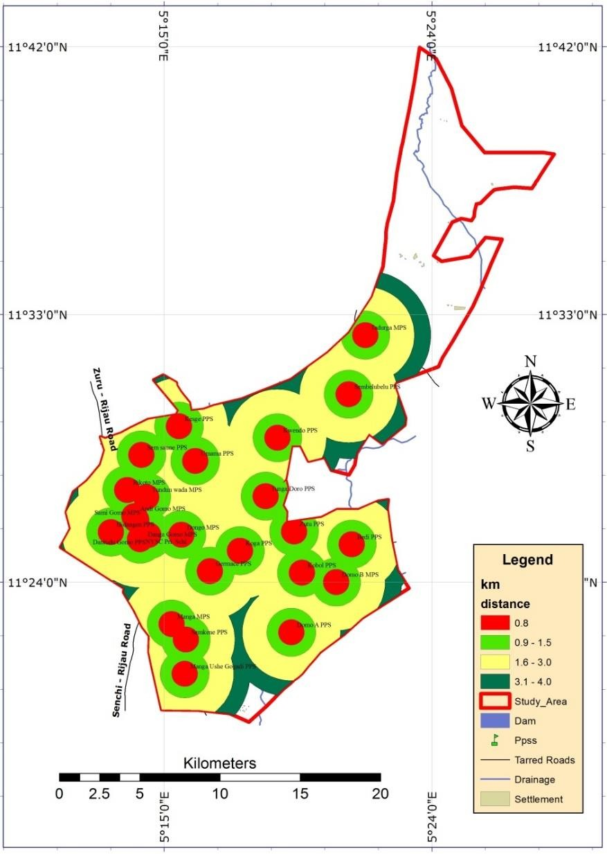

Figure 4.11: Catchment area of PPSs within Zuru L.G.A

Source: Researcher’s Field Work, 2020

The result in Figure 4.11 implied that, where clusters are formed by overlapping catchment areas especially within 0.8km and 1.5km there are higher rate of accessibility to public primary school facilities. However, when a public primary school catchment area does not overlap with another public primary school within 3km and 4km radius, it means that the surrounding households have access to only a particular primary school. Such examples include, the Domo A PPS and Tadurga MPS as shown in Figure 4.11. The areas outside the buffer represent areas or households that are not serviced by PPSs. Figure 4.11 revealed that

some part of Tadurga ward does not have adequate access to a public primary school and people living in that area must travel more than 4km before accessing the nearest PPSs.

However physical barriers like mountains and water bodies (natural drainages) were not considered in the measuring straight line distances. This may lead to either underestimation or overestimation of the actual travelled distance (dos Anjos - Luis and Cabral, 2016). These inadequacies promoted the use of road network distances as a method for measuring accessibility to public primary schools (PPSs) in this study. The result shown in Figure 4.12 was an extract from the actual existing road network dataset of the study area as shown in Figure 4.8.

The result of the analysis illustrated in Figure 4.12 showed the catchment area of PPSs using the existing road data. The catchment areas were established using 4km as established by the UBE standard action plan (Opoh *et al*. 2014; and Egbosi and Offor. 2016) as the maximum space standard for the allocation of public primary school. As estimated by Phiri and Munthali (2019) pedestrian travels 12 minutes for every 1km. Thus, the empirical value used as shortest travel time during this study is two thousand eight hundred and eighty seconds (2880s). Road that extended beyond 4km were erased and as such do not form catchment areas for PPSs. Therefore, any area with an erased road network line in Figure 4.12 does not have adequate access to the nearest PPSs and as such people in such environment will have to walk more than 4km before reaching the nearest public primary school. A polygon was drawn around of the underserved region. The Figure 4.12 also showed the natural constraint (drainage) as indicated by dos Anjos - Luis and Cabral (2016) as a factor that limits the adequacy of the Euclidean method.

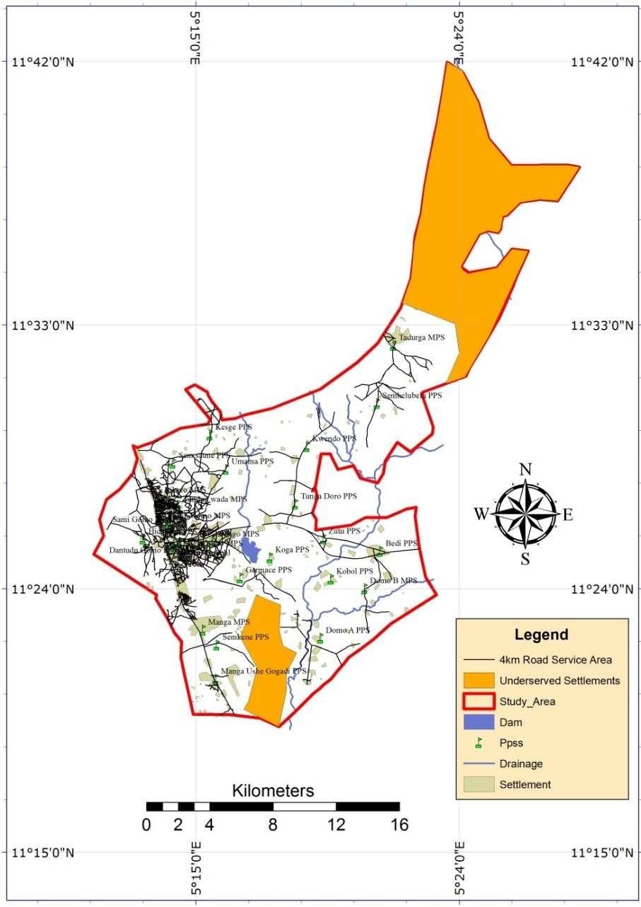

Figure 4.12: Road Network Service Area of PPSs within Zuru L.G.A

Source: Researcher’s Field Work, 2020

In other to determine the difference between the Euclidean method and the use of actual road distances to measure accessibility, comparisons between both results were illustrated in Figure 4.13. The underserved regions characterized by inaccessibility were measured to determine the differences in the result. Euclidean analysis resulted to 79.158km2 of underserved region in Tadurga ward while the network analysis revealed 82.626 km2 as the underserved area. A difference of 3.468km2 was observed. A significant difference of 16.546 km2 was observed in Manga Ushe ward because straight line analysis showed adequacy while the network analysis showed an area spanning 16.546 km2 around erased road network.

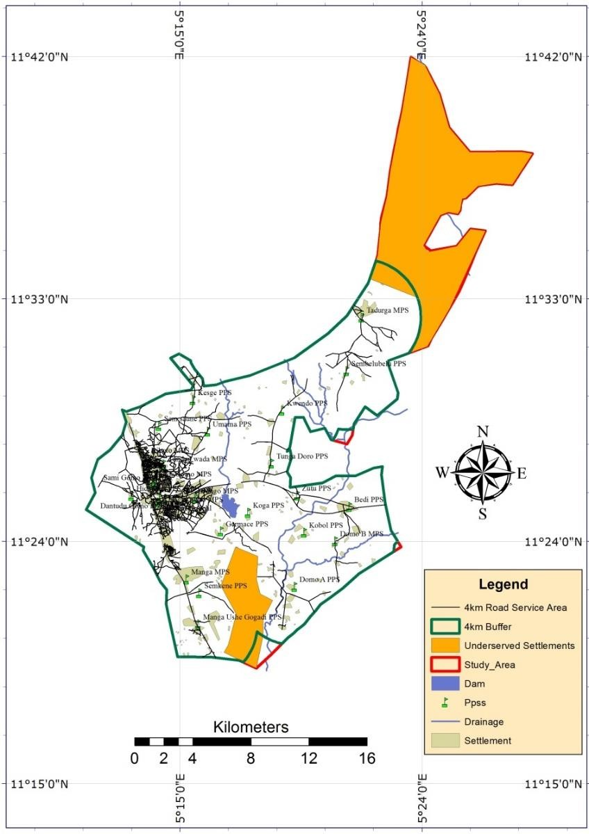

Figure 4.13: Comparison between the Euclidean and Network Analysis for the Accessibility

of PPSs within Zuru L.G.A

Source: Researcher’s Field Work, 2020

# Spatial Inequality

This section illustrates the analysis of available data in view of understanding, describing and drawing inferences from the statistical output of such data to explain the levels of spatial inequalities in the study area. It firstly determines the relationship between the distribution of PHCs and PPSs and the population of each sampled ward through statistical correlation to test the research hypothesis. The data used is presented in Table 4.3. The estimated population is the dependent variable and the number of PHCs and PPSs found in each ward was used as the independent variables.

# Table 4.3: Data for Spatial Inequality

|  |  |  |  |  |  |
| --- | --- | --- | --- | --- | --- |
| **S/no** | **Ward** | **No. of PPSs** | **No. of PHCs** | **Ward Pop.** | **Land Area (km2)** |
| 1 | Dabai | 5 | 4 | 31,055 | 81.734 |
| 2 | Bedi | 7 | 3 | 19,640 | 84.382 |
| 3 | Manga Ushe | 4 | 4 | 28,285 | 71.535 |
| 4 | Rafin Zuru | 6 | 1 | 26,550 | 23.642 |
| 5 | Rikoto | 3 | 1 | 32,910 | 18.032 |
| 6 | Tadurga | 1 | 1 | 13,810 | 114.828 |
| **Total** |  | 26 | 14 | 152,250 | 394.153 |

Source: Zuru LGA Primary Health Centre Head Office (2019), and Researcher’s Computation (2020)

The LQ model on the order hand sorts to measure the share of a ward in relation to the designated area for this study. The LQ was determined by using population and land area as denominators in the index. The summation of the number of PPSs and PHCs, ward population land area represents the larger data of the study area in Table 4.3. Wards like Tadurga have less population and a very large land area while Rikoto have the largest population and the smallest land area. Hence, spatial inequality must be determined based on both factors (population and land area).

# Test of hypothesis

The count of social infrastructure was used to test for significant relationship. The count in this regard referred to the number of existing infrastructure (either PPSs or PHCs) in a particular ward. The null hypothesis is as follows;

Ho: There is no statistical significant relationship between the distribution of social infrastructure and population in Zuru local government.

The result of regression analysis is presented in the Table 4.4. The R2 (correlation of determination) explained the likelihood of an occurring event by the percentage of variation between two independent variables. In the case presented in Table 4.4, the distribution of public primary schools (PPSs) and primary health centres (PHCs) only explains 8.7% (that is,

R2 = 0.087) likelihood to be influenced by the population of wards within Zuru local government area.

|  |  |  |  |  |  |  |  |
| --- | --- | --- | --- | --- | --- | --- | --- |
| **Table 4.4: Regression Model Summary** | | | | | | | |
| **Model** | **R** | **R²** | **Adjusted R²** | | **RMSE** |  |  |
| 1 | 0.295 | 0.087 | -0.522 |  | 8989.583 |  |  |
| **Coefficients** | | | | | | | |
| **Model** |  | **Unstandardized** | | **Standard Error** | **Standardized** | **t** | **p** |
| 1 | (Intercept) | 20901.367 | | 9474.092 |  | 2.206 | 0.115 |
| No. of PPSs | | 504.889 |  | 2020.559 | 0.150 | 0.250 | 0.819 |
| No. of PHCs | | 979.621 |  | 2899.219 | 0.202 | 0.338 | 0.758 |

Source: Researcher’s Field Work, 2020

The p value of the regression analysis resulted to 0.819 and 0.758 for number of PPSs and PHCs respectively as shown in Table 4.4. The p value is greater than the 0.05 acceptable standards for social science research. The result thus, signifies that there is no statistically significant relationship in the distribution of social infrastructure and the population of Zuru local government area. Thus, the null hypothesis (Ho) is accepted.

# Location quotient (LQ)

Allocation of social infrastructure is done either with spatial or population based criterion (Noreen 2010; Teriman *et al.* 2011; Opoh *et al*. 2014; Egbosi and Offor 2016). Using data in Table 4.3 to measure the location index (LQ) of existing PHCs and PPSs within Zuru local government, Table 4.5 showed the result of the analysis. Population (pop) and land area are the two factors that determined the LQ of each ward as shown in Table 4.5.

As stated by Abu *et al.* (2015), any ward with both LQ (population and land area) less than

0.4 is very poor, between 0.4 to less than 0.8 is poor and 0.8 to less than 1.0 is moderate. LQ between 1.0 to less than 1.5 means an equal share of PPSs or PHCs as the local government and LQ above 1.0 will mean that the ward has a higher proportion of the PPSs and PHCs than the local government as seen in Table 4.5.

# Table 4.5: LQ for social infrastructure within Zuru local government

|  |  |  |  |  |  |
| --- | --- | --- | --- | --- | --- |
| **Ward No.** | **Wards** | **PPSs**  **n/pop** | **PPSs**  **n/land area** | **PHCs**  **n/pop** | **PHCs**  **n/land area** |
| 1 | Dabai | 0.94 | 0.93 | 1.40 | 1.38 |
| 2 | Bedi | 2.09 | 1.26 | 1.66 | 1.00 |
| 3 | Manga Ushe | 0.83 | 0.85 | 1.54 | 1.57 |
| 4 | Rafin Zuru | 1.32 | 3.85 | 0.41 | 1.19 |
| 5 | Rikoto | 0.53 | 2.52 | 0.33 | 1.56 |
| 6 | Tadurga | 0.42 | 0.13 | 0.79 | 0.25 |

Source: Researcher’s Field Work, 2020

As illustrated in Table 4.5, public primary schools (PPSs) in Bedi and Rafin Zuru have both LQs (population and land area) greater than 1.00 and as such can be regarded as well served wards. Manga ushe and Dabai has both LQ 0.8 to 1.0 and as such can be regarded as moderately or fairly served. However, Tadurga has a poor LQ for public primary school and this means that it has a low share of PPSs compared to the local government share of PPSs. Rikoto resulted to two LQs that 0.53 and 2.52 for population and land area respectively. Thus, illustrating a poor LQ when population is the variable for measuring spatial inequality while, being adequate when measured by land area as shown in Table 4.5.

Both LQs in Dabai, Bedi and Manga Ushe wards were ranging from 1.0 to 1.66, and as such revealed that these wards have a good share in the allocation of PHCs within the local government as shown in Table 4.5. Despite the variation in the LQs, Tarduga has the lowest LQs which are less than 1.0. Thus, Tadurga ward tend to have the lowest share of the allocated PHCs within the local government. Rafin Zuru and Rikoto wards in Table 4.5

showed conflicting results which explained PHCs were allocated adequately using spatial consideration (land area) and not the population.

# 4.5 Summary of Findings

This study revealed that some public primary schools and primary health care centres in Zuru local government were actually located outside the boundary of the local government area. However, a large number of the social infrastructure was located within the local government. There exist 14 primary health centres and 26 public primary schools to serve the need of the populace within the six sampled wards namely; Bedi, Dabai, Rafin Zuru, Manga Ushe, Tadurga and Rikoto wards. The spatial distribution analysis showed that both the PPSs and PHCs exhibited a dispersed pattern of distribution. This explains that the allocation of social infrastructure within the study area did not maintain uniform distance between them nor were they distributed randomly. A dispersed pattern depicts the tendency that each facility was located as far as possible from another.

This also study used a multiple regression model to examine the statistical correlation existing between population and the existing social infrastructure stock amongst the six sampled wards. Result of the analysis showed that there is no statistically significant correlation between the population and the existing social infrastructural stock within Zuru local government area. Hence, it depicts that a population based model of resource or infrastructural allocation within Zuru local government is unlikely. As such, population is not used as a determinant of the quantity of social infrastructure allocated to any ward. This nullifies the idea that the greater the population the more the number of facilities allocated to them. On the contrary, the relationship existing between PPSs and PHCs as illustrated in the Euclidean or buffer analysis showed how the service areas of PHCs and PPSs overlapped. This suggests a spatial relationship as well as a high potential for social infrastructural accessibility. This also implied that, spatial considerations and accessibility is the

predominant criteria used to determine the allocation of PPSs and PHCs in Zuru local government and not threshold population.

Nevertheless, a location quotient (LQ) model was also adopted as a viable tool to examine the level of spatial disparities or inequalities in the allocation of PPSs and PHCs within the study area. Spatial inequalities analysis was viewed from two perspectives in contrast for this research. Firstly, by measuring the share of existing social infrastructural and ward population and secondly by measuring the existing social infrastructure and land area of respective ward. Cross tabulating the LQ results of each ward highlighted the ward with LQ lesser than 1.0 which do not have a fair share of the allocated social infrastructure. Tadurga ward in this study was identified as a ward deprived or underserved with both public primary school and public primary health facility allocation in the LQ analysis.

To ensure the effectiveness of the spatial analysis, this study adopted recognised standards to examine accessibility to PPSs and PHCs respectively. These include the WHO one-hour pedestrian travel time for primary health centres and also 3km to 4km UBE service radius standard for public primary schools. The analysis identified the areas accessible and those that are not having adequate access to existing social infrastructure using linear and network distances. Analysing the accessibility of the existing PPSs and PHCs, revealed that Tadurga ward is underserved with PHCs and PPSs due to an identified large expanse of land outside the catchment area. Although the settlement pattern in the underserved region is dispersed, there is a need for them to access these basic infrastructures.

The Euclidean and road network analysis showed variations in the total land area outside the catchment areas of PPSs and PHCs during this study. In Tadurga ward for instance, Euclidean analysis revealed a land area of 42.228km2 while the road network analysis revealed 78.466km2 of land area outside the PHC catchment area. This illustrated the

differences between the Euclidean and the network analysis. Although both have the tendency of measuring spatial accessibility and determining areas outside the catchment area, the Euclidean measurement underestimated the land area of the underserved region.

Furthermore, some areas within Bedi ward were identified as underserved because they fall outside the catchment area of the nearest PHCs. This area covers 71.632km2 from the network analysis findings and 10.64km2 from the Euclidean analysis. An area covering 16.546km2 of land in Manga Ushe ward was identified outside the catchment area during network analysis while the Euclidean analysis showed its adequacy. As revealed in the study, the Euclidean method used straight line distances to measure accessibility in the forms of buffers or ring like catchment areas. While, the network analysis adopts the use of existing transport routes and the shortest or fastest possible travel time to determine the catchment area of each facility. It also takes into cognisance the nature of the road which is not in straight lines.

The underserved settlements that were identified in Figure 4.10 and 4.13 respectively can be regarded as the households with inadequate access to primary health care and public primary school services. This becomes an identified gap or short fall in social infrastructural adequacy which is also a planning issue worthy of note. The households with poor access to social infrastructure were found in areas within Manga Ushe, Bedi and Tadurga ward.

**CHAPTER FIVE**

* 1. **CONCLUSION AND RECOMMENDATION**

# Conclusion

This study deduced that, the spatial distribution pattern of social infrastructure within Zuru local government is dispersed. It also illustrated the location of each facility and its relationship to another in distance. The overlapping of catchment areas and the regression analysis revealed that the allocation of primary health centres and public primary schools in Zuru local government were not based on ward population but on spatial consideration. Spatial inequality analysis showed that Tadurga ward does not have a fair share in the allocation and distribution of PHCs and PPSs.

The access to the public primary school and primary health centre were examined spatially to identify households that are within and outside the service area. This highlighted households that have the potential of benefiting from their nearest primary health care centre and public primary school in recommendable time as well as those that cannot access them. This study also emphasised on the advantage of using actual road network distance over linear distances in analysing spatial accessibility. By making use of walking distances as a parameter to measure accessibility, road network analysis revealed a larger land area of inadequate access than Euclidean analysis. As a way of enhancing accessibility to improve community well- being of the underserved households, this study provided some recommendable guidelines and strategies as remedies for the identified inadequacies.

# Recommendations

Based on the findings of this research, the major identified inadequacies were on spatial accessibility and not on population based approach of allocation of facilities. As such the approach in solving these identified inadequacies should provide adequate access to social infrastructure to the underserved households. Strategies that could be employed are as follows;

* + 1. In the case of the underserved households in Tadurga ward, one primary health centre and one public primary school should be provided. This will create new catchment area and as well become accessible to the underserved population.
    2. The Dam area in Bedi ward has inadequate access to primary health care facility. In this regard, there is a need to provide one primary health centre in other to enhance their access to primary health care services within the standard time as stipulated by the World Health Organisation.
    3. There are two alternatives for the underserved households in Manga Ushe ward having poor access to public primary school. A new public primary school could be provided or the road network could be improved so as to enhance access to nearby schools (Semkene and Germace PPS).

Implementing these strategies will aid in improving access to primary health care and public primary schools in Zuru local government, thereby making access to social infrastructure adequate. However, there is need to further study the phenomena in salient areas not covered by this research. These include; the demand and supply of social infrastructure and household preference and choice in choosing a facility and factors that influence spatial distribution and accessibility. There is also the need to investigate other social infrastructure. They may include but are not restricted to, recreation, education, health and empowerment.

# References

Abdulraheem, I. S., Olapipo, A. R. & Amodu, M. O. (2012). Primary Health Care Services in Nigeria: Critical Issues and Strategies for Enhancing the Use by the Rural Communities. *Journal of Public Health and Epidemiology*, 4(1), 5-13

Abu, H., Anika, T., Antora, M. H., Rifat, H., Sarwar, J., & Anindya, K. D. (2015). Determination of Location Quotient (LQ) of Districts of Bangladesh based on Level of Urbanization and their Regionalization to study the Regional Disparities based on Indicators of Urban Areas of Bangladesh. *European Academic Research*, III(2), 1671-1692

Abraha, T. A. (2019). Analyzing Spatial and Non-Spatial Factors that Influence Educational Quality of Primary Schools in Emerging Regions of Ethiopia: Evidence from Geospatial Analysis and Administrative Time Series Data. *Journal of Geography and Regional Planning*, 12(1), 10-19

Adefila, J. O. & Bulus, J. S. (2014). Spatial Inequalities in Infrastructural Development in Plateau State, Nigeria. *American International Journal of Contemporary Research*, 4(7), 89-97

Adrain, B. (2008). Spatial Statistics. A Presentation at the ASC Workshop with R of the University of Western Australia.

Akpan P. A. & Atser J. (2010). Implications of Spatial Pattern of Social Infrastructure Stock in the Development of Rural Areas of Akwa Ibom State. *FUTY Journal of the Environment*, 5(1), 29-42

Avinash, T. (2017). Development of Social Infrastructure of Primary School in Karnataka: An Overview. *International Journal of Advance Research and Development*, 2(6), 453-458

Barret, P., Aberto, T., Tigran, S., Diego, A. & Maria, U., (2019). *The Impact of School Infrastructure on Learning: A Synthesis of the Evidence.* International Development in Focus. Washington DC: World Bank. doi:10.1596/978-1-4648-1378-8

Bello, M. N., Abbas, I. I., & Akpu, B. (2014). Analysis of Land Use-Land Cover Changes in Zuru and its Environment of Kebbi State, Nigeria Using Remote Sensing and Geographic Information System Technology. *Journal of Geography and Earth Sciences*, 2(1), 113-126

Bingler, S., Diamond, B. M., Hill, B., Hoffman, J. L., Howley, C. B., Lawrence, B. K., Mitchell, S., Rudolph, D., & Washor, E. (2002). *Dollars and Sense: The Cost Effectiveness of Small Schools.* Retrieved from the Rural School and Community Trust website: <http://www.ruraledu.org/user_uploads/file/Dollars_and_Sense.pdf>

Biktemirova, M. K., Tatiana A. S., Lyudmila G. R., Sergey V. K., Tatyana V. N., Liudmila

V. S. & Larisa E. F., (2015). The Social Infrastructure Services in the Context of Economic Growth Factors. *Mediterranean Journal of Social Sciences MCSER Publishing, Rome-Italy* 6(2), 260-267

Boasson, E. & Boasson, V. (2011). The Spatial-Temporal Cluster Development in the Healthcare Service Industry- An Integrated GIS Approach. *Environmental Economics,* 2(3), 131-140

Brown, J. & Barber, A. (2012). Social Infrastructure and Sustainable Urban Communities.

*Engineering Sustainability,* 165(ES1) 99-109

Chobotová, M., & Palová, Z. (2015). Social Disparities in Relation to Sector Specialization.

*International Journal of Humanities Social Sciences and Education,* 2(7), 176-182

Davern, M., Gunn, G., Whitzman, C., Higgs, C., Giles-Corti, B., Simons, K., Villanueva, K., Mavoa, S., Roberts, R. & Badland, H. (2017). Using Spatial Measures to Test a Conceptual Model of Social Infrastructure That Supports Health and Wellbeing. *Cities and Health*, 1(2), 194-209,

Dejen, A., Soni S. & Semaw, F. (2019). Spatial Accessibility Analysis of Healthcare Service Centers in Gamo Gofa Zone, Ethiopia through Geospatial Technique. *Remote Sensing Applications: Society and Environment,* 1(13), 466–473

Dejene T. B., Tulu B. B., & Leta G. D. (2018). Analyzing Spatial Distribution and Accessibility of Primary Schools in Bishoftu Town, Ethiopia. *Spatial Information Research,* 1, 1-13 Retrieved from <https://doi.org/10.1007/s41324-018-0227-6>

Dronkers, J. & Robert, P. (2003). The Effectiveness of Public and Private Schools from a Comparative Perspective. *EUI Working Paper,* 13, 1-63

dos Anjos Luis, A., & Cabral, P. (2016). Geographic Accessibility to Primary Healthcare Centers in Mozambique. *International Journal for Equity in Health,* 15(173), 1-13

Ebener, S., El Morjani, Z., Black, M., Alexakis, E., Martin, Diaz A., Vanasse, A. & Hemiari,

A. (2004). Measurement of Accessibility to Health Care, Part II: GIS Development. *Proceedings of the 6th GEOIDE Annual Scientific Conference. La Chaudière, Ottawa, Canada.*

Efiong, J. (2019). GIS-Based Network Analysis for Optimization of Public Facilities Closure: A Study on Libraries in Leicestershire, United Kingdom. *Journal of Geography, Environment and Earth Science International*, 23(3), 1-18

Egbewale, B.E. & Odu, O. O. (2013). Perception and Utilization of Primary Health Care Services in A Semi-Urban Community in South-Western Nigeria. *Journal of Community Medicine and Primary Health Care*, 24(1), 11-20.

Egbosi, I. B. & Offor, U. I. (2016). Application of Access Principle to Primary Education Management in Anambra State of Nigeria. *IOSR-Journal of Research and Method in Education,* 6(4), 43-50

Emeka, E. O. & Masemote, G. M. (2011). Functioning and Challenges of Primary Health Care (PHC) Program in Roma Valley, Lesotho. *Ethno Medicine*, 5(2), 73-88

Fabiyi O. O. & Ogunyemi S. A. (2015). Spatial Distribution and Accessibility to Post Primary Educational Institution in Ogun State, Southwestern Nigeria: Case Study of Yewa South Local Government Area, Nigeria*. Journal of Scientific Research and Reports,* 5(7), 542-552

Federal Republic of Nigeria (2012). *National Housing policy.* Abuja: Federal Ministry of Lands, Housing and Urban Development.

Frolova, E.V., Mikhail V. V., Andrey V. K., Olga V. R. & Kabanova E.E. (2016). Development of Social Infrastructure in the Management Practices of Local Authorities: Trends and Factors. *International Journal of Environmental and Science Education*, 11(15), 7421-7430

Garnham, J. (2015). The Location of Public Schools: Implications for Communities and Planners, and School District Decision-Making in Puget Sound Region. An Unpublished Master's Thesis Submitted to Urban Design and Planning Department University of Washington.

Gianpiero, T. (2009). Public Infrastructure: Definition, Classification and Measurement Issues*.* Retrieved from MPRA Paper Database (12990)

Gokan, T. (2010). On the Usage of the Measurement of Geographical Concentration and Specialization with Areal Data. *Institute of Developing Economies, Japan External Trade Organization,* 2, 1-20

Grant, U. (2010). Spatial Inequality and Urban Poverty Traps. CPRC Working Paper 166 Haggins, C. & Knight, K. A. (2011). What Makes a Public School Public? A Framework for

Evaluating the Civic Substance of Schooling. *Educational Theory,* 61(4), 365-380

Hassan, O, G. & Nor, A. A. (2017). Lack of Infrastructure: The Impact on Economic Development as a Case of Benadir Region and Hir-Shabelle, Somalia. *Developing Country Studies,* 7(1), 49-55

Idemudia, E. & Victor, O. (2010). The Role of Primary Health Care in Nigeria. Health Care Delivery Systems: Problems and Prospect. *Knowledge Review*, 21(1), 71-76

Knitter, D., Blum, H., Horejs, B., Nakoinz, O., Schütt, B. & Meyer, M. (2013) Integrated Centrality Analysis: A Diachronic Comparison of Selected Western Anatolian Locations. *Quaternary International,* 312, 45–56.

Knitter, D. & Nakoinz, O. (2018). The Relative Concentration of Interaction – Aproposal for an Integrated Understanding of Centrality and Central Places. *Land*, 7(3), 86 <https://doi.org/10.3390/land7030086>

Kosfeld, R., Eckey, H. & Lauridsen, J. (2009): Spatial Point Pattern Analysis and Industry Concentration. *Joint Discussion Paper Series in Economics,* 16, Retrieved from [https://Hdl.Handle.Net/10419/30145](https://hdl.handle.net/10419/30145)

Latham, A. & Layton, J. (2019) Social Infrastructure and the Public Life of Cities: Studying Urban Sociality and Public Spaces. *Geography Compass,* E12444, 1-15 Retrieved From [https://Doi.Org/10.1111/Gec3.12444](https://doi.org/10.1111/Gec3.12444)

Liu, S. & Zhu, X. (2004). Accessibility Analyst: And Integrated GIS Tool for Accessibility Analysis in Urban Transportation Planning. *Environment and Planning B: Planning and Design*, 31, 105-124

Liu, Y., Liu, Y. & He, J. (2008). Spatial Analysis Techniques Based on Data Field and its Application in Land Gradation. *The International Archives of the Photogrammetry, Remote Sensing and Spatial Information Sciences,* XXXVII(B2), 229-236

Morenikeji, O. O. (2006). *Research and Analytical Methods for Social Scientists; Planning and Environmentalist*. Jos: Jos University Press Ltd.

National Planning Commision (2015). *National Integrated Infrastructure Master Plan*.

Abuja: National Planning Commission.

National Population Commission (2010). *2006 Population and Housing Census*: Population Distribution by Sex, State, LGA & Senatorial Distribution. Abuja: National Population Commission

National Population Commission (2019). *Nigeria Demographic and Health Survey 2018*.

Abuja: Author. Retrieved from <http://dhsprogram.com/pubs/pdf/FR359/FR359.pdf>.

Ngeleza, G. K., Florax, R. J. G. M., & Masters, W. A. (2011). Spatial Inequality: Overcoming Neighbourhood Effects in Africa. *Applied Econometrics and International Development*, 11(2), 165-190

Noreen, C. M. (2010). School Siting. *Journal of the American Planning Association*, 76(2), 184-198

National Primary Health Care Development Agency (2010). *Minimum Standards for Primary Health Care in Nigeria*. Abuja: Department of Planning, Research and Statistics.

Obi, Z. C. & Ezemba, C. C. (2019). Management of Public Primary Schools in a Depressed Economy: The Roles of Teachers. *IDOSR Journal of Science and Technology*, 4(1), 76-80.

Ogunyemi, S. A., Muibi, K. H., Eguaroje, O. E., Fabiyi, O. O. & Halilu, A. S. (2014). A Geospatial Approach to Evaluation of Accessibility to Secondary Educational Institution in Ogun State, Nigeria. *IOP Conf. Series: Earth and Environmental Science* 20**,** 012045

Oguzor, N. S. (2011). A Spatial Analysis of Infrastructures and Social Services in Rural Nigeria: Implications for Public Policy. *Geo Tropico*, 5(1), 25-38

Opoh, F. A., Okou, F. T. & Ubungi, J. A. (2014). Improving the Standard and Quality of Primary Education in Nigeria for National Development. *International Journal of Research and Reviews in Education,* 1, 1-6

Osumgborogwu, I. (2016). Analysis of Access to Social Infrastructure in Rural Imo State, Nigeria. *Journal of Geography, Environment and Earth Science International,* 7(2), 1-7

Otu, E. (2018). Geographical Access to Health Care Facilities in Nigeria – A Review.

*International Journal of Integrative Humanism*, 10(1), 17-26

Owoeye, J. S. & Yara, P. O. (2011). School Location and Academic Achievement of Secondary School in Ekiti State, Nigeria. *Asian Social Science,* 7(5), 170-175

Oyedele, O.A (2012). The Challenges of Infrastructure Development in Democratic Governance. *TSO1C- Construction Economics and Management,* 1, 6119

Phiri, Y. & Munthali, K. (2019). FOSS Technologies in Modelling Spatial Accessibility of Primary Health Care in Malawi. *ISPRS - International Archives of the Photogrammetry, Remote Sensing and Spatial Information Sciences.* XLII-4/W14, 189-195

Putnam, R. (2000). *Bowling alone:* The collapse and revival of American community*.* New York: Simon & Schuster.

Robert, J. H. & Aniruddha, G. (2019). Spatial Data Analysis with R. *Innovation Lab for Collaborative Research on Sustainable Intensification,* Retrieved from <https://www.rspatial.org/index.html>

Salisu, A. K. (2016). Socio-Economic Infrastructure and National Development: An Analytical Assessment from Nigerian Perspective. *IOSR Journal of Humanities and Social* Science, 21(10), 36-42

Shanmathi, R. R., Shayesta, W., Nisha, R., & Samson, M. (2017). Accessibility Analysis of Health Care Facility Using Geospatial Techniques. *Transportation Research Procedia*, 27, 1163-1170

Shroyer, A., Schilling, J., & Poethig, E. (2019). *Catalyzing Neighborhood Revitalization by Strengthening Civic Infrastructure.* Washington, DC: Urban Institute.

Somik, V. L., & Sanjoy, C. (2005). Industrial Location and Spatial Inequality: Theory and Evidence in India. *Review of Development Economics,* 9(1), 47-68

Teriman, S., Yigitcanlar, T. & Mayere, S. (2011) Social Infrastructure Planning and Sustainable Community: Example from South East Queensland, Australia. *Proceedings of the Business and Social Science Research Conference. Novotel World Trade Centre, Dubai.*

Tao, Z., Cheng, Y., Zheng, Q & Li, G. (2018). Measuring Spatial Accessibility to Healthcare Services with Constraint of Administrative Boundary: A Case Study of Yanquing District, Beijing, China. *International Journal for Equity in Health*, 17(7), 1-12

Vionis, A. K. & Papantoniou, G. (2019). Central Place Theory Reloaded and Revised: Political Economy and Landscape Dynamics in the Longue Durée. *Land,* 8(36) 1-12 https://doi:10.3390/Land8020036

United Nations (2015). *Infrastructure Development within the Context of Africa’s Cooperation with New and Emerging Development Partners.* New York: Office of the Special Adviser on Africa Report.

United Nations (2018). Achieving the Sustainable Development Goals in the Least Developed Countries: A Compendium of Policy Options. *United Nations Conference on Trade and Development United New York and Geneva.*

White, F. (2015). Primary Health Care and Public Health: Foundations of Universal Health Systems. *Medical Principles and Practice,* 24, 103-116

World Health Organisation (2017). *Primary Health Care Systems (PRIMASYS): Case Study from Nigeria.* Geneva: World Health Organisation

Yusuff, J. A. (2011). Child Education in Nigeria: Hindrances and Legal Solutions. *Procedia Social and Behavioural Sciences*, 15, 3027-3031

**Appendix A**

**FEDERAL UNIVERSITY OF TECHNOLOGY MINNA POSTGRADUATE SCHOOL**

**SCHOOL OF ENVIRONMENTAL TECHNOLOGY**

**Checklist**

**Wards:**

|  |  |  |  |  |
| --- | --- | --- | --- | --- |
| **Name of infrastructure** | | **Location** | **Latitude** | **Longitude** |
|  | |  |  |  |
| **Distance travelled by household to Infrastructure** | | | | |
| From 0 - 1 kilometres | From 1.01 - 2 kilometres | From 2.01 - 3 kilometres | From 3.01 - 4 kilometres | From 4.01 - 5 kilometres |
|  |  |  |  |  |
|  |  |  |  |  |
|  |  |  |  |  |
|  |  |  |  |  |
|  |  |  |  |  |
|  |  |  |  |  |
|  |  |  |  |  |
|  |  |  |  |  |
|  |  |  |  |  |
|  |  |  |  |  |
|  |  |  |  |  |
|  |  |  |  |  |
|  |  |  |  |  |