# ANALYSIS OF RENTAL HOUSING QUALITY AND CO-TENANTS RELATIONSHIP IN MINNA, NIGERIA

The quantitative and qualitative shortfall of housing in Nigeria occasioned by population explosion is a primary driver of rental buildings. However, the quality of the rental buildings and satisfaction of tenants has become a major source of concern for government at all levels. Therefore, this study examines the quality and social relationship impact among tenants of tenement houses in Minna, Niger State with the view to suggesting ways of improving housing quality and satisfaction of the tenants. The study investigates the level of tenant’s satisfaction/dissatisfaction perceived by the tenants of rental houses in Minna; assessed housing quality, examine factors that has militated against cordial relationship between co-tenants; establish to what extent social relationship, contribute to tenant’s satisfaction, and propose ways of improving co-tenant relationship as to better tenement houses. The study used a cross-sectional survey, questionnaire was administered to selected rental houses in Minna. The response from the questionnaire was subjected to descriptive statistics; frequency distribution table with percentages and Likert scale was used. The findings showed that the adequate building facilities in the study area was toilet facility. The adequacy rating computed was 3.71. Next to this was kitchen facility with adequacy rating of 3.61. The least in adequacy was septic tank (2.27) and next to this was a drainages facility (2.81). It also discovered that most common causes of conflicts amongst residents of the face-me-I-face-you type of tenements residential houses in Minna is inadequate infrastructure. It was discovered that Inadequate infrastructure contributes greatly as a source of conflicts. The study concludes that tenants were fairly satisfied with the tenement housing in the area, and it could be observed that the environmental quality of most of the rental housing in the study area were in deplorable conditions. It therefore recommends that adequate policy formulation to guide and bring about sustainable rental housing provision as an alternative to home ownership in the study area and in Nigeria at large.

# CHAPTER ONE

* 1. **INTRODUCTION**

# Background to the Study

Housing is a composite commodity that fulfils several human needs. The major need is dwelling (Bajari *et al.,* 2015) but it can also argue that having a social space to interact and socialize with family and friends, or to be able to reach a desired social status, might be some reasons for which individuals demand some housing services. Thus, from a social point of view, housing is more than a dwelling unit and its objective characteristics, since it also provides security, privacy, neighbourhood and social relations, status, community facilities and services, access to jobs and control over the environment. The complexity of the concept entails that being ‘‘ill-housed’’, could mean deprivation along any of these dimensions. It is also often an expression of personal identity and social status. Housing is therefore an important aspect of individual well-being and quality of life.

Social relations are a fundamental aspect of human life (Ajrouch *et al.,* 2017). This has been advocated early in the history of social science by luminaries and continues to be of significance today as scholars document this point both theoretically and empirically (Ajrouch *et al.,* 2017). for a review. Context also matters, in that the ways in which social relations evolve and influence well-being have been shown to vary across time and place (Ajrouch *et al.,* 2017). At the same time, technological developments are fundamentally changing the ways in which one experience social relations and may impact health and well-being accordingly.

The quality of a social relationship represents the history of past social interactions

between two individuals, from which the nature and outcome of future interactions can be predicted. Current theory predicts that relationship quality comprises three separate

components, its value, compatibility, and security. Social relations are a central dimension in people’s life, and especially so when it comes to children. However, social relations are sometimes an overlooked dimension of children’s well-being. The quality of social relations has a central role, both in human life and in sociology. There are several ways in which relationships are important. For instance, close relations are a basis for attachment and social support (Gifford-Smith and Brownell, 2013). Relationships are a source of social influence, and are central for identity formation, role modelling, sense of belonging, and social comparisons (Berkman *et al.,* 2010). Furthermore, a relationship can be a means to access different types of resources that other people possess (Lin, 2011). Also, strained relations have been shown to be adverse for child well-being (Bond *et al.,* 2011; Låftman and Östberg, 2016). When studying social relations, different aspects of a relationship can be examined. For example, the structure of relations is related to the linkages between individuals, such as the number of relationships a person has and how a social network is constituted. The function or the quality of a relationship refers to the content of a relationship, such as social support or relational strain (Bond *et al.,* 2011).

Impact of social relations are significant in adolescence, because comparisons and processes of identity formation are intense during this period. Moreover, children’s living conditions are to a large extent dependent on and determined by relationships to other people and by others’ actions and resources (Jonsson and Ostberg, 2010). The opportunities to choose social relations are, furthermore, limited for children (Ostner, 2017). The focus on social relations enables a view of children as actors who form relations, use social support, and make social comparisons. The active role of children and the focus on their social relations are in line with the research paradigm called the new sociology of childhood. Studies of children and their lives have changed during the

last decades. The traditional views of children in sociology as a target of socialization, and childhood in psychology as a mere developmental stage, have been criticized (Corsaro, 2015).

A "rental house" is any house or building, or portion thereof, which is rented, leased, let or hired out, to be occupied, or is occupied, or is intended, arranged, or designed to be occupied as the home or residence of two or more families living independently of each other (which family may consist of one or more persons) and having a common right in the halls, stairways, yard, cellar, water-closets or privies, or any of them, and includes apartment houses and flat houses, but does not include hotels; and including dwelling houses occupied or intended to be occupied as the home or residence of one family or more, if built in a continuous row of more than two houses, if the halls, stairways, yard, cellar, water supply, well, and cistern, water-closets or privies, or any of them are used in common (Watson, 2018).

Tenant relationship in a rental s house is a pre-requisite for societal advancement and growth (Mohd, 2010). Tenant relations generally deal with avoiding and resolving issues concerning residents living in a landed property (Salleh, 2011). The low-income earners have peculiar taste for rental properties because of its low rent, though many of such properties lack basic amenities. The rental type of residential properties usually consists of unit rooms flanking both sides of a central passage that connects the rooms to shared unit kitchens and toilets at the rear. Sometimes the kitchen is attached to the structure while the common toilets and bathrooms are in most cases detached from the main building. The property is also characterized by overcrowding and vices; with several individual families occupying unit rooms or room-and-parlours; and individual occupiers

having differing tastes, aspirations, and socio-cultural backgrounds. As a result of

differing socio-cultural backgrounds, on many occasions the occupiers of the low-income houses engage in arguments and in most cases may result to fighting and violence, and because of the population of occupiers, the facilities are inadequate with the use of available bathrooms, kitchens and toilets carried out on rotational basis. The occupiers often resort to cooking at the central passage. Disagreement, misunderstanding, quarrelling and open confrontations occasionally bloody do occur.

The relationship between co-tenants in Nigeria has reached a very significant stage in the modern-day society in Nigeria, thus there is a need to know and review the effect of the relationship between co-tenants on rental s houses. Reviewing this, also, it is important to know the position as it exists between tenants in rental s houses prior to the legal evaluation of tenancy Law in Nigeria. More importantly, it is also desirable for every tenant to know their right as guaranteed under the various applicable laws on the subject matter. This will ensure a peaceful co-existence between tenants in rental s houses. Against the background, this study will examine the quality and social relationship impacts among tenants of rental houses in Minna.

# Statement of the Research Problem

The menace of poor housing in Nigeria as a result of population explosion which has resulted to the erection of rental buildings has a major problem and has regrettably led to various social vices and more regrettably to domestic conflict. Rental housing in most parts of the country has been both a crime and violence breeding ground in Nigeria leading to the increase in violence which has contributed to the already alarming rate of insecurity in Nigeria. The management of rental s houses in most developing countries, including Nigeria is often bedeviled by poor maintenance, high rentals and more often

than not, conflict between co-tenants and tenants are unsatisfied with their dwelling units.

These factors plus poor or no tenancy agreements between landlords and tenants contribute towards the general decline of rental housing (Hegedus & Mark, 2014).

Drafting of a comprehensive tenancy agreement requires the services of a competent lawyer, who will concisely spell out the duties and responsibilities of both the landlord and the tenant is sometimes ignored by some landlords or not drafted at all. In the absence of a comprehensive tenancy agreement, conflict and soar relationship between the landlord and the tenant may arise, when one party is not satisfied with the conduct of the other. The resultant derelict state of rental s housing sadly also incubates high vandalism rates which in turn further contribute to the high maintenance cost of residential properties. Sheena (1979) asserts that it is often difficult to distinguish intentional forms of damage from wear and tear, indifference, neglect, and thoughtlessness in public housing estates. Vandalism in such neighbourhoods, therefore, is part of a spectrum of behaviour which begins with very common forms of carelessness such as dropping litter and continues through a wide range of rough handling bumping prams into glass swing doors, taking short cuts through newly planted flower beds, for example to the stage where damage is deliberate: glass broken by stray objects such as stones when children are playing, smashed fittings, and dismantled fire-hoses. These are typical features in public housing owing to various factors.

Conflicts are a natural part of human interaction, and it is common amongst occupiers of land and buildings which create concern to many individuals. They occur amongst the occupiers of rental houses in Minna. The city represents the melting-point of various races, and of economic activities, commercial entities, high grade residential precincts. This makes demand for residential properties increase on daily basis as migration of all

classes of people into the State increases.

From previous research works, it has become clear that non fulfilment of obligations binding on relationships can have a drastic effect. For there to be a proper conveyance of title or right to occupy in the case of a rental house to a tenant, there are obligations binding on co-tenants that must be met (Basorun and Fadairo, 2012). This binding factor which is called ‘conflict’ on the part of the tenant has a bigger effect as to whether it will last long or not. Conflict as a determinant in relationship can be a constraint (Downs, 2004). There are challenges posed by this factor as it affects the relationship between the tenants for various reasons ranging from non-communication to unsatisfied attitude. Most tenants especially ignore their obligation to pay utility bills and other bills binding on them by virtue of occupying the property. All these have played a huge role in affecting the relationship between them.

# Research Questions

In order to guide the study and achieve the objectives for the study, the following research questions were formulated:

* + 1. What are the socio-economic characteristics of people living in rental houses in Minna?
    2. What are the prevalent rental housing qualities and conditions?
    3. What is the level of tenant’s satisfaction/dissatisfaction in rental s houses in Minna?
    4. What are the factors that are militating against cordial relationship between co- tenants?
    5. To what extent does social relationship, contribute to tenant’s satisfaction?

# Aim and Objectives of the Study

* + 1. **Aim of the study**

The main aim of the study is to examine the housing quality and satisfaction of occupants in rental houses in Minna, Niger State with the view to suggesting ways of attaining peaceable enjoyment and improving co-tenant relationship.

# Objectives of the study

Specific objectives of the study are to:

* + - 1. examine the socio-economic characteristics of people living in rental houses in Minna?
      2. examine the prevalent rental housing qualities and conditions
      3. investigate the level of tenant’s satisfaction/dissatisfaction in rental s houses in Minna
      4. examine the factors that are militating against cordial relationship between co- tenants
      5. establish to what extent does rental housing quality contribute to tenant’s satisfaction

# Justification for the Study

Rental ’s housing although critical and inevitable in facilitating access to decent housing for the low-income earners especially in cities and urban areas should be taken seriously. If tenant’s relationship is adequately managed, rental housing can supplement the inadequacies of market driven housing delivery systems and delivering a more inclusive society. The management of rental housing cannot be feasible if conflicts are not properly considered and managed.

The study would be of immense importance to government at all levels and all relevant stakeholders in housing as it would reveal the impact of rental housing on domestic conflict in Nigeria. The study would also benefit students, researchers and scholars who are interested in developing further research on the rental housing and conflicts in Nigeria. This study will therefore greatly contribute towards improving tenant relationships and proffer solutions to most tenant conflicts.

# Scope of the Study

The study was restricted to selected rental neighbourhoods within Minna. The rental neighbourhoods were selected randomly, and the study arrived at Tunga, Maitumbi and Bosso as the selected neighbourhoods. The study focused on examining the quality of the residential housing stock in the selected neighbourhoods using key housing components such as wall, roof, doors, windows and floors. The housing components were weighted appropriately, and the quality index was evolved. The study further examined the tenant’s satisfaction with the housing quality using five item likert scale. The relationship and extent to which housing quality contribute to the tenant’s satisfaction with the housing was also established.

# Study Area

Minna, the capital of Niger State lies between Latitude 9° 33’ and 9° 40’ North, and Longitude 6° 29’ and 6° 35’ East. At the North –east corridor of the town lies continuous steep outcrop of granite, which form a limitation towards physical development in that axis. In the present political zoning system, the town is within the North Central Zone, and occupies an area of about 884 hectares. It is about 145 kilometers by road from Abuja, the Federal Capital of Nigeria. Since 1999, the city has

experienced change in both pace of growth and types of space occupied for

development. It has a total area of 74,344 km2, (Sanusi, 2011). Minna has estimated projected population of 304,458 (NPC, 2006) as one of the 25 Local Government Areas in Niger State, see Figure 1.1.

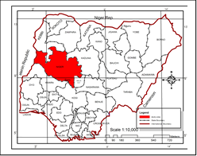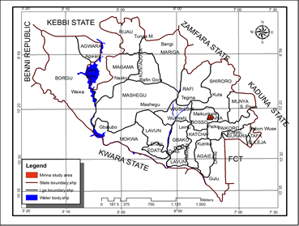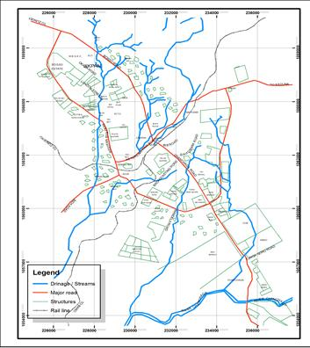

# Figure 1.1: Minna in Niger State, Nigeria

**Source:** Niger State Ministry of Land and Housing, (2020)

# Climate

The climate of Minna is characterized by alternative wet and dry season in response to the changes in pressure patterns. The rainy season in this region is associated with late onset and earlier cessation, the onset and cessation are also characterized by destructive storms which destroy life and property. The seasonal temperature ranges, the highest maximum air temperature is recorded in the northern part usually areas North of lat 9o and occur in March/April and minimum temperatures are recorded in December/January North of lat 9o. The general relief of Minna is between 300 to 900mm. the town is dominated by savanna vegetation types; Guinea, Sudan and Sahel Savanna, the density of trees and grasses decrease northwards responding to climatic conditions (Abdulkadir *et al.,* 2013).

# Urbanization of Minna

UN- Habitat (2012) stated that, Africa is the fastest urbanizing continent. However, the 2010 state of African cities Report estimated that 62% of African urban dwellers reside in slums. Scholars projected that, urban poverty and slums urbanism will continue to feature significantly in African city (Pieterse, 2010; Yunusa, 2010). Cities of the world are arising from the rate of urbanization through demographic statistics. In Nigeria, available indices suggested that urban growth has continued unabated. Studies have shown that Nigeria population would double by the next year 2020 (UN-Habitat, 2012). This would invariably transform to more demand for housing and infrastructures that would complement the increase in urban population which will bring about rapid unplanned urbanization.

Minna the capital of Niger State has grown from a compact settlement that it uses to be a settlement that had grown around the railway station as far as 10km to 15km from the

center of the town. Since then, the land area of Minna has expanded from about 800 hectares in 2000 to over 10,000 hectares in 2005 (Eluwa *et al.,* 2012). Minna became the administrative headquarter of Niger State in 1976 with new status and continuous migration of people and business into the capital town, it has grown from its initial small population of 12,810 in 1953 to 189,200 in 1991 and 209, 951 in year 2006 (NPC,2006). Urbanization of Minna can be observable in the increased number of its administrative wards from six (6) in 1950 to eleven (11) presently.

Also as stated by Dukiya*,* (2012), the movement of the Federal Capital of Nigeria to Abuja further influenced the growth of Minna and the heterogeneity of its population growth experienced over the years is matched with physical expansion of the town and Minna is gradually assuming the status of a big city with high potentials of urban security problems. The spatial coverage of Minna now covers areas from River Chanchaga to the south-east, Upper River Basin Development Authority Headquarters, to the North and Maitumbi to the east and can be classified into 26 neighbourhoods including a Military area. The establishment of the state’s College of Education in 1976, the Federal University of Technology in 1981 and other Tertiary Institution and Federal Institutions could account for the higher growth rate between 1979 and 1991. All these led to influx of people from within and outside Niger into Minna (Morenikeji *et al.*, 2015).

# CHAPTER TWO

* 1. **LITERATURE REVIEW**

# Conceptual Clarification

* + 1. **Rental houses**

The [Oxford English Dictionary](https://www.nypl.org/collections/articles-databases/oxford-english-dictionary-oed-2nd-edition)’s primary definition of rental is "a room or a set of rooms forming a separate residence within a house or block of apartments." It’s a fairly all- inclusive definition that speaks to the historic definitions of rental as well as its modern and colloquial connotations, which the dictionary also addresses with this: "a house divided into and rented out as separate residences, especially one that is run-down and overcrowded (Mauch, 2018*).*

Rental housing today constitutes a significant proportion of the housing stock in many countries, including some of the world’s most developed societies. About half of the urban population in developing countries is made up of tenants (UN-HABITAT, 2013). Despite that considerable progress has been achieved in developing countries in the past two decades where there has been a shift in public sector’s role from direct provision of rental housing to focusing on utilization of potential and capacity of informal sector, there continue to exist a wide gap between policy formulation and its implementation particularly on rental accommodation. This has affected the provision and supply of rental housing and the status of housing delivery today is far from being satisfactory.

Whether the proportion of owner-occupiers has increased or not, a common feature of housing in most developing countries is that the number of urban families living in rental accommodation has usually increased. The sheer volume of urban growth, through both migration and natural increase, has encouraged that tendency because most migrants and new urban households initially rent or share accommodation. Two decades ago, the issue

of renting and sharing was virtually absent on the policy tables of developing countries hence issues on rental housing were neglected topics. According to UN HABITAT (2013), there was profound ignorance about who most tenants and sharers were, about the conditions in which they lived, and “almost nothing is known about those who provide rental accommodation”. Additionally, the myth that homeownership offers a better life had captured the attention of governments of developing countries; they were therefore wholly uninterested in tenants and sharers, except to convert them into homeowners. Today, more is known about tenants (UN-HABITAT, 2013). From the 1990s, a lot of efforts have been put into bringing renting back onto the housing agenda, albeit there are still areas of ambiguity and issues that must be investigated in more detail. Nonetheless, the broad outlines of the informal rental housing sector are no longer shrouded in obscurity.

A meeting of experts organized in 2013 by UN-HABITAT recognized the invaluable role of rental housing in meeting housing needs and concluded that: “governments should review their housing policies and devise appropriate strategies for rental housing which removes biases against non-owners” (UN-HABITAT, 2013) Unfortunately, in practical terms little has actually happened, and all attempts to recognise the important role played by the rental sector in meeting housing needs of developing countries still constitutes perhaps the greatest hole in most national housing policies. It is difficult to find more than a handful of examples of developing country governments that even admit publicly that a rental housing market exists (UN-HABITAT, 2013). In Nepal, there is a housing policy, but not a recognition and focus on rental housing (Tarki, 2012). According to Dubel and Pfeiffer (2012) in South Africa, neglect of rental housing by the government means that it “fails to fulfill its classical social function, namely, housing the poorer parts of the

population with limited or no access to homeownership in a formal dwelling”. Few governments discuss rental housing and insofar as it figures in public policy at all, it is discouraged through the impact of ageing statutes on rent control. According to Datta (2010), “to ignore rental housing given that half of the population is living in these dwellings is simply being irresponsible”.

Many governments have neglected rental housing basically for ideological reasons. Over the year’s politicians have queued up to attest that owner-occupier are better off than tenants. Many politicians have argued that owners are more mature than tenants and contribute more to both economy and society. Also, owners are politically conservative and contribute to the economy both through their savings and their investment. There is the argument that building homes for owner-occupation creates jobs and is generally good for the economy. Little empirical evidence has been provided to support these arguments, but they seemed to appeal to the electorate (UN-HABITAT, 2013). Most of those arguments are highly flawed. For example, there are average and above average income earners who rent accommodation but are better off than some landlords. This is not to downplay the role of owner occupation, it certainly offers families a great deal, but the advantages are greatly exaggerated. Criticisms of rental housing are equally exaggerated ignoring the benefits that renting offers to tenants and landlords as well as governments and perpetuating false myths about the nature of landlordism. As would be seen from the data and discussions below, rental housing has been ignorantly neglected.

# Social relationship

Social relationship is any relationship between two or more individuals. Social relations derived from [individual agency](https://en.wikipedia.org/wiki/Agency_(sociology)) form the basis of [social structure](https://en.wikipedia.org/wiki/Social_structure) and the basic object for analysis by [social scientists](https://en.wikipedia.org/wiki/Social_scientists). Fundamental inquiries into the nature of social relations

feature in the work of sociologists such as [Max Weber](https://en.wikipedia.org/wiki/Max_Weber) in his theory of [social action](https://en.wikipedia.org/wiki/Social_action). Social relationships are a special case of social relations that can exist without any communication taking place between the actors involved. Social relationships refer to the connections that exist between people who have recurring interactions that are perceived by the participants to have personal meaning. This definition includes relationships between family members, friends, neighbors, co-workers, and other associates but excludes social contacts and interactions that are fleeting, incidental, or perceived to have limited significance.

# Social Relations and Life Satisfaction

Subjective well-being refers to the many types of evaluations that people make of their lives and is conceptualized and measured in different ways and with different proxies (Kahneman and Deaton [2010](https://www.ncbi.nlm.nih.gov/pmc/articles/PMC5937874/#CR41); Dolan and Metcalfe, [2012](https://www.ncbi.nlm.nih.gov/pmc/articles/PMC5937874/#CR23)). Although life satisfaction is only one factor in the general construct of subjective well-being, it is routinely used as a measure of subjective well-being in many studies (Shields *et al.,* [20](https://www.ncbi.nlm.nih.gov/pmc/articles/PMC5937874/#CR61)10). In particular, life satisfaction, referring to a holistic evaluation of the person’s own life, concerns the cognitive component of the subjective well-being. Another commonly used measure for subjective well-being is happiness, often used interchangeably with life satisfaction.

There is substantial evidence in the psychological and sociological literature that individuals with richer networks of active social relationships tend to be more satisfied and happier with their lives. This positive role of social relationships on subjective well- being may be explained by the benefits they bring. First, relationships, being key players in affirming an individual’s sense of self, satisfy the basic human need for belongingness (Deci and Ryan, [2012](https://www.ncbi.nlm.nih.gov/pmc/articles/PMC5937874/#CR16)) and are a source of positive affirmation. The levels of subjective

well-being increase with the number of people an individual can trust and confide in and

with whom he or she can discuss problems or important matters. On the other hand, these levels decrease with a surplus presence of acquaintances or strangers in the network (Powdthavee, [20](https://www.ncbi.nlm.nih.gov/pmc/articles/PMC5937874/#CR57)10).

Second, the presence of social relationships has positive impacts on mental and physical health, contributing to an individual’s general well-being, whereas the absence of social relationships increases an individual’s susceptibility to psychological distress (Nguyen *et al.,* [2015](https://www.ncbi.nlm.nih.gov/pmc/articles/PMC5937874/#CR52)). Several studies such as Deci and Ryan, (2012); Powdthavee, (2010); Dolan and Metcalfe, (2012) have shown that social relations stimulate individuals to fight diseases and reinforce healthy behaviors. Social interactions have the potential to protect individuals at risk (e.g., encouraging them to develop adjustment techniques to face the difficulties) and promote positive personal and social development, which diminishes the exposure to various types of stress (Halpern, [2015](https://www.ncbi.nlm.nih.gov/pmc/articles/PMC5937874/#CR34)) and increases the ability to cope with it.

Finally, social relationships form a resource pool for an individual. These resources can take several forms, such as access to useful information, company (e.g., personal and intimate relationships, time spent talking together, and shared amusement time or meals), and emotional (e.g., advice about a serious personal or family matter) and instrumental (e.g., economic aid, administrative procedures, housekeeping) support. Several studies have detailed how receiving support contributes to higher well-being, although the effects may vary by the type and the provider(s) of support (Merz and Huxhold, [2010](https://www.ncbi.nlm.nih.gov/pmc/articles/PMC5937874/#CR49)). In a wider perspective, social relationships serve as buffers that diminish the negative consequences of stressful life events, such as bereavement, rape, job loss, and illness. The perceived availability of support or received support from others may, indeed, lead to a more benign

appraisal of a negative situation.

In this view, friendships, considered as voluntary relationships that involve a variety of activities, may contribute significantly to the overall subjective well-being (Clark and Graham, [2015](https://www.ncbi.nlm.nih.gov/pmc/articles/PMC5937874/#CR14)). Friends are only one of the possible alters in an ego-centered network, as represented by Figure. 2.[1](https://www.ncbi.nlm.nih.gov/pmc/articles/PMC5937874/figure/Fig1/). At the same time, they are the only alters that a person chooses as a node that belongs to his/her personal network while parents, siblings, and relatives are “the family you are born with”, and neighbors and co-workers are people an individual usually encounters in a pre-existing situation, “friends are the family you choose” (Wrzus *et al.,* [2012](https://www.ncbi.nlm.nih.gov/pmc/articles/PMC5937874/#CR68)).

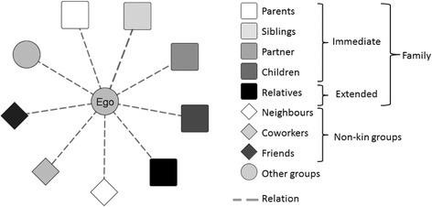

Figure 2.1: Ego and kinds of alters in an ego-centered network Source: Wrzus *et al.,* ([2012](https://www.ncbi.nlm.nih.gov/pmc/articles/PMC5937874/#CR68))

As for many relationships, friendship strongly depends on meeting opportunities, as determined by social settings (Pattison and Robins, [2012](https://www.ncbi.nlm.nih.gov/pmc/articles/PMC5937874/#CR53)), and the decision of individuals to establish a certain friendship tie. This indicates that friendship is often related to positive interpersonal relationships which are important and meaningful to an individual and satisfy various provisions (intimacy, support, loyalty, self-validation). In addition, support from friends is usually voluntary, sustained only by feelings of affection, mutuality, and love, but not motivated by moral obligations (Merz *et al.,* [20](https://www.ncbi.nlm.nih.gov/pmc/articles/PMC5937874/#CR48)10).

Recent years witnessed the growth of social contexts where the importance of friends is increasing. First, sociodemographic changes, such as the reduction in the number of children in each family and a weakening of traditional communities like churches and extended families, raise the relevance of friends in the network (Suanet and Antonucci, [2017](https://www.ncbi.nlm.nih.gov/pmc/articles/PMC5937874/#CR63)). Second, family, and marital relationships have also changed over the last few decades; through divorce and remarriage, they appear more complex and less robust. The breakup of the immediate household and of the extended family can have direct implications on the relationships among the household members. Friends can substitute, in a certain sense, the traditional family (Ghisleni, [2012](https://www.ncbi.nlm.nih.gov/pmc/articles/PMC5937874/#CR28)), offering invaluable advice, support, and companionship.

Only the positive consequences of friendship on well-being have been considered so far. However, friendships might also play a negative role for an individual’s well-being. Concerning the need for belongingness, some friends may be disturbed individuals and thus have a damaging effect on an individual (Halpern, [2015](https://www.ncbi.nlm.nih.gov/pmc/articles/PMC5937874/#CR34)); in addition, the fear of being criticized or excluded may also have a negative impact on well-being. As to the health motivation friends might encourage individuals toward unhealthy behaviors, such as smoking or overeating (Schaefer *et al.,* [2012](https://www.ncbi.nlm.nih.gov/pmc/articles/PMC5937874/#CR60); Huang *et al.,* [2014](https://www.ncbi.nlm.nih.gov/pmc/articles/PMC5937874/#CR37)). Finally, unfulfilled expectations may negatively affect the benefits derived from support. Despite these potentially negative influences, friendships are generally expected to have a positive role in an individual’s well-being (Van Der Horst and Coffè, [2012](https://www.ncbi.nlm.nih.gov/pmc/articles/PMC5937874/#CR65)).

# Quality of tenants’ relationships

Tenants’ relationships can recall both quantitative and qualitative dimensions. For instance, asking about having or not having tenants’ ties is often related to the count of

the number of tenants; similarly, evaluating the degree of mutual concern and interest

calls for a quantitative measure, such as the duration of tenants’ or the frequency of interaction. Distinguishing between tenants’ “really true” or “not true” friends (Boman *et al.,* [2012](https://www.ncbi.nlm.nih.gov/pmc/articles/PMC5937874/#CR10)) is qualitative measures of tenants’ relationships. The qualitative aspects are determined by the fact that friendship relations might be close, intense, and supportive at different levels. In general, the closer the friendship, the more evident the various qualitative attributes of friendship (Demir and Özdemir, [2010](https://www.ncbi.nlm.nih.gov/pmc/articles/PMC5937874/#CR18)).

The different definitions of tenants emphasize both the qualitative dimension and the interactive sphere of tenants’. Hays ([1994](https://www.ncbi.nlm.nih.gov/pmc/articles/PMC5937874/#CR36)), based on a review of theoretical and empirical literature, suggested a more comprehensive definition of friendship, wherein “a voluntary interdependence between two persons over time, that is intended to facilitate socio- emotional goals of the participants, and may involve varying types and degrees of companionship, intimacy, affection, and mutual assistance”. The Encyclopedia Britannica defines friendship as a “state of enduring affection, esteem, intimacy, and trust between two people” (Berger *et al.,* [2017](https://www.ncbi.nlm.nih.gov/pmc/articles/PMC5937874/#CR8)). All these definitions indicate that friendship is recognized as a dyadic relationship by both members of the relationship and is characterized by a bond or tie of reciprocated affection. It is not obligatory, carrying with it no formal duties or legal obligations to one another, and is typically egalitarian in nature and almost always characterized by companionship and shared activities (Berger *et al.,* [2017](https://www.ncbi.nlm.nih.gov/pmc/articles/PMC5937874/#CR8)).

The network perspective emphasizes the dyadic nature of friendship and stresses the quantitative dimension of friendship relationships in terms of the “strength” of an interpersonal tie, where “the strength of a tie is a (probably linear) combination of the amount of time, the emotional intensity, the intimacy (mutual confiding), and the

reciprocal services which characterize the tie” (Granovetter, [1973](https://www.ncbi.nlm.nih.gov/pmc/articles/PMC5937874/#CR31)).

The analysis of the interaction between tenants and personal well-being or life satisfaction is strongly influenced by the available data, which often regards the quantitative dimension of friendships. Several studies such as Boman *et al.* (2012); Demir and Ozdemir, (2010), Berger *et al.* (2017) have emphasized how this dimension affects an individual’s well-being through the benefits friendship brings. In particular, a large number of friends, as well as more contact with these friends and a low heterogeneity of the friendship network, are related to more social trust, less stress, and better health (McCamish-Svensson *et al.,* [1999](https://www.ncbi.nlm.nih.gov/pmc/articles/PMC5937874/#CR46); Van Der Horst and Coffè, [2012](https://www.ncbi.nlm.nih.gov/pmc/articles/PMC5937874/#CR65)). From the point of view of support, having many friends and frequent contact with them increases the chance of receiving help when needed (Van Der Horst and Coffè, [2012](https://www.ncbi.nlm.nih.gov/pmc/articles/PMC5937874/#CR65)). More broadly, the frequency of meeting a friend can be an indicator of the strength or intensity of the relationship (Haines *et al.,* [1996](https://www.ncbi.nlm.nih.gov/pmc/articles/PMC5937874/#CR32)). Stronger relationships might imply increase knowledge of an individual’s needs, thus creating a stronger source of potential help. Regarding the qualitative dimension, empirical research is quite scanty; however, what is available shows that satisfaction with a friendship is strictly related to an individual’s well-being and life satisfaction (Diener and Diener, [2009](https://www.ncbi.nlm.nih.gov/pmc/articles/PMC5937874/#CR22); Froneman, [2014](https://www.ncbi.nlm.nih.gov/pmc/articles/PMC5937874/#CR27)).

Taking into account both the questionnaire constraints and the research focus on studying the role of tenants in life satisfaction, this study focused on adulthood and measured the quantitative dimension of co-tenants through the intensity of interaction (frequency of meeting friends) and the qualitative dimension through the satisfaction with tenants’ relationships. The hypotheses that the intensity of relations with tenants might have a different effect depending on the level of satisfaction with these relations were tested. A faithful frequency of contacts with co-tenants, together with positive satisfaction with co-

tenants relationships, connects individuals to a range of extra benefits, including a higher sense of belongingness, better health, and more support (Van Der Horst and Coffè, [2012](https://www.ncbi.nlm.nih.gov/pmc/articles/PMC5937874/#CR65)).

# Tenants Satisfaction

Identifying determinants of tenant’s satisfaction has attracted substantial interest from scholars since the 1980s onwards (e.g., Galster and Hesser, 1981; Lu, 1999; Molin and Timmermans, 2003). Multiple determinants of residential satisfaction (Amole, 2009) have been identified. Often, these determinants have been grouped into housing, neighbourhood, and accessibility dimensions (Clark, 1982). Among these, housing and neighbourhood attributes have been found most important, although importance varies between social-demographic groups (Molin and Timmermans, 2003; He and Yang, 2011; Grigolon, *et al.*, 2014; Addo, 2016; Ren and Folmer, 2016; Azimi and Esmaeilzadeh, 2017). As the potential effects of neighbourhood characteristics on behaviour have a long history in social science (Briggs, 1997), it is not surprising that neighbourhood effects especially drew increasingly more attention in residential studies.

Specifically, the assessment of variables related to the neighbourhood shifted from measuring few neighbourhood attributes (Lu, 1999) to comprehensive analyses, including both physical and social aspects (Parkes *et al.,* 2002). Recently, neighbourhood characteristics are considered to include a set of morphological and functional characteristics, but social composition is sometimes also included. For instance, He and Yang (2011), Huang and Du (2015) and Ren and Folmer (2016) found that community facilities exert a strong influence on residential satisfaction. Social factors such as crime and ethnical composition have also been identified as influential factors (Parkes *et al.,* 2002).

Besides neighbourhood, tenure (Molin and Timmermans, 2003; Elsinga and Hoekstra, 2005; Diaz-Serrano, 2009; Hu, 2013; Huang *et al.,* 2015) and age of residents. Although a myriad of factors has been analysed as the determinants of residential satisfaction, early research mainly assessed the direct effects of the influential factors on residential satisfaction. It means that such studies, implicitly or explicitly, have assumed that people with the same socio-demographic profile will derive the same satisfaction from housing attributes or characteristics of the neighbourhood. However, different people may have different levels of aspiration, which may lead to varying satisfaction, even for the same attribute values or levels. An increasing mismatch between aspirations and the daily experienced real situation may result in lower satisfaction. Thus, change in residents’ satisfaction may not only be caused by attributes of the house and the environment, but may also reflect a change in aspiration levels. However, the number of studies about the relationship between aspiration and residential satisfaction is limited.

Residential satisfaction has also been analysed as an intervening variable to explain residential mobility. Speare (1974) first used satisfaction as a mediator between individual and residential variables and residential mobility, including the propensity to move and the real move. He concluded that social-demographic characteristics influence both types of moves through satisfaction. This finding was later confirmed by Oh (2003) and Diaz-Serrano (2010). By analysing the data from 12 countries, Diaz-Serrano (2010) confirmed that, in most of the selected countries, the mediating effect of residential satisfaction on mobility is very strong. Deane (1990), who expanded Speare’s model by adding adjustment as the mediation between satisfaction and intention to move, also found a strong impact on the intention to move.

Home ownership status has been found to have a strong positive effect on satisfaction in the sense that owning the house will provide a higher satisfaction than renting the property (Diaz-Serrano, 2009; Mohit *et al.,* 2010; Ibem and Aduwo, 2013; Hu, 2013). Also, older people tend to be more satisfied with their housing (Waziri *et al.,* 2014). On the one hand, it may reflect that older people with higher accumulated wealth had longer time and a bigger budget to find a living environment that better meets their aspirations; on the other hand, it is well known that older people tend to give higher satisfaction ratings, regardless of the topic of interest.

Occupants’ relationship as a mediator variable of social-demographics, although it directly and strongly influences rental s houses. The mediating effect of residential satisfaction was also not supported by Liao (2004). Residents’ aspirations were not taken into consideration. By studying the causality between residential satisfaction and mobility, scholars also found that the residential history will affect current residential satisfaction, although those studies are based on different scales of relocation (Barcus, 2004; Lu, 2002; Posthumus *et al.,* 2014).

Turning from the general residential satisfaction literature to studies on historical blocks, it should be emphasised that the number of studies on residential satisfaction in renovated historical blocks is still very limited (Temelová and Dvořáková, 2012), although there is a large body of knowledge about satisfaction regarding residential mobility in other urban areas (Baker, 2002; Kleinhans, 2003; Meerts *et al.,* 2011; Posthumus *et al.,* 2014). Both qualitative (Meerts *et al.,* 2011) and quantitative methods (Posthumus *et al.,* 2014) have been used to study inhabitants’ residential satisfaction and identify different determinants in other urban areas. Specifically, policy influence is considered significant in Meerts *et al.* (2011) study, while Posthumus *et al.* (2014) signal out economic factors.

Focusing on tenants’ satisfaction research in China, even though the recently emerging flow of studies examined determinants of tenant’s satisfaction of low-income residents in urban areas in different cities (Li and Chen, 2011; Chen, *et al.,* 2013; Li and Wu, 2013; Tao, *et al.,* 2014; Huang, *et al.,* 2015), the number of studies is small. Most followed the Western tradition. Li and Wu (2013) found that factors underlying residential satisfaction differ between cities. Results showed that, overall, housing attributes (e.g., size, property rights), attributes of the neighbourhood and facilities tend to have a major impact on residential satisfaction.

# Rental housing satisfaction and social interactions

Rental housing satisfaction is a complex cognitive construct, and several attempts have been made to conceptualize it from disciplines other than Economics (Sociology, Psychology, Planning, or Geography). Overall, it is worth noting that theories of housing satisfaction all centre around the notion that housing satisfaction measures the difference between households’ actual and desired (or aspired-to) housing and neighbourhood situations (Galster 1987; Galster and Hesser, 1981; Lu 1999). Therefore, individuals make judgements about residential conditions based on their needs and aspirations. Satisfaction with one’s residential situation indicates the absence of complaints and a high degree of agreement between actual and desired situations. On the other hand, incongruence between their actual housing and needed conditions may lead to dissatisfaction.

Morris and Winter (1975) introduced the notion of ‘‘housing deficit’’ to conceptualize residential (dis)satisfaction. In their housing adjustment model of residential mobility, they theorize that individuals judge their housing conditions according to normatively

defined norms, including both family and personal norms and aspiration (internal norm), which account to households’ own standards for housing, and cultural norms, which are dictated by societal standards or rules for life conditions (this idea equals what we called the external norm or peer-effect in financial satisfaction (Vera-Toscano and Ateca- Amestoy, 2008).

In this sense, Rossi (1955) posits that changing housing needs and aspirations as households progress through different life-cycle stages often place households out of conformity with their housing and neighbourhood situations. The ‘‘lack of fit’’ between their current and desired housing needs creates stress or dissatisfaction through migration or remodeling, which brings a family’s housing into adjustment with its housing needs subject to the constraints posed by their financial resources and by the information regarding alternative adaptation opportunities. Moreover, there is little doubt that human beings are socially influenced by many means. When discussing social interactions, it refers to interdependencies between individual decisions or behaviour and the decisions and characteristics of others within a common group.

As argued by Brock and Durlauf (2003), in virtually any economic model describing individual behaviour, the decisions of one individual will be influenced by the behaviour and characteristics of others. Following Manski (1993), who adopts the term ‘‘social interactions’’ from the sociology literature, one can think of an agent’s interactions with her neighbourhood as being composed of two factors: contextual and endogenous. The first (contextual) refers to those factors that are group specific and based on characteristics of the group members. The second (endogenous) refers to how agents are affected by the contemporaneous behavioural choices of group members.

# Characteristics of tenants

Tenants are a much more diverse group and are therefore harder to define. However, there are a few characteristics, for example they are often less affluent than their owners (Gilbert and Varley, 2012). Nonetheless in terms of average incomes, landlords in informal settlements have been said to be only slightly richer than tenants (Ballesteros, 2014). Although this division of wealth might depend on the landlord’s age. Therefore, length of residency is not so much important as to age when it comes to their economic situation. A second characteristic is that the tenants are often migrants, who benefit from renting since they need a home that is more flexible because their stay can be temporary (Cadstedt, 2010; Shirgaokar and Rumbach, 2018). However, if tenants stay is not temporary, they will on the other hand often have the aspiration to become homeowners someday (Cadstedt, 2010; Gilbert and Varley, 2012; Kumar, 2011).

The third possible characteristic of tenants is that they are often younger people, who are in the earlier stages of life; single, students, simple wageworkers or professionals (Gilbert and Varley, 2012). Also, when coupled, they tend to have fewer or no children because having children triggers the aspiration of becoming a homeowner, considering it offers more security. If they are not in an earlier stage of their life, they are often single-parent household, who due to the loss of their partner cannot afford their home anymore (Gilbert and Varley, 2012). Lastly according to Gilbert and Varley (2012) an important aspect to keep in mind is that there are also tenants who can afford to own a home but simply have different priorities (saving for a business). Understanding what type of tenants are renting rooms in the self-help structures might result in a more inclusive analysis of complications when housing the urban poor. Renting a space can have positive or negative outcomes for tenants. An important negative effect mentioned by various scholars is exploitation.

Exploitation of tenants can occur when there is a housing scarcity, when there is no formal contract between landlord and tenants (Rakodi, 2005), when no regulations are implemented to protect the tenants or when they are not aware of existing regulations (Obeng-Odoom, 2011). Exploitation results in the poor not being able to afford housing. This also happened in Cebu, Philippines, where the middle-income residents took over the housing market of the poor. A second negative aspect of being a tenant is insecurity ( Cadstedt, 2010), because they have the risk of displacement. Obeng-Odoom (2011) claims that tenants, in the informal rental sector especially, are vulnerable to eviction because there is no contract and therefore landlords can do as they please. This insecurity can lead to unwanted mobility, nevertheless mobility is also seen as a positive outcome since it means flexibility for the tenants to move whenever they please (Cadstedt, 2010). Another positive aspect that should not be taken too lightly is that, through the private rental business, tenants have more options to choose a house in the city and this gives them the opportunity to pursue their urban livelihood (Kumar, 2011).

# Factors Affecting Demand for Rental Housing

Well-functioning rental housing provides a variety of housing options at affordable prices and within easy access of places of employment. Besides income and location, the occupation, family circumstances, lifestyle and mobility also deeply influence tenure choice. Several factors come to play in influencing the tenure choice of households.

# Quality of housing unit

Housing economist defines housing as a ‘bundle of attributes. Attributes here means not only the physical aspects of the house, but all the other services which one purchases or gains access to by buying (or renting) a house. The price that a buyer (or renter) is willing

to pay is an indication of how much value that person places on the attributes of the house

they will occupy (Leaf, 1993). It is these housing attributes that make two identical houses, built in two different locations, be sold (or let) for vastly different prices. Assessment of both rental and owner-occupied housing quality needs to consider at least three sets of attributes: (i) the quality of the accommodation, (ii) access to basic infrastructure and services, and (iii) the social and economic access to public services and the neighbourhood.

Housing quality is influenced by several factors, which include materials of the outer walls, materials of the roofs, type of water services, type of sewage services, tenure, and food markets, public transportation, primary schools, secondary schools, and health clinic/hospitals. Wall and roofing materials are valued according to their durability. The quality of drinking water is based on hygienic conditions of the water source; water from an indoor tap is considered safer than water from rivers, lakes, or ponds.

Regarding basic infrastructure, quality of housing is measured by the ease of access to utilities like electricity, running water and sanitation. Self-contained housing units have the easiest access, rooms with shared access score lower. Housing quality diminishes as access to utilities is further away from the accommodation or is permanently unavailable. A third level of quality attributes includes proximity to places of employment or schooling, accessibility and availability of public transport facilities, and the quality of services and social infrastructure in the neighbourhood. These are usually more easily accessible in the inner city rather than in the urban periphery.

Location implies “access to the city”, which means in the first place: access to employment and income. Precarious employment, varying sources of income and unexpected expenditure force tenants to rely extensively on familial solidarity and

informal networks, while minimizing unnecessary expenses on utilities, services or transportation. Also, the level of security may be less fragile in inner city areas, because of the density of social networks and the availability of a wide range of housing options due to the variety of job opportunities and income levels. Location thus affects rent levels and hence tenure choice. Rental unit located in the inner city with easy access to social infrastructure and services would attract higher rent compared to urban periphery where access to these facilities is difficult or simply nonexistent.

# Income level

The strong promotion of homeownership in past decades has led to the mistaken belief that rental tenure mainly results of budgetary constraints. This misconception will probably remain difficult to eradicate for many years to come, because there will always be groups that border on homelessness. They may seek no more than a place to sleep, whether in public places or at their place of work (Monkkonen, 2011).

The motivation for people to opt for renting is linked to long-term security just as much as it is for people who opt for homeownership. The only difference is that tenants, like other poor households and individuals often lack long-term security of income, and therefore may opt to set aside their meagre resources for other long-term investments, such as supporting the extended family or providing an education for the next generation. By forcing households to make difficult tradeoffs like skimping on basic needs, taking long and costly travels, and accepting substandard housing, unaffordable rental housing is producing negative health and labour outcomes, reducing savings, and placing children at risk.

# Mobility

Moving in and out of an urban environment has become an inherent part of life for many particularly in developing countries where wide gap exists between rural and urban environments. Whether it is to pursue higher education, seek a job to supplement the family income, negotiate an economic transaction or build a professional career, one cannot avoid the city in the conduct of study, work, trade, or leisure. Freshly graduated students and other young tenants wanting to gain experience are always on the look-out for new and better paid jobs and change jobs frequently. Single people may want to save enough money to return to their home province and settle down there; others are determined to settle down in the city once they have found a stable employment. For this and many other reasons, households may opt for rental accommodation. Tenants thus base their choice on the possibility to leave at short notice and with a minimum of formalities.

# Discrimination

Discrimination permeates many aspects of housing markets throughout the world. Women and migrants tend to have less access to ownership than other groups, those with political contacts gain easier access to public housing than others. In Belgium, there is discrimination against risky groups; single persons, single mothers, asylum seekers and people living on social allowances (UN HABITAT, 2013). Race and ethnicity have long been a source of discrimination. In Lagos, Nigeria, landlords are more receptive to strangers and outsiders. According to Barnes (1982), private owners prefer to rent to members of ethnic groups other than their own because as they report, it is easier to collect rents from those to whom one is not close. Furthermore, strangers are more likely to leave the premises when asked, unlike certain family relations.

Additionally, age, sex and marital status also influence landlord’s decision in renting out a facility. In Surat (India), and in Guadalajara and Pueblo in Mexico, landlords do not like single men; in Bangalore (India), it is women headed households, whether widows or single women who are less welcome (Kumar, 2011). Also, pets are in many countries likely to discourage landlords from accepting tenant.

# Rent affordability

Rental affordability is by far the most common housing problem found among renters. Defining housing affordability is complicated and entails subjective judgments. For example, should households that spend a small fraction of their income on housing but that live in a substandard home or in an unsafe neighbourhood or at great distances from their jobs be construed as having affordability problems? If so, then which households ought to be counted? Should households with moderate incomes who spend so much on housing that they have too little leftover to save and invest be viewed as having an affordability problem? Should a low or moderate-income households that spend a large share of their income on housing to live in an affluent neighbourhood be viewed as having an affordability problem or as having just made a choice to spend more on housing? Indeed, distinguishing between who is allocating large shares of income to housing or taking long travels out of choice and who is doing so out of necessity is a bedeviling task.

However, according to the Department of Housing and Urban Development (HUD) of United States of America (USA), housing is considered affordable when a household pays no more than 30 per cent of their net- income on rent. The HUD benchmark for housing affordability is a 30 per cent rent-to-income ratio. Similarly, the Victorian Council of Social Services (VCOSS), Australia, measures of housing affordability is based on the

National Centre for Social and Economic Modeling definition of housing stress when households in the lowest 40 per cent of disposable income are paying 30 per cent or more of that income on housing.

Income plays an important role as a primary determinant of whether housing is affordable, but income also affects the price of housing in the market. Thus, housing is a normal ‘good’ and, as incomes increase, it is expected that more housing will be demanded, which in turn increases the average price of housing. Demography also plays a similar role because housing is a necessity, so as the population increases, so does the demand for housing. As demand for housing increases, housing prices rise. Increased demand will provide the incentive for developers to increase the supply of housing. If enough new housing is constructed to meet the demands of a growing population, there should be little impact on the price of housing.

Again, the costs borne by developers will also have a significant impact on whether or not housing is affordable. Land has to be purchased and the labour force that is building new housing has to be paid. New housing developments will be aimed at capturing as much of the new demand as possible and, given the costs of land and construction, housing will only be supplied above a certain minimum price level. This means that the supply of affordable housing is not likely to keep pace with demand for new housing units. This especially affects low-income earners whose wages may have fallen or have risen only marginally.

Interest rates are also very important and influence both the demand and supply of housing. If the interest rate declines, developers will find it cheaper to finance their business, making development more profitable. Policies and programmes at the national

and local levels promoting this form of residential tenure are still rare, and aid programmes for rental tenure remain a neglected element of international assistance (UN- HABITAT, 2013). Governments and international organizations are slowly beginning to recognise the important role played by the rental sector in informal settlements.

# Housing Concept, Attributes of Tenants and Satisfaction

Several definitions have been advanced in literature to explain the concept of housing. The World Health Organization (WHO) in 1961 described housing as the provision of any physical structure used for shelter. This includes all facilities, equipment services and devices needed for healthful living. In another contribution, the concept of housing was defined as that which encompasses all the ancillary services and community facilities which are necessary to human well-being (Jiboye, 2009).

Housing is more than shelter; the habitability of a house depends not only on the physical characteristics of the dwelling but also on the social, cultural, and behavioural characteristics of the occupants. Furthermore, housing has been conceived as a unit of the environment which has a profound influence on the health, efficiency, social behaviour, satisfaction, and general welfare of the community. It reflects the cultural, social, and economic values of a society as it is the best physical and historical evidence of civilization in a country (Onibokun cited in Jiboye, 2009, 2010). Adequate housing therefore contributes to the attainment of physical and moral health of a nation and stimulates the social stability, the work efficiency, and the development of the individuals (Adeniyi cited in Jiboye, 2009).

It has been argued that the concept of habitable and ideal housing is related not only to the physical, architectural, and engineering components of the home, but also to the

social, behavioural, cultural and personal characteristics of the inhabitants, the components of the environment (of which the home is a part) and the nature of the institutional arrangements under which the house is managed. In this regard, Onibokun had argued further that the issues involved in housing are more than the availability of physical and structural efficiency of the dwelling. Therefore, a dwelling that is adequate from the physical or design point of view may not be adequate or satisfactory from the inhabitant’s point of view. In other words, the house is only one link in a chain of factors which determines people’s satisfaction with their accommodation (Onibokun cited in Oladapo, 2006 and Jiboye, 2009).

The relevance of tenants’ socioeconomic characteristics in the actualization of adequate dwellings appears self-evident in the light of the preceding remarks. This essentially is predicated on the need to make housing responsive to user wants (Jiboye, 2010). In other words, housing must satisfy the social values and personal needs of its occupants, it must be accessible and affordable. It is also the case that a dwelling is an important investment which has become a status symbol. Therefore, people’s positions in a society, occupational status and other resources, also affect the type of house that is built (Jiboye, 2004; Jiboye and Ogunshakin, 2010). The notion of housing or residential satisfaction has been defined from different perspectives. Fransescato *et al.* (1987) defined satisfaction as the measure of people’s attitudes towards their residential environment. Similarly, Amerigo (2002) defines it as a function of the pleasure derived from an encounter with the dwelling, the neighbourhood, and the neighbours. Hur and Morrow-Jones (2008) also defined it as the evaluation of features of the physical and social environment which determine people’s mobility and quality of life.

In measuring residential satisfaction, different approaches have been developed. However, two basic approaches have been identified for empirical research. One approach is to view residential satisfaction as a criterion of quality of life, while the other is to view it as a predictor of a variety of behaviours. Considering these approaches, the model of residential satisfaction proposed by Francescato *et al.* (1987) described a six- domain taxonomy of predictor variables for resident’s satisfaction. These include objective environmental attributes and individual characteristics, behavioural and normative beliefs, perceptions, emotions, and behavioral intentions. These variables include the physical environment, management, community, and health (Potter and Cantarero, 2006).

While explaining the notion of satisfaction, Onibokun (1974) referred to it as a human concept which involves four interacting variables the tenant, the dwelling, the environment, and the management. In this concept, the tenant’s subsystem is at the centre, and acts as the recipient of all the feedback from the other subsystem. The dwelling subsystem is the housing unit which forms part of an environment where the unit is located. There is also the management subsystem or component of satisfaction. This subsystem comprises of the entire institutional arrangement under which public housing is administered. Furthermore, the tenant’s view of a dwelling is influenced by socio- cultural characteristics, the lifestyle, economic status and the behavioural patterns of the housing inhabitant. It is on this basis that a system approach for evaluating tenants’ satisfaction was developed. Thus, according to Fleury-Bahi *et al.* (2008), residential satisfaction is indeed strongly associated with one’s attachment to the living space and is generally related to the quality of the space.

Measuring housing satisfaction is important because an understanding of the factors that make a tenants satisfied or dissatisfied can play a critical role in formulating successful housing policies. Certain variables have also been identified in the literature as indicators of evaluating housing satisfaction. By adopting Onibokun’s systems approach, the tenant subsystem as the recipient of all the feedback from other housing components could be influenced by three major domains as identified by Potter and Cantarero (2006). These consist of the physical environment, socioeconomic and cultural aspects of life, and public services domains. Under the physical environment are variables such as quality of residence or housing conditions, neighbourhood, and community.

Under the socioeconomic and cultural aspects of life are family structure and relations, race, culture, job or employment, and religious affiliation. In measuring the socioeconomic domain, variables such as sex/gender, age, marital status, religion, length of residence, occupation, education, income, and household size have also been identified as indicators that could influence the judgment of tenants of their residence (Kearney and Winterbottom, 2006; Hur and Morrow-Jones, 2008; Jiboye, 2010; Aigbavboa and Thwala, 2011). Under public services domain are management and maintenance, security, provision of basic amenities and other utilities. Other relevant indicators such as the adequacy of a dwelling as determined by the internal spaces, the structural quality, the amenities and facilities within the dwelling have also been established as determinants of users’s residential satisfaction (Jiboye 2009, 2010). Considering the comprehensiveness and appropriateness of the concept of residential satisfaction highlighted above, tenants’ residential satisfaction is measured using the basic framework and approach suggested by Onibokun, and adopted by Oladapo (2006) and Jiboye (2009, 2010).

It has however been observed that the nature and determinants of residential attitudes and choices vary among different groups of people, and this variation is influenced by their social and personal values and lifestyles. A study by Hartman in 1963 concluded that residential satisfaction is not discrete but may be related to an entire living pattern and a larger set of social and personal values (Jiboye, 2009, 2010). Evaluating housing satisfaction using these criteria which are related to the factors of the environment, dwelling and management components permits a comprehensive survey of the satisfaction of tenants with their housing. In essence, the relevance of socioeconomic parameters in the determination of tenants housing needs and preferences cannot be overemphasized. However, housing studies (in Nigeria and other developing nations alike) which consider the inputs from human values are negligible. Yet these inputs are relevant prerequisites for the improvement of housing. The present study intends to address these lapses by examining the relevance of tenants’ socioeconomic factors on public housing satisfaction

# Residential Satisfaction

In order to understand, the concept of residential satisfaction or housing satisfaction as some researchers usually use it, it should, firstly, take the term apart as Housing and Satisfaction and define them separately and secondly, it should define the concept of residential satisfaction or housing satisfaction together. Housing does not mean an individual ‘s dwelling unit only. It is a composite of the overall physical and social components that makeup the housing system (Francescato *et al.,* 1987). Further, housing is a multidimensional phenomenon, including structural type (e.g., single family home), tenure (own or rent), location and political jurisdiction (Shlay, 1998).

Satisfaction is a process of evaluation between what was received and what was expected (Parker and Mathews, 2001). Satisfaction can be precisely defined as the perceived discrepancy between aspiration and achievement, ranging from the perception of fulfilment to that of deprivation (Campbell *et al.,* 1976). Williamson (1981) found that satisfaction was not only conditioned by physical aspects but also by the ability to form social networks. Finally, Satisfaction is a subjective response to an objective environment (Potter and Cantarero, 2006). Rental s satisfaction involves an extensive range of experts and professionals; some of them try to define the term from one dimension while others try to define it from multi-dimensional perspectives. For instance, Onibokun (1974), defined the residential satisfaction as a spatial aspect, Housing satisfaction encompasses satisfaction with dwelling unit and satisfaction with the neighbourhood and the area.

Conversely, Satsangi and Kearns (1992), defined residential satisfaction as psychological aspect, housing satisfaction is a complex attitude. In addition, Lu (1999) has defined residential satisfaction as a complex cognitive construct. Besides that, Ogu (2002) reported that the concept of housing or residential satisfaction is often employed to evaluate residents’ perceptions of and feelings for their housing units and the environment. On the other hand, Galster (1985) has defined residential satisfaction as social aspect. The concept of residential satisfaction has become the pre-eminent social indicator employed by housing developers, analysts, and policymakers alike during the last decade. Also, McCray and Day (1977) refer to housing satisfaction as the degree of contentment experienced by an individual or a family member with regard to the current housing situation.

Contrary to the above, many experts and professionals have realized that residential satisfaction is multi-dimensional aspects. For instance, Bechtel (1997) observed that

residential satisfaction is determined by a mix of factors that include not only the house and its physical qualities but also the surrounding neighbourhood and social quality of the surrounding. Further, Francescato *et al.* (1987) mentioned that residential satisfaction indicates people ‘s response to the environment in which they live. In this definition the term environment refers not only to physical aspects of residential setting such as dwelling, housing developments, and neighbourhoods, but also social, economic, and organizational or institutional aspects of such settings.

# Residential Rental Property

Residential land use among the competing urban land uses consumes large portion of land in the urban areas and are characterized by enormous political, social, and economic, and cultural importance in the part of the countries in which they are located (Olayiwola, *et al.,* 2006). Housing is a residential that makes the physical, mental, health and social well-being worthy of living; it has several unusual, if not unique characteristics, with important economic implications.

These characteristics are that; it is a complex commodity having both stock and flow and is evaluated by specific tenants in a different manner, depending on their preference functions; a very large item in tenant’s budget and by far the largest in that of an indigent tenant as a result of high transaction cost involved in moving from one apartment to another. There exist few effective substitutes and demand tends to be inelastic; it is particularly vulnerable to quality deterioration as a result of improper repair and maintenance, which lead to substantial future costs, both private and public; and it is a capital good, which if properly attended to can have a very long-life expectancy (Hirsch, 1983; Babalola, 2006).

Yap and Dewandeler (2010) classified residential landlords into “would- be”, “circumstantial”, “petty”, and “commercial” landlords. Would-be landlords like to earn income from property but lack either the capital or the space to build an extra room to let, while they may have plenty of space of their own, family, or rent-free sharers occupy all of it, while retirement, unemployment or economic recession creates financial shortage that triggers the step to revenue-based landlordism. On the other hand, circumstantial landlords who have surplus capital and space, either because they inherited money or property or because they left their own house for employer-provided housing, It may also arise because there are spare rooms as a result of either family break- up, death of relatives or relocation of children; it may be characterized by lack of market for the property. Petty landlords are entrepreneurs who choose to use whatever capital and space available. This arises as a result of lack of knowledge of other ways to make money, although rental income either help this type of landlords to pay instalments on land and/or house or meet expenses of repairs, maintenance or improvement works.

It also serves as a safety net against unstable employment or when moving from wage labour to self-employment. It may also serve as substitute pension after retirement or as investment for the next generation. Commercial landlords are in many ways comparable to petty landlords but operate in a more professional way. They have larger capital to invest with large scale business which they rotate to maximize returns. They sometimes target middle- or high-income tenants rather than low-income groups, and operate in a formal way, that is with written contracts and following building and safety standards. By the market segment in which they operate, they may use different strategies to maximize return on investment while keeping taxable income to a minimum and may not

necessarily aim to build a business empire but secure the future for themselves and their offspring.

It was concluded that for all types of landlords. Where rent levels are amongst the most critical factors to decide whether to set up, expand or discontinue rental operations. If the rent level is set too low, the quality of the accommodation may be affected. Such effects may be low maintenance, low level of amenities, and repairs postponed till damaging. On the other hand, where it is set too high, tenants may voluntarily leave or forcefully be evicted. Sometimes, landlords may be satisfied with low rates of revenue because they consider property as a long-term investment. Since rental fees are also linked to real income, the landlords often stand to lose the most: if income levels drop below a certain point, they may have the choice between evicting tenants, and forsake any income at all, or keeping tenants and hope that they will be able (and willing) to pay arrears later.

# Importance of rental housing

It is fundamental that rental housing is a critical housing option and one which government particularly in developed countries have shown interest in ensuring that it is available and that artificial barriers are not put up that slant the playing field towards ownership for the following important reasons:

* + - 1. Rental housing reduces costs and hence provides less of a barrier to mobility, a fact economists take note of because it speeds the adjustment of the labour market when the geographic pattern of labour demand changes (Green and Hendershott, 2011). Thus, renting lets people stay mobile and move away when good work is available elsewhere, without being tied down to any particular place.
      2. Rental housing lowers transactions costs that constitute market inefficiencies and produce deadweight losses (Haurin and Gil, 2012).
      3. Unlike homeowners, renters do not have to assume the risks associated with an undiversified investment in a single primary residence (Goetzmann and Spiegel, 2012).
      4. Rental housing provides an opportunity for real estate risk to be pooled and diversified by larger scale owners better able to manage and professionally assess real estate risk.
      5. Rental gives people flexibility in how individuals manage their household budgets, moving to cheaper housing when times are hard and to better housing when their incomes increase, or freeing up more of their earnings for more essential needs like food, education, medical care or emergencies.
      6. Rental allows people to send more of their city earnings home to relatives, or to invest in buying land or building a house back in the village as in the case of migrants (Gilbert and Varley, 2012).
      7. It also provides a means through which poor and middle-income landlords, including women and the old, can increase their incomes (Gilbert and Varley, 2012).
      8. In addition, it provides urban authorities a way in which cities can reduce the housing deficit (Gilbert and Varley, 2012).

Many people live in rental housing all over the world, but rental accommodation is more pervasive in the urban areas due to the opportunities that abound in these areas which attract people and thus influence in-migration. Evidence suggests strongly that the issue of renting can only be ignored by any society at its own peril.

# Theories of Tenants’ Satisfaction

Residential satisfaction, defined as the feeling of contentment when one has or achieves what one needs or desires in a house, is an important indicator and planners, architects, developers and policy makers use it in a number of ways. Indeed, theories of residential satisfaction all hinge upon the notion that residential satisfaction measures the differences between household actual and desired (or aspired to) housing and neighbourhood situations (Galster and Hesser, 1981). There are three main theories upon which most of the empirical studies are based. These are housing needs theory, housing deficit theory and psychological construct theory.

# Housing needs theory

Rossi (1955) introduced the notion of housing needs to conceptualize residential satisfaction / dissatisfaction. In his theory, Rossi posited that changing housing needs and aspirations as households‘progress through different life cycle stages often place households out of conformity with their housing and neighbourhood situations. The lack of fit between their current and desired housing needs creates stress or dissatisfaction with their current residence. Households respond to such stress or dissatisfaction through migration, which brings a family’s housing into adjustment with its housing needs. Life cycle changes may generate different space requirements, which are considered the most important aspect of the needs. Thus, households are likely to feel dissatisfied if their housing and neighbourhood do not meet their residential needs and aspirations.

# Housing deficit theory

Morris (1978) introduced the notion of housing deficit to conceptualize residential

satisfaction / dissatisfaction. In their housing adjustment model of residential mobility, they theorize that individuals judge their housing conditions according to normatively

defined norms, including both cultural norms, which are dictated by societal standards or rules for life conditions, and family/personal norms, which amount to households ‘own standards for housing. Thus, an incongruity between the actual housing situation and the cultural and /or familial housing norms results in a housing deficit, which in turn gives rise to residential dissatisfaction. Households with a housing deficit who are hence dissatisfied are likely to consider some form of housing adjustment. They may attempt to make in situ adjustments to reduce dissatisfaction by revising their needs and aspirations to reconcile the incongruity or by improving their housing conditions through remodeling. They may also move to another place and bring their housing into conformity with their needs.

# Psychological construct theory

Galster (1985) introduced the notion of psychological construct of residential satisfaction and theorized that individuals may be seen as cognitively constructing a reference‖ condition for each facet of their residential situation. The quantity or quality of the given facet implied by the reference point will depend on the individual ‘s self-assessed needs and aspirations. If the current situation is perceived to be in proximate congruence with (or superior to) the reference situation, a psychological state of satisfaction ‘should be manifested. If, on the other hand, the current situation falls short of the reference situation by more than a threshold deficiency, two alternatives are possible. One may attempt to reconcile the incongruence by adaptation through redefining needs, reducing aspirations and/or altering the evaluation of the current situation, thereby producing a modicum of satisfaction. The other alternative is that one cannot somehow adapt to the current residential context, in which case dissatisfaction should be manifested. Such individuals, over time, would likely attempt to reduce their dissatisfaction by altering conditions of

the present dwelling unit or by moving to another more congruent residential situation (Foote *et al.,* 1960). Of course, these options may be relatively limited, e.g., by lack of purchasing power for lower income households and discrimination against minority households.

# CHAPTER THREE

* 1. **RESEARCH METHODOLOGY**

# Research Design

This outlines the scheme by which the work was carried out. There is no single design that will be suitable for all research problems; this is because there are several ways of studying a research problem. According to Ojo (2015), research designs can be classified into three broad categories, survey research design, experimental research design, and time series design. Survey research design is one in which the sample subjects and the variables that are studied are simply being observed as they are without controlling or manipulating them. Survey research can be divided into two, cross- sectional research design and longitudinal research design. Cross-sectional research design includes descriptive, exploratory and explanatory designs.

According to Crowe *et al.* (2011), descriptive research is concerned with conditions that exists, practices that prevail, beliefs, point of view, or attitude that are developing. It is concerned with how what exists is related to a few preceding events that has influenced or affected a present condition or event, a common feature of descriptive research is assessing people’s attitudes or opinion towards situations and attempts to report things the way they are. Explanatory research involves explaining a situation that is already known, it may take the form of creatively recognizing a relationship between and among variables. It helps us understand a situation well enough to predict what will happen in them and give adequate explanation of any occurrence.

For this study, the cross-sectional survey type of design was used, in the form of descriptive and explanatory research. A cross-sectional study involves looking at data from a population at one specific point in time. The participants in this type of study are selected based

on particular variables of interest. Cross-sectional studies are [observational](https://www.verywellmind.com/what-are-observational-studies-2224215) in nature and are known as [descriptive research,](https://www.verywellmind.com/introduction-to-research-methods-2795793) not causal or relational, meaning that you can't use them to determine the cause of something, such as a disease. Researchers record the information that is present in a population, but they do not manipulate [variables.](https://www.verywellmind.com/what-is-a-variable-2795789)

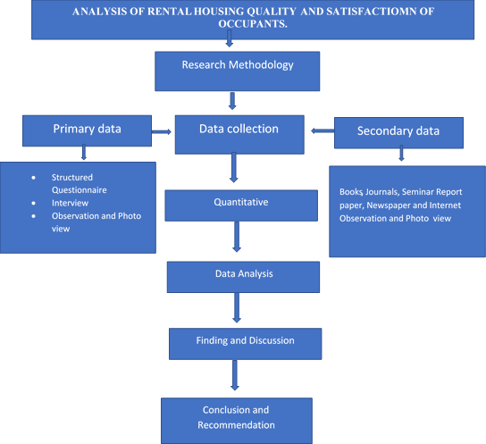

**Figure 3.1:** Research Methodology

# Data Requirement for the Research Objectives

In this study, as earlier sated objectives are the possible steps in attaining the major aim of the research. Each stated objective is detailed to show the type of data required and their sources, data collection instruments and the type of analysis that the collected data was subjected to as depicted in Table 3.1.

# Table 3.1: Data requirement for research objectives

|  |  |  |  |  |
| --- | --- | --- | --- | --- |
| **Objective** | **Type of Data** | **Data source** | **Instruments of Data**  **collection** | **Type of Analysis** |
| **Socioeconomic characteristics of Rental house occupants** | Socio- economic characteristics (education, occupation, income, household size, etc | Primary | Questionnaire | Descriptive |
| **Rental housing quality and conditions** | Building components materials (wall, window, door, roof, floor, drainage, ancillary services) and their conditions | Primary | Questionnaire, camera | Descriptive |
| **Factors affecting tenant’s relationship** | Ownership of house properties, availability of facilities and use | Primary | Questionnaire, interview | Descriptive |
| **Tenants’ level of satisfaction** | House/housing quality, relationship factors | Primary | Questionnaire, interview | Inferential |
| **Social relationship contributions to tenant’s satisfaction** | Factors of dissatisfaction in rental  houses | Primary/Secondary | Questionnaire, interview, literature | Inferential |

*Source: Authors Analysis, 2021*

* + 1. **Determination of the socioeconomic characteristics of rental house occupants** Data required to attain the objective includes socio-economic characteristics of the sampling elements/respondents such as gender, age, marital and educational status, occupation, household income, household size, number of rooms occupied and duration of tenancy. These variables were sourced primarily and majorly with the aid of questionnaires and was descriptively analyzed.

# Rental housing quality and conditions

Assessment of building components such as wall, window, door, roof, floor, drainage, and ancillary services as well as their conditions are necessary. Questionnaires and digital camera were employed in the gathering of the data which was descriptively analyzed also.

# Factors affecting tenants’ relationship

Some of the possible factors that militate against the social relationship among rental house occupants include but not limited to ownership of house properties such as electronic gadgets, grinding machines, electricity generators, motor vehicles, etc; domestic animals such as dogs, cats, chickens, (Leaf, 1993). Equally, availability and/or communizing of ancillary facilities and their use such as toilets, bathrooms, kitchen, open spaces, etc. influences tenants’ relationship in a building. Descriptive and inferential statistics using SPSS tools such as cross tabulation, frequency charts were used for the analysis.

# Tenants’ level of satisfaction

To determine the tenants’ level of satisfaction, both house/housing quality and tenants’ relationship factors was considered. The outcome was facilitated by discerning whether both tangible and intangible factors within and about the target building need

improvement likewise the type of improvement. Inferential statistics was used in analyzing the data collected.

# Social relationship contributions to tenant’s satisfaction

Factors capable of causing dissatisfaction among tenants in rental houses include among others; the use of common facilities (kitchen, toilet, bathroom, etc), mode of operating and positioning of owned properties (electronics, generator, etc), inadequate space/setbacks, attitudinal behaviours and problems (difficulty in synergizing such as payment of electricity/water bills). The data were sourced from questionnaire administration, literature and oral interview thereafter analyzed inferentially.

# Instruments and Procedure for Data Collection

This is the process or stages through which data and information for the research are got in order to achieve the aim of the research. The procedure to be adopted for data collection in this research work involves sourcing data from primary and secondary means.

# Primary source and data collection instruments

It refers to the fieldwork organized to carry out the study. It relates to fresh or raw data obtained directly from field. This was done majorly by administering questionnaires. The questions to be contained in the questionnaire was prepared in tandem with the aim, objectives, research questions, and problems identified in the study area.

For primary sources of data collection, the following methods and instruments was adopted:

* + - 1. Questionnaire administration
      2. Physical data capturing (digital camera, hand-held GPS)

# Questionnaire

Semi structured questionnaire was devised through which sampling population socio- economic characteristics was generated. The questionnaire was structured to address the problems identified and accommodate the objectives of the research. These include population characteristics such as age, household size, occupation, educational qualification, marital status, average household monthly income and years of tenancy.

# Physical data capturing

Physical data capturing device (digital camera) was used to capture real situation information such as building components and their conditions likewise ancillary facilities in the rental houses. Hand-held GPS instrument was used to obtain the coordinates of the sampling units that facilitates plotting of a dot map.

# Secondary source and data collection instruments

This involves collection of materials relevant to the research topic and the sources of obtaining this include; Internet (Google Earth Images), Library (textbooks, journals, pamphlets and published working paper from both Governmental and Non-Governmental Organizations).

# Analysis Instruments

Statistical Package for the Social Sciences was used for descriptive and inferential analysis and to determine the frequency and occurrence likewise establishing the relationship of variables under study. The version used is IBM SPSS Statistics 23.

# Study Population

The population to be sampled are the representatives or household heads of the tenants in the sample rental houses of the selected study area. Rental building population data are not readily available and as such the researcher deriving the inventory from the 2021

Google Earth map of the selected study areas (Bosso, Maitumbi and Tunga neighbourhoods) as shown in Figure 3.2 map of Minna metropolis showing the 3 neighbourhoods and Table 3.2 shows the components of the selected neighbourhoods and the inventory of the rental houses as observed in the selected neighbourhoods.

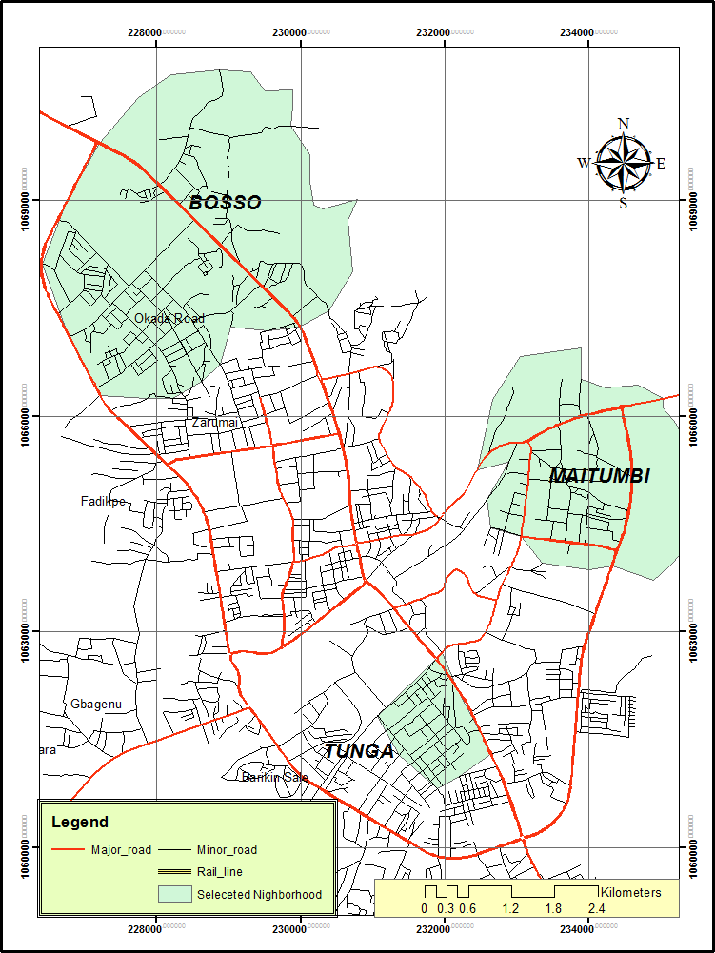

**Figure 3.2:** Map of Minna metropolis showing the three (3) selected neighborhoods

# Table 3.2: Population of rental s houses in the selected neighbourhoods

|  |  |  |
| --- | --- | --- |
| **Tunga Neighborhood** | | |
| **Selected Streets** | **No. of Residential Buildings** | **Number of Rental Housing Units** |
| Old Alheri Road | 456 | 152 |
| Niteco Road | 397 | 166 |
| Bay Clinic Road | 296 | 91 |
| Peter Sarki Road | 201 | 67 |
| Kolawole Street | 276 | 93 |
| Behind Shiroro Hotel | 317 | 121 |
| Old Custom Barrack | 311 | 89 |
| Tunga Low-cost | 291 | 77 |
| Haske Hotel Street | 302 | 89 |
| Alh Moh’d Liman  Street | 319 | 204 |
| Alh. Shuaibu Street | 267 | 189 |
| Farm center | 211 | 73 |
| Behind CBN Street | 233 | 53 |
| Behind Custom  Barrack | 202 | 61 |
| Broadcasting Road | 119 | 75 |
| Germina Road | 187 | 78 |
| Behind Yantaya | 101 | 103 |
| Banana House | 97 | 37 |
| Cooper Family Area | 131 | 93 |
| Maitumbi Neighborhood | | |
| GududuMaitumbi | 311 | 172 |
| New Road | 287 | 121 |
| Angwan Roka  Maitumbi | 311 | 241 |
| AngwanKajeMaitumbi | 204 | 199 |
| GebgeyinMaitumbi | 276 | 167 |
| Bosso Neighborhood | | |
| Bosso City | 378 | 230 |
| AngwanbiriBosso | 311 | 152 |
| Mechanic Road Bosso | 326 | 187 |
| Total | 7,118 | 2032 |

Source: Authors Field Survey, 2020

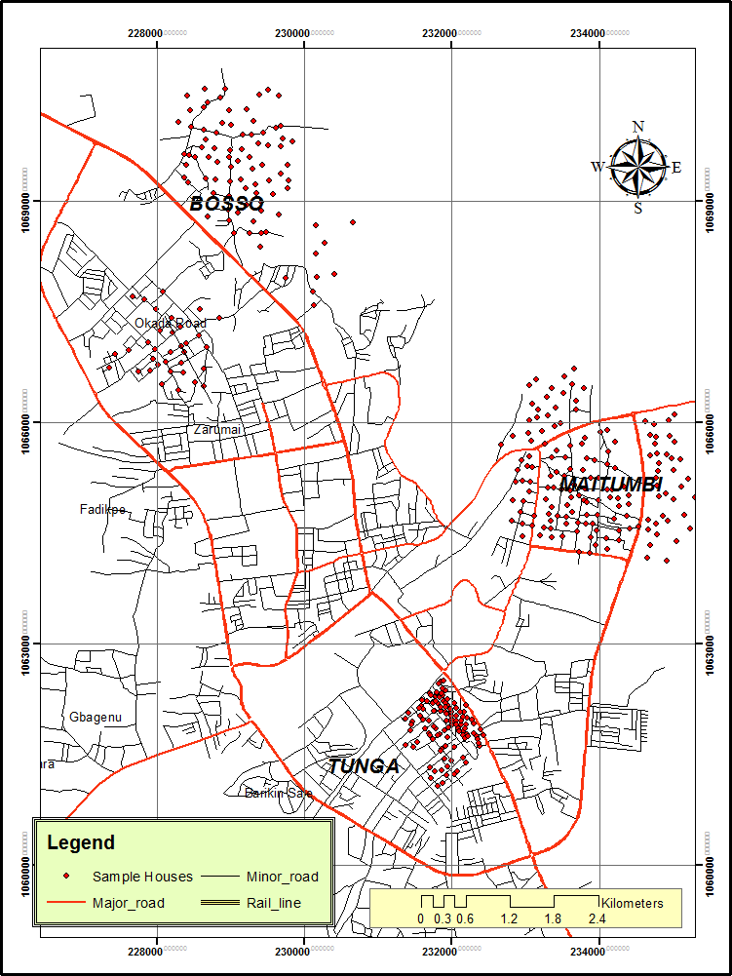

**Figure 3.3:** Dot map showing the sampled houses

The Total number of residential buildings in the selected neighbourhoods is 7118 while the number of rental s houses in the neighbourhoods is2932. This implies that rental buildings make up 41 percent of the residential buildings in the selected neighbourhoods.

It further suggests that the selected neighbourhoods are predominantly characterized by rental houses.

Hinged on the major aim of this research and also, since rental buildings, on the assumption that it houses more than a household, the average number of households in a rental building was determined. The national household size average of 5.5 was used in determining the human population of rental house tenants in the selected neighbourhoods that will facilitate the determination of the research sample size.

# Sampling frame

The sampling frame entails where the samples are drawn from in research. For this research, the sampling frame is the number of residential houses to be sourced from the 2021 Google Earth map of the selected neighbourhoods where the sampling units (rental buildings) was selected. Google Earth map of the selected neighbourhoods used to facilitate even distribution of sampling units and to avoid their concentration in a particular part of the neighbourhoods. The sampling units are the scientifically selected rental buildings where the sampling elements was drawn from. The researcher adopts the nearest rental building to the one selected from the Google Earth map if it is discovered not to be residential rental building or the one not inhabited.

The sampling elements are the possible respondents the researcher or his/her assistant meets to elicit information from. The inclusion criteria were household heads or their representatives aged 18 years and above and must have been residing in the sampling unit for a minimum of one year to have known or experienced the relationship situation in the sampling units. To narrow down to the sampling elements based on multifamily rental buildings, a simple random selection technique was adopted to select 50 percent of the

households in the sampling unit to be sampled.

# Sampling size

Sample size simply means a part of the population. It comprises the total number of population elements of sample units that are selected for investigation in a research study. In this research study, sample size determination is an important aspect of examination due to difficulty in studying the whole population. There are common procedures for determining sample size for simple random and systematic random samples (Gay, 1981; Nwana, 1981) while Krejcie and Morgan’s (1970) and Cochran’s (1977) formula are the most commonly used.

The Krejcie and Morgan's sample size calculation was based on p = 0.05 where the probability of committing type I error is less than 5 % or p < 0.05.

 (3.1)

Where,

s = required sample size.

X2 = the table value of chi-square for 1 degree of freedom at the desired confidence level (0.05 = 3.841).

N = the population size.

P= the population proportion (assumed to be 0.50 since this would provide the maximum sample size.

d = the degree of accuracy expressed as proportion (0.05).

Adopting Krejcie and Morgan (1970) sample size as shown in Table 3.4, the sample size for this research with population of 2032 is 327. This is to attain a proportional sampling units’ population for each selected neighbourhood. It is against this background that 327 respondents were sampled in the study area.

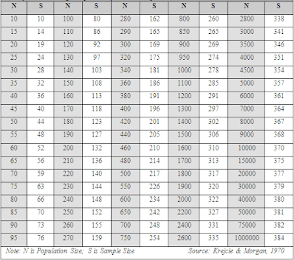

# Figure 3.4: Krejcie and Morgan sample size table

* + 1. **Sampling technique**

Cresswell (2012), opined that complete inventory is usually a difficult task particularly with large number of populations. This is exactly the issue with city of Minna. Therefore, purposive sampling technique was employed in which the rental buildings are purposely relevant to the study instead of all the residential buildings. The research also adopts simple random or accidental sampling to arrive at the required number of sampling units. This was done with the use of Google earth imagery and street guide map of the selected neighbourhoods. Equally, a hand-held GPS was used to obtain the coordinates of the rental buildings to facilitate dot mapping of the sampling units. Furthermore, random

sampling was also be used to finally arrive at the adopted 50 percent of the sampling elements within the sampling units having multifamily.

# Method of Data Analysis

To give meaning to data, it has to be analyzed and interpreted statistically. The study employs the use of descriptive and inferential statistics. For the descriptive statistics, frequency distribution table with percentages, Likert scaling was used. The inferential statistics used is multi regression analysis to examine the housing quality and its impacts on social relationship among the occupants in Minna. The evaluation of relationship between dependent and independent variables will be carried out using the multiple regression models. The first step consists of defining the variables of interest. This determines the relationship between the combined explanatory variables.

# CHAPTER FOUR

* 1. **RESULTS AND DISCUSSION**

This chapter presents the results of data analysis and addresses the rationale behind quality and social relationship impact among tenants of rental houses in Minna, Niger State. This chapter consists of five sections. The first section determines the socio- economic status of occupants. The second section identifies the quality and condition of rental houses in Minna. The third section deals with the factors militating against cordial relationship and the fourth section focused on the satisfaction level of rental house occupant in the study area, while the fifth section established the extent social relationship contributes to tenants’ satisfaction.

# Socio-economic Status of Occupants

The socio-economic status of the occupants was examined based on gender, marital status, educational level, occupational status, level of income, household size, no of rooms and types of building they occupied.

# Gender of the respondents

Figure 4.1 shows the analysis of respondent based on gender; the analysis shows that 68% of the respondents are females while 32% of the respondents are male. it was observed that female were the highest respondents to this research question and this could be attribute to the fact that female was found to be mostly available at home most of the time the researcher visited the rental houses during the period of this study.

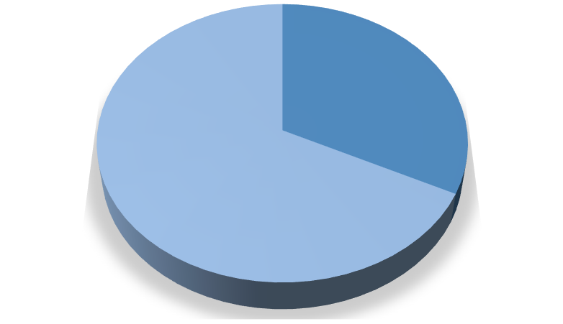

**32%**

**68%**

Male

Female

**Figure 4.1:** Gender of the Respondents

# Marital status of the respondents

Analysis in figure 4.2 shows the marital status of the respondents, it was discovered that 59.57% are married, 29.08% are single, 3.19% are divorced and 8.16% are widowed. It shows that majority of the respondents are married. This signify that majority of the respondents to the research questions were married and mostly with children.

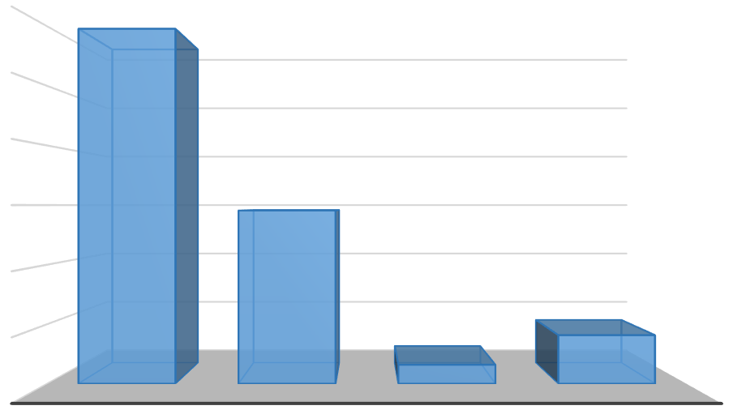

60

59.57

50

40

29.08

30

20

8.16

10

3.19

0

MARRIED

SINGLE

DIVORCE

WIDOW

**Figure 4.2:** Marital Status

# Educational status of the respondents

It was observed from the analysis in Figure 4.3 that 21.28% of the respondents have no formal education at all, 15.25% of the respondents have primary educational level, 17.73% of the respondents have secondary educational level, 23.76% of the respondents have NCE/ Diploma level, 14.89% of the respondents has B.Sc holder, while 7.09% of the respondents has up to postgraduate. The analysis signifies that majority of the respondents has up to NCE/Diploma level, it shows that the respondents were literate enough to do justices to the research questions.

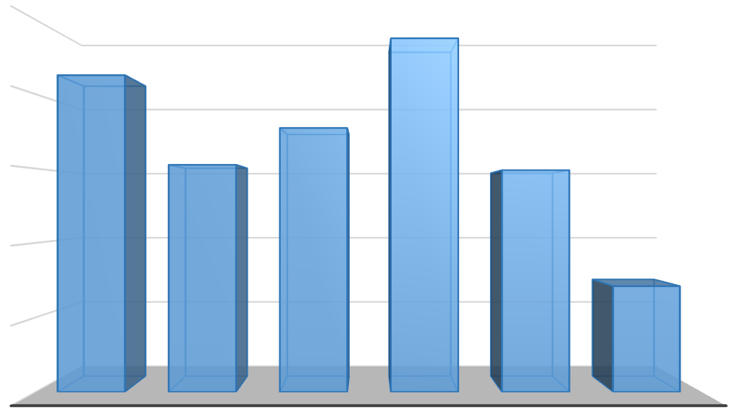

25

23.76

21.28

20

17.73

15.25

14.89

15

10

7.09

5

0

NO FORMAL EDUCATIONPRIMARY SECONDARY SCHOONLCE/DIPLOMA

**Educational Status**

B.SC

POST GRADUATE

**Percentage**

**Figure 4.3:** Educational Status of the Respondents

# Occupational status of the respondents

The analysis in Figure 4.4 shows the occupational status of the respondents, it was observed that 42.91% of the respondents are self-employed, 25.53% of the respondents are civil servant, 17.73% of the respondents are businessman, 8.16% of the respondents are farmers, while 5.67% of the respondents are retiree. The analysis signifies that

majority of the respondents are self- employed whom do not have a fix income and this could be a determinate to their choice of housing.

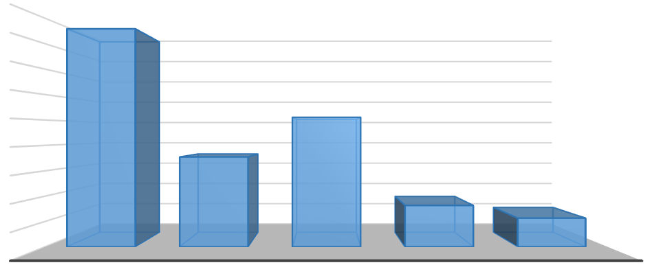

45

40

35

42.91

30

25

20

15

10

5

0

25.53

17.73

8.16

5.67

SELF

EMPLOYED

BUSINESS MAN CIVIL SERVANT

FARMERS

RETIREMENT

**Occupational Status**

**Percentage**

**Figure 4.4:** Occupational Status of the Respondents

# Average monthly income of the respondents

The result from Table 4.1 shows the average monthly income of the respondents, the table indicates that 42.7% of the respondents earn below N 30,000 followed by those

with income between N 31,000 and N50,000 representing 31.2%. whereas other

tenants that earn between N51,000 and N80,000 are 19.57% while those that earn

above N 80,000 are just 16.51% from the above table, it is deduced that majority of

the tenants are low-income earners. This substantiates their option for rental buildings.

# Table 4.1: Average Monthly Income of the Respondents

|  |  |  |
| --- | --- | --- |
| **Average Monthly Income** | **Frequency** | **Percentage** |
| Below 30,000 | 121 | 37.00 |
| 31,000 - 50,000 | 88 | 26.91 |
| 51,000 - 80,000 | 64 | 19.57 |
| Above 80,000 | 54 | 16.51 |
| **Total** | **327** | **100.00** |

* + 1. **Household size of the respondents**

Table 4.2 shows household size of the respondents, it was discovered that 43% of the respondents has less than 5 members of household, 51% of the respondents has between 6-10 members of household, 10.70% of the respondents has between 11-15 members of household while 8.87% of the respondents has above 16 members household size. The analysis signifies that majority of the respondents has between 6-10 members of household; this will enable the researcher to justify social relationship with tenancy satisfaction

# Table 4.2: Household Size of the Respondents

|  |  |  |
| --- | --- | --- |
| **Household-Size** | **Frequency** | **Percentage** |
| >5 | 120 | 36.70 |
| 06 - 10 | 143 | 43.73 |
| 11 - 15 | 35 | 10.70 |
| 16 and above | 29 | 8.87 |
| **Total** | **327** | **100.00** |

* + 1. **Number of rooms occupied by the respondents**

The analysis in Table 4.3 shows the numbers of rooms occupied by the respondents, it was observed that 44.34% of the respondents occupied two rooms (Room and parlor), 33.64% of the respondents occupied one room (Single room), 10.64% of the respondents occupied four room, 7.8% of the respondents occupied five rooms, while 7.09% of the respondents could not specify the type of rooms, they are occupying within the rental s houses in the study area. This signifies that majority of the respondents occupied two rooms and above. The study shows that household income is a major determinant of residential housing and facility. This also confirms the findings of previous studies which indicated that living in rental and flats is common among Nigerian households.

# Table 4.3: Number of Rooms Occupied

|  |  |  |
| --- | --- | --- |
| **No of Rooms** | **Frequency** | **Percentage** |
| Single Room | 110 | 33.64 |
| Room &Parlour (Two rooms) | 145 | 44.34 |
| Four (4) Rooms | 30 | 9.17 |
| Five (5) Rooms | 22 | 6.73 |
| Others | 20 | 6.12 |
| **Total** | **327** | **100.00** |

Source: Authors Field Survey, 2021

# Types of building occupied by the respondents

Figure 4.5 shows the types of building occupied by the respondents, it was discovered that 34.04% of the respondents occupied “face me I face you”, type of building as show in Plate i, 15.96% of the respondents occupied self-contain, 17.73% of the respondents occupied Room and parlor self-contain, 22.34% of the respondents occupied 2-bedroom flat and 9.93% of the respondents occupied Bungalow type of building in the study area. Although, the various types



Plate I: Typical nature of “face me, I face you” rental house type in Minna

of the property are rented by the tenants but prominent one is the rental building possibly due to the fact that it is relatively the cheapest. By virtue of being cheap, it may be lacking in ancillary services, quality and their condition may be deplorable.

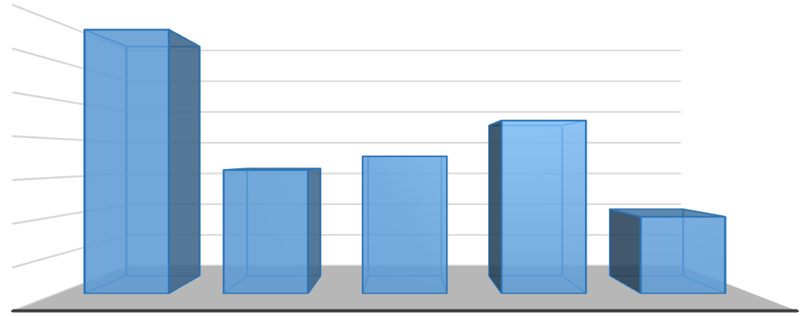

35

34.04

30

25

22.34

20

15.96

17.73

15

9.93

10

5

0

FACE ME, I FACE SELF-CONTAIN

YOU

ROOM AND

PARLOUR SELF CONTAIN

**Types of Building**

2 BEDROOM

FLAT

BUNGALOW

**Percentage**

**Figure 4.5:** Building Type occupied by Respondents

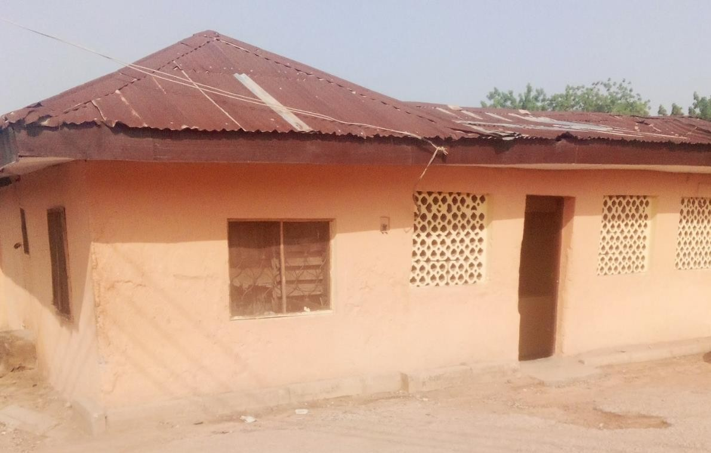

**Plate II:** Typical nature of room and palour type at Old Alheri Road in Minna

# Quality and Condition of Rental Houses in Minna

* + 1. **Age of building**

The age of building occupied by the tenants was examined, Table 4.4 shows that 4.59% of the houses occupied by the respondents were less 10 years of construction, 28.13% of the houses were between 10-19 years old, 49.85% of the respondent’s occupied houses were between 20 – 29 years old; 9.48% of the respondent’s occupied houses were between 30-39 years old while 7.95% of the respondents occupied houses were over 40 years old. The study reveals that age of building in the study area also determine the quality and adequacy of facilities in the building.

# Table 4.4: Age of the Building

|  |  |  |
| --- | --- | --- |
| **Age of the Building** | **Frequency** | **Percentage** |
| Less than 10 | 15 | 4.59 |
| 10-19 | 92 | 28.13 |
| 20-29 | 163 | 49.85 |
| 30-39 | 31 | 9.48 |
| 40 years & above | 26 | 7.95 |
| **Total** | **327** | **100.00** |

* + 1. **Wall materials and condition**

The materials used for construction of rental s houses in the study area were examined, Table 4.5 shows that 7.65% of the rental s houses in the area were built with mud, 23.55% of the houses were bult with bricks, while 68.81% of the houses occupied by tenants in the area were built with cement block. This signifies that majority of the rental houses in study area were built with cement block and this testify to the condition of rental houses in the area as it is liable to be improved on.

# Table 4.5 Wall Materials of Rental Houses

|  |  |  |
| --- | --- | --- |
| **Wall Material for Constructions** | **Frequency** | **Percentage** |
| Mud | 25 | 7.65 |
| Bricks | 77 | 23.55 |
| Sandcrete block | 225 | 68.81 |
| **Total** | **327** | **100.00** |

Table 4.6 show analysis of wall conditions of rental houses in the area, it was discovered that 55.35% of the respondents agree that the conditions of house wall are good (plastered), 30.89% of the respondents said that the wall of their house is cracked while, 13.76% said the condition of their wall is patched. The cracks on the walls of the buildings paved way for rodents, snakes, lizards, mosquitoes and termites to enter their houses thereby creating some discomfort such as food and water contaminations.

# Table 4.6: Condition of Walls

|  |  |  |
| --- | --- | --- |
| **Conditions of wall** | **Frequency** | **Percentage** |
| Good | 181 | 55.35 |
| cracked | 101 | 30.89 |
| Patched | 45 | 13.76 |
| **Total** | **327** | **100.00** |

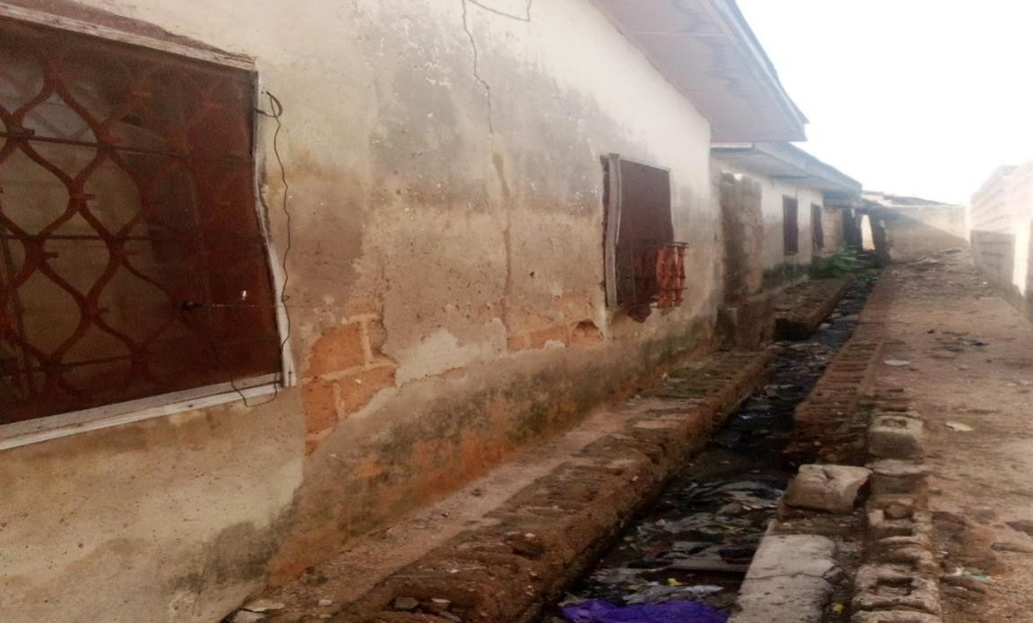

Plate III: Wall condition of rental house in Tunga lowcost Minna

# Roofing material and condition

Figure 4.6 shows the types of roofing materials used for rental housing construction in the study area, it was observed that 21% of the rental houses in the area were roofed with aluminum roofing sheet, none of the houses in the area is roofed with asbestos, while majority of the houses in the study area with 79% used iron sheets for roofing.

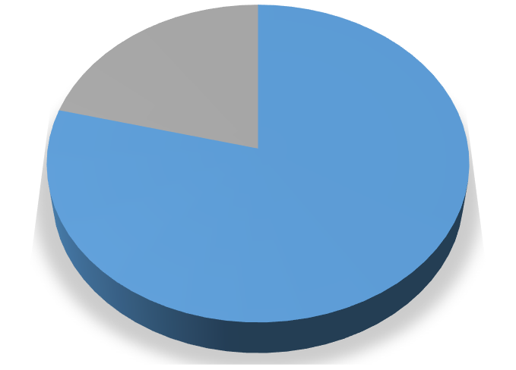

21%

0%

79%

Iron

Asbestos Aluminum

**Figure 4.6**: Roofing Materials for Rental Houses

Roofing condition of the rental houses was revealed from the analysis in Figure 4.7, it shows that 27% have their roof leaking, 47.3% are made of corrugated rusty iron sheet, while 26% are made of missing part of their roofs.

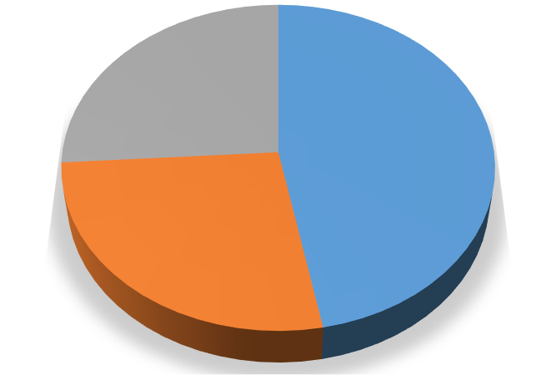

**26%**

**47%**

**27%**

Rusty

Leaking Part missing

**Figure 4.7:** Roofing Condition of Rental Houses in Minna

In addition, the corrugated roofing sheet which dominates the area was in a deplorable state with some respondents disclosing that their roofs leaked whenever it rained thereby soaking the internal wall and ceiling materials. The soaked walls and ceilings create offensive odour in rooms resulting in respiratory problems.



**Plate V:** Nature and condition of most roof of rental house at Haske Hotel Street in Minna



**Plate VI**: Nature and condition of rental house at Gududu Maitumbi in Minna

# Windows types and condition

Figure 4.8 shows the types and condition of windows provided in rental houses in the study area, it was revealed from the respondents that 37% were made of wood, 23% were made of metal, 15% were made of Glass while 25% were acombination of metal and glass or wood and metal.

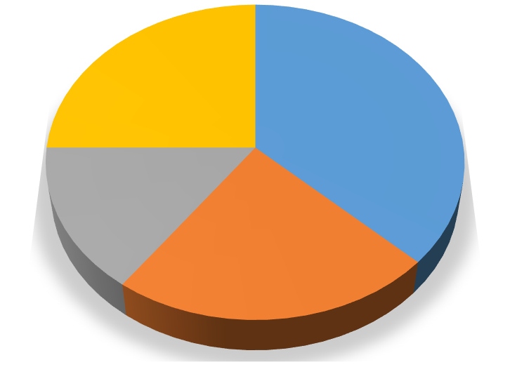

**25%**

**37%**

**15%**

**23%**

Wood Metal Glass

Combined

**Figure 4.8:** Window Type of Rental Housing

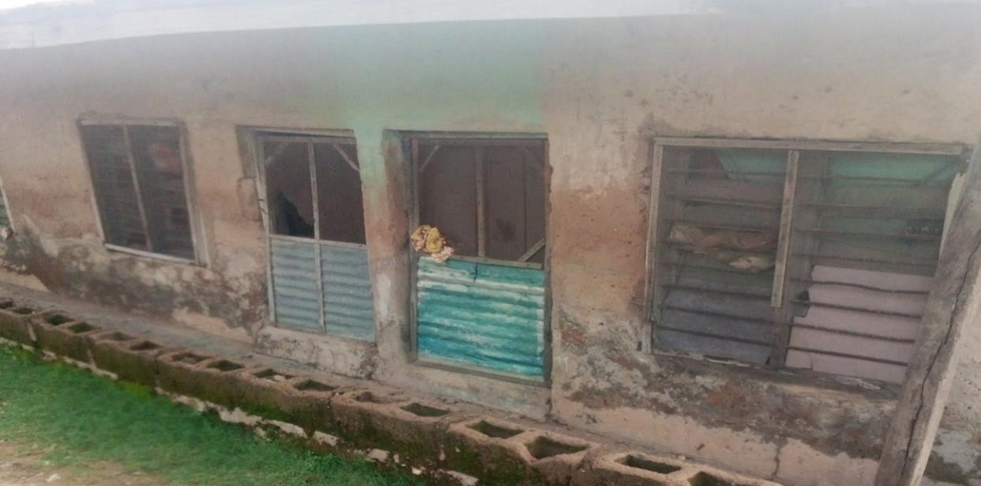

Plate IV: Nature and types of commonly used window and doors among rental house at

Alhaji Moh’d Liman Street in Minna

# Door types and condition

It was discovered from the analysis in Figure 4.9 that 55% of the houses use wooden door in their houses, 18% use Iron doors, 10% used Glass doors while 15% of the respondents combined different materials for their doors such as wood and glass or iron and glass. It was also observed that 30% of the doors were in good condition, 70% only managed their doors because part of the door is broken or not in good shape



**Door Materials**

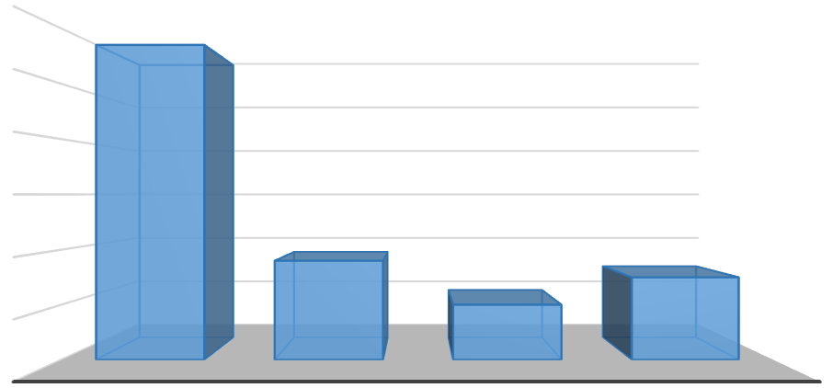

**Percentage**

|  |  |  |  |  |
| --- | --- | --- | --- | --- |
| 60 |  | | | |
| 50 |  |  |  |  |
| 40 |  |  |  |  |
| 30 |  |  |  |  |
| 20 |  |  |  |  |
| 10 |  |  |  |  |
| 0 | WOOD | IRON | GLASS | COMBINED |

**Figure 4.9:** Door Types of Rental Housing

# Floor condition and condition

The analysis in Figure 4.10 shows floor types in the area, it was discovered, 9% of rental houses floor is made of Tarazo floor, 5% of the houses floor is made of mud floor, 19% of the floor is made of tiles while 67% of the rental houses floor is made of cement floor. The analysis justifies the conventional nature of the floor condition of the houses.

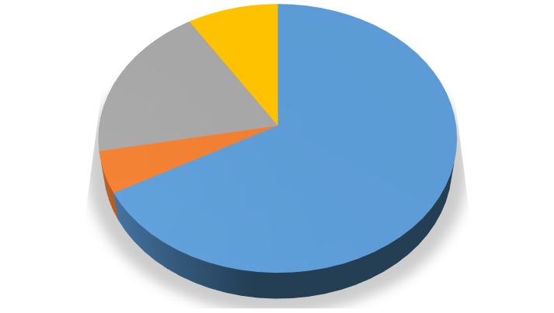

**9%**

**19%**

**5%**

**67%**

Cement Floor Mud floor Tiles floor

Tarazo floor

**Figure 4.10:** Floor Condition of Rental Housing

# Toilet/bathroom type and condition

The type of building and the class of the occupants determine in most cases the type of bathroom/toilet facilities. From this analysis in Figure 4.11, it was observed that most toilet facilities in the area are very unhygienic. Water closet accounted for 26%, Pit system accounted for 55% while stooling in bushes, stream accounted to 19. The situation of toilet facilities is discouraging, for the use of pit toilets are still common among the rental s houses in Minna.

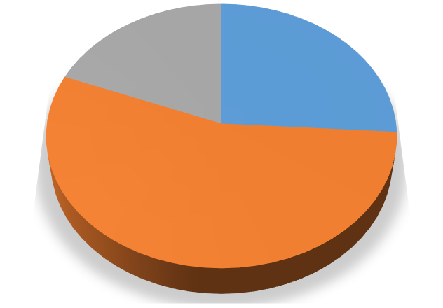

**19%**

**26%**

**55%**

WC

Pit

Bushes / Stream

**Figure 4.11:** Condition of Toilets

Many of the bathrooms in rental houses are erected outside the building and had gravels or stones as their floors and rusted roofing iron sheets and in some cases, woods are used to fence them. Majority of them have their doors damaged, some used cement wrapper or their cloths as door covering; their drainage systems were very poor due to lack of septic tanks and as such serving as breeding places for mosquitoes and insects. The conditions of bathrooms, apart from enabling mosquito breeding, make the surroundings look unpleasant, with several degrees of odour. Out of the households who had access to bathrooms, only few have their bathrooms being standard (had no doors, cemented, or tiled floors, properly roofed and good drainage system). The remaining had their bathrooms in poor or sub-standard conditions and posing several health risks to the occupants and residents.

# Condition of waste disposal

The study noted that the responsibility for the management of solid waste in Minna lies on the Niger State Environmental Protection Agency (NISEPA). Analysis in Figure 4.12 shows that among the sampled rental houses in Minna, 18.3% of their waste are collected by NISEPA, 40% are thrown into the bush, 26.7% are dumped in open space and 15%

are burned. It was observed that most footpaths and backyards are used as waste dumping sites. Another serious issue noticed was the fact that the waste collection vehicles do not have access to some areas within the study area due to the nature of the road. This situation brings to the fore more considerations given to locations where the solid waste collection vehicles can have easy access to when they are due for collection. The study observed that considering the persistent increase in waste generation by households, the number of days it takes the evacuation vehicles is inadequate since they are so much that they piled up in undesignated places and become a nuisance to the residents. Also, they result in the littering and dumping of solid waste at any available open spaces or places, such as along the roads, uncompleted buildings and in open drains within and around the city

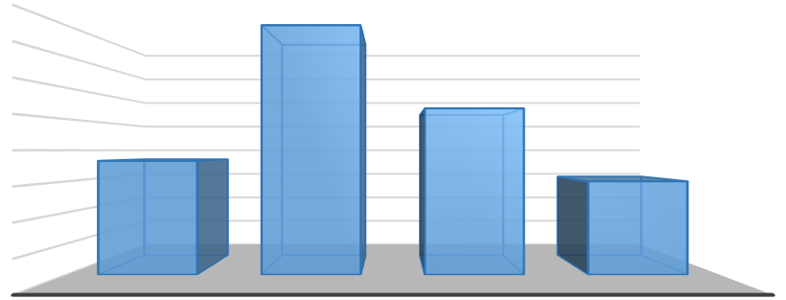

40

35

30

25

20

15

10

5

0

NISEPA

BUSH

OPEN DUMP

SITE

BURNING

**Waste disposal**

**Percentage**

**Figure 4.12:** Condition of Waste Disposal

# Source and condition of water supply

Figure 4.13 shows the analysis of water supply system, only 45% of the rental s houses have pipe borne water system within the study area, 28.3% accounted for the water supply from the public stand tap, while bore hole which another form of public water supply source, constitute about 35%, while Surface wells water supply constitute 45% of water sources among the rental houses in the study area. Poor condition of water supply has

been the greatest nuisance among the rental s houses in the area.

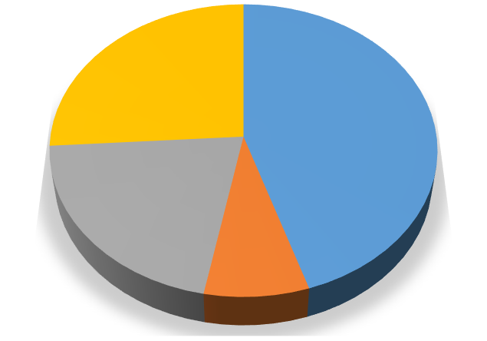

**26%**

**45%**

**21%**

**8%**

Pipe borne water Public stand tap Bore hole

Surface wells water

**Figure 4.13:** Source of Water Supply of Tenants in Rental Houses in the Study Area

The reason given by the respondents for not having pipe borne water was that the public source is presently in comatose, hence there is no need wasting their resources in a fruitless exercise. Study revealed that majority of households in Minna have their water supply provided by sources other than the Niger State Water Board. According to some of these households, their major source of water supply (well) dry up during the dry season; as a result they get water from water vendor (Mai-ruwa) and therefore have to store water in barrels and gallons anytime they have supply.

# Adequacy of Basic Facilities in Rental Houses

In order to examine these, respondents were to express their opinion using Likert scales of “Regularly‟; “inadequacy” and “not available” for building facilities. To arrive at “Rating value”, descriptive analysis was used to arrive at the percentage of basic facilitates adequacy. Figure 4.14 shows that bathroom has the highest percentage of respondents with 28%, followed by Kitchen with 23% of the respondent, Toilets has 19% of the respondents, sock away pit has a percentage score of 14, drainage has 9% while septic tank has 7%. Figure 4.14Shows the adequacy of basic facilities in rental s houses in Minna.

**Figure 4.14:** Adequacy of Basic Facilities in Rental Houses in Minna

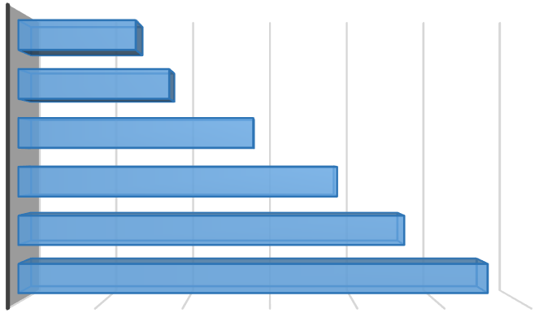

SEPTIC TANK

7

DRAINAGE

9

SOAK AWAY-PIT

14

TOILET

19

KITCHEN

23

BATHROOM

28

0

5

10

15

**Percentage**

20

25

30

**Facilities**

# Factors Militating Against Cordial Relationship

Table 4.7 show the mean scores and standard deviation (SD) of respondents on factors militating against cordial relationship on how common use of the toilet, bathroom, kitchen contribute to conflict among dwellers of rental houses. The respondents agreed to all the items with mean scores greater than the criterion mean of 2.5. The aggregate mean scores of 3.57 showed that common use of toilet, bathroom, kitchen could add to conflict among dwellers of rental houses, and this is Mingling with dissimilar types of characters; lack of privacy, noise pollution like blasting of music at odd hours, children’s noise and generator sounds, child vulnerability to abuse and limited number of conveniences respectively.

# Table 4.7: Factors that Contribute to Conflict Among Dwellers of Rental Houses

|  |  |  |  |  |
| --- | --- | --- | --- | --- |
| **Factors** |  |  | **Mean** | **Decision** |
|  | x | SD1 |  |  |
| Mingling with different types of characters | 3.98 | 0.134 | 3.96 | Agreed |
| No privacy | 3.60 | 0.490 | 3.75 | Agreed |
| Noise pollution e.g. blasting of music at odd hours, children’s noise and generator sounds | 3.60 | 0.490 | 3.75 | Agreed |
| Child vulnerability to abuse | 2.70 | 0.557 | 2.89 | Agreed |
| A limited number of conveniences | 3.98 | 0.134 | 3.96 | Agreed |
| **Aggregate Mean** | **3.57** | **0.361** | **3.57** | **Agreed** |

It was also discovered from Table 4.8, the mean scores and standard deviation (SD) of respondents on how overpopulation could contribute to conflict among rental house dwellers. The respondents agreed to all the items with mean scores greater than the criterion means of 2.5 except for item one which is: Inadequate infra-structure: bathroom, toilet, kitchen. However, the aggregate mean scores of 3.34 showed that overpopulation could add to conflict among rental house dwellers in ways such as Misrepresentation, Back-biting, Clashes between children, threat to parties' concerns and interests (like amorous relationships); envy, uncooperative attitudes and non-settlement of bills.

**Table 4.8:** Population Factor that Contribute to Conflict Among Rental House Dwellers

|  |  |  |  |  |
| --- | --- | --- | --- | --- |
| **Population factors** | **x** | **SD1** | **Mean**  **set** | **Decision** |
| Inadequate infrastructure | 1.59 | 0.758 | 1.58 | Disagreed |
| misrepresentation | 3.78 | 0.456 | 3.68 | Agreed |
| Back-biting | 3.88 | 0.329 | 3.76 | Agreed |
| Clashes between children | 3.09 | 0.289 | 3.06 | Agreed |
| The threat to parties’ interests and concerns  (e.g amorous relationships) | 3.90 | 0.307 | 3.79 | Agreed |
| Envy | 3.22 | 1.262 | 3.46 | Agreed |
| Uncooperative attitudes | 3.51 | 0.501 | 3.57 | Agreed |
| Non-settlement of bills | 3.72 | 0.447 | 3.78 | Agreed |
| **Aggregate mean** | **3.34** | **0.544** | **3.34** | **Agreed** |

Table 4.9 also shows the mean scores and standard deviation (SD) of respondents on how rental house pattern contributes to conflict among residents. The respondents agreed to all the items with mean scores greater than the criterion mean of 2.5.

# Table 4.9: Social Factor that Cause Conflict Among Residents

|  |  |  |  |  |
| --- | --- | --- | --- | --- |
| **Social Factors** | **x** | **SD1** | **Mean**  **set** | **Decision** |
| Parents overreaction towards child  protection | 3.67 | 0.507 | 3.64 | Agreed |
| Exposure to immoral and delinquent  behaviors | 3.38 | 0.522 | 3.45 | Agreed |
| Problems of joint payment of utility bill e.g.  NEPA | 3.80 | 0.404 | 3.79 | Agreed |
| Non-cooperation from some tenants towards  cleaning of conveniences and sweeping of the compound. | 3.64 | 0.518 | 3.62 | Agreed |
| Gossip from nosy neighbors | 3.04 | 0.871 | 3.11 | Agreed |
| Over dependent neighbors | 2.92 | 0.599 | 3.1 | Agreed |
| **Aggregate mean** | **3.41** | **0.652** | **3.45** | **Agreed** |

The aggregate mean scores of 3.41 agreed to the rate to which rental social factors contributes to conflict among residents are through: Parents overreaction towards child protection; exposure to immoral and delinquent behaviours; problems of joint payment of utility bill like NEPA; non-cooperation from some tenants toward cleaning of conveniences and sweeping of the compound; gossips from nosy neighbours and over- dependent neighbours respectively.

# Tenants Satisfaction Level

* + 1. **Tenants satisfaction with housing condition**

Table 4.10 shows the result of respondents’ (tenants) rating of their levels of satisfaction with housing in the study area. The result indicates that most of the respondents in the study area were generally satisfied with their housing condition. A good majority 41%of the respondents in the entire sample claimed that they were not satisfied with their housing condition, 13% of the respondents were undecided and about 44% of the respondents were satisfied with the condition of the houses.

# Table 4.10: Tenants Satisfaction of Housing Condition

|  |  |  |
| --- | --- | --- |
| **Satisfaction Level** | **Frequency** | **Percentage** |
| Very dissatisfied | 10 | 3.06 |
| Dissatisfied | 125 | 38.23 |
| Undecided | 45 | 13.76 |
| Satisfied | 95 | 29.05 |
| Very Satisfied | 52 | 15.90 |
| **Total** | **327** | **100.00** |

* + 1. **Tenants satisfaction with housing environment**

Analysis in Table 4.11 shows tenants satisfaction level with their housing environment, it was discovered that about 14% of the respondent were not satisfied with their housing environment while majority of the respondent with over 50% of the respondents were satisfied with their housing environment. This finding could be justified on the ground that most rental houses environments were conceived and developed having basic neighbourhood amenities and social infrastructures like road, water, drainages, waste disposal and electricity. The availability and level of maintenance of these facilities could possibly influence tenants’ satisfaction level.

# Table 4.11: Tenants Satisfaction with Housing Environment

|  |  |  |
| --- | --- | --- |
| **Satisfaction Level** | **Frequency** | **Percentage** |
| Very dissatisfied | 15 | 4.59 |
| Dissatisfied | 33 | 10.09 |
| Undecided | 95 | 29.05 |
| Satisfied | 116 | 35.47 |
| Very Satisfied | 70 | 20.80 |
| **Total** | **327** | **100.00** |

* + 1. **Tenants satisfaction with dwelling spaces**

It was discovered from the analysis in Table 4.12 shows that about 51% of the respondents were not satisfied with the dwelling space within the rental houses in the study area, 15% of the respondents were undecided, while 32% of the respondents were satisfied. A result similar to that discussed above is obtained for respondents’ satisfaction with their dwellings (housing units), as a good number of the respondents claimed they were not satisfied with their dwelling spaces, dwelling interior design and the overall dwelling.

# Table 4.12: Tenants Satisfaction with Dwelling Spaces

|  |  |  |
| --- | --- | --- |
| **Satisfaction Level** | **Frequency** | **Percentage** |
| Very dissatisfied | 87 | 26.61 |
| Dissatisfied | 82 | 25.08 |
| Undecided | 50 | 15.29 |
| Satisfied | 43 | 13.15 |
| Very Satisfied | 65 | 19.88 |
| **Total** | **327** | **100.00** |

* + 1. **Tenants Satisfaction with Ventilation**

Table 4.13 shows the satisfaction level of respondents on ventilation in their houses, Majority of the respondents claimed they are not satisfied with the ventilation with 65%, 15% of the respondent were undecided and only about 18% were satisfied with the ventilation in their houses.

# Table 4.13: Tenants Satisfaction with Ventilation

|  |  |  |
| --- | --- | --- |
| **Satisfaction Level** | **Frequency** | **Percentage** |
| Very dissatisfied | 100 | 30.58 |
| Dissatisfied | 115 | 35.17 |
| Undecided | 50 | 15.29 |
| Satisfied | 14 | 4.28 |
| Very Satisfied | 48 | 14.68 |
| **Total** | **327** | **100.00** |

* + 1. **Tenants satisfaction with privacy in dwelling**

Respondents’ satisfaction with privacy in dwelling was examined, it was discovered from the analysis in Table 4.14 that about 65% of the respondents are not satisfied with the privacy in their dwelling, 7% were undecided while, about 26% were satisfied with the privacy in their dwelling.

# Table 4.14: Tenants Satisfaction with Privacy

|  |  |  |
| --- | --- | --- |
| **Satisfaction Level** | **Frequency** | **Percentage** |
| Very dissatisfied | 100 | 30.58 |
| Dissatisfied | 115 | 35.17 |
| Undecided | 25 | 7.65 |
| Satisfied | 15 | 4.59 |
| Very Satisfied | 72 | 22.02 |
| **Total** | **327** | **100.00** |

In determine the factors (correlates) affecting rental housing satisfaction, the dependent variables of the environment, the dwelling, and the condition components were correlated (using Pearson’s correlation coefficient). The acceptable levels of significance were obtained at the 0.01 and 0.05 probability levels respectively. Consequently, attributes with significant correlations were further subjected to regression analysis and analysis of variance test (ANOVA). The analysis also indicates that variables like access to water supply, condition of building, environment have negative but significant correlation coefficients of - 0.122, -0.091, -0.112, and -0.159 respectively, and are inversely related to satisfaction with the environment (component E). This also implies that tenants’ satisfaction with their environment is negatively affected by the either the availability or non-nonavailability of facilities in the study area. Table 4.17 shows the correlation coefficients between satisfaction with the dwelling and some dwelling attributes.

**Table 4.15:** Regression Coefficient of Dwelling Factors of Satisfaction

|  |  |  |  |  |
| --- | --- | --- | --- | --- |
| **Dwelling factors** | **B Std error** | **Beta** | **t** | **Sig. (P)** |
| (Constant) | 1.478 0.141 |  | 10.461 | 0.000 |
| Number of sleeping rooms | -0.087 0.032 | -0.086 | -2.761 | 0.006 |
| Building design | 0.252 0.036 | 0.235 | 7.050 | 0.000 |
| Floor condition | 0.124 0.035 | 0.120 | 3.533 | 0.000 |
| Roof’s condition | 0.193 0.033 | 0.191 | 5.882 | 0.000 |
| Wall condition | 0.14240.062 | 0.235 | 7.050 | 0.000 |
| Door condition | 0.22120.011 | 0.087 | 1.231 | 0.000 |
| Widow condition | 0.246 0.066 | 0.151 | 3.441 | 0.000 |

P significant at 0.01.

# Social Relationship Contributions to Tenants’ Satisfaction

The respondent’s overall rental housing quality in Minna was tested using the One-way Analysis of Variance (ANOVA). By comparing the mean values for these variables, the test yielded an F-ratio of 14.55 at less than 0.05 level of significance (*P = 0.000*), (Table 4.16)**.** This result indicates that household-size has a significant influence on the overall housing quality in Minna.

**Table 4.16**: Housing Condition and Overall Rental Housing Quality in Minna

|  |  |  |  |  |  |
| --- | --- | --- | --- | --- | --- |
| **Sources of variation** | **Sum of**  **Square** | **Df** | **Mean Squares** | **F** | **Sig** |
| Between Group | 343.22 | 3 | 921.08 | 14.55 | .000 |
| Within Group | 42561.89 | 489 | 95.63 |  |  |
| **Total** | **47.463.91** | **495** |  |  |  |

*Significant (P<0.00)

The analysis in Table 4.17 also indicates a positive correlation between the two variables. For p < 0.01, the correlation is highly significant at the 1% level. Hence, “There is a great

relationship between housing condition and rental s satisfaction. “There is significant correlation between availabilities of basic facilities tenants’ satisfaction”. This implies that tenant satisfaction index of 0.55 obtained represents the true level of tenant satisfaction based on the actual state of housing condition of the dwelling and not on extraneous factors.

**Table 4.17:** Correlation Between Tenant’s Satisfaction and Housing Condition

|  |  |  |  |
| --- | --- | --- | --- |
|  |  | Condition of the houses | P-value |
| State of maintenance of the houses | Pearson Correlation | 1 | 0.532** |
|  | Sig. (2-tailed) | . | 0.000 |
| Level of tenant | Pearson | 0.532** | 1 |
| satisfaction with the | Correlation |  |  |
| maintenance of the |  |  |  |
| houses |  |  |  |
| Sig. (2-tailed) | 0.000 | . |

# Summary of Findings

* + 1. **Socio-economic status of occupants**

The socio-economic status of the occupants was examined based on gender, marital status, educational level, occupational status, level of income, household size, no of rooms and types of building they occupied. The findings shows that 68% of the respondents were female and are married, has up to NCE/Diploma level and mostly self- employed whom do not have a fixed income and this could be a determinate to their choice of housing.

The findings also revealed that majority of the respondents with 42% earn below N 30,000

monthly and has between 6-10 members of household size and majority of the respondents (42%) occupied room and palour and stay in “face me I face you”, type of

building. Although, the various types of the property are rented by the tenants but prominent one is the rental building possibly due to the fact that it is relatively the cheapest. By virtue of being cheap, it may be lacking in ancillary services, quality and their condition may be deplorable.

# Quality and condition of rental houses in Minna

The finding reveals that most of the rental building in the study area between 20-29 years old and mostly used cement block for constructions. It was also discovered that majority of the houses in the study area with 79% used iron sheets for roofing and the condition of wall of the rental houses were rusted, most of the houses used wooden door in their houses, mostly used cement floor that are durable.

Figure 4.14 shows that bathroom has the highest percentage of respondents with 28%, followed by Kitchen with 23% of the respondent, Toilets has 19% of the respondents, sock away pit has a percentage score of 14, drainage has 9% while septic tank has 7%. Figure 4.14 Shows the adequacy of basic facilities in rental s houses in Minna.

# Factors militating against cordial relationship

The finding shows that toilet, bathroom, kitchen contribute to conflict among dwellers of rental houses. The aggregate mean scores of 3.57 showed that common use of toilet, bathroom, kitchen could add to conflict among dwellers of rental houses, and this is Mingling with dissimilar types of characters; lack of privacy, noise pollution like blasting of music at odd hours, children’s noise and generator sounds, child vulnerability to abuse and limited number of conveniences respectively. It also reveals that inadequate infrastructure such as bathroom, toilet, kitchen. However, the aggregate mean scores of

3.34 showed that overpopulation could add to conflict among rental house dwellers in ways such as Misrepresentation, Back-biting, Clashes between children, threat to parties'

concerns and interests (like amorous relationships); envy, uncooperative attitudes and non-settlement of bills. It was also discovered that mean scores of 3.41 agreed to the rate to which rental house pattern contributes to conflict among residents are through: Parents overreaction towards child protection; exposure to immoral and delinquent behaviours; problems of joint payment of utility bill like NEPA; non-cooperation from some tenants toward cleaning of conveniences and sweeping of the compound; gossips from nosy neighbours and over-dependent neighbours respectively.

# Tenants satisfaction with housing condition

The study reveals that 48% of respondent in the sample area claimed that they were satisfied with their housing condition and 58% of the respondents were not satisfied with the dwelling space within the rental houses. 62% of the respondents claimed they were not satisfied with the ventilation with 60% also reveals that 62% of the respondents were not satisfied with the privacy in their dwelling. The findings indicate that variables like access to water supply, condition of building, environment have negative but significant correlation coefficients of - 0.122, -0.091, -0.112, and -0.159 respectively, and are inversely related to satisfaction with the environment (component E). This also implies that tenants’ satisfaction with their environment is negatively affected by the either the availability or non-nonavailability of facilities in the study area.

# Social relationship influence on tenants’ satisfaction.

The respondents overall housing quality, household-size and housing quality in Minna was tested using the Analysis of Variance (ANOVA). By comparing the mean values for these variables, the test yielded an F-ratio of 14.55 at less than 0.05 level of significance (*P = 0.000*), This result indicates that household-size has a significant influence on the overall housing quality in Minna. It also shows a positive correlation between the two

variables. For p < 0.01, the correlation is highly significant at the 1% level. Hence, “There is a great relationship between housing condition and rental s satisfaction. “There is significant correlation between availabilities of basic facilities tenants’ satisfaction”. This implies that tenant satisfaction index of 0.55 obtained represents the true level of tenant satisfaction based on the actual state of housing condition of the dwelling and not on extraneous factors.

# CHAPTER FIVE

* 1. **CONCLUSION AND RECOMMENDATIONS**

# Conclusion

This study has examined the housing quality and satisfaction of occupants of rental houses in Minna, Niger State. The study focused on rental residential housing which is one of the fundamental elements that shapes an urban community. The study identified and discussed the most common components of rental housing which include type of houses, quality and condition of the houses, adequacy of basic facilities in rental houses. The development and management of rental housing have over the years been driven by the forces of demand and supply. As a result, the provision of housing facilities differs in different parts of the city; also, the rent paid in different parts also differs due to the differentia in facilities provisions.

Having examined the quality of rental housing and tenants’ satisfaction in Minna; it is obvious that the prevailing situation of providing decent housing will be a mirage if something drastic and urgent is not done by the stakeholders. Therefore, the respondents could only claim to be satisfied with such areas as a matter of choice, since the socio- economic characteristics of the respondents vary. It is always better not to manage any property at all than to manage crisis-infected ones. Creative problem-solving strategies are essential positive approaches to maintain good social relations, and such management should start from tenants’ recruitment stage. To bring this to bare, it is important to separate the development of housing from mere developing good and secure housing to a holistic social approach of urban city development which consist of adequate facilities.

# Recommendations

The following recommendations were made after analyzing the data collected from the residents of the study area:

* + 1. Houses should be provided with all necessary facilities and services to enhance its functional efficiency as a place of habitation, and this would increase the overall longevity of the occupants.
    2. It is recommended that landlords should make provision for boreholes in order to ensure that there is ample supply of water to avoid violence among co-tenants.
    3. Renovation of the houses should be done by the Landlords when the need arises to prevent or avoid attrition of the houses or wear and tear.
    4. Government should be actively involved in the provision of adequate housing for the citizens through the provision of housing grants or low interest loans to the people and also contribute at least 60% to the development of houses for the low- income urban dwellers to make good houses at affordable prices for those who wish to leave in rental houses.
    5. Strict enforcement of building and environmental bye-laws to punish those landlords who fails to provide the basic housing facilities in their houses; and those residents that fails to use the provided facilities.
    6. A toilet and a kitchen should be allocated to atleast two families inorder to reduce delay and violence when it comes to use of the toilets and kitchen facilities.
    7. House owners and indeed all residents should be properly sensitized through environmental education on the dangers inherent in living in poor housing and environment.

# REFERENCES

Abdulkadir. A., Usman, M.T., Shaba, A.H., & Saidu, S. (2013). An Appraisal of the Eco climatic Characteristics in Northern Nigeria. *African Journal of Environmental Science and Technology,* 7(8), 748-757

Addo, I. A. (2016). Assessing residential satisfaction among low income households in multi-habited dwellings in selected low income communities in Accra. *Urban Studies*, 53(4), 631–650

Aigbavboa, C. O., & Thwala, W. D. (2011, July). Community participation for housing development. In *Proceedings 6 Built Environment Conference*.

Ajrouch, K. J., Antonucci, T. C., & Birditt, K. S. (2017). The convoy model: Explaining social relations from a multidisciplinary perspective, *Gerontologist, 54*(1), 82–92. doi:10.1093/geront/gnt118

Amerigo, M. (2002) A Psychological Approach to the Study of Residential Satisfaction, in: J. I. Aragon´es, G. Francescato & T. Garling (Eds), *Residential Environments: Choice, Satisfaction, and Behavior.* Westport: Bergin & Garvey. (pp. 81–99).

Amole, D. (2009). Residential satisfaction in students' housing. *Journal of Environmental Psychology*, *29*(1), 76-85.

Azimi, N., & Esmaeilzadeh, Y. (2017). Assessing the relationship between house types and residential satisfaction in Tabriz, Iran. *International Journal of Urban Sciences*, *21*(2), 185-203.

Babalola, F. D. (2006). Issues and option for appropriate management strategies of campus tree at university of Ibadan, Nigeria. *Nigerian Journal of Ecology*, *11*, 33- 42.

Bajari, P., Benkard, C. L., & Krainer, J. (2015). House prices and consumer welfare.

*Journal of Urban Economics,* 58, 474–487.

Baker, E. L. (2002). *Public Housing Tenant Relocation: Residential Mobility, Satisfaction, and the Development of a Tenant's Spatial Decision Support System* (Doctoral dissertation).

Ballesteros, M. M. (2014). *Rental housing for urban low-income households in the Philippines Real estate development, principles, and processes (3rd ed.).* Washington D.C: Urban Land Institute.

Barcus, H. R. (2004). “Urban-rural migration in the USA: An analysis of residential satisfaction.” *Regional Studies*, 38(6), 643–657.

Barnes, K. (1982). Housing associations: European ideas. *American applications. Journal of Housing*, 39, 10-13

Basorun J.O. & Fadairo G. (2012) Government Challenges in Housing the Urban Poor in Ado-Ekiti, *Nigeria‖ Journal of Sustainable Society*, 1(2), 31-35

Bechtel, R.B. (1997). *Environment and behavior: An introduction*. Thousand Oaks, CA: Sage Publications.

Berger L., Hohman L., Furman W. F. (2017). *Encyclopædia Britannica* (6th Ed). Chicago: Encyclopædia Britannica, Inc.

Berkman, H., Cole, R., & Fu, L. (2010). Political connections and minority-shareholder protection: Evidence from securities-market regulation in China. *Journal of Financial and Quantitative Analysis*, 45(6), 1391–1417

Boman IV, J. H., Krohn, M. D., Gibson, C. L., & Stogner, J. M. (2012). Investigating friendship quality: an exploration of selfcontrol and social control theories’ friendship hypotheses. *Journal of Youth and Adolescence*. [https://doi.org/10.](https://doi.org/10) 1007/s10964-012-9747-x.

Bond, J., Petrer, O., & Bonnefoy, X. (2011), “Inadequate Housing and Health: An Overview”, *International Journal of Environmental Pollution,* 30(3/4), 17-32.

Briggs, X. S. (1997). “Moving Up Versus Moving Out: Neighborhood Effects: Housing Mobility Programs. *Housing Policy Debate* 8(1): 195–234

Brock, W. A., & Durlauf, S. N. (2003). *Macroeconomics and model uncertainty*.

University of Wisconsin: Social Systems Research Institute.

Cadstedt, J. (2010). Private rental housing in Tanzania: a private matter? *Habitat International,* 34(1), 46–52.

Campbell, A., Converse, P. E., & Rodgers, W. L. (1976). *The quality of American life: Perceptions, evaluations, and satisfactions*. USA: Russell Sage Foundation.

Chen, Z., Xu, J., & Jing, H. (2013). Multi-scale spatial analysis of historic district based on syntax: Taking three lanes and seven alleys in Fuzhou as an example. *City Planning Review*, 33(8), 92–96.

Clark, M. S., & Graham, S. M. (2015). Do relationship researchers neglect singles? Can we do better? Psychological Inquiry. *Environment and Behavior, 13*(6), 735-758.

Clark, D. (1982). *The Irish in Philadelphia: Ten generations of urban experience*.

Philadelphia:Temple University Press.

Cochran, W. G. (1977). *Sampling techniques* (3rd ed.). New York: John Wiley & Sons Corsaro, K.W. (2015). An Emperical Study of the Relationship between Economic

Growth, Real Estate Prices and Real Estate Investments in Hong Kong, *Journal*

*of Surveying and Built Environment. 16 (2), 10-32.*

Cresswell, T. (2012). Mobilities II: still. *Progress in human geography*, *36*(5), 645-653.

Crowe, S., Cresswell, K., Robertson, A., Huby, G., Avery, A., & Sheikh, A. (2011). The case study approach. *BMC medical research methodology*, *11*(1), 1-9.

Datta, K., (2010). “The organization and performance of a low-income rental market: The case of Gaborone, Botswana”, *Cities*, 13, 237-245.

Deane, G. D. (1990). Mobility and adjustments: Paths to the resolution of residential stress. Demography, 27(1), 65–79

Deci, E. L., & Ryan, E. M. (2012). *Handbook of self-determination research*. Rochester: University of Rochester Press.

Demir, M., & Özdemir, M. (2010). Friendship, need satisfaction and happiness. *Journal of happiness studies*, *11*(2), 243-259.

Diaz-Serrano, L. (2010). Mobility and housing satisfaction: An empirical analysis for 12 EU countries. *Journal of Economic Geography*, 10(5), 661–683.

Diaz-Serrano, L. (2009). Disentangling the housing satisfaction puzzle: does homeownership really matter? Journal of Economic Psychology, 30(5), 745-755.

Diener, E., & Diener, M. (2009). Cross-cultural correlates of life satisfaction and self- esteem. In *Culture and well-being* (pp. 71-91). Dordrecht: Springer.

Dolan, P., & Metcalfe, R. (2012). Measuring subjective well-being: recommendations on measures for use by National Governments. *Journal of Social Policy*, 41(2), 409– 427.

Downs, A. (Ed.). (2004). *Growth management and affordable housing: Do they conflict?*.

United Kingdom: Brookings Institution Press.

Dubel, A. & Pfeiffer, U., (2012), *A critical appraisal of rent control in South Africa*: Report on a study project commissioned by the Ministry of Housing of the Republic of South Africa, Bonn.

Dukiya, J. J. (2012). Remote Sensing and GIS Assessment of Flood Vulnerability of Nigeria's Confluence Town. *Journal of Research in National Development*, *10*(3), 123-128.

Elsinga, M., & Hoekstra, J. (2005). Homeownership and housing satisfaction. *Journal of housing and the built environment*, *20*(4), 401-424.

Eluwa. S. E, Ajagbe. A.M, Umaru. E.T., Ojo A. K & Yusuf O. G, (2012). Assessing Inter- city Road Traffic in an Indigenous African City. Ibadan Nigeria. *Engineering Science and Technology and International Journal 2*(2), 221-228.

Fleury-Bahi, G., Félonneau, M. L., & Marchand, D. (2008). Processes of place identification and residential satisfaction. *Environment and Behavior*, *40*(5), 669- 682.

Foote, N. N., Abu-Lughod, J., Foley, M. M., & Winnick, L. (1960). *Housing Choices and Housing Constraints*. New York: McGraw-Hill.

Francescato, G., Weidemann, S., & Anderson, J. R. (1987). Residential satisfaction: Its uses and limitations in housing. In W. van Vliet, H. Choldin, W. Michelson, & D. Popenoe (Eds.), *Housing and neighborhoods: Theoretical and empirical contributions* (pp. 43–57). New York: Greenwood.

Froneman, K. (2014). *Exploring the basic elements required for an effective educator– student relationship in nursing education* (Doctoral dissertation).

Gifford-Smith, M. E., & Brownell, C. A. (2013). Childhood peer relationships: Social acceptance, friendships, and peer networks. *Journal of school psychology*, *41*(4), 235-284.

Galster, G. C. (1987). Identifying the correlates of dwelling satisfaction: An empirical critique. *Environment and Behavior*, 19(5), 539–568.

Galster, G. C. (1985). Evaluating indicators for housing policy: Residential satisfaction vs marginal improvement priorities. *Social Indicators Research*, *16*(4), 415-448.

Galster, G. C., & Hesser, G. (1981). Residential satisfaction: Compositional and contextual correlates. *Environment and Behavior*, 13(6), 735–758.

Gay, D. D. (1981). The effect of dental amalgams on mercury levels in expired air. *Journal of Dental Research*, *60*(9), 1668-1671.

Ghisleni, M. (2012). The importance of the geographic level of analysis in the assessment of the quality of life: the case of Spain. *Social Indicators Research*, 102(2), 209– 228.

Gilbert, A., & Varley, A. (2012). Landlord and tenant: Housing the poor in urban Mexico. *Research Journal of Art, Social Science and Humanities*. 3(3), 27-39. (ISSN: 2350-2258)

Goetzmann, W. N., & Spiegel, M. (2012). “Policy Implications of Portfolio Choice in 19 Underserved Mortgage Markets,” in *Low-Income Homeownership: Examining the Unexamined Goal*, edited by Nicolas P. Retsinas and Eric S. Belsky. Washington, DC: Brookings Institution Press. (pp. 257-278).

Granovetter, M. S. (1973). The strength of weak ties. *American journal of sociology*, *78*(6), 1360-1380.

Grigolon, A., Dane, G., Rasouli, S., & Timmermans, H. (2014). Binomial random parameters logistic regression model of housing satisfaction. *Procedia Environmental Sciences*, 22, 280–287

Green, R. K., & Hendershott, H. (2011). Homeownership and the Duration of Unemployment. Working Paper.

Haines, V. A., Hurlbert, J. S., & Beggs, J. J. (1996). Exploring the determinants of support provision: provider characteristics, personal networks, community contexts and support following life events. *Journal of Health and Social Behavior*, 37, 252– 264.

Halpern, D. (2015). *Social capital.* Cambridge: Polity Press.

Haurin, D. R., & Gill, H. L. (2012). The impact of transaction costs and the expected length of stay on homeownership. *Journal of Urban Economics*, 51, 563-584

Hays, R. A. (1994). Housing privatization: social goals and policy strategies. *Journal of Urban Affairs*, *16*(4), 295-317.

He, L., & Yang, C. (2011). Housing satisfaction of urban residents and its influential factors. *Journal of Public Management*, 8(2), 43–51.

Hegedus, J., & Mark, K. (2014). Tenant satisfaction with public housing management: Budapest in transition. *Housing Studies,* 9(3), 315.

Hirsch, W. Z. (1983). Effects of habitability and anti-speedy eviction laws on black and aged indigent tenant groups: An economic analysis. *International Review of Law and Economics*, *3*(2), 121-135.

Hu, F. (2013). Homeownership and subjective wellbeing in urban China: Does owning a house make you happier? *Social Indicators Research*, 110(3), 951–971.

Huang, G. C., Soto, D., Fujimoto, K., & Valente, T. W. (2014). The interplay of friendship networks and social networking sites: longitudinal analysis of selection and influence effects on adolescent smokin Hur, M., & Morrow-Jones, H. (2008). Factors that influence residents' satisfaction with neighborhoods. *Environment and behavior*, *40*(5), 619-635.

Huang, Z., Du, X., & Yu, X. (2015). Home ownership and residential satisfaction: Evidence from Hangzhou, China. *Habitat International*, 49, 74–83.

Huang, Z., & Du, X. (2015). Assessment and determinants of residential satisfaction with public housing in Hangzhou, China. *Habitat International*, 47, 218–230

Hur, M., & Morrow-Jones, H. (2008). Factors that influence residents' satisfaction with neighborhoods. *Environment and behavior*, *40*(5), 619-635.

Ibem, E. O., & Aduwo, E. B. (2013). Assessment of residential satisfaction in public housing in Ogun State, Nigeria. *Habitat International*, *40*, 163-175.

Jiboye, A. D. (2010). The correlates of public housing satisfaction in Lagos, Nigeria. *Journal of Geography and Regional Planning*, *3*(2), 017-028.

Jiboye, A. D. (2009). Evaluating tenants’ satisfaction with public housing in Lagos, Nigeria. *Town Planning and Architecture*, *33*(4), 239-247.

Jiboye, A. (2004). The Socio–Cultural Responsiveness of Household Size on Housing Quality In Osogbo, Nigeria. *The Anthropologist*, *6*(3), 169-174.

Jiboye, A. D., & Ogunshakin, L. (2010). The place of the family house in contemporary Oyo town, Nigeria. *Journal of Sustainable Development*, *3*(2), 117.

Jonsson, J. O., & Östberg, V. (2010). Studying young people’s level of living: the Swedish child-LNU. *Child Indicators Research*, *3*(1), 47-64.

Kahneman, D., & Deaton, A. (2010). High income improves evaluation of the life but not emotional wellbeing. *Proceedings of the National Academy of Sciences*, 107(38), 16489–16493.

Kearney, A. R., & Winterbottom, D. (2006). Nearby nature and long-term care facility residents: Benefits and design recommendations. *Journal of Housing for the Elderly*, *19*(3-4), 7-28.

Kleinhans, R. (2003). Displaced but still moving upwards in the housing career? Implications of forced residential relocation in the Netherlands. *Housing Studies*, *18*(4), 473-499.

Krejcie, R. V., & Morgan, D. W. (1970). Determining sample size for research activities. *Educational and psychological measurement*, *30*(3), 607-610.

Kumar, D. S. (2011). Social Relations Rental Housing Markets & the Poor in Urban India. Department of Social Policy, London School of Economics & Political Science.

Låftman, S. B., & Östberg, V. (2016). School leadership and cyberbullying—A multilevel analysis. *International journal of environmental research and public health*, *14*(10), 1226.

Leaf, M., (1993). Land rights for residential development in Jakarta: the colonial roots of contemporary urban dualism. *International Journal of Urban and Regional Research*, 17, 477–491.

Li, S., & Chen, Y. (2011). Redevelopment, displacement, housing conditions, and residential satisfaction: A study of Shanghai. *Environment and Planning*, 41(5), 1090–1108.

Li, Z., & Wu, F. (2013). Residential satisfaction in China's informal settlements: A case study of Beijing, Shanghai, and Guangzhou. *Urban Geography*, 34(7), 923–949.

Liao, P. (2004). Emotional attachment, residential satisfaction, and mobility propensity.

*Journal of Population Studies*, 28, 49–79.

Lin, N. (2011). The position generator: a measurement instrument for social capital.

*Journal of Sex & Marital Therapy*, *37*(5), 386-403.

Lu, M. (2002). Are pastures greener? Residential consequences of migration.

*International Journal of Population Geography*, 8, 201–216.

Lu, M. (1999). Determinants of residential satisfaction: Ordered logit vs. regression models. *Growth and change*, *30*(2), 264-287.

Manski, C. F. (1993). Identification of endogenous social effects: The reflection problem. *The review of economic studies*, *60*(3), 531-542.

Mauch, J. (2018). [Industrialism](https://books.google.com/books?id=k-bD5SXr0SMC&pg=PA33)*. Infobase Publishing.* Archived *from the original on 14– via Google Books.*

McCray, J.W., Day, S.S., (1977). Housing values, aspirations, and satisfactions as indicators of housing needs. *Home Economics,* 5(4), 244–254.

Meerts, A., Kleinhans, R., & Posthumus, H. (2011, July). Choice within limits. How forced relocation affects residents’ dwelling searches and trade-offs in dwelling choice. In *conference of the European Network for Housing Research, Toulouse* (pp. 5-8).

McCamish‐Svensson, C., Samuelsson, G., Hagberg, B., Svensson, T., & Dehlin, O. (1999). Informal and formal support from a multi‐disciplinary perspective: a Swedish follow‐up between 80 and 82 years of age. *Health & social care in the community*, *7*(3), 163-176.

Merz, E. M., Consedine, N. S., Schulze, H. J., & Schuengel, C. (2010). Wellbeing of adult children and ageing parents is associated with intergenerational support and relationship quality. *Ageing & Society*, 29(5), 783–802.

Merz, E. M., & Huxhold, O. (2010). Wellbeing depends on social relationship characteristics: Comparing different types and providers of support to older adults. *Ageing & Society*, *30*(5), 843-857.

Mohd, Z. A. (2010). Social housing estates and sustainable community development in South Korea. *Habitat International*, 32, 349–363.

Mohit, M. A., Ibrahim, M., & Rashid, Y. R. (2010). Assessment of residential satisfaction in newly designed public low-cost housing in Kuala Lumpur, Malaysia. *Habitat international*, *34*(1), 18-27.

Molin, E. J., & Timmermans, H. J. (2003). Testing hierarchical information integration theory: the causal structure of household residential satisfaction. *Environment and Planning A*, *35*(1), 43-58.

Monkkonen, P., (2011). Do Mexican cities sprawl? Housing finance reform and changing patterns of urban growth. *Urban Geography* 32 (3), 406–423.

Morenikeji, G., Urmaru, E.T., Liman, S.H., & Ajagbe. A.M. (2015). Application of Remote Sensing and Geographical Information System in monitoring the dynamics of Land use in Minna. Centre for Disaster Risk Management and Development Studies and Entrepreneurship Development in business management Covenant University Ota. *International Journal of Academic Research in Business and Social Sciences,* 5(6), 39-54 ISSN: 2222-6990.

Morris, E. W., & Winter, M., (1975). Housing norms, housing satisfaction and the propensity to move. *Journal of Marriage and Family*, 38(2), 309–320.

Morris, E. W., (1978). *Housing, Family, and Society*. New York: John Wiley and Sons

Nguyen, A. W., Chatters, L. M., Taylor, R. J., & Mouzon, D. M. (2015). Social support from family and friends and subjective well-being of older African Americans. *Journal of Happiness Studies*. <https://doi.org/10.1007/s10902-015-9626-8>.

NPC (2006). *2006 National Population Census Data*. Abuja: National Population Commission

Nwana, O. C. (1981). *Introductory to educational research.* Ibadan: Heinemann Educational Books Ltd.

Obeng-Odoom, F. (2011). Private rental housing in Ghana: Reform or renounce?. *Journal of International Real Estate and Construction Studies*, *1*(1), 71.

Ogu, V. I. (2002). Urban residential satisfaction and the planning implications in a developing world context: The example of Benin City, Nigeria. *International Planning Studies*, *7*(1), 37-53.

Oh, J. (2003). Social bonds and the migration intentions of elderly urban residents: The mediating effect social bonds and the migration intentions of elderly urban residents: The mediating effect of residential satisfaction. Population Research and Policy Review, 22(2), 127–146.

Ojo, I. O. (2015). Causes and Prevalence of Antisocial Behaviour among Students with Hearing Impairment in Ibadan, Nigeria. *Journal of Education and Practice*, *6*(28), 38-43.

Oladapo, A. A. (2006). A study of tenants’ maintenance awareness, responsibility and satisfaction in institutional housing in Nigeria. *International Journal of Strategic Property Management*, *10*(4), 217-231.

Olayiwola, L. M., Adeleye, O., & Oduwaye, A. (2006). Spatial variation in residential land value determinants in Lagos, Nigeria. 5th FIG Regional Conference, Accra, Ghana.

Onibokun, A. G. (1974). Evaluating consumers' satisfaction with housing: an application of a systems approach. *Journal of the American Institute of Planners*, *40*(3), 189- 200.

Ostner, S. (2017). A Comparative Study on the Investment Value of Residential Properties and Stocks *International Journal of Strategic Property Management. 8(2), 63-72*

Parkes, A., Kearns, A., & Atkinson, R. (2002). What makes people dissatisfied with their neighbourhoods? *Urban Studies,* 39(13), 2413–2438.

Parker, C., & Matthews, B. P. (2001). Customer satisfaction: Contrasting academics and customers' interpretations. *Marketing Intelligence and planning*, 19(1), 38-44.

Pattison, P. E., & Robins, G. L. (2012). Neighbourhood based models for social networks.

*Sociological Methodology*, 32, 301–337.

Pieterse, A. (2010), A critical appraisal of rent control in South Africa: Report on a study project commissioned by the Ministry of Housing of the Republic of South Africa, Bonn.

Potter, J., & Cantarero, R. (2006). How does increasing population and diversity affect resident satisfaction? A small community case study. *Environment and Behavior*, *38*(5), 605-625.

Posthumus, H., Bolt, G., & van Kempen, R. (2014). Victims or victors? The effects of forced relocations on housing satisfaction in Dutch cities. *Journal of Urban Affairs,* 36(1), 13–32.

Powdthavee, N. (2010). Putting a price tag on friends, relatives, and neighbours: using surveys of life satisfaction to value social relationships. *The Journal of Socioeconomics*, 37(4), 1459–480.

Rakodi, C. (2005). Rental tenure in the cities of developing countries. *Urban Studies*, 32(4 and 5), 791-811.

Ren, H., & Folmer, H. (2016). Determinants of residential satisfaction in urban China: A multi-group structural equation analysis. *Urban Studies*. <http://dx.doi.org/10.1177/>0042098015627112.

Rossi, P. H. (1955). *Why families move*. Glencoe, IL: The Free Press

Sanusi, Y. A. (2011). Pressure-State-Response framework analysis of residential development on ecologically unstable land in Minna, Nigeria. *Ozean Journal of Applied Sciences*, *4*(2), 145-169.

Salleh, AG. (2011). Tenant satisfaction with public housing management: Budapest in transition‖. *Housing Studies*, 9(3), 215-235.

Satsangi, M., & Kearns, A., (1992). The use and interpretation of tenant satisfaction surveys in British Social Housing. *Environment and Planning,* 10(4), 317–331.

Schaefer, D. R., Haas, S. A., & Bisho, N. J. (2012). A dynamic model of US adolescents’ smoking and friendship networks. *American Journal of Public Health,* 102(6), 12–18.

Sheena, V. A. (1979). Exploring the determinants of support provision: provider characteristics, personal networks, community contexts and support following life events. *Journal of Health and Social Behavior*, 37, 252–264.

Shields, M. A., Price, S. W., & Wooden, M. (2010). Life satisfaction and the economic and social characteristics of neighbourhoods. *Journal of Population Economics*, 22(2), 421–443.

Shirgaokar, M., & Rumbach, A. (2018). Investigating housing tenures beyond homeownership: *International Journal of Economy, Management and Social Sciences*, 2(5), 195-201.

Shlay, A.B. (1998). *Residential Satisfaction, Encyclopedia of Housing*, ed: Vliet W. V., London: Sage Publishers. (pp. 481-483).

Speare, J. A. (1974). Residential satisfaction as an intervening variable in residential mobility. *Demography*, 11(2), 173–188.

Suanet, B., & Antonucci, T. C. (2017). Cohort differences in received social support in later life: the role of network type. *The Journals of Gerontology, Series B: Psychological Sciences and Social Sciences,* 72(4), 706–715.

Tao, L., Wong, F. K. W., & Hui, E. C. M. (2014). Residential satisfaction of migrant workers in China: A case study of Shenzhen. *Habitat International*, 42, 193–202.

Tarki, T.K. (2012). Overheads Reduction: Policy Change as a Political Innovation. *European Quarterly of Political Attitudes and Mentalities*, *5*(3), 70.

Temelová, J., & Dvořáková, N. (2012). Residential satisfaction of elderly in the city centre: The case of revitalizing neighbourhoods in Prague. *Cities*, 29(5), 310–317.

UN – HABITAT (2013). Rental Housing-An Essential Option for the Urban Poor in Developing Countries

UN-Habitat (2012). *World Urbanization Prospects*. The 2010 revision. New York: United Nations.

Van Der Horst, M., & Coffè, H. (2012). How friendship network characteristics influence subjective well-being. *Social Indicators Research*, 107(3), 509–529

Vera-Toscano, E., & Ateca-Amestoy, V. (2008). The relevance of social interactions on housing satisfaction. *Social Indicators Research*, *86*(2), 257-274.

Watson, D. P. (2018). The housing first technical assistance and training (HFTAT) implementation strategy: outcomes from a mixed methods study of three programs. *Substance abuse treatment, prevention, and policy*, *13*(1), 1-13.

Waziri, A. G., Yusof, N., & Abd Rahim, N. M. S. (2014). Occupant’s housing satisfaction: Does age really matter? *Urban, Planning and Transport Research*, 2(12), 341–353.

Williamson, R. C. (1981). Adjustment to the highrise: Variables in a German sample. *Environment and Behavior*, *13*(3), 289-310.

World Health Organization. (1961). *Expert Committee on the Public Health Aspects of Housing [meeting held in Geneva from 19 to 26 June 1961]: first report*. World Health Organization.

Wrzus, C., Wagner, J., & Neyer, F. J. (2012). The interdependence of horizontal family relationships and friendships relates to higher well-being. *Personal Relationships.* 19, 465–482.

Yap, K. S., & Dewandeler, K. (2010). Self-help housing in Bangkok. *Habitat International*, *34*(3), 332-341.

Yunusa, G.K. (2010), “Policies and Barriers in the Provision of Affordable Housing in Ghana”, *African Journal of Applied Research,* 1(1), 159-169.

APPENDIX A



# FEDERAL UNIVERSITY OF TECHNOLOGY, MINNA DEPARTMENT OF URBAN AND REGIONAL PLANNING

**QUESTIONNAIRE**

# ANALYSIS OF RENTAL HOUSING QUALITY AND CO-TENANTS RELATIONSHIP IN MINNA, NIGER STATE NIGERIA.

Dear Sir/Madam,

I am a post-graduate student of the above institution and department undertaking a research on the above-mentioned topic in part fulfillment of the requirements for the award of the Degree of Master of Technology (MTech) in Urban and Regional Planning. The information obtained will be used as primary data for the prosecution of this research work. The researcher undertakes that all information obtained will be treated with utmost confidentiality and strictly for the purposes of the study.

Thank you in advance.

# ABUBAKAR, Jamila Nababa M.TECH/SET/2018/8342

**SECTION A: SOCIO-ECONOMIC CHARACTERISTICS OF THE OCCUPANTS**

1. Education Level (a) No Formal Education (b) Primary Education (c) NCE/Diploma (d) Bsc
2. Occupations Status (a) Self-employed (b) Business man (c) Civil Servant (d) Farmers (e) Others

3. Income Status (a) Below 30,000 (b) 31,000-50,000 (c) 51,000-80,000 (d)

Above 80,000

1. Building Type (a) Face me & Face / Traditional Compound (b) Self-contain (c) Room and PARLOUR Self contain (d) Two bedroom flat (e) Bungalow

# SECTION B: CHARACTERISTICS AND CONDITION OF RENTAL HOUSES

1. How can you rank the conditions of the following services in your area?

|  |  |  |  |  |  |  |
| --- | --- | --- | --- | --- | --- | --- |
| S/ N | Services | Condition and states of the services | | | | |
| To a Great Exten  t | To a Considerabl e able Extent  (TCE) | To a Moderat e Extent  (TME) | To a Low Exten  t | To No Exten t  (TNE |
| 1 | Road |  |  |  |  |  |
| 2. | Drainage |  |  |  |  |  |
| 3. | Pedestrian lane |  |  |  |  |  |
| 4. | Water supply |  |  |  |  |  |
| 5. | Sewer system |  |  |  |  |  |
| 6. | Solid waste  managemen |  |  |  |  |  |
| 7. | Natural environment and |  |  |  |  |  |

1. How can you rate the Degree of your Agreement to the following variables in determining the building characteristics of your house?

|  |  |  |  |  |  |  |
| --- | --- | --- | --- | --- | --- | --- |
| S/N | Identified Variables | Condition and states of the services | | | | |
| Strongly Agree | Agree | Slightly Agree | Disagree | Strongly Disagree |
| 1. | Structural Integrity /Fitness |  |  |  |  |  |
| 2. | Quality of Finishing |  |  |  |  |  |
| 3. | Aesthetics |  |  |  |  |  |
| 4. | Accessibility |  |  |  |  |  |
| 5. | Open space |  |  |  |  |  |
| 6. | Quality of Materials used |  |  |  |  |  |
| 7 | Sizes of building |  |  |  |  |  |
| 8. | Sizes of room |  |  |  |  |  |
| 9. | Type of walls |  |  |  |  |  |
| 10. | Type of floor |  |  |  |  |  |
| 11. | Toilet |  |  |  |  |  |
| 12. | Kitchen |  |  |  |  |  |
| 13. | Bathroom |  |  |  |  |  |
| 14. | Rate of Water supply |  |  |  |  |  |
| 15. | Availability of Electricity |  |  |  |  |  |

1. How can you rate the Degree of your Agreement to the following variables in determining the building characteristics of your house?

|  |  |  |  |  |  |
| --- | --- | --- | --- | --- | --- |
| Building Characteristics | Respondents opinions | | | | |
| (5) very satisfied | (4)  Satisfied | (3)  Fairly | (2)  Dissatisfied | (1) very dissatisfied |
| Location of living room |  |  |  |  |  |
| Location of bedroom |  |  |  |  |  |
| Location of kitchen |  |  |  |  |  |
| Location of Toilet/bath |  |  |  |  |  |
| Size of living room |  |  |  |  |  |
| Size of bedroom |  |  |  |  |  |
| Size of kitchen |  |  |  |  |  |
| Size of toilet/bath |  |  |  |  |  |
| Size of window/door |  |  |  |  |  |
| Number of bedrooms |  |  |  |  |  |
| Number of toilet/bath |  |  |  |  |  |
| Total size of house |  |  |  |  |  |

# SECTION C: SATISFACTION LEVEL OF TENEMENT HOUSE OCCUPANT

1. **Rental’ Satisfaction with Building Characteristics**

|  |  |  |  |  |  |
| --- | --- | --- | --- | --- | --- |
| Building Characteristics | Respondents opinions | | | | |
| (5) very satisfie | (4)  Satisfie | (3)  Fairly | (2)  Dissatisfie | (1) very dissatisfie |
| External  constructio n |  |  |  |  |  |
| Internal construction quality |  |  |  |  |  |
| Wall quality |  |  |  |  |  |
| Floor quality |  |  |  |  |  |
| Writing quality |  |  |  |  |  |
| General lighting |  |  |  |  |  |
| Plumbing quality |  |  |  |  |  |
| Ventilation within Building |  |  |  |  |  |
| Overall building Quality |  |  |  |  |  |

# Rental Satisfaction with Building Quality

|  |  |  |  |  |  |
| --- | --- | --- | --- | --- | --- |
|  | Respondents | | | | |
| (5) very satisfied | (4) Satisfied | (3)  Fairly | (2) Not satisfied | (1) Badly dissatisfied |
| Building  management services |  |  |  |  |  |
| Friendliness of management |  |  |  |  |  |
| Time taken to complaint |  |  |  |  |  |
| Repairs provided |  |  |  |  |  |
| Waste collection |  |  |  |  |  |
| Current rent |  |  |  |  |  |
| Mode of  rent |  |  |  |  |  |
| Duration of  rent payment |  |  |  |  |  |