**ANALYSIS OF FACTORS INFLUENCING PRIVATE REAL ESTATE DEVELOPMENTS IN THE PERI-URBAN AREAS OF BIDA, NIGER STATE**

**BY**

**MOHAMMED MAISHERA USMAN MTECH/SET/2017/7548**

**DEPARTMENT OF ESTATE MANAGEMENT AND VALUATION FEDERAL UNIVERSITY OF TECHNOLOGY**

**MINNA**

**MARCH, 2021**

**ANALYSIS OF FACTORS INFLUENCING PRIVATE REAL ESTATE DEVELOPMENTS IN THE PERI-URBAN AREAS OF BIDA, NIGER STATE**

**BY**

**MOHAMMED MAISHERA USMAN MTECH/SET/2017/7548**

**A THESIS SUBMITTED TO THE POSTGRADUATE SCHOOL, FEDERAL UNIVERSITY OF TECHNOLOGY, MINNA, NIGERIA IN PARTIAL FULFILMENT OF THE REQUIREMENTS FOR THE AWARD OF THE DEGREE OF MASTER OF TECHNOLOGY (M.TECH) IN ESTATE MANAGEMENT AND VALUATION**

**MARCH, 2021**

**ABSTRACT**

Peri-urban is the transition zone between well organized, recognized urban land uses and areas devoted to agriculture. The study examined the trend of private development across the peri-urban area of the town. the study administered 400 closed ended questionnaires and the total of 235 questionnaires were retrieved through random sampling technique. The study utilized both descriptive and inferential method of data analysis as well GIS tool. The result of analysis of GIS revealed that there is continuous sprawling in residential land use development in peri-urban area of Bida. Also the spatial analysis of the area revealed that there is an overlapping function in land use where agricultural land use area continues to be substituted for residential land use. the result of mean revealed that three major drivers of peri-urban development to includes urban expansion, large scale public investment and availability of social amenities and were ranked in order of relative importance 94%, 93.6% and 92.6% respectively and the factor analysis revealed 76.145% of variability in the identified twenty-two (22) factors influencing peri-urban development comprised of eight important factors influencing peri-urban development such as neighborhood factor, environmental and market factor, physical infrastructure factors, communication networks and security, urban factors, migration and low labor price, community service factor and climate and planning factor. The study concludes that urban sprawl will continue to emerge unless certain factors that influence peri-urban development are addressed and study recommends that building specification and development of master plan that specified various land uses should be embarked upon by the government.

|  |  |  |
| --- | --- | --- |
|  | **TABLE OF CONTENT** |  |
| DECLARATION CERTIFICATION DEDICATION ACKNOWLEDGEMENTS ABSTRACT  TABLE OF CONTENT LIST OF TABLES LIST OF FIGURES |  | **Error! Bookmark not defined. Error! Bookmark not defined. Error! Bookmark not defined. Error! Bookmark not defined.**  iii iv viii ix |
| CHAPTER ONE |  | 1 |

* 1. INTRODUCTION 1
  2. Background of the Study 1
  3. Statement of the Research Problem 3
  4. Aim and Objectives 5
  5. Research Questions 6
  6. Justification of the Study 6
  7. Significance of the Study 7
  8. Scope of the Study 8
  9. Study Area 9
     1. Historical Development of the Study Area 9

1.8.3 Geographical Location 10

1.8.2 Population 111

1.8.4 Administration 111

* 1. Administration 112

|  |  |
| --- | --- |
| CHAPTER TWO | 166 |
| 2.0 LITERATURE REVIEW | 166 |
| 2.1 Theoretical Framework of the Study | 166 |
| 2.1.1 Travel Cost Minimization Theory | 166 |
| 2.1.2 Travel Cost and Housing Cost Trade Off Theory | 177 |
| 2.1.3 Maximum housing expenditure theory | 188 |
| 2.2 Concept of Property Development | 199 |
| 2.3 Concept of Peri-Urban Areas | 222 |
| 2.4 Concept of Peri-Urban Land Development | 244 |
| 2.5 Relationship between Peri-Urban Areas And Physical Development | 299 |
| 2.6 Drivers of Peri-Urban Development | 311 |
| 2.6.1 Large-scale investment in Peri-Urban | 31 |
| 2.6.2 Public Policy | 3232 |
| 2.6.3 Availability of Relatively Inexpensive Labor | 344 |
| 2.6.4 Residential Development | 344 |
| 2.6.5 Migration | 355 |
| 2.6.6 Urban expansion | 355 |
| 2.7 Factors Influencing Physical Development In Peri-Urban Areas | 365 |
| CHAPTER THREE | 388 |
| 3.0 RESEARCH METHODOLOGY | 388 |
| 3.1 Research Design | 388 |
| 3.2 Population of the Study | 388 |

|  |  |
| --- | --- |
| 3.3 Sources of Data | 388 |
| 3.3.1 Primary sources of data | 388 |
| 3.3.2 Secondary source of data | 399 |
| 3.4 Sampling Techniques | 399 |
| 3.5 Method of Data Collection | 40 |
| 3.6 Method of Data Analysis analytical techniques | 411 |
| CHAPTER FOUR | 444 |
| 4.0 RESULTS AND DISCUSSION | 444 |
| 4.1 Introduction | 444 |
| 4.2 Socioeconomic Characteristics of Peri-Urban Dwellers | 444 |
| 4.2.1 Demographic Characteristics | 444 |
| 4.3 Types of private real estate development in Bida Peri-Urban | 455 |
| 4.4 The Drivers of Peri-Urban Development in Bida | 50 |
| 4.5 Factor Influencing Peri-Urban Development in Bida | 522 |
| 4.6 Spatial Distribution of Private Real Estate Development in Peri Urban area of Bida | 588 |
| 4.7 Summary of findings | 644 |
| CHAPPTER FIVE | 666 |
| 5.0 CONCLUSION AND RECOMMENDATION | 666 |
| 5.1 Conclusion | 666 |
| 5.2 Recommendations | 677 |
| REFERENCE | 688 |
| APPENDIX | 7171 |

**LIST OF TABLES**

|  |  |
| --- | --- |
| Table 3.1: Data Requirements, Sources and Methods | 433 |
| Table 4.1: Demographic Information of Respondents | 444 |
| Table 4.2: Conditions of Peri-Urban Development Area of Bida | 499 |
| Table 4.3: Drivers of Peri-urban Movement in Bida | 511 |
| Table 4.4: Factor Influencing Peri-Urban Development in Bida | 5252 |
| Table 4.5: Total Variance Analysis of factors Influencing Peri Urban Development | 533 |
| Table 4.6: Loading Analysis of Factors Influencing Peri-Urban Development | 566 |
| Table 4.7: Growth Rate of Private Real Estate Development in Peri-urban Areas of Bida | 644 |

**LIST OF FIGURES**

|  |  |
| --- | --- |
| Figure 1.2: Map of Nigeria Showing Niger State | 133 |
| Figure 1.2: Location of Bida, Niger State | 144 |
| Figure 1.3: Bida Showing the Study Areas | 155 |
| Figure 2.1: Stage of Property Development | 20 |
| Figure 4.1: Major Type of Real Estate Land Use Development | 455 |
| Figure 4.2: Main Occupation Of Peri-Urban Dwellers in Bida | 466 |
| Figure 4.3: Income level of Peri-urban Dwellers in Bida | 477 |
| Figure 4.4: Nature of land ownership developer in Per-Urban of Bida | 488 |
| Figure 4.5: Major Drivers of Peri-Urban Development of Bida | 50 |
| Figure 4.6: Scree Plot of Components Analysis of Factors Influencing Peri-Urban |  |
| Development | 555 |
| Figure 4.5: Sachi Peri-Urban Area of Bida, 2007 | 588 |
| Figure 4.6: Sachi Peri-Urban Area of Bida, 2018 | 599 |
| Figure 4.7: Pichi Road Peri-Urban Area, 2007 | 60 |
| Figure 4.8: Pichi Road Peri-Urban Area, 2018 | 611 |
| Figure 4.9: Project Quarters Peri-Urban Area, 2007 | 622 |
| Figure 4.10: Project Quarters Peri-Urban Area, 2018 | 633 |

**CHAPTER ONE**

# INTRODUCTION

# Background of the Study

Peri-urban is the space in which the town extends as a result of the process of urbanization. It refers to the transition zone between well organized, recognized urban land uses and areas devoted to agriculture (Ayorinde,2009). Most agricultural activities are carried out under green house micro environment establishments since the rainfall of the area is unreliable. In the truest sense of a peri-urban area, an area into which there is an overlap between residential and agricultural activities. The pastoral community is largely the suppliers of land for sale and the fact that they too are embracing property development as an alternative economic activity through availing land for sale and being involved in private property development in the occupier capacity is proof that construction activities are not the preserve of the incoming settlers only (Adair *et al.,* 2007).

Adjekumhene (2002) the concept of ‘development’ is a multidimensional one which can be viewed from many perspectives. The study explained “land development” to mean ‘a broad subject encompassing the development of natural areas to redevelopment of occupied land or derelict sites’. In his view development in this context means any kind of engineering or building work carried out in, on or over land or any material change of use of land. In support of this definition and for the purposes of this study, ‘land development’ is considered as any kind of physical developments that change the original use of the land (Broni, 2002).

Property development is process that involves change in intensifying the use of land to produce buildings and such an undertaking requires land. Balchin *et al.* (2001) profitability and utility are largely determined by accessibility such that the greater the accessibility of a location (and the lower the net economic cost of movement in terms of distance, time and convenience) the greater the comparative advantage and the greater the demand for property in that location and the higher the level of development (Ebohon *et al.,* 2002).

The developments in Bida Township are dominated solely by residential and little commercial activities and are in total disregard of social, aesthetic and environmental long- term impacts on the areas’ inhabitants. Private developers dictate pace of physical developments in this township. This has resulted in high densities, overcrowded housing, insanitary conditions, environmental pollution, diminishing open spaces pressure on infrastructural amenities and haphazard peripheral development (Kazungu *et.al* 2011). Changes in peri-urban areas is majorly constituted of real property development, which formally is a predominant agricultural town now turned into a real estate town where such aspects concerning the unrestricted development of commercial and residential properties in contravention with the urban planning procedures. As a result the supply of waste management procedures, public water and well maintained access roads network was found to be inadequate largely due to the freehold ownership of land in the area (Muiruri, 2001).

Middle income earners either develop their own residential property or rely on private residential property developers to build rental apartments and homes which they buy or rent at the market selling rate (Brook & Davila, 2000). These individuals are able to live in a peri-urban town and work within city since they can afford. They constitute the effective

demand for private residential property developments without considering supportive infrastructure such road, water supply, drainage and waste management in the area.

Regardless, private development has some advantages such as the developer having the sole responsibility over the development resulting in quick decision making, effective administration and rapid completion; the developer is competitive in his approach since he bears all the risks attributed to the investment and he is therefore profit motivated (Acheampong & Anokye, 2013). However, an associated disadvantage is that the developer cannot change the existing layout of roads in order to produce a better development thus they either conform their developments to specified road structure or enlist the help of the local authority in modifying it.

However, Bida has experienced sprawl development over the years especially from 1999 third republic where the country experience massive development across the states. This sprawl development has emanated from town into peri-urban and most of these developments are privately owned, and the peri-urban area has been characterized with lack of planning and basic infrastructure. It is on this basis that this study looks into activities of factors influencing private estate development in peri-urban areas of Bida with a view to identifying the major drivers of peri-urban development.

# Statement of the Research Problem

Peri-urban development area of Bida is characterized as strip and nodal physical development which has not occurred under planning control, with haphazard developments in Bida that spreads outwardly to peripheral. This is precipitated by increasing demand for

shelter, physical and social infrastructure, ineffective physical planning systems, informal investment finance and speculative land costs has resulted in high densities, overcrowded housing, insanitary conditions, diminishing open spaces, and haphazard peripheral development (Kazungu *et al* 2011).

The private property developers in the town take into account various key indicators of the viability of investing in construction development against other feasible investment ventures. These key indicators are effective demand, availability of land and finances, the aspects of labor and materials and their effect on construction as well as how the availability or lack of infrastructure has affected the private property developer (Muiruri, 2001). Also, most the peri-urban development in Bida area is dominated by majorly by residential activities with total disregard of social amenities, aesthetic and environmental long-term impacts on the areas’ inhabitants; and private developers become dictators of pace of physical developments in the study area.

Moreover, the private property developments be they commercial, residential, institutional and the like occur side by side with no indication of any development planning procedures effected such that incompatible land use activities are adjacent to each other (Mutisya, 2008). The problem of poor infrastructure development is as a result of low income neighborhoods in peri-urban is not specific but a prevalent problem in Kenya which adds to the costs of construction. Also, the Problems of poor drainage facilities and poor waste disposal procedures make the town at best unsightly and smelly especially in the market areas such as Ibadan due to decomposition of organic matter (Ayorinde, 2009). These problems are not different from what has been observed in the study area. The drainage and

waste disposal facilities are not adequately provided in the study area by the local authorities, most private developers have not made their own provisions for such services adding to the costs of construction and long route.

Despite the above outlined problems that make construction development less attractive for private developer, the growth of the construction activities in peri-urban area of the town is unrelenting and private developers still see the advantage of such an undertaking. The factors that encourage such development and the relative significance of the same are the major focus of this study with respect to private residential property developers both in large and small scale capacities.

# Aim and Objectives

The aim of the study is to analyse the factors influencing private real estate developments in peri-urban areas of Bida.

Objectives of the study include:

* + 1. To identify the types of private real estate development in Bida peri-urban
    2. To examine the drivers of peri-urban development in Bida.
    3. To assess the factors influencing private real estate development in peri-urban area of Bida
    4. To examine the spatial distribution of private development in peri urban area of Bida

# Research Questions

* + 1. What are the types of real estate development properties in Bida peri-urban?
    2. What are the drivers of peri-urban development in Bida?
    3. What are the factors influencing private development in peri-urban area of Bida?
    4. What pattern of spatial distribution does private development exhibit in Bida?

# Justification of the Study

This study is tailored towards analyzing the peri-urban development in term private estate development in Bida area of Niger state. The study thereby looks into both positive and negative factors that affect private property development specifically residential development in satellite towns of Bida peripheral. The study is grounded chiefly on the development cycle and the theories that determine residential location and development. the study is justified on the ground that previous studies have explored similar concepts but concentrated their research elsewhere, for instance, Muiruri (2001) studied real property development changes in peri-urban areas Nairobi, the study found that unrestricted development of commercial and residential properties in contravention with the urban planning procedures, this study could not address other factors affecting developers in peri- urban area which this study intends to address.

Mutisya (2008) evaluated the sustainability of the residential housing developments in rapidly growing satellite towns in Kenya. The study found out that 60% of the developers of the developers understood the concepts of sustainability as defined in the study and that

80% of the structures developed constituted structurally sustainable materials, that majority of the structures actually had access to water supply, drainage facilities and electricity, this fails to look into planning and nature network of road which this study intends to address. Ayorinde (2009) studied the private property development in peri-urban in South Western Nigeria (Yoruba cities) the study discovered that physical developments in the peri-urban areas of Ibadan is characterized by a mixture of residential developments, agriculture, forestry, and exhibited weak and ineffective planning control, and further stated that this finding is not different from those in the north, only that they have high population densities even in the rural villages. This study is considered inadequate as it fails to spatially look into sprawl in peri-urban area, this justifies this study as it tends to address

These studies fail to look into spatial nature development and factors affecting private estate development, which this intends to address Therefore this study will extend existing knowledge of property development in peri-urban areas because these factors may be uniquely preeminent in the area. Also, differences that may arise may point to a refinement of the consideration of private property development in peri-urban towns.

# Significance of the Study

The importance of this study to the various land stakeholder can be overemphasis. This study will enable the identification of the more significant factors amongst those outlined so as to enable future property developers in the area be mindful of them in an effort to develop property knowledgeably, saving on finances especially if these factors prove to be of financial importance. In so far as academia is concerned, this study will bring to light

those key development factors facing developers in the study area, the extent to which each factor is significant, whether development is affected by all factors acting jointly and how their impacts can be mitigated.

The results of this study rather than only arming the residential property developer with key information with which to make investment decisions, will enable developers to take into account the recommendations put forth especially regarding materials and labor factors to tailor their development agenda with the reality of the area to accrue value and benefits rather than rely solely on unverified suppositions concerning their acquisition and costs. With respect to land acquisition, the study will no doubt emphasize that the procedures for land ownership or leasing be hastened by the local lands office so that the infestation of the middle men who unnecessarily make the process more expensive through corruption and delays can be rooted out to save developers time and encourage would be real estate investors in the area.

# Scope of the Study

The study covers the geographical location of Bida peripheral areas, the study covers the all types and nature of private estate development in the peri-urban. More importantly looking into factor affecting the development of private real estate and critical analysis of peri- urban development in term of housing supporting infrastructure in the area is major focus of the study.

Furthermore, the purpose of this study is to identify drivers of peri-urban development and factors influencing the demand for peri-urban that necessitates increase in private estate development, with particular reference to availability or lack of of infrastructure, labor and material acquisition, availability of funding both in the long term and the short term and availability of land affect the development choices of the private property developer and how this individual surmounts these limitations to develop residential property tailored for the middle income earner, who constitutes majority of the effective demand.

The central concepts outlined above will be studied extensively to identify whether they all jointly affect the private residential developer, whether any of the key aspects is more relevant than the other and why.

# Study Area

# 1.8.1 Historical Development of the Study Area

Bida is a traditional town in Nigeria, a successor to the old Nupe kingdom, with its headquarters in Bida, Niger State. The head of the state is the leader of the Nupe people. Also, the old Nupe kingdom was established in the middle of the 15th century, in a basin between the Niger and Kaduna rivers in what is now called the central Nigeria. Early history is mostly based on verbally transmitted legends. King Jibril who reigned around 1770, was the first Nupe king to become Muslim, so came the EtsuMuazu who brought the kingdom to its period of its greatest power, dying in 1818. During that period, the Fulani were gaining power across Northern Nigeria. After Muazus death and during subsequent wars of succession, the Nupe kingdom came under the control of the Gwandu emirate,

Masaba, son of the Fulani leader, MallamDendo and a Nupe mother gained power in 1841 (Mohammed, 2014).

During Masabas reign, the Nupe kingdom grew extensively, Masaba residing first in Lade and later in Rabba conquered the Kamaku in the north, the Gbari in the east of Kakanda in the south, he however entrenched himself firmly on the Yoruba side of the Niger, snatching the country from the Fulani cheifs who had gained a foothold there (Mohammed, 2014).

# 1.8.3 Geographical Location

Bida is Located on 9°05′N, 6°01′E, 9.083°N, 6.017°E, Coordinates (see Figures 1.1, and 1.2). The local government is located on A124 highway (a regional road) linked Ilorin to Minna and Abuja. The LGA has an area of 1.698 km². Bida is the second largest city in Niger State. It is located southwest of Minna, capital of Niger State, and is a dry, arid town.

A typical middle belt region, Bida emirate experiences distinct dry and wet seasons The wet season, which lasts for about 200 days starts from April to October. Average rainfall is 122.7mm with July and September recording the highest rains of 226.3mm and 248 8mm respectively. The weather at this time is humid. The cold dry harmattan winds usher in dry season which gradually becomes hot between March and May, lust before the rains set in the monthly temperature is highest in March at 313c and lowest in August at 26.0oc. Bida emirate is thus blessed with moderate climatic condition throughout the year (Niger State Government, 2015).

An area of hills and valley occur some three to four kilometers west of the present built up area. Occasional small steep hills rise 20-25m above sea level and the well drained gutter slopping between the valley. Most gradient are around 1:40 part of mesas and along the edge of the valleys north and south of the Town. The southern valley does not pass as far as to the west as the river Gbako forms a barrier and the whole area between the valley and the hill measures some 100sqkms. The Town is drained by landzu streams which flow across the heart of the Town with its other seasonal tributaries that are today guily routes.

# 1.8.2 Population

According to the 2006 National Population Census, Bida Local Government Area has population of 188,181 with 3,764 population density. The population of the Local Government was projected to 219,940 people in 2011.While there are pull factors in the area, the population is expected to double its number in the year 2021.

# 1.8.4 Administration

The creation of additional local governments on 19th September, 1991 gave birth to five (5) local governments in the State; Bida became the Local Government headquarters of the newly created Bida Local Government Area (Niger State Government, 2007). Bida consist of 14 administrative wards namely; Masaga A, Masaga B, Masaba A, Masaba B, Wadata, Kyari, Cheniyan, Mayaki Ndajiya, Landzun, Dokodza, Bariki, UmaruMajigi A, UmaruMajigi B and Nasarafu wards respectively (Niger State Bureau of Statistics, 2012).

Bida is the headquarters of the [Nupe Kingdom](http://en.wikipedia.org/wiki/Nupe_Kingdom) led by the Etsu[YahayaAbubakar](http://en.wikipedia.org/wiki/Yahaya_Abubakar) and consisting of many districts, such as [Katcha,](http://en.wikipedia.org/wiki/Katcha%2C_Nigeria) [Lapai,](http://en.wikipedia.org/wiki/Lapai) [Mokwa,](http://en.wikipedia.org/wiki/Mokwa) Enagi, Baddeggi, [Agaie,](http://en.wikipedia.org/wiki/Agaie) [Pategi,](http://en.wikipedia.org/wiki/Pategi) Lemu, [Kutigi,](http://en.wikipedia.org/w/index.php?title=Kutigi&action=edit&redlink=1) and others. The leadership style of the ancient town of Bida is emirship, and the head of the town is addressed as [Etsu Nupe](http://en.wikipedia.org/w/index.php?title=Etsu_Nupe&action=edit&redlink=1) (Niger State Government, 2015).

# Limitation of the Study

The following are the limitations which may have likely affected the comprehensive and adequacy of the findings of the study:

* + 1. Lack of accessibility to the master plan in the peri-urban area in order to establish compliance level.
    2. There is limitation to documents on the number of approved development and non- approved development at local development. This would have enable to know the number of properties that complied with master plan if there any.
    3. There is inadequate transportation facilities which would enable the researcher to access the outer peri-urban to gather more information.

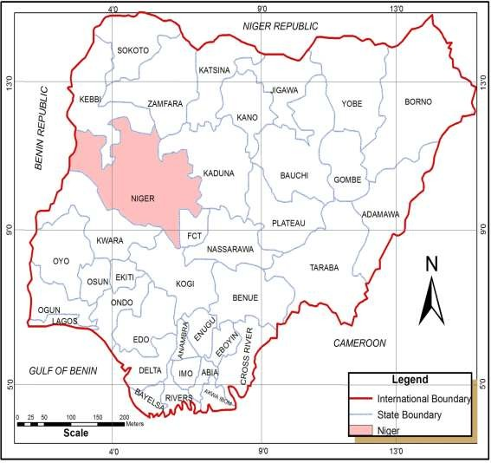

**Figure 1.2: Map of Nigeria Showing Niger State Source:** Federal Ministry of Land and Housing, Abuja

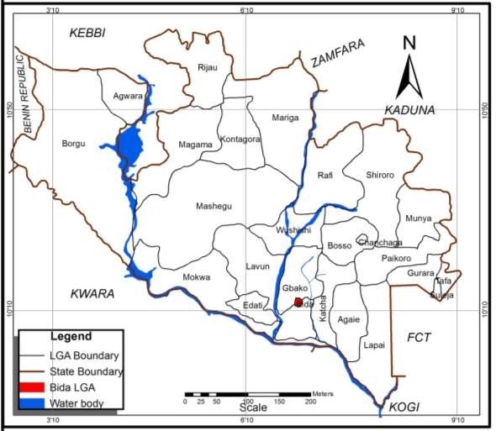

**Figure 1.2: Location of Bida, Niger State**

**Source:** Niger State Ministry of Lands and Housing, 2016

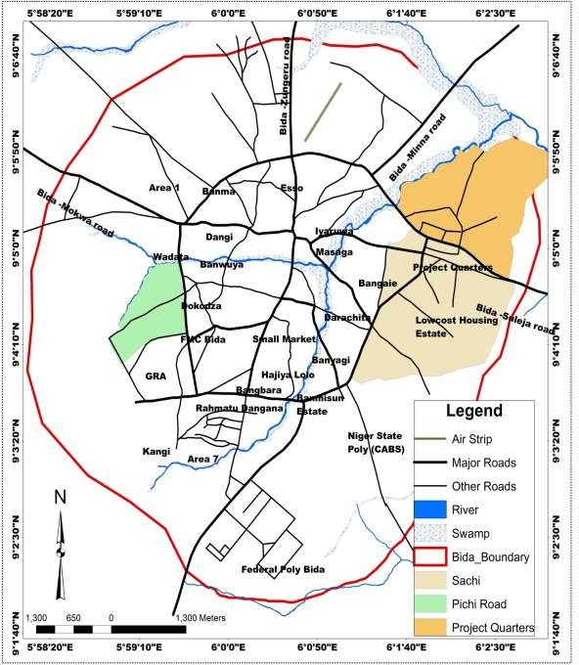

**Figure 1.3: Bida Showing the Study Areas**

**Source:** Niger State Ministry of Lands and Housing, 2016

**CHAPTER TWO**

* 1. **LITERATURE REVIEW**
  2. **Theoretical Framework of the Study**

The study of analysis of factors influencing private residential property development in peri-urban area is hinged upon authoritative work especially in the property development process and upon market and the location of urban land uses especially the residential location theory which will be thoroughly explored hence. Although there is a relationship between personal income, place of work and place of residence, this relationship is subject to various and conflicting interpretations.

* + 1. **Travel Cost Minimization Theory**

It has been argued, by Balchin et al (2001) , that if travel costs to work are nil or very low, households will be prepared to pay the highest rent or prices for accommodation. Through the working of price mechanism, this would imply that the rich live very close to the central business district and the poor live in less expensive outer areas, but the converse is generally true. Low-income earners live close to their work (usually within the inner areas of cities) to minimize their travelling costs, rents are mainly regulated and population density is high. As incomes rise, there has been a tendency for people to live further away from their work in areas of lower density and more expensive housing. Moreover, the outward spread of cities would only be compatible with travel cost minimization if employment was simultaneously decentralized which is not usually the case (Maconnachie & Binns, 2006). The theory is valid to some extent.

* + 1. **Travel Cost and Housing Cost Trade Off Theory**

According to Adjekunhene (2002), a perfect trade off assumes that households of the same income group are prepared to pay, over a period, the same aggregate cost of travel and housing regardless of distance from a city centre. Often, there is not a perfect trade off and therefore, it is assumed that households will attempt to minimize aggregate costs. Thus in the context of commuting into the city centre there will be a migration of households inwards if travel costs rise, but a migration of travel costs outward if travel costs fall. If on the other hand housing costs rise, there will be an out-migration and if they fall, there will be an in-migration (Webster, 2002).

Moreover, although there is an inverse correlation between site values and travel costs around many cities, the same is not true with housing prices and travel costs. High income commuters do not have to trade off travel costs since they can afford both and prefer to live in the commuter belt where they benefit from better environment and space and where they can segregate themselves from lower socio-economic groups; and it may only be within the outer cities that sites are available for the construction of new and expensive houses and apartments (Adesina, 2007). Motorways also make outer locations more accessible than many inner suburban locations from the central business district.

There is a high degree of immobility with respect to changing costs of housing and travel as non-economic reasons may outweigh economic considerations in determining locational choice such as changing jobs, marriage or a change in the size of the family than a changing

relationship between travel costs and house prices. In so far as the middle and high income earners are able to pay their transportation and housing costs, it can be argued that they form the effective demand for private property developers` housing complexes (pasquini & Maconachie, 2005). However, since private developers lean towards construction of apartments along or near to the road and the richer prefer to live in their own homes further away, it can be argue that the middle income earning population is the primary constituent of the effective demand in consideration.

* + 1. **Maximum housing expenditure theory**

Again according to Balchin *et al*. (2001), this theory states that income and the availability of mortgage finance (including the effects of tax allowances) determine residential location. The theory is based on the assumption that house-buyers will attempt to acquire a house as expensive as they can afford with maximum mortgage which they can raise in the area of their choice. Although house-buyers may seek a property over a wide area, transport costs may be a relatively minor consideration and may be variable in relation to the distribution of houses within a specific price range.

Environmental and social factors (and the prospects of capital appreciation) are likely to be a much greater influence over choice. This hypothesis, evolved by Ellis and Stegman implies that there is no overall relationship between income, travel cost/time and place of work and that there is no effective trade-off. Kazungu *et al.,* (2011) suggests that if it is thought that there is a trade-off between housing expenditure and travelling costs, then policy should concentrate on reducing travelling costs to work and/or developing high

density housing in the inner areas of cities. Alternatively, a policy of decentralizing employment would benefit low income householders in the outer suburbs. It is found that environmental conditions influence householders more than travelling costs, policies would need to concentrate on providing satisfactory residential environments rather than on reducing the cost of journey to work (Rakodi, 2002).

* 1. **Concept of Property Development**

Development is the process of carrying out works involving a change in the physical use or in the intensity of an existing use of land or buildings. Development may be a lengthy process from the original conception to the existing use, to survey, design, estimates, preliminary discussion with various public bodies, land acquisitions, to the formal application for planning consent (Ebohon *et al.,* 2002).

Constant appraisal of the cost implications of the scheme and financial arrangements are necessary until successful completion. The success of the development process rests upon a large number of related decisions. Many of these are legal, financial, architectural and constructional but, at the same time, they all have a considerable effect on the conditions of estate management not only during the course, of course, of development but throughout the life of the completed property. According to Ayorinde (2009), the combination of various inputs in order to achieve an output or product; the product is a change of land use and or new or altered building in a process combining land, labor, materials and finance. The end product is unique, either in terms of its physical characteristics and or location.

The property development process involves certain stages from initiation through evaluation, design and costing to the disposal stage. However, availability of land is of critical importance to the development process and must be strictly adhered to. Unlike what obtains in other markets, the product in property implies “change of land use” or an “alteration to an existing building” in a combination with other factors of production – labour; materials and finance (Adair *et al.,* 2007).

Madichie and Madichie (2006) upheld this view when they emphasised on what they ascribed to as the ‘eight stages’ through the development process from initiation to disposal (see Figure 2.1). These stages may not always follow this sequence and may even overlap or repeat. The sequence is typical of a speculative development process where an occupier is not sought until the buildings have been completed (Ebohon *et al.,* 2002).

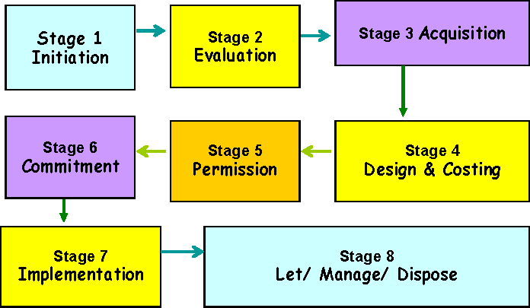

**Figure 2.1: Stage of Property Development Source:** Madichie and Madichie, (2006)

These stages are consistent with Fisher’s (2005) ‘events-sequence of development’ where he synthesized the property development literature and produced a list of 14 phases of development attributable to studies

Fisher’s (2005) case studies on the property development process (drawing upon Grainger Town in the North East of England as a deprived regional economy) focused on embracing all public and private stakeholders and responding to the need. In Nigeria, for example, it is not unusual that feasibility studies are required for any development project and that the key factors to be considered for successful property development projects include physical, legal, economic, technology, finance and government policy initiatives. The process of property development is enhanced by a fairly stable environment monitored by effective legislation and encouraged by related institutions. With the Nigerian situation, however, it is entirely different, as a result of the ever-changing macroeconomic environment (Madichie & Madichie, 2006).

In the 1980s, Nigeria, the meaning of property development to the common man was simply housing (i.e., more choice houses built irrespective of who is building). However, it is still the quest of the common man for a ‘home’ whether fully owned or rented – a situation, which has worsened in recent years. Residential developments are usually not pre-let as they are built first before being let or sold (Ayorinde, 2009). Furthermore, Nigerians have not embraced the idea of pre-let or sold developments because of the inherent volatility of the market – which reinforces the need for the development process sequence in property developments.

Adams *et al.* (2002), underlined the importance of the physical character of sites when analysing the planning process. The site also embodies the power of legal ownership without which there can be no development. At the outset, this rests with the landowner(s), but during the development process, ownership may pass through a number of hands in different forms. Sites, with or without work in progress, may be merged or split, mortgaged or leased. In some circumstances, the ‘developer’ may never own the freehold. The site thus marks the starting point of the process, which is then transformed by construction into the new real estate required at the end (Ebohon *et al.,* 2002). To what extent this is applicable in the Nigerian context warrants a cursory look and some much needed assessment.

* 1. **Concept of Peri-Urban Areas**

Many terms are used to describe the zone between urban and rural areas. Some of these terms are ‘urban periphery’ ‘urban edge’, ‘urban fringe’, ‘urban-rural interface’, among others ‘Peri urban’ is commonly used today, because the region is not a fixed boundary, or a line but rather a ‘zone of transition’ characterized by a mixture of urban and rural resources, uses, systems and patterns. According to Nagot (2008) the peri urban area is a district undergoing demographic changes, characterized by the deconcentration of population and jobs from the city to sparsely populated areas; a process which she describes as ‘peri-urbanization’. To her, peri-urban residential location is a trade-off between housing cost, rising transport cost and a decreased in facilities available in the district of residence with distance from the city (Lanjouw *et al.,* 2001)

Peri-urban areas are not however, for residence alone, but as 5th Regular Meeting in Beirut in 2004 has pointed out, periurban environments mean different things to different people. To the poor, it is the place where it is easier to build shelter and to occupy land for agriculture. For industry; it provides sources of materials essential for urban life, water, bricks, clays, sand and gravel, timber, fuel wood, etc. To the middle class, it provides the potential zone for houses in a rural setting with golf courses and other recreational facilities.

Critics of peri-urban areas are to maintain that the predominance of growth form over the period of time has had significant harmful impacts. It has thwarted mass transit development, separated rich and poor, caused unnecessary travel, consumed fragile land, and generated excessive public expenditures. On the other side, there are those who believe that citizens are getting what they want: single-family homes on large plots, safe communities with good school systems, and metropolitan locations far from the pace and problems of urban populations (Vagneron, 2006).

Lanjouw *et al.* (2001) peri-urban areas have comparatively better infrastructure such as roads, electricity and telephone than their rural counterparts. Therefore, it can be argued that the infrastructural development in the peri-urban areas would create new economic opportunities through creation of business opportunities and new jobs. Consequently, these will reduce poverty in the particular peri-urban areas (that is, former rural). Current peri- urban research is concentrated on assessing peri-urban land use change and environmental impacts, impact on agriculture as well as peri-urban concepts and definitions.

* 1. **Concept of Peri-Urban Land Development**

The term peri-urbanization refers to a process, often a highly dynamic one, in which rural areas located on the outskirts of established cities become more urban in character. This transformation occurs in physical, economic, and social terms, and often in piecemeal fashion. Peri-urban development usually involves rapid social change, as small agricultural communities are forced to adjust to an urban or industrial way of life in a very short time. High levels of in-migration are an important driver of social change (Buxton, 2007). Rapid environmental deterioration and infrastructure backlogs are usually another characteristic of the peri-urban landscape (Maconachie & Binns, 2006). Typically, peri-urbanization is stimulated by an infusion of new investment, generally from outside, including foreign direct investment (FDI).

Peri-urbanization refers to the process in which rural areas located on the outskirts of established cities become more urban in character, in physical, economic and social terms. These peri-urban areas are characterized by fast and unplanned physical growth and development (Adesina, 2007). The unregulated pattern of physical development in these areas has given rise to complex organic urban growth which predominantly expands horizontally. The term peri-urban has been widely used, however, there seems to be no specific definition for the term. Rather, most literature use urban and rural information to build hypotheses for this ‘transitional’ zone. peri-urban areas are areas immediately surrounding cities where farmland is being developed for urban uses and the rural economy is significantly affected by its urban links (Lanjouw *et al.,* 2001).

The peri-urban concept attempts to move understanding beyond definitions considered solely in terms of geographical location and spatial land use. Rather it considers the peri- urban interface (PUI) as the meeting of rural and urban activities – in effect a process rather than a place (Brook and Davila 2000). As the cities expand, the surrounding peri-urban areas also grow. This means that the nature of the peri-urban interface is one of constant change leading to a variety of livelihood and natural resource problems specific to the PUI.

According to Adjekumhene (2002), the concept of ‘development’ is a multidimensional one which can be viewed from many perspectives. He explained “land development” to mean ‘a broad subject encompassing the development of natural areas to redevelopment of occupied land or derelict sites’. land development’ is considered as any kind of physical developments that changes the original use of the land. Broni (2002), observes that land is the basic asset on which the wealth of Ghana is built. Land represents the main form of wealth and the principal source of economic and political power. It is both a natural resource and marketable commodity and therefore should be managed on a sustainable basis. He said land also provides a more attractive source of investment. Indeed, the development of a peri-urban area is an inevitable consequence of urbanisation.

According to Nagot (2008) the peri urban area is a district undergoing demographic changes, characterized by the deconcentration of population and jobs from the city to sparsely populated areas; a process which she describes as ‘peri-urbanization’. peri-urban residential location is a trade-off between housing cost, rising transport cost and a decreased in facilities available in the district of residence with distance from the city.

USAID has described per-urban areas, as areas characterized by uncertain land tenure, inferior infrastructure, low incomes and lack of recognition by formal governments (USAID,2000). It is observed that third world cities are made of two distinct elements, the formal and informal; with the peri-urban areas constituting the informal section where planning and control of development is outside formal public institutions, but where traditions institutions are still strong. Ayorinde (2009) examined peri-urban areas in Ibadan Nigeria points out that peri-urban areas contain substantial but continuous areas of urban development’s mixed with stretches of more extensive and traditional rural areas utilized for agriculture and forestry.

Pasquini and Maconachie (2005) studies on peri-urban areas have been influenced by the optimistic or the pessimistic schools. The optimistic school view peri-urban areas as capable to evolving in a sustainable way promoting urban and rural livelihoods and coping with the pressures and dynamics of population and land use changes. The pessimists however argue otherwise. Simon (2008) peri-urban areas are increasingly attracting middle- class and higher-income people whose lives exhibit lifestyles reflective of inner-city dwellers in a predominantly rural setting.

Allen, Dávila, and Hofmann (2006) have explained that the peri-urban interface comprises a ‘heterogenous mosaic’ of environmental and productive ecosystems working in combination with the prevailing socio-economic peculiarities. This supports the view that peri-urban lands are used for multiple activities. Similarly, peri-urban areas may contain a (dis)organized cluster of residential, commercial, rural-residential, and often varied agricultural uses (Mandere, Ness & Anderberg, 2010).

There are two major driving forces for conversion and transformation of land use in the peri-urban peripheries; these are demands for housing for the growing population (Acheampong & Anokye 2013) and the deteriorating housing conditions and inadequate urban services. Further, another reason for the conversion of land was advanced by Webster, (2002), as being a result of higher economic gains from conversion and transformation to other land uses other than agriculture.

The peri-urban area is an area of mixed rural and urban population and land uses. It begins at the point where agricultural land uses appears near the city and extends up to the point where villages have distinct urban land uses or where some persons, at least from the village community commute to the city daily for work or other purposes. The term is used to describe the built up area just outside the corporation limits of the city (Doos, 2012). The term fringe suggests a borderline case between the rural and urban and actually lies on the periphery of urban areas, surrounding it and distinguishing it from the truly rural countryside.

The peri-urban development has arguments for and against it. However, it is evident that it alters the urban spatial structure to bring about negative externalities that affect the functioning of the city. This implies that causes are to be treated to lessen the negative impacts. The growth of an urban area are being propelled by the economic growth and demographic pressure. The sociocultural characteristics of the context and preferences exhibited, shape growth into growth patterns. In the wake of rapid expansion of

metropolitan cities, the local governments can barely cope up with only operation and maintenance of the existing services within their jurisdiction (Peron & Geoffriau, 2007).

While serviced urban land may indeed be far below the requirement of the urban area, the processes of speculative purchase and land conversion from agriculture to nonagricultural use continue unabated in the peri-urban areas. However, the form this growth takes and its after effects are contributed to the institutional inefficiencies and land management mechanisms within their legal framework. However, the benefits include access to a wider choice of neighborhoods with required levels of stimulus and rest, access to more natural environments, affordable land market and subsidized services. Within the neighborhoods, congestion levels are lower and security is higher.

The process of property development is enhanced by a fairly stable environment monitored by effective legislation and encouraged by related institutions. With the Nigerian situation, however, it is entirely different, as a result of the ever-changing macroeconomic environment. Residential developments are usually not pre-let as they are built first before being let or sold. Furthermore, Nigerians have not embraced the idea of pre-let or sold developments because of the inherent volatility of the market – which reinforces the need for the development process sequence in property developments. It is for the same reason also that the process has long been completely ignored, thus making property development in Nigeria a cause for serious concern and worthy of further investigation

* 1. **Relationship between Peri-Urban Areas and Physical Development**

physical development as the carrying out of building, engineering, mining or other operations in, on, over or under land or the making of any material or substantial change in the use of any building or land. Physical development entails the carrying out of any operation on or any modification to land by mankind in an attempt to create a liveable and comfortable environment. The ultimate objective of physical development is to sustain the improvement in the wellbeing of individuals and bestow benefits on all. At the community level, physical development covers land that has been put to some form of use ranging from a building to an outdoor open space as against land which has not been touched and is covered with ‘bush’. Physical development manifests itself in the form of human activities or land uses in towns and cities.Peri-urban areas, then, may be defined as a transition zone between urbanized land in cities and predominantly agricultural areas (Rakodi, 2002).

The dynamic and integrative nature of peri-urban areas has been a major constraint in outlining physical development (land use) pattern of these areas. While peri-urban areas are multifunctional and interrelated zones with potential for change, the nature of physical development is complex and does not have defined character. It is defined by unauthorized developments, spatial unit zones, non-contiguous developments and land use changes. Other writers have argued that peri-urban areas experience continuous and alarming rate of physical expansion as the population grows (Buxton, 2007).

Moreover, literature on peri-urban dynamics suggests that as urban areas grow, most of the growth occurs at the fringes because of the availability of land at nominal cost (O’Sullivan,

2000). Thus, peri-urban areas, by virtue of their status as dormitory towns, are dominated by moderate and low density residential development. Housing in these areas is segregated by socio-economic class or ethnicity and is usually clustered close to a railway or a major thoroughfare. Other writers have argued that peri-urban areas experience continuous and alarming rate of physical expansion as the population grows (Buxton, 2007).

Moreover, literature on peri-urban dynamics suggests that as urban areas grow, most of the growth occurs at the fringes because of the availability of land at nominal cost (O’Sullivan, 2000). Thus, peri-urban areas, by virtue of their status as dormitory towns, are dominated by moderate and low density residential development. Housing in these areas is segregated by socio-economic class or ethnicity and is usually clustered close to a railway or a major thoroughfare

Another relationship is leap frogging development which is characterized by relatively low- density, noncontiguous, automobile dependent, residential and non residential development that consumes farmland. The farmland is converted into housing, commercial and industrial premises, and infrastructure such as roads, other land-extensive recreational facilities, waste dumps, and sewage treatment plants (Timms, 2006).

Drivers for residential development include the attractiveness of peri-urban land in terms of lower pollution, traffic congestion and a higher level of individual safety. Another driver is that cheap agricultural land can be acquired for the sole purpose of speculation. Obviously, also new land uses associated with the innovations listed previously lead to multiple land- use claims, including urban agriculture (Péron and Geoffriau, 2007), tourism and leisure

facilities, infrastructure, and services provisioning. Peri-urban development is a transition development stage between rural and city. In line with Lanjouw et al. (2001) peri-urban areas have comparatively better infrastructure such as roads, electricity and telephone than their rural counterparts.

* 1. **Drivers of Peri-Urban Development**
     1. **Large-scale investment in Peri-Urban**

Large-scale investment, especially in manufacturing, is usually the trigger that sets off peri- urbanization. Often foreign direct investment is the driver, but in some cases, such as China, domestic investment is more significant. Peri-urban regions are attractive to foreign and domestic investment for two main reasons. First, peri-urban regions offer large, relatively inexpensive, land plots and less hindered freight transportation, especially by truck, in support of just-in-time production processes motivated (Vagneron, 2006).

The need for large land plots is reinforced by investor and government preferences to group manufacturing firms in industrial estates. Industrial estates, especially high quality estates, lessen negative environmental impacts and facilitate government monitoring (Acheampong & Anokye, 2013).

These estates also provide locators with reliable infrastructure, spatial clustering of suppliers, often one-window approval services, and an intermediary, or buffer, in dealing with government officials and service providers. At the same time, peri-urban locations

enable relatively easy access, to a major city that offers advanced producer and personal services, and access to major government decision-makers (Maconachie & Binns, 2006).

* + 1. **Public Policy**

A second driver of peri-urbanization is public policy explicitly supporting dispersal of manufacturing away from core, and even suburban, areas. Generally the underlying rationale for these policies is to ease truck traffic, pollution, and reduce the risk of largescale industrial accidents from manufacturing activities, in the core city (Balchin et al, 2000). Given the large-scale capital spending involved, and thus their political sensitivity, public policies in support of peri-urbanization are often justified in terms of regional development objectives, i.e., dispersal of employment opportunities, and improvements to the quality of urban life associated with de-industrialization of core cities (Timms, 2006).

Public investment support for peri-urbanization usually includes the provision of large scale infrastructure, such as ports, highways, rail links, telecommunication facilities, water reservoirs, container handling facilities, airports, and sometimes, publicly-owned industrial estates. These infrastructure investments, usually delivered by national governments, either through line agencies or state enterprises, are often funded through international borrowing (Rakodi, 2002).

Increasingly, public authorities attempt to attract private investors to fund these large projects through mechanisms such as Build-Operate- Transfer. Industrial location incentive packages are usually also a component of the public policy package. Such incentives

generally take the form of tariff and corporate tax reductions to investors for a specified period of time, and often include an immigration policy component to enable expatriates to work as high level managerial and technical staff in the industries attracted to the peri- urbanizing areas (Acheampong & Anokye, 2013)..

The precise nature of peri-urbanization public policies vary among countries and over time within countries. A striking feature common to most peri-urban areas in developing countries, however, is the lack of sufficient investment in social facilities, city building, and environmental infrastructure. For example, about 88% of cumulative public investment to 1999 in Thailand’s flagship Eastern Seaboard peri-urban region has been utilized for “production support infrastructure”. Frequently high quality regional plans will be developed for peri-urban areas that include proposals for quality community developments, e.g., new towns, but expected private and public sector investment often does not materialize as planned (Péron and Geoffriau, 2007)

.

Public policy to relocate slum settlements out of the center city, or to relocate rural communities for large projects, such as dams, is another important driver of peri urbanization, e.g., in Chongqing, China. Public housing, or suitable sites and services, are not always provided, prompting settlement in fragile, and frequently dangerous, areas, such as wetlands or steep slopes. Relocation decisions rarely take into consideration the availability of employment opportunities and social services. Thus, where population relocation policies are an important factor in the peri-urbanization process, the informal sector tends to play a much more significant role in the peri-urban economy, and access to social services by migrant populations is usually inadequate (Ayorinde, 2001).

* + 1. **Availability of Relatively Inexpensive Labour**

Another driver of peri-urbanization is the availability of relatively inexpensive labor, both in situ, in rural areas that are being enveloped by peri-urbanization, and inmigrants, particularly from poor regions in the countries in question, seeking employment opportunities. Migration dynamics can be either from rural to urban or step-wise from smaller towns and cities. There is wide variation in the mix of migrant versus in situ labor employed in peri-urban areas in different countries with very significant implications for public policy and potential local conflict (Lanjouw *et al.,* 2001).

Because of labor mobility, the importance of local labor availability is less important than the availability of qualified labor at virtually all skill levels within the country in question that is willing to relocate to peri-urban areas. Daily commutes from the urban core are not possible for the vast majority of labor, especially production workers, because of the long travel times (Péron and Geoffriau, 2007). When labor migration to these regions exceeds employment opportunities, as in the case of the extended Manila region, it frequently leads to hyper-urbanization.

* + 1. **Residential Development**

Residential development can also act as a driver of peri-urbanization—this process is termed suburbanization, or in cases where it jumps further out from the core, exurbanization. Middle and upper-middle class groups seeking more space at an affordable price, may purchase, and live in residences in peri-urban areas even though they do not work in the area. This driver is most important where peri-urbanization is found relatively

close to the core city, or where core city personal security concerns (Adjekunhene, 2002). Large property developers, often single-handedly shape peri-urban localities by building large integrated residential complexes comprising several gated housing developments catering to a range of incomes, and new commercial centers to service them. These gated communities, situated in peri-urban green fields, are essentially privately financed new towns (Maconnachie & Binns, 2006).

* + 1. **Migration**

Migration considered as major factor to urban growth dynamics in many cities and has significant contribution to the country’s urban population. The population migration to urban centres has been rural-urban and urban–urban. Several studies including the report on State of Ethiopian Cities revealed that proportion of migrants in urban centres drastically increased. The proportion of migrants in the urban population which was above 40% and more than 73% of the urban migrants were from rural areas (Maconnachie & Binns, 2006), indicating increasingly general level of rural-urban migration. This doesn’t include day labour migrants coming from surrounding rural areas for which data is not available in any of studies done before.

* + 1. **Urban expansion**

As demand for land increased over time, urban centres have been physically expanding their boundaries to surrounding rural and peri-urban areas by including additional land where people did base their lives in agriculture. Urban expansion was practicing in planned and unplanned manner. Most commercial and manufacturing expansions were guided by

the urban expansion planning where as many of the residential settlements were due to urban sprawl from inner cities and informal settlement with people living at outskirts in a built or rented housing occupations (Kazungu, 2011) .

This type of expansion is very common to urban where causes for creation of substantial peri- urban centres around big and medium urban centres. Public led investments at industrial parks in cities expected to physically annex hundreds of hectares along with farmers to boundaries they manage. Commercial activities, infrastructures and services in expansion areas attracts people who were originally agrarian to gradually transform their living styles to urban settings and these causes spatial expansion as well as urban population increments to overall count Madichie & Madichie, 2006).

* 1. **Factors Influencing Physical Development In Peri-Urban Areas**

Physical development in peri-urban areas is influenced by the interplay of several factors. These factors operate to regulate the morphology (size and form), arrangement and intensity of land uses; and are explained in the subsequent paragraphs. Improvement in transport facilities like roads and automobile produce urban decentralization in the outer part of cities as they reduce travel time. This attracts individuals and firms to relocate to the peri-urban areas to take advantage of the availability of large but low land value.

As a result, low land value is another factor. The price of land in peri-urban areas is relatively low compared to the parent city (O’Sullivan, 2000). This attracts people of different income groups to the urban fringe. Other factors include government public policies especially on housing provision has broadened the social groups found in the urban

fringe locations. Moreover, movement of retail services to the peripheries of cities as a result of decentralization of consumers, central area decline and development of automobile has influenced the physical development of these areas (Balchin *et al.*, 2000). The presence of serene and conducive environmental conditions is also a contributing factor to the high rate of physical development in the peri-urban areas.

Additionally, Adesina (2007) argues that the practice of landowners withholding land from the market in order to gain increases in value in the future has influence physical development in the peri-urban areas. The above factors have contributed to peri-urban areas experiencing premature and scattered or noncontiguous physical development which threatens their sustainability. These are useful lessons for investigating the pattern of physical development in peri-urban in Bida as well.

**CHAPTER THREE**

* 1. **RESEARCH METHODOLOGY**
  2. **Research Design**

The study employed quantitative research design. It involves collecting data in order to determine whether and to what degree a relationship exists between two or more variables. Quantitative research will include designs, techniques and measures that produce discreet numerical or quantifiable data. The questionnaires issued to the developers and interviews conducted to obtain relevant information from the construction professionals mainly the Quantity Surveyors and real estate agents were used to gather quantitative data which will be analysed using analytical techniques.

* 1. **Population of the Study**

The study population simply comprises of real estate developers in peri-urban areas of Bida. The developer is expected to provide information on the types of real estate development in peri-urban of the area of the town, to also provide information on available government infrastructure that motivate their development and also information on the factors that influence the developers choice of development in peri-urban area of Bida.

* 1. **Sources of Data**
     1. **Primary sources of data**

Primary data comprises of raw information collected through questionnaires from developers in the town, physical survey and interview. Primary data for this study

comprises of the data on responses on the types of real estate development in peri-urban of the area of the town, available government infrastructure that motivate their development and the factors that influence the developers choice of real estate development in peri-urban of Bida town.

* + 1. **Secondary source of data**

These include materials from published and unpublished sources. The secondary data consulted includes the published material on land uses in the areas, planning document of the peri-urban area of the Bida, and information on published journal, conference proceedings, and textbooks and other relevant materials on the subject matter.

* 1. **Sampling Techniques**

Simple random sampling technique was used to select developers in the study areas, especially the developers in Bida who are conversant about the development pattern of peri-urban area of Bida. Simple random techniques was selected on the ground that every developer has equal opportunity to be selected. The people selected for the study comprises of the developers who built in the peri-urban area of the town. The study select 237 land owners through random sampling technique because every land owner has equal right of been selected and because of the homogenous nature of the respondents.

**Sample size:** the sample size for the study population (650 individual developers in peri- urban area- Urban Development Board) was determined using Yamma’s formular model expressed as follows:

𝑛 = 𝑁 1+𝑁(𝑒)2

Where;

n= Sample size

N= Sample population e= confidence level

The population of 650, the sample size is derived at 237 for the study. The study administered 237 questionnaires to private land owners through random sampling technique and 235 returned questionnaires were analyzed.

* 1. **Method of Data Collection**

This study utilized two different methods of data collection and the essence is to ensure accuracy and genuine data for the study and with the corresponding detailed of data analysis. The methods of collection involve the use of observation and field survey, interview and administration of questionnaire, as explained below:

* + 1. **Questionnaires:** A structured or closed ended questionnaire method is designed to collect relevant information from real estate developers in Bida area of Niger state. The questionnaires were randomly distributed to the respondent.
    2. **Physical Survey:** this is a field observation where the researcher observed the area and pick the details in the area and available infrastructure. Taking photographs of the available infrastructure in the area.
    3. **Geographical Information System (GIS)**: this method is employed to pick coordinates of the private property development across the peri-urban area of Bida. The

ArcGIS software was employed for spatial analysis to geo-reference the satellite imageries and digitize private housing developments for the yesr 2007 and 2018 in the three study area.

* 1. **Method of Data Analysis analytical techniques**

The method of data analysis for the study is both descriptive and inferential methods. Descriptive method of analysis featured the mean average, percentages and other measure of central tendencies and likert scaling. Inferential method of analysis used chi-square test.

* + 1. **Objective one:** to identify the types of private real estate development in Bida. This objective require the charts and percentage table to present the types of property development in peri-urban.

Objective two: to examine spatial distribution of real estate development in peri-urban area of Bida. This require the use geographic information system to examine the trend of development.

* + 1. **Objective two**: to examine the drivers of peri-urban development. this objective requires the both percentage distribution of most most responded drivers and five-likert scale analysis of relative important index of the most important factors.
    2. **Objective three**: (to assess factors influencing private real estate development in peri-urban area of Bida). This objective required mean and factor analysis of variable rated on five-point liker scale. This method helped to reduce the factors into group and named the identified group factors.
    3. **Objective Four**: (to examine the spatial distribution of private real estate development in peri-urban development). this objective required the use geospatial techniques to analyse the development of real estate in peri-urban area of Bida

**Mean:** The mean is the measure of central tendency which is used to determine the average of the weighted mean of data, it is calculated thus:

𝑋̅ = ∑(𝐹𝑊)

𝑁

Where 𝑋̅ = mean, F- is the frequency, W- weight

* + - 1. **Chi-square Test:** the test is adopted to test relationship in respondents responses to the factors influencing peri-urban development. It is also adopted to test if the respondents are related in their responses towards factors influencing peri-urban development.

×2= ∑(𝑂−𝐸)2

∑ 𝐸

Where O - is the observed frequency and E - is the expected.

* + - 1. **Calculation of growth rate:**

𝐺𝑟𝑜𝑤𝑡ℎ 𝑅𝑎𝑡𝑒 =

𝐶𝑢𝑟𝑟𝑒𝑛𝑡 𝑦𝑒𝑎𝑟 − 𝐼𝑛𝑖𝑡𝑖𝑎𝑙 𝑦𝑒𝑎𝑟

𝐼𝑛𝑖𝑡𝑖𝑎𝑙 𝑦𝑒𝑎𝑟

× 100

**Table 3.1: Data Requirements, Sources and Methods**

**Objectives Method of data Analysis**

To identify the types of private real

estate development in Bida Descriptive

**Analytical techniques**

Simple chart Descriptive

To examine the real estate supportive infrastructure in the peri- urban area of Bida

Descriptive/inferential

Mean descriptive/chi square

To assess the factors influencing private real estate development in peri-urban area of Bida

Descriptive/inferential

Mean/factor analysis

To examine the spatial distribution of private real estate development in peri urban area of Bida

Spatial analysise ArcGIS

**CHAPTER FOUR**

* 1. **RESULTS AND DISCUSSION**
  2. **Introduction**

The chapter presents the result of the study using both descriptive and inferential analysis. The chapter first present the socio-economic or demographic information of peri-urban dwellers, major human activities and analysis of the drivers of peri-urban development and analysis of factors influencing peri-urban development is also presented. The chapter also presents the summary of findings.

* 1. **Socioeconomic Characteristics of Peri-Urban Dwellers**
     1. **Demographic Characteristics**

**Table 4.1: Demographic Information of Respondents**

Demographic Information Frequency Percent Valid

Percent

Cumulative Percent

status

|  |  |  |  |  |
| --- | --- | --- | --- | --- |
| Male | 201 | 85.5 | 85.5 | 85.5 |
| Gender Female | 34 | 14.5 | 14.5 | 100.0 |
| Total | 235 | 100.0 | 100.0 |  |
| 18-30year | 14 | 6.0 | 6.0 | 6.0 |
| Age 31-40year | 90 | 38.3 | 38.3 | 44.3 |
| 41-50year | 84 | 35.7 | 35.7 | 80.0 |
| 51-60year | 33 | 14.0 | 14.0 | 94.0 |
| Above 61years | 14 | 6.0 | 6.0 | 100.0 |
| Total | 235 | 100.0 | 100.0 |  |
| Single | 42 | 17.9 | 17.9 | 17.9 |
| Marital Married | 183 | 77.9 | 77.9 | 95.7 |
| Widow | 10 | 4.3 | 4.3 | 100.0 |
| Total | 235 | 100.0 | 100.0 |  |

Source: field survey, 2019

Demographic information of respondents presented in table 4.1showed that 85.5% majority of the respondents were male, 38.3% majority of the respondent falls within the age bracket and 77.9% majority of respondents were married men and women..

* 1. **Types of private real estate development in Bida Peri-Urban**

This objective requires the type of real estate development in Bida, peri-urban areas. The objective also comprised both income level ownership and the nature of ownership of real estate development

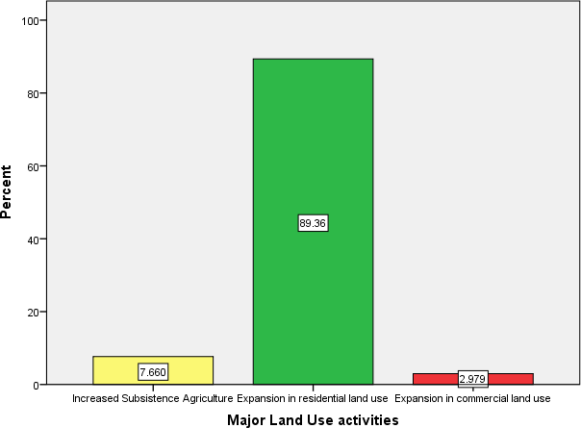

**Figure 4.1: Major Type of Real Estate Land Use Development**

Source: field survey, 2019

The result of major land use activities in peri-urban area of Bida presented in figure 4.2 showed that 89.36% majority of peri-urban dwellers involved in residential land use

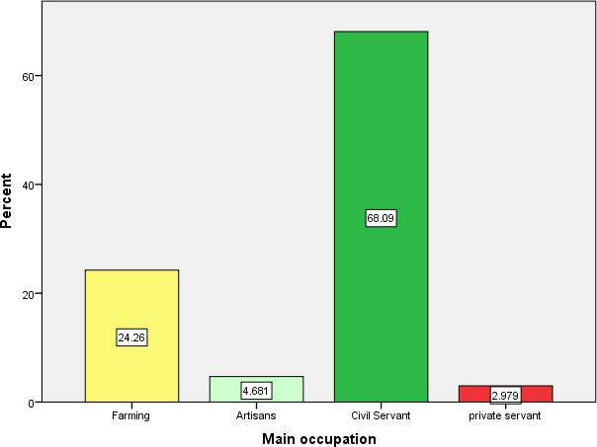activities, 2.98% of peri-urban dwellers involved in commercial land use activities and while 7.66% involved in subsistence agriculture.

**Figure 4.2: Main Occupation Of Peri-Urban Dwellers in Bida**

Source: field survey, 2019

The main occupation of peri-urban dwellers in Bida presented in figure 4.1 revealed that 68.09% of the respondent were civil servants. 24.26% were farmers, 4.68% and 2.97% respectively were artisan and private servants.

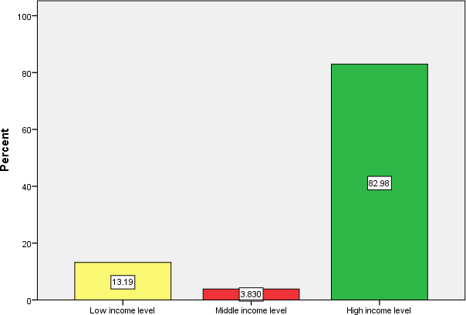

**Figure 4.3: Income level of Peri-urban Dwellers in Bida**

Source: Field Survey, 2019

The income level of respondent presented in figure 4.3 revealed that 82.98% of urban dwellers fall within the high income group, 13.19% and 3.83% fall within the low and middle income respectively. The implication is that majority of peri-urban dwellers in Bida are high income earners who moved out congested urban area to peri-urban in to have open space for ventilation easthetics and good atmosphere.

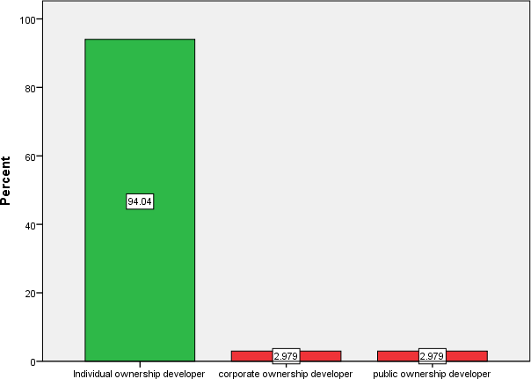

**Figure 4.4: Nature of land ownership developer in Per-Urban of Bida**

Source: Field Survey, 2019

The nature of land ownership in Bida is presented in Figure 4.4. 94.04% majority of urban dweller develop their own property individually represents. While 2.97% for corporate and public ownership each. This further indicates that individual property development is most predominant type of ownership of property in peri-urban area of Bida.

**Table 4.2: Conditions of Peri-Urban Development Area of Bida**

|  |  |  |  |
| --- | --- | --- | --- |
| Condition of Peri-urban N | Sum | Mean | RII |
| Rapid but unplanned growth with 235 | 640.00 | 2.723 | 90 |
| Unplanned and accelerated development of 235 | 629.00 | 2.676 | 89 |
| Decrease in rural primary activities: 235 | 627.00 | 2.668 | 88 |
| Increase in demand for residential housing 235 | 634.00 | 2.697 | 90 |
| Poor accessibility in Peri-urban Area 235 | 639.00 | 2.677 | 89 |
| Lack lay-out plan for development 235 | 620.00 | 2.593 | 86 |
| Valid N (listwise) 235 |  |  |  |

inadequate service infrastructure residential and urban commercial uses

in the area

Source: Field Survey, 2019

The nature of peri-urban area of Bida presented in table 4.2 showed the result of 3-piont likert scaling to rate condition of peri-urban area. the study revealed that there was rapid and unplanned growth with inadequate service infrastructure around peri-urban area of bida and the response rate is given at relative 90% importance. Increase in demand for residential development characterized by peri- urban area of Bida with adequate service infrastructure and the response rate is give at relatively 90%. Unplanned and accelerated development of residential and small commercial land uses characterized the peri-urban area at relatively 89% response rate and poor accessibility to peri-urban development characterized the area at given 89% response rate. Decrease in rural primary activities also characterized the peri-urban area of Bida at a given response rate 88%. Poor lay out plan for development is also characterized the area at 88% response rate.

* 1. **The Drivers of Peri-Urban Development in Bida**

This objective examines the major activities in peri-urban areas that propel development of peri-urban areas. These activities are those that triggered development in peri-urban areas.

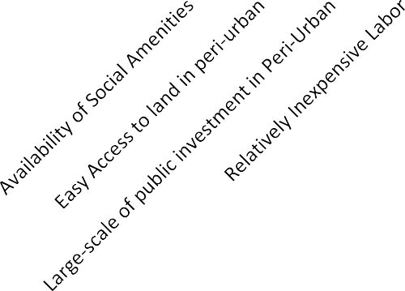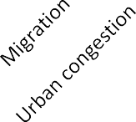

100

%

90

80

70

60

50

40

30

20

10

0

60

20

10

5

3

2

Major Factors Driving Peri-urban

Development

**Figure 4.5: Major Drivers of Peri-Urban Development of Bida**

Source: field survey 2019

The major factors driving peri-urban area of Bida is presented in Figure 4.5. the result revealed that 60% majority of peri-urban development is influenced by urban congestion. Large scale of public investment in peri urban area of Bida such as federal polytechnics influenced peri-urban development at 20% and availability of social amenities also characterized driver of peri-urban development at 10% response rate.

**Table 4.3: Drivers of Peri-urban Movement in Bida**

|  |  |  |  |  |  |  |  |
| --- | --- | --- | --- | --- | --- | --- | --- |
| Drivers | N | Sum | Mean | RII | Rk | Chi.sq | p-value |
| Availability of Social Amenities | 235 | 1083 | 4.63 | 0.926 | 3 | 19.04 | 0.000 |
| Easy Access to land | 235 | 650 | 2.76 | 0.550 | 6 |  |  |
| Large-scale of public investment in | 235 | 1100 | 4.68 | 0.936 | 2 |  |  |
| Peri-Urban |  |  |  |  |  | | |
| Relatively Inexpensive Labor | 235 | 894 | 3.80 | 0.762 | 5 | | |
| Migration | 235 | 964 | 4.10 | 0.820 | 4 | | |
| Urban congestion | 235 | 1104 | 4.70 | 0.940 | 1 | | |
| Valid N (listwise) | 235 |  |  |  |  | | |
| Source: Field Survey, 2019 |  |  |  |  |  | | |

The descriptive analysis of drivers of peri-urban development is presented in table 4.3. the result revealed the relationship of the factors driving the peri-urban development in Bida and relative importance index of these factors. The variables were measured on five-point likert scale (Strongly agree, agree, indifferent, disagree and strongly disagree). Urban expansion is ranked first with 94% relative important drivers, this is followed by large scale investment in peri-urban is ranked second with 93.6% relative importance and followed by availability of social amenities in the peri-urban development area at 92.6%. The result of chi-square test statistics (19.04) statistically significant at p-value 0.000 less than 0.05 level of significance, this indicates that there is significant relationship between the respondents’ opinion on the factors or drivers of peri-urban development.

**4.4 Factor Influencing Peri-Urban Development in Bida**

**Table 4.4: Factor Influencing Peri-Urban Development in Bida**

|  |  |  |  |
| --- | --- | --- | --- |
| **Factors** | **N** | **Sum** | **Mean** |
| State of the Roads Infrastructure | 235 | 924.00 | 3.9319 |
| Drainage Service | 235 | 873.00 | 3.7149 |
| Waste disposal management in peri-urban area | 235 | 921.00 | 3.9191 |
| Condition of electricity and transmission networks | 235 | 940.00 | 4.0000 |
| Condition of telecommunication network in peri- | 235 | 935.00 | 3.9787 |
| urban area  Availability of Social Amenities | 235 | 802.00 | 3.4128 |
| Easy Access to land | 235 | 841.00 | 3.5787 |
| Large-scale of public investment in Peri-Urban | 235 | 872.00 | 3.7106 |
| Relatively Inexpensive Labor | 235 | 877.00 | 3.7319 |
| Migration | 235 | 856.00 | 3.6426 |
| Urban crime | 235 | 866.00 | 3.6851 |
| Poor planning of urban area | 235 | 908.00 | 3.8638 |
| High urban rent | 235 | 774.00 | 3.2936 |
| Urban congestion | 235 | 846.00 | 3.6000 |
| Deteriorating livelihood in urban area | 235 | 797.00 | 3.3915 |
| Poor climate change in urban area | 235 | 770.00 | 3.2766 |
| Low cost development in peri-urban area | 235 | 930.00 | 3.9574 |
| Low market price of agricultural products | 235 | 881.00 | 3.7489 |
| Water supply services | 235 | 921.00 | 3.9191 |
| Availability of green spaces for healthy life | 235 | 944.00 | 4.0170 |
| Security | 235 | 949.00 | 4.0383 |
| Pollution | 235 | 898.00 | 3.8213 |
| Valid N (listwise) | 235 |  |  |
| Source: Field Survey, 2019 |  |  |  |

The result of factors influencing peri-urban development in Bida presented in table 4.4. the descriptive analysis of five-point likert scale. The identified factor has the mean response rate that are higher than 3.00 minimum bench mark. This revealed that the response rates of the peri-urban dweller is higher than 60% indicating that all the identified factors influence peri-urban development in Bida. The analysis of principal component was carried out to identified the most highly emphasized factors is presented in subsequent tables.

**Table 4.5: Total Variance Analysis of factors Influencing Peri Urban Development**

**Compone Initial Eigenvalues Extraction Sums of Squared Loadings Rotation Sums of Squared Loadings**

|  |  |  |  |  |  |  |  |  |  |
| --- | --- | --- | --- | --- | --- | --- | --- | --- | --- |
| **nt** | Total | % of  Variance | Cumulative  % | Total | % of  Variance | Cumulative  % | Total | % of  Variance | Cumulative  % |
| 1 | 5.469 | 24.857 | 24.857 | 5.469 | 24.857 | 24.857 | 2.509 | 11.403 | 11.403 |
| 2 | 2.577 | 11.713 | 36.570 | 2.577 | 11.713 | 36.570 | 2.388 | 10.857 | 22.259 |
| 3 | 1.934 | 8.789 | 45.360 | 1.934 | 8.789 | 45.360 | 2.347 | 10.666 | 32.926 |
| 4 | 1.770 | 8.044 | 53.404 | 1.770 | 8.044 | 53.404 | 2.287 | 10.395 | 43.320 |
| 5 | 1.480 | 6.728 | 60.132 | 1.480 | 6.728 | 60.132 | 2.064 | 9.380 | 52.701 |
| 6 | 1.294 | 5.882 | 66.014 | 1.294 | 5.882 | 66.014 | 1.997 | 9.077 | 61.778 |
| 7 | 1.124 | 5.110 | 71.124 | 1.124 | 5.110 | 71.124 | 1.736 | 7.891 | 69.669 |
| 8 | 1.105 | 5.021 | 76.145 | 1.105 | 5.021 | 76.145 | 1.425 | 6.476 | 76.145 |
| 9 | .978 | 4.446 | 80.591 |  | | | | | |
| 10 | .917 | 4.170 | 84.761 |
| 11 | .757 | 3.443 | 88.204 |
| 12 | .649 | 2.949 | 91.153 |
| 13 | .587 | 2.667 | 93.820 |
| 14 | .470 | 2.137 | 95.957 |
| 15 | .342 | 1.555 | 97.512 |
| 16 | .294 | 1.337 | 98.848 |
| 17 | .171 | .777 | 99.625 |
| 18 | .056 | .255 | 99.880 |
| 19 | .016 | .072 | 99.952 |
| 20 | .007 | .032 | 99.984 |
| 21 | .003 | .016 | 100.000 |
| 22 | 8.348E- | 3.794E-016 | 100.000 |
|  | 017 |  |  |

Source: computed from table 4.4

53

The cumulative variance of the eight the most correlated factors influencing peri-urban development in Bida presented in Table 4.5. The eigen value in the table, and the total under eigen value revealed the amount of total variance in the original variable accounted for by each of the components. The variance which is simply the ratio of variance accounted for by each of the component to the total variance of the variables. The analysis required the first eight components to be extracted and they are regarded the most emphasized factors influencing peri-urban development. The extraction of sum of the square loadings in the second section explained the variability in original 21 variables. The extracted components explained 76.145% variability in the original variables. therefore this study considerably reduce the data by selecting the extracted components as the most emphasized factors influencing peri-urban development with the minimum of 23.85% loss of information. This further indicates that the outlined factors are through representative of entire factors influencing peri-urban development.

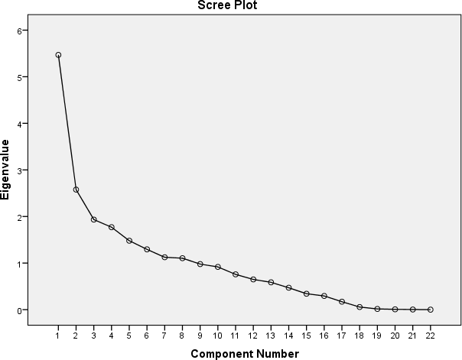

**Figure 4.6: Scree Plot of Components Analysis of Factors Influencing Peri-Urban Development**

Source: computed from table 4.4

The result of scree plot analysis factors influencing peri-urban development is presented in figure 4:10 showed eigenvalue of each component of the initial solution. The extraction of four components is done at slope and contributed about 76.145% cumulative variance, and therefore the components at shallow slope contribute little to the solution about 23.85%. The last drop occurs between components sixth and seventh components; therefore using the first six component is an easy choice.

**Table 4.6: Loading Analysis of Factors Influencing Peri-Urban Development**

|  |  |  |  |
| --- | --- | --- | --- |
| **Factors** | **Factor**  **loading** | **Eigen value** | **% of**  **variance** |
| Factor 1: Neighborhood factor  electricity and transmission networks | 0.874 | 5.469 | 24.857 |
| availability of green spaces | 0.883 |  |  |
| roads infrastructure | 0.611 |  |  |
| Low cost development | 0.61 |  |  |
| Factor 2: environmental and market factor Drainage service | 0.946 | 2.577 | 11.713 |
| low market price of agricultural product | 0.939 |  |  |
| Pollution | 0.606 |  |  |
| Factor 3: Physical infrastructure factors  Easy Access to land | 0.876 | 1.934 | 8.789 |
| Large-scale of public investment in Peri- Urban  Availability of Social Amenities | 0.842  0.652 |  |  |
| Factor 4: communication and security telecommunication network | 0.902 | 1.770 | 8.044 |
| Security | 0.901 |  |  |
| Factor 5: Urban factors Urban congestion | 0.85 | 1.480 | 6.728 |
| Deteriorating livelihood in urban area | 0.792 |  |  |
| High urban rent | 0.773 |  |  |
| Factor 6: Community Service Factor waste disposal management | 0.892 | 1.294 | 5.882 |
| water supply services | 0.892 |  |  |
| Factor 7: migration and low labor price Migration | 0.858 | 1.124 | 5.110 |
| Relatively Inexpensive Labor | 0.79 |  |  |
| Factor 8: climate and planning factor poor climate change in urban area | 0.686 | 1.105 | 5.021 |
| Urban crime | 0.658 |  |  |
| Poor planning of urban area | 0.641 |  |  |
| Source: field survey, 2019 |  |  |  |

The result of analysis of factors influencing peri-urban development is presented in table

4.4 revealed that the eight factors that were loaded constituted about 76.145% variance in the factors influencing peri-urban development. The cut-off point for this study is taken 0.5 and above as general rule of thumb applied. The most important Factor one (1) is Neighborhood factor and it explained about 24.857% variance in the determination of factors influencing peri-urban development. The factor (2) is environmental and market factor and it explained 11.71% variance across 13 factors influencing peri-urban development, Factor (3) is named as Physical infrastructure factors, and it explained 8.79% variance in the determination of factors influencing peri-urban development. Factor four

(4) is named as communication and security, and it explained 8.04% variance in the determining the factors influencing peri-urban development. Factor (5) is named as urban factors, and it explained 6.72% variance in the determination of factors influencing peri- urban development. Factor (6) is named as Community Service Factor, and it explained 5.88% variance in the determination of factors influencing peri-urban development. Factor

(7) is named as migration and low labor price, and it explained 5.11% variance in the determination of factors influencing peri-urban development. Factor (8) is named as climate and planning factor, and it explained 5.02% variance in the determination of factors influencing peri-urban development.

* 1. **Spatial Distribution of Private Real Estate Development in Peri Urban area of Bida**

This objective requires geospatial analysis of the peri-urban real estate development from 2007 to 2018. The study requires the analysis of physical development that has occurred between 2007 to 2018.

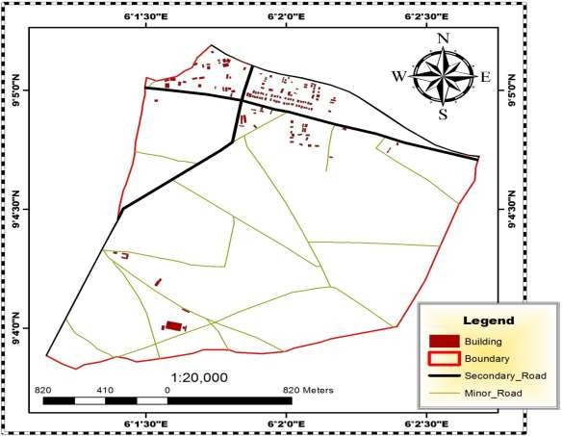

**Figure 4.5: Sachi Peri-Urban Area of Bida, 2007 Source: Google Imagery in 2007**

The Figure 4.5 showed the Sach peri-urban area of Bida in 2007. This area is characterized with subsistence agriculture and with single government structure in the middle. The area marked red represented boundary of Sachi peri-urban area of Bida without development in 2007.

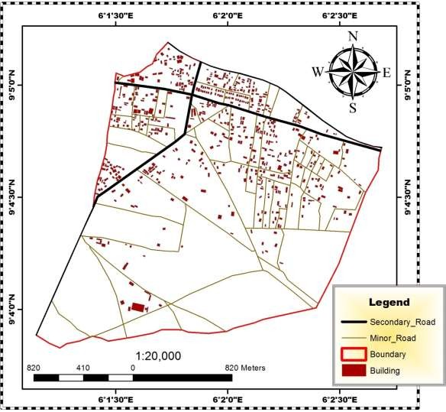

**Figure 4.6: Sachi Peri-Urban Area of Bida, 2018 Source: Google Imagery in 2018**

The plate 4.6 showed the later development of Sachi peri-urban area of Bida after a period of 11years. This area witnesses new developments and majorly characterized by residential development. The new development is concentrated along the major road. This indicates that peri-urban development is characterized by presence of road infrastructure.

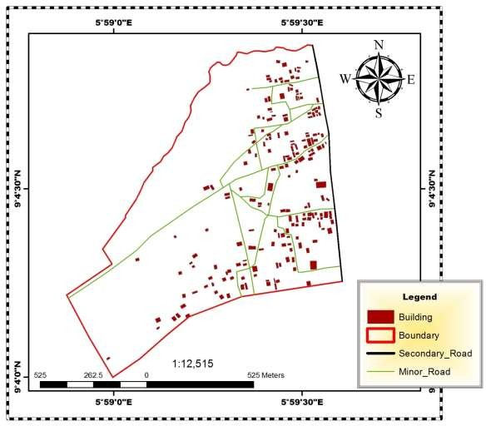

**Figure 4.7: Pichi Road Peri-Urban Area, 2007 Source: Google Imagery in 2007**

The Figure 4.7 revealed pichi peri-urban area of Bida in 2007. The area is characterized existence of transportation route. The area showed a little scattered development along the major route. The area comprised of subsistence agriculture along with little residential development.

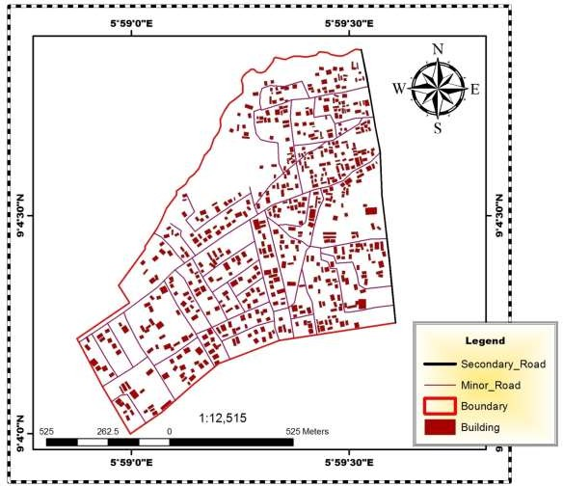

**Figure 4.8: Pichi Road Peri-Urban Area, 2018 Source: Google Imagery in 2018**

Figure 4.8 showed the peri-urban development of Bida in 2018. The area showed a new development after 11years and this development characterized by more of residential development than agriculture.

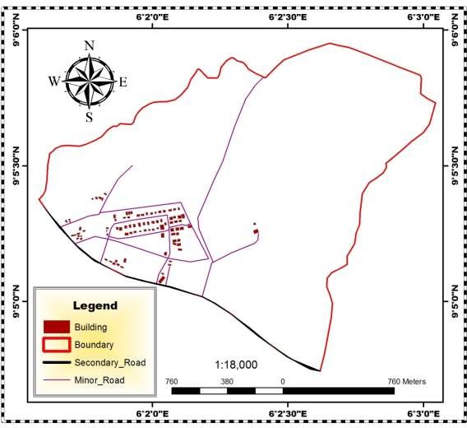

**Figure 4.9: Project Quarters Peri-Urban Area, 2007 Source: Google Imagery in 2007**

The Figure 4.9 showed the area view of peri-urban area of Bida in 2007. This area is characterized with subsistence agriculture and with little or no development. The area marked red represented the peri-urban area of Bida without development in 2007.

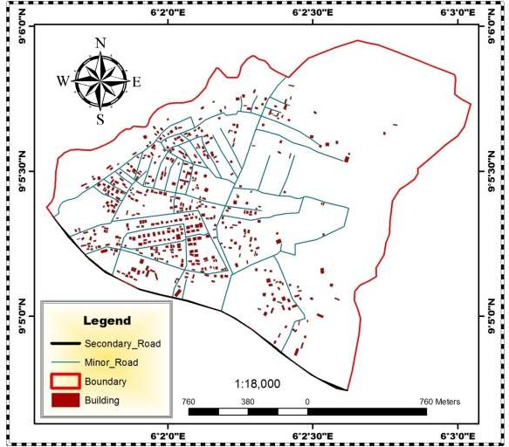

**Figure 4.10: Project Quarters Peri-Urban Area, 2007 Source: Google Imagery in 2007**

The Figure 4.10 showed the later development of peri-urban area of Bida after a period of 11years. This area constitutes new development and majorly characterized by residential development. the new development is concentrated along the major road. This showed that peri-urban development is characterized by presence of road infrastructure.

**Table 4.7: Growth Rate of Private Real Estate Development in Peri-urban Areas of Bida**

**Number of Buildings**

Source: Attribute Table of Maps, 2007 and 2018

|  |  |  |  |
| --- | --- | --- | --- |
| **Peri-Urban** |  |  | **Growth Rate** |
|  | **2007** | **2018** |  |
| Sachi | 147 | 625 | 325.17% |
| Pichi Road | 195 | 608 | 211.79% |
| Project Quarters | 91 | 500 | 449.45% |

* 1. **Summary of findings**
     1. The study revealed that residential land use constitutes bulk of peri-urban land use activities. It was also discovered that 89.36% peri-urban dwellers constituted the bulk of residential land owners in the area. the study further discovered about 82.9% the bulk residential land owners in peri-urban area of Bida constituted high income group who left congested urban area in seeking more open space for health, esthetic and conducive environment.
     2. The result further analyses the nature of peri-urban area and discovered that peri- urban has been characterized by rapid and unplanned growth with inadequate service infrastructure, Unplanned and accelerated development of residential land uses, poor accessibility, Decrease in rural primary and lack lay out plan for development .
     3. The study identified three major drivers of peri-urban development to includes urban expansion, large scale public investment and availability of social amenities and were ranked in order of relative importance 94%, 93.6% and 92.6%

respectively. the respondents’ opinion revealed a high level of agreement and the opinions were significantly related.

* + 1. The study discovered that 76.145% of variability in the original twenty-two (22) factors influencing peri-urban development constituted about eight the most emphasized factors such neighborhood factor, environmental and market factor, physical infrastructure factors, communication networks and security, urban factors, migration and low labor price, community service factor and climate and planning factor.
    2. The study found that there is a continuous sprawling in residential land use development in peri-urban area of Bida. Also the spatial analysis of the area revealed that there is an overlapping function in land use where agricultural land use area continues to be substituted for residential land use. the major bulk residential development is concentrated along Pichi road, making the development to occur along transportation route.

**CHAPTER FIVE**

* 1. **CONCLUSION AND RECOMMENDATION**
  2. **Conclusion**

The analysis of private estate development in Bida has been to unravel the pattern of residential development across the peri-urban area of Bida. The study understood that residential land use has an overriding function over and above agricultural land use over given period. residential land use continues sprawling across the peri-urban areas, deficiency characterized by inadequate drivers of peri-urban development area of Bida is characterized by unplanned growth with inadequate service infrastructure and poor accessibility become the order of the day. Also availability of social amenities, large scale of public investment and urban congestion in Bida urban area has been affirmed as major drivers of peri-urban development.

The study further identified that urban congestion as a major factors driver of peri-urban development, this is as result of poor urban planning, not only that large scale of public investment such location of federal poly Bida is driver of peri-urban development other government investment in peri-urban is mass housing development in the peripheral are of the town. Social amenities such Development of layout plans in peri-urban and opening up new untarred road has also been responsible for peri-urban development of Bida. Finally the implication of this study is that urban sprawl will continue to emerge unless certain factors that influence peri-urban development are addressed such factor to address includes neighborhood factor, environmental and market factor, physical infrastructure factors,

communication networks and security, urban factors, migration and low labor price, community service factor and climate and planning factors.

* 1. **Recommendations**
     1. Base on the analysis of the study, the growing sprawl in peri-urban area required urgent attention, and it is therefore recommended that building specification and development of master plan that specified various land uses.
     2. It is thus imperative to ensure adherence to the laid-down physical planning regulations and schemes which regulate the boundaries of land uses and land covers through zoning. Also, public planning policy for sustainable urban area should established in order to discourage outward movement to peripheral should be enacted
     3. The study therefore recommends that government should further provide site and services facilities available in peri-urban area to avoid future sprawl in peripheral area of the town. Also government expenditure in such as road construction, drainages, bridges and heavy industrial and housing projects.
     4. Also Bida urban development Board should saddled with responsibility Monitoring the peri-and control urban physical development, this is because, individual property development without government supervision can lead to haphazard development.

**REFERENCE**

Adair, A., Berry, J., Hutchison, N. and Mcgreal, S. (2007) ‘Attracting institutional investment into regeneration: necessary conditions for effective funding’, *Journal of Property Research*, Vol. 24, No. 3, September, pp.221–240.

Adams, D., Disberry, A., Hutchinson, N. and Munjoma, T. (2002) ‘The impact of land management and development strategies on urban redevelopment prospects’, in Guy, S. and Henneberry, J. (Eds): *Development and Developers: Perspectives on Property*, Blackwell, Oxford.

Adesina A, (2007) *Socio-Spatial Transformations and the Urban Fringe Landscape in Developing Countries*, Nigeria: IbadanUniversity Press.

Adjekumhene Ishmael, 2002 The Impact Of Development On The Environment. Paper presented at the Annual Seminar of the general practice division of Ghana institution of surveyors on 19septenber 2002. KNUST, Kumasi.

Allen, A., Dávila, J. D., & Hofmann, P. (2006). The Peri-urban Water Poor: Citizens or Consumers? *Environment and Urbanization, 18*(2), 333-351.

<http://dx.doi.org/10.1177/0956247806069608>

Acheampong, R. A., & Anokye, P. A. (2013). Understanding Households’ Residential Location Choice in Kumasi’s Peri-Urban Settlements and the Implications for Sustainable Urban Growth. *Research on Humanities and Social Sciences, 3*(9), 60- 70.

Ayorinde, D. (2009), Controlling development at the urban fringe: A case study of Ibadan, Nigeria, In Urban Management and Urban Violence in Africa, Vol 2(2), 22-43.

Balchin, P.N., Isaac, D. & Chen, J. J. (2000) Urban Ecoomics, A Global Perspective, United States: Palgrave Macmillan.

Broni T. H,, 2002 Keynote address delivered at the Annual Seminar of the general practice division of Ghana institution of surveyors on 19septenber 2002. KNUST, Kumasi.

Brook R. and Davila J. (2000) The Peri Urban Interface. A Tale of Two Cities. Gwasg.

Francon, Bethesda, Wales.

Buxton, M. (2007) *Change in Peri-urban Australia: Implications for Land Use Policies,*

Australia: Department of Environment and Heritage Publishing Unit.

Doos, M. H., “Health and Peri-urban Natural Resource Production”, Environment and Urbanization, Vol. 10, No. 1, p. 89-106.

Ebohon, O., Field, B. and Mbuga, R. (2002) ‘A conceptual analysis of the problems associated with real property development in sub-Saharan Africa’, *Journal of Property Management*, Vol. 20, No. 1, pp.7–22.

Fisher, P. (2005) ‘The property development process: case studies from Grainger town’,

*Property Management*, Vol. 23, No. 3, pp.158–175.

Kazungu,R., Gitau, J., Gichuru, P., (2011*). On the Planning Challenge of Karen and Ongata Rongai Peripheral Locations*, Nairobi: 47th ISOCARP Congress.

Lanjouw P, Quizon J, Sparrow R (2001). Non-agricultural earnings in peri-urban areas of Tanzania: evidence from household survey data. Food Policy, 26: 385-403.

Maconachie RA, Binns T (2006). Sustainability under threat? The dynamics of environmental change and food production in peri-urban Kano, Northern Nigeria. Land Degrad. Dev. 17: 159-171.

Madichie M & Madichie C,(2006). Changing patterns in the urbanized countryside of Western Europe. Landscape Ecol. 15: 257-270.

Mandere, M. N., Ness, B., & Anderberg, S. (2010). Peri-urban development, livelihood change and household income: A case study of peri-urban Nyahururu, Kenya. *Journal of Agricultural Extension and Rural Development, 2*(5), 73-83.

Muiruri, G.W., (2001). *An Analysis of Real Property Development Changes in Peri- Urban Areas*. A Case Study of Kangemi Area in Nairobi, Kangemi area. Nairobi Unpublished Project. University of Nairobi.

Mutisya, K. M., (2008)*. An Evaluation of the Sustainability of the Residential Housing Developments in Rapidly Growing Satellite Towns in Kenya*. A Case Study of Mlolongo Township. Nairobi Unpublished Project. University of Nairobi.

Nagot, F. (2008 ). ‘A residential location model in Peri-urban areas’ downloaded pdf file from the Internet.

O’Sullivan, A, (2000) *Urban Economics*, United States: The McGraw Hill Companies Inc. Pasquini, M.W & Maconachie, R. (2005), Peri-urban systems under stress in Jos and Kano

Nigeria? New perspectives on resource management and degradation, In Parrot, L.

(ed) *Proceedings of the International Workshop on Agriculture and Urban Developments in Central Africa,* University of Yaoude, Cameroon

Peron, P. B. & Geoffriam, C. (2007) Urban Sprawl and the Loss of Peri-Urban Land in Kumasi, Ghana. *International Journal of Social and Human Sciences,* 6, 388-397

Rakodi, C. (2002) *Urban Livelihoods: A People-Centred Approach to Reducing Poverty*,Report No 86, July 1993.

Simon, D. (2008) Urban Environments: Issues on the Peri-Urban Fringe. *Annual Review of Environment and Resources* 33, 167-185.

Timms, P. (2006) Peri-Urban Development, Conference Presentation at the *European Aid Co-operation Centre* in China.

USAID (2000), The unique challenges of improving per-urban sanitation, WASH Technical London: Earthscan.

Vagneron I (2006). Economic appraisal of profitability and sustainability of peri-urban agriculture in Bangkok. Ecol. Econ. 61: 516-529.

Webster, D. (2002) *On the Edge: Shaping the Future of Peri-Urban East Asia*, Stanford: Stanford University Press.

**APPENDIX**

**APPENDIX I**

**Rotated Component Matrixa**

|  |  |  |  |  |  |  |  |  |
| --- | --- | --- | --- | --- | --- | --- | --- | --- |
|  | Component | | | | | | | |
| 1 | 2 | 3 | 4 | 5 | 6 | 7 | 8 |
| state of the roads infrastructure Drainage service  waste disposal management in peri-urban area Condition of electricity and transmission networks Condition of telecommunication network in peri-urban area Availability of Social Amenities  Easy Access to land Large-scale of public investment in Peri-Urban Relatively Inexpensive Labor  Migration Urban crime  Poor planning of urban area High urban rent  Urban congestion Deteriorating livelihood in urban area  poor climate change in urban area  low cost development in peri-urban area  low market price of agricultural products water supply services  availability of green spaces for healthy life  Security  Pollution | **.611**  .096  .193  **.874**  .141  .158  .121  .078  -.005  .010  -.092  -.037  .060  -.035  -.050  .063  **.610**  .114  .193  **.883**  .186  .043 | .022  **.946**  .135  .145  .138  .263  .024  .034  -.091  -.004  -.062  .095  .025  -.024  -.108  -.094  .037  **.939**  .135  .150  .164  **.608** | .327  .121  .231  .099  .085  **.652**  **.876**  **.842**  .066  -.065  .016  -.026  -.149  -.080  .165  -.009  .339  .089  .231  .087  .028  .053 | .511  .064  .144  .116  **.902**  .065  .046  .097  .018  -.086  -.004  -.141  -.094  .032  -.012  .010  .508  .084  .144  .113  **.901**  .103 | -.094  -.041  -.008  .021  -.009  -.002  -.028  -.030  .016  .198  -.001  .007  **.773**  **.850**  **.792**  .231  -.091  -.041  -.008  .022  -.015  -.024 | -.149  .060  **.892**  .293  .170  .009  .230  .221  -.057  -.041  -.001  .002  -.022  -.032  .042  .025  -.141  .073  **.892**  .292  .188  .091 | -.132  -.014  -.066  .045  -.010  -.077  .037  .056  **.790**  **.858**  .461  -.095  .267  -.063  .071  .104  -.135  -.028  -.066  .046  -.015  -.059 | -.047  -.014  .018  -.006  -.087  .033  -.027  -.035  .179  -.044  **.658**  **.641**  -.068  .114  .189  **.686**  -.051  -.013  .018  -.004  -.078  .000 |

Extraction Method: Principal Component Analysis. Rotation Method: Varimax with Kaiser Normalization.

a. Rotation converged in 8 iterations.

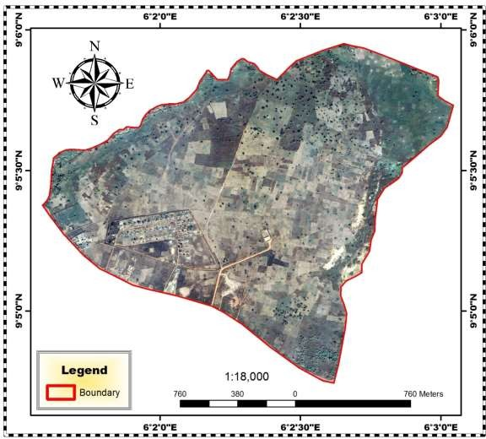

**Satellite Image of Project Quarters 2007**

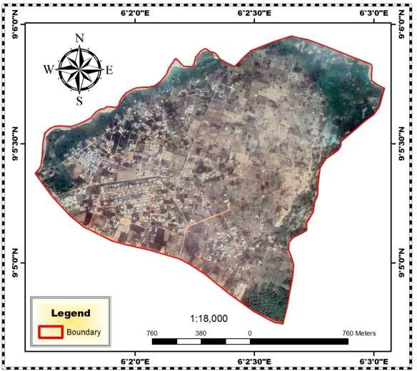

**Satellite Image of Project Quarters 2018**

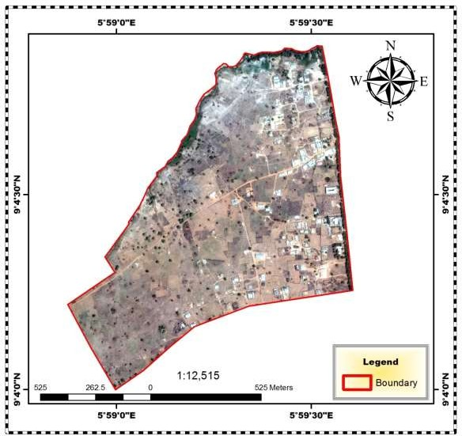

**Satellite Image of Pichi Road 2007**

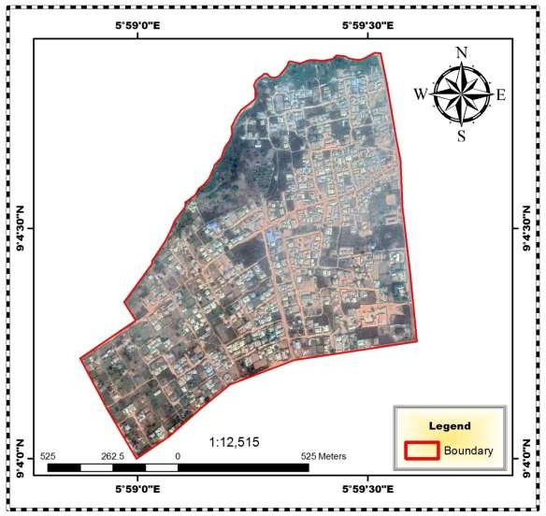

**Satellite Image of Pichi Road 2018**

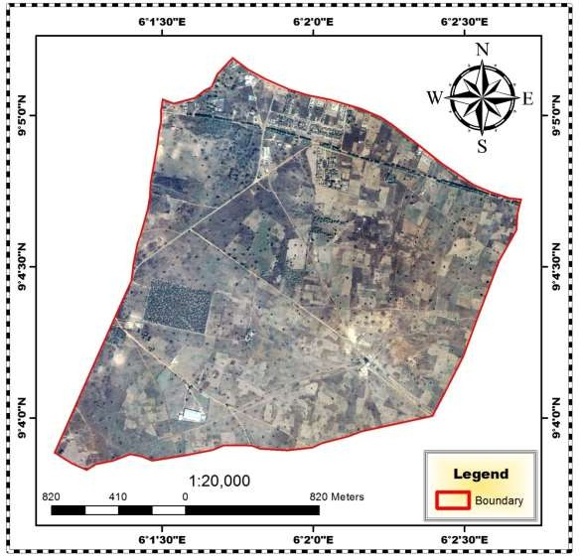

**Satellite Image of Sachi 2007**

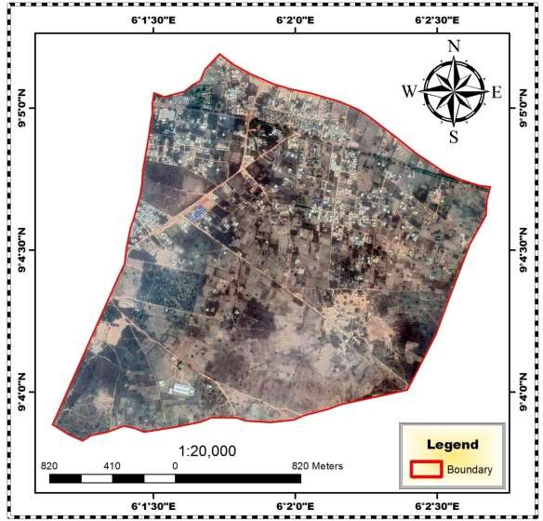

**Satellite Image of Sachi 2018**