Computer science | Project Research | Pages: 54 | Quantitative
Frequency and percentage | 1-5 Chapters | APA 7th Edition | 48 Hours

ANALYSIS OF DESIGN AND IMPLEMENTATION OF A CREDIT CARD DETENTION SYSTEM ON FRAUD

ABSTRACT
All over the world, the most accepted payment mode is via credit card for both online and offline payments in today’s world, it helps implement the cashless policy for shopping at every shop across the country. It is the most convenient method to do shopping on the internet, and also for paying utility bills etc. Hence, increasing the risks of credit card fraud transaction. In the existing manual credit card fraud detection business processing system, fraudulent transaction will be detected after transaction is done. It has become very difficult to find out fraudulent and regarding loses will be barred by issuing authorities. In this research, the researcher has proposed to design and implement a credit card fraud detention system developed using HTML, CSS and PHP.

CHAPTER ONE

INTRODUCTION
  - BACKGROUND OF THE STUDY
Online transactions for the acquisition of products and services are becoming more prevalent in daily life. 28 of the world's population, according to a Nielsen research done in 2007–2008, use the internet. 85 of these individuals have used the internet to do online shopping, which is a 40 percent increase from 2005 to 2008. Credit cards are the most popular payment option for internet purchases (Stolfo, 2020). Credit cards are the most widely accepted form of payment for both online and offline transactions in both developed and developing nations. It may cause the issuing authority to suffer financial losses. In the second manner of buying, known as online, these transactions often take place over the phone or the internet, and in order to complete this kind of transaction, the user will need certain crucial credit card information (such as credit card number, validity, CVV number, name of card holder).
Credit cards are utilized in our everyday lives to make purchases of goods and services using either a real card for offline transactions or a virtual card for internet transactions. When making a purchase with a physical card, the cardholder physically hands the retailer his card to complete the transaction. An attacker has to steal the credit card in order to conduct fraudulent transactions for this sort of purchase. The credit card firm may suffer a large financial loss if the cardholder is unaware of the loss of the card. Attackers simply require a little amount of information to conduct fraudulent transactions in the online payment mechanism (secure code, card number, expiration date etc.). Most transactions in this buying method will be made over the phone or the Internet (Aleskerov, 2019). A fraudster just has to be aware of the card information in order to make these sorts of transactions fraudulently. The majority of the time, the legitimate cardholder is unaware that his card information has been seen or stolen. The only method to identify this kind of fraud is to examine each card's purchasing habits and look for any discrepancies from "normal" spending habits. A potential strategy for lowering the frequency of successful credit card frauds is fraud detection based on the study of the cardholder's past purchase data. Every Card holder may be represented by a collection of patterns that include details about the usual purchase category, the amount spent, the time since the previous transaction, and other behaviorist profiles that individuals often display (Kim , 2022).
Deviation from these patterns might endanger the system.
  - STATEMENT OF THE PROBLEM
It has already been mentioned that the losses of a credit card fraud can affect all consumers, merchants and issuing banks. Therefore, it is important to establish techniques for detecting and preventing credit card fraud. This research contains a variety of techniques which can be used to build fraud detection systems. Understanding the characteristics of all those techniques can be a tedious task. A technique which promises a high predictive accuracy may be an appealing candidate to be used in the fraud detection system. However, there are various different parameters that need to be considered before deciding which technique best suits the needs of a particular situation. And also as all the transaction is maintained in a log. And also now a day’s lot of online purchase are made so we don’t know the person how is using the card online, we just capture the IP address for verification purpose. So there is a need to develop a system to fight cyber -crime and to aid in investigating the fraud. To avoid the entire above disadvantage we propose the system to detect the fraud in a best and easy way.

  - AIMS AND OBJECTIVE OF THE STUDY
This research aims at the design and implementation of a credit card detention system on fraud.
The following are the objectives of the study:
- Develop a system to keep record of every fraudulent credit card transaction online.
- A system to easily detect a stolen credit card.
- To easily track and report fraudulent transactions to relevant agency.

  - SCOPE OF THE STUDY
The scope of the research is focused on implementing a credit card fraud detention system to compact the increasing cyber-crimes faced by our country.
  - DEFINITION OF TERMS
- Credit Card - A credit card is a thin rectangular slab of plastic issued by a financial company, that lets cardholders borrow funds with which to pay for goods and services.
- Fraudulent - Obtained, done by, or involving deception, especially criminal deception.
- Verification - The process of establishing the truth, accuracy, or validity of something.
- Consumer- A person who purchases goods and services for personal use.
- Transaction- An instance of buying or selling something.
- Purchase- Acquire (something) by paying for it; buy.

CHAPTER TWO
LITERATURE REVIEW
This chapter details the information found in the literature. It starts with a reference to the different fraud types of credit industry. Then a discussion on the existing techniques for detecting and preventing credit fraud is made. There is also a brief discussion on the technologies which were used during this project. Finally, other fraud types and crimes are discussed.
2.1 Credit Fraud
There are three main types of credit fraud in the literature. These are credit card fraud, bankruptcy fraud and credit application fraud. A detailed explanation of each fraud type follows.
2.1.1 Credit Card Fraud
This is the most common fraud type that occurs in credit industry. A fraudster uses a legitimate card to undertake illegitimate transactions. The cardholder is not aware of the fact that their card is being used without their permission. The fraudster takes advantage of cardholder’s ignorance by undertaking as much transactions as possible before the cardholder realizes and reports the fraud to their bank.
According to Laleh et al. (2009) credit card fraud can be committed either offline or online. These two ways are discussed below.
Offline Credit Card Fraud
Offline fraud occurs when a fraudster steals the physical card and uses it at the actual stores. Although offline fraud is still popular nowadays; it is less common because there is a higher probability to fail. More precisely, the cardholders tend to realize the loss of the physical card and report that to their bank before the fraudster manages to undertake any illegitimate transactions with it. As soon as the stolen card is reported to the bank, the latter will lock the card so as it cannot be used anymore. It is particularly useful to notice that if the cardholder does not realize the loss of their card, a significant financial loss can occur. As mentioned in the introduction chapter, the policies of some banks enforce cardholders to pay for the losses which occur due to an unreported credit card theft. Notice that most of the UK banks tend to send the newly created cards via the post office. This is extremely dangerous because the cards may be stolen while they are on the way to cardholder’s destination address.

Online Credit Card Fraud
During online fraud only the details of the card are stolen and not the card itself. This is also known as virtual card theft. The details of the card can be used in places where the card need not be physically present like internet or phone purchases. This type of credit card fraud is very dangerous and more difficult to prevent because fraudsters can hold credit card’s information for a long period of time before they use it. There is no way for the cardholder to know in advance that their credit card information is stolen. Therefore this type of fraud may only be detected after one or more illegitimate transactions are taken place.
There are various ways that fraudsters adapt in order to steal the information of credit cards. Some of these ways are briefly discussed below.
Skimming
Patidar et al. (2011) define skimming as the “process where the actual data on a card’s magnetic stripe is electronically copied onto another”. Fraudsters use special-purpose devices – also known as skimmers – to capture the information of credit cards that are encapsulated inside their magnetic stripes. They can use the stolen card information to create counterfeit physical cards in order to use them at actual shops or simply supply the card information at online shops. Skimming can be committed by an unfaithful employee, who may swipe customer’s card using the skimmer device, while the customer is at the point of sale. In the past, skimmer devices have also been introduced on ATM cash machines. In addition to that, micro-cameras have been used to record the PIN code of a cardholder during ATM transactions.
Site Cloning
Fraudsters clone a legitimate website to deceive customers into placing an order with them. Since the fraudulent website seems identical to the legitimate one, the unsuspecting customers provide their credit card information to complete their order. Consequently fraudsters who obtained the customer’s credit card information can commit credit card fraud whenever they wish to.
False Merchant Sites According to Patidar et al. (2011) there are various websites that ask for credit card information in order to confirm customer’s age. These websites will never charge the credit cards directly but they may sell their information to fraudsters who will commit credit card fraud.
Credit Card Generators
These are automated programs which make use of banks’ algorithms to generate credit card numbers. Fraudsters can generate an arbitrary sequence of candidate numbers and then use other techniques – like trial and error – to figure out which numbers correspond to real credit card accounts.

Phishing
Refers to the spam emails that are sent by fraudsters in order to deceive their victims and obtain their personal information. Fraudsters can impersonate a service provider or institute that victims collaborate with. In their email, fraudsters can make use of a convincing excuse to ask for victim’s personal information including credit card details. The spam emails may also include links to fraudulent websites which again can deceive victims into revealing their personal information. Taking into account the enormous amount of spam emails that we receive at a daily basis, anyone can conclude that this type of fraud is still popular nowadays; although it has been out for many years.

2.1.2 Bankruptcy Fraud
Bankruptcy fraud occurs when consumers use their credit cards to spend more money than they can actually pay. Credit cards can be seen as a way for consumers to borrow money from their banks. Normally consumers will use their credit cards to carry out daily transactions. At a regular basis – for instance once every month – the bank will send a bill to their customers in order to request a payment for their credit card transactions. Customers, who plan to commit bankruptcy fraud, will overdraft their credit card accounts and then declare themselves as being in a position of a personal bankruptcy. In such a case the bank will have to pay for all the losses. Xiong et al. (2013) state that bankruptcy fraud increases expeditiously and can cause serious losses to issuing banks. In addition to that, they suggest the evaluation of credit card applications in order to verify the creditworthiness of applicants. Such an evaluation can usually reveal the possibility of a customer to go bankrupt in the future. Xiong et al. (2013) also state that the abovementioned evaluation is not enough because customers with initial good creditworthiness can still be proved insolvent at a later stage. Therefore even if an applicant, who satisfies the desirable levels of creditworthiness, is provided with a credit card account, the latter should keep being inspected by the bank in order to predict any possibility of future insolvency.

2.1.3 Credit Application Fraud
Credit application fraud occurs when a fraudster applies for a credit card using false information. The credit application fraud is associated with another serious fraud, the identity fraud.
Identity Fraud Identity fraud occurs when a fraudster uses a false identity with intension to commit another fraud. Identity fraud can be perpetrated by inventing an identity which does not belong to a real person or by stealing the actual identity of a real person – also known as identity theft. Inventing an identity is easy because there is no need for fraudsters to look for valid information of a real person. Nevertheless, this type of identity fraud is very difficult to succeed nowadays because financial institutions tend to check whether the applicant’s information corresponds to a physical person or not.

2.2 Data Mining and Detection Techniques
This section describes the concept of data mining and the techniques which are found in the literature for detecting credit fraud. The main reason why these techniques are reviewed is that they form the basis of the credit fraud detection ontology and they are reported as an implementation advice by the expert system.

2.2.1 Data Mining
Data mining refers to a family of machine learning techniques capable to analyze and extract non-trivial patterns from data. Data mining is also known as knowledge discovery because it can reveal previously unknown information which was hidden in the data of various databases. The mined information can be proved very useful for the organizations who apply data mining. Based on the results, organizations may make important decisions which can help them survive in the competitive environment. For instance an organization can analyze the sale records of its customers in order to send attractive offers on the most popular products. Hormozi et al. (2004) state that “data mining enables an organization to focus on the most important information in the database, which allows managers to make more knowledge decisions by predicting future trends and behaviours”. Given that databases are too large; it is very inconvenient and impractical to look manually for hidden patterns on the data. Therefore data mining can be introduced to facilitate the discovery of useful knowledge. Forrester Research firm reported that 52%, of 1000 companies in total, decided to employ data mining techniques in 2001 to improve their marketing strategies; an increase of 34% comparing to 1999.
Data mining can also be used to detect fraudulent credit card transactions, predict which customers are more likely to default their contractual obligations by going bankrupt as well as identify fraudulent credit applications. Srivastava et al. (2008) state that the only way to detect credit card fraud is by analyzing the spending behavior of customers using data mining techniques. Customers tend to follow a standard spending profile and therefore any transaction which deviates from that standard can be considered as suspicious. Suspicious transactions can be examined in detailed by bank officers to determine whether they are indeed fraudulent or not.

2.2.2 Detection Techniques
This subsection provides a brief discussion on various data mining techniques which can be used to detect credit fraud. It is particularly useful to notice that the algorithmic details of these techniques are out of the scope of this report. What is more important for this project is to understand the techniques at a higher level of abstraction and extract useful characteristics which can be used to build the knowledge base, Here there is a general discussion over the detection techniques.

Artificial Neural Networks (ANNs)
An artificial neural network imitates the way that human brain works. It consists of a number of nodes – which are called neurons – and edges which interconnect those neurons. Neurons are computational units which process some input information and produce some output. The output of one neuron is passed as input to another. A neuron of human brain is activated if and only if the received signal is sufficiently strong. Likewise an artificial neuron receives not only some input signals but also a weight which determines whether the input signals are sufficiently strong or not. If the signals are strong enough, an activation function will start executing to produce the output.
Support Vector Machines (SVMs)
Support Vector Machines is a binary classification methodology. This means that an input sample can be classified into one out of two possible classes. It is suitable for credit card fraud detection because only two classes are needed; namely the “legitimate” and “fraudulent” class. SVM tries to calculate an optimal hyperplane which will separate the samples of the two classes. There are various hyperplanes which can do that job but an optimal hyperplane will also maximize the margins between the samples of the two classes. Blue and black bullets correspond to the samples of the two distinct classes. Support vectors define the boundaries of each class by taking into account the sample which is closest to the hyperplane. Clearly the separating hyperplane lies in the middle of support vectors by maximizing the margin between them. A new sample is classified by measuring its distance from the hyperplane.
According to Wu et al. (2007), SVM “has a sound theoretical foundation” which makes it a robust classification technique. Nevertheless, an optimal hyperplane which separates linearly the samples of the two classes is not always possible to be found. In that situation a kernel function can be used to map the non-linearly separable data into a higher dimension in which an optimal hyperplane can be found. The main issue with kernel functions is that they increase the implementation complexity of SVMs.
2.3 Related Work
This section provides a brief reference to the literature articles which suggest the techniques of subsection 2.2.2 for detecting credit fraud. It is split into further subsections based on the different types of credit fraud. The implementations described in these articles are encapsulated in the credit fraud detection.

2.3.1 Related Work for Credit Card Fraud
The literature work which is related to credit card fraud is described below. This is done by categorizing the work based on the detection techniques.
Using ANN
Wiese et al. (2009) suggest an implementation of ANNs for detecting credit card fraud. Their implementation takes into account a sequence of transactions that have occurred at some time in the past, in order to determine whether a new transaction is legitimate or fraudulent. They believe that “looking at individual transactions” only is misleading since it cannot face any periodical changes in spending behavior of a customer. They call their approach as “Long Short-term Memory Recurrent Neural Network (LSTM)”.
Guo et al. (2008) suggest a different implementation of ANNs by converting the training samples into confidence values using a specific mathematical formula and then supply these values to train the ANN – instead of the original training samples. They call their approach as “confidence-based neural network” and they claim that it can achieve promising results in detecting credit card fraud.
Using SVM
Chen et al. (2006) suggest an implementation of SVM which they call “Binary Support Vector System (BSVS)”. One of the main problems of data mining techniques arises in situations where the training samples have an imbalanced distribution – also known as skewed distribution. In such a case the misclassification rate is increased whereas the predicting accuracy of the classifier is reduced. The approach of Chen et al. (2006) is insensitive to skewed distribution of training samples. An innovative implementation of SVMs for detecting credit card fraud is also suggested by Chen et al. (2004). They suggest from the issuing banks to ask their new customers to fill some questionnaires that can help them understand the spending habits of the customers. This is particularly useful since there is no any prior history on the spending behaviour of new customers and therefore the detection techniques cannot spot fraudulent transactions at the initial stage. Therefore the answers to the questionnaires can be used in a similar manner to the historical information of each customer. They call their approach as “Questionnaire-Responded Transaction Model” (QRT Model).
2.4 Conclusion
In this chapter the background research – which has been undertaken during the project – was presented. The chapter started from the different fraud types that occur in credit industry. It then moved to a general description of the various techniques which can be used to detect the above fraud types. The related articles concerning these detection techniques were also mentioned.

CHAPTER THREE
METHODOLOGY AND ANALYSIS OF THE EXISTING SYSTEM
3.1 GENERAL DESCRIPTION OF THE EXISTING SYSTEM
In the existing credit card fraud detection business processing system, fraudulent transaction will be detected after transaction is done. It is difficult to find out fraudulent and regarding loses will be barred by issuing authorities. Hidden Markov Model is the statistical tools for engineer and scientists to solve various problems. In this paper, it is shown that credit card fraud can be detected using Hidden Markov Model during transactions. Hidden Markov Model helps to obtain a high fraud coverage combined with a low false alarm rate.
.
3.2 FACT FINDING METHODS USED
There are two main sources of data collection in carrying out this study, information was basically obtained from the two sources which are:
- Primary source
And
(b) Secondary source

3.2.1 Primary Source
Primary source refers to the sources of collecting original data in which the researcher makes use of empirical approach such as personal interview, questionnaires or observation.
In my research I used the interview method for my primary source of Information; this is done by asking question from the banks. I also used a method of observation were I was attentive to all the activities of the department, studying their activities and recording them down on daily basis or as required.

3.2.2 Secondary Source
The need for the secondary sources of data for this kind of project cannot be over emphasized. The secondary data were obtained by me from magazines, Journal, newspapers, library source and most of the information from the library research has been covered in my literature review in the previous chapter of this project.

3.3 APPLICATIONS
- The detection of the fraud use of the card is found much faster than the existing system.
- The Transactions of the account holder never stopped as this system allows the user to use the virtual card Using the virtual ID and password, until he gets the new card.
- The user can easily block the card by him when he finds that the card is being stolen.
- In this system we have used the ONE TIME PASSWORD for the security to get the virtual ID and Password securely.
- We can find the most accurate detection using this technique.

3.4 ORGANIZATIONAL STRUCTURE
The information form will be arise which has set of questions where the user has to answer that question correctly to do the transaction. These form have information like Personal, Professional address, DOB, etc. are available in database. If user entered information will be matched with the database information then the transaction will be done securely. Else user transaction will be terminated and transfer to online shopping website.
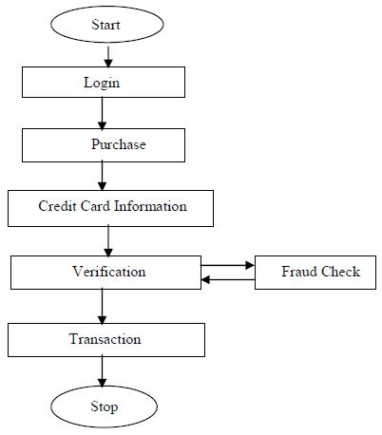

FIG3.1: Organizational Structure
3.5 INPUT ANALYSIS
The input to the system is the transaction limit and card information Form. It contains detail information of the cards. This form shows the input to the system and what it contains:
TRANSACTION LIMIT FORM
Transaction Limit: …………………………………………….

Update

CARD INFORMATION FORM
Your card number: …………………………………………….
Your Pin: …………………………………………….

Withdraw

FIG 3.2: Input Analysis “Existing System”

3.6 PROCESS ANALYSIS
The information gathered was processed into a more meaningful format for entry into the files. The forms filled by the student are processed to produce a comprehensive report.
3.7 OUTPUT ANALYSIS
The output from the system designed is generated from the system inputs. These reports can also be presented as hard copy.
3.8 INFOMATION FLOW DIAGRAM
Customer comes in

Insert his/ her card
System checks
Validate the card

Process the amount
Display the results

FIG 3.3: Information Flow Diagram
3.9 ENVIRONMENTAL
- The credit card fraud detection system shall not cause physical harm to users and non-users.

- The credit card fraud detection system shall not cause interference to external systems or any type of misbehave.

3.9.1 MAINTAINABILITY
- Maximizes the correct prediction and maintain the incorrect prediction at an acceptable level

CHAPTER FOUR
DESIGN AND IMPLEMENTATION OF THE NEW SYSTEM
4.1 DESIGN STANDARD
- Design an input format that will enable the user to key in their credit card and pin.
- Design an input format that will enable the user to insert the transaction limit amount.
- Design an Output format that will enable the user to create a report of transaction and blockings.
- Design an input format that will enable the user to login inorder to access the main application to avoid losss of data.
- Structure a database system that will store all the information using MYSQL.
- Employ a top-down methodology in the design.
  - OUTPUT SPECIFICATION AND DESIGN
The output design was based on the inputs. The report generated gives a meaningful report to the management. These outputs can be generated as softcopy or printed in hard copy.
4.3 INPUT DESIGN AND SPECIFICATION
Computer is designed in such a way that sometimes it is called GIGO, denoting that what goes in is what comes out. The input forms are designs generally based on the necessary data that needs to be entered into the system. The data are captured through the keyboard and stored on a magnetic disk in an access database.
The new system is composed mainly of an input form:-
TRANSACTION LIMIT FORM
Transaction Limit: …………………………………………….

Update

CARD INFORMATION FORM
Your card number: …………………………………………….
Your Pin: …………………………………………….

Withdraw

4.4 FILE DESIGN
Files held in this project are made up of different data types. These types are text, varchar, and int. Some of the files used are designed and linked with database. Also in the project design, MYSQL database was used. Below is the database specification for the files used.

4.4.1 Structure for File “account”
FIELD NAME | DATA TYPE | SIZE
id | int | 5
User_id | int | 5
Branch_id | int | 5
status | int | 1
balance | double
Trans_limit | int | 5

4.4.2 Structure for File “block_history”

FIELD NAME | DATA TYPE | SIZE
id | int | 5
Account_id | int | 5
Created_at | timestamp
Branch_id | int | 5
TABLE 4.2: Structure for file “block_history”

4.4.3 Structure for File “branch”
FIELD NAME | DATA TYPE | SIZE
id | int | 5
name | varchar | 32
location | varchar | 64

4.6 SYSTEM FLOWCHART

Credit Card Detection System

Processor

Disk
Storage
Output (Report)
Result to Screen
Input From the Keyboard

Control Unit

4.7 SYSTEM REQUIREMENTS

The requirements needed to implement this system are as follows:

4.7.1 Hardware Requirements

The software designed needed the following hardware for an effective operation of the newly designed system.

A system running on AMD, Pentium 2 or higher processor
- The random access memory (ram) should be at least 512mb.
- Enhanced keyboard.
- At least 20 GB hard disk.
- V.G.A or a colored monitor.

4.7.2 Software Requirements
The software requirements includes:-
- A window 98 or higher version for faster processing.
- MYSQL database (.sql)
- PhP

4.8 PROGRAM FLOWCHART

Start

Input credit card number and pin

Withdraw

Is Fraud?
Process amount
No

Yes

Card not allowed
Display Amount

Stop

CHAPTER FIVE
SUMMARY, CONCLUSION AND RECOMMENDATIONS

5.1 SUMMARY
In summary, this Academic Work project has done a great deal of giving a broad knowledge of what credit card fraud detection system is all about. It went as far as highlighting the uses of credit card fraud detection system.

5.2 CONCLUSION
From this Academic Work, I have been able to show the application of database management system(credit card fraud detection system) and how it can be used, it has achieve the full aim of letting the public know what computer system is all about.

5.3 Recommendation
I hereby recommend this Academic work to be used by staff and management and indeed any other Institution with similar structure and organizational framework for the following reasons:
- The academic work has been able to solve the problem related to easy access of credit card information.
- It has helped the user on how to login and view report, enter credit card for detection.

REFERENCES
- Ghosh, S., and Reilly, D.L., 1994. Credit Card Fraud Detection with a Neural-Network, 27th Hawaii International l Conference on Information Systems, vol. 3 (2003), pp. 621- 630.

- Syeda, M., Zhang, Y. Q., and Pan, Y., 2002 Parallel Granular Networks for Fast Credit Card Fraud Detection, Proceedings of IEEE International Conference on Fuzzy Systems, pp. 572-577 (2002).

- Stolfo, S. J., Fan, D. W., Lee, W., Prodromidis, A., and Chan, P. K., 2020. Cost-Based Modeling for Fraud and Intrusion Detection: Results from the JAM Project, Proceedings of DARPA Information Survivability Conference and Exposition, vol. 2 (2000), pp. 130-144.

- Aleskerov, E., Freisleben, B., and Rao, B., 2019. CARDWATCH: A Neural Network Based Database Mining System for Credit Card Fraud Detection, Proceedings of IEEE/IAFE: Computational Intelligence for Financial Eng. (1997), pp. 220-226.

- M.J. Kim and T.S. Kim, “A Neural Classifier with Fraud Density Map for Effective Credit Card Fraud Detection,” Proc. Int’l Conf. Intelligent Data Eng. and Automated Learning, pp. 378-383, 2022.

APPENDICES
APPENDIX - A
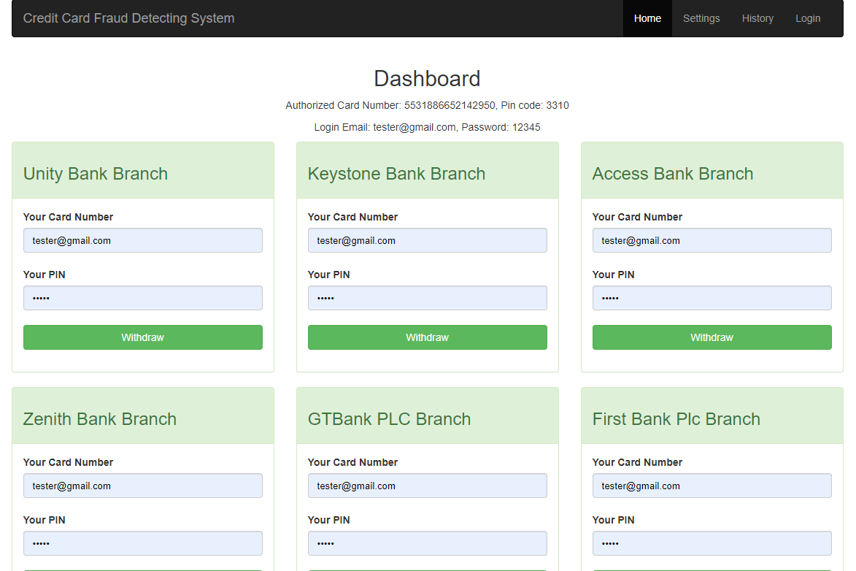
Front End

APPENDIX – B
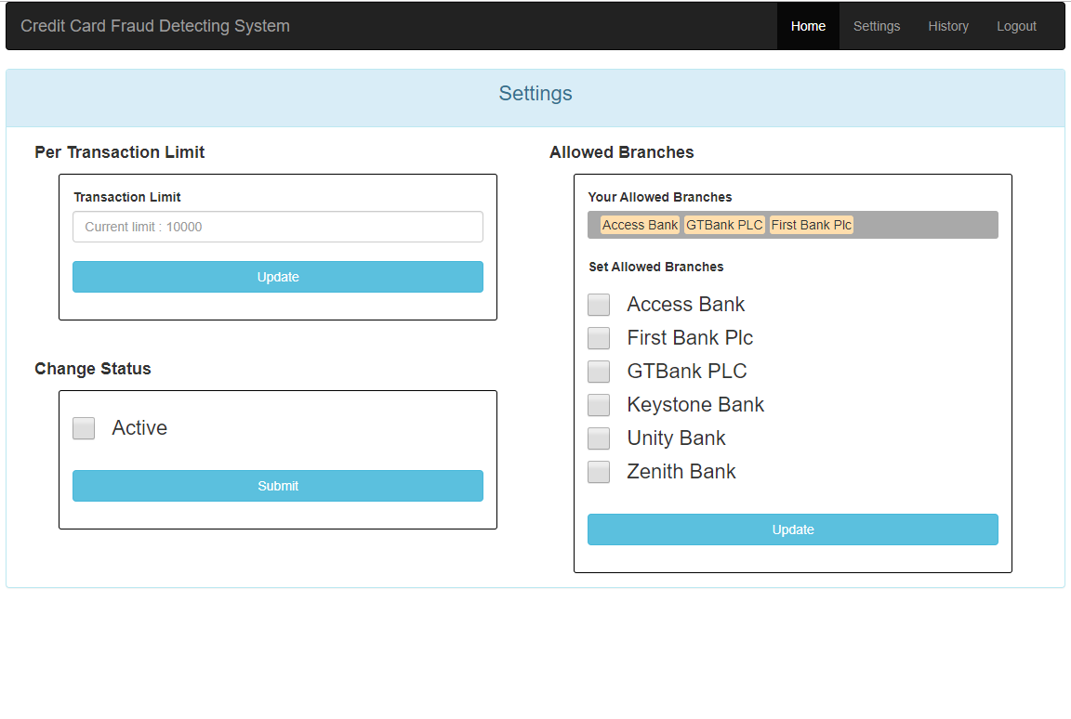
Settings

APPENDIX - C
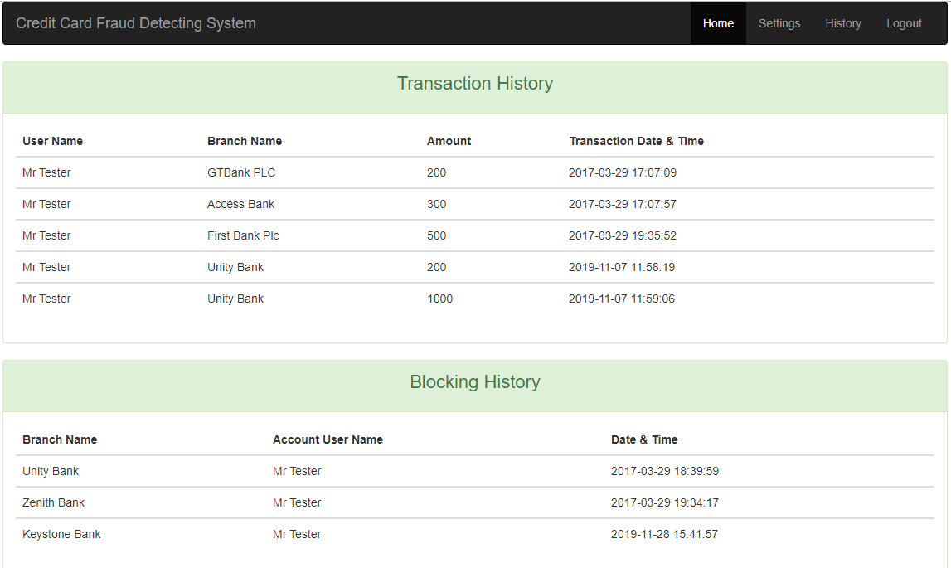

Transaction and Blocking History

APPENDIX H
SOURCE CODE
- Transaction.php
<!-- Check for a valid transaction -->
<?php
session_start();

if(isset($_SESSION['account'])) {
// Do something if anything special you need.
}else{
header("Location: index.php");
}
?>

<!DOCTYPE html>
<html>
<head>
<meta name="viewport" content="width=device-width, initial-scale=1">
<title>Credit Card Faurd Detecting System</title>

<!-- Load all static files -->
<link rel="stylesheet" type="text/css" href="assets/BS/css/bootstrap.min.css">
<link rel="stylesheet" type="text/css" href="assets/css/styles.css">

</head>
<body class="container">
<!-- Navbar included -->
<?php include 'helper/navbar.html' ?>
<!-- Config included -->
<?php include 'helper/config.php' ?>

<div class="row m-r-0 m-l-0">
<!-- After submitting the form -->
<?php
if($_SERVER['REQUEST_METHOD'] == 'POST') {
// get data from form
$amount = $_POST['amount'];
$total_balance = $_POST['total_balance'];
$trans_limit = $_POST['trans_limit'];
$acc_table_id = $_POST['id'];

// Withdrawal business logic
if($amount <= $total_balance) {
if($amount <= $trans_limit) {
$branch_pk = $_SESSION['branch_pk'];
// update will be rest of the amount
$rest_amount = $total_balance - $amount;
$update_query = "UPDATE account SET balance=".$rest_amount." WHERE id=".$acc_table_id;
$conn->query($update_query);
// Now it's time to add a row on transaction table
$add_trans_sql = "INSERT INTO transaction (account_id, branch_id, amount) VALUES (".$acc_table_id.", ".$branch_pk.", ".$amount.")";
$conn->query($add_trans_sql);
unset($_SESSION["branch_pk"]);

// show success message
echo '<p class="success-message">Successfully Withdrawn!!</p>';

}else {
// show error message (when maximum limit)
echo '<p class="error-message">Sorry!! Maximum limit reached. Try Again!!</p>';
}
}else {
// show error message (When insufficient funds)
echo '<p class="error-message">Not Enough Fund!!</p>';
}

}
?>
</div>

<!-- This part will show first -->
<div class="row m-r-0 m-l-0">
<?php
if(isset($_SESSION['account'])) {
$account_pk = $_SESSION['account_id'];
// Warning OR Notification about last blocking message
$blocked_sql = "SELECT block_history.account_id, block_history.branch_id, created_at, branch.id, branch.name as branch_name FROM block_history, branch WHERE block_history.account_id=".$account_pk." AND block_history.branch_id=branch.id ORDER BY created_at DESC";

$blocked_last_row = $conn->query($blocked_sql);

if($blocked_last_row->num_rows > 0) {
$blocked_row = $blocked_last_row->fetch_row();
$blocked_timestamp = $blocked_row[2];
$blocked_branch_name = $blocked_row[4];

// Show Warning
echo '<p class="warning-message">You account was tryng to access from <strong>'.$blocked_branch_name.'</strong> at <strong>'.$blocked_timestamp.'</strong></p>';
}

$ac_number = $_SESSION['account'];
$account_id = $_SESSION['account_id'];

// Get data from account table
$sql = "SELECT * FROM account WHERE id=".$account_id;
$result = $conn->query($sql);

if($result->num_rows == 1) {
$row = $result->fetch_row();
echo '
<div class="col-sm-12 col-md-6">
<div class="panel panel-primary">
<div class="panel-heading">
<h3>Transaction</h3>
</div>
<div class="panel-body">
<form method="POST" action="" class="form-group">
<p>Available Balance: '.$row[4].'</p>
<label>Enter Amount</label>
<input type="number" name="amount" class="form-control" required/>
<input type="hidden" name="total_balance" value="'.$row[4].'"/>
<input type="hidden" name="trans_limit" value="'.$row[5].'"/>
<input type="hidden" name="id" value="'.$row[0].'"/>
<br/>
<input class="btn btn-primary btn-block" type="submit" name="submit" value="Withdraw"/>
</form>
</div>
</div>
</div>
';
}
}
?>
<!-- The clock / time limit will be here -->
<div class="col-sm-12 col-md-4 jumbotron pull-right m-r-15">
<h2 class="alert-message-color">You are running out of time.</h2>
<div id="s_timer"></div>
<p class="p-t-sm f-16 alert-message-color">
<strong>Note:</strong> You just have 60 seconds to finish this transaction.
If you missed to finish you have re-enter your AC number and PIN.
</p>
</div>
</div>

</body>
<footer>
<!-- All the Javascript will be load here... -->
<script type="text/javascript" src="assets/JS/jquery-3.1.1.min.js"></script>
<script type="text/javascript" src="assets/JS/jquery.countdownTimer.min.js"></script>
<script type="text/javascript" src="assets/JS/main.js"></script>
<script type="text/javascript" src="assets/JS/timer.js"></script>
<script type="text/javascript" src="assets/BS/js/bootstrap.min.js"></script>
</footer>
</html>

- Settings.php
<?php
include 'helper/config.php';

session_start();

if (isset($_SESSION['username'])) {
// logged in
// Something will happen here....
} else {
// not logged in
header('Location: login.php');
}
?>

<!DOCTYPE html>
<html>
<head>
<meta name="viewport" content="width=device-width, initial-scale=1">
<title>Settings | Credit Card</title>

<!-- Load all static files -->
<link rel="stylesheet" type="text/css" href="assets/BS/css/bootstrap.min.css">
<link rel="stylesheet" type="text/css" href="assets/css/styles.css">
</head>
<body class="container">
<!-- Config included -->
<?php
include 'helper/navbar.html';
?>

<div class="row">
<div class="col-sm-12 col-md-12">
<!-- After submitting the form -->
<?php
if($_SERVER['REQUEST_METHOD'] == 'POST') {
$trans_limit = $_POST['trans_limit'];
if($trans_limit > 0){
$user_pk = $_POST['user_id'];
$update_sql = "UPDATE account SET trans_limit=".$trans_limit." WHERE user_id=".$user_pk;

$updated = $conn->query($update_sql);
if($updated) {
echo '<p class="success-message">Successfully set!!</p>';
}else{
echo '<p class="error-message">May be you are doing wrong<br>Contact with the Service Provider</p>';
}
}else {
echo '<p class="error-message">SORRY!! You can\'t set 0(Zero) here</p>';
}
}

// To changing status
if(isset($_SERVER['REQUEST_METHOD']) && isset($_GET['submit'])) {
if($_SERVER['REQUEST_METHOD'] == 'GET' && $_GET['submit'] == 'Submit') {
$status_code = $_GET['status'];
$account_pk = $_SESSION['account_id'];
$update_status_sql = "UPDATE credit_card SET status=".$status_code." WHERE account_id=".$account_pk;
$updated_status = $conn->query($update_status_sql);
if($updated_status) {
echo '<p class="success-message">Successfully set!!</p>';
}else {
echo '<p class="error-message">May be you are doing wrong. Contact with the Service Provider</p>';
}
}
}
// For updating branches
if(isset($_SERVER['REQUEST_METHOD']) && isset($_GET['submit'])) {
if($_SERVER['REQUEST_METHOD'] == 'GET' && $_GET['submit'] == 'Update') {
$selected_array = $_GET['branch_pk'];
$array_len = sizeof($selected_array);

$formated_string = "[";

for($i=0; $i<$array_len; $i++) {
$formated_string = $formated_string." ".$selected_array[$i];
}
$formated_string = $formated_string."]";
$account_pk = $_SESSION['account_id'];

$update_branch_sql = "UPDATE credit_card SET allowed_branches='".$formated_string."' WHERE account_id=".$account_pk;
$updated_data = $conn->query($update_branch_sql);
if($updated_data) {
echo '<p class="success-message">Successfully set!!</p>';
}else {
'<p class="error-message">May be you are doing wrong<br>Contact with the Service Provider</p>';
}
}}
?>

<div class="panel panel-info">
<div class="panel-heading">
<p class="text-22px text-center">Settings</p>
</div>
<div class="panel-body">
<div class="col-sm-6 col-md-6">
<?php
// get user data (id only)
$email = $_SESSION['username'];
$user_data_sql = "SELECT id FROM users WHERE email='".$email."'";
$user_data = $conn->query($user_data_sql);
if($user_data->num_rows == 1){
$user_pk = $user_data->fetch_row()[0];
// Now I got login user ID
$ac_info_sql = "SELECT id, trans_limit FROM account WHERE user_id=".$user_pk;
$account_data = $conn->query($ac_info_sql);

// Work with account data
if($account_data->num_rows == 1) {
$temp_result = $account_data->fetch_row();
$transaction_limit = $temp_result[1];
// Temporary session
$_SESSION['account_id'] = $temp_result[0];
}
}
echo '
<p class="list-head">Per Transaction Limit</p>
<div class="mini-container">
<div class="nice-border">
<form method="POST" action="" class="form-group p-a-sm">
<label>Transaction Limit</label>
<input type="hidden" name="user_id" value="'.$user_pk.'">
<input type="number" name="trans_limit" class="form-control"
placeholder="Current limit : '.$transaction_limit.'" required/>
<br/>
<input class="btn btn-info btn-block" type="submit" name="submit" value="Update"/>
</form>
</div>
</div>
';

echo "<br><br>";

// Change Account Status
$account_pk = $_SESSION['account_id'];
$get_status_sql = "SELECT status FROM credit_card WHERE account_id=".$account_pk;
$status_obj = $conn->query($get_status_sql);
if($status_obj->num_rows == 1) {
$status = $status_obj->fetch_row()[0];
}
echo '
<p class="list-head">Change Status</p>
<div class="mini-container">
<div class="nice-border">
<form method="GET" action="" class="form-group p-a-sm">
<div class="checkbox">
<label>
';
if($status == 0) {
echo '
<input class="custom-checkbox" type="checkbox" name="status" value="1">
<span class="check-label">Active</span>
';
}else {
echo '
<input class="custom-checkbox" type="checkbox" name="status" value="0">
<span class="check-label">Blocked</span>
';
}

echo' </label>
</div>
<br/>
<input class="btn btn-info btn-block" type="submit" name="submit" value="Submit"/>
</form>
</div>
</div>
';

?>

</div>

<div class="col-sm-6 col-md-6">

<?php
// A Function for producing string to array with desire formation
function str_to_array($string) {
$length = strlen($string);
$branch_ids_str = substr($string, 1, $length-2);
$branch_ids_list = array_map('intval', explode(" ", $branch_ids_str));

return $branch_ids_list;
}

$branches_sql = "SELECT * FROM branch ORDER BY name";
$account_id = $_SESSION['account_id'];
$allowed_branches_sql = "SELECT * FROM credit_card WHERE account_id=".$account_id;

// Execute queries
$branches = $conn->query($branches_sql);
$allowed_branches_data = $conn->query($allowed_branches_sql);
if($allowed_branches_data->num_rows == 1) {
$temp_result = $allowed_branches_data->fetch_row();
$allowed_branches = $temp_result[1];
$card_id = $temp_result[0];

$branch_ids_list = str_to_array($allowed_branches);
$branch_ids_list = implode("','",$branch_ids_list);

$filtered_branches_sql = "SELECT * FROM branch WHERE id IN ('".$branch_ids_list."')";
$filtered_branches_data = $conn->query($filtered_branches_sql);

}

echo '
<p class="list-head">Allowed Branches</p>
<div class="mini-container">
<div class="nice-border">
<form method="GET" action="" class="form-group p-a-sm">
<label>Your Allowed Branches</label>
<div class="bg-list-item">
';

while($row = $filtered_branches_data->fetch_assoc()) {
echo '<span class="list-item">'.$row["name"].'</span>';
}

echo '
</div>
<br/>
<label>Set Allowed Branches</label>
';

while($row = $branches->fetch_assoc()) {
echo '
<div class="checkbox">
<label>
<input class="custom-checkbox" type="checkbox" name="branch_pk[]" value="'.$row["id"].'">
<span class="check-label">'.$row["name"].'</span>
</label>
</div>
';
}

echo '
<br/>
<input class="btn btn-info btn-block" type="submit" name="submit" value="Update"/>
</form>
</div>
</div>
';
?>
</div>
</div>
</div>
</div>
</div>

</body>
<footer>
<!-- All the Javascript will be load here... -->
<script type="text/javascript" src="assets/JS/jquery-3.1.1.min.js"></script>
<script type="text/javascript" src="assets/JS/main.js"></script>
<script type="text/javascript" src="assets/BS/js/bootstrap.min.js"></script>
</footer>
</html>
- Login.php
<?php
ob_start();
session_start();

// Check previous session untill is destroyed
if (isset($_SESSION['username'])) {
// logged in
header('Location: settings.php');
}
?>
<!DOCTYPE html>
<html>
<head>
<meta name="viewport" content="width=device-width, initial-scale=1">
<title>Login | Credit Card</title>

<!-- Load all static files -->
<link rel="stylesheet" type="text/css" href="assets/BS/css/bootstrap.min.css">
<link rel="stylesheet" type="text/css" href="assets/css/styles.css">
</head>
<body class="container">
<!-- Config included -->
<?php include 'helper/config.php' ?>

<!-- Here will be checking for login -->
<?php
if($_SERVER['REQUEST_METHOD'] == 'POST') {
$email = $_POST['email'];
$password = $_POST['password'];

$get_login_sql = "SELECT * FROM users WHERE email='".$email."' AND password='".$password."'";

$login_success = $conn->query($get_login_sql);
if($login_success->num_rows == 1){
// Check the session and add into session
$_SESSION['valid'] = true;
$_SESSION['timeout'] = time();
$_SESSION['username'] = $email;

// Redirect to settings page
header('Location: settings.php');
}else {
echo '<p class="error-message">Credientials are not correct!!</p>';
}
}
?>

<!-- Login view -->
<form class="form-signin"method="POST" action="">
<h2 class="form-signin-heading">SIGN IN</h2>
<label for="inputEmail" class="sr-only">Email address</label>
<input type="email" id="inputEmail" name="email" class="form-control" placeholder="Email address" required autofocus>
<label for="inputPassword" class="sr-only">Password</label>
<input type="password" id="inputPassword" name="password" class="form-control" placeholder="Password" required>
<button class="btn btn-lg btn-primary btn-block" type="submit">Sign in</button>
</form>
</body>
<footer>
<!-- All the Javascript will be load here... -->
<script type="text/javascript" src="assets/JS/jquery-3.1.1.min.js"></script>
<script type="text/javascript" src="assets/JS/main.js"></script>
<script type="text/javascript" src="assets/BS/js/bootstrap.min.js"></script>
</footer>
</html>

- Index.php
<!DOCTYPE html>
<html>
<head>
<meta name="viewport" content="width=device-width, initial-scale=1">
<title>Credit Card Faurd Detecting System</title>

<!-- Load all static files -->
<link rel="stylesheet" type="text/css" href="assets/BS/css/bootstrap.min.css">
<link rel="stylesheet" type="text/css" href="assets/css/styles.css">
</head>
<body class="container">
<!-- Navbar included -->
<?php include 'helper/navbar.html' ?>
<!-- Config included -->
<?php include 'helper/config.php' ?>

<!-- Let's do something more -->
<?php include 'dashboard.php' ?>
</body>
<footer>
<!-- All the Javascript will be load here... -->
<script type="text/javascript" src="assets/JS/jquery-3.1.1.min.js"></script>
<script type="text/javascript" src="assets/JS/main.js"></script>
<script type="text/javascript" src="assets/BS/js/bootstrap.min.js"></script>
</footer>
</html>

- History.php
<?php
include 'helper/config.php';

session_start();

if (isset($_SESSION['username'])) {
// logged in
// Something will happen here....
} else {
// not logged in
header('Location: login.php');
}
?>

<!DOCTYPE html>
<html>
<head>
<meta name="viewport" content="width=device-width, initial-scale=1">
<title>History | Credit Card</title>

<!-- Load all static files -->
<link rel="stylesheet" type="text/css" href="assets/BS/css/bootstrap.min.css">
<link rel="stylesheet" type="text/css" href="assets/css/styles.css">
</head>
<body class="container">
<!-- Config included -->
<?php
include 'helper/navbar.html';
?>

<!-- Transaction history -->
<div class="row">
<div class="col-sm-12 col-md-12">
<div class="panel panel-success">
<div class="panel-heading">
<p class="text-22px text-center">Transaction History</p>
</div>
<div class="panel-body">
<table class="table">
<?php
$email = $_SESSION['username'];
$user_data_sql = "SELECT id FROM users WHERE email='".$email."'";
$user_data = $conn->query($user_data_sql);
if($user_data->num_rows == 1){
$user_pk = $user_data->fetch_row()[0];
}
$get_account_sql = "SELECT id from account WHERE user_id=".$user_pk;
$account_data = $conn->query($get_account_sql);
if($account_data->num_rows == 1) {
$account_pk = $account_data->fetch_row()[0];
}

$sql = "SELECT transaction.account_id, transaction.amount, transaction.branch_id, created_at, account.id, account.user_id, users.id, users.name AS user_name, branch.id, branch.name AS branch_name FROM transaction, account, users, branch WHERE transaction.account_id=".$account_pk." AND account.user_id=".$user_pk." AND branch.id=transaction.branch_id AND users.id=".$user_pk." ORDER BY transaction.id";

$transaction_data = $conn->query($sql);

if($transaction_data->num_rows > 0) {
echo '
<thead>
<tr>
<th>User Name</th>
<th>Branch Name</th>
<th>Amount</th>
<th>Transaction Date & Time</th>
</tr>
</thead>
';
while($row = $transaction_data->fetch_assoc()){
echo '
<tbody>
<tr>
<td>'.$row["user_name"].'</td>
<td>'.$row["branch_name"].'</td>
<td>'.$row["amount"].'</td>
<td>'.$row["created_at"].'</td>
</tr>
</tbody>
';
}
}else{
echo '<p class="text-center">No data to show</p>';
}
?>
</table>
</div>
</div>
</div>
</div>

<!-- Blocking History -->
<div class="row">
<div class="col-sm-12 col-md-12">
<div class="panel panel-success">
<div class="panel-heading">
<p class="text-22px text-center">Blocking History</p>
</div>
<div class="panel-body">
<table class="table">
<?php
$email = $_SESSION['username'];
$user_data_sql = "SELECT id FROM users WHERE email='".$email."'";
$user_data = $conn->query($user_data_sql);
if($user_data->num_rows == 1){
$user_pk = $user_data->fetch_row()[0];
}

$get_account_sql = "SELECT id from account WHERE user_id=".$user_pk;
$account_data = $conn->query($get_account_sql);
if($account_data->num_rows == 1) {
$account_pk = $account_data->fetch_row()[0];
}

$sql = "SELECT block_history.account_id, block_history.branch_id, created_at, account.user_id, users.id, users.name AS user_name, branch.id, branch.name AS branch_name FROM block_history, account, users, branch WHERE block_history.account_id=".$account_pk." AND block_history.branch_id=branch.id AND account.user_id=".$user_pk." AND users.id=".$user_pk." ORDER BY created_at";

$blocking_history = $conn->query($sql);

if($blocking_history->num_rows > 0) {
echo '
<thead>
<tr>
<th>Branch Name</th>
<th>Account User Name</th>
<th>Date & Time</th>
</tr>
</thead>
';
while($row = $blocking_history->fetch_assoc()){
echo '
<tbody>
<tr>
<td>'.$row["branch_name"].'</td>
<td>'.$row["user_name"].'</td>
<td>'.$row["created_at"].'</td>
</tr>
</tbody>
';
}
}else{
echo '<p class="text-center">No data to show</p>';
}
?>
</table>
</div>
</div>
</div>
</div>
</body>
<footer>
<!-- All the Javascript will be load here... -->
<script type="text/javascript" src="assets/JS/jquery-3.1.1.min.js"></script>
<script type="text/javascript" src="assets/JS/main.js"></script>
<script type="text/javascript" src="assets/BS/js/bootstrap.min.js"></script>
</footer>
</html>

- Dashboard.php
<!-- After submiting the form -->
<?php
// Initialize the session
session_start();
if($_SERVER['REQUEST_METHOD'] == 'POST') {
$card_number = $_POST['card_number'];
$pin = $_POST['pin'];
$branch_id = $_POST['branch_id'];

// Get all the the pins with card number then I'll match with inputed data
$query = "SELECT * FROM credit_card";
$credit_cards = $conn->query($query);

if ($credit_cards->num_rows > 0) {
// Declare some helper arrays
$card_number_array = array();
while($row = $credit_cards->fetch_assoc()) {
array_push($card_number_array, $row["ac_number"]);
}
}

$matched = False;
// Match with the inputed data
for($i=0; $i<count($card_number_array); $i++){
if($card_number == $card_number_array[$i]){
$matched = True;
break;
}
}
// After matching
if($matched) {
// Again call db for specific response
$card_data_sql = "SELECT * FROM credit_card WHERE ac_number=".$card_number." AND pin=".$pin;
$card_data = $conn->query($card_data_sql);

if($card_data->num_rows == 0){
echo '<p class="error-message">You are not authorised!!</p>';
}

if($card_data->num_rows == 1){
$row = $card_data->fetch_row();
$allowed_branches = $row[1];
$ac_status = $row[5];

if($ac_status == 1){
if(strpos($allowed_branches, $branch_id)) {
// set AC num and pin to session
$_SESSION['account'] = $card_number;
$_SESSION['account_id'] = $row[4];
$_SESSION['branch_pk'] = $branch_id;
header("Location: transaction.php");
}else {
echo '<p class="error-message">SORRY! This Branch is not Allowed!!</p>';
// Account will be locked now.
/*
0 = Block
1 = Active
*/
$update_block_sql = "UPDATE credit_card SET status=0 WHERE ac_number=".$card_number;
$updated_block_status = $conn->query($update_block_sql);
if($updated_block_status) {
echo '<p class="error-message">Account will be blocked!!</p>';
$block_history_sql = "INSERT INTO block_history (account_id, branch_id) VALUES(".$row[4].", ".$branch_id.")";
$conn->query($block_history_sql);
}
}
}else {
echo '<p class="error-message">Your account has blocked!!</p>';
}

}

}else {
echo '<p class="error-message">You are not authorised!!</p>';
}
}

?>

<div class="row">
<h2 class="text-center">Dashboard</h2>
<p class="text-center">Authorized Card Number: 5531886652142950, Pin code: 3310</p>
<p class="text-center">Login Email: tester@gmail.com, Password: 12345</p>
<?php
// Get branches data from database
$sql = "SELECT * FROM branch";
$result = $conn->query($sql);

if ($result->num_rows > 0) {
// output data of each row
while($row = $result->fetch_assoc()) {
$name = $row["name"];

echo '
<div class="col-xs-6 col-md-4">
<div class="panel panel-success">
<div class="panel-heading">
<h3>'.$name.' Branch</h3>
</div>
<div class="panel-body">
<form method="POST" action="" class="form-group">
<label>Your Card Number</label>
<input type="text" name="card_number" class="form-control" required/>
<br/>
<label>Your PIN</label>
<input type="password" name="pin" class="form-control" required/>
<input type="hidden" name="branch_id" value="'.$row["id"].'"/>
<br/>
<input class="btn btn-success btn-block" type="submit" name="submit" value="Withdraw"/>
</form>
</div>
</div>
</div>
';
}
} else {
echo "0 results";
}
// $conn->close();
?>

</div>

