# ANALYSIS OF AGROFORESTRY PRACTICES IN THE GUINEA SAVANNAH ECOLOGICAL ZONE: A CASE STUDY OF THE FEDERAL CAPITAL TERRITORY OF NIGERIA

**BY**

# CLEMENT DIDI CHUP (PGES/UJ/12687/99)

**B. Sc. (HONS), BENIN, 1986; M.Sc. UNIMAID, 1995**

# A Thesis in the Department Of GEOGRAPHY AND PLANNING, Faculty of Environmental Sciences

**Submitted to the School of Postgraduate Studies University of Jos in Partial Fulfillment of the requirements for the award of the degree of DOCTOR OF PHILOSOPHY (Ph.D) of the**

UNIVERSITY OF JOS

# OCTOBER, 2004

## DECLARATION

I, Clement Didi Chup, do hereby declare that this thesis has been written by me and is a record of my own original research, and no part of the thesis has, to my knowledge, been presented or published anywhere and at anytime for the award of any higher degree; and all quotations and references have been duly acknowledged.

Chup, C. D.

**ACKNOWLEDGEMENTS**

This thesis has been made possible through the assistance and support of several people to whom I am indebted, and wish to express my profound gratitude. The following have however been of much assistance, and the work would not be complete without mentioning them. My unquantifiable gratitude goes to my supervisor, Professor A. A. Adepetu. You have been very gracious to me with your time, knowledge and materials. You have always been there for me, and I truly lack words to express my sincere appreciation. You are indeed a father and a mentor. May the good Lord continue to bless you and your family abundantly. I am also grateful to the following lecturers of the Department of Geography and Planning, University of Jos for their constructive criticisms, encouragement and assistance. Dr. A.C. Eziashi; Dr. J. Dung-Gwom; Dr. E.A. Olowolafe; Professor J.A.O. Olaniyan, Mr. V.C. Iheamagbullem and Dr. D.

D. Dabi.

I also wish to express gratitude to my brother, Hon. Alex S. Chup; his wife, Jessicah; and the family, for all the assistance, love and support throughout the period of this work. It would have been unbearable without you. I also say a big thank you to Dr. E.H. Kwon-Ndung of N.R.C.I. Badegi; for his concern and occasional inspiring questions, which kept me going.

The following colleagues in the Department of Geography, University of Abuja have also been of tremendous assistance and I am very grateful to them. They include Mr. P.D. Dawam, for giving me the initial encouragement and support, late Professor O. Balogun, for consistently willing to “assist in any little way” and for his motivation [May his soul rest in perfect peace]; Dr. (Mrs.) R. Mundi; Mr. S.P. Ejaro; Mrs. M.L. Garba; Mall. S.M. Hassan; Dr. S.A. Mashi and M.M. Alhassan. Also from the same university, are Professor J.S.A. Adelabu (Physics Department); Professor A.A. Idrees (History department); Professor S.E. Gbillekaa (Theatre Arts); Dr. V.E. Ekhator (Public

Administration); as well as Dr. P. Idisi; Dr. E. Aiyedun and Dr. P. Siyan (Economics Department), for their encouragement.

I am also grateful to the following friends who have contributed enormously to the success of this work. These are Dr. B.M. Matur, Dr. M.A. Maisamari; Dr. S. Dauda; Dr. H.D. Aliyu; Dr. Y.A. Zoaka and Mr. G.O. Wafure, all of the University of Abuja. I pray that God’s abundant reward will be showered on you all. I also acknowledge the good wishes and support of all members of the COCIN Church, Giri L.C.C. Abuja.

The staff of the Abuja Agricultural Development Programme (AADP), particularly, Mr. Moses Anaukwu; Mr. Emmanuel O. Muyiwa; Alhaji S.O. Sadiq and all the extension officers,have been of great assistance. Some professionals have also contributed in the production of materials and final copies of this work. These include Mr. Mustapha Jibril (Biological Science Department), Sa’datu James and Omojola Ajayi (Geography Department,); Raji Salaudeen (Faculty of Science); Kate Agbons, David Water and Rita (Alpha Business Centre, Gwagwalada). I am also grateful to Mr. Dinka Simon of Giri Village and Awoji John of Awoji and Awoji Computers, Gwagwalada, Abuja. I say a big thank you, and wish you the best of luck.

Furthermore, I wish to express sincere appreciation and special thanks to my beloved wife (Josephine), and my children (Nathanael, Tina, Shishang and Ephraim), for the unquantifiable sacrifices they made and for their prayers and support throughout the period this work was carried out.

Above all, I am most grateful to God Almighty for His ever sufficient grace, care, provision and protection. To Him be glory, honour and adoration. It is His doing and may His name be praised.

Chup, C.D.

## DEDICATION

This thesis is dedicated to my father, Mr. Chup, D. Manbok; for his initial support and sacrifice for my education; and also to my father in-law (Late Mr. Toma C. Mbellem) for his encouragement. May his gentle soul rest in perfect peace! Amen.

|  |  |  |
| --- | --- | --- |
|  | **TABLE OF CONTENTS** |  |
| TITLE PAGE |  | I |
| DECLARATION PAGE |  | II |
| CERTIFICATION PAGE |  | III |
| ACKNOWLEDGEMENT |  | IV |
| DEDICATION |  | VI |
| TABLE OF CONTENTS |  | VII |
| APPENDICES |  | XI |
| LIST OF TABLES |  | XII |
| LIST OF FIGURES |  | XIV |
| LIST OF PLATES |  | XV |
| ABSTRACT |  | XVI |

## CHAPTER ONE: INTRODUCTION

* 1. BACKGROUND TO THE STUDY 1
  2. THE STUDY PROBLEM 8
     1. Background to the Problem 8
     2. Research Questions 10
     3. Problem Formulation 11
  3. AIM AND OBJECTIVES OF STUDY 13
  4. STUDY HYPOTHESES 14
  5. SCOPE OF STUDY 14
  6. JUSTIFICATION OF STUDY 15
  7. CONCEPTUAL FRAMEWORK 16

|  |  |  |
| --- | --- | --- |
| 1.7.1 Land Use and Population Relationship | 16 |  |
| 1.7.2 Adaptation | 18 |  |
| 1.7.3 Models of Adaptation | 21 |  |
| **CHAPTER TWO: LITERATURE REVIEW**  2.1 INTRODUCTION | 24 |  |
| 2.2 DEFINITION OF AGROFORESTRY | 25 |  |
| * 1. OBJECTIVES OF AGROFORESTRY   2. AGROFORESTRY IN THE TEMPERATE ZONE | 32 | 36 |

* + 1. Agroforestry in North-America 36
    2. Agroforestry in New Zealand 38
    3. Agroforestry in Temperate Australia 40
    4. Agroforestry in China 43
    5. Agroforestry in Europe 45
  1. AGROFORESTRY IN THE TROPICS 46
     1. Agroforestry in Tropical Asia 47
     2. Agroforestry in Central and South America 50
     3. Agroforestry in East and Central Africa 52
     4. Agroforestry in West-Africa 58
  2. AGROFORESTRY IN NIGERIA 60
     1. Shifting Cultivation 61
     2. Scattered Farm Trees 62
     3. Home Gardens 63
     4. Taungya 63
     5. Shelter Belts 64
     6. Alley Cropping 65
     7. Boundary Trees 66
     8. Dune Fixation 66
     9. Aquaforestry 67

CHAPTER THREE: STUDY LOCATION

* 1. LOCATION AND SIZE 68
  2. GEOLOGY AND LANDFORMS 68
  3. SOILS 71
  4. CLIMATE 72
  5. VEGETATION 74
     1. The Forest Vegetation 75
     2. The Savannah Vegetation 77
  6. POPULATION 80
  7. SETTLEMENTS 82

**CHAPTER FOUR: MATERIALS AND METHODS**

|  |  |  |
| --- | --- | --- |
| 4.1 DATA NEEDS |  | 85 |
| 4.2 DATA SOURCES |  | 86 |
| 4.3 DATA COLLECTION | 88 |  |

* + 1. Procedures for Data Collection 88
    2. Instruments of Data Collection 90
    3. Field Measurement 90
    4. Field Observation 92
  1. QUESTIONNAIRE FORMAT AND ADMINISTRATION 92
     1. Questionnaire Structure and Content 93
     2. Questionnaire Administration 94
  2. SAMPLING PROCEDURE 94
     1. Sampling Frame 94
     2. Sampling Fraction 96
     3. Sampling Techniques 96
  3. DATA ANALYSIS 97
  4. PROBLEMS OF RESEARCH 98

## CHAPTER FIVE: DATA PRESENTATION AND DISCUSSION

|  |  |  |
| --- | --- | --- |
| 5.1 | NUMBER OF SAMPLED FARMERS IN AGROFORESTRY | 100 |
| 5.2 | SOCIO-DEMOGRAPHIC CHARACTERISTICS OF |  |
|  | FARMERS PRACTISING AGROFORESTRY | 102 |
| 5.3 | FORMS OF AGROFORESTRY | 106 |
| 5.4 | THE EXTENT OF AGROFORESTRY | 109 |
| 5.4.1 | Extent of Agroforestry Practices | 109 |
| 5.4.2 | Agroforestry Species | 110 |
| 5.4.3 | Temporal Dimension of Agroforestry | 128 |
| 5.5 | OWNERSHIP AND MANAGEMENT OF AGROFORESTRY |  |
|  | FARMS | 129 |
| 5.5.1. | Ownership of Agroforestry Farms | 129 |
| 5.5.2. | Management of Agroforestry Farms | 133 |
| 5.6 | SPONSORSHIP AND SUPPORT FOR AGROFORESTRY | 135 |
| 5.6.1 | Sponsorship of Agroforestry Practices | 135 |
| 5.6.2 | Support for Agroforestry | 138 |
| 5.7 | ACCESSIBILITY TO LAND AND ITS RESOURCES | 141 |
| 5.8 | BENEFITS OF AGROFORESTRY | 143 |
| 5.8.1 | Procurement of Manure | 143 |
| 5.8.2 | Improvement in Soil quality | 145 |

* + 1. Ecosystem Stability 145
    2. Provision of Shade 146
    3. Improvement in Family Income 147
    4. Increased Variety of Food 148
    5. Extraction for Fuelwood 149

5.8.9 Extractions for Medicinal Purposes 150

## CHAPTER SIX: HYPOTHESES VERIFICATION

* 1. VERIFICATION OF HYPOTHESIS I 169
     1. Comparison of Number of Farmers 169
     2. Comparison of Crop Species 170
     3. Comparison of Animal Types 170
     4. Decision on Hypothesis I 171
  2. VERIFICATION OF HYPOTHESIS II 171
     1. Test for Variation in Number of Farmers 172

by Area Councils

* + 1. Test for Variations in Accessibility to Resources 173
    2. Test for Spatial Variations in Crops Cultivated by 174

Agroforestry Farmers

* + 1. Test for Spatial Variation in Tree Types Maintained by 176

Agroforestry Farmers

* + 1. Test for Spatial Variation in Animals Reared 177
    2. Test for Spatial Variations in Additives Used by 178

Agroforestry Farmers.

* + 1. Decision on Hypothesis II 179

## CHAPTER SEVEN: CONCLUSION

* 1. SUMMARY OF FINDINGS 181
  2. CONCLUSION 184
  3. RECOMMENDATIONS 186

## SUMMARY OF RESULTS 190

## CONTRIBUTION TO KNOWLEDGE 191

## REFERENCES 192

|  |  |  |
| --- | --- | --- |
|  | **APPENDICES** |  |
| APPENDIX A: | Questionnaire on Agroforestry practices | 204 |
|  | in the Federal Capital Territory of Nigeria |  |
| APPENDIX B I: | Farmers in Agroforestry in Sampled |  |
|  | Settlements | 210 |
| APPENDIX B II: | Distribution of Agroforestry Farmers by | 212 |
|  | Residential status. |  |
| APPENDIX B III: | Number of Crop Species Cultivated in sampled | 214 |
|  | Settlements. |  |
| APPENDIX B IV: | Summary of Number of Animal Types Reared | 216 |
| by Respondent Farmers in Sampled Settlements. | | |
| APPENDIX B V: | Expected Values for Spatial Variation in | 218 |
|  | Agroforestry Farmers. |  |
| APPENDIX B VI: | Chi-Square Values for Spatial Variation in | 219 |
|  | Agroforestry Farmers. |  |
| APPENDIX B VII: | Expected Values for Spatial Variation in | 220 |
|  | Accessibility of Land Resources. |  |

APPENDIX B VIII: Chi-Square Values for Spatial Variation 222

in Accessibility to Land Resources.

APPENDIX C: Publication From Thesis 223

## LIST OF TABLES

|  |  |  |
| --- | --- | --- |
| **Table** | **Title** | **Page** |
| 1 | Estimated FCT Population (1991-2002) | 81 |
| 2 | Respondent Farmers in Agroforestry in the FCT | 100 |
| 3. | Distribution of Respondent Farmers by Residential Status | 101 |
| 4 | Distribution of Agroforestry Farmers by Residential Status | 102 |
| 5 | Gender and Marital Status of Agroforestry Farmers | 103 |
| 6. | Age Distribution of Agroforestry Farmers in FCT | 104 |
| 7. | Income Status of Agroforestry Farmers in FCT | 105 |
| 8. | Educational Status of Agroforestry Farmers in FCT | 106 |
| 9. | Family Sizes of Agroforestry Farmers in FCT | 107 |
| 10. | Land Area Under Agroforestry in the FCT | 110 |
| 11. | Tree Planting by Agroforestry Farmers | 115 |
| 12. | Reasons for Planting Trees by Agroforestry Farmers | 118 |
| 13. | Reasons for the Non-Investment in Tree Planting | 123 |
|  | by Agroforestry Farmers |  |
| 14. | Ownership of Agroforestry Farms By Farmers in FCT | 129 |
| 15. | Land Tenure Status Of Agroforestry Farms in FCT | 133 |
| 16. | Sources of Labour for Activities on Agroforestry Farms | 134 |
| 17. | Use of Farm Additives by Agroforestry Farmers | 135 |
| 18. | Average quantity of manure used by agroforestry farmers | 136 |
| 19. | Sources of Animal Feeds and Pesticides for Agroforestry |  |
|  | Farmers | 137 |
| 20. | Sponsorship of Agroforestry Activities in FCT | 138 |
| 21. | Support Services by Government To Agroforestry Farmers | 140 |

1. Socio-Economic Benefits of Agroforestry in FCT 144
2. Average Crop Production of Agroforestry Farmers

(1998-2002) 151

1. Average Quantity of Tree Products of Agroforestry

Farmers (1998-2002) 157

25. Proceeds From Livestock of Agroforestry Farmers

(1998-2002) 163

## LIST OF FIGURES

**FIGURE TITLE PAGE**

1. Anatomy of Adaptation (after Smith et al 1998) 19
2. Conceptual Model of Adaptation, Applicable to FCT 23
3. Location of Abuja, FCT 69
4. Physiographic Regions of the FCT 70
5. Mean Annual Rainfall of selected Places in FCT 73
6. Mean Monthly Temperature of selected Places in FCT 75
7. Vegetation Map of the FCT 79
8. Major Settlements of the FCT 83
9. Sampled Quadrats and Villages 95
10. Histogram of Crop Species of Agroforestry Farmers in FCT 112
11. Histogram of Tree Types Grown by Agroforesty Farmers

in FCT 119

1. Histogram of Number of Animal by Types

Reared by Agroforesty Farmers in FCT 125

## LIST OF PLATES

**PLATES TITLE PAGE**

1. Agroforestry Farm of Okra and Beans Under Cashew,

Shea Butter and Mango Trees in Bwari Area Council. 116

1. Agroforestry Farm of Cassava, Beans and Maize with Shea 117 Butter and Cashew Trees at Kiyi, Kuje Area Council.
2. Yam Farm Under Different Tree Species at Yangoji, 122

Kwali Area Council.

1. Alley Cropping with Beniseed Planted in between, at Abaji 130
2. Agroforestry Farm Boundary Using Bitter Leaf and Sugar 131

Cane Plants, at Wako Irrigation Scheme.

1. Cocoyam, Sugar Cane and Rice with Guava and Mango 132

Trees at Wako Irrigation Scheme.

## ABSTRACT

This study examined the nature of agroforestry practices in the FCT, as an alternative to the conventional cropping systems. This is done not only as an alternative to the provision of food, but also as a strategy towards enhancing environmental stability. Furthermore, the study aimed at providing data on the practice of agroforestry in the territory and therefore highlighted the extent of agroforestry in the territory, the ownership and management of agroforestry practices, the temporal and spatial variations in the practice of agroforestry, as well as the socio- economic benefits derived from agroforestry, by individuals and communities at large. Data collection was done through reconnaissance survey, field observations and measurement as well as questionnaire- based interviews of 600 farmers. Data were also collected through personal interviews with rural community members, and extension workers. Furthermore, the Focus Group Discussion (FGD) was also adopted to augment data already collected. Secondary data was also derived from different sources and utilized for the study. In the analysis of data, different methods of data summaries were utilized and in addition, simple proportions and the chi-square test were applied in the verification of the hypotheses. The study found that, more than seven out of every ten farmers were engaged in agroforestry; the agroforestry farmers were largely the indigenous populations, low income earners, of a low literate level, largely males and characterized by large family sizes; and agroforestry practices were largely the scattered tree farming

(random mix), although some alley cropping and agro-silvo-pastoralism were also present. The major agroforestry practice thus consisted of three components. These were made of twelve crop types, ten tree types, and local varieties of five animal types. The study also showed that ownership of agroforestry farms was tied to the land tenure system, which was largely communal. Agroforestry farms were managed largely by the farmers , with some support from the Abuja Agricultural Development Programme (AADP), in the form of supply of farm inputs, and provision of extension services. Finally, the study found that some benefits derived from agroforestry has resulted in improvement in soil fertility, increased agricultural productivity and accordingly, intake by the family and general improvement of the study area.

# CHAPTER ONE INTRODUCTION

## BACKGROUND TO THE STUDY

Agricultural production, particularly crop cultivation, has remained a significant and important component of human population, due to its strategic role of providing food supply to the generality of the entire human race. This system has however, had severe repercussions on land resources; as continuous tillage of the land easily loosens the soil and results in soil erosion and large-scale environmental degradation. Conventional cropping, and in many parts of the world, monocropping has been intensified due to geometric increases in population. This has resulted in increased demand for cultivable land, which has in turn resulted in pressure on land, and consequent cultivation of marginal lands. The breakdown of traditional systems of agriculture such as rotational bush fallow and shifting cultivation, due mainly to population pressure, has also compelled peasant farmers to continuously cultivate the land, damning the consequences of loss in soil fertility, soil erosion and reduced productivity (Beets, 1990; Kang et al, 1999). FAO (1986) noted that the pressures of growing populations in developing counties, have forced landless farmers unto soils which cannot sustain crop production, and unto slopes which cannot be safely cultivated, at least with technologies and resources available to the

farmers. The consequences of this to the farmers have often been increased wind and soil erosion, silting, flooding and drought.

Apart from the environmental problems enumerated above, increasing demand for land has also intensified deforestation. Most traditional systems of agriculture are largely charaterised by clearance of vegetation. This clearance of unwanted woody perennial is not without repercussions, as it is confirmed to result in lower potential productivity, reduction in leaf area index, and ground water recharge, disruption of soil ecology, breakdown of nutrient cycling and increase in soil erosion, siltation of dams and reservoirs, destruction of wildlife habitats, and loss of plant and genetic diversity (World Bank, 1991). Furthermore, the pressure on trees and other plant matter due to demand for fuel wood, housing and others, have forced some rural poor families to reduce their cooking, and eventually, their cooked meals. This has also consumed a lot of human labour, as well as significant proportions of family budgets (FAO, 1986).

The overall consequence of continuous cultivation and monocropping is thus large-scale environmental degradation which will eventually result in reduction in food supply and increase in level of poverty, landlessness, deprivation, and communal conflicts, to mention a few. Crop cultivation however cannot be halted, as this would cut down food supply and would be associated with consequences that are terribly severe on man and the environment.

Attention has therefore shifted to ways through which available land resources could be effectively utilized so that the resources would continue to be available, and also be used in such a way as to ensure its conservation (Allan, 1965; Beets, 1990; Kang et al, 1999; Kelly and Adger, 2000). The realisation of this has thus brought into focus, the need for man to work in partnership with the environment. The land should therefore be used in such a way that would ensure its sustainability. One way of doing this is to embark on farming practices that will not only ensure the maintenance of land fertility, but also enable a balance of the entire ecosystem. Mcnamara (1973), then World Bank President expressed doubt on the relevance of development policies and approaches, which according to him, never adequately addressed the basic needs of the poorest, especially the rural poor. He therefore advocated for an agricultural system that would address the problems of the rural peasant farmers. Such a system would also help to combat land degradation, that has become a glaring characteristic of highly populated farming communities.

Initial attempts to combat the problems associated with conventional cropping suggested forestry in combination, or to be practised side by side with crop cultivation, by farmers and communities. Communities and individual farmers in different countries were encouraged to engage in forestry. Government departments of forestry were empowered to support and encourage

forestry projects through loans, supervision and provision of extension services to farmers and communities. Similarly, tree planting was earlier acknowledged as an approach to combating land degradation, and the introduction of trees was considered necessarily a good thing, regardless of the specific components, arrangements or management. (Beets, 1990; Nair, 1993; Kang et al, 1999). It is however, now widely acknowledged that the development of more sustainable land use systems is necessary if the overall improvement of rural productivity and sustainable land use management is to be achieved (Scheer and Muller, 1991). Forestry, apart from requiring a fairly long time before its benefits can be visible, is also associated with loss of cultivable land. Farmers, on the other hand, require immediate benefits in terms of increased food production(Young, 1989; Ogar, 1992; Wilden, 1992). Thus it has become difficult to convince farmers to invest in, and devote their land to forestry production. Although forestry has had some significant success in combating soil erosion, provision of fuelwood, and reducing overall land degradation, its adoption has nevertheless been low among farmers and communities in many parts of the world. Success has been restricted largely to government programmes which have been implemented through legislation and strict enforcement by agents. Such programmes have in most places been perceived as alien by the rural farmers and communities, without bringing about significant changes in their

lives (Lundgren, 1982; Falconer, 1990; Nair, 1993). Moreover, the failure of forestry to combat ecological problems associated with crop production therefore left much to be desired (King, 1987; Sekhwela, 1990).

The failure of agricultural programmes such as forestry and the Green Revolution to combat the problems of land degradation led to the initiation of a study team by the International Development Research Centre(IDRC) of Canada. The study report by Bene, et al (1977) recommended that priority be given to production systems which would integrate forestry, agriculture, and/or animal husbandry in order to ensure optimal use of tropical land. The Bene report was the major basis for the establishment of the International Council for Research in Agroforestry (ICRAF) in 1977, and renamed International Centre for Research in Agroforestry in 1991.

The integration of trees with monocultural crops, and animal rearing is considered an appropriate strategy that is capable of bringing about a balance in the ecosystem, especially in already degraded environments, and also in areas already threatened by land degradation as a result of large-scale and often uncontrolled anthropogenic activities. The combination of tree production with annual crop cultivation and sometimes with the rearing of animals on the same piece of land could enable an interaction between the combined species, which bring about stability of the soil and equally

enhance increased productivity (in terms of harvests). This system, known as agroforstry, therefore does not only ensure stability of land resources, but could also be used as a means of controlling large-scale erosion, reclaiming degraded lands, as well as improve food production (Sekwela, 1990; Stocking et al, 1990; Gordon et al, 1997).

Leakey (1994) observed that agroforestry may be considered as ‘a woody plant revolution’ that can help in easing the destruction of the earth’s forest and woodlands, rehabilitate degraded lands, reduce deforestation and allow human beings around the world to feed themselves. Similarly, Stocking, et al (1990) noted that agroforestry is seen by many as a solution to environmental problems, and as a sustainable enterprise that is especially suited to resource poor framers. This, according to them, explains why agroforestry is presently receiving urgent attention as a means of avoiding what is perceived to be the failure of rural and agricultural development. Agroforestry is especially aimed at the poor, developing country subsistence household (Nair, 1989). Spore (2000b) opined that the conservation and management of natural resources for sustainable agriculture production, for greater food security and nutrition should be the target of any agricultural policy or strategy. Agroforestry seems to be meeting this target, as there has been a remarkable increase in the number of rural development projects that are involved in agroforestry, in recent years especially

in Africa(Kerkhof, 1990;Nair, 1993; Backes, 1999). Many of such projects are encouraged with the objective of increasing the productivity and sustainability of small holder land use systems, especially in the tropics. This enthusiasm in the adoption of agroforestry cannot be without evidence of immediate socio- economic and environmental benefits by the rural poor farmers and communities at large (Nair, 1993; Gordon, et al, 1997).

Agroforstry system, consists of several practices and different temporal and spatial combinations. Young (1989) however believes agroforestry system involves basically three processes of growth, management and interactions. Growth relates to trees, crops, pastures and animals; while management refers to the effective and efficient use of climate, water, soil, plants and animals as the case may be. Interactions on the other hand refers to the tree-crop, tree- pasture, and tree-animal associations. Furthermore, when the growth of trees is combined with cultivation and sometimes with animals, it provides an essential part of an agricultural system which facilitates both productive and protective functions.

Agroforestry is therefore a comprehensive alternative to both conventional crop cultivation and forestry. As observed by Nair (1989) agroforestry is an interface between forestry and agriculture and it encompasses mixed land use practices. Such practices have been developed primarily in response to the spatial needs and conditions of developing tropical countries which have not been

satisfactorily addressed by advances in conventional agriculture and forestry(Spore, 2000a).

The Federal Capital Territory (FCT) of Nigeria, though primarily an administrative region, lies wholly within the Guinea Savannah ecological zone. Agroforestry practices within the region, though largely on a small scale are highlighted in this study. Heretofore,no attempt has been made to determine the agroforestry practices and examine their influences on the people and the environment of the territory.Such a study is considered necessary because of the potentials of agroforestry in curbing environmental degradation,as well as improving food supply.There is therefore the absence of data on agroforestry practices within the FCT,and this study is a step towards providing such data.

## THE STUDY PROBLEM

* + 1. **Background to the Problem**

Conventional cropping systems are the most widely practised in Nigeria, and particularly in the guinea savannah ecological zone, where the FCT lies. These systems are undoubtedly associated with large scale deforestation and consequent loss of soil nutrients, biodiversity and soil impoverishment, among others. These systems, despite their attendant problems are nevertheless important for human survival, in the light of increasing demand for food, which has resulted from increasing population growth. This situation becomes much more alarming in view of the fact that conventional

cropping systems have remained the most dominant agricultural systems in most parts of the world (Areola, 1991).

In light of the above problems associated with conventional cropping, there is a need for farmers and agriculturalists to ensure that agricultural systems adopted would not slow down food production, but should rather, further enhance increased soil quality and reduction in soil erosion. In other words, what is needed is a cropping system that would not only improve the socio-economic life of the people, but also be environment friendly (Falconer, 1990; Beets, 1990; Areola, 1991; Olofin, 1997). This is because the agricultural system adopted should among other things, ensure continuous crop production, and also bring about maintenance of soil quality, and eventually, sustainable ultilisation of land resources. Agroforestry may well serve as the alternative cropping system in the FCT, since the area suffers from severe devegetation resulting largely from conventional cropping.

Agroforestry is yet to be widely adopted on a large-scale in Nigeria, compared to countries in Central and East Africa. Furthermore, there is paucity of data on agroforestry systems and practices, particularly in Nigeria (Williams, 1992). The Federal Capital Territory is presently undergoing large-scale deforestation, rapid and continuous increases in land cultivation, all of which have been a consequence of population influx into the territory within the past two decades. The continuous influx of people into this territory has had

some resultant ecological problems. These include defrestration intensification of land cultivation, soil erosion, deporsition of wastes into river channels and biodiversity loss (Gaza, 1991; Abumere, 1993; Chup and Mundi, 2003). The need to adopt an establish a sustainable farming system in the territory can not be overemphasized. However, there is equally, the need to make use of reliable data in the adoption of such a system. So far, there exists no data on agroforestry practices within the FCT. This study therefore seeks to contribution towards the provision of such data. This study has been necessitated by the need to provide data on agroforestry practices in the territory.

## Research Questions:

The study generally examined the agroforestry practices of the FCT, with the aim of ensuring the availability of data on this practices. The study attempts to find solutions to the following:

1. How much agroforestry is practiced in the FCT? This is considered in terms of the agroforestry species combined, and the area over which agroforestry is practiced is also be determined.
2. Who are the people practicing agroforestry? This will be considered in terms of the socio-demographic characteristic of the sampled agroforestry farmers.
3. How is the ownership of land and the tree tenure system of the area? This is investigated inorder find out the nature of land tenure, and its resources, especially trees.
4. What are the various forms of agroforestry in this territory?
5. What are the benefits of agroforestry, to participating farmers, as well as communities?
6. What are the constraints to the practice of agroforestry in the F.C.T.

## Problem Formulation

Agroforestry has been described as an old practice, but a new science (Nair, 1983; Raintree, 1983; Huxley, 1986; Beets, 1990; Kang et al, 1999). The situation might not be different in the FCT as it has been practised by peasant farmers over the years, though on a small holder basis. Certain factors might have either facilitated or hindered the practice of agroforestry in this territory.

The natural environment of the FCT, which is entirely within the guinea savannah ecological zone, is characterized by a combination of trees and grasses in different proportions. This readily provides conducive conditions for the combined cultivation of annual crops and perennial crops, or trees. Furthermore, the availability of grasses, shrubs and fodder from woody species further promotes the rearing of animals (Areola, 1991). The natural environment therefore favours agroforestry and the peasant farmers might have easily adopted it naturally.

Secondly, the climate of this territory is marked by wet and dry seasons which is often characterized by rainfall shortages in some years; and surpluses in other years. Whenever either occurs, as has been the case in history (Alford and Touley, 1975;

Mabogunje, 1977; Abumere, 1993), it often results in crop failures. Furthermore, the menace of crop pests and diseases also occur within this environment, and equally leads to crop losses (Mabogunje, 1977, Gaza 1991). The effects of these natural disasters have been enormous. Since these have occurred repeatedly over the years, the adoption of agroforestry practices by the peasant farmers might have been a response, as a means to ensure alternative sources of sustaining their families (Mabogunje, 1977; Gaza,1991; Abumere, 1993).

Thirdly, the FCT, until recently, was generally, inaccessible and lacked basic infrastructure (Mabogunje 1977; Gaza, 1991; Abumere, 1993). Presently, most of the rural areas are still in this condition. These have contributed negatively to result in wastage of farm products especially during harvest periods, and consequent loss of income to the farmers. The adoption of agroforestry might have been an attempt by the peasant farmers to ensure security against crop losses and wastage, as the agroforestry products will provide alternatives to food, income and other uses.

On the other hand, some factors might have hindered the adoption and practice of agroforestry in the FCT. One of such factors is the land tenure system. In the FCT, the land tenure system is traditional and communal (Mabogunje, 1977; Gaza, 1991). Despite the promulgation of the Land Use Decree of 1978 which vested all land in the FCT to the Federal Government, land occupation and

acquisition in FCT has remained largely traditional (Ejaro, 2000). This communal ownership of land especially in the rural parts of the territory has encouraged land fragmentation, and in some cases, the “slash and burn” system which is associated with large-scale deforestation (Buchanam and Pugh, 1955; Allan, 1965; Beets, 1990). Furthermore, immigrant settlers of the FCT have problems in acquiring land for cultivation, and they do so only on a temporary basis. These factors have all combined to hinder the large-scale adoption of agroforestry in the territory.

Secondly, the inaccessible nature of most parts of the FCT coupled with the absence of basic infrastructure, have for a long time perpetrated poverty within the territory (Gaza 1991; Abumere, 1993). The perpetration of poverty has therefore been an obstacle to farmers’ investment in agriculture generally in terms of procurement of inputs, and particularly the procurement of tree seedlings and animal species for agroforestry practices.

## AIM AND OBJECTIVES OF STUDY

This study seeks to generate data on agroforestry practices within the Federal Capital Territory. This is done with the belief that reliable information on these pactices would be made available through the findings of the study. Specifically, the following constitute the objectives of study:

1. Determining the socio-demographic characteristics of people involved in agroforestry within the F.C.T.
2. Establishing the ownership of land and the tree tenure system of the area.
3. Establishing the forms of agroforestry pactised within the FCT.
4. Determining the benefits of agroforestry to participating farmers and their communities at large.
5. Establishing the constraints to the large scale adoption and practice of agroforestry in the territory; and how such constraints can be overcome.

## STUDY HYPOTHESES

The following constitute the hypotheses for this study:

1. Agroforestry is widely practised in the Federal Capital Territory.
2. There are significant spatial variations in intensity of agroforestry practices in the FCT.

## SCOPE OF STUDY

This thesis focused on the study of the agroforestry practices in the Federal Capital Territory (FCT) of Nigeria. Emphasis was therefore on the practices that constitute agroforestry, within this territory. Thus the people involved in agroforestry are determined. The prompters of agroforestry in the area are also investigated. These include the instigators, the initiators and the promoters of agroforestry in the area. Also determined is how the farmers carry out their activities, what are the different combinations, the benefits

the farmers and their communities derive from agroforestry practices. Furthermore, those problems hindering the adoption of, and investment in agroforestry, are also highlighted. Significantly, the outcome of the study would provide data on the practice of agroforestry within the area, and could stimulate further studies.

## JUSTIFICATION OF STUDY

The Federal Capital Territory (FCT) is mainly an administrative area which lies entirely within the guinea savannah ecological zone. The establishment of this territory, and subsequent movement of government establishments into it in the 1980s and 1990s has had the consequence of population influx into the area. This influx has been accompanied with intensification of anthropogenic activities particularly deforestation, cultivation, and large-scale building and construction activities (Gaza, 1991; Chup and Mundi, 2000). The consequence of all these is the environmental problems that now characterize the territory (Chup, 2000a; Saromi, 2004). These environmental problems will continue to escalate if the present rate of population influx and consequent environmental changes continue unabated. The entire territory is therefore under threat of large- scale environmental problems, such as deforestation, soil erosion and gullying, land impoverishment, flooding and biodiversity loss, among others (Gaza, 1991; Chup and Mundi, 2000; Saromi, 2004).

The sustainability of the agricultural system of the territory might be under threat and in need of urgent and deliberate efforts

to halt the threat to food supply and environmental stability. The best option is to evolve an agricultural system that will not only increase food supply to meet increasing demand from an increasingly growing population, but will equally enhance sustainable usage of land resources. The study of the agroforestry practices in the territory is therefore very necessary for a clearer understanding of the system in the area. The need to overcome the paucity of data in the territory is a motivating factor in the choice of this study. So far there has been no documention of the agroforestry practices of this territory. Furthermore, the FCT represents a previously unexplored area that is now threatened by severe environmental problems which are largely a response to large-scale and often uncontrolled human activities, all in the quest to improve human habitation of the environment. Knowledge of the agroforestry practices of this territory would serve as reference materials for other areas with similar characteristics (within or outside this ecological zone) or under similar development programmes.

## CONCEPTUAL FRAMEWORK

* + 1. **Landuse and Population Relationship**

Human existence worldwide has largely been as a consequence of his ability to interact with his environment. This interaction, though in many forms, has been mainly exploitative. This in the sense that man’s ability to exploit and utilize the natural resources within his environment has been strategic not only to his

survival, but also his development. Thus the higher the level of development or civilisation, the greater the ability of man to exploit the natural environment. Very prominent and effective form of human exploitation of the environment has been agriculture or farming.

Man has been engaged in crop cultivation since time immemorial, starting from the discovery of sedentary life. Human interaction with the environment through cultivation was not associated with any significant environmental consequence until the last century (Alan, 1965). This is because the capability of an area to support people at a particular standard of living (known as carrying capacity) was quite low in most ecosystems (Beats, 1990). This is because there was no population pressure in most areas, and as such the environment was capable of naturally regenerating and coping with the human insults (Areola, 1991). As long as this situation prevails, carrying capacity remains low and there would be no significant consequences of human exploitation on the environment (Beats 1990; Bender and Smith, 1997). This explains why most places in Africa were able to practise farming systems that allowed for natural regeneration of the environment.

Increases in population have significantly affected landuse worldwide. In Africa for instance, population pressure has been witnessed in almost all parts, and this has led to over-exploitation, reduction and gradual disappearance of fallow periods, which have

combined to result in environmental degradation. Thus population pressure promotes intensification of landuse, and thus promotes over-exploitation which results in environmental degradation. In the third world countries for instance, population explosion has been a major source of concern; because demographic changes reveal that while population increase has been up to 3% per annum, food production has been only about 1.5% (Bender and Smith, 1997). The reverse has been the case in the developed countries. This situation in the third world countries led to the continuous exploitation of the land resources; since people are so much in need of food and fuel, and are “forced to destroy their environment in an attempt to delay their destruction” (Beets, 1990). In other words, emphasis is usually on immediate survival rather than future environmental consequences. The preoccupation of farmers is usually with production rather than conservation, and it seems logical that all conservation efforts should be accompanied with interventions that simultaneously increase production, and total output. To the farmer therefore, conservation practices must be suitable for his land, his crops and his livestock. Such plans should therefore be aimed at enhancing adaptation to forces that bring about sustainable environmental or ecosystem equilibrium.

## Adaptation

Adaptation refers to adjustments or changes through which organisms become fitted to an environment (Smithers and Smit,

1997a). It could thus be said to be the adjustments made by communities in response to unfavourable conditions within their environment. As noted by Watson, et al (1996) and Smit, et al (1998), adaptation could be spontaneous or planned or may be in response to or in anticipation of change in conditions. Whichever from it takes, adaptation involves processes which are always in response to some stimuli (i.e. forces and conditions), and must provide answers to questions such as adaptation to what, who and what adapts, and how would adaptation occur?

**Forces and conditions of adaptation**

*(stimuli)*

**Adaptation of what?** *(Temporal and Spatial phenomena)*

**Who or what adapts?**

*(Definition and Characteristics)*

**How would adaptation occur?**

*(Processes and Outcomes)*

Fig. 1: Anatomy of Adaptation Adopted from Smit et al (1998)

The prevailing conditions in most African countries have acted as stimuli to necessitate adaptation. This is in order to resuscitate

the deteriorating productivity of land resources, which as already noted, are mainly the consequence of rapid increases in population. This rapid increases in population have resulted in over utilization of soil resources in some areas. The situation has brought about the inability of most areas to meet their carrying capacity (Allan, 1965; Beets, 1990).

A close look at the Guinea Savannah ecological zone and especially the FCT reveals the prevalence of large scale anthropogenic activities, which are a direct consequence of growing population. This has brought about significant changes in farming activities and systems, especially the addition of soil improving inputs such as chemical fertilizers and pesticides (Gaza, 1991; Chup and Mundi, 2000). These anthropogenic activities have thus provided the stimuli for adaptation in the FCT ecosystem. This adaptation is necessary because there are already, existing evidences of environmental deterioration in the territory (Chup, 2000a; Balogun, 2001). The adaptation to be embarked upon should therefore be well planned in order to avoid a future calamity. The FCT is vulnerable to large-scale changes, and eventual ecosystem break down if the present trend continuous unabated. The local farmers are more concerned with production rather than conservation; as no production will result in immediate hunger, while no conservation will have very little or no immediate tangible effects (Beets, 1990).

Adaptation is believed to be most successful when natural resources are effectively managed and utilized to cope with any forces or stimuli within a system. In addition, adaptation should also be planned to ensure sustainable utilization of resources of an area (Beets, 1990, Kang et al, 1999; Kelly and Adger, 2000). Agroforestry in the FCT is an effective means of utilizing natural resources to cope with environmental problems, as well as enhancing sustainable use of land resources. Thus if well planned, it may be a very good tool towards adaptation in the territory.

## Models of Adaptation

Three approaches or models of adaptation processes have been mentioned in the literature. These models were intended for adaptation to climate change, but could also be used for adaptation arising from other forces or stimuli. These models include the conceptual model of adaptation; the numerical model, and the empirical adaptation studies model.

## The Numerical Input Assessment Model

This model makes use of information on adaptation to estimate future impacts of stimulating forces in ecosystems or environments, or territories, as the case may be. Initial effects of adaptation are assessed and used as data to predict future or long term inputs. These models which have been used by Leemans (1992), Yohe et al (1996) and Tol et al (1997) among others, relies much on assumptions about when, how and to what extent adaptations occur, they are based on theoretical principles.

## The Empirical Adaptation Studies’ Model

This model is used to enable better understanding of the nature and processes of adaptation by observation, documentation, and reconstruction of current and past adaptations to stimulating forces. These models have been developed and used by Mcdonald et al (1993), Glantz (1988), and Smithers and Smit (1997b). The major draw back of this model is the fact that it requires a very long time (often running to hundreds and thousands of years) for observation and documentations.

## The Conceptual Model

This has been developed by UNEP (1996), Smit et al (1996) and Klein and Nicholls (1998), and it specifies sequential relationships and feed backs, such as stimuli, sensitivity and vulnerability of systems, short term or autonomous adaptation, initial impacts, long term or strategic adaptations and net residual adaptation. In this model, there is a conceptualization of adaptation processes, sequences and relationships and interconnections. This could further provide the framework or structure for the numerical analysis of adaptation processes (Smit et al, 1998).

This model is considered appropriate for this study as the large-scale anthropogenic activities which are fast bringing about a break down of the ecosystem balance, and the large scale adoption of agroforestry practices do not only fit into the sequences provided by the model, but are also likely to bring about regeneration of the ecosystem, and eventual adaptation.



**Stimuli**

*(population Influx and large scale anthropogenic activities)*



**Short term or autonomous adaptation**

*(Local and small scale adoption of Agroforestry)*

**Sensitivity and Vulnerability** *(Low productivity and break down of indigenous farming systems)*



**Initial impacts**

*(Loss of vegetation cover and large scale environmental problems)*

**Long term or strategic adaptations**

*(Well planned and large scale adoption of agroforestry)*



**Net or residual adaptations** *(Regeneration of ecosystem and restoration of land resources)*

Fig. 2: Conceptual model of adaptation;

applicable to the FCT.

## CHAPTER TWO LITERATURE REVIEW

* 1. **INTRODUCTION**

Agroforestry has been widely viewed as an agricultural system that is capable of resustitating already degraded lands, improving the supply of food and other tree and farm products, enhancing sustainable resources utilization, and being environmentally friendly (FAO, 1986; Leakey, 1994; Spore, 1995). Agroforestry has been in existence for a very long time. It has been described as a very old system which has been practised by farmers, particularly those characterized by low level of technology and resources inputs, and mostly in areas believed to be unsuitable for profitable monocropping systems (Sekhwela, 1990).

The term ‘agroforestry’ is relatively new, and was initially developed for the tropical regions where prevailing climatic conditions are largely harsh and tend not to favour conventional cropping systems (Raintree et al, 1984; Gordon et al, 1997). Agroforestry is therefore a set of old practices with a new name (Torres, 1983), which has however, not been restricted to the tropical regions, but has been, and is still, being practised even in the temperate environments. Gordon et al (1997) particularly observed that the practice has been in existence for more than 600 years in some parts of the world; although it was never considered in that light by the farmers involved. Agroforestry was the general

practice in Europe before the middle ages; and it continued in Finland up to the 19th century; and in Germany up to 20th century (King, 1987). In some parts of temperate Europe and America, the practice has continued up to today (Young, 1987; Gordon et al 1997). The adoption and practice of agroforestry in several areas has often been a remedy to climatic and other environmental inclemencies and uncentainties (Young, 1989; Gordon et al, 1997; Backes, 1999). What then is agroforestry? What are its objectives? How is it practised? What are its variants, its benefits and possible problems? These are the questions that this section seeks to answer and clarify.

## DEFINITION OF AGROFORESTRY

Agroforestry is characterized by many definitions, all of which tend to explain an agricultural system that combines the cultivation of crops with that of trees, and in some cases, the rearing of animals on the same piece of land.Nair (1980) points out that agroforestry should best be considered as a philosophy of integrated land use that is particularly suited for marginal areas and low input systems. He further observed that the underlying principle in agroforestry systems is that the system should optimize the combined production of agricultural and forest crops, and at the same time conserve and improve the site.

Lundgren (1982) also defined agroforestry as “an agricultural system where trees are combined with annual crops and often,

animal rearing, and should involve correct choice of special combinations, management practices, and adequate motivation of people involved”. He insisted that any definition should emphasise on two characteristics which should be common to all forms of agroforestry, and distinguishes them from other forms of agricultural land use. These are (i) deliberate growth of woody perennial on the same unit of land as crops, and/or animals, either in some form of spatial mixture or sequence; and (ii) existence of some significant interaction (positive and/or negative) between the woody and non- woody components of the system (either ecological or economic). This definition, though very encompassing is of the impression that agroforestry has to be monitored from above, and there is emphasis on the motivation of participants, rather than sustainable empowerment and assistance.

A year later, Torres (1983) attempted a definition of agroforestry as “a deliberate combination of trees with crop plantation or pasture, or both, in an effort to optimize the use of accessible resources to satisfy the objectives of the producer in a sustainable way”.

This definition must be given credit for recognizing the fact that agroforestry involves deliberate activities, it also aims at enhancing the sustainability of the system. It is however not explicit on the patterns of combinations to be embarked upon.

Huxley (1983) further views agroforestry as a term used for “sustainable land use system which involve more or less intimate and interacting associations of agricultural/horticultural crops and woody perennial (trees, shrubs, palms, vines, bamboos) all on the same unit of land”.

He further noted that agroforestry should be characterized by two main objectives (i) productivity, which involves multiplicity of outputs, and (ii) sustainability, which relates to the conservation, or even improvement of the environment. Agroforestry could thus be a tool for enhancing the resustitution or improvement of soils, in order to broaden future land use options.

Raintree et al (1984) further defined agroforestry as “a variety of land use systems in which woody perennial are directly associated with agricultural crops and/or livestock, in order to realize higher productivity, more dependable economic returns and a broader range of social benefits on a sustained basis”. This definition may be applauded for emphasizing on the beneficial aspects of agroforestry. It is however silent on the nature and patterns of combinations involved.

Four years later, Umeh (1988:12), gave another definition which according to him refers to

a group of land management systems which combine forest and food crop production with or without livestock husbandry in such a way that they are technically and financially feasible, and enable the small farmer to obtain higher income and living standards,

while fostering improvement of the soil environment.

Embedded in this definition is emphasis on techniques, financial returns and socio-economic benefits of agroforestry. Credit must also be given for his recognition of the ecological benefits derivable from this system. However, the pattern of combination of annual crops with tree crops and/or animal rearing is neglected in this definition. Beets (1990) further defined agroforestry as “land use systems in which trees are grown on the same piece of land with agricultural crops and/or animals, either in a spatial arrangement or a time sequence, and in which there are both ecological and economic interactions between the trees and non-tree components”. This definition is very comprehensive, though it is silent on the benefits derived from agroforestry. Interactions do not necessarily imply that there are benefits. Within the same year, Newman (1989) viewed agroforestry as “an activity where woody plants (or trees) are used in more or less intimate association with animals and, or crops, in order to make use of ecological and economic interactions in the production of wide range of materials including food, fuel, fodder and chemicals”. This is quite encompassing and explanatory, but it neglects sustainability of the system, as well as the pattern of

combinations inherent in agroforestry.

Furthermore, Stocking et al (1990:21) defined agroforestry as a collective name for land use systems

where woody perennial (tree, shrubs, palms,

bamboos, etc.) grow on the same land management unit with agricultural crops, and/or animals; and where there are both ecological and economic interactions between the different components.

Within this definition are a variety of separate land use practices which range from pure crop or livestock production, to pure forestry, with all combinations in between. Emphasis is also on both ecological and socio-economic interactions, and consequent benefits. However, the definition still neglects the spatial and temporal nature of combinations that characterize agroforestry systems.

Samariba (1992), in an attempt to correct the deficiency of Beets’ definition, opined that agroforestry must satisfy five requirements which include (i) involve multiple cropping; (ii) have one of its components being a woody perennial; (iii) have the components arranged in a defined spatial and temporal order; (iv) involve the diversification of products, and (v) the components should have significant biological and/or economic interactions.

Earlier on however, Lundgren and Raintree (1982:38) gave a definition which perceived agroforestry as

a collective name for land use systems and technologies where woody perennial (trees, shrubs, palms and bamboos) are deliberately used on the same land management unit as agricultural crops and/or animals, either in some form of spatial arrangement or temporal sequence. In agroforestry systems, there are both ecological and economic

interactions between the different components.

This definition has the credit of acknowledging the combination in agroforestry, the deliberate nature of the system in terms of input of participants; the temporal and spatial nature of combinations, as well as the economic and ecological benefits.

Spore (1995) sees agroforestry as a modern term for an ancient skill which is the system of land management in which perennial woody species are intentionally grown on land which is also being used for crop cultivation and/or animal husbandry. Spore further noted that globally, research has increased, and is aimed at improving agroforestry system; and suggested that time is ripe to use the help of extension workers to transfer research results to small-scaled farmers.

Finally, Gordon et al (1997:2), gave a fairly accurate definition of agroforestry,

an approach to land use that incorporates trees into farming systems, and allows for the production of trees and crops or livestock from the same piece of land. It should be designed to enhance beneficial ecological interactions that may be in the form of improved yields, resource use efficiency, or environmentally friendly (such as increased soil stabilization, and benefits to wildlife.

Agroforestry, according to them, is multidisciplinary and should thus be characterized by biological productivity, profitability and sustainability.

Many of these definitions, especially the later three, have enjoyed wide acceptability, although debate has however continued on the meaning of agroforestry. This should not be of much concern because even the older long established land use disciplines such as agriculture and forestry do not have completely satisfactory definitions. It is therefore a near impossibility to have a definition that will be acceptable to all (Nair, 1989). Nevertheless, the author is strongly of the view that an acceptable definition of agroforestry should in addition to emphasizing combination of trees with crops, and sometimes animals, and their interactions, also include the spatial and temporal nature of combinations and must also reflect the socio-economic benefits of such combinations, as well as the management and technicalities to be so applied. Furthermore, the sustainability of the system should not be left out.

Thus, agroforestry may be understood as an agricultural land use system which deliberately combines trees with crops and/or animals on the same land management unit, having a temporal and spatial sequence; with the aim of increasing yields, improved land resources utilization, and enhancing overall environmental stability. This simple definition includes all the different systems of agroforestry. It also recognizes the temporal and spatial

combinations that characterize agroforestry in different parts of the world. Particularly of note here is the activities of herders who deliberately rear animals with trees. This enhances interaction between the trees, animals and the soil. Similarly, is the temporal sequence of agroforestry combinations. A situation where cultivation of crops and animal rearing is done on the same piece of land on seasonal basis is also included in this definition; and this brings to light all agricultural combinations that make up agroforestry. This system is contractual between farmers and cattle rearers. The farmer after harvest, allows the cattle rearers to stay on the farm, so as to add fertility to the farm through the animal dungs. This reflects some positive ecological and economic interaction of the combined species as the cattle would feed on the crop residues on the farm, while also the animal dung would enhance increased yield of agricultural crops in the next cropping season. This system of agroforestry is very common within the guinea savannah ecological zone where the FCT lies.

## OBJECTIVES OF AGROFORESTRY

Contrary to some opinions that agroforestry is particularly suited to the tropics, the practices have been in existence even in temperate Europe and North America (Gordon and Newman, 1997), South East Asia and virtually all parts of Africa, as contained in a survey report of more than twenty countries (Kerkhof, 1990). What then are the objectives of agroforestry, and more importantly, what is the

justification for the recent clamour for the adoption of agroforestry even in areas where the practice has either been low, or not in existence at all?

While acknowledging differences that are bound to occur spatially and temporally, the author would posit that the major objectives of agroforestry in an area should include some of the following:

## Increase in food supply

The amount of food products from agroforestry farms is expected to be more than those derived from agricultural monoculture or forestry. This is one of the most significant points used for the adoption of agroforestry. Spore (1988) observed that under agroforestry systems, crop and animal production may be combined in more complex, ecologically sound manners which are designed to maximize production. FAO (1986), Young (1989), Scheer and Muller (1991), Gordon et al (1997); and Riechelt (1999) all support this belief. This objective of increasing yields or overall productivity is very crucial in order to enhance adoption of agroforestry by farmers.

## Increased variety of farm products

Since agroforestry is basically the combination of crops and forest, it therefore enables more crops to be cultivated on the same piece of land. Furthermore, since agroforestry should

naturally involve two or more species of crops and sometimes combined with animals, the practice would therefore enable the cultivation of many more species, than would be the case with conventional cropping, and forestry (Raintree, et al 1984; Falconer, 1990; Backes, 1999).

## Conservation and improvement of farmland on which it is practised

Degraded lands have the capability to often regenerate over times, but this is enhanced when agroforestry is adopted in such areas. This has been advocated strongly by Newman (1989), Sekhwela (1990) and Riechelt (1999). In addition, areas that are threatened by large scale environmental degradation may be protected by the adoption of agroforestry in such areas (Leakey, 1994; Gorden et al, 1997) **Sustainable resource utilisation**

The overall land resources that are ultilised in the course of any agricultural practises are always tempered with. In most cases, there has to be the destruction of some resources in order to enhance the continuous supply of food. It has however been observed that agroforestry provides for a system in which there is not only control of destruction of species, but also continuous availability of all species and resources for the present, and future uses (Young 1989; Ehui, 1992; Backes, 1999).

## Participation of local population

The level of participation of people in any project is a logical first step towards its success or failure, as the case may be (Ijere and Giro, 1988). For any agroforestry project or programme to have any meaningful input on the people concerned therefore, it should be designed and implemented to involve the people, so that they do not perceive it being alien (George, 1994). In addition to enhancing local participation, agroforestry also aims at ensuring that local technologies are adopted, which are compatible with the existing culture of the people (Nair, 1989; Scherr and Muller, 1991).

## Minimise risk of crop failure

Agroforestry has been advocated for both tropical and temperate areas that are characterized by adverse climatic conditions which facilitate environmental degradation (Nair, 1980; Kerkhof, 1990; Falconer, 1990; Gordon et al 1997). The reason behind this is to bring about reduction of the adverse effects of the harsh climatic conditions which, in most tropical countries, are irregular and unpredictable (Raintree, et al, 1984, Backes, 1999). When agricultural crops are combined with forest crops, and sometimes with animal rearing, the chances of losing crops by farmers is minimized (FAO, 1986; Spore, 1988; Kang, et al, 1999).

## AGROFORESTRY IN THE TEMPERATE ZONES

The temperate zones referred to here include North America, New Zealand, Australia, China and Europe. Agroforestry, was practised in these areas, but was later in the late 19th and early 20th centuries abandoned for monocultural agricultural practices. It was late (as from the 1930s) reintroduced into these regions mainly in response to ecological problems that emanated from the continual practice of monoculture (Wiersum, 1981, Williams et al 1997).

## Agroforestry in North America

Agroforestry is believed to have been very common in North America before the era of European settlement in the 17th century. Before this era, the agricultural system was very much similar to those of subsistence farmers of the other parts of the world. Native Americans were then more active as land managers who also reared animals (Williams et al, 1997). Slash and burn as well as rotational bush fallow was then the dominant system of agriculture. Burning was also used by the farmers to improve hunting, facilitate harvesting and produce needed woody materials.

European settlers however brought changes in agroforestry, as was common in Europe at that time. These changes include forms of silvopasture in natural forests and orchards, intercropping with fruit trees and annual crops, as well as home gardens. These were, however, later abandoned in preference for large scale monocultural

agriculture. After the dust bowl of 1930s, however, the need to reintroduce agroforestry was again realized (Williams et al 1997).

Presently, some of the common agroforestry practices in North America include forest range and farm woodlot management, marble syrup production, plantations on marginal or degraded land (such as forest and Christmas tree plantations, and riparian forest plantings), alley cropping systems and wind breaks (Gordon et al, 1997). Also included are the intercropping of black walnut (*juglans nigra*) with cash crops, forest production and silvopasture with pines as practised in South Eastern USA as well as the use of livestock as a weed control measure in conifer plantations in the western U.S.A (Ellen, 1991). Furthermore, Gordon and Newman (1997) and Levitan (1994) observed in New York that land use activities included a broad range of crops, livestock, and forest and wildlife products. These constitute the third largest source of income, behind wages and social security payments. These agroforestry practices have diversified household economies of as much as seven times greater than those dependent on conventional farming activities alone.

Similarly, it has been observed that hill top residents had become significantly more dependent on non-conventional agricultural production and resource extraction, than when crop production played a more dominant role in the regional economy. Newman and Gordon (1997) believe there is a need to use

agroforestry systems in North America in an appropriate manner in order to enhance not only its usefulness as a land use system, but also its potential to increae the value and benefits of farming on the landscape.

## Agroforestry in New Zealand

Agroforestry has been in practice in New Zealand for more than a century. This was particularly the case with shelterbelt planting and management. In several parts of New Zealand, there has been a deliberate conversion of pastoral land to forestry, understorey grazing. This was done mainly as a means of checking or halting ecological problems in many areas (Hawke and Knowles, 1997). There are presently three major and distinct types of agroforestry systems in New Zealand;

* + - 1. Tree on pasture: that is, planting of trees in existing pasture, and their management under a direct sawlog region.
      2. Grazing in plantation forests; otherwise known as forest grazing; and
      3. Planting and management of shelter belts.

Tree on pasture as an agroforestry system, has been observed to have significant positive effects on understorey pasture production, and soil nutrients (increases soil fertility and nutrient status). For instance, studies have revealed that gradual accumulation of pine needles is the main factor responsible for the

reduction of soil pH levels. Similarly, the accumulation of tree litter and the concurrent reduction in mineralisation of nitrogen suggests that when pasture is re-established after tree crop felling, there will be strong legume dominance until nitrogen is restored. Furthermore, trees on pasture have also been observed to bring about modifications in micro climate (Hawke and Knowles, 1997). The planting and management of shelter belts have generally reduced wind speed and improved the environment’s young lambs. Furthermore, wood from the tree species are harvested and used for timber and construction, among other things.

What has boosted agroforestry in New Zealand has been the increasing availability of genetically improved tree stock as well as the use of rooted cuttings. These, according to Hawke and Knowles (1997), have allowed reductions in number of trees planted and consequently, the benefits of reduced thinning and pruning debris, pasture shading and silviculture costs. Radiata pine (*pinus radiation*) is the most dominant agroforestry tree species in New Zealand. It constitutes more than 90%, and it is a fast growing species. Furthermore, its utilization is relatively problem-free, it has ready acceptance in the international market and provides very good economic returns (Hawke and Knowles, 1997).

Regarding agroforestry in New Zealand, Hawke and Knowles (1997) observed that the agricultural industry is now becoming more interested in trees, because of the investment opportunities

provided by such trees. In addition, this has also brought about diversification of the economy, land sustainability as well as potentially high financial returns.

## Agroforestry in Temperate Australia

As is the case with North American, agroforestry systems, which were initially practiced in temperate Australia were later replaced by more specialized farming systems based on the production of only one product. However, due to large scale environmental degradation and consequent decline in agricultural productivity a new system of production was introduced recently and adopted in temperate Australia (Prinsely, 1991; Moor and Bird, 1997). By 1969, Australia was faced with severe land degradation of different kinds, especially in South Western Australia. For instance, Woods (1983) had observed that 51% of agricultural and pastoral land required treatment, and tree loss was a major culprit of every aspect of land degradation. Land degradation manifested in dry land salinity, water and wind erosion, soil acidification, soil structural decline and soil nutrient degradation. These, together with rising costs of production, and declining value of traditional products (such as wool and wheat), forced farmers to become eager to adopt agroforestry as a substitute to the traditional agricultural system.

The current emphasis on agroforestry (especially in Victoria), is to encourage farmers to plant and manage trees which have a high value end-product. Farmers usually supply the high labour

input, as well as the optimum site for particular species. It is therefore a partnership between farmers and supervising authorities (Moore and Bird, 1997). Although indigenous tree species are slow in maturing, compared to the exotic species, it has been observed that farmers generally prefer growing the indigenous species (such as eucalyptus) rather than exotic species. This may not be unconnected with their knowledge and acquaintance with the slow growing indigenous species.

Campbell (1991) observed that several land care movement groups were formed to combat environmental degradation with the encouragement to plant trees taken as a priority. Percentage of farmers that adopted tree planting was high (50-60) in temperate Australia (especially in South Australia and Tasmania). This was supported by Prinsely (1991). Furthermore, it was recognized that trees could play a significant role not only in protecting the land, but also in improving the economics of farming. In addition, 10-20% of the temperate Australian land, if utilized for the planting of trees (and other woody perennial), would contribute in no small measure to ensuring more sustainable and productive agricultural practices. These have led to the development of a wide range of agroforestry systems in temperate Australia (Moore and Bird, 1997).

The major types of agroforestry systems adopted in temperate Australia include scattered trees on pasture, tree belts and woodlots. The scattered trees on pasture is a system where trees are widely

spaced and planted across farmland, used mainly for grazing. Such trees are pruned periodically, and are later harvested for several purposes. This was started in Western Australia, where annual precipitation is less than 600mm. This has promoted a very good understanding of the interactions between pine trees, pasture and livestock. Tree species have been broadened to include Eucalyptus, which grows at a fast rate, is easier to prune, and provides hard wood and sawlogs. In addition, the land is not wasted during the growth period of the trees, as income is derived from the crops and livestock intercropping together (Moor and Bird, 1997).

Tree belts refers to a situation where trees are arranged in wide spaces in rows and separated by wide expanse of pasture. This is widely practiced by farmers due to its advantages. Such as easier usage of land, faster growth rate and maturity of individual trees, as well as checks on erosion; as in the case near Esperance in Western Australia. The belts in addition, provide shelter for crops, pasture and livestock, windbreaks and timber belts in some places. The tree belts usually range from 1-10 rows and have a width of 4 to 30m (Moore and Bird, 1997).

Woodlots, also known as blocks of trees, are trees that are deliberately planted in special areas mainly for the production of wood; and other purposes such as reduction in ground water infiltration, utilization of excess water, alleviation of salnisation of land and streams. Woodlots are usually planted in areas of rocky

hills, lower slopes or inaccessible parts of some farmlands. Rather than leaving such areas, bare, woodlots are planted, and apart from the ecological advantage derived, the trees are pruned and later harvested for several purpose (Campbell, 1991). The block of trees thus provide shelter to crops, pasture and livestock; in addition to providing wood, the main tree species used include radiata pine, maritime pine (for softwood sawlogs), *Euculyptus globalus* (for pulp wood) and some species of hardwood sawlogs. The woodlot has also encourage biodiversity conservation. This is because the farmers protect the woodlots by not clearing the trees, as is the custom in other farmlands. These therefore does not only protect the trees, but also, the fauna in the area (Moore and Bird, 1997).

## Agroforestry in China

Several variants of agroforestry are known to have been practiced in China for centuries. The term was however, recently introduced in the mid 1980s. Several agroforestry systems have developed since the 1950s, as a result of long term adaptations of cultivated plants and cultural techniques, to local ecological conditions (Wu and Zhu, 1997). The most common agroforestry systems in temperate China are silvoarable in nature; though the primary forms of agroforestry practiced nationwide are environmental agroforestry systems. These include home gardens, and the four sides plantations, i.e. trees planted along roads and canals, and also around houses and villages. In addition, the

intercropping of fruits and nut trees are gradually being adopted by farmers.

The recent adoption of agroforestry in temperate China has been as a result of three serious but linked problems of environmental degradation, population growth and resources depletion. In order to immediately meet the dramatically increasing food needs of China and also tackle the timber shortages problems, agroforestry was introduced and adopted by many Chinese farmers. This agricultural system was seen as a land use system that is capable of protecting the environment and controlling soil and water erosion through afforestation. It was also used to increase agricultural land area, through the reclamation of marginal land. Significant progress has so far been made in the development of large scale agroforestry systems, especially with respect to sand dune fixation, shelter belt systems and alley cropping (Wu and Zhu, 1997).

China has thus succeeded in integrating agriculture with forestry, and as observed by Wu and Zhu (1997), one of the extensive systems of tree-crop admixtures in the world is spread in the northern provinces of China. According to them, one social factor that has positively influenced agroforestry development in China is the Social System Regime. The entire systems were carried out with collective participation of the party carders, the technicians and the masses. This is known as the three-in-one-combination. Here, the

party carders set targets and development policies, and technicians possess knowledge and as such supervise implementation of policies, while the masses carry out the actual work. In the same spirit, the output is distributed directly to the farmers.

Furthermore most farmers individually design and adopt agroforestry systems by themselves, on their small land parcels. And this has further diversified agroforestry in temperate China. The following agroforestry projects are some of the large scale projects embarked upon in temperate China. They include the three North Protection Forests (Great Green Wall), the Coast Protection Forests, Plains Greenisation, the Four-Sides Plantations, the Paulownia-Crop Intercropping, and the Farmland Shelter Belts (Wu and Zhu, 1997).

## Agroforestry in Europe

Western Europe is known to have practiced agroforestry for centuries before later replacing it with large scale mechanized monocultural systems, towards the end of the 19th century, and at the beginning of the twentieth century (Gordon et al, 1997; Newman and Gordon, 1997). Traditional silvopastoral systems were mainly practised, and they included the planting of trees and shrubs around field boundaries. This is known as hedgerow (or bocage landscape) and was widely practised in northern Europe. It also included the widely spaced oak (*Quercus spp.*) in Southern Europe. This oak was planted or allowed to regenerate in pastures, and arable fields. These systems declined drastically until the latter half

of the 20th century when they were again revitalized, in realisation of their biodiversity and heritage potential (Ong and Huxley, 1996).

Presently, emphasis is given to the inclusion of broadleaved tree species, to the detriment of carneferous species. This is because the broadleaved tree species have been discovered to be more useful, economically viable and suitable for agroforestry systems (Ong and Huxley, 1996). Silvoarable systems are also being encouraged, because they are optimized for mechanization, with the preference of deciduous species (especially poplar). Orchard farming is also practised in Europe, and it involves the use of a lot of chemical sprays. It is presently diversified and largely on a small scale. In Europe, single use forest management is increasingly giving way to multiple objective integrated land use systems, and forest grazing is also becoming more acceptable among the farmers. This multiple-objective integrated land use has been observed to be capable of improving fodder. It is therefore being encouraged by government and multinational organizations (Newman and Gordon, 1997).

## AGROFORESTRY IN THE TROPICS

Agroforestry is indigenous to most tropical countries, both as an agricultural system, and as a practice. The practice has been and continue to dominate agricultural systems mainly as a land conservation measure, and also as a system which augments family income (Kerkhof, 1990). Agroforestry was initially introduced and

intended to be used as a system that could help check the problem of environmental degradation, which results largely from some conventional agricultural practices. It was also to help combat the problem of dwindling food supply, amidst increasing population, especially in developing countries, which coincidentally, are mostly tropical (Nair, 1980; FAO, 1986). ‘Agroforestry’ was first adopted and aimed at tropical regions, although the system has now been discovered to be applicable to all environments, especially those which are degraded, or marginal. As a practice, agroforestry is widely accepted, and forms part of the agricultural system in all parts of the tropical world. This section highlights some agroforestry practices in different regions of the tropics, especially Asia, Central and South America, and Africa.

## Agroforestry in Tropical Asia

Some agroforestry practices in Asian countries are highlighted here. Such countries include Burma, Vietnam, Sir-Lanka, Indonesia, India and the Philippines. In Burma, where the *taungya* system emanated in 1806, teak plantations were grown in rows and landless labourers were allowed to cultivate the land in between the tree rows, in addition to maintaining the trees. This system, which was initially aimed at promoting forestry, has since spread to several tropical countries. It has been discovered to be a very effective land management system. *Taungya* is still very much practised in Burma,

as alley cropping dominates the farming system of most average and peasant farmers (King, 1987).

Silvoarable systems dominate agricultural practises in Mekong Delta of South Vietnam. Here, there is a combination of fruit tree cultivation (*sesbania grandiflora*) with annual crops. The fruit trees are usually planted in ‘home gardens’ in tiers. For instance, while papaya and banana usually constitute a lower tier, coconuts, mangoes and durian may form the upper tier. This system provides farmers with a variety of useful products such as poles for fishing, fodder for animals, pulpwood, edible flower and stemwood for mushroom production. This system therefore does not only increase fruit trees, but also improves the soil condition. Van Nao (1983) and Spore (1988) have observed that this system is a very promising scheme for rural development. Similarly, a system where the production of rice and fuelwood is combined, also exists in this region. Here, rice is grown together with trees (*sesbania aculeata*) on wet clay soils. The rice is grown in between the trees, and even after harvest, the trees are maintained and allowed to grow. The *sesbania acculeata* thus provides fuelwood, fodder as well as supplies nitrogen and organic matter for the improvement of the soils, and subsequently increase in crop yields (Van Nao, 1983; Spore, 1988).

In the Kandy and Matale provinces of Sri Lanka, some tree species (*Glincidian seplium*) are introduced in tea and pepper

plantations to provide shade, and also to minimize harmful effects of erosion. In addition to these, such trees also supply other requirements of the farmers, including fuelwood (Van Nao, 1983). In many parts of India, Indonesia and Sri Lanka, medicinal plants are cultivated under forest trees. Tumeric, ginger and cardamon are usually grown under plantations, mango or other tree shades. These medicinal plants, apart from the ecological benefits they bring to the system, also bring additional income to the farmers (Spore, 1988).

In the Philippines, the Hanunoo people practise a somewhat complex and sophisticated type of shifting cultivation. Certain trees are deliberately spared while clearing for cultivation. These provide partial canopy of new foliage to the soil (to prevent excessive exposure to the sun) at the end of the rice growing season. These trees are sometimes preserved from original forests and combined with rice, or are sometimes deliberately planted to provide food. They in addition, also provide medicines, construction wood and cosmetics. This farming system is not only common in the Philippines, but is widely practised in other parts of humid lowland tropics of Asia (King, 1987). Also in the Philippines, a very handy solution to mangrove degradation has been evolved. A system known as Agri-Nipa-Aquaculture (ANA) which integrates three practices in one mangrove plot has been adopted by farmers. Sugar palm (*Nipa fruticans*) locally known as Nipa, market gardening and aquaculture, are combined in one system. Palm trees are planted in

the center of the plot, and they help in stabilizing the soil, while their fibres and wood are used in handicrafts. Furthermore, sugar, vinegar and alcohol are made from their sap. Depending on the tides, the trees are partially submerged, and thus provide natural refuge for fish, as well as habitat for raising of tilapia and milk fish (*chanos, chanos*), which breed and grow quickly under such conditions. Ditches are usually dug around the perimeter of the Nipa plantations and dykes are built up on the outside of the ditches. The dykes are then planted with market garden vegetables and fruits. Best suited for these saline conditions are tomatoes, aubergine, okra, maize, groundnuts, pineapples, bananas and jackfruit. Waste vegetation from the mangrove is used as compost and applied to the dykes (Spore, 1999).

## Agroforestry in Central and South America

Multicropping has been part of the agricultural system of Central America for a long time. This in the sense that farmers have traditionally practised the planting of about two dozen species of plants on plots of about one-tenth of a hectare (Wilken, 1977). Several reasons may be deduced from this. Farmers for instance planted coconut or papaya with a lower layer of banana or citrus, a shrub layer of coffee or cacao, annual crops of different stature such as maize, and finally, a spreading ground cover such as squash. This intimate mixture of various plants, each with a different structure, imitate the layered configuration of the mixed tropical forests. This

system has been discovered to be very efficient in improving soils, and ultimately yields, guarding against climatic vagaries, which may be destructive to some crops and improving overall family incomes (King, 1987; Spore, 1999).

In Trinidad, maize and pigeon pea are intercropped, and in Mexico, maize is intercropped with beans, in addition to being grown on the same plot of land with coconut. Cocoa is also grown under coconut trees, and managed together for efficient land use, as well as for fruit and wood extraction. In Costa Rica, Eucalyptus trees are grown and harvested for fodder, in addition to rearing of animals in the protected pasture (Van Nao, 1983). In the coastal areas of Mexico, Jamaica, Trinidad and the Bahamas, afforestation programmes have been put in place, and in several places, annual crops have been intercropped with trees (Van Nao, 1983; Spore, 1999).

In South America, specifically in Peru, Argentina and Brazil, a perfect display of agroforestry as a means of environmental conservation has been put in place. In North West Peru for instance, a 1000 hectare afforestation scheme plantation has been established on sand dunes of semi desert conditions. Direct seeding of bean seeds is done in rows in between the trees, and are irrigated. Sheep are later introduced to graze after harvest of the beans. The pods of the trees provide food. Fodder, molassess and honey, and the grazing sheep make use of the dry leaf litter. The trees are also

harvested for fuelwood and timber. The area has therefore witnessed successful re-afforestation and has created valuable resources for a balanced output of food, feed and animal husbandry, which was hitherto not obtainable (Van Nao, 1983; Spore, 1999).

## Agroforestry in East and Central Africa

It has been observed that in East Africa, silvoarable and silvopastoral systems are often combined in different proportions by farmers and organizations (Spore, 1988; Nair, 1989). Forest trees usually provide shade to annual crops and material for mulching. The leaves and stems of the crops in turn provide food for grazing animals. It is also the common practice in most countries of East and Central Africa to have in place, multi-storey crop combinations, such as coconut-pepper, coconut-pineapple, in an effort to maximize production from a unit of land. Spore (2000c) also observed that, as common with all sub-Saharan Africa, parkland agroforestry is also practised in East and Central Africa. In this system, trees are deliberately retained on cultivated or recently fallowed land. This also incorporates crop cultivation and sometimes animal rearing in an attempt to provide fuelwood, fodder, fruits and medicines from the trees. Some special projects are however, highlighted here.

In Cameroon for instance, at Mbengue Souk (160km from Yaounde) between 1953 and 1977, a seventy hectare land was used for cocoa and cassava plantation. The cocoa was later (in 1977) replaced with oil palms which were then intercropped with bananas,

cucumber, cocoyams and maize. The products from this land have been able to boost income, created employment, and increased food production. In addition to the intercropping, chicken are also raised among guava and mango trees (Spore, 1999).

In the mountainous area of North West Bamenda Province, tropical montane rainforest vegetation has been cleared and replaced by grass and bush. The traditional agricultural system, a special system of slash and burn, known as ‘burry and burn’ had to give way to permanent agriculture due to increasing population density. An area of about 18,000km2 with average annual rainfall of about 2300mm, witnessed widespread land degradation and decreasing agricultural yields under a population density of between 73-150pp/km2. A special project known as the Promotion of Adapted Farming System based on Animal Traction (PAFSAT) was introduced in 1984. The project was aimed at promoting permanent farming based on the use of oxen. The farmers and livestock herders were the target groups, and special emphasis was on women participation. The farmers were given training courses in animal traction and permanent farming techniques, and were then supplied with animals and equipment such as ploughs and carts, on credit. The PAFSAT extension service provides follow-up advice on farming methods (particularly erosion control and maintenance of soil fertility), animal husbandry and the care and maintenance of equipment. Contour bunds were used, and reinforced with

permanent crops on top, then seasoned crops like beans, soya beans, groundnut, pepper, bitter leaves, and okra, by the sides; and fodder crops in between. The permanent crops, which were regularly pruned, helped to stabilize the soil, and hold the bunds together. The seasonal crops were used to augment family income, at least while the permanent crops grow to maturity. The fodder crops are used to feed the animal, which provide dung, that is used on the farms, and they also provide cover against erosion (Kerkhoff, 1990).

In Gabon, hevea (*hevea brasiliensis*) is cultivated mixed with food crops; which use a few inputs and require no special material. Unlike previous times when only rubber trees were planted, and took 5-7 years before yielding dividends, the years of ‘wastage’ are not utilized by using the space in between the rows of rubber trees to cultivate crops that do well in the forest soils. Such crops include combinations of rice and groundnut (for two or three crop cycles); followed by plantain (for one crop cycle); or cassava or vegetables with rice. Others are groundnuts and plantain (one of two cycles). Many benefits results from this system, and include reduction in tillage, better growth of rubber trees, increased and diversified farmer’s income (Spore, 2000b).

In the Nyabisindu area of South Rwanda where population densities (2400pp/km2) are among the highest in Africa, traditional systems had already been stretched to near breaking point. In 1969, a project was initiated, known as Project Agropastoral De Nyabisinda

(PAP), and was meant to provide funds for rehabilitating a milk factory, and the improvement of local milk collection. By 1973 however, it was observed that problems of high costs of fertilizer and fuelwood shortages had hindered meaningful progress. The project was therefore extended to cover fodder production, subsistence food crop cultivation and tree growing. The project sought to encourage organic farming as a means of restoring declining soil fertility in the area. There were about 80-100 model farms based on the concept of ‘eco-development’. Extension services were provided by the project experts, and the farmers were allowed to cultivate and manage the model farms which were to serve as centers of dissemination.

Rows of *Grevillae robusta* were planted on ‘soil conservation strips’ along farm boundaries, and also on contours of sloping ground. There was also an understorey of leguminous trees and grasses, and the direction of strips were usually east-west to reduce food crop shading. Various rotations and density periods were used. Periodic pruning of the trees was carried out, and used mostly for mulching. Eight years later, it was observed that the harvest of wood and leaves was adequate to meet the annual needs of average families. In addition, the financial reward from agroforestry farms was almost twice that of non- agroforestry farms. This was in addition to increased crop yields, especially in maize, beans and sweet potatoes, which varied from 0.2. to 1.0 tonnes per hectare.

Furthermore, the farmers participation in tree growing had significantly increased (Kerkhoff, 1990).

In North East Tanzania, a mountainous area in West Usambara, formerly covered with dense vegetation was cleared and heavily degraded through population pressure, over-cultivation and over-grazing. A project which was initially aimed at contolling erosion and improving dairy farming was introduced in 1981; it was later widened to include agroforestry components in 1984, and by 1988, it was further widened to have a general goal of stabilizing the environment. This project, known as the Soil Erosion Control and Agroforestry Project (SECAP) was con-funded by a German Organisation (GTZ) and the Tanzanian government. it was implemented in collaboration with the SECAP officials, Ministry of Agriculture (for extension services) and the local farmers. The principles of Eco-development and ecological sustainability (as applied in PAP in Rwanda) was applied here. The dairy farming component promoted stall feeding of cattle, and the use of cattle manure to increase soil fertility. Fodder grasses were grown along contours to support stall feeding. The agroforestry component encouraged inter cropping of trees with food and cash crops and planting of trees along contours. There was also a forestry component which was mainly on hill tops, and it concentrated on reforestation of the hill tops and eroded mountain slopes. The tree species preferred by local participants include *Grevillea robusta* and

*Albizea schimperiana,* which are known to be capable of improving soil fertility (Kerkhoff, 1990).

In the western province of Kenya, and particularly in Bungoma district, Backes (1999) observed a mixture of traditional and modern agroforestry systems which have contributed in stabilizing the environment. The system consists of naturally preserved tree zones as well as those that are owned and maintained by private individuals and organizations. These areas are inter cropped with vegetable and annual crops as well as permanent crops such as coffee and bananas. The areas located a little further away from the settlements are reserved for grazing. This Agro-silvo-pastoral system has not only increased crop yields and family income, but is observed to have played a vital role in preserving floristic diversity of the cultural landscape (Backes, 1999). Nair (1980) had also observed a vertically arranged agroforestry system where ecucalyptus trees in woodlots are grown on the hill tops. Cotton trees with pasture and annual crops such as maize, coffee and wattle are grown a little lower. Beans and maize are then grown on the lower slopes, while tea is grown at the hill base. This system has been observed to increase variety of crops cultivated, and also overall food that is produced, as well as enhance family income (Nair, 1980).

## Agroforestry in West Africa

Agroforestry has remained very important in the agricultural system of all parts of West Africa. Some spatial variations however, do occur due largely to differences in climatic, edaphic, and consequently, vegetation characteristics. For instance, the southern and central belts of West Africa (areas south of the 750mm isohyet) exhibit the dominance of agrosilvoculture, mainly parkland and woodland systems. These are largely characterized by slash and burn, shifting cultivation, and of recent, highly intensified home gardens especially in the densely populated areas. Intercropping is also a main feature of this system, in addition to some animal farming. The northern belt of West Africa (north of 750 isohyet) is however mainly characterized by an indigenous form of silvopastoral system, where livestock is largely reared in a nomadic and transhumance manner. Some trees are preserved mainly to supply fruits and leaves, as well as fodder for livestock. The livestock fodder needs are supplemented by leaves and fruits from trees and shrubs, which vary from 5% in the rainy season, to 45% in the dry season (Raintree et al, 1984).

In areas with an annual rainfall of less than 500mm, such as Northern Senegal, Mali, Boukina Faso and Niger, trees and shrubs are usually preserved to supply livestock fodder especially in the long dry season. This plays a significant role in livestock management. The trees and shrubs also supply edible fruits and

leaves to many people, especially those who do not engage in arable farming. Furthermore, the trees provide wood and other products, including medicinal. Growing human and livestock populations have however taken a serious toll on the environment, to the extent that the carrying capacity has been substantially reduced. In Northern Senegal for instance, it is just below one person and twenty-five livestock units per square kilometer (Raintree et al, 1984).

Another type of traditional silvo-pastoralism is practised just south of the belt described above. This zone has higher rainfall and is a transition zone between the pastoral and rainfed agricultural belts. This belt cuts across South Senegal, Mali, Niger and Northern Nigeria. Annual crops such as millet, cowpeas, and groundnuts are grown during the rainy season. After harvest, livestock, which had been restricted to the surrounding grasslands during the rainy season, are allowed to feed on the crop residues. This form of rotation has been established over time, and is well adapted to the ecosystem and local needs. It is practised by local farmers, in cooperation with nomadic herders.

However, a different form of agro-silvicultural system is practised in the drier parts of West Africa. Here, a combination of trees and shrubs is utilized with rainfed crop production, sometimes with a seasonal livestock component. In the oases of Niger, Mali, Boukina Faso and the semi-arid sahelin regions, grains such as wheat, barley and sorghum, and tree crops such as grapes and

olives are intercropped in different proportions. In farms with acacia albida scattered around, millet and sorghum are also grown. In all these, there exists ecological interactions which increase yields and stabilizes the farms (Raintree et al, 1984).

Further south, in the Guinea Savannah belt, varieties of acha, okra, fibres and some other annual crops are grown under shades of locust beans and acacia trees. A lot of intercropping of annual crops on the same farmland with trees such as cashew, guava, mangoes and shear butter is also common in this zone (Oboho, 1990; King, 1987; Adedire, 1992). All these systems however involve the livestock component, which largely graze on crop residues after harvests.

In the forest belt of West Africa, annual crops like yam, cassava and maize have for long been grown under shades of tree crops such as cocoa, rubber and palm trees. Furthermore, tree crops have been used as shelter belts for the cultivation of annual crops such as maize, yam, and vegetables. This has been the practice in Southern Ghana, Ivory Coast, Togo and Nigeria (Adegbehin, 1986; Anamas, 1988; Bumer, 1990).

## AGROFORESTRY IN NIGERIA

Agroforestry practices in Nigeria are generally not different from those of the rest of West Africa. For the purpose of highlighting the major practices in the country, this section is devoted to reviewing the common practices in all parts of the country. Though

spatial variations exist, most of the systems are not completely alien to other parts of the country. Adedire (1992) and Oboho et al, (1992) identified ten major agroforestry systems in Nigeria. These are as follows:

i. Shifting cultivation ii. Scattered farm trees

iii. Home gardens iv. Taungya v. Shelter belts

1. Alley cropping
2. Boundary trees viii. Dune fixation ix. Aquaforestry

## Shifting Cultivation

This is the oldest agroforestry practice in the tropics as a whole, and it is suited for areas of low population densities (25-30 persons/km2) (Adedire, 1992; Dvorak, 1993). Shifting cultivation is the alternation of cropping periods with those of fallow; and it includes many indigenous agricultural systems. It has been developed to suit diverse environments throughout the tropics. In Nigeria, shifting cultivation is widely practised in the rainforest, and the derived savannah belts; although increases in human and livestock populations have continued to threaten its sustainability (Adedire, 1992). These have brought about reduced crop yields, lower soil fertility and ecological disturbances, including biodiversity loss due to excessive felling of trees and other woody perennial (Okafor et al, 1987). In this system, crops such as yam, cassava, okra, vegetables and maize are grown together with economic trees such as rubber, kolanut, palm trees, oranges, etc. The trees supply

edible fruits and timber as well as fuelwood to the farmer (Oboho, 1990). Where population pressure is not high however, this system may be stabilized by supplementing natural growth with suitable woody species which will lead to improved fallow system (Adegbehin et al, 1992).

## Scattered Farm Trees

This is otherwise known as parkland farming (Spore, 2000a). It is a common land use system whereby trees are deliberately retained on cultivated or recently fallowed land. This system dominates agricultural practices in the savannah regions generally and particularly in Nigeria. This sometimes incorporate animal production and it involves no special technique, species type or density per unit area. The trees are allowed to grow and they appear scattered over the farm. Gatahum, et al (1987), and Oboho and Anyia (1992) have observed that the trees serve several purposes, including fuelwood supply, shade, fruit supply and wind breaks especially in the semi-arid parts of the country. Furthermore, the trees also serve as source of timber and fodder, in addition to replenishing soil nutrients by conveying minerals from the subsoil, and releasing them to the soil surface in form of litter. Where the animal component is involved, it is usually by the nomadic cattle rearers who graze on the farmlands during the dry season or after harvests, for crop residues. Similarly, domesticated animals such as goats and chicken are also important here, as their wastes, are used

as manure on the farms (Agboola, 1982, Winterbottom, 1987, Spore, 2000a).

## Home Gardens

This is more common in the Southern part of Nigeria, and is usually near the permanent compound farms where multiple cropping, or multiple purpose tree planting is done on the farms (Gatahum et al, 1987, Okafor and Fernandes, 1987). More than five crop types are often intercropped on a small farmland with some economic trees. Fertility is usually maintained through addition of crop residues, animal wastes and household refuse (Winterbottom, 1987). This practice has helped in providing not only food, but also vegetables, fruits and medicine.

## Taungya

This system originated from Burma in the early 1860s and was introduced in Nigeria at Sapoba in Edo State in 1926 (Adedire, 1992). It involves the cultivation of annual crops among young trees until the tree canopy closes over the crops and deprives them of sufficient sunlight. Under normal circumstances, the period of crop growth varies between one to three years, and is only temporal. The system is aimed at promoting forestry, and enhancing better usage of land (King, 1987). The Yoruba of South-Western Nigeria have practised this system by intercropping herbaceous shrub or yam and maize, with economic trees such as cocoa and kolanut. They believed the system helps to conserve human energy by making full

use of limited space that is allowed by dense forest. This system however, helps in maintaining soil fertility, combat erosion and nutrient leaching at an inexpensive rate (King, 1987, Adedire, 1992). The Ibo of South Eastern Nigeria also practice this by planting melon, okra, and vegetables under rubber and palm trees. Oboho (1990) observed that *taungya* is not restricted to the southern parts of Nigeria, but has been extending toward the north, where it has played a significant role in reducing land hunger. It was initially adopted by forestry departments and altered to suit local conditions. The government owned forestry departments involved farmers who planted and managed crops under forestry trees. By implication, these farmers also took care of the forestry trees. In a situation of landlessness, the farmers were merely paid wages. Later on, as the tree canopy closes, livestock components are introduced and grazed on understorey grasses (Ball and Umeh; 1982). This practice of involving farmers is very common in Oyo, Ondo, Edo, Delta, Cross River and Akwa Ibom States (Adegbehin, 1990; Ogar, 1992; Idisi, 1999).

## Shelter Belts

These are strips of vegetation, planted against the wind direction, which help to reduce wind speed, erosion, evaporation, as well as damage to farmlands, livestock and settlements (Ekwebelem, 1988; Oboho and Onyia, 1992). This system gained recognition in Nigeria in the early 1950s and was used around

agricultural land. By 1970, shelter belts were established in the then five states of the semi-arid region of the country; namely Borno, Kano, Kaduna, Sokoto and Gongola. By1986, over 100km of shelter belts had been established in Kano State alone (Igugu and Osemeoba, 1990); and by 1992, over 600km of shelter belts existed in the country (Tejwani, 1994). The effects of shelter belts include increased crop yields, fuelwood supplies from the tree species, reduced erosion and desertification. The increase in crop yields was further highlighted by Arnord (1983) and Adegbehin et al (1990) when they discovered that increases of between 183-363% in maize and millet occurred in some parts of Jigawa State. Compared to 114-189% in unsheltered areas. Udofia (1994) and Tejwani (1994) noted that shelter belts in the far north consists mainly of mixed planting of cassia seamia, acacia species, neem trees and eucalyptus.

## Alley Cropping

This system was popularized in Nigeria by scientists at the International Institute for Tropical Agriculture (IITA) Ibadan, in the late 1970s. It involves the cultivation of food crops such as upland rice, maize, yam, cassava and cowpeas, in alleys between rows of fast growing leguminous trees or shrubs (Ong, 1994). This system recognizes multipurpose use of trees, and trees species are selectively retained, and periodically pruned to prevent shading of the food crops. Oboho et al (1992) noted that the trees supply litter

for nutrient recycling, help in suppressing weeds, as well as control of soil erosion. The periodic pruning provides manure to the soil, fodder for animal, and fuel to the farmer. Gichuru, et al (1987) and Idisi (1999) in separate studies in Ibadan, Edo and Ondo States respectively, have collaborated the above mentioned advantages of alley cropping.

## Boundary Trees

These are strips of trees or other vegetation planted on the edges of fields. It could also be said to be the intercropping of trees or other woody perennial within farm crops to provide demarcation lines, or boundaries (Dwivedi, 1992). This is practised in many parts of the country, particularly in areas of land hunger, such as the Jos Plateau, where cactus species are used to demarcate farm boundaries. The species of plants used vary significantly depending on location. The woody species, apart from preventing boundary disputes, also augment fuelwood supplies of the family (Oboho, 1990; Adedire, 1992). It has also been observed that boundary trees also help in preventing animal browsing of cultivated crops (Wildin, 1992).

## Dune Fixation

This is the use of woody perennial to fix dunes. In other words, it is the planting of woody perennial in some strategic positions along the direction of wind. Ogigiri et al, (1990) described this system as a biological approach, mostly used in Northern

Nigeria, which offers a more permanent solution than the mechanical and chemical means of applying obstacles and bitumen respectively, on the erosion course. Apart from halting the advancement of sand, Idowu (1990) noted that dune fixation also plays an additional role of creating a favourable environment for the production of wood and animals, as well as for recreational purposes. Dune fixation is common in the northern parts of Sokoto, Zamfara, Katsina, Jigawa, Borno and Yobe States.

## Aquaforestry

This is a system whereby trees or woody perennial are planted in or by water bodies such that the leaves of the trees are shedded into the water, for the aquatic animals to feed on. In this system, there exists some interaction between the woody perennial and the aquatic animals, which encourage both animal and plant production. Adedire (1992) has done some research work on aquaforestry in different parts of southern Nigeria, and reported that it is practised mostly by the rural communities around rivers, ponds and pools. He further observed that mangrove plants are used as niches for rearing crabs and pawn. He further noted that this can be extended to other parts of the country, wherever sheets of water exist.

# CHAPTER THREE

**STUDY LOCATION**

## LOCATION AND SIZE

The Federal Capital Territory of Nigeria constitutes the location in which this study is conducted. The territory was established by Decree No. 6 of 1976, and it lies between Lat 8025/ and 9025/ North; and Long. 6045/ and 7045/ East (see Fig. 3). The territory has a total land area of 8,000km2 and it lies wholly within the geo-political region referred to as the middle belt, and it forms part of the Guinea Savannah ecological zone (Mabogunje, 1977). The FCT is bounded to the west and north by Niger State. It also shares boundary with Kaduna State in the North East, Nasarawa State in the West, and Kogi State in the South. A straight line drawn across the FCT from north to south covers a distance of about 87km, and from east to west is about 90km.

## GEOLOGY AND LANDFORMS

The underlying rocks of the FCT are basically of the basement complex rocks and the sedimentary rocks, which cover total land areas of 48% and 52% respectively (Abumere, 1993). The areas underlain by the basement complex rocks are occupied mainly by hills and dissected terrain with rocks consisting mainly of schists, gneiss and older granites. These areas are also of highest elevation in the territory, with the highest peak of 940m above sea level (asl) towards the North East. Areas underlain by sedimentary rocks are mainly undulating plains which are remnants of erosional surfaces of the quarternary period (Mabogunje1977; Adeleye, 1989). These plains are however dotted with isolated hills and inselbergs (Chup, 2000b).

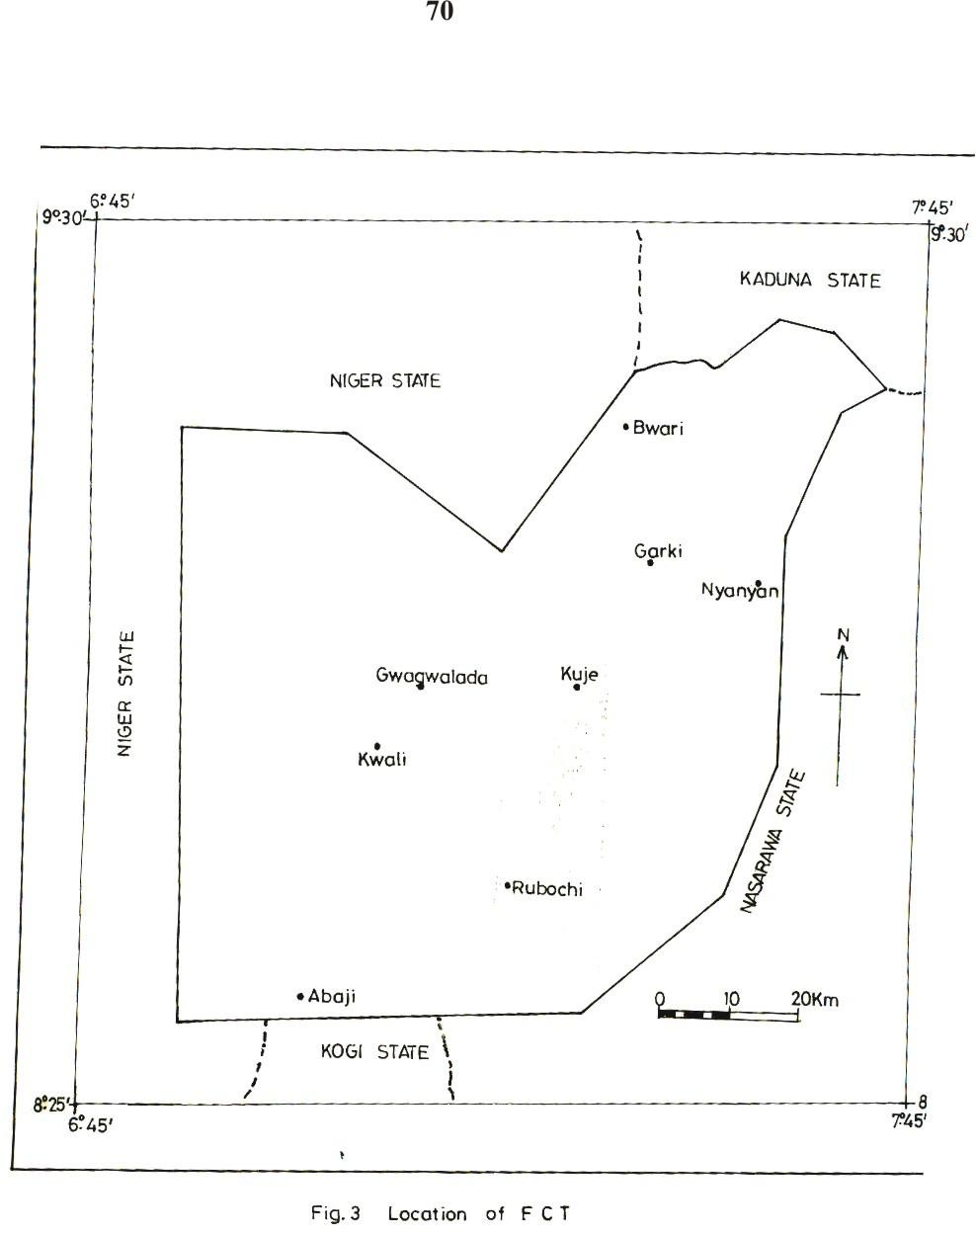

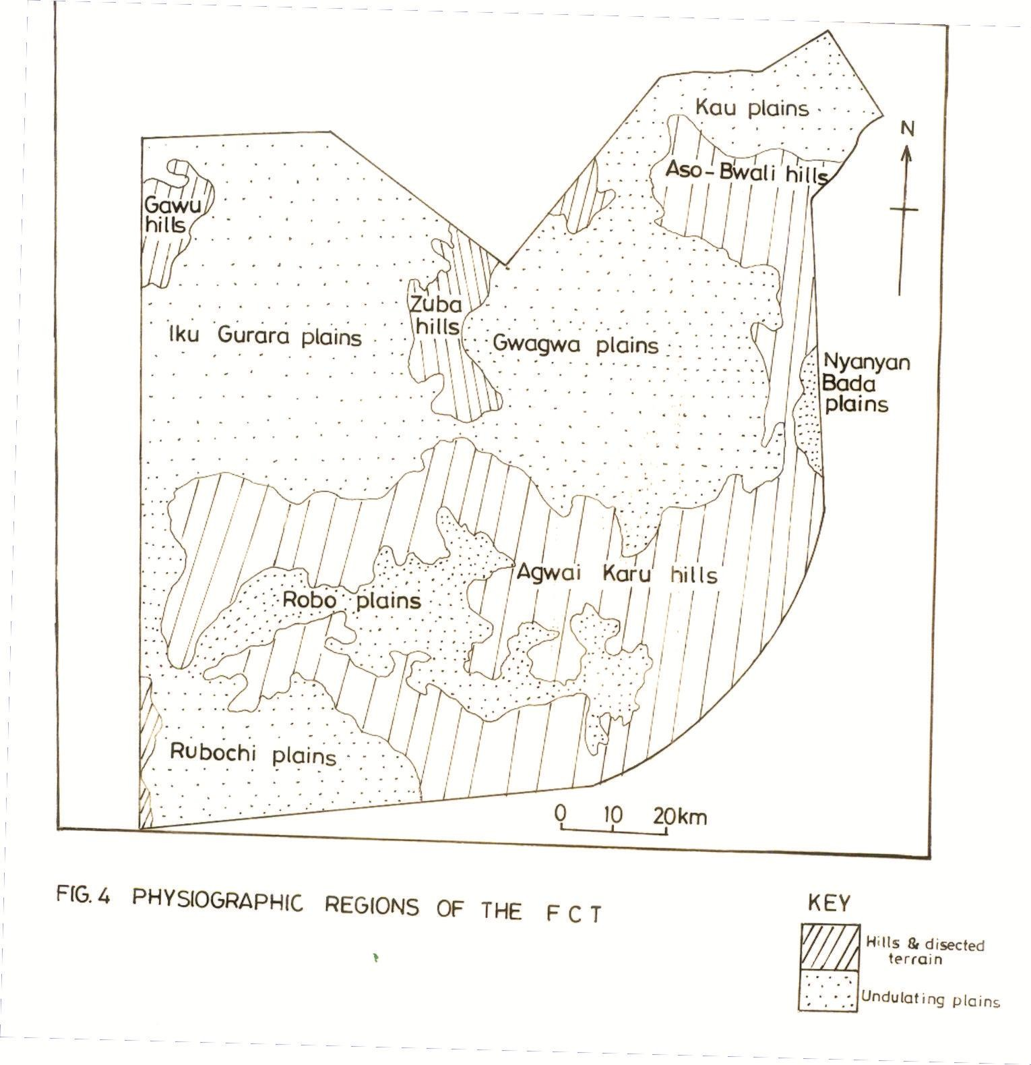

There exists some sand ridges and outliers of sandstone cappings towards the south-west of the territory.

In parts of Abaji and Kwali Area Councils, there are some significant proportions of sandstone and clay. The entire sedimentary formations of the FCT exhibit evidence of dissection by numerous seasonal rivers (Mabogunje, 1977). This promote continuous denudation activities, especially erosion and seasonal flooding of river channels and their adjourning riparian areas.

The landforms generally constitute the hill ranges and plains. The hill ranges are four, namely the Gawu, the Zuba, the Bwaru-Aso and the Agwai-Karu hills. The plains, on the other hand, are six in number; they include the Iku-Gurara, the Robo, the Kau, the Gwagwa, the Bada, and the Rubochi plains (Fig. 4). Generally, elevation is lowest in the south west around Yaba, where the Gurara flood plains are at a height of 70m asl. The elevation increases generally towards the north, east and north east (Mabogunje, 1977; Abumere, 1993; Chup, 2000b). The areas of low elevation, especially the South and South Western part of the Territory are characterized by severe gully erosion and flooding from river channels. The areas of high elevation on the other hand are characterized by sheet and rill erosion which if undeterred, would drastically affect the fertility of the soil, and the agricultural potential of these areas.

## SOILS

The soils of the FCT derive basically from two s rces; the crystalline rocks of the basement complex rocks, which cover the northern two-thirds of the territory, and the Nupe sandstones, which covers the southern one-third of the territory. The soils are often described along the identified physiographic regions (Alford and Touley, 1975; Mabogunje, 1977; Alhassan, 2000). The major soil

types include the gleysols, fluvisols, luvisols, combisols, regosols and lithosols. Generally the alluvial complexes contain gleysols and fluvisols, with the exception of the alluvial pediment complex of the Zuba hills, which contain combisols and regosols. The interfluves are dominated by luvisols and combisols. The summit and upper slopes of most interfluves are dominated by combisols and lithosols, while the wooded hills of plains (especially Gwagwa, Iku and Kau) are dominated by the regosols. The areas dominated by lithosols are easily eroded and therefore possess thin soils. These areas are also characterized by gully erosion. On the other hand, the area dominated by regosols are mostly flat lands where materials are deposited; thereby, possessing thicker soils. Their ability to support agricultural activities is higher than in areas with lithosols.

## CLIMATE

This section presents a brief description of the precipitation, temperature and humidity characteristics of the territory.

In terms of precipitation, mean annual amount varies from about 1400mm in the southern part of the FCT to about 1765mm in the north-east (fig. 5). The rainfall in the FCT occurs during the rainy season (April to October) when the tropical Maritime Airmass prevails over most parts of the country. There is extreme concentration of rainfall in the three months of July, August and September when more than 60% of the rainfall is received. The duration of the rainy season also varies from six months in the northern parts, to eight months in the southern parts of the FCT.

Highest temperatures in the FCT occur during the dry season months which are generally cloudless. Maximum temperatures in March

350



300

250

200



Lower Usuma

150

Yaba

100

50

0

JAN FEB MARCH APRIL MAY JUNE JULY AUG SEPT OCT NOV DEC



## Fig. 5 Mean annual rainfall in some places in FCT

March vary from 390C in the south west to about 340C in the north east. this period also records the highest diurnal temperature range of about 170C. The rainy season months usually record lower diurnal temperature ranges of about 70C. Maximum temperatures during this period vary from about 340C in the south west to about 310C in the north east. Average temperatures of about 240C and 280C are recorded in the rainy and dry seasons respectively in the north east and 270C and 300C, in the south west (Fig. 6).

Humidity varies in the dry season from as low as 20% in the afternoon, in areas of high elevation (North and North East), to about 30% in areas of lower elevation (South West). The low

humidity of this period, coupled with high afternoon temperatures largely account for the desiccating effects of the dry season, which also experiences the presence of the harmattan haze. In the rainy season however, afternoon humidity is about 50% for all places. It is often as high as 70-80% in July to September.

## VEGETATION

The vegetation of the FCT reveals a gradual transition from the rain forest in the south, to the Sudan Savannah in the north. The existence of numerous river valleys and hill ranges have added to the variety of vegetation in the territory. Kaeaya (1960), Alford and Touley (1975), Mabogunje (1977) and Adakayi (2000), have separately discussed the variety of vegetation in the FCT. A common observation is the fact that the vegetation consists of both forests and savannah types. The forests consist predominantly of woody plants, while the savannah consist of a combination of woody plants and mesophytic grasses which may grow to a height of 0.8m.

40

35

30

Maximum

25



0

20

Minimum

15

10

5

0

JAN FEB MARCH APRIL MAY JUNE JULY AUG SEP OCT NOV DEC

**A. Lower Usman**

45



Key

40

35

Maximum

30

25



0

20

Minimum

15

10

5

0

JAN FEB MARCH APRIL MAY JUNE JULY AUG SEPT OCT NOV DEC

## B Yaba

**Fig. 6 Average monthly temperatures (1991 - 2000). of some places in FCT.**

## The Forest Vegetation

The forest vegetation of the FCT consists of two types; the rain forests and the riparian vegetation complex. The rain forest vegetation is found in various locations of the territory and have a total area of 592km2 or 7.4% of the FCT. This vegetation occurs in the Gwagwa plains, the rugged south-eastern part of the territory

and the gullied landscape of the sedimentary rock area of the south west. The occurrence is on the foot of rocky hills like the Maje and Abuchi forest reserves, the hill country north of the Gwagwa plains, the Krima-Kaho area near Kuje, the deep gorge-like river valleys, valley heads and adjacent interfluves like the Gwagwa plains, central, southern and south eastern parts of the territory. They are also the broad valley bottoms, such as those of rivers Robo, Mangol, Afara Bakoi and their tributaries (Mabogunje, 1977; Adakayi, 2000). This vegetation is dominated by large trees which grow to a height of 40m; and their woody elements are arranged with their foliage crowns forming four layers. The upper three layers are trees, while the lowest consists of shrubs. This forest is evergreen, though it exhibits some deciduous characteristics, as some of the trees shed and regrow their leaves within two weeks. Large climbers and epiphytes of different species also grow on the trunks of the larger trees. The most common tree species include *Anthocleista, nobilis, Ceiba pentandra, Antiaris africana, Colagi gantea, Terminalis sueperda and Dracaena arborea.* (Mabounje, 1977; Adakayi, 2000).

The riparian vegetation complex, on the other hand, covers an area of 1,000km2 or 12.5% of the FCT. It occurs mainly in the valleys of river Usuma, Uku, Middle Gurara and Wuye. This vegetation has a mixture of riparian woodlands, gallary forests and dense thickets. The predominant tree species include *Phyllanthus discoideus, Afzelia africana, Alabizia zygia, Anogeissus leicarpus,*

*Elaeis guineensis* and the palm (*Pandanus candelarbum*) which appears to be the rather common. There also exists a ground layer of thick growth of di-cotyledonous herbs over which the palms usually stand. There are also thickets and woodland species within this vegetation belt. (Adakayi, 2000; Balogun, 2001).

## The Savannah Vegetation

The savannah vegetation in the territory consists of three sub- types namely the savannah woodlands, the park savannah, and the shrub savannah. The savannah woodlands are found mainly in the more rugged and less accessible parts of the territory, that are particularly associated with ridges and hill ranges. Such areas include the east and south of Kwali along the Sukuku hills towards the fringes of Robo plains, the Agwai-Karu hills, the upper basins of Afara bakoi and Robo rivers; parts of Iku plains to the north and Chibiri and west of Rafinpa. This vegetation covers a total area of 1,026km2 or 12.8% of the FCT. The savannah woodland vegetation is fire resistant and consists of ground vegetation dominated by grasses, and a continuous tree canopy where the vegetation is best developed. There also exist a large number of shrubs, largely between the tree trunks. The most common species of this vegetation include *Anona senegalensis, Uapala togoensis, Daniellia oliveri, Afzdia africana, Albizia zyga, Bombax constatum, Bridelia ferruginea, Parinati curatellifolia* and *Crossopteryx febrifuga* (Kaeaya, 1960; Mabogunje, 1977; Adakayi, 2000).

The park vegetation, which covers an area of about 4231km2 or 53% of the FCT, is easily distinguished from the woodland by their discontinuous foliage, when observed from above. Furthermore, this vegetation has a thicker and fuller growth of grasses as well as better marked horizontal separation between the foliage of the shrub and that of the tree layers. Species here are similar to those of the savannah woodland, and the dominant ones include the Albizia Zyga, shea butter (*Butyrospermum paradoxium*), *parkia clappertoniana and daniellia oliveri*. Three of the species, Albizia, Butyrospermum and parkia, bear fruits that are used as condiments in food separation, while doniellia oliveri is used for furniture making. These species are therefore protected and their dominance may well increase. Common species of the shrub layer include *Amona, nauclea, terminalia piliostigma* and *bombax constratum*. Common grass species include *andropogona* and *hyperorhenia species*. *Imperata cylindrica* is also a common grass, as it grows quickly at the beginning of the rainy season, but is later submerged by taller grasses (Alford and Tuley, 1975; Adakayi, 2000).

The shrub savannah covers an area of about 1032km2 or 12.9% of the FCT, and it occurs close to valley complexes, usually below wooded ridges and hills. It is found mainly on the northern fringes of the Iku-Gurara plains, the middle Gurara valley, along the Usuma valley (between Chibiri and Gwako), and between Gwagwalada and Tunga Aguma. Other areas include the hills ranges

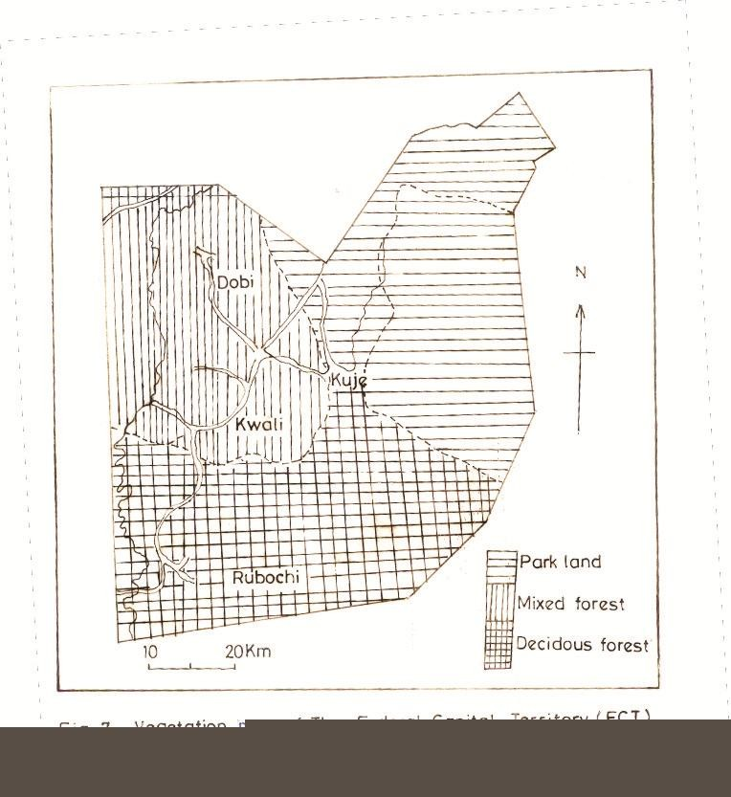

## Fig. 7 Vegetation Map of the F.C.T.

north of Gwagwa plains and the undulating terrain between the Robo and Afara Bakoi rivers. A distinguishing feature of the shrub savannah is the occurrence of trees in scattered locations, as well as the foliage layer provided by shrubs. Dominant tree species here include *Hymenocardia acida, Datarium microcarpum, Afromosis laxiflora, Terminalia laxiflora* and *Pirinari curatellifolia*. The grassy species are similar to those of the park savannah, except that they are more in abundance (Alford and Tuley, 1975; Mabogunje, 1977).

A relationship between vegetation and the environment can be observed here. The areas of savannah vegetation are in the North and Central part of the Territory, and have experienced more influx of people. It is here that the capital city and most satellite towns are located. These areas have witnessed more deforestration, intesivitation of land cultivation and general environmental degradation. The area of forest vegetation however are found in the Southern part of the Territory, and are less disturbed by human activities. These areas have less evidence of ecological problems resulting from human interference with the environment.

## POPULATION

The population of the FCT has been on the increase especially within the last two decades. Using an estimated annual growth rate of 4.0%, the population has grown from 125,000 in 1977 to about 582,948 by 2002 (Table 1). As at 1999, the FCT had an average household size of 7.9 persons, and as more people continue to migrate into the territory, it is believed that the population would continue to increase. The reasons for large scale migration of people into the FCT ranges from political, economic to social (Mundi, 2000).

## Table 1: Estimated FCT Population from 1991-2002

|  |  |  |  |  |  |
| --- | --- | --- | --- | --- | --- |
| Area | 1991 | 1994 | 1997 | 2000 | 2002 |
| Abaji | 23,647 | 26,600 | 29,922 | 33,65 | 36,405 |
| Gwagwalada | 80,841 | 90,936 | 102,290 | 115,062 | 124,451 |
| Kuje | 61,329 | 68,987 | 77,601 | 87,290 | 94,413 |
| Municipal | 212,854 | 239,432 | 269,328 | 302,959 | 327,680 |
| Total | 378.671 | 445,992 | 479,140 | 538,970 | 582,948 |

Source: NPC 1991; Mundi, 2000

The population of the FCT as at 1987 consisted mainly of eight ethnic groups which included Gbagyi 61.7%, Bassa 17.4%, Koro 6.1%, Gade 4.8%, Hausa 3.0%, Gwandara 2.7%, Ebira 1.3%, Tiv

0.8%.

In addition, other ethnic groups constituted 2.2% of the population (Unibadan Consult, 1987; Mundi, 2000). The indigenous population is presently mostly restricted to the rural areas, while the urban centers are heterogenous. To illustrate this, the entirely rural population of 1977, with no settlement having a population of up to 5,000 is believed to have had at least 27 settlements with populations of more than 5,000 by 1999 (Mundi, 2000). Furthermore, Chup and Mundi (2000) observed that not less than 60% of the FCT population as at 1997, migrated into the territory after 1977.

The 1991 population census results reveal that 29.1% of the economically active population of the FCT were engaged in

agriculture as their main occupation. In separate studies however, Gaza (1991) and Chup and Mundi (2000) discovered that more than 62% of the FCT dwellers are engaged in agriculture, either as a main occupation, or to supplement their earnings. Some migrants have taken advantage of the fertile land and have settled in the rural areas to farm. The increased in agricultural is a clear indication of more human interaction with the environment. This has contributed in intensification of deforestation and cultivation, and consequently, soil erosion and gullying. These no doubt are likely to increase the magnitude of environmental degradation, if majors are not taken to ensure sustainable use of the environment.

## SETTLEMENTS

The FCT has more than 850 settlements out of which more than 80% are rural (Gaza, 1991; Dawam 2000). Apart from the FCC, Gwagwalada, Kwali, Kuje, Bwari, Yaba, Robochi, Karshi, Zuba, Kubwa, Gwagwa, Karimu, Idu, Lugbe, Nyanya and Karu, all other settlements are villages and hamlets which are of the isolated nucleated pattern (Dawam, 2000; Balogun, 2001). As at 1977, all the settlements lacked basic infrastructure and the inhabitants were engaged in farming and other extractive activities. The urban areas today are provided with basic amenities and infrastructure, and have populations whose major occupation is in the secondary and tertiary sectors of the economy (Abumere, 1993; Dawam, 2000).

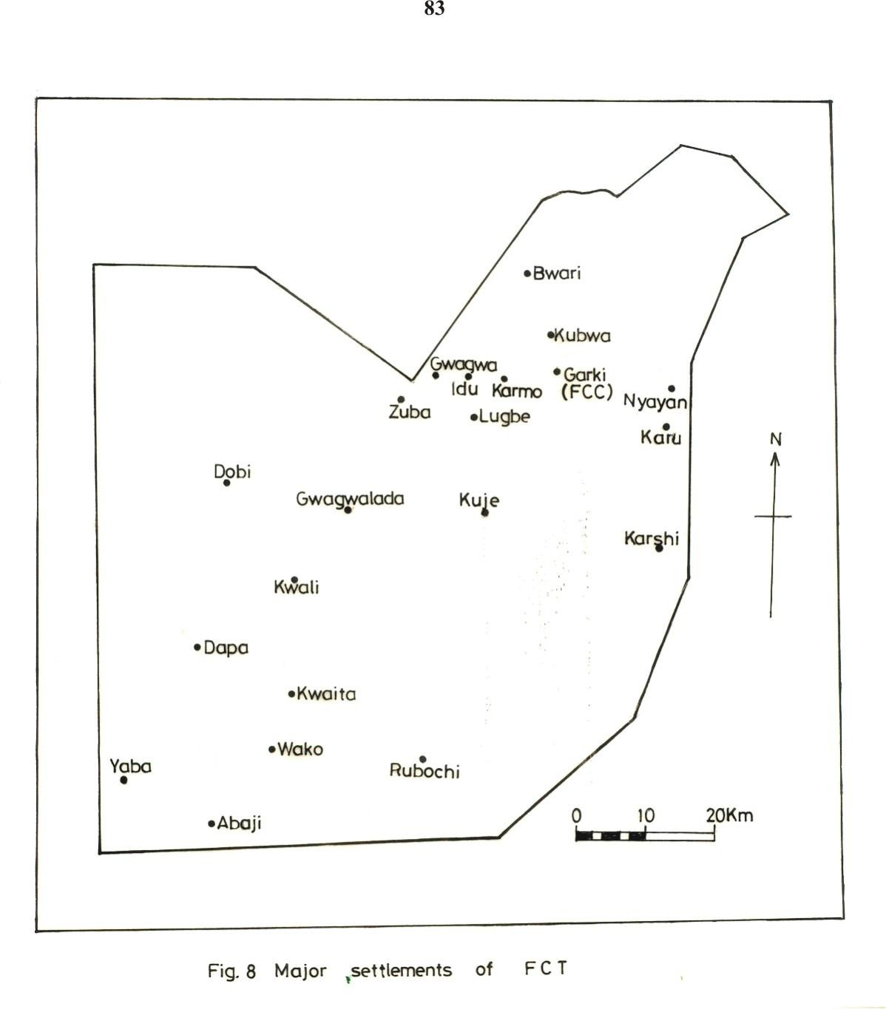

The predominantly rural settlements are within the interior and have remained largely agricultural. These settlements are also largely inhabited by the indigenous ethnic groups mentioned in Section 3.6 above. The individual settlement pattern varies depending on major ethnic groups in the area. These rural settlements, like in most parts of Nigeria, are largely inaccessible, lacked basic amenities such as health facilities, roads, electricity and portable water. The inhabitants of the rural settlements live a communal life style (Balogun, 2001). Attention has however been on the urbanized parts of the territory, to the detriment of the predominant rural areas which ironically provide a substantial part of the food requirements of not only their residents, but also those of the urban centres.

The major settlements are therefore largely concentrated in the North Easthern and Central Parts of the Territory (Fig. 8). These settlements are areas of large scale deforestration resulting from infrastructural development , urbanization and intensification of land cultivation. The implication of this is increased environmental problems. This is likely to intensify with time unless deliberate measures are taken to ensure sustainable management of the land,and its resources.

# CHAPTER FOUR MATERIALS AND METHODS

## DATA NEEDS

This section discusses the type of data that are required to achieve the objectives of the study. The data required include the socio-demographic characteristics of farmers who practise agroforestry. The socio-demographic information includes their ethnic and cultural characteristics, gender and social status (such as income, literacy status and family size). Information was also needed on the extent to which agroforestry is practised in FCT. Thus data were sought for and obtained on the area of land under agroforestry; as well as its spatial distribution. The involvement of people and organizations in agroforestry also constituted relevant data needed to achieve this objective. Furthermore, information on the crops and trees grown as well as animals husbanded in different parts of the territory was also collected. Information on the spatial variations in agroforestry practices within the FCT was also important. Such information included variations in tree species combination as well as the animal and annual crop combinations.

Furthermore, information was obtained on the reasons why farmers practice agroforestry. Thus data on the proceeds of agroforestry, such as food crops, fruits, income, fuelwood, fodder and medicines were collected. Similarly, the perceived benefits of

agroforestry to the farmers and their communities, as a whole also formed part of the data collected. Another objective of this study was to understand the ownership of and accessibility to land and its resources, particularly trees. Accordingly, information was collected on who controls land, as well as who and what determines its acquisition, the ownership of land, in different places, as well as the processes of land acquisition.

Information was further obtained on the variants of agroforestry practised by farmers in the territory. This was to enable an understanding of the different forms of agroforestry that are practised in the area. The nature of investment in afforestation as well as efforts made towards promoting afforestation was also determined. In order to aid the understanding of the management of agroforestry farms, information was sought and obtained on the technology applied, especially the labour inputs into the agroforestry farms.

## DATA SOURCES

The various sources from which the data collected as discussed in Section 4.1 above, are explained in this section. Basically, data for this study were obtained largely from primary sources. These include field observation, questionnaire administration, Focus Group Discussions, face to face interviews and measurements.

Specifically, field observation was employed to obtain data on the people involved in agroforestry, especially their socio- demographic characteristics. It was also used to obtain information on the extent to which agroforestry is practised as well as the spatial variation of agroforestry, in terms of species combination and spatial and temporal patterns. Furthermore, it was also used to obtain data on the benefits farmers derive from participating in agroforestry, the land tenure conditions, as well as labour requirements and input. It was also through this source that data on the forms of agroforestry in the territory were obtained.

The questionnaire was also used to obtain information on the socio-demographic characteristics of farmers involved in agroforestry. It was also the source from which data on the seasonal involvement of people in agroforestry, as well as the spatial variation of agroforestry was obtained. Furthermore, questionnaire administration also provided data on the benefits of agroforestry, land tenure conditions, management and ownership of agroforestry farms, as well as labour requirement and inputs into agroforestry.

Another important source of data for this study was the Focus Group Discussion (FGD). It was used to seek for, and obtain information on the benefits of agroforestry to the farmers, and the communities, as well as such benefits to the soil and the ecosystem, as perceived by the farmers. It also provided data on the forms of

agroforestry within the FCT. The FGD was also a source for obtaining data on the ownership and management of agroforestry farms, and also on labour requirements and inputs. The results obtained from this were used mainly for the verification of information derived from the questionnaire.

Face to face interview is another important tool that was used to obtain information for this study. It provided information on the extent of agroforestry, the seasonal involvement of farmers as well as the spatial variation of agroforestry, and species combination. Data on the benefits of agroforestry was partly obtained through this source. Finally, information on the land tenure conditions as well as the management and ownership of agroforestry farms was also obtained through face to face interviews.

## DATA COLLECTION

This section explains the procedures and instruments utilized in the process of data collection. It also explains the measurements carried out in the process of collection of data for the study.

## Procedures for Data Collection

Data collection actually began with a reconnaissance survey of the study area by the researcher, assisted by two guides who were extension workers of the Abuja Agricultural Development Programme (ADP). The extension workers were therefore conversant with the area. The reconnaissance survey, which was undertaken in order to familarise the researcher with the territory

generally, and the sampled settlements in particular, lasted for about one month (November to December 2002). After the reconnaissance survey, field observations commenced and lasted for about five months (covering the period of data collection). This was conducted periodically (between February to December 2003) in order to observe seasonal differences in agroforestry practices. The assistance of guides, as well as a botanist was also engaged. The botanist helped in the identification of botanical nomenclature of some woody components of agroforestry in the territory.

The administration of questionnaire came next. This was done with the help of ten research assistants, who were able to communicate fluently with the farmers. These assistants also had a minimum educational qualification of post Secondary Education. They were in addition given special training which focused mainly on the interpretation of the questionnaire and the translation of answers onto the questionnaire. The administration of questionnaire lasted for about three months during which the researcher effectively monitored the exercise.

Face to face interviews were conducted by the researcher throughout the period of data collection. Different interviews were conducted among different groups. One was among farmers and rural community members, while another was among research workers, extension workers and experts in agroforestry in the territory. The essence of these interviews was to understand the

knowledge of, and extent of participation in agroforestry by these different groups. The Focus Group Discussion (FGD) was conducted by the researcher and involved discussions with groups of between 5-10 farmers in the sampled communities. This exercise lasted about a month, and involved the use of tape recorders and audio cassettes. The discussions allowed participants to discuss freely on agroforestry, and was recorded for later analysis by the researcher.

## Instruments of Data Collection

These include instruments for interview, observation and measurements. The instruments for observation include field note books and pencils, for recording. The instruments for interview include the questionnaire, tape recorders and audio cassettes. The instruments for measurement were as follows:

* + - 1. Measuring tapes for determining the sizes of agroforestry farms.
      2. 25kg and 50kg sacks for determining quantity of farm products, especially crops.
      3. Cash for determining value of inputs as well as outputs of agroforestry. It was also used to determine the income of farmers’ household income from agroforestry.
      4. Field notebooks and pencils for recording information.

## Field Measurement

Measurement constituted a significant source from which data was collected for this study. Measurement was conducted on farm

sizes, agroforestry combinations, as well as some benefits of agroforestry.

Regarding farm sizes, measuring tapes were used to determine the area of land that is put into agroforestry. Local units of measurement, such as yam heaps, were also used to determine farm sizes. Measurement was also conducted in form of counting of crops, trees and animal species that are combined by farmers in different parts of the territory.

Some benefits of agroforestry were measured as follows:

1. crop yields were measured in sacks, using 50kg sacks, and the number converted to monetary value using market prices, at different seasons.
2. Yams were measured in terms of ‘calabash’ (i.e. 100 tubers of yam), and average annual monetary value determined using market price.
3. Fruits were measured in terms of average baskets and head pans and their average monetary value determined.
4. Firewood was measured in terms of average bundles, and monetary value was also determined using market price.
5. Manure was measured using 50kg sacks, and then value determined in monetary terms.

These benefits were determined for three to five years in order to give a fairly accurate situation, as they accrued to the farmers and their communities.

## Field Observation

Field observation constituted a significant aspect of the data collection for this study. This was conducted by the researcher, and was aimed at determining the practices of farmers that constitute agroforestry. Observations were made on the crops cultivated and animals reared as well as the trees grown. It also involved an examination of the period when such practices were conducted, as well as the different spatial and temporal combinations of both annual crops and woody perennial, and also the animal component of agroforestry.

Furthermore, the various forms of agroforestry in different localities were observed. This was to enable an understanding of the spatial arrangement of the different agroforestry components around the settlements. Observations were also made on the contributions or obvious benefits of agroforestry, as well as the problems encountered by the farmers which constituted obstacles to agroforestry in the territory.

## QUESTIONNAIRE FORMAT AND ADMINISTRATION

This section is concerned with the questionnaire that was administered; and it explains the structure and contents of the

questionnaire, as well as the procedures adopted in its administration.

## Questionnaire Structure and Content

The questionnaire for this study was divided into three sections. Section A contained questions which sought to obtain personal information from the respondents. Such information included the respondent’s age, sex, marital status, number of children, and other dependants, as well as their educational and economic status. Such personal data are important because the respondents’ perception and response to environmental issues and problems is often influenced by their personal ethno-social characteristics. Section B of the questionnaire sought to obtain information on agroforestry practices in the FCT. People’s involvement in agroforestry, the different combinations as well as the socio-economic benefits of agroforestry formed the content of this section. Also obtained were data on the problems militating against agroforestry, the management of agroforestry farms, as well as the comparative benefits or losses to farmers and communities. Section C of the questionnaire was designed to obtain information on farmers’ and communal access to land and tree resources. It also sought to obtain data on the relative ease with which farmers invest in land, animal rearing and tree planting. (See Appendix A)

## Questionnaire Administration

The administration of the questionnaire was done by trained field assistants who covered the forty sampled settlements. The use of field assistants enabled easy interpretation of some information and concepts that may not be easily understood by the farmers. The field assistants were people who knew the area very well, and could communicate easily with local farmers. A total of ten field assistants were employed and trained before they embarked on the actual work of administering the questionnaire. The ten assistants therefore covered four settlements each.

The questionnaire administration was done in such a way that not more than one farmer per household constituted part of the respondents. There was no time-lag between the distribution and collation of questionnaire, as the field assistants interpreted the questionnaire and transferred answers onto the questionnaire. All assistants therefore conducted the exercise simultaneously for a period of about three months.

## SAMPLING PROCEDURE

The sampling procedure here relates to the sampling frame, sampling fraction, as well as the sampling techniques adopted in the process of data collection.

## Sampling Frame

The sampling frame for this study was the entire Federal Capital Territory of Nigeria. Administratively, it is divided into six

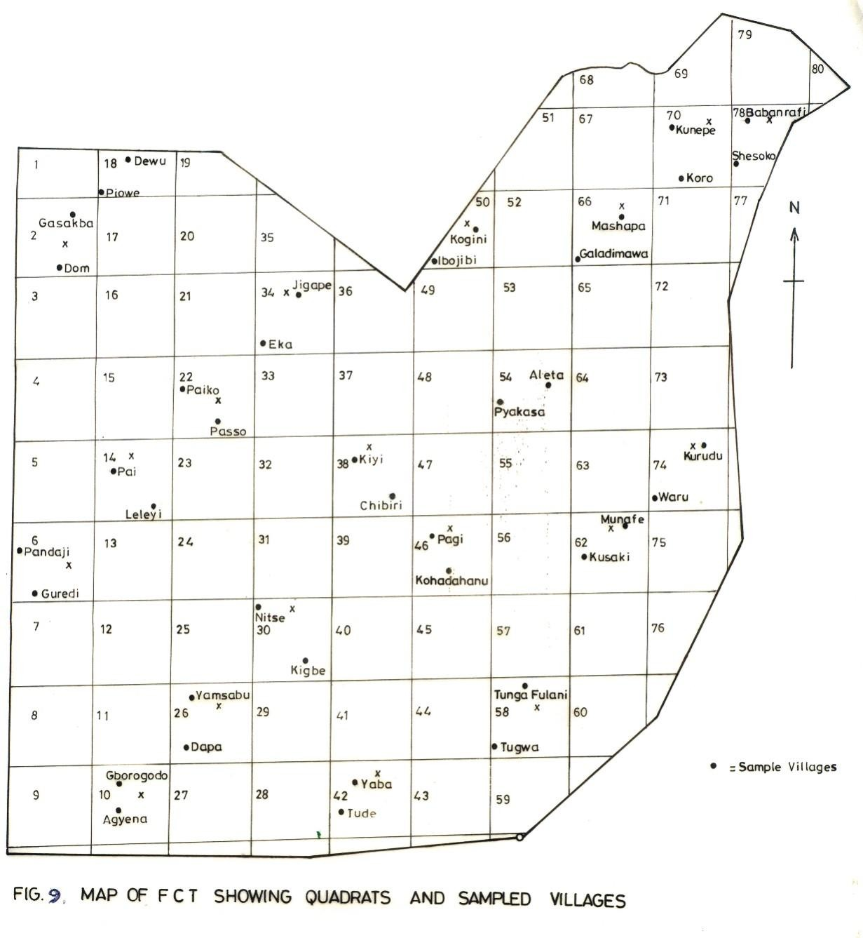

area councils, namely Bwari, Municipal, Gwagwalada, Kuje, Kwali and Abaji. The entire territory therefore constituted the sampling frame.

## Sampling Fraction

The area was divided into 80 quadrats of 100km each. Twenty of these quadrats were then selected systematically to constitute the sampling fraction. The guadrats were numbered 1-40 beginning from the North Eastern part of the map. The first guadrat that was selected was quadrat no 2. Henceforth, the fourth quadrat was consecutively chosen until 20 were selected through this process. This enabled the selected quadrats to be evenly spread through out the territory, (Fig. 9). The selected quadrats therefore give a total of 2,000km2, which was thus sampled and studied.

## Sampling Techniques

Systematic sampling was adopted in selecting the twenty quadrats that constituted the sample. All settlements in the chosen quadrats were listed and two were chosen to constitute the sampled settlements. A total of forty (40) settlements were therefore chosen for the purpose of questionnaire administration (See Figure 9). The two villages chosen in each quadrat, as much as possible, were not geographically contiguous. The administration of the questionnaire was done by the trained field assistants who administered one questionnaire each to fifteen (15) farmers in every sampled settlement. A total of six hundred (600) questionnaire were

therefore administered in the forty sampled settlements. The choice of the farmer to administer the questionnaire to was randomly done, and not more than one farmer per household was chosen for this purpose.

## DATA ANALYSIS

This section is concerned with the explanation of how the data collected from the field was processed and presented, in order to enable an understanding of the complex nature of such data. Different techniques were adopted, which include descriptive statistics, comparative analysis, and the use of an appropriate statistical test.

The data has been summarized and presented with the aid of tabular and graphical techniques. The use of several numerical measures such as ratios, percentages, central tendencies and interquartal ranges have also been applied in the analysis of data.

Comparative analysis have also been used in the analysis of data for this study. These were used to determine the relationships in the occurrence of phenomena. Tables and graphs have also been utilized for this purpose. Simple proportions were applied in the verification of the hypothesis on the extent of practice of agroforestry in the F.C.T. Furthermore, the chi-square test was also utilized, and this was for the verification of the hypothesis on the spatial variation of the intensity of agroforestry practices.

The Chi-square test is derived as follows:

 0  *e*2



2

*X*

*n e*

where

o = observed frequencies of data e = expected frequencies of data

## Problems of Research

This refers to the problems encountered during the course of this study. These problems no doubt affected the out come of the entire work, and include the following:

* + 1. The inaccessible nature of most rural areas was a major draw back of the study. Most of the villages covered by the study could not be easily reached, and this also delayed the completion of the work.
    2. Low level of literacy among most of the respondents.

This was the reason why the research assistants had to interprete the questionnaire, and translate their reponses into the questionnaire. There is no doubt that some distortion of facts might have occurred as a result of this.

* + 1. The absence of a uniform unit of measurement, especially with regards to farm outputs. The researcher had to resort to use of local units, and then conversions,

which apart from the difficulty it posses, might not always be very accurate.

* + 1. Uncooperating Manner of some respondents: Some of the respondents were not willing to provide information to the researcher and research assistants. The conduct of Focus Group Discussion was especially faced with this problem, and the researcher had to persuade them with some incentives.
    2. The high cost of research, which was borne entirely by the researcher, was another problem encountered during this work.

# CHAPTER FIVE

**DATA PRESENTATION AND DISCUSSION.**

## NUMBER OF SAMPLED FARMERS IN AGROFORESTRY

Information on the farmers who are engaged in agroforestry is summarized in table 2.

## Table 2: Respondent Farmers in Agroforestry in the FCT

Area Council

Farmers in agroforestry

Farmers not in agorforestry

Total number of farmers

|  |  |  |  |  |  |  |
| --- | --- | --- | --- | --- | --- | --- |
|  | | Number | % | Number | % |  |
| Abaji |  | 61 | 67.8 | 29 | 32.2 | 90 |
| AMAC |  | 71 | 59.2 | 49 | 40.8 | 120 |
| Bwari |  | 79 | 87.8 | 11 | 12.2 | 90 |
| Gwagwalada |  | 63 | 70.0 | 27 | 30.0 | 90 |
| Kuje |  | 94 | 78.3 | 26 | 21.7 | 120 |
| Kwali |  | 56 | 62.2 | 34 | 37.8 | 90 |
| Total |  | 424 | 70.7 | 176 | 29.3 | 600 |
| Table | 2 | Source:  revealed that | Field  just | survey, 2003  over 70% of | respondent | farmers |

practise agroforestry. However, this percentage varies widely from just under 60% in AMAC, through 78% in Kuje to just under 90% in Bwari. The proportion of sampled farmers in Agroforestry is least in AMAC, probably due to promiximity to the city; where many other activities apart from farming are carried out. Furthermore, the population in areas close to the city are employed in other sectors of the economy.

The distribution of respondent agroforestry farmers by residential status is summarized in table 3.

## Table 3. Distribution of Respondent Agroforestry Farmers by Residential Status.

Residential status

Respondent farmers Total in agroforestry not in

agroforestry

|  |  |  |  |  |  |  |
| --- | --- | --- | --- | --- | --- | --- |
|  | Number | % | Number | % | Number | % |
| Indigines | 350 | 82.5 | 99 | 60.8 | 449 | 74.8 |
| Immigrants | 74 | 17.5 | 77 | 39.2 | 151 | 25.2 |
| Total | 424 | 100.0 | 176 | 100.0 | 600 | 100.0 |

Source: Field survey, 2003.

Table 3. reveals that out of every 10 sampled farmers who practice agroforestry, more than 8 are indigenes while the rest are immigrants. It is significant to note that more than four-fifths of the indigenous farmers practice agroforestry, while just under 20% of the immigrant population practice agroforestry.

Table 4. further reveals the spatial distribution of agroforestry farmers by residential status. More details are presented in appendix Bii. Kuje Area Council recorded the hightest proportion of immigrant agroforestry farmers, while Abaji recorded the least. The relatively low proportion of immigrant farmers in agroforestry might not be unconnected with the communual land tenure system which does not encourage individual investment in land and its resources (Allan, 1965; Kang, et al; 1999). The relatively high proportion of immigrant agroforestry farmers in Kuje Area Council, might be due

to the fact that accessibility of land is much easier in the area. Table

17 which summarised land tenure status of sampled agrofrestry farmers seems to support this. The Area council recorded the lowest percentage of farmers who acquired the land through inheritance. It also recorded the highest percentage of farmers who were able to purchase the land.

## Table 4. Distribution of sampled Agroforestry Farmers by Residential Status.

Area Council Indigenes Immigrants Number % Number %

|  |  |  |  |  |
| --- | --- | --- | --- | --- |
| Abaji | 55 | 90.2 | 6 | 9.8 |
| AMAC | 63 | 88.7 | 8 | 11.3 |
| Bwari | 67 | 84.8 | 12 | 15.2 |
| Gwagwalada | 51 | 80.9 | 12 | 19.1 |
| Kuje | 67 | 71.3 | 27 | 28.7 |
| Kwali | 47 | 83.9 | 9 | 16.1 |
| Total | 350 | 82.5 | 74 | 17.5 |

Source: Field survey, 2003

## SOCIO-DEMOGRAPHIC CHARACTERISTICS OF FARMERS IN AGROFORESTRY

Table 5. summarised the gender and marital characteristics of agroforestry farmers in the FCT. The table reveals that at least 19 out of every 20 agroforestry farmers were males. However only 19% of the female agroforestry farmers were married, while about the same proportions were either divorced or separated. Almost two out of every five female agroforestry farmers were widowed. In the case of the male agroforestry farmers, more than 95% were married,

while the rest were single or widowed. There is therefore a gender disparity in agroforestry farming. The fact that one respondent was selected in a household, who was usually the household head, and who were mostly male, explains the very low, proportion of women observed in agroforestry in this study. It is significant to note that over three quarters of women agroforestry farmers were either divorced separated or widowed (Table 5). It was only in situations were such women were family or household heads that they had the opportunity to be selected as respondents.

## Table 5. Gender and Marital Status of Agroforestry Farmers in the FCT.

Gender Marital status Total Married Single Divorced Separated Widowed

Male 373 29 - - 1 403

Female 4 - 5 4 8 21

Total 377 29 5 4 9 424

Source: Field survey, 2003

The modal age of the farmers is 35-39. This age constituted about one-quarter of the total agroforestry farmers. The table has thus revealed that agroforestry farmers were mostly young, between the age of 30 and 49. This age range constitute more than three-quarters of the total agroforestry farmers of the territory. This youthful population would no doubt be an asset to investment in, and largescale adoption of agroforestry, as they would provide enough labour for such projects. This becomes clearer as almost 17 out of every 20 agroforestry farmers were relatively young (table 6).

## Table 6: Age Distribution of Agroforestry Farmers in the FCT

|  |  |  |
| --- | --- | --- |
| Age | Number of farmers | Percentage |
| 20-24 | 5 | 1.2 |
| 25-29 | 26 | 6.1 |
| 30-34 | 42 | 9.9 |
| 35-39 | 103 | 24.3 |
| 40-44 | 76 | 17.9 |
| 45-49 | 99 | 23.4 |
| 50-54 | 29 | 6.8 |
| 55-59 | 27 | 6.4 |
| 60-64 | 17 | 4.0 |
| Total | 424 | 100.0 |

Source: Field survey, 2003.

Another variable expected to influence farmers decision to practice agroforestry is income. The information provided on this by the respondents is presented in table 7 which shows that the income of agroforestry farmers is fairly evenly distributed; although majority of the farmers earned more than N100,000.00 constituting nearly 65% of the entire agroforestry farmers. This income level is actually not much when compared with current inflationary trends. Furthermore, the farmers would not be able to invest in any long term activity, due to poverty. This no doubt is a hinderance to largescale adoption of agroforestry by the farmers.

Another important social characteristic of the respondents considered is their educational status. Table 8 summarises the highest educational attainment of the farmers. It is quite obvious from the table that over three quarters of the agroforestry farmers

were literate to varying degrees, with about nine out of every twenty having primary school education.

## Table 7: Income Status of Agroforestry Farmers in the FCT

|  |  |  |
| --- | --- | --- |
| Income per annum (N) | Number | Percentage |
| Less than 50,000.00 | 52 | 12.5 |
| 50,000.00 - 100,000.00 | 94 | 22.7 |
| 100,000.00 – 200,000.00 | 115 | 27.7 |
| 200,000.00 - 300,000.00 | 117 | 28.2 |
| Moe than 300,000.00 | 37 | 8.9 |
| Total | 415 | 100.0 |

Source: Field survey, 2003.

The rest had secondary and post secondary education. Considering the present standard of education in the country, primary school leavers might not be able to communcate effectively. Thus almost 70% of the respondent agroforestry farmers would have problems of communication (see section 4.7). this would be a hinderance to effective information dissemination, and may also be a constraint to investment in agroforestry.

Information on the family size of respondent agroforestry farmers is summarized in table 9. which reveals that these farmers had relatively large families. Only 6% of the respondents had fewer than five member households, while just over two-fifths had 5-10 member households, just less than one-third had 11-15 member households, with the rest having more than 16 member households. The entire agroforestry farmers had a mean household size of 11.5. The information proided in table 9 revealed the typical rural communal life of most African communities, where families are

characterized by large sizes (Allan, 1965; Beats, 1985; Kerkhof, 1990). This large family sizes may be a burden on family resources.

## Table 8: Educational Level of Agroforestry Farmers in the FCT.

|  |  |  |
| --- | --- | --- |
| Educational level | Number | Percentage |
| No formal education | 98 | 23.1 |
| Primary school | 196 | 46.3 |
| Secondary school | 85 | 20.0 |
| Post secondary | 45 | 10.6 |
| Total | 424 | 100.0 |
| Source:  However, considering | Field survey, 2003  the major ocurpation | of these respondent |

households, the large sizes would no doubt be a viable resource in terms of ready farm labour supply. Moreover, where the need arises for largescale adoption of agroforestry, which could be labour intensive.

## 5.3. FORMS OF AGROFORESTRY

Various forms of agroforestry combinations abound in all ecological and geographical regions of the world, but most distinctively in the tropics (Torres, 1983; King, 1979; Huxley, 1983; Nair, 1993). The FCT is no exception, as different forms of agroforestry have been observed to exist in the territory. These were observed mainly during the field observation by the researcher and comfirmed during the Focus Group Discussion, and the Face to Face interviews with different groups. (Section 4.3.1) The forms of agroforestry in the

## Table 9: Family Size of Agroforestry Farmers in the FCT.

|  |  |  |
| --- | --- | --- |
| Family size | Number | Percentage |
| 1 – 5 | 25 | 6.0 |
| 6 – 10 | 174 | 41.7 |
| 11 – 15 | 122 | 29.3 |
| 16 – 20 | 68 | 16.3 |
| 21 – 25 | 23 | 5.7 |
| More than 25 | 4 | 1.0 |
| Total | 417 | 100.0 |
| Source: | Field survey, 2003 |  |

F.C.T. can be classified based on their structural basis. In this case emphasis is on the nature of the components, as well as arrangement of such components in space. These were observed to be as follows:

1. Agrisilviculture: In this category, crops and trees including shrubs are combined in different proportions. This has been observed to be dominant throughout the FCT. The scattered tree cultivation (also known as random mix), could be observed in all parts of the territory and this corresponds with the general situation in the savannah ecological zones of Africa (Torres, 1983; Raintree, et, al, 1984; Kerkhof, 1990; Nair, 1993). Virtually all respondent agroforestry farmers in the study area practice this form of agroforestry.

Another type of this form of agroforestry in the territory was Alley Croping. In this case, trees are planted in rows, with the space in between, used for the cultivation of crops. This practice is gaining acceptability in all ecological zones of Nigeria (Idowu, 1990; Adedire, 1992; Ong, 1994; Udofia, 1994; Idisi, 1999); and it was observed in some parts of Kwali, Kuje and Abaji Area Councils (Plate 4). This was however not common among the respondent agroforestry farmers, especially in the Northern parts of the FCT

1. Agrosilvipastoralism: This involves combination of crops and trees, with the rearing of animals on the same piece of land. This involve both temporal and spatial combinations (Raintree, et al, 1984; Nair, 1993). In the FCT, this practice is observed in the northern parts of the territory (Bwari and some parts of AMAC and Gwagwalada Area Councils); and as observed in section 22 is often contractual between farmers and cattle herders. The Fulani cattle rearers usually rear the animals on the farm after harvests. This system enables both parties to benefit, as the animal feed on crop residues, while the animals increase the fertility of the land through their dungs.
2. Multipurpose tree lots: This system involves the deliberate planting of trees in concentration, on a piece of land. There exist different purposes for this practice. These include the production of fuel wood (woodlots), prevention of erosion, and production of fruits also known as orchard plantation (Kerkhof, 1990; Idisi, 1999;

Backes, 1999; Kang et al, 1999). The forms of this practice observed in the FCT are the woodlots (in some parts of Bwari Area Council), and orchad plantations, observed in all parts of the territory. These are planted and maintained by individual farmers, whose main aim is to improve cultivation of fruits, which are sold to increase income. In this practice, annual crops (such as vegetables, groundnuts and beniseed) are planted in between the trees (such as oranges, cashew, and guava) especially in the first few years of plantation.

## THE EXTENT OF AGROFORESTRY

This refers to the extent to which agroforestry is practised in the area. It involves the farmers who practise agroforestry, as well as the land area under agroforestry. In order to fully comprehend the extent of agroforestry practices, information was also obtained on the structure of agroforestry, which is presented in this section.

## Extent of Agroforestry Practices

The socio-demographic characteristics of respondent farmers practicing agroforestry has already been presented in section 5.1 while information on the land area under agroforestry has been summarized in table 10. The estimated total land area under agroforestry by the respondent agroforestry farmers was found to be 852.9 Hectres (or 8.53km2). This however varies from 68.2 Hectres in Kwali Area Council, through 123.4 Hectres in Abaji, to

197.8 Hectres in Kuje Area Council. The per capital land area, which is 2.01 Hectres for the entire territory, varies from 1.218 Hectres in Kwali to 2.714 in AMAC. This was obtained by dividing the total land area by the number of farmers. From table 10, the total land used for agroforestry by the respondent farmers was more in AMAC and Kuje Area Council. This may be because these Area Councils had more respondent farmers than the others (Table 2). Total land under agroforestry is actually much more than this, as table 10 revealed only that of sampled agorforestry farmers.

## Table 10: Land Area of Sampled Agroforestry farmers.

Area Council Number of farmer Per capital Area

(in hectres)

Total area (in hectres)

Abaji 61 2.023 123.4

AMAC 71 2.714 191.7

Bwari 79 2.005 158.2

Gwagwalada 63 1.793 113.6

Kuje 94 2.104 197.8

Kwali 56 1.218 68.2

Total 424 2.01 852.9

Source: Field survey, 2003

## Agroforestry Species:

* + - 1. **Crop species:**

A total of 12 crop types were cultivated by agroforestry farmers mainly from the scattered tree cultvitation in all the area councils.

These are summarized in figure 10. However, in terms of total number of farmers involved, maize (*zea mays*) was the commonest crop, as it was grown by 90% of the sampled agroforestry farmers. The others in

descending order of magnitude and the proportion of farmers growing them are guinea corn (*sorghum SPP*), 86%; Yam (*dioscore Alata SP*), 69%; millet (*Eleasin corocana*), 53%; rice (*oriza satiya*), 47%, and groundnut (*Arachis Hypogea*), 39%. Others were Beans (*vigna unguiculata*), 32%; cassava (*manihot esculenta*), 29%; Beniseed (*Sesamum indicum*), 23%; melon (*Citrullus lanatas*), 20%; Garden egg (*Solanum melongena*), 7%; and sugar cane (*Saccharum officinarum*), with just over 5%. The most favoured crop types namely; maize, guinea corn, millet and yam, are largely food crops. These are produced mainly to provide food to the largely subsistent farmers of the territory. This is an indication of the nature of agricultural production in the area under which this study is carried out; which points to the low capacity of the farmers to invest in largescale agricultural projects.

16

14

12

10

Dom Gasakpa Pandayi Guredi Gborogodo Agyena

No. of farmers

8

6

4

2

0

Rice

Maize

Yam

Guinea Corn

Cassava

Beneseed

Beans

G/Nut

Millet

Mellon

## FIG. 10a Histogram of Crop Species of Agroforestry Farmers in Abaji Area Council

16

14

12

Pyakasa Aleta Wunafe Kusaki Mashapa Galadimawa Waru Kuduru

No. of farmers

10

8

6

4

2

0

Rice

Maize Yam Guinea Corn Cassava G/egg Beneseed Beans G/Nut Millet S/cane Mellon

## FIG. 10b Histogram of Crop Species of Agroforestry Farmers in Amac

16

14

12

No. of farmers

Kagiri Ibojibi Kunepe Koro Baban Rafi

Shesoko

10

8

6

4

2

0

**c. Bwari**

## FIG. 10c Histogram of Crop Species of Agroforestry Farmers in Bwari Area Council

16

14

12

10

Dewu Piowe Eka

Jigape

Passo Paiko

8

No. of farmers

6

4

2

0

Rice

Maize

Yam

Guinea Corn Cassava G/ egg

**d. Gwa gwa l a da**

Beneseed Beans

G/ Nut

Millet

S/ cane Mellon

## FIG. 10d Histogram of Crop Species of Agroforestry Farmers in Gwagwalada Area Council

16

14

12

Chibiri Kiyi Tude Yaba Pagi

Kohodowu Tungwa

Tungwa Fulani

10

8

6

4

2

0

No. of farmers

Rice

Maize

Yam

Guinea Corn Cassava

G/ egg Beneseed

Beans

G/ Nut

Millet

S/ cane

Mellon

## FIG. 10e Histogram of Crop Species of Agroforestry Farmers in Kuje Area Council

**e . K uj e**

14

12

10

Pai Leleyi Dapa Yamsabu Nit se

Kigbe

No. of farmers

8

6

4

2

0

Rice

Maize

Yam

Guinea Corn

Cassava

G/ egg Beneseed Beans

**f . K wa l i**

G/ Nut

Millet

S/ cane

Mellon

**FIG. 10f Histogram of Crop Species of Agroforestry Farmers In Kwali Area Council**

# Tree Types

A total of Ten tree species were cultivated and, or protected by the agroforestry farmers in the area. As can be seen from figure 11, the tree crop that is most frequently patronized by the farmers is Mango (*magnifera Indica*), with about 56%. The others in descending order are orange (*citrus aurantium*), 49%; cashew (annacarium accidental), 43% and Guava (*Guirera*), 32%. Others are Locust beans (*Parkia aupertomana*), 21% Banana and plantain (*musa Sapientum* and *Musa Parades*), 17%; shea butter (*Butryrospernum Parkii*) about 12%; pawpaw (*carica papaya*), and umbrella tree (*terminalia catappa*), with barely 2%.

## Table 11: Tree planting by agroforestry farmers

|  |  |  |
| --- | --- | --- |
| Area Council | Number of farmers | Percentage |
| Abaji | 31 | 50.8 |
| AMAC | 34 | 47.8 |
| Bwari | 46 | 58.2 |
| Gwagwalada | 30 | 47.6 |
| Kuje | 47 | 50.0 |
| Kwali | 17 | 30.4 |
| Total | 205 | 48.3 |

Source: Field survey, 2003

The number of farmers combining these trees with annual crops varies from one Area Council to another. Kwali had the highest proportion of farmers in three types namely cashew, orange, and plam trees. It was followed by Abaji, Bwari and Gwagwalada with highest in only two each. Kwali ranked highest in only Guava, while

Agroforestry Farm of Okra and Beans under Cashew, Shea butter and Mango Tress at Bwaro Area Council.

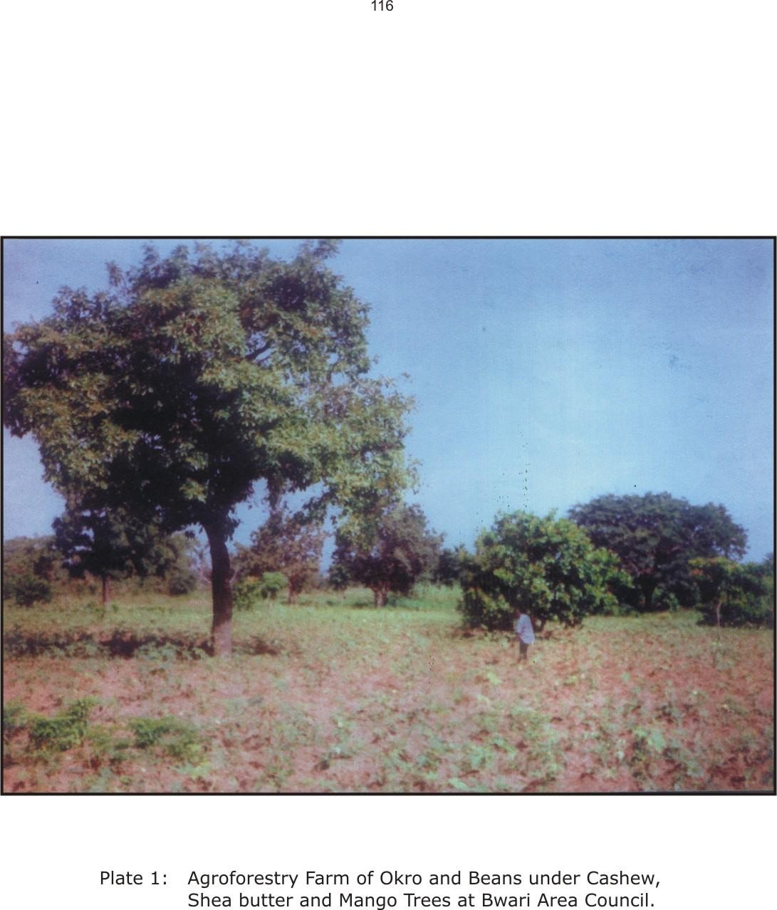

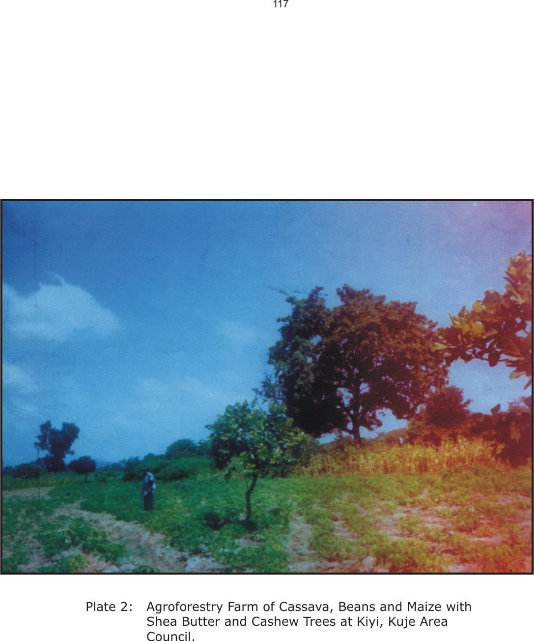

AMAC did not rank highest in the combination of any of the ten tree types. In addition AMAC ranked lowest in the proportion of farmers cultivating six out of the ten tree types (table 24). This same table further revealed that Bwari, Gwagwalada and Kuje Area Councils recorded the highest average quantities of two tree types each. This is an indication of the fact that there is variation of intensity of agroforestry practices within the different parts of the territory (chapter six).

In addition to protecting trees by the farmers, it was also found that nearly one-half of them had been engaged in tree planting. The distribution of this category of farmers is shown in table 11. It can be seen from this table that the highest proportion of agroforestry farmers who had so far engaged in tree planting was recorded in Bwari Area Council while the lowest was in kwali Area Council. Reasons for the planting of trees by the farmers are summarized in table 12.

## Table 12: Reasons for planting trees by agorforestry farmers

|  |  |  |
| --- | --- | --- |
| Reason | Number of farmers | Percentage |
| Provision of fruits | 74 | 36.6 |
| Provision of firewood | 56 | 27.3 |
| Protection of farmland | 49 | 23.9 |
| Provision of shade | 29 | 14.2 |

N =205.

Source: Field survey, 2003

10

9

8

a b c d e f h I

j

7

6

No. of farmers

5

4

3

2

1

0

Dom

Gasakpa

Pandayi

Guredi

Gborogodo

Agyena

## fig. 11a. Histogram of Tree Types Maintained by Farmers in Abaji A.C.

|  |  |  |  |
| --- | --- | --- | --- |
|  | a = Mango | e = Locust beans | i = Umbrella tree |
| b = Cashew | f = Orange | j = Palm tree |
| c = Guava | g = Shea buter |  |
|  | d = Plantain/Banana | h = Pawpaw |  |

10

9

8

a b c d e f g h i j

7

6

5

No. of farmers

4

3

2

1

0

Pyakasa

Aleta

Wunafe

Kusaki

Mashapa

Galadimawa Waru Kuduru

**b. AMAC**

## fig. 11b. Histogram of Tree Types Maintained by Farmers in AMAC

12

10

a b c d e f g h i

j

8

6

4

2

0

No. of farmers

Kagiri Ibojibi Kunepe Koro Baban Rafi Shesoko

## fig. 11c. Histogram of Tree Types Maintained by Farmers in Bwari A.C

7

6

5

a b c d e f h

4

3

No. of farmers

2

1

0

Dewu

Piowe

Eka

Jigape

Passo

Paiko

## fig. 11d. Histogram of Tree Types Maintained by Farmers in Gwagwalada

9

8

7

No. of farmers

6

a b c d e f h

5

4

3

2

1

0

Chibiri

Kiyi

Tude

Yaba

Pagi

Kohodowu

Tugwa

Tungwa Fulani

## fig. 11e. Histogram of Tree Types Maintained by Farmers in Kuje A.C.

6

5

4

No. of farmers

a b c d e

f

3

2

1

0

Pai

Leleyi

Dapa

Yamsabu

Nitse

Kigbe

## fig. 11f. Histogram of Tree Types Maintained by Farmers in Kwali A.C.

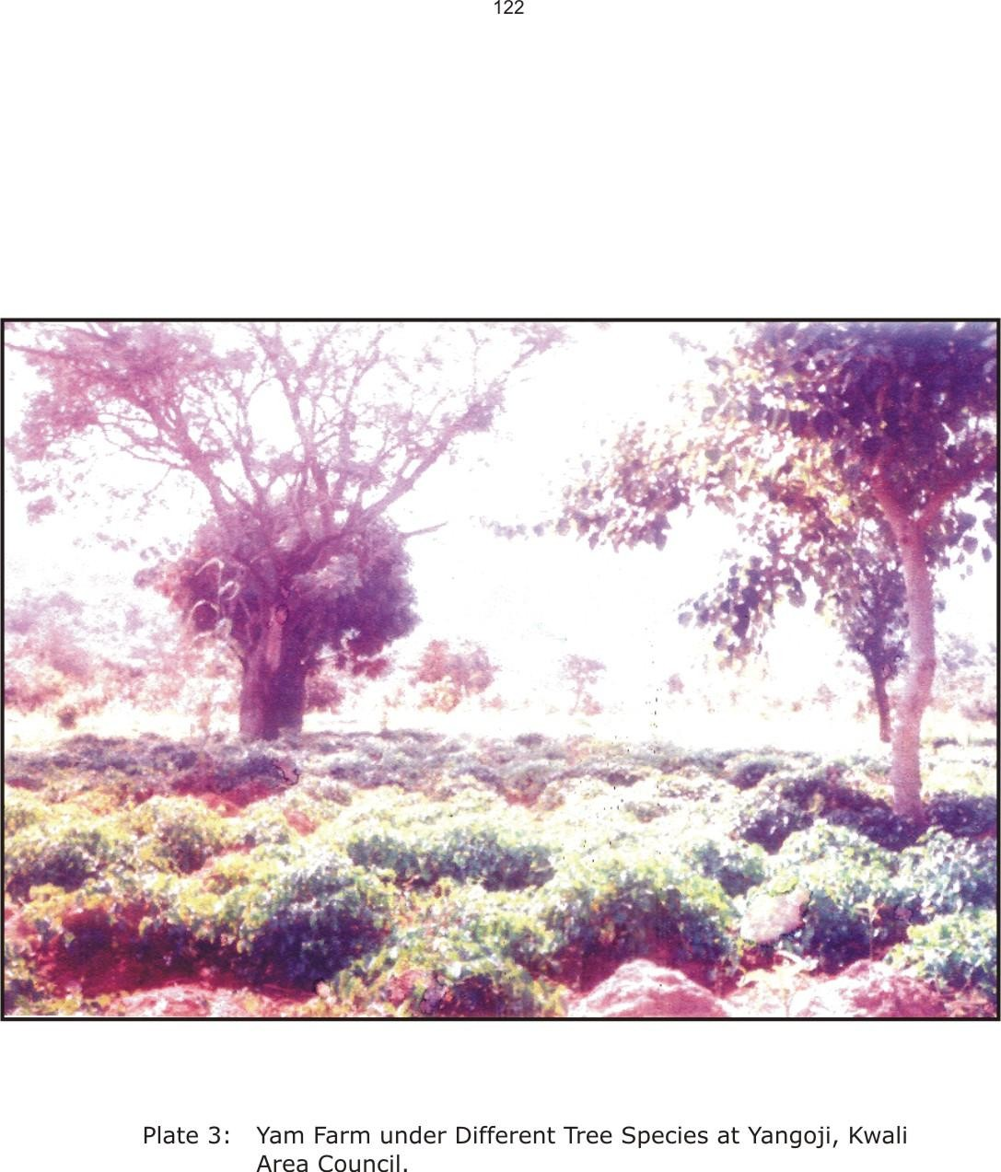

The main reasons given for the planting of trees as shown in table 12 collaborates the benefits derived from the farmers who practised agroforestry. This further confirms the objective of gorforestry in the FCT. Agroforestry farmers who did not engage in tree planting also gave reasons for their non-involvement in the practice. The reasons given by the farmers are summarized in table 13.

## Table 13: Reasons for the non-investment in tree planting by agroforestry farmers.

|  |  |
| --- | --- |
| Reasons Number of farmers | Percentage |
| Restriction by landowners/families 46 | 58.2 |
| Lack of interest 34 | 50.8 |
| Waste of time and resources 31 | 47.8 |
| Lack of financial resources 30 | 47.6 |
| N=67 |  |
| Source: Field survey, 2003 |  |

A total of 67 respondent agroforestry farmers gave reasons for not planting trees. Almost six out of every ten of them believed the land owners restricted them from doing so. This reveals that accessibility to land and its reasources is to a large extent restricted, and this no doubt is a hinderance to the improvement of agroforestry in the territory.

## Livestock Types

The rearing of livestock was further incorporated into agroforestry by the farmers. The number of farmers keeping livestock and the types of livestock kept are summarized in figure 12, which revealed that a total of five livestock types consisting of different local species are reared. The goat was the most favoured in terms of the number of farmers rearing it. On the other hand, the pig was not reared by any of the respondent agroforestry farmers in Abaji Area Council. In terms of spread of the livestock component of agroforestry, Kwali Area Council recorded the highest number of farmers in sheep, poultry and pigs. Abaji recorded the highest number of farmers rearing goats and kuje ranked highest in rearing of cattle. Furthermore, table 25 revealed that Kwali Area Council had the highest proceeds in terms of livestock sold over a period of five years. This is because it recorded highest proceeds in goats, sheep and cattle. Kuje and Bwari recorded the highest proceeds from chicken and pigs, respectively (table 25). These are indications of the variations in intensity of agroforestry practices in the territory.

10

9

8

No. of farmers

7

6

i ii iii iv

v

5

4

3

2

1

0

Dom Gasakpa Pandayi Guredi Gborogodo Agyena

**a. Abaji**

## fig. 12a. Histogram of livestock reared by agroforestry farmers in Abaji A.C.

i. = Goats ii. = Sheep iii. = Chicken iv. = Cattle v. = Pigs

10

9

8

i ii iii iv v

7

6

No. of farmers

5

4

I

3

2

1

0

Pyakasa

Aleta

Wunafe

Kusaki

1. **AMAC**

Mashapa

Galadimawa Waru Kuduru

## fig. 12b. Histogram of livestock reared by agroforestry farmers in AMAC

12

10

i

ii iii iv v

No. of farmers

8

6

4

2

0

Kagiri

Ibojibi

Kunepe

1. **Bwari**

Koro

Baban Rafi

Shesoko

## fig. 12c. Histogram of livestock reared by agroforestry farmers in Bwari A.C.

7

6

5

No. of farmers

i ii iii iv v

4

3

2

1

0

Dewu

Piowe

Eka

Jigape

Passo

Paiko

1. **Gwagwalada**

**fig. 12d. Histogram of livestock reared by agroforestry farmers in Gwagwalada A.C.**

9

8

7

6

i ii iii iv v

No. of farmers

5

4

3

2

1

0

Chibiri

Kiyi

Tude

Yaba

Pagi

Kohodowu

Tugwa

Tungwa Fulani

## fig. 12e. Histogram of livestock reared by agroforestry farmers in Kuje A.C.

6

5

4

i ii iii iv v

No. of farmers

3

2

1

0

Pai

Leleyi

Dapa

Yamsabu

Nitse

Kigbe

## fig. 12f. Histogram of livestock reared by agroforestry farmers in Kwali A.C.

* + 1. **Temporal Dimension of Agroforestry Practices**

It has been observed generally within the FCT that perennial trees such as Locust beans, shea butter, mango and cashew are intermixed with annual crops, usually during the rainy season. The mixture in all parts of the territory, is the “scattered farm tree system” (Gatahum, et al, 1987; Oboho and Onyia, 1992; Balogun, 2001). After the harvest of the annual crops, and especially in the dry season, the perennial trees are left, and are often prunned to provide fodder for animals. This collaborates the practice in other ecological zones of the tropics (Raintree, et al, 1984; King, 1987; Adedire, 1992; Spore, 2000a). The pruning of the trees is usually done by the local agroforestry farmers, and some Fulani cattle rearers.

Furthermore, animals such as goats, sheep and cattle are allowed to freely graze on the farmland, after the harvest of the annual crops. This justifies the inclusion of the livestock component into the system, as their wastes help to enrich the soil (Agboola, 1982; Winterbottom, 1987; Kang, et al, 1999). Other animals such as pigs and chicken are also significant. These livestock though largely restricted, their wastes are nevertheless utilized as manure on the farms. These are collected regularly and applied to the farms during the cropping season (Agboola, 1982; Winterbottom, 1987; Adedire, 1992). Table 17. revealed the average amount of manure

that farmers have been using on their agroforestry farms. The manure is derived from livestock wastes.

An exception to this seasonal combination however, exists at Wako in Kwali Area Council. Here, cultivation is done on a permanent basis through the adoption of irrigation. Water of river Afara bakwoi and the rich alluvial soils within the valley provides very good conditions for irrigated farming (Abubakar, 1996). Here, annual crops such as maize, okra, sugar cane and vegetables are intermixed with trees such as mango, orange, bitter leaf, pawpaw and banana (See Plates 5 and 6). There does not exist any fallow period here, as the farm is continuously cultivated through both rainfed crop cultivation, and irrigation.

## OWNERSHIP AND MANAGEMENT OF AGROFORESTRY FARMS

* + 1. **Ownership Of Agroforestry Farms**

Information was obtained on who owns and who manages agroforestry farms in the FCT. This information is presented in table

14. According to the table, 16 out of every 20 respondents believed that they owned the farms on which they carried out their activities.

## Table 14: Ownership of agroforestry farms by farmers in the FCT

Ownership Area Council Total

|  |  |  |  |  |  |  |  |
| --- | --- | --- | --- | --- | --- | --- | --- |
| of farms | Abaji | AMAC | Bwari | G/Lada | Kuje | Kwali |  |
| Yes | 59 | 58 | 69 | 51 | 79 | 47 | 363 |
| No | 2 | 13 | 10 | 12 | 15 | 9 | 61 |
| Total | 61 | 71 | 79 | 63 | 94 | 56 | 424 |

Source: Field survey, 2003

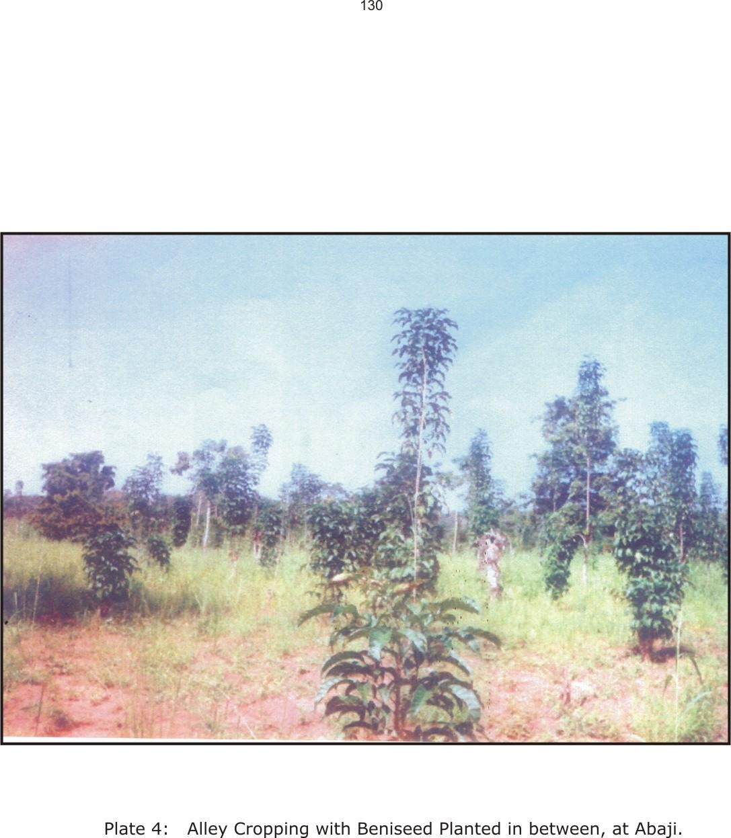

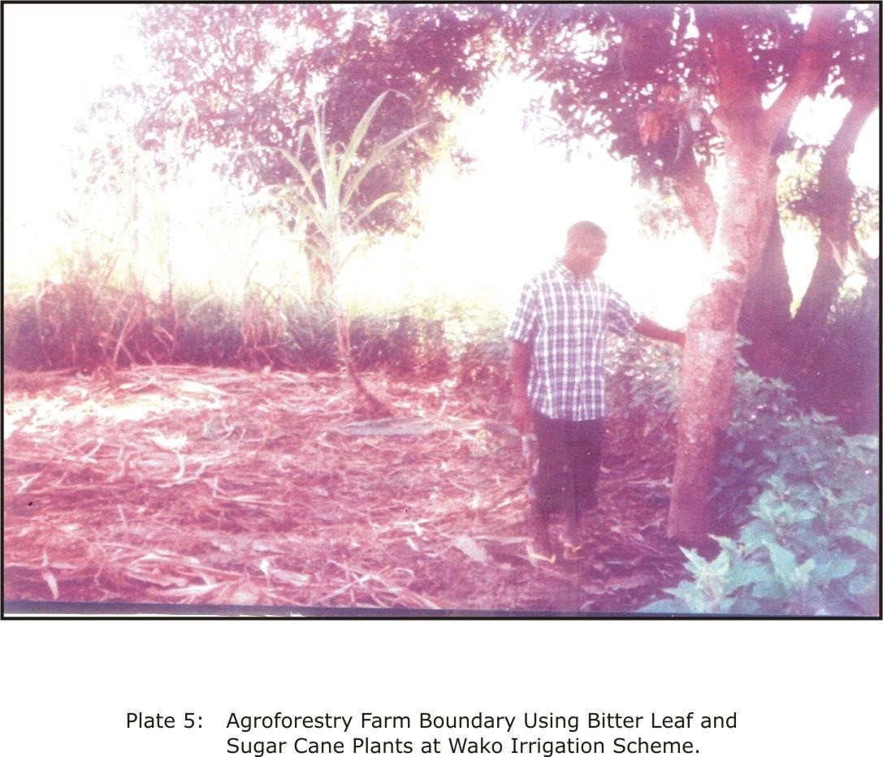

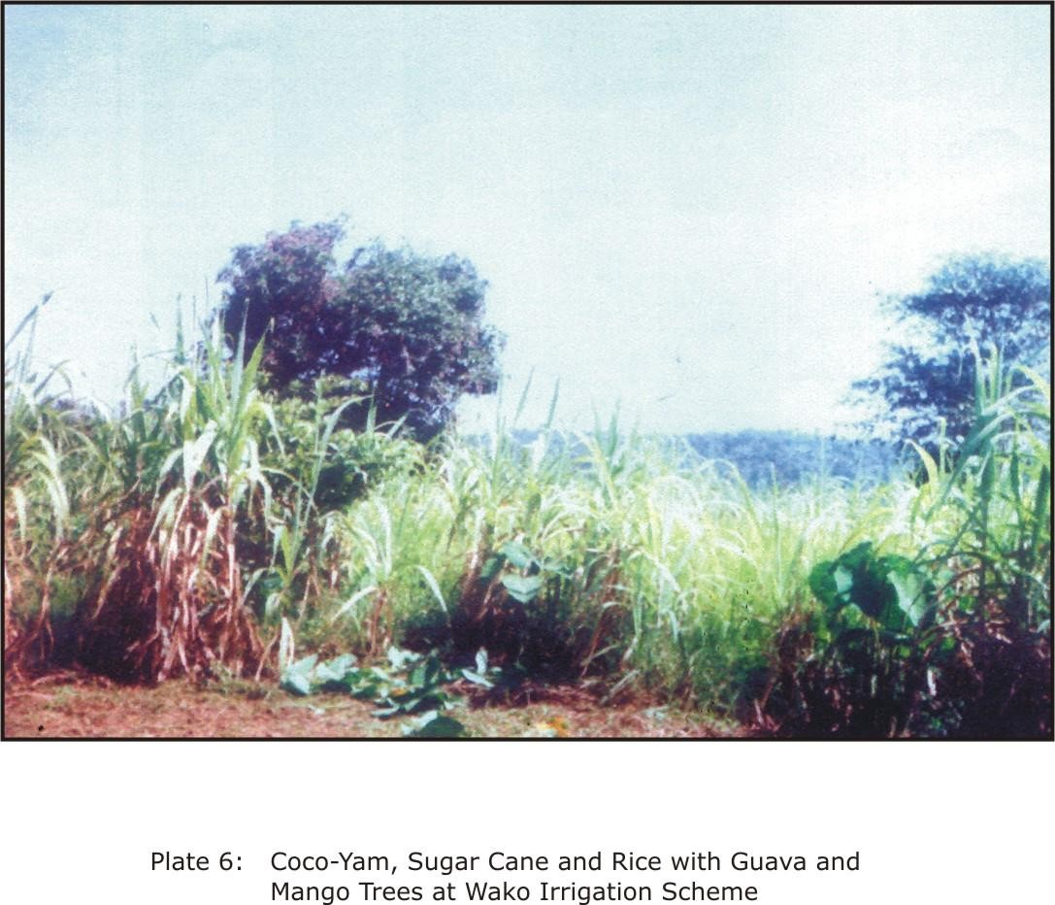

It is quite obvious from table 15 that only a very small proportion of the farmers actually owned their farmlands; as nearly 80% of them operated on family and communal land, through inheritance. The table also revealed that almost 13% of these farmers were using the land on a temporal basis, through rent or lease. These category of farmers could not invest in the land, without the permission of those who granted them such land. Only about 8% of the farmers who practiced agroforestry could truly be said to be owners of the land, as they had purchased such land, and could utilize it for whatever purpose they so wished.

Table 15: Land tenure status of Agroforestry farmers in the FCT

Land tenure

Farmers per Area Council Total Abaji AMAC Bwari G/Lada Kuje Kwali

|  |  |  |  |  |  |  |  |  |  |  |  |  |  |  |
| --- | --- | --- | --- | --- | --- | --- | --- | --- | --- | --- | --- | --- | --- | --- |
| status | No | % | No | % | No | % | No | % | No | % | No | % | No | % |
| Inheritance | 53 | 85.5 | 54 | 77.1 | 67 | 85.9 | 47 | 75.8 | 62 | 68.9 | 44 | 84.6 | 327 | 79.0 |
| Purchase | 6 | 9.7 | 4 | 5.7 | 3 | 3.8 | 1 | 1.6 | 15 | 16.7 | 5 | 9.6 | 34 | 8.2 |
| Lease | 3 | 4.8 | 9 | 12.9 | 8 | 10.3 | 11 | 17.8 | 9 | 10.0 | 3 | 5.8 | 43 | 10.4 |
| Rent | - | - | 3 | 4.3 | - | - | 3 | 4.8 | 4 | 4.4 | - | - | 10 | 2.4 |
| Total | 62 | 100.0 | 70 | 100.0 | 78 | 100.0 | 62 | 100.0 | 90 | 100.0 | 52 | 100.0 | 414 | 100.0 |

Source: Field survey, 2003

## Management of Agroforestry Farms

The management of agroforestry farms is very significant to this study, and it was considered in terms of labour, as well as additives applied to the farms by the agroforestry farmers. Labour sources for planting, ploughing, weeding and harvesting are

summarized in table 16. According to the table, agroforestry farmers obtained labour from three sources, namely family, group and communal, as well as hired. About three quarters of all the farmers depended on family labour for their activities. About nine out of every 20 farmers depended on group and communal labour, while a little more than one quarter depended on hired labour.

## Table 16: Sources of labour for various operations on agroforestry farms.

Labour source Number of farmers/Area Council Total

|  |  |  |  |  |  |  |  |
| --- | --- | --- | --- | --- | --- | --- | --- |
|  | Abaji | AMAC | Bwari | G/Lada | Kuje | Kwali |  |
| Family | 40 | 54 | 84 | 36 | 67 | 39 | 320 |
| Group/communal | 30 | 26 | 27 | 27 | 64 | 23 | 197 |
| Hired | 18 | 28 | 22 | 21 | 13 | 12 | 114 |

Source: Field survey, 2003

The overhelming dependence on family labour was due to two factors. Frist, the rural nature of the respondent communities, which encourages communal or social pattern of life, were things are to a large extent, collectively done (Balogun, 2001). The existence of group or communal labour for all forms of activities is a further testimony of this. Secondly, the predominantly large sizes of families among agroforestry practising farmers (Table 9) readily provide free labour for all farm work.

Another significant aspect of agroforestry management is the application of farm inputs. Table 17 reveals that chemical fertilizers, manure, as well as pesticides and herbicides were the main additives applied to agroforestry farms. About 56% of the farmers

applied fertilizers on their farms. More than one-half of the farmers used manure, which was from livestock wastes, while about seven out of twenty farmers applied pesticides and herbicides on their farms. Almost nine out of every ten farmers use one form of additive or the other. Chemical fertiliser, and pesticides were procured either from the open market, or the Abuja ADP. On the other hand, the manure used by the farmers was from livestock wastes, making livestock rearing an integral part of agroforestry in this territory.

## Table 17: Use of farm inputs by agroforestry farmers

Additives Number of farmers/Area Council Total Abaji AMAC Bwari G/Lada Kuje Kwali

|  |  |  |  |  |  |  |  |  |  |  |  |  |  |  |
| --- | --- | --- | --- | --- | --- | --- | --- | --- | --- | --- | --- | --- | --- | --- |
|  | No | % | No | % | No | % | No | % | No | % | No | % | No | % |
| Chemical | 63 | 98.4 | 37 | 52.1 | 27 | 34.2 | 53 | 84.1 | 25 | 26.6 | 35 | 62.5 | 240 | 55.9 |
| Fertilisers |  |  |  |  |  |  |  |  |  |  |  |  |  |  |
| Manure | 18 | 29.5 | 36 | 50.7 | 52 | 65.8 | 29 | 46.0 | 49 | 52.1 | 42 | 75.0 | 226 | 53.3 |
| Pesticides/ | 19 | 31.1 | 30 | 42.3 | 27 | 34.2 | 20 | 31.7 | 29 | 30.9 | 25 | 44.6 | 150 | 35.3 |
| herbicides |  |  |  |  |  |  |  |  |  |  |  |  |  |  |

Source: Field survey, 2003

## SPONSORSHIP AND SUPPORT OF AGROFORESTRY

* + 1. **Sponsorship of Agroforestry**

Information was also sought for and gathered on agencies and authorities which were responsible for the farmer’s agroforestry activities. Table 20 has summarized this information, and has revealed that the farmers and their families were largely responsible, and provided virtually all the financial requirements for their activities.

Table 18: Average quantity (in 50kg bags) of manure used by agroforestry farmers in FCT

Area council Average quantity per farmer per year

|  |  |  |  |  |  |
| --- | --- | --- | --- | --- | --- |
|  | 1998 | 1999 | 2000 | 2001 | 2002 |
| Abaji | 1.5 | 1.5 | 2.0 | 2.1 | 2.0 |
| AMAC | 3.0 | 3.3 | 4.2 | 4.5 | 4.7 |
| Bwari | 4.0 | 4.5 | 4.4 | 5.0 | 5.2 |
| Gwagwalada | 2.0 | 3.0 | 2.3 | 3.4 | 3.8 |
| Kuje | 2.7 | 2.9 | 3.2 | 3.4 | 3.6 |
| Kwali | 1.8 | 2.2 | 2.3 | 2.4 | 2.5 |

Source: Field survey, 2003

## Table 19: Sources of Animal Feeds and Pesticides for Agroforestry Farmers.

Source Number of farmers/Area Council Total Abaji AMAC Bwari G/Lada Kuje Kwali

|  |  |  |  |  |  |  |  |  |  |  |  |  |  |  |
| --- | --- | --- | --- | --- | --- | --- | --- | --- | --- | --- | --- | --- | --- | --- |
|  | No | % | No | % | No | % | No | % | No | % | No | % | No | % |
| Locally | 25 | 41.0 | 9 | 12.7 | 25 | 31.6 | 11 | 17.5 | 29 | 30.8 | 19 | 33.9 | 118 | 27.8 |
| sourced |  |  |  |  |  |  |  |  |  |  |  |  |  |  |
| Open | 18 | 29.5 | 21 | 29.6 | 20 | 25.3 | 21 | 33.3 | 19 | 20.2 | 9 | 16.1 | 108 | 25.5 |
| market |  |  |  |  |  |  |  |  |  |  |  |  |  |  |
| Government | 5 | 8.2 | 18 | 25.4 | 13 | 16.5 | 20 | 31.7 | 14 | 14.9 | 14 | 25.0 | 84 | 19.8 |
| agencies |  |  |  |  |  |  |  |  |  |  |  |  |  |  |

Source: Field survey, 2003

## Table 20: Sponsorship of Agroforestry Activities in the FCT

Nature of Number of farmers/Area Council Total

|  |  |  |  |  |  |  |  |
| --- | --- | --- | --- | --- | --- | --- | --- |
| sponsorship | Abaji | AMAC | Bwari | G/Lada | Kuje | Kwali |  |
| Individual | 59 | 69 | 73 | 59 | 84 | 55 | 399 |
| Family | - | - | 4 | 4 | 6 | - | 14 |
| Government | 2 | 3 | 1 | - | - | - | 6 |
| Total | 61 | 72 | 78 | 63 | 90 | 55 | 419 |

Source: Field survey, 2003

This table revealed that about 19 out of every 20 farmers individually sponsored their agroforestry activities. This was the general situation in all the Area Councils. These farmers therefore relied on themselves and their nuclear families to carry out their agroforestry activities. The 14 farmers who admitted that their families sponsored their agroforestry activities, were actually, not family heads. Further investigations have revealed that these farmers looked unto their family heads for support. A very insignificant proportion of the farmers admitted they enjoyed government sponsorship of their agroforestry activities. Further investigations however revealed the farmers had enjoyed government support, and therefore perceived such support as sponsorship. Sponsorship of agroforestry activities is therefore handled by the individual farmers and their families.

## Support for Agroforestry

The Abuja Agricultural Development Programme (ADP) has been of tremendous support to agroforestry farmers in the study area. Table

21, which summarises the nature of support provided to agroforestry farmers by government revealed that almost nine out of every ten farmers benefited from extension services of the ADP. Over two-fifths of the respondents were supplied with both fertilizer and seedlings. Furthermore, about one-third were supplied with pesticides and herbicides. It was only the government agricultural loan that was not provided by the ADP. The Abuja ADP has therefore played a supportive role in agroforestry, in all parts of the FCT. Another aspect of the support relevant here is the nature of procurement of animal feeds and medicines for the livestock component of agroforestry. Table 19 revealed that almost one- fifth of all respondent farmers procured their animal feeds, and drugs and vaccines from government agencies. Further investigations have revealed that the responsible government agency here is the Abuja ADP. This further reiterates the supportive role of this government agency in agroforestry, in the entire FCT.

140

## Table 21:

**Support services provided by government to agroforestry farmers.**

Nature of support

Number of farmers/Area Council Total Abaji AMAC Bwari G/Lada Kuje Kwali

|  |  |  |  |  |  |  |  |  |  |  |  |  |  |  |
| --- | --- | --- | --- | --- | --- | --- | --- | --- | --- | --- | --- | --- | --- | --- |
|  | No | % | No | % | No | % | No | % | No | % | No | % | No | % |
| Extension | 56 | 91.8 | 61 | 85.9 | 69 | 87.3 | 62 | 98.4 | 81 | 86.2 | 50 | 89.3 | 379 | 89.4 |
| services |  |  |  |  |  |  |  |  |  |  |  |  |  |  |
| Government | 27 | 44.3 | 36 | 50.7 | 34 | 43.0 | 33 | 52.4 | 32 | 34.0 | 23 | 41.1 | 185 | 43.6 |
| loans |  |  |  |  |  |  |  |  |  |  |  |  |  |  |
| Seedlings | 24 | 39.3 | 31 | 43.7 | 33 | 41.8 | 27 | 42.9 | 52 | 55.3 | 16 | 28.6 | 183 | 43.2 |
| Fertilizers | 42 | 68.9 | 29 | 40.8 | 24 | 30.4 | 45 | 71.4 | 19 | 20.2 | 23 | 41.1 | 182 | 42.9 |
| Pesticides | 18 | 29.5 | 30 | 42.8 | 25 | 31.7 | 20 | 31.7 | 26 | 27.7 | 24 | 24.9 | 143 | 33.7 |

Source: Field survey, 2003

It is worth noting here that the Wako irrigation scheme (section 5.4.3), which is sponsored mainly by farmers’ individual efforts, also received support from the Abuja ADP, as well as the agricultural department of the Ministry of the Federal Capital Territory (MFCT). This support has been in the form of inputs (such as seedlings, fertilizers and pesticides), as well as water pumping machines in the form of loans (Abubakar, 1996). 19 out of every 20 respondents claimed they supported their activities. The rest reported they received support either from their families (3.3%) or from the government (1.5%). However, most agroforestry farmers reported that they benefited from support services provided by the government. The type of services provided by government and the number of farmers benefiting from each are presented on table 17.

## ACCESSIBILITY TO LAND AND ITS RESOURCES

The ease with which land and its resources, particularly trees, are accessible to farmers affects the use to which they put the land. It also, invariably affects their willingness and ability with which they can invest in such land (Allan, 1965; Kang, et al, 1999). Tables 14 and 15 gave summaries of the ownership of farmlands, as it affected the respondent farmers. Almost nine out of every ten farmers admitted ownership of the land. However, the mode of acquisition of such land does not confirm this opinion. Table 15 revealed that about four out of every five of the farmers who admitted ownership of the land, actually had no absolute control over such land, since

the land was acquired through inheritance, and therefore collectively owned by the family. Less than 10% of the farmers could lay absolute claim of ownership of their farmlands, since they purchased it. This situation is made possible by the land tenure system which vests ownership of land on the community. The community in turn vests the right of usage of the land on the family heads (Gaza, 1991; Balogun, 2001). The claim of ownership of land by indigenous farmers was therefore due to their belief that communal and family property equally belongs to all members of the community and family. This is much more the case, as most of the respondents were family heads.

A significant revelation here is the fact that ownership of land is intrisitly tied to ownership of its resources. The ownership of land implies ownership and usage of its resources, especially trees. Ownership of land resources is therefore not divorced from the ownership of the land. It is therefore almost impossible to invest in land that one does not have absolute control of (Buchanam and Pugh, 1955; Allan, 1965; Igugu and Osemeoba, 1990; Wilden, 1992). In the FCT, there exists group control of land and its resources; individual control is restricted and only transitory. It is therefore very difficult for farmers who are not family heads to invest in tree planting. It is even more difficult for immigrants to make such investments, as the land is mostly allocated to them on an annual basis. Table 13 revealed that almost six out of every ten

of the respondent agroforestry farmers, who had not been engaged in tree planting, were restricted by local owners, who are the indigenous families and communities. The existing land tenure system therefore, generally discourages further expansion and overall success of agroforestry, as an agricultural system in the FCT.

## BENEFITS OF AGROFORESTRY

Information provided by respondents on the benefits derived from agroforestry is summarized in table 22. The table has shown very clearly the benefit enjoyed most by the farmers, which is improvement in family income. This is followed in descending order by procurement of manure from livestock, increase in variety of food grown, availability of fuelwood and improvement in quality of soil. The benefit with the least number of respondents is extraction of tree components for medicinal purposes. Data was also provided by the respondents on the proceeds of agroforestry, and this is summarized on table 23. The proceeds include crop types, tree products, as well as animals reared.

## Procurement of Manure

A total of 226 respondents acknowledged they procured manure from the livestock component of agroforestry, as one of the benefits they derived from practising the system (Table 22). This represents more than one-half of the sampled agroforestry farmers. Bwari reported the highest number of those deriving this benefit, as well as quantity of manure used by the farmers (table 18) A significant aspect of this benefit is the fact that it accrues as a result of the incorporation of livestock into agroforestry.

144

## Table 22: Benefits of agroforestry in the FCT

Nature of benefit

Improvement in income Manure from livestock Increased variety of food Availability of fuelwood Provision of shade Improvement in soil quality Fodder for animals Ecosystem stability Extraction of medicines

Number of farmers/Area Council Total

Abaji AMAC Bwari G/Lada Kuje Kwali

No % No % No % No % No % No % No %

48 78.7 39 54.9 52 65.8 48 76.2 81 86.2 73 73.2 309 72.9

18 29.5 36 50.7 52 65.8 29 46.0 49 52.1 42 75.0 226 53.3

30 49.2 42 59.2 39 49.4 24 38.1 64 68.1 24 42.9 223 52.6

10 16.4 21 29.6 23 40.5 14 22.2 30 31.9 13 23.2 120 28.3

13 21.3 18 25.4 18 22.8 15 23.8 30 31.9 10 17.9 104 24.5

15 24.6 18 25.4 9 11.4 3 4.8 36 38.3 3 5.5 84 19.8

6 9.8 10 14.1 18 22.8 8 12.7 9 9.6 4 7.1 55 13.0

1 1.6 18 25.4 6 7.6 6 9.5 9 9.6 12 21.4 52 12.3

8 13.1 4 5.6 10 12.7 6 9.5 14 14.9 4 7.1 46 10.8

Source: Field survey, 2003

## Improvement in Soil Quality

About one-fifth of all respondents admitted they enjoyed this benefit of agroforestry. The proportion however varied among the Area Councils. It was highest in Kuje where almost four out of every ten farmers admitted benefiting from improvement in their soil quality. This was followed by AMAC and Abaji, with about one- quarter of their farmers. Gwagwalada Area Council, with about one out of every twenty farmers recorded the least. The overall proportion of farmers that admitted they derived this benefit was about 20%. Further investigations have however revealed that two factors may be responsible, as the actual proportion of farmers may likely be higher. First, the respondent population is characterized by a generally low level of education (table 8). This most likely hindered understanding of farmers, and affected their responses. Secondly, the evidence of this benefit is usually gradual and takes time before becoming manifest to farmers (Raintree, et al, 1984; Young, 1987; Gordon, et al; 1997; Kang, et , al 1999).

## Ecosystem Stability

Another benefit of agroforestry enjoyed by not only the farmers in the territory but also, the community at large was the ability of the agroforestry system to enhance the overall stability of the ecosystem. Less than three out of every twenty farmers admitted they derived this benefit (table 22). The corresponding

proportions for all Area Councils is very low; except for AMAC which had about one-quarter; and Kwali, which had about one-fifth. Reasons for the low proportions of farmers acknowledging this as a benefit may not be different from those responsible for the low level of acknowledgement of improvement in soil quality. This view is supported by Sekwela (1990); Smithers and Smit (1997b) and Reichelt (1999).

## Provisions of Shade

The provision of shade to farmers by the tree component of agroforestry is another benefit enjoyed by the farmers. Almost a quarter of the respondents admitted they benefited from the shade provided by the trees, on their farms (table 22). Kuje had the highest proportion of farmers that reportedly enjoyed this benefit. This was followed by AMAC, while Kwali had the lowest proportion of just less than two out of every twenty respondent farmers. A closer observation of the agroforestry practices in the entire territory however revealed that almost all farmers actually derived this benefit. This is because agroforestry practicing farmers all over the territory use the tree shades for rest during all farming activies. The low level of acknowledgement again cannot be divorced from lack of understanding. Furthermore, since this benefit is not quantified, it is mostly taken for granted by farmers.

## Improvement in Family Income

More than seven out of every ten farmers admitted that their participation in agroforestry had brought about significant improvement in their family income (table 22). It can be further observed from the table that this benefit has the highest proportion of agroforestry farmers in four Area Councils, with Kuje ranking highest. It was followed by Abaji, gwagwalada and Kwali, in descending order. In these four Area Councils, more than seven out of every ten farmers had derived this benefit.

Average crop production of farmers in all the Area Councils is summarized in table 23. Some of the crops, such as rice, groundnut, beans, melon, garden egg, yam and cassava, were not only consumed by the family, but were also sold for cash. Income generated from the sale of these crops was used to meet some family needs. Similarly, the products of the tree components of agroforestry (summarized in table 24); are also cash oriented. These products were sold largely to the urban population. Furthermore, the proceeds from the livestock of agroforestry farmers (table 25) had also generated additional income to the farmers. A substantial amount of money was therefore generated from the products of the different components of agroforestry, and was used by the farmers to meet their family needs. This, in turn had contributed enormously in enhancing the economy of the rural

communities (Stocking, et al, 1990; Gordon, et al, 1997; Kang, et al, 1999).

## Increased variety of Food

More than one-half of the respondents admitted that their participation in agroforestry had afforded them the benefit of enjoying increased variety of food (table 22). Kuje Area Council had the highest proportion of farmers in this category, with almost seven out of every ten farmers. AMAC ranked next with about six out of every ten farmers; followed by Bwari and Abaji Area Councils, with about one-half of the respondent farmers each. The least proportion of less than four out of every ten farmers was reported in Gwagwalada.

A significant aspect of this benefit is the fact that all products of the three components of agroforestry are partly consumed by the farmers, their families and their communities. A total of 12 crop types,and 10 tree types, were cultivated and/or protected by the farmers. In addition, local varieties of five animal types were reared. The products of all these, no doubt contributed in augmenting the food situation of the communities. Inherent here was the fact that these different food varieties had been made possible through the involvement of farmers in agroforestry (Beets, 1985; Falconer, 1990; Prinseley, 1990; Arma-Klamesu, 2000).

## 5.5.7 Extraction of Fuelwood

Agroforestry practices in the FCT have also enhanced the availability of fuelwood to the farmers, as well as their communities. Table 22 revealed that just under 30% of the sampled farmers reported that they derived this benefit. Bwari Area Council had the highest proportion (40.5%) of all the respondents. This was followed by Kuje (32%), and AMAC (30%). The lowest proportions were from Abaji, Gwagwalada and Kwali, with 16%, 22% and 23% respectively. More fuelwood may therefore be extracted from the northern parts of the territory, than the southern parts. Evident from this therefore is the fact that the tree components of agroforestry are regularly extracted and utilized as fuelwood. Similarly trees are planted and protected (table 11), and are eventually, selectively cut down and used as fuelwood. The availability of trees on farmlands generally reduces the problem of fuelwood scarcity (Mundi, 1996; Ogbonna, 1997; Ehiemere, 1997).

## Fodder for Animals

Table 22 revealed that about 13% of the respondents admitted they regularly prune trees to get fodder for their livestock. The proportions of those who have derived this benefit shows that Bwari had the highest (about 23%), followed by AMAC (14%) and Gwagwalada (13%). The Area Councils with the least proportion were Kwali (7%), and Abaji (10%). Further investigations have revealed that the pruning of trees for animal feeds is largely carried

out by Fulani cattle rearers, and some local farmers, mainly during the dry season, and especially after crop harvests. The response reflected in table 22 does not include the Fulani cattle rearers, who did not constitute part of the respondents. Secondly, the local farmers who prune trees, do not keep records, and as such could not provide tangible data on the quantity of tree leaves pruned. The extent of tree pruning was therefore much higher than had been reflected. Furthermore, table 19 revealed that almost 28% of the respondent farmers in the FCT derived animal feeds from local sources. These local sources no doubt include pruning of trees, especially for goats and cattle.

## Extractions for Medicinal Purposes

About 11% of the respondents admitted that they extracted tree leaves and barks for medicinal purposes (table 22). Kuje reported the highest proportion of respondents (15%), while AMAC recorded the lowest proportion of just under 6%. Further investigations revealed that most respondents took this benefit for granted and thus failed to acknowledge it. The situation on ground is however different, as most farmers, and the general public in these communities usually extract tree barks and leaves for the treatment of a wide range of illnesses. The extracted tree barks and leaves are usually boiled, and the liquid is consumed orally. The reason for the low level of acknowledgement by the farmers is partly because they do not regard this as a benefit of agroforestry; and partly because

the extractions are neither restricted to agroforestry tree species, nor to agroforestry farmers (Raintree, et al, 1984; Gatahum, et al, 1987; Reichelt, 1999).

## Table 23: Average Crop Production of Agroforestry Farmers (1998-2002)

1. **Abaji Area Council**

Crop type Average quantity/year

|  |  |  |  |  |  |  |
| --- | --- | --- | --- | --- | --- | --- |
|  | | 1998 | 1999 | 2000 | 2001 | 2002 |
| Rice (50kg | sack) | 13.0 | 12.4 | 12.8 | 13.2 | 12.7 |
| Maize | “ | 8.6 | 10.0 | 8.2 | 9.4 | 10.2 |
| Guinea corn | “ | 8.5 | 8.5 | 9.3 | 10.5 | 11.1 |
| Ground nut | “ | 8.0 | 8.8 | 8.6 | 9.4 | 9.1 |
| Millet | “ | 6.0 | 5.4 | 6.8 | 8.0 | 8.4 |
| Beans | “ | 3.4 | 3.8 | 4.1 | 4.3 | 4.8 |
| Melon | “ | 5.2 | 5.7 | 6.0 | 6.8 | 5.4 |
| Beniseed | “ | 2.4 | 3.2 | 2.8 | 3.0 | 2.7 |
| Yam (calabash) | | 20.3 | 20.5 | 20.8 | 22.3 | 22.8 |
| Cassava (heaps) | | 2.1 | 2.3 | 2.6 | 2.8 | 2.7 |

## NOTE:

* 1. A calabash of yam consists of about 100 average size yam tubers, and an average sized yam tuber weighs about 5kg.
  2. A heap of cassava consists of about 500 average sized cassava tubers; with a tuber weighing about 1kg.
  3. A bundle of sugar cane consists approximately of 20 stalks of sugar cane, and weighs about 50kg.

## Abuja Municipal Area Council (AMAC)

Crop type Average quantity/year

|  |  |  |  |  |  |  |
| --- | --- | --- | --- | --- | --- | --- |
|  |  | 1998 | 1999 | 2000 | 2001 | 2002 |
| Rice (50kg | sack) | 11.5 | 12.0 | 8.0 | 12.5 | 13.1 |
| Maize | “ | 10.9 | 11.9 | 11.7 | 12.1 | 12.7 |
| Guinea corn | “ | 6.3 | 7.6 | 7.7 | 8.3 | 9.4 |
| Groundnut | “ | 10.8 | 12.2 | 13.6 | 12.5 | 12.6 |
| Millet | “ | 6.0 | 7.0 | 6.8 | 7.6 | 8.2 |
| Beans | “ | 2.9 | 3.4 | 3.6 | 3.8 | 4.2 |
| Melon | “ | 3.5 | 4.4 | 4.8 | 5.4 | 5.2 |
| Beniseed | “ | 1.6 | 2.0 | 2.1 | 2.8 | 3.2 |
| Garden egg | “ | 3.8 | 3.4 | 3.1 | 4.3 | 4.5 |
| Yam (calabash) | | 20.0 | 20.8 | 20.7 | 23.2 | 23.4 |
| Cassava (heaps) | | 2.4 | 2.5 | 2.4 | 2.8 | 2.6 |
| Sugar cane (bundles) | | 8.0 | 10.2 | 10.6 | 12.5 | 13.4 |

## Bwari Area Council

Crop type Average quantity/year

|  |  |  |  |  |  |  |
| --- | --- | --- | --- | --- | --- | --- |
|  |  | 1998 | 1999 | 2000 | 2001 | 2002 |
| Rice (50kg | sack) | 12.6 | 13.1 | 12.0 | 13.2 | 15.0 |
| Maize | “ | 17.8 | 19.2 | 16.2 | 18.4 | 20.1 |
| Guinea corn | “ | 14.2 | 15.6 | 14.1 | 15.2 | 16.0 |
| Groundnut | “ | 16.2 | 18.2 | 15.3 | 16.2 | 16.6 |
| Millet | “ | 8.2 | 8.4 | 6.4 | 8.8 | 10.2 |
| Beans | “ | 4.1 | 4.3 | 3.6 | 4.4 | 4.6 |
| Mellon | “ | 3.4 | 4. | 4.0 | 5.2 | 3.6 |
| Beniseed | “ | 3.6 | 3.9 | 3.4 | 5.8 | 5.1 |
| Garden egg | “ | 6.0 | 8.2 | 5.4 | 6.8 | 7.4 |
| Yam (calabash) | | 20.6 | 20.9 | 20.3 | 21.4 | 21.7 |
| Cassava (heaps) | | 3.2 | 3.4 | 3.3 | 3.6 | 3.5 |

## Gwagwalada Area Council

Crop type Average quantity/year

|  |  |  |  |  |  |  |
| --- | --- | --- | --- | --- | --- | --- |
|  |  | 1998 | 1999 | 2000 | 2001 | 2002 |
| Rice (50kg | sack) | 8.9 | 9.6 | 10.9 | 10.3 | 11.1 |
| Maize | “ | 10.2 | 9.4 | 8.9 | 10.5 | 12.3 |
| Guinea corn | “ | 6.5 | 7.2 | 6.6 | 8.2 | 9.3 |
| Groundnuts | “ | 5.8 | 6.6 | 4.8 | 6.0 | 6.2 |
| Millet | “ | 4.8 | 5.0 | 4.3 | 5.2 | 6.4 |
| Beans | “ | 2.2 | 2.3 | 3.0 | 3.2 | 3.9 |
| Melon | “ | 2.0 | 2.8 | 3.5 | 4.0 | 4.3 |
| Beniseed | “ | 2.1 | 2.3 | 2.5 | 2.6 | 2.9 |
| Garden egg | “ | 12.0 | 12.3 | 14.0 | 15.1 | 15.5 |
| Yam (calabash) | | 23.4 | 23.8 | 23.3 | 24.2 | 25.3 |
| Cassava (heaps) | | 3.0 | 3.2 | 3.1 | 3.4 | 3.3 |
| Sugar cane (bundles) | | 10.4 | 12.6 | 13.2 | 14.1 | 15.0 |

## Kuje Area Council

Crop type Average quantity per year

|  |  |  |  |  |  |  |
| --- | --- | --- | --- | --- | --- | --- |
|  |  | 1998 | 1999 | 2000 | 2001 | 2002 |
| Rice (50kg | sack) | 14.3 | 13.5 | 12.7 | 13.3 | 14.0 |
| Maize | “ | 9.9 | 10.4 | 10.6 | 11.3 | 11.2 |
| Guinea corn | “ | 7.4 | 8.3 | 9.3 | 12.0 | 12.2 |
| Groundnuts | “ | 13.3 | 13.8 | 12.3 | 13.1 | 14.0 |
| Millet | “ | 5.2 | 4.6 | 4.2 | 4.9 | 5.3 |
| Beans | “ | 2.5 | 2.9 | 3.1 | 3.6 | 3.9 |
| Melon | “ | 4.9 | 5.4 | 4.6 | 5.4 | 5.6 |
| Beniseed | “ | 2.3 | 2.7 | 2.8 | 2.7 | 2.8 |
| Yam (calabash) | | 20.3 | 21.1 | 23.6 | 24.4 | 23.2 |
| Cassava (heaps) | | 2.6 | 2.8 | 3.2 | 3.4 | 3.2 |
| Sugar cane (bundles) | | 17.5 | 15.0 | 18.4 | 21.4 | 22.0 |

## Kwali Area Council

Crop type Average quantity per year

|  |  |  |  |  |  |  |
| --- | --- | --- | --- | --- | --- | --- |
|  |  | 1998 | 1999 | 2000 | 2001 | 2002 |
| Rice (50kg | sack) | 10.0 | 12.0 | 14.4 | 15.6 | 16.0 |
| Maize | “ | 10.0 | 11.2 | 11.6 | 13.0 | 13.2 |
| Guinea corn | “ | 11.7 | 12.2 | 13.5 | 14.0 | 14.7 |
| Groundnuts | “ | 11.0 | 12.0 | 13.4 | 14.1 | 13.5 |
| Millet | “ | 5.0 | 4.8 | 5.5 | 7.0 | 8.4 |
| Beans | “ | 3.4 | 3.6 | 3.2 | 4.2 | 4.5 |
| Melon | “ | 4.1 | 4.6 | 5.0 | 5.3 | 5.6 |
| Beniseed | “ | 8.6 | 8.4 | 7.2 | 8.8 | 10.2 |
| Yam (calabash) | | 31.3 | 32.5 | 32.4 | 35.0 | 35.3 |
| Cassava (heaps) | | 2.9 | 3.1 | 3.2 | 3.4 | 3.2 |
| Sugar cane (bundles) | | 9.1 | 10.8 | 10.4 | 11.8 | 12.2 |

Source: Field survey, 2003.

## Table 24: Average quantity of tree products of agroforestry farmers (1998-2002)

1. **ABAJI**

Tree products Average proceeds per year

|  |  |  |  |  |  |
| --- | --- | --- | --- | --- | --- |
|  | 1998 | 1999 | 2000 | 2001 | 2002 |
| Oranges (baskets) | 4.2 | 4.0 | 3.4 | 4.2 | 5.1 |
| Mango “ | 7.0 | 5.4 | 6.8 | 7.2 | 6.7 |
| Guava (headpan) | 3.0 | 2.3 | 3.3 | 3.0 | 3.6 |
| Cashew “ | 3.8 | 3.0 | 4.2 | 4.1 | 4.3 |
| Locust bean seed | 2.1 | 2.4 | 2.8 | 3.0 | 2.6 |
| (50kg sack) |  |  |  |  |  |
| Banana/plantain | 4.8 | 5.4 | 5.0 | 5.1 | 5.3 |
| (bundles) |  |  |  |  |  |

## NOTE:

* 1. A basket of oranges consists of about 100-110 oranges and weighs about 55kg.
  2. A basket of mangos consists of about 80-100 mango fruits and weighs about 50kg.
  3. A head pan of guava consists of about 50-70 average sized guava fruits and weighs about 20kg.
  4. A head pan of cashew consists of about 60-80 average size cashew fruits and weighs about 20kg.
  5. A bundle of banana/plantain weighs about 25kg.

## AMAC

Tree products Average proceeds per year

|  |  |  |  |  |  |
| --- | --- | --- | --- | --- | --- |
|  | 1998 | 1999 | 2000 | 2001 | 2002 |
| Oranges (baskets) | 4.5 | 4.2 | 5.1 | 5.7 | 6.3 |
| Mango “ | 7.4 | 7.2 | 6.5 | 6.6 | 7.3 |
| Guava (headpan) | 5.7 | 6.3 | 7.2 | 8.5 | 8.8 |
| Cashew “ | 6.0 | 6.6 | 7.1 | 8.4 | 8.5 |
| Shea butter seeds | 2.5 | 3.2 | 3.7 | 4.2 | 4.3 |
| (50kg sack) |  |  |  |  |  |

## BWARI

Tree products Average proceeds per year

|  |  |  |  |  |  |
| --- | --- | --- | --- | --- | --- |
|  | 1998 | 1999 | 2000 | 2001 | 2002 |
| Oranges (baskets) | 4.8 | 5.3 | 6.3 | 6.4 | 7.2 |
| Mango “ | 9.4 | 10.3 | 10.7 | 11.3 | 12.2 |
| Guava (headpan) | 5.8 | 6.3 | 6.5 | 6.4 | 6.8 |
| Cashew “ | 5.0 | 5.8 | 6.4 | 6.9 | 7.2 |
| Locust bean seed | 5.0 | 4.2 | 4.8 | 5.2 | 5.4 |
| (50kg sack) |  |  |  |  |  |
| Banana/plantain | 5.8 | 6.2 | 6.4 | 7.1 | 6.8 |
| (bundles) |  |  |  |  |  |

## GWAGWALADA

Tree products Average proceeds per year

|  |  |  |  |  |  |
| --- | --- | --- | --- | --- | --- |
|  | 1998 | 1999 | 2000 | 2001 | 2002 |
| Oranges (baskets) | 4.2 | 4.6 | 4.0 | 4.5 | 4.8 |
| Mango “ | 5.1 | 5.2 | 6.1 | 7.3 | 7.0 |
| Guava (headpan) | 6.0 | 6.7 | 6.4 | 6.9 | 7.2 |
| Cashew “ | 5.1 | 5.5 | 6.7 | 6.3 | 6.5 |
| Locust bean seed | 3.5 | 3.8 | 4.2 | 3.8 | 4.1 |
| (50kg sacks) |  |  |  |  |  |
| Shea butter seeds | 3.1 | 4.0 | 4.3 | 3.7 | 3.6 |
| (50 kg sacks |  |  |  |  |  |
| Banana/plantain | 4.8 | 5.0 | 5.4 | 4.2 | 4.4 |
| (bundles) |  |  |  |  |  |

## KUJE

Tree products Average proceeds per year

|  |  |  |  |  |  |
| --- | --- | --- | --- | --- | --- |
|  | 1998 | 1999 | 2000 | 2001 | 2002 |
| Oranges (baskets) | 10.8 | 9.9 | 10.2 | 8.4 | 10.3 |
| Mango “ | 11.3 | 12.9 | 12.7 | 13.4 | 13.3 |
| Guava (headpan) | 5.4 | 5.0 | 5.3 | 5.5 | 6.3 |
| Cashew “ | 10.1 | 10.0 | 9.4 | 10.3 | 9.8 |
| Locust bean seed | 3.8 | 4.6 | 4.2 | 5.3 | 4.8 |
| (50kg sacks) |  |  |  |  |  |
| Shea butter seeds | 3.0 | 3.7 | 4.3 | 3.8 | 4.1 |
| (50 kg sacks |  |  |  |  |  |
| Banana/plantain | 4.0 | 4.4 | 4.8 | 5.2 | 5.4 |
| (bundles) |  |  |  |  |  |

## KWALI

Tree products Average proceeds per year

|  |  |  |  |  |  |
| --- | --- | --- | --- | --- | --- |
|  | 1998 | 1999 | 2000 | 2001 | 2002 |
| Oranges (baskets) | 71 | 7.8 | 8.1 | 8.3 | 7.7 |
| Mango “ | 7.6 | 8.4 | 6.9 | 6.3 | 7.6 |
| Guava (headpan) | 5.8 | 6.5 | 6.3 | 7.2 | 6.8 |
| Cashew “ | 6.9 | 5.9 | 5.7 | 6.0 | 7.1 |
| Locust bean seed | 2.5 | 3.1 | 2.8 | 2.4 | 2.7 |
| (50kg sacks) |  |  |  |  |  |
| Banana/plantain | 3.8 | 4.5 | 4.4 | 3.7 | 4.3 |
| (bundles) |  |  |  |  |  |

Source: Field survey, 2003.

Furthermore, the proceeds from livestock of agroforestry farmers were sold by the farmers to augment family income. Information on the estimated number of animals sold was obtained, and is summarized on table 25.

## Table 25: Proceeds from livestock of agroforestry farmers (1998-2002)

1. **ABAJI**

Products (livestock) Number sold/year

|  |  |  |  |  |  |
| --- | --- | --- | --- | --- | --- |
|  | 1998 | 1999 | 2000 | 2001 | 2002 |
| Goats | 86 | 92 | 123 | 116 | 139 |
| Sheep | 48 | 56 | 54 | 62 | 68 |
| Cattle | 33 | 45 | 58 | 55 | 71 |
| Chicken | 328 | 499 | 488 | 439 | 355 |

## AMAC

(Livestock) Number sold/year

|  |  |  |  |  |  |
| --- | --- | --- | --- | --- | --- |
|  | 1998 | 1999 | 2000 | 2001 | 2002 |
| Goats | 241 | 254 | 232 | 325 | 405 |
| Sheep | 103 | 129 | 107 | 112 | 111 |
| Cattle | 62 | 67 | 80 | 79 | 81 |
| Chicken | 581 | 592 | 671 | 734 | 731 |

## BWARI

(Livestock) Number sold/year

|  |  |  |  |  |  |
| --- | --- | --- | --- | --- | --- |
|  | 1998 | 1999 | 2000 | 2001 | 2002 |
| Goats | 147 | 160 | 177 | 156 | 169 |
| Sheep | 72 | 80 | 85 | 82 | 89 |
| Cattle | 38 | 42 | 40 | 46 | 44 |
| Chicken | 351 | 363 | 416 | 501 | 571 |
| Pigs | 125 | 145 | 113 | 127 | 122 |

## GWAGWALADA

(Livestock) Number sold/year

|  |  |  |  |  |  |
| --- | --- | --- | --- | --- | --- |
|  | 1998 | 1999 | 2000 | 2001 | 2002 |
| Goats | 145 | 175 | 163 | 157 | 117 |
| Sheep | 17 | 19 | 20 | 22 | 21 |
| Cattle | 21 | 19 | 21 | 20 | 17 |
| Chicken | 313 | 372 | 386 | 365 | 321 |
| Pigs | 11 | 8 | 14 | 11 | 7 |

## KUJE

(Livestock) Number sold/year

|  |  |  |  |  |  |
| --- | --- | --- | --- | --- | --- |
|  | 1998 | 1999 | 2000 | 2001 | 2002 |
| Goats | 284 | 324 | 453 | 529 | 451 |
| Sheep | 76 | 106 | 113 | 149 | 107 |
| Cattle | 86 | 84 | 113 | 162 | 110 |
| Chicken | 564 | 598 | 706 | 687 | 685 |
| Pigs | 18 | 20 | 22 | 23 | 25 |

## KWALI

(Livestock) Number sold/year

|  |  |  |  |  |  |
| --- | --- | --- | --- | --- | --- |
|  | 1998 | 1999 | 2000 | 2001 | 2002 |
| Goats | 296 | 300 | 326 | 269 | 377 |
| Sheep | 157 | 176 | 209 | 221 | 268 |
| Cattle | 71 | 73 | 90 | 114 | 87 |
| Chicken | 312 | 368 | 393 | 373 | 348 |
| Pigs | 23 | 21 | 23 | 22 | 23 |

Source: Field survey, 2002/2003.

It is quite evident from the tables (27) that there has been progressive increases in the total annual number of livestock that were sold by the farmers.

# CHAPTER SIX HYPOTHESES VERIFICATION

This chapter attempts the verification of the hypotheses put forward in section 1.4. Appropriate technigues are applied for testing the hypotheses, which as stated, are as follows:

**Hypothesis I**: Agroforestry is widely practised by farmers in the Federal Capital Territory.

**Hypothesis II**: There are significant variations in the spatial pattern of agroforestry practices in the Federal Capital Territory.

## VERIFICATION OF HYPOTHESIS I

The verification of Hypothesis 1 is done by applying simple proportions. This is done by comparing the number of farmers practising agroforestry, with those not in agroforestry. The comparism is done for each of the six Area Councils, as well as the entire Federal Capital Territory. It is also used to compare number of crop species cultivated, as well as animal types reared in agrofrestry.

## Comparism of Number of Farmers

Appendix B1, summarized the number of farmers practising agroforestry, as well as those not in agroforestry. Similarly, table 2 gives the proportions of farmers in terms of their agroforestry status; for all the Area Councils. In Abaji Area Council, almost seven

out of every ten respondent farmers practised agroforestry. The proportion for Abuja Municipal Area Council is six out of ten; while it is about nine, seven, eight and six, out of ten for Bwari, Gwagwalada, Kuje and Kwali respectively. For the entire territory, about 71% of the farmers practiced agroforestry.

## Comparism of Crop Species

Appendix BII gives a summary of the number of crop species cultivated by farmers in agroforestry, as well as those not practising the system. It is obvious that in all the six Area Councils, crop species of agroforestry farmers are more than those of farmers not in agroforestry. The number of crop species cultivated varies from 5

– 11 for agroforestry farmers, but is 0 – 6 for farmers not in agroforestry. On the whole agroforestry farmers cultivate more crop species in all the Area Councils.

## Comparism of Animal Types

Appendix Biv gives a summary of the number of animal types reared by respondent farmers. It equally summarised the number for both the farmers who practiced agroforestry, and those not in agrofrestry. The number of animal types reared by the agroforestry practising farmers varied from 2 – 4 in Abaji Area Council, to 4 – 5 in Bwari and Kwali Area Councils. On the other hand, number of animals reared by farmers who did not practice agroforestry varied from 0 – 2 in Bwari and Gwagwalada Area Councils, to 2 – 3 in Kwali Area Council. This also reveals that the number of animal types is

more with farmers who practised agroforestry, than those who did not practise the system.

## Decission on Hypothesis I

The comparism above gives a clear indicatin of the fact that the proportion of farmers who practised agroforestry is much more than that of those who did not engage in agroforestry. This was understood in terms of total number of farmers in agroforestry in each of the six Area Councils, as well as the sum total for the entire

F.C.T. Similarly, the number of crop species cultivated by farmers in agroforestry were more than that cultivated by farmers who did not practise agroforestry. The same applies in terms of number of animals reared.

Furthermore, it was only the agroforestry farmers that planted trees on their farms; as those not in agroforestry did not engage in any form of afforestation. It is therefore very clear, and safe to conclude that agroforestry is widely practised in the Federal Capital Territory.

## VERIFICATION OF HYPOTHESIS II

In order to verify this hypothesis, the chi-square test is applied to test for significance in the spatial variation of six aspects of the agro forestry practices of the territory. These include the number of farmers practising agro forestry by Area Councils, variations in accessibility to resources, variations in crops cultivated,

variations in tree types maintained, variations in animal types reared, as well as variations in additives applied by the farmers.

## Test for Variation in Number of Farmers, by Area Councils:

**Ho**: There is no significant spatial variation in the number of farmers practising agro forestry.

**H1**: There is a significant spatial variation in the number of farmers practising agro forestry.

The verification of this hypothesis is conducted using the chi- square test. Appendix Bi, is hereby summarised as shown below, and is used for the test.

Area Council No of farmers in Agro Forestry Farmers not in

Agroforestry

Total

|  |  |  |  |
| --- | --- | --- | --- |
| Abaji | 61 | 29 | 90 |
| AMAC | 71 | 49 | 120 |
| Bwari | 79 | 11 | 90 |
| Gwagwalada | 63 | 27 | 90 |
| Kuje | 94 | 26 | 120 |
| Kwali | 56 | 34 | 90 |
| Total | 424 | 176 | 600 |

The chi-square formular is then applied, as follows:

*X* 2*n* 

*n*



*i* 1

(0  *e*)2

*e*

- - - - - - -

|  |  |  |  |
| --- | --- | --- | --- |
| Where | 0 | = | observed frequencies |
|  | e | = | expected frequencies |

in order to get the expected frequencies, the following formular is used;

e  RTx CT

ij

GT

- - - - - -

|  |  |  |  |
| --- | --- | --- | --- |
| Where | RT | = | row total |
|  | CT | = | column total |
|  | GT | = | Grand total |

Applying this formular, expected values were calculated and derived (see appendix Bv).

Similarly the formular for chi-square was also applied and the chi-square value of 28.298 was obtained (see appendix Bvi).

Thus *X* 25 at 0.01 level, is 16.75.

Since the calculated value of 28.3 is greater than the critical value at the 0.01 rejection level, the null hypothesis is rejected.

## Test for Variations in Accessibility to Resources

This test is conducted using table 14, which summarised the land tenure status of the agro forestry farmers according to Area Councils.

**Ho**: There is no significant spatial variation in farmers’ accessibility to land resources, in terms of land tenure status.

**H1**: There exists significant spatial variation in farmers’ accessibility to land resources in terms of land tenure status.

Tenure Status Area Councils

|  |  |  |  |  |  |  |  |
| --- | --- | --- | --- | --- | --- | --- | --- |
|  | Abaji | AMAC | Bwari | G/lada | Kuje | Kwali | Total |
| Inheritance | 53 | 54 | 67 | 47 | 62 | 44 | 327 |
| Purchase | 6 | 4 | 3 | 1 | 15 | 5 | 34 |
| Lease | 3 | 9 | 8 | 11 | 9 | 3 | 43 |
| Rent | 0 | 3 | 0 | 3 | 4 | 0 | 10 |
| Total | 62 | 70 | 78 | 62 | 90 | 52 | 414 |

Thus applying the chi-square test, the expected values are derived (appendix Bvii). The chi-square value of 31.84 is equally derived (appendix Bviii).

X152 at 0.05 level = 27.49,

The calculated value is greater than the critical value at the

0.05 rejection level, while it is lower at the 0.01 rejection level.

Thus the null hypothesis may be rejected at the 0.05 level.

## Test for Spatial Variation in Crops Cultivated by Agroforestry Farmers

**Ho**: There is no significant spatial variation in the crops cultivated by agroforestry farmers in the FCT.

**H1**: There is a significant spatial variation in the crops cultivated by agroforestry farmers in the FCT.

The spatial pattern of crops cultivated can be summarised from figure 10, and used for this test.

Area Council

Rice

Maize

Yam

G/Corn

Cassava

G/Egg

B/Seed

Beans

G/Nut

Millet

S/Cane

Melon

Number of Farmers/Crop Type Total

|  |  |  |  |  |  |  |  |  |  |  |  |  |  |
| --- | --- | --- | --- | --- | --- | --- | --- | --- | --- | --- | --- | --- | --- |
| Abaji | 36 | 61 | 50 | 52 | 30 | - | 9 | 11 | 29 | 29 | - | 11 | 318 |
| AMAC | 22 | 52 | 49 | 56 | 20 | 6 | 6 | 25 | 26 | 20 | 4 | 8 | 294 |
| Bwari | 41 | 68 | 46 | 74 | 15 | 7 | 31 | 33 | 40 | 69 | 2 | 18 | 444 |
| G/lada | 28 | 61 | 53 | 50 | 16 | 15 | 22 | 15 | 15 | 20 | 9 | 5 | 309 |
| Kuje | 42 | 85 | 61 | 82 | 12 | 1 | 20 | 31 | 39 | 49 | 3 | 32 | 457 |
| Kwali | 28 | 51 | 35 | 50 | 28 | 1 | 11 | 22 | 16 | 37 | 5 | 11 | 295 |
| Total | 199 | 398 | 294 | 364 | 121 | 30 | 99 | 137 | 165 | 224 | 23 | 85 | 2117 |

Thus applying the chi-square test, expected values are calculated and a chi-square values of 151.852 is derived.

Thus comparing the calculated value to table value at both

0.05 and 0.01 rejection levels;

Thus *X* 255  0-.01 level, it is 85.72.

Since the calculated value is greater than the critical value, the null hypothesis is rejected.

## Test for Spatial Variation in Tree Types Maintained by Agroforestry farmers

**Ho**: There is no significant spatial variation in tree types maintained by agroforestry farmers.

**H1**: There is a significant spatial variation in tree types maintained by agroforestry farmers in the FCT.

The total number of agroforestry farmers cultivating and protecting each tree type is summarised from figure 11, and presented here to be used for the verification of this hypothesis.

Area Council

Mango

Cashew

Guava

Banana/

Plantain L/beans

Orange

Slea-

butter Paw-paw

Umbella tree

Palm tress

Number of Farmers/Crop Type Total

|  |  |  |  |  |  |  |  |  |  |  |  |
| --- | --- | --- | --- | --- | --- | --- | --- | --- | --- | --- | --- |
| Abaji | 36 | 28 | 13 | 7 | 18 | 31 | 17 | - | 5 | - | 155 |
| AMAC | 18 | 23 | 18 | 2 | 4 | 24 | 5 | - | 2 | 4 | 100 |
| Bwari | 48 | 30 | 28 | 14 | 25 | 48 | 3 | 9 | - | 10 | 215 |
| G/lada | 42 | 30 | 21 | 21 | 12 | 22 | 7 | - | - | 1 | 156 |
| Kuje | 56 | 42 | 37 | 15 | 15 | 41 | 8 | 1 | - | 6 | 221 |
| Kwali | 36 | 29 | 18 | 13 | 15 | 42 | 12 | - | 2 | 13 | 180 |
| Total | 236 | 182 | 135 | 72 | 89 | 208 | 52 | 10 | 09 | 34 | 1027 |

Expected values for each frequency were calculated using the same formular and values were obtained. Similarly, the chi-square value was also calculated, and a value of 118.303 was obtained.

Thus *X* 245  0.05 = 65.41

✪ 0.01 = 73.17.

Since calculated value of X2 is greater than the critical value, the null hypothesis is rejected.

## Test for Spatial Variation in Animals Reared

**Ho**: There is no significant spatial variation in the animal types reared by agroforestry farmers

**H1**: There is a significant spatial variation in the animal types reared by agroforestry farmers in the FCT.

The number of farmers rearing each animal type, presented in figure 12 is used for this test; and is represented here:

Area Council Number of Farmers/Animal Type

|  |  |  |  |  |  |  |
| --- | --- | --- | --- | --- | --- | --- |
|  | Goats | Sheep | Chicken | Cattle | Pigs | Total |
| Abaji | 33 | 16 | 29 | 11 | - | 89 |
| AMAC | 33 | 21 | 34 | 11 | 3 | 102 |
| Bwari | 27 | 21 | 31 | 10 | 11 | 100 |
| Gwagwalada | 30 | 13 | 25 | 8 | 2 | 78 |
| Kuje | 41 | 23 | 37 | 18 | 9 | 128 |
| Kwali | 30 | 23 | 30 | 10 | 10 | 103 |
| Total | 194 | 117 | 186 | 68 | 35 | 600 |

Expected values for this table were calculated and obtained.

The chi-square value was also calculated and obtained as 21.494.

Thus the critical values of the X2 at df = 20; i.e. *X* 220  0.05 = 34.17

The calculated value of the X2 is less than the critical value. There is therefore no justification for the rejection of the null hypothesis.

## Test for Spatial Variation in Additives used by Agroforestry Farmers

**Ho**: There is no significant spatial variation in the additives used by agroforestry farmers.

**H1**: There is a significant spatial variation in the additives used by agroforestry farmers.

In order to verify this hypothesis, table 17 is used and therefore represented here.

Additives No of Farmers/Area Council Total

|  |  |  |  |  |  |  |  |
| --- | --- | --- | --- | --- | --- | --- | --- |
|  | Abaji | AMAC | Bwari | G/Lada | Kuje | Kwali |  |
| Chemical fertilizer | 63 | 37 | 27 | 53 | 25 | 35 | 240 |
| Manure | 18 | 36 | 52 | 29 | 49 | 42 | 226 |
| Pesticides/Herbicides | 19 | 30 | 27 | 20 | 29 | 25 | 150 |
| Total | 100 | 103 | 106 | 102 | 103 | 102 | 616 |

Expected values for these frequencies were calculated and obtained. The chi-square value was also calculated and obtained as 54.24.

The critical values of the X2 distribution of df = 10 i.e. *X* 210  0.01 = 25.19

Since the calculated value of the X2 is greater than the critical value of the X2 distribution, the null hypothesis is therefore rejected.

## Decision on Hypothesis II

The verification of this hypothesis was done using the chi- square test on six aspects of the agro-forestry practices of the territory. The test for spatial variation in the number of farmers practising agroforestry revealed that the null hypothesis be rejected at the 0.01 level of significance. In other words, there is a significant spatial variation in the number of farmers practising agro- forestry in the FCT.

The outcome of the test for spatial variation in farmer’s accessibility to land resources, in terms of land tenure status, shows that the null hypothesis may be rejected at a 0.05 level of rejection. The same test however revealed that there is no enough justification for the rejection of the null hypothesis at the 0.01 rejection level.

Furthermore, the test for spatial variation in crops cultivated indicated a rejection of the null hypothesis at a level of rejection of

0.01. This means that there is a significant spatial variation in the crops cultivated by agroforestry farmers in the FCT. Similarly, the test for spatial variation in tree types maintained by farmers also justifies a rejection of the null hypothesis. In other words, there is a significant spatial variation in the tree components of agroforestry in the study area.

The test for spatial variation in animals reared by agroforestry farmers however revealed that there is no justification for the rejection of the null hypothesis.

Finally, the test for spatial variation in additives used by agro- forestry farmers indicated a clear enough justification for the rejection of the null hypothesis. This implies the existence of a significant spatial variation in the additives used by agroforestry farmers.

Taking an overall decision on the variation in the intensity of agro-forestry practices in the Federal Capital Territory; the outcome of these tests revealed that at the 0.05 rejection level; all but one indicate the existence of spatial variation in the aspects tested. Similarly, at the 0.01 level of rejection, only two out of six tests do not indicate the existence of spatial variation in intensity of agroforestry practices. It may therefore be safe to conclude that there are significant spatial variations in the intensity of agroforestry practices in the Federal Capital Territory.

# CHAPTER SEVEN CONCLUSION

This concluding chapter is divided into three sections, the summary of findings, the conclusion, and the recommendations.

## SUMMARY OF FINDINGS

This study has examined the agroforestry practices of the guinea savannah ecological zone, using the Federal Capital Territory as a case study. In the light of the study problems and objectives (sections 1.2 and 1.3), the major findings of this study can be summarized as follows:

It was discovered that more than 70% of the respondent farmers were engaged in agroforestry. The study further revealed that eight out of every ten of these predominantly rural farmers were indigenes, while the rest were immigrants. Furthermore, these farmers were predominantly men who belong to low income group and generally of a low level of education. These farmers who were largely of subsistence in nature were also characterized by large family sizes.

The practice of agroforestry has been widespread throughout the FCT, with some spatial variations in the intensity of activities (see sections 5.4.3 and 6.2). The practices are characterized generally by a temporal pattern, whereby the cultivation of annual crops is combined with tree crops during the rainy season. After the harvest of the annual crops, the trees are left, and are often pruned

to provide fodder for animals, which are grazed on the same piece of land. The animal dung thus enriches the soil. The total land area put under agroforestry by the respondent farmers was found to be about 853 hectres. As noted in section 5.4.3, the only exception to this seasonal pattern exists at Wako (Gada biyu) in Kwali Area Council, where the cultivation of annual crops is combined with perennial trees on a permanent basis, through irrigation.

Furthermore, the agroforestry species of the study area consisted of three components. These were the annual crops, perennial trees, and animals, which were combined in different proportions, spatially and temporally. The annual crops consisted of 12 types; while the perennial trees were of 10 types, and the animal component consisted of local varieties of five types of animals.

Another thing that was brought to bare by this study is the land tenure system of communities within the FCT. The tenure system was largely traditional and communal, especially in the rural communities. It is worth noting here that despite the existence of the land use Decree of 1978, which vests the ownership of the entire land of the FCT to the Federal Government, such land has remained under the control of the local communities. The ownership of the land and its resources is therefore with the community, which in turn transfers the right of usage to the family heads. This land tenure system has encouraged land fragmentation in the area.

Regarding the ownership, sponsorship and management of agroforestry farms, the study findings revealed that in all the sampled communities, farms are largely owned by the communities and families of the farmers. The individual families are largely responsible for the management of their activities, as they are responsible for the cultivation, planting, weeding and harvesting of the crops, maintenance and protection of the trees, as well as rearing of the animals. Support has however been received from some government agencies, especially the Abuja Agricultural Development Programme (AADP). This has been in the form of improved crop varieties, seedlings, animal feeds as well as pesticides and herbicides, in addition to extension services.

Some benefits have accrued to the farmers and their communities, as a result of their involvement in agroforestry. These benefits, as discussed in sections 5.5 and 6.6; include improvement in family income; procurement of manure from animal wastes, which is used to enrich the farms; availability of increased variety of food, and the periodic extraction of fuelwood from the tree component of agroforestry. Others include the provision of shade by trees; improvement in soil quality, as a result of the interactions of the different components of agroforestry; extraction of fodder from trees for animals; general stability of the ecosystem; as well as extraction of tree barks and leaves for medicinal purposes.

Finally, the study findings revealed that there exists some obstacles to the practice and improvement of agroforestry, in the study area. A major hindrance to agroforestry in the FCT has been the existing land tenure system; which has largely restricted accessibility to land and its resources. It has also hindered individual investment in agroforestry in the study area. This has been more evident with female farmers, and those not family heads, as well as immigrant farmers. The fragmentation of land which the land tenure system encourages, has also compounded the problem of investment in agroforestry, especially in tree planting.

Furthermore, as earlier stated, agroforestry farmers in the study area are largely of a low level of education. This no doubt could serve as a hindrance to effective information and innovation dissemination. Similarly, the characteristic low income nature of the agroforestry farmers could also serve as an obstacle to investment in agroforestry. These have combined in no small measure to serve as obstacles to the practice of agroforestry in the study area.

## CONCLUSION

The following are outlined, to serve as the conclusion for this study. The large proportion of farmers in agroforestry throughout the FCT might not necessarily mean the adoption of the system as an innovation. It is rather a cultural practice which has long been adopted as a strategy towards safeguarding against unfavourable weather as well as pests and diseases infestation, which often result

in crop failures. Furthermore, the wide practice of agroforestry in the study area has been necessitated by the natural endowment of the ecological area. The area is characterized by marked wet and dry seasons, with the savannah vegetation which naturally favours the growth of both annual and perennial (tree) crops, as well as the rearing of animals.

Secondly, large scale adoption of agroforestry in the FCT would help to boost the economic and social conditions of the farmers and their communities. This may further improve food supply and equally enhance the stability of the environment, which is already characterized by large scale environmental problems. Large scale adoption of agroforestry may serve as a perfect adaptation process for the maintenance of an ecological balance, which has already been disrupted by large scale, and often uncontrolled anthropogenic activities. These activities have been as a consequence of population influx into the territory, as well as rural unemployment and poverty, which have accelerated land cultivation in the rural areas.

Thirdly, there are some benefits of agroforestry that have accrued to the farmers and their communities. Some of these benefits are however, either not appreciated, or taken for granted by the farmers. Such benefits include the provision of tree shades, extraction of tree barks and leaves for medicinal purposes, improvement in soil quality, as well as general stability of the

ecosystem. The reasons for this are due mainly to low level of education, which renders the farmers ignorant, and also due to the fact that some of the benefits are not immediately recognized. Furthermore, some of these benefits are not peculiar to agroforestry species alone. This especially relates to fuelwood extractions, and the extraction of tree barks and leaves for medicinal purposes.

Finally, there exist some constraints to the practice of agroforestry. These have combined to hinder investment in agroforestry, especially tree planting. The land tenure system, which has restricted accessibility to land and its resources, especially to non-family heads, and immigrant farmers, has been mainly responsible for these observed constraints.

## RECOMMENDATIONS

It is the opinion of the author that the following recommendations, if implemented, will not only ensure the large scale adoption of agroforestry, but will also enhance the overall improvement of food supply. It will also facilitate the stability of the FCT environment as a whole.

Measures should be taken to make land and its resources more accessible to farmers, in order to encourage individual investment in agroforestry, especially in tree planting. The implementation of the Land Use Decree, as it applies to the FCT may be a good step in this direction. The empowerment of implementing agencies should also be explored towards achieving this goal.

Secondly, government should henceforth directly intervene, through its agencies, in agroforestry in the FCT. This could be in form of loans, and more involvement of extension workers, provision of agroforestry inputs, as well as basic infrastructure to the rural communities. Government’s role should not only be supportive, but also in the sponsorship of agroforestry. Agroforestry demonstration farms and centers should be established in all parts of the territory. These would boost the fortunes of agroforestry, and equally improve farmers’ investment opportunities in agroforestry in the territory. This would also enhance community investment and participation in agroforestry. Furthermore, Non Governmental Organisations, especially those involved in environmental management, and individuals should also be encouraged to get involved in agroforestry. These measures should be taken to guard against the FCT becoming ecologically fragile, since it already portrays characteristics of severe environmental degradation. Agroforestry as practised presently is largely the random mix, and on a limited scale which is not capable of ensuring utilization of natural resources on a sustainable manner. What should be encouraged is a deliberate counscious effort to adopt agroforestry on a large scale, and the planting and protection of more trees by farmers.

Thirdly, effective awareness campaigns and mass education of rural farmers, on agroforestry practices and benefits should be embarked upon without delay. The extension officers of the Abuja

ADP, who are already conversant with the area and farmers, may be motivated for this exercise, which should be made sustainable. Audio-Visual techniques and the electronic media may equally be used for this purpose. It is believed that these exercises will rapidly improve the rural farmers’ awareness of the strategies, techniques and benefits of agroforestry. This will be of significant benefit, not only to the farmers, but also to their communities, and the environment as a whole.

Fourthly, as a follow up of the success of the Wako irrigated agroforestry farms in Kwali Area Council, measures should be taken by the Ministry of Federal Capital Territory, through the agriculture department, to establish more of such farms. There exists areas of rich alluvial deposits in the South Western part of the FCT, which can be utilized for irrigation agroforestry practices. The flood plains of the Gurara and Afara bakoi rivers can be developed for this project, which if well implemented, would further improve food supply, and boost economic activities. It will also enhance sustainable environmental resources utilization. This should be done by involving the rural farmers in the projects, and providing them with inputs and extension services.

Finally, further studies of agroforestry practices within and outside the guinea-savannah ecological zone should be encouraged. This will highlight peculiarities, as well as the temporal and spatial variations associated with agroforestry, as an agricultural system.

This will also assist in combating the paucity of data on agroforestry in the area, and the country at large; and will equally help in enhancing the large-scale adoption and practice of agroforestry in Nigeria as a whole. The potential of agroforestry as a strategy towards increasing food supply as well as enhancing environmental stability could be further explored through this measure.

# SUMMARY OF RESULTS

The result of this study can be summarised as follows:

Agroforestry is widely practised by the farmers within the study area, as more than seven out of every ten farmers are engaged in agroforestry. However, there exist some spatial variations in the intensity of activities.

There is a distinctive temporal pattern of agroforestry practices which are largely influnced by seasonal changes. An exception however exists at Wako irrigation scheme in Kwali Area Council where agroforestry practices are uniform all year round.

Agroforestry in the FCT is mainly the scattered tree cultivation (random mix) and consists of three components. These are the annual crops which consist of 12 crop types, the perennial trees which are of 10 types; and the animal component which consists of local varieties of five animal types.

The land tenure system of the entire study area is largely communal, and landuse is determined by the community and controled by the family heads, on whom the right of usage is vested. Similarly, the ownership, sponsorship and management of agroforestry farms are largely by the families.

Some benefits have accrued to agroforestry farmers and their communities, due to their involvement in agroforestry. However, there exist some constraints to the practice and improvement of agroforestry in the area.

# CONTRIBUTION TO KNOWLEDGE

The major contributions of this study are outlined as follows:

This thesis will provide data on the practice of agroforestry within the Federal Capital Territory, which is entirely within the Guinea Savannah ecological zone. These data would no doubt serve as a stimulant to further studies on the subject as well as the area.

Secondly, the agroforestry practices of this territory have been discover to be mainly random mix, although there exists some Alley Cropping and Silvopastoralism. The present practice however, can not enhance environmental stability, since it is mostly on a limited scale and not capable of utilising natural resources in a sustainable manner. Furthermore, agroforestry practices consist of three components which include annual crops, perennial trees and local varieties of animals. (See Appendix C)

Another significant revelation of this study is the manner in which agroforestry farms are managed and sponsored. These are handled entirely by individual farmers and their families. Government’s involvement is only in provision of extension services and agricultural inputs.

Accessibility to land and its resources is restricted by the prevailing land tenure system of the territory which is predominantly communal. Immigrant farmers are especially hindered, and cannot easily invest in agroforestry.

## REFERENCES

Abubakar, I. U. (1996), “Problems of Dry Season Farming in Gwagwalada Area Council: A case study of Gada Biyu Irrigation Scheme”. *An unpublished B.Sc Dissertation; University of Abuja*, Abuja, FCT.

Abumere, S.I. (1993), Federal Capital Territory. In Udo, R.K. and mamman, A.B. (eds) *Nigeria; Giant in the Tropics* Vol. 2 State Surveys, pp. 15-24

Adakayi, P.E. (2000), “Climate”. In Dawam, P.D. (ed) *Geography of Abuja Federal Capital Territory,* Famous/Asanlu publisher, pp. 9-22

Adedire, M.O. (1992), *Environmental Protection, The Agroforestry Option.* Forestry Association of Nigeria, Hidemo Litho Press, Ibadan

Adegbehin, J.O. (1986), The Impact of Afforestattion in Northern Areas of Nigeria *International Tree Crops Journal* Vol. 4, pp. 147-165

Agboola, A.A. (1982), Crop Mixture in Traditional System, in McDonal, L.H. (ed) *Agroforestry in the African Humid Tropics,* Japan, pp. 46-48

Alford, M.T. and Tuley, P. (1975), “The Land Resources of Central Nigeria, Phase I”, *Interim report on the Landfroms, Soils and Vegetation of the Jama’a Platform* Vol. 2 Climate and Vegetation LRD Survey, England.

Alhassan, M.M. (2000), Soils, In Dawam, P.D. (ed) *Geography of Abuja: Federal Capital Territory,* Famous Asanlu Publishers, pp. 31-39

Allan, W. (1965), *The African Husbandman,* Greenwood Press Publishers. Westpoint Conecticut.

Anamas, K.A. (1988), *African Farm Management,* Ghana University press, Accra.

Arma-Klamesu, M., (2000); “Urban agriculture and Food Security, Nutrition and Health”. In Bakker, N; Dubbeling, M; Gundel, S; Sabel-Koschella, U; and Henk de zeeuw (eds). *Growing Cities, Growing Food*: FADC. Germany pp.99-118

Areola, O. (1991), *Ecology of Natural Resources in Nigeria,*

Athenaeum Press Ltd, New Castle Upon Tyne.

Arnord, J.E.M. (1983), Economic Consideration in Agroforestry Projects in Steppler, H.A. and Nair, P.K.R. (eds) *Agroforestry: A Decade of Development* ICRAF, Nairobi, Kenya, pp. 200-311

Backes, M.M. (1999), Floristic and Biocultural landscape Diverity in Autochethonous Agroforestry Systems: A Case Study From Western Kenya, *Applied Geography and Development,* Vol. 54, pp. 7-45

Ball, J.B. and Umeh, L.I. (1982), Development Trends in Taungya Systems in the Moist Lowland Forest of Nigeria Between 1975-1980. In McDonald, L.H. (ed), *Agroforestry in the African Humid Tropics*, Japan pp.72-78

Balogun, O. (2001), The Federal Capital Territory of Nigeria, a Geography of its Development, Ibadan University press.

Baumer, M. (1990), *The Potential of Agroforestry in Combating Desertification and Environmental Degradation with special reference to Africa,* TCA and Rural Cooperation, The Netherlands

Beets, W.C. (1985), *Agroforestry in African Farming Systems,* United States Agency for International Development, Washington, pp.9-12

Beets, W.C. (1990), *Raising and sustaining Productivity of Small Holder Farming Systems in the Tropics*. Agbe Publishing. Holland.

Bender, W. and Smith, M. (1997). *“Population, Food and Nutrition” Population Bulletin. Publication of the population* Ref. Bureau Inc. vol. 51. No. 4.

Bene, J.G; Beall, H.W. and Cote, A. (1977), *Trees, Food and People,*

IDRC, Ottawa, Canada.

Buchanam, K.M. and Pugh, J.C. (1955), *Land and People in Nigeria,*

University of London Press.

Campbell, A. (1991), *Planning for Sustainable Farming* Lothian Book, Melbourne

Chup, C.D. (2000a) “Environmental Problems”, in Dawam, P.D. (ed) *Geography of Abuja Federal Capital Territory,* Famous/Asanlu Publishers, pp.56-66

Chup, C.D., (2000b) “Landforms”: in Dawam, P.D. (ed). *Geography of Abuja, Federal Capital Territory,* Famous/Asanlu Publishers.

Chup, C.D. and Mundi, R. (2000); “Population Dynamics and the Physical Environment in the Federal capital Territory”; in Dawam P.D. (ed) *Geography of Abuja, Federal Capital Territory,* Famous/Asanlu Publishers. pp. 80-94

Cunningham, W.P. and Saigo, B.W. (1990) *Environmental Science: A Global Approach,* WCB WMC Brown Publishers.

Dawam, P.D. (2000) “Rural Settlement Systems”; in Dawam, P.D. (ed) *Geography of Abuja: Federal Capital Territory,* Famous/Asanlu Publishers, pp.140-147

Dvorak, K.A. (1993), “Resources Management by West African Farmers and the Economics of Shifting Cultivations”, *IITA Research Notes Publication,* Ibadan.

Dwidedi, A.P. (1992), *Agroforestry Principles and Practice,* Oxford and IBH Publishing Co. Ltd

Ehimere, E.O. (1997); “Fuelwood Supply and Utilisation in Bama

L.G.A. of Borno State”. In Daura, M.M. (ed) *Issues in Monitoring the Nigerian environment*. Latter day publishers. pp.75.80

Ehui, S.K. (1992), “Population Density, Soil Erosion and Profitability of Alternative Landuse Systems in the Tropics: An Example in South- West Nigeria”, in Sulivan, G.M., Huke,

S.M. and Fox, J.M. (eds) *Financial Analysis of Agroforestry Systems,* Nitrogen Fixing Tree Association, Hawaii USA pp. 95-106

Ejaro, S.P. (2000), “Land Administration”. in Dawam, P.D. (ed) *Geography of Abuja, Federal Capital Territory,* Famous/Asanlu Publishers, pp.158-172

Ekwebelem, S.A. (1988), “Shelterbelts and Farm Forestry: Principles and Procedures”, *Bulletin* No. 4 Federal Ministry of Agriculture, Rural Development and Water Resources, pp. 1-14

Falconer, J. (1990), “Agroforestry and Household Food Security”, in Prinseley, R.S. (ed) *Agroforestry for Sustainable Production: Economic Implications,* Commonwealth Science Council, London, pp. 215-239

FAO (Food and Agriculture Organisation) (1986), Tree growing by Rural people, *Forestry paper* No. 64, FAO Rome, Italy, pp.10-13

Gatahun, A., Wilson, G.F. and Kang, B.T. (1987), “The Role of Trees in the Humid Tropics”. in McDonald, L.H. (ed) *Agroforestry in the African Humid Tropics,* Japan, pp. 28-33

Gaza, L.Z. (1991), “Induced Changes in the Rural Areas of the Federal Capital Territory, Abuja”, Unpublished M.Sc. Disertation, ABU, Zaria

George, N.A. (1994), Listening to the Farmer, *Agroforestry Today,*

Vol. 6 No. 2, pp. 12-13

Glantz, M. (ed) (1988), *Societal Responses to Climate Change: Forcasting by Analogy* Westview Press, Boulder

Gordon, A.M., Newman, S.M. and Williams, P.A. (1997), Temperate Agroforestry: An Overview, in Gordon, A.M. and Newman,

S.M. (eds) *Temperate Agroforestry System,* CAB International, pp.1-8

Hawke, M.F. and Knowles, R.L. (1997), “Temperate Agroforestry in New Zealand”, in Gordon, A.M. and Newman, S.M. (eds) *Temperate Agroforestry Systems* CAB International, pp.85-118

Huxley, P. A. (1983): “The Role of Trees in Agroforestry: Some comments”. in Huxley P.A. (ed.). *Plant Research and Agroforestry*. ICRAF, Nairobi, Kenya. PP. 257 – 270.

Idisi, P.O (1999) “Bioeconomic Evaluation of Farm Level Alley Cropping in Delta and Ondo States of Nigeria”, an unpublished Ph.D. Thesis; University of Ibadan, Nigeria.

Idowu, J.B. (1990) “Sanddune Stabilisation in Gidan Kaura, Gada Local Government Area of Sokoto State, Nigeria”,

*Development and Management of Forest Resources of the Arid Zone of Nigeria* Proceedings of the 20th Annual Conference of the Forestry Association of Nigeria, Katsina, pp.94-98

Igugu, G.O. and Osemeoba, G.J. (1990), “Strategies for Facilitating Shelterbelt Establishment in Nigeria”, *Development and Management of Forest Resources of the Arid Zone of Nigeria,* Proceedings of the 20th Annual Conference of the Forestry Association of Nigeria, Katsina, pp.198-205

Ijere, J.A. and Giro, M.F. (1988), “An Evaluation of the Performance of the Sokoto Agricultural and Rural Development Authority (SARDA) in Bunza Local Government Area Sokoto State”, in Sanda, O. (ed) *Corporate Strategy for Agricultural and Rural Development in Nigeria,* Les Shyaden (Nig) Ltd

Ijere, J.A. (1997); “Man-Water Relationship: The case of Lake Chad”. in Daura, M.M. (ed). *Issues in Environmental monitoring in Nigeria* Latter day publishers. pp. 191-198

Kaeaya, R.W.J. (1960), An Example of Northern Guinea Savannah Zone in Nigeria, *Nigerian Forestry Information Bulletin* No. 1 Lagos

Kang, B.T., Atta-Krah, A.N. and Reynolds, L. (1999), *Alley Farming*

Macmillan Education Ltd.

Kerkhof, P. (1990) Agroforestry in Africa: A Survey of Project Experience, ICRAF, Nairobi, Kenya

Kelly, P.M. and Adger, W.N. (2000) Theory and Practice in Assessing Vulnerability to Climate Change and Facilitating Adaptation, *Climate Change* 47, pp.325-252

Klein, R.J.T. and Nicholls, R.J. (1998a) Assessment of Coastal Vulnerability to Climate Charge, *Climate Change* 43, pp. 126-134

Klein, R.J.T. and Nicholls R.J. (1998b). *Assessment of Coastal Vulnerability to Climate Change: Options and Technologies*. Institute of Environmental Sciences. Vrije Universiteit, Amsterdam

King, K.F.S. (1987), “The History of Agroforestry”, in Steppler, H.A. and Nair, P.K.R. (eds) *Agroforestry: A Decade of Development,* ICRAF Narobi, pp. 1-11

Leakey, R.R.B. (1994), Cinderalla Tree Species, the Clock Strikes Eleven, *Agroforestry Today.* Vol. 6 No. 2, pp. 3-5

Leemans, R. (1992), Modelling Ecological and Agricultural Impacts of Global Change on a Global Scale, *Journal of Science and Industrial Research* 51, pp. 709-724.

Lundgren, B.O. (1982), The use of Agroforestry to Improve the Productivity of Converted Tropical Land *ICRAF Miscellaneous Papers,* ICRAF, Nairobi, Kenya.

Lundgren, B.O. and Raintree, J.B. (1982), “Sustained Agroforestry”, in Nestel, B. (ed) *Agricultural Research for Development: Potentials and Challenges in Asia,* ISNAR, The Hague, Netherlands, pp. 37-49.

Mabogunje, A.L. (Project Coordinator; 1977) *Report of the Ecological Survey of the Federal Capital Territory,* Vol. 1 The Environment Planning Studies Programme, University of Ibadan.

MacDonald, G.M., Edwards, T.W.D., Moses, K.A., Pienitz, R. and Smol, J.R. (1993), Rapid Response of Treeline Vegetation and Lakes of Past Climate Warming, *Nature,* 361, pp. 243- 246.

McNamara, R.S. (1973), “One hundred countries, Two Billion People”, Praeges, New York.

More, R.W. and Bird, P.R. (1997), Agroforestry Systems in Temperate Australia: In Gordon, A.M. and Newman, S.M. (eds) *Temperate Agroforestry Systems* CAB International, pp. 119-148.

Mundi, R. (1996); “Rural Domestic Energy use in the FCT: Supply and Consumption Pattern”. *A Paper presented at the 39th Annual Conference of Nigerian Geographical Association (NGA).* University of Maiduguri, 5-8th May.

Mundi, R. (2000), “Population”, in Dawam, P.D. (ed) *Geography of Abuja: Federal Capital Territory,* Famous/Asanlu Publishes, pp. 67-69.

Nair, P.K.R. (1980), *Agroforestry Species, A Crop Sheet Manual,*

ICRAF, Nairobi, Kenya.

Nair, P.K.R. (1989a), “Agroforestry Systems in Major Ecological Zones of the Tropics and Subtropics”, in Reifsnyder, W.S.

and Darnhofer, T.O. (eds) *Meteorology and Agroforesty,*

ICRAF, Nairobi, Kenya, pp.57-71.

Nair, P.K.R. (ed) (1989b); *Agroforestry systems in the Tropics.*

*Kluver, Dordrecht,* The Nether lands.

Nair, P.K.R. (1993), *An Introduction to Agroforestry.* Wuwer Academic Publishers Dordrecht

Newman, S.M. (1989), “Ecological Methods for Agroforestry Research”, in Reifsnyder, W.S. and Darnhofer, T.O. (eds) *Meteorology and Agroforestry,* ICRAF, Nairobi, Kenya, pp.347-354

Newman, S.M. and Gordon, A.M. (1997) “Temperate Agroforestry: Synthesis and Future Directions”, in Gordon, A.M. and Newman, S.M. (eds) Temperate Agroforestry Systems, CAB International, pp.251-26

Oboho, E.G. (1990), A Need for Integration of Forestry and Agriculture in the Semi-Arid Zone of Nigeria, *The Nigerian Journal of Forestry,* Vol. 1 No. 1 pp.31-40.

Oboho, E.G. and Anyia, O.O. (1992), “Agroforestry Practices in Semi-Arid Zone of Nigeria”, Proceedings of the 22nd Annual Conference of the Forestry Association of Nigeria, Kano.

Ogar, W.N. (1992), “Agroforestry: The Key to Sustainable Rural Development in Cross River State”, Proceedings of the 22nd Annual Conference of the Forestry Association of Nigeria, Kano, pp.98-105

Ogbonna, D.O., (1997); “Water Issues in the Context of Resource Development in the Semi-Arid Region of Nigeria”. in Daura

M.M. (ed). *Issues in Environmental Monitoring in Nigeria*. Latter day publishers. pp.183-190

Ogigiri, M., Babalola, O., Odeyinde, M.A. and Adekiya, F.Y. (1990), “Soil Conditions for Sand Dune Stablisation in Nigeria”, in *Development and Management of the Forest Resources of the Arid Zone of Nigeria,* Proceedings of the 20th Annual Conference of the Forestry Association of Nigeria Katsina, pp.98-105

Okafor, J.C. and Fernandez, E.C.M. (1987), Compound Farms of South Eastern Nigeria: A Predominant Agroforestry Home Garden System with Crops and Livestock, Agroforestry Systems, Vol. 5 No. 2, pp.153-168

Olofin, E.A. (1997), “Geography and Environmental Monitoring for Effective Resources Management”; in Daura, M.M. (ed) *Issues in Environmental Monitoring in Nigeria,* Latter Day Publishers, pp.2-9

Ong, C. (1994), Alley Cropping, Ecological Pie in the Sky,

*Agroforestry Today,* ICRAF, Nairobi, Kenya

Prinsley, R.T. (ed; 1990), *Agroforestry for Sustainable Production: Economic Implications, Commonwealth Science Council*

Raintree, J.B. (1983), Bioeconomic considerations in the Design of Agroforestry Cropping Systems, in Huxley, P.A. (ed) *Plant Research and Agroforestry,* ICRAF, Nairobi, Kenya, pp.271- 289.

Raintree, J.B., Thomson, J., and Van-Maydell, H. (1984), *Agroforestry in the West Africa Sahel,* National Academy Press, Washington DC

Reichelt, R. (1999), Nature Conservation and Ecology in West Africa: Climate and Anthropogenic Obstacles: A general view Including specific examples, *Applied Geography and Development* Vol. 54, pp93-105

Reid, P.R. (ed; 1994), *EEC/FNG End of Project Report,* Federal Department of Forestry, Abuja, Nigeria

Samarriba, E. (1992), Revisiting the Past: An Essay on Agroforestry Definitions, *Agroforestry Systems,* Vol. 13, pp.233-240.

Saromi, B. (2004), “Assessment of Erosion Risk in the Federal Capital Territory using Nigeria SAT 1 Satelite Data”. *Unpublished B.Sc. dissertation, university of Abuja, Abuja F.C.T.*

Scheer, S.J. and Muller, E.U. (1991) Technology Impact Evaluation in Agroforestry Project, *Agroforestry Systems,* Vol. 13, pp.235-257.

Sekhwela, M. (1990), Agroforestry: Technical Aspects and Benefit Analysis in the Context of land Degratation. in Prinseley, R. (ed) *Agroforestry for Sustainable Production: Economic Implications.* Commonwealth Science Council, London, pp.405-417

Smit, B, McNabb, D. and Smithers, J. (1996), Agricultural Adaptation to Climate Change, *Climate Change* Vol. 33, pp.7-29.

Smit, B. Burton, I. and Wein, R.J.T. (1998) Antomy of Adaptation to Climate Change and Variability, Climatic Change 42, pp.1- 28.

Smithers, J. and Smit, B. (1997a), Human Adaptation in Climate Variability and Change. *Global Environmental Change* Vol. 7 No. 2 pp.129-146

Spore (1988) No. 15 Technical Centre for Agricultural and Rural Cooperation (CTA), The Netherlands, pp.4-6

Spore (1995), No. 47 Technical Centre for Agricultural and Rural Cooperation (CTA), The Netherlands, pp. 5 – 7.

Spore, (1999), No. 84 Technical Centre for Agricultural and Rural Cooperation (CTA) The Netherlands

Spore, (2000a) No. 85, Technical Centre for Agricultural and Rural Cooperation (CTA) The Netherlands, pp.2-4

Spore, (2000b) No. 86, Technical Centre for Agricultural and Rural Cooperation (CTA) The Netherlands, pp.5-7

Spore, (2000c) No. 87, Technical Centre for Agricultural and Rural Cooperation (CTA) The Netherlands, pp.2-4

Smithers, J. and Smit, B. (1997b), “Agriculture System response to environmental stress”, in Ilberry, B, Chiotti, Q, and Rickard,

T. (eds) *Agricultural Restructuring and Sustainability,* CAB International Wallingford, pp. 167-183

Stocking, M., Bojo J., and Abel, N. (1990) Financial and Economic Analysis of Agroforestry: Key Issues. in Prinseley R (ed) *Agroforestry for Sustainable Production: Economic Implications,* Commonwealth Science Council, pp. 13-119

Tejwani, K.G. (1994) *Agroforestry in India,* Oxford and IBH. Publishing Co Ltd

Tol, R.S.J., Frankhauser, S. and Smith, J.B. (1997) *The Scope for Adaptation to Climate Change, What can we Learn from the Literature?* Institute for Environmental Studies, Vrije, Universiteit, Amsterdam

Torres, F. (1983), “Agroforestry: concepts and practice”. in Hoekstra, D.A., and Kuguru, F.M. (eds) *Agroforestry Systems for Small-Scale Farmers.* proceedings of the ICRAF/BAT Workshop held in Nairobi in September, 1982, ICRAF, Nairobi, Kenya, pp.27-32

Udofia, S.I. (1994) The place of Forestry Resources in the Economy of Nigeria. G*reen Light Magazine* Vol. 2, No. 1

Ufono, J.U. and Manir, G. (1990) Agroforestry Practices in Northern Nigeria. *Green light Magazine*, Vol. 1 No. 10.

University of Ibadan Consultancy Report (UIC; 1987)

United Nations Environmental Programme (UNEP; 1996), *Handbook on Methods for Climate Change: Impact Assessment and Adaptation Strategies.* Institute for Environmental Studies, Virje Univeriteit, Amsterdam

United Nations Environmental Programme (UNEP; 2001) *Vulnerability Indices Climate Change Impacts and Adaptation.* UNEP Policy Series

Umeh, L.I. (1988) “Agroforestry Concept and Classification”. A Paper presented at the AERLS National Workshop, Forestry Research Institute of Nigeria 1-5th September

Vaner, P.Z. and Tegera, P. (1980) “An Experimental Approach for Improvement in Peasant Systems in Tropical

Intercroppings”, A paper presented at a symposium on Intercropping in the Semi-Arid Areas, Morogoro, Tanzania

Van Nao, T. (1983) “Agroforesry Systems and some Research Problems”, in Huxley, P.A. (ed) *Plant Research and Agroforestry* ICRAF, Nairobi, Kenya, pp.71-77

Watson, R.J., Zinyowera, M.C. and Moss, R.H. (1996) *Climate Change 1995: Impacts, Adaptations and Mitigation of Climate Change: Scientific Technical Analysis* Contribution of Working Group II to the Second Assessment Report of the Inter-governmental Panel on Climate Change, Camrbridge University Press, Cambridge

Wiersum, K.F. (1981) “Outline of the Agroforestry Concept”. in Wiersum, K.F. (ed) *Viewpoints on Agroforestry.* Department of Forestry, Hinkloord Agricultural University, Wagennje, the Netherlands pp. 1-5

Wilden, J. (1992), Sustainable Development of Degraded Land in Australia through Agroforestry and other farming systems. *Agroforestry Systems for Sustainable Land Use,* pp. 81-86

Wilken, G.C. (1977), Integration of forest and Small Scale Farm Systems in Middle America. Agro-Ecosystems, Vol. 4 pp. 291-302

Williams, T.O. (1992), “A Framework for Economic Evaluation of Small holder Agroforestry: with particular reference to the Semi-Arid Zone of West Africa”. in Sulivan, A.M., Huke, S.M. and Fox, J.M. (eds) *Financial Analysis of Agroforestry systems,* Nitrogen Fixing Tress Association, Hawaii, USA, pp. 127-144

Williams, P.A., Gordon, A.M., Garrett, H.E. and Buck, L. (1997). “Agroforestry in North America and its Role in Farming Systems”, in Gordon, A.M. and Newman, S.M. (eds) Temperate Agroforestry Systems CAB International, pp. 9- 84.

Winterbolton, R. (1987), Agroforestry and Sustainable Development: Making the Correction. *Ambio Magazine* Vol. 16, Nos. 2-3 pp. 100-109

Woods, L.E. (1983), *Land Degradation in Australia.* Department of Home Affairs and Environment: Australian government publishing Service, Canberra

World Bank (1991), *Forestry Policy Paper,* The World Bank, Washington DC USA.

Wu, Y, and Zhu, Z. (1997) “Temperate Agroforestry in China”, in Gordon, A. M. and Newman, S.M. (eds) *Temperate Agroforestry System* CAB International,

Yohe, G.W., Newmann, J.E., Marshall, P.B. and Ameden, R. (1996), The Economic Cost of Greenhouse Induced sea Level Rise for Developed Property in the United States. *Climatic Change* Vol. 32, No. 4 pp. 387-410

Young, A. (1987), The Potential of Agroforestry for Soil Conservation Part III, Soil Changes under Agroforestry (SCUAF), A Predictive Model. *ICRAF Working Paper* No. 44. Nairobi.

Young, A. (1989), “The Environmental Basis of Agroforestry”, in Reifsnyder, W.S. and Darnhofer, T.O. (eds) *Meteorology and Agroforestry,* ICRAF, Nairobi, Kenya, pp.29-48.

## APPENDIX A

Questionnaire on Agroforestry practices in the FCT

**SECTION A:** Personal characteristics of Respondents

1. Location/village of respondent ……………………………………………..

2. Area Council …………………………………………………………………………..

3. Age of respondent …………………………………………………………………

1. Sex: Male [ ] Female [ ]
2. Marital Status: Married [ ], Single [ ], Divorce [

],

Separated [ ].

1. Number of wives …………………………………
2. Number of children ………………………………
3. Number in your family ………………………..
4. Highest Educational qualification: No formal education [

];

primary school [ ]; Secondary school [ ];

post secondary school [ ]; Degree/HND [ ]; Post-graduate

[ ]

1. What is your occupation? …………………………………………
2. What is your average annual income les than N50,000.000 [ ] N50,000.00 – N100,000.00 [ ] N100,000.00 – N200,000.00 [ ] N200,000.00 – N300,000.00 [ ] More than N300,000.00 [ ]
3. What is your state of origin? ……………………………………
4. What is your ethnic group? ………………………………………
5. When did you migrate into the FCT ………………………….
6. How long have you been staying in this village? ……………………..

**SECTION B:** Agroforestry practices

1. Are you engaged in agroforestry practices? Yes [ ] No [

]

17a. Do you cultivate annual crops? Yes [ ]; No [ ]

17b. Please list the different crop types, as well as their proceeds in the last five years.

|  |  |  |  |  |  |
| --- | --- | --- | --- | --- | --- |
| **Crops** | **Proceeds** | | | | |
| **1998** | **1999** | **2000** | **2001** | **2002** |
|  |  |  |  |  |  |

18. Do you protect trees on your farms? Yes [ ]; No [ ] 19a. Have you harvested any products from the trees? Yes [ ]; No [

]

19b. If (a) above is Yes, please list the of quantity products from the trees in the past five years.

|  |  |  |  |  |  |
| --- | --- | --- | --- | --- | --- |
| **Tree**  **products** | **Quantity** | | | | |
| **1998** | **1999** | **2000** | **2001** | **2002** |
|  |  |  |  |  |  |

1. Do you rear animals? Yes [ ]; No [ ]
2. If Yes, list the animal types ………………………….…………………

…………………………………….…………………………………………………………………………

……………………………………………………………………………………………………………… 22a. Do you derive any benefits from the rearing of these animals?

Yes [ ]; No [ ]

22b. If (a) above is Yes, please list the animals and their value for the past five years.

|  |  |  |  |  |  |
| --- | --- | --- | --- | --- | --- |
| **Animals** | **1998** | **1999** | **2000** | **2001** | **2002** |
|  |  |  |  |  |  |

23a. Do you apply any inputs (i.e. fertilizer, pesticides and manure) into your farms? Yes [ ]; No [ ]

23b. If Yes, about how much of these inputs have you used in the past five years?

|  |  |  |  |  |
| --- | --- | --- | --- | --- |
| **Year** | **Fertiliser** | **Manure** | **Pesticides** | **Herbicides** |
| **1998** |  |  |  |  |
| **1999** |  |  |  |  |
| **2000** |  |  |  |  |
| **2001** |  |  |  |  |
| **2002** |  |  |  |  |

1. What is the source of labour for your farm work? (tick whichever is applicable)

personal labour [ ]; family labour [ ]; Hired labour [

];

communal labour [ ]; group labour [ ]

1. What sort of farm work do you engage labour for? (tick whichever is applicable)

cultivation [ ]; planting [ ]; weeding [ ]; Harvesting [ ]; transportation [ ]

1. How many people usually work on your farm on the average on a daily basis? ……………………………………..
2. How much does hired labour cost per day? ………………………………
3. About how many hours does one spend on the farm on an average day? ………………………………………………….
4. About how many days does it take to do all your farm work in a year? …………………………………………………..
5. What other benefits do you derive from your agroforestry practices? (tick whichever is applicable)
   1. manure from animals [ ]
   2. improvement in soil quality [ ]
   3. stablisation of ecosystem [ ]
   4. provision of shade by trees [ ]
   5. improvement in family income [ ]
   6. variety of food items [ ]
   7. Extraction of trees for medicinal purposes [ ]
   8. Extraction of trees for fuelwood [ ]
   9. Prunning of trees for fodder for animals [ ]
6. Could you please give details of quantities of the following if you ticked them in (30) above?

(i) Manure …………………………..

1. Variety of food …………………….
2. Extractions of medicine ……………………..
3. Fuelwood extraction
4. Fodder for animals
5. What is the total land area you have been putting into agroforestry? ……………………………………………
6. What measure problem (s) have you encountered in your agroforestry practices? ……………………………………………………………

……………………………………………………………………………………………………

34a. How do you transport your agroforestry proceeds home?

…………………………………………………………………………………………..……… 34b. How much does it cost you annually? …………..……………

……………………………………………………………………………………………………

**SECTION C:** Accessibility to land and tree resources.

35a. Do you own the land on which you carryout your agricultural practices? Yes [ ]; No [ ]

1. If (a) is Yes, how did you acquire the land? By inheritance [

]

by purchase [ ]; by lease [ ]; by renting [ ].

1. If (a) is No, how did you manage to cultivate it?

………………………….

1. If you purchased the land how much did you spend and how long did it take you to get the land?

……………………………………………………….

36a. If the land does not belong to you, do you freely use the tree products on the land? Yes [ ]; No [ ]

b. If (a) above is No, why? ………………………………………………

…………………………………………………………………………………………………… 37a. Have you been cultivating the same farm land(s) for he past

five years? Yes [ ]; No [ ]

b. If (a) above is No, please give reasons ……..……………

………………………….………………………………………………………………………….

38a. Have you planted any trees on the farm you cultivate?

Yes [ ]; No [ ]

b. If (a) is Yes, could you list such trees? ……………………

…………………………………………………………………………………….………………. c. If (a) is NO, why not? …………………………………..………………

……………………………………………………………………………………………………

1. Are your farm lands in the same location? Yes [ ]; No [ ]
2. How far is your farm(s) from your village? ………….………………

…………………………………………………………………………………………………….

1. What measure problem(s) have you encountered in getting farmland in this locality? ……………………………………………………………

……………………………………………………………………………………………………

…………………………………………………………………………………………………

**APPENDIX Bi**

Farmers in agroforestry in sampled settlements.

|  |  |  |  |
| --- | --- | --- | --- |
| **Area Council** | **Settlement** | **Farmers** | |
| **In agroforestry** | **Not in**  **agroforestry** |
| **ABAJI** | Dom | 9 | 6 |
|  | Gasakpa | 8 | 7 |
|  | Pandayi | 15 | - |
|  | Guredi | 10 | 5 |
|  | Gborogodo | 10 | 5 |
|  | Agyena | 9 | 6 |
| **AMAC** | Pyakasa | 9 | 6 |
|  | Aleta | 5 | 10 |
|  | Wunafe | 15 | - |
|  | Kasaki | 5 | 10 |
|  | Mashapa | 3 | 12 |
|  | Galadimawa | 11 | 4 |
|  | Waru | 15 | - |
|  | Kuduru | 8 | 7 |
| **BWARI** | Kagini | 11 | 4 |
|  | Ibojibi | 10 | 5 |
|  | Kunepe | 15 | - |
|  | Koro | 13 | 2 |
|  | Baban rafi | 15 | - |
|  | Shesoko | 15 | - |
| **GWAGWALADA** | Dewu | 4 | 11 |
|  | Piowe | 15 | - |
|  | Passo | 8 | 7 |
|  | Paiko | 12 | 3 |
|  | Eka | 12 | 3 |
|  | Jigape | 12 | 3 |

|  |  |  |  |
| --- | --- | --- | --- |
| **KUJE** | Chibiri | 12 | 3 |
|  | Kiyi | 15 | - |
|  | Tude | 9 | 6 |
|  | Yaba | 10 | 5 |
|  | Pagi | 12 | 3 |
|  | Kohodahawu | 13 | 2 |
|  | Tugwa | 15 | - |
|  | Tungan Fulani | 8 | 7 |
| **KWALI** | Pai | 12 | 3 |
|  | Leleyi | 7 | 8 |
|  | Dapa | 4 | 11 |
|  | Yamsabu | 12 | 3 |
|  | Nitse | 11 | 4 |
|  | Kigbe | 10 | 5 |
| **TOTAL** | | **424** | **176** |

**APPENDIX Bii**

Distribution of agroforestry farmers by residential status

|  |  |  |  |  |
| --- | --- | --- | --- | --- |
| **Area Council** | **Settlement** | **Indigenes** | **Immigrants** | **Total** |
| **ABAJI** | Dom | 9 | - | 9 |
|  | Gasakpa | 8 | - | 8 |
|  | Pandayi | 12 | 3 | 15 |
|  | Guredi | 7 | 3 | 10 |
|  | Gborogodo | 10 | - | 10 |
|  | Agyena | 9 | - | 9 |
| **AMAC** | Pyakasa | 8 | 1 | 9 |
|  | Aleta | 5 | - | 5 |
|  | Wunafe | 15 | - | 15 |
|  | Kasaki | 3 | 2 | 5 |
|  | Mashapa | - | 3 | 3 |
|  | Galadimawa | 11 | - | 11 |
|  | Waru | 15 | - | 15 |
|  | Kuduru | 6 | 2 | 8 |
| **BWARI** | Kagini | 9 | 2 | 11 |
|  | Ibojibi | 8 | 2 | 10 |
|  | Kunepe | 15 | - | 16 |
|  | Koro | 11 | 2 | 13 |
|  | Baban rafi | 12 | 3 | 15 |
|  | Shesoko | 12 | 3 | 15 |
| **GWAGWALADA** | Dewu | 4 | - | 4 |
|  | Piowe | 15 | - | 15 |
|  | Passo | 10 | 2 | 12 |
|  | Paiko | 9 | 3 | 12 |
|  | Eka | 5 | 3 | 8 |
|  | Jigape | 8 | 4 | 12 |

|  |  |  |  |  |
| --- | --- | --- | --- | --- |
| **KUJE** | Chibiri | 11 | 1 | 12 |
|  | Kiyi | 13 | 2 | 15 |
|  | Tude | - | 9 | 9 |
|  | Yaba | 2 | 8 | 10 |
|  | Pagi | 9 | 3 | 12 |
|  | Kohodahawu | 9 | 4 | 13 |
|  | Tugwa | 15 | - | 15 |
|  | Tungan Fulani | 8 | - | 8 |
| **KWALI** | Pai | 8 | 4 | 12 |
|  | Leleyi | 3 | 4 | 7 |
|  | Dapa | 4 | - | 4 |
|  | Yamsabu | 11 | 1 | 12 |
|  | Nitse | 11 | - | 11 |
|  | Kigbe | 10 | - | 10 |
| **TOTAL** | | **350** | **74** | **424** |

**APPENDIX Biii**

Number of crop species cultivated in sampled settlements.

|  |  |  |  |
| --- | --- | --- | --- |
| **Area Council** | **Settlement** | **Number of crop species** | |
| **Agroforestry**  **farmers** | **Farmer not in**  **agroforestry** |
| **ABAJI** | Dom | 9 | 5 |
|  | Gasakpa | 7 | 5 |
|  | Pandayi | 9 | 0 |
|  | Guredi | 8 | 4 |
|  | Gborogodo | 5 | 3 |
|  | Agyena | 6 | 5 |
| **AMAC** | Pyakasa | 7 | 5 |
|  | Aleta | 7 | 6 |
|  | Kasaki | 9 | 0 |
|  | Mashapa | 9 | 4 |
|  | Galadimawa | 7 | 5 |
|  | Waru | 7 | 3 |
|  | Kuduru | 8 | 3 |
| **BWARI** | Kagini | 6 | 2 |
|  | Ibojibi | 10 | 4 |
|  | Kunepe | 11 | 5 |
|  | Koro | 10 | 0 |
|  | Baban rafi | 10 | 5 |
|  | Shesoko | 11 | 0 |
| **GWAGWALADA** | Dewu | 10 | 0 |
|  | Piowe | 4 | 4 |
|  | Passo | 6 | 0 |
|  | Paiko | 10 | 4 |
|  | Eka | 10 | 5 |
|  | Jigape | 9 | 6 |

|  |  |  |  |
| --- | --- | --- | --- |
| **KUJE** | Chibiri | 10 | 6 |
|  | Kiyi | 10 | 5 |
|  | Tude | 5 | 0 |
|  | Yaba | 9 | 6 |
|  | Pagi | 9 | 4 |
|  | Kohodahawu | 10 | 5 |
|  | Tugwa | 9 | 0 |
|  | Tungan Fulani | 9 | 5 |
| **KWALI** | Pai | 7 | 4 |
|  | Leleyi | 7 | 5 |
|  | Dapa | 8 | 5 |
|  | Yamsabu | 10 | 4 |
|  | Nitse | 10 | 5 |
|  | Kigbe | 10 | 6 |

**APPENDIX Biv**

Summary of number of animal types reared by respondent farmers in sampled settlement

|  |  |  |  |
| --- | --- | --- | --- |
| **Area Council** | **Settlement** | **Number of animal types** | |
| **Agroforestry**  **farmers** | **Farmer not in**  **agroforestry** |
| **ABAJI** | Dom | 4 | 3 |
|  | Gasakpa | 4 | 2 |
|  | Pandayi | 3 | 0 |
|  | Guredi | 4 | 2 |
|  | Gborogodo | 2 | 1 |
|  | Agyena | 2 | 2 |
| **AMAC** | Pyakasa | 4 | 2 |
|  | Aleta | 4 | 3 |
|  | Wunafe | 3 | 0 |
|  | Kasaki | 4 | 2 |
|  | Mashapa | 3 | 2 |
|  | Galadimawa | 0 | 1 |
|  | Waru | 3 | 0 |
|  | Kuduru | 4 | 0 |
| **BWARI** | Kagini | 5 | 3 |
|  | Ibojibi | 4 | 2 |
|  | Kunepe | 5 | 0 |
|  | Koro | 4 | 2 |
|  | Baban rafi | 5 | 0 |
|  | Shesoko | 5 | 0 |
| **GWAGWALADA** | Dewu | 0 | 2 |
|  | Piowe | 2 | 0 |
|  | Passo | 5 | 3 |
|  | Paiko | 4 | 1 |
|  | Eka | 3 | 2 |
|  | Jigape | 3 | 2 |

|  |  |  |  |
| --- | --- | --- | --- |
| **KUJE** | Chibiri | 4 | 3 |
|  | Kiyi | 3 | 0 |
|  | Tude | 2 | 2 |
|  | Yaba | 4 | 3 |
|  | Pagi | 5 | 3 |
|  | Kohodahawu | 5 | 2 |
|  | Tugwa | 5 | 0 |
|  | Tungan Fulani | 5 | 3 |
| **KWALI** | Pai | 4 | 2 |
|  | Leleyi | 4 | 2 |
|  | Dapa | 4 | 2 |
|  | Yamsabu | 5 | 3 |
|  | Nitse | 5 | 2 |
|  | Kigbe | 4 | 3 |

## APPENDIX Bv

Expected values for spatial variations in agroforestry farmers.

|  |  |  |  |  |
| --- | --- | --- | --- | --- |
| e11 | = | 90 x 424  600 | = | 63.6 |
| e12 | = | 90 x 176  600 | = | 26.4 |
| e21 | = | 120 x 424  600 | = | 84.8 |
| e22 | = | 120 x 176  600 | = | 35.2 |
| e31 | = | 90 x 424  600 | = | 63.6 |
| e32 | = | 90 x 176  600 | = | 26.4 |
| e41 | = | 90 x 424  600 | = | 63.6 |
| e42 | = | 90 x 176  600 | = | 26.4 |
| e51 | = | 120 x 424  600 | = | 84.8 |
| e52 | = | 120 x 176  600 | = | 35.2 |
| e61 | = | 90 x 424  600 | = | 63.6 |
| e62 | = | 90 x 176  600 | = | 26.4 |

## APPENDIX Bvi

Chi-square values for spatial variation in agoforestry farmers. X2

|  |  |  |  |  |
| --- | --- | --- | --- | --- |
| = | ∑(o – e)2 | = | (o11 – e11)2 | - (on – en)2 |
|  | e |  | e11 | en |

= (16 – 63.6)2 + (29 – 26.4)2 + (71 – 84.8)2 + (49 –

35.2)2

63.6 26.4 84.8 35.2

+ (79 – 63.6)2 + (11 – 26.4)2 + (63 – 63.6)2 + (27 –

26.4)2

63.6 26.4 63.6 26.4

+ (94 – 84.8)2 + (26 – 35.2)2 + (56 – 63.6)2 + (34 –

26.4)2

84.8 35.2 63.6 26.4

|  |  |  |
| --- | --- | --- |
| = 0.106 | + 0.256 + 2.246 + | 5.410 + 3.728 + 8.983 |
| + 0.006 | + 0.014 + 2.055 + | 2.405 + 0.908 + 2.188 |
| = | 28.298 |  |

## APPENDIX Bvii

Expected values for spatial variation in accessibility to resources

|  |  |  |  |  |  |  |  |  |
| --- | --- | --- | --- | --- | --- | --- | --- | --- |
| e11 | = | 327 x 62  414 | = | 48.97 | e12 | = | 327 x 70  414 | = |
|  | 55.29 |  |  |  |  |  |  |  |
| e13 | = | 327 x 78  414 | = | 61.6 | e14 | = | 327 x 64  414 | = |
|  | 48.97 |  |  |  |  |  |  |  |
| e15 | = | 327 x 90 |  |  | e16 | = | 327 x 52 |  |
|  |  | 414 | = | 71.1 |  |  | 414 | = |
|  | 41.1 |  |  |  |  |  |  |  |
| e21 | = | 34 x 62  414 | = | 5.1 | e22 | = | 34 x 70  414 | = |
|  | 5.75 |  |  |  |  |  |  |  |
| e23 | = | 34 x 78  414 | = | 6.41 | e24 | = | 34 x 62  414 | = |
|  | 5.1 |  |  |  |  |  |  |  |
| e25 | = | 34 x 90  414 | = | 7.39 | e26 | = | 34 x 52  414 | = |
|  | 4.27 |  |  |  |  |  |  |  |
| e31 | = | 43 x 62  414 | = | 6.44 | e32 | = | 43 x 70  414 | = |
|  | 7.27 |  |  |  |  |  |  |  |
| e33 | = | 43 x 78 |  |  | e34 | = | 43 x 62 |  |

414 = 8.1 414 =

6.4

e35 = 43 x 90 e36 = 43 x 52

414 = 9.35 414 =

5.4

=

|  |  |  |  |  |  |  |  |
| --- | --- | --- | --- | --- | --- | --- | --- |
| e41 | = | 10 x 62  414 | = | 1.497 | e42 | = | 10 x 70  414 |
|  | 1.69 |  |  |  |  |  |  |
| e43 | = | 10 x 78  414 | = | 1.88 | e44 | = | 10 x 62  414 |
|  | 1.497 |  |  |  |  |  |  |
| e45 | = | 10 x 90  414 | = | 2.17 | e46 | = | 10 x 52  414 |
|  | 1.27 |  |  |  |  |  |  |

=

=

## APPENDIX Bviii

Chi-square values for variations in accessibility to land resources.

X2 = (53 – 48.97)2 + (54 – 55.3)2 + (67 – 61.6)2 + (47 –

48.9)2

48.97 55.3 61.6 48.9

|  |  |  |  |  |  |  |
| --- | --- | --- | --- | --- | --- | --- |
| + (62 – 71.1)2 | + | (44 – 41.1)2 | + | (6 – 5.1)2 | + | (4 – 5.8)2 |
| 71.1 |  | 41.1 |  | 5.1 |  | 5.8 |

|  |  |  |  |  |  |  |  |
| --- | --- | --- | --- | --- | --- | --- | --- |
| (3 – 6.4)2  6.4 | + | (1 – 5.1)2  5.1 | + | (15 –7.4)2  7.4 | + | (5 – 4.3)2  4.3 | |
| + (3 – 6.4)2  6.4 | + | (9 – 7.3)2  7.3 | + | (8 – 8.1)2  8.1 | + | (11 – 6.4)2  6.4 | |
| + (9 – 9.4)2  9.4 | + | (3 – 5.4)2  5.4 | + | (0 – 1.5)2  1.5 | + | (3 – 1.7)2  1.7 | |
| + (0 – 1.9)2  1.9 | + | (3 – 1.5)2  1.5 | + | (4 – 2.2)2  2.2 | + | (0 – 1.3)2  1.3 | |
| = 0.33 + 0.03 | + 0.47 + 0.07 + 1.16 + | | | | 0.2 + 0.16 + 0.56 | | + |
| 1.8 + 3.29 + | 7.81 + 0.11 + 1.8 + 0.99 | | | | + 0.001 + 3.31 | | + |

0.02 + 1.07 + 1.5 + 0.99 + 1.9 + 1.5 + 1.47 + 1.3

= 31.841

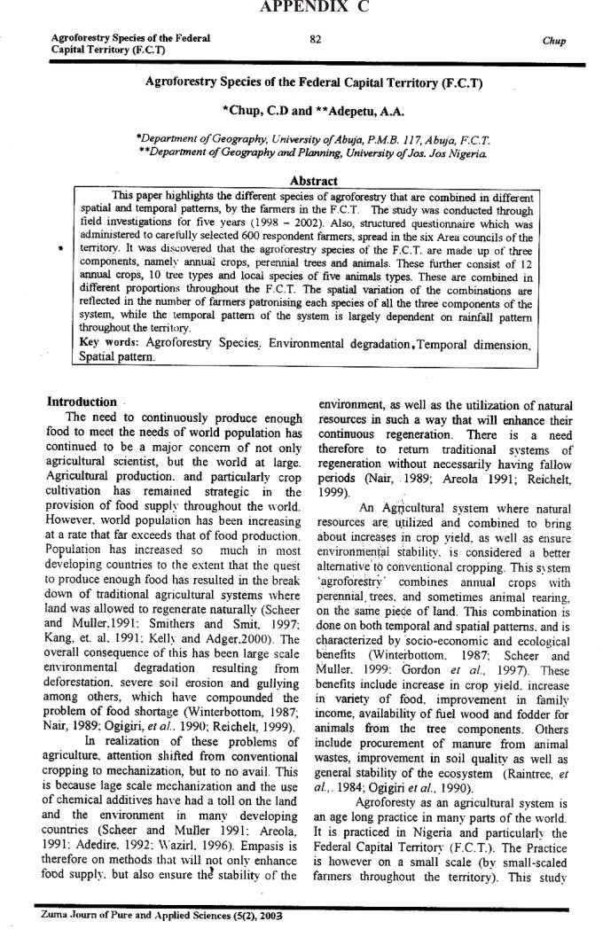

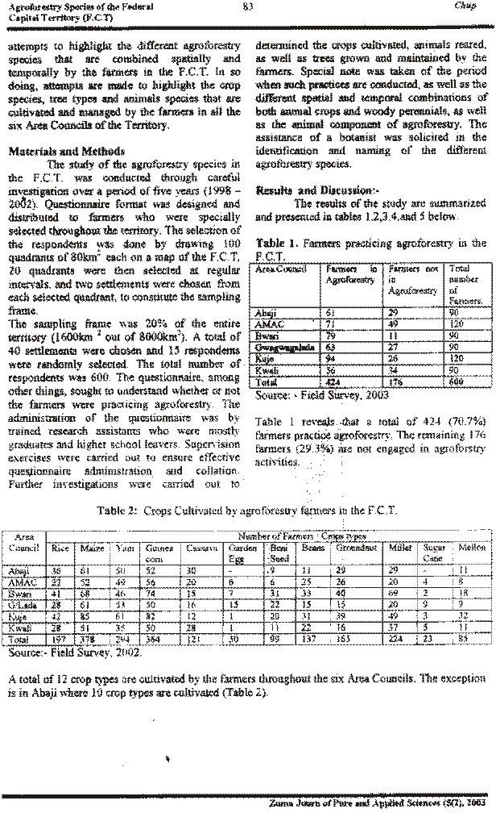

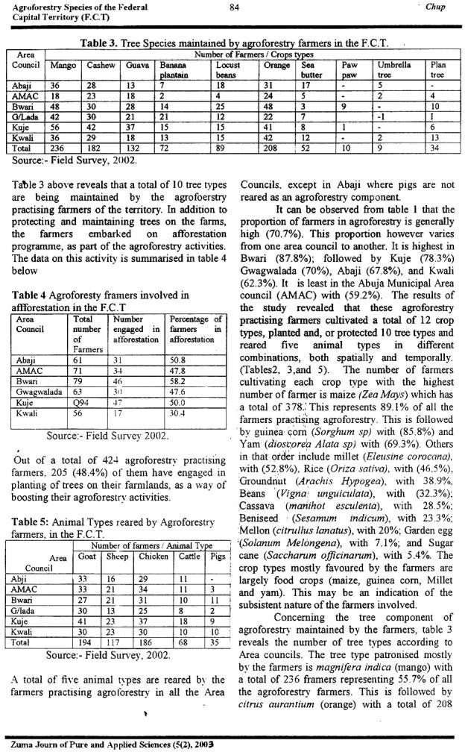

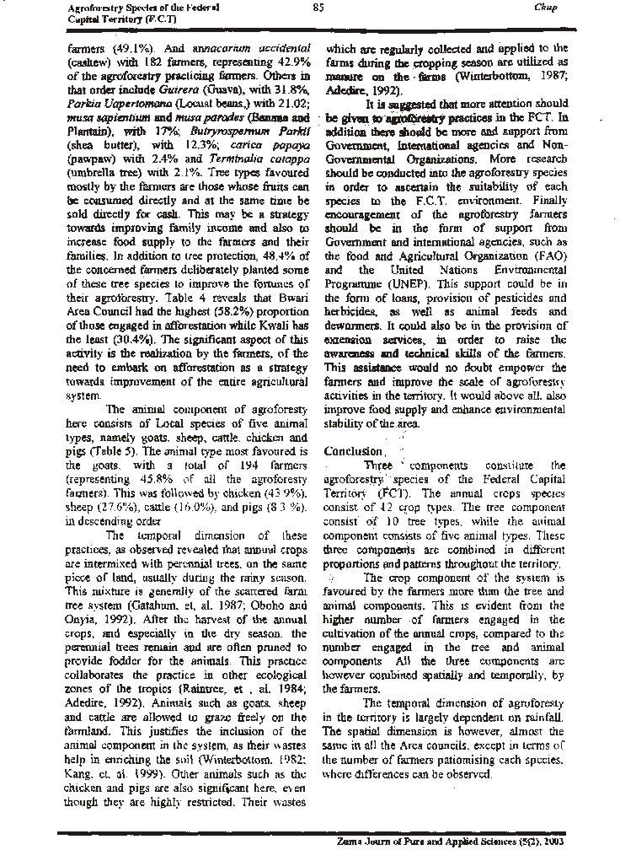

***Proceedings of the 20th Annual Conference of the Forestry Association of Nigeria. Katsina, Pp 96 - 105***

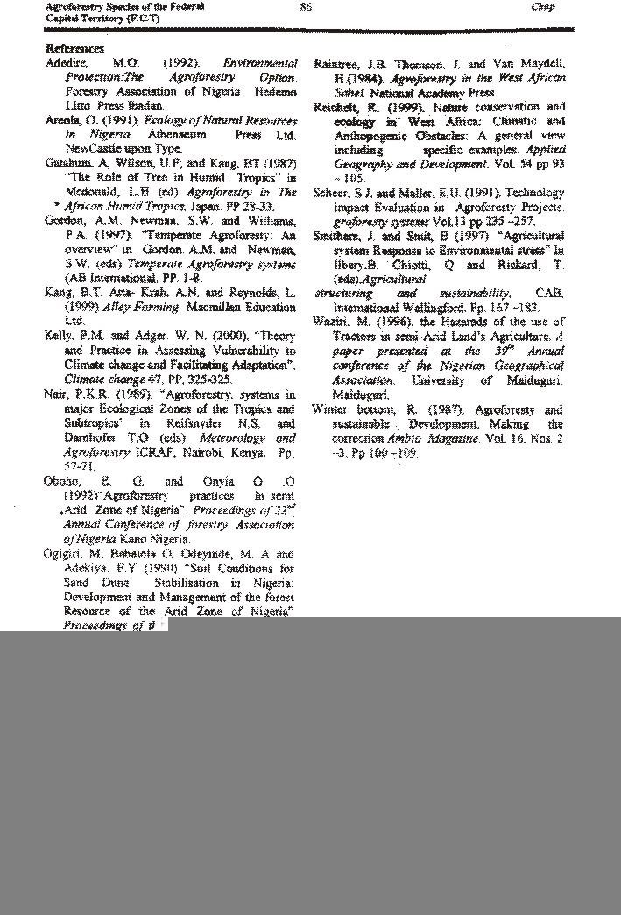

**Zuma Journ of Pure and Applied Sciences (5(2), 2003**