### AMERICAN UNIVERSITY OF NIGERIA DEPARTMENT OF NATURAL AND ENVIRONMENTAL SCIENCES

Senior Research Project

### AN *IN VITRO* STUDY OF THE ANTIBACTERIAL PROPERTIES OF SELECTED PLANT SPECIES FOUND IN ADAMAWA STATE, NIGERIA

by

### UZOAMAKA A. O. NWAGBO

Submitted in partial fulfillment of the requirements for the degree of Bachelor of Science

2015

### AMERICAN UNIVERSITY OF NIGERIA DEPARTMENT OF NATURAL AND ENVIRONMENTAL SCIENCES

**AN *IN VITRO* STUDY OF THE ANTIBACTERIAL PROPERTIES OF SELECTED PLANT SPECIES FOUND IN ADAMAWA STATE, NIGERIA**

This thesis represents my original work in accordance with the American University of Nigeria regulations. I am solely responsible for its content.

### UZOAMAKA A. O. NWABO

**Signature Date**

I further authorize the American University of Nigeria to reproduce this thesis by photocopying or by any other means, in total or in part, at the request of other institutions or individuals for the purpose of scholarly research.

### UZOAMAKA A. O. NWAGBO

**Signature Date**

### AN *IN VITRO* STUDY OF THE ANTIBACTERIAL PROPERTIES OF SELECTED PLANT SPECIES FOUND IN ADAMAWA STATE, NIGERIA

**UZOAMAKA A. O. NWAGBO**

Approved by

Research Supervisor: **Hayatu Raji, Ph.D**. Professor of Natural and Environmental Sciences

Signature Date

Second Reader: **Jessica M. Boyd, Ph.D**. Professor of Natural and Environmental Sciences

Signature Date

*To God, Dad, Mum, Dinma, Kene, & Ugo*

Acknowledgements

For their tireless commitment in getting me through this research project, I would like to thank Drs. Hayatu Raji and Jessica Boyd, my supervisors; Mr. Luqman Jimoh

, Ms. Gloria Onyebarachi & Mr. Joshua Madu for guiding and helping me in the lab.

### AN *IN VITRO* STUDY OF THE ANTIBACTERIAL PROPERTIES OF SELECTED PLANT SPECIES FOUND IN ADAMAWA STATE, NIGERIA

**UZOAMAKA A. O. NWAGBO**

American University of Nigeria, 2015

Major Professor: Hayatu Raji, Ph.D., Professor of Natural and Environmental Sciences

ABSTRACT

The antibacterial activity of plant extracts compared to a known antibiotic (ampicillin) was evaluated against ten gram-negative and gram-positive bacteria which can infect humans. In addition, the efficacies of different extraction methods were studied. Soxhlet, cold aqueous, and hot aqueous extractions were used in this study. Moreover, extracts from the following plants were utilized: *Zingiber officinale* (ginger); and the leaves of *Agave americana* (agave), *Musa acuminata* (banana), *Mangifera indica* (mango), *Azadirachta indica* (neem), and *Eucalyptus sp.* (Eucalyptus). The most antibacterial activities were observed for the extracts of *Eucalyptus sp.* and *Mangifera indica*, which inhibited 60% and 50% of the tested bacterial species, respectively. There was significant activity against gram-positive bacteria. Agave and banana extracts, on the other hand, did not demonstrate any antibacterial activity. The most susceptible species of bacteria tested was *Micrococcus luteus* with a total of 8 out of 17 different plant/preparation combinations affecting it. The least susceptible species were *Escherichia coli*,

*Proteus vulgaris*, *Salmonella typhi* & *Klebsiella pneumoniae*. Soxhlet extraction provided the highest number of zones of inhibition by its bioactive compounds of the three extraction methods.

**Key words:** soxhlet extraction, aqueous extraction, ginger root, banana leaves, neem leaves, eucalyptus leaves, mango leaves, agave leaves, disk diffusion, Kirby-Bauer testing, gram-positive, gram-negative, bacteria.

**Table of Contents**

List of Tables x

List of Figures x

Introduction 1

Literature Review 2

Antimicrobial Compounds 2

Bacteria 3

Klebsiella pneumoniae 3

Pseudomonas aeruginosa 3

Escherichia coli 3

Staphylococcus aureus 4

Staphylococcus epidermidis 5

Bacillus subtilis 5

Micrococcus luteus 5

Salmonella typhi 6

Proteus vulgaris 6

Enterococcus faecalis 6

Plants 7

Zingiber officinale 7

Agave americana 7

Musa acuminata 9

Mangifera indica 9

Azadirachta indica 10

Eucalyptus sp 10

Modes of Extraction 11

Testing Methods 12

Luria Broth and Kirby-Bauer testing 12

Materials and Methods 13

Extractions and Diffusion Disk Preparation 14

Soxhlet Extraction. 14

Hot Aqueous Extraction. 17

Cold Water Extraction 18

Bacterial Culture Inoculation and Agar Plate Preparation 19

LB & LBA Growth Media Preparation 19

Bacterial Culture 19

Plate Preparation 19

Results 21

Pilot Test 21

Neem 22

Mango 22

Ginger 23

Eucalyptus 23

Agave 24

Banana 24

Control 25

Discussion 26

Result Summary 26

Comparison with Other Studies 26

Agave 26

Ginger 26

Banana 26

Eucalyptus 26

Neem 26

Mango 27

Problems & Limitations 27

Way Forward 27

Conclusion 28

Appendices 29

1. Cold Aqueous Extraction 29
2. Soxhlet Extraction 30
3. Hot Aqueous Extraction 30

Works Cited 31

# List of Tables

Table 1 Pilot Test 21

# List of Figures

Figure 1 Ginger root 7

Figure 2 Agave plant 8

Figure 3 Banana tree 9

Figure 4 Mango tree 10

Figure 5 Diagram of Soxhlet extraction equipment 15

Figure 6 Plant extracts being boiled on a heating mantle 17

Figure 7 Nitrocellulose filtration apparautus 18

Figure 8 Agar plates poured under a BSC 19

Figure 9 Bacteria left to grow overnight in a test tube rotator 19

Figure 10 A Mueller-Hinton agar plate inoculated with S. aureus and various

antibiotics 20

Figure 11 "Brown zone" 27

Figure 12 Bacterial contamination of the control 28

# Introduction

There has been a rise in antibiotic resistant bacteria over the last decade. This is mainly due to the mainstream misuse of them. What’s more is that these strains of bacteria are found where the most vulnerable people in communities are, hospitals (Wilson, et al. 2011). The combination of weak host defenses and drug-resistant bacteria has led scientists to explore new options in antimicrobial therapy. One of these options is the plant kingdom. For millennia, plants have been used and marketed in one way or the other for a perceived ability to cure diseases. In fact, 60,000 years ago, a plant called hollyhock was used for medicine by Neanderthals living in present-day Iraq (Cowan 1999). However, substantial scientific research has not been conducted in the investigation of antibacterial activity expressed by plants.

Plants have many advantages. They are abundant, sustainable, and it is relatively easy and inexpensive to extract potentially active compounds from them.

By broad definition an antimicrobial can be said to be any substance that antagonizes the proliferation of microbes. “Microbe” is a general term which includes various viruses, bacteria, fungi, and protozoan parasites – which may not necessarily be harmful to humans. A more accurate term to describe harmful microbes is “pathogen”. However, it is common knowledge that antiviral, antifungal, antibacterial and antiparasitic drugs are targeted at the harmful microbes. With that said, the antibacterial properties of different plants studied in this paper focuses on the harmful pathogenic bacteria.

The aim of this study was to discover plant species with novel antibacterial activity. To achieve this, locally found plants were acquired, a variety of methods were used

to extract their chemical contents, and possible antibacterial activity was determined by testing the plant extracts against ten bacterial species.

Plants have coevolved with other organisms in their environments. Consequently, it is proper to say that they must have developed mechanisms to protect themselves from bacterial infection after an insect or animal has fed on their leaves. If this bioactive mechanism is chemical in nature, these same chemicals can be extracted and used directly on pathogenic or opportunistic bacteria and have some effect.

Therefore, the hypothesis for this study was that: Some plant extracts will demonstrate significant antimicrobial activity.

# Literature Review

## Antimicrobial Compounds

All antibacterial compounds fall into either one of two categories. They are either bacteriocidal or bacteriostatic (Salyers and Whitt 2002). Bacteriocidal compounds kill bacteria, while bacteriostatic compounds only stop or slow down their growth. Bacteriostatic compounds can be very helpful in patients with healthy immune systems. Patients who are immunocompromised however, need to rely on a bacteriocidal compound to enact a cure (Wilson, et al. 2011).

What’s more, some antimicrobials do not have differential toxicity. Differential toxicity is an ideal state where the antimicrobial compound attacks bacterial cells without also attacking human cells (Wilson, et al. 2011). This is the cause of various side effects of medication.

## Bacteria

***Klebsiella pneumoniae***

*K. pneumoniae* is a gram-negative species of bacteria. It is most commonly found in water, soil, and the human colon (Creighton University School of Medicine n.d.). Some of the diseases caused by *K. pneumoniae* include: pneumonia, hospital acquired urinary tract infections (UTIs) and sepsis. *Klebsiella* is said to release heat- stable and heat-labile (HT and ST) enterotoxins in food (Food and Drug Administration 2012). Initial gastrointestinal infection with this pathogen can lead to a whole systemic infection. *Klebsiella* can be found in unpasteurized milk.

Sources say that recent infectious outbreaks in intensive care units (ICUs) were caused by pathogens like *Klebsiella pneumonia* isolated from under the nails of ICU personnel. (Wilson, et al. 2011)

***Pseudomonas aeruginosa***

*Pseudomonas aeruginosa* is a gram-negative species of bacteria. It is opportunistic, soil and water borne; and usually causes nosocomial infections like burn wound infections, sepsis, UTI, and endocarditis.

*Pseudomonas* is also a cause for concern to the medical field because it is becoming increasingly hard to kill because of its ability to form biofilms. For example, according to Hoiby, et al. 2010, biofilm-growing mucoid strains of *P. aeruginosa* are responsible for the chronic *P. aeruginosa* lung infection in cystic fibrosis patients. (Hoiby, et al. 2010)

***Escherichia coli***

*Escherichia coli* are gram-negative bacteria. It is found as part of the normal flora in human gastrointestinal and urinary tracts. Pathogenic E. coli cause many diseases including severe diarrhea, neonatal meningitis; UTI, hospital acquired pneumonia,

and kidney failure. It is usually transmitted through the fecal- oral route, migration through the urethra, colonization of catheters, or aspiration (Creighton University School of Medicine n.d.).

Most species of *E.coli* are not pathogens. However, some called enterohemorrhagic

*E. coli* (EHEC) produce Shiga toxin that is lethal to humans (Food and Drug Administration 2012). *E. coli* can be found in raw or undercooked ground meats, unpasteurized milk and fruit juice, and fresh vegetables. The very young, very old, and immunocompromised in the population are particularly vulnerable to complications arising from an *E. coli* infection.

***Staphylococcus aureus***

*S.aureus* is gram-positive. It can be found in the human nose, upper respiratory tract, skin, and vagina (Creighton University School of Medicine n.d.), as well as soil and water. It is a major cause of hospital-acquired infections (Wilson, et al. 2011). Like *Pseudomonas, S. aureus* can form biofilms which help in the preservation of the species. Diseases most notably caused by *S. aureus* include: toxic shock syndrome, skin infections, food poisoning, osteomyelitis, and endocarditis.

Antibiotic resistance of *S. aureus* can be attributed to the use (and overuse) of vancomycin to treat or prevent *S. aureus* infections caused by *Staphylococcus aureus* (Wilson, et al. 2011). The resistant strains are causing problems for a number of hospitals. Methicillin-resistant *S. aureus* (MRSA) are a particularly great cause of concern.

Food known to be colonized by the bacteria include: “meat products; poultry and egg products; salads, such as egg, tuna, chicken, potato, and macaroni; [some] bakery products; sandwich fillings; and milk and dairy products” (Food and Drug Administration 2012). *S. aureus* toxins act rapidly and can manifest symptoms within

1- 7 hours of ingesting contaminated food. Anyone can be infected and it is the principal cause of food poisoning episodes globally (Food and Drug Administration 2012).

***Staphylococcus epidermidis***

*S. epidermidis* is gram-positive. It normally resides in the skin and mucous membranes of humans. They are opportunistic pathogens. Infection with this bacteria causes: UTIs and nosocomial infections. *S. epidermidis* is resistant to most accessible antibiotics (Wilson, et al. 2011) so surgical-wound and catheter-associated infections due to *S. epidermidis* have become more prevalent.

This antibiotic resistance developed as a result of antibiotic-containing sweat coming into contact with skin that normally hosts *S. epidermidis*. It also developed due to the wide use of antibiotic ointments used to treat chronic skin infections (Wilson, et al. 2011).

***Bacillus subtilis***

*B. subtilis* is gram positive. It is a common soil bacterium which is also part of the normal flora of the human gastrointestinal (GI) tract. It cause food putrefaction but rarely causes food poisoning. *B. subtilis,* forms spores just like *B. anthracis*. (Wilson, et al. 2011). It is also able to take up any DNA and incorporate it into its own (Wilson, et al. 2011)

***Micrococcus luteus***

*M. luteus* is gram- positive. It can be seen in soil, water, skin, mucous membrane samples. It is opportunistic and can lead to diseases such as intracranial abscess, and folliculitis (particularly in HIV-1 patients).

***Salmonella typhi***

*S. typhi* is a gram-negative species. The bacteria can be found in water and soil. This bacteria causes typhoid fever; a disease which is characterized by malaise, headaches, fever, nausea, vomiting, aches, rashes, constipation, abdominal pain, and bloody stools. Symptoms usually occur at about 14 days from the time of infection. (Food and Drug Administration 2012). It is transferred through the fecal-oral route, and asymptomatic carriers of the pathogen can become chronic carriers.

*Salmonella* can be found in meats, poultry, raw eggs, milk and dairy products, seafood, spices, yeast, coconut, cocoa, fruits and vegetables, and chocolate.

If left untreated, the mortality for this disease is 10% (Food and Drug Administration 2012)

***Proteus vulgaris***

*P. vulgaris* are gram-negative bacteria. They are most commonly found in the human GI tract, soil, and water. Infection with the bacteria may lead to pneumonia, hospital- acquired UTIs and sepsis, and neonatal meningitis. *P. vulgaris* can cause putrefaction in meats. In seafood dishes, the presence of *Proteus* can lead scombroid poisoning (Food and Drug Administration 2012). Cases of infections by this bacterium are not reportable to the Centers for Disease Control and Prevention (CDC) so care numbers are not monitored (Food and Drug Administration 2012)

***Enterococcus faecalis***

*E. faecalis* are gram-positive bacteria. They are opportunistic pathogens. They normally reside in the human colon as part of the normal flora. They cause infection in hospitalized and cancer patients (Wilson, et al. 2011). One of the categories of diseases they cause are UTIs. Like other opportunists, they have developed a

resistance to antibiotics (particularly strains found in hospitals) and thus infections are hard to treat.

This is the major reason why E. faecalis and S. epidermidis, though non-virulent, can kill.

## Plants

### Compounds, Their Traditional Uses, Connection of compounds to Bacteria

***Zingiber officinale*** (Ginger root)

Ginger is the rhizome of the *Zingiber officinale* plant. It is consumed as a delicacy, and/or used as a medicine, or spice in different parts of the world.

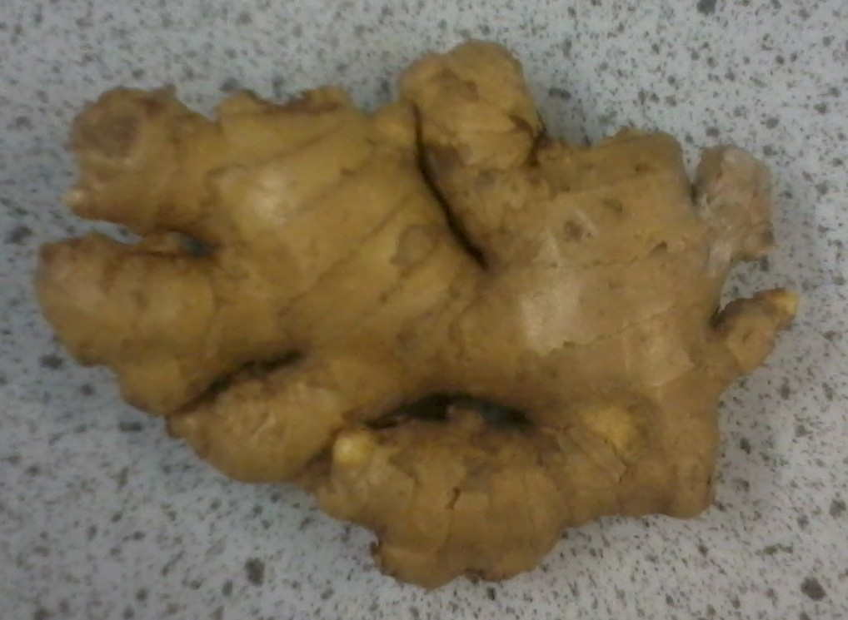

**Figure 1 Ginger root**

***Agave americana*** (Agave leaves)

*Agave Americana* is called the “century plant” or “American aloe”, or “maguey” in different parts of the world. It is not related to aloe, although it bears some resemblances. There are different subspecies which differ in appearance within this species. The subspecies used in this study is most likely the *Agave*

*americana* var. *oaxacensis*.

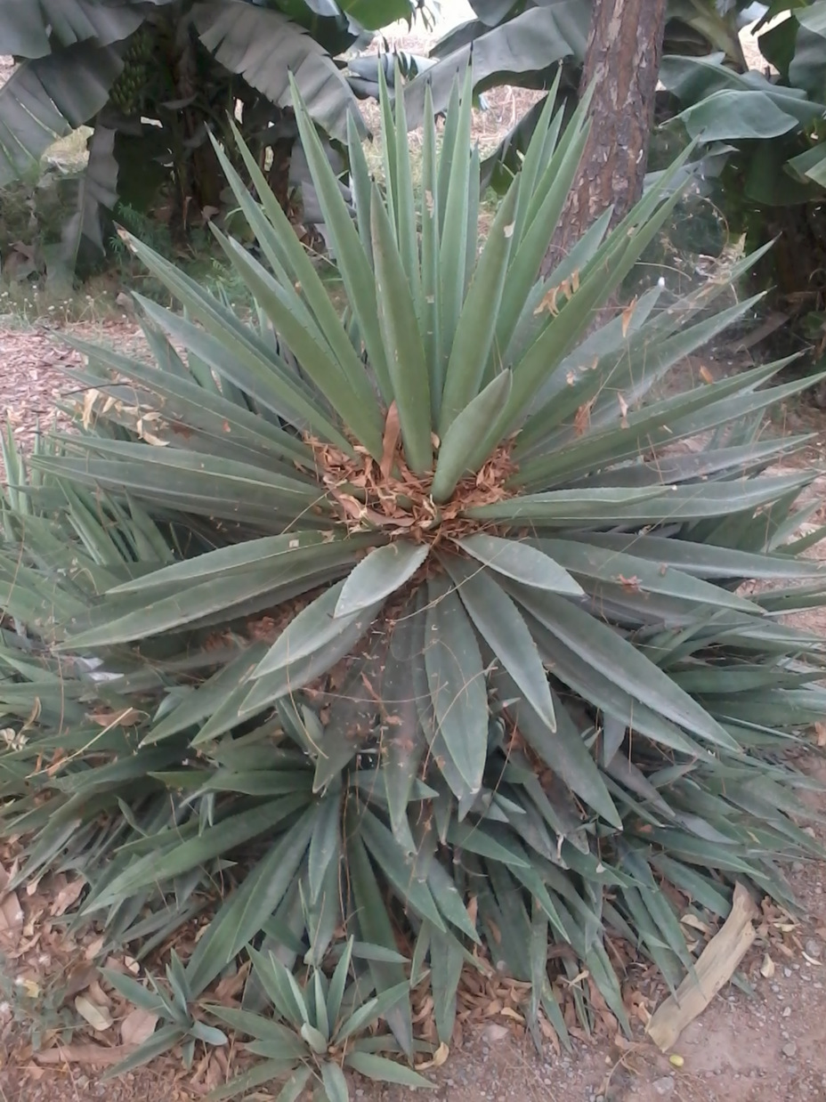

**Figure 2 Agave plant**

Aside from being an ornamental plant, agave juice is used to make syrup; pulque, mezcal, and tequila alcoholic drinks; and its leaf fibers make ropes and coarse cloths (Aden Earth 2011). It is also “largely used in traditional medicine” (Hamissa, et al. 2012) as a diuretic, laxative, emmenagogue; treatment for wounds, syphilis, cardiac disease, GI & rheumatic problems; as an insecticide, molluscicide; and in the treatment of hypertension (Oudhia n.d.;Anajwala, et al. 2010).

***Musa acuminata*** (Banana leaves)

Parts of the Musa acuminata plant are believed to have medicinal properties. For instance, the stem juice is used in the treatment of epilepsy, hysteria, dysentery, diarrhea, and the healing of intestinal lesions; and the flowers have astringent properties (Karuppiah and Mustaffa 2013).

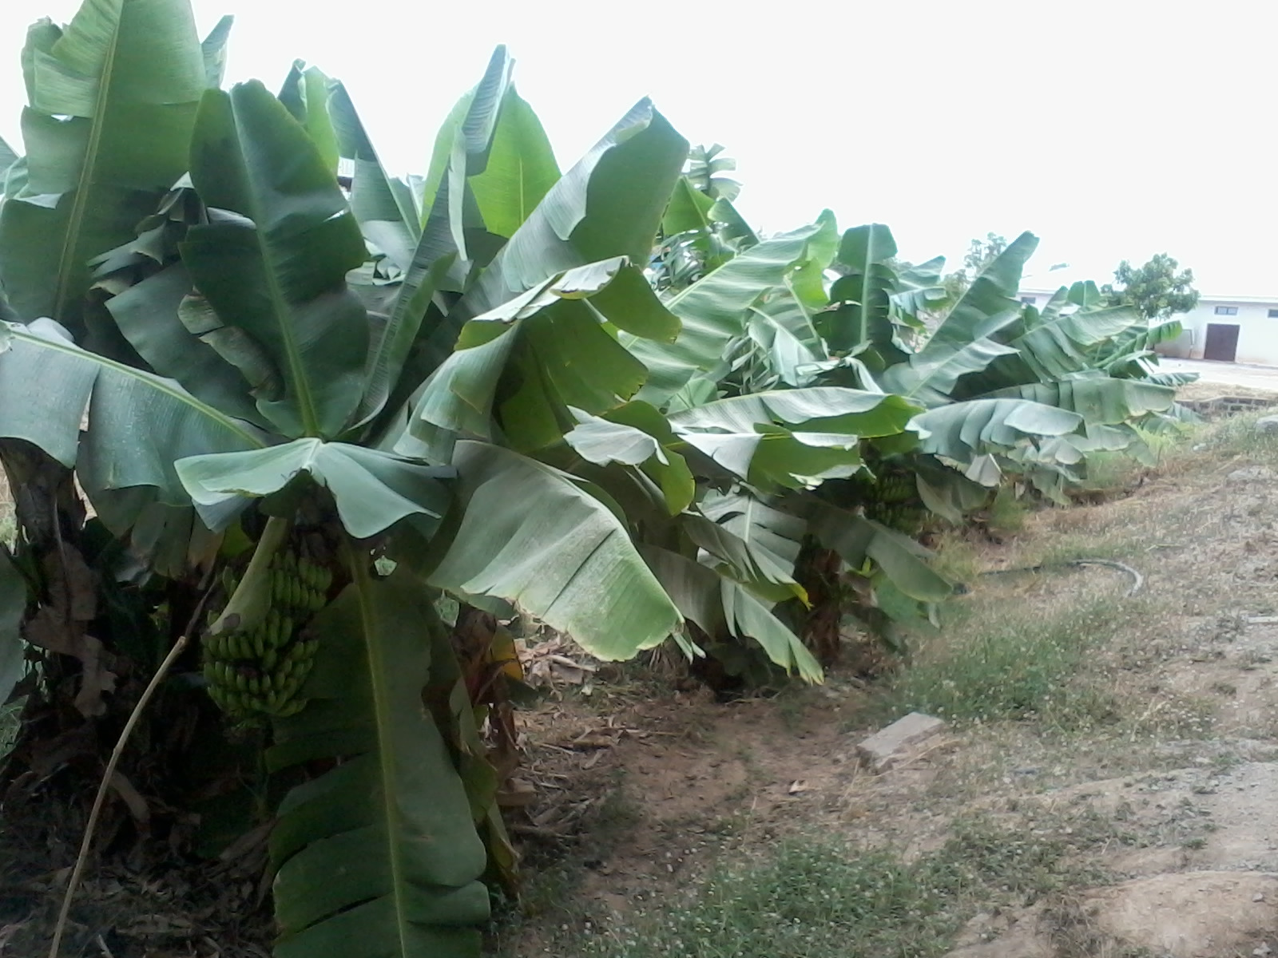

**Figure 3 Banana tree**

***Mangifera indica*** (Mango leaves)

*M. indica* leaves are commonly boiled and used to treat fevers in Northern Nigeria.

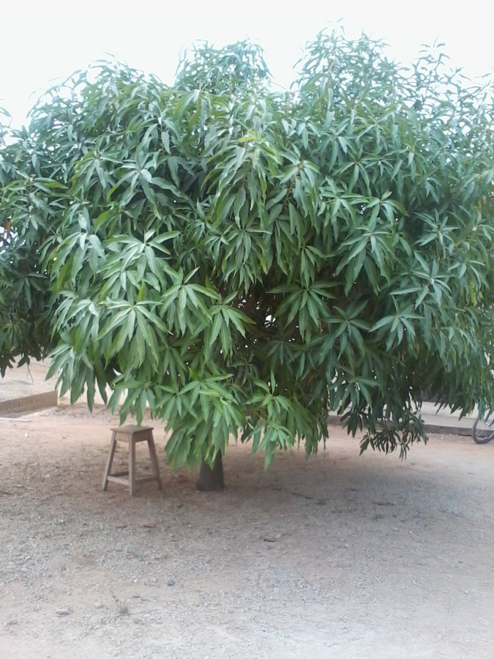

**Figure 4 Mango tree**

***Azadirachta indica*** (Neem leaves)

Azadiratcha indica is used in Ayurveda, Unani and homoeopathic medicine. It is known as “Sacred Tree” in India and its products have been used for their medicinal properties for over two millennia (Aden Earth 2011).

Neem is used in food and cosmetic preparation, oral hygiene; as a mosquito repellent; pesticide, spermicide, antioxidant, antiparasitic agent; for diabetes, ulcer, fever acne, measles, chicken pox , scabies, human lice, dog and cat fleas; and as a malaria prophylaxis (Aden Earth 2011) (Atawodi and Atawodi 2009)

***Eucalyptus sp.*** (Eucalyptus leaves) Tannin, Polyphenol, Bacteria, viruses

* Remedy for sore throat and other bacterial infection of the respiratory and urinary tracts.
* Essential oils of the leaves are used in the treatment of lung diseases while the volatile oils are

used as expectorants

* Topical ointments to heal wounds and fungal infections.

in very small quantities in food supplements, especially sweets, cough drops and decongestants

Ornamental Tree, swap drainage, wind and water soil erosion barrier in farms

It is used for medicinal purposes, especially as a cough remedy and expectorant, but it also has febrifuge, tonic, astringent, antiseptic, haemostatic and vermifugal properties.

In Senegal a leaf decoction sweetened with sugar is used to treat stomach- ache and dysmenorrhoea. In Sudan fresh leaves are applied against rheumatism, and the smoke of burnt leaves is inhaled for the treatment of respiratory problems. The gum is used medicinally to treat diarrhoea and pharyngeal inflammations, and as an astringent. In Nigeria chewing sticks are obtained from the tree. The smoke of burnt leaves serves to repel insects (Doran and Wongkaew n.d.)

## Modes of Extraction

Different modes of extraction are used to extract different chemical compounds. For instance, some chemical compounds in plants are polar, so it follows that they will require a polar solvent. On the other hand, other compounds are non-polar, and thus require a non-polar solvent.

## Testing Methods:

**Luria Broth and Kirby-Bauer testing**

Kirby-Bauer antibiotic testing determines the efficacy of an antibiotic by placing filter paper “disks” infused with the antibiotic onto agar plates with a specific bacteria spread onto it. While the plates are incubated, the antibiotic in the disk diffuses through the plate and comes into contact with the bacteria. . If the bacteria are sensitive to the antibiotic it will not be able to grow close to the disc where the antibiotic concentrations are high creating a zone without growth, or zone of inhibition. A zone of inhibition is essentially an area around the disk where the bacteria have stopped growing because of the antibiotic. An effective antibiotic creates a larger zone of inhibition than a less effective one.

The advantages of this method of testing are that: it is fast and relatively cheap to do; it is especially effective at testing the antibacterial properties of water-soluble antimicrobials; many samples can be tested at once using this method; and both solid and liquid compounds can be tested for antimicrobial behavior as long as they can diffuse through the plate (Chaudhary 2013).

The main weaknesses of zone inhibition testing for antibacterial agents include: the fact that zone inhibition testing cannot show whether an antibacterial compound is bacteriostatic or bacteriocidal; the agar might interfere with the antibacterial compound (Chaudhary 2013). Moreover, antibacterial compounds that leach out into the agar plates will be more effective than those that adhere to the diffusion disks; zones of inhibition may sometimes have irregular shapes; the method is not fully quantitative through simple observation (Antimicrobial Test Laboratories n.d.).

# Materials and Methods

Extracts from the following plants were used: the root of *Zingiber officinale* (ginger); and the leaves of *Agave americana* (agave), *Musa acuminata* (banana), *Mangifera indica* (mango), *Azadirachta indica* (neem), and *Eucalyptus sp.* (Eucalyptus).

Through soxhlet and aqueous extractions using absolute ethanol and distilled water respectively, the plant extracts were tested against 10 different species of bacteria. These were: *Salmonella typhi*, *Pseudomonas aeruginosa*, *Bacillus subtilis*, *Escherichia coli*, *Micrococcus luteus*, *Staphylococcus aureus*, *Staphylococcus epidermidis*, *Klebsiella pneumonia*, *Proteus vulgaris*, and *Enterococcus faecalis*.

The bacterial culturing equipment used during this experiment were: a Biological Safety Cabinet (BSC); disposable Petri dishes, Luria broth (LB), Luria broth agar (LBA), sterile L- shaped spreaders, sterile plastic wire loops, a Petri dish rotator, a micropipette with sterile pipette tips, sterile 5 milliliter pipettes, test tubes with lids, centrifuge tubes, a test tube rotator, a microwave, and test tube racks.

The equipment used to prepare the soxhlet extracts were: heating mantles, a hot plate, round bottom flasks, simple distillation apparatus, a magnetic stirring bar, clips, ring stands, absolute ethanol (as the solvent), distilled water, the shade dried plant material, a weighing scale, 250mL conical flasks, foil paper, a timer/ or stopwatch, watch glasses, scissors, soxhlet extractor, and cotton wool. Materials used for aqueous extraction include: beakers, conical flasks, foil paper, a weighing scale, filter paper, coffee filter paper, funnels, bottles with covers, a centrifuge, ethanol (for sterilizing equipment), aWaring® blender, mortar and pestle, and sealable plastic bags

In the preparation of the diffusion disks, the following equipment were used: Eppendorf® microcentrifuge tubes, a micropipette with sterilized tips, sterilized disks, 95% ethanol, distilled water, sterilized forceps, plant extracts, syringe, nitrocellulose filtration apparatus, glass Petri dishes, and ampicillin (control).

Other equipment used during this experiment were: masking tape, a marker pen, a perforator & filter paper (to make the sterilized disks), a rule, an incubator, an autoclave, a fridge, a microwave, disinfectant (bleach), and antibacterial hand wash.

## Extractions and Diffusion Disk Preparation

**Soxhlet Extraction**

Soxhlet extraction was used to extract essential oils from plant material. The plant could be fresh or dry. However, dry material was used in this study. This is a more efficient way of extracting essential oils than simply soaking the plant material in ethanol for days.

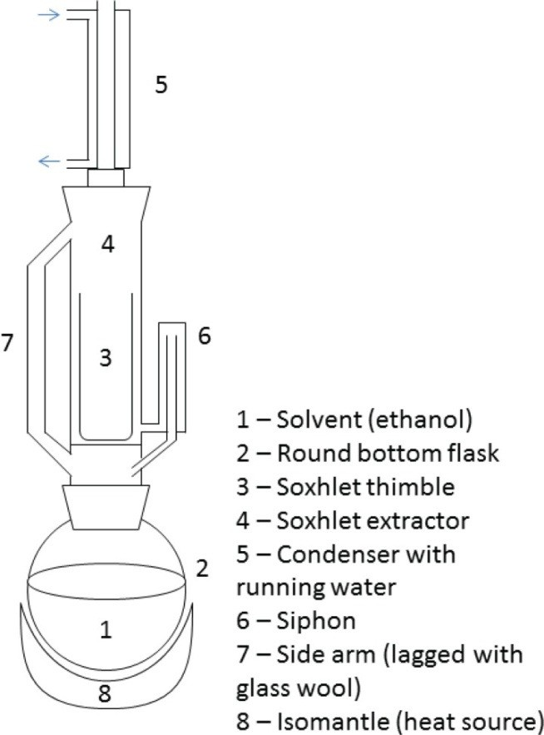

Figure 5 Diagram of Soxhlet extraction equipment. From: Redfern, James, Malcom Kinninmonth, Dariel Burdass, and Joanna Verran. "Figure 1." Journal of Microbiology and Microbiology Education. *Using Soxhlet Ethanol Extraction to Produce and Test Plant Material (Essential Oils) for Their Antimicrobial Properties.* 2014.

Thus, to extract essential oils in the plants which many demonstrate antibacterial activity, a soxhlet extraction with ethanol as the solvent was performed. Firstly, leaves were shade dried for a number of days until they were fully dry. Dried leaves were then crushed using a mortar and pestle or Waring® blender. Crushed powder product was placed in sealable plastic bags.

A soxhlet extraction apparatus was set up under a fume hood for each crushed plant extract. 10g of powder was weighed and placed on top of cotton wool inside the soxhlet extractor. Cotton wool was used to replace a thimble (because it was not available). 100mL of absolute ethanol was placed in the round-bottom flask, while 150mL of absolute ethanol was added on top on the plant powder in the soxhlet extractor. The ethanol was allowed to reflux 4 times before being removed for distillation. The apparatus when in use was under constant observation. The refluxed mixture was distilled until it was reduced to about 20mL or lower. Then, the heating mantle was turned off (allowing the water to continue running) and condensed ethanol is collected as a distillate.The remaining concentrated mixture was placed in a sterile centrifuge tube.

Further evaporation of ethanol from the reflux mixtures was carried out using a watch glass on a steam bath until the plant extract became powdery (solid). The solid was then scraped off the watch glass using a knife. If the solid could not be removed simply by scraping it, ethanol was added to dissolve the solid, and then the watch glass was left to air dry while the excess ethanol evaporated.

After this, 20g of each solid plant extract was weighed and dissolved with 1mL of distilled water in a Petri dish. This solution was then used to prepare the “soxhlet” diffusion disks.

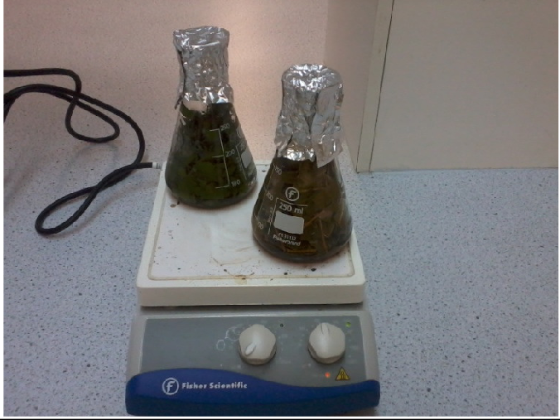**Hot Aqueous Extraction**

**Figure 6 Plant extracts being boiled on a heating mantle**

Firstly, 40g of fresh leaves were rinsed with water, waved dry, and then weighed before being cut into smaller pieces using scissors. The diced leaves were then put into a 250mL Erlenmeyer flask. Then, 200mL of water was then added to each flask (100mL was added initially to the Agave and Ginger because 100mL was enough to immerse the plant pieces fully in water). After this, the leaves were boiled using a heating mantle at about 100°C for less than 2 hours. Then the plant extract infused liquid was left to cool to room temperature for some minutes in the Erlenmeyer flask. After which it was kept in a fridge at 4 - 10°C for later use. When the plant extracts needed to be used, they were poured into separate sterile centrifuge tubes. 1mL of each plant extract was placed in separate Eppendorf® tubes and then 11 disks were soaked inside the tubes and left to dry. These were now diffusion disks.

**Cold Water Extraction**

20g of each plant was soaked in distilled water in 50mL capped bottles for 2 weeks (14 days). After this time period, the leaves were air dried and then blended. 20g of Neem, Banana, Eucalyptus, and Mango leaves were each blended using

100mL of water. While, 20g of

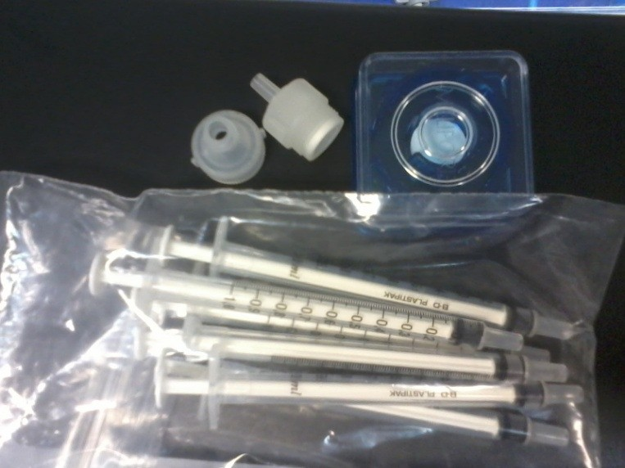

**Figure 7 Nitrocellulose filtration apparautus**

Ginger root and Agave leaves were each blended using 50mL of water (Again, because they did not require as much water in the blending process). The pulps were then filtered into conical flasks using coffee filter paper and funnels. After they were filtered, 20mL of each plant extract was poured into labeled centrifuge tubes and spun at 13,000 x g for 30 minutes twice – for clarification. The pellet was discarded and the supernatant kept each time. The supernatant was kept in the fridge at a low temperature until they were needed in disk preparation. Then, a syringe was used to draw 1mL of the plant extract and pushed through a clean nitrocellulose filter to remove any microorganisms that may be present in the centrifuged extract. The filtered plant extract was kept in a sterilized Eppendorf® tube. 11 sterilized disks were placed in each Eppendorf® tube containing a plant extract. These were air dried and used as diffusion disks.

**Control (Ampicillin) Preparation**

The control, ampicillin was prepared using 200 mg of the solid dissolved in 1 ml of distilled water in a glass Petri dish. Then the diffusion disks were put in the Petri dish and allowed to soak in the solution.

## Bacterial Culture Inoculation and Agar Plate Preparation

**LB & LBA Growth Media Preparation**

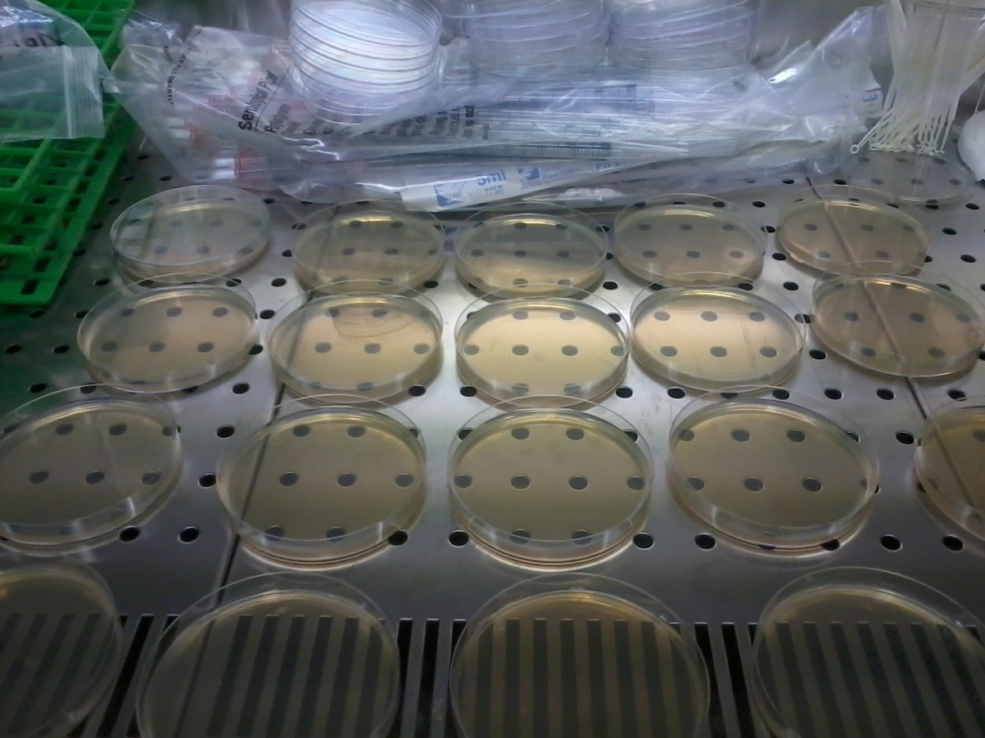Under a laminar flow chamber, 20g of LB was placed in a bottle. 1L of distilled water was used to dissolve it by first adding 100mL- 500mL of the water to initially dissolve the solid then adding up the water to 1L. After which, a magnetic stirrer was placed in the bottle and the mixture was sterilized at a temperature of 121°C and

pressure of 15m/square inch. This same procedure was used to prepare the LB agar. When the LBA cooled down it was poured into Petri dishes.

**Figure 8 Agar plates poured under a BSC**

**Bacterial Culture**

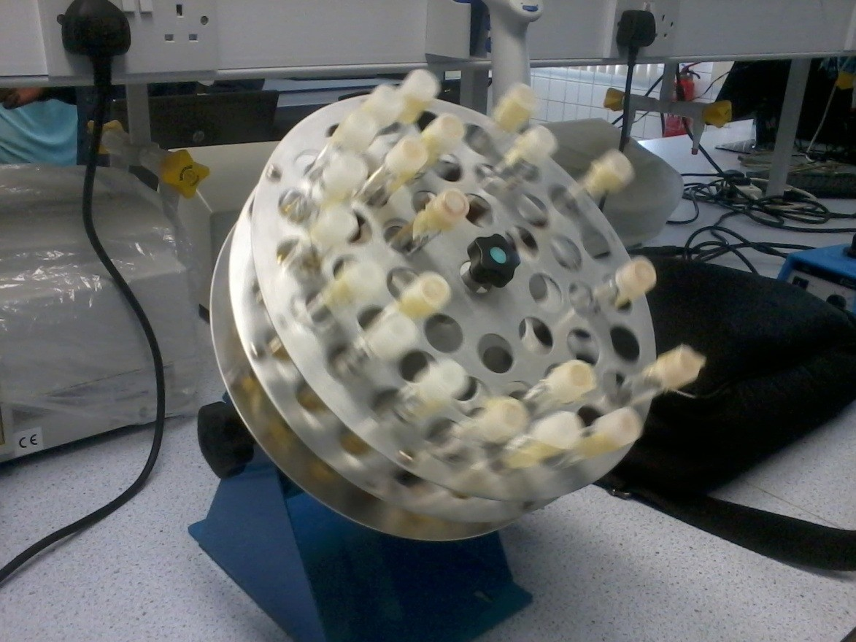First, the bacterial cultures were taken out of the fridge. Then, 11 sterilized test tubes (with covers) were each filled with 5mL of LB. The test tubes were loosely covered. Sterile technique was used

to inoculate the broth. The 11th test tube had no bacteria and was used as a control. Then,

**Figure 9 Bacteria left to grow overnight in a test tube rotator**

the test tubes were left to spin overnight in a test tube rotator at room temperature.

**Plate Preparation**

When the bacteria had grown overnight, 100 microliters ( µL) of a bacterial culture was placed on an LBA Petri dish and spread using a sterile L-shaped spreader and a Petri dish rotator. Then each diffusion disk was placed on its designated area. The bacterial plates were then placed in an incubator at 30°C and left for 20 – 24 hours.

After which, the Petri dishes were checked and the zones of inhibition measured and recorded.

Every step was repeated thrice for the three trials.

After the experiment the used LBA plates were steam-autoclaved and disposed of.

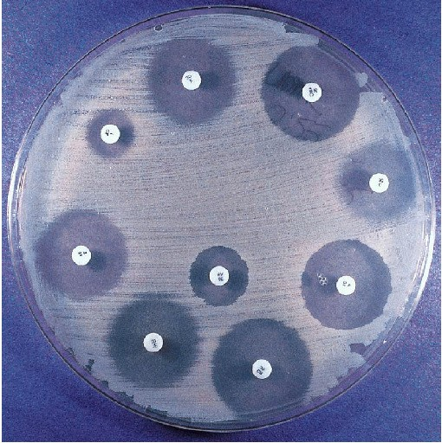

Figure 10 A Mueller-Hinton agar plate inoculated with S. aureus and various antibiotics. From: Harley, John P., and Lansing M. Prescott. Laboratory Exercises in Microbiology 5th Edition. *Figure 43.1 A Kirby-Bauer Plate.* The McGraw-Hill Companies, 2002.

# Results

## Pilot Test

**Table 1 Pilot Test**

|  |  |  |  |  |  |  |  |
| --- | --- | --- | --- | --- | --- | --- | --- |
|  | Diameter of Zone of Inhibition (mm) | | | | | | |
| Bacterium | 1st Trial Eucalyptus | 1st Trial Mango | 1st Trial Banana | 1st Trial Neem | 1st Trial Aloe Vera | Ampicillin | 2nd Trial Eucalyptus |
| *M. luteus* | 11 | 6 | 0 | 0 | 0 | 52 | 11 |
| *S. epidermidis* | 12 | 6 | 0 | 0 | 0 | 38 | 0 |
| *E. coli* | 0 | 0 | 0 | 0 | 0 | 35 | 0 |
| *B. subtilis* | 0 | 7 | 0 | 0 | 0 | 26 | 10 |
| *P. aeruginosa* | 0 | 0 | 0 | 0 | 0 | 20 | 0 |
| *S. typhi* | 14 | 0 | 0 | 0 | 0 | 13 | 0 |
| *S. aureus* | 9 | 5 | 0 | 0 | 0 | 52 | 13 |
| *P. vulgaris* | 0 | 2 | 0 | 0 | 0 | 0 | 0 |
| *K. pneumoniae* | 0 | 0 | 0 | 0 | 0 | 22 | 0 |
| *E. faecalis* | 14 | 7 | 0 | 0 | 0 | 45 | 10 |

### Soaked Leaves

* + In the “Soaked Leaves” first trial, the plates were found to be contaminated, so the result from the first trial were omitted in the calculation of average.** See Appendix A

## Neem

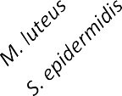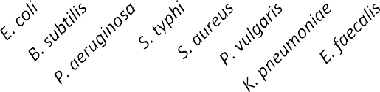

12

10

8

6

4

2

0

Soxhlet

Cold Aqueous Hot Aqueous

**Bacterium**

**Average Diameter of Inhibition Zone**

**(mm)**

## Mango

**Average Diameter of Inhibition Zone**

**(mm)**

12

10

8

6

4

2

0

Soxhlet

Cold Aqueous Hot Aqueous

**Bacterium**

## Ginger

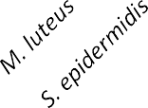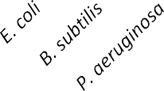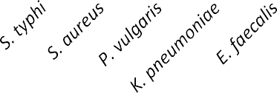

9

8

7

6

5

4

3

2

1

0

Cold Aqueous

Hot Aqueous

**Bacterium**

**Average Diameter of Inhibition Zone (mm)**

## Eucalyptus

**Average Diameter of Inhibition Zone**

**(mm)**

14

12

10

8

6

4

2

0

Soxhlet

Cold Aqueous Hot Aqueous

**Bacterium**

## Agave

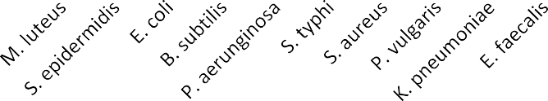

1

0.9

0.8

0.7

0.6

0.5

0.4

0.3

0.2

0.1

0

Soxhlet

Cold Aqueous Hot Aqueous

**Bacterium**

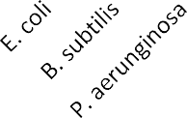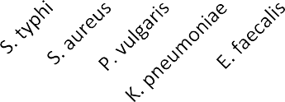

**Average Diameter of Inhibition**

**Zone (mm)**

## Banana

**Average Diameter of Inhibition Zone**

**(mm)**

1

0.9

0.8

0.7

0.6

0.5

0.4

0.3

0.2

0.1

0

Soxhlet

Cold Aqueous Hot Aqueous

**Bacterium**

## Control

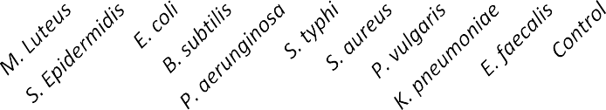

**Ampicilin Diameter of Inhibition**

45

40

35

30

25

20

15

10

5

0

Ampicilin Diameter of

Inhibition

**Bacteria**

**Diameter of Inhibition (mm)**

* + **Note that the diameter of the zone of inhibition does not indicate the effectiveness of the compound as an antibacterial. Rather, it indicates the solubility of the antibacterial compound within the agar media.**

**Number of Bioactive Plants and Inhibition**

**Zones Created for Each Extraction Method**

14

12

10

8

6

Number of Inhibition zones

created by bioactive plant extracts

Number of Bioactive Plants

4

2

0

Soxhlet

Cold Aqueous Hot Aqueous

**Extraction Method**

# Discussion

**Result Summary**

The most susceptible bacteria was *M. luteus.* The most resistant were: *E. coli*, *P. vulgaris*, *S. typhi* & *K. pneumonia.* The most effective plant extract was eucalyptus. The least effective were agave and banana preparations. Finally, most bioactive plant contents extracted through soxhlet.

**Comparison with Other Studies Agave**

In one study, extracts from agave showed antibacterial activity

against *Staphylococcus* spp., *Pseudomonas aeruginosa* and *Escherichia coli*

(Oudhia n.d.).

### Ginger

Ethanolic extract of ginger effective against *E. coli* and *S. typhi*; aqueous ginger extract effective against *S. typhi*(Ekwenye & Elegalam 2005)

Ethanolic and aqueous extracts of ginger does not inhibit “*Staphylococcus aureus; Bacillus spp., Escherichia coli and Salmonella spp.”* (Onyeagba et al 2004)

### Banana

Musa sp. leaf extracts showed moderate antibacterial activities against *E. coli*, *P. aeruginosa* (Karuppiah & Mustaffa 2013) *

No antibacterial activity against *E. coli* and *B. subtilis* (Meenashree, Vasnthi & Mary 2014)

### Eucalyptus

“The methanol extract … displayed broad spectrum activity against *Klebsiella spp, Salmonella typhi, Pseudomonas aeruginosa, Staphylococcus aureus and Bacillus subtilis »* (Ayepola & Adeniyi 2008)

### Neem

“Methanol extract showed … good antibacterial activity.

*Proteus vulgaris and Micrococcus luteus were the most susceptible bacteria while Bacillus subtilis* was more resistant to the hexane and methanol extracts of neem (Koona & Budida 2011)

### Mango

Acetone, & methanol extractions inhibited growth of *S. typhi*. Cold water extraction did not inhibit the growths of *E. coli* and *S. typhi* (Doughari & Manzara 2008)

## Problems & Limitations

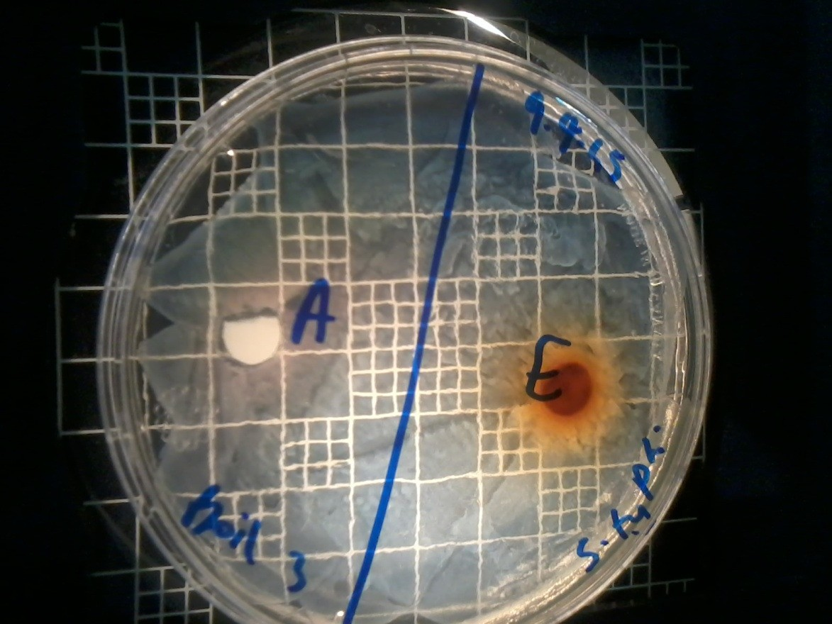Though the data tables show the diameter of inhibition zones created by certain plant extract on an agar plate with a particular species of bacteria, it however, does not

show whether or not the bacteria is susceptible to that plant extract. This means that: a visible zone of inhibition does not automatically mean the bacterium is susceptible to the plant extract.

**Figure 11 "Brown zone"**

*Different sources report differing antibacterial activities of plants possibly because even though the bacterium is of the same species, they may not be the exact same strain. Different bacterial strains have different levels of resistance. Similarly, the plant extracts used have different geographical locations and this may also affect its efficacy as an antibacterial. Moreover, the season and time at which the plant material was obtained may also be a critical factor in the release of specific phytochemicals from the plant which have antibacterial properties.

**Way Forward**

Perhaps, increasing the concentration of the plant extracts would have shown more plants to have antibacterial activity. Performing a titration on the extracts would lead to an increase in their concentration.

To build on this study, mechanized antibiotic sensitivity testing could be used; also plant extracts could be mixed to see if there is a significant improvement in antibacterial activity due to the interaction of more phytochemicals.

For example, “Association of antibiotics and plant extracts showed synergistic antibacterial activity against antibiotic-resistant bacteria” (Nascimento, et al. 2000).

Plants could be merely boiled and used to abate cholera or typhoid epidemics or used for food preservation.

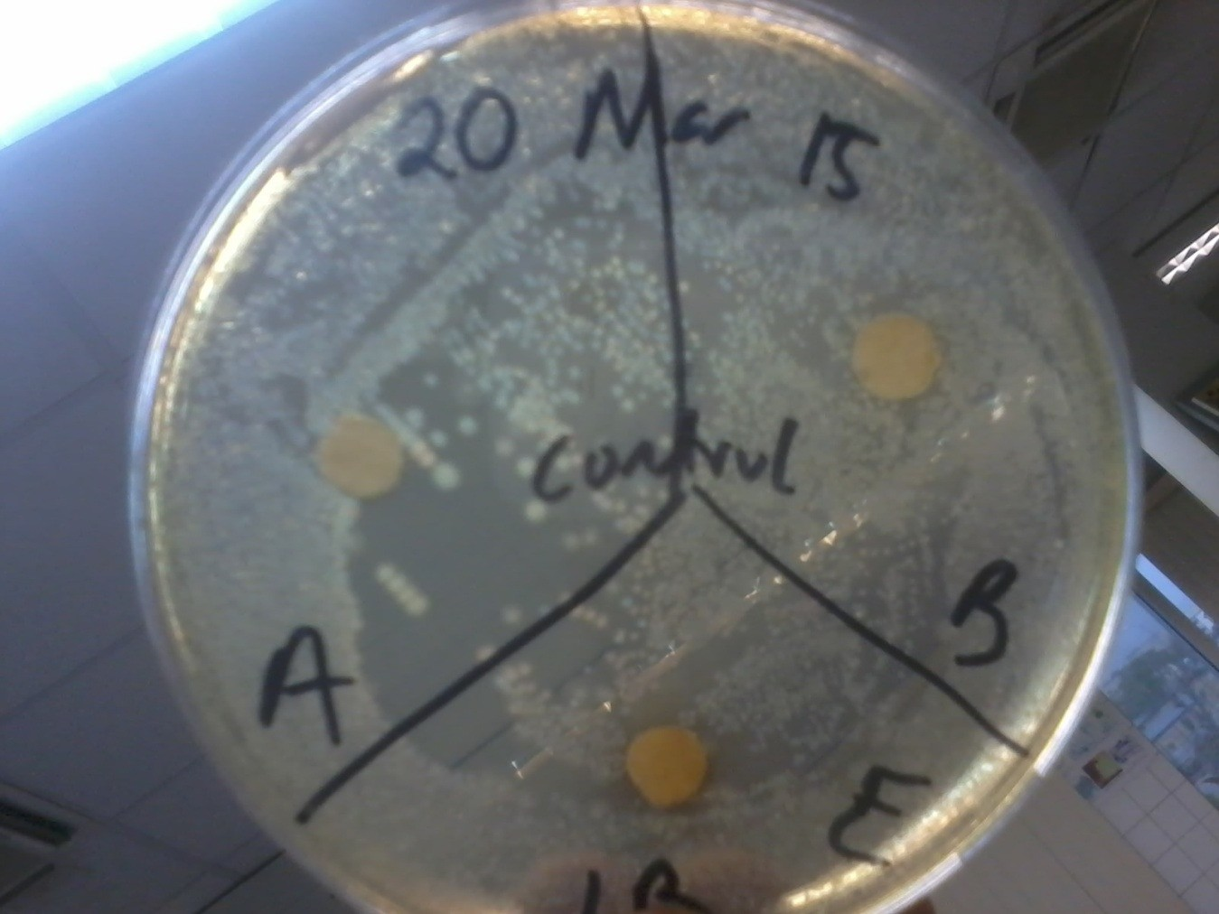

**Figure 12 Bacterial contamination of the control**

# Conclusion

In conclusion, the findings confirm that some plant extracts demonstrate significant antibacterial activity. They have the potential to be mainstream antibacterial treatments, disinfectants, to be used in water treatment for municipal or public health purposes; or to be used in water filtration. To further this research, different plant extracts could be mixed with each other or with an antibiotic to see if there is improved antibacterial activity or diffusion through the culture media.

# Appendices

## Cold Aqueous Extraction

|  |  |  |  |  |  |  |  |  |  |  |  |  |  |  |  |  |  |  |  |  |  |  |  |  |  |  |  |
| --- | --- | --- | --- | --- | --- | --- | --- | --- | --- | --- | --- | --- | --- | --- | --- | --- | --- | --- | --- | --- | --- | --- | --- | --- | --- | --- | --- |
|  | Diameter of Zone of Inhibition (mm) | | | | | | | | | | | | | | | | | | | | | | | | | | |
| A | | | A1 | | | B | | | E | | | G | | | G1 | | | N | | | M | | | Amp | | |
| Bacteriu m | 1  s t | 2  n d | 3  r d | 1  s t | 2  n d | 3  r d | 1  s t | 2  n d | 3  r d | 1  s t | 2  n d | 3  r d | 1  s t | 2  n d | 3  r d | 1  s t | 2  n d | 3  r d | 1  s t | 2  n d | 3  r d | 1  s t | 2  n d | 3  r d | 1  s t | 2  n d | 3  r d |
| *M. luteus* | 0 | 0 | 0 | 0 | 0 | 0 | 0 | 0 | 0 | 0 | 0 | 0 | 0 | 0 | 1  0 | 0 | 1  3 | 0 | 0 | 0 | 1  1 | 0 | 0 | 8 | 0 | 3  3 | 3  8 |
| *S.*  *epidermid is* | 7 | 0 | 0 | 0 | 0 | 0 | 0 | 0 | 0 | 0 | 0 | 0 | 0 | 0 | 0 | 0 | 0 | 0 | 0 | 0 | 0 | 0 | 0 | 0 | 1  1 | 3  3 | 4  1 |
| *E. coli* | 7 | 0 | 0 | 0 | 0 | 0 | 0 | 0 | 0 | 0 | 0 | 0 | 0 | 0 | 0 | 0 | 0 | 0 | 0 | 0 | 0 | 0 | 0 | 0 | 0 | 2  9 | 3  4 |
| *B. subtilis* | 0 | 0 | 0 | 0 | 0 | 0 | 0 | 0 | 0 | 0 | 0 | 0 | 0 | 8 | 8 | 0 | 1  0 | 1  1 | 0 | 0 | 0 | 0 | 0 | 0 | 1  2 | 2  3 | 3  1 |
| *P.*  *aeruginos*  *a* | 0 | 0 | 0 | 0 | 0 | 0 | 0 | 0 | 0 | 0 | 0 | 0 | 0 | 0 | 0 | 0 | 0 | 0 | 0 | 0 | 0 | 8 | 0 | 0 | 0 | 2  2 | 2  5 |
| *S. typhi* | 0 | 0 | 0 | 0 | 0 | 0 | 0 | 0 | 0 | 0 | 0 | 0 | 0 | 0 | 0 | 0 | 0 | 0 | 0 | 0 | 0 | 0 | 0 | 0 | 1  1 | 0 | 3  5 |
| *S. aureus* | 0 | 0 | 0 | 0 | 0 | 0 | 0 | 0 | 0 | 7 | 0 | 0 | 0 | 0 | 0 | 0 | 9 | 0 | 0 | 0 | 0 | 0 | 0 | 0 | 1  1 | 3  2 | 4  2 |
| *P.*  *vulgaris* | 0 | 0 | 0 | 0 | 0 | 0 | 0 | 0 | 0 | 0 | 0 | 0 | 0 | 0 | 0 | 0 | 0 | 0 | 0 | 0 | 0 | 0 | 0 | 0 | 9 | 0 | 1  3 |
| *K.*  *pneumoni*  *ae* | 0 | 0 | 0 | 0 | 0 | 0 | 0 | 0 | 0 | 0 | 0 | 0 | 0 | 0 | 0 | 0 | 0 | 0 | 0 | 0 | 0 | 0 | 0 | 0 | 8 | 1  1 | 2  2 |
| *E. faecalis* | 0 | 0 | 0 | 0 | 0 | 0 | 0 | 0 | 0 | 9 | 0 | 0 | 0 | 0 | 0 | 0 | 1  7 | 8 | 0 | 0 | 0 | 0 | 8  . 5 | 0 | 2  3 | 3  8 | 4  2 |
| Control | 0 | 0 | 0 | 0 | 0 | 0 | 0 | 0 | 0 | 0 | 0 | 0 | 0 | 0 | 0 | 0 | 0 | 0 | 0 | 0 | 0 | 0 | 0 | 0 | 2  6 | 0 | 0 |

Anomalo us Readings

*\*Contami nated Plates\**

## Soxhlet Extraction

|  |  |  |  |  |  |  |  |  |  |  |  |  |  |  |  |
| --- | --- | --- | --- | --- | --- | --- | --- | --- | --- | --- | --- | --- | --- | --- | --- |
|  | Diameter of Zone of Inhibition (mm) | | | | | | | | | | | | | | |
| A | | | B | | | E | | | N | | | M | | |
| Bacterium | 1s  t | 2n  d | 3r  d | 1s  t | 2n  d | 3r  d | 1s  t | 2n  d | 3r  d | 1s  t | 2n  d | 3r  d | 1st | 2n  d | 3r  d |
| *M. luteus* | 0 | 0 | 0 | 0 | 0 | 0 | 9 | 9 | 10 | 0 | 11 | 9 | 8 | 8 | 10 |
| *S. epidermidis* |  |  |  |  |  |  |  |  |  |  |  |  |  |  | 7. |
|  | 0 | 0 | 0 | 0 | 0 | 0 | 8 | 6.5 | 13 | 0 | 0 | 0 | 6 | 9 | 5 |
| *E. coli* | 0 | 0 | 0 | 0 | 6 | 0 | 0 | 0 | 0 | 0 | 0 | 0 | 8 | 0 | 0 |
| *B. subtilis* |  |  |  |  |  |  |  |  |  |  |  |  | 10. |  |  |
|  | 0 | 0 | 0 | 0 | 0 | 0 | 11 | 10 | 7 | 10 | 0 | 6 | 5 | 10 | 6 |
| *P. aeruginosa* | 0 | 0 | 0 | 0 | 0 | 0 | 0 | 0 | 0 | 0 | 0 | 0 | 0 | 0 | 0 |
| *S. typhi* | 0 | 0 | 0 | 0 | 0 | 0 | 0 | 0 | 0 | 0 | 0 | 0 | 0 | 0 | 0 |
| *S. aureus* | 0 | 0 | 0 | 0 | 0 | 0 | 8 | 9 | 6 | 0 | 0 | 0 | 6 | 6 | 6 |
| *P. vulgaris* | 0 | 0 | 0 | 0 | 0 | 0 | 0 | 0 | 0 | 0 | 0 | 0 | 0 | 0 | 0 |
| *K. pneumoniae* | 0 | 0 | 0 | 0 | 0 | 0 | 0 | 0 | 0 | 0 | 0 | 0 | 0 | 0 | 0 |
| *E. faecalis* | 0 | 0 | 0 | 0 | 0 | 0 | 7 | 9 | 7 | 7 | 12 | 0 | 12 | 10 | 0 |
| Control | 0 | 0 | 0 | 0 | 0 | 0 | 0 | 0 | 0 | 0 | 0 | 0 | 0 | 0 | 0 |
| Anomalous  Readings |  | | | | | | | | | | | | | | |

## Hot Aqueous Extraction

|  |  |  |  |  |  |  |  |  |  |  |  |  |  |  |  |  |  |  |
| --- | --- | --- | --- | --- | --- | --- | --- | --- | --- | --- | --- | --- | --- | --- | --- | --- | --- | --- |
|  | Diameter of Zone of Inhibition (mm) | | | | | | | | | | | | | | | | | |
| A | | | B | | | E | | | G | | | N | | | M | | |
| Bacterium | 1  st | 2  n d | 3r d | 1  st | 2  n d | 3r d | 1  st | 2  n d | 3r d | 1  st | 2  n d | 3r d | 1  st | 2  n d | 3r d | 1  st | 2  n d | 3r d |
| *M. luteus* |  |  |  |  |  |  | 1 | 1 | 1 |  |  |  |  |  |  |  |  |  |
|  | 7 | 0 | 0 | 7 | 0 | 0 | 2 | 2 | 1 | 0 | 0 | 0 | 0 | 0 | 0 | 0 | 0 | 8 |
| *S.* |  |  |  |  |  |  |  |  | 1 |  |  |  |  |  |  |  |  |  |
| *epidermidis* | 0 | 0 | 0 | 0 | 0 | 0 | 7 | 6 | 0 | 0 | 0 | 0 | 0 | 0 | 0 | 8 | 6 | 8 |
| *E. coli* | 0 | 0 | 0 | 0 | 0 | 0 | 0 | 0 | 0 | 0 | 0 | 0 | 0 | 0 | 0 | 0 | 0 | 0 |
| *B. subtilis* |  |  |  |  |  |  | 8. |  |  |  |  |  |  |  |  |  |  |  |
|  | 0 | 0 | 0 | 0 | 0 | 0 | 5 | 7 | 8 | 0 | 0 | 0 | 0 | 0 | 0 | 0 | 0 | 0 |
| *P.* |  |  |  |  |  |  |  |  |  |  |  |  |  |  |  |  |  |  |
| *aeruginosa* | 0 | 0 | 0 | 0 | 0 | 0 | 0 | 0 | 9 | 0 | 0 | 0 | 0 | 0 | 0 | 0 | 0 | 0 |
| *S. typhi* | 0 | 0 | 7 | 0 | 0 | 0 | 0 | 0 | 0 | 0 | 0 | 0 | 0 | 0 | 0 | 0 | 0 | 0 |
| *S. aureus* | 0 | 0 | 0 | 0 | 0 | 0 | 6 | 8 | 8 | 0 | 0 | 0 | 0 | 0 | 0 | 6 | 0 | 6 |
| *P. vulgaris* | 0 | 0 | 0 | 0 | 0 | 0 | 0 | 0 | 0 | 0 | 0 | 0 | 0 | 0 | 0 | 0 | 0 | 0 |
| *K.* |  |  |  |  |  |  |  |  |  |  |  |  |  |  |  |  |  |  |
| *pneumoniae* | 0 | 0 | 0 | 0 | 0 | 0 | 0 | 0 | 0 | 0 | 0 | 0 | 0 | 0 | 0 | 0 | 0 | 0 |
| *E. faecalis* |  |  |  |  |  |  | 1 |  | 1 |  |  |  |  |  |  |  |  |  |
|  | 0 | 0 | 0 | 0 | 0 | 0 | 0 | 9 | 3 | 0 | 0 | 0 | 0 | 0 | 0 | 0 | 6 | 0 |
| Control | 0 | 0 | 0 | 0 | 0 | 0 | 0 | 0 | 0 | 0 | 0 | 0 | 0 | 0 | 0 | 0 | 0 | 0 |
| Anomalous  Readings |  | | | | | | | | | | | | | | | | | |

# Works Cited

Aden Earth. *Agave americana.* May 29, 2011. <http://www.theplantencyclopedia.org/wiki/Agave_americana>(accessed May 1, 2015).

—. *Azadirachta indica.* May 29, 2011. <http://theplantencyclopedia.org/wiki/Azadirachta_indica>(accessed May 1, 2015).

Anajwala, Chetan C., Rajesh M. Patel, Sanjay L. Dakhara, and Jitesh K. Jariwala. "In Vitro Cytotoxicity Study of Agave americana, Strychnos nuxvomica and Areca catechu Extracts Using MCF-7 Cell Line." *Journal of Advance Pharmaceutical Technology and Research*, 2010: 245-52.

Antimicrobial Test Laboratories. *Zone of Inhibition Test for Antimicrobial Activit.* <http://www.antimicrobialtestlaboratories.com/Zone_of_Inhibition_Test_for_A> ntimicrobial_Activity.htm (accessed April 10, 2015).

Atawodi, Sunday E., and Joy C. Atawodi. "Azaraditcha indica (Neem): A plant of multiple biological and pharmacological activities." *Phytochemical Review*, 2009: 601-620.

Chaudhary, Divya. *New synthetic strategies for the synthesis of benzo[b]fluorene skeleton of kinobscurinone, 2,3-diaryl benzo[b] furans and 3-alkenyl salicylic acids.* Graduate Dissertation, Iowa: Iowa State University, 2013.

Cowan, Marjorie M. "Plants as Antimicrobial Agents." *Clinical Microbiology Reviews*, 1999: 564–582.

Creighton University School of Medicine. "Bacteria Table." *Creighton University School of Medicine.* <http://medschool.creighton.edu/fileadmin/user/medicine/MMI/Files/Bacteria_T> able.pdf (accessed May 1, 2015).

Doran, J. C., and W. Wongkaew. *Eucalyptus camaldulensis Dehnh.* [http://www.prota4u.info/protav8.asp?h=M4&t=Eucalyptus&p=Eucalyptus+ca](http://www.prota4u.info/protav8.asp?h=M4&t=Eucalyptus&p=Eucalyptus%2Bca) maldulensis#Synonyms (accessed May 1, 2015).

Ekwenye, U. N., and N. N. Elegalam. "Antibacterial Activity of Ginger (Zingiber officinale Roscoe) and Garlic (Allium sativu L.) Extracts on Escherichia coli Salmonella typhi ." *Internatonal Journal of Molecular Medicne and Advance Science 1*, 2005: 411- 416.

Food and Drug Administration. *Bad Bug Book, Foodborne Pathogenic Microorganisms and Natural Toxins.* 2nd. 2012.

Hamissa, Aicha M. B., Mongi Seffen, Bahar Aliakbarian, A. Alessandro Casazza, Patrizia Perego, and Attilio Converti. "Phenolics Extraction from Agave americana (L.) leaves using High-Temperature, High-Pressure Reactor." *Food and Bioproducts Processing*, 2012: 17-21.

Harley, John P., and Lansing M. Prescott. Laboratory Exercises in Microbiology 5th Edition. *Figure 43.1 A Kirby-Bauer Plate.* The McGraw-Hill Companies, 2002.

Hoiby, N., T. Bjarnsholt, M. Givskov, S. Molin, and O. Ciofu. "Antibiotic Resistance of Bacteiral Films." *International Journal of Antimicrobial Agents* (Elsevier

B.V. and the International Society of Chemotherapy) 35, no. 4 (April 2010): 322-332.

Karuppiah, Ponmurugan, and Muhammed Mustaffa. "Antibacterial and antioxidant activities of Musa sp. leaf extracts against multidrug resistant clinical pathogens causing nosocomial infection." *Asian Pacific Journal of Tropical Biomedicine*, 2013: 737-42.

Nascimento, Giselene G. F., Juliana Juliana Locatelli, Paulo C. Freitas, and Giuliana

L. Silva. "Antibacterial Activity of Plant Extracts and Phytochemicals on Antibiotic-Resistant Bacteria." *Brazilian Journal of Microbiology*, 2000: 247- 256.

Onyeagba, R. A., O. C. Ugbogu, C. U. Okeke, and O. Iroakasi. "Studies on the antimicrobial effects of garlic (Allium sativum Linn), ginger (Zingiber officinale Roscoe) and lime (Citrus aurantifolia Linn)." *African Journal of Biotechnology* 3, no. 10 (2004): 552-554.

Oudhia, P. *Agave americana L.* [http://www.prota4u.info/protav8.asp?h=M4&t=Agave,americana&p=Agave+a](http://www.prota4u.info/protav8.asp?h=M4&t=Agave%2Camericana&p=Agave%2Ba) mericana#Synonyms (accessed May 1, 2015).

Redfern, James, Malcom Kinninmonth, Dariel Burdass, and Joanna Verran. "Figure 1." Journal of Microbiology and Microbiology Education. *Using Soxhlet Ethanol Extraction to Produce and Test Plant Material (Essential Oils) for Their Antimicrobial Properties.* 2014.

Salyers, Abigail A., and Dixie D. Whitt. *Bacterial Pathogenesis: A molecular approach.* 2nd. Washington, D.C.: American Society for Microbiology Press, 2002.

Wilson, Brenda A., Abigail A. Salyers, Dixie D. Whitt, and Malcom E. Winkler.

*Bacterial Pathogenesis: A molecular approach.* 3rd. Washington, D.C.: American Society for Microbiology Press, 2011.