**AN ASSESSMENT ON THE EFFECT OF HOME DELIVERY AMONG PREGNANT WOMEN**

**ABSTRACT**

The study was designed to determine the effect of home delivery among pregnant women of Sabon Gari Kaduna South Local Government Area Kaduna State. The project is divided into 5 chapters in other to make easy understanding, chapter 1 scope and delimitation, aim and objectives, limitation and defination of terms of the study. Chapter 2 focused on literature review of the study from different authors, which the topics is divided into sub-topic, they include: effect of home delivery, causes of home delivery, which are poverty, lack of clinics, ignorance, lack of personnels, distance also tried to find the risk factor associated with home delivery which are complication like haemorrage, retained placenta, obstructed labour, maternal mortality infection etc. chapter 3 deals with the methodology used in the research project they are research design, population of the study which is about 6050 people, the sample study is 100 people, the sampling, the data collection used in this work is questionnaire which are distributed top different people, the instrument used for data analysis is simple table chart with percentage. The next chapter discuss on the presentation of findings of data collected from the respondents and the last chapter deals with summary of findings, conclusion, recommendation and references, which shows that home delivery can reduce through creating, provision of adequate clinics and personnel. 27% believes is adequate medical personnels and 37% said health education, the majority of the respondent belief it is an adequate clinics that will reduce home delivery followed by health education and adequate personnels, from table 13, it shows that 50% of the respondent have only on health centre in their area while 30% have 2 and 19% have 3 above, therefore majority of the respondent have only 1 clinic in there area.

**TABLE OF CONTENTS**

ABSTRACT

CHAPTER ONE: INTRODUCTION

Background Information

Problem Statement

Objectives

Research Questions

Significance of the Study

study scope

CHAPTER TWO: LITERATURE REVIEW

2.1Preamble

Impacts of Home Deliveries on Maternal and Infant Mortality

Impact on maternal mortality

Impact on infant mortality

CHAPTER THREE: RESEARCH METHODOLOGY

Study Area and Population

Research Design

Sample Size and Sampling Procedure

Types of Data, Sources, and Methods of Data Collection

Data Processing and Analysis

CHAPTER FOUR: RESULTS AND DISCUSSION

Overview

Sample Size and Characteristics of the Sample

Results

How demographic factors affected home deliveries

Age

Marital status

Family size

Level of education

How Economic Factors Influenced Home Deliveries

Family’s economic status

Costs for delivery services at health facilities

Transport cost to health facility

How geographical factors influenced home deliveries

Distance to health facility

Condition of roads to health facilities

Availability of transportation

How Socio-Cultural Factors Affected Home Deliveries

Traditional practices

Women’s decision making power

Timing

Experience of mothers in previous deliveries

How Environment of Health Facility Influenced Home Deliveries

Quality of delivery services in health facilities

Availability of delivery equipments and supplies in health facilities

Availability of birth attendants in health facilities

Whether Home Deliveries have Impacts on Maternal and Infant Mortality

The impact of home deliveries on maternal mortality

Impact of home deliveries on infant mortality

4.8.2Home deliveries lead to more infant mortality than health

facility deliveries

CHAPTER FIVE: SUMMARY, CONCLUSIONS, AND

RECOMMENDATIONS

Summary

Conclusion

Recommendations

REFERENCES

APPENDICES

**CHAPTER ONE**

**INTRODUCTION**

**1.1 BACKGROUND OF THE STUDY**

Home delivering is a common traditional belief that child birth is a natural process which does not require any medical attention and should be conducted at home by the family who is a well known and trusted figure for the family, is easily available and is not very expensive.

Home deliveries by traditional birth attendant are a cultural norm in Nigeria. This is true both for rural areas as well as urban slums. This attitude coupled with poverty, illiteracy and ignorance regarding complication of delivery is responsible for the majority of women preffering to deliver at home in Nigeria.

Worldwide, an estimated 529,000 maternal deaths occur every year almost all of them in developing countries e.g. Nigeria, Chad, is an inverse relationship between the proportion of deliveries assisted by a skilled attendant and the maternal mortality ratio in these countries.

According to WHO, immediate and effective professional care at the time of delivery can make the difference between life and death for both women and their new born. Furthermore, this care should be available close to where people live, but at the same time safe with a skilled professional able to act immediately when unpredictable complications occurs TBAs (whether trained or not) have not been included among the skilled birth attendants by the WHO. Since their training has not shown any reduction in maternal mortality. However, it has been suggested that TBAs could perform the role of the skilled attendants where required with some training. As they may be the only source of care for some women. In addition they may also serve to provide emotional support and health education to pregnant women at the local level.

According to the latest Nigeria Demographic and Health Survey (DNHs) 2007, the maternal mortality ratio of Nigeria is 276/100,000 live births and the three major killers are post partum hemorrhage, puerperal sepsis and eclampsia. This survey, the largest household survey ever conducted in Nigeria also showed that 65% of deliveries are conducted at home. Traditional birth attendants assisted almost 79% of home deliveries followed by relatives or friends in 11%. According to this survey, the most frequent reason (stated by 57% of women) for not delivering in a facility was the belief that it was not necessary. The next most common reason (stated by 38% of women) was that the cost is too much.

**1.2 STATEMENT OF THE PROBLEM**

I observed that home delivery is very common in Sabon Gari Kaduna South Local Government, in most cases of the delivery, a complication usually arise which include a high risk of neonatal or bleeding and fatal malposition which may lead to the dead of the baby or the mother. Also sometimes it happens that the women may have a serious problem or the baby in which the person near her will not observe anything about it unless through medical personnel (doctors, nurse, midwives). This study is meant to find out the effect of home delivery among pregnant women in Sabon Gari Kaduna South Local Government.

**1.3 AIM AND OBJECTIVES**

The aim of the study is to determine the effect of home delivery among pregnant women in Sabon Gari Kaduna South Local Government Area through the following objectives:

1. To identify the reason and adverse outcomes of home deliveries in women.
2. To identify the possible measures that will reduce home delivery among pregnant women in Sabon Gari.
3. To understand the effect of home delivery.

4. To identify the causes of home delivery among pregnant women.

5. To make recommendation according to findings.

**1.4 SIGNIFICANCE OF THE STUDY**

The significance of the study is to create awareness among pregnant women especially those of child bearing age within Sabon Gari Kaduna South Local Government.

Also to help people to know the importance of health care facility delivery in order to prevent complication that may arise at home such as post partum haemorage, maternal mortality.

**1.5 SCOPE OF THE STUDY**

The scope of this study is limited to women of child bearing age and pregnant women of Sabon Gari Kaduna South Local Government Area, which will show the effect of home delivery.

**1.6 RESEARCH QUESTIONS**

1. What is home delivery?

2. What are the causes of home delivery?

3. What are the effects of home delivery?

4. What are the importance of delivering at the presence of a medical personnel?

5. What are the possible measures that will reduce home delivery?

**1.7 LIMITATION OF THE STUDY**

During the course of the study challenges encountered were exclusively but not delimited to the following numerous. These are

* **Financial constrain**t: Insufficient fund tends to impede the efficiency of the researcher in sourcing for the relevant materials, literature or information and in the process of data collection (internet, questionnaire and interview)
* **Time constraint**: time factor pose another constraint since having to cope in this research which went simultaneously within the time schedule of other academic work making it impossible to undertake this study in large more representative skill.

**1.8 DEFINITION OF TERMS**

1. Maternal mortality: death rate of women as a result of complication.

2. TBAs: Traditional Birth Attendant

3. Post partum haemorage: is the loss of more than 500ml – 1000ml of blood within the first 24hours following child birth.

4. Bleeding: is the loss of blood from the body as a result of injury.

5. Puerperal sepsis: is a condition that occurs after child birth as a result of infection.

6. Eclampsia:

# CHAPTER TWO

# LITERATURE REVIEW

# 2.1 Preamble

Health and well being of women everywhere is very important for it is a key to the health and well being of their families and societies. This is true due to their roles in the health of members of their families. They also need good basic care during pregnancy, at birth and after delivery by having access to safe facilities that can provide the service which are available to health units (Mpembeni *et al.,* 2000; Family Care International, 2006).

In the wake of the importance of the health and well being of women, various initiatives have been established in the world to save mothers’ and infants’ lives. For example, worldwide, the Safe Motherhood Initiatives started in 1987 to improve maternity services and to protect the health of mother and infants (Glob and Regan, 2002). In Kenya the initiatives were established in May 2007 by abolishing maternity fees in public hospitals in order to increase accessibility to referral obstetric care (Kimani, 2008). In Nigeria the initiatives started in 1998 (MDCHMT, 2003; Maswia *et al.,* 2006). Sabon Gari launched Safe Motherhood Initiatives in all its 41 health facilities by equipping them with delivery beds, delivery kits, gloves as well as maternal and child health trained staff, expecting to serve women during labour and childbirth (SDC, 2007).

World Health Organisation and other agencies call for global action of ensuring that all pregnant women have access to a skilled attendant at delivery and referral for high-risk pregnancies and obstetric emergencies. A number of developing countries have made policies and have established strategies and extensive health infrastructures to offer reproductive and child health services free of charge in improving reproductive and child health care services (Mpembeni *et al.,* 2008; Rahma, 1999). For example, Mpembeni *et al*. (2000) found that the government of Nigeria has been establishing extensive infrastructure of health services. It is estimated that 72% of Nigerians live within 5kms of health facility and 93% live within 10kms. In 1994, 87% of all health facilities provided reproductive and child health services free of charge. Rahma (1999) found that in Bangladesh, a vast of infrastructure has been established to provide maternal health care under national health and family planning programs, which are provided free of charge.

With all these efforts, however, literatures such as Rosser *et al.* (2000); MDCHMT, (2006) and Kimani, (2008) reported that women’s health status continues to be compromised by inadequate maternal health care especially in rural areas. This has implications for both infant and maternal welfare, as it leads to their mortality. It is reported that unskilled personnel attend most of deliveries at home, traditionally without hygiene, and unsafely; as a result, they create risk to the mothers and infants; pregnant women had no prompt access to referral obstetric care and safe delivery which are available in health facilities; as a result, many women deliver at home (Sreeamareddy, 2006; Koenig, 2007). In Nigeria, home deliveries are referred to childbirths outside health facility (Ministry of Health, 2000).

Various studies have found that many childbirths take place at home, majority of them are in developing countries. For example, in Nepal, Sreeramareddy, (2006) reported that a very large proportion (more than 90%) of deliveries took place at home. Most of the deliveries were natural and traditionally attended. They were privately performed, but unhygienic since there was no use of delivery kits, the attendants did not wash their hands before attending the mothers, and they applied mustard oil to the umbilical cord. Also Koenig (2007) found that in Bangladesh 90% of deliveries took place outside health facilities and ware assisted by medically unskilled birth attendants, with only 10% of them delivering in health facilities.

In Sub Saharan Africa, the percentage of home deliveries attended by non-medical personnel is also high. For instance, Per *et al.* (2007) reported that 60% of mothers in Sub Saharan Africa deliver without assistance health workers. Telemu (2002) and MDCHMT (2006) found that in Uganda, while antenatal services coverage is 90%; it is deplorable that 74% to 90% of deliveries still occur outside the health facilities.

In Nigeria, (URT 2005; MPEE 2006) reported that though 95% of pregnant women attended antenatal care in health facilities; 47% of the deliveries took place at home. There is a decline in the proportion of births delivered in health facilities over time; from 53% in 1991 to 1992, to 47% in 1996, and 44% in 1999; while in 2004 were 47% of the women that attended antenatal care in health facilities. SDC annual health reports of 2005; 2006 and 2007 show that there was a persistence of home deliveries in Sabon Gari; in 2005, 44%, 40% in 2006, 42% in 2007 that were attended by unskilled health personnel outside health facilities, although more than 95% of pregnant women attended antenatal care in health facilities.

Findings from different studies reported that, the underutilization of health facilities during labour and deliveries has been influenced by various socio- economic factors namely; perception of societies on pregnancy is that, giving birth is a normal natural process and not a disease, so there is no need of going to hospital unless there are complications. Mothers particularly of older children feel much happier to stay at home with them (Ensor,1985, Gihanga 1997); they have great freedom at home rather than at hospital, a mother decides who will visit her and when; what she will eat, who will look after her and so on (this is often in developed countries) (Rayner,1968). Women demand natural childbirth and refuse any interference; therefore, the deliveries are perceived to be convenient. Rayner, (1968); Gihanga, (1997) and Screeramaddy (2006) found that hospitalization is too costly many cannot afford, even if the hospital services were to be free, there are costs for transport, and some other items bought that would otherwise have not been bought, all these make hospital delivery expensive and only few women in labour can afford. Moreover, health units do not appreciate traditional beliefs and taboos like use of traditional herbs that facilitate labour, cords be cut by oldest women in a family or neighbourhood, application of mustard oil to the umbilical cord as well as avoidance of feeding colostrums to their babies (Gihanga, 1997 and Sreeramareddy *et al.,* 2006). Gihanga (1997); NBS (2000) and MPEE (2006) furthermore, reported that sophisticated machines, shaving, keeping the baby away from mother after delivery, uncomfortable positions during delivery scare women, to avoid such situation they better deliver at home. Again, Gihanga (1997) found that some expectant mothers do not speak the same language as the hospital personnel, this creates a gap between them; as a result, they decide to be attended by traditional birth attendants at home. Rahma *et al. (*1999) Sreeramareddy *et al.,* (2006), and Kayongo (2006) have indicated that most health units especially in rural areas are ill equipped and overcrowded; there is no privacy unless one can afford to pay for a private room. Hospital staffs sometimes do not have time for patients as individuals, this make them feel being neglected (MDCHM, 2006). Most of mothers start journey to health units when they are already in established labour and sometimes end up delivering on the way with the assistance of whoever was escorting them. If they stay at home majority of mothers feel they could avoid such embarrassment (Rahma, 1999 and Mpembeni *et al.,*2000). Distance from home to health facility; lack of transport and lack of escort during labour are among reasons for unplanned home deliveries (MDCHMT, 2006). Mlay (2006) has also reported that Nigerian women choose to give birth at home alone, with relatives or traditional birth attendants (TBAs) for variety of reasons including distrust of the level of care that will be provided at health facility, lack of finances and social norms which promote the practice of home delivery. The social norms are extremely unsafe practice given the number of complications that can arise and that these deliveries are monitored by an untrained attendant. Although Sabon Gari belongs to a developing country Nigeria, it may have different or more factors apart from those found in the areas in which studies have been conducted. There is a need for further investigations on factors influencing home deliveries (accessibility, quality, and cost of delivery services, prejudices, women in decision making process, subordinate status of women, and delivery practices of rural women in the area).

# 

# Impacts of Home Deliveries on Maternal and Infant Mortality

# Impact on maternal mortality

Maternal deaths are one of the big global health problems, which need great attention be paid to since they are among the leading causes of deaths and disabilities for women in developing countries (Mc Michael, 1976; Mascarenhas and Mbilinyi, 1983). Family Care International (2000); Lankinen (2002); Murphy (2005); and Veena (2006) define maternal mortality as deaths of pregnant women during pregnancy, childbirth and within 42 days after termination of pregnancy from any cause related to pregnancy or its management.

According to WHO (2007), the present annual estimate for maternal deaths worldwide is more than 500 000 of which more than 90% occur in developing countries. Statistically, maternal mortality contributes 2.3% total mortality. For every maternal death, other 30 to 50 women suffer serious and long-term complications. Mlay (2006) argues that the rise of maternal deaths is due to the fact that over half of pregnant women deliver at home and are attended by unskilled personnel who lack proper training and experience to handle the most common causes of maternal deaths including haemorrhaging obstructed labour, abortion, infection, and eclampsia or have no access to emergency obstetric care. Each of these can be remedied if detected in time by skilled health providers.

Kimani (2008) has reported that 60% mothers in SSA do not have a health worker present during childbirth. This heightens the risks of complications, contributing to greater maternal and child death and disability. The 23 countries in the world with the worst maternal and infant mortality rates in 2006 were all in SSA. Kimani (2008) has found that in Sierra Leone, the risk of maternal death is one in seven while in Sweden one in 30 000. Kimani continues reporting that if nothing is done to improve access to maternal care in Africa, 2.5 million women would die before the end of the decade, and 49 million would be living with disabilities.

In Nigeria, Kimani (2008) has reported that 9000 women die each year due to complications related to pregnancy. Maternal mortality in Nigeria is estimated to be 578 per 100 000 live births (RAWG, 2005). Also Demographic Health Survey (DHS) data show that maternal mortality has not changed in Nigeria. Estimates from 2004 data are in fact higher than that of 1999 (578 versus 529) respectively (NBS, 2005). SDC (2005, 2006 and 2007) annual health reports have indicated status of maternal mortality in the Sabon Gari over three years as 0.09%, in 2005; 0.11% in 2006; and 0.07% in 2007. Most of these deaths were due to childbirths at home.

Again global efforts have been made to reduce deaths associated with pregnancy and childbirth. These include Deliver Now, a campaign by 80 Governments, Donor Agencies, and NGOs aiming at raising the commitment and funds to improve delivery and accessibility to maternal services and reducing maternal mortality being one the Millennium Development Goals (Linkester, 2002 and NBS, 2002). To this effect, in May 2007, Kenya for instance, abolished maternity fees in public hospitals like Pumwani. Improving access to emergency obstetric care is a key to saving mothers’ and infants’ lives (Kimani, 2008). Nigeria has put a target to reduce three quarters of maternal mortality rate, between 1990 and 2015 by improving health infrastructure like those related to obstetric access to care including prompt referral services especially for poor and rural women (MPEE, 2005). Moreover, the WRATZ works to promote public awareness and to develop action plans to make pregnancy and childbirth safe for all women and newborns in the developed and developing worlds (Mlay, 2006). Together with these efforts, there is a need of great focus on skilled service providers (midwives) who provide care for women during all stages of their pregnancies and ensure adequate care for mothers and their newborns (Myles, 1981; Nafis, 1989; Gihang, 2000; Ayo, 2006). They detect complications and provide appropriate treatment, ensure birth preparedness, anticipate any potential complications, and educate women on health care of their newborn. Therefore, any reduction in the maternal mortality rate of the country will require use of these professionals (Nyigo, 2009).

Together with these efforts, developing countries need long-term investments in the general state of health care system instead of focusing on specific themes like HIV/AIDS, TB, and malaria (Rosser, 1997; Mwaluko *et al.,* 1999). For example, if a surgery room is well equipped, it will serve entire community, not only mothers; or a road, which goes to a health unit will serve the community in other ways. Also Nigerian health system like any other of a developing country currently faces a human resources crisis due to acute shortage of health workers ranging from 30% to 70% depending on human on regions. The government should therefore establish health training institutions, train and employ adequate health providers who are the cornerstone of any health care system (Ayo, 2006). The governments and donor agencies should put maternal mortality in their annual budgets like Honduras and Sri Lanka, which despite poverty have been able to do a lot (Bernis, 2008).

# Impact on infant mortality

Inadequate maternal health care services especially in the rural areas have implications to infant mortality (Marley, 1996; MoH, 2000; Kimani, 2008) define infant mortality as any death of an infant less than one year of age. Infant mortality rate (IMR) is expressed as the number of such deaths per 1000 live births in a specific area.

Maternal complications of pregnancy and unsafe deliveries carried out at home are one of the leading causes of infant deaths in developing countries (UNICEF, 1992; NBS, 1997). At least 1.2 million newborn infants die from complications of during delivery. Neonatal mortality accounts for 70% in infant mortality worldwide. IMR is one of the key indicators of a nation’s health status. The rate increased from 37.2/1 000 in 2001 to 49/1 000 in 2002 worldwide (UN, 2005).

In Nigeria, MPEE (2006) has reported that skilled health personnel attended only 42% of deliveries in rural area. This situation (of low personnel attendance) leads to high risk to newborn die before their first birthday. Thus, health care professionals and the public have stressed the need for better prenatal care, coordination of health services, the provision of comprehensive maternal-child services, and attendance of skilled health personnel at childbirth so that as to save infants’ lives. According to UN (2005) skilled care during childbirths and immediately afterward can make a critical contribution in preventing the newborn deaths. SDC (2005, 2006 and 2007) annual health reports have indicated status of infant mortality in the area over three years (2005 to 2007): as 5%, in 2005 4% in 2006 and 3%. in 2007. Most of these deaths were due to childbirths at home.

**THEORITCAL FRAMEWORK**

For the purpose of this study the researcher employed jtheory of planned behaviour

**Theory of Planned behavior**

The Theory of Planned Behavior (TPB) was developed by social psychologists and has been widely employed as a tool to aid our understanding of a variety of behaviors including health behaviors (Ajzen 1991, Godin and Kok 1996). The theory of planned behavior is a psychological theory that links beliefs to behavior. The theory maintains that three core components, namely, attitude, subjective norms, and perceived behavioral control, together shape an individual's behavioral intentions

According to the theory of planned behavior, an individual’s intention to engage in a certain behavior facilitates the practice of the behavior. Individuals are much more likely to intend to have healthy behaviors (use of health facility for childbirth or use home delivery) if they have positive attitudes about the behaviors, believe that perceived subjective norms (social pressure) are favorable towards those behaviors and believe they are able to perform those behaviors correctly. Also, a person’s intentions will be stronger when they have all three of the above than when they have only one. Research demonstrates that intentions matter – as the stronger a person’s intentions to use health facility for childbirth, the more likely that person will actually perform that behavior. However, it is important to remember that many outside factors and restrictions can prevent an individual from performing a behavior, even when they have an intention to do so.

This study used the theory of planned behavior to explain birth in home intention by pregnant women weather is a sole decision or dependent on their male partner.

Although Majority of study respondents had intention to use health facility for childbirth. The intention to use health facility for childbirth among pregnant women was higher compared to the intention among their male partners. The reason for the difference could be routed from the traditional gender roles and responsibilities. Male partners are responsible in provision of financial support. They may find it expensive for their female partners to use health facility for childbirth than home births where they will not be required to pay for transport and staying allowance. When other factors were controlled only the perceived social pressure (perceived subjective norms) significantly influenced intention to use health facility for childbirth among pregnant women. When other factors were controlled among male partners only perceived behavior control showed a significant influence to birth in health facility intention. According to theory of planned behavior, birth in health facility intention was weak among both pregnant women and their male partners because only one predictor of intentions showed to be significant.

# CHAPTER THREE

# RESEARCH METHODOLOGY

# 3.1 Study Area and Population

This study was conducted in Sabon Gari, Kaaduna state. According to Housing Census (2002), the area has a population of 171 202 with a growth rate of 2.8%. Administratively, the area is divided into three divisions, 14 wards and 71 registered villages. The area has one hospital, two health centres and 48 dispensaries of which the government owns 35 (health facilities), voluntary agencies 13, the army two and the private sector one (SDCP, 2008).

# 

# 3.2 Research Design

The study used cross-sectional research design in which data were collected at one point in time. According to Casley and Kumar (1998), this design is favourable in a situation where a researcher is constrained by time and resource for data collection. The design is good in determining relationship among and between variables. Therefore based on the advantages exemplified in this research design, the researcher concentrated on the design which facilitates simple statistical description and interpretation of data and provides a possibility of determining relationship between variables needed in the discussion.

# 

# 3.3 Sample Size and Sampling Procedure

The study involved 200 women of whom 111 had delivered at home and 89 at health facilities. The respondents were obtained from five wards The selection of the 89 women who delivered at health facilities was random, conducted in exit interviews, whereby the researcher had to wait for women that were coming from the clinic and ask anyone of them to be interviewed. When an interview with one of them was being conducted, the rest of them were exiting.

# 3.4 Types of Data, Sources, and Methods of Data Collection

The study involved two types of data, primary and secondary data. Primary data were collected through face to face interviews using structured questionnaires and observation while secondary data were obtained from various documentary sources including library (Sokoine National Agriculture Library and Nigeria Library Services, Morogoro branch), Sabon Gari Area Council’s office, and internet). Bugress (1984) maintains that no single technique is necessarily superior to any other while a combination of two or three methods would make data highly reliable in terms of consistency of results once similar questions were used. Through questionnaires, the respondents were provided with a chance to provide adequate response in a short time. The researcher used close ended questions

# 3.5 Data Processing and Analysis

Quantitative and qualitative data from the field survey were verified, coded, and summarised before they were analyzed using SPSS 12.0 computer software in order to have a picture based on the study sample. The study used descriptive statistics namely, frequencies and percentages. Qualitative data were analyzed thematically, but practically these data only supplemented qualitative data.

# CHAPTER FOUR

# RESULTS AND DISCUSSION

# 4.1 Overview

This study sought to examine factors that influence home deliveries in Sabon Gari. In first place, the study sought to establish the influence of demographic, socio- cultural, geographic, economic factors, and the environment of health facilities on home deliveries. Secondly, it intended to determine the impact of home deliveries on maternal and infant mortality.

# 4.2 Sample Size and Characteristics of the Sample

Research respondents consisted of 200 mothers who were categorised according to where they delivered; at home or health facility. Mothers who delivered at home were 111, while those who delivered at health facilities were 89. The 200 mothers were drawn from five wards and ten villages as was intended.

# 

# 4.3 Results

# How demographic factors affected home deliveries

The first objective of this study was to determine whether demographic factors (age, marital status, education level, and number of children in a household) influence home deliveries. The hypothesis for the demographic variables was that age, family size, and marital status were positively related with home deliveries. But for education, the hypothesis was that it was inversely related with home deliveries.

# Age

The assumption for the age variable was that it influences mothers to deliver at home. In other words, women of older age were likely to deliver at home because they assume that their reproductive organs are mature, and thus they can deliver safely at home. Data from the field showed that 19% of 111women who delivered at home were less than 20 years old while 81% were 20 and above years old. At the same time, out of 89 women who delivered at health facilities 65% were above 20 years old whereas 35% were below 20 years old (Fig. 2).

As it was hypothesized, most of mothers who delivered at home were aged 20 years and above. Thus the assumption that experience matters seems to hold (see also results of this under the experience section). On the other hand, presumably because of fear of delivery complications and being less experienced, mothers aged below 20 years were likely to deliver at health facilities more than at home. However, the few (19%) who delivered at home at the age of below 20 years seemed to have been abandoned by their parents or relatives because of giving birth before mature age.

**Age**

# Figure 2: Age of respondents and home delivery (N =200).

# Marital status

The assumption for the variable marital status was that unmarried women were likely to deliver at home than married women. This is because women who are not married tend to miss support in contrast to married ones who get assistance from their spouses.

Data from the field indicate that 52% of mothers who delivered at home were unmarried whereas 48% were married. On the other hand, 70% of women who delivered at health facilities were married while 30% were unmarried (Fig. 3). Further data from the study suggest that unmarried women lack assistance as some of them were abandoned by their husbands when they had become pregnant, as one unmarried woman who had delivered at home said:

*“Once we are pregnant everything is over, men responsible for our pregnancies abandon us and become less concerned and irresponsible.”*

Another reason for unmarried women that lead them to deliver at home was financial constraint as they were single and earned low income. They could not afford hospitalization costs. Only those with better income delivered at health facilities as they could cover hospitalization costs. In the study area therefore, marital status of mothers influences home deliveries. Potts (2009) is of the same opinion that unmarried women especially in rural areas were likely to deliver at home simply because they lacked financial support.

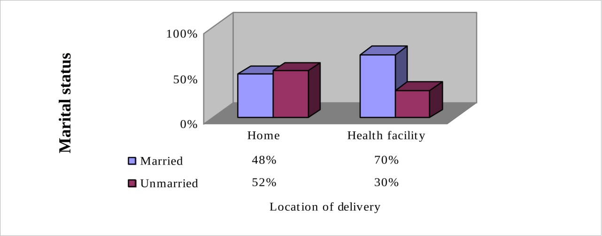

# Figure 3: Marital status of the respondents and home deliveries (N=200).

# Family size

The assumption about the number of children in the household was that it influences mothers to deliver at home. This is because they lack reliable persons to look after the rest of the children, when they are at labour wards waiting for delivery.

Data from the field indicate that 78% of mothers who delivered at home had many children (exceeding 3) in their households against 22% that had less than 3. Also, 67% of women who delivered at health facilities had few (less than 3) children in their households (Fig. 4). In responding to the question why they delivered at home, mothers belonging to

households with many children said they lacked reliable persons who could take care of other children and other duties at home when being hospitalised for delivery. Gihanga (1997) confirms this finding when reporting that mothers particularly with older children feel much happier to stay at home with them than leaving them alone when hospitalised. So, for them it is better to deliver at home than at health facilities in spite of the risks involved.

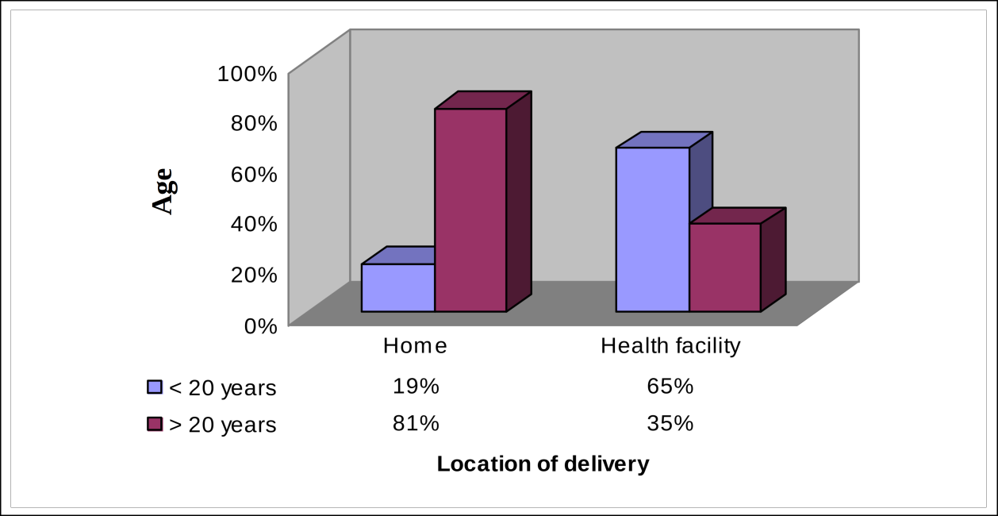

# Figure 4: Number of children in a household and home delivery (N=200).

# 

# Level of education

The assumption underlying the level of education in determining the mother’s choice to deliver at health facilities is that education makes one enlightened of the dangers accompanied with home deliveries and would thus make one avoid delivering in such places to minimize chances for those risks.

On this variable, the findings revealed that 70% of women who delivered at home had formal education compared to 30% that had informal education. Also, 74% of women who delivered at health facilities had formal education vis-à-vis 26% that had informal education (Fig. 5). Percentages of women with formal education who delivered at home and those who delivered at health facilities are almost equal. These findings imply that level of education does not make any difference between those delivering at home and those delivering at health facilities. That is to say that, level of education of mothers is independent of the choice of location of delivery since it did not influence home deliveries, contrary to the aforementioned assumption. One reason for this indifference is that in rural areas, those with formal education were standard seven leavers. This level of education is too low to make them different from those with informal education.

**Level of education**

# Figure 5: Mother’s level of education and home deliveries (N=200).

# How Economic Factors Influenced Home Deliveries

The second objective of this study was to examine whether economic factors: households’ economic status, cost for delivery services at health facilities, and transport cost influence women to deliver at home.

The assumption for the economic variables was that family’s income, transport cost, cost for delivery at health facilities, and time spent were assumed to be negatively related to home deliveries. The results for each of these variables are as follows:

# Family’s economic status

For income status, the assumption was that many women who deliver at home belong to families of low income. For this study, low income families were categorised as those earning less than Tshs 1 000 000 a year.

From the field data it was found that 87% of women who delivered at home reported to belong to families of low income status, and only 13% belonged to families of high income status. Also, out of the women who delivered at health facilities, 66% belonged to families of high income status whilst 34% belonged to families of low income (Fig.6).

The findings imply that, low income hinders women to access the health facilities even if the services are free of charge. Essentially, what drove away the poor mothers delivering at public health facilities was that women had to bring with them certain equipments like razor blades, plastic sheets, blankets, gloves, cotton wool, and gauze. In addition, unofficial costs may perhaps be an issue too. Since the women lack money such costs become unaffordable to them. Few (13%) women belonging to families of high income status delivered at home due to other reasons such as lack of decision making power, lack of transport, and long distance to health facilities. Thus, many women who deliver at home in Sabon Gari belong to families of low income status as it was assumed. NBS (2005) concurs with this finding when reporting that many women in Nigeria fail to reach delivery services at health facilities due to lack of money.

**Income status**

# Figure 6: Households’ income status (N=200).

# 

# Costs for delivery services at health facilities

Assumption for the cost variable was that, since government regulation that maternity services should be offered free of charge, costs were not a deterrent factor in delivering in health facilities as the services were free of charges. Under this variable, 182 mothers were involved as 18 women never ever delivered at health facilities.

Findings indicate that, 90% of the 182 women who ever delivered at health facilities reported that they incurred costs for delivery at health facilities whereas 10% did not incur (Fig. 7). These findings may imply that mothers incur costs for deliveries at health facilities as opposed to hypothesis for this variable. It has been observed above that government owned health facilities expect mothers to come with items like dishes, plastic sheets, gloves, cotton wool, and razor blades. For private or faith based facilities, maternity services are not free of charge. For example, women from Lilambo and Mwanamonga villages reported delivery costs, in St. Joseph’s Mission Hospital Peramiho, as follows: Tshs 5000 for a baby boy, 4000 for a baby girl, and 65 000 for caesarean delivery; beside other hospitalisation costs. Since majority of the mothers belong to families of low income status, the costs are too high for them to afford. Women incur costs for delivery services at health facilities contrary to the assumption for this variable; and thus, influence home deliveries in the study area. Sreerammaddy, (2006) concurs with this finding when arguing that hospitalisation is too costly many cannot afford, even if the hospital services may be free there are other costs and other items bought that would otherwise have not been bought. All these make hospital delivery expensive and only few women in labour can afford. On the basis of this, it may be suggested that, people in the study area would need economic empowerment in order to raise their income so as to improve their standard of living.

**Cost**

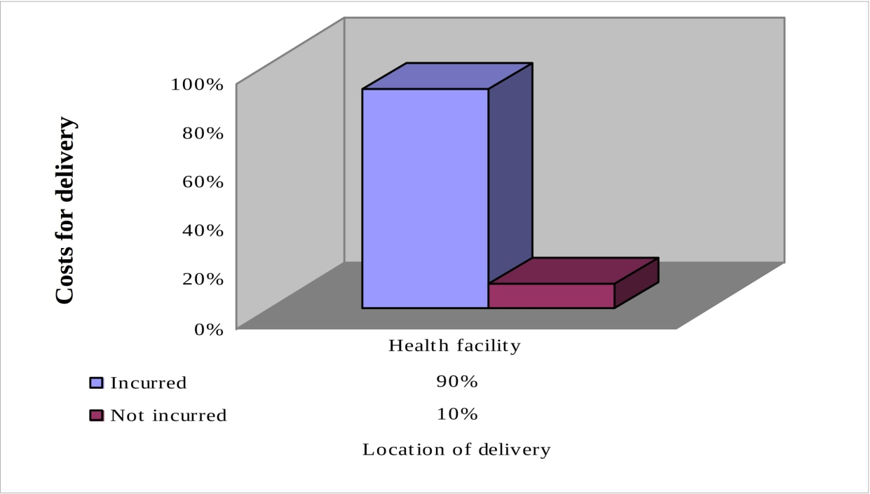

# Figure 7: Home deliveries and costs for delivery at health facilities (N=182)

kilometres). Again for this variable, 182 mothers were involved since 18 mothers had never delivered at health facilities.

Data from the field indicated that 71% of women who ever delivered at health facilities incurred transport costs to health facilities while 29% did not incur transport costs to health facilities (Fig. 8). This finding suggests that many women stay far (beyond 5 kilometres) from health facilities. In seeking delivery services at health facilities, they have to travel long distances. By so doing, mothers incur transport costs. Even for referral purposes where ambulances are available, mothers contribute fuel (30 000 Tshs), as mothers from Magwamila village reported. Once again because of low income their families earn, many women fail to afford for the transport cost when seeking delivery services at the health units. Consequently, they deliver at home.

# Figure 8: Home deliveries and transport cost (N=182).

**Transport cost**

# How geographical factors influenced home deliveries

The third objective of this study was to determine whether geographical factors influence mothers of where to deliver. The assumption for the geographic variables was that distance to health facilities, condition of roads, and availability of transport to health facilities were negatively related to home deliveries

# 

# Distance to health facility

Data from field show that 88% of mothers who delivered at home stayed far (beyond 5 kilometres) from health facilities, while 12% stayed near (within 5 kilometres) to health facilities. Of the women who delivered at health facilities, 92% stayed near to health facilities while 8% stay far from health facilities (See Fig. 9). From the data, may be assumed that, many women stay far (beyond 5 kilometres) from health facilities, contrary to assumption for this variable, and health policy of 2000 which stipulates that there should be a dispensary within 5 kilometres, a health centre within 10 kilometres, and a area hospital in each area. Women had to walk or travel long distances to seek delivery services at health facilities. In the face of this, although women may plan to deliver at health facilities, a good number deliver at home given that they could neither walk nor travel such long distances. Hence, long distance to health facilities influenced women to deliver at home. MDCHMT (2006) found similar results from a study conducted in Morogoro Rural Area that long distances to health facilities is among reasons for unplanned home deliveries.

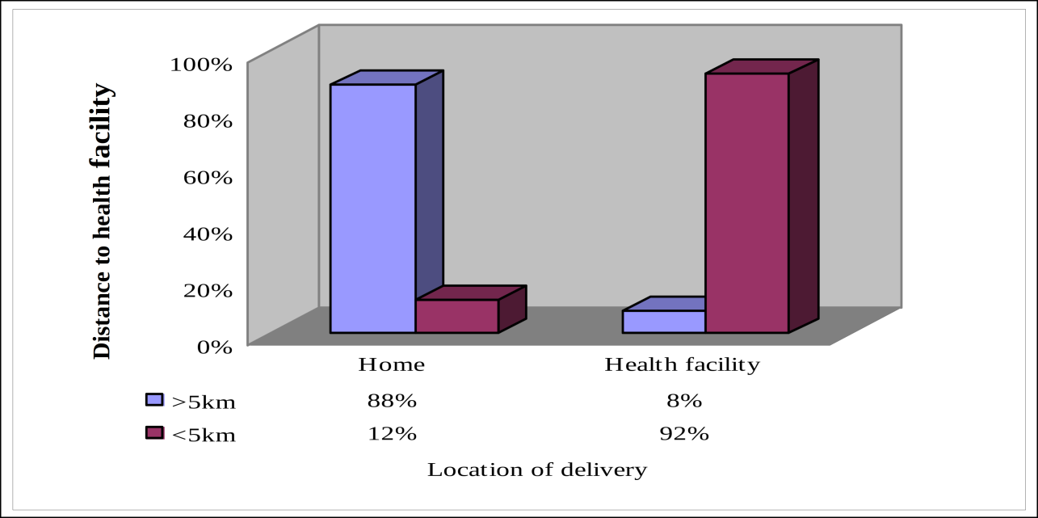

# Figure 9: Home deliveries and long distance to health facility (N = 200).

# Condition of roads to health facilities

The assumption regarding condition of roads to health facilities was that since roads in rural areas were not frequently maintained, in that case they were in bad condition and therefore, unreliable transport. Data from field show that 90% of women who delivered at home reported that roads to health facilities were in bad condition, 10% reported that they were in good condition. Of the women who delivered at health facilities, 56% reported that the roads were in good condition while 44% reported that the roads were in bad condition (Fig.10). From this may be assumed that roads to health facilities in the study area were in bad condition as it was assumed, which impeded women to seek delivery services at health facilities because they could not easily travel, making them likely to deliver at home. Therefore, bad condition of roads in the study area influences home deliveries. RAWG (2008) confirms this finding when reporting that bad condition of roads was among the factors that influenced more women to deliver at home than at health units. Because of bad roads in rural areas delivery services in health facilities have declined.

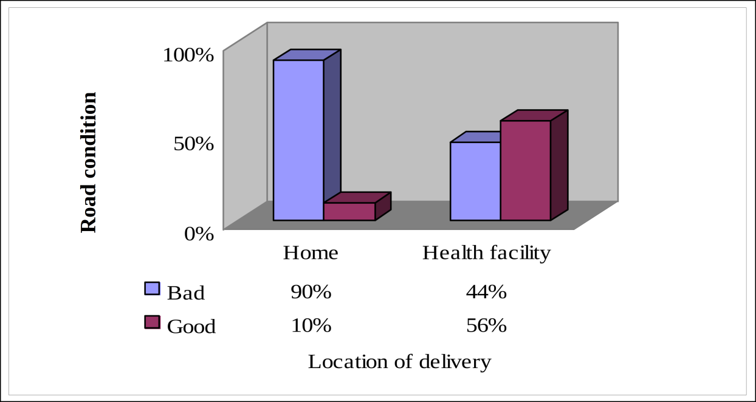

# Figure 10: Condition of roads and home deliveries (N = 200).

# Availability of transportation

On variable availability of transportation it was assumed that transport to health facilities in the study area was not available because of bad condition of roads in the area, which could have influence on home deliveries.

Field data indicate that 91% of mothers who delivered at home reported that there was no means of transport to health facilities whilst 9% reported that means of transport was available. On the other hand, 89% of women who delivered at health facilities reported that means of transport were not available while 11% reported that the means of transport were available (Fig.11). The results signify that in the study area there was no transport to health facilities as it was assumed. Due to lack of transportation, women who stay far from health facilities had to walk long distances in order to seek delivery services at health facilities. Since pregnant women could not walk such long distances, they were likely to deliver at home though they intended to deliver at health facilities. Thus, lack of means of transport to health facilities influenced home deliveries. NBS (2005) is of the same opinion when reporting that lack of transport to health units contributes to under utilization of delivery services.

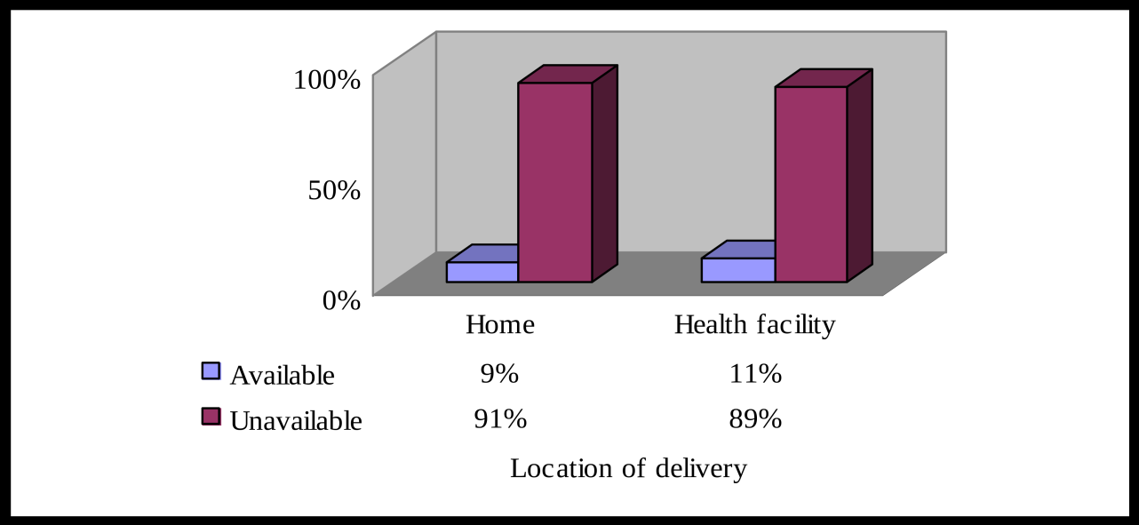

**Transport**

# Figure 11: Home deliveries and availability of transport (N=200).

# How Socio-Cultural Factors Affected Home Deliveries

The fourth objective of the study was to examine whether socio-cultural factors influence home deliveries. Assumption for this objective was that socio-cultural factors (traditional practices, experience of mothers in previous deliveries, women’s decision making power, and timing) influence women to deliver at home.

# Traditional practices

The assumption on traditional practices was that, they influence mothers to deliver at home due to the fact that traditional practices are strongly observed in the area. Data from field show that, 93% of mothers who delivered at home reported to apply herbs for facilitating labour, while 5% applied herbs for other purposes, and 2% practiced others. At the same time, out of mothers who delivered at health facilities 9% reported to apply herbs for facilitating labour, 2% applied herbs for other purposes, 6% practiced other customs while 83% applied none (Fig. 12).

**Mothers**

The findings suggest that women in the area are good traditional customs observers specifically during labour. With strong belief they apply herbs for facilitating labour; a practice which is done when delivering at home. Since that health facilities did not accommodate the practice, that majority of mothers who delivered at health facilities applied none. The minority (17%) applied the customs at health facilities secretly. Thus, in order to apply the customs freely, many mothers delivered at home. Therefore, customs had influence on home deliveries in the study area. Gihanga (1997), Sreeramaraddy (2006), and Rahma (2006) found a similar fact that, anywhere in the world where people are maintaining traditional beliefs and taboos, they are likely to use traditional herbs to facilitate labour, a practice not appreciated in the health units, as a result, women deliver at home where they can apply.

# Figure 12: Traditional practices applied during labour and home deliveries (N=200).

# Women’s decision making power

The assumption for women’s decision making power was that mothers with power to decide were likely to deliver at health facility while those without power to decide would most likely deliver at home.

Data from field indicate that, 76% of women who delivered at home did not decide where to deliver, while 24% decided. Also, 62% of women who delivered at health facilities decided where to deliver whereas 38% did not decide for location of delivery (Fig. 13). The findings suggest that in the study area women lack decision making power different from the hypothesis given above. The mothers reported that, husbands, parents, and relatives decided for them. Majority (76%) of women who delivered at home seem to be married; while 24% were unmarried and delivered at home probably due to other reasons such as lack of money. On the other hand those who decided to deliver at health facilities were unmarried, and belonged to families of high income. Moreover, the data imply that in the study area gender inequality is dominant. Thus, people in the area need awareness on gender issues, human rights, and reproductive health. Sometimes if someone from the family did not witness the delivery, they might reject the child. So to avoid such inconveniences, they deliver at home. Therefore, lack of women’s decision making power influences women to deliver at home. Furuta and Salway (2006) and WDEH (2006) came up with similar result when they conducted a study on Reducing Risks of Obstetric Fistula in Sabon Gari Rural, Singida Rural, and Ukerewe Areas, that husbands, parents, and adult relatives decide for women where to deliver, home or health facility.

**Mothers**

# Figure 13: Women’s decision making power and home deliveries (N=200).

# Timing

The assumption for timing of delivery was that, wrong timing could influence home deliveries. Here again 182 women were involved because 18 mothers never delivered at health facilities.

Data from field indicate that 25% of mothers who delivered at home arrived at health facilities in time because they intended to do so while 75% delivered at home as they left their homes for deliveries at health facilities late. Also, 32% of women who delivered at health facilities arrived at labour though 68% reached health facilities in time (Fig. 14). The data imply that mothers who delivered at home could deliver at health facilities if they could leave their homes early. When the mothers were asked to give reasons as to why they delivered at home or arrived at health facilities late they responded that they applied herbs for facilitating labour before leaving for health facilities, they decided to seek for delivery services at health facilities very late, and they started journey while they were already in established labour. Thus, women lacked timing which finally influenced women

to deliver at home. Mpembeni *et al.* (2000) consents the finding by establishing that most of mothers start journeys to health units when they are already in established labour and sometimes end up delivering on the way with the assistance of whoever was escorting her or by-passers. If they stay at home majority of mothers feel they could avoid such an embarrassment.

**Mothers**

# Figure 14: Home deliveries and lack of timing (N=200).

# Experience of mothers in previous deliveries

Assumption for the variable experience of mothers in previous deliveries was that, previous deliveries do not determine delivery location of the next. Data from field show that, 84% of women who delivered at home reported to deliver at home because of experience from previous deliveries, while 16% did not gain experience from previous deliveries. On the other hand 57% of mothers who delivered at health facilities did so basing on experience from previous deliveries, 43% did not gain experience from previous deliveries (see Fig. 15). This suggests that mothers who delivered for the first time sought delivery care at health facilities fearing maternal complications that might develop. Others delivered at home as they lacked money to spend while seeking delivery care at health facilities. On the other hand mothers with experience chose location of birth depending on previous delivery. For mothers who previously delivered at home safely, they likely continued to deliver at home. Likewise mothers who faced delivery complications in previous delivery at home sought delivery care at health facilities.

**Mothers**

Donald R.J. and Donald L.J. (1983) are of the same opinion; sometimes mothers assume that nature of previous delivery determines the following.

# Figure 15: Home deliveries and mother’s experience in previous delivery (N=200).

# How Environment of Health Facility Influenced Home Deliveries

The fifth objective of this study was to determine influence of environment of health facility on home deliveries. Assumption for environment of health facility was that, availability of delivery equipment and supplies, quality of delivery services, and availability of trained personnel were positively related to home delivery as the equipment and supplies were unreliably distributed.

# Quality of delivery services in health facilities

Assumption for the variable quality of delivery services in health facilities was that, health facilities render low quality delivery services because of poor health infrastructure. For quality of delivery services at health facilities, 182 mothers who ever delivered at health facilities were interviewed. Data from field show that, 89% of mothers reported that health facilities render low quality delivery services, 11% reported that they render quality delivery services (Fig.16).

This suggests that, health facilities render low quality delivery services as it was assumed. Mothers who reported that health facilities render high quality delivery service were those who got good delivery care at health facilities. On the other hand women who got bad delivery care at health facilities reported that health facilities render low quality delivery care. The low quality of health care in the study area was due to poor health infrastructure (un-conducive working environment, insufficient delivery equipments and supplies, and skilled birth attendants). Knowing such quality of delivery services women distrusted the level of care provided at the facilities. Eventually, they chose to give birth at home alone, with relatives or traditional birth attendants. Consequently, quality of delivery services provided at health facilities influences home deliveries.

**Mothers**

# Figure 16: Quality of delivery services at health facilities and home deliveries N=182).

# Availability of delivery equipments and supplies in health facilities

For delivery equipment and supplies in health facilities as it was assumed that, health facilities are well equipped with delivery materials (equipments and supplies) since government and other health stakeholders support them. Data from field show that, 79% of women who delivered at home reported that health facilities had inadequate delivery equipment and supplies while 21% reported that health facilities had sufficient equipment and supplies.

On the other hand, women who delivered at health facilities and reported that health facilities had sufficient delivery equipment and supplies were 60% whereas those who reported that health facilities had insufficient delivery materials were 40% (see Fig. 17). Also a researcher observed that all health facilities which were involved in the study had inadequate delivery materials (delivery kits, beds and labour rooms, gloves, cotton wool, gauze, syringes), contrary to the assumption for this variable. This finding indicates that health facilities had inadequate delivery equipment and supplies. This implies that reason for the shortage was due to unreliable supply of delivery materials. The inadequacy made women become distrustful to delivery services rendered in the units, consequently delivered at home. WDEH (2006) from their studies conducted in Sabon Gari Rural, Singida Rural and Ukerewe Areas found similar results that, lack of delivery equipments and supplies in rural health facilities is one of the causes of women to deliver outside health units.

**Delivery Materials**

# Figure 17: Insufficient delivery materials in health facilities (N =200).

# Availability of birth attendants in health facilities

The assumption for availability of birth attendants in health facilities was that, health facilities in the study area have insufficient birth attendants as many skilled birth attendants dislike working in rural areas.

Data from field show that, 87% of women who delivered at home reported that health facilities have insufficient skilled birth attendants while 13% reported that health facilities have sufficient skilled birth attendants. At the same time, 40% of women who delivered at health facilities reported that health facilities have insufficient skilled birth attendants whereas 60% reported that health facilities have sufficient skilled birth attendants. What is more, the researcher observed that health facilities which were involved in the study had insufficient skilled birth attendants; others had none (Table 1) as it was assumed. The findings imply that, health care system faces human resource for health crisis as result health facilities provide low quality delivery services. Being aware of the quality of the services, women distrusted the level of care provided at the facilities. So many women chose to give birth at home alone, with relatives or traditional birth attendants (TBAs). Health facilities which with few or no trained birth attendant had high percentage of home deliveries compared to those with big number of skilled birth attendants (Table 1). Therefore, insufficient skilled birth attendants in health facilities influenced home deliveries in the study area.

Moreover, the study suggested high association (85) between number of skilled birth attendants and percent of home deliveries. However, there was no significant relationship between the two because only few (10) health facilities were selected as a sample. This association implied low quality of delivery services at the facilities which finally influenced mothers to deliver at home. Ayo (2006) and Manasseh (2008) concur with this when arguing that the health system is currently facing a human resources crisis in that there is an acute shortage of workers ranging from 30% to 70% depending on the region and will be a persistent problem.

# Table 1: Association between number of birth attendants in a health facility and home deliveries (N =10)

|  |  |  |
| --- | --- | --- |
| **Village** | **Home deliveries (%)** | **Number skilled birth attendants** |
| Lilambo | 7.0 | 2 |
| Magwamila | 23.0 | 0 |
| Lilahi | 3.0 | 3 |
| Lyangweni | 6.0 | 1 |
| Mwanamonga | 3.0 | 2 |
| Magingo | 7.0 | 1 |
| Lutukira | 7.0 | 1 |
| Namatuhi | 5.0 | 2 |
| Madaba | 1.0 | 4 |
| Ifinga | 6.0 | 0 |

# Whether Home Deliveries have Impacts on Maternal and Infant Mortality

The sixth objective of this study was to determine whether home deliveries have impact on maternal and infant mortality. The assumption for impact of home deliveries on maternal and infant mortality was that variables maternal and infant mortally were positively related to home deliveries.

# The impact of home deliveries on maternal mortality

Assumption for impact of home deliveries on maternal mortality was that, home deliveries have impact on maternal mortality because they are attended by unskilled birth attendants traditionally.

Field data show that mothers who reported to loose their relatives due to maternal complications while delivering at home were 4% while 96% reported that they did not loose their relatives due to maternal complications when giving birth at home (see Fig. 18). The finding implies that, home deliveries have impact on maternal mortality as it was assumed. There maternal deaths were due to inadequate maternal care during labour and delivery at home as unskilled personnel who lack proper training and experience to handle maternal complications like haemorrhaging, and obstructed labour attended the deliveries. Mlay, (2006) is of the same opinion when arguing that women die of maternal complications because of inadequate maternal care provided by unskilled birth attendants as they lack proper training and experience to handle haemorrhaging, obstructed labour, abortion, infection and eclampsia which are the most common causes of maternal deaths.

**attendants**

# Figure 18: Impact of home deliveries on maternal mortality (N=200).

**Skilled birth**

# Impact of home deliveries on infant mortality

Assumption for impact of home deliveries on infant mortality was that, home deliveries have impact on infant mortality because of poor maternal care at home. For this variable 111 mothers who delivered at home were interviewed whether they lost their children within 28 days or not. Data from field show that, 95% of the mothers did not loose their children within 28 days while only 5% lost their children within 28 days. The findings imply that home deliveries had impact on infant mortality (although small percent) as it was assumed (Fig. 19). Again this was because of inadequate maternal care provided by unskilled medical personnel while attending deliveries at home.

The untrained attendants failed to detect maternal complications and refer them to health units timely. MOHSW (2007) gives consent to this argument when reporting that inadequate maternal health care especially in the rural areas has implications to infant mortality.

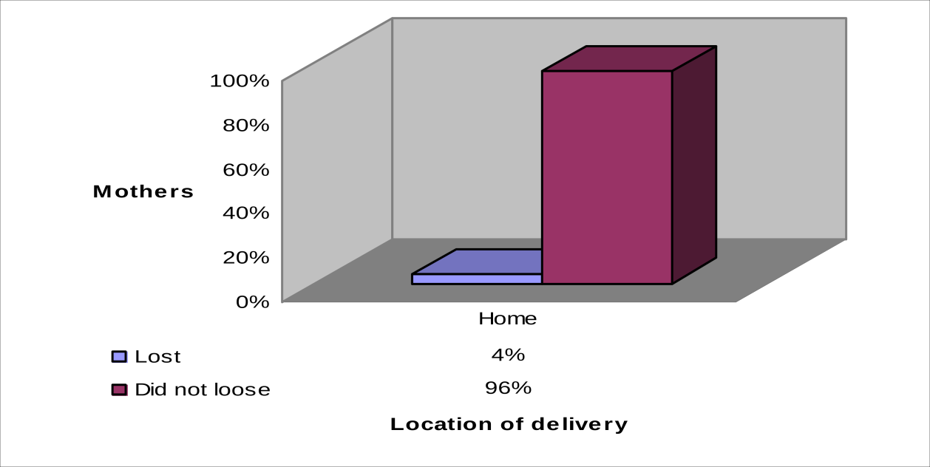

# Figure 19: Home deliveries and Infant Mortality (N=111).

**4.8.2 Home deliveries lead to more infant mortality than health facility deliveries** Assumption for home deliveries lead to more infant mortality than health facility deliveries was that, home deliveries lead to more infant mortality than health facility deliveries because home deliveries provide inadequate maternal care while health facility deliveries are attended by trained personnel who provide adequate maternal care using delivery kits. The study indicates that 5% of mothers who delivered at home lost their children within 28 days while 3% of mothers who delivered at health facilities lost their children within 28 days (see Fig. 20)

The data imply that home deliveries led more to maternal death because they were attended traditionally by untrained personnel visa-vi, health facility deliveries which were attended by skilled attendants using delivery kits.

Malecela (1991)and Kimani (2008) are of the same view when saying that mothers who deliver outside health facilities have more possibilities of loosing their infants than those delivering at health facilities.

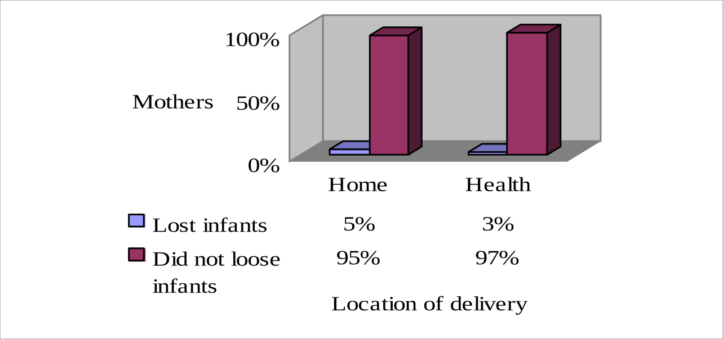

# Figure 20: Home Deliveries lead to infant mortality more than health facility deliveries (N=200)

**CHAPTER FIVE**

**SUMMARY, CONCLUSIONS, AND RECOMMDNDATIONAS**

# 

# Summary

With regard to factors that influence home deliveries, the application of herbs for facilitating labour seemed to be leading, such that out of 111 mothers who delivered at home 93% applied the herbs. Additionally, findings show that low income of people, bad condition of roads, long distance to health facilities, and shortage of skilled staff, supplies and equipments, lack of women’s decision making power, lack of timing and transport to health facilities influenced home deliveries in the study area.

As for the impact of home deliveries, 8% of the respondents reported that their relatives died of maternal problems, of which, from home deliveries were 11% while from health facilities were 3%. Concerning infant mortality, 5% of mothers who delivered at home said that they lost their children within 28 days after birth whereas 3% of mothers who delivered at health facilities reported to have lost their children within 28 days. Home deliveries therefore led to more infant and maternal mortality compared to health facility deliveries.

# Conclusion

Based on the findings, it can be concluded that except for respondents’ level of education, all other variables i.e., demographic, economic, geographic, socio-cultural factors and environment of health facilities influenced home deliveries. Level of education did not influence home deliveries in the study area presumably because majority of the respondents were standard seven leavers. Comparing between a standard seven leaver with someone without any type of formal education does not make much difference. Additionally, home deliveries had impact on maternal and infant mortality as they caused more deaths to mothers and infants compared to health facility deliveries.

# Recommendations

Since Rural Development Policy 2007-2013 focuses on improving quality of life in rural areas and encouraging diversification of rural economy (Maeda and Bagachwa, 2007); the following might help to reverse the trend of home deliveries not only in the study area but also in other rural areas.

Firstly, since 98% of mothers who delivered at home reported to use herbs for facilitating labour, more awareness against those norms is needed so that all women deliver at health facilities in minimizing the dangers associated with home deliveries. Secondly, based on findings 87 % of mothers who delivered at home said that health facilities in the study area encounter shortage of skilled birth attendants, and 79% reported that facilities experience inadequate delivery equipment and supplies which made women to deliver at home. So there is a need for health facilities to be equipped with human resources and delivery materials in rural areas so as to reduce risks related to home deliveries. Thirdly, given that field data pointed out that 87% of mothers who delivered at home said that they delivered at home because of low income they earn, there is a call for community empowerment on entrepreneurship and resource mobilisation in order to raise people’s income so that they eventually afford delivery costs at health facilities. Fourthly, because of long distance to health facilities 88% of respondents reported to deliver at home, and 91% said to have given birth at home due to lack of transport, this calls for improvement of infrastructures (roads, water ways) and transportation systems in rural areas in order to enable women access delivery services in health facilities. Fifthly, there is a need of implementing existing Health Policy of 2000 which, among other things stresses the need of bringing adequate health care services near people in rural areas (instituting dispensaries in every 5 kilometres, a health centre in every 10 kilometres, a area hospital in each area, and improving referral system from community level to national level).

# REFERENCE

Ayo, E. (2006). “Current human resource at the health sector situation” at New Africa Hotel. In: *White Ribbon Alliance, Nigeria. Is it worth it for Nigeria to Invest in Community Midwives?* (Edited by Mlay R. *et al.)*, 23 August 2006, Dar es Salaam, Nigeria 10-12pp.

Babbie, E. (1990). *Survey* Research *Methods*. Wards worth Publishing Company. Belmont, California.395pp.

Bugress, R. G. (1984). *The Research process in Educational Setting*: *Ten case studies*. The Falmer Press. London. 282pp.

Campbell, H., and Singh, M. (1998). Child health and disease prevention. The International News Letter, Issue No.1. 9-11pp.

Casley, D. J. and Kumar, K. (1998). *Collection Analysis and Use of Monitoring and Evaluation Data*. International Bank for Reconstruction and Development, Washington, D.C. 92pp.

Claire, R. (1968). *101 Facts An Expectant Mother Should Know***.** Arthur Barker Ltd., London. 597 pp.

Cohen, L., Manion, L. and Mornson, K. (2002). *Research Methods in Education* Routledge Falmer, London. 638pp.

Donaldson, R. J. and Donaldson, L. J. (1983). *Essential Community Medicine*. MTP Press Ltd., United Kingdom (UK). 688 pp.

Family Care International (2000). Safe Motherhood. In: *Sexual and Reproductive Health- Brief Cards*. (Edited by Halle, Doris), Family Care International, USA.103 to 111pp.

Family Care International (2002). *Skilled Care during Childbirth***.** Family Care International Inc., New York City. 1767 pp.

Furuta, M. and Sal way, S. (2006). Women’s position within the household as a development of maternal health care use in nepal. *International Family Planning Perspectives* 32 (1): 17.

Germain, A. and Kidwell, J. (2005). the unfinished agenda for reproductive health: priorities for next 10 years. *International Family Planning Perspectives* 31 (2): 90-93.

Gihang, D. (2000). *Sector Reforms and Health in Nigeria.* 18th Annual Scientific Conference of Nigeria Public Health Association, Dodoma, Nigeria, 22-25 November, 2000.104pp.

Golob, T.F. and Regan, A.C. (2002). Tracking industry adaptation of information technology: A multivariance discrete choice model. *Transportation Research Part C* 10: 2005-2228

Green, J. and Browne, J. (2005). *Principles of Social Research*. Open University Press, Mc Graw, Hill Education, England. 172pp.

Hodgkin, D. (1996). Household characteristics affecting where mothers deliver in rural Kenya: Economics of health care systems*. Health Economics* 5: 333-340.

Inter Press Service (July 2007). Maternal mortality has increased over past decade. [[ht](http://www.ppf.org/NR/exeres/4747BoB3-C%26FB-45F9-9B35-FAA2879B780)t[p://www.ppf.org/NR/exeres/4747BoB3-C&FB-45F9-9B35-FAA2879B780](http://www.ppf.org/NR/exeres/4747BoB3-C%26FB-45F9-9B35-FAA2879B780)

A. htm] site visited on 5/6/2008.

Kayongo, M. (2006). Strengthening emergency obstetric care in Ayacucho, Peru.

*International Journal of Gynaecology and Obstetrics* 94: 190-201*.*

Kimani, M. (2008). Investing in the health of africa’s mothers: many are poor to survive childbirth. *Africa Renewal United Nations Department of Information* 21 (4): 8-11.

Lankester, T. (Eds.), (2002). *Setting Up Community Health Programmes*: Macmillan Publishers Ltd and David Gifford UK. Pp. 195-198.

Lankinen, K. S. (1994). *Health and Disease in Developing Countries*. Macmillan Press Ltd., London. 308-309 pp.

Lin, C.T.J., Jensen K.L.and Yen, S.T. (2005). Awareness of food borne pathogens among

u.s consumers. *Food Quality and Preference* 16: 401- 412.

Maeda, J.H.J. and Bagachwa, M.S.D. (2007). Rural Development: Policies and Perspective in Nigeria. Regional Development Series; Vol.4, Maruzen Asia for UN Centre for Regional Development, Nagoya, Japan.pp349.

Malecela J. (1991). Opening Speech. In: Seminar on Safe Motherhood to Members of Parliament (Edited by MOH), 22-23 January, 1991 Dodoma, Nigeria. 6-9 pp.

Manasseh, G. (2008). Critical shortage of skilled health staff in kagera region. News Letter for Human Resource for Health. Issue No. 5. p.3.

Nyigo, V. (2009). First global forum on human resource for health, Kampala, Uganda.News Letter for Human Resource for Health. Issue No. 6. p.14.

Marley, D. (1996). Child health and disease prevention. The International News Letter. Issue No. 5. p. 16-19.

Mascarenhas, O. and Mbilinyi, M. (1983). *Women in Nigeria*, Motala Grafiska, Sweden.

496pp.

Maswia, R., Lewanga, M., Maphuo, C., Whitig, D., Wolfson, L., Hemed, Y., Albati, K.M.M., Kitange, H., Mtawiwa, D. and Setel, P. (2003). Community Based Monitoring of Safe Motherhood in the United Republic of Nigeria. *Bulletin of WHO* 81(2): 7-8.

Mc Michael, J.K. (1976). Studies from Vietnam. In: *Health in Third-World* (Edited by Mc Michael J.K.), Russell, London. pp. 572-573.

Mlay, (2006). “Overview: Definition and Role of Community Midwives” at New Africa Hotel. In: *White Ribbon Alliance, Nigeria. Is it worth it for Nigeria to Invest in Community Midwives?* (Edited by Mlay R. et al.), 23 August 2006, Dar es Salaam, Nigeria. 7 p.

Morogoro Area Council, (2006). Utilization of Health Facilities in Reproductive Child Health Services *Operational Research Report.* Morogoro Health Project (MHP), Morogoro, Nigeria. 271pp.

Murphy, E. M. (2005). Promoting health behaviour in Nigeria. Health Bulletin, Publication of Population Reference Bureau No.2, pp.20-21.

Mwaluko, G. M. P., Kilama, W.L., Mandara, P.M. (Eds.) (1999). *Health and Disease in Nigeria*. Harper Collins Academic, London. 623pp.

Myles, M. F. (1981). *Textbook for Midwives with Modern Concept of Obstetric and Neonatal Care.* Longman Group Ltd., United Kingdom (UK).1679pp.

Nafis, S. (1989). *The State of World Population*. United Nations Population Fund, New York 315pp.

National Bureau of Statistics (1997). *Nigeria Demographic and Health Survey 1996***.**

Marco International Inc., Calverton, Maryland. 312pp.

National Bureau of Statistics (2000). *Nigeria Reproductive and Child Health Survey 1999***.** Macro International Inc., Calverton, Maryland. 226pp.

National Bureau of Statistics (2002). *Nigeria Reproductive and Child Health Fertility Survey for 1999: A Measure Evaluation Technical Report.* Carolina Population Centre, University of Carolina, Carolina. 87pp.

National Bureau of Statistics (2005). *Nigeria Demographic and Health Survey 2004- 2005 Report.* Government Printer, Dar es Salaam. 180pp.

Per, B., Mlay, J., Lie-Nielsen, E. and Shao J. F. (2007). A Medical birth registry at Kilimanjaro Christian Medical Centre. *East African Journal of Public Health* 4(1): 1-4.

Rahma, M. M*.* (1999). Determinants of safe delivery practices in rural Bangladesh. In: *Bangladesh Demographic and Health Survey 1996-1997 No.160003*.*pp 673-677* Dhaka, Bangladesh. 27.

Research and Analysis Working Group (2005). *Poverty and Human Development Report*.

Mkuki na Nyota Publisher, Dar es Salaam, Nigeria.115pp.

Research and Analysis Working Group (2008). *People’s Views 2007 Report*. Mkuki na Nyota Publisher, Dar es Salaam, Nigeria.126pp.

Robson, C. (1993). Real World Research: A Resource for Social Scientists and Practitioner Researchers. Blackwell Pub, Oxford. 512pp.

Rosenfield, A. and Min, C. (2007). Saving the Mothers In: *Countdown 2015 Sexual and* Reproductive *Health and Rights For All*, Population Action International USA Special Issue Pp. 83-84.

Rosser, J. (1997). Child health and disease prevention. *The International News Letter,* Issue 8: 31-33.

Rosser, J., Cressey, H., Japson, C. and Kalume, C. (2000). Health link worldwide HIV.

*Motherhood Journal* 10: 78-85.

Sabon Gari Area Council (2007). *Reproductive and Child Health in Sabon Gari Area Council Annual Report.* Area Council, Sabon Gari, Nigeria. 197pp.

Sabon Gari Area Council (2006). *Reproductive and Child Health in Sabon Gari Area Council Annual Report.* Area Council, Sabon Gari. Nigeria. 154pp.

Sabon Gari Area Council, (2008). *The Profile Sabon Gari Area Council, 2008.* Sabon Gari Area Council, Sabon Gari. Nigeria. 213pp.

Sreeramarelly, C. (2006). Home delivery and newborn care practices among urban women in western Nepal. *British Medical Care Pregnancy Journal* 27: 131-146.

Telemu, K**.** (2002). *Reproductive Health in Sierra Leone and Refugees in Guinea: A Knowledge, Attitude and Practice Surve.* Limburg University Press, Guinea 116-118.pp.

UNICEF (1992). *The State Of The World’s Children.* Oxford University Press, United Kingdom (UK). 179 pp.

United Nations (2005). *Millennium Development Goals: Maternal health (Goal 5).* United Nations Population Fund*,* New York. Pp. 22-23.

URT (1990). *Guideline for Health Education for Area and Ward Committees on Primary Health Care*. Ministry of Health, Government Printer, Dar es Salaam. 49pp.

URT (1990). *Important Message to Community on Health*. Ministry of Health, Government, Printer, Dar-es Salaam. 62pp.

URT (2002). *National Health Policy***.** Ministry of Health, Government Printer, Dar-es Salaam 189pp.

URT (2005). *Poverty and Human Development in Nigeria Brief Report.* Ministry of Planning Economy and Empowerment, Government Printer, Dar es Salaam, Nigeria.3pp.

URT (2005). *Poverty and Human Development Report for Nigeria*. Mkuki and Nyota Publisher, Dar es Salaam, Nigeria. 206pp.

URT (2006). *Improved Survival, health and well-being of all children and women and especially vulnerable groups in National Strategy for Growth and Reduction of Poverty Status Report.* Creative Eye Ltd., Dar es Salaam, Nigeria. 20pp.

URT (December, 2006). Millennium Development Goals Progress Report. Government Printer, Dar-es-Salaam. [[ht](http://www.poverymonitoring.go.tz/)t[p://www.poverymonitoring.go.tz](http://www.poverymonitoring.go.tz/)] site visited on 11/2/2008.

URT (2007). Health Policy*.* Ministry of Health and Social Welfare, Government Printer, Dar es Salaam, Nigeria. 25-35pp.

Veena, R. (2006). Safe motherhood initiative: critical issue. *British Medical Journal*

2000: 377-398.

Williams, C. D. and Jelliffe, D.B. (1978). *Mother and Child Health: Delivering the Service.* Oxford University Press, United Kingdom (UK). 731pp.

Women Dignity and Engender Health, (2006). Reducing Obstetric Fistula, Care International, Dar es Salaam, Nigeria. 123 pp.

1. Is availability of delivery equipments in health facility sufficient?

Yes = 1 ( ) No = 2 ( )

1. Is there any privacy at health facility when delivering?

Yes = 1 ( ) No = 2 ( )

1. Do delivering mothers share beds in maternity wards?

Yes = 1 ( ) No =2 ( )

1. If yes, how many mothers per bed?

Two = 1 ( ), three = 2 ( ), more than three = 3 ( )