#### AN ASSESSMENT OF THE RAINFALL AND TEMPERATURE VARIATIONS IN PARTS OF NORTHERN NIGERIA

**Peter Eje Adakayi**

#### JUNE, 2012

**AN ASSESMENT OF RAINFALL AND TEMPERATURE VARIATIONS IN SELECTED STATIONS IN PARTS OF NORTHERN NIGERIA**

Peter Eje Adakayi (B.Sc; M.Sc (Jos) PGES/UJ/0152/04

A Thesis in the DEPARTMENT OF GEOGRAPHY AND PLANNING, Faculty of Environmental Sciences,

Submitted to the School of Post-Graduate Studies, University of Jos, in fulfillment of the Requirements for the Award of DEGREE OF DOCTOR OF PHILOSOPHY in ENVIRONMENTAL RESOURCES PLANNING of the

UNIVERSITY OF JOS

June, 2012.

DECLARATION

I, Mr. Peter Eje Adakayi hereby declare that this work on assessment of rainfall and temperature in parts of Northern Nigeria was carried out by me under the supervision of Prof

A.C. Eziashi and Prof. E.A. Olowolafe, and has not been presented elsewhere for the award of a degree or certificate. All sources of literature and data have been duly distinguished and appropriately acknowledged.

……………………………………. ...……………………. Peter Eje Adakayi (B.Sc; M.Sc, Jos) Date PGES/UJ/0152/04

CERTIFICATION

This research by Peter E. Adakayi (PGES/UJ/0152/04) was carried out under our supervision.

Prof. A.C. Eziashi Date

(First Supervisor)

Prof. E.A. Olowolafe Date

(Second Supervisor)

Prof. J.Y. Dung-Gwom Date

(Head of Department)

ACKNOWLEDGEMENT

I wish to acknowledge the contributions of a lot of people towards the completion of this work.

First and foremost, my gratitude goes to my supervisors, Professor A.C. Eziashi and Professor

E. A. Olowolafe. for their immense contribution towards shaping this work to its present form. May God reward them abundantly. Secondly, my gratitude goes to the entire staff of the Department for their various contributions especially Prof. C.Y. Oche who painstakingly went through every draft of this work. May God bless you all. So also professors D.D.Dabi and J.Y.Dung-Gwom.

My sincere appreciation goes to Dr. Sam Ede and Prof. Steve Onah and their families for making me their guest whenever I was in Makurdi for the purpose of this work. God will surely reward you all.To my colleagues, thanks be to you all especially Dr. P.D. Dawam and Professor (Mrs) R Mundi for your encouragement and concern. I am grateful also to Mr. Pius Olofu and Dominion Segun for processing and printing the initial work. May God reward you.

My gratitude also goes to Paul, Lazarus, Ishaya, Magaji and My son Adakayi for the pain they took to make the maps and diagrams, proof reading, processing and printing of the work. May God bless them abundantly.

My sincere gratitude goes to Steve, Sam, Maisamari, Saint and the University for their financial assistance from time to time.

I must also appreciate Professor I.I.Ekoja for the facilities and materials made available to me and also his concern.

Thanks to my friends, Ashe, Teke and all the others for their moral support in the course of this work.

Finally, to my family, who were denied certain things in the course of this work. I pray things will be better from now on. Thank you sincerely.

DEDICATION

This work is dedicated to the Almighty God, Mummy and the Boys.

TABLE OF CONTENTS

TITLE PAGE

DECLARATION iii

CERTIFICATION… iv

ACKNOWLEDGEMENT… v

DEDICATION… vi

TABLE OF CONTENTS vii

LIST OF FIGURES ix

LIST OF TABLES xiii

ABSTRACT… xiv

**CHAPTER ONE INTRODUCTION**

* 1. BACKGROUND TO THE STUDY 1
  2. PREDIDCTIONS ABOUT CLIMATE CHANGE IN NORTHERN NIGERIA 2
  3. THE STUDY PROBLEM 12
  4. AIM AND OBJECTIVES OF THE STUDY 15
  5. ASSUMPTION 16
  6. ASPECTS AND SCOPE OF THE STUDY 16
  7. THE STUDY AREA 17

**CHAPTER TWO LITERATURE REVIEW**

* 1. CONCEPTUALIZATION OF CLIMATE CHANGE 32
  2. THE LGM TO HOLOCENE TRANSITION 38
  3. THE HOLOCENE 40
  4. CLIMATE TREND 40
  5. CLIMATE VARIATION 42
  6. THEORIES OF CLIMATE CHANGE 48
  7. SUMMARY 53

**CHAPTER THREE METHODOLOGY**

* 1. NATURE, TYPES AND SOURCES OF DATA 55
  2. METHODS OF DATA COLLECTION 55
  3. METHODS OF DATA ANALYSIS 55

**CHAPTER FOUR DATA ANALYSIS AND**

INTERPRETATION OF RESULTS

* 1. RAINFALL ANALYLSIS 58
     1. Rainfall Summaries by Stations 58
     2. Rainfall Summaries by Year… 60
     3. Time Series Analysis (Rainfall)… 62
     4. Time Series Analysis of (Rain days). 98
  2. TEMPERATURE ANALYSIS 109
     1. Time Series Analysis Of Maximum Temperature 109

Time Series Analysis… 116

* + 1. Analysis of Minimum Temperature 142
    2. Time Series Analysis of Minimum Temperature 145
  1. RELATIONSHIP BETWEEN RAINFALL, MAXIMUM TEMPERATURE

AND MINIMUM TEMPERATURE… 168

* + 1. Relationship Between Rainfall and Maximum Temperature 168
    2. Relationship Between Rainfall and Minimum Temperature 168

CHAPTER FIVE DISCUSSION OF RESULTS

* 1. RAINALL AMOUNT AND DISTRIBUTION… 171
  2. NUMBER OF RAINDAYS… 176
  3. TEMPERATURE CHARACTERISTICS 177
     1. Maximum Temperatures 177
     2. Minimum Temperatures… 180
  4. RELATIONSHIP BETWEEN RAINFALL AND TEMPERATURE… 181

**CHAPTER SIX SUMMARY AND CONCLUSION**

* 1. OVERVIEW OF THE STUDY 182
  2. MAJOR FINDINGS OF THE STUDY… 183
  3. CONTRIBUTION TO KNOWLEDGE… 184
  4. CRITIQUE OF THE STUDY… 185
  5. CONCLUSION… 185
  6. RECOMMENDATIONS 187

REFERENCES 188

APPENDIX I 196

APPENDIX II 197

LIST OF TABLES

**TABLE PAGE**

1. Population of study Area by State 18
2. Temperature of the Study Area 25
3. Rainfall of the Study Area 26
4. Summaries of Mean Annual Rainfall by Stations in the Study Area 59
5. Summaries of Mean Annual Rainfall by year in the Study Area 61
6. Time Series Modeler 89
7. Statistical Summary of Number of Rain days by year 100
8. Statistical Summary of Number of Rain days by Stations. 101
9. Time Series Modeler 108
10. Simple Statistical Measures of Maximum Temperature by Station. 113
11. Simple Statistical Measures of Maximum Temperature by Years 114
12. Simple Statistical Measures of Minimum Temperature by Stations 115
13. Time Series Modeler (Maximum Temperature) 141
14. Time Series Modeler (Maximum Temperature) 167
15. Correlation Coefficients between rainfall and maximum temperature for 36 years. 169
16. Correlation Coefficients between Rainfall and minimum temperature for 36 years. 170

LIST OF FIGURES

**FIGURE PAGE**

|  |  |  |
| --- | --- | --- |
| 1 | Nigeria Showing Study Area | 20 |
| 2 | Major Geological Formations of the Study Area | 22 |
| 3 | Major Relief of the study area | 23 |
| 3b | Vegetation Map of the Study Area | 30 |
| 4 | Nigeria Showing Study Weather Stations | 57 |
| 5 | Rainfall Variability in the Study Area | 63 |
| 6 | Time Series Graph Of The Total Rainfall In Bauchi Between 1971-2006 | 65 |
| 7 | Time Series Graph Of The Total Rainfall In Gusau Between 1971-2006 | 66 |
| 8 | Time Series Graph Of The Total Rainfall In Kano Between 1971-2006 | 67 |
| 9 | Time Series Graph Of The Total Rainfall In Nguru Between 1971-2006 | 68 |
| 10 | Time Series Graph Of The Total Rainfall In Katsina Between 1971-2006 | 69 |
| 11a | Time Series Graph Of The Total Rainfall In Maiduguri between 1971-2006 | 70 |
| 11b | Time Series Graph Of The Total Rainfall In Yola between 1971-2006 | 71 |

12a The Time Series Graph of Average Rainfall in all Stations between (1971-2006) 72 12b The Time Series Graph Of Mean Annual Rainfall In all the stations (1971-2006) 73

1. Time Series Graph of the Mean annual rainfall in all stations(2007-2030)(forecast) 74
2. Time series graph of the monthly number of raindays in YOLA(1971 -2006) 75
3. The time series graph of the monthly number of rain days in POT (1971 -2006) 76
4. The time series graph of the monthly number of rain days in NGU (1971 -2006) 77
5. The time series graph of the monthly number of rain days in KATSINA (1971 -06)78
6. The time series graph of the Average monthly number of Raindays in all the Station between 1971 and 2006 79

18b The time series graph of the Average monthly number of Raindays between

1971 and 2006 80

1. The time series graph of the Average monthly number of rainday in all stations between 2007 and 2030(forecast) 81
2. Mean Annual Values of Rainfall (1971-2006) 84
3. Transforms difference (1) 85
4. Transforms difference (2) 86
5. Auto-correlation of Mean Annual Values of Rainfall 87

FIGURE PAGE

1. Partial Auto-correlation of Mean Annual Values of Rainfall 88
2. Autocorrelation of Rainfall in 1971 90
3. Autocorrelation of Rainfall in 1972 91
4. Autocorrelation of Rainfall in 1990 92
5. Autocorrelation of Rainfall in 2006 93
6. Histogram of Distribution of Total Rainfall for 1972 94
7. Histogram of Distribution of Total Rainfall for 1978 95
8. Histogram of Distribution of Total Rainfall for 1980 96
9. Histogram of Distribution of Total Rainfall for 1982 97
10. Mean Monthly Number of Rain days (1971-2005) 103
11. Transform difference (1) 104
12. Transform difference (2) 105
13. Auto-correlation of Mean Monthly Number of Rain Days 106
14. Partial Auto-correlation of Mean Monthly Number of Rain Days 107
15. Temperature Variability in the Study Area 111
16. The time series graph of the maximum temperature in Bauchi

between 1971-2006 118

1. The Time Series Graph of the Maximum Temperature in Gusau

between 1971-2006 119

1. The Time Series Graph Of The Maximum Temperature In Kaduna

Between 1971-200 120

1. The Time Series Graph Of The Maximum Temperature In Kano

Between 1971-2006 121

1. The Time Series Graph of the Maximum Temperature in Katsina

between 1971-2006 122

1. The Time Series Graph of the Maximum Temperature in Maiduguri

between 1971-2006 123

1. The Time Series Graph Of The Maximum Temperature In NGU

between 1971-2006 124

1. The Time Series Graph of the Maximum Temperature in POT

between 1971-2006 125

FIGURE PAGE

|  |  |  |
| --- | --- | --- |
| 47 | The Time Series Graph Of The Maximum Temperature In |  |
|  | Sokoto between 1971-2006 | 126 |
| 48 | The Time Series Graph Of The Maximum Temperature In YEL |  |
|  | between 1971-2006 | 127 |
| 49 | The Time Series Graph Of The Maximum Temperature In YOLA |  |
|  | between 1971-2006 | 128 |
| 50a | The Time Series Graph Of the Average Maximum Temperature In all the |  |
|  | stations between 1971- 2006 | 129 |
| 50b | The Time Series Graph Of Mean Maximum Temperature between |  |
|  | 1971- 2006 | 130 |
| 51 | the time series graph of the average max. Temperature in all the |  |
|  | stations between 2007 and 2030 (forecast) | 131 |
| 52 | Line graph of Maximum Temperature in 1971 | 132 |
| 53 | Line graph of Maximum Temperature in 1977 | 133 |
| 54 | Mean Annual Values of Maximum Temperature (1971-2006) | 135 |
| 55 | Transforms difference (1) | 136 |
| 56 | Transforms difference(2) | 137 |
| 57 | Transforms difference (2) | 138 |
| 58 | Auto-correlation of Mean Values of Maximum Temperatures | 139 |
| 59 | Partial Auto-correlation of Mean Values of Maximum Temperatures | 140 |
| 60 | Line graph of Mean Annual Minimum Temperatures at the Weather |  |
|  | Station | 143 |
| 61 | Line graph of Mean Annual Minimum Temperatures in 1981 | 144 |
| 62 | The time series of the minimum Temperature In Bauchi between 1971-2006 | 146 |
| 63 | The time series of the minimum Temperature in Gusau between 1971-2006 | 147 |
| 64 | The time series of the minimum Temperature in Kano between 1971-2006 | 148 |
| 65 | The time series of the minimum Temperature In Katsina between 1971-2006 | 149 |
| 66 | The time series graph of the minimum Temperature In Kaduna |  |
|  | between 1971-2006 | 150 |
| 67 | The time series graph of the minimum Temperature In Maiduguri |  |
|  | between 1971-2006 | 151 |

**FIGURE PAGE**

|  |  |  |
| --- | --- | --- |
| 68 | The time series graph of the minimum Temperature of NGU |  |
|  | between 1971-2006 | 152 |
| 69 | The time series graph of the minimum Temperature of POT between |  |
|  | 1971-2006 | 153 |
| 70 | The time series graph of the minimum Temperature in Sokoto |  |
|  | between 1971-2006 | 154 |
| 71 | The time series graph of the minimum Temperature in Yelwa |  |
|  | between 1971-2006 | 155 |
| 72 | The time series graph of the minimum Temperature in Yola |  |
|  | between 1971-2006 | 156 |
| 73a | The time series graph of the Average minimum Temperature In all |  |
|  | the stations between 1971-2006 | 157 |
| 73b | The time series graph of the Mean minimum Temperature In all |  |
|  | the stations between 1971-2006 | 158 |
| 74 | The time series graph of mean minimum Temperature In all |  |
|  | the stations between 2007 and 2030 (forecast) | 159 |
| 75 | Mean Values of Minimum Temperatures | 161 |
| 76 | Transform difference (1) | 162 |
| 77 | Transform difference (2) | 163 |
| 78 | Transform natural log difference (2) | 164 |
| 79 | Auto-correlation of Mean Annual Minimum Temperature | 165 |
| 80 | Partial Auto-correlation of Mean Annual Minimum Temperature | 166 |

#### Abstract

The aim of the study is the assessment of rainfall and temperature variations in parts of Northern Nigeria. To achieve the aim, the study set out the following objectives (i) to determine variations in rainfall characteristics in terms of number of rain days, extreme rainfall amounts, variability and ranges; (ii) to determine variations in maximum, minimum and mean temperature patterns and using the time series to determine any trend in the change, (upward or downward) (iii) to predict the values for the periods: 2007-2030, which was also subjected to the time series analysis; (iv) to determine the relationship between rainfall and temperature, and (v) to account for the causes of temperature and rainfall variability in the study area. The data for the study which were collected from the Nigerian Meteorological Agency for eleven (11) stations in parts of Northern Nigeria for a period of thirty six (36) years include, those of rainfall amounts, number of rain days, maximum temperature, and minimum temperature. Simple statistical measures of mean, median, maximum, minimum, standard deviation, variance, skewness, kurtosis and coefficient of variability were used for discerning the patterns and distribution of the climatic elements considered in the study. Time series analysis were carried out to determine the trends and predict future values of the variables. The results achieved indicate that: the region could be divided into two periods on the basis of years with lower temperatures and rainfall (1970s and 1980s) and periods with higher temperatures and rainfall (1990s and 2000s). During the predicted period, 2007-2030, rainfall declines until 2019 and from 2020, rainfall begins to increase until 2030, mean annual number of rain days decrease from 6.5 days per month in 2007 to 5.2 days per month in 2030, mean annual maximum temperature and mean annual minimum temperature continue to increase from 34.50C in 2007 to 36.60C in 2030 and 21.10C in 2007 to 21.50C in 2030 respectively. The southern part of the region has higher rainfall and lower temperatures compared to the northern parts. Temperatures vary very slightly in the region; none of the elements have departed significantly from the normal. There is a general increase in rainfall in the forecast period and a corresponding decrease in the number of rain days. There is also a general increase in mean annual temperature and annual minimum temperature. The work recommends that more of this type of studies be carried out. The result show that no signal has really been detected. We should devote more attention to regional studies of current climatic behaviours in various regions of Nigeria.

## CHAPTER ONE INTRODUCTION

#### BACKGROUND OF THE STUDY

Throughout the history of the earth, climates (global, regional, and local) have never been static. The non-static natures are in various magnitudes ranging from variability through fluctuations, trends, and abrupt to gradual changes. Analyses of proxy data from tidal waves, and changing sea and lake levels; tree rings; pollen counts and ice- core have shown that climatic changes have been dramatic on time scales of 10,000 years or more (Oladipo, 1991). We know that the earth had entered and emerged from series of ice-ages. What is happening now however is the fear of an unprecedented dramatic global warming arising from the continued dumping of industrial by-products into the atmosphere and massive deforestation, among other human activities (Oladipo, 1991).

The Inter-Governmental Panel on Climate Change (IPCC) working group 1 Report (1991) affirmed that the quantity of these green house gasses (carbon dioxide (C02), methane (CH4), chroflurocarbons (CFC – 11, CFC – 12, CFC – 13), nitrous oxide (N20), ozone (03) and aerosol/particulates) contribute significantly to climate change. It is believed that variability, in terms of fluctuation or trend is an inherent attribute of climate or weather. What is crucial is the degree of variability that climate is subject to as well as the duration of such variability (Ayoade, 2003). Ayoade (2003) also noted that minor fluctuations or variations constitute not more than a “noise” in the climate series and that man can easily adapt to such minor variations. However, when fluctuations in climate constitute significant departures from the normal conditions or become prolonged to constitute a new climate state, then there are problems of adjustment and the environment, man and his activities become very vulnerable. The rapidity of variations or

change in climate also heightens the vulnerability of man, his socio-economic activities and the ecosystems in general to the change.

The studies on paleoclimatology indicate that the world climate has never been static in geologic past. Cold climates alternate with warm climate. Indeed it is generally believed that the world is currently passing through a warm inter-glacial period. This means that the warming experienced now is to be expected. However, if we believe that we are passing through a warm inter-glacial period and therefore warming is expected, then we might ask the following questions.

* + 1. Will the global warming experienced in recent decades still have occurred without the aid of greenhouse gases produced by man through his various activities?
    2. If human activities are playing a key role in the current global warming, will such activities postpone the onset of a glaciation period in future or even totally prevent a glacial period ever re-occurring again?
    3. If the warming has continued after the Pleistocene glaciations, are we moving towards the peak of such a warm period?

#### Predictions about Climate Change in Northern Nigeria

Ayoade (2003) observed that the world is passing through a warm inter-glacial period. Rodwell and Haskins (1996) noted that Central Sahara is receiving abundant moisture during the same time period as a result of the early development of SW monsoon.

Martin and Clausen, (2003), used climate system model intermediate complexity (natural climate change), paleo-simulation), (orbital, forcing, and sensitivity simulations) and (CO2 increase) to predict Green Sahara changes in the early and mid holocene (9000- 6000 yrs BP), expansion of the Sahara during cold phases (glaciers) and reduction (greening) of the Sahara during warm periods. Balling (2005) used Climate models to

suggest that a build-up of greenhouse gases in the atmosphere could lead to a warming Africa, increased PET rates, a reduction in soil moisture, and an increase in the frequency, intensity, and magnitudes of drought.

Xue and Shukla (1997) using more sophisticated GCM, revealed that in the Sahel, land degradation would cause both an increase in local temperature and decrease in rainfall levels and that afforestation could increase local rainfall, especially in the dry years.

Janicot (1996) observed that desertification appeared to have its greatest impact in temperatures from high-sun months (rainy season) and its least impact during the low- sun months (harmattan). Also, correlations between the El Nino Southern Oscillation index and rainfall in the Sahel have increased in recent years and that decreasing rainfall in the region is related to warm water in the East Pacific, the Equatorial Pacific, and the Indian Ocean.

Eltahir and Gong (1996) provided a theoretical argument suggesting that a cold pool of water in the region south of the West African Coast should favour a strong monsoonal circulation favouring wet conditions in the Sahel. Zheng, (1999) used a numerical model and found that warm spring sea surface temperature yield a wet summer in the Sahel. Zheng, (1999) for most of Africa, the increase in temperature causes increase in potential evapotranspiration that overwhelms any increases in rainfall and results in a reduction in soil moisture. Soil moisture levels throughout most of Saharan Africa are expected to decline by less than 1.0cm.

Beniston, (2005), Ferro (2005), Giorgi (2004), Jones (2001, 2004), Kjellstrom (2004), and Raisanen (2004) variously projected climates for the period 2071-2100 under A2 and B2 scenarios to 1oc – 5.50 oc increases in temperature and 1 oc – 2 oc in the

case of low emissions. Hulme (2001) Scenarios suggest a future annual warming across Africa ranging from below 0.2 oc per decade to over 0.5 oc per decade. This warming is greatest over the interior semi-arid tropical margins of the Sahara and Central Southern Africa, and least in Equatorial latitudes and Coastal environments.

In Northern Nigeria, it is important to find out how our climate fits into this general expectation of a warming earth. The result of the post-glacial warming period is a pointer to what to expect if the current global warming continues unabated. It is feared that many more coastal areas and Islands may be submerged by the accompanying rise in sea level. In addition, there may be changes in rainfall patterns with some areas of the world receiving more rainfall than they currently do receive, while others will receive considerably less rainfall.

In the light of the expectations of a warming earth and changing patterns of rainfall, the current study focuses on all the behaviour of temperature (minimum, maximum) and rainfall in Northern Nigeria. Climate change, fluctuations, variations are examined in greater detail in the section that deals with the review of relevant literature.

Nigeria’s rural economy is heavily dependent on agriculture. Prior to the period of oil boom, export earnings from agricultural produce such as cocoa, groundnut, cotton, palm produce contributed about 90% to the Nigerian Economy. The productions of these crops are climate dependent. Climatic aberrations and hazards, coupled with uncoordinated and over-ambitious agrarian adventures in drought prone areas, have accelerated the desertification process to the extent that preliminary estimate put average percentage cover of Sahelien type of shrub/dry grass/land in Northern Nigeria at 20-40%. Where soil additives (fertilizers, herbicides, insecticides) are being applied (in most cases wrongly due to low-level of extension services) “free” land across the entire country

cannot be more than 40-60% of the total land area. By free, it is meant, land that can support the increasing equitable climate (Adefolalu, 1991). This is akin to the draw down period in geologic times of the Pleistocene as opposed to the “greening” of the Sahara in the Missinian period. At about 4.6m.a, North Africa became drier probably in response to the developing dominance of the features of the Asian monsoon that transferred moisture mainly to Southern Asia, features of the monsoon that are well recognized today.

Griffin (2001) noted that the climate of North Africa is influenced by the ever evolving desert/monsoon system. Within such context, it is quite natural for aridity and humidity to occur in close proximity in time and space with seasonal and longer term cyclical changes emphasizing the duality. This study will compliment earlier studies on the climate of Northern Nigeria which form part of this great North Africa. During the Pleistocene and Holocene a large Lake occupied the Chad basin; it had an overspill into the Benue-Niger River system (Pachur and Altmann 1977). The recent situation is a far cry from the past. It is well known that the Lake Chad has almost disappeared from Nigerian territory. This situation will be linked in the present study by the new emerging patterns of rainfall and temperature variations.

Pachur and Altmann (1977) have noted that the divide on the Southern and South Eastern flanks of the Chad basin have been subjected to considerable erosion since the messinian and are now no doubt considerably lower than during that stage. The northern divides have been by the Pliocene aridity. The intuitive concept that a strong SW monsoon wind will result in a drier North Eastern Africa is borne out by the data summarized by Rodwell and Haskins (1996). Conversely, there is evidence of north eastern Africa and the central Sahara receiving abundant moisture during the same time period as the early development of SW monsoon. A possible resolution of this situation

is provided by recognizing the cyclical nature of the monsoon phenomenon and the influence upon it at the 19 – 23 km precessional cycle.

Martin, (2003) used climate system model intermediate complexity (natural climate change), paleo-simulation) (orbital forcing and sensitivity simulations (Co2 increase) to predict Green Sahara in the early and mid Holocene (9000-6000yrs BP), expansion of the Sahara during cold phases (glaciers) and reduction (greening) of the Sahara during warm periods. The present study of rainfall and temperature in the past 36 years will prove support or otherwise to these predictions.

Understanding climate and climate change is a very difficult task. Perhaps even more difficult is the relationship between climate change and agricultural production and even impacts of climate change in general because of the numerous variables involved. However interest in the topic of climate change has been increasing during the last few years (Flores Mendoza, 1988). This fact is supported by the activities of the IPCC. The interest is as a result of the need to improve food production capabilities in the world to meet the growing demand of the rapidly increasing world population. Even with improved agricultural technology, to a large degree, production can be vulnerable to diverse weather phenomena. Agricultural crops such as wheat, corn, sorghum and millet which are photoperiodic have been known to respond to weather fluctuations such as ten

(10) minutes in day length. This is particularly so with respect to phenology of the crops

e.g. tasseling and/or flowering. However, in this work detailed effects of weather on agriculture may not be studied.

Generally speaking, climate models suggest that a build-up of greenhouse gases in the atmosphere could lead to a warming Africa, increased potential evapotranspiration (PET) rates, a reduction in soil moisture, and an increase in the frequency, intensity and magnitude of drought (Balling 2005).

Charney, (1975) developed the “Charney Hypothesis” which is a complex biogeophysical feedback mechanism that could initiate/or reinforce drought in sub- Saharan Africa as a result of vegetation depletion. In their numerical model, the degradation of vegetation by natural or anthropogenic causes would increase the surface temperature and increase the relative emission of long-wave radiation due to a slight increase in the emmisivity of the surface. These processes will reduce the net radiation at the surface and the overlying atmosphere. These changes in heat transfer would stabilize the lower layers of the atmosphere and suppress local convection. The reduction in local rainfall would further stress the remaining vegetation, thereby initiating a positive biogeophysical feedback (Charney, 1975, and Charney 1977).

The hypothesis was challenged on both theoretical and empirical grounds. In areas where vegetation was reduced, the local surface and near-surface hydrological processes, not albedo effects would dominate the surface energy balance changes associated with vegetation removed in most dry land environments. At the end of the debate, desertification affects the local and regional climates, while the global and regional climates certainly induce desertification in Africa.

The 1990s has been a decade of substantial theoretical research on climate change. Scientists have linked a detailed local surface energy balance model to a global climate model and found that in the Sahel temperature and precipitation are very sensitive to soil moisture content in the region (Bounova and Krishnamurti, 1993a). Others have used a Global Climate Model (GCM) and found that sub-Saharan desertification leads to.

1. A reduction in moisture flux and rainfall in the Sahel,
2. An increase in moisture flux and rainfall to the south of the Sahel,
3. A reduction in the strength of the tropical easterly jet,
4. A strengthening of the African easterly jet,
5. A decrease in the intensity of easterly waves in the region (Xue and Shukla, 1993).

Northern Nigeria falls squarely in the sudan and guinea savannah region and therefore expects a reduction in moisture flux and rainfall. The question is, is this true in recent recorded period? The use of more sophisticated GCM has revealed that in the Sahel, land degradation would cause both an increase in local temperatures and decrease in rainfall levels (Xue and Shukla, 1997). These authors also said that afforestation could increase local rainfall especially in the dry years (Xue and Shukla, 1996).

In similar vein, Zheng and Eltahir (1998) stated that human impacts on vegetation influenced climate; but deforestation, and not desertification, dominated the feedbacks. In the case of Ridder (1998), it was suggested that simulations show that the presence of a densely vegetated surface acts as a catalyst in the hydrological cycle, creating a positive feedback and enhancing rainfall recycling. de Ridder (1998) argued that this result is due to the relation between the characteristic drying-out time of the soil and the return frequency of the rain triggering African easterly waves.

The role of vegetation disruptions on local climate usually involves perturbations to the surface energy balance which in turn alter energy and moisture fluxes in the lower atmosphere. However, once the vegetation is depleted, the local atmosphere is further influenced by increased dust loads.

Most modeling efforts lead to a conclusion that increased mineral aerosols loads will cool the surface, warm the lower atmosphere, stabilize the atmosphere, and reduce local rainfall (Littman, 1991, Tergen, 1996, Moulin 1997). Besides all of the above, it is observed that areas in North Africa with severe desertification were warming faster than nearby areas with less magnitude of desertification. Furthermore, desertification

appeared to have its greatest impact in temperatures from high-sun months and its least impact during the low-sun months. Janicot (1996) also found that correlations between the El Nino Southern Oscillation index and rainfall amounts in the Sahel have increased in recent years and that decreasing rainfall in the region is related to warm water in the east pacific, the equatorial pacific, and the Indian Oceans. These could also be used as explanations for the decreasing rainfall in Northern Nigeria.

Eltahir and Gong (1996) provided a theoretical argument suggesting that a cold pool of water in the region south of the West African Coast should favour a strong monsoonal circulation favouring wet conditions in the Sahel. Zheng (1999) used a numeral model and found that warm spring sea surface temperature yields a wet summer in the Sahel. The rainfall anomaly begins over the sea and propagates over land and persists for several months due in part to a positive relationship between soil moisture and local rainfall.

For most of Africa, the increase in temperature causes an increase in potential evaporation that overwhelms any increases in precipitation and results in a reduction in soil moisture. Soil moisture contents throughout most of Saharan Africa are expected to decline by less than 1.0cm.The northern portion of the Sahel is projected to have up to 3.0cm reduction. The uncertainties of these projections are related to limitations of the numerical climate models and the identification of the different “forcings’ that will drive future climate including the impact of future land use changes. Africa is a rich repository of palaeoenvironmental and palaeoclimatic change (Odada and Olago, 2005). It provides proxies to link and delink present climates from past climates (Palaeo climates). The present natural variability can still be separated from anthropogenicaly induced variability in order to better assess the extent of the current anthropogenic impact on the

climate and the environment, and to better predict the possible future trends in the dynamic earth system as a whole.

For the purpose of clarity, the

* 1. Holocene period = 10,000 BP (Before Present) to present
  2. Last glacial maximum (LGM) = 22,000 – 14,000 BP is a complete contrast to Holocene.
  3. Transition period = 14,000 – 10,000 BP = Unstable.

McGregor (2006) wrote that from a societal perspective, climate may be viewed as a resource, a determinant or a hazard. Therefore, climate variability and change are likely to have impacts on the resource base, alter the conditions under which a range of human activities can take place and present challenges to the safety of people and property.

The Northern Nigeria climate system like other climates is part of the wider global climate system composed of the five inter linked earth components of the atmosphere, hydrosphere (oceans and other water bodies), the cryosphere (snow and ice), the biosphere (flora and fauna), and the lithosphere (crust). These five components interact to produce the climate of a location while the changing relationship between them determines the nature of a location’s climate variability and climate change. The atmosphere is a fluid and, therefore has a circulation, which manifest itself as the system of global and regional wind patterns. It also acts as an absorbent of heat emitted from earth’s surface in the form of terrestrial radiation, and a conduit for solar radiation as it makes its way from the sun to the earth’s surface. Within the atmosphere, a range of physical processes occur as well as chemical reactions that govern the levels of important gases such as Methane and Ozone. In the case of Northern Nigeria, the main facets of the atmospheric circulation are the South West (SW) and the North East (NE) trade winds.

The SW trade winds are like the North West monsoon winds in South East Asia, bringing moisture all over the North from the Atlantic Ocean with high temperature (summer) during the months of May to September. The NE trade wind on the other hand brings in dry cold winds from the Sahara Desert during the months of October to April (winter). The inter phase of these two wind systems is the Inter-tropical convergence zone or the inter-tropical discontinuity. (ITCZ or ITD). The migration of this zone determines the wetness or dryness of any location in the region.

The Northern Nigerian land surface has an important influence in

1. airflow
2. the absorption of solar energy and
3. the hydrological cycle.

Mountains and high elevation areas such as the Adamawa high lands and the Jos Plateau act to force the ascent of air, thus creating unstable air masses or steer winds around their flanks. The nature of the land use, whether it be urban, industrial, agricultural or arable, influences the absorption of heat at the earth’s surface and the exchange of moisture with the overlaying atmosphere. The seasonality of rains also has similar effects on heat and moisture exchanges.

The cold dry NE wind is enhanced by the near cloudless skies during the dry period of the year. The clear skies allow almost all insulation to be taken back to space leaving very little energy in the biosphere. With this high energy fluctuation, plant productivity is at its lowest ebb, and this partly account for the advancement of the Sahara. The sand particles also act as alternative surfaces, adding to further loss of energy from the biosphere. During the rainy season, the moisture content of both the atmosphere and the earth surface act as reservoir of heat at the earth surface. Similarly,

the heavy cloud cover acts as blanket for terrestrial radiation thereby preventing loss of energy from the earth surface.

#### THE STUDY PROBLEM

The IPCC has shown that the world climate has been changing and will continue to change. The question of climate change, fluctuation, variation and trend is no longer debatable. What is not clear is the nature of this change, fluctuations, variations and trends in specific region like the Northern Nigeria. This region’s main occupation is farming, mainly rain-fed agriculture. Any change, variation or fluctuation of climate, whether slowly or rapidly will seriously affect the occupation of the inhabitants of this region. Therefore, a thorough knowledge of the behavior of climate, present and future, will contribute significantly to the well being of the people. Series of predictions have been made on the basis of five main human factors of CO2 and CO increases, CH4 gas introduction, CFC introduction, N2O, ozone layer depletion together with natural factors like radiative forcing, earth orbital changes, and influencing climate change.

However, short time compliance or agreement of these predictions with actual data is a good cause to investigate. This is especially so in Northern Nigeria, where we know that climatic conditions are becoming more arid, the Sahara desert is advancing and the Lake Chad is rapidly receding.

The study attempts the following pertinent questions:

1. What are the temporal/or spatial variations of lengths of rainy and dry seasons?
2. Do these variations follow defined patterns?

For nearly five decades in the twentieth century rainfall amounts in Africa remained relatively high, allowing local inhabitants to sustain or even increase crop yields, cattle herds and human population levels (Balling 2005). However, in the early 1960s, the rainfall amounts declined in the region and by the early 1970s; the human and

ecological tragedy of the Sahel was a serious matter receiving considerable attention worldwide. We know that climate in Africa dry lands has varied considerably through time, and there is no reason to believe that today’s climate will persist into the future. Climate change in African dry lands is the rule, not the exception (Balling, 2005).

Understanding and predicting temporal variations in Africa climate has become the major challenge facing Africa and climatologists in recent years (Hulme, Doherty, Ngara and New 2006). Whilst seasonal climate forecasts have taken great strides forward (Stockdale, 1998; Washington and Downing, 1999), there remains uncertainty on the ultimate causes of the lower frequency decades or multi-decadal rainfall variability that affects some African climate regimes, especially in the Sahel region (Rowell 1995; Sud and Lau, 1996; Xue and Shukla, 1998).

Africa is no exception in experiencing these human-induced changes in climate, although much work still need to be done in separating the “natural” factors of climate change from the human induced ones (Xue, 1997). Climate scholars face a further challenge in that it is in this continent that the role of land-cover changes in modifying regional climate is perhaps most marked. In this study we may wish to reframe our earlier questions as follows:

* 1. Are the changes that can be simulated into Global climate models (GCMS) for the next century larger or smaller in relation to our best estimates of the “natural” climate variability in Northern Nigeria?
  2. How well do GCM predictions agree with the empirical observations in Northern Nigeria?
  3. What are the strengths and weaknesses of these model predictions?

This study hopes to contribute to a greater understanding of the behaviour of our climate in the light of current predictions. Even for the seasonally wet months of June,

July and August in the Sahel suggests that different GCM simulation yield (sometimes) very different regional rainfall responses to a given greenhouse gas forcing. This goes also for parts of Central America, and much of South-East Asia (Carter, 2000). This again is an indication that there is need for a closer study at smaller spatial and temporal climate variations in Northern Nigeria. Most climate change scenarios in the Sahel do not represent adequately, past, present and future estimates of climate of the region (Carter, 2000). This could even be more obvious if smaller regions like northern Nigeria are considered.

Besides this, given the rapidly growing of human impact on the environment, as well as the models of feedback and degree of interaction between the various components/factors of change, there is a need for better understanding of atmospherinc and other environmental changes. Rapid progress in this area of study is critical (Odada and Olago, 2005). The mechanism underlying the abrupt large scale temperature rainfall variations in the Holocene need to be understood as they occurred during a period with climate boundaries similar to those of today. Just as Menne and Ebi (2006) puts it, the non appreciation and sufficient preparedness to tackle impacts of climate change is probably due to the fact that we have not really understood the true nature of climate change especially in specific region like the Northern Nigeria.

Understanding the nature and causes of climatic variability and change is therefore an important pre-requisite for developing effective adaptation strategies to cope with the vagaries of climate. Evidence is emerging for a link between extreme climate events such as the anomalously hot 2003 summer and the biting cold in 2007 due to ocean/atmosphere interaction in the Tropical Atlantic related to wetter than average conditions (Odada and Olago, 2005). This emerging evidence will be sought in the present study of climate variations (fluctuations) in northern Nigeria. The variations in

the land cover across Northern Nigeria could explain climate variation in the present study.

In recent times, reports of crop failures, desert desertification, drought, famine and other climate related problems are rampant in Northern Nigeria. Therefore, there is no better place to carry out this study than Northern Nigeria. That is to see how predictions of climate change holds true in this region. That we expect to see shorter rainy season (length of rainy season), and incidences of flash floods are probable climatic changes this study intends to investigate.

Further areas of focus in this study relate to the following question: That is, are the increases higher in the rainy season or dry season (summer and winter respectively). On the whole, are these decreases or increases indicative of climate change or fluctuations over and above the “noise” level or that a “signal” is beginning to emerge? That is, is there a discernable trend now or are the fluctuations still within the normal range? The study problem is captured succinctly as the assessment of temperature and rainfall variations in some parts of Northern Nigeria.

#### AIM AND OBJECTIVES OF THE STUDY

The aim of the research work is to examine the nature and extent of climate variation in parts of northern Nigeria. Arising from this aim, the study tackled the following objectives:

1. To determine rainfall variability and number of rain days, highest and lowest amounts of rainfall, and variability;
2. To determine variations in maximum and minimum temperature patterns;
3. To establish the relationship between rainfall and temperature;
4. To determine the causes of variations in the climatic elements if they exist; and
5. To predict future climate of parts of Northern Nigeria.

#### ASSUMPTION

The study is based on the assumption that the variation in the climate of the selected stations in parts of Northern Nigeria are still within the normal level for the study period.

#### ASPECTS AND SCOPE OF THE STUDY

The work will cover parts of northern Nigeria in the North West and North- East areas. The zone mostly lies squarely in the Sahel sudan and guinea savannah region of Northern Nigeria. This is the region where we are noticing remarkable changes in patterns of rainfall (distribution), crop failures and reduced yields, flash floods, desertification and desertization including incidences of drought. The study also examines the variations that have occurred in the study area over the past thirty-six (36) years from 1971-2006. At this point it is important to briefly define some keywords in this study for the sake of clarity.

**Climate trend** is the term used when the change is discernable whether upward or downward in the values of the climatic element concerned. When these variations become periodical or cyclical it becomes a **Climatic cycle.** When variations occur in such a manner that a new state or average conditions in the climatic elements exist, then a C**limate change** has taken place. Climatic variations or fluctuations are rather the general nomenclature for shifts in the values of these climatic elements. While variations or fluctuations occur in a short term periods (e.g., diurnal, monthly, annually), trends, climatic cycle or change are detected only over longer periods of time.

In this study, climatic variations are the emphasis. This is due to the fact that variations definitely occur but the nature of the variation is not known until after the analysis of existing data. The study will then reveal if a trend exists or a climatic cycle is discerned or even a change. Eleven weather stations were used, with each of them having thirty-six years of data. These are the stations with the longest number of years of

secondary data. The stations are those of Gusau, Sokoto, Kano, Kaduna, Maiduguri, Bauchi, Yola, Nguru, Potiskum and Yelwa.

The temperature and rainfall data collected were subjected to series of analysis using the simple measures of central tendencies and dispersion. Also both line graphs and bar graphs were used to dipict the frequencies and nature of occurrence of these elements over the thirty-six years. Furthermore the time series analysis was employed to detect trends of both present and further temperature and rainfall. Also, all weather stations with records up to thirty-six (36) years were used for the study (the longer the length of records the better for the study).

#### THE STUDY AREA

The location, position and size of the study area is bounded by latitudes 9oN and 13oN and longitudes 3oE and 15oE (Fig 1) It has a population of about 54,758,909 by 2006 census figures (Table 1).

It is majorly made up of the Sudan Savannah grassland and the Guinea Savannah. The topography is even and precambian igneous and metamorphic rocks of the basement complex are the most common. But peaks such as the Mambila Plateau and the

##### Table 1: Population of study Area by State

|  |  |  |
| --- | --- | --- |
| S/NO | STATE | POPULATION |
| 1 | Bauchi | 4676465 |
| 2 | Kebi | 3238628 |
| 3 | Kano | 9383682 |
| 4 | Katsina | 5792578 |
| 5 | Kaduna | 6066562 |
| 6 | Borno | 4651193 |
| 7 | Yobe | 2321591 |
| 8 | Sokoto | 3696999 |
| 9 | Adamawa | 3168101 |
| 10 | Zamfara | 3259846 |
|  | Total | 54758909 |

Source: 2006 Census Figures

Adawama highlands are mostly of granites and volcanic rocks (Oguntoyinbo, Areola and Filani, 1978).The major rivers traversing the place are Rivers Benue and Niger at the Southern boundaries and Rivers Rima, Hadejia, Nguru, Sokoto, Gana, Jamaare, and a fairly large area covered by the Lake Chad at the North Eastern corner.

Groundwater is highly used in this region often to a depth of 100 metres for a borehole. Static water could be found at the depths of 40 metres. The region has about four of the River Basins in Nigeria, namely; Upper Benue River Basin, Lake Chad Basin, Heidejia-Jamare River Basin and Sokoto-Rima River Basin. Deforestation is active in the region contributing significantly to desertification and drought.

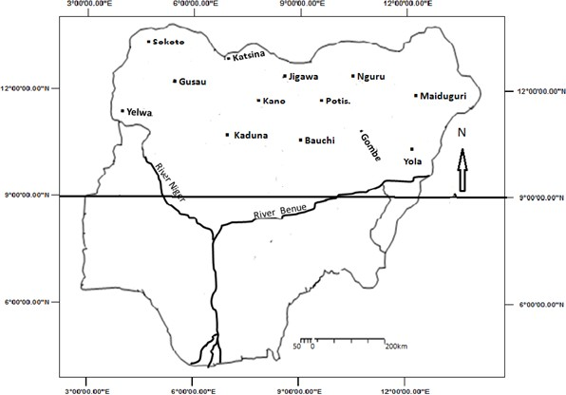

Abuja

Figure 1: Nigeria Showing Study Area

#### Geology and Topography

The Geology and Topography of Northern Nigeria described here is mainly based on the work of Tuley and Alford (1975). Northern Nigeria belongs almost completely to the Basement Complex. In association with the Basement Complex are the precambian igneous and metamorphic rocks and granite rocks (fig 2). The granite rocks are in general associated with porosities of about 1%, compared to such rocks as limestone with a porosity of 10%. Their permeability is also in the same range of about 1%. There also exist cretaceous deposits such as gravels, clay sands, shales, gypsum, having marl, and ferruginous sand stones.

The relief ranges from 300m to 750m around Katsina and Zaria provinces and around 1,600m in the Bauchi and Adamawa highlands (fig 3). The region has an average slope of about 2o (Tuley and Alford, 1975). Many authors have outlined the geomorphological history of the country regarding the landscape as an arrangement of planation surfaces of different levels separated by escarpments or broad zones of dissection (Pugh and Kings, 1952).

The influence of climatic fluctuations is reflected in the superficial deposits overlaying most of northern Nigeria. In the Chad Basin, there led to the deposition of series of longitudinal and traverse dunes (Grove 1958, Grove and Pullan 1964, Grove and Warren 1968). Repeated regressions of Lake Chad led to the formation of standline ridges such as the Barma and Ngelewa ridges, and the deposition of lagoonal clay flate and deltas in between these ridges. The Northern part of Nigeria is underlain by the Basement Complex and the sedimentary rocks in the Chad Basin. The Basement Complex are pre-cambian. Volcanic rocks present in the Biu, Languda and Mambila areas are of tertiary age.

Parts of the Basement Complex rocks have been folded in a NE-SW direction in conformity with other crystalline rocks in West Africa. The rocks were also probably subject to warring and falling in the Mesozoic period to give rise to depressions like the Sokoto and Chad Basins now filled with sediments, and grabens along the Benue and the Niger.

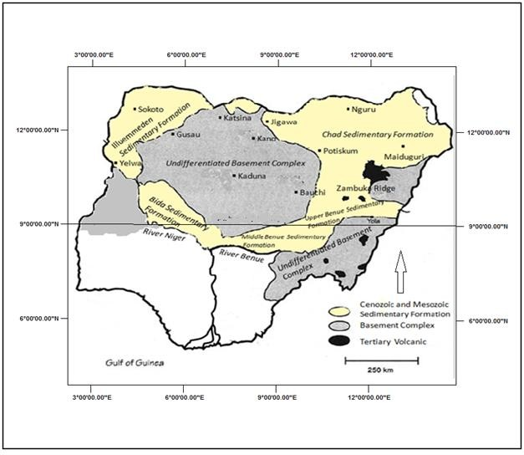

Figure 2: Major Geological Formations of the Study Area

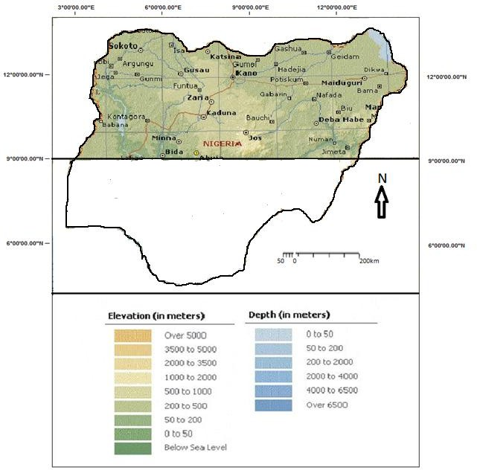

Figure 3: Major Relief of the study area

###### Climate

The major climatic feature of the region is the alternating wet and dry seasons alternatively called, rainy and dry seasons (Oguntoyinbo, Areola and Filani, 1978). This is as a result of the migration of the ITD or ITCZ. This line is formed by the meeting of the Tropical Maritime Airmass (TM) which is wet and the Tropical Continental Airmass (TC) which is dry. Generally the climate of Northern Nigeria like elsewhere in Nigeria is controlled by temperature, wind, pressure, atmospheric humidity and precipitation. Temperatures range between 25.40C to 28.80C (Table 2) at the onset of rains and could be as low as 19.10C during the harmattan period. In general, it is said that the nights are the winters of the tropics where Northern Nigeria is situated. The coldest temperatures are usually in the nights. When the sun rises, it heats up the atmosphere and the land/sea surfaces thereby increase the diurnal temperatures. Mean annual total rainfall generally ranges between 486.1mm to 1281.2mm it has an average of 811.9mm (Table 3). The pattern of rainfall is seasonal. It varies both in time and space.

Sunshine hours about 3,200 hours in the extreme north eastern part of northern Nigeria annually. There seem to be only slight variations in the sunshine hours in Northern Nigeria. On monthly basis, it is about 325 hours in January at Maiduguri and as low as 280 hours in June. The northern part of the country shows an east-west trend in the isohels. The months of September and October show a uniform pattern with the isohels running east to west.

Table 2: Temperature of the Study Area

|  |  |  |  |
| --- | --- | --- | --- |
| S/NO | CLIMATIC | STATIONS | MEAN TEMPERATURE |
| 1 | Bauchi | 28.0 | |
| 2 | Yelwa | 26.2 | |
| 3 | Kano | 26.8 | |
| 4 | Katsina | 26.5 | |
| 5 | Kaduna | 26.7 | |
| 6 | Maiduguri | 25.4 | |
| 7 | Potiskum | 27.8 | |
| 8 | Sokoto | 28.1 | |
| 9 | Yola | 27.1 | |
| 10 | Gusau | 28.8 | |
| 11 | Nguru | 28.1 | |

Table 3: Rainfall of the Study Area

|  |  |  |
| --- | --- | --- |
| 1 | Bauchi | 1001.5mm |
| 2 | Yelwa | 908.6mm |
| 3 | Kano | 897.2mm |
| 4 | Katsina | 534.9mm |
| 5 | Kaduna | 1218.2mm |
| 6 | Maiduguri | 486.1mm |
| 7 | Potiskum | 641.5mm |
| 8 | Sokoto | 625.3mm |
| 9 | Yola | 902.7mm |
| 10 | Gusau | 903.4mm |
| 11 | Nguru | 409.8mm |
|  | 775.4mm | |

S/NO CLIMATIC STATIONS ANNUAL RAINFALL



Northern Nigeria has about 190kg.cal of radiation on annual basis. The annual radiation varies very little in Northern Nigeria the monthly values which show great seasonal variations. The highest temperatures are experienced about April in Northern Nigeria. Minimum temperatures are usually in December. Maximum temperatures could be as much as 40.6 oC while the minimum could be as little as 12.8oC. the northern part of the country has humidity values of 20% in April and the diurnal values could fall from 30% a down to 10% in the afternoon. This is characteristic of the harmattan season when the dry and dust-laden North-East Trade winds are blowing from the Sahara under cloudless but dusty conditions. The variations in humidity also reflect variations in temperatures.

There appears to have been a period of low rainfall in the latter part of the last century when drought conditions swept over most parts of West Africa. This pattern conforms with the fluctuations in the level of Lake Chad; this was the period of the “Little Chad” (Sikes, 1969). This condition appeared to have continued into the twentieth century when the northwestern part of Nigeria suffered drought conditions in the first and second decades and the Sahara was encroaching upon the Sudan. The year 1913 was known to have been extremely dry. Northern Nigeria experience better rainfall conditions between 1915 and 1935, then a period of low rainfall between mid 1930 and mid 1950 when there were numerous local famines throughout Nigeria (High, 1973). By the decade 1964-1973, Kano received only 80% of the mean annual rainfall. In 1973 that city received 417mm of rainfall about 40% of its normal amount.

###### Soils, Vegetation and Land Use

The natural vegetation is that of the Guinea and Sudan Savannah grassland, woodlands, shruds and parklands. Impact of agricultural practices and open range grazing has affected the vegetation types greatly. Tuley and Alford (1975) summarized the relations between the soils and vegetation as:

1. soils of hills and rocks which are largely shallow with pockets of deep often fertile soils carry a diverse and composite vegetation;
2. Soils over ironpan carry a characteristic plant community with dwarf grasses and specialized herbs;
3. Infertile soils with gravels carry a lower grassland of thin leaved species;

Whyte (1966) observed that the disappearance of the woody plants in the tropics and reduction in their average height adversely affects the micro-climate. As a result, the Sahelian drought of the 1973 was blamed on the industrial activity in the developed nations of the Northern Hemisphere. Overgrazing is also a cause of drought in the Sahel.

Soils and vegetation are closely related and they are associated with one another in the people’s mind (Areola, 1978). The vegetation cover has always served as an indicator of soil status for the local people in their agricultural and other primary production activities. In the absence of animal and chemical manure, Nigerian farmers relied on bush fallow for the restoration of soil fertility.

The regosols occur mainly in the Chad Basin. They are brown to grey-brown coarse sandy soils developed on desert sand drift, found principality in central Borno and the north-eastern margins of the Kano region. Some lateralization has taken place so that iron concretions occur in the weathering profile in some places. Apart from the poor profile development and low water retention, their productivity is further impaired by the

lack of an adequate vegetation cover to supply soil organic matter. The vegetation consists of scattered thickets of shrubs with a sparse grown flora of tufted grasses. The area is used mainly for grazing and browsing by cattle and goats. The river valleys and depressions have marked by clay soils (vertisols).

In the savanna regions of the north, the terrain consists of isolated rocky hills and hill ranges rising above extensive plains dissected by streams. Where the underlying rock is made up of biotite granite or greiss, moderately deep soils occur in close rock outcrops. Elsewhere lithosols and shallow soils are most widespread close to the hills. The soils becomes progressively deeper towards the valleys. They are highly fernigizes and many are characterized by a textural clancy subsurface horizon. But the clay horizon is absent from the more sandy soils developed on slope wash collurial sediments. The deep soils of the rolling plains which support most of the agricultural products of the region have low to medium organic matter content, moderate to good water holding capacity and a friable consistence. But as with most tropical soils they are intensely leached and, therefore, are of low natural fertility. Furthermore, over large areas, the vegetation does not provide adequate cover for the soil especially at the beginning of the rains. This is because incessant annual bush burning has reduced the grass cover so that large tracts are occupied by shrubs and woody plants between which the ground surface is exposed (Areola, 1978).

Shaduf irrigation and flood plain farming are practiced in the dry savanna regions (Floyed, 1965). In the savanna regions, organic litter is usually ploughed into the soil when heaps or ridges are being made. Savanna vegetation covers over three-quarters of the land area of Nigeria but it contains very low timber tree species. In fact most of the savannas have a crop fit only for firewood. The guinea savanna zone in particular and gallery forest in the riverine areas contain scattered trees of value such as lophira

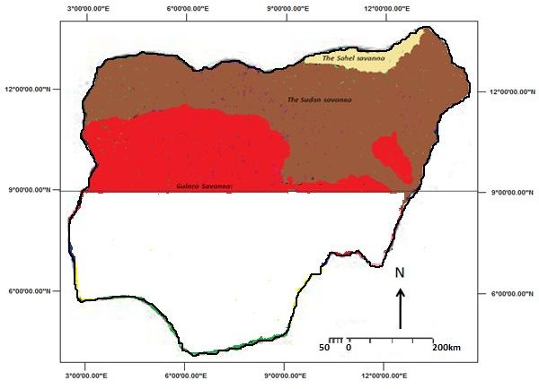

Figure 3b: Vegetation Map of the Study Area

lanceolata, terminalia glauscens, ofzelia Africana, terminalia macroptera, nitrogyna inermis and deniellia oliveri.

The grass, weed, shrub and leguminuous competent of the savanna lands are very important to the grazing economy of the country. Many of the grass species prevalent in the guinea zone are also present in the sudan, but the dominant grasses are sorghum and other turf species including Pennisetum Purpureum, axonopus compressus, loudetra togoensis species of brachiaria, chloris, aristida, digitaria and erogrostis (Areola, 1978).

Population and Human Activities

The population of the study area is about 45,755,645 according to the 2006 National Population Census (Table 1). This population is made up of 22,301,398 females and 23,454,247 males. Over 90% of the population is engaged in farming activities. The remaining are involved in civil service work and others in the few industries available. Farming activities are majorly cropping and animal husbandry and some limited ones in the fishing industry. The major crops are grains such as millet, sorghum, maize and groundnuts, onions, cotton. The southern parts of Kaduna could produce yams, rice, soya beans and sweet potato and also in small quantities irish potato. The crops are rain-fed and the animals graze all over the place. Dry season irrigation agriculture takes place in the area of Jamare-Hadejia river basin. As a result of these human activities, any variation in rainfall and or temperature, especially significant or sudden ones, will have a lot of impact on the population. It will lead to lack of water or surplus water, which are detrimental to growth and development of these crops. Insufficient grasses and shrubs for the herds and eventual farmine and death of both humans and animals; or flooding and destruction of lives and properties will also occur. However, if planning is done, these catastrophes can be averted or ameriorated. This is why this study is very apt at this time where so much interest is generated about climate change.

## CHAPTER TWO

### LITERATURE REVIEW

#### CONCEPTUALIZATION OF CLIMATE CHANGE

Climate today as we know it is the synthesis of weather of a place over a long period of time (30years- 35years). By synthesis, we mean average conditions (smoothening the variations) over a long period. Therefore statistics such as mean and standard deviation are the most initial point of analysis and the longer the length of statistics, the better the results.

The World Meteorological organization (WMO) recommended the use of 30 years to derive the climate of a place because it is believed that a period of 30years is sufficient for calculating climate normal, whether of temperature or rainfall (Ayoade, 2003). Because climatic variations occur in both time and space, various terms have been used to describe the variations on the basis of climate trends

1. climate cycles
2. and climatic variability which emphasized the inherently dynamic nature of climate.

The IPCC concluded in 2001 that there are strong evidences that not only were most of the global warming observed over the last 50 years attributable to human activities, but also that climate change could affect human health just like other aspects of the environment such as water resources, agriculture and forestry. The effects can be direct such as through increased heat stress, and loss of life in floods and storms, or indirect through changes in the ranges of disease vectors such as mosquitoes, water- borne pathogens and water and air quality, as well as food availability and quality.

A study of climate change in effect will help in a clear understanding of the patterns in the past, present and the future so that adequate preparations can be made

towards mitigating/reducing any possible catastrophic effects. The flood events in 2002 and the heat-wave of August 2003 in Europe had given evidence that no one is on the safe side when it comes. Even the floods of 2007 and 2008 in both Europe and North America, are indications of this reality. The framework convention on climate change (UNFCCC), in its Article 1, defines “climate change” as “a change of climate which is attributed directly or indirectly to human activity that alters the composition of the global atmosphere and which is in addition to natural climate variability observed over comparable time periods”. The UNFCCC, thus, makes a distinction between “climate change” attributable to human activities altering the atmospheric composition, and “climate variability attributable to natural causes.

The evidence of climate change is increasing (Klein Tank, 2005) and in Europe much is been invested in undertaking climate change projections (Parry, 2000). It involves several steps. First, energy productions are to construct global Greenhouse Gas Emission (GHGE) Scenarios. These are then used as input into global carbon cycle model that provides estimates of the sinks and sources of carbon. The difference between these provides an estimate of the increase in carbon dioxide (CO2) concentrations in the atmosphere for a given GHGE Scenario. Global climate models (GCM) are then run in order to establish how higher CO2 concentrations may affect, for example, changes in temperature and precipitation.

The GCMS are three-dimensional mathematical models that represent physical and dynamic processes that are responsible for climate. All models are first run for a control simulation that is representative of present-day climate or that of pre-industrial times. Next, a perturbed run is made as the current levels of GHG bases are perturbed (increased) within the GCM to match some future level. Generally two types of perturbed climate model experiment can be run for estimating future climate namely equilibrium

and transient- response experiments. In equilibrium experiments, the equilibrium response (new stable state) of the global climate following an instantaneous increase (e.g. doubling) of atmosphere CO2 concentration is evaluated. Transient experiments are conducted with coupled atmosphere – ocean models (AOGCMS), which link detailed models of the ocean with those of the atmosphere. AOGCMs are able to simulate time lags between a given change in atmosphere composition and the response of climate.

A regional climate model (RCM) within a GCM (nesting) can be made for higher resolution climate fields to be produced (Giorgi, 2004). In order to get an idea of the nature of the climate change resulting from increased GHG concentrations, the mean differences between the control run (current climate) and the perturbed run (future climate) are calculated. Most climate change projections are made for fixed times (e.g. the 2020s, the 2050s, and the 2080s) or 30years climatological periods (e.g. 2071-2100) in the future. Changes could occur in climate statistics using these models (Mc Gregor; 2005) such as extreme events when mean states move upwards or downwards. There could also be changes in scale and shape of the distribution.

A number of experiments in Europe have used the GCMs and RCMs “forced” with the IPCC A2 and B2 GHG emission Scenarios. The B2 scenario represents a future typified by low emission and the A2 Scenario assumes a high level of emissions throughout the 21st Century, resulting from low priorities concerning greenhouse-gas abatement strategies and high population growth in the developing world (Naki’cenovi’c. 2000). In this Scenario, the CO2 levels will reach about 800PPMV by 2100 (three times their pre-industrial values).

Climate projections for the period 2071 – 2100 under A2 and B2 Scenarios reveal considerable warming in all seasons ranging from 1-5.5oC with temperatures generally 1- 2oC lower in the case of low emissions (Beniston 2005; Eerro. 2005; Giorgi. 2004; Jones.

2001; 2004; Kjellstrom, 2004; Raisane, 2004). Maximum warming occurs over northern and Eastern Europe in winter. In summer this is found over Western and Southern Europe.

Climate models show the precipitation response to be far more variable than temperature. It is also reported that winter precipitation increases are likely across most of Europe as a result of increase in atmospheric moisture content and storm activity (McCabe. 2001). In summer, Europe wide-precipitation decreases have been predicted because of increased blocking activity over the North Eastern parts of the North Atlantic. The changes are not so obvious in spring and autumn (Giorgi. 2004).

The result of these increase in temperature and changing precipitation patterns in an increased risk of drought across Europe in a warmer world (Jones. 2001). Predictions from three RCMs forced with the A2 emissions scenario show earlier onset and greater duration of drought. Other regions demonstrating marked changes in drought climatology include parts of central and western France as well as Southern Italy and Greece. As well as changes in frequency and severity of meteorological drought, alterations to the distribution of hydrological drought are also likely with global warming (Strzepek and Yates, 1997; Graham. 2005).

The tropics have experienced large and sometimes abrupt fluctuations in the water balance since the beginning of the Holocene period. Water levels were generally high in the equatorial region and Northern hemisphere at the beginning of the Holocene, a trend that was asynchronous with many Southern hemisphere records. Apart from a desiccation event in many African lakes between 8000 and 7,500yr BP, water levels continued to be high until C. 5000yr BP. Southern hemisphere sites experienced intermediate to high lake levels at C. 6000yrs BP. The tropical lakes experience drying phase (Lake Chad) between 5000 and 3000yrs BP, and these arid conditions have

continued to the present day. Tropical glaciers have, on the other hand, been gradually receding during the Holocene period, but there have been several minor advances.

The major trend is from wet/moist vegetation in the early Holocene to drier vegetation from the middle Holocene to the present. The climatic, hydrological and environmental Oscillations of the low-latitude regions during the Holocene are linked to changes in earth surface temperatures, sea surface temperatures (SST), Ocean and atmospheric circulation patterns, regional topography, land surface Albedo etc. The relative importance of these forcing factors and the extent of the linkages between them are still unclear, but the data suggest that the climate and hydrology of the tropical regions may be adversely affected by the anthropogenically driven rise in global temperature and land use.

Arid interval in LGM (12,000-14,000yrs BP and in some up to 12,500yr BP), low water levels (just like the present Lake Chad) were recorded across a broad belt from the tropic of cancer to about 3-4oN, while the intermediate and high water levels prevailed from near the equator to around 10oS (Street-Perrott and Harrison, 1985; Street-Perrott. 1985, 1989). The greatest aridity in equatorial and Northern tropical Africa occurred between 16,000 and 14,000yr BP, while the Southern Hemispheric South America (30- 35oS) occurred between 15,000 and 12,000yr BP (Street-Perrott. 1989).

Maximum glaciation took place in South America between 16,000-14,000 yr BP when temperatures decreased at between 7-9oC (Weingarten. 1991). During the last glaciation, temperatures in East Africa (MT Elgon) decrease by 3.5oC compared to preent (Hamilton and Perrott, 1979). On the Ethiopian Mts, temperatures reduced by about 7oC (Hurni, 1981). The global warming that led to the melting of the last ice sheets may have begun worldwide between 15,000 and 14,000yr BP (Broecker zand Denton, 1990).

High-altitude vegetation zones were depressed to lower altitudes, with little loss of integrity of the ecozones (although on local scales this may have been quite significant). Tropical low-altitude vegetation ecozones expanded/ contracted latitudinally. For a vegetation depression of 1,000m, and using the usual values for lapse rates, a mean annual temperature value of 6-7oC lower than today is derived for high- altitude regions in South America during the last glaciation (Van der Hammen, 1974). Pollen from coastal central Brazil (19oS, 46o 461w) indicates that conditions were drier between 17,000 and 14,000yr BP (Ledru, 1993). During this period most of the Amazon area was occupied by Savanna (Brown and Ab’saber, 1979) and the tropical rainforests retreated into remnant enclaves or refugia (e.g. Spencer and Douglas, 1985; Livingstone, 1975, 1980).

The LGM in West Africa was marked by drastic reductions of forest, freshwater swamps and moist Savannah Communities in the Niger Delta (Sowunmi, 1981). During this period, forests occurred in three isolated Refugia; upper guinea, Cameroon-Gabon and Eastern Zaire (Maley, 1987). Pooid grasses (Identified by grass cuticle analysis), and Olea hochstetteri pollen imply palaeotemperatures several degrees lower than today in Southern Ghana (Talbot. 1984). More recently, Bonnefille. (1990) use multivariate statistical analysis (based on extensive modern data set (350 sites) from East and Central Africa between latitudes 4oS and 12oN and longitude 28oE to 42oE, covering desert, Subalpine grassland and all forest types) on a 40,000-years (radiocarbon dated Pollen profile from Kashiru Swamp, Burundi (32o 81S, 29o 341E) to derive quantitative estimates of past temperatures in tropical Africa. They derived, for the last glacial period, a temperature decrease of 4.0oC + 2oC, which is slightly lower than previously inferred values, and simultaneous 30% decrease in mean annual rainfall, which is in broad agreement with the concomitant lake level declines in the East African region. Using a

similar method, Vincens (1993) gave an estimated temperature lowering of 4.2 + 3.6oC, and a mean precipitation lowering of 15% (with a large deviation) for Lake Tanganyika. The cold phase is associated with relatively humid climates, except for the coldest period, which corresponds with a dry spell (Scott, 1990).

#### THE LGM TO HOLOCENE TRANSITION

Following the arid LGM, water levels began to rise again at about 12,500yr BP across a vast area extending from at least 8oS in East Africa to 25oN in the eastern Sahara. Conversely, in Australia and New Zealand, low water levels at 12,000 yr BP are indicative of wide spread aridity (Street-Perrott. 1989). Upper limits of last glacial climates are indicated at: 13,000 + 1,400 yr BP in Northern Africa, with means centering around 13,000 + 1,500yr BP in Southern Africa: and 13,000 + 1,500yr BP with a significant median at 12,000yr BP in inter tropical Africa (Littmann, 1989).

In northern Africa, there was a spread of both deciduous and evergreen oaks and pine forests from 12,000yr BP (Brun, 1991). During the transition, pleitocene-early Holocene boundary, there are areas of higher moisture and forest expansion and areas of dryer and colder than normal periods. Using a coupled atmosphere/mixed-layer ocean model, Kutzbach and Gallimore (1988) observed a slightly greater intensification of the monsoon (as compared to non-coupled atmosphere GCMs) resulting from small positive ocean feedbacks. These data are compatible with the rise of lake levels in many lakes in Africa and the warming accompanied by high CO2 and CH4 concentrations (e.g. Chappellaz. 1993; Greenland Ice Core Project (GRIP) Members, 1993; Dansgaard. 1993, Taylor. 1993). The decrease in CH4 was observed to coincide with severe droughts in Northern, Western and Eastern Africa, Tibet, and Northern South America, and was related to reduced CH4 emissions from dry wetlands in these areas (Street-Perrott, 1993).

At about c. 10,000yr BP in Africa, there were rises in water levels following a short, dry interlude which is broadly correlated with the YD event, dry interlude which is

broadly correlated with the YD data on the lake level trends indicate that they respond first near the equator and rose progressively later towards the central Sahara, and by 9000yr BP, a belt of high lake levels extended from 4oS to 33oN, suggesting that large areas now arid were regularly receiving substantial tropical rainfall (Street-Perrot. 1989) . Apart from a global cooling event recorded at about 8,000 year Bp (ct. Beget,

1983), which generally correlates with large and abrupt desiccation event in many African lakes between 8,000 and 7,500 year Bp (street-Perrott. 1985) or 8000 to 7000 year Bp across west Asia, East and west Africa (Gasse and Van Campo, 1994), water levels continue to be high until C.5000 year Bp, when arid conditions returned, and intermediate lake levels were restricted to the narrow latitudinal range (2oS to 13oN) that they occupy today. A drying phase began soon after 5000 year Bp in Africa and, by 300 year Bp, almost all areas north of 16os had lower water levels than at 6000 year Bp (Street-Perrott. 1989). The lake levels of today were achieved at about 2,000 years ago (Street-Perrott. 1983).

Most GCMs have concerned themselves mainly on the contrasting climatic extremes of the LGM and the early Holocene periods (Street-Perrott, 1995). During the LGM (at 18,000year BP), the seasonal cycle and the annual total of solar radiation reaching the earth is similar to the present (Berger, 1979; Kutzbach and Street-Perrott, 1985; Kutzbach and Wright, 1985). Global circulation models show that tropical Africa, for example, was considerably more arid than at present (e.g. Manabe and Hahn, 1977; Kuttbach and Guetta, 1986), a trend consistent with the Southward displacement of the ITCZ and relative monsoon ppt. The simulations are strongly corroborated by Nicholson and Flohn (1980) inferences on the major circulation features over Africa and South America during the more arid phase of the Late Glacial (20,000 to 12,000 yr BP), based on geological data. Most parts of Africa appear to have been dominated by dry North-

East and Northerly winds. This Southern part of the North-West monsoon of West Africa and the SW monsoon of East Africa, resulting in more ppt over a much restricted land area (Nicholson and Flohn, 1980).

#### THE HOLOCENE

A comparison of the rainfall pattern in the Sahel region (Western Africa) with the Global Ocean SST patterns shows that during the past 80yrs, of episodes in the Sahel (reduction of moisture flux) have been correlated with warming of surface Ocean in the Southern hemisphere and Northern Indian Ocean, and cooling of the North Atlantic and North pacific (Folland. 1996). This time interval, after 4,000-5,000yrs BP, is characterized by a general trend towards a dry spell which in turn is characterized by a general trend towards a dry climate (Gillespie. 1993). Palaeosoil studies of the last 4,000yrs in the high lands of Northern Ethiopia (Tigray) show phases of soil formation interpreted in terms of water conditions at 4,000-3,500; 2,500-1,500; 1,000-960yrs BP, and two degradational phases at 3,500-2,500 and 1,500-1000yrs BP (Machando..1998). Historical records of climate events too are rare in Ethiopia; they come mainly from royal chronicles (Pankhurt, 1985), travelers accounts and indirectly from the Nile flow record (Hassan, 1981) show several decades- scale Nile flood variation linked mainly to the rainfall on the Ethiopia highlands.

High inter-annual variability of rainfall during the twentieth century, and particularly the events of famine during the beginning of the 1970s and 1980s have been attributed to the El Nino southern oscillation (ENSO) event (WMO, 1987). There are some meteorological data that show recent trends in temperature increases (Billi, 1998). The meteorological time series is too short to reveal any significant cyclicity or a major trend. In the future, it will have to be supported by Palaeo data from tree rings, stalagnites and the sedimentary records.

#### CLIMATE TREND

The term trend is used when the change is discernable whether upward or downward in the values of the climatic element concerned. When these variations

become periodical or cyclical, it becomes a climatic cycle. When fluctuations or variations occurs, in such a manner that a change in the prevailing climate of a place occur, then we have a **Climate Change*.*** Fluctuations or variations in 30 years are rather too soon to pronounce climate change. It is when changes that occur are not less than 150 years that we can actually talk of climate change (Ayoade, 2003). This is when the impact on the ecosystem is seen and felt. It is also important that a difference between 2 climate normal is seen then we can talk about climate change. Otherwise, it will be sufficient to talk of fluctuations or variations.

It is important to note that climatic anomalies occur when significant departures from the normal on monthly, seasonal, annual basis are observed. These departures are nothing more than fluctuations. Trends in warm spell duration (number of consecutive days above a given temperature threshold) have been observed. Increases in this climate index are greater in winter than in summer commensurate with warming winters and decreases in snow depth and snow cover and the number of frost days across Europe. Among the statistics this study will seek to establish are the observed variations of dry season temperatures as compared to rain season temperatures.

A feature of the period 1946-2004 is symmetric warming (Klein-Tank and Konnen, 2003) meaning that there has been an approximately equal increase in the occurrence of both cold and hot extremes and, thus, no change in temperature variability that we can talk of climate change. However, within this period, two “asymmetric” sub- periods, namely 1946-1975 and 1976-1999 may be identified due to contrasting relationship between the mean and extremes. For 1946-1975 a period of slight cooling occurred across Europe with an associated decrease in the number of warm extremes.

However, the annual number of cold extremes did not increase, implying a decrease in temperature variability. In contrast, pronounced warming and an increase in the annual warm extremes at a rate of two times faster than the expected change in cold extremes, which implies increased variability characterized the period 1976-1999 (Klein-

Tank and Konnen, 2003). From a biometeorological point of view such changes have had an impact as levels of human thermal comfort and the length of the discomfort season (McGregor 2002), the phenology of a range of plant and animal species (Ahas. 2002, Van Velt and Schwartz, 2002) and the possible re-emergence of some tick-borne disease (Randolph, 2004). The last 50yrs have shown a statistically significant increases in rainfall in Europe for winter and not so for summer, most especially, Northern Europe. Trends in measures of precipitation extremes partly mirror the observed trends for precipitation total but the spatial coherence of trends is low. However, where changes in annual amounts are significant there is disproportionate change in the contribution of very wet days to precipitation totals, indicating an increase in precipitation extremes (Klein-Tank and Konnen, 2003). Precipitation intensity has also increased in the UK, more so in the winter months (Osborn. 2002) as found in the European Alpine region (Frei and Schar, 2001).

#### CLIMATE VARIATION

This is a general term used to describe the inherent variation of climate on various temporal scales (Ayoade, 2003). Climate even varies on temporal scales longer than a decade as mentioned earlier. Climate is never static and this is a notion captured by the term climate variations. The variation around the mean or average state in an area is referred to as the climatic “NOISE”. But they become climate anomalies if they are large. These variations are periodic. Quasi-periodic or non-periodic in nature.

After analyzing the rainfall and temperature patterns of Northern Nigeria, one would be able to tell the nature of variation based on existing theories. Climate variability refers to variations in the mean state and other statistics (such as , and the occurrence of extremes), of the climate on all temporal and spatial scales beyond that of individual weather events (e.g. inter-annual through decade to millennial). Variability

may be due to natural internal processes within the climate system (internal variability), or to variations in natural or anthropogenic external forcing.

In Europe, over the past 1000yrs, there has been a medieval warm period (MWP) and the little ice age (LIA). The MWP occurred between the 11th and 14th century when temperatures were about 0.2 – 0.3oC warmer Gthan the 15th to 19th centuries. However temperatures never achieve the levels they have in the 20th century. The LIA began in the 13th or 14th centuries and culminate somewhere between the mid 16th and 19th centuries. During this period, temperatures across Europe were up to -1oC cooler then present. Perhaps one of the strongest influences on inter-annual climatic variability in Europe is the North Atlantic Oscillations (NAO) (Mitchell. 2001). The NAO is simply the oscillation in atmospheric pressure sub-polar and sub-tropical latitudes over the North Atlantic. This oscillation reaches its maximum expression in the Northern Hemisphere winter when an area of low pressure, referred to as the Icelandic low, occurs in the vicinity of Iceland. At the same time over sub-tropical latitudes, in the region of the Azores, a semi-permanent area of high pressure occurs called the Azores High. The difference in pressure between the Azores high and the Icelandic low creates a pressure gradient that determines the strength of the westerly winds over Europe such that a coincident strengthening or weakening of pressure in these two centres of action results in contrasting winter climates for Western Europe. When atmospheric pressure in the Azores High region is anomalously high (Low) and pressure in the Icelandic low is anomalously low (High), the NAO is said to be in a strong positive (Negative), phase. The climatic consequence of a positive NAO phase is an intense winter atmospheric circulation over Western Europe with resultant mild and wet conditions; in the same phase, Southern Europe and the Mediterranean experience warm and dry conditions.

In contrast, a negative NAO phase, the result of the reversal of the “normal” pattern of atmospheric pressure, tends to a weakened westerly flow, the predominance of winds from a Northerly direction and consequently cold dry conditions over Western Europe. Southern Europe and the Mediterranean, on the other hand, experience mild wet conditions. Unlike other low frequency variations in atmospheric circulation, such as ENSO and the Quasi Biennial Oscillation, which are important components of the climate system in sub tropical to tropical regions, the NAO has no dominant periodicity although there is a hint of a weak periodicity at the 2 – 3 year time-scale (Stephson. 2000). Over the last century the NAO has demonstrated both persistence and variability. For example the periods 1903-1914; 1920 – 1937, and 1973 – 1995 were dominated by a NAO positive phase, which contributed to higher than normal temperatures during these periods. In contrast 1950 – 1960 was characterized by a negative phase when winter temperatures were frequently lower than normal.

The recent positive phase of 1973 – 1995 also coincides with the period for which European surface air temperatures have shown rapid increases. Interestingly there is some evidence that the NAO may be returning to a period of more “normal” activity under no one particular phase dominating for a prolonged period.

NAO controls temperature variation in Europe up to 30-40% and have marked effect on rainfall distribution (Hurrell, 1995, Marshall, 2001). The NAO also controls the incidences of storms across Europe. Its positive phase brings about more storms and the negative phase brings in less than average number of storms. Because the mean trajectory of storms and coastal wave climates and sea levels are sensitive to storm related winds, the NAO also exerts an influence on the variability of sea level along the coast of North western Europe on a range of time scales (Yan. 2004). Panayiotopoulos. (2005) have shown that the Siberian High (SH) has a lot of influence on the inter-annual variability of

temperatures in the last two decades due to related increases in surface air temperature in the source region of the SH. This is a trend that might be expected with increasing concentration of greenhouse gases (Gillette, 2003).

Just like the atmosphere, the interaction between the ocean and the atmosphere mainly through variations in sea surface temperatures (SST) exert a control on the thermodynamics and the dynamics of the overlaying atmosphere. Variations are SST has also led to variations in stream flow patterns in Europe (Rimbu. 2002). Despite the theoretical importance for climate of the land surface (Dirmeyer, 2003, Pitman, 2003); little research has been conducted in the relationship between climatic variability and land surface characteristics. Because changes in land cover occur beyond the time scale of inter-annual variability, the climatic response to natural or human related alterations in surface characteristics is likely to manifest itself in decade timescales or more (Schneider. 2004).

One of the first attempts to explain climate “failure” especially in the Sahel. Bryson (1973) proposed that pollution in the NH was creating a human “Volcano” causing a cooling at the hemispheric level. In Bryson’s view, that cooling was causing a Southerly migration of the Northern circumpolar vortex (the jet stream) as well as a Southerly migration of the subtropical high pressure belt. This pattern will restrict the ability of the rain-producing ITCZ to move northward into the Sahel, and lower ppt levels during the summer time rainy season would result. He blamed the Sahelian drought to the industrial activity in the developed nations of the NH.

Cloudsley-Thompson (1974) identified overgrazing in the Sahel as the major cause of the droughts. To him overgrazing could result in increases both in the surface albedo (reflectivity) and the soil compaction, leading to an increasing surface run off and a reduction in available soil moisture. The ‘expanding Sahara’ could be the result of local

activities and not the industrialization of the mid latitudes of the NH. Otternan (1974) similarly argued that overgrazing in dry land areas could increase albedo, reduce surface temperatures, and near-surface air temperatures, stabilize the atmosphere, and reduce local rain levels.

“Charney Hypothesis” = Related activities in complex biogeophysical feedback model of desertification in the Sahel Jule- Charney (1975) is the major proponent. They developed a biogeophsical feedback mechanism that could initiate/or reinforce drought in Sub-Saharan Africa as a result of vegetation depletion. In their numerical model, the degradation of vegetation by natural or anthropogenic causes would increase the surface temperature, and increase the relative emission of long-wave radiation due to a slight increase in the emissivity of the surface. These processes will reduce the net radiation at the surface, leaving less energy for warming the surface and the overlying atmosphere. These changes in heat transfer would stabilize the lower layers of the atmosphere and suppress local convection. The reduction in local rainfall would further stress the remaining vegetation, thereby initiating a positive biogeophysical feedback (Charney, 1975; Charney. 1977).

The hypothesis was challenged on theoretical and empirical grounds. In areas where vegetation was reduced, the local surface and near-surface temperatures would increase not decrease. Hydrological processes, not albedo effects, would dominate the surface energy balance changes associated with vegetation removal in most dry land environment. At the end of the debate, desertification affects the local and regional climates, while the global and regional climate certainly impact desertification in Africa. The 1990s has been a decade of substantial theoretical research on the issue. Scientists have linked a detailed local surface energy balance model to a global climate model and found that Sahelian-area temperature and precipitation patterns are very sensitive to soil

moisture levels in the region (Bounova and Krishnamurti, 1993a; 1993b). Others have used a GCM and found that Sub-Sahara desertification leads to

* + 1. a reduction in moisture flux and rainfall in the Sahel;
    2. an increase in rainfall moisture flux and precipitation to the South of the Sahel;
    3. a reduction in the strength of the tropical easterly jet;
    4. a strengthening of the Africa easterly jet;
    5. a decrease in the intensity of easterly waves in the region (Xue and Shukla, 1993).
* The use of more sophisticated GCM had revealed that in the Sahel, land degradation would cause both an increase in local temperatures and decrease in rainfall levels (Xue, 1997).
* Afforestation could increase local ppt especially in the dry years (Xue and Shukla, 1996).
* Zheng and Eltahir (1998) = Human impacts on vegetation influenced climate, but deforestation, and not desertification, dominate the feedbacks.
* De-Ridder (1998) = simultaneously show that the presence of a densely vegetated surface acts as a catalyst is the hydrological cycle, creating a positive feedback and enhancing ppt recycling. DC Ridder (1998) argued that this result is due to the relation between the characteristic drying-out time of the soil and the return frequency of the rain-triggering African easterly waves. The role of vegetation disruption on local climate usually involves perturbation to the surface energy balance which in turn affected the moisture fluxes in the lower atmosphere. However, once the vegetation is depleted, the local atmosphere is further influenced by increased dust loads.

Most modeling efforts lead to a conclusion that increased mineral aerosol loads will cool the surface, warm the lower atmosphere, stabilize the atmosphere, and reduce local ppt (Littman, 1991, Tergen 1996, Moulin 1997).

* Areas in North Africa with severe desertification were warming faster than nearby areas with little or no ongoing desertification. Furthermore, desertification appeared to have its greatest impact on temperatures from high-sun months and its least impact during the low-sun months.
* Janicot. (1996) found that correlations between the El-Nino Southern Oscillation index and rainfall in the Sahel have increased in recent years and that decreasing rainfall in the region is related to warm water in the east pacific, the equatorial pacific, and the Indian Ocean. We know that climate in African dry lands has varied considerably through time, and there is no reason to believe that today’s climate will persist into the future. Climate change in African dry lands is the rule, not the exception.

Dry land= ratio of ppt (PET) on an annual basis between 0.05 and 0.65. Satellite records in the Sahel from 1980 to 1995 show us that while vegetation varies with rainfall, no evidence exists of any expansion or deterioration of the desert environment (Nicholson 1998).

#### THEORIES OF CLIMATE CHANGE

There have been so many theories attempting to explain past and future changes in climate. However, none seem to have been able to explain any of the changes completely. But then, a number of them have become quite popular that an attempt will be made here to review them. Indeed, during the past few decades, it has become clear, possibly, no one theory alone can explain all scales of climatic change. The same cause has been used to explain two opposite effects. For example, cold winters favour the development of dryness, while dryness is best if the winters are mild. Others think that

outbreaks of vulcanicity is the cause of warm phases, while Huntington believed that they are the causes of glacial phases. The onset of glaciation has also been considered to be due to the decreased solar radiation, and to increased solar radiation. In general, the large number of theories can be grouped into three categories.

1. Terrestrial causes including those related to
   1. the extent, distribution and topography of continents and
   2. relief hypothesis
   3. characteristics of the interior of the earth and vulcanicity
   4. variations in characteristics of the atmosphere including carbon dioxide content and
   5. polar wandering and continental drift.
2. Variations of the earth’s orbit (planetary hypothesis) including (a) periodic variations (radiation curves and a periodic variation).
3. Extra-terrestrial causes including
   1. absorption of solar radiation outside the earth’s atmosphere and
   2. primary variations of solar radiation.

All these theories differently put by some other authors; all try to explain past climate change and a projection into the future. The present work will attempt to situate the current variations in the past 36 years into the body of any of the existing theory or theories of the “natural” climate variability in Africa?

* How well do GCM simulations agree for the African continent?
* And what are the limitations/uncertainties of these model predictions? This section makes a contribution to this debate by providing an assessment of future climates in the light of modeling uncertainties and in the context of other causes of African climate variability and change.

It is clear that the oceans, especially the pacific are important modulators of both inter-annual and inter-decadal climate variability in Africa. Human influences on climate, greenhouse gases, aerosols have detectable effects on the global climate system (Santer. 1996). These effects will be manifest at regional scales, although perhaps in more uncertain terms (Mitchell and Hulme, 1999).

As far back as the 1920s and 1930s, theories about the encroachment of the Sahara and the desiccation of the climate of West Africa were put forth by Stebbing, 1935; Aubreville, 1949. These ideas have been explored over the past 25yrs through modeling studies of tropical North Africa climate (e.g. Charney, 1975; Cunnington and Rowntree, 1986; Zheng and Eltahir, 1977). It is for these reasons – large internal climate variability as driven by Oceans and the compounding role human-induced land-cover change-that climate change “predictions” (or scenario) for Africa based on greenhouse gas Warming remain highly uncertain. While GCMS simulate changes to African climate as a result of increased greenhouse gas concentrations, these two potentially important drivers of African climate variability – El Nino Southern Oscillation (Enso) (poorly) and land-cover change (not at all) – are not well represented in the models.

Warming through the 20th century has been at the rate of about 0.5oC/century. Slightly larger warming in the June-August and September – November seasons than in December-February and March-May. The six warmest years in Africa have all occurred since 1987, with 1998 being the warmest year. Similar to global situations.

Temperatures in all these regions of Africa, the Sahel, East Africa and South-east Africa during the 1990s were higher than they have been during the 20th century. (Except for a period at the end of the 1930s in the Sahel). Between 0.2oC and 0.3oC warmer than the 1960-1990. Hulme (1990c) noted that drying in the Sahel was associated with a moderate warming trend. With regards to inter-annual rainfall variability in

Africa, the ENSO is one of the more important controlling factors, at least for some regions (Janowiak 1988; Ropelewski, and Halpert, 1987; 1989, 1996). (La Niña = high index years).

The works of IPCC (1999), Mitchell. (1990); Kittell. (1998) and Giorgi and Francisco (2003) did not detail any scenarios of future Africa climate. This work in Northern Nigeria therefore becomes very apt as a contribution to this cause. Tyson (1991) did for Southern Africa using GCM equilibrium 2XCO2 experiments, Hulme (1994a) compared GCM to IPCC I992 emission scenarios. Although there have been studies of GCM-simulated climate change for several regions in Africa, the downscaling of GCM outputs to finer spatial and temporal scales had received relatively little attention in Africa.

The Hulme (2001) Scenarios suggest a future annual warming across Africa ranging from below 0.2oC per decade to over 0.5oC per decade. This warming is greatest over the interior semi-arid tropical margins of the Sahara and central Southern Africa, and least in equatorial latitudes and coastal environments. All of the estimated temperature changes exceeded the one sigma level of natural temperature variability even under the B1-low scenario. The inter-modal range (an indicator of the extent of agreement between different GCMS) is smallest over Northern Africa and the equator and greatest in the interior of Central Southern Africa.

Future changes in mean seasonal rainfall in Africa are less defined. Under B1-low scenario, relatively few regions in Africa experience a change in either DJF or JJA rainfall that exceeds the one sigma level of natural rainfall variability. The exceptions are parts of equatorial East Africa where rainfall increases by 5% to 30% in DJF and decreases by 5% to 10% in JJA. With more rapid global warming (e.g. the B2, A1 and high scenarios), increasing areas of Africa experience changes in DJF or JJA rainfall that

do exceed the one sigma level of natural rainfall variability. For the A2 – high scenario, large areas of equatorial Africa experience ‘significant’ increases in DJF rainfall of up to 50% or 100% over parts of East Africa while rainfall decrease ‘significantly’ in JJA over parts of the Horn of Africa and North-West Africa. Some ‘significant’ JJA rainfall increases and DJF in rainfall occur over much of South Africa and Namibia and along the Mediterranean Coast. Even for the seasonally wet JJA rainfall regime of the Sahel, inter-modal ranges can exceed 100%, suggesting that different GCM simulation yield (sometimes) very different regional rainfall responses to a given greenhouse gas forcing. This goes also for parts of Central America and much of South East Asia (Carter. 2000). Smith and Ropelewski (1997) looked at Southern Oscillation-rainfall relationships in the National centre for Environmental prediction (NCEP) atmospheric GCM, where the model is used to re-create observed climate variability after being with observed sea surface temperatures (SST). Even in this most favourable of model experiments the model relationships do not always reproduce those observed.

On the basis of our assessment of the literature, we are not convinced that quantifying future changes to high inter-annual rainfall variability in Africa due to greenhouse gas forcing is warranted. At the very least, this issue deserves a more thorough investigation of ENSO – rainfall relationships in the GCMS used here, and how these relationships change in the future (Doherty and Hulme, 2002). Such analysis might also be useful in determining the extent to which seasonal rainfall forecasts in Africa that rely upon ENSO signatures may remain valid under scenarios of future greenhouse gas forcing.

This study if nothing else provide some basis for comparing models predictions).

Limitations to climate change scenario in Africa are as a result of

* Problem of small signal- to – noise ratio in the scenario for precipitation and other variables,
* The mobility of climate model predictions to account for the influence of land- cover changes on future climate and
* The relatively poor representation in many models of some aspect of climate variability that are important for Africa (e.g ENSO)

Most climate change scenarios in the Sahel do not represent past, present nor future climates of the region, especially in the recent decades. This could even be more obvious if smaller region like Northern Nigeria is considered. Here lies again the need for this study. One can see that none of the model rainfall curves for the Sahel displays multi- decadal desiccation similar to what has been observed in recent decades. This conclusion also applies to the multi- century inforced integration performed with the same GCMs (Brooks, 1999) The latter process of elevated sahara dust concentrations may also be implicated in the recent Sahelian desiccation (Brooks, 1999).

#### SUMMARY

Water Levels were generally high in the equatorial region and Northern hemisphere at the beginning of the Holocene. Apart from a desiccation event in many African lakes between 8000 years and 7,500 years BP, water levels continue to be high until C.5000 years BP. The tropical lakes experience drying phase (Lake Chad) between 5000 years and 3000 years BP and these arid conditions have continued to the present day. Tropical glaciers have, on the other hand, been gradually receding during the Holcene period, but there have been several minor advances.

The major trend is from wet/moist vegetation in the early Holocene to drier vegetation from the middle Holocene to the present. The global warming that led to the melting of the last ice sheets in East Africa may have begun worldwide between 15,000 and 14,000 years BP. It was predicted that changes in heat transfer will result in a

positive bio-geophysical feedback. (Reduced vegetation covers lead to increase in surface temperature and increase in long wave radiation at the surface and overlying atmosphere, stabilize the lower atmosphere and suppress local convection – reduction in local rainfall, stressing the remaining vegetation). However, vegetation reduction, hydrological processes, not albedo effect would dominate the surface energy balance changes. Bounova and Krishnamurti (1993a) found that Sahel temperature and precipitation are very sensitive to soil moisture levels.

Sub-Saharan desertification leads to;

1. A reduction in moisture flux and rainfall in the Sahel.
2. An increase in moisture flux and rainfall in the south of the Sahel.

## CHAPTER THREE METHODOLOGY

#### NATURE, TYPES AND SOURCES OF DATA

The data used in this study are purely secondary data collected from the Nigerian Meteorological Agency, Maitama, Abuja. Synoptic stations in Nigeria submit data collected in their stations to the Agency Headquarters. The data exist both in hard and soft copies. Both of them were collected and all adjustments (e.g interpolation and averaging) for cases of missing data. The types of data collected are maximum temperature, minimum temperature, rainfall and number of rain days. The data were on monthly and annual basis according to each station. The length of data was thirty-six years for the eleven synoptic stations.

#### METHODS OF DATA COLLECTION

Existing data on rainfall and maximum and minimum temperatures of thirty-six years of record were collected from eleven (11) synoptic stations in Northern Nigeria. The stations are: Bauchi, Gusau, Kano, Katsina, Kaduna, Maiduguri, Nguru, Potiskum, Sokoto, Yola and Yelwa (fig 4). The Nigeria meteorological agency provided the data required. Other derivatives of these data were computed and used for further analysis. Such derivatives include, averages, number of rainy days especially in the months of July and August (the period of high volume of rainfall and frequent rainstorm occurrences in the Guinea Savannah region of Nigeria). These data and those derived from them, like dry and wet spells will be used for further analysis in order to explain some climatic events like, droughts, floods, dry spells and to achieve our earlier stated objectives.

#### METHODS OF DATA ANALYSIS

Series of analytical techniques were employed to verify the study assumption in order to make discernable decisions. These techniques include statistical measures such as the time series analysis (Mitchel, 1966), to show the temporal and spatial distribution patterns of the rainfall, temperature and number of rain days and to predict same from 2007 to 2030, and the Pearson Product Moment correlation (rp), coefficient to test for the relationship between rainfall and temperature and other derived variables. The SPSS software package was used for the analyses.

The normality test, Fisher’ standardized coefficient of Skewness (Z1) and Kurtosis (Z2) were used to determine if the data collected are normally distributed to enable us use the parametric statistic in their further analysis.

These analyses yield the following statistics.

* Variations in dry season temperature and rainy season temperatures.
* Increases in rainfall totals either in winter or summer.
* Relationship between rainfall extremes and trends in rainfall totals.
* Contributions of very wet days to rainfall totals (extremes)
* Rainfall intensities
* Number of months and duration and frequency of months above a normal,

These statistics were also derived for minimum and maximum temperatures. At the end of the analysis, a discussion of the result was done, focusing on the prediction of the GCMs and likely trends in Northern Nigeria.

Further analysis included the use of the Box-Ljung Statistics showing both auto- correlation and partial autocorrelations results. These helped to show if the rainfall, temperature and number of the rain days of the previous year(s) have any relationship with the succeding year(s). The correlation coefficients (rp) were calculated and the

probability of significance of these coefficients was also calculated including the plot of the graphs of these coefficients.

The Box-Ljung involved a total of thirty six (36) cases (the 36 years of study); computable first lags of 35, the rp of each lag and the other are given together with the other statistics for the autocorrelations and each lag with partial autocorrelation and standard error were given without the probability and Box-Ljung statistics because this partial autocorrelation relates the first year with each other year.



Figure 4: Climatic Stations in the Study Area

## CHAPTER FOUR

**DATA ANALYSIS AND INTERPRETATION OF RESULTS**

#### RAINFALL ANALYSIS

Rainfall summaries were conducted in two forms:

* + 1. Rainfall summaries by stations in order to explain the spatial variations.
    2. Rainfall summaries by year to explain the temporal variation.

Further analyses were carried out using frequency histograms and line graphs.

The time series analysis was also undertaken to observe trends both in the data collected (1921-2008) and the forecast from 2006 to 2030.

#### Rainfall Summaries by Stations

The highest amount of mean annual rainfall was recorded in Kaduna with the sum of 1218.21mm, followed by Bauchi (1001.45mm) and then Gusau (908.58mm).

On the other hand, the least amount of mean annual rainfall was recorded at Nguru with the sum of 409.78mm followed by Katsina with the sum of 534.88mm and then Maiduguri with the sum of 562.37mm (Table 4).

Table 4: Summaries of Mean Annual Rainfall by Stations in the Study Area

|  |  |  |  |  |  |  |  |  |  |  |  |  |
| --- | --- | --- | --- | --- | --- | --- | --- | --- | --- | --- | --- | --- |
| Stations BAU | | GUS | KAN | KAT | KAD | MAI | NGU | POT | SOK | YOL | YEL |  |
| Statistics  N 36 | | 36 | 36 | 36 | 36 | 36 | 36 | 36 | 36 | 36 | 36 |
| Mean | 1001.50 | 908.60 | 897.2 | 534.91 | 1218.2 | 562.40 | 409.81 | 641.5 | 625.3 | 902.71 | 903.4 | |
| Median | 988.91 | 853.4 | 754.5 | 533.81 | 1225.61 | 590.2 | 417.0 | 630.1 | 638.71 | 923.91 | 948.1 | |
| Sum | 36053.5 | 32708.9 | 32300.0 | 19255.6 | 43855.4 | 20245.2 | 14752.0 | 23094.8 | 22510.9 | 32496.9 | 32521.4 | |
| Min | 725.6 | 662.1 | 441.1 | 259.8 | 887.7 | 263.5 | 236.7 | 362.0 | 324.5 | 701.0 | 247.3 | |
| Max | 1400.0 | 1507.1 | 1869.3 | 776.3 | 1543.6 | 917.3 | 642.6 | 968.1 | 850.4 | 1141.7 | 1556.2 | |
| Range | 674.4 | 845.0 | 1428.2 | 516.5 | 655.9 | 653.8 | 405.9 | 606.1 | 525.9 | 440.7 | 1308.9 | |
| Std. | 166.91 | 204.7 | 350.10 | 137.71 | 154.10 | 150.4 | 106.6 | 137.10 | 132.7 | 108.1 | 283.9 | |
| Variance | 27850.8 | 41907.5 | 123177.9 | 18957.6 | 24021.0 | 22624.1 | 11353.7 | 19034.9 | 17616.6 | 11681.6 | 80603.2 | |
| Kurtosis | -.4 | 1.7 | .3 | -.6 | -.1 | -.4 | -.5 | -.3 | -.7 | -.5 | .10 | |
| Skewness | .4 | 1.4 | .9 | -.1 | -.2 | .1 | .2 | .0 | -.2 | .0 | -.4 | |
| C.V | 17% | 17% | 39% | 26% | 13% | 27% | 26% | 21% | 21% | 12% | 31% | |

## NOTE: LEGEND

Bau…… Represents… Bauchi

Gus………….;; Gusau

Kan………….;; Kano

Kat…………..;;… Katsina

Kad………….;; Kaduna

Mai…………..;; Maiduguri

Ngu………….;; Nguru

Pot…………...;;… Potiskum

Sok…………..;; Sokoto

Yol…………..;; Yola

Yel…………...;;… Yelwa

The highest annual total rainfall was recorded at Kano with the sum of 1869.30mm while the lowest was recorded at Nguru with the sum of 236.70mm. However, the largest range in rainfall amount is recorded at the Kano station with the sum of 1428.20mm and the least at Nguru with the sum of 405.90mm (Table 5).

The most evenly skewed distribution is found in Potiskum with a value of

0.017 followed by Yola with a value of 0.034. However, the most uneven positive distribution is found at Gusau station with a value of 1.396 followed by Kano with a value of 0.913.

Rainfall variability was highest in Kano with a C.V of 39% followed by Yelwa with a value of 31%. The least variable station was Yola with a value of 12% followed by Bauchi and Gusau with values of 17% each (Table 5). The stations with high amounts of mean annual rainfall are the stations with least variability with the exception of Yelwa.

#### Rainfall Summaries by Year

The highest mean annual rainfall was recorded in 1999 with the sum of 984.06mm followed by 1998 with the sum of 958.98mm and then, the year 2003 with the sum of 956.98mm (Table 6). Incidentally the last two years followed one after another, that is, 1998 and 1999. The least mean annual total of rainfall were found in 1973 with the sum of 551.05mm, then 1983 with the sum of 589.17mm and 1987 with the sum of 609.00mm. From the values here there seem to be lower rainfalls between 1971 and 1990 than 1991 to 2006 (Table 6).

The minimum amount of rainfall occurred in 1983 with the sum of 236.70mm followed by 1986 with the sum of 240.60mm and 1987 with a value of 250.20mm. The least amounts of rainfall all occurred in the 1980s. On the other hand the highest amounts of rainfall occurred in 1998 with a value of 1869.30mm followed by 1999 with the value of 1556.20mm then 1994 with the value of 1507.20mm. This indicates that the 1990s had the highest amount of rainfall just like the mean annual rainfall

##### Table 5: Summaries of Mean Annual Rainfall by year in the Study Area

1990

1989

1988

1987

1986

1985

1984

1983

1982

1981

1980

1979

1978

1977

1976

1975

1974

1973

1972

1971

9 816.1 887.7 8976.7 409.5 1057.3 647.8 214.1 45830.5 -.7 -.7 26

9 875.3 917.3 9628.1 448.6 1375.5 926.9 253.1 64041.8 .5 .2 29

|  |  |  |  |  |  |  |  |  |  |  |  |  |
| --- | --- | --- | --- | --- | --- | --- | --- | --- | --- | --- | --- | --- |
| year | Statistics | | | | | | | | | | | |
|  | N | mean | median | Sum | Min | Max | Range | Std.D | Var | Kurt | Skew | C.V% |
| 2006 |  | | | | | | | | | | | |
| 2005 |
| 2004 |
| 2003 |
| 2002 |
| 2001 |
| 2000 |
| 1999 |
| 1998 |
| 1997 |
| 1996 |
| 1995 |
| 1994 |
| 1993 |
| 1992 |
| 1991 |

11 833.1 866.0 9164.0 293.7 1379.0 1085.3 316.0 99883.9 -.1 .2 38

11 956.10 943.8 10526.8 481.3 1543.6 1062.3 363.1 131865.4 -1.1 .5 38

11 779.1 768.7 8570.6 444.1 1306.4 862.3 249.3 62173.6 .9 .7 32

11 924.5 777.3 10169.4 416.0 1613.0 1197.0 350.7 122994.4 -.2 .7 38

11 828.4 732.6 9112.5 353.8 1241.8 888.0 273.4 74761.8 -.8 -.0 33

11 984.1 957.2 10824.6 446.7 1556.2 1109.5 376.1 141444.9 -1.3 .1 38

11 958.10 1005.6 10548.8 422.1 1869.3 1447.2 394.90 155939.2 2.1 .9 41

11 840.5 787.6 9245.5 502.8 1293.6 790.8 287.0 82369.7 -1.0 .5 34

11 838.3 885.9 9220.8 259.8 1214.7 954.9 304.8 92907.8 -.6 -.5 37

11 756.8 699.7 8325.2 370.6 1183.3 812.7 280.8 78821.3 -1.2 .3 37

11 887.2 785.2 9759.4 426.6 1507.2 1080.6 370.6 137366.8 -.5 .7 42

11 789.7 920.2 8686.70 262.0 1242.2 980.2 349.4 122107.1 -1.3 -.3 44

11 829.8 927.0 9128.1 333.1 1344.2 1011.1 343.5 118026.1 -1.4 -.0 41

11 811.5 774.9 8926.4 333.9 1405.1 1071.2 330.7 109361.7 -.4 .1 41

11 657.5 654.2 7232.5 410.5 1022.0 611.5 207.6 43106.6 -.10 .4 32

11 742.1 784.3 8163.0 338.6 996.6 658.0 199.6 39822.7 -.0 -.8 27

11 857.1 940.3 9428.2 320.6 1 188.1 867.5 255.3 65194.5 .4 -.9 30

11 609.0 506.0 6699.0 250.2 1200.1 949.9 304.2 92546.1 -.2 .8 50

11 739.6 809.4 8136.1 240.6 1095.7 855.1 267.3 71471.8 -.8 -.5 36

11 671.5 655.6 7386.0 414.1 1223.1 809.0 259.2 67176.3 .4 .9 39

11 641.1 478.7 7051.6 332.4 1173.2 840.8 287.2 82486.9 -.9 .6 45

11 589.2 583.9 6480.9 236.7 902.4 665.7 226.9 51510.7 -1.1 -.2 36

11 718.1 638.1 7899.4 354.0 1312.8 958.8 293.2 85964.9 .1 .8 41

11 767.5 733.5 8442.8 428.9 1250.8 821.9 290.4 84307.5 -.9 .6 38

11 825.3 881.4 9078.8 339.6 1287.2 947.6 269.8 72808.3 -.0 -.1 33

11 865.4 776.3 9519.0 587.8 1476.0 888.2 262.9 69150.4 1.8 1.3 30

11 862.8 887.4 9490.9 496.7 1437.8 941.1 303.8 92305.0 -.5 .4 35

11 735.5 786.2 8090.9 362.0 982.4 620.4 186.10 34967.3 .1 -.8 25

11 772.7 689.9 8499.6 430.9 1350.5 919.6 310.9 96700.8 .4 1.3 40

11 756.8 656.9 8324.4 557.4 1289.1 731.7 245.9 60503.6 -.6 1.3 32

11 793.2 671.2 8725.5 472.4 1441.7 969.3 284.6 80976.5 1.8 1.3 36

11 551.0 441.1 6061 258.9 1226.1 967.2 288.9 83507.2 1.8 1.3 36

11 614.8 549.1 6762.4 247.3 1231.7 984. 4 295.6 87373.7 .5 1.3 48

11 682.6 628.5 7508.5 373.5 1268.30 894.8 280.6 78751.7 .5 1.3 41

The distribution of rainfall is most even in 1992 with a skewness of -0.006 followed by 1991 with a value of 0.079, then, 1980 with a value of -0.061. The most uneven years are 1974, 1973 and 1979 with values of 1.461, 1.353 and 1.320 respectively (Table 5). This is an indication that the 1970s presented the most problematic years in rainfall distribution. The year 1986 was the most variable year with regards to rainfall distributing with a C.V of 50% followed by 1972 with a value of 48% and 1983 with a values of 45%. The least rainfall variable occurred in 1977 with a value of 25% followed by the year 2006 with a value of 26% and 1989 with a value of 27%.

The spatial variability in the study area reveals that the lower latitudes have lower rainfall variability than the upper latitudes. This is expected, as it agrees with the general trend in Nigeria. That is the variability is related to the upward and downward movement of the ITCZ as controlled by the NE and SW air mass movement.( Fig 5)

###### Time series Analysis (Rainfall)

Time series analysis was also carried out using the trend lines with respect to the mean value. This enabled the researcher to discern whether there exist increasing or decreasing trends in the distribution of rainfall during the thirty-six (36) years.

The upward trends for rainfall amounts are most noticeable in Bauchi (Fig. 6), Gusau(Fig 7), Nguru (Fig 9), and Maiduguri(Fig 11). Katsina (Fig 10) however presented a special situation where, there was a serious downward trend between 1985 and 1996, then a steady rise up till 2004. There was then a short fall before another upward trend.

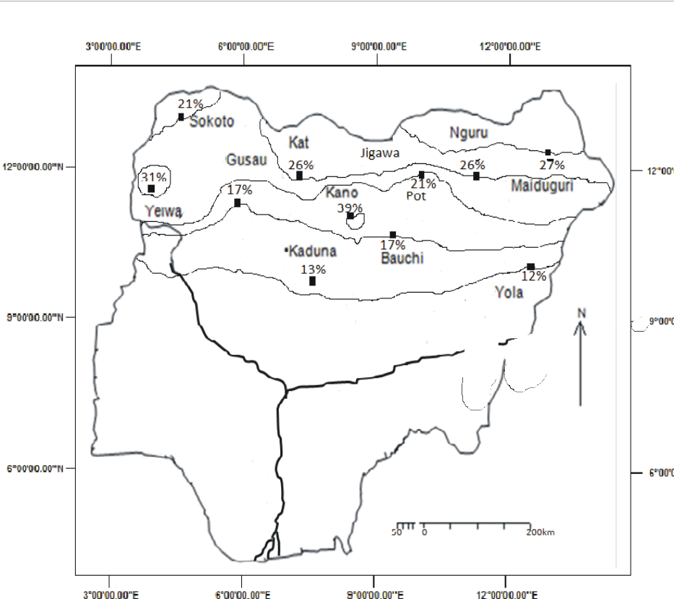

Figure 5: Rainfall Variability in the Study Area

The overall picture is however very interesting. A downward trend started about 1971 and continued until about 1983. From this year, upward trend started until about 1988 when the rainfall amount equaled the mean value of about 800mm. the upward trend continued to the value of 1,200mm by about 1990 when another downward trend started. This downward trend brought the mean rainfall to between 600mm and a steady rise has continued up till present (Fig.12).

The straight line equation of the time series yielded y=5.86x+890.6 for the thirty six (36) years of data. The line indicates a continuous rise from 1971 to 2006 (fig 12(b)). This is evidence that there is improved rainfall in the study area. The time series was also applied to the forecast values of mean annual rainfall of 2007 to 2030. This yielded a straight line equation of the form y=6.675x-1263.9. The result also show that there was large compliance between the straight line expression and the forecast values with R2=0.607 (fig.13). This is saying that the forecast values are correct to as much as 60.7%. Generally there will be a gradual increase in rainfall from 778.8mim in 2014 to 971.9mm in 2030 a difference of 93.1mm in 23 years.

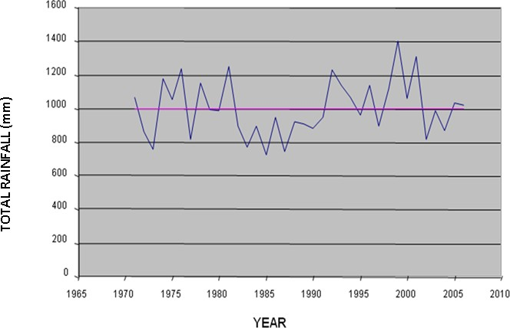

Figure 6:Time Series Graph Of The Total Rainfall In Bauchi Between 1971-2006

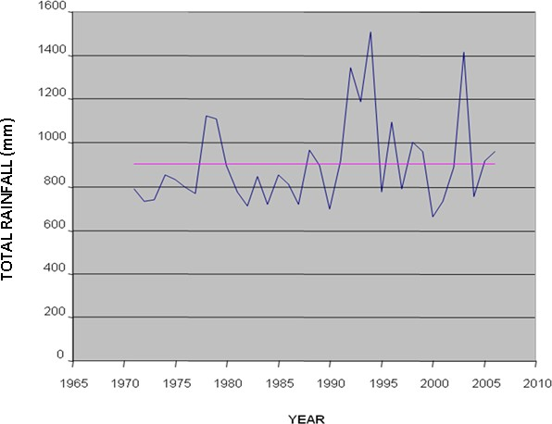

Figure 7: Time Series Graph Of The Total Rainfall In Gusau Between 1971-2006

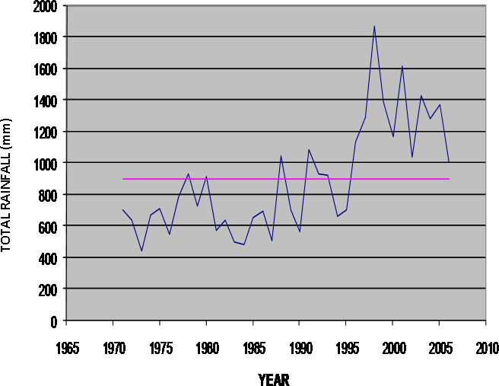

Figure 8: The Time Series Graph Of The Total Rainfall In Kano Between 1971-2006

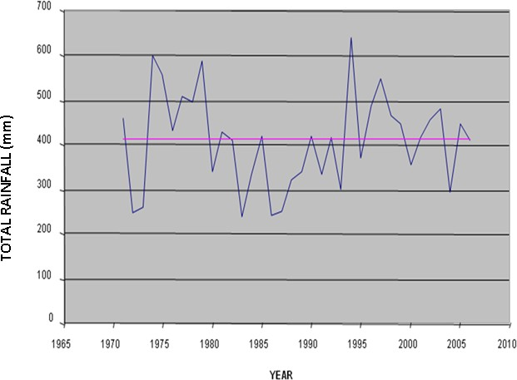

Figure 9: The Time Series Graph Of The Total Rainfall In Nug

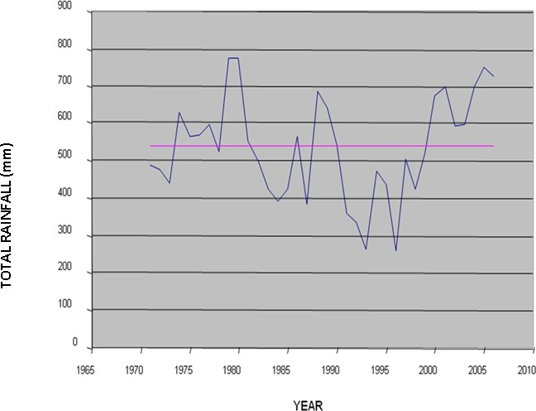

Figure 10: The Time Series Graph Of The Total Rainfall In Katsina 1971-2006

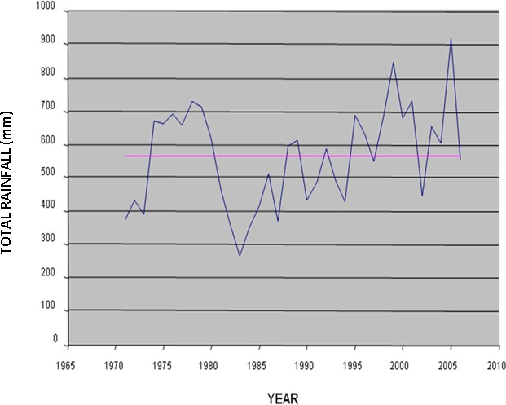

Figure 11a: The Time Series Graph Of The Total Rainfall In Maiduguri Between 1971-2006

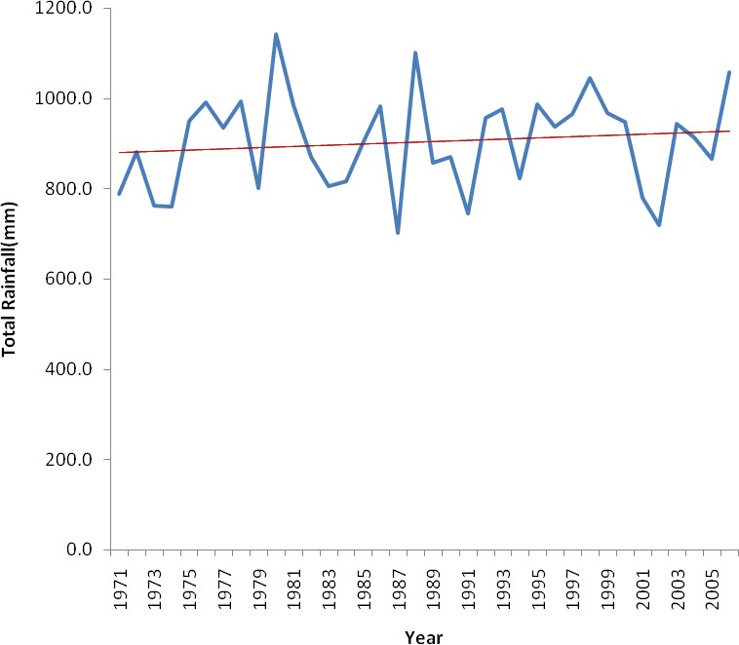

Figure 11b: The Time Series Graph Of The Total Rainfall In Yola Between 1971-2006

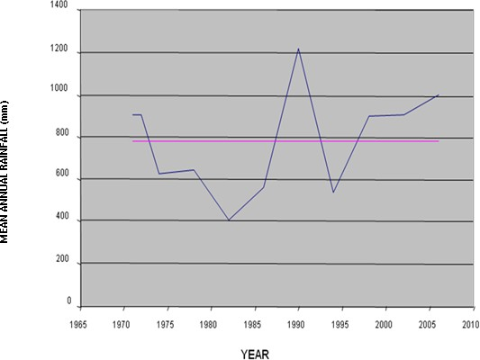

Figure 12a: The Time Series Graph Of Average Rainfall In all the stations between 1971-2006

73

Figure 12b: The time series graph of the mean annual rainfall in all stations between1971 and 2006

**Mean Annual Rainfall(mm)**

1200

1000

800

600

400

200

2006



0

2005

2004

2003

2002

2001

2000

1999

1998

1997

1996

1995

1994

1993

1992

1991

1990

1989

**Year**

1988

1987

1986

1985

1984

1983

1982

1981

1980

1979

1978

1977

1976

1975

1974

1973

1972

1971

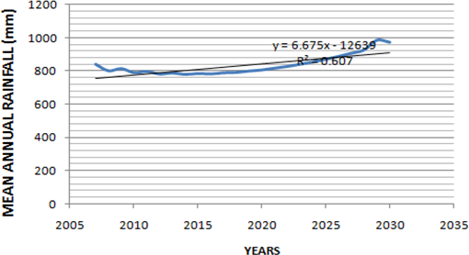

Figure 13: The time series graph of the mean annual rainfall in all stations between 2007 and 2030(forecast)

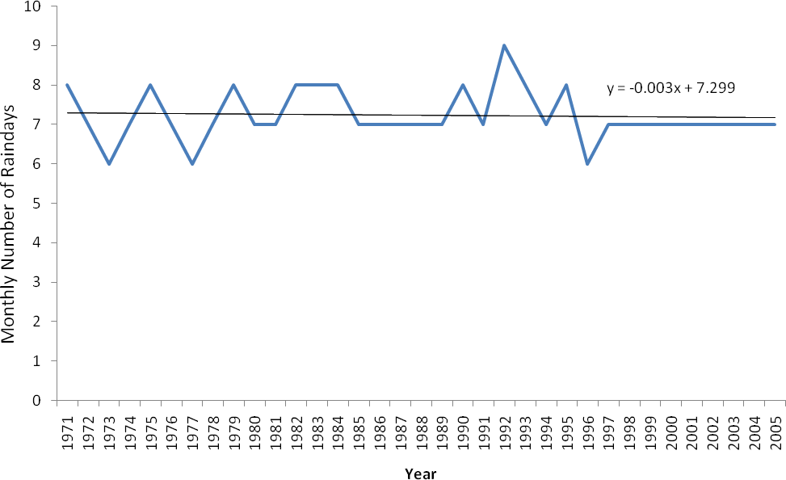

Figure 14: The time series graph of the monthly number of rain days in YOLA between 1971-2005

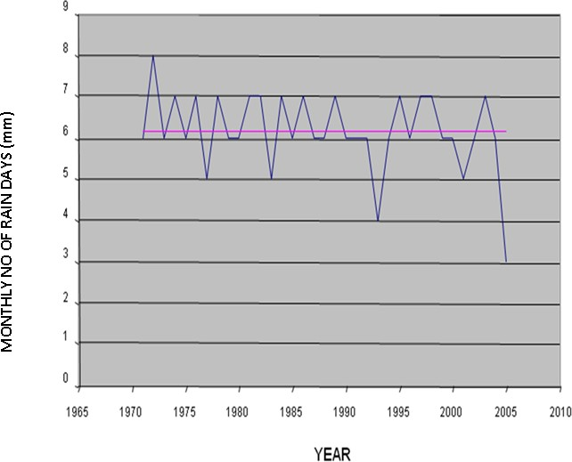

Figure 15: the time series graph of the monthly number of rain days in POT between 2007 -2005

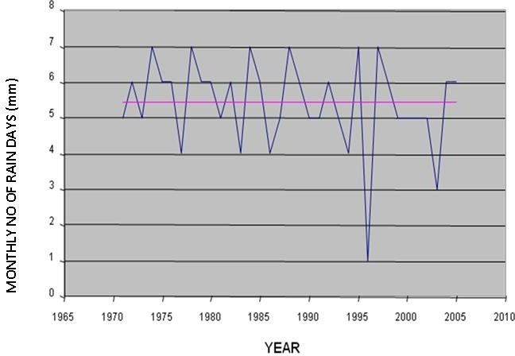

Figure 16:the time series graph of the monthly number of rain days in NGURU between 2007-2005

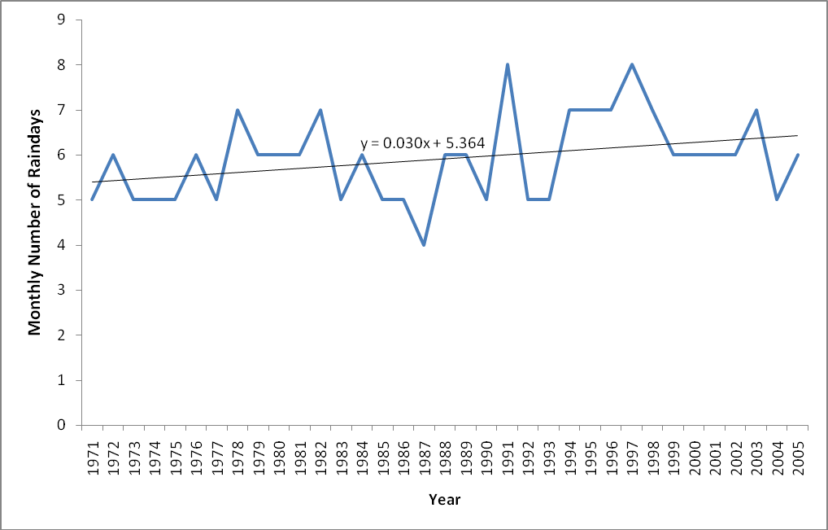

Figure 17: the time series graph of the monthly number of rain days in KATSINA between 1971 -2005

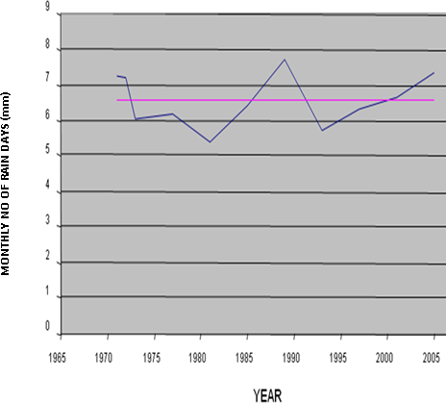

Figure 18a: The time series graph of the Average monthly number of Raindays in all the Stations between 1971 and2005

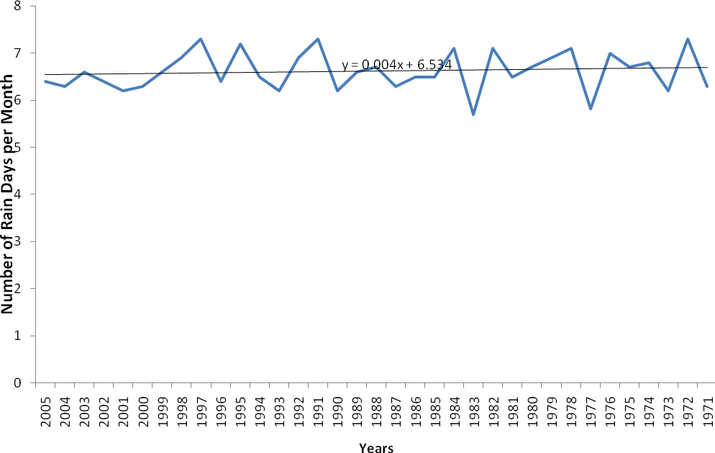

Figure 18b: The time series graph of the Average monthly number of Raindays (1971-2005)

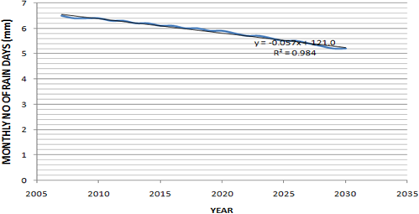

Figure 19: The time series graph of the Average monthly number of rainday in all stations between 2007 and 2030(forecast)

The Box-Ljung statistic with both auto and partial autocorrelations were conducted for all the thirty-six years. However, only three years are reported as typical examples of the region. In 1972, the autocorrelation results indicate that all the correlations are significant at 0.05. The highest correlation being -0.426 (lag 6) and the highest probability 0.788. The results means that the rainfall amounts of previous years has no significant relationship on subsequent years (fig. 25). A partial autocorrelation also indicate the highest rp of -0.309 again at lag 6 (fig. 26)

In 1990, the autocorrelation results have rp of -.288 having a probability of

0.436 at 20.05 indicating that the relationship is not significant. The least relationship is at lag 8 with an rp of -0.003 with a Box-Ljung of 4.951 and Probability of 0.763 (fig. 27). In the same vein, in the year 2006, the autocorrelation analysis indicates that the highest rp has a value of 0.479, a Box-Ljung of 3.276 and a probability of 0.070. This still means there is no significant relationship between the previous year and the present year. That is between 2005 and 2006 (fig. 28). The partial autocorrelation has the highest value of 0.479 and the least at lag 7 with a value of -0.013 (fig. 24).

An attempt was made to predict mean annual rainfall totals from the year 2007 to 2030. The rainfall values were transformed using the difference between the means (fig. 21) and a second transformation (fig. 22) was carried out. Subsequently both autocorrelation and partial autocorrelation were also carried out (fig. 23) and (fig. 24). All these are processes that enable the researchers to choose the most appropriate Forecast model. The ARIMA (1, 2, 0) was identified as the most appropriate. This was employed to forecast mean annual rainfall from 2007 to 2030 (table 6). The result indicates that mean annual rainfall continues to decrease gradually until the year 2019. The rainfall amounts picks up from the year 2030. In fact from the year 2033, mean annual rainfall surpasses that of 2007. Between these periods, the difference in

rainfall amount is as much as 55.2mm. The forecast assumes that present conditions continue, which is hardly possible. The present decreases in mean annual rainfall are not drastic, so there might be no fear of drought.

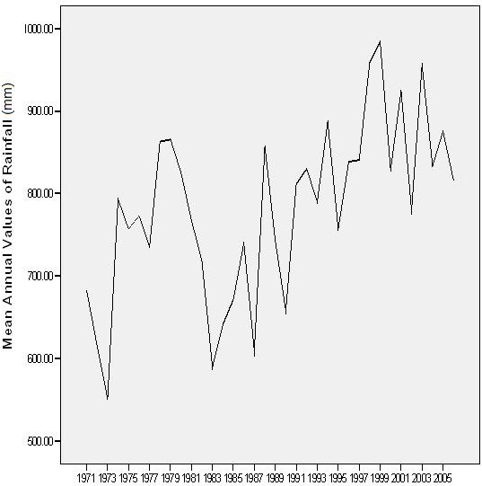

Figure 20: Mean Annual Values of Rainfall (1971 - 2006)

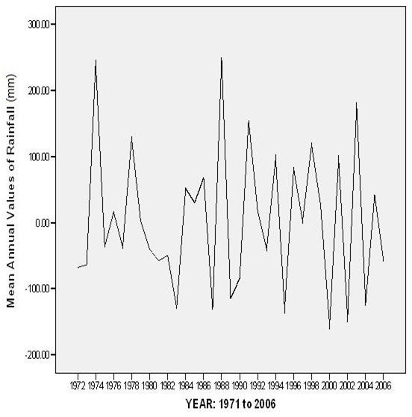

Figure 21: Transforms difference (1)

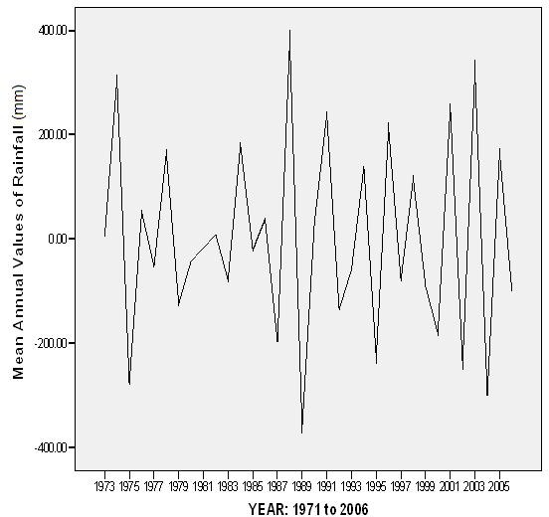

Figure 22: Transforms difference (2)

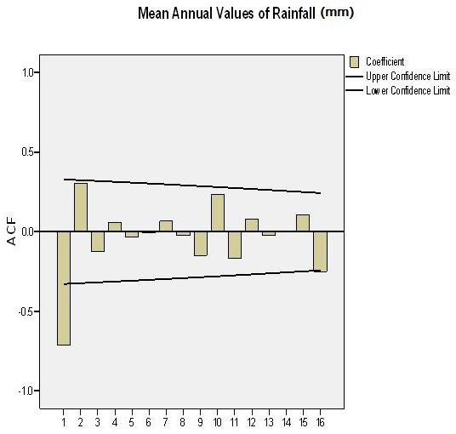

Lag Number

Figure 23: Auto-correlation of Mean Annual Values of Rainfall

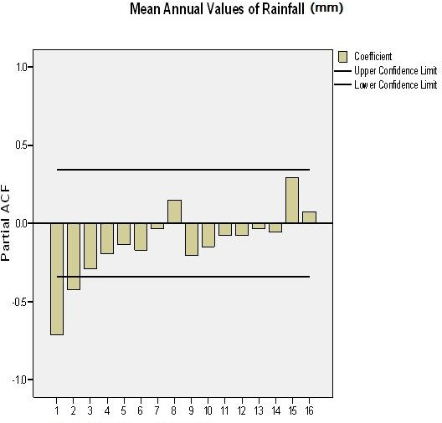

Lag Number

Figure 24: Partial Auto-correlation of Mean Annual Values of Rainfall

## Table 6: Time Series Modeler

|  |  |
| --- | --- |
| **Model Description** | |
|  | Model Type |
| Model ID Mean Annual Model_1 Values of Rainfall | ARIMA(1,2,0) |

**Forecast** Model Mean Annual Values of Rainfall -Model_1

|  |  |  |  |
| --- | --- | --- | --- |
| year | forecast | UCL | LCL |
| 2007 | 839.6793 | 1078.024 | 601.3344 |
| 2008 | 800.7385 | 1175.081 | 426.396 |
| 2009 | 813.9046 | 1428.400 | 199.4094 |
| 2010 | 788.7481 | 1626.182 | -48.686 |
| 2011 | 796.6090 | 1916.063 | -322.845 |
| 2012 | 781.2071 | 2183.177 | -620.763 |
| 2013 | 786.9419 | 2510.509 | -936.625 |
| 2014 | 778.7865 | 2832.014 | -1274.44 |
| 2015 | 784.3738 | 3195.916 | -1627.17 |
| 2016 | 781.9041 | 3563.178 | -1999.37 |
| 2017 | 788.5752 | 3962.268 | -2385.12 |
| 2018 | 790.8198 | 4369.729 | -2788.09 |
| 2019 | 799.3411 | 4802.498 | -3203.82 |
| 2020 | 805.6953 | 5246.311 | -3634.92 |
| 2021 | 816.5438 | 5711.275 | -4078.19 |
| 2022 | 826.634 | 6188.626 | -4535.36 |
| 2023 | 840.190 | 6684.39 | -5004.18 |
| 2024 | 853.696 | 7193.126 | -5485.74 |
| 2025 | 869.979 | 7718.408 | -5978.46 |
| 2026 | 886.910 | 8256.82 | -648300 |
| 2027 | 906.112 | 8810.456 | -6998.22 |
| 2028 | 926.310 | 9377.14 | -7524.50 |
| 2029 | 948.525 | 9958.077 | -8061.04 |
| 2030 | 971.927 | 10551.86 | -860800 |

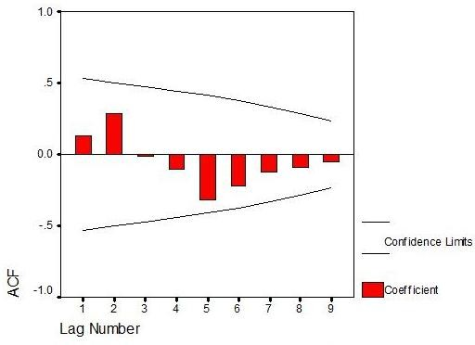

Figure 25: Autocorrelation of Rainfall in 1971

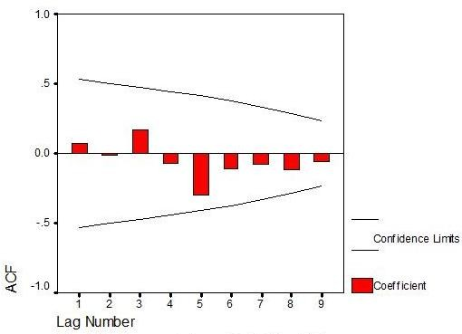

Figure 26: Autocorrelation of Rainfall in 1972

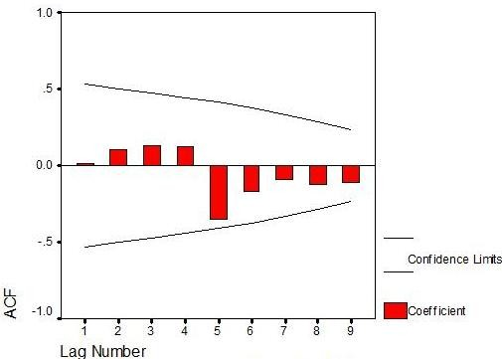

Figure 27: Autocorrelation of Rainfall in 1990

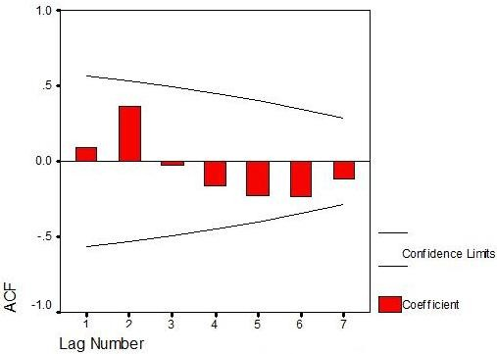

Figure 28: Autocorrelation of Rainfall in 2006

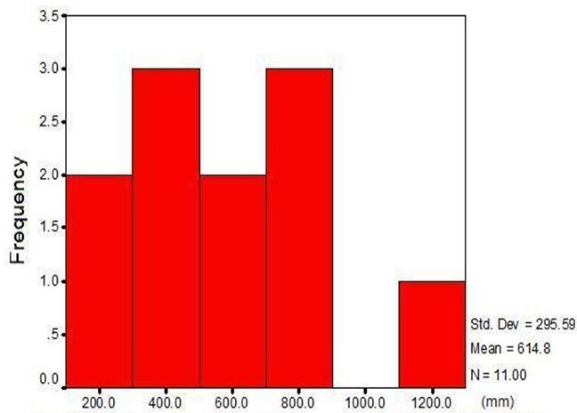

Figure 29: Histogram of Distribution of Total Rainfall for 1972

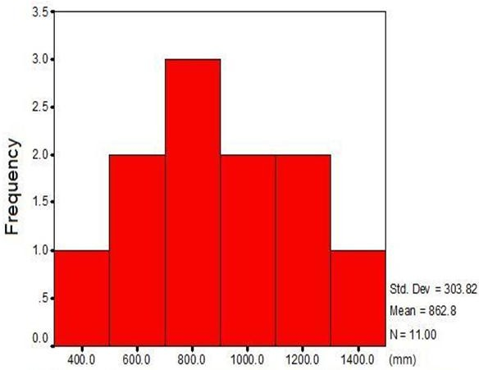

Figure 30: Histogram of Distribution of Total Rainfall for 1978

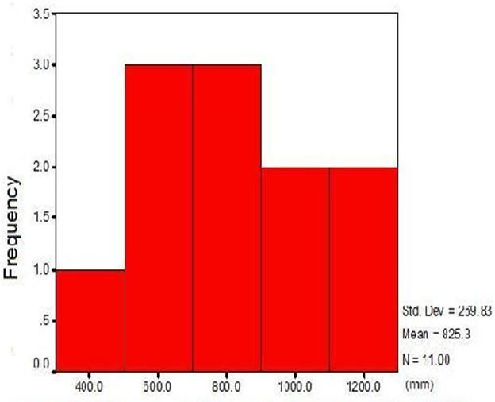

Figure 31: Histogram of Distribution of Total Rainfall for 1980

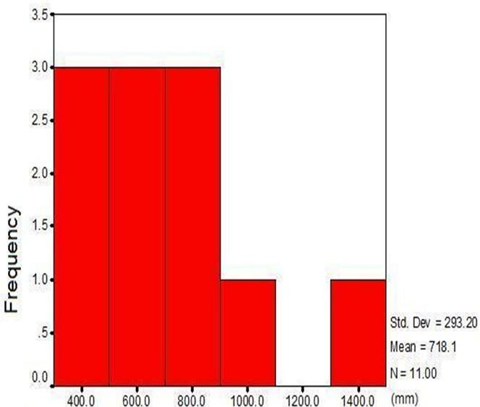

Figure 32: Histogram of Distribution of Total Rainfall for 1982

The distribution of rainfall in the study area is also shown using the histogram. The histogram for rainfall in 1972 indicate that two stations have rainfall amounts of 200mm and 600mm each while three stations have rainfall amounts of 400mm and 800mm each. In 1978 two stations have a rainfall amount of 600mm, 1000mm and 1200mm. the highest frequency of three stations have rainfall amounts of 800mm each. The distribution in 1980 indicates that three stations each have rainfall amounts of 600mm and 800mm. two stations have rainfall amounts of 1000mm and 1200mm each. In 1982 three stations have rainfall amounts of 400mm, 600mm and 800mm each.

###### Time Series Analysis of Rain Days

Simple statistical measures of number of rain days were carried and the summary is presented in table 7. The highlights are as follows:

The year with the highest number of rain days are 1991 and 1972 with the same values of 80 days followed by 1984, 1982 and 1978 with the same values of 78 days (Table 7). On the other hand, the years with the least number of rain days are 1996 and 1997 with the value of 58 days and 64 days respectively. It is observed generally that the number of rain days has increased in the 1990s and 2000s (Table 7). The mean maximum number of rain days per month occurred in 1975, 1988 and 1992 with a value of 9 days each, while the mean minimum occurred in 2003 and 2005 with the value of 3 days (Table 7).

The most variable in the number of rain days occurred in 1992 with a value of

1.58 and the least variable occurred in 1998 with a value of 0.30. The most skewed distribution of rain days occurred in 1998 which incidentally is the same year with the least variable rain days (Table 7). The least variable year with regard to mean monthly number of rain days in 1998 with a value of 4.0% followed by 1978 with a

value of 7.0% than 1997, 1996 and 1995, each with C.V of 8.0% (table 7). On the other hand, the most variable years are 1992 with a value of 23%, 1986 with 22% and 1993, 1977, 1971 each with 21% (Table 7). The Potiskum synoptic station exhibited the least variability of C.V 7.0% followed by Bauchi synoptic station with a value of 9.0% (Table 8). On the other hand, Nguru synoptic station has the highest variability of 18% followed by Kaduna with C.V of 17% (Table 8). There do not seem to be a significant North-South nor East-West pattern of increase or decrease of variability. It is also station specific.

Table 7: Statistical Summary of Number of Rain days by year

|  |  |  |  |  |  |  |  |  |  |  |  |
| --- | --- | --- | --- | --- | --- | --- | --- | --- | --- | --- | --- |
| Year | Statistics | | | | | | | | | | |
|  | N | mean | Sum | Min | Max | Range | Std.D | Var | Kur | Skew | C.V% |
| 2006 | 11 |  |  |  |  |  |  |  |  |  |  |
| 2005 | 11 | 6.4 | 70.0 | 3.0 | 8.0 | 5.0 | 1.3 | 1.7 | 4.9 | -1.9 | 20 |
| 2004 | 11 | 6.3 | 69.0 | 5.0 | 8.0 | 3.0 | 1.1 | 1.2 | -.9 | .4 | 17 |
| 2003 | 10 | 6.6 | 66.0 | 3.0 | 7.0 | 4.0 | 1.23 | 1.6 | 10.0 | -3.2 | 18 |
| 2002 | 11 | 6.4 | 70.0 | 5.0 | 8.0 | 3.0 | 1.0 | 1.1 | -1.1 | -.2 | 17 |
| 2001 | 11 | 6.2 | 68.0 | 5.0 | 7.0 | 2.0 | .9 | .8 | -1.6 | -.4 | 15 |
| 2000 | 11 | 6.3 | 69.0 | 5.0 | 7.0 | 2.0 | .6 | .4 | -.2 | -.3 | 10 |
| 1999 | 11 | 6.6 | 66.0 | 5.0 | 8.0 | 3.0 | .8 | .7 | .4 | -.4 | 12 |
| 1998 | 11 | 6.9 | 76.0 | 6.0 | 7.0 | 1.0 | .3 | .1 | 11.0 | -3.3 | 4 |
| 1997 | 11 | 7.3 | 80.0 | 6.0 | 8.0 | 2.0 | .6 | .4 | -.2 | -.3 | 8 |
| 1996 | 9 | 6.4 | 58.0 | 6.0 | 7.0 | 1.0 | .5 | .3 | -2.6 | .3 | 8 |
| 1995 | 11 | 7.2 | 79.0 | 6.0 | 8.0 | 2.0 | .6 | .4 | .4 | -.0 | 8 |
| 1994 | 11 | 6.5 | 72.0 | 4.0 | 8.0 | 4.0 | 1.1 | 1.3 | 1.8 | -1.4 | 18 |
| 1993 | 11 | 6.2 | 68.0 | 4.0 | 8.0 | 4.0 | 1.3 | 1.6 | -.5 | -.0 | 21 |
| 1992 | 11 | 6.9 | 76.0 | 5.0 | 9.0 | 4.0 | 1.6 | 2.5 | -1.6 | .4 | 23 |
| 1991 | 11 | 7.3 | 80.0 | 5.0 | 8.0 | 3.0 | 1.0 | 1.0 | 1.3 | -1.4 | 14 |
| 1990 | 11 | 6.2 | 68.0 | 5.0 | 8.0 | 3.0 | 1.1 | 1.2 | -1.4 | .2 | 18 |
| 1989 | 11 | 6.6 | 73.0 | 6.0 | 7.0 | 1.0 | .5 | .3 | -1.10 | -.7 | 7 |
| 1988 | 11 | 6.7 | 74.0 | 4.0 | 9.0 | 5.0 | 1.3 | 1.6 | 1.8 | -.4 | 19 |
| 1987 | 11 | 6.3 | 69.0 | 4.0 | 8.0 | 4.0 | 1.1 | 1.2 | .7 | -.7 | 17 |
| 1986 | 11 | 6.5 | 71.0 | 4.0 | 8.0 | 4.0 | 1.4 | 2.1 | -1.3 | -.5 | 22 |
| 1985 | 11 | 6.5 | 71.0 | 5.0 | 8.0 | 3.0 | 1.1 | 1.3 | -1.2 | .4 | 17 |
| 1984 | 11 | 7.1 | 78.0 | 5.0 | 8.0 | 3.0 | .9 | .9 | 1.2 | -1.1 | 13 |
| 1983 | 11 | 5.7 | 63.0 | 4.0 | 7.0 | 3.0 | 1.0 | 1.0 | -1.0 | -.1 | 18 |
| 1982 | 11 | 7.1 | 78.0 | 6.0 | 8.0 | 2.0 | .7 | .5 | -.5 | -.1 | 10 |
| 1981 | 11 | 6.5 | 71.0 | 5.0 | 8.0 | 3.0 | .9 | .9 | -.5 | -.3 | 14 |
| 1980 | 11 | 6.7 | 74.0 | 6.0 | 8.0 | 2.0 | .8 | .6 | -.10 | .6 | 12 |
| 1979 | 11 | 6.9 | 76.0 | 6.0 | 9.0 | 3.0 | 1.1 | 1.3 | 1.1 | .7 | 16 |
| 1978 | 11 | 7.1 | 78.0 | 6.0 | 8.0 | 2.0 | .5 | .3 | 1.9 | .2 | 7 |
| 1977 | 11 | 5.8182 | 64.0 | 4.0 | 8.0 | 4.0 | 1.2 | 1.4 | -.3 | .4 | 21 |
| 1976 | 11 | 7.0000 | 77.0 | 6.0 | 8.0 | 2.0 | .8 | .6 | -1.1 | .0 | 11 |
| 1975 | 11 | 6.7 | 73.0 | 5.0 | 9.0 | 4.0 | 1.1 | 1.3 | .8 | .10 | 16 |
| 1974 | 11 | 6.8 | 75.0 | 5.0 | 8.0 | 3.0 | .9 | .8 | .8 | -.7 | 13 |
| 1973 | 11 | 6.2 | 68.0 | 5.0 | 8.0 | 3.0 | .10 | .10 | -.6 | .3 | 16 |
| 1972 | 11 | 7.3 | 80.0 | 6.0 | 8.0 | 2.0 | .8 | .6 | -.10 | -.6 | 11 |
| 1971 | 11 | 6.3 | 69.0 | 5.0 | 8.0 | 3.0 | 1.3 | 1.6 | -1.5 | .4 | 21 |

n = Number of stations in the study area

##### Table 8: Statistical Summary of data on Rain days by Stations.

|  |  |  |  |  |  |  |  |  |  |  |  |
| --- | --- | --- | --- | --- | --- | --- | --- | --- | --- | --- | --- |
| year | Statistics | | | | | | | | | | |
|  | N | mean | Sum | Min | Max | Range | Std.D | Variance | Kurtosis | Skews | C.V% |
| BAU | 35 | 7.3 | 256.0 | 7.0 | 9.0 | 2.0 | .6 | .3 | 2.2 | -1.4 | 9 |
| GUS | 35 | 6.7 | 236.0 | 6.0 | 9.0 | 3.0 | .7 | .6 | 1.1 | -.2 | 10 |
| KAN | 35 | 6.3 | 221.0 | 5.0 | 7.0 | 2.0 | .7 | .5 | -.7 | .2 | 11 |
| KAT | 34 | 5.9 | 200.0 | 4.0 | 8.0 | 4.0 | .9 | .9 | -.1 | -1.2 | 15 |
| KAD | 35 | 7.7 | 269.0 | 7.0 | 9.0 | 2.0 | .6 | .3 | -.5 | -.4 | 17 |
| MAI | 35 | 6.4 | 224.0 | 5.0 | 8.0 | 3.0 | .8 | .7 | -.7 | -.5 | 13 |
| NGU | 34 | 5.5 | 188.0 | 3.0 | 7.0 | 4.0 | 1.0 | 1.0 | -.2 | .2 | 18 |
| POT | 35 | 6.2 | 216.0 | 3.0 | 8.0 | 5.0 | .10 | .9 | 2.9 | .5 | 7 |
| SOK | 35 | 6.0 | 211.0 | 4.0 | 8.0 | 4.0 | .9 | .9 | -.2 | -.5 | 15 |
| YOL | 34 | 7.1 | 243.0 | 5.0 | 9.0 | 4.0 | .7 | .6 | 1.7 | .9 | 10 |
| YEL | 34 | 7.4 | 253.0 | 5.0 | 8.0 | 3.0 | .7 | .5 | 2.9 | 1.7 | 10 |

The station with the highest number of rain days during the time period of study (36 years) is Kaduna (Table 8) with a value of 269 days followed by Bauchi, 256 days and Yelwa, 253 days, while the least number of rain days are found at Nguru, 188 days, followed by Katsina 200 days and Sokoto 211 days (Table 8). The number of rain days was also subjected to the time series analysis. The trend in the number of rain days about the mean value did not differ significantly except for a few years in Yola (2004) (fig. 14), Potiskum (2005) (fig. 15), Nguru (1996) (fig. 16), and and Katsina, also in 1996 (fig. 17). In general, there has been a recent upward trend of the number of rain days in the study area (fig. 18). This started in the 1990s but it is only by 2003 that the upward movement came above the mean value of about 6.5 days. There was an upward movement that started in the 1980s and peaked by 1988. It started reducing again till about 1994(fig. 18(a)).

The straight line summary of the series yielded a relationship of the form y=0.004x+6.53 (fig 18(b)). It indicates an almost straight line that no changes, neither increase nor decrease of number of raindays in the study area between 1971 and 2005. An attempt was also made to forecast mean monthly values of rain days. After processing using transformations and autocorrelation and partial autocorrelation Fig. 33, 34, 35, 36, 37, the best model was identified as ARIMA (0, 2, 1). The forecast was from the year 2007 to 2030. The results show that there will be a continuous decline in the mean monthly number of rain days starting from 6.5 days in 2007 to 5.2 days in 2030 (table 9) a reduction of 1.3 days. Though the number of rain days continue to decline until the year 2030, mean annual rainfall in expected to pick up from the year 2020. The implication of this is that cases of flash floods will abound in Northern Nigeria.

The time series analysis of the forecast values of number of rain days was carried out. The straight line equation is y = 121.0 - 0.057x with an R2 =0.984 (fig.19). This indicates a 98.4% compliance. That means that the forecasts are significant. In general, there will be a gradual decrease in number of rain days from

6.5 days in 2007 to 5.2 days in 2030, a difference of 1.3 days in 23years.

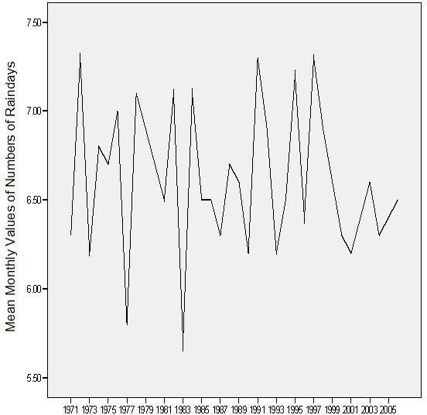

Figure 33: Mean Monthly Values of Number of Raindays (1971-2005)

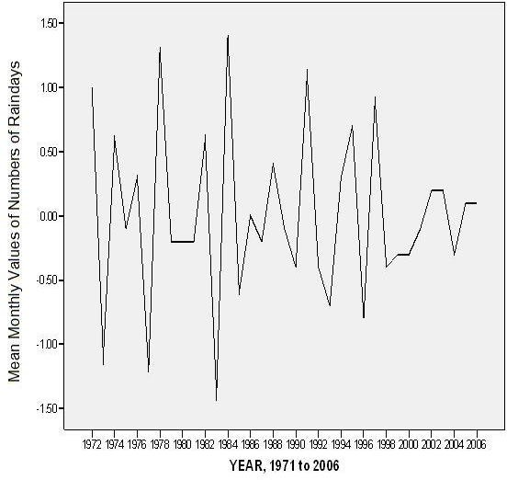

Figure 34: Transform difference(1)

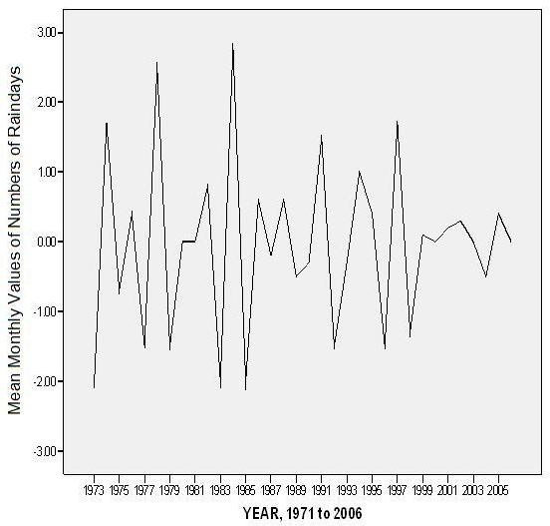

Figure 35: Transform difference(2)

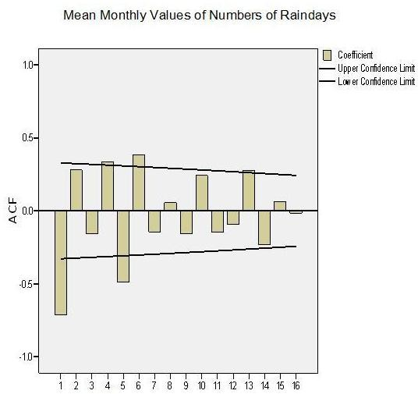

Lag Number

Figure 36: Auto-correlation of Mean Monthly Values of Number of Raindays

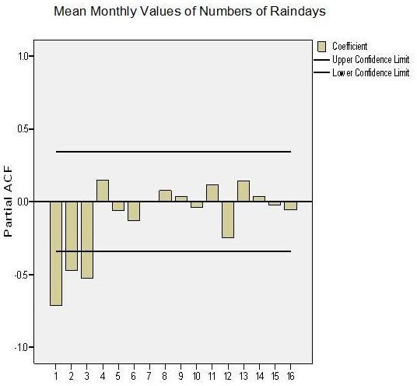

Lag Number

Figure 37: Partial Auto-correlation of Mean Monthly Values of Number of Raindays

**Table 9: Time Series Modeler**

|  |  |
| --- | --- |
| **Model Description** | |
|  | Model Type |
| Model ID Mean Monthly Values of Model_1 Numbers of Rain days | ARIMA(0,2,1) |

Forecast Model Mean Monthly Values of Numbers of Raindays-Model_1

|  |  |  |  |
| --- | --- | --- | --- |
| year | forecast | UCL | LCL |
| 2007 | 6.468245 | 7.556993 | 5.379497 |
| 2008 | 6.434407 | 7.995572 | 4.873242 |
| 2009 | 6.398487 | 8.335476 | 4.461499 |
| 2010 | 6.360486 | 8.624552 | 4.096419 |
| 2011 | 6.320402 | 8.880916 | 3.759887 |
| 2012 | 6.278236 | 9.11366 | 3.442812 |
| 2013 | 6.233988 | 9.328073 | 3.139902 |
| 2014 | 6.187657 | 9.527541 | 2.847774 |
| 2015 | 6.139245 | 9.714375 | 2.564115 |
| 2016 | 6.088751 | 9.890233 | 2.287268 |
| 2017 | 6.036174 | 10.05635 | 2.015994 |
| 2018 | 5.981515 | 10.21369 | 1.749341 |
| 2019 | 5.924775 | 10.36299 | 1.486558 |
| 2020 | 5.865952 | 10.50487 | 1.227038 |
| 2021 | 5.805047 | 10.63981 | 0.970282 |
| 2022 | 5.742059 | 10.76824 | 0.715875 |
| 2023 | 5.67699 | 10.89052 | 0.463462 |
| 2024 | 5.609839 | 11.00694 | 0.212742 |
| 2025 | 5.540605 | 11.11776 | -0.036550 |
| 2026 | 5.46929 | 11.22322 | -0.284640 |
| 2027 | 5.395892 | 11.32351 | -0.531730 |
| 2028 | 5.320412 | 11.41883 | -0.778000 |
| 2029 | 5.24285 | 11.50932 | -1.023620 |
| 2030 | 5.163206 | 11.59514 | -1.268730 |

#### TEMPERATURE ANALYSIS

###### Time Series Analysis of Maximum Temperature

One of the climatic elements frequently discussed when looking at climate change is maximum temperature. In this section, attempt is made to draw up some simple statistical measures to characterize maximum temperature.

The highest mean maximum temperature is recorded in Maiduguri with the sum of 35.3oC followed by Nguru (35.2oC) and Sokoto (35.2oC) this could be as a result of their low altitudinal position. The least mean maximum temperature is found in Kaduna (31.7oC), followed by Bauchi (32.9oC) and Kano (33.4oC, Table 10) this could also be because of their altitudes1. The highest value of the mean maximum temperature during the study period is found in Maiduguri (36.7oC) just like the mean value while the lowest value of the maximum temperature is found in Kaduna (30.3oC) again like the mean value (Table 10). In all cases, the variances and the standard deviations are little. Even the spread and peakedness are also little.

The highest value of mean maximum temperature is found in the year 1973 (35.1oC) followed by 1987 (34.9oC) and 1988 (34.8oC). The lowest mean maximum temperatures are received in 1989 (33.1oC), 1992 (33.3oC) and 2000 (33.6oC). The range of maximum temperature is therefore small (Table 11). The highest mean maximum temperature is received in 1973 (36.7oC) followed by 1987 (36.4oC), while the minimum values are in 1975 (30.3oC) followed by 1974 (30.9 oC) and then 1978 (30.9oC). The minimum values are all in the 1970s (Table 11). Overall, the variations and skewness are very slight. This is supported by the values of Kurtosis. The line graphs of the stations used in the study collaborates earlier findings using the simple statistical measures. In most cases, Kaduna exhibit the lowest maximum temperature, while Maiduguri exhibits the highest (fig. 10), There are distortions from this general

pattern like in 1977 where Yola station was third to Kaduna and Bauchi in low values (fig. 10).

The variability as measured the coefficient of variability indicates so much similarity. All the stations show range from C.V of 14.5% to 23%. Potiskum synoptic station has the highest variability of 23% while Maiduguri has a C.V of 14%. Most of the other stations are 18% and 17% (Table 10).

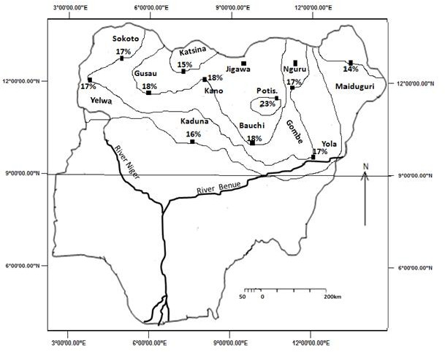

Figure 38: Temperature Variability in the Study Area

The spatial variability is not very obvious. However, the central northern portion has a slightly higher variability than the north western and north eastern portions (fig 38). The most likely influence is that of river Benue and river Niger that is responsible for this slight lowering of the variability of temperature in the study area. The Adamawa highlands could also have accounted for the lowering in the north eastern parts. It is noted also that there is no longitudinal variations in temperature in the study area.

On the year by year analysis, the coefficient of variability ranges from 29% in 1996 to 42% in 1976 (Table 11). The variability from year to year is much higher than station by station. The implication of this is that planners will have to worry more about the annual variability than the spatial locations. This observation is similar to those rainfalls and the number of rain days. There will be a general increase in mean maximum temperature from 34.5oC in 2007 to 36.6oC in 2030, as increase of 2.1oC is 23years (Table 13).

Table 10: Simple Statistical Measures of Maximum Temperature by Station.

|  |  |  |  |  |  |  |  |  |  |  |
| --- | --- | --- | --- | --- | --- | --- | --- | --- | --- | --- |
| Station | Statistics | | | | | | | | | |
|  | N | mean | Sum | Min | Max | Std.D | Var | Kurt | Skew | C.V% |
| YEL | 34 | 34.4 | 170.3 | 33.0 | 35.3 | .6 | .3 | .5 | -.9 | 17 |
| BAU | 36 | 32.9 | 1183.7 | 31.9 | 34.3 | .6 | .4 | -.6 | .3 | 18 |
| GUS | 36 | 33.7 | 1211.3 | 31.7 | 5.0 | .6 | .4 | 1.7 | -.7 | 18 |
| KAN | 36 | 33.4 | 1203.0 | 32.1 | 32.8 | .6 | .4 | .1 | .2 | 18 |
| KAT | 36 | 33.7 | 1214.0 | 32.8 | 35.0 | .5 | .3 | .2 | .7 | 15 |
| KAD | 36 | 31.7 | 1141.9 | 30.3 | 32.7 | .5 | .3 | .5 | -.5 | 16 |
| MAI | 36 | 35.3 | 1270.2 | 34.1 | 36.7 | .5 | .3 | .9 | -.1 | 14 |
| NGU | 36 | 35.2 | 1265.4 | 33.4 | 36.3 | .6 | .4 | 1.1 | -.9 | 17 |
| POT | 36 | 34.2 | 1231.7 | 31.4 | 35.4 | .8 | .7 | 3.3 | -1.6 | 23 |
| SOK | 36 | 35.2 | 1265.3 | 33.7 | 36.4 | .6 | .4 | .1 | .1 | 17 |
| YOL | 34 | 34.8 | 1182.3 | 32.6 | 36.4 | .6 | .4 | 4.1 | -.6 | 17 |

Table 11: Simple Statistical Measures of Maximum Temperature by Years

|  |  |  |  |  |  |  |  |  |  |  |  |  |
| --- | --- | --- | --- | --- | --- | --- | --- | --- | --- | --- | --- | --- |
| year | Statistics | | | | | | | | | | | |
|  | N | mean | median | Sum | Min | Max | Range | Std.D | Vari | Kurt | Skew | C.V% |
| 2006 | 9 | 34.5 | 34.5 | 310.8 | 32.6 | 36.4 | 3.9 | 1.3 | 1.6 | -1.1 | -.1 | 38 |
| 2005 | 9 | 34.6 | 34.5 | 311.6 | 32.6 | 36.2 | 3.6 | 1.1 | 1.3 | -.4 | -.5 | 32 |
| 2004 | 11 | 34.1 | 34.4 | 375.5 | 31.7 | 35.2 | 3.6 | 1.1 | 1.2 | 1.3 | -1.3 | 32 |
| 2003 | 11 | 34.2 | 34.4 | 375.9 | 32.0 | 35.4 | 3.4 | 1.1 | 1.3 | -.10 | -.5 | 32 |
| 2002 | 11 | 34.3 | 34.6 | 377.1 | 32.0 | 35.7 | 3.7 | 1.3 | 1.6 | -1.1 | -.5 | 38 |
| 2001 | 11 | 33.9 | 34.4 | 372.5 | 31.8 | 35.3 | 3.4 | 1.2 | 1.4 | -.10 | -.6 | 35 |
| 2000 | 11 | 33.6 | 33.5 | 369.9 | 31.9 | 35.2 | 3.2 | 1.3 | 1.6 | -1.5 | -.2 | 39 |
| 1999 | 11 | 34.1 | 34.4 | 375.1 | 31.7 | 35.7 | 4.0 | 1.3 | 1.8 | -.5 | -.8 | 38 |
| 1998 | 11 | 34.3 | 34.6 | 377.8 | 32.1 | 35.7 | 3.6 | 1.2 | 1.5 | -.6 | -.6 | 35 |
| 1997 | 11 | 34.3 | 34.4 | 377.3 | 31.9 | 35.5 | 3.7 | 1.0 | 1.1 | 2.3 | -1.2 | 29 |
| 1996 | 11 | 34.5 | 34.7 | 379.7 | 32.2 | 35.9 | 3.7 | 1.0 | 1.1 | 1.3 | -.8 | 29 |
| 1995 | 11 | 34.2 | 34.6 | 377.3 | 32.1 | 35.6 | 3.6 | 1.1 | 1.2 | .2 | -.7 | 32 |
| 1994 | 11 | 33.9 | 34.3 | 373.3 | 31.4 | 35.3 | 3.9 | 1.2 | 1.5 | .1 | .9 | 35 |
| 1993 | 11 | 34.2 | 34.3 | 376.0 | 32.1 | 35.6 | 3.6 | 1.0 | 1.1 | .3 | -.9 | 29 |
| 1992 | 11 | 33.3 | 33.2 | 366.1 | 31.4 | 34.7 | 3.3 | 1.1 | 1.2 | -.9 | -.3 | 33 |
| 1991 | 11 | 33.9 | 34.0 | 372.7 | 31.9 | 35.1 | 3.2 | .10 | .10 | -.3 | -.6 | 29 |
| 1990 | 11 | 34.6 | 34.9 | 380.9 | 32.3 | 35.9 | 3.6 | 1.0 | 1.1 | 1.7 | -1.2 | 29 |
| 1989 | 11 | 33.2 | 33.0 | 364.8 | 31.0 | 34.3 | 3.3 | 1.1 | 1.2 | -.2 | -.7 | 33 |
| 1988 | 11 | 33.8 | 33.8 | 372.1 | 31.7 | 35.0 | 3.3 | 1.1 | 1.3 | -.6 | -.6 | 33 |
| 1987 | 11 | 34.9 | 34.8 | 384.3 | 32.7 | 36.4 | 3.6 | 1.1 | 1.2 | -.1 | -.4 | 32 |
| 1986 | 11 | 34.3 | 34.2 | 376.9 | 32.0 | 35.8 | 3.8 | 1.1 | 1.2 | .4 | -.6 | 32 |
| 1985 | 11 | 33.7 | 33.6 | 370.7 | 31.4 | 35.2 | 3.8 | 1.3 | 1.7 | -.8 | -.6 | 39 |
| 1984 | 11 | 34.1 | 33.9 | 374.8 | 31.7 | 35.9 | 4.2 | 1.3 | 1.6 | -.2 | -.2 | 38 |
| 1983 | 11 | 33.10 | 34.1 | 373.9 | 31.7 | 35.4 | 3.7 | 1.1 | 1.3 | .2 | -.8 | 33 |
| 1982 | 11 | 33.9 | 34.2 | 373.6 | 31.2 | 35.8 | 4.6 | 1.3 | 1.7 | .8 | -.9 | 38 |
| 1981 | 11 | 33.9 | 33.8 | 373.1 | 31.8 | 35.4 | 3.6 | 1.2 | 1.4 | -.7 | -.5 | 35 |
| 1980 | 11 | 34.0 | 33.9 | 374.1 | 31.5 | 35.6 | 4.1 | 1.2 | 1.5 | .5 | . -6 | 35 |
| 1979 | 11 | 34.1 | 34.5 | 374.7 | 31.5 | 35.3 | 3.8 | 1.2 | 1.5 | .1 | -.9 | 35 |
| 1978 | 11 | 33.6 | 33.6 | 370.1 | 30.9 | 35.1 | 4.2 | 1.3 | 1.7 | .2 | -.8 | 39 |
| 1977 | 11 | 33.4 | 33.4 | 367.8 | 31.3 | 35.1 | 3.8 | 1.2 | 1.5 | -.10 | -.3 | 35 |
| 1976 | 11 | 33.7 | 33.7 | 371.2 | 30.9 | 35.9 | 4.9 | 1.4 | 1.9 | .5 | -.5 | 42 |
| 1975 | 11 | 33.3 | 33.4 | 366.6 | 30.3 | 34.6 | 4.3 | 1.3 | 1.6 | 2.6 | -1.5 | 39 |
| 1974 | 11 | 33.4 | 33.3 | 367.8 | 30.9 | 34.9 | 4.1 | 1.2 | 1.3 | 1.1 | -.9 | 36 |
| 1973 | 11 | 35.1 | 35.0 | 385.7 | 32.3 | 36.7 | 4.5 | 1.3 | 1.6 | 1.4 | -.9 | 37 |
| 1972 | 11 | 34.1 | 34.0 | 375.3 | 31.5 | 35.4 | 3.8 | 1.1 | 1.3 | 1.7 | -1.1 | 32 |
| 1971 | 11 | 33.8 | 33.8 | 371.9 | 31.2 | 35.6 | 4.4 | 1.4 | 1.9 | -.4 | -.6 | 41 |

n = Number of stations

##### Table 12: Simple Statistical Measures of Minimum Temperature by Stations

|  |  |  |  |  |  |  |  |  |  |  |  |  |
| --- | --- | --- | --- | --- | --- | --- | --- | --- | --- | --- | --- | --- |
| Statio  n | Statistics | | | | | | | | | | | |
|  | N | mean | Median | Sum | Min | Max | Range | Std.D | Var | Kurt | Skew | C.V% |
| BAU | 36 | 19.4 | 19.3 | 696.9 | 17.7 | 21.3 | 3.7 | .8 | .6 | .3 | .242 | 0 |
| GUS | 36 | 19.9 | 19.10 | 716.3 | 17.9 | 22.9 | 4.10 | .8 | .7 | 4.6 | .769 | 0 |
| KAN | 36 | 19.6 | 19.9 | 706.7 | 17.7 | 21.3 | 3.5 | .9 | .9 | -.9 | -.294 | 0 |
| KAT | 36 | 19.7 | 19.9 | 709.2 | 17.4 | 21.5 | 4.1 | .10 | .9 | -.1 | -.602 | 0 |
| KAD | 36 | 19.1 | 19.1 | 687.5 | 18.1 | 20.8 | 2.7 | .6 | 3 | .6 | .398 | 0 |
| MAI | 36 | 20.3 | 20.4 | 732.5 | 19.2 | 21.1 | 2.8 | .6 | .321 | .10 | .457 | 0 |
| NGU | 36 | 20.9 | 20.8 | 751.8 | 19.7 | 23.4 | 3.7 | .7 | .548 | 2.6 | .995 | 0 |
| POT | 36 | 19.9 | 20.1 | 715.5 | 17.3 | 21.7 | 4.5 | .7 | .527 | 4.2 | -.962 | 0 |
| SOK | 33 | 22.3 | 22.4 | 735.8 | 20.1 | 24.1 | 3.1 | .8 | .576 | -.1 | .387 | 0 |
| YOL | 35 | 22.0 | 22.0 | 771.6 | 20.5 | 23.5 | 2.9 | .7 | .5 | -.2 | -.096 | 0 |
| YEL | 36 | 21.5 | 21.5 | 772.2 | 19.1 | 22.6 | 3.5 | .7 | .5 | 3.9 | -1.688 | 0 |

n = number of stations.

Similarly, in 1985, Potiskum had the lowest value, while Nguru the same year was the highest (fig. 45). In the year 2000, Potiskum again was as low as Kaduna. In the year 2002, Yola overtook Maiduguri while in 2001, Sokoto became the highest (fig. 47). The trends in maximum temperatures area are a mixed situation. Most stations exhibit both downward and upward trends. However, Maiduguri (fig. 44) peaked at about 36.6oC in 1973, followed by Katsina (fig. 43) at 35oC in 1994.

The downward trend came to a minimum in 1975 at Kaduna (fig. 41) with a value of about 30.3oC. This is followed by Potiskum in 1985 (fig. 46) with a value of 31.5oC. In general, maximum temperatures started a downward trend since about 1985 until about 1998 with a value of 31.6oC (fig. 50). Then an upward trend started and halted about 2003 even when it has not reached the mean condition. There were earlier upward trends from 1972 to a peak of 35.1oC reducing a little and up again till 1985. The Box-Ljung autocorrelation and the partial autocorrelation indicate no significant relationship between current and previous years of maximum and minimum temperatures.(Figure 58, 59, 79, and 80)

#### TIME SERIES ANALYSIS

The Time Series Analysis indicates that in Bauchi, most times in the study period, mean maximum temperatures have been below the mean values. For example, the years 1974 to about 1986. The fluctuations were much between 1986 to 1994. However, it has remained higher than the mean value since the year 2001 (fig. 39). All the stations show great variability except that of Maiduguri (fig. 44) and Nguru (fig. 45) and Potiskum (fig. 46) seem to be the highest. The result of Sokoto (fig. 47) shows a very interesting case. Apart from the year 1984, all the other years indicate mean maximum temperatures above the mean values.

In Northern Nigerian on the whole, mean annual maximum temperatures have been below the mean since about 1992 till date.

The linear equation of the time series from 1971 to 2006 is y=-0.013x+34.24 (fig. 50(b)). This indicates that maximum temperatures have been rising steadily though very slightly. The mean annual maximum temperature forecasted from 2007 to 2030 was subjected to time series analysis. The result indicate a straight line equation of y=0.087x – 141.3 and an R2=0.987. This shows a 98.7% compliance that is the correlation is highly significant (Fig. 51(b)). The result shows an upward positive change in mean annual maximum temperatures from 2007 to 2030.

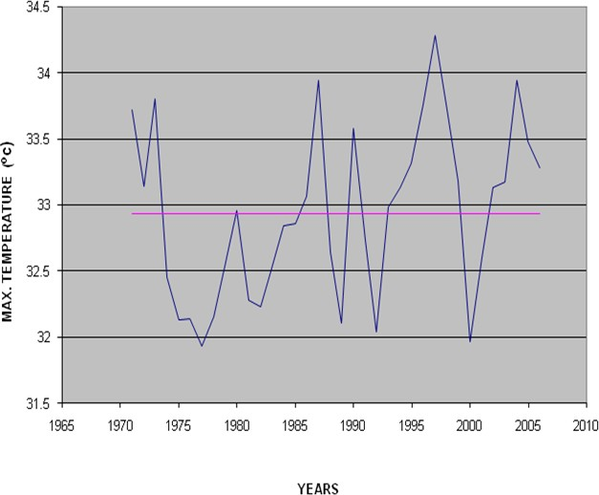

Figure 39: the time series graph of the maximum temperature in Bauchi between 1971-2006

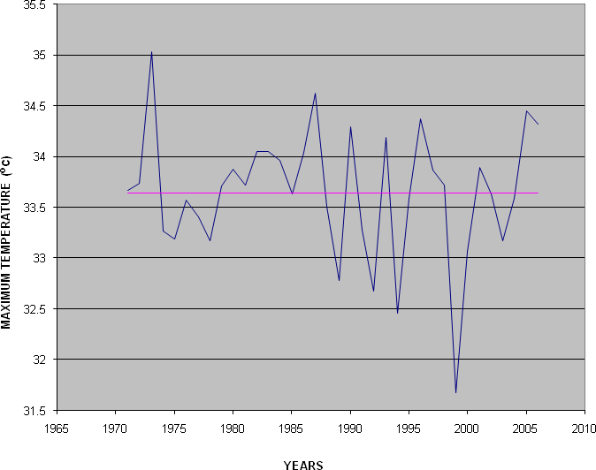

Figure 40: The Time Series Graph of the Maximum Temperature in Gusau between 1971-2006

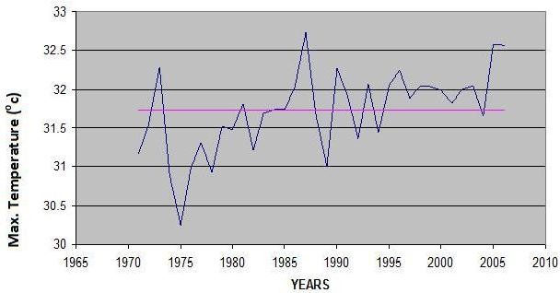

Figure 41: The Time Series Graph Of The Maximum Temperature In Kaduna Between 1971- 2006

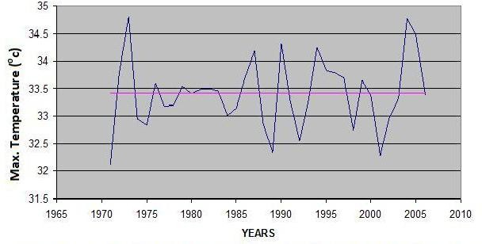

Figure 42: The Time Series Graph Of The Maximum Temperature In Kano Between 1971- 2006

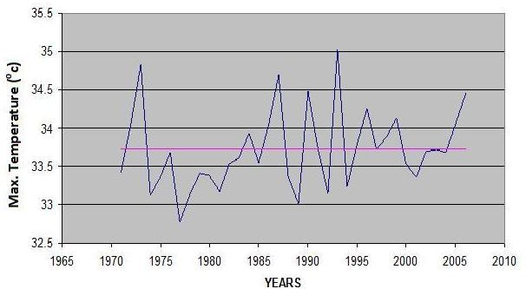

Figure 43: The Time Series Graph of the Maximum Temperature in Katsina between 1971- 2006

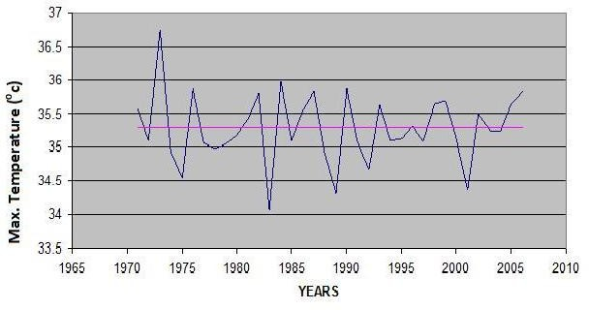

Figure 44: The Time Series Graph of the Maximum Temperature in Maiduguri between 1971- 2006

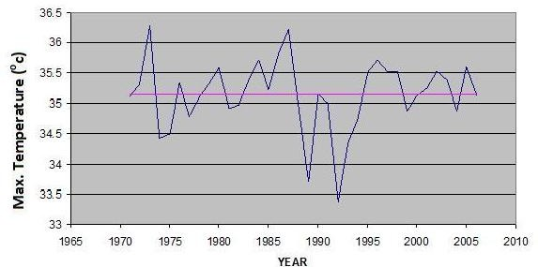

Figure 45: The Time Series Graph of the Maximum Temperature in NGU between 1971-2006

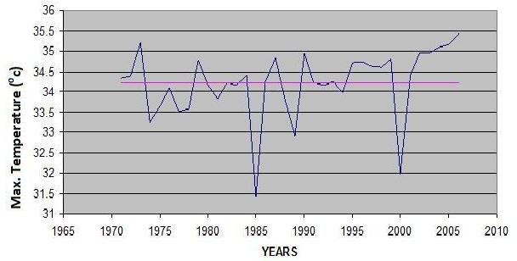

Figure 46: The Time Series Graph of the Maximum Temperature in POT between 1971-2006

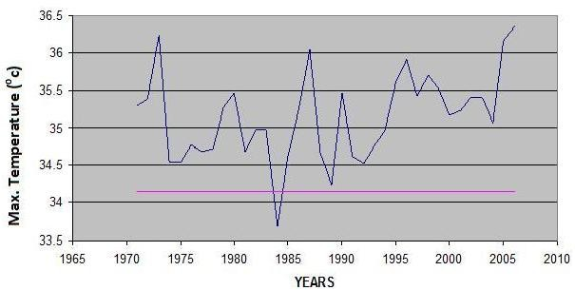

Figure 47: The Time Series Graph of the Maximum Temperature in Sokoto between 1971-2006

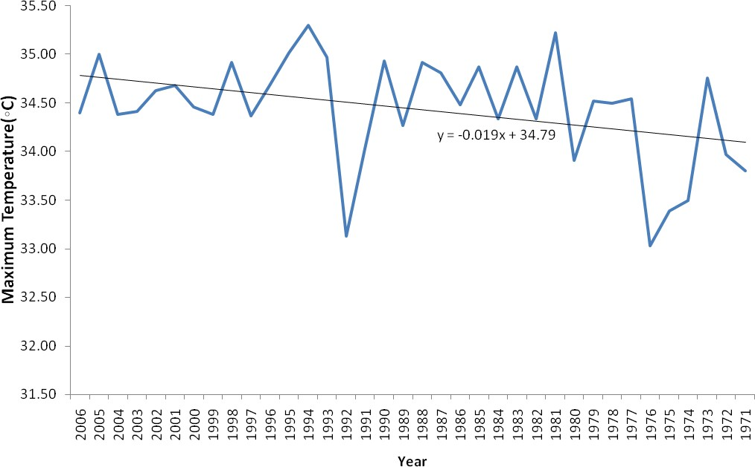

Figure 48: The Time Series Graph of the Maximum Temperature in Yelwa between 1971-2006

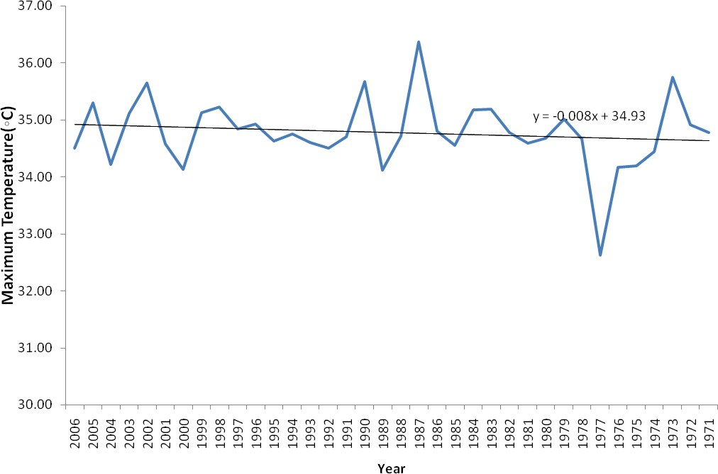

Figure 49: The Time Series Graph of the Maximum Temperature in Yola between 1971-2006

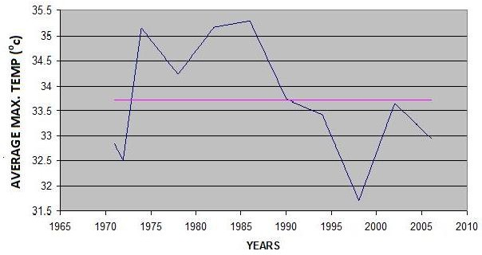

Figure 50a: The Time Series Graph Of The Average Maximum Temperature In all the stations Between 1971-2006

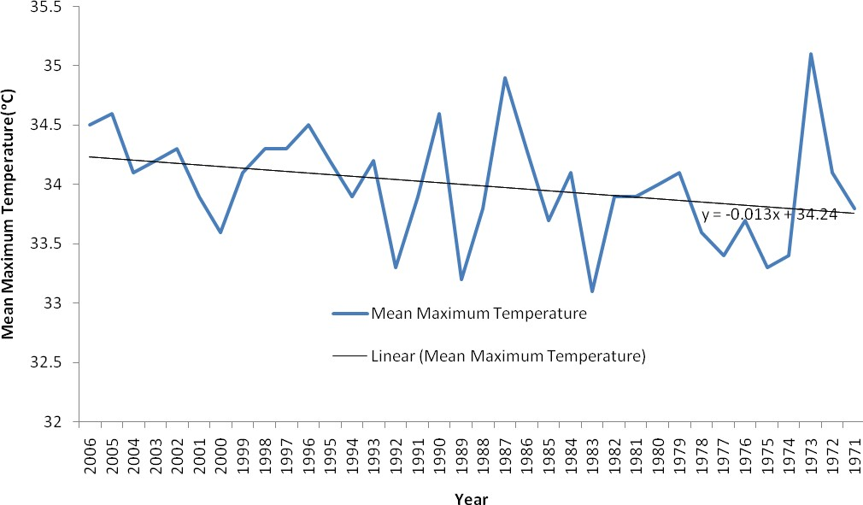

Figure 50b: The Time Series Graph of Mean Maximum Temperature (1971-2006)

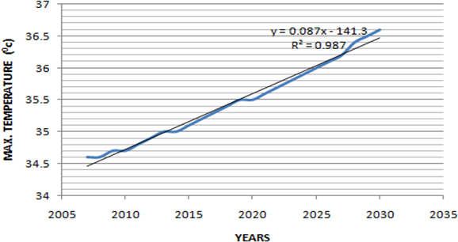

Figure 51: the time series graph of the average max. Temperature in all the stations between 2007 and 2030 (forecast)

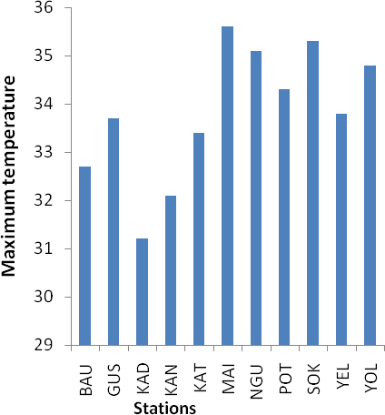

Figure 52: Bar graph of Maximum Temperature in 1971

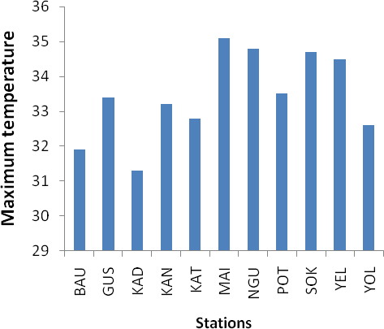

Figure 53: Bar graph of Maximum Temperature in 1977

In other to see if this situation will continue, the time series forecasting model was used. The model, ARIMA (0, 2, 2) was selected as the best predictive model after processing the existing data through transformation fig. 54, fig. 55, fig. 56, fig. 57, fig. 58 and fig. 59. The forecast are shown in table 13. The results indicate a continuous increase in mean maximum temperature from 35.7oc in 2007 to 36.6oc in 2030. This is an increase of 0.9oc. This result could of course be important in the areas of agriculture, and water resources.

In all the years of record, Kaduna has the least values of maximum temperatures, while both Sokoto and Yelwa have the highest. However, Potiskum presents a very peculiar case. Most times it has high values, but surprisingly, in the years, 1982, 1986, 2005, it has the lowest value or second after Kaduna (Table 11). There is also the general trend that Potiskum presents values of least maximum temperatures lower than the surrounding areas.

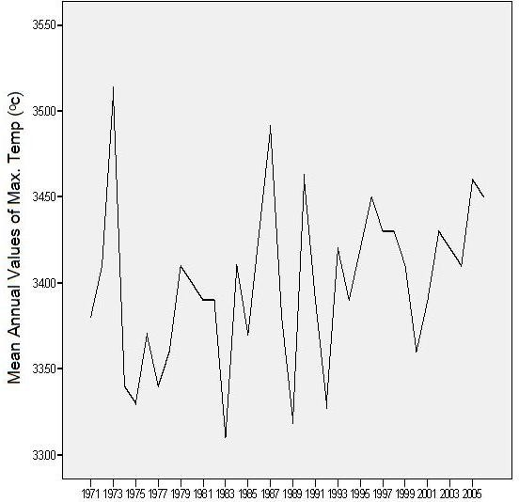

Figure 54: Mean Annual Values of Annual Temperature (1971-2006)

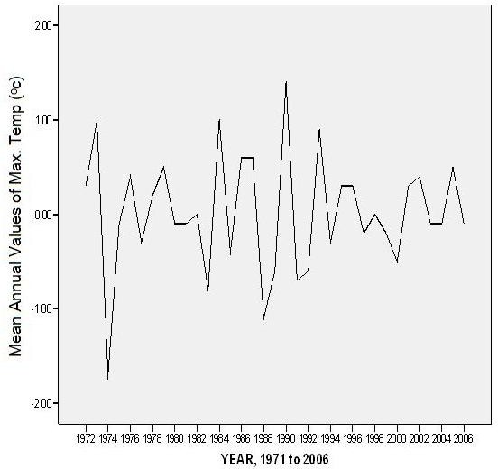

Figure 55: Transforms difference (1)

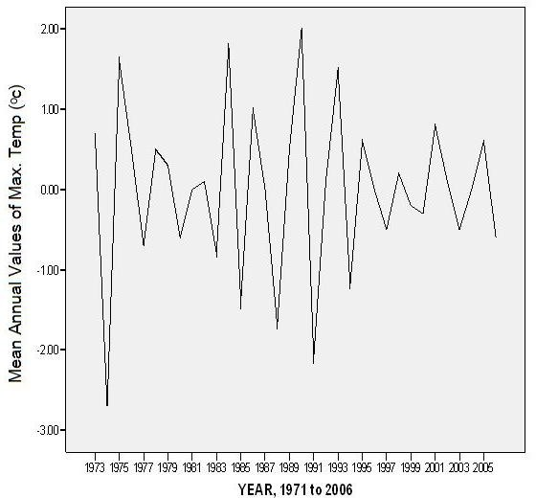

Figure 56: Transforms difference(2)

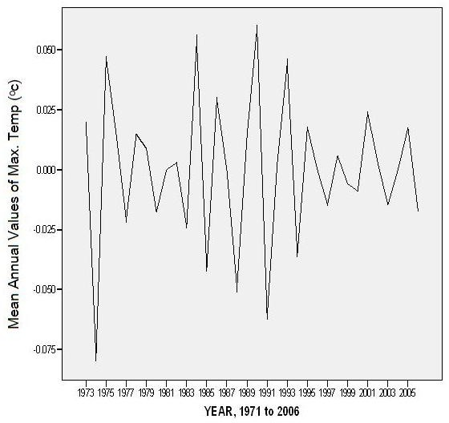

Figure 57: Transforms difference (2)

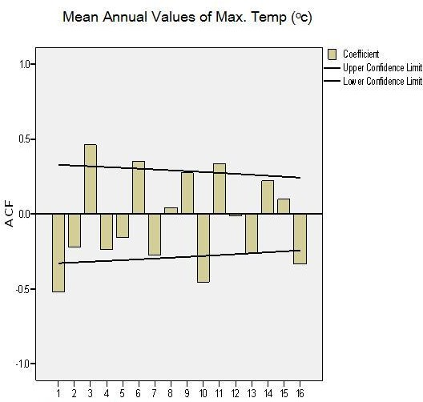

Lag Number

Figure 58: Auto-correlation of Mean Annual Values of Maximum Temperature

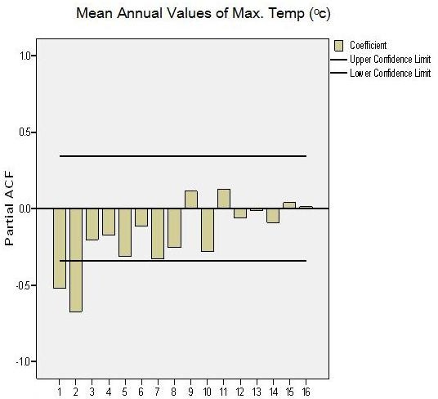

Lag Number

Figure 59: Partial Auto-correlation of Mean Annual Values of Maximum Temperature

#### Table 13 Time Series Modeler

|  |  |  |  |  |
| --- | --- | --- | --- | --- |
| **Model Description** | | | | |
|  | | | Model Type | |
| Model ID | Mean Annual Values of Max.Temp | Model_1 | ARIMA(0,2,2) | |
| Forecast Model Mean Annual Values of Max.Temp-Model_1 | | | | |
| year | forecast | UCL | | LCL |
| 2007 | 34.56617 | 35.65918 | | 33.49883 |
| 2008 | 34.62636 | 35.97151 | | 33.3198 |
| 2009 | 34.68886 | 36.26812 | | 33.16243 |
| 2010 | 34.75369 | 36.55686 | | 33.01896 |
| 2011 | 34.82088 | 36.84207 | | 32.88512 |
| 2012 | 34.89044 | 37.12639 | | 32.75837 |
| 2013 | 34.96239 | 37.41157 | | 32.63705 |
| 2014 | 35.03675 | 37.69888 | | 32.52001 |
| 2015 | 35.11355 | 37.98922 | | 32.40644 |
| 2016 | 35.19281 | 38.28334 | | 32.29572 |
| 2017 | 35.27455 | 38.5818 | | 32.18739 |
| 2018 | 35.3588 | 38.88508 | | 32.08108 |
| 2019 | 35.44558 | 39.19361 | | 31.97649 |
| 2020 | 35.53493 | 39.50773 | | 31.87341 |
| 2021 | 35.62685 | 39.82777 | | 31.77163 |
| 2022 | 35.72139 | 40.15401 | | 31.671 |
| 2023 | 35.81858 | 40.48671 | | 31.5714 |
| 2024 | 35.91843 | 40.82612 | | 31.47271 |
| 2025 | 36.02099 | 41.17247 | | 31.37486 |
| 2026 | 36.12627 | 41.52597 | | 31.27775 |
| 2027 | 36.23432 | 41.88684 | | 31.18134 |
| 2028 | 36.34516 | 42.25529 | | 31.08557 |
| 2029 | 36.45882 | 42.6315 | | 30.99039 |
| 2030 | 36.57535 | 43.01568 | | 30.89578 |

###### Analysis of Minimum Temperature

Statistical measures of minimum temperatures were carried out by stations and graphically by years. The statistical measures yielded the following results:

The highest mean minimum temperature is found in Sokoto (22.3oC) followed by Yola (22.0oC) and then Yelwa (21.5oC). On the other hand the least mean minimum temperatures were found in Kaduna (19.1oC), followed by Bauchi (19.4oC) then Kano (19.6oC) (Table 12). These results are consistent with the analysis of maximum temperatures where Kaduna, Bauchi and Kano exhibited the least mean maximum temperatures (Table 12). The highest values of minimum temperatures is found in Sokoto (24.1oC) followed by Yola (23.5oC) then Nguru (23.4oC). The minimum values are found in Potiskum (17.3oC) followed by Katsina (17.4oC) and Bauchi (17.7oC) (Table 12). The range of minimum temperatures are however small. So also the spread and the peakedness. The graphical representation of minimum temperature are presented in figures typical of the others in fig. 60 and fig. 61.

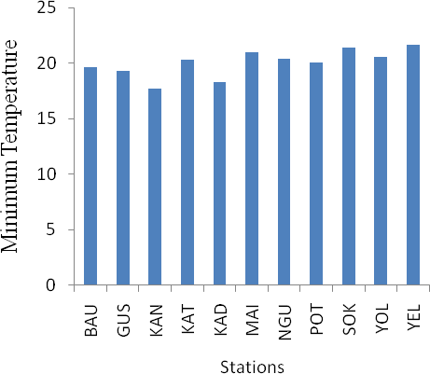

Figure 60: Bar Graph of Mean Annual Minimum Temperatures at the Weather Station

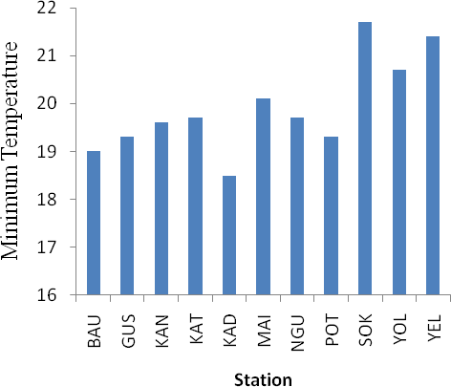

Figure 61: Bar Graph of Mean Annual Minimum Temperatures in 1981

###### Time Series Analysis of Minimum Temperature

Time Series Analysis was employed to see the annual variation of minimum temperature about the mean values for the various study stations and the overall situation in Northern Nigeria. The graph (fig. 62 to fig. 72) exhibit similar variations about the mean, though they are of varying degrees. However, the situation at Nguru (fig. 71) is of particular interest. This station shows that apart from four years, every other year has values above the mean value. The overall picture is shown in figure 73. The result indicate a lower than mean value since about 1985 to date. The value for 1990 has been the lowest in the recorded period of study. This is followed by the year 2006.

The time series straight line equation is of the form y=0.035+19.74 (fig 73(b)). This shows that minimum temperature. The implication here is that the range of temperature might not differ significantly. In other to see if this trend will continue, the time series model was used, the ARIMA (0, 2, 2) just like the maximum temperature was determined as the best for the forecast. The choice also went through the processes of transformations (fig. 75; fig. 76; fig. 77; and fig. 78); and the analysis of autocorrelations and partial autocorrelations. The result of the prediction for the period 2007 to 2030 is shown in table 14. The result shows that mean minimum temperature will continue to increase from 21.1 oC in 2007 to 21.5 oC in 2030. This is an increase of 0.4 oC. When this is compared to mean annual maximum temperature increase of 0.9 oC, it is realigned that there will be a slight increase in the range of temperature. This is an indication of a warmer Northern Nigeria.

Generally, we have a situation of increased rainfall in the last ten (10) years of this period of prediction, reduced number of rain days, increased mean maximum temperature and increased mean annual minimum temperature.

Forecast minimum temperatures in the study area were subjected to time series analysis. The result yielded a straight line summary of y= –11.44 + 0.016x and a coefficient of determination R2=0.927 (fig 74). This means that the forecasts are highly significant. There is a general upward trend in minimum temperatures between 2007 and 2030. It will range from 21.1oC in 2007 to 21.5oC in 2030, an increase of 0.4oC in 23years. This is much smaller than maximum temperature, indicating a slight increase is the range of temperatures.

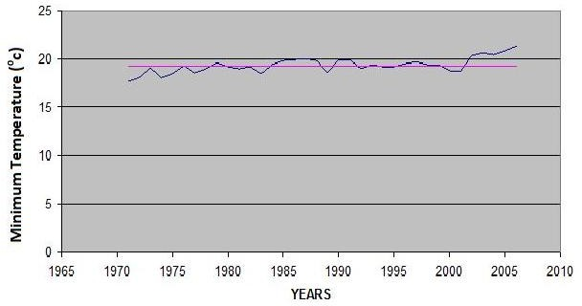

Figure 62: The time series of the minimum Temperature In Bauchi between 1971-2006

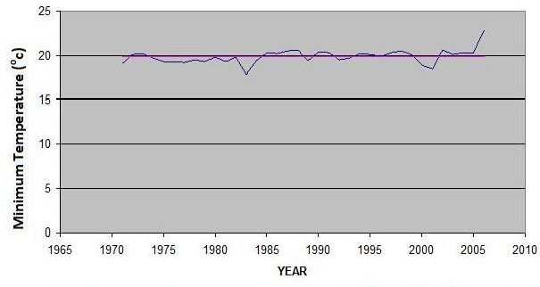

Figure 63: The time series of the minimum Temperature in Gusau between 1971-2006

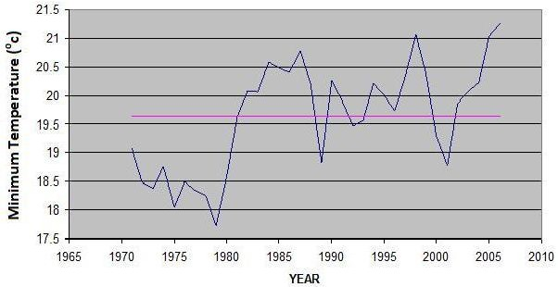

Figure 64: The time series of the minimum Temperature in Kano between 1971-2006

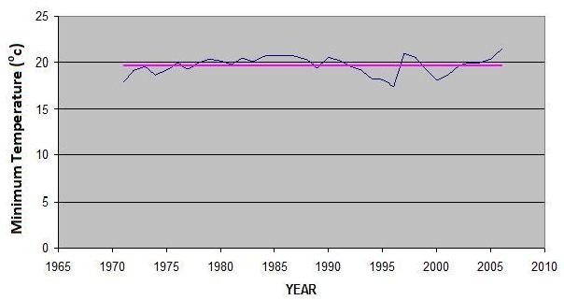

Figure 65: The time series of the minimum Temperature In Katsina between 1971-2006

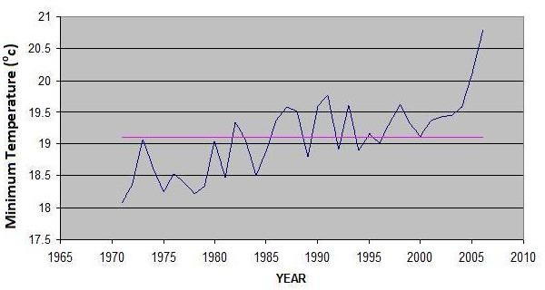

Figure 66: The time series graph of the minimum Temperature In Kaduna between 1971-2006

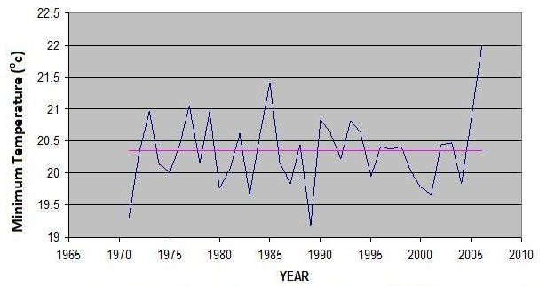

Figure 67: The time series graph of the minimum Temperature In Maiduguri between 1971- 2006

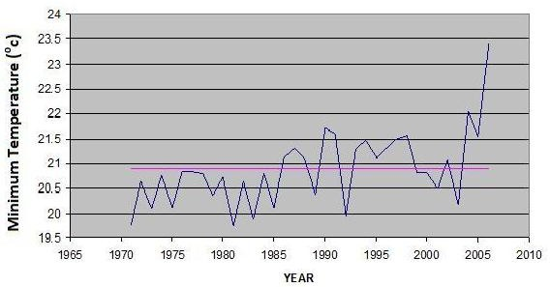

Figure 68: The time series graph of the minimum Temperature of NGU between 1971-2006

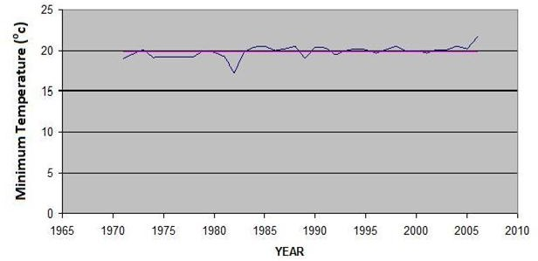

Figure 69: The time series graph of the minimum Temperature of POT between 1971-2006

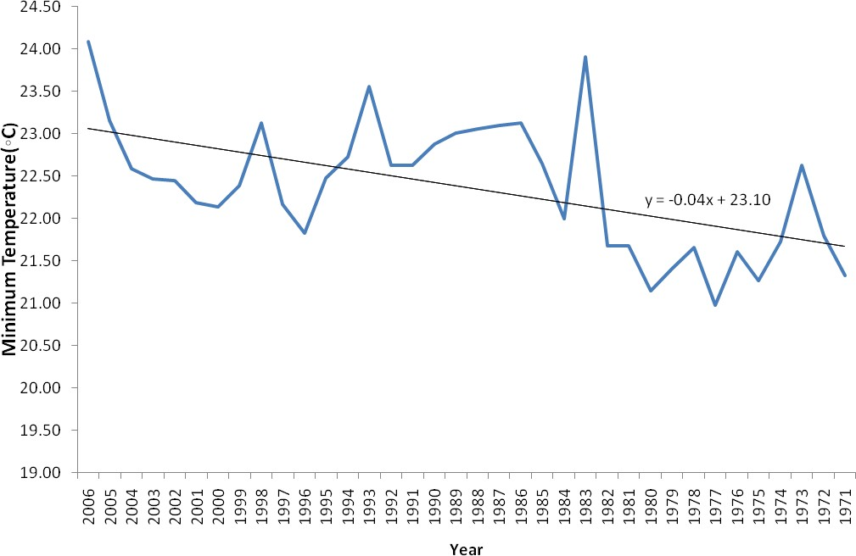

Figure 70: The time series graph of the minimum Temperature in Sokoto between 1971-2006

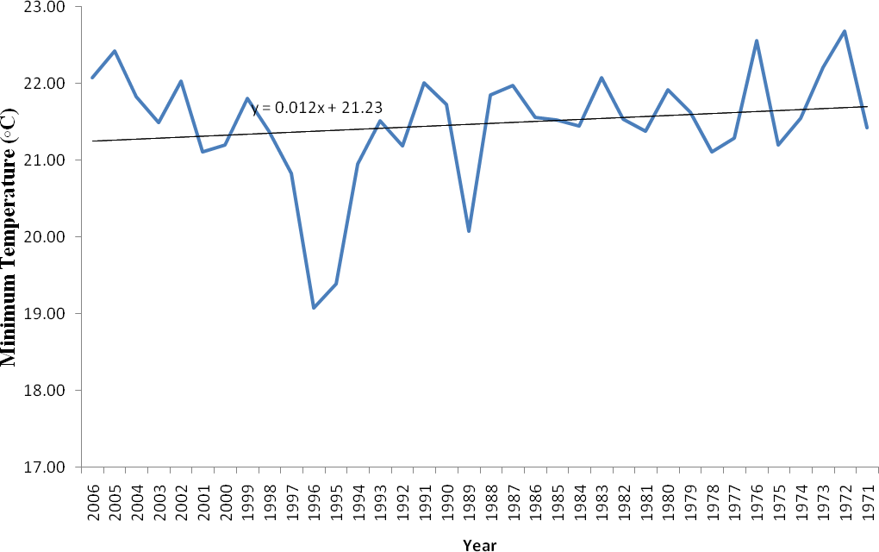

Figure 71: The time series graph of the minimum Temperature in Yelwa between 1971-2006

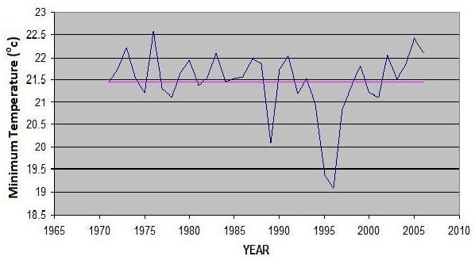

Figure 72: The time series graph of the minimum Temperature in Yola between 1971-2006

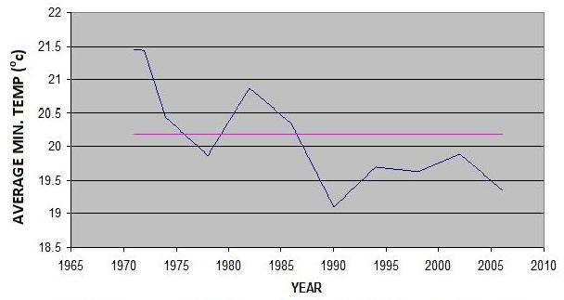

Figure 73a: The time series graph of the average minimum Temperature In all the stations between 1971-2006

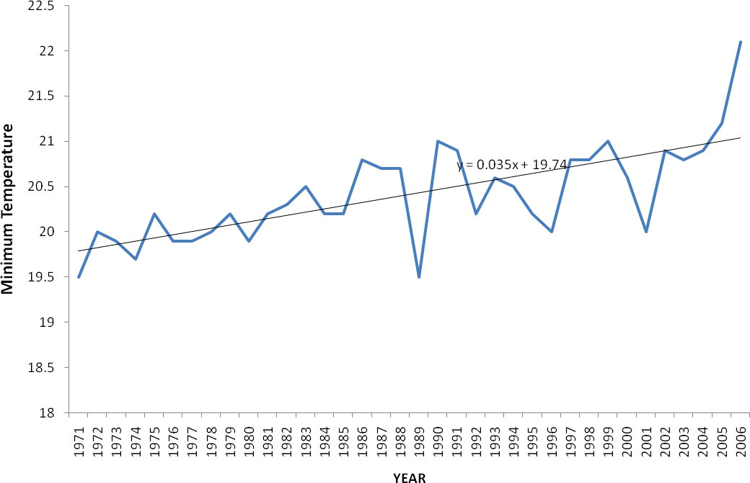

Figure 73b: the time series graph of the mean min. temp. in all the stations between 1971 and 2006

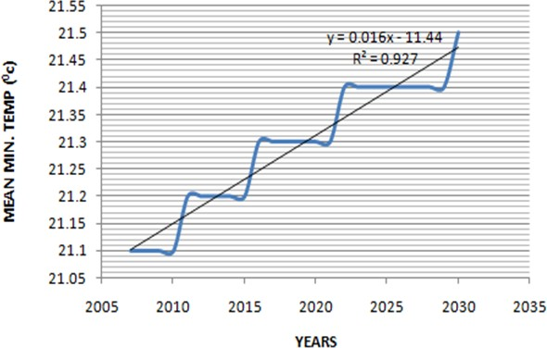

Figure 74: the time series graph of the mean min. temp. in all the stations between 2007 and 2030 (forecast)

Table 14a: Summaries of Mean Annual Minimum Temperatures (1971-2006)

|  |  |  |  |  |  |  |  |  |  |  |
| --- | --- | --- | --- | --- | --- | --- | --- | --- | --- | --- |
| Year | 1971 | 1972 | 1973 | 1974 | 1975 | 1976 | 1977 | 1978 | 1979 | 1980 |
|  | 1989 | 1990 | 1991 | 1992 | 1993 | 1994 | 1995 | 1996 | 1997 | 1998 |
|  | 1981 | 1982 | 1983 | 1984 | 1985 | 1986 | 1987 | 1988 | 1981 | 1982 |
|  | 1999 | 2000 | 2001 | 2002 | 2003 | 2004 | 2005 | 2006 |  |  |
| Statistics | | | | | | | | | | |
| Mean | | | | 20.4 | | | | | | |
| Stdev | | | | 0.5 | | | | | | |
| Min | | | | 19.5 | | | | | | |
| Max | | | | 22.1 | | | | | | |
| Skew | | | | 0.6 | | | | | | |
| Kurt | | | | 1.2 | | | | | | |
| Range | | | | 2.6 | | | | | | |
| C.V | | | | 2.6 | | | | | | |

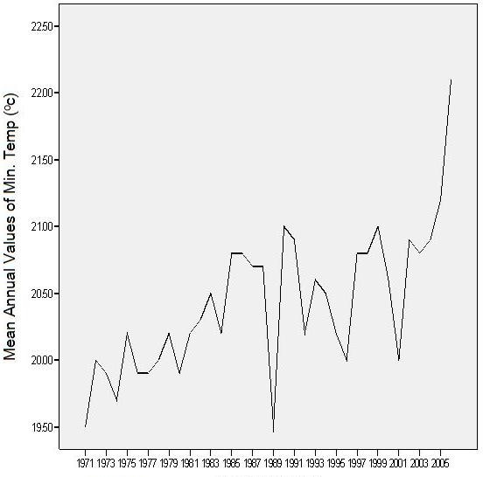

Figure 75: Mean Annual Values of Minimum Temperature (1971-2006)

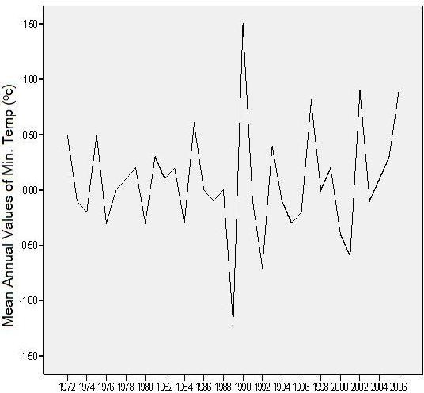

Year 1971-2006

Figure 76: Transform difference (1)

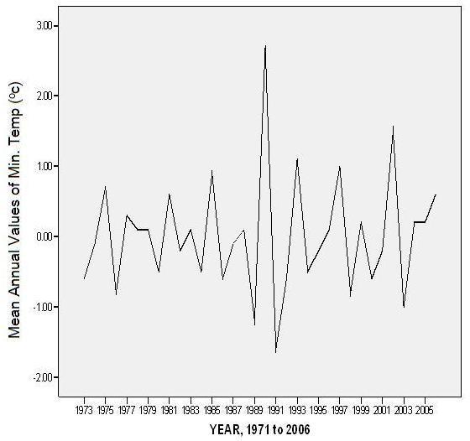

Figure 77: Transform difference (2)

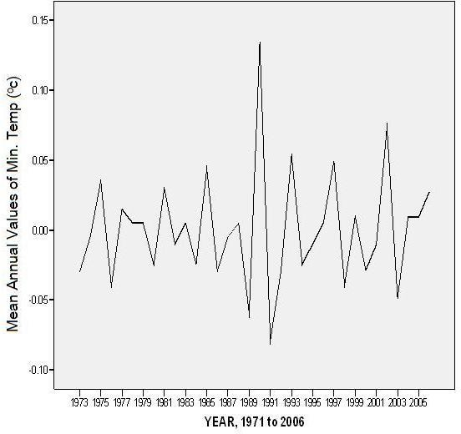

Figure 78: Transform natural log difference (2)

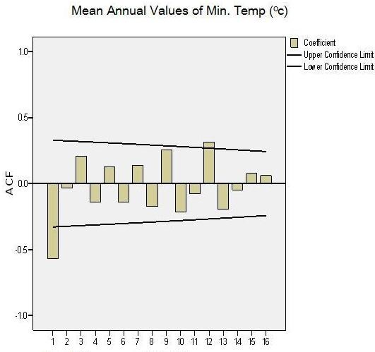

Lag Number

Figure 79: Auto-correlation of Mean Values of Minimum Temperature

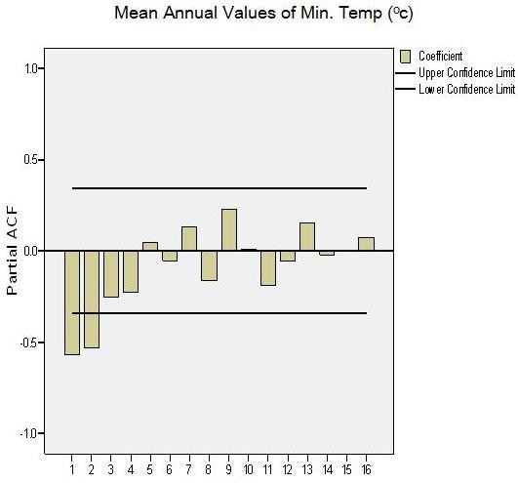

Lag Number

Figure 80: Partial Auto-correlation of Mean Values of Minimum Temperature

**Table 14: Time Series Modeler**

|  |  |
| --- | --- |
| **Model Description** | |
|  | Model Type |
| Model ID Mean Annual Values of Model_1 Min.Temp | ARIMA(0,2,2) |

Forecast Model Mean Annual Values of Min.Temp-Model_1

|  |  |  |  |
| --- | --- | --- | --- |
| year | forecast | UCL | LCL |
| 2007 | 21.05986 | 21.75763 | 20.3621 |
| 2008 | 21.08476 | 21.85645 | 20.31307 |
| 2009 | 21.10894 | 21.9516 | 20.26628 |
| 2010 | 21.13239 | 22.04335 | 20.22143 |
| 2011 | 21.15512 | 22.13211 | 20.17812 |
| 2012 | 21.17713 | 22.2182 | 20.13605 |
| 2013 | 21.19841 | 22.30185 | 20.09497 |
| 2014 | 21.21897 | 22.38324 | 20.05471 |
| 2015 | 21.23881 | 22.46251 | 20.01512 |
| 2016 | 21.25793 | 22.53979 | 19.97608 |
| 2017 | 21.27633 | 22.61518 | 19.93748 |
| 2018 | 21.29400 | 22.68877 | 19.89924 |
| 2019 | 21.31095 | 22.76063 | 19.86127 |
| 2020 | 21.32718 | 22.83084 | 19.82352 |
| 2021 | 21.34269 | 22.89945 | 19.78592 |
| 2022 | 21.35747 | 22.96652 | 19.74842 |
| 2023 | 21.37153 | 23.0321 | 19.71097 |
| 2024 | 21.38487 | 23.09622 | 19.67352 |
| 2025 | 21.39749 | 23.15893 | 19.63604 |
| 2026 | 21.40938 | 23.22027 | 19.59849 |
| 2027 | 21.42055 | 23.28027 | 19.56083 |
| 2028 | 21.431 | 23.33896 | 19.52304 |
| 2029 | 21.44073 | 23.39638 | 19.48508 |
| 2030 | 21.44973 | 23.45254 | 19.44692 |

###### RELATIONSHIP BETWEEN RAINFALL, MAXIMUM TEMPERATURES AND MINIMUM TEMPERATURE

This section discusses the relationship between rainfall and maximum temperature on the one hand and rainfall and minimum on the other.

###### Relationship Between Rainfall and Maximum Temperature

Relationships were sought between rainfall and maximum temperatures using the Pearson product moment correlation co-efficient. The results indicate that only Gusau (-0.409) and Katsina (-0.372) are the correlations significant at 0.05 confidence level with a 2-tailed test (Table 15).All the other stations are not significant at any level of test. However there seem to be a general slight upward trend indicating possible climate change.

###### Relationship Between Rainfall and Minimum Temperature

Relationships were also sought between rainfall and minimum temperatures using the Pearson r. The results indicate that none of the stations exhibit any significant relationship between rainfall and minimum temperature (Table 16)

Table 15: Correlation Coefficients between rainfall and maximum temperature for 36 years.

|  |  |  |
| --- | --- | --- |
| **Stations** | **Correlations Coefficient** | **Sig (2 tailed)** |
| Bauchi | -0.252 | 0.139 |
| Gusau | -0.409* | 0.013 |
| Kano | -0.163 | 0.026 |
| Katsina | -0.228 | 0.055 |
| Kaduna | -0.293 | 0.083 |
| Maiduguri | -0.174 | 0.310 |
| Nguru | -0.247 | 0.146 |
| Potiskum | -0.042 | 0.806 |
| Sokoto | -0.050 | 0.774 |
| Yola | -0.160 | 0.351 |
| Yelwa | -0.064 | 0.709 |

*Correlation is Significant at the 0.05 level (2-tailed)

Table 16: Correlation Coefficients Between Rainfall and minimum Temperature for 36 years.

|  |  |  |
| --- | --- | --- |
| **Stations** | **Correlations Coefficient** | **Sig (2 tailed)** |
| Bauchi | -.216 | 0.206 |
| Gusau | 0.139 | 0.418 |
| Kano | 0.288 | 0.088 |
| Katsina | 0.179 | 0.298 |
| Kaduna | -.300 | 0.075 |
| Maiduguri | -.055 | 0.749 |
| Nguru | -.012 | 0.944 |
| Potiskum | 0.071 | 0.680 |
| Sokoto | 0.623 | 0.121 |
| Yola | -0.240 | 0.158 |
| Yelwa | -0.252 | 0.13 |

**CHAPTER FIVE**

**DISCUSSION OF RESULTS**

#### RAINFALL AMOUNT AND DISTRIBUTION

The highest amounts of rainfall occurred in the Southern parts with the exception of Gusau as a result of their latitudinal position. The least values were recorded at Nguru, Katsina and Maiduguri which are all in the Northern part of the study area. These are the areas in the heart of the Sahel. Kano located in the central part of the study area recorded the maximum highest total annual rainfall and the minimum again at Nguru. However, Kano recorded the largest range that is the difference between the minimum and the maximum. Potiskum exhibits the most evenly spread distribution followed by Yola. All these distributions have their implications and the patterns will be discussed latter.

On the trend of rainfall distribution, 1999 has the highest mean annual rainfall during the period of study. Followed by 1998 and then 2003. The higher rainfall amounts are therefore found in the 1990s and 2000s. The least mean annual rainfall occurred in 1973. The year 1973 is noted for being dry (drought year) with resultant famine. This is followed by 1983 and 1987. It is this 1973 and 1983 that earlier gave an impression that drought could be cyclic. For the thirty-six (36) years of data in the study, this was not exhibited.

From these results, we can talk about two (2) phases of rainfall regime in the study area:

* + 1. the dry years (1971-1990);
    2. the wet years (1991-2006).

The distribution of rainfall is most even in 1992 followed by 1991. The most uneven distribution occurred in 1974, then 1973 and 1979. There are years already recorded as

lean years of harvest and drought and dislocation of people and many more attendant problems, (Oladipo 1991). However, most of the years indicate negative departures from the mean values.

It is interesting to note that in 1985, 1987, and 1988, all the stations have a lower rainfall values below the mean. With higher rainfall amounts and decreased raindays, the likely hood of intensity and attendant consequences of flash floods, destruction of lives and properties and rivers overflowing their bank. Rainfall varies both in time and space in the region but there is no specific pattern of variability. That is, there is no South-North nor West-East observed general pattern. The variability are station specific. This goes to say that planning activities in this region will have to be localized.

The histograms of the rainfall distribution (Fig 29, 30, 31, 32) indicate that

1972, 1978, 1980 and 1982 have higher rainfalls than most other years. Rainfall distribution and amounts present their own problems in planning for water resources, agriculture and forestry. The analysis above generally indicates that Northern Nigeria is receiving more rainfall now than before. The implications of this include halting the advance of the Sahara and even greening of the Sahara, which is stopping its expansion. There is also the possibility of an expansion of the Lake Chad, improvement in vegetation growth etc. There is the expectation of improvement in agricultural yield. Of course the cries of famine, drought and desert encroachment of the 1970s has declined.

In those earlier years of the 1970s, the over-ambitious agrarian programmes / schemes like the Chad Basin Development Authority, the Hadejia-Jamare River Basin and Sokoto-Rima River Basins must have contributed in one way or the other to the drying up of the region. One of such examples is the total removal of vegetation to engage in mechanize agriculture. It is also known that the Endorheric Lake Chad occupied a large area during the Pleitocene and Holocene with an over-spill into the Benue-Niger River system (Pachur and Altman, 1977). Then in the 1970s there was reduced rainfall which again improved in the 1990s and 2000s.

Martin (2003) using climate models of

1. climate system model intermediate complexity (natural climate change);
2. Paleo – simulation
3. Sensitivity simulation (CO2 increase) and came out with the following results:
   1. Green Sahara in the early and mid Holocene (9000 – 6000 years BP).
   2. Expansion of the Sahara during cold phases (70s and 80s) (glaciers).
   3. Reduction (greening) of the Sahara during warm periods.

The first two observations (a and b) have supported the current findings of dry years in the 70s and 80s and wet years in the 90s and 2000s. Other Authors like Xue and Shukla, 1993 for example used a GCM and found that Sub-Sahara desertification leads to

* a reduction in moisture flux and rainfall in the Sahel just like Nguru, Sokoto and Maiduguri etc., in our study.
* an increase in moisture flux and rainfall to the south of the Sahel which agrees with our study that Kaduna has the highest amount of rainfall.

Increases in local rainfall could be as a result of conscious effort at aforestation programmes especially in dry years. This is supported by Xue and Shukla (1996), that land degradation would cause both an increase in local temperature and decrease in rainfall amounts. Also, that aforestation could increase rainfall. Janicot (1996) identified decreasing rainfall in the Sahel to be related to warm water in the east pacific, the equatorial pacific, and the Indian Oceans. These could actually be the reason for the current improvements in rainfall in the study area.

Zhang (1999) used a numerical model and found that warm spring sea surface temperature yield a wet summer in the Sahel. This linkage could be studied to support the current observations in the Sahel. Climate models have already shown that precipitation response is more variable than temperature. In fact, the high inter-annual variability of rainfall during the twentieth century, and particularly the events of famine during the beginning of the 1970s and 1980s have been attributed to the El-NINO

Southern Oscillation (ENSO) event (WMO, 1987). The current situation could therefore be the other phase of the ENSO phenomenon where there is improved rainfall in the Sahel.

Problems associated with vegetation and soil relationship are precipitated by the removal of the soil vegetal cover by man. Forest clearance, repeated crop cultivation, overgrazing and bush burning in the region frequently expose the soil to intense isolation leading to increased rates of evaporation, decomposition and oxidation of soil organic matter; while the major nutrients and trace elements are rapidly exhausted from the soil through crop removal, leaching and erosion.

The human factor has been very important in vegetation dynamics in Nigeria. Adejuwon (1971) pointed out that present day vegetation types in Nigeria are all anthropogenic derivatives of former climax communities as follows:

1. The forest and derived Savana communities in the humid south are derivatives of the tropical rain forest;
2. The Southern and Northern Guinea Savana derived from a tropical deciduous forest which developed in a climatic region characterized by a dominance of humid over arid tropical conditions; and
3. The Sudan and Sahel Savana derived from former tropical xerophytic woodlands developed in a sub-humid to semi-arid climatic environment.

West Africa was marked by drastic reductions of forest, freshwater swamps and moist Savanah communities in the Niger Delta.

A reduction in CH4 gas emissions coincided with severe drought in Northern, Western and Eastern Africa, Tibet and Northern South America (Street Perrott, 1993). A bet of high lake levels extended from 40oS to 30oN, suggesting that large areas now arid were regularly receiving substantial tropical rainfall. Water levels continue to be

high until C.5000 years BP, when arid conditions returned, and intermediate lake levels were restricted to the narrow latitudinal range (20oS to 30oN) that they occupy today. The lake levels of today were achieved at about 2000 years ago. The forecast increases and mean annual rainfall and decreases in mean monthly rain days is a sure indication of potential occurrence of flash flows, rivers and coastal flooding, splash and gully erosions and general land degradation. This therefore calls for careful and more efficient management of soils and vegetation in this region that is regarded as fragile already.

Comparison of the rainfall pattern in the Sahel region (Western Africa) with the global ocean SST patterns shows that during the past 80 years, reduction of moisture flux have been correlated with warming of surface ocean in the Southern hemisphere and Northern Indian ocean, and cooling of the North Atlantic and North Pacific oceans.

Temperature variability is sometimes low and some other times high both in place and time. Such variations will have impact on levels of human thermal comfort and the length of the discomfort season, the phenology of a range of plant and animal species and the possible re-emergence of some tick-borne diseases. The last 50 years have shown statistically significant increases in rainfall in Europe for winter and not so for summer, most especially, Northern Europe. Trends in measures of precipitation extremes partly mirror the observed trends for precipitation total but the spatial coherence of trend is low. However, where changes in annual amounts are significant there is disproportionate change in the contribution of very wet days to precipitation totals, indicating an increase in precipitation extremes.

Eltahir and Gong’s (1996) theoretical argument suggesting that a cold pool of water in the region South of the West African coast should favour a strong monsoonal circulation favouring wet conditions in the Sahel seems to be correct as seen in this

research with improving rainfall conditions. Reduced rainfall in the 1970s and 1980s and improved rainfall in the 1990s and 2000s and again a decrease in the late 20s and improvement in the 2020-2030 seem to be collaborating the hunch that drought is cyclical in Northern Nigeria. A cycle being 10years. However, we might be talking of lesser rainfall than normal in such drought years and not really drought. Since both rainfall and temperature are increasing, improvement in rainfall could be annulled because of the potential of high evapotranspiration leading to decrease in soil moisture and more crop failures and less surface water. The improvements in rainfall does not seem sufficient to take us back to the Pleistocene and Holocene when a large lake occupied the Chad Basin with an over spill in the Benue-Niger River System (Pachur and Altmann, (1997). The attempted prediction of mean annual rainfall indicating improvements are good signs of greening Sahara and increase in the size of Lake Chad. However, due to expected increase in mean annual maximum temperatures and decrease in mean annual minimum temperatures, we expected greater evapotranspiration, overcoming the improvements expected.

#### NUMBER OF RAIN DAYS

The number of rain days are highest in 1991 and 1992 with a value of 80 days followed by 1984, 1982, and 1978 with a value of 78 days. The 1972, 1982 and 1978 presents a very special cases especially 1972 which signaled the beginning of the 1973 drought. The only conclusion is that the rainfall were very light and were therefore not sufficient to meet the soil moisture requirements and subsequently plant growth. On the other hand, 1996 that has a very high amount of rainfall has the least number of rain days. The implication can only be incidences of flash floods, sheet erosion, channel floods etc. The results for 1983 and 1977 agree with the general trend in Nigeria. The maximum number of rain days per month occurred in 1975, 1988 and 1992 (9 days per month), while the minimum occurred in 2003 and 2005 (3 days each). These results have serious implications. The most obvious is that, the 2000s have been found to be years of improved rainfall with lesser days of rainfall occurrence (Tables 5 and 7).

That means that rainfall intensity is very high leading to leaching of soils and crops destruction including life and properties.

Variability in the number of rain days are greater in the 1990s which also resulted into the greater skewness in their distribution. The greater number of rain days in Kaduna, Bauchi and Yelwa is an indication that grains could be grown and root crops in Kaduna, while the lower rain days at Nguru, Katsina and Sokoto can support only the short-time maturing grains. The coefficient of variability measures also reinforces our earlier observation that there seem not to be any directional North-South nor West-East increases or decreases in variability. They are like rainfall station specific.

The Time Series Analysis of number of rain days fortified the earlier results that there would be decreased number of rain days with greater rainfall. Number of rain days will decrease from 6.5 days in 2007 to 5.2 days in 2030. When this is combined with potential increase in mean annual rainfall, we expect greater land degradation in general and the society must braze up for this.

#### TEMPERATURE CHARACTERISTICS

* + 1. **Maximum Temperature**

The Northern part of the study area presents the highest maximum temperatures just like it presents the lowest rainfall amounts and number of rain days. These conditions certainly make the area very uncomfortable for living, and not favourable to non irrigated agriculture and vegetation growth. It is no wonder therefore that incidences of desertification are prominent in the region.

The least maximum temperatures are found in the southern parts of Kaduna and Bauchi. These areas again correspond to areas of higher rainfalls and higher number of rain days. In all cases, the variability and peakedness of distribution is low. The year 1973 has the highest maximum temperature. This is the year also with the least rainfall. No wonder the drought of this year was so pronounced that the catastrophy

which resulted from it, is very high. This was followed by the year 1987 and 1988 (two years at a stretch). The years 1992 and 2000 were perhaps the coolest of the years under study. These are also years of good rains. In fact the year 1992 seem to be the beginning of more favourable years that we enjoy up till the present day. The range of temperatures are also small.

Balling (2005) concluded that climate models suggest that in Africa, warming results from:

* a build-up of green house gases in the atmosphere;
* increased potential evapotranspiration (PET) rates;
* a reduction in soil moisture;
* increase in the intensity, frequency and magnitude of drought.

Perhaps, while we cannot confirm the build-up of greenhouse gases in this region, the last three suggestions could actually hold true from our recent study.

In the 1990s, scientists have linked a detailed local surface energy balance model to a global climate model and found that in the Sahel, temperature and precipitation are very sensitive to soil moisture levels in the region (Bounova and Krishnamurti, 1993a). Perhaps this explains why soil desiccation is still a common feature in the Sahel despite improved rainfall. The higher PET leads to greater loss of moisture from the soils leaving it drier, with less vegetation and poor harvest except with irrigation. The land degradation occurring in the Sahel again causes both an increase in local temperature and decrease in rainfall levels just as Xue and Shukla (1997) had observed. Afforestation potentially increases local rainfall especially in the dry years (Xue and Shukla, 1996).

Billi (1998) had noted that meteorological data show recent increases in temperature just like this study has indicated but with increases in rainfall occurrence.

From biometeorological point of view, changes such as above have had an impact on levels of human thermal comfort and the length of the discomfort season (McGregor. 2002), the phenology of a range of plant and animal species (Ahas. 2002); Van Veilt and Schwartz, 2002) and the possible re-emergence of some tick-borne diseases (Randolph, 2004).

Warming through the 20th century has been at the rate of about 0.5oC per century. Slightly larger warming in June-August and September-November seasons than in December-February and March-May. These observations were not made in the current study. The six warmest years in Africa have all occurred since 1987, with 1998 being the warmest year, similar to global situations. This agrees with our current study of increasing rainfalls and temperatures.

Temperatures in all these regions of Africa, the Sahel, East Africa and South- East Africa during the 1990s were higher than they have been during the 20th century (except for a period at the end of the 1930s in the Sahel). Hulme (1990c) noted that drying in the Sahel was associated with a moderate warming trend. This period therefore is a warm period and the expectation is greening of the Sahara postulated by Martin (2003).

Ballings (2005) prediction of warming Africa can be said to be true in the case of temperature by increase in the frequency intensity and magnitudes of drought does not agree with the present research in Northern Nigeria. Land degradation has been a major problem in the stud area and according to Xue and Shukla (1997) could lead to increase in local temperatures, but rainfall has not decreased as such except that the number of rain days continues to decrease leading to flash floods and erosion meaning greater degradation. In the six decades covered by this work, there has been a

0.15 oC increase in mean annual maximum temperature per decade, a result similar to that of Hulme (2001).

Mean maximum temperature variability is generally moderate like most other areas in the topics. The range is also quite small in both space and time but more in time. However, there will be a general increase in mean annual maximum temperature just like the mean annual minimum temperature will continue to increase from 2007 to 2030. A difference of 2.1oC and 0.4 oC in 23years. The increase in minimum temperature is much smaller than maximum temperature, therefore the range of temperature will increase. This will have very great implication for our construction industries (expansion and reduction of building materials), our agriculture (tolerance limits of our crops for maximum production), our water resources and general planning considerations. We must therefore brace up for these changes.

#### Minimum Temperatures

Minimum temperatures in Sokoto, Yola and Yelwa exhibit higher values. This means that the range of temperatures between minimum and maximum temperatures will be small. Then in Kaduna, Bauchi and Kano, there are lower minimum temperatures. These are the stations with lower maximum temperatures. This explains why the range of temperatures again is small. On the whole, we would say that the Northern part of the study area is more uncomfortable for both fauna and floral than the southern parts. The pattern exhibited here corresponds to those of rainfall analysis.

From the line graphs presented, it is noticed that in all the years of record Kaduna has the least values of minimum temperatures, while both Sokoto and Yelwa have the highest. However, Potiskum presents a very peculiar case. Most times it has high values, but surprisingly, in the years, 1982, 1986 and 2005, it has the lowest values or second after Kaduna. There is also the general trend that Potiskum presents values of minimum temperatures lower than the surrounding areas.

#### RELATIONSHIP BETWEEN RAINFALL AND TEMPERATURE

From theory, it is realized that higher temperatures assist in the uplift of moist air to heights where cooling takes place and subsequently precipitate depending on the location and cloud cover. This could imply that where moisture is available, the higher temperatures will contribute to higher amounts of rainfall.

In this work the Pearson Product Moment Correlation Coefficient was employed to seek the relationship between rainfall and temperatures, both maximum and minimum temperatures. The results indicate that only in Gusau ( r = -0.49) and Katsina (r = -0.372) that the relationship is negatively significant at 0.05 level of test at the 2-tail test. All other stations are not significant at any level of test. The implication of this is that other factors are responsible for higher or lower rainfalls in the region like the GCM, or RCM, aforestation or devegetation.

## CHAPTER SIX

#### SUMMARY AND CONCLUSION

#### OVERVIEW OF THE STUDY

The research sets out to examine the variations in rainfall and temperatures in parts of Northern Nigeria. Specifically, the research examines variations in maximum, minimum temperatures, rainfall amounts and the number of rain days.

The data were collected from eleven (11) synoptic weather stations in parts of Northern Nigeria namely – Sokoto, Yelwa, Kano, Gusau, Katsina, Kaduna, Maidugri, Potiskum, Nguru, Yola, and Bauchi. The length of data thirty six (36) years and they were collected from the Nigerian Meteorological Agency.

These data were subjected to series of analysis such as measures of central tendencies and measures of dispersion with further employment of the Time Series to determine the trends of the distributions. The research also employed the ARIMA Time Series modeler to forecast these variables from 2007 – 2030.

In summary, the research yielded the following results:

* That the region could be divided into periods on the basis of rainfall amounts. The 1970’s and 1980’s as the period of lower temperatures and rainfall and the 1990’s and 2000’s as the period of higher rainfall than the mean state.
* During the forecast period, 2007 to 2030; rain continues to decline until 2019 and begins to increase from 2020 to 2030. Similarly, temperatures increase from 35.7oC in 2007 to 36.6oC in 2030, an increase of 0.9oC in thirteen (13) years.
* The Southern parts of the study area have higher rainfall and lower temperatures compared to the Northern parts. This greatly agrees with other results and also the forecasted periods.
* The annual ranges of temperatures vary very slightly as in earlier studies
* Generally, none of the elements (variables) have departed significantly from the normal.

At the end of the research, it is recommended that similar works be carried out in other parts of the country and other regions of Africa where corresponding researches have not been done like the developed world. Also, a single variable maybe used for a more in-depth analysis and discussion.

#### MAJOR FINDINGS OF THE STUDY

The summary of the major findings are presented below:

The general trend in rainfall amounts indicates a gradual decrease from the southern parts of Kaduna and Bauchi to the northern parts of Nguru, Maiduguri and Sokoto. There is also a general improvement of rainfall amounts from the 1970s and 1980 to the 1990s to 2006. The prediction indicate that rainfall will decrease from 2007 to 2019 and an increase from 2020 to 2030, an increase of 55.2mm. The range of rainfall amounts is greater in the southern parts like Kaduna (1418.20mm) than the northern parts like Nguru (405.90mm).

Generally, the distribution is normal. That is most stations exhibit fluctuations about the mean value, few times very great. The Time series Analysis shows that there have been more rainfalls lower than the mean values than that of over the mean value. This probably are the indications that we are in drier times than before. That means that rainfall in these years is actually below normal. However, we must not lose sight of the fact that the 1990s and early 2020s are better than 1970s and 1980s. Even though the amount of rainfall is low, most of the stations presented a uniform amount in 1972, 1978, 1980 and 1982. The most uneven distributions were found in 1984, 1985, 1995

and 2006.

The years 1991 and 1972 have the highest number of rain days followed by 1984, 1982 and then 1978. However, 1996, 1983 and 1977 have the least number of rain days. Generally, the number of rain days has increased since the 1990s. The temperatures are generally higher in the extreme north than the southern part, and that the range of temperatures is higher in the northern areas also. That is the severity of the hamattan is much more in this area. In 1988, 1992 and 2001, the temperatures were lower than the mean value. The year 1973, 1987 and 1988 have the highest amounts of mean maximum temperatures. The lowest ones were in 1989, 1992 and 2000. Overall, the variations and skewness are very slight. We also expect that minimum temperature will continue to increase into 2030, an increase of 0.15oc per decade. The minimum temperatures also follow the same pattern as the maximum. There are higher in the northern areas of Sokoto, and Yelwa than in Kaduna, Bauchi and Kano. The general trend of minimum temperature is that of decrease even into 2030. Apart from Gusau and Katsina, no other station in the study period exhibit any form of relationship between rainfall and temperatures. Even these two where significant relationship exists is in the negative.

#### CONTRIBUTION TO KNOWLEDGE

From this research work, it is now known that the periods of 1970’s and the 1980’s were periods of lower than average temperatures and rainfall in the study area, while the 1990’s and 2000’s were periods of higher than average temperatures and rainfall. The forecast also indicates a decline in rainfall from 2007 to 2019 and increases from 2020 to 2030. However, there is an increase in maximum temperature by about 0.9 oc in thirteen (13) years, while the minimum temperatures increases by about 0.15 oc per decade. The number of rain days will decrease from 6.5 days in 2007 to 5.2 days in 2030. This decrease in number of rain days during the forecast period and the increases in rainfall portends serious problems of flooding, landslides, erosion, human and property losses.

The research work has successfully shown like earlier researches that annual rainfall amounts and annual temperatures are higher and smaller respectively in southern parts of the study area than in the northern parts.

#### CRITIQUE OF THE STUDY

This work seems to have considered too many elements (variables) for a single work, it is believed that one variable at a time will yield better results and discussions of the results. The work also has not been able to look at the natural changes in temperature and rainfall. Greater understanding of the Time Series and other statistical techniques would have improved the discussions. In this regards a corroborative research between climatologists and statisticians are recommended.

The work has not pretended in any way to have used any model in this study or even to attempt at modeling. The work also did not use any natural geographical boundaries like latitudes and longitude which probably would have been better, but the aim of the research is not however lost since the work tries to establish the presence of change or signal in using the selected synoptic weather stations.

#### CONCLUSION

In this section, a conclusion will now be made with respect to the current research work.

In the current study, the period is too short to determine the factors responsible for change but that rainfall and temperatures are on the increase. From our analysis, the situation in Northern Nigeria can best be described as quasi-periodic because of the discernible distribution between 1970s and 1980 and 1990 to 2000s.

Bryson (1973) blamed industrial activity in the NH for climate “failure” in the Sahel while Cloudsley-Thompson (1974) identified overgrazing as the major cause of droughts. Similarly, Jule-Charney (1975) attributed the climate change in the Sahel to vegetation depletion. However, the Cloudsley-Thompson (1974) and Jule-Charney

(1975) assertion seem to be more plausible, but that the changes observed are only variations. However, once the vegetation is depleted like in Northern Nigeria, the local atmosphere is further influenced by increased dust loads. Most modeling efforts led to a conclusion that increased mineral aerosol loads will cool the surface, warm the lower atmosphere, stabilize the atmosphere, and reduce local rainfall (Litman, 1991; Tergen. 1996; Moulin. 1997). Overgrazing, drought, de-vegetation and increased dust clouds and aerosols actually could have been responsible for the lower temperatures and rainfall in the 1970s and the 1980. For most of Africa, the increase in temperature causes an increase in PET that overwhelms any increases in PPt and results in a reduction in soil moisture. This explains the continual desiccation of soils in the region despite improved rainfall. Similarly, high energy fluctuation has led to low plant productivity and this partly account for the advancement of the Sahara.

In this study the variability is rather small so also is the duration. Ayoade (2003) also concluded that what we observe now is just “noise” and not “signal”. This work also supports this assertion. The rapidity of variability heightens man’s vulnerability and ecosystem. However, the changes observed in this study are within the confidence limits except a few of them. It is generally confirmed in this study that we are still within a warm period which started in the 1990s. Whether, human activities will prevent a return to cold periods is yet to be seen. We must however, appreciate the relationship between desertification and deforestation and even drought. All these three are very prominent in the study area. This study concludes also that the region could be divided into two eras on the basis of rainfall amounts.

* + 1. The 1970’s and 1980’s as a period of lower temperatures and rainfall and
    2. The 1990’s and 200’s as periods of higher rainfall and temperature.

During the period of forecast, 2007 to 2030 rain continues to decline until 2019 and increases from 2020 till 2030. Similarly, temperatures increase from 35.7 oc in 2007 to

36.6 oc in 2030, an increase of 0.9 oc in thirteen (13) years. The southern parts of the study area have higher rainfall and lower temperatures compared to the Northern parts. Finally as at now, we have concluded that only variations which are normal that is taking place. A new climate normal has yet been achieved, neither is there any trend towards that, but regular research must continue to detect any early signal.

#### RECOMMENDATIONS

At the end of this work, it is pertinent to draw up the following recommendations:

* + 1. It has been proved as at today, the climate has not changed enormously to warrant the amounts of attention been paid to impact analysis. Instead, closer watch should be mounted in all regions to monitor the emerging pattern. This will help us to match simulations with reality on ground.
    2. This work has looked at so many ramifications of change at once to detect any area to show promise of a change. Subsequently, researchers should be encouraged to look at one item at a time hoping that a greater detailed work shall be achieved.
    3. Like earlier stated, specific model building should be embarked upon in specific regions like Northern Nigeria for a better fitting of models to realities on the ground.
    4. Attempts should also be made to continuously try to quantify the amounts of CO2, CH4, CFC-11, CFC-12, CFC213, N2O, O3 and aerosols/particulates so also to define more appropriate models.
    5. Land surface must continue to be monitored to determine their effects on climate change.

#### REFERENCES

Adefolalu, D.O. (1999). Climate Change and Natural Disasters in Nigeria during the 1999 Rainy Season. Centre for climate change, Minna.

Ahas, R., Aasa, A. Menzel, A. Fedotova, G. and Scheifinger, H. (2000). Changes in European Springs, Phenology. *International Journal of Climatology.* 22: 1727-1738.

Areola, O. (1978). “Soils and Vegetal resources” in Oguntoyinbo, J.S., Areola, O.O. and Filani, M. (ed)(1978) *A Geography of Nigeria Development.* 2nd edition. Ibadan: Heinemann Educational Books (Nig) Ltd.

Ayoade, J.O. (2003). *Climate Change: A Synthesis of its Nature, causes, Effects and Management*

Ibadan:Vantage Publisher.

Bach, W. (1984). *Our Threatened Climate* D. Dordretch Reidel Publishing Company Holland, 368pp.

Bednorz, E. (2006). Snow Cover in Western Poland and Macro-Scale Circulation Conditions.

*International Journal of Climatology.* 22: 533-541.

Bednorz, E. (2004). Snow Cover in Eastern Europe in relation to temperature, precipitation and circulation. *International Journal of Climatology.* 24: 591-601

Bamzai, A.S. (2003). Relationship between Snow Cover Variability and Arctic Oscillation index on a hierachy of time scales. *International Journal of Climatology.* 23: 131-142.

Beniston, M. (2005). Future extreme events in European Climate: An exploration of regional climate model Projections. *Climate Change* (In Press).

Brown, R.D. (2000). Northern Hemisphere Snow Cover Variability and change, 1915-97, *Journal of Climate Change.* 13: 2339-2355

Brovin, V., Claussen, M.and Ganopolski, A. ( 1998). “On the Stability of the Atmosphere Vegetation System in the Sahara/Sahel, Region”. *Journal of Geophysical Research*. 103 (D24) 31613- 31624.

Cassou, C., Terray, I and Phillips, A. S. (2005). Tropical Atlantic influence on European heat waves. Journal of Climate (in press).

Charney, J.G. (1975). “Dynamic of Desert and Droughts in the Sahel”, *Quarterly Journal of Royal.*

*Meteorological Society.* 101: 193-202.

Claussen, M. (1997). “Modeling Biogeophysical Feedback in the African and Indian Monsoon Region”. *Climate DYN*. 247-257.

Clausen, M. (2001). “Biogeophysical Feedbacks and the Dynamics of Climate” in Schulze, E. D., Harrison. S. P., Heimann, M., Holland, E.A., Lloyd, J., Prentice, I.C., and Schimel, D (eds.), *Global Biogeochemical Cycles in the Climate system*: San Diego Academic Press, , pp.61-71.

Clausen, M., Brovkin, V., Ganopolski, A., Kbatzki, C., and Petoukhov, V. (1998). “Modelling Global Terrestrial Vegetation- Climate Interaction” *Philosophical Translations of Royal Society. London* B353, 53-63.

Clausen, M. and Gayler, V. (1997). “The Greening of Sahara during the Mid-Holocene: Results of an Interactive Atmosphere- Biome Model”, *Global Ecological and Biogeographical Letters*. 6,369-377.

Clausen, M., Kubatzki, C., Brovkin, V., Ganopolski, A., Hoelzmann, P. J. and Pollard, D. (2000). “Fully Coupled Climate/Dynamical Vegetation at the End of the Mid-Holocene”, *Geophysical Research Letters* 24 (14), 2037 - 2040.

Cunnington, W. M. and Rowntree, P. R. (1986). Simulations of the saharan atmosphere: dependence on moisture and albedo. *Quaterly Journal of Royal Meteorological Society.* 112, 971

- 999

Dirmeyer, P.A. (2003). The role of the land surface background State in climate predictability.

*Journal of Hydrometeorology.* 4: 599-610.

Doherty, R., Kutzbach, J., Foley, J and Pollard, D. (2000). “Fully Coupled Climate/Dynamical Vegetation Model Simulations over Northern Africa during the Mid- Holocene”, *Climate Dynamics*. 16. 561-573.

Eltahir, E. A. B. (1996). “Role of Vegetation in Sustaining Large- Scale Atmospheric Circulation in the Tropics”, *Journal of Geophysical Research*. 101 (D2), 4255-4268.

Eltahir, E. A. B. and Gong, C. (1995). “Dynamics of Wet and Dry Years in West Africa”, *Journal of Climate.* 9 (5), 1030-1042.

EPA (1989). “The Potential Effects of Global Climate change on the USA” *Report to Congress*. Fadarz, M. (2004). Variability and trends in the duration and depth of Snow Cover in Poland in the

20th century. *International Journal of Climatology.* 24: 1713-1727.

Ferro, C.A.T. (2005). Simple Techniques for describing changes in probability distributions of weather and climate. *Journal of Climate* (In Press).

Frei, C. and Shår, C. (2001). Detection Probability of Trends in Rare Events: Theory and Application to Heavy Precipitation in the Alpine Region. *Journal of Climatology*. 14: 1568- 1584.

Flores-Mendoza, F.J. (1998). *The Influence of Climate change on Agriculture Crop Production for select US Crops*. Unpublished M.Sc. Thesis. (1998)

Folland, C.K. (1996). Sahel rainfall and worldwide sea temperature, 1901-85. *Nature*, 320, 602-

607.

Gillett, N.P. (2003). Detection of human influence on sea-level pressure. *Nature.* 422: 292-294.

Giorgi, F., Bi XQ. and pal, J. (2004). “Mean, Inter-annual Variability and Trends in a Regional Climate change Experiment over Europe, II”. Climate Change Scenarios (2071-2100), *Climate Dynamics.* 23: 839-858.

Graham, L. P. (2005). Assessing Climate Change impacts on hydrology from an ensemble of regional climate models, model scales and linking methods- a case study on the Lake River Basin. *Climate Change.* (In Press).

Griffin, D.L. (2001). “Aridity and Humidity: Two aspects of the late Miocene Climate of Northern Africa and the Mediterranean”. *Elsevier Science.*Canada.

Grove, A.T. (1958). “The ancient erg of Hausaland and Similar formation South of the Sahara”

*Geographical Journal*. 125:528-533.

Grove, A.T and Pullan, R.A. (1964). “Some aspects of the Pleistocene Paleogeography of the Chad Basin” in ed. Howell, F.C and Bouliere, F. *African ecology and human Evolution*, London University Press.

Grove, A.T and Warren, A. (1968). “Quaternary Landforms and Climate on the South side of the Sahara” *Geographical Journal.* 1349 (2): 193-208.

Hamilton, A. and Perrott, R.A. (1979). Aspects of the glaciations of Mount Elgon, East Africa.

*Palaeoecological Attributes.* 11: 153-161

Hantel, M. (2002). Climate Sensitivity of Snow Cover duration in Austria. *International Journal of Climatology.* 20: 615-640.

Harrison, S. P., Jolly, D., Laarif, F., Abe- Ouchi, A., Dong, B., Herterich, K., Hewitt, C., Joussaume, S., Kutzbach, J. E., Mitchell, J., de Noblet, N. and Valdes, P. (1998). “Intercomparision of Simulated Global Vegetation Distributions in Response to 6kyr Bp Orbital Forcing). *Journal of Climate.* 11: 2721-2742.

High, C., Oguntoyinbo, J.S. and Richards, P. (1973). ‘Rainfall, Droughts and food supply in Nigeria”. *Savanna.* 2, 115-121.

Houghton, J.T., Jenkins, G. T. and Ephramus, J. J. (Ed). (1990). Climate Change: The IPCC Scientific Assessment, Cambridge: Cambridge University Press.

Houghton, J.T., Callender B. A, and Varney S. K. (1992). Climate Change 1992: The Supplementary Report to the IPCC Scientific Assessment, Cambridge: Cambridge University Press.

Hulme, M. (1996). “Climate Change and Southern Africa. Report to The world Wilderlife Foundation” *Nortwich, Climatic Research Unit*. University of East Anglia.

Hulme, M., Doherty, R., Ngara, T. and New, M. (2001). “Africa Climate change: 1900- 2100”

*Climate Research.* 17: 145-168.

Hurrell, J.W. (1995). Decadal trends in the North Atlantic Oscillation: Regional temperatures and precipitations. *Science.* 269: 676-679.

Inter-Governmental Panel on Climate Change (1990). Working Group 1 Report, Cambridge: University Press.

Inter-Governmental Panel on Climate Change (1991). Working Group 1 Report, Cambridge: University Press.

Jeje, L.K. (1978). “Aspect of the Geomorphology of Nigeria” in Oguntoyinbo, J.S., Areola, O.O. and Filiani, M.(ed). (1978). A Geography of Nigeria Development 2nd edition, Ibadan:Heinemann Education Books (Nigeria) Limited.

Jones, R., Murphy, J., Hassell, D. and Taylor, R. (2001). Ensemble mean changes in a simulation of the Europeen climate of 2071/2100 using the new Hadley Centre regional modeling system, HadAMZH/HadRM311. Hadley Centre Report, 2001.

Jones, C.G. (2004). The Rossby Centre Regional Atmospheric Climate Model part 1. Model Climatology and Performance for the present climate over Europe. *Ambio*. 33: 199-210.

Keay, R.W.J. (1948). An outline of Nigerian Vegetation. Lagos: Government Printer,

Kjellstrom, E. (2004). Recent and Future Signatures of Climate change in Europe. *Ambio* 33: 193- 198.

Klein-Tank, A.M.G. and Können, G.P. (2003). Trends in Indices of Daily Temperature and Precipitation Extremes in Europe, 1946-99. *Journal of Climate.* 16: 3665-3680.

Klein-Tank, A.M.G. (2005). Signals of anthropogenic influence on Europeen wamming as seen in the trend patterns of daily temperature variance. *International Journal of Climatology.* 25: 1- 16.

Kutbach, J. E., Bonan, G., Foley, J., and Harison, S. P. (1996). “Vegetation and Soil Feedbacks on the response of the African Monsoon to Orbital Forcing in the Early to Middle Holocene”. *Nature.* 384, 623-626

Kutzbach, J. E. and Guetter, P. J. (1986). “The Influence of Changing Orbital Parameters and Surface Boundary Conditions on Climate Simulations for the Past 18,000 Years”, *Journal of Atmospheric Science.* 43: 1762-1759.

Kutzbach, H. E., Harrison, S. P. and Coc, M. T. (2001). “Land-Ocean - Atmosphere Interactions and Monsoon Climate Change: A Paleo-perspective”, in Schulze, E. D., Harrison, S. P., Heimann, M. *In the Climate System.* San Diego, Academic Press, pp. 73-86.

Laternser, M. and Schneebeli, M. (2003). Long-term Snow climate trends of the Swiss Alps (1931- 99). *International Journal of Climatology.* 23: 733-750.

Mason, S. J. (1996). “Rainfall Trends over the Lowveld of South Africa”. *Climatic Change.* 32:35- 54.

Mason, S. J. and Tyson, P.D. (2000). “The Occurrence and Predictability of Droughts over Southern Africa”. In: Whilhite DA (edited). *Drought, Volume 1, A Global Assessment*. London: Routledge, Pp.113-134.

Mason, S. J., Waylen, P. R., Mimmack, G. M., Rajaratnam, B. and Harrison, M. J. (1999). “Changes in Extreme Rainfall Events in South Africa”. *Climate Change.* 41:249-257.

Marshall, R. T., Kushnir, Y., Battisti, D., Chang, P., Czaja, A., Dickson, R., Hurrel, J., McCartney, M., Saravanan, R. and Visbeck, M. (2001). North Atlantic climate variability: Phenomena, impacts and mechanisms. *International Journal of Climatology.* 21: 1863-1898.

McGregor, G.R., Markou, M. T., Bartzokas, A. and Katsoulis, B. D. (2002). An evaluation of the nature and timing of summer human discomfort in Athems, Greece. *Climate Research.* 20: 83-92.

McGregor, G. R., Ferro, C.A.T and. Stephenson, D. B. (2005). “Projected Changes in Extreme Weather and Climate Events in Europe”. In: Kirch W, Menne B., Bertollini R. *Extreme Weather and Climate Events: Public Health Responses*. Heidelberg, Springer, pp 13-23.

Mitchell, J. M. (2003). “Climate change” *World Meteorological Organization Technical Note.* No.

195 TP-100 Geneva 79pp.

Mitchell, J. K. (2003). “European River Floods in a Changing World”. *Risk Analysis.* 23:567-574. Mitchell, T. and Hulme, M. (1999). Predicting Regional Change: *Living with Uncertainty:*

*Program in Physical Geography. 23, 57 – 78.*

Morisawa, M. (1985). Rivers: Form and Process. *Geomorphology Texts 7*. New York, Longman.

Moulin, C., Lambert, C. E., Dulac, F. and Dayan, U. (1997). *Control of atmospheric export of dust from North Africa in the North Atlantic Oscillation.*

Nakicenovic, N. (2000). IPCC Special Report on Emissionn Scenarios. Cambridge: University Press, Cambridge, United Kingdom and New York, USA, 599 pages.

Nicholson, S. E. (1986). “The Nature of Rainfall Variability in Africa South of the equator”.

*Journal of Climatology.* 6:515-530

Nicholson, S. E. (1993). “An overview of African rainfall Fluctuations of the last decade”. *Journal of Climate.* 6:1463-1466.

Nicholson, S. E. and Entekhabi, D. (1986). “The Quasi-periodic behaviour of Rainfall variability in Africa and its Relationship to the Southern Oscillation”. *Archiv Für Meteorologie, Geophysik and Bioklimatologie* 34A:311 348.

Nicholson, S. E., Tucker, C. J. and Ba, M. B. (1998). Desertification, drought, and surface vegetation; an example from the West African Sahel. *Bulletin of American Meteorological Society.* 79: 815 – 822.

Odada, E., Totolo, O., Stafford-Smith, M. and Ingram, J. (1996). “Global change and Subsistence Rangelands in Southern Africa: the Impact of Livelihood Variability and Resource Access on Rural Livelihoods”. *GCTE Working Document 20*. Stockholm, IGBP.

Oladipo, E. O. (1991). *Potential Impacts of Climatic Change Nigeria*. Paper Presented at the Geography week of National Association Geography Students. ABU, Zaria.

Osborn, T. J., Hulme, M., Jones, P. D. and Basnett, T. (2000). “Observed trends in the daily Intensity of United Kingdom precipitation”. *International Journal of Climatology* 20:347- 364.

Pachur, H. J. and Altmann, N. (1997). “The Quarternary (Holocene, ca. 8000 a BP)”. In: Schandelmeier, H. and Reynolds, P.-O. (eds.), *Palaeogeographic Paleotectonic Atlas of North-Eastern Africa, Arabia and Adjacent Areas*. Rotterdam, Balkema, pp. 111-125.

Panagiotopoulos, F., Shahgedanova, M., Hannachi, A. and Stephenson, D.B. (2005). “Observed trends and telecommunications of the Siberian High: A Decently Declining Center of Action”. *Journal of Climate.* 18:1411-1422.

Parry, M. L. and Carter, T. R. (1989). *An Assessment of the Effects of Climatic Change on Agriculture.*

Parry, M. L. (ed.) (2000). *Assessment of the Potential Effects Water and Adaptations for Climate Change in Europe*: The Europe ACACIA Project. Jackson Environment Institute, University of East Anglia, Norwich, UK, 320 pages.

Petti-Maire, N. (1990). “Will Greenhouse Green the Sahara”?’, *Episodes 13(2),* 103-107.

Pitman, A. J. (2003). The evolution of, and revolution in Land surface schemes designed for climate models. *International Journal of Climatology.* 23: 479-510.

Pugh, J.C. and King, L.C. 91952). “Outline of the Geomorphology of Nigeria”. *South Africa Geographical Journal.* 34 pp, 30-37.

Raisanen, J., Hanson, U., Dosher, R., Graham, L. P., Jones, C., Meler, M., Samuelsson, P. and Willen, U. (2004). European climate in the later 21st century: regional simulations with two driving global models and two forcing Scenarios. *Climate Dynamics.* 22: 13-31.

Randolph, S.E. (2004). Evidence that Climate Change has caused “emergence” of tick-borne diseases in Europe. *International Journal of Medical Microbiology.* 293: (supplementary) (37) 10-15.

Rinbu, N., Boronean, C., Bu, C. and Dinna, M. (2002). Decadal Variability of the Danube river flow in the lower basin and its relation with the North Atlantic Oscillation. *International Journal of Climatology.* 22: 1169-1179.

Rodwell, M. J. and Hoskins, B. J. (1996). “Monsoons and the dynamics of deserts”. *Quarterly Journal of Royal Meteorological Societ*y. 122, 1385-1404.

Said, R. (1981). *The Geological Evolution of the River Nile*. Heidelberg, Springer-Verlag, Said, R. (1993). *The River Nile. Geology, Hydrology and Utilization*. Oxford, Pergamon.

Schlesinger, J.F, Syktus, M.E. Thompson, J, Valdes S, Vettoretti, P, Webb, G, and Wyputta R.

S.U. (1999), “Monsoon Changhes for 6000 Years ago: result of 18 Simulatins from the Paleoclimate Modelling Intercomparison Project (PMIP)”, *Geophysical Research Letters.* 26 (7), 859-862

Schneider, S. H. (ed.) (1996). *Encyclopedia of Climate and Weather*. Oxford: Oxford University Press,.

Schneider, N. Eugster, W. and Schicher, B. (2004). The impact of historical land use changes on the near-surf atmosphere conditions on the swiss plateau, *Earth Interactions.* 8: 1-27.

Schreiber, B. C., Freidman, G. M., Decima, A. and Schreiber, E. (1976). “Depositional Environments of Upper Miocene (Messinian) Evaporite Deposits of the Sicillian Basin”. *Sedimentology.* 23, 729-760.

Sikes, S. (1969). *Lake Chad*. Eyre and Methuen

Spencer, T. and Douglas, I. (1985). The significance of Environmental change: diversity, Disturbance of tropical ecosystem. In I. Douglas and T. Spencer (Eds), Environmental change and Tropical Geomorphology, London, George Allen and Unwin, Pp. 13-33.

Stephenson, D.B. (2000). Is the North Atlantic Oscillation a random walk*? International Journal of Climatology.* 20: 1-18.

Tryson, P., Fuchs, R. F. U. C., Lebel, L., Mitra, A. P., Odada, E., Perry, J., Steffen, W. and Virji,

H. (eds) (2002). *Global Regional Linkages in the Earth System*.

Taylor, A. H. (1996). “North-South shifts of the Gulf Stream: Ocean - atmosphere interactions in the North Atlantic”. *International Journal of Climatology.* 16:559-339.

Van Vliet, A.J.H. and Schwartz, M.D. (2002). Phenology and Climate; the timing of life cycle events as indicators.

Xue, Y. and Shukla, J. (1993). “The Influence of Land Surface Properties on Sahel Climate. Part 1: Desertification”, *Journal of Climate.* 6, 2232-2245.

Wang, G. and Eltahir, E. A. B. (2000a). “Biosphere-Atmosphere Interactions over West Africa. Part I, Development and Validation of a Coupled Dynamic Model”. *Quarterly Journal of Royal Meteorological* Society. 126: 1239-1260.

Wang, G. and Eltahir, E. A. B. (2000b). “Biosphere-Atmosphere Interactions over West Africa. 2.

Multiple Equilibira”, *Quarterly Journal of Royal Meteorological* Society. 126, 1261-1280.

Wang, G. and Eltahir, E. A. B. (2000c). “Role of Vegetation Dynamics in Enhancing the Low- Frequency Variability of Sahel Rainfall”, *Water Resources Researcher.* 36. (4), 1013-1021.

Whyte, R.O. (1966). The Use of Arid and Semi-Arid Lands. “UNESCO SYMPOSIUM on Arid Lands’’

Zheng, X. and Eltahir, E. A. B. (1998). “The Role of Vegetation in the Dynamics of West Africa Monsoons”, *Journal of Climate.* 11, 2078-2096.

Appendix I

Mean annual values by stations of variables used for the study.

|  |  |  |  |  |
| --- | --- | --- | --- | --- |
| Stations | Rainfall (mm) | No. of Rain days | Max.Temp(oc) | Min.Temp(oc) |
| Yelwa | 903.4 | 7.4 | 34.4 | 21.5 |
| Bauchi | 1001.5 | 7.3 | 32.9 | 19.4 |
| Gusau | 908.6 | 6.7 | 33.7 | 19.9 |
| Kano | 897.2 | 6.3 | 33.4 | 19.6 |
| Katsina | 534.9 | 5.9 | 33.7 | 19.7 |
| Kaduna | 1218.2 | 7.7 | 21.7 | 19.1 |
| Maiduguri | 562.4 | 6.4 | 35.3 | 20.3 |
| Nguru | 409.8 | 5.5 | 35.2 | 20.9 |
| Potiskum | 641.5 | 6.2 | 34.2 | 19.9 |
| Sokoto | 625.3 | 6.0 | 35.2 | 22.3 |
| Yola | 902.7 | 7.1 | 34.8 | 22.0 |

# Appendix II

Mean annual values of variables used for the study.

|  |  |  |  |  |
| --- | --- | --- | --- | --- |
| Years | Rainfall (mm) | No. of Rain days | Max. Temp(oc) | Min.Temp(oc) |
| 1971 | 682.6 | 6.3 | 33.8 | 19.5 |
| 1972 | 614.8 | 7.3 | 34.1 | 20.0 |
| 1973 | 551.0 | 6.2 | 35.1 | 19.9 |
| 1974 | 793.2 | 6.8 | 33.4 | 19.7 |
| 1975 | 756.8 | 6.7 | 33.3 | 20.2 |
| 1976 | 772.7 | 7.0 | 33.7 | 19.9 |
| 1977 | 735.5 | 5.8 | 33.4 | 19.9 |
| 1978 | 862.8 | 7.1 | 33.6 | 20.0 |
| 1979 | 865.4 | 6.9 | 34.1 | 20.2 |
| 1980 | 825.3 | 6.7 | 34.0 | 19.9 |
| 1981 | 767.5 | 6.5 | 33.9 | 20.2 |
| 1982 | 718.1 | 7.1 | 33.9 | 20.3 |
| 1983 | 589.2 | 5.7 | 33.1 | 20.5 |
| 1984 | 641.1 | 7.1 | 34.1 | 20.2 |
| 1985 | 671.5 | 6.5 | 33.7 | 20.8 |
| 1986 | 739.6 | 6.5 | 34.3 | 20.8 |
| 1987 | 609.0 | 6.3 | 34.9 | 20.7 |
| 1988 | 857.1 | 6.7 | 33.8 | 20.7 |
| 1989 | 742.1 | 6.6 | 33.2 | 19.5 |
| 1990 | 657.5 | 6.2 | 34.6 | 21.0 |

|  |  |  |  |  |
| --- | --- | --- | --- | --- |
| Years | Rainfall (mm) | No. of Rain days | Max. Temp(oc) | Min.Temp(oc) |
| 1991 | 811.5 | 7.3 | 33.9 | 20.9 |
| 1992 | 829.8 | 6.9 | 33.3 | 20.2 |
| 1993 | 789.7 | 6.2 | 34.2 | 20.6 |
| 1994 | 887.2 | 6.5 | 33.9 | 20.5 |
| 1995 | 756.8 | 7.2 | 34.2 | 20.2 |
| 1996 | 838.3 | 6.4 | 34.5 | 20.0 |
| 1997 | 840.5 | 7.3 | 34.3 | 20.8 |
| 1998 | 958.1 | 6.9 | 34.3 | 20.8 |
| 1999 | 984.1 | 6.6 | 34.1 | 21.0 |
| 2000 | 828.4 | 6.3 | 33.6 | 20.6 |
| 2001 | 924.5 | 6.2 | 33.9 | 20.0 |
| 2002 | 779.1 | 6.4 | 34.3 | 20.9 |
| 2003 | 956.1 | 6.6 | 34.2 | 20.8 |
| 2004 | 833.1 | 6.3 | 34.1 | 20.9 |
| 2005 | 875.3 | 6.4 | 34.6 | 21.2 |
| 2006 | 816.1 | 6.5 | 34.5 | 22.1 |