## AN ASSESSMENT OF SOCIO-ECONOMIC CONSEQUENCES OF BOKO HARAM TERRORISM IN MUBI-METROPOLIS OF ADAMAWA STATE (2011-2015)

**BY**

**SULAIMAN SAIDU ABUBAKAR- P13-SSPS-8281 M.Sc. POLITICAL SCIENCE,**

**A THESIS SUBMITTED TO THE SCHOOL OF POSTGRADUATE STUDIES, AHAMDU BELLO UNIVERSITY, ZARIA**

**IN PARTIAL FULFILLMENT OF THE REQUIREMENTS FOR THE AWARD OF MASTER DEGREE (M.Sc.) IN POLITICAL SCIENCE,**

**DEPARTMENT OF POLITICAL SCIENCE AND INTERNATIONAL STUDIES,**

**FACULTY OF SOCIAL SCIENCES AHMADU BELLO UNIVERSITY, ZARIA, NIGERIA**

**APRIL, 2018**

## DECLARATION

I declare that the work in this Thesis entitled ―An Assessment of Socio-Economic Consequences of Boko Haram Terrorism in Mubi-Metropolis of Adamawa State: 2011-2015‖, has been carried out by me in the Department of Political Science and International Studies. The information derived from the literature has been duly acknowledged in the text and a list of references provided. No part of this thesis was previously presented for another degree or diploma at this or any other Institution.

—————————————— ——————

Sulaiman Saidu Abubakar Date

## CERTIFICATION

This thesis entitled **AN ASSESSMENT OF SOCIO-ECONOMIC CONSEQUENCES OF BOKO HARAM TERRORISM IN MUBI-METROPOLIS OF ADAMAWA STATE (2011-**

**2015)** by SULAIMAN SAIDU ABUBAKAR- P13-SSPS-8281 meets the regulations governing the award of M.Sc. Degree in Political Science of the Ahmadu Bello University, and is approved for its contribution to knowledge and literary presentation.

—————————————— ——————

Prof. R. Ayo Dunmoye

## (Chairman, Supervisory Committee) Date/Sign

—————————————— ——————

Prof. Yusufu A. Yakubu

## (Member, Supervisory Committee) Date/Sign

—————————————— ——————

Dr. Aliyu Yahya

## (H. O. D) Date/Sign

—————————————— ——————

Prof. Sadiq. Z. Abubakar

## (Dean Post Graduate School) Date/Sign

**DEDICATION**

I dedicate this work to my parents, family, wife and all the victims of Boko Haram terrorism.

## ACKNOWLEDGEMENT

All Praises and thanks are due to ALMIGHTY ALLAH for granting me the ability, determination, and inspiration to pursue this (M.Sc.) Degree in Political Science. I must acknowledge with profound gratitude my Thesis supervisors: Professor R. A. Dunmoye and Professor Yusufu A. Yakubu. I also acknowledge with immense gratitude the support of my parents (Alhaji Saidu Abubakar and Hajiya Ummul-Kulthum Muhammad Naseer), family members and my wife, Zainab Mukhtar-Sulaiman.

I owe a lot of gratitude to Professor U. A Tar, Head, Centre for Defence Studies and Documentation, Nigerian Defence Academy, Kaduna, Associate Professor B. E Mijah, Associate Professor E. U Tedheke, Mallam S. M Lawal and Mr. N. K Achi.

I also wish to say a big thank you to Mallam Yusuf Abdullahi Manu and Mallam Auwalu Musa for their support.

## ABSTRACT

Terrorism constitute serious threats to Nigeria‘s security, affecting not only Nigeria‘s sovereignty, law and order, but also creating deep fear and socio-economic suffering amongst citizens. Recently, Nigeria is faced with Boko Haram Terrorism, particularly in North Eastern part of the country. The impacts of terrorism on the socio-economic activities of any society cannot be over-emphasized. Terror attacks or mere threats of terrorism can have so much socio-economic consequences, for instance terror attacks can lead to loss of means of livelihood, diversion of foreign direct investment (FDI), reduction in level of trade, redirecting of public investment funds to security, low productivity in the society among others. The Boko Haram terrorist use suicide bombings, improvised explosives devices (IEDs), kidnapping and raping of women and children as weapons of war. Mostly, they target security forces, government buildings, schools, market places, large gatherings, among others. It is based on these nefarious and destructive activities of the Boko Haram terrorist that this research sets out to assess the socio-economic consequences of Boko Haram Terrorism on Mubi-Metropolis of Adamawa State: 2011-2014. The study applies Theory of Human Security as a theoretical guide. The study mainly relied on primary data based on, questionnaire, interviews, Focus Group Discussion and personal observation. The primary data gathered were supported by relevant secondary data. From the data gathered, the study discovered that: the socio-economic consequences of Boko Haram terrorism on Mubi-Metropolis are really negative, the Boko Haram attacks led to loss of lives and properties, destruction of commercial activities, agriculture, livestock, education, and the total collapse of socio-economic activities in Mubi-Metropolis. The study concludes that Boko Haram terrorism has wrecked so much havoc on many villages and towns particularly in North-Eastern Nigeria, the impact of Boko Haram terrorism will linger on for a long time. Arising from these findings as supported by empirical data, the study recommends that: the federal, state and local governments should live up to their main responsibilities of good governance, provision of jobs, provision of quality education, and to ensure that citizens at various levels of the society are carried along in government policies and programmes.

## TABLE OF CONTENTS

**Chapter One**

* 1. Background to the Study 1
  2. Statement of the research problem 2
  3. Research questions 3
  4. Aim and Objectives of the Study 4
  5. Research Assumptions 4
  6. Significance of the Study 5
  7. Scope and Limitations of the Study 5
  8. Plan of the Study 6

Chapter Two: Literature Review and Theoretical Framework

* 1. Literature Review 8
     1. Distinguishing Terrorism and Insurgency 8
     2. Characteristics of Terrorism 12
     3. Types of Terrorism 12
     4. Insurgency 19
     5. Global Dynamics of Terrorism 21
     6. Case Studies 24
     7. Irgun Zvai Leumi-Irgun 25
     8. Aum Shinrikyo (Supreme Truth) 27
     9. Al-Qaeda, the Base 28
     10. Causes of Terrorism and Insurgency 31
     11. Review of literature on Socio-Economic Consequences of Boko Haram Terrorism in North-Eastern Nigeria34
     12. Gaps in the Literature 36
  2. Theoretical Framework 40
     1. Major characteristics of Human Security 41
     2. Weaknesses of the Theory 44
     3. Relevance to the Study 45

Chapter Three: Historical Background of Terrorism and Insurgency in Nigeria and Research Methodology

* 1. Terrorism in Nigeria 46
     1. Terrorism in North Eastern Nigeria 49
     2. The Origin of Boko Haram 50
     3. Historical Background of Mubi 54
  2. Research Methodology 55
     1. Research Design 55
     2. Population of the Study 56
     3. Sampling Technique 56
     4. Data collection Instruments 58

Chapter Four: Data presentation and analysis

* 1. Introduction 62
  2. Data Analysis and Presentation 62
  3. An Assessment of Socio-Economic Consequences of Boko Haram Terrorism in Mubi- Metropolis of Adamawa State: 2011-2015. 67
  4. Discussion of Major Findings 90
  5. Contribution to Existing Knowledge 93

Chapter Five: Summary, Conclusion and Recommendations

* 1. Summary 94
  2. Conclusion 95
  3. Recommendations 96

References 99

Appendices A, B, C, D, E, and F 110

## CHAPTER ONE

**Introduction**

## Background to the Study

The progress and prosperity of any society depends on its ability to manage its security challenges—both internal and external. Security of lives and property have been a major source of concern for man right from time immemorial, the search for security forms part of the reasons why ―people aggregated into bands, tribes, kingdoms, and nation-states to join international organisations,‖ (PadelFord, 1976:182). Even in ancient times the need for security was expressed in the form of fruit gathering and periodic expeditions for the aim of meeting the most important socio-economic requirements of the people. Perhaps, the physical security need of the people constituted part of the reasons why they preferred rocky and mountainous topographies for shelter, (Peterside, 2014). Thus, one of the most important roles of any state is to protect its citizens and inhabitants against any threat, be it physical, social or economic. In the words of Aristotle ―The state exists for the sake of life, and continues for the sake of the best life‖ (Aristotle, n.d.).

The impacts of terrorism on the socio-economic activities of any society cannot be over-emphasized. Terror attacks or mere threats of terrorism can have so much socio-economic consequences, for instance terror attacks can lead to diversion of foreign direct investment (FDI), reduction in level of trade, redirecting of public investment funds to security, destruction of public infrastructure, internal displacement, refugee outflow, homelessness, personal insecurity, proliferation of widows and orphans, loss of means of livelihood, low productivity in the society among others. Terrorists attacks may also have spillover cost on neighbouring communities, societies or countries as the case may be.

Terrorism in Nigeria predates its creation. The British colonist used state terrorism to conquer hitherto independent nations within the territory called Nigeria today. Some few years after independence, Nigeria was engulfed in many internal crises. Some of these crises included: the Tiv riots in 1962, post-election violence 1964-65, and the 1966 first military coup d'état, Isaac Adaka Boro uprising in 1966, the counter coup d'état of 1966, the Nigerian Civil war, the Agbekoya Parapo Revolt of 1968-69, etc. In the 1980s, the Maitatsine uprisings erupted in Kano and other parts of northern Nigeria, including Gombe, Yola and Bauchi, the anti-SAP riots of 1989; the 12 June 1993 post-election annulment riots, the Odua People's Congress saga, the Niger Delta militancy in the Niger Delta region and most recently the Boko Haram Terrorism in North Eastern part of the country.

## Statement of Research Problem

Mubi is an area rich in economic history and highly cosmopolitan in nature given the allure of the wealth and social hospitality of the people and communities in the area. Indeed, Mubi serves as the socio-economic and commercial nerve centre of the former Adamawa province in its economic relations with other parts of contemporary Nigeria, such as the Kannem Borno, and other locations across the border with Nigeria, for instance, Niger, Chad, and Cameroon. This makes Mubi strategic to socio-economic dynamics of not just Adamawa state, but the whole of what translates to be the present North-East Geo-political zone of Nigeria. Some of the reasons why Mubi is important for this study are; because of its strategic location, also, Mubi is the next biggest town after Yola in Adamawa state. Furthermore, in North Eastern Nigeria, almost all the economic activities, like buying, selling and trading are in one way or another connected to the

socio-economic activities of Mubi. Mubi was a very peaceful town before the waves of Boko Haram attacks.

The Boko Haram terrorist use suicide bombings, improvised explosives devices (IEDs), kidnapping and raping of women and children as weapons of war. Mostly, they target security forces, government buildings, schools, market places, large gatherings, among others.

Some of the attacks carried out by Boko Haram in Mubi include: on 28th, December 2011: a gun attack on a drinking joint in Mubi town which left 15 people with varying degrees of injuries, on 1st October, 2012, an overnight attack at Wuro Fatuji, a students‘ residential area in Mubi led to the death of about 25 people, mostly, students of the Federal Polytechnic in the town and others from the neighbouring School of Health Technology, on 17th October, 2012, a bomb exploded at the extension of the Wuro Bulude (Kasuwan Kuturu), a famous market in Mubi, in October 2014 Mubi was captured and renamed ―Madinatul Islam, meaning the City of Islam‖ (Idris, 2015). Also, Boko Haram terrorists destroyed all banks in Mubi except one.

It is based on these nefarious and destructive activities of Boko Haram terrorist that this research sets out to assess the socio-economic consequences of the Boko Haram Terrorism in Mubi- Metropolis of Adamawa state.

## Research Questions

This research seeks to answer the following questions.

* + 1. What are the socio-economic consequences of Boko Haram terrorism in Mubi metropolis?
    2. How can the impact of Boko Haram terrorism on socio-economic activities in Mubi- Metropolis be effectively mitigated?
    3. What was the government‘s response to Boko Haram terrorism in Mubi metropolis?

## Aim and Objectives of the Study

The aim of the study is to assess the Socio-Economic Consequences of Boko Haram Terrorism in Mubi metropolis. The specific objectives of the Study are:

1. To assess the socio-economic consequences of Boko Haram terrorism in Mubi metropolis.
2. To suggest ways in which the socio-economic impact of Boko Haram terrorism in Mubi metropolis can be mitigated.
3. To evaluate the government‘s response to Boko Haram terrorism in Mubi metropolis.

## Research Assumptions/Propositions

1. Boko Haram terrorism has no negative impacts on socio-economic activities in Mubi- metropolis.
2. Boko Haram terrorism has negative impacts on socio-economic activities in Mubi-metropolis.

## Significance of the Study

Most available literature on Boko Haram terrorism focused on its implication on National Security, the causes of Boko Haram terrorism, its implication on Northern Nigeria, government response to Boko Haram terrorism while some dwelt on Boko Haram terrorism looking at it from the angle of insecurity.

For instance, Peterside (2014) wrote on ―A Threat to National Security: The Case of Boko Haram in Nigeria―, Adenrele, (2012) wrote on **“**Boko Haram insurgency in Nigeria as a symptom of poverty and political alienation‖, Nwagwu (2014), wrote on ―Unemployment and Poverty in Nigeria: A Link To National Insecurity‖, etc.

Fewer studies focused on the Socio-economic consequences of Boko Haram Terrorism on North- Eastern Nigeria for example Fawole (2014) wrote on the ―Political and Socio-economic Consequences of Insurgency in North-Eastern Nigeria: The Way Out of The Quagmire‖.

To the best of the knowledge of this researcher, given the strategic importance of Mubi, no study has empirically established the socio-economic consequences of the Boko Haram terrorism on Mubi Metropolis of Adamawa State. Thus, this study was informed by the near absence of empirical literature on socio-economic consequences of Boko Haram terrorism on Mubi Metropolis of Adamawa State. Therefore, this study is significant because it filled this gap by going to Mubi and conducting empirical research using questionnaire, interview, focused group discussion and personal observation. That is, the study did a micro-level analysis on the subject matter by going to the place of events to meet directly with victims of Boko Haram terrorism.

## Scope and Limitations of the Study

Boko Haram terrorism came into the limelight in 2009—July—after the group‘s encounter with security forces which led to the killing of the group‘s leader and many of its followers. It was suppressed after this encounter. However, the group re-emerged stronger and more sophisticated in 2010, by 2011 it spread it attacks to other parts of the country including Mubi. It was in 2014 that the group seized large swathes of territories from Nigeria, and its attacks peaked in that same year. Though, Mubi was liberated towards the end of 2014, most displace people started returning to Mubi in 2015 after the liberation and gradual return of peace and normalcy thus, the scope of the study is: 2011 to 2015.

There is the need to point out this study had some constraints. The constraints encountered in executing this research were:

Questionnaire and interview apathy by some of the respondents, for instance, the chairman of Mubi South Local Government area declined interview with the researcher, also bank managers and any of their staff declined speaking with the researcher. They all said that any discussion on Boko Haram is too dangerous for them to get involved in. Furthermore, some of the respondents were not willing to fill in the questionnaire.

However, the researcher was able to overcome these challenges; for the questionnaire the researcher overcame the challenges by employing three indigenous research assistants, this enabled the researcher gain the trust of the respondents and to have access to other respondents. For the interview, the researcher had to increase the number of interviewees to cover for those who declined interview session.

## Plan of the Study

This study is structured by five chapters each having a specific content. Chapter one is an introductory chapter. It deals with background of the study, statement of research problem, research questions, and objectives of the study, research propositions, and justification of the study, scope and limitations of the study, plan of the study.

Chapter two is the literature review. A review of the literature was carried out under the following sub-themes: Distinguishing between Terrorism and Insurgency, Characteristics of Terrorism, Types of Terrorism, Global Dynamics of Terrorism, Causes of Terrorism, and gaps in the literature was discussed. Furthermore, the chapter contains the Theoretical Framework.

Chapter three discussed Historical Background of Terrorism in Nigeria, Terrorism in North Eastern Nigeria, the Origin of Boko Haram, Historical background of Mubi, Boko Haram attacks in Mubiand Methodology, chapter four covered data presentation and analysis and chapter five is summary, conclusion and recommendations.

## Operationalization of Variables

The indicators of Social Consequences are:

* Education
* Destruction of infrastructure
* Health
* Death
* Interpersonal relationship

The indicators of Economic Consequences are:

* Livelihood
* Business environment
* Agricultural output
* Commercial activities
* Trade

## CHAPTER TWO

**Literature Review and Theoretical Framework**

## Literature Review

A lot has been written on Boko Haram terrorism, efforts were made in this chapter to review some literature on terrorism. These reviews were conducted under the following sub-themes: Conceptualizing terrorism, Conceptualizing insurgency, Characteristics of terrorism, Types of terrorism, Global dynamics of terrorism, Causes of terrorism, Review of literature on socio- economic consequences of Boko Haram terrorism in North-Eastern Nigeria and Gaps in the literature.

## Conceptualizing Terrorism

Etymologically speaking, the word ―Terror‖ originates from the Latin word, ―terrere‖ which connotes ―frighten‖ or ―tremble.‖ If it is added to the French suffix isme, it means ―practicing the trembling‖ or ―causing the frightening.‖ Trembling and frightening are synonymous with fear, anxiety, and panic, and all these words could mean terror, (Chaliand and Blin, 2007; prezi.com).

Terrorism is not a new phenomenon in our social existence, the concept ―terrorism‖ does not have a single and universally accepted definition. There are a lot of controversies surrounding the definition of terrorism. It daily usage by the media, policy makers, politicians, amongst others has added more to this confusion. Notwithstanding, attempts were made to define terrorism by analysts, scholars, government agencies, non-governmental organisations, and other institutions alike.

Hoffman (2006:43), states that ―Terrorism is ineluctably political in aims and motives, violent— or, equally important, threatens violence, designed to have far-reaching psychological repercus- sions beyond the immediate victim or target, conducted by an organization with an identifiable chain of command or conspiratorial cell structure (whose members wear no uniform or identifying insignia), and perpetrated by a subnational group or non-state entity.‖ Rapoport (1977) sees terrorism as ―the use of violence to provoke consciousness, to evoke certain feelings of sympathy and revulsion.‖ Laqueur (1987:143) explained that ―Terrorism is the use or the threat of the use of violence, a method of combat, or a strategy to achieve certain targets… It aims to induce a state of fear in the victim that is ruthless and does not conform with humanitarian rules… Publicity is an essential factor in the terrorist strategy.‖

In the same vein, U.S. Department of Defense (2008), defined terrorism as ―the calculated use of unlawful violence or threat of unlawful violence to inculcate fear; intended to coerce or to intimidate governments or societies in the pursuit of goals that are generally political, religious, or ideological.‖ U.S. Department of State (2001:13) sees terrorism as ―premeditated, politically motivated violence perpetrated against noncombatant targets by subnational groups or clandestine agents, usually intended to influence an audience.‖ The Nigerian Terrorism (Prevention) Act 2011, Section 1(2), (a-d), states that, an ―act of terrorism‖ means ―an act which is deliberately done with malice, aforethought and which may seriously harm or damage a country or an international organization‖ or ―is intended or can reasonably be regarded as having been intended to unduly compel a government or international organization to perform or abstain from performing any act, seriously intimidate a population, seriously destabilize or destroy the fundamental political, constitutional, economic or social structures of a country or an

international organization, or otherwise influence such government or international organization by intimidation or coercion…‖

The Arab Convention for the Suppression of Terrorism (1998) defined terrorism as ―any act or threat of violence, whatever its motives or purposes, that occurs in the advancement of an individual or collective criminal agenda and seeking to sow panic among people, causing fear by harming them, or placing their lives, liberty or security in danger, or seeking to cause damage to the environment or to public or private installations or property or to occupying or seizing them, or seeking to jeopardize a national resources.‖

However, the above definitions of terrorism are incomplete because they did not include state terrorism. A more encompassing definition of terrorism could be: ―Terrorism is an anxiety- inspiring method of repeated violent action, employed by (semi-)clandestine individual, group, or state actors, for idiosyncratic, criminal, or political reasons, whereby—in contrast to assassination—the direct targets of violence are not the main targets. The immediate human victims of violence are generally chosen randomly (targets of opportunity) or selectively (representative or symbolic targets) from a target population, and serve as message generators,‖ (Schmid and Jongman, 1988:28). ―Terrorism is an activity or a ‗weapon system‘… which has been used by an enormous variety of non-state groups, regimes and governments,‖ (Wilkinson, 2011:6).

State terrorism is even far worse than sub-state terrorism because regimes or governments are more organized and are likely to have more weapons and manpower to carry out terrorism on its citizens or abroad. Examples include: terrorism carried out by colonial masters on the indigenous

people, Hitler in Nazi Germany, Stalin in Soviet Union, Mao in China, (Wilkinson, 2011: Rogers, 2008), recently Assad in Syria and other dictatorial regimes.

The term ‗Terrorism‘ is even more confusing when viewed from different perspectives. For instance, the American led invasion of Iraq by the allied forces was welcomed by the West and her supporters as an attempt to get rid of a terrorist regime in possession of Weapon of Mass Destruction, while many Arab countries in the Middle East saw America and her allies as terrorist, committing terrorism in Iraq. The same can be said of Hizbullah in Lebanon. Many Lebanese see Hizbullah as a nationalist organisation and freedom fighter whereas for Israel, America and her Western allies, Hizbullah is a terrorist organisation. The Israel-Palestine conflict is another good example. For Israel and her Western allies, Fatah and Hamas are terrorist organisations, but for the Palestinians and their supporters Fatah and Hamas are freedom fighters, rather, for them Israel and her allies are the terrorist. This dilemma was vividly captured by Yasser Arafat, (the late Chairman of the Palestine Liberation Organization, the PLO), in his 1974 speech (before the UN General Assembly) when he stated that, ―Today I come bearing an olive branch in one hand, and the freedom fighter's gun in the other‖ (Smith, 2015). Thus, one man‘s terrorist is another man‘s freedom fighter; therefore, terrorism like beauty is in the eye of the beholder. What is terrorism depends on who is asking and who is answering.

Therefore, it can be understood that terrorism involves the induction of fear in the minds of people, intimidation, threat to life and mass destruction of property, an attempt to influence or coerce the behaviour of a government, the victims may not necessarily be the target; state terrorism is far wider than non-state terrorism, one man‘s terrorist is another man‘s freedom fighter, there is the possibility that government will apply the terms terrorism and terrorist

exclusively to non-state terrorism, in recent times, sub-state terrorism dominates the world and terrorism as a concept defies universally accepted definition.

## Characteristics of Terrorism

From the foregoing discussion the following can be discerned as the characteristics of terrorism:

* + - * It is premeditated and designed to create a climate of extreme fear,
      * It is directed at a wider target than the immediate victims
      * It inherently involves attacks on random or symbolic targets, including civilians
      * It is considered by the society in which it occurs as ‗extra-normal‘, that is in the literal sense that it violates the norms regulating disputes, protest and dissent, and
      * It is used primarily, though not exclusively, to influence the political behaviour of governments, communities or specific social groups, (Wilkinson, 2011:1).
    1. **Types of Terrorism**: there are many aspects of terrorism

## Sub-state Terrorism

Sub-state terrorism involves terrorist activities carried out by individual groups. It does not involve state sponsored terrorism. One of the earliest sub-state terrorist groups was the Zealots (66–73 CE). The Assassins was also a sub-state terrorist group that existed in the Middle Ages. Recent sub-state terrorist groups include: Euskadi Ta Askatasuna—ETA in northern Spain and southwestern France, Red Brigades in Italy, Kurdistan Workers' Party—the PKK in Turkey, Abu Sayyaf Group (ASG) in Philliphines, Aum Shinrikyo—Supreme Truth in Japan, Irgun Zvai Leumi—Irgun, Provisional Irish Republican Army—IRA, Palestinian Liberation Organisation—

PLO, Liberation Tigers of Tamil Eelem—Tamil Tigers Sri Lanka, Hamas, Harakatul Mujahedin, Front de Liberatione Nationale—FLN, Alqa‘eda—the Base, Boko Haram amongst others.

## State Terrorism

State terrorism refers to terrorism carried out or sponsored by a state. State terrorism could be violence directed against other states or violence that states inflict on their own citizens. Large scale state terrorism occurred during the French Revolution in 1790s. The Reign of Terror was a campaign of large scale violence by the French state; between 16,000 and 40,000 people were killed within a short period of time, (Burke, 1969). State terrorism was the order of the day in the 20th century. Crystal instances were, the campaign of mass terror and genocide waged by Hitler and Stalin regimes, state sponsored death squads in many Latin American countries (Chaliand and Blin, 2007; Wilkinson, 2011). Most recent examples include state sponsored violence in Egypt under Hosni Mubarak during the 2011 Arab Spring and state terrorism carried out by the Assad regime in Syria.

## Left and Right wing terrorism

Some terrorist groups do not belong to any religion; neither are they nationalist in nature but they are based on ideology, mostly political ideology. Most political movements that are not religious or ethno-nationalist in nature can be categorized as either leftist or rightist. The adherents of either the Left or Right ideology become dissidents if they are not satisfied with the activities of the government in power, especially if they perceive the government as being repressive. They may resort to violent terrorism to vent their anger.

## Left Wing Terrorism

Leftist ideologies generally proclaim that their ideal state will include the establishment of greater equality and the reduction or destruction of privilege and rank, they are frequently universalistic in that they claim to apply to many, if not all the peoples and societies of the world (Lutz and Lutz, 2008: 130). A good example of violence base on Leftist ideologies could be seen in the Middle Ages in Europe and early Renaissance when the peasants rebelled against the nobility and the agents of the upper class. Also, the early days of the French revolution involved political violence and terrorism.

The ideologies of the Left were greatly influenced by the writings of Karl Marx, and Engels and subsequent communists like Mao Tse-tung, Lenin and others alike. One of the first groups of the leftist to resort to using terrorism as weapon for the struggle against the despotic dominating class were the anarchists who came into the limelight in the 19th century (Laqueur, 2001).

The anarchist used assassinations and attacks with bombs in carrying out terrorism. They often targeted heads of state who were an insignia of the political system. Some of their victims include: President Carnot of France in 1894, Spanish Prime Minister Canova del Castillo in 1897, Empress Elizabeth of Austria-Hungry in 1898, King Umberto of Italy in 1900, president McKinley of the United States in 1901, Queen Victoria of Great Britain, King Louis Phillipe of France, and Kaiser Wilhelm I of Germany (Ford 1985: 208-9, 360). After Second World War, Left-wing ideologies served as the ideological basis for dissident groups in different ways, thus these groups often resorted to the use of terrorism.

**The Symbionese Liberation Army (SLA):** the SLA is a leftist ideology group in the United States. It launched a series of violent attacks on US society and the political system, including kidnappings and bank robberies that helped to fund the group, the organisation got public attention when it kidnapped heiress Patricia Hearst (Lutz and Lutz, 2008).

**Japanese Red Army (JRA):** the JRA is a leftist group which attracted young leftist in Japan. It shares the general ideology of the left particularly the hate for global capitalism; it is also in opposition to the economic and political policies of the US. At its inception, the group attempted carrying out attacks in Japan but this was stalled by the Japanese authorities, thus the group had to shift it attacks to foreign soil. The group resorted to hijacking airliners flying out of Japan; it attacked embassies abroad as a means of furthering its Marxist-Leninist agenda, and it gained concessions from the Japanese government in return for releasing hostages (Wilkinson, 2003: 117). In collaboration with other dissident organisations, the JRA carried out terrorist attacks in foreign lands. For instance, the JRA collaborated with the Popular Front for the Liberation of the Palestine (PFLP) and carried out an attack at Lod Airport in Tel Aviv, Israel in 1976. Twenty five people were killed and seventy-six injured in the assault (Tan, 2006: 177).

Other examples of dissident groups that are leftist in ideology and have resorted to the use of terror include: the Red Brigades in Italy, Naxalites in India, the Red Army Faction or Baader- Meinhof Gang in the Former West Germany, the Montoneros in Argentina, etc.

## Right Wing Terrorism

Rightist ideologies often emphasize the need for order and hierarchy and the presence of some form of natural ordering of groups in political systems, they may even define some natural elite

that should govern. They can even suggest that there is great value in differences and even in the presence of inequalities, inequality is considered to be a principle of nature (Bjorgo 1995).

Right wing ideologies and associated violence go back to the days of Roman Republic. The forces supporting the status quo were involved in the turbulent policies of the Republican era. The lesser nobles that opted to lead the commoners were particular targets for the aristocracy (Lutz and Lutz, 2008: 161). Dissidents from the right often use violence and terror to keep the leftist away from obtaining political power. They targeted the leftist directly. One of the earliest groups of the rightist to appear in defense of the status quo was the Black Hundred in Russia at the beginning of the twentieth century. This group targeted Jews and liberals who sought to challenge the monarchy and traditional society in Czarist Russia (Laqueur, 1999:21).

**Stormtrooper in Weimar Germany:** the Sturmabteilungen (SA) otherwise known as storm sections usually translated as stormtroopers was a right wing group which used violence and terrorism against the leftist in the era of the Weimar Germany. The SA was mainly formed to provide protection for Nazi Party gatherings and campaign speeches against disruptions and assaults from members of other parties. Its activities quickly spread to include assaults on the activities of other parties. SA men would attempt to disrupt the gatherings and campaign speeches for other political parties, particularly those on the left. They would also attack leftist marchers when they were demonstrating or generate confrontations with leftist groups whenever possible (Shirer, 1959: 43, 120). Newspaper offices and party reading rooms would be attacked and eventually the violence extended to identifiable supporters of the opposition parties. The SA often engages in street battles in order to weaken the opposition left and send a strong message to supporters of the left.

**The Ku Klux Klan (KKK):** the Ku Klux Klan was a right wing terrorist group in the US. It used violence against its targets. It operated on three different occasions. First it appeared in the defeated states in the American South after the Civil War. It was a reaction to the changes that occurred as a result of the Civil War, it was effective in using terror and intimidation to displace the former slaves and their supporters from positions of authority in state and local government. With the coming back of the old elite in power the KKK disappeared since there were no longer needed. The KKK re-emerged in 1915 when a local clergyman restarted the group. This version of the KKK suddenly became so powerful in the 1920s in a number of states but soon faded away by the start of Second World War. The third version of KKK appeared after the war as a reaction to the movement for racial equality and civil rights. The KKK regained some strength for a brief period, drawing in those who were opposed to racial equality. The KKK disappeared with the passage of the 1964 Civil Rights Act and the 1965 Voting Rights Act (Lutz and Lutz, 2008: 169).

Examples of other Right wing terrorist groups include: the American Militia/Patriot Movement, The Silent Brotherhood (The Order), the Danish Green Jackets, amongst others.

## Nationalist Separatist Terrorism

Some terrorist groups are based on ethno-nationalism. They want to secede from the main state and create an independent state base on their ethnic identity. Examples of such terrorist groups include: Euskadi Ta Askatasuna—ETA in northern Spain and southwestern France, Liberation Tigers of Tamil Eelem—Tamil Tigers in Sri Lanka, Kurdistan Workers' Party—the PKK in Turkey, Indigenous People of Biafra in Nigeria amongst others.

## Religious Extremism/Terrorism

Religious extremism is one of the oldest sources of terrorism. People of a particular faith tend to justify acts of terrorism against those who do not belong to the same religious faith or sect with them. Examples are: the Sikhs of India, the Army of God in the US founded by Reverend Mike Bray, Abu Sayyaf Group (ASG) in Philliphines, Harakatul Mujahedin, Aum Shinrikyo— Supreme Truth in Japan, Alqa‘eda—the Base, ISIS—the Islamic State of Iraq, the Boko Haram, to mention but just a few.

## Criminal Terrorism

Criminal terrorism involves the committing of crimes using violence; it is often committed for economic gains. It is a violent terrorism committed by citizens against their fellow citizens. It involves assassination or inflicting bodily harm on the targeted individual or society. Examples include: drug cartels, sophisticated arm robbery gangs, etc.

## Political Terrorism

Political terrorism involves terrorism based on politics. Political assassination, political violence, intimidation, coercion, kidnappings and scaring away the opposition are good examples. For instance in Nigeria, thugs are hired by politicians to intimidate, coerce, and kidnap their opponents, ballot boxes are violently snatched during elections. Political thugs like the Yan kalare in Gombe, and Sara suka in Bauchi are worthy of mention. The Sturmabteilungen (SA) or stormtroopers in Weimar Germany often engaged in street fighting to intimidate opponents of the Nazi Party. In advanced countries, politicians hire assassins to kill their political opponents.

## Conceptualizing Insurgency

Insurgency is a relatively value-neutral concept which connotes an uprising or a rebellion against any government in power or the civil authorities, (Wilkinson, 2011). Insurgents are usually very small in number.

Insurgency and terrorism are usually understood to be the same, the reason being that they have identical objectives; however a closer look at the two will reveal that some differences exist. One of the major differences between insurgency and terrorism is that, an insurgency is a movement, a political effort with a specific goal whereas terrorism could be used as a method to pursue the goals of the political movement, (Wilkinson, 2011; terrorism-research.com). In other words, terrorism is a method (one of the strategies) used by insurgents to achieve their goals.

Another difference is in the intent of the activities and operations of insurgencies versus terrorism. Many insurgents might use terrorism as a weapon but there are some who denounce the use of terrorism. For instance, Mao Tse-tung and Che Guevara do not support the use of terror against the civilians because they believed it would lose them the support they need while terrorist aim at massive destruction of lives, property, and induction of fear in the minds of people, intimidation and coercion, they do not really care for support from the population (Wilkinson, 2011; terrorism-research.com).

The primary aim of an insurgency is to challenge the existing government for control of all or a chunk of its territory or to force political trade-off in sharing political power. Insurgencies need the active or implied support of parts of the population. Insurgents might get some external backing, recognition or approval from other countries or political entities. A terrorist organisation does not need and scarcely ever has the active backing or even sympathy from a

large portion of the population (terrorism-research.com). Insurgents often call themselves

―insurgents‖ or ―guerillas‖ while terrorists call themselves freedom fighters, activists or holy warriors.

Terrorists do not fight government forces directly; they scarcely ever attempt to control or seize a territory, because seizing a territory makes them stay in one place, hence this exposes them to possible government forces attack. However, this does not mean that there were no instances were terrorist had physical confrontation with government forces. Insurgents rarely attack or target noncombatant civilians while terrorists target or attack noncombatant civilians, in fact most of the times they are made the focus of the targets and attacks (Wilkinson, 2011; terrorism- research.com).

Also, the difference between insurgency and terrorism can be seen from the intent of the actor. Insurgency movement may stick to the international standards with regards to laws of war in realizing their goals but terrorists do not have regards for any international law in carrying out attacks and are by default carrying out crimes under both civil and military legal codes (terrorism-research.com).

However, a curious look at the recent trends and events in the international stage with regards to terrorism and insurgency will show that some of the differences between insurgency and terrorism as enumerated above would no longer stand. In other words most of these differences have diminished or are diminishing. The attempts by the ISIS-the Islamic State of Iraq and Syria or the Islamic State of Iraq and ash-Sham, or Islamic State for short- to seize large swathe of land from Iraq and Syria to establish an Islamic State is a clear example. The ISIS has large supporters among some Iraqis and Syrians; thousands of people, from across the world,

(including Europe and America) mostly youths have gone to Iraq to fight alongside with the ISIS.

The Taureg terrorists in Mali also attempted to seize some territories to establish an Islamic state in Northern Mali. Another good example is the attempts by the Boko Haram terrorist (Jama‘atu Ahlis Sunna Lidda‘ awati Wal-Jihad) in Nigeria to take away large portion of the North-Eastern region and establish an Islamic Caliphate. The reason why the differences between insurgency and terrorism are diminishing could be that, the terrorists have become more sophisticated and have adopted advanced strategies similar to or higher than that of the insurgents.

## Global Dynamics of terrorism

It was after the 9/11 attacks in the United States that global attention was really drawn to terrorism. The deadly attacks of 9/11 indicate how much and how long terrorism had been a problem to the world. Since the attacks, one would hardly flip through newspapers, magazines or watch news on the TV or other media outlets without stumbling over news on terrorism or other terrorist related activities.

However, an in-depth look into the books of history reveals that terrorism existed from the time of antiquity. One of the first recorded cases of terrorism was during the reign of Assurnasirpal of Assyria (884–860 BCE). Assurnasirpal—a king and a warrior in ancient Iraq—was reported to have imposed his rule on conquered territories by building stone monuments. Written on the stone monument was:

*I built a pillar over against his city gate and I flayed all the chiefs who had revolted, and I covered the pillar with their skin. Some I walled up within the pillar, some I impaled upon the pillar on stakes… Many captives from among them I burned with fire, and many I took as living captives. From some I cut off their noses, their ears and their fingers, of many I put out the eyes. I made one pillar of the living and another of heads, (*Georges, 1966: 263).

It is obvious that these acts by the King constitute terrorism. Tyrannicide and regicide were among the pre-modern era terrorism, (Chaliand and Blin, 2007). Many kings and tyrants were killed by terrorist of their time. A good example was the assassination of Julius Caesar in ancient Rome.

Furthermore, it was on record that, the Germanic tribes (in 9 CE) carried out guerrilla attacks against passing Roman army. Hermann the Cheruscan (Arminius), a Germanic freedom fighter, left the Roman army and organized the great revolt of Germania. Arminius‘s forces attacked Roman legionnaires as they passed through the deeply wooded region of Teutoburger Wald.

Three Roman legions were completely wiped out at the Battle of Teutoburger Wald. Probably, 15,000 Roman soldiers were killed and many others were slain after being captured as prisoners of war, (Edward, 1974). Definitely for the Romans, the killing of their soldiers was an act of terrorism.

One of the earliest terrorist groups was the Zealots (66–73 CE). The Zealots were members of the Jewish community in the province of Judea under the Roman Empire. They sought to fight and rebel against the alien rule of the Romans, (Lutz and Lutz, 2008). They also targeted moderate Jews who aligned themselves with the Romans and were seen as traitors. For instance, one of their first victims was the High Priest, (Reich, 1998:263). They believed that change could only come through violence; therefore, they embraced terrorism as a strategy, (Chaliand and Blin, 2007; Matusitz, 2008; Lutz and Lutz, 2008). For them, any means to achieving religious and political freedom was justifiable.

The Zealots were otherwise known as Sicarri -the dagger men-, this name was given to them because of the weapon they used (Chaliand and Blin, 2007; Lutz and Lutz, 2008). They often used dagger to slit off the throats of their victims. The Sicarii‘s objectives were viz: as a religious organisation, they sought to, by force impose strict religious practice and as a political organisation, they sought to fight for their country‘s independence from Rome, (Chaliand and Blin, 2007). The tactics, strategy and organisation they adopted are so similar to that of modern terrorist. For instance they kidnapped prominent individuals including at one point the son of the High Priest in order to exchange them for captured comrades (Allegro, 1972:278). They often carried out attacks in broad day light in crowded areas like marketplaces among others, the Sicarii could act wherever and whenever they wanted. That was their strength (Chaliand and Blin, 2007:58; Lutz and Lutz, 2008).

In addition, the Zealots were willing to repeat attacks on their targets despite the humiliation, public and painful death their members often suffered at the hands of Roman soldiers. They gathered supporters and were able to terrorize the Romans for some time before they were finally encircled by the Roman army in Masada in 73 CE; they chose to commit suicide than to fall to the hands of the Roman army. In the long run, they lost it to the Romans, (Ben-Yehuda, 1998; Chaliand and Blin, 2007; Lutz and Lutz, 2008).

Next to the Zealots were the Assassins. The Assassins were a popular terrorist group during the middle ages; they often carried out terrorist attacks against the majority Sunni rulers who suppressed them as a minority Shia sect, (Chaliand and Blin, 2007; Lutz and Lutz, 2008). The word ―Assassins‖ originated from **hashashins**—meaning hashish eaters, (Chaliand and Blin,

2007). Hashish was a drug the assassins often took before carrying out terrorist attacks, (Lutz and Lutz, 2008).

Large scale state terrorism occurred during the French Revolution in 1790s. A group of rebels used terrorism as a tactic in carrying out the revolution—the Jacobins. The Reign of Terror was a campaign of large—scale violence by the French state; between 16,000 and 40,000 people were killed within a short period of time, (Burke, 1969).

State terrorism was the order of the day in the 20th century. Crystal instances were, the campaign of mass terror and genocide waged by Hitler and Stalin regimes, (Chaliand and Blin, 2007; Wilkinson, 2011). The atrocities committed in WW I and WW II left indelible marks on the face of global history. However, none—state terrorist groups emerged in mid and late 20th century. Examples of such groups include: Euskadi Ta Askatasuna-ETA in northern Spain and southwestern France, Red Brigades in Italy, Kurdistan Workers' Party-the PKK in Turkey, Abu Sayyaf Group (ASG) in Philliphines, Aum Shinrikyo-Supreme Truth in Japan, (Lutz and Lutz, 2008), among others. The end of the Cold War in early 1990s meant the decline in state terrorism. Thus, in 21st century, sub-state terrorism dominates the global scene. The most popular sub—state terrorist group could be the Alqa‘eda—the base, led by Usama bin Laden.

## Case Studies

They are many sub-state terrorist groups, some with political colorations, others with religious background and some with both. Some of these groups include; Irgun Zvai Leumi—Irgun, Provisional Irish Republican Army—IRA, Palestinian Liberation Organisation—PLO, Liberation Tigers of Tamil Eelem—Tamil Tigers in Sri Lanka, Hamas, Harakatul Mujahedin,

Front de Liberatione Nationale—FLN, amongst others. Three case studies will be presented below. The groups that will be studied are: Irgun Zvai Leumi—Irgun, Aum Shinrikyo—Supreme Truth, and the Alqa‘eda—the Base.

## Irgun Zvai Leumi-Irgun

The two prominent Jewish terrorist groups in pre-independence Israel-Palestine were Irgun Zvai Leumi—National Military Organisation, NMO also known by the Hebrew letters Etzel— founded in 1937, and the Lohamei Herut Israel—Fighters for the Freedom of Israel, it is otherwise called the Stern Gang named after its leader Avraham Stern, founded in 1940, its Hebrew acronym is Lehi, (Neff, 2006). It is worth stating that the Irgun was an offshoot of Haganah. Irgun broke away from Haganah, an older and a bigger Jewish paramilitary organisation, (Jacob, 1988). Lehi is also a splinter group from Irgun, it leaders included Avraham Stern and Yatzak Shamir. However, our mandate here is to discuss the Irgun Zvai Leumi, the Irgun for short.

The driving force behind the ideology of Irgun was the Revisionist Zionism founded by Ze'ev Jabotinsky. Jabotinsky‘s ideology was that: ―every Jew had the right to enter Palestine; only active retaliation would deter the Arabs; only Jewish armed forces would ensure the Jewish state", (Sachar, 2000: 265–266). Any means that would lead to the creation of the Israeli state was justifiable. The Irgun stated that ―political violence and terrorism were legitimate tools in the Jewish national struggle for the land of Israel,‖ (CJPME, 2007). The group mainly targeted the Arabs and aspired to restore Eretz Yisrael—that is the ancient land of Israel, (Neff, 2006). It killed over 5,000 Palestinians and dozens of British, (CJPME, 2007). The leader of the group was Menachem Begin.

The Irgun carried out many attacks targeting mainly the Arab-Palestine and the British soldiers. Some of the major attacks they carried out included:

1. The Jerusalem Massacre – October 1st, 1937, a member of the Irgun Zionist organisation detonated a bomb in the vegetable market near the Damascus (Nablus) Gate in Jerusalem killing dozens of Arab civilians and wounding many others.
2. The Haifa Massacre - March 6, 1937, Terrorists from the Irgun and Lehi Zionist gangs bombed a market in Haifa killing 18 Arab civilians and wounding 38.
3. The Haifa Massacre – July 6, 1938, Terrorists from the Irgun Zionist gang placed two car bombs in a Haifa market killing 21 Arab civilians and wounding 52.
4. The Jerusalem Massacre – August 26, 1938, a car bomb placed by the Irgun gang exploded in a Jerusalem Arab market killing 34 Arabs and wounding 35.
5. The Haifa Massacre –March 27, 1939, the Irgun Zionist gang detonated two bombs in Haifa killing 27 Arabs and wounding 39.
6. The Haifa Massacre –June 20, 1948, 78 Arabs were killed and 24 wounded by a bomb placed inside a vegetable box in a Haifa vegetable market. The Irgun and Lehi gangs were responsible for this.
7. The Deir Yassin Massacre –April 9, 1948, commandos of Irgun and Lehi headed by Menachem Begin attacked the village of Deir Yassin. The men were lined up and shot; 254 men, women and children were killed.
8. Attack on the British Officers‘ Club at Goldsmidt House, Jerusalem—March 1947.

This attack killed 17 British Military and Intelligence officers.

1. The July 22, 1946 bombing of the King David Hotel in Jerusalem.—Led by Menachem Begin the Irgun planned and carried out the bombing of the King David Hotel in Jerusalem, which was the British Military headquarters in July 1946 in order to destroy documents proving the terrorist campaigns of Zionist groups. The attack resulted in killing of 91 people—41 Arabs, 28 British and 17 Jews, (MEMO, 2013; CJPME, 2007; Neff, 2006).

It is worth stating that, the Jewish Agency which was an official representative of the Jewish community, frequently denied support for the Zionist terrorist groups. However, there were evidences of cooperation among the Jewish Agency, Irgun, Lehi and the Haganah underground army under an agreement called the Hebrew Resistance Movement, (Neff, 2006). Thus in December 1947, British High Commissioner Alan Cunningham reported to London that the Jewish Agency and the dissident groups were working so closely together, (Neff, 2006).

After the creation of the state of Israel in May, 1948, most former Zionist terrorist groups transitioned into political parties. Menachem Begin transoformed the Irgun into a political party called—Herut, the Lehi became the Modelet party, (CJPME, 2007). The former terrorist groups leaders—Menachem Begin and Yatzak Shamir later became prime ministers of Israel.

## Aum Shinrikyo (Supreme Truth)

Aum Shinrikyo (Supreme Truth) is a Japanese religious sect that was founded in 1987 by Shoko Asahara, (Lutz and Lutz, 2008). The sect is led and dominated by its founder who set rules and policies for it. It claims to have more than 40,000 members most of them in Japan and Russia, (Schmid, 2000). Asahara sees himself as the religious leader who was sent to salvage the world

and he has the supreme truth with him, (Hoffman, 2006). Asahara foresaw the outbreak of a world war which would take a form of necessary purification, he aspires to restore, establish a pure and holy Japanese society, the world must be destroyed so that it can be renewed (Lifton, 2000). It is obvious that it was in line with this ideology that the sect released sarin nerve gas in the Japanese—Tokyo—subway system in 1995, in an attempt to cause mass casualties, (Lutz and Lutz, 2008). The chemical attack led to many deaths and the need for medical attention for thousands. The sect attempted to carry out earlier unsuccessful chemical warfare.

Aum Shinrikyo is the first terrorist group to use chemical weapons, (Lutz and Lutz, 2008; Crenshaw, 2011). As a minority religious sect, the group felt suppressed and persecuted by the government and other individuals, especially when it started having problems with old members and had legal issues which exposed it activities to the public. Hence, it increased its efforts to develop and acquire a variety of both conventional weapons and biological agents abroad, particularly from Russia, (Harmon, 2000: 97). The group used wind-borne chemicals to attack judges who were handling a case against it. The attack was carried out in a hotel; it caused illness to the judges and one of them died as a result. They were other casualties leading to seven deaths and even more illnesses that resulted from the attack, (Tucker, 2006:338). The Japanese government did not realize on time that the group uses chemical weapon.

The sect‘s ability to use chemical weapon is indicative of the fact that the sect has well educated and trained scientists amongst its members, and also its financial resources is really sound. Hence, it was able to produce the chemical weapons it used with these resources, (Lutz and Lutz, 2008).

## Al-Qaeda-the base

Alqa‘eda or the base was founded in 1989 by Usama bin Laden and Abdallah Azzam, (Wilkinson, 2011). Alqa‘eda is a multinational organisation with many terrorist groups in various countries linked to it. The organisation recruit members across the globe, its funding is universal and it uses modern sophisticated technology in terms of communication, organisation, tactics and strategy, (Lutz and Lutz, 2008; Cronin, 2006). It is estimated that the group has about 5,000 to 12,000 members in at least twenty four different groups (Lutz and Lutz, 2008).

The origin of the group goes back to the Soviet Union invasion of Afghanistan in 1979. Volunteers were sought to join the fight against the invasion. Many countries sent funds and arms to the rebels including several Muslim countries and the US, (Lutz and Lutz, 2008; Wilkinson, 2011). Usama Bin Laden was one of the volunteers or mujaheedins who went to Afghanistan to fight against the Soviet. He played a key role in bringing in many recruits from several Muslim countries. It was there he established face-to-face contacts with many fighters who would later join the Alqa‘eda network, (Wilkinson, 2011). Bin Laden was from a very wealthy family, thus, this enabled him to gather large financial donations from wealthy sympathizers.

The volunteers received training in Afghanistan in camps secretly supported by the US. After the Soviet withdrawal from Afghanistan, the militants returned to their countries. They were disenchanted with the political activities of their governments; hence they resorted to violence to make changes and many of them joined local Muslim groups opposed to non-Muslim rulers, (Fuller, 2002). The connections they had established with other militants while in Afghanistan allowed them to cooperate and support each other despite being in different countries. Thus, this

makes the organisation very flexible, fluid and capable of carrying out attacks in many parts of the world.

Wilkinson (2011:42) identified the following as the major beliefs and aims of the Alqa‘eda.

1. They believe in establishing strict Shari‘a religious law rule.
2. They aim to expel the US and other ‗infidels‘ from the Middle East and from Muslim lands everywhere.
3. They want to topple Muslim regimes which they claim are betraying ‗true‘ Islam and collaborating with the US and its allies.
4. Ultimately they aim to establish a pan-Islamist Caliphate (super-state) uniting all Muslims.
5. Alqa‘eda has declared a jihad or holy war against the US and its allies and has set up a World Islamic Front for Jihad, declaring it is the duty of all Muslims to kill US citizens— civilians or military, and their allies everywhere.

Alqa‘eda has been accused of carrying out many terrorist attacks. Prominent amongst them include;

* 1. It supported the Somali groups that attacked US forces in 1993,
  2. The bombing of the US barracks in Dharan, Saudi Arabia in 1996,
  3. The 1998 attacks on the US embassies in Nairobi-Kenya, and Dar es-Salam- Tanzania,
  4. The suicide attack on the US destroyer Cole in 2000 in Aden harbor,
  5. Groups with some links to Alqa‘eda carried out the bombings that targeted the tourist areas in Bali in 2002, the Madrid commuter trains attacks in 2004, and the most

popular attacks with largest casualties from any single terrorist attacks the world has ever seen—the 9/11 or September 11, 2001 attacks, (Lutz and Lutz, 2008: 94; Crenshaw, 2011). The attacks were carried out simultaneously on the World Trade Centre Towers and the Pentagon. It was estimated that over three thousand people were killed.

In response to these attacks, the US government under President Bush launched Global War on Terror and other counter-terrorist measures, (Wilkinson, 2011). Some few years later, the US and its allies were able to trim down the strength of Alqa‘eda and other global terrorist organisations. On May 2, 2011, Usama Bin Laden was killed by the American Navy Seals in his home in Abbottabad—Pakistan, where he went hiding.

## Causes of Terrorism

There is no particular theory or exact explanation on the causes of terrorism. Virtually, each terrorist group has a particular or unique reason why it resorted to terrorism. The causes are as complex as the definition of terrorism itself. A clear explanation of the causes of terrorism must take into account the environment in which terrorism happens and face the question whether broad political, social, and economic conditions make terrorism more likely in some context than in others, (Crenshaw, 2011).

Many commentators on terrorism tried to identify the causes of terrorism. For instance, in identifying the causes of terrorism, Crenshaw categorized the causes into: pre-conditions for terrorism; that is factors that set the stage for terrorism over the long run, permissive factors which creates auspicious environment for terrorism to thrive and situations that directly inspire and motivate terrorist campaigns, (Crenshaw, 2011:36)*.*

Some of the permissive factors he identified include:

## Modernisation

*Modernisation produces an interrelated set of factors that is a significant permissive cause of terrorism, as increased complexity on all levels of society and economy creates opportunities and vulnerabilities. Sophisticated networks of transportation and communication offer mobility and means of publicity for terrorist. The terrorist of Narodnaya Volya would have been unable to operate without Russia‘s newly established railway system and the Popular Front for the Liberation of Palestine could not indulge in hijacking without the commercial jet aircraft,* (Crenshaw, 2011:36)*.*

Urbanization brings people together into larger settlements thereby rendering such large population a possible target for attack. Globalization is also a key factor.

## Social facilitation

Social facilitation refers to social habits and historical traditions that support the use of violence against the government, making it morally and politically justifiable and even dictating an appropriate form, such as demonstrations, coups, or terrorism, (Crenshaw, 2011:37). This permits the development of terrorism as an established political custom. A good example is the case of Ireland where the tradition of physical force goes back to 18th century.

## Government’s inability or unwillingness to prevent terrorism

This is the most important factor in the category of permissive causes. The lack of adequate prevention by police and intelligence services allows the spread of terrorism. The lack of efficient security measures could be one of the major causes of terrorism, (Crenshaw, 2011:37).

## Direct causes of terrorism

**The Existence of concrete grievances among an identifiable subgroup of a larger population**

One of the direct causes of terrorism is the existence of concrete grievances among an identifiable subgroup of a larger population, such as an ethnic minority discriminated against by the majority, (Crenshaw, 2011:37). To address their grievances, the aggrieved subgroup might develop a social movement. The social movement might aim to either gain equal right or attempt to separate from the bigger population. Hence, an extremist faction of this broader movement might resort to terrorism in order to achieve these objectives. Separatist nationalism among Basques, Bretons, and Quebecois has motivated terrorism; also, in the colonial era nationalist movements frequently resorted to terrorism, (Crenshaw, 2011:38).

However, it is worth stating that, grievances of the minority or majority is not always a necessary cause of terrorism.

## Lack of opportunity for political participation

Lack of opportunity for political participation is another cause for direct terrorism. When a regime denies its opponents access to power, or other basic state resources and blocks the opponent‘s attempt to use the legal means available to express his/their dissatisfaction or to seek redress, the opponent might turn to terrorism. Here the grievances are political, not social or economic, (Crenshaw, 2011).

## Government use of unexpected or unusual force in response to protest

The use of unexpected or unusual force by government in response to protest or demonstrations often leads to terrorist retaliation. The development of such an action-reaction syndrome then establishes the structure of the conflict between the regime and its challengers, (Crenshaw, 2011:39). Good examples include: the British government‘s execution of the heroes of the Easter Rising which set the stage for Michael Collins and the IRA, the French government‘s persecution of anarchist was a factor in subsequent anarchist terrorism in the 1890s.

Therefore, generally speaking causes of terrorism might include; the possibilities that government structures and exploitative economic systems exist, that repression and discrimination are present, that there is relative deprivation wherein a group sees its position in society slip in regard to other groups, that rapid change disrupts the social and political systems, imperialism and colonialism, (Lutz and Lutz, 2008: 17).

## Review of literature on Socio-Economic Consequences of Boko Haram Terrorism in North-Eastern Nigeria

Writing on the Socio-economic implications of Boko Haram Activities in Northern Nigeria, Ovaga (n.d) stated that ―the growing insecurity in the north has seriously affected the socioeconomic condition such that many people including businessmen are fleeing to more peaceful environment in the southern parts of the country‖.

Tochukwu (2013) asserts that since Boko Haram resumed its operations in 2010, foreign direct investment (FDI) into Nigeria has plummeted. Citing the World Investment Report (WIR) 2013, FDI flows into Nigeria dropped by 21.3 percent in just one year — from $8.9 billion in 2011 to

$7 billion in 2012. He stated ―this substantial loss in FDI over a short period of time will have many further consequences for the country. First, FDI into Nigeria has a direct impact on trade, assuring progression of economic growth. Second, FDI inflow supplements the available domestic capital by stimulating the productivity of domestic investments. And lastly — but most worrisome — is the high co-dependency ratio between the inflow of FDI, the Nigerian oil sector, and the country‗s GDP‖.

Furthermore, he noted ―that the rush to escape from the north is also affecting the profitability of business establishments in that region as banks were reported to be closing down their outlets due to a decrease of economic activities in the area. The massive departure from the northern region constitutes a depletion of economic affairs in the north as well as throwing those who are departing from the north into financial and psychological pressures‖.

Writing on ―The Effect of Boko Haram Crisis On Socio-economic Activities In Yobe State‖ Dauda (2014) stated that ―the impact of the heinous activities of Boko Haram terrorism on the social economic and political structure of Yobe State is over-whelming and devastating. Many businesses in the state have been affected by the activities of the insurgence. Some shops have been taken over by the military personnel who have made it their base, forcing the business owners to either relocate or abandon it totally. Small businesses that use to strive in the night like Tea selling, restaurants, etc. are no longer operating as a result of the security situation. Banks can no longer travel to local government council to pay salaries due to frequent attacks along the way, staff of the local council have to come down to the state capital for their salaries which is very risky‖. He also observed that‖ Besides loss of job occasioned by business closedown,

insecurity in Adamawa, Borno, Yobe, Kano has cost the Nigerian economy N1.3trillion ($6 billion) as a result of attacks by the Boko Haram group‖.

Fawole, (2014: 4) remarked that: ―the nature and scale of the economic consequences (of Boko Haram terrorism) on productivity, the social consequences and the security implications of internal displacement, refugee outflow, homelessness, personal insecurity, proliferation of widows and orphans who lose loved ones to the crisis, the anguish of parents of Chibok girls and other kidnapped girls and women, and such other unspeakable horrors being daily visited on hapless and defenseless individuals are simply too mind boggling…‖

Furthermore, he noted that: ―both for the internally displaced persons and the refugees in neighbouring countries, some of the consequences include total loss of the means of livelihood, having to scavenge for food or waiting for infrequent and often insufficient food hand-outs from philanthropic bodies, living in unsanitary and unhygienic conditions and being exposed to epidemics, diseases…‖

## Gaps in the Literature

Most available literature on Boko Haram terrorism focused on its implication on National Security, the causes of Boko Haram terrorism, its implication on Northern Nigeria, government response to Boko Haram terrorism while some dwelt on Boko Haram terrorism looking at it from the angle of insecurity.

For instance, Peterside (2014) wrote on ―A Threat to National Security: The Case of Boko Haram in Nigeria―, Adenrele, (2012) wrote on **“**Boko Haram insurgency in Nigeria as a symptom of poverty and political alienation‖, Nwagwu (2014), wrote on ―Unemployment and

Poverty in Nigeria: A Link To National Insecurity‖, Durotoye (2015) wrote on ―Economic Consequences and Manage of Boko Haram Insurgency in Nigeria‖,Chukwurah, *et.al* (2015) wrote on ―Implication of Boko Haram Terrorism on Northern Nigeria‖, Ovaga (n.d) wrote on

―The Socio-Economic Implications of Book-Haram Activities in Northern Nigeria,‖ Okpaga, *et.al* (2012) wrote on ―Activities of Boko Haram and Insecurity Question in Nigeria‖, Ugwu (2015) wrote on ―Boko Haram and Insecurity in Nigeria: The Quest for a Permanent Solution,‖ Isyaku (2013) wrote on ‖Terrorism: A New Challenge to Nigeria`s Stability in the 21st Century‖, while Chinwokwu (2013) wrote on ―Terrorism and the Dilemmas of Combating the Menace in Nigeria‖.

Fewer studies focused on the Socio-economic consequences of Boko Haram Terrorism on North- Eastern Nigeria for example Fawole (2014) wrote on the ―Political and Socio-economic Consequences of Insurgency in North-Eastern Nigeria: The Way Out of The Quagmire‖.

To the best of the knowledge of this researcher, given the strategic importance of Mubi, no study has empirically established the socio-economic consequences of the Boko Haram terrorism on Mubi Metropolis of Adamawa State. Thus, this study was informed by the near absence of empirical literature on socio-economic consequences of Boko Haram terrorism on Mubi Metropolis of Adamawa State. Therefore, this study filled this gap by going to Mubi and conducting empirical research using questionnaire, interview, focused group discussion and personal observation. That is, the study did a micro-level analysis on the subject matter by going to the place of events to meet directly with victims of Boko Haram terrorism.

The second gap in the literature is on conceptualizing and designating groups as either terrorists or insurgents. Although a lot of research has been carried out and much written on the issues of

terrorism and insurgency and the distinctions between the two related yet separated issues, there is a dearth of literature on the contemporary manifestations and modus operandi of terrorism and insurgency. This is primarily due to the fact that it is becoming increasingly difficult to distinguish between insurgencies and terrorist groups. In the last five years there has been an increasing rise in groups that can squarely fit into the descriptions of both terrorism and insurgency.

In classic literature, the distinctions between terrorism and insurgency for example was that;

‗‗the primary aim of an insurgency is to challenge the existing government for control of all or a chunk of its territory, whereas terrorists do not seek to take control of a territory from the government, insurgents fight the government forces directly while terrorists do not fight government forces directly, insurgents have large supporters among the people whereas terrorists do not‘‘, to mention but just a few, however, these distinctions can no longer be relied upon in classifying groups as either terrorists or insurgents. The attempts by the ISIS—the Islamic State of Iraq and Syria or the Islamic State of Iraq and ash-Sham, or Islamic State for short—to seize large swathes of land from Iraq and Syria to establish an Islamic State is a clear example. The ISIS has large supporters among some Iraqis and Syrians; thousands of people, from across the world, (including Europe and America) mostly youths have gone to Iraq to fight alongside with the ISIS. The Taureg terrorists in Mali also attempted to seize some territories to establish an Islamic state in Northern Mali. Another good example is the attempts by the Boko Haram terrorist (Jama‘atu Ahlis Sunna Lidda‘ awati Wal-Jihad) in Nigeria to take away large portion of the North-Eastern region and establish an Islamic Caliphate.

From the foregoing, it is apparent that a gap does exist in conceptualizing and designating groups as either terrorists or insurgents. These designations are vital, as it guides governments and non- state actors in formulating either counter-terrorism or counter-insurgency strategies. With these dividing lines between insurgency and terrorism disappearing, what is obtainable now is what this researcher refers to as ―hybrid terrorist or insurgent groups.‖ These hybrid groups manifest a combination of both the characteristics of insurgent and terrorist groups such as the attempt for territorial control, direct confrontation with the government forces, having large supporters among the people, using modern sophisticated weapons, to mention but just a few.

## The indices used for conducting this research are:

1. Commercial activities: the impacts on market, and trade,
2. Agriculture: how has Boko Haram terrorism affected farming, livestock, etc.?
3. Major infrastructures, for instance, how has the destruction of roads, electricity and telecom by the terrorist affected the socio-economic activities in Mubi metropolis?
4. Education: how has Boko Haram terrorism affected education in Mubi metropolis for example?
5. Governance: how did the government responded to the capture of Mubi for instance?

## Theoretical Framework Theory of Human Security

The term ―Human Security‖ was invented or brought into use in the international system by the UN Development Programme in its 1994‘s Human Development Report. It defined Human Security as: ―the security of people through development not arms; through cooperation, not confrontation; through peace not war…human security can be said to have two main aspects. It means first, safety from such chronic threats as hunger, disease and repression. And second, it means protection from sudden and hurtful disruptions in the pattern of daily life- whether in homes, in jobs or in communities‖ (UNDP, 1994).

The report argues that the concept is not really a new one at all, that the founders of the UN have always given equal importance to people‘s security and to territorial security. The idea of freedom from ―want and freedom from fear‟ is found in Roosevelt‘s Four Freedoms during World War II and in many reports and analysis many years ago.

The UN‘s Commission on Human Security (CHS), in its final report ―Human Security Now‖*,* defines human security as:

*―…to protect the vital core of all human lives in ways that enhance human freedoms and human fulfillment. Human security means protecting fundamentalfreedoms – freedoms that are the essence of life. It means protecting people from critical(severe) and pervasive (widespread) threats and situations. It means using processes thatbuild on people‘s strengths and aspirations. It means creating political, social,environmental, economic, military and cultural systems that together give people thebuilding blocks of survival, livelihood and dignity‖ (CHS: 2003: 4).*

Therefore, the definition given by the CHS changed the meaning of security in a fundamental way by:

1. Moving away from traditional, state-centric conceptions of security that focused primarily on the safety of states from military aggression, to one that concentrates on the security of the individuals, their protection and empowerment;
2. Drawing attention to a multitude of threats that cut across different aspects of human life and thus highlighting the interface between security, development and human rights; and
3. Promoting a new integrated, coordinated and people-centered approach to advancing peace, security and development within and across nations.

## Major characteristics of Human Security

Human security brings together the ‗human elements‘ of security, rights and development. As such, it is an inter-disciplinary concept that displays the following characteristics:

1. people-centered
2. multi-sectoral
3. comprehensive
4. context-specific
5. prevention-oriented

As a people-centeredconcept, human security places the individual at the ‗centre of analysis.‘ Consequently, it considers a broad range of conditions which threaten survival, livelihood and dignity, and identifies the threshold below which human life is intolerably threatened.

Human security is also based on a multi-sectoralunderstanding of insecurities. Therefore, human security entails a broadened understanding of threats and includes causes of insecurity relating

for instance to economic, food, health, environmental, personal, community and political security.

Moreover, human security emphasizes the interconnectedness of both threats and responses when addressing these insecurities. That is, threats to human security are mutually reinforcing and interconnected in two ways. First, they are interlinked in a domino effect in the sense that each threat feeds on the other. For example, violent conflicts can lead to deprivation and poverty which in turn could lead to resource depletion, infectious diseases, education deficits, etc. Second, threats within a given country or area can spread into a wider region and have negative externalities for regional and international security.

This interdependence has important implications for policy-making as it implies that human insecurities cannot be tackled in isolation through fragmented stand-alone responses. Instead, human security involves comprehensiveapproaches that stress the need for cooperative and multisectoral responses that bring together the agendas of those dealing with security, development and human rights. ―With human security [as] the objective, there must be a stronger and more integrated response from communities and states around the globe‖ (CHS: 2003: 2).

In addition, as a context-specificconcept, human security acknowledges that insecurities vary considerably across different settings and as such advances contextualized solutions that are responsive to the particular situations they seek to address. Lastly, in addressing risks and root causes of insecurities, human security is prevention-orientedand introduces a dual focus on protection and empowerment.

As the traditional concept of security is ―state centered‟ and its core value is to gain the security of the state from all types of threats that endanger its sovereignty, territory and its existence, human security is totally different from it. It is a ―people centered‟ concept and its main idea is

―how free and secure are we as individuals‟.

The 1994 UNDP, Human Development Report is the first significant attempt at articulating the broad approach to human security. This document argued that human security required the reduction of a wide range of threats to people. These were grouped under:

* Economic security refers to an individual‘s enjoyment of a basic income, either through gainful employment or from a social safety net.
* Food security means end of hunger, malnutrition, ensuring healthy diet and life-styles, especially for vulnerable groups, ensuring availability of food entitlement with work and end of famine.
* Health security, guaranteeing a minimum protection from disease and unhealthy lifestyle.
* Environmental security means integrity of safe water, fresh air and arable land and also includes freedom from deforestation, desertification and natural disasters.
* Political security encompasses freedom of speech, conscience, and assembly. It also means freedom from government repression, systematic human right violation and militarization.
* Community security covers the right to freedom of identity (of race, language, caste, class, ethnicity, gender, generation, religion, nationality etc.
* Personal security means protecting people from physical violence, whether from state, from external states, from violent individuals and sub-state actors, from domestic abuse, from predatory adults, or even from the individual himself (as in protection from suicide) (UNDP,1994).

In addition to all this, there is the issue of energy security, that is access to reliable and affordable supplies of clean energy is an essential human rights based on the responsibility of the world community to empower the poor to meet their material needs to fuel economic productivity and to ensure the quality of life for people everywhere (Doug 2007).

## Possible Types of Human Security Threats

|  |  |
| --- | --- |
| Type of Security | Examples of Main Threats |
| **Economic security** | Persistent poverty, unemployment |
| **Food security** | Hunger, famine |
| **Health security** | Deadly infectious diseases, unsafe food, malnutrition, lack of access to basic health care |
| **Environmental security** | Environmental degradation, resource depletion, natural disasters, pollution |
| **Personal security** | Physical violence, crime, terrorism, domestic violence, child labor |
| **Community security** | Inter-ethnic, religious and other identity based tensions |
| **Political security** | Political repression, human rights abuses |

**Source**: (UNDP Human Development Report of 1994 and Human Security Unit)

## Weaknesses of the theory

It is challenged on the arbitrariness, vagueness of idea and the broadness of its epistemology of threats, for instance, the UNDP‘s report lists threats to human security to include everything from substance abuse to genocide, making it impossible to determine where policy attention is most required and priorities for action to be established. ‟Human security is like sustainable development‟ –everyone is for it, but few people have a clear idea of what it means. Existing definitions of human security tend to be extraordinarily expensive and vague, encompassing everything from physical security to psychological well-being, which provides policy makers with little guidance in the prioritization of competing policy (Roland, 2001). Besides, human security as a concept aspires to explain almost everything and consequently, in reality explains nothing. It is academically confusing because it seems to support all hypotheses and their opposites at the same time. It therefore seems to add complexity without extra-explanatory power.

Another limitation of this concept is that it challenges the role of the state and is considered as threat to state‘s sovereignty. Human security challenges the role of the sovereign state as the sole provider of security.

The concept of human security may be used to justify military interventions and may impose military solutions to problems of the welfare states. It can become a new excuse for interventionism in areas where sovereignty was previously respected.

## Relevance to the study

The Boko Haram insurgency has destroyed all the socio-economic activities in Mubi; for instance, education, commerce, agriculture, and infrastructure were all ravaged. Innumerable lives and property were lost. As a result of this destruction many people lost their means of livelihood, bread winners were killed, children were orphaned and many women widowed. Even the environment was affected as a result of the IEDs and bombs used by the insurgents. Thus, the Boko Haram insurgency plunged Mubi and the entire North-East into unprecedented humanitarian crises.

Therefore, the Boko Haram terrorism has directly affected all the core values that make up human security like economic security,food security, health security, among others.

## CHAPTER THREE

**Historical Background of Terrorism in Nigeria**

## Terrorism in Nigeria

Terrorism in Nigeria predates the birth of Nigeria itself. The British colonist used state terrorism to conquer hitherto independent nations within the territories called Nigeria today. ―The history of Nigeria can be summed up as the history of using state terrorism by British state for forceful invasion and colonial occupation,‖ (Ogunrotifa, 2013:36). The forceful conquest of communities and kingdoms in Southern Nigeria in 1900 making the Southern Protectorate, and different emirates into Northern Protectorate in 1903 which culminated into the 1914 Amalgamation of the two protectorates—without the consent of the indigenous people—was the hallmark of British colonial terrorism.

Since independence in 1960, Nigeria has been confronted with various kinds of instability—both political and religious—instances include; Tiv riots in 1962, post-election violence 1964-65, the 1966 first military coup d'état, Isaac Adaka Boro uprising in 1966, the counter coup d'état of 1966, the Nigerian Civil war that commenced in 1966; the Agbekoya Parapo Revolt of 1968-69, the anti-SAP riots of 1989; the 12 June 1993 post-election annulment riots, the Odua People's Congress saga of 1994-2003, the Niger Delta militancy (Gilbert, 2013), the Maitatsine uprisings in the 1980s, (Adesoji, 2010), to mention but just a few. During the Nigerian Civil war, the Biafran rebels and the federal government were accused of committing terrorism. In fact the war claimed more than one million lives, (Jerome, n.d). With the exception of the Civil War, none of the above mentioned instances threatened Nigeria‘s stability as the Maitatsine did.

The Maitatsine group was founded by Muhammed Marwa in Kano, Northern Nigeria. Marwa was a Cameroonian Muslim Scholar, who preached abusively and provocatively against modernisation, westernization, the moderate Muslims, the emirate system and the ruling class, Maitatsine, simply means one who curses, (Danjibo, 2009; Adesoji, 2010; The Street Journal, 2012). The group abhorred ―such technological commonplace as radios, wrist watches, automobiles, motorcycles, and even bicycles. Those who use these things or who read books other than the Qur‘an were viewed as hell-bound pagans‖, (Falola, 1990:143 cited in Danjibo, 2009; The Street Journal, 2012).

Consequently, because of its radical and provocative approach, conflicts between the group and the Nigerian state ensued. By December 1980, the group mounted a major insurrection against the security forces. It took the security forces 11 days to suppress and dislodge the group. By the time the violence was contained, Marwa was killed, more than 1,000 members of the group were arrested, the lives of more than 4,179 people lost, many more were injured, and hundreds of houses and shops were destroyed, (Danjibo, 2009; Adesoji, 2010; The Street Journal, 2012; Ogunrotifa, 2013).

In 1982, the Maitatsine sect re-emerged. For instance It carried out attacks in Bulumkutu— Maiduguri—in 1982, in 1984, one of Marwa‘s disciples—Musa Makani—unleashed terror in Yola, (Adesoji, 2010; The Street Journal, 2012). The Maitatsine sect was eventually brought under control by the Nigerian Army.

Nigeria returned to democratic rule in 1999. Soon afterwards, the country was faced with many internal crises. Most of these crises were suppressed with force during the military era. The Niger Delta rebellion was the loudest among all these internal disturbances. The Niger Delta agitations were for resource control and larger shares from the proceeds of oil revenues, (International Crisis Group, 2015). The Movement for the Emancipation of the Niger Delta— MEND—was the champion for the Niger Delta cause. MEND is an umbrella organisation for several armed groups in the Niger Delta which launches terrorist attacks, (the Economist, 2008). The strategies of attacks adopted by MEND included sabotage, theft, property destruction, petroleum pipeline vandalism, [guerrilla warfare,](https://en.wikipedia.org/wiki/Guerrilla_warfare) and kidnapping, (Hanson, 2007).

Some of the attacks launched by MEND included:

* + 1. On May 3, 2008, MEND militants attacked Shell-operated pipelines in Nigeria, forcing the company to halt 170,000 barrels per day of exports of Bonny Light crude, (Tan, 2008).
    2. On June 20, 2008, MEND naval forces attacked the Shell-operated [Bonga](https://en.wikipedia.org/wiki/Bonga) oil platform, shutting down 10% of Nigeria's oil production in one fell swoop, (BBC News Online, 2008).

iii. On June 18, 2009, MEND claimed they had blown up a Shell pipeline, as a warning to Russian president [Dmitry Medvedev](https://en.wikipedia.org/wiki/Dmitry_Medvedev) who was arriving to Nigeria the next day and to any potential foreign investors, (CNN, 2009).

Terrorism in the form of kidnapping soon gained popularity in the region. It was reported that over 200 foreigners were kidnapped in ex-change for money, thousands of expatriate oil workers and their relatives fled the region, abandoning oil production and infrastructural projects in the

zone, (Chinwokwu, 2013: 265). The late Umaru Musa Yar‘adua‘s regime introduced the amnesty programme which reduced drastically the Niger Delta terrorist activities.

Recently, Nigeria is faced with a religious extremist terrorism in the North Eastern Region and other parts of the North by a dissident group popularly called Boko Haram.

## Terrorism in North Eastern Nigeria

North Eastern Nigeria comprises: Borno, Adamawa, Bauchi, Yobe, Taraba and Gombe states. The North Eastern region is bordered with Cameroon, Chad and Niger Republic.

Boko Haram Terrorism in North-Eastern Nigeria came into the lime light in 2009 when the group had a bloody encounter with the Nigerian security forces. The group‘s leader and its official founder is Muhammad Yusuf, the group is popularly known as Boko Haram. The word

‗Boko‘ originates from Hausa, which means, western education, Haram is an Arabic word which means sin or forbidden, therefore, put together, the two words Boko Haram literally translate to western education is sin and forbidden (Danjibo, 2009; Adesoji, 2010; Ogunrotifa, 2013; Gilbert, 2014; International Crisis Group, 2014; Peterside, 2014). The official name of the group is Jama‘atu Ahlis Sunna Lidda‘ awati Wal-Jihad, which means People Committed to the Propagation of the Prophet‘s Teachings and Jihad (Danjibo, 2009; Adesoji, 2010; Ogunrotifa, 2013; International Crisis Group, 2014; Peterside, 2014).

The group is also known as the Yussufiya Movement. It has been called by various names, thus Imam and Kyari (2011:30) noted that:

*Yusfiyya Movement has several names given to it base on the different perception of people, beliefs and ideologies. The leader himself, Muhammad Yusuf, claimed that people were calling them by different names associated with some sects like Khawarism; Shi‘ism and Qura‘aniyyunism… but it is clear that initially, the group called themselves Ahlul*

*Sunnahwal Jama‘ah as it was made known by a leader at the Kannama forest, during the Yobe insurgency in November 2003. Also they called themselves or were being called as the Nigerian Taliban to differentiate it with that of Afghanistan. It is believed that they once wrote Taliban on their Toyota van that was snatched from the police at Geidam. After the uprising in Bama and Gwoza in 2004, the name of the movement was later changed in Borno and Yobe states and was replaced with either Yusufiyya or Yan Boko Haram, which came to be more popular during the mayhem in Bauchi, Maiduguri and some states in Northern Nigeria in July 2009.*

## Origin of Boko Haram

There are various accounts as to the origin and the genesis of the Boko Haram Terrorism. It is on record in most literature that the group was officially founded in 2002 by Yusuf (Ogunrotifa, 2013). Yusuf became so critical of western education and the western style of governance especially as it seems to him to accommodate corruption, injustice, and all sorts of socio- economic inequalities and hardship put out on the people by the system (International Crisis Group, 2014). In the process of acquiring Islamic knowledge, Yusuf joined different Muslim organisations such as the Izalatul Bidiah Wa‘iqamatus Sunnah, and the Shi‘a sect, led by Sheikh Ibrahim El-Yakub al-Zakzaki (Imam and Kyari, 2011). His membership of these previous organisations shaped his thinking and added to his knowledge on how to form an Islamic organisation and also made him more radical.

Boko Haram‘s origin could be traced to the radical Islamic Youth Vanguard known as Shababul Islam of Ahl Sunnah, Yusuf was the preacher and the leader of the youth wing of the group, the group worshipped at the Al-haji Muhammadu Indimi Mosque in Maiduguri, (International Crisis Group, 2014). Subsequently, he became the Imam of the Mosque. His radical interpretation of the Holy Qur‘an and the Sunnah of the Holy Prophet led him into conflict with other moderate Islamic scholars at the mosque (Peterside, 2014). For example he had a lot of disagreements with

the late Sheikh Jafaar Mahmud Adam on issues bothering on the validity of western education in Islam, the instalment of an Islamic state, the western liberal type of democracy, etc. ―He subsequently broke ties with the scholars in Indimi Mosque and later with the Dagash Mosque where he later shifted to‖, (Imam and Kyari, 2011:31). Subsequently, Yusuf built his mosque in old Maiduguri close to the railway terminal, which was called Markaz ibn Taymiyya or Makarz for short, where he continued the preaching and teaching of his version of Islam.

Thus, Peterside, (2014:286) observed that:

*The Boko Haram militant group has been in existence right from the 1960s but only drew attention in 2002, there are evidences that the group has been operating under the name of Shabaab Muslim Youth Organisation with Mallam Lawal as the leader since 1995 but the leadership changed to Mallam Mohammed Yusuf following the former‘s educational pursuit in Saudi Arabia…it is also on record that it was the leadership of Mallam Mohammed Yusuf that opened up the group to political influence and thus can be said to be the official founder in 2002 in the city of Maiduguri with the aim of establishing Shariah government in Borno and neighbouring states.*

After establishing the Markaz, Yusuf was able to attract a large chunk of followers, especially from the poor unemployed youths in Maiduguri, Yobe, and other northern states. The Boko Haram leaders preached its ideology across the North. Within a short period of time, the group gathered large supporters in the North, especially in Borno and Yobe states. The sect was able to attract more than 280,000 members across Northern Nigeria as well as in Chad and Niger Republic, with some members in Cameroon, (Danjibo, 2009; Ogunrotifa, 2013).

The main objective of the group was to overthrow the existing corrupt and unjust Western system of government in the North, (Imam and Kyari, 2011). The group seeks to replace modern state formation with an Islamic state because Western values run contrary to Islamic values; the Western values accommodate evil, corruption and all sorts of social vices, (Danjibo, 2009).

*The mission of the sect was to establish an Islamic state where ‗orthodox Islam‘ is practised. Orthodox Islam according to him (Mohammed Yusuf, leader of the sect) frowns at Western education and working in the civil service because it is sinful. Hence, for their aim to be achieved, all institutions represented by government including security agencies like police, military and other uniformed personnel should be crushed*, (Tell, 2009:34)*.*

A major violence between the sect and the Nigerian security forces erupted in July, 2009, in Maiduguri, Yobe and other parts of the North, the fight lasted for five days until Boko Haram was eventually suppressed by the Nigerian security forces (Gilbert, 2014). When the violence was finally contained, it was estimated that more than 1,000 people lost their lives with inestimable damages to properties (Danjibo, 2009; Adesoji, 2010), Yusuf was arrested, detained and he subsequently died in police custody, (Gilbert, 2014). However, it is worth stating that, the group carried out attacks previously, for instance in 2003 It attacked Kanamma, burnt down the police station, carted away with arms, kidnapped some villagers who refused to join the sect and set ablaze other government buildings, (Imam and Kyari, 2011; International Crisis Group, 2014).

Following the killing of Yusuf and its defeat by the Nigerian security forces in 2009, Boko Haram went low and resurfaced in 2010 as a more sophisticated, dynamic and full blown terrorist group under the leadership of Abubakar Shekau, (Gilbert, 2014). It aimed to avenge the death of its leader and continue the fight for the installation of an Islamic state in Northern Nigeria, (Gilbert, 2014; International Crisis Group, 2014).

Some of the attacks launched by the terrorist group include:

* + - 1. On the 16th of June 2011, bombing of Nigeria Police Headquarters in Abuja, three people died and various cars were destroyed,
      2. On 26 August 2011, bombing of the UN building in Abuja by a suicide bomber, 50 people died,
      3. on 02 December 2013, about 200 Boko Haram members dressed in military uniforms and armed with sophisticated weapons, such as rocket launchers attacked the air force base and military barracks in Maiduguri and destroyed property worth millions of naira,
      4. in June 2013, the Yobe state government reported that Boko Haram had burnt down 209 schools in the state,
      5. on the 28th September 2014, Boko Haram terrorists invaded College of Agriculture at Gujba in Yobe state at night and killed 65 students that were asleep,
      6. on the 11th of February 2014, a group of Boko Haram terrorists invaded Konduga in Borno state and burnt down about 2000 houses, killed 39 people and wounded several others,
      7. on the 15th of February 2014, Bama, was attacked, Boko Haram operated there freely between 3:30am and 12 noon, at the end of their operation, 98 persons were killed, 400 vehicles were burnt and over 400 people were wounded,
      8. on the night of April 14-15, 2014, Boko Haram terrorists invaded Government Girls Secondary School in Chibok, Borno state and kidnapped over 200 girls writing their Senior School Certificate Examination (SSCE), (Ogunrotifa, 2013; Gilbert, 2014; International Crisis Group, 2014; Peterside, 2014).

In 2012 alone it was reported that the group carried out over thirty suicide attacks in Nigeria, it killed over 2,000 people in 2014 and it was responsible for more than 12,000 deaths and injuring over 8,000 people since it began its attacks, (Andrews, Iroegbu, Somorin and Okolie, 2014).

Attacks by the group peaked in 2014 when it seized large swathes of land from parts of Borno, Yobe and Adamawa states and declared it a caliphate (Fawole, 2014).

## Historical Background of Mubi

The study area is Mubi-Metropolis of Adamawa State, Nigeria. It is located in the northern part of the state with about 200 kilometers away from Yola, the state capital. The metropolis lies between latitudes 100 05‘ and 100 30‘N of the equator and between longitude 130 12‘ and 130 19‘ E of the Greenwich Meridian (Adebayo, 2004). It is bounded in the north by Borno State, in the West by Hong Local Government Area; Song Local Government Area in the South and in the East by the Republic of Cameroon (Adebayo, 2004). Mubi metropolis is made up of two local government areas; Mubi-North and Mubi South. The two Local government areas occupy a land area of 192,307 Km2 with a population of 325,391 (National Bureau of Statistics, 2012). Mubi- Metropolis is made up of six wards from parts of Mubi-North and South LGAs, viz: Kolere, Lokuwa, Sabon Layi, Yelwa, Gude, and Nassarawo.

The growth of Mubi town is traced to the agricultural, administrative, and commercial functions it performs. By 1902, Mubi was a German base from where the neighbouring tribes (i.e Fali, Gude, Kilba, Higgi, Margi and Njanyi) of the region were subjugated. On 1st April 1960, Mubi was made Native Authority headquarters. The same year, July 1960, the town became provincial headquarters of the defunct Sardauna province. In 1967, Mubi was made Local Government Area headquarters while in 1996, the town was splinted into Mubi-North and Mubi-South local government areas (Peter *et.al*, 2015:72).

Presently, the town is the seat of Mubi Emirate Council and the headquarters of Adamawa-North Senatorial District. Mubi is geographically well placed and functions not only as center of commerce in the region but also extends its sphere of influence to countries such as Cameroun, Niger, Central Africa Republic and Chad. Numerous banks, filling stations and hotels exist in the town to support the commercial activities. Another factor that led to growth of the town is rural- urban migration experienced from the surrounding villages. Furthermore, the town has become center of learning with numerous tertiary and secondary institutions established in the metropolis (Peter *et.al*, 2015).

## Research Methodology

This research relied on both primary and secondary sources of data.For any research to acquire its scientific status, the researcher cannot ignore how the research was carried out, including the means used for data gathering and analysis. It is through the appropriate methods of data collection that empirical information is elicited to answer the research questions and assumptions.

## Research Design

In carrying out this research, the study adopted survey research design as its methodological plan. The justification being that the survey method is scientific hence will fetch more relevant data that will be useful for the subject matter of this study.

## Population of the Study

The population of the study is Mubi metropolis which is made up of six political wards from parts of Mubi-North and Mubi South Local Government Areas of Adamawa state. The six political wards are: Sabon Layi, Nassarawo, Lokuwa, Kolere, Yelwaand Gude. The breakdown

of the population of each of these wards is: Sabon Layi: 15,923; Nassarawo: 15,023; Lokuwa: 12,503; Kolere; 10,691, Yelwa; 8,959; and Gude: 9,779. The total population of all the six wards is: 72,878 (National Bureau of Statistics, 2012).

## Table 3.1 Breakdown of Mubi-Metropolis’ wards population

|  |  |  |
| --- | --- | --- |
| S/N | Ward Name | Population |
| 1 | Sabon Layi | 15,923 |
| 2 | Nassarawo | 15,023 |
| 3 | Lokuwa | 12,503 |
| 4 | Kolere | 10,691 |
| 5 | Yelwa | 8,959 |
| 6 | Gude | 9,779 |
|  | **Total** | 72,878 |

**Source:** (National Bureau of Statistics, 2012)

Since it is not feasible to study the entire population of Mubi metropolis, a sample was drawn.

## Sampling Technique

The process of selecting a part from the whole in order to make inferences about the whole is called sampling; a sample is that small part selected from the whole or population, it is a subset of the population (Obasi, 1999; Mbachu, 2005; Bryman, 2008).

The six political wards that make up Mubi-Metropolis were picked as a cluster; first residence was sampled at random and the subsequent ones were picked at interval of five, five houses, in each of the residence sampled, questionnaire was administered to the head of household irrespective of the gender. This type of sampling technique is called ―Multi-stage cluster sampling technique‖.

The study used Yamane‘s formula, (1967) to arrive at the sample size needed for the research. Yamane provided a simplified formula for calculating sample sizes. Yamane formula, (1967: 258) states that: n is the sample size, N is the population size, and e is the level of precision.

## The formula is illustrated in the diagram below.

𝑛 =

N

1+N(e)2

n= Sample Size

N = Population size

(e) = Level of precision

**Source: Yamane, (1967: 258)**

**Using Yamane’s formula to calculate the sample size for Mubi**

n = Sample Size N= Population size. N = 72,878

Level of precision (e) = ± 5 percent i.e. 0.05

Substituting the values in to equation 1 we have

𝑛 = 72,878

1+72,878 (0.05)2

…………………………………..equation (2)

𝑛 = 72,878

1+72,878 (0.0025 )

…………………………………equation (3)

𝑛 = 72,878

183 .2

………………………………………………equation (4)

Therefore the sample size is 400.

𝑛 = 400

To cover for possible unreturned questionnaires, the study added 15 questionnaires. Thus, 415 questionnaires were administered

## Data Collection Instruments Primary sources

* + - 1. **Questionnaire Administration**

For the purpose of this study, both close-ended and open-ended questionnaires were used. Using these types of questionnaires allow the respondents the freedom to express their opinion based on the subject of research and the research questions, in addition it also provide opportunity for the researcher to gather adequate responses from the respondents since they have the choice to respond to questions as it suit them best.

The questionnaires were administered in proportionate to the population size of each of the six political wards in Mubi-Metropolis. That is, the number of questionnaires given to each ward was determined by the population size of the ward, and to arrive at this in a scientific way, the study used the Yamane‘s formula (1967) as illustrated in the diagram above.

Thus, for instance calculating for Sabon Layi, n= 15,923

N=72,878 x 415 = 90

Thus, 90 questionnaires were administered in Sabon Layi, 86 questionnaires were administered in Nasarawo, and 71 in Lokuwa; 61 in Kolere, 51 in Yelwa and 56 in Gude.

**Table 3.2: Breakdown of questionnaire administration**

|  |  |  |  |
| --- | --- | --- | --- |
| S/N | Ward | Population | Sample size for each ward |
| 1 | Sabon Layi | 15,923 | 90 |
| 2 | Nassarawo | 15,023 | 86 |
| 3 | Lokuwa | 12,503 | 71 |
| 4 | Kolere | 10,691 | 61 |
| 5 | Yelwa | 8,959 | 51 |
| 6 | Gude | 9,779 | 56 |
|  | **Total** | 72,878 | 415 |

## Source: Developed by the researcher, (2016).

* + - 1. **Interview Sessions**

The study used structured (close-ended) and unstructured (open-ended) interview. The study conducted interview sessions with the following respondents:

1. Dr Umar Dahiru Jungur a Senior Lecturer and presently the Head of Department Political

Science and Administration in Adamawa State University, Mubi, a resident of Mubi for the past thirteen years.

1. Dr Aliyu Umar Fudamu Senior Lecturer in the Department Business Administration, Adamawa State University, an indigene of Mubi, he has been in Mubi for more than thirty five years.
2. Adamu Jibrilla, a Lecturer in the Department of Economics, Adamawa State University, a resident of Mubi for more than ten years.
3. Lawandi Mallam Haruna, chairman National Union of Road and Transport Workers (NURTW) Mubi branch. A driver by profession, he was born in Mubi and stayed in Mubi all his life.
4. Shehu Garba, chairman Amalgamated Cattle Dealers of Nigeria (ACDN) Mubi branch, a resident of Mubi for the past twenty years.
5. Zira Bulus, a representative of International Organisation for Migration (IOM). He has been working in Adamawa state for the organisation for the past two years.
6. Nuruddeen Muhammad Musa is an official of the National Emergency Management Agency (NEMA). He is a senior search and rescue officer, he is the camp manager of the NYSC IDP camp, Damare, Yola.
7. James Maduwa, internal revenue generating officer, Mubi.
8. Emmanuel Iliya, a trader in Mubi central market.
9. Joseph Garba, a health worker in Mubi general hospital.
10. Peter Linus, Principal; Kwa Primary and Secondary schools

## Table 3.3 Breakdown of respondents interviewed

|  |  |  |  |
| --- | --- | --- | --- |
| **S/N** | **Place of**  **interview** | **Respondents interviewed** | **Organisation** |
| **1** | Mubi-Metropolis | Dr. Umar Dahiru Jungur | ADSU |
| **2** | Mubi-Metropolis | Emmanuel Iliya | Mubi central market |
| **3** | Mubi-Metropolis | Lawandi Mallam Haruna, | NURTW |
| **4** | Mubi-Metropolis | Dr. Aliyu Umar Fudamu | ADSU |
| **5** | Mubi-Metropolis | Zira Bulus | IOM |
| **6** | Mubi-Metropolis | Adamu Jibrilla | ADSU |
| **7** | Mubi-Metropolis | James Maduwa | Internal revenue Mubi |
| **8** | Yola NYSC camp | Nuruddeen Muhammad Musa | NEMA |
| **9** | Mubi-Metropolis | Joseph Garba | Mubi general hospital |
| **10** | Mubi-Metropolis | Shehu Garba | ACDN |
| **11** | Mubi-Metropolis | Peter Linus | Kwa Primary and  Secondary schools |
| **12** | Total | 11 | 11 |

**Source: Developed by the researcher, (2016). Focus Group Discussion (FGD)**

The study held one session of focus group discussion (FGD) with twelve internally displaced persons (IDPs) in the NYSC IDP camp, Damare, Yola. The composition of the FGD was: six female respondents and six male respondents. The researcher was the moderator of the discussion.

## Table 3.3 breakdown of FGD participants

|  |  |  |  |
| --- | --- | --- | --- |
| **S/N** | **Place of FGD** | **FGD participants** | **Frequency** |
| **1** | NYSC IDP camp, Damare | Female IDPs | 6 |
| **2** | NYSC IDP camp, Damare | Male IDPs | 6 |
|  |  | Total | 12 |

**Source: Developed by the researcher, (2016).**

## Secondary Data:

Secondary source of data refers to materials written by a third party which a researcher could use for the purpose of conducting a research. The research did systematic qualitative content analysis through the consultation of secondary sources such as text books, journals, seminar papers, newspapers, magazines, relevant materials from the internet among others. The post graduate library in the Department of Political and International Relations, Ahmadu Bello University, Zaria was visited, the library of the Department of Political Science and Defence Studies in Nigerian Defence Academy, Kaduna was also consulted, furthermore, Nigerian Defence Academy‘s main library was also used and finally the library in Gusau Institute located at 2, Dendo Road Kaduna was explored.

## CHAPTER FOUR

**DATA PRESENTATION AND ANALYSIS**

## Introduction

This chapter contains the presentation and the analysis of data collected through secondary and primary sources on the subject under study in the light of which deductions and findings were drawn and verified against the propositions posed in chapter one. The study has done what is called data triangulation, where the data collected through questionnaires, interviews and focus group discussion were collectively presented and analysed.

## An Assessment Of the Socio-Economic Consequences of Boko Haram Terrorism in Mubi-Metropolis of Adamawa State: 2011-2015.

**Table 4.1 Administration and Retrieval of Questionnaires**

|  |  |  |  |  |  |
| --- | --- | --- | --- | --- | --- |
| **S/N** | **Wards in Mubi-**  **Metropolis** | **Questionnaires**  **Administered** | **Questionnaires**  **Retrieved** | **Valid**  **Questionnaires** | **Invalid**  **Questionnaires** |
| **1** | Sabon Layi | 90 | 87 | 85 | 2 |
| **2** | Nasarawo | 86 | 82 | 81 | 1 |
| **3** | Lokuwa | 71 | 67 | 65 | 2 |
| **4** | Kolere | 61 | 58 | 57 | 1 |
| **5** | Yelwa | 51 | 48 | 47 | 1 |
| **6** | Gude | 56 | 53 | 51 | 2 |
|  | Total | 415 | 395 | 386 | 9 |

**Source:** Field Work, 2016

As the above table indicates, a total of 415 questionnaires were administered in all the wards that make up Mubi-Metropolis. Out of the 415 questionnaires administered, 395 (representing 95.1%) were retrieved and only 386 were properly filled (representing 93.0%). Thus 386 questionnaires were considered to be valid for data analysis.

## Basic Demographic Data

**Table 4.2: Age Bracket of the Respondents**

|  |  |  |
| --- | --- | --- |
| **Age** | **Frequency** | **Percentage** |
| **18–25** | 54 | 14.0 |
| **26–35** | 85 | 22.0 |
| **36–45** | 132 | 34.2 |
| **46-55** | 88 | 22.8 |
| **56-59** | 27 | 7.0 |
| **Total** | 386 | 100 |

**Source:** Field Work, 2016

The above table indicates that 54 of the respondents representing 14.0% were between ages 18–

25. 85 of them representing 22.0% were within the age range of 26 to 35 while 132 of the respondents representing 34.2% fall to the age range of 36–45. Also, 88 of them representing 22.8% belong to the age range 46–55, while 27 of the respondents representing 7.0 % were between the age ranges of 56-59. This implies that the researcher obtained data from all the categories of adult population of the area under study; hence, they were capable to dispensing necessary information for the topic under study. Furthermore, the table indicates that majority of the respondents of this study belong to age bracket 36–45 years.

## Table 4.3: Distribution of Respondents’ Gender

|  |  |  |
| --- | --- | --- |
| **Gender** | **Frequency** | **Percentage** |
| **Male** | 299 | 77.4 |
| **Female** | 87 | 23 |
| **Total** | 386 | 100 |

**Source:** Field Work, 2016

From the above table, the sex distribution of the respondents indicates that out of the 386 of them, 299 representing 77.4% of the respondents were males while 87 representing 23% of them were females. This implies that most of the socio-economic activities in Mubi is male dominant, which is true in most societies in Nigeria.

## Table 4.4: Distribution of Respondents by Marital Status

|  |  |  |
| --- | --- | --- |
| **Marital status** | **Frequency** | **Percentage** |
| **Married** | 291 | 75.3 |
| **Single** | 95 | 25 |
| **Total** | 386 | 100 |

**Source:** Field Work, 2016

The table above shows that 291 representing 75.3 % of the respondents were married while 95 representing 25% of them were not. This explains that majority of the respondents were married residents of the area under study. This implies that the researcher was able to get data from both married and single people, who were considered responsible in their respective families to express their views on thesocio-economic consequences of the Boko Haram insurgency in Mubi. Furthermore, married people dominated the responses because most people in the area under study marry early as was observed by the researcher while carrying out the field study.

## Table 4.5: Educational Background of the Respondents

|  |  |  |
| --- | --- | --- |
| **Educational Background** | **Frequency** | **Percentage** |
| **SSCE** | 27 | 6.9 |
| **ND** | 151 | 39 |
| **HND** | 98 | 25.3 |
| **First Degree** | 55 | 14.2 |
| **Master’s Degree** | 20 | 5.2 |
| **PhD** | 17 | 4.4 |
| **None** | 18 | 5 |
| **Total** | 386 | 100 |

**Source:** Field Work, 2016

The statistics presented above show that 27 of the respondents representing 6.9 % have Senior Secondary School Certificate (SSCE), 151 of them representing 39% hold National Diploma (ND) while 98 of the respondents representing 25.3 % have Higher National Diploma (HND). Furthermore, 55 respondents representing 14.2% of the study have first degree while 20 of them representing 5.2 % have Master‘s Degree. And a few 17 of the respondents representing 4.4 % hold Ph.D. while 18 of them representing 5 % have none of the above qualifications. Therefore, this indicates that majority of the respondents for this study has National Diploma. Thus by explanation the respondents are literate enough to provide necessary information for the study. Furthermore, the spread in academic qualifications among the respondents reflects the preponderance of different academic institutions in Mubi, like the Federal Polytechnic, College of Health Technology, and Adamawa State University among others.

## Table 4.6: Distribution of Respondents by Occupation

|  |  |  |
| --- | --- | --- |
| **Occupation** | **Frequency** | **Percentage** |
| **Farmer** | 78 | 20.2 |
| **Trader** | 134 | 34.7 |
| **Entrepreneur** | 54 | 13.9 |
| **Civil servant** | 40 | 11 |
| **Student** | 60 | 15.5 |
| **Others** | 20 | 5 |
| **Total** | 386 | 100 |

**Source:** Field Work, 2016

Table 4.6 above presents the occupational distribution of the respondents in the study area whereby 78 of them representing 20.2% were farmers while 134 of them representing 34.7% were traders, about 54 of them representing 13.9 % were entrepreneurs while 40 of them representing 11% were civil servants. 60 of the respondents representing 15.5% were students while 20 representing 5% of them belong to the category of others, hence, majority of the respondents were traders. Therefore, it can be understood that the mixture of different categories of respondents affirms to the fact that Mubi is an old town which serves as the economic nerve centre of the Mubi environs, Adamawa state, the North-Eastern region and neighbouring countries like Cameroon, Chad and Niger Republic, thus, the presence of different categories of people, academic institutions and other institutions alike.

# An Assessment of Socio-Economic Consequences of Boko Haram Terrorism in Mubi-Metropolis of Adamawa State: 2011-2015.

This section presents the outcome of the analysis after examining the research questions and propositions/hypothesis of this study. In doing this, the research questions and propositions‘ response from the array of respondents were presented and analysed using simple percentages and frequency tabulation to quantify the cross-section of the respondents‘ opinion on the issue.

## Table 4.7: Residents of Mubi–Metropolis

|  |  |  |
| --- | --- | --- |
| **Residents of Mubi–Metropolis** | **Frequency** | **Percentage** |
| **Residents** | 326 | 84.4 |
| **Students** | 60 | 15.5 |
| **Total** | 386 | 100 |

**Source:** Field Work, 2016

The above table shows that 326 of the respondents representing 84.4 % were residents of Mubi Metropolis while 60 representing 16% of them were students in various academic institutions within the metropolis. This explains that majority of the respondents of this study were residents of Mubi Metropolis. Being residents of Mubi, they posses enough knowledge of what Mubi was before and after the insurgency, thus, they were capable of giving vital information on the impacts of the Boko Haram insurgency on the socio-economic activities of Mubi.

Furthermore, almost all the respondents interviewed for this study were residents of Mubi for not less than five years; many were given birth to in Mubi, at such they have requisite knowledge to respond to the questions that were asked.

## Table 4.8: Socio–Economic Activities of most residents of Mubi–Metropolis

|  |  |  |
| --- | --- | --- |
| **Socio–Economic Activities of People In Mubi–Metropolis** | **Frequency** | **Percentage** |
| **Farming** | 92 | 24 |
| **Trading** | 167 | 43.2 |
| **Entrepreneurship** | 89 | 23.0 |
| **Civil service** | 27 | 7 |
| **All of the above** | 11 | 3 |
| **Total** | 386 | 100 |

**Source:** Field Work, 2016

The above table presents the respondents‘ views on the socio-economic activities of most residents of Mubi Metropolis. The statistics presented above indicates that 92 of the respondents representing 24% said that the socio-economic activities of the area under study were farming while 167 of them representing 43.2 % said the socio-economic activities most residents of Mubi engage in was trading. About 89 of the respondents representing 23.0 % were of the view that most of the socio-economic activities Mubi residents engage in were entrepreneurship while 27 of them representing 7 % said that the socio-economic activities most residents of Mubi engage in was civil service and according to 11 of the respondents representing 3% the socio- economic activities of most residents of Mubi is all of the above. In this case, the table shows that trading (with 43.2%) is the major socio-economic activity of the area under study.

The opinion of those who said trading was the major socio-economic activities of Mubi corroborates with that of Dr Umar Dahiru Jungur, the Head of Department of Political Science and Administration, Adamawa State University, who stated that;

Mubi is the commercial nerve centre of Adamawa state, a population of very vibrant civil society, most of the residents of Mubi-Metropolis engage in the act of buying and selling. Mubi is the hub of export and trans-border trade between

Nigeria, Cameroon, Chad, down to Democratic Republic of Congo. People come here to buy merchandise, they bring goods here and they buy ours (Interview, 2016).

Another informant (Aliyu Fudamu) stated that ―mostly the people in Mubi-Metropolis are engaged in buying and selling, exporting and importing goods from neighbouring countries like Cameroon, Chad and Niger‖, (interview, 2016). Speaking in the same line Lawandi Mallam Haruna (interview, 2016) the chairman National Union of Road Transport Workers (NURTW) Mubi branch said that ―the people of Mubi are mostly engaged in commercial activities, such as cattle trading, transportation of goods and services amongst others‖. ―Mubi is known to be a commercial town right from time immemorial, so most of the people engage in commercial activities of buying and selling goods, they also engage in farming, though now many of them are civil servants‖ (Adamu Jibrilla, interview 2016).

## Table 4.9: Business activities before Boko Haram Terrorism

|  |  |  |
| --- | --- | --- |
| **Business before Boko Haram Terrorism** | **Frequency** | **Percentage** |
| **Very good** | 267 | 69.1 |
| **Good** | 117 | 30.3 |
| **Bad** | 2 | 0.5 |
| **Total** | 386 | 100 |

**Source:** Field Work, 2016

The table above shows the statistics of the business in Mubi before Boko Haram terrorism, therefore 267 representing 69.1% of the respondents said that their businesses were in a very good shape and 117 representing 30.3% of them also said that the condition of their businesses before Boko Haram was in a good shape. However, 2 representing 0.5 % of them said the

condition of their business before terrorism was bad. With the view of the majority (267 representing 69.1%) in this table, it tells that the businesses of the people of Mubi were going on smoothly before the Boko Haram terrorism.

Speaking on how businesses were in Mubi before the Boko Haram terrorism, some of the respondents interviewed had this to say:

Before the Boko Haram terrorism the business activities in Mubi-Metropolis was very fantastic, in fact the economy was booming, academic activities were going on well, College of Health Technology, Adamawa State University, and Federal Polytechnic were all functioning very well before the Boko Haram terrorism, so everything was going on smoothly (Adamu Jibrilla, Interview 2016).

―Before the Boko Haram terrorism, our businesses were really thriving well; we moved goods and people to and fro without any hindrance, fear or intimidation (Lawandi Mallam Haruna).

―Businesses in Mubi before Boko Haram terrorism was at its greatest, highest peak, in fact it can be argued that the business activities in Mubi generated about 60 to 70% of the internally generated revenue of Adamawa State (James Maduwa, interview, 2016).

Therefore, from this analysis it can be deduced that business activities in Mubi were really going on well before the Boko Haram terrorism.

## Table 4.10: Business Activities after Boko Haram Terrorism

|  |  |  |
| --- | --- | --- |
| **Business after Boko Haram Terrorism** | **Frequency** | **Percentage** |
| **Good** | 3 | 0.8 |
| **Very bad** | 284 | 73.6 |
| **Bad** | 99 | 25.6 |
| **Total** | 386 | 100 |

**Source:** Field Work, 2016

The above table presents respondents‘ views on the condition of businesses in Mubi after the Boko Haram terrorism. The table above indicates that 3 respondents representing 0.8 % said that

their businesses after Boko Haram terrorism were in a good shape while 284 of them representing 73.6% said that their businesses were very bad as a result of Boko Haram terrorism, and 99 of the respondents representing 25.6% stated that their businesses were bad as a result of Boko Haram terrorism. Going by the views of the majority, (284 representing 73.6%) this table shows that the Boko Haram terrorism really destroyed businesses of all the people in Mubi and its environs.

Commenting on this Emmanuel Iliya asserted that ―businesses were really disrupted by the Boko Haram terrorism, Mubi became more of a ghost town, traders and our business partners who come from other parts of the country and those who come from across the borders, from Niger, Chad and Cameroon stopped coming to Mubi because of the terrorist (interview, 2016). Lawandi Mallam Haruna (interview, 2016) stated that‖ they (referring to Boko Haram) really have wrecked so much havoc on our businesses, there was nothing left in all the markets in Mubi, in this section of our own transport business they took seven cars owned by different members of our union, even the cattle market was not spared‖.

Another informant (Shehu Garba, interview 2016) observed that:

―The Boko Haram terrorism has affected our businesses immensely. Before the Boko Haram attacks we used to sell about 300 and above trucks of cattle within two days (i.e during the market days, between Tuesdays and Wednesdays, weekly) but now as a result of the terrorist attacks we have low patronage, at times we don‘t sell up to 20 trucks within the two days or at the maximum we sell 30 within the two days, even the goat and sheep markets are affected.

With the above statistics and various opinions from different respondents, it is apparent that the Boko Haram terrorism has really scuttled a lot of business activities in Mubi and destroyed the process of economic integration across borders with the neighbouring countries of Cameroon, Niger, and Chad.

## Table 4.11: Stability and Prosperity of Socio-Economic Activities before the Boko Haram Terrorism

|  |  |  |
| --- | --- | --- |
| **Socio-economic activities before Boko Haram Terrorism** | **Frequency** | **percentage** |
| **Very stable** | 221 | 57.2 |
| **Stable** | 160 | 41.5 |
| **Not Sure** | 5 | 1.2 |
| **Total** | 386 | 100 |

**Source:** Field Work, 2016

The above table presents the respondent‘s views on the stability and prosperity of the socio- economic activities in Mubi before Boko Haram terrorism. 221 respondents representing 57.2% said that the socio-economic activities in Mubi were very stable before Boko Haram terrorism, while 160 of them representing 41.5% said the socio-economic activities in Mubi were stable before Boko Haram terrorism. A few of the respondent, 5 representing only 1.2% demonstrated ignorance about the socio-economic activities in Mubi before the terrorism by choosing not sure. Therefore, going by the views of the majority (221 representing 57.2) the socio-economic activities in Mubi before the Boko Haram terrorism were very stable.

Similarly, Peter Linus (interview, 2016) asserted that ―before the Boko Haram terrorism, the socio-economic activities in Mubi were really very stable, all the corresponding socio-economic activities within Mubi were working well, traders, farmers, artisans, public servants and a host of other activities moved on well without obstruction‖. Also, Adamu Jibrilla (interview, 2016) stated that: ―Before Boko Haram terrorism, the socio-economic activities in Mubi were very stable, in fact it was growing, and the economy was doing very well‖. Aliyu Fudamu (interview, 2016) observed that: ―the socio-economic activities in Mubi before the Boko Haram terrorism

were okay, everything was going on normal‖. Speaking in the same line, another informant (Dahiru Jungur, interview 2016) asserted that:‖ the stability of socio-economic activities in Mubi-Metropolis before Boko Haram terrorism was really great, things were moving in the right direction‖.

Apparently, it can be deduced from the statistics presented in the table above and the opinions of different respondents interviewed that before the Boko Haram terrorism, the socio-economic activities in Mubi were really very stable, prosperous and flourishing.

## Table 4.12: Impacts of Boko Haram Terrorism on Socio–Economic Activities in Mubi

|  |  |  |
| --- | --- | --- |
| **Impact of Boko Haram Terrorism on Socio–Economic Activities**  **in Mubi** | **Frequency** | **Percentage** |
| **Negative** | 354 | 91.7 |
| **Devastating** | 15 | 3.9 |
| **Total collapse** | 17 | 4.4 |
| **Total** | 386 | 100 |

**Source:** Field Work, 2016

In an effort to ascertain the socio-economic consequences of the Boko Haram terrorism in Mubi, the respondents were required to express their views on this subject matter. As the table above indicates, 354 of the respondents representing 91.7% were of the opinion that the impacts of the Boko Haram terrorism on the socio-economic activities in Mubi-Metropolis were negative. 15 of them representing 3.9% stated that the impacts of the Boko Haram terrorism were devastating, while 17 of the respondents representing 4.4% said that the impacts were total collapse on the socio-economic activities in Mubi.

The results on this table shows that majority of the respondents (354 representing 91.7%) opined that the Boko Haram terrorism has negatively impacted on the socio-economic activities in Mubi-Metropolis.

Commenting on the socio-economic consequences of the Boko Haram terrorism in Mubi- Metropolis, Dr Umar Dahiru Jungur, the Head of Department of Political Science and Administration, Adamawa State University, asserted that:

The Boko Haram terrorism has affected the university; we as a community observe that most of our colleagues have left Mubi. The university lost so many of its staff and some students, for instance, Mr Devo and his children were killed, our offices were burgled, so many things were taken away. So the Boko Haram terrorism has impacted negatively on the stability and development of the university. Many people especially from the southern extraction left Mubi, they destroyed so many places, my house was also broken, and so many things were taken away (interview, 2016).

James Maduwa (interview, 2016) stated that ―the impacts of Boko Haram terrorism on socio- economic activities of Mubi-Metropolis can be better appreciated when one looks at it from the angle of revenue generation. Before the Boko Haram terrorism, we generated so much revenue to the local government and the Adamawa state government at large. But after Boko Haram terrorism, the revenues generated dropped down drastically, I wont give you the exact figures but I can tell you that the revenue generation dropped down to about 90% or so. That should tell you the level of the impacts of Boko Haram terrorism on the socio-economic activities of Mubi‖.

Writing on the political and socio-economic consequences of insurgency in North-Eastern Nigeria, Fawole, (2014: 4) remarked that: ―the nature and scale of the economic consequences on productivity, the social consequences and the security implications of internal displacement, refugee outflow, homelessness, personal insecurity, proliferation of widows and orphans who

lose loved ones to the crisis, the anguish of parents of Chibok girls and other kidnapped girls and women, and such other unspeakable horrors being daily visited on hapless and defenseless individuals are simply too mind boggling…‖

Similarly, Aliyu Fudamu (interview, 2016) observed that: ―the Boko Haram terrorism has affected the socio-economic activities in Mubi negatively, morally it has affected us, mentally and psychology it has affected us. You know when we are talking about the Boko Haram terrorism, the impact is definitely negative because it affected every sector of the economy, electricity cables were damaged, telecommunication mast were bombed, when we talk about the socio-economic activities it is down, when we talk about political activities it is down, banks were also not spared, the Boko Haram terrorism negatively affected the activities of the metropolis‖.

―Well actually the damage that the Boko Haram terrorism did on the socio-economic activities of Mubi cannot be readily measured because so many people lost their businesses, houses were burnt, telecommunication gadgets were destroyed, all the banks in Mubi were levelled down, jobs were lost, lives were also taken, bread winners of many families were killed. When a bread winner of a family is taken out of that family, you can imagine the kind of suffering that family gets into, so the Boko Haram terrorism actually brought about serious damages to the economy of Mubi and socio-economic wellbeing of the people of Mubi‖ (Adamu Jibrilla, interview, 2016).

In a related development, Zira Bulus (interview, 2016) adds that ―well the terrorism has done so many bad things because with what I have seen so far almost everything is affected. Because

now, most of the Internally Displaced Persons (IDPs) I visited don‘t have schools to attend, most of them don‘t have food, they have lost their jobs and socio-economic capacity, so many of them don‘t have so many things. All this is as a result of Boko Haram terrorism in Mubi and the entire North Eastern region. Even me as a person I am affected, I am supposed to withdraw some money now but I could not do that in Mubi, I have to go to some other places to get money, so it has really affected so many things here‖.

Another informant remarked that ―the impacts of Boko Haram terrorism on the socio-economic activities in Mubi are huge, the cattle market is down, and other socio-economic ventures are also not functioning well as a result of the Boko Haram terrorism. As I told you earlier, we used to sell about 300 and above trucks of cattle within two days but now it is not so, at times we don‘t sell up to 20 trucks within the two days or at the maximum we sell 30. The cattle market is empty now, you can even organise a foot ball match here. What do you expect when a town like Mubi is ravaged by the terrorists? The whole town was destroyed‖ (Shehu Garba, interview 2016)**.**

In addition to this, Lawandi Mallam Haruna (interview, 2016) said that ―the Boko Haram terrorism has affected the whole socio-economic activities in Mubi. All the infrastructural facilities that serve as basic amenities were damaged; telecom, electricity, bridges, and major sources of water supply were all destroyed. The market in layin goro was also burnt; all the banks in Mubi were razed down except Skye Bank. In fact as I speak with you now, Etisalat has not restored its network in Mubi. For instance, streets like Sabon Layi, Shu‘are, Wuro Alkali, Kolere, Garkeje, Yelwa, Sabon Pegi, Gwassham, and Nasarawo were all destroyed. I think the

impacts of the Boko Haram terrorism on the socio-economic activities in Mubi cannot be really quantified. As I said early, they destroyed the whole Mubi‖.

Speaking in the same vein, Joseph Garba (interview, 2016) observed that ―Laboratories were burgled and looted, ambulances were stolen, a lot of other important gadgets and movable machines in the hospital were taken away. We lost some of our staff to Boko Haram terrorism, some were killed, and many others left Mubi. Surely, the Boko Haram terrorism has affected Mubi as a whole‖.

Another informant stated that ―Well the socio-economic consequences of the Boko Haram terrorism are that, Mubi used to be very lively, some people qualify it to be the heart of Adamawa in terms of business and socio-economic activities. So the consequences is that the whole of the state is affected, it is affected in so many ways. Mubi market used to generate a lot of revenue to the government, now it does not, the market provide livelihood for people within that metropolis, Adamawa state, and even Cameroonians but now with the Boko haram terrorism it is not longer so‖ (Nuruddeen Muhammad Musa, interview 2016).

All the IDPs who participated in the Focused Group Discussion unanimously agreed that the Boko Haram terrorism has enormously affected them. They stated that ―we have lost everything in life except that God saved our lives. Our towns, our wealth, our properties, our relatives, our pride, reputation and dignity were all destroyed. We have nothing left except our lives; words alone cannot express our sufferings and nasty experiences. If not for the Boko Haram terrorism what will bring us to the camp as displaced persons?‖ (FGD, 2016).

Similarly, Fawole (2014: 5) remarked that:

both for the internally displaced persons and the refugees in neighbouring countries, some of the consequences include total loss of the means of livelihood, having to scavenge for food or waiting for infrequent and often insufficient food hand-outs from philanthropic bodies, living in unsanitary and unhygienic conditions and being exposed to epidemics, diseases and exposure to the elements (e.g., rain, harmattan cold, etc.) which may cause mass deaths because of non- existent or poor healthcare facilities, children are subjected to horrible living and growing conditions, stunting of their education, uncertainties about the next moment, psychologically traumatised, and facing a generally bleak future. What of the diverse socio-economic and security implications and strains on host communities that have to cope with influx of internally displaced persons?

Furthermore, Peter Linus, (interview 2016) asserted ―Many secondary and primary schools were burnt down; books, computers, record files and other vital school properties were all destroyed. Many students and some of our colleagues got killed, others won‘t return to Mubi any time soon, those of us alive narrowly escaped. For instance, Giwa Bulum Primary school, Kwa Primary and Secondary schools, Muva Primary and Secondary schools, Betso Mango Primary School and Local Education Authority (LEA) were all damaged. All I have to say is that the Boko Haram terrorism impacted negatively on all sectors in Mubi‖.

Similarly, Durotoye (2015: 1247) maintained that ―the Boko Haram terrorism in Nigeria has had a lot of socio-political and economic consequences…the deadly attacks by the Boko Haram terrorists have cost more than 4,000 lives, displaced close to a million, destroyed hundreds of schools and government buildings and devastated an already ravaged economy in the North- East…‖

In the light of the statistics presented in the table above and deducing from the responses of the interviewees, it is crystal clear that the socio-economic consequences of the Boko Haram

terrorism on Mubi-Metropolis and its environs is hugely negative. The Boko Haram terrorism broke whole complex and rich interconnected socio-economic activities; people who were hitherto employed lost their jobs and livelihood means, whole communities destroyed, families lost their bread winners, many children orphaned, schools and other academic institutions alike pillaged. Similarly, government not just of Mubi local area but also Adamawa state and the North Eastern region lost huge revenues and other stream of incomes. Because of the integrative nature of socio-economic activities of Mubi with Cameroon, Niger and Chad, the negative impacts of the Boko Haram terrorism cut across borders into these neighbouring countries.

## Table 4.13: Government’s Response to Boko Haram Terrorism in Mubi Metropolis

|  |  |  |
| --- | --- | --- |
| **Government response to the Boko Haram Terrorism in Mubi**  **Metropolis** | **Frequency** | **Percentage** |
| **High** | 80 | 20.7 |
| **Average** | 252 | 65.3 |
| **Low** | 42 | 10.9 |
| **Not sure** | 12 | 3.1 |
| **Total** | 386 | 100 |

**Source:** Field Work, 2016

The table above presents different views of the respondents on the government‘s response to the Boko Haram terrorism in Mubi. The table shows that 80 of the respondents, representing 20.7 % rated the government‘s response to the Boko Haram terrorism in Mubi as high. 252 of them representing 65.3 % rated the government as average while 42 representing 10.9% of the respondents rated it as low. And about 12 of them representing 3.1% of the respondents gave their rating as, not sure. Based on the views of the majority (252 representing 65.3 %) the government responded averagely.

Although majority of the respondents attested to the fact that the government‘s response to the Boko Haram terrorism in Mubi was high and average; a significant number of them disagreed with that.

Also, the opinions of the interviewees on the government‘s response to the Boko Haram terrorism in Mubi were divergent. Commenting on government‘s response to the Boko Haram terrorism in Mubi Aliyu Fudamu (interview 2016) had this to say: ―yes the government responded positively, the government‘s response improved on the security situation in Mubi, this led to the return of many people who started their businesses all over. So when we talk of the government‘s response I will rate the government 90%‖.

Sharing similar opinion with Fudamu, Jibrilla (interview 2016) remarked that: ―the government responded by bringing in the military, police, vigilante and hunters to liberate Mubi from the terrorists. The government‘s intervention had actually assisted in returning normalcy in Mubi, thus reviving the business activities in the town. So I will rate the government like say 60%.‖

Speaking in the same line, Lawandi Mallam Haruna (interview 2016) observed that: ―the government responded by sending troops to Mubi accompanied by hunters. The government‘s response improved on the socio-economic activities of Mubi-Metropolis, when the Boko Haram terrorists heard the troops and hunters were coming they stated running out of Mubi. I will rate the government‘s response as positive; they did well by sending security personnel and hunters‖.

―In fact the government‘s response is very recommendable. The socio-economic activities of Mubi Metropolis are gradually picking up; the cattle market, banks and other socio-economic activities are picking up‖ (Nuruddeen Muhammad Musa, interview 2016).

However, some of the respondents gave different views. ―The government‘s response was not proactive; Mubi was occupied for almost a month before efforts were made to liberate it. If the government was really proactive the damages done in Mubi would not have been this much. The terrorists had enough time to carry out destruction. In fact if not for the bravery of hunters and vigilantes who led the government‘s troops the situation would have been worst than what it was. So I will rate the government‘s response as low (Emmanuel Iliya, interview 2016)‖.

Speaking in the same vein, Umar Dahiru Jungur (interview, 2016) stated that: ―the government‘s response was a fire brigade approach, it was after we paid price in both human lives, and properties that the government came later to come and so called rescued the town. The government did not respond appropriately, they only did after pressure from civil society and other pressure groups, so it as rated as low‖.

―The government‘s response in our various communities is nothing to ride home about. We are not really happy with the government‘s response. Some of our communities are still under occupation while those that were liberated were completely shattered without the government doing anything to rebuild them. We are still suffering in this camp; if the government did enough we would not have been in the camp up till now, though that should not sound as if we are ingrates but that is the naked truth (FGD, 2016).

Also, Shehu Garba (interview, 2016) remarked that: ―the government responded by only sending security forces to Mubi. The security forces were aided by the vigilante; it was the combined efforts of the security forces, vigilante and the hunters that drove the Boko Haram out of Mubi. However, there was no intervention by the government to help the victims of the Boko Haram attacks in Mubi. They gave us nothing and I have not heard anyone in the entire of Mubi receiving any assistance from the government. Therefore, the government only sent security forces to liberate Mubi. I can rate the government‘s response as low‖.

―The federal government did not respond on time, in fact when Mubi was taken the government was indifferent about it. It was the efforts of Adamawa state government and some influential indigenes of the state that saved the day. They were the ones who organised and sponsored vigilantes and hunters to go and liberate Mubi. The federal government troops joined later on after the hunters and vigilante took the lead in the operation. The government did not respond appropriately, thus it can be rated as low‖ (Peter Linus, interview 2016).

Whatever the opinion expressed by the respondents with regards to government‘s response to the Boko Haram terrorism in Mubi, it is apparent that Mubi was liberated by the combined efforts of security forces, vigilantes and hunters. It can also be deduced that the socio-economic activities in Mubi is gradually picking up and taking shape back to what it used to be, the security situation in the Metropolis has also improved to a large extent, though many of the respondents agreed that there was no direct government intervention to help revamp the socio-economic activities in Mubi.

## Table 4.14: Ways of mitigating the socio-economic impacts of Boko Haram Terrorism on Mubi Metropolis

|  |  |  |
| --- | --- | --- |
| **Ways of mitigating the impacts of Boko Haram Terrorism** o**n**  **Mubi Metropolis** | **Frequency** | **Percentage** |
| **Provision of jobs** | 195 | 50.5 |
| **Quality education** | 44 | 11.4 |
| **Good governance** | 118 | 30.6 |
| **Community participation** | 29 | 7.5 |
| **Total** | 386 | 100 |

**Source:** Field Work, 2016

The table presented above shows that 195 of the respondents representing 50.5 % maintained that provision of jobs to the unemployed and teeming youths population in the area under study is one of the best ways to mitigating the socio-economic impacts of the Boko Haram terrorism. 44 of them representing 11.4 % said the provision of quality education to the residents of the area under study will go along way in reducing the impacts of the terrorism. Also, 118 of the respondents representing 30.6 % were of the view that good governance will really reduce the socio-economic impacts of the terrorism while 29 of them representing 7.5 % stated that community participation will really play a great role in mitigating the socio-economic impacts of the terrorism in the area under study.

It is apparent that the respondents expressed different views on how the socio-economic impacts of the Boko Haram terrorism can be effectively reduced. Based on the views of the majority of the respondents (195 of them representing 50.5%) provision of jobs to the teeming youths population is one of the best ways to mitigating the socio-economic impacts of the Boko Haram terrorism.

The interviewees also gave divergent opinions on this issue.

―I am of the opinion that the Boko Haram terrorists had their field day on the society because of the high rate of unemployment among the youths. When you have able bodied men and women living in the midst of poverty, this provides fertile ground for them to be brainwashed to join criminal groups like the Boko Haram sect. They were brainwashed that if they die while fighting they will go to heaven, so they have nothing to loose, this ideological brainwash was what let us to these crises. Therefore, provision of jobs to the youths will really save the situation‖ (Umar Dahiru Jungur, interview 2016).

Speaking with a similar voice Adamu Jibrilla (interview, 2016) maintained that ―yes of course the socio-economic impacts of the terrorism in Mubi-Metropolis can be effectively mitigated, the government should give people who lost their businesses and other sources of income some form of support like soft loans and most importantly jobs should be given to the unemployed people particularly the youths. Furthermore, the government should put adequate security measures on ground to forestall any future security breach‖.

Another informant stated that ―The socio-economic impacts of the Boko Haram terrorism can be reduced in many ways. I think the government can come in and provide succor to the victims of the terrorism, what I mean by this is that the government should give those who lost their capital soft loans to re-establish their businesses. Also the Non-governmental Organisations (NGOs) and the International Non-governmental Organisations (INGOs) have key roles to play‖ (Nuruddeen Muhammad Musa, interview 2016).

Commenting on this with a different view, Zira Bulus (Interview, 2016) stated that ―the socio- economic impacts of the Boko Haram terrorism on Mubi can be effectively reduced with so many measures that is we have to join hands; both the humanitarian family, the government and

the individuals to help revamp the socio-economic activities in Mubi and the entire North- Eastern region. There must be some form of community participation at all levels.‖

Similarly, Lawandi Mallam Haruna (interview, 2016) observed that ―the socio-economic impacts of the Boko Haram terrorism can be effectively reduced. The government and people of Mubi must work together to reduce the negative impact of the terrorism, everyone should do the right thing, everyone must participate in this process and at all levels‖.

Peter Linus (interview, 2016) remarked that ―our people must be educated and enlightened to deal with the problems the terrorism left on our society, the government must be up and doing in discharging its major responsibilities‖.

It is crystal clear that despite the various opinions expressed above, both the government and the people must work hand in hand to really ameliorate the socio-economic consequences of the Boko Haram terrorism on Mubi-Metropolis.

## Numerical presentation of data on the impacts of Boko Haram terrorism on education and commercial activities in Mubi-Metropolis of Adamawa State

As stated earlier, the Boko Haram terrorism has affected all the socio-economic activities in Mubi, to appreciate the impacts of the terrorist attacks on Mubi the study presented data in numerical terms below.

To demonstrate the impacts on education in numerical terms, the study picked as case study Wuro-Gude Primary and Nursery School located in Kolere ward.

## Pupils Enrollment before Boko Haram Terrorism in Wuro-Gude Primary and Nursery School in Kolere Ward Of Mubi

**Table 4.15: Pupils Enrollment before Boko Haram Terrorism in Wuro-Gude Primary and Nursery School in Kolere Ward Of Mubi at early October 2014**

|  |  |  |  |  |
| --- | --- | --- | --- | --- |
| **S/N** | **Pupils Enrollment** | **Male** | **Female** | **Total** |
| **1** | Class One | 51 | 29 | 80 |
| **2** | Class Two | 53 | 52 | 105 |
| **3** | Class Three | 78 | 50 | 128 |
| **4** | Class Four | 74 | 76 | 150 |
| **5** | Class Five | 102 | 82 | 184 |
| **6** | Class Six | 78 | 49 | 127 |
| **7** | Nursery | 30 | 22 | 52 |
| **8** | Total | 466 | 360 | 826 |

## Source: Mubi North Local Government and Education Authority, Adamawa State, Pupils Enrolment and Conditions (2014).

**The data above is presented in the chart below:**



900

800

700

600

500

400

300

MALE

FEMALE TOTAL

200

100

0

CLASS CLASS CLASS CLASS CLASS CLASS SIX NURSERY TOTAL

ONE TWO THREE FOUR FIVE

## Pupils Enrollment after Boko Haram Terrorism in Wuro-Gude Primary and Nursery School in Kolere Ward of Mubi

**Table 4.16: Pupils Enrollment after Boko Haram Terrorism in Wuro-Gude Primary and Nursery School in Kolere Ward of Mubi at December 2015**

|  |  |  |  |  |
| --- | --- | --- | --- | --- |
| **S/N** | **Pupils Enrollment** | **Male** | **Female** | **Total** |
| **1** | Class One | 22 | 30 | 52 |
| **2** | Class Two | 32 | 21 | 53 |
| **3** | Class Three | 20 | 30 | 50 |
| **4** | Class Four | 25 | 20 | 45 |
| **5** | Class Five | 11 | 13 | 24 |
| **6** | Class Six | 33 | 30 | 63 |
| **7** | Nursery | 26 | 25 | 51 |
| **8** | Total | 169 | 169 | 338 |

## Source: Mubi North Local Government and Education Authority, Adamawa State, Pupils Enrolment and Conditions (2015).

**The data above is presented in the chart below:**



400

350

300

250

200

150

MALE

FEMALE TOTAL

100

50

0

CLASS CLASS CLASS CLASS CLASS CLASS SIX NURSERY TOTAL

ONE TWO THREE FOUR FIVE

To demonstrate in numbers the impacts of terrorist attacks on commercial activities in Mubi, the study picked the popular international Mubi cattle market as a case study.

As stated earlier by one of the respondents ―we used to sell about 300 and above trucks of cattle within two days but now it is not so, at times we don‘t sell up to 20 trucks within the two days or at the maximum we sell 30, the cattle market is empty now…‖ (Shehu Garba, interview 2016)**.**

Each truck carries 31, 32 or 35 cattle at the maximum, depending on the size of the cattle.

## Number of cattle sold in Mubi international cattle market on market days before Boko Haram terrorism

Within the two market days (i.e. Tuesdays and Wednesdays) it was estimated that about 9600 cattle were sold.

## Number of cattle sold in Mubi international cattle market on market days after Boko Haram terrorism

Within the two market days (i.e. Tuesdays and Wednesdays)after Boko Haram terrorism it was estimated that about 640 cattle were sold. Base on these figures, one can appreciate the extent of the impacts of Boko Haram Terrorism on Mubi-Metropolis, the entire North-East and Nigeria at large.

## Chart: estimate number of cattle sold before and after the Boko Haram terrorism

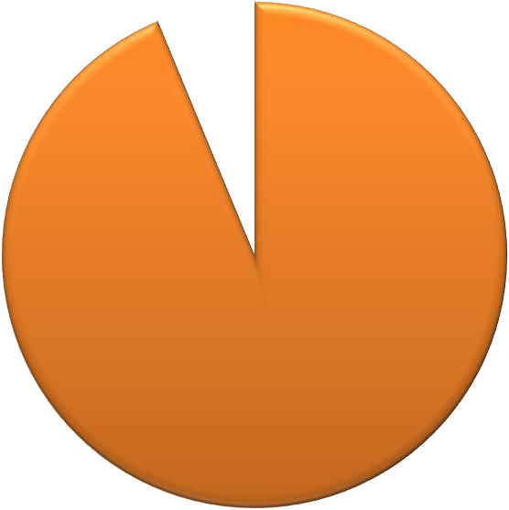

640

**640**

Estimate number of cattle sold

before Boko Haram Terrorism

Estimate number of cattle sold after Boko Haram Terrorism

**9,600**

9600

**Source: field work 2016**

## Discussion of Major Findings and Verification of Research Assumptions

From the relevant data presented and analysed above on the subject studied, the following deductions or findings were drawn:

* + 1. That most residents of Mubi-Metropolis are traders engaged in different types of commercial activities that cut across the borders of Nigeria into Cameroon, Niger and Chad. This can be seen on table 4.8 above where over 43% of the respondents posited that trading is the major socio-economic activities of Mubi-Metropolis residents.
    2. That before the Boko Haram terrorism, the socio-economic activities in Mubi-Metropolis was very stable and prosperous. This can be seen on table 4.11 above where 98.7% of the respondent stated that before the Boko Haram terrorism, the socio-economic activities in Mubi-Metropolis was very stable and prosperous.
    3. The socio-economic consequences of Boko Haram terrorism on Mubi-Metropolis are really negative. In line with this, Fawole (2014:5) remarked that: ―some of the consequences [referring to the consequences of Boko Haram terrorism] include total loss of the means of livelihood, having to scavenge for food or waiting for infrequent and often insufficient food hand-outs from philanthropic bodies, living in unsanitary and unhygienic conditions and being exposed to epidemics, diseases and exposure to the elements (e.g., rain, harmattan cold, etc.) which may cause mass deaths because of non- existent or poor healthcare facilities‖.
    4. Lives and properties worth billions of naira were lost.
    5. The Boko Haram terrorism led to total loss of the means of livelihood and socio- economic capacity.
    6. The Boko Haram terrorism led to the devastation and total collapse of the socio- economic activities in Mubi-Metropolis and its environs.
    7. Commercial activities, agriculture, livestock, education, and other socio-economic sectors within the metropolis were really badly affected.
    8. Major infrastructural facilities such as telecom, electricity, banks, and major sources of water among others within the metropolis were damaged.
    9. The federal government responded by sending security forces supported by hunters and vigilantes. The hunters and vigilantes played key roles in the liberation of Mubi from the terrorist.
    10. The federal government‘s response to the capture of Mubi was not proactive; this is so because it took the government a month to send security forces to liberate Mubi.
    11. The socio-economic consequences of the Boko Haram terrorism in the area under study can really be mitigated through various ways which include; good governance, the provision of jobs, provision of quality education, and community participation at all levels of the society.

## Additional findings while conducting the Field Work

In the course of conducting the research certain findings were made which though are outside the scope of this research yet are salient:

1. The economy of Mubi is to a large extent integrated to the economy of many towns and villages in neighbouring Cameroon, Niger, and Chad. As stated by one of the informants

―Mubi is the hub of export and trans-border trade between Nigeria, Cameroon, and Chad, down to Democratic Republic of Congo‖ (Umar Dahiru Jungur, interview 2016).

Example of some of these towns and villages are: Garwa, Marwa, Ngaundere, Sahuda, Dumo, Gidar, Bukula and Mbaibum.

1. That prior to the Boko Haram terrorism in the North-East, there existed international arm bandits in towns and villages that shared borders with Cameroon, Niger and Chad. These gangs of armed bandits carried out arm robbery attacks on these villages and towns. Many of these bandits used Boko Haram terrorism as a disguise to carry out arm banditry, while some of them subsequently joined the Boko Haram terrorism. Thus, this implies that the North-Eastern region was already a fertile ground for the emergence of Boko Haram terrorism.
2. The study also observed that in many towns and villages leading to the area under study, there was complete absence of government. For example in Shafa (through tashan alade) Hawul and Garkida there was no functioning health care centre or any other basic amenities. The people and their communities looked so disconnected from the Nigerian state. No doubt this could make them prone to being brainwashed and recruited to fight against the government since they don‘t get any benefits from the government.
3. The study observed that government intervention was limited to the liberation of Mubi from the terrorist; government did nothing tangible to ameliorate the suffering of victims of Boko Haram terrorism in the area under study. There were no deliberate government policies or efforts to revamp the socio-economic activities of the area under study.
4. The internally displaced persons (IDPs) are not well catered for. The camp officials are really exploiting the IDPs to enrich themselves. All the IDPs who participated in the FGD attest to the fact that most of the aids sent to them hardly get to them; most of the times they are only fed once in a day.

Thus, these findings conform to assumption number of this study which states that **“**The Boko Haram Terrorism has negative impacts on socio-economic activities in Mubi-metropolis‖.

From the general findings and particular responses on table 4.12 and the responses from the interviewees and secondary sources used, the second assumption which says that ―The Boko Haram terrorism has no negative impacts on socio-economic activities in Mubi-metropolis‖ is hereby disproved while the findings uphold and conform to the the first assumption which says that **“**The Boko Haram Terrorism has negative impacts on socio-economic activities in Mubi- metropolis‖.

The theory adopted also supported the study‘s objectives especially the major assumption which stated that ―Boko Haram terrorism has negative impacts on socio-economic activities in Mubi- metropolis of Adamawa state‖.

## Contribution to Existing Knowledge

As stated earlier, fewer studies focused on establishing empirically the Socio-economic consequences of Boko Haram Terrorism in Mubi and North-Eastern Nigeria. The study did a Micro study of the consequences of Boko Haram terrorism on social and economic activities in Mubi-Metropolis of Adamawa state. Thus, the study contributed to existing knowledge on the subject matter particularly by quantifying the extent of the impacts of Boko Haram terrorism on Mubi-Metropolis.

The study also contributed the terms ―Hybrid terrorist/insurgents‖ should be used in designating terrorist/insurgent groups in order to take care of their changing characteristics.

## CHAPTER FIVE

**Summary, Conclusion and Recommendations**

## Summary

This study assessed the socio-economic consequences of Boko Haram terrorism in Mubi- Metropolis of Adamawa State.

Terrorism in Nigeria predates the birth of the country; the British colonists used state terrorism to conquer hitherto independent nations within the territory called Nigeria today. Some few years after independence the country was engulfed in many internal crises some of which include Tiv riots in 1962, post-election violence 1964-65, the Nigerian Civil War among others. In 1980s there was the Maitatsine saga and most recently the country is faced with the Boko Haram terrorism in the North-Eastern region.

The Boko Haram terrorism has destroyed whole communities, wiped out many families, rendered large number of people jobless, many people became internally displaced or refugees in neighbouring countries. In short, the negative consequences of the Boko Haram terrorism on Mubi, the entire North-Eastern region and Nigeria at large cannot be readily measured.

Chapter one covered the introductory part. The chapter succinctly stated the statement of research problem, research questions, research objectives, research propositions/hypotheses, significance of the study, scope and limitations of the study, and plan of work.

Chapter two reviewed relevant literature on the subject matter of the study, the review dwelt on distinguishing between terrorism and terrorism, characteristics of terrorism, types of terrorism,

global dynamics of terrorism, causes of terrorism, and gaps in the literature. The chapter further discussed a relevant theory for the study and its applicability.

Chapter three gave a historical background of terrorism in Nigeria, terrorism in North Eastern Nigeria, the origin of Boko Haram, historical background of Mubi, and Boko Haram attacks in Mubi**.** Furthermore, the chapter discussed the research methodology; it gave details on how the research was conducted, and it discussed in details the primary and secondary sources of data that were used in the study.

In chapter four, the data collected were presented and analysed; respondents views were presented and analysed using simple percentages and frequency tabulation. Secondary sources were also used.

Chapter five summarised the research, made a conclusion and gave some recommendations.

## Conclusion

In conclusion, Boko Haram which started as a peaceful religious sect metamorphosed into a violent terrorist group. The terrorist group has wrecked havoc on various villages and towns particularly in the North-Eastern region.

It is obvious that the socio-economic consequences of the Boko Haram terrorism on Mubi- Metropolis and its environs are hugely negative. The Boko Haram terrorism broke whole complex and rich interconnected socio-economic activities; people who were hitherto employed lost their jobs and livelihood means, whole communities destroyed; commercial activities, agriculture, livestock, education, major infrastructural facilities such as telecom, electricity, banks, and major sources of water among others were damaged.

Furthermore, families lost their bread winners, many children orphaned and a large number of survivors are living as internally displaced persons or refugees in neighbouring countries, schools and other academic institutions alike pillaged. Similarly, government not just of Mubi local area but also Adamawa state and the North Eastern region lost huge revenues and other stream of incomes. Because of the integrative nature of socio-economic activities of Mubi with Cameroon, Niger and Chad, the negative impacts of Boko Haram terrorism cut across borders into these neighbouring countries.

Indeed, the Boko Haram terrorism has had and will for some time to come have adverse socio- economic consequences on Mubi, the entire North-Eastern region, particularly Borno, Yobe and Adamawa states and Nigeria as a country at large.

## Recommendations

The Boko Haram terrorism has really destabilized hitherto peaceful and prosperous socio- economic activities in Mubi, the North-Eastern states of Borno, Yobe and Adamawa states. Thus, the study makes the following recommendations:

* + 1. The federal, state and local governments must live up to their main responsibilities of good governance, provision of jobs, provision of quality education, and to ensure that citizens at various levels of the society are carried along in government policies and programmes.
    2. The federal government must as a matter of urgency revamp socio-economic activities in Mubi and the entire North-East.
    3. The federal, state and local governments should restore lost socio-economic capacity of the internally displaced persons and other victims of Boko Haram terrorism by training them and engaging them in meaningful programmes.
    4. Government should establish programmes that promote patriotism, unity and the development of human capacity of all citizens in Nigeria particularly the youths.
    5. The federal government in collaboration with other stakeholders should re-build destroyed communities.
    6. Government should make it mandatory for religious preachers to obtain clearance and preaching certificates before preaching anywhere in the country.
    7. Political extremism, violence and thuggery must be discouraged at all cost and at all levels of the society.
    8. The security agencies must be strengthened to meet up with modern security challenges especially in surveillance, intelligence and data gathering.
    9. There is the need to establish a National Guard; the National Guard should handle sophisticated internal security issues.
    10. More attention should be given to community policing, particularly using vigilantes at all community levels.
    11. The federal government should establish border patrol teams; these teams should comprise all the security agencies in the country.
    12. There must be cooperation and coordination between the Nigerian security forces and those of the neighbouring countries in combating trans-border crimes and terrorism.

## References

Adebayo, A.A. (2004) *Geographical Synthensis of Mubi Region,* 1st ed. Yola. Paraclete Publishers, Nigeria.

Adenrele, A. R. (2012). Boko Haram insurgency in Nigeria as a symptom of poverty and political alienation. *IOSR Journal Of Humanities And Social Science* 3(5), 21-26 *(JHSS)* Retrieved from [*www.Iosrjournals.Org*](http://www.iosrjournals.org/)

Adesina, J. O. (1997). *Methods of Data Collection: Questionnaire Design*. Paper prepared for a Research Training Workshop (Damina) organised by the Centre for Research and Documentation (CRD), Kano.

Allegro, J. M. (1972). *The Chosen People: A Study of Jewish History from the Time of the Exile until the Revolt of the Bar Kocheba, Sixth Century B.C to Second Century A.D.,* Garden City, NY: Doubleday.

Andrews, J., Iroegbu, S., Somorin, Z., & Okolie, A. (2014). Nigeria, Cameroon cooperation boost war against Boko Haram. *ThisDay,* 18 May, 19(6963), 1&5.

Arab Convention for the Suppression of Terrorism (1998). *Arab Convention on Terrorism*. Cairo: Council of Arab Ministers of the Interior and the Council of Arab Ministers of Justice.

Aristotle. (n.d.). *BrainyQuote.com.* Retrieved from BrainyQuote.com

:http/[/www](http://www.brainyquote.com/quotes/quotes/a/aristotle490507).[brainyquote.com/quotes/quotes/a/aristotle490507.](http://www.brainyquote.com/quotes/quotes/a/aristotle490507)

BBC, (2008). Nigerian Attack Closes Oilfield. *BBC News Online*. Retrieved from [http://news.bbc.co.uk/2/hi/africa/7463288.stm.](http://news.bbc.co.uk/2/hi/africa/7463288.stm)

Ben-Yehuda, N. (1998). Where Masada‘s Defenders Fell. *Biblical Archaeology Review 24*(6), 32–39.

Berelson, B. (1952). *Content Analysis in Communication Research.* New York: Free Press. Bjorgo, T. (1995). Extreme Nationalism and Violent Discourses in Scandinavia: The Resistance,

Traitors and Foreign Invaders, in T. Bjorgo (ed.) *Terror from the Extreme Right,* London: Frank Cass, 182-220.

Bryman, A. (2008). *Social Research Methods.* Oxford. Oxford University Press.

Burke, E. (1969). *Reflections on the Revolution in France, (1790),* ed. C. C. O‘Brien.

Harmondsworth: Penguin.

Chaliand, G. and Blin, A. (Ed). (2007). *The History of Terrorism from Antiquity to Al Qaeda.*University of California Press,Berkeley and Los Angeles, California,University of California Press, Ltd.London, England. The Regents of the University of California.

Chinwokwu, E. C. (2013). Terrorism and the Dilemmas of Combating the Menace in Nigeria.

*International Journal of Humanities and Social Science,* 3(4), 265-272*.*

Chukwurah, D. C., Okechukwu, E. and Nmire, O. E. (2015). Implication of Boko Haram Terrorism on Northern Nigeria. *Mediterranean Journal of Social Sciences MCSER Publishing, Rome-Italy.* 6(3), 371-379. Doi:10.5901/mjss.2015.v6n3p371.

CJPME, (2007). Jewish Terrorism under the British Mandate. *Canadians for Justice and Peace in Middle East, Factsheet series*, no. 23. Retrieved from http//[www.](http://www/) cjpme.org

CNN, (2009). Nigerian Militants Claim Bomb on Major pipeline. *CNN*. Retrieved from <http://edition.cnn.com/2009/WORLD/africa/06/19/nigeria.militants.oil.pipeline/>

Crenshaw, M. (2011). *Explaining Terrorism Causes, processes and consequences*. Routledge.

Cronin, A. K. (2006). How al-Qaida Ends: The Decline and Demise of Terrorist Groups,

*international Security,* 31(1): 7-48.

Danjibo, N. D. (2009). *Islamic Fundamentalism and Sectarian Violence: The ‗Maitatsine‘ and*

*‗Boko Haram‘ Crises in Northern Nigeria, p.1-21*. Paper presented at the French Institute for Research in Africa (IFRA) Conference at Ahmadu Bello University Zaria, Nigeria, retrieved on August 13, 2015, from [http://www.ifranigeria.org/spip?article156.](http://www.ifranigeria.org/spip?article156)

Dauda, M. (2014) ―The Effect Of Boko Haram Crisis On Socioeconomic Activities In Yobe State, *The International Journal of Social Sciences and Humanities Invention.* 1 (4). 251- 257.

Differences between Terrorism and Insurgence: *terrorism-research.com*. Retrieved from <http://www.terrorismresearch.com/insurgency/>

Doug, S. (2007). Blood for Oil? Global Capital. Counter-Insurgency and the Dual Logic of American Energy Security in *The Review of International Studies*, 33(2 ), 245-264.

Durotoye, A. (2015). Economic Consequences and Management of Boko Haram Insurgency in Nigeria. *International Journal of Economics, Commerce and Management.* United Kingdom. Vol. III (6), June. p. 1247-1270. <http://ijecm.co.uk/>ISSN 2348 0386

Edward, G. (1974). *The History of the Decline and Fall of the Roman Empire*. New York: AMS Press.

Fawole, W. A. (2014, November). *The Political and Socio-Economic Consequences of Insurgency North-Eastern Nigeria: The Way Out of the Quagmire*. Lecture Delivered at the Nigerian Network on Security and Democratic Governance (NINSED), One-Day Roundtable Discourse on Insurgency in North-Eastern Nigeria, Organised by the National Defence

College, Nigeria, and Friedrich Ebert Stiftung, held at the Institute for Peace and Conflict Resolution (IPCR), Abuja.

Ford, F. L. (1985). *Political Murder*: *From Tyrannicide to Terrorism.* Cambridge, MA: Harvard University Press.

Fuller, G. E. (2002). The Future of Political Islam, *Foreign Affairs*, 81(2): 48-60. Georges, R. (1966). *Ancient Iraq*. Baltimore, MD: Penguin Books.

Gilbert, L. D. (2013). Revisiting ethno-nationalism in the Niger Delta of Nigeria: An interrogation of its achievements and prospects. *International Affairs and Global Strategy*, 16, 50-56.

Griffiths, M. (2003). *International Relations. Schools, currents, thinkers*. Bucharest, Ed. Ziua.

Hanson, S. (2007). MEND: The Niger Delta‘s Umbrella Militant Group. *Council on Foreign Relations*. Retrieved from [http://www.cfr.org/nigeria/mend-niger-deltas-umbrella-militant-](http://www.cfr.org/nigeria/mend-niger-deltas-umbrella-militant-group/p12920) [group/p12920](http://www.cfr.org/nigeria/mend-niger-deltas-umbrella-militant-group/p12920).

Harmon, C. C. (2000). *Terrorism Today*, London: Frank Cass.

Hoffman, B. (2006). *Inside Terrorism* (2nd ed.). New York: Columbia University Press, p. 43. Holsti, O. R. (1969). *Content Analysis for the Social Sciences and Humanities.* Reading, Mass.:

Addison-Wesley.

International Crisis Group (2014). Curbing violence in Nigeria (II): The Boko Haram insurgency. *ICG*.

International Crisis Group, (2015). Curbing violence in Nigeria (III): Revisiting the Niger Delta.

*ICG.*

Israel, G. D. (1992). *Sampling the Evidence of Extension Program Impact*. Program Evaluation and Organizational Development, IFAS, University of Florida.

Isyaku, A.(2013).Terrorism: A New Challenge to Nigeria`S Stability in the 21stCentury.

International Affairs and Global Strategy. Vol.12. [*www.iiste.org*](http://www.iiste.org/)

Jacob, S. (1988). *Jabotinsky and the Revisionist Movement 1925–1948*. Routledge.

Jerome, A. (n.d). Lessons From Colombia For Curtailing The Boko Haram Insurgency In Nigeria. *PRISM,* 5, (2), 95-105.

Joint Chiefs of Staff DOD (2008). *Department of Defense Dictionary of Military and Associated Terms*. Washington, D.C.: DOD.

Kerlinger, F. N. (1999). *Foundations of Behavioural Research (4th ed.*) Wadsworth Publishing.

Laqueur, W. (1987). *The Age of Terrorism* (2nd ed.). Boston: Little & Brown, p. 143. Laqueur, W. (2001). *A History of Terrorism.* New Brunswick, NJ: Transaction Publishers.

Lifton, R. J. (2000). *Destroying the World To Save It: Aum Shrinkyo, Apocalyptic Violence, and the New Global Terrorism,* New York: Henry Holt.

Lutz, B. J., and Lutz, J. M. (2008). *Global Terrorism,* (2nd ed). Routledge.

Matusitz, J. (2008). Similarities between Terrorist Networks in Antiquity and Present-Day Cyberterrorist Networks. *Trends in Organized Crime, 11*(2), 183–199.

May, T. (1993). *Social Research: Issues, Methods and Process.* Buckingham.Open University Press.

Mbachu, O. (2005). *Social Science Research Methods: For Policy and Strategic Studies.*

Kaduna: Medusa Academic Publishers.

MEMO, (2013). Notorious massacres of Palestinians between 1937 & 1948.*Middle East Monitor, FACT SHEET*. Retrieved from [http://www.](http://www/) middleeastmonitor.com

Mohammed, I. Z. (2006). Sampling in Social Science Research. In Adamu, Y. M, Mohammed,

H. and Dandago, K. I. (Ed). *Readings In Social Science Research.* Adamu Joji Publishers, Kano, pp. 121-137

Murphy, C. N. (2005). *Global Institutions, Marginalization, and Development*. London. New York: Routledge.

Mubi North Local Government and Education Authority, Adamawa State, Pupils Enrolment and Conditions (2014).

National Population Commission (NPC), (2006). Population Census Data Adamawa State, Nigeria. Federal Republic of Nigeria Official Gazette, National and State Provisional Totals Census. Printed and Published in 2007 by the Federal Government Printer, Lagos, Nigeria. 94 (21). 175 – 198.

National Population Commission, (2006). *Population and Housing Census of the Federal Republic of Nigeria.*

Navari, C. (1995). ―David Mitrany and International Functionalism,‖ in *Thinkers of the Twenty Years. Crisis: Inter-War Idealism Reassessed,* eds. David Long and Peter Wilson Oxford: Clarendon Press.

Neff, D. (2006). Hamas: A Pale Image of the Jewish Irgun And Lehi Gangs. *Washington Report on Middle East Affairs—WRMEA , Special Report, May/June,* 14-15. Retrieved from http//[www.wrmea.org](http://www.wrmea.org/)

Neuman, L. W. (2004). *Basics of Social Science: Qualitative and Quantitative Approaches,*

Boston: Pearson.

Nwagwu, E. J. (2014). Unemployment And Poverty In Nigeria: A Link To National Insecurity. *Global Journal of Politics and Law Research.* 2(1), 19-35. European Centre for Research Training and Development UK available at [www.ea-journals.org](http://www.ea-journals.org/).

Nwana, O. (1998). *Introduction to Educational Research.* Ibadan: Heinemann Educational Books Limited.

Obasi, N. I. (1999). *Research Methodology in Political Science.* Academic Publishing Company, Enugu, Nigeria.

Ogunrotifa, B. A. (2013). Class Theory of Terrorism: A Case Study of Boko Haram in Nigeria. *Research on Humanities and Social Sciences,* (Online). 3(1), 27-59. Retrieved from: [www.](http://www/) iiste.org

Okpaga, A., Chijioke, U. S., and Innocent E. O. (2012). Activities of Boko Haram and Insecurity Question in Nigeria. *Arabian Journal of Business and Management Review (OMAN Chapter).*1(9),77-99.

Osuala, E. C. (1982). *Introduction to Research Methodology.* Benin-city. African Fep Publishers Limited.

Ovaga, O. H. (n.d.). The Socio-Economic Implications of Boko-Haram Activities in Northern Nigeria. *Review of Public Administration and Management.* 1(2). 19-37. Retrieved from <http://www.omicsonline.com/open-access/review-public-adminstration-management.php>

Padelford, N. (1976) *The Dynamics Of International Politics*: New York: Macmillan Publishing Company.

Peter, Y., Gadiga, B. L., and Mshelia, A. D. (2015).Landuse/landcover change detection of Mubi Metropolis, Adamawa State, Nigeria.*Sky Journal of Soil Science and Environmental Management*. 4(6), 70 – 78.Retrieved from <http://www.skyjournals.org/SJSSEM>

Peterside, B. Z. (2014). A Threat to National Security: The Case of Boko Haram in Nigeria. *Academic Journal of Interdisciplinary Studies, MCSER Publishing, Rome-Italy, 3*(4), 283- 290. Doi:10.5901/ajis.2014.v3n4p283.

Rapoport, D. C. (1977, November 26). The Government Is Up in the Air over Combating Terrorism. *National Journal, 9*, 1853–1856.

Reich, W. (1998). Understanding Terrorist Behaviour: The Limits and Opportunities of Psychological Inquiry, in W. Reich (ed) *Origins of Terrorism: Psychologies, Ideologies, Theologies, States of Mind,* Washington, DC: Woodrow Wilson Centre Press, 261-79.

Rogers, P. (2008). Terrorism. In: Williams, D. P. (Ed). *Security Studies: An Introduction*.

Routledge Taylor & Francis group, Milton Park, Abingdon, Oxon, pp. 171-184.

Roland, P. (2001). Human Security: Paradigm Shift or Hot Air in *International security*, 26(2).

77-87.

Rosamond, B. (2000). *Theories of European Integration*. Hampshire: Palgrave.

Rugg, G. and Petre, M. (2007). *A Gentle Guide to Research Methods.* England: McGraw-Hill Education, Open University Press.

[Sachar,](https://en.wikipedia.org/wiki/Howard_Sachar) H. M. (2000). *A History of Israel: From the Rise of Zionism to Our Time (2nd ed)*.

New York: Knopf.

Schmid, A. and Jongman, A. (1988). *Political Terrorism: A New Guide to Actors, Authors, Concepts, Data Bases, Theories, and Literature*. Amsterdam: North Holland, Transaction Books.

Schmid, A. P. (2000). Terrorism and the Use of Weapons of Mass Destruction: From Where the Risk? In M. Taylor and J. Horgan (Eds.) *The Future of Terrorism,* London: Frank Cass, 106- 32.

Selltiz, C. et.al, (1976). *Research Methods in Social Relations,* Third Edition, USA: Holt, Rinehart and Winston, Inc.

Shirer, W. L. (1959). *The Rise and Fall of the Third Reich.* New York: MJF Books.

Smith, A. (2015). MEMO Profile: Yasser Arafat (24 August 1929 - 11 November 2004), *Middle Eastern Monitor*. Retrieved from https:/[/www](http://www.middleeastmonitor.com/resources/profiles/20575-memo-profile-yasser-arafat-).[middleeastmonitor.com/resources/profiles/20575-memo-profile-yasser-arafat-](http://www.middleeastmonitor.com/resources/profiles/20575-memo-profile-yasser-arafat-) 24-august-1929-11-november-2004

Tan, A. T. H. (2006). *The Politics of Terrorism: A Survey.* London: Routledge.

Tan, S. (2008). Oil Trades Near $120 After Rising to Record on Demand Outlook. *Bloomberg*. Retrieved from

[http://www.bloomberg.com/apps/news?pid=newsarchive&sid=aNXVIrK.7.Y4&refer=home.](http://www.bloomberg.com/apps/news?pid=newsarchive&sid=aNXVIrK.7.Y4&refer=home)

*Tell, August 10, 2009, p. 34.*

Terrorism, prezi.com. Retrieved from [https://prezi.com/xzlkfyvbcqza/1-terror-comes-from-the-](https://prezi.com/xzlkfyvbcqza/1-terror-comes-from-the-latin-word-terrere-and-it-means-f/) [latin-word-terrere-and-it-means-f/](https://prezi.com/xzlkfyvbcqza/1-terror-comes-from-the-latin-word-terrere-and-it-means-f/)

The Economist, (2008). Risky toughness, The army‘s tough approach to Delta militants could end up uniting them. *The Economist.* Retrieved from [http://www.economist.com/node/12267373.](http://www.economist.com/node/12267373)

*The Nigerian Terrorism (Prevention) Act 2011.*

The Street Journal, (2012). *Faces of The Bad Boys Who Introduced Terrorism to Nigeria*.

Retrieved on August 13, 2015, from [http://www.thestreetjournal.org](http://www.thestreetjournal.org/).

Tochukwu, A. (2013) ―Boko Haram And Its Economic Consequences‖. Retrieved June 17, 2015 from<http://www.fairobserver.com/region/africa/boko-haram-and-its-economic-> consequences/.

Tucker, J. B. (2006). *Wars of Nerves: Chemical Warfare from World War I to Al-Qaeda,* New York: Pantheon Books.

Ugwu, O. L. (2015). Boko Haram and Insecurity in Nigeria: The Quest for a Permanent Solution. *An International Multidisciplinary Journal, Ethiopia, International Association of African Researchers and Reviewers. 9(1), 36.* 47-61. DOI: <http://dx.doi.org/10.4314/afrrev.v9i1.5>

UNDP (1994). *New Dimensions of Human Security in Human Security Development Report,*

Oxford University Press, New York.22-25

University of Bradford, (2015). *Writing Your PG Research Project Proposal.* Academic Skills Advice service. Retrieved from http/[/www](http://www.brad.ac.uk/academic-skills/).[brad.ac.uk/academic-skills/](http://www.brad.ac.uk/academic-skills/)

US Department of State (2001) *Annual Country Reports on Terrorism* (Washington, DC: US Government Printing Office).

Wilkinson, P. (2003). Why Modern Terrorism? Differentiating Types and Distinguishing Ideological Motivations in C. W. Kegley, Jr (ed.) *The New Global Terrorism: Characteristics, Causes, Controls.* Upper Saddle River, NJ: Prentice Hall, 106-38.

Wilkinson, P. (2011). *Terrorism versus Democracy: The liberal state reponse (*3rd ed.)*.*

Routledge Taylor & Francis group, Milton Park, Abingdon, Oxon.

Yamane, T. (1967). *Statistics: An Introductory Analysis*, 2nd Ed., New York: Harper and Row.

**APPENDIX A QUESTIONNAIRE FOR RESPONDENTS**

Dear Respondent,

Department of Political and International Relations

Faculty of Arts and Social Sciences Ahmadu Bello University Zaria School Postgraduate

# QUESTIONNAIRE ADMINISTRATION ON THE ASSESSMENT OF THE SOCIO-ECONOMIC CONSEQUENCES OF THE BOKO HARAM TERRORISM IN MUBI-METROPOLIS OF ADAMAWA STATE: 2011-2014.

I am Sulaiman Saidu Abubakar, an M.Sc. Political Science student with the registration number P13-SSPS-8281 in the Department of Political Science and International Relations, ABU, Zaria. Presently, I am carrying out a research on ―the Assessment of the Socio-Economic Consequences of the Boko Haram Terrorism in Mubi-Metropolis of Adamawa State: 2011-2014.‖

I would be grateful if you could fill and return the attached questionnaire. Please be assured that all information provided by you would be used purely for academic purposes and shall be treated with absolute confidentiality.

Please note that, you are free to opt out of responding to the questionnaire at any time of the research.

Thank you for your anticipated cooperation. Yours faithfully,

Sulaiman Saidu Abubakar

# SECTION A

**Basic Demographic Data (Please Tick Where Appropriate)**

1. Age

a. 18 – 25 [ ]

b. 26 – 35 [ ]

c. 36 – 45 [ ]

d. 46 – 55 [ ]

e. 56 – 59 [ ]

1. Gender:
   1. Male [ ]
   2. Female [ ]
2. Marital Status:
   1. Married [ ]
   2. Single [ ]
3. Educational Background
   1. Senior Secondary School Certificate [ ]
   2. National Diploma [ ]
   3. Higher National Diploma [ ]
   4. First Degree [ ]
   5. Master‘s Degree [ ]
   6. PhD
   7. None
   8. Others (please specify) ……………………………………………
4. What is your occupation?
   1. Farmer [ ]
   2. Trader [ ]
   3. Entrepreneur (Artisan, saloon owner etc.) [ ]
   4. School teacher [ ]
   5. Student [ ]
   6. Public Sector Employee [ ]

g. Others (specify] ……………………………………………

# SECTION B

1. Are you a resident of Mubi- Metropolis? Yes [ ] No [ ]

If yes, for how long have you been residing in Mubi- Metropolis?

………………………………………………………………………………………

………………………………………………………………………………………

1. What socio-economic activities do most residents of Mubi-Metropolis engage in?

Farming [ ] Trading [ ] Entrepreneurship [ ] Civil Service [ ]

Others (specify) explain below:

…………………………………………………………………………………

…………………………………………………………………………………

…………………………………………………………………………………

1. How was your business before the Boko Haram terrorism?

…………………………………………………………………………………

…………………………………………………………………………………

………………………………………………………………………………..

1. How has the Boko Haram terrorism affected your business?

…………………………………………………………………………………

…………………………………………………………………………………

………………………………………………………………………………..

1. How stable and prosperous was the socio-economic activities in Mubi-

Metropolis before the Boko Haram terrorism?

Stable [ ] Very Stable [ ] Not stable [ ] You may explain further:

…………………………………………………………………………………

…………………………………………………………………………………

…………………………………………………………………………………

…………………………………………………………………………………

…………………..

1. Were you in Mubi during the Boko Haram attacks, particularly when they seized it?
   1. Yes [ ]
   2. No [ ]
2. If yes, in your opinion how has these attacks affected the socio-economic activities in Mubi?

…………………………………………………………………………………

…………………………………………………………………………………

…………………………………………………………………………………

…………………………………………………………………………………

…………………………………………………………………………………

………………………..

1. Were you affected?
   1. Yes [ ]
   2. No [ ]

If yes how?

…………………………………………………………………………………

…………………………………………………………………………………

…………………………………………………………………………………

…………………………………………………………………………………

…………………………………………………………………………………

…………………………

1. What is the impact of the Boko Haram terrorism on the socio-economic activities of Mubi-Metropolis?

…………………………………………………………………………………

…………………………………………………………………………………

…………………………………………………………………………………

…………………………………………………………………………………

…………………………………………………………………………………

…………………………

1. Did the Boko Haram terrorism destroy any major infrastructural facility (ies), such as roads, electricity, telecom, etc. in Mubi-Metropolis? Yes [ ] No [ ]

If yes, which of these facilities were destroyed?

…………………………………………………………………………………

…………………………………………………………………………………

…………………………………………………………………………………

…………………………………………………………………………………

……………………

1. Were you affected by such destruction? Yes [ ] No [ ] If yes how

…………………………………………………………………………………

…………………………………………………………………………………

…………………………………………………………………………………

………………

1. How has the destruction of such facility (ies) affected the socio-economic activities in Mubi-Metropolis?

…………………………………………………………………………………

…………………………………………………………………………………

…………………………………………………………………………………

…………………………………………………………………………………

……………………

# SECTION C

1. What was the government‘s response to the Boko Haram terrorism in Mubi Metropolis?

…………………………………………………………………………………………

…………………………………………………………………………………………

…………………………………………………………………………………………

…………………………………………………………………………………………

……………………

1. In your opinion, do you think the government responded appropriately?

Yes [ ] No [ ] Not sure [ ] If yes, explain below

…………………………………………………………………………………………

…………………………………………………………………………………………

…………………………………………………………………………………………

…………………………………………………………………………………………

…………………………………………………………………………………………

…………………………

1. Did the government‘s response improve on the socio-economic activities in Mubi Metropolis?

…………………………………………………………………………………………

…………………………………………………………………………………………

…………………………………………………………………………………………

…………………………………………………………………………………………

……………………

1. How do you rate the government‘s response? Low [ ] Average [ ] High [ ] Not sure [ ] You may explain further:

…………………………………………………………………………………………

…………………………………………………………………………………………

…………………………………………………………………………………………

…………………………………………………………………………………………

…………………………………………………………………………………………

…………………………

# SECTION D

1. Do you think that the impact of the Boko Haram terrorism on the socio-economic activities of Mubi-Metropolis can be effectively reduced? Yes [ ] No [ ] Not sure [ ]

If yes how? You may explain below:

…………………………………………………………………………………………

…………………………………………………………………………………………

…………………………………………………………………………………………

…………………………………………………………………………………………

…………………………………………………………………………………………

………………………..

1. Do you think there is a way forward? Yes [ ] No [ ] Not sure [ ]

If yes, what is that way?

…………………………………………………………………………………………

…………………………………………………………………………………………

…………………………………………………………………………………………

…………………………………………………………………………………………

…………………..

1. Do you have any other comments/observation to assist this study?

…………………………………………………………………………………………

…………………………………………………………………………………………

…………………………………………………………………………………………

…………………………………………………………………………………………

……………………

## APPENDIX B

## Data Analysis and Presentation

## Table 4.1 Administration and Retrieval of Questionnaires

|  |  |  |  |  |  |
| --- | --- | --- | --- | --- | --- |
| **S/N** | **Wards in Mubi- Metropolis** | **Questionnaires Administered** | **Questionnaires Retrieved** | **Valid Questionnaires** | **Invalid Questionnaires** |
| **1** | Sabon Layi | 90 | 87 | 85 | 2 |
| **2** | Nasarawo | 86 | 82 | 81 | 1 |
| **3** | Lokuwa | 71 | 67 | 65 | 2 |
| **4** | Kolere | 61 | 58 | 57 | 1 |
| **5** | Yelwa | 51 | 48 | 47 | 1 |
| **6** | Gude | 56 | 53 | 51 | 2 |
|  | Total | 415 | 395 | 386 | 9 |

**Source:** Field Work, 2016

## Basic Demographic Data

**Table 4.2: Age Bracket of the Respondents**

|  |  |  |
| --- | --- | --- |
| **Age** | **Frequency** | **Percentage** |
| **18–25** | 54 | 14.0 |
| **26–35** | 85 | 22.0 |
| **36–45** | 132 | 34.2 |
| **46-55** | 88 | 22.8 |
| **56-59** | 27 | 7.0 |
| **Total** | 386 | 100 |

**Source:** Field Work, 2016

## Table 4.3: Distribution of Respondents’ Gender

|  |  |  |
| --- | --- | --- |
| **Gender** | **Frequency** | **Percentage** |
| **Male** | 299 | 77.4 |
| **Female** | 87 | 23 |
| **Total** | 386 | 100 |

**Source:** Field Work, 2016

## Table 4.4: Distribution of Respondents by Marital Status

|  |  |  |
| --- | --- | --- |
| **Marital status** | **Frequency** | **Percentage** |
| **Married** | 291 | 75.3 |
| **Single** | 95 | 25 |
| **Total** | 386 | 100 |

**Source:** Field Work, 2016

## Table 4.5: Educational Background of the Respondents

|  |  |  |
| --- | --- | --- |
| **Educational Background** | **Frequency** | **Percentage** |
| **SSCE** | 27 | 6.9 |
| **ND** | 151 | 39 |
| **HND** | 98 | 25.3 |
| **First Degree** | 55 | 14.2 |
| **Master’s Degree** | 20 | 5.2 |
| **PhD** | 17 | 4.4 |
| **None** | 18 | 5 |
| **Total** | 386 | 100 |

**Source:** Field Work, 2016

## Table 4.6: Distribution of Respondents by Occupation

|  |  |  |
| --- | --- | --- |
| **Occupation** | **Frequency** | **Percentage** |
| **Farmer** | 78 | 20.2 |
| **Trader** | 134 | 34.7 |
| **Entrepreneur** | 54 | 13.9 |
| **Civil servant** | 40 | 11 |
| **Student** | 60 | 15.5 |
| **Others** | 20 | 5 |
| **Total** | 386 | 100 |

**Source:** Field Work, 2016

## Table 4.7: Residents of Mubi–Metropolis

|  |  |  |
| --- | --- | --- |
| **Residents of Mubi–Metropolis** | **Frequency** | **Percentage** |
| **Residents** | 326 | 84.4 |
| **Students** | 60 | 15.5 |
| **Total** | 386 | 100 |

**Source:** Field Work, 2016

## Table 4.8: Socio–Economic Activities of most residents of Mubi–Metropolis

|  |  |  |
| --- | --- | --- |
| **Socio–Economic Activities of People In Mubi–Metropolis** | **Frequency** | **Percentage** |
| **Farming** | 92 | 24 |
| **Trading** | 167 | 43.2 |
| **Entrepreneurship** | 89 | 23.0 |
| **Civil service** | 27 | 7 |
| **All of the above** | 11 | 3 |
| **Total** | 386 | 100 |

**Source:** Field Work, 2016

## Table 4.9: Business Activities before Boko Haram Terrorism

|  |  |  |
| --- | --- | --- |
| **Business before Boko Haram Terrorism** | **Frequency** | **Percentage** |
| **Very good** | 267 | 69.1 |
| **Good** | 117 | 30.3 |
| **Bad** | 2 | 0.5 |
| **Total** | 386 | 100 |

**Source:** Field Work, 2016

## Table 4.10: Business Activities after Boko Haram Terrorism

|  |  |  |
| --- | --- | --- |
| **Business after Boko Haram Terrorism** | **Frequency** | **Percentage** |
| **Good** | 3 | 0.8 |
| **Very bad** | 284 | 73.6 |
| **Bad** | 99 | 25.6 |
| **Total** | 386 | 100 |

**Source:** Field Work, 2016

## Table 4.11: Stability and Prosperity of Socio-Economic Activities before the Boko Haram Terrorism

|  |  |  |
| --- | --- | --- |
| **Socio-economic activities before Boko Haram Terrorism** | **Frequency** | **percentage** |
| **Very stable** | 221 | 57.2 |
| **Stable** | 160 | 41.5 |
| **Not Sure** | 5 | 1.2 |
| **Total** | 386 | 100 |

**Source:** Field Work, 2016

## Table 4.12: Impacts of Boko Haram Terrorism on Socio–Economic Activities in Mubi

|  |  |  |
| --- | --- | --- |
| **Impact of Boko Haram Terrorism on Socio–Economic Activities**  **in Mubi** | **Frequency** | **Percentage** |
| **Negative** | 354 | 91.7 |
| **Devastating** | 15 | 3.9 |
| **Total collapse** | 17 | 4.4 |
| **Total** | 386 | 100 |

**Source:** Field Work, 2016

## Table 4.13: Government’s Response to Boko Haram Terrorism in Mubi Metropolis

|  |  |  |
| --- | --- | --- |
| **Government response to the Boko Haram Terrorism in Mubi**  **Metropolis** | **Frequency** | **Percentage** |
| **High** | 80 | 20.7 |
| **Average** | 252 | 65.3 |
| **Low** | 42 | 10.9 |
| **Not sure** | 12 | 3.1 |
| **Total** | 386 | 100 |

**Source:** Field Work, 2016

## Table 4.14: Ways of mitigating the socio-economic impacts of Boko Haram Terrorism on Mubi Metropolis

|  |  |  |
| --- | --- | --- |
| **Ways of mitigating the impacts of Boko Haram Terrorism** o**n**  **Mubi Metropolis** | **Frequency** | **Percentage** |
| **Provision of jobs** | 195 | 50.5 |
| **Quality education** | 44 | 11.4 |
| **Good governance** | 118 | 30.6 |
| **Community participation** | 29 | 7.5 |
| **Total** | 386 | 100 |

**Source:** Field Work, 2016

## Table 4.15: Pupils Enrollment before Boko Haram Terrorism in Wuro-Gude Primary and Nursery School in Kolere Ward Of Mubi at early October 2014

|  |  |  |  |  |
| --- | --- | --- | --- | --- |
| **S/N** | **Pupils Enrollment** | **Male** | **Female** | **Total** |
| **1** | Class One | 51 | 29 | 80 |
| **2** | Class Two | 53 | 52 | 105 |
| **3** | Class Three | 78 | 50 | 128 |
| **4** | Class Four | 74 | 76 | 150 |
| **5** | Class Five | 102 | 82 | 184 |
| **6** | Class Six | 78 | 49 | 127 |
| **7** | Nursery | 30 | 22 | 52 |
| **8** | Total | 466 | 360 | 826 |

**Source: field work 2016**

## Table 4.16: Pupils Enrollment after Boko Haram Terrorism in Wuro-Gude Primary and Nursery School in Kolere Ward of Mubi at December 2015

|  |  |  |  |  |
| --- | --- | --- | --- | --- |
| **S/N** | **Pupils Enrollment** | **Male** | **Female** | **Total** |
| **1** | Class One | 22 | 30 | 52 |
| **2** | Class Two | 32 | 21 | 53 |
| **3** | Class Three | 20 | 30 | 50 |
| **4** | Class Four | 25 | 20 | 45 |
| **5** | Class Five | 11 | 13 | 24 |
| **6** | Class Six | 33 | 30 | 63 |
| **7** | Nursery | 26 | 25 | 51 |
| **8** | Total | 169 | 169 | 338 |

**Source: field work 2016**

## APPENDIX C

**INTERVIEW QUESTIONS FOR RESPONDENTS IN MUBI**

Department of Political and International Relations Faculty of Arts and Social Sciences

Ahmadu Bello University Zaria School Postgraduate

Dear Respondent,

**INTERVIEW ON THE ASSESSMENT OF THE SOCIO-ECONOMIC CONSEQUENCES OF THE BOKO HARAM TERRORISM IN MUBI-METROPOLIS OF ADAMAWA STATE: 2011-2014.**

I am Sulaiman Saidu Abubakar, an M.Sc. Political Science student with the registration number P13-SSPS-8281 in the Department of Political Science and International Relations, ABU, Zaria. Presently, I am carrying out a research on ―the Assessment of the Socio-Economic Consequences of the Boko Haram Terrorism in Mubi-Metropolis of Adamawa State: 2011-2014.‖

I humbly request an interview with you as regards my research topic. Please be assured that all information provided by you would be used purely for academic purposes and shall be treated with absolute confidentiality.

Please find attached a sample of the questions intended to be asked in the course of the interview. Note that, you are free to opt out of the interview session at any time of the research.

Thank you for your anticipated cooperation.

Yours faithfully,

Sulaiman Saidu Abubakar

**SECTION A:**

RESPONDENT‘S DATA

1. Name ……………………………………………………………………………….

2. Occupation …………………………………………………………………………

3. Position …………………………………………......................................................

4. Organisation ………………………………………………………………………...

**SECTION B**

* + 1. Are you a resident of Mubi-Metropolis?

If yes, for how long have you been residing in Mubi-Metropolis?

…………………………………………………………………………………………

…………………………………………………………………………………………

* + 1. What socio-economic activities do most residents of Mubi-Metropolis engage in?

…………………………………………………………………………………………

…………………………………………………………………………………………

* + 1. How was your business before the Boko Haram terrorism?

…………………………………………………………………………………………

…………………………………………………………………………………………

* + 1. How has the Boko Haram terrorism affected your business?

…………………………………………………………………………………………

…………………………………………………………………………………………

* + 1. How stable and prosperous was the socio-economic activities in Mubi-Metropolis before the Boko Haram terrorism?

…………………………………………………………………………………………

…………………………………………………………………………………………

* + 1. In your opinion how has the Boko Haram terrorism affected the socio-economic activities in Mubi-Metropolis?

…………………………………………………………………………………………

…………………………………………………………………………………………

* + 1. What is the impact of the Boko Haram terrorism on the socio-economic activities of Mubi-Metropolis?

…………………………………………………………………………………………

…………………………………………………………………………………………

…………………………………………………………………………………………

* + 1. Did the Boko Haram terrorism destroy any major infrastructural facility (ies), such as roads, electricity, telecom, etc. in Mubi-Metropolis?

If yes, which of these facilities were destroyed?

…………………………………………………………………………………………

…………………………………………………………………………………………

* + 1. Were you affected by such destruction? If yes how

…………………………………………………………………………………………

…………………………………………………………………………………………

* + 1. How has the destruction of such facility (ies) affected the socio-economic activities in Mubi-Metropolis?

…………………………………………………………………………………………

…………………………………………………………………………………………

…………………………………………………………………………………………

**SECTION C**

* + 1. What was the government‘s response to the Boko Haram terrorism in Mubi- Metropolis?

…………………………………………………………………………………………

…………………………………………………………………………………………

…………………………………………………………………………………………

* + 1. In your opinion, do you think the government responded appropriately?

If yes, how

…………………………………………………………………………………………

…………………………………………………………………………………………

…………………………………………………………………………………………

* + 1. Did the government‘s response improve on the socio-economic activities in Mubi Metropolis?

…………………………………………………………………………………………

…………………………………………………………………………………………

…………………………………………………………………………………………

* + 1. How do you rate the government‘s response?

…………………………………………………………………………………………

…………………………………………………………………………………………

…………………………………………………………………………………………

**SECTION D**

* + 1. Do you think that the impact of the Boko Haram terrorism on the socio-economic activities of Mubi-Metropolis can be effectively reduced?

If yes how?

…………………………………………………………………………………………

…………………………………………………………………………………………

…………………………………………………………………………………………

* + 1. Do you think there is a way forward? If yes, what is that way?

…………………………………………………………………………………………

…………………………………………………………………………………………

…………………………………………………………………………………………

* + 1. Do you have any other comments/observation to assist this study?

…………………………………………………………………………………………

…………………………………………………………………………………………

…………………………………………………………………………………………

**NGOs AND IDP CAMP OFFICIALS INTERVIEW QUESTIONS**

Department of Political and International Relations

Faculty of Arts and Social Sciences Ahmadu Bello University Zaria School Postgraduate

Dear Respondent,

# INTERVIEW ON THE ASSESSMENT OF THE SOCIO-ECONOMIC CONSEQUENCES OF THE BOKO HARAM TERRORISM IN MUBI- METROPOLIS OF ADAMAWA STATE: 2011-2014.

I am Sulaiman Saidu Abubakar, an M.Sc. Political Science student with the registration number P13-SSPS-8281 in the Department of Political Science and International Relations, ABU, Zaria. Presently, I am carrying out a research on ―the Assessment of the Socio-Economic Consequences of the Boko Haram Terrorism in Mubi metropolis of Adamawa State: 2011-2014.‖

I humbly request an interview with you as regards my research topic. Please be assured that all information provided by you would be used purely for academic purposes and shall be treated with absolute confidentiality.

Please find attached a sample of the questions intended to be asked in the course of the interview. Note that, you are free to opt out of the interview session at any time of the research.

Thank you for your anticipated cooperation.

Yours faithfully,

Sulaiman Saidu Abubakar

## NGOs AND IDP CAMP OFFICIALS INTERVIEW QUESTIONS SECTION A:

RESPONDENT‘S DATA

5. Name ……………………………………………………………………………….

6. Occupation …………………………………………………………………………

7. Position …………………………………………......................................................

8. Organisation ………………………………………………………………………...

# SECTION B

1. For how long have you been involved with Internally Displaced Persons (IDPs) in North Eastern Nigeria particularly Adamawa State?

………………………………………………………………………………………

………………………………………………………………………………………

1. How would you describe the situation of IDPs in Malkohi camp and other camps in Yola?

………………………………………………………………………………………

………………………………………………………………………………………

1. What are your experiences with IDPs in Malkohi camp?

………………………………………………………………………………………

………………………………………………………………………………………

1. Do you think the IDPs are adequately catered for?

………………………………………………………………………………………

………………………………………………………………………………………

1. What specific way has your organisation been of help to the IDPs in this camp?

............................................................................................................................. .......

....................................................................................................................................

1. Do you have any specific Programme (s) for empowering or training the IDPs?

………………………………………………………………………………………

……………………………………………………………………………………… If yes, would you please throw more light on such programme (s)/training?

………………………………………………………………………………………

……………………………………………………………………………………… How would such training empower them?

………………………………………………………………………………………

………………………………………………………………………………………

1. What are your major challenges in dealing with lost socio- economic capacity by the IDPs?

………………………………………………………………………………………

………………………………………………………………………………………

1. In your opinion what are the socio-economic consequences of the Boko Haram terrorism on Mubi metropolis?

………………………………………………………………………………………

………………………………………………………………………………………

1. Do you think the terrorism has affected businesses, schools and other socio- economic activities in Mubi metropolis?

………………………………………………………………………………………

…………………………………………………………………………………….. If yes how?

………………………………………………………………………………………

………………………………………………………………………………………

1. How would you comment on the government‘s response to Boko Haram terrorism in Mubi metropolis?

………………………………………………………………………………………

………………………………………………………………………………………

1. Do you think that the impact of the Boko Haram terrorism on socio-economic activities of Mubi metropolis can be effectively reduced?

………………………………………………………………………………………

……………………………………………………………………………………… If yes how?

………………………………………………………………………………………

………………………………………………………………………………………

1. In your opinion, how can we revamp the socio-economic activities in Mubi metropolis?

………………………………………………………………………………………

………………………………………………………………………………………

1. Do you have any other comment (s)/ observation to assist this study?

………………………………………………………………………………………

………………………………………………………………………………………

## APPENDIX D

**The profile of people the study interviewed**

The study conducted interview sessions with the following respondents:

1. Dr Umar Dahiru Jungur a Senior Lecturer and presently the Head of Department Political Science and Administration in Adamawa State University, Mubi, a resident of Mubi for the past thirteen years.
2. Dr Aliyu Umar Fudamu Senior Lecturer in the Department Business Administration, Adamawa State University, an indigene of Mubi, he has been in Mubi for more than thirty five years.
3. Adamu Jibrilla, a Lecturer in the Department of Economics, Adamawa State University, a resident of Mubi for more than ten years.
4. Lawandi Mallam Haruna, chairman National Union of Road and Transport Workers (NURTW) Mubi branch. A driver by profession, he was born in Mubi and stayed in Mubi all his life.
5. Shehu Garba, chairman Amalgamated Cattle Dealers of Nigeria (ACDN) Mubi branch, a resident of Mubi for the past twenty years.
6. Zira Bulus, a representative of International Organisation for Migration (IOM). He has been working in Adamawa state for the organisation for the past two years.
7. Nuruddeen Muhammad Musa is an official of the National Emergency Management Agency (NEMA). He is a senior search and rescue officer, he is the camp manager of the NYSC IDP camp, Damare, Yola.
8. James Maduwa, internal revenue generating officer, Mubi.
9. Emmanuel Iliya, a trader in Mubi central market.
10. Joseph Garba, a health worker in Mubi general hospital.
11. Peter Linus, Principal; Kwa Primary and Secondary schools

**APPENDIX E**

# FOCUSED GROUP DISCUSSION (DAMARE, NYSC ORIENTATION IDP CAMP, YOLA)

Department of Political and International Relations

Faculty of Arts and Social Sciences Ahmadu Bello University Zaria School Postgraduate

Dear Respondent,

# INTERVIEW ON THE ASSESSMENT OF THE SOCIO-ECONOMIC CONSEQUENCES OF THE BOKO HARAM TERRORISM IN MUBI- METROPOLIS OF ADAMAWA STATE: 2011-2014.

I am Sulaiman Saidu Abubakar, an M.Sc. Political Science student with the registration number P13-SSPS-8281 in the Department of Political Science and International Relations, ABU, Zaria. Presently, I am carrying out a research on ―the Assessment of the Socio-Economic Consequences of the Boko Haram Terrorism in Mubi-North Local Government Area of Adamawa State: 2011-2014.‖

I humbly request an interview with you as regards my research topic. Please be assured that all information provided by you would be used purely for academic purposes and shall be treated with absolute confidentiality.

Please find attached a sample of the questions intended to be asked in the course of the interview. Note that, you are free to opt out of the interview session at any time of the research.

Thank you for your anticipated cooperation.

Yours faithfully, Sulaiman Saidu Abubakar

* 1. What are your experiences as internally displaced persons?

………………………………………………………………………………………

………………………………………………………………………………………

* 1. What are the major challenges you face in the camp?

………………………………………………………………………………………

………………………………………………………………………………………

* 1. Are you well catered for by the government?

………………………………………………………………………………………

………………………………………………………………………………………

* 1. What of the NGOs, are they of any help to you in the camp?

………………………………………………………………………………………

………………………………………………………………………………………

* 1. What do you think could be done to improve on your situation in the camp?

………………………………………………………………………………………

………………………………………………………………………………………

* 1. How has the Boko Haram terrorism affected you?

………………………………………………………………………………………

………………………………………………………………………………………

* 1. What is your opinion about government‘s response to the Boko Haram terrorism, particularly in your community?

………………………………………………………………………………………

………………………………………………………………………………………

* 1. Is there any other thing you would want to discuss with the researcher that would add value to this study?

………………………………………………………………………………………

………………………………………………………………………………………

140

## APPENDIX F

**SOME PHOTOS OF THE RESEARCHER IN THE FIELD**

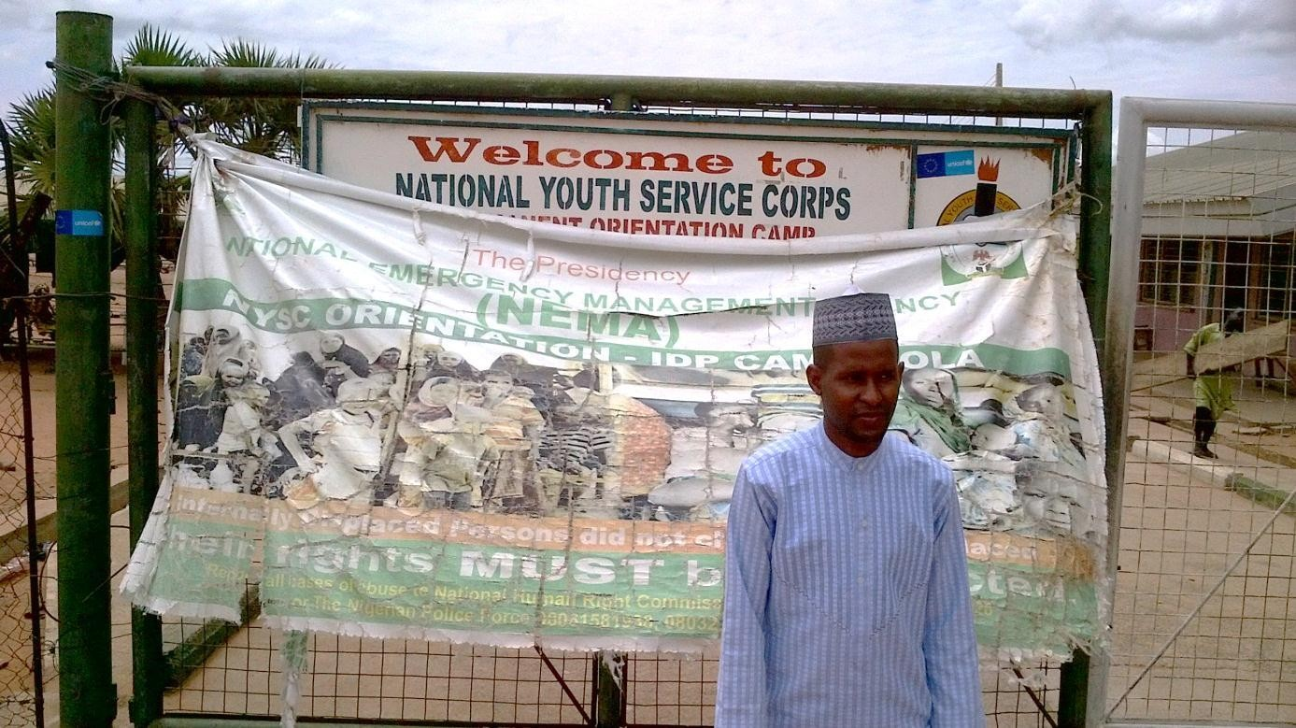

Picture 1: The researcher at NYSC IDP camp, Damare Yola

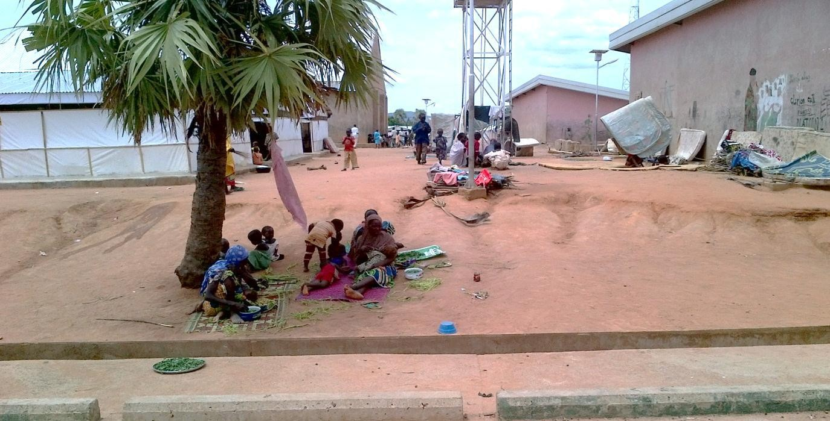

Picture 2: Some IDPs inside the camp

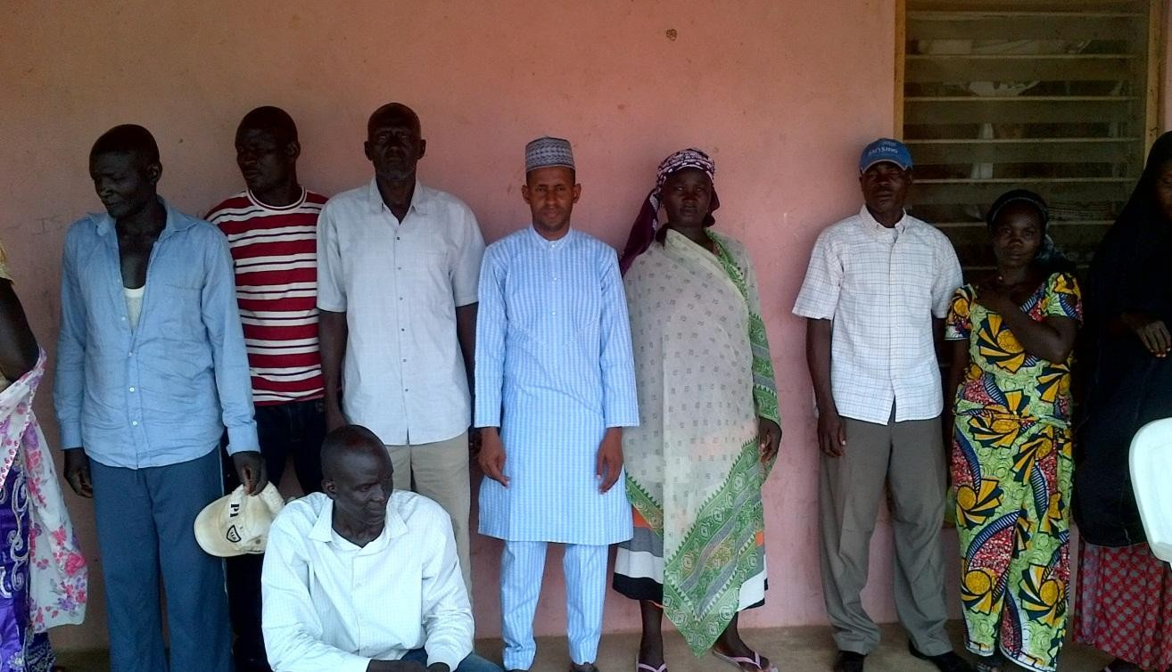

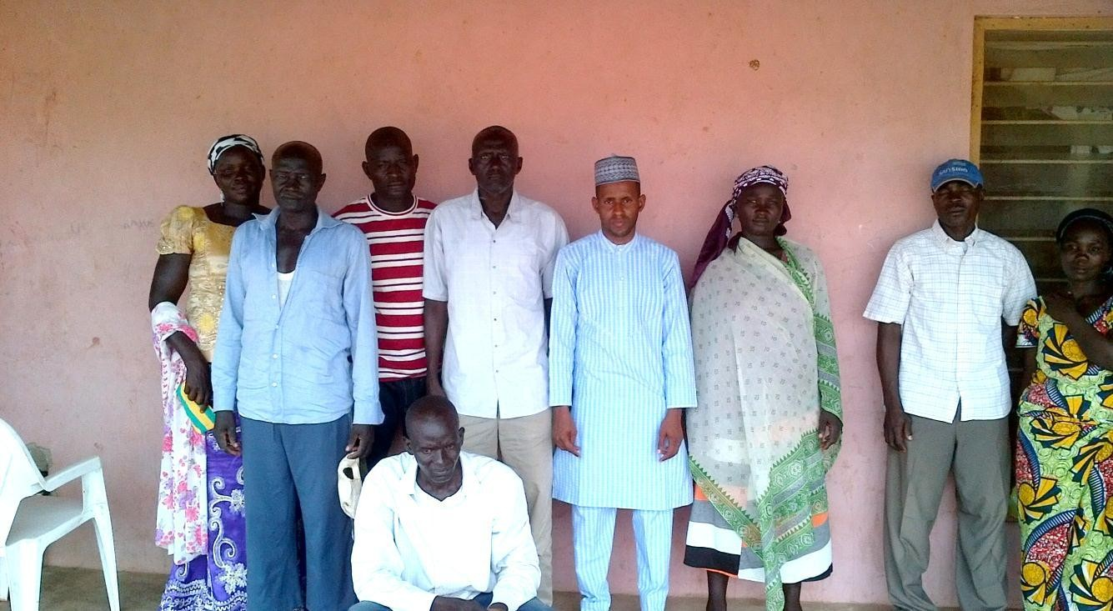

Picture 3: The researcher with the FGD participants in the camp

141

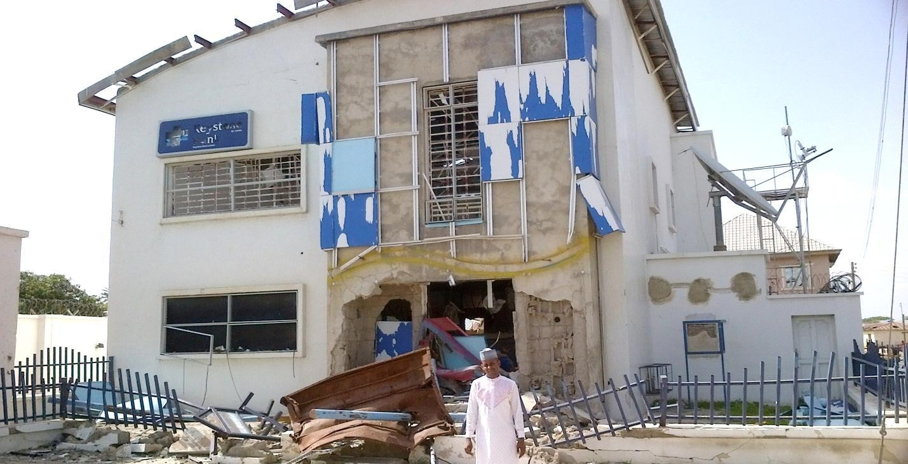

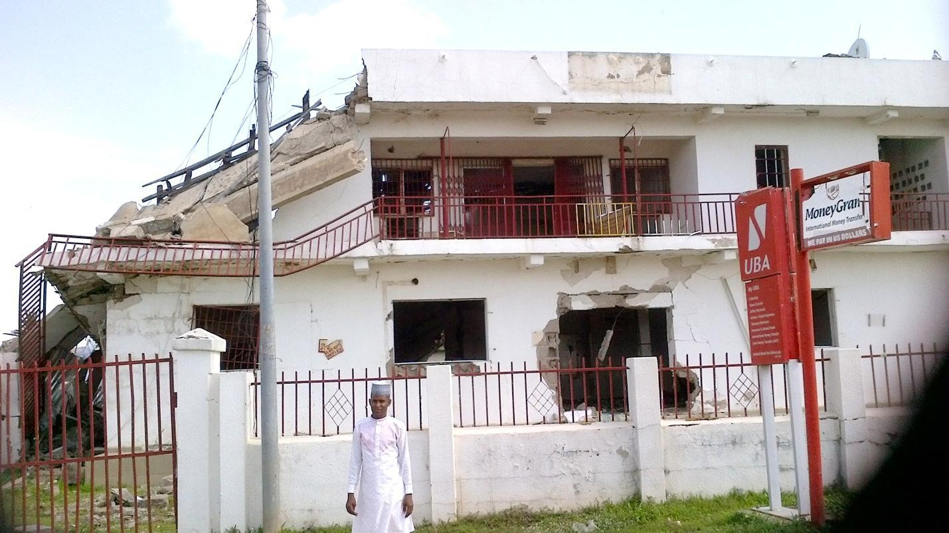

Picture 4: The researcher in front of banks destroyed by Boko Haram in Mubi-Metropolis

142

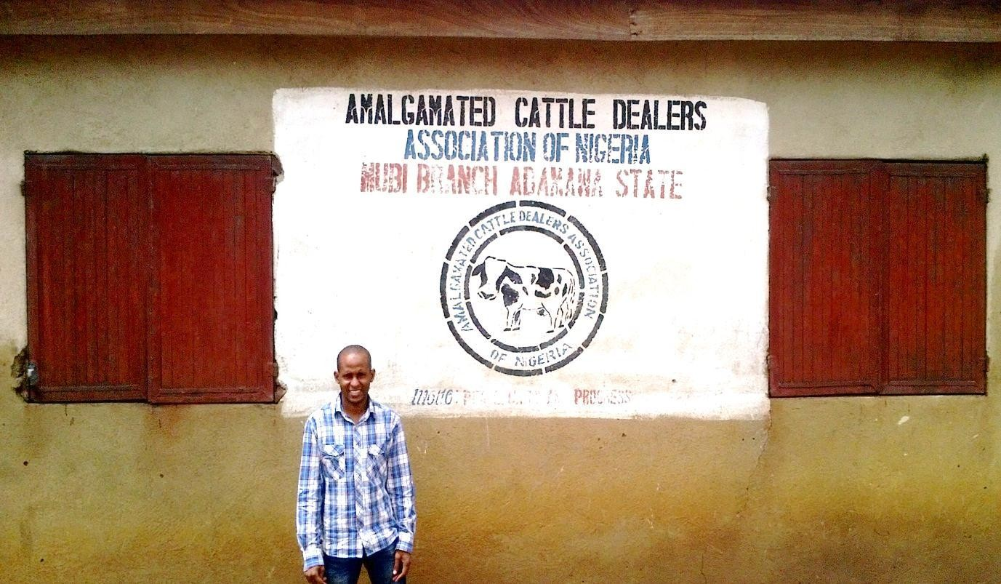

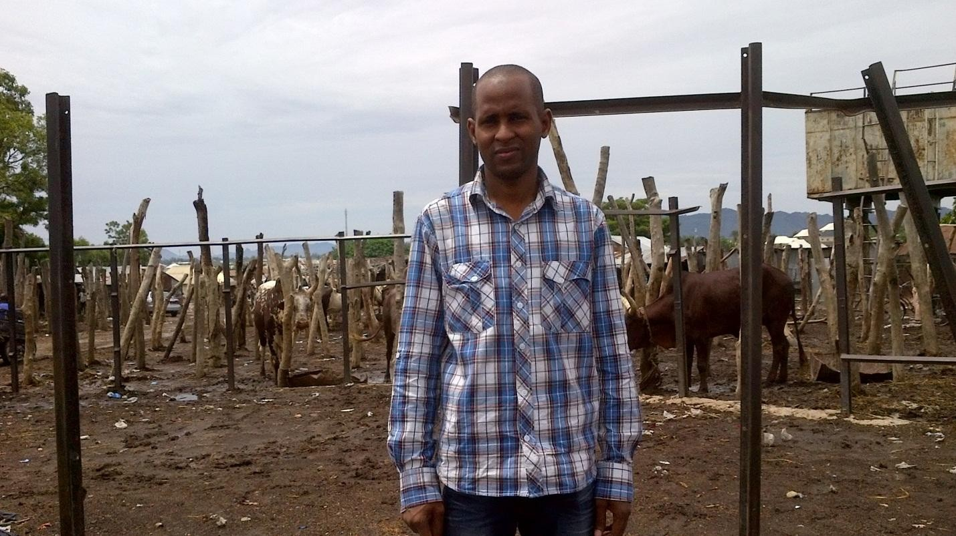

Picture 5: The researcher in the popular Mubi cattle market, in Mubi-Metropolis

143

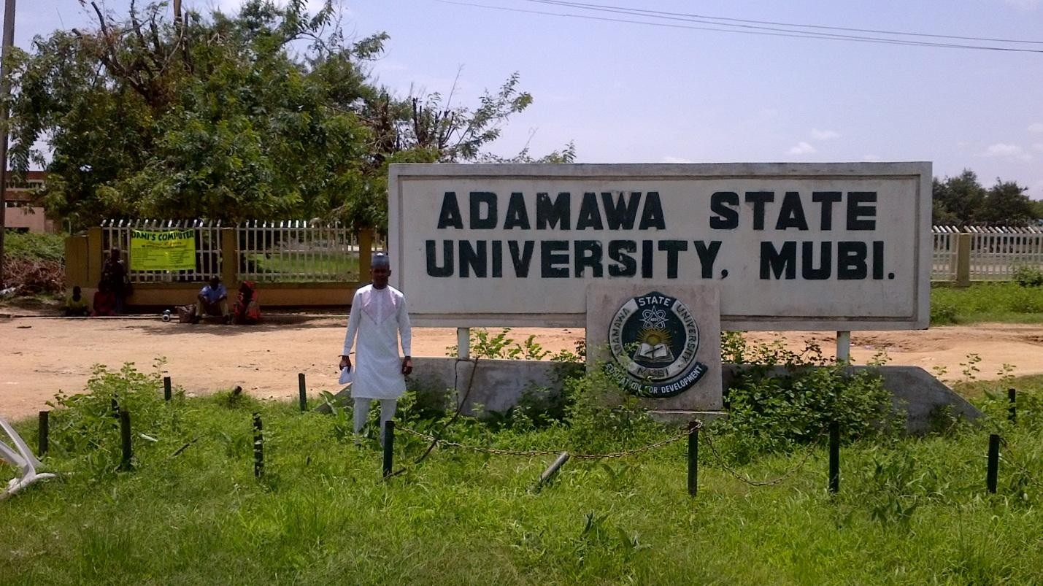

Picture 6: The researcher at the entrance of Adamawa State University, Mubi

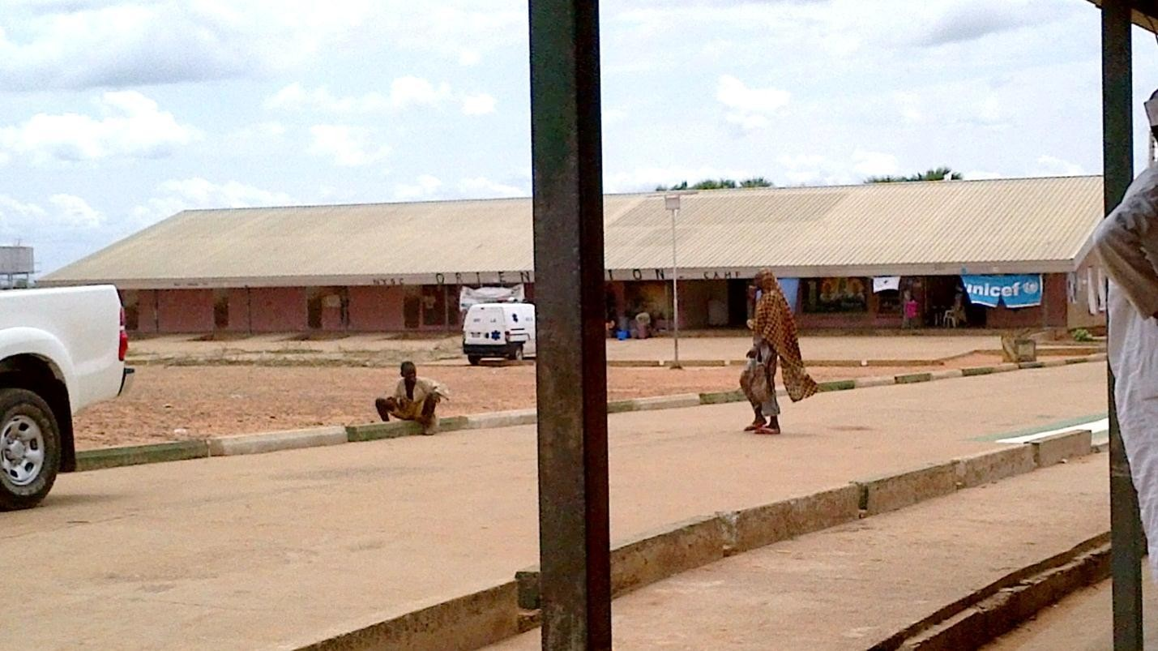

Picture 7: Some IDPs in the Damare IDP camp, Yola

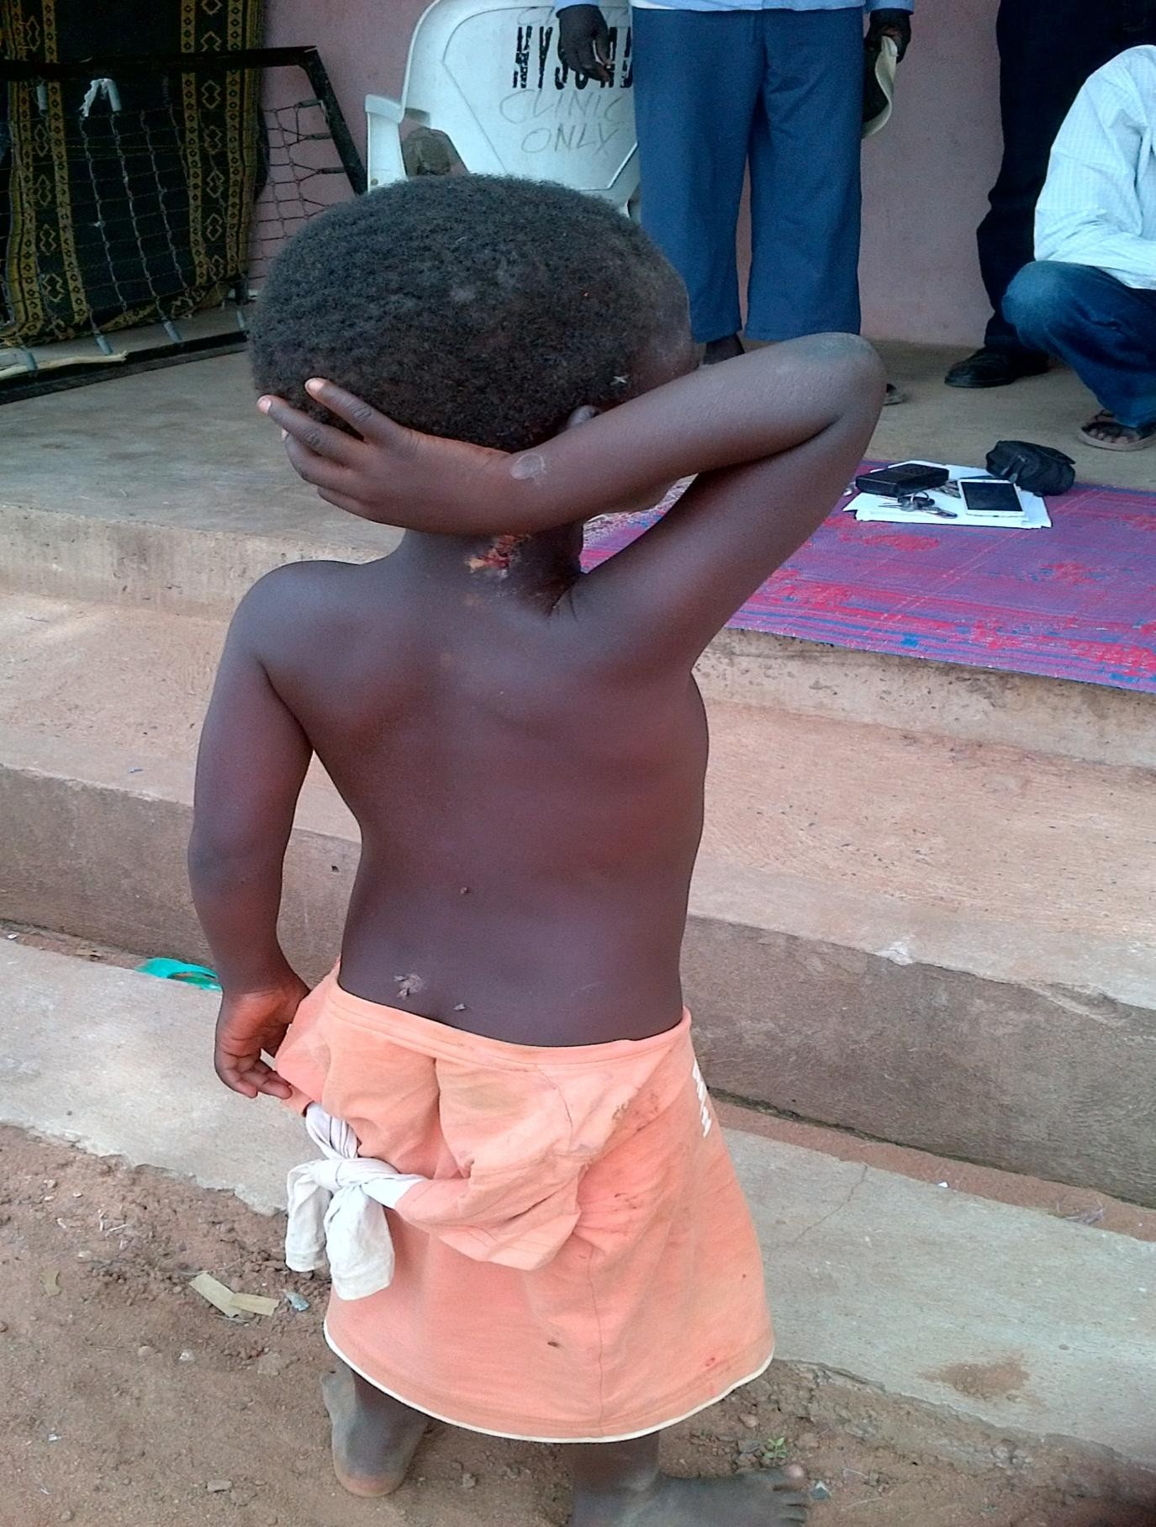

Picture 8: IDP child in Damare IDP camp Yola